No. 19 1233

THE SOUTH AUSTRALIAN

GOVERNMENT GAZETTE
www.governmentgazette.sa.gov.au

PUBLISHED BY AUTHORITY

ALL PUBLIC ACTS appearing in this GAZETTE are to be considered official, and obeyed as such

ADELAIDE, THURSDAY, 10 APRIL 2008

CONTENTS

Page
Appointments, Resignations, Etc. 1234
Building Work Contractors Act 1995—Notice 1235
Controlled Substances Act 1994—Notice 1236
Corporations and District Councils—Notices 1301
Development Act 1993—Notices 1235
Environment Protection Act 1993—
Notices 1242
[Republished] 1239
Fisheries Management Act 2007—Notices 1252
Housing Improvement Act 1940—Notices 1255
Land Acquisition Act 1969—Notices 1256
Land and Business (Sale and Conveyancing) Act 1994—
Notice 1259
Liquor Licensing Act 1997—Notices 1259
Livestock Act 1997—Notices 1272

Page
Mining Act 1971—Notice 1262
National Electricity Law—Notice 1262
National Parks and Wildlife Act 1972—Notice 1262
National Parks and Wildlife (National Parks)
Regulations 2001—Notice 1263
Petroleum Act 2000—Notices 1264
Phylloxera and Grape Industry Act 1995—Notice 1293
Proclamations 1294
Public Trustee Office—Administration of Estates 1302
REGULATIONS
Health Care Act 2008 (No. 33 of 2008) 1296
Tobacco Products Regulation Act 1997
(No. 34 of 2008) 1298
Roads (Opening and Closing) Act 1991—Notices 1293
Transport, Department of—Notices to Mariners 1264

GOVERNMENT GAZETTE NOTICES
ALL poundkeepers’ and private advertisements forwarded for publication in the South Australian Government Gazette must be PAID FOR PRIOR TO INSERTION; and all notices, from whatever source, should be legibly written on one side of the paper only and sent to Government Publishing SA so as to be received no later
than 4 p.m. on the Tuesday preceding the day of publication. Phone 8207 1045 or Fax 8207 1040. E-mail: governmentgazette@dpc.sa.gov.au. Send as attachments in Word format and please confirm your transmission with a faxed copy of your document, including the date the notice is to be published and to whom the notice will be charged. The Government Gazette is available online at: www.governmentgazette.sa.gov.au

Department of the Premier and Cabinet
Adelaide, 10 April 2008
HIS Excellency the Governor in Executive Council has been pleased to appoint the undermentioned to the Administrative and Disciplinary Division of the District Court, pursuant to the provisions of the Guardianship and Administration Act 1993:
Section 66 (3) Panel Assessor: (from 14 April 2008 until 13 April 2011)
Polly Sumner-Dodd
Margaret Heylen
Section 66 (3) Panel Assessor: (from 19 May 2008 until 18 May 2011)
Samantha Jane Battams
By command,
Gail Gago, for Premier
AGO0320/04CS

Department of the Premier and Cabinet
Adelaide, 10 April 2008
HIS Excellency the Governor in Executive Council has been pleased to appoint the undermentioned to the Equal Opportunity Tribunal, pursuant to the provisions of the Equal Opportunity Act 1984:
Deputy Presiding Officer: (from 14 April 2008 until 13 April 2011)
Barry Francis Beazley
Deputy Presiding Officer: (from 19 May 2008 until 18 May 2011)
Gordon Fraser Barrett
Deputy Presiding Officer: (from 9 June 2008 until 8 June 2011)
Marie Elizabeth Shaw
Wayne Chivell
Sydney William Tilmouth
By command,
Gail Gago, for Premier
AGO0266/02CS

Department of the Premier and Cabinet
Adelaide, 10 April 2008
HIS Excellency the Governor in Executive Council has been pleased to appoint Hieu Van Le as Governor’s Deputy of South Australia for the period from 2 p.m. on Wednesday, 16 April 2008 until 5 p.m. on Saturday, 19 April 2008.
By command,
Gail Gago, for Premier

Department of the Premier and Cabinet
Adelaide, 10 April 2008
HIS Excellency the Governor in Executive Council has been pleased to appoint Bruce Lander to the office of Judge of the Supreme Court of South Australia on an auxiliary basis from
10 April 2008 to 9 April 2009, pursuant to section 3 of the Judicial Administration (Auxiliary Appointments and Powers) Act 1988.
By command,
Gail Gago, for Premier
AGO0057/05CS

Department of the Premier and Cabinet
Adelaide, 10 April 2008
HIS Excellency the Governor in Executive Council has been pleased to appoint Michael James O’Connell to the position of Interim Commissioner for Victims’ Rights for a period of three months commencing on 19 April 2008 and expiring on 18 July 2008, pursuant to section 68 of the Constitution Act 1934.
By command,
Gail Gago, for Premier
AGO0098/04CS

Department of the Premier and Cabinet
Adelaide, 10 April 2008
HIS Excellency the Governor in Executive Council has been pleased to appoint the Members to the Natural Resources Management Boards listed, for the terms specified, pursuant to the Natural Resources Management Act 2004:
Adelaide and Mount Lofty Ranges Natural Resources Manage-ment Board:
For a term commencing on 14 April 2008 and expiring on 13 April 2010
Kenneth Frank Bradley
Matthew John Jeffs
Rosney Snell
Sandra Gail Taylor
For a term commencing on 14 April 2008 and expiring on 13 April 2011
Anita Aspinall
Debra Just
Penelope Ann Paton
Eyre Peninsula Natural Resources Management Board:
For a term commencing on 14 April 2008 and expiring on 13 April 2010
Anthony John Irvine
Sandra Judith McCallum
Sean Gregory O’Brien
Evelyn Grace Poole
For a term commencing on 14 April 2008 and expiring on 13 April 2011
Russell John Bambridge
Karen Shirley Burrows
Alan Edgar Dodd
Cecilia Woolford
Kangaroo Island Natural Resources Management Board:
For a term commencing on 14 April 2008 and expiring on 13 April 2010
David Minchin Ball
Alan John Childs
Ken Chou Liu
Fraser James Vickery
For a term commencing on 14 April 2008 and expiring on 13 April 2011
Joanne Lyn Davidson
Peggy Dianne Rismiller
Richard Evans Trethewey
Northern and Yorke Natural Resources Management Board:
For a term commencing on 14 April 2008 and expiring on 13 April 2010
Helen Joanna Thomas
Richard Arnold Wilkinson
Neville Kevin Wilson
Jacqueline Anne O’Reilly
For a term commencing on 14 April 2008 and expiring on 13 April 2011
Alfred Parry Agius
Jayne Lesley Bishop
Kathleen Bowman
Kerry Mark Ward
South Australian Arid Lands Natural Resources Management Board:
For a term commencing on 14 April 2008 and expiring on 13 April 2010
Brenton Kenneth Arnold
Geoffrey Douglas Mills
Josephine Maree Morton
Ronald Trevor Whitelaw
For a term commencing on 14 April 2008 and expiring on 13 April 2011
Randall Jeff Crozier
Carolyn Ireland
Leanne Maree Liddle
Katherine Elizabeth Moseby
South East Natural Resources Management Board:
For a term commencing on 14 April 2008 and expiring on 13 April 2010
Christine Chaston Johnson
Deborah Margaret Lang
Robert James Mock
Pip Rasenberg
For a term commencing on 14 April 2008 and expiring on 13 April 2011
Dianne Catherine Ashby
Jennifer Anne Lillecrapp
Andrew John Moore
Richard John Vickery
By command,
Gail Gago, for Premier
WBCS08/0007

BUILDING WORK CONTRACTORS ACT 1995
Exemption
TAKE notice that, pursuant to section 45 of the Building Work Contractors Act 1995, I, Mal Hemmerling, Commissioner for Consumer Affairs, do hereby exempt the licensee named in Schedule 1 from the application of Division 3 of Part 5 of the above Act in relation to domestic building work described in Schedule 2 and subject to the conditions specified in Schedule 3.
Schedule 1
John Giannaros, BLD 8994.
Schedule 2
Construction of a single-storey house on land situated at 302 Cross Road, Clarence Park, S.A. 5034 (Allotment 35 in Deposited Plan 73984 in the area named Clarence Park, Hundred of Adelaide (certificate of title volume 5986, folio 413)).
Schedule 3
1. This exemption is limited to domestic building work personally performed by the licensee for the construction of a single-storey house on land situated at 302 Cross Road, Clarence Park, S.A. 5034 (Allotment 35 in Deposited Plan 73984 in the area named Clarence Park, Hundred of Adelaide (certificate of title volume 5986, folio 413)).
2. This exemption does not apply to any domestic building work the licensee sub-contracts to another building work contractor, for which that contractor is required by law to hold building indemnity insurance.
3. That the licensee does not transfer his interest in the land prior to five years from the date of completion of the building work the subject of this exemption, without the prior authorisation of the Commissioner for Consumer Affairs. Before giving such authorisation, the Commissioner for Consumer Affairs may require the licensee to take any reasonable steps to protect the future purchaser(s) of the property, including but not limited to:
• providing evidence that an adequate policy of building indemnity insurance is in force to cover the balance of the five-year period from the date of completion of the building work the subject of this exemption;
• providing evidence of an independent expert inspection of the building work the subject of this exemption;
• making an independent expert report available to pros-pective purchasers of the property; and
• giving prospective purchasers of the property notice of the absence of a policy of building indemnity insurance.
Dated 3 April 2008.
M. Hemmerling, Commissioner for Consumer Affairs, Office of Consumer and Business Affairs, Delegate of the Minister for Consumer Affairs
Ref.: 610/08-00023

CONTROLLED SUBSTANCES ACT 1994
Revocation of Order
TAKE notice that on 3 April 2008, I, Keith Evans, Executive Director of the Drug and Alcohol Services South Australia, exercised the authority delegated by the Minister for Mental Health and Substance Abuse under section 62A of the Controlled Substances Act 1984, and order under section 57 (2) of the Act, that the previous order made under section 57 (1) in relation to:
Dr Ian Holden Buttfield
90 Unley Road,
Unley, S.A. 5061
on 18 December 2007, be revoked.
K. Evans, Delegate for the Minister for Mental Health and Substance Abuse

DEVELOPMENT ACT 1993, SECTION 25 (17): CITY OF ONKAPARINGA—RESIDENTIAL (FOOTHILLS) DEVELOP-MENT PLAN AMENDMENT
Preamble
1. The Development Plan amendment entitled ‘City of Onkaparinga—Residential (Foothills) Development Plan Amend-ment’ (the Plan Amendment) has been finalised in accordance with the provisions of the Development Act 1993.
2. The Minister for Urban Development and Planning has decided to approve the Plan Amendment.
Notice
PURSUANT to section 25 of the Development Act 1993, I—
(a) approve the Plan Amendment; and
(b) fix the day on which this notice is published in the Gazette as the day on which the Plan Amendment will come into operation.
Dated 10 April 2008.
Paul Holloway, Minister for Urban Development and Planning

DEVELOPMENT ACT 1993, SECTION 25 (17): CITY OF ONKAPARINGA—GENERAL AMENDMENTS PART 1 DEVELOPMENT PLAN AMENDMENT
Preamble
1. The Development Plan amendment entitled ‘City of Onkaparinga—General Amendments Part 1 Development Plan Amendment’ (the Plan Amendment) has been finalised in accordance with the provisions of the Development Act 1993.
2. The Minister for Urban Development and Planning has decided to approve the Plan Amendment.
Notice
PURSUANT to section 25 of the Development Act 1993, I—
(a) approve the Plan Amendment; and
(b) fix the day on which this notice is published in the Gazette as the day on which the Plan Amendment will come into operation.
Dated 10 April 2008.
Paul Holloway, Minister for Urban Development and Planning

DEVELOPMENT ACT 1993: SECTION 46 (4)
Preamble
1. On 15 September 2005, the Minister for Mineral Resources Development, by notice in the Gazette (see Gazette, 15 September 2005, page 3318), declared that section 46 of the Development Act 1993, applied to any development of a kind specified in the Schedule to that notice (the declaration).
2. On 14 December 2006, the Minister for Mineral Resources Development, by notice in the Gazette (see Gazette, 14 December 2006, page 4310), varied the declaration.
3. It has been decided to vary the declaration again.
Notice
PURSUANT to section 46 (4) of the Development Act 1993, I vary the declaration referred to in Clause 1 of the preamble, as previously varied by the notice referred to in Clause 2 of the preamble, by inserting, after paragraph (j) in the Schedule to the declaration, the following words:
But excluding:
(k) any activities relating to the investigation of the extent of dewatering of the proposed open pit that may be required, including, without limitation, the drilling of dewatering wells and the transport of water by pipeline between the wells and proposed saline water borefields;
(l) any activities relating to the investigation of the potential establishment of a water borefield for supply of water and/or potential re-injection of water produced by the dewatering, including the drilling of wells, the storage and transport of water and other activities to investigate the location of the borefield and its capacity; and
(m) any activities relating to geotechnical investigations, including drilling holes, digging pits, collecting samples and conducting other activities to investigate the condition, quality and features of land.
The declaration, as so varied, is set out in the Schedule below.

Schedule
DEVELOPMENT ACT 1993: SECTION 46 (1)
Preamble
Clause 28 (2) of the Olympic Dam and Stuart Shelf Indenture in the Schedule to the Roxby Downs (Indenture Ratification) Act 1982, provides that references to the ‘Minister’ in Division 2 of
Part 4 of the Development Act 1993, are to be taken to be references to the Minister responsible for Mineral Resources Development (the Indenture Minister). Subsection (1) of section 46 of the Development Act 1993, therefore enables the Minister to apply that section to a specified kind of development or project if the Minister is of the opinion that a declaration under that section is appropriate or necessary for the proper assessment of develop-ment or a project of major environmental, social or economic importance.
Notice
PURSUANT to section 46 (1) of the Development Act 1993, being of the opinion that a declaration is appropriate for the proper assessment of a development or project of major environmental, social or economic importance, I declare that section 46 of the Act applies to any development of a kind specified in the Schedule.
Schedule—Specified kinds of Development
Development for the purposes of establishing the expanded Olympic Dam Project (not including works in the nature of repairs or maintenance), including any or all of the following elements:
(a) any new water supply pipeline from any borefield, including any related bores or pumps;
(b) any new energy supply transmission line;
(c) any new natural gas pipeline, not including the liquid fuel replacement gas pipeline between Moomba and Olympic Dam being investigated as part of current operations;
(d) any new on-site power station;
(e) any rail line;
(f) any mine expansion, including open pit mine, tailings disposal facilities and evaporation ponds or waste rock disposal area;
(g) any minerals processing facility;
(h) any new airport;
(i) any coastal seawater desalination plant and pipeline, with the exception of a pilot coastal seawater desalination plant and associated infrastructure; and
(j) any future alteration to any approved element of the expanded Olympic Dam Project which occupies a significantly different site than that of the approved element.
But excluding:
(k) any activities relating to the investigation of the extent of dewatering of the proposed open pit that may be required, including, without limitation, the drilling of dewatering wells and the transport of water by pipeline between the wells and proposed saline water borefields;
(l) any activities relating to the investigation of the potential establishment of a water borefield for supply of water and/or potential re-injection of water produced by the dewatering, including the drilling of wells, the storage and transport of water and other activities to investigate the location of the borefield and its capacity; and
(m) any activities relating to geotechnical investigations, including drilling holes, digging pits, collecting samples and conducting other activities to investigate the con-dition, quality and features of land.
Dated 4 April 2008.
Paul Holloway, Minister for Mineral Resources Development

DEVELOPMENT ACT 1993, SECTION 29 (2) (b) (ii): AMENDMENT TO THE CITY OF WEST TORRENS
DEVELOPMENT PLAN
Preamble
It is necessary to amend the City of West Torrens Development Plan dated 11 October 2007.
Notice
PURSUANT to section 29 (2) (b) (ii) of the Development Act 1993, I, Paul Holloway, being the Minister administering the Act, amend the City of West Torrens Development Plan dated 11 October 2007 as follows:
• Delete Policy Area Map WeTo/30 and replace with Map WeTo/30.
• Delete Policy Area Map WeTo/18 and replace with Map WeTo/18.

Dated 10 April 2008
Paul Holloway, Minister for Urban Development and Planning

[Republished]
NOTICE in Government Gazette No. 17 dated 3 April 2008, on page 1160, second notice appearing, should be replaced with this notice.
ENVIRONMENT PROTECTION ACT 1993
Approval of Category B Containers
I, STEPHEN RICHARD SMITH, Senior Adviser, Container Deposit Legislation and Delegate of the Environment Protection Authority (‘the Authority’), pursuant to section 69 of the Environment Protection Act 1993 (SA) (‘the Act’) hereby:
Approval of Category B Containers:
Approve as Category B Containers, subject to the conditions in subclauses (i) and (ii) below, each of the classes of containers identified by reference to the following matters described in the first 4 columns of Schedule 1 of this Notice which are sold in South Australia:
(a) the product which each class of containers shall contain;
(b) the size of the containers;
(c) the type of containers;
(d) the name of the holders of these approvals.
(i) Subsection 69 (3) Arrangements:
The holders of these approvals must ensure that the empty containers which belong to their respective class of containers hereby approved as Category B Containers are collected from collection depots approved under section 69 of the Act by the party named in Column 5 of Schedule 1 of this Notice; and
(ii) Approved Refund Markings:
(a) The holders of these approvals must ensure that each container which belongs to their respective class of containers hereby approved as Category B Containers bears the refund marking approved by the Authority in respect of that class of containers.
(b) The refund marking that appears on each container that belongs to the class of containers hereby approved, must be a minimum 1.5 mm for the smallest letter in the statement and a minimum 3 mm for the numeric (‘5’) in the statement.
(c) The holder of these approvals must ensure that if a sticker bearing the refund marking has been approved, and is applied to the container, then the sticker must not be placed on any portion of the opening mechanism or in any other place that would require complete or partial removal of the sticker before the contents may be consumed.
Schedule 1

Column 1 | Column 2 |  | Column 3 |  | Column 4 |  | Column 5
Product Name | Container  Size (mL) |  | Container Type |  | Approval Holder |  | Collection  Arrangements
Archers Schnapps Aqua Fruitini |  | 275 |  | Glass with PVC Label |  | Diageo Australia Pty Ltd |  | Statewide Recycling
Rubbel Sexy Lager |  | 330 |  | Brown Glass with Paper Label |  | Empire Liquor |  | Statewide Recycling
Dole Singles Pineapple Juice |  | 240 |  | Can—Steel |  | Austmark International Pty Ltd |  | Statewide Recycling
Dole Citrus Sunrise |  | 250 |  | Can—Steel |  | Austmark International Pty Ltd |  | Statewide Recycling
Dole Mango Mambo |  | 250 |  | Can—Steel |  | Austmark International Pty Ltd |  | Statewide Recycling
Dole Apple Jumble |  | 250 |  | Can—Steel |  | Austmark International Pty Ltd |  | Statewide Recycling
Pepsi Cola |  | 390 |  | PET with Polypropylene Label |  | Cadbury Schweppes Pty Ltd |  | Statewide Recycling
Crown Lager |  | 355 |  | Bottle—Aluminium |  | Carlton & United Beverages Pty Ltd |  | Visy Recycling CDL Services
Black Heart Rum & Cola |  | 440 |  | Can—Aluminium |  | Independent Distillers (Aust.) Pty Ltd |  | Statewide Recycling
Black Heart Rum & Cola |  | 330 |  | Clear Glass with Paper Label |  | Independent Distillers (Aust.) Pty Ltd |  | Statewide Recycling
Black Velvet Canadian Whisky And Cola |  | 440 |  | Can—Aluminium |  | Independent Distillers (Aust.) Pty Ltd |  | Statewide Recycling
Black Velvet Canadian Whisky And Dry |  | 440 |  | Can—Aluminium |  | Independent Distillers (Aust.) Pty Ltd |  | Statewide Recycling
Schwelmer Bernstein |  | 500 |  | Brown Glass with Paper Label |  | Empire Liquor |  | Statewide Recycling
Sol Beer |  | 330 |  | Clear Glass |  | International Liquor Wholesalers |  | Marine Stores Ltd
Amsterdam Mariner Premium Lager |  | 500 |  | Can—Aluminium |  | International Liquor Wholesalers |  | Marine Stores Ltd
Bitburger Premium Beer |  | 330 |  | Brown Glass with Paper Label |  | International Liquor Wholesalers |  | Marine Stores Ltd
Grolsch Premium Lager |  | 250 |  | Green Glass with Paper Label |  | International Liquor Wholesalers |  | Marine Stores Ltd
Lowenbrau Original Beer |  | 330 |  | Green Glass with Paper Label |  | International Liquor Wholesalers |  | Marine Stores Ltd
Coke Zero |  | 390 |  | PET with Polypropylene Label |  | Coca Cola Amatil (Aust.) Pty Ltd |  | Statewide Recycling
Coke Zero |  | 600 |  | PET with Polypropylene Label |  | Coca Cola Amatil (Aust.) Pty Ltd |  | Statewide Recycling
Coke Zero |  | 1 000 |  | PET with Polypropylene Label |  | Coca Cola Amatil (Aust.) Pty Ltd |  | Statewide Recycling
Coke Zero |  | 1 250 |  | PET with Polypropylene Label |  | Coca Cola Amatil (Aust.) Pty Ltd |  | Statewide Recycling
Coke Zero |  | 1 500 |  | PET with Polypropylene Label |  | Coca Cola Amatil (Aust.) Pty Ltd |  | Statewide Recycling
Coke Zero |  | 2 000 |  | PET with Polypropylene Label |  | Coca Cola Amatil (Aust.) Pty Ltd |  | Statewide Recycling
Coke Zero |  | 250 |  | Can—Aluminium |  | Coca Cola Amatil (Aust.) Pty Ltd |  | Statewide Recycling
Coke Zero |  | 375 |  | Can—Aluminium |  | Coca Cola Amatil (Aust.) Pty Ltd |  | Statewide Recycling
Seagers Gin & Tonic with Lime |  | 375 |  | Can—Aluminium |  | Independent Distillers (Aust.) Pty Ltd |  | Statewide Recycling
Grolsch Premium Lager |  | 500 |  | Can—Aluminium |  | Independent Distillers (Aust.) Pty Ltd |  | Statewide Recycling
Lora Recoaro Natural Mineral Water Sparkling |  | 1 000 |  | Green Glass with Paper Label |  | Siena Foods Pty Ltd |  | Statewide Recycling
Lora Recoaro Natural Mineral Water Sparkling |  | 500 |  | Green Glass with Paper Label |  | Siena Foods Pty Ltd |  | Statewide Recycling
Lora Recoaro Natural Mineral Water Still |  | 500 |  | Green Glass with Paper Label |  | Siena Foods Pty Ltd |  | Statewide Recycling
Lora Recoaro Natural Mineral Water Still |  | 1 000 |  | Green Glass with Paper Label |  | Siena Foods Pty Ltd |  | Statewide Recycling
Pokka Ice Lemon Tea |  | 500 |  | PET with Paper Label (Sticker) |  | Asian Food Wholesalers |  | Statewide Recycling
Pokka Blueberry Tea |  | 500 |  | PET with Paper Label (Sticker) |  | Asian Food Wholesalers |  | Statewide Recycling
Pokka Peach Tea |  | 500 |  | PET with Paper Label (Sticker) |  | Asian Food Wholesalers |  | Statewide Recycling
Pokka Oolong Tea |  | 500 |  | PET with Paper Label (Sticker) |  | Asian Food Wholesalers |  | Statewide Recycling
Pokka Apple Tea |  | 500 |  | PET with Paper Label (Sticker) |  | Asian Food Wholesalers |  | Statewide Recycling
Pokka Ice Lychee Tea |  | 500 |  | PET with Paper Label (Sticker) |  | Asian Food Wholesalers |  | Statewide Recycling
Pokka Ice Mango Tea |  | 500 |  | PET with Paper Label (Sticker) |  | Asian Food Wholesalers |  | Statewide Recycling
Pokka Raspberry Tea |  | 500 |  | PET with Paper Label (Sticker) |  | Asian Food Wholesalers |  | Statewide Recycling
Pokka Jasmine Green Tea |  | 1 500 |  | PET with Paper Label (Sticker) |  | Asian Food Wholesalers |  | Statewide Recycling
Cocta Soft Drink |  | 1 500 |  | PVC with Paper Label (Sticker) |  | Ras Trade Pty Ltd |  | Statewide Recycling
Fresh Attitude Organic Carrot Apple Ginger |  | 300 |  | Glass with Paper Label |  | Australian Food Innovators |  | Flagcan Distributors
Fresh Attitude Organic Apple Blackcurrant |  | 300 |  | Glass with Paper Label |  | Australian Food Innovators |  | Flagcan Distributors
Fresh Attitude Organic Carrot Apple Celery |  | 300 |  | Glass with Paper Label |  | Australian Food Innovators |  | Flagcan Distributors
Fresh Attitude Organic Carrot Apple Apricot |  | 300 |  | Glass with Paper Label |  | Australian Food Innovators |  | Flagcan Distributors
Fresh Attitude Organic Orange |  | 300 |  | Glass with Paper Label |  | Australian Food Innovators |  | Flagcan Distributors
Fresh Attitude Organic Apple |  | 300 |  | Glass with Paper Label |  | Australian Food Innovators |  | Flagcan Distributors
Popper Juice Fizz Apple & Blackcurrant |  | 300 |  | PET with Paper Label |  | Golden Circle Limited |  | Statewide Recycling
Popper Juice Fizz Apple Orange & Mango |  | 300 |  | PET with Paper Label |  | Golden Circle Limited |  | Statewide Recycling
Popper Juice Fizz Apple Lemon & Lime |  | 300 |  | PET with Paper Label |  | Golden Circle Limited |  | Statewide Recycling
Popper Juice Fizz Apple Pine & Passionfruit |  | 300 |  | PET with Paper Label |  | Golden Circle Limited |  | Statewide Recycling
Popper Juice Fizz Apple & Raspberry |  | 300 |  | PET with Paper Label |  | Golden Circle Limited |  | Statewide Recycling
Golden Circle Chilled Apple Juice |  | 500 |  | PET with Paper Label |  | Golden Circle Limited |  | Statewide Recycling
Golden Circle Chilled Apple Mango Juice |  | 500 |  | PET with Paper Label |  | Golden Circle Limited |  | Statewide Recycling
Golden Circle Chilled Orange Juice |  | 500 |  | PET with Paper Label |  | Golden Circle Limited |  | Statewide Recycling
Golden Circle Chilled Orange Passionfruit Juice |  | 500 |  | PET with Paper Label |  | Golden Circle Limited |  | Statewide Recycling
Golden Circle Chilled Breakfast Juice |  | 500 |  | PET with Paper Label |  | Golden Circle Limited |  | Statewide Recycling
Adams Ale Purified Australian Water |  | 350 |  | PET with Paper Label |  | Golden Circle Limited |  | Statewide Recycling
Red Eye Classic |  | 330 |  | Glass with Paper Label |  | Metro Beverage Company |  | Statewide Recycling
Red Eye Gold |  | 330 |  | Glass with Paper Label |  | Metro Beverage Company |  | Statewide Recycling
Red Eye Extreme |  | 330 |  | Glass with Paper Label |  | Metro Beverage Company |  | Statewide Recycling
Red Eye Platinum |  | 330 |  | Glass with Paper Label |  | Metro Beverage Company |  | Statewide Recycling
Red Eye Passion |  | 330 |  | Glass with Paper Label |  | Metro Beverage Company |  | Statewide Recycling
Red Eye Power |  | 250 |  | Can—Aluminium |  | Metro Beverage Company |  | Statewide Recycling
Fruity Flavorits Sublime Slime |  | 250 |  | PET with PVC Label |  | Metro Beverage Company |  | Statewide Recycling
Fruity Flavorits Chaotic Cola |  | 250 |  | PET with PVC Label |  | Metro Beverage Company |  | Statewide Recycling
Fruity Flavorits Bubblegum Bliss |  | 250 |  | PET with PVC Label |  | Metro Beverage Company |  | Statewide Recycling
Fruity Flavorits Orange Ooz |  | 250 |  | PET with PVC Label |  | Metro Beverage Company |  | Statewide Recycling
Fruity Flavorits Totally Bubblegum |  | 250 |  | PET with PVC Label |  | Metro Beverage Company |  | Statewide Recycling
Fruity Flavorits Tropical Deelish |  | 250 |  | PET with PVC Label |  | Metro Beverage Company |  | Statewide Recycling
Fruity Flavorits Berry |  | 250 |  | PET with PVC Label |  | Metro Beverage Company |  | Statewide Recycling
Fruity Flavorits Sunberry Grove |  | 250 |  | PET with PVC Label |  | Metro Beverage Company |  | Statewide Recycling
Fruity Flavorits Tropical Tango |  | 250 |  | PET with PVC Label |  | Metro Beverage Company |  | Statewide Recycling
Fruity Flavorits Cookie Monster Lemonade |  | 250 |  | PET with PVC Label |  | Metro Beverage Company |  | Statewide Recycling
Fruity Flavorits Elmo Raspberry |  | 250 |  | PET with PVC Label |  | Metro Beverage Company |  | Statewide Recycling
Fruity Flavorits Madagascar Royal Reserve |  | 250 |  | PET with PVC Label |  | Metro Beverage Company |  | Statewide Recycling
Fruity Flavorits Madagascar Zebra Zapper |  | 250 |  | PET with PVC Label |  | Metro Beverage Company |  | Statewide Recycling
Fruity Flavorits Madagascar Long Nectar |  | 250 |  | PET with PVC Label |  | Metro Beverage Company |  | Statewide Recycling
Fruity Flavorits Madagascar Jungle Jive |  | 250 |  | PET with PVC Label |  | Metro Beverage Company |  | Statewide Recycling
Blanche De Chambly |  | 355 |  | Brown Glass with Paper Label (Sticker) |  | Palais Imports |  | Marine Stores Ltd
Blanche De Chambly |  | 750 |  | Brown Glass with Paper Label (Sticker) |  | Palais Imports |  | Marine Stores Ltd
Maudite |  | 750 |  | Brown Glass with Paper Label (Sticker) |  | Palais Imports |  | Marine Stores Ltd
Maudite |  | 355 |  | Brown Glass with Paper Label (Sticker) |  | Palais Imports |  | Marine Stores Ltd
La Fin Du Monde |  | 355 |  | Brown Glass with Paper Label (Sticker) |  | Palais Imports |  | Marine Stores Ltd
La Fin Du Monde |  | 750 |  | Brown Glass with Paper Label (Sticker) |  | Palais Imports |  | Marine Stores Ltd
Raftman |  | 750 |  | Brown Glass with Paper Label (Sticker) |  | Palais Imports |  | Marine Stores Ltd
Don De Dieu |  | 750 |  | Brown Glass with Paper Label (Sticker) |  | Palais Imports |  | Marine Stores Ltd
Don De Dieu |  | 355 |  | Brown Glass with Paper Label (Sticker) |  | Palais Imports |  | Marine Stores Ltd
Eau Benite |  | 750 |  | Brown Glass with Paper Label (Sticker) |  | Palais Imports |  | Marine Stores Ltd
Trois Pistoles |  | 750 |  | Brown Glass with Paper Label (Sticker) |  | Palais Imports |  | Marine Stores Ltd
Trois Pistoles |  | 355 |  | Brown Glass with Paper Label (Sticker) |  | Palais Imports |  | Marine Stores Ltd
Apple Ephemere |  | 750 |  | Brown Glass with Paper Label (Sticker) |  | Palais Imports |  | Marine Stores Ltd
Chambly Noir |  | 341 |  | Brown Glass with Paper Label (Sticker) |  | Palais Imports |  | Marine Stores Ltd
Ocean Spray White Cranberry Light |  | 1 500 |  | Glass with Paper Label |  | Ocean Spray International Inc. |  | Visy Recycling CDL Services
Ocean Spray Cranberry Light |  | 1 500 |  | Glass with Paper Label |  | Ocean Spray International Inc. |  | Visy Recycling CDL Services
Ocean Spray Ruby Red Grapefruit |  | 1 000 |  | Glass with Paper Label |  | Ocean Spray International Inc. |  | Visy Recycling CDL Services
Ocean Spray Ruby Red Grapefruit |  | 1 500 |  | PET with Paper Label |  | Ocean Spray International Inc. |  | Visy Recycling CDL Services

ENVIRONMENT PROTECTION ACT 1993
Revocation of Approval of Category B Containers
I, STEPHEN RICHARD SMITH, Senior Adviser, Container Deposit Legislation and Delegate of the Environment Protection Authority (‘the Authority’), pursuant to section 69 (8) of the Environment Protection Act 1993 (SA) (‘the Act’) hereby revoke the approvals of the classes of Category B Containers sold in South Australia as identified by reference to the following matters, which are described in the first 4 columns of Schedule 1 of this Notice:
(a) the product which each class of containers shall contain;
(b) the size of the containers;
(c) the type of containers;
(d) the name of the holders of these approvals.
These approvals are revoked as the Authority is satisfied that the subsection 69 (3) arrangement between the approval holder and the party named in Column 5 of Schedule 1 of this Notice has been cancelled.

Column 1 | Column 2 | Column 3 | Column 4 | Column 5
Product Name | Container  Size (mL) | Container Type | Approval Holder | Collection  Arrangements
Advantage Shake Chocolate | 330 | LPB—Aseptic | Atkins Nutritionals Pty Ltd | Visy Recycling CDL Services
Advantage Shake Strawberry | 330 | LPB—Aseptic | Atkins Nutritionals Pty Ltd | Visy Recycling CDL Services
Advantage Shake Vanilla | 330 | LPB—Aseptic | Atkins Nutritionals Pty Ltd | Visy Recycling CDL Services
Bacos Apple Tree Apple & Banana Juice | 375 | Glass | Baco Pty Ltd | Visy Recycling CDL Services
Bacos Apple Tree Apple & Blackcurrant Juice | 375 | Glass | Baco Pty Ltd | Visy Recycling CDL Services
Bacos Apple Tree Apple & Mango Juice | 375 | Glass | Baco Pty Ltd | Visy Recycling CDL Services
Bacos Apple Tree Apple & Passionfruit Juice | 375 | Glass | Baco Pty Ltd | Visy Recycling CDL Services
Bacos Apple Tree Apple & Pineapple Juice | 375 | Glass | Baco Pty Ltd | Visy Recycling CDL Services
Bacos Apple Tree Apple & Tropical Juice | 375 | Glass | Baco Pty Ltd | Visy Recycling CDL Services
BerrySweet Pure Blueberry & Raspberry Juice | 250 | Glass | BerrySweet Australia | Visy Recycling CDL Services
BerrySweet Pure Blueberry & Raspberry Juice | 500 | PET | BerrySweet Australia | Visy Recycling CDL Services
BerrySweet Pure Blueberry & Raspberry Juice | 100 | Glass | BerrySweet Australia | Visy Recycling CDL Services
BerrySweet Pure Blueberry & Raspberry Juice | 300 | Glass | BerrySweet Australia | Visy Recycling CDL Services
BerrySweet Pure Blueberry Juice | 250 | Glass | BerrySweet Australia | Visy Recycling CDL Services
BerrySweet Pure Blueberry Juice | 300 | Glass | BerrySweet Australia | Visy Recycling CDL Services
BerrySweet Pure Blueberry Juice | 500 | PET | BerrySweet Australia | Visy Recycling CDL Services
BerrySweet Pure Blueberry Juice | 100 | Glass | BerrySweet Australia | Visy Recycling CDL Services
BerrySweet Pure Raspberry Juice | 250 | Glass | BerrySweet Australia | Visy Recycling CDL Services
BerrySweet Pure Raspberry Juice | 500 | PET | BerrySweet Australia | Visy Recycling CDL Services
BerrySweet Pure Raspberry Juice | 300 | Glass | BerrySweet Australia | Visy Recycling CDL Services
BerrySweet Pure Raspberry Juice | 100 | Glass | BerrySweet Australia | Visy Recycling CDL Services
Bi Lo Sparkling Apple Fruit Drink | 750 | Glass | Carlton & United Breweries Ltd | Statewide Recycling
Capri Cocktail Appletini | 275 | Glass | Carlton & United Breweries Ltd | Visy Recycling CDL Services
Capri Cocktail Blue Lagoon | 275 | Glass | Carlton & United Breweries Ltd | Visy Recycling CDL Services
Capri Cocktail Co.smopolitan | 275 | Glass | Carlton & United Breweries Ltd | Visy Recycling CDL Services
Capri Cocktail Flirtini | 275 | Glass | Carlton & United Breweries Ltd | Visy Recycling CDL Services
Capri Cocktail Margarita | 275 | Glass | Carlton & United Breweries Ltd | Visy Recycling CDL Services
Capri Cocktail Pina Colada | 275 | Glass | Carlton & United Breweries Ltd | Visy Recycling CDL Services
Capri Cocktails Mango Tango | 275 | Glass | Carlton & United Breweries Ltd | Visy Recycling CDL Services
Carlton Cold Shot | 375 | Glass | Carlton & United Breweries Ltd | Visy Recycling CDL Services
Carlton Diamond | 375 | Glass | Carlton & United Breweries Ltd | Toll Recycling
Carlton Diamond | 375 | Can | Carlton & United Breweries Ltd | Toll Recycling
Carlton G | 355 | Glass | Carlton & United Breweries Ltd | Visy Recycling CDL Services
Fosters Lager | 375 | Glass | Carlton & United Breweries Ltd | Toll Recycling
Fosters Light | 750 | Glass | Carlton & United Breweries Ltd | Toll Recycling
Fosters Light | 375 | Can | Carlton & United Breweries Ltd | Toll Recycling
Fosters Light | 375 | Glass | Carlton & United Breweries Ltd | Toll Recycling
Harvey Wallbanger Valentino Steve to check this | 375 | Can | Carlton & United Breweries Ltd | Toll Recycling
Heineken | 650 | Glass | Carlton & United Breweries Ltd | Visy Recycling CDL Services
Heineken | 330 | Can | Carlton & United Breweries Ltd | Visy Recycling CDL Services
Heineken | 330 | Glass | Carlton & United Breweries Ltd | Visy Recycling CDL Services
Melbourne Bitter | 750 | Glass | Carlton & United Breweries Ltd | Visy Recycling CDL Services
Play Sport Water Raspberry | 500 | PET | Carlton & United Breweries Ltd | Flagcan Distributors
Sub Zero Lemon | 300 | Plastic | Carlton & United Breweries Ltd | Visy Recycling CDL Services
Sub Zero Mandarin Vodka Mix | 330 | Glass | Carlton & United Breweries Ltd | Visy Recycling CDL Services
Sub Zero Pink Grape Fruit | 330 | Glass | Carlton & United Breweries Ltd | Visy Recycling CDL Services
Sub Zero Pink Grapefruit Vodka Mix | 275 | Glass | Carlton & United Breweries Ltd | Visy Recycling CDL Services
Sub Zero Remix | 330 | Glass | Carlton & United Breweries Ltd | Visy Recycling CDL Services
Torque Accelerated Recovery Green Chicane | 660 | PET | Carlton & United Breweries Ltd | Flagcan Distributors
Torque Accelerated Recovery Purple Thunder | 660 | PET | Carlton & United Breweries Ltd | Flagcan Distributors
Torque Accelerated Recovery Red Demon | 660 | PET | Carlton & United Breweries Ltd | Flagcan Distributors
Torque Accelerated Recovery Yellow Pare | 660 | PET | Carlton & United Breweries Ltd | Flagcan Distributors
Victoria Bitter | 750 | Glass | Carlton & United Breweries Ltd | Visy Recycling CDL Services
Australias Choice Caffeine Free Diet Cola | 375 | Can—Aluminium | Carlton Non Alcoholic Brands | Flagcan Distributors
Australias Choice Caffeine Free Diet Cola | 2 000 | PET | Carlton Non Alcoholic Brands | Flagcan Distributors
Australias Choice Cola | 375 | Can—Aluminium | Carlton Non Alcoholic Brands | Flagcan Distributors
Australias Choice Cola | 2 000 | PET | Carlton Non Alcoholic Brands | Flagcan Distributors
Australias Choice Creamy Soda | 2 000 | PET | Carlton Non Alcoholic Brands | Flagcan Distributors
Australias Choice Diet Cola | 375 | Can—Aluminium | Carlton Non Alcoholic Brands | Flagcan Distributors
Australias Choice Diet Cola | 375 | Can—Aluminium | Carlton Non Alcoholic Brands | Flagcan Distributors
Australias Choice Diet Cola | 2 000 | PET | Carlton Non Alcoholic Brands | Flagcan Distributors
Australias Choice Diet Lemon | 375 | Can—Aluminium | Carlton Non Alcoholic Brands | Flagcan Distributors
Australias Choice Diet Lemonade | 2 000 | PET | Carlton Non Alcoholic Brands | Flagcan Distributors
Australias Choice Lemon | 375 | Can—Aluminium | Carlton Non Alcoholic Brands | Flagcan Distributors
Australias Choice Lemon | 2 000 | PET | Carlton Non Alcoholic Brands | Flagcan Distributors
Australias Choice Lemon | 375 | Can—Aluminium | Carlton Non Alcoholic Brands | Flagcan Distributors
Australias Choice Lemonade | 375 | Can—Aluminium | Carlton Non Alcoholic Brands | Flagcan Distributors
Australias Choice Lemonade | 375 | Can—Aluminium | Carlton Non Alcoholic Brands | Flagcan Distributors
Australias Choice Lemonade | 2 000 | PET | Carlton Non Alcoholic Brands | Flagcan Distributors
Australias Choice Lime | 2 000 | PET | Carlton Non Alcoholic Brands | Flagcan Distributors
Australias Choice Orange | 375 | Can—Aluminium | Carlton Non Alcoholic Brands | Flagcan Distributors
Australias Choice Orange | 2 000 | PET | Carlton Non Alcoholic Brands | Flagcan Distributors
Australias Choice Orange | 375 | Can—Aluminium | Carlton Non Alcoholic Brands | Flagcan Distributors
Australias Choice Raspberry | 2 000 | PET | Carlton Non Alcoholic Brands | Flagcan Distributors
Australias Choice Spring Water | 600 | PET | Carlton Non Alcoholic Brands | Flagcan Distributors
Australias Choice Spring Water | 1 500 | PET | Carlton Non Alcoholic Brands | Flagcan Distributors
Bi Lo Lemon Lime Orange Mineral Water | 2 000 | PET | Carlton Non Alcoholic Brands | Flagcan Distributors
Bi Lo Lemon Mineral Water | 2 000 | PET | Carlton Non Alcoholic Brands | Flagcan Distributors
Bi Lo Natural Lemon Mineral Water | 2 000 | PET | Carlton Non Alcoholic Brands | Flagcan Distributors
Bi Lo Orange & Mango Mineral Water | 2 000 | PET | Carlton Non Alcoholic Brands | Flagcan Distributors
Bilo Cola | 375 | Can—Aluminium | Carlton Non Alcoholic Brands | Flagcan Distributors
Bilo Cola | 2 000 | PET | Carlton Non Alcoholic Brands | Flagcan Distributors
Bilo Cola | 1 250 | PET | Carlton Non Alcoholic Brands | Flagcan Distributors
Bilo Creaming Soda | 375 | Can—Aluminium | Carlton Non Alcoholic Brands | Flagcan Distributors
Bilo Creaming Soda | 1 250 | PET | Carlton Non Alcoholic Brands | Flagcan Distributors
Bilo Lemon | 375 | Can—Aluminium | Carlton Non Alcoholic Brands | Flagcan Distributors
Bilo Lemon | 1 250 | PET | Carlton Non Alcoholic Brands | Flagcan Distributors
Bilo Lemon | 2 000 | PET | Carlton Non Alcoholic Brands | Flagcan Distributors
Bilo Lemonade | 375 | Can—Aluminium | Carlton Non Alcoholic Brands | Flagcan Distributors
Bilo Lemonade | 2 000 | PET | Carlton Non Alcoholic Brands | Flagcan Distributors
Bilo Lemonade | 1 250 | PET | Carlton Non Alcoholic Brands | Flagcan Distributors
Bilo Lemonade Lite | 375 | Can—Aluminium | Carlton Non Alcoholic Brands | Flagcan Distributors
Bilo Lime | 375 | Can—Aluminium | Carlton Non Alcoholic Brands | Flagcan Distributors
Bilo Lime | 1 250 | PET | Carlton Non Alcoholic Brands | Flagcan Distributors
Bilo Lite Cola | 2 000 | PET | Carlton Non Alcoholic Brands | Flagcan Distributors
Bilo Lite Cola | 1 250 | PET | Carlton Non Alcoholic Brands | Flagcan Distributors
Bilo Lite Lemonade | 1 250 | PET | Carlton Non Alcoholic Brands | Flagcan Distributors
Bilo Orange | 375 | Can—Aluminium | Carlton Non Alcoholic Brands | Flagcan Distributors
Bilo Orange | 2 000 | PET | Carlton Non Alcoholic Brands | Flagcan Distributors
Bilo Orange | 1 250 | PET | Carlton Non Alcoholic Brands | Flagcan Distributors
Bilo Passionfruit | 375 | Can—Aluminium | Carlton Non Alcoholic Brands | Flagcan Distributors
Bilo Passionfruit | 1 250 | PET | Carlton Non Alcoholic Brands | Flagcan Distributors
Bilo Pineapple | 2 000 | PET | Carlton Non Alcoholic Brands | Flagcan Distributors
Bilo Pineapple | 1 250 | PET | Carlton Non Alcoholic Brands | Flagcan Distributors
Bilo Raspberry | 375 | Can—Aluminium | Carlton Non Alcoholic Brands | Flagcan Distributors
Bilo Raspberry | 2 000 | PET | Carlton Non Alcoholic Brands | Flagcan Distributors
Bilo Raspberry | 1 250 | PET | Carlton Non Alcoholic Brands | Flagcan Distributors
Black & Gold Cola | 375 | Can—Aluminium | Carlton Non Alcoholic Brands | Flagcan Distributors
Black & Gold Cola | 1 250 | PET | Carlton Non Alcoholic Brands | Flagcan Distributors
Black & Gold Cola | 2 000 | PET | Carlton Non Alcoholic Brands | Flagcan Distributors
Black & Gold Diet Cola | 1 250 | PET | Carlton Non Alcoholic Brands | Flagcan Distributors
Black & Gold Diet Lemonade | 1 250 | PET | Carlton Non Alcoholic Brands | Flagcan Distributors
Black & Gold Diet Lemondae | 2 000 | PET | Carlton Non Alcoholic Brands | Flagcan Distributors
Black & Gold Dry Ginger | 300 | Glass | Carlton Non Alcoholic Brands | Flagcan Distributors
Black & Gold Dry Ginger | 1 250 | PET | Carlton Non Alcoholic Brands | Flagcan Distributors
Black & Gold Dry Ginger | 2 000 | PET | Carlton Non Alcoholic Brands | Flagcan Distributors
Black & Gold Lemon | 375 | Can—Aluminium | Carlton Non Alcoholic Brands | Flagcan Distributors
Black & Gold Lemon | 2 000 | PET | Carlton Non Alcoholic Brands | Flagcan Distributors
Black & Gold Lemon | 1 250 | PET | Carlton Non Alcoholic Brands | Flagcan Distributors
Black & Gold Lemon Mineral Water | 1 250 | PET | Carlton Non Alcoholic Brands | Flagcan Distributors
Black & Gold Lemonade | 375 | Can—Aluminium | Carlton Non Alcoholic Brands | Flagcan Distributors
Black & Gold Lemonade | 1 250 | PET | Carlton Non Alcoholic Brands | Flagcan Distributors
Black & Gold Lemonade | 2 000 | PET | Carlton Non Alcoholic Brands | Flagcan Distributors
Black & Gold Lime | 375 | Can—Aluminium | Carlton Non Alcoholic Brands | Flagcan Distributors
Black & Gold Lime | 1 250 | PET | Carlton Non Alcoholic Brands | Flagcan Distributors
Black & Gold Natural Mineral Water | 1 250 | PET | Carlton Non Alcoholic Brands | Flagcan Distributors
Black & Gold Orange | 375 | Can—Aluminium | Carlton Non Alcoholic Brands | Flagcan Distributors
Black & Gold Orange | 2 000 | PET | Carlton Non Alcoholic Brands | Flagcan Distributors
Black & Gold Orange | 1 250 | PET | Carlton Non Alcoholic Brands | Flagcan Distributors
Black & Gold Orange Mineral Water | 1 250 | PET | Carlton Non Alcoholic Brands | Flagcan Distributors
Black & Gold Pineapple | 2 000 | PET | Carlton Non Alcoholic Brands | Flagcan Distributors
Black & Gold Raspberry | 1 250 | PET | Carlton Non Alcoholic Brands | Flagcan Distributors
Black & Gold Raspberry | 2 000 | PET | Carlton Non Alcoholic Brands | Flagcan Distributors
Black & Gold Soda Water | 300 | Glass | Carlton Non Alcoholic Brands | Flagcan Distributors
Black & Gold Soda Water | 2 000 | PET | Carlton Non Alcoholic Brands | Flagcan Distributors
Black & Gold Soda Water | 1 250 | PET | Carlton Non Alcoholic Brands | Flagcan Distributors
Black & Gold Spring Water | 1 500 | PET | Carlton Non Alcoholic Brands | Flagcan Distributors
Black & Gold Tonic Water | 300 | Glass | Carlton Non Alcoholic Brands | Flagcan Distributors
Buehlers Cola | 375 | Can—Aluminium | Carlton Non Alcoholic Brands | Flagcan Distributors
Buehlers Diet Cola | 375 | Can—Aluminium | Carlton Non Alcoholic Brands | Flagcan Distributors
Buehlers Lemon | 375 | Can—Aluminium | Carlton Non Alcoholic Brands | Flagcan Distributors
Buehlers Lemonade | 375 | Can—Aluminium | Carlton Non Alcoholic Brands | Flagcan Distributors
Buehlers Orange | 375 | Can—Aluminium | Carlton Non Alcoholic Brands | Flagcan Distributors
CCC Cola | 375 | Can—Aluminium | Carlton Non Alcoholic Brands | Flagcan Distributors
Farmland Caffeine Free Diet Cola | 2 000 | PET | Carlton Non Alcoholic Brands | Flagcan Distributors
Farmland Caffeine Free Diet Cola | 375 | Can—Aluminium | Carlton Non Alcoholic Brands | Flagcan Distributors
Farmland Cola | 1 250 | PET | Carlton Non Alcoholic Brands | Flagcan Distributors
Farmland Cola | 2 000 | PET | Carlton Non Alcoholic Brands | Flagcan Distributors
Farmland Cola | 375 | Can—Aluminium | Carlton Non Alcoholic Brands | Flagcan Distributors
Farmland Cola Maximum | 375 | Can—Aluminium | Carlton Non Alcoholic Brands | Flagcan Distributors
Farmland Cola Maximum | 2 000 | PET | Carlton Non Alcoholic Brands | Flagcan Distributors
Farmland Diet Cola | 1 250 | PET | Carlton Non Alcoholic Brands | Flagcan Distributors
Farmland Diet Cola | 375 | Can—Aluminium | Carlton Non Alcoholic Brands | Flagcan Distributors
Farmland Diet Lemonade | 1 250 | PET | Carlton Non Alcoholic Brands | Flagcan Distributors
Farmland Diet Lemonade | 375 | Can—Aluminium | Carlton Non Alcoholic Brands | Flagcan Distributors
Farmland Diet Lemonade | 2 000 | PET | Carlton Non Alcoholic Brands | Flagcan Distributors
Farmland Lemon | 1 250 | PET | Carlton Non Alcoholic Brands | Flagcan Distributors
Farmland Lemon | 375 | Can—Aluminium | Carlton Non Alcoholic Brands | Flagcan Distributors
Farmland Lemonade | 1 250 | PET | Carlton Non Alcoholic Brands | Flagcan Distributors
Farmland Lemonade | 375 | Can—Aluminium | Carlton Non Alcoholic Brands | Flagcan Distributors
Farmland Lime | 1 250 | PET | Carlton Non Alcoholic Brands | Flagcan Distributors
Farmland Orange | 1 250 | PET | Carlton Non Alcoholic Brands | Flagcan Distributors
Farmland Orange | 375 | Can—Aluminium | Carlton Non Alcoholic Brands | Flagcan Distributors
Farmland Pineapple | 1 250 | PET | Carlton Non Alcoholic Brands | Flagcan Distributors
Farmland Raspberry | 1 250 | PET | Carlton Non Alcoholic Brands | Flagcan Distributors
IGA Cola | 375 | Can—Aluminium | Carlton Non Alcoholic Brands | Flagcan Distributors
IGA Cola | 1 250 | PET | Carlton Non Alcoholic Brands | Flagcan Distributors
IGA Creaming Soda | 375 | Can—Aluminium | Carlton Non Alcoholic Brands | Flagcan Distributors
IGA Creaming Soda | 1 250 | PET | Carlton Non Alcoholic Brands | Flagcan Distributors
IGA Diet Cola | 375 | Can—Aluminium | Carlton Non Alcoholic Brands | Flagcan Distributors
IGA Diet Cola | 1 250 | PET | Carlton Non Alcoholic Brands | Flagcan Distributors
IGA Frenzy Cola | 2 000 | PET | Carlton Non Alcoholic Brands | Flagcan Distributors
IGA Frenzy Cola | 1 250 | PET | Carlton Non Alcoholic Brands | Flagcan Distributors
IGA Frenzy Cola | 375 | Can—Aluminium | Carlton Non Alcoholic Brands | Flagcan Distributors
IGA Frenzy Cola | 2 000 | PET | Carlton Non Alcoholic Brands | Flagcan Distributors
IGA Frenzy Creaming Soda | 1 250 | PET | Carlton Non Alcoholic Brands | Flagcan Distributors
IGA Frenzy Creaming Soda | 375 | Can—Aluminium | Carlton Non Alcoholic Brands | Flagcan Distributors
IGA Frenzy Diet Cola | 1 250 | PET | Carlton Non Alcoholic Brands | Flagcan Distributors
IGA Frenzy Diet Cola | 375 | Can—Aluminium | Carlton Non Alcoholic Brands | Flagcan Distributors
IGA Frenzy Lemon | 2 000 | PET | Carlton Non Alcoholic Brands | Flagcan Distributors
IGA Frenzy Lemon | 1 250 | PET | Carlton Non Alcoholic Brands | Flagcan Distributors
IGA Frenzy Lemon | 375 | Can—Aluminium | Carlton Non Alcoholic Brands | Flagcan Distributors
IGA Frenzy Lemonade | 2 000 | PET | Carlton Non Alcoholic Brands | Flagcan Distributors
IGA Frenzy Lemonade | 375 | Can—Aluminium | Carlton Non Alcoholic Brands | Flagcan Distributors
IGA Frenzy Lemonade | 1 250 | PET | Carlton Non Alcoholic Brands | Flagcan Distributors
IGA Frenzy Lime | 375 | Can—Aluminium | Carlton Non Alcoholic Brands | Flagcan Distributors
IGA Frenzy Orange | 2 000 | PET | Carlton Non Alcoholic Brands | Flagcan Distributors
IGA Frenzy Orange | 1 250 | PET | Carlton Non Alcoholic Brands | Flagcan Distributors
IGA Frenzy Orange | 375 | Can—Aluminium | Carlton Non Alcoholic Brands | Flagcan Distributors
IGA Frenzy Soda Water | 2 000 | PET | Carlton Non Alcoholic Brands | Flagcan Distributors
IGA Frenzy Soda Water | 1 250 | PET | Carlton Non Alcoholic Brands | Flagcan Distributors
IGA Lemon | 375 | Can—Aluminium | Carlton Non Alcoholic Brands | Flagcan Distributors
IGA Lemon | 1 250 | PET | Carlton Non Alcoholic Brands | Flagcan Distributors
IGA Lemonade | 375 | Can—Aluminium | Carlton Non Alcoholic Brands | Flagcan Distributors
IGA Lemonade | 1 250 | PET | Carlton Non Alcoholic Brands | Flagcan Distributors
IGA Natural Still Spring Water | 600 | PET | Carlton Non Alcoholic Brands | Flagcan Distributors
IGA Natural Still Spring Water | 1 500 | PET | Carlton Non Alcoholic Brands | Flagcan Distributors
IGA Orange | 375 | Can—Aluminium | Carlton Non Alcoholic Brands | Flagcan Distributors
IGA Orange | 1 250 | PET | Carlton Non Alcoholic Brands | Flagcan Distributors
IGA Soda Water | 1 250 | PET | Carlton Non Alcoholic Brands | Flagcan Distributors
IGA Spring Water | 1 500 | PET | Carlton Non Alcoholic Brands | Flagcan Distributors
Torquay Caffeine Free Bondi Cola Mineral Water | 350 | PET | Carlton Non Alcoholic Brands | Flagcan Distributors
Becks Bier | 330 | Glass | Carlton Special Beverages Co. Pty Ltd | Visy Recycling CDL Services
Cactus Blackcurrant | 330 | Glass | Carlton Special Beverages Co. Pty Ltd | Visy Recycling CDL Services
Cactus Lemon | 330 | Glass | Carlton Special Beverages Co. Pty Ltd | Visy Recycling CDL Services
Cactus Orange | 330 | Glass | Carlton Special Beverages Co. Pty Ltd | Visy Recycling CDL Services
Cubano | 275 | Glass | Carlton Special Beverages Co. Pty Ltd | Visy Recycling CDL Services
Harp Lager | 330 | Glass | Carlton Special Beverages Co. Pty Ltd | Visy Recycling CDL Services
Huon Valley Sparkling Natural Mineral Water | 300 | Glass | Carlton Special Beverages Co. Pty Ltd | Visy Recycling CDL Services
Huon Valley Still Mineral Water | 300 | Glass | Carlton Special Beverages Co. Pty Ltd | Visy Recycling CDL Services
Huon Valley Still Spring Water | 350 | Plastic | Carlton Special Beverages Co. Pty Ltd | Visy Recycling CDL Services
Malthouse Real Ale | 345 | Glass | Carlton Special Beverages Co. Pty Ltd | Visy Recycling CDL Services
Miller Genuine Draft | 345 | Glass | Carlton Special Beverages Co. Pty Ltd | Visy Recycling CDL Services
Molson Ice | 341 | Glass | Carlton Special Beverages Co. Pty Ltd | Visy Recycling CDL Services
Moosehead | 345 | Glass | Carlton Special Beverages Co. Pty Ltd | Visy Recycling CDL Services
R2D Bourbon & Cola | 375 | Can | Carlton Special Beverages Co. Pty Ltd | Visy Recycling CDL Services
R2D Rum & Cola | 375 | Can | Carlton Special Beverages Co. Pty Ltd | Visy Recycling CDL Services
R2D Scotch & Cola | 375 | Can | Carlton Special Beverages Co. Pty Ltd | Visy Recycling CDL Services
R2D Vodka & Orange | 375 | Can | Carlton Special Beverages Co. Pty Ltd | Visy Recycling CDL Services
R2D Vodka Cranberry & Orange | 375 | Can | Carlton Special Beverages Co. Pty Ltd | Visy Recycling CDL Services
R2D Vodka Lemon Lime & Soda | 375 | Can | Carlton Special Beverages Co. Pty Ltd | Visy Recycling CDL Services
San Miguel | 355 | Glass | Carlton Special Beverages Co. Pty Ltd | Visy Recycling CDL Services
San Miguel | 320 | Glass | Carlton Special Beverages Co. Pty Ltd | Visy Recycling CDL Services
Sub Zero Alcoholic Soda | 330 | Glass | Carlton Special Beverages Co. Pty Ltd | Visy Recycling CDL Services
Sub Zero Lemon | 330 | Glass | Carlton Special Beverages Co. Pty Ltd | Visy Recycling CDL Services
Sub Zero Lime | 375 | Can | Carlton Special Beverages Co. Pty Ltd | Visy Recycling CDL Services
Sub Zero Mango Passion | 375 | Can | Carlton Special Beverages Co. Pty Ltd | Visy Recycling CDL Services
Sub Zero Raspberry | 375 | Can | Carlton Special Beverages Co. Pty Ltd | Visy Recycling CDL Services
Tuborg Lager | 330 | Glass | Carlton Special Beverages Co. Pty Ltd | Visy Recycling CDL Services
Youngs Ramrod | 345 | Glass | Carlton Special Beverages Co. Pty Ltd | Visy Recycling CDL Services
H2O To Go Premium Springwater | 1 500 | PET | Coastal Springs Pty Ltd | Visy Recycling CDL Services
H2O To Go Premium Springwater | 600 | PET | Coastal Springs Pty Ltd | Visy Recycling CDL Services
H2O To Go Premium Springwater | 350 | PET | Coastal Springs Pty Ltd | Visy Recycling CDL Services
Fiji Natural Artesian Water | 1 000 | PET | Fiji Water Australia Pty Ltd | Visy Recycling CDL Services
Fiji Natural Artesian Water | 500 | PET | Fiji Water Australia Pty Ltd | Visy Recycling CDL Services
Coles Smart Buy Cola | 1 250 | PET | Fosters Australia | Flagcan Distributors
Coles Smart Buy Lemon Mineral Water | 2 000 | PET | Fosters Australia | Flagcan Distributors
Coles Smart Buy Lemonade | 1 250 | PET | Fosters Australia | Flagcan Distributors
Coles Smart Buy Natural Mineral Water | 2 000 | PET | Fosters Australia | Flagcan Distributors
Coles Smart Buy Soda Water | 2 000 | PET | Fosters Australia | Flagcan Distributors
Coles Smart Buy Tonic Water | 2 000 | PET | Fosters Australia | Flagcan Distributors
Youll Love Coles Apple & Berry Mineral Water | 1 250 | PET | Fosters Australia | Statewide Recycling
Youll Love Coles Cola | 375 | Can—Aluminium | Fosters Australia | Flagcan Distributors
Youll Love Coles Cola | 2 000 | PET | Fosters Australia | Flagcan Distributors
Youll Love Coles Cola | 1 250 | PET | Fosters Australia | Flagcan Distributors
Youll Love Coles Diet Cola | 375 | Can—Aluminium | Fosters Australia | Flagcan Distributors
Youll Love Coles Diet Cola | 2 000 | PET | Fosters Australia | Flagcan Distributors
Youll Love Coles Diet Cola | 1 250 | PET | Fosters Australia | Flagcan Distributors
Youll Love Coles Diet Dry Ginger Ale Sparkling Mixer | 1 250 | PET | Fosters Australia | Statewide Recycling
Youll Love Coles Diet Lemonade Soft Drink | 1 250 | PET | Fosters Australia | Flagcan Distributors
Youll Love Coles Diet Tonic Water Sparkling Mixer | 1 250 | PET | Fosters Australia | Statewide Recycling
Youll Love Coles Dry Ginger Ale Sparkling Mixer | 1 250 | PET | Fosters Australia | Statewide Recycling
Youll Love Coles Lemon & Lime Mineral Water | 1 250 | PET | Fosters Australia | Statewide Recycling
Youll Love Coles Lemon Mineral Water | 1 250 | PET | Fosters Australia | Flagcan Distributors
Youll Love Coles Lemon Soft Drink | 375 | Can—Aluminium | Fosters Australia | Flagcan Distributors
Youll Love Coles Lemon Soft Drink | 1 250 | PET | Fosters Australia | Flagcan Distributors
Youll Love Coles Lemon Soft Drink | 2 000 | PET | Fosters Australia | Flagcan Distributors
Youll Love Coles Lemonade Soft Drink | 375 | Can—Aluminium | Fosters Australia | Flagcan Distributors
Youll Love Coles Lemonade Soft Drink | 2 000 | PET | Fosters Australia | Flagcan Distributors
Youll Love Coles Lemonade Soft Drink | 1 250 | PET | Fosters Australia | Flagcan Distributors
Youll Love Coles Lime Flavoured Soft Drink | 1 250 | PET | Fosters Australia | Flagcan Distributors
Youll Love Coles Natural Mineral Water | 1 250 | PET | Fosters Australia | Statewide Recycling
Youll Love Coles Orange & Mango Mineral Water | 1 250 | PET | Fosters Australia | Statewide Recycling
Youll Love Coles Orange Soft Drink | 375 | Can—Aluminium | Fosters Australia | Flagcan Distributors
Youll Love Coles Orange Soft Drink | 1 250 | PET | Fosters Australia | Flagcan Distributors
Youll Love Coles Orange Soft Drink | 2 000 | PET | Fosters Australia | Flagcan Distributors
Youll Love Coles Pineapple & Mango Mineral Water | 1 250 | PET | Fosters Australia | Statewide Recycling
Youll Love Coles Pineapple Flavoured Soft Drink | 1 250 | PET | Fosters Australia | Flagcan Distributors
Youll Love Coles Raspberry Flavoured Soft Drink | 1 250 | PET | Fosters Australia | Flagcan Distributors
Youll Love Coles Soda Water Sparkling Mixer | 1 250 | PET | Fosters Australia | Statewide Recycling
Youll Love Coles Tonic Water Sparkling Mixer | 1 250 | PET | Fosters Australia | Statewide Recycling
Hartz Cola Mineral Water | 375 | Glass | Hartz International Pty Ltd | Visy Recycling CDL Services
Hartz Creaming Soda Mineral Water | 375 | Glass | Hartz International Pty Ltd | Visy Recycling CDL Services
Hartz Double Sarsaparilla Mineral Water | 375 | Glass | Hartz International Pty Ltd | Visy Recycling CDL Services
Hartz Energy Mineral Water | 375 | Glass | Hartz International Pty Ltd | Visy Recycling CDL Services
Hartz Lemon & Lime Mineral Water | 375 | Glass | Hartz International Pty Ltd | Visy Recycling CDL Services
Hartz Lemon Mineral Water | 375 | Glass | Hartz International Pty Ltd | Visy Recycling CDL Services
Hartz Lemonade Mineral Water | 375 | Glass | Hartz International Pty Ltd | Visy Recycling CDL Services
Hartz Light Bitters Mineral Water | 375 | Glass | Hartz International Pty Ltd | Visy Recycling CDL Services
Hartz Lime Mineral Water | 375 | Glass | Hartz International Pty Ltd | Visy Recycling CDL Services
Hartz Orange Mineral Water | 375 | Glass | Hartz International Pty Ltd | Visy Recycling CDL Services
Hartz Pink Grapefruit Mineral Water | 375 | Glass | Hartz International Pty Ltd | Visy Recycling CDL Services
Hartz Raspberry Mineral Water | 375 | Glass | Hartz International Pty Ltd | Visy Recycling CDL Services
Hartz Sparkling Natural Mineral Water | 375 | Glass | Hartz International Pty Ltd | Visy Recycling CDL Services
Hartz Wild Berry Mineral Water | 375 | Glass | Hartz International Pty Ltd | Visy Recycling CDL Services
Mountain Maid Apple & Berry Juice | 375 | Glass | Hartz International Pty Ltd | Visy Recycling CDL Services
Mountain Maid Apple & Guava Juice | 375 | Glass | Hartz International Pty Ltd | Visy Recycling CDL Services
Mountain Maid Apple & Mango Juice | 375 | Glass | Hartz International Pty Ltd | Visy Recycling CDL Services
Mountain Maid Apple & Tropical Juice | 375 | Glass | Hartz International Pty Ltd | Visy Recycling CDL Services
Mountain Maid Apple Juice | 375 | Glass | Hartz International Pty Ltd | Visy Recycling CDL Services
Mountain Maid Apple Max | 375 | Glass | Hartz International Pty Ltd | Visy Recycling CDL Services
Mountain Maid Orange Juice | 375 | Glass | Hartz International Pty Ltd | Visy Recycling CDL Services
Hartz Lemon Flavoured Tasmanian Mineral Water | 250 | Glass | Hartz Tasmania Pty Ltd | Statewide Recycling
Hartz Natural Flavoured Tasmanian Mineral Water | 250 | Glass | Hartz Tasmania Pty Ltd | Statewide Recycling
Hartz Orange Peach Flavoured Tasmanian Mineral Water | 250 | Glass | Hartz Tasmania Pty Ltd | Statewide Recycling
Hartz Wild Berry Flavoured Tasmanian Mineral Water | 250 | Glass | Hartz Tasmania Pty Ltd | Statewide Recycling
Tetleys English Ale | 440 | Can | Heron Tower Pty Ltd | Toll Recycling
Tuborg | 330 | Glass | Heron Tower Pty Ltd | Visy Recycling CDL Services
Hop & Grape Amber Ale | 660 | Glass | Hop & Grape | Visy Recycling CDL Services
Hop & Grape Amber Ale | 330 | Glass | Hop & Grape | Visy Recycling CDL Services
Hop & Grape American Premium Lager | 660 | Glass | Hop & Grape | Visy Recycling CDL Services
Hop & Grape American Premium Lager | 330 | Glass | Hop & Grape | Visy Recycling CDL Services
Hop & Grape Apple Cider | 660 | Glass | Hop & Grape | Visy Recycling CDL Services
Hop & Grape Apple Cider | 330 | Glass | Hop & Grape | Visy Recycling CDL Services
Hop & Grape Aussie Lager | 330 | Glass | Hop & Grape | Visy Recycling CDL Services
Hop & Grape Aussie Lager | 660 | Glass | Hop & Grape | Visy Recycling CDL Services
Hop & Grape Australian Premium Lager | 330 | Glass | Hop & Grape | Visy Recycling CDL Services
Hop & Grape Australian Premium Lager | 660 | Glass | Hop & Grape | Visy Recycling CDL Services
Hop & Grape Cream Ale | 660 | Glass | Hop & Grape | Visy Recycling CDL Services
Hop & Grape Cream Ale | 330 | Glass | Hop & Grape | Visy Recycling CDL Services
Hop & Grape Irish Stout | 330 | Glass | Hop & Grape | Visy Recycling CDL Services
Hop & Grape Irish Stout | 660 | Glass | Hop & Grape | Visy Recycling CDL Services
Hop & Grape Mexican Cerveza | 660 | Glass | Hop & Grape | Visy Recycling CDL Services
Hop & Grape Mexican Cerveza | 330 | Glass | Hop & Grape | Visy Recycling CDL Services
Hop & Grape Munich Dark Lager | 330 | Glass | Hop & Grape | Visy Recycling CDL Services
Hop & Grape Munich Dark Lager | 660 | Glass | Hop & Grape | Visy Recycling CDL Services
Hop & Grape Old Ale | 330 | Glass | Hop & Grape | Visy Recycling CDL Services
Hop & Grape Old Ale | 660 | Glass | Hop & Grape | Visy Recycling CDL Services
Hop & Grape Pale Ale | 330 | Glass | Hop & Grape | Visy Recycling CDL Services
Hop & Grape Pale Ale | 660 | Glass | Hop & Grape | Visy Recycling CDL Services
Hop & Grape Pilesner | 330 | Glass | Hop & Grape | Visy Recycling CDL Services
Hop & Grape Pilesner | 660 | Glass | Hop & Grape | Visy Recycling CDL Services
Hop & Grape Pilsener | 660 | Glass | Hop & Grape | Visy Recycling CDL Services
Hop & Grape Pilsener | 330 | Glass | Hop & Grape | Visy Recycling CDL Services
Hop & Grape Summer Ale | 660 | Glass | Hop & Grape | Visy Recycling CDL Services
Hop & Grape Summer Ale | 330 | Glass | Hop & Grape | Visy Recycling CDL Services
Hop & Grape Wheat Beer | 330 | Glass | Hop & Grape | Visy Recycling CDL Services
Hop & Grape Wheat Beer | 660 | Glass | Hop & Grape | Visy Recycling CDL Services
Hop & Grape Wheat Beer | 330 | Glass | Hop & Grape | Visy Recycling CDL Services
WKD Original Vodka Blue | 275 | Glass | Liquor Pty Ltd trading as Liquorsource | Statewide Recycling
WKD Original Vodka Iron Brew | 275 | Glass | Liquor Pty Ltd trading as Liquorsource | Statewide Recycling
Splashdown Natural Spring Water Diet Creamy Soda | 330 | Plastic | Milk Plus Service | Visy Recycling CDL Services
Splashdown Natural Spring Water Diet Creamy Soda | 600 | Plastic | Milk Plus Service | Visy Recycling CDL Services
Splashdown Natural Spring Water Diet Lemon Barley | 330 | Plastic | Milk Plus Service | Visy Recycling CDL Services
Splashdown Natural Spring Water Diet Lemon Barley | 600 | Plastic | Milk Plus Service | Visy Recycling CDL Services
Splashdown Natural Spring Water Diet Lemon Lime | 330 | Plastic | Milk Plus Service | Visy Recycling CDL Services
Splashdown Natural Spring Water Diet Lemon Lime | 600 | Plastic | Milk Plus Service | Visy Recycling CDL Services
Splashdown Natural Spring Water Diet Pineapple | 330 | Plastic | Milk Plus Service | Visy Recycling CDL Services
Splashdown Natural Spring Water Diet Pineapple | 600 | Plastic | Milk Plus Service | Visy Recycling CDL Services
Splashdown Natural Spring Water Diet Portello | 330 | Plastic | Milk Plus Service | Visy Recycling CDL Services
Splashdown Natural Spring Water Diet Portello | 600 | Plastic | Milk Plus Service | Visy Recycling CDL Services
Splashdown Natural Spring Water Diet Raspberry | 330 | Plastic | Milk Plus Service | Visy Recycling CDL Services
Splashdown Natural Spring Water Diet Raspberry | 600 | Plastic | Milk Plus Service | Visy Recycling CDL Services
Mountain Maid Apple Max Natural Sparkling Apple Juice | 750 | Glass | Mountain Maid Pty Ltd | Visy Recycling CDL Services
Ocean Spray Cranberry Blackcurrant | 1 500 | Glass | Ocean Spray International Inc. | Visy Recycling CDL Services
Ocean Spray Cranberry Classic | 1 900 | PET | Ocean Spray International Inc. | Visy Recycling CDL Services
Ocean Spray Cranberry Classic | 1 500 | PET | Ocean Spray International Inc. | Visy Recycling CDL Services
Ocean Spray Cranberry Classic | 1 000 | Glass | Ocean Spray International Inc. | Visy Recycling CDL Services
Ocean Spray Cranberry Classic | 1 500 | Glass | Ocean Spray International Inc. | Visy Recycling CDL Services
Ocean Spray Cranberry Classic | 295 | Glass | Ocean Spray International Inc. | Visy Recycling CDL Services
Ocean Spray Cranberry Light | 1 500 | Glass | Ocean Spray International Inc. | Visy Recycling CDL Services
Ocean Spray Cranberry Lite Style | 1 000 | Glass | Ocean Spray International Inc. | Visy Recycling CDL Services
Ocean Spray Pink Grapefruit & Passionfruit | 1 500 | Glass | Ocean Spray International Inc. | Visy Recycling CDL Services
Ocean Spray Raspberry Cranberry | 1 500 | Glass | Ocean Spray International Inc. | Visy Recycling CDL Services
Ocean Spray Raspberry Cranberry Light | 1 500 | PET | Ocean Spray International Inc. | Visy Recycling CDL Services
Ocean Spray Ruby Red Grapefruit | 1 000 | Glass | Ocean Spray International Inc. | Visy Recycling CDL Services
Ocean Spray Ruby Red Grapefruit | 1 500 | PET | Ocean Spray International Inc. | Visy Recycling CDL Services
Ocean Spray Ruby Red Grapefruit | 1 500 | PET | Ocean Spray International Inc. | Visy Recycling CDL Services
Ocean Spray Ruby Red Grapefruit | 1 500 | Glass | Ocean Spray International Inc. | Visy Recycling CDL Services
Ocean Spray White Cranberry | 1 500 | Glass | Ocean Spray International Inc. | Visy Recycling CDL Services
Ocean Spray White Cranberry Light | 1 500 | Glass | Ocean Spray International Inc. | Visy Recycling CDL Services
Ocean Spray White Cranberry Light | 1 500 | Glass | Ocean Spray International Inc. | Visy Recycling CDL Services
Ocean Spray White Cranberry Light | 1 500 | PET | Ocean Spray International Inc. | Visy Recycling CDL Services
Ocean Spray White Cranberry Peach | 1 500 | Glass | Ocean Spray International Inc. | Visy Recycling CDL Services
Ocean Spray White Cranberry Strawberry | 1 500 | Glass | Ocean Spray International Inc. | Visy Recycling CDL Services
Ocean Spray Blueberry Cranberry | 1 500 | Glass | Ocean Spray International Inc. | Visy Recycling CDL Services
Natures Way Edge 30g Protein Chocolate | 375 | LPB—Aseptic | Pharmacare Laboratories | Visy Recycling CDL Services
Natures Way Edge 30g Protein Vanilla | 375 | LPB—Aseptic | Pharmacare Laboratories | Visy Recycling CDL Services
Natures Way Instant Natural Protein Shake Chocolate | 250 | LPB—Aseptic | Pharmacare Laboratories | Visy Recycling CDL Services
Natures Way Instant Natural Protein Shake Vanilla | 250 | LPB—Aseptic | Pharmacare Laboratories | Visy Recycling CDL Services
Natures Way Slim Right Chocolate Shake | 250 | LPB—Aseptic | Pharmacare Laboratories | Visy Recycling CDL Services
Natures Way Slim Right Coffee Shake | 250 | LPB—Aseptic | Pharmacare Laboratories | Visy Recycling CDL Services
Bi Lo Cola | 375 | Can | Pure & Natural Juices Pty Ltd | Flagcan Distributors
Bi Lo Lemon | 375 | Can | Pure & Natural Juices Pty Ltd | Flagcan Distributors
Bi Lo Lemonade | 375 | Can | Pure & Natural Juices Pty Ltd | Flagcan Distributors
Bi Lo Lime | 375 | Can | Pure & Natural Juices Pty Ltd | Flagcan Distributors
Bi Lo Orange | 375 | Can | Pure & Natural Juices Pty Ltd | Flagcan Distributors
Bi Lo Raspberry | 375 | Can | Pure & Natural Juices Pty Ltd | Flagcan Distributors
Savings Cola | 375 | Can | Pure & Natural Juices Pty Ltd | Flagcan Distributors
Savings Lemon | 375 | Can | Pure & Natural Juices Pty Ltd | Flagcan Distributors
Savings Lemonade | 375 | Can | Pure & Natural Juices Pty Ltd | Flagcan Distributors
Savings Lime | 375 | Can | Pure & Natural Juices Pty Ltd | Flagcan Distributors
Savings Orange | 375 | Can | Pure & Natural Juices Pty Ltd | Flagcan Distributors
Savings Raspberry | 375 | Can | Pure & Natural Juices Pty Ltd | Flagcan Distributors
Ballantines Finest Scotch Whisky & Cola 5.0% | 375 | Can—Aluminium | Swift & Moore Pty Ltd | Statewide Recycling
Ballantines Finest Scotch Whisky & Cola 7.0% | 375 | Can—Aluminium | Swift & Moore Pty Ltd | Statewide Recycling
Canadian Club & Cola | 330 | Glass | Swift & Moore Pty Ltd | Statewide Recycling
Canadian Club & Cola 5% | 375 | Can—Aluminium | Swift & Moore Pty Ltd | Statewide Recycling
Canadian Club CC Dry 5% | 330 | Glass | Swift & Moore Pty Ltd | Statewide Recycling
Canadian Club Cola 7% | 375 | Can—Aluminium | Swift & Moore Pty Ltd | Statewide Recycling
Canadian Club Cola 7% | 375 | Glass | Swift & Moore Pty Ltd | Statewide Recycling
Canadian Club Dry 5% | 375 | Can—Aluminium | Swift & Moore Pty Ltd | Statewide Recycling
Citrus Jack | 340 | Glass | Swift & Moore Pty Ltd | Statewide Recycling
Jack Daniels & Cola | 375 | Can | Swift & Moore Pty Ltd | Statewide Recycling
Jack Daniels & Cola | 340 | Glass | Swift & Moore Pty Ltd | Statewide Recycling
Jack Daniels & Dry | 375 | Can—Aluminium | Swift & Moore Pty Ltd | Statewide Recycling
Jack Daniels & Lemonade | 375 | Can—Aluminium | Swift & Moore Pty Ltd | Statewide Recycling
Jack Daniels Citrus Jack | 340 | Glass | Swift & Moore Pty Ltd | Statewide Recycling
Jack Daniels Citrus Jack | 375 | Can | Swift & Moore Pty Ltd | Statewide Recycling
Jack Daniels Whiskey & Dry | 340 | Glass | Swift & Moore Pty Ltd | Statewide Recycling
Jack Daniels Whiskey & Lemonade | 340 | Glass | Swift & Moore Pty Ltd | Statewide Recycling
Kahlua & Milk | 200 | Glass | Swift & Moore Pty Ltd | Statewide Recycling
Kahlua & Milk | 200 | Plastic | Swift & Moore Pty Ltd | Statewide Recycling
Kahlua Bandido | 50 | Plastic | Swift & Moore Pty Ltd | Statewide Recycling
Kahlua IcePick | 50 | Plastic | Swift & Moore Pty Ltd | Statewide Recycling
Malibu Chill Citrus Crush | 275 | Glass | Swift & Moore Pty Ltd | Statewide Recycling
Malibu Chill Cola Coola | 275 | Glass | Swift & Moore Pty Ltd | Statewide Recycling
Malibu Chill Tropical Crush | 275 | Glass | Swift & Moore Pty Ltd | Statewide Recycling
Malibu Citrus Splice | 200 | Glass | Swift & Moore Pty Ltd | Statewide Recycling
Malibu Pineapple Punch | 200 | Glass | Swift & Moore Pty Ltd | Statewide Recycling
Malibu Spice Pineapple | 275 | Glass | Swift & Moore Pty Ltd | Statewide Recycling
Malibu Spice Tropical | 275 | Glass | Swift & Moore Pty Ltd | Statewide Recycling
Malibu Tropical Quencher | 200 | Glass | Swift & Moore Pty Ltd | Statewide Recycling
Malibu White Coconut Rum & Cola | 375 | Can—Aluminium | Swift & Moore Pty Ltd | Statewide Recycling
Smirnoff & Orange | 375 | Can | Swift & Moore Pty Ltd | Flagcan Distributors
Smirnoff Mule | 275 | Glass | Swift & Moore Pty Ltd | Statewide Recycling
Southern Comfort & Cola | 330 | Glass | Swift & Moore Pty Ltd | Statewide Recycling
Southern Comfort & Cola | 275 | Glass | Swift & Moore Pty Ltd | Statewide Recycling
Southern Comfort & Cola | 375 | Can | Swift & Moore Pty Ltd | Statewide Recycling
Southern Comfort & Cola | 440 | Can | Swift & Moore Pty Ltd | Statewide Recycling
Southern Comfort & Cranberry Lemonade | 330 | Glass | Swift & Moore Pty Ltd | Statewide Recycling
Southern Comfort & Dry | 275 | Glass | Swift & Moore Pty Ltd | Statewide Recycling
Southern Comfort & Lemonade | 275 | Glass | Swift & Moore Pty Ltd | Statewide Recycling
Southern Comfort & Lemonade | 330 | Glass | Swift & Moore Pty Ltd | Statewide Recycling
Vault Black | 345 | Glass | Swift & Moore Pty Ltd | Statewide Recycling
Vault Clear | 345 | Glass | Swift & Moore Pty Ltd | Statewide Recycling
The Little Bottle Of Juice Apples Lemons & Limes | 300 | PET | The Little Bottle Of Juice | Statewide Recycling
The Little Bottle Of Juice Apples Pineapples Limes & Mint | 300 | PET | The Little Bottle Of Juice | Statewide Recycling
The Little Bottle Of Juice Pineapples Mangoes & Ginger | 300 | PET | The Little Bottle Of Juice | Statewide Recycling
The Little Bottle Of Juice Pink Grapefruits & Raspberries | 300 | PET | The Little Bottle Of Juice | Statewide Recycling
The Little Bottle Of Juice Pulpy Oranges | 300 | PET | The Little Bottle Of Juice | Statewide Recycling
Amstel Lager | 330 | Glass | Woolworths Limited | Visy Recycling CDL Services
Amsterdam Mariner Premium Lager | 330 | Glass | Woolworths Limited | Visy Recycling CDL Services
DB Breweries Super Dry | 330 | Glass | Woolworths Limited | Visy Recycling CDL Services
Lowenbrau Original | 330 | Glass | Woolworths Limited | Visy Recycling CDL Services
Monteiths Black Beer | 330 | Glass | Woolworths Limited | Visy Recycling CDL Services
Monteiths Golden Lager Beer | 330 | Glass | Woolworths Limited | Visy Recycling CDL Services
Monteiths Original Ale Beer | 330 | Glass | Woolworths Limited | Visy Recycling CDL Services

ENVIRONMENT PROTECTION ACT 1993
Vary the Approval of Category B Containers
I, STEPHEN RICHARD SMITH, Senior Adviser, Container Deposit Legislation and Delegate of the Environment Protection Authority (‘the Authority’), pursuant to section 69 of the Environment Protection Act 1993 (SA) (‘the Act’) hereby:
Vary the Approval of Category B Containers:
Approve as Category B Containers, subject to the conditions in subclauses (i) and (ii) below, each of the classes of containers identified by reference to the following matters described in the first 4 columns of Schedule 1 of this Notice which are sold in South Australia:
(a) the product which each class of containers shall contain;
(b) the size of the containers;
(c) the type of containers;
(d) the name of the holders of these approvals.
(i) Subsection 69 (3) Arrangements:
The holders of these approvals must ensure that the empty containers which belong to their respective class of containers hereby approved as Category B Containers are collected from the collection depots approved under section 69 of the Act by the party named in Column 5 of Schedule 1 of this Notice; and
(ii) Approved Refund Markings:
(a) The holders of these approvals must ensure that each container which belongs to their respective class of containers hereby approved as Category B Containers bears the refund marking approved by the Authority in respect of that class of containers.
(b) The refund marking that appears on each container that belongs to the class of containers hereby approved, must be a minimum 1.5 mm for the smallest letter in the statement and a minimum 3 mm for the numeric (‘5’) in the statement.
(c) The holder of these approvals must ensure that if a sticker bearing the refund marking has been approved, and is applied to the container, then the sticker must not be placed on any portion of the opening mechanism or in any other place that would require complete or partial removal of the sticker before the contents may be consumed.

Column 1 | Column 2 | Column 3 | Column 4 | Column 5
Product Name | Container  Size (mL) | Container Type | Approval Holder | Collection  Arrangements
Sunraysia Blackcurrant Drink | 250 | Glass | Sunraysia Natural Beverage Company | Statewide Recycling
Sunraysia Blackcurrant Drink | 1 000 | Glass | Sunraysia Natural Beverage Company | Statewide Recycling
Sunraysia Cherry Drink | 1 000 | Glass | Sunraysia Natural Beverage Company | Statewide Recycling
Sunraysia Cranberry Drink | 1 000 | Glass | Sunraysia Natural Beverage Company | Statewide Recycling
Sunraysia Cranberry Drink | 500 | Glass | Sunraysia Natural Beverage Company | Statewide Recycling
Sunraysia Cranberry Drink | 250 | Glass | Sunraysia Natural Beverage Company | Statewide Recycling
Sunraysia Crush Apple Fruit Juice | 250 | Glass | Sunraysia Natural Beverage Company | Statewide Recycling
Sunraysia Crush Mango Fruit Drink | 750 | Glass | Sunraysia Natural Beverage Company | Statewide Recycling
Sunraysia Crush Pear Fruit Drink | 750 | Glass | Sunraysia Natural Beverage Company | Statewide Recycling
Sunraysia Diet Lite Cranberry Drink | 250 | Glass | Sunraysia Natural Beverage Company | Statewide Recycling
Sunraysia Diet Lite Cranberry Drink | 1 000 | Glass | Sunraysia Natural Beverage Company | Statewide Recycling
Sunraysia Diet Lite Lemon Drink | 250 | Glass | Sunraysia Natural Beverage Company | Statewide Recycling
Sunraysia Diet Lite Pink Grapefruit Drink | 250 | Glass | Sunraysia Natural Beverage Company | Statewide Recycling
Sunraysia Fruit Mango Drink | 1 000 | Glass | Sunraysia Natural Beverage Company | Statewide Recycling
Sunraysia Fruit Mango Drink | 500 | Glass | Sunraysia Natural Beverage Company | Statewide Recycling
Sunraysia Fruit Mango Drink | 250 | Glass | Sunraysia Natural Beverage Company | Statewide Recycling
Sunraysia Liquid Fruit Pear Drink | 1 000 | Glass | Sunraysia Natural Beverage Company | Statewide Recycling
Sunraysia Liquid Fruit Pear Drink | 500 | Glass | Sunraysia Natural Beverage Company | Statewide Recycling
Sunraysia Liquid Fruit Pear Drink | 250 | Glass | Sunraysia Natural Beverage Company | Statewide Recycling
Sunraysia Mango Liquid Fruit | 750 | Glass | Sunraysia Natural Beverage Company | Statewide Recycling
Sunraysia Pear Liquid Fruit | 750 | Glass | Sunraysia Natural Beverage Company | Statewide Recycling
Sunraysia Prune Juice | 250 | Glass | Sunraysia Natural Beverage Company | Statewide Recycling
Sunraysia Prune Juice | 500 | Glass | Sunraysia Natural Beverage Company | Statewide Recycling
Sunraysia Pure Squeezed Carrot Juice | 750 | Glass | Sunraysia Natural Beverage Company | Statewide Recycling
Sunraysia Pure Squeezed Prune Juice | 750 | Glass | Sunraysia Natural Beverage Company | Statewide Recycling
Sunraysia Pure Squeezed Tomato Juice | 750 | Glass | Sunraysia Natural Beverage Company | Statewide Recycling
Sunraysia Simply Fruit Premium Cranberry Fruit Drink | 800 | PET | Sunraysia Natural Beverage Company | Statewide Recycling
Sunraysia Simply Fruit Premium Tomato Juice | 800 | PET | Sunraysia Natural Beverage Company | Statewide Recycling
Sunraysia Sparkler Cranberry | 300 | Glass | Sunraysia Natural Beverage Company | Statewide Recycling
Sunraysia Sparkler Cranberry Lite | 300 | Glass | Sunraysia Natural Beverage Company | Statewide Recycling
Sunraysia Sparkler Lemon | 300 | Glass | Sunraysia Natural Beverage Company | Statewide Recycling
Sunraysia Sparkler Orange | 300 | Glass | Sunraysia Natural Beverage Company | Statewide Recycling
Sunraysia Sparkler Pink Grapefruit | 300 | Glass | Sunraysia Natural Beverage Company | Statewide Recycling
Sunraysia Wild Berry Fruit Juice Drink | 1 000 | Glass | Sunraysia Natural Beverage Company | Statewide Recycling

FISHERIES MANAGEMENT ACT 2007: SECTION 115
TAKE notice that pursuant to section 115 of the Fisheries Management Act 2007, Dr Lee Baumgartner of the N.S.W. Department of Primary Industries of Narrandera Fisheries Centre, Buckingbong Road, Narrandera, N.S.W. 2700 (the ‘exemption holder’), or a person acting as his agent, is exempt from the provision of section 70 of the Fisheries Management Act 2007
and the Fisheries Management (General) Regulations 2007, but only insofar as he may engage in the collection of fish (the ‘exempted activity’) from waters of the River Murray in the vicinity of Lock 1 (including within the existing exclusion zone) and down stream to Walkers Flat, using the gear specified in Schedule 1, subject to the conditions set out in Schedule 2, from 31 March 2008 until 3 April 2008, unless varied or revoked earlier.
Schedule 1
• Fish traps;
• Fyke nets;
• Elecrofishing gear;
• Fishing rod;
• Hand line.
Schedule 2
1. All specimens collected pursuant to this exemption notice are for scientific and research purposes only and must not be sold.
2. All native fish taken pursuant to the exempted activity must be immediately returned to the water as soon as information is collected. All native fish may be tagged prior to returning to the water.
3. All non-native fish must be destroyed and disposed of appropriately. Carp may be provided to Garry Warrick, River Fishery Licence No. R27.
4. The exempted activity may only be conducted on the exemption holder’s behalf by Jonathon Doyle, Mick Bettanin and Jarrod McPherson.
5. At least one hour before conducting the exempted activity, the exemption holder must contact the PIRSA Fisheries Compliance Unit on 1800 065 522 and answer a series of questions about the exempted activity. You will need to have a copy of your exemption with you at the time of making the call, and be able to provide information about the area and time of the exempted activity, the vehicles and/or boats involved, the names the agents undertaking the exempted activity, a contact telephone number and other related issues. Exemption No. 9902117.
6. While engaged in the exempted activity, the exemption holder or a person acting as an agent must be in possession of a copy of this notice. Such notice must be produced to a PIRSA Fisheries Compliance Officer if requested.
7. The exemption holder must not contravene or fail to comply with the Fisheries Management Act 2007, or any regulations made under that Act, except where specifically exempted by this notice.
Dated 4 April 2008.
W. Zacharin, Director of Fisheries

FISHERIES MANAGEMENT ACT 2007: SECTION 79
TAKE note that the notice made under section 79 of the Fisheries Management Act 2007, published in the South Australian Government Gazette, dated 7 December 2007, referring to the Gulf St Vincent Prawn Fishery, is hereby varied such that it will not be unlawful for a person fishing pursuant to a Gulf St Vincent Prawn Fishery Licence to use prawn trawl nets in the area specified in Schedule 1 during the period specified in Schedule 2.
Schedule 1
The waters of the Gulf St Vincent Prawn Fishery, within the following co-ordinates, starting at position latitude 34°53.00′S, longitude 138°08.50′E, then to position latitude 34°52.50′S, longitude 138°02.75′E, then to position latitude 34°48.00′S, longitude 138°03.50′E, then to position latitude 34°48.25′S, longitude 138°09.25′E, then returning to position latitude 34°53.00′S, longitude 138°08.50′E.
Schedule 2
From 1800 hours on 8 April 2008 to 0630 hours on 9 April 2008.
Dated 8 April 2008.
S. Sloan, Senior Fisheries Manager

FISHERIES MANAGEMENT ACT 2007: SECTION 79
TAKE note that the notice made under section 79 of the Fisheries Management Act 2007, dated 7 December 2007, referring to the Spencer Gulf Prawn Fishery, is hereby varied such that it will be unlawful for a person fishing pursuant to a Spencer Gulf Prawn Fishery Licence to use prawn trawl nets in the areas specified in Schedule 1 during the period specified in Schedule 2.
Schedule 1
The waters of the Spencer Gulf Prawn Fishery that are:
1. North of the following co-ordinates: Commencing at position latitude 34°10.00′S, longitude 137°28.00′E, then to position latitude 33°42.00′S, longitude 137°19.00′E, then to position latitude 33°47.00′S, longitude 137°11.00′E, then to position latitude 33°52.00′S, longitude 137°15.00′E, then to position latitude 33°55.00′S, longitude 137°09.00′E, then to position latitude 33°59.00′S, longitude 137°12.00′E, then to position latitude 34°17.00′S, longitude 136°54.00′E, then to position latitude 34°17.00′S, longitude 136°45.00′E, then to position latitude 34°04.00′S, longitude 136°49.00′E, then to position latitude 33°52.00′S, longitude 136°40.00′E.
Except within the following area: Commencing at position latitude 33°46.00′S, longitude 137°44.00′E, then to position latitude 33°37.00′S, longitude 137°33.00′E, then to position latitude 33°47.00′S, longitude 137°30.00′E, then to position latitude 33°48.50′S, longitude 137°33.50′E, then to position latitude 33°51.50′S, longitude 137°31.00′E, then to position latitude 33°56.00′S, longitude 137°39.00′E.
2. Within the Wardang Island area: Commencing at position latitude 34°19.00′S, longitude 137°30.00′E, then to position latitude 34°19.00′S, longitude 137°20.00′E, then to position latitude 34°23.00′S, longitude 137°15.00′E, then to position latitude 34°54.00′S, longitude 137°15.00′E.
Schedule 2
From 1830 hours on 8 April 2008 to 0600 hours on 12 April 2008.
Dated 8 April 2008.
S. Sloan, Senior Fisheries Manager

FISHERIES MANAGEMENT ACT 2007: SECTION 79
TAKE note that the notice made under section 79 of the Fisheries Management Act 2007, dated 7 December 2007, referring to the Spencer Gulf Prawn Fishery, is hereby varied such that it will be unlawful for a person fishing pursuant to a Spencer Gulf Prawn Fishery licence to use prawn trawl nets in the areas specified in Schedule 1 during the period specified in Schedule 2.
Schedule 1
The waters of the Spencer Gulf Prawn Fishery that are:
1. North of the following co-ordinates: Commencing at position latitude 34°10.00′S longitude 137°28.00′E, then to position latitude 33°42.00′S longitude 137°19.00′E, then to position latitude 33°47.00′S longitude 137°11.00′E, then to position latitude 33°52.00′S longitude 137°15.00′E, then to position latitude 33°55.00′S longitude 137°09.00′E, then to position latitude 33°59.00′S longitude 137°12.00′E, then to position latitude 34°17.00′S longitude 136°54.00′E, then to position latitude 34°17.00′S longitude 136°45.00′E, then to position latitude 34°04.00′S longitude 136°49.00′E, then to position latitude 33°52.00′S longitude 136°40.00′E.
Except within the following area: Commencing at position latitude 33°46.00′S longitude 137°44.00′E, then to position latitude 33°37.00′S longitude 137°33.00′E, then to position latitude 33°47.00′S longitude 137°30.00′E, then to position latitude 33°48.50′S longitude 137°33.50′E, then to position latitude 33°51.50′S longitude 137°31.00E, then to position latitude 33°56.00′S longitude 137°39.00′E
2. Within the Wardang Island area, commencing at position latitude: 34°19.00′S longitude 137°30.00′E, then to position latitude 34°19.00′S longitude 137°20.00′E, then to position latitude 34°23.00′S longitude 137°15.00′E, then to position latitude 34°54.00′S longitude 137°15.00′E.
Schedule 2
From 2100 hours on 7 April 2008 to 0600 hours on 8 April 2008.
Dated 7 April 2008.
S. Sloan, Senior Fisheries Manager

FISHERIES MANAGEMENT ACT 2007: SECTION 79
TAKE note that the notices made under section 79 of the Fisheries Management Act 2007, dated 2 April 2008, referring to the Spencer Gulf Prawn Fishery, are hereby revoked.
Take note that the notice made under section 79 of the Fisheries Management Act 2007, dated 7 December 2007, referring to the Spencer Gulf Prawn Fishery, is hereby varied such that it will be unlawful for a person fishing pursuant to a Spencer Gulf Prawn Fishery Licence to use prawn trawl nets in the areas specified in Schedule 1 during the period specified in Schedule 2.
Schedule 1
The waters of the Spencer Gulf Prawn Fishery that are:
1. North of the following co-ordinates: Commencing at position latitude 34°19.00′S, longitude, 137°31.00′E, then to position latitude 34°19.00′S, longitude, 137°25.00′E, then to position latitude 33°57.00′S, longitude, 137°25.00′E, then to position latitude 33°51.00′S, longitude, 137°18.00′E, then to position latitude 33°55.00′S, longitude, 137°09.00′E, then to position latitude 33°59.00′S, longitude, 137°12.00′E, then to position latitude 34°10.00′S, longitude, 137°01.00′E, then to position latitude 34°10.00′S, longitude, 136°55.00′E, then to position latitude 34°17.00′S, longitude, 136°50.00′E, then to position latitude 34°17.00′S, longitude, 136°45.00′E, then to position latitude 34°04.00′S, longitude, 136°45.00′E, then to position latitude 33°54.00′S, longitude, 136°35.00′E.
2. Within the Wardang Island area, commencing at position latitude 34°19.00′S, longitude, 137°30.00′E, then to position latitude 34°19.00′S, longitude, 137°20.00′E, then to position latitude 34°23.00′S, longitude, 137°15.00′E, then to position latitude 34°54.00′S, longitude, 137°15.00′E.
Schedule 2
From 1930 hours on 4 April 2008 to 0730 hours on 5 April 2008.
Dated 2 April 2008.
S. Sloan, Senior Fisheries Manager

FISHERIES MANAGEMENT ACT 2007: SECTION 79
TAKE note that the notice made under section 79 of the Fisheries Management Act 2007, dated 7 December 2007, referring to the Spencer Gulf Prawn Fishery, is hereby varied such that it will be unlawful for a person fishing pursuant to a Spencer Gulf Prawn Fishery Licence to use prawn trawl nets in the areas specified in Schedule 1 during the period specified in Schedule 2.
Schedule 1
The waters of the Spencer Gulf Prawn Fishery that are:
1. North of the following co-ordinates: Commencing at position latitude 34°10.00′S, longitude 137°29.00′E, then to position latitude 34°10.00′S, longitude 136°55.00′E, then to position latitude 34°17.00′S, longitude 136°50.00′E, then to position latitude 34°17.00′S, longitude 136°45.00′E, then to position latitude 34°04.00′S, longitude 136°45.00′E, then to position latitude 33°54.00′S, longitude 136°35.00′E.
2. Within the Wardang Island area, commencing at position latitude 34°19.00′S, longitude 137°30.00′E, then to position latitude 34°19.00′S, longitude 137°20.00′E, then to position latitude 34°23.00′S, longitude 137°15.00′E, then to position latitude 34°54.00′S, longitude 137°15.00′E.
Schedule 2
From 2000 hours on 3 April 2008 to 0700 hours on 4 April 2008.
Dated 2 April 2008.
S. Sloan, Senior Fisheries Manager

FISHERIES MANAGEMENT ACT 2007: SECTION 79
TAKE note that the notices made under section 79 of the Fisheries Management Act 2007, dated 25 March 2007, referring to the Spencer Gulf Prawn Fishery, are hereby revoked.
Dated 2 April 2008.
S. Sloan, Senior Fisheries Manager

FISHERIES MANAGEMENT ACT 2007: SECTION 79
TAKE note that the notice made under section 79 of the Fisheries Management Act 2007, dated 7 December 2007, referring to the Spencer Gulf Prawn Fishery, is hereby varied such that it will be unlawful for a person fishing pursuant to a Spencer Gulf Prawn Fishery Licence to use prawn trawl nets in the areas specified in Schedule 1 during the period specified in Schedule 2.
Schedule 1
The waters of the Spencer Gulf Prawn Fishery that are:
1. North of the following co-ordinates: Commencing at position latitude 34°19.00′S, longitude 137°31.00′E, then to position latitude 34°19.00′S, longitude 137°25.00′E, then to position latitude 33°57.00′S, longitude 137°25.00′E, then to position latitude 33°51.00′S, longitude 137°18.00′E, then to position latitude 33°55.00′S, longitude 137°09.00′E, then to position latitude 33°59.00′S, longitude 137°12.00′E, then to position latitude 34°10.00′S, longitude 137°01.00′E, then to position latitude 34°10.00′S, longitude 136°55.00′E, then to position latitude 34°17.00′S, longitude 136°50.00′E, then to position latitude 34°17.00′S, longitude 136°45.00′E, then to position latitude 34°04.00′S, longitude 136°45.00′E, then to position latitude 33°54.00′S, longitude 136°35.00′E.
2. Within the Wardang Island area, commencing at position latitude 34°19.00′S, longitude 137°30.00′E, then to position latitude 34°19.00′S, longitude 137°20.00′E, then to position latitude 34°23.00′S, longitude 137°15.00′E, then to position latitude 34°54.00′S, longitude 137°15.00′E.
Schedule 2
From 2000 hours on 4 April 2008 to 0700 hours on 5 April 2008.
Dated 2 April 2008.
S. Sloan, Senior Fisheries Manager

FISHERIES MANAGEMENT ACT 2007: SECTION 115
TAKE notice that pursuant to section 115 of the Fisheries Management Act 2007, Ryan Baring, 4 Clisby Avenue, Ingle Farm, S.A. 5098 (the ‘exemption holder’) is exempt from sections 76 and 77 of the Fisheries Management Act 2007 and Clauses 112 and 118 of Schedule 6 of the Fisheries Management (General) Regulations 2007, but only insofar as the exemption holder may collect fish in the waters described in Schedule 1 using hand nets or by using chemical anaesthetics (the ‘exempted activity’), subject to the conditions set out in Schedule 2, from 2 April 2008 until 30 September 2008, unless varied or revoked earlier.
Schedule 1
Coastal waters of the Fleurieu Peninsula including intertidal ‘rocky’ reefs, excluding aquatic reserves other than the Aldinga Reef Aquatic Reserve.
Schedule 2
1. The specimens collected by the exemption holder are for scientific and research purposes only and must not be sold. Any unwanted specimens must be returned to the water immediately.
2. Any species collected that are not returned to the water must be lodged as voucher specimens with the South Australian Museum.
3. The exemption holders must not use any explosive or poisonous substances to collect fish other than the use the chemical anaesthetic AQUI-S.
4. Before conducting the exempted activity, the exemption holder must contact the PIRSA Fisheries Compliance Unit on 1800 065 522 and answer a series of questions about the exempted activity. You will need to have a copy of your exemption with you at the time of making the call, and be able to provide information about the area and time of the exempted activity, the vehicles and/or boats involved, the number of agents undertaking the exempted activity and other related issues. Exemption No. 9902109.
5. The exemption holder must provide a report in writing detailing the outcomes of the collection of fish pursuant to this notice to the Director of Fisheries (G.P.O. Box 1625, Adelaide, S.A. 5001), within three months of the expiry of this notice, giving the following details:
• the date, time and location of each collection;
• the description of all species collected; and
• the number of each species collected.
6. While engaged in the exempted activity, the exemption holder must be in possession of a copy of this notice. Such notice must be produced to a PIRSA Fisheries Compliance Officer if requested.
7. The exemption holders must not contravene or fail to comply with the Fisheries Management Act 2007, or any regulations made under that Act, except where specifically exempted by this notice.
Dated 2 April 2008.
W. Zacharin, Director of Fisheries

HOUSING IMPROVEMENT ACT 1940
WHEREAS by notice published in the Government Gazette on the dates mentioned in the following table the South Australian Housing Trust did declare the houses described in the said table to be substandard for the purposes of Part 7 of the Housing Improvement Act 1940, the South Australian Housing Trust in the exercise of the powers conferred by the said Part, does hereby fix as the maximum rental per week which shall be payable subject to section 55 of the Residential Tenancies Act 1995, in respect of each house described in the following table the amount shown in the said table opposite the description of such house and this notice shall come into force on the date of this publication in the Gazette.
Address of House | Allotment, Section, etc. | Certificate of Title  Volume Folio | Date and page of Government Gazette in which notice declaring house to be substandard published | Maximum rental per week payable in respect of each house  $

6 Charlton Street, Exeter |  | Allotment 88 in Filed Plan 3167, Hundred of Port Adelaide | 5165 | 142 |  | 17.8.78, page 595 | 160.00
 |  | Allotment 90 in Filed Plan 3167, Hundred of Port Adelaide | 5165 | 143
57 Redward Avenue, Greenacres |  | Allotment 48 in Deposited Plan 4945, Hundred of Yatala | 5171 | 205 |  | 14.2.08, page 469 | 125.00
Section 347, Vogts Road, Saddleworth (also known as Government Road) |  | Sections 346 and 347, Hundred of Saddleworth in area named Saddleworth | 5297 | 852 |  | 31.1.08, page 330 | 90.00
181 Churchill Road, Prospect |  | Allotment 83 in Deposited Plan 1749, Hundred of Yatala | 5954 | 520 |  | 31.1.08, page 330 | 155.00
6 Pamir Court, Port Lincoln (also known as 6-8 Pamir Court) |  | Allotment 225 in Deposited Plan 7972, Area of Port Lincoln, Hundred of Lincoln | 6004 | 923 |  | 26.7.07, page 3177 | 135.00
18 Loral Street, Modbury |  | Allotment 53 in Deposited Plan 7086, Hundred of Yatala | 5158 | 644 |  | 31.1.08, page 330 | 150.00

Dated at Adelaide, 10 April 2008. D. Huxley, Director, Corporate and Board Services

HOUSING IMPROVEMENT ACT 1940
WHEREAS by notice published in the Government Gazette on the dates mentioned in the following table the South Australian Housing Trust did declare the houses described in the said table to be substandard for the purposes of Part 7 of the Housing Improvement Act 1940, and whereas the South Australian Housing Trust is satisfied that each of the houses described hereunder has ceased to be substandard, notice is hereby given that, in exercise of the powers conferred by the said Part, the South Australian Housing Trust does hereby revoke the said declaration in respect of each house.
Address of House | Allotment, Section, etc. | Certificate of Title  Volume Folio | Date and page of Government Gazette in which notice declaring house to be substandard published

24 Poyton Street, Ceduna |  | Allotment 52 in Deposited Plan 5211, Hundred of Bonython | 5411 | 157 |  | 20.12.01, page 5596
36 Daly Street, Clare |  | Allotment 31 of subdivision of portion of Section 40, Hundred of Clare | 5443 | 57 |  | 11.2.88, page 359
Unit 4/608 Magill Road, Magill |  | Unit 4, Strata Plan 1843, Hundred of Adelaide | 5057 | 551 |  | 14.12.06, page 4321
68 Bailey Road, Middleton |  | Allotment 179 in Deposited Plan 9415, Hundred of Goolwa | 5580 | 134 |  | 17.1.08, page 250
13 Alfred Street, Norwood |  | Allotment 31 in Filed Plan 100012, Hundred of Adelaide | 5172 | 836 |  | 14.4.77, page 1128
124 Milne Road, Para Hills |  | Allotment 9 in Deposited Plan 8529, Hundred of Yatala | 5575 | 79 |  | 26.10.06, page 3774
13 Motcombe Road, Salisbury North |  | Allotment 19 in Filed Plan 39502, Hundred of Munno Para | 5563 | 925 |  | 17.1.08, page 250

Dated at Adelaide, 10 April 2008. D. Huxley, Director, Corporate and Board Services

HOUSING IMPROVEMENT ACT 1940
NOTICE is hereby given that the South Australian Housing Trust in the exercise of the powers conferred by the Housing Improvement Act 1940, does hereby declare the houses described in the table hereunder to be substandard for the purposes of Part 7 of the Housing Improvement Act 1940.
No. of House and Street | Locality | Allotment, Section, etc. | Certificate of Title  Volume Folio

8 Kirk Street |  | Elizabeth Park | Allotment 627 in Deposited Plan 7004, Hundred of Munno Para | 5924 | 222
Unit 5/8 Victoria Street |  | Klemzig | Allotment 69 in Filed Plan 127903, Hundred of Yatala | 5534 | 481
6 Clara Street |  | Wallaroo | Allotment 716 in Filed Plan 189658, Hundred of Wallaroo | 5449 | 661

Dated at Adelaide, 10 April 2008. D. Huxley, Director, Corporate and Board Services

LAND ACQUISITION ACT 1969
(Section 16)
Notice of Acquisition
THE COMMISSIONER OF HIGHWAYS (the ‘Authority’), 33 Warwick Street, Walkerville, S.A. 5081, acquires the following interests in the following land:
Definition of Land Acquired
Comprising an unencumbered estate in fee simple in that piece of land situated at Lot 72, Nash Road, Virginia, being the whole of allotment 72 in Deposited Plan 44257 and being the whole of the land comprised in certificate of title volume 5332, folio 284.
This notice is given under section 16 of the Land Acquisition Act 1969.
Compensation
A person who has or had an interest in the land that is divested or diminished by the acquisition or the enjoyment of which is adversely affected by the acquisition who does not receive an offer of compensation from the Authority may apply to the Authority for compensation.
Inquiries
Inquiries should be directed to:
Jim Tuppin,
P.O. Box 1,
Walkerville, S.A. 5081
Telephone: (08) 8343 2760
Dated 8 April 2008.
The Common Seal of the Commissioner of Highways was hereto affixed by direction of the Commissioner of Highways in the presence of:
A. Hartley, Acting Manager, Property Planning and Management Services, Department for Transport, Energy and Infrastructure
DTEI 2007/03359/01

LAND ACQUISITION ACT 1969
(Section 16)
Notice of Acquisition
THE COMMISSIONER OF HIGHWAYS (the ‘Authority’), 33 Warwick Street, Walkerville, S.A. 5081, acquires the following interests in the following land:
Definition of Land Acquired
First: Comprising an estate in fee simple in that piece of land situated at Lot 461, Womma Road, Penfield, being the whole of allotment 461 in Filed Plan 162810 and being the whole of the land comprised in certificate of title volume 5902, folio 382, subject to the existing easement created in TG 9622085; and
Second: Comprising an unencumbered estate in fee simple in that piece of land situated at Lot 460, Womma Road, Penfield, being the whole of allotment 460 in Filed Plan 162809 and being the whole of the land comprised in certificate of title volume 5813, folio 70.
This notice is given under section 16 of the Land Acquisition Act 1969.
Compensation
A person who has or had an interest in the land that is divested or diminished by the acquisition or the enjoyment of which is adversely affected by the acquisition who does not receive an offer of compensation from the Authority may apply to the Authority for compensation.
Inquiries
Inquiries should be directed to:
Jim Tuppin,
P.O. Box 1,
Walkerville, S.A. 5081
Telephone: (08) 8343 2760
Dated 8 April 2008.
The Common Seal of the Commissioner of Highways was hereto affixed by direction of the Commissioner of Highways in the presence of:
A. Hartley, Acting Manager, Property Planning and Management Services, Department for Transport, Energy and Infrastructure
DTEI 2007/05742/01

LAND ACQUISITION ACT 1969
(Section 16)
Notice of Acquisition
THE COMMISSIONER OF HIGHWAYS (the ‘Authority’), 33 Warwick Street, Walkerville, S.A. 5081, acquires the following interests in the following land:
Definition of Land Acquired
Comprising an unencumbered estate in fee simple in that piece of land situated at Lot 42, Taylors Road, Virginia, being portion of allotment 42 in Deposited Plan 32579, being portion of the land comprised in certificate of title volume 5879, folio 602 and being the whole of the land numbered 38 in an unapproved plan numbered DP 76443 that has been lodged in the Lands Titles Office.
This notice is given under section 16 of the Land Acquisition Act 1969.
Compensation
A person who has or had an interest in the land that is divested or diminished by the acquisition or the enjoyment of which is adversely affected by the acquisition who does not receive an offer of compensation from the Authority may apply to the Authority for compensation.
Inquiries
Inquiries should be directed to:
Jim Tuppin,
P.O. Box 1,
Walkerville, S.A. 5081
Telephone: (08) 8343 2760
Dated 8 April 2008.
The Common Seal of the Commissioner of Highways was hereto affixed by direction of the Commissioner of Highways in the presence of:
A. Hartley, Acting Manager, Property Planning and Management Services, Department for Transport, Energy and Infrastructure
DTEI 2007/11509/01

LAND ACQUISITION ACT 1969
(Section 16)
Notice of Acquisition
THE COMMISSIONER OF HIGHWAYS (the ‘Authority’), 33 Warwick Street, Walkerville, S.A. 5081, acquires the following interests in the following land:
Definition of Land Acquired
Comprising an unencumbered estate in fee simple in that piece of land situated at Lot 35, Taylors Road, Waterloo Corner, being portion of allotment 35 in Filed Plan 114849, being portion of the land comprised in certificate of title volume 5814, folio 786 and being the whole of the land numbered 42 in an unapproved plan numbered DP 77268 lodged in the Lands Titles Office.
This notice is given under section 16 of the Land Acquisition Act 1969.
Compensation
A person who has or had an interest in the land that is divested or diminished by the acquisition or the enjoyment of which is adversely affected by the acquisition who does not receive an offer of compensation from the Authority may apply to the Authority for compensation.
Inquiries
Inquiries should be directed to:
Jim Tuppin,
P.O. Box 1,
Walkerville, S.A. 5081
Telephone: (08) 8343 2760
Dated 8 April 2008.
The Common Seal of the Commissioner of Highways was hereto affixed by direction of the Commissioner of Highways in the presence of:
A. Hartley, Acting Manager, Property Planning and Management Services, Department for Transport, Energy and Infrastructure
DTEI 2007/11516/01

LAND ACQUISITION ACT 1969
(Section 16)
Notice of Acquisition
THE COMMISSIONER OF HIGHWAYS (the ‘Authority’), 33 Warwick Street, Walkerville, S.A. 5081, acquires the following interests in the following land:
Definition of Land Acquired
Comprising an unencumbered estate in fee simple in that piece of land situated at Lot 23, Pellew Road, Penfield, being portion of the land comprised in certificate of title volume 5397, folio 617 and being the whole of the land numbered 40 in an unapproved plan numbered DP 77273 lodged in the Lands Titles Office.
This notice is given under section 16 of the Land Acquisition Act 1969.
Compensation
A person who has or had an interest in the land that is divested or diminished by the acquisition or the enjoyment of which is adversely affected by the acquisition who does not receive an offer of compensation from the Authority may apply to the Authority for compensation.
Inquiries
Inquiries should be directed to:
Jim Tuppin,
P.O. Box 1,
Walkerville, S.A. 5081
Telephone: (08) 8343 2760
Dated 8 April 2008.
The Common Seal of the Commissioner of Highways was hereto affixed by direction of the Commissioner of Highways in the presence of:
A. Hartley, Acting Manager, Property Planning and Management Services, Department for Transport, Energy and Infrastructure
DTEI 2007/11518/01

LAND ACQUISITION ACT 1969
(Section 16)
Notice of Acquisition
THE COMMISSIONER OF HIGHWAYS (the ‘Authority’), 33 Warwick Street, Walkerville, S.A. 5081, acquires the following interests in the following land:
Definition of Land Acquired
Comprising an unencumbered estate in fee simple in that piece of land situated at Section 4110, Womma Road, Penfield, being portion of Section 4110, Hundred of Munno Para comprised in certificate of title volume 5623, folio 401 and being the whole of the land numbered 223 in the plan numbered D 76500 lodged in the Lands Titles Office.
This notice is given under section 16 of the Land Acquisition Act 1969.
Compensation
A person who has or had an interest in the land that is divested or diminished by the acquisition or the enjoyment of which is adversely affected by the acquisition who does not receive an offer of compensation from the Authority may apply to the Authority for compensation.
Inquiries
Inquiries should be directed to:
Jim Tuppin,
P.O. Box 1,
Walkerville, S.A. 5081
Telephone: (08) 8343 2760
Dated 8 April 2008.
The Common Seal of the Commissioner of Highways was hereto affixed by direction of the Commissioner of Highways in the presence of:
A. Hartley, Acting Manager, Property Planning and Management Services, Department for Transport, Energy and Infrastructure
DTEI 2007/11559/01

LAND ACQUISITION ACT 1969
(Section 16)
Notice of Acquisition
THE COMMISSIONER OF HIGHWAYS (the ‘Authority’), 33 Warwick Street, Walkerville, S.A. 5081, acquires the following interests in the following land:
Definition of Land Acquired
Comprising an estate in fee simple in that piece of land situated at Lot 467, Heaslip Road, Penfield, being portion of allotment 467 in Filed Plan 162816, comprised in certificate of title volume 5895, folio 892 and being the whole of the land numbered 221 in an unapproved plan numbered D 76511 that has been lodged in the Lands Titles Office, subject to the existing easement created in TG 9529266.
This notice is given under section 16 of the Land Acquisition Act 1969.
Compensation
A person who has or had an interest in the land that is divested or diminished by the acquisition or the enjoyment of which is adversely affected by the acquisition who does not receive an offer of compensation from the Authority may apply to the Authority for compensation.
Inquiries
Inquiries should be directed to:
Jim Tuppin,
P.O. Box 1,
Walkerville, S.A. 5081
Telephone: (08) 8343 2760
Dated 8 April 2008.
The Common Seal of the Commissioner of Highways was hereto affixed by direction of the Commissioner of Highways in the presence of:
A. Hartley, Acting Manager, Property Planning and Management Services, Department for Transport, Energy and Infrastructure
DTEI 2007/11561/01

LAND ACQUISITION ACT 1969
(Section 16)
Notice of Acquisition
THE COMMISSIONER OF HIGHWAYS (the ‘Authority’), 33 Warwick Street, Walkerville, S.A. 5081, acquires the following interests in the following land:
Definition of Land Acquired
Comprising an unencumbered estate in fee simple in that piece of land situated at Lot 200, Angle Vale Road, Hillier, being portion of allotment 200 in Filed Plan 163168, comprised in certificate of title volume 5531, folio 737 and being the whole of the land numbered 330 in the plan numbered D 76425 lodged in the Lands Titles Office.
This notice is given under section 16 of the Land Acquisition Act 1969.
Compensation
A person who has or had an interest in the land that is divested or diminished by the acquisition or the enjoyment of which is adversely affected by the acquisition who does not receive an offer of compensation from the Authority may apply to the Authority for compensation.
Inquiries
Inquiries should be directed to:
Jim Tuppin,
P.O. Box 1,
Walkerville, S.A. 5081
Telephone: (08) 8343 2760
Dated 8 April 2008.
The Common Seal of the Commissioner of Highways was hereto affixed by direction of the Commissioner of Highways in the presence of:
A. Hartley, Acting Manager, Property Planning and Management Services, Department for Transport, Energy and Infrastructure
DTEI 2007/11831/01

LAND ACQUISITION ACT 1969
(Section 16)
Notice of Acquisition
THE COMMISSIONER OF HIGHWAYS (the ‘Authority’), 33 Warwick Street, Walkerville, S.A. 5081, acquires the following interests in the following land:
Definition of Land Acquired
Comprising an estate in fee simple in that piece of land situated at Lot 7, Fradd Road, Munno Para Downs, being portion of allotment 7 in Deposited Plan 30337, comprised in certificate of title volume 5412, folio 22 and being the whole of the land numbered 318 in an unapproved plan numbered D 76416 lodged in the Lands Titles Office, subject to the existing easement for drainage purposes as described in the said certificate of title.
This notice is given under section 16 of the Land Acquisition Act 1969.
Compensation
A person who has or had an interest in the land that is divested or diminished by the acquisition or the enjoyment of which is adversely affected by the acquisition who does not receive an offer of compensation from the Authority may apply to the Authority for compensation.
Inquiries
Inquiries should be directed to:
Jim Tuppin,
P.O. Box 1,
Walkerville, S.A. 5081
Telephone: (08) 8343 2760
Dated 8 April 2008.
The Common Seal of the Commissioner of Highways was hereto affixed by direction of the Commissioner of Highways in the presence of:
A. Hartley, Acting Manager, Property Planning and Management Services, Department for Transport, Energy and Infrastructure
DTEI 2007/11832/01

LAND ACQUISITION ACT 1969
(Section 16)
Notice of Acquisition
THE COMMISSIONER OF HIGHWAYS (the ‘Authority’), 33 Warwick Street, Walkerville, S.A. 5081, acquires the following interests in the following land:
Definition of Land Acquired
Comprising an unencumbered estate in fee simple in that piece of land situated at Section 34A, Two Wells Road, Buchfelde, being the whole of Section 34A, Hundred of Mudla Wirra and being the whole of the land comprised in limited certificate of title volume 5696, folio 910.
This notice is given under section 16 of the Land Acquisition Act 1969.
Compensation
A person who has or had an interest in the land that is divested or diminished by the acquisition or the enjoyment of which is adversely affected by the acquisition who does not receive an offer of compensation from the Authority may apply to the Authority for compensation.
Inquiries
Inquiries should be directed to:
Jim Tuppin,
P.O. Box 1,
Walkerville, S.A. 5081
Telephone: (08) 8343 2760
Dated 8 April 2008.
The Common Seal of the Commissioner of Highways was hereto affixed by direction of the Commissioner of Highways in the presence of:
A. Hartley, Acting Manager, Property Planning and Management Services, Department for Transport, Energy and Infrastructure
DTEI 2007/12355/01

LAND AND BUSINESS (SALE AND CONVEYANCING)
ACT 1994
Exemption
TAKE notice that, pursuant to section 23 (3) of the Land and Business (Sale and Conveyancing) Act 1994, I, Jennifer Rankine, Minister for Consumer Affairs, do hereby exempt the person named in Schedule 1 from the application of section 23 (2) of the Act in relation to the purchase of the land specified in Schedule 2.
Schedule 1
Joanne Michelle Cresp, an employee of Dimark Pty Ltd.
Schedule 2
The land described in a whole of certificate of title register book volume 5729, folio 395, situated at 50 Thirteenth Street, Renmark, S.A. 5341.
J. Rankine, Minister for Consumer Affairs

LIQUOR LICENSING ACT 1997 AND GAMING MACHINES ACT 1992
Notice of Application
NOTICE is hereby given, pursuant to section 52 of the Liquor Licensing Act 1997 and section 29 of the Gaming Machines Act 1992, that Lawrie Brothers Pty Ltd as trustee for Lawrie Hotels Trust has applied to the Licensing Authority for the transfer of a Hotel and Gaming Machine Licence in respect of premises situated at 76 Wakefield Street, Adelaide, S.A. 5000 and known as Wakefield Hotel.
The application has been set down for hearing on 8 May 2008 at 9 a.m.
Any person may object to the application by lodging a notice of objection in the prescribed form with the Liquor and Gambling Commissioner and serving a copy of the notice on the applicant at the applicant’s address, at least seven days before the hearing date (viz: 1 May 2008).
The applicant’s address for service is c/o Philip Foreman, 69 Mount Barker Road, Stirling, S.A. 5152.
Plans in respect of the premises the subject of the application are open to public inspection without fee at the Office of the Liquor and Gambling Commissioner, 9th Floor, East Wing, 50 Grenfell Street, Adelaide, S.A. 5000. Phone 8226 8410, Fax:
8226 8512. Email: olgc@agd.sa.gov.au.
Dated 1 April 2008.
Applicant

LIQUOR LICENSING ACT 1997
Notice of Application
NOTICE is hereby given, pursuant to section 52 (2) (b) of the Liquor Licensing Act 1997, that Fassina Investments Pty Ltd has applied to the Licensing Authority for the removal of a Retail Liquor Merchant’s Licence in respect of premises situated at corner Farrel Street and Wood Terrace, Whyalla, S.A. 5600 and to be situated at 82-86 Essington Lewis Avenue, Whyalla, S.A. 5600 and known as Fassina Liquor Merchants.
The application has been set down for callover on 2 May 2008 at 9 a.m.
Any person may object to the application by lodging a notice of objection in the prescribed form with the Liquor and Gambling Commissioner and serving a copy of the notice on the applicant at the applicant’s address, at least seven days before the callover date (viz: 25 April 2008).
The applicant’s address for service is c/o Wallmans Lawyers, 173 Wakefield Street, Adelaide, S.A. 5000 (Attention: Peter Hoban or Ben Allen).
Plans in respect of the premises the subject of the application are open to public inspection without fee at the Office of the Liquor and Gambling Commissioner, 9th Floor, East Wing, 50 Grenfell Street, Adelaide, S.A. 5000. Phone 8226 8410, Fax:
8226 8512. Email: olgc@agd.sa.gov.au.
Dated 1 April 2008.
Applicant

LIQUOR LICENSING ACT 1997
Notice of Application
NOTICE is hereby given, pursuant to section 52 (2) (b) of the Liquor Licensing Act 1997, that Ling Liu has applied to the Licensing Authority for the transfer of a Restaurant Licence in respect of premises situated at Shop 39, Golden Grove Village Shopping Centre, Golden Grove, S.A. 5125 and to be known as Jan-Bo Chinese and Thai Restaurant.
The application has been set down for hearing on 8 May 2008 at 9.30 a.m.
Any person may object to the application by lodging a notice of objection in the prescribed form with the Liquor and Gambling Commissioner and serving a copy of the notice on the applicant at the applicant’s address, at least seven days before the hearing date (viz: 1 May 2008).
The applicant’s address for service is c/o Ling Liu, 281 Salisbury Highway, Salisbury Downs, S.A. 5108.
Plans in respect of the premises the subject of the application are open to public inspection without fee at the Office of the Liquor and Gambling Commissioner, 9th Floor, East Wing, 50 Grenfell Street, Adelaide, S.A. 5000. Phone 8226 8410, Fax:
8226 8512. Email: olgc@agd.sa.gov.au.
Dated 3 April 2008.
Applicant

LIQUOR LICENSING ACT 1997
Notice of Application
NOTICE is hereby given, pursuant to section 52 (2) (b) of the Liquor Licensing Act 1997, that Gregory Hagias and Tristana Joanne Chiera have applied to the Licensing Authority for a Restaurant Licence in respect of premises situated at 161 Jeffcott Street, North Adelaide, S.A. 5006.
The application has been set down for callover on 9 May 2008 at 9 a.m.
Any person may object to the application by lodging a notice of objection in the prescribed form with the Liquor and Gambling Commissioner and serving a copy of the notice on the applicants at the applicants’ address, at least seven days before the callover date (viz: 2 May 2008).
The applicants’ address for service is c/o 33 Leila Street, Bedford Park, S.A. 5042.
Plans in respect of the premises the subject of the application are open to public inspection without fee at the Office of the Liquor and Gambling Commissioner, 9th Floor, East Wing, 50 Grenfell Street, Adelaide, S.A. 5000. Phone 8226 8410, Fax:
8226 8512. Email: olgc@agd.sa.gov.au.
Dated 2 April 2008.
Applicants

LIQUOR LICENSING ACT 1997
Notice of Application
NOTICE is hereby given, pursuant to section 52 (2) (b) of the Liquor Licensing Act 1997, that Bird In Hand Winery Pty Ltd has applied to the Licensing Authority for the transfer of a Producer’s Licence, Alterations and Redefinition in respect of premises situated at 5 Pfeiffer Road, Woodside, S.A. 5244 and known as Bird In Hand Winery.
The application has been set down for callover on 9 May 2008 at 9 a.m.
Conditions
The following licence conditions are sought:
• Alterations and Redefinition to include a sampling area as per plans lodged with this office.
Any person may object to the application by lodging a notice of objection in the prescribed form with the Liquor and Gambling Commissioner and serving a copy of the notice on the applicant at the applicant’s address, at least seven days before the callover date (viz: 2 May 2008).
The applicant’s address for service is c/o Bird In Hand Winery Pty Ltd, P.O. Box 163, Woodside, S.A. 5244.
Plans in respect of the premises the subject of the application are open to public inspection without fee at the Office of the Liquor and Gambling Commissioner, 9th Floor, East Wing, 50 Grenfell Street, Adelaide, S.A. 5000. Phone 8226 8410, Fax:
8226 8512. Email: olgc@agd.sa.gov.au.
Dated 2 April 2008.
Applicant

LIQUOR LICENSING ACT 1997
Notice of Application
NOTICE is hereby given, pursuant to section 52 (2) (b) of the Liquor Licensing Act 1997, that Hurley Hotels Pty Ltd has applied to the Licensing Authority for Alterations, Redefinition and variation to an Extended Trading Authorisation in respect of premises situated at 926 South Road, Edwardstown, S.A. 5039 and known as Maid of Auckland Hotel.
The application has been set down for callover on 9 May 2008 at 9 a.m.
Conditions
The following licence conditions are sought:
• Alterations and Redefinition for approval to establish two smoking annexes on the western side of the premises.
• Variation to Extended Trading Authorisation:
Monday, Tuesday and Wednesday from midnight to 2 a.m. the following day; and Good Friday from midnight to 2 a.m. (an extension of Maundy Thursday trading) in addition to the currently approved trading hours. Approval is also sought for the Extended Trading Authorisation to apply to the smokers’ annexes.
• Entertainment will not be provided in the smokers’ annexes.
Any person may object to the application by lodging a notice of objection in the prescribed form with the Liquor and Gambling Commissioner and serving a copy of the notice on the applicant at the applicant’s address, at least seven days before the callover date (viz: 2 May 2008).
The applicant’s address for service is c/o Australian Hotels Association (S.A. Branch), 4th Floor, 60 Hindmarsh Square, Adelaide, S.A. 5000.
Plans in respect of the premises the subject of the application are open to public inspection without fee at the Office of the Liquor and Gambling Commissioner, 9th Floor, East Wing, 50 Grenfell Street, Adelaide, S.A. 5000. Phone 8226 8410, Fax:
8226 8512. Email: olgc@agd.sa.gov.au.
Dated 3 April 2008.
Applicant

LIQUOR LICENSING ACT 1997
Notice of Application
NOTICE is hereby given, pursuant to section 52 (2) (b) of the Liquor Licensing Act 1997, that Sean Caddy has applied to the Licensing Authority for a Restaurant Licence in respect of premises situated at 67-71 Ayr Street, Jamestown, S.A. 5491 and known as Jamestown Cafe.
The application has been set down for hearing on 9 May 2008 at 9 a.m.
Any person may object to the application by lodging a notice of objection in the prescribed form with the Liquor and Gambling Commissioner and serving a copy of the notice on the applicant at the applicant’s address, at least seven days before the hearing date (viz: 2 May 2008).
The applicant’s address for service is c/o Sean Caddy, P.O. Box 156, Jamestown, S.A. 5491.
Plans in respect of the premises the subject of the application are open to public inspection without fee at the Office of the Liquor and Gambling Commissioner, 9th Floor, East Wing, 50 Grenfell Street, Adelaide, S.A. 5000. Phone 8226 8410, Fax:
8226 8512. Email: olgc@agd.sa.gov.au.
Dated 3 April 2008.
Applicant

LIQUOR LICENSING ACT 1997
Notice of Application
NOTICE is hereby given, pursuant to section 52 (2) (b) of the Liquor Licensing Act 1997, that Michael Rubenhold and Fanchon Ferrandi have applied to the Licensing Authority for a Producer’s Licence in respect of premises situated at Lot 2, Cox Road, Aldinga Beach, S.A. 5173 and to be known as Azur Estate.
The application has been set down for callover on 9 May 2008 at 9 a.m.
Any person may object to the application by lodging a notice of objection in the prescribed form with the Liquor and Gambling Commissioner and serving a copy of the notice on the applicants at the applicants’ address, at least seven days before the callover date (viz: 2 May 2008).
The applicants’ address for service is c/o Fanchon Ferrandi, P.O. Box 1243, Aldinga Beach, S.A. 5173.
Plans in respect of the premises the subject of the application are open to public inspection without fee at the Office of the Liquor and Gambling Commissioner, 9th Floor, East Wing, 50 Grenfell Street, Adelaide, S.A. 5000. Phone 8226 8410, Fax:
8226 8512. Email: olgc@agd.sa.gov.au.
Dated 4 April 2008.
Applicants

LIQUOR LICENSING ACT 1997
Notice of Application
NOTICE is hereby given, pursuant to section 52 (2) (b) of the Liquor Licensing Act 1997, that Phuong Le has applied to the Licensing Authority for an Extended Trading Authorisation and variation to Entertainment Consent in respect of premises situated at 116 Flinders Street, Adelaide, S.A. 5000 and known as Echo Karaoke Lounge & Restaurant.
The application has been set down for callover on 9 May 2008 at 9 a.m.
Conditions
The following licence conditions are sought:
• Extended Trading Authorisation:
Monday to Thursday: Midnight to 3 a.m. the following day;
Friday and Saturday: Midnight to 5 a.m. the following day;
Sunday: 8 a.m. to 11 a.m. and 8 p.m. to 3 a.m. the following day;
Good Friday: Midnight to 2 a.m.;
Christmas Day: Midnight to 2 a.m.;
Sunday Christmas Eve: 8 p.m. to 2 a.m. the following day;
New Year’s Eve: 2 a.m. the following day to 5 a.m. the following day;
Days preceding other Public Holidays: Midnight to 5 a.m. the following day; and
Sundays preceding Public Holidays: 8 p.m. to 5 a.m. the following day.
• Variation to Entertainment Consent to include the above-mentioned hours.
Any person may object to the application by lodging a notice of objection in the prescribed form with the Liquor and Gambling Commissioner and serving a copy of the notice on the applicant at the applicant’s address, at least seven days before the callover date (viz: 2 May 2008).
The applicant’s address for service is c/o Phuong Le, 116 Flinders Street, Adelaide, S.A. 5000.
Plans in respect of the premises the subject of the application are open to public inspection without fee at the Office of the Liquor and Gambling Commissioner, 9th Floor, East Wing, 50 Grenfell Street, Adelaide, S.A. 5000. Phone 8226 8410, Fax:
8226 8512. Email: olgc@agd.sa.gov.au.
Dated 4 April 2008.
Applicant

LIQUOR LICENSING ACT 1997
Notice of Application
NOTICE is hereby given, pursuant to section 52 (2) (b) of the Liquor Licensing Act 1997, that Joanne Mary Seabrook, Hamish Ian Seabrook, Brendan Marshall and Anne Theresa Marshall have applied to the Licensing Authority for a Direct Sales Licence in respect of premises situated at Lot 350, Light Pass Road, Vine Vale, S.A. 5352 and to be known as Seabrook Wines.
The application has been set down for callover on 9 May 2008 at 9 a.m.
Any person may object to the application by lodging a notice of objection in the prescribed form with the Liquor and Gambling Commissioner and serving a copy of the notice on the applicants at the applicants’ address, at least seven days before the callover date (viz: 2 May 2008).
The applicants’ address for service is c/o Joanne Seabrook, P.O. Box 567, Tanunda, S.A. 5352.
Plans in respect of the premises the subject of the application are open to public inspection without fee at the Office of the Liquor and Gambling Commissioner, 9th Floor, East Wing, 50 Grenfell Street, Adelaide, S.A. 5000. Phone 8226 8410, Fax:
8226 8512. Email: olgc@agd.sa.gov.au.
Dated 4 April 2008.
Applicants

LIQUOR LICENSING ACT 1997
Notice of Application
NOTICE is hereby given, pursuant to section 52 (2) (b) of the Liquor Licensing Act 1997, that Scott Longbottom Pty Ltd has applied to the Licensing Authority for the removal of a Producer’s Licence in respect of premises situated at Section 349, Hundred of Glenroy, Evanglen Grubbed Road, Padthaway, S.A. 5271 and to be situated at Section 354, Hundred of Glenroy, Evanglen Grubbed Road, Padthaway, S.A. 5271 and known as SB Longbottom & CJ Merrett.
The application has been set down for callover on 9 May 2008 at 9 a.m.
Any person may object to the application by lodging a notice of objection in the prescribed form with the Liquor and Gambling Commissioner and serving a copy of the notice on the applicant at the applicant’s address, at least seven days before the callover date (viz: 2 May 2008).
The applicant’s address for service is c/o Sally McCarthy, PMB 99, Naracoorte, S.A. 5271.
Plans in respect of the premises the subject of the application are open to public inspection without fee at the Office of the Liquor and Gambling Commissioner, 9th Floor, East Wing, 50 Grenfell Street, Adelaide, S.A. 5000. Phone 8226 8410, Fax:
8226 8512. Email: olgc@agd.sa.gov.au.
Dated 4 April 2008.
Applicant

LIQUOR LICENSING ACT 1997
Notice of Application
NOTICE is hereby given, pursuant to section 52 (2) (b) of the Liquor Licensing Act 1997, that Doc Adams Wines Pty Ltd as trustee for Doc Adams Wines Unit Trust has applied to the Licensing Authority for the transfer of a Producer’s Licence in respect of premises situated at 2/41 High Street, Willunga, S.A. 5172 and known as Doc Adams.
The application has been set down for hearing on 12 May 2008 at 10 a.m.
Any person may object to the application by lodging a notice of objection in the prescribed form with the Liquor and Gambling Commissioner and serving a copy of the notice on the applicant at the applicant’s address, at least seven days before the hearing date (viz: 5 May 2008).
The applicant’s address for service is c/o Karen Jacobs, P.O. Box 651, Willunga, S.A. 5172.
Plans in respect of the premises the subject of the application are open to public inspection without fee at the Office of the Liquor and Gambling Commissioner, 9th Floor, East Wing, 50 Grenfell Street, Adelaide, S.A. 5000. Phone 8226 8410, Fax:
8226 8512. Email: olgc@agd.sa.gov.au.
Dated 2 April 2008.
Applicant

LIQUOR LICENSING ACT 1997
Notice of Application
NOTICE is hereby given, pursuant to section 52 (2) (b) of the Liquor Licensing Act 1997, that Wesley Ross Gilson and Grant Andrew Winchester have applied to the Licensing Authority for the transfer of a Restaurant Licence in respect of premises situated at 61A Gouger Street, Adelaide, S.A. 5000 and known as Wish On Gouger.
The application has been set down for hearing on 12 May 2008 at 9 a.m.
Any person may object to the application by lodging a notice of objection in the prescribed form with the Liquor and Gambling Commissioner and serving a copy of the notice on the applicants at the applicants’ address, at least seven days before the hearing date (viz: 5 May 2008).
The applicants’ address for service is c/o Wesley Ross Gilson and Grant Andrew Winchester, 17A Edgeworth Street, Prospect, S.A. 5082.
Plans in respect of the premises the subject of the application are open to public inspection without fee at the Office of the Liquor and Gambling Commissioner, 9th Floor, East Wing, 50 Grenfell Street, Adelaide, S.A. 5000. Phone 8226 8410, Fax:
8226 8512. Email: olgc@agd.sa.gov.au.
Dated 4 April 2008.
Applicants

LIQUOR LICENSING ACT 1997
Notice of Application
NOTICE is hereby given, pursuant to section 52 (2) (b) of the Liquor Licensing Act 1997, that Julie Anne Modra has applied to the Licensing Authority for the transfer of a Retail Liquor Merchant’s Licence in respect of premises situated at Sections 688 and 689 of Younghusband, Grulunga via Mannum, S.A. 5238 and known as Younghusband General Store.
The application has been set down for hearing on 13 May 2008 at 10 a.m.
Any person may object to the application by lodging a notice of objection in the prescribed form with the Liquor and Gambling Commissioner and serving a copy of the notice on the applicant at the applicant’s address, at least seven days before the hearing date (viz: 6 May 2008).
The applicant’s address for service is c/o Julie Modra, Sections 688 and 689 of Younghusband, Grulunga via Mannum, S.A. 5238.
Plans in respect of the premises the subject of the application are open to public inspection without fee at the Office of the Liquor and Gambling Commissioner, 9th Floor, East Wing, 50 Grenfell Street, Adelaide, S.A. 5000. Phone 8226 8410, Fax:
8226 8512. Email: olgc@agd.sa.gov.au.
Dated 7 April 2008.
Applicant

LIQUOR LICENSING ACT 1997
Notice of Application
NOTICE is hereby given, pursuant to section 52 (2) (b) of the Liquor Licensing Act 1997, that Blue Galah (S.A.) Pty Ltd has applied to the Licensing Authority for the transfer of a Residential Licence in respect of premises situated at Levels 1 and 2, 52-62 King William Street, Adelaide, S.A. 5000 and known as Blue Galah Backpackers Hostel.
The application has been set down for hearing on 13 May 2008 at 11 a.m.
Any person may object to the application by lodging a notice of objection in the prescribed form with the Liquor and Gambling Commissioner and serving a copy of the notice on the applicant at the applicant’s address, at least seven days before the hearing date (viz: 6 May 2008).
The applicant’s address for service is c/o Rusak Corporate Conveyancers, P.O. Box 154, Ingle Farm, S.A. 5098.
Plans in respect of the premises the subject of the application are open to public inspection without fee at the Office of the Liquor and Gambling Commissioner, 9th Floor, East Wing, 50 Grenfell Street, Adelaide, S.A. 5000. Phone 8226 8410, Fax:
8226 8512. Email: olgc@agd.sa.gov.au.
Dated 7 April 2008.
Applicant

MINING ACT 1971
NOTICE is hereby given in accordance with section 35A (1) of the Mining Act 1971, that an application for a mining lease over the undermentioned mineral claim has been received. Details of the proposal may be inspected at the Department of Primary Industries and Resources, Mineral Resources Group, Level 7, 101 Grenfell Street, Adelaide, S.A. 5000:
Applicant: Jason Paul Walsgott
Claim Number: 3784
Location: Allotment 2, Filed Plan 15893, Hundred of Blanche—Approximately 8 km west of Mount Gambier.
Area: 34.20 hectares
Purpose: Recovery of Dolomite Agricultural
Reference: T02647
A copy of the proposal has been provided to the District Council of Grant.
Written submissions in relation to the granting of the mining lease are invited to be received at the Department of Primary Industries and Resources, Mineral Resources Group, Level 7, 101 Grenfell Street, Adelaide, S.A. 5000 or G.P.O. Box 1671, Adelaide, S.A. 5001 no later than 2 May 2008.
Copies of all submissions will be forwarded to the applicant and may be made available for public inspection unless confidentiality is requested.
H. Tyrteos, Mining Registrar

NATIONAL ELECTRICITY LAW
THE Australian Energy Market Commission (AEMC) gives notice under the National Electricity Law (NEL) of the following matter.
Under section 95, the Australian Energy Regulator has requested the making of the proposed National Electricity Amendment (Re-classification of Contingency Events) Rule 2008. The proposal primarily seeks to implement a clearer process for NEMMCO to re-classify contingency events during abnormal conditions. Submissions must be received by 12 May 2008.
Under section 99, the making of the draft determination and draft National Electricity Amendment (Economic Regulation of Transmission Services Undertaken by Distributors) Rule 2008. In relation to the draft determination:
• Requests for a pre-determination hearing must be received by 17 April 2008.
• Submissions must be received by 23 May 2008.
• Submission and requests for a hearing should be forwarded to submissions@aemc.gov.au.
Under section 107, the period of time for preparing the draft determination for the proposed National Electricity Amendment (Compensation Arrangements under Administered Pricing) Rule 2008 has been extended from 1 May 2008 to 5 June 2008.
Further details on the above matters are available on AEMC’s website www.aemc.gov.au. All documents in relation to the above matters are published on the AEMC’s website and are available for inspection at the offices of the AEMC.
John Tamblyn
Chairman
Australian Energy Market Commission
Level 5, 201 Elizabeth Street
Sydney, N.S.W. 2000
Telephone: (02) 8296 7800
Facsimile: (02) 8296 7899
10 April 2008.

NATIONAL PARKS AND WILDLIFE ACT 1972
Ngaut Ngaut Conservation Park Management Plan—Draft
I, GREG LEAMAN, Director of National Parks and Wildlife, hereby give notice under the provisions of section 38 of the National Parks and Wildlife Act 1972, that a draft management plan has been proposed for Ngaut Ngaut Conservation Park.
Copies of the plan may be inspected at or obtained from the offices of the Department for Environment and Heritage at:
• DEH Information Line (Level 1, 100 Pirie Street, Adelaide, S.A. 5000, email dehinformation@saugov.sa.gov.au), telephone 8204 1910;
• www.parks.sa.gov.au/parks/management/managementplans/index.htm;
• DEH Murraylands/Riverland District Office (28 Vaughan Terrace, Berri, S.A. 5343), telephone 8576 3690.
Any person may make representations in connection with the draft management plan during the period up to and including
11 July 2008.
Written comments should be forwarded to the Manager, Policy and Planning, Department for Environment and Heritage, G.P.O. Box 1047, Adelaide, S.A. 5001 or emailed to:
irving.jason@saugov.sa.gov.au.
G. Leaman, Director of National Parks and Wildlife, Delegate of the Minister for Environment and Conservation

NATIONAL PARKS AND WILDLIFE (NATIONAL PARKS) REGULATIONS 2001
Closure of Coffin Bay National Park
PURSUANT to Regulations 8 (3) (a) and 8 (3) (d) of the National Parks and Wildlife (National Parks) Regulations 2001, I, Edward Gregory Leaman, Director of National Parks and Wildlife, close to the public, part of Coffin Bay National Park from 6 p.m. on Monday, 5 May 2008 until 10 a.m. on Thursday, 8 May 2008.
The closure applies to the area encompassing all of the Park to the north and to the west of the Yangi Bay Campground. The remainder of the Park including the Yangi Bay Campground will remain open to the public during this period.
The purpose of the closure is to ensure the safety of the public during an animal control and monitoring program within the reserve during the period indicated.
Dated 8 April 2008.
E. G. Leaman, Director of National Parks and Wildlife

NOTICE TO MARINERS
No. 21 of 2008
South Australia—Port River—Port Adelaide—Inner Harbour—Queens Wharf Pontoon—ANZAC Commemoration
‘Light the Sky—Gallipoli Lifeboats’
MARINERS are advised that on 24 April 2008, between the hours of 2000 (8 p.m.) and 2130 (9.30 p.m.) a ceremony will be taking place on the Queens Wharf Pontoon in the Inner Harbour which will involve the launching of between 500 and 1 000 cardboard lifeboats in the area between Birkenhead Bridge and the new Port River Expressway Bridges. Guard vessels will patrol the area and the cardboard lifeboats will be retrieved by small boats at the conclusion of the ceremony.
Mariners are advised to use caution and decorum while navigating in the vicinity.
Charts affected: Aus 137.
Adelaide, 2 April 2008.
Patrick Conlon, Minister for Transport
DTEI 2008/00767

NOTICE TO MARINERS
No. 22 of 2008
South Australia—Fleurieu Peninsula—Rapid Bay Jetty—
Lights De-commissioned
MARINERS are advised that the following lights located at the ends of the T-head on Rapid Bay Jetty have been decom-missioned:
(1) Latitude 35°31.2′S, longitude 138°11.0′E.
(2) Latitude 35°31.2′S, longitude 138°11.3′E.
Chart affected: Aus 345.
Publications affected: Australia Pilot, Vol. 1 (First Edition, 2005) page 384. List of Lights Vol. K-2091.3 and 2091.31.
Adelaide, 8 April 2008.
Patrick Conlon, Minister for Transport
DTEI 2008/00767

PETROLEUM ACT 2000
Grant of Pipeline Licence
NOTICE is hereby given that the undermentioned Pipeline Licence has been granted under the provisions of the Petroleum Act 2000, pursuant to delegated powers dated 28 March 2002, Gazetted 11 April 2002, page 1573.
No. of Licence | Licensee | Locality | Date of  Expiry | Reference
PL 18 | Epic Energy Queensland Pty Limited | Cooper Basin of South Australia | 6 April 2029 | 28/01/422

General Description of the Licence Area
The Pipeline is to be constructed along the route shown on the map following:
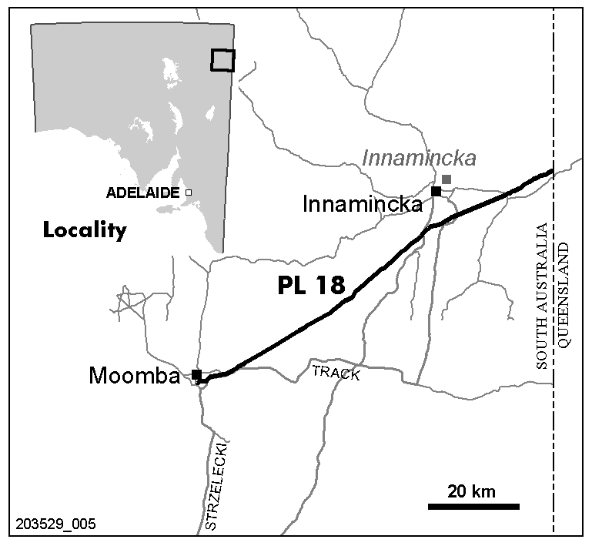
Dated 7 April 2008.
C. D. Cockshell, Acting Director Petroleum and Geothermal
Minerals and Energy Resources
Primary Industries and Resources SA
Delegate of the Minister for Mineral Resources Development

PETROLEUM ACT 2000
Notice of Invitation of Applications for an Exploration Licence
I, BARRY ALAN GOLDSTEIN, Director Petroleum and Geothermal, Minerals and Energy Resources, Department of Primary Industries and Resources in the State of South Australia, pursuant to the provisions of the Petroleum Act 2000, and pursuant to delegated powers dated 28 March 2002, gazetted 11 April 2002, page 1573 and in accordance with section 22 (1) of the Petroleum Act 2000, on behalf of the Minister for Mineral Resources Development (Minister) hereby invite applications for the grant of an Exploration Licence in respect of the areas described below and shown on the attached plan.
OT 2008-A
Description of Area
Commencing at a point being the intersection of latitude 36°54′00″S GDA94 and longitude 139°50′00″E GDA94, thence east to longitude 140°00′00″E GDA94, south to latitude 36°55′00″S GDA94, east to longitude 140°25′00″E GDA94, south to latitude 37°05′00″S GDA94, west to longitude 140°20′00″E GDA94, south to latitude 37°10′00″S GDA94, west to longitude 140°05′00″E GDA94, north to latitude 37°05′00″S GDA94, west to the Territorial Sea Baseline at low water mark, Southern Ocean, thence generally north-westerly along the said Baseline to latitude 37°00′00″S GDA94, east to longitude 139°50′00″E GDA94 and north to the point of commencement but excluding Guichen Bay Conservation Park.
Area: 1 269 km² approximately.
OT 2008-B
Description of Area
All that part of the State of South Australia bounded as follows:
Commencing at a point being the intersection of latitude 37°00′00″S GDA94 and longitude 140°25′00″E GDA94, thence east to longitude 140°40′00″E GDA94, south to latitude 37°05′00″S GDA94, east to longitude 140°45′00″E GDA94, south to latitude 37°19′15″S GDA94, west to longitude 140°42′40″E GDA94, south to latitude 37°20′05″S GDA94, east to longitude 140°42′57″E GDA94, south to latitude 37°21′50″S GDA94, west to longitude 140°42′40″E GDA94, south to latitude 37°25′50″S GDA94, west to longitude 140°42′25″E GDA94, north to latitude 37°25′45″S GDA94, west to longitude 140°42′05″E GDA94, south to latitude 37°25′50″S GDA94, west to longitude 140°41′40″E GDA94, north to latitude 37°25′45″S GDA94, west to longitude 140°41′25″E GDA94, south to latitude 37°26′00″S GDA94, west to longitude 140°41′15″E GDA94, south to latitude 37°26′15″S GDA94, east to longitude 140°42′00″E GDA94, north to latitude 37°26′10″S GDA94, east to longitude 140°42′40″E GDA94, south to latitude 37°32′30″S GDA94, west to longitude 140°40′00″E GDA94, north to latitude 37°30′30″S GDA94, west to longitude 140°37′30″E GDA94, north to latitude 37°30′00″S GDA94, west to longitude 140°22′30″E GDA94, south to longiude 140°22′30″E GDA94, north to latitude 37°24′50″S GDA94, east to longitude 140°27′30″E GDA94, north to latitude 37°17′30″S GDA94, west to longitude 140°15′00″E GDA94, north to latitude 37°10′00″S GDA94, east to longitude 140°20′00″E GDA94, north to latitude 37°05′00″S GDA94, east to longitude 140°25′00″E GDA94 and north to the point of commencement but excluding Hacks Lagoon Conservation Park, Bool Lagoon Game Reserve, Big Heath Conservation Park, Mary Seymour Conservation Park, Calectasia Conservation Park and Penola Conservation Park and also excluding the area bounded as follows:
Commencing at a point being the intersection of latitude 37°12′00″S AGD66 and longitude 140°37′15″E GDA94, thence east to longitude 140°39′35″E GDA94, south to latitude 37°12′05″S GDA94, east to longitude 140°40′00″E GDA94, south to latitude 37°12′15″S GDA94, east to longitude 140°40′25″E GDA94, south to latitude 37°12′25″S GDA94, east to longitude 140°40′40″E GDA94, south to latitude 37°12′35″S GDA94, east to longitude 140°41′00″E GDA94, south to latitude 37°12′45″S GDA94, east to longitude 140°41′15″E GDA94, south to latitude 37°12′55″S GDA94, east to longitude 140°41′25″E GDA94, south to latitude 37°13′05″S GDA94, east to longitude 140°41′35″E GDA94, south to latitude 37°13′15″S GDA94, east to longitude 140°41′45″E GDA94, south to latitude 37°13′30″S GDA94, east to longitude 140°42′00″E GDA94, south to latitude 37°13′40″S GDA94, east to longitude 140°42′10″E GDA94, south to latitude 37°13′50″S GDA94, east to longitude 140°42′25″E GDA94, south to latitude 37°14′05″S GDA94, east to longitude 140°42′35″E GDA94, south to latitude 37°14′20″S GDA94, east to longitude 140°42′40″E GDA94, south to latitude 37°14′45″S GDA94, west to longitude 140°42′05″E GDA94, north to latitude 37°14′40″S GDA94, west to longitude 140°41′30″E GDA94, north to latitude 37°14′35″S GDA94, west to longitude 140°41′20″E GDA94, north to latitude 37°14′30″S GDA94, west to longitude 140°41′05″E GDA94, north to latitude 37°14′20″S GDA94, west to longitude 140°40′50″E GDA94, north to latitude 37°14′15″S GDA94, west to longitude 140°40′30″E GDA94, north to latitude 37°14′10″S GDA94, west to longitude 140°40′05″E GDA94, north to latitude 37°13′30″S GDA94, west to longitude 140°39′45″E GDA94, north to latitude 37°13′25″S GDA94, west to longitude 140°39′25″E GDA94, north to latitude 37°13′15″S GDA94, west to longitude 140°39′10″E GDA94, north to latitude 37°13′05″S GDA94, west to longitude 140°38′50″E GDA94, north to latitude 37°12′55″S GDA94, west to longitude 140°38′35″E GDA94, north to latitude 37°12′45″S GDA94, west to longitude 140°38′20″E GDA94, north to latitude 37°12′40″S GDA94, west to longitude 140°38′05″E GDA94, north to latitude 37°12′35″S GDA94, west to longitude 140°37′55″E GDA94, north to latitude 37°12′30″S GDA94, west to longitude 140°37′40″E GDA94, north to latitude 37°12′20″S GDA94, west to longitude 140°37′30″E GDA94, north to latitude 37°12′10″S GDA94, west to longitude 140°37′15″E GDA94 and north to the point of commencement.
Area: 1 765 km² approximately.
OT 2008-C
Description of Area
All that part of the State of South Australia bounded as follows:
Commencing at a point being the intersection of latitude 37°05′00″S GDA94 and longitude 140°45′00″E GDA94, thence east to longitude 140°50′00″E GDA94, south to latitude 37°10′00″S GDA94, east to the eastern border of the State of South Australia, thence southerly along the border of the said State to latitude 37°28′50″S GDA94, west to longitude 140°51′00″E GDA94, south to latitude 37°29′10″S GDA94, west to longitude 140°50′00″E GDA94, south to latitude 37°33′00″S GDA94, west to longitude 140°44′30″E GDA94, north to latitude 37°32′20″S GDA94, west to longitude 140°43′10″E GDA94, north to latitude 37°32′00″S GDA94, west to longitude 140°42′40″E GDA94, north to latitude 37°26′10″S GDA94, east to longitude 140°42′45″E GDA94, north to latitude 37°26′05″S GDA94, east to longitude 140°43′00″E GDA94, north to latitude 37°25′55″S GDA94, west to longitude 140°42′40″E GDA94, north to latitude 37°21′50″S GDA94, east to longitude 140°43′55″E GDA94, south to latitude 37°22′30″S GDA94, east to longitude 140°45′05″E GDA94, south to latitude 37°23′25″S GDA94, east to longitude 140°46′00″E GDA94, south to latitude 37°23′35″S GDA94, east to longitude 140°46′50″E GDA94, north to latitude 37°23′25″S GDA94, east to longitude 140°47′40″E GDA94, north to latitude 37°22′35″S GDA94, west to longitude 140°47′30″E GDA94, north to latitude 37°20′55″S GDA94, west to longitude 140°46′15″E GDA94, north to latitude 37°20′05″S GDA94, west to longitude 140°44′45″E GDA94, north to latitude 37°19′15″S GDA94, east to longitude 140°45′00″E GDA94 and north to the point of commencement but excluding the Naracoorte Caves National Park and Glen Roy Conservation Park and also excluding the following areas:
Commencing at a point being the intersection of latitude 37°24′09″S GDA94 and longitude 140°51′55″E GDA94, thence east to longitude 140°52′20″E GDA94, south to latitude 37°24′14″S GDA94, east to longitude 140°53′05″E GDA94, south to latitude 37°24′19″S GDA94, east to longitude 140°53′10″E GDA94, south to latitude 37°24′24″S GDA94, east to longitude 140°53′25″E GDA94, south to latitude 37°24′29″S GDA94, east to longitude 140°53′35″E GDA94, south to latitude 37°24′34″S GDA94, east to longitude 140°53′40″E GDA94, south to latitude 37°24′49″S GDA94, west to longitude 140°53′35″E GDA94, south to latitude 37°25′09″S GDA94, west to longitude 140°52′45″E GDA94, north to latitude 37°25′04″S GDA94, west to longitude 140°52′40″E GDA94, north to latitude 37°24′59″S GDA94, west to longitude 140°52′15″E GDA94, north to latitude 37°24′54″S GDA94, west to longitude 140°52′00″E GDA94, north to latitude 37°24′49″S GDA94, west to longitude 140°51′55″E GDA94, north to latitude 37°24′44″S GDA94, west to longitude 140°51′50″E GDA94, north to latitude 37°24′14″S GDA94, east to longitude 140°51′55″E GDA94 and north to the point of commencement.
And:
Commencing at a point being the intersection of latitude 37°25′15″S AGD66 and longitude 140°45′10″E AGD66, thence east to longitude 140°45′50″E AGD66, south to latitude 37°25′20″S AGD66, east to longitude 140°46′20″E AGD66, south to latitude 37°25′25″S AGD66, east to longitude 140°46′25″E AGD66, south to latitude 37°25′30″S AGD66, east to longitude 140°47′45″E AGD66, south to latitude 37°25′40″S AGD66, east to longitude 140°48′05″E AGD66, south to latitude 37°26′25″S AGD66, east to longitude 140°48′15″E AGD66, north to latitude 37°26′20″S AGD66, east to longitude 140°48′35″E AGD66, south to latitude 37°26′25″S AGD66, east to longitude 140°49′00″E AGD66, north to latitude 37°25′55″S AGD66, east to longitude 140°49′05″E AGD66, north to latitude 37°25′50″S AGD66, east to longitude 140°49′10″E AGD66, north to latitude 37°25′45″S AGD66, east to longitude 140°49′25″E AGD66, south to latitude 37°25′50″S AGD66, east to longitude 140°49′30″E AGD66, north to latitude 37°25′45″S GDA94, east to longitude 140°49′45″E GDA94, south to latitude 37°25′55″S AGD66, east to longitude 140°49′45″E AGD66, south to latitude 37°26′00″S AGD66, east to longitude 140°49′50″E AGD66, south to latitude 37°26′05″S AGD66, east to longitude 140°49′55″E AGD66, south to latitude 37°26′10″S AGD66, east to longitude 140°50′05″E AGD66, south to latitude 37°26′15″S AGD66, east to longitude 140°50′10″E AGD66, south to latitude 37°26′20″S AGD66, east to longitude 140°50′25″E AGD66, south to latitude 37°26′25″S AGD66, east to longitude 140°50′35″E AGD66, south to latitude 37°26′30″S AGD66, east to longitude 140°50′45″E AGD66, south to latitude 37°26′35″S AGD66, east to longitude 140°50′55″E AGD66, south to latitude 37°26′40″S AGD66, east to longitude 140°51′05″E AGD66, north to latitude 37°26′35″S GDA94, east to longitude 140°51′35″E GDA94, south to latitude 37°26′40″S GDA94, east to longitude 140°51′45″E GDA94, south to latitude 37°26′45″S GDA94, east to longitude 140°52′00″E GDA94, south to latitude 37°26′50″S GDA94, east to longitude 140°52′05″E GDA94, south to latitude 37°27′00″S GDA94, west to longitude 140°51′50″E AGD66, south to latitude 37°27′10″S AGD66, east to longitude 140°51′55″E AGD66, south to latitude 37°27′15″S GDA94, east to longitude 140°52′25″E GDA94, south to latitude 37°27′20″S GDA94, east to longitude 140°52′35″E GDA94, south to latitude 37°27′25″S GDA94, east to longitude 140°52′40″E GDA94, south to latitude 37°27′30″S GDA94, east to longitude 140°52′50″E GDA94, south to latitude 37°27′35″S GDA94, east to longitude 140°53′00″E GDA94, south to latitude 37°27′50″S GDA94, west to longitude 140°52′20″E GDA94, north to latitude 37°27′45″S GDA94, west to longitude 140°52′00″E GDA94, north to latitude 37°27′40″S GDA94, west to longitude 140°51′55″E GDA94, north to latitude 37°27′35″S GDA94, west to longitude 140°51′35″E GDA94, north to latitude 37°27′35″S AGD66, west to longitude 140°50′35″E AGD66, north to latitude 37°27′25″S AGD66, west to longitude 140°50′20″E AGD66, north to latitude 37°27′20″S AGD66, west to longitude 140°50′00″E AGD66, north to latitude 37°27′15″S AGD66, west to longitude 140°49′40″E AGD66, south to latitude 37°27′20″S AGD66, west to longitude 140°49′35″E AGD66, south to latitude 37°27′30″S AGD66, west to longitude 140°49′20″E AGD66, north to latitude 37°27′25″S AGD66, west to longitude 140°48′45″E AGD66, north to latitude 37°27′20″S AGD66, west to longitude 140°48′05″E AGD66, south to latitude 37°27′25″S AGD66, west to longitude 140°47′55″E AGD66, south to latitude 37°27′30″S AGD66, west to longitude 140°47′50″E AGD66, south to latitude 37°27′35″S AGD66, west to longitude 140°47′15″E AGD66, south to latitude 37°27′40″S AGD66, east to longitude 140°47′25″E AGD66, south to latitude 37°27′45″S AGD66, east to longitude 140°49′05″E AGD66, south to latitude 37°27′50″S AGD66, east to longitude 140°49′25″E AGD66, south to latitude 37°27′55″S AGD66, east to longitude 140°49′45″E AGD66, south to latitude 37°28′00″S AGD66, east to longitude 140°50′00″E AGD66, south to latitude 37°28′05″S AGD66, east to longitude 140°50′10″E AGD66, south to latitude 37°28′10″S AGD66, east to longitude 140°50′20″E AGD66, south to latitude 37°28′15″S AGD66, east to longitude 140°50′40″E AGD66, south to latitude 37°28′40″S AGD66, west to longitude 140°50′20″E AGD66, north to latitude 37°28′30″S AGD66, west to longitude 140°50′05″E AGD66, north to latitude 37°28′25″S AGD66, west to longitude 140°49′50″E AGD66, north to latitude 37°28′20″S AGD66, west to longitude 140°49′35″E AGD66, north to latitude 37°28′15″S AGD66, west to longitude 140°49′25″E AGD66, north to latitude 37°28′10″S AGD66, west to longitude 140°49′15″E AGD66, north to latitude 37°28′05″S AGD66, west to longitude 140°48′55″E AGD66, south to latitude 37°28′15″S AGD66, west to longitude 140°48′55″E GDA94, south to latitude 37°28′15″S GDA94, west to longitude 140°48′35″E GDA94, south to latitude 37°28′20″S GDA94, west to longitude 140°48′20″E GDA94, north to latitude 37°28′15″S AGD66, west to longitude 140°48′05″E AGD66, south to latitude 37°28′20″S AGD66, west to longitude 140°47′50″E AGD66, south to latitude 37°28′25″S AGD66, west to longitude 140°47′15″E AGD66, north to latitude 37°28′20″S AGD66, west to longitude 140°47′10″E AGD66, north to latitude 37°28′15″S AGD66, west to longitude 140°46′40″E AGD66, north to latitude 37°28′10″S AGD66, west to longitude 140°46′30″E GDA94, south to latitude 37°28′10″S GDA94, west to longitude 140°46′10″E GDA94, north to latitude 37°28′05″S AGD66, west to longitude 140°46′00″E AGD66, south to latitude 37°28′10″S AGD66, west to longitude 140°45′55″E AGD66, south to latitude 37°28′14″S AGD66, west to longitude 140°45′45″E AGD66, north to latitude 37°28′10″S AGD66, west to longitude 140°45′35″E AGD66, north to latitude 37°27′50″S AGD66, west to longitude 140°45′10″E AGD66, south to latitude 37°27′55″S AGD66, west to longitude 140°45′05″E AGD66, south to latitude 37°28′00″S AGD66, west to longitude 140°44′50″E AGD66, north to latitude 37°27′35″S AGD66, west to longitude 140°44′45″E AGD66, north to latitude 37°27′20″S AGD66, east to longitude 140°44′50″E AGD66, north to latitude 37°27′05″S AGD66, west to longitude 140°44′40″E AGD66, north to latitude 37°27′00″S AGD66, west to longitude 140°44′30″E AGD66, north to latitude 37°26′50″S AGD66, west to longitude 140°44′25″E AGD66, north to latitude 37°26′35″S AGD66, east to longitude 140°45′30″E AGD66, north to latitude 37°26′30″S AGD66, west to longitude 140°45′25″E AGD66, north to latitude 37°26′20″S AGD66, east to longitude 140°45′55″E AGD66, north to latitude 37°26′15″S AGD66, west to longitude 140°45′50″E AGD66, north to latitude 37°26′10″S AGD66, west to longitude 140°45′40″E AGD66, north to latitude 37°26′05″S AGD66, west to longitude 140°45′20″E AGD66, north to latitude 37°26′00″S AGD66, west to longitude 140°44′45″E AGD66, north to latitude 37°25′55″S AGD66, west to longitude 140°44′25″E AGD66, north to latitude 37°25′20″S AGD66, east to longitude 140°45′10″E AGD66 and north to the point of commencement.
Area: 793 km² approximately.
Special Conditions
Licence Term
The PELs will be offered for a five-year term with a right of renewal for a further five-year term at the end of the initial five-year term, with a compulsory relinquishment of 50% of initial area at renewal.
Security
A minimum $50 000 security (amount subject to review) will be required to be lodged by the licensee prior to entering the guaranteed licence term in which seismic or well activities are planned.
Applications
Applications lodged under section 65 (1) of the Petroleum Act 2000, are required to be made in the approved form as identified on the DVD ‘Otway Basin Acreage Release OT 2008-A, B and C’ (can be ordered from www.petroleum.pir.sa.gov.au or the Director Petroleum and Geothermal at the address below).
Applications:
• must satisfy the requirements of Regulation 4 of the Regulations under the Petroleum Act 2000;
• must be accompanied by a proposed work program for the first five-year term of the licence;
• must be accompanied by a statement of the financial and technical resources available to the applicant; and
• must be accompanied by the scheduled application fee.
Applications close at 4 p.m. on Thursday, 27 November 2008 (Australian Central Daylight Time).
The following special instructions for lodgement of applications should be observed:
• the application and supporting data, together with the scheduled application fee (currently $3 215, but expected to increase on 1 July 2008), payable to the Department of Primary Industries and Resources SA, should be sealed in a plain envelope or package and clearly marked as ‘Application for Area OT 2008-A, B or C—Commercial-in-Confidence’;
• the envelope or package should then be enclosed in another envelope and posted, or delivered by hand to:
Director Petroleum and Geothermal
Minerals and Energy Resources
Department of Primary Industries and Resources SA
Level 7, 101 Grenfell Street
Adelaide, S.A. 5000
Copies of the basic exploration data pertaining to the area comprising this notice are available from the Petroleum and Geothermal Group of the Department of Primary Industries and Resources SA. Enquiries may be directed to Barry Goldstein, Director Petroleum and Geothermal (Telephone (08) 8463 3200; email: Goldstein.Barry@saugov.sa.gov.au).
Criteria for Assessment of Applications
The winning bidder will be selected on the basis of the five-year work program bid. The work program must include a statement of exploratory operations the applicant proposes to carry out in each year of the first five-year licence term. The aim of the work program is to evaluate the prospectivity of the licence area and discover regulated resources. It is expected that at least one petroleum exploration well would be included in the five-year work program.
Bids will be assessed taking account of the criteria listed below. It is important to note that the timing of well drilling and seismic acquisition will be taken into account. The most important criteria for assessment of OT 2008-A, OT 2008-B or OT 2008-C work programs are:
• the number of exploration wells to be drilled in the licence area (development wells are not considered);
• the number of years the applicant is prepared to guarantee the program;
• the extent to which proposed wells are supported by seismic data;
• the amount and nature of seismic surveying to be carried out and its timing;
• other data acquisition (e.g. gravity, aeromagnetic or geochemical surveys);
• seismic reprocessing to be carried out;
• adequacy of financial resources and technical expertise available to the applicant; and
• the applicant’s past performance in fulfilling work program commitments elsewhere in Australia.
The Minister will announce the winning bidder, together with details of the work program.
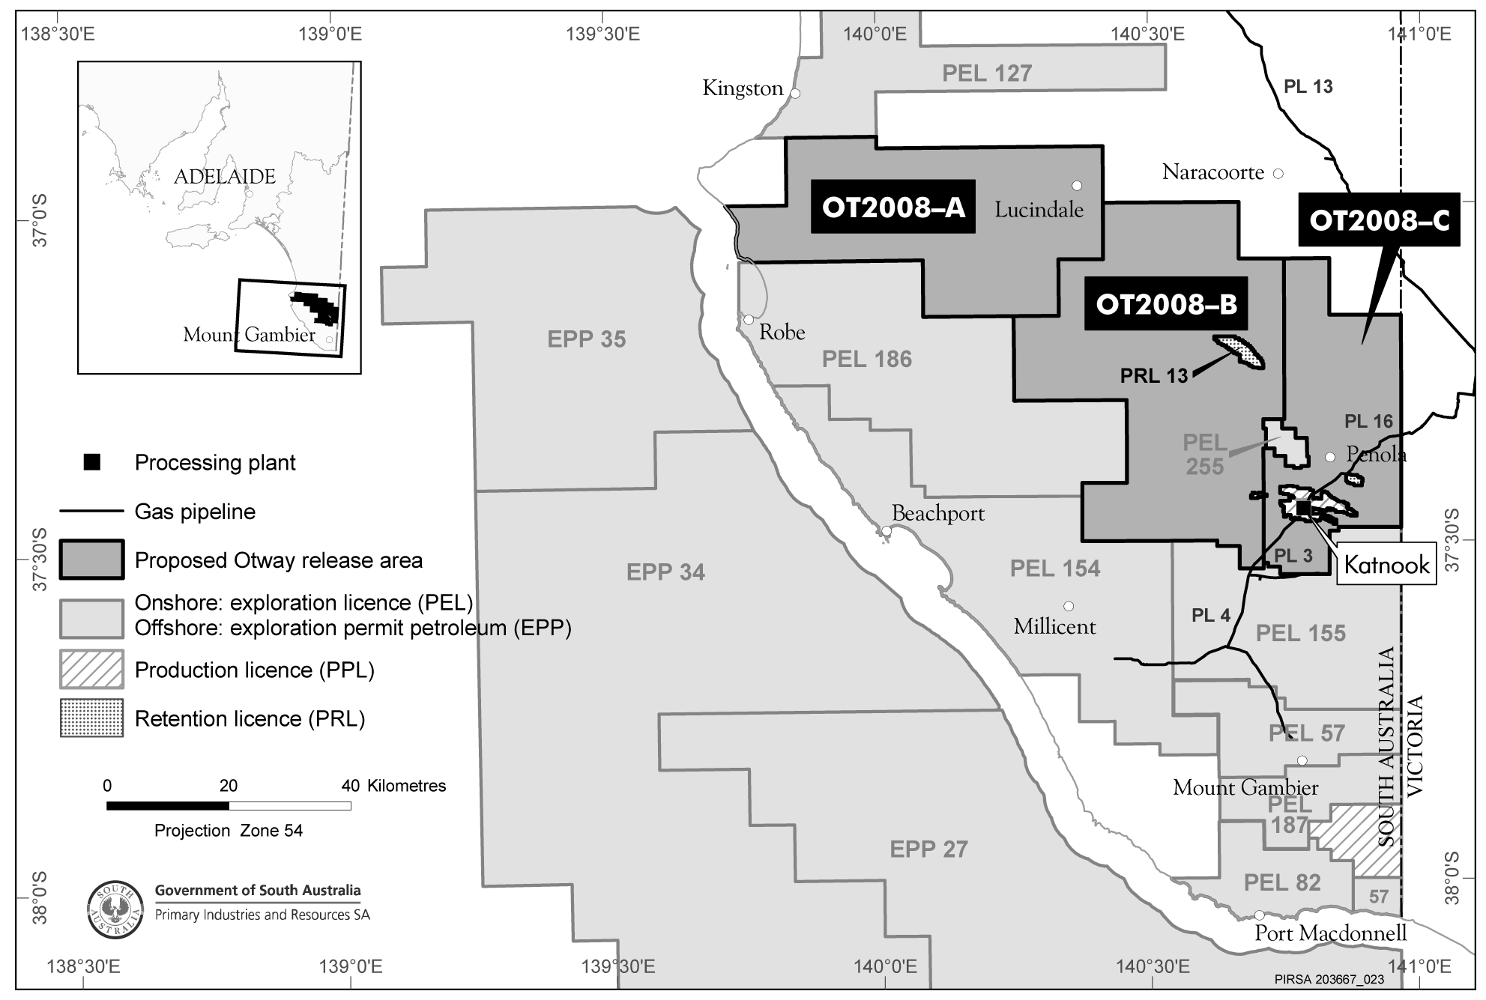
Dated 2 April 2008.
B. A. Goldstein, Director Petroleum and Geothermal
Minerals and Energy Resources
Primary Industries and Resources SA
Delegate of the Minister for Mineral Resources Development

PETROLEUM ACT 2000
Application for Grant of Associated Facilities Licence—AFL 140
PURSUANT to section 65 (6) of the Petroleum Act 2000 (the Act) and Delegation dated 28 March 2002, Gazetted 11 April 2002, page 1573, notice is hereby given that an application for the grant of an Associated Facilities Licence over the areas described below has been received from Santos Limited, Vamgas Pty Ltd, Delhi Petroleum Pty Ltd, Origin Energy Resources Ltd and Santos (NARNL Cooper) Pty Ltd.
Description of Application Area
All that part of the State of South Australia, bounded as follows:
The land bounded by a line joining points of co-ordinates set out in the following table (All co-ordinates are GDA94 except where stated): Commencing at position latitude 26°48′40.0″S (AGD66), longitude 140°51′08.5″E, then to position latitude 26°47′45.2″S, longitude 140°51′23.0″E, then to position latitude 26°47′22.2″S, longitude 140°51′15.5″E, then to position latitude 26°45′57.0″S, longitude 140°51′25.9″E, then to position latitude 26°44′45.2″S, longitude 140°52′04.4″E, then to position latitude 26°45′00.8″S, longitude 140°52′39.4″E, then to position latitude 26°46′03.7″S, longitude 140°51′44.9″E, then to position latitude 26°47′17.5″S, longitude 140°51′34.5″E, then to position latitude 26°47′48.0″S, longitude 140°51′43.2″E, then to position latitude 26°48′45.4″S, longitude 140°51′23.6″E, then to position latitude 26°48′55.7″S, longitude 140°51′05.0″E (AGD66).
Area: 4.75 km² approximately.
Dated 7 April 2008.
C. D. Cockshell, Acting Director Petroleum and Geothermal
Minerals and Energy Resources
Primary Industries and Resources SA
Delegate of the Minister for Mineral Resources Development

PETROLEUM ACT 2000
Surrender of Petroleum Exploration Licence—PEL 57
NOTICE is hereby given that I have accepted surrender of the abovementioned Petroleum Exploration Licence under the provisions of the Petroleum Act 2000, pursuant to delegated powers dated 28 March 2002, Gazetted 11 April 2002, page 1573.
No of  Licence | Licensees | Locality | Date of  Surrender | Area in  km² | Reference
57 | Lakes Oil NL  Mirboo Ridge Pty Ltd  Victoria Petroleum NL | Otway Basin of South Australia | 8 February 2008 | 408 | 27/2/113
Description of Area
All that part of the State of South Australia, bounded as follows:
Area 1
Commencing at a point being the intersection of longitude 140°51′00″E GDA94 and latitude 37°49′00″E GDA94, thence south to latitude 37°50′00″S GDA94, west to longitude 140°45′00″E GDA94, south to latitude 37°51′00″S GDA94, west to longitude 140°37′30″E AGD66, north to latitude 37°45′30″S AGD66, west to longitude 140°32′30″E AGD66, north to latitude 37°42′30″S AGD66, east to longitude 140°41′00″E GDA94, south to latitude 37°43′00″S GDA94, east to longitude 140°44′00″E GDA94, south to latitude 37°44′00″S GDA94, east to longitude 140°45′00″E GDA94, south to latitude 37°45′00″S GDA94, east to the eastern border of the State of South Australia, thence southerly along the border of the said State to latitude 37°49′00″E GDA94 and west to point of commencement.
Area 2
Commencing at a point being the intersection of latitude 38°00′00″S AGD66 and longitude 140°52′30″E AGD66, thence east to the eastern border of the State of South Australia, thence southerly along the border of the said State to the Territorial Sea Baseline, Southern Ocean, thence generally westerly along the said Baseline to longitude 140°52′30″E AGD66 and north to point of commencement.
Area: 408 km² approximately.
Dated 4 April 2008.
B. A. Goldstein, Director Petroleum and Geothermal
Minerals and Energy Resources
Primary Industries and Resources SA
Delegate of the Minister for Mineral Resources Development

GOVERNMENT GAZETTE ADVERTISEMENT RATES

To apply from 1 July 2007

$  Agents, Ceasing to Act as 39.60  Associations:  Incorporation 20.10  Intention of Incorporation 49.75  Transfer of Properties 49.75  Attorney, Appointment of 39.60  Bailiff’s Sale 49.75  Cemetery Curator Appointed 29.45  Companies:  Alteration to Constitution 39.60  Capital, Increase or Decrease of 49.75  Ceasing to Carry on Business 29.45  Declaration of Dividend 29.45  Incorporation 39.60  Lost Share Certificates:  First Name 29.45  Each Subsequent Name 10.10  Meeting Final 33.10  Meeting Final Regarding Liquidator’s Report on  Conduct of Winding Up (equivalent to ‘Final  Meeting’)  First Name 39.60  Each Subsequent Name 10.10  Notices:  Call 49.75  Change of Name 20.10  Creditors 39.60  Creditors Compromise of Arrangement 39.60  Creditors (extraordinary resolution that ‘the Com-pany be wound up voluntarily and that a liquidator be appointed’) 49.75  Release of Liquidator⎯Application⎯Large Ad. 78.65  ⎯Release Granted 49.75  Receiver and Manager Appointed 45.85  Receiver and Manager Ceasing to Act 39.60  Restored Name 37.25  Petition to Supreme Court for Winding Up 69.30  Summons in Action 58.85  Order of Supreme Court for Winding Up Action 39.60  Register of Interests⎯Section 84 (1) Exempt 89.10  Removal of Office 20.10  Proof of Debts 39.60  Sales of Shares and Forfeiture 39.60  Estates:  Assigned 29.45  Deceased Persons⎯Notice to Creditors, etc. 49.75  Each Subsequent Name 10.10  Deceased Persons⎯Closed Estates 29.45  Each Subsequent Estate 1.30  Probate, Selling of 39.60  Public Trustee, each Estate 10.10 |  | $  Firms:  Ceasing to Carry on Business (each insertion) 26.30  Discontinuance Place of Business 26.30  Land⎯Real Property Act:  Intention to Sell, Notice of 49.75  Lost Certificate of Title Notices 49.75  Cancellation, Notice of (Strata Plan) 49.75  Mortgages:  Caveat Lodgement 20.10  Discharge of 21.05  Foreclosures 20.10  Transfer of 20.10  Sublet 10.10  Leases⎯Application for Transfer (2 insertions) each 10.10  Lost Treasury Receipts (3 insertions) each 29.45  Licensing 58.85  Municipal or District Councils:  Annual Financial Statement⎯Forms 1 and 2 554.35  Electricity Supply⎯Forms 19 and 20 393.90  Default in Payment of Rates:  First Name 78.65  Each Subsequent Name 10.10  Noxious Trade 29.45  Partnership, Dissolution of 29.45  Petitions (small) 20.10  Registered Building Societies (from Registrar-  General) 20.10  Register of Unclaimed Moneys⎯First Name 29.45  Each Subsequent Name 10.10  Registers of Members⎯Three pages and over:  Rate per page (in 8pt) 252.15  Rate per page (in 6pt) 333.45  Sale of Land by Public Auction 50.30  Advertisements 2.80  ¼ page advertisement 117.75  ½ page advertisement 235.50  Full page advertisement 461.60  Advertisements, other than those listed are charged at $2.80 per column line, tabular one-third extra.  Notices by Colleges, Universities, Corporations and District Councils to be charged at $2.80 per line.  Where the notice inserted varies significantly in length from that which is usually published a charge of $2.80 per column line will be applied in lieu of advertisement rates listed.  South Australian Government publications are sold on the condition that they will not be reproduced without prior permission from the Government Printer.
All the above prices include GST

GOVERNMENT GAZETTE NOTICES
ALL private advertisements forwarded for publication in the South Australian Government Gazette must be PAID FOR PRIOR TO INSERTION; and all notices, from whatever source, should be legibly written on one side of the paper only and sent to Government Publishing SA so as to be received no later than 4 p.m. Tuesday preceding the day of publication. Phone 8207 1045 or Fax 8207 1040. E-mail: governmentgazette@dpc.sa.gov.au. Send as attachments in Word format. Please include date the notice is to be published and to whom the notice will be charged. The Government Gazette is available online at: www.governmentgazette.sa.gov.au.

MISCELLANEOUS LEGISLATION AND GOVERNMENT PUBLICATIONS PRICES AS FROM 1 JULY 2007

Acts, Bills, Rules, Parliamentary Papers and Regulations
Pages | Main | Amends | Pages | Main | Amends

1-16 | 2.40 | 1.10 | 497-512 | 33.60 | 32.55
17-32 | 3.25 | 2.05 | 513-528 | 34.65 | 33.35
33-48 | 4.20 | 3.00 | 529-544 | 35.70 | 34.65
49-64 | 5.30 | 4.05 | 545-560 | 36.75 | 35.70
65-80 | 6.25 | 5.15 | 561-576 | 37.50 | 36.75
81-96 | 7.25 | 6.00 | 577-592 | 38.55 | 37.25
97-112 | 8.25 | 7.05 | 593-608 | 39.85 | 38.30
113-128 | 9.25 | 8.10 | 609-624 | 40.65 | 39.60
129-144 | 10.35 | 9.15 | 625-640 | 41.70 | 40.10
145-160 | 11.35 | 10.10 | 641-656 | 42.70 | 41.70
161-176 | 12.40 | 11.15 | 657-672 | 43.25 | 42.20
177-192 | 13.45 | 12.20 | 673-688 | 45.05 | 43.25
193-208 | 14.50 | 13.35 | 689-704 | 45.85 | 44.30
209-224 | 15.30 | 14.15 | 705-720 | 46.65 | 45.35
225-240 | 16.35 | 15.10 | 721-736 | 48.45 | 46.35
241-257 | 17.50 | 15.95 | 737-752 | 48.95 | 47.40
258-272 | 18.45 | 17.00 | 753-768 | 50.00 | 48.20
273-288 | 19.50 | 18.25 | 769-784 | 50.55 | 49.75
289-304 | 20.30 | 19.15 | 785-800 | 51.60 | 50.80
305-320 | 21.55 | 20.20 | 801-816 | 52.60 | 51.30
321-336 | 22.40 | 21.15 | 817-832 | 53.65 | 52.60
337-352 | 23.55 | 22.30 | 833-848 | 54.70 | 53.65
353-368 | 24.50 | 23.35 | 849-864 | 55.75 | 54.20
369-384 | 25.55 | 24.40 | 865-880 | 56.80 | 55.75
385-400 | 26.55 | 25.30 | 881-896 | 57.30 | 56.25
401-416 | 27.60 | 26.05 | 897-912 | 58.85 | 57.30
417-432 | 28.65 | 27.35 | 913-928 | 59.40 | 58.85
433-448 | 29.70 | 28.40 | 929-944 | 60.45 | 59.40
449-464 | 30.50 | 29.20 | 945-960 | 61.50 | 59.90
465-480 | 31.00 | 30.20 | 961-976 | 63.05 | 60.95
481-496 | 32.55 | 31.00 | 977-992 | 64.10 | 61.50

Legislation—Acts, Regulations, etc: $
Subscriptions:
Acts 207.00
All Bills as Laid 497.00
Rules and Regulations 497.00
Parliamentary Papers 497.00
Bound Acts 230.00
Index 115.00
Government Gazette
Copy 5.40
Subscription 274.00
Hansard
Copy 15.10
Subscription—per session (issued weekly) 431.00
Cloth bound—per volume 185.00
Subscription—per session (issued daily) 431.00
Legislation on Disk
Whole Database 3192.00
Annual Subscription for fortnightly updates 981.00
Individual Act(s) including updates POA
Compendium
Subscriptions:
Subscriptions 1891.00
Updates 667.00
(All the above prices include GST)

All Legislation, Government Gazette, Hansard and Legislation on disk are available from:
Counter Sales Service SA, Government Legislation⁺ Outlet
and Mail Orders: Lands Titles Office, 101 Grenfell Street, Adelaide, S.A. 5000
Phone: 13 23 24 (local call cost), Fax: (08) 8204 1909
Postal: G.P.O. Box 1707, Adelaide, S.A. 5001

Online Shop: www.shop.service.sa.gov.au

Subscriptions and Government Publishing SA
Standing Orders: Box 9, Plaza Level, Riverside Centre, North Terrace, Adelaide, S.A. 5000
Phone: (08) 8207 1043, (08) 8207 0910, Fax: (08) 8207 1040

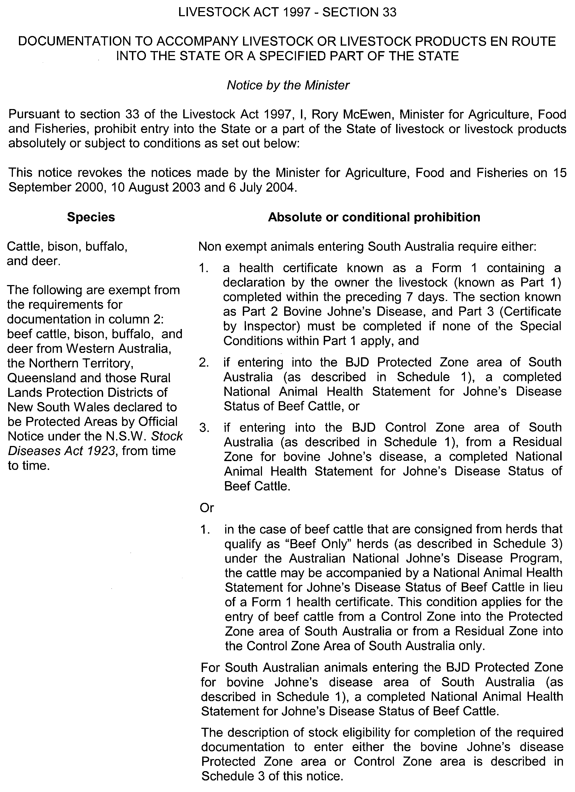
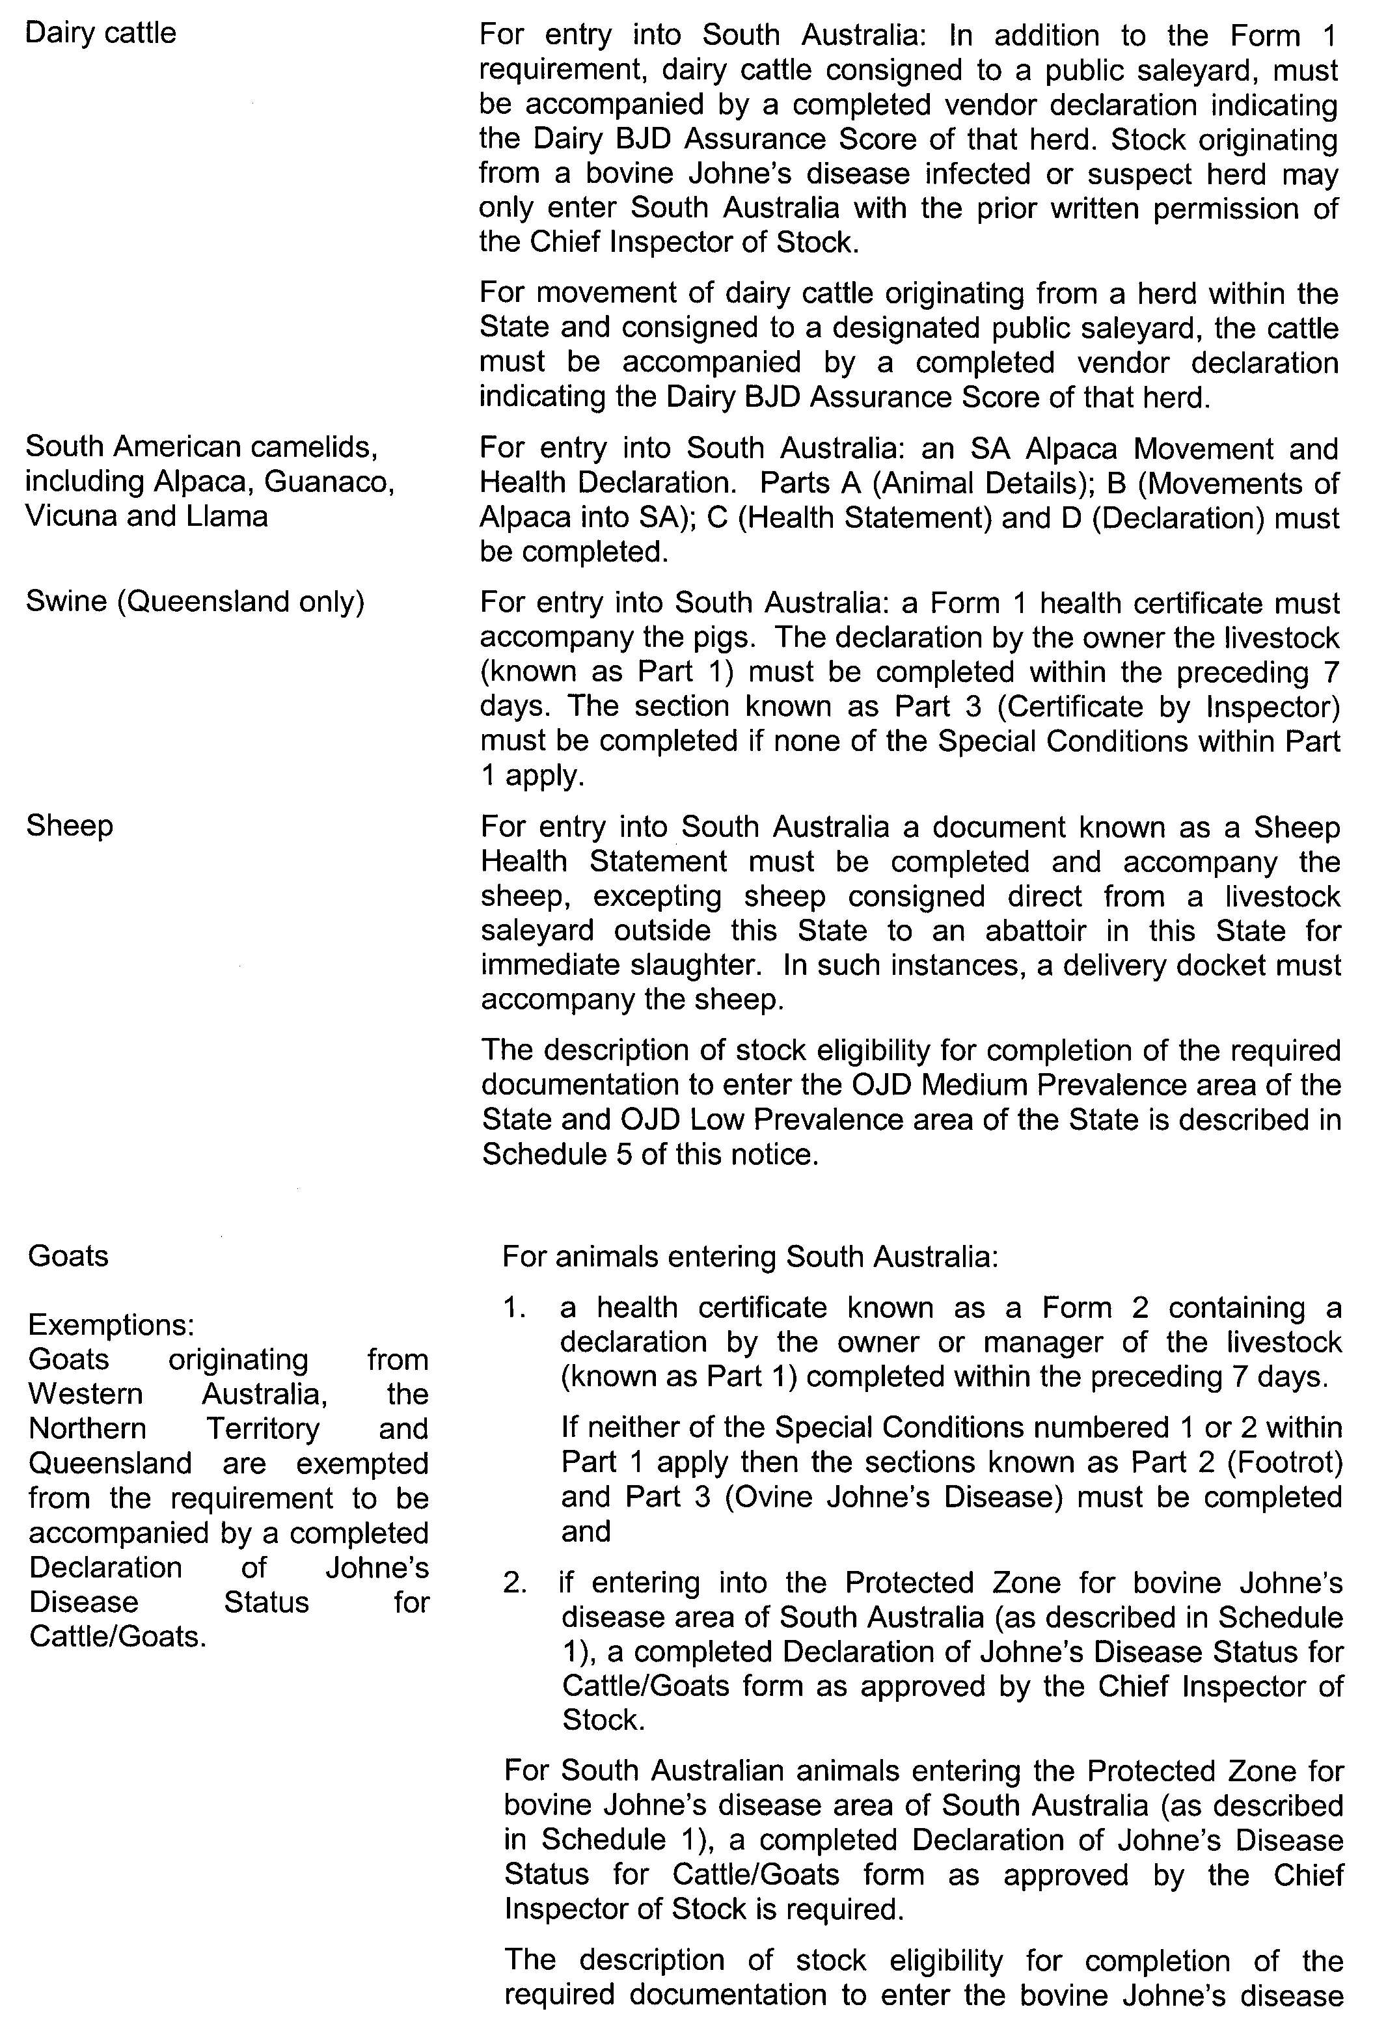
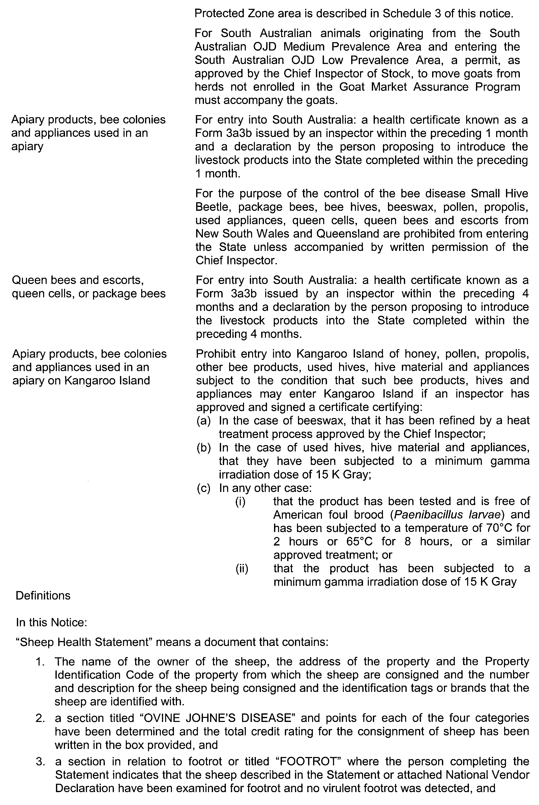
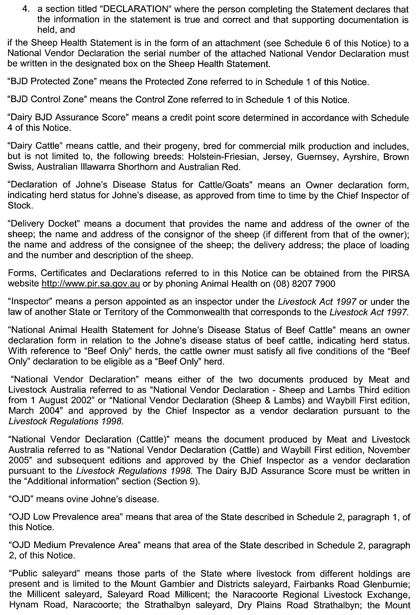
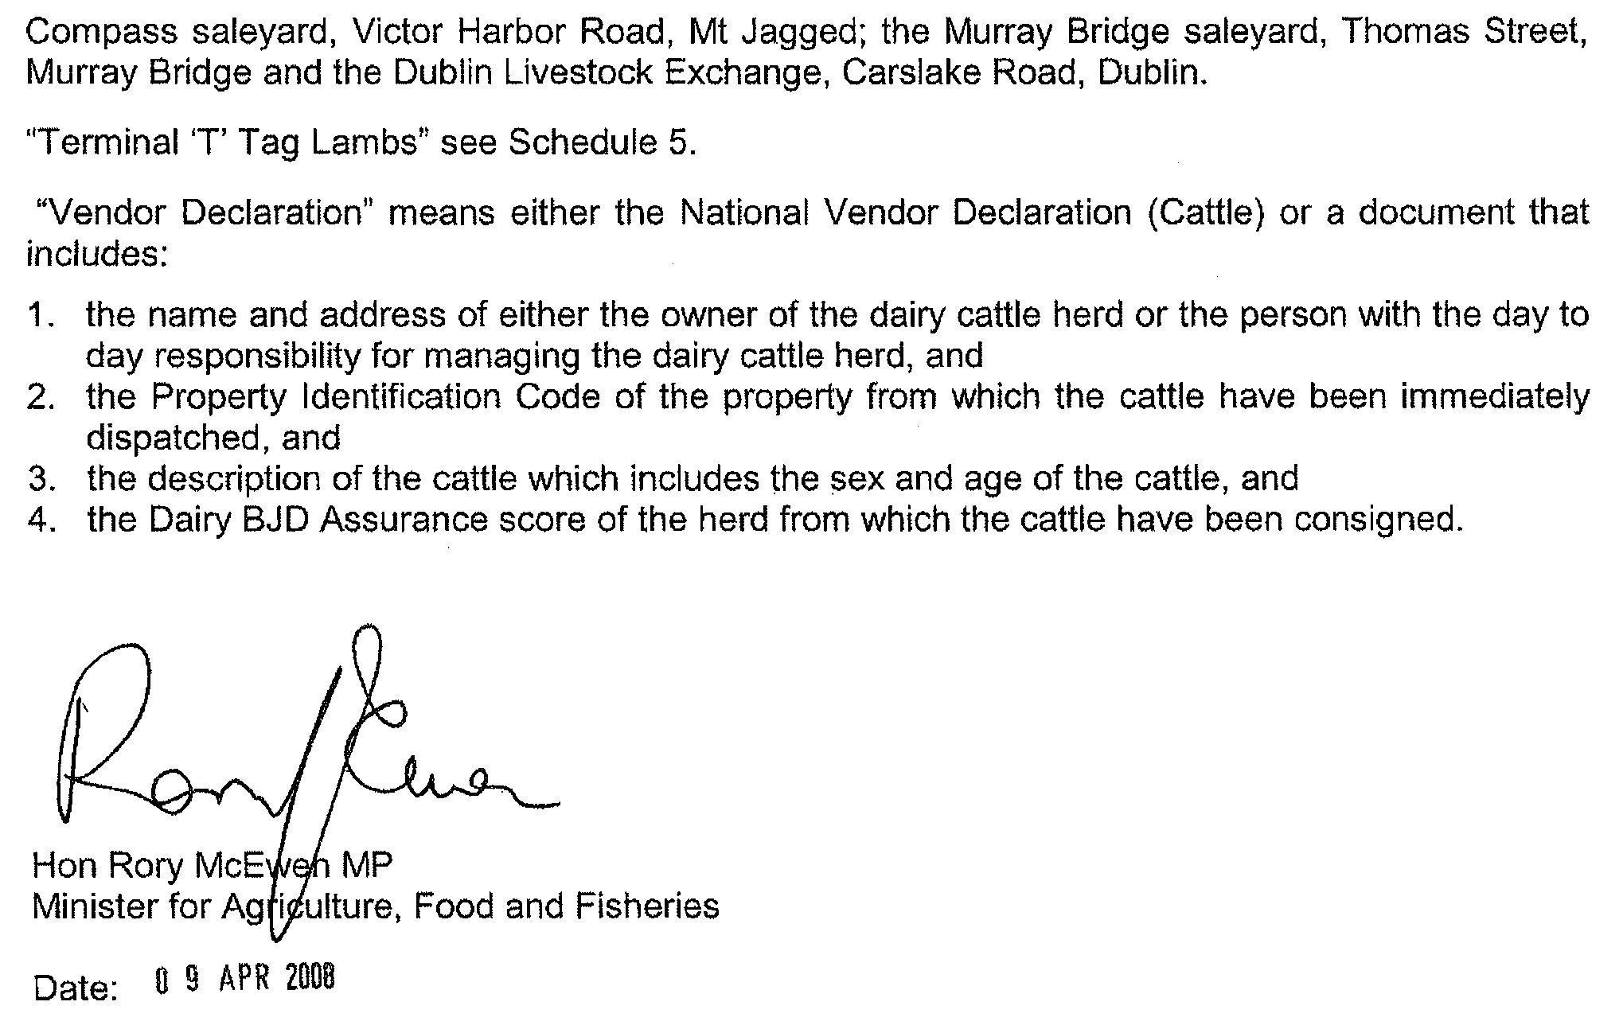
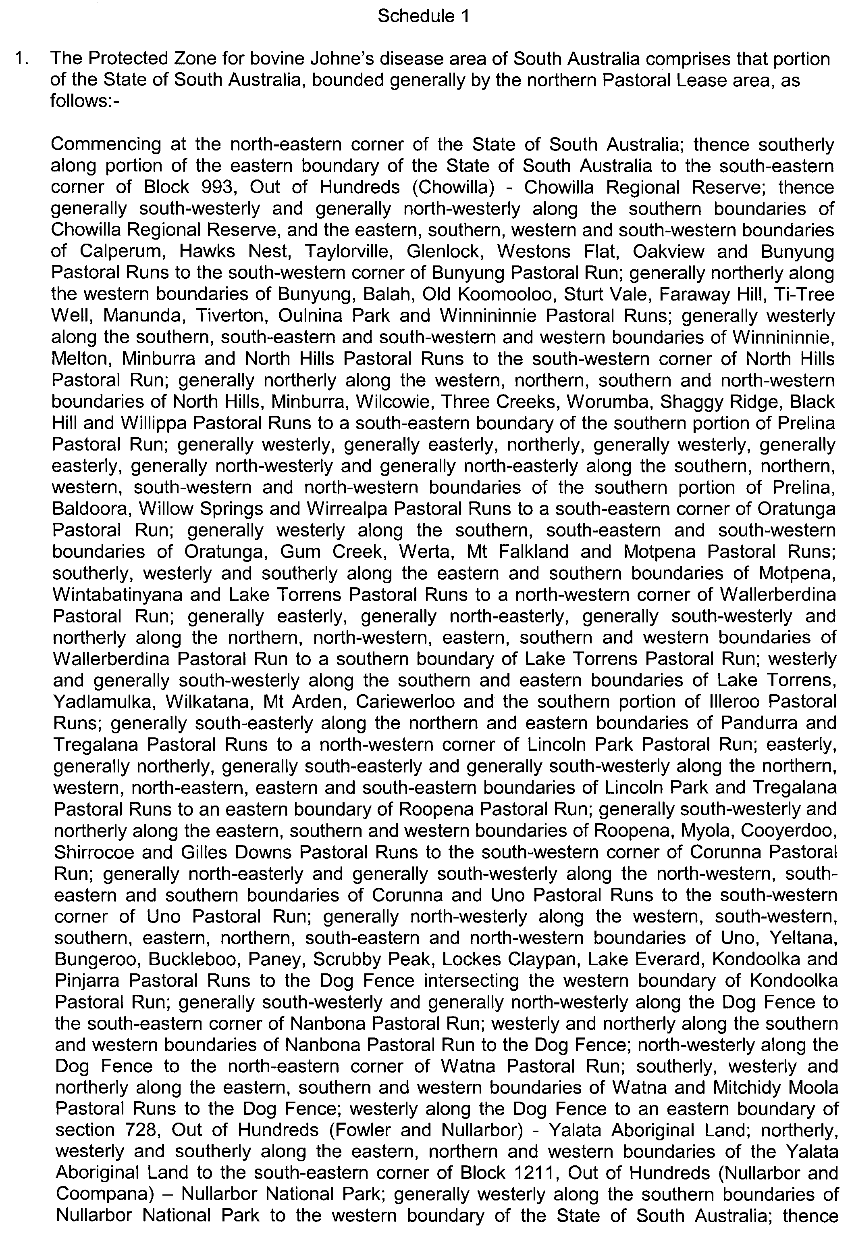
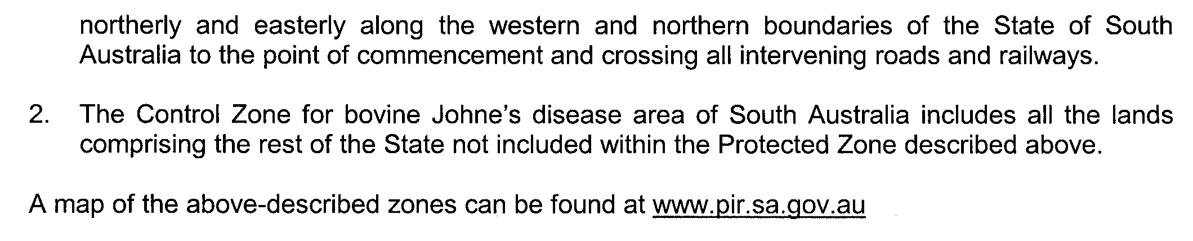
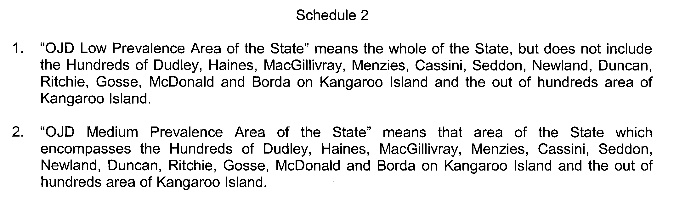
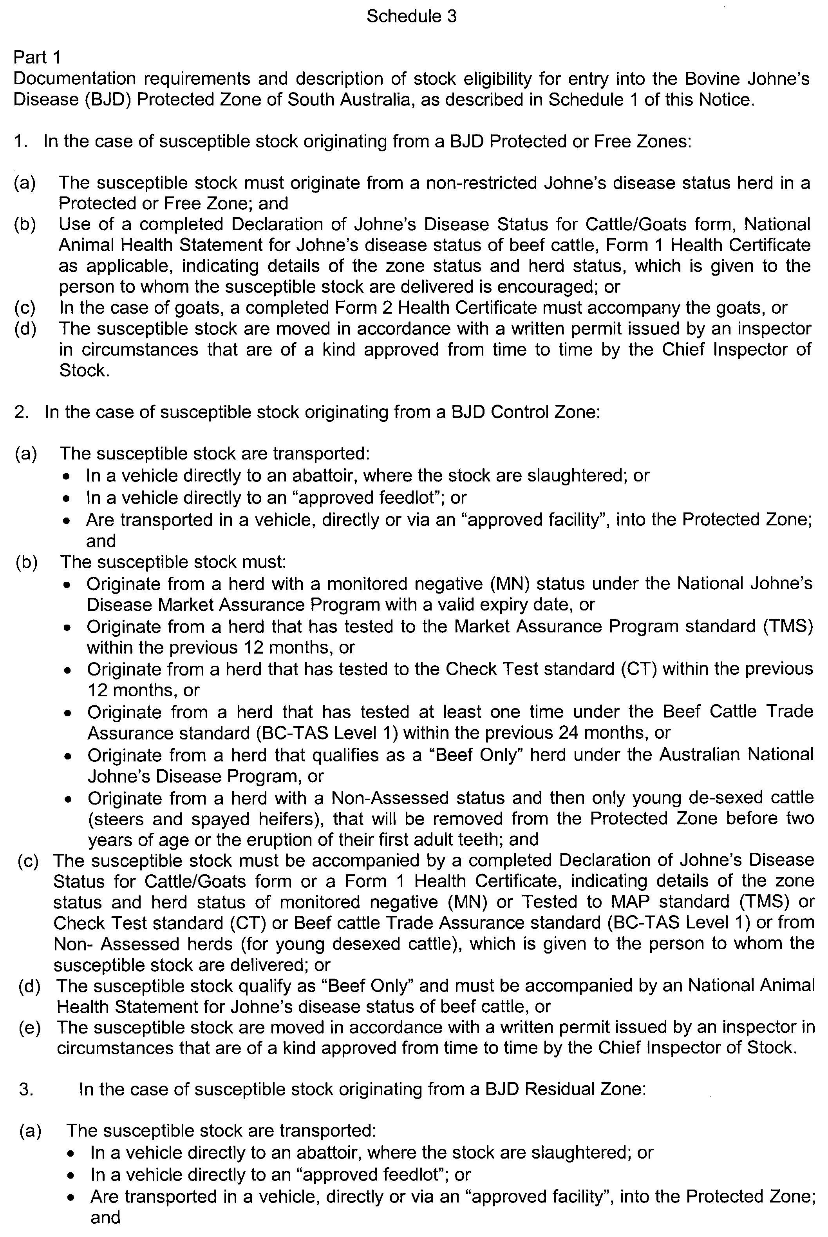
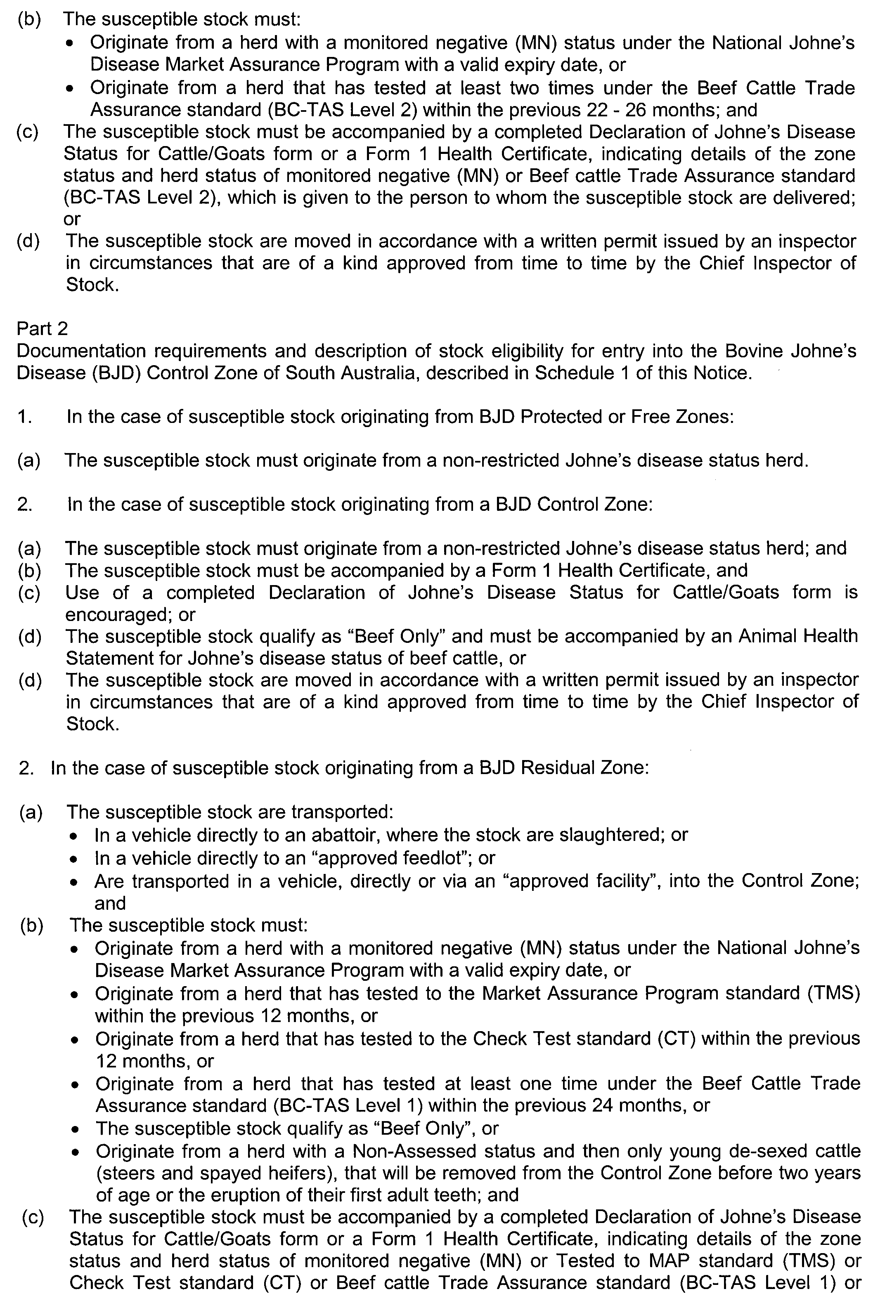
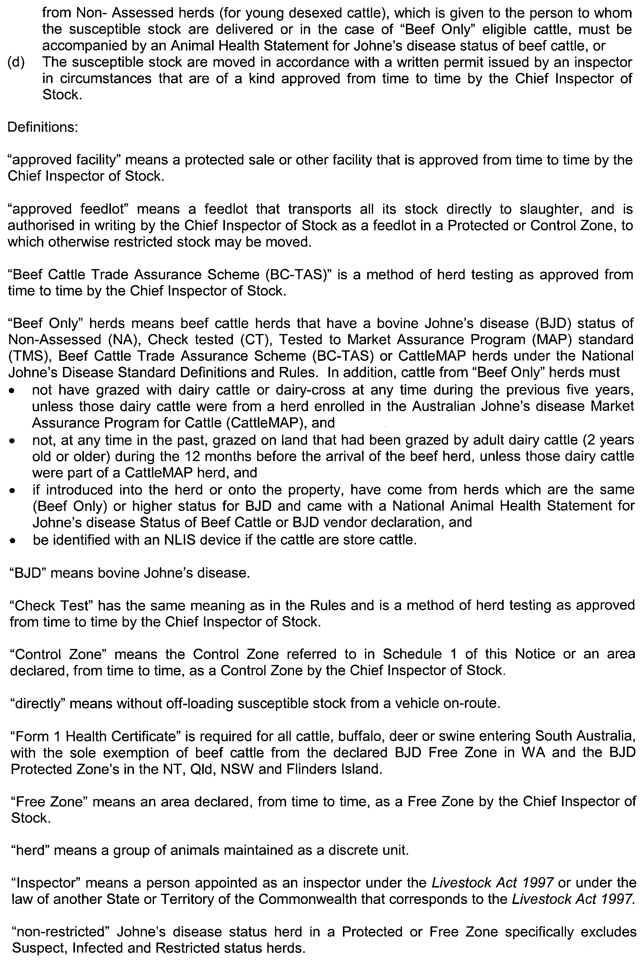
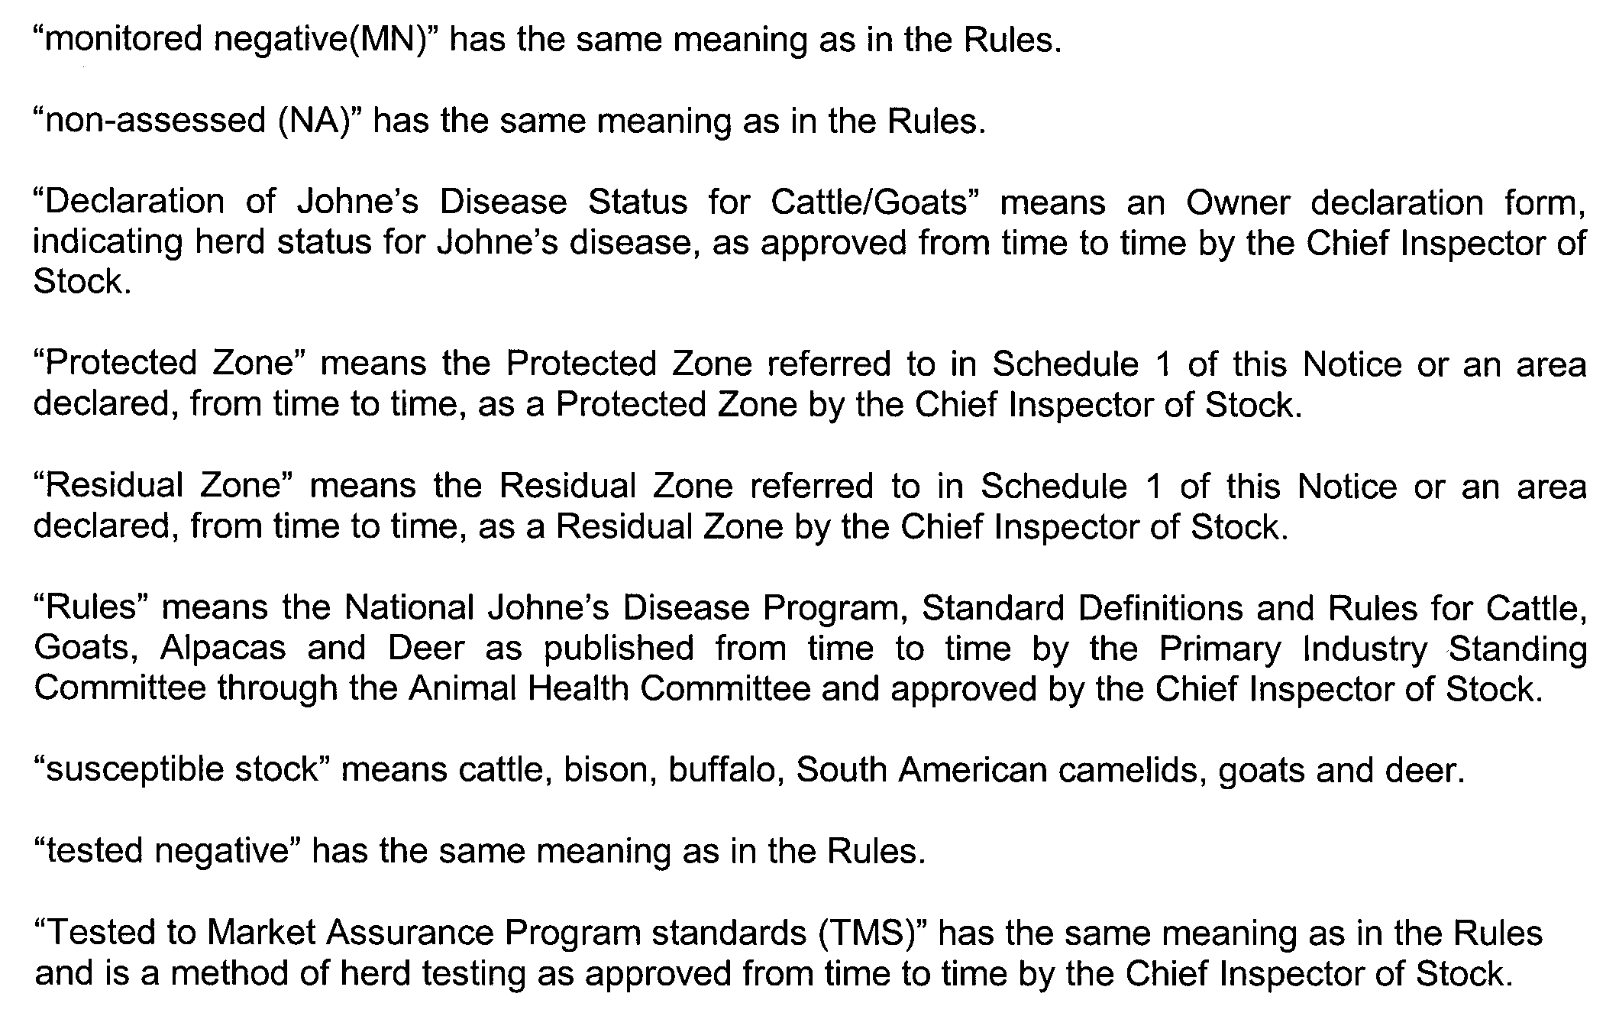
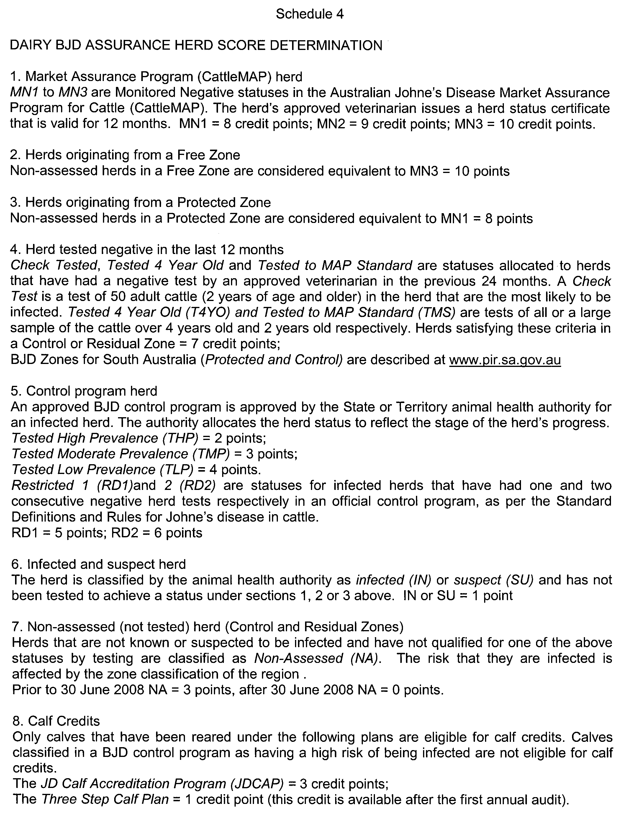
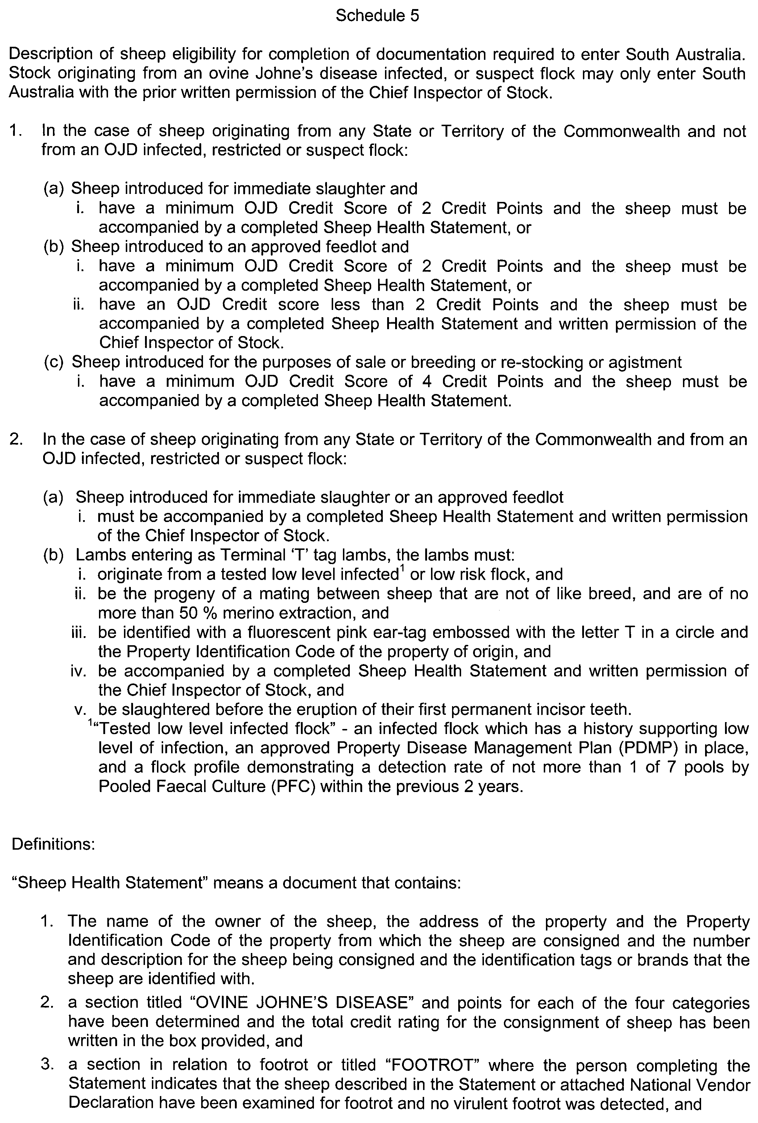
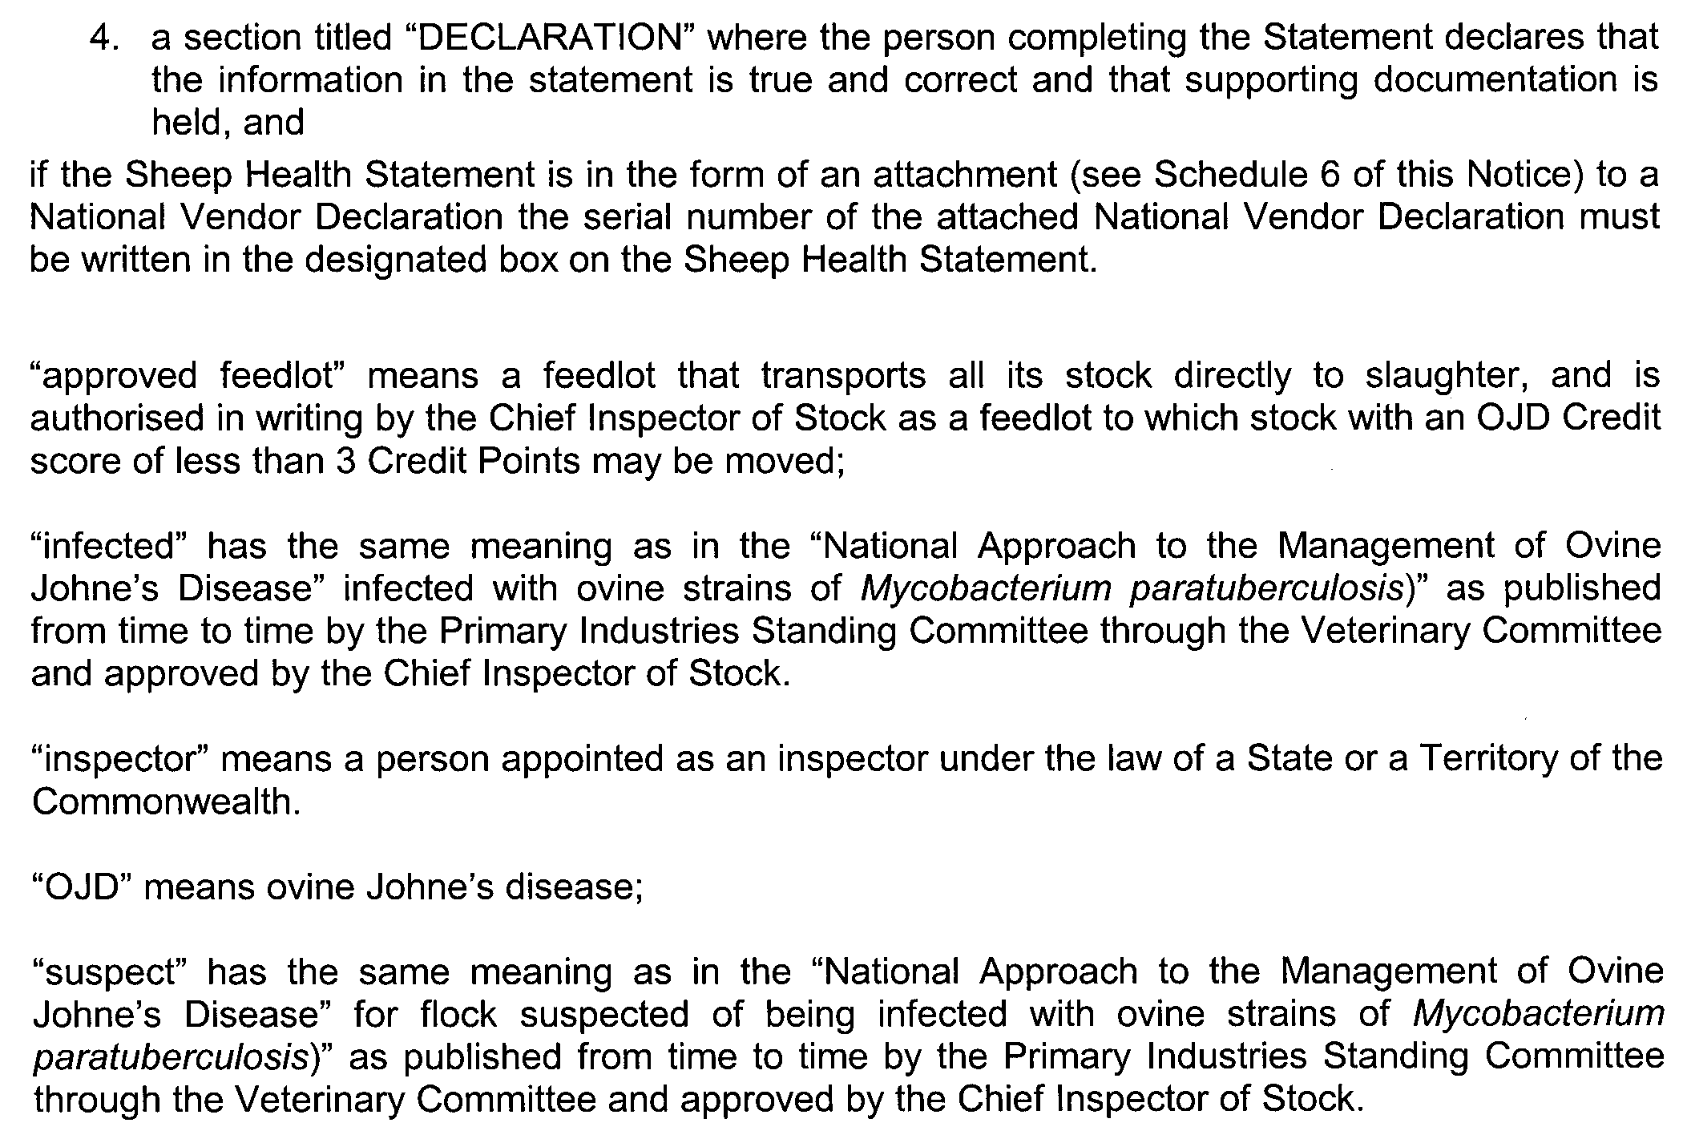
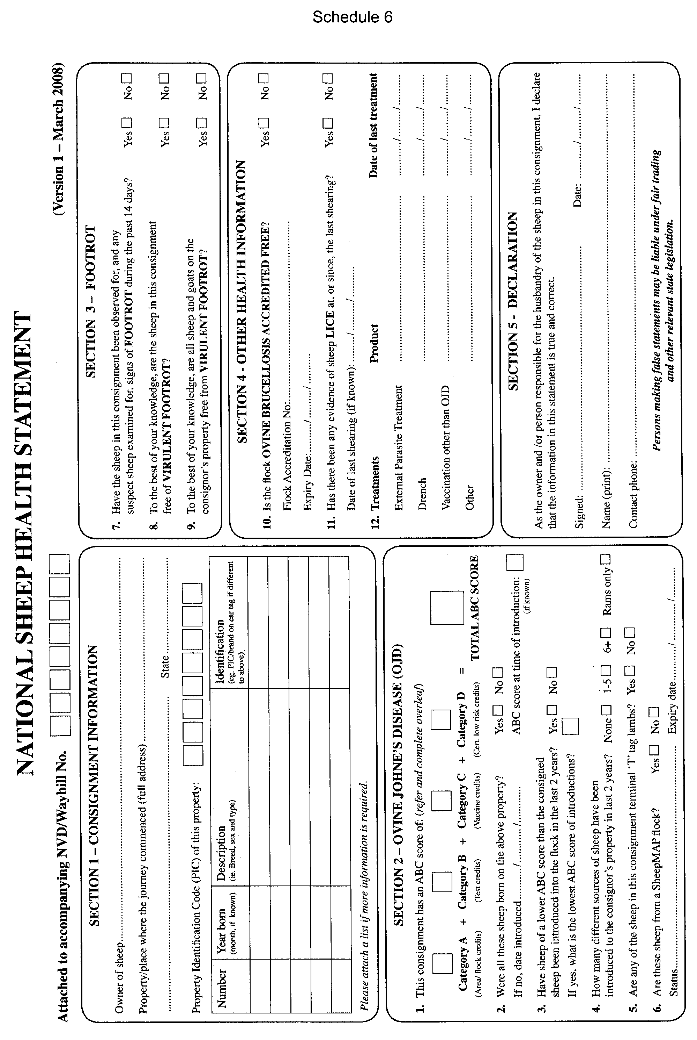
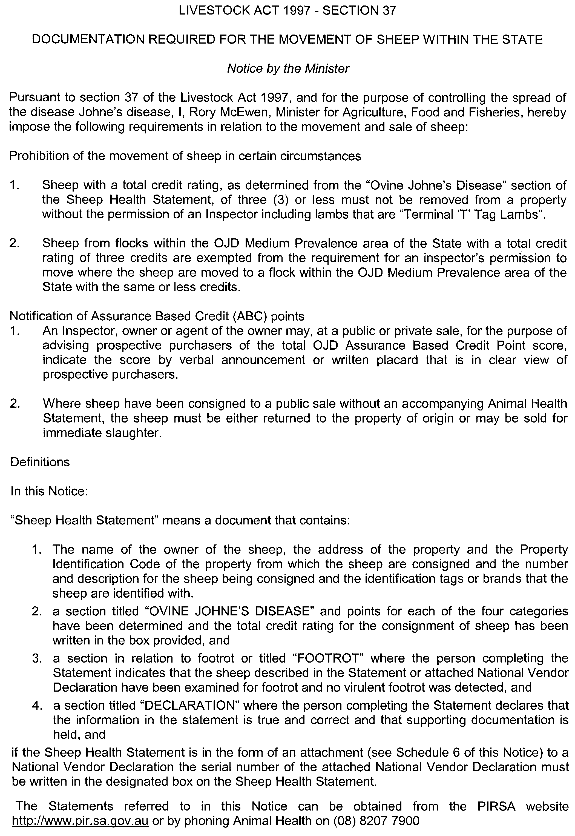
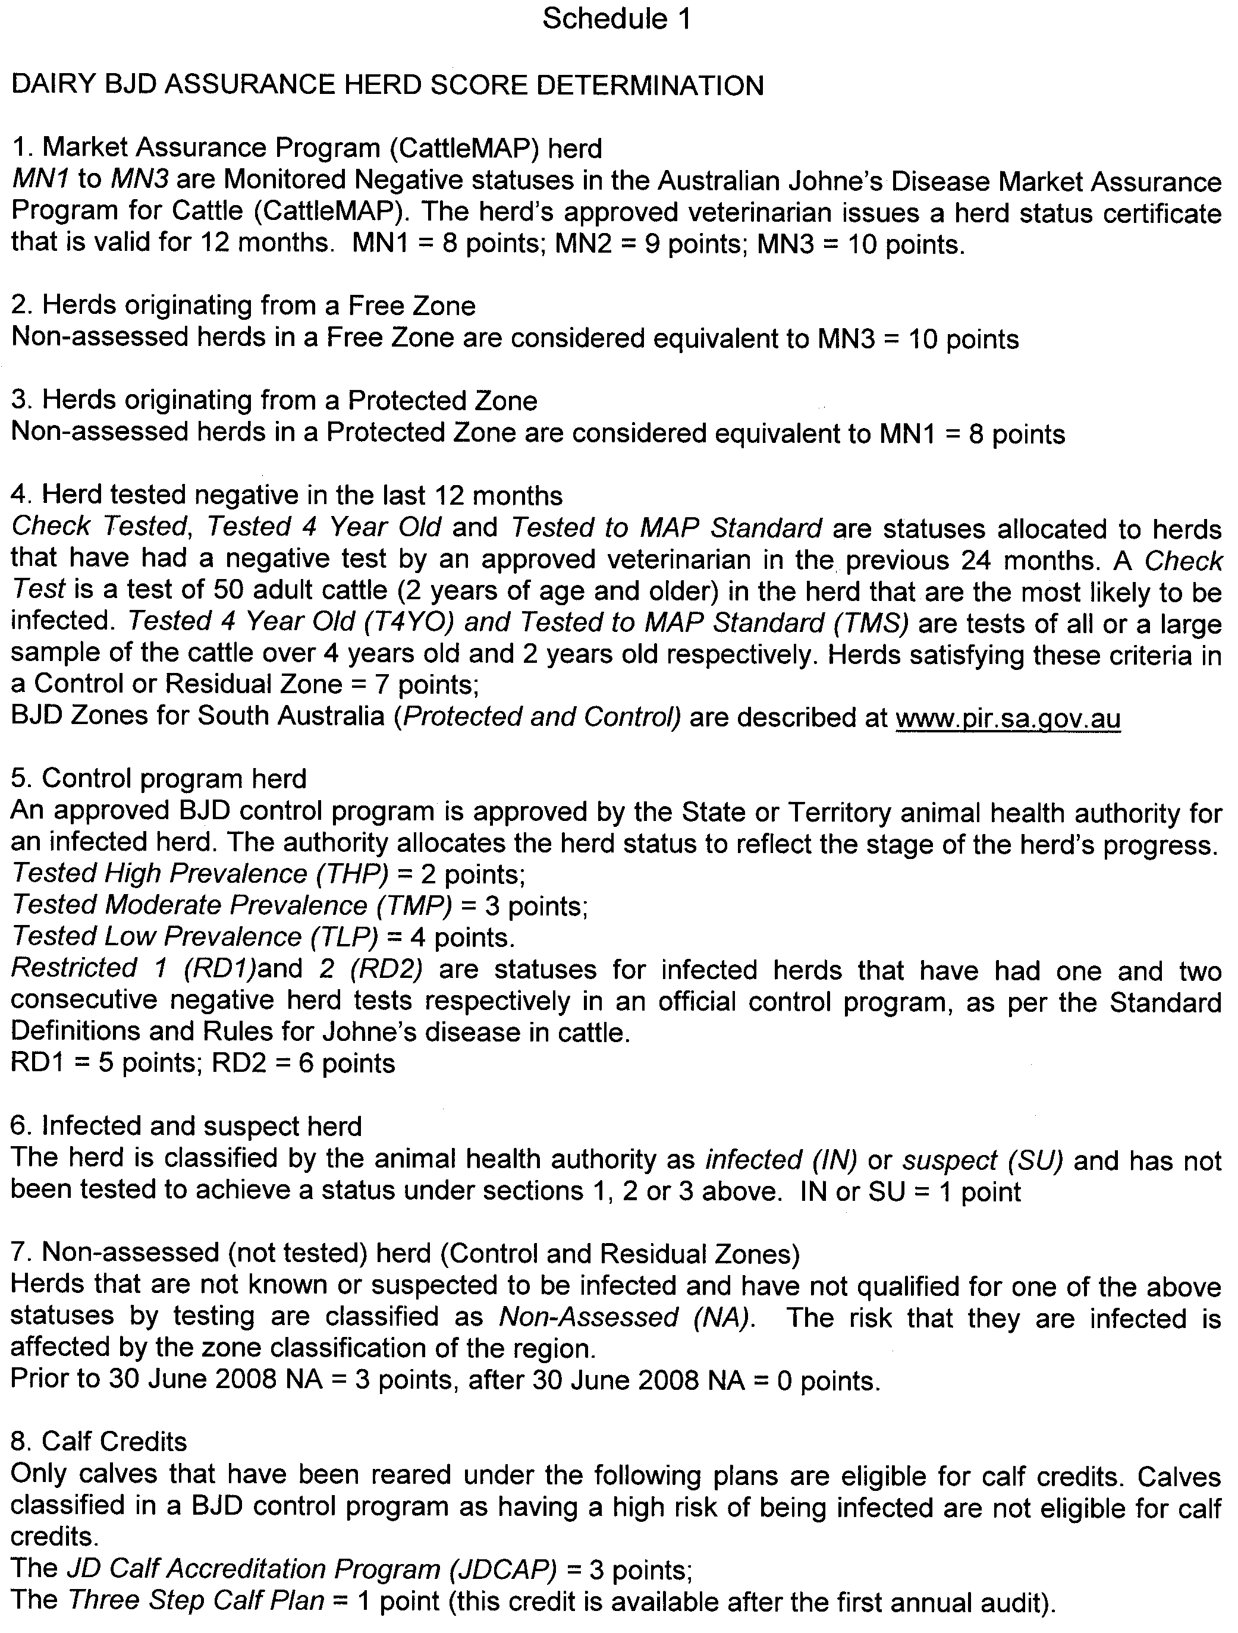
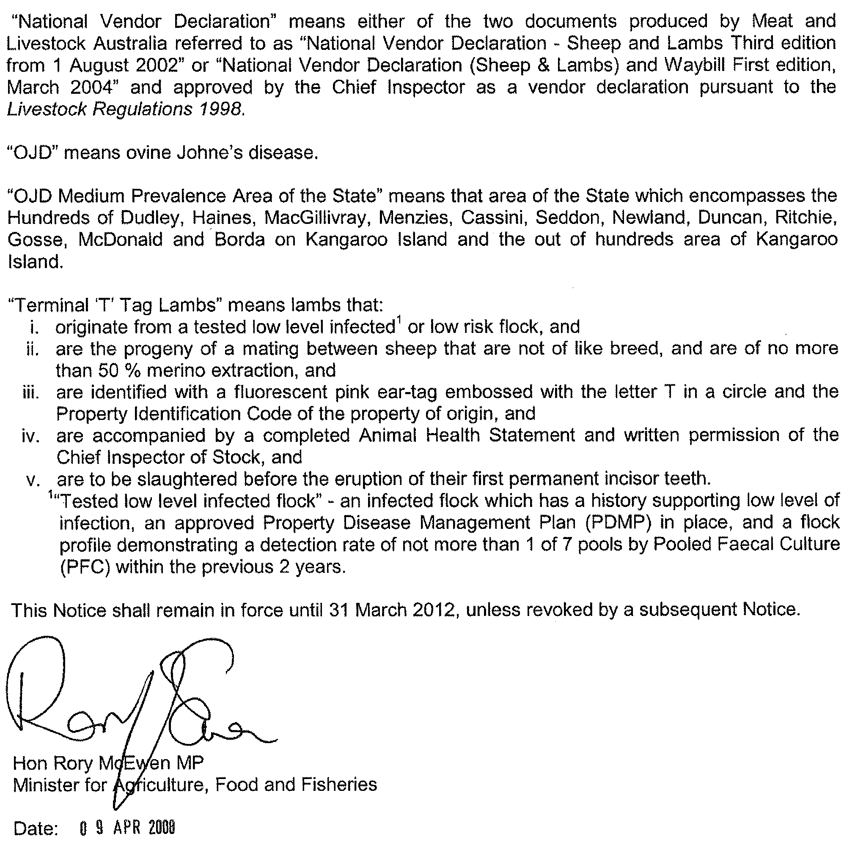
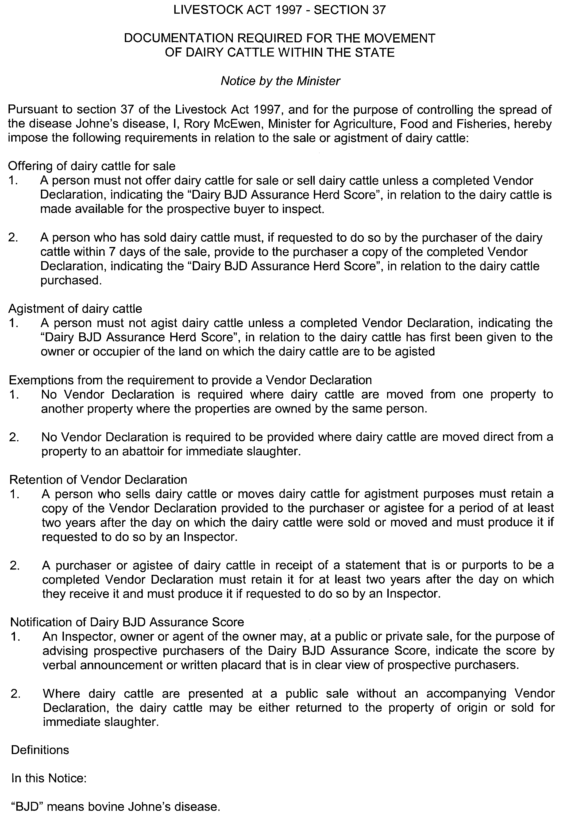

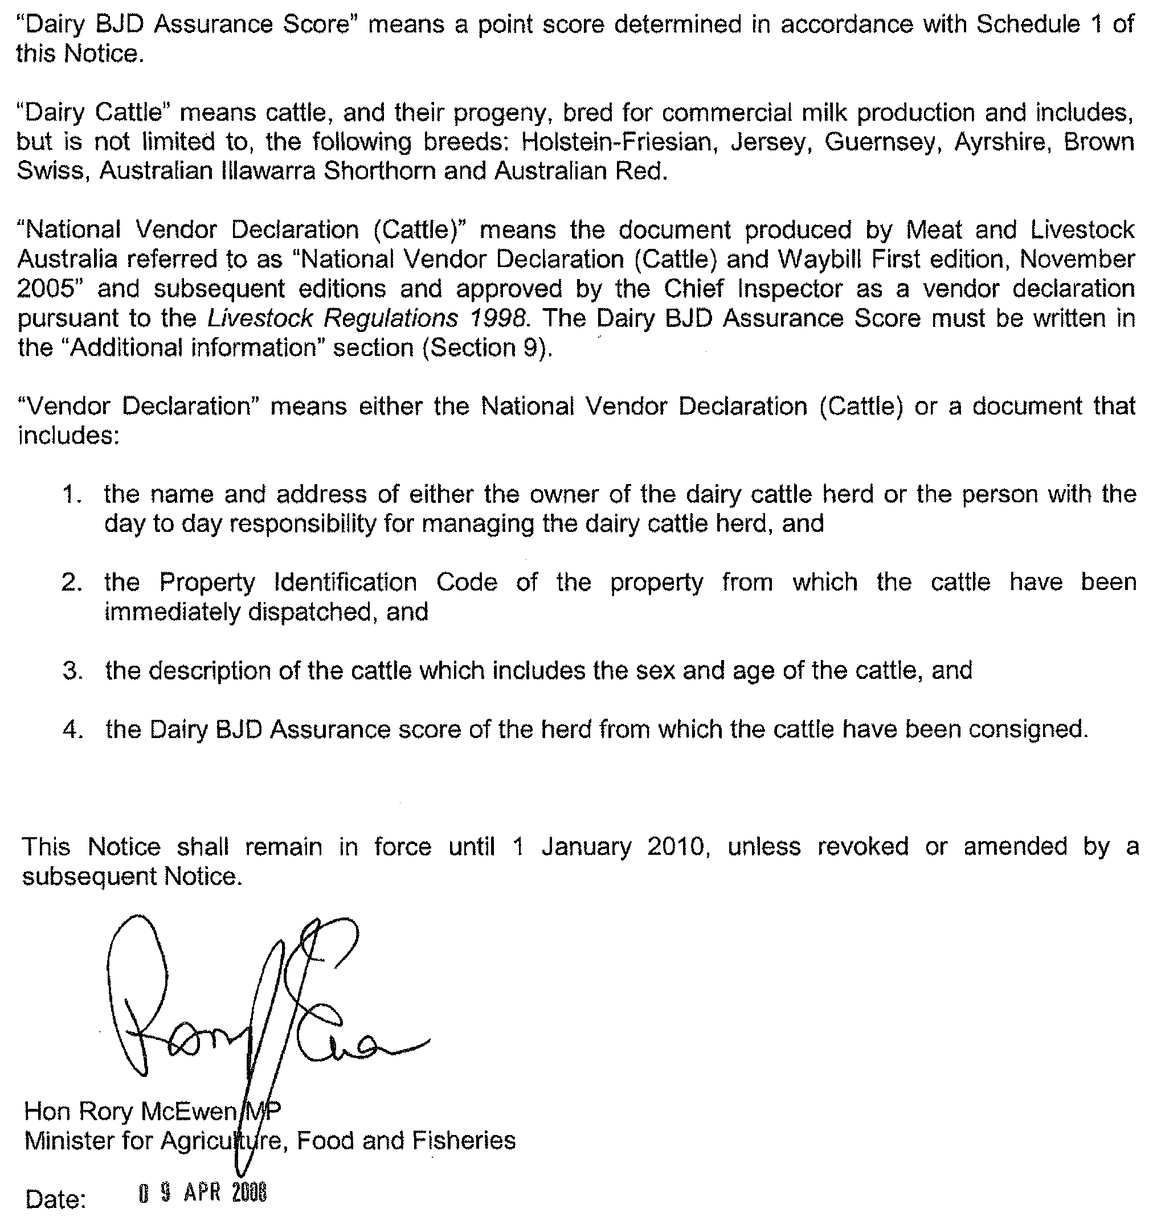

PHYLLOXERA AND GRAPE INDUSTRY ACT 1995
Contributions Towards Primary Functions Under the Act
for Year 2008-2009
PURSUANT to section 23 of the above Act, the Phylloxera and Grape Industry Board gives notice that registered persons (being persons who are recorded in the Register established by the Board as owners of 0.5 hectares, or more of planted vines) must contribute to the costs of the Board’s primary functions for the year ending 30 April 2009.
The rules of calculation of such contributions are as follows:
(1) Calculations will be based on the area of vines recorded in the Register as being owned by each person.
(2) The rate per hectare of vines will be $9.50 with a minimum contribution of $50.
(3) Any fee for default or delay in contribution payment will be calculated on a per hectare basis.
(4) The levy will be collected or recovered by the Commissioner of Land Tax on behalf of the Board as if the contribution were land tax and will be subject to the same penalties for delay or default in payment (section 23 (3) of the Act).
Notices of contributions will be forwarded by post to registered persons.
P. Hackworth, Chief Executive

ROADS (OPENING AND CLOSING) ACT 1991:
SECTION 24
NOTICE OF CONFIRMATION OF ROAD
PROCESS ORDER
Road Closure—Donaldson Road, Buckleboo
BY Road Process Order made on 16 January 2008, The District Council of Kimba ordered that:
1. Portion of the public road (Donaldson Road) opposite Hall Road and adjoining allotment 100 in Deposited Plan 60112, shown more particularly delineated and lettered ‘M’ in Preliminary Plan No. 07/0069 be closed.
2. The whole of the land subject to closure be transferred to AUSBULK Ltd in accordance with agreement for transfer dated 25 September 2007 entered into between The District Council of Kimba and AUSBULK Ltd.
On 14 March 2008 that order was confirmed by the Minister for Infrastructure conditionally upon the deposit by the Registrar-General of Deposited Plan 76846 being the authority for the new boundaries.
Pursuant to section 24 (5) of the Roads (Opening and Closing) Act 1991, NOTICE of the order referred to above and its confirmation is hereby given.
Dated 10 April 2008.
P. M. Kentish, Surveyor-General

ROADS (OPENING AND CLOSING) ACT 1991:
SECTION 24
NOTICE OF CONFIRMATION OF ROAD
PROCESS ORDER
Road Opening—Berrima Road and Lander Road, Sheidow Park
BY Road Process Order made on 12 February 2008, The Corporation of the City of Marion ordered that:
1. Portion of allotment 306 in Deposited Plan 34866 adjoining Berrima and Lander Roads, more particularly numbered ‘1’ in Preliminary Plan No. 07/0079 be opened as road.
On 5 April 2008 that order was confirmed by the Minister for Infrastructure conditionally upon the deposit by the Registrar-General of Deposited Plan 76962 being the authority for the new boundaries.
Pursuant to section 24 (5) of the Roads (Opening and Closing) Act 1991, NOTICE of the order referred to above and its confirmation is hereby given.
Dated 10 April 2008.
P. M. Kentish, Surveyor-General

South Australia
Health Care Act (Commencement) Proclamation 2008
1—Short title
This proclamation may be cited as the Health Care Act (Commencement) Proclamation 2008.
2—Commencement of Act and suspension of certain provisions
(1) The Health Care Act 2008 (No 3 of 2008) will come into operation on 10 April 2008.
(2) The operation of the following provisions of the Act is suspended until a day or time or days or times to be fixed by subsequent proclamation or proclamations:
(a) Part 2;
(b) sections 11 to 14 (inclusive);
(c) Parts 4 to 10 (inclusive);
(d) sections 89 to 99 (inclusive);
(e) section 101;
(f) Schedules 2 to 4 (inclusive).
Made by the Governor
with the advice and consent of the Executive Council
on 10 April 2008
HEACS/08/266

South Australia
Administrative Arrangements (Administration of Health Care Act) Proclamation 2008
under section 5 of the Administrative Arrangements Act 1994
1—Short title
This proclamation may be cited as the Administrative Arrangements (Administration of Health Care Act) Proclamation 2008.
2—Commencement
This proclamation comes into operation on the day on which it is made.
3—Administration of Act committed to Minister for Health
The administration of the Health Care Act 2008 is committed to the Minister for Health.
Made by the Governor
with the advice and consent of the Executive Council
on 10 April 2008
HEACS/08/266

South Australia
Health Care (HPC—Appointment of Members) Regulations 2008
under section 9(3) of the Health Care Act 2008

Contents
1 Short title
2 Commencement
3 Interpretation
4 Establishment of Health Performance Council (HPC)

1—Short title
These regulations may be cited as the Health Care (HPC—Appointment of Members) Regulations 2008.
2—Commencement
These regulations will come into operation on the day on which section 9 of the Health Care Act 2008 comes into operation.
3—Interpretation
In these regulations—
Act means the Health Care Act 2008.
4—Establishment of Health Performance Council (HPC)
For the purposes of section 9(3) of the Act—
(a) the following are prescribed bodies:
(i) Aboriginal Health Council of South Australia Incorporated;
(ii) Australian Medical Association (South Australia) Incorporated;
(iii) Carers SA;
(iv) Consultative Council of Ex-Service Organisations (SA);
(v) Council on the Ageing (South Australia) Incorporated;
(vi) Health Consumers Alliance of South Australia Incorporated;
(vii) Multicultural Communities Council of South Australia Incorporated;
(viii) Regional Communities Consultative Council (SA);
(ix) Rural Doctors Association of South Australia Incorporated;
(x) S.A. Divisions of General Practice Incorporated;
(xi) The Flinders University of South Australia;
(xii) The Returned & Services League of Australia (S.A. Branch) Incorporated;
(xiii) The South Australian Country Women's Association Incorporated;
(xiv) The University of Adelaide;
(xv) University of South Australia;
(xvi) Volunteering SA and NT Incorporated; and
(b) the Minister is to consult with the prescribed bodies in relation to the selection of persons for appointment to HPC as follows:
(i) when appointments are to be made to fill 2 or more vacancies, an invitation is to be extended to each prescribed body to recommend suitable candidates within a specified period;
(ii) the invitation is to specify the number of persons to be appointed and invite each body to recommend a specified number of suitable candidates consisting, as far as practicable, of equal numbers of men and women;
(iii) the invitation may specify areas of knowledge, expertise, experience, skills or qualifications listed in section 9(2) of the Act required of appointees and, if it does so, a recommendation of a candidate is to be accompanied by relevant information about the candidate's knowledge, expertise, experience, skills or qualifications.
Note—
As required by section 10AA(2) of the Subordinate Legislation Act 1978, the Minister has certified that, in the Minister's opinion, it is necessary or appropriate that these regulations come into operation as set out in these regulations.
Made by the Governor
with the advice and consent of the Executive Council
on 10 April 2008
No 33 of 2008
HEACS/08/266
South Australia
Tobacco Products Variation Regulations 2008
under the Tobacco Products Regulation Act 1997

Contents
Part 1—Preliminary
1 Short title
2 Commencement
3 Variation provisions
Part 2—Variation of Tobacco Products Regulations 2004
4 Variation of regulation 6—Certain advertising prohibited (section 40)

Part 1—Preliminary
1—Short title
These regulations may be cited as the Tobacco Products Variation Regulations 2008.
2—Commencement
These regulations come into operation on the day on which they are made.
3—Variation provisions
In these regulations, a provision under a heading referring to the variation of specified regulations varies the regulations so specified.
Part 2—Variation of Tobacco Products Regulations 2004
4—Variation of regulation 6—Certain advertising prohibited (section 40)
(1) Regulation 6(2a)—after paragraph (g) insert:
(ga) the retail display must not display fruit or confectionary flavoured cigarettes;
(2) Regulation 6(2c)—after paragraph (g) insert:
(ga) the retail display must not display fruit or confectionary flavoured cigarettes;
(3) Regulation 6(2f)—after paragraph (c) insert:
(ca) the advertisement must not be an advertisement for, or in relation to, fruit or confectionary flavoured cigarettes;
(4) Regulation 6(2g)—after paragraph (c) insert:
(ca) the information on the board must not relate to fruit or confectionary flavoured cigarettes;
(5) Regulation 6(2h)—after paragraph (c) insert:
(ca) the price ticket must not relate to fruit or confectionary flavoured cigarettes;
(6) Regulation 6(3)—after the definition of floor area insert:
fruit or confectionary flavoured cigarette means a cigarette—
(a) that possesses, or the smoke of which possesses, a distinctive fruity, sweet or confectionary-like character; and
(b) that is advertised in a way that might encourage young people to smoke,
but does not include a cigarette the flavouring of which is primarily of a menthol character;
Note—
As required by section 10AA(2) of the Subordinate Legislation Act 1978, the Minister has certified that, in the Minister's opinion, it is necessary or appropriate that these regulations come into operation as set out in these regulations.
Made by the Governor
with the advice and consent of the Executive Council
on 10 April 2008
No 34 of 2008
HEACS/08/264

FAXING COPY?
IF you fax copy to Government Publishing SA for inclusion in the Government Gazette, there is no need to send a Confirmation Copy to us as well.
This creates confusion and may well result in your notice being printed twice.
Please use the following fax number:
Fax transmission: (08) 8207 1040
Phone Inquiries: (08) 8207 1045
Please include a contact person, phone number and order number so that we can phone back with any queries we may have regarding the fax copy.
NOTE: Closing time for lodging new copy (fax, hard copy or email) is 4 p.m. on Tuesday preceding the day of publication.

Government Gazette notices can be E-mailed.
The address is:
governmentgazette@dpc.sa.gov.au
Documents should be sent as attachments in Word format.
When sending a document via E-mail, please confirm your transmission with a faxed copy of your document, including the date the notice is to be published.
Fax transmission: (08) 8207 1040
Enquiries: (08) 8207 1045
NOTE: Closing time for lodging new copy (fax, hard copy or email) is 4 p.m. on Tuesday preceding the day of publication.

CITY OF MITCHAM
Naming of a Private Road
NOTICE is hereby given pursuant to section 219 of the Local Government Act 1999, that Council at its meeting held on 25 March 2008, has assigned the name Bruce Webb Crescent to the previously un-named private road on the University of Adelaide, Waite Campus which enters Waite Road at its intersection with Heather Avenue and which appears in allotment 100 in Lands Titles Office Deposited Plan 15506 and contained in certificate of title volume 5275, folio 860.
R. Malcolm, Chief Executive Officer

CITY OF NORWOOD, PAYNEHAM & ST PETERS
Development Assessment Panel
NOTICE is hereby given that pursuant to section 56A (5) of the Development Act 1993, the Council has appointed the following Members to the City of Norwood, Payneham & St Peters Development Assessment Panel:
Councillors Carlo Dottore, Kevin Duke, Sue Whitington and John Minney, David Cree, Peter Dungey, Mark Adcock and Pellegrino De Fazio. One position is currently vacant.
The Council has appointed David Cree as the Presiding Member of the Panel and all appointments are for a period of 12 months effective from Monday, 17 March 2008.
The Council has appointed Mario Barone, Chief Executive Officer (and/or his delegate) to the role of Public Officer of the City of Norwood, Payneham & St Peters Development Assessment Panel. The Public Officer is responsible for ensuring the proper investigation of complaints about the conduct of a member of the Council’s Development Assessment Panel.
All written enquiries should be directed to:
Mario Barone
Chief Executive Officer
City of Norwood, Payneham & St Peters
P.O. Box 204
Kent Town, S.A. 5071
All telephone enquiries should be directed to Mark Thompson, Acting Manager, Development Assessment on 8366 4567.
M. Barone, Chief Executive Officer

PORT AUGUSTA CITY COUNCIL
Appointment of Authorised Officers—Building Fire
Safety Committee
NOTICE is hereby given that Council at its meeting held on 25 March 2008:
(1) Appointed Andrew Sharrad and Nick Ludborzs to the Port Augusta City Council’s Building Fire Safety Committee.
(2) Approved Andrew Sharrad’s and Nick Ludborzs’ appointment as Authorised Officers pursuant to section 18 of the Development Act 1993, to enable them to enter and inspect fire safety of existing and new buildings within the City of Port Augusta.
(3) Revoked the Authorised Officer appointments previously made to Randall Figg and Graham Woodforde.
Dated 4 April 2008.
J. G. Stephens, City Manager

ALEXANDRINA COUNCIL
Roads (Opening and Closing) Act 1991
Road Closure, Portion of Franklin Street, Goolwa North
NOTICE is hereby given pursuant to section 10 of the said act, that Council proposes to make a Road Process Order to close and sell to I. L. Fartch the greater portion of Franklin Street shown as ‘A’ on Preliminary Plan No. 07/0044.
A copy of the plan and statement of persons affected are available for public inspection at Council’s Office, 11 Cadell Street, Goolwa and the office of the Surveyor-General, 101 Grenfell Street, Adelaide, during normal office hours.
Any application for easement or objections must be made in writing within 28 days from 10 April 2008, to the Council, P.O. Box 21, Goolwa, S.A. 5214 and the Surveyor-General, G.P.O. Box 1354, Adelaide, S.A. 5001, setting out full details.
Where a submission is made, Council will give notification of a meeting to deal with the matter.
J. L. Coombe, Chief Executive Officer

KANGAROO ISLAND COUNCIL
Airport Fees
NOTICE is hereby given that pursuant to section 6 of the Aerodrome Fees Act 1998, the Council has determined the following increased charges for the Kingscote, Kangaroo Island Airport to take effect from 1 April 2008:
Schedule of Charges
Weight-based charges per movement calculated on certified maximum take-off weight of the aircraft with a movement defined as a departure:
From $9.20 to $9.50 plus GST per 1 000 kg pro rata, with a minimum charge from $9.20 to $9.50 plus GST.
From $15.60 to $16.20 plus GST for all helicopters.
Passenger Levy based charges for Regular Passenger Transport and Tourist Charter operations:
From $6.60 to $6.85 per head per each way passenger movement plus GST for adults and children.
Training flights—by prior arrangement.
Non RPT aircraft apron parking on sealed apron by prior arrangement only or a parking fee remaining at $200 per day or part thereof may be incurred.
C. Noon, Chief Executive Officer

DISTRICT COUNCIL OF MOUNT BARKER
Separate Rate
NOTICE is hereby given that at its meeting held on 3 March 2008, the Council in accordance with section 154 of the Local Govern-ment Act 1999, imposed a separate rate of an amount comprising fixed charges to a total value of $550 000 which has been agreed with the principal ratepayers and is set out in a legal agreement entered into between the Council and the principal ratepayers dated 6 February 2008, for the purpose of securing the con-struction of the Morphett Street Stormwater Infrastructure Upgrade, as follows:
Separate  Rate  $ | Applicable Rateable Land and Ratepayer
198 460 | CT 5103/247, Flinders Nominees, Stephen Street, Mount Barker.
 | CT 5839/251, Herriot Rural Investments Pty Ltd, Stephen Street, Mount Barker.
 | CT 5431/305, James Herriot Nominees Pty Ltd, Hutchinson Street, Mount Barker.
103 740 | CT 5486/749, Meap Pty Ltd and Reonne Nominees Pty Ltd, Morphett Street, Mount Barker.
 | CT 5486/751, Bruce King Nominees Pty Ltd and Meap Pty Ltd, Walker Street, Mount Barker.
 | CT 5486/750, Goix Pty Ltd and Reonne Nominees Pty Ltd, Walker Street, Mount Barker.
102 900 | CT 5273/339, Euroday Developments Pty Ltd, Stephen Street, Mount Barker.
 | CT 5345/521, Magnolia Holdings Pty Ltd, Hutchinson Street, Mount Barker.
144 900 | CT 5955/390, Gilbert Motors Pty Ltd, Adelaide Road, Mount Barker.
A. Stuart, Chief Executive Officer

DISTRICT COUNCIL OF STREAKY BAY
Change of Road Names
NOTICE is hereby given that Council resolved the following at their meeting held on 27 March 2008:
‘That Council determine to extend Alfred Terrace to include the entire length of the road from the northern Jubilee Road T-Junction to Linklater Street.
In addition, Council rename the road formally known as Flinders Highway, from Park Avenue south to the Jubilee Road T-Junction as Bay Road’.
J. Rumbelow, Chief Executive Officer

WAKEFIELD REGIONAL COUNCIL
Appointment
NOTICE is hereby given that Council, at its ordinary meeting held on 26 March 2008, accepted the resignation of James Maitland from Council’s Development Assessment Panel, and pursuant to section 56A (3) of the Development Act 1993, appointed David Lamond to that vacant position.
P. Barry, Chief Executive Officer

IN the matter of the estates of the undermentioned deceased persons:
Cannell, Margaret Ivy, late of 54 Woodcroft Drive, Morphett Vale, of no occupation, who died on 4 January 2008.
Coats, Robert Leslie, late of 300 Military Road, Grange, retired die setter, who died on 5 September 2007.
Cool, Annetta Joan, late of 7 Railway Terrace, Old Reynella, of no occupation, who died on 14 January 2008.
Cox, Jean Ada Annie, late of 550 Portrush Road, Glen Osmond, widow, who died on 4 February 2008.
Dahl-Helm, Kenneth Henry, late of 24-28 Wayford Street, Elizabeth Vale, retired army officer, who died on 8 February 2008.
Eager, Andrea Vivienne, late of Drabsch Street, Loxton, retired shop proprietor, who died on 2 February 2008.
Eldridge, Jack Hastings, late of 98 Military Road, Semaphore South, retired fitter and turner, who died on 29 January 2008.
Howie, Cathryn, late of 1 Smith Street, Whyalla Norrie, retired clerical officer, who died on 21 October 2007.
Kerrison, Melva Jean, late of Hazel Grove, Ridgehaven, of no occupation, who died on 19 February 2008.
Lehmann, May, late of 15 Halliday Street, Risdon Park, retired secretary, who died on 21 January 2008.
Mars, Walter, late of Kennedy Court, Largs Bay, of no occupation, who died on 7 February 2008.
McKinnon, Leigh John, late of 3 Rain Tree Street, Kununurra, Western Australia, security officer, who died on 12 March 2006.
Mende, Richard, late of 6 Sandilands Street, Lockleys, retired train driver, who died on 24 January 2008.
Munro, Thomas John, late of 59 Norman Street, Adelaide, of no occupation, who died on 25 November 2007.
Padgham, Maria Burn, late of 367-379 Waterloo Corner Road, Burton, of no occupation, who died on 13 January 2008.
Paterson, Bevan Anthony, late of 65 Lane Street, Richmond, of no occupation, who died on 3 February 2008.
Reich, Sadie Delmar, late of 29 Austral Terrace, Morphettville, widow, who died on 27 November 2007.
Ricketts, William Edgar John, late of 2 Horatio Street, Modbury, retired hospital administrator, who died on 15 December 2007.
Roos, Agnes Viola, late of 52 Dunrobin Road, Hove, widow, who died on 21 January 2008.
Ross, Ethel Mavis, late of 61 Silkes Road, Paradise, of no occupation, who died on 31 January 2008.
Schwarz, Roza, late of 565 Lower North East Road, Campbelltown, of no occupation, who died on 25 January 2008.
Smith, Josephine Mary, late of 26 Crouch Street South, Mount Gambier, retired nurse, who died on 13 January 2008.
Spicer, Merle Olive, late of 86 Oaklands Road, Glengowrie, widow, who died on 31 December 2007.
Turner, Constance Clare, late of 7 Victoria Street, Goodwood, retired mobile librarian, who died on 8 February 2008.
Weidmann, Elfriede Anna, late of 15A First Avenue, Tanunda, retired public servant, who died on 25 September 2007.
Wilson, Arthur Frank, late of 10 Watson Street, Risdon Park, retired public servant, who died on 3 January 2008.
Wojtych, Hrynko, late of 172 Trimmer Parade, Seaton, retired labourer, who died on 25 December 2007.
Notice is hereby given pursuant to the Trustee Act 1936, as amended, the Inheritance (Family Provision) Act 1972, and the Family Relationships Act 1975, that all creditors, beneficiaries, and other persons having claims against the said estates are required to send, in writing, to the Public Trustee, 25 Franklin Street, Adelaide, S.A. 5000, full particulars and proof of such claims, on or before 9 May 2008, otherwise they will be excluded from the distribution of the said estate; and notice is also hereby given that all persons who are indebted to the said estates are required to pay the amount of their debts to the Public Trustee or proceedings will be taken for the recovery thereof; and all persons having any property belonging to the said estates are forthwith to deliver the same to the Public Trustee.
Dated 10 April 2008.
M. I. Bodycoat, Public Trustee

ATTENTION

CUSTOMERS requiring a proof of their notice for inclusion in the Government Gazette, please note that the onus is on you to inform Government Publishing SA of any subsequent corrections by 10 a.m. on Thursday, which is our publication deadline.

For any corrections to your notice please phone 8207 1045 or Fax 8207 1040 before 10 a.m. on Thursday.

If we do not receive any communication by 10 a.m. on Thursday (day of publication) we will presume the notice is correct and will print it as it is.

Remember—the onus is on you to inform us of any corrections necessary to your notice.

NOTE: Closing time for lodging new copy (electronically, fax or hard copy) is 4 p.m. on Tuesday preceding the day of publication. Phone 8207 1045—Fax 8207 1040.
Email: governmentgazette@dpc.sa.gov.au

Printed and published by authority every Thursday by T. GOODES, Government Printer, South Australia
Price: $5.40, plus postage; to subscribers, $274.00 per annum.
(The above prices are inclusive of GST)

