No. 20 1305

THE SOUTH AUSTRALIAN

GOVERNMENT GAZETTE
www.governmentgazette.sa.gov.au

PUBLISHED BY AUTHORITY

ALL PUBLIC ACTS appearing in this GAZETTE are to be considered official, and obeyed as such

ADELAIDE, THURSDAY, 17 APRIL 2008

CONTENTS

Page
Acts Assented To 1306
Appointments, Resignations, Etc. 1306
Architects Act 1939—Notice 1306
Corporations and District Councils—Notices 1413
Development Act 1993—Notices 1306
Fisheries Management Act 2007—Notices 1308
Geographical Names Act 1991—Notice 1308
Land and Business (Sale and Conveyancing) Act 1994—
Notice 1309
Liquor Licensing Act 1997—Notices 1309
Mining Act 1971—Notices 1314
National Electricity Law—Notice 1314
National Parks and Wildlife (National Parks)
Regulations 2001—Notices 1314
Passenger Transport Act 1994—Notices 1316
Petroleum Act 2000—Notices 1316
Proclamation 1369
Public Trustee Office—Administration of Estates 1415
Real Property Act 1886—Notice 1318
Renmark Irrigation Trust, The—Notice 1316

Page
REGULATIONS
Lottery and Gaming Act 1936 (No. 35 of 2008) 1370
Fire and Emergency Services Act 2005 (No. 36 of 2008) 1409
Genetically Modified Crops Management Act 2004—
(No. 37 of 2008) 1411
Roads (Opening and Closing) Act 1991—Notices 1316

RULES OF COURT
Corporations Rules 2003 (South Australia)—
Amendment No. 3 1319
Magistrates Court Rules 1992—
Amendment No. 29 1328
Magistrates Court (Civil) Rules 1992—
Amendment No. 29 1344
South Australia Fire and Emergency Services Act 2005—
Notice 1366
South Australian Motor Sport Act 1984—Notices 1362
Trade Standards Regulations 2000—Notice 1366
Transport, Department of—Notices to Mariners 1315
Water Mains and Sewers—Main Laid, Replaced, Etc 1366

GOVERNMENT GAZETTE NOTICES
ALL poundkeepers’ and private advertisements forwarded for publication in the South Australian Government Gazette must be PAID FOR PRIOR TO INSERTION; and all notices, from whatever source, should be legibly written on one side of the paper only and sent to Government Publishing SA so as to be received no later
than 4 p.m. on the Tuesday preceding the day of publication. Phone 8207 1045 or Fax 8207 1040. E-mail: governmentgazette@dpc.sa.gov.au. Send as attachments in Word format and please confirm your transmission with a faxed copy of your document, including the date the notice is to be published and to whom the notice will be charged. The Government Gazette is available online at: www.governmentgazette.sa.gov.au

Department of the Premier and Cabinet
Adelaide, 17 April 2008
HIS Excellency the Governor’s Deputy directs it to be notified for general information that he has in the name and on behalf of Her Majesty The Queen, this day assented to the undermentioned Acts passed by the Legislative Council and House of Assembly in Parliament assembled, viz.:
No. 7 of 2008—Statutes Amendment (Evidence and Procedure) Act 2008. An Act to amend various Acts to make provision for miscellaneous evidentiary and other procedural matters.
No. 8 of 2008—Statutes Amendment (Public Order Offences) Act 2008. An Act to amend the Criminal Law Consolidation Act 1935 and the Summary Offences Act 1953.
No. 9 of 2008—Statute Law Revision Act 2008. An Act to make minor amendments of a statute law revision nature to various Acts.
No. 10 of 2008—Criminal Law Consolidation (Rape and Sexual Offences) Amendment Act 2008. An Act to amend the Criminal Law Consolidation Act 1935 and to make related amendments to the Child Sex Offenders Registration Act 2006, the Correctional Services Act 1982, the Criminal Law (Sentencing) Act 1988, the Evidence Act 1929 and the Summary Procedure Act 1921.
By command,
Jennifer Rankine, for Premier
DPC06/0875

Department of the Premier and Cabinet
Adelaide, 17 April 2008
HIS Excellency the Governor’s Deputy in Executive Council has been pleased to appoint the undermentioned to the Libraries Board of South Australia, pursuant to the provisions of the Libraries Act 1982:
Member: (from 17 April 2008 until 16 April 2012)
Beth Davidson-Park
Helen Nichols
By command,
Jennifer Rankine, for Premier
ASACAB002/02

Department of the Premier and Cabinet
Adelaide, 17 April 2008
HIS Excellency the Governor’s Deputy in Executive Council has been pleased to appoint the undermentioned to the Adelaide Festival Centre Trust, pursuant to the provisions of the Adelaide Festival Centre Trust Act 1971:
Trustee: (from 24 April 2008 until 23 April 2011)
Susan Clearihan
By command,
Jennifer Rankine, for Premier
ASACAB009/002

Department of the Premier and Cabinet
Adelaide, 17 April 2008
HIS Excellency the Governor’s Deputy in Executive Council has been pleased to appoint the Honourable Paul Holloway, MLC, Minister for Police, Minister for Mineral Resources Development and Minister for Urban Development and Planning to be also Acting Minister for Agriculture, Food and Fisheries and Acting Minister for Forests for the period from 11 May 2008 until 23 May 2008 inclusive, during the absence of the Honourable Rory John McEwen, MP.
By command,
Jennifer Rankine, for Premier
MAFF08/008CS

Department of the Premier and Cabinet
Adelaide, 17 April 2008
HIS Excellency the Governor in Executive Council on 20 March 2008, confirmed the following by-laws under the Architects Act 1939 made by the Architects Board of South Australia on 25 February 2008, pursuant to section 43 of the Architects Act 1939.

ARCHITECTS ACT 1939
By-laws
THE ARCHITECTS BOARD OF SOUTH AUSTRALIA, by virtue of the Architects Act 1939 and all other powers, hereby makes the following by-laws:
By-laws Under the Architects Act 1939
1. The by-laws made by the Architects Board of South Australia, pursuant to the Architects Act 1939, on 31 March 1977 and published in the Government Gazette on the same day at pages 999 to 1005 inclusive as varied are hereinafter referred to as ‘the principal by-laws’.
2. By-law 14 of the principal by-laws is varied as follows:
(1) by deleting the words ‘one hundred and twenty-five dollars’ and substituting the words ‘one hundred and twenty-seven dollars’; and
(2) by deleting the words ‘three hundred and sixty-four dollars’ and substituting the words ‘three hundred and seventy dollars’.
3. By-law 15 of the principal by-laws is varied as follows:
(1) by deleting the words ‘two hundred and eighty-six dollars’ and substituting the words ‘two hundred and ninety dollars’; and
(2) by deleting the words ‘four hundred and sixteen dollars for companies with up to two directors, and four hundred and sixty-eight dollars for companies with more than two directors’ and substituting the words ‘four hundred and twenty-five dollars for companies with up to two directors, and four hundred and seventy-five dollars for companies with more than two directors’.
The above by-laws were duly made and passed by the Architects Board of South Australia at a meeting of the Board held on 19 September 2007.
These by-laws are to come into operation on 1 January 2008.
Dated 21 February 2008.
A. L. S. Davies, Chairman
R. P. Krantz, Registrar
Confirmed in Executive Council, 20 March 2008.
Kevin John Scarce, Governor
Pursuant to section 10AA (2) of the Subordinate Legislation Act 1978, I, certify that, in my opinion, it is necessary or appropriate that these by-laws come into operation on 1 January 2008.
Endorsed,
Paul Holloway, Minister for Urban Development and Planning

DEVELOPMENT ACT 1993, SECTION 25 (17): CITY OF MITCHAM—GENERAL AMENDMENTS No. 1 DEVELOP-MENT PLAN AMENDMENT
Preamble
1. The Development Plan amendment entitled ‘City of Mitcham—General Amendments No. 1 Development Plan Amendment’ (the Plan Amendment) has been finalised in accordance with the provisions of the Development Act 1993.
2. The Minister for Urban Development and Planning has decided to approve the Plan Amendment.
Notice
PURSUANT to section 25 of the Development Act 1993, I—
(a) approve the Plan Amendment; and
(b) fix the day on which this notice is published in the Gazette as the day on which the Plan Amendment will come into operation.
Dated 17 April 2008.
P. Holloway, Minister for Urban Development and Planning

DEVELOPMENT ACT 1993: SECTION 46 (1)
Preamble
Section 46 (1) of the Development Act 1993, allows the Minister for Urban Development and Planning to apply that section to a specified kind of development or project if the Minister is of the opinion that a declaration under that section is appropriate or necessary for the proper assessment of development or a project of major environmental, social or economic importance.
Notice
PURSUANT to section 46 (1) of the Development Act 1993, being of the opinion that a declaration under that section is appropriate for the proper assessment of development of major environmental, social or economic importance, I declare that section 46 of the Act applies to all development of a kind specified in Schedule 1, in that part of the State specified in Schedule 2.
Dated 17 April 2008.
Paul Holloway, Minister for Urban Development and Planning

Schedule 1
The following kinds of development are specified if undertaken in, or in relation to, that part of the State specified in Schedule 2:
(a) All activities and works associated with the construction and operation of a Desalination Plant at Port Stanvac, excluding:
(i) the construction and operation of a small scale temporary desalination pilot plant;
(ii) preliminary site works including surveys, geo-technical and other site investigations, stormwater, access, site security and approach works; and
(iii) interconnection works including pipes, storage tanks and pumping stations required to transfer water to the Happy Valley Water Treatment Plant.
(b) All activities and works associated with connection and installation of the marine intake and outfall pipelines, excluding preliminary investigations, surveys and base-line monitoring works.
Schedule 2
All of the land delineated by the bold line in the map in Schedule 3 is specified for the purposes of Schedule 1, comprising:
1. The whole of the land comprised in certificates of title register book volumes/folios CT5972/908, CT5783/312, CT 5752/89, CT 5608/586, CT 5752/73, CT 5752/84, CT 5752/88 and CT5753/580.
2. An area adjacent to the coastline extending into Gulf St Vincent as shown on attached map in Schedule 3.
Schedule 3

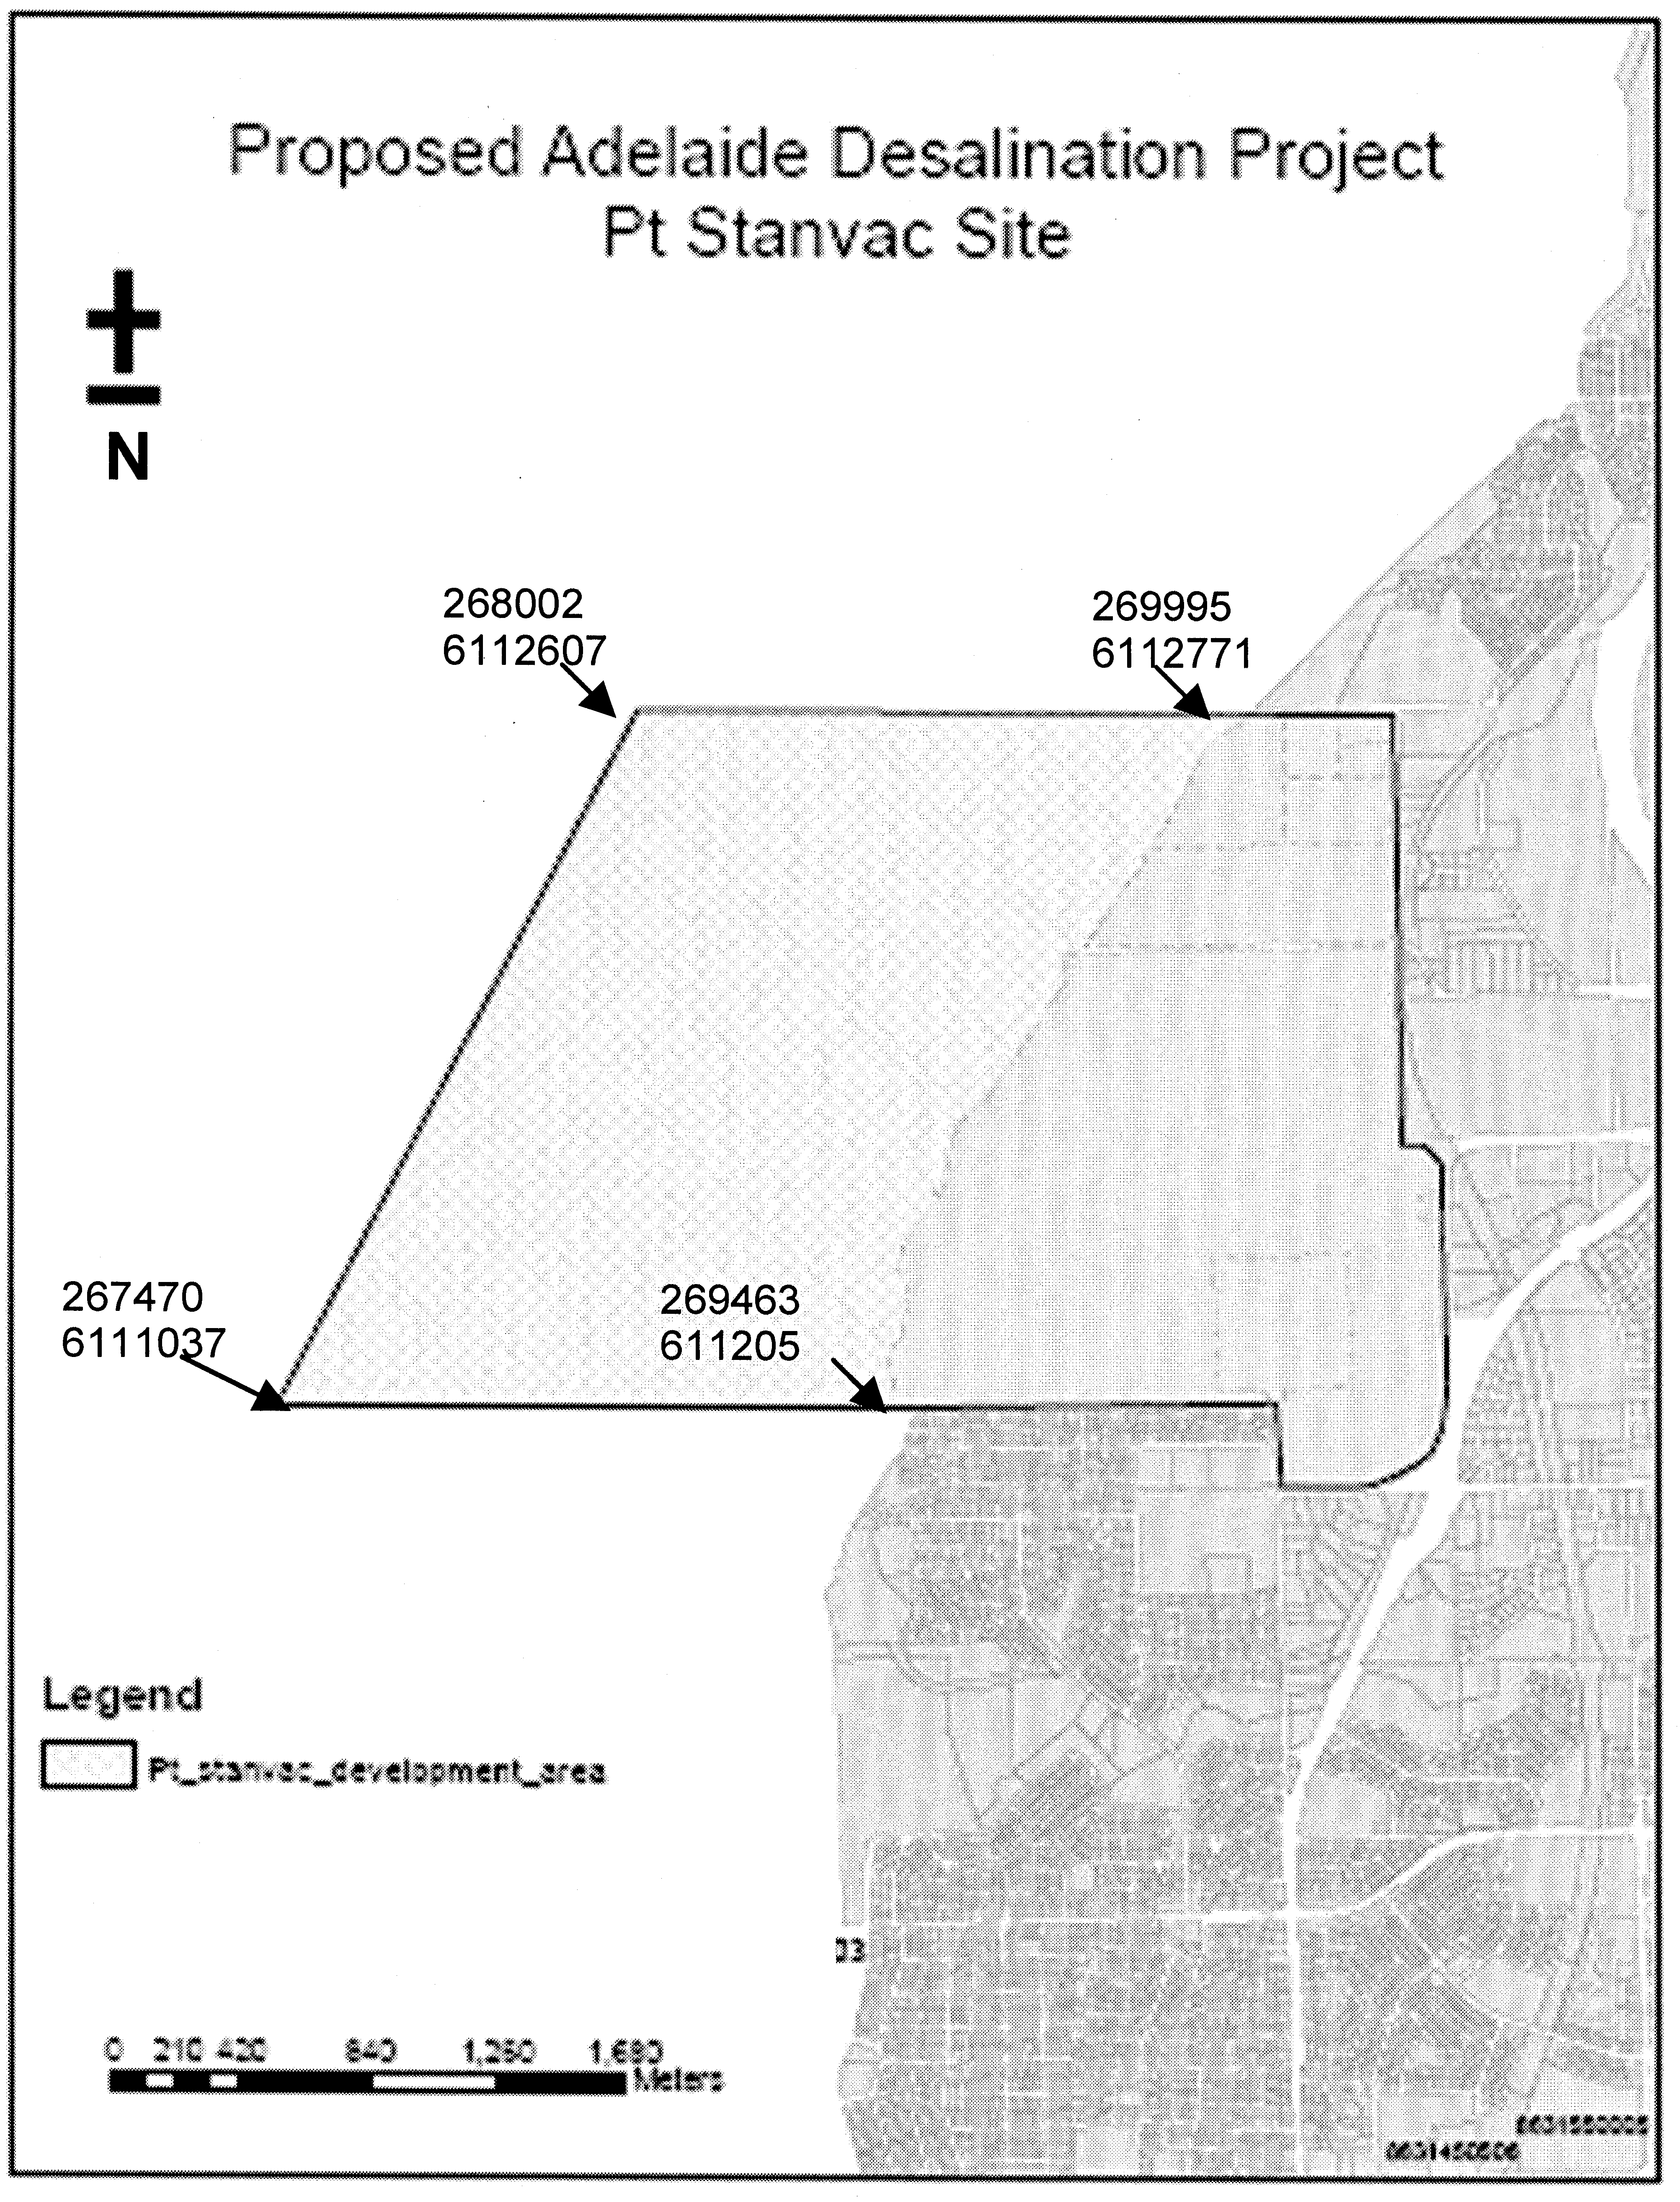
Note to Figure: The co-ordinates delineated are metres east and metres north using UTM Projection (MGA54) and are based on the cadastral land parcel boundaries into the ocean off Port Stanvac.
Paul Holloway, Minister for Urban Development and Planning

DEVELOPMENT ACT 1993
Alteration to the Building Code of Australia
Preamble
1. The Building Code of Australia as in force from time to time is adopted by the Development Regulations 1993, as part of the Building Rules under the Development Act 1993.
2. The Building Code of Australia is altered annually for national adoption on 1 May each year.
3. The Development Act 1993, requires that notice of the alteration must be published before the alteration can take effect.
Notice
PURSUANT to section 4 (7) of the Development Act 1993, notice is given of an alteration to the 2007 edition of the Building Code of Australia. The Code has been amended and republished as BCA 2008 by the Australian Building Codes Board.
BCA 2008, as modified by the variations and additions for South Australia contained in the Appendix to that Code will take effect for the purposes of the Development Act 1993 on 1 May 2008.
Dated 8 April 2008.
Paul Holloway, Minister for Urban Development and Planning

FISHERIES MANAGEMENT ACT 2007: SECTION 79
TAKE note that the notice made under section 79 of the Fisheries Management Act 2007, dated 8 April 2008, referring to the Spencer Gulf Prawn Fishery, is hereby revoked.
Take note that the notice made under section 79 of the Fisheries Management Act 2007, dated 7 December 2007, referring to the Spencer Gulf Prawn Fishery, is hereby varied such that it will be unlawful for a person fishing pursuant to a Spencer Gulf Prawn Fishery Licence to use prawn trawl nets in the areas specified in Schedule 1 during the period specified in Schedule 2.
Schedule 1
The waters of the Spencer Gulf Prawn Fishery that are:
1. North of the following co-ordinates: Commencing at position latitude 34°10.00′S, longitude 137°28.00′E, then to position latitude 33°42.00′S, longitude 137°19.00′E, then to position latitude 33°47.00′S, longitude 137°11.00′E, then to position latitude 33°52.00′S, longitude 137°15.00′E, then to position latitude 33°55.00′S, longitude 137°09.00′E, then to position latitude 33°59.00′S, longitude 137°12.00′E, then to position latitude 34°17.00′S, longitude 136°54.00′E, then to position latitude 34°17.00′S, longitude 136°45.00′E, then to position latitude 34°04.00′S, longitude 136°49.00′E, then to position latitude 33°52.00′S, longitude 136°40.00′E.
Except within the following area: Commencing at position latitude 33°46.00′S, longitude 137°44.00′E, then to position latitude 33°37.00′S, longitude 137°33.00′E, then to position latitude 33°47.00′S, longitude 137°30.00′E, then to position latitude 33°48.60′S, longitude 137°33.70′E, then to position latitude 33°51.60′S, longitude 137°31.20′E, then to position latitude. 33°56.00′S, longitude 137°39.00′E.
2. Within the Wardang Island area, commencing at position latitude 34°19.00′S, longitude 137°30.00′E, then to position latitude 34°19.00′S, longitude 137°20.00′E, then to position latitude 34°23.00′S, longitude 137°15.00′E, then to position latitude 34°54.00′S, longitude 137°15.00′E.
Schedule 2
From 1830 hours on 9 April 2008 to 0600 hours on 12 April 2008.
Dated 9 April 2008
S. Sloan, Senior Fisheries Manager

FISHERIES MANAGEMENT ACT 2007: SECTION 79
TAKE note that the notice made under section 79 of the Fisheries Management Act 2007, published in the South Australian Government Gazette, dated 7 December 2007, referring to the Gulf St Vincent Prawn Fishery, is hereby varied such that it will not be unlawful for a person fishing pursuant to a Gulf St Vincent Prawn Fishery Licence to use prawn trawl nets in the area specified in Schedule 1 during the period specified in Schedule 2.
Schedule 1
1. The waters of the Gulf St Vincent Prawn Fishery in the Investigator Straits, within the following co-ordinates: Commencing at position latitude 35°17.00′S, longitude 137°46.10′E, then to position latitude 35°20.00′S, longitude 137°48.60′E, then to position latitude 35°21.30′S, longitude 137°47.00′E, then to position latitude 35°23.00′S, longitude 137°48.90′E, then to position latitude 35°25.80′S, longitude 137°45.00′E, then to position latitude 35°21.20′S, longitude 137°40.30′E, then returning to position latitude 35°17.00′S, longitude 137°46.10′E.
2. The waters of the Gulf St Vincent Prawn Fishery, adjacent to Wirrina Cove, within the following co-ordinates: Commencing at position latitude 35°15.50′S, longitude 138°12.10′E, then to position latitude 35°17.60′S, longitude 138°16.00′E, then to position latitude 35°22.70′S, longitude 138°12.30′E, then to position latitude 35°21.70′S, longitude 138°09.60′E, then returning to position latitude 35°15.50′S, longitude 138°12.10′E.
Schedule 2
From 1800 hours on 9 April 2008 to 0630 hours on 13 April 2008.
Dated 9 April 2008.
S. Sloan, Senior Fisheries Manager

FISHERIES MANAGEMENT ACT 2007: SECTION 79
TAKE note that the notice made under section 79 of the Fisheries Management Act 2007, dated 9 April 2008, referring to the Spencer Gulf Prawn Fishery, is hereby revoked.
Take note that the notice made under section 79 of the Fisheries Management Act 2007, dated 7 December 2007, referring to the Spencer Gulf Prawn Fishery, is hereby varied such that it will be unlawful for a person fishing pursuant to a Spencer Gulf Prawn Fishery Licence to use prawn trawl nets in the areas Specified in Schedule 1 during the period specified in Schedule 2.
Schedule 1
The waters of the Spencer Gulf Prawn Fishery that are:
1. North of the following co-ordinates: Commencing at position latitude 34°10.00′S, longitude 137°27.70′E, then to position latitude 33°42.20′S, longitude 137°18.70′E, then to position latitude 33°46.80′S, longitude 137°11.30′E, then to position latitude 33°52.00′S, longitude 137°15.00′E, then to position latitude 33°55.00′S, longitude 137°09.00′E, then to position latitude 33°59.00′S, longitude 137°12.00′E, then to position latitude 34°17.00′S, longitude 136°54.00′E, then to position latitude 34°17.00′S, longitude 136°45.00′E, then to position latitude 34°04.00′S, longitude 136°49.00′E, then to position latitude 33°52.00′S, longitude 136°40.00′E.
Except within the following area: Commencing at position latitude 33°46.00′S, longitude 137°44.00′E, then to position latitude 33°37.00′S, longitude 137°33.00′E, then to position latitude 33°47.00′S, longitude 137°30.00′E, then to position latitude 33°48.60′S, longitude 137°33.70′E, then to position latitude 33°51.40′S, longitude 137°31.40′E, then to position latitude 33°56.00′S, longitude 137°39.40′E.
2. Within the Wardang Island area, commencing at position latitude 34°19.00′S, longitude 137°30.00′E, then to position latitude 34°19.00′S, longitude 137°20.00′E, then to position latitude 34°23.00′S, longitude 137°15.00′E, then to position latitude 34°54.00′S, longitude 137°15.00′E.
Schedule 2
From 1830 hours on 9 April 2008 to 0600 hours on 12 April 2008.
Dated 10 April 2008.
S. Sloan, Senior Fisheries Manager

GEOGRAPHICAL NAMES ACT 1991
Notice of Declaration of Names of Places
NOTICE is hereby given pursuant to section 11A of the Geographical Names Act 1991, that the names of those places
set out in The Schedule hereunder shall be the geographical
names of those said places. Precise location of the said features can be obtained from the South Australian Government Gazette at www.placenames.sa.gov.au or by contacting the Geographical Name Unit, DTEI on (08) 8204 8539.
The Schedule

Mapsheet | Feature
1:50 000 Mapsheet 6526-4 (Cape Jervis) | Tree Hill
1:50 000 Mapsheet Pts 6426-1 and 2 (Penneshaw) | Blue Gum Gully
1:50 000 Mapsheet 6326-2 (Seddon) | Pelorus Islet  Quin Rock
1:50 000 Mapsheet 7022-4 (Kalangadoo) | Botts Swamp  Cat Swamp  Hundred Line Swamp  Lake Letty  Osborne Swamp  Paddy Swamp  Pear Tree Hill  Pott Boy Swamp  Tantanoola Cave  The Black Hole  The Blue Gum Waterhole  The Marshes  The Mern  The Yard Swamp
1:50 000 Mapsheet 6326-3 (Vivonne) | Fernandez Creek  Stun’Sail Boom Beach
1:50 000 Mapsheet 6922-4 (Buffon) | Abyssinia Bay  Boozy Gully  Cameron Rocks  Canunda Rock  Cascade Rock  Cullen Bay  Devils Gap  Devils Wash  Double Island  Eddy Bay  Lonely Reef  McIntyre Beach  McIntyre Rocks  Mounce and Battye Rock  Mullins Swamp  Pether Rock  Shag Rock  Stanway Point  Sweep Rock  The Twins (Rock)  Watt Rocks  West Rock
1:50 000 Mapsheet 7023-2 (Penola) | Racecourse Swamp  Reedy Lagoon  Sawpit Swamp  Wire Swamp  Woolwash Swamp
1:50 000 Mapsheet 7024-4 (Keppoch) | Wonarah Trig  Moorex Trig
1:50 000 Mapsheet 7024-1 (Frances) | Whip Spring
1:50 000 Mapsheet 6824-3 (Jaffa) | Jaffa Trig  Hog Tower
1:50 000 Mapsheet 7023-3 (Monbulla) | Emu Flat  Red Gum Swamp  Sheepwash Swamp
1:50 000 Mapsheet 7023-1 (Struan) | Deadmans Swamp  Kay Swamp
1:50 000 Mapsheet 6823-1 (Robe) | Snewin Rock
1:50 000 Mapsheet 7023-4 (Bool Lagoon) | Goose Neck Swamp  Green Swamp  Little Bool Lagoon
1:50 000 Mapsheet 6823-2 (Beachport) | Dolly Lake  Five Mile Rocks  Foster Islands  Foster Point  Mular Point  Packin Point  Perch Hole  Pigeon Cove  Post Office Rock  Pud Lake  Salmon Hole  Sea Lake  Three Mile Rocks  Two Lakes
1:50 000 Mapsheet 6923-3 (Hatherleigh) | Cockies Point

Note: Words shown in parentheses are not part of the name.
Certified that the above names have been examined in line with the policies of the Geographical Names Unit, and that they comply with section 11A of the Geographical Names Act 1991.
Dated 14 April 2008.
P. M. Kentish, Surveyor-General, Department for Transport, Energy and Infrastructure
DTEI.22-413/07/0032

LAND AND BUSINESS (SALE AND CONVEYANCING)
ACT 1994
Exemption
TAKE notice that, pursuant to section 32 of the Land and Business (Sale and Conveyancing) Act 1994, I, Jennifer Rankine, Minister for Consumer Affairs, do hereby exempt the person named in Schedule 1 from the application of section 23 (1) of the Act in relation to the purchase of the land specified in Schedule 2.
Schedule 1
Charles Kemble Goulder, an employee of Michael R. Heuzenroeder Real Estate.
Schedule 2
The land described in a whole of certificate of title register book volume 5458, folio 227, situated at Section 375, Stockroute Road, Point Pass via Eudunda, S.A. 5374.
Dated 10 April 2008.
J. Rankine, Minister for Consumer Affairs

LIQUOR LICENSING ACT 1997 AND GAMING MACHINES ACT 1992
Notice of Application
NOTICE is hereby given, pursuant to section 52 of the Liquor Licensing Act 1997 and section 29 of the Gaming Machines Act 1992, that Tony’s Maylands Pty Ltd as trustee for the Tony’s Maylands Family Trust, Peter’s Maylands Pty Ltd as trustee for the Peter’s Maylands Family Trust and Vicki’s Maylands Pty Ltd as trustee for the Vicki’s Maylands Family Trust have applied to the Licensing Authority for the transfer of a Hotel and Gaming Machine Licence in respect of premises situated at 117 Kermode Street, North Adelaide, S.A. 5006 and known as The Queens Head Hotel.
The application has been set down for hearing on 19 May 2008 at 9 a.m.
Any person may object to the application by lodging a notice of objection in the prescribed form with the Liquor and Gambling Commissioner and serving a copy of the notice on the applicants at the applicants’ address, at least seven days before the hearing date (viz: 12 May 2008).
The applicants’ address for service is c/o DLA Phillips Fox, Sue Chenery, 100 King William Street, Adelaide, S.A. 5000.
Plans in respect of the premises the subject of the application are open to public inspection without fee at the Office of the Liquor and Gambling Commissioner, 9th Floor, East Wing, 50 Grenfell Street, Adelaide, S.A. 5000. Phone 8226 8410, Fax:
8226 8512. Email: olgc@agd.sa.gov.au.
Dated 14 April 2008.
Applicants

LIQUOR LICENSING ACT 1997
Notice of Application
NOTICE is hereby given, pursuant to section 52 (2) (b) of the Liquor Licensing Act 1997, that Chelsea Bay Pty Ltd, M. J. Lunniss Investments Pty Ltd and Daly Waters Property Pty Ltd have applied to the Licensing Authority for Alterations, Redefinition, variation to an Extended Trading Authorisation, variation to Entertainment Consent and variation to Conditions in respect of premises situated at 30 Jubilee Place, Port Pirie, S.A. 5540 and known as Central Hotel.
The application has been set down for callover on 9 May 2008 at 9 a.m.
Conditions
The following licence conditions are sought:
• Alterations and Redefinition to the licensed premises for demolition of the two-storey building to be replaced with a single-storey building as per plans lodged with the office of the Liquor and Gambling Commissioner.
• A variation to the areas that the Extended Trading Authorisation and Entertainment Consent apply to as a result of the alterations. The trading hours and licence conditions that form part of the existing hotel licence will remain unchanged.
• Removal of Condition 1:
The licensee is to ensure no alcohol in unsealed containers be carried from the licensed premises on to any part of the betting shop premises.
• Exemption from the obligation to provide meals.
Any person may object to the application by lodging a notice of objection in the prescribed form with the Liquor and Gambling Commissioner and serving a copy of the notice on the applicants at the applicants’ address, at least seven days before the callover date (viz: 2 May 2008).
The applicants’ address for service is c/o Kelly & Co., Level 17, Westpac House, 91 King William Street, Adelaide, S.A. 5000 (Attention: Caroline Beeston for Graham Hobbs).
Plans in respect of the premises the subject of the application are open to public inspection without fee at the Office of the Liquor and Gambling Commissioner, 9th Floor, East Wing, 50 Grenfell Street, Adelaide, S.A. 5000. Phone 8226 8410, Fax:
8226 8512. Email: olgc@agd.sa.gov.au.
Dated 8 April 2008.
Applicants

LIQUOR LICENSING ACT 1997
Notice of Application
NOTICE is hereby given, pursuant to section 52 (2) (b) of the Liquor Licensing Act 1997, that Chloe Bay Pty Ltd has applied to the Licensing Authority for Alterations, Redefinition, variation to Trading Authorisation and variation to Entertainment Consent in respect of premises situated at 4 Tassie Street, Port Augusta, S.A. 5700 and known as Northern Hotel Port Augusta.
The application has been set down for callover on 9 May 2008 at 9 a.m.
Conditions
The following licence conditions are sought:
• Alterations and Redefinition to the licensed premises for demolition of the two-storey building to be replaced with a single-storey building as per plans lodged with the office of the Liquor and Gambling Commissioner.
• A variation to the areas that the Extended Trading Authorisation and Entertainment Consent apply to as a result of the alterations. The trading hours and licence conditions that form part of the existing Hotel Licence will remain unchanged.
• Exemption from the obligation to provide meals.
Any person may object to the application by lodging a notice of objection in the prescribed form with the Liquor and Gambling Commissioner and serving a copy of the notice on the applicant at the applicant’s address, at least seven days before the callover date (viz: 2 May 2008).
The applicant’s address for service is c/o Kelly & Co., Level 17, Westpac House, 91 King William Street, Adelaide, S.A. 5000 (Attention: Caroline Beeston for Graham Hobbs).
Plans in respect of the premises the subject of the application are open to public inspection without fee at the Office of the Liquor and Gambling Commissioner, 9th Floor, East Wing, 50 Grenfell Street, Adelaide, S.A. 5000. Phone 8226 8410, Fax:
8226 8512. Email: olgc@agd.sa.gov.au.
Dated 8 April 2008.
Applicant

LIQUOR LICENSING ACT 1997
Notice of Application
NOTICE is hereby given, pursuant to section 52 (2) (b) of the Liquor Licensing Act 1997, that David Anthony Sandow and Julie Elizabeth Roberts as trustees for the Sandow/Roberts Trust and Blenheim Proprietors Pty Ltd have applied to the Licensing Authority for a Producer’s Licence in respect of premises situated at 1 Blenheim Road, Watervale, S.A. 5452 and to be known as Blenheim Wines.
The application has been set down for callover on 16 May 2008 at 9 a.m.
Any person may object to the application by lodging a notice of objection in the prescribed form with the Liquor and Gambling Commissioner and serving a copy of the notice on the applicants at the applicants’ address, at least seven days before the callover date (viz: 9 May 2008).
The applicants’ address for service is c/o Wallmans Lawyers, 173 Wakefield Street, Adelaide, S.A. 5000 (Attention: Peter Hoban or Ben Allen).
Plans in respect of the premises the subject of the application are open to public inspection without fee at the Office of the Liquor and Gambling Commissioner, 9th Floor, East Wing, 50 Grenfell Street, Adelaide, S.A. 5000. Phone 8226 8410, Fax:
8226 8512. Email: olgc@agd.sa.gov.au.
Dated 15 April 2008.
Applicants

LIQUOR LICENSING ACT 1997
Notice of Application
NOTICE is hereby given, pursuant to section 52 (2) (b) of the Liquor Licensing Act 1997, that Chloe Bay Pty Ltd has applied to the Licensing Authority for Alterations, Redefinition, variation to Trading Authorisation and variation to Entertainment Consent in respect of premises situated at 4 Tassie Street, Port Augusta, S.A. 5700 and known as Exchange Hotel Port Augusta.
The application has been set down for callover on 9 May 2008 at 9 a.m.
Conditions
The following licence conditions are sought:
• Alterations and Redefinition to the licensed premises for demolition of the two-storey building to be replaced with a single-storey building as per plans lodged with the office of the Liquor and Gambling Commissioner.
• A variation to the areas that the Extended Trading Authorisation and Entertainment Consent apply to as a result of the alterations. The trading hours and licence conditions that form part of the existing Hotel Licence will remain unchanged.
Any person may object to the application by lodging a notice of objection in the prescribed form with the Liquor and Gambling Commissioner and serving a copy of the notice on the applicant at the applicant’s address, at least seven days before the callover date (viz: 2 May 2008).
The applicant’s address for service is c/o Kelly & Co., Level 17, Westpac House, 91 King William Street, Adelaide, S.A. 5000 (Attention: Caroline Beeston for Graham Hobbs).
Plans in respect of the premises the subject of the application are open to public inspection without fee at the Office of the Liquor and Gambling Commissioner, 9th Floor, East Wing, 50 Grenfell Street, Adelaide, S.A. 5000. Phone 8226 8410, Fax:
8226 8512. Email: olgc@agd.sa.gov.au.
Dated 8 April 2008.
Applicant

LIQUOR LICENSING ACT 1997
Notice of Application
NOTICE is hereby given, pursuant to section 52 (2) (b) of the Liquor Licensing Act 1997, that Sue Entertainment Pty Ltd has applied to the Licensing Authority for an Entertainment Venue Licence, Section 34 (1) (c) and Extended Trading Authorisation in respect of premises situated at 82A Hindley Street, Adelaide, S.A. 5000 and to be known as Sue Karaoke.
The application has been set down for callover on 9 May 2008 at 9 a.m.
Conditions
The following licence conditions are sought:
• Approval under Section 35 (1) (c) to sell liquor for con-sumption on the licensed premises by persons:
(a) seated at a table; or
(b) attending a function at which food is provided.
• Extended Trading Authorisation:
Monday to Thursday: 3 p.m. to 3 a.m. the following day;
Friday: 3 p.m. to 5 a.m. the following day;
Saturday: 12 midday to 5 a.m. the following day;
Sunday: 12 midday to 3 a.m. the following day;
Maundy Thursday: 3 p.m. to 9 p.m.;
Christmas Eve: 3 p.m. to 2 a.m. the following day;
Sunday Christmas Eve: 12 midday to 2 a.m. the following day;
New Year’s Eve: 12 midday to 5 a.m. the following day;
Days preceding other Public Holidays: 12 midday to 5 a.m. the following day;
Sundays preceding Public Holidays: 12 midday to 5 a.m. the following day.
Any person may object to the application by lodging a notice of objection in the prescribed form with the Liquor and Gambling Commissioner and serving a copy of the notice on the applicant at the applicant’s address, at least seven days before the callover date (viz: 2 May 2008).
The applicant’s address for service is c/o Clelands Lawyers, 208 Carrington Street, Adelaide, S.A. 5000.
Plans in respect of the premises the subject of the application are open to public inspection without fee at the Office of the Liquor and Gambling Commissioner, 9th Floor, East Wing, 50 Grenfell Street, Adelaide, S.A. 5000. Phone 8226 8410, Fax:
8226 8512. Email: olgc@agd.sa.gov.au.
Dated 8 April 2008.
Applicant

LIQUOR LICENSING ACT 1997
Notice of Application
NOTICE is hereby given, pursuant to section 52 (2) (b) of the Liquor Licensing Act 1997, that Theofilos Kotrotsios as trustee for Theofilos Kotrotsios Family Trust has applied to the Licensing Authority for a Restaurant Licence, Section 34 (1) (c), Extended Trading Authorisation and Entertainment Consent in respect of premises situated at 45 Commercial Road, Port Adelaide, S.A. 5015 and to be known as Argo Hellenic Cafe Restaurant.
The application has been set down for callover on 16 May 2008 at 9 a.m.
Conditions
The following licence conditions are sought:
• Approval under Section 35 (1) (c) to sell liquor for con-sumption on the licensed premises by persons:
(a) seated at a table; or
(b) attending a function at which food is provided.
• Extended Trading Authorisation:
Friday: Midnight to 2 a.m. the following day;
Saturday: Midnight to 2 a.m. the following day;
Sunday: 8 p.m. to 2 a.m. the following day;
Good Friday: Midnight to 2 a.m.;
Christmas Day: Midnight to 2 a.m.;
Sunday Christmas Eve: 8 p.m. to 2 a.m. the following day;
Days preceding Public Holidays: Midnight to 2 a.m. the following day;
Sundays preceding Public Holidays: 8 p.m. to 2 a.m. the following day.
• Entertainment Consent:
Friday to Sunday: 6 p.m. to 2 a.m. the following day;
Maundy Thursday: 6 p.m. to 2 a.m. the following day;
Christmas Eve: 6 p.m. to 2 a.m. the following day;
New Year’s Eve: 6 p.m. to 2 a.m. the following day;
Days preceding Public Holidays: 6 p.m. to 2 a.m. the following day.
Any person may object to the application by lodging a notice of objection in the prescribed form with the Liquor and Gambling Commissioner and serving a copy of the notice on the applicant at the applicant’s address, at least seven days before the callover date (viz: 9 May 2008).
The applicant’s address for service is c/o Theofilos Kotrotsios, 41 Emilie Street, Sefton Park, S.A. 5083.
Plans in respect of the premises the subject of the application are open to public inspection without fee at the Office of the Liquor and Gambling Commissioner, 9th Floor, East Wing, 50 Grenfell Street, Adelaide, S.A. 5000. Phone 8226 8410, Fax:
8226 8512. Email: olgc@agd.sa.gov.au.
Dated 8 April 2008.
Applicant

LIQUOR LICENSING ACT 1997
Notice of Application
NOTICE is hereby given, pursuant to section 52 (2) (b) of the Liquor Licensing Act 1997, that Sea Breeze Hotel Investments Pty Ltd as agents for Sea Breeze Hotel Partnership has applied to the Licensing Authority for Alterations, extension of Trading Area and variation to an Extended Trading Authorisation in respect of premises situated at Tumby Terrace, Tumby Bay, S.A. 5605 and known as Sea Breeze Hotel.
The application has been set down for callover on 16 May 2008 at 9 a.m.
Conditions
The following licence conditions are sought:
• Alterations and extension of Trading Area to include two outdoor areas as per plans lodged with this office.
• Variation to Extended Trading Authorisation to include the abovementioned areas.
Any person may object to the application by lodging a notice of objection in the prescribed form with the Liquor and Gambling Commissioner and serving a copy of the notice on the applicant at the applicant’s address, at least seven days before the callover date (viz: 9 May 2008).
The applicant’s address for service is c/o Sea Breeze Hotel Investments Pty Ltd, P.O. Box 31, Tumby Bay, S.A. 5605.
Plans in respect of the premises the subject of the application are open to public inspection without fee at the Office of the Liquor and Gambling Commissioner, 9th Floor, East Wing, 50 Grenfell Street, Adelaide, S.A. 5000. Phone 8226 8410, Fax:
8226 8512. Email: olgc@agd.sa.gov.au.
Dated 11 April 2008.
Applicant

LIQUOR LICENSING ACT 1997
Notice of Application
NOTICE is hereby given, pursuant to section 52 (2) (b) of the Liquor Licensing Act 1997, that Phijo Management Services Pty Ltd has applied to the Licensing Authority for a Direct Sales Licence in respect of premises situated at 2A Centre Way, Belair, S.A. 5052 and to be known as Phijo Management Services.
The application has been set down for callover on 16 May 2008 at 9 a.m.
Any person may object to the application by lodging a notice of objection in the prescribed form with the Liquor and Gambling Commissioner and serving a copy of the notice on the applicant at the applicant’s address, at least seven days before the callover date (viz: 9 May 2008).
The applicant’s address for service is c/o David Watts and Associates, 1 Cator Street, Glenside, S.A. 5065.
Plans in respect of the premises the subject of the application are open to public inspection without fee at the Office of the Liquor and Gambling Commissioner, 9th Floor, East Wing, 50 Grenfell Street, Adelaide, S.A. 5000. Phone 8226 8410, Fax:
8226 8512. Email: olgc@agd.sa.gov.au.
Dated 11 April 2008.
Applicant

LIQUOR LICENSING ACT 1997
Notice of Application
NOTICE is hereby given, pursuant to section 52 (2) (b) of the Liquor Licensing Act 1997, that Heath Wines Pty Ltd has applied to the Licensing Authority for the removal of a Producer’s Licence and a Wholesale Liquor Merchant’s Licence in respect of premises situated at 21-23 Fourth Street, Bowden, S.A. 5007 to premises situated at 121 Greenhill Road, Unley, S.A. 5061 and both licences are known as Heath Wines.
The application has been set down for callover on 16 May 2008 at 9 a.m.
Any person may object to the application by lodging a notice of objection in the prescribed form with the Liquor and Gambling Commissioner and serving a copy of the notice on the applicant at the applicant’s address, at least seven days before the callover date (viz: 9 May 2008).
The applicant’s address for service is c/o David Watts and Associates, 1 Cator Street, Glenside, S.A. 5065.
Plans in respect of the premises the subject of the application are open to public inspection without fee at the Office of the Liquor and Gambling Commissioner, 9th Floor, East Wing, 50 Grenfell Street, Adelaide, S.A. 5000. Phone 8226 8410, Fax:
8226 8512. Email: olgc@agd.sa.gov.au.
Dated 11 April 2008.
Applicant

LIQUOR LICENSING ACT 1997
Notice of Application
NOTICE is hereby given, pursuant to section 52 (2) (b) of the Liquor Licensing Act 1997, that K.J. Beswick Pty Ltd, P.M.J. Investments Pty Ltd and Tiffean Nominees Pty Ltd have applied to the Licensing Authority for an approval to redefine the Outdoor Smoking Areas adjacent to the Sports Bar and the Gaming Room in respect of premises situated at corner of Bridge Road and Goodalls Road, Para Hills, S.A. 5096 and known as Somerset Hotel.
The application has been set down for callover on 16 May 2008 at 9 a.m.
Conditions
The following licence conditions are sought:
• Approval is also sought for the Extended Trading Authorisation which applies to the existing Smoking Areas to include the redefined areas.
• Entertainment will not be provided in the Smoking Areas.
Any person may object to the application by lodging a notice of objection in the prescribed form with the Liquor and Gambling Commissioner and serving a copy of the notice on the applicants at the applicants’ address, at least seven days before the callover date (viz: 9 May 2008).
The applicants’ address for service is c/o The Australian Hotel Association (S.A. Branch) 4th Floor, 60 Hindmarsh Square, Adelaide, S.A. 5000.
Plans in respect of the premises the subject of the application are open to public inspection without fee at the Office of the Liquor and Gambling Commissioner, 9th Floor, East Wing, 50 Grenfell Street, Adelaide, S.A. 5000. Phone 8226 8410, Fax:
8226 8512. Email: olgc@agd.sa.gov.au.
Dated 11 April 2008.
Applicants

LIQUOR LICENSING ACT 1997
Notice of Application
NOTICE is hereby given, pursuant to section 52 (2) (b) of the Liquor Licensing Act 1997, that Philip Arthur John Langton has applied to the Licensing Authority for the transfer of a Restaurant Licence in respect of premises situated at 89 Railway Terrace, Tailem Bend, S.A. 5260 and known as Helgas Cafe.
The application has been set down for hearing on 19 May 2008 at 9.30 a.m.
Any person may object to the application by lodging a notice of objection in the prescribed form with the Liquor and Gambling Commissioner and serving a copy of the notice on the applicant at the applicant’s address, at least seven days before the hearing date (viz: 12 May 2008).
The applicant’s address for service is c/o Philip Arthur John Langton, P.O. Box 109, Tailem Bend, S.A. 5260.
Plans in respect of the premises the subject of the application are open to public inspection without fee at the Office of the Liquor and Gambling Commissioner, 9th Floor, East Wing, 50 Grenfell Street, Adelaide, S.A. 5000. Phone 8226 8410, Fax:
8226 8512. Email: olgc@agd.sa.gov.au.
Dated 10 April 2008.
Applicant

LIQUOR LICENSING ACT 1997
Notice of Application
NOTICE is hereby given, pursuant to section 52 (2) (b) of the Liquor Licensing Act 1997, that Annacarllia Pty Ltd as trustee for the Annacarllia Trust has applied to the Licensing Authority for the transfer of a Special Circumstances Licence in respect of premises situated at Foreshore, Jetty Road, Normanville, S.A. 5204 and known as Normanville Beach Cafe.
The application has been set down for hearing on 19 May 2008 at 10 a.m.
Any person may object to the application by lodging a notice of objection in the prescribed form with the Liquor and Gambling Commissioner and serving a copy of the notice on the applicant at the applicant’s address, at least seven days before the hearing date (viz: 12 May 2008).
The applicant’s address for service is c/o Racquel Butler, 11/3 Trinity Street, College Park, S.A. 5069.
Plans in respect of the premises the subject of the application are open to public inspection without fee at the Office of the Liquor and Gambling Commissioner, 9th Floor, East Wing, 50 Grenfell Street, Adelaide, S.A. 5000. Phone 8226 8410, Fax:
8226 8512. Email: olgc@agd.sa.gov.au.
Dated 10 April 2008.
Applicant

LIQUOR LICENSING ACT 1997
Notice of Application
NOTICE is hereby given, pursuant to section 52 (2) (b) of the Liquor Licensing Act 1997, that Italian Centre Pty Ltd has applied to the Licensing Authority for the transfer of a Restaurant Licence in respect of premises situated at 262 Carrington Street, Adelaide, S.A. 5000 and known as Enoteca Cucina.
The application has been set down for hearing on 19 May 2008 at 11 a.m.
Any person may object to the application by lodging a notice of objection in the prescribed form with the Liquor and Gambling Commissioner and serving a copy of the notice on the applicant at the applicant’s address, at least seven days before the hearing date (viz: 12 May 2008).
The applicant’s address for service is c/o David Watts & Associates, 1 Cator Street, Glenside, S.A. 5065.
Plans in respect of the premises the subject of the application are open to public inspection without fee at the Office of the Liquor and Gambling Commissioner, 9th Floor, East Wing, 50 Grenfell Street, Adelaide, S.A. 5000. Phone 8226 8410, Fax:
8226 8512. Email: olgc@agd.sa.gov.au.
Dated 14 April 2008.
Applicant

LIQUOR LICENSING ACT 1997
Notice of Application
NOTICE is hereby given, pursuant to section 52 (2) (b) of the Liquor Licensing Act 1997, that North INV Pty Ltd has applied to the Licensing Authority for the transfer of a Retail Liquor Merchant’s Licence in respect of premises situated at Railway Terrace, Marree, S.A. 5733 and known as Marree Stores.
The application has been set down for hearing on 20 May 2008 at 10 a.m.
Any person may object to the application by lodging a notice of objection in the prescribed form with the Liquor and Gambling Commissioner and serving a copy of the notice on the applicant at the applicant’s address, at least seven days before the hearing date (viz: 13 May 2008).
The applicant’s address for service is c/o Southern Vales Accounting, P.O. Box 107, McLaren Vale, S.A. 5171 (Attention: Tony Dutton).
Plans in respect of the premises the subject of the application are open to public inspection without fee at the Office of the Liquor and Gambling Commissioner, 9th Floor, East Wing, 50 Grenfell Street, Adelaide, S.A. 5000. Phone 8226 8410, Fax:
8226 8512. Email: olgc@agd.sa.gov.au.
Dated 14 April 2008.
Applicant

LIQUOR LICENSING ACT 1997
Notice of Application
NOTICE is hereby given, pursuant to section 52 (2) (b) of the Liquor Licensing Act 1997, that North INV Pty Ltd has applied to the Licensing Authority for the transfer of a Restaurant Licence in respect of premises situated at Railway Terrace North, Marree, S.A. 5733 and known as Marree Outback Roadhouse & General Store.
The application has been set down for hearing on 20 May 2008 at 10.30 a.m.
Any person may object to the application by lodging a notice of objection in the prescribed form with the Liquor and Gambling Commissioner and serving a copy of the notice on the applicant at the applicant’s address, at least seven days before the hearing date (viz: 13 May 2008).
The applicant’s address for service is c/o Southern Vales Legal, P.O. Box 1047, McLaren Vale, S.A. 5171 (Attention: Tony Dutton).
Plans in respect of the premises the subject of the application are open to public inspection without fee at the Office of the Liquor and Gambling Commissioner, 9th Floor, East Wing, 50 Grenfell Street, Adelaide, S.A. 5000. Phone 8226 8410, Fax:
8226 8512. Email: olgc@agd.sa.gov.au.
Dated 14 April 2008.
Applicant

LIQUOR LICENSING ACT 1997
Notice of Application
NOTICE is hereby given, pursuant to section 52 (2) (b) of the Liquor Licensing Act 1997, that Michael Rubenhold has applied to the Licensing Authority for a Producer’s Licence in respect of premises situated at Lot 2, Cox Road, Aldinga Beach, S.A. 5173 and to be known as Azur Estate.
The application has been set down for callover on 23 May 2008 at 9 a.m.
Any person may object to the application by lodging a notice of objection in the prescribed form with the Liquor and Gambling Commissioner and serving a copy of the notice on the applicant at the applicant’s address, at least seven days before the callover date (viz: 16 May 2008).
The applicant’s address for service is c/o Fanchon Ferrandi, P.O. Box 1243, Aldinga Beach, S.A. 5173.
Plans in respect of the premises the subject of the application are open to public inspection without fee at the Office of the Liquor and Gambling Commissioner, 9th Floor, East Wing, 50 Grenfell Street, Adelaide, S.A. 5000. Phone 8226 8410, Fax:
8226 8512. Email: olgc@agd.sa.gov.au.
Dated 14 April 2008.
Applicant

LIQUOR LICENSING ACT 1997
Notice of Application
NOTICE is hereby given, pursuant to section 52 (2) (b) of the Liquor Licensing Act 1997, that The Opal Inn Pty Ltd has applied to the Licensing Authority for Alterations, Redefinition, variation to an Extended Trading Authorisation, variation to Entertainment Consent and variation to Conditions in respect of premises situated at Hutchinson Street, Coober Pedy, S.A. 5723 and known as Opal Inn.
The application has been set down for callover on 16 May 2008 at 9 a.m.
Conditions
The following licence conditions are sought:
• Alterations and Redefinition to create four outdoor areas as per plans lodged with this office.
• Variation to Extended Trading Authorisation to include the abovementioned area for the following hours:
Monday to Thursday: Midnight to 2 a.m. the following day;
Friday and Saturday: Midnight to 3.30 a.m. the following day;
Sunday: 8 a.m. to 11 a.m. and 8 p.m. to 2 a.m. the following day;
Christmas Day: Midnight to 2 a.m.;
Good Friday: Midnight to 2 a.m.
• Variation to Entertainment Consent to include the above-mentioned area and the Extended Trading Authorisation as mentioned above.
• Variation to Conditions to delete the following:
The Extended Trading Authorisation and Entertainment Consent shall not apply to Area 11.
Any person may object to the application by lodging a notice of objection in the prescribed form with the Liquor and Gambling Commissioner and serving a copy of the notice on the applicant at the applicant’s address, at least seven days before the callover date (viz: 9 May 2008).
The applicant’s address for service is c/o Wallmans Lawyers, 173 Wakefield Street, Adelaide, S.A. 5000 (Attention: Peter Hoban or Ben Allen).
Plans in respect of the premises the subject of the application are open to public inspection without fee at the Office of the Liquor and Gambling Commissioner, 9th Floor, East Wing, 50 Grenfell Street, Adelaide, S.A. 5000. Phone 8226 8410, Fax:
8226 8512. Email: olgc@agd.sa.gov.au.
Dated 15 April 2008.
Applicant

MINING ACT 1971
NOTICE is hereby given in accordance with section 28 (5) of the Mining Act 1971, that the Minister for Mineral Resources Development proposes to grant an Exploration Licence over the undermentioned area:
Applicant: Currie Resources Pty Ltd
Location: Wootoona area⎯Approximately 70 km east-south-east of Streaky Bay.
Pastoral Lease: Courtabie
Term: 1 year
Area in km²: 250
Ref.: 2007/00382
Plan and co-ordinates can be found on the PIRSA Sarig website: http://www.minerals.pir.sa.gov.au/sarig or by phoning Mineral Tenements on (08) 8463 3103.
H. Tyrteos, Mining Registrar

MINING ACT 1971
NOTICE is hereby given in accordance with section 28 (5) of the Mining Act 1971, that the Minister for Mineral Resources Development proposes to grant an Exploration Licence over the undermentioned area:
Applicant: Torrens Energy Limited
Location: Motpena area⎯Approximately 30 km south-west of Parachilna.
Pastoral Lease: Wintabatinyana; Motpena
Term: 1 year
Area in km²: 838
Ref.: 2007/00517
Plan and co-ordinates can be found on the PIRSA Sarig website: http://www.minerals.pir.sa.gov.au/sarig or by phoning Mineral Tenements on (08) 8463 3103.
H. Tyrteos, Mining Registrar

MINING ACT 1971
NOTICE is hereby given in accordance with section 28 (5) of the Mining Act 1971, that the Minister for Mineral Resources Development proposes to grant an Exploration Licence over the undermentioned area:
Applicant: Kelaray Pty Ltd
Location: Myrtle Springs area⎯Approximately 15 km west of Leigh Creek.
Pastoral Lease: Myrtle Springs; Beltana Station
Term: 1 year
Area in km²: 166
Ref.: 2008/00128
Plan and co-ordinates can be found on the PIRSA Sarig website: http://www.minerals.pir.sa.gov.au/sarig or by phoning Mineral Tenements on (08) 8463 3103.
H. Tyrteos, Mining Registrar

NATIONAL ELECTRICITY LAW
THE Australian Energy Market Commission (AEMC) gives notice under the National Electricity Law (NEL) of the following matters.
Under section 107, the preparation of the final determination of the proposed National Electricity Amendment (Central Dispatch and Integration of Wind and Other Intermittent Generation) Rule 2008 has been extended from 17 April 2008 to 1 May 2008.
Further details on the above matter is available on the AEMC’s website www.aemc.gov.au. All documents in relation to the above matters are published on the AEMC’s website and are available for inspection at the offices of the AEMC.
John Tamblyn
Chairman
Australian Energy Market Commission
Level 5, 201 Elizabeth Street
Sydney, N.S.W. 2000
Telephone: (02) 8296 7800
Facsimile: (02) 8296 7899
17 April 2008.

NATIONAL PARKS AND WILDLIFE (NATIONAL PARKS)
REGULATIONS 2001
Closure of Innamincka Regional Reserve
PURSUANT to Regulations 8 (3) (a) and 8 (3) (d) of the National Parks and Wildlife (National Parks) Regulations 2001, I, Edward Gregory Leaman, Director of National Parks and Wildlife, close to the public the whole of Innamincka Regional Reserve from 6 p.m. on Wednesday, 7 May 2008 until 6 p.m. on Monday, 12 May 2008, with the following exceptions:
Innamincka Township; and
Innamincka Town Common Campground.
Through travel on the following public roads is unaffected by the closure, however stopping is prohibited: Dillon Highway, Cordillo Downs Road, Nappa Merrie Road, Innamincka Flood by-pass Road, Fifteen Mile/Walkers Crossing Track, Strzelecki Track and Old Strzelecki Track.
The purpose of the closure is to ensure the safety of the public during a pest control and monitoring program within the reserve during the period indicated.
Dated 15 April 2008.
E. G. Leaman, Director of National Parks and Wildlife

NATIONAL PARKS AND WILDLIFE (NATIONAL PARKS)
REGULATIONS 2001
Closure of Coongie Lakes National Park
PURSUANT to Regulations 8 (3) (a) and 8 (3) (d) of the National Parks and Wildlife (National Parks) Regulations 2001, I, Edward Gregory Leaman, Director of National Parks and Wildlife, close to the public the whole of Coongie Lakes National Park from 6 p.m. on Wednesday, 7 May 2008 until 6 p.m. on Monday, 12 May 2008.
The purpose of the closure is to ensure the safety of the public during a pest control and monitoring program within the reserve during the period indicated.
Dated 15 April 2008.
E. G. Leaman, Director of National Parks and Wildlife

NATIONAL PARKS AND WILDLIFE (NATIONAL PARKS)
REGULATIONS 2001
Closure of Whyalla Conservation Park
PURSUANT to Regulations 8 (3) (a) and 8 (3) (d) of the National Parks and Wildlife (National Parks) Regulations 2001, I, Edward Gregory Leaman, Director of National Parks and Wildlife, close to the public, the whole of Whyalla Conservation Park from 6 a.m. until 6 p.m. on Friday, 23 May 2008.
The purpose of the closure is to ensure safety of the public during a pest control program being conducted within the reserve during the abovementioned period.
Use of Explosives within the Reserve
Pursuant to Regulations 8 (4), 20 (1) (b), and 41 of the National Parks and Wildlife (National Parks) Regulations 2001, I, Edward Gregory Leaman, Director of National Parks and Wildlife, grant permission to contractors in possession of a current permit and explosives to enter and remain in the whole of Whyalla Conservation Park from 6 a.m. until 6 p.m. on Friday, 23 May 2008, for the purpose of undertaking feral animal control activities.
This permission is conditional upon the observance by each of those persons of the requirements of the National Parks and Wildlife Act 1972 and the National Parks and Wildlife (National Parks) Regulations 2001, including those requiring compliance with the Director’s requests, requirements and orders of a Warden.
Dated 15 April 2008.
E. G. Leaman, Director of National Parks and Wildlife

NOTICE TO MARINERS
No. 23 of 2008
South Australia—Murray River Mouth—Dredging Works—
Restriction of Access to all Craft
MARINERS are advised that from 1600 (4 p.m.) on Sunday, 27 April 2008 until further notice access for vessels past the River Murray mouth dredging exclusion zone will be prohibited at all times in the dredging area from inside the river mouth to approximate position latitude 35°33′34″S, longitude 138°52′40″E.
The dredges will operate continuously day and night and will display the appropriate lights and shapes as prescribed in the Collision Regulations.
Yellow buoys, either connected by surface cable and rod, or individually anchored will mark the extent of the exclusion zone in the Goolwa and Coorong channels.
Mariners are further advised that vessels are not permitted to enter this buoyed zone and that a penalty for entering the buoyed zone will be enforced.
Charts affected: Aus 347.
Publications affected: Australia Pilot Vol. 1 (Fifth Edition, 2005) pages 398 and 399.
Adelaide, 16 April 2008.
Patrick Conlon, Minister for Transport
DTEI 2008/00767

NOTICE TO MARINERS
No. 24 of 2008
South Australia—River Murray—Goolwa Channel—Rat Island—New Aid to Navigation Established
MARINERS are advised that due to low water levels in the River Murray, the Goolwa Channels is progressively being surveyed in sections with the view towards ensuring that the channel is properly designated.
As a result of the survey of the section between beacons 64 and 75 the establishment of an additional starboard hand lateral mark to facilitate safe navigation between Starboard hand beacons 70 and 72, approximately 0.24 nautical miles (450 m) to the east of the north-eastern most tip of Rat Island, a new starboard hand beacon, designated as 70A has been established in the following position:
Latitude: 35°31.133′S
Longitude: 138°58.087′E
(UTM Z5431752 Easting 6067514 Northing).
Mariners are further advised that while the channel is still navigable, this section is relatively shallow and caution should be exercised when navigating and only at slow speeds.
Adelaide, 15 April 2008.
Patrick Conlon, Minister for Transport
DTEI 2008/00767

NOTICE TO MARINERS
No. 25 of 2008
South Australia—River Murray—Lake Alexandrina—Goolwa Channel—Relocation of Starboard Hand Beacon No. 90—
Light Established
MARINERS are advised that due to the low water levels in the River Murray, the Starboard hand lateral mark No. 90 in Lake Alexandrina, also used for water levels and salinity recording has been lit and has been relocated approximately 0.4 nautical miles (674 m) to the north-west from its previous location and is now approximately 0.9 nautical miles (1.7 km) to the north-west of Woodrow point.
Beacon No. 90 L.Fl.G.12 secs 2 m (green light displaying one long Flash every 12 secs with a 2 nautical mile nominal range) now installed in position:
Latitude: 35°29.186′S
Longitude: 139°08.282′E
(UTM Z54331095 Easting 6071417 Northing)
Mariners are advised that due to shallow water vessels should proceed at slow speed at all times while navigating in these waters.
Adelaide, 15 April 2008.
Patrick Conlon, Minister for Transport
DTEI 2008/00767

PASSENGER TRANSPORT ACT 1994
Appointment of an Authorised Officer
NOTICE is hereby given that the following person has been appointed by the Minister for Transport as an Authorised Officer under section 53 of the Passenger Transport Act 1994:
Kristy Lee Grant
Dated 3 April 2008.
J. V. Hallion, Chief Executive, Department for Transport, Energy and Infrastructure

PASSENGER TRANSPORT ACT 1994
Appointment of a Prescribed Officer
NOTICE is hereby given that the following person has been appointed by the Minister for Transport as a Prescribed Officer under section 57 of the Passenger Transport Act 1994:
Kristy Lee Grant
Dated 3 April 2008.
J. V. Hallion, Chief Executive, Department for Transport, Energy and Infrastructure

PASSENGER TRANSPORT ACT 1994
Authorisation of Persons to Issue Expiation Notices
NOTICE is hereby given that the following person has been authorised by the Minister for Transport to issue expiation notices under Regulation 90A of the Passenger Transport (General) Regulations 1994:
Kristy Lee Grant
Dated 3 April 2008.
J. V. Hallion, Chief Executive, Department for Transport, Energy and Infrastructure

PASSENGER TRANSPORT ACT 1994
Appointment of Prescribed Officers
NOTICE is hereby given that the following persons have been appointed by the Minister for Transport as Prescribed Officers under section 57 of the Passenger Transport Act 1994:
Timothy David James
Todd Anthony Graham
Martin O’Connell
Dated 3 April 2008.
J. V. Hallion, Chief Executive, Department for Transport, Energy and Infrastructure

PASSENGER TRANSPORT ACT 1994
Appointment of Authorised Officers
NOTICE is hereby given that the following persons have been appointed by the Minister for Transport as Authorised Officers under section 53 of the Passenger Transport Act 1994:
Timothy David James
Todd Anthony Graham
Martin O’Connell
Dated 3 April 2008.
J. V. Hallion, Chief Executive, Department for Transport, Energy and Infrastructure

PETROLEUM ACT 2000
Temporary Cessation of Suspension of Geothermal Exploration Licences—Gels 191-205 and GELs 236-238
PURSUANT to section 90 of the Petroleum Act 2000, notice is hereby given that the suspension dated 17 March 2008, of the abovementioned Exploration Licence has been temporarily ceased under the provisions of the Petroleum Act 2000, from and including 20 April 2008 to 24 April 2008, pursuant to delegated powers dated 28 March 2002, Gazetted 11 April 2002, page 1573.
The expiry date of GELs 191-205 is now 1 January 2011.
The expiry date of GELs 236-238 is now 1 January 2012.
Dated 11 April 2008.
C. D. Cockshell,
Acting Director Petroleum and Geothermal
Minerals and Energy Resources
Primary Industries and Resources SA
Delegate of the Minister for Mineral
Resources Development

PETROLEUM ACT 2000
Suspension of Exploration Licence—PEL 102
PURSUANT to section 90 of the Petroleum Act 2000, notice is hereby given that the abovementioned Exploration Licence has been suspended under the provisions of the Petroleum Act 2000, from and including 16 April 2008 until 15 November 2008, pursuant to delegated powers dated 28 March 2002, Gazetted
11 April 2002, page 1573.
The expiry date of Exploration Licence PEL 102 is now determined to be 24 February 2009.
Dated 9 April 2008.
C. D. Cockshell,
Acting Director Petroleum and Geothermal
Minerals and Energy Resources
Primary Industries and Resources SA
Delegate of the Minister for Mineral
Resources Development

THE RENMARK IRRIGATION TRUST
Notice of Water Supply Rate No. 16
AT a meeting of the Renmark Irrigation Trust, duly held on 25 February 2008, a Water Supply Rate incorporating an Access Charge of $126.40 per hectare on all ratable land within the district, and a Delivery Fee of 3.26 cents per kilolitre was declared for the half year ending 30 June 2008. All persons liable are required to pay the amount of the rate, according to the assessment, to the Secretary at the Trust Office.
Dated 7 April 2008.
W. D. Morris, Chief Executive Officer/Secretary

ROADS (OPENING AND CLOSING) ACT 1991:
SECTION 24
NOTICE OF CONFIRMATION OF ROAD
PROCESS ORDER
Road Closure—German Flat
BY Road Process Order made on 18 July 2007, the Wattle Range Council ordered that:
1. The whole of the unnamed public road between Canunda Frontage Road and Poonada Road situated intersecting sections 246 and 247, Hundred of Mayurra and dividing pieces 99 and 100 in Filed Plan 200328, more particularly delineated and lettered ‘A’, ‘B’ and ‘C’ in Preliminary Plan No. 06/0098 be closed.
2. The whole of the land subject to closure lettered ‘A’ be transferred to Marlex Nominees Pty Ltd in accordance with agreement for transfer dated 21 December 2006 entered into between the Wattle Range Council and Marlex Nominees Pty Ltd.
3. The whole of the land subject to closure lettered ‘B’ be transferred to Lucieton Holdings Pty Ltd in accordance with agreement for transfer dated 22 February 2007 entered into between the Wattle Range Council and Lucieton Holdings Pty Ltd.
4. The whole of the land subject to closure lettered ‘C’ be transferred to Raymore Holdings Pty Ltd in accordance with agreement for transfer dated 22 February 2007 entered into between the Wattle Range Council and Raymore Holdings Pty Ltd.

5. The following easement be granted over portion of the land subject to that closure:
Grant to Distribution Lessor Corporation (subject to Lease 8890000) an easement for overhead electricity supply purposes.
On 16 January 2008 that order was confirmed by the Minister for Infrastructure conditionally upon the deposit by the Registrar-General of Deposited Plan 74975 being the authority for the new boundaries.
Pursuant to section 24 (5) of the Roads (Opening and Closing) Act 1991, NOTICE of the order referred to above and its confirmation is hereby given.
Dated 17 April 2008.
P. M. Kentish, Surveyor-General

ROADS (OPENING AND CLOSING) ACT 1991:
SECTION 24
NOTICE OF CONFIRMATION OF ROAD
PROCESS ORDER
Road Closure
Burnell Drive, Belair
BY Road Process Order made on 21 November 2007, the City of Mitcham ordered that:
1. Portion of Burnell Drive between allotment 200 in Deposited Plan 64117 and allotment 1 in Filed Plan 148189, more particularly lettered ‘A’ in Preliminary Plan No. 06/0087 be closed.
2. The whole of the land subject to closure be transferred to Charles Keith Thompson in accordance with agreement for transfer dated 8 November 2007 entered into between the City of Mitcham and C. K. Thompson.
On 6 March 2008 that order was confirmed by the Minister for Infrastructure conditionally upon the deposit by the Registrar-General of Deposited Plan 76550 being the authority for the new boundaries.
Pursuant to section 24 (5) of the Roads (Opening and Closing) Act 1991, NOTICE of the order referred to above and its confirmation is hereby given.
Dated 17 April 2008.
P. M. Kentish, Surveyor-General

REAL PROPERTY ACT NOTICE
WHEREAS the persons named at the foot hereof have each respectively for himself made application to have the land set forth and described before his name at the foot hereof brought under the operation of the Real Property Act: Notice is hereby given that unless caveat be lodged with the Registrar-General by some person having estate or interest in the said lands on or before the expiration of the period herein below for each case specified, the said several pieces of land will be brought under the operation of the said Act as by law directed. Diagrams delineating these parcels of land may be inspected at the Lands Titles Registration Office, Adelaide, and in the offices of the several corporations or district councils in which the lands are situated.

The Schedule
No. of  Applica-  tion | Description of Property |  | Name |  | Residence | Date up to and  inclusive of which  caveat may be  lodged

31145 | A free and unrestricted right of way over portion of Allotment 121 marked B on Filed Plan No. 50681 to be held appurtenant to the whole of the land in Certificate of Title Volume 5706, Folio 986 |  | Elizabeth Anne Vorbach |  | 11D Edsall Street, Norwood, S.A. 5067 | 17 June 2008

Dated 17 April 2008, at the Lands Titles Registration Office, Adelaide. J. Zaccaria, Deputy Registrar-General

CORPORATIONS RULES 2003
(South Australia)
Amendment No. 3
BY virtue and in pursuance of section 72 of the Supreme Court Act 1935 and all other enabling powers, We, Judges of the Supreme Court of South Australia, do hereby make the following Rules to take effect as amendments to the Corporations Rules 2003 (South Australia).
1. These Rules may be cited as the ‘Corporations Rules 2003 (South Australia) Amendment No. 3’.
2. The Corporations Rules 2003 (South Australia), as amended by these Rules, may be cited as the ‘Corporations Rules 2003 (South Australia)’.
3. These Rules come into operation on 1 May 2008, or upon their gazettal, which-ever is the later.
4. Rule 1.4 is amended by:
(1) inserting immediately below the entry for the expression ‘ARBN’ the following: ‘ASIC—see section 9’;
(2) omitting altogether the words ‘Commission—see section 9’.
5. Rule 2.15 is amended by deleting ‘5.6.12’ and inserting in its place ‘5.6.11’.
6. Rule 9.1 is amended by deleting the Note under subrule 9.1 (1) and inserting in its place the following two Notes:
‘Note 1: Under paragraph 425 (2) (b) of the Corporations Act, the Court may exercise its power to make an order fixing the remuneration of a receiver appointed under an instrument even if the receiver has died, or has ceased to act, before the making of the order or the application for the order.
Note 2: The amendment to section 425 of the Corporations Act made by the Corporations Amendment (Insolvency) Act 2007, applies in relation to a receiver appointed on or after 31 December 2007—See Corporations Act section 1480 (5).’
7. Rule 9.1 is amended by deleting subrule 9.1 (6) and inserting in its place:
‘(6) An affidavit in support of the originating process, or interlocutory process, seeking the order must:
(a) include evidence of the matters mentioned in subsection 425 (8) of the Corporations Act;
(b) state the nature of the work performed or likely to be performed by the receiver;
(c) state the amount of remuneration claimed;
(d) include a summary of the receipts taken and payments made by the receiver;
(e) state particulars of any objection of which the receiver has received notice; and
(f) if the receivership is continuing—give details of any matters delaying the completion of the receivership.’
8. Division 9 is amended by deleting the whole of Rule 9.2 and inserting in its place the following new Rules 9.2 and 9.2A:
‘9.2 Determination by Court of Remuneration of Administrator (Corpora-tions Act section 449E (1) (c) and (1A) (c))—Form 16
(1) This rule applies to an application by the administrator of a company under administration, or of a deed of company arrangement, for an order under paragraph 449E (1) (c) or (1A) (c) of the Corporations Act deter-mining the administrator’s remuneration.
(2) At least 21 days before filing an originating process, or interlocutory process, seeking the order, the administrator must serve a notice in accordance with Form 16 of the administrator’s intention to apply for the order and a copy of any affidavit on which the administrator intends to rely, on the following persons:
(a) each creditor who was present, in person or by proxy at any meeting of creditors;
(b) each member of any committee of creditors or committee or inspection;
(c) if there is no committee of creditors or committee of inspection, and no meeting of creditors has been convened and held, each of the five largest (measured by amount of debt) creditors of the company;
(d) each members of the company whose shareholding represents at least 10% of the issue capital of the company.
(3) Within 21 days after the last service of the documents mentioned in subrule (2), any creditor or contributory may give to the administrator a notice of objection to the remuneration claimed, stating the grounds of objection.
(4) If the administrator does not receive a notice of objection within the period mentioned in subrule (3):
(a) the administrator may file an affidavit, made after the end of that period, in support of the originating process, or interlocutory process, seeking the order stating:
(i) the date, or dates, when the notice and affidavit required to be served under subrule (2) were served; and
(ii) that the administrator has not received any notice of objection to the remuneration claimed within the period mentioned in subrule (3); and
(b) the administrator may endorse the originating process, or interlocutory process, with a request that the application be dealt with in the absence of the public and without any attendance by, or on behalf of, the administrator; and
(c) the application may be so dealt with.
(5) If the administrator receives a notice of objection within the period mentioned in subrule (3), the administrator must serve a copy of the originating process, or interlocutory process, seeking the order on each creditor or contributory who has given notice of objection.
(6) An affidavit in support of the originating process, or interlocutory process, seeking the order must:
(a) include evidence of the matters mentioned in subsection 449E (4) of the Corporations Act;
(b) state the nature of the work performed or likely to be performed by the administrator;
(c) state the amount of remuneration claimed;
(d) include a summary of the receipts taken and payments made by the administrator;
(e) state particulars of any objection of which the administrator has received notice; and
(f) if the administration is continuing—give details of any matters delaying the completion of the administration.
9.2A Review of Remuneration of Administrator (Corporations Act subsection 449E (2))
(1) This rule applies to an application for review of the amount of the remuneration of an administrator under subsection 449E (2) of the Corporations Act:
Note: The amendment to section 449E of the Corporations Act made by the Corporations Amendment (Insolvency) Act 2007, applies in relation to an administrator appointed on or after 31 December 2008—see Corporations Act section 1480 (6).
(2) The application may be made only after the remuneration has been determined under paragraph 449E (1) (a) or (b) or paragraph 449E (1A) (a) or (b) of the Corporations Act.
(3) At least 21 days before filing the originating process or the interlocutory process applying for a review, the plaintiff or applicant must serve a notice, in accordance with Form 16A, of intention to apply for the review and a copy of any affidavit on which the plaintiff or applicant intends to rely (other than an affidavit required by subrule (9)), on the following persons:
(a) if there is a committee of creditors or a committee of inspection—each member of the committee;
(b) if the remuneration of the administrator was determined by the creditors—each creditor who was present, in person or by proxy at the meeting of creditors at which the remuneration was determined;
(c) each member of the company whose shareholding represents at least 10% of the issued capita of the company.
(4) Within 21 days after the last service of the documents mentioned in subrule (3), any person on whom the notice has been served may serve on the plaintiff or applicant a notice:
(a) stating the person’s intention to appear at the hearing of the application for review; and
(b) setting out the issues that the person seeks to raise before the Court.
(5) A person mentioned in subrule (3) is entitled to be heard on the application for review, but only (unless the Court otherwise orders) if the person has served on the plaintiff or applicant a notice in accordance with subrule (4).
(6) If the plaintiff or applicant is served with a notice in accordance with subrule (4), the plaintiff or applicant must serve a copy of the originating process or interlocutory process applying for the review on each person who has served such a notice.
(7) The administrator must file an affidavit stating the following matters:
(a) the matters mentioned in subsection 449E (4) of the Corporations Act;
(b) the nature of the work performed or likely to be performed by the administrator;
(c) the amount of remuneration claimed by the administrator if that amount is different from the amount of remuneration that has been determined;
(d) a summary of the receipts taken and payments made by the administrator;
(e) particulars of any objection to the remuneration as determined, of which the administrator has received notice;
(f) if the administration is continuing—details of any matters delaying the completion of the administration.
(8) The affidavit mentioned in subrule (7) must annex a copy of the report that the administrator was required to prepare before remuneration was determined.
(9) The plaintiff or applicant must:
(a) file an affidavit stating whether any notice or notices under subrule (4) has or have been served; and
(b) annex or exhibit to the affidavit a copy of any such notice.’
9. Rule 9.3 is amended by:
(1) deleting from subrule 9.3 (7) (a) the words ‘carried out’ and inserting in their place the words ‘performed or likely to be performed’;
(2) omitting from subrule 9.3 (7) (c) the words ‘for the period for which remuneration is claimed’;
(3) inserting after subrule 9.3 (7) the following:
‘(8) The affidavit must also provide evidence of the matters mentioned in subsection 473 (1) of the Corporations Act:
(a) to the extent that they may be relevant to a provisional liquidator; and
(b) as if references in that subsection to ‘liquidator’ were references to ‘provisional liquidator’.’
10. Rule 9.4 is amended by:
(1) deleting the whole heading, and inserting in its place:
‘9.4 Determination by Court of Liquidator’s Remuneration (Corporations Act section 473 (3) (b) (ii))’
(2) deleting from subrule 9.4 (1) the words ‘subsection 473 (3)’ and inserting in their place the words ‘subparagraph 473 (3) (b) (ii)’;
(3) inserting at the foot of subrule 9.4 (1):
‘Note: The amendment to section 473 of the Corporations Act made by the Corporations Amendment (Insolvency) Act 2007, applies in relation to a liquidator appointed on or after 31 December 2007—see Corporations Act section 1480 (7)’;
(4) deleting from subrule 9.4 (3) (a) the words ‘the meeting of creditors’ and inserting in their place the words ‘any meeting of creditors at which the remuneration of the liquidator was considered’;
(5) deleting subrule 9.4 (3) (c) and inserting:
‘(c) if there is no committee of inspection, and no meeting of creditors has been convened and held—each of the five largest (measured by amount of debt) creditors of the company;
(d) each member of the company whose shareholding represents at least 10% of the issued capital of the company’;
(6) deleting subrule 9.4 (7) and inserting in its place:
‘(7) An affidavit in support of the interlocutory process seeking the order must:
(a) include evidence of the matters mentioned in subsection 473 (10) of the Corporations Act;
(b) state the nature of the work performed or likely to be performed by the liquidator;
(c) state the amount of remuneration claimed;
(d) include a summary of the receipts taken and payments made by the liquidator;
(e) state particulars of any objection of which the liquidator has received notice; and
(f) if the winding up is continuing—give details of any matters delaying the completion of the winding up.’
(7) After Rule 9.4, a new Rule 9.4A is inserted as follows:
‘9.4A Review of Remuneration of Liquidator (Corporations Act section 473 (5) and (6) and section 504 (1)).
(1) This rule applies to an application for review of the amount of the remuneration of a liquidator under subsection 473 (5) or (6) or 504 (1) of the Corporations Act:
Note: The amendment to section 504 of the Corporations Act made by the Corporations Amendment (Insolvency) Act 2007, applies in relation to a liquidator appointed on or after 31 December 2007—see Corporations Act section 1480 (7).
(2) The application may only be made after remuneration has been determined under paragraph 473 (3) (a) or sub-paragraph 473 (3) (b) (i), or fixed under subsections 495 (1) or 499 (3), of the Corporations Act.
(3) At least 21 days before filing the originating process or interlocutory process applying for a review, the plaintiff or applicant must serve a notice, in accordance with Form 16A, of intention to apply for the review and a copy of any affidavit on which the plaintiff or applicant intends to rely (other than an affidavit required by subrule (9)), on the following persons:
(a) if there is a committee of inspection—each member of the committee;
(b) if the remuneration of the liquidator was determined or fixed by the creditors—each creditor who was present, in person or by proxy, at the meeting of creditors at which the remuneration was determined or fixed;
(c) each member of the company whose shareholding represents at least 10% of the issued capital of the company.
(4) Within 21 days after the last service of the documents mentioned in subrule (3), any person on whom the notice has been served may serve on the plaintiff or applicant a notice:
(a) stating the person’s intention to appear at the hearing of the application for review; and
(b) setting out the issues that the person seeks to raise before the Court.
(5) A person mentioned in subrule (3) is entitled to be heard on the application for review, but only (unless the Court otherwise orders) if the person has served on the plaintiff or applicant a notice in accordance with subrule (4).
(6) If the plaintiff or applicant is served with a notice in accordance with subrule (4), the plaintiff or applicant must serve a copy of the originating process or interlocutory process applying for the review on each person who has served such a notice.
(7) The liquidator must file an affidavit stating the following matters:
(a) for an application under subsections 473 (5) or (6) of the Corporations Act—the matters mentioned in sub-section 473 (10) of the Corporations Act;
(b) for an application under subsection 504 (1) of the Corporations Act—the matters mentioned in sub-section 504 (2) of the Corporations Act;
(c) the nature of the work performed or likely to be performed by the liquidator;
(d) the amount of remuneration claimed by the liquidator if that amount is different from the amount of remuneration that has been determined or fixed;
(e) a summary of the receipts taken and payments made by the liquidator;
(f) particulars of any objection to the remuneration as determined or fixed of which the liquidator has received notice; and
(g) if the winding up is continuing—details of any matters delaying the completion of the winding up.
(8) The affidavit under subrule (7) must annex a copy of the report that the liquidator was required to prepare before remuneration was determined or fixed.
Note: For the requirement to prepare a report, see subsections 473 (11), 473 (12), 495 (5), 499 (6) and 499 (7) of the Corpora-tions Act.
(9) The plaintiff or applicant must:
(a) file an affidavit stating whether any notice or notices under subrule (4) has or have been served; and
(b) annex or exhibit to the affidavit a copy of any such notice.’
Rule 9.5 is amended by:
(1) deleting the words ‘carried out’ in subrule 9.5 (7) (a) and inserting in their place ‘performed or likely to be performed’.
(2) deleting from subrule 9.5 (7) (c) the words ‘for the period for which remuneration is claimed’.
11. After Rule 11.11, insert the following:
‘Division 11.A Warrants (Corporations Act section 486B and Part 5.4B Division 3 Subdivision B)
11A.1 Arrest of Person (Corporations Act section 486B)—Form 17A
(1) An application for the issue of a warrant under subsection 486B (1) of the Corporations Act for the arrest of a person must state the grounds for the issue of the warrant.
(2) The application must be accompanied by an affidavit stating the facts in support of the application.
(3) The warrant must be in accordance with Form 17A.
(4) If a person is arrested under the warrant, the person who carried out the arrest must immediately give notice of the arrest to the Registrar.
Note: Sections 489A to 489E of the Corporations Act, inserted by the Corporations Amendment (Insolvency) Act 2007, apply in relation to a warrant issued on or after 31 December 2007—See Corporations Act section 1481 (3).’
12. Schedule 1, Form 8 is amended by inserting after the words ‘of the company’ in the second paragraph the following:
‘EITHER
I am not aware of any relevant relationship mentioned in subsection 60 (2) of the Corporations Act 2001.
OR
I have, or have had within the preceding 24 months, the following relevant relationships mentioned in subsection 60 (2) of the Corporations Act 2001:
[Set out all relevant relationships]’
13. Schedule 1 is amended by inserting after Form 16 the following new form:
‘FORM 16A Rules 9.2A, 9.4A
NOTICE OF INTENTION TO APPLY FOR REVIEW OF REMUNERATION
IN THE MATTER OF [company name]
ACN or ABN: [ACN or ABN of company to which proceeding relates]
TO: [name and address of person to whom notice is given]
TAKE NOTICE that, not less than 21 days after this notice is served on you, I, [name and address of proposed plaintiff or applicant], *[the *administrator/*liquidator of the above company] intend to apply to the Court to review *the remuneration of/*my remuneration as the*administrator/*liquidator of the above company.
The amount of the remuneration that has been determined or fixed is [state the amount]. The remuneration was determined or fixed by [state who determined or fixed the remuneration] on [state the date when the remuneration was determined or fixed].
I intend to apply for an order to*confirm/*increase/*reduce the remuneration.
[Set out the grounds upon which an order or orders will be sought. If an order to increase or reduce the remuneration is sought, set out the amount by which the remuneration is sought to be increased or reduced.]
If you wish to appear at the hearing of the application, in order to raise any issues before the Court, you must, within 21 days after being served with this notice, serve on me a notice under subrule *9.2A (4)/*9.4A (4) of the Corporations Rules 2003 (South Australia), stating your intention to appear at the hearing and setting out the issues that you seek to raise before the Court.
Date:
………………………………………………
Signature of proposed plaintiff or applicant
* Omit if not applicable’
14. Schedule 1 is amended by inserting after Form 17 the following new form:
‘FORM 17A
ARREST WARRANT
(Corporations Act 2001 (Cth), section 486B and Corporations Rules 2003 (South Australia), Rule 11A.01)
[Title]
TO: The Sheriff and the Sheriff’s Officers, to all members and special members of the Australian Federal Police and to all officers of the police force of the State or Territory in which [name of person] is found.
WHEREAS
• [name of company] (the Company) is being wound up in insolvency*
or
• [name of company] (the Company) is being wound up by the Court*
or
• an application has been made for [name of company] (the Company) to be wound up*
AND THE COURT IS SATISFIED THAT [name of person]
(i) is about to leave [*name of jurisdiction/*Australia], in order to avoid:
(A) paying money payable to the Company;*
or
(B) being examined about the Company’s affairs;*
or
(C) complying with an order of the Court, or some other obligation, under Chapter 5 of the Corporations Act 2001 (Cth) in connection with the winding up;*
or
(ii) has concealed or removed property of the Company in order to prevent or delay the taking of the property in the liquidator’s custody or control;*
or
(iii) has destroyed, concealed or removed books of the Company or is about to do so.*
THIS WARRANT THEREFORE requires and authorises you to take [name of person] and to bring*him/*her before the Court at 1 Gouger Street, Adelaide in the State of South Australia and to keep*him/*her there pending the making of a further order by the Court.
THIS WARRANT ALSO requires and authorises you, and all other persons to whom this warrant is addressed, to seize any property or books of the company in the possession of [name of person] and to deliver them into the custody of the Registrar to be kept by the Registrar until the Court makes an order for their disposal.
Note: Section 489A of the Corporations Act 2001 (Cth) provides that if the Court issues a section 486B warrant for a person to be arrested and brought before the Court, and the person is not in prison, then the person named in the warrant may be arrested by an officer of the police force of the State or Territory in which the person is found, the Sheriff of that State or Territory or any of the Sheriff’s officers, or a member or special member of the Australian Federal Police.
Dated:
[signed, Registrar]
Registrar
* Omit if not applicable’
15. The following Rules are amended by deleting the phrase ‘the Commission’ wherever occurring and inserting in each case ‘ASIC’:
• subrule 2.4 (2);
• paragraph 2.4A (3) (a);
• subrules 2.8 (1), (2) and (3) and 2.10 (1) and (2);
• paragraphs 3.5 (b) and paragraph 6.2 (2) (a);
• subrule 7.1 (1);
• paragraphs 7.2 (2) (a), 7.5 (1) (b) and 7.5 (3) (e);
• subparagraph 7.5 (3) (g) (i);
• paragraphs 7.5 (3) (h) and 7.7 (2) (c);
• subrules 7.7 (3), 7.11 (2) and (4);
• paragraphs 11.2 (1) (a) and (b);
• subrule 11.3 (6);
• paragraphs 11.5 (3) (b) and 11.8 (1) (a);
• subrule 11.8 (2);
• subrule 11.11 (2), note;
• Rules 12.1 and 15.1;
• Schedule 1, Form 5, heading;
• Schedule 1, Form 5, signature block.
16. The headings to the following Rules are amended by deleting the word ‘Commission’ wherever occurring and inserting in each case in its place ‘ASIC’:
• Rules 2.8, 2.10, 3.5, 12.1 and 15.1.
GIVEN under our hands and the Seal of the Supreme Court of South Australia this
31st day of March 2008.
(l.s.) J. DOYLE, CJ
K. P. DUGGAN, J
B. M. DEBELLE, J
D. J. BLEBY, J
T. A. GRAY, J
T. R. ANDERSON, J
R. C. WHITE, J

RULES OF COURT
Magistrates Court of South Australia
Amendment No. 29 to the Magistrates
Court Rules 1992
PURSUANT to section 49 of the Magistrates Court Act 1991, and all other enabling powers, we, the undersigned, do hereby make the following amendments to the Magistrates Court Rules 1992, as amended:
Rule is amended by the inclusion of this new subrule:
4.05 The jurisdiction conferred on the Court by the Criminal Law (Clamping, Impounding and Forfeiture of Vehicles) Act 2007, shall vest in the Criminal Division of the Court.
The inclusion of new Rule 28A as follows:
28A.01 In this Rule ‘the Act’ means the Criminal Law (Clamping, Impounding and Forfeiture of Vehicles) Act 2007.
28A.02 An application made pursuant to sections 7, 12 or 21 of the Act shall comply with Form No. 83.
28A.03 An order to extend a clamping period or to impound or forfeit a motor vehicle shall comply with Form No. 84.
28A.04 An order for relief shall comply with Form No. 85.
28A.05 An application for a warrant to seize a motor vehicle pursuant to section 17 must comply with Form No. 86.
28A.06 A warrant to seize a motor vehicle must comply with Form No. 87.
28A.07 A warrant to seize a motor vehicle after a telephone application must comply with Form No. 88.
28A.08 A duplicate warrant made pursuant to section 17 (6) (f) must comply with Form No. 89.
28A.09 An application made under this Act and notice of the hearing date must be served by the Registrar on all the registered owners of the motor vehicle, anyone who holds a registered security interest in respect of the motor vehicle under the Goods Securities Act 1986 and any person known to the prosecution or credit provider who claims ownership of the motor vehicle or who is likely to suffer financial or physical hardship as a result of the making of the order.
28A.10 If an application for relief is made by a credit provider, the application and notice of the hearing date must also be served by the Registrar on the Commissioner of Police (if the motor vehicle is clamped or impounded under Part 2) or the Sheriff (if the motor vehicle is impounded or has been forfeited under Part 3).
The following forms are prescribed:

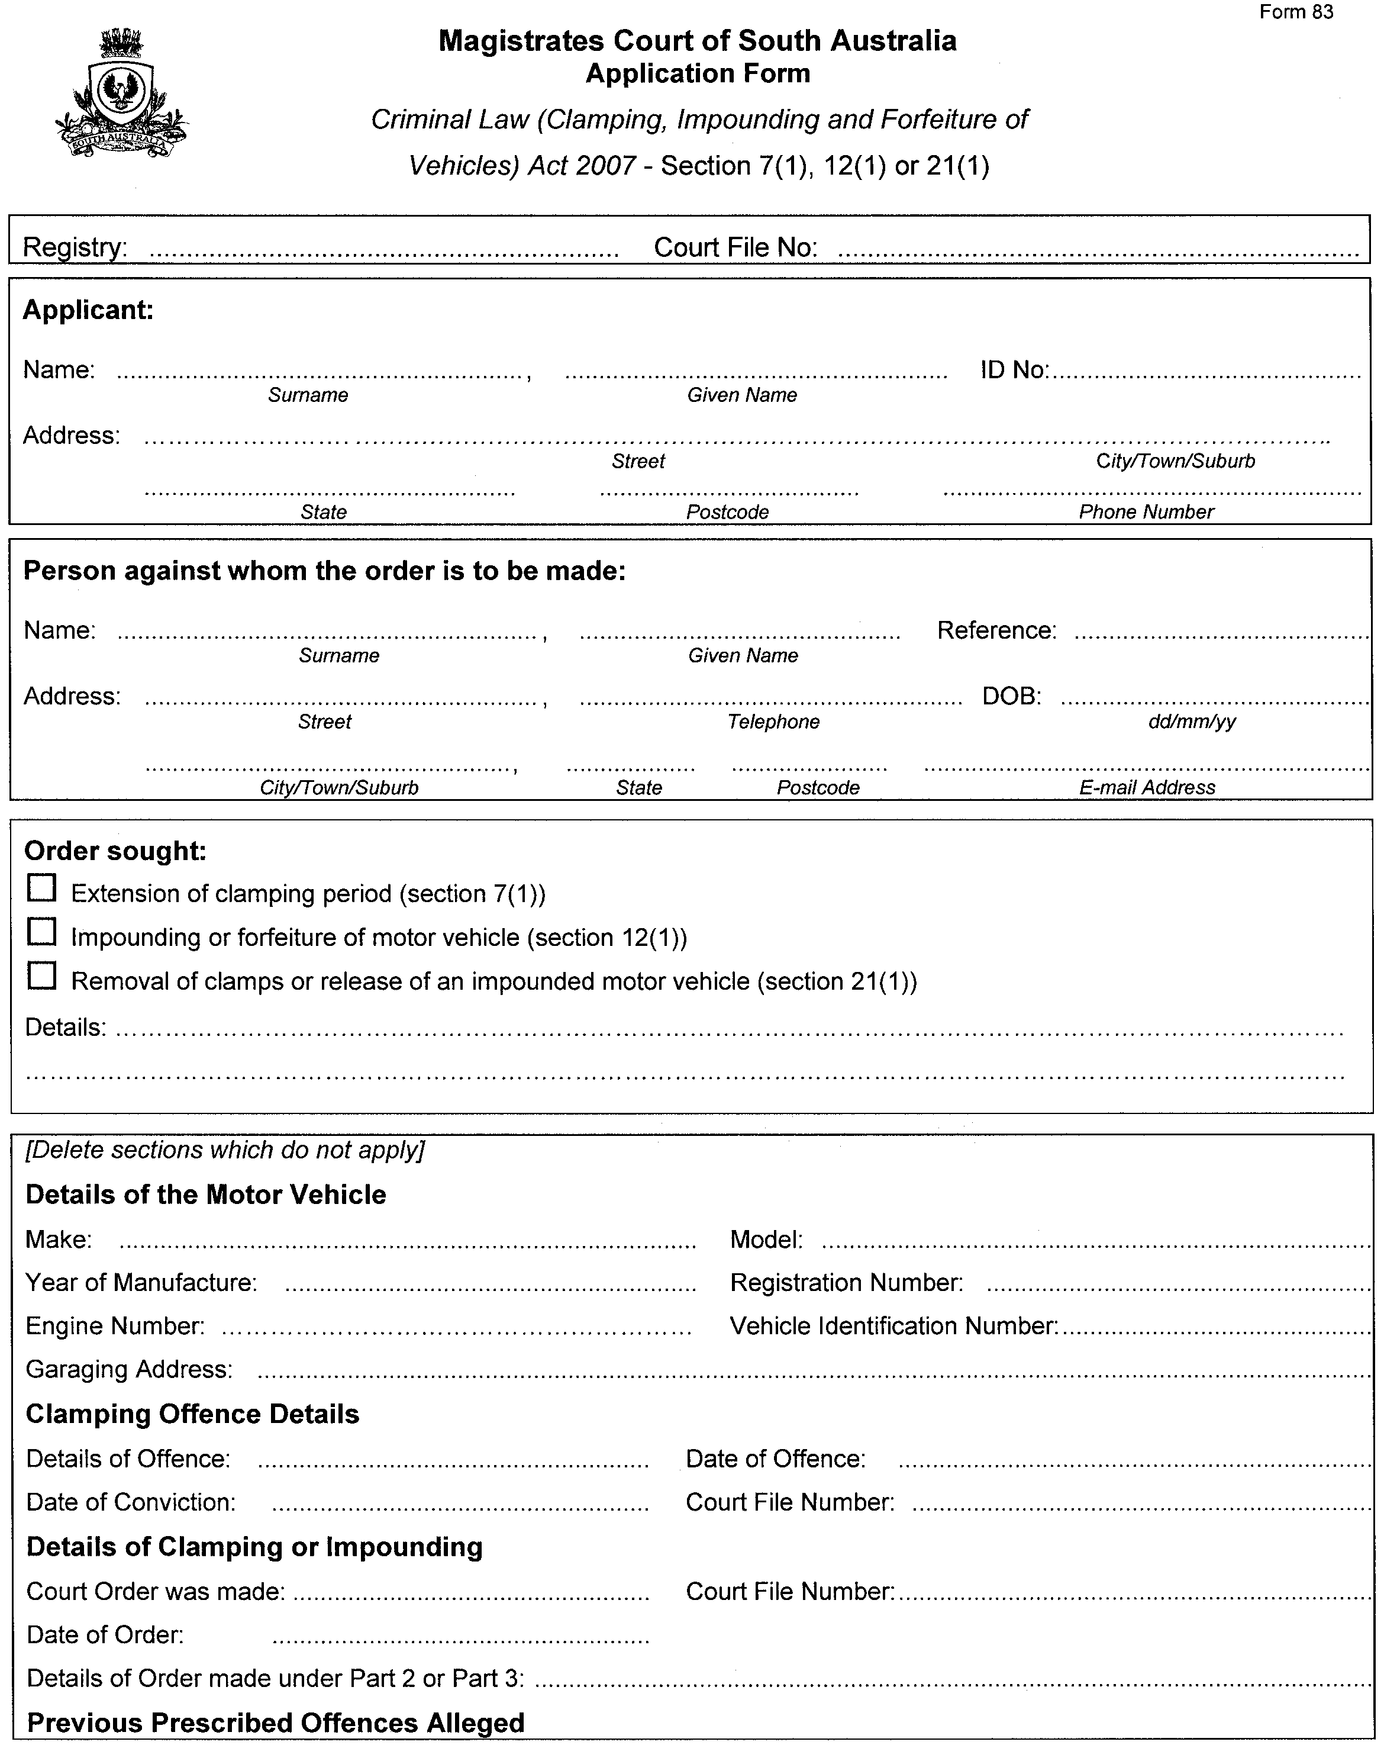
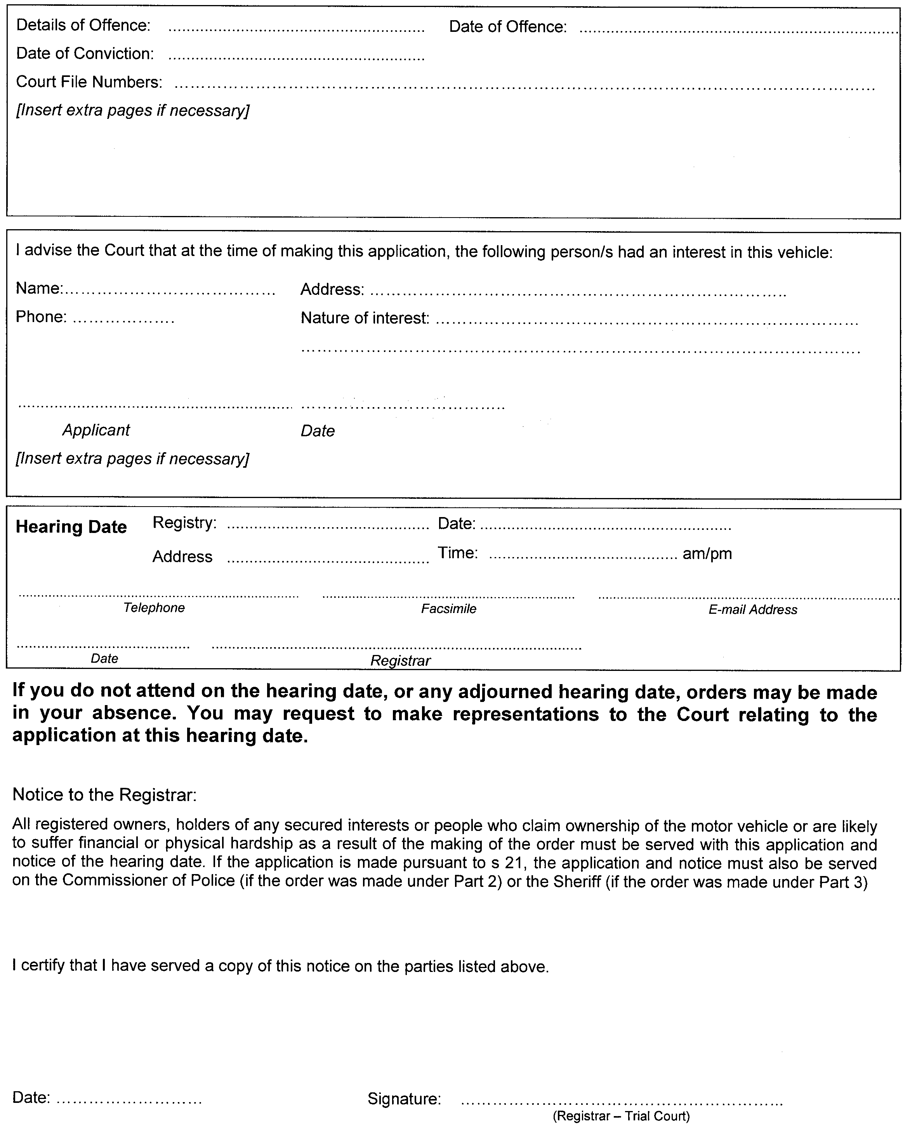
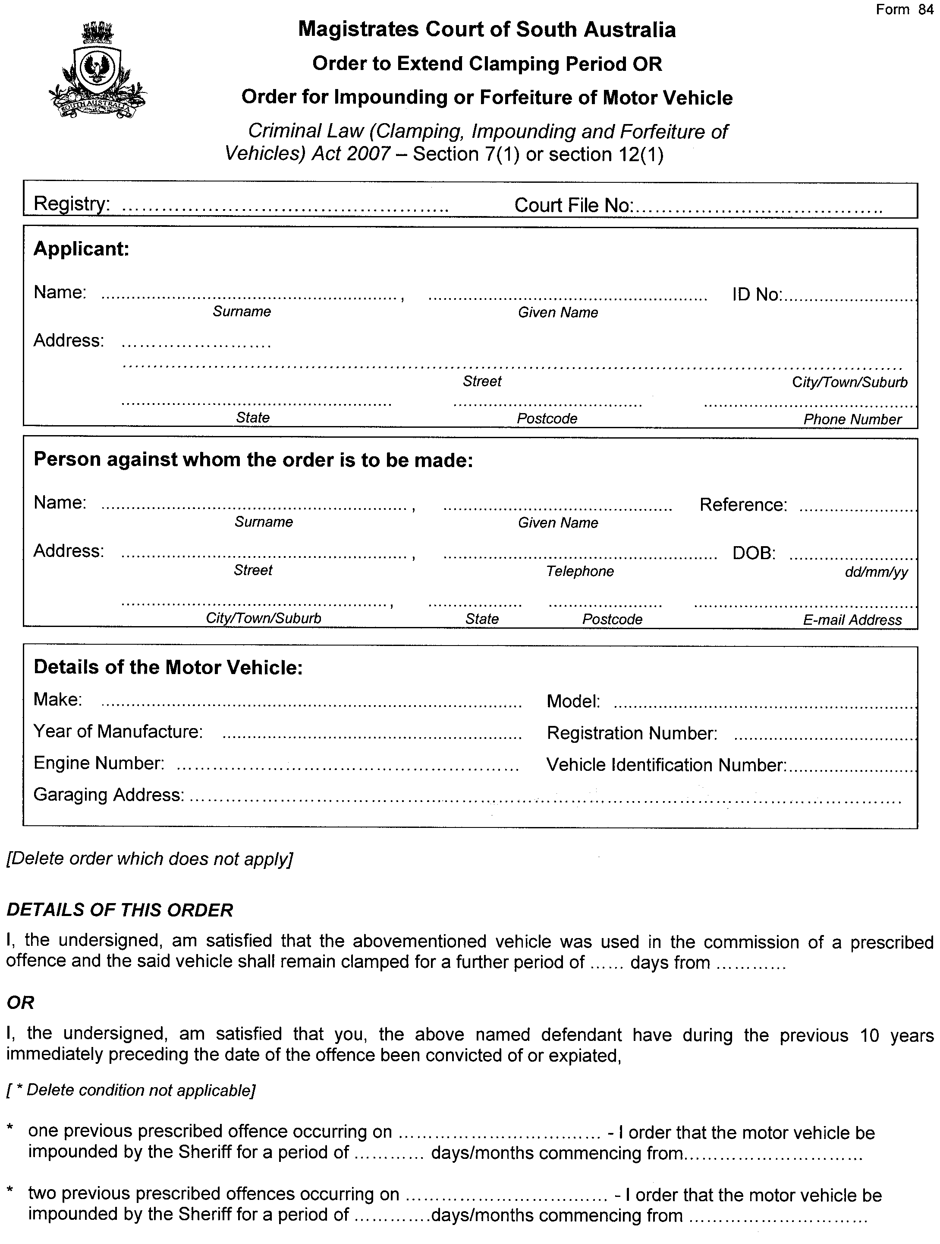
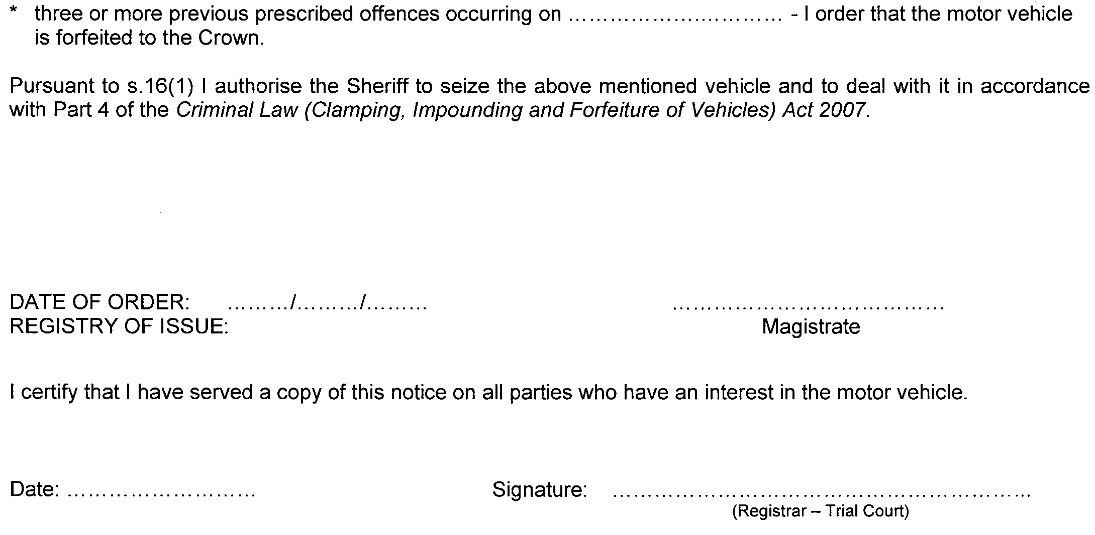
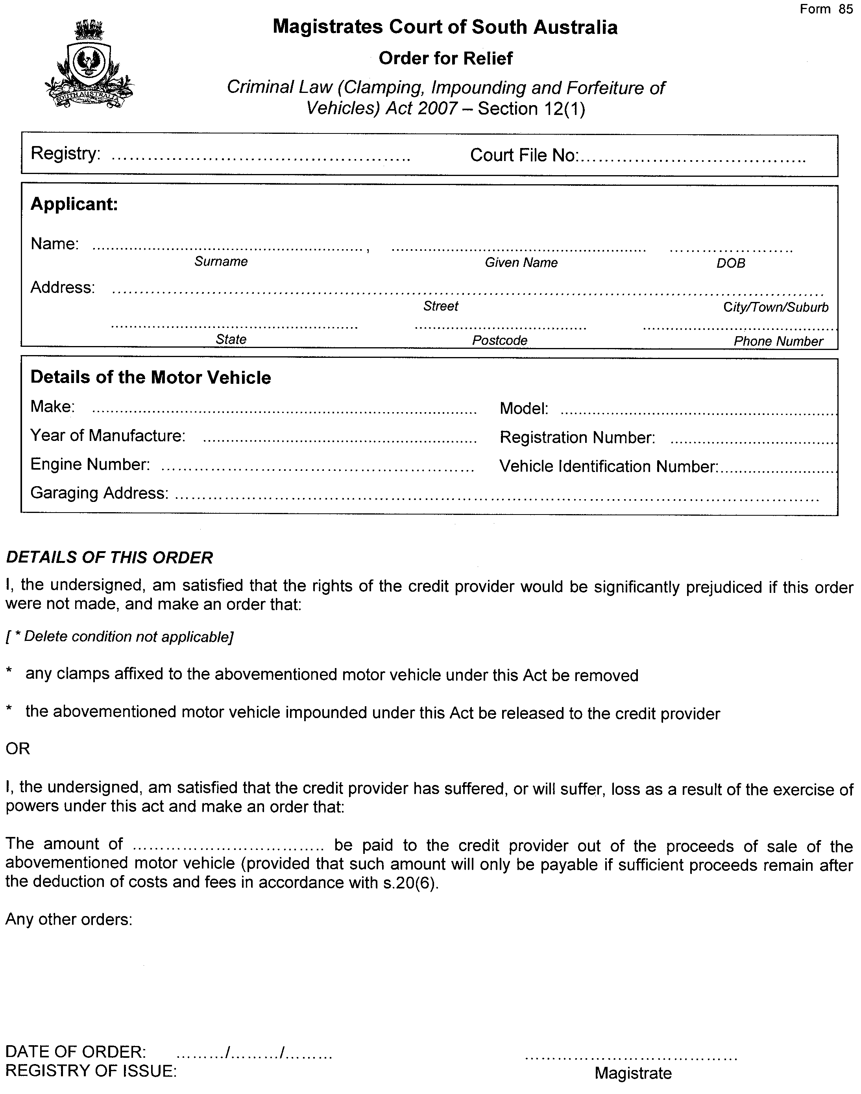
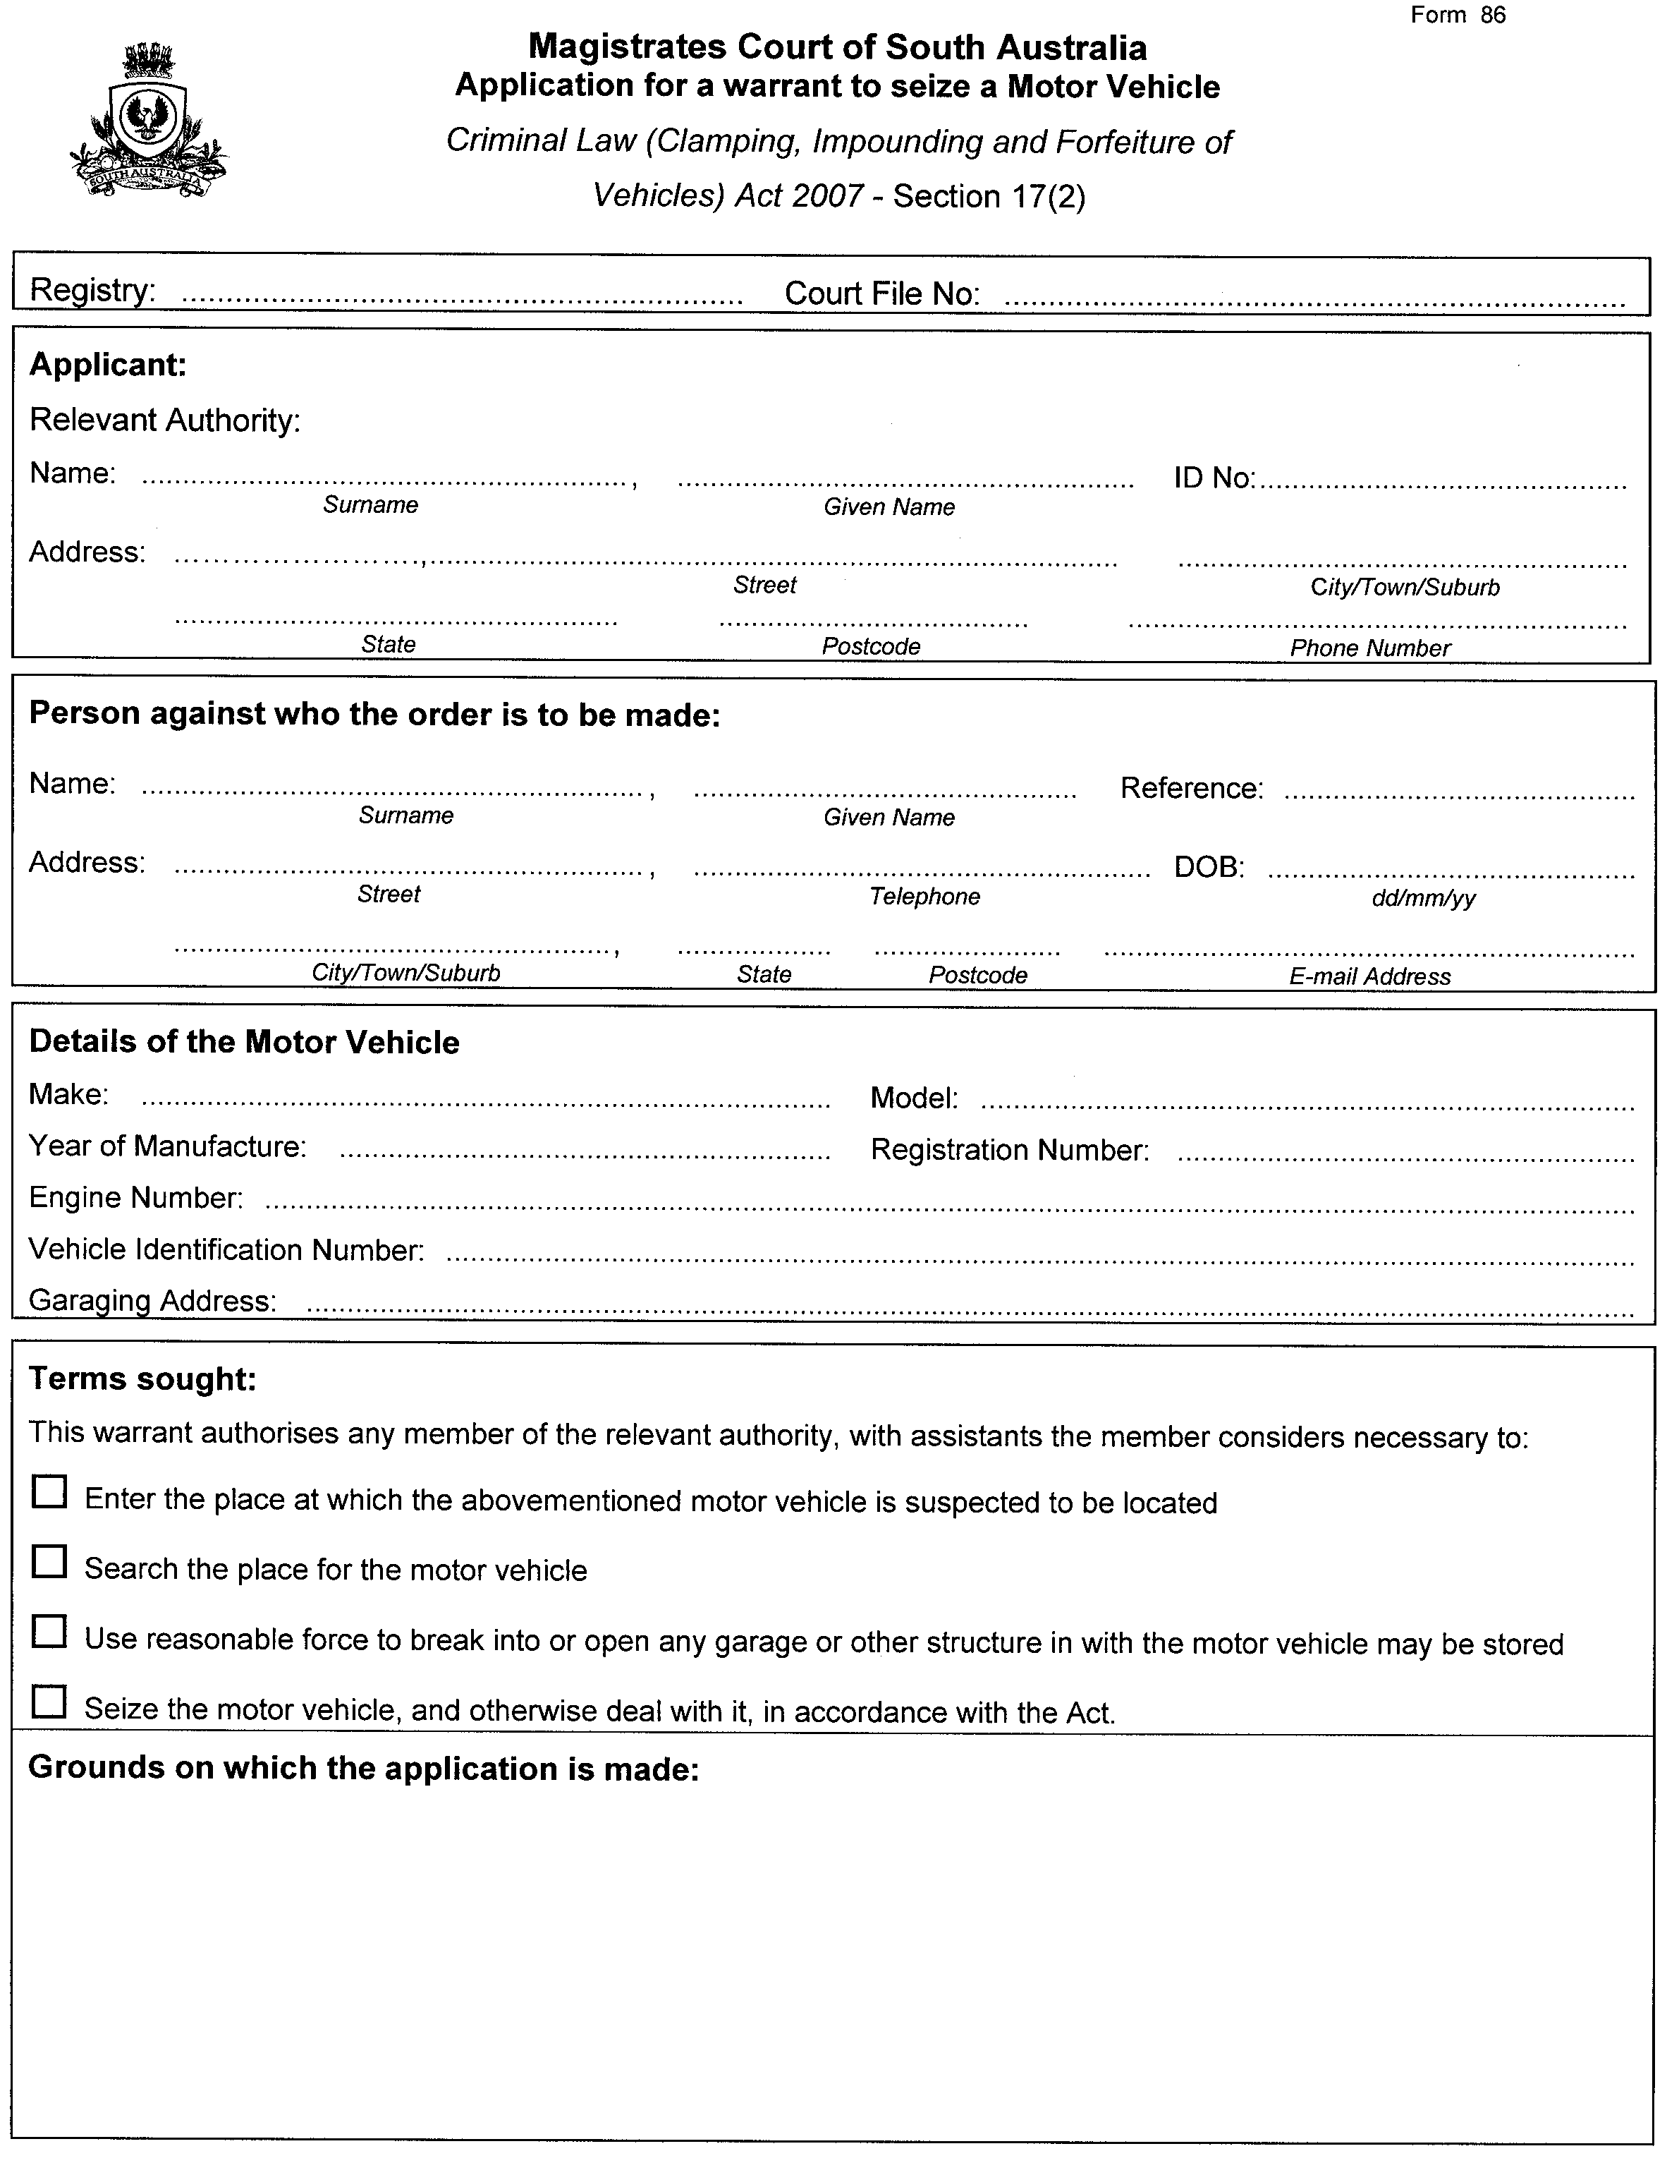
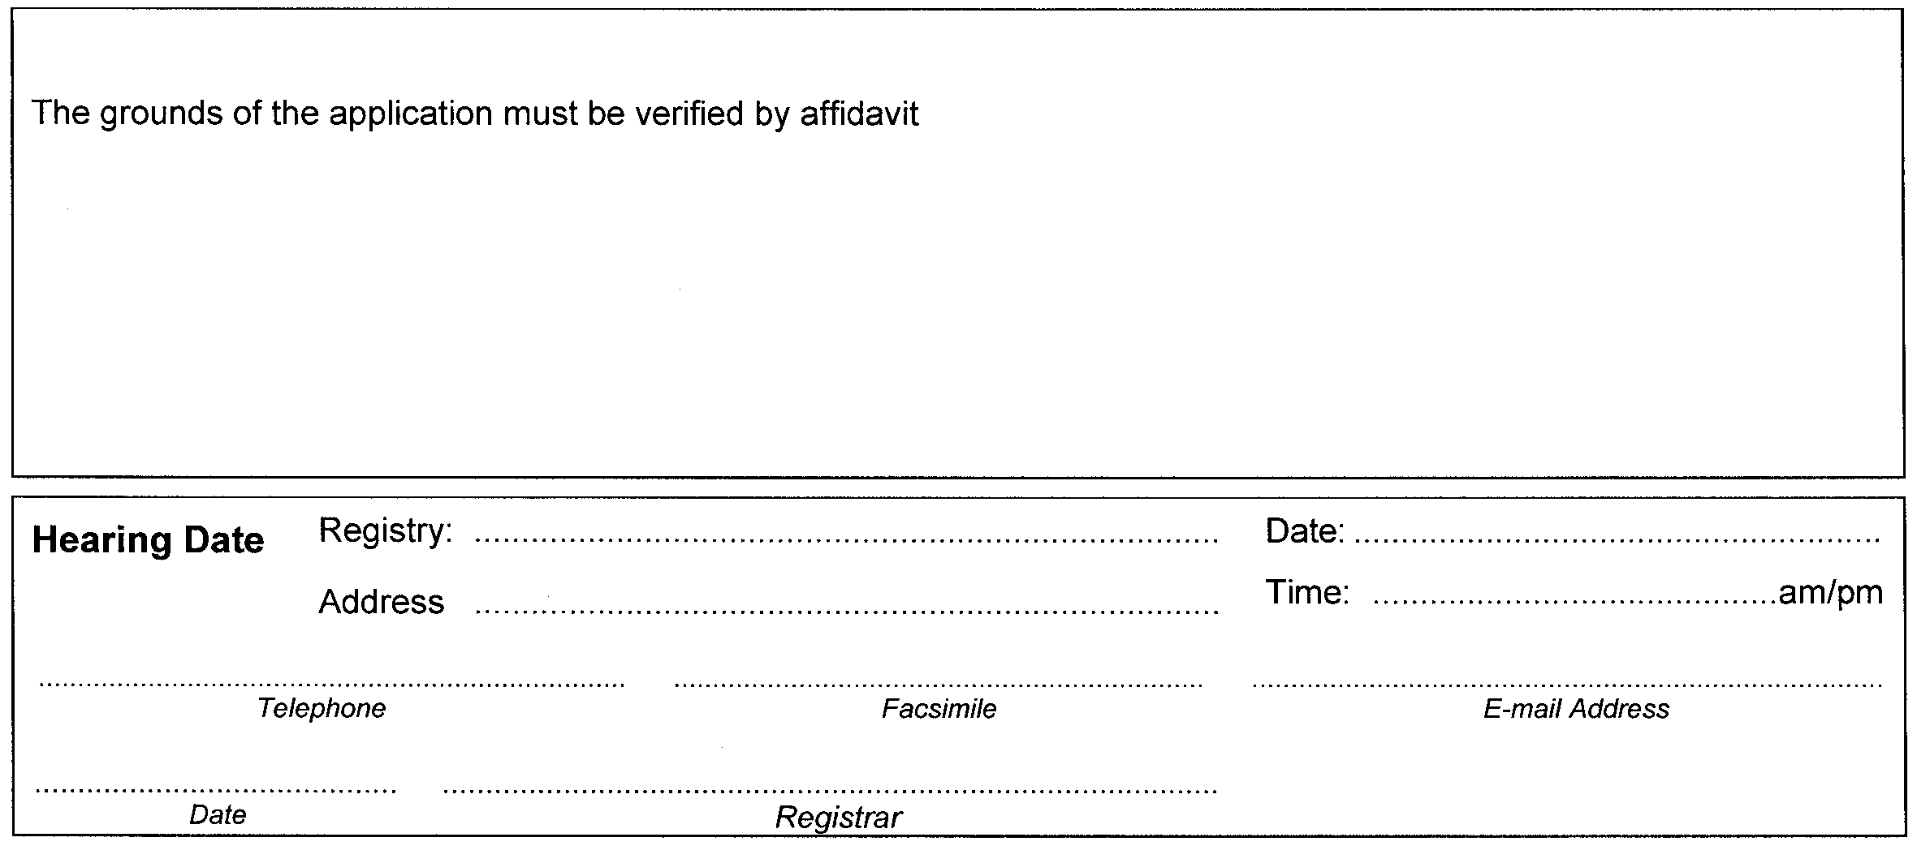

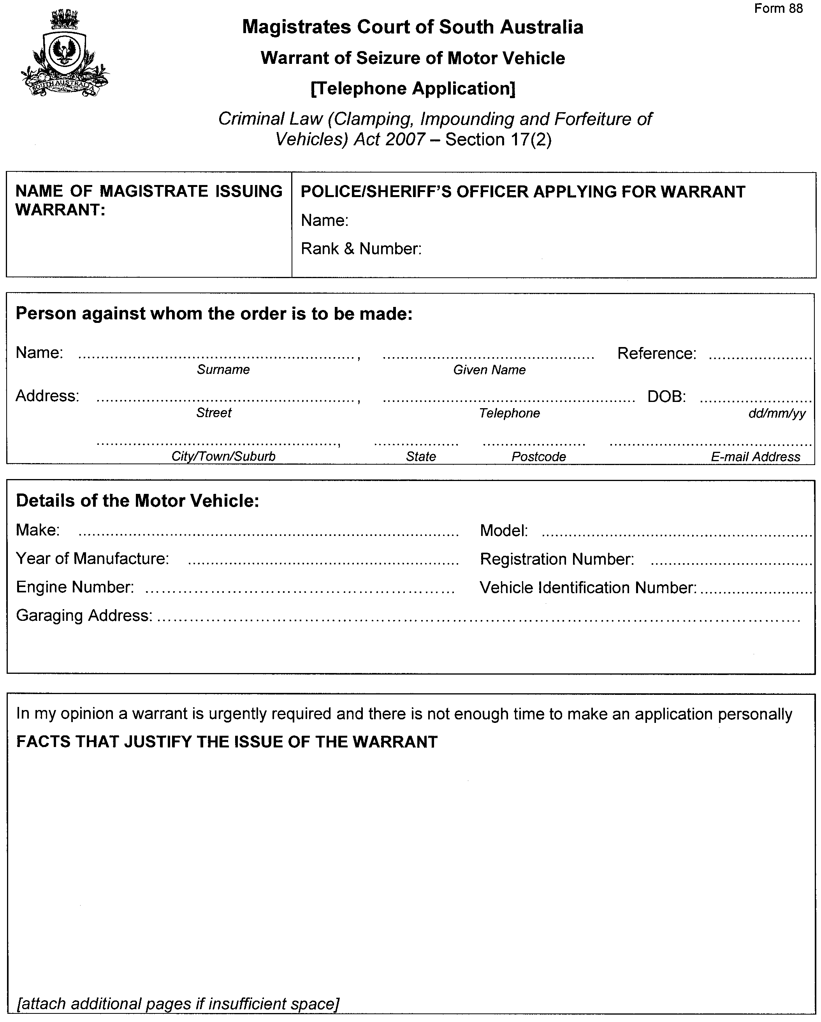
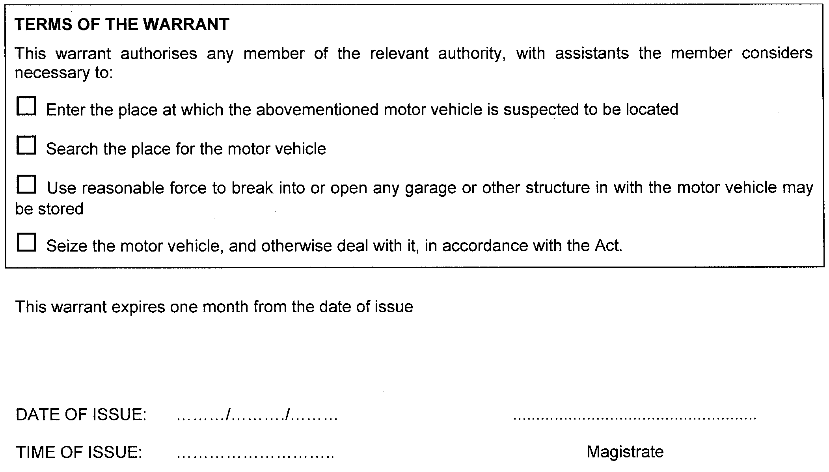
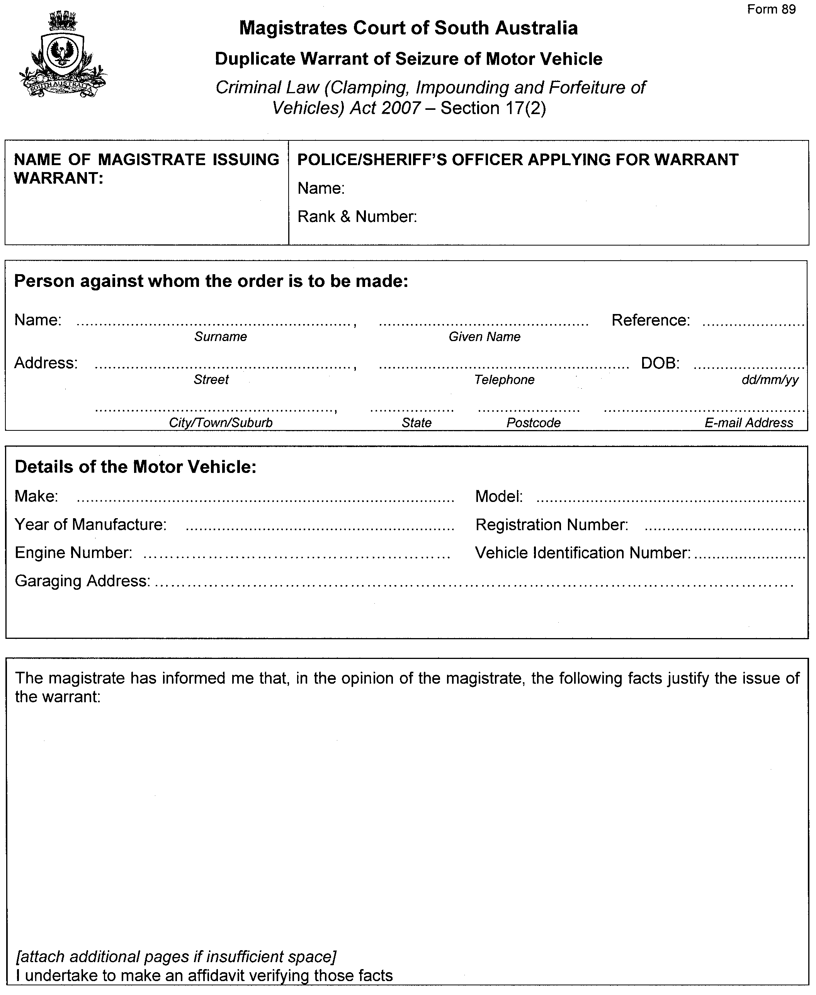
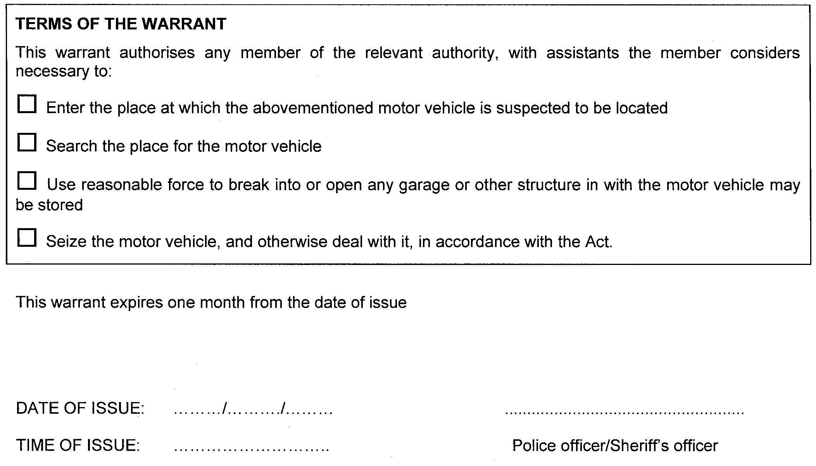
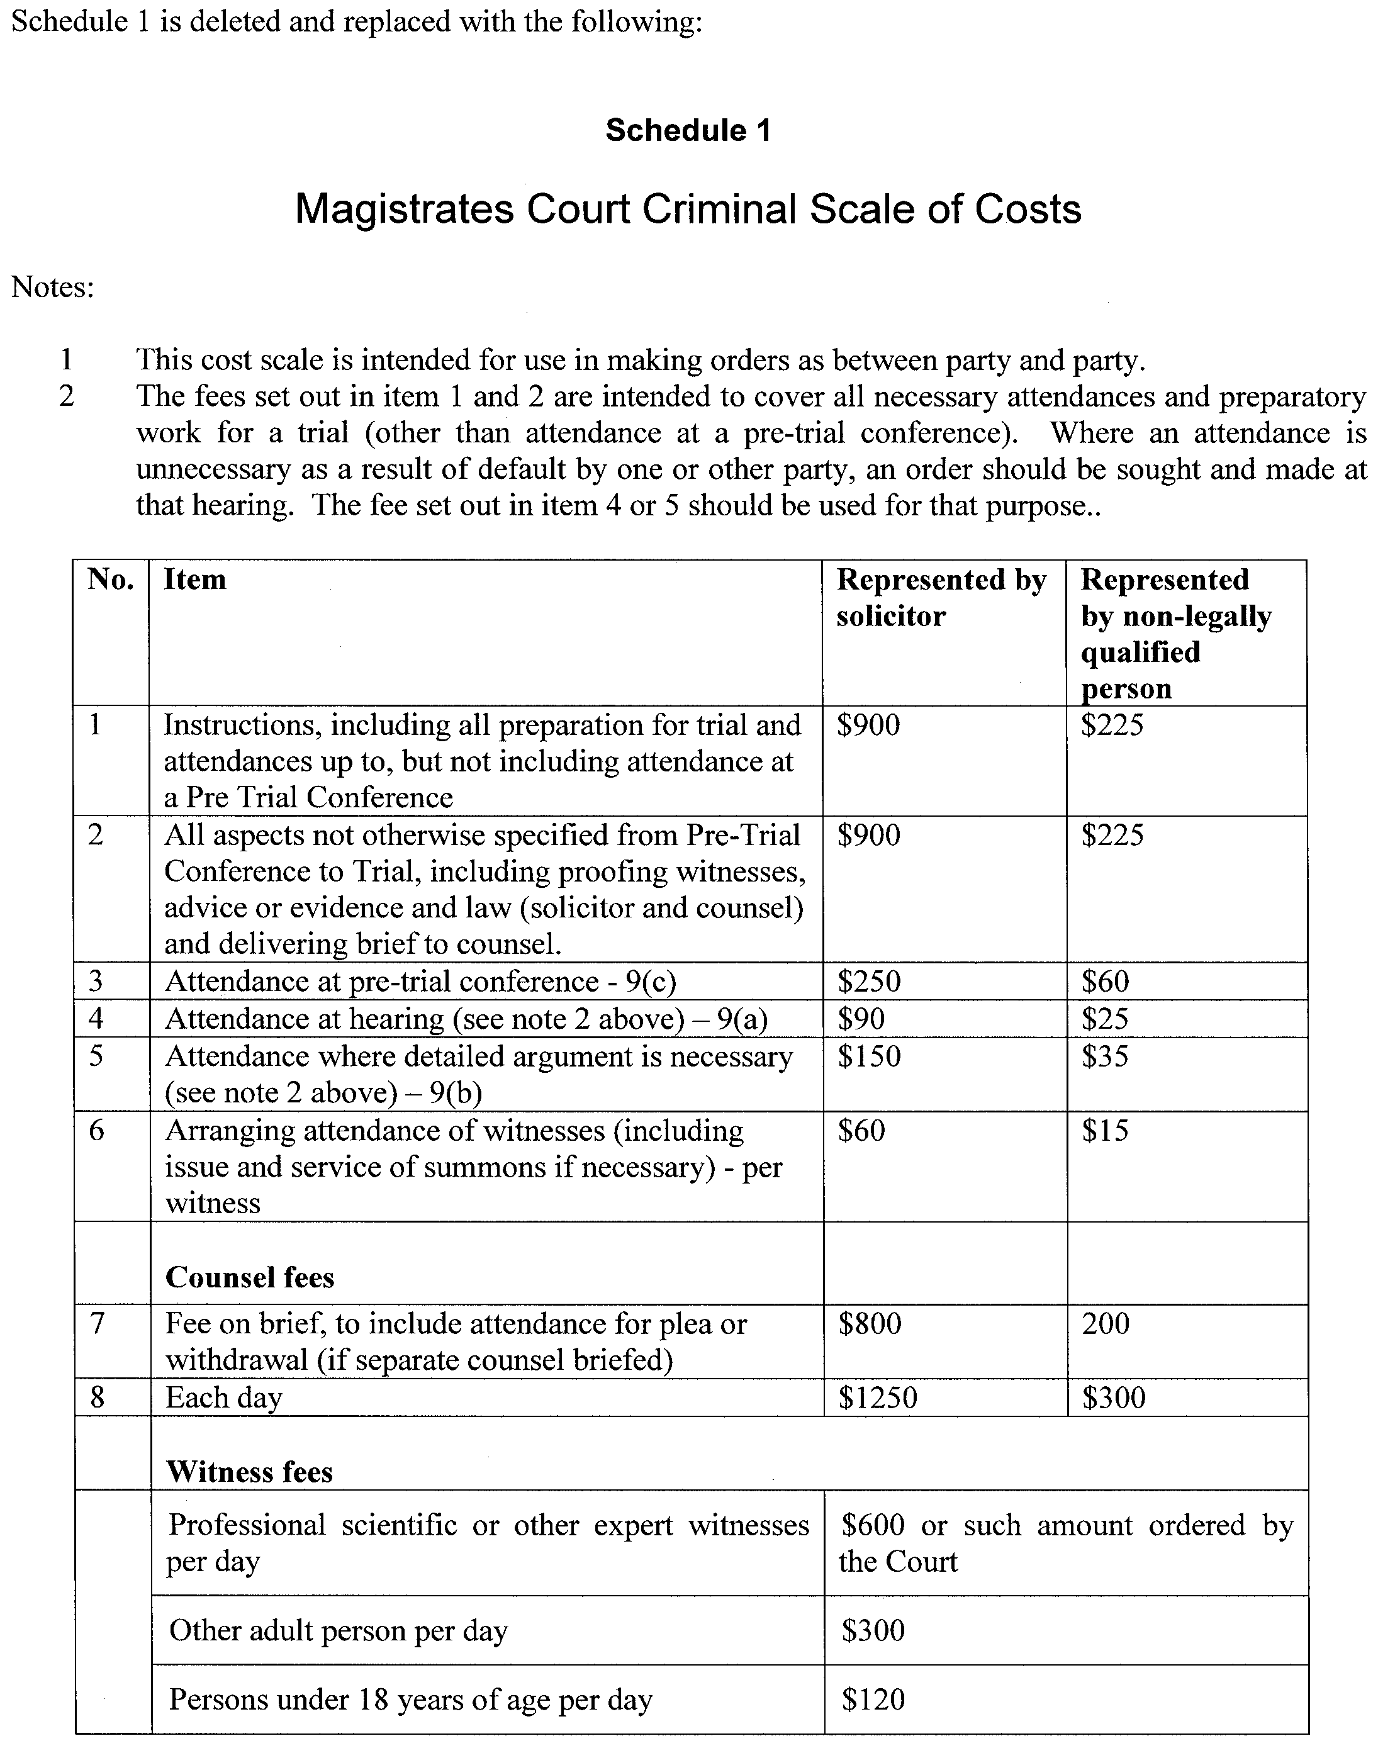
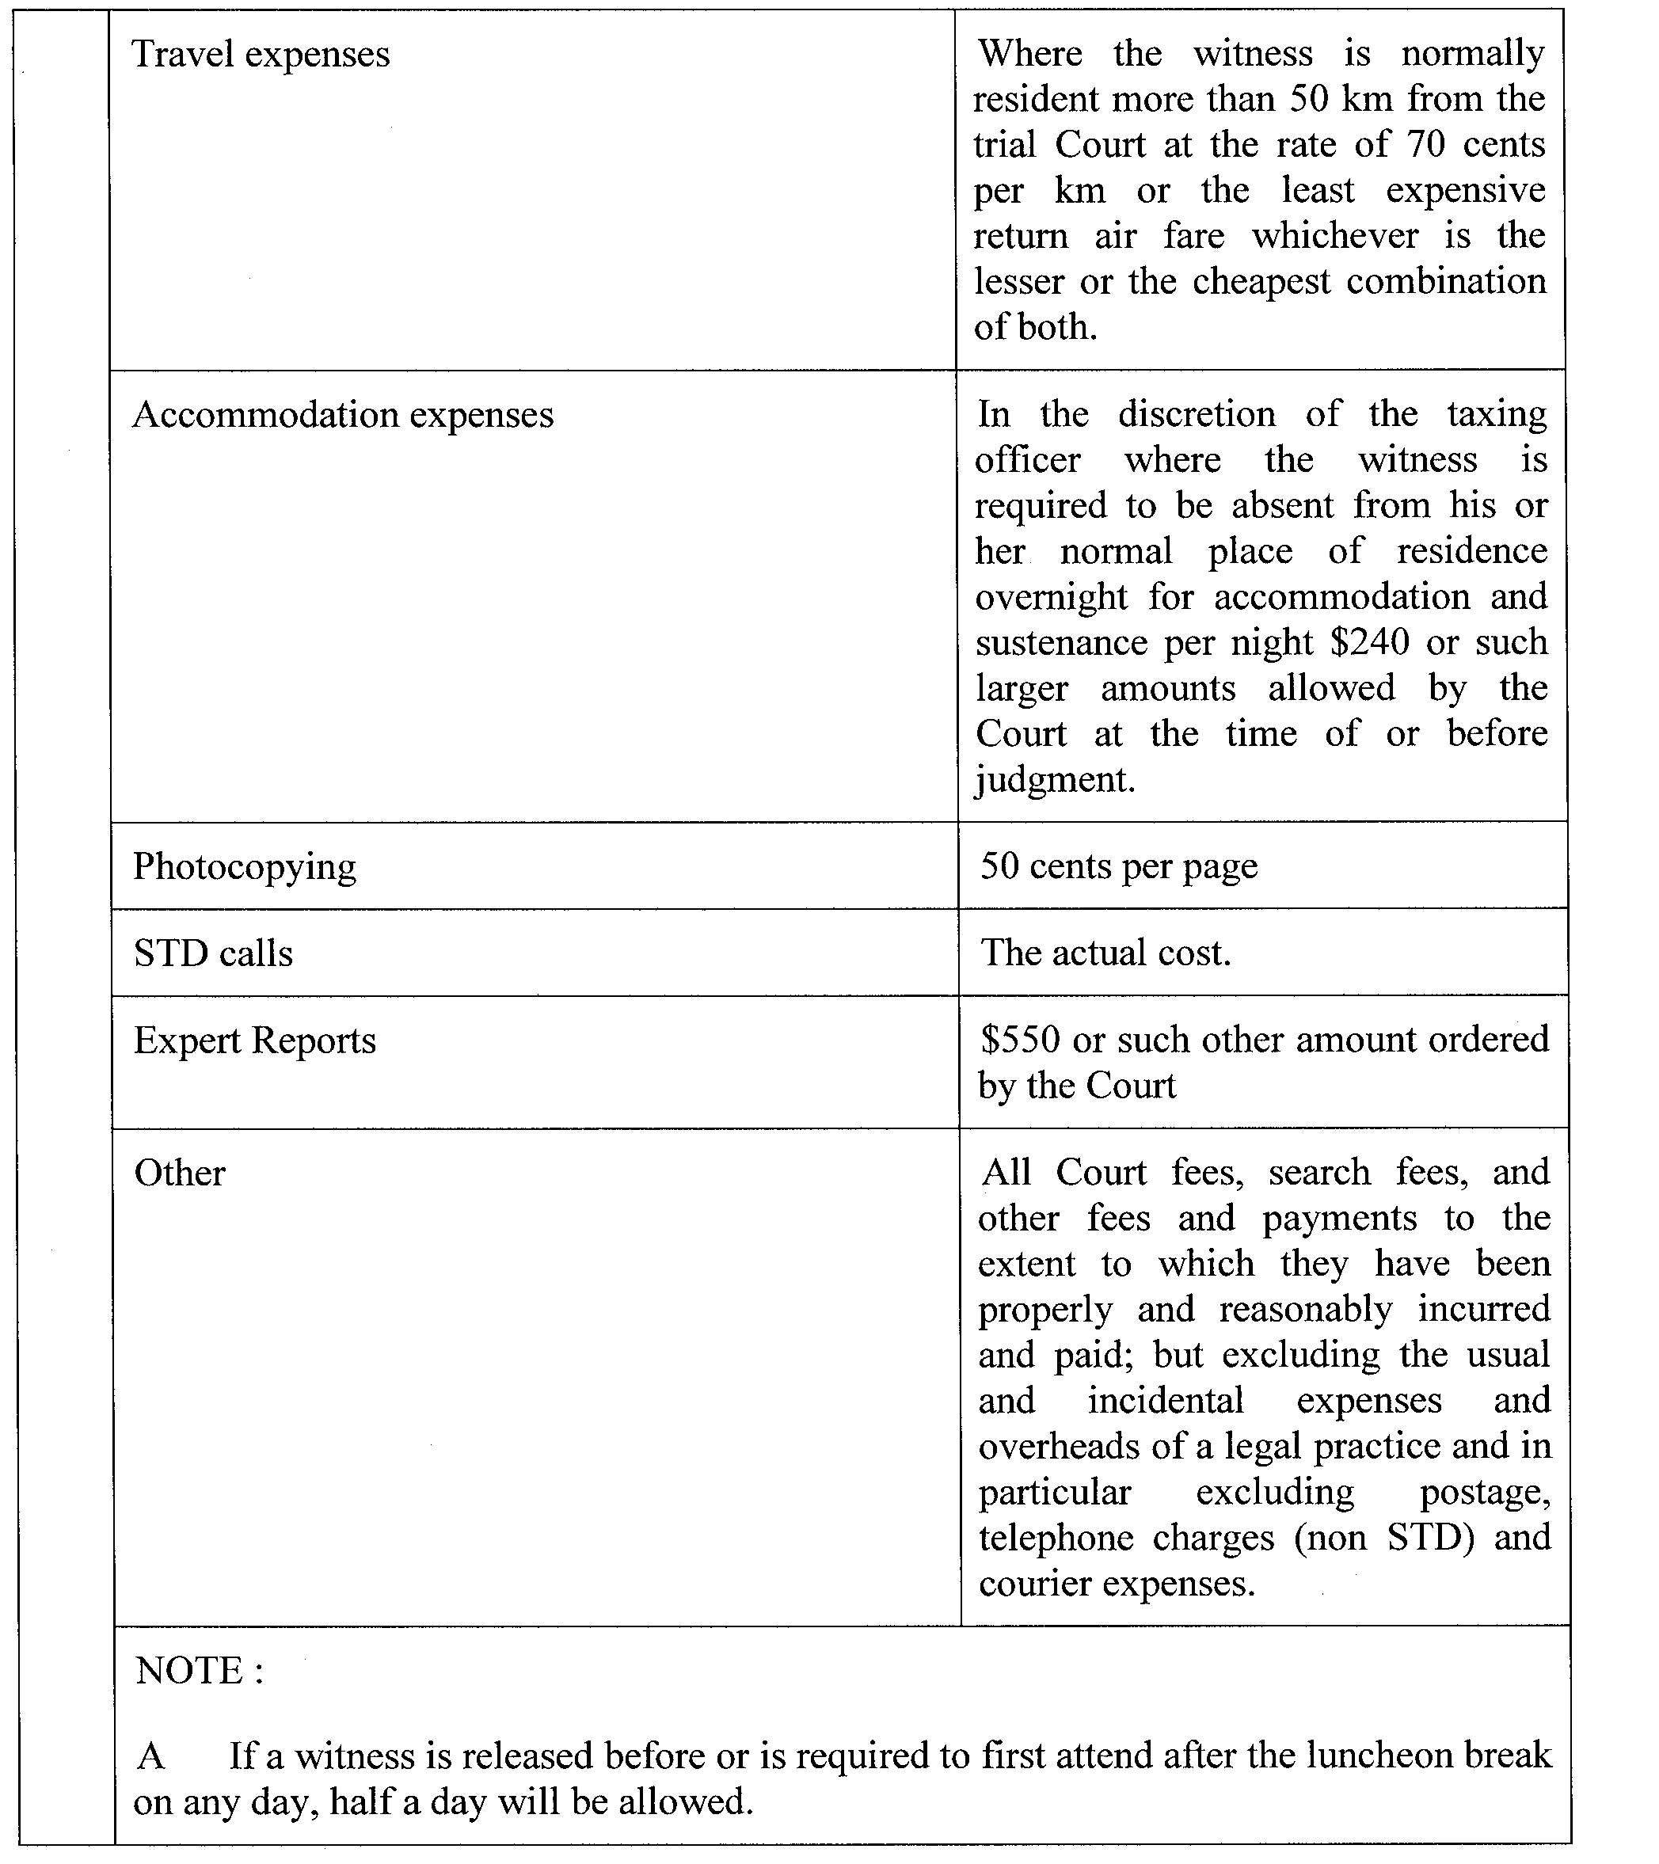
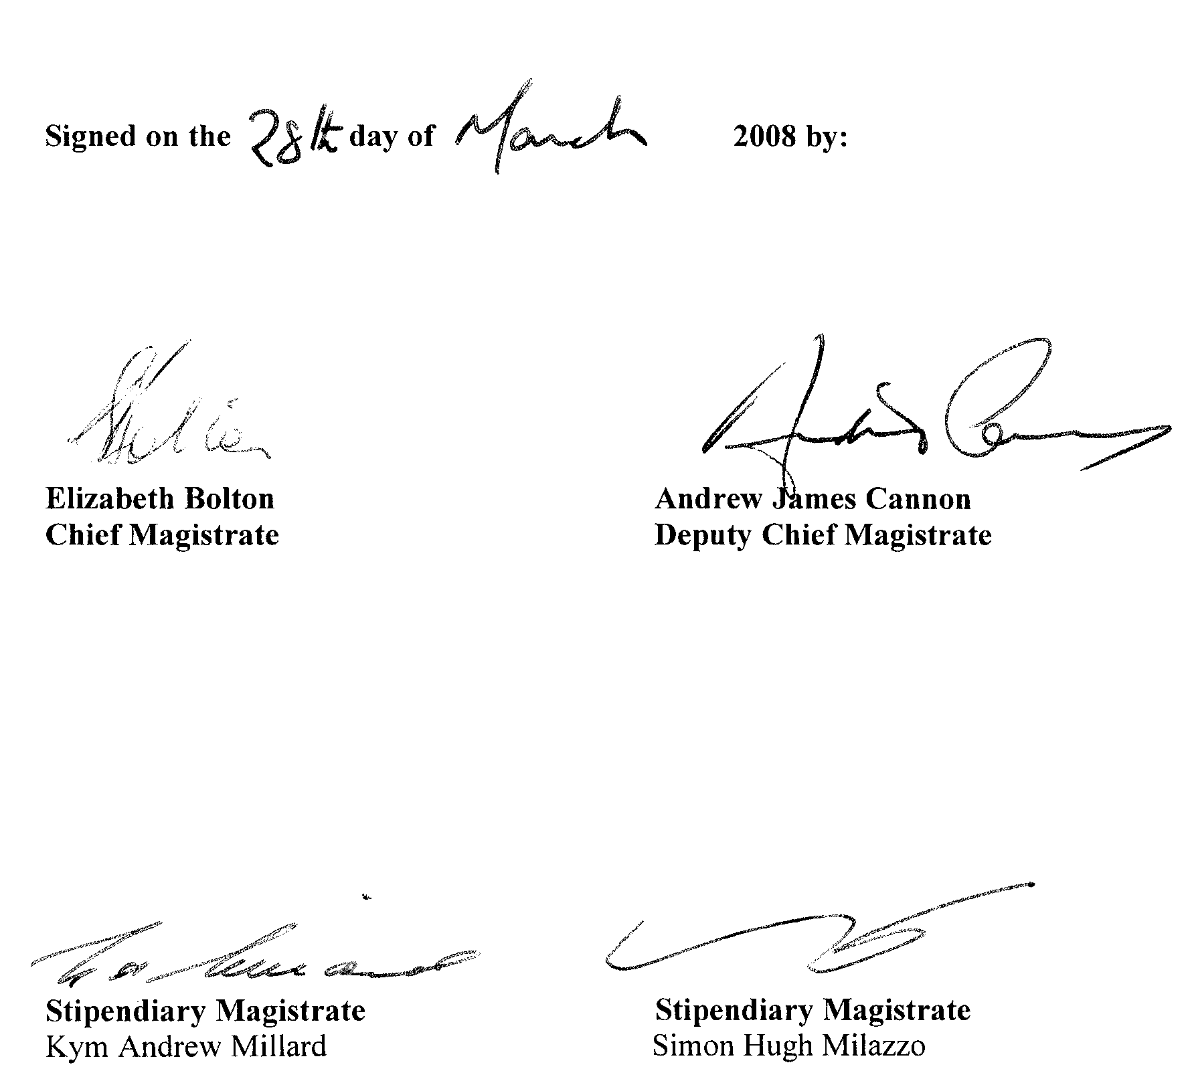

THE MAGISTRATES COURT OF SOUTH AUSTRALIA
Amendment No. 29 of Magistrates Court (Civil)
Rules 1992
PURSUANT to section 49 of the Magistrates Court Act 1991 and all other enabling powers, we the undersigned do make the following amendments to the Magistrates Court (Civil) Rules 1992:
The amendments to the Third Schedule come into effect on 30 June 2008 and the other amendments are effective upon gazettal.
Rule 126 (1) is deleted and replaced with the following:
126. (1) If a judgment debtor has no assets available against which execution could be levied, nor other means of satisfying a judgment debt, and an order for payment which does not impose an unreasonable obligation on the judgment debtor will not within 12 months satisfy the judgment debtor’s current unpaid judgment debts in the Court
record on which there has been an enforcement process in the last
12 months, the Court may declare that the judgment debtor is a chronic debtor.
In the Second Schedule Forms 1A, 1C and 17 each are deleted and replaced with the following:

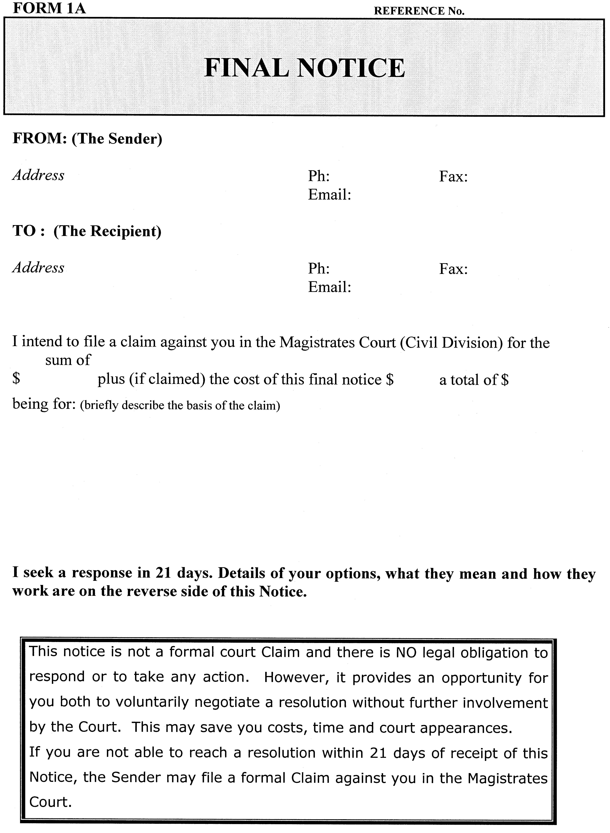
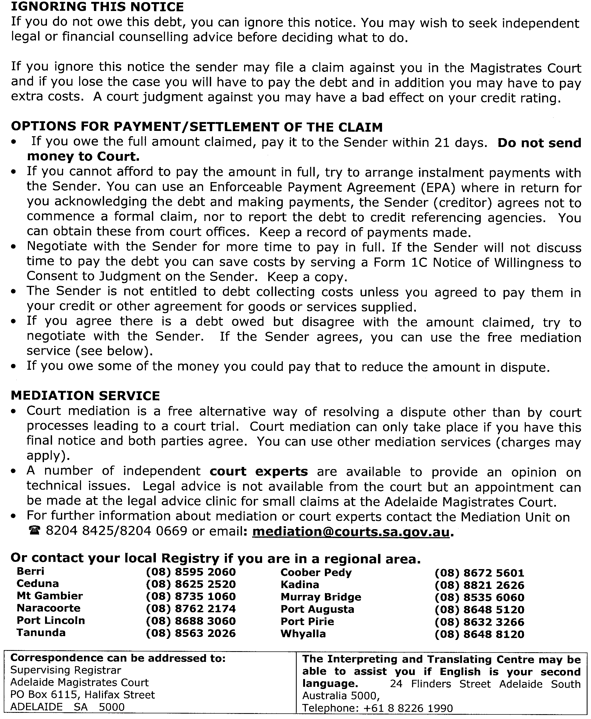
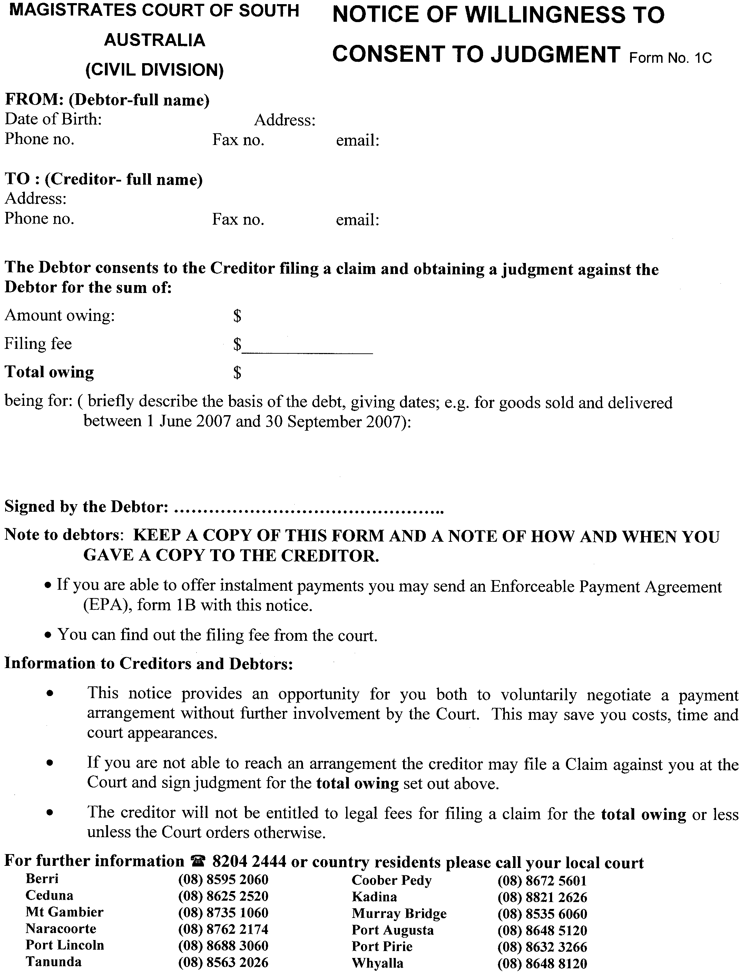
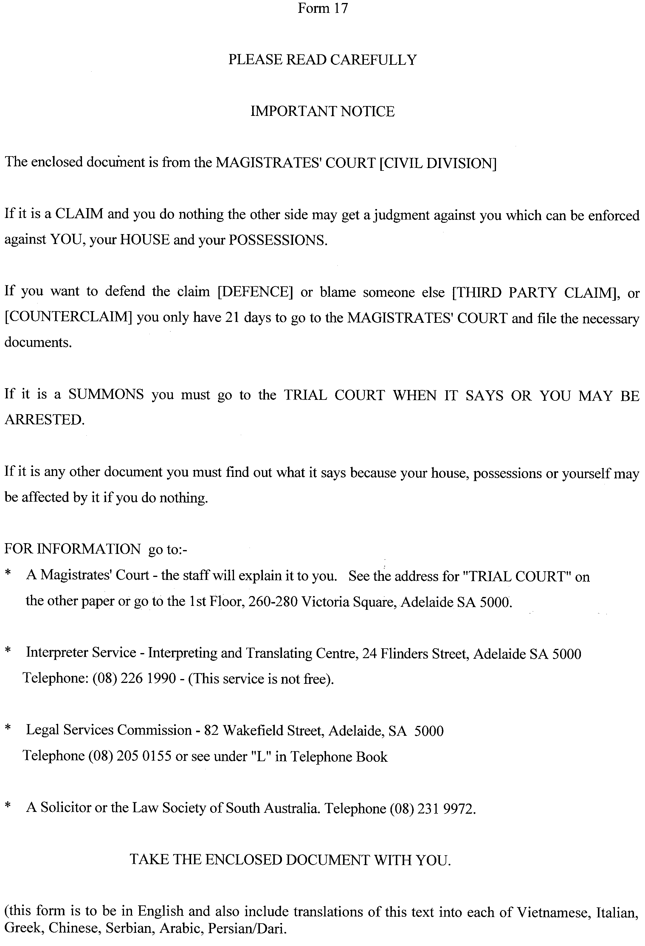
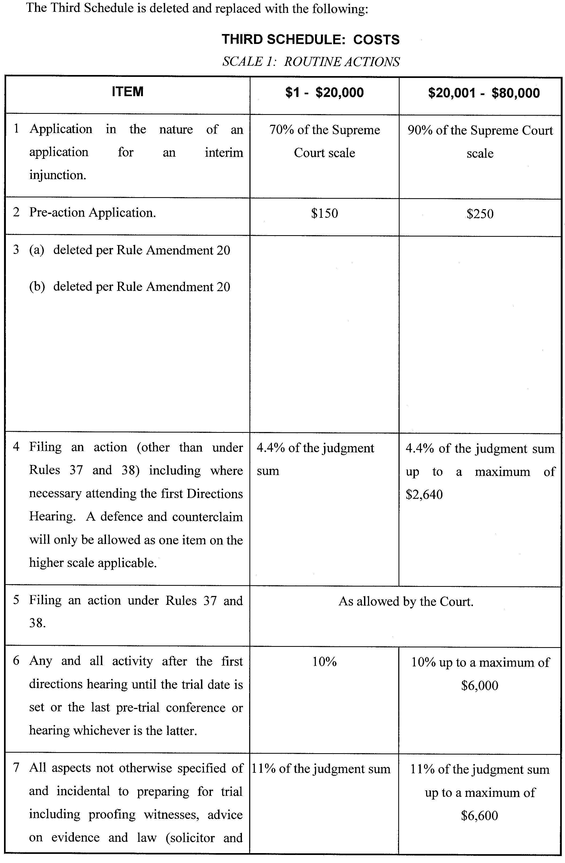
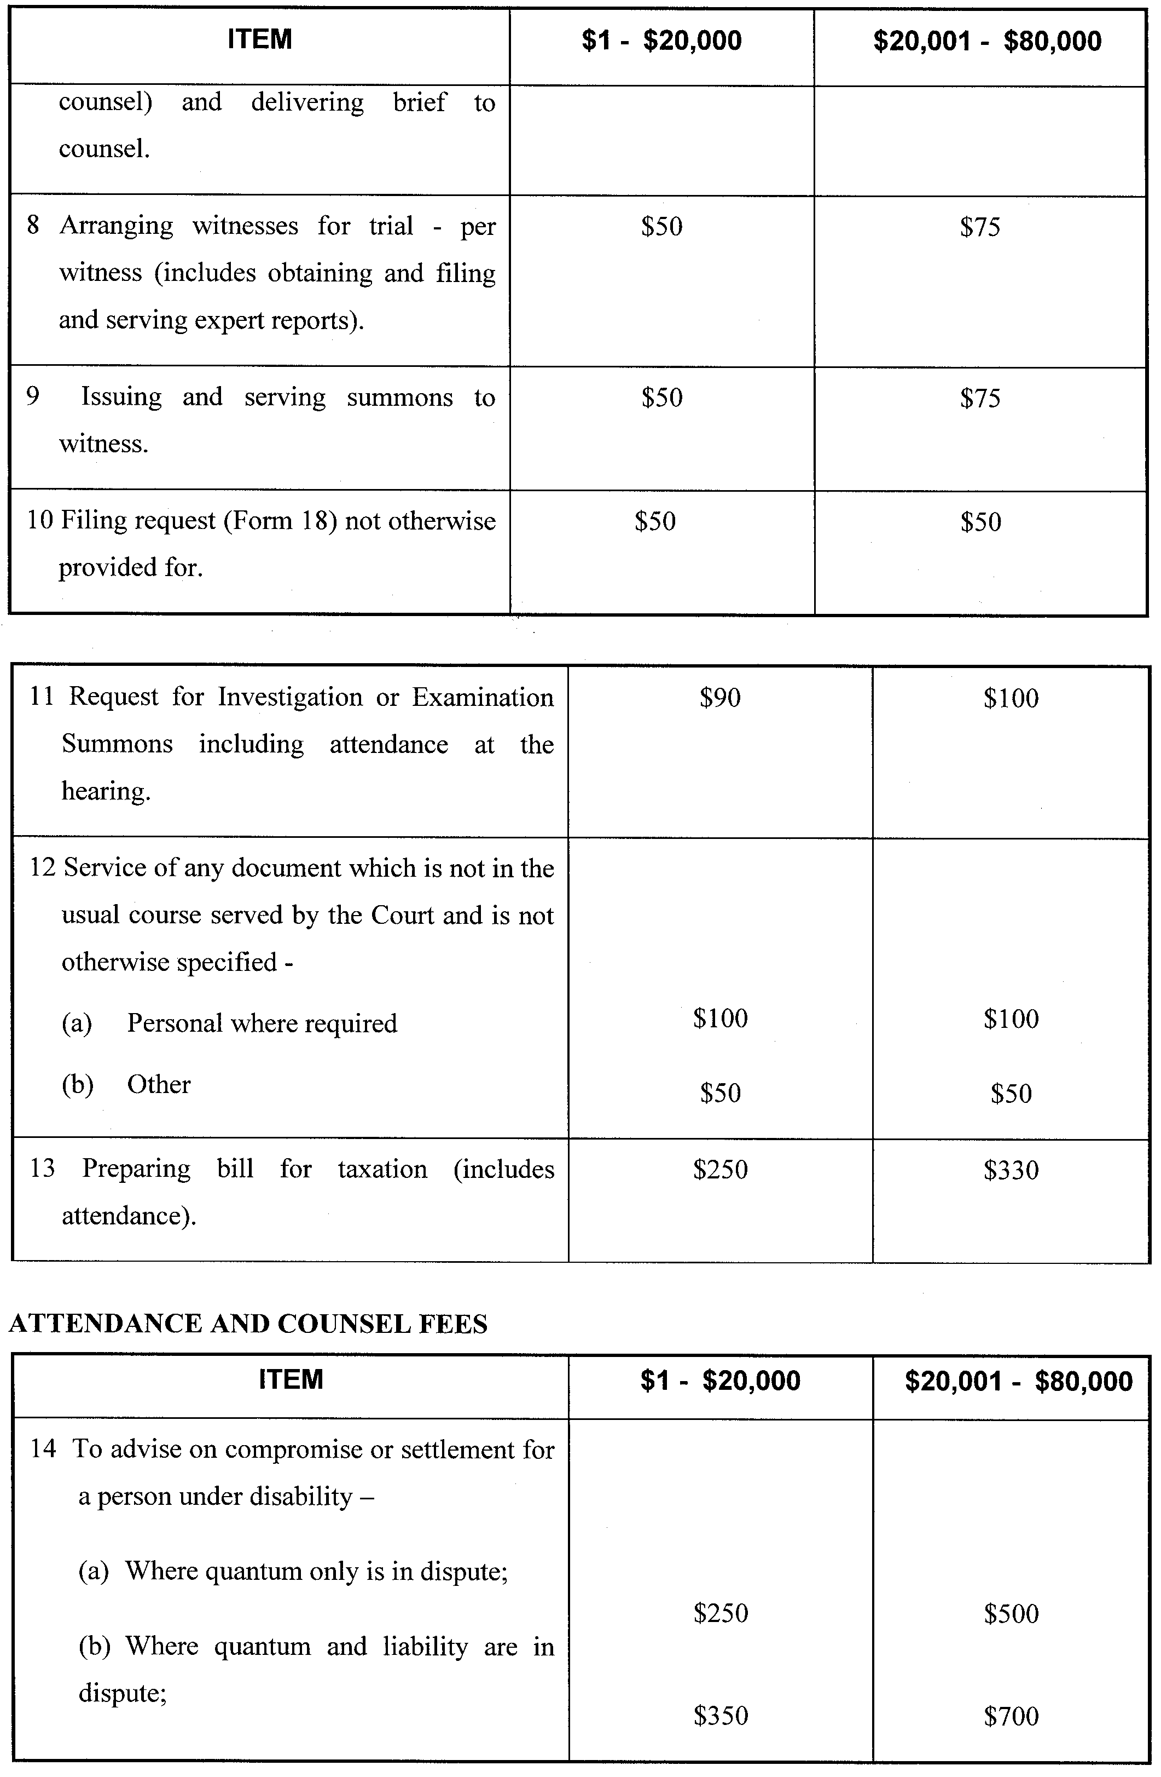
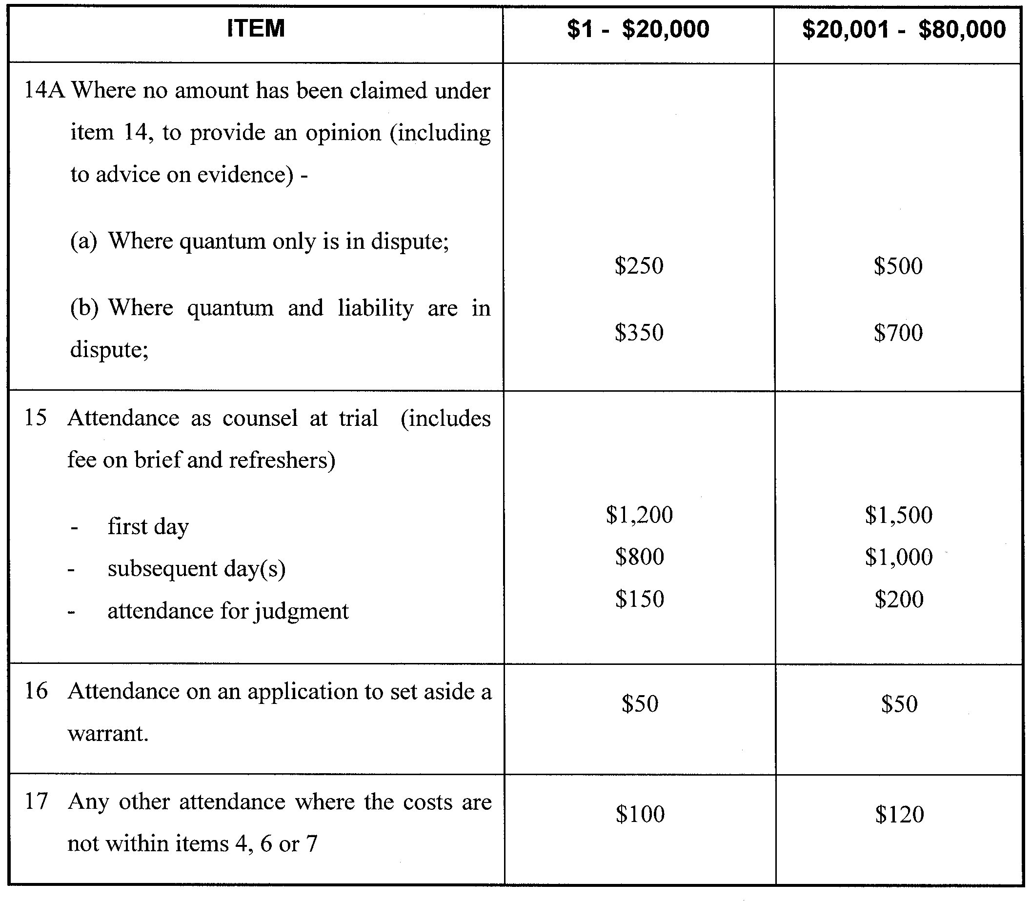
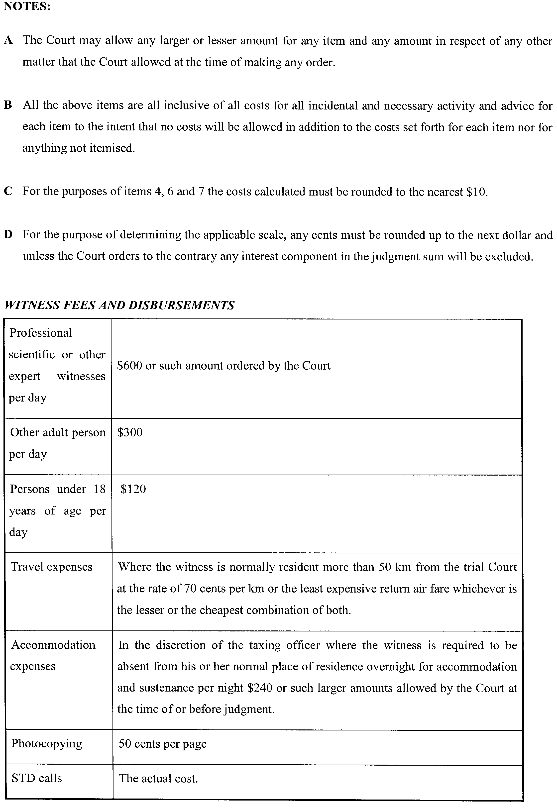
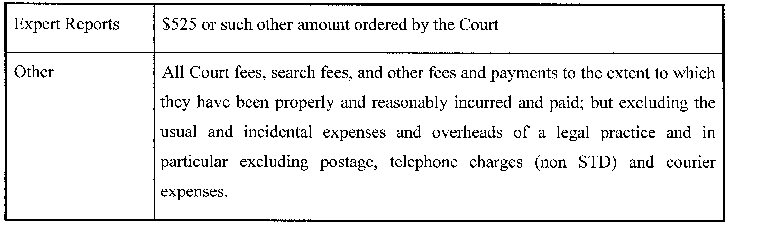
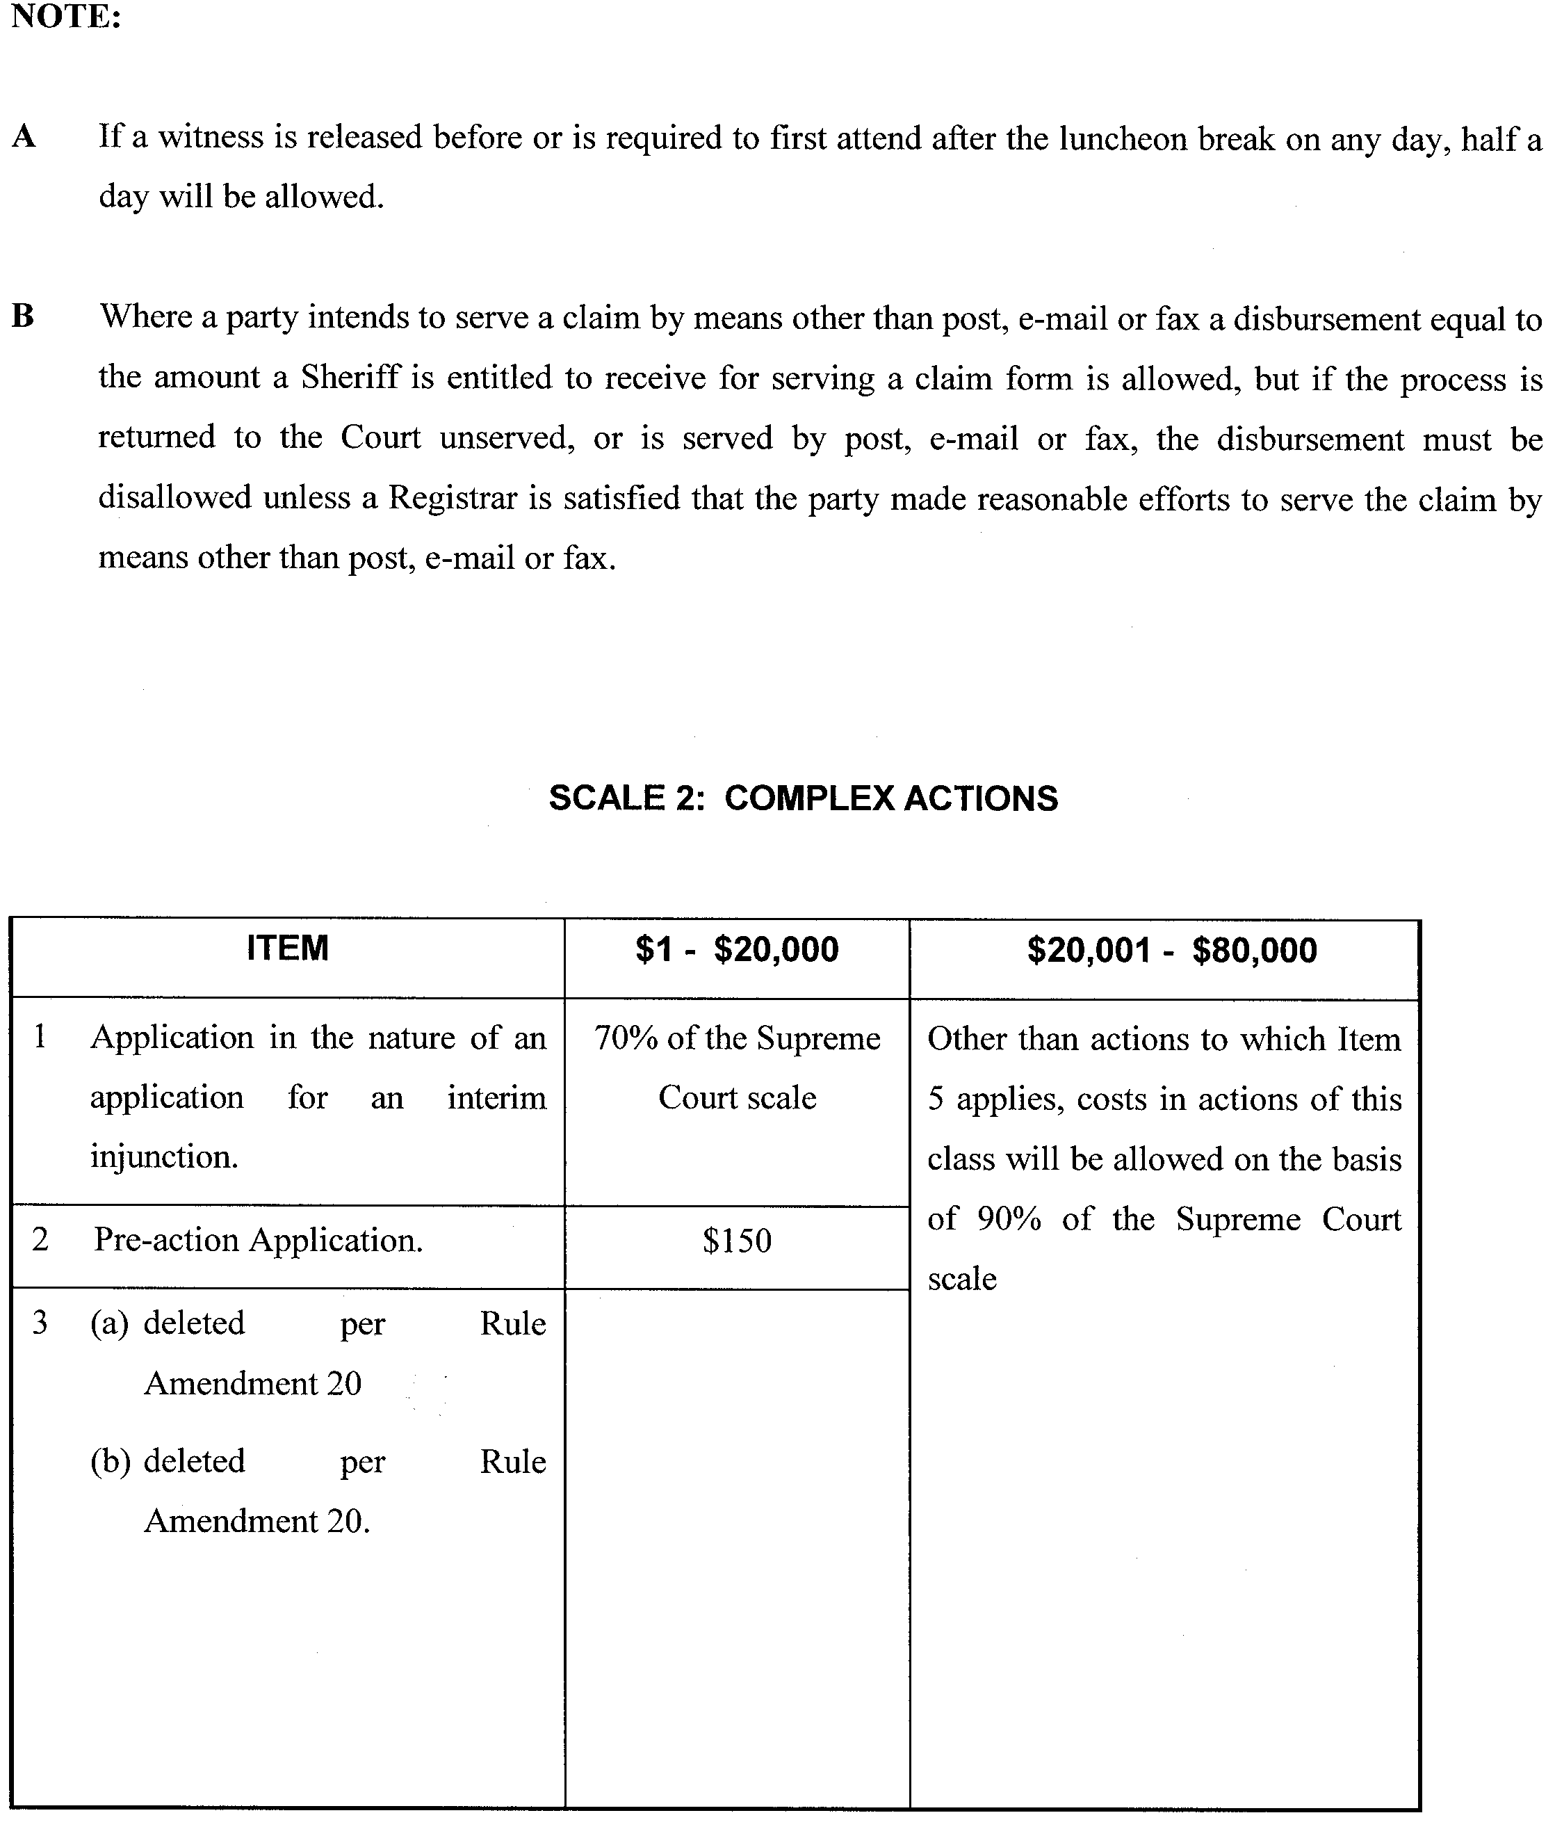
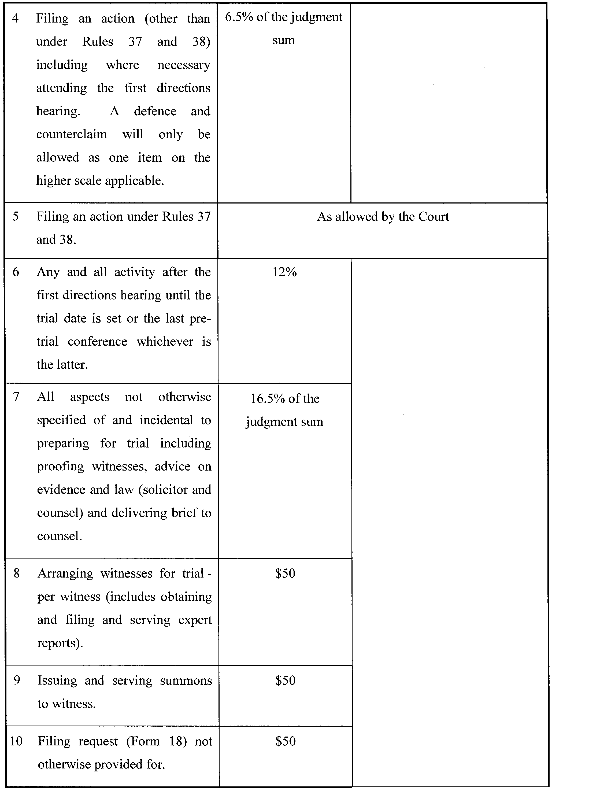
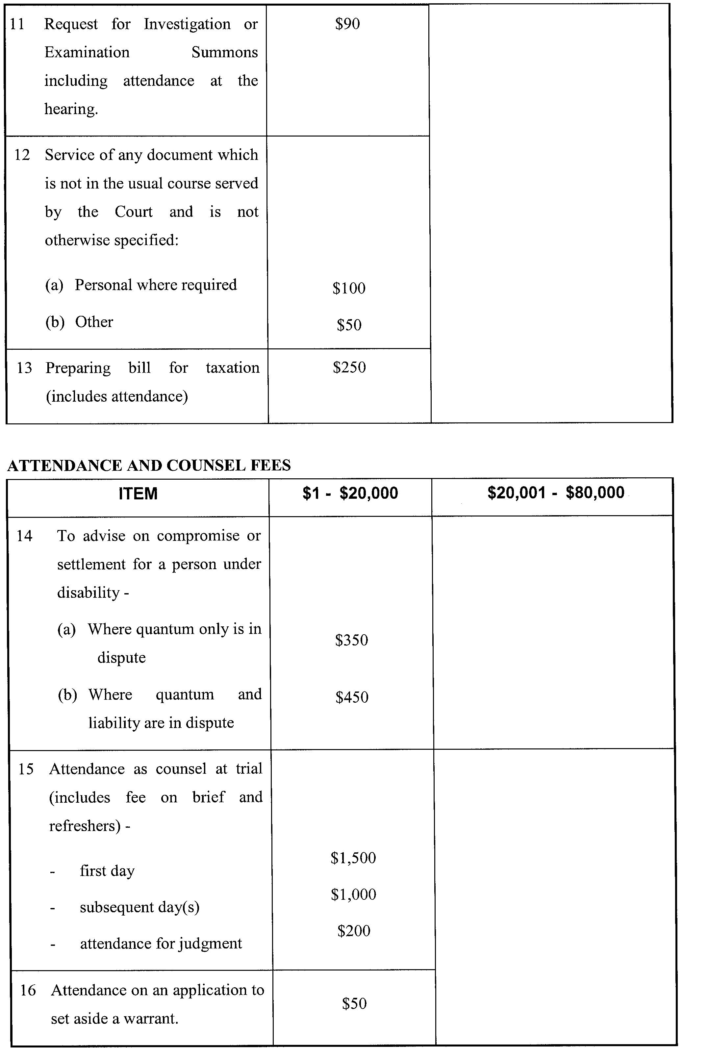
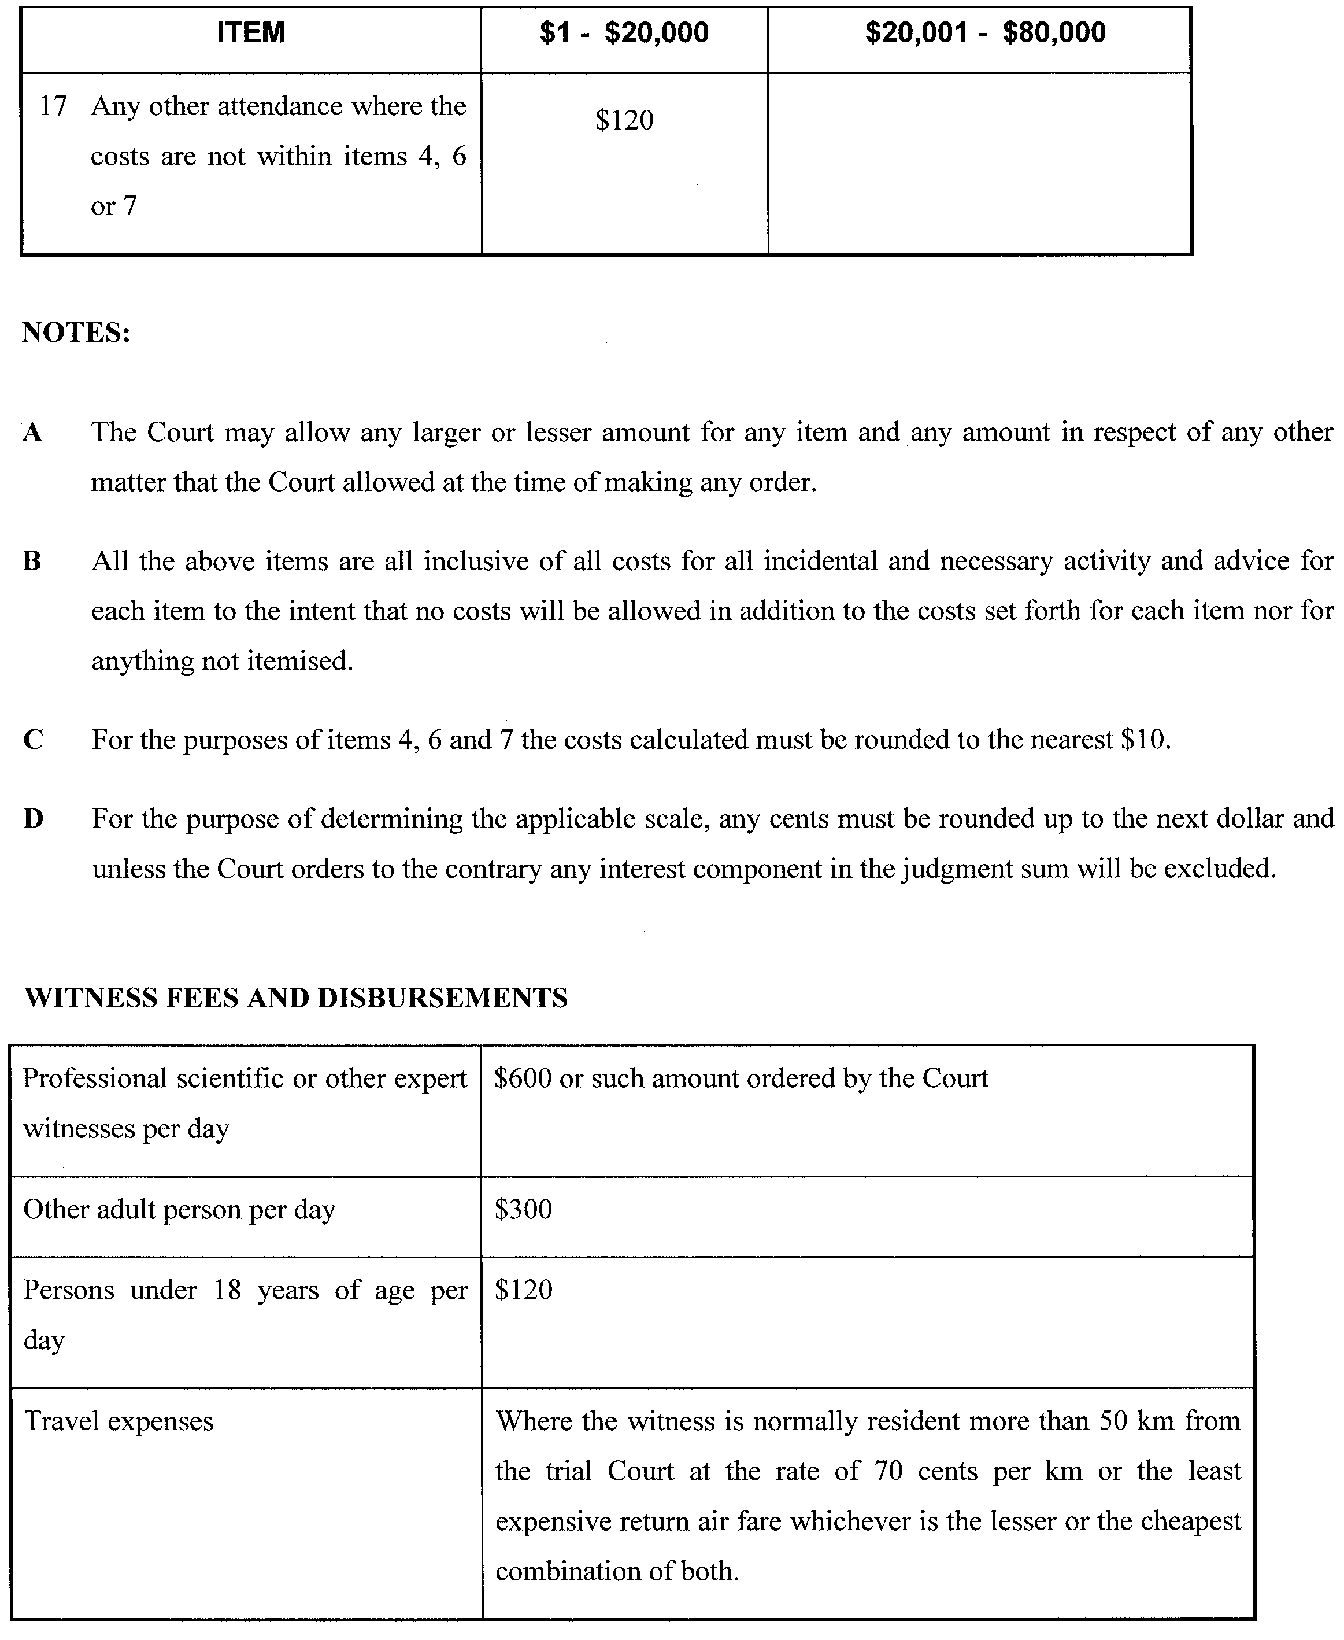
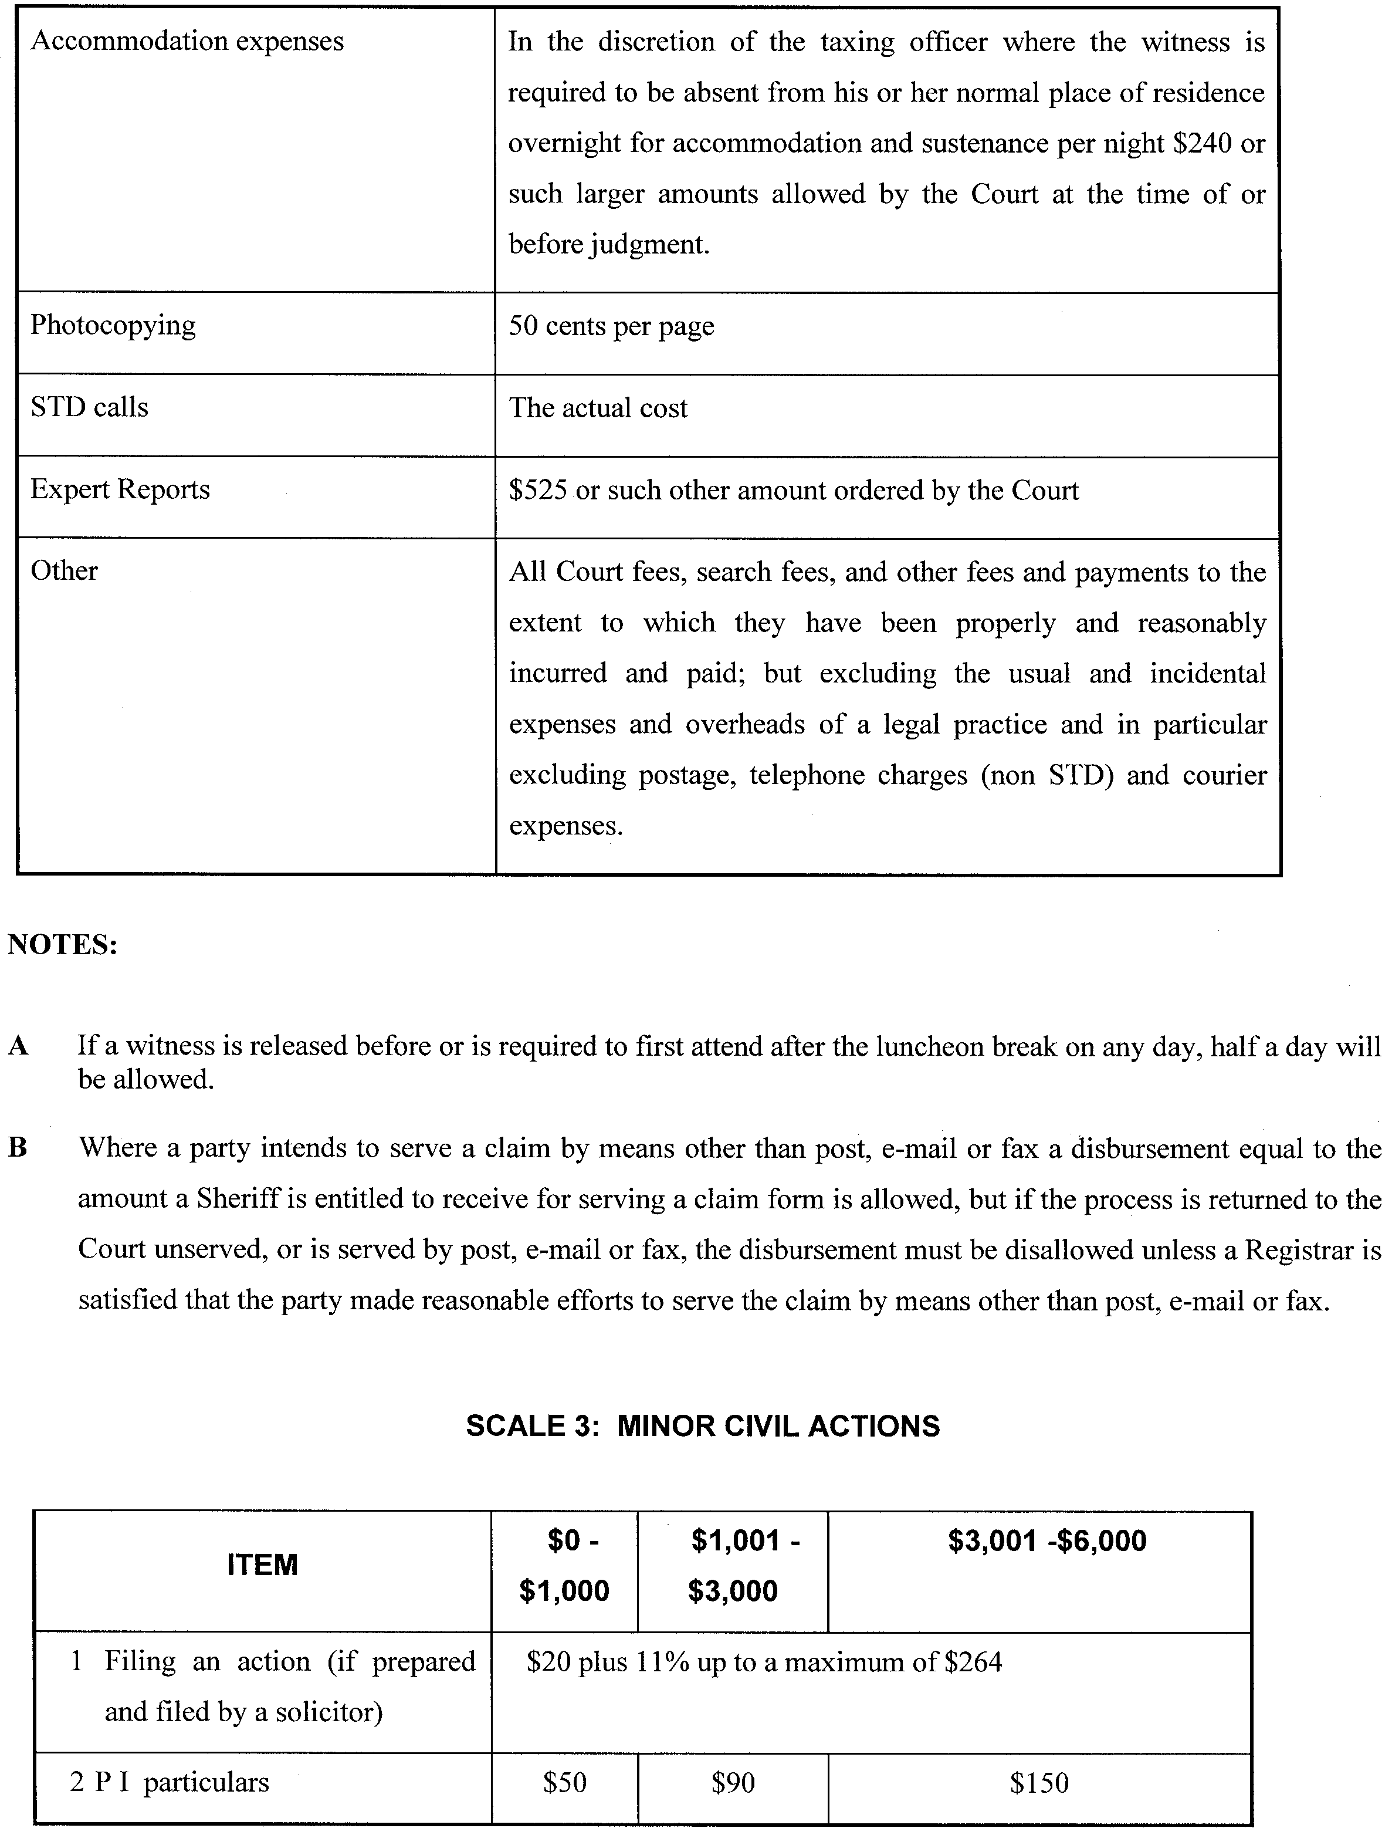
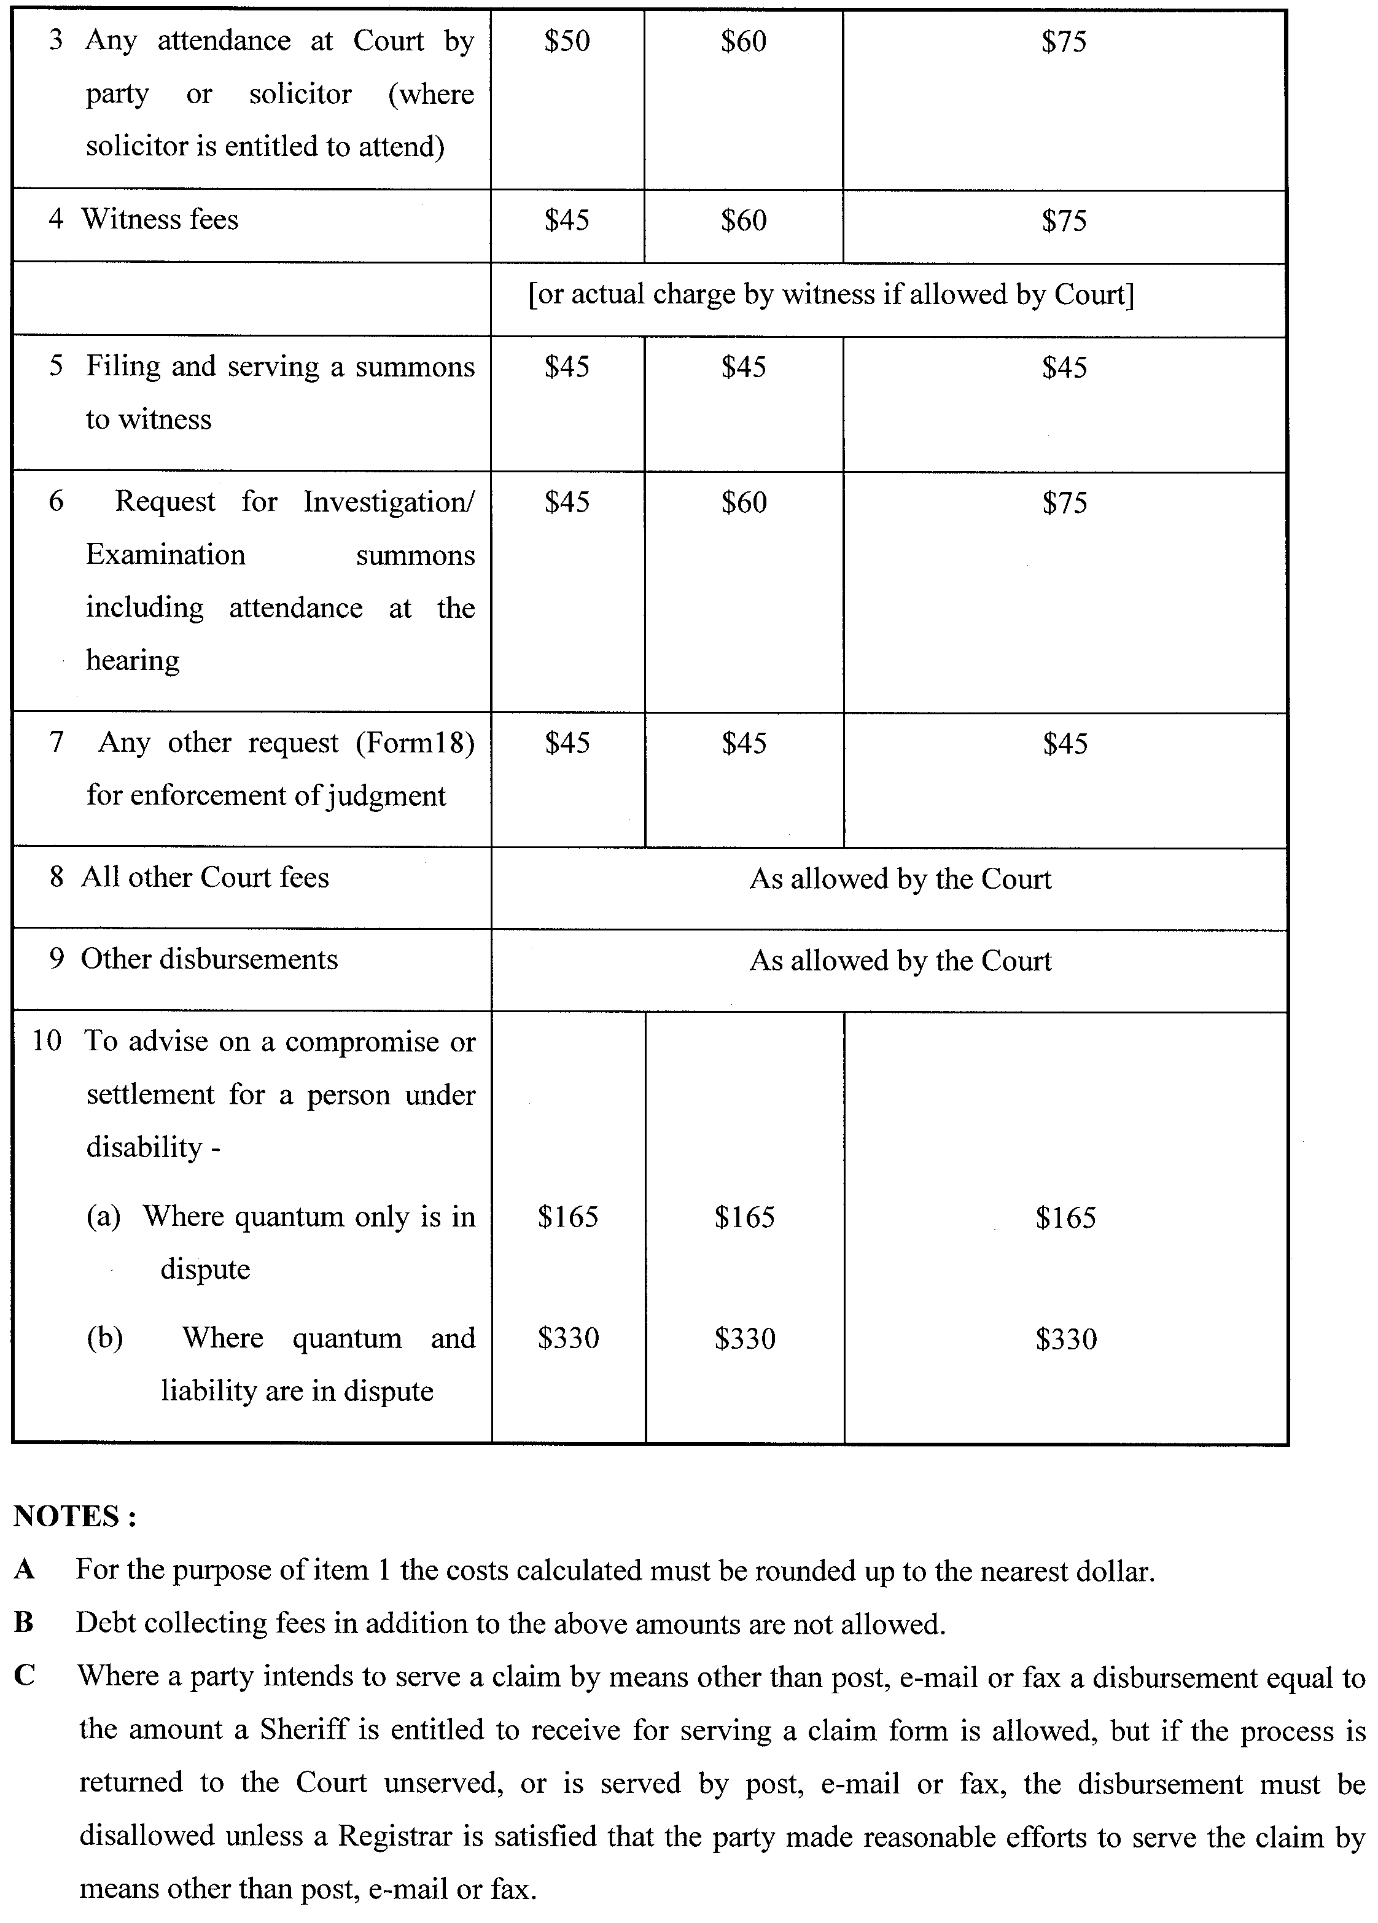
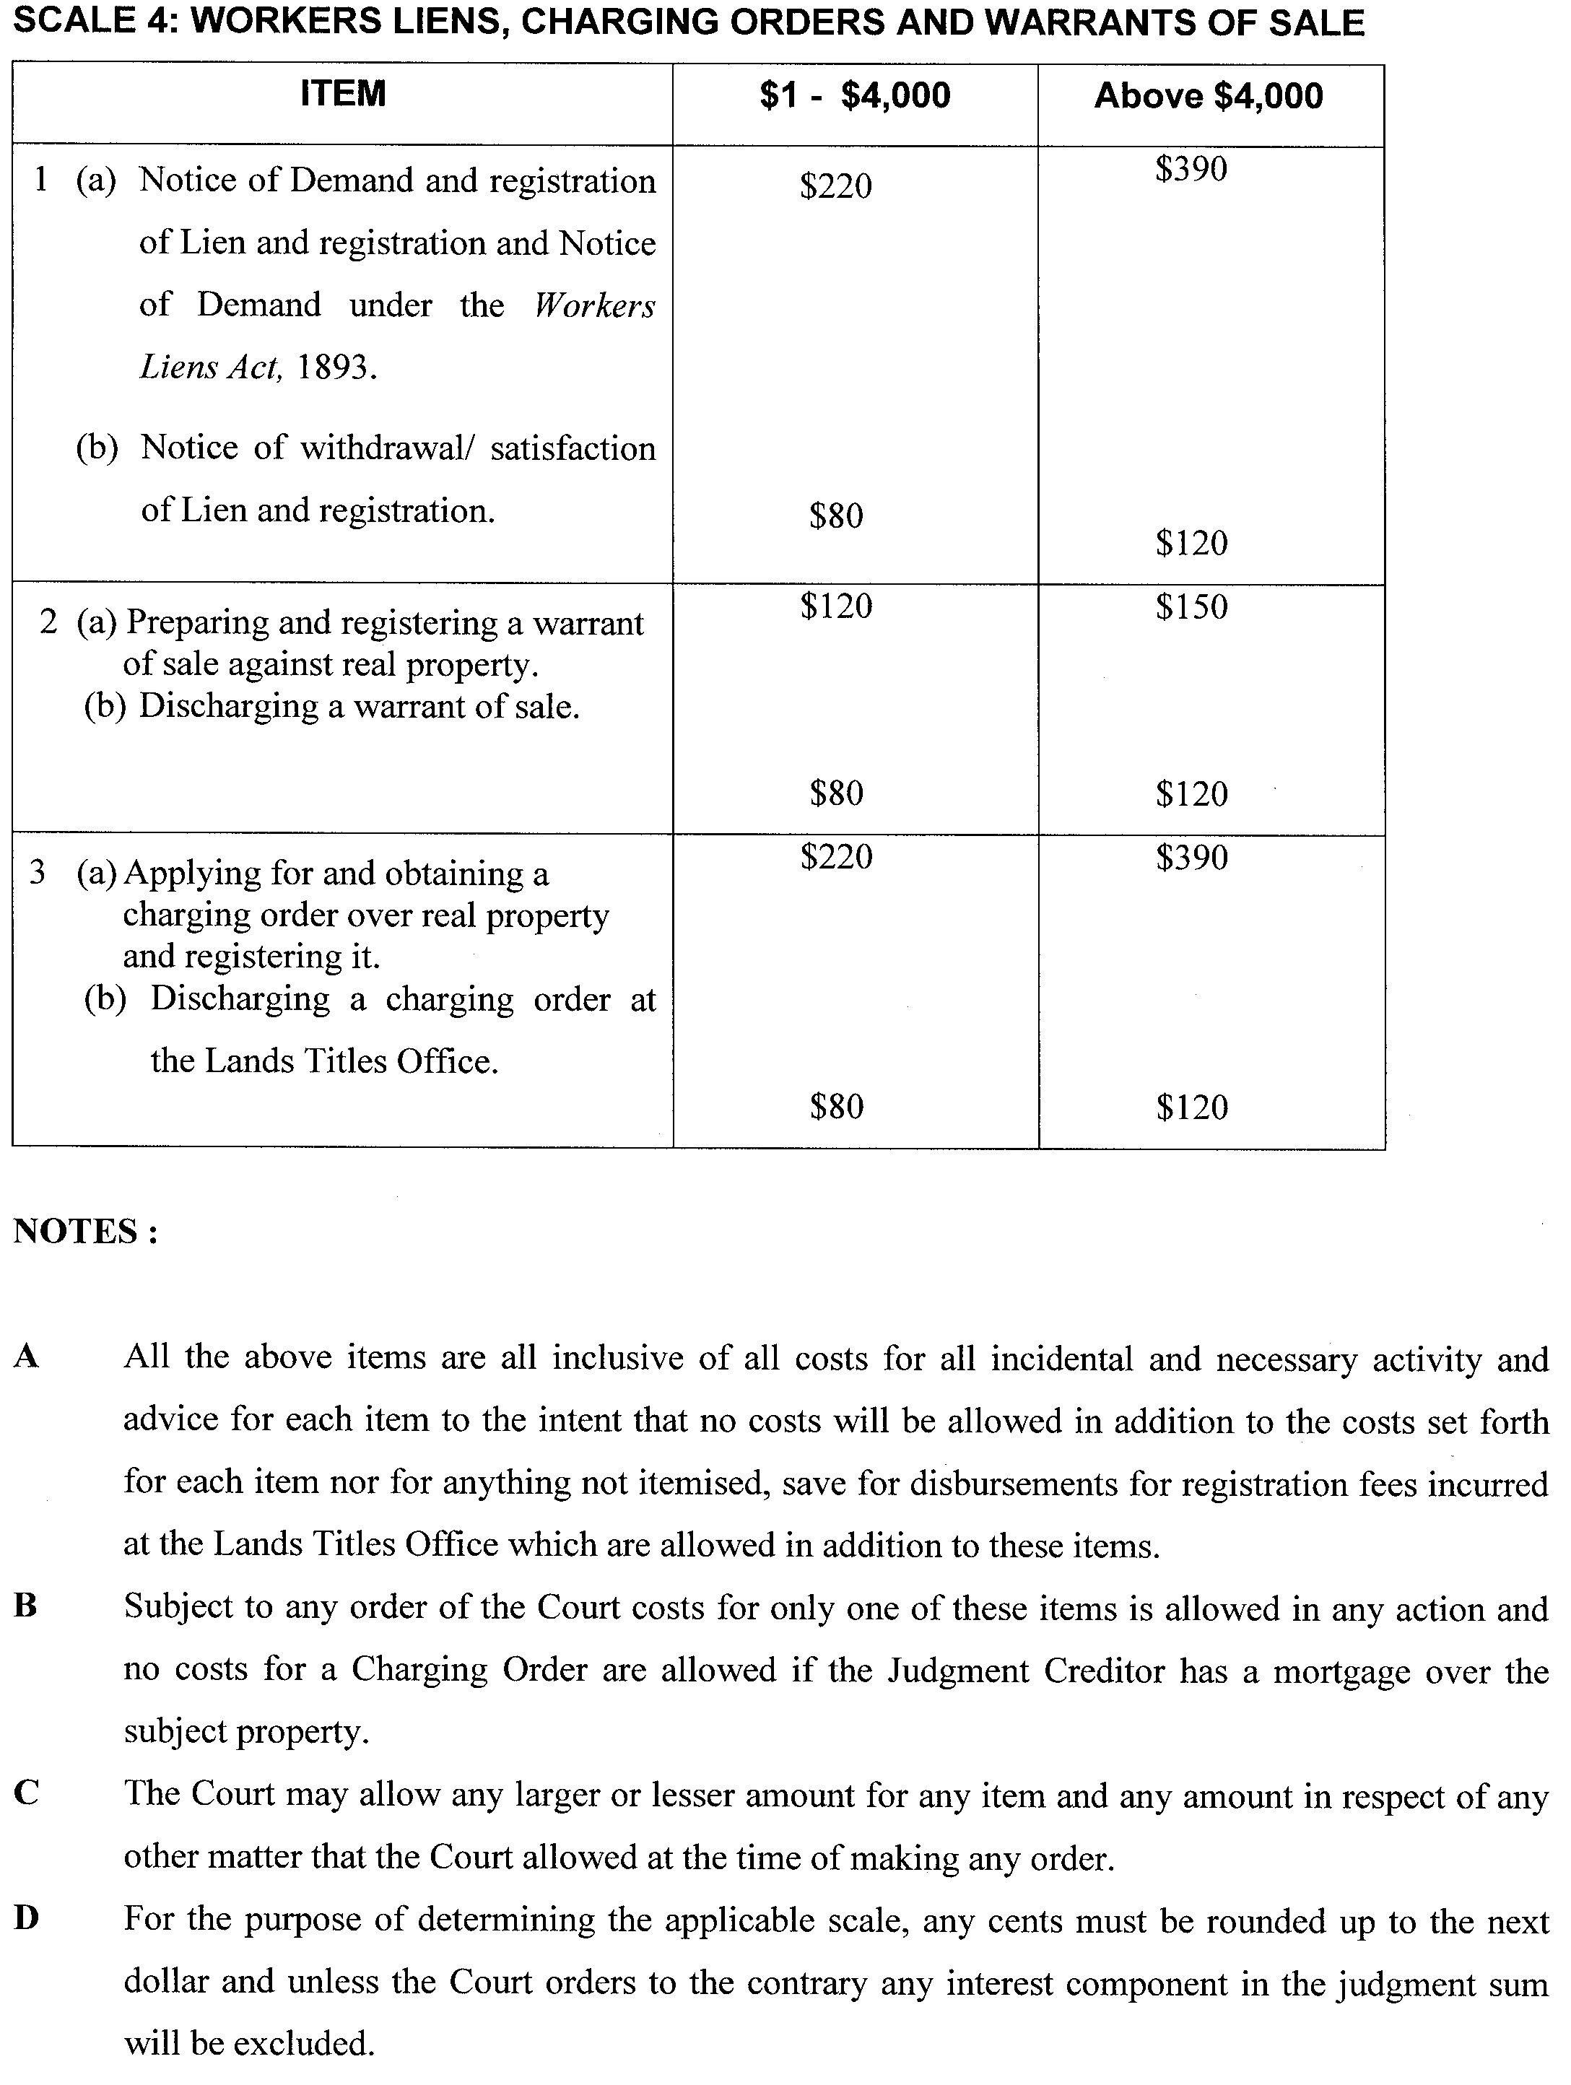
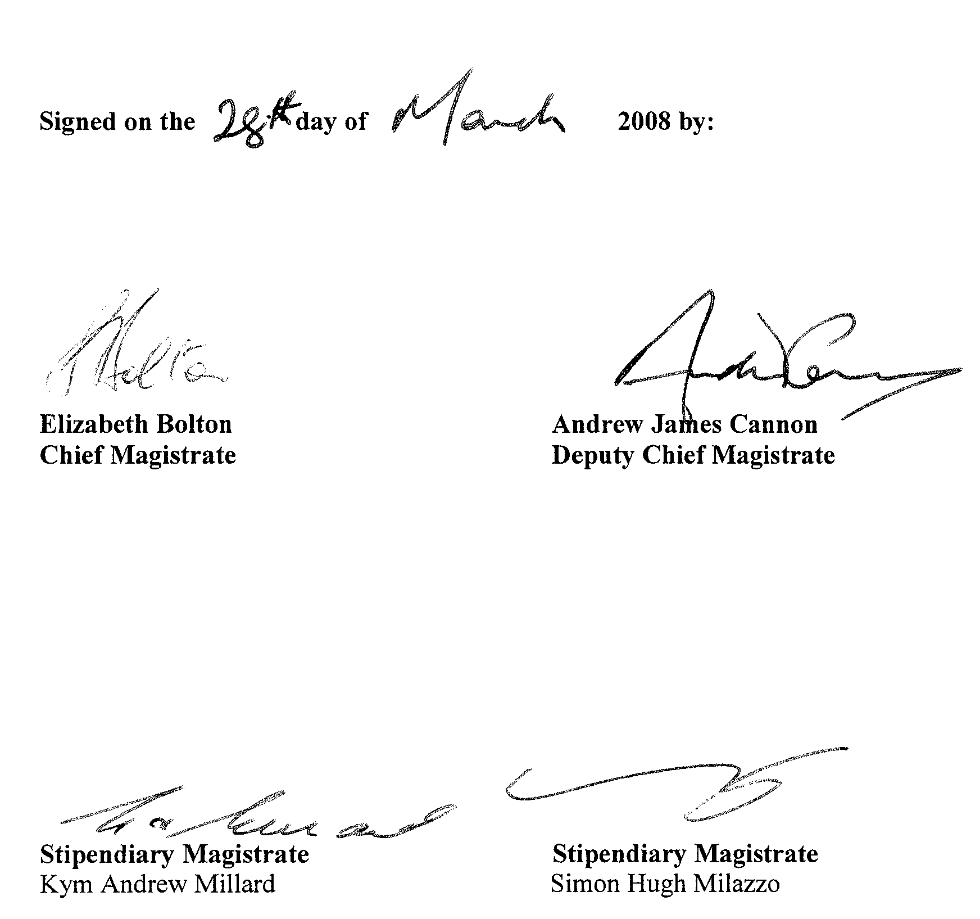

SOUTH AUSTRALIAN MOTOR SPORT ACT 1984: SECTION 26—AVAILABILITY OF PLANS FOR PUBLIC INSPECTION
Notice by the Deputy Premier
PURSUANT to section 26 of the South Australian Motor Sport Act 1984, the Minister to whom the administration of that Act has been committed, hereby designate the offices of Kellogg Brown & Root Pty Ltd, located at 186 Greenhill Road, Parkside as the place at which may be inspected by members of the public plans of all works proposed to be carried out by the South Australian Motor Sport Board in relation to the event known as the ‘Clipsal 500 Adelaide’.
Dated 10 April 2008.
Kevin Foley, Deputy Premier

SOUTH AUSTRALIAN MOTOR SPORT ACT 1984: SECTION 20 (1)—DECLARATION OF AREA, PERIOD AND
PRESCRIBED WORKS PERIOD
Notice by the Deputy Premier
PURSUANT to section 20 (1) of the South Australian Motor Sport Act 1984, I, the Minister to whom the administration of that Act has been committed, in respect of the motor sport event promoted by the South Australian Motor Sport Board under the name ‘2009 Clipsal 500 Adelaide’, acting on the recommendation of the Board, declare:
(a) that the area delineated on the plan in the Schedule will be a declared area under the Act for the purposes of the event; and
(b) that the prescribed works period in respect of works necessary for the infrastructure upgrade to assets owned by the South Australian Motor Sport Board for the purpose of staging the Clipsal 500 Adelaide, be the period commencing on 30 April 2008 and concluding on 15 May 2009.
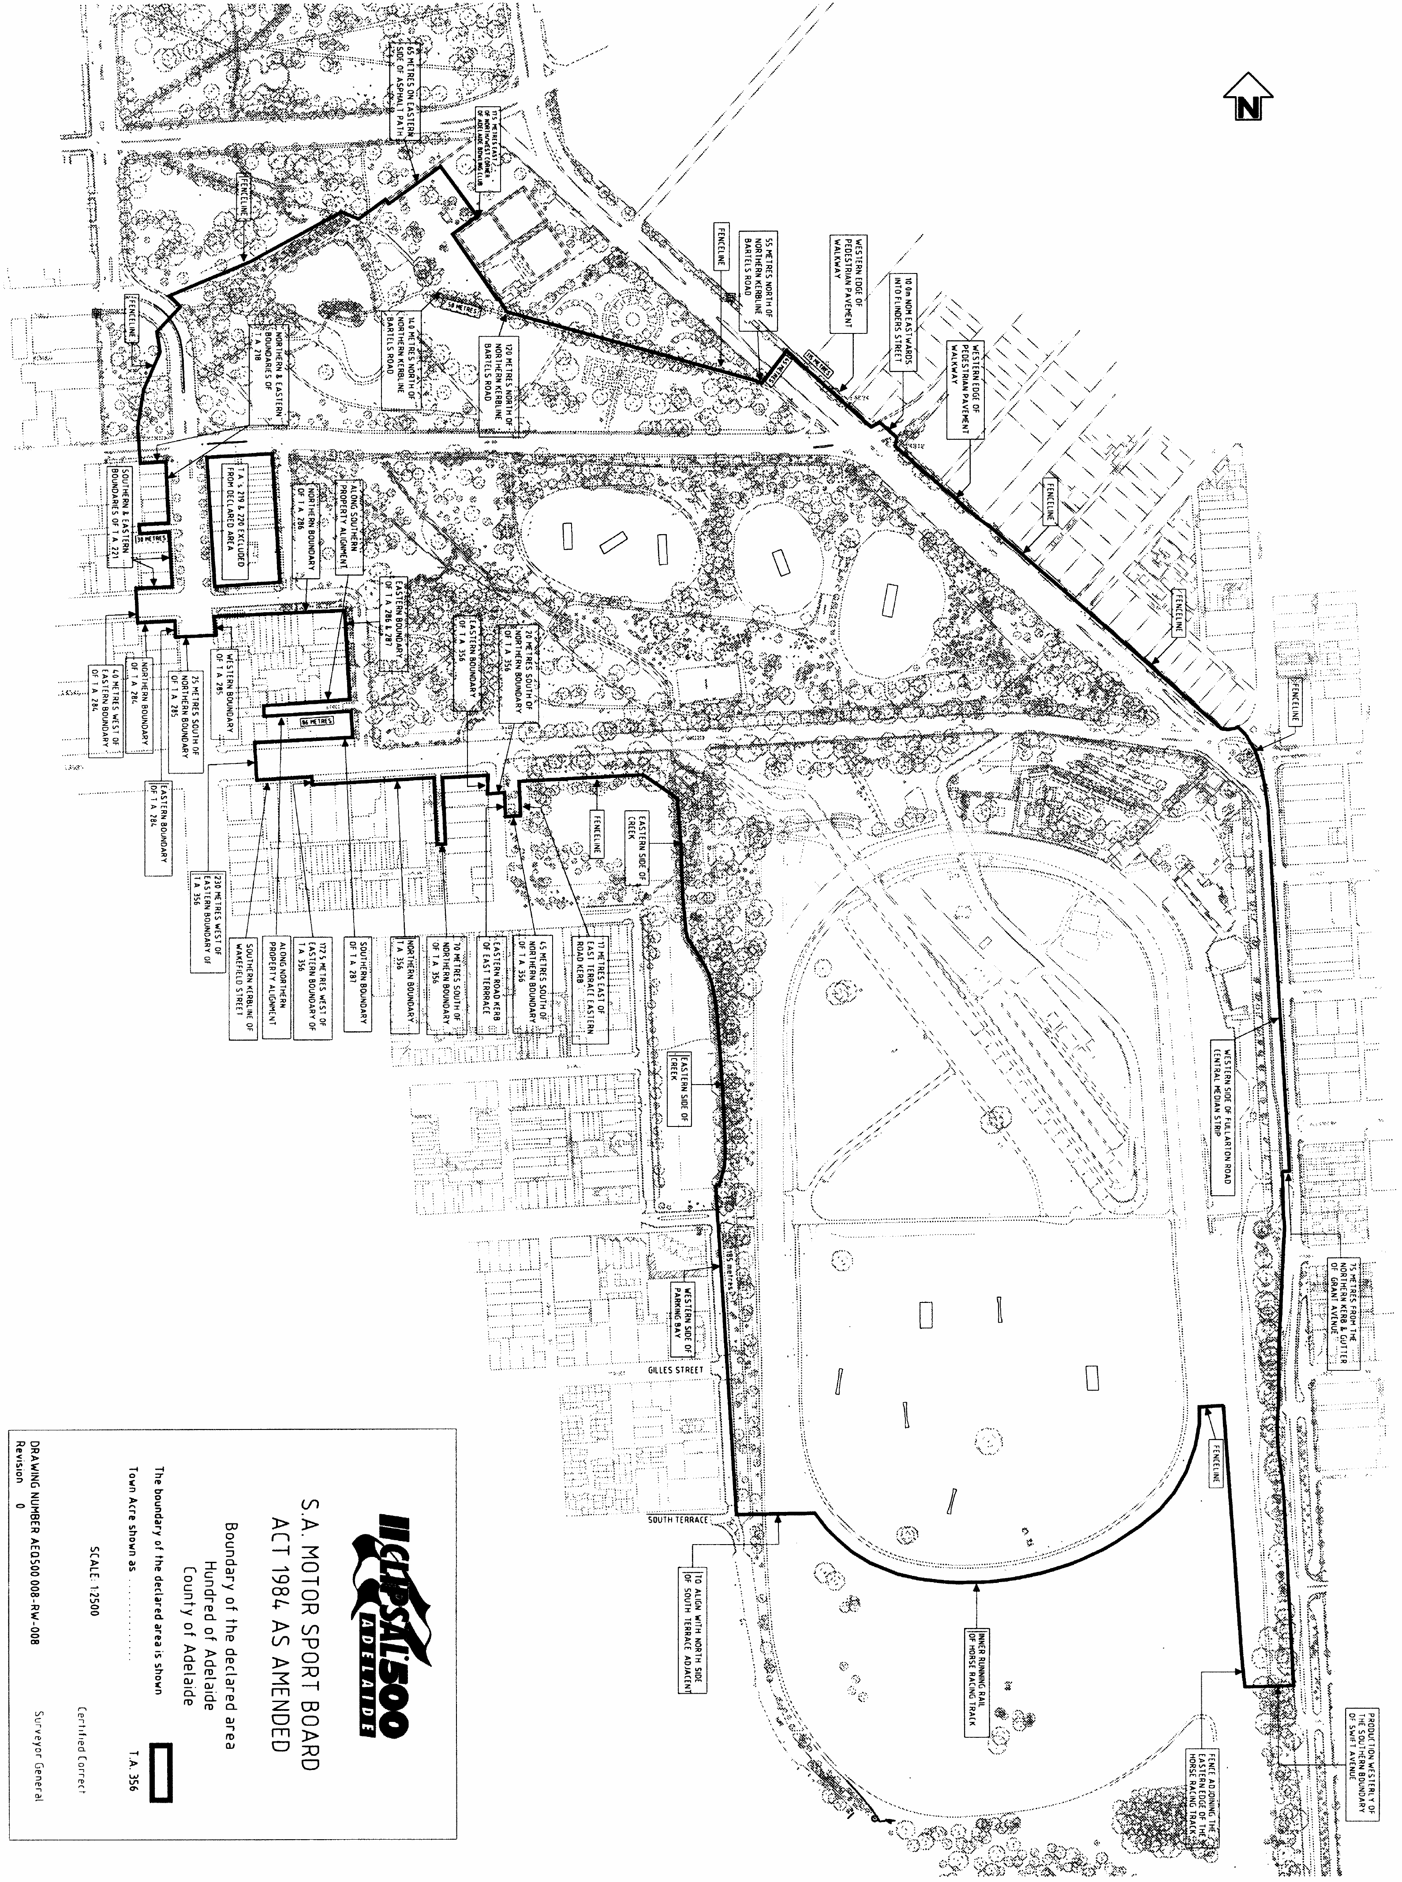
Dated 10 April 2008.
Kevin Foley, Deputy Premier

GOVERNMENT GAZETTE ADVERTISEMENT RATES

To apply from 1 July 2007

$  Agents, Ceasing to Act as 39.60  Associations:  Incorporation 20.10  Intention of Incorporation 49.75  Transfer of Properties 49.75  Attorney, Appointment of 39.60  Bailiff’s Sale 49.75  Cemetery Curator Appointed 29.45  Companies:  Alteration to Constitution 39.60  Capital, Increase or Decrease of 49.75  Ceasing to Carry on Business 29.45  Declaration of Dividend 29.45  Incorporation 39.60  Lost Share Certificates:  First Name 29.45  Each Subsequent Name 10.10  Meeting Final 33.10  Meeting Final Regarding Liquidator’s Report on  Conduct of Winding Up (equivalent to ‘Final  Meeting’)  First Name 39.60  Each Subsequent Name 10.10  Notices:  Call 49.75  Change of Name 20.10  Creditors 39.60  Creditors Compromise of Arrangement 39.60  Creditors (extraordinary resolution that ‘the Com-pany be wound up voluntarily and that a liquidator be appointed’) 49.75  Release of Liquidator⎯Application⎯Large Ad. 78.65  ⎯Release Granted 49.75  Receiver and Manager Appointed 45.85  Receiver and Manager Ceasing to Act 39.60  Restored Name 37.25  Petition to Supreme Court for Winding Up 69.30  Summons in Action 58.85  Order of Supreme Court for Winding Up Action 39.60  Register of Interests⎯Section 84 (1) Exempt 89.10  Removal of Office 20.10  Proof of Debts 39.60  Sales of Shares and Forfeiture 39.60  Estates:  Assigned 29.45  Deceased Persons⎯Notice to Creditors, etc. 49.75  Each Subsequent Name 10.10  Deceased Persons⎯Closed Estates 29.45  Each Subsequent Estate 1.30  Probate, Selling of 39.60  Public Trustee, each Estate 10.10 |  | $  Firms:  Ceasing to Carry on Business (each insertion) 26.30  Discontinuance Place of Business 26.30  Land⎯Real Property Act:  Intention to Sell, Notice of 49.75  Lost Certificate of Title Notices 49.75  Cancellation, Notice of (Strata Plan) 49.75  Mortgages:  Caveat Lodgement 20.10  Discharge of 21.05  Foreclosures 20.10  Transfer of 20.10  Sublet 10.10  Leases⎯Application for Transfer (2 insertions) each 10.10  Lost Treasury Receipts (3 insertions) each 29.45  Licensing 58.85  Municipal or District Councils:  Annual Financial Statement⎯Forms 1 and 2 554.35  Electricity Supply⎯Forms 19 and 20 393.90  Default in Payment of Rates:  First Name 78.65  Each Subsequent Name 10.10  Noxious Trade 29.45  Partnership, Dissolution of 29.45  Petitions (small) 20.10  Registered Building Societies (from Registrar-  General) 20.10  Register of Unclaimed Moneys⎯First Name 29.45  Each Subsequent Name 10.10  Registers of Members⎯Three pages and over:  Rate per page (in 8pt) 252.15  Rate per page (in 6pt) 333.45  Sale of Land by Public Auction 50.30  Advertisements 2.80  ¼ page advertisement 117.75  ½ page advertisement 235.50  Full page advertisement 461.60  Advertisements, other than those listed are charged at $2.80 per column line, tabular one-third extra.  Notices by Colleges, Universities, Corporations and District Councils to be charged at $2.80 per line.  Where the notice inserted varies significantly in length from that which is usually published a charge of $2.80 per column line will be applied in lieu of advertisement rates listed.  South Australian Government publications are sold on the condition that they will not be reproduced without prior permission from the Government Printer.
All the above prices include GST

GOVERNMENT GAZETTE NOTICES
ALL private advertisements forwarded for publication in the South Australian Government Gazette must be PAID FOR PRIOR TO INSERTION; and all notices, from whatever source, should be legibly written on one side of the paper only and sent to Government Publishing SA so as to be received no later than 4 p.m. Tuesday preceding the day of publication. Phone 8207 1045 or Fax 8207 1040. E-mail: governmentgazette@dpc.sa.gov.au. Send as attachments in Word format. Please include date the notice is to be published and to whom the notice will be charged. The Government Gazette is available online at: www.governmentgazette.sa.gov.au.

MISCELLANEOUS LEGISLATION AND GOVERNMENT PUBLICATIONS PRICES AS FROM 1 JULY 2007

Acts, Bills, Rules, Parliamentary Papers and Regulations
Pages | Main | Amends | Pages | Main | Amends

1-16 | 2.40 | 1.10 | 497-512 | 33.60 | 32.55
17-32 | 3.25 | 2.05 | 513-528 | 34.65 | 33.35
33-48 | 4.20 | 3.00 | 529-544 | 35.70 | 34.65
49-64 | 5.30 | 4.05 | 545-560 | 36.75 | 35.70
65-80 | 6.25 | 5.15 | 561-576 | 37.50 | 36.75
81-96 | 7.25 | 6.00 | 577-592 | 38.55 | 37.25
97-112 | 8.25 | 7.05 | 593-608 | 39.85 | 38.30
113-128 | 9.25 | 8.10 | 609-624 | 40.65 | 39.60
129-144 | 10.35 | 9.15 | 625-640 | 41.70 | 40.10
145-160 | 11.35 | 10.10 | 641-656 | 42.70 | 41.70
161-176 | 12.40 | 11.15 | 657-672 | 43.25 | 42.20
177-192 | 13.45 | 12.20 | 673-688 | 45.05 | 43.25
193-208 | 14.50 | 13.35 | 689-704 | 45.85 | 44.30
209-224 | 15.30 | 14.15 | 705-720 | 46.65 | 45.35
225-240 | 16.35 | 15.10 | 721-736 | 48.45 | 46.35
241-257 | 17.50 | 15.95 | 737-752 | 48.95 | 47.40
258-272 | 18.45 | 17.00 | 753-768 | 50.00 | 48.20
273-288 | 19.50 | 18.25 | 769-784 | 50.55 | 49.75
289-304 | 20.30 | 19.15 | 785-800 | 51.60 | 50.80
305-320 | 21.55 | 20.20 | 801-816 | 52.60 | 51.30
321-336 | 22.40 | 21.15 | 817-832 | 53.65 | 52.60
337-352 | 23.55 | 22.30 | 833-848 | 54.70 | 53.65
353-368 | 24.50 | 23.35 | 849-864 | 55.75 | 54.20
369-384 | 25.55 | 24.40 | 865-880 | 56.80 | 55.75
385-400 | 26.55 | 25.30 | 881-896 | 57.30 | 56.25
401-416 | 27.60 | 26.05 | 897-912 | 58.85 | 57.30
417-432 | 28.65 | 27.35 | 913-928 | 59.40 | 58.85
433-448 | 29.70 | 28.40 | 929-944 | 60.45 | 59.40
449-464 | 30.50 | 29.20 | 945-960 | 61.50 | 59.90
465-480 | 31.00 | 30.20 | 961-976 | 63.05 | 60.95
481-496 | 32.55 | 31.00 | 977-992 | 64.10 | 61.50

Legislation—Acts, Regulations, etc: $
Subscriptions:
Acts 207.00
All Bills as Laid 497.00
Rules and Regulations 497.00
Parliamentary Papers 497.00
Bound Acts 230.00
Index 115.00
Government Gazette
Copy 5.40
Subscription 274.00
Hansard
Copy 15.10
Subscription—per session (issued weekly) 431.00
Cloth bound—per volume 185.00
Subscription—per session (issued daily) 431.00
Legislation on Disk
Whole Database 3192.00
Annual Subscription for fortnightly updates 981.00
Individual Act(s) including updates POA
Compendium
Subscriptions:
Subscriptions 1891.00
Updates 667.00
(All the above prices include GST)

All Legislation, Government Gazette, Hansard and Legislation on disk are available from:
Counter Sales Service SA, Government Legislation⁺ Outlet
and Mail Orders: Lands Titles Office, 101 Grenfell Street, Adelaide, S.A. 5000
Phone: 13 23 24 (local call cost), Fax: (08) 8204 1909
Postal: G.P.O. Box 1707, Adelaide, S.A. 5001

Online Shop: www.shop.service.sa.gov.au

Subscriptions and Government Publishing SA
Standing Orders: Box 9, Plaza Level, Riverside Centre, North Terrace, Adelaide, S.A. 5000
Phone: (08) 8207 1043, (08) 8207 0910, Fax: (08) 8207 1040

SOUTH AUSTRALIA FIRE AND EMERGENCY
SERVICES ACT 2005
Dissolution of SASES Units
NOTICE is hereby given pursuant to Part 5, Division 4, Section 116 (8) of the South Australia Fire and Emergency Services Act 2005, that the Chief Officer dissolves the Cockburn SES Unit effective 4 April 2008.
Dated 28 March 2008.
S. M. Macleod, Chief Officer

TRADE STANDARDS REGULATIONS 2000
Exemption from Safety Standards—Children’s Folding Chair
TAKE notice that I, Mal Hemmerling, Commissioner for Consumer Affairs, am satisfied that it is appropriate to exempt the children’s folding chair as specified in the Schedule below, pursuant to Clause 3 of Schedule 1 of the Trade Standards Regulations 2000.
Schedule
The children’s folding chair supplied by Slumbertrek Australia Pty Ltd marked ‘SL001’ (‘the chair’), is exempted from the provisions of Schedule 1, Clause 2 (1) of the Trade Standards Regulations 2000, only with respect to the trapping space at the pivoting joints located at the base of the legs of the chair. Other components of the chair are not exempted from the Trade Standards Regulations 2000, including Schedule 1, Clause 2 (1).
Dated 11 April 2008.
Mal Hemmerling, Commissioner for Consumer Affairs

WATER MAINS AND SEWERS

Office of the South Australian Water Corporation
Adelaide, 17 April 2008

WATER MAINS LAID

Notice is hereby given that the following main pipes or parts of main pipes have been laid down by the South Australian Water Corporation in or near the undermentioned water districts and are now available for a constant supply of water to adjacent land.

ADELAIDE WATER DISTRICT

CAMPBELLTOWN CITY COUNCIL
Blyth Street, Magill. p9

CITY OF CHARLES STURT
William Langman Circuit, Ridleyton. p8
Eucalypt Avenue, Flinders Park. p10

CITY OF HOLDFAST BAY
Highland Avenue, Glenelg North. p11
Eitzen Street, Glenelg. p20
Yuill Street, Glenelg. p21

DISTRICT COUNCIL OF MOUNT BARKER
Shakes Road, Nairne. p4
Clover Way, Nairne. p4
Jeffrey Street, Nairne. p4

CITY OF ONKAPARINGA
In and across Corrimal Avenue, Noarlunga Downs. p5
Aramis Mews, Noarlunga Downs. p5
Kapara Close, Noarlunga Downs. p5
Goulbourn Terrace, Noarlunga Downs. p5
Easement in allotment piece 7003 in LTRO DP 75541, River Road, Noarlunga Downs. p5
Norman Road, Willunga. p19

CITY OF PORT ADELAIDE ENFIELD
Across Moorang Street, Kilburn. p1
Mapleton Court, Kilburn. p1
Braeville Court, Kilburn. p1

CITY OF SALISBURY
Adeline Street, Mawson Lakes. p2
Sylvia Court, Mawson Lakes. p2

BAROSSA COUNTRY LANDS WATER DISTRICT

LIGHT REGIONAL COUNCIL
Best Road, Kingsford. p23-26

MARREE WATER DISTRICT

OUTSIDE DISTRICT COUNCILS
Across and in Boorloo Terrace, Marree. p28

MYPONGA WATER DISTRICT

DISTRICT COUNCIL OF YANKALILLA
Amber Grove, Myponga. p3

PORT LINCOLN WATER DISTRICT

CITY OF PORT LINCOLN
Tasman Terrace, Port Lincoln. p22
Lewis Street, Port Lincoln. p22

PORT VINCENT WATER DISTRICT

DISTRICT COUNCIL OF YORKE PENINSULA
Kooringa Street, Port Vincent. p7
John Robb Court, Port Vincent. p7

WALLAROO WATER DISTRICT

DISTRICT COUNCIL OF THE COPPER COAST
Meander Way, North Beach. p6
Kassa Road, North Beach. p6

WATER MAINS ABANDONED

Notice is hereby given that the undermentioned water mains have been abandoned by the South Australian Water Corporation.

ADELAIDE WATER DISTRICT

DISTRICT COUNCIL OF MOUNT BARKER
Shakes Road, Nairne. p4
Jeffrey Street, Nairne. p4

BAROSSA COUNTRY LANDS WATER DISTRICT

LIGHT REGIONAL COUNCIL
Best Road, Kingsford. p23-26

MARREE WATER DISTRICT

OUTSIDE DISTRICT COUNCILS
Boorloo Terrace, Marree. p28

PORT LINCOLN WATER DISTRICT

CITY OF PORT LINCOLN
Tasman Terrace, Port Lincoln. p22
Lewis Street, Port Lincoln. p22

OUTSIDE WATER DISTRICTS

THE FLINDERS RANGES COUNCIL
Dutchmans Stern Road, Quorn. p27
Easements in allotment piece 110 in LTRO DP 59334, Arden Vale Road, Quorn. p27

WATER MAINS LAID

Notice is hereby given that the undermentioned water main has been laid down by the South Australian Water Corporation and is not available for a constant supply of water to adjacent land.

OUTSIDE MARREE WATER DISTRICT

OUTSIDE DISTRICT COUNCILS
Waterworks land (section 985, out of hundreds (Marree)), Boorloo Terrace, Marree. p28

SEWERS LAID

Notice is hereby given that the following sewers have been laid down by the South Australian Water Corporation in the undermentioned drainage areas and are now available for house connections.

ADELAIDE DRAINAGE AREA

CAMPBELLTOWN CITY COUNCIL
Blyth Street, Magill. FB 1171 p14
Warren Avenue, Paradise. FB 1171 p16

CITY OF CHARLES STURT
Across and in South Road, Ridleyton. FB 1170 p30 and 31
Easement in reserve (lot 50 in LTRO DP 74723, South Road), and lot 14 in LTRO DP 74723, William Langman Circuit, Ridleyton. FB 1170 p30 and 31
William Langman Circuit, Ridleyton. FB 1170 p30 and 31
Adamson Avenue, Findon. FB 1171 p10
Parker Avenue, Seaton. FB 1171 p12
Easements in lot 42 in LTRO DP 6010, and lot 101 in LTRO DP 75810, Hoover Road, Henley Beach South. FB 1171 p13
Glenavon Street, Woodville South. FB 1171 p17
Eucalypt Avenue, Flinders Park. FB 1171 p18

TOWN OF GAWLER
Blue Stone Quarry Road, Gawler South. FB 1171 p11

CITY OF HOLDFAST BAY
Highland Avenue, Glenelg North. FB 1171 p22

CITY OF NORWOOD PAYNEHAM & ST PETERS
Scott Street, Glynde. FB 1171 p8
Gertrude Street, Norwood. FB 1171 p15

CITY OF ONKAPARINGA
River Road, Noarlunga Downs. FB 1170 p25-28
Corrimal Avenue, Noarlunga Downs. FB 1170 p25, 27 and 28
Aramis Mews, Noarlunga Downs. FB 1170 p25, 27 and 29
In and across Goulbourn Terrace, Noarlunga Downs. FB 1170 p25, 27 and 29
Easement in allotment piece 7003 in LTRO DP 75541, River Road, Noarlunga Downs. FB 1170 p25, 27 and 29
Easement in lot 668 in LTRO DP 75541, Goulbourn Terrace, Noarlunga Downs. FB 1170 p25, 27 and 29
Kapara Close, Noarlunga Downs. FB 1170 p25, 27 and 29
Salter Crescent, Christies Beach. FB 1171 p7
Easement in lot 84 in LTRO FP 152160, View Court, Happy Valley. FB 1171 p19
Morningside Drive, Woodcroft. FB 1171 p21
Easements in lot 501 in LTRO DP 20587, and lot 2 in LTRO DP 76261, Featherstone Drive, Huntfield Heights. FB 1171 p24

CITY OF PORT ADELAIDE ENFIELD
Across Bundarra Avenue, Kilburn. FB 1170 p19 and 21
Easement in lots 214-212 in LTRO DP 64800, Coolah Street, Kilburn. FB 1170 p19 and 21
Mapleton Court, Kilburn. FB 1170 p19 and 21
Braeville Court, Kilburn. FB 1170 p19 and 21
Talinga Avenue, Kilburn. FB 1170 p20 and 21
In and across Hillsdale Street, Kilburn. FB 1170 p20 and 21
Easement in lot 606 in LTRO DP 65117, Prospect Road, Kilburn. FB 1170 p20 and 21
Earle Street, Hillcrest. FB 1171 p20
Treweck Avenue, Hillcrest. FB 1171 p23
Jetty Road, Largs Bay. FB 1171 p25

CITY OF SALISBURY
Across Franklin Avenue, Mawson Lakes. FB 1170 p22-24
Easement in reserve (lot 802 in LTRO DP 74136), Franklin Avenue, Mawson Lakes. FB 1170 p22-24
Sylvia Court, Mawson Lakes. FB 1170 p22-24
Adeline Street, Mawson Lakes. FB 1170 p22-24

CITY OF UNLEY
Duthy Street, Malvern. FB 1171 p27

ALDINGA DRAINAGE AREA

CITY OF ONKAPARINGA
Harvey Crescent, Aldinga Beach. FB 1171 p9

LOBETHAL COUNTRY DRAINAGE AREA

ADELAIDE HILLS COUNCIL
Easements in lot 304 in LTRO FP 4771, and lot 21 in LTRO CP 24439, Ridge Road, Lobethal. FB 1171 p26

MYPONGA COUNTRY DRAINAGE AREA

DISTRICT COUNCIL OF YANKALILLA
Amber Grove, Myponga. FB 1169 p46 and 47

STIRLING COUNTRY DRAINAGE AREA

ADELAIDE HILLS COUNCIL
Easements in lot 35 in LTRO FP 158181, Cricklewood Road, and lot 100 in LTRO DP 47555, Longwood Road, Heathfield. FB 1170 p33

WHYALLA COUNTRY DRAINAGE AREA

THE CORPORATION OF THE CITY OF WHYALLA
Marevista Crescent, Whyalla. FB 1170 p32

SEWERS ABANDONED

Notice is hereby given that the undermentioned sewers have been abandoned by the South Australian Water Corporation.

ADELAIDE DRAINAGE AREA

CITY OF PORT ADELAIDE ENFIELD
Across Moorang Street, Kilburn. FB 1170 p19
Easement in lot 204 in LTRO DP 64800, Moorang Street, Kilburn. FB 1170 p19
Bundarra Avenue, Kilburn. FB 1170 p20

STIRLING COUNTRY DRAINAGE AREA

ADELAIDE HILLS COUNCIL
Easements in lot 35 in LTRO FP 158181, Cricklewood Road, and lot 100 in LTRO DP 47555, Longwood Road, Heathfield. FB 1170 p33

ADDENDUM

Addendum to notice in “Government Gazette” of 20 August 1959.

“NOTICE is hereby given that sewers have been laid down by the Minister of Works in the undermentioned streets, etc. and are now available for house connections.”

“NARACOORTE COUNTRY DRAINAGE AREA”

“CORPORATE TOWN OF NARACOORTE.”

“Riverside Avenue, easement in allotments 1A, 56, 3, 55 and 54, through park lands, easement in allotments 64 to 66 and block 46, Naracoorte and easement in allotment 17, Naracoorte North—North-easterly and northerly for 2 756ft from McRae Street to Corner Crescent.”

To this notice add “This main available on application only between chainages 1 653.1 metres (5 423ft 6in) and 1849.4 metres (6 067ft 6in).”

DELETION

Deletion of notice in Government Gazette” of 21 July 1960.

“CORRECTIONS”

“Correction of notice in Government Gazette, 20 August 1959.

“NARACOORTE COUNTRY DRAINAGE AREA”

“CORPORATE TOWN OF NARACOORTE”

“Riverside Avenue, easement in allotments 1A, 56, 3, 55 and 54, through park lands, easement in allotments 64 to 66 and block 46, Naracoorte and easement in allotment 17, Naracoorte North—North-easterly, etc.
This sewer is not available for house connections for 644ft northerly from a point 194ft from Letchford Terrace.”

Delete this notice.

A. Howe, Chief Executive Officer, South Australian Water Corporation

South Australia
Administrative Arrangements (References to Minister) Proclamation 2008
under section 8 of the Administrative Arrangements Act 1994
1—Short title
This proclamation may be cited as the Administrative Arrangements (References to Minister) Proclamation 2007.
2—Commencement
This proclamation comes into operation on the day on which it is made.
3—Interpretative provision
A reference to the Chief Secretary in the Lottery and Gaming Act 1936 will have effect as if it were a reference to the Minister for Gambling.
Made by the Governor’s Deputy
with the advice and consent of the Executive Council
on 17 April 2008
MGA06/06CS

South Australia
Lottery and Gaming Regulations 2008
under the Lottery and Gaming Act 1936

Contents
Part 1—Preliminary
1 Short title
2 Commencement
3 Interpretation
4 Prohibited goods and services
Part 2—Exempted lotteries
Division 1—Fundraiser lotteries
5 Minor lotteries
6 Bingo played at minor bingo sessions
7 Sweepstakes
Division 2—Non-fundraiser lotteries
8 Lotteries where all proceeds go in prizes
9 Minor trade promotion lotteries
10 Calcutta sweepstakes
Part 3—Authorised lotteries
Division 1—Fundraiser lotteries
11 Classes of lottery licence
12 Eligible applicants
13 Applications for lottery licence
14 Grant of lottery licences
15 Duration of licence
16 Licence conditions
Division 2—Trade promotion lotteries
17 Classes of trade promotion lottery licence
18 Applications for trade promotion lottery licence
19 Grant of trade promotion lottery licence
20 Duration of trade promotion lottery licence
21 Licence conditions
Division 3—Licences generally
22 Cancellation or suspension of licence
Part 4—Lottery rules
23 Minor lottery rules
24 Major lottery rules
25 Minor bingo session rules
26 Major bingo session rules
27 Instant lottery rules
28 Sweepstakes rules
29 Calcutta sweepstakes rules
30 Minor trade promotion lottery rules
31 Major trade promotion lottery rules
32 Trade promotion (instant prize) lottery rules
33 Minister may waive compliance with lottery rules
34 Minister may give directions on winding up or dissolution of licensed association
Part 5—Instant lottery ticket suppliers' licences
35 Application
36 Licence conditions
Part 6—Miscellaneous
37 False or misleading statements
38 Service of documents
39 Restriction on sale of lottery tickets by children
40 Identification of winning ticket
41 Commission agents must pay lottery ticket proceeds by cheque etc
42 Keeping of accounts relating to licensed lotteries conducted by associations
43 Offences by traders conducting trade promotion lotteries
44 Inducements to enter a lottery
45 Advertising of fundraiser lotteries
46 Unclaimed prizes
47 Duty of auditor of lottery accounts
48 Offences committed by an association or corporation
49 Fees
Schedule 1—Licence Applications
Part 1—Major lottery licence application
Part 2—Major bingo licence application
Part 3—Instant lottery licence application
Part 4—Major trade promotion lottery licence application
Part 5—Trade promotion (instant prize) lottery licence application
Part 6—Instant lottery ticket supplier's licence application
Schedule 2—Financial Statements
Part 1—Major lottery licence financial statement
Part 2—Major bingo licence financial statement
Part 3—Instant lottery licence financial statement
Schedule 3—Fees
Schedule 4—Revocations and transitional provisions
Part 1—Revocation of Lottery and Gaming Regulations 1993
Part 2—Transitional provisions

Part 1—Preliminary
1—Short title
These regulations may be cited as the Lottery and Gaming Regulations 2008.
2—Commencement
These regulations will come into operation on 1 September 2008.
3—Interpretation
(1) In these regulations, unless the contrary intention appears—
Act means the Lottery and Gaming Act 1936;
administrative expenses, in relation to the conduct of a lottery—
(a) includes any commission, salary or other remuneration paid to a person for conducting the lottery or for selling tickets in the lottery; but
(b) does not include fees payable under these regulations or any other government charges or, in relation to conducting bingo sessions, rent of the premises in which the sessions are conducted;
approved purposes, in relation to a fundraiser lottery, means any of the following purposes:
(a) a religious, educational, charitable or benevolent purpose;
(b) the purpose of promoting or encouraging literature, science or the arts;
(c) the purpose of providing medical treatment or attention, or promoting the interests of persons who have a particular physical, mental or intellectual disability;
(d) the purpose of establishing, carrying on or improving a community centre, or promoting the interests of a local community or a particular section of a local community;
(e) the purpose of sport, recreation or amusement;
(f) the purpose of promoting animal welfare;
(g) the purpose of conserving resources or preserving any part of the environmental, historical or cultural heritage of the State;
(h) the purpose of promoting the interests of students or staff of an educational institution;
(i) a political purpose;
(j) the purpose of promoting the common interests of persons who are engaged in, or interested in, a particular business, trade or industry;
association means any association of persons, whether incorporated or not, that has—
(a) at least 10 members; and
(b) a management committee appointed or elected by the members of the association; and
(c) a written constitution,
but does not include a registered corporation that returns profits to its members;
auditor means a person who is a member of—
(a) the Australian Society of Certified Practising Accountants; or
(b) The Institute of Chartered Accountants in Australia; or
(c) the National Institute of Accountants;
bingo means the game of chance known as bingo, housie or housie when played by the method commonly known as "eyes down";
bingo session means an event at which a series of bingo games is played;
Calcutta sweepstakes (or Calcutta) means a sweepstakes conducted on the basis that the winning chances will be auctioned;
domestic partner means a person who is a domestic partner within the meaning of the Family Relationships Act 1975, whether declared as such under that Act or not;
fundraiser, in relation to a lottery, means a lottery conducted by an association on the basis that the net proceeds of the lottery are to be applied by the association for 1 or more approved purposes;
GST means the tax payable under the GST law;
GST law means—
(a) A New Tax System (Goods and Services Tax) Act 1999 of the Commonwealth; and
(b) the related legislation of the Commonwealth dealing with the imposition of a tax on the supply of goods, services and other things;
instant lottery means a lottery—
(a) the prizes of which do not, in total, exceed $5 000 in value; and
(b) in which the right to participate depends on purchasing an instant lottery ticket;
instant prize means a prize to be won on a ticket—
(a) that has on it a number, letter or symbol giving rise to a winning chance; and
(b) that is realisable (without being drawn) immediately after its acquisition by the participant in the lottery,
and includes a prize to be found within the packaging of goods that are the subject of a trade promotion lottery;
licensed supplier means the holder of an instant lottery ticket supplier's licence;
lottery licence means a licence issued under these regulations to conduct a major lottery, major bingo sessions or instant lotteries;
lottery rules means the rules under these regulations with which persons conducting lotteries (whether exempted or authorised lotteries) must comply;
major bingo session means bingo played at a bingo session where the gross proceeds received from the session exceed $500;
major lottery means a lottery the prizes of which exceed, in total, $5 000 in value, but does not include an instant lottery, a sweepstakes or a Calcutta sweepstakes;
major trade promotion lottery means a trade promotion lottery—
(a) of which the total value of all the prizes exceeds $5 000; or
(b) the prizes of which include both instant prizes and drawn prizes (regardless of the value of the prizes); or
(c) the prizes of which are to be drawn by electronic means (regardless of the value of the prizes),
but does not include a trade promotion (instant prize) lottery;
minor bingo session means bingo played at a bingo session where the gross proceeds of the session do not exceed $500;
minor lottery means a lottery the prizes of which do not, in total, exceed $5 000 in value, but does not include an instant lottery, a sweepstakes or a Calcutta sweepstakes;
minor trade promotion lottery means a trade promotion lottery other than a major trade promotion lottery or a trade promotion (instant prize) lottery;
net proceeds, in relation to a lottery, means the gross proceeds of the lottery less the amount of the prizes and administrative expenses of conducting the lottery;
prohibited goods or services means goods or services prohibited by the Minister under regulation 4;
registered corporation means a corporation that is registered under the Corporations Law 2001 of the Commonwealth;
revoked regulations means the Lottery and Gaming Regulations 1993 revoked by these regulations;
scrutineer means—
(a) a commissioner for taking affidavits in the Supreme Court; or
(b) a justice of the peace; or
(c) a notary public; or
(d) any other person authorised to take declarations under the Oaths Act 1936; or
(e) a person, or a person of a class, authorised by the Minister to be a scrutineer;
spouse—a person is the spouse of another if they are legally married;
supplier's licence means an instant lottery ticket supplier's licence;
ticket means a token of any kind used for the purposes of drawing the prizes in a lottery or claiming an instant prize in a lottery and includes—
(a) a recording, by electronic means or otherwise, of a participant's name or telephone number; and
(b) the packaging of goods in which an instant prize, or a ticket for an instant prize, may be found;
trade promotion (instant prize) lottery means a trade promotion lottery all the prizes of which are instant prizes;
trade promotion lottery licence means a licence issued under these regulations to conduct a major trade promotion lottery or a trade promotion (instant prize) lottery;
trader, in relation to a trade promotion lottery, means the seller of the goods or services that are the subject of the promotion;
value, in relation to an item that is a prize in a lottery, means—
(a) if the item is an antique or a piece of artwork, craftwork or collectible bric-a-brac or is secondhand—the price likely to be paid for the item if sold at auction;
(b) in any other case—the retail price, or a reasonable estimate of the likely retail price, of the item.
(2) A reference in these regulations—
(a) to a trade promotion lottery includes a reference to a minor trade promotion lottery, a major trade promotion lottery and a trade promotion (instant prize) lottery;
(b) to a sweepstakes does not include a reference to a Calcutta sweepstakes.
(3) For the purposes of these regulations—
(a) a member of an association will not be taken to receive a benefit from the net proceeds of a lottery conducted by the association by virtue only of the fact that he or she, as a member of the association, shares with the other members in the facilities or services provided by the association; and
(b) a registered corporation will not be taken to receive a benefit from the net proceeds of a lottery by virtue only of the fact that part of those proceeds is used to acquire goods or services from the corporation; and
(c) a ticket in a lottery will not be regarded as giving rise to an equal chance of winning a prize in the lottery if the holder of the ticket is required to be present at the drawing of the lottery in order to have a chance to win any particular prize.
(4) For the purposes of these regulations, a person is associated with a licensee conducting a lottery if—
(a) the person is a spouse, domestic partner, parent, brother, sister or child of the licensee; or
(b) either the person or the licensee is an employer or an employee of the other; or
(c) the licensee is an association and the person is a member of the association; or
(d) the person is a partner of the licensee; or
(e) the person manages, or is to manage the lottery to be conducted by the licensee; or
(f) the person and the licensee are both trustees or beneficiaries of the same trust, or 1 is a trustee and the other is a beneficiary of the same trust; or
(g) the licensee is a body corporate and the person is a director or member of the governing body of the body corporate; or
(h) the licensee is a body corporate and the person is a shareholder in the body corporate; or
(i) a chain of relationships can be traced between the person or the licensee under any 1 or more of the above paragraphs.
4—Prohibited goods and services
(1) The Minister may, by notice in the Gazette, prohibit specified goods or services (or a specified class of goods or services) from being—
(a) a prize in a lottery, sweepstakes or Calcutta; or
(b) offered as an inducement to enter or participate in a major lottery, a major bingo session or a trade promotion lottery; or
(c) promoted by a trade promotion lottery.
(2) The Minister may, by notice in the Gazette, vary or revoke a notice under subregulation (1).
Part 2—Exempted lotteries
Division 1—Fundraiser lotteries
5—Minor lotteries
A minor lottery that is a fundraiser is an exempted lottery for the purposes of the Act if—
(a) the lottery is conducted by an association on its own behalf; and
(b) the prizes do not include any prohibited goods or services; and
(c) the association, in conducting the lottery, complies with the minor lottery rules set out in regulation 23.
6—Bingo played at minor bingo sessions
Bingo played at a minor bingo session that is a fundraiser is an exempted lottery for the purposes of the Act if—
(a) the bingo session is conducted by an association on its own behalf; and
(b) the association, in conducting the bingo session, complies with the minor bingo session rules set out in regulation 25.
7—Sweepstakes
A sweepstakes that is a fundraiser is an exempted lottery for the purposes of the Act if—
(a) the sweepstakes is conducted by an association on its own behalf; and
(b) the gross proceeds of the sweepstakes do not exceed $2 000; and
(c) the prizes do not include any prohibited goods or services; and
(d) the association, in conducting the sweepstakes, complies with the sweepstakes rules set out in regulation 28.
Division 2—Non-fundraiser lotteries
8—Lotteries where all proceeds go in prizes
A lottery (of a kind other than an instant lottery) is an exempted lottery for the purposes of the Act if—
(a) the gross proceeds of the lottery do not exceed $2 000; and
(b) the whole of the proceeds of the lottery, after deduction of the administrative expenses of conducting the lottery, constitute the prize, or prizes, in the lottery; and
(c) the prizes do not include any prohibited goods or services; and
(d) the amount deducted for administrative expenses does not exceed 2% of the gross proceeds of the lottery; and
(e) each ticket in the lottery gives rise to a fair and equal chance of winning the major prize in the lottery.
9—Minor trade promotion lotteries
A minor trade promotion lottery is an exempted lottery for the purposes of the Act if—
(a) the prizes do not include any instant prizes or prohibited goods or services; and
(b) the lottery is not for the purpose of promoting the sale of prohibited goods or services; and
(c) no prohibited goods or services are offered as an inducement to enter or participate in the lottery; and
(d) no prize in the lottery is drawn by electronic means; and
(e) the lottery does not consist of bingo sessions conducted on the premises to which a gaming machine licence under the Gaming Machines Act 1992 relates; and
(f) the person conducting the lottery complies with the minor trade promotion lottery rules set out in regulation 30.
10—Calcutta sweepstakes
A Calcutta sweepstakes, the gross proceeds of which exceed $2 000, is an exempted lottery for the purposes of the Act if—
(a) the Calcutta is conducted by an association on its own behalf; and
(b) the gross proceeds of the Calcutta do not exceed $15 000; and
(c) the prizes do not include any prohibited goods or services; and
(d) the association, in conducting the Calcutta, complies with the Calcutta sweepstakes rules set out in regulation 29.
Part 3—Authorised lotteries
Division 1—Fundraiser lotteries
11—Classes of lottery licence
The classes of licence that may be issued under these regulations for the conduct of lotteries that are fundraisers are as follows:
(a) major lottery licence
the holder of a major lottery licence is authorised by the licence to conduct a major lottery subject to and in accordance with these regulations and the conditions of the licence;
(b) major bingo licence
the holder of a major bingo licence is authorised by the licence to conduct major bingo sessions subject to and in accordance with these regulations and the conditions of the licence;
(c) instant lottery licence
the holder of an instant lottery licence is authorised by the licence to conduct instant lotteries subject to and in accordance with these regulations and the conditions of the licence.
12—Eligible applicants
(1) An application for a lottery licence may be made only by or on behalf of an association, to conduct lotteries on its own behalf.
(2) A person under the age of 18 years cannot apply on behalf of an association for a lottery licence.
13—Applications for lottery licence
(1) An application for a lottery licence must be made to the Minister and must include the particulars required by Schedule 1 Part 1, Part 2 or Part 3, as the case requires.
(2) The Minister may require an applicant to provide further information about or verification of a matter relevant to the application.
14—Grant of lottery licences
(1) The Minister may, on application, grant a lottery licence to an association that satisfies the Minister, by such evidence as the Minister may require—
(a) that it is eligible to apply for a lottery licence; and
(b) that the whole of the net proceeds of a lottery to be conducted under the licence will be applied for 1 or more approved purposes; and
(c) that no part of the net proceeds of a lottery is to be applied for the benefit of—
(i) a member of the association; or
(ii) a registered corporation that returns profits to its members; and
(d) that the association is a fit and proper body to conduct lotteries of the kind authorised by the licence; and
(e) that, in the case of an application for a major lottery licence, the lottery to which the licence relates appears to be financially viable.
(2) The Minister may refuse an application for a lottery licence on any reasonable ground.
(3) Without limiting the grounds on which the Minister may refuse an application for a lottery licence, the Minister may refuse an application—
(a) in the case of an application for a major lottery licence—if the applicant has previously conducted a major lottery that has turned out not to be financially viable and the Minister is of the opinion that, if any further major lottery were to be conducted by the applicant, it is likely that it also would be unviable;
(b) in the case of an application for a major bingo licence—if the Minister is of the opinion—
(i) that there is some relationship or arrangement between the applicant and another association that holds a major bingo licence; and
(ii) that, by virtue of that relationship or arrangement, proceeds derived by the applicant from conducting major bingo sessions would benefit that other association; and
(iii) that to grant the licence would therefore give that other association an unfair advantage over other holders of major bingo licences;
(c) if the terms and conditions of the lottery provide for the manner in which an unclaimed prize is to be dealt, and the Minister is of the opinion that those terms and conditions do not allow a reasonable opportunity (having regard to the nature of the prize) for the prize winner to claim the prize.
(4) The Minister must refuse an application for a lottery licence if the Minister is of the opinion that—
(a) the prizes for the lottery include prohibited goods or services; or
(b) in the case of major lottery licence or a major bingo licence—a gift, reward or benefit (other than a prize in the lottery) being offered as an inducement to enter or participate in the lottery includes prohibited goods or services.
15—Duration of licence
(1) A major lottery licence expires on the licensee providing the Minister, in accordance with these regulations, with a financial statement in respect of the lottery to which the licence relates.
(2) A major bingo licence has effect for the period determined by the Minister and specified in the licence (being not less than 1 year).
(3) An instant lottery licence has effect for the period determined by the Minister and specified in the licence (being not less than 1 year).
16—Licence conditions
(1) A major lottery licence is subject to a condition that the licensee must, in connection with the lottery authorised by the licence, comply with the major lottery rules set out in regulation 24.
(2) A major bingo licence is subject to a condition that the licensee must, in connection with major bingo sessions authorised by the licence, comply with the major bingo session rules set out in regulation 26.
(3) An instant lottery licence is subject to a condition that the licensee must, in connection with instant lotteries authorised by the licence, comply with the instant lottery rules set out in regulation 27.
Division 2—Trade promotion lotteries
17—Classes of trade promotion lottery licence
The classes of licence that may be issued under these regulations for the conduct of lotteries that are trade promotion lotteries are as follows:
(a) major trade promotion lottery licence
the holder of a major trade promotion lottery licence is authorised by the licence to conduct a major trade promotion lottery subject to and in accordance with these regulations and the conditions of the licence;
(b) trade promotion (instant prize) lottery licence
the holder of a trade promotion (instant prize) lottery licence is authorised by the licence to conduct a trade promotion (instant prize) lottery subject to and in accordance with these regulations and the conditions of the licence.
18—Applications for trade promotion lottery licence
(1) An application for a trade promotion lottery licence must be made to the Minister and must include the particulars required by Schedule 1 Part 4 and Schedule 1 Part 5 as the case requires.
(2) The Minister may require an applicant to provide further information about, or verification of, a matter relevant to the application.
19—Grant of trade promotion lottery licence
(1) The Minister may, on application, grant a trade promotion lottery licence to the applicant.
(2) The Minister may refuse an application for a trade promotion lottery licence on any reasonable ground.
(3) Without limiting subregulation (2), the Minister may refuse a licence application if the terms and conditions of the lottery provide for the manner in which an unclaimed prize is to be dealt, and the Minister is of the opinion that those terms and conditions do not allow a reasonable opportunity (having regard to the nature of the prize) for the prize winner to claim the prize.
(4) The Minister must refuse an application for a trade promotion lottery licence if the Minister is of the opinion that—
(a) the purpose of the lottery is, or includes, the promotion of prohibited goods or services; or
(b) the prizes for the lottery include prohibited goods or services; or
(c) a gift, reward or benefit (other than a prize in the lottery) being offered as an inducement to enter or participate in the lottery includes prohibited goods or services; or
(d) in the case of a lottery consisting of bingo sessions—the lottery is to be conducted on the premises to which a gaming machine licence under the Gaming Machines Act 1992 relates.
20—Duration of trade promotion lottery licence
(1) A major trade promotion lottery licence expires on final compliance by the licensee with the conditions of the licence.
(2) A trade promotion (instant prize) lottery licence expires at the close of the lottery.
21—Licence conditions
(1) A major trade promotion lottery licence is subject to a condition that the licensee must, in connection with the lottery authorised by the licence, comply with the major trade promotion lottery rules set out in regulation 31.
(2) A trade promotion (instant prize) lottery is subject to the condition that the licensee must, in connection with the lottery authorised by the licence, comply with the trade promotion (instant prize) lottery rules set out in regulation 32.
Division 3—Licences generally
22—Cancellation or suspension of licence
(1) The Minister may, by giving written notice to the licensee, cancel a lottery licence or a trade promotion lottery licence, or suspend it for a specified period—
(a) if the licence was improperly obtained; or
(b) if the licensee commits or is found guilty of an offence against the Act or these regulations; or
(c) if the licensee contravenes a condition to which the licence is subject; or
(d) if the Minister is of the opinion that the prizes in the lottery being conducted under the licence include prohibited goods or services; or
(e) if, in the case of a trade promotion lottery licence, the Minister is of the opinion that the purpose of the lottery being conducted under the licence is, or includes, promoting prohibited goods or services; or
(f) if, in the case of a major lottery licence, a major bingo licence or a trade promotion lottery licence, the Minister is of the opinion that a gift, reward or benefit (other than a prize in the lottery) being offered as an inducement to enter or participate in the lottery being conducted under the licence includes prohibited goods or services; or
(g) if, in the case of a major lottery licence, major bingo licence or instant lottery licence, the licensee does not comply with the requirements in respect of the advertising of fundraiser lotteries under regulation 45; or
(h) if the licensee is in default for more than 1 month in payment of any amount due by way of fees under these regulations; or
(i) if, in the case of a major lottery licence, the Minister is of the opinion that the lottery authorised by the licence has become financially unviable.
(2) The Minister may, in a notice of cancellation, give such directions to the licensee as to the winding up of a lottery being conducted under the licence as the Minister thinks appropriate.
(3) An association that fails to comply with a direction given under subregulation (2) is guilty of an offence.
Maximum penalty: $2 000.
(4) The holder of a licence that has been suspended will be taken to be unlicensed during the period of the suspension.
Part 4—Lottery rules
23—Minor lottery rules
The rules with which an association must comply in relation to conducting a minor lottery that is a fundraiser are as follows:
(a) an association must not enter a lottery conducted by that association;
(b) the whole of the net proceeds of the lottery must be applied for 1 or more approved purposes;
(c) the total amount of proceeds applied for 1 or more approved purposes must not be less than 15% of the gross proceeds of the lottery;
(d) no part of the net proceeds of the lottery may be applied for the benefit of—
(i) a member of the association; or
(ii) a registered corporation that returns profits to its members;
(e) the total value of all prizes in the lottery must be not less than 20% of the total face value of all tickets in the lottery;
(f) the association must keep accurate records of—
(i) the distribution of all prizes to the prize winners and the details of any unclaimed prizes and the manner in which they were dealt; and
(ii) the gross proceeds of the lottery; and
(iii) the administrative costs of conducting the lottery;
(g) the records required to be kept under paragraph (f) must be kept for a period of not less than 3 months from when the lottery is drawn;
(h) each ticket in the lottery must give rise to an equal chance of winning the major prize;
(i) if tickets in the lottery are to be sold before the day on which the lottery is to be drawn or at places other than the place at which the lottery is to be drawn—
(i) each ticket and the butt of each ticket must have the name of the association conducting the lottery, and the date, place and time for the drawing of the lottery, clearly printed on it; and
(ii) the butt of each ticket sold in the lottery must have the name and address (or telephone number) of the purchaser of the ticket clearly written on it; and
(iii) the lottery must be drawn on the day and at the place and time so specified;
(j) if the gross proceeds from the lottery are insufficient to meet the cost of the prizes in the lottery, the association must make up the deficiency from its other funds, and must notify the Minister in writing as soon as it becomes apparent that such a deficiency will arise;
(k) if a prize in the lottery is not delivered to its winner within 4 days of the drawing of the lottery, written notification must be given before the end of that period to the winner of the nature or amount of the prize and of the time and place at which it can be collected;
(l) if the terms and conditions of the lottery provide for the manner in which an unclaimed prize is to be dealt, those terms and conditions must allow a reasonable opportunity (having regard to the nature of the prize) for the prize winner to claim the prize;
(m) the association conducting the lottery must provide the Minister with such information, and in such manner, as is reasonably required by the Minister for the purpose of monitoring compliance with these regulations.
24—Major lottery rules
The rules with which an association must comply in relation to a lottery authorised by a major lottery licence held by the association are as follows:
(a) an association must not enter a lottery conducted by that association;
(b) the whole of the net proceeds of the lottery must be applied for the approved purposes that are specified in the licence;
(c) the total amount of proceeds applied for the approved purposes that are specified in the licence must not be less than an amount equivalent to 35% of the gross proceeds of the lottery;
(d) no part of the net proceeds of the lottery may be applied for the benefit of—
(i) a member of the association; or
(ii) a registered corporation that returns profits to its members;
(e) the total value of all prizes in the lottery must be not less than 20% of the total face value of all tickets in the lottery;
(f) if bonus tickets are to be on offer to purchasers of a certain number of tickets in the lottery—
(i) details of the bonus offer must appear on the face of each ticket in the lottery; and
(ii) the bonus offer must apply throughout the whole period during which tickets are on sale;
(g) the prizes in the lottery must consist of cash, goods or services;
(h) each ticket in the lottery must give rise to an equal chance of winning the major prize;
(i) an advertisement of the lottery must state the number of the lottery licence under which the lottery is conducted;
(j) any tickets, ticket butts and ticket book covers used in the lottery must be in the form and contain the information as approved by the Minister on granting the licence;
(k) the number of tickets in the lottery must not exceed the number specified in the licence;
(l) the licensee must keep a record of—
(i) the number of tickets issued for sale; and
(ii) the names and addresses of the persons to whom they were issued for sale; and
(iii) the number of tickets sold; and
(iv) the number of tickets returned unsold;
(m) the licensee must require a person to whom tickets are issued for sale to give a receipt for the tickets;
(n) the licensee must issue each person who is to sell tickets in the lottery with a certificate or some other form of authority to sell that can be shown to any purchaser on request;
(o) no ticket in the lottery may be sold unless the name and address of the purchaser of the ticket is filled in on the butt of the ticket or is otherwise recorded and retained by the licensee;
(p) no ticket in the lottery may be sold—
(i) before the day specified in the licence for the commencement of the lottery; or
(ii) within the period of 7 days before the day on which the lottery is drawn;
(q) a ticket in the lottery must not be given or posted to a person for sale to or by that person without his or her prior consent;
(r) the licensee must ensure that all unsold tickets, proceeds from ticket sales and butts of sold tickets, or other record of the name and address of the purchaser, are in the hands of the licensee no later than 7 days prior to the drawing of the lottery;
(s) the lottery must be drawn—
(i) on the day and at the time and place specified in the licence; and
(ii) under the supervision of the licensee; and
(iii) in the presence of a scrutineer who is not associated with the licensee or otherwise involved with the conduct of the lottery; and
(iv) in the presence of such of the ticket holders in the lottery who wish to be present;
(t) the winners of the prizes in the lottery must be determined by lot;
(u) if the gross proceeds from the lottery are insufficient to meet the cost of the prizes in the lottery, the licensee must make up the deficiency from its other funds and must notify the Minister in writing as soon as it becomes apparent that such a deficiency will arise;
(v) if a prize is not delivered to its winner at the time the lottery is drawn, the winner must, within 4 days of the drawing of the lottery, be notified in writing of the prize he or she has won and the particulars of how the prize is to be delivered or collected;
(w) the licensee must, within 7 days of the drawing of the lottery, cause the numbers of the prize winning tickets for each prize that is for a value of $250 or more, to be published in a newspaper circulating generally throughout the State;
(x) the licensee must keep accurate records of the distribution of all prizes to the prize winners and the details of any unclaimed prizes and the manner in which they were dealt;
(y) the licensee must provide the Minister with such information, and in such manner, as is reasonably required by the Minister for the purpose of monitoring compliance with these regulations;
(z) the licensee must—
(i) pay all money received from the sale of tickets in the lottery into an ADI account operated by the licensee; and
(ii) keep accurate accounts of all income and expenditure relating to the lottery, being accounts that are separate from the other accounts kept by the licensee; and
(iii) cause those accounts to be audited by an auditor;
(za) the licensee must, within 1 month of the drawing of the lottery (or where there is more than 1 drawing of the lottery, within 1 month of the final drawing of that lottery), provide the Minister with a financial statement—
(i) that includes the particulars required by Schedule 2 Part 1; and
(ii) that is certified correct by the auditor who audited the accounts of the lottery.
25—Minor bingo session rules
The rules with which an association must comply in relation to conducting a minor bingo session that is a fundraiser are as follows:
(a) the whole of the net proceeds of the bingo session must be applied for 1 or more approved purposes;
(b) the total amount of proceeds applied for 1 or more approved purposes must not be less than an amount equivalent to 10% of the gross proceeds of the session;
(c) no part of the net proceeds of the bingo session may be applied for the benefit of—
(i) a member of the association; or
(ii) a registered corporation that returns profits to its members;
(d) no more than 3 bingo sessions may be conducted in any 1 week;
(e) if 2 or more sessions are conducted on the 1 day, there must be an interval of at least 30 minutes between each session during which no game of bingo is played;
(f) at least 2 persons who are members of the management committee or staff of the association must be present at the session;
(g) a person under the age of 18 years must not participate in a game of bingo unless the person is accompanied by, and under the supervision of, an adult;
(h) the prizes of any other game of chance made available to persons attending the session must not be used to subsidise the bingo prizes;
(i) all bingo sheets must be purchased from a licensed supplier of instant lottery tickets;
(j) all bingo sheets used in the 1 game must be priced for the players at the same price and must give rise to an equal chance of winning;
(k) no bingo sheet may be offered to a player free of charge;
(l) the bingo game printed on a bingo sheet must be constituted of at least 15 different numbers;
(m) each bingo sheet used in the 1 game must bear on the face of the sheet the same serial number that is unique to that game;
(n) the serial number applicable to a game of bingo must be announced to the players in the game immediately prior to the commencement of the game;
(o) the prizes must not accumulate (or jackpot) between a game played in 1 bingo session and a game played in another session;
(p) if a jackpot is conducted during a session, the amount of the jackpot must not exceed 10% of the gross proceeds of the session;
(q) the total value of the prize in every game of bingo must not be less than 20% of the gross proceeds of the game (less any amount for a jackpot);
(r) the prize in every game of bingo (together with any jackpot won on the game) must be paid in cash immediately after completion of the game and, if more than 1 person wins the game, the prize must be divided equally between them;
(s) the association must keep all bingo sheets in a secure place;
(t) the association must make an accurate record, in a form approved by the Minister, of the bingo sheets used in, and the gross proceeds and prizes of, each game of bingo played during a bingo session immediately after its completion and before the commencement of the next game;
(u) the association must keep a copy of the record referred to in paragraph (t) for a period of 3 months from the day on which the bingo session was conducted and ensure that it is available for inspection by the Minister during that period;
(v) the association conducting the lottery must provide the Minister with such information, and in such manner, as is reasonably required by the Minister for the purpose of monitoring compliance with these regulations.
26—Major bingo session rules
The rules with which an association must comply in relation to conducting a major bingo session that is a fundraiser authorised by a major bingo licence held by the association are as follows:
(a) the whole of the net proceeds of the bingo session must be applied for the approved purposes that are specified in the licence;
(b) the total amount of proceeds applied for the approved purposes that are specified in the licence must not be less than an amount equivalent to 10% of the gross proceeds of the session;
(c) no part of the net proceeds of the bingo session may be applied for the benefit of—
(i) a member of the association; or
(ii) a registered corporation that returns profits to its members;
(d) no more than 3 bingo sessions may be conducted in any 1 week;
(e) if 2 or more sessions are conducted on the 1 day, there must be an interval of at least 30 minutes between each session during which no game of bingo is played;
(f) a session of bingo must not exceed 3 hours duration;
(g) the gross proceeds received from a session of bingo must not exceed $9 000;
(h) the session must be conducted under the supervision of the association;
(i) at least 2 persons who are members of the management committee or staff of the association must be present at the session;
(j) a person under the age of 18 years must not participate in a game of bingo unless the person is accompanied by, and under the supervision of, an adult;
(k) the prizes of any other game of chance made available to persons attending the session must not be used to subsidise the bingo prizes;
(l) all bingo sheets must be purchased from a licensed supplier of instant lottery tickets;
(m) all bingo sheets used in the 1 game must be priced for the players at the same price and must give rise to an equal chance of winning;
(n) no bingo sheet may be offered to a player free of charge;
(o) the bingo game printed on a bingo sheet must be constituted of at least 15 different numbers;
(p) each bingo sheet used in the 1 game must bear the same serial number that is unique to that game;
(q) the serial number applicable to a game of bingo must be announced to the players in the game immediately prior to the commencement of the game;
(r) the prizes must not accumulate (or jackpot) between a game played in 1 bingo session and a game played in another session;
(s) if a jackpot is conducted during a session, the amount of the jackpot must not exceed 10% of the gross proceeds of the session;
(t) the total value of the prize in every game of bingo must not be less than 20% of the gross proceeds of the game (less any amount for a jackpot);
(u) the prize in every game of bingo (together with any jackpot won on the game) must be paid in cash immediately after completion of the game and, if more than 1 person wins the game, the prize must be divided equally between them;
(v) the association must keep all bingo sheets in a secure place;
(w) the association must not issue the bingo sheets to be used during a bingo session to the person conducting the session more than 1 bingo session in advance;
(x) the bingo sessions must be conducted at the place and on the days specified in the licence;
(y) an advertisement of a bingo session must state the number of the licence under which the session is conducted;
(z) the licensee must make an accurate record, in a form approved by the Minister, of the bingo sheets used in, and the gross proceeds and prizes of, each game of bingo played during a bingo session immediately after its completion and before the commencement of the next game;
(za) the licensee must keep a copy of the record referred to in paragraph (z) for a period of 1 year and ensure that it is available for inspection by the Minister during that period;
(zb) the licensee must provide the Minister with such other information, and in such manner, as is reasonably required by the Minister for the purpose of monitoring compliance with these regulations;
(zc) the net proceeds of all bingo sessions conducted under the licence must be paid into an ADI account that is kept by the licensee;
(zd) the licensee must, within 1 month of the expiry of each quarter of the licence period, provide the Minister with a financial statement that includes the particulars required by Schedule 2 Part 2 and that is certified correct by a member of the management committee of the licensee authorised by the licensee for the purpose.
27—Instant lottery rules
The rules with which an association must comply in relation to conducting an instant lottery authorised by an instant lottery licence held by the association are as follows:
(a) an association must not enter a lottery conducted by that association;
(b) the whole of the net proceeds of the lottery must be applied for the approved purposes that are specified in the licence;
(c) the total amount of proceeds applied for the approved purposes that are specified in the licence must not be less than an amount equivalent to 10% of the gross proceeds of the lottery;
(d) no part of the net proceeds of the lottery may be applied for the benefit of—
(i) a member of the association; or
(ii) a registered corporation that returns profits to its members;
(e) the tickets for the lottery must be purchased from a licensed supplier of instant lottery tickets;
(f) an instant lottery ticket must not be sold to a person under the age of 18 years;
(g) the total value of all prizes in the lottery must be not less than 20% of the total face value of all tickets in the lottery;
(h) each ticket in the lottery must be of equal value and give rise to an equal chance of winning;
(i) the licensee must display, at or near the place at which the tickets in the lottery are being sold, a sign stating the nature and value of each prize to be won in the lottery, unless that information appears on the tickets;
(j) an advertisement of the lottery must state the number of the lottery licence under which the lottery is conducted;
(k) the licensee must—
(i) pay all money received from the sale of tickets in the lottery into an ADI account operated by the licensee; and
(ii) keep accurate accounts of all income and expenditure relating to the lottery, being accounts that are separate from the other accounts kept by the licensee; and
(iii) cause those accounts to be audited annually by an auditor;
(l) the licensee must provide the Minister with such information, and in such manner, as is reasonably required by the Minister for the purpose of monitoring compliance with these regulations;
(m) the licensee must, within 1 month of the expiry of each licence period, provide the Minister with a financial statement—
(i) that includes the particulars required by Schedule 2 Part 3; and
(ii) that is certified correct by the auditor who audited the accounts of the lottery conducted under the licence.
28—Sweepstakes rules
The rules with which an association must comply in relation to conducting a sweepstakes that is a fundraiser are as follows:
(a) the sweepstakes may only be conducted on the outcome of a horse race, harness race or greyhound race (whether run inside or outside this State) in respect of which on-course totalisator betting is authorised under the Authorised Betting Operations Act 2000;
(b) the whole of the net proceeds of the sweepstakes must be applied for 1 or more approved purposes;
(c) the total amount of proceeds applied for 1 or more approved purposes must not be less than 35% of the gross proceeds of the sweepstakes;
(d) no part of the net proceeds of the sweepstakes may be applied for the benefit of—
(i) a member of the association; or
(ii) a registered corporation that returns profits to its members;
(e) the total value of the prizes in the sweepstakes must not be less than 20% of the gross proceeds of the sweepstakes;
(f) each ticket in the sweepstakes must be of equal value and give rise to an equal chance of winning;
(g) if tickets in the sweepstakes are to be sold before the day of the draw or at places other than the place at which the draw is to be carried out—
(i) each ticket and the butt of each ticket must have the name of the association conducting the sweepstakes, the name of the race and the date, place and time for the draw clearly printed on it; and
(ii) the butt of each ticket sold in the sweepstakes must have the name and address (or telephone number) of the purchaser of the ticket clearly written on it; and
(iii) the draw must be carried out on the day and at the place and time so specified;
(h) each person who has been successful in the draw must, before the race to which the sweepstakes relates is run, be notified personally of the name of the horse that he or she has drawn;
(i) a list of the names of the persons successful in the draw must be read out and exhibited immediately after the draw has been carried out;
(j) if a prize in the sweepstakes is not delivered to its winner within 4 days of the race being run, written notification must be given before the end of that period to the winner of the amount of the prize and of the time and place at which it can be collected;
(k) if the terms and conditions of the sweepstakes provide for the manner in which an unclaimed prize is to be dealt, those terms and conditions must allow a reasonable opportunity (having regard to the nature of the prize) for the prize winner to claim the prize;
(l) the association must keep accurate records of the sweepstakes including—
(i) the gross proceeds of the sweepstakes; and
(ii) the administrative expenses of conducting the sweepstakes; and
(iii) the distribution of all prizes to the prize winners and the details of any unclaimed prizes and the manner in which they were dealt;
(m) the records required to be kept under paragraph (l) must be kept for a period of not less than 3 months from when the lottery is drawn;
(n) the association conducting the lottery must provide the Minister with such information, and in such manner, as is reasonably required by the Minister for the purpose of monitoring compliance with these regulations.
29—Calcutta sweepstakes rules
The rules with which an association must comply in relation to conducting a Calcutta sweepstakes are as follows:
(a) the Calcutta may only be conducted on the outcome of—
(i) a horse race, harness race or greyhound race (whether run inside or outside this State) in respect of which on-course totalisator betting is authorised under the Authorised Betting Operations Act 2000; or
(ii) the final of the foot race known as the "Bay Sheffield";
(b) the whole of the proceeds of the Calcutta (including the amount raised by the auction of the drawn names), after deduction of the administrative expenses of conducting the Calcutta, must constitute the prizes in the Calcutta;
(c) the administrative expenses of conducting the lottery must not exceed 10% of the gross proceeds of the Calcutta;
(d) no ticket in the Calcutta may be sold more than 3 months before the day on which the race to which the Calcutta relates is to be run;
(e) each ticket in the Calcutta must be of equal value and give rise to an equal chance of winning;
(f) if tickets in the Calcutta are to be sold before the day of the draw or at places other than the place at which the draw is to be carried out—
(i) each ticket and the butt of each ticket must have the name of the association conducting the Calcutta, the name of the race and the date, place and time for the draw clearly printed on it; and
(ii) the butt of each ticket sold in the Calcutta must have the name and address (or telephone number) of the purchaser of the ticket clearly written on it; and
(iii) the draw must be carried out on the day and at the place and time so specified;
(g) each person who has been successful in the draw must, before the race to which the Calcutta relates is run, be notified personally of the name that he or she has drawn;
(h) a list of the names of the persons successful in the draw must be read out and exhibited immediately after the draw has been carried out;
(i) if a prize in the Calcutta is not delivered to its winner within 4 days of the race being run, written notification must be given before the end of that period to the winner of the amount of the prize and of the time and place at which it can be collected;
(j) if the terms and conditions of the Calcutta provide for the manner in which an unclaimed prize is to be dealt, those terms and conditions must allow a reasonable opportunity (having regard to the nature of the prize) for the prize winner to claim the prize;
(k) the association must keep accurate records of the Calcutta including—
(i) the gross proceeds of the Calcutta; and
(ii) the administrative expenses of conducting the Calcutta; and
(iii) the distribution of all prizes to the prize winners and the details of any unclaimed prizes and the manner in which they were dealt;
(l) the records required to be kept under paragraph (k) must be kept for a period of not less than 3 months from when the lottery is drawn;
(m) the association conducting the lottery must provide the Minister with such information, and in such manner, as is reasonably required by the Minister for the purpose of monitoring compliance with these regulations.
30—Minor trade promotion lottery rules
The rules with which a person must comply in relation to conducting a minor trade promotion lottery are as follows:
(a) entry in the lottery must be free except that—
(i) the right to participate in the lottery may be dependent on the purchase of any of the goods or services the subject of the promotion; and
(ii) in the case of—
(A) entry in the lottery by mobile telephone—the cost of entering the lottery by such telephone must not exceed the cost of the telephone call and the amount received in respect of the call by the holder of the trade promotion lottery licence must not exceed 50 cents;
(B) entry in the lottery by fixed phone—the cost of entering the lottery by such telephone must not exceed the cost of the telephone call which must not exceed an amount that, after deduction of the GST payable in respect of the call, is 50 cents;
(iii) the cost of entering the lottery by post must not exceed the normal cost of postage;
(b) the entry or participation of a person in a lottery which includes a prize of, or promotes, goods or services that the person, by reason of his or her age, would not otherwise be permitted to purchase is void;
(c) subject to any test of participants' knowledge, skills or judgment, each ticket in the lottery must give rise to an equal chance of winning the major prize in the lottery;
(d) the duration of the lottery must not exceed 12 months;
(e) all advertisements of the lottery (other than advertisements on television, radio or at the cinema) must contain the following information:
(i) the name and address of the trader;
(ii) the duration of the lottery;
(iii) the nature and value of the prizes to be won;
(iv) the number of draws in the lottery and the date, place and time for the drawing of the lottery;
(v) the date on which and method by which participants in the lottery will be advised of the results of the drawing of the lottery;
(vi) if the full terms and conditions of the lottery are not included in the advertisement, how and where they may be obtained;
(f) all advertisements of the lottery on television, radio or at the cinema must contain the following information:
(i) how a person may enter the lottery;
(ii) the nature and value of the prizes to be won;
(iii) how and where to get a copy of the full terms and conditions of the lottery;
(g) the lottery must be drawn on the date and at the time and place specified in the advertisements of the lottery;
(h) the winners of the drawn prizes in the lottery must be determined by lot;
(i) a list of the drawn prizes and their winners, or the winning ticket numbers, in the lottery must be displayed in a prominent place in the premises at which the lottery was drawn for at least 7 days after the day on which the lottery was drawn;
(j) if a prize is not delivered to its winner at the time the lottery is drawn and the identity of the winner is known or is reasonably ascertainable, the winner must, within 14 days of the drawing of the lottery, be notified in writing of the prize that he or she has won and the particulars of how the prize is to be delivered or collected;
(k) all prize winning ticket butts (or other records of entry) and the list of prizes and their winners (or winning ticket numbers) for the lottery must be retained by the person conducting the lottery for at least 3 months after the drawing of the lottery or, where there is more than 1 drawing of the lottery, the final drawing of the lottery and must be made available for inspection by the Minister, on request, during that period;
(l) if the terms and conditions of the lottery provide for the manner in which an unclaimed prize is to be dealt, those terms and conditions must allow a reasonable opportunity (having regard to the nature of the prize) for the prize winner to claim the prize;
(m) the person conducting the lottery must provide the Minister with such information, and in such manner, as is reasonably required by the Minister for the purpose of monitoring compliance with these regulations.
31—Major trade promotion lottery rules
The rules with which a person must comply in relation to conducting a major trade promotion lottery authorised by a major trade promotion lottery licence are as follows:
(a) entry in the lottery must be free except that—
(i) the right to participate in the lottery may be dependent on the purchase of any of the goods or services the subject of the promotion; and
(ii) in the case of—
(A) entry in the lottery by mobile telephone—the cost of entering the lottery by such telephone must not exceed the cost of the telephone call and the amount received in respect of the call by the holder of the trade promotion lottery licence must not exceed 50 cents;
(B) entry in the lottery by fixed phone—the cost of entering the lottery by such telephone must not exceed the cost of the telephone call which must not exceed an amount that, after deduction of the GST payable in respect of the call, is 50 cents; and
(iii) the cost of entering the lottery by post must not exceed the normal cost of postage;
(b) the entry or participation of a person in a lottery which includes a prize of, or promotes, goods or services that the person, by reason of his or her age, would not otherwise be permitted to purchase is void;
(c) subject to any test of participants' knowledge, skills or judgment, each ticket in the lottery must give rise to an equal chance of winning the major prize in the lottery;
(d) if some of the prizes in the lottery are instant prizes, the licensee conducting the lottery must ensure that the tickets for those prizes are manufactured, packaged and stored in a manner such that the prizes, or the numbers, letters or symbols that give rise to the winning chance or chances, cannot be detected by any person before the persons participating in the lottery have acquired them;
(e) the duration of the lottery must not exceed 12 months;
(f) all advertisements of the lottery (other than advertisements on television, radio or at the cinema) must contain the following information:
(i) the name and address of the trader;
(ii) the licence number and the name and address of the licensee;
(iii) the duration of the lottery;
(iv) the nature and value of the prizes to be won;
(v) the number of draws in the lottery and the date, place and time for the drawing of the lottery;
(vi) the date on which and method by which participants in the lottery will be advised of the results of the drawing of the lottery;
(vii) if the full terms and conditions of the lottery are not included in the advertisement, how and where they may be obtained;
(g) all advertisements of the lottery on television, radio or at the cinema must contain the following information:
(i) the licence number;
(ii) how a person may enter the lottery;
(iii) the nature and value of the prizes to be won;
(iv) how and where to get a copy of the full terms and conditions of the lottery;
(h) the lottery must not be drawn electronically except by way of such a system as may from time to time be approved by the Minister for the purpose;
(i) the lottery must be drawn on the date and at the time and place specified in the advertisements of the lottery;
(j) any lottery draw (including a draw in a lottery with more than 1 draw) where—
(i) the total value of all prizes in that particular draw is $20 000 or more; or
(ii) the Minister so directs,
must be conducted in the presence of a scrutineer who is not associated with the licensee or otherwise involved in the conduct of the lottery;
(k) the winners of the drawn prizes in the lottery must be determined by lot;
(l) the name and address of each winner of—
(i) a drawn prize in the lottery; or
(ii) an instant prize the value of which exceeds $250,
must be provided to the Minister within 14 days of the drawing of the lottery;
(m) if a prize is not delivered to its winner at the time the lottery is drawn, the winner must, within 14 days of the drawing of the lottery, be notified in writing of the prize he or she has won and the particulars of how the prize is to be delivered or collected;
(n) the name and address of each winner of a prize the value of which is over $250 must (except for any winner who has requested that his or her name and address not be so published) be published within 30 days of the drawing of the lottery—
(i) in a newspaper circulating generally throughout the State; or
(ii) if the lottery has only been advertised in a particular magazine, newspaper, newsletter or other publication (whether electronic or otherwise) or on a particular website, in that magazine, newspaper, newsletter or other publication or on that website (as the case may be); or
(iii) if entry in the lottery is only permitted on a particular website, on that website;
(o) all ticket butts, entry forms and other records relating to the conduct of the lottery must be retained by the person for at least 3 months after the drawing of the lottery or, where there is more than 1 drawing of the lottery, the final drawing of the lottery and must be made available for inspection by the Minister, on request, during that period;
(p) the licensee conducting the lottery must provide the Minister with such information, and in such manner, as is reasonably required by the Minister for the purpose of monitoring compliance with these regulations.
32—Trade promotion (instant prize) lottery rules
The rules with which a person must comply in relation to conducting a trade promotion (instant prize) lottery authorised by a trade promotion (instant prize) lottery licence are as follows:
(a) the right to participate in the lottery may be dependent on the purchase of any of the goods or services the subject of the promotion, but otherwise entry in the lottery must be free;
(b) the entry or participation of a person in a lottery which includes a prize of, or promotes, goods or services that the person, by reason of his or her age, would not otherwise be permitted to purchase is void;
(c) each ticket in the lottery must give rise to an equal chance of winning a prize in the lottery;
(d) the licensee conducting the lottery must ensure that the tickets in the lottery are manufactured, packaged and stored in a manner such that the prizes, or the numbers, letters or symbols that give rise to the winning chance or chances, cannot be detected by any person before the persons participating in the lottery have acquired them;
(e) the duration of the lottery must not exceed 12 months;
(f) all advertisements of the lottery must contain the following information:
(i) the name and address of the trader;
(ii) the licence number and except in the case of an advertisement on television, radio or at the cinema, the name and address of the licensee;
(iii) the duration of the lottery;
(iv) the nature and value of the prizes to be won;
(v) if the full terms and conditions of the lottery are not included in the advertisement, how and where they may be obtained;
(g) the name and address of each winner of a prize in the lottery the value of which exceeds $250—
(i) must be provided to the Minister within 14 days of the close of the lottery; and
(ii) must (except for any winner who has requested that his or her name and address not be so published) be published within 30 days of the close of the lottery—
(A) in a newspaper circulating generally throughout the State; or
(B) if the lottery has only been advertised in a particular magazine, newspaper, newsletter or other publication (whether electronic or otherwise) or on a particular website, in that magazine, newspaper, newsletter or other publication or on that website (as the case may be); or
(C) if entry in the lottery is only permitted on a particular website, on that website;
(h) the licensee conducting the lottery must provide the Minister with such information, and in such manner, as is reasonably required by the Minister for the purpose of monitoring compliance with these regulations.
33—Minister may waive compliance with lottery rules
(1) The Minister may, on application made by or on behalf of the holder of a lottery licence or a person who conducts or proposes to conduct exempted lotteries, waive compliance with a specified lottery rule, if the Minister is satisfied that to do so would not prejudice the interests of the participants in the lottery or lotteries to which the waiver relates.
(2) A waiver may be granted subject to such conditions as the Minister thinks fit and specifies in the instrument of waiver.
(3) A person who contravenes a condition imposed under subregulation (2) is guilty of an offence.
Maximum penalty: $500.
34—Minister may give directions on winding up or dissolution of licensed association
(1) If an application is made or notice is given for the winding up or dissolution of an association that holds a lottery licence, the association—
(a) must immediately give notice of the proposal to the Minister in writing; and
(b) must comply with directions given by the Minister with respect to the provision of financial statements, payment of licence fees or any other matter.
Maximum penalty: $2 000.
(2) If any direction given under subregulation (1) has not been complied with before the association ceases to exist, the person who last occupied the position of treasurer of the association must take such steps as are reasonably practicable to ensure compliance with the direction.
Maximum penalty: $2 000.
Part 5—Instant lottery ticket suppliers' licences
35—Application
(1) An application for a supplier's licence must be made to the Minister and must include the particulars required by Schedule 1 Part 6.
(2) An application for the grant of the licence under this regulation must be accompanied by a letter from the manager of an ADI used by the applicant in connection with the carrying on of a business certifying as to the applicant's banking record and history with that ADI.
36—Licence conditions
(1) A supplier's licence is subject to the following conditions:
(a) a condition that the licensee must keep proper and accurate records of all transactions carried out in pursuance of the licence and make those records available for inspection at any reasonable time by a person authorised by the Minister for the purpose;
(b) a condition that each series of instant lottery tickets that comprises a lottery must be allocated a unique identifying serial number;
(c) a condition that each instant lottery ticket supplied by the licence holder in pursuance of the licence must have printed on it—
(i) the name and licence number of the licensee; and
(ii) the identifying serial number and classification code of the lottery of which the ticket forms a part; and
(iii) the price of the ticket; and
(iv) if the instant lottery tickets are supplied direct to the holder of an instant lottery licence—the name and licence number of the holder of that licence;
(d) a condition that the instant lottery tickets comprising a lottery must be manufactured, packaged and stored in such a manner that the numbers, letters or symbols that give rise to the winning chance or chances in the lottery cannot be detected before the persons participating in the lottery have purchased the tickets;
(e) a condition that the licensee must not supply instant lottery tickets in pursuance of the licence except—
(i) to another holder of a supplier's licence; or
(ii) to the holder of an instant lottery licence; or
(iii) to a person authorised in writing to purchase those tickets on behalf of the holder of such a licence;
(f) a condition that, within 14 days prior to—
(i) discontinuing the supply of a particular class of instant lottery tickets; or
(ii) commencing the supply of a new class of instant lottery tickets,
the licensee must notify the Minister, in writing, of the proposed change.
(2) The Minister will establish classification codes for each class of instant lottery for the purposes of this regulation.
Part 6—Miscellaneous
37—False or misleading statements
A person must not make a statement that is false or misleading in a material particular (whether by reason of the inclusion or omission of any particular) in any information provided, or record kept, under these regulations.
Maximum penalty: $2 000.
38—Service of documents
A notice or document required or authorised to be given or sent to a person for the purposes of these regulations may—
(a) be given to the person personally; or
(b) be posted in an envelope addressed to the person—
(i) at the person's last known address; or
(ii) at the person's address for service; or
(c) be left for the person at the address for service with someone apparently over the age of 16 years; or
(d) be transmitted by fax or email to a fax number or email address provided by the person for that purpose (in which case the notice or document will be taken to have been given or served at the time of transmission).
39—Restriction on sale of lottery tickets by children
A person must not cause or permit a child under the age of 15 years to sell lottery tickets, unless the child is accompanied by and under the supervision of an adult.
Maximum penalty: $2 000.
40—Identification of winning ticket
A person who identifies or discloses the identity of a winning ticket in an instant lottery, or a trade promotion lottery some or all of the tickets of which are instant tickets, before the ticket is acquired by a person entering the lottery is guilty of an offence.
Maximum penalty: $2 000.
41—Commission agents must pay lottery ticket proceeds by cheque etc
A person who sells lottery tickets on behalf of an association and charges a commission for doing so must pay the net proceeds of sale to the association by cheque or by deposit in an ADI account kept by the association for the receipt of lottery proceeds.
Maximum penalty: $500.
42—Keeping of accounts relating to licensed lotteries conducted by associations
Subject to these regulations, an association that conducts a major lottery, a major bingo session or an instant lottery under a licence must—
(a) keep the accounts and records relating to each lottery or bingo session it conducts and any unsold tickets in the lottery for a period of at least 1 year from the day on which the licence under which the lottery or bingo session was conducted expires; and
(b) make those accounts, records or tickets available for inspection by the Minister, on request, at any time during that period.
Maximum penalty: $500.
43—Offences by traders conducting trade promotion lotteries
(1) If participation in a trade promotion lottery is dependent on the purchase of goods or services, the trader conducting the lottery must not, while the lottery is open, charge more for those goods or services than the normal price charged by that trader.
Maximum penalty: $2 000.
(2) If a person who conducts a trade promotion lottery on behalf of a trader fails to comply with the trade promotion lottery rules set out in regulation 30 or regulation 31 (as the case requires) the trader is guilty of an offence.
Maximum penalty: $2 000.
(3) It is a defence for a trader who is charged with an offence against subregulation (2) to prove that the offence did not result from any failure on his or her part to take reasonable care to avoid commission of the offence.
44—Inducements to enter a lottery
A person who conducts a lottery (other than a major lottery, a major bingo session or a trade promotion lottery) must not offer any gift, reward or other benefit (other than the prizes in the lottery) as an inducement to enter or participate in the lottery.
Maximum penalty: $500.
45—Advertising of fundraiser lotteries
(1) Subject to subclause (2), an association which conducts a lottery that is a fundraiser must not advertise or promote the lottery—
(a) on the radio on a weekday between the hours of 6.00 a.m. and 8.30 a.m.; or
(b) on the television on a weekday between the hours of 4.00 p.m. and 7.30 p.m.
Maximum penalty: $2 000.
(2) Subclause (1) does not apply to a fundraiser lottery that is a major lottery.
(3) An association which conducts a lottery that is a fundraiser must ensure that the following requirements with respect to advertising or promoting the lottery are complied with:
(a) the advertising or promoting must not be such so as to appear, to a reasonable observer, to—
(i) be directed at minors or to portray minors participating in gambling activities; or
(ii) imply that the lottery is a means of relieving personal or financial difficulties or providing for the payment of such things as rent, mortgages, education or household staples; or
(iii) imply that the lottery is a means of enhancing social, sexual or employment prospects;
(b) the advertising or promoting must not—
(i) exaggerate the prizes or the chances of winning a prize; or
(ii) present the chances of winning in a manner which is false, misleading or in a manner that cannot be verified;
(c) the advertising or promoting must not state or imply that the skill of the participant can influence the outcome of the lottery;
(d) the advertising or promoting must not associate the lottery with excessive alcohol consumption;
(e) the advertising or promoting must not exaggerate the connection between the lottery and the use to which the association intends to apply the proceeds of the lottery;
(f) the advertising or promoting must not refer to the value or nature of a prize, or the frequency with which a prize may be won unless the advertising or promoting—
(i) includes sufficient information for a reasonably informed person to understand the odds of winning or the overall return to the participant; and
(ii) if the advertising or promoting is intended to encourage a person to participate in the lottery during a particular period—includes sufficient information for a reasonably informed person to understand the likelihood that the prize will be won by a person during that period.
46—Unclaimed prizes
(1) Subject to these regulations, this regulation does not apply in respect of a lottery if the terms and conditions of the lottery provide for the manner in which unclaimed prizes must be dealt.
(2) Subject to this regulation, the person conducting a lottery (other than a minor trade promotion lottery or a trade promotion (instant prize) lottery)—
(a) must keep and preserve each prize in the lottery until it is claimed by its winner, or it is disposed of in accordance with this regulation, whichever first occurs; and
(b) must give the Minister notice in writing of any prize in the lottery that remains unclaimed 3 months after the drawing of the lottery or that has been sold under subregulation (5).
Maximum penalty: $500.
(3) The Minister may, on receiving a notice under subregulation (2), give written directions to the person to take such steps to dispose of any unclaimed prize, or the proceeds of the sale of any unclaimed perishable prize, as the Minister thinks fit.
(4) A person to whom a direction is given under subregulation (3) must comply with the direction.
Maximum penalty: $500.
(5) If a prize is perishable and has not been delivered to or claimed by its winner by the time at which it is likely to deteriorate, the person who conducted the lottery may sell the prize and must keep the proceeds of sale until they are claimed by the winner or disposed of in accordance with a direction given under subregulation (3), whichever first occurs.
(6) Subject to subregulation (8), the person conducting a minor trade promotion lottery must keep and preserve each prize in the lottery until it is claimed by its winner, or until the end of 1 month after the drawing of the lottery, whichever first occurs.
Maximum penalty: $500.
(7) If a prize in a minor trade promotion lottery remains unclaimed 1 month after the drawing of the lottery, the person who conducted the lottery may dispose of the prize and the winner will be taken to have forfeited any right to the prize.
(8) If a prize in a minor trade promotion lottery is perishable and has not been claimed by its winner by the time at which it is likely to deteriorate, the person who conducted the lottery may dispose of the prize and the winner will be taken to have forfeited any right to the prize.
(9) If a prize in a trade promotion (instant prize) lottery remains unclaimed at the close of the lottery, the person who conducted the lottery may dispose of the prize in an appropriate manner.
47—Duty of auditor of lottery accounts
An auditor appointed by the holder of a lottery licence to audit the accounts of a lottery in accordance with these regulations—
(a) must take reasonable steps to ensure that the licence holder keeps records in relation to the lottery that are sufficient to enable the auditor to carry out a proper audit of the lottery; and
(b) must, in carrying out an audit, audit the tickets in the lottery with a view to determining the number of tickets sold, unsold or lost; and
(c) must carry out the audit in sufficient time to enable the licence holder to comply with these regulations in relation to the provision of a financial statement in respect of the lottery; and
(d) must, on completing an audit, provide a certificate as to the results of the audit that includes the particulars required by the relevant Part of Schedule 2.
Maximum penalty: $2 000.
48—Offences committed by an association or corporation
If an association or corporation is guilty of an offence against these regulations, each person who was a member of its management committee or board of directors at the time the offence was committed, and any person who was its chief executive officer at that time or who was an employee of the association or corporation responsible for the conduct of the lottery in relation to which the offence was committed, is guilty of an offence and liable to the same penalty as is prescribed for the principal offence.
49—Fees
Fees are payable as set out in Schedule 3.
Schedule 1—Licence Applications
Part 1—Major lottery licence application
The following details must be included in or provided with an application for a major lottery licence:
(a) the name, address and contact details of the association making the application;
(b) the name, address and contact details of the association's contact person;
(c) the names, addresses and contact details of the association's management committee;
(d) the purpose or purposes for which the proceeds of the lottery are to be applied;
(e) a description of the nature and value of the prizes;
(f) a description of any inducements (other than prizes) to enter or participate in the lottery intended to be offered;
(g) whether or not persons under the age of 18 are permitted to enter;
(h) the number and value of the tickets in the lottery;
(i) a copy of any ticket and ticket butt to be used in the lottery;
(j) a copy of the ticket book cover (if any);
(k) the commencement and closing dates of the lottery;
(l) the date, time and venue of each draw in the lottery draw (including any preliminary draws);
(m) a copy of the terms and conditions of entry or participation in the lottery;
(n) when an association is making an application for a licence for the first time, a copy of the association's constitution names and addresses of the management committee and a current list of the financial members of the association;
(o) a declaration regarding the truth and correctness of the contents of and information provided with the application;
(p) a statement regarding the authority of the person or persons making the application on behalf of the association.
Part 2—Major bingo licence application
The following details must be included in or provided with an application for a major bingo licence:
(a) the name, address and contact details of the association making the application;
(b) the name, address and contact details of the association's contact person;
(c) the names, addresses and contact details of the association's management committee;
(d) the purpose or purposes for which the proceeds of the bingo sessions are to be applied;
(e) a description of any inducements (other than prizes) to participate in the bingo sessions that are intended to be offered;
(f) whether or not persons under the age of 18 will be permitted to participate;
(g) details of the day of the week, time of the day and venue at which the bingo sessions are to be held;
(h) details of any other associations holding a major bingo licence with whom the applicant has a relationship or arrangement that may result in that association benefiting from the proceeds derived by the applicant from conducting major bingo sessions;
(i) when an association is making an application for a licence for the first time, a copy of the association's constitution, names and addresses of the management committee and a current list of the financial members of the association;
(j) a declaration regarding the truth and correctness of the contents of and the information provided with the application;
(k) a statement regarding the authority of the person or persons making the application on behalf of the association.
Part 3—Instant lottery licence application
The following details must be included in or provided with an application for an instant lottery licence:
(a) the name, address and contact details of the association making the application;
(b) the name, address and contact details of the association's contact person;
(c) the names, addresses and contact details of the association's management committee;
(d) the purpose or purposes for which the proceeds of the lottery are to be applied;
(e) a description of the nature and value of the prizes;
(f) when an association is making an application for a licence for the first time, a copy of the association's constitution, the names and addresses of the management committee and a current list of the financial members of the association;
(g) a declaration regarding the truth and correctness of the contents of and information provided with the application;
(h) a statement regarding the authority of the person or persons making the application on behalf of the association.
Part 4—Major trade promotion lottery licence application
The following details must be included in or provided with an application for a major trade promotion lottery licence:
(a) the name, address and contact details of the applicant;
(b) the name, address and contact details of the trader;
(c) whether the applicant requests the licence to be granted within 5 business days from the date the application is received;
(d) a description of the goods and services to be promoted by the lottery;
(e) the title of the lottery;
(f) a description of the nature and value of the prizes;
(g) the details of the manufacture, packaging or storage of instant prize tickets in the lottery (if any) and a statement that the prizes, numbers, letters or symbols that give rise to the winning chance or chances cannot be detected by a person participating in the lottery prior to acquiring the relevant goods or services;
(h) the total value of the prizes that may be won by a person in South Australia;
(i) a description of any inducements (other than prizes) to enter or participate in the lottery intended to be offered;
(j) whether or not persons under the age of 18 will be permitted to enter;
(k) the terms and conditions of participation or entry in the lottery;
(l) the method of entry and details of electric drawing system (if any);
(m) the commencement and closing dates of the lottery;
(n) the date, time and venue of each draw in the lottery draw (including any preliminary draws);
(o) the name, address, contact details and status of the scrutineer witnessing the lottery draw;
(p) a declaration regarding the truth and correctness of the contents of and information provided with the application;
(q) a statement regarding the authority of the person or persons making the application.
Part 5—Trade promotion (instant prize) lottery licence application
The following details must be included in or provided with an application for a trade promotion (instant prize) lottery licence:
(a) the name, address and contact details of the applicant;
(b) the name, address and contact details of the trader;
(c) whether the applicant requests the licence to be granted within 5 business days from the date the application is received;
(d) a description of the goods and services to be promoted by the lottery;
(e) a description of the nature and value of the prizes;
(f) the total value of the prizes that may be won by a person in South Australia;
(g) a description of any inducements (other than prizes) to enter or participate in the lottery intended to be offered;
(h) details of the manufacture, packaging or storage of the tickets in the lottery and a statement that the prizes, numbers, letters or symbols that give rise to the winning chance or chances cannot be detected by a person participating in the lottery prior to acquiring the relevant goods or services;
(i) whether or not persons under the age of 18 will be permitted to enter the lottery;
(j) the title of the lottery;
(k) the terms and conditions of entry in the lottery;
(l) the commencement and closing dates of the lottery;
(m) a declaration regarding the truth and correctness of the contents of and information provided with the application;
(n) a statement regarding the authority of the person or persons making the application.
Part 6—Instant lottery ticket supplier's licence application
The following details must be included in or provided with an application for an instant lottery ticket supplier's licence:
(a) the name, address and contact details of the applicant;
(b) the name, address and contact details of the applicant's business;
(c) a description of the nature of the applicant's principal business;
(d) the name and address of each partner, director, manager or other person controlling the management of the business supplying the tickets under the licence;
(e) whether or not in the last 10 years the applicant has—
(i) been licensed or registered in any other Australian state or territory to supply instant lottery tickets;
(ii) been refused the right or restricted in the right to carry on a trade, business or profession for which some form of registration, licence or other authority is required by law (whether in this State or another Australian state or territory);
(iii) been convicted (in this State or another jurisdiction) of an offence other than traffic or parking offences;
(iv) carried on a business (in this State or another jurisdiction) under any other name other than the name shown on the application;
(v) had judgment given against them (in this State or another jurisdiction) in civil proceedings in which fraud, misrepresentation or dishonesty was an element;
(vi) been wound up, placed in receivership, declared bankrupt, compounded with creditors or been the subject of similar proceedings (in this State or another jurisdiction) arising out of an inability to pay debts;
(vii) had any previous experience in the supply of instant lottery tickets;
(f) the details relevant to any of the items listed in paragraph (e);
(g) details of the classes of instant tickets to be supplied under the licence;
(h) a letter from the applicant's ADI manager certifying as to the applicant's banking record and history with the ADI;
(i) declaration regarding the truth and correctness of the contents of and information provided with the application;
(j) a statement regarding the authority of the person or persons making the application.
Schedule 2—Financial Statements
Part 1—Major lottery licence financial statement
The following details must be included in the financial statement for a lottery conducted under a major lottery licence:
(a) the name of the association holding the licence;
(b) the licence number;
(c) the dates and locations of the prize draws in the lottery;
(o) the name, address, contact details and status of the scrutineer required to witness the lottery draw or draws under regulation 24(s)(iii);
(e) the names and contact details of the prize winners;
(f) details of the gross proceeds and net proceeds of the lottery;
(g) details of the distribution of the net proceeds of the lottery including—
(i) the names of each recipient; and
(ii) the amount each recipient received;
(h) an auditor's report on the audit conducted of the association's accounts and the tickets sold, unsold or lost in relation to the lottery that includes—
(i) the name, address and contact details of the auditor; and
(ii) the qualifications of the auditor; and
(iii) the results of and any comments on the audit of the accounts and ticket sales; and
(iv) certification by the auditor as to the correctness of the information provided in the financial statement;
(i) a declaration regarding the truth and correctness of the contents of and information provided with the financial statement, and a statement regarding the authority of the person to do so, on behalf of the licensee.
Part 2—Major bingo licence financial statement
The following details must be included in the financial statement in relation to major bingo sessions conducted under a major bingo licence:
(a) the name of the association holding the licence;
(b) the licence number;
(c) the dates of the quarter ending to which the statement relates;
(d) details of the bingo sessions held during the quarter including—
(i) the dates of each session; and
(ii) the gross proceeds of each session; and
(iii) the net proceeds of each session; and
(iv) the details of the prizes for each bingo game in the session; and
(v) the details of the gross proceeds of each bingo game in the session; and
(vi) details of any jackpots of the games in the session;
(e) the details of the distribution of the net proceeds of the bingo sessions including—
(i) the names of each recipient; and
(ii) the amount each recipient received;
(f) the certification of the authorised member or members of the management committee of the association as to the correctness of the information provided in the financial statement;
(g) a statement as to the authority of the person or persons providing and certifying the statement.
Part 3—Instant lottery licence financial statement
The following details must be included in the financial statement in relation to an instant lottery conducted under an instant lottery licence:
(a) the name of the association holding the licence;
(b) the licence number;
(c) the time period to which the statement relates;
(d) the details of the lotteries conducted including—
(i) the ticket codes;
(ii) number of complete boxes of tickets sold;
(iii) the serial numbers of the tickets for each complete box of tickets sold;
(iv) the total value of all the prizes in respect of each complete box of tickets sold;
(v) the total face value of the tickets in respect of each complete box of tickets sold;
(vi) the gross proceeds received from each complete box of tickets sold;
(vii) the net proceeds received from each complete box of tickets sold;
(e) the details of the distribution of net proceeds of the lottery including—
(i) the name of each recipient;
(ii) the amount received by each recipient;
(f) an auditor's report on the audit conducted of the association's accounts and ticket sales in relation to the lottery that includes—
(i) the name, address and contact details of the auditor; and
(ii) the qualifications of the auditor; and
(iii) the results of and any comments on the audit of the accounts and ticket sales; and
(iv) certification by the auditor as to the correctness of the information provided in the financial statement;
(g) a declaration regarding the truth and correctness of the contents of and information provided in the financial statement, and a statement regarding the authority of the person to do so, on behalf of the licensee.
Schedule 3—Fees

1 | Application for lottery licence | $6.25
2 | Application for trade promotion lottery licence—Standard fee calculated on the basis of the total value of all prizes in the lottery as follows:
 | (a) for a total value of not more than $10 000 | $144.00
 | (b) for a total value of more than $10 000 but not more than $50 000 | $526.00
 | (c) for a total value of more than $50 000 but not more than $100 000 | $918.00
 | (d) for a total value of more than $100 000 but not more than $200 000 | $1 576.00
 | (e) for a total value of more than $200 000 | $2 890.00
 | However, if the terms of the lottery provide for allocation of prizes among a number of States or Territories of the Commonwealth, the fee is to be calculated on the basis of the total value of only those prizes that are capable of being awarded to winners in this State.
3 | If an application for a trade promotion lottery licence requests that the licence be granted 5 business days or less from the day on which the application is received by the Minister—fee calculated on the basis of the total value of all prizes in the lottery as follows:
 | (a) for a total value of not more than $10 000 | $288.00
 | (b) for a total value of more than $10 000 but not more than $50 000 | $1 052.00
 | (c) for a total value of more than $50 000 but not more than $100 000 | $1 836.00
 | (d) for a total value of more than $100 000 but not more than $200 000 | $3 152.00
 | (e) for a total value of more than $200 000 | $5 780.00
 | However, if the terms of the lottery provide for allocation of prizes among a number of States or Territories of the Commonwealth, the fee is to be calculated on the basis of the total value of only those prizes that are capable of being awarded to winners in this State.
4 | Application by holder of trade promotion lottery licence to Minister for variation of terms of lottery to which licence applies | $46.90
5 | Application for grant of supplier's licence | $1 328.00
6 | Application for renewal of supplier's licence | $130.00
Schedule 4—Revocations and transitional provisions
Part 1—Revocation of Lottery and Gaming Regulations 1993
The Lottery and Gaming Regulations 1993 are revoked.
Part 2—Transitional provisions
A licence granted and in force under the revoked regulations immediately before the commencement of these regulations will, on the commencement of these regulations, be taken to have been granted under these regulations.
Made by the Governor’s Deputy
with the advice and consent of the Executive Council
on 17 April 2008
No 35 of 2008
MGA06/06CS

South Australia
Fire and Emergency Services Variation Regulations 2008
under the Fire and Emergency Services Act 2005

Contents
Part 1—Preliminary
1 Short title
2 Commencement
3 Variation provisions
Part 2—Variation of Fire and Emergency Services Regulations 2005
4 Variation of regulation 48—Prescribed offences under section 79(1)

Part 1—Preliminary
1—Short title
These regulations may be cited as the Fire and Emergency Services (Variation) Regulations 2008.
2—Commencement
These regulations come into operation on the day on which they are made.
3—Variation provisions
In these regulations, a provision under a heading referring to the variation of specified regulations varies the regulations so specified.
Part 2—Variation of Fire and Emergency Services Regulations 2005
4—Variation of regulation 48—Prescribed offences under section 79(1)
Regulation 48—after paragraph (e) insert:
(f) if the fire is lighted or maintained for a gas fire or electric element for cooking purposes under subregulation (1) of regulation 34—the offence consists of a failure to comply with a requirement imposed under that subregulation.
Note—
As required by section 10AA(2) of the Subordinate Legislation Act 1978, the Minister has certified that, in the Minister's opinion, it is necessary or appropriate that these regulations come into operation as set out in these regulations.
Made by the Governor’s Deputy
with the advice and consent of the Executive Council
on 17 April 2008
No 36 of 2008
MES08/003CS

South Australia
Genetically Modified Crops Management Regulations 2008
under section 5 of the Genetically Modified Crops Management Act 2004

Contents
1 Short title
2 Commencement
3 Interpretation
4 Designation of area in which cultivation of genetically modified food crops is prohibited
Schedule 1—Revocation of Genetically Modified Crops Management (Designation of Areas) Regulations 2004

1—Short title
These regulations may be cited as the Genetically Modified Crops Management Regulations 2008.
2—Commencement
These regulations will come into operation on 28 April 2008.
3—Interpretation
In these regulations—
Act means the Genetically Modified Crops Management Act 2004.
4—Designation of area in which cultivation of genetically modified food crops is prohibited
Pursuant to section 5(1)(a)(ii) of the Act, the whole of the State is designated as an area in which no genetically modified food crops may be cultivated.
Schedule 1—Revocation of Genetically Modified Crops Management (Designation of Areas) Regulations 2004
The Genetically Modified Crops Management (Designation of Areas) Regulations 2004 are revoked.
Note—
As required by section 10AA(2) of the Subordinate Legislation Act 1978, the Minister has certified that, in the Minister's opinion, it is necessary or appropriate that these regulations come into operation as set out in these regulations.
Made by the Governor’s Deputy
on the recommendation of the Minister and with the advice and consent of the Executive Council
on 17 April 2008
No 37 of 2008
MAFF08/005CS

FAXING COPY?
IF you fax copy to Government Publishing SA for inclusion in the Government Gazette, there is no need to send a Confirmation Copy to us as well.
This creates confusion and may well result in your notice being printed twice.
Please use the following fax number:
Fax transmission: (08) 8207 1040
Phone Inquiries: (08) 8207 1045
Please include a contact person, phone number and order number so that we can phone back with any queries we may have regarding the fax copy.
NOTE: Closing time for lodging new copy (fax, hard copy or email) is 4 p.m. on Tuesday preceding the day of publication.

Government Gazette notices can be E-mailed.
The address is:
governmentgazette@dpc.sa.gov.au
Documents should be sent as attachments in Word format.
When sending a document via E-mail, please confirm your transmission with a faxed copy of your document, including the date the notice is to be published.
Fax transmission: (08) 8207 1040
Enquiries: (08) 8207 1045
NOTE: Closing time for lodging new copy (fax, hard copy or email) is 4 p.m. on Tuesday preceding the day of publication.

CITY OF SALISBURY
Call for Nominations
Supplementary Election for Councillor in Para Ward
NOMINATIONS to be a candidate for election as a member of City of Salisbury will be received between Thursday, 24 April 2008 and 12 noon on Thursday, 8 May 2008. Candidates must submit a profile of not more than 150 words with their nomination form and may also provide a photograph, predominantly head and shoulders, taken within the previous 12 months.
Nomination kits are available from the Council Office, 12 James Street, Salisbury.
A briefing session for intending candidates will be held at 6 p.m. on Monday, 28 April 2008 at the Jack Bormann Room, Civic Centre, 12 James Street, Salisbury.
K. Mousley, Returning Officer

CITY OF TEA TREE GULLY
Roads (Opening and Closing) Act 1991
Road Closure, Portion of Ladywood Road, Modbury North
NOTICE is hereby given, pursuant to section 10 of the Roads (Opening and Closing) Act 1991, that the City of Tea Tree Gully proposes to make a Road Process Order, to close and retain for Council purposes, a portion of the public road (Ladywood Road) adjoining Allotment 46 in Filed Plan 132048 and Allotment 47 in Filed Plan 132049 as delineated and lettered ‘A’ on Preliminary Plan No. 08/0026.
A preliminary plan of the proposal and a statement of persons affected may be viewed at the Civic Centre, 571 Montague Road, Modbury between the hours of 8.45 a.m. and 5 p.m. Monday to Friday, or at the Adelaide office of the Surveyor-General, 101 Grenfell Street, Adelaide, during normal office hours.
Any application for an easement over the land subject to closure, or an objection, must set out the full name and address of the person making the submission, and must be fully supported by reasons. The application for easement or objection must be made in writing to the Council, P.O. Box 571, Modbury, S.A. 5092 by Friday, 16 May 2008 and a copy of the submission must be forwarded to the Surveyor-General, G.P.O. Box 1354, Adelaide, S.A. 5001.
Where a submission is made, the Council will give notification of a meeting at which the matter will be considered.
Enquiries relating to this matter can be directed to Desire’e Morgan on 8397 7444.
G. J. Perkin, Chief Executive Officer

CITY OF VICTOR HARBOR
Roads (Opening and Closing) Act 1991
George Main Road, Victor Harbor
PURSUANT to section 10 of the Roads (Opening and Closing) Act 1991, the City of Victor Harbor hereby gives notice of its intention to implement a Road Process Order in the Hundred of Encounter Bay to:
(i) open as road portion of allotment 5 in Filed Plan 106836, more particularly delineated and numbered ‘1’ on Preliminary Plan No. 08/0004; and
(ii) close and transfer to Craig Richard Adams portion of George Main Road adjoining allotment 5 in Filed Plan 106836, in exchange for land taken for new road ‘1’ (above), more particularly delineated and lettered ‘A’ on Preliminary Plan No. 08/0004.
A statement of persons affected by the process together with a copy of the preliminary plan is available for public inspection at the offices of the City of Victor Harbor, corner of George Main Road and Bay Road, Victor Harbor and at the Adelaide offices of the Surveyor-General during normal office hours.
Any person who may wish to object to the proposed Road Process, or any person who may wish to apply for an easement to be granted in that person’s favour over the land subject to the proposed closure must lodge with the said Council a notice of objection or an application for easement within 28 days of the date of the publication of this notice.
All objections shall be in writing stating the objector’s full name and address and the reasons for the objection and whether the objector wishes to appear in person or be represented at a meeting convened by the Council for the determination of objections.
An application for easement shall be in writing stating the applicant’s full name and address, the reasons for the application for the grant of easement, full details of the nature and location of the easement applied for and whether the easement will be in favour of adjoining or nearby land, and if so, specifying the land to which the easement will be annexed.
Where a submission is made the Council will give notification of a meeting at which the matter will be considered so that the person making the submission or their representative may attend if so desired.
A copy of any notice or application shall, at the same time it is lodged with the City of Victor Harbor, P.O. Box 11, Victor Harbor, S.A. 5211, be forwarded to the Adelaide office of the Surveyor-General, c/o P.O. Box 1354, Adelaide, S.A. 5000.
Dated 28 February 2008.
G. Maxwell, City Manager

COORONG DISTRICT COUNCIL
Close of Nominations
Supplementary Election for Councillor in Lakes Ward—
Nominations Received
AT the close of nominations at 12 noon on Thursday, 10 April 2008, the following people were accepted as candidates and are listed in the order in which they will appear on the ballot paper.
Councillor for Lakes Ward—1 vacancy:
Bland, Sharon
Harvey, Cathie
Postal Voting
The election will be conducted by post. Ballot papers and pre-paid envelopes for each voting entitlement will be posted between Tuesday, 22 April 2008 and Monday, 28 April 2008 to every person, body corporate and group listed on the voters roll at roll close on Friday, 29 February 2008. Voting is voluntary.
A person who has not received voting material by Monday, 28 April 2008 and believes they are entitled to vote should contact the Deputy Returning Officer on 8401 4327.
Completed voting material must be returned to reach the Returning Officer no later than 12 noon on Monday, 12 May 2008.
A ballot box will be provided at the Council offices, located at:
• 49 Princes Highway, Meningie; and
• 95 Railway Terrace, Tailem Bend,
for electors wishing to hand deliver their completed voting material during office hours.
Vote Counting Location
The scrutiny and counting of votes will take place at the Meningie Bowling Club, Princes Highway, Meningie as soon as practicable after 12 noon on Monday, 12 May 2008. A provisional declaration will be made at the conclusion of the election count.
Campaign Donations Return
All candidates must forward a Campaign Donations Return to the Council Chief Executive Officer within six weeks after the conclusion of the election.
K. Mousley, Returning Officer

DISTRICT COUNCIL OF THE COPPER COAST
Assignment of Names for Public Roads and Streets
NOTICE is hereby given that Council, pursuant to section 219 of the Local Government Act 1999, allocated public road and street names in Kadina, Wallaroo and Moonta at the following meetings:
11 October 2006
• Daddow Court, for the section of road adjacent and parallel to Graves Street, from East Terrace, which intersects with Abbott Drive, Kadina (House Nos 110 to 150).
1 November 2006
• Manuel Road, from the intersection of the Kadina/Alford Road to the intersection of the Kadina/Bute Road.
• Baker Road, from the Kadina/Paskeville Road to the Thomas Plains Road.
• Hargrave Street, from Westlake Street to Ramsey Street.
6 December 2006
• Brand Road, for the road connecting Athena Drive and Ashton Road, Wallaroo.
• Rucioch Road, for the road connecting Athena Drive and Bowman Road, Wallaroo.
• Donaldson Road, the road between Port Road, Kadina and Heath Road.
• Bulls Road, the road between Brittain Road and Adams Plain Road.
P. Dinning, Chief Executive Officer

DISTRICT COUNCIL OF THE COPPER COAST
Assignment of Names for Public Roads and Streets
NOTICE is hereby given that Council, pursuant to section 219 of the Local Government Act 1999, allocated public road and street names in Kadina, Wallaroo and Moonta at the following meetings:
7 March 2007
• Brittain Road, Kadina, be extended from the corner of Harris Road to Donaldson Road.
4 April 2007
• Point Riley Road, be extended from the corner of Hopgood Road to Wembley Corner.
6 June 2007
• Allens Road from Cunliffe Road to Moonta/Thrington Road, with sections 1043, 256, 1044, 255, 1045 and 252 bordering.
• Rodda Road, from Moonta/Thrington Road to sections 185 and 186 bordering.
4 July 2007
• Kinnears Road, from Wallaroo/Tickera Road with sections 65, 66, 29 and 64 bordering.
• Rees Road from Myponie Point Drive to Wallaroo/Tickera Road with sections 35, 559, 560, 36, 561, 101, 562, 586 and 37 bordering.
• Jones Road, from Hopgood Road to Wallaroo/Tickera Road with sections 927 and 930 bordering.
• Lehman Road, from Kadina/Wallaroo Road to Bowmans Road.
• Ellis Road, from Bowmans Road to Drain Road, Kadina.
• Dunn Road, from Rosslyn Road to Drain Road.
• Milne Street, from Kadina Moonta Road, sections 12, 14, 16 and 1854 bordering.
• Old Duryea Mine Road, from Federal Avenue, sections 106, 855 and 2523 bordering.
• Warburton Road, be extended to the intersection of the Kadina/Moonta Road from where it borders sections 111 and 515.
• Old Doora Mine Road, from Warburton Road to Kadina/ Moonta Road, sections 129, 1339 to 1309 and 1310 bordering.
• Woodwards Road, from Moonta/Cunliffe Road, sections 1034, 1035, 1036 and 1037 bordering.
• Mills Road, from Moonta/Thrington Road to Moonta/ Cunliffe Road, sections 1117, 1536, 1032, 1042, 1229, 1041, 1033 and 1040 bordering.
• Mitchells Road, from Moonta/Thrington Road, sections 53, 55, 57, 58, 59, 185, 184, 178 and 60 bordering.
• Daddow Road, from Moonta/Thrington Road (Stanways Corner) to the Council boundary, section 4069/674 and 2265/42.
• Copper Hill Road, from Rodda Road, sections 180 and 36 to the Council boundary, sections 500 and 269.
• Green Plains Road, from Kadina/Paskeville Road, sections 625, 626, 22, 23, 26, 28, 30, 32, 712, 713, 12, 13 and 17 bordering.
• Stennings Road, from the Council Boundary, sections 270, 271, 272, 495, 494, 1018, 1017 and 492 bordering.
• Parkers Road, from Stanways Corner to Boors Plains Corner, sections 68, 69, 70, 78, 82 and 83 bordering.
• Sandercocks Road, from Moonta/Thrington Road, sections 1774 and 1100 to Moonta/Kadina Road, sections 1106 and 1087.
• Allens Road, extending the currently named Allens Road from the Kadina/Cunliffe Road, sections 140 and 480 to the Moonta/Thrington Road, sections 2868 and 489.
• Paskeville/Cunliffe Road, from the township of Cunliffe, section 730 to the township of Paskeville and adjoins Railway Terrace.
• Bussenschutt Road, from the township of Cunliffe, section 731 to Council boundary, sections 501 and 500.
• Holmans Road, from Bussenschutt Road along Council’s southern boundary to sections 348 and 349, Council’s eastern boundary.
• Boweys Road, from sections 348 and 349, Council’s eastern boundary to Paskeville Kulpara Road.
• Rodda Road, from Rodda Road, sections 612 and 609, extending to the Kadina Paskeville Road.
• Schilling Road, from Daddow Road, section 615 to Green Plains Road, sections 492 and 494.
• Greens Plains Road from Greens Plains Road, sections 33 and 17 to Holmans Road.
• Harrop Road, from Greens Plains Road, sections 275 and 274N to Boweys Road.
• Pontifex Road, from Greens Plains Road, sections 274S and 273N to Boweys Road.
• West Ella Road, from Harrop Road, sections 275 and 68 to Paskeville/Cunliffe Road, sections 278 and 70.
• Stoney Ridge Road, from Pontifex Road, sections 333 and 332 to Paskeville/Cunliffe Road.
• Drewett Road, from Railway Terrace, Paskeville to Boweys Road.
• Abbott Road from Paskeville/Kulpara Road, sections 456 and 457 to Council’s northern boundary.
• New Holland Road, from Moonta/Thrington Road, sections 714 and 668 to Paskeville/Cunliffe Road.
• Kuchel Road, from Kadina/Paskeville Road to Moonta/ Thrington Road.
• Haynes Road, from Kadina/Paskeville Road, sections 687 and 170 bordering sections 171, 14, 16, 21, 175, 84, 174, 85, 82, 87, 81 and 88.
• McKays Road, from Kadina/Paskeville Road, sections 18 and 20 and extending to Council’s northern boundary.
• Pine Forest Road, from Kadina/Paskeville Road, section 682 to Council’s northern boundary and adjoining Pine Forest Road.
• Sandpit Road, from Pine Forest Road to Abbot Road.
• Prices Road, from Ninnes Road to sections 538 and 13.
• Fuss Street, Old Horse Tramway be changed.
7 November 2007
• Pollard Street, the public road off Military Road, Moonta.
• Reid Road, from the intersection of Copper Hill Road and Schilling Road to the intersection of Greens Plains Road, Hundred of Kadina.
P. Dinning, Chief Executive Officer

DISTRICT COUNCIL OF MALLALA
Public Road Declaration
NOTICE is hereby given that in accordance with section 208 of the Local Government Act 1999, the District Council of Mallala, at its meeting held on 16 July 2007, declared allotment 57 in Deposited Plan 14929, being the whole of the land comprised and described in certificate of title register book volume 5895, folio 784, a public road.
J. Tillack, Acting Chief Executive Officer

IN the matter of the estates of the undermentioned deceased persons:
Abbot, Alan Frederick Walter, late of 15 Rosemary Street, Woodville West, retired farmer, who died on 1 December 2007.
Batchelor, Thomas Frank, late of 32 Aerodrome Road, Mallala, of no occupation, who died on 18 February 2008.
Blake, Melva Isobel, late of 160 Walkerville Terrace, Walkerville, retired registered nurse, who died on 21 January 2008.
Brodie, Betty Doreen, late of 170 Oaklands Road, Glengowrie, retired school assistant, who died on 10 February 2008.
Caldwell, Bryan Thomas, late of 8 Elmgrove Road, Salisbury North, retired teacher, who died on 29 January 2008.
Cencic, Leonarda, late of 148 Beulah Road, Norwood, retired catering officer, who died on 5 January 2008.
Christie, Margaret Helen, late of 17-19 Victoria Road, Clare, of no occupation, who died on 17 December 2007.
Cooper, David John, late of Wade Street, Nelson, Victoria, retired clerk, who died on 4 January 2008.
Deane, Lorna Dunn, late of 26 River Road, Port Noarlunga, of no occupation, who died on 19 February 2008.
Glynn, Gerald Dudley, late of 212 Diagonal Road, Warradale, retired university employee, who died on 7 September 2007.
Judd, Gordon Frederick Last, late of 580 Brighton Road, South Brighton, retired waterside worker, who died on 14 February 2008.
Littler, Richard Francis, late of 60 States Road, Morphett Vale, of no occupation, who died on 15 January 2008.
Lukins, Gweneth Barbara, late of 60 States Road, Morphett Vale, retired publican, who died on 2 November 2007.
Marshall, Janice Rosemary, late of 1 Aroha Terrace, Forestville, retired service advisor, who died on 17 February 2008.
Meade, John Thomas, late of 95-97 Awoonga Road, Hope Valley, of no occupation, who died on 25 November 2007.
Miller, Rose Catherine, late of 1 Myzantha Street, Lockleys, of no occupation, who died on 6 February 2008.
Roberts, Benjamin Thomas, late of 330 Morphett Road, Warradale, retired garage proprietor, who died on 3 January 2008.
Taylor, Gwenyth Ruth, late of 20 Alpha Road, Prospect, widow, who died on 22 February 2008.
Turner, Freda Newstead, late of 38 Nairne Road, Woodside, of no occupation, who died on 31 December 2007.
Tyler, Isabel Mary, late of 34 Norman Terrace, Everard Park, of no occupation, who died on 16 January 2008.
Underdown, Harry, late of 58 Lincoln Street, Largs Bay, retired flour miller, who died on 4 February 2008.
Valodze, Leeana Vicki, late of 21 Matilda Terrace, Para Hills, of no occupation, who died on 26 November 2007.
Notice is hereby given pursuant to the Trustee Act 1936, as amended, the Inheritance (Family Provision) Act 1972, and the Family Relationships Act 1975, that all creditors, beneficiaries, and other persons having claims against the said estates are required to send, in writing, to the Public Trustee, 25 Franklin Street, Adelaide, S.A. 5000, full particulars and proof of such claims, on or before 16 May 2008, otherwise they will be excluded from the distribution of the said estate; and notice is also hereby given that all persons who are indebted to the said estates are required to pay the amount of their debts to the Public Trustee or proceedings will be taken for the recovery thereof; and all persons having any property belonging to the said estates are forthwith to deliver the same to the Public Trustee.
Dated 17 April 2008.
M. I. Bodycoat, Public Trustee

ATTENTION

CUSTOMERS requiring a proof of their notice for inclusion in the Government Gazette, please note that the onus is on you to inform Government Publishing SA of any subsequent corrections by 10 a.m. on Thursday, which is our publication deadline.

For any corrections to your notice please phone 8207 1045 or Fax 8207 1040 before 10 a.m. on Thursday.

If we do not receive any communication by 10 a.m. on Thursday (day of publication) we will presume the notice is correct and will print it as it is.

Remember—the onus is on you to inform us of any corrections necessary to your notice.

NOTE: Closing time for lodging new copy (electronically, fax or hard copy) is 4 p.m. on Tuesday preceding the day of publication. Phone 8207 1045—Fax 8207 1040.
Email: governmentgazette@dpc.sa.gov.au

Printed and published by authority every Thursday by T. GOODES, Government Printer, South Australia
Price: $5.40, plus postage; to subscribers, $274.00 per annum.
(The above prices are inclusive of GST)

