No. 50 3829

THE SOUTH AUSTRALIAN

GOVERNMENT GAZETTE
www.governmentgazette.sa.gov.au

PUBLISHED BY AUTHORITY

ALL PUBLIC ACTS appearing in this GAZETTE are to be considered official, and obeyed as such

ADELAIDE, THURSDAY, 28 AUGUST 2008

CONTENTS

Page
Appointments, Resignations, Etc. 3830
Building Work Contractors Act 1995—Notice 3831
Corporations and District Councils—Notices 3886
Crown Lands Act 1929—Notice 3831
Development Act 1993—Notices 3831
Environment Protection Act 1993—Notices 3832
Fisheries Management Act 2007—Notices 3837
Fisheries Management (Rock Lobster Fisheries)
Regulations 2006—Notice 3837
Genetically Modified Crops Management Act
2004—Notice 3837
Housing Improvement Act 1940—Notices 3840
Land Acquisition Act 1969—Notice 3842
Liquor Licensing Act 1997—Notices 3842
Mining Act 1971—Notice 3846
National Electricity Law—Notice 3847
Natural Resources Management Act 2004—Notice 3847
Passenger Transport Act 1994—Notices 3847
Petroleum Act 2000—Notices 3848
Podiatry Practice Act 2005—Notice 3850
Public Trustee Office—Administration of Estates 3888
Radiation Protection and Control Act 1982—Notice 3884
Real Property Act 1886—Notice 3878
Road Traffic Act 1961—Notice 3879
Wheat Marketing Act 1989—Notices 3884

GOVERNMENT GAZETTE NOTICES
ALL poundkeepers’ and private advertisements forwarded for publication in the South Australian Government Gazette must be PAID FOR PRIOR TO INSERTION; and all notices, from whatever source, should be legibly written on one side of the paper only and sent to Government Publishing SA so as to be received no later
than 4 p.m. on the Tuesday preceding the day of publication. Phone 8207 1045 or Fax 8207 1040. E-mail: governmentgazette@dpc.sa.gov.au. Send as attachments in Word format and please confirm your transmission with a faxed copy of your document, including the date the notice is to be published and to whom the notice will be charged. The Government Gazette is available online at: www.governmentgazette.sa.gov.au

Department of the Premier and Cabinet
Adelaide, 28 August 2008
HIS Excellency the Governor in Executive Council has been pleased to appoint the undermentioned to the Guardianship Board, pursuant to the provisions of the Guardianship and Administration Act 1993:
Section 8 (2) Panel Member: (from 5 September 2008 until 4 September 2011)
Judith Helen Worrall
By command,
Paul Caica, for Acting Premier
AGO0143/06CS

Department of the Premier and Cabinet
Adelaide, 28 August 2008
HIS Excellency the Governor in Executive Council has been pleased to appoint the undermentioned to the Podiatry Board of South Australia, pursuant to the provisions of the Podiatry Practice Act 2005:
Member: (from 31 August 2008 until 30 August 2011)
Helen Ann Banwell
Meredith Gwendoline Dickson
Rita Princi
Margaret Joan Bradley Russell
Junette Hepworth-Smith
By command,
Paul Caica, for Acting Premier
HEACS/08/312

Department of the Premier and Cabinet
Adelaide, 28 August 2008
HIS Excellency the Governor in Executive Council has been pleased to appoint the undermentioned to the Physiotherapy Board of South Australia, pursuant to the provisions of the Physiotherapy Practice Act 2005:
Member: (from 1 September 2008 until 31 August 2011)
Lorraine Amanda Sheppard
Margaret Evelyn Graham-King
Mary Christine Brown
Elizabeth Ann Nelson
Elizabeth Dudley Kosmala
Deputy Member: (from 1 September 2008 until 31 August 2011)
Elizabeth Sheppard (Deputy to Graham-King)
By command,
Paul Caica, for Acting Premier
HEACS/08/307

Department of the Premier and Cabinet
Adelaide, 28 August 2008
HIS Excellency the Governor in Executive Council has been pleased to appoint the undermentioned to the Medical Board of South Australia, pursuant to the provisions of the Medical Practice Act 2004:
Member: (from 28 August 2008 until 27 August 2011)
Philip John Henschke
Carlien Lorraine Kimber
Trevor Mudge
Rosemary Eva Davey
Paul Laris
Christine Putland
Deputy Member: (from 28 August 2008 until 27 August 2011)
Lesley Claire Palk (Deputy to Davey)
By command,
Paul Caica, for Acting Premier
HEACS/08/300

Department of the Premier and Cabinet
Adelaide, 28 August 2008
HIS Excellency the Governor in Executive Council has been pleased to appoint Helen Margaret Fulcher to the position of Chief Executive, Environment Protection Authority for a term of three years, commencing on 1 September 2008 and expiring on 31 August 2011, pursuant to section 4 of the Public Sector Manage-ment Act 1995.
By command,
Paul Caica, for Acting Premier
DPC08/023CS

Department of the Premier and Cabinet
Adelaide, 28 August 2008
HIS Excellency the Governor in Executive Council has been pleased to appoint Helen Margaret Fulcher as the presiding member of the Radiation Protection Committee commencing on
1 September 2008, for a term concurrent with her appointment as Chief Executive, Environment Protection Authority, pursuant to section 9 (2) (a) of the Radiation Protection and Control Act 1982.
By command,
Paul Caica, for Acting Premier
DPC08/023CS

Department of the Premier and Cabinet
Adelaide, 28 August 2008
HIS Excellency the Governor in Executive Council has been pleased to appoint Jason Allen to the position of Chief Executive, South Australian Motor Sport Board for a term of three years commencing on 13 October 2008 and expiring on 12 October 2011, pursuant to section 13 of the South Australian Motor Sport Act 1984.
By command,
Paul Caica, for Acting Premier
TF08/058CS

Department of the Premier and Cabinet
Adelaide, 28 August 2008
HIS Excellency the Governor in Executive Council has been pleased to appoint the people listed as Justices of the Peace for South Australia for a period of 10 years commencing from 28 August 2008 and expiring on 27 August 2018, pursuant to section 4 of the Justices of the Peace Act 2005:
Jennifer Anne Chandler
Nicholas Diakomichalis
Jacqueline Lisa Emery
Dianne Kay Harris
Susan Holness
Katherine Anne Keough
Wendy Lynette McDonald
Carlene Fay Newell
Mary Nguyen
Lee-Anne Jean O’Connell
Peter John Redman
Cheryl Marie Reeve
Susan Jean Runbelow
Keith Leonard Warren
Belinda Lee Wood
By command,
Paul Caica, for Acting Premier
JPS08/020CS

Department of the Premier and Cabinet
Adelaide, 28 August 2008
Erratum
IN the Government Gazette dated 21 August 2008 on page 3708, an error was made in relation to the name of a person appointed as a Justice of the Peace for South Australia.
The name Rudiger de Cock should have read Rudiger De Cock.
JPS08/029CS

BUILDING WORK CONTRACTORS ACT 1995
Exemption
TAKE notice that, pursuant to section 45 of the Building Work Contractors Act 1995, I, Debra Contala, Acting Commissioner for Consumer Affairs, do hereby exempt the licensee named in Schedule 1 from the application of Division 3 of Part 5 of the above Act in relation to domestic building work described in Schedule 2 and subject to the conditions specified in Schedule 3.
Schedule 1
Eric Victor Parletta, BLD 58165.
Schedule 2
Construction of two single-storey dwellings situated at 20 Acacia Avenue, Campbelltown, S.A. 5074 (Allotment 5 in Deposited Plan 4611 in the area named Campbelltown, Hundred of Adelaide, certificate of title volume 5314, folio 805).
Schedule 3
1. This exemption is limited to domestic building work personally performed by the licensee for the construction of two single dwellings on land situated at 20 Acacia Avenue, Campbell-town, S.A. 5074 (Allotment 5 in Deposited Plan 4611 in the area named Campbelltown, Hundred of Adelaide, certificate of title volume 5314, folio 805).
2. This exemption does not apply to any domestic building work the licensee sub-contracts to another building work contractor, for which that contractor is required by law to hold building indem-nity insurance.
3. That the licensee does not transfer his interest in the land prior to five years from the date of completion of the building work the subject of this exemption, without the prior authorisation of the Commissioner for Consumer Affairs. Before giving such authorisation, the Commissioner for Consumer Affairs may require the licensee to take any reasonable steps to protect the future purchaser(s) of the property, including but not limited to:
• providing evidence that an adequate policy of building indemnity insurance is in force to cover the balance of the five-year period from the date of completion of the building work the subject of this exemption;
• providing evidence of an independent expert inspection of the building work the subject of this exemption;
• making an independent expert report available to pros-pective purchasers of the property; and
• giving prospective purchasers of the property notice of the absence of a policy of building indemnity insurance.
Dated 20 August 2008.
D. Contala, Acting Commissioner for Con-sumer Affairs, Office of Consumer and Business Affairs, Delegate of the Minister for Consumer Affairs
Ref.: 610/08-00007

CROWN LANDS ACT 1929: SECTION 5
TAKE NOTICE that pursuant to the Crown Lands Act 1929, I, JAY WEATHERILL, Minister for Environment and Conservation, Minister of the Crown to whom the administration of the Crown Lands Act 1929 is committed DO HEREBY:
1. Resume the land defined in The First Schedule.
2. Dedicate the Crown Land defined in The Second Schedule as a Reserve for Sewer Purposes and declare that such land shall be under the care, control and management of the District Council of the Copper Coast.
3. Dedicate the Crown Land defined in The Third Schedule as Public Road.
The First Schedule
Portion of Corporation Reserve, Section 1645, Hundred of Wallaroo, County of Daly, the proclamation of which, together with other land was published in the Government Gazette of
1 June 1978 at page 1875, The Second Schedule, being portion of the land comprised in Crown Record Volume 5755, Folio 950.
The Second Schedule
Allotment 607 in Deposited Plan 76902, Hundred of Wallaroo, County of Daly, exclusive of all necessary roads.
The Third Schedule
Allotment 610 in Deposited Plan 76902, Hundred of Wallaroo, County of Daly, being within the district of the Copper Coast.
Dated 28 August 2008.
Jay Weatherill, Minister for Environment and Conservation
DEH 10/1243

DEVELOPMENT ACT 1993, SECTION 28 (1): DECLARA-TION OF INTERIM OPERATION OF CITY OF ONKA-PARINGA—LOCAL HERITAGE (ONKAPARINGA) DEVELOPMENT PLAN AMENDMENT
PURSUANT to section 28 (1) of the Development Act 1993, I, Paul Holloway, Minister for Urban Development and Planning, am of the opinion that it is necessary in the interest of the orderly and proper development of the area affected by the ‘City of Onkaparinga—Local Heritage (Onkaparinga) Development Plan Amendment’ that the Plan Amendment should come into operation without delay on an interim basis on 28 August 2008.
Paul Holloway, Minister for Urban Development and Planning

DEVELOPMENT ACT 1993, SECTION 28 (1): DECLARA-TION OF INTERIM OPERATION OF PORT PIRIE REGIONAL COUNCIL—RANGES ZONE DEVELOP-MENT PLAN AMENDMENT
PURSUANT to section 28 (1) of the Development Act 1993, I, Paul Holloway, Minister for Urban Development and Planning, am of the opinion that it is necessary in the interest of the orderly and proper development of the area affected by the ‘Port Pirie Regional Council—Ranges Zone Development Plan Amendment’ that the Plan Amendment should come into operation without delay on an interim basis on 28 August 2008.
Paul Holloway, Minister for Urban Development and Planning

ENVIRONMENT PROTECTION ACT 1993
Approval of Category B Containers
I, STEPHEN RICHARD SMITH, Senior Adviser, Container Deposit Legislation and Delegate of the Environment Protection Authority (‘the Authority’), pursuant to section 69 of the Environment Protection Act 1993 (SA) (‘the Act’) hereby:
Approval of Category B Containers:
Approve as Category B Containers, subject to the conditions in subclauses (i) and (ii) below, each of the classes of containers identified by reference to the following matters described in the first 4 columns of Schedule 1 of this Notice which are sold in South Australia:
(a) the product which each class of containers shall contain;
(b) the size of the containers;
(c) the type of containers; and
(d) the name of the holders of these approvals.
(i) Subsection 69 (3) Arrangements:
The holders of these approvals must ensure that the empty containers which belong to their respective class of containers hereby approved as Category B Containers are collected from collection depots approved under section 69 of the Act by the party named in Column 5 of Schedule 1 of this Notice; and
(ii) Approved Refund Markings:
(a) The holders of these approvals must ensure that each container which belongs to their respective class of containers hereby approved as Category B Containers bears the refund marking approved by the Authority in respect of that class of containers.
(b) The refund marking that appears on each container that belongs to the class of containers hereby approved, must be a minimum 1.5 mm for the smallest letter in the statement and a minimum 3 mm for the numeric (‘5’) in the statement.
(c) The holder of these approvals must ensure that if a sticker bearing the refund marking has been approved, and is applied to the container, then the sticker must not be placed on any portion of the opening mechanism or in any other place that would require complete or partial removal of the sticker before the contents may be consumed.
Schedule 1

Column 1 |  | Column 2 |  | Column 3 |  | Column 4 |  | Column 5
Product Name |  | Container  Size (mL) |  | Container Type |  | Approval Holder |  | Collection  Arrangements
Ambo Natural Sparkling Mineral Water | 330 |  | Glass |  | Abyssinia Restaurant |  | Statewide Recycling
Bati Beer | 330 |  | Glass |  | Abyssinia Restaurant |  | Statewide Recycling
Castel Beer | 330 |  | Glass |  | Abyssinia Restaurant |  | Statewide Recycling
Dashen Beer | 330 |  | Glass |  | Abyssinia Restaurant |  | Statewide Recycling
Hakim Stout | 330 |  | Glass |  | Abyssinia Restaurant |  | Statewide Recycling
Harar Beer | 330 |  | Glass |  | Abyssinia Restaurant |  | Statewide Recycling
Harar Sofi Malt Drink Alcohol Free | 330 |  | Glass |  | Abyssinia Restaurant |  | Statewide Recycling
St George Premium Lager Beer | 330 |  | Glass |  | Abyssinia Restaurant |  | Statewide Recycling
Aussie Bodies Protein Revival Coffee | 375 |  | LPB—Aseptic |  | Aussie Bodies Pty Ltd |  | Statewide Recycling
Real Belgian Pils | 330 |  | Glass |  | Beer Importers & Distributors Pty Ltd |  | Statewide Recycling
Deep Spring Natural Mango & Guava Island | 500 |  | PET |  | Coca Cola Amatil (Aust) Pty Ltd |  | Statewide Recycling
Deep Spring Natural Mineral Water | 300 |  | Glass |  | Coca Cola Amatil (Aust) Pty Ltd |  | Statewide Recycling
Deep Spring Natural Orange & Passionfruit | 300 |  | Glass |  | Coca Cola Amatil (Aust) Pty Ltd |  | Statewide Recycling
Deep Spring Natural Orange Lemon & Lime | 300 |  | Glass |  | Coca Cola Amatil (Aust) Pty Ltd |  | Statewide Recycling
Deep Spring Natural Pineapple & Watermelon Twist | 1 250 |  | PET |  | Coca Cola Amatil (Aust) Pty Ltd |  | Statewide Recycling
Bourgogne Des Flandres Blond Bier 6.0% | 330 |  | Glass |  | Empire Liquor |  | Statewide Recycling
Bourgogne Des Flandres Bruin Bier 5.0% | 330 |  | Glass |  | Empire Liquor |  | Statewide Recycling
Wychwood Blackwych 5.0% | 500 |  | Glass |  | Empire Liquor |  | Statewide Recycling
Wychwood Circlemaster 4.7% | 500 |  | Glass |  | Empire Liquor |  | Statewide Recycling
Wychwood Goliath 4.2% | 660 |  | Glass |  | Empire Liquor |  | Statewide Recycling
Wychwood Hobgiblin 5.2% | 500 |  | Glass |  | Empire Liquor |  | Statewide Recycling
Ace Of Spades Stout | 330 |  | Glass |  | Fresh Cellars trading as Brewboys |  | Marine Stores Ltd
Maiden Ale 4.9% | 330 |  | Glass |  | Fresh Cellars trading as Brewboys |  | Marine Stores Ltd
Golden Circle Fruit Crush Apple Guava 40% Fruit Juice Drink | 2 000 |  | HDPE |  | Golden Circle Limited |  | Statewide Recycling
Golden Circle Fruit Crush Orange Pash 40% Fruit Juice Drink | 2 000 |  | HDPE |  | Golden Circle Limited |  | Statewide Recycling
Golden Circle Fruit Crush Tangy Lemon 40% Fruit Juice Drink | 2 000 |  | HDPE |  | Golden Circle Limited |  | Statewide Recycling
Golden Circle Fruit Crush Wild Mango 40% Fruit Juice Drink | 2 000 |  | HDPE |  | Golden Circle Limited |  | Statewide Recycling
One 4 One Natural Spring Water | 600 |  | PET |  | HoBo Co. Pty Ltd |  | Statewide Recycling
Fruity Flavorits Berries for Friends Peach Strawberry Flavoured Fruit Drink | 250 |  | HDPE |  | International Beverage Group |  | Statewide Recycling
Fruity Flavorits Honourable Mix Orange Mango Fruit Drink | 250 |  | HDPE |  | International Beverage Group |  | Statewide Recycling
Fruity Flavorits Legendary Mix Peach & Strawberry Flavoured Drink | 250 |  | HDPE |  | International Beverage Group |  | Statewide Recycling
Fruity Flavorits Master Mix Tropical Flavoured Fruit Drink | 250 |  | HDPE |  | International Beverage Group |  | Statewide Recycling
Fruity Flavorits Smack Down Thirst Apple Blackcurrant Fruit Drink | 250 |  | HDPE |  | International Beverage Group |  | Statewide Recycling
Fruity Flavorits Soaking Up The Juice Tropical Flavoured Fruit Drink | 250 |  | HDPE |  | International Beverage Group |  | Statewide Recycling
Fruity Flavorits Surprise Apple Blackcurrant Fruit Drink | 250 |  | HDPE |  | International Beverage Group |  | Statewide Recycling
Wonderfarm Coconut Water With Meat Drink | 520 |  | Can—Steel |  | Maxim Pty Ltd |  | Statewide Recycling
Wonderfarm Sarsi Drink | 330 |  | Can—Aluminium |  | Maxim Pty Ltd |  | Statewide Recycling
Ned Kelly Red Heavy | 330 |  | Glass |  | Mical Nominees trading as Callipari Wine & Food |  | Marine Stores Ltd
Ned Kelly Red Heavy | 750 |  | Glass |  | Mical Nominees trading as Callipari Wine & Food |  | Marine Stores Ltd
Nexcite Herbal Drink | 750 |  | Glass |  | Nexcite Drinks Australasia Pty Ltd |  | Marine Stores Ltd
Nexcite Herbal Drink | 200 |  | Glass |  | Nexcite Drinks Australasia Pty Ltd |  | Marine Stores Ltd
Devondale Sparkling Apple Juice | 750 |  | Glass |  | Sunraysia Natural Beverage Company |  | Statewide Recycling
Jose Cuervo Vivezo 5.5% | 330 |  | Glass |  | Suntory (Aust) Pty Ltd |  | Statewide Recycling

ENVIRONMENT PROTECTION ACT 1993
Approval of Additional Collection Depot
I, STEPHEN RICHARD SMITH Senior Adviser, Container Deposit Legislation and Delegate of the Environment Protection Authority (‘the Authority’), pursuant to section 69 of the Environment Protection Act 1993 (SA) (‘the Act’) hereby:
Approval of Additional Collection Depot:
Approve the collection depot identified by reference to the following matters, to receive all containers belonging to a class of containers which is, at or subsequent to the date of this Notice, approved as Category B Containers:
(a) the name of the collection depot described in Column 1 of Schedule 1 of this Notice;
(b) the name of the proprietor of the depot identified in Column 3 of Schedule 1 of this Notice;
(c) the location of the depot described in Columns 4-6 of Schedule 1 of this Notice; and
(d) the collection area in relation to which the collection depot is approved referred to in Column 7 of Schedule 1 of this Notice.
Conditions of Approval:
Impose the following conditions of these approvals:
(a) The person in charge of a collection depot shall ensure the depot premises complies with Council planning regulations and shall be kept in an orderly condition.
(b) The person in charge of a collection depot who wishes to transfer the operation of a depot to another person or intends to change the location of a depot shall notify the Authority in writing within one month of the change occurring.
(c) The person in charge of a collection depot who wishes to cease operation of that depot shall give notice in writing to the Authority.
(d) The person in charge of a collection depot shall take such measures as are necessary in the operation and maintenance of the depot to prevent or control:
(i) a nuisance or offensive condition;
(ii) a risk to health or safety; and
(iii) damage to the environment.
(e) The person in charge of a collection depot is reminded of the general environmental duty, as required by section 25 of the Environment Protection Act 1993, to take all reasonable and practical measures to ensure that the activities on the whole site, do not pollute the environment in a way which causes or may cause environmental harm.
Schedule 1

Column 1 | Column 2 | Column 3 | Column 4 | Column 5 | Column 6 | Column 7
Depot Name | Company/Trading Name | Proprietors | Depot Location  Street | Depot Location  Suburb | Certificate of Title No. Volume/Folio No. | Collection  Area
Lonsdale Waste & Recycling Depot | SA Waste Management Pty Ltd | Robert Rodato and Raymond Valentini | 10 Donegal Road | Lonsdale | 4010/623 | Southern

ENVIRONMENT PROTECTION ACT 1993
Approval of Additional Collection Depot
I, STEPHEN RICHARD SMITH Senior Adviser, Container Deposit Legislation and Delegate of the Environment Protection Authority (‘the Authority’), pursuant to section 69 of the Environment Protection Act 1993 (SA) (‘the Act’) hereby:
Approval of Additional Collection Depot:
Approve the collection depot identified by reference to the following matters, to receive all containers belonging to a class of containers which is, at or subsequent to the date of this Notice, approved as Category B Containers:
(a) the name of the collection depot described in Column 1 of Schedule 1 of this Notice;
(b) the name of the proprietor of the depot identified in Column 3 of Schedule 1 of this Notice;
(c) the location of the depot described in Columns 4-6 of Schedule 1 of this Notice; and
(d) the collection area in relation to which the collection depot is approved referred to in Column 7 of Schedule 1 of this Notice.
Conditions of Approval:
Impose the following conditions of these approvals:
(a) The person in charge of a collection depot shall ensure the depot premises complies with Council planning regulations and shall be kept in an orderly condition.
(b) The person in charge of a collection depot who wishes to transfer the operation of a depot to another person or intends to change the location of a depot shall notify the Authority in writing within one month of the change occurring.
(c) The person in charge of a collection depot who wishes to cease operation of that depot shall give notice in writing to the Authority.
(d) The person in charge of a collection depot shall take such measures as are necessary in the operation and maintenance of the depot to prevent or control:
(i) a nuisance or offensive condition;
(ii) a risk to health or safety; and
(iii) damage to the environment.
(e) The person in charge of a collection depot is reminded of the general environmental duty, as required by section 25 of the Environment Protection Act 1993, to take all reasonable and practical measures to ensure that the activities on the whole site, do not pollute the environment in a way which causes or may cause environmental harm.
Schedule 1

Column 1 | Column 2 | Column 3 | Column 4 | Column 5 | Column 6 | Column 7
Depot Name | Company/Trading Name | Proprietors | Depot Location  Street | Depot Location  Suburb | Certificate of Title No. Volume/Folio No. | Collection  Area
Port Broughton Recycling Depot | Port Broughton Recycling Depot | Philip John and Sharon Kay Clark | Dale Road | Port Broughton | 5740/425 | Southern

ENVIRONMENT PROTECTION ACT 1993
Revocation of Collection Depot
I, STEPHEN RICHARD SMITH Senior Adviser, Container Deposit Legislation and Delegate of the Environment Protection Authority (‘the Authority’), pursuant to section 69 of the Environment Protection Act 1993 (SA) (‘the Act’) hereby:
Revocation of Collection Depot:
Revoke the collection depot identified by reference to the following matters, which previously received all containers belonging to a class of containers that were approved as Category B Containers:
(a) the name of the collection depot described in Column 1 of Schedule 1 of this Notice;
(b) the names of the proprietors of the depot identified in Column 3 of Schedule 1 of this Notice;
(c) the location of the depot described in Columns 4-6 of Schedule 1 of this Notice; and
(d) the collection area in relation to which the collection depot was approved referred to in Column 7 of Schedule 1 of this Notice.
Schedule 1

Column 1 | Column 2 | Column 3 | Column 4 | Column 5 | Column 6 | Column 7
Depot Name | Company/Trading Name | Proprietors | Depot Location  Street | Depot Location  Suburb | Certificate of Title No. Volume/Folio No. | Collection  Area
Adelaide Plains Recycling | YP Logistics Pty Ltd trading as YP Recycling | Neil and Sue Drogemuller | Lot 2, Middle Beach Road | Two Wells | — | Southern

ENVIRONMENT PROTECTION ACT 1993
Variation to Existing Approval of Collection Depot
I, STEPHEN RICHARD SMITH, Senior Adviser, Container Deposit Legislation and Delegate of the Environment Protection Authority (‘the Authority’), pursuant to section 69 of the Environment Protection Act 1993 (SA) (‘the Act’) hereby:
Variation to Existing Approval of Collection Depot
Vary the approval of the collection depot, listed at Schedule 1 of this Notice, that was granted under the Act prior to the date of this Notice and impose the conditions of this approval to be as follows:
Approval of Collection Depot
The collection depot identified by reference to the following matters is approved:
(a) the name of the collection depot described in Column 1 of Schedule 1 of this Notice;
(b) the name of the proprietor of the depot identified in Column 3 of Schedule 1 of this Notice;
(c) the location of the depot described in Columns 4-5 of Schedule 1 of this Notice; and
(d) the collection area in relation to which the collection depot is approved referred to in Column 6 of Schedule 1 of this Notice.
The collection depot listed at Schedule 1 of this Notice is approved in relation to all classes of containers which were approved under the Act, at or subsequent to the date of this Notice, as Category B Containers.
Conditions of Approval
Impose the following conditions on the approval:
(a) The person in charge of the collection depot shall ensure the depot premises complies with Council Planning Regulations and shall be kept in an orderly condition.
(b) The person in charge of the collection depot who wishes to transfer the operation of a depot to another person or intends to change the location of a depot shall notify the Authority in writing within one month of the change occurring.
(c) The person in charge of the collection depot who wishes to cease operation of that depot shall give notice in writing to the Authority.
(d) The person in charge of the collection depot shall take such measures as are necessary in the operation and maintenance of the depot to prevent or control:
(i) a nuisance or offensive condition;
(ii) a risk to health or safety; and
(iii) damage to the environment.
(e) The person in charge of the collection depot is reminded of the general environmental duty, as required by section 25 of the Environment Protection Act 1993, to take all reasonable and practical measures to ensure that the activities on the whole site, do not pollute the environment in a way which causes or may cause environmental harm.
Schedule 1

Column 1 | Column 2 | Column 3 | Column 4 | Column 5 | Column 6 | Column 7
Depot Name | Company/Trading Name | Proprietors | Depot Location  Street | Depot Location  Suburb | Certificate of Title No. Volume/Folio No. | Collection  Area
Elizabeth Recycling | Elizabeth Recycling | Eddie and Kathy Stubing | 195 Philip Highway | Elizabeth South | 5609/916 | Southern

FISHERIES MANAGEMENT (ROCK LOBSTER FISHERIES) REGULATIONS 2006
TAKE notice that, in relation to the nominated certification stations listed in Column 1 below, the corresponding times specified in Columns 2 and 3 are, for the purposes of sub-regulations 22 (2) and 23 (2) of the Fisheries Management (Rock Lobster Fisheries) Regulations 2006, the times during which the requirements in 22 (1) and 23 (1) do not apply.
This notice applies from 1 October 2008 until 30 April 2009, unless varied or revoked earlier.
Column 1  Certification Station | Column 2  Start Time | Column 3  Finish Time
Beachport | 8.30 a.m. | 5 p.m.
Blackfellows Caves | 8.30 a.m. | 5 p.m.
Cape Jaffa | 8.30 a.m. | 5 p.m.
Carpenter Rocks | 8.30 a.m. | 5 p.m.
Port MacDonnell | 8.30 a.m. | 5 p.m.
Robe | 8.30 a.m. | 5 p.m.
Southend | 8.30 a.m. | 5 p.m.
Dated 19 August 2008.
W. Zacharin, Director of Fisheries

FISHERIES MANAGEMENT ACT 2007: SECTION 79
TAKE note that the notice made under section 79 of the Fisheries Management Act 2007, published in the South Australian Government Gazette, dated 4 March 2008, referring to the West Coast Prawn Fishery, is hereby varied such that it will not be unlawful for a person fishing pursuant to a West Coast Prawn Fishery Licence to use prawn trawl nets in the waters specified in Schedule 1, under the conditions specified in Schedule 2, during the period specified in Schedule 3.
Schedule 1
1. The waters of the west coast prawn fishery within Venus Bay and Coffin Bay.
Schedule 2
1. Each licence holder must ensure that a representative sample of the catch (a ‘bucket count’) is taken for each trawl shot carried out during the fishing activity.
2. Each ‘bucket count’ sample must be accurately weighed to 7 kg where possible and the total number of prawns contained in the bucket must be recorded on the attached data sheet, marked ‘West Coast Prawn Fishery Bucket Count Data Sheet’.
3. The information recorded on the ‘WCPF Bucket Count Data Sheet’ must be returned to SARDI Aquatic Sciences within 15 days of the fishing activity being completed.
4. Fishing must cease if one or both of the following limits are reached:
(a) The average catch per vessel, per night (for all three vessels) drops below 300 kg for two consecutive nights.
(b) The average prawn ‘bucket count’ for all three vessels exceeds 240 prawns per bucket on any single fishing night.
5. The fleet must nominate a licence holder to provide a daily update by telephone or SMS message to the PIRSA Fisheries Manager, to report the total prawn catch per night and the average prawn ‘bucket count’ information.
Schedule 3
From 1830 hours on 24 August 2008 to 0700 hours on
7 September 2008.
Dated 18 August 2008.
S. Sloan, Program Leader, Fisheries Management

FISHERIES MANAGEMENT ACT 2007: SECTION 115
TAKE notice that pursuant to section 115 of the Fisheries Management Act 2007, Garry Warrick, RSD 9, Section 209-210, Loxton, S.A. 5333 (the ‘exemption holder’) or a person acting as his agent, is exempt from Clauses 72 and 121 of Schedule 6 of the Fisheries Management (General) Regulations 2007, but only insofar as the exemption holder shall not be guilty of an offence when emptying the ‘carp separation cage’ located at Lock 1, Blanchetown (the ‘exempted activity’), subject to the conditions specified in Schedule 1, from 22 August 2008 until 31 July 2009, unless varied or revoked earlier.
Schedule 1
1. The exemption holder may only take and retain carp (Family Cyprinidae) and non-native species when undertaking the exempted activity.
2. All native species taken in the course of the exempted activity must be immediately returned to the water.
3. Non-native species must not be returned to the water alive.
4. The exemption holder may use Damien Wilksch and/or Trevor Bottrill to assist in the exempted activity.
5. While engaged in the exempted activity the exemption holder must have in his possession a copy of this notice and produce a copy of the notice if required by a PIRSA Fisheries Compliance Officer.
6. The exemption holder must not contravene or fail to comply with the Fisheries Management Act 2007, or any regulations made under the Act, except where specifically exempted by this notice.
Dated 22 August 2008.
W. Zacharin, Director of Fisheries

GENETICALLY MODIFIED CROPS MANAGEMENT
ACT 2004
Declaration of Threshold
PURSUANT to section 4 (1) of the Genetically Modified Crops Management Act 2004, I, Rory John McEwen, Minister for Agriculture, Food and Fisheries, declare the following threshold:
Threshold for seed to be used to cultivate food crops of the class canola
From the date of publication of this notice, the threshold in relation to the presence of the genetically modified organisms listed in Schedule 1 in any seed used to cultivate any food crop of the class canola (Brassica napus) is 0.5%.
Schedule 1: GMOs Approved by the Gene Technology Regulator
Canola varieties under the registered trade name InVigor® canola.
Canola under the registered trade name Roundup Ready® canola.
Dated 26 August 2008.
R. McEwen, Minister for Agriculture, Food and Fisheries

GOVERNMENT GAZETTE ADVERTISEMENT RATES

To apply from 1 July 2008

$  Agents, Ceasing to Act as 41.00  Associations:  Incorporation 20.80  Intention of Incorporation 51.50  Transfer of Properties 51.50  Attorney, Appointment of 41.00  Bailiff’s Sale 51.50  Cemetery Curator Appointed 30.50  Companies:  Alteration to Constitution 41.00  Capital, Increase or Decrease of 51.50  Ceasing to Carry on Business 30.50  Declaration of Dividend 30.50  Incorporation 41.00  Lost Share Certificates:  First Name 30.50  Each Subsequent Name 10.50  Meeting Final 34.25  Meeting Final Regarding Liquidator’s Report on  Conduct of Winding Up (equivalent to ‘Final  Meeting’)  First Name 41.00  Each Subsequent Name 10.50  Notices:  Call 51.50  Change of Name 20.80  Creditors 41.00  Creditors Compromise of Arrangement 41.00  Creditors (extraordinary resolution that ‘the Com-pany be wound up voluntarily and that a liquidator be appointed’) 51.50  Release of Liquidator⎯Application⎯Large Ad. 81.50  ⎯Release Granted 51.50  Receiver and Manager Appointed 47.50  Receiver and Manager Ceasing to Act 41.00  Restored Name 38.50  Petition to Supreme Court for Winding Up 71.50  Summons in Action 61.00  Order of Supreme Court for Winding Up Action 41.00  Register of Interests⎯Section 84 (1) Exempt 92.00  Removal of Office 20.80  Proof of Debts 41.00  Sales of Shares and Forfeiture 41.00  Estates:  Assigned 30.50  Deceased Persons⎯Notice to Creditors, etc. 51.50  Each Subsequent Name 10.50  Deceased Persons⎯Closed Estates 30.50  Each Subsequent Estate 1.35  Probate, Selling of 41.00  Public Trustee, each Estate 10.50 |  | $  Firms:  Ceasing to Carry on Business (each insertion) 27.25  Discontinuance Place of Business 27.25  Land⎯Real Property Act:  Intention to Sell, Notice of 51.50  Lost Certificate of Title Notices 51.50  Cancellation, Notice of (Strata Plan) 51.50  Mortgages:  Caveat Lodgement 20.80  Discharge of 21.80  Foreclosures 20.80  Transfer of 20.80  Sublet 10.50  Leases⎯Application for Transfer (2 insertions) each 10.50  Lost Treasury Receipts (3 insertions) each 30.50  Licensing 61.00  Municipal or District Councils:  Annual Financial Statement⎯Forms 1 and 2 574.00  Electricity Supply⎯Forms 19 and 20 408.00  Default in Payment of Rates:  First Name 81.50  Each Subsequent Name 10.50  Noxious Trade 30.50  Partnership, Dissolution of 30.50  Petitions (small) 20.80  Registered Building Societies (from Registrar-  General) 20.80  Register of Unclaimed Moneys⎯First Name 30.50  Each Subsequent Name 10.50  Registers of Members⎯Three pages and over:  Rate per page (in 8pt) 261.00  Rate per page (in 6pt) 345.00  Sale of Land by Public Auction 52.00  Advertisements 2.90  ¼ page advertisement 122.00  ½ page advertisement 244.00  Full page advertisement 478.00  Advertisements, other than those listed are charged at $2.90 per column line, tabular one-third extra.  Notices by Colleges, Universities, Corporations and District Councils to be charged at $2.90 per line.  Where the notice inserted varies significantly in length from that which is usually published a charge of $2.90 per column line will be applied in lieu of advertisement rates listed.  South Australian Government publications are sold on the condition that they will not be reproduced without prior permission from the Government Printer.
All the above prices include GST

GOVERNMENT GAZETTE NOTICES
ALL private advertisements forwarded for publication in the South Australian Government Gazette must be PAID FOR PRIOR TO INSERTION; and all notices, from whatever source, should be legibly written on one side of the paper only and sent to Government Publishing SA so as to be received no later than 4 p.m. Tuesday preceding the day of publication. Phone 8207 1045 or Fax 8207 1040. E-mail: governmentgazette@dpc.sa.gov.au. Send as attachments in Word format. Please include date the notice is to be published and to whom the notice will be charged. The Government Gazette is available online at: www.governmentgazette.sa.gov.au.

MISCELLANEOUS LEGISLATION AND GOVERNMENT PUBLICATIONS PRICES AS FROM 1 JULY 2008

Acts, Bills, Rules, Parliamentary Papers and Regulations
Pages | Main | Amends | Pages | Main | Amends

1-16 | 2.50 | 1.15 | 497-512 | 34.75 | 33.75
17-32 | 3.35 | 2.10 | 513-528 | 35.75 | 34.50
33-48 | 4.35 | 3.10 | 529-544 | 37.00 | 35.75
49-64 | 5.50 | 4.20 | 545-560 | 38.00 | 37.00
65-80 | 6.45 | 5.35 | 561-576 | 38.75 | 38.00
81-96 | 7.50 | 6.20 | 577-592 | 40.00 | 38.50
97-112 | 8.55 | 7.30 | 593-608 | 41.25 | 39.75
113-128 | 9.55 | 8.40 | 609-624 | 42.00 | 41.00
129-144 | 10.70 | 9.45 | 625-640 | 43.25 | 41.50
145-160 | 11.70 | 10.50 | 641-656 | 44.25 | 43.25
161-176 | 12.80 | 11.50 | 657-672 | 44.75 | 43.75
177-192 | 13.90 | 12.60 | 673-688 | 46.75 | 44.75
193-208 | 15.00 | 13.80 | 689-704 | 47.50 | 45.70
209-224 | 15.80 | 14.60 | 705-720 | 48.25 | 47.00
225-240 | 16.90 | 15.60 | 721-736 | 50.00 | 48.00
241-257 | 18.10 | 16.50 | 737-752 | 50.50 | 49.00
258-272 | 19.10 | 17.60 | 753-768 | 51.50 | 50.00
273-288 | 20.20 | 18.90 | 769-784 | 52.50 | 51.50
289-304 | 21.00 | 19.80 | 785-800 | 53.50 | 52.50
305-320 | 22.30 | 20.90 | 801-816 | 54.50 | 53.00
321-336 | 23.20 | 21.90 | 817-832 | 55.50 | 54.50
337-352 | 24.40 | 23.10 | 833-848 | 56.50 | 55.50
353-368 | 25.25 | 24.20 | 849-864 | 57.50 | 56.00
369-384 | 26.50 | 25.25 | 865-880 | 59.00 | 57.50
385-400 | 27.50 | 26.25 | 881-896 | 59.50 | 58.00
401-416 | 28.50 | 27.00 | 897-912 | 61.00 | 59.50
417-432 | 29.75 | 28.25 | 913-928 | 61.50 | 61.00
433-448 | 30.75 | 29.50 | 929-944 | 62.50 | 61.50
449-464 | 31.50 | 30.25 | 945-960 | 63.50 | 62.00
465-480 | 32.00 | 31.25 | 961-976 | 65.50 | 63.00
481-496 | 33.75 | 32.00 | 977-992 | 66.50 | 63.50

Legislation—Acts, Regulations, etc: $
Subscriptions:
Acts 214.00
All Bills as Laid 514.00
Rules and Regulations 514.00
Parliamentary Papers 514.00
Bound Acts 238.00
Index 119.00
Government Gazette
Copy 5.60
Subscription 284.00
Hansard
Copy 15.60
Subscription—per session (issued weekly) 446.00
Cloth bound—per volume 191.00
Subscription—per session (issued daily) 446.00
Legislation on Disk
Whole Database 3 304.00
Annual Subscription for fortnightly updates 1 015.00
Individual Act(s) including updates POA
Compendium
Subscriptions:
Subscriptions 1 957.00
Updates 690.00
(All the above prices include GST)

All Legislation, Government Gazette, Hansard and Legislation on disk are available from:
Counter Sales Government Legislation⁺ Outlet
and Mail Orders: Service SA Customer Service Centre,
Ground Floor—EDS Centre, 108 North Terrace, Adelaide, S.A. 5000
Phone: 13 23 24 (local call cost), Fax: (08) 8204 1909
Postal: G.P.O. Box 1707, Adelaide, S.A. 5001

Online Shop: www.shop.service.sa.gov.au

Subscriptions and Government Publishing SA
Standing Orders: Box 9, Plaza Level, Riverside Centre, North Terrace, Adelaide, S.A. 5000
Phone: (08) 8207 1043, (08) 8207 0910, Fax: (08) 8207 1040

HOUSING IMPROVEMENT ACT 1940
WHEREAS by notice published in the Government Gazette on the dates mentioned in the following table the South Australian Housing Trust did declare the houses described in the said table to be substandard for the purposes of Part 7 of the Housing Improvement Act 1940, the South Australian Housing Trust in the exercise of the powers conferred by the said Part, does hereby fix as the maximum rental per week which shall be payable subject to section 55 of the Residential Tenancies Act 1995, in respect of each house described in the following table the amount shown in the said table opposite the description of such house and this notice shall come into force on the date of this publication in the Gazette.
Address of House | Allotment, Section, etc. | Certificate of Title  Volume Folio | Date and page of Government Gazette in which notice declaring house to be substandard published | Maximum rental per week payable in respect of each house  $

88 Whitington Road, Davoren Park |  | Allotment 666 in Deposited Plan 7710, Hundred of Munno Para | 5577 | 927 |  | 3.7.08, page 3152 | 113.00
11 Rogers Street, Goodwood |  | Allotment 1 in Filed Plan 9768, Hundred of Adelaide | 5319 | 741 |  | 19.6.08, page 2353 | 270.00
4 Hare Street, Kurralta Park |  | Allotment 12 in Filed Plan 7057, Hundred of Adelaide | 5079 | 224 |  | 24.4.08, page 1422 | 170.00
Section 89, Tunkin Road, Barmera |  | Allotment 302 in Deposited Plan 61897, Cobdogla Irrigation Area | 5901 | 319 |  | 13.7.89, page 87 | 100.00
29 Fuller Street, Parkside |  | Allotment 513 in Filed Plan 14934, Hundred of Adelaide | 5223 | 246 |  | 24.4.97, page 1622 | 180.00
54 Langham Place, Port Adelaide |  | Allotment 341 of Section 1129, Hundred of Port Adelaide | 5800 | 608 |  | 6.7.67, page 38 | 104.00
1016 Greenhill Road, Summertown |  | Allotment 96 of Part Section 2, Hundred of Onkaparinga | 5408 | 320 |  | 26.9.96, page 1220 | 300.00
150 Waterfall Gully Road, Waterfall Gully |  | Allotment 8 in Deposited Plan 4777, Hundred of Adelaide  Allotment 9 in Deposited Plan 4777, Hundred of Adelaide | 5449  5236 | 268  514 |  | 30.3.95, page 1142 | 115.00
71 Lyons Road, Windsor Gardens |  | Allotment 351 in Deposited Plan 49326, Hundred of Yatala | 5553 | 206 |  | 28.2.02, page 1097 | 68.00

Dated at Adelaide, 28 August 2008. D. Huxley, Director, Corporate and Board Services

HOUSING IMPROVEMENT ACT 1940
NOTICE is hereby given that the South Australian Housing Trust in the exercise of the powers conferred by the Housing Improvement Act 1940, does hereby declare the houses described in the table hereunder to be substandard for the purposes of Part 7 of the Housing Improvement Act 1940.
No. of House and Street | Locality | Allotment, Section, etc. | Certificate of Title  Volume Folio

17 Dorothy Street |  | Brahma Lodge | Allotment 50 in Deposited Plan 7713, Hundred of Yatala | 5319 | 680
42 New Road |  | Clare | Allotment 438 in Filed Plan 191000, Hundred of Clare | 5561 | 853

Dated at Adelaide, 28 August 2008. D. Huxley, Director, Corporate and Board Services

HOUSING IMPROVEMENT ACT 1940
WHEREAS by notice published in the Government Gazette on the dates mentioned in the following table the South Australian Housing Trust did declare the houses described in the said table to be substandard for the purposes of Part 7 of the Housing Improvement Act 1940, and whereas the South Australian Housing Trust is satisfied that each of the houses described hereunder has ceased to be substandard, notice is hereby given that, in exercise of the powers conferred by the said Part, the South Australian Housing Trust does hereby revoke the said declaration in respect of each house.
Address of House | Allotment, Section, etc. | Certificate of Title  Volume Folio | Date and page of Government Gazette in which notice declaring house to be substandard published

21 William Street, Mile End South |  | Allotment 63 of portion of Section 4, Hundred of Adelaide | 5272 | 66 |  | 30.7.92, page 759
195 Melbourne Street, North Adelaide |  | Allotment 7 of portion of Town Acre 969 | 5447 | 195 |  | 29.4.93, page 1556
83 Dew Street, Thebarton |  | Allotment 76 of portion of Section 46, Hundred of Adelaide | 5557 | 910 |  | 22.3.73, page 1169
83A Dew Street, Thebarton |  | Allotment 76 of portion of Section 46, Hundred of Adelaide | 5557 | 910 |  | 31.5.73, page 2332
Part Allotment 11 of Section 455, Hundred of Port Gawler, Main Road, Two Wells (also known as 66 Port Wakefield Road) |  | Allotment 41 of part Section 455, Hundred of Port Gawler  Allotment 42 of part Section 455, Hundred of Port Gawler | 5926  5926 | 25  26 |  | 13.1.77, page 68
12 High Street, Wirrabara (also known as Lot 153, First Street) |  | Allotment 153 of Allotment 112 in Filed Plan 20184, Hundred of Appila | 5078 | 753 |  | 23.12.92, page 2295

Dated at Adelaide, 28 August 2008. D. Huxley, Director, Corporate and Board Services

LAND ACQUISITION ACT 1969
(Section 16)
Notice of Acquisition
THE COMMISSIONER OF HIGHWAYS (the ‘Authority’), 33 Warwick Street, Walkerville, S.A. 5081, acquires the following interests in the following land:
Definition of Land Acquired
Comprising an unencumbered estate in fee simple in that piece of land being portion of Allotment 200 in Filed Plan 219131 situated at the corner of Wills Street and Elder Road, Largs Bay, more particularly described as the whole of the land numbered 200 in an approved plan numbered DP 75124 lodged in the Land Titles Office and being portion of the land comprised in certificate of title volume 6010, folio 660.
This notice is given under section 16 of the Land Acquisition Act 1969.
Compensation
A person who has or had an interest in the land that is divested or diminished by the acquisition or the enjoyment of which is adversely affected by the acquisition who does not receive an offer of compensation from the Authority may apply to the Authority for compensation.
Inquiries
Inquiries should be directed to:
Peter Lloyd,
P.O. Box 1,
Walkerville, S.A. 5081
Telephone: (08) 8343 2780
Dated 26 August 2008.
The Common Seal of the Commissioner of Highways was hereto affixed by direction of the Commissioner of Highways in the presence of:
A. Hartley, Acting Manager, Property Planning and Management Services, Department for Transport, Energy and Infrastructure

LIQUOR LICENSING ACT 1997 AND GAMING MACHINES ACT 1992
Notice of Application
NOTICE is hereby given, pursuant to section 52 of the Liquor Licensing Act 1997 and section 29 of the Gaming Machines Act 1992, that Pubco (SA) Pty Ltd as trustee for Kenmar Business Trust, Karma Business Trust, B-Jems Business Trust and Stevens & Sons Business Trust has applied to the Licensing Authority for the transfer of a Hotel and Gaming Machine Licence in respect of premises situated at 32 Hughes Street, Wallaroo, S.A. 5556 and known as Prince Edward Hotel.
The applications have been set down for hearing on 30 September 2008 at 10 a.m.
Any person may object to the application by lodging a notice of objection in the prescribed form with the Liquor and Gambling Commissioner and serving a copy of the notice on the applicant at the applicant’s address, at least seven days before the hearing date (viz: 23 September 2008).
The applicant’s address for service is c/o Foreman Legal, 69 Mount Barker Road, Stirling, S.A. 5152 (Attention: Philip Foreman).
Plans in respect of the premises the subject of the application are open to public inspection without fee at the Office of the Liquor and Gambling Commissioner, 9th Floor, East Wing, 50 Grenfell Street, Adelaide, S.A. 5000. Phone 8226 8410, Fax:
8226 8512. Email: olgc@agd.sa.gov.au.
Dated 25 August 2008.
Applicant

LIQUOR LICENSING ACT 1997
Notice of Application
NOTICE is hereby given, pursuant to section 52 (2) (b) of the Liquor Licensing Act 1997, that Helen Kaye Hatch has applied to the Licensing Authority for the transfer of a Retail Liquor Merchant’s Licence in respect of premises situated at Sheuard Road, Cobdogla, S.A. 5346 and known as Cobby Liquor Shop.
The application has been set down for hearing on 10 September 2008 at 9.30 a.m.
Any person may object to the application by lodging a notice of objection in the prescribed form with the Liquor and Gambling Commissioner and serving a copy of the notice on the applicant at the applicant’s address, before the hearing date (viz: 9 September 2008).
The applicant’s address for service is c/o Stuart Andrew, Barristers and Solicitors, 11 Ahern Street, Berri, S.A. 5343 (Attention: Megan McFarlane).
Plans in respect of the premises the subject of the application are open to public inspection without fee at the Office of the Liquor and Gambling Commissioner, 9th Floor, East Wing, 50 Grenfell Street, Adelaide, S.A. 5000. Phone 8226 8410, Fax:
8226 8512. Email: olgc@agd.sa.gov.au.
Dated 20 August 2008.
Applicant

LIQUOR LICENSING ACT 1997
Notice of Application
NOTICE is hereby given, pursuant to section 52 (2) (b) of the Liquor Licensing Act 1997, that Thachi Operations Pty Ltd has applied to the Licensing Authority for the transfer of a Special Circumstances Licence in respect of premises situated at Bookpurnong Road, Loxton, S.A. 5333, known as Australian Vintage and to be known as Loxton Cellars.
The application has been set down for hearing on 16 September 2008 at 10.30 a.m.
Any person may object to the application by lodging a notice of objection in the prescribed form with the Liquor and Gambling Commissioner and serving a copy of the notice on the applicant at the applicant’s address, before the hearing date (viz: 15 September 2008).
The applicant’s address for service is c/o Finlaysons Lawyers, 81 Flinders Street, Adelaide, S.A. 5000 (Attention: Andrew Williams).
Plans in respect of the premises the subject of the application are open to public inspection without fee at the Office of the Liquor and Gambling Commissioner, 9th Floor, East Wing, 50 Grenfell Street, Adelaide, S.A. 5000. Phone 8226 8410, Fax:
8226 8512. Email: olgc@agd.sa.gov.au.
Dated 21 August 2008.
Applicant

LIQUOR LICENSING ACT 1997
Notice of Application
NOTICE is hereby given, pursuant to section 52 (2) (b) of the Liquor Licensing Act 1997, that Appellation Wine Company Pty Ltd has applied to the Licensing Authority for a Wholesale Liquor Merchant’s Licence in respect of premises situated at 11 Piccadilly Circus, Golden Grove, S.A. 5125 and to be known as Wine Company.
The application has been set down for callover on 26 September 2008 at 9 a.m.
Any person may object to the application by lodging a notice of objection in the prescribed form with the Liquor and Gambling Commissioner and serving a copy of the notice on the applicant at the applicant’s address, at least seven days before the callover date (viz: 19 September 2008).
The applicant’s address for service is c/o David Watts & Associates, 1 Cator Street, Glenside, S.A. 5065.
Plans in respect of the premises the subject of the application are open to public inspection without fee at the Office of the Liquor and Gambling Commissioner, 9th Floor, East Wing, 50 Grenfell Street, Adelaide, S.A. 5000. Phone 8226 8410, Fax:
8226 8512. Email: olgc@agd.sa.gov.au.
Dated 20 August 2008.
Applicant

LIQUOR LICENSING ACT 1997
Notice of Application
NOTICE is hereby given, pursuant to section 52 (2) (b) of the Liquor Licensing Act 1997, that James Varley Luxton and Janet Florence Luxton as trustee for the estate of the late Mary V. Luxton Number 2 Account have applied to the Licensing Authority for a Producer’s Licence in respect of premises situated at Lot 12, Western Branch Road, Lobethal, S.A. 5241 and to be known as J. L. Etching.
The application has been set down for callover on 26 September 2008 at 9 a.m.
Any person may object to the application by lodging a notice of objection in the prescribed form with the Liquor and Gambling Commissioner and serving a copy of the notice on the applicants at the applicants’ address, at least seven days before the callover date (viz: 19 September 2008).
The applicants’ address for service is c/o James V. Luxton, P.O. Box 58, Woodside, S.A. 5244.
Plans in respect of the premises the subject of the application are open to public inspection without fee at the Office of the Liquor and Gambling Commissioner, 9th Floor, East Wing, 50 Grenfell Street, Adelaide, S.A. 5000. Phone 8226 8410, Fax:
8226 8512. Email: olgc@agd.sa.gov.au.
Dated 21 August 2008.
Applicants

LIQUOR LICENSING ACT 1997
Notice of Application
NOTICE is hereby given, pursuant to section 52 (2) (b) of the Liquor Licensing Act 1997, that Manobishnu Pty Ltd has applied to the Licensing Authority for the transfer of a Restaurant Licence and an Extended Trading Authorisation in respect of premises situated at 125 Gouger Street, Adelaide, S.A. 5000, known as La Guillotine and to be known as The Village Indian Restaurant.
Conditions
The following licence conditions are sought:
• Extended Trading Authorisation:
Sunday: 8 a.m. to 11 a.m. and 8 p.m. to 10 p.m.
The application has been set down for hearing on 26 September 2008 at 9 a.m.
Any person may object to the application by lodging a notice of objection in the prescribed form with the Liquor and Gambling Commissioner and serving a copy of the notice on the applicant at the applicant’s address, at least seven days before the hearing date (viz: 19 September 2008).
The applicant’s address for service is c/o Aaron Conveyancing, P.O. Box 521, Salisbury, S.A. 5108.
Plans in respect of the premises the subject of the application are open to public inspection without fee at the Office of the Liquor and Gambling Commissioner, 9th Floor, East Wing, 50 Grenfell Street, Adelaide, S.A. 5000. Phone 8226 8410, Fax:
8226 8512. Email: olgc@agd.sa.gov.au.
Dated 21 August 2008.
Applicant

LIQUOR LICENSING ACT 1997
Notice of Application
NOTICE is hereby given, pursuant to section 52 (2) (b) of the Liquor Licensing Act 1997, that The Speedway Riders Association of SA Inc. has applied to the Licensing Authority for a Club Licence in respect of premises situated at The Heini Becker Motor Cycle Complex, Wilkins Road, Gillman, S.A. 5013 and to be known as The Speedway Riders Association.
The application has been set down for callover on 26 September 2008 at 9 a.m.
Any person may object to the application by lodging a notice of objection in the prescribed form with the Liquor and Gambling Commissioner and serving a copy of the notice on the applicant at the applicant’s address, at least seven days before the callover date (viz: 19 September 2008).
The applicant’s address for service is c/o David Watts & Associates, 1 Cator Street, Glenside, S.A. 5065.
Plans in respect of the premises the subject of the application are open to public inspection without fee at the Office of the Liquor and Gambling Commissioner, 9th Floor, East Wing, 50 Grenfell Street, Adelaide, S.A. 5000. Phone 8226 8410, Fax:
8226 8512. Email: olgc@agd.sa.gov.au.
Dated 21 August 2008.
Applicant

LIQUOR LICENSING ACT 1997
Notice of Application
NOTICE is hereby given, pursuant to section 52 (2) (b) of the Liquor Licensing Act 1997, that Clare Vineyards Pty Ltd as trustee for the Clare Vineyards Trust has applied to the Licensing Authority for a Producer’s Licence in respect of premises situated at 213 Hutt Street, Adelaide, S.A. 5000 and to be known as Clare Vineyards Pty Ltd.
The application has been set down for callover on 26 September 2008 at 9 a.m.
Any person may object to the application by lodging a notice of objection in the prescribed form with the Liquor and Gambling Commissioner and serving a copy of the notice on the applicant at the applicant’s address, at least seven days before the callover date (viz: 19 September 2008).
The applicant’s address for service is c/o Warren Hunt, 213 Hutt Street, Adelaide, S.A. 5000.
Plans in respect of the premises the subject of the application are open to public inspection without fee at the Office of the Liquor and Gambling Commissioner, 9th Floor, East Wing, 50 Grenfell Street, Adelaide, S.A. 5000. Phone 8226 8410, Fax:
8226 8512. Email: olgc@agd.sa.gov.au.
Dated 22 August 2008.
Applicant

LIQUOR LICENSING ACT 1997
Notice of Application
NOTICE is hereby given, pursuant to section 52 (2) (b) of the Liquor Licensing Act 1997, that Kooringa Hotel Burra Pty Ltd has applied to the Licensing Authority for a variation to an Extended Trading Authorisation in respect of premises situated at 4 Kingston Street, Burra, S.A. 5417 and known as Kooringa Hotel.
The application has been set down for callover on 26 September 2008 at 9 a.m.
Conditions
The following licence conditions are sought:
• Variation to Extended Trading Authorisation to include:
Monday to Thursday: Midnight to 2 a.m. the following day.
Any person may object to the application by lodging a notice of objection in the prescribed form with the Liquor and Gambling Commissioner and serving a copy of the notice on the applicant at the applicant’s address, at least seven days before the callover date (viz: 19 September 2008).
The applicant’s address for service is c/o Barbara Wallis, 4 Kingston Street, Burra, S.A. 5417.
Plans in respect of the premises the subject of the application are open to public inspection without fee at the Office of the Liquor and Gambling Commissioner, 9th Floor, East Wing, 50 Grenfell Street, Adelaide, S.A. 5000. Phone 8226 8410, Fax:
8226 8512. Email: olgc@agd.sa.gov.au.
Dated 22 August 2008.
Applicant

LIQUOR LICENSING ACT 1997
Notice of Application
NOTICE is hereby given, pursuant to section 52 (2) (b) of the Liquor Licensing Act 1997, that Efira Services Pty Ltd has applied to the Licensing Authority for a Redefinition in respect of premises situated at Trevarrick Road, Seven Hill, via Clare, S.A. 5453 and known as Skillogalee Vineyards.
The application has been set down for callover on 26 September 2008 at 9 a.m.
Conditions
The following licence conditions are sought:
• Redefinition to include the garden area and outdoor patio area as per plans lodged with this office.
Any person may object to the application by lodging a notice of objection in the prescribed form with the Liquor and Gambling Commissioner and serving a copy of the notice on the applicant at the applicant’s address, at least seven days before the callover date (viz: 19 September 2008).
The applicant’s address for service is c/o Efira Services Pty Ltd, P.O. Box 87, Sevenhill, via Clare, S.A. 5453 (Attention: Nicola Palmer).
Plans in respect of the premises the subject of the application are open to public inspection without fee at the Office of the Liquor and Gambling Commissioner, 9th Floor, East Wing, 50 Grenfell Street, Adelaide, S.A. 5000. Phone 8226 8410, Fax:
8226 8512. Email: olgc@agd.sa.gov.au.
Dated 22 August 2008.
Applicant

LIQUOR LICENSING ACT 1997
Notice of Application
NOTICE is hereby given, pursuant to section 52 (2) (b) of the Liquor Licensing Act 1997, that Peter George Lock has applied to the Licensing Authority for a Special Circumstances Licence in respect of premises situated at Lot 12, Stokes Bay, S.A. 5223 and to be known as Stokes Bar and Grill.
The application has been set down for callover on 26 September 2008 at 9 a.m.
Conditions
The following licence conditions are sought:
• Under section 40 of the Liquor Licensing Act 1997, the licence authorises the sale of liquor on the licensed premises at any time for consumption at a place other than the licensed premises, provided that such consumption is only by a person (other than a minor) at a pre-booked function with or ancillary to food provided licensee.
• To provide a picnic hamper with a bottle of alcohol for consumption off the premises on any day at any time.
• To provide liquor at any time on any day:
(a) with or ancillary to a meal provided by the licensee;
(b) to a person seated at a table;
(c) to a person attending a pre-booked function or reception.
• Entertainment Consent on any day from 11 a.m. to 2 a.m. the following day.
Any person may object to the application by lodging a notice of objection in the prescribed form with the Liquor and Gambling Commissioner and serving a copy of the notice on the applicant at the applicant’s address, at least seven days before the callover date (viz: 19 September 2008).
The applicant’s address for service is c/o Peter Lock, RSD 10A, Stokes Bay, S.A. 5223.
Plans in respect of the premises the subject of the application are open to public inspection without fee at the Office of the Liquor and Gambling Commissioner, 9th Floor, East Wing, 50 Grenfell Street, Adelaide, S.A. 5000. Phone 8226 8410, Fax:
8226 8512. Email: olgc@agd.sa.gov.au.
Dated 25 August 2008.
Applicant

LIQUOR LICENSING ACT 1997
Notice of Application
NOTICE is hereby given, pursuant to section 52 (2) (b) of the Liquor Licensing Act 1997, that Seppeltsfield Wines Pty Ltd has applied to the Licensing Authority for a Special Circumstances Licence in respect of premises situated at Seppeltsfield Road, Seppeltsfield, S.A. 5355 and to be known as Seppeltsfield.
The application has been set down for callover on 26 September 2008 at 9 a.m.
Conditions
The following licence conditions are sought:
• To sell and supply liquor for consumption on the licensed premises:
Sunday to Thursday: 9 a.m. to midnight;
Friday to Saturday: 9 a.m. to 1 a.m. the following day;
(a) with or ancillary to food;
(b) by persons attending a pre-booked function at which food is provided;
(c) by persons attending a reception;
(d) by persons seated at a table;
(e) by way of sample.
• For consumption off the licensed premises:
Monday to Sunday: 9 a.m. to midnight.
• Liquor sold and supplied by way of retail sale for consumption off the licensed premises is restricted to liquor produced by the licensee or a related body corporate;
• Liquor sold and supplied by way of wholesale sale shall not be restricted to liquor produced by the licensee or related body corporate, however, liquor must not be sold to a purchaser in an aggregate quantity of less than 4.5 litres.
• Entertainment consent is sought as follows:
Sunday to Thursday: 9 a.m. to midnight;
Friday to Saturday: 9 a.m. to 1 a.m. the following day.
Any person may object to the application by lodging a notice of objection in the prescribed form with the Liquor and Gambling Commissioner and serving a copy of the notice on the applicant at the applicant’s address, at least seven days before the callover date (viz: 19 September 2008).
The applicant’s address for service is c/o David Watts & Associates, 1 Cator Street, Glenside, S.A. 5065.
Plans in respect of the premises the subject of the application are open to public inspection without fee at the Office of the Liquor and Gambling Commissioner, 9th Floor, East Wing, 50 Grenfell Street, Adelaide, S.A. 5000. Phone 8226 8410, Fax:
8226 8512. Email: olgc@agd.sa.gov.au.
Dated 25 August 2008.
Applicant

LIQUOR LICENSING ACT 1997
Notice of Application
NOTICE is hereby given, pursuant to section 52 (2) (b) of the Liquor Licensing Act 1997, that Kaligro Vineyards Pty Ltd has applied to the Licensing Authority for the removal of a Producer’s Licence in respect of premises situated at 127 Edward Street, Norwood, S.A. 5067, to be situated at Lot 23, Victor Harbor Road, Mount Compass, S.A. 5210, known as Kaligro Vineyards and to be known as Square Waterhole.
The application has been set down for callover on 26 September 2008 at 9 a.m.
Any person may object to the application by lodging a notice of objection in the prescribed form with the Liquor and Gambling Commissioner and serving a copy of the notice on the applicant at the applicant’s address, at least seven days before the callover date (viz: 19 September 2008).
The applicant’s address for service is c/o Kaligro Vineyards Pty Ltd, P.O. Box 2734, Kent Town, S.A. 5071 (Attention: Fanis Katsarelias).
Plans in respect of the premises the subject of the application are open to public inspection without fee at the Office of the Liquor and Gambling Commissioner, 9th Floor, East Wing, 50 Grenfell Street, Adelaide, S.A. 5000. Phone 8226 8410, Fax:
8226 8512. Email: olgc@agd.sa.gov.au.
Dated 25 August 2008.
Applicant

LIQUOR LICENSING ACT 1997
Notice of Application
NOTICE is hereby given, pursuant to section 52 (2) (b) of the Liquor Licensing Act 1997, that Peter Manfred Domhoff and Antoniette Pina Domhoff as trustees for the Domhoff Family Trust have applied to the Licensing Authority for a Restaurant Licence with Section 34 (1) (c), Extended Trading Authorisation, exten-sion of Trading Area and Entertainment Consent in respect of premises situated at 70 Light Square, Adelaide, S.A. 5000 and to be known as Lime 2 Cafe.
The application has been set down for callover on 26 September 2008 at 9 a.m.
Conditions
The following licence conditions are sought:
• Approval under Section 34 (1) (c) to liquor for con-sumption on the licensed premises by persons:
(a) seated at a table; or
(b) attending a function at which food is provided.
• Extended Trading Authorisation to apply to the following times:
Friday: Midnight to 1 a.m. the following day;
Saturday: Midnight to 2 a.m. the following day;
Sunday: 8 a.m. to 11 a.m. and 8 p.m. to 1 a.m. the following day;
Good Friday: Midnight to 2 a.m.;
Christmas Day: Midnight to 2 a.m.;
Sunday Christmas Eve: 8 p.m. to 2 a.m. the following day;
Days preceding Public Holidays: Midnight to 2 a.m. the following day;
Sunday preceding Public Holidays: 8 p.m. to 2 a.m. the following day.
• Entertainment Consent to apply to the following hours:
Monday to Thursday: 8 a.m. to midnight;
Friday: 8 a.m. to 1 a.m. the following day;
Saturday: 8 a.m. to 2 a.m. the following day;
Sunday: 8 a.m. to 1 a.m. the following day;
Maundy Thursday: 8 a.m. to 2 a.m. the following day;
Christmas Eve: 8 a.m. to 2 a.m. the following day;
Sunday Christmas Eve: 8 a.m. to 2 a.m. the following day;
New Year’s Eve: 8 a.m. to 2 a.m. the following day;
Days preceding Public Holidays: 8 a.m. to 2 a.m. the following day;
Sunday preceding Public Holidays: 8 a.m. to 2 a.m. the following day.
Any person may object to the application by lodging a notice of objection in the prescribed form with the Liquor and Gambling Commissioner and serving a copy of the notice on the applicants at the applicants’ address, at least seven days before the callover date (viz: 19 September 2008).
The applicants’ address for service is c/o Griffin Hilditch Lawyers, 49 Flinders Street, Adelaide, S.A. 5000 (Attention: Ian Rice).
Plans in respect of the premises the subject of the application are open to public inspection without fee at the Office of the Liquor and Gambling Commissioner, 9th Floor, East Wing, 50 Grenfell Street, Adelaide, S.A. 5000. Phone 8226 8410, Fax:
8226 8512. Email: olgc@agd.sa.gov.au.
Dated 25 August 2008.
Applicants

LIQUOR LICENSING ACT 1997
Notice of Application
NOTICE is hereby given, pursuant to section 52 (2) (b) of the Liquor Licensing Act 1997, that Manobishnu Pty Ltd has applied to the Licensing Authority for the transfer for a Restaurant Licence and an Extended Trading Authorisation in respect of premises situated at 125 Gouger Street, Adelaide, S.A. 5000, known as La Guillotine and to be known as the Village Indian Restaurant.
The application has been set down for hearing on 26 September 2008 at 9 a.m.
Conditions
The following licence conditions are sought:
• Extended Trading Authorisation:
Sunday: 8 a.m. to 11 a.m. and 8 p.m. to 10 p.m.
Any person may object to the application by lodging a notice of objection in the prescribed form with the Liquor and Gambling Commissioner and serving a copy of the notice on the applicant at the applicant’s address, at least seven days before the hearing date (viz: 19 September 2008).
The applicant’s address for service is c/o Aaron Conveyancing, P.O. Box 521, Salisbury, S.A. 5108.
Plans in respect of the premises the subject of the application are open to public inspection without fee at the Office of the Liquor and Gambling Commissioner, 9th Floor, East Wing, 50 Grenfell Street, Adelaide, S.A. 5000. Phone 8226 8410, Fax:
8226 8512. Email: olgc@agd.sa.gov.au.
Dated 21 August 2008.
Applicant

LIQUOR LICENSING ACT 1997
Notice of Application
NOTICE is hereby given, pursuant to section 52 (2) (b) of the Liquor Licensing Act 1997, that Edenmae Pty Ltd has applied to the Licensing Authority for a Direct Sales Licence in respect of premises situated at Lot 75, Parkers Road, Mount Pleasant, S.A. 5235 and to be known as Edenmae.
The application has been set down for callover on 26 September 2008 at 9 a.m.
Any person may object to the application by lodging a notice of objection in the prescribed form with the Liquor and Gambling Commissioner and serving a copy of the notice on the applicant at the applicant’s address, at least seven days before the callover date (viz: 19 September 2008).
The applicant’s address for service is c/o Edenmae Pty Ltd, RSD 567, Mount Pleasant, S.A. 5235 (Attention: David Redhead).
Plans in respect of the premises the subject of the application are open to public inspection without fee at the Office of the Liquor and Gambling Commissioner, 9th Floor, East Wing, 50 Grenfell Street, Adelaide, S.A. 5000. Phone 8226 8410, Fax:
8226 8512. Email: olgc@agd.sa.gov.au.
Dated 19 August 2008.
Applicant

LIQUOR LICENSING ACT 1997
Notice of Application
NOTICE is hereby given, pursuant to section 52 (2) (b) of the Liquor Licensing Act 1997, that Kooky Village Pty Ltd has applied to the Licensing Authority for a Producer’s Licence in respect of premises situated at 13 Murray Street, Eden Valley, S.A. 5235 and to be known as Kooky Village Wines.
The application has been set down for callover on 26 September 2008 at 9 a.m.
Any person may object to the application by lodging a notice of objection in the prescribed form with the Liquor and Gambling Commissioner and serving a copy of the notice on the applicant at the applicant’s address, at least seven days before the callover date (viz: 19 September 2008).
The applicant’s address for service is c/o Kooky Village Pty Ltd, P.O. Box 83, Eden Valley, S.A. 5235 (Attention: Nathan Burley).
Plans in respect of the premises the subject of the application are open to public inspection without fee at the Office of the Liquor and Gambling Commissioner, 9th Floor, East Wing, 50 Grenfell Street, Adelaide, S.A. 5000. Phone 8226 8410, Fax:
8226 8512. Email: olgc@agd.sa.gov.au.
Dated 18 August 2008.
Applicant

LIQUOR LICENSING ACT 1997
Notice of Application
NOTICE is hereby given, pursuant to section 52 (2) (b) of the Liquor Licensing Act 1997, that Expanding Crust Pty Ltd as trustee for Neale Family Trust has applied to the Licensing Authority for the transfer of a Hotel Licence in respect of premises situated at 437 Pulteney Street, Adelaide, S.A. 5000 and known as Astor Restaurant & Bar.
The application has been set down for hearing on 29 September 2008 at 11 a.m.
Any person may object to the application by lodging a notice of objection in the prescribed form with the Liquor and Gambling Commissioner and serving a copy of the notice on the applicant at the applicant’s address, at least seven days before the hearing date (viz: 22 September 2008).
The applicant’s address for service is c/o Duncan Basheer Hannon, Barristers and Solicitors, G.P.O. Box 2, Adelaide, S.A. 5001 (Attention: Max Basheer or David Tillett).
Plans in respect of the premises the subject of the application are open to public inspection without fee at the Office of the Liquor and Gambling Commissioner, 9th Floor, East Wing, 50 Grenfell Street, Adelaide, S.A. 5000. Phone 8226 8410, Fax:
8226 8512. Email: olgc@agd.sa.gov.au.
Dated 25 August 2008.
Applicant

LIQUOR LICENSING ACT 1997
Notice of Application
NOTICE is hereby given, pursuant to section 52 (2) (b) of the Liquor Licensing Act 1997, that D.S. & Cheng Pty Ltd has applied to the Licensing Authority for the transfer of a Restaurant Licence in respect of premises situated at Shop 3-4, 297 Payneham Road, Royston Park, S.A. 5070 and known as Jade View Inn Chinese Restaurant.
The application has been set down for hearing on 30 September 2008 at 9.30 a.m.
Any person may object to the application by lodging a notice of objection in the prescribed form with the Liquor and Gambling Commissioner and serving a copy of the notice on the applicant at the applicant’s address, at least seven days before the hearing date (viz: 22 September 2008).
The applicant’s address for service is c/o Michael Brown, Barrister and Solicitor, 98 Unley Road, Unley, S.A. 5061.
Plans in respect of the premises the subject of the application are open to public inspection without fee at the Office of the Liquor and Gambling Commissioner, 9th Floor, East Wing, 50 Grenfell Street, Adelaide, S.A. 5000. Phone 8226 8410, Fax:
8226 8512. Email: olgc@agd.sa.gov.au.
Dated 21 August 2008.
Applicant

LIQUOR LICENSING ACT 1997
Notice of Application
NOTICE is hereby given, pursuant to section 52 (2) (b) of the Liquor Licensing Act 1997, that K. & B. Lambert Corporation Pty Ltd as trustee for Lambert Family Trust has applied to the Licensing Authority for the transfer of a Residential Licence in respect of premises situated at 445-447 Torrens Road, Woodville Park, S.A. 5011 and known as Lindy Lodge Motel.
The application has been set down for hearing on 30 September 2008 at 11 a.m.
Any person may object to the application by lodging a notice of objection in the prescribed form with the Liquor and Gambling Commissioner and serving a copy of the notice on the applicant at the applicant’s address, at least seven days before the hearing date (viz: 23 September 2008).
The applicant’s address for service is c/o DMAW Lawyers, Level 3, 80 King William Street, Adelaide, S.A. 5000 (Attention: Adrian Battiston or Craig Vozzo).
Plans in respect of the premises the subject of the application are open to public inspection without fee at the Office of the Liquor and Gambling Commissioner, 9th Floor, East Wing, 50 Grenfell Street, Adelaide, S.A. 5000. Phone 8226 8410, Fax:
8226 8512. Email: olgc@agd.sa.gov.au.
Dated 25 August 2008.
Applicant

MINING ACT 1971
NOTICE is hereby given in accordance with section 35A (1) of the Mining Act 1971, that an application for a mining lease over the undermentioned mineral claim has been received. Details of the proposal may be inspected at the Department of Primary Industries and Resources, Mineral Resources Group, Level 7, 101 Grenfell Street, Adelaide, S.A. 5000:
Applicant: Gambier Earth Movers Pty Ltd
Claim Number: 3782
Location: Sections 107, 807 and Road Reserve, Hundred of MacDonnell—Approximately 14 km south-west of Mount Gambier.
Area: 7.7 hectares
Purpose: For the recovery of basalt
Reference: T02629
A copy of the proposal has been provided to the District Council of Grant.
Written submissions in relation to the granting of the mining lease are invited to be received at the Department of Primary Industries and Resources, Mineral Resources Group, Level 7, 101 Grenfell Street, Adelaide, S.A. 5000 or G.P.O. Box 1671, Adelaide, S.A. 5001 no later than 30 September 2008 (extension of time for written submissions, previously stated as 11 September 2008).
Copies of all submissions will be forwarded to the applicant and may be made available for public inspection unless confidentiality is requested.
H. Thomas, Mining Registrar

NATIONAL ELECTRICITY LAW
THE Australian Energy Market Commission (AEMC) gives notice under the National Electricity Law (NEL) of the following matters.
Under section 95, the Queensland Government has requested the making of the proposed National Electricity Amendment (Queensland Generator Technical Performance Standards Derogation) Rule 2008. The proposal seeks to delete most of the Queensland generator technical performance standards juris-dictional derogations from the National Electricity Rules. Submissions must be received by 26 September 2008.
Under section 99, the making of draft determinations on the National Electricity Amendment (WACC Parameter Values, Equity Beta & Gamma) proposal and the National Electricity Amendment (Cost Allocation Arrangements for Transmission Services) proposal. In relation to these draft determinations:
• Requests for a pre-determination hearing must be received by 4 September 2008;
• Submissions must be received by 10 October 2008.
Under section 107, the period of time for making the draft determination on the proposed National Electricity Amendment (Ramp Rates, Market Ancillary Service Offers and Dispatch Inflexibility) Rule has been extended from 28 August 2008 to
30 October 2008.
Under section 107, the period of time for making the draft determination on the proposed National Electricity Amendment (Demand Management) Rule has been extended from 26 September 2008 to 19 December 2008.
Submissions and requests for a hearing should be forwarded to submissions@aemc.gov.au.
Submissions should be submitted in accordance with the AEMC’s Guidelines for making written submissions on Rule change proposals. The AEMC publishes all submissions on its website subject to considering confidentiality claims.
Further details on the above matters are available on the AEMC’s website www.aemc.gov.au. All documents in relation to the above matters are published on the AEMC’s website and are available for inspection at the offices of the AEMC.
John Tamblyn
Chairman
Australian Energy Market Commission
Level 5, 201 Elizabeth Street
Sydney, N.S.W. 2000
Telephone: (02) 8296 7800
Facsimile: (02) 8296 7899
28 August 2008.

PASSENGER TRANSPORT ACT 1994
Appointment of a Prescribed Officer
NOTICE is hereby given that the following person has been appointed by the Minister for Transport as a Prescribed Officer under section 57 of the Passenger Transport Act 1994:
David Hogg
Dated 20 August 2008.
P. T. Allan, Executive Director, Safety and Regulation Division

PASSENGER TRANSPORT ACT 1994
Appointment of an Authorised Officer
NOTICE is hereby given that the following person has been appointed by the Minister for Transport as an Authorised Officer under section 53 of the Passenger Transport Act 1994:
David Hogg
Dated 20 August 2008.
P. T. Allan, Executive Director, Safety and Regulation Division

PASSENGER TRANSPORT ACT 1994
Authorisation of Person to Issue Expiation Notices
NOTICE is hereby given that the following person has been authorised by the Minister for Transport to issue expiation notices under Regulation 90A of the Passenger Transport (General) Regulations 1994 and Regulation 39 of the Passenger Transport (Regular Passenger Services: Conduct of Passengers) Regulations 1994:
David Hogg
Dated 20 August 2008.
P. T. Allan, Executive Director, Safety and Regulation Division

PASSENGER TRANSPORT ACT 1994
Appointment of Approved Vehicle Inspector
NOTICE is hereby given that the following person has been appointed by the Minister for Transport as an Approved Vehicle Inspector under section 54 of the Passenger Transport Act 1994:
Stephen James Buss
Dated 20 August 2008.
P. T. Allan, Executive Director, Safety and Regulation Division

NATURAL RESOURCES MANAGEMENT ACT 2004
Declaration of Animals and Plants
PURSUANT to section 174 of the Natural Resources Management Act 2004 (the Act), I, Jay Weatherill, Minister for Environment and Conservation, vary the notice published on pages 2018-2060 of the Government Gazette of 30 June 2005 (as varied) as follows:
Schedule 1 is amended with the following:
Delete Mustela putorius furo domestic ferret from Class 5.
Insert new Class
Animals | Provisions of the Act which apply | Category | Control Area
Class 20
MAMMALS  CARNIVORA  Mustela putorius furo  Domestic ferret | 179, 181 (1) | 3 | Whole of the State excluding Kangaroo Island

Insert new Class
Animals | Provisions of the Act which apply | Category | Control Area
Class 21
MAMMALS  CARNIVORA  Mustela putorius furo  Domestic ferret | 175 (1) (3), 176 (1), 177, 179, 180, 181 (1), 182 (1) | 3 | Kangaroo Island

Dated 22 August 2008.
J. Weatherill, Minister for Environment and Conservation

PETROLEUM ACT 2000
Grant of Associated Facilities Licence—AFL 145
(Adjunct to Petroleum Exploration Licence—PEL 105)
NOTICE is hereby given that the undermentioned Associated Facilities Licence has been granted under the provisions of the Petroleum Act 2000, pursuant to delegated powers dated 28 March 2002, Gazetted 11 April 2002, page 1573.
No. of  Licence | Licensee | Locality | Area in km² | Reference
AFL 145 | Austin Exploration Limited | Cooper Basin | 0.40 | 27/02/541
Description of Area
AFL 145
All that part of the State of South Australia, bounded as follows:
Commencing at a point being the intersection of latitude 27°31′34.6″S GDA94 and longitude 140°27′20″E AGD66, thence east to longitude 140°27′48″E GDA94, south to latitude 27°32′00″S AGD66, west to longitude 140°27′20″E AGD66 and north to the point of commencement.
Area: 0.40 km² approximately.
Dated 26 August 2008.
B. A. Goldstein, Director Petroleum and Geothermal
Minerals and Energy Resources
Primary Industries and Resources SA
Delegate of the Minister for Mineral Resources Development

PETROLEUM ACT 2000
Grant of Associated Facilities Licences—AFL 142, AFL 143 and AFL 144
(Adjunct to Petroleum Exploration Licence—PEL 218)
NOTICE is hereby given that the undermentioned Associated Facilities Licences have been granted under the provisions of the Petroleum Act 2000, pursuant to delegated powers dated 28 March 2002, Gazetted 11 April 2002, page 1573.
No. of  Licence | Licensee | Locality | Area in km² | Reference
AFL 142 | Adelaide Energy Limited | Cooper Basin | 3.62 | 27/02/541
AFL 143 | Adelaide Energy Limited | Cooper Basin | 2.24 | 27/02/541
AFL 144 | Adelaide Energy Limited | Cooper Basin | 4.73 | 27/02/541
Description of Areas
AFL 142
All that part of the State of South Australia, bounded as follows:
Commencing at a point being the intersection of latitude 27°47′00″S GDA94 and longitude 140°40′36.13″E GDA94, thence east to longitude 140°41′00″E GDA94, south to latitude 27°50′00″S GDA94, west to longitude 140°40′36.13″E GDA94 and north to the point of commencement.
Area: 3.62 km² approximately.
AFL 143
All that part of the State of South Australia, bounded as follows:
Commencing at a point being the intersection of latitude 27°46′10″S GDA94 and longitude 140°32′16.48″E GDA94, thence east to longitude 140°34′00″E AGD66, south to latitude 27°46′40″S AGD66, west to longitude 140°32′16.48″E GDA94 and north to the point of commencement.
Area: 2.24 km² approximately.
AFL 144
All that part of the State of South Australia, bounded as follows:
Commencing at a point being the intersection of latitude 27°45′00″S GDA94 and longitude 140°25′40″E AGD66, thence east to longitude 140°26′43.85″E GDA94, south to latitude 27°46′40″S AGD66, west to longitude 140°25′40″E AGD66 and north to the point of commencement.
Area: 4.73 km² approximately.
Dated 26 August 2008.
B. A. Goldstein, Director Petroleum and Geothermal
Minerals and Energy Resources
Primary Industries and Resources SA
Delegate of the Minister for Mineral Resources Development

PETROLEUM ACT 2000
Grant of Geothermal Exploration Licence—GEL 446
NOTICE is hereby given that the undermentioned Geothermal Exploration Licence has been granted under the provisions of the Petroleum Act 2000, pursuant to delegated powers dated 28 March 2002, Gazetted 11 April 2002, page 1573.

No. of Licence | Licensee | Locality | Expiry
GEL 446 | Geothermal Resources Ltd | Arrowie Basin | 24 August 2013

Description of Area—GEL 446
All that part of the State of South Australia, bounded as follows:
Commencing at a point being the intersection of latitude 30°44′00″S GDA94 and longitude 140°30′00″E GDA94, thence east to longitude 140°45′00″E GDA94, south to latitude 30°55′00″S GDA94, west to longitude 140°30′00″E GDA94 and north to the point of commencement.
Area: 486 km² approximately.
Dated 25 August 2008.
B. A. Goldstein, Director Petroleum and Geothermal
Minerals and Energy Resources
Primary Industries and Resources SA
Delegate of the Minister for Mineral Resources Development

PETROLEUM ACT 2000
Statements of Environmental Objectives for New
Regulated Activities
PURSUANT to section 104 (1) of the Petroleum Act 2000 (the Act) I, Barry Goldstein, Director Petroleum and Geothermal, Minerals and Energy Resources, Department of Primary Industries and Resources SA, Delegate of the Minister for Mineral Resources Development, pursuant to Delegation dated 28 March 2002, Gazetted 28 August 2008, do hereby publish the following document as having been approved as a statement of environ-mental objectives under the Act.
Documents:
1. Statement of Environmental Objectives, 1MW Geothermal Power Plant at Innamincka, August 2008.
This document is available for public inspection on the Environmental Register section of PIRSA’s website www.pir.sa.gov.au/petrol/envreg or at the Public Office deter-mined pursuant to section 107 (1) of the Act to be at:
Office of Minerals and Energy Resources
Customer Services
Level 7, 101 Grenfell Street
Adelaide, S.A. 5000.
Dated 28 August 2008.
B. A. Goldstein,
Director Petroleum and Geothermal
Delegate of the Minister for Mineral
Resources Development



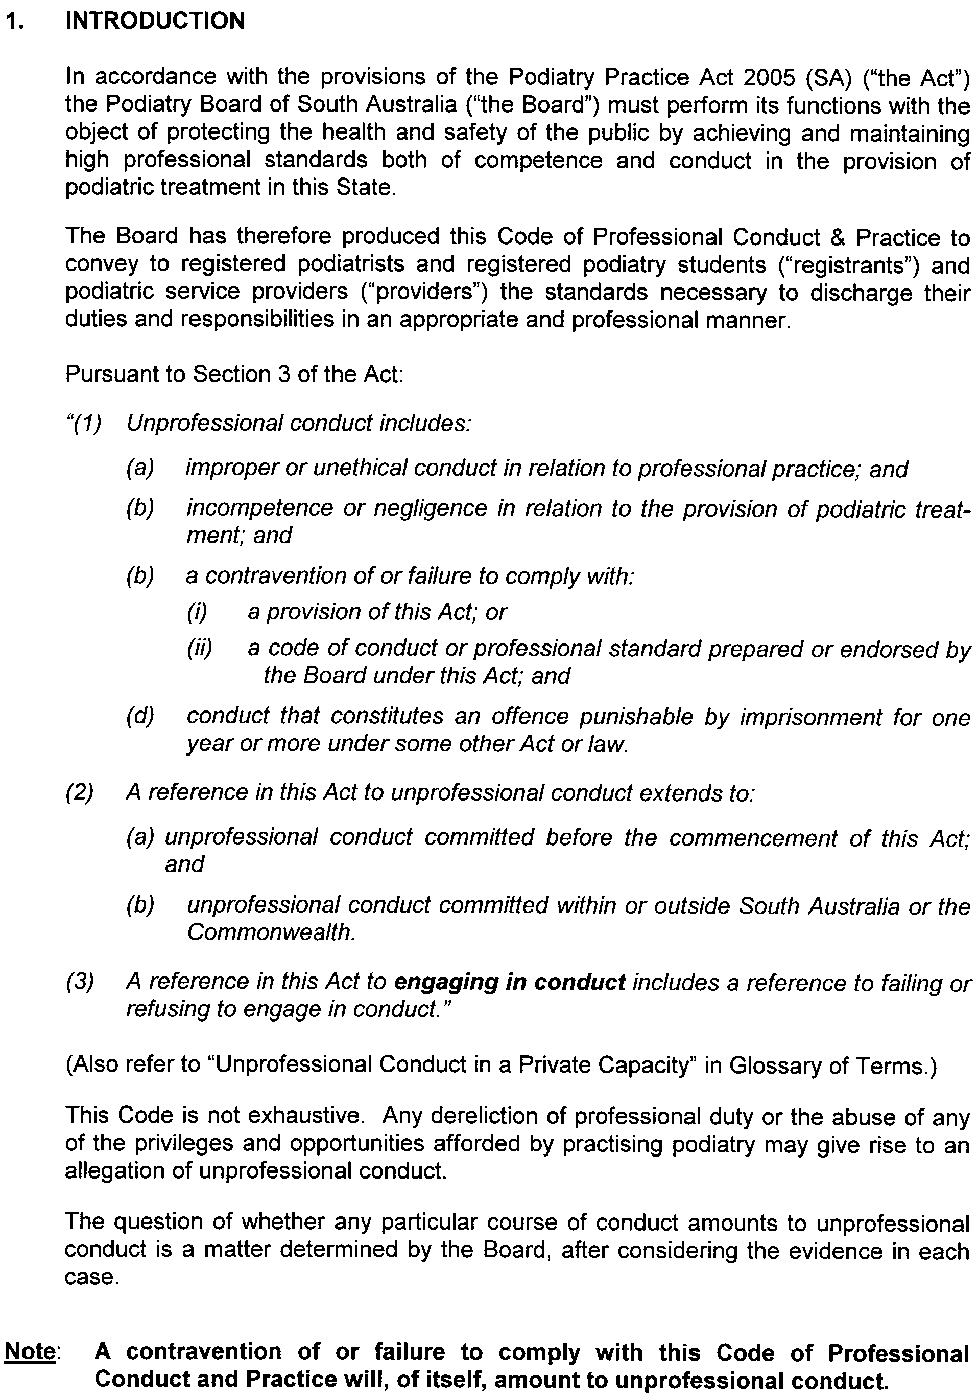


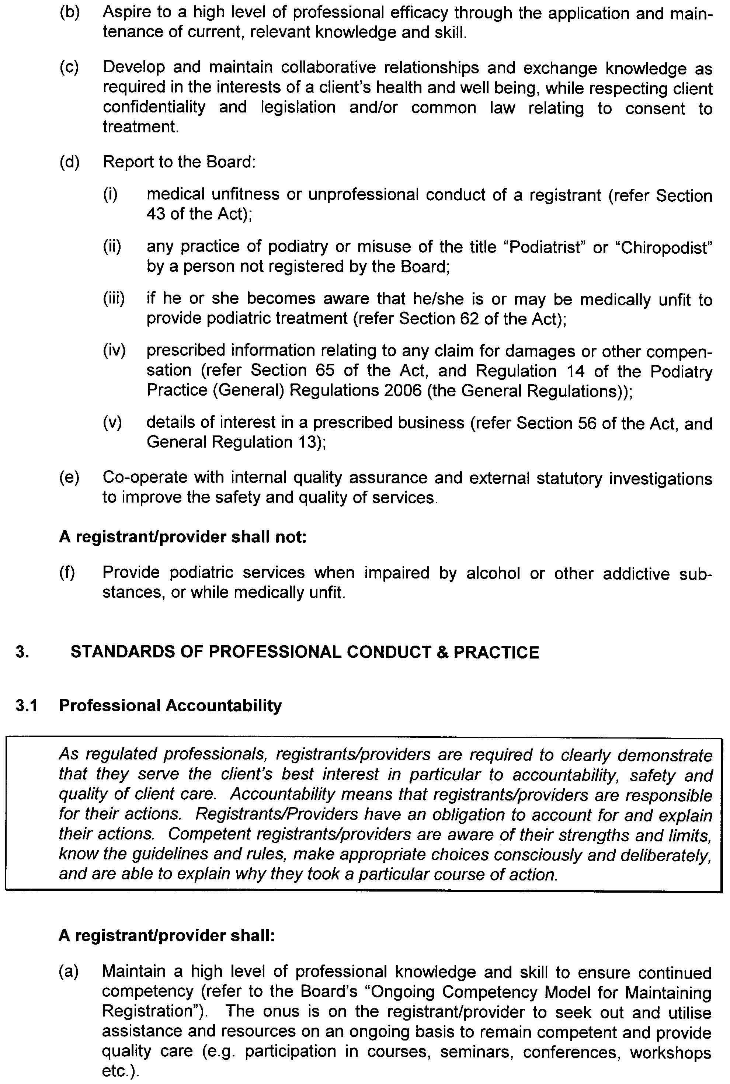

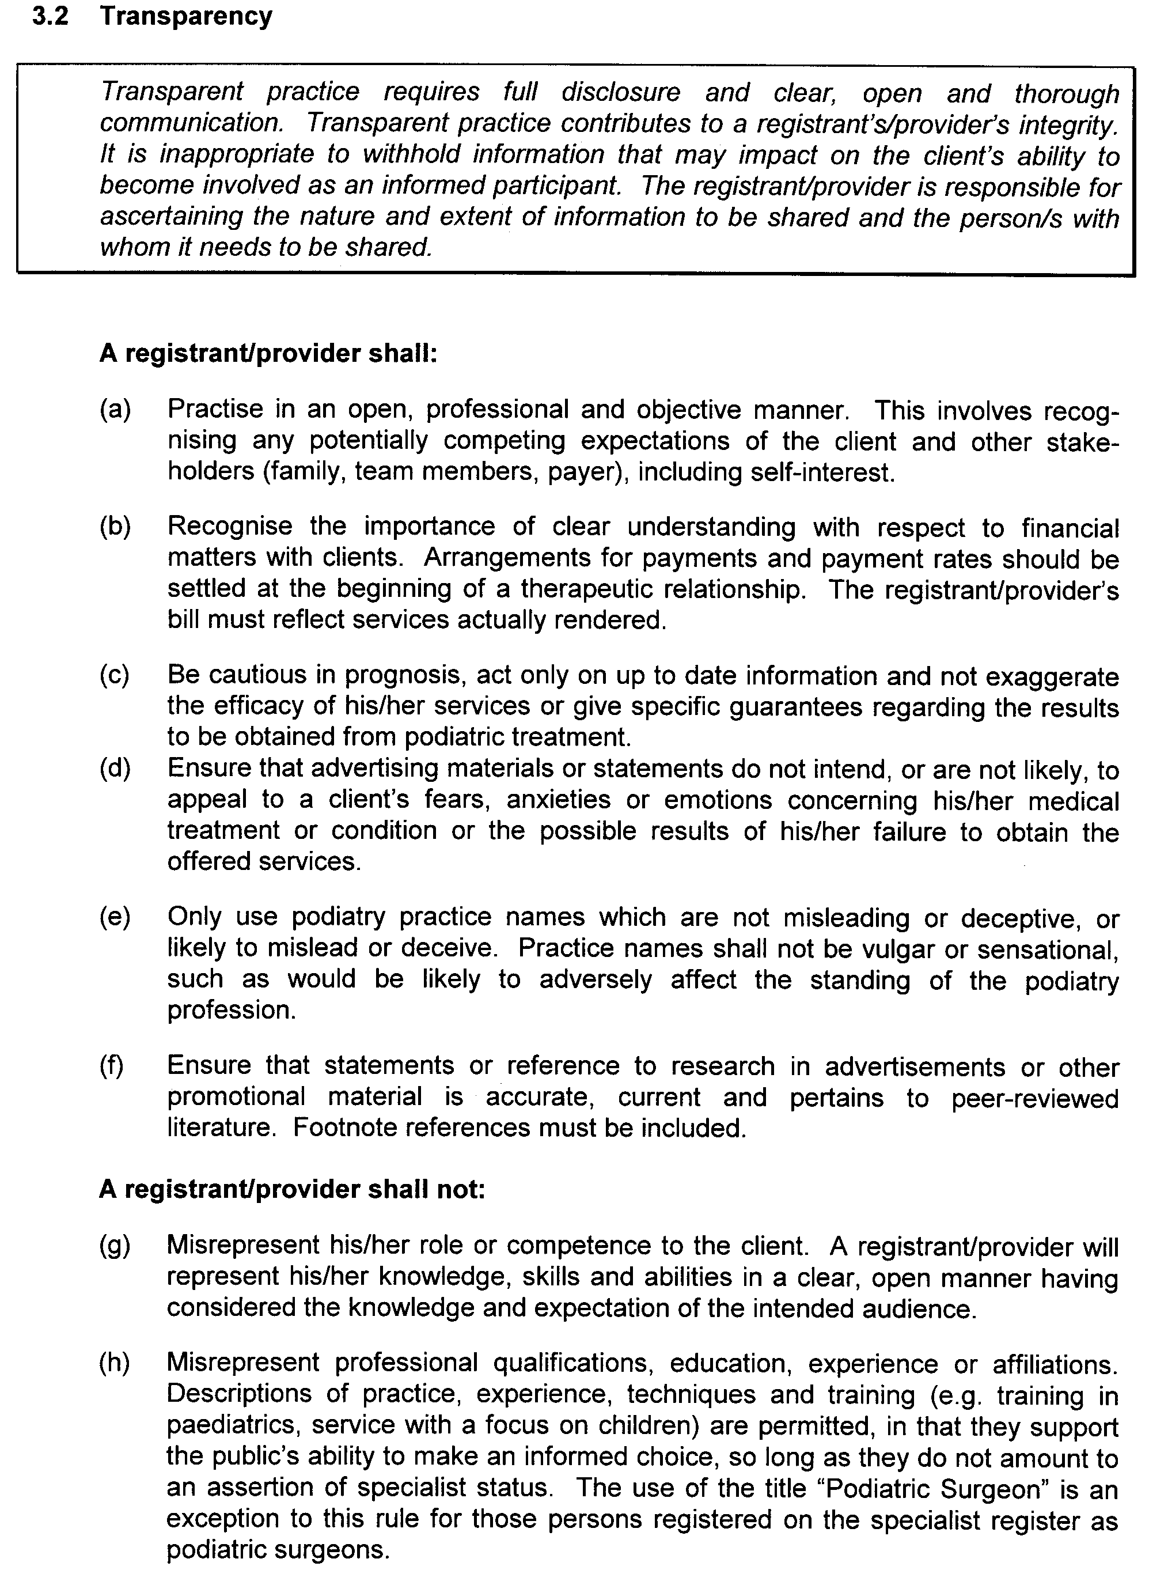
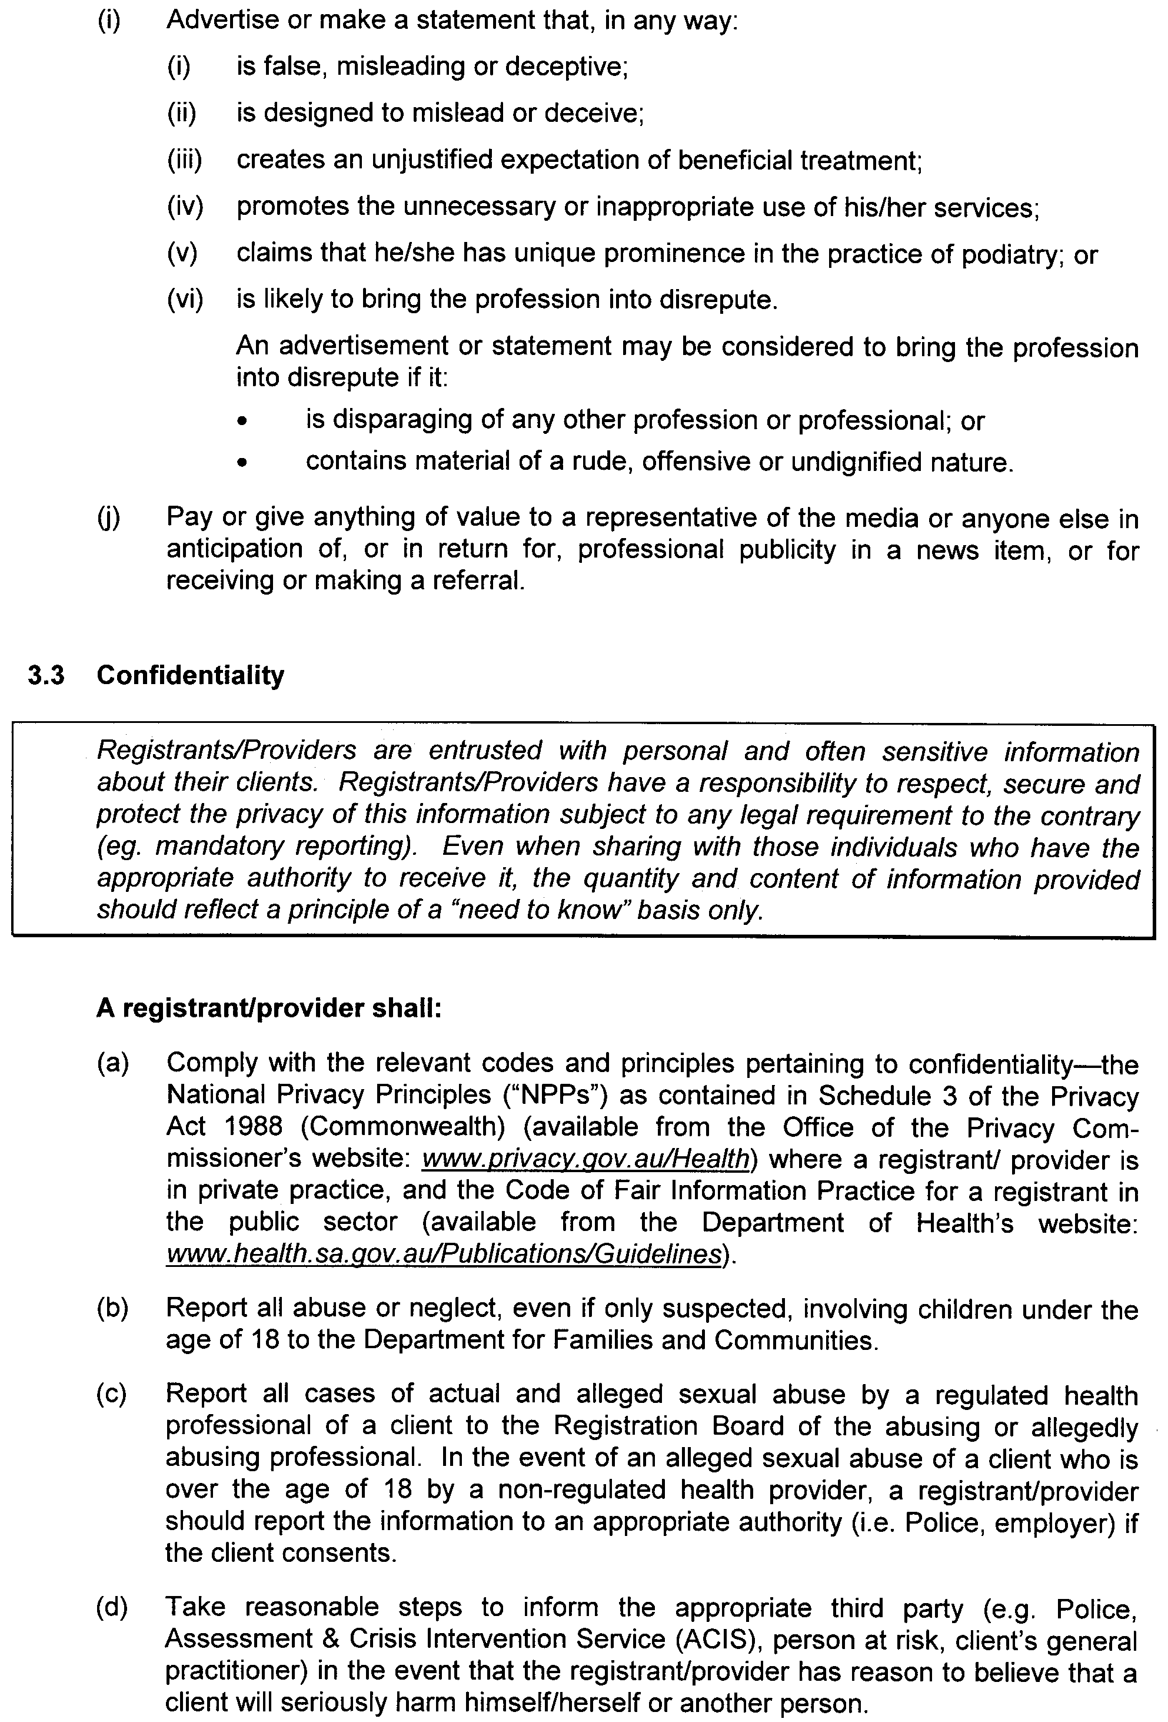

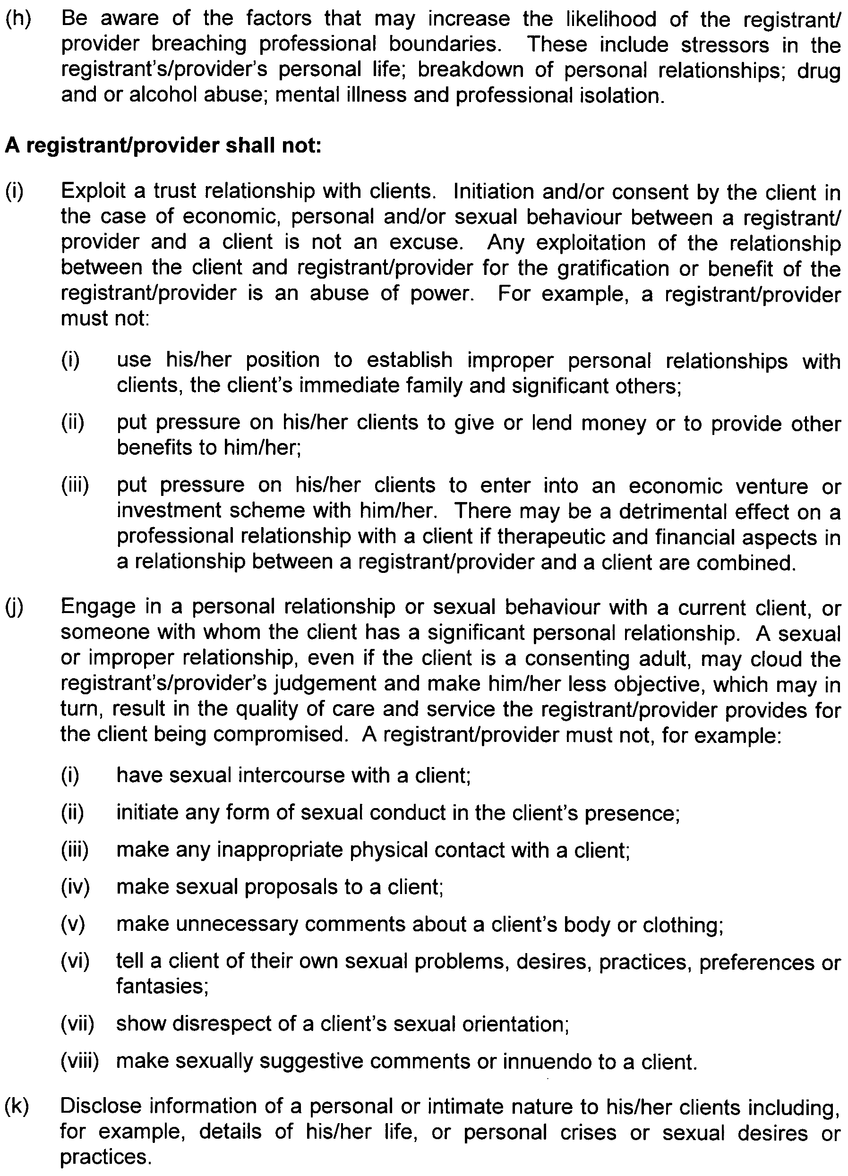

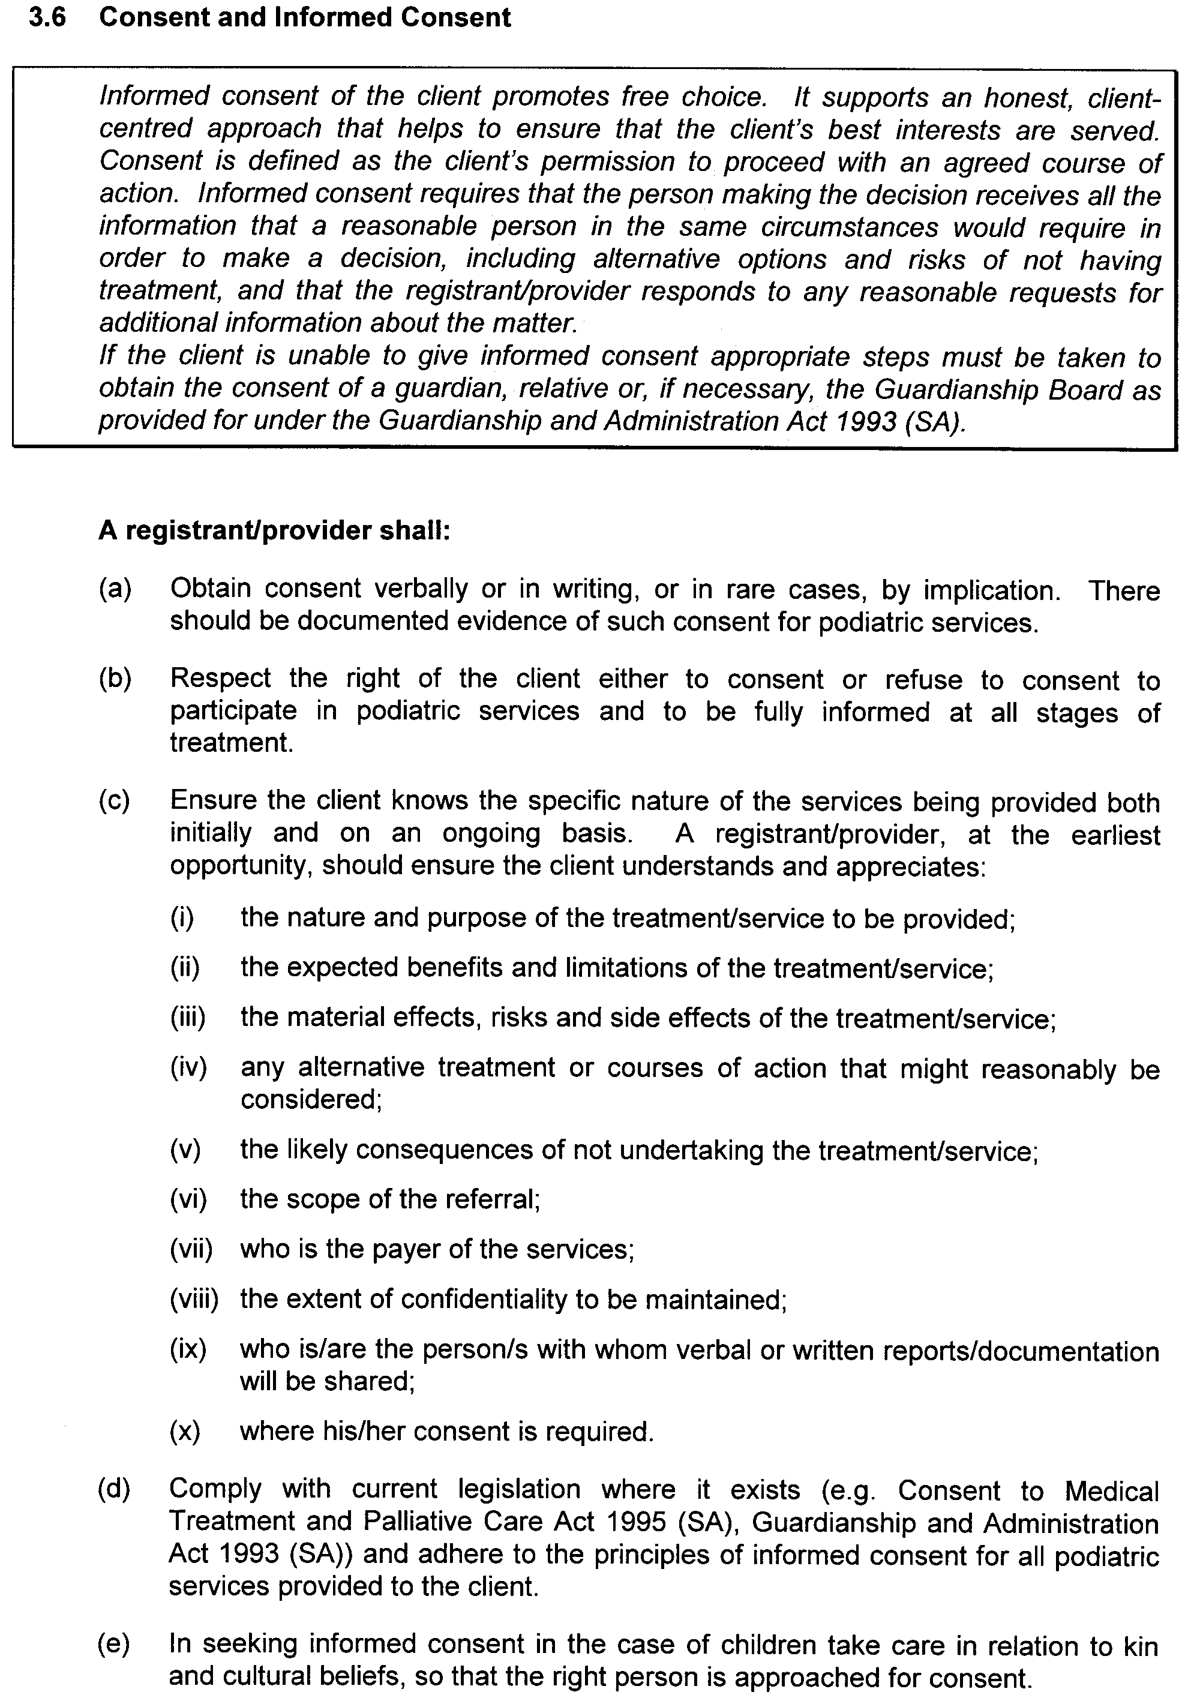
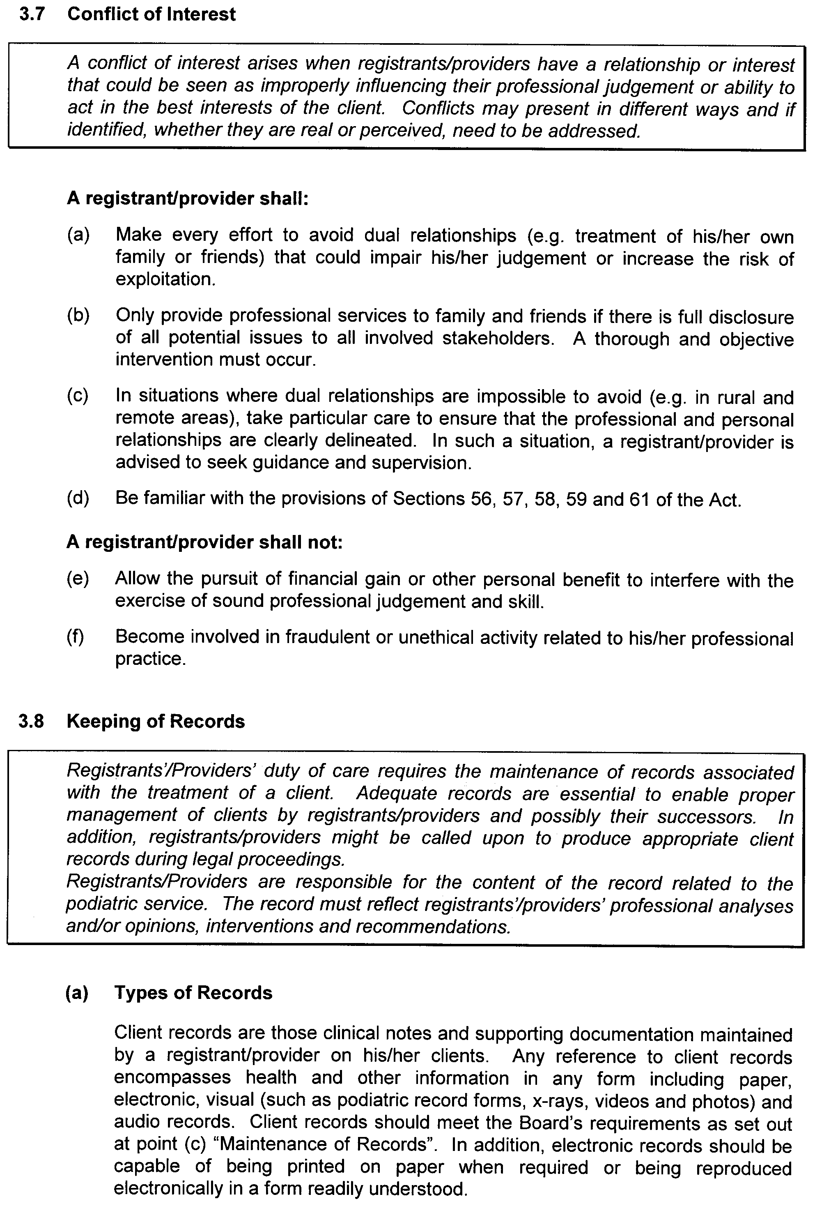
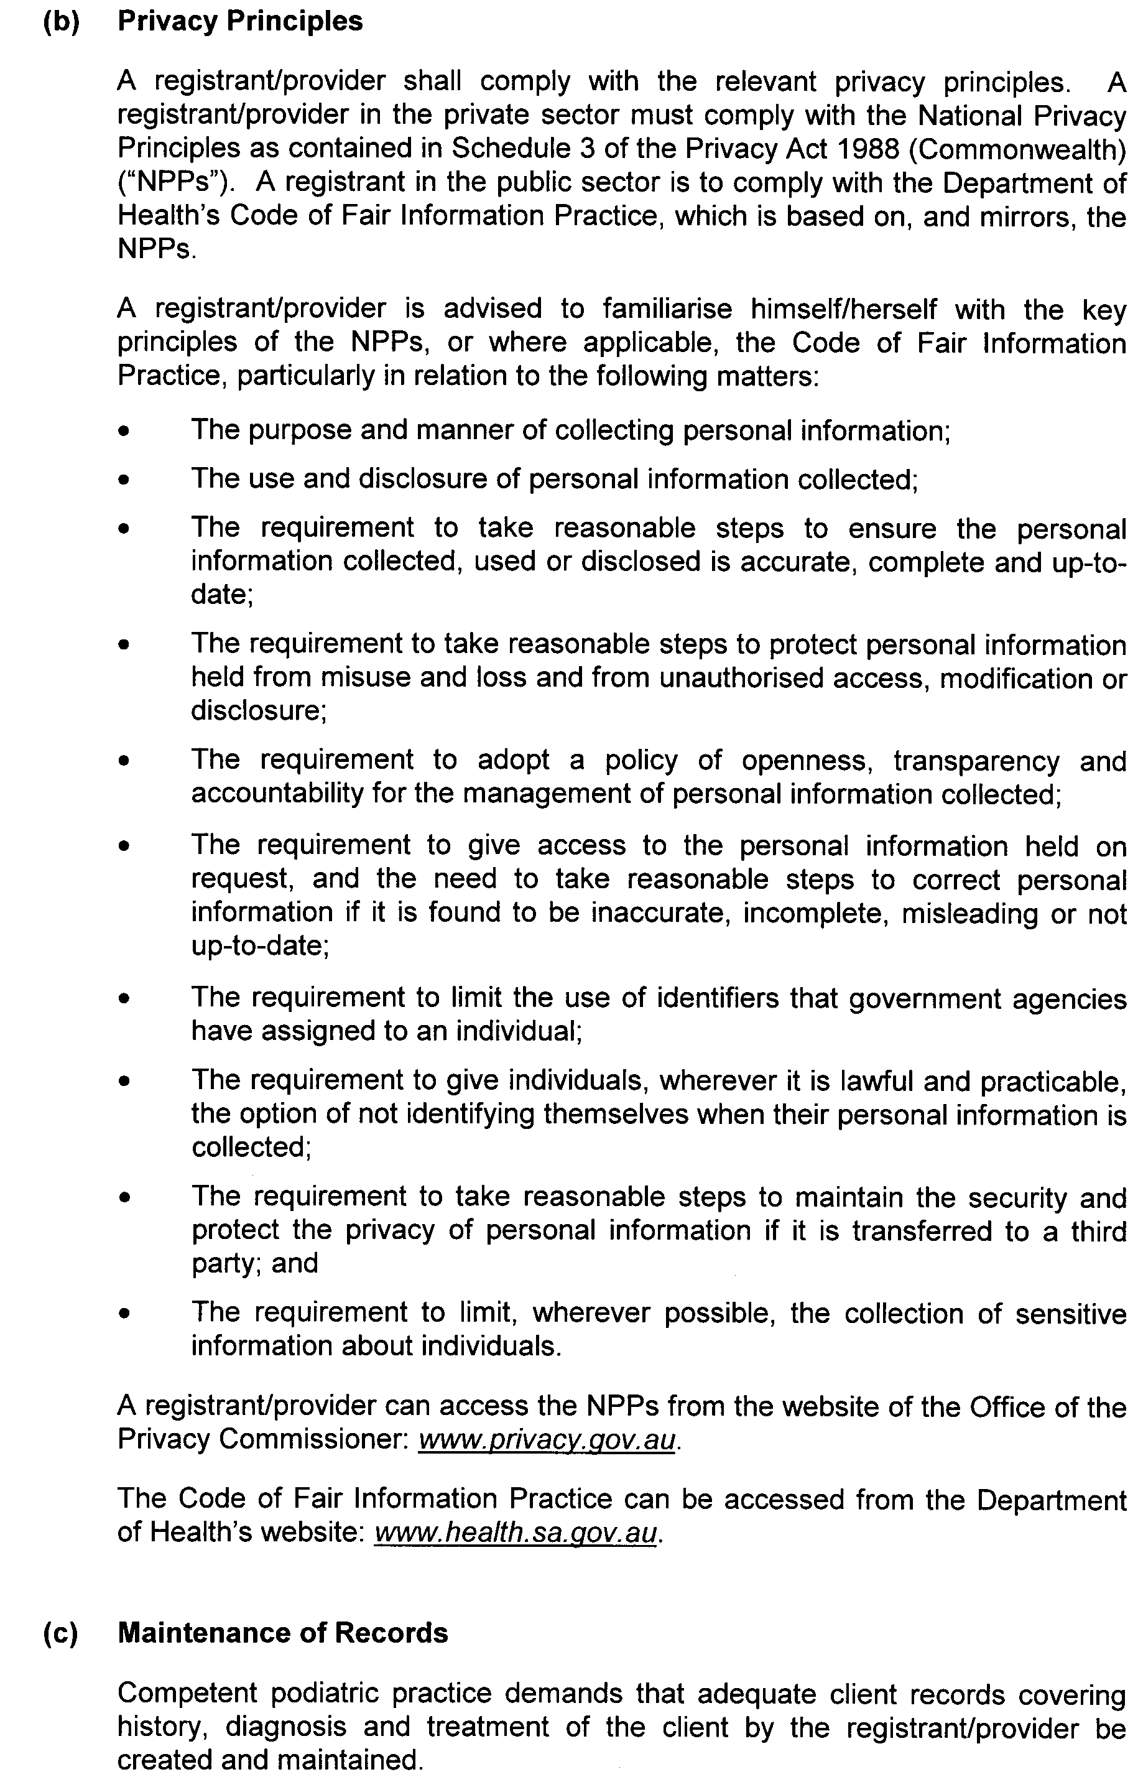
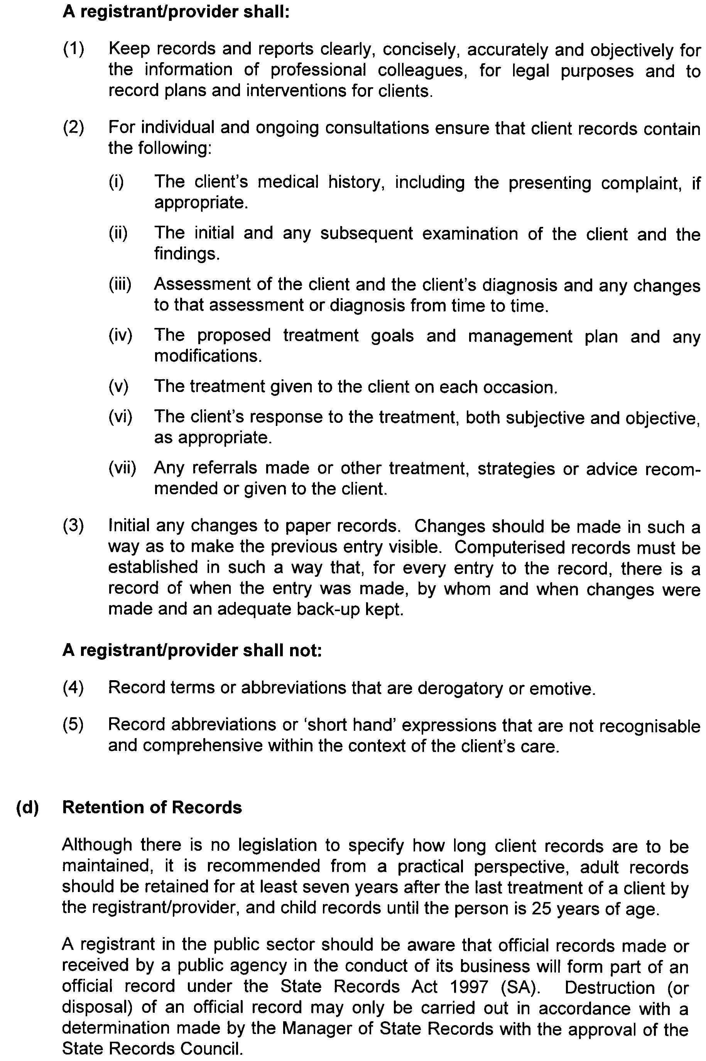
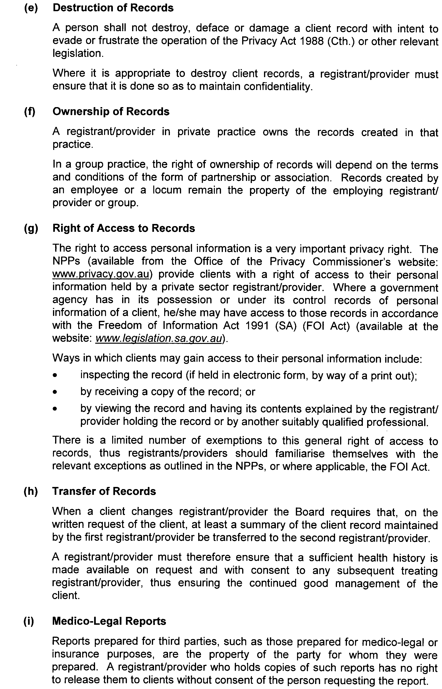
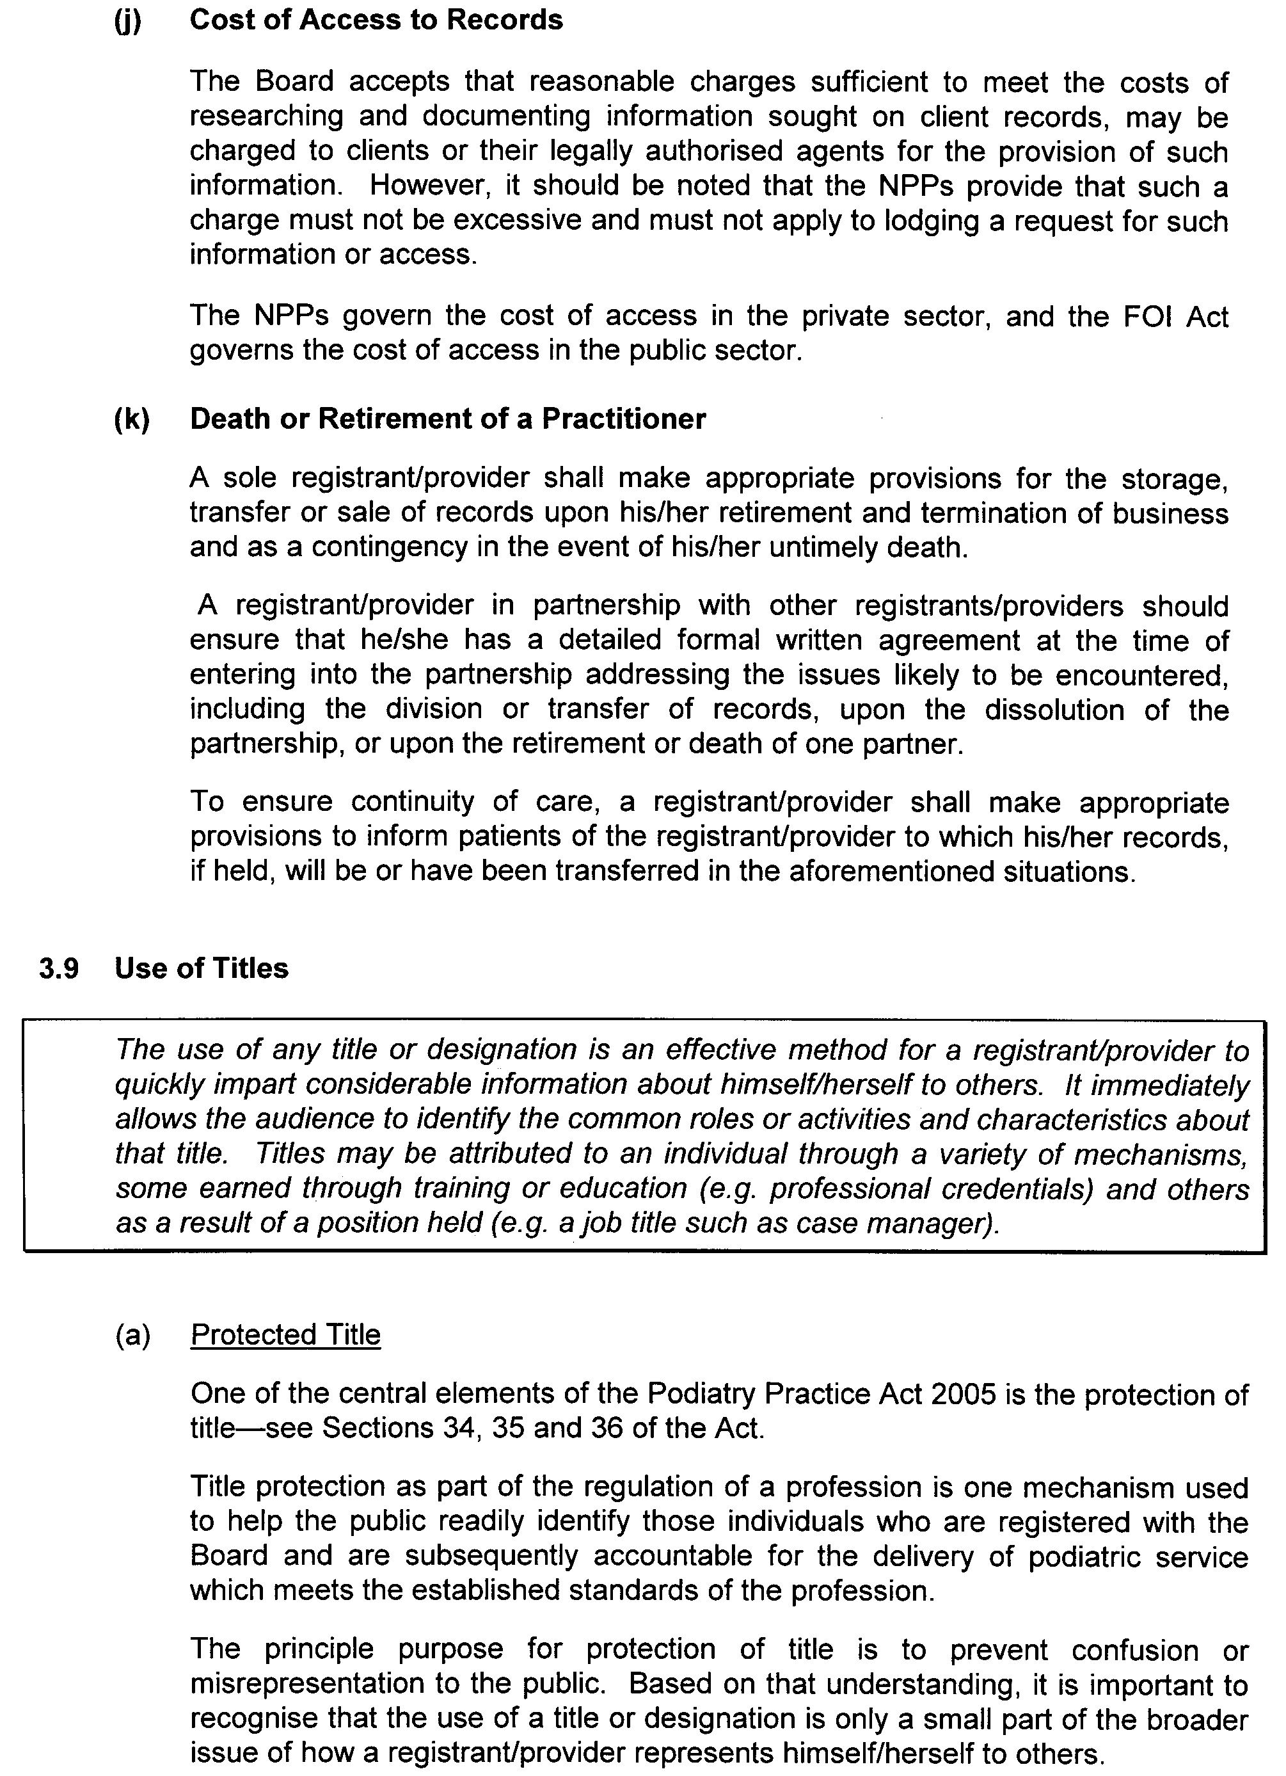
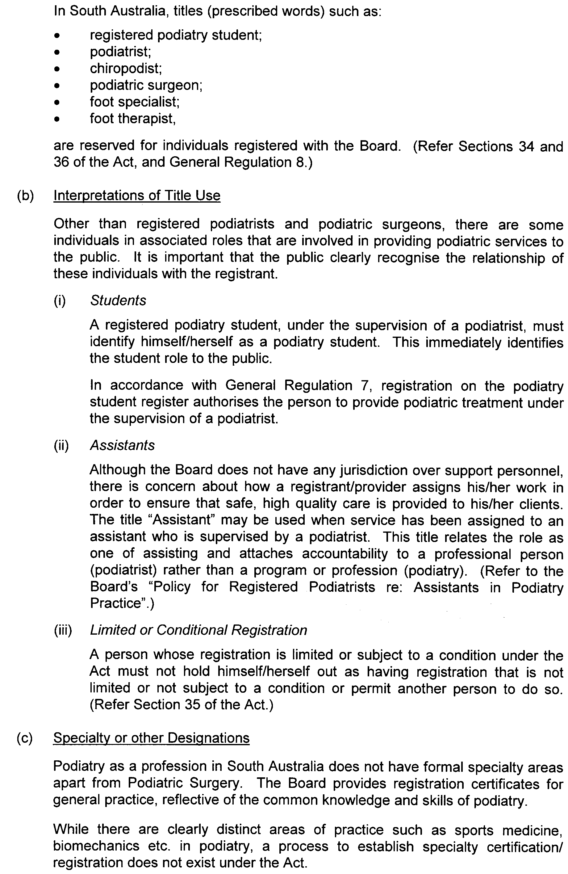
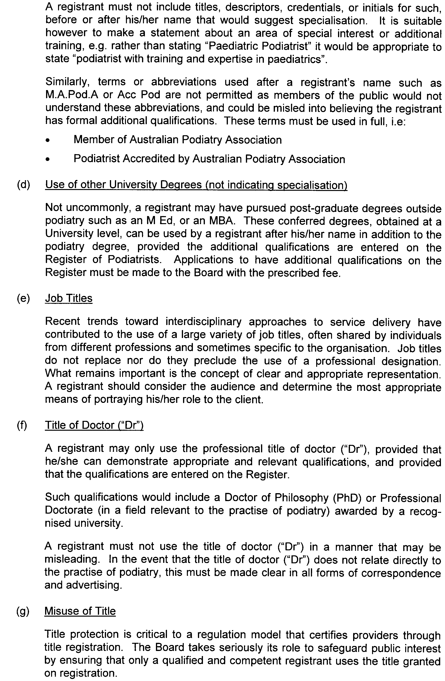
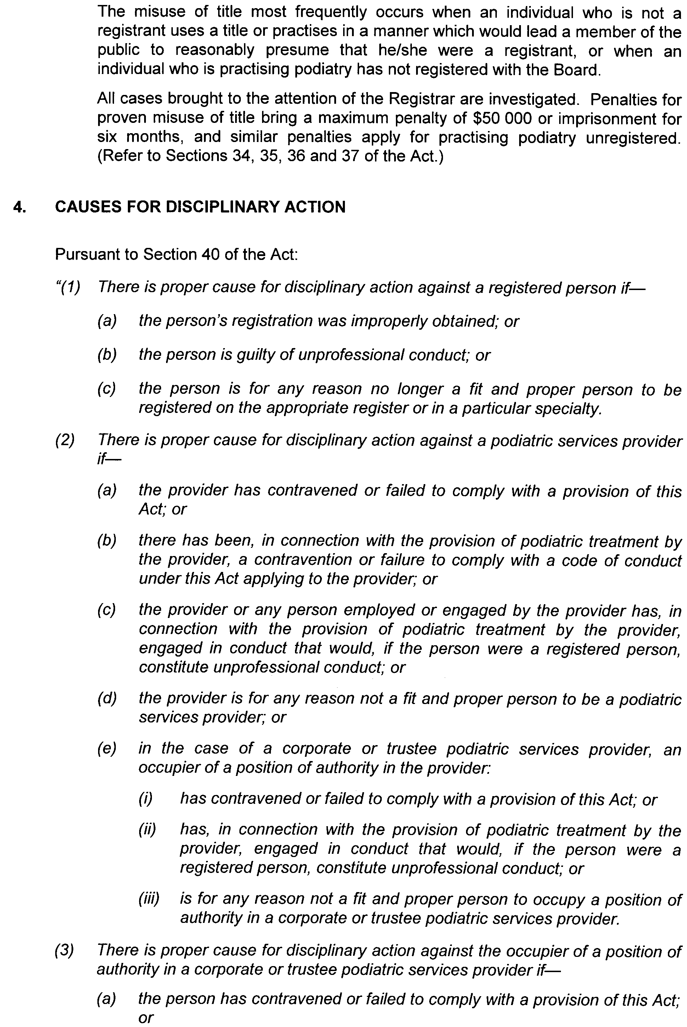
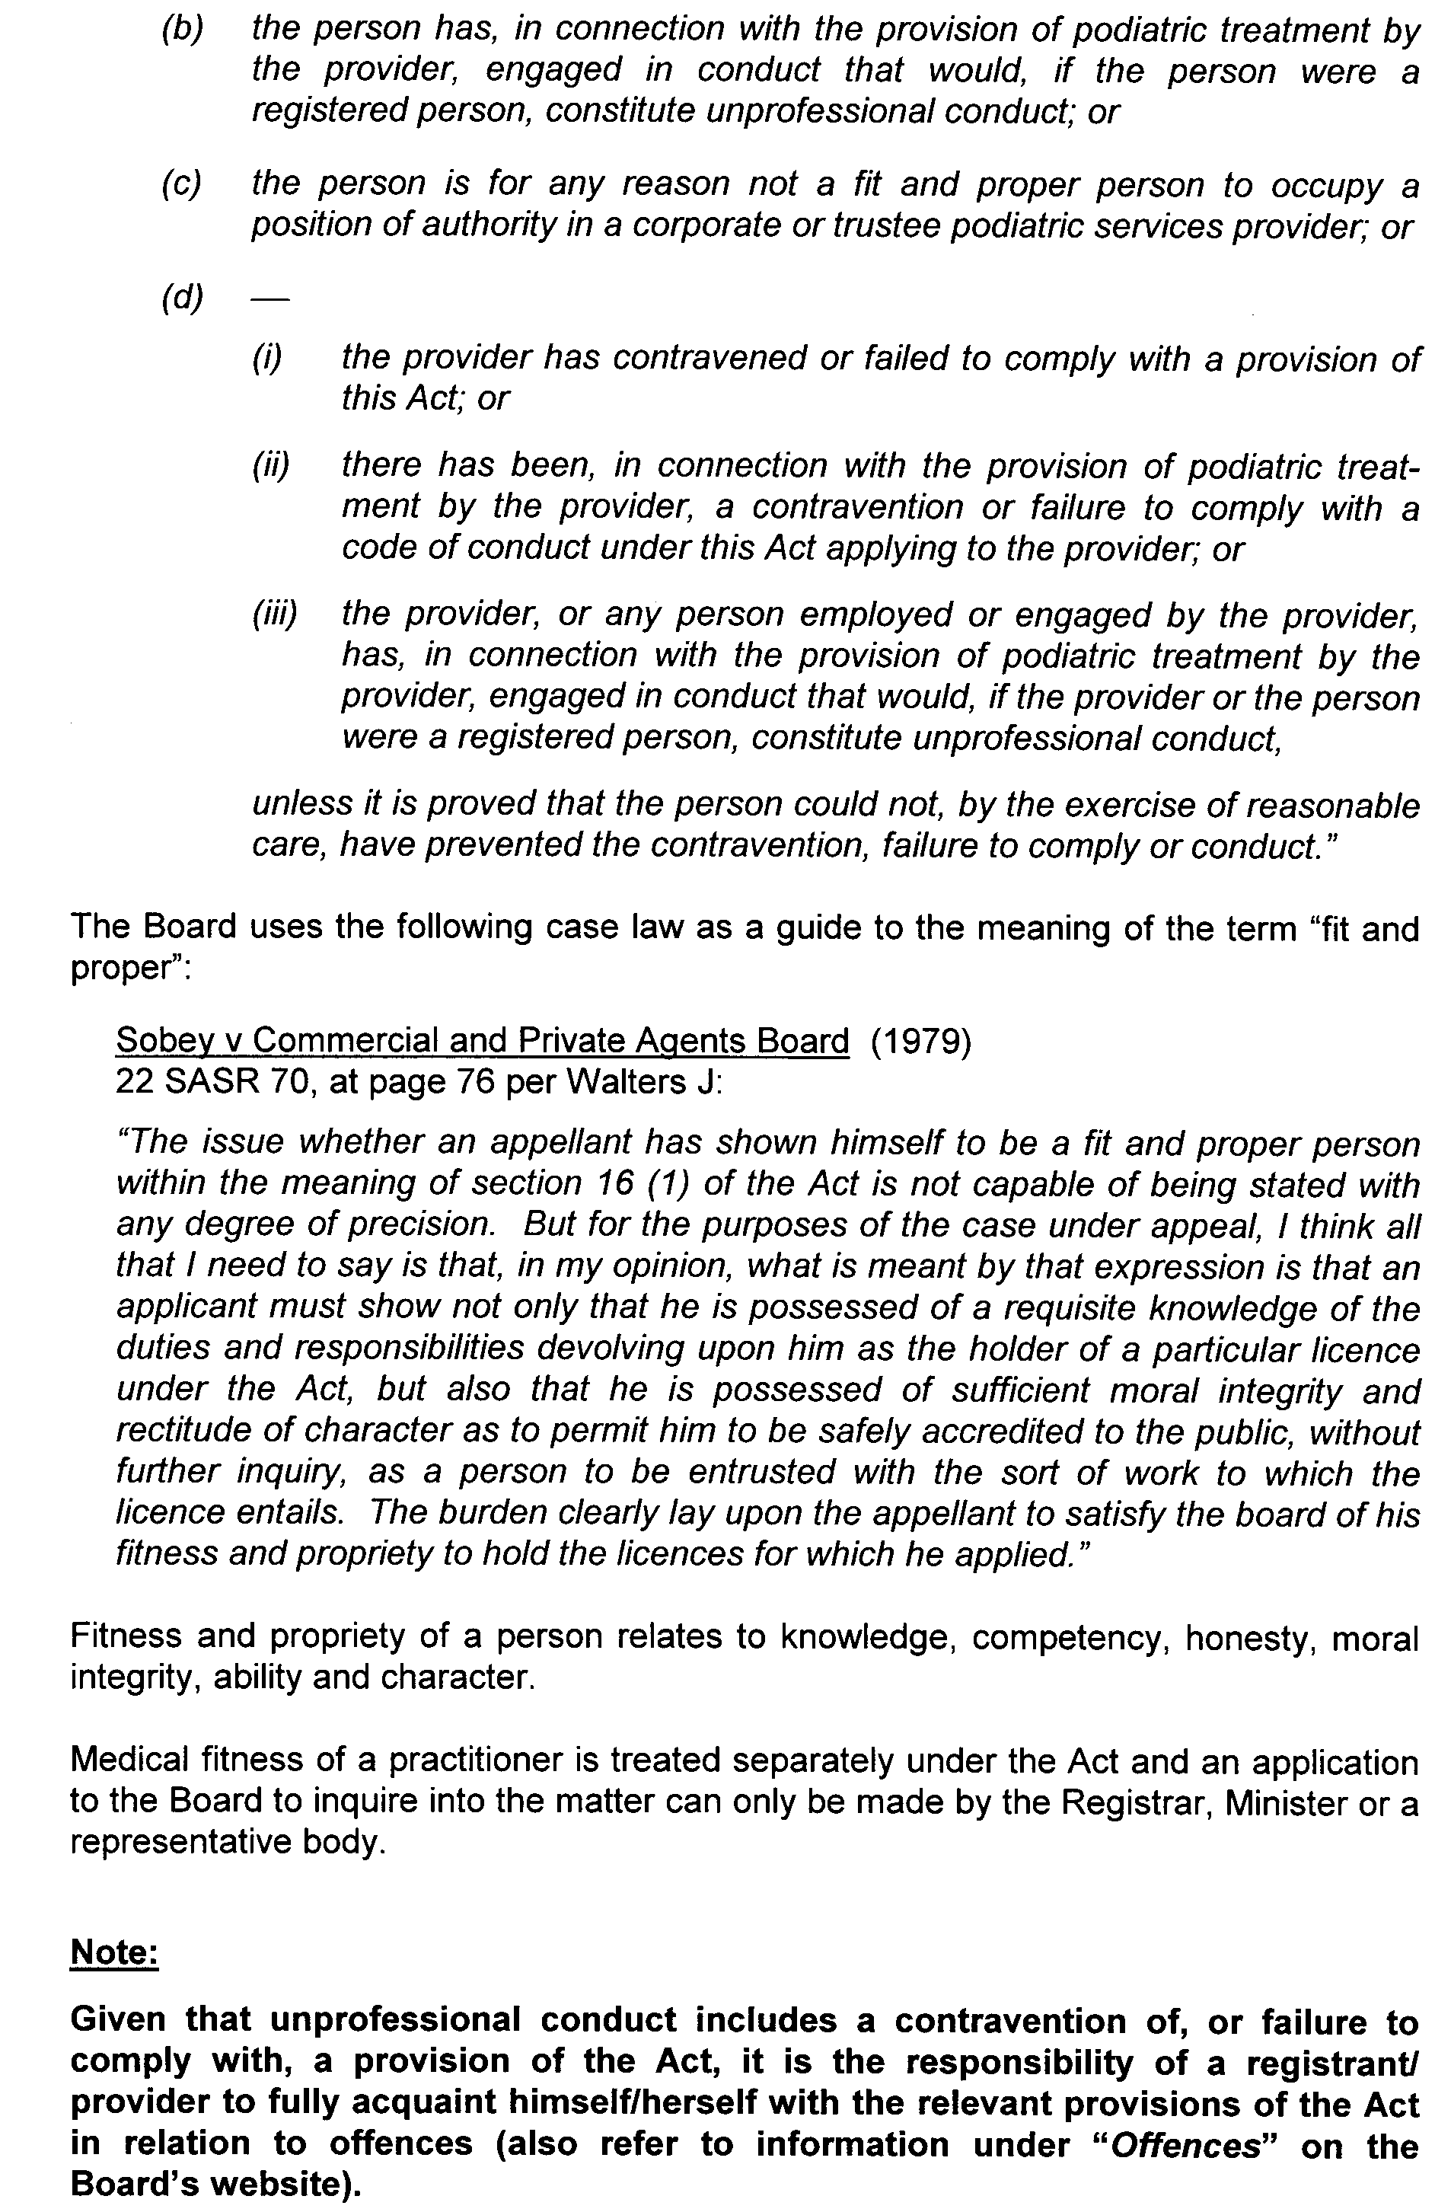

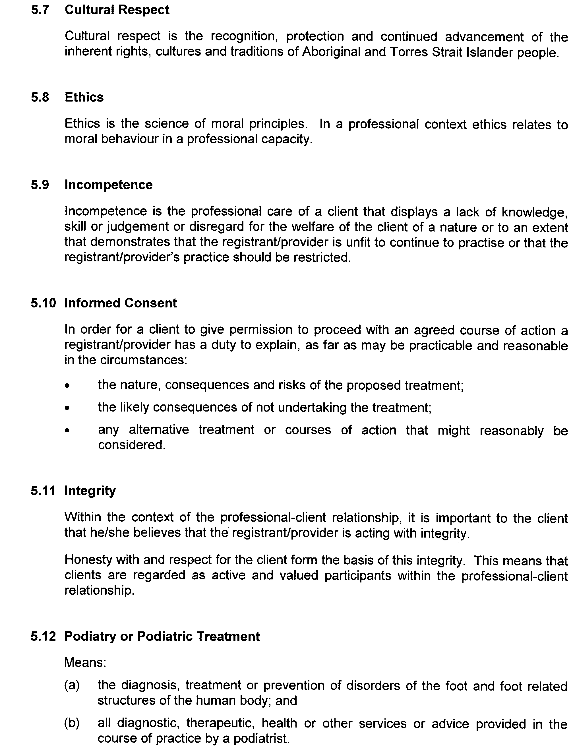

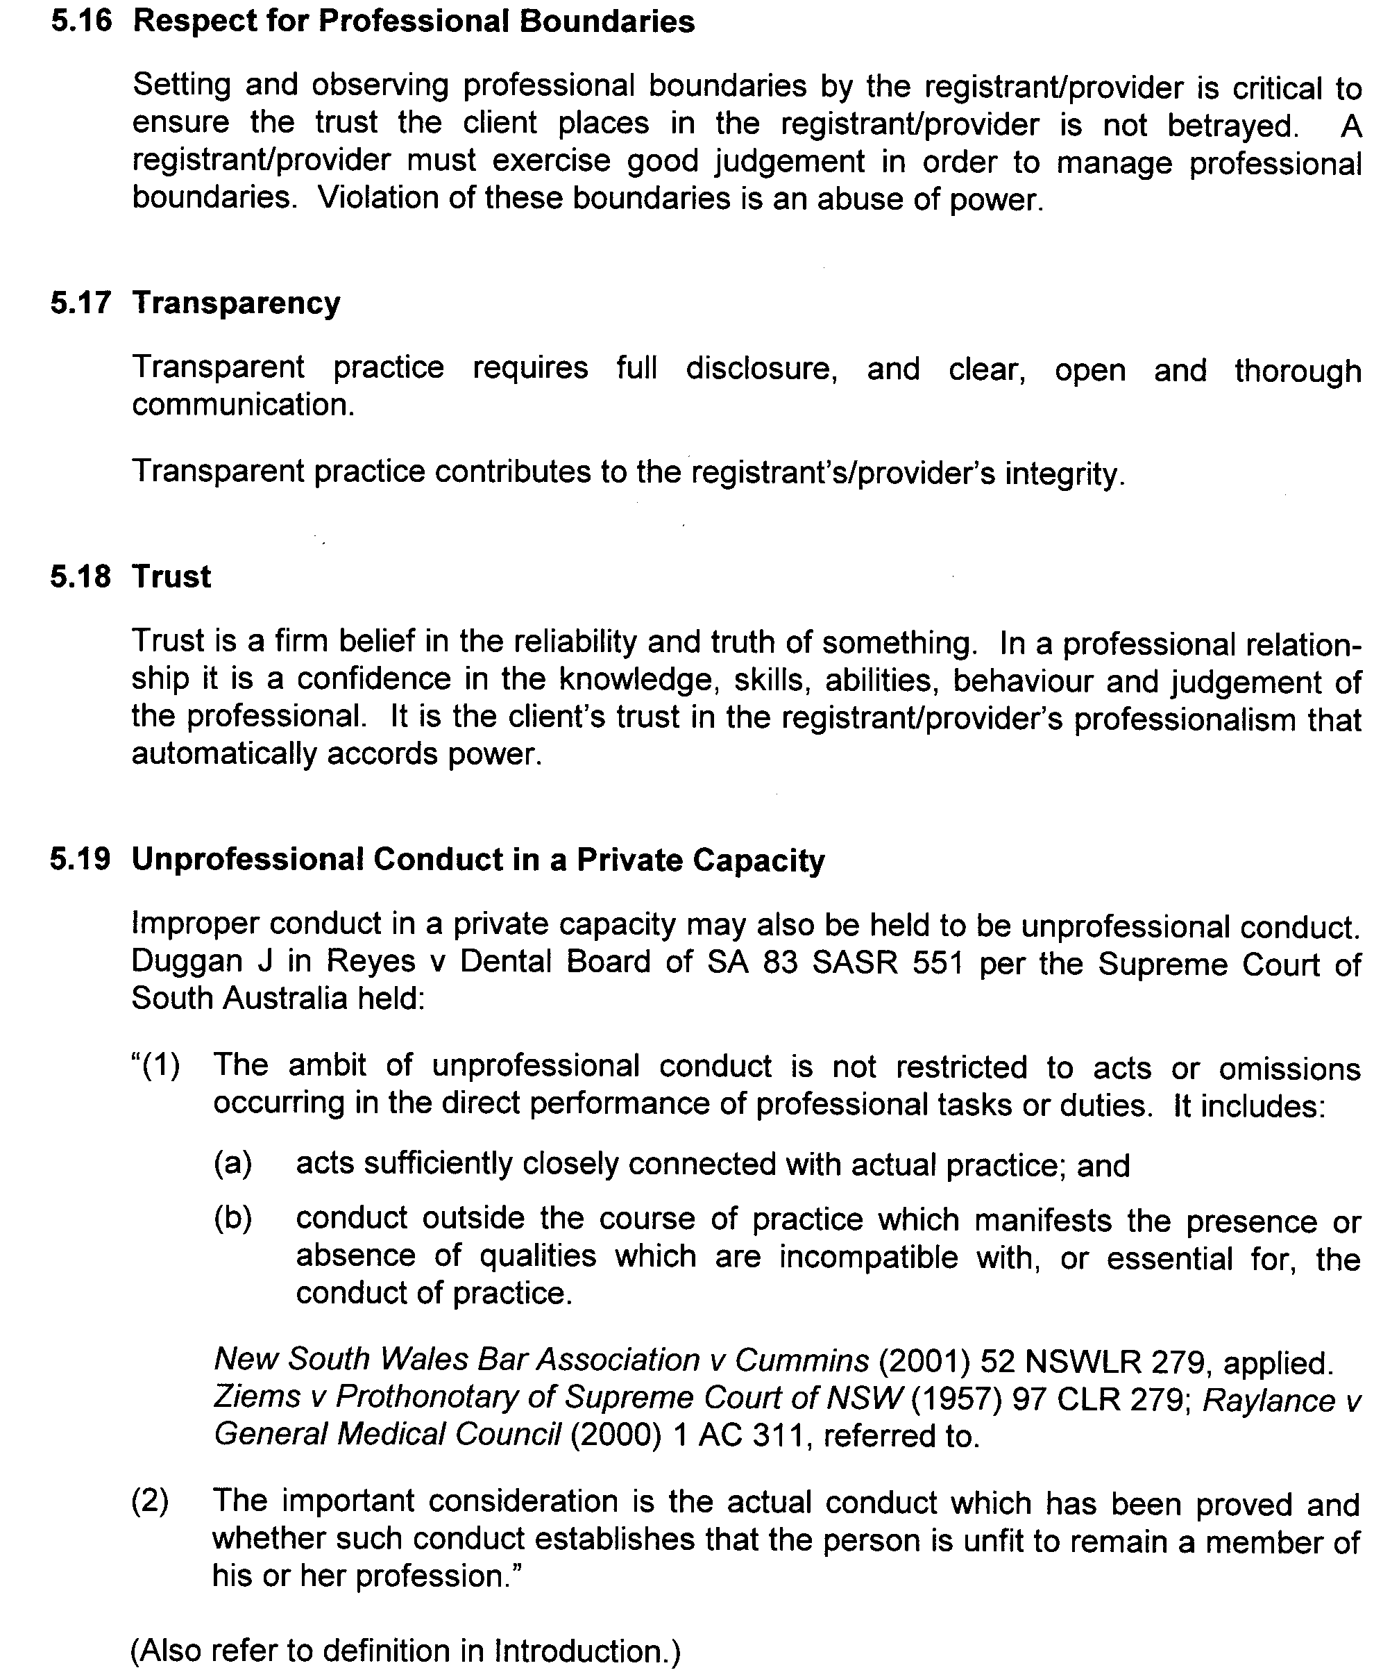


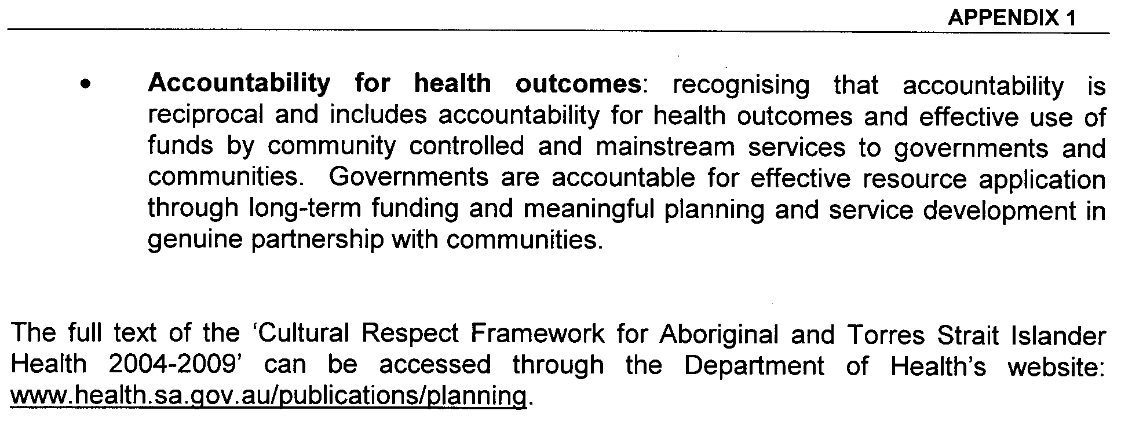
Dated 2 August 2008.
John Hill, Minister for Health

REAL PROPERTY ACT NOTICE
WHEREAS the persons named at the foot hereof have each respectively for himself made application to have the land set forth and described before his name at the foot hereof brought under the operation of the Real Property Act: Notice is hereby given that unless caveat be lodged with the Registrar-General by some person having estate or interest in the said lands on or before the expiration of the period herein below for each case specified, the said several pieces of land will be brought under the operation of the said Act as by law directed. Diagrams delineating these parcels of land may be inspected at the Lands Titles Registration Office, Adelaide, and in the offices of the several corporations or district councils in which the lands are situated.

The Schedule
No. of  Applica-  tion | Description of Property |  | Name |  | Residence | Date up to and  inclusive of which  caveat may be  lodged

31074 | Portion of Allotment 11 in L.T.R.O. Deposited Plan No. 69003, being portion of Allotment 276, Township of Currency Creek |  | James Edwards |  | P.O. Box 850, Goolwa, S.A. 5124 | 29 October 2008

Dated 26 August 2008, at the Lands Titles Registration Office, Adelaide. J. Zaccaria, Deputy Registrar-General

ROAD TRAFFIC ACT 1961

SUPPLEMENTARY NOTICE OF APPROVAL
Pursuant to Section 161A of the Road Traffic Act 1961

Higher mass limits for vehicles fitted with road friendly suspension

1. APPROVAL
Information Note
This Notice adds additional routes to the network that can be used by vehicles fitted with Road Friendly Suspension and is a supplement to the Notice titled ‘Higher Mass Limits for Vehicles Fitted with Road Friendly Suspension’ dated 5 May 2005.

1.1 In accordance with the powers delegated to me by the Minister for Transport under Section 163AA of the Road Traffic Act 1961, I hereby vary the conditions of the Gazette Notice of Approval and Exemption titled, ‘Higher Mass Limits for Vehicles Fitted with Road Friendly Suspension’ dated 5 May 2005 as detailed below.

2. DEFINITIONS

2.1 In this Notice:

2.1.1 ‘Approved Vehicles’ means vehicles fitted with Road Friendly Suspension as described in Table 1 of the Primary Notice;
2.1.2 ‘Supplementary routes’ means the approved routes specified in the maps ‘Route Network for General Access Vehicles fitted with Road Friendly Suspension’ attached to this Supplementary Notice;
2.1.3 ‘Supplementary Notice’ means this Notice;
2.1.4 ‘Primary Notice’ means the Gazette Notice ‘Higher Mass Limits for Vehicles Fitted with Road Friendly Suspension’ dated 5 May 2005; and
2.1.5 all other terms have the same meaning as in the Primary Notice.

3. APPLICATION OF SUPPLEMENTARY NOTICE

3.1 This Supplementary Notice must be read in conjunction with the Primary Notice and applies to all Approved Vehicles operating under the Primary Notice travelling on routes specified in the attached maps.

4. ROUTES AVAILABLE TO APPROVED VEHICLES

4.1 An Approved Vehicle may operate under the conditions of the Primary Notice on a supplementary route specified hereunder:

4.1.1 ‘Route Network for General Access Vehicles fitted with Road Friendly Suspension’ Map R8 (Billabong Road and Thiele Road, Pompoota, Dabinett Road and Kenny Road, Ponde).
4.1.2 ‘Route Network for General Access Vehicles fitted with Road Friendly Suspension’ Map R9 (Brighton Drive from Deviation to Moyhall Road, Naracoorte).
4.1.3 ‘Route Network for General Access Vehicles fitted with Road Friendly Suspension’ Map U1 (Wheaton Road, McLaren Vale).
4.1.4 ‘Route Network for General Access Vehicles fitted with Road Friendly Suspension’ Township Map M-P (Brighton Drive from Deviation to Moyhall Road, Naracoorte).

5. CONDITIONS AND LIMITATIONS APPLYING TO THIS SUPPLEMENTARY NOTICE

5.1 When operating on a route specified in the attached maps, the driver of an Approved Vehicle must:

5.1.1 continue to comply with all conditions and requirements of the Primary Notice; and
5.1.2 carry a legible, current and complete copy of:
(i) this Supplementary Notice and attached maps;
(ii) the Primary Notice;
(iii) any combination specific documents as requested by the Primary Notice; and
5.1.3 produce these documents when requested by a Department for Transport, Energy and Infrastructure, Transport Safety Compliance Officer appointed under the Road Traffic Act 1961 and/or the Motor Vehicles Act 1959 or a Police Officer.

6. COMMENCEMENT OF THIS NOTICE

6.1 This Notice is effective from 12.01 a.m. on 5 September 2008.

Executive Director,
Safety and Regulation Division
Department for Transport, Energy and Infrastructure
Authorised Delegate for the Minister for Transport
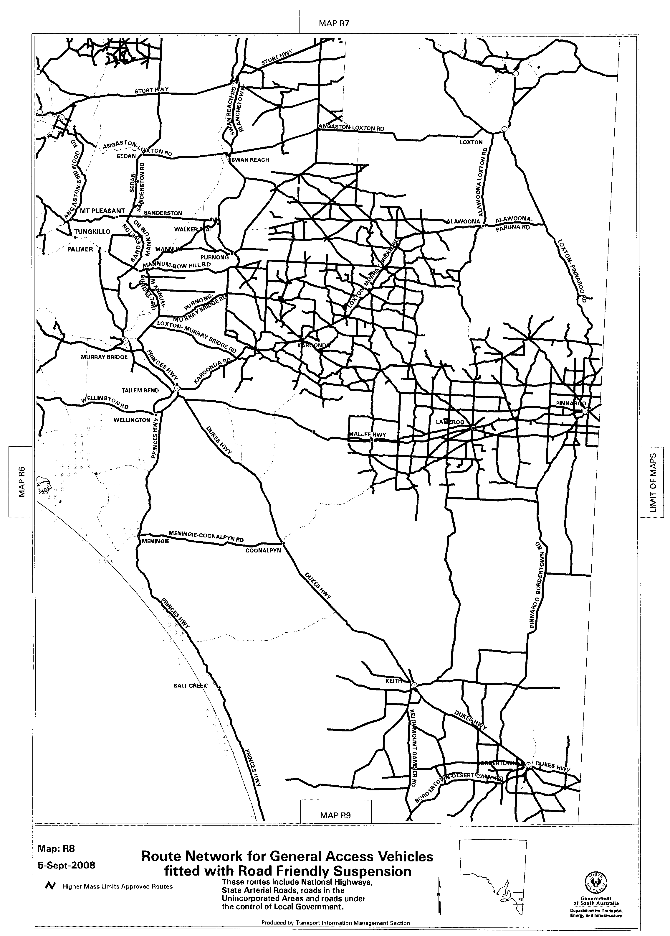
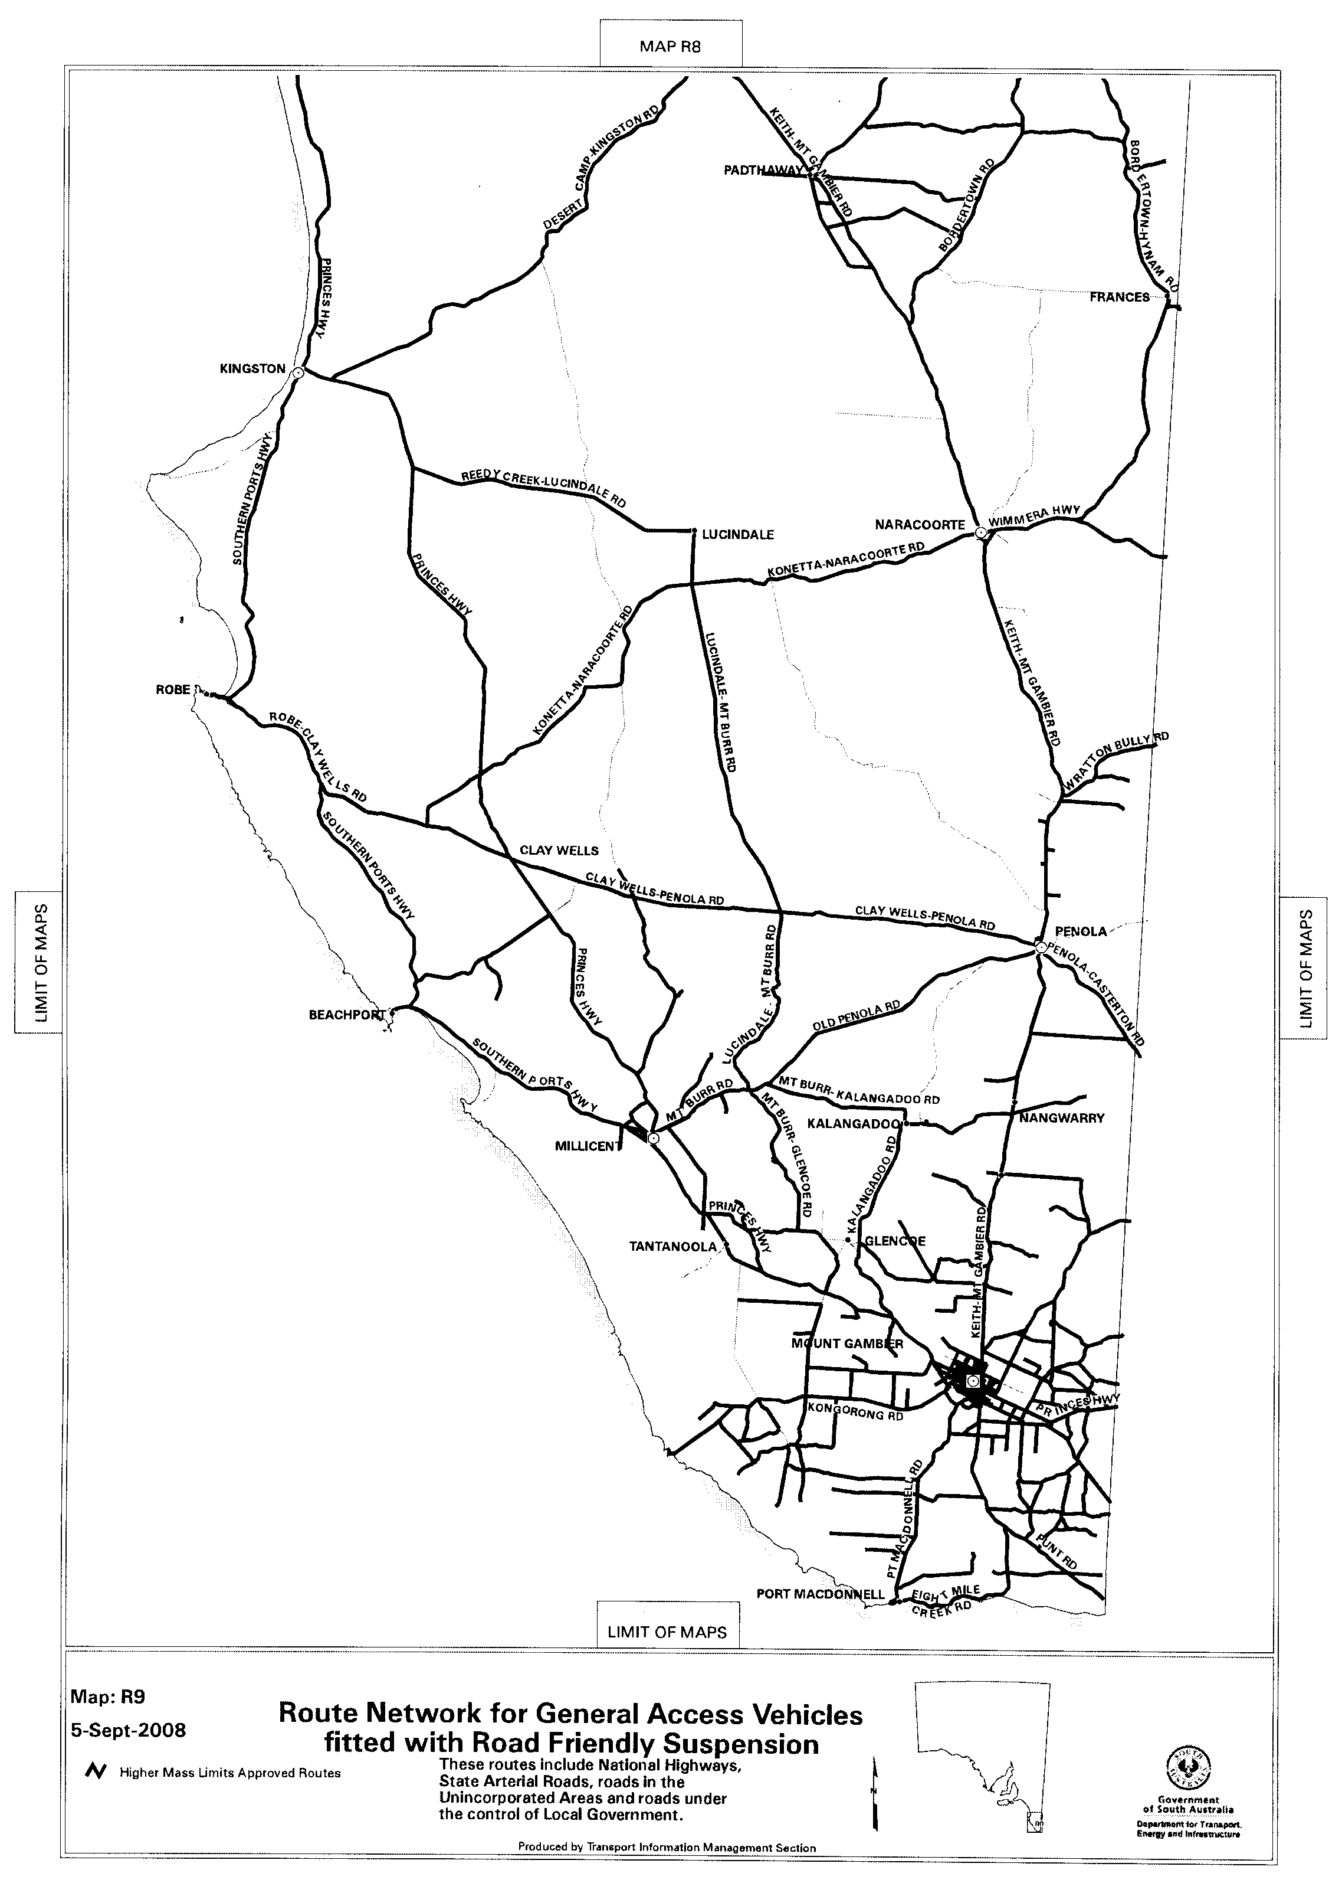
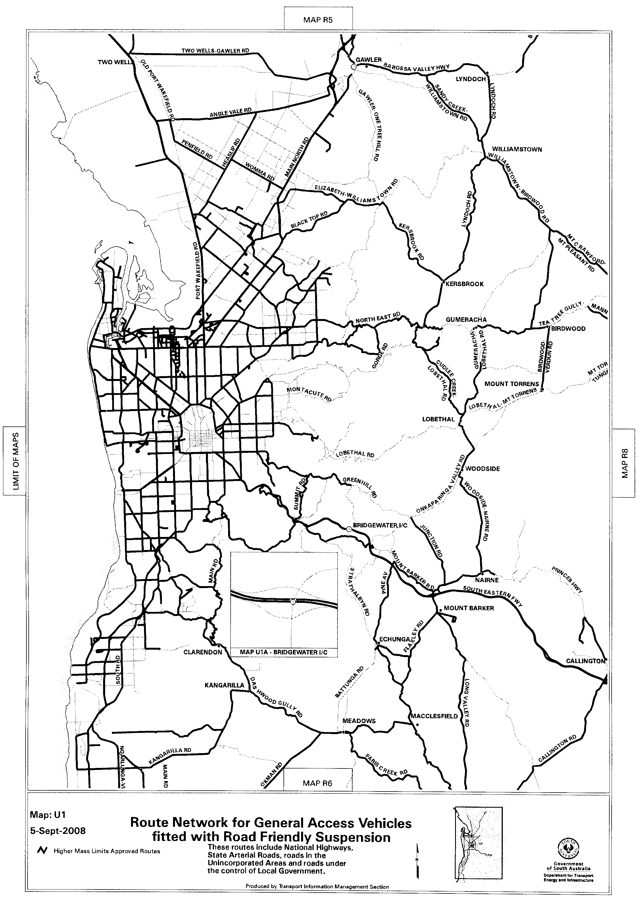
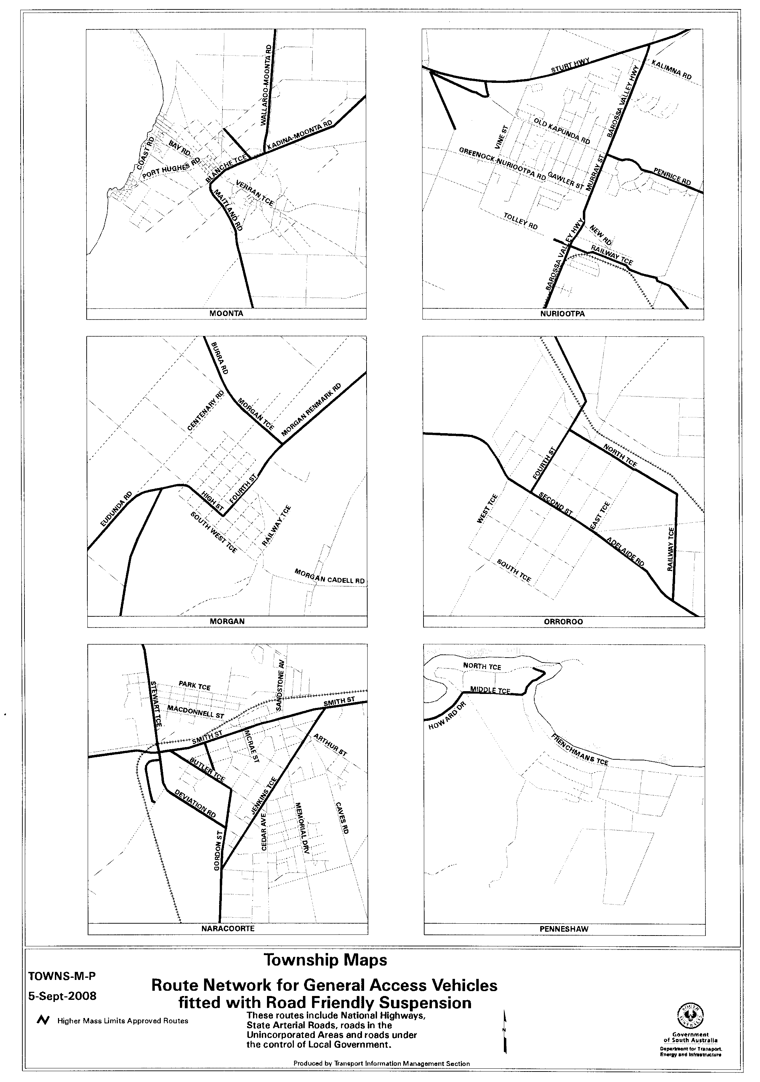

RADIATION PROTECTION AND CONTROL ACT 1982
Section 44
Notice by Delegate of the Minister for Environment and Conservation
PURSUANT to section 44 of the Radiation Protection and Control Act 1982, I, Keith Baldry, Director of the Radiation Protection Division of the Environment Protection Authority, being a person to whom the powers of the Minister under that section have been delegated under the Act, exempt owners of cabinet X-ray apparatus from the requirements of Regulation 18 of the Radiation Protection and Control (Ionising Radiation) Regulations 2000, subject to the following conditions:
(1) the apparatus must comply with the requirements of Regulation 66 and be maintained in good working order and condition;
(2) the owner must issue a personal monitoring device to a radiation worker if directed in writing by the Director of the Radiaton Protection Division of the Environment Protection Authority to do so; and
(3) this exemption does not apply to monitoring of persons operating the apparatus for purposes of installing, main-taining or servicing the apparatus.
Dated 20 August 2008.
K. Baldry, Delegate of the Minister for Environment and Conservation

WHEAT MARKETING ACT 1989
Deductions for Grains Research
PURSUANT to section 10 of the Wheat Marketing Act 1989, I, Rory McEwen, Minister for Agriculture, Food and Fisheries, Minister for Forests and Minister for Regional Development, make the following notice concerning grain for the season 2008-2009:
1. There shall be deductions for the purposes of research from the proceeds of all grain for the season.
2. The prescribed rate for such deductions shall be 20 cents per tonne.
3. A purchaser of grain harvested in 2008-2009 is to presume conclusively that the seller has consented to the making of payments under this section.
4. If the seller, by notice in writing given to the Minister by 31 March 2009, indicates that he or she does not consent to the making of such payments in respect of grain harvested in 2008-2009, the Minister must pay to the seller the amount received by the Minister in respect of grain of that season sold by the seller.
5. The written notice should be forwarded to the Minister for Agriculture, Food and Fisheries, G.P.O. Box 1671, Adelaide, S.A. 5001, by the stipulated date.
Dated 26 August 2008.
Rory McEwen, Minister for Agriculture, Food and Fisheries

WHEAT MARKETING ACT 1989
Deductions for South Australian Farmers Federation (SAFF) Grains Council
PURSUANT to section 10 of the Wheat Marketing Act 1989, I, Rory McEwen, Minister for Agriculture, Food and Fisheries, Minister for Forests and Minister for Regional Development, make the following notice concerning grain for the season 2008-2009.
1. There shall be deductions for the purposes of the SAFF Grains Council from the proceeds of all grain for the season.
2. The prescribed rate for such deductions shall be 5 cents per tonne.
3. A purchaser of grain harvested in 2008-2009 is to presume conclusively that the seller has consented to the making of payments under this section.
4. If the seller, by notice in writing given to the Minister by 31 March 2009, indicates that he or she does not consent to the making of such payments in respect of grain harvested in 2008-2009, the Minister must pay to the seller the amount received by the Minister in respect of grain of that season sold by the seller.
5. The written notice should be forwarded to the Minister for Agriculture, Food and Fisheries, G.P.O. Box 1671, Adelaide, S.A. 5001, by the stipulated date.
Dated 26 August 2008.
Rory McEwen, Minister for Agriculture, Food and Fisheries

FAXING COPY?
IF you fax copy to Government Publishing SA for inclusion in the Government Gazette, there is no need to send a Confirmation Copy to us as well.
This creates confusion and may well result in your notice being printed twice.
Please use the following fax number:
Fax transmission: (08) 8207 1040
Phone Inquiries: (08) 8207 1045
Please include a contact person, phone number and order number so that we can phone back with any queries we may have regarding the fax copy.
NOTE: Closing time for lodging new copy (fax, hard copy or email) is 4 p.m. on Tuesday preceding the day of publication.

Government Gazette notices can be E-mailed.
The address is:
governmentgazette@dpc.sa.gov.au
Documents should be sent as attachments in Word format.
When sending a document via E-mail, please confirm your transmission with a faxed copy of your document, including the date the notice is to be published.
Fax transmission: (08) 8207 1040
Enquiries: (08) 8207 1045
NOTE: Closing time for lodging new copy (fax, hard copy or email) is 4 p.m. on Tuesday preceding the day of publication.

CITY OF ONKAPARINGA
Development Act 1993, Section 25 (5)
Onkaparinga (City) Development Plan Local Heritage (Onkaparinga) Development Plan Amendment—
Draft for Agency/Public Consultation
NOTICE is hereby given that the City of Onkaparinga has prepared a draft Development Plan Amendment Report (DPA) to amend the Onkaparinga (City) Development Plan. The Plan Amendment Report proposes to:
• update the register of State Heritage Places in accordance with State Heritage Branch listings;
• update the register of Local Heritage Places and Contributory Items;
• arrange Heritage Places and Contributory Items, in line with the Better Development Plans templates.
The draft DPA will be available for public inspection during normal office hours at Council’s Aberfoyle Park, Noarlunga Centre and Willunga offices, and on Council’s website www.onkaparingacity.com from 28 August 2008 to 24 October 2008. A copy of the report can be purchased from the Council for $20, or it can be downloaded from the website.
Written submissions regarding the draft amendment will be accepted by Council until 24 October 2008 and should be addressed to the Chief Executive Officer, City of Onkaparinga, P.O. Box 1, Noarlunga Centre, S.A. 5168, marked to the attention of Wendy Possingham. The submission should clearly indicate whether you or a representative wishes to speak on the submission at a public meeting for the DPA. The submissions may be lodged electronically at mail@onkaparinga.sa.gov.au.
Copies of all public submissions will be made available for inspection by interested persons at Council’s offices from 24 October 2008, to the conclusion of the public meeting. The public meeting will be held from 6.30 p.m. at Council’s Noarlunga Centre Office (Civic Centre, Ramsay Place, Noarlunga Centre) on 29 October 2008. The public meeting may not be held if no submission makes a request to be heard.
If you would like further information about the draft Development Plan Amendment Report, please contact Wendy Possingham, City of Onkaparinga on telephone 8384 0589 or by email at wenpos@onkaparinga.sa.gov.au.
Dated 28 August 2008.
J. Tate, Chief Executive Officer

CITY OF PORT ADELAIDE ENFIELD
Development Act 1993
Draft Outdoor Advertisements Development Plan Amendment—Draft for Public Consultation
NOTICE is hereby given that the City of Port Adelaide Enfield has prepared a draft Outdoor Advertisements Development Plan Amendment (DPA) to amend the Port Adelaide Enfield (City) Development Plan. The proposed amendments include:
• replacement of Council-wide Objectives and Principles of Development Control to provide a more comprehensive and clear expression of the outdoor advertising outcomes sought by the City;
• the introduction of provisions that establish a height limit for outdoor advertisements in all zones across the City; and
• the introduction of a new table that provides illustrative examples of outdoor advertisements that adhere to several of the key Principles of Development Control proposed to be inserted into the Council-wide Policy section of the Development Plan.
Availability of the Draft DPA Document
The draft Development Plan Amendment will be on public consultation from 9 a.m. on Thursday, 28 August 2008 to 5 p.m. on Friday, 31 October 2008 and will be available for public inspection during normal office hours at:
• the City of Port Adelaide Enfield Civic Centre, 163 St Vincent Street, Port Adelaide;
• the following Library-Council Offices:
Parks: 2-46 Cowan Street, Angle Park;
Enfield: 1 Kensington Crescent, Enfield; and
Greenacres: 2 Fosters Road, Greenacres.
A copy of the draft Development Plan Amendment is also available on Council’s website www.portenf.sa.gov.au. The document may also be purchased at the Port Adelaide Enfield Civic Centre, 163 St Vincent Street, Port Adelaide for $20.
Written Submissions
Written submissions regarding the draft Development Plan Amendment will be accepted by the City of Port Adelaide Enfield until 5 p.m. on Friday, 31 October 2008 and should be addressed to:
City Manager
City of Port Adelaide Enfield
P.O. Box 110
Port Adelaide, S.A. 5015
Interested persons making a written submission should clearly indicate in the submission whether they wish to speak on their submission at the public hearing—see below for details.
Written submissions may be lodged electronically by email to custserv@portenf.sa.gov.au (the text ‘Submission Regarding Draft Outdoor Advertisements DPA’ should be included in the subject header).
Copies of all submissions received will be available for inspection by interested persons at the City of Port Adelaide Enfield Civic Centre, 163 St Vincent Street, Port Adelaide from 9 a.m. on Monday, 3 November 2008, until the conclusion of the public hearing.
Public Hearing
A public hearing is scheduled for 7 p.m. on Tuesday, 25 November 2008, in the City of Port Adelaide Enfield Council Chamber, 62 Commercial Road, Port Adelaide. The public hearing will not be held if there are nil submissions received, or if the submissions received do not include a request to be heard at the public hearing.
Dated 28 August 2008.
H. J. Wierda, City Manager

CLARE & GILBERT VALLEYS COUNCIL
Temporary Road Closure
NOTICE is hereby given that in the interest of traffic control and public safety and pursuant to powers contained in section 359 of the Local Government Act 1934, as amended, all classes of motor vehicles, with the exception of emergency, be excluded from Gillen Street, Clare, between Main North Road and Gleeson Street, from Monday, 1 September 2008 to Tuesday, 30 September 2008, for the purpose of carrying out roadworks.
R. Blight, Chief Executive Officer

CLARE & GILBERT VALLEYS COUNCIL
Roads (Opening and Closing) Act 1991
Portions of Gillen and Gleeson Streets and Public Road, Clare
NOTICE is hereby given, pursuant to section 10 of the Roads (Opening and Closing) Act 1991, that the Clare & Gilbert Valleys Council proposes to make a Road Process Order to open as road portion of Allotment 91 in Filed Plan 204224 more particularly delineated and numbered ‘1’ on Preliminary Plan No. 08/0048 and to close and merge with Allotment 91 in Filed Plan 204224 the portion of the public road adjoining Allotment 91 in Filed Plan 204224 (portions of Gillen and Gleeson Streets and Public Road) more particularly delineated and lettered ‘A’ on Preliminary Plan No. 08/0048 in exchange for land taken for new road.
A copy of the plan and a statement of persons affected are available for public inspection at the offices of the Clare & Gilbert Valleys Council and the Adelaide office of the Surveyor-General during normal office hours.
Any application for easement or objection must set out the full name, address and details of the submission and must be fully supported by reasons. The application for easement or objection must be made in writing to the Clare & Gilbert Valleys Council,
4 Gleeson Street, Clare, S.A. 5453 within 28 days of this notice and a copy must be forwarded to the Surveyor-General, G.P.O. Box 1354, Adelaide, S.A. 5001. Where a submission is made, the Council will give notification of a meeting at which the matter will be considered.
Dated 18 April 2008.
R. D. Blight, Chief Executive Officer

KINGSTON DISTRICT COUNCIL
Naming of Public Road
NOTICE is hereby given that pursuant to section 219 of the Local Government Act 1999, Council at its monthly meeting held on
22 August 2008, resolved to name the following road:
The section of government road commencing at Pinks Beach Road (adjacent to allotment 7 in Deposited Plan 27317 and allotment 15 in Deposited Plan 28055), and travelling in a southerly and westerly direction to Butchers Gap Drain, to be named ‘Wrights Road’.
M. McCarthy, Chief Executive Officer

[Republished]
DISTRICT COUNCIL OF LOXTON WAIKERIE
Roads (Opening and Closing) Act 1991
Thompson Street, Waikerie
NOTICE is hereby given, pursuant to section 10 of the Roads (Opening and Closing) Act 1991, that the District Council of Loxton Waikerie proposes to make a Road Process Order to close and retain for Council purposes the portion of Thompson Street adjoining Allotments 78 and 423 in the Town of Waikerie, more particularly delineated and lettered ‘A’ in Preliminary Plan No. 06/0078.
A copy of the plan and a statement of persons affected are available for public inspection at the office of the Council, 29 East Terrace, Loxton, S.A. 5333 and the Adelaide office of the Surveyor-General during normal office hours.
Any application for easement or objection must set out the full name, address and details of the submission and must be fully supported by reasons. The application for easement or objection must be made in writing to the Council, Box 409, Loxton, S.A. 5333 within 28 days of this notice and a copy must be forwarded to the Surveyor-General, G.P.O. Box 1354, Adelaide, S.A. 5001. Where a submission is made, the Council will give notification of a meeting at which the matter will be considered.
P. Ackland, Chief Executive Officer

DISTRICT COUNCIL OF MOUNT REMARKABLE
Roads (Opening and Closing) Act 1991
West Terrace North, Wirrabara
NOTICE is hereby given, pursuant to section 10 of the Roads (Opening and Closing) Act 1991, that the District Council of Mount Remarkable proposes to make a Road Process Order to close portion of West Terrace North and merge with the adjoining Allotment 198 in Filed Plan 185090 more particularly delineated and lettered ‘A’ in Preliminary Plan No. 08/0074.
A copy of the plan and a statement of persons affected are available for public inspection at the office of the Council, 3 to 5 Stuart Street, Melrose and the Adelaide office of the Surveyor-General during normal office hours.
Any application for easement or objection must set out the full name, address and details of the submission and must be fully supported by reasons. The application for easement or objection must be made in writing to the Council, P.O. Box 94, Melrose, S.A. 5483 within 28 days of this notice and a copy must be forwarded to the Surveyor-General, G.P.O. Box 1354, Adelaide, S.A. 5001.
Where a submission is made, the Council will give notification of a meeting at which the matter will be considered.
S. Cheriton, Chief Executive Officer

DISTRICT COUNCIL OF PETERBOROUGH
Periodical Review of Elector Representation
NOTICE is hereby given that pursuant to the provisions of section 12 (5) of the Local Government Act 1999, Council is to carry out a review to determine whether a change of arrangements in respect to elector representation, including ward boundaries and the composition of Council, will result in the electors of the Council being more adequately and fairly represented.
Information regarding the nature of the periodical review is available from the Council Office, Main Street, Peterborough during office hours or by contacting Terry Barnes by telephone on (08) 8651 3566 of email to tdb@peterborough.sa.gov.au.
Written submissions are invited from interested persons from Friday, 29 August 2008 and should be directed to the Chief Executive Officer, Box 121, Peterborough, S.A. 5422 to be received by 5 p.m. on Friday, 10 October 2008.
Any person(s) making a written submission will also be invited to appear before a meeting of Council, or a Council Committee, to be heard in respect of their submission.
T. D. Barnes, Chief Executive Officer

PORT PIRIE REGIONAL COUNCIL
Roads (Opening and Closing) Act 1991
Public Road adjoining the Flinders Industrial Estate
(off Boundary Road, Solomontown)
NOTICE is hereby given, pursuant to section 10 of the Roads (Opening and Closing) Act 1991, that the Port Pirie Regional Council proposes to make a Road Process Order to close and retain for addition to the adjoining Council-owned land the whole of the public road adjoining Allotment 206 in Deposited Plan 75001, more particularly delineated and lettered ‘A’ on Preliminary Plan No. 08/0082.
A copy of the plan and a statement of persons affected are available for public inspection at the offices of the Port Pirie Regional Council and the Adelaide office of the Surveyor-General during normal office hours.
Any application for easement or objection must set out the full name, address and details of the submission and must be fully supported by reasons. The application for easement or objection must be made in writing to the Port Pirie Regional Council, P.O. Box 45, Port Pirie, S.A. 5540 within 28 days of this notice and a copy must be forwarded to the Surveyor-General, G.P.O. Box 1354, Adelaide, S.A. 5001. Where a submission is made, the Council will give notification of a meeting at which the matter will be considered.
Dated 14 August 2008.
A. K. Johnson, Chief Executive Officer

PORT PIRIE REGIONAL COUNCIL
Development Act 1993
Ranges Zone Development Plan Amendment Prepared by the Council—For Public Consultation
NOTICE is hereby given that the Port Pirie Regional Council has prepared a Development Plan Amendment (DPA) report to amend its current Development Plan to address planning and development issues within the Ranges Zone.
Matters addressed in the DPA Report include:
• Addressing concerns surrounding current provisions applicable to the Ranges Zone, more specifically intro-ducing new policy with the intent to limit inappropriate forms of development within the zone; and to ensure the conservation and preservation of the natural character of the land, along with the maintenance of agricultural productivity.
The DPA Report and statement will be available for public inspection from 28 August 2008 until 31 October 2008 on Council’s website at www.pirie.sa.gov.au, or for inspection and/or purchase during normal office hours of the Port Pirie Regional Council offices at the following locations:
• 115 Ellen Street, Port Pirie; or
• Bowman Street, Crystal Brook.
Written submissions regarding the draft amendment should be lodged no later than 5 p.m. on 31 October 2008. All submissions should be addressed to the Chief Executive Officer, Port Pirie Regional Council, P.O. Box 45, Port Pirie, S.A. 5540 and should clearly indicate whether you wish to be heard in support of your submission.
Copies of all submissions will be available for inspection by interested persons at the Council offices from 3 November 2008 until the public meeting.
A public meeting will be held at 7.30 p.m. on Wednesday, 5 November 2008 in the Council Chambers, 115 Ellen Street, Port Pirie.
The public meeting will not be held if no submissions are received or if no submission has a request to be heard.
Dated 28 August 2008.
A. Johnson, Chief Executive Officer

SOUTHERN MALLEE DISTRICT COUNCIL
Adoption of Valuation and Declaration of Rates
NOTICE is hereby given that the Southern Mallee District Council at its meeting held on 13 August 2008, resolved as follows:
Adoption of Valuation
In accordance with section 167 (2) (a) of the Local Govern-ment Act 1999, Council adopts the Government assessment capital rateable value in relation to the area of the Council and totalling $401 166 100 and hereby specifies 1 July 2008, as the day as and from which such valuation shall become and be the valuation of the Council for the year ending 30 June 2009 (total valuation $421 392 400).
Declaration of Rates—Differential General Rates
Pursuant to section 153 (1) (b) and section 156 (1) (b) of the Local Government Act 1999, Council declares a differential general rate on property within its area for the financial year ending on 30 June 2009:
• 0.58 of a cent in the dollar—Township of Geranium, Parilla, Parrakie, Pinnaroo and Lameroo.
• 0.55 of a cent in the dollar—all the rural land outside the abovementioned townships.
Minimum Amount Payable by Way of Rates
Pursuant to section 158 of the Local Government Act 1999, Council declares a minimum amount payable by way of rates in respect of rateable land within the whole of the area of $390.
Service Charges
Pursuant to section 155 (2) of the Local Government Act 1999, Council declares a service charge payable on the land benefited:
• Lameroo and Pinnaroo Township:
$312 per unit charge on each piece of land whether vacant or occupied to which the prescribed service (Community Wastewater Management Scheme) is available.
‘Unit’ code is defined by the CWMS Property Unit Code under Regulation 9A of the Local Government (General) Regulations 1999.
Natural Resources Management Levy
Pursuant to section 95 of the Natural Resources Management Act 2004 and section 154 of the Local Government Act 1999, in order to reimburse to the Council the amount contributed to the
South East Natural Resources Management Board for the year ending 30 June 2009, the Council declares a separate rate based on a fixed charge of the same amount on all rateable land in the Council’s area within the Board area of $35.61.
Pursuant to section 95 of the Natural Resources Management Act 2004 and section 154 of the Local Government Act 1999, in order to reimburse to the Council the amount contributed to the South Australian Murray-Darling Basin Natural Resources Management Board for the year ending 30 June 2009, a separate rate of 0.000049 in the dollar be declared on all rateable land in the Council’s area within the Board area.
Method of Payment
Pursuant to section 181 of the Local Government Act 1999, Council declares the above rates to be paid by four equal or approximately equal instalments on 30 September 2008, 15 December 2008, 2 March 2009 and 1 June 2009.
R. Ralph, Chief Executive Officer

IN the matter of the estates of the undermentioned deceased persons:
Aitchison, Anne Eileen, late of South Terrace, Snowtown, of no occupation, who died on 1 March 2008.
Bleeze, Dorothy Ann, late of 42 Main Street, Eastwood, home duties, who died on 28 June 2008.
Coombes, Thelma Jean, late of 25 Newton Street, Whyalla, widow, who died on 29 May 2008.
Davy, Beryl Violet, late of 95-97 Awoonga Road, Hope Valley, of no occupation, who died on 1 July 2008.
Doma, Joan Elizabeth, late of 29 Austral Terrace, Morphett-ville, of no occupation, who died on 8 July 2008.
Gamlin, Nathalie, late of 16 Hay Street, Lower Mitcham, home duties, who died on 19 May 2008.
Griffiths, Bernice Ida, late of 32 Knighton Road, Elizabeth North, retired secretary, who died on 1 May 2008.
Harris, Leonard Melville, late of 86 Oaklands Road, Glengowrie, retired farmer, who died on 27 June 2008.
McArdle, Edgar Frank, late of 17 Graham Road, Darlington, retired public service manager, who died on 13 June 2008.
Moore, Janet Lillian, late of Kennedy Court, Largs Bay, of no occupation, who died on 23 June 2008.
Pobke, Irma Evelyn, late of 1 Duffield Street, Gawler East, widow, who died on 2 July 2008.
Potter, Albion James Radford, late of 2 Balmoral Street, Lockleys, retired industrial engineer, who died on 27 May 2008.
Seddon, Yvette Rose, late of 18 Trafford Street, Angle Park, of no occupation, who died on 22 June 2008.
Sherlock, David, late of 14 Trevan Street, Whyalla Norrie, retired boilermaker, who died on 7 June 2008.
Williams, Verna Claire, late of 15 Rosefield Lane, Sturt, home duties, who died on 13 July 2008.
Notice is hereby given pursuant to the Trustee Act 1936, as amended, the Inheritance (Family Provision) Act 1972, and the Family Relationships Act 1975, that all creditors, beneficiaries, and other persons having claims against the said estates are required to send, in writing, to the Public Trustee, 25 Franklin Street, Adelaide, S.A. 5000, full particulars and proof of such claims, on or before 26 September 2008, otherwise they will be excluded from the distribution of the said estate; and notice is also hereby given that all persons who are indebted to the said estates are required to pay the amount of their debts to the Public Trustee or proceedings will be taken for the recovery thereof; and all persons having any property belonging to the said estates are forthwith to deliver the same to the Public Trustee.
Dated 28 August 2008.
M. I. Bodycoat, Public Trustee

ATTENTION

CUSTOMERS requiring a proof of their notice for inclusion in the Government Gazette, please note that the onus is on you to inform Government Publishing SA of any subsequent corrections by 10 a.m. on Thursday, which is our publication deadline.

For any corrections to your notice please phone 8207 1045 or Fax 8207 1040 before 10 a.m. on Thursday.

If we do not receive any communication by 10 a.m. on Thursday (day of publication) we will presume the notice is correct and will print it as it is.

Remember—the onus is on you to inform us of any corrections necessary to your notice.

NOTE: Closing time for lodging new copy (electronically, fax or hard copy) is 4 p.m. on Tuesday preceding the day of publication. Phone 8207 1045—Fax 8207 1040.
Email: governmentgazette@dpc.sa.gov.au

Printed and published by authority every Thursday by T. GOODES, Government Printer, South Australia
Price: $5.40, plus postage; to subscribers, $274.00 per annum.
(The above prices are inclusive of GST)

