No. 73 5401

THE SOUTH AUSTRALIAN

GOVERNMENT GAZETTE
www.governmentgazette.sa.gov.au

PUBLISHED BY AUTHORITY

ALL PUBLIC ACTS appearing in this GAZETTE are to be considered official, and obeyed as such

ADELAIDE, THURSDAY, 11 DECEMBER 2008

CONTENTS

Page
Acts Assented To 5402
Appointments, Resignations, Etc. 5402
Chiropractic and Osteopathy Practice Act 2005—Notice 5404
Corporations and District Councils—Notices 5580
Crown Lands Act 1929—Notices 5446
Development Act 1993—Notices 5446
Environment Protection Act 1993—Notices 5454
Fire and Emergency Services Act 2005—Notice 5457
Fisheries Management Act (Exemption—Revocation
of Declaration) Notice 2008 5457
Fisheries Management Act 2007—Notices 5457
Geographical Names Act 1991—Notices 5458
Housing Improvement Act 1940—Erratum 5458
Liquor Licensing Act 1997—Notices 5459
Local Government (Superannuation Scheme)
Amendment Act 2008—Notice 5462
Mining Act 1971—Notices 5462
National Electricity Law—Notice 5463
National Parks and Wildlife Act 1972—Notice 5463
National Parks and Wildlife (National Parks) Regulations
2001—Notices 5465
Proclamations 5474
Proof of Sunrise and Sunset Act 1923—Almanac 5466

Page
Public Trustee Office—Administration of Estates 5581

REGULATIONS
Public Corporations Act 1993 (No. 299 of 2008) 5477
Dangerous Substances Act 1979 (No. 300 of 2008) 5479
Liquor Licensing Act 1997—
(No. 301 of 2008) 5564
(No. 302 of 2008) 5566
Pay-roll Tax Act 1971 (No. 303 of 2008) 5568
Stamp Duties Act 1923 (No. 304 of 2008) 5571
Emergency Services Funding Act 1998
(No. 305 of 2008) 5573
Land Tax Act 1936 (No. 306 of 2008) 5574
Development Act 1993 (No. 307 of 2008) 5575
Roads (Opening and Closing) Act 1991—Notices 5467
Sewerage Act 1929—[Republished] 5467
South Australian Motor Sport Act 1984—
Notices 5468
South Australian Motor Sport Regulations 1999—
Notices 5468, 5469
Transport, Department of—Notice to Mariners 5470
Water Mains and Sewers—Main Laid, Replaced, Etc 5470
Waterworks Act 1932—[Republished] 5473

GOVERNMENT GAZETTE NOTICES
ALL poundkeepers’ and private advertisements forwarded for publication in the South Australian Government Gazette must be PAID FOR PRIOR TO INSERTION; and all notices, from whatever source, should be legibly written on one side of the paper only and sent to Government Publishing SA so as to be received no later
than 4 p.m. on the Tuesday preceding the day of publication. Phone 8207 1045 or Fax 8207 1040. E-mail: governmentgazette@dpc.sa.gov.au. Send as attachments in Word format and please confirm your transmission with a faxed copy of your document, including the date the notice is to be published and to whom the notice will be charged. The Government Gazette is available online at: www.governmentgazette.sa.gov.au

Department of the Premier and Cabinet
Adelaide, 11 December 2008
HER Excellency the Governor directs it to be notified for general information that she has in the name and on behalf of Her Majesty The Queen, this day assented to the undermentioned Acts passed by the Legislative Council and House of Assembly in Parliament assembled, viz.:
No. 51 of 2008—Civil Liability (Food Donors and Distributors) Amendment Act 2008. An act to amend the Civil Liability Act 1936.
No. 52 of 2008—University of South Australia (Miscel-laneous) Amendment Act 2008. An Act to amend the University of South Australia Act 1990.
By command,
Gail Gago, for Acting Premier
DPC06/0875

Department of the Premier and Cabinet
Adelaide, 11 December 2008
HIS Excellency the Governor in Executive Council has been pleased to appoint the undermentioned to the Superannuation Funds Management Corporation of South Australia Board (Funds SA), pursuant to the provisions of the Superannuation Funds Management Corporation of South Australia Act 1995:
Director: (from 11 December 2008 until 1 December 2011)
David Richard McMahon
Anne Michelle De Salis
By command,
Gail Gago, for Acting Premier
T&F08/084CS

Department of the Premier and Cabinet
Adelaide, 11 December 2008
HIS Excellency the Governor in Executive Council has been pleased to appoint the undermentioned to the Adelaide Festival Centre Trust, pursuant to the provisions of the Adelaide Festival Centre Trust Act 1971:
Trustee: (from 15 December 2008 until 14 December 2011)
Barry Francis Fitzpatrick
Chair: (from 15 December 2008 until 14 December 2011)
Barry Francis Fitzpatrick
By command,
Gail Gago, for Acting Premier
ASACAB009/02

Department of the Premier and Cabinet
Adelaide, 11 December 2008
HIS Excellency the Governor in Executive Council has been pleased to appoint the undermentioned to the Teachers Registration Board, pursuant to the provisions of the Teachers Registration and Standards Act 2004:
Deputy Member: (from 11 December 2008 until 30 March 2011)
Lara Anne Kelly (Deputy to Bone-George)
Lee Anne Nita Dühring (Deputy to Hocking)
Patricia Dorothy Cavanagh (Deputy to Parkinson)
By command,
Gail Gago, for Acting Premier
MEDU08/022CS

Department of the Premier and Cabinet
Adelaide, 11 December 2008
HIS Excellency the Governor in Executive Council has been pleased to appoint the Honourable John David Hill, MP, Minister for Health, Minister for the Southern Suburbs and Minister Assisting the Premier in the Arts to be appointed as Acting Deputy Premier, Acting Treasurer, Acting Minister for Industry and Trade and Acting Minister for Federal/State Relations for the period from 26 December 2008 to 4 January 2009 inclusive, during the absence of the Honourable Kevin Owen Foley, MP.
By command,
Gail Gago, for Acting Premier
DPC08/037CS

Department of the Premier and Cabinet
Adelaide, 11 December 2008
HIS Excellency the Governor in Executive Council has been pleased to appoint the Honourable Michael John Atkinson, MP, Attorney-General, Minister for Justice, Minister for Multicultural Affairs and Minister for Veterans’ Affairs to be appointed as Acting Deputy Premier, Acting Treasurer, Acting Minister for Industry and Trade and Acting Minister for Federal/State Relations for the period from 5 January 2009 to 9 January 2009 inclusive, during the absence of the Honourable Kevin Owen Foley, MP.
By command,
Gail Gago, for Acting Premier
DPC08/037CS

Department of the Premier and Cabinet
Adelaide, 11 December 2008
HIS Excellency the Governor in Executive Council has been pleased to appoint the Honourable Michael John Atkinson, MP, Attorney-General, Minister for Justice, Minister for Multicultural Affairs and Minister for Veterans’ Affairs to be appointed as Acting Minister for Mineral Resources Development, Acting Minister for Urban Development and Planning and Acting Minister for Small Business for the period from 24 December 2008 to 11 January 2009 inclusive, during the absence of the Honourable Paul Holloway, MLC.
By command,
Gail Gago, for Acting Premier
DPC08/037CS

Department of the Premier and Cabinet
Adelaide, 11 December 2008
HIS Excellency the Governor in Executive Council has been pleased to appoint the Honourable Michael John Atkinson, MP, Attorney-General, Minister for Justice, Minister for Multicultural Affairs and Minister for Veterans’ Affairs to be appointed as Acting Minister for Police, Acting Minister for Emergency Services and Acting Minister for Recreation, Sport and Racing for the period from 20 December 2008 to 11 January 2009 inclusive, during the absence of the Honourable Michael John Wright, MP.
By command,
Gail Gago, for Acting Premier
DPC08/037CS

Department of the Premier and Cabinet
Adelaide, 11 December 2008
HIS Excellency the Governor in Executive Council has been pleased to appoint the Honourable John David Hill, MP, Minister for Health, Minister for the Southern Suburbs and Minister Assisting the Premier in the Arts to be appointed as Acting Minister for Environment and Conservation, Acting Minister for Early Childhood Development, Acting Minister for Aboriginal Affairs and Reconciliation and Acting Minister Assisting the Premier in Cabinet Business and Public Sector Management for the period from 19 January 2009 to 26 January 2009 inclusive, during the absence of the Honourable Jay Wilson Weatherill, MP.
By command,
Gail Gago, for Acting Premier
DPC08/037CS

Department of the Premier and Cabinet
Adelaide, 11 December 2008
HIS Excellency the Governor in Executive Council has been pleased to appoint the Honourable Michael John Atkinson, MP, Attorney-General, Minister for Justice, Minister for Multicultural Affairs and Minister for Veterans’ Affairs to be appointed as Acting Minister for Correctional Services, Acting Minister for Road Safety, Acting Minister for Gambling and Acting Minister Assisting the Minister for Multicultural Affairs for the period from 29 December 2008 to 11 January 2009 inclusive, during the absence of the Honourable Carmel Zollo, MLC.
By command,
Gail Gago, for Acting Premier
DPC08/037CS

Department of the Premier and Cabinet
Adelaide, 11 December 2008
HIS Excellency the Governor in Executive Council has been pleased to appoint the Honourable Michael John Atkinson, MP, Attorney-General, Minister for Justice, Minister for Multicultural Affairs and Minister for Veterans’ Affairs to be appointed as Acting Minister for Families and Communities, Acting Minister for the Northern Suburbs, Acting Minister for Housing, Acting Minister for Ageing and Acting Minister for Disability for the period from 16 December 2008 to 24 December 2008 inclusive, during the absence of the Honourable Jennifer Mary Rankine, MP.
By command,
Gail Gago, for Acting Premier
DPC08/037CS

Department of the Premier and Cabinet
Adelaide, 11 December 2008
HIS Excellency the Governor in Executive Council has been pleased to appoint the Honourable Gail Elizabeth Gago, MLC, Minister for State/Local Government Relations, Minister for the Status of Women, Minister for Consumer Affairs, Minister for Government Enterprises and Minister Assisting the Minister for Transport, Infrastructure and Energy to be also Acting Minister for Environment and Conservation, Acting Minister for Aboriginal
Affairs and Reconciliation and Acting Minister Assisting the Premier in Cabinet Business and Public Sector Management for the period from 16 December 2008 to 21 December 2008 inclusive, during the absence of the Honourable Jay Wilson Weatherill, MP.
By command,
Gail Gago, for Acting Premier
EHCS08/0034

Department of the Premier and Cabinet
Adelaide, 11 December 2008
HIS Excellency the Governor in Executive Council has been pleased to appoint the Honourable John David Hill, MP, Minister for Health, Minister for the Southern Suburbs and Minister Assisting the Premier in the Arts to be also Acting Minister for Environment and Conservation, Acting Minister for Aboriginal Affairs and Reconciliation and Acting Minister Assisting the Premier in Cabinet Business and Public Sector Management on 22 December 2008, during the absence of the Honourable Jay Wilson Weatherill, MP.
By command,
Gail Gago, for Acting Premier
EHCS08/0034

Department of the Premier and Cabinet
Adelaide, 11 December 2008
HIS Excellency the Governor in Executive Council has been pleased to appoint as officers of the Crown for the purpose of providing the range of custodial services for Prisoner Movement and In-Court Management Services and for the management and operation of the Mount Gambier Prison, in accordance with the South Australian Prisoner Movement and In-Court Management contract and the contract for the management and operation of the Mount Gambier Prison, without pay or other industrial entitlement, staff of GSL Custodial Services Pty Ltd, as listed below, pursuant to section 68 of the Constitution Act 1934:
Ian James Wheller
Peter James Coombe
Benjamin Max Rosenthal
Jeremy David Hammond
By command,
Gail Gago, for Acting Premier
MCS08/026SC

Department of the Premier and Cabinet
Adelaide, 11 December 2008
HIS Excellency the Governor in Executive Council has been pleased to allow and countersign the proposed repeal of Statute 2.5, 2.6, 3.1 and 3.3 of the Flinders University of South Australia, approved by the Council of the University on 9 October 2008, pursuant to section 20 (3) of The Flinders University of South Australia Act 1966.
By command,
Gail Gago, for Acting Premier
METAFE17/08CS


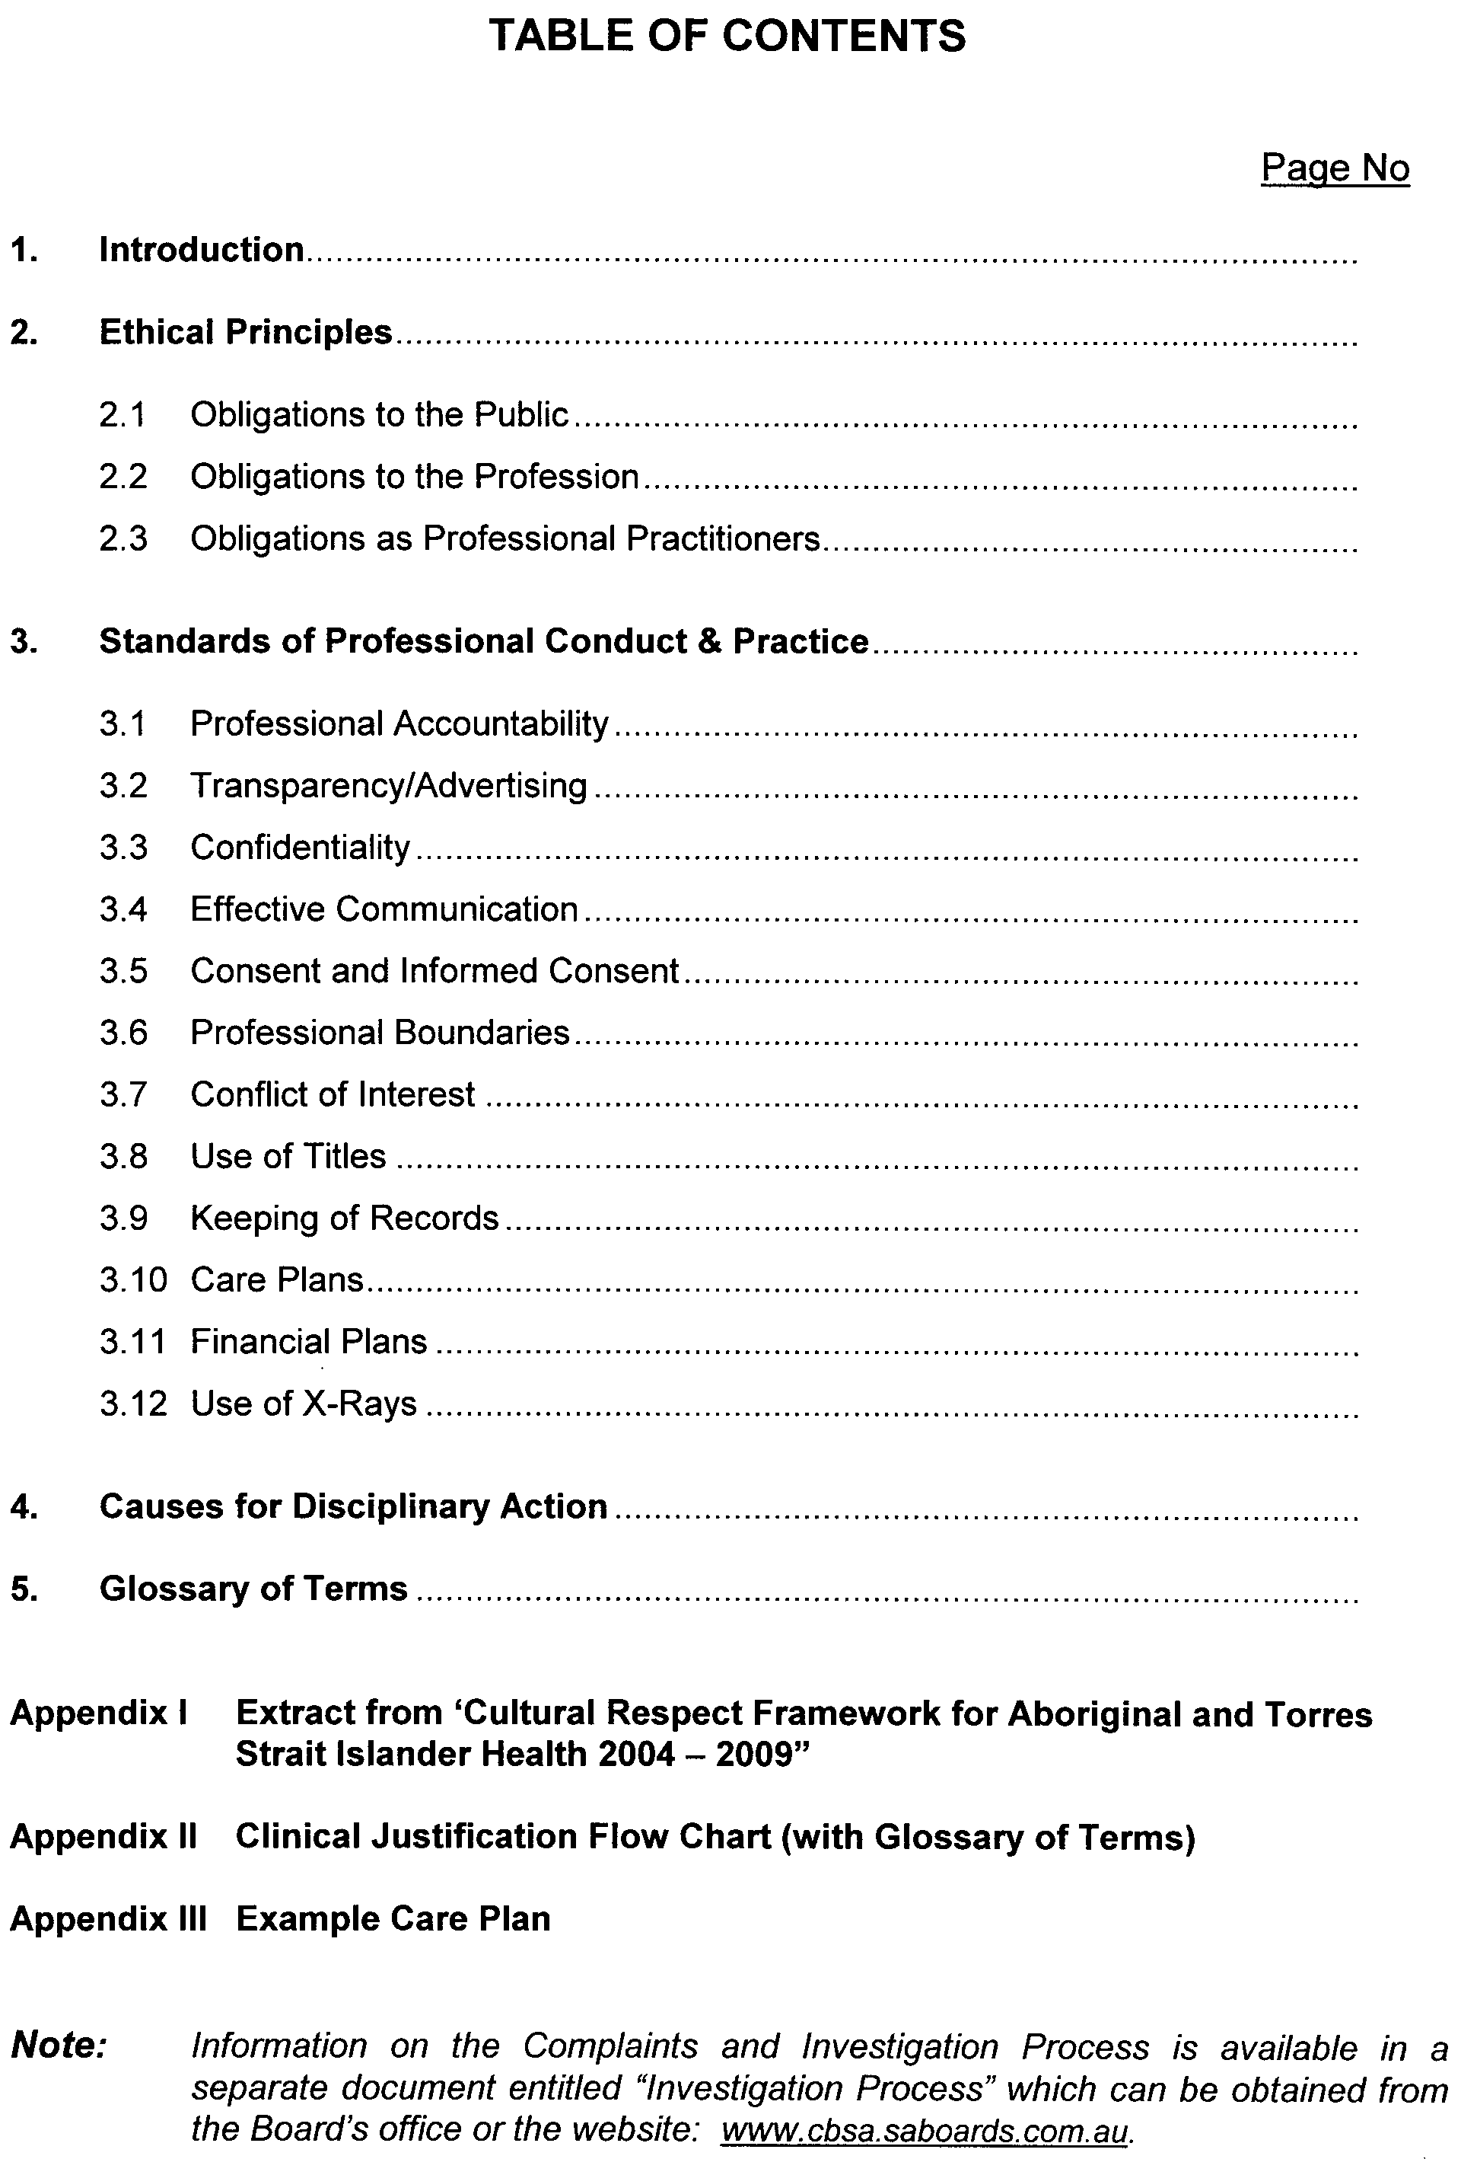
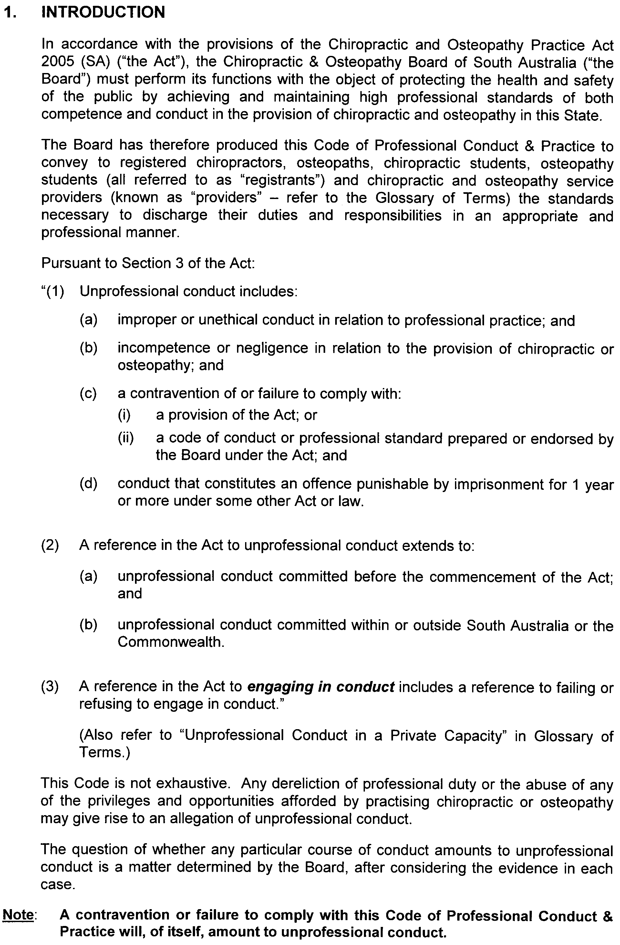
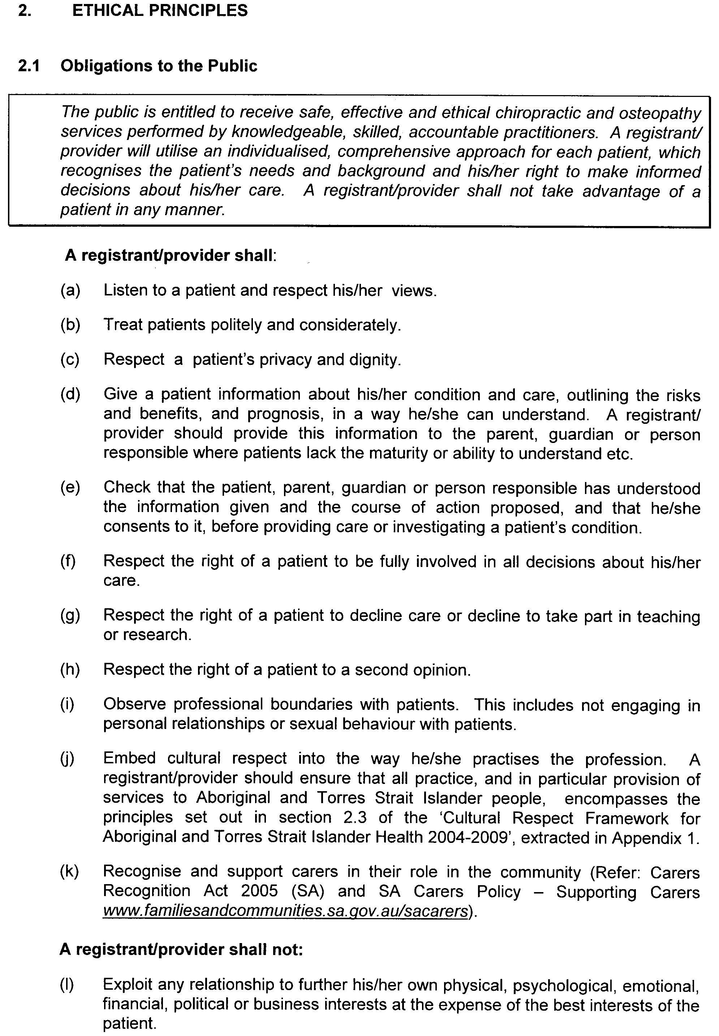
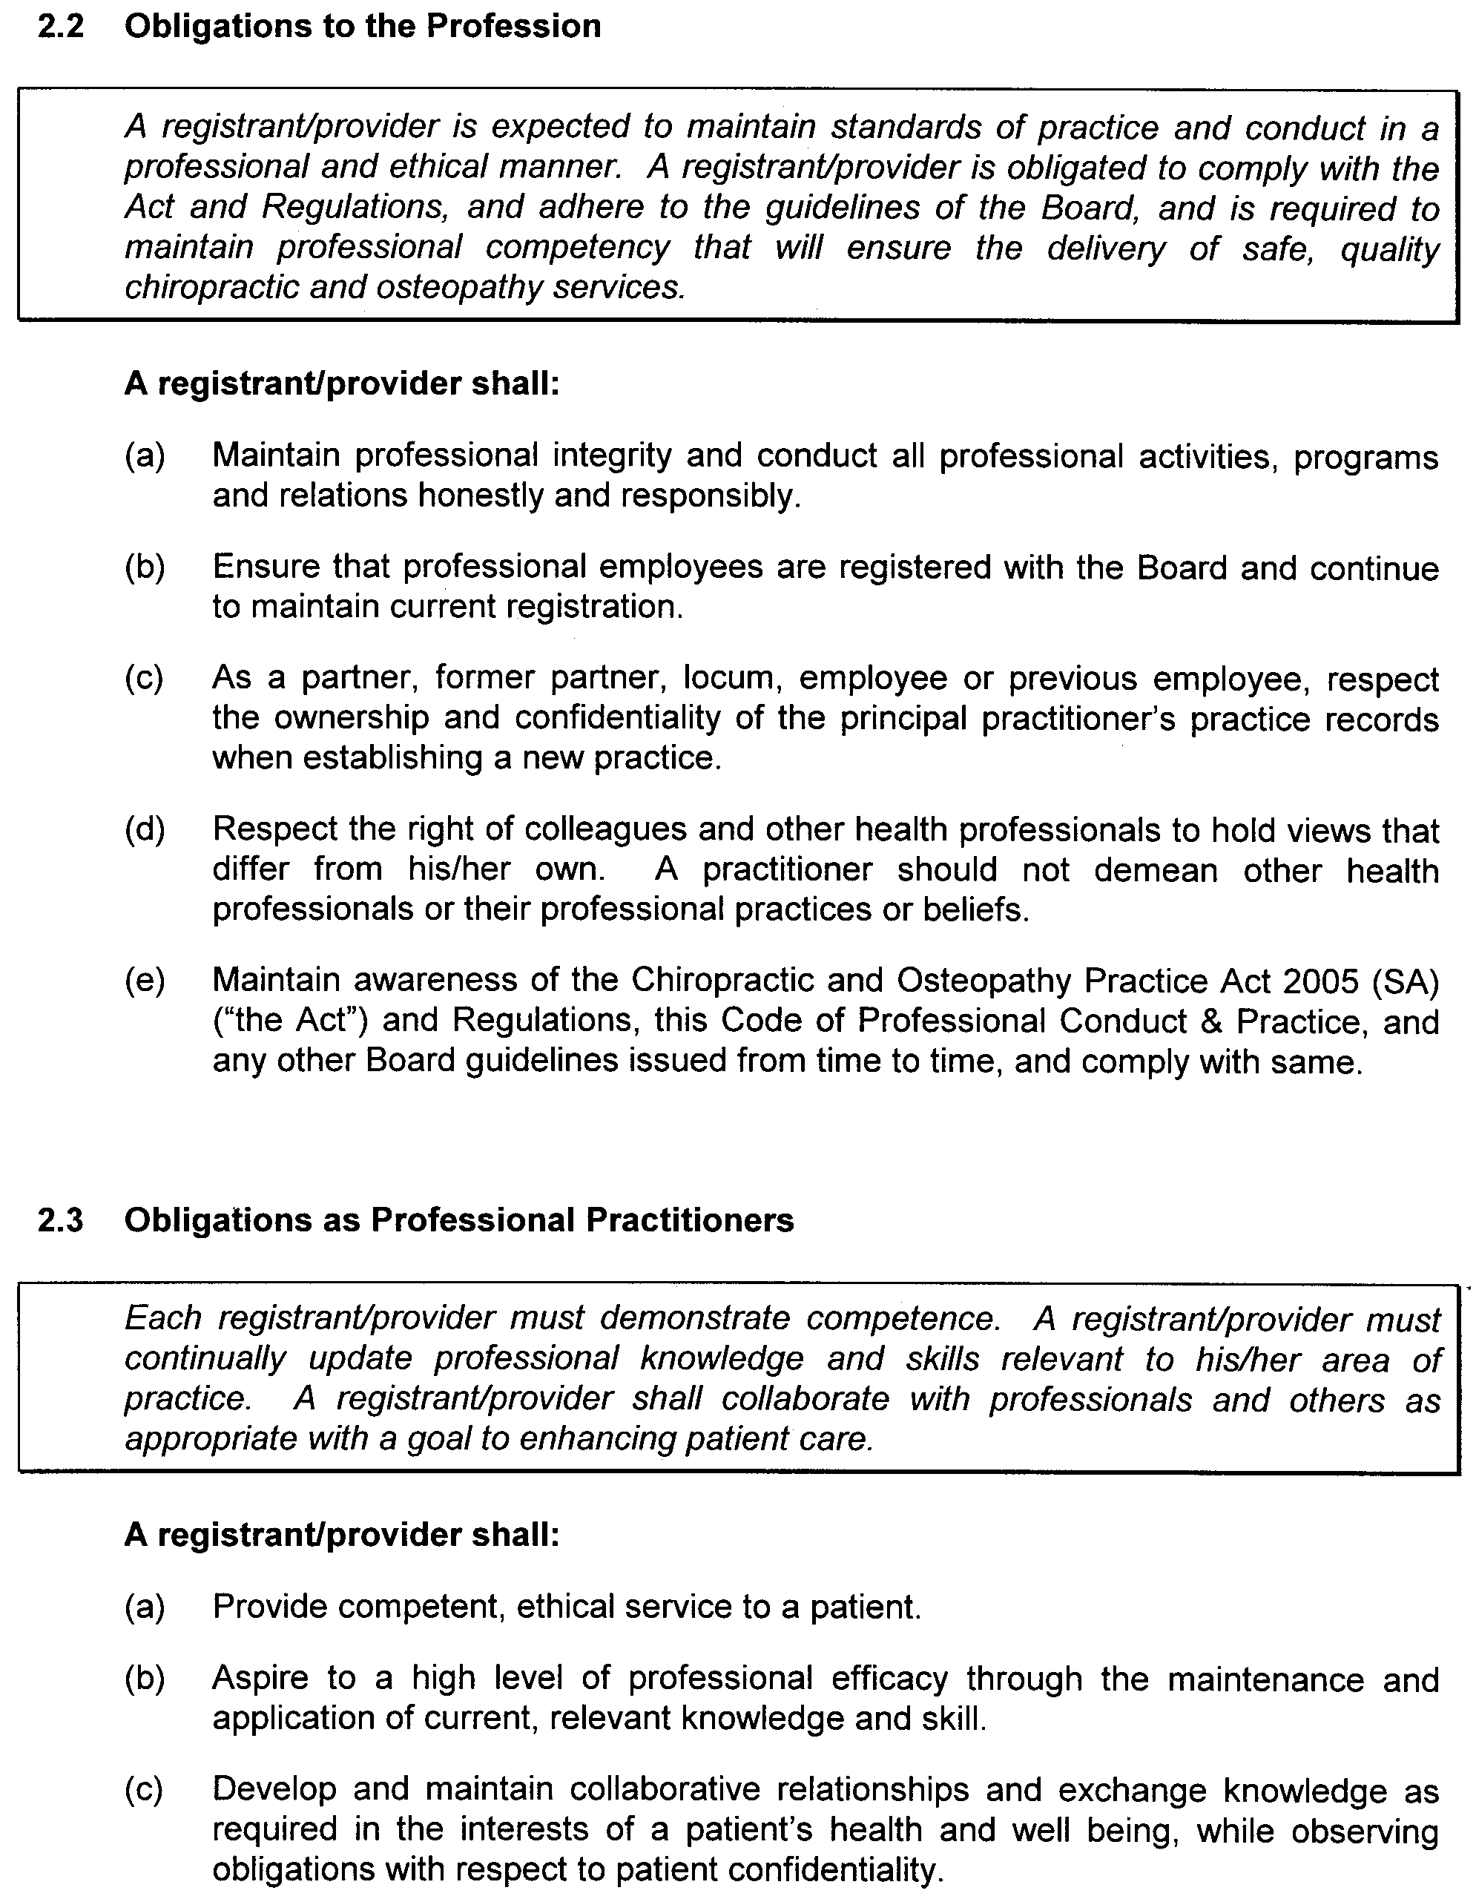
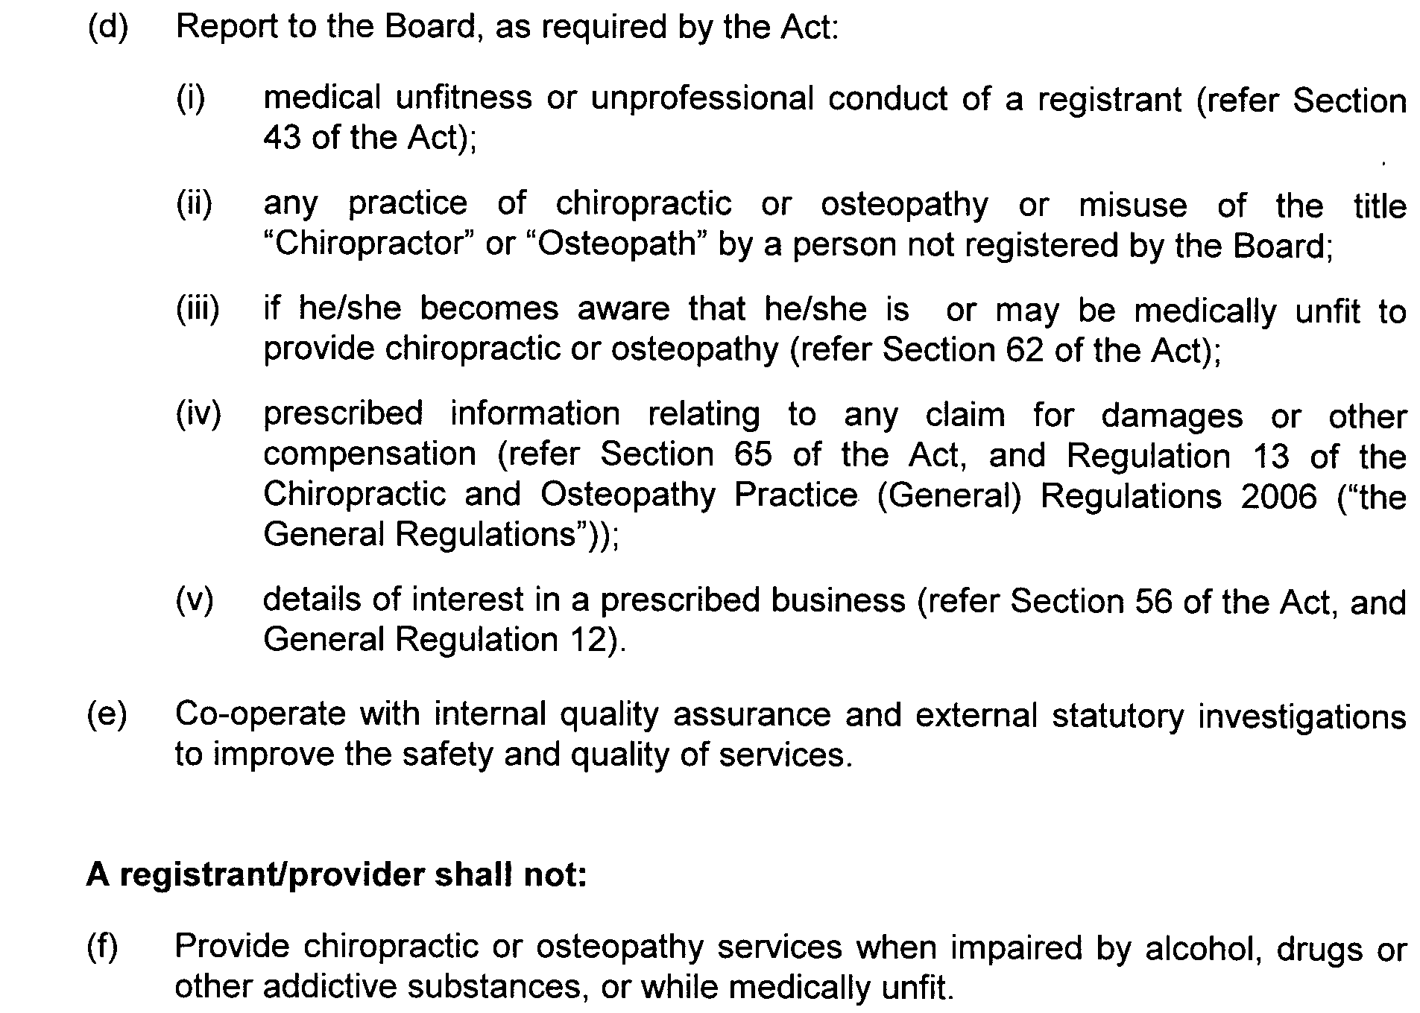
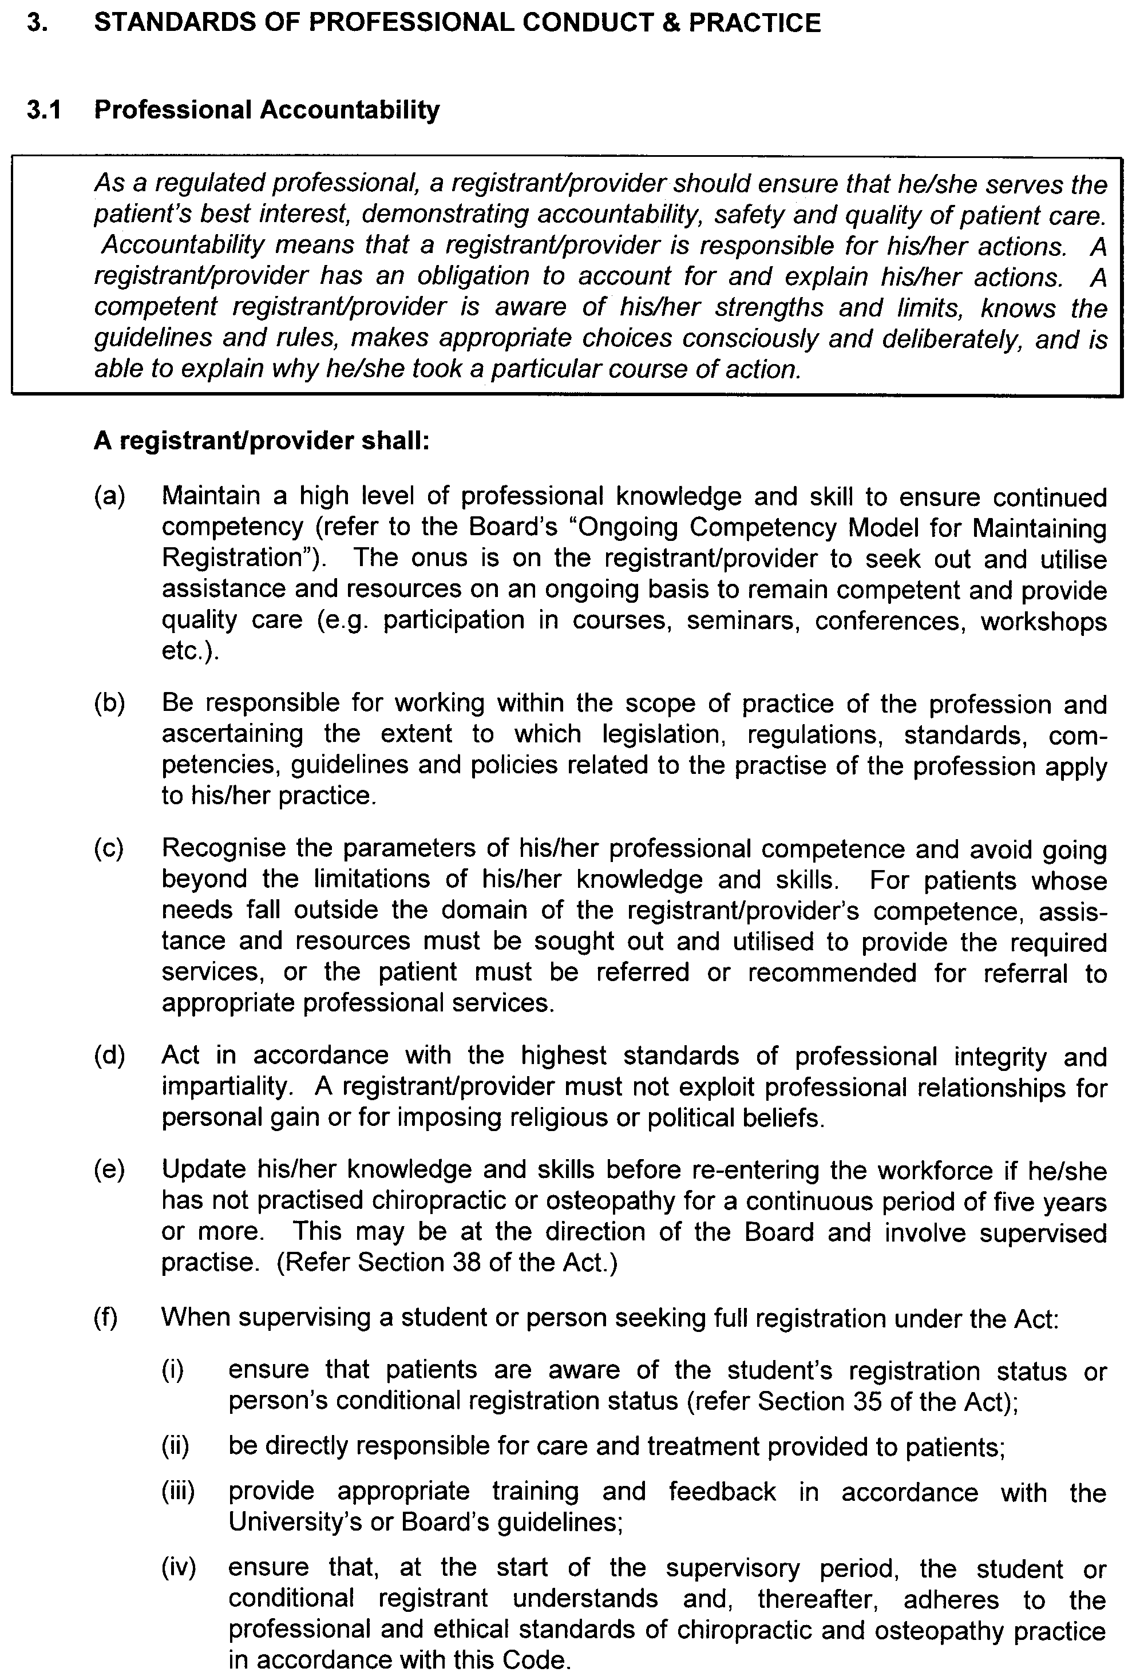
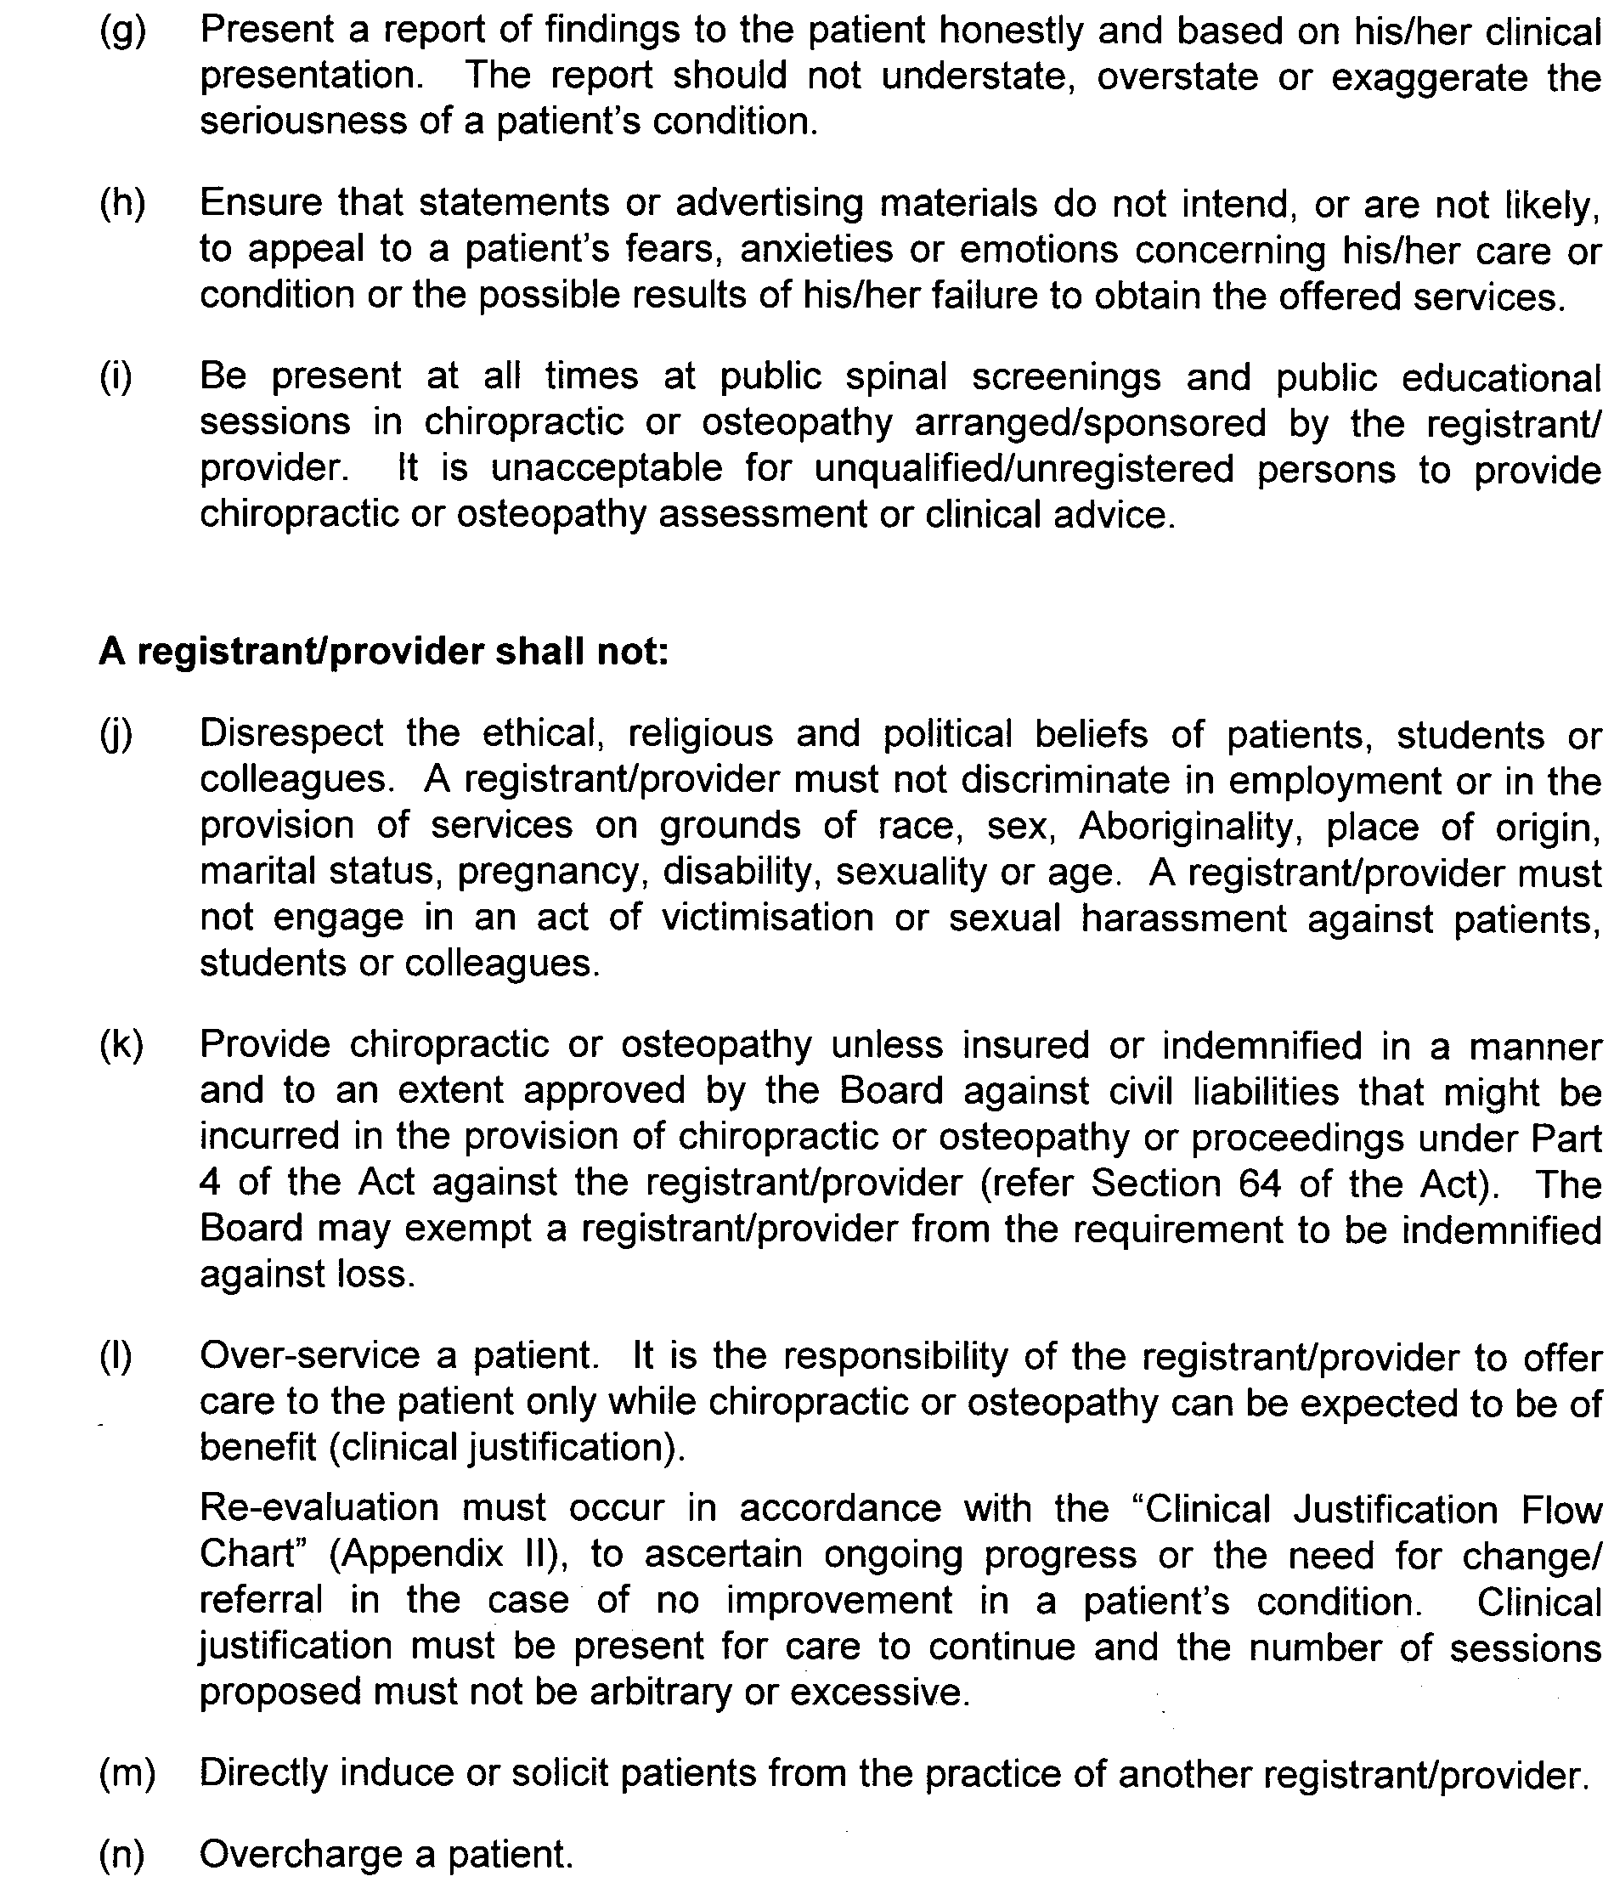
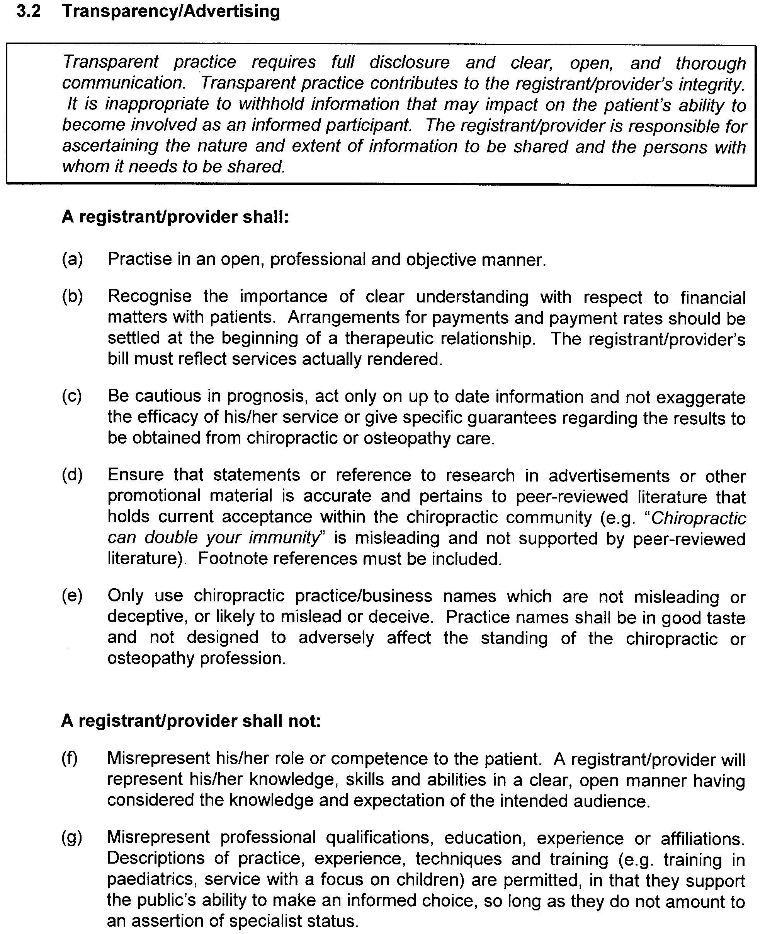
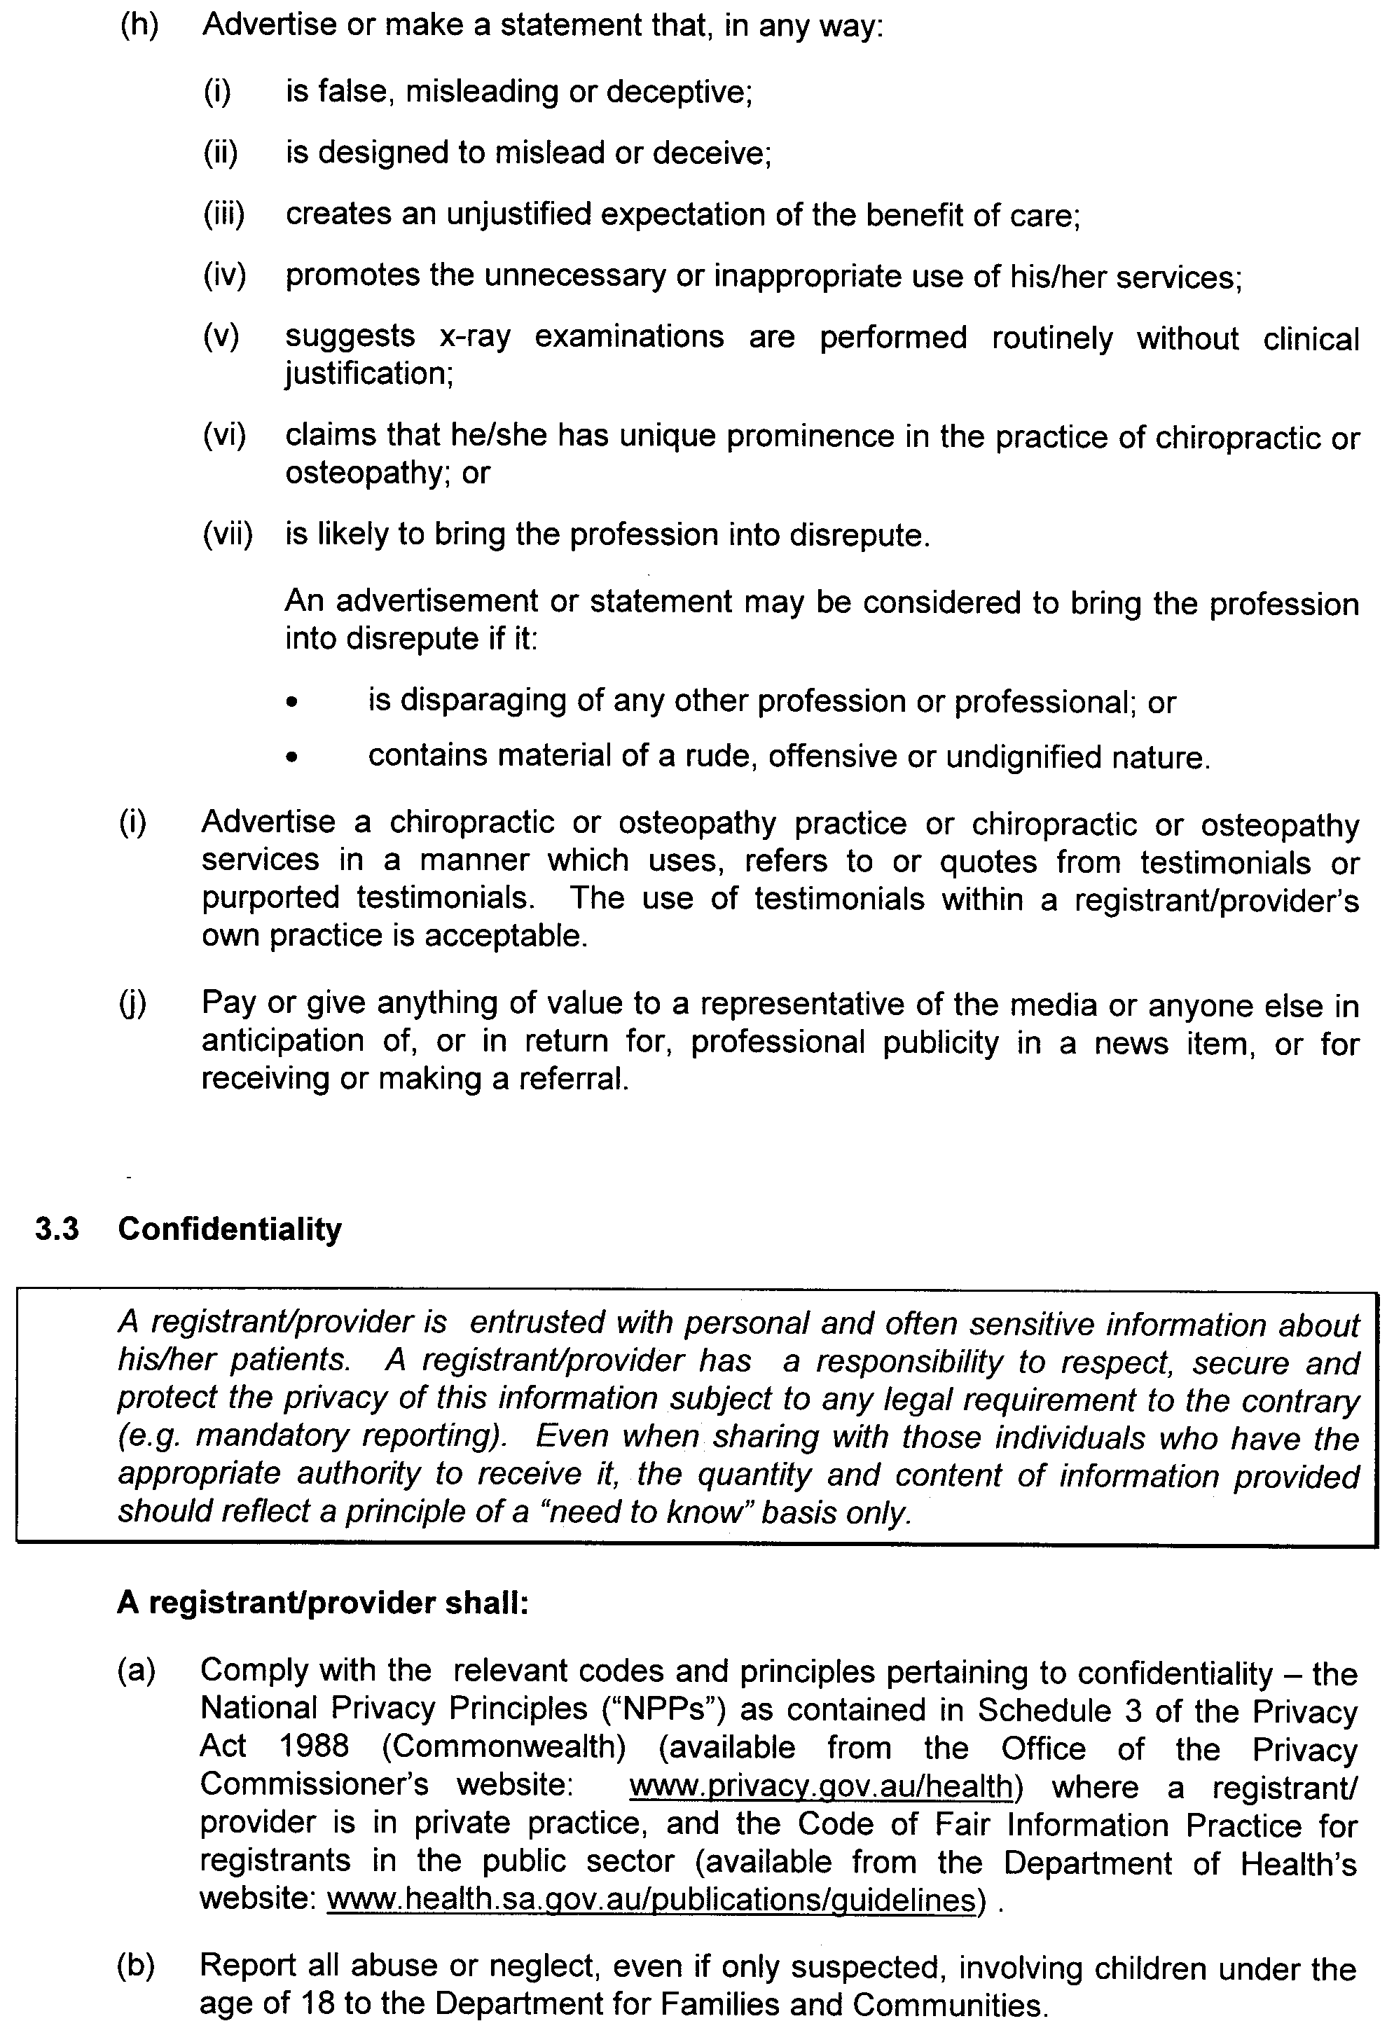
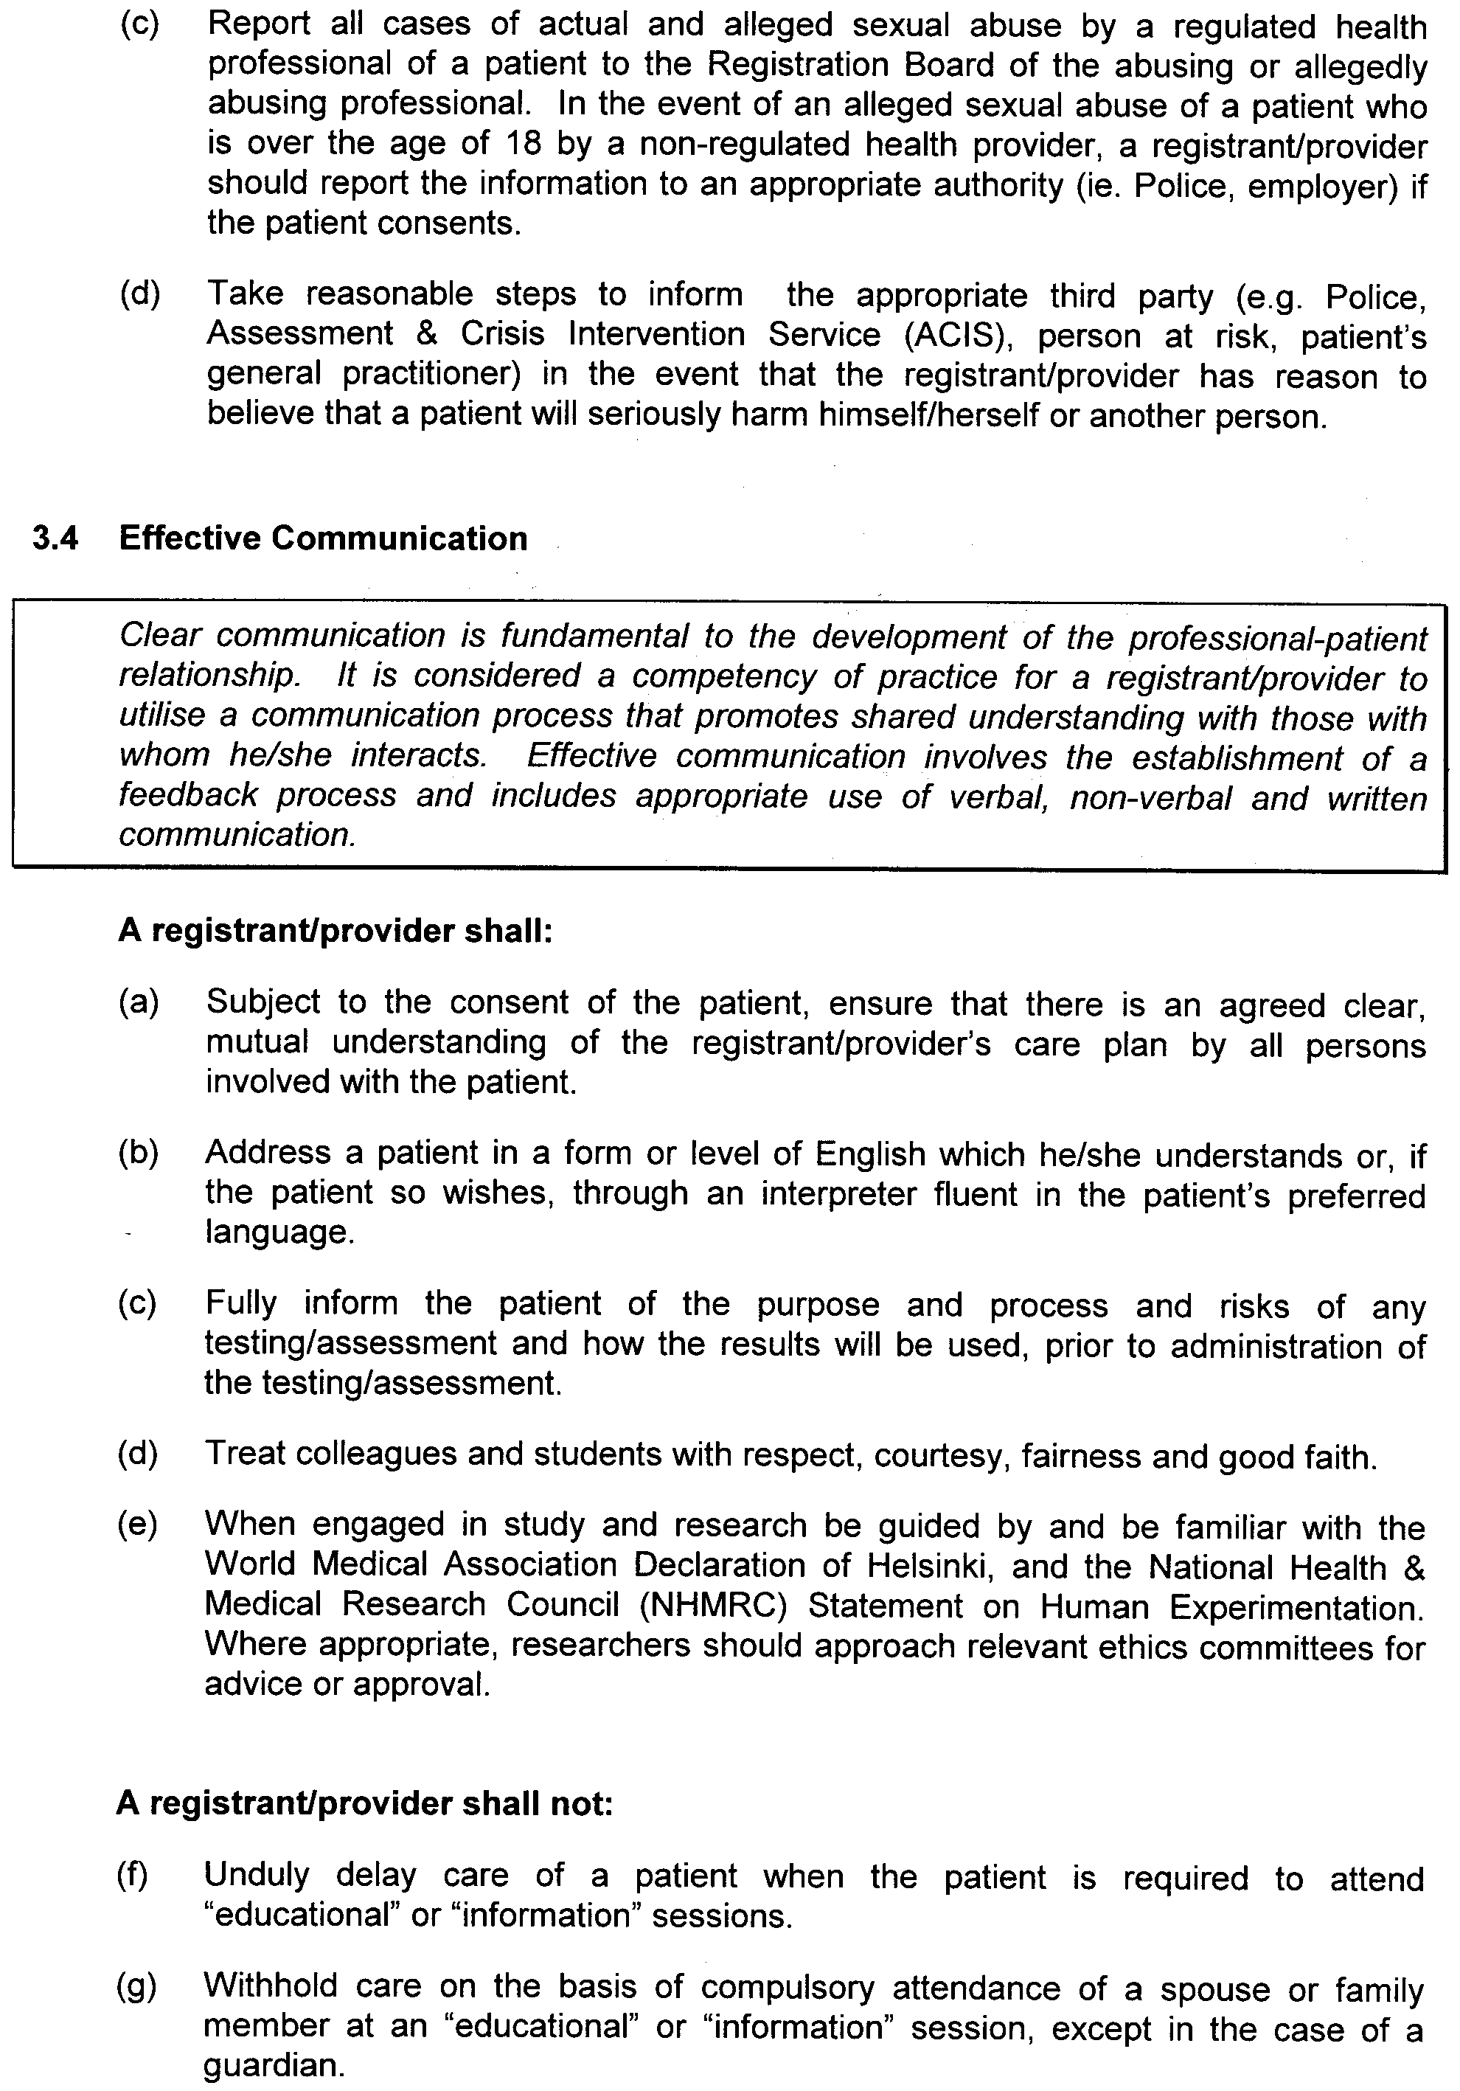
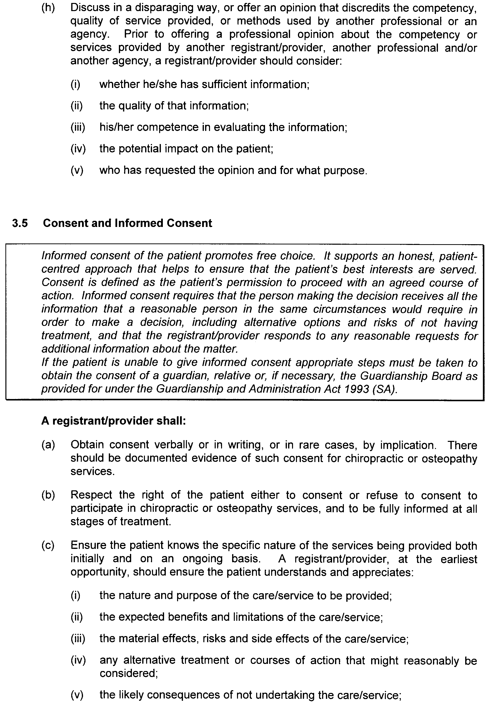
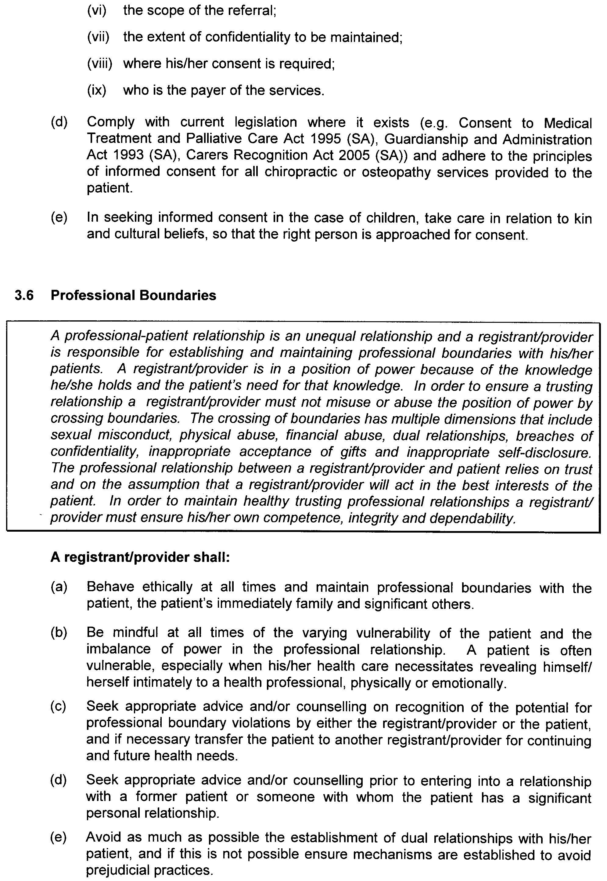
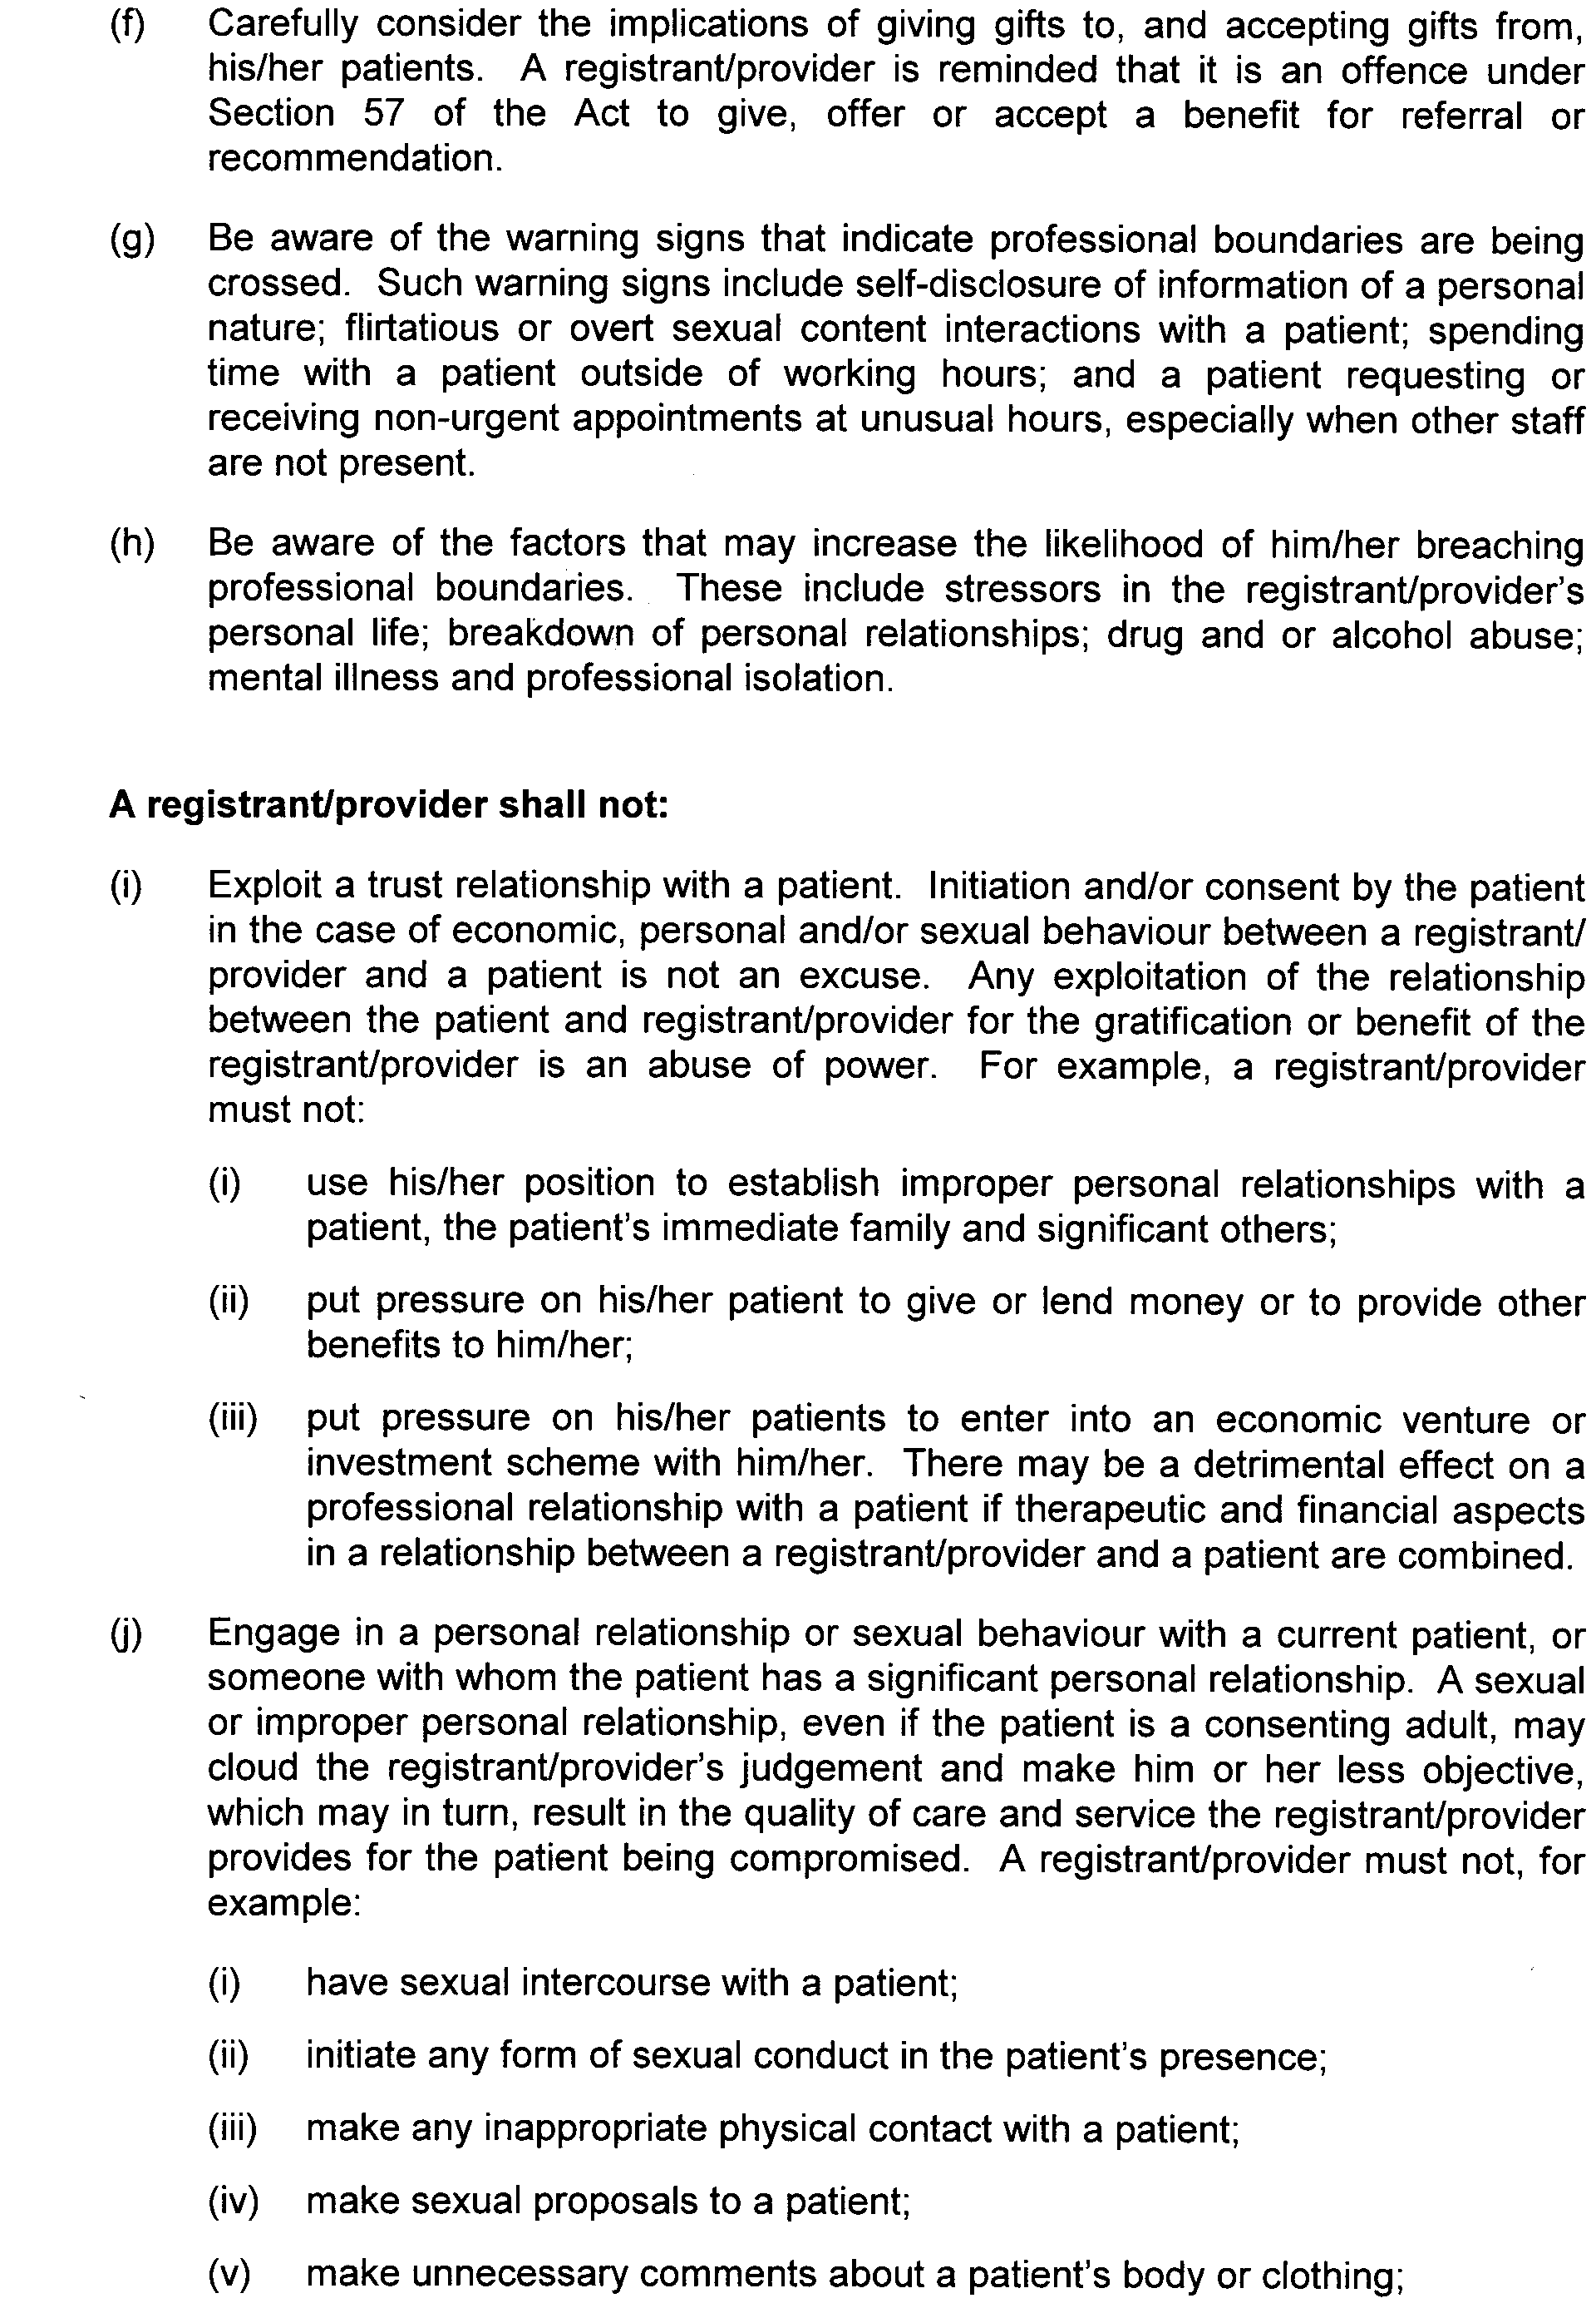
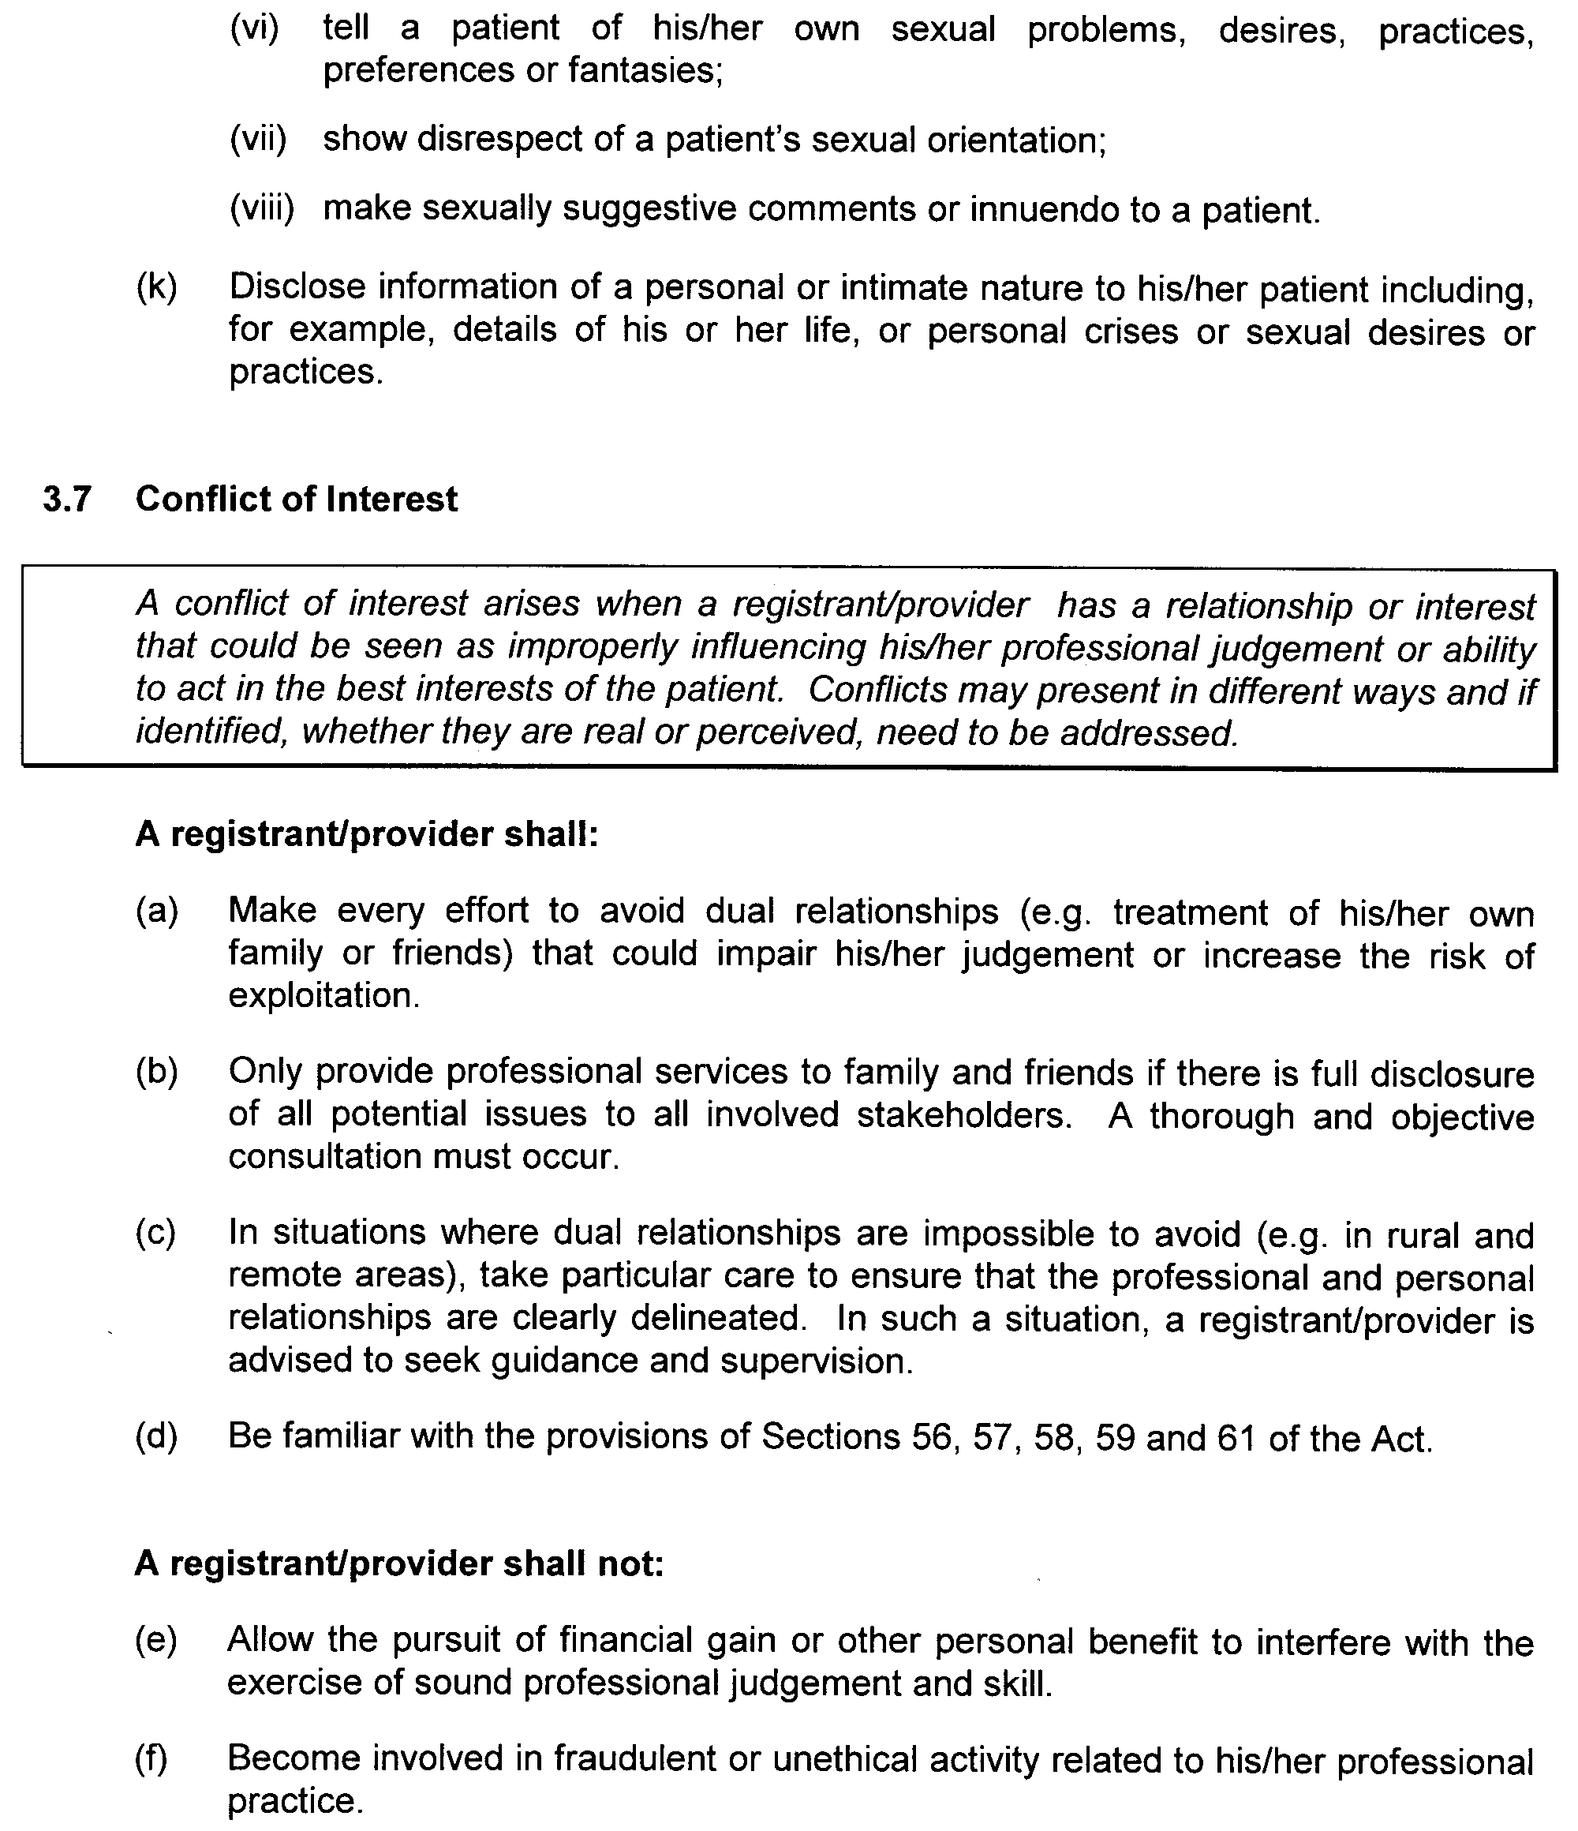
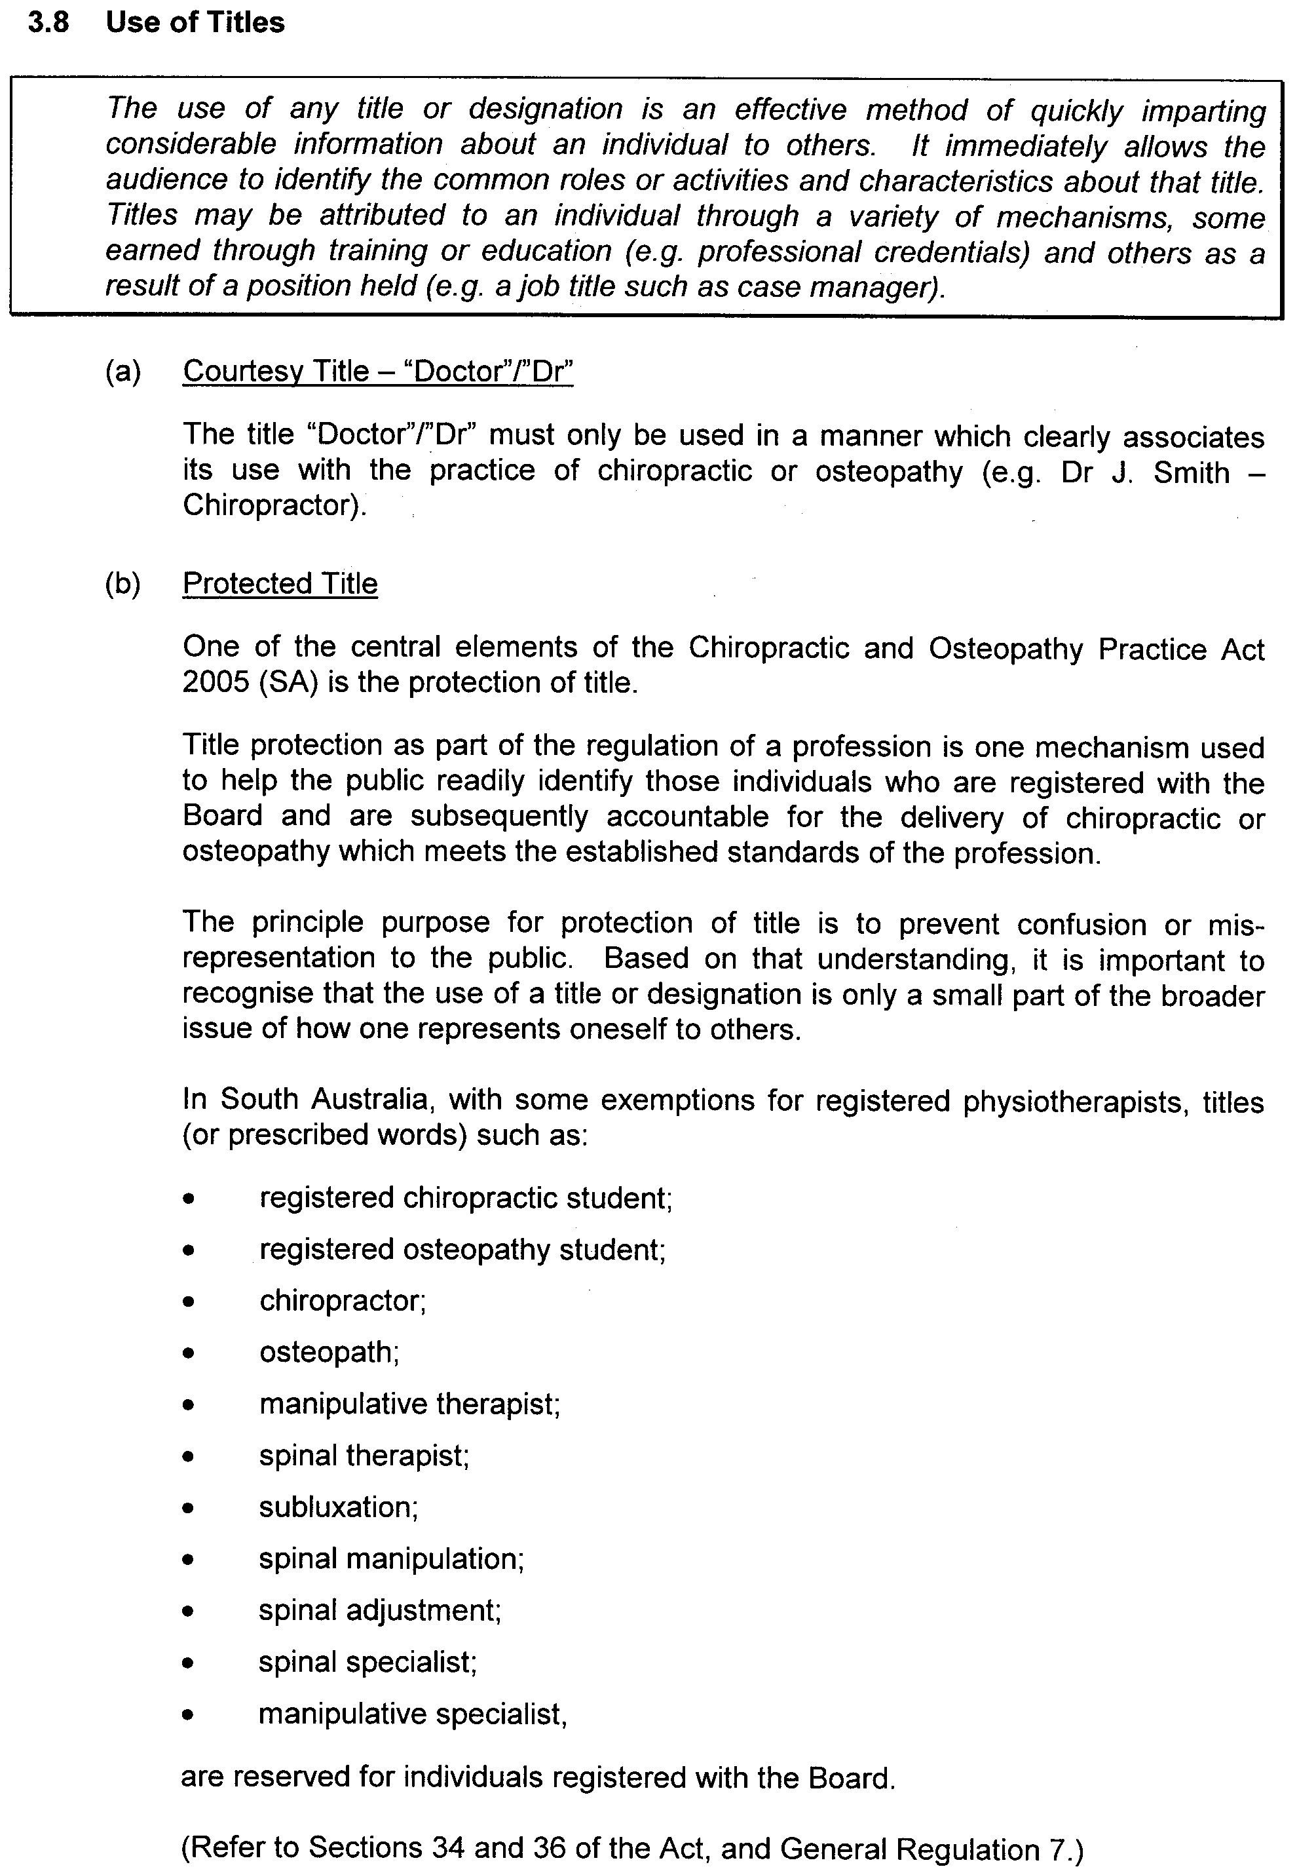
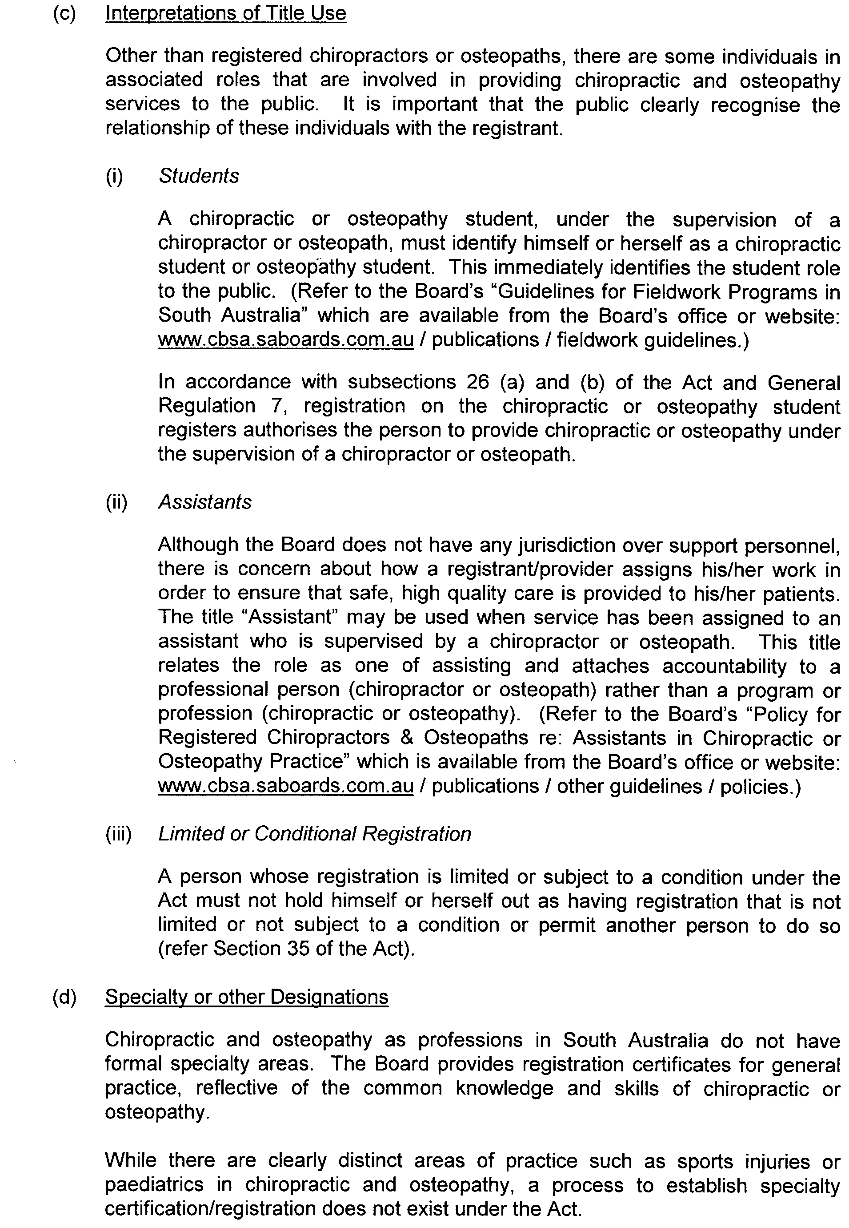
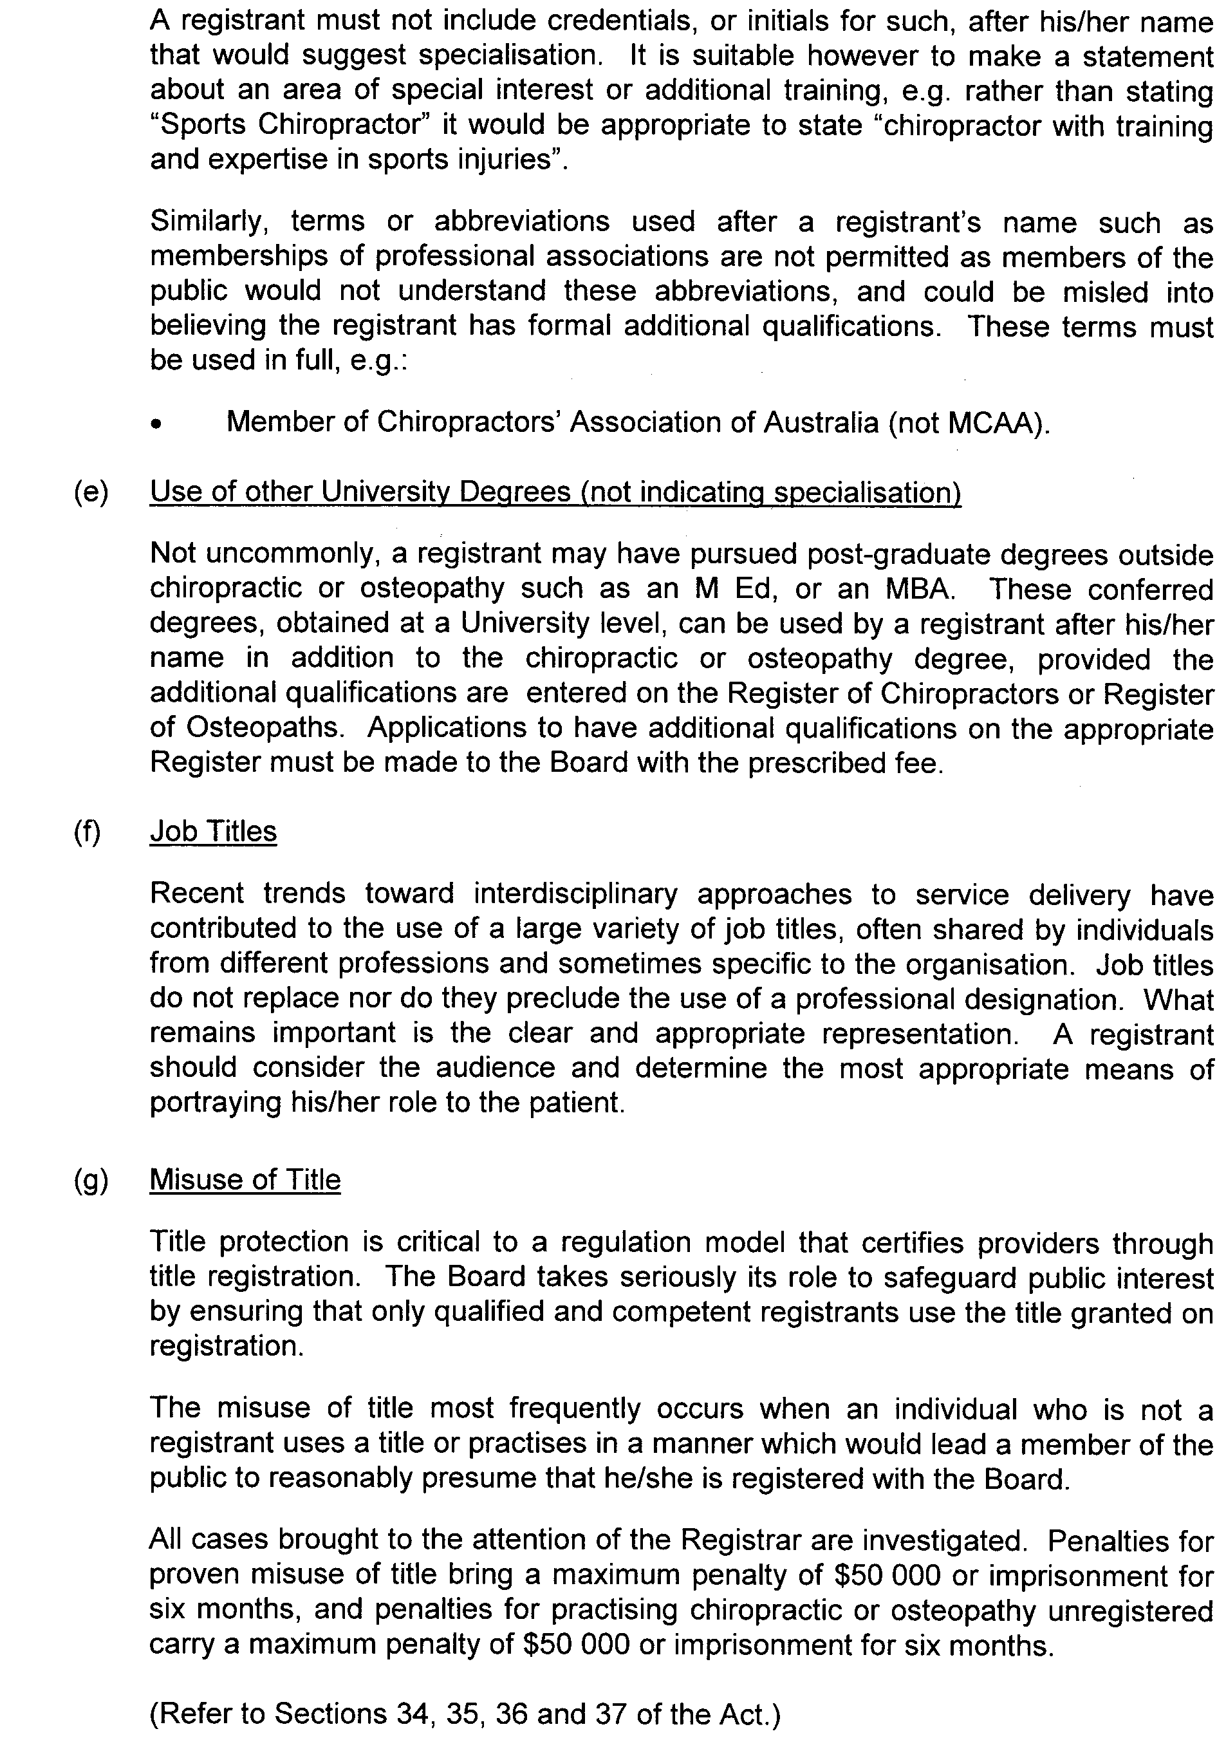
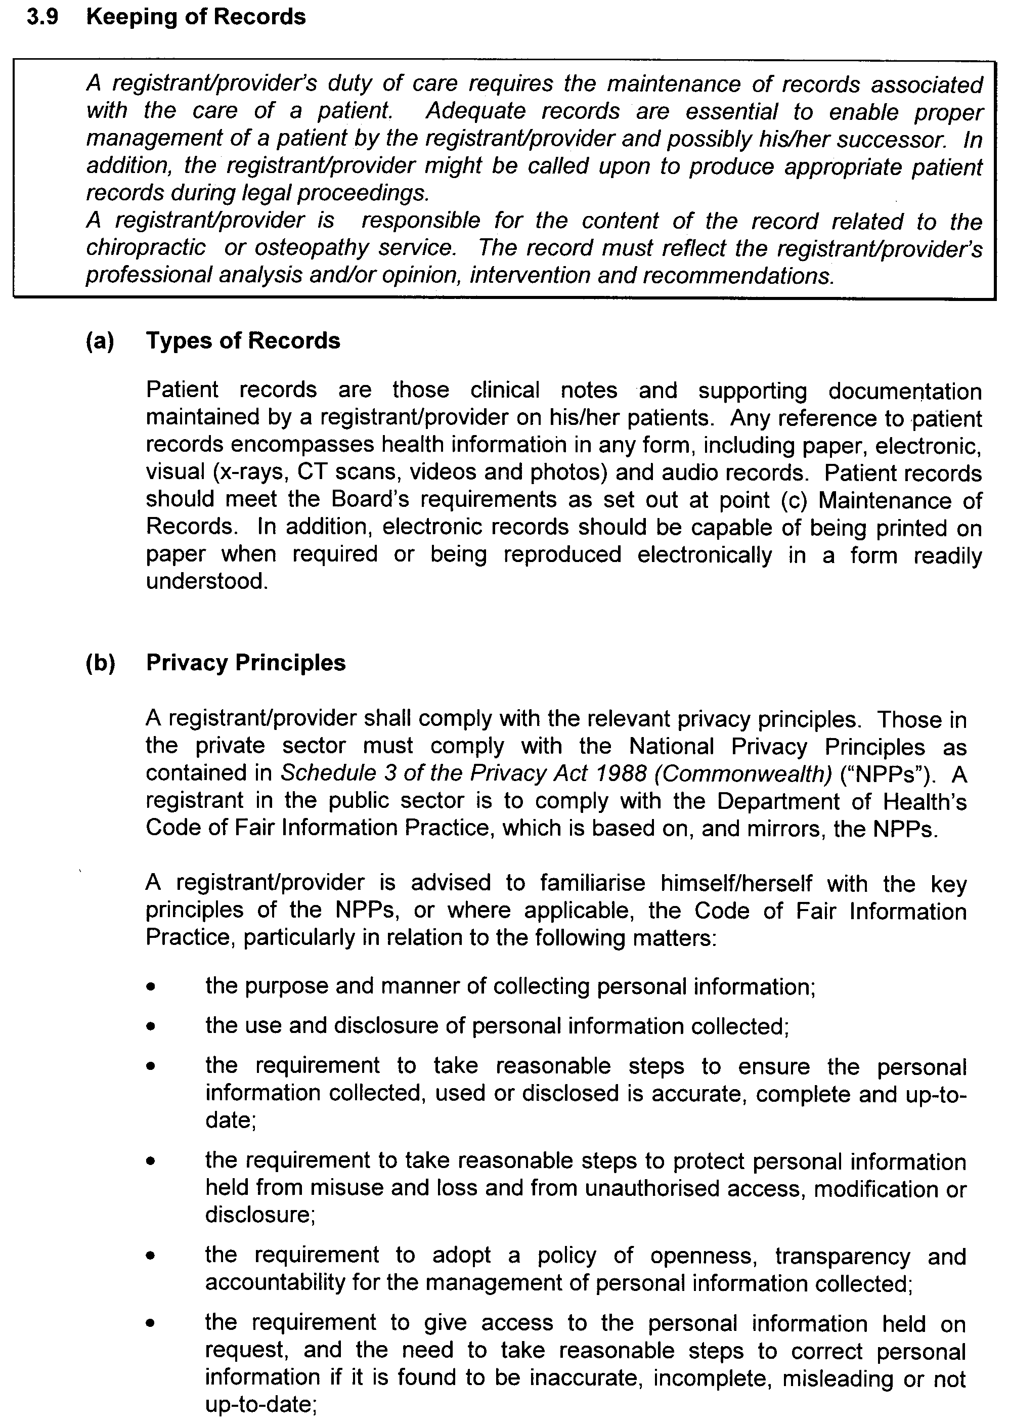
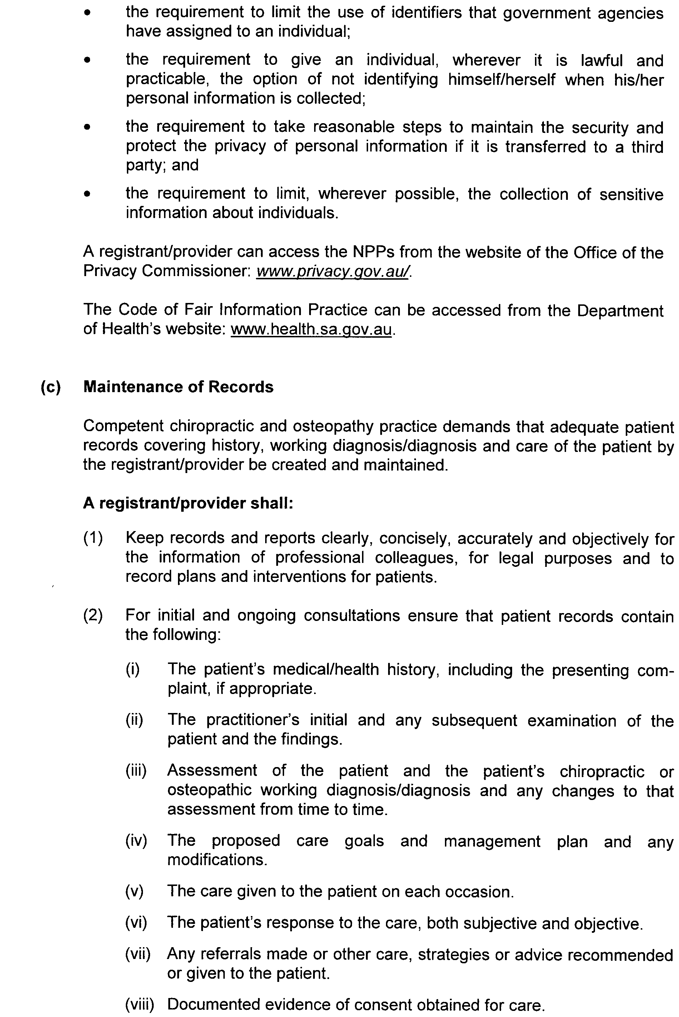
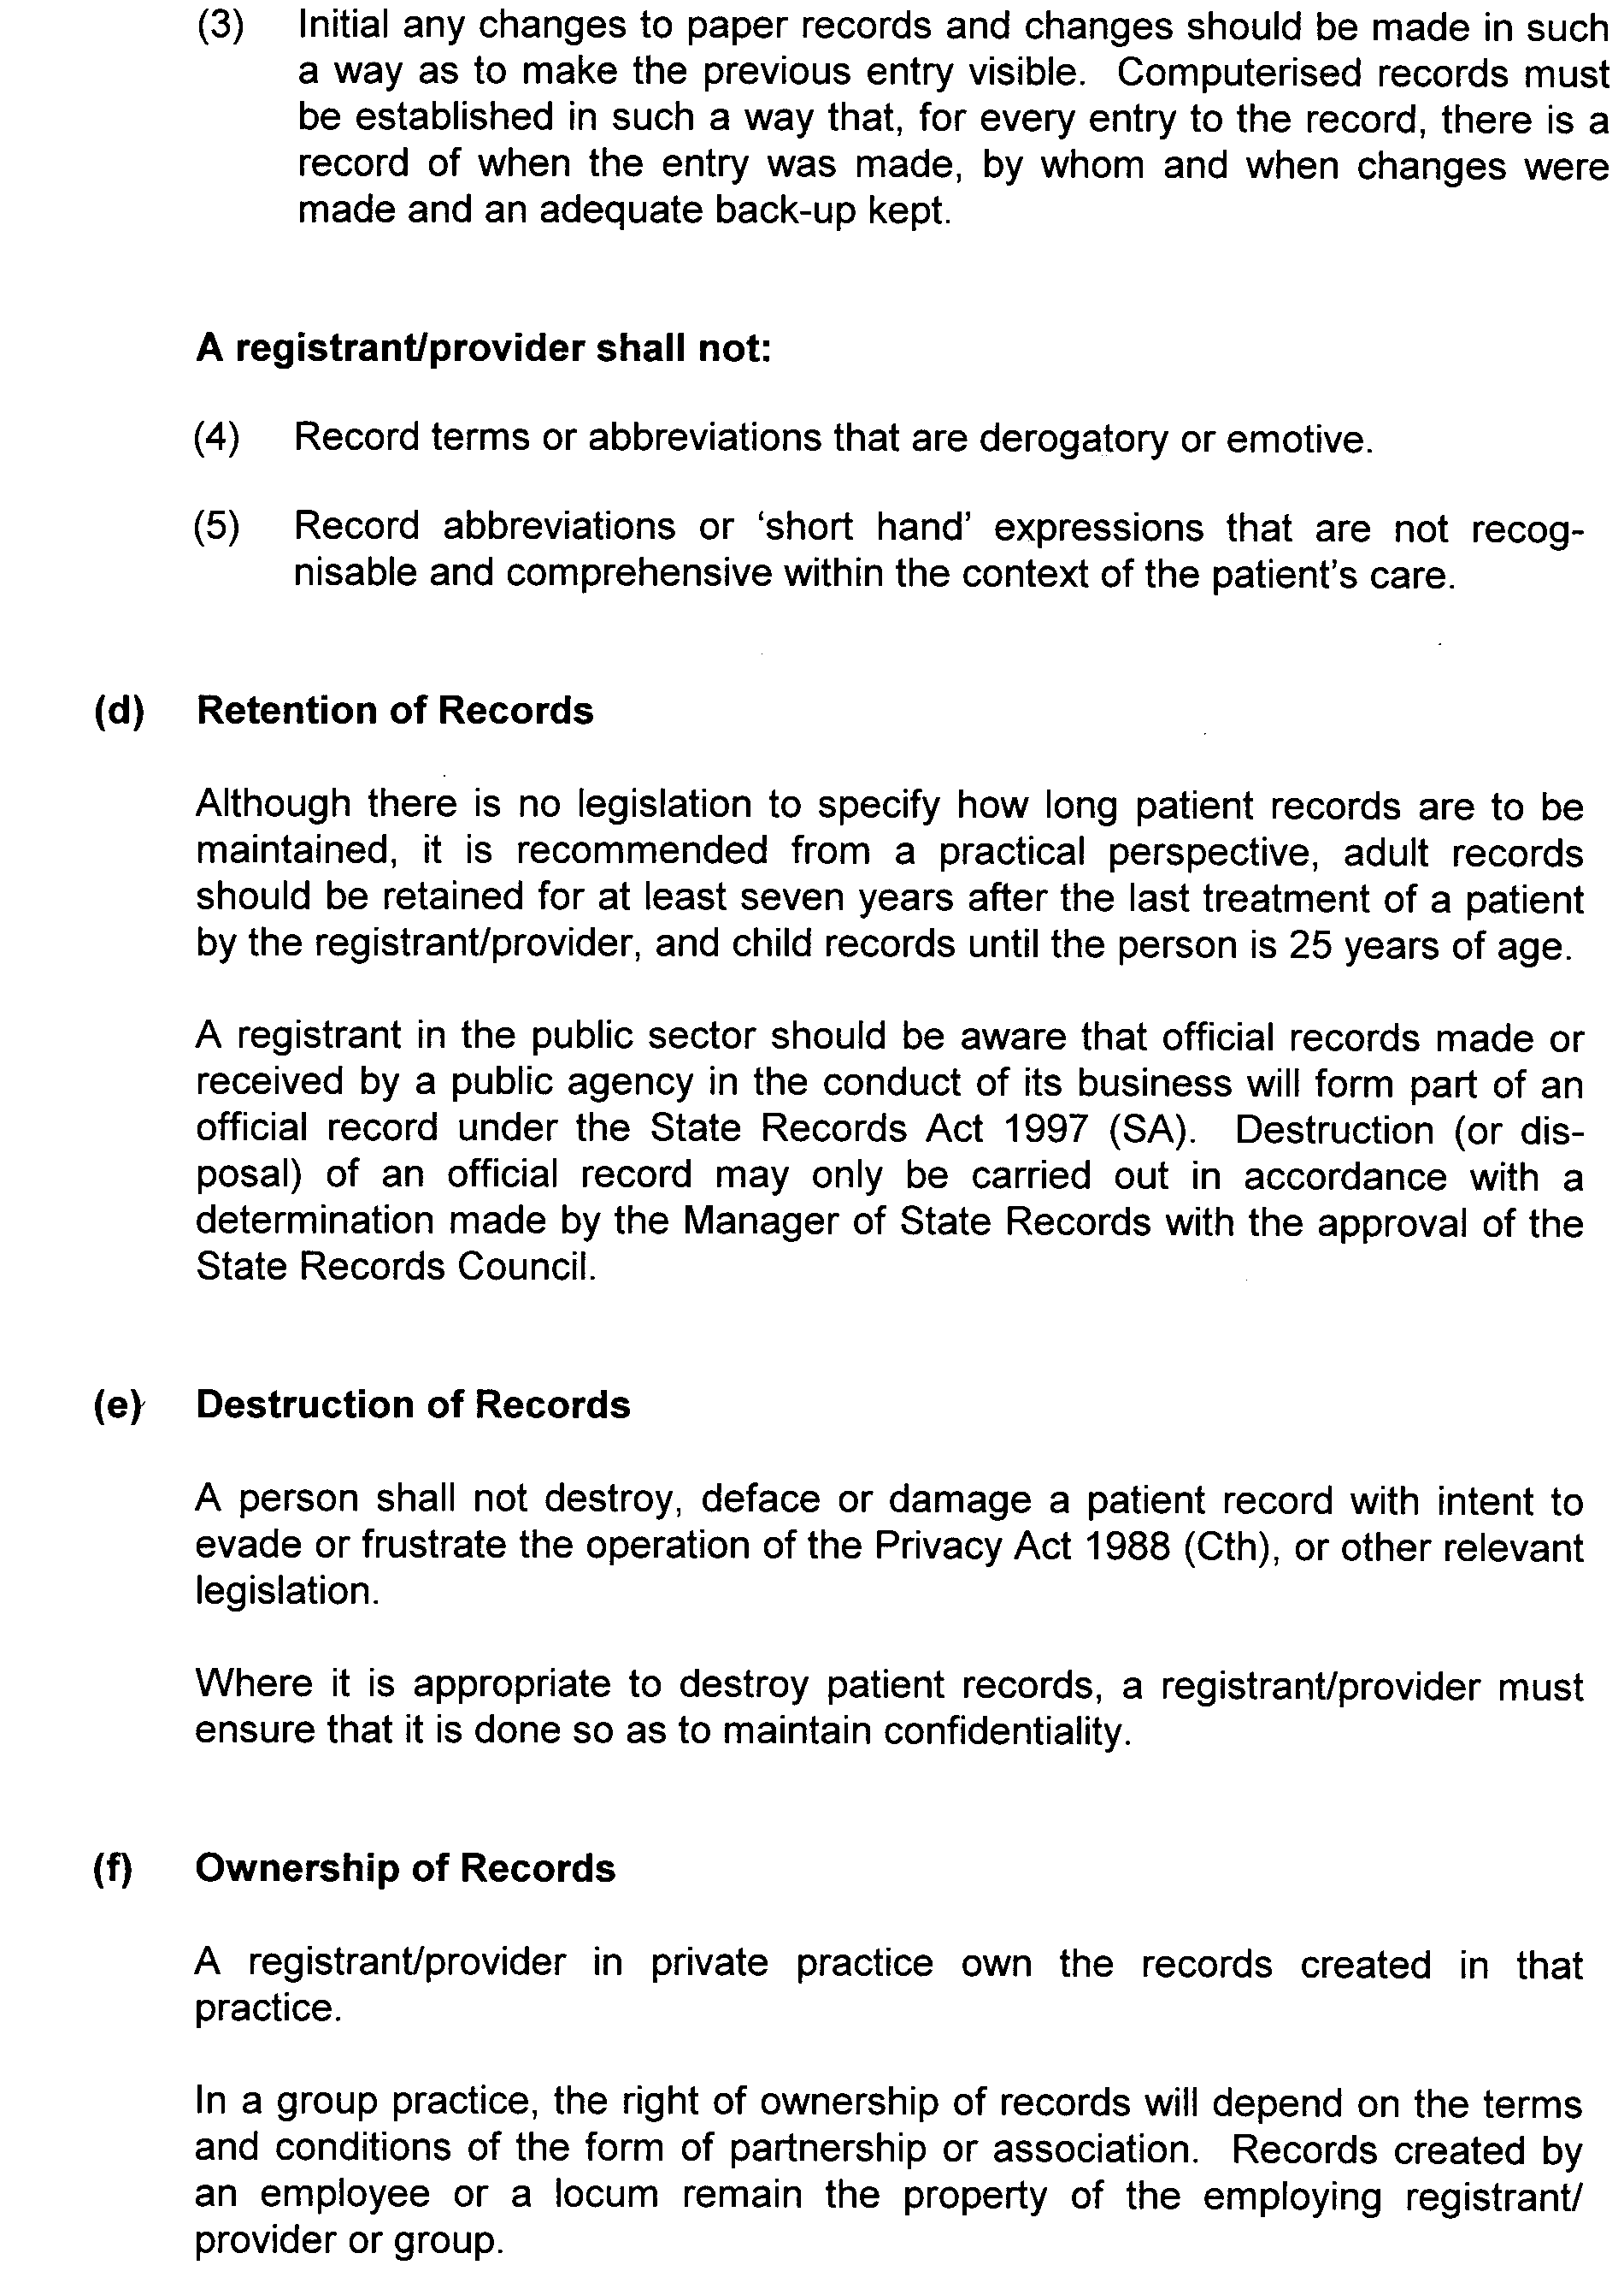
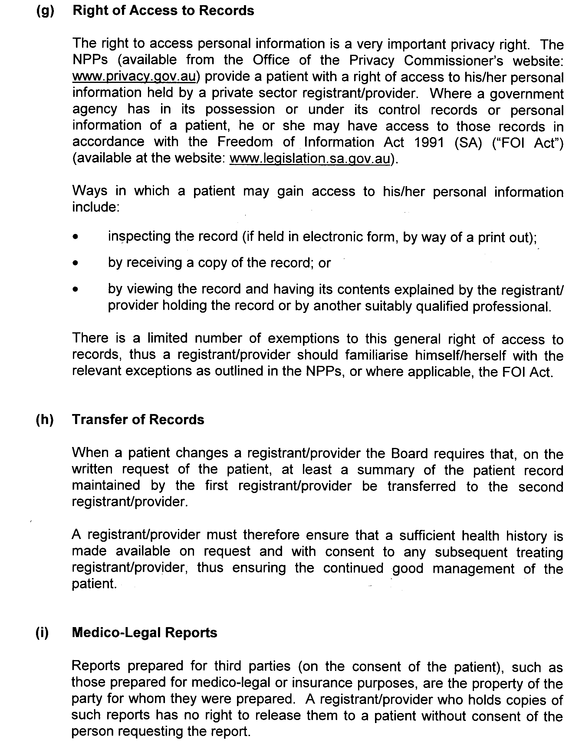
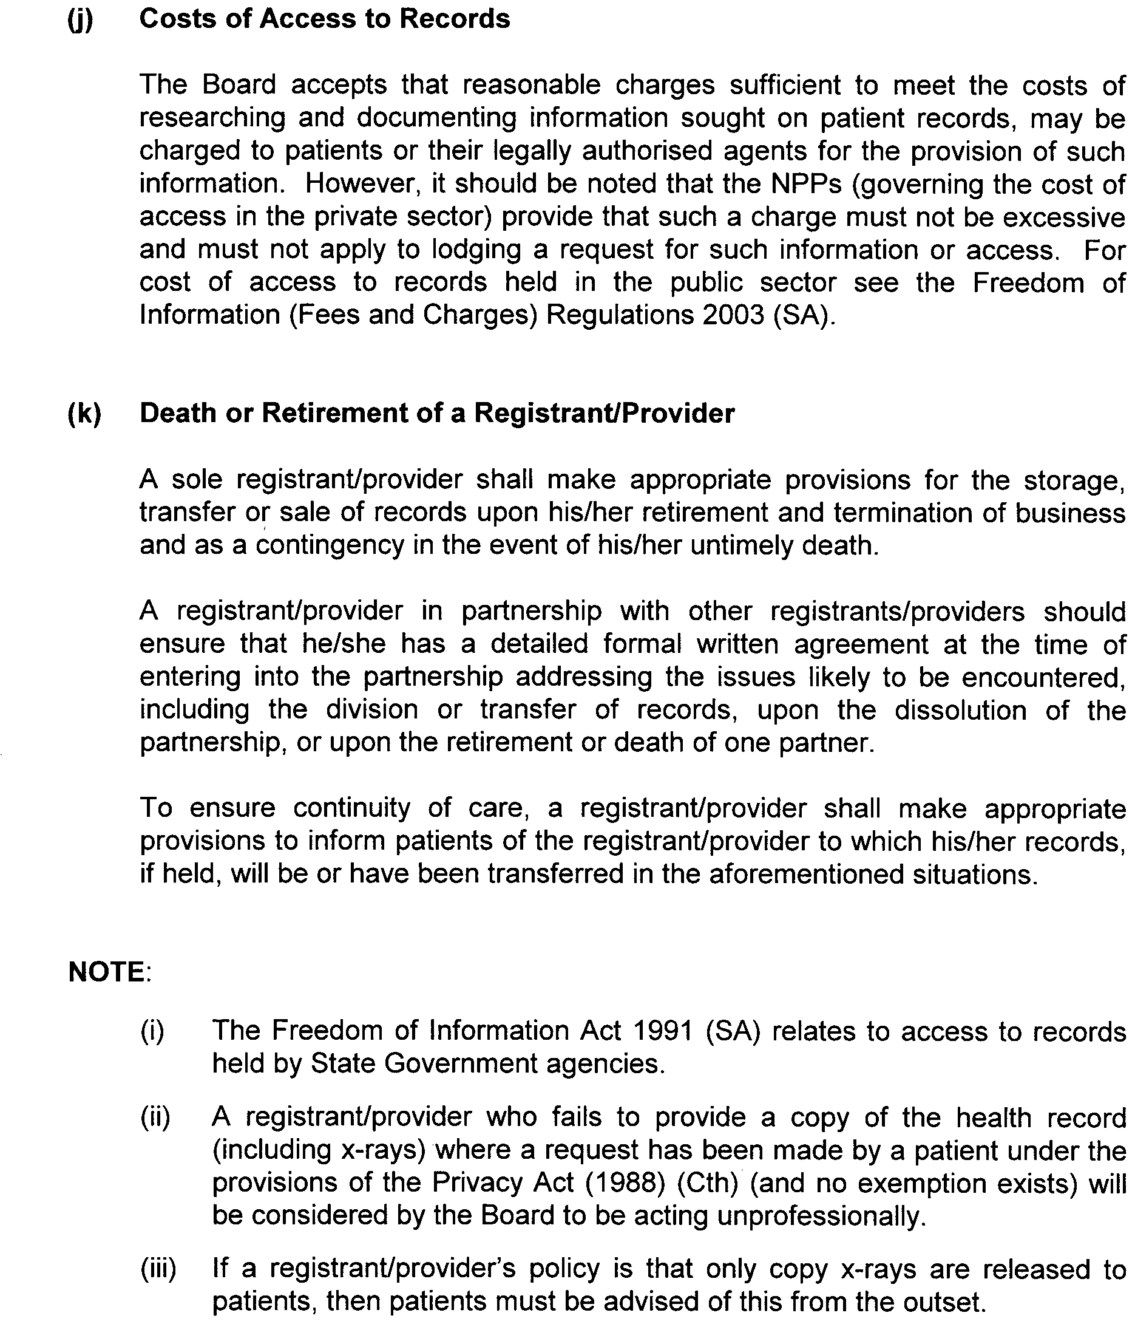
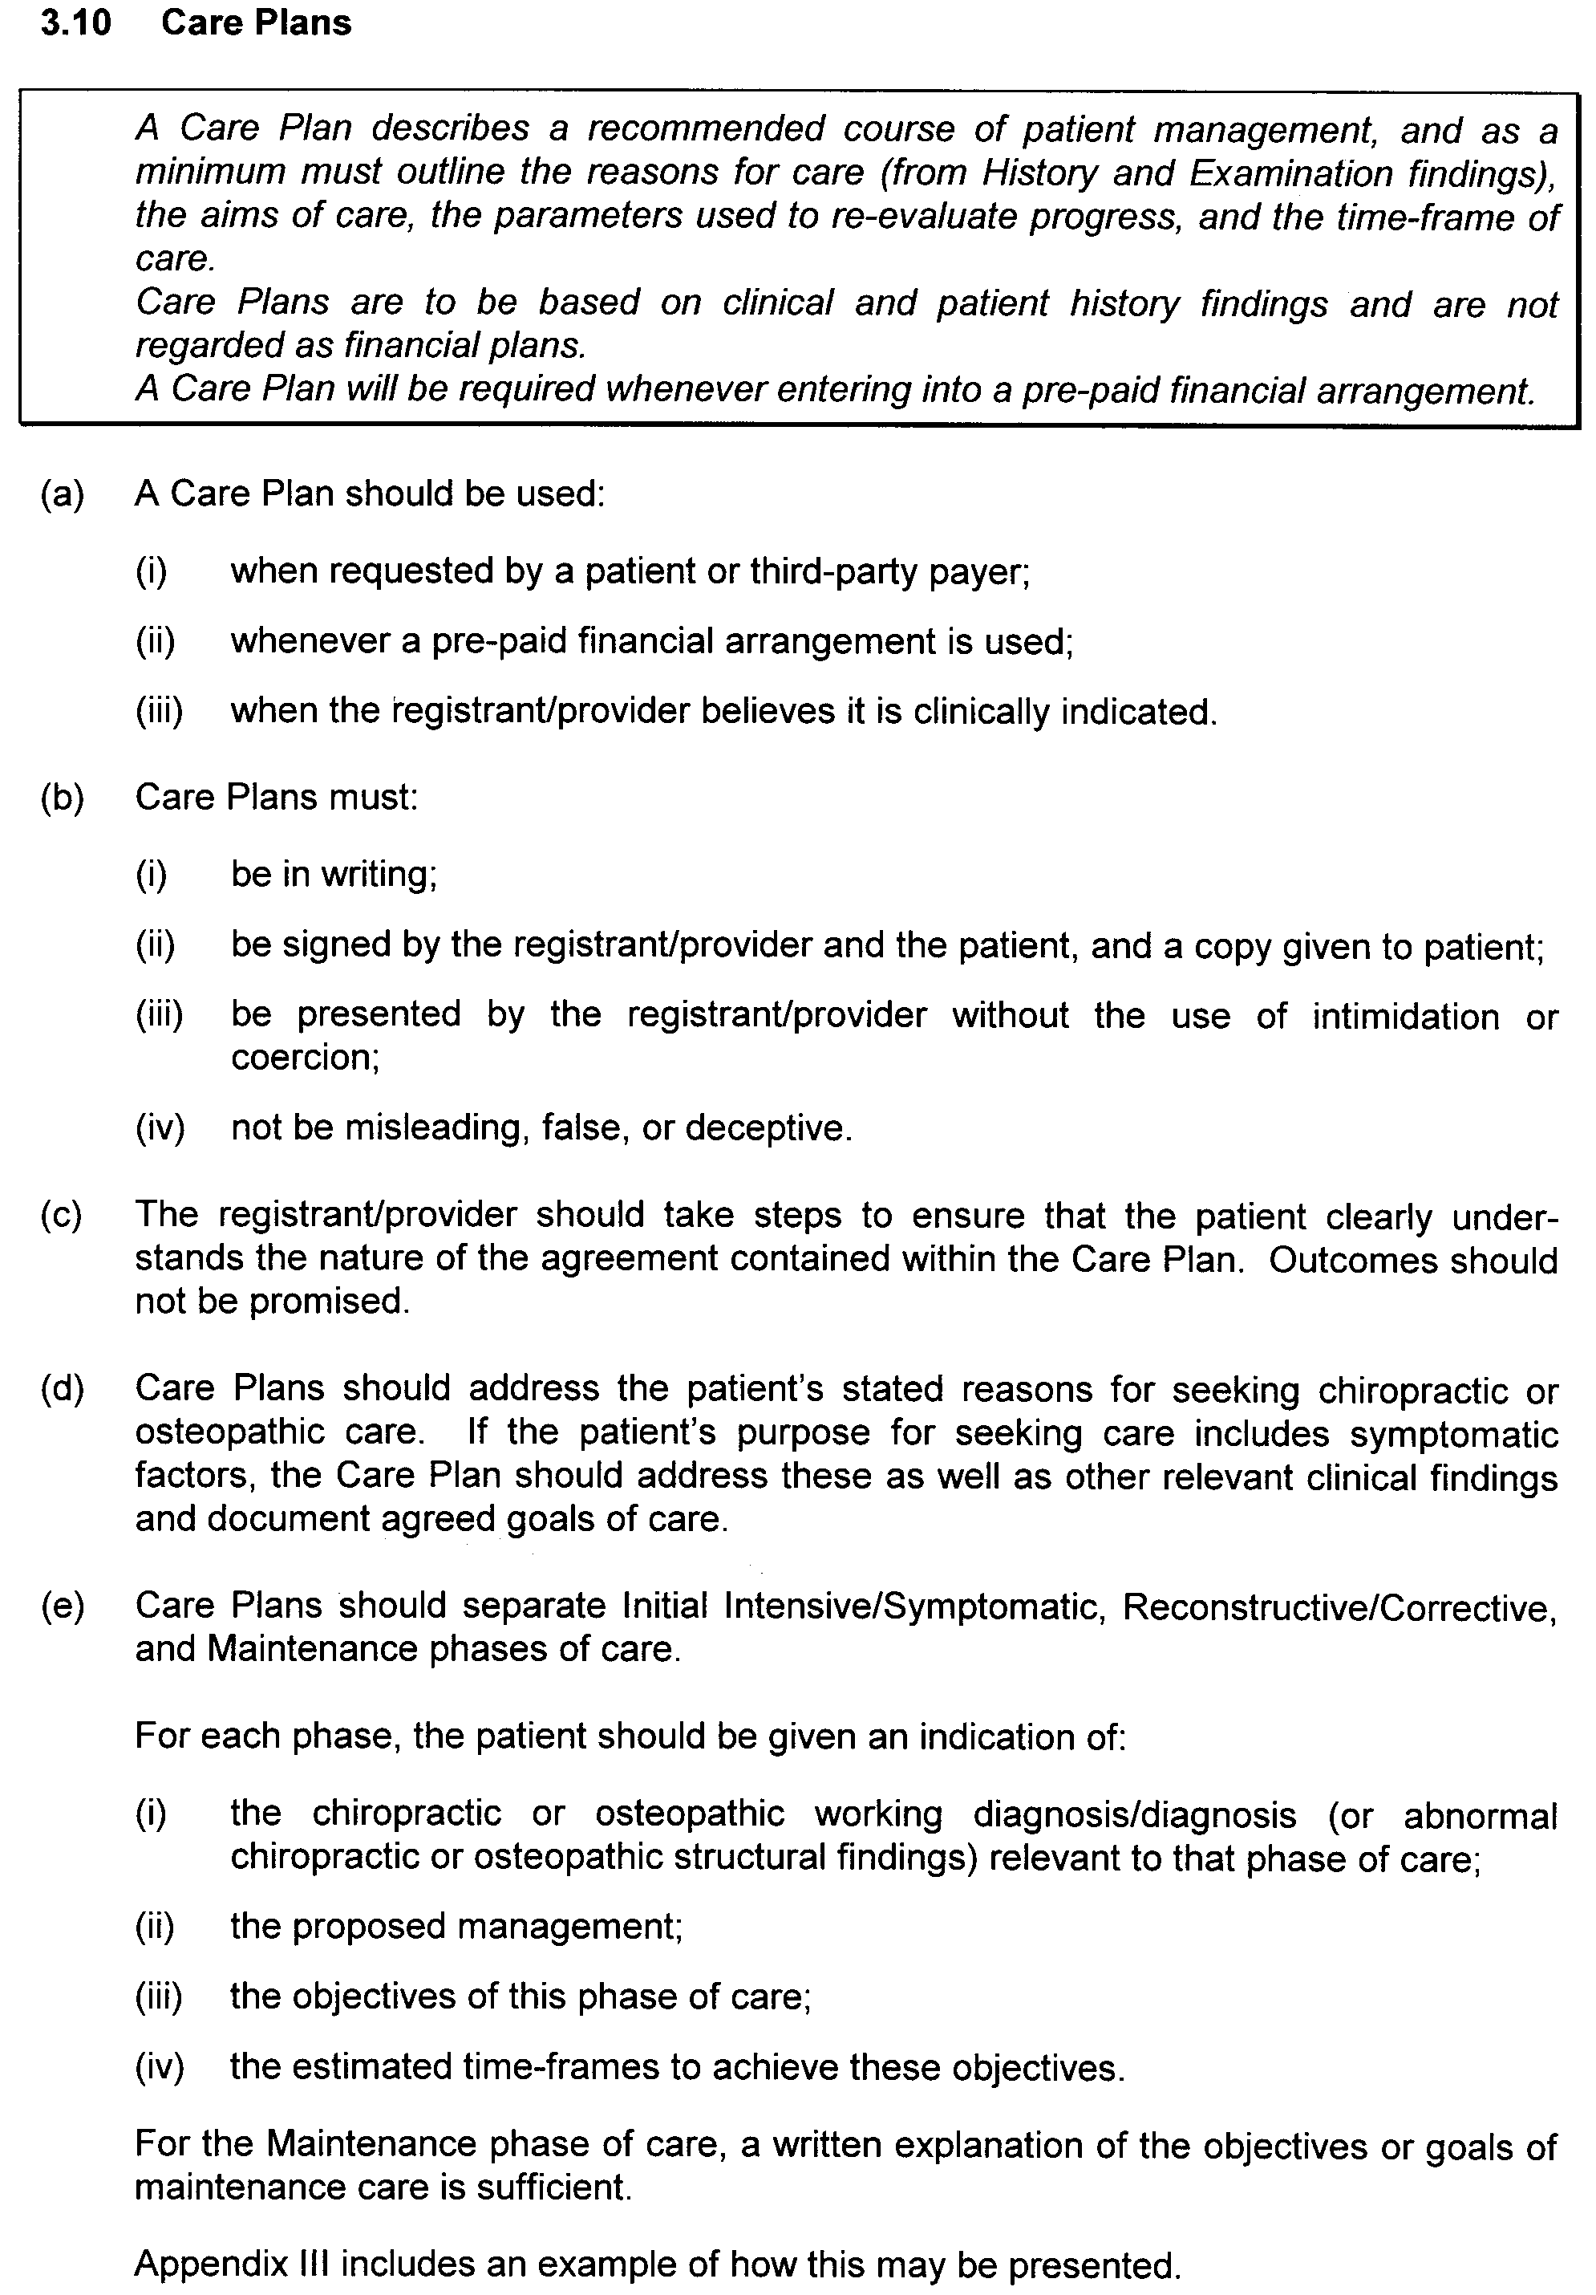
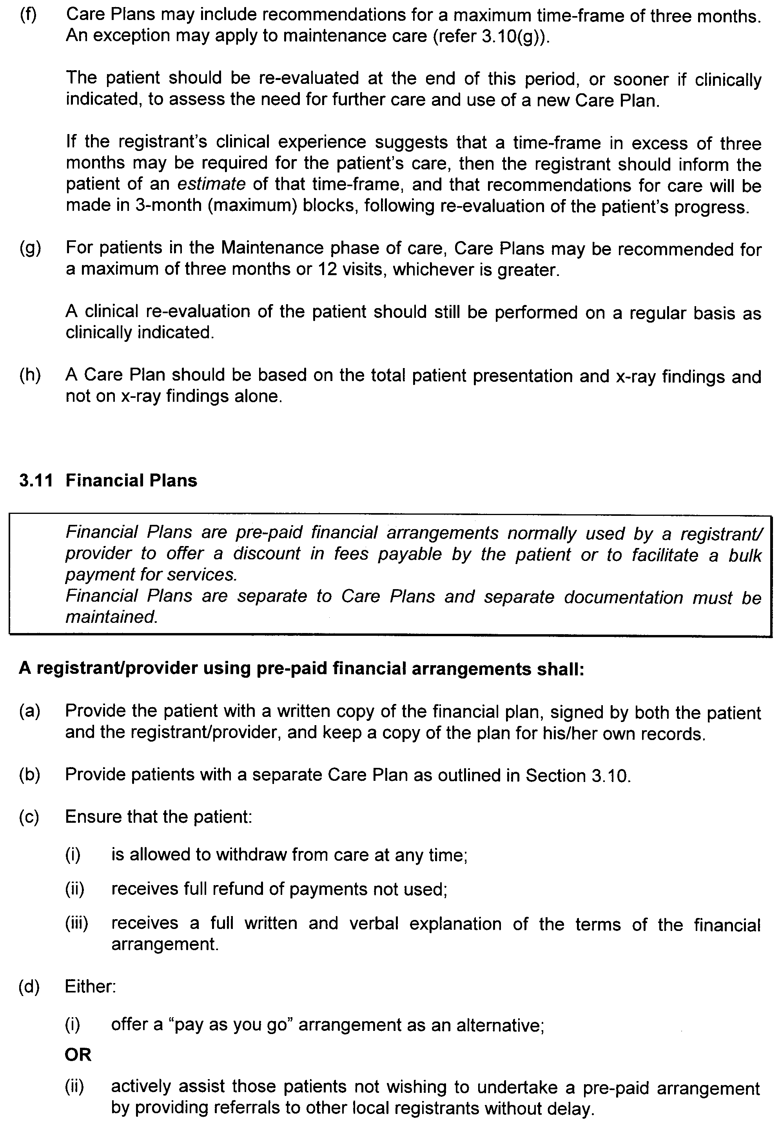
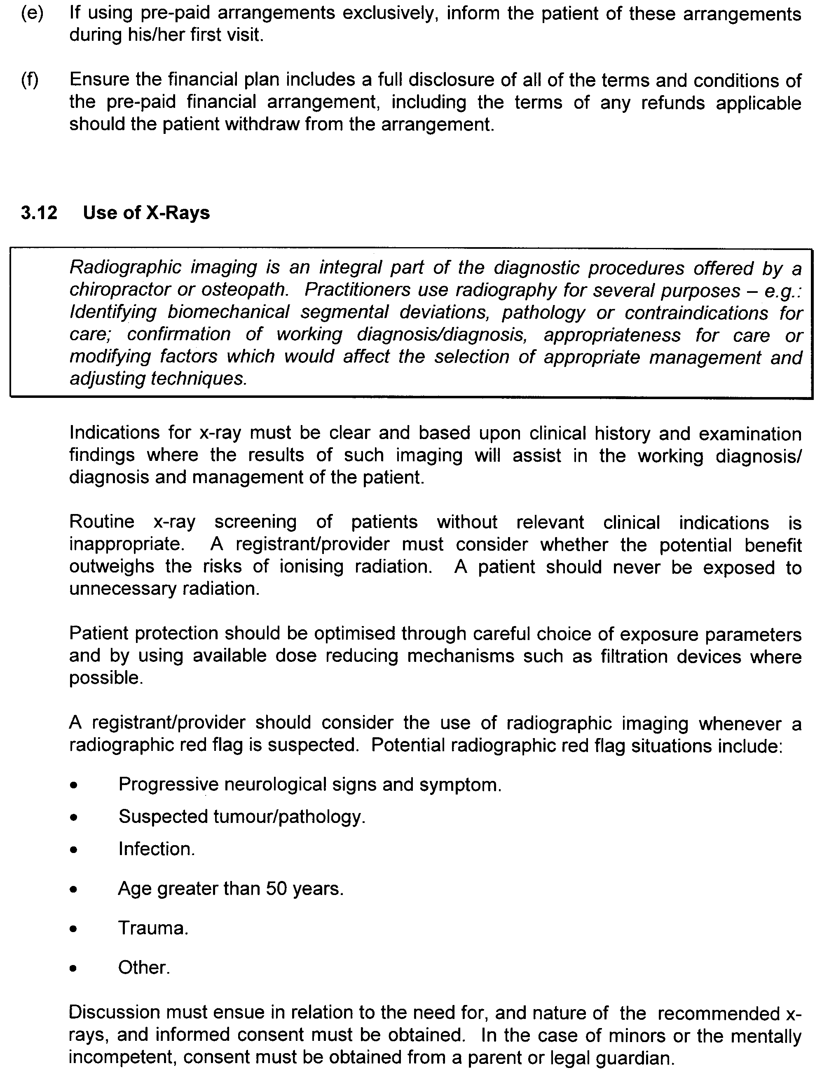
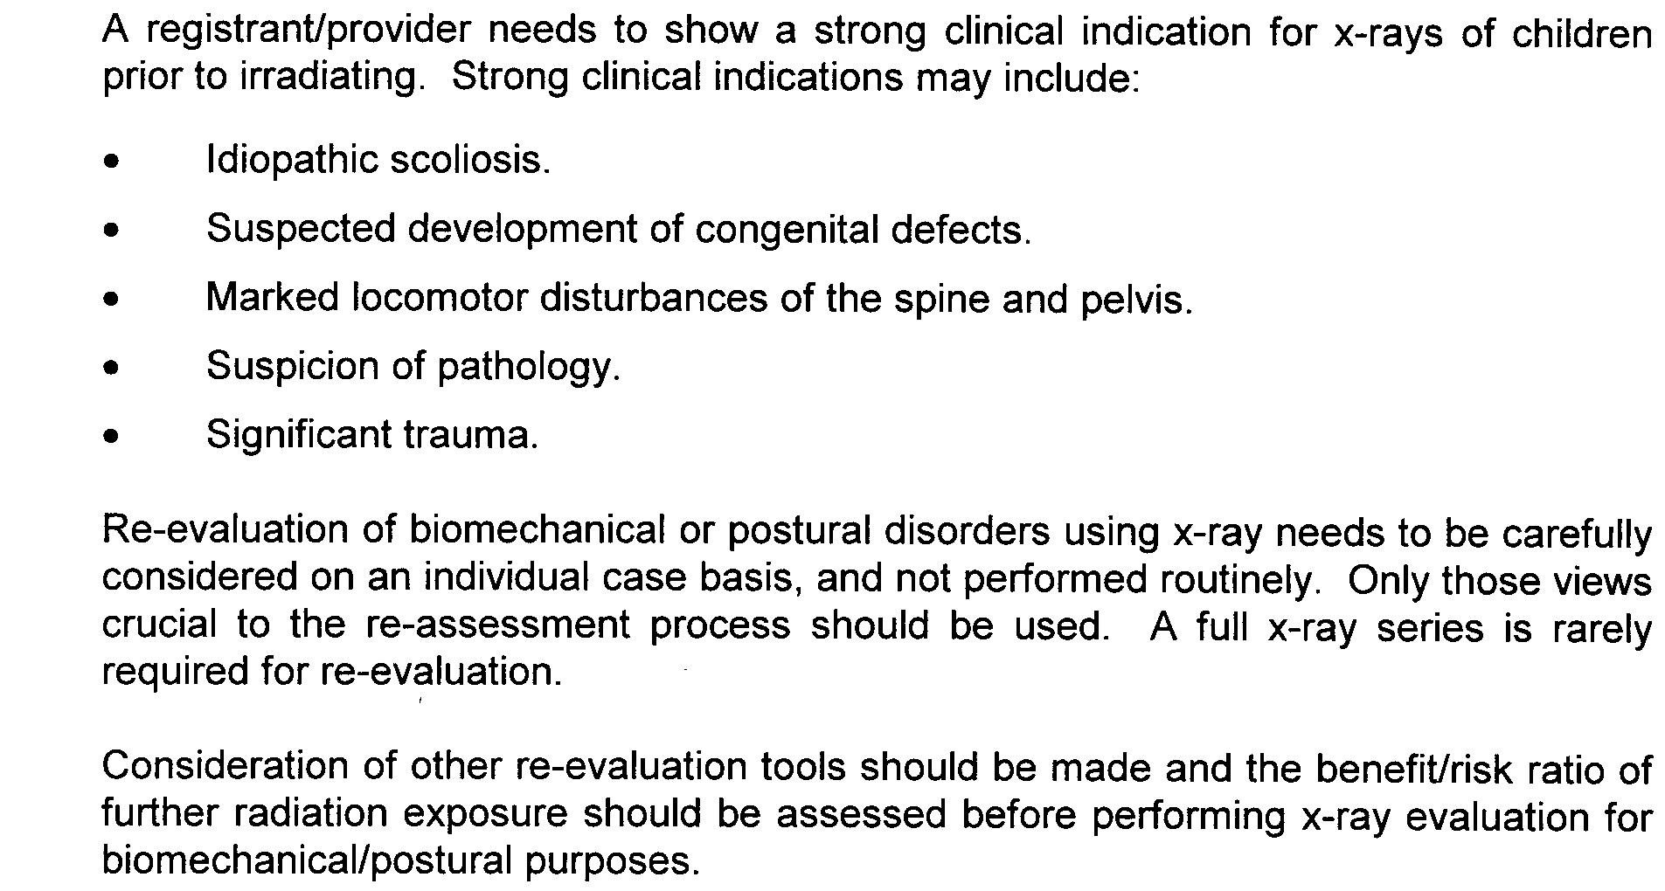
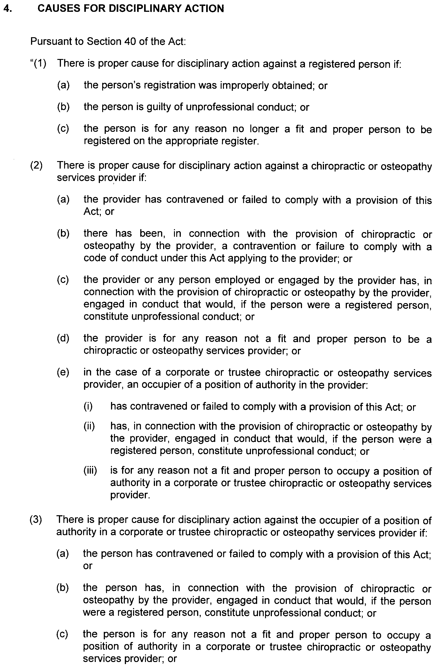
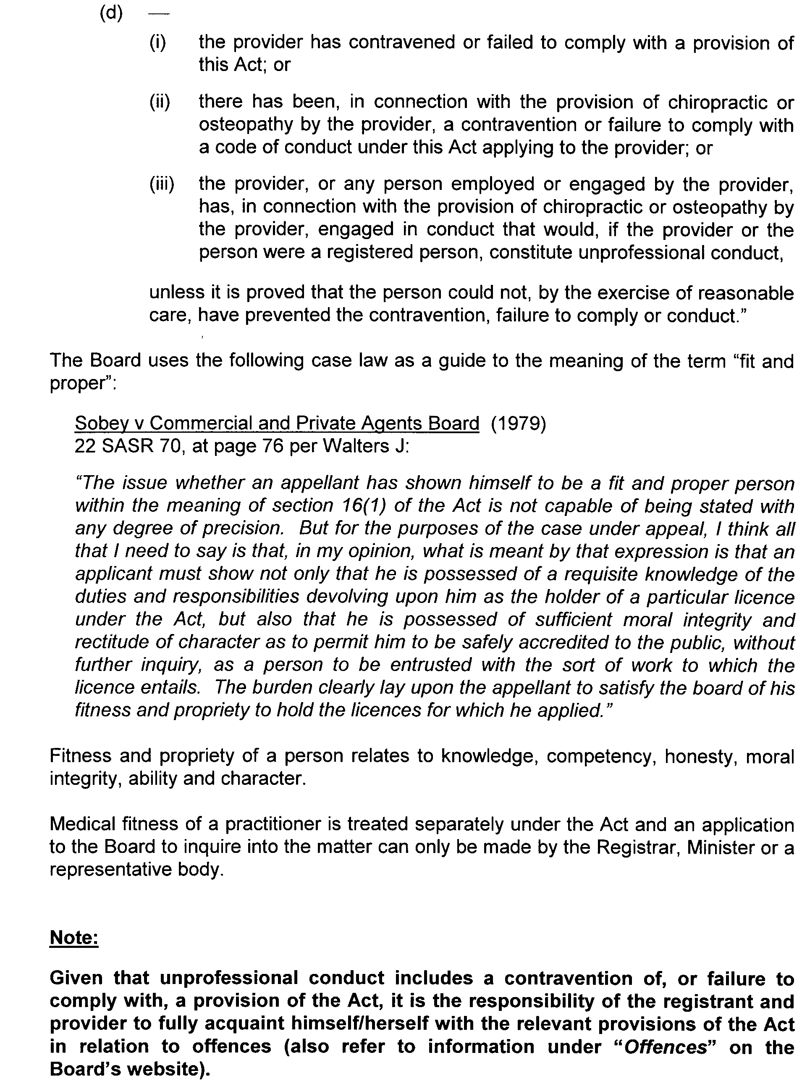
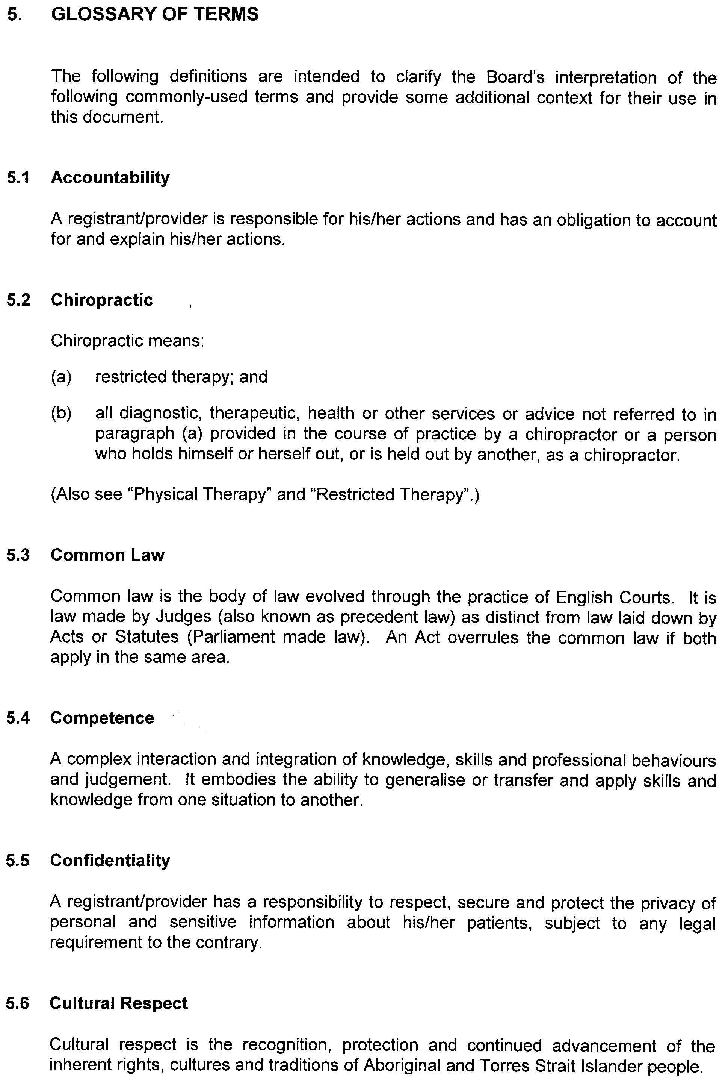
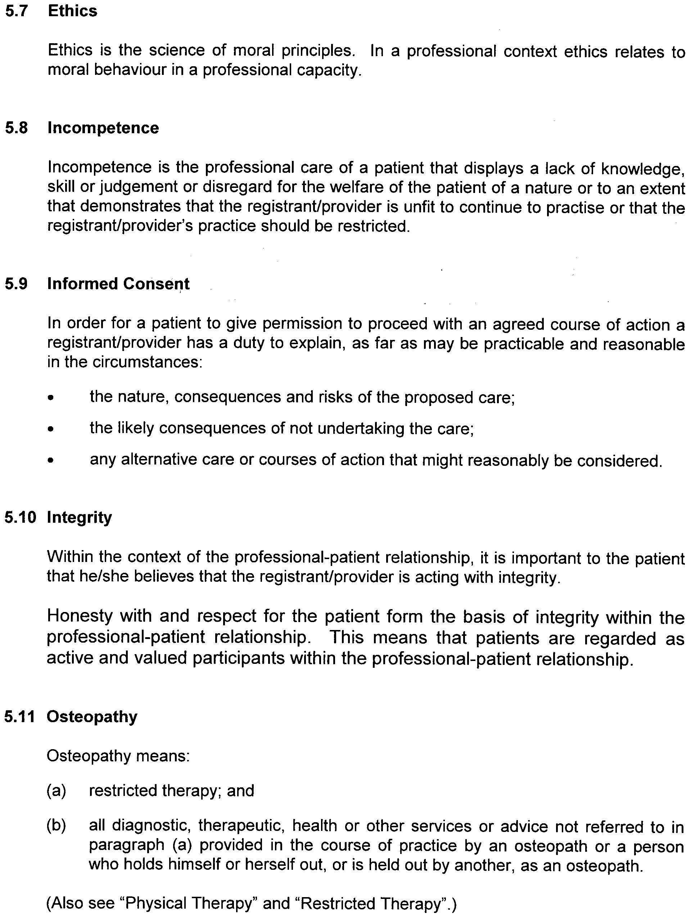
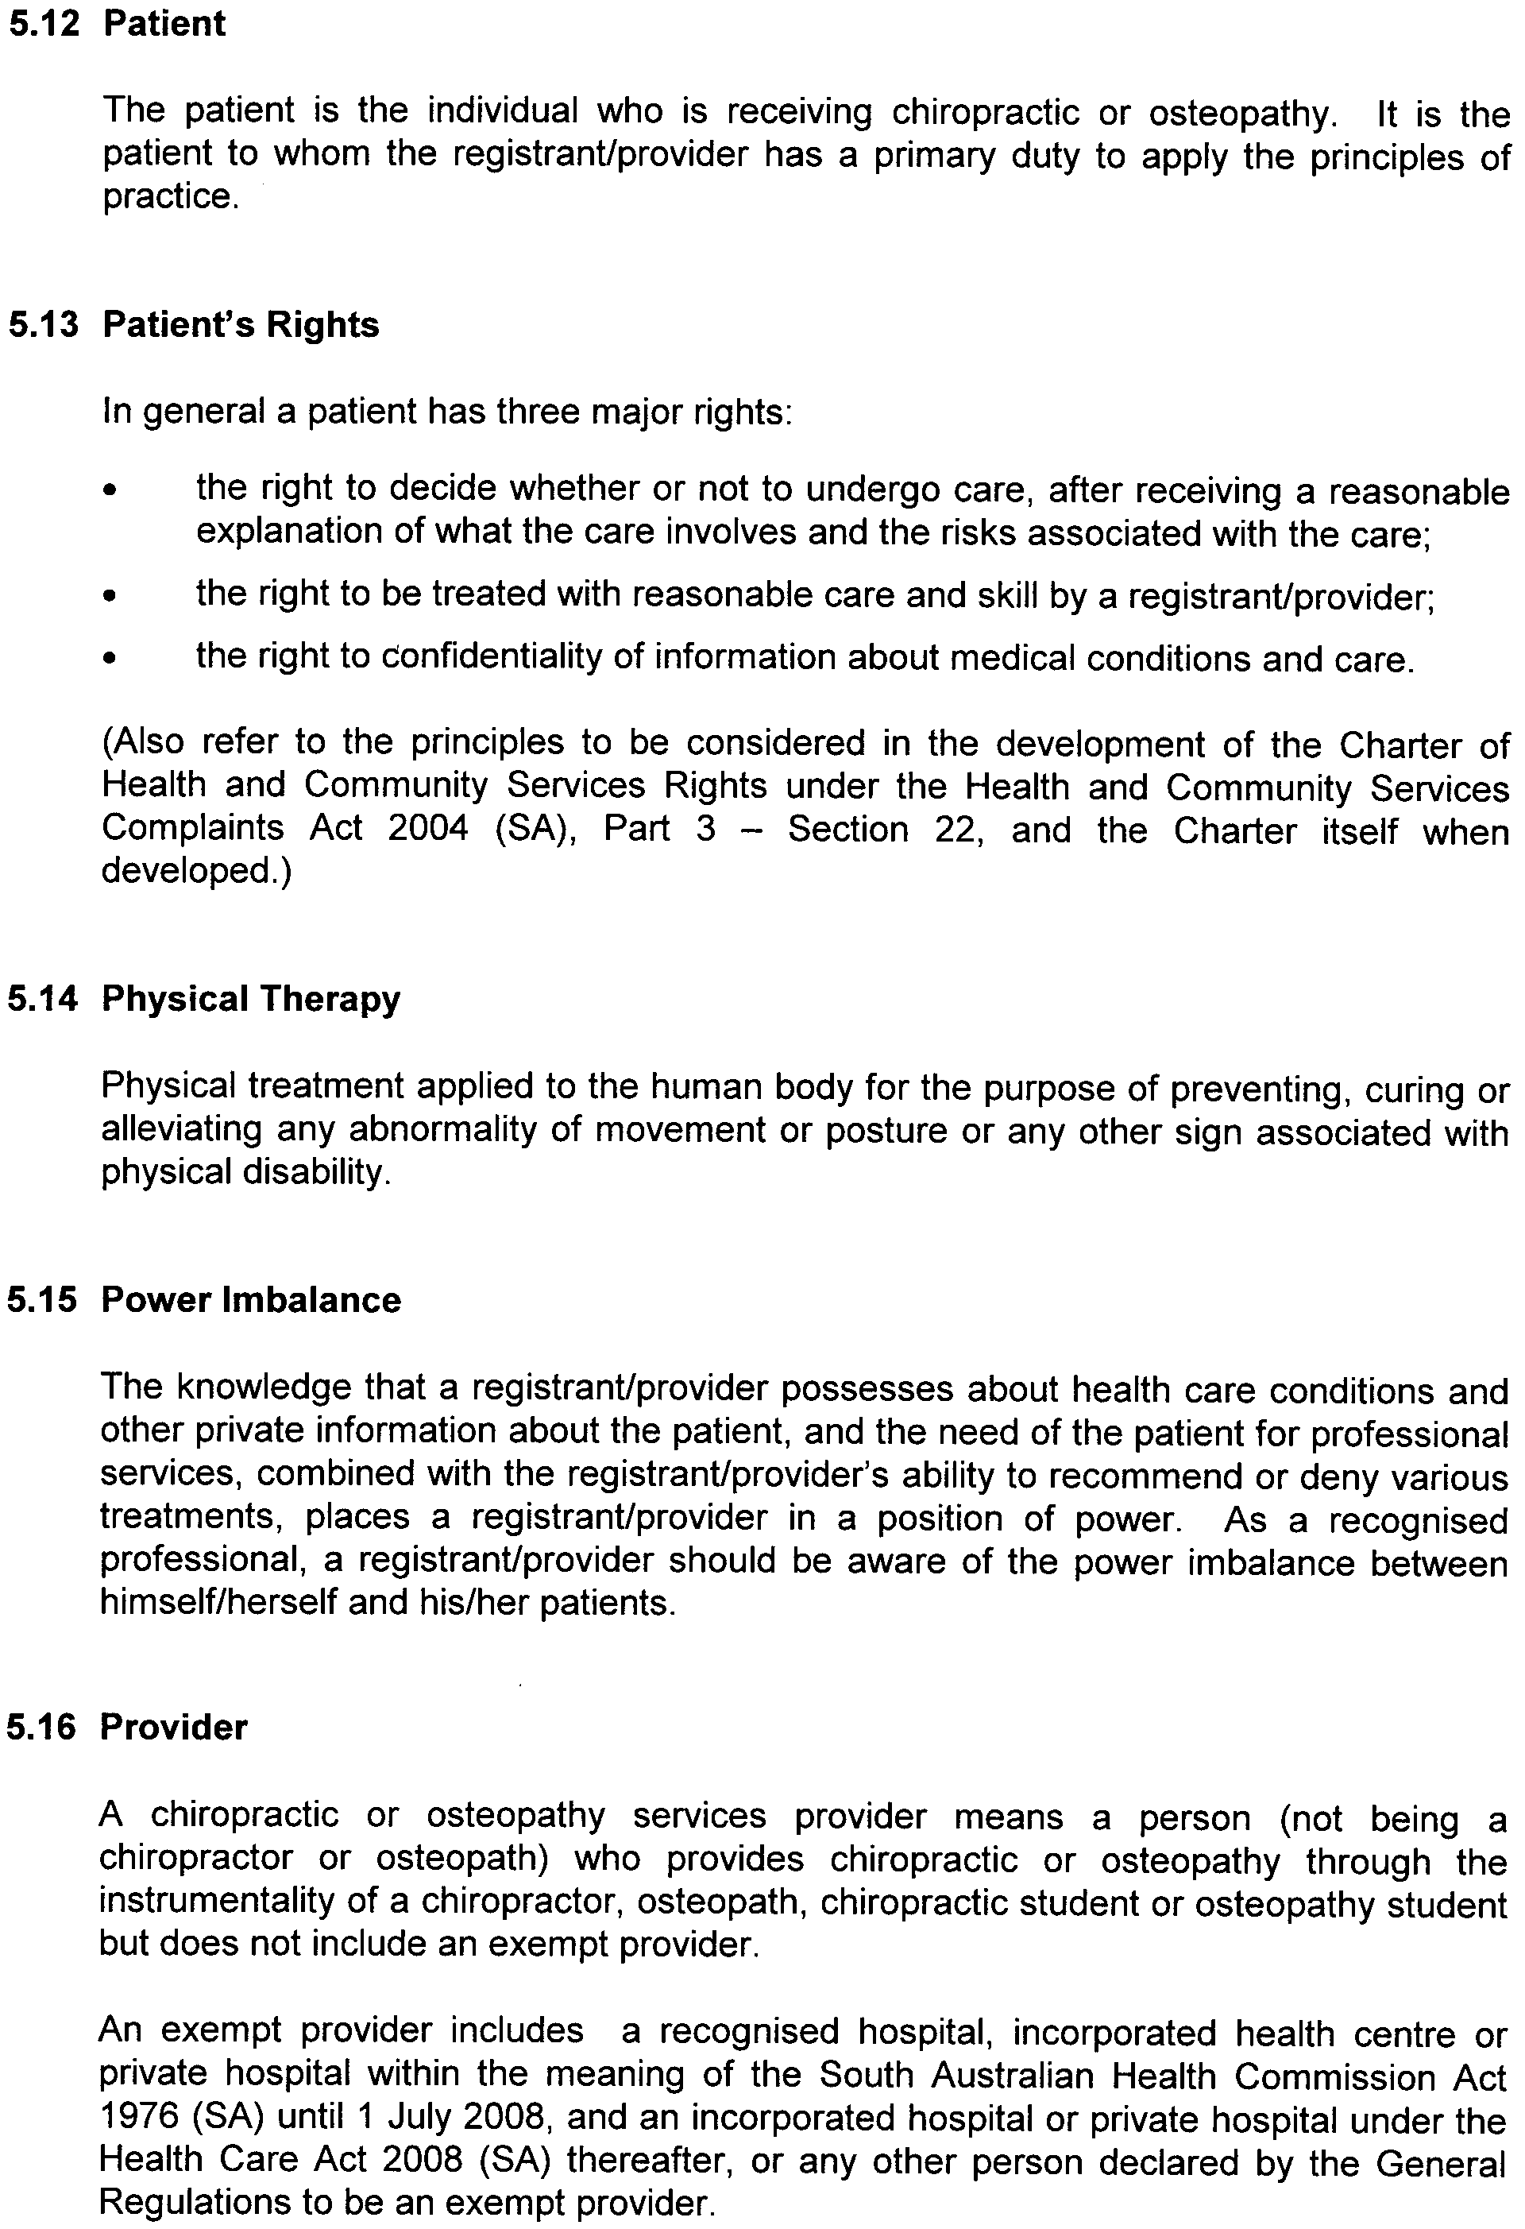
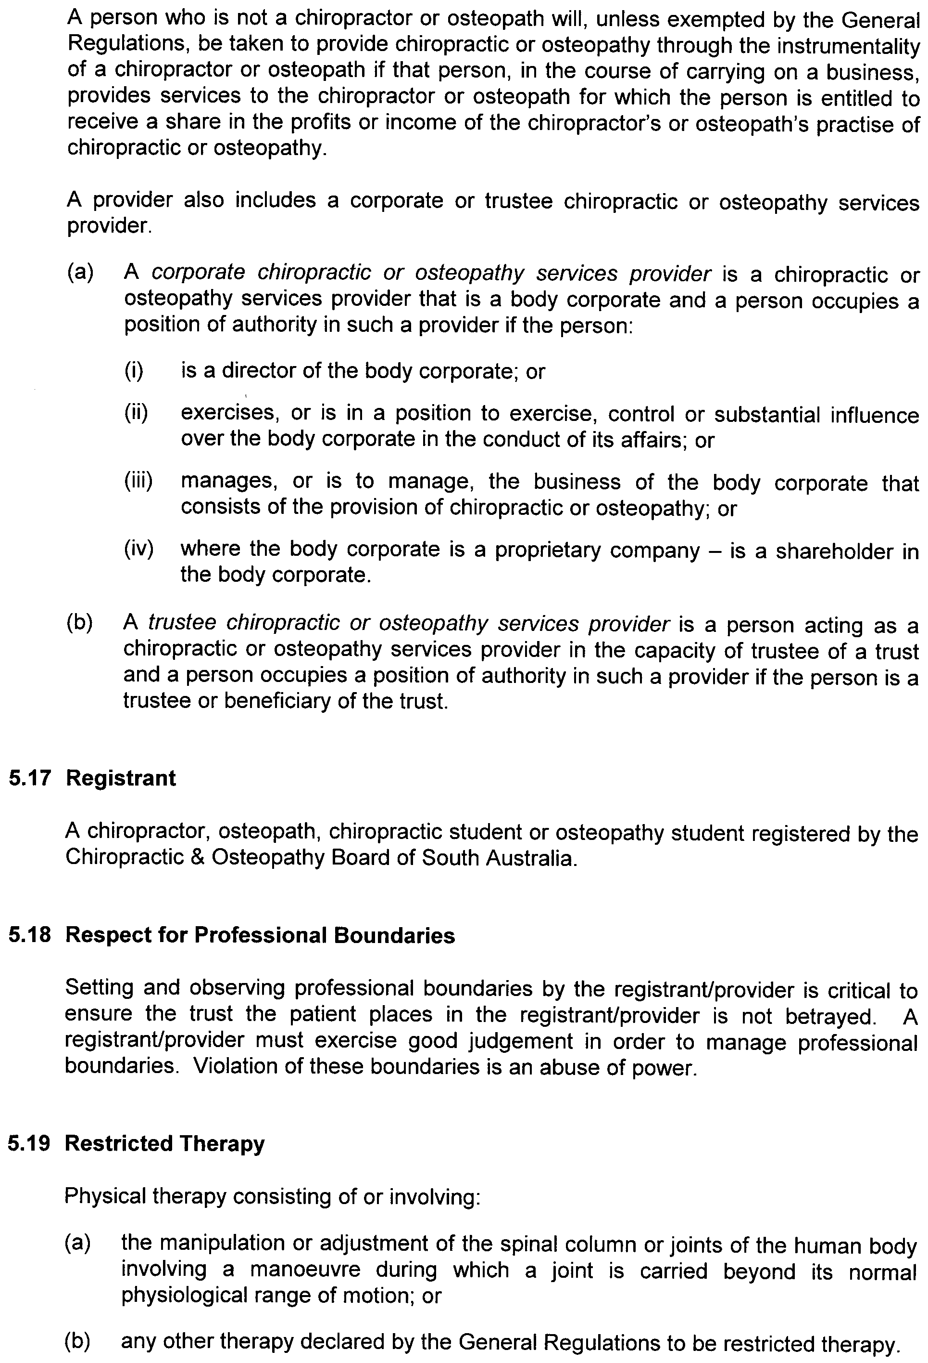
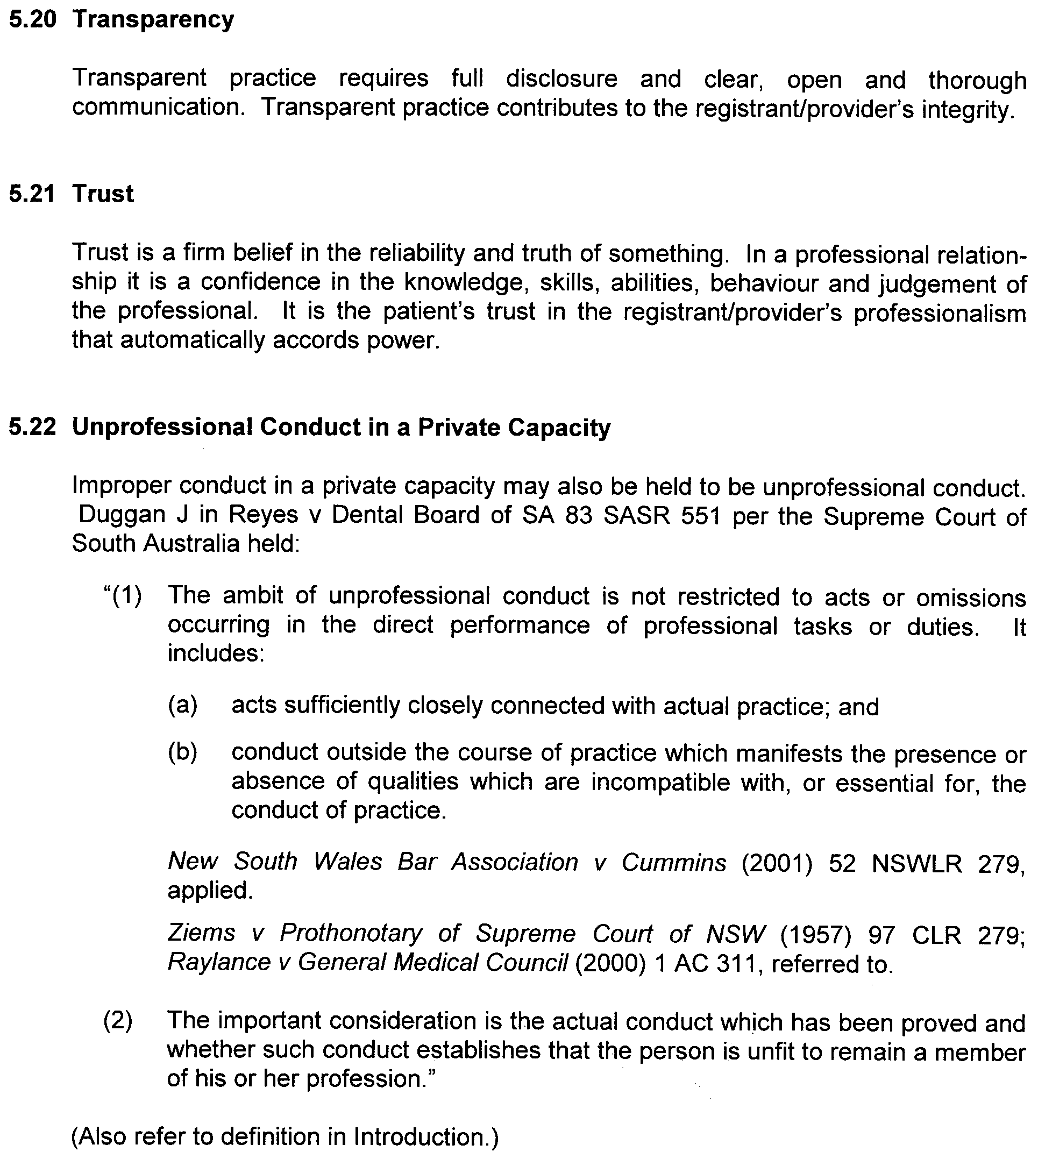

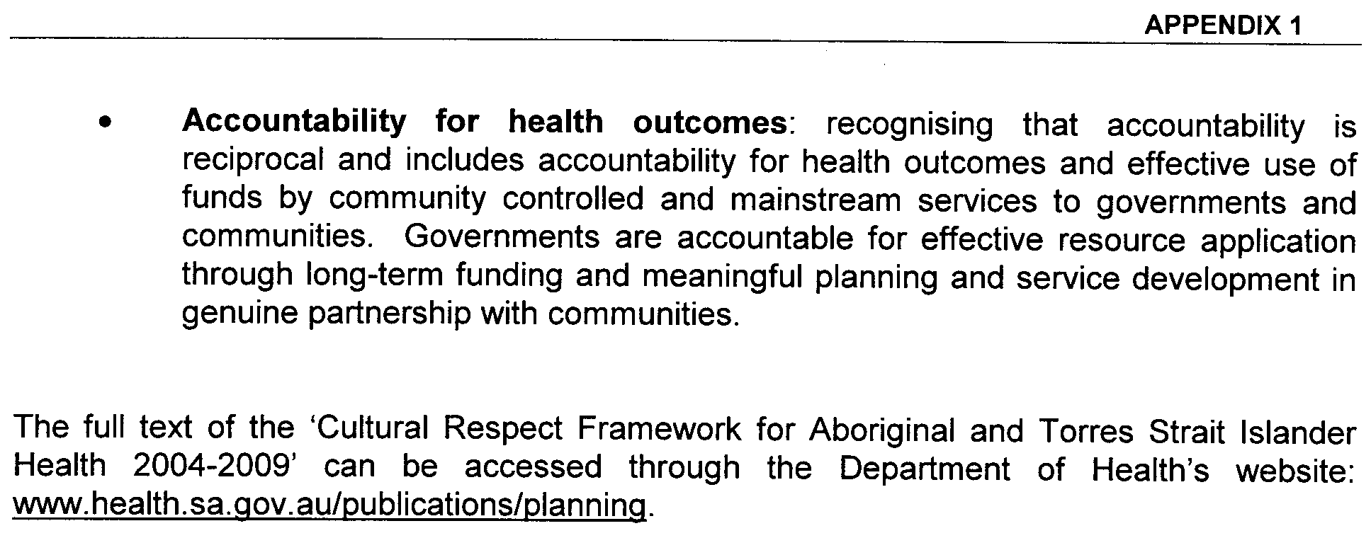

Christmas/New Year Holiday Publishing Information

Last Gazette for 2008 will be Thursday, 18 December 2008

Closing date for notices for publication will be
4 p.m. Tuesday, 16 December 2008

First Gazette for 2009 will be Thursday, 8 January 2009

Closing date for notices for publication will be
4 p.m. Tuesday, 6 January 2008

(There will NOT be a Gazette in the period between these two dates)

It would be appreciated if Government Gazette notices for publication be addressed to:

Email address for Government Gazette notices:

governmentgazette@dpc.sa.gov.au

When sending a document via Email please confirm your transmission with a faxed copy, including the date the notice is to be published.

Facsimile transmission of notices:
(08) 8207 1040
Attention: Government Gazette Section

Inquiries telephone: 8207 1045

AusDoc subscribers:

Government Publishing SA
DX 56508

Postal address:

Government Publishing SA
Box 9
Plaza Level
Riverside Centre
North Terrace, Adelaide, S.A. 5000

GOVERNMENT GAZETTE ADVERTISEMENT RATES

To apply from 1 July 2008

$  Agents, Ceasing to Act as 41.00  Associations:  Incorporation 20.80  Intention of Incorporation 51.50  Transfer of Properties 51.50  Attorney, Appointment of 41.00  Bailiff’s Sale 51.50  Cemetery Curator Appointed 30.50  Companies:  Alteration to Constitution 41.00  Capital, Increase or Decrease of 51.50  Ceasing to Carry on Business 30.50  Declaration of Dividend 30.50  Incorporation 41.00  Lost Share Certificates:  First Name 30.50  Each Subsequent Name 10.50  Meeting Final 34.25  Meeting Final Regarding Liquidator’s Report on  Conduct of Winding Up (equivalent to ‘Final  Meeting’)  First Name 41.00  Each Subsequent Name 10.50  Notices:  Call 51.50  Change of Name 20.80  Creditors 41.00  Creditors Compromise of Arrangement 41.00  Creditors (extraordinary resolution that ‘the Com-pany be wound up voluntarily and that a liquidator be appointed’) 51.50  Release of Liquidator⎯Application⎯Large Ad. 81.50  ⎯Release Granted 51.50  Receiver and Manager Appointed 47.50  Receiver and Manager Ceasing to Act 41.00  Restored Name 38.50  Petition to Supreme Court for Winding Up 71.50  Summons in Action 61.00  Order of Supreme Court for Winding Up Action 41.00  Register of Interests⎯Section 84 (1) Exempt 92.00  Removal of Office 20.80  Proof of Debts 41.00  Sales of Shares and Forfeiture 41.00  Estates:  Assigned 30.50  Deceased Persons⎯Notice to Creditors, etc. 51.50  Each Subsequent Name 10.50  Deceased Persons⎯Closed Estates 30.50  Each Subsequent Estate 1.35  Probate, Selling of 41.00  Public Trustee, each Estate 10.50 |  | $  Firms:  Ceasing to Carry on Business (each insertion) 27.25  Discontinuance Place of Business 27.25  Land⎯Real Property Act:  Intention to Sell, Notice of 51.50  Lost Certificate of Title Notices 51.50  Cancellation, Notice of (Strata Plan) 51.50  Mortgages:  Caveat Lodgement 20.80  Discharge of 21.80  Foreclosures 20.80  Transfer of 20.80  Sublet 10.50  Leases⎯Application for Transfer (2 insertions) each 10.50  Lost Treasury Receipts (3 insertions) each 30.50  Licensing 61.00  Municipal or District Councils:  Annual Financial Statement⎯Forms 1 and 2 574.00  Electricity Supply⎯Forms 19 and 20 408.00  Default in Payment of Rates:  First Name 81.50  Each Subsequent Name 10.50  Noxious Trade 30.50  Partnership, Dissolution of 30.50  Petitions (small) 20.80  Registered Building Societies (from Registrar-  General) 20.80  Register of Unclaimed Moneys⎯First Name 30.50  Each Subsequent Name 10.50  Registers of Members⎯Three pages and over:  Rate per page (in 8pt) 261.00  Rate per page (in 6pt) 345.00  Sale of Land by Public Auction 52.00  Advertisements 2.90  ¼ page advertisement 122.00  ½ page advertisement 244.00  Full page advertisement 478.00  Advertisements, other than those listed are charged at $2.90 per column line, tabular one-third extra.  Notices by Colleges, Universities, Corporations and District Councils to be charged at $2.90 per line.  Where the notice inserted varies significantly in length from that which is usually published a charge of $2.90 per column line will be applied in lieu of advertisement rates listed.  South Australian Government publications are sold on the condition that they will not be reproduced without prior permission from the Government Printer.
All the above prices include GST

GOVERNMENT GAZETTE NOTICES
ALL private advertisements forwarded for publication in the South Australian Government Gazette must be PAID FOR PRIOR TO INSERTION; and all notices, from whatever source, should be legibly written on one side of the paper only and sent to Government Publishing SA so as to be received no later than 4 p.m. Tuesday preceding the day of publication. Phone 8207 1045 or Fax 8207 1040. E-mail: governmentgazette@dpc.sa.gov.au. Send as attachments in Word format. Please include date the notice is to be published and to whom the notice will be charged. The Government Gazette is available online at: www.governmentgazette.sa.gov.au.

MISCELLANEOUS LEGISLATION AND GOVERNMENT PUBLICATIONS PRICES AS FROM 1 JULY 2008

Acts, Bills, Rules, Parliamentary Papers and Regulations
Pages | Main | Amends | Pages | Main | Amends

1-16 | 2.50 | 1.15 | 497-512 | 34.75 | 33.75
17-32 | 3.35 | 2.10 | 513-528 | 35.75 | 34.50
33-48 | 4.35 | 3.10 | 529-544 | 37.00 | 35.75
49-64 | 5.50 | 4.20 | 545-560 | 38.00 | 37.00
65-80 | 6.45 | 5.35 | 561-576 | 38.75 | 38.00
81-96 | 7.50 | 6.20 | 577-592 | 40.00 | 38.50
97-112 | 8.55 | 7.30 | 593-608 | 41.25 | 39.75
113-128 | 9.55 | 8.40 | 609-624 | 42.00 | 41.00
129-144 | 10.70 | 9.45 | 625-640 | 43.25 | 41.50
145-160 | 11.70 | 10.50 | 641-656 | 44.25 | 43.25
161-176 | 12.80 | 11.50 | 657-672 | 44.75 | 43.75
177-192 | 13.90 | 12.60 | 673-688 | 46.75 | 44.75
193-208 | 15.00 | 13.80 | 689-704 | 47.50 | 45.70
209-224 | 15.80 | 14.60 | 705-720 | 48.25 | 47.00
225-240 | 16.90 | 15.60 | 721-736 | 50.00 | 48.00
241-257 | 18.10 | 16.50 | 737-752 | 50.50 | 49.00
258-272 | 19.10 | 17.60 | 753-768 | 51.50 | 50.00
273-288 | 20.20 | 18.90 | 769-784 | 52.50 | 51.50
289-304 | 21.00 | 19.80 | 785-800 | 53.50 | 52.50
305-320 | 22.30 | 20.90 | 801-816 | 54.50 | 53.00
321-336 | 23.20 | 21.90 | 817-832 | 55.50 | 54.50
337-352 | 24.40 | 23.10 | 833-848 | 56.50 | 55.50
353-368 | 25.25 | 24.20 | 849-864 | 57.50 | 56.00
369-384 | 26.50 | 25.25 | 865-880 | 59.00 | 57.50
385-400 | 27.50 | 26.25 | 881-896 | 59.50 | 58.00
401-416 | 28.50 | 27.00 | 897-912 | 61.00 | 59.50
417-432 | 29.75 | 28.25 | 913-928 | 61.50 | 61.00
433-448 | 30.75 | 29.50 | 929-944 | 62.50 | 61.50
449-464 | 31.50 | 30.25 | 945-960 | 63.50 | 62.00
465-480 | 32.00 | 31.25 | 961-976 | 65.50 | 63.00
481-496 | 33.75 | 32.00 | 977-992 | 66.50 | 63.50

Legislation—Acts, Regulations, etc: $
Subscriptions:
Acts 214.00
All Bills as Laid 514.00
Rules and Regulations 514.00
Parliamentary Papers 514.00
Bound Acts 238.00
Index 119.00
Government Gazette
Copy 5.60
Subscription 284.00
Hansard
Copy 15.60
Subscription—per session (issued weekly) 446.00
Cloth bound—per volume 191.00
Subscription—per session (issued daily) 446.00
Legislation on Disk
Whole Database 3 304.00
Annual Subscription for fortnightly updates 1 015.00
Individual Act(s) including updates POA
Compendium
Subscriptions:
Subscriptions 1 957.00
Updates 690.00
(All the above prices include GST)

All Legislation, Government Gazette, Hansard and Legislation on disk are available from:
Counter Sales Government Legislation⁺ Outlet
and Mail Orders: Service SA Customer Service Centre,
Ground Floor—EDS Centre, 108 North Terrace, Adelaide, S.A. 5000
Phone: 13 23 24 (local call cost), Fax: (08) 8204 1909
Postal: G.P.O. Box 1707, Adelaide, S.A. 5001

Online Shop: www.shop.service.sa.gov.au

Subscriptions and Government Publishing SA
Standing Orders: Box 9, Plaza Level, Riverside Centre, North Terrace, Adelaide, S.A. 5000
Phone: (08) 8207 1043, (08) 8207 0910, Fax: (08) 8207 1040

CROWN LANDS ACT 1929: SECTION 5
TAKE NOTICE that pursuant to the Crown Lands Act 1929, I, JAY WEATHERILL, Minister for Environment and Conservation, Minister of the Crown to whom the administration of the Crown Lands Act 1929 is committed DO HEREBY resume the land defined in The Schedule.
The Schedule
1. Recreation Reserve, Sections 424 and 426, Hundred of Dudley, County of Carnarvon, the proclamation of which was published in the Government Gazette of 13 May 1982 at page 1569, being the whole of the land comprised in Crown Record Volume 5756, Folio 662.
2. Recreation Reserve, Sections 434 and 539, Hundred of Dudley, County of Carnarvon, the proclamation of which was published in the Government Gazette of 20 May 1982 at page 1710, The Second Schedule, being the whole of the land comprised in Crown Record Volume 5756, Folio 663.
Dated 11 December 2008.
Jay Weatherill, Minister for Environment and Conservation
DEH 12/0919

CROWN LANDS ACT 1929: SECTION 5
TAKE NOTICE that pursuant to the Crown Lands Act 1929, I, JAY WEATHERILL, Minister for Environment and Conservation, Minister of the Crown to whom the administration of the Crown Lands Act 1929 is committed DO HEREBY:
1. Resume the land defined in The First Schedule.
2. Dedicate the Crown Land defined in The Second Schedule as a Reserve for Waste Management Purposes and declare that such land shall be under the care, control and management of The Coorong District Council.
The First Schedule
Portion of Park Lands, portion of Allotment 101 in Deposited Plan 69069, now identified as Allotment 51 in Deposited Plan 79450, adjacent to the Town of Meningie, Hundred of Bonney, County of Russell, the proclamation of which, together with other land was published in the Government Gazette of 20 September 1984 at page 901, The Fourth Schedule, being portion of the land comprised in Crown Record Volume 5958, Folio 444.
The Second Schedule
Allotment 51 in Deposited Plan 79450, Hundred of Bonney, County of Russell, exclusive of all necessary roads.
Dated 11 December 2008.
Jay Weatherill, Minister for Environment and Conservation
DEH 09/3161

CROWN LANDS ACT 1929: SECTION 5
TAKE NOTICE that pursuant to the Crown Lands Act 1929, I, JAY WEATHERILL, Minister for Environment and Conservation, Minister of the Crown to whom the administration of the Crown Lands Act 1929 is committed DO HEREBY dedicate the Crown Land defined in The Schedule as a Recreation Reserve and declare that such land shall be under the care, control and management of the District Council of the Copper Coast.
The Schedule
Allotment 105 in Deposited Plan 57809, Hundred of Wallaroo, County of Daly, exclusive of all necessary roads, being the whole of the land comprised in Crown Record Volume 5950, Folio 664, subject to an existing easement over portion of Allotment 105 marked C on Deposited Plan 57809 to Distribution Lessor Corporation (subject to lease 8890000) for Electricity Supply Purposes (TG 9707793).
Dated 11 December 2008.
Jay Weatherill, Minister for Environment and Conservation
DEH 10/1251

DEVELOPMENT ACT 1993: SECTION 48
Decision by the Governor
Preamble
1. On 8 February 2007 the Minister for Urban Development and Planning gave notice in the Government Gazette that he was of the opinion that it was appropriate for the proper assessment of development of major environmental, social or economic importance that section 46 of the Development Act 1993 applied to any development of a kind listed in Schedule 1 of that notice in the parts of the State listed in Schedule 2 of that notice.
2. A proposal from the South Australian National Football League (hereafter ‘the proponent’) to install new lighting at AAMI Stadium at West Lakes, was the subject of a development application lodged on 16 November 2007.
3. In accordance with the declaration referred to in paragraph 1 of this Preamble, the application has been under consideration under Division 2 of Part 4 of the Development Act 1993. The proposal has been the subject of a Development Report and an Assessment Report under sections 46 and 46D of the Development Act 1993, and is hereafter referred to as the ‘proposed Major Development’.
4. I am satisfied that an appropriate Development Report and an Assessment Report have been prepared in relation to the proposed Major Development, in accordance with sections 46 and 46D, Division 2 of Part 4 of the Development Act 1993, and have had regard, when considering the proposed Major Development, to all relevant matters under section 48 (5) of the Development Act 1993.
5. I have decided to grant provisional development authorisation to the proposed Major Development under section 48 (6) of the Development Act 1993, whilst reserving the decision on specified matters until further assessment of the proposed development.
6. Contemporaneously with the issuing of this Notice, I intend, pursuant to section 48 (8) of the Development Act 1993 to delegate to the Minister for Urban Development and Planning:
(a) the power to assess the reserve matters and to issue a final development authorisation for the purposes of section 48 (2) (b) (i) of the Act;
(b) the power to grant or permit any variation associated with that provisional development authorisation (provided that the essential nature of the development is not changed); and
(c) in relation to that provisional development authorisation, or any variation—the power to vary or revoke con-ditions, or to attach new conditions, under section 48 (7) of the Development Act 1993 (provided that the essential nature of the development is not changed).
Decision
PURSUANT to section 48 of the Development Act 1993 and with the advice and consent of the Executive Council, and having due regard to the matters set out in section 48 (5) and all other relevant matters, I:
(a) grant a provisional development authorisation in relation to the proposed Major Development under section 48 (6) subject to the conditions set out in Part B below;
(b) pursuant to section 48 (6) reserve my decision on the reserved matters specified in Part A below;
(c) specify all matters relating to this provisional develop-ment authorisation as matters in respect of which conditions of this authorisation may be varied or revoked, or new conditions attached; and
(d) specify for the purposes of section 48 (11) (b) the period of two years from the date of this provisional develop-ment authorisation as the time within which substantial work must be commenced on site, failing which I may cancel this authorisation.
Part A: Reserved Matters
The following are the matters I have reserved for further assessment:
(a) Compliance with the Building Rules in relation to all aspects of the proposed Major Development.
(b) Detailed designs, drawings (including elevations), and engineering specifications for the lighting towers (including headframes).
(c) Construction Environmental Management Plan and Monitoring Plan to cover the pre-construction phases to address management issues during construction.
Part B: Conditions of Provisional Development Authorisation
1. The development authorisation granted hereunder is provisional only, does not operate as a final development authorisation, and does not therefore authorise implementation of the proposed Major Development. Only an authorisation granted under section 48 (2) (b) (i) can operate to authorise implemen-tation of the proposed Major Development, which authorisation will only be granted after the reserved matters have been assessed and approved.
1a. Except where minor amendments may be required by other legislation, or by conditions imposed herein, the proposed Major Development shall be undertaken in strict accordance with the following documents:
• Development application by the SANFL dated 16 November 2007 (except to the extent that it may be varied by a subsequent document in this paragraph).
• Development Report, New Lighting System for AAMI Stadium, West Lakes, by the SANFL dated March 2008 (except to the extent that it may be varied by a subsequent document in this paragraph).
• Response to Submissions, New Lighting System for AAMI Stadium, West Lakes, by the SANFL dated May 2008 (except to the extent that it may be varied by a subsequent document in this paragraph).
• Assessment Report prepared by the Minister for Urban Development and Planning dated November 2008.
2. All works and site activities shall be undertaken in accordance with an approved Construction Environmental Management and Monitoring Plan.
3. Normal operating hours for construction activities and truck movements to and from the site shall be from 7 a.m. to 7 p.m., Monday to Saturday, inclusive. Only if it is considered necessary by the proponent shall construction be undertaken on Sundays, in which case construction hours shall be from 9 a.m. to 6 p.m.
4. The Environment Protection (Noise) Policy 2007 shall be complied with during construction activities and truck movements.
5. Any hazardous substances (e.g. fuels, compressed gases, solvents, paints, asbestos, polychlorinated biphenyls (PCB’s) and other construction-related substances), shall be removed and disposed of in accordance with Environment Protection Authority requirements.
6. The proponent shall address the reserved matters and submit relevant documentation to the Minister for Urban Development and Planning for its approval.
Part C: Notes To Proponent
1. In respect of the reserved matters, the following is advised to the proponent:
(a) Detailed Designs, Drawings (including elevations), and Engineering Specifications for the Lighting Towers (including headframes)
Appropriately detailed designs, drawings (including elevations) and specifications for the abovementioned should be provided to enable their proper assessment.
A certificate from a registered engineer (certifying the soundness of the designs) shall accompany these designs on their submission to the Development Assessment Commission for approval.
(b) Building Rules
The proponent must obtain a Building Rules assessment and certification from either the Charles Sturt Council or a private certifier (at the proponent’s option) and forward to the Development Assessment Commission all relevant certification documents as outlined in Regulation 64 of the Development Regulations 2008.
Pursuant to Development Regulation 64, the proponent is especially advised that the Charles Sturt Council or private certifier conducting a Building Rules assessment must:
• provide to the Minister for Urban Development and Planning a certification in the form set out in Schedule 12A of the Development Regulations 2008, in relation to the building works in question; and
• to the extent that may be relevant and appropriate:
(i) issue a Schedule of Essential Safety Provisions under Division 4 of Part 12; and
(ii) assign a classification of the building under these regulations; and
(iii) ensure that the appropriate levy has been paid under the Construction Industry Training Fund 1993.
Regulation 64 of the Development Regulations 2008 provides further information about the type and quantity of all Building Rules certification documentation for Major Developments required for referral to the Minister for Urban Development and Planning. The Charles Sturt Council or private certifier undertaking Building Rules assessments must ensure that the assessment and certification are consistent with this provisional develop-ment authorisation (including its Conditions and Notes).
(c) A Construction, Environmental Management and Monitoring Plan covering Pre-construction and Construction Phases
A Construction Environmental Management and Moni-toring Plan (CEMMP) covering both pre-construction and construction phases shall be prepared in consultation with the Environment Protection Authority, before its submission to the Development Assessment Commission for approval.
The proponent’s Construction Environmental Manage-ment and Monitoring Plan (CEMMP), should be prepared taking into consideration, and with explicit reference to, relevant Environment Protection Authority policies and guideline documents, including the Environment Protection (Noise) Policy 2007.
2. The proponent is advised of the General Environmental Duty under section 25 of the Environment Protection Act 1993, which requires that a person must not undertake any activity, which pollutes, or may pollute, without taking all reasonable and practical measures to prevent or minimise harm to the environment.
3. The applicant is advised that noise emissions from the new lighting system will be subject to the Environment Protection (Noise) Policy 2007 and the Environment Protection Act 1993.
4. The applicant is advised that the Development Act 1993 outlines the roles and responsibilities of the applicant and the City of Charles Sturt Council for matters relating to building works during and after construction of the new lighting system.
5. Please note that any previous conditions still apply unless superceded by this decision.
6. The Minister has a specific power to require testing, monitoring and auditing under section 48C of the Development Act 1993.
7. Should the proponent wish to vary the Major Development or any of the components of the Major Development, an application may be submitted, provided that the development application variation remains within the ambit of the Development Report and Assessment Report referred to in this provisional development authorisation. If an application for variation involves substantial changes to the proposal, it will be processed pursuant to section 47 (2) (b) of the Development Act 1993.
Given under my hand at Adelaide, 11 December 2008.
Kevin Scarce, Governor

DEVELOPMENT ACT 1993: SECTION 48
Notice By The Governor
Preamble
1. I have given a provisional development authorisation pursuant to section 48 of the Development Act 1993, for the installation of new lighting at AAMI Stadium, West Lakes, by the South Australian National Football League, which authorisation is published in the Gazette of 11 December 2008.
2. I wish to delegate certain of my powers under section 48 to the Minister for Urban Development and Planning.
Delegation
PURSUANT to section 48 (8) of the Development Act 1993 and with the advice and consent of the Executive Council I make the following delegations:
1. I delegate to the Minister for Urban Development and Planning:
(a) my power to assess and approve the reserved matters specified in the said provisional development authorisation (provided the essential nature of the development is not changed);
(b) my power under section 48 (7a) to grant or permit any variation associated with the said provisional develop-ment authorisation (provided the essential nature of the development is not changed);
(c) in relation to the said provisional development authorisation, or any variation thereof, my power to vary or revoke conditions, or to attach new conditions, under section 48 (7) (provided the essential nature of the development is not changed);
(d) if all reserved matters specified in the said provisional development authorisation have been approved, my power to grant the development authorisation required under section 48 (2) (b) (i) (provided there has been no alteration to the Development Report to which section 47 (2) (b) has applied);
(e) my power under section 48 (2) (a) to indicate that a development authorisation will not be granted, should there be any amendment to the Development Report to which section 47 (2) (b) has applied; and
(f) my power to grant the development authorisation required under section 48 (2) (b) (i) if there has been any amendment to the Development Report to which section 47 (2) (b) has applied.
Given under my hand at Adelaide, 11 December 2008.
Kevin Scarce, Governor

DEVELOPMENT ACT 1993, SECTION 26 (9): RESIDENTIAL PARKS AND CARAVAN AND TOURIST PARKS DEVELOPMENT PLAN AMENDMENT
Preamble
1. The Development Plan amendment entitled ‘Residential Parks and Caravan and Tourist Parks Development Plan Amendment’ (the Plan Amendment) has been finalised in accordance with the provisions of the Development Act 1993.
2. The Minister for Urban Development and Planning has decided to approve the Plan Amendment.
Notice
PURSUANT to section 26 of the Development Act 1993, I—
(a) approve the Plan Amendment; and
(b) fix the day on which this notice is published in the Gazette as the day on which the Plan Amendment will come into operation.
Dated 11 December 2008.
Paul Holloway, Minister for Urban Development and Planning

DEVELOPMENT ACT 1993: SECTION 48
Decision by the Minister for Urban Development and Planning
Preamble
1. The Governor, by a decision made on 27 May 2004 and published in the Gazette of that date at pages 1350-1354, granted provisional development authorisation under section 48 of the Development Act 1993, for the development of a 19 storey apartment complex located at 41-51 Hindmarsh Square and 131-139 Grenfell Street (RAA Corner), incorporating environmentally sustainable development features and comprising:
• the construction of a 19 level residential apartment tower and podium (ten storeys high) containing 127 apartments, with ground and part first floor retail and office use;
• renovation of the adjacent two-storey State Heritage listed YWCA building (incorporating a café, gymnasium, function room, lounges and wine storage areas);
• redevelopment of the roadway on the western side of Hindmarsh Square in front of the apartment allotment; and
• a three-level basement car park extending 30 metres under the Hindmarsh Square roadway (for the width of the development site only), with provision for 158 car spaces, 27 bicycle spaces, storage, plant rooms and water storage tank.
That provisional development authorisation was subject to the 22 conditions attached to the authorisation.
2. Conservatory on Hindmarsh Square Pty Ltd (formerly Grenfell St East Pty Ltd), the person having the benefit of the development authorisation applied for an amendment to that development authorisation to amend the development which was still for a 19 storey building but contained several changes, including:
• deletion of the underground car parking intruding into the roadway of Hindmarsh Square;
• an elevated car park incorporated into the building at levels 2 to 5. The car park façade includes solar panels and passive ventilation. The number of car parking spaces has been reduced from 155 to 116;
• the building of 19 storeys no longer constructed over the adjoining YWCA heritage building;
• the number of apartments reduced from 124 to 72 and more commercial space included with an increase from 832 m² to 3 600 m²; and
• all green elements such as water retention, water saving, waste management, power generation and energy usage minimisation maintained or improved.
3. The proposal was the subject of an Amended Development Report and an Amended Assessment Report under section 47 of the Development Act 1993.
4. The Governor, by a decision made on 1 September 2005 and published in the Gazette of that date at pages 3145-3149 granted provisional development authorisation under section 48 of the Development Act 1993, for the amended development.
5. Amended proposals and reserved matters for the Hindmarsh Square Development were subsequently considered and approved by the Development Assessment Commission and published in the Gazette on 2 March 2006, 13 July 2006, 24 May 2006, 7 June 2007, 18 October 2007, 25 October 2007 and 26 June 2008.
6. An amended proposal, for four land division applications, for the Hindmarsh Square Development was also subsequently con-sidered and approved by the Governor and published in the Gazette on 27 March 2008.
7. The Government Gazette on 27 March 2008 also included a Notice by the Governor which delegated powers, to the Minister for Urban Development and Planning, to make certain decisions, including those for variations and reserved matters, which do not change the essential nature of the development.
8. Application has now been made to the Minister for Urban Development and Planning as delegate of the Governor under section 48 of the Development Act 1993, to grant an approval for a minor variation to install a box gutter on and remove two chimneys from the former YWCA building.
9. The amendments to the development are contained in the email from Pruszinski Architects dated 20 October 2008.
10. The Minister for Urban Development and Planning has in considering the application had regard to all relevant matters under section 48 (5) of the Development Act 1993.
11. The Minister for Urban Development and Planning is satisfied that the variations do not require the preparation of a further amended Development Report.
Decision
PURSUANT to section 48 of the Development Act 1993, the Minister for Urban Development and Planning as delegate of the Governor, in relation to a proposal submitted by Conservatory on Hindmarsh Square Pty Ltd to develop the Hindmarsh Square Apartment Complex at 41-51 Hindmarsh Square and 131-139 Grenfell Street:
(a) grant a development authorisation in relation to the proposed major development, subject to the conditions and notes to the applicant below;
(b) pursuant to section 48 (6) reserve a decision on the following matters:
(i) Compliance with the Building Rules in relation to the YWCA State Heritage listed building;
(c) specify all matters relating to this development authorisation as matters in respect of which conditions of this authorisation may be varied or revoked, or new conditions may be attached;
(d) specify for the purposes of section 48 (11) (b) the period of two years from the date hereof as the time within which substantial work must be commenced on the site of the development.
Conditions of Approval
1. Except where minor amendments may be required by other legislation, or by conditions imposed herein, the proposed major development shall be undertaken in strict accordance with:
(a) the following drawings contained within the letter from Connor Holmes Pty Ltd (for Grenfell East Pty Ltd) to Planning SA dated 30 April 2004, outlining the final, amended application except to the extent that they are varied by the plans as described in paragraph (c) (e) and (g):
• Drawing Titled: ‘Location Plan’ 1:500; Drawing Number: 503225 A000 C; dated 16 April 2004;
• Drawing Titled: ‘Plan B01’; 1:100; Drawing Number: 503225 A109 F; dated 16 April 2004;
• Drawing Titled: ‘Plan B02’; 1:100; Drawing Number: 503225 A110 G; dated 16 April 2004;
• Drawing Titled: ‘Plan B03’; 1:100; Drawing Number: 503225 A111 A; dated 16 April 2004 (new drawing);
• Drawing Titled: ‘Plan L00’ 1:100; Drawing Number: 503225 A100 C; dated 16 April 2004;
• Drawing Titled: ‘Plan L01’; 1:100; Drawing Number: 503225 A101 C; dated 16 April 2004;
• Drawing Titled: ‘Plan L02’; 1:100; Drawing Number: 503225 A102 C; dated 16 April 2004;
• Drawing Titled: ‘Plan L03-L09’ 1:100; Drawing Number: 503225 A103 C; dated 16 April 2004;
• Drawing Titled: ‘Plan L10’; 1:100; Drawing Number: 503225 A104 C; dated 16 April 2004;
• Drawing Titled: ‘Plan L11-L18’; 1:100; Drawing Number: 503225 A105 C; dated 16 April 2004 (except to the extent that they may be varied by a document in paragraph (b), dated 30 April 2004);
• Drawing Titled: ‘Plan Roof’; 1:100; Drawing Number: 503225 A108 C; dated 16 April 2004 (except to the extent that they may be varied by a document in paragraph (b), dated 30 April 2004);
• Drawing Titled: ‘North Elevation’; 1:200; Drawing Number: 503225 A200 C; dated 16 April 2004;
• Drawing Titled: ‘East Elevation’; 1:200; Drawing Number: 503225 A201 C; dated 16 April 2004;
• Drawing Titled: ‘West Elevation/South Elevation’; 1:200; Drawing Number: 503225 A202 C; dated 16 April 2004; and
• Drawing Titled: ‘Sections’; 1:200; Drawing Number: 503225 A203 C; dated 16 April 2004;
(b) the following documents except to the extent that they are varied by the plans as described in paragraph (d) and (f):
• Development application, ‘Residential apartment building with retailing and offices and basement car parking at 131-139 Grenfell Street/41-51 Hindmarsh Square, Adelaide’, prepared by Connor Holmes Pty Ltd (for Grenfell East Pty Ltd) dated 26 May 2003 (except to the extent that it may be varied by a subsequent document in this paragraph);
• Development Report, Hindmarsh Square Apartment Complex, prepared by Connor Holmes Pty Ltd (for Grenfell East Pty Ltd) dated 5 November 2003 (except to the extent that it may be varied by a subsequent document in this paragraph);
• Response to Submissions Document, Hindmarsh Square Apartment Complex, prepared by Connor Holmes Pty Ltd (for Grenfell East Pty Ltd) dated 18 December 2003 (contained within an appendix to the Assessment Report noted below) (except to the extent that it may be varied by a subsequent document in this paragraph);
• Assessment Report prepared by the Minister for Urban Development and Planning and released 8 March 2004 (except to the extent that it may be varied by a subsequent document in this paragraph);
• Letter from Connor Holmes Pty Ltd (for Grenfell East Pty Ltd) to the Minister for Urban Development and Planning dated 18 March 2004, outlining the applicant’s response to the Assessment Report (except to the extent that it may be varied by a subsequent document in this paragraph);
• Letter from Grenfell East Pty Ltd to the Minister for Urban Development and Planning dated 24 March 2004, proposing amendments to the proposal (except to the extent that it may be varied by a subsequent document in this paragraph);
• Letter from Grenfell East Pty Ltd to the Minister for Urban Development and Planning dated 22 April 2004, outlining additional transport initiatives (except to the extent that it may be varied by a subsequent document in this paragraph);
• Letter from Connor Holmes Pty Ltd (for Grenfell East Pty Ltd) to Planning SA dated 30 April 2004, outlining a final, amended application and accompanying plans, including reduction of the apartment tower height by two levels; reduction of the extent of the three-level basement car park (located under the apartment complex and adjacent roadway and footpath) with no encroachment in front of the adjacent property to the south; and a list of reserved matters for further application and decision-making (except to the extent that it may be varied by a subsequent document in this paragraph); and
• Correspondence from Jack Hines (for Grenfell East Pty Ltd) to Planning SA dated 30 April 2004, listing final design of the apartment complex roof line and Level 18 of the complex as reserved matters for later decision-making subject to further application;
(c) the following drawings accompanying the Further Information and Clarification letter dated 27 June 2005 and the Amended Development Report dated 4 April 2005, except to the extent that they are varied by the plans as described in paragraph (e) and (g):
• Drawing Titled: ‘Site Plan’; 1:500; Drawing Number: D-04335-01-01; dated 24 June 2005;
• Drawing Titled: ‘Basement Floor Plan’; 1:100; Drawing Number: D-04335-02-01; dated 24 June 2005;
• Drawing Titled: ‘Ground Floor Plan’; 1:100; Drawing Number: D-04335-02-02; dated 24 June 2005;
• Drawing Titled: ‘Level 1 Floor Plan’; 1:100; Drawing Number: D-04335-02-03; dated 24 June 2005;
• Drawing Titled: ‘Ramp Arrangement Floor Plan’; 1:100; Drawing Number: D-04335-02-04; dated 24 June 2005;
• Drawing Titled: ‘Level 2 Floor Plan’; 1:100; Drawing Number: D-04335-02-05; dated 24 June 2005;
• Drawing Titled: ‘Level 3 Floor Plan’; 1:100; Drawing Number: D-04335-02-06; dated 24 June 2005;
• Drawing Titled: ‘Level 4 Carparking’; 1:100; Drawing Number: D-04335-02-07; dated 24 June 2005;
• Drawing Titled: ‘Level 5 Floor Plan’; 1:100; Drawing Number: D-04335-02-08; dated 24 June 2005;
• Drawing Titled: ‘Level 6 Commercial Floor Plan’; 1:100; Drawing Number: D-04335-02-09; dated 24 June 2005;
• Drawing Titled: ‘Level 7-9 Commercial Floor Plan’; 1:100; Drawing Number: D-04335-02-10; dated 24 June 2005;
• Drawing Titled: ‘Level 10—Residential Floor Plan’; 1:100; Drawing Number: D-04335-02-11; dated 24 June 2005;
• Drawing Titled: ‘Level 11-18—Residential Floor Plan’; 1:100; Drawing Number: D-04335-02-12; dated 24 June 2005;
• Drawing Titled: ‘East Elevation (Hindmarsh Square)’; 1:200; Drawing Number: D-04335-04-01; dated 24 June 2005;
• Drawing Titled: ‘North Elevation (Grenfell Street)’; 1:200; Drawing Number: D-04335-04-02; dated 24 June 2005;
• Drawing Titled: ‘West Elevation/South Elevation’; 1:200; Drawing Number: D-04335-04-03; dated 24 June 2005;
• Drawing Titled: ‘Section 1’; 1:200; Drawing Number: D-04335-05-01; dated 24 June 2005;
• Drawing Titled: ‘Perspective’; Drawing Number: D-04335-12-02; dated 24 June 2005;
• Drawing Titled: ‘Shadow Diagram’; 1:1000; Drawing Number: D-04335-12.01; dated 24 June 2005;
• Drawing Titled: ‘Ground Floor Plan Display YWCA Building’; 1:100; Un-numbered drawing submitted with drawings dated 24 June 2005; and
• Drawing Titled: ‘Roof Floor Plan’; 1:100; Drawing Number: D-04335-02-13; dated 28 March 2005;
(d) the following documents except to the extent that they are varied by the plans as described in paragraph (f):
• Letter from Tecon Australia dated 15 February 2006, which includes copies of the varied drawings for the Temporary Display Unit in the YWCA Building and its associated Building Rules Certification;
• Correspondence dated 14 February 2006 by Pruszinski Architects;
• Amended Development Report, Hindmarsh Square Apartment Complex, prepared by Connor Holmes Pty Ltd (for Grenfell East Pty Ltd) dated 4 April 2005 (except to the extent that it may be varied by a subsequent document in this paragraph); and
• Letter from Connor Holmes Pty Ltd (for Grenfell East Pty Ltd) to the Assessment Branch, Planning SA dated 27 June 2005, outlining the applicant’s response to issues raised in emails seeking further information dated 29 May 2005 and 8 June 2005;
(e) the following drawings except to the extent that they are varied by the plans as described in paragraph (g):
• Architectural drawings numbered 05354-02-03, 05354-03-01, 05354-03-02, 05354-03-03, 05354-06-01 & 05354-06-02 by Pruszinski Architects, dated 21 December 2005;
• Mechanical services drawings numbered LCE2453A-M01 by Lucid Consulting Engineers, dated 13 February 2006;
• Electrical services drawings numbered LCE2453A-E01 by Lucid Consulting Engineers, dated 13 February 2006; and
• Hydraulic services drawings numbered LCE2453A-H01 by Lucid Consulting Engineers, dated 13 February 2006;
(f) the following document:
• Letter from Connor Holmes Pty Ltd (for the Conserva-tory on Hindmarsh Square) to the Assessment Branch, Planning SA dated 21 March 2006;
(g) the following drawings:
• Drawing Titled: ‘Site Plan’; 1:500; Drawing Number: D-04335-01-01; dated 15 March 2006;
• Drawing Titled: ‘Basement Floor Plan’; 1:100; Drawing Number: D-04335-02-01; dated 15 March 2006;
• Drawing Titled: ‘Ground Floor Plan’; 1:100; Drawing Number: D-04335-02-02; dated 15 March 2006;
• Drawing Titled: ‘Ramp Arrangement Floor Plan’; 1:100; Drawing Number: D-04335-02-03; dated 15 March 2006;
• Drawing Titled: ‘Level 1 Floor Plan’; 1:100; Drawing Number: D-04335-02-04; dated 15 March 2006;
• Drawing Titled: ‘Level 2 Floor Plan’; 1:100; Drawing Number: D-04335-02-05; dated 15 March 2006;
• Drawing Titled: ‘Level 3 Floor Plan’; 1:100; Drawing Number: D-04335-02-06; dated 15 March 2006;
• Drawing Titled: ‘Level 4 Carparking’; 1:100; Drawing Number: D-04335-02-07; dated 15 March 2006;
• Drawing Titled: ‘Level 5 Floor Plan’; 1:100; Drawing Number: D-04335-02-08; dated 18 May 2006;
• Drawing Titled: ‘Level 6 Commercial Floor Plan’; 1:100; Drawing Number: D-04335-02-09; dated 18 May 2006;
• Drawing Titled: ‘Level 7 Commercial Floor Plan’; 1:100; Drawing Number: D-04335-02-10; dated 18 May 2006;
• Drawing Titled: ‘Level 8 Commercial Floor Plan’; 1:100; Drawing Number: D-04335-02-11; dated 18 May 2006;
• Drawing Titled: ‘Level 9 Commercial Floor Plan’; 1:100; Drawing Number: D-04335-02-12; dated 18 May 2006;
• Drawing Titled: ‘Level 10—Residential Floor Plan’; 1:100; Drawing Number: D-04335-02-13; dated 18 May 2006;
• Drawing Titled: ‘Level 11—Residential Floor Plan’; 1:100; Drawing Number: D-04335-02-14; dated 18 May 2006;
• Drawing Titled: ‘Level 12—Residential Floor Plan’; 1:100; Drawing Number: D-04335-02-15; dated 18 May 2006;
• Drawing Titled: ‘Level 13—Residential Floor Plan’; 1:100; Drawing Number: D-04335-02-16; dated 18 May 2006;
• Drawing Titled: ‘Level 14—Residential Floor Plan’; 1:100; Drawing Number: D-04335-02-17; dated 18 May 2006;
• Drawing Titled: ‘Level 15—Residential Floor Plan’; 1:100; Drawing Number: D-04335-02-18; dated 18 May 2006;
• Drawing Titled: ‘Level 16—Residential Floor Plan’; 1:100; Drawing Number: D-04335-02-19; dated 18 May 2006;
• Drawing Titled: ‘Level 17—Residential Floor Plan’; 1:100; Drawing Number: D-04335-02-20; dated 18 May 2006;
• Drawing Titled: ‘Level 18—Residential Floor Plan’; 1:100; Drawing Number: D-04335-02-21; dated 18 May 2006;
• Drawing Titled: ‘Roof Floor Plan’; 1:100; Drawing Number: D-04335-02-22; dated 15 March 2006;
• Drawing Titled: ‘North Elevation (Grenfell Street)’; 1:100; Drawing Number: D-04335-04-01; dated 15 March 2006;
• Drawing Titled: ‘East Elevation (Hindmarsh Square)’; 1:100; Drawing Number: D-04335-04-02; dated 15 March 2006;
• Drawing Titled: ‘South Elevation’; 1:100; Drawing Number: D-04335-04-03; dated 15 March 2006; and
• Drawing Titled: ‘West Elevation’; 1:100; Drawing Number: D-04335-04-03; dated 18 May 2006;
(h) the following documents:
Email from Paul Pruzinski Architects to the Assess-ment Branch Planning SA dated 10 May 2007;
(i) Letter and accompanying drawings dated 25 May 2007 from Tecon Australia in regard to Building Rules Certification for Demolition Works at 41 Hindmarsh Square;
(j) Letter and accompanying drawings dated 12 October 2007 from Tecon Australia in regard to Building Rules Certification to construct a 19 level apartment, office, retail and car parking complex at 41 Hindmarsh Square;
(k) Land division plans and associated correspondence for Torrens title land division application 020/D022/07 and community title land division applications 020/C019/07, 020/C020/07 and 020/C021/07, up-loaded onto the Electronic Land Division Lodgement Site (EDALA) on 31 May 2007;
(l) Email and accompanying drawings dated 12 May 2008, in regard to temporary hoarding signage from James Hines, Conservatory on Hindmarsh Square; and
(m) Email and accompanying drawings included with corres-pondence dated 20 October 2008, in regard to a minor variation to install a box gutter on and remove two chimneys from the former YWCA building, from Pruszinski Architects.
2. The applicant shall submit further information and appli-cation(s) in relation to the matters that have been reserved, to the satisfaction of the Minister for Urban Development and Planning.
3. No building works on any part of the development, with the exception of demolition works, shall commence until a favourable decision has been notified to the applicant by the Governor or the Governor’s delegate in respect of those reserved matters referred to in subparagraph (i) in paragraph (b) of the Decision section above.
4. Subject to condition 3, the applicant may commence a stage of building works before receiving the Governor’s decision concerning building rules compliance for other stages (refer reserved matter (i) in paragraph (b) of the Decision section above.) No building works shall commence on a stage of the development, however, until a favourable decision in relation to building rules compliance in respect of that stage has been notified in writing to the applicant by the Governor or the Governor’s delegate.
5. A decision on building rules compliance (refer reserved matter above) will only be made after a Building Rules assessment and certification has been undertaken and issued by the Adelaide City Council, or a private certifier, in accordance with the provisions of the Development Act 1993, and after the Minister for Urban Development and Planning receives a copy of all relevant certification documentation, as outlined in Regulation 64 of the Development Regulations 1993 (refer to ‘Notes to Applicant’ below for further information).
6. Further sustainability modelling, for the selection of materials and finishes and sustainability features of the apartment complex, shall be undertaken in consultation with a group consisting of the Urban Design Unit of Planning SA, Heritage SA, Department for Environment and Heritage and the Working Party referred to in the applicant’s Development Report, dated 5 November 2003.
7. Before any works commence, a Construction Environmental Management Plan (CEMP) shall be prepared in consultation with and approved by the Environment Protection Authority, Planning SA and the Adelaide City Council, to address management issues during construction and to be lodged with the Minister for Urban Development and Planning. An Environmental Consultant shall be engaged to audit the management plan in accordance with commitments made by the applicant in the Original Response to Submissions dated 18 December 2003. Matters to be addressed in the CEMP must include (but shall not be limited to):
• reference to, and methods of adherence to, all relevant Environment Protection Authority (EPA) policies and codes of practice for construction sites, including the inclusion of a copy of Schedule 1 of the Environment Protection Act 1993 as an Appendix to the Construction Environmental Management Plan to ensure contractors are aware of EPA requirements, in accordance with commit-ments made in the applicant’s Response to Submissions, dated 18 December 2003;
• timing, staging and methodology of the construction process and working hours (refer also to condition outlining working hours);
• a Risk Assessment relating to the potential impacts of construction activities;
• traffic management strategies during construction of the apartment complex, including transport beyond the development site;
• management of infrastructure services during construction and/or relocation and re-establishment of local amenity and landscaping;
• control and management of construction noise, vibration, dust and mud;
• stormwater and groundwater management during con-struction;
• identification and management of contaminated soils and groundwater, should these be encountered;
• site security, fencing and safety and management of impacts on local amenity for residents, traffic and pedestrians;
• disposal of construction waste and refuse in an appropriate manner according to the nature of the waste;
• protection and cleaning of roads and pathways; and
• overall site clean up.
8. The applicant shall conduct monitoring of the effectiveness of attaining the agreed post-construction sustainability targets and regularly lodge documented outcomes, where the information is available, with Planning SA, the Department for Environment and Heritage (Office of Sustainability) and the Sustainability Working Party, in accordance with commitments made in the letter from the applicant dated 30 April 2004 and confirmed in the letter from Connor Holmes to Planning SA dated 27 June 2005. The applicant shall also report in person to the Working Party to verify the attainment of the sustainability goals of the development on a regular basis, to be agreed between the applicant and the Working Party.
9. Operating hours for construction activities and truck movements to and from the site shall be from 7 a.m. to 7 p.m., Monday to Saturday inclusive. If it is considered necessary for construction works to also be undertaken on Sundays, construction hours shall be from 9 a.m. to 6 p.m. on Sundays (refer ‘Notes to Applicant’ relating to EPA noise emission policies).
10. Any collected groundwater or stormwater shall only be discharged to the stormwater system if it meets quality control criteria specified in Environment Protection Authority require-ments to avoid sedimentation of local pipes and pollution of the Torrens Lake (refer ‘Notes to the Applicant’ for relevant requirements).
11. All drainage, finished floor levels, landscaping, and public works associated with the development, including the disposal of stormwater and earthworks, shall be carried out in accordance with accepted engineering standards and to the reasonable satisfaction of the Adelaide City Council.
12. Any hazardous substances (e.g. fuels, compressed gases, solvents, paints, asbestos, polychlorinated biphenyls (PCB’s) and other construction-related substances), shall be removed and disposed of in accordance with Environment Protection Authority requirements.
13. Provision shall be made for 32 bicycle parking spaces in addition to the provision of bicycle racks for use by RAA staff (the location of which is to be determined in consultation with Planning SA and the Adelaide City Council).
14. The apartment complex and car park shall be maintained in a serviceable condition and operated in an orderly, tidy, safe and healthy manner at all times.
15. The waste and general storage and service/operational areas of the apartment complex building shall be kept in a neat, tidy, safe and healthy condition at all times and the service area access door shall remain closed at all times, other than when loading or unloading is taking place.
16. Any machinery, plant operating equipment, lighting, building façade designs, or sound devices associated with the apartment complex development shall not impair or impinge upon the enjoyment or safety of residents of the apartment complex, adjoining properties (or occupiers thereof), or the local traffic and pedestrian environment.
17. Details of any external advertising signage affecting the locality and the adjacent two-storey YWCA State Heritage listed building shall be developed in consultation with, and to the approval of the Development Assessment Commission in con-sultation with Heritage SA.
18. The internal leaf of the new northern infill wall shall be set out as a reconstruction of the original wall. The main finished wall face shall be set on the same alignment as the original, and projecting elements (e.g. pilasters and mouldings) and recessed elements (window reveals) shall be set out to the same dimensions, locations and profiles as the original. The work shall be documented to the reasonable satisfaction of the Heritage SA prior to commencement and be completed prior to occupation of the new building.
19. That payment of $15 500 shall be made into the Planning and Development Fund (four allotments @ $3 878/allotment) for DA 020/C019/07.
20. That payment of $15 500 shall be made into the Planning and Development Fund (four allotments @ $3 878/allotment) for DA 020/C020/07.
21. That payment of $201 500 shall be made into the Planning and Development Fund (52 allotments @ $3 878/allotment) for DA 020/C021/07. (All cheques for the Planning and Develop-ment Fund shall be made payable and marked ‘Not Negotiable’ to the Development Assessment Commission and payment made on Level 5, Roma Mitchell House, 136 North Terrace, Adelaide, (opposite the Railway Station) or sent to G.P.O. Box 1815, Adelaide, S.A. 5001)).
Notes
• Pursuant to Development Regulation 64, the applicant is advised that the Adelaide City Council or private certifier conducting a Building Rules assessment must:
(a) provide to the Minister for Urban Development and Planning a certification in the form set out in Schedule 12A of the Development Regulations 1993 in relation to the building works in question; and
(b) to the extent that may be relevant and appropriate:
(i) issue a schedule of essential safety provisions under Division 4 of Part 12;
(ii) assign a classification of the building under these regulations; and
(iii) ensure that the appropriate levy has been paid under the Construction Industry Training Fund 1993.
Regulation 64 of the Development Regulations 1993, provides further information about the type and quantity of all Building Rules certification documentation for Major Developments required for referral to the Minister for Urban Development and Planning.
• The Adelaide City Council or private certifier undertaking Building Rules assessment and certification must ensure that the assessment and certification are consistent with this provisional development authorisation (including any conditions or notes that apply in relation to this provisional development authorisation).
• This provisional development authorisation does not extend to the provision of any wind turbines, as indicated in the letter from Grenfell East Pty Ltd to the Minister for Urban Development and Planning dated 24 March 2004, or any other such devices. Any such turbines or devices, if subsequently proposed, will require a new application under the appropriate assessment process.
• Should the applicant wish to vary the development or any of the components of the development in relation to which a decision has been reserved, an application may be submitted, pursuant to section 48B of the Development Act 1993, provided that the development application variation remains within the ambit of the Amended Development Report and Amendment to the Assessment Report referred to in this provisional development authorisation. If an application variation involves substantial changes to the proposal, pursuant to section 47 of the Development Act 1993, the applicant will be required to prepare an amended Development Report for public inspection and purchase. A further amended Assessment Report may also be required to assess any new issues not covered by the Assessment Report and the Amendment to the Assessment Report and a decision made by the Governor pursuant to section 48 of the Development Act 1993.
• If the development is not substantially commenced within two years of the date hereof, the Governor may cancel this development authorisation.
• The applicant is reminded that Heritage SA of the Department for Environment and Heritage (DEH) shall be consulted in regard to any physical intervention to the northern wall on the adjacent YWCA State Heritage listed building, which is listed as a reserved matter for further decision-making in this provisional development authori-sation. Any such work must be executed in accordance with requirements notified to it by the DEH and must be consistent with the decision by the Governor (or his delegate) on the reserved matter (e.g. materials, finishes and colour schedules).
• The proponent is advised of the General Environmental Duty under section 25 of the Environment Protection Act 1993, which requires that a person must not undertake any activity, which pollutes, or may pollute; without taking all reasonable and practical measures to prevent or minimise harm to the environment.
• The applicant is advised of the requirement to comply with the Environment Protection Authority’s (EPA) ‘Stormwater Pollution Prevention Code of Practice for the Building and Construction Industry’ during demolition and construction of the development.
• The applicant is advised that noise emissions from the apartment complex development will be subject to the Environment Protection (Industrial Noise) Policy 1994, Environment Protection Authority Guidelines and Information Sheet Number 7 (‘Construction Noise’, July 2002) and the Environment Protection Act 1993.
• The applicant will consult with the Adelaide City Council about the type, nature and ongoing maintenance of any landscaping undertaken in relation to the apartment complex, in accordance with commitments (excluding those relating to the underground car park) made by the applicant in the original Response to Submissions document, dated 18 December 2003.
• The applicant is advised that the Development Act 1993, outlines the roles and responsibilities of the applicant and the Adelaide City Council for matters relating to building works during and after construction of the apartment complex development and associated works.
• It is recommended that the applicant consult with Planning SA when applying to the Adelaide City Council for a ‘Certificate of Occupancy’, to ascertain that all conditions of this provisional development authorisation and decisions on reserved matters have been complied with in an appropriate manner, including those relating to Building Rules assessment and certification requirements.
• The Minister for Urban Development and Planning has a specific power to require testing, monitoring and auditing under section 48C of the Development Act 1993.
• In the instance that either of the two buildings is sold to another party, it is recommended that an easement be created, over the former YWCA Building title, for the discharge of rainwater run-off.
Advisory Notes for the Temporary Display Unit
• Pursuant to Regulation 74 of the Development Regulations 1993 the applicant or builder proposing to undertake the development is advised of their obligation to give the Council one day’s notice of the commencement and completion of the development and at the stages notified by council with the Development Approval. The notice of commencement shall include the names of the persons who will be signing the Statement of Compliance required by Regulation 83AB (8) of the Development Regulations 1993.
• Tecon Australia Pty Ltd has formed the opinion that the building is not unsafe or structurally unsound and that access for people with disabilities has been considered as required by section 53A of the Development Act 1993.
• The report by Tecon Australia Pty Ltd is based on the building rules assessment only and does not suggest or infer compliance with any other legislation.
• A certificate of occupation will not be required for this new work as the building is lawfully occupied and there is no change in classification.
• A Schedule of Essential Safety Provisions Form 2 and a pro forma Builders Statement of compliance have been attached to this consent. These forms shall be completed by the builder and returned to Tecon Australia at the completion of the development.
• The existing method of recording the maintenance of the essential safety provisions shall be amended as necessary to include the alterations to the fire and life safety items.
Advisory Notes for Demolition Works
1. Pursuant to Regulation 74 of the Development Regulations 1993 the applicant or builder proposing to undertake the development is advised of their obligation to give the relevant authority one day’s notice of the commencement and completion of the development and at the stages notified by relevant authority with the Development Approval. The notice of commencement shall include the names of the persons who will be signing the Statement of Compliance required by Regulation 83AB (8) of the Development Regulations 1993.
2. The report by Tecon Australia is based on the building rules assessment only and does not suggest or infer compliance with any other legislation.
Advisory Notes for Construction of the Apartment/Commercial/
Retail and Car Parking Components
1. Alternative solutions for the following items have been accepted by this office:
• the distance between alternative exits on the apartment levels;
• hose reels to the apartments and mezzanine;
• the fire hydrant operating pressures;
• the location of the discharge from the apartment exhaust systems;
• deletion of EWIS from basement and car park;
• the use of the main entrance lobby as the Fire Control Centre;
• the use of life safety doors to apartments in lieu of fire doors;
• the omission of automatic fire sprinklers from the swimming pool area; and
• the location of the re-entry from Fire isolated stairs.
2. Pursuant to Regulation 74 Development Regulations 1993, the applicant or builder proposing to undertake the development is advised of their obligation to give the Council one day’s notice of the commencement and completion of the development and at the stages notified by council with the Development Authorisation. The notice of commencement shall include the names of the persons who will be signing the Statement of Compliance required by Regulation 83AB (8) of the Development Regulations 1993.
3. This report based on the Building Rules assessment only and does not suggest or infer compliance with any other legislation.
4. This certification does not include the fit out of any com-mercial or retail area, such work shall be the subject of a separate approval.
5. A certificate of occupation will be required for this new work and will nominate the maximum number of occupants for this area as:
6. Tecon Australia will issue this certificate of occupation however we will require a written request for the certificate accompanied by a builder’s statement of compliance, confirmation of compliance with all conditions of Provisional Building Rules Certification a report from the SAFS in relation to the fire fighting and detection systems, the relevant Schedule of Essential Safety Provisions Form 2’s signed by the responsible contractors for the work and a copy of the title confirming that the building has rights to overhang the neighbouring site and the public place.
Storey | Portion | Class | No. of  Persons
Basement | Storage | 7b | 4
 | Recycling | 8 | 2
 | Gymnasium and pool area | 9b | 20
Ground floor | Retail | 6 | 500
1st to 4th floors | Car park | 7a | 25
5th to 9th floors | Offices | 5 | 75
10th to 18th floors | Apartments | 2 | N/A
Roof | Roof garden | 10b | N/A
7. A Schedule of Essential Safety Provisions Form 1, as required by Regulation 76 of the Development Regulations 1993, has been attached to this consent. The items to be inspected or tested are detailed in this schedule.
8. Adjoining owners affected by this development are required to be notified 28 days prior to the commencement of work.
Dated 6 December 2008.
Paul Holloway, Minister for Urban Development and Planning

ENVIRONMENT PROTECTION ACT 1993
Approval of Category B Containers
I, ANDREA KAYE WOODS, Team Leader, Container Deposit Legislation and Delegate of the Environment Protection Authority (‘the Authority’), pursuant to section 68 of the Environment Protection Act 1993 (SA) (‘the Act’) hereby:
Approval of Category B Containers:
Approve as Category B Containers, subject to the conditions in subclauses (1), (2), (3) and (4) below, each of the classes of containers identified by reference to the following matters described in the first 4 columns of Schedule 1 of this Notice which are sold in South Australia:
(a) the product which each class of containers shall contain;
(b) the size of the containers;
(c) the type of containers; and
(d) the name of the holders of these approvals.
(1) That containers of the class to which the approval relates must bear the refund marking specified by the Authority for containers of that class.
(2) The holder of the approval must have in place an effective and appropriate waste management arrangement in relation to containers of that class. For the purpose of this approval notice the company named in Column 5 of Schedule 1 of this Notice is the nominated super collector.
(3) In the case of an approval in relation to Category B containers that the waste management arrangement must require the holder of the approval to provide specified super collectors with a declaration in the form determined by the Authority in relation to each sale of such containers by the holder of the approval as soon as practicable after the sale.
(4) The holder of these approvals must ensure that if a sticker bearing the refund marking has been approved, and is applied to the container, then the sticker must not be placed on any portion of the opening mechanism or in any other place that would require complete or partial removal of the sticker before the contents may be consumed.
Schedule 1

Column 1 |  | Column 2 |  | Column 3 |  | Column 4 |  | Column 5
Product Name |  | Container  Size (mL) |  | Container Type |  | Approval Holder |  | Collection  Arrangements
Libbys Nectar | 354 |  | Glass |  | Adelaide Lebanese Bakery |  | Marine Stores Ltd
Billabong Old Style Ginger Beer | 375 |  | Glass |  | Affiliated Lion Pty Ltd |  | Marine Stores Ltd
Billabong Springwater | 600 |  | PET |  | Affiliated Lion Pty Ltd |  | Marine Stores Ltd
Billabong Springwater | 350 |  | PET |  | Affiliated Lion Pty Ltd |  | Marine Stores Ltd
Ashton Valley Crush Sparkling Apple & Strawberry Juice | 750 |  | Glass |  | Ashton Valley Fresh Pty Ltd |  | Marine Stores Ltd
Ashton Valley Crush Sparkling Apple Juice | 750 |  | Glass |  | Ashton Valley Fresh Pty Ltd |  | Marine Stores Ltd
Ashton Valley Crush Sparkling Pear Juice | 750 |  | Glass |  | Ashton Valley Fresh Pty Ltd |  | Marine Stores Ltd
Monarch Draught Cider | 330 |  | Glass |  | BDS Marketing |  | Statewide Recycling
Monarch Dry Cider | 330 |  | Glass |  | BDS Marketing |  | Statewide Recycling
Monarch Sweet Cider | 330 |  | Glass |  | BDS Marketing |  | Statewide Recycling
Organic Ale | 330 |  | Glass |  | Barossa Valley Brewing Pty Ltd |  | Marine Stores Ltd
Charlies Vitamin Water Antioxidant Pomegranate | 500 |  | PET |  | Charlies Group Australia Pty Ltd |  | Statewide Recycling
Charlies Vitamin Water Defence Mangosteen Lemon | 500 |  | PET |  | Charlies Group Australia Pty Ltd |  | Statewide Recycling
Charlies Vitamin Water Energy Orange Mandarin | 500 |  | PET |  | Charlies Group Australia Pty Ltd |  | Statewide Recycling
Charlies Vitamin Water Multivitamin Yumberry Cranberry | 500 |  | PET |  | Charlies Group Australia Pty Ltd |  | Statewide Recycling
Bourbon Blonde | 275 |  | Glass |  | Copack Beverage a Limited Partnership |  | Flagcan Distributors
Top Gear Energy Drink | 300 |  | Can—Aluminium |  | Copack Beverage a Limited Partnership |  | Flagcan Distributors
Sidra Escaniador Since 1914 5% | 330 |  | Glass |  | Empire Liquor |  | Statewide Recycling
Beard and Brau Golden Paw | 330 |  | Glass |  | Harlow And Herring Enterprises Pty Ltd |  | Statewide Recycling
Beard and Brau Red Tail | 330 |  | Glass |  | Harlow And Herring Enterprises Pty Ltd |  | Statewide Recycling
H2O Hipp Flask | 375 |  | PET |  | Hipp Future Pty Ltd |  | Statewide Recycling
ARWA Spring Water | 500 |  | PET |  | Jubba Super Mart |  | Statewide Recycling
Magza Guava | 250 |  | PET |  | Jubba Super Mart |  | Statewide Recycling
Melco Cocktail | 250 |  | LPB—Aseptic |  | Jubba Super Mart |  | Statewide Recycling
Melco Mango | 250 |  | LPB—Aseptic |  | Jubba Super Mart |  | Statewide Recycling
Big M Edge Vanilla | 500 |  | HDPE |  | National Foods Milk Limited |  | Statewide Recycling
Pura Classic Espresso | 600 |  | LPB—Gable Top |  | National Foods Milk Limited |  | Statewide Recycling
M Mango Fruit Blend | 250 |  | PET |  | Nudie Foods Pty Ltd |  | Statewide Recycling
M Strawberry Fruit Blend | 250 |  | PET |  | Nudie Foods Pty Ltd |  | Statewide Recycling
Ami Blood Red Orange | 330 |  | Glass |  | Occasio Australia Pty Ltd |  | Statewide Recycling
Ami Lime & Cranberry | 330 |  | Glass |  | Occasio Australia Pty Ltd |  | Statewide Recycling
Ami Mango & Dragon Fruit | 330 |  | Glass |  | Occasio Australia Pty Ltd |  | Statewide Recycling
Ami Pink Grapefruit | 330 |  | Glass |  | Occasio Australia Pty Ltd |  | Statewide Recycling
Irn Bru Original and Best Diet | 1 250 |  | PET |  | Occasio Australia Pty Ltd |  | Statewide Recycling
Irn Bru Sparkling Flavoured Soft Drink | 500 |  | PET |  | Occasio Australia Pty Ltd |  | Statewide Recycling
Irn Bru Sparkling Flavoured Soft Drink | 1 250 |  | PET |  | Occasio Australia Pty Ltd |  | Statewide Recycling
Pokka Aloe V | 300 |  | Can—Aluminium |  | Pokka Australia Pty Ltd |  | Statewide Recycling
Pokka Apple Tea | 500 |  | PET |  | Pokka Australia Pty Ltd |  | Statewide Recycling
Pokka Blueberry Tea | 1 500 |  | PET |  | Pokka Australia Pty Ltd |  | Statewide Recycling
Pokka Blueberry Tea | 500 |  | PET |  | Pokka Australia Pty Ltd |  | Statewide Recycling
Pokka Cappuccino Real Brewed | 240 |  | Can—Aluminium |  | Pokka Australia Pty Ltd |  | Statewide Recycling
Pokka Chrysanthemum White Tea | 1 500 |  | PET |  | Pokka Australia Pty Ltd |  | Statewide Recycling
Pokka Chrysanthemum White Tea | 300 |  | Can—Aluminium |  | Pokka Australia Pty Ltd |  | Statewide Recycling
Pokka Chrysanthemum White Tea | 500 |  | PET |  | Pokka Australia Pty Ltd |  | Statewide Recycling
Pokka Green Tea Jasmine | 1 500 |  | PET |  | Pokka Australia Pty Ltd |  | Statewide Recycling
Pokka Guava Juice drink | 300 |  | Can—Aluminium |  | Pokka Australia Pty Ltd |  | Statewide Recycling
Pokka Ice Tea Lemon | 330 |  | Can—Aluminium |  | Pokka Australia Pty Ltd |  | Statewide Recycling
Pokka Ice Tea Lychee | 330 |  | Can—Aluminium |  | Pokka Australia Pty Ltd |  | Statewide Recycling
Pokka Ice Tea Mango | 330 |  | Can—Aluminium |  | Pokka Australia Pty Ltd |  | Statewide Recycling
Pokka Ice Tea Peach | 330 |  | Can—Aluminium |  | Pokka Australia Pty Ltd |  | Statewide Recycling
Pokka Japanese Green Tea | 500 |  | PET |  | Pokka Australia Pty Ltd |  | Statewide Recycling
Pokka Japanese Green Tea | 300 |  | Can—Aluminium |  | Pokka Australia Pty Ltd |  | Statewide Recycling
Pokka Lemon Tea | 1 500 |  | PET |  | Pokka Australia Pty Ltd |  | Statewide Recycling
Pokka Lemon Tea | 500 |  | PET |  | Pokka Australia Pty Ltd |  | Statewide Recycling
Pokka Lychee tea | 500 |  | PET |  | Pokka Australia Pty Ltd |  | Statewide Recycling
Pokka Mango Tea | 500 |  | PET |  | Pokka Australia Pty Ltd |  | Statewide Recycling
Pokka Milk Coffee Real Brewed | 300 |  | Can—Aluminium |  | Pokka Australia Pty Ltd |  | Statewide Recycling
Pokka Oolong Tea | 1 500 |  | PET |  | Pokka Australia Pty Ltd |  | Statewide Recycling
Pokka Oolong Tea | 500 |  | PET |  | Pokka Australia Pty Ltd |  | Statewide Recycling
Pokka Oolong Tea | 300 |  | Can—Aluminium |  | Pokka Australia Pty Ltd |  | Statewide Recycling
Pokka Peach Tea | 1 500 |  | PET |  | Pokka Australia Pty Ltd |  | Statewide Recycling
Pokka Peach Tea | 500 |  | PET |  | Pokka Australia Pty Ltd |  | Statewide Recycling
Pokka Pomegranate Tea | 500 |  | PET |  | Pokka Australia Pty Ltd |  | Statewide Recycling
Un Thirst | 350 |  | PET |  | SGIC Insurance Australia Ltd |  | Statewide Recycling
Outback Spirit Rejuvenating Water Apple Elderberry Pomegranate & Blueberry | 500 |  | PET |  | Saxbys Soft Drinks Pty Ltd |  | Statewide Recycling
Outback Spirit Rejuvenating Water Apple Lemon Lime & Lemon Aspen | 500 |  | PET |  | Saxbys Soft Drinks Pty Ltd |  | Statewide Recycling
Outback Spirit Rejuvenating Water Wild Lime & Lemon Aspen | 500 |  | PET |  | Saxbys Soft Drinks Pty Ltd |  | Statewide Recycling
Outback Spirit Rejuvenating Water Wild Rosella & Lemon Aspen | 500 |  | PET |  | Saxbys Soft Drinks Pty Ltd |  | Statewide Recycling
Sweet Carribie Drinking Water | 600 |  | PET |  | Seawolf Concepts |  | Statewide Recycling
Tooheys New White Stag | 345 |  | Glass |  | South Australian Brewing Company Pty Ltd |  | Marine Stores Ltd
Granini Apple | 200 |  | Glass |  | Spiroski Foods Pty Ltd |  | Statewide Recycling
Granini Apricot | 750 |  | Glass |  | Spiroski Foods Pty Ltd |  | Statewide Recycling
Granini Apricot | 200 |  | Glass |  | Spiroski Foods Pty Ltd |  | Statewide Recycling
Granini Banana | 750 |  | Glass |  | Spiroski Foods Pty Ltd |  | Statewide Recycling
Granini Black Currant | 750 |  | Glass |  | Spiroski Foods Pty Ltd |  | Statewide Recycling
Granini Black Currant | 200 |  | Glass |  | Spiroski Foods Pty Ltd |  | Statewide Recycling
Granini Mango | 200 |  | Glass |  | Spiroski Foods Pty Ltd |  | Statewide Recycling
Granini Orange | 750 |  | Glass |  | Spiroski Foods Pty Ltd |  | Statewide Recycling
Granini Orange | 200 |  | Glass |  | Spiroski Foods Pty Ltd |  | Statewide Recycling
Granini Peach | 750 |  | Glass |  | Spiroski Foods Pty Ltd |  | Statewide Recycling
Granini Peach | 200 |  | Glass |  | Spiroski Foods Pty Ltd |  | Statewide Recycling
Granini Pear | 200 |  | Glass |  | Spiroski Foods Pty Ltd |  | Statewide Recycling
Granini Raisin | 200 |  | Glass |  | Spiroski Foods Pty Ltd |  | Statewide Recycling
Granini Red Grapefruit | 750 |  | Glass |  | Spiroski Foods Pty Ltd |  | Statewide Recycling
Rauch Ice Tea Lemon | 330 |  | Glass |  | Spiroski Foods Pty Ltd |  | Statewide Recycling
Rauch Ice Tea Lemon | 500 |  | PET |  | Spiroski Foods Pty Ltd |  | Statewide Recycling
Rauch Ice Tea Lemon Light | 500 |  | PET |  | Spiroski Foods Pty Ltd |  | Statewide Recycling
Rauch Ice Tea Mango | 330 |  | Glass |  | Spiroski Foods Pty Ltd |  | Statewide Recycling
Rauch Ice Tea Mango | 500 |  | PET |  | Spiroski Foods Pty Ltd |  | Statewide Recycling
Rauch Ice Tea Peach | 330 |  | Glass |  | Spiroski Foods Pty Ltd |  | Statewide Recycling
Rauch Ice Tea Peach | 500 |  | PET |  | Spiroski Foods Pty Ltd |  | Statewide Recycling
Rauch Ice Tea Peach Light | 500 |  | PET |  | Spiroski Foods Pty Ltd |  | Statewide Recycling
Rauch Nativa Ginkgo Green Tea | 1 500 |  | PET |  | Spiroski Foods Pty Ltd |  | Statewide Recycling
Rauch Nativa Ginkgo Green Tea | 500 |  | PET |  | Spiroski Foods Pty Ltd |  | Statewide Recycling
Rauch Nativa Green Tea Lemon | 1 500 |  | PET |  | Spiroski Foods Pty Ltd |  | Statewide Recycling
Rauch Nativa Green Tea Lemon | 500 |  | PET |  | Spiroski Foods Pty Ltd |  | Statewide Recycling
Chopper Heavy Lager | 330 |  | Glass |  | Steel River Brewery (Australia) Pty Ltd |  | Marine Stores Ltd
Virgin Blonde | 330 |  | Glass |  | Steel River Brewery (Australia) Pty Ltd |  | Marine Stores Ltd
Brakspear Bitter | 500 |  | Glass |  | Vinimpex International |  | Statewide Recycling
Brakspear English Pale Ale | 500 |  | Glass |  | Vinimpex International |  | Statewide Recycling
Brakspear Oxford Gold Organic Ale | 330 |  | Glass |  | Vinimpex International |  | Statewide Recycling
Brakspear Oxford Gold Organic Ale | 500 |  | Glass |  | Vinimpex International |  | Statewide Recycling
Brakspear Tripple Ale | 500 |  | Glass |  | Vinimpex International |  | Statewide Recycling
Duchy Originals Organic Ale | 500 |  | Glass |  | Vinimpex International |  | Statewide Recycling
Duchy Originals Organic Select Ale | 500 |  | Glass |  | Vinimpex International |  | Statewide Recycling
Estrella Damn | 330 |  | Glass |  | Vinimpex International |  | Statewide Recycling
Magners Irish Cider | 568 |  | Glass |  | Vinimpex International |  | Statewide Recycling
Scrumpy Jack Cider | 500 |  | Glass |  | Vinimpex International |  | Statewide Recycling
Tyskie Gronie Beer | 500 |  | Glass |  | Vinimpex International |  | Statewide Recycling
Ushers Founders English Ale | 500 |  | Glass |  | Vinimpex International |  | Statewide Recycling
Wadworth 6X Ale | 500 |  | Can—Aluminium |  | Vinimpex International |  | Statewide Recycling
Wadworth 6X Ale | 500 |  | Glass |  | Vinimpex International |  | Statewide Recycling
Wadworth Bishops Tripple Ale | 500 |  | Glass |  | Vinimpex International |  | Statewide Recycling
Wychwood Black Wych Ale | 500 |  | Glass |  | Vinimpex International |  | Statewide Recycling
Wychwood Circle Master Ale | 500 |  | Glass |  | Vinimpex International |  | Statewide Recycling
Wychwood Fiddlers Elbow Ale | 500 |  | Glass |  | Vinimpex International |  | Statewide Recycling
Wychwood Goliath Ale | 660 |  | Glass |  | Vinimpex International |  | Statewide Recycling
Wychwood Green Goblin | 500 |  | Glass |  | Vinimpex International |  | Statewide Recycling
Wychwood Hobgoblin Ale | 500 |  | Can—Aluminium |  | Vinimpex International |  | Statewide Recycling
Wychwood Hobgoblin Ale | 550 |  | Glass |  | Vinimpex International |  | Statewide Recycling
Wychwood Wychcraft Ale | 500 |  | Glass |  | Vinimpex International |  | Statewide Recycling
Zywiec Original Beer | 500 |  | Glass |  | Vinimpex International |  | Statewide Recycling

ENVIRONMENT PROTECTION ACT 1993
Approval of Category A Containers
I, ANDREA KAYE WOODS, Team Leader, Container Deposit Legislation and Delegate of the Environment Protection Authority (‘the Authority’), pursuant to section 68 of the Environment Protection Act 1993 (SA) (‘the Act’) hereby:
Approval of Category A Containers:
Approve as Category A Containers, subject to the conditions in subclauses (1), (2) and (3) below, each of the classes of containers identified by reference to the following matters described in the first 4 columns of Schedule 1 of this Notice which are sold in South Australia:
(a) the product which each class of containers shall contain;
(b) the size of the containers;
(c) the type of containers; and
(d) the name of the holders of these approvals.
(1) That containers of the class to which the approval relates must bear the refund marking specified by the Authority for containers of that class.
(2) The holder of the approval must have in place an effective and appropriate waste management arrangement in relation to containers of that class.
(3) The holder of these approvals must ensure that if a sticker bearing the refund marking has been approved, and is applied to the container, then the sticker must not be placed on any portion of the opening mechanism or in any other place that would require complete or partial removal of the sticker before the contents may be consumed.
Schedule 1

Column 1 | Column 2 | Column 3 | Column 4 | Column 5
Product Name | Container  Size (mL) | Container Type | Approval Holder | Collection  Arrangements
Bavaria Apple Malt | 250 | Glass | Persian Grocery | N/A—see notes
Bavaria Malt | 250 | Glass | Persian Grocery | N/A—see notes
Bavaria Malt | 330 | Can—Aluminium | Persian Grocery | N/A—see notes
Bavaria Peach Malt | 250 | Glass | Persian Grocery | N/A—see notes

ENVIRONMENT PROTECTION ACT 1993
Approval of Super Collectors
I, ANDREA KAYE WOODS, Team Leader, Container Deposit Legislation and Delegate of the Environment Protection Authority, pursuant to section 69 of the Environment Protection Act 1993 (SA) hereby:
1. Approval of Super Collectors:
Approve the Super Collector identified by reference to the following matters, to collect, handle and deliver for reuse, recycling or other disposal, containers received from collection depots, whether personally or through an agent:
(a) the name of the super collector described in Column 1 of Schedule 1 of this Notice;
(b) the company or trading name of the super collector identified in Column 2 of Schedule 1 of this Notice;
(c) the location of the premises.
2. Conditions of Approval:
(1) The approval holder must ensure that every employee, agent or contractor responsible for carrying out any task under this approval is properly advised as to the general environmental duty, pursuant to section 25 of the Environment Protection Act 1993, not to undertake an activity that pollutes, or might pollute the environment unless that person takes all reasonable and practical measures to prevent or minimize any resulting environ-mental harm.
(2) The approval holder must include in the annual return pursuant to section 69A of the Environment Protection Act 1993, the following information for the quarters July to September, October to December, January to March and April to June:
• the total number of containers sold for each material type (e.g., glass, aluminium, PET, HDPE, LPB);
• the total number of containers returned for each material type;
• the total weight of containers returned for each material type;
• the rate of return in % for each material type.
(3) The approval holder must notify the Authority in writing of the following circumstances:
• an intention to cease carrying on a business as a super collector;
• an intention to transfer the business to another person or company;
• change of address of the business.
Schedule 1

Column 1 | Column 2 | Column 3
Name of Super  Collector | Company/Trading Name | Location of  Premises
Flagcan Distributors Pty Ltd | Flagcan Distributors Pty Ltd | 246 Brighton Road, Somerton Park, S.A. 5044
Statewide Recycling | Can Recycling (SA) Pty Ltd | 16A Duncan Court, Ottoway, S.A. 5013
Marine Stores Pty  Ltd | Marine Stores Pty  Ltd | 107 Port Road, Thebarton, S.A. 5031

FIRE AND EMERGENCY SERVICES ACT 2005
Section 79 (3) (b)
Fires During the Fire Danger Season
I, EUAN ARTHUR FERGUSON, the Chief Officer of the SA Country Fire Service, hereby varies the restriction on lighting and maintaining of fires to allow the lighting of candles on the day of 12 December 2008, within the part of the State bounded by the boundaries of the South Australian Police Academy, Strathfield Terrace, Taperoo.
E. Ferguson, Chief Officer

FISHERIES MANAGEMENT ACT (EXEMPTION—REVOCATION OF DECLARATION) NOTICE 2008
Under Section 115 (1) (b) of the Fisheries Management Act 2007
Preamble
By notice published on 3 February 2003 (Gazette 3 February 2003, page 428), a notice under section 59 of the Fisheries Act 1982, exempting fisheries officers insofar as they may use unregistered rock lobster pots.
1—Short Title
This notice may be cited as the Fisheries Management Act (Exemption—Revocation of Declaration) Notice 2008.
2—Revocation of Declaration
The declarations referred to in Clause 1 of the Preamble are revoked.
Dated 25 November 2008.
W. Zacharin, Director of Fisheries

FISHERIES MANAGEMENT ACT 2007: SECTION 115
TAKE notice that pursuant to section 115 of the Fisheries Management Act 2007, Terry Scott, P.O. Box 251, Coffin Bay, S.A. 5607 (the ‘exemption holder’) or a person acting as his agent, is exempt from section 52 of the Fisheries Management Act 2007, but only insofar as the exemption holder may take turbo (Turbo undulatus) from South Australian coastal waters for the purpose of trade or business (the ‘exempted activity’), subject to the conditions in Schedule 1, from 5 December 2008 until 30 June 2009, unless this notice is revoked or varied earlier.
Schedule 1
1. The exemption holder may only take turbo (Turbo undulatus) by diving and collection by hand.
2. The exemption holder may take no more than 200 kg of turbo (Turbo undulatus) in any one calendar week.
3. The exempted activity may only be conducted by Terry Scott and/or the permitted agent of the exemption holder, Toby Mueller (Weashir Road, Wangary, S.A. 5607). Only one person may conduct the exempted activity at any one time.
4. The exemption holder or a person acting as an agent must notify PIRSA Fisheries prior to departing on a fishing trip by calling 1800 065 522 and providing the following information:
• the name of the person making the call;
• details of the boat that will be used to engage in the exempted activity;
• the time and date the exempted activity will commence;
• an estimated time of landing;
• the place of landing; and
• Exemption No. 9902138.
5. If the exemption holder is not able to land turbo at the estimated time or place notified in accordance with condition 4 above, they must notify PIRSA Fisheries by calling 1800 065 522 before the estimated time provided and provide a new time of landing or place of landing.
6. Within half an hour of landing turbo the exemption holder must weigh the turbo and complete the daily log sheet in accordance with condition 7.
7. The exemption holder must provide the Director of Fisheries separate statistical catch and effort information, in the form of a log sheet as provided by the Director. The exemption holder must complete the log sheet every day and submit a completed monthly log to the Director no later than the 15th day of the month following the month to which the log sheet relates (G.P.O. Box 1625, Adelaide, S.A. 5001). The log sheet must be submitted to the Director at the address specified on the approved log sheet. If no fishing activity was undertaken or no fish were taken on a day or during a month, a nil return must still be completed and submitted to the Director.
8. A PIRSA Fisheries Departmental Officer may accompany the exemption holder at any time during fishing operations.
9. While engaged in the exempted activity the exemption holder or a person acting as his agent must carry or have in their possession a copy of this notice. If undertaking fishing activities from a boat, a copy of this notice must be on the boat. If undertaking fishing activities from shore, a copy of this notice must be in the vehicle used in conjunction with the fishing activity.
10. The exemption holder must not contravene or fail to comply with the Fisheries Management Act 2007, or any regulations made under that Act, except where specifically exempted by this notice.
Dated 5 December 2008.
W. Zacharin, Director of Fisheries

GEOGRAPHICAL NAMES ACT 1991
Notice of Declaration of Names of Places
NOTICE is hereby given pursuant to section 11A of the Geographical Names Act 1991, that the names of those places set out in The Schedule hereunder shall be the geographical names of those said places. Precise location of the said features can be obtained from the South Australian Government Gazetteer at www.placenames.sa.gov.au or by contacting the Geographical Names Unit, DTEI on (08) 8204 8539.
The Schedule
Mapsheet | Feature
1:50 000 Mapsheet 6531-1 (Laura) | White Cliff Hill
1:50 000 Mapsheet 6630-3 (Clare) | Skilly Hills  Spring Gully  Stony Point  Wright Creek
1:50 000 Mapsheet 6627-4 (Noarlunga) | Minkarra Creek
1:50 000 Mapsheet 6630-4 (Spalding) | Swampy Flat  Yackamoorundie Range
Note: Words shown in parentheses are not part of the name.
Certified that the above names have been examined in line with the policies of the Geographical Names Unit and that they comply with section 11A of the Geographical Names Act 1991.
Dated 27 November 2008.
P. M. Kentish, Surveyor-General, Department for Transport, Energy and Infrastructure
DTEI.22-413/07/0032

GEOGRAPHICAL NAMES ACT 1991
Notice to Alter the Name of a Place
NOTICE is hereby given pursuant to the provisions of the above Act, that I, PETER MACLAREN KENTISH, Surveyor-General and Delegate appointed by Patrick Conlon, Minister for Infrastructure, Minister of the Crown to whom the administration of the Geographical Names Act 1991 is committed DO HEREBY rescind as a geographical name APPRODINNA ATTORA KNOLLS and assign the name WARRA-BULLANA, the name given by the traditional landowners to that feature located in the vicinity of Poeppel Corner on the 1:250 000 Mapsheet SG53-12 (Poolwanna) at latitude -26°04′01″ and longitude 137°36′50″.
Dated 27 November 2008.
P. M. Kentish, Surveyor-General, Department for Transport, Energy and Infrastructure
DTEI.22-413/07/0017

HOUSING IMPROVEMENT ACT 1940
Erratum
IN Government Gazette No. 70 dated 4 December 2008, on page 5311, fourth entry below was printed in error and should be replaced with the following.
Address of House | Allotment, Section, etc. | Certificate of Title  Volume Folio | Date and page of Government Gazette in which notice declaring house to be substandard published | Maximum rental per week payable in respect of each house  $

6 No. 2 Lane, Kadina |  | Allotment 751 in Deposited Plan 198122, Hundred of Wallaroo | 5805 | 416 |  | 15.12.05, page 4282 | 170.00

Dated at Adelaide, 11 December 2008. D. Huxley, Director, Corporate and Board Services

LIQUOR LICENSING ACT 1997
Notice of Application
NOTICE is hereby given, pursuant to section 52 (2) (b) of the Liquor Licensing Act 1997, that Olstar Pty Ltd has applied to the Licensing Authority for a variation to an Extended Trading Area and variation to Extended Trading Authorisation in respect of premises situated at 316 Pulteney Street, Adelaide, S.A. 5000 and known as Earl of Aberdeen Hotel.
The application has been set down for callover on 19 December 2008 at 9 a.m.
Conditions
The following licence conditions are sought:
• Increase to Extended Trading Area to include the proposed area on the Carrington Street side of the premises as per plans lodged.
• Extended Trading Area on the Pulteney Street side of the premises is to be removed.
• Current approved Extended Trading Authorisation to apply to the proposed area.
Any person may object to the application by lodging a notice of objection in the prescribed form with the Liquor and Gambling Commissioner and serving a copy of the notice on the applicant at the applicant’s address, at least the day before the callover date (viz: 18 December 2008).
The applicant’s address for service is c/o Oliver Porter, 316 Pulteney Street, Adelaide, S.A. 5000.
Plans in respect of the premises the subject of the application are open to public inspection without fee at the Office of the Liquor and Gambling Commissioner, 9th Floor, East Wing, 50 Grenfell Street, Adelaide, S.A. 5000. Phone 8226 8410, Fax:
8226 8512. Email: olgc@agd.sa.gov.au.
Dated 4 December 2008.
Applicant

LIQUOR LICENSING ACT 1997
Notice of Application
NOTICE is hereby given, pursuant to section 52 (2) (b) of the Liquor Licensing Act 1997, that Moet Hennessy Australia Pty Ltd has applied to the Licensing Authority for the removal of a Wholesale Liquor Merchant’s Licence in respect of premises situated at 46 Greenhill Road, Wayville, S.A. 5031 and to be situated at 25 Naweena Road, Regency Park, S.A. 5010 and known as Moet Hennessy Australia.
The application has been set down for callover on 9 January 2009 at 9 a.m.
Any person may object to the application by lodging a notice of objection in the prescribed form with the Liquor and Gambling Commissioner and serving a copy of the notice on the applicant at the applicant’s address, at least seven days before the callover date (viz: 2 January 2009).
The applicant’s address for service is c/o Wallmans Lawyers, 173 Wakefield Street, Adelaide, S.A. 5000 (Attention: Scott Lumsden).
Plans in respect of the premises the subject of the application are open to public inspection without fee at the Office of the Liquor and Gambling Commissioner, 9th Floor, East Wing, 50 Grenfell Street, Adelaide, S.A. 5000. Phone 8226 8410, Fax:
8226 8512. Email: olgc@agd.sa.gov.au.
Dated 8 December 2008.
Applicant

LIQUOR LICENSING ACT 1997
Notice of Application
NOTICE is hereby given, pursuant to section 52 (2) (b) of the Liquor Licensing Act 1997, that Ropega Saroma Pty Ltd as trustee for Ropega Saroma Unit Trust No. 3 has applied to the Licensing Authority for a Producer’s Licence in respect of premises situated at Section 57, Hundred of Milne, Clare, S.A. 5453 and to be known as Wykari Wines.
The application has been set down for callover on 9 January 2009 at 9 a.m.
Any person may object to the application by lodging a notice of objection in the prescribed form with the Liquor and Gambling Commissioner and serving a copy of the notice on the applicant at the applicant’s address, at least seven days before the callover date (viz: 2 January 2009).
The applicant’s address for service is c/o Clelands Lawyers, 208 Carrington Street, Adelaide, S.A. 5000 (Attention: Leon McEvoy).
Plans in respect of the premises the subject of the application are open to public inspection without fee at the Office of the Liquor and Gambling Commissioner, 9th Floor, East Wing, 50 Grenfell Street, Adelaide, S.A. 5000. Phone 8226 8410, Fax:
8226 8512. Email: olgc@agd.sa.gov.au.
Dated 26 November 2008.
Applicant

LIQUOR LICENSING ACT 1997
Notice of Application
NOTICE is hereby given, pursuant to section 52 (2) (b) of the Liquor Licensing Act 1997, that Lions Club of Keith Inc. has applied to the Licensing Authority for a Limited Club Licence in respect of premises situated at 2 Anzac Terrace, Keith, S.A. 5267 and to be known as Lions Club of Keith Inc.
The application has been set down for callover on 9 January 2009 at 9 a.m.
Any person may object to the application by lodging a notice of objection in the prescribed form with the Liquor and Gambling Commissioner and serving a copy of the notice on the applicant at the applicant’s address, at least seven days before the callover date (viz: 2 January 2009).
The applicant’s address for service is c/o Lions Club of Keith Inc., 18 Davis Avenue, Keith, S.A. 5267.
Plans in respect of the premises the subject of the application are open to public inspection without fee at the Office of the Liquor and Gambling Commissioner, 9th Floor, East Wing, 50 Grenfell Street, Adelaide, S.A. 5000. Phone 8226 8410, Fax:
8226 8512. Email: olgc@agd.sa.gov.au.
Dated 4 December 2008.
Applicant

LIQUOR LICENSING ACT 1997
Notice of Application
NOTICE is hereby given, pursuant to section 52 (2) (b) of the Liquor Licensing Act 1997, that CR Lindner Nominees Pty Ltd has applied to the Licensing Authority for the removal of a Producer’s Licence in respect of premises situated at 119 Murray Street, Tanunda, S.A. 5352 and to be situated at 72 Murray Street, Tanunda, S.A. 5352 and known as C.R. Lindner Nominees.
The application has been set down for callover on 9 January 2009 at 9 a.m.
Any person may object to the application by lodging a notice of objection in the prescribed form with the Liquor and Gambling Commissioner and serving a copy of the notice on the applicant at the applicant’s address, at least seven days before the callover date (viz: 2 January 2009).
The applicant’s address for service is c/o Teusner & Co., P.O. Box 70, Tanunda, S.A. 5352.
Plans in respect of the premises the subject of the application are open to public inspection without fee at the Office of the Liquor and Gambling Commissioner, 9th Floor, East Wing, 50 Grenfell Street, Adelaide, S.A. 5000. Phone 8226 8410, Fax:
8226 8512. Email: olgc@agd.sa.gov.au.
Dated 4 December 2008.
Applicant

LIQUOR LICENSING ACT 1997
Notice of Application
NOTICE is hereby given, pursuant to section 52 (2) (b) of the Liquor Licensing Act 1997, that Developed Characters Pty Ltd has applied to the Licensing Authority for a Producer’s Licence in respect of premises situated at 1 Banyan Court, Greenwith, S.A. 5125 and to be known as Arete Wines.
The application has been set down for callover on 9 January 2009 at 9 a.m.
Any person may object to the application by lodging a notice of objection in the prescribed form with the Liquor and Gambling Commissioner and serving a copy of the notice on the applicant at the applicant’s address, at least seven days before the callover date (viz: 2 January 2009).
The applicant’s address for service is c/o Developed Charters Pty Ltd, 1 Banyan Court, Greenwith, S.A. 5125.
Plans in respect of the premises the subject of the application are open to public inspection without fee at the Office of the Liquor and Gambling Commissioner, 9th Floor, East Wing, 50 Grenfell Street, Adelaide, S.A. 5000. Phone 8226 8410, Fax:
8226 8512. Email: olgc@agd.sa.gov.au.
Dated 3 December 2008.
Applicant

LIQUOR LICENSING ACT 1997
Notice of Application
NOTICE is hereby given, pursuant to section 52 (2) (b) of the Liquor Licensing Act 1997, that Tornado Holdings Pty Ltd has applied to the Licensing Authority for the transfer of a Hotel Licence, Alterations, Redefinition, Extended Trading Authori-sation and variation to Entertainment Consent in respect of premises situated at 15 Railway Terrace, Wanbi, S.A. 5310 and known as Wanbi Hotel.
The application has been set down for callover on 9 January 2009 at 9 a.m.
Conditions
The following licence conditions are sought:
• Alterations and Redefinition to include two extensions of the outdoor area known as Area 5 and to include an outdoor area at the rear of the premises as per plans lodged with this office.
• Extended Trading Authorisation for consumption on the licensed premises to include the whole of the licensed premises including the abovememtioned areas for the following hours:
Monday to Saturday: Midnight to 2 a.m. the following day.
Sunday: 8 a.m. to 11 a.m. and 8 p.m. to 2 a.m. the following day.
Good Friday: Midnight to 2 a.m.
Christmas Day: Midnight to 2 a.m.
Sunday Christmas Eve: 8 p.m. to 2 a.m. the following day.
Days preceding other Public Holidays: Midnight to 2 a.m. the following day.
Sundays preceding Public Holidays: 8 p.m. to 2 a.m. the following day.
• Extended Trading Authorisation for consumption off the licensed premises:
Sundays: 8 p.m. to 9 p.m.
• Variation to Entertainment Consent to include Areas 1, 4, 5 and the extension of Area 5 and an area adjacent to Area 3 as per plans lodged with this office.
• Variation to Entertainment Consent to include the above-mentioned hours.
Any person may object to the application by lodging a notice of objection in the prescribed form with the Liquor and Gambling Commissioner and serving a copy of the notice on the applicant at the applicant’s address, at least seven days before the callover date (viz: 2 January 2009).
The applicant’s address for service is c/o Tornado Holdings Pty Ltd, 11 Railway Terrace, Wanbi, S.A. 5310.
Plans in respect of the premises the subject of the application are open to public inspection without fee at the Office of the Liquor and Gambling Commissioner, 9th Floor, East Wing, 50 Grenfell Street, Adelaide, S.A. 5000. Phone 8226 8410, Fax:
8226 8512. Email: olgc@agd.sa.gov.au.
Dated 8 December 2008.
Applicant

LIQUOR LICENSING ACT 1997
Notice of Application
NOTICE is hereby given, pursuant to section 52 (2) (b) of the Liquor Licensing Act 1997, that Golden Grove Lifestyle Village Residents Association Inc. has applied to the Licensing Authority for a Limited Club Licence and Entertainment Consent in respect of premises situated at 1-25 Captain Robertson Avenue, Golden Grove, S.A. 5125 and to be known as Golden Grove Lifestyle Village Residents Association Inc.
The application has been set down for callover on 9 January 2009 at 9 a.m.
Conditions
The following licence conditions are sought:
• Entertainment Consent is sought for the areas shown on the plan lodged with this office.
Any person may object to the application by lodging a notice of objection in the prescribed form with the Liquor and Gambling Commissioner and serving a copy of the notice on the applicant at the applicant’s address, at least seven days before the callover date (viz: 2 January 2009).
The applicant’s address for service is c/o Robert Wainwright, Unit 3, 1-25 Captain Robertson Avenue, Golden Grove, S.A. 5125.
Plans in respect of the premises the subject of the application are open to public inspection without fee at the Office of the Liquor and Gambling Commissioner, 9th Floor, East Wing, 50 Grenfell Street, Adelaide, S.A. 5000. Phone 8226 8410, Fax:
8226 8512. Email: olgc@agd.sa.gov.au.
Dated 8 December 2008.
Applicant

LIQUOR LICENSING ACT 1997
Notice of Application
NOTICE is hereby given, pursuant to section 52 (2) (b) of the Liquor Licensing Act 1997, that Global Skilled.com Pty Ltd has applied to the Licensing Authority for a Restaurant Licence in respect of premises situated at 69 Topham Mall, Adelaide, S.A. 5000 and to be known as Gobble & Go Food Company.
The application has been set down for callover on 9 January 2009 at 9 a.m.
Any person may object to the application by lodging a notice of objection in the prescribed form with the Liquor and Gambling Commissioner and serving a copy of the notice on the applicant at the applicant’s address, at least seven days before the callover date (viz: 2 January 2009).
The applicant’s address for service is c/o Colin Martin, Ground Floor, 41 Currie Street, Adelaide, S.A. 5000.
Plans in respect of the premises the subject of the application are open to public inspection without fee at the Office of the Liquor and Gambling Commissioner, 9th Floor, East Wing, 50 Grenfell Street, Adelaide, S.A. 5000. Phone 8226 8410, Fax:
8226 8512. Email: olgc@agd.sa.gov.au.
Dated 2 December 2008.
Applicant

LIQUOR LICENSING ACT 1997
Notice of Application
NOTICE is hereby given, pursuant to section 52 (2) (b) of the Liquor Licensing Act 1997, that West of Eden Pty Ltd has applied to the Licensing Authority for the transfer of a Restaurant Licence in respect of premises situated at Shop 12, Balhannah Junction Shopping Centre, Balhannah, S.A. 5242, known as Fresh Temptations and to be known as the Olive Branch.
The application has been set down for hearing on 13 January 2009 at 9 a.m.
Any person may object to the application by lodging a notice of objection in the prescribed form with the Liquor and Gambling Commissioner and serving a copy of the notice on the applicant at the applicant’s address, at least seven days before the hearing date (viz: 6 January 2009).
The applicant’s address for service is c/o Nicole McIntosh, Shop 12, Balhannah Junction Shopping Centre, 84 Main Street, Balhannah, S.A. 5242.
Plans in respect of the premises the subject of the application are open to public inspection without fee at the Office of the Liquor and Gambling Commissioner, 9th Floor, East Wing, 50 Grenfell Street, Adelaide, S.A. 5000. Phone 8226 8410, Fax:
8226 8512. Email: olgc@agd.sa.gov.au.
Dated 2 December 2008.
Applicant

LIQUOR LICENSING ACT 1997
Notice of Application
NOTICE is hereby given, pursuant to section 52 (2) (b) of the Liquor Licensing Act 1997, that PC Pty Ltd has applied to the Licensing Authority for the transfer of a Special Circumstances Licence in respect of premises situated at 147-149 Hindley Street, Adelaide, S.A. 5000, known as Tapas West and to be known as Tapas.
The application has been set down for hearing on 13 January 2009 at 9.30 a.m.
Any person may object to the application by lodging a notice of objection in the prescribed form with the Liquor and Gambling Commissioner and serving a copy of the notice on the applicant at the applicant’s address, at least seven days before the hearing date (viz: 6 January 2009).
The applicant’s address for service is c/o Paola Coro, 147-149 Hindley Street, Adelaide, S.A. 5000.
Plans in respect of the premises the subject of the application are open to public inspection without fee at the Office of the Liquor and Gambling Commissioner, 9th Floor, East Wing, 50 Grenfell Street, Adelaide, S.A. 5000. Phone 8226 8410, Fax:
8226 8512. Email: olgc@agd.sa.gov.au.
Dated 2 December 2008.
Applicant

LIQUOR LICENSING ACT 1997
Notice of Application
NOTICE is hereby given, pursuant to section 52 (2) (b) of the Liquor Licensing Act 1997, that Amos Vignerons Pty Ltd has applied to the Licensing Authority for Entertainment Consent in respect of premises situated at Lot 1, Bald Hills Road, Nairne, S.A. 5252 and known as Howard Vineyard.
The application has been set down for hearing on 9 January 2009 at 9 a.m.
Conditions
The following licence conditions are sought:
• Entertainment Consent is sought as per plans lodged with this office during the following hours:
Monday to Thursday: 7 a.m. to 10 p.m.;
Friday to Saturday: 7 a.m. to 11 p.m.;
Sunday: 8 a.m. to 6 p.m.;
Sunday Christmas Eve: 8 a.m. to 10 p.m.;
New Year’s Eve: 8 a.m. to 2 p.m.;
Days preceding other Public Holidays: 8 a.m. to 11 p.m.; and
Sundays preceding Public Holidays: 8 a.m. to 11 p.m.
• Type of entertainment is specified as: CD Player, Solo Artist, Acoustic Ensemble or small group with modest amplification.
Any person may object to the application by lodging a notice of objection in the prescribed form with the Liquor and Gambling Commissioner and serving a copy of the notice on the applicant at the applicant’s address, at least seven days before the hearing date (viz: 2 January 2009).
The applicant’s address for service is c/o Mark Hamilton, 2nd Floor, 15 Bentham Street, Adelaide, S.A. 5000.
Plans in respect of the premises the subject of the application are open to public inspection without fee at the Office of the Liquor and Gambling Commissioner, 9th Floor, East Wing, 50 Grenfell Street, Adelaide, S.A. 5000. Phone 8226 8410, Fax:
8226 8512. Email: olgc@agd.sa.gov.au.
Dated 9 December 2008.
Applicant

LIQUOR LICENSING ACT 1997
Notice of Application
NOTICE is hereby given, pursuant to section 52 (2) (b) of the Liquor Licensing Act 1997, that Jalstar Pty Ltd has applied to the Licensing Authority for a Restaurant Licence with Section 34 (1) (c) Authorisation and Extended Trading Authorisation in respect of premises situated at 171A Hutt Street, Adelaide, S.A. 5000 and to be known as Barendoe.
The application has been set down for callover on 9 January 2009 at 9 a.m.
Conditions
The following licence conditions are sought:
• Approval under Section 34 (1) (c) to sell liquor for con-sumption on the licensed premises by persons:
(a) seated at a table; or
(b) attending a function at which food is provided.
• Extended Trading Authorisation to apply to the whole premises for the following days and times:
Friday: Midnight to 1 a.m. the following day;
Saturday: Midnight to 1 a.m. the following day;
Sunday: 8 a.m. to 11 a.m. and 8 p.m. to midnight;
Any day preceding a Public Holiday: midnight to 1 a.m. the following day.
Any person may object to the application by lodging a notice of objection in the prescribed form with the Liquor and Gambling Commissioner and serving a copy of the notice on the applicant at the applicant’s address, at least seven days before the callover date (viz: 2 January 2009).
The applicant’s address for service is c/o Griffin Hilditch Lawyers, 49 Flinders Street, Adelaide, S.A. 5000 (Attention: Adrian Tisato).
Plans in respect of the premises the subject of the application are open to public inspection without fee at the Office of the Liquor and Gambling Commissioner, 9th Floor, East Wing, 50 Grenfell Street, Adelaide, S.A. 5000. Phone 8226 8410, Fax:
8226 8512. Email: olgc@agd.sa.gov.au.
Dated 9 December 2008.
Applicant

LIQUOR LICENSING ACT 1997
Notice of Application
NOTICE is hereby given, pursuant to section 52 (2) (b) of the Liquor Licensing Act 1997, that Daniel Stephen Brine as trustee for the Brine Family Trust and Kees Brandsma have applied to the Licensing Authority for the transfer of a Hotel Licence in respect of premises situated at 2 South Terrace, Eudunda, S.A. 5374 and known as Eudunda Motel Hotel.
The application has been set down for hearing on 14 January 2009 at 10.30 a.m.
Any person may object to the application by lodging a notice of objection in the prescribed form with the Liquor and Gambling Commissioner and serving a copy of the notice on the applicants at the applicants’ address, at least seven days before the hearing date (viz: 5 January 2009).
The applicants’ address for service is c/o Ian Edgley, G.P.O. Box 468, Adelaide, S.A. 5001.
Plans in respect of the premises the subject of the application are open to public inspection without fee at the Office of the Liquor and Gambling Commissioner, 9th Floor, East Wing, 50 Grenfell Street, Adelaide, S.A. 5000. Phone 8226 8410, Fax:
8226 8512. Email: olgc@agd.sa.gov.au.
Dated 8 December 2008.
Applicants

LIQUOR LICENSING ACT 1997
Notice of Application
NOTICE is hereby given, pursuant to section 52 (2) (b) of the Liquor Licensing Act 1997, that Mesa Osteria Pty Ltd has applied to the Licensing Authority for the transfer of a Restaurant Licence in respect of premises situated at 205 Glen Osmond Road, Frewville, S.A. 5063 and to be known as Mesa Osteria.
The application has been set down for hearing on 13 January 2009 at 10.30 a.m.
Any person may object to the application by lodging a notice of objection in the prescribed form with the Liquor and Gambling Commissioner and serving a copy of the notice on the applicant at the applicant’s address, at least seven days before the hearing date (viz: 5 January 2009).
The applicant’s address for service is c/o Sarah Howell, 6/193 Hindley Street, Adelaide, S.A. 5000.
Plans in respect of the premises the subject of the application are open to public inspection without fee at the Office of the Liquor and Gambling Commissioner, 9th Floor, East Wing, 50 Grenfell Street, Adelaide, S.A. 5000. Phone 8226 8410, Fax:
8226 8512. Email: olgc@agd.sa.gov.au.
Dated 8 December 2008.
Applicant

LOCAL GOVERNMENT (SUPERANNUATION SCHEME) AMENDMENT ACT 2008
I, KEVIN FOLEY, Treasurer of South Australia hereby give notice, pursuant to Clause 3 of Schedule 1 to the Local Govern-ment (Superannuation Scheme) Amendment Act 2008 (the ‘Amendment Act’), that the trust deed prepared by the Local Government Superannuation Board for the purposes of continuing the Local Government Superannuation Scheme will commence with effect from 1 January 2009.
In giving this notice, and as required in terms of Subclause (3) of Clause 3 of Schedule 1 of the Amendment Act, I am satisfied that:
(a) Local Super Pty Ltd (ACN 131 286 792), being the company that will act as trustee to administer the new scheme in accordance with the trust deed, has been established as required by Clause 4 of Schedule 1 to the Amendment Act; and
(b) the trust deed meets the requirements specified in Clause 5 of Schedule 1 to the Amendment Act.
Dated 3 December 2008.
Kevin Foley, Treasurer

MINING ACT 1971
NOTICE is hereby given in accordance with section 28 (5) of the Mining Act 1971, that the Minister for Mineral Resources Development proposes to grant an Exploration Licence over the undermentioned area:
Applicant: Qzcorp Australia Pty Ltd
Location: Yandama Creek area⎯Approximately 210 km south-south-east of Moomba.
Pastoral Lease: Quinyambie
Term: 1 year
Area in km²: 185
Ref.: 2008/00260
Plan and co-ordinates can be found on the PIRSA website: http://www.pir.sa.gov.au/minerals/public_notices or by phoning Mineral Tenements on (08) 8463 3103.
H. Thomas, Mining Registrar

MINING ACT 1971
NOTICE is hereby given in accordance with section 28 (5) of the Mining Act 1971, that the Minister for Mineral Resources Development proposes to grant an Exploration Licence over the undermentioned area:
Applicant: Qzcorp Australia Pty Ltd
Location: Lake Gregory area⎯Approximately 110 km north-east of Marree.
Pastoral Leases: Murnpeowie and Cooryanna.
Term: 1 year
Area in km²: 662
Ref.: 2008/00261
Plan and co-ordinates can be found on the PIRSA website: http://www.pir.sa.gov.au/minerals/public_notices or by phoning Mineral Tenements on (08) 8463 3103.
H. Thomas, Mining Registrar

MINING ACT 1971
NOTICE is hereby given in accordance with section 28 (5) of the Mining Act 1971, that the Minister for Mineral Resources Development proposes to grant an Exploration Licence over the undermentioned area:
Applicant: Flinders Power Partnership
Location: Port Wakefield area⎯Approximately 90 km north-north-west of Adelaide.
Term: 1 year
Area in km²: 315
Ref.: 2008/00443
Plan and co-ordinates can be found on the PIRSA website: http://www.pir.sa.gov.au/minerals/public_notices or by phoning Mineral Tenements on (08) 8463 3103.
H. Thomas, Mining Registrar

MINING ACT 1971
NOTICE is hereby given in accordance with section 28 (5) of the Mining Act 1971, that the Minister for Mineral Resources Development proposes to grant an Exploration Licence over the undermentioned area:
Applicant: Phoenix Copper Limited
Location: Condowie area⎯Approximately 55 km west-south-west of Burra.
Term: 2 years
Area in km²: 86
Ref.: 2008/00446
Plan and co-ordinates can be found on the PIRSA website: http://www.pir.sa.gov.au/minerals/public_notices or by phoning Mineral Tenements on (08) 8463 3103.
H. Thomas, Mining Registrar

MINING ACT 1971
NOTICE is hereby given in accordance with section 28 (5) of the Mining Act 1971, that the Minister for Mineral Resources Development proposes to grant an Exploration Licence over the undermentioned area:
Applicant: Afmeco Mining and Exploration Pty Ltd
Location: Curnamona area⎯Approximately 110 km north-west of Olary.
Pastoral Leases: Erudina and Curnamona.
Term: 2 years
Area in km²: 993
Ref.: 2008/00447
Plan and co-ordinates can be found on the PIRSA website: http://www.pir.sa.gov.au/minerals/public_notices or by phoning Mineral Tenements on (08) 8463 3103.
H. Thomas, Mining Registrar

MINING ACT 1971
NOTICE is hereby given in accordance with section 28 (5) of the Mining Act 1971, that the Minister for Mineral Resources Development proposes to grant an Exploration Licence over the undermentioned area:
Applicant: Afmeco Mining and Exploration Pty Ltd
Location: Frome Downs area⎯Approximately 130 km north-west of Olary.
Pastoral Leases: Erudina, Wertaloona and Frome Downs.
Term: 2 years
Area in km²: 963
Ref.: 2008/00448
Plan and co-ordinates can be found on the PIRSA website: http://www.pir.sa.gov.au/minerals/public_notices or by phoning Mineral Tenements on (08) 8463 3103.
H. Thomas, Mining Registrar

MINING ACT 1971
NOTICE is hereby given in accordance with section 28 (5) of the Mining Act 1971, that the Minister for Mineral Resources Development proposes to grant an Exploration Licence over the undermentioned area:
Applicant: Afmeco Mining and Exploration Pty Ltd
Location: Lake Namba area⎯Approximately 140 km north of Olary.
Pastoral Leases: Lakeside, Quinyambie and Frome Downs.
Term: 2 years
Area in km²: 682
Ref.: 2008/00449
Plan and co-ordinates can be found on the PIRSA website: http://www.pir.sa.gov.au/minerals/public_notices or by phoning Mineral Tenements on (08) 8463 3103.
H. Thomas, Mining Registrar

MINING ACT 1971
NOTICE is hereby given in accordance with section 28 (5) of the Mining Act 1971, that the Minister for Mineral Resources Development proposes to grant an Exploration Licence over the undermentioned area:
Applicant: Phoenix Copper Limited
Location: Mongalata area⎯Approximately 15 km north-east of Burra.
Term: 1 year
Area in km²: 283
Ref.: 2008/00451
Plan and co-ordinates can be found on the PIRSA website: http://www.pir.sa.gov.au/minerals/public_notices or by phoning Mineral Tenements on (08) 8463 3103.
H. Thomas, Mining Registrar

MINING ACT 1971
NOTICE is hereby given in accordance with section 35A (1) of the Mining Act 1971, that an application for a mining lease over the undermentioned mineral claims have been received. Details of the proposal may be inspected at the Department of Primary Industries and Resources, Mineral Resources Group, Level 7, 101 Grenfell Street, Adelaide, S.A. 5000:
Applicant: Clay & Mineral Sales Pty Ltd
Claim Number: 4112
Location: Section 280, Hundred of Nangkita—Approximately 11 km north of Goolwa.
Area: 2.8 hectares
Purpose: For the recovery of extractive minerals (sand).
Reference: T02759
A copy of the proposal has been provided to the Alexandrina Council.
Written submissions in relation to the granting of the mining lease are invited to be received at the Department of Primary Industries and Resources, Mineral Resources Group, Level 7, 101 Grenfell Street, Adelaide, S.A. 5000 or G.P.O. Box 1671, Adelaide, S.A. 5001 no later than 9 January 2009.
Copies of all submissions will be forwarded to the applicant and may be made available for public inspection unless confidentiality is requested.
H. Thomas, Mining Registrar

NATIONAL ELECTRICITY LAW
THE Australian Energy Market Commission (AEMC) gives notice under the National Electricity Law of the following matters.
Under section 107, the period of time for the making of the draft determination on the proposed National Electricity Amendment (Futures Offset Arrangements) Rule has been extended to 22 January 2009.
Under sections 102 and 103, the making of the National Electricity Amendment (Queensland Generator Technical Performance Standards Derogations) Rule 2008 No. 16 and related final determination. All provisions commence on 1 January 2009.
Further details on the above matters are available on the AEMC’s website www.aemc.gov.au. All documents in relation to the above matters are published on the AEMC’s website and are available for inspection at the offices of the AEMC.
John Tamblyn
Chairman
Australian Energy Market Commission
Level 5, 201 Elizabeth Street
Sydney, N.S.W. 2000
Telephone: (02) 8296 7800
Facsimile: (02) 8296 7899
11 December 2008.

NATIONAL PARKS AND WILDLIFE ACT 1972
Appointment of Wardens
PURSUANT to section 20 of the National Parks and Wildlife Act 1972, I, Edward Gregory Leaman, Director of National Parks and Wildlife, authorised delegate, hereby appoint each of the persons listed in Schedule 1 below as Wardens for the whole of the State of South Australia, for the period commencing on Thursday,
1 January 2009 and ending on Thursday, 31 December 2009.
Schedule 1

Card No. Name of Warden

431 Agius, Gavin
263 Ah Chee, Dean Lennie
183 Alexander, Peter James
131 Allen, Ross James
407 Amey, Donald Leigh
269 Anderson Kenneth Paul
79 Anderson, Malcolm John
358 Anderson, Ross David
Card No. Name of Warden

266 Armenio, Melanie Marie
352 Armstrong, David Mark
276 Arnold, Christine Radegunde
299 Axford, Geoffrey Bruce
119 Bailey, Nicholas John
408 Bastian, Nathaniel James
446 Beaton, Nicola Jane
223 Beinke, Stuart W.
340 Belcher, Kenneth Ross
409 Bell, Catherine Louise
447 Bone, Verity Anne
365 Bourne, Steven
437 Bowyer, Nicole
154 Bracken, John Francis
387 Bredl, Rose-Marie
182 Brown, Stephen Hugh
331 Buck, Alison Janette
397 Burton, Kate
411 Causebrook, Andrew Moulton
168 Chance, Robert Stephen
448 Clarke, Alexander Abel Saxton
361 Clarke, Simon
007 Clayton, Stephen
430 Cliff, Wendy
348 Clisby, Nathan James
152 Collins, James Timothy
21 Coombe, Arthur Richard
301 Coulthard, Arthur Fredrick
403 Coulthard, Shara
412 Cox, Tamahina
349 Crack, Rebecca Jane
305 Crawford, Darren Robert
200 Crocker, James Scott
80 Dahl, Erik Sverre
215 Dalzell, Brett Graham
413 Davis, Deborah Ann
142 De Groot, Richard
323 De Smit, Eric Edward
396 Dickson, Catherine
449 Dinan, Nicholas Liam John
147 Dougherty, Pearce Nicholson
310 Dowie, David Martin
332 Doyle, Daniel Dominic
238 Dridan, Hannah Gosse
278 Drogemuller, Glen
214 Egan, Leah Marree
429 Ellis, Janine
164 Ellis, Robert James
134 Falkenberg, Ian Douglas
450 Ferschl, Donna Yvonne
53 Fitzpatrick, Gary John
146 Fraser, Timothy Scott
218 Freak, Michael James
124 Fuhlbohm, Timothy Wayne
261 Gable, Grant Morrison
133 Gerschwitz, Ronald Thomas
92 Giebel, Gerhard Wilhelm Otto
90 Gilbert, Steven John
424 Gitsham, John
452 Gow, Keenan Timothy
383 Haegi, Laurence
385 Hall, Tim
55 Halstead, Christopher Kenneth
453 Hansford, Andrew Douglas
56 Harper, Michael John
454 Hartman, Timothy James
428 Havelberg, Christopher
380 Heard, David
100 Heyne, Kenneth Maxwell
415 Hicks, Stuart Darren
455 Hlava, Cassandra
3 Hollow, Philip Rodney
445 Holmes, Justin
88 Houlahan, Neville Ross
191 Jackway, Glenn Richard
Card No. Name of Warden

345 Jennings, Scott Adrian
456 Jensen, Donna Maree
328 Kalinowska, Ewilina
293 Kelly, Deborah Kaye
436 Klopp, Nalini
344 Koerner, Dylan Charles
457 Koolmatrie, Joseph
128 Kraehenbuehl, Janine Ann
458 Kumar, Saras Suresh
384 Laver, Robert
270 Leggett, Tamara Jane
373 Liddle, Leanne
405 Magor, Tony Brett
84 Maguire, Anthony
272 McIntosh, Thomas William
459 McLean, Anne
356 Morcom, Robyn Joanne
138 Mount, Donald Gerard
129 Naismith, Trevor Leonard
460 Nester, Samantha Lee Anne
367 Nicholls, Sonya
187 Nixon, Craig Leslie
395 Nussio, Donna Marie
281 Oster, Simon Mark
324 Paterson, Caroline Jane
433 Patrick, Andrew
398 Penhall, Michael
440 Pitman, Jennifer
376 Pobke, Katrina
442 Robb, Adrian Joseph
222 Robins, Brian Andrew
181 Saers, Ronald Henry
406 Sanderson, Sam
461 Savage, Russell Edward
434 Schmidt, Carol
81 Scholz, Volker Helmet
462 Sims, Philip Jonathan
355 Sleep, Robert George
382 Smith, Aaron
381 Snowball, Derek
37 Stelmann, Joachim Gerry
255 Storr, Robin Frank
216 Strachan, Phillip James
439 Sutcliffe, Mark
374 Swales, Jasmine
208 Tanner, Ian Craig
283 Taylor, Stephen Martin
463 Thompson, Christopher Mark
167 Tilley, Joseph William
464 Tomlinson, James Andrew
378 Trebilcock, Michael
196 Troath, Robert Bryn Lewis
421 Underwood, Geoffrey Haydn
274 Unsworth, Paul Graham
422 Uppill, Kym Nicholas
325 Villiers, Kerri Anne
306 Watkins, Peter James
364 Welsby, Keith Antony
199 Wigg, Michael John
425 Wilkins, David
399 Wilkins, Peter
465 Williams, Barry Douglas
466 Williams, Justin Christopher
423 Wilson, Darren Lee
467 Wilson, Roger Mark
327 Woods, Jonathan David
377 Wright, Jacqueline
149 Young, Robin Edward
158 Zepf, Albert Gerard
294 Zidarich, Anthony David

Dated 8 December 2008.
E. G. Leaman, Director of National Parks and Wildlife

NATIONAL PARKS AND WILDLIFE (NATIONAL PARKS) REGULATIONS 2001
Closure of Mount Brown Conservation Park
PURSUANT to Regulations 8 (3) (a) and 8 (3) (d) of the National Parks and Wildlife (National Parks) Regulations 2001, I, Edward Gregory Leaman, Director of National Parks and Wildlife, close to the public, the whole of Mount Brown Conservation Park from 6 a.m. on Friday, 23 January 2009 until 6 p.m. on Monday,
26 January 2009.
The purpose of the closure is to ensure the safety of the public during a pest control and monitoring program within the reserve during the period indicated.
Use of Firearms within the Reserve
Pursuant to Regulations 8 (4), 20 (1) and 41 of the National Parks and Wildlife (National Parks) Regulations 2001, I, Edward Gregory Leaman, Director of National Parks and Wildlife, grant permission to members of the Sporting Shooters Association of Australia Hunting & Conservation Branch (SA) Inc. in possession of both a current Hunting Permit and a firearm to enter and remain in Mount Brown Conservation Park from 6 a.m. on Friday,
23 January 2009 until 6 p.m. on Monday, 26 January 2009, for the purpose of taking feral animals.
This permission is conditional upon the observance by each of those persons of the requirements of the National Parks and Wildlife Act 1972, National Parks and Wildlife (National Parks) Regulations 2001 and the National Parks and Wildlife (Hunting) Regulations 1996, including those requiring compliance with the Director’s requests, requirements and orders of a Warden.
Dated 8 December 2008.
E. G. Leaman, Director of National Parks and Wildlife

NATIONAL PARKS AND WILDLIFE (NATIONAL PARKS) REGULATIONS 2001
Closure of The Dutchmans Stern Conservation Park
PURSUANT to Regulations 8 (3) (a) and 8 (3) (d) of the National Parks and Wildlife (National Parks) Regulations 2001, I, Edward Gregory Leaman, Director of National Parks and Wildlife, close to the public, the whole of The Dutchmans Stern Conservation Park from 6 a.m. on Monday, 12 January 2009 until 6 p.m. on Friday, 16 January 2009.
The purpose of the closure is to ensure safety of the public during a pest control program being conducted within the reserve during the abovementioned period.
Use of Firearms within the Reserve
Pursuant to Regulations 8 (4), 20 (1) and 41 of the National Parks and Wildlife (National Parks) Regulations 2001, I, Edward Gregory Leaman, Director of National Parks and Wildlife, grant
permission to members of the Sporting Shooters Association of Australia Hunting & Conservation Branch (SA) Inc. in possession of both a current Hunting Permit and a firearm to enter and remain in The Dutchmans Stern Conservation Park from 6 a.m. on Monday, 12 January 2009 until 6 p.m. on Friday, 16 January 2009, for the purpose of taking feral animals.
This permission is conditional upon the observance by each of those persons of the requirements of the National Parks and Wildlife Act 1972, National Parks and Wildlife (National Parks) Regulations 2001 and National Parks and Wildlife (Hunting) Regulations 1996.
Dated 8 December 2008.
E. G. Leaman, Director of National Parks and Wildlife

NATIONAL PARKS AND WILDLIFE (NATIONAL PARKS) REGULATIONS 2001
Closure of Red Banks Conservation Park and Pandappa Conservation Park
PURSUANT to Regulations 8 (3) (a) and 8 (3) (d) of the National Parks and Wildlife (National Parks) Regulations 2001, I, Edward Gregory Leaman, Director of National Parks and Wildlife, close to the public, the whole of Red Banks Conservation Park and the whole of Pandappa Conservation Park from 6 a.m. on Friday, 2 January 2009 until 6 p.m. on Friday, 9 January 2009.
The purpose of the closure is to ensure the safety of the public during a pest control and monitoring program within the reserves during the period indicated.
Use of Firearms within the Reserve
Pursuant to Regulations 8 (4), 20 (1) and 41 of the National Parks and Wildlife (National Parks) Regulations 2001, I, Edward Gregory Leaman, Director of National Parks and Wildlife, grant permission to members of the Sporting Shooters Association of Australia Hunting & Conservation Branch (SA) Inc. in possession of both a current Hunting Permit and a firearm to enter and remain in the whole of Red Banks Conservation Park and the whole of Pandappa Conservation Park from 6 a.m. on Friday, 2 January 2009 until 6 p.m. on Friday, 9 January 2009, for the purpose of taking feral animals.
This permission is conditional upon the observance by each of those persons of the requirements of the National Parks and Wildlife Act 1972, National Parks and Wildlife (National Parks) Regulations 2001 and the National Parks and Wildlife (Hunting) Regulations 1996, including those requiring compliance with the Director’s requests, requirements and orders of a Warden.
Dated 5 December 2008.
E. G. Leaman, Director of National Parks and Wildlife

PROOF OF SUNRISE AND SUNSET ACT 1923—ALMANAC FOR JANUARY, FEBRUARY AND MARCH 2009
PURSUANT to the requirements of the Proof of Sunrise and Sunset Act 1923, I, Jim Hallion, Commissioner of Highways, at the direction of the Honourable the Minister for Transport and Urban Planning, publish in the Schedule hereto an almanac setting out the times of sunrise and sunset on every day for the three calendar months of January, February and March 2009.
Dated at Adelaide, 3 December 2008.
J. Hallion, Commissioner of Highways
97/03263

The Schedule
Times of sunrise and sunset during the months of January, February and March 2009 for Adelaide: latitude 34°56′S, longitude 138°36′E, GMT + 9.50 hours (Daylight saving GMT + 10.50 hours).
Month | January |  | February |  | March
Date | Sunrise  hr min | Sunset  hr min | Sunrise  hr min | Sunset  hr min | Sunrise  hr min | Sunset  hr min

1  2  3  4  5  6  7  8  9  10  11  12  13  14  15  16  17  18  19  20  21  22  23  24  25  26  27  28  29  30  31 | 06 05  06 06  06 07  06 08  06 08  06 09  06 10  06 11  06 12  06 13  06 14  06 15  06 16  06 17  06 18  06 19  06 20  06 21  06 22  06 23  06 24  06 25  06 26  06 27  06 28  06 29  06 30  06 31  06 32  06 33  06 34 | 20 33  20 33  20 33  20 33  20 33  20 33  20 33  20 33  20 33  20 33  20 33  20.33  20 32  20 32  20 32  20 32  20 31  20 31  20 31  20 30  20 30  20 29  20 29  20 28  20 28  20 27  20 26  20 26  20 25  20 24  20 24 | 06 35  06 36  06 37  06.38  06 39  06 40  06 41  06 42  06 43  06 44  06 45  06 46  06 47  06 48  06 49  06 50  06 51  06 52  06 53  06 54  06 55  06 56  06 57  06 58  06 59  07 00  07 00  07 01 | 20 23  20 22  20 21  20 21  20 20  20 19  20 18  20 17  20 16  20 15  20 14  20 13  20 12  20 11  20 10  20 09  20 08  20 07  20 05  20 04  20 03  20 02  20 01  20 00  19 58  19 57  19 56  19 55 | 07 02  07 03  07 04  07 05  07 06  07 07  07 08  07 08  07 09  07 10  07 11  07 12  07 13  07 14  07 14  07 15  07 16  07 17  07 18  07 18  07 19  07 20  07 21  07 22  07 22  07 23  07 24  07 25  07 26  07 26  07 27 | 19 53  19 52  19 51  19 49  19 48  19 47  19 45  19 44  19 43  19 41  19 40  19 39  19 37  19 36  19 34  19 33  19 32  19 30  19 29  19 27  19 26  19 25  19 23  19 22  19 20  19 19  19 18  19 16  19 15  19 14  19 12

*Note: Daylight saving time is subject to change. Sunrise and Sunset times calculated on 17 November 2008.

ROADS (OPENING AND CLOSING) ACT 1991:
SECTION 24
NOTICE OF CONFIRMATION OF ROAD
PROCESS ORDER
Road Closure—Right of Way, Aldinga Beach
BY Road Process Order made on 14 November 2008, the City of Onkaparinga ordered that:
1. Portion of the right of way situate north of Wurlie Road adjoining the western boundaries of allotments 98, 99 and 100 in Deposited Plan 3724, more particularly lettered ‘A’, ‘B’, ‘C’ and ‘D’ in Preliminary Plan No. 08/0028 be closed.
2. The whole of the land subject to closure lettered ‘A’ be transferred to Robert Douglas Evans in accordance with agreement for transfer dated 30 January 2007 entered into between the City of Onkaparinga and R. D. Evans.
3. The whole of the land subject to closure lettered ‘B’ be transferred to Christopher Michael Greenfield in accordance with agreement for transfer dated 17 May 2007 entered into between the City of Onkaparinga and C. M. Greenfield.
4. The whole of the land subject to closure lettered ‘C’ be transferred to Dianne Monica Belle in accordance with agreement for transfer dated 16 October 2008 entered into between the City of Onkaparinga and D. M. Belle.
5. The whole of the land subject to closure lettered ‘D’ be transferred to Christopher Phillip Arnoul and Caroline Anne-Marie Arnoul in accordance with agreement for transfer dated 6 March 2007 entered into between the City of Onkaparinga and C. P. and C. A. Arnoul.
6. The following easement be granted over portion of the land subject to that closure:
Grant to Distribution Lessor Corporation (subject to Lease 8890000) an easement for electricity supply purposes.
On 4 December 2008 that order was confirmed by the Minister for Infrastructure conditionally upon the deposit by the Registrar-General of Deposited Plan 75122 being the authority for the new boundaries.
Pursuant to section 24 (5) of the Roads (Opening and Closing) Act 1991, NOTICE of the order referred to above and its confirmation is hereby given.
Dated 11 December 2008.
P. M. Kentish, Surveyor-General

ROADS (OPENING AND CLOSING) ACT 1991:
SECTION 24
NOTICE OF CONFIRMATION OF ROAD
PROCESS ORDER
Road Closure—Clare Street, Athol Park
BY Road Process Order made on 2 October 2008, the City of Charles Sturt ordered that:
1. Portion of Clare Street generally adjoining the eastern boundary of allotment 114 in Deposited Plan 7468, more particularly delineated and lettered ‘A’ in Preliminary Plan No. 07/0024 be closed.
2. The whole of the land subject to closure be transferred to the South Australian Housing Trust in accordance with agreement for transfer dated 2 October 2008 entered into between the City of Charles Sturt and the South Australian Housing Trust.
On 8 December 2008 that order was confirmed by the Minister for Infrastructure conditionally upon the deposit by the Registrar-General of Deposited Plan 78959 being the authority for the new boundaries.
Pursuant to section 24 (5) of the Roads (Opening and Closing) Act 1991, NOTICE of the order referred to above and its confirmation is hereby given.
Dated 11 December 2008.
P. M. Kentish, Surveyor-General

[Republished]
NOTICE published in Government Gazette No. 70, dated 4 December 2008, on page 5339, first notice appearing, should be replaced with this notice.
SEWERAGE ACT 1929
Addition of Land to Port Lincoln Drainage Area
PURSUANT to section 18 of the Sewerage Act 1929, the South Australian Water Corporation:
(a) adds to the Port Lincoln Drainage Area all the land contained in allotment 16 in Deposited Plan 19597 and allotment 256 in Filed Plan 179478; and
(b) declares that this notice will have effect from 1 July 2008.
Dated 8 December 2008.
Signed for and on behalf of the South Australian Water Corporation by a person duly authorised so to do:
A. Sheedy, Manager Shared Services
In the presence of:
N. Morales, Billing Manager
SAWATER 08/12126 D1387

[Republished]
NOTICE published in Government Gazette No. 70, dated 4 December 2008, on page 5339, second notice appearing, should be replaced with this notice.
SEWERAGE ACT 1929
Addition of Land to Victor Harbor Country Drainage Area
PURSUANT to section 18 of the Sewerage Act 1929, the South Australian Water Corporation:
(a) adds to the Victor Harbor Country Drainage Area all the land contained in allotments 1 to 50 inclusive, allotments 300 to 304 inclusive (reserves), allotments 400 to 403 inclusive (roads) in Deposited Plan 75057; and all the land contained in allotments 142 to 149 inclusive, allotments 155 to 176 inclusive, allotment 701, allotment pieces 702 to 705 inclusive, allotments 305 to 307 inclusive (reserves), allotments 404 to 405 inclusive (roads) in Deposited Plan 78451; and
(b) declares that this notice will have effect from 1 July 2008.
Dated 8 December 2008.
Signed for and on behalf of the South Australian Water Corporation by a person duly authorised so to do:
A. Sheedy, Manager Shared Services
In the presence of:
N. Morales, Billing Manager
SAWATER 08/03814 D1382

SOUTH AUSTRALIAN MOTOR SPORT ACT 1984: SECTION 26—AVAILABILITY OF PLANS FOR PUBLIC INSPECTION
Notice by the Deputy Premier
PURSUANT to section 26 of the South Australian Motor Sport Act 1984, the Minister to whom the administration of that Act has been committed, hereby designate the offices of Kellogg Brown & Root Pty Ltd located at 186 Greenhill Road, Parkside as the place at which may be inspected by members of the public plans of all works proposed to be carried out by the South Australian Motor Sport Board in relation to the event known as the ‘Clipsal 500 Adelaide’.
Dated 5 December 2008.
Kevin Foley, Deputy Premier

SOUTH AUSTRALIAN MOTOR SPORT REGULATIONS 1999: REGULATION 11—OPENING AND CLOSING TIMES OF THE DECLARED AREA
Notice by the South Australian Motor Sport Board
PURSUANT to Regulation 11 of the South Australian Motor Sport Regulations 1999, I, the Minister to whom the administration of that Act has been committed, hereby fix the following opening and closing times in respect of declared areas for each day of the declared period:
Day Opening Time Closing Time
Thursday, 19 March 2009 8 a.m. 11.00 p.m.
Friday, 20 March 2009 8 a.m. 11.30 p.m.
Saturday, 21 March 2009 8 a.m. 11.00 p.m.
Sunday, 22 March 2009 8 a.m. 11.00 p.m.
Dated 5 December 2008.
Kevin Foley, Deputy Premier

SOUTH AUSTRALIAN MOTOR SPORT ACT 1984: SECTION 20 (1)—DECLARATION OF PERIOD
Notice by the Deputy Premier
PURSUANT to section 20 (1) of the South Australian Motor Sport Act 1984, I, the Minister to whom the administration of that Act has been committed, in respect of the motor sport event promoted by the South Australian Motor Sport Board under the name ‘2009 Clipsal 500 Adelaide’, acting on the recommendation of the Board, declare:
(a) That the period commencing on 18 March 2009 and ending on 22 March 2009 (both days inclusive) will be a declared period under the Act for the purposes of the event.
Dated 5 December 2008.
Kevin Foley, Deputy Premier

SOUTH AUSTRALIAN MOTOR SPORT REGULATIONS 1999: REGULATION 12—CONDITIONS IMPOSED ON TICKETS
Notice by the South Australian Motor Sport Board
PURSUANT to Regulation 12 of the South Australian Motor Sport Regulations 1999, the Minister, to whom the administration of that Act has been committed, hereby impose the following conditions in respect of each of the permits, authorisations and tickets to the event known as the ‘Clipsal 500 Adelaide’ in addition to the terms and conditions contained on the back of each ticket:
CONDITIONS OF SALE
In addition to the terms and conditions contained on the back of each ticket, the following conditions and rules shall apply:
Except to the extent permitted by the Trade Practices Act 1974, tickets cannot be exchanged or refunded after purchase. Tickets are non-transferable on the day or during the day of presentation. Upon exit, the Ticketholder’s hand must be stamped to regain entry on the same day. The stamp must be shown along with the valid ticket clipped for that day to regain entry. The South Australian Motor Sport Board (‘the Board’) reserves the right to refuse admittance to or evict from the event any person with reasonable cause.
The Board reserves the right to add, withdraw or substitute any drivers, performers or activities associated with the event, vary programs, seating arrangements and audience capacity and determine and publish additional conditions from time to time.
A person cannot make, reproduce or use any form of still or moving picture or any sound recording (footage) of the motor sport event as defined in the South Australian Motor Sport Act 1984 or any part of it for profit, gain, public advertisement, display or for any other purpose except for the private enjoyment of the person making the footage, without the consent of the Board; and will on demand assign all rights thereto to the Board or its nominees.
Any ticket purchased and the Ticketholder’s entry to and presence at the event is subject to these conditions of sale, conditions of entry displayed at the event entrances and the South Australian Motor Sport Act 1984, as amended, and its Regulations. Details are freely available from Clipsal 500 Adelaide, P.O. Box V8, Kent Town, S.A. 5071.
Patrons may not, without prior written consent of the Board bring any of the following items into the Event: any alcoholic beverages; any glass bottles or containers or glass objects (excluding sunglasses, binoculars and prescription glasses); any beverage container with the manufacturer’s seal broken; any drinks coolers or ice boxes (other than one predominantly constructed of polystyrene); any structure or item that may be used to erect a structure, or which is capable of supporting the weight of a person including, without limitation, any chairs, lounges, benches or stools (other than a folding chair or stool); no animals; no weapons of any kind; no fireworks.
CONDITIONS OF ENTRY
THE SA MOTOR SPORT BOARD (Board) WILL NOT BE LIABLE FOR PERSONAL INJURY OR PROPERTY DAMAGE
The Ticketholder attending the motor race and other associated events (Events) hereby acknowledges and agrees as follows:
The Ticketholder has read and understood the Conditions of Sale and Conditions of Entry (Conditions) and agrees to be bound by the Conditions; and intends the Conditions to have full contractual effect. Where relevant, the Ticketholder and any third party who purchases a ticket on behalf of the Ticketholder (‘the third party’) each warrant that the third party had the Ticketholder’s full authority to act as the Ticketholder’s agent for the purposes of buying the ticket and accepting the Conditions.
MOTOR SPORT IS DANGEROUS
In exchange for being able to attend or participate in the event, (and as a condition of the purchase or issue of a ticket): You agree to release Confederation of Australian Motor Sport Ltd (‘CAMS’) and Australian Motor Sport Commission Ltd, promoters, sponsor organisations, land owners and lessees, organisers of the event, their respective servants, officials, representatives and agents (collectively, the ‘Associated Entities’) from all liability for your death, personal injury (including burns), psychological trauma, loss or damage (including property damage) (‘harm’) howsoever arising from your participation in or attendance at the event, except to the extent prohibited by law; you agree that CAMS and Associated Entities do not make any warranty, implied or express, that the event services will be provided with due care and skill or that any materials provided in connection with the services will be fit for the purpose for which they are supplied; and you agree to attend or participate in the event at your own risk.
You acknowledge that the risks associated with attending or participating in the event include the risk that you may suffer harm as a result of: motor vehicles (or parts of them) colliding with other motor vehicles, persons or property; acts of violence and other harmful acts (whether intentional or inadvertent) committed by persons attending or participating in the event; and the failure or unsuitability of facilities (including grand-stands, fences and guard rails) to ensure the safety of persons or property at the event.
You acknowledge that motor sport is dangerous and that accidents causing harm can and do happen and may happen to you.
You accept the conditions of, and acknowledge the risks arising from, attending or participating in the event and being provided with the event services by CAMS and the Associated Entities.
HIGH DANGER AREAS
The Ticketholder on entering into pit lane and/or pit paddock is fully aware and recognises that pit lane and pit paddock are extremely dangerous and there is a real possibility of an accident causing injury, death, property damage or other losses in those areas; is fully aware that it is a condition of entry that they enter the pit lane and pit paddock and other high danger areas of the events ground at their own risk.
CHILDREN ARE TO BE SUPERVISED BY ADULTS
The Ticketholder acknowledges that all children attending the Events must be under the supervision of an adult guardian at all times.
SEVERANCE
If anything in these Conditions of Entry is unenforceable, illegal or void then it is severed and the rest of the Conditions of Entry remain in force.
Dated 5 December 2008.
Kevin Foley, Deputy Premier

NOTICE TO MARINERS
No. 59 of 2008
South Australia—Spencer Gulf—Port Pirie—Inner Harbor Leads Removed and New Navigation Aid Installed
MARINERS are advised that the leads located in the vicinity of No. 3 Berth, Inner Harbor at Port Pirie have been removed and replaced with a single Vega sector light at approximate WGS84 position latitude 33°10′41.17″S, longitude 138°00′42.21″E.
The sectors for this new directional navigation aid are as follows:
Fixed Green:
189°27′00″ to 191°22′20″ (1°55′20″ of arc).
Oscillating Green/White:
191°22′20″ to 192°35′20″ (1°13′00″ of arc).
Fixed White:
192°35′20″ to 193°04′30″ (0°29′10″ of arc).
Oscillating Red/White:
193°04′30″ to 194°17′20″ (1°12′50″ of arc).
Fixed Red:
194°17′20″ to 194°59′40″ (0°42′20″ of arc).
Navy Chart affected: Aus 136.
Publications affected: Australian Pilot, Volume 1 (Second Edition 2008), pages 380-382.
Admiralty List of Lights and Fog Signals, Volume K (2008-2009 Edition) Nos 1969 and 1969.1.
Adelaide, 2 December 2008.
Patrick Conlon, Minister for Transport
FP 2001/1439
DTEI 2008/00767

WATER MAINS AND SEWERS

Office of the South Australian Water Corporation
Adelaide, 11 December 2008

WATER MAINS LAID

Notice is hereby given that the following main pipes or parts of main pipes have been laid down by the South Australian Water Corporation in or near the undermentioned water districts and are now available for a constant supply of water to adjacent land.

ADELAIDE WATER DISTRICT

CAMPBELLTOWN CITY COUNCIL
Peter Avenue, Campbelltown. p37
Budhollow Avenue, Paradise. p40

TOWN OF GAWLER
Gawler River Road, Willaston. p20
Across Gawler River Road, Willaston. p20
Colville Drive, Willaston. p20

CITY OF HOLDFAST BAY
Morris Street, Glenelg North. p38

CITY OF MARION
John Street, South Plympton. p42

CITY OF ONKAPARINGA
In and across Esperance Boulevard, Seaford Rise. p13
Easement in allotment piece 4002 in LTRO DP 78175, Esperance Boulevard, Seaford Rise. p13
Byron Bay Boulevard, Seaford Rise. p13 and 14
In and across Anglesea Lane, Seaford Rise. p14
Easement in lot 4000 in LTRO DP 78175, Esperance Boulevard, Seaford Rise. p14
Portsea Drive, Seaford Rise. p14
Public road south of lot 5000 in LTRO DP 75118, Seaford Rise. p14
Chandlers Hill Road, Happy Valley.p39

CITY OF PLAYFORD
Barfield Crescent, Elizabeth West. p7
Steele Court, Elizabeth West. p7

CITY OF PORT ADELAIDE ENFIELD
Across Fletcher Road, Largs North. p8
Little Street, Largs North. p8
Across and in Schumacher Road, Wingfield. p30 and 31
Public road (lots 31 and 29 in LTRO DP 71326), Wingfield. p30

CITY OF SALISBURY
In and across Kaurna Avenue, Edinburgh. p1, 2, and 4-6
Tappa Road, Edinburgh. p2 and 3

CITY OF TEA TREE GULLY
Swallow Avenue, Modbury Heights. p12
Bellbird Street, Modbury Heights. p12

BEETALOO COUNTRY LANDS WATER DISTRICT

DISTRICT COUNCIL OF THE COPPER COAST
Morcombe Road, Moonta Mines. p62
Moonta-Maitland Road, Kooroona. p63

BORDERTOWN WATER DISTRICT

TATIARA DISTRICT COUNCIL
De Courcey Street, Bordertown. p50
Across Park Terrace, Bordertown. p50

BRINKLEY COUNTRY LANDS WATER DISTRICT

THE RURAL CITY OF MURRAY BRIDGE
Swanport Village Road, Swanport. p16
Lovers Lane, Swanport. p16 and 17
Across Jervois Road, Swanport. p17
Across Carter Road, Swanport. p18
Jendarra Court, Swanport. p18 and 19

CALLINGTON WATER DISTRICT

THE RURAL CITY OF MURRAY BRIDGE
Across East Terrace, Callington. p36
Cemetery Road, Callington. p36

COFFIN BAY WATER DISTRICT

DISTRICT COUNCIL OF LOWER EYRE PENINSULA
Across Greenly Avenue, Coffin Bay. p47
Gulf Street, Coffin Bay. p47
In and across Nancy Road, Coffin Bay. p47
In and across Serena Street, Coffin Bay. p47
Patrick Street, Coffin Bay. p47
In and across Nancy Road, Coffin Bay. p48
Almonta Close, Coffin Bay. p48

CUMMINS WATER DISTRICT

DISTRICT COUNCIL OF LOWER EYRE PENINSULA
Hinton Street, Cummins. p32

EDITHBURGH WATER DISTRICT

DISTRICT COUNCIL OF YORKE PENINSULA
In and across Park Terrace, Edithburgh. p54
Across Old Honiton Road, Edithburgh. p55 and 56
Easements in lot 300 in LTRO DP 65508, Old Honiton Road, Edithburgh. p55 and 56

TOWNSHIP OF JAMESTOWN WATER DISTRICT

NORTHERN AREAS COUNCIL
Jamestown-Orroroo Road, Jamestown. p51

JAMESTOWN COUNTRY LANDS WATER DISTRICT

NORTHERN AREAS COUNCIL
Jamestown-Orroroo Road, Jamestown. p51

MILLICENT WATER DISTRICT

WATTLE RANGE COUNCIL
Across Campbell Street, Millicent. p11
Finlayson Court, Millicent. p11

MOUNT COMPASS WATER DISTRICT

ALEXANDRINA COUNCIL
In and across Haywood Court, Mount Compass. p33 and 34
Easements in reserve (lot 600 in LTRO DP 71134), Haywood Court, and lot 603 in LTRO DP 71134, Victor Harbor Road, Mount Compass. p34
Waye Street, Mount Compass. p33
Waye Court, Mount Compass. p34
Across Clyde Terrace, Mount Compass. p57
In and across McKinlay Street, Mount Compass. p57
Anderson Court, Mount Compass. p57
Easements in reserve (lot 150 in LTRO DP 69615), Waye Court, Mount Compass. p57

MOUNT GAMBIER WATER DISTRICT

DISTRICT COUNCIL OF GRANT
Eldridge Drive, Worrolong. p58 and 59

CITY OF MOUNT GAMBIER
Across Wireless Lane, Mount Gambier. p35
Kensen Court, Mount Gambier. p35
Jubilee Highway, Suttontown. p64

PORT AUGUSTA WATER DISTRICT

PORT AUGUSTA CITY COUNCIL
Across and in Herbert Street, Stirling North. p43
Drysdale Street, Stirling North. p43
Christopher Street, Stirling North. p52
Duregon Street, Stirling North. p52

RENMARK WATER DISTRICT

RENMARK PARINGA COUNCIL
Seventeenth Street, Renmark. p65
Tapio Street, Renmark. p65

ROBE WATER DISTRICT

DISTRICT COUNCIL OF ROBE
Domaschenz Street, Robe. p41

STRATHALBYN WATER DISTRICT

ALEXANDRINA COUNCIL
Across Parker Avenue, Strathalbyn. p15
In and across Cobb & Co Court, Strathalbyn. p15
Glenalbyn Close, Strathalbyn. p15
In and across Field Drive, Strathalbyn. p60
Celtic Court, Strathalbyn. p60

TRURO WATER DISTRICT

MID MURRAY COUNCIL
Coppermine Road, Truro. p61

TWO WELLS WATER DISTRICT

DISTRICT COUNCIL OF MALLALA
Bethesda Road, Lewiston. p9
Karapas Court, Lewiston. p9 and 10

WHYALLA WATER DISTRICT

THE COPORATION OF THE CITY OF WHYALLA
Across and in Duncan Street, Whyalla. p49
Across and in Lacey Street, Whyalla Playford. p53
Across Risby Avenue, Whyalla Jenkins. p69
In and across Jensen Avenue, Whyalla Jenkins. p69 and 70
In and across Bradshaw Street, Whyalla Jenkins. p69
Tummel Circle, Whyalla Jenkins. p69
Johnston Place, Whyalla Jenkins. p70
In and across Fitzgerald Avenue, Whyalla Jenkins. p70
Custance Avenue, Whyalla Jenkins. p70

WILMINGTON WATER DISTRICT

DISTRICT COUNCIL OF MOUNT REMARKABLE
Ormiston Road, Wilmington. p44 and 45

WATER MAINS ABANDONED

Notice is hereby given that the undermentioned water mains have been abandoned by the South Australian Water Corporation.

ADELAIDE WATER DISTRICT

CITY OF CHARLES STURT
Across Hanson Road, Athol Park. p66
Easement in lot 101 in LTRO DP 77049, The Avenue, Athol Park. p66
Across Pistachio Avenue, Athol Park. p66
Easement in lot 102 in LTRO DP 77049, The Avenue, Athol Park. p66
Ely Street, Athol Park. p66
Ely Street, Athol Park. p67
Easement in lots 160 and 159 in LTRO DP 77049, Ely Street, and lots 158-155 in LTRO DP 77049, The Avenue, Athol Park. p67
Across Yvonne Street, Athol Park. p67
Across Gateshead Street, Athol Park. p68
Easements in lots 219-224, Blackwood Avenue, Athol Park. p68
Easements in reserve (lot 901 in LTRO DP 77490), Gateshead Street, Athol Park. p68

CITY OF MITCHAM
Across Brownhill Creek Road, Mitcham. p46
Blythewood Road, Mitcham. p46
Across Neweys Road, Mitcham. p46

CITY OF PORT ADELAIDE ENFIELD
Across Hanson Road, Mansfield Park. p66

EDITHBURGH WATER DISTRICT

DISTRICT COUNCIL OF YORKE PENINSULA
Park Terrace, Edithburgh. p54

PORT AUGUSTA WATER DISTRICT

PORT AUGUSTA CITY COUNCIL
Christopher Street, Stirling North. p52

RENMARK WATER DISTRICT

RENMARK PARINGA COUNCIL
Seventeenth Street, Renmark. p65

WHYALLA WATER DISTRICT

THE CORPORATION OF THE CITY OF WHYALLA
Across Duncan Street, Whyalla. p49
Across Lacey Street, Whyalla Playford. p53

SEWERS LAID

Notice is hereby given that the following sewers have been laid down by the South Australian Water Corporation in the undermentioned drainage areas and are now available for house connections.

ADELAIDE DRAINAGE AREA

CITY OF CHARLES STURT
Andrews Street, Athol Park. FB 1178 p20, 21 and 23
Ely Street, Athol Park. FB 1178 p20, 21 and 23
In and across Yellow Gum Avenue, Athol Park. FB 1178 p20, 21 and 23
In and across The Avenue, Athol Park. FB 1178 p20-23
Across Yvonne Street, Athol Park. FB 1178 p20, 22 and 23
Crymbia Avenue, Athol Park. FB 1178 p20, 22 and 23
Clare Street, Athol Park. FB 1178 p20, 22 and 23
Park Avenue, Athol Park. FB 1178 p20, 22 and 23
Across Lewis Crescent, Woodville West. FB 1177 p56
May Street, Woodville West. FB 1177 p56

TOWN OF GAWLER
Across Gawler River Road, Willaston. FB 1176 p58 and 59
Colville Drive, Willaston. FB 1176 p58 and 59

CITY OF HOLDFAST BAY
Morris Street, Glenelg North. FB 1177 p59
Burke Street, Seacliff Park. FB 1177 p51

CITY OF MARION
Miller Street, Seacombe Gardens. FB 1177 p53
Waratah Square, Seacombe Gardens. FB 1177 p52
Shetland Avenue, Marion. FB 1179 p3
Across Ramrod Avenue, Hallett Cove. FB 1179 p5
Easements in lot 7 in LTRO DP 14891 and lot 6 in LTRO FP 8399, Ramrod Avenue, Hallett Cove. FB 1179 p5
Stanley Street, Glengowrie. FB 1179 p7
Inglis Street, Edwardstown. FB 1179 p10
Seymour Terrace, Ascot Park. FB 1179 p12

CITY OF ONKAPARINGA
Public road south of lot 5000 in LTRO DP 75118, Seaford Rise. FB 1178 p4, 5 and 7
In and across Byron Bay Boulevard, Seaford Rise. FB 1178 p4-7
Easements in allotment piece 4002 in LTRO DP 78175, Byron Bay Boulevard, Seaford Rise. FB 1178 p4 and 6-9
Easement in lot 288 in LTRO DP 78175, Byron Bay Boulevard and lots 290-296 in LTRO DP 78175, Anglesea Lane, Seaford Rise. FB 1178 p4, 5 and 8
In and across Anglesea Lane, Seaford Rise. FB 1178 p4, 5 and 8
Easement in lot 4000 in LTRO DP 78175, Esperance Boulevard, Seaford Rise. FB 1178 p4, 5 and 8
Easements in lots 327-331 in LTRO DP 78175, Portsea Drive and lot 357 in LTRO DP 78175, Esperance Boulevard, Seaford Rise. FB 1178 p4-6 and 8
In and across Portsea Drive, Seaford Rise. FB 1178 p4-6 and 9
Easement in lots 319-324 in LTRO DP 78175, Portsea Drive, Seaford Rise. FB 1178 p4-6 and 9
In and across Esperance Boulevard, Seaford Rise. FB 1178 p4, 6 and 9
Chandlers Hill Road, Happy Valley. FB 1177 p60
Across Berwick Street, Port Noarlunga South. FB 1177 p58
Truro Street, Port Noarlunga South. FB 1177 p58
Cambridge Street, Port Noarlunga South. FB 1177 p50
Easement in lot 77 in LTRO DP 9136 and lot 101 in LTRO DP 78514, Francis Avenue, Happy Valley. FB 1177 p49
Archerfield Avenue, Christies Beach. FB 1179 p11

CITY OF PLAYFORD
Steele Court, Elizabeth West. FB 1176 p55 and 56

CITY OF PORT ADELAIDE ENFIELD
Across Fletcher Road, Largs North. FB 1178 p1
Little Street, Largs North. FB 1178 p1
Tindara Avenue, Windsor Gardens. FB 1177 p55
Stewart Avenue, Northfield. FB 1177 p48
Mary Street, Largs Bay. FB 1179 p4

CITY OF SALISBURY
Cotton Street, Salisbury North. FB 1176 p57
Ghent Street, Salisbury North. FB 1178 p19
Horwood Road, Salisbury North. FB 1178 p10, 11 and 14
Plough Street, Salisbury North. FB 1178 p10, 11 and 14
International Avenue, Salisbury North. FB 1178 p10,12 and 14
Walter Street, Salisbury North. FB 1178 p10, 12 and 14
Easements in lot 901 in LTRO DP 75400, Edinburgh Road, Edinburgh. FB 1178 p24, 25 and 29
In and across Kaurna Avenue, Edinburgh. FB 1178 p24-27 and 29
Easements in lot 127 in LTRO DP 75400, Kaurna Avenue and lots 101 and 102 in LTRO DP 75400, Edinburgh Road, Edinburgh. FB 1178 p24-26 and 28

CITY OF TEA TREE GULLY
In and across Swallow Avenue, Modbury Heights. FB 1178 p2 and 3
Easements in lot 16 in LTRO DP 74293, Swallow Avenue, lots 17 and 18 in LTRO DP 74293, Bellbird Street and lots 10 and 9 in LTRO DP 74293, Swallow Avenue, Modbury Heights. FB 1178 p2 and 3
Easements in lots 124 and 123 in LTRO DP 10650 and lot 20 in LTRO DP 74293, Swallow Avenue, Modbury Heights. FB 1178 p2 and 3
Easements in lot 2 in LTRO DP 74899, Golden Grove Road, Modbury North. FB 1179 p1

CITY OF UNLEY
Charles Street, Unley. FB 1176 p60
Easements in Common Property in LTRO Community Plan 22637, Charles Street, Unley. FB 1176 p60

CITY OF WEST TORRENS
McArthur Avenue, Plympton. FB 1179 p2

ALDINGA DRAINAGE AREA

CITY OF ONKAPARINGA
Storey Avenue, Aldinga Beach. FB 1168 p20

MOUNT GAMBIER COUNTRY DRAINAGE AREA

CITY OF MOUNT GAMBIER
Easements in lot 11 in LTRO DP 69816, O’Halloran Terrace and in Common Property in LTRO Community Plan 23515, Lake Terrace West, Mount Gambier. FB 1175 p1

PORT LINCLON COUNTRY DRAINAGE AREA

CITY OF PORT LINCOLN
Easement in lot 53 in LTRO DP 6150, Morgan Street, Port Lincoln. FB 1177 p57

PORT PIRIE COUNTRY DRAINAGE AREA

PORT PIRIE REGIONAL COUNCIL
Easement in lot 91 in LTRO FP 199813, Ellen Street, Port Pirie. FB 1177 p54

VICTOR HARBOR COUNTRY DRAINAGE AREA

ALEXANDRINA COUNCIL
Sixth Avenue, Hayborough. FB 1179 p6
Seagull Avenue, Hayborough. FB 1179 p6

CITY OF VICTOR HARBOR
Across Battye Road, Encounter Bay. FB 1179 p8
Easement in lot 102 in LTRO DP 77370, Shannon Street, Encounter Bay. FB 1179 p8
Cakebread Road, Encounter Bay. FB 1179 p9

WHYALLA COUNTRY DRAINAGE AREA

THE CORPORATION OF THE CITY OF WHYALLA
In public utility reserve (lot 6946), Walsh Street, Whyalla Norrie. FB 1177 p47
Across and in Walsh Street, Whyalla Norrie. FB 1177 p47

SEWERS ABANDONED

Notice is hereby given that the undermentioned sewers have been abandoned by the South Australian Water Corporation.

ADELAIDE DRAINAGE AREA

CITY OF CHARLES STURT
Across Finsbury Avenue, Athol Park. FB 1178 p20 and 21
Easement in lot 102 in LTRO DP 77049, The Avenue, Athol Park. FB 1178 p20 and 21
Across Pistachio Avenue, Athol Park. FB 1178 p20 and 21
Andrews Street, Athol Park. FB 1178 p20 and 21
Ely Street, Athol Park. FB 1178 p20 and 21
Easement in lots 143 and 145 in LTRO DP 77049, Yellow Gum Avenue and lot 146 in LTRO DP 77049, Yvonne Street, Athol Park. FB 1178 p20-22
Across Yvonne Street, Athol Park. FB 1178 p20 and 22
Easment in lots 155 and 156 in LTRO DP 77049, Corymbia Avenue, Athol Park. FB 1178 p20 and 22
Yellow Gum Avenue, Athol Park. FB 1178 p20 and 21
The Avenue, Athol Park. FB 1178 p20-22
Cambridge Street, Athol Park. FB 1178 p20 and 21
Park Avenue, Athol Park. FB 1178 p20 and 22

CITY OF MARION
Across Ramrod Avenue, Hallett Cove. FB 1179 p5
Easements in lot 7 in LTRO DP 14891 and lot 6 in LTRO FP 8399, Ramrod Avenue, Hallett Cove. FB 1179 p5
Seymour Terrace, Ascot Park. FB 1179 p12

CITY OF SALISBURY
Easements in lot 901 in LTRO DP 75400, Edinburgh Road and in lots 133-135 in LTRO DP 75400, Kaurna Avenue, Edinburgh. FB 1178 p24-26
Kaurna Avenue, Edinburgh. FB 1178 p24 and 26

SEWERS LAID

Notice is hereby given that the undermentioned sewer has been laid down by the South Australian Water Corporation and is not available for house connections.

OUTSIDE ADELAIDE DRAINAGE AREA

CITY OF ONKAPARINGA
Chandlers Hill Road, Happy Valley. This main is available on the south side only between chainages 126.0 metres and 127.0 metres. FB 1177 p60

A. Howe, Chief Executive Officer, South Australian Water Corporation.

[Republished]
NOTICE published in Government Gazette No. 70, dated 4 December 2008, on page 5339, third notice appearing, should be replaced with this notice.
WATERWORKS ACT 1932
Addition of Land to the Adelaide Water District
PURSUANT to section 6 of the Waterworks Act 1932, the South Australian Water Corporation:
(a) adds to the Adelaide Water District all the land contained in Deposited Plan 78786; and
(b) declares that this notice has effect from 1 July 2009.
Dated 8 December 2008.
Signed for and on behalf of the South Australian Water Corporation by a person duly authorised so to do:
A. Sheedy, General Manager Shared Services
In the presence of:
N. Morales, Billing Manager
SAWATER 08/03816 W1376

[Republished]
NOTICE published in Government Gazette No. 70, dated 4 December 2008, on page 5339, second column, third notice appearing, should be replaced with this notice.
WATERWORKS ACT 1932
Removal of Land from Encounter Bay Country Lands Water District and Addition to Port Elliot Water District
PURSUANT to section 6 of the Waterworks Act 1932, the South Australian Water Corporation:
(a) removes from the Encounter Bay Country Lands Water District and adds to the Port Elliot Water District all the land contained in allotments 1 to 50 inclusive, allotments 300 to 304 inclusive (reserves), allotments 400 to 403 inclusive (roads) in Deposited Plan 75057; and all the land contained in allotments 142 to 149 inclusive, allotments 155 to 176 inclusive, allotment 701, allotment pieces 702 to 705 inclusive, allotments 305 to 307 inclusive (reserves), allotments 404 to 405 inclusive (roads) in Deposited Plan 78451; and
(b) declares that this notice will have effect from 1 July 2008.
Dated 8 December 2008.
Signed for and on behalf of the South Australian Water Corporation by a person duly authorised so to do:
A. Sheedy, Manager Shared Services
In the presence of:
N. Morales, Billing Manager
SAWATER 08/05608 W1385

South Australia
Civil Liability (Food Donors and Distributors)
Amendment Act (Commencement) Proclamation 2008
1—Short title
This proclamation may be cited as the Civil Liability (Food Donors and Distributors) Amendment Act (Commencement) Proclamation 2008.
2—Commencement of Act
The Civil Liability (Food Donors and Distributors) Amendment Act 2008
(No 51 of 2008) will come into operation on 12 December 2008.
Made by the Governor
with the advice and consent of the Executive Council
on 11 December 2008
AGO0030/07CS

South Australia
Local Government (Superannuation Scheme)
Amendment Act (Commencement) Proclamation 2008
1—Short title
This proclamation may be cited as the Local Government (Superannuation Scheme) Amendment Act (Commencement) Proclamation 2008.
2—Commencement of remaining provision
Section 4 of the Local Government (Superannuation Scheme) Amendment Act 2008 (No 29 of 2008) will come into operation on 1 January 2009.
Made by the Governor
with the advice and consent of the Executive Council
on 11 December 2008
T&F07/097CS

South Australia
Murray-Darling Basin Act (Commencement) Proclamation 2008
1—Short title
This proclamation may be cited as the Murray-Darling Basin Act (Commencement) Proclamation 2008.
2—Commencement of Act and suspension of certain provisions
(1) The Murray-Darling Basin Act 2008 (No 41 of 2008) will come into operation on 15 December 2008.
(2) The operation of Part 5 of Schedule 1 of that Act is suspended until a day or time or days or times to be fixed by subsequent proclamation or proclamations.
Made by the Governor
with the advice and consent of the Executive Council
on 11 December 2008
MRMCS08/115

South Australia
Statutes Amendment and Repeal (Taxation
Administration) Act (Commencement)
Proclamation 2008
1—Short title
This proclamation may be cited as the Statutes Amendment and Repeal (Taxation Administration) Act (Commencement) Proclamation 2008.
2—Commencement of Act
(1) Subject to subclause (2), the Statutes Amendment and Repeal (Taxation
Administration) Act 2008 (No 38 of 2008) will come into operation on
1 January 2009.
(2) Parts 2 and 3 of the Act will come into operation on 1 July 2009.
Made by the Governor
with the advice and consent of the Executive Council
on 11 December 2008
T&F07/028CS

South Australia
Statutes Amendment (Bulk Goods) Act
(Commencement) Proclamation 2008
1—Short title
This proclamation may be cited as the Statutes Amendment (Bulk Goods) Act (Commencement) Proclamation 2008.
2—Commencement of Act
The Statutes Amendment (Bulk Goods) Act 2008 (No 49 of 2008) will come into operation on 12 December 2008.
Made by the Governor
with the advice and consent of the Executive Council
on 11 December 2008
AGO0106/07CS

South Australia
Administrative Arrangements (Administration of Murray-Darling Basin Act) Proclamation 2008
under section 5 of the Administrative Arrangements Act 1994
1—Short title
This proclamation may be cited as the Administrative Arrangements (Administration of Murray-Darling Basin Act) Proclamation 2008.
2—Commencement
This proclamation comes into operation on the day on which it is made.
3—Administration of Act committed to Minister for the River Murray
The administration of the Murray-Darling Basin Act 2008 is committed to the Minister for the River Murray.
Made by the Governor
with the advice and consent of the Executive Council
on 11 December 2008
MRMCS08/115

South Australia
Public Corporations (Land Management Corporation) Variation Regulations 2008
under the Public Corporations Act 1993

Contents
Part 1—Preliminary
1 Short title
2 Commencement
3 Variation provisions
Part 2—Variation of Public Corporations (Land Management Corporation) Regulations 1997
4 Variation of regulation 7—Composition of board
5 Variation of regulation 11—Proceedings

Part 1—Preliminary
1—Short title
These regulations may be cited as the Public Corporations (Land Management Corporation) Variation Regulations 2008.
2—Commencement
These regulations come into operation on the day on which they are made.
3—Variation provisions
In these regulations, a provision under a heading referring to the variation of specified regulations varies the regulations so specified.
Part 2—Variation of Public Corporations (Land Management Corporation) Regulations 1997
4—Variation of regulation 7—Composition of board
Regulation 7(1)—delete "seven" and substitute:
8
5—Variation of regulation 11—Proceedings
Regulation 11(1)—delete "four" and substitute:
5
Note—
As required by section 10AA(2) of the Subordinate Legislation Act 1978, the Minister has certified that, in the Minister's opinion, it is necessary or appropriate that these regulations come into operation as set out in these regulations.
Made by the Governor
with the advice and consent of the Executive Council
on 11 December 2008
No 299 of 2008
MFI08/023

South Australia
Dangerous Substances (Dangerous Goods Transport) Regulations 2008
under the Dangerous Substances Act 1979

Contents
Part 1—Preliminary
1 Short title
2 Commencement
3 Scope of Act and regulations
Part 2—Interpretation
Division 1—General
4 Interpretation
5 Reference to ADG Code extends to special provisions
6 References in the ADG Code to regulations
7 References to codes, standards and rules
8 References to licences, determinations, approvals and exemptions
9 References to variation of licences, determinations, approvals and exemptions
10 Inconsistency between regulations and codes etc
Division 2—Key concepts
11 Dangerous goods
12 Goods too dangerous to transport
13 UN Classes, Divisions and Categories
14 Subsidiary Risk
15 Packing Groups
16 Incompatibility
Part 3—Licences
Division 1—Preliminary
17 Circumstances in which licence required
18 Part additional to other laws
Division 2—Dangerous goods driver licences
19 Application for licence or renewal of licence
20 Grant of licence
21 Renewal of licence
22 Licence period
23 Licence conditions imposed by Competent Authority
24 Licence condition requiring production of certificate of medical fitness
Division 3—Dangerous goods vehicle licences
25 Application for licence or renewal of licence
26 Grant or renewal of licence
27 Licence period
28 Licence conditions imposed by Competent Authority
Division 4—Cancellation, suspension and variation of licences
29 Interpretation
30 Variation of licence on application
31 When licence taken to be suspended
32 Grounds for cancelling, suspending or varying licence
33 Cancellation and suspension giving effect to court order
34 When cancellation, suspension and variation take effect
Division 5—Licences generally
35 Interpretation
36 Replacement licences and licence labels
37 Failure to comply with licence condition
38 Surrender of licence
39 Change of information given in licence application
40 Production of licence to Competent Authority
Division 6—Corresponding licences
41 Corresponding licences
Division 7—Additional requirements
42 Driver licence to be carried
43 Vehicle licence label
44 Disposal of licensed vehicle
45 Consignor's duties
Part 4—General industry requirements
Division 1—Insurance
46 Requirements for insurance
47 Requiring evidence of insurance etc
Division 2—Instruction and training
48 Instruction and training
Division 3—Goods suspected of being dangerous goods
49 Goods suspected of being dangerous goods
Part 5—Packaging
Division 1—General
50 Suitability of packaging for transport
51 References to Part 4 of ADG Code include Dangerous Goods List requirements (including Special Provisions) and determinations effectively modifying Part 4
52 Breach of conditions of approvals
53 Marking packaging
54 Seller's and supplier's duties
Division 2—MEGCs, portable tanks, demountable tanks, bulk containers, freight containers and tanks on tank vehicles
55 Application of Division
56 Manufacturer's duties—compliance plates
57 Owner’s duties
58 Consignor’s duties
59 Packer's duties
60 Loader’s duties
61 Prime contractor’s and rail operator’s duties
62 Driver’s duties
Division 3—Overpacks
63 Consignor’s duties
64 Duty on packers
65 Loader’s duties
66 Prime contractor’s and rail operator’s duties
67 Driver’s duties
Division 4—Other packaging
68 Meaning of other packaging
69 Consignor's duties
70 Packer's duties
71 Loader’s duties
72 Prime contractor’s and rail operator’s duties
73 Driver’s duties
Part 6—Signage
Division 1—Marking and labelling of packages
74 Appropriately marked and labelled
75 Consignor’s duties
76 Packer's duties
77 Prime contractor’s and rail operator’s duties
Division 2—Placarding of loads
78 Appropriately placarded
79 Consignor’s duties
80 Loader’s duties
81 Prime contractor’s and rail operator’s duties
82 Driver’s duties
Part 7—Vehicles and equipment
Division 1—Standards
83 Owner’s duties
84 Consignor’s duties
85 Loader’s duties
86 Prime contractor’s and rail operator’s duties
87 Driver’s duties
Division 2—Safety equipment
88 Owner’s duties
89 Prime contractor’s duties
90 Driver’s duties
Part 8—Self reactive substances, organic peroxides and certain other substances
91 Interpretation
92 Owner’s duties
93 Consignor’s duties
94 Loader’s duties
95 Prime contractor’s and rail operator’s duties
96 Driver’s duties
Part 9—Stowage and restraint
97 Consignor’s duties
98 Loader’s duties
99 Prime contractor’s and rail operator’s duties
100 Driver’s duties
Part 10—Segregation
101 Application of Part
102 Exceptions
103 Consignor’s duties
104 Loader’s duties
105 Prime contractor’s duties
106 Rail operator’s duties
107 Driver’s duties
Part 11—Special requirements for transport in tank vehicles and bulk transfer
Division 1—Equipment and transfer
108 Application of Division
109 Transferor’s duties—hose assemblies
110 Transferor’s duties—general
111 Occupier’s duties
112 Prime contractor’s duties
113 Rail operator’s duties
Division 2—Filling ratio and ullage for tank vehicles
114 Transferor’s duties
115 Prime contractor’s and rail operator’s duties
116 Driver’s duties
Part 12—Documentation
Division 1—Transport documentation
117 False or misleading information
118 Consignor’s duties—transport by road vehicle
119 Consignor’s duties—transport by rail
120 Prime contractor’s duties
121 Rail operator’s duties
122 Driver’s duties
123 Train driver’s duties
Division 2—Emergency information
124 Meaning of required emergency information
125 Consignor’s duties
126 Prime contractor’s duties
127 Rail operator’s duties
128 Driver’s duties
129 Train driver’s duties
Part 13—Procedures during transport
Division 1—Road vehicles—driver’s duties
130 Driving
131 Parking
132 Control of ignition sources
133 Unloading or unpacking
134 Detaching trailer
135 Road tank vehicle equipped with burner
Division 2—Routes, times etc
136 Prime contractor’s and rail operator’s duties
137 Driver’s duties
Division 3—Immobilised and stopped vehicles
138 Interpretation
139 Driver’s duties
140 Prime contractor’s duties
141 Rail operator’s duties
Division 4—Emergencies generally
142 Driver’s duties
143 Train driver's and rail operator’s duties
144 Prime contractor’s and rail operator’s duties—food or food packaging
145 Prime contractor's and rail operator's duties—reporting
Division 5—Emergencies involving placard loads
146 Telephone advisory service for certain placard loads
147 Emergency plans
148 Provision of information and resources
Part 14—ADG Code Special Provisions
149 Application of this Part
150 Consignor's duties
151 Packer's duties
152 Loader's duties
153 Prime contractor’s and rail operator’s duties
154 Driver's duties
Part 15—Administration
Division 1—Determinations and approvals
Subdivision 1—Determinations
155 Determinations
156 Corresponding determinations
Subdivision 2—Approvals
157 Approvals
158 Corresponding approvals
Subdivision 3—General
159 Application of Subdivision
160 Application for determination or approval
161 Court orders
162 Form and term of determination or approval
163 Variation or revocation of determination or approval on application
164 Grounds for revocation or variation
165 Revocation giving effect to court orders
166 When revocation and variation take effect
167 Application for reconsideration of decision
Division 2—Exemptions
168 Applications for exemptions
169 Corresponding exemptions
Division 3—Relationship with corresponding authorities
170 References to CAP
171 Recommendations by Competent Authority
172 Recommendations by corresponding authorities
Division 4—Register
173 Register
174 Inspection of register
Division 5—Service of notices
175 Giving of notice
Schedule 1—Fees
Schedule 2—Related variations and transitional provisions
Part 1—Preliminary
1 Variation provisions
Part 2—Variation of Dangerous Substances Regulations 2002
2 Variation of regulation 4—Interpretation
3 Revocation of regulation 5
5 Dangerous goods
4 Revocation of Part 4
Part 3—Transitional provisions
5 Continuing effect of licences, determinations, approvals and exemptions
6 Continuing effect of corresponding licences, determinations, approvals and exemptions
7 Alternative compliance with ADG 6 until 31 December 2009

Part 1—Preliminary
1—Short title
These regulations may be cited as the Dangerous Substances (Dangerous Goods Transport) Regulations 2008.
2—Commencement
These regulations will come into operation on 1 January 2009.
3—Scope of Act and regulations
(1) For the purposes of Part 4 of the Act and these regulations, the following will not be regarded as dangerous goods that are being transported in or on a vehicle:
(a) dangerous goods that are in the vehicle’s fuel tank;
(b) dangerous goods that are in an appliance or plant that is necessary for the vehicle's operation and forms part of the vehicle;
(c) dangerous goods that comprise portable fire fighting equipment or other portable safety equipment and are part of the safety equipment of the vehicle.
(2) Part 4 of the Act and these regulations do not apply to the transport of the following dangerous goods except when they are being transported with other dangerous goods:
(a) dangerous goods of UN Class 1 (explosives);
(b) dangerous goods of UN Division 6.2 (infectious substances);
(c) dangerous goods of UN Class 7 (radioactive material);
(d) explosives within the meaning of the Explosives Act 1936 and substances declared to be explosives by proclamation under section 5 of that Act.
Note—
Security sensitive ammonium nitrate has been declared to be an explosive by proclamation (see Gazette 25.1.2006 p 348).
(3) Part 4 of the Act and these regulations do not apply to—
(a) goods that satisfy the criteria set out, or referred to, in Part 2 of the ADG Code if a determination under regulation 155 that the goods are not dangerous goods is in effect; and
(b) goods if they are described as not subject to the ADG Code in a Special Provision applied to the goods by column 6 of the Dangerous Goods List and any criteria set out in that description as the basis for the goods not being subject to the code are satisfied.
(4) Part 4 of the Act and these regulations do not apply to the transport of a load of dangerous goods in or on a vehicle if the aggregate quantity of dangerous goods in the load is less than the quantity for which an inner package is required by the ADG Code to be marked with a proper shipping name or the technical name of the goods (see section 5.2.1.8 of the ADG Code).
(5) Part 4 of the Act and these regulations do not apply to the transport of a load of dangerous goods in or on a vehicle if each of the following is satisfied:
(a) the load does not include dangerous goods of UN Class 1 (explosives), disregarding any track signals carried in a unit of rolling stock for the safety of persons working in rail transport and any dangerous goods of UN Division 1.4S other than detonators, shaped charges and detonating cord;
(b) if the load includes dangerous goods of UN Division 2.1 (other than aerosols), UN Division 2.3 or Packing Group I—the aggregate quantity of dangerous goods in the load is less than 62.5;
(c) the load does not include dangerous goods of Category A of UN Division 6.2 (infectious substances) or UN Class 7 (radioactive material);
(d) the load does not include dangerous goods in a receptacle with a capacity of more than 500 litres;
(e) the load does not include more than 500 kilograms of dangerous goods in a receptacle;
(f) the aggregate quantity of the dangerous goods in the load is less than 250;
(g) the goods are packed in packaging that is suitable for their transport, and in accordance with any relevant provisions of Part 4 (or, if applicable, Chapter 3.4) of the ADG Code, as required by Part 5;
(h) the goods are not being transported in the course of a business of transporting goods by road;
(i) in relation to transport by rail—the goods are not being transported on a passenger train.
(6) Part 4 of the Act and these regulations do not apply to the transport of dangerous goods by or at the direction of—
(a) an authorised officer who is exercising a power under the Act; or
(b) an emergency services officer who is acting to reduce, eliminate or avert risk of personal injury, property damage or environmental harm from dangerous goods in a dangerous situation.
Part 2—Interpretation
Division 1—General
4—Interpretation
(1) For the purposes of these regulations, unless the contrary intention appears—
Act means the Dangerous Substances Act 1979;
ADG Code means the 7th edition (2007) of the Australian Code for the Transport of Dangerous Goods by Road and Rail published by the Commonwealth of Australia (ISBN 1 921168 57 9);
ADR approved means approved in accordance with the European Agreement Concerning the International Carriage of Dangerous Goods by Road published by the Inland Transport Committee of the Economic Commission for Europe;
aggregate quantity—the aggregate quantity of dangerous goods in a load is the total of—
(a) the number of kilograms of—
(i) solid dangerous goods; and
(ii) articles (including aerosols),
in the load; and
(b) the number of litres or kilograms, whichever is used in the transport documentation for the load to describe the goods, of liquid dangerous goods in the load; and
(c) the total capacity in litres of receptacles in the load containing dangerous goods of UN Class 2 (other than aerosols);
ambulance officer means a person employed as an ambulance officer, or engaged as a volunteer ambulance officer, with an organisation that provides ambulance services;
appropriately marked and labelled—see regulation 74;
appropriately placarded—see regulation 78;
approval—see regulation 157;
approved packaging means—
(a) packaging of a design that is approved under regulation 157(3); or
(b) foreign approved packaging;
approved tank means—
(a) a tank of a design that is approved under regulation 157(3); or
(b) a foreign approved tank;
approved test means a test that is approved under regulation 157(1);
approved training course means a training course that is approved under regulation 157(1);
Australian Transport Council has the same meaning as in the National Transport Commission Act 2003 of the Commonwealth;
bulk container means a container (with or without a liner or coating) that has a capacity of 1.0 m3 or more and is intended for the transport of solid dangerous goods that are in direct contact with the container, but does not include—
(a) a large packaging that complies with the requirements of Chapter 6.6 of the ADG Code; or
(b) an IBC; or
(c) a tank; or
(d) a tank vehicle; or
(e) any other packaging that complies with the requirements of Chapter 6.1 or 6.3 of the ADG Code;
bulk transfer of dangerous goods means the transfer by gravity, pump or pressure differential of liquid, solid or gaseous dangerous goods by the use of pipework or hose;
CAP means the Competent Authorities Panel comprised of the Competent Authority and the corresponding authorities and acting under rules established by the participating jurisdictions through the National Transport Commission;
capacity means the total internal volume of a packaging at a temperature of 15° Celsius, expressed in litres or cubic metres;
compliance plate means a plate that must be attached to an MEGC, portable tank or tank vehicle under Part 6 of the ADG Code;
consignor—a person is the consignor of goods that are transported if—
(a) the person is, with the person’s authority, named or otherwise identified in transport documentation as the consignor of the goods; or
(b) the person engages a prime contractor or rail operator, either directly or through an agent or other intermediary, to transport the goods; or
(c) the person has possession of, or control over, the goods immediately before the goods are transported; or
(d) the person loads a vehicle with the goods, for transport, at a place—
(i) where dangerous goods are awaiting collection; and
(ii) that is unattended (except by the driver) during loading; or
(e) in the case of goods transported following their import into Australia—the person is the importer of the goods;
contravene includes fail to comply;
converter dolly has the same meaning as in the Road Traffic (Vehicle Standards) Rules 1999;
corresponding approval means an approval to which regulation 158 applies;
corresponding authority means the authority in another participating jurisdiction, or if there are separate authorities in that jurisdiction in relation to road transport and to rail transport, the authority in relation to road transport or rail transport, as the case requires, whose functions most nearly correspond to those of the Competent Authority;
corresponding dangerous goods driver licence means a licence granted under a provision of the law of another State or a Territory of the Commonwealth corresponding to regulation 20 and to which regulation 41 applies;
corresponding dangerous goods vehicle licence means a licence granted under a provision of the law of another State or a Territory of the Commonwealth corresponding to regulation 26 and to which regulation 41 applies;
corresponding determination means a determination to which regulation 156 applies;
corresponding exemption means an exemption to which regulation 169 applies;
corresponding law means a law of another State or a Territory of the Commonwealth corresponding, or substantially corresponding, to Part 4 of the Act and these regulations;
dangerous goods—see regulation 11;
dangerous goods driver licence means a licence that is in force under Part 3 Division 2;
Dangerous Goods List means the list set out in section 3.2.3 of the ADG Code;
dangerous goods vehicle licence means a licence that is in force under Part 3 Division 3;
demountable tank means a tank, other than a portable tank, that is designed to be carried on a vehicle but that does not form part of and is not permanently attached to the vehicle and is designed to be removable;
determination—see regulation 155;
driver licence means a licence (including a probationary and a conditional licence but not including a provisional or learner's licence or permit) issued under the Motor Vehicles Act 1959 or a law of another State or a Territory of the Commonwealth that corresponds to that Act authorising the driver to drive a road vehicle;
emergency services officer means—
(a) an officer or employee of South Australian Metropolitan Fire Service, South Australian Country Fire Service or South Australian State Emergency Service; or
(b) an ambulance officer;
equipment in relation to a vehicle includes a device for segregating dangerous goods from incompatible goods;
exemption means an exemption granted under section 36 of the Act;
fire service means the South Australian Metropolitan Fire Service or the South Australian Country Fire Service;
food includes—
(a) a substance prepared or intended for human or animal consumption; and
(b) a substance (except dangerous goods) intended to be an ingredient of food;
food packaging means—
(a) a receptacle that contains, or is designed or intended to contain, food; or
(b) material designed or intended to be used in a receptacle that is designed or intended to contain food;
foreign approved, in relation to packaging, means packaging that has the markings required by Part 6 of the ADG Code for packaging of its type, in confirmation that the packaging is ADR, ICAO, IMO, RID or UN approved;
Note—
Types of foreign approved packaging include, but are not limited to, bulk containers, IBCs, large packagings, MEGCs, portable tanks, pressure drums and tubes that are ADR, ICAO, IMO, RID or UN approved.
freight container means a re-useable container of the kind mentioned in AS/NZS 3711 that is designed for repeated use for the transport of goods by 1 or more modes of transport;
goods means substances or articles;
goods too dangerous to transport—see regulation 12;
hose assembly means a hose, or hoses connected together, for use in the transfer of dangerous goods to or from a tank on a vehicle, a portable tank or a storage receptacle and includes—
(a) if there are 2 or more hoses connected together—the connections between the hoses; and
(b) the attachment connecting the hose or hoses to the tank; and
(c) anything else (except the vehicle, tank or receptacle) attached to the hose or hoses;
IBC (intermediate bulk container) means a rigid or flexible portable packaging for the transport of dangerous goods that complies with the specifications in Chapter 6.5 of the ADG Code and that—
(a) has a capacity of not more than—
(i) for solids of Packing Group I packed in a composite, fibreboard, flexible, wooden or rigid plastics container—1 500 litres; and
(ii) for solids of Packing Group I packed in a metal container—3 000 litres; and
(iii) for solids or liquids of Packing Groups II and III—3 000 litres; and
(b) is designed for mechanical handling,
but does not include rigid or flexible portable packaging that complies with the requirements of Chapter 6.1, 6.3 or 6.6 of the ADG Code;
ICAO approved means approved in accordance with the Technical Instructions for the Safe Transport of Dangerous Goods by Air published by the International Civil Aviation Organisation;
IMO approved means approved in accordance with the International Maritime Dangerous Goods Code published by the International Maritime Organisation;
incompatible—see regulation 16;
inner packaging, in relation to goods for which outer packaging is required if the goods are to be transported, means any packaging that is, or that is to be, contained or protected by outer packaging;
journey means the transport of dangerous goods from where the goods are consigned to where the goods are delivered to the consignee;
large packaging means outer packaging that—
(a) is designed for mechanical handling; and
(b) has a capacity of not more than 3 m3; and
(c) is intended to contain articles or inner packaging with—
(i) a net mass of more than 400 kilograms; or
(ii) capacities totalling more than 450 litres;
licence label means a dangerous goods vehicle licence label issued under regulation 43;
load—a person loads goods on to a vehicle for transport if the person—
(a) places or secures unpackaged articles or 1 or more packages of goods in or on the vehicle (but not by placing or securing a package in further packaging already on the vehicle); or
(b) supervises an activity mentioned in paragraph (a); or
(c) manages or controls an activity mentioned in paragraph (a) or (b);
load—
(a) all the goods transported in a transport unit on a unit of rolling stock being operated or used on rails constitute a load; and
(b) all the goods transported in or on a vehicle (other than a vehicle that is a unit of rolling stock being operated or used on rails or a transport unit on such a unit of rolling stock) constitute a load,
and, for those purposes, goods transported in or on all trailers attached to a vehicle (including a vehicle that is a transport unit on a unit of rolling stock) will be regarded as being transported in or on the vehicle;
MEGC (multiple-element gas container) means a multimodal assembly of cylinders, tubes and bundles of cylinders that are interconnected by a manifold and assembled within a framework for the transport of gases in the cylinders and tubes, together with service equipment and structural equipment necessary for the transport of gases in the cylinders and tubes;
multimodal means applicable to, or suitable for use on, more than 1 mode of transport;
NATA means the National Association of Testing Authorities Australia;
outer packaging means external packaging (including absorbent materials, cushioning and any other components) necessary for the purposes of transport to contain and protect—
(a) articles; or
(b) receptacles in composite packaging within the meaning of section 1.2.1.1 of the ADG Code; or
(c) inner packaging in combination packaging within the meaning of section 1.2.1.1 of the ADG Code;
overpack means packaging (other than large packaging) used to hold and consolidate packages of goods into a single unit for easier handling and stowage;
Examples—
A pallet, together with strapping or shrink wrapping, designed to hold packages; a box or crate into which packages are placed.
owner—a person is an owner of a vehicle if the person—
(a) is the sole owner, a joint owner or a part owner of the vehicle; or
(b) has possession or use of the vehicle under a credit, hire-purchase, lease or other agreement, except an agreement requiring the vehicle to be registered in the name of someone else;
pack—a person packs goods for transport if the person—
(a) puts the goods in a packaging (even if that packaging is already in or on a vehicle); or
(b) assembles, places or secures packages in packaging designed to hold, enclose or otherwise contain more than 1 package (even if that packaging is already in or on a vehicle); or
(c) supervises an activity mentioned in paragraph (a) or (b); or
(d) manages or controls an activity mentioned in paragraph (a), (b) or (c);
package—a package of dangerous goods or other goods is the complete product of the packing of the goods for transport, and consists of the goods and their packaging;
packaging—the packaging of the goods is anything that contains, holds, protects or encloses the goods, whether directly or indirectly, to enable them to be received or held for transport or to be transported; the term includes inner packaging, outer packaging, overpacks, large packaging, IBCs, MEGCs, tanks (including the tanks on tank vehicles), bulk and freight containers, drums, barrels, jerry cans, boxes and bags;
Packing Group—see regulation 15;
participating jurisdiction means this State or another State or a Territory of the Commonwealth that has a corresponding law;
placard load means a load of dangerous goods that—
(a) contains dangerous goods in a receptacle with a capacity of more than 500 litres; or
(b) contains more than 500 kilograms of dangerous goods in a receptacle; or
(c) contains an aggregate quantity of dangerous goods of 250 or more and those goods include—
(i) dangerous goods of UN Division 2.1 that are not aerosols; or
(ii) dangerous goods of UN Division 2.3; or
(iii) dangerous goods of Packing Group I; or
(d) contains dangerous goods of Category A of UN Division 6.2; or
(e) contains an aggregate quantity of dangerous goods of UN Division 6.2 (other than Category A) of 10 or more; or
(f) contains an aggregate quantity of dangerous goods of 1 000 or more,
but does not include a retail distribution load;
portable tank means a multimodal tank that—
(a) is designed primarily to be loaded on to a vehicle or ship; and
(b) has a capacity of more than 450 litres; and
(c) is equipped with skids, mountings, stabilisers and accessories to facilitate mechanical handling; and
(d) is capable of being loaded and unloaded without removing its service equipment or structural equipment; and
(e) is capable of being lifted when full;
pressure drum means a welded transportable pressure receptacle of a water capacity of more than 150 litres but not more than 1 000 litres;
prime contractor—a person is a prime contractor in relation to goods transported by road vehicle if the person, in conducting a business of or involving the transport of dangerous goods, undertakes to be responsible, or is responsible, for the transport of the goods by road vehicle;
prime mover means a road vehicle that is designed to tow a trailer but does not include a vehicle that has a load carrying capacity without a trailer;
rail operator—a person is a rail operator in relation to goods transported by rail if the person undertakes to be responsible, or is responsible, for—
(a) the transport of the goods by rail; or
(b) the condition of a unit of rolling stock transporting the goods;
receptacle, in relation to a substance or article, means a container that is—
(a) for receiving and holding the substance or article (including anything that enables the container to be closed); and
(b) in contact with the substance or article;
registered medical practitioner means a medical practitioner registered under the Medical Practice Act 2004;
registered vehicle means a vehicle registered under the Motor Vehicles Act 1959 or a law of the Commonwealth or of another State or a Territory of the Commonwealth dealing with the registration of motor vehicles;
retail distribution load has the same meaning as in the ADG Code;
RID approved means approved in accordance with the International Regulations Concerning the Carriage of Dangerous Goods by Rail published by the Inland Transport Committee of the Economic Commission for Europe;
road includes a road-related area within the meaning of the Road Traffic Act 1961 (but the meaning of road in these regulations is not limited to the meaning of road in that Act);
road vehicle means any vehicle other than a unit of rolling stock being operated or used on rails;
service equipment, in relation to an MEGC or tank, has the meaning given in section 6.7.2.1, 6.7.3.1, 6.7.4.1 or 6.7.5.1 of the ADG Code, as the case requires;
Special Provision—Column 6 of the Dangerous Goods List specifies whether a Special Provision applies to dangerous goods, and Chapter 3.3 of the ADG Code lists the Special Provisions that apply;
structural equipment, in relation to an MEGC or tank, has the meaning given in section 6.7.2.1, 6.7.3.1, 6.7.4.1 or 6.7.5.1 of the ADG Code, as the case requires;
Subsidiary Risk—see regulation 14;
tank means a receptacle for receiving and holding dangerous goods, together with any service equipment or structural equipment that enables the receptacle to transport those goods, but does not include—
(a) a receptacle for receiving and holding dangerous goods of UN Class 2 with a capacity of 450 litres or less; or
(b) packaging that complies with the requirements of Chapter 6.1, 6.3 or 6.6 of the ADG Code; or
(c) an IBC; or
(d) an MEGC; or
(e) a cylinder; or
(f) a pressure drum; or
(g) a tube; or
(h) a bulk container that complies with the requirements of Chapter 6.8 of the ADG Code;
tank vehicle means a road vehicle or unit of rolling stock—
(a) of which a tank forms part; or
(b) to which a tank (other than a portable tank) is attached;
trailer means a road vehicle that is designed to be towed, or is towed, by another road vehicle but does not include a road vehicle propelled by a motor that forms part of the vehicle;
train means 2 or more units of rolling stock that are coupled together, at least 1 unit of which is a locomotive or self propelled unit;
transport documentation means a manifest of goods being, or to be, transported in or on a vehicle;
transport unit means—
(a) a vehicle; or
(b) a portable tank; or
(c) a bulk container; or
(d) a freight container;
tube means a seamless transportable pressure receptacle of a water capacity of more than 150 litres but not more than 3 000 litres;
UN approved means approved in accordance with the United Nations Model Regulations for the Transport of Dangerous Goods published by the United Nations;
UN Class of dangerous goods means the Class to which dangerous goods belong in accordance with regulation 13;
UN Division of dangerous goods means the Division to which dangerous goods of a particular UN Class belong in accordance with regulation 13;
unit of rolling stock means a vehicle designed to run on rails; the term includes a vehicle that is designed to operate or be used on a road or on rails but only while it is being operated or used on rails.
Examples—
A rail wagon; a rail tank wagon; a locomotive; a guard’s van; a crew or passenger carriage; a track maintenance vehicle.
(2) For the purposes of these regulations, a packaging will be taken to contain dangerous goods if it has contained dangerous goods, the dangerous goods have been unpacked from the packaging and the packaging is not free from dangerous goods.
(3) For the purposes of the definition of unit load in the Act, unit load has the same meaning as overpack.
5—Reference to ADG Code extends to special provisions
(1) For the purposes of these regulations, a reference to a particular Part, Chapter or section of the ADG Code is to be read as if it incorporated and were subject to the Special Provisions referenced in the Dangerous Goods List.
(2) Consequently, for example—
(a) in Part 6, a requirement for a package of dangerous goods to be marked and labelled in accordance with Chapter 5.2 of the ADG Code is subject to any applicable Special Provision referenced in the Dangerous Goods List, and includes a requirement that the package be marked and labelled in accordance with any additional requirement specified in such a Special Provision (for example, SP No 29); and
(b) in Part 9, a requirement for dangerous goods and their packaging to be stowed, loaded and restrained in accordance with Chapter 8.1 of the ADG Code is subject to any applicable Special Provision referenced in the Dangerous Goods List, and includes a requirement that the goods and their packaging be stowed, loaded and restrained in accordance with any additional requirement specified in such a Special Provision (for example, SP No 132); and
(c) in Part 12, a requirement for transport documentation to comply with Chapter 11.1 of the ADG Code is subject to any applicable Special Provision referenced in the Dangerous Goods List, and includes a requirement that the documentation comply with any additional requirement specified in such a Special Provision (for example, SP No 274 and SP No 297).
Note—
See also regulation 51.
6—References in the ADG Code to regulations
For the purposes of these regulations, a reference in the ADG Code to a numbered regulation is to be taken to be a reference to the provision in these regulations that corresponds to the provision of that number in Schedule 2 of the National Transport Commission (Model Legislation—Transport of Dangerous Goods by Road or Rail) Regulations 2007 of the Commonwealth.
7—References to codes, standards and rules
(1) In these regulations, a reference to an instrument includes a reference to another instrument as applied or adopted by, or incorporated in, the first instrument (including the instrument as amended from time to time if that is how it is applied, adopted or incorporated).
(2) In these regulations, unless the contrary intention appears, a reference to an instrument (other than the ADG Code) is a reference to the instrument as amended from time to time.
(3) In this regulation—
instrument means a code, standard, rule or other document (whether made in or outside Australia), and includes a provision of an instrument.
8—References to licences, determinations, approvals and exemptions
In these regulations, a reference to—
(a) a dangerous goods driver licence, dangerous goods vehicle licence, determination, approval or exemption; or
(b) a corresponding dangerous goods driver licence, corresponding dangerous goods vehicle licence, corresponding determination, corresponding approval or corresponding exemption,
includes a reference to the licence, determination, approval or exemption as varied.
9—References to variation of licences, determinations, approvals and exemptions
In these regulations, a reference to the variation of—
(a) a dangerous goods driver licence, dangerous goods vehicle licence, determination, approval or exemption; or
(b) a corresponding dangerous goods driver licence, corresponding dangerous goods vehicle licence, corresponding determination, corresponding exemption or corresponding approval,
includes a reference to a variation by addition, omission or substitution.
10—Inconsistency between regulations and codes etc
If all or part of a code, standard, rule or other document (whether made in or outside Australia) is applied or adopted by, or is incorporated in, these regulations and the code, standard, rule or other document or the relevant part of the code, standard, rule or other document is inconsistent with these regulations, these regulations prevail to the extent of the inconsistency.
Division 2—Key concepts
11—Dangerous goods
Goods are dangerous goods if—
(a) the goods satisfy the criteria set out, or referred to, in Part 2 of the ADG Code for classifying goods as dangerous goods; or
(b) a determination under regulation 155 that the goods are dangerous goods is in effect.
12—Goods too dangerous to transport
(1) Dangerous goods are too dangerous to transport if they are—
(a) goods for which a determination under regulation 155 that the goods are too dangerous to be transported is in effect; or
(b) goods named or described in Appendix A to the ADG Code; or
(c) goods that are so sensitive or unstable that they cannot be safely transported even if the relevant requirements of these regulations and the ADG Code are complied with.
(2) However, goods named or described in Appendix A to the ADG Code are not too dangerous to transport if a determination under regulation 155 that the goods are not goods too dangerous to be transported is in effect.
13—UN Classes, Divisions and Categories
(1) The UN Class or UN Division of particular goods is—
(a) if a determination under regulation 155 that the goods are of a particular UN Class or UN Division is in effect—the Class or Division specified in the determination; or
(b) if no such determination is in effect—the Class or Division determined for the goods in accordance with the ADG Code.
Notes—
1 Under the UN classification system there are 9 classes of dangerous goods. Under that system some Classes are further divided into Divisions.
2 Under the ADG Code, if particular dangerous goods are listed in the Dangerous Goods List, their UN Class or Division is that listed in column 2 of that list opposite the name and description of those goods, unless Chapter 3.3 of the Code provides for those goods to be assigned to a different UN Class or Division.
(2) The UN Category of Division 6.2 (infectious substances) is the Category determined for the goods in accordance with the ADG Code.
14—Subsidiary Risk
The Subsidiary Risk, if any, of particular dangerous goods is—
(a) if a determination under regulation 155 that the goods have a particular Subsidiary Risk is in effect—the Subsidiary Risk specified in the determination; or
(b) if no such determination is in effect—the Subsidiary Risk determined for the goods in accordance with the ADG Code.
Note—
Dangerous goods that are able to be assigned to more than 1 UN Class or Division are assigned a Subsidiary Risk. This Subsidiary Risk is the other UN Class/es or Division/s to which the goods also belong. Under the ADG Code, if particular dangerous goods are listed in the Dangerous Goods List, their Subsidiary Risk is that listed in column 4 of that list opposite the name and description of those goods, unless Chapter 3.3 of the Code provides for those goods to be assigned a different Subsidiary Risk.
15—Packing Groups
The Packing Group, if any, of particular dangerous goods is—
(a) if a determination under regulation 155 that the goods are of a particular Packing Group is in effect—the Packing Group specified in the determination; or
(b) if no such determination is in effect—the Packing Group determined for the goods in accordance with the ADG Code.
Note—
The assignment of particular dangerous goods to a Packing Group indicates the degree of danger, and the level of containment required for, the goods. The Packing Groups, and the degree of danger they indicate are—
Packing Group I (substances presenting high danger);
Packing Group II (substances presenting medium danger);
Packing Group III (substances presenting low danger).
The Packing Group of a substance can be determined from the Dangerous Goods List, although in some cases it is also necessary to refer to Chapter 3.3 of the ADG Code (the List identifies those cases).
16—Incompatibility
(1) Dangerous or other goods are incompatible with dangerous goods if—
(a) the goods are incompatible with the dangerous goods under Chapter 9.1 of the ADG Code; or
(b) the goods are determined under regulation 155 to be incompatible with the dangerous goods; or
(c) when the goods are mixed, or otherwise brought into contact, with the dangerous goods, the goods are likely to interact with the dangerous goods and increase risk of personal injury, property damage or environmental harm because of the interaction; or
(d) should a vehicle transporting both the goods and the dangerous goods be involved in an incident resulting in a dangerous situation, the situation would be substantially more serious because the goods and the dangerous goods are being transported together.
Example—
Flammable material is incompatible with an oxidising agent because of the substantial increase in risk in the event of a fire (whether or not the flammable material is likely to interact with the oxidising agent and increase risk of personal injury, property damage or environmental harm because of the interaction).
(2) Packaging or equipment for use in the transport of dangerous goods is incompatible with the goods if any component of the packaging or equipment that is intended or likely to come into contact with the goods during transport—
(a) is likely to interact with the goods and increase risk of personal injury, property damage or environmental harm because of the interaction; and
(b) is not protected from contact under foreseeable circumstances by a protective coating or other effective means.
Part 3—Licences
Division 1—Preliminary
17—Circumstances in which licence required
(1) A licence is only required for the purposes of section 24(2), (3), (4) and (6) of the Act in relation to a vehicle if the vehicle is used to transport—
(a) dangerous goods in a receptacle with a capacity of more than 500 litres; or
(b) more than 500 kilograms of dangerous goods in a receptacle.
(2) However—
(a) a licence is not required for the purposes of section 24(2), (3), (4) or (6) of the Act if—
(i) —
(A) the dangerous goods are transported in an IBC; and
(B) the IBC is not packed or unpacked on the vehicle; and
(C) the total capacity of IBCs containing dangerous goods on the vehicle is not more than 3 000 litres; or
(ii) a licence is in force in respect of the vehicle under the Explosives Act 1936; or
(iii) the vehicle is a unit of rolling stock; and
(b) a licence is not required for the purposes of section 24(2) or (4) of the Act if the vehicle is a prime mover or converter dolly.
18—Part additional to other laws
Part 4 of the Act and this Part are in addition to any other law in force in this State about—
(a) the licensing of drivers; or
(b) the employment or engagement of drivers; or
(c) the registration of vehicles; or
(d) the transport of goods.
Division 2—Dangerous goods driver licences
19—Application for licence or renewal of licence
(1) A person resident in the State may apply to the Competent Authority for a dangerous goods driver licence.
(2) A person who holds a dangerous goods driver licence may, not earlier than 2 months and not later than 7 days before expiry of the licence, apply to the Competent Authority for renewal of the licence.
(3) An application for the grant or renewal of a dangerous goods driver licence must be accompanied by—
(a) each of the following:
(i) evidence that the person holds a current driver licence;
(ii) for each State or Territory of the Commonwealth in which the applicant holds or has held a driver licence—
(A) a certified extract of entries about the applicant from the relevant register of driver licences obtained within the immediately preceding 6 months; or
(B) an authorisation for the Competent Authority to have access to such entries;
(iii) for each State or Territory of the Commonwealth—
(A) a certified copy (obtained within the immediately preceding 6 months) of an official record showing whether the applicant has been convicted of any driving offence in that State or Territory and providing details of any such conviction; or
(B) an authorisation for the Competent Authority to have access to such records; and
(b) evidence that the applicant has passed an approved test, or completed an approved training course, within the immediately preceding 6 months, comprised of a certificate issued by the person who conducted the test or course or other written evidence; and
(c) a certificate about the medical fitness of the applicant to drive a road vehicle—
(i) issued by a registered medical practitioner following an examination of the applicant by the practitioner within the immediately preceding 6 months; and
(ii) certifying that the medical practitioner examined and passed the applicant in accordance with the standards in Assessing Fitness to Drive—Medical Standards for Licensing and Clinical Management Guidelines published by Austroads and the National Road Transport Commission in September 2003 (ISBN 0 85588 507 6); and
(d) 2 photographs of the applicant of a size suitable for an Australian passport that were taken within the immediately preceding 6 months; and
(e) the fee fixed by Schedule 1.
20—Grant of licence
(1) The Competent Authority must not grant an application for a dangerous goods driver licence if—
(a) in the 5 years immediately preceding the application—
(i) the applicant has been found guilty by a court in Australia of an offence that makes the applicant unsuitable to be the driver of a vehicle transporting dangerous goods; or
(ii) the applicant’s driver licence has been cancelled or suspended on a ground that makes the applicant unsuitable to be the driver of a vehicle transporting dangerous goods; or
(b) the applicant is prohibited by a court order from involvement in the transport of dangerous goods by road.
(2) If the Competent Authority refuses to grant a dangerous goods driver licence, the Authority must inform the applicant in writing of the refusal and of the reasons for the refusal.
21—Renewal of licence
(1) The Competent Authority must not grant an application for renewal of a dangerous goods driver licence if—
(a) while the licence had effect—
(i) the applicant was found guilty by a court in Australia of an offence that makes the applicant unsuitable to be the driver of a vehicle transporting dangerous goods; or
(ii) the applicant’s driver licence has been cancelled or suspended on a ground that makes the applicant unsuitable to be the driver of a vehicle transporting dangerous goods; or
(b) the applicant is prohibited by a court order from involvement in the transport of dangerous goods by road.
(2) If the Competent Authority refuses to renew a dangerous goods driver licence, the Authority must inform the applicant in writing of the refusal and of the reasons for the refusal.
22—Licence period
(1) Subject to these regulations, a dangerous goods driver licence remains in force for the period specified in the licence on its grant or renewal.
(2) The period specified must not exceed 3 years.
(3) A dangerous goods driver licence takes effect on the day it is granted or, if a later day is specified in the licence, that later day.
(4) The renewal of a dangerous goods driver licence takes effect on the day the licence would otherwise have expired.
23—Licence conditions imposed by Competent Authority
(1) A dangerous goods driver licence is subject to any conditions specified in the licence by the Competent Authority.
(2) The Competent Authority may impose—
(a) conditions about—
(i) the dangerous goods that may or may not be transported in or on a road vehicle driven by the licensee; and
(ii) the packaging that may or may not be used to transport dangerous goods in or on a road vehicle driven by the licensee; and
(iii) the road vehicles that may be driven by the licensee in transporting dangerous goods; and
(iv) the areas where the licensee may or may not drive a road vehicle transporting dangerous goods; and
(v) the supervision of the licensee when driving a road vehicle transporting dangerous goods; and
(b) any other condition the Authority considers necessary for the safe transport of dangerous goods.
24—Licence condition requiring production of certificate of medical fitness
(1) It is a condition of a dangerous goods driver licence that the Competent Authority may, by written notice given to the licensee, require the licensee to produce to the Authority a certificate about the medical fitness of the applicant to drive a road vehicle—
(a) issued by a registered medical practitioner following an examination of the applicant by the practitioner within the 6 months immediately preceding the day when the certificate is produced to the Authority; and
(b) certifying that the medical practitioner examined and passed the applicant in accordance with the standards in Assessing Fitness to Drive—Medical Standards for Licensing and Clinical Management Guidelines published by Austroads and the National Road Transport Commission in September 2003 (ISBN 0 85588 507 6).
(2) The licensee must be allowed at least 2 months within which to produce the certificate.
(3) The Competent Authority must not give notice to the licensee under the condition if the dangerous goods driver licence is due to expire in less than 4 months.
Division 3—Dangerous goods vehicle licences
25—Application for licence or renewal of licence
(1) A person may apply to the Competent Authority for a dangerous goods vehicle licence for a road vehicle used, or intended to be used, in transporting dangerous goods.
(2) A person who holds a dangerous goods vehicle licence for a vehicle may, not earlier than
2 months and not later than 7 days before expiry of the licence, apply to the Competent Authority for renewal of the licence.
(3) An application for the grant or renewal of a dangerous goods vehicle licence must include the following information:
(a) the registration number (if any), make and type of the vehicle;
(b) the type of dangerous goods intended to be transported in or on the vehicle.
(4) If the vehicle is a registered vehicle, the application must be accompanied by a copy of the certificate of registration.
(5) The application must be accompanied by the fee fixed by Schedule 1.
(6) The application may relate to 2 or more vehicles.
(7) The Competent Authority may, by written notice, require an applicant for the grant or renewal of a dangerous goods vehicle licence for a vehicle—
(a) to give to the Authority, or to someone nominated by the Authority, any additional information necessary for a proper consideration of the application; and
(b) to make the vehicle available for inspection by the Authority, or by someone nominated by the Authority, at a specified place and time.
(8) The Competent Authority must give a copy of any report of an inspection to the applicant if the applicant asks for it.
26—Grant or renewal of licence
(1) The Competent Authority may refuse to grant or renew a dangerous goods vehicle licence for a road vehicle if not satisfied that the vehicle is suitable to transport each type of dangerous goods intended to be transported in or on the vehicle.
(2) Without limiting subregulation (1), if a vehicle is intended for use in the transport of dangerous goods in the form of a liquid or gas using a tank that forms part of the vehicle or is to be attached to it, the vehicle is suitable only if—
(a) the tank is an approved tank; and
(b) the vehicle complies with any relevant provision of Chapters 4.4 and 6.9 of the ADG Code.
(3) The Competent Authority must not grant or renew a dangerous goods vehicle licence if the applicant is prohibited by a court order from involvement in the transport of dangerous goods by road.
(4) The Competent Authority may issue a single dangerous goods vehicle licence for more than 1 vehicle.
(5) If the Competent Authority refuses to grant or renew a dangerous goods vehicle licence, the Authority must inform the applicant in writing of the refusal and of the reasons for the refusal.
27—Licence period
(1) Subject to these regulations, a dangerous goods vehicle licence remains in force for the period specified in the licence on its grant or renewal.
(2) The period specified must not exceed 3 years.
(3) A dangerous goods vehicle licence takes effect on the day it is granted or, if a later day is specified in the licence, that later day.
(4) The renewal of a dangerous goods vehicle licence takes effect on the day the licence would otherwise have expired.
28—Licence conditions imposed by Competent Authority
(1) A dangerous goods vehicle licence is subject to any conditions specified in the licence by the Competent Authority.
(2) The Competent Authority may impose—
(a) conditions about—
(i) the dangerous goods that may or may not be transported in or on the vehicle; and
(ii) the areas where the vehicle may or may not be used to transport dangerous goods; and
(iii) the inspections of the vehicle (if any) that are required; and
(b) any other condition the Authority considers necessary for the safe transport of dangerous goods.
Division 4—Cancellation, suspension and variation of licences
29—Interpretation
In this Division—
licence means a dangerous goods driver licence or dangerous goods vehicle licence;
vary a licence means—
(a) vary or revoke a condition of the licence; or
(b) impose a further condition on the licence.
30—Variation of licence on application
(1) The Competent Authority may, on application by the holder of a licence, vary the licence.
(2) An application for the variation of a licence must be accompanied by the licence.
31—When licence taken to be suspended
(1) A dangerous goods driver licence is taken to be suspended for any period for which the holder’s driver licence has no effect.
(2) A dangerous goods vehicle licence for a vehicle that was a registered vehicle on the grant of the licence is taken to be suspended in relation to the vehicle for any period for which the vehicle is not so registered.
32—Grounds for cancelling, suspending or varying licence
(1) The Competent Authority may cancel, suspend (for a period not exceeding 12 months) or vary a dangerous goods driver licence if satisfied that—
(a) the application for the grant or renewal of the licence did not comply with these regulations or was false or misleading in a material respect; or
(b) the licensee is unsuitable to continue to be the driver of a vehicle transporting dangerous goods (or to so continue without a variation of the licence) because—
(i) the licensee has contravened—
(A) a provision of Part 4 of the Act or these regulations; or
(B) a provision of a corresponding law; or
(ii) the licensee has been found guilty by a court in Australia of an offence; or
(iii) the licensee’s driver licence has been cancelled; or
(iv) the licensee is suffering from a medical condition, or has a physical or mental disability.
(2) The Competent Authority may cancel, suspend (for a period not exceeding 12 months) or vary a dangerous goods vehicle licence if satisfied that—
(a) the application for the grant or renewal of the licence did not comply with these regulations or was false or misleading in a material respect; or
(b) the vehicle does not comply with the Act or these regulations.
(3) The Competent Authority may vary a licence for any other good reason.
(4) The Competent Authority must, before cancelling, suspending or varying a licence under this regulation, give to the licensee a written notice that—
(a) states what the proposed action is; and
(b) if the proposed action is to suspend the licence—states what the proposed suspension period is; and
(c) if the proposed action is to vary the licence—sets out the proposed variation; and
(d) sets out the ground for the proposed action; and
(e) outlines the facts and other circumstances forming the basis for the ground; and
(f) invites the licensee to state in writing, within a specified period of at least 28 days after the day the notice is given to the licensee, why the proposed action should not be taken.
(5) Notice is not required under subregulation (4) if, in the opinion of the Competent Authority, the cancellation, suspension or variation of the licence is necessary to avoid, eliminate or minimise a dangerous situation.
(6) The Competent Authority may, by written notice to the licensee, shorten the period of a suspension of a licence.
33—Cancellation and suspension giving effect to court order
The Competent Authority must cancel or suspend a licence as necessary to give effect to a court order prohibiting the licensee from involvement in the transport of dangerous goods by road.
34—When cancellation, suspension and variation take effect
(1) The cancellation, suspension or variation of a licence by the Competent Authority takes effect on—
(a) the day the licensee is given written notice by the Competent Authority of the cancellation, suspension or variation; or
(b) a later day specified in the notice.
(2) The Competent Authority must inform the licensee in writing of the reasons for the cancellation, suspension or variation.
Division 5—Licences generally
35—Interpretation
In this Division—
licence means a dangerous goods driver licence or dangerous goods vehicle licence.
36—Replacement licences and licence labels
(1) The Competent Authority may issue a replacement licence to a licensee if—
(a) the licence is renewed; or
(b) the licence is varied; or
(c) a period of suspension of the licence ends.
(2) The Competent Authority must issue a replacement licence or licence label to a licensee if the Authority is satisfied that the licence or label has been defaced, destroyed, lost or stolen.
37—Failure to comply with licence condition
A licensee must not contravene a condition of his or her licence.
Maximum penalty:
(a) in the case of a body corporate—$20 000;
(b) in the case of a natural person—$4 000.
Expiation fee:
(a) in the case of a body corporate—$4 000;
(b) in the case of a natural person—$800.
38—Surrender of licence
(1) A licensee may surrender his or her licence by giving written notice of surrender to the Competent Authority and returning the licence to the Authority.
(2) A licence ceases to have effect on its surrender.
39—Change of information given in licence application
Within 14 days after becoming aware that information given by the licensee to the Competent Authority in, or in relation to, an application for the grant or renewal of a licence is or has become incorrect in a material respect, the licensee must inform the Competent Authority and give the correct information to the Authority in writing.
Maximum penalty:
(a) in the case of a body corporate—$3 250;
(b) in the case of a natural person—$650.
40—Production of licence to Competent Authority
(1) The Competent Authority may, by written notice, require a licensee to produce his or her licence to the Authority.
(2) The licensee must produce the licence to the Competent Authority within 14 days after the day the notice is given to the licensee.
Maximum penalty:
(a) in the case of a body corporate—$3 250;
(b) in the case of a natural person—$650.
Expiation fee:
(a) in the case of a body corporate—$650;
(b) in the case of a natural person—$130.
(3) A person who held a licence immediately before its cancellation or suspension must return the licence to the Competent Authority within 14 days after the cancellation or suspension.
Maximum penalty:
(a) in the case of a body corporate—$3 250;
(b) in the case of a natural person—$650.
Expiation fee:
(a) in the case of a body corporate—$650;
(b) in the case of a natural person—$130.
Division 6—Corresponding licences
41—Corresponding licences
(1) This regulation applies to a licence that—
(a) has been granted under a provision of the law of another State or a Territory of the Commonwealth corresponding to regulation 20 or regulation 26; and
(b) has effect in the other State or Territory.
(2) Except for circumstances that do not exist in this State, the licence has effect in this State as if it were a licence granted by the Competent Authority under regulation 20 or regulation 26 (as the case requires).
Division 7—Additional requirements
42—Driver licence to be carried
The holder of a dangerous goods driver licence must carry the licence at all times while driving a vehicle pursuant to the licence.
Maximum penalty: $650.
Expiation fee: $130.
43—Vehicle licence label
(1) The Competent Authority must issue to the holder of a dangerous goods vehicle licence a licence label for each vehicle to which the licence relates.
(2) A person must not drive a vehicle to which a dangerous goods vehicle licence relates that is being used to transport dangerous goods if a current licence label for the vehicle is not attached to the vehicle in a conspicuous place.
Maximum penalty: $650.
Expiation fee: $130.
(3) A prime contractor must not transport dangerous goods in or on a vehicle to which a dangerous goods vehicle licence relates if a current licence label for the vehicle is not attached to the vehicle in a conspicuous place.
Maximum penalty:
(a) in the case of a body corporate—$3 250;
(b) in the case of a natural person—$650.
Expiation fee:
(a) in the case of a body corporate—$650;
(b) in the case of a natural person—$130.
44—Disposal of licensed vehicle
(1) If a vehicle for which a dangerous goods vehicle licence is in force is disposed of, the person who holds the licence for the vehicle (the disposed vehicle) must—
(a) within 21 days after the disposal, give the Competent Authority notice of the disposal; and
(b) ensure that the licence label for the vehicle is—
(i) attached to the notice of the disposal; or
(ii) destroyed (in which case, the person must, if required by the Competent Authority, provide sufficient evidence to show that this has been done); and
(c) ensure that the licence for the vehicle is—
(i) attached to the notice of the disposal; or
(ii) if the licence does not relate to any other vehicle, destroyed (in which case, the person must, if required by the Competent Authority, provide sufficient evidence to show that this has been done).
Maximum penalty:
(a) in the case of a body corporate—$3 250;
(b) in the case of a natural person—$650.
(2) On receipt of a licence for a disposed vehicle, the Competent Authority may, as appropriate, alter and replace or cancel the licence.
45—Consignor's duties
A person must not consign dangerous goods for transport in or on a vehicle if—
(a) the vehicle is required to be licensed under the Act to transport the goods; and
(b) the person knows, or ought reasonably to know, that the vehicle is not so licensed.
Maximum penalty:
(a) in the case of a body corporate—$25 000;
(b) in any other case—$5 000.
Part 4—General industry requirements
Division 1—Insurance
46—Requirements for insurance
(1) The owner of a road vehicle must not use the vehicle, or permit it to be used, to transport a placard load unless—
(a) the use of the vehicle is covered by a policy of insurance, or other form of indemnity, for a sum that includes at least $5 000 000 for each load bearing vehicle comprising the vehicle, in respect of—
(i) personal injury, death, property damage and other damage (except consequential economic loss) arising out of fire, explosion, leakage or spillage of dangerous goods in, on or from the vehicle or any packaging transported in or on the vehicle; and
(ii) costs incurred by or on behalf of a government authority of the Commonwealth, a State or a Territory of the Commonwealth in a clean up resulting from such fire, explosion, leakage or spillage; or
(b) the owner has an approval under regulation 157(2) in relation to the vehicle and is complying with any conditions of the approval.
Maximum penalty:
(a) in the case of a body corporate—$25 000;
(b) in the case of a natural person—$5 000.
(2) A prime contractor must not use a road vehicle to transport a placard load unless—
(a) the use of the vehicle is covered by a policy of insurance, or other form of indemnity, for a sum that includes at least $5 000 000 for each load bearing vehicle comprising the vehicle, in respect of—
(i) personal injury, death, property damage and other damage (except consequential economic loss) arising out of fire, explosion, leakage or spillage of dangerous goods in, on or from the vehicle or any packaging transported in or on the vehicle; and
(ii) costs incurred by or on behalf of a government authority of the Commonwealth, a State or a Territory of the Commonwealth in a clean up resulting from such fire, explosion, leakage or spillage; or
(b) the prime contractor has an approval under regulation 157(2) in relation to the vehicle and is complying with any conditions of the approval.
Maximum penalty:
(a) in the case of a body corporate—$25 000;
(b) in the case of a natural person—$5 000.
47—Requiring evidence of insurance etc
(1) The Competent Authority may, by written notice, require the owner of a road vehicle used to transport a placard load, or a prime contractor responsible for the condition of the vehicle, to produce—
(a) written evidence that the vehicle is covered by a policy of insurance or other form of indemnity in accordance with regulation 46; or
(b) an approval under regulation 157(2) in relation to the vehicle.
(2) The owner or prime contractor must produce the evidence or approval to the Competent Authority within 14 days after the day the notice is given to the person.
Maximum penalty:
(a) in the case of a body corporate—$6 500;
(b) in the case of a natural person—$1 300.
Expiation fee:
(a) in the case of a body corporate—$1 300;
(b) in the case of a natural person—$260.
Division 2—Instruction and training
48—Instruction and training
(1) This regulation applies to any task involved in the transport of dangerous goods, including the following:
(a) packing dangerous goods;
(b) unpacking dangerous goods (including by bulk transfer);
(c) consigning dangerous goods;
(d) loading packages or unpackaged articles of dangerous goods;
(e) unloading packages or unpackaged articles of dangerous goods;
(f) marking packages or unpackaged articles of dangerous goods;
(g) placarding placard loads;
(h) preparing transport documentation;
(i) maintaining vehicles and equipment used in the transport of dangerous goods;
(j) driving a vehicle transporting dangerous goods;
(k) being the consignee of dangerous goods;
(l) following the appropriate procedures in accordance with these regulations in a dangerous situation.
(2) A person who is responsible for management, control or supervision of a task must not employ, engage or permit another person to perform the task if the other person—
(a) has not received appropriate instruction and training to ensure that he or she is able to perform the task safely and in accordance with these regulations; or
(b) is not appropriately supervised in performing the task to ensure that he or she is able to perform the task safely and in accordance with these regulations.
Maximum penalty:
(a) in the case of a body corporate—$20 000;
(b) in the case of a natural person—$4 000.
(3) A person must not manage, control or supervise a task unless the person has received instruction and training to enable him or her to manage, control or supervise (respectively) another person to perform the task safely and in accordance with these regulations.
Maximum penalty: $4 000.
Expiation fee: $800.
Division 3—Goods suspected of being dangerous goods
49—Goods suspected of being dangerous goods
If it is not clear whether goods are dangerous goods but a person suspects, or ought reasonably to suspect, that they are, the person must not consign or transport the goods until—
(a) the goods have been classified in accordance with the ADG Code by the manufacturer or importer of the goods; or
(b) a determination has been made under regulation 155 as to whether or not the goods are dangerous goods.
Maximum penalty:
(a) in the case of a body corporate—$20 000;
(b) in the case of a natural person—$4 000.
Part 5—Packaging
Division 1—General
50—Suitability of packaging for transport
(1) For the purposes of this Part, packaging is unsuitable for the transport of dangerous goods if—
(a) it is required to undergo performance tests under Part 6 of the ADG Code and it is not approved packaging; or
(b) it does not meet any relevant standards or requirements specified by Part 4 or Part 6 of the ADG Code (including requirements with respect to inspection, maintenance and repair); or
(c) its use, or reuse, for the transport of the goods does not comply with Part 4 or Part 6 of the ADG Code; or
(d) its use for the transport of the goods contravenes a Special Provision referenced in the Dangerous Goods List (for example, SP No 26); or
(e) its use for the transport of the goods contravenes a determination under regulation 155(1)(c); or
(f) in the case of an MEGC, portable tank or tank on a tank vehicle, it does not have a compliance plate attached; or
(g) in the case of a freight container used for the transport of solid dangerous goods that are in direct contact with the container, it does not have a Safety Approval Plate attached as required under the International Convention for Safe Containers 1972; or
(h) it is incompatible with the goods; or
(i) it is damaged or defective to the extent that it is not safe to use to transport the goods.
(2) However, packaging that would otherwise be unsuitable for the transport of particular dangerous goods under subregulation (1) is not unsuitable for that transport if a determination that the goods may be transported in the packaging is in effect.
51—References to Part 4 of ADG Code include Dangerous Goods List requirements (including Special Provisions) and determinations effectively modifying Part 4
(1) In this Part, a requirement for dangerous goods to be packed in packaging in accordance with any relevant provision of Part 4 of the ADG Code includes—
(a) a requirement for the goods to be packed in accordance with any packing requirement specified in relation to the goods in the Dangerous Goods List (but subject to any Special Provision referenced in the Dangerous Goods List and any determination under regulation 155); and
(b) a requirement for the goods to be packed in accordance with any additional requirement specified in a Special Provision referenced in the Dangerous Goods List or a determination under regulation 155.
(2) If a determination under regulation 155 is inconsistent with a Special Provision referenced in the Dangerous Goods List, the determination prevails to the extent of the inconsistency.
(3) Consequently, for example—
(a) if a Special Provision referenced in the Dangerous Goods List imposes conditions in relation to packing for transport of particular substances (for example, SP No 28, SP No 132 and SP No 209), those conditions must be complied with for the goods to be packed in accordance with the relevant provisions of Part 4 of the ADG Code; and
(b) if a determination requires that particular dangerous goods must or must not be transported in specified packaging (despite any prohibition or authorisation in the Dangerous Goods List) those requirements must be complied with for the goods to be packed in accordance with the relevant provisions of Part 4 of the ADG Code.
52—Breach of conditions of approvals
(1) A person must not construct, pack or fail to maintain packaging for use in the transport of dangerous goods, or use packaging to transport dangerous goods, if the person knows, or ought reasonably to know, that—
(a) a condition about the construction, packing, maintenance or use of the packaging, as the case may be, was imposed in relation to the approval of the design for the packaging; and
(b) the construction, packing, failure to maintain, or use is in contravention of the condition.
Maximum penalty:
(a) in the case of a body corporate—$20 000;
(b) in the case of a natural person—$4 000.
(2) A person must not use an overpack to transport dangerous goods if the person knows, or ought reasonably to know, that—
(a) a condition about the use of the overpack was imposed in relation to the approval of the method of preparing the overpack; and
(b) the use is in contravention of the condition.
Maximum penalty:
(a) in the case of a body corporate—$20 000;
(b) in the case of a natural person—$4 000.
53—Marking packaging
(1) A person must not apply any marking required by Part 6 of the ADG Code on packaging if the packaging is not of a design approved under regulation 157(3).
Maximum penalty:
(a) in the case of a body corporate—$20 000;
(b) in the case of a natural person—$4 000.
(2) A person must not apply a marking mentioned in Part 6 of the ADG Code on packaging if the marking is not appropriate for the packaging.
Maximum penalty:
(a) in the case of a body corporate—$20 000;
(b) in the case of a natural person—$4 000.
54—Seller's and supplier's duties
A person must not sell, supply or offer to sell or supply any packaging for use in the transport of particular dangerous goods unless—
(a) it is packaging of a design that has been approved under regulation 157(3), and it is marked in accordance with Part 6 (or, if applicable, Chapter 3.4) of the ADG Code, and, according to the marking, its use is appropriate for those goods; or
(b) it complies with the relevant requirements of Parts 4 and 6 (or, if applicable, Chapter 3.4) of the ADG Code (including any relevant marking requirements) and its use is appropriate for those goods.
Maximum penalty:
(a) in the case of a body corporate—$20 000;
(b) in the case of a natural person—$4 000.
Expiation fee:
(a) in the case of a body corporate—$4 000;
(b) in the case of a natural person—$800.
Division 2—MEGCs, portable tanks, demountable tanks, bulk containers, freight containers and tanks on tank vehicles
55—Application of Division
This Division applies to the following packaging:
(a) an MEGC;
(b) a portable tank;
(c) a demountable tank;
(d) a bulk container;
(e) a freight container;
(f) a tank on a tank vehicle.
56—Manufacturer's duties—compliance plates
(1) A person who manufactures an MEGC or a portable tank for use in the transport of dangerous goods must attach a compliance plate to the MEGC or tank in accordance with Chapter 6.7 of the ADG Code.
Maximum penalty:
(a) in the case of a body corporate—$20 000;
(b) in the case of a natural person—$4 000.
(2) Subregulation (1) does not apply to a person in relation to a portable tank if Chapter 6.7 of the ADG Code permits the marking of the tank instead of the attachment of a compliance plate and the tank is marked as required by that Chapter.
(3) A person who manufactures a tank vehicle for use in the transport of dangerous goods must attach a compliance plate to the vehicle in accordance with section 6.9.2.2 of the ADG Code.
Maximum penalty:
(a) in the case of a body corporate—$20 000;
(b) in the case of a natural person—$4 000.
57—Owner’s duties
The owner of an MEGC, a portable tank, a demountable tank or a tank vehicle must not use the MEGC, portable tank, demountable tank or tank on the tank vehicle, or permit the MEGC, portable tank, demountable tank or tank on the tank vehicle to be used, to transport dangerous goods if the MEGC or tank is unsuitable for the transport of the goods.
Maximum penalty:
(a) in the case of a body corporate—$20 000;
(b) in the case of a natural person—$4 000.
Expiation fee:
(a) in the case of a body corporate—$4 000;
(b) in the case of a natural person—$800.
58—Consignor’s duties
(1) A person must not consign dangerous goods for transport in packaging to which this Division applies provided by the person if—
(a) the packaging is unsuitable for the transport of the goods; or
(b) the goods have not been packed in the packaging in accordance with any relevant provision of Part 4 of the ADG Code.
Maximum penalty:
(a) in the case of a body corporate—$20 000;
(b) in the case of a natural person—$4 000.
(2) A person must not consign dangerous goods for transport in packaging to which this Division applies provided by any other person if the person knows, or ought reasonably to know, that—
(a) the packaging is unsuitable for the transport of the goods; or
(b) the goods have not been packed in the packaging in accordance with any relevant provision of Part 4 of the ADG Code.
Maximum penalty:
(a) in the case of a body corporate—$20 000;
(b) in the case of a natural person—$4 000.
59—Packer's duties
(1) A person must not pack dangerous goods for transport in packaging to which this Division applies if the person knows, or ought reasonably to know, that the packaging is unsuitable for the transport of the goods.
Maximum penalty:
(a) in the case of a body corporate—$20 000;
(b) in the case of a natural person—$4 000.
(2) A person must not pack dangerous goods for transport in packaging to which this Division applies in a way that the person knows, or ought reasonably to know, does not comply with any relevant provision of Part 4 of the ADG Code.
Maximum penalty:
(a) in the case of a body corporate—$20 000;
(b) in the case of a natural person—$4 000.
60—Loader’s duties
A person must not load dangerous goods that are in packaging to which this Division applies on to a vehicle for transport if the person knows, or ought reasonably to know, that the packaging is unsuitable for the transport of the goods.
Maximum penalty:
(a) in the case of a body corporate—$20 000;
(b) in the case of a natural person—$4 000.
Expiation fee:
(a) in the case of a body corporate—$4 000;
(b) in the case of a natural person—$800.
61—Prime contractor’s and rail operator’s duties
(1) A prime contractor or rail operator must not transport dangerous goods in packaging to which this Division applies provided by the prime contractor or rail operator if—
(a) the packaging is unsuitable for the transport of the goods; or
(b) the goods have not been packed in the packaging in accordance with any relevant provision of Part 4 of the ADG Code.
Maximum penalty:
(a) in the case of a body corporate—$20 000;
(b) in the case of a natural person—$4 000.
(2) A prime contractor or rail operator must not transport dangerous goods in packaging to which this Division applies provided by any other person if the prime contractor or rail operator knows, or ought reasonably to know, that—
(a) the packaging is unsuitable for the transport of the goods; or
(b) the goods have not been packed in the packaging in accordance with any relevant provision of Part 4 of the ADG Code.
Maximum penalty:
(a) in the case of a body corporate—$20 000;
(b) in the case of a natural person—$4 000.
62—Driver’s duties
A person must not drive a road vehicle transporting dangerous goods in packaging to which this Division applies if the person knows, or ought reasonably to know, that—
(a) the packaging is unsuitable for the transport of the goods; or
(b) the goods have not been packed in the packaging in accordance with any relevant provision of Part 4 of the ADG Code.
Maximum penalty: $4 000.
Expiation fee: $800.
Division 3—Overpacks
63—Consignor’s duties
A person must not consign dangerous goods for transport in an overpack if the preparation of the overpack and its contents does not comply with—
(a) if an approval under regulation 157(4) applies—the approval; or
(b) in any other case—section 5.1.2 of the ADG Code.
Maximum penalty:
(a) in the case of a body corporate—$10 000;
(b) in the case of a natural person—$2 000.
64—Duty on packers
A person must not pack dangerous goods for transport in an overpack if the person knows, or ought reasonably to know, that the packing of the packages into the overpack, or the preparation of the overpack or its contents, does not comply with—
(a) if an approval under regulation 157(4) applies—the approval; or
(b) in any other case—section 5.1.2 of the ADG Code.
Maximum penalty:
(a) in the case of a body corporate—$10 000;
(b) in the case of a natural person—$2 000.
65—Loader’s duties
A person must not load dangerous goods in an overpack on to a vehicle for transport if the person knows, or ought reasonably to know, that the preparation of the overpack, or its contents, does not comply with—
(a) if an approval under regulation 157(4) applies—the approval; or
(b) in any other case—section 5.1.2 of the ADG Code.
Maximum penalty:
(a) in the case of a body corporate—$10 000;
(b) in the case of a natural person—$2 000.
Expiation fee:
(a) in the case of a body corporate—$2 000;
(b) in the case of a natural person—$400.
66—Prime contractor’s and rail operator’s duties
A prime contractor or rail operator must not transport dangerous goods in an overpack if the prime contractor or rail operator knows, or ought reasonably to know, that the preparation of the overpack, or its contents, does not comply with—
(a) if an approval under regulation 157(4) applies—the approval; or
(b) in any other case—section 5.1.2 of the ADG Code.
Maximum penalty:
(a) in the case of a body corporate—$10 000;
(b) in the case of a natural person—$2 000.
Expiation fee:
(a) in the case of a body corporate—$2 000;
(b) in the case of a natural person—$400.
67—Driver’s duties
A person must not drive a road vehicle transporting dangerous goods in an overpack if the person knows, or ought reasonably to know, that the preparation of the overpack, or its contents, does not comply with—
(a) if an approval under regulation 157(4) applies—the approval; or
(b) in any other case—section 5.1.2 of the ADG Code.
Maximum penalty: $1 300.
Expiation fee: $260.
Division 4—Other packaging
68—Meaning of other packaging
In this Division—
other packaging means all packaging (including large packagings) other than MEGCs, portable tanks, bulk containers, freight containers, tanks on tank vehicles and overpacks.
69—Consignor's duties
A person must not consign dangerous goods for transport in other packaging if the person knows, or ought reasonably to know, that—
(a) the packaging is unsuitable for the transport of the goods; or
(b) the goods have not been packed in the packaging in accordance with any relevant provision of Part 4 of the ADG Code, nor in accordance with Chapter 3.4 of the ADG Code (which applies only if the quantity of dangerous goods in each inner packaging or in each article does not exceed the quantity specified, or referred to, in column 7 of the Dangerous Goods List for those goods).
Maximum penalty:
(a) in the case of a body corporate—$20 000;
(b) in the case of a natural person—$4 000.
70—Packer's duties
(1) A person must not pack dangerous goods for transport in other packaging if the person knows, or ought reasonably to know, that the packaging is unsuitable for the transport of the goods.
Maximum penalty:
(a) in the case of a body corporate—$20 000;
(b) in the case of a natural person—$4 000.
(2) A person must not pack dangerous goods for transport in other packaging in a way that the person knows, or ought reasonably to know, does not comply with—
(a) if the quantity of dangerous goods in each inner packaging or in each article does not exceed the quantity specified, or referred to, in column 7 of the Dangerous Goods List for those goods—Chapter 3.4 of the ADG Code; or
(b) in any other case—any relevant provision of Part 4 of the ADG Code.
Maximum penalty:
(a) in the case of a body corporate—$20 000;
(b) in the case of a natural person—$4 000.
71—Loader’s duties
A person must not load dangerous goods that are in other packaging on to a vehicle for transport if the person knows, or ought reasonably to know, that the packaging is damaged or defective to the extent that it is not safe to use to transport the goods.
Maximum penalty:
(a) in the case of a body corporate—$20 000;
(b) in the case of a natural person—$4 000.
Expiation fee:
(a) in the case of a body corporate—$4 000;
(b) in the case of a natural person—$800.
72—Prime contractor’s and rail operator’s duties
A prime contractor or rail operator must not transport dangerous goods in other packaging if the prime contractor or rail operator knows, or ought reasonably to know, that the packaging is damaged or defective to the extent that it is not safe to use to transport the goods.
Maximum penalty:
(a) in the case of a body corporate—$20 000;
(b) in the case of a natural person—$4 000.
Expiation fee:
(a) in the case of a body corporate—$4 000;
(b) in the case of a natural person—$800.
73—Driver’s duties
A person must not drive a road vehicle transporting dangerous goods in other packaging if the person knows, or ought reasonably to know, that the packaging is damaged or defective to the extent that it is not safe to use to transport the goods.
Maximum penalty: $2 000.
Expiation fee: $400.
Part 6—Signage
Division 1—Marking and labelling of packages
74—Appropriately marked and labelled
(1) For the purposes of this Division, a package of dangerous goods is appropriately marked and labelled only if the following is complied with:
(a) the package is marked and labelled in accordance with Chapter 5.2 of the ADG Code;
(b) if the package includes an overpack—the overpack is marked and labelled in accordance with section 5.1.2 of the ADG Code or an applicable approval under regulation 157(4);
(c) if the package includes a receptacle (other than a portable tank, bulk container, freight container or overpack) with a capacity of more than 500 litres or kilograms—the package is placarded in accordance with section 5.3.3 of the ADG Code.
(2) However—
(a) a package of dangerous goods containing a quantity of dangerous goods in each inner packaging or in each article that does not exceed the quantity specified, or referred to, in column 7 of the Dangerous Goods List for those goods is appropriately marked and labelled for the purposes of this Division if, instead, it is marked and labelled in accordance with Chapter 3.4 of the ADG Code; and
(b) a package of dangerous goods transported only as part of a retail distribution load is appropriately marked and labelled for the purposes of this Division if, instead, it is marked and labelled in accordance with Chapter 7.3 of the ADG Code.
(3) For the purposes of this Division, an unpackaged article of dangerous goods is appropriately marked and labelled only if it is marked and labelled in accordance with Chapter 5.2 of the ADG Code.
75—Consignor’s duties
(1) A person must not consign dangerous goods for transport in a package or as an unpackaged article if the package or article is not appropriately marked and labelled.
Maximum penalty:
(a) for an offence involving large packaging or an overpack—
(i) in the case of a body corporate—$10 000;
(ii) in the case of a natural person—$2 000;
(b) for any other offence—
(i) in the case of a body corporate—$3 250;
(ii) in the case of a natural person—$650.
(2) A person must not consign dangerous goods for transport in a package or as an unpackaged article if a marking or label on the package or article about its contents is false or misleading in a material particular.
Maximum penalty:
(a) for an offence involving large packaging or an overpack—
(i) in the case of a body corporate—$10 000;
(ii) in the case of a natural person—$2 000;
(b) for any other offence—
(i) in the case of a body corporate—$3 250;
(ii) in the case of a natural person—$650.
(3) A person must not consign goods for transport in a package, or as an unpackaged article, that does not contain dangerous goods but is marked or labelled as if it contained dangerous goods.
Maximum penalty:
(a) for an offence involving large packaging or an overpack—
(i) in the case of a body corporate—$10 000;
(ii) in the case of a natural person—$2 000;
(b) for any other offence—
(i) in the case of a body corporate—$3 250;
(ii) in the case of a natural person—$650.
Expiation fee:
(a) for an offence involving large packaging or an overpack—
(i) in the case of a body corporate—$2 000;
(ii) in the case of a natural person—$400;
(b) for any other offence—
(i) in the case of a body corporate—$650;
(ii) in the case of a natural person—$130.
76—Packer's duties
(1) A person must not pack dangerous goods for transport in a package if the person knows, or ought reasonably to know, that the package is not, or will not be once the package is ready to be transported, appropriately marked and labelled.
Maximum penalty:
(a) for an offence involving large packaging or an overpack—
(i) in the case of a body corporate—$10 000;
(ii) in the case of a natural person—$2 000;
(b) for any other offence—
(i) in the case of a body corporate—$3 250;
(ii) in the case of a natural person—$650.
(2) A person who packs dangerous goods for transport in a package must not mark or label the package with a marking or label about its contents that the person knows, or ought reasonably to know, is false or misleading in a material particular.
Maximum penalty:
(a) for an offence involving large packaging or an overpack—
(i) in the case of a body corporate—$10 000;
(ii) in the case of a natural person—$2 000;
(b) for any other offence—
(i) in the case of a body corporate—$3 250;
(ii) in the case of a natural person—$650.
(3) A person who packs goods for transport in a package must not mark or label the package as if it contained dangerous goods if the person knows, or ought reasonably to know, that it does not contain dangerous goods.
Maximum penalty:
(a) for an offence involving large packaging or an overpack—
(i) in the case of a body corporate—$10 000;
(ii) in the case of a natural person—$2 000;
(b) for any other offence—
(i) in the case of a body corporate—$3 250;
(ii) in the case of a natural person—$650.
Expiation fee:
(a) for an offence involving large packaging or an overpack—
(i) in the case of a body corporate—$2 000;
(ii) in the case of a natural person—$400;
(b) for any other offence—
(i) in the case of a body corporate—$650;
(ii) in the case of a natural person—$130.
77—Prime contractor’s and rail operator’s duties
(1) A prime contractor or rail operator must not transport goods in a package or as an unpackaged article if the prime contractor or rail operator knows, or ought reasonably to know, that—
(a) the goods are dangerous goods; and
(b) the package or article is not appropriately marked and labelled.
Maximum penalty:
(a) for an offence involving large packaging or an overpack—
(i) in the case of a body corporate—$10 000;
(ii) in the case of a natural person—$2 000;
(b) for any other offence—
(i) in the case of a body corporate—$3 250;
(ii) in the case of a natural person—$650.
Expiation fee:
(a) for an offence involving large packaging or an overpack—
(i) in the case of a body corporate—$2 000;
(ii) in the case of a natural person—$400;
(b) for any other offence—
(i) in the case of a body corporate—$650;
(ii) in the case of a natural person—$130.
(2) A prime contractor or rail operator must not transport dangerous goods in a package or as an unpackaged article if the prime contractor or rail operator knows, or ought reasonably to know, that a marking or label on the package or article about its contents is false or misleading in a material particular.
Maximum penalty:
(a) for an offence involving large packaging or an overpack—
(i) in the case of a body corporate—$10 000;
(ii) in the case of a natural person—$2 000;
(b) for any other offence—
(i) in the case of a body corporate—$3 250;
(ii) in the case of a natural person—$650.
(3) A prime contractor or rail operator must not transport goods in a package, or as an unpackaged article, that is marked or labelled as if it contained dangerous goods if the prime contractor or rail operator knows, or ought reasonably to know, that the package or article does not contain dangerous goods.
Maximum penalty:
(a) for an offence involving large packaging or an overpack—
(i) in the case of a body corporate—$10 000;
(ii) in the case of a natural person—$2 000;
(b) for any other offence—
(i) in the case of a body corporate—$3 250;
(ii) in the case of a natural person—$650.
Expiation fee:
(a) for an offence involving large packaging or an overpack—
(i) in the case of a body corporate—$2 000;
(ii) in the case of a natural person—$400;
(b) for any other offence—
(i) in the case of a body corporate—$650;
(ii) in the case of a natural person—$130.
Division 2—Placarding of loads
78—Appropriately placarded
For the purposes of this Division, a placard load is appropriately placarded if, in accordance with Chapter 5.3 of the ADG Code, labels and emergency information panels are affixed, stencilled, printed or placed on any thing used or to be used to transport the load.
79—Consignor’s duties
(1) A person must not consign a placard load for transport if the load is not appropriately placarded.
Maximum penalty:
(a) in the case of a body corporate—$20 000;
(b) in the case of a natural person—$4 000.
(2) A person must not consign a placard load for transport if the placarding of the load is false or misleading in a material particular.
Maximum penalty:
(a) in the case of a body corporate—$20 000;
(b) in the case of a natural person—$4 000.
(3) A person must not consign goods for transport in or on a transport unit that does not contain dangerous goods but is placarded as if it were a placard load.
Maximum penalty:
(a) in the case of a body corporate—$20 000;
(b) in the case of a natural person—$4 000.
Expiation fee:
(a) in the case of a body corporate—$4 000;
(b) in the case of a natural person—$800.
80—Loader’s duties
(1) A person who loads dangerous goods on to a vehicle for transport must ensure that the load is appropriately placarded if the person knows, or ought reasonably to know, that the load is a placard load.
Maximum penalty:
(a) in the case of a body corporate—$20 000;
(b) in the case of a natural person—$4 000.
Expiation fee:
(a) in the case of a body corporate—$4 000;
(b) in the case of a natural person—$800.
(2) A person who loads a placard load on to a vehicle for transport must not placard the load with placarding that the person knows, or ought reasonably to know, is false or misleading in a material particular.
Maximum penalty:
(a) in the case of a body corporate—$20 000;
(b) in the case of a natural person—$4 000.
(3) A person who loads goods on to a vehicle for transport must not placard the load as if it were a placard load if the person knows, or ought reasonably to know, that the load does not contain dangerous goods.
Maximum penalty:
(a) in the case of a body corporate—$20 000;
(b) in the case of a natural person—$4 000.
Expiation fee:
(a) in the case of a body corporate—$4 000;
(b) in the case of a natural person—$800.
81—Prime contractor’s and rail operator’s duties
(1) A prime contractor or rail operator must not transport dangerous goods if the prime contractor or rail operator knows, or ought reasonably to know, that—
(a) the goods are a placard load; and
(b) the load is not appropriately placarded.
Maximum penalty:
(a) in the case of a body corporate—$20 000;
(b) in the case of a natural person—$4 000.
Expiation fee:
(a) in the case of a body corporate—$4 000;
(b) in the case of a natural person—$800.
(2) A prime contractor or rail operator must not transport a placard load if the prime contractor or rail operator knows, or ought reasonably to know, that the placarding of the load is false or misleading in a material particular.
Maximum penalty:
(a) in the case of a body corporate—$20 000;
(b) in the case of a natural person—$4 000.
(3) A prime contractor or rail operator must not use a transport unit that is placarded as if it were a placard load if the person knows, or ought reasonably to know, that the transport unit does not contain dangerous goods.
Maximum penalty:
(a) in the case of a body corporate—$20 000;
(b) in the case of a natural person—$4 000.
Expiation fee:
(a) in the case of a body corporate—$4 000;
(b) in the case of a natural person—$800.
82—Driver’s duties
(1) A person must not drive a road vehicle transporting dangerous goods if the person knows, or ought reasonably to know, that—
(a) the goods are a placard load; and
(b) the load is not appropriately placarded.
Maximum penalty: $2 000.
Expiation fee: $400.
(2) A person must not drive a road vehicle transporting a placard load if the person knows, or ought reasonably to know, that the placarding of the load is false or misleading in a material particular.
Maximum penalty: $2 000.
Expiation fee: $400.
(3) A person must not drive a road vehicle carrying a load that is placarded as if it were a placard load if the person knows, or ought reasonably to know, that the load does not contain dangerous goods.
Maximum penalty: $2 000.
Expiation fee: $400.
Part 7—Vehicles and equipment
Division 1—Standards
83—Owner’s duties
The owner of a vehicle must not use the vehicle, or permit it to be used, to transport dangerous goods if the vehicle or its equipment does not comply with Chapter 4.4 of the ADG Code.
Maximum penalty:
(a) in the case of a body corporate—$20 000;
(b) in the case of a natural person—$4 000.
84—Consignor’s duties
A person must not consign dangerous goods for transport in or on a vehicle if the person knows, or ought reasonably to know, that the vehicle or its equipment does not comply with Chapter 4.4 of the ADG Code.
Maximum penalty:
(a) in the case of a body corporate—$20 000;
(b) in the case of a natural person—$4 000.
85—Loader’s duties
A person must not load dangerous goods on to a vehicle for transport if the person knows, or ought reasonably to know, that the vehicle or its equipment does not comply with Chapter 4.4 of the ADG Code.
Maximum penalty:
(a) in the case of a body corporate—$10 000;
(b) in the case of a natural person—$2 000.
Expiation fee:
(a) in the case of a body corporate—$2 000;
(b) in the case of a natural person—$400.
86—Prime contractor’s and rail operator’s duties
A prime contractor or rail operator must not use a vehicle to transport dangerous goods if the vehicle or its equipment does not comply with Chapter 4.4 of the ADG Code.
Maximum penalty:
(a) in the case of a body corporate—$20 000;
(b) in the case of a natural person—$4 000.
Expiation fee:
(a) in the case of a body corporate—$4 000;
(b) in the case of a natural person—$800.
87—Driver’s duties
A person must not drive a road vehicle transporting dangerous goods if the person knows, or ought reasonably to know, that the vehicle or its equipment does not comply with Chapter 4.4 of the ADG Code.
Maximum penalty: $2 000.
Expiation fee: $400.
Division 2—Safety equipment
88—Owner’s duties
The owner of a road vehicle must not use the vehicle, or permit the vehicle to be used, to transport a placard load unless the vehicle is equipped with—
(a) fire extinguishers and portable warning devices that comply with Part 12 of the ADG Code; and
(b) any other equipment required under that Part.
Maximum penalty:
(a) in the case of a body corporate—$20 000;
(b) in the case of a natural person—$4 000.
Expiation fee:
(a) in the case of a body corporate—$4 000;
(b) in the case of a natural person—$800.
89—Prime contractor’s duties
(1) A prime contractor must not use a road vehicle to transport a placard load unless the vehicle is equipped with—
(a) fire extinguishers and portable warning devices that comply with Part 12 of the ADG Code; and
(b) any other equipment required under that Part.
Maximum penalty:
(a) in the case of a body corporate—$20 000;
(b) in the case of a natural person—$4 000.
Expiation fee:
(a) in the case of a body corporate—$4 000;
(b) in the case of a natural person—$800.
(2) A prime contractor must not use a road vehicle to transport a placard load if the prime contractor knows, or ought reasonably to know, that the equipment for the vehicle mentioned in subregulation (1)—
(a) has not been inspected or tested in accordance with Part 12 of the ADG Code; or
(b) is not in good repair or proper working order.
Maximum penalty:
(a) in the case of a body corporate—$20 000;
(b) in the case of a natural person—$4 000.
90—Driver’s duties
(1) A person must not drive a road vehicle transporting a placard load unless the vehicle is equipped with—
(a) fire extinguishers and portable warning devices that comply with Part 12 of the ADG Code; and
(b) any other equipment required under that Part.
Maximum penalty: $1 300.
Expiation fee: $260.
(2) A person must not drive a road vehicle transporting a placard load if the person knows, or ought reasonably to know, that the equipment for the vehicle mentioned in subregulation (1)—
(a) is not stowed in accordance with Part 12 of the ADG Code; or
(b) has not been inspected or tested in accordance with that Part; or
(c) is not in good repair or proper working order.
Maximum penalty: $1 300.
Expiation fee: $260.
Part 8—Self reactive substances, organic peroxides and certain other substances
91—Interpretation
In this Division—
designated dangerous goods means—
(a) gases of UN Class 2;
(b) self-reactive substances of UN Division 4.1;
(c) dangerous when wet substances of UN Division 4.3;
(d) organic peroxides of UN Division 5.2;
(e) toxic substances of UN Division or Subsidiary Risk 6.1;
(f) infectious substances of UN Division 6.2;
(g) other substances for which the proper shipping name contains the word "STABILIZED" and the self-accelerating decomposition temperature (as determined in accordance with Part 2 of the ADG Code) when presented for transport in a packaging is 50°C or lower.
92—Owner’s duties
The owner of a transport unit that has been used to carry dangerous goods comprised of toxic substances of UN Division or Subsidiary Risk 6.1 or infectious substances of UN Division 6.2 must not further use or permit the further use of the transport unit if the owner knows, or ought reasonably to know, that the transport unit has not been decontaminated.
Maximum penalty:
(a) in the case of a body corporate—$10 000;
(b) in the case of a natural person—$2 000.
93—Consignor’s duties
A person must not consign designated dangerous goods for transport if the person knows, or ought reasonably to know, that the goods are not loaded or stowed, or cannot be transported or unloaded, in accordance with Chapter 7.1 of the ADG Code.
Maximum penalty:
(a) in the case of a body corporate—$10 000;
(b) in the case of a natural person—$2 000.
94—Loader’s duties
A person must not load designated dangerous goods on a vehicle for transport otherwise than in accordance with Chapter 7.1 of the ADG Code.
Maximum penalty:
(a) in the case of a body corporate—$10 000;
(b) in the case of a natural person—$2 000.
95—Prime contractor’s and rail operator’s duties
(1) A prime contractor or rail operator must not transport designated dangerous goods if the prime contractor or rail operator knows, or ought reasonably to know, that the transport does not comply with Chapter 7.1 of the ADG Code.
Maximum penalty:
(a) in the case of a body corporate—$10 000;
(b) in the case of a natural person—$2 000.
(2) If a prime contractor or rail operator has used a transport unit to carry dangerous goods comprised of toxic substances of UN Division or Subsidiary Risk 6.1 or infectious substances of UN Division 6.2, the prime contractor or rail operator must ensure—
(a) that markings, labels and placards indicating the presence of the dangerous goods are not removed from the transport unit until the transport unit has been decontaminated; and
(b) that the transport unit is not further used to transport dangerous goods until it has been decontaminated.
Maximum penalty:
(a) in the case of a body corporate—$10 000;
(b) in the case of a natural person—$2 000.
96—Driver’s duties
A person must not drive a road vehicle transporting designated dangerous goods if the person knows, or ought reasonably to know, that the dangerous goods are not being transported in accordance with Chapter 7.1 of the ADG Code.
Maximum penalty: $1 300.
Expiation fee: $260.
Part 9—Stowage and restraint
97—Consignor’s duties
(1) A person must not consign for transport in or on a vehicle a load of dangerous goods that is a placard load if the person knows, or ought reasonably to know, that the goods or their packaging are not, or will not be, stowed, loaded or restrained in accordance with Chapter 8.1 of the ADG Code.
Maximum penalty:
(a) in the case of a body corporate—$10 000;
(b) in the case of a natural person—$2 000.
Expiation fee:
(a) in the case of a body corporate—$2 000;
(b) in the case of a natural person—$400.
(2) A person must not consign a load of dangerous goods for transport in or on a transport unit if the person knows, or ought reasonably to know, that the transport unit is not, or will not be, restrained in accordance with Chapter 8.2 of the ADG Code.
Maximum penalty:
(a) in the case of a body corporate—$10 000;
(b) in the case of a natural person—$2 000.
Expiation fee:
(a) in the case of a body corporate—$2 000;
(b) in the case of a natural person—$400.
98—Loader’s duties
(1) A person who loads on to a vehicle for transport a load of dangerous goods that is a placard load must ensure that the goods and their packaging are stowed, loaded and restrained in accordance with Chapter 8.1 of the ADG Code.
Maximum penalty:
(a) in the case of a body corporate—$10 000;
(b) in the case of a natural person—$2 000.
Expiation fee:
(a) in the case of a body corporate—$2 000;
(b) in the case of a natural person—$400.
(2) A person who loads on to a vehicle for transport dangerous goods that are in a transport unit must ensure that the transport unit is restrained in accordance with Chapter 8.2 of the ADG Code.
Maximum penalty:
(a) in the case of a body corporate—$10 000;
(b) in the case of a natural person—$2 000.
Expiation fee:
(a) in the case of a body corporate—$2 000;
(b) in the case of a natural person—$400.
99—Prime contractor’s and rail operator’s duties
(1) A prime contractor or rail operator must not transport in or on a vehicle a load of dangerous goods that is a placard load if the prime contractor or rail operator knows, or ought reasonably to know, that the goods or their packaging are not stowed, loaded or restrained in accordance with Chapter 8.1 of the ADG Code.
Maximum penalty:
(a) in the case of a body corporate—$10 000;
(b) in the case of a natural person—$2 000.
Expiation fee:
(a) in the case of a body corporate—$2 000;
(b) in the case of a natural person—$400.
(2) A prime contractor or rail operator must not transport dangerous goods in or on a transport unit if the prime contractor or rail operator knows, or ought reasonably to know, that the transport unit is not restrained in accordance with Chapter 8.2 of the ADG Code.
Maximum penalty:
(a) in the case of a body corporate—$10 000;
(b) in the case of a natural person—$2 000.
Expiation fee:
(a) in the case of a body corporate—$2 000;
(b) in the case of a natural person—$400.
100—Driver’s duties
(1) A person must not drive a road vehicle transporting a load of dangerous goods that is a placard load if the person knows, or ought reasonably to know, that the goods or their packaging are not stowed, loaded or restrained in accordance with Chapter 8.1 of the ADG Code.
Maximum penalty: $1 300.
Expiation fee: $260.
(2) A person must not drive a road vehicle transporting dangerous goods in a transport unit if the person knows, or ought reasonably to know, that the transport unit is not restrained in accordance with Chapter 8.2 of the ADG Code.
Maximum penalty: $1 300.
Expiation fee: $260.
Part 10—Segregation
101—Application of Part
This Part applies to—
(a) the transport of a placard load; and
(b) the transport of a load of dangerous goods that is not a placard load if the load contains dangerous goods of UN Division 2.3, UN Class 6 or UN Class 8, or dangerous goods that have a Subsidiary Risk of 6.1 or 8, that are being, or are to be, transported with food or food packaging.
102—Exceptions
(1) This Part does not apply to dangerous goods if—
(a) the dangerous goods are the only dangerous goods in or on a vehicle or in a freight container; and
(b) the quantity of dangerous goods in each inner packaging or in each article does not exceed the quantity specified, or referred to, in column 7 of the Dangerous Goods List for those goods; and
(c) the goods are packed in accordance with Chapter 3.4 of the ADG Code.
(2) This Part does not prevent food and food packaging being transported on a road vehicle with dangerous goods if the food or food packaging is in the road vehicle’s cabin and is for the driver’s personal use.
(3) This Part does not prevent particular dangerous goods being transported in or on the same transport unit as other goods if a determination under regulation 155(1)(e) allowing the goods to be so transported is in effect and the goods are transported in accordance with any conditions of the determination.
103—Consignor’s duties
A person must not consign dangerous goods for transport in or on a vehicle if the person knows, or ought reasonably to know, that—
(a) the vehicle is, in the same journey, transporting incompatible goods; and
(b) the dangerous goods will not be segregated from the incompatible goods in accordance with—
(i) if an approval under regulation 157(6) applies—the approval; or
(ii) in any other case—Part 9 of the ADG Code.
Maximum penalty:
(a) in the case of a body corporate—$20 000;
(b) in the case of a natural person—$4 000.
104—Loader’s duties
A person must not load dangerous goods on to a vehicle for transport if the person knows, or ought reasonably to know, that—
(a) the vehicle is, in the same journey, transporting incompatible goods; and
(b) the dangerous goods will not be segregated from the incompatible goods in accordance with—
(i) if an approval under regulation 157(6) applies—the approval; or
(ii) in any other case—Part 9 of the ADG Code.
Maximum penalty:
(a) in the case of a body corporate—$20 000;
(b) in the case of a natural person—$4 000.
105—Prime contractor’s duties
A prime contractor must not use a road vehicle to transport dangerous goods if the prime contractor knows, or ought reasonably to know, that—
(a) the road vehicle is, in the same journey, transporting incompatible goods; and
(b) the dangerous goods are not segregated from the incompatible goods in accordance with—
(i) if an approval under regulation 157(6) applies—the approval; or
(ii) in any other case—Part 9 of the ADG Code.
Maximum penalty:
(a) in the case of a body corporate—$20 000;
(b) in the case of a natural person—$4 000.
106—Rail operator’s duties
A rail operator must not use a train to transport dangerous goods if the rail operator knows, or ought reasonably to know, that—
(a) the train is, in the same journey, transporting incompatible goods; and
(b) the dangerous goods are not segregated from the incompatible goods in accordance with—
(i) if an approval under regulation 157(6) applies—the approval; or
(ii) in any other case—Part 9 of the ADG Code.
Maximum penalty:
(a) in the case of a body corporate—$20 000;
(b) in the case of a natural person—$4 000.
107—Driver’s duties
A person must not drive a road vehicle transporting dangerous goods if the person knows, or ought reasonably to know, that—
(a) the road vehicle is, in the same journey, transporting incompatible goods; and
(b) the dangerous goods are not segregated from the incompatible goods in accordance with—
(i) if an approval under regulation 157(6) applies—the approval; or
(ii) in any other case—Part 9 of the ADG Code.
Maximum penalty: $1 300.
Expiation fee: $260.
Part 11—Special requirements for transport in tank vehicles and bulk transfer
Division 1—Equipment and transfer
108—Application of Division
This Division applies to bulk transfer into or out of a tank vehicle or into or out of—
(a) an MEGC; or
(b) a portable tank; or
(c) a demountable tank; or
(d) a tube; or
(e) a pressure drum; or
(f) a bulk container; or
(g) an IBC,
that is on a vehicle.
109—Transferor’s duties—hose assemblies
(1) A person must not use a hose assembly for the bulk transfer of dangerous goods if the person knows, or ought reasonably to know, that the hose assembly is damaged or defective to the extent that it is not safe to use to transfer the goods.
Maximum penalty: $2 000.
Expiation fee: $400.
(2) A person must not use a hose assembly for the bulk transfer of dangerous goods if the person knows, or ought reasonably to know, that the hose assembly—
(a) has not been constructed, assembled or maintained in accordance with Chapter 10.1 of the ADG Code; or
(b) has not been inspected or tested at the intervals, or in the way, required under that Chapter; or
(c) did not satisfy a test under that Chapter.
Maximum penalty: $4 000.
Expiation fee: $800.
110—Transferor’s duties—general
(1) A person engaged in the bulk transfer of dangerous goods must ensure that the goods are transferred in accordance with Chapter 10.2 of the ADG Code.
Maximum penalty: $2 000.
Expiation fee: $400.
(2) A person must not engage in the bulk transfer of dangerous goods if the person knows, or ought reasonably to know, that—
(a) the receiving receptacle or the transfer equipment is incompatible with the dangerous goods; or
(b) the receptacle contains goods that are incompatible with the dangerous goods.
Maximum penalty: $2 000.
Expiation fee: $400.
(3) If, during the bulk transfer of dangerous goods, the goods leak, spill or accidentally escape, the person engaged in transferring the goods—
(a) must immediately stop transferring the goods; and
(b) must not resume transferring the goods until the conditions that caused the leak, spill or escape have been rectified.
Maximum penalty: $2 000.
Expiation fee: $400.
111—Occupier’s duties
(1) The occupier of premises where the bulk transfer of dangerous goods occurs must ensure that any hose assembly on the premises that is used, or that is intended to be used, for the transfer (other than a hose assembly brought onto the premises on a vehicle involved in the transfer)—
(a) has been constructed, assembled and maintained in accordance with Chapter 10.1 of the ADG Code; and
(b) has been inspected and tested at the intervals, and in the way, required under that Chapter; and
(c) satisfies each test required under that Chapter.
Maximum penalty:
(a) in the case of a body corporate—$10 000;
(b) in the case of a natural person—$2 000.
(2) The occupier of premises where the bulk transfer of dangerous goods occurs must ensure that the goods are transferred in accordance with Chapter 10.2 of the ADG Code.
Maximum penalty:
(a) in the case of a body corporate—$20 000;
(b) in the case of a natural person—$4 000.
(3) The occupier of premises where the bulk transfer of dangerous goods occurs must keep, in accordance with section 10.1.3.4 of the ADG Code, accurate records of each inspection and test, and all maintenance work, carried out on any hose assembly on the premises that is used, or that is intended to be used, for the transfer (other than a hose assembly brought onto the premises on a vehicle involved in the transfer).
Maximum penalty:
(a) in the case of a body corporate—$3 250;
(b) in the case of a natural person—$650.
112—Prime contractor’s duties
(1) A prime contractor engaged in the bulk transfer of dangerous goods must ensure that any hose assembly that is used, or intended to be used, for the transfer of the goods (other than a hose assembly for which the prime contractor is not responsible)—
(a) has been constructed, assembled and maintained in accordance with Chapter 10.1 of the ADG Code; and
(b) has been inspected and tested at the intervals, and in the way, required under that Chapter; and
(c) satisfies each test required under that Chapter.
Maximum penalty:
(a) in the case of a body corporate—$10 000;
(b) in the case of a natural person—$2 000.
(2) A prime contractor engaged in the bulk transfer of dangerous goods must ensure that dangerous goods are transferred in accordance with Chapter 10.2 of the ADG Code.
Maximum penalty:
(a) in the case of a body corporate—$20 000;
(b) in the case of a natural person—$4 000.
(3) A prime contractor engaged in the bulk transfer of dangerous goods must keep, in accordance with section 10.1.3.4 of the ADG Code, accurate records of each inspection and test, and all maintenance work, carried out on any hose assembly that is used, or intended to be used, for the transfer of the goods (other than a hose assembly for which the prime contractor is not responsible).
Maximum penalty:
(a) in the case of a body corporate—$3 250;
(b) in the case of a natural person—$650.
113—Rail operator’s duties
A rail operator engaged in the bulk transfer of dangerous goods must ensure that any hose assembly that is used, or intended to be used, for the transfer of the goods (other than a hose assembly for which the rail operator is not responsible)—
(a) has been constructed, assembled and maintained in accordance with Chapter 10.1 of the ADG Code; and
(b) has been inspected and tested at the intervals, and in the way, required under that Chapter; and
(c) satisfies each test required under that Chapter.
Maximum penalty:
(a) in the case of a body corporate—$10 000;
(b) in the case of a natural person—$2 000.
Division 2—Filling ratio and ullage for tank vehicles
114—Transferor’s duties
A person engaged in the bulk transfer of dangerous goods into a tank on a tank vehicle must ensure that—
(a) for dangerous goods of UN Class 2 that are not in the form of a refrigerated liquid—the quantity of the goods in the tank to which the goods are transferred does not exceed the maximum permitted filling ratio set out in section 10.3.2 of the ADG Code; and
(b) in any other case—the ullage in the tank complies with section 10.3.1 of the ADG Code.
Maximum penalty: $2 000.
Expiation fee: $400.
115—Prime contractor’s and rail operator’s duties
A prime contractor or rail operator must not transport dangerous goods in a tank on a tank vehicle if—
(a) for dangerous goods of UN Class 2 that are not in the form of a refrigerated liquid—the quantity of goods in the tank exceeds the maximum permitted filling ratio set out in section 10.3.2 of the ADG Code; or
(b) in any other case—the ullage in the tank does not comply with section 10.3.1 of the ADG Code.
Maximum penalty:
(a) in the case of a body corporate—$10 000;
(b) in the case of a natural person—$2 000.
Expiation fee:
(a) in the case of a body corporate—$2 000;
(b) in the case of a natural person—$400.
116—Driver’s duties
A person must not drive a road tank vehicle that is transporting dangerous goods if the person knows, or ought reasonably to know, that—
(a) for dangerous goods of UN Class 2 that are not in the form of a refrigerated liquid—the quantity of goods in the tank exceeds the maximum permitted filling ratio set out in section 10.3.2 of the ADG Code; or
(b) in any other case—the ullage in the tank does not comply with section 10.3.1 of the ADG Code.
Maximum penalty: $2 000.
Expiation fee: $400.
Part 12—Documentation
Division 1—Transport documentation
117—False or misleading information
A person must not include information in transport documentation for dangerous goods that the person knows, or ought reasonably to know, is false or misleading in a material particular.
Maximum penalty:
(a) in the case of a body corporate—$20 000;
(b) in the case of a natural person—$4 000.
118—Consignor’s duties—transport by road vehicle
(1) A person must not consign dangerous goods for transport in or on a road vehicle if the prime contractor, or, if there is no prime contractor, the driver of the vehicle, has not been given transport documentation that complies with Chapter 11.1 of the ADG Code for the goods.
Maximum penalty:
(a) in the case of a body corporate—$6 500;
(b) in the case of a natural person—$1 300.
Expiation fee:
(a) in the case of a body corporate—$1 300;
(b) in the case of a natural person—$260.
(2) A person must not consign dangerous goods for transport if—
(a) the person knows, or ought reasonably to know, that the goods will be divided and transported in separate loads on 2 or more road vehicles; and
(b) the prime contractor, or, if there is no prime contractor, the driver of each road vehicle transporting the goods, has not been given separate transport documentation that complies with Chapter 11.1 of the ADG Code for each load.
Maximum penalty:
(a) in the case of a body corporate—$6 500;
(b) in the case of a natural person—$1 300.
Expiation fee:
(a) in the case of a body corporate—$1 300;
(b) in the case of a natural person—$260.
119—Consignor’s duties—transport by rail
(1) A person must not consign dangerous goods for transport in or on a unit of rolling stock if the rail operator has not been given transport documentation that complies with Chapter 11.1 of the ADG Code for the goods.
Maximum penalty:
(a) in the case of a body corporate—$6 500;
(b) in the case of a natural person—$1 300.
Expiation fee:
(a) in the case of a body corporate—$1 300;
(b) in the case of a natural person—$260.
(2) For the purposes of subregulation (1), a rail operator is to be taken to have been given the transport documentation if the contents of the transport documentation have been communicated to the rail operator by means of electronic data processing or electronic data interchange.
120—Prime contractor’s duties
A prime contractor must ensure that a person does not drive a road vehicle used by the prime contractor to transport dangerous goods if the person has not been given transport documentation that complies with Chapter 11.1 of the ADG Code for the goods.
Maximum penalty:
(a) in the case of a body corporate—$10 000;
(b) in the case of a natural person—$2 000.
Expiation fee:
(a) in the case of a body corporate—$2 000;
(b) in the case of a natural person—$400.
121—Rail operator’s duties
(1) A rail operator must not transport dangerous goods by rail unless the driver of the train transporting the goods has been given transport documentation that complies with Chapter 11.1 of the ADG Code for the goods.
Maximum penalty:
(a) in the case of a body corporate—$10 000;
(b) in the case of a natural person—$2 000.
Expiation fee:
(a) in the case of a body corporate—$2 000;
(b) in the case of a natural person—$400.
(2) For the purposes of subregulation (1), a driver is to be taken to have been given the transport documentation if the contents of the transport documentation have been communicated to the driver by means of electronic data processing or electronic data interchange.
(3) Subregulation (1) and (2) do not apply if the train is in a depot or yard or is engaged in shunting operations and the transport documentation for the goods is readily available elsewhere in the immediate vicinity of the depot, yard or operations.
122—Driver’s duties
(1) The driver of a road vehicle must ensure that, while the vehicle is being used to transport dangerous goods, transport documentation for the goods is carried in or on the vehicle.
Maximum penalty: $1 300.
Expiation fee: $260.
(2) The driver of a road vehicle transporting dangerous goods must produce the transport documentation for the goods for inspection by an authorised officer, or an emergency services officer, if the officer asks the driver to produce the documentation for inspection.
Maximum penalty: $1 300.
Expiation fee: $260.
123—Train driver’s duties
(1) A person must not drive a train that the person knows, or ought reasonably to know, is transporting dangerous goods, if the person does not have transport documentation for the goods.
Maximum penalty: $1 300.
Expiation fee: $260.
(2) The driver of a train transporting dangerous goods must produce the transport documentation for the goods for inspection by an authorised officer, or an emergency services officer, if the officer asks the driver to produce the documentation for inspection.
Maximum penalty: $1 300.
Expiation fee: $260.
(3) Subregulations (1) and (2) do not apply if the train is in a depot or yard or is engaged in shunting operations and the transport documentation for the goods is readily available elsewhere in the immediate vicinity of the depot, yard or operations.
Division 2—Emergency information
124—Meaning of required emergency information
In this Division—
required emergency information means—
(a) if an approval under regulation 157(7) applies—emergency information that complies with the approval; or
(b) in any other case—emergency information that complies with Chapter 11.2 of the ADG Code.
125—Consignor’s duties
A person must not consign a placard load for transport in or on a vehicle if the person knows, or ought reasonably to know, that the required emergency information for the dangerous goods in the load is not, or will not be, on the vehicle.
Maximum penalty:
(a) in the case of a body corporate—$6 500;
(b) in the case of a natural person—$1 300.
Expiation fee:
(a) in the case of a body corporate—$1 300;
(b) in the case of a natural person—$260.
126—Prime contractor’s duties
A prime contractor must not use a road vehicle to transport a placard load if—
(a) the vehicle is not equipped with an emergency information holder that complies with Chapter 11.2 of the ADG Code; or
(b) the required emergency information for the dangerous goods in the load is not in the holder.
Maximum penalty:
(a) in the case of a body corporate—$10 000;
(b) in the case of a natural person—$2 000.
Expiation fee:
(a) in the case of a body corporate—$2 000;
(b) in the case of a natural person—$400.
127—Rail operator’s duties
(1) A rail operator must not transport a placard load in a transport unit on a train if the required emergency information for the dangerous goods in the load is not in the train driver’s cab.
Maximum penalty:
(a) in the case of a body corporate—$10 000;
(b) in the case of a natural person—$2 000.
Expiation fee:
(a) in the case of a body corporate—$2 000;
(b) in the case of a natural person—$400.
(2) Subregulation (1) does not apply if the train is in a depot or yard, or is involved in shunting operations, and the required emergency information for the dangerous goods in the load is readily available elsewhere in the immediate vicinity of those operations.
128—Driver’s duties
(1) A person must not drive a road vehicle transporting a placard load if—
(a) the vehicle is not equipped with an emergency information holder that complies with Chapter 11.2 of the ADG Code; or
(b) the required emergency information for the dangerous goods in the load is not in the holder.
Maximum penalty: $1 300.
Expiation fee: $260.
(2) The driver of a road vehicle transporting a placard load must ensure that the vehicle’s emergency information holder contains only—
(a) the required emergency information for the dangerous goods in the load; and
(b) the transport documentation for the goods.
Maximum penalty: $650.
Expiation fee: $130.
(3) The driver of a road vehicle transporting a placard load must produce the required emergency information for the dangerous goods in the load for inspection by an authorised officer, or an emergency services officer, if the officer asks the driver to produce the information for inspection.
Maximum penalty: $1 300.
Expiation fee: $260.
129—Train driver’s duties
(1) A person must not drive a train that is transporting a placard load if the required emergency information for the dangerous goods in the load is not in the train driver’s cab.
Maximum penalty: $1 300.
Expiation fee: $260.
(2) The driver of a train transporting a placard load must produce the required emergency information for the dangerous goods in the load for inspection by an authorised officer or an emergency services officer, if the officer asks the driver to produce the information for inspection.
Maximum penalty: $1 300.
Expiation fee: $260.
(3) Subregulations (1) and (2) do not apply if the train is in a depot or yard or is engaged in shunting operations and the required emergency information is readily available elsewhere in the immediate vicinity of the depot, yard or operations.
Part 13—Procedures during transport
Division 1—Road vehicles—driver’s duties
130—Driving
The driver of a road vehicle transporting a placard load must not allow anyone else to ride in the vehicle except in accordance with Part 13 of the ADG Code.
Maximum penalty: $650.
Expiation fee: $130.
131—Parking
The driver of a road vehicle transporting a placard load must not park the vehicle, or leave the vehicle standing, in a public or private place except in accordance with Part 13 of the ADG Code.
Maximum penalty: $1 300.
Expiation fee: $260.
132—Control of ignition sources
(1) This regulation applies to a road vehicle transporting—
(a) a load that contains—
(i) dangerous goods in a receptacle with a capacity of more than 500 litres; or
(ii) more than 500 kilograms of dangerous goods in a receptacle; and
(b) the dangerous goods are of UN Division 2.1 or UN Class 3, 4 or 5 or have a Subsidiary Risk of 2.1, 3, 4 or 5.1.
(2) The driver of the road vehicle must not—
(a) have matches or a cigarette lighter in his or her possession in the vehicle; or
(b) smoke in the vehicle.
Maximum penalty: $4 000.
Expiation fee: $800.
(3) The driver must do everything practicable to ensure that anyone else in the road vehicle does not—
(a) have matches or a cigarette lighter in his or her possession; or
(b) smoke.
Maximum penalty: $4 000.
Expiation fee: $800.
133—Unloading or unpacking
(1) The driver of a road vehicle transporting a placard load must not unload or unpack the dangerous goods, or permit the dangerous goods to be unloaded or unpacked, from the vehicle except in accordance with Part 13 of the ADG Code.
Maximum penalty: $4 000.
Expiation fee: $800.
(2) In this regulation, a reference to unpacking dangerous goods from a vehicle extends to the bulk transfer of dangerous goods out of a tank vehicle or a container in or on a vehicle.
134—Detaching trailer
The driver of a road vehicle that has attached to it a trailer transporting a placard load must not detach the trailer, or permit it to be detached, from the vehicle except in accordance with Part 13 of the ADG Code.
Maximum penalty: $4 000.
Expiation fee: $800.
135—Road tank vehicle equipped with burner
The driver of a road tank vehicle that is transporting a placard load and is equipped with a burner to heat the load must not operate the burner, or permit it to be operated, except in accordance with Part 13 of the ADG Code.
Maximum penalty: $4 000.
Expiation fee: $800.
Division 2—Routes, times etc
136—Prime contractor’s and rail operator’s duties
A prime contractor or rail operator must not transport dangerous goods contrary to a determination under regulation 155(1)(d) or (e).
Maximum penalty:
(a) in the case of a body corporate—$10 000;
(b) in the case of a natural person—$2 000.
Expiation fee:
(a) in the case of a body corporate—$2 000;
(b) in the case of a natural person—$400.
137—Driver’s duties
A person must not drive a road vehicle transporting dangerous goods contrary to a determination under regulation 155(1)(d) or (e).
Maximum penalty: $2 000.
Expiation fee: $400.
Division 3—Immobilised and stopped vehicles
138—Interpretation
For the purposes of this Division—
(a) a motor vehicle is broken down if it is not possible to drive the vehicle because it is disabled through damage, mechanical failure, lack of fuel or any similar reason; and
(b) a trailer is broken down if it is not connected (either directly or by 1 or more other trailers) to a towing vehicle, whether or not the trailer is disabled through damage, mechanical failure or any similar reason; and
(c) the driver of a trailer that is broken down is the driver of the towing vehicle to which the trailer was last connected (either directly or by 1 or more other trailers).
139—Driver’s duties
(1) This regulation applies if a road vehicle transporting a placard load—
(a) is broken down or otherwise immobilised, or has stopped, on a road; and
(b) is a traffic hazard.
(2) The driver must alert other road users of the hazard in accordance with Part 13 of the ADG Code.
Maximum penalty: $650.
Expiation fee: $130.
140—Prime contractor’s duties
(1) If a prime contractor knows, or ought reasonably to know, that a road vehicle that the prime contractor is using to transport a placard load has broken down or is otherwise immobilised on a road and requires repair, the prime contractor must, as soon as practicable, ensure that the vehicle is—
(a) repaired so that it can be driven safely off the road; or
(b) towed to a place where it can be repaired.
Maximum penalty:
(a) in the case of a body corporate—$10 000;
(b) in the case of a natural person—$2 000.
Expiation fee:
(a) in the case of a body corporate—$2 000;
(b) in the case of a natural person—$400.
(2) The prime contractor must—
(a) remove the dangerous goods from the road vehicle before it is repaired or towed; and
(b) transport the dangerous goods from the place of the breakdown or immobilisation,
if the risk of personal injury, property damage or environmental harm involved in complying with paragraphs (a) and (b) is not greater than the risk involved in not complying with the paragraphs.
Maximum penalty:
(a) in the case of a body corporate—$10 000;
(b) in the case of a natural person—$2 000.
Expiation fee:
(a) in the case of a body corporate—$2 000;
(b) in the case of a natural person—$400.
141—Rail operator’s duties
If a train transporting a placard load fails or is otherwise immobilised, the rail operator must, as soon as practicable, take all appropriate steps to ensure that a dangerous situation does not arise.
Maximum penalty:
(a) in the case of a body corporate—$10 000;
(b) in the case of a natural person—$2 000.
Division 4—Emergencies generally
142—Driver’s duties
If a road vehicle transporting dangerous goods is involved in an incident resulting in a dangerous situation, the driver of the vehicle must—
(a) notify the prime contractor, the Competent Authority and the police or fire service, of the incident as soon as practicable; and
(b) provide any reasonable assistance required by an authorised officer, or an emergency services officer, to deal with the situation.
Maximum penalty: $1 300.
143—Train driver's and rail operator’s duties
(1) If a train transporting dangerous goods is involved in an incident resulting in a dangerous situation, the driver of the train must—
(a) notify the rail operator of the incident as soon as practicable; and
(b) provide any reasonable assistance required by an authorised officer, or an emergency services officer, to deal with the situation.
Maximum penalty: $1 300.
(2) On becoming aware of the incident, the rail operator must—
(a) notify the police or fire service of the incident as soon as practicable; and
(b) provide any reasonable assistance required by an authorised officer, or an emergency services officer, to deal with the situation.
Maximum penalty:
(a) in the case of a body corporate—$6 500;
(b) in the case of a natural person—$1 300.
144—Prime contractor’s and rail operator’s duties—food or food packaging
(1) This regulation applies if—
(a) an incident involving a vehicle transporting dangerous goods results in the leakage, spillage or accidental escape of the dangerous goods, or in a fire or explosion; and
(b) there is food or food packaging in the vicinity of the incident that is within the control of a prime contractor or rail operator.
(2) In the case of a prime contractor, the prime contractor must ensure that the food or food packaging is not transported from the site of the incident unless the Competent Authority has given permission to the prime contractor to transport the food or food packaging from the site.
Maximum penalty:
(a) in the case of a body corporate—$20 000;
(b) in the case of a natural person—$4 000.
(3) In the case of a rail operator, the rail operator must—
(a) notify the Competent Authority of the incident as soon as practicable after the incident; and
(b) deal with the food or food packaging as directed by the Competent Authority.
Maximum penalty:
(a) in the case of a body corporate—$20 000;
(b) in the case of a natural person—$4 000.
145—Prime contractor's and rail operator's duties—reporting
(1) This regulation applies if a vehicle transporting dangerous goods is involved in an incident resulting in a dangerous situation.
(2) As soon as practicable after becoming aware of the incident, the prime contractor or rail operator must provide the Competent Authority with the following details about the incident:
(a) where the incident happened;
(b) the date and time of the incident;
(c) the nature of the incident;
(d) the dangerous goods being transported when the incident happened;
(e) any other details that the Competent Authority may require.
Maximum penalty:
(a) in the case of a body corporate—$10 000;
(b) in the case of a natural person—$2 000.
(3) Not later than 21 days after the day of the incident, the prime contractor or rail operator must give the Competent Authority a written report about the incident stating the following:
(a) where the incident happened;
(b) the date and time of the incident;
(c) the nature of the incident;
(d) the dangerous goods being transported when the incident happened;
(e) what the driver believes to be the likely cause of the incident;
(f) what the prime contractor or rail operator believes to be the likely cause of the incident;
(g) the measures taken to control any leak, spill or accidental escape of dangerous goods, and any fire or explosion, resulting from the incident;
(h) the measures taken after the incident in relation to the dangerous goods involved in the incident.
Maximum penalty:
(a) in the case of a body corporate—$10 000;
(b) in the case of a natural person—$2 000.
Division 5—Emergencies involving placard loads
146—Telephone advisory service for certain placard loads
(1) A prime contractor or rail operator must not transport a load that contains—
(a) dangerous goods in a receptacle with a capacity of more than 500 litres; or
(b) more than 500 kilograms of dangerous goods in a receptacle,
if a telephone advisory service is not available during the journey.
Maximum penalty:
(a) in the case of a body corporate—$20 000;
(b) in the case of a natural person—$4 000.
(2) A person must not consign a load that contains—
(a) dangerous goods in a receptacle with a capacity of more than 500 litres; or
(b) more than 500 kilograms of dangerous goods in a receptacle,
if a telephone advisory service is not available during the journey.
Maximum penalty:
(a) in the case of a body corporate—$20 000;
(b) in the case of a natural person—$4 000.
(3) The telephone advisory service—
(a) must comprise a service providing access by a continuously monitored telephone not located on a vehicle transporting dangerous goods to a person competent to give advice about the following:
(i) the construction and properties of the receptacles in which the dangerous goods are being transported;
(ii) the use of equipment on vehicles in or on which the dangerous goods are being transported;
(iii) the properties of the dangerous goods;
(iv) methods of safely handling the dangerous goods;
(v) methods of safely containing and controlling the dangerous goods in a dangerous situation; and
(b) may be provided by the prime contractor, rail operator or consignor, or someone else for the prime contractor, rail operator or consignor.
147—Emergency plans
(1) Before a person consigns a placard load for transport, the person must prepare and have an emergency plan for the transport of the goods.
Maximum penalty:
(a) in the case of a body corporate—$20 000;
(b) in the case of a natural person—$4 000.
(2) Before a prime contractor or rail operator transports a placard load, the prime contractor or rail operator must prepare and have an emergency plan for the transport of the goods.
Maximum penalty:
(a) in the case of a body corporate—$20 000;
(b) in the case of a natural person—$4 000.
(3) The emergency plan must—
(a) be in writing; and
(b) include procedures for dealing with any dangerous situation arising from the transport of the goods; and
(c) be prepared having regard to any guidelines approved by the Australian Transport Council.
148—Provision of information and resources
(1) This regulation applies if a vehicle transporting a placard load is involved in an incident resulting in a dangerous situation.
(2) As soon as practicable after being asked by an authorised officer or an emergency services officer, the consignor of goods included in the load must—
(a) give the officer the information the officer requires about—
(i) the properties of the dangerous goods being transported; and
(ii) safe methods of handling the goods; and
(iii) safe methods of containing and controlling the goods in a dangerous situation; and
(b) provide the equipment and other resources necessary—
(i) to control the dangerous situation; and
(ii) to contain, control, recover and dispose of dangerous goods that have leaked, spilled or accidentally escaped.
Maximum penalty:
(a) in the case of a body corporate—$10 000;
(b) in the case of a natural person—$2 000.
(3) As soon as practicable after being asked by an authorised officer or an emergency services officer, the prime contractor or rail operator must—
(a) give the officer the information the officer requires about the vehicle’s construction, properties and equipment; and
(b) provide the equipment and other resources necessary—
(i) to control the dangerous situation; and
(ii) to recover the vehicle or its equipment.
Maximum penalty:
(a) in the case of a body corporate—$10 000;
(b) in the case of a natural person—$2 000.
(4) If the prime contractor and the consignor, or the rail operator and the consignor, of the dangerous goods are asked to give the same information or provide the same resources for the incident, it is sufficient if the consignor or, as the case may be, the prime contractor or the rail operator gives the information or provides the resources.
Part 14—ADG Code Special Provisions
149—Application of this Part
(1) This Part applies if a Special Provision referenced in the Dangerous Goods List applies to dangerous goods and that Special Provision prohibits the transport of the goods by land or imposes a restriction on the way the goods are to be transported by land.
(2) A Special Provision is subject to any applicable determination under regulation 155.
150—Consignor's duties
A person must not consign dangerous goods for transport if the person knows, or ought reasonably to know—
(a) that a Special Provision applies to the transport of the goods; and
(b) that the transport of the goods contravenes or will contravene the Special Provision.
Maximum penalty:
(a) in the case of a body corporate—$10 000;
(b) in the case of a natural person—$2 000.
Expiation fee:
(a) in the case of a body corporate—$2 000;
(b) in the case of a natural person—$400.
151—Packer's duties
A person must not pack dangerous goods for transport if the person knows, or ought reasonably to know—
(a) that a Special Provision applies to the transport of the goods; and
(b) that the transport of the goods contravenes or will contravene the Special Provision.
Maximum penalty:
(a) in the case of a body corporate—$10 000;
(b) in the case of a natural person—$2 000.
152—Loader's duties
A person must not load dangerous goods on to a vehicle for transport if the person knows, or ought reasonably to know—
(a) that a Special Provision applies to the transport of the goods; and
(b) that the transport of the goods contravenes or will contravene the Special Provision.
Maximum penalty:
(a) in the case of a body corporate—$10 000;
(b) in the case of a natural person—$2 000.
153—Prime contractor’s and rail operator’s duties
A prime contractor or rail operator must not transport dangerous goods if the prime contractor or rail operator knows, or ought reasonably to know—
(a) that a Special Provision applies to the transport of the goods; and
(b) that the transport of the goods contravenes the Special Provision.
Maximum penalty:
(a) in the case of a body corporate—$10 000;
(b) in the case of a natural person—$2 000.
154—Driver's duties
A person must not drive a road vehicle transporting dangerous goods if the person knows, or ought reasonably to know—
(a) that a Special Provision applies to the transport of the goods; and
(b) that the transport of the goods contravenes the Special Provision.
Maximum penalty: $1 000.
Part 15—Administration
Division 1—Determinations and approvals
Subdivision 1—Determinations
155—Determinations
(1) For the purposes of Part 4 of the Act and these regulations, the Competent Authority may, on application or on its own initiative, determine—
(a) that goods are or are not—
(i) dangerous goods; or
(ii) dangerous goods of a particular UN Class or UN Division; or
(iii) dangerous goods with a particular Subsidiary Risk; or
(iv) substances of a particular Packing Group; or
(v) incompatible with particular dangerous goods; or
(b) that particular dangerous goods are or are not too dangerous to be transported; or
(c) that particular dangerous goods may be, must or must not be transported in specified packaging (despite any prohibition or authorisation in the Dangerous Goods List); or
(d) that particular dangerous goods may be or must or must not be transported—
(i) using a specified vehicle, or kind of vehicle; or
(ii) on a specified route; or
(iii) in or through a specified area; or
(iv) at a specified time; or
(v) in quantities in excess of a specified amount; or
(e) that particular dangerous goods may be or must not be transported in or on the same transport unit as other goods, whether or not dangerous goods.
(2) A determination may be subject to any condition necessary for the safe transport of dangerous goods.
Note—
To the extent of any inconsistency, a determination prevails over any provision of these regulations or the ADG Code in its application to particular dangerous goods.
156—Corresponding determinations
(1) This regulation applies to a determination made by a corresponding authority if—
(a) the determination is made under a provision of the law of the other jurisdiction corresponding to regulation 155; and
(b) the determination has effect in the other jurisdiction; and
(c) CAP has decided that the determination should have effect in all participating jurisdictions or participating jurisdictions including this State, and CAP has not reversed the decision.
(2) The determination has effect in this State as if it were a determination made by the Competent Authority under regulation 155.
Subdivision 2—Approvals
157—Approvals
(1) Tests and training courses for drivers
The following provisions apply to an approval for the purposes of Part 3:
(a) the Competent Authority may, on application, approve—
(i) a test of competence for drivers of road vehicles transporting dangerous goods; or
(ii) a training course for drivers of road vehicles transporting dangerous goods;
(b) the Competent Authority may approve a test of competence or a training course only if the Authority considers that a person who passes the test, or completes the course, will have the skills and knowledge to perform the task to which the test or course relates safely and in accordance with these regulations.
(2) Insurance—exemption from Part 4 Division 1
The following provisions apply to an approval for the use of a vehicle for the purposes of Part 4 Division 1:
(a) the owner of a road vehicle used to transport placard loads, or a prime contractor responsible for the condition of the vehicle, may make an application to the Competent Authority for approval to use the vehicle even if the vehicle is not covered by a policy of insurance or other form of indemnity in accordance with
Part 4 Division 1;
(b) if the Competent Authority is satisfied that the owner or prime contractor is adequately capable of self insurance for the purposes of Part 4 Division 1, the Competent Authority may give written approval for the use of the vehicle;
(c) an approval under paragraph (b) may be given by the Competent Authority—
(i) for a single use or for a period not longer than 3 years; and
(ii) subject to any other condition.
(3) Packaging design
The following provisions apply to an approval of a design for packaging for the purposes of Part 5:
(a) the Competent Authority may, on application, approve a design for a packaging for use in the transport of dangerous goods if satisfied that a packaging of that design—
(i) will comply with, or is permitted by, Part 6 of the ADG Code; and
(ii) satisfies all the relevant testing and inspection requirements set out in that Part;
(b) in giving approval, the Competent Authority may impose in relation to the approval any condition about the construction, packing, use or maintenance of a packaging manufactured in accordance with the design necessary for the safe use of the packaging to transport dangerous goods;
(c) for the purposes of determining an application for the approval of a design for packaging, the following provisions apply:
(i) the Competent Authority may rely on a certificate issued by a recognised testing facility certifying that a packaging design type has passed particular performance tests for particular dangerous goods;
(ii) if a performance test is conducted by a testing facility registered by NATA, any certificate or report of the test must—
(A) contain any details required under the relevant Chapter of Part 6 of the ADG Code; and
(B) be in the appropriate form used by NATA registered testing facilities;
(iii) if a performance test is conducted in Australia by a recognised testing facility that is not registered by NATA—
(A) the test must be observed by or for the Competent Authority; and
(B) any certificate or report of the test must contain any details required under the relevant Chapter of Part 6 of the ADG Code;
(iv) the following testing facilities are recognised testing facilities for a packaging design type:
(A) a testing facility registered by NATA to conduct performance tests under Part 6 of the ADG Code for the packaging design type;
(B) if NATA has not registered a testing facility to conduct performance tests of that kind—a testing facility in Australia capable of conducting the tests;
(C) a facility in a foreign country approved by a public authority of the country to conduct performance tests of that kind.
(4) Method of preparing overpack and contents—exemption from section 5.1.2 of ADG Code
The following provisions apply to an approval of a method of preparing an overpack and its contents for the purposes of Part 5:
(a) the Competent Authority may, on application, approve a method of preparing an overpack and its contents for transporting dangerous goods that does not comply with section 5.1.2 of the ADG Code if the Authority considers that the risk of personal injury, property damage or environmental harm involved in using the method is not greater than the risk involved in using a method complying with the section;
(b) in giving approval, the Competent Authority may impose in relation to the approval any condition about the use of the overpack necessary for the safe use of the overpack to transport dangerous goods.
(5) Segregation devices
The following provisions apply to an approval of a design for a Type II segregation device for the purposes of Part 10:
(a) the Competent Authority may, on application, approve a design for a Type II segregation device if the design complies with Chapter 6.11 of the ADG Code;
(b) the approval of the design may be subject to any condition necessary for the safe transport of dangerous goods.
(6) Methods of segregation—exemption from Part 9 of ADG Code
The following provisions apply to an approval of a method of segregation for the purposes of Part 10:
(a) the Competent Authority may approve a method of segregation not complying with Part 9 of the ADG Code for transporting dangerous goods and incompatible goods, if the Authority considers that—
(i) it is impracticable to segregate the goods by a segregation device, or method of segregation, complying with that Part; and
(ii) the risk of personal injury, property damage or environmental harm involved in using the method to transport the goods is not greater than the risk involved in using a device or method complying with that Part to transport the goods;
(b) the approval of the method may be subject to any condition necessary for the safe transport of dangerous goods.
(7) Emergency information—exemption from Chapter 11.2 of ADG Code
The following provisions apply to an approval of emergency information for the purposes of Part 12 Division 2:
The Competent Authority may, on application, approve emergency information that does not comply with Chapter 11.2 of the ADG Code if the Authority considers that use of the information would be as accurate, and at least as convenient and efficient, as information that complies with the Chapter.
158—Corresponding approvals
(1) This regulation applies to an approval given in another participating jurisdiction if—
(a) the approval is given under a provision of the law of the other jurisdiction corresponding to regulation 157; and
(b) the approval has effect in the other jurisdiction; and
(c) CAP has decided that the approval should have effect in all participating jurisdictions or participating jurisdictions including this State, and CAP has not reversed the decision.
(2) The approval has effect in this State as if it were an approval given by the Competent Authority under regulation 157.
Subdivision 3—General
159—Application of Subdivision
This Subdivision applies to determinations made under this Part on application and to approvals given under this Part.
160—Application for determination or approval
(1) An application for a determination or approval must—
(a) be made to the Competent Authority in writing; and
(b) in the case of an application for the approval of a design for packaging—include the information required under Part 6 of the ADG Code; and
(c) in the case of an application for the approval of a design for a Type II segregation device—include the information required under Chapter 6.11 of the ADG Code; and
(d) be accompanied by the fee fixed by Schedule 1.
(2) The Competent Authority may, by written notice, require an applicant to give to the Authority any additional information necessary for the proper consideration of the application.
(3) If the Competent Authority refuses the application, the Authority must inform the applicant in writing of the refusal and of the reasons for the refusal.
161—Court orders
The Competent Authority must not make a determination or give an approval on the application of a person who is prohibited by court order from involvement in the transport of dangerous goods.
162—Form and term of determination or approval
(1) A determination or approval must be in writing.
(2) A condition to which a determination or approval is subject must be specified in the determination or approval.
(3) A determination or approval has effect for the period specified in the determination or approval.
(4) A person on whose application a determination is made or approval given is, for the purposes of these regulations, the holder of the determination or approval.
163—Variation or revocation of determination or approval on application
(1) The Competent Authority may, on application by the holder of a determination or approval, vary or revoke the determination or approval.
(2) An application for variation or revocation of a determination or approval must be accompanied by the determination or approval.
164—Grounds for revocation or variation
(1) The Competent Authority may revoke a determination or approval if satisfied that—
(a) the application for the determination or approval did not comply with these regulations or was false or misleading in a material respect; or
(b) a relevant change has happened since the determination was made or approval given and, if the change had happened earlier, the determination would not have been made or approval given; or
(c) the holder of the determination or approval is unsuitable to continue to be the holder of the determination or approval because the person has contravened Part 4 of the Act or these regulations or a corresponding law; or
(d) other reasonable grounds exist for doing so.
(2) The Competent Authority may vary a determination or approval if satisfied that—
(a) the application for the determination or approval did not comply with these regulations or was false or misleading in a material respect; or
(b) a relevant change has happened since the determination was made or approval given and, if the change had happened earlier, the determination would have been made, or the approval would have been given, in the way in which it is proposed to be varied; or
(c) the holder of the determination or approval is unsuitable to continue to be the holder of the determination or approval without variation because the person has contravened Part 4 of the Act or these regulations or a corresponding law; or
(d) other reasonable grounds exist for doing so.
(3) The Competent Authority must, before revoking or varying a determination or approval under this regulation, give to the holder of the determination or approval a written notice that—
(a) states what the proposed action is; and
(b) if the proposed action is to vary the determination or approval—sets out the proposed variation; and
(c) sets out the ground for the proposed action; and
(d) outlines the facts and other circumstances forming the basis for the ground; and
(e) invites the holder to state in writing, within a specified period of at least 28 days after the day the notice is given to the holder, why the proposed action should not be taken.
(4) Notice is not required under subregulation (3) if, in the opinion of the Competent Authority, the revocation or variation is necessary to avoid, eliminate or minimise a dangerous situation.
(5) In this regulation—
relevant change means a change about something that the Competent Authority may or must consider in deciding whether to make the determination or give the approval.
165—Revocation giving effect to court orders
The Competent Authority must revoke a determination or approval if the holder is prohibited by court order from involvement in the transport of dangerous goods.
166—When revocation and variation take effect
(1) The revocation or variation of a determination or approval by the Competent Authority takes effect on—
(a) the day the holder of the determination or approval is given written notice by the Competent Authority of the revocation or variation; or
(b) a later day specified in the notice.
(2) The Competent Authority must inform the holder of a determination or approval in writing of the reasons for the revocation or variation.
167—Application for reconsideration of decision
(1) A person directly affected by a decision of the Competent Authority relating to a determination or approval may apply to the Competent Authority for reconsideration of the decision.
(2) An application for reconsideration must be made within—
(a) 28 days after the day the person was informed of the decision by the Competent Authority; or
(b) a longer period allowed by the Competent Authority, either before or after the end of the 28 days.
(3) The application must be in writing and set out the grounds on which reconsideration of the decision is sought.
(4) Within 28 days after receiving the application, the Competent Authority must reconsider the decision, and confirm, revoke or vary the decision.
(5) If the Competent Authority has not reconsidered the decision within that period, the Competent Authority is to be taken to have confirmed the decision.
(6) The Competent Authority must inform the applicant in writing of the result of the reconsideration and of the reasons for the result.
(7) A person may appeal to the Administrative and Disciplinary Division of the District Court in circumstances where an application for reconsideration of a decision may be made under this regulation, subject to an application for reconsideration of the decision having been made and the period allowed for reconsideration having expired before the appeal is instituted.
(8) An appeal must be instituted within 28 days of the applicant receiving notice of the result of the reconsideration or, if the Competent Authority has not reconsidered the decision within the period allowed by this regulation, within 28 days after the expiry of that period.
Division 2—Exemptions
168—Applications for exemptions
(1) An application for an exemption (under section 36 of the Act) from Part 4 of the Act or these regulations must—
(a) be made in writing to the Competent Authority; and
(b) state the applicant’s name and address; and
(c) specify the provisions of the Act, these regulations or the ADG Code to which it is proposed the exemption relate; and
(d) specify the person, place, vehicles or activities or the class of persons, places, vehicles or activities to which it is proposed the exemption relate; and
(e) state why, in the applicant’s opinion, compliance with the provisions is not reasonably practicable; and
(f) state why, in the applicant’s opinion, the exemption (subject to compliance with specified conditions, if any) would not result in an increased risk of personal injury, property damage or environmental harm and would not cause unnecessary administrative or enforcement difficulties; and
(g) specify the period for which the exemption is sought; and
(h) specify any conditions to which it is proposed the exemption be subject; and
(i) be signed and dated by or for the applicant; and
(j) be accompanied by the fee fixed by Schedule 1.
(2) The Competent Authority may, by written notice, require the applicant to give to the Authority any additional information necessary for a proper consideration of the application.
169—Corresponding exemptions
(1) This regulation applies to an exemption granted by a corresponding authority if—
(a) the exemption is granted from compliance with a provision of the law of the other jurisdiction corresponding to a provision (the relevant provision) of these regulations; and
(b) the exemption has effect in the other jurisdiction; and
(c) CAP has decided that the exemption should have effect in all participating jurisdictions or participating jurisdictions including this State, and CAP has not reversed the decision.
(2) Subject to subregulation (3), the exemption has effect in this State as if it were an exemption from compliance with the relevant provision granted by the Competent Authority.
(3) The exemption will cease to have effect 10 years after the day CAP decided that the exemption should have effect in all participating jurisdictions or participating jurisdictions including this State (if it has not earlier ceased to have effect).
Division 3—Relationship with corresponding authorities
170—References to CAP
(1) The Competent Authority must refer the following matters to CAP:
(a) an application for a determination or approval under these regulations, or for an exemption under section 36 of the Act, that the Authority considers should have effect in another participating jurisdiction;
(b) any proposal of the Competent Authority to revoke or vary a determination, approval or exemption having effect in this State and 1 or more other participating jurisdictions.
(2) The Competent Authority must have regard to any decision made by CAP on a matter referred to it under this regulation.
171—Recommendations by Competent Authority
(1) The Competent Authority may recommend, in writing, to a corresponding authority that the authority—
(a) cancel, suspend or vary a corresponding dangerous goods driver licence or corresponding dangerous goods vehicle licence; or
(b) revoke or vary a corresponding determination, corresponding approval or corresponding exemption.
(2) The Competent Authority must provide written reasons to the corresponding authority for the recommendation.
172—Recommendations by corresponding authorities
(1) If the Competent Authority receives a recommendation in writing from a corresponding authority that the Authority revoke or vary a determination, approval or exemption, the Competent Authority need not take any action on the recommendation until CAP has considered the recommendation.
(2) The Competent Authority must have regard to any decision made by CAP on the matter.
(3) If the Competent Authority receives a recommendation in writing from a corresponding authority that the Authority cancel, suspend or vary a dangerous goods driver licence or dangerous goods vehicle licence, the Competent Authority must have regard to the recommendation.
Division 4—Register
173—Register
(1) The Competent Authority must keep a register of the following:
(a) dangerous goods driver licences;
(b) dangerous goods vehicle licences;
(c) determinations;
(d) approvals;
(e) exemptions.
(2) The register—
(a) may be part of a central register kept by the Competent Authority with corresponding authorities; and
(b) may have separate divisions for different kinds of licences, determinations, approvals or exemptions; and
(c) may be kept by computer.
(3) The record of a licence in the register must include the following information:
(a) the name of the licensee;
(b) the date the licence was granted or renewed;
(c) either—
(i) the period for which the licence was granted or renewed; or
(ii) the expiry date of the licence;
(d) for a dangerous goods driver licence—the licensee’s date of birth;
(e) for a dangerous goods vehicle licence—the registration number (if any), make and type of each road vehicle to which the licence relates;
(f) any condition to which the licence is subject.
(4) The Competent Authority must note in the register the surrender, cancellation, suspension or variation of a licence.
(5) The record of a determination, approval or exemption in the register must include—
(a) the terms of the determination, approval or exemption; and
(b) if the determination, approval or exemption was made on the application of a person—the name of the holder of the determination, approval or exemption; and
(c) the date the determination, approval or exemption was made, given or granted.
(6) The Competent Authority must note in the register the revocation or variation of a determination, approval or exemption.
174—Inspection of register
(1) The Competent Authority must ensure that the register kept under these regulations is available for inspection by corresponding authorities and the public.
(2) The Competent Authority is taken to comply with subregulation (1) by ensuring that there is reasonable access to—
(a) copies of information in the register; or
(b) a computer terminal to inspect the register.
Division 5—Service of notices
175—Giving of notice
(1) A notice required or authorised by these regulations to be given to a person by the Competent Authority or an authorised officer may be given—
(a) by delivering it personally to the person or an agent of the person; or
(b) by leaving it for the person at the person's place of residence or business with someone apparently over the age of 16 years; or
(c) by posting it to the person or agent of the person at the person's or agent's last known place of residence or business.
(2) Without limiting subregulation (1), a notice required or authorised to be given to an applicant under these regulations or to a licensee under the Act may be given—
(a) by posting it to the person at the address last provided to the Competent Authority by the person for that purpose; or
(b) by transmitting it to the person by fax transmission or email to the fax number or email address last provided to the Competent Authority by the person for that purpose; or
(c) in the case of a company or registered body within the meaning of the Corporations Act 2001 of the Commonwealth—in accordance with that Act.
Schedule 1—Fees

1 | Application for dangerous goods driver licence or for renewal of dangerous goods driver licence—
 | (a) for a period of 1 year or less | $20
 | (b) for a period of more than 1 year but not more than 2 years | $40
 | (c) for a period of more than 2 years | $60
2 | Application for dangerous goods vehicle licence or for renewal of dangerous goods vehicle licence—
 | (a) for a period of 1 year or less | $120
 | (b) for a period of more than 1 year but not more than 2 years | $240
 | (c) for a period of more than 2 years | $360
4 | Application for determination under regulations or for variation of determination | $260
5 | Application for approval under regulations or for variation of approval | $260
6 | Application for exemption under section 36 of Act | $260
7 | Replacement licence, label, approval or exemption if lost, defaced or stolen | $20
Schedule 2—Related variations and transitional provisions
Part 1—Preliminary
1—Variation provisions
In this Schedule, a provision under a heading referring to the variation of specified regulations varies the regulations so specified.
Part 2—Variation of Dangerous Substances Regulations 2002
2—Variation of regulation 4—Interpretation
(1) Regulation 4(1), definitions of AS/NZS and Australian Standard or AS—delete the definitions and substitute:
Class of substance—see subregulation (5);
(2) Regulation 4(1), definition of Class 6 substance—delete ", under these regulations (see especially subregulations (2)-(5))"
(3) Regulation 4(1), definition of Class 8 substance—delete ", under these regulations (see especially subregulations (2)-(5))"
(4) Regulation 4(1), definition of the Code—delete the definition and substitute:
Code means the 7th edition (2007) of the Australian Code for the Transport of Dangerous Goods by Road and Rail published by the Commonwealth of Australia (ISBN 1 921168 57 9);
(5) Regulation 4(1), definition of flammable liquid—delete ", under these regulations (see especially subregulations (2)-(5))"
(6) Regulation 4(1), definition of Packing Group—delete "(3)" and substitute:
(5)
(7) Regulation 4(1), definition of security sensitive substance—delete the definition
(8) Regulation 4(2) to (4)—delete subregulations (2) to (4) (inclusive)
(9) Regulation 4(5)(a) and (b)—delete "the class" wherever occurring and substitute in each case:
the UN Class
(10) Regulation 4(5)—delete "pursuant to subregulation (2)" wherever occurring and "pursuant to subregulation (3)" wherever occurring and substitute in each case:
under the Dangerous Substances (Dangerous Goods Transport) Regulations 2008
3—Revocation of regulation 5
Regulation 5—delete the regulation and substitute:
5—Dangerous goods
The classification of certain substances and articles as dangerous goods in the Dangerous Substances (Dangerous Goods Transport) Regulations 2008 applies for the purposes of the definitions of dangerous goods and dangerous substance in section 2(1) of the Act.
4—Revocation of Part 4
Part 4—delete the Part
Part 3—Transitional provisions
5—Continuing effect of licences, determinations, approvals and exemptions
(1) This clause applies to a licence, determination, approval or exemption that—
(a) was granted, made or given under the Act, Part 4 of the Dangerous Substances Regulations 2002 as in force before the commencement of these regulations or a provision applied by that Part; and
(b) was in force in this State immediately before the commencement of these regulations; and
(c) is, respectively—
(i) a licence of a kind that may be granted under—
(A) regulation 20 (dangerous goods driver licence); or
(B) regulation 26 (dangerous goods vehicle licence);
(ii) a determination of a kind that may be made under regulation 155;
(iii) an approval of a kind that may be given under regulation 157;
(iv) an exemption from compliance with a provision of or applied by Part 4 of the Dangerous Substances Regulations 2002 that corresponds to a provision of these regulations (the relevant exemption provision).
(2) The licence, determination or approval has effect for the purposes of these regulations as if it were a licence, determination or approval granted, made or given by the Competent Authority under the regulation referred to in subregulation (1)(c)(i), (ii) or (iii), as the case requires.
(3) The exemption has effect for the purposes of these regulations as if it were an exemption granted by the Competent Authority under section 36 of the Act from compliance with the relevant exemption provision.
(4) If an approval or exemption that is continued in effect by virtue of this clause does not have an expiry date, it will expire on the fifth anniversary of the commencement of these regulations (if it has not earlier ceased to have effect).
6—Continuing effect of corresponding licences, determinations, approvals and exemptions
(1) This clause applies to a licence, determination, approval or exemption (however described) that—
(a) was granted, made or given under a law regulating the transport of dangerous goods by road or rail made by another State or a Territory of the Commonwealth that has passed or has indicated that it intends to pass a corresponding law; and
(b) was in force in the other State or Territory immediately before the commencement of these regulations; and
(c) is a licence, determination, approval or exemption that may be granted, made or given under a provision of the law of the other State or Territory corresponding to a provision of these regulations.
(2) Except for circumstances that do not exist in this State, the licence, determination, approval or exemption has effect for the purposes of these regulations as if it were a corresponding dangerous goods driver licence, corresponding dangerous goods vehicle licence, corresponding determination, corresponding approval or corresponding exemption (as the case requires).
(3) If an approval or exemption that is continued in effect by this clause does not have an expiry date, it will expire on the fifth anniversary of the commencement of these regulations (if it has not earlier ceased to have effect).
7—Alternative compliance with ADG 6 until 31 December 2009
(1) Until 31 December 2009, for the purposes of these regulations—
(a) dangerous goods may continue to be classified in accordance with ADG 6 and consequently be regarded as being of the UN Class, Packing Group and Subsidiary Risk, and having the UN Number, proper shipping name and HAZCHEM Code, applicable under ADG 6; and
(b) dangerous goods that, in accordance with ADG 6, are of a particular UN Class comprised of a decimal number will be regarded as being dangerous goods of the UN Division of the same number; and
(c) the Special Provisions referenced in the Dangerous Goods List in ADG 6 continue to apply in relation to dangerous goods classified in accordance with ADG 6 as if they were Special Provisions referenced in the Dangerous Goods List in ADG 7; and
(d) packaging that complies with the requirements of ADG 6 will be regarded as if it were packaging that complies with the relevant requirements of Parts 4 and 6 of ADG 7; and
(e) packagings and packing methods that are used for dangerous goods in accordance with ADG 6 will be regarded as if they were packaging and packing methods used for the dangerous goods in accordance with ADG 7,
and these regulations will have effect accordingly, despite any other provision of these regulations.
(2) Consequently, for example, until 31 December 2009—
(a) an offence involving dangerous goods is not committed against these regulations if the offence would not have been committed taking into account the classification and description of the goods applicable under ADG 6 rather than ADG 7; and
(b) an offence involving contravention of a requirement of ADG 7 relating to packagings or packing methods is not committed unless there is a contravention of the relevant requirements of both ADG 7 and ADG 6; and
(c) an offence may be committed against Part 14 in relation to goods classified in accordance with ADG 6 if a Special Provision referenced in the Dangerous Goods List in ADG 6 applies to the transport of the goods and the transport of the goods contravenes or will contravene the Special Provision.
(3) For the purposes of this clause—
(a) ADG 6 is comprised of the 6th edition of the Australian Code for the Transport of Dangerous Goods by Road and Rail, as in force under the Road Transport Reform (Dangerous Goods) (South Australia) Regulations 1998 immediately before the commencement of these regulations, read as if it incorporated and were subject to any relevant determinations; and
(b) ADG 7 is the ADG Code, as defined by regulation 4.
Note—
As required by section 10AA(2) of the Subordinate Legislation Act 1978, the Minister has certified that, in the Minister's opinion, it is necessary or appropriate that these regulations come into operation as set out in these regulations.
Made by the Governor
with the advice and consent of the Executive Council
on 11 December 2008
No 300 of 2008
MIR36/08CS

South Australia
Liquor Licensing (Dry Areas—Long Term) Variation Regulations 2008
under the Liquor Licensing Act 1997

Contents
Part 1—Preliminary
1 Short title
2 Commencement
3 Variation provisions
Part 2—Variation of Liquor Licensing (Dry Areas—Long Term)
Regulations 1997
4 Variation of Schedule 1—Long term dry areas

Part 1—Preliminary
1—Short title
These regulations may be cited as the Liquor Licensing (Dry Areas—Long Term)
Variation Regulations 2008.
2—Commencement
These regulations come into operation on the day on which they are made.
3—Variation provisions
In these regulations, a provision under a heading referring to the variation of specified regulations varies the regulations so specified.
Part 2—Variation of Liquor Licensing (Dry Areas—Long Term) Regulations 1997
4—Variation of Schedule 1—Long term dry areas
Schedule 1, item headed "Waikerie—Area 1", column headed "Period"—delete "2008" and substitute:
2011
Note—
As required by section 10AA(2) of the Subordinate Legislation Act 1978, the Minister has certified that, in the Minister's opinion, it is necessary or appropriate that these regulations come into operation as set out in these regulations.
Made by the Governor
with the advice and consent of the Executive Council
on 11 December 2008
No 301 of 2008
OLGCCS0020/04

South Australia
Liquor Licensing (Dry Areas—Long Term) Variation Regulations 2008
under the Liquor Licensing Act 1997

Contents
Part 1—Preliminary
1 Short title
2 Commencement
3 Variation provisions
Part 2—Variation of Liquor Licensing (Dry Areas—Long Term) Regulations 1997
4 Variation of Schedule 1—Long term dry areas

Part 1—Preliminary
1—Short title
These regulations may be cited as the Liquor Licensing (Dry Areas—Long Term) Variation Regulations 2008.
2—Commencement
These regulations come into operation on the day on which they are made.
3—Variation provisions
In these regulations, a provision under a heading referring to the variation of specified regulations varies the regulations so specified.
Part 2—Variation of Liquor Licensing (Dry Areas—Long Term) Regulations 1997
4—Variation of Schedule 1—Long term dry areas
Schedule 1, item headed "Peterborough—Area 1", column headed "Period"—delete
"10 December 2008" and substitute:
11 December 2010
Note—
As required by section 10AA(2) of the Subordinate Legislation Act 1978, the Minister has certified that, in the Minister's opinion, it is necessary or appropriate that these regulations come into operation as set out in these regulations.
Made by the Governor
with the advice and consent of the Executive Council
on 11 December 2008
No 302 of 2008
OLGCCS2073/01

South Australia
Pay-roll Tax Variation Regulations 2008
under the Pay-roll Tax Act 1971

Contents
Part 1—Preliminary
1 Short title
2 Commencement
3 Variation provisions
Part 2—Variation of Pay-roll Tax Regulations 2001
4 Substitution of regulation 4
4 Interpretation
5 Revocation of regulation 5
6 Variation of regulation 6—Deduction by single employer (section 11A(5))
7 Variation of regulation 8—Deduction by group employer (section 18J(1))

Part 1—Preliminary
1—Short title
These regulations may be cited as the Pay-roll Tax Variation Regulations 2008.
2—Commencement
These regulations will come into operation on the day on which Part 4 of the Statutes Amendment and Repeal (Taxation Administration) Act 2008 comes into operation.
3—Variation provisions
In these regulations, a provision under a heading referring to the variation of specified regulations varies the regulations so specified.
Part 2—Variation of Pay-roll Tax Regulations 2001
4—Substitution of regulation 4
Regulation 4—delete the regulation and substitute:
4—Interpretation
In these regulations—
Act means the Pay-roll Tax Act 1971.
5—Revocation of regulation 5
Regulation 5—delete the regulation
6—Variation of regulation 6—Deduction by single employer (section 11A(5))
Regulation 6(a)—delete paragraph (a) and substitute:
(a) the amount that an employer may nominate as a deduction for a return period of 1 month is an amount calculated in accordance with the following formula:
where—
A is the amount that the employer may nominate
TW is the employer's estimate of the taxable wages payable by the employer during the relevant financial year
W is the employer's estimate of the total amount of taxable wages and interstate wages payable by the employer during the relevant financial year
P is the prescribed amount as defined in section 11A(1) of the Act for that month; and
7—Variation of regulation 8—Deduction by group employer (section 18J(1))
Regulation 8(a) and (b)—delete paragraphs (a) and (b) and substitute:
(a) the amount that the members of the group may nominate as a deduction for a return period of 1 month, where none of the members of the group pay or are liable to pay interstate wages during the relevant financial year, is the prescribed amount as defined in section 11A(1) of the Act; and
(b) the amount that the members of a group may nominate as a deduction for a return period of 1 month, where a member of the group pays or is liable to pay interstate wages during the relevant financial year, is an amount calculated in accordance with the following formula:
where—
A is the amount that the members of the group may nominate
TW is the designated group employer's estimate of the taxable wages payable by the members of the group during the relevant financial year
W is the designated group employer's estimate of the total amount of taxable wages and interstate wages payable by the members of the group during the relevant financial year
P is the prescribed amount as defined in section 11A(1) of the Act for that month; and
Note—
As required by section 10AA(2) of the Subordinate Legislation Act 1978, the Minister has certified that, in the Minister's opinion, it is necessary or appropriate that these regulations come into operation as set out in these regulations.
Made by the Governor
with the advice and consent of the Executive Council
on 11 December 2008
No 303 of 2008
T&F07/028CS

South Australia
Stamp Duties Variation Regulations 2008
under the Stamp Duties Act 1923

Contents
Part 1—Preliminary
1 Short title
2 Commencement
3 Variation provisions
Part 2—Variation of Stamp Duties Regulations 2002
4 Revocation of regulations 7 to 10
5 Variation of regulation 11—Application for allowance for spoiled or unused stamps
6 Variation of regulation 13—Disposal of spoiled or unused stamps
7 Revocation of Part 6
8 Revocation of regulation 30
9 Revocation of Schedule

Part 1—Preliminary
1—Short title
These regulations may be cited as the Stamp Duties Variation Regulations 2008.
2—Commencement
These regulations will come into operation on the day on which Part 5 of the Statutes Amendment and Repeal (Taxation Administration) Act 2008 comes into operation.
3—Variation provisions
In these regulations, a provision under a heading referring to the variation of specified regulations varies the regulations so specified.
Part 2—Variation of Stamp Duties Regulations 2002
4—Revocation of regulations 7 to 10
Regulations 7 to 10 (inclusive)—delete the regulations
5—Variation of regulation 11—Application for allowance for spoiled or unused stamps
Regulation 11(2)—delete subregulation (2)
6—Variation of regulation 13—Disposal of spoiled or unused stamps
(1) Regulation 13(1)—delete "Subject to subregulation (2), after" and substitute:
After
(2) Regulation 13(2)—delete subregulation (2)
7—Revocation of Part 6
Part 6—delete the Part
8—Revocation of regulation 30
Regulation 30—delete the regulation
9—Revocation of Schedule
Schedule—delete the Schedule
Note—
As required by section 10AA(2) of the Subordinate Legislation Act 1978, the Minister has certified that, in the Minister's opinion, it is necessary or appropriate that these regulations come into operation as set out in these regulations.
Made by the Governor
with the advice and consent of the Executive Council
on 11 December 2008
No 304 of 2008
T&F07/028CS

South Australia
Emergency Services Funding Revocation
Regulations 2008
under the Emergency Services Funding Act 1998

Contents
Part 1—Preliminary
1 Short title
2 Commencement
Part 2—Revocation of Emergency Services Funding Regulations 1999
3 Revocation of regulations

Part 1—Preliminary
1—Short title
These regulations may be cited as the Emergency Services Funding Revocation Regulations 2008.
2—Commencement
These regulations will come into operation on the day on which Part 2 of the Statutes Amendment and Repeal (Taxation Administration) Act 2008 comes into operation.
Part 2—Revocation of Emergency Services Funding Regulations 1999
3—Revocation of regulations
The Emergency Services Funding Regulations 1999 are revoked.
Made by the Governor
with the advice and consent of the Executive Council
on 11 December 2008
No 305 of 2008
T&F07/028CS

South Australia
Land Tax Variation Regulations 2008
under the Land Tax Act 1936

Contents
Part 1—Preliminary
1 Short title
2 Commencement
3 Variation provisions
Part 2—Variation of Land Tax Regulations 1999
4 Variation of regulation 8—Prescribed associations (section 4)
5 Variation of regulation 11—Certificates in respect of liability to land tax

Part 1—Preliminary
1—Short title
These regulations may be cited as the Land Tax Variation Regulations 2008.
2—Commencement
These regulations will come into operation on the day on which Part 3 of the Statutes Amendment and Repeal (Taxation Administration) Act 2008 comes into operation.
3—Variation provisions
In these regulations, a provision under a heading referring to the variation of specified regulations varies the regulations so specified.
Part 2—Variation of Land Tax Regulations 1999
4—Variation of regulation 8—Prescribed associations (section 4)
Regulation 8(b)—delete paragraph (b)
5—Variation of regulation 11—Certificates in respect of liability to land tax
Regulation 11(2)(a)—delete "Department for Environment, Heritage and Aboriginal Affairs" and substitute:
Department for Transport, Energy and Infrastructure
Made by the Governor
with the advice and consent of the Executive Council
on 11 December 2008
No 306 of 2008
T&F07/028CS
South Australia
Development (Exclusions) Variation Regulations 2008
under the Development Act 1993

Contents
Part 1—Preliminary
1 Short title
2 Commencement
3 Variation provisions
Part 2—Variation of Development Regulations 2008
4 Variation of Schedule 3—Acts and activities which are not development
5 Variation of Schedule 4—Complying development

Part 1—Preliminary
1—Short title
These regulations may be cited as the Development (Exclusions) Variation Regulations 2008.
2—Commencement
These regulations will come into operation on 1 January 2009.
3—Variation provisions
In these regulations, a provision under a heading referring to the variation of specified regulations varies the regulations so specified.
Part 2—Variation of Development Regulations 2008
4—Variation of Schedule 3—Acts and activities which are not development
(1) Schedule 3, clause 4(1)(a)(ii) and (iii)—delete subparagraphs (ii) and (iii) and substitute:
(ii) has a total floor area not exceeding—
(A) in the case of an outbuilding in a Historic (Conservation) Zone, a Historic (Conservation) Policy Area, a Residential Historic (Conservation) Zone, a Historic Conservation Area or a Historic Township Zone—10 square metres;
(B) in any other case—15 square metres; and
(iia) has no span exceeding 3 metres, and no part of the building being higher than 2.5 metres above the natural surface of the ground; and

(iii) is not being constructed, added to or altered so that any portion of the building is situated—
(A) in front of any part of the building line of the building to which it is ancillary that faces the primary street; or
(B) within 900 millimetres of a boundary of the land with a secondary street (if the land has boundaries on 2 or more roads); and
(2) Schedule 3, clause 4(1)(f)—delete "2 metres" and substitute:
2.1 metres
(3) Schedule 3, clause 4(1)(g)—delete "2 metres" and substitute:
2.1 metres
(4) Schedule 3, clause 4(1)(j)—after subparagraph (ii) insert:
(iia) is located wholly above ground; and
(5) Schedule 3, clause 4(1)—after paragraph (k) insert:
or
(l) a deck (other than in a Coastal Zone, a Coastal Conservation Zone, the Hills Face Zone, a Historic (Conservation) Zone, a Historic (Conservation) Policy Area, a Residential Historic (Conservation) Zone, a Historic Conservation Area or a Historic Township Zone or in a bushfire prone area under regulation 78(1)) which is used (or to be used) in association with an existing dwelling and which—
(i) will not have any point on the floor of the deck that is higher than 500 millimetres above the natural surface of the ground; and
(ii) will not have any portion of the deck situated within 900 millimetres of a boundary of the land.
(6) Schedule 3, clause 4—after subclause (1) insert:
(1a) Other than in respect of a local heritage place or in a Historic (Conservation) Zone, a Historic (Conservation) Policy Area, a Residential Historic (Conservation) Zone, a Historic Conservation Area or a Historic Township Zone, the installation of a garage or carport door (of any kind or style) if the garage or carport—
(a) already exists on the site; and
(b) is ancillary to another building which is erected on the site or for which consent has been granted by the relevant authority; and
(c) does not have any portion in front of any part of the building line of the building to which it is ancillary that faces the primary street.
(1b) Other than in respect of a local heritage place or in a Historic (Conservation) Zone, a Historic (Conservation) Policy Area, a Residential Historic (Conservation) Zone, a Historic Conservation Area or a Historic Township Zone, the construction of a shade sail if—
(a) the shade sail is to consist of permeable material; and
(b) the area of the sail will not exceed 20 square metres; and
(c) no part of the sail will be more than 3 metres above ground or floor level (depending on where it is to be situated); and
(d) no part of the sail will be in front of any part of the building line of the building to which it is ancillary that faces the primary street.
(7) Schedule 3, clause 4(3)(b)—delete "the installation of which requires the approval of an authority other than a council,"
(8) Schedule 3, clause 4(3)(c)(iv)—delete subparagraph (iv) and substitute:
(iv) which is not being constructed so that any part of the pergola will be in front of any part of the building line of the dwelling to which it is ancillary that faces the primary street.
(9) Schedule 3, clause 4(4)—after paragraph (c) insert:
or
(ca) any electrical, gas, water, sewage and sullage, or telecommunications service (including appliances and fittings),
(10) Schedule 3, clause 4—after subclause (7) insert:
(7a) For the purposes of this clause—
(a) the primary street in relation to a building is the road that forms part of the street address of the building, as determined by the council for the relevant area when it is allocating numbers to buildings and allotments under section 220 of the Local Government Act 1999; and
(b) a secondary street in relation to a building is any road, other than the primary street, that shares a boundary with the land where the building is situated (or to be situated).
(11) Schedule 3, clause 4(8)—before the definition of swimming pool insert:
road has the same meaning as in the Local Government Act 1999 but does not include an alley, lane or right of way;
(12) Schedule 3, clause 12(1)(b)(ii)—delete "2.4" and substitute:
2.6
(13) Schedule 3, after clause 14 insert:
15—Solar photovoltaic panels
(1) Subject to subclause (2), the installation, alteration, repair or maintenance of a designated photovoltaic system on the roof of a building.
(2) Subclause (1) does not apply if the place where the designated photovoltaic system is installed is a local heritage place if, when installed, it is able to be seen by a person standing at ground level in a public street.
(3) In this clause—
designated photovoltaic system means—
(a) a photovoltaic system comprising solar photovoltaic panels that have a total weight not exceeding 100 kilograms; or

(b) a photovoltaic system comprising solar photovoltaic panels that have a total weight exceeding 100 kilograms if—
(i) the weight load is distributed so that it does not exceed 100 kilograms at any 1 point of attachment to the roof; and
(ii) the panels (and any associated components) do not overhang any part of the roof; and
(iii) the panels are fitted parallel to the roof with the underside surface of the panels being not more than 100 millimetres above the surface of the roof; and
(iv) the panels are installed by a person who holds an accreditation under a scheme recognised by the Minister for the purposes of this paragraph.
5—Variation of Schedule 4—Complying development
(1) Schedule 4, clause 1(d)—delete "2 metres" and substitute:
2.1 metres
(2) Schedule 4, clause 14(1)(a)—delete "10 square metres" and substitute:
15 square metres
(3) Schedule 4, clause 14(1)(b)—delete "2 metres" and substitute:
2.1 metres
(4) Schedule 4, clause 14(1)(e)—after subparagraph (ii) insert:
(iia) is located wholly above ground; and
Note—
As required by section 10AA(2) of the Subordinate Legislation Act 1978, the Minister has certified that, in the Minister's opinion, it is necessary or appropriate that these regulations come into operation as set out in these regulations.
Made by the Governor
with the advice and consent of the Executive Council
on 11 December 2008
No 307 of 2008
PLANF2008/001691P01

FAXING COPY?
IF you fax copy to Government Publishing SA for inclusion in the Government Gazette, there is no need to send a Confirmation Copy to us as well.
This creates confusion and may well result in your notice being printed twice.
Please use the following fax number:
Fax transmission: (08) 8207 1040
Phone Inquiries: (08) 8207 1045
Please include a contact person, phone number and order number so that we can phone back with any queries we may have regarding the fax copy.
NOTE: Closing time for lodging new copy (fax, hard copy or email) is 4 p.m. on Tuesday preceding the day of publication.

Government Gazette notices can be E-mailed.
The address is:
governmentgazette@dpc.sa.gov.au
Documents should be sent as attachments in Word format.
When sending a document via E-mail, please confirm your transmission with a faxed copy of your document, including the date the notice is to be published.
Fax transmission: (08) 8207 1040
Enquiries: (08) 8207 1045
NOTE: Closing time for lodging new copy (fax, hard copy or email) is 4 p.m. on Tuesday preceding the day of publication.

CITY OF PLAYFORD
Townships and Hinterland Development Plan Amendment
NOTICE is hereby given that the Council has withdrawn the current Townships and Hinterland Development Plan Amendment (DPA) from consultation.
In addition the Public Hearing on 17 December 2008, has been cancelled.
The DPA has been withdrawn due to resident concerns regarding elements of the planning policy particularly the proposed vegetated buffer around the Townships.
Council is currently reviewing its strategy to consult the community and address issues in the three Townships of Virginia, Angle Vale and One Tree Hill. Please contact Chris Hannaford, Manager, Economic and Land Use Strategy on (08) 8256 0325 for further information.
Dated 10 December 2008.
T. Jackson, Chief Executive Officer

CITY OF PORT AUGUSTA
Roads (Opening and Closing) Act 1991
Road Closure—Barett Avenue and Smith Street, Stirling North
NOTICE is hereby given, pursuant to section 10 of the Roads (Opening and Closing) Act 1991, that the Corporation of the City of Port Augusta proposes to make a Road Process Order to:
(1) close portion of Barett Avenue and merge with the adjoining Allotment 95 in Filed Plan 212247, more particularly delineated and numbered ‘A’ on Preliminary Plan No. 08/0114; and
(2) close the whole of Smith Street and merge with the adjoining Allotment 100 in Filed Plan 212247, more particularly delineated and numbered ‘B’ on Preliminary Plan No. 08/0114.
A copy of the plan and a statement of persons affected are available for public inspection at the office of the Council,
4 Mackay Street, Port Augusta and the Adelaide office of the Surveyor-General during normal office hours.
Any application for easement or objection must set out the full name, address and details of the submission and must be fully supported by reasons.
The application for easement or objection must be made in writing to the Council, P.O. Box 1704, Port Augusta, S.A. 5700 within 28 days of this notice and a copy must be forwarded to the Surveyor-General, G.P.O. Box 1354, Adelaide, S.A. 5001. Where a submission is made, the Council will give notification of a meeting at which the matter will be considered.
M. Dunemann, Acting Chief Executive Officer

CITY OF PORT LINCOLN
Office and Library Closure
NOTICE is hereby given that the City of Port Lincoln’s Principal Office and Library will close through the Christmas and New Year period from 5 p.m. on Tuesday, 23 December 2008 until 9 a.m. on Monday, 5 January 2009.
G. Dodd, Chief Executive Officer

ADELAIDE HILLS COUNCIL
Name Change Koonunga Avenue, Rostrevor
NOTICE is hereby given that the Adelaide Hills Council resolved at its meeting held on 16 September 2008, to change the name of Koonunga Avenue, Rostrevor to Schirmer Avenue.
P. Peppin, Chief Executive Officer

DISTRICT COUNCIL OF THE COPPER COAST
Resignation of Councillor
NOTICE is hereby given in accordance with section 54 (6) of the Local Government Act 1999, that a vacancy has occurred in the office of Councillor for Wallaroo Ward, due to the resignation
of Councillor Peter Sims, to take effect from Wednesday,
3 December 2009.
P. Dinning, Chief Executive Officer

DISTRICT COUNCIL OF THE COPPER COAST
Close of Roll for Supplementary Election
Due to the resignation of a member of the Council, a supplementary election will be necessary to fill the vacancy of Councillor for Wallaroo Ward.
The voters roll for this supplementary election will close at 5 p.m. on Thursday, 18 December 2008.
You are entitled to vote in the election if you are on the State electoral roll. If you have recently turned 18 or changed your residential or postal address you must complete an electoral enrolment form, available from post offices or online at www.seo.sa.gov.au.
If you are not eligible to enrol on the State electoral roll you may still be entitled to enrol to vote if you own or occupy a property. Contact the Council to find out how.
Nominations to fill the vacancy will open on Thursday,
15 January 2009 and will be received until 12 noon on Thursday, 29 January 2009.
The election will be conducted entirely by post with the return of ballot material to reach the Deputy Returning Officer no later than 12 noon on Monday, 2 March 2009.
K. Mousley, Returning Officer

[Republished]
NARACOORTE LUCINDALE COUNCIL
Appointment
NOTICE is hereby given that at a meeting of Council held on
25 November 2008 and pursuant to section 102 of the Local Government Act 1999, Fiona Louise Stringer was appointed Acting Chief Executive Officer for the period from Thursday, 18 December 2008 to Monday, 5 January 2009 inclusive, while the Chief Executive Officer is on annual leave.
A. Evans, Chief Executive Officer

DISTRICT COUNCIL OF STREAKY BAY
Alteration to Meeting Date
NOTICE is hereby given that the next ordinary meeting of Council will be held in the Council Chambers, 29 Alfred Terrace, Streaky Bay on Monday, 15 December 2008 in lieu of Thursday, 18 December 2008.
D. Jennings, Chief Executive Officer

DISTRICT COUNCIL OF TUMBY BAY
Temporary Road Closure—Tumby Bay Township
NOTICE is hereby given that the Council has declared that the activities associated with the Annual Christmas Celebrations is an event to which section 33 of the Road Traffic Act applies and hereby makes an order declaring:
That portion of West Terrace commencing from South Terrace in a northerly direction until it meets North Terrace, the full length of North Terrace, Spencer Street commencing from North Terrace in a southerly direction until it meets Mortlock
Street, Mortlock Street between Spencer Street and Tumby Terrace, Tumby Terrace commencing from Mortlock Street in a northerly direction until it meets North Terrace, Esplanade commencing from North Terrace in a northerly direction until it meets Wibberley Street, Wibberly Street commencing from Esplanade in a westerly direction until it meets West Terrace, West Terrace commencing from Wibberley Street in a southerly direction until it meets Lipson Road, Lipson Road commencing from West Terrace in a south-easterly direction until it meets North Terrace, Tumby Bay, are roads on which the event is to be held and that the roads will be closed to traffic on Wednesday, 24 December 2008, for the holding of the Street Parade and Celebrations between 6 p.m. and 10 p.m.
E. A. Roberts, District Clerk

WUDINNA DISTRICT COUNCIL
Notice of Road Closure
NOTICE is hereby given that acting under authorisation from the Wudinna District Council, I hereby make the following order, for and on behalf of the said Council:
That Council exercises the power pursuant to section 33 of the Road Traffic Act 1961 and Clause F of the Instrument of General Approval of the Minister dated 12 March 2001, to:
Pursuant to section 33 (1) of the Road Traffic Act 1961, declare that the event described below (‘the Event’) that is to take place on the road described below (‘the Road’) is an event to which section 33 of the Road Traffic Act 1961 applies; and
Pursuant to section 33 (1) of the Road Traffic Act 1961, make an order directing that the Road on which the Event is to be held as specified below be closed to traffic for the period specified below:
Road: The portion of Burton Terrace between Atkins Street and Delatour Street in Wudinna, South Australia.
Event: Wudinna Hotel Motel Keg Roll.
Period of Closure: From 5 p.m. to midnight on Wednesday, 24 December 2008.
A. F. McGuire, Chief Executive Officer

DISTRICT COUNCIL OF YORKE PENINSULA
Development Act 1993
Stansbury—Aquaculture Zone Development Plan Amendment (DPA) by the District Council of Yorke Peninsula—
Draft for Public Consultation
NOTICE is hereby given that the District Council of Yorke Peninsula has, pursuant to section 25 of the Development Act 1993, prepared a draft Stansbury—Aquaculture Zone DPA to amend the District Council of Yorke Peninsula Development Plan.
The draft DPA proposes to amend the District Council of Yorke Peninsula Development Plan by providing a review of zoning within and surrounding Stansbury to address the issues associated with the establishment of an area dedicated to support the onshore activities associated with the oyster industry at Stansbury.
Currently the on-shore facilities used to manage oyster production are located within the residential zone and generally used in association with a dwelling, which has given rise to a number of land use conflicts.
The investigations have identified a need to provide a specific area to accommodate the activities and facilities associated with the aquaculture industry; as a result this DPA proposes to rezone the subject land from General Farming to Aquaculture, in order to establish an appropriate site to accommodate the requirements for all the activities envisaged for the proposed Aquaculture Zone in an environmentally acceptable area and free of incompatible land.
The draft DPA will be on public consultation from Thursday, 11 December 2008 to Thursday, 12 February 2009.
Copies (both hard copy and electronic) of the draft DPA are available during normal office hours at the offices of the District Council of Yorke Peninsula, or can be viewed on the internet at www.yorke.sa.gov.au:
• 8 Elizabeth Street, Maitland;
• 18 Main Street, Minlaton;
• 15 Edithburgh Road, Yorketown;
• Player Street, Warooka.
Written submissions regarding the draft DPA should be submitted no later than 5 p.m. on Thursday, 12 February 2009. All submissions should be addressed to the Director Development and Community Services, District Council of Yorke Peninsula, P.O. Box 88, Minlaton, S.A. 5575, marked attention to Roger Brooks, and should clearly indicate whether you wish to be heard in support of your submission at the public meeting. If you wish to lodge your submission electronically, could you please email the electronic submission to admin@yorke.sa.gov.au.
R. Bruhn, Chief Executive Officer

IN the matter of the estates of the undermentioned deceased persons:
Barratt, Phyllis Hermione, late of 226 Fullarton Road, Glenside, retired dental nurse, who died on 27 March 2008.
Bihet, Laura Slocomb, late of 160 O.G. Road, Felixstow, of no occupation, who died on 11 September 2008.
Bushby, Isabella Agnes, late of 53-59 Austral Terrace, Morphettville, of no occupation, who died on 14 September 2008.
Campbell, Malcolm John, late of 276 Portrush Road, Beulah Park, retired process worker, who died on 18 June 2008.
Chetcuti, Charles, late of 103 Fisher Street, Fullarton, of no occupation, who died on 24 April 2008.
Dew, Donald Alan, late of 56 Quorn Road, Wilmington, retired storeman, who died on 17 September 2008.
Gidding, Gladys Rose, late of 7 Salisbury Highway, Salisbury, of no occupation, who died on 2 September 2008.
Lukstins, Oskar, late of Kangaroo Flat Road, Wandilo, retired forest worker, who died on 15 May 2008.
McKenzie, Colin James, late of 17 West Street, Queenstown, retired car detailer, who died on 5 August 2008.
Mitchell, David, late of 18 Cudmore Terrace, Marleston, retired driver, who died on 31 October 2008.
Norman, Mary Ellen, late of Blamey Road, Elizabeth East, of no occupation, who died on 23 September 2008.
Stephens, Thomas Tyler, late of 7 Lancelot Drive, Daw Park, of no occupation, who died on 6 October 2008.
Stewart, Anne Christine, late of 88 Old Mount Barker Road, Stirling, retired teacher, who died on 6 June 2008.
Warland, Beatrix Elizabeth Vivienne Bristow, late of 122 Esplanade, Semaphore, retired teacher, who died on 16 October 2008.
Weir, Bruce Arthur, late of 2 Jelley Street, Woodville, of no occupation, who died on 2 July 2008.
Willshire, Colin Laurence, late of Memorial Drive, Elliston, retired plant operator, who died on 19 February 2008.
Woodforde, Frank Bertram, late of 77 Seaview Road, Port Augusta, retired chairman, who died on 3 August 2008.
Notice is hereby given pursuant to the Trustee Act 1936, as amended, the Inheritance (Family Provision) Act 1972, and the Family Relationships Act 1975, that all creditors, beneficiaries, and other persons having claims against the said estates are required to send, in writing, to the Public Trustee, 25 Franklin Street, Adelaide, S.A. 5000, full particulars and proof of such claims, on or before 16 January 2009, otherwise they will be excluded from the distribution of the said estate; and notice is also hereby given that all persons who are indebted to the said estates are required to pay the amount of their debts to the Public Trustee or proceedings will be taken for the recovery thereof; and all persons having any property belonging to the said estates are forthwith to deliver the same to the Public Trustee.
Dated 11 December 2008.
M. I. Bodycoat, Public Trustee

ATTENTION

CUSTOMERS requiring a proof of their notice for inclusion in the Government Gazette, please note that the onus is on you to inform Government Publishing SA of any subsequent corrections by 10 a.m. on Thursday, which is our publication deadline.

For any corrections to your notice please phone 8207 1045 or Fax 8207 1040 before 10 a.m. on Thursday.

If we do not receive any communication by 10 a.m. on Thursday (day of publication) we will presume the notice is correct and will print it as it is.

Remember—the onus is on you to inform us of any corrections necessary to your notice.

NOTE: Closing time for lodging new copy (electronically, fax or hard copy) is 4 p.m. on Tuesday preceding the day of publication. Phone 8207 1045—Fax 8207 1040.
Email: governmentgazette@dpc.sa.gov.au

Printed and published by authority every Thursday by T. GOODES, Government Printer, South Australia
Price: $5.40, plus postage; to subscribers, $274.00 per annum.
(The above prices are inclusive of GST)

