SUPPLEMENTARY GAZETTE



THE SOUTH AUSTRALIAN

GOVERNMENT GAZETTE
www.governmentgazette.sa.gov.au

PUBLISHED BY AUTHORITY

ALL PUBLIC ACTS appearing in this GAZETTE are to be considered official, and obeyed as such

ADELAIDE, THURSDAY, 18 DECEMBER 2008

WORKERS REHABILITATION AND COMPENSATION
ACT 1986
Notice Pursuant to Section 32 (7)
THE Workers Rehabilitation and Compensation Corporation hereby varies the scale of charges fixed for the purposes of section 32 (7) of the Workers Rehabilitation and Compensation Act 1986, by notices published in the Government Gazette on 9 February 1995, 22 June 2000, 29 March 2001, 29 November 2001,
5 December 2002, 11 December 2003, 9 December 2004,
8 December 2005, 21 December 2006 and 29 November 2007 as follows:
By inserting after item (12) the following item:
(13) This Notice is effective for travel on or after 1 January 2009.
Travel Allowance
Item No. | Service Description | Charge
1. | Where a worker travels in a private vehicle to or from any place for the purpose of receiving medical services, hospitalisa-tion or approved rehabilitation, and the travel is reasonably necessary in the circumstances of the case, the worker is entitled to a travel allowance for each kilometre travelled at the rate of: | 37.1c
Dated 17 December 2008.
Paul Caica, Minister for Industrial Relations

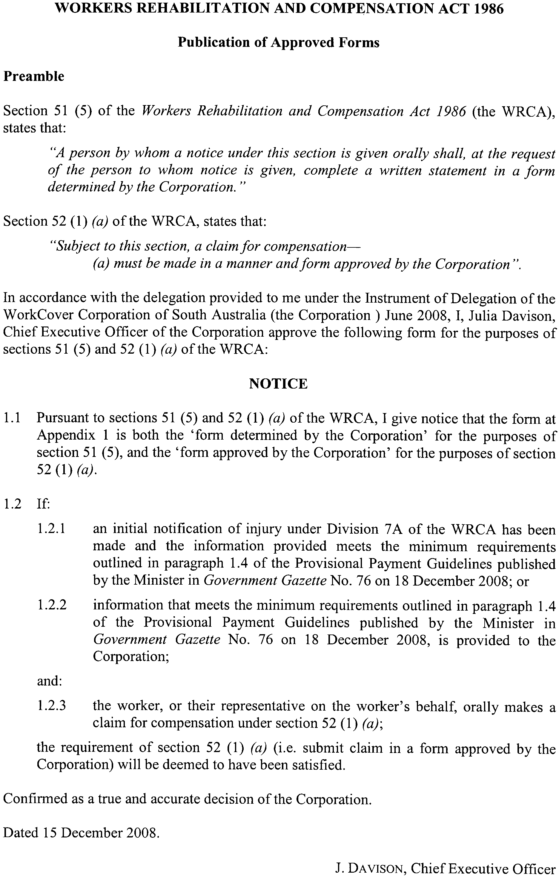

Appendix 1

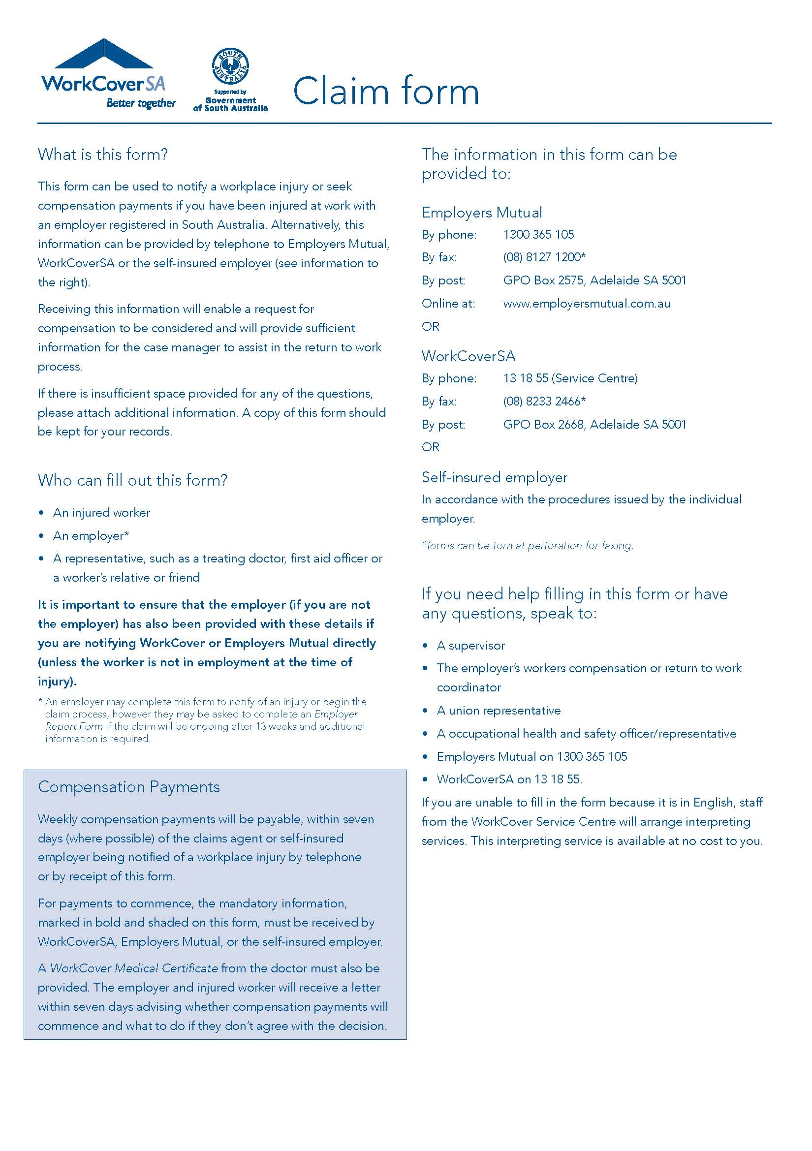

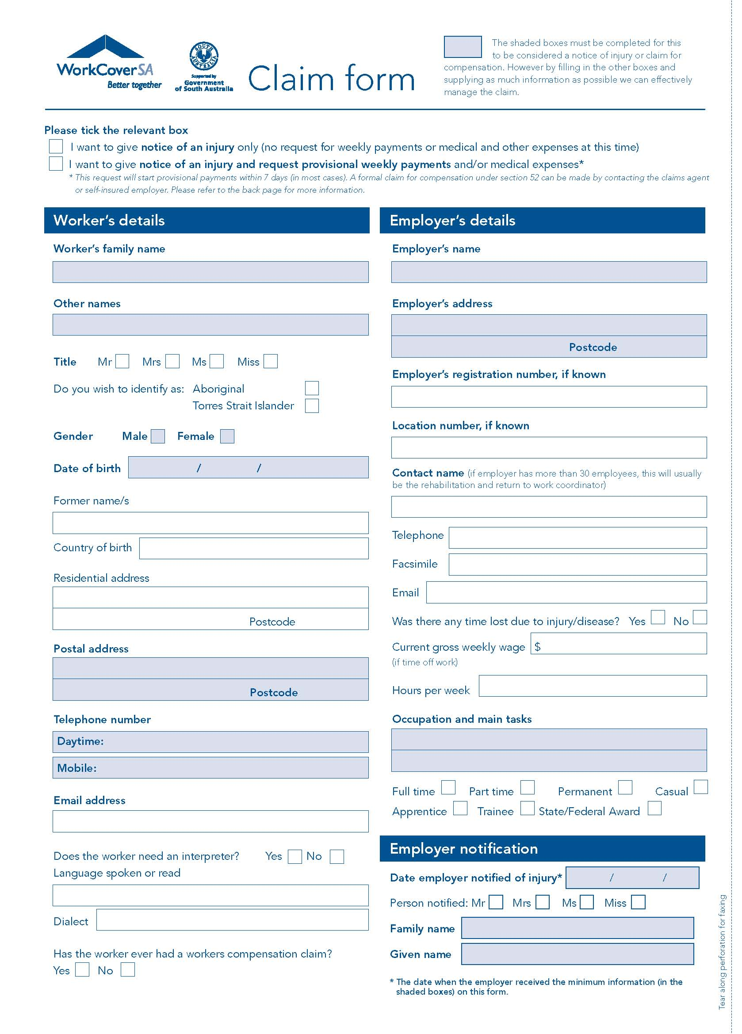

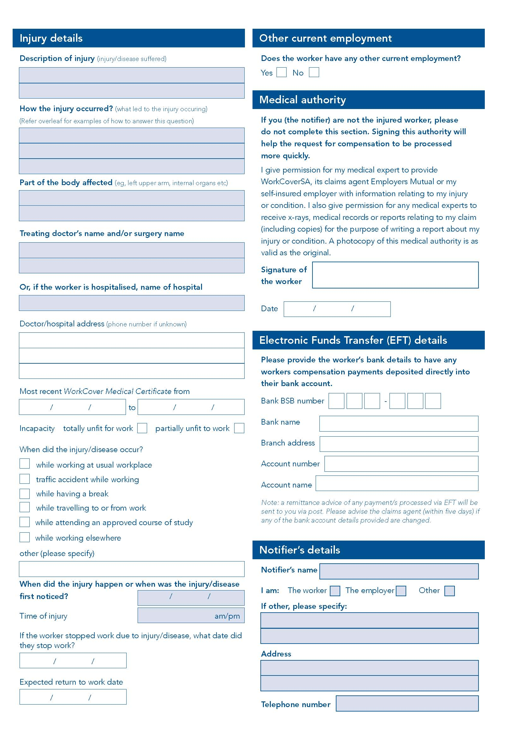

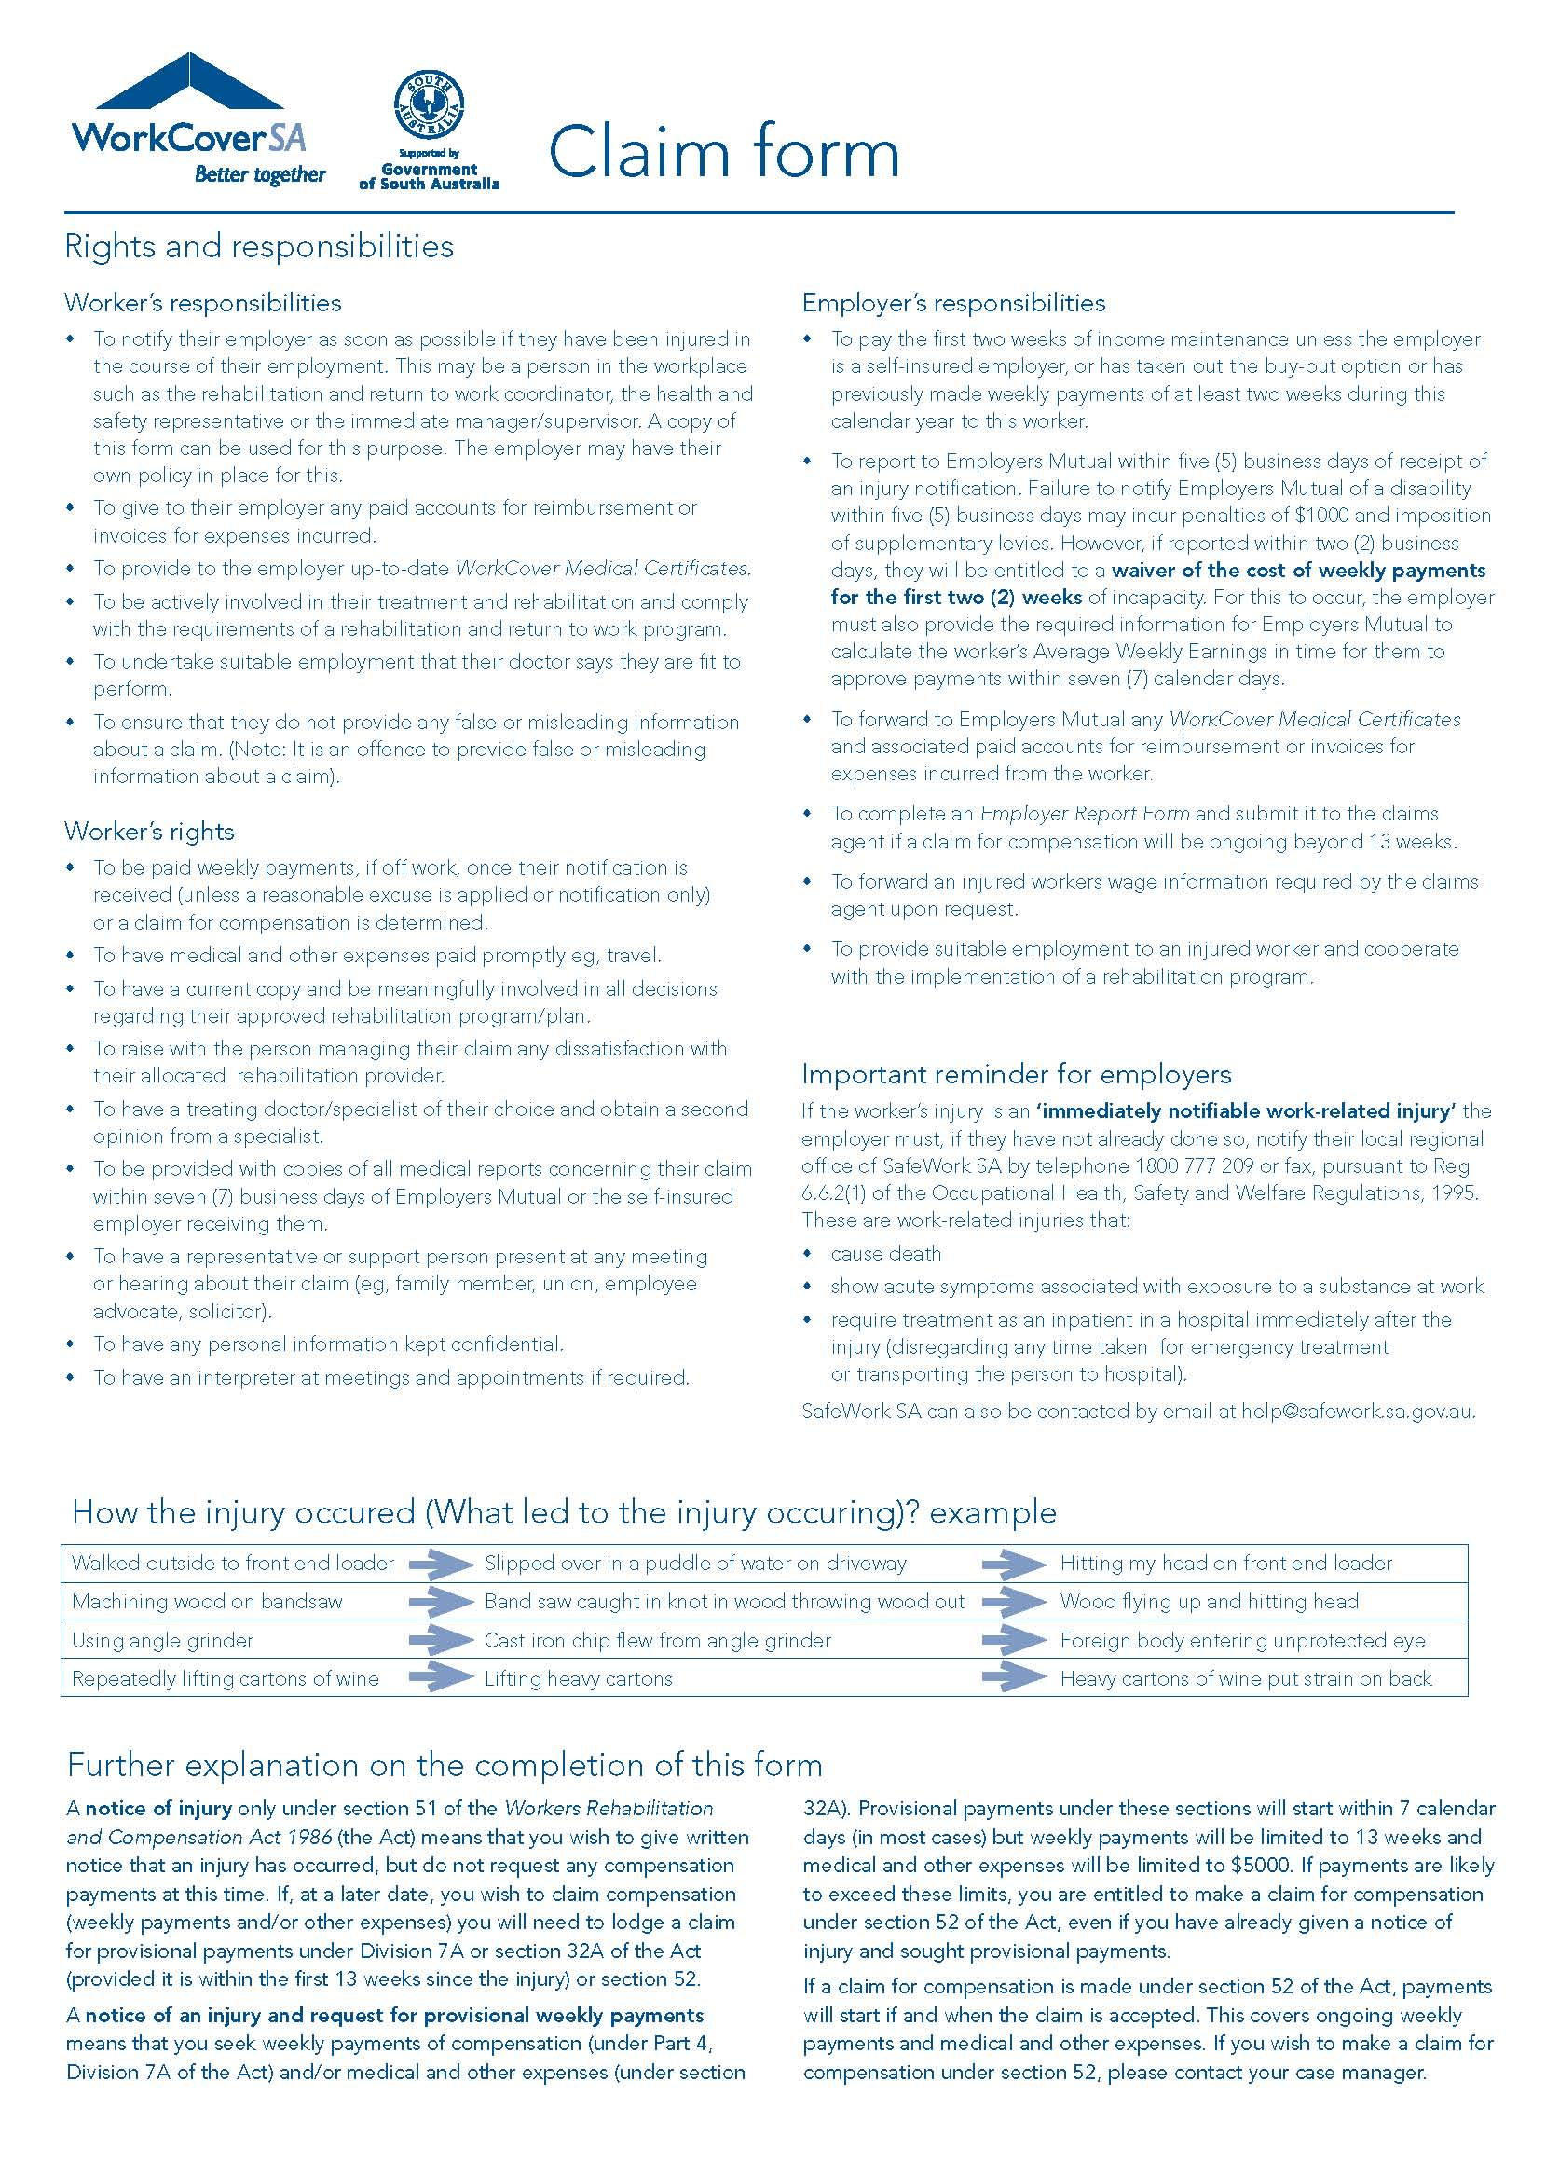
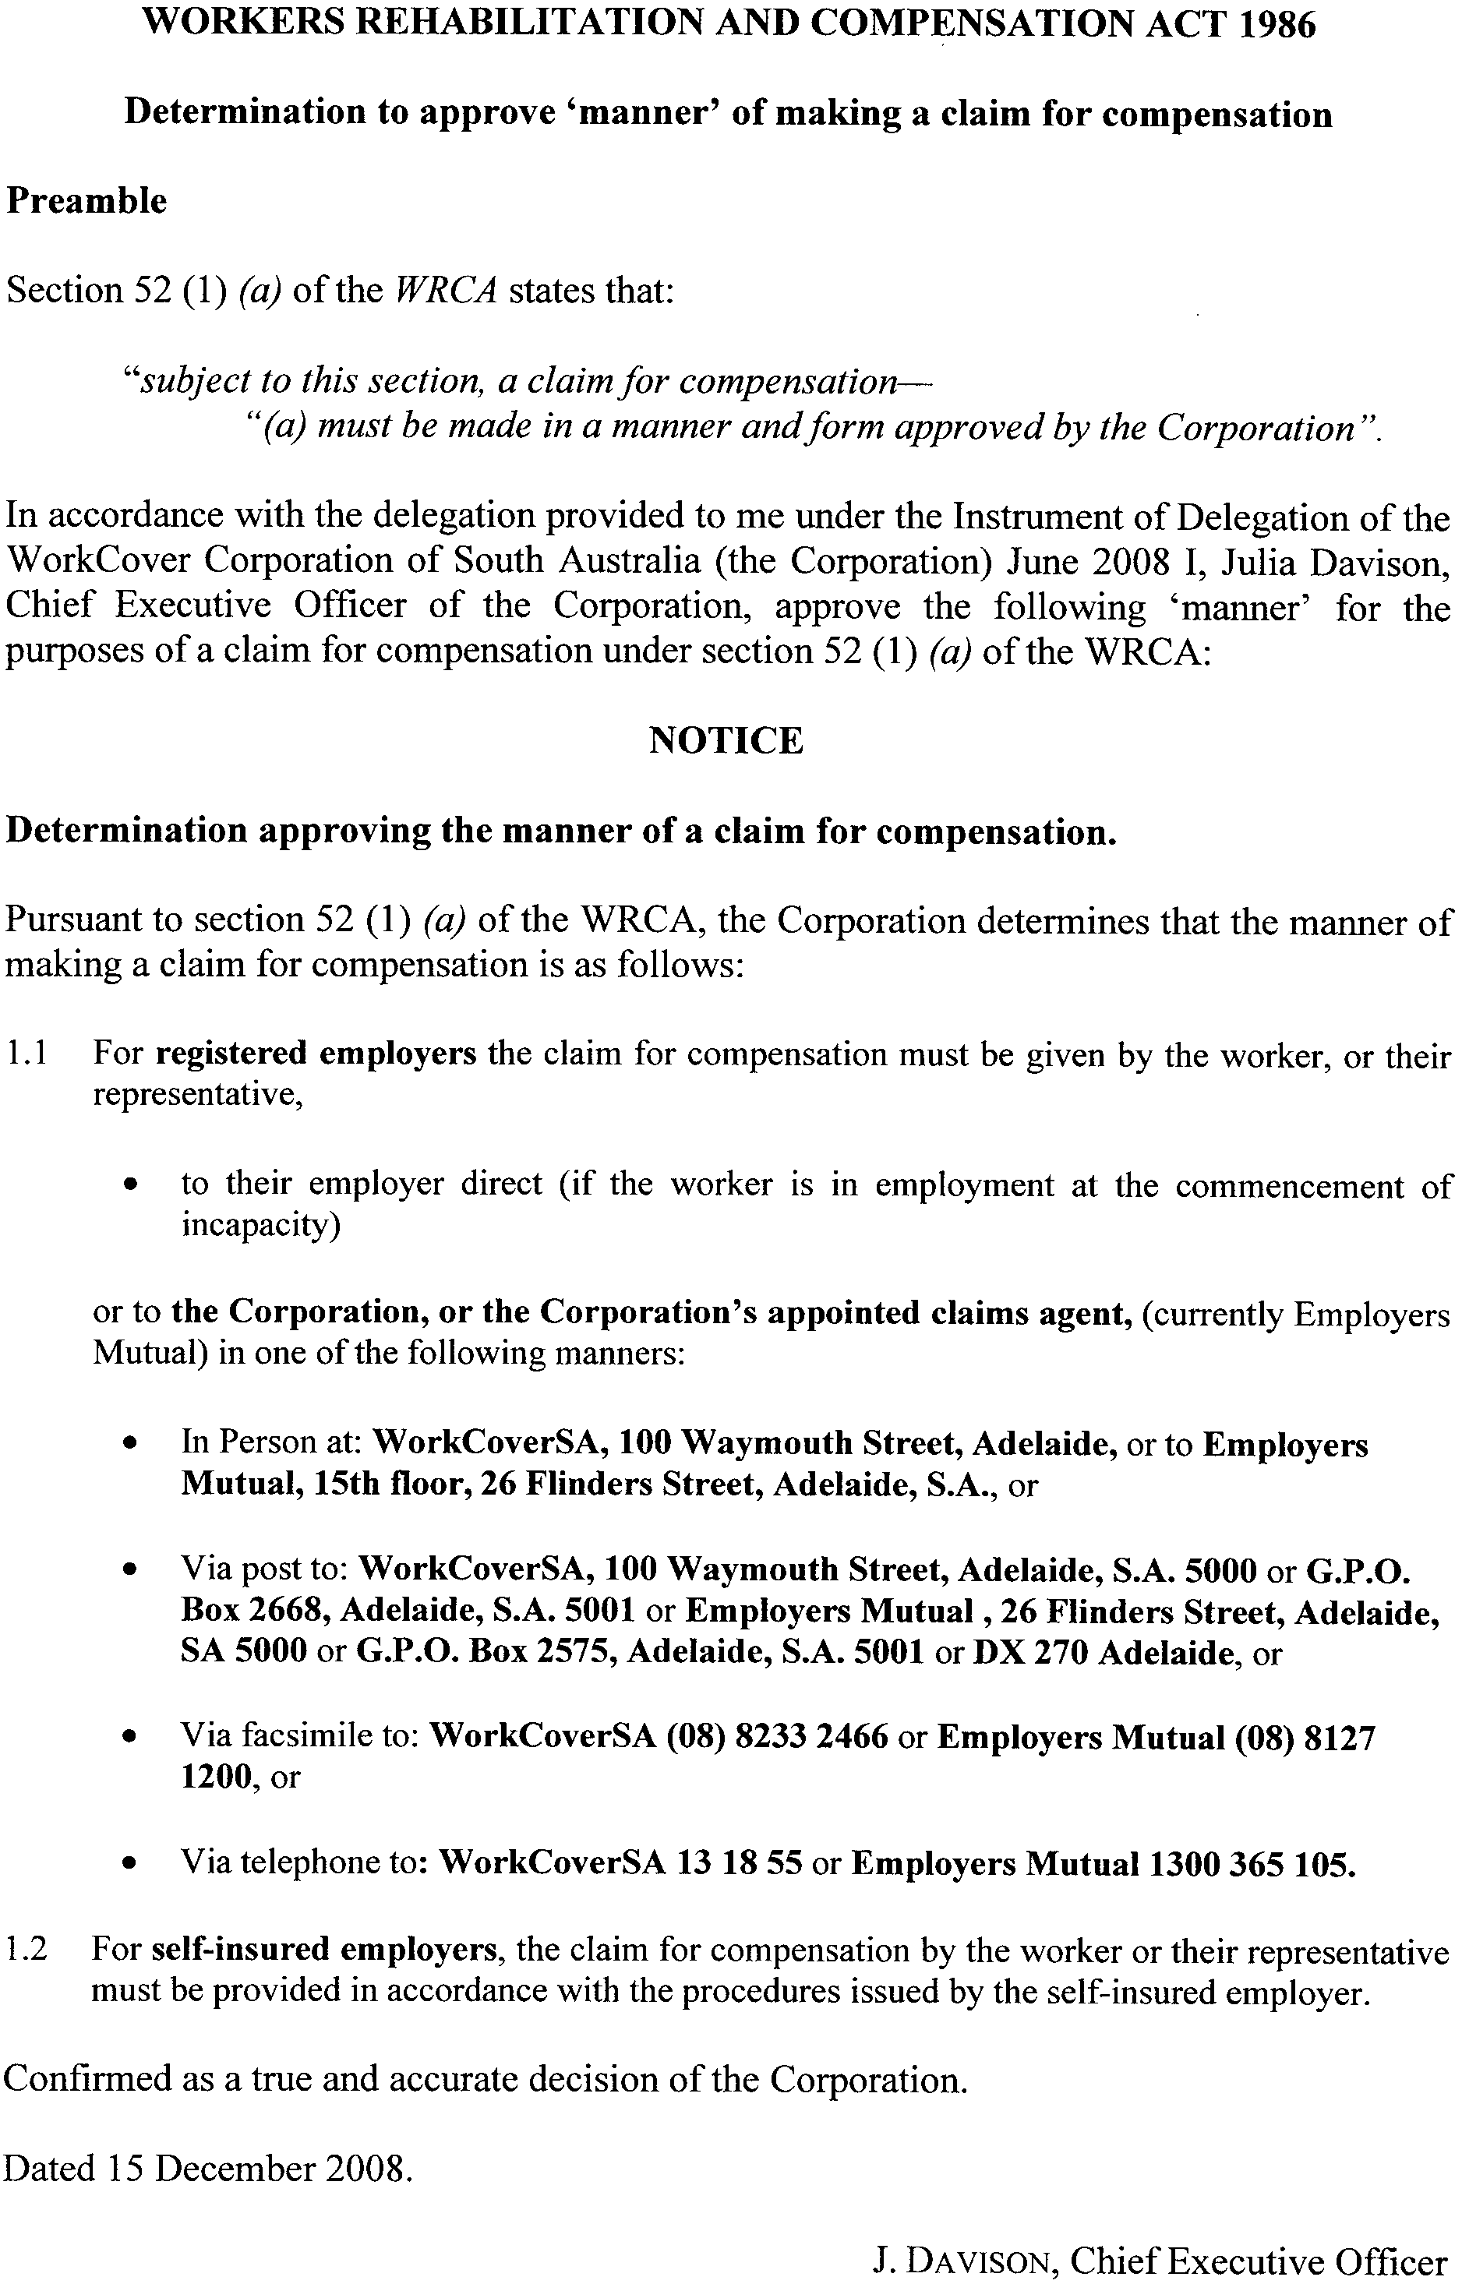

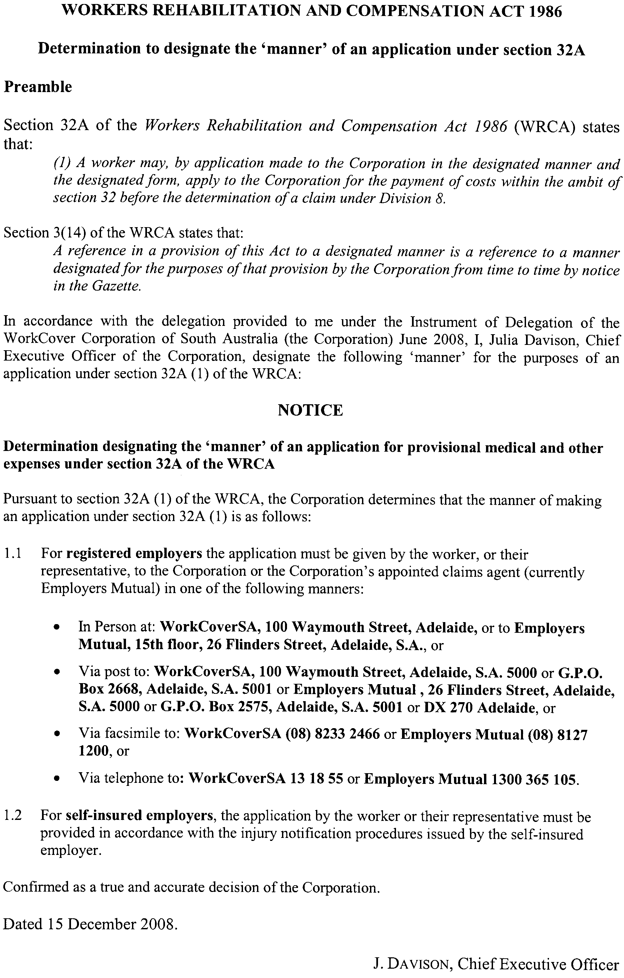

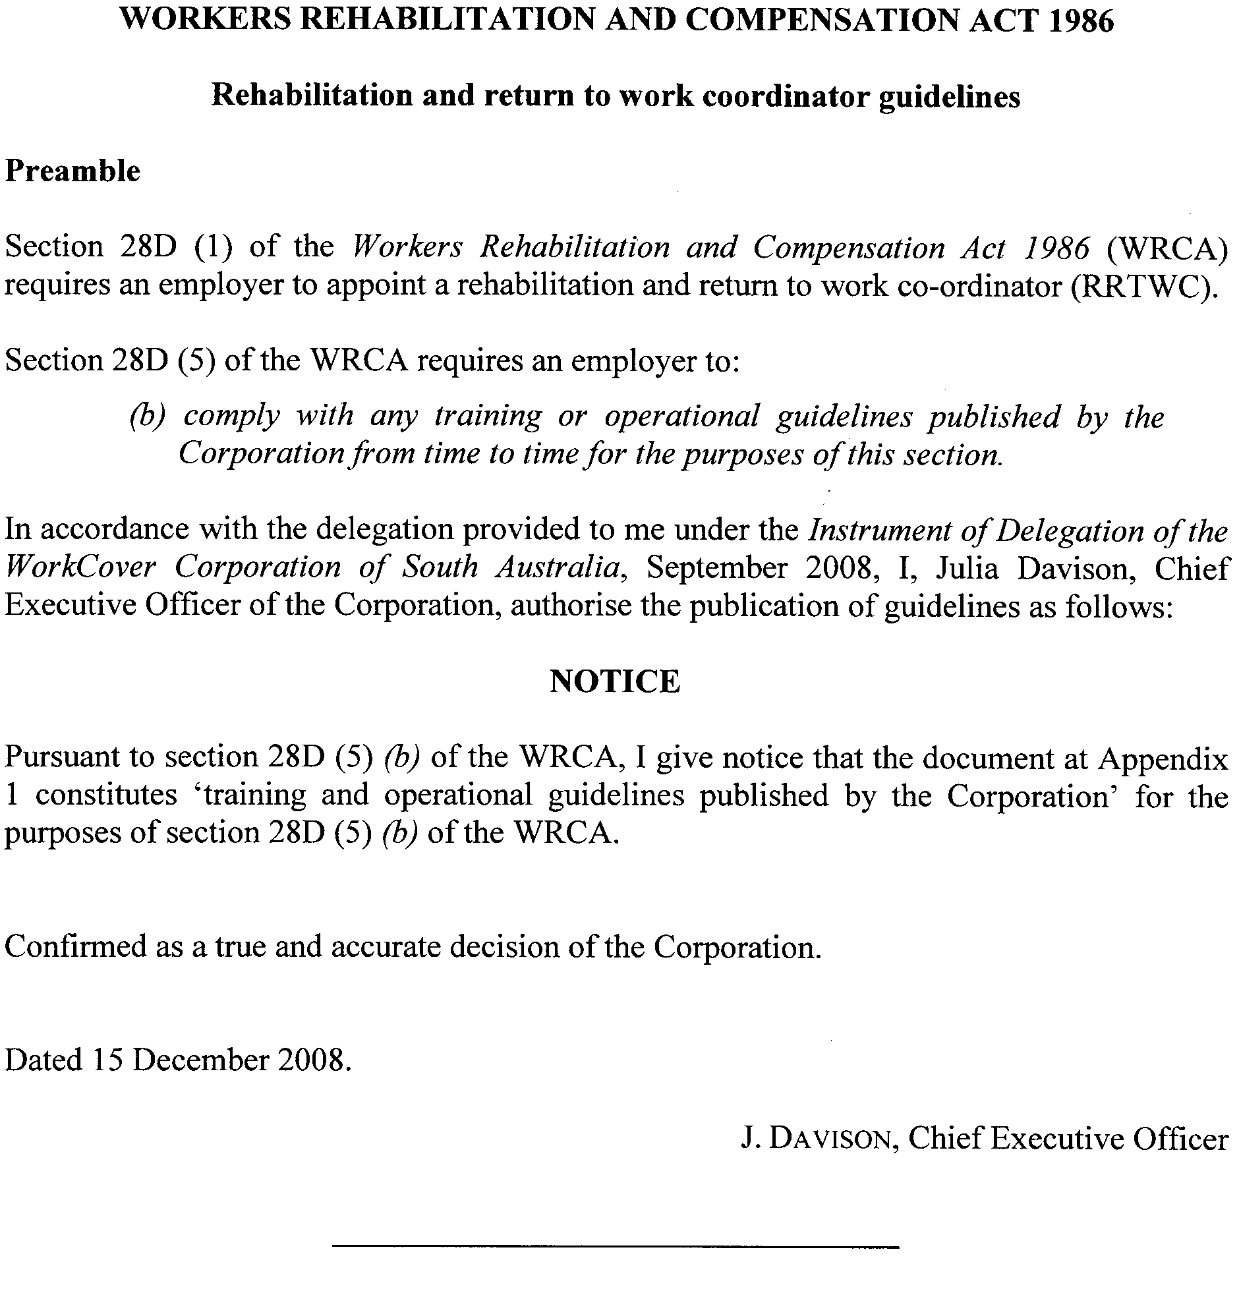
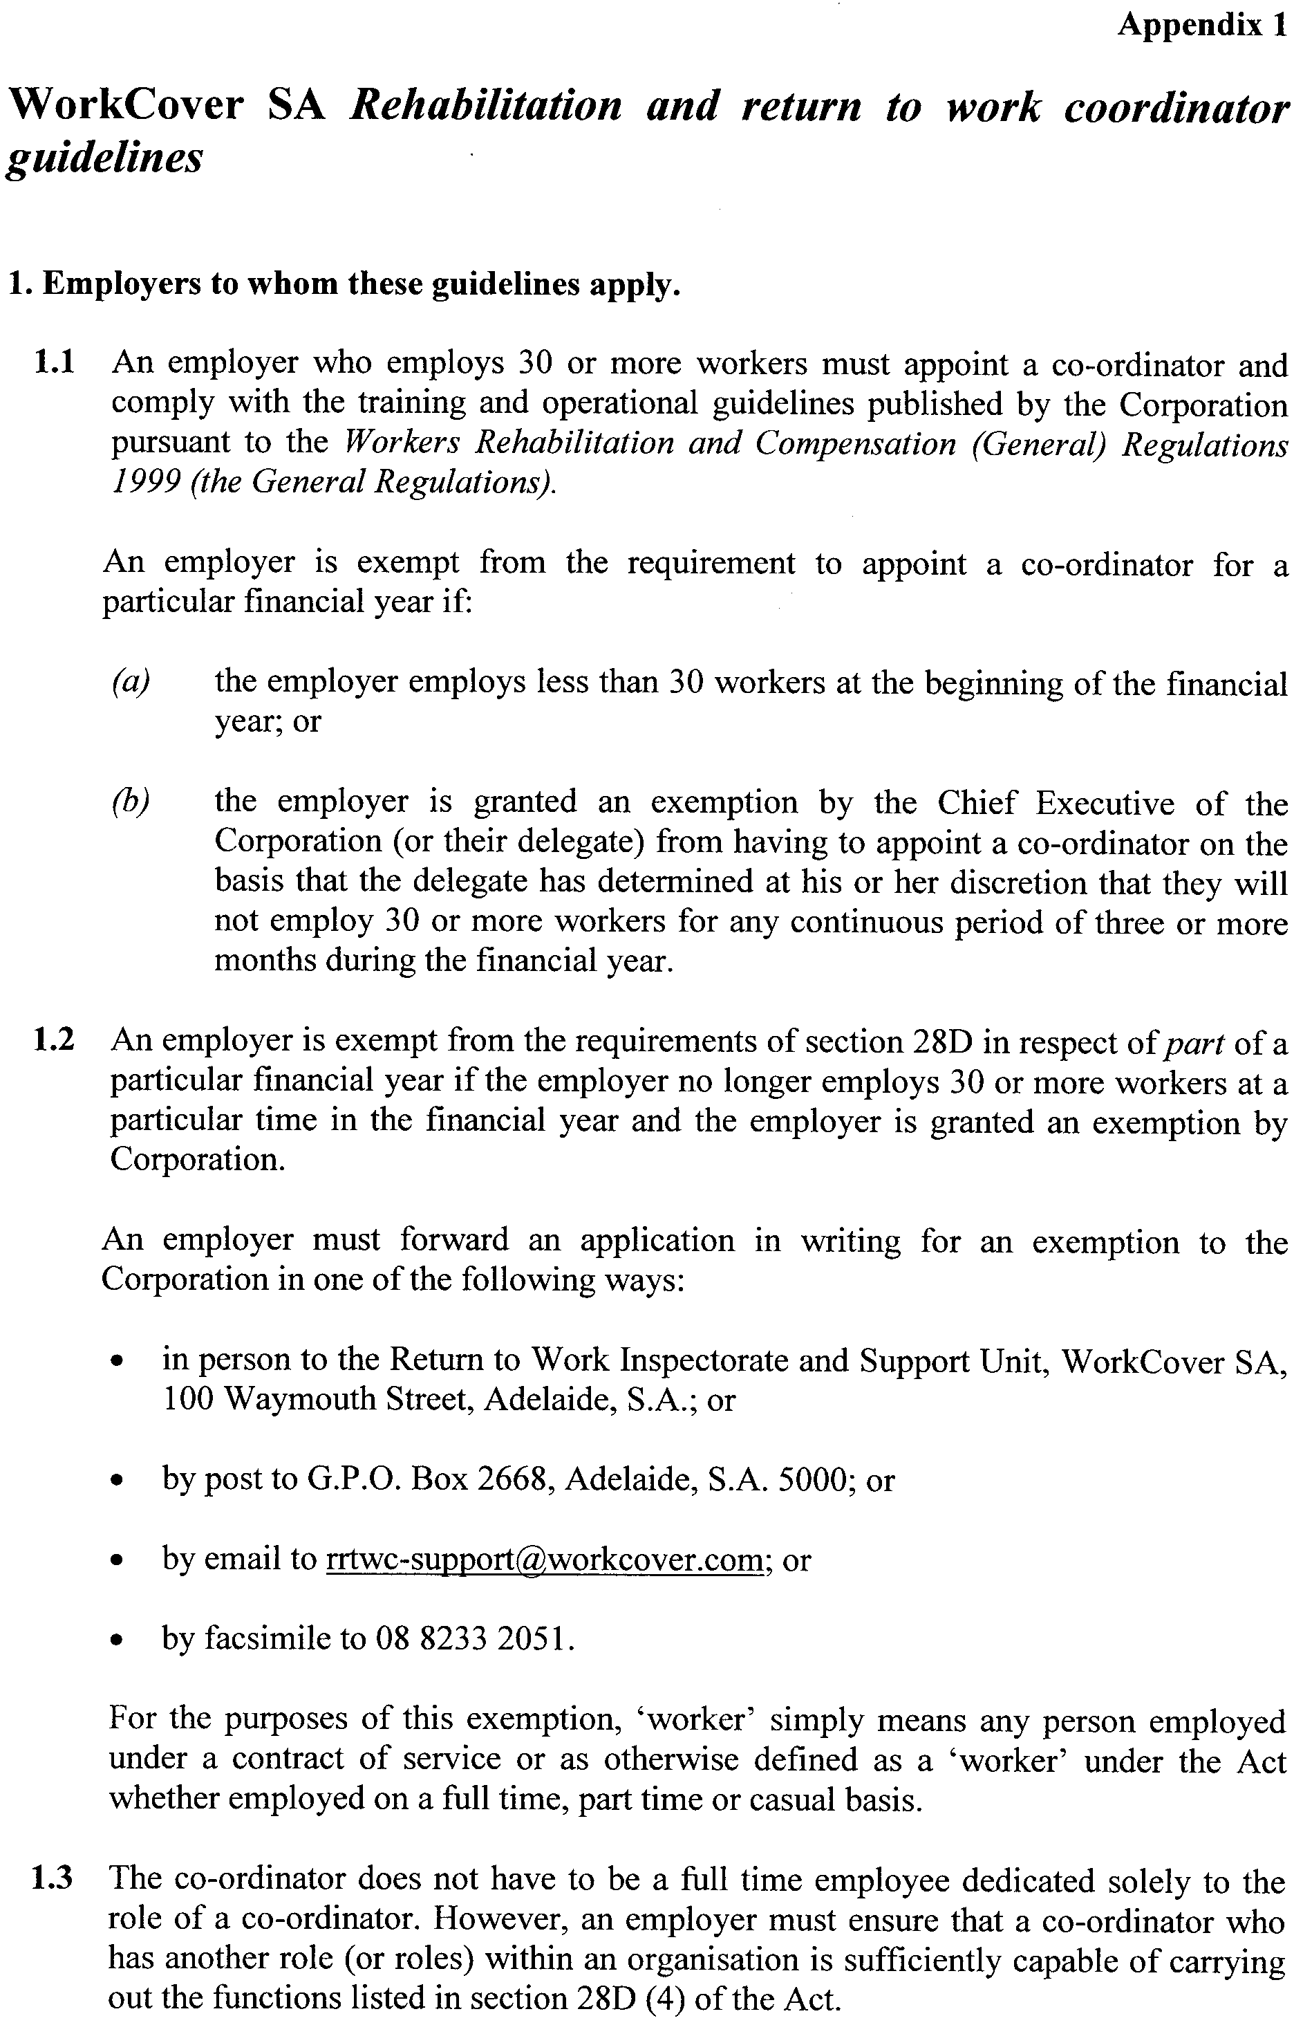
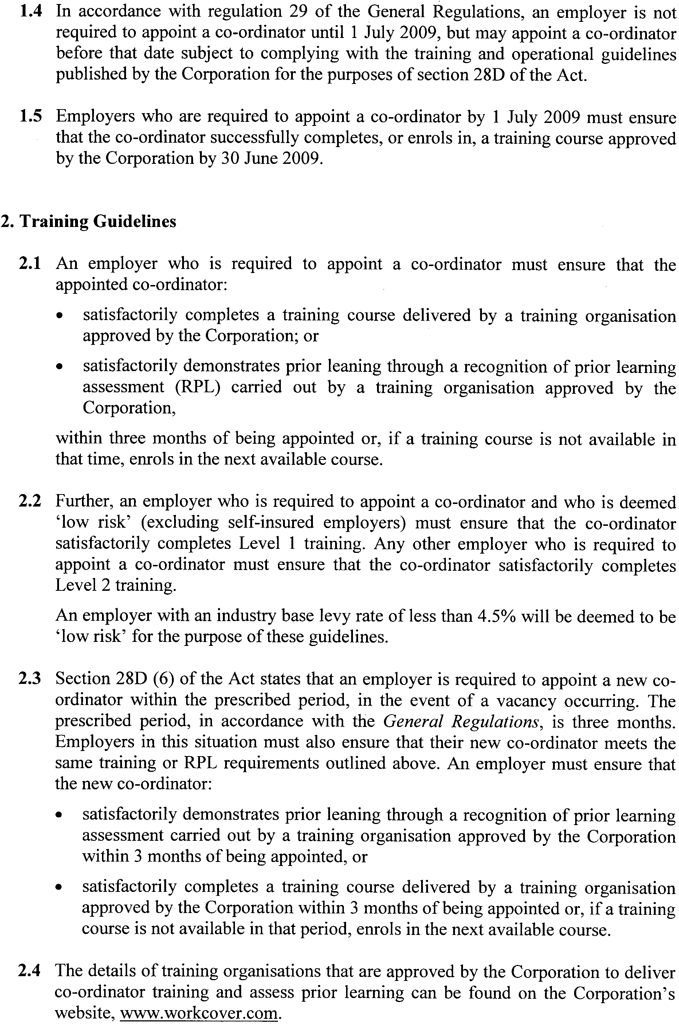
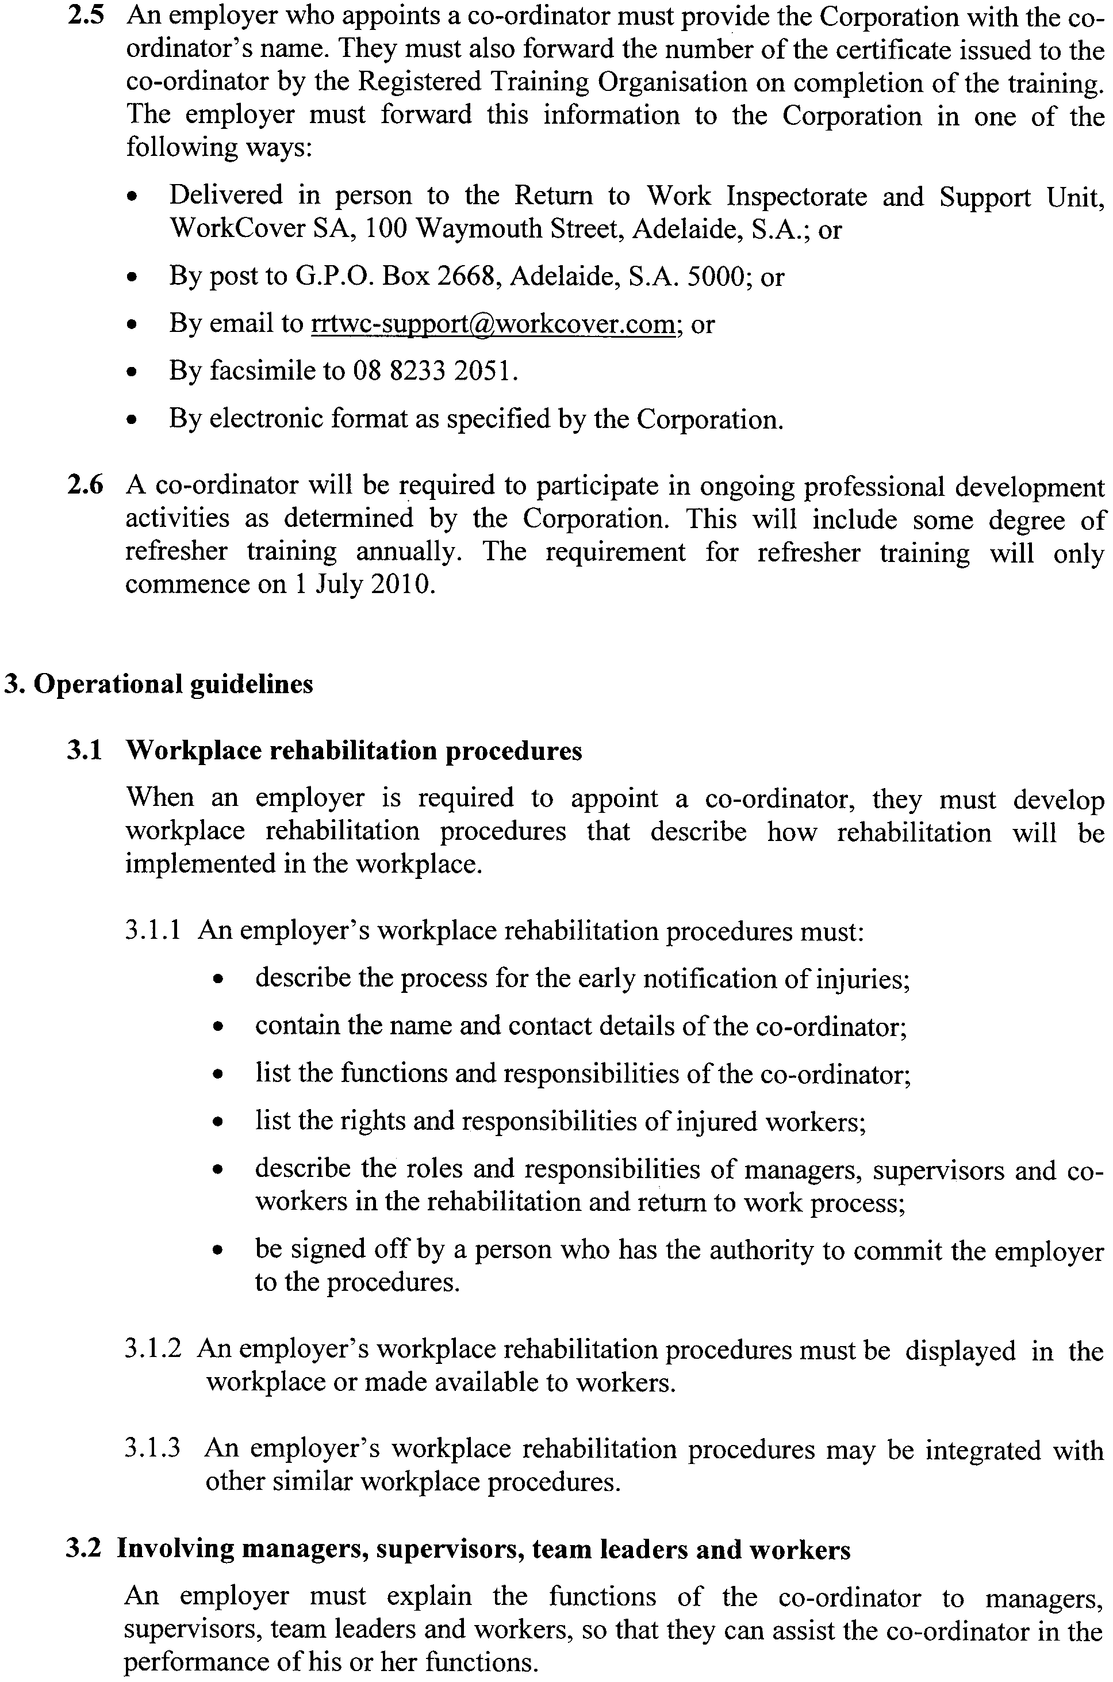
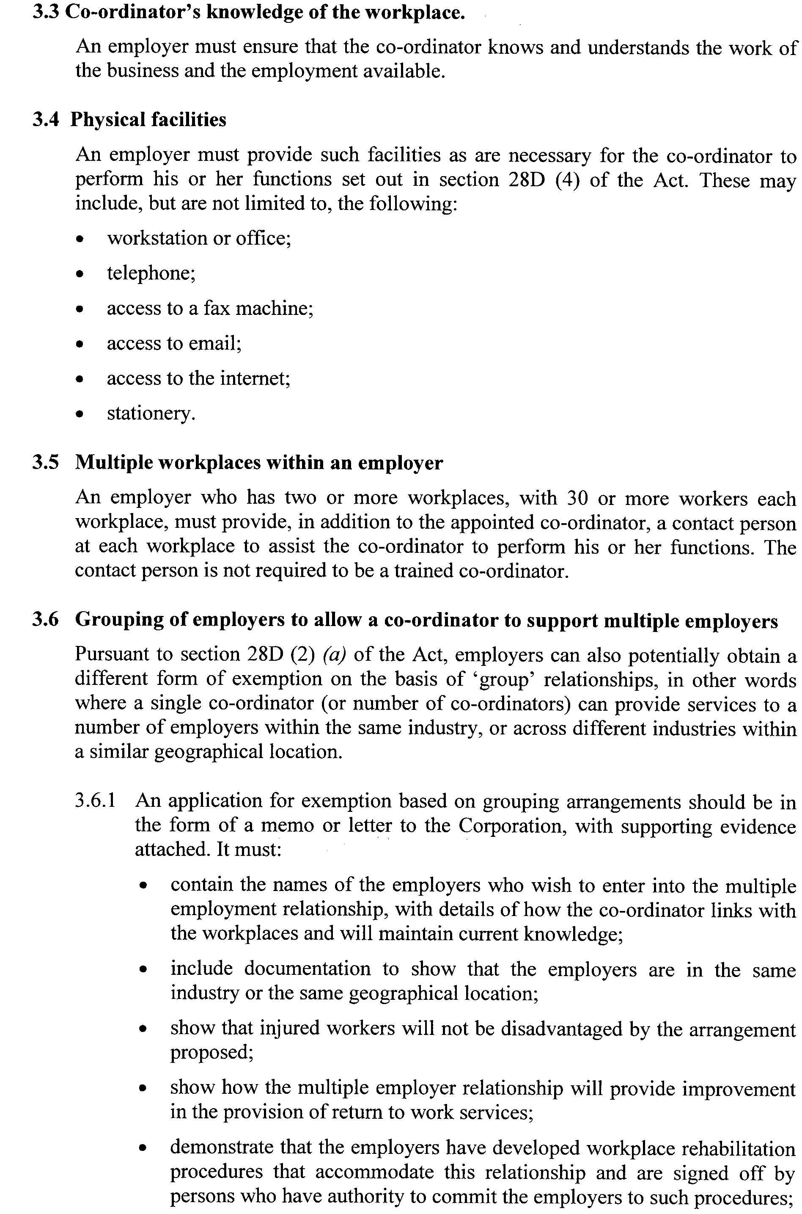
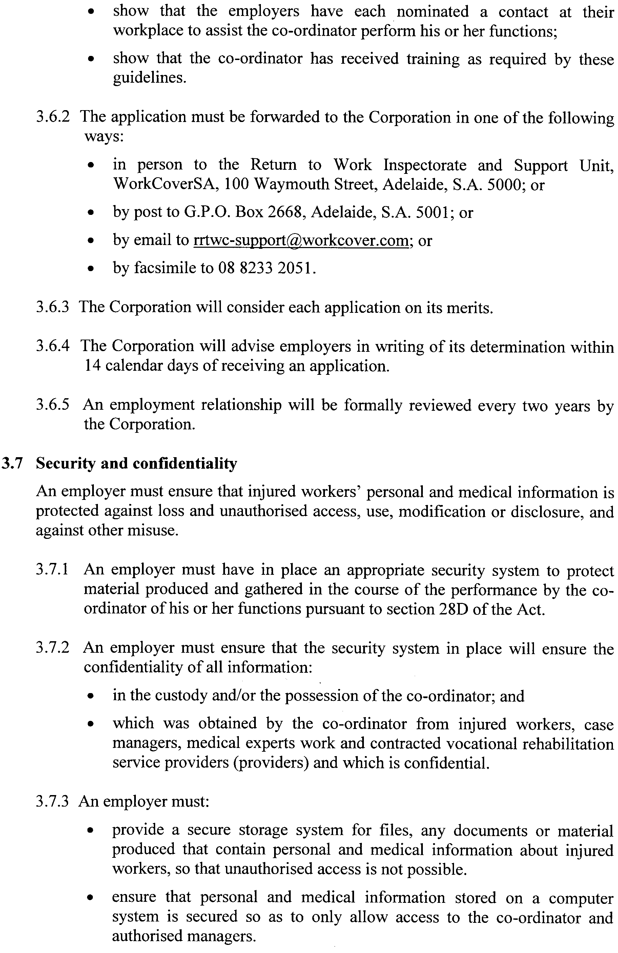
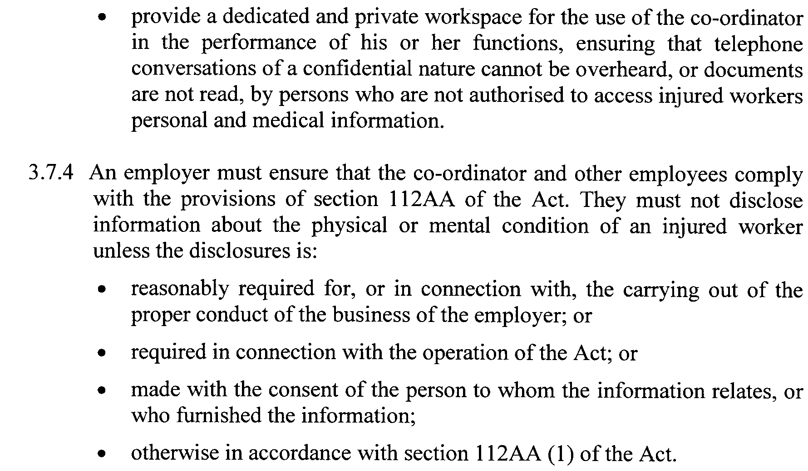

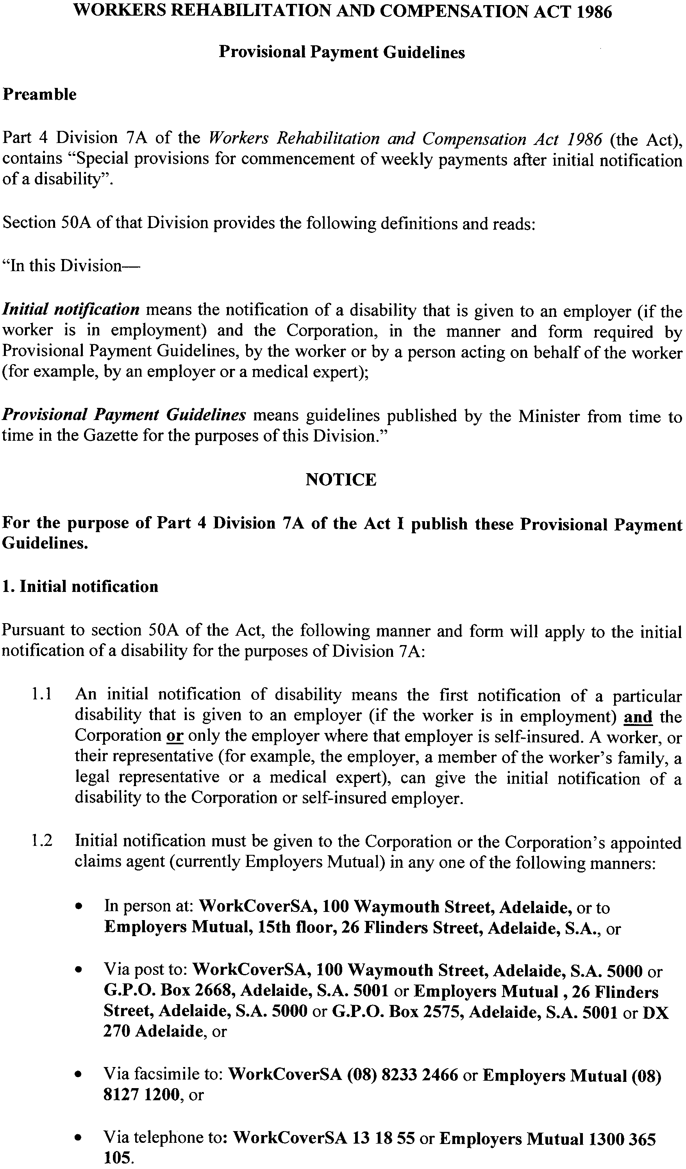
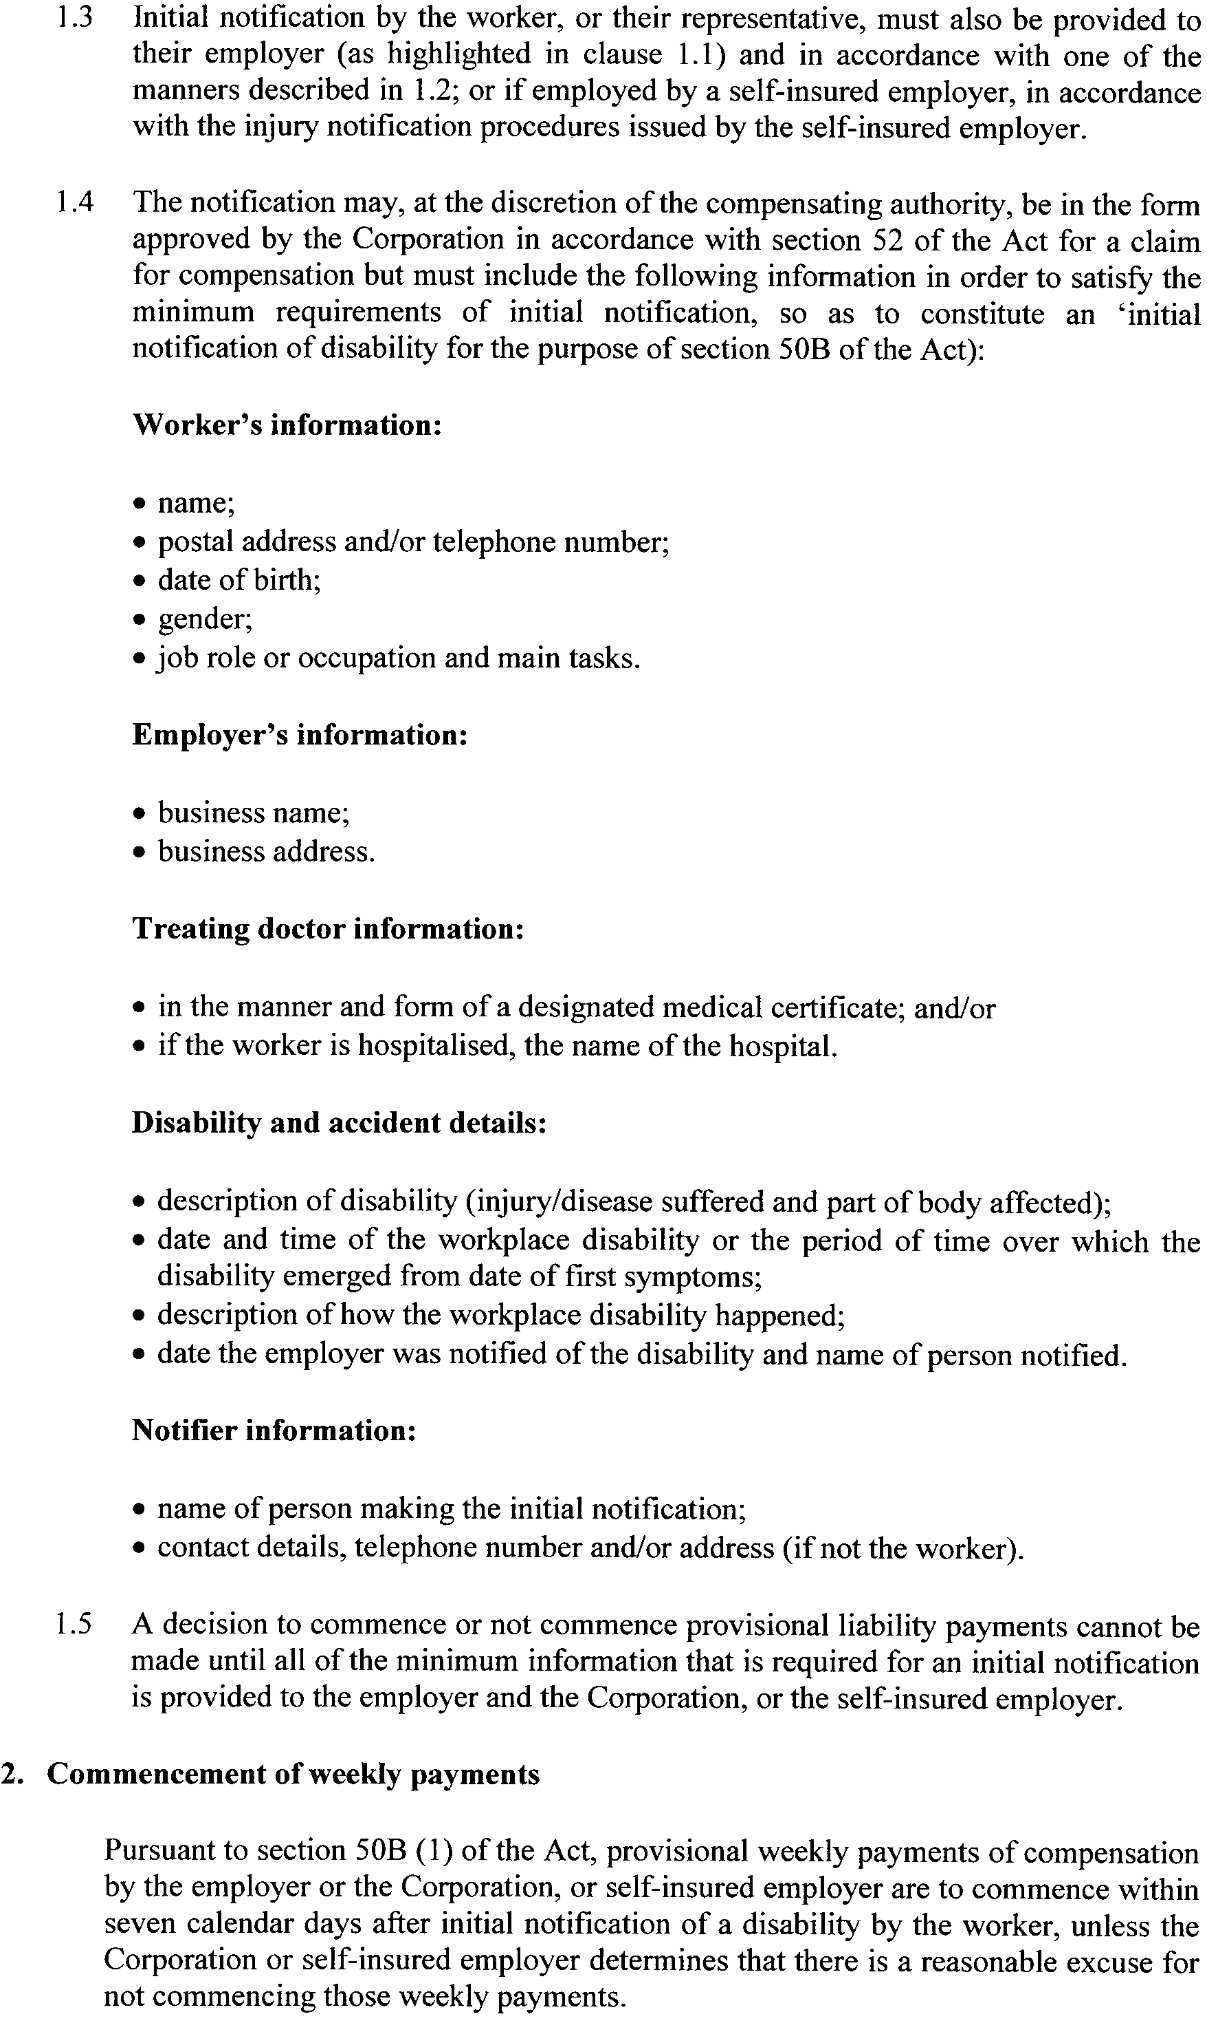
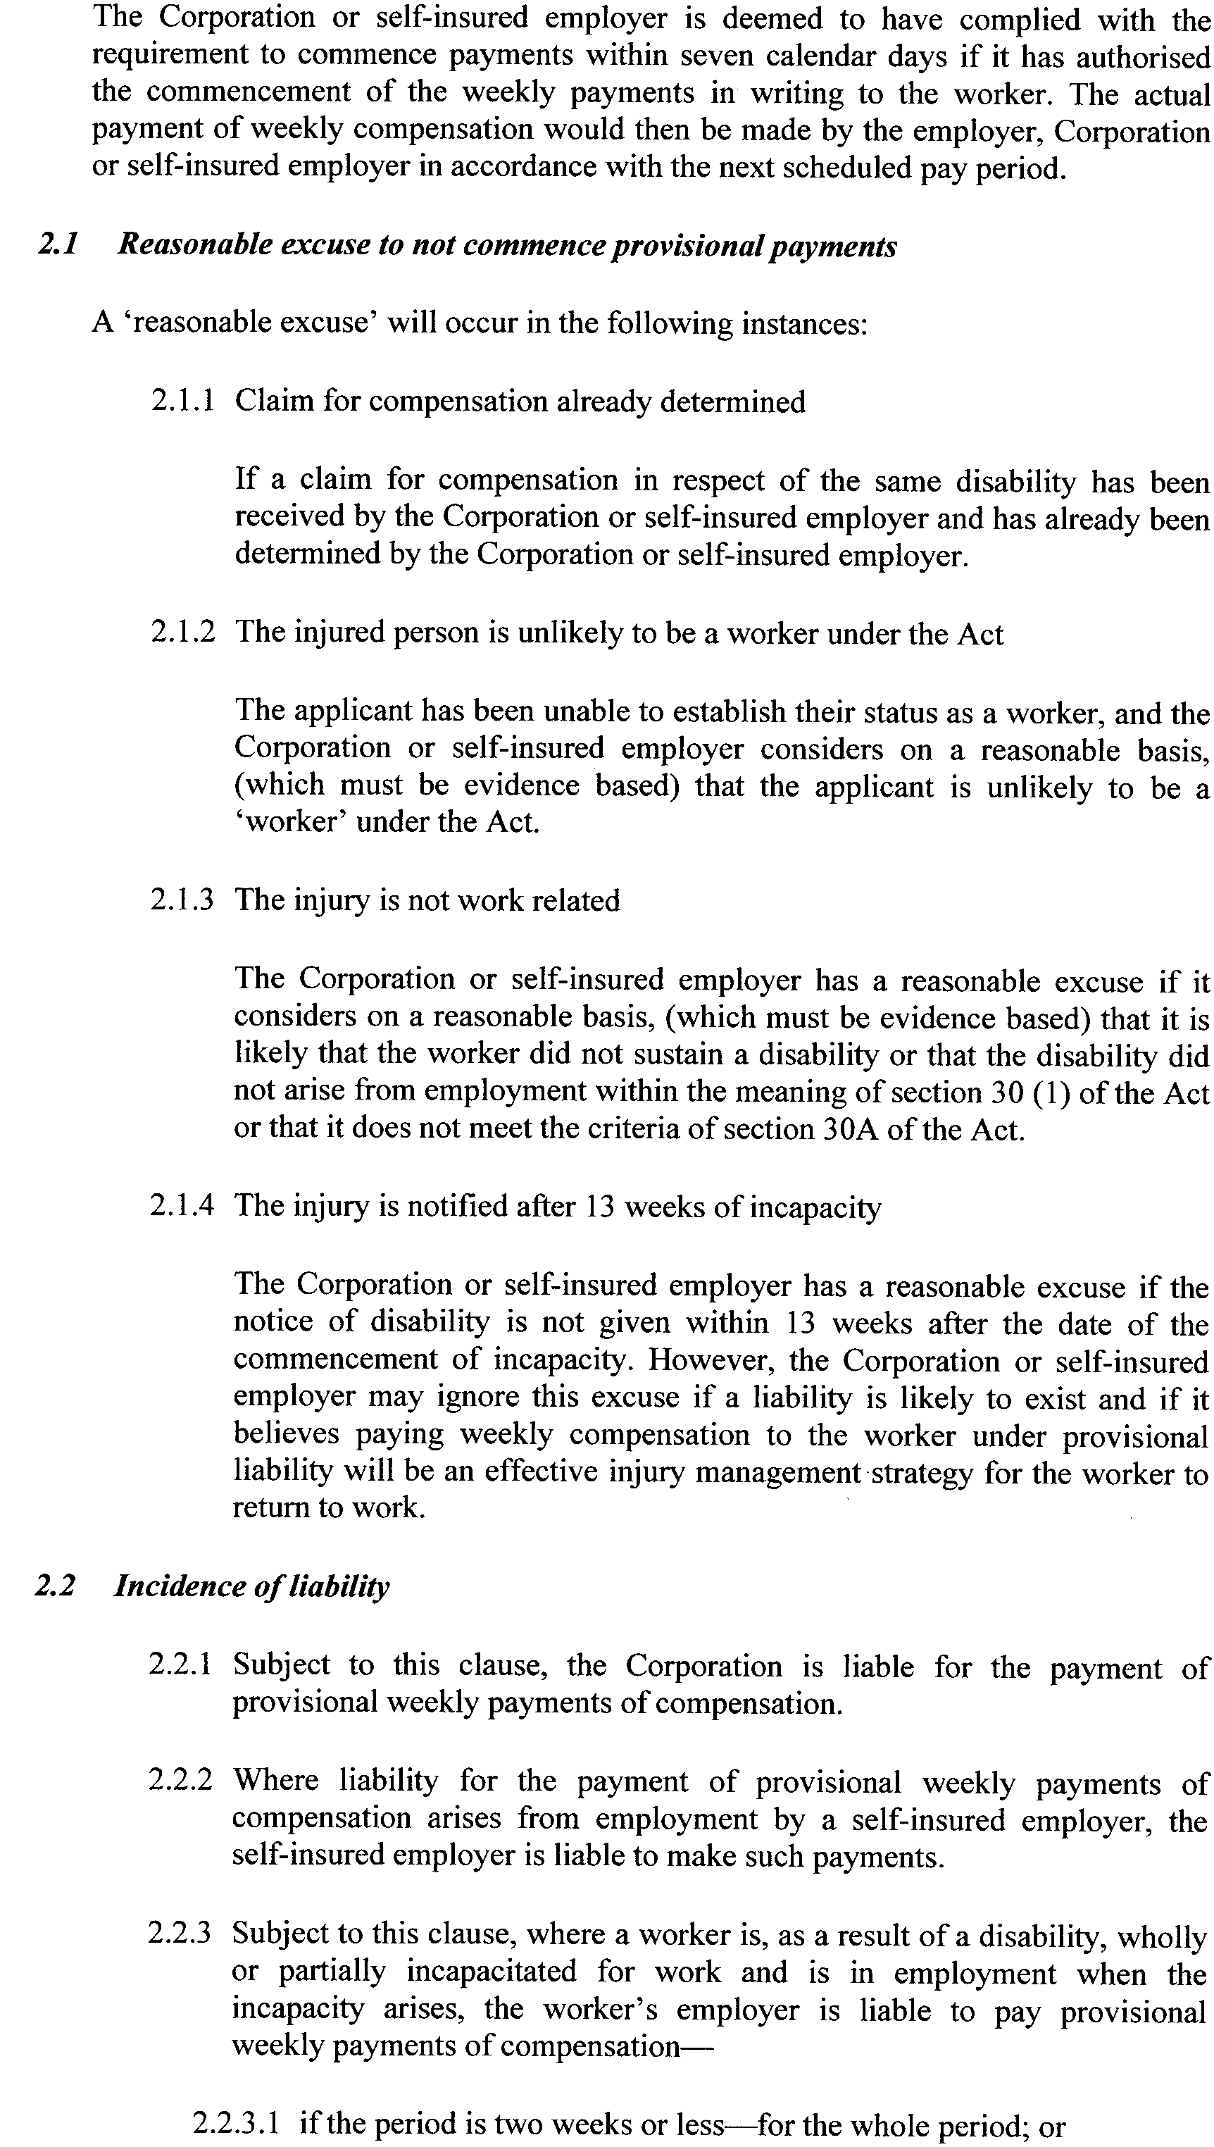
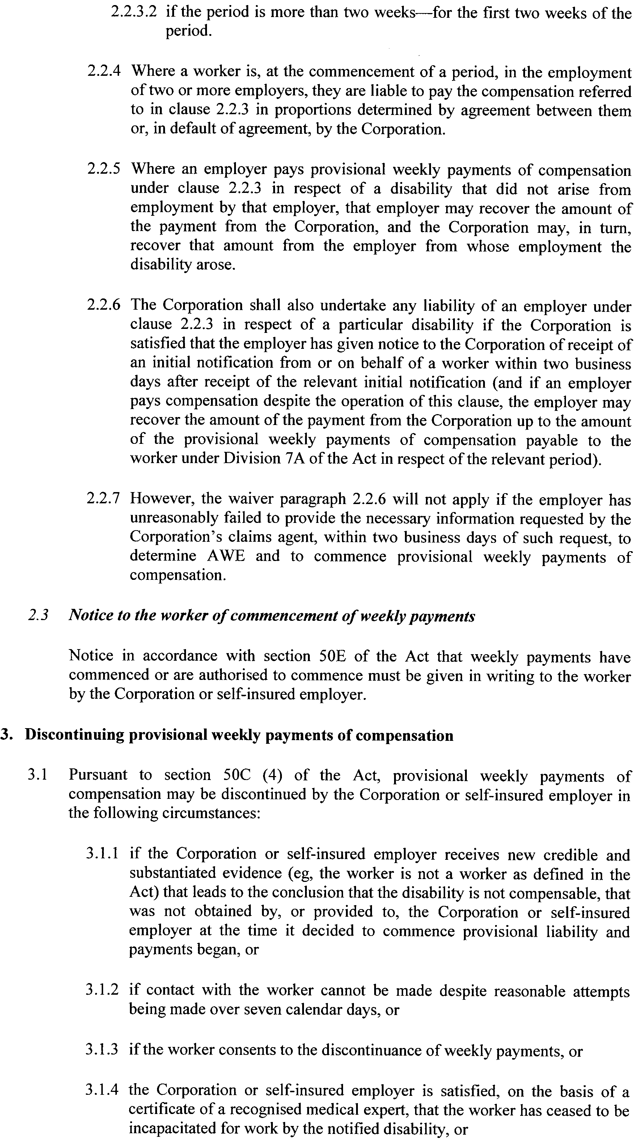
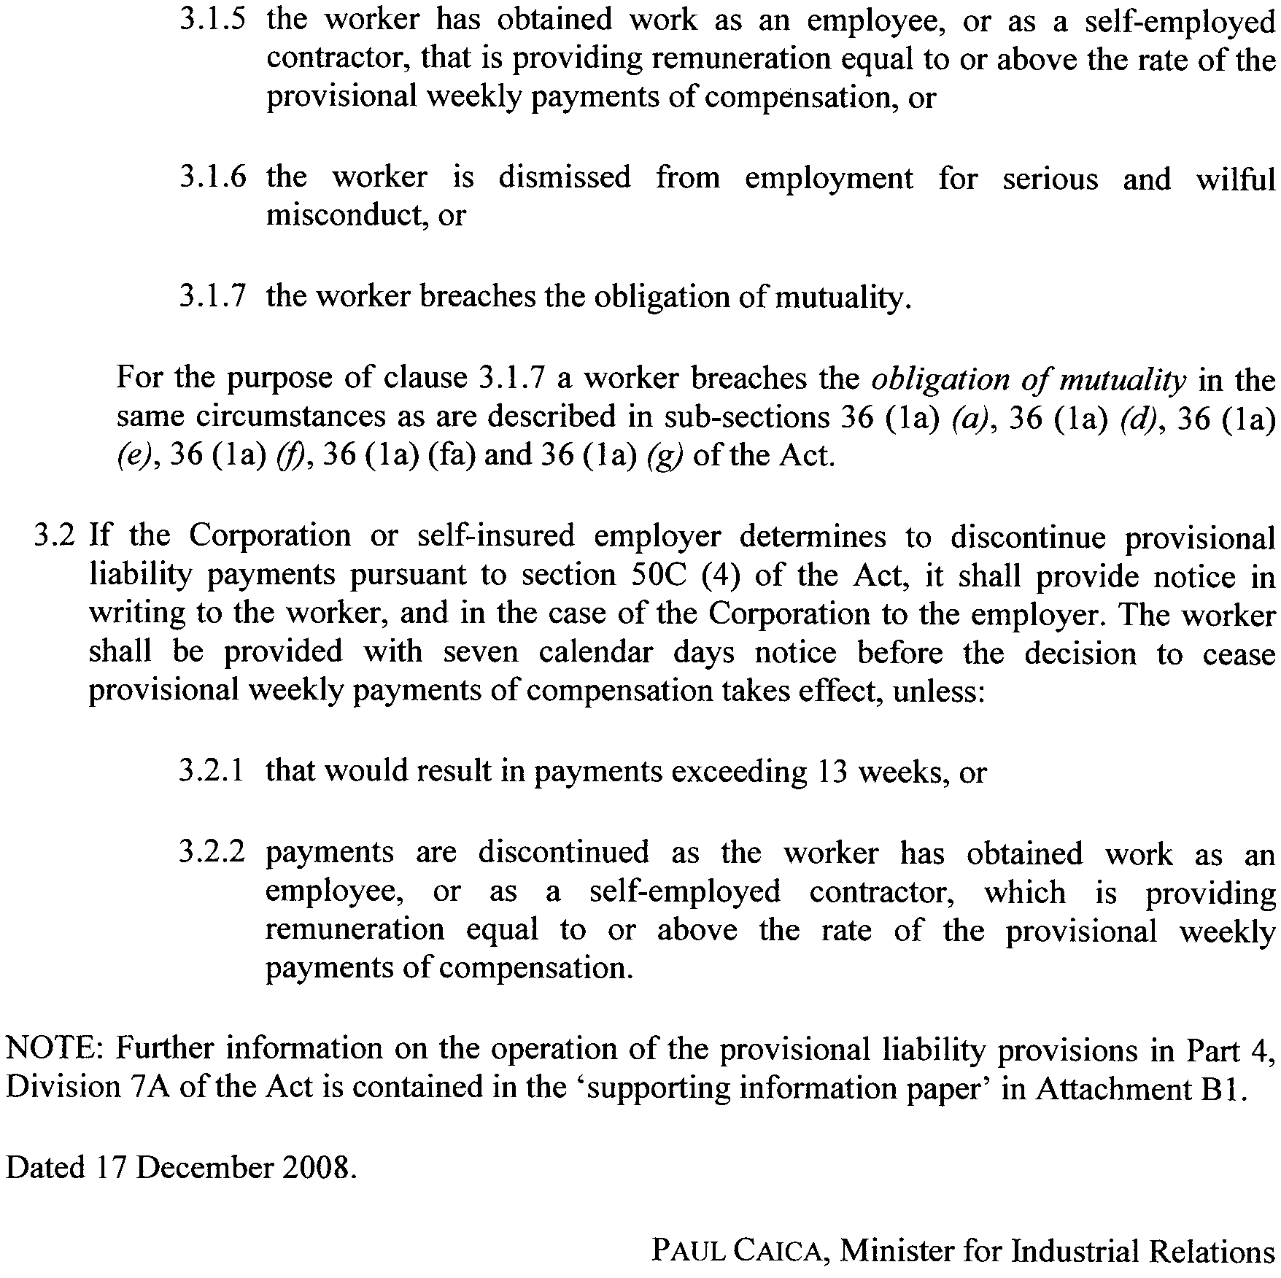

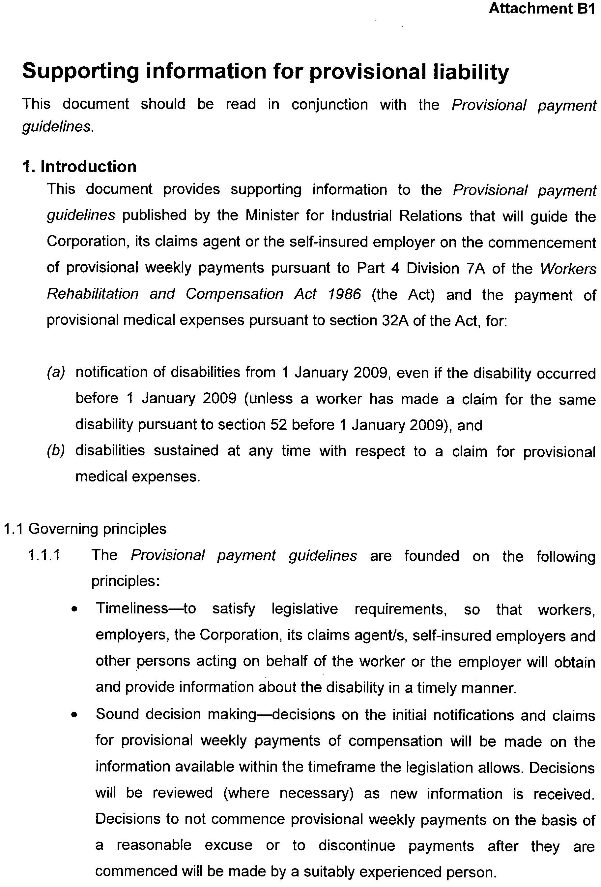
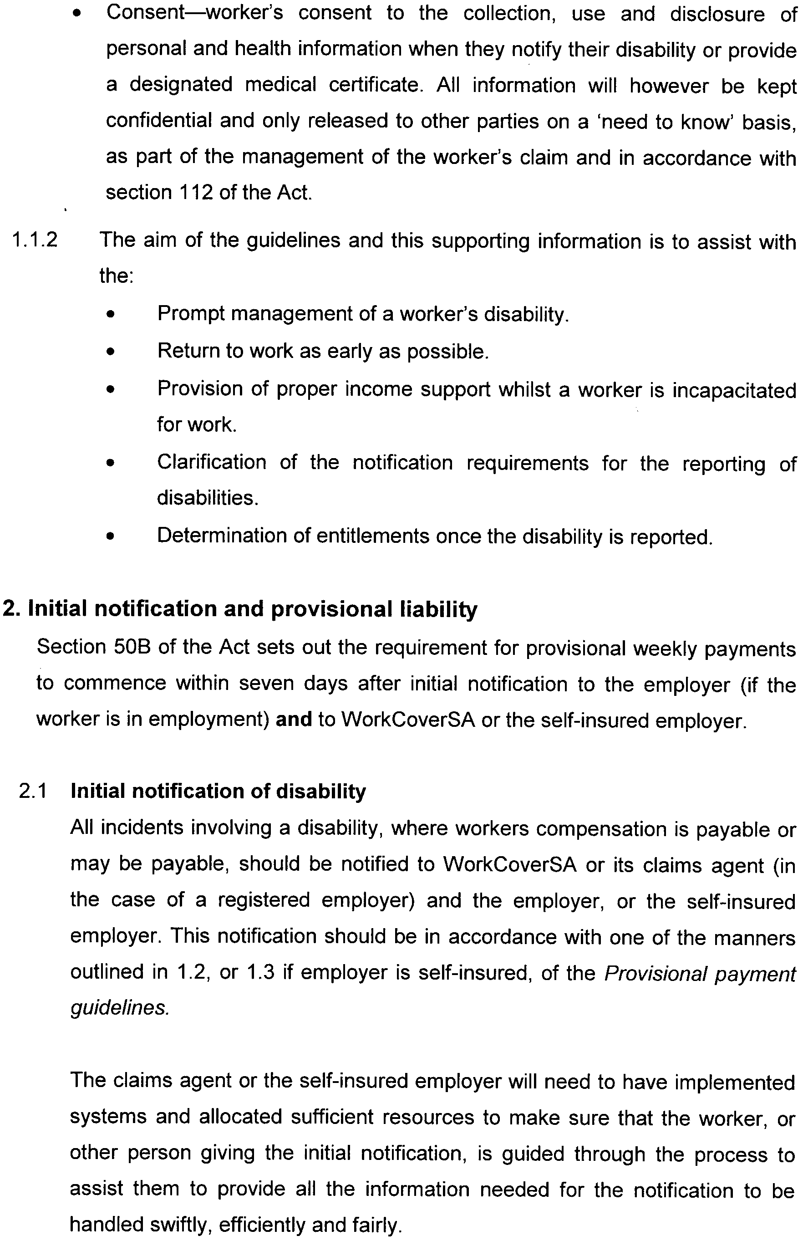
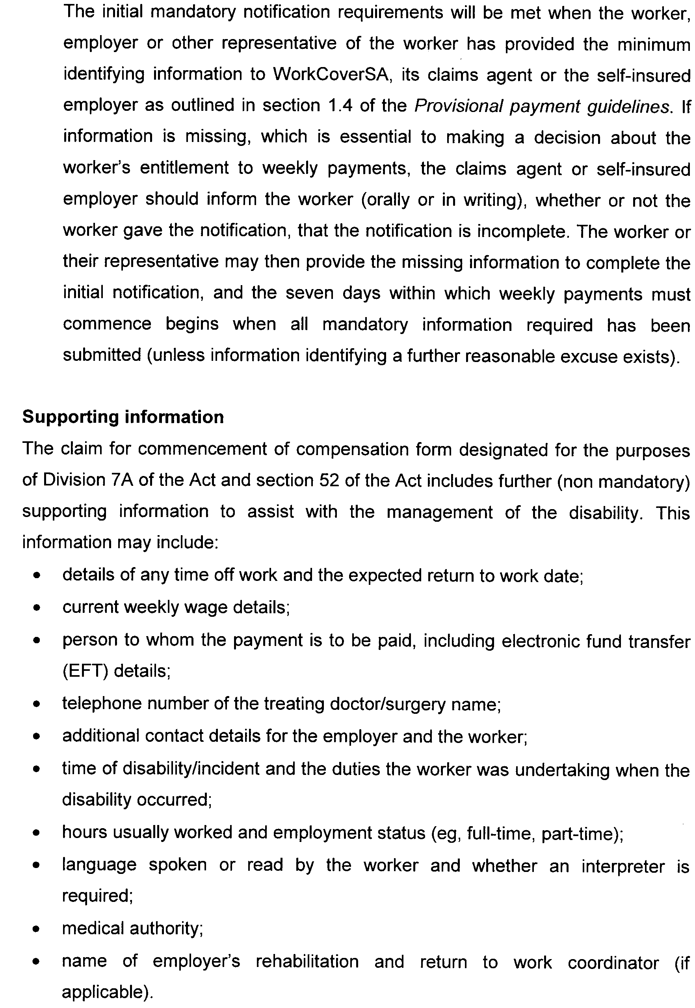
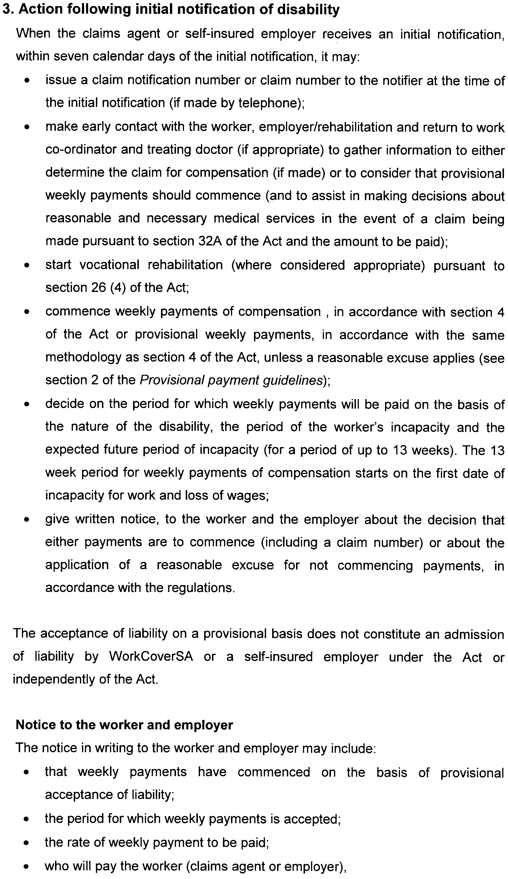
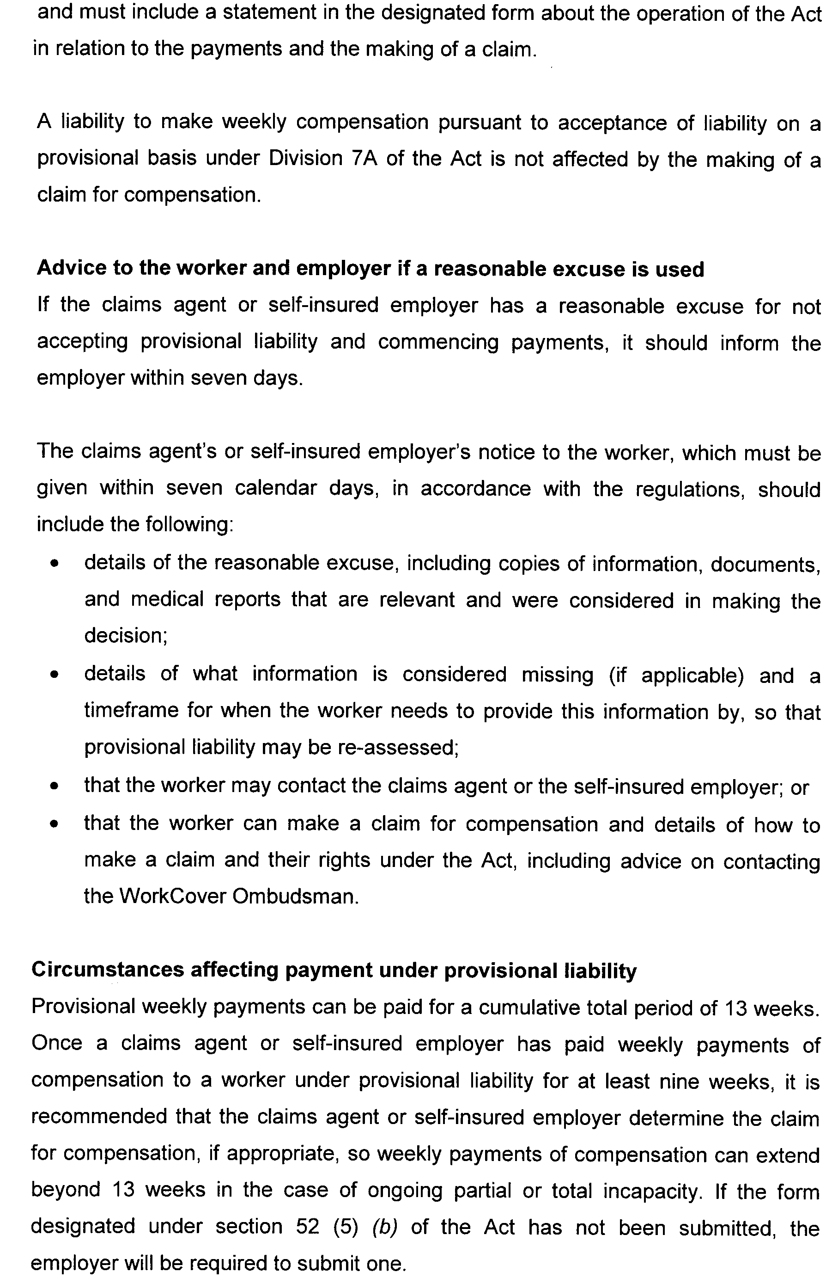
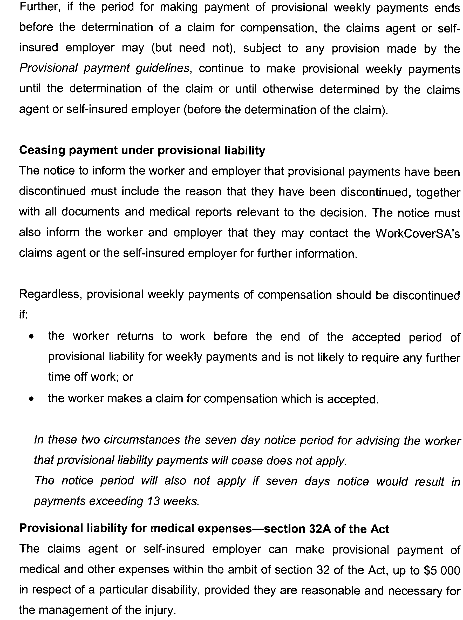
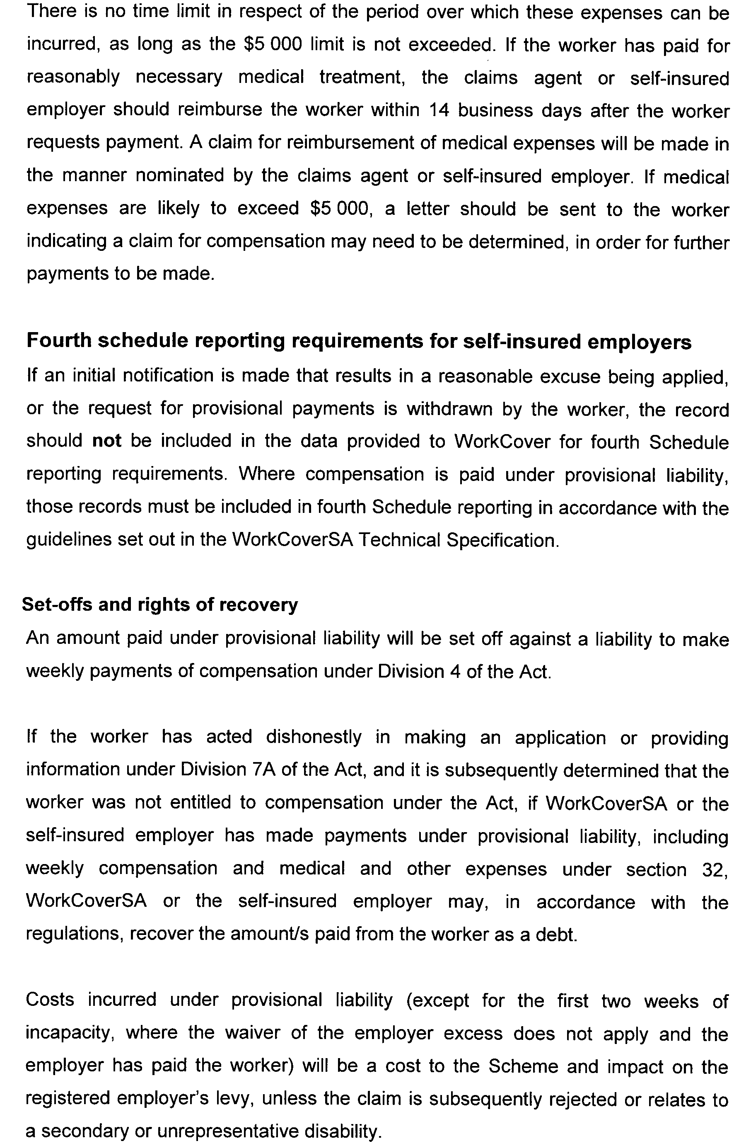
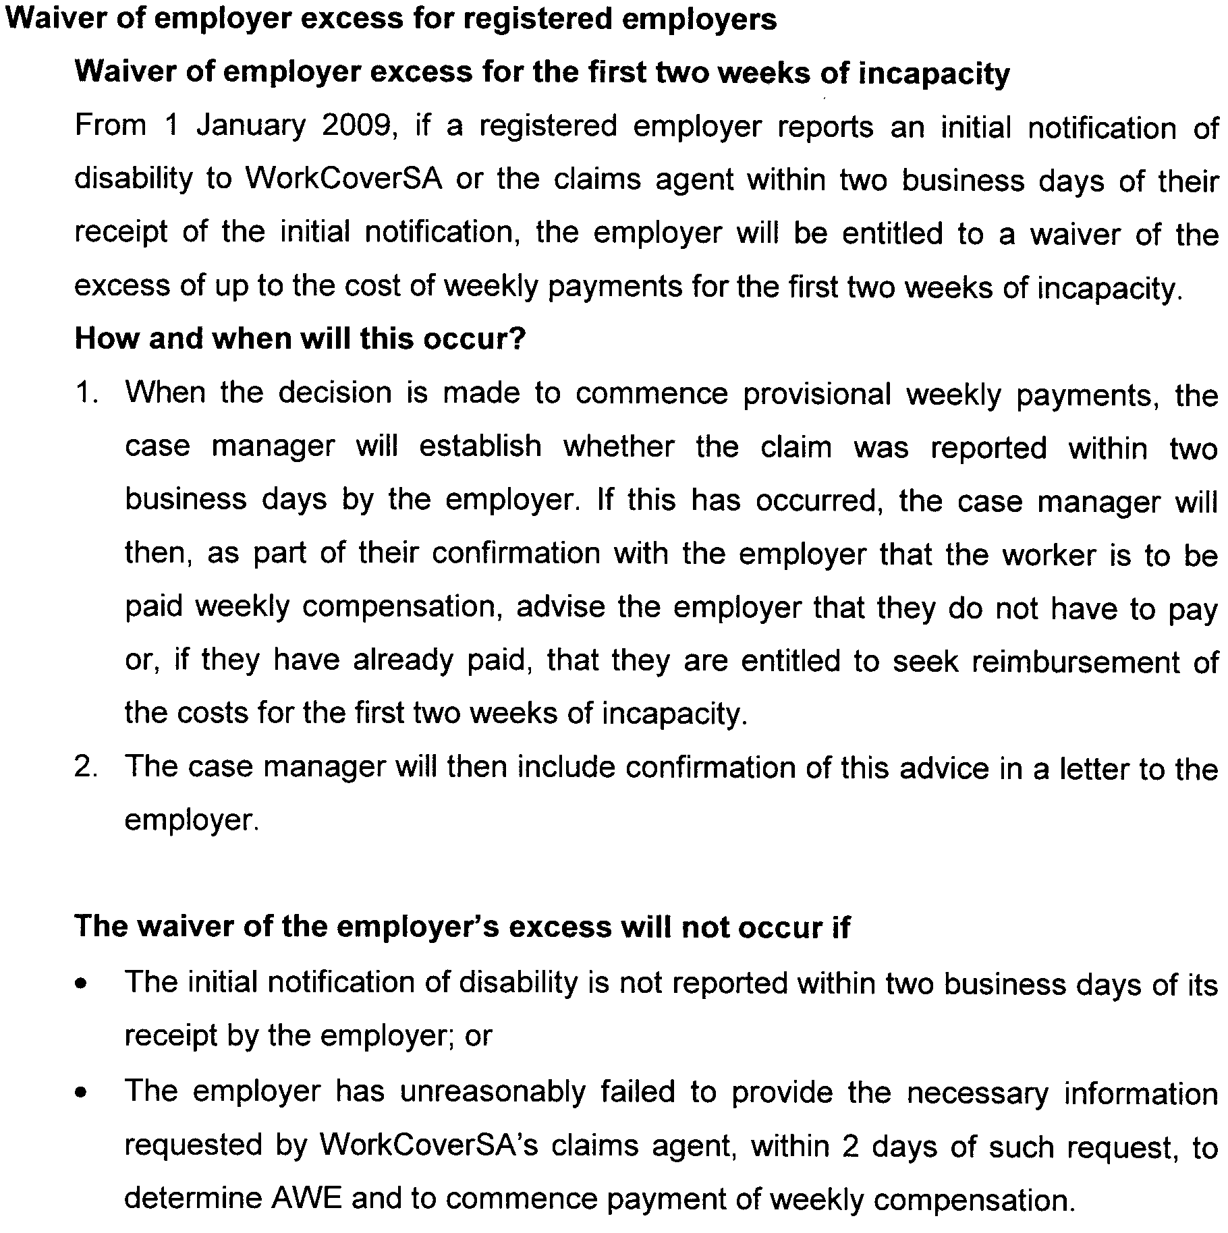

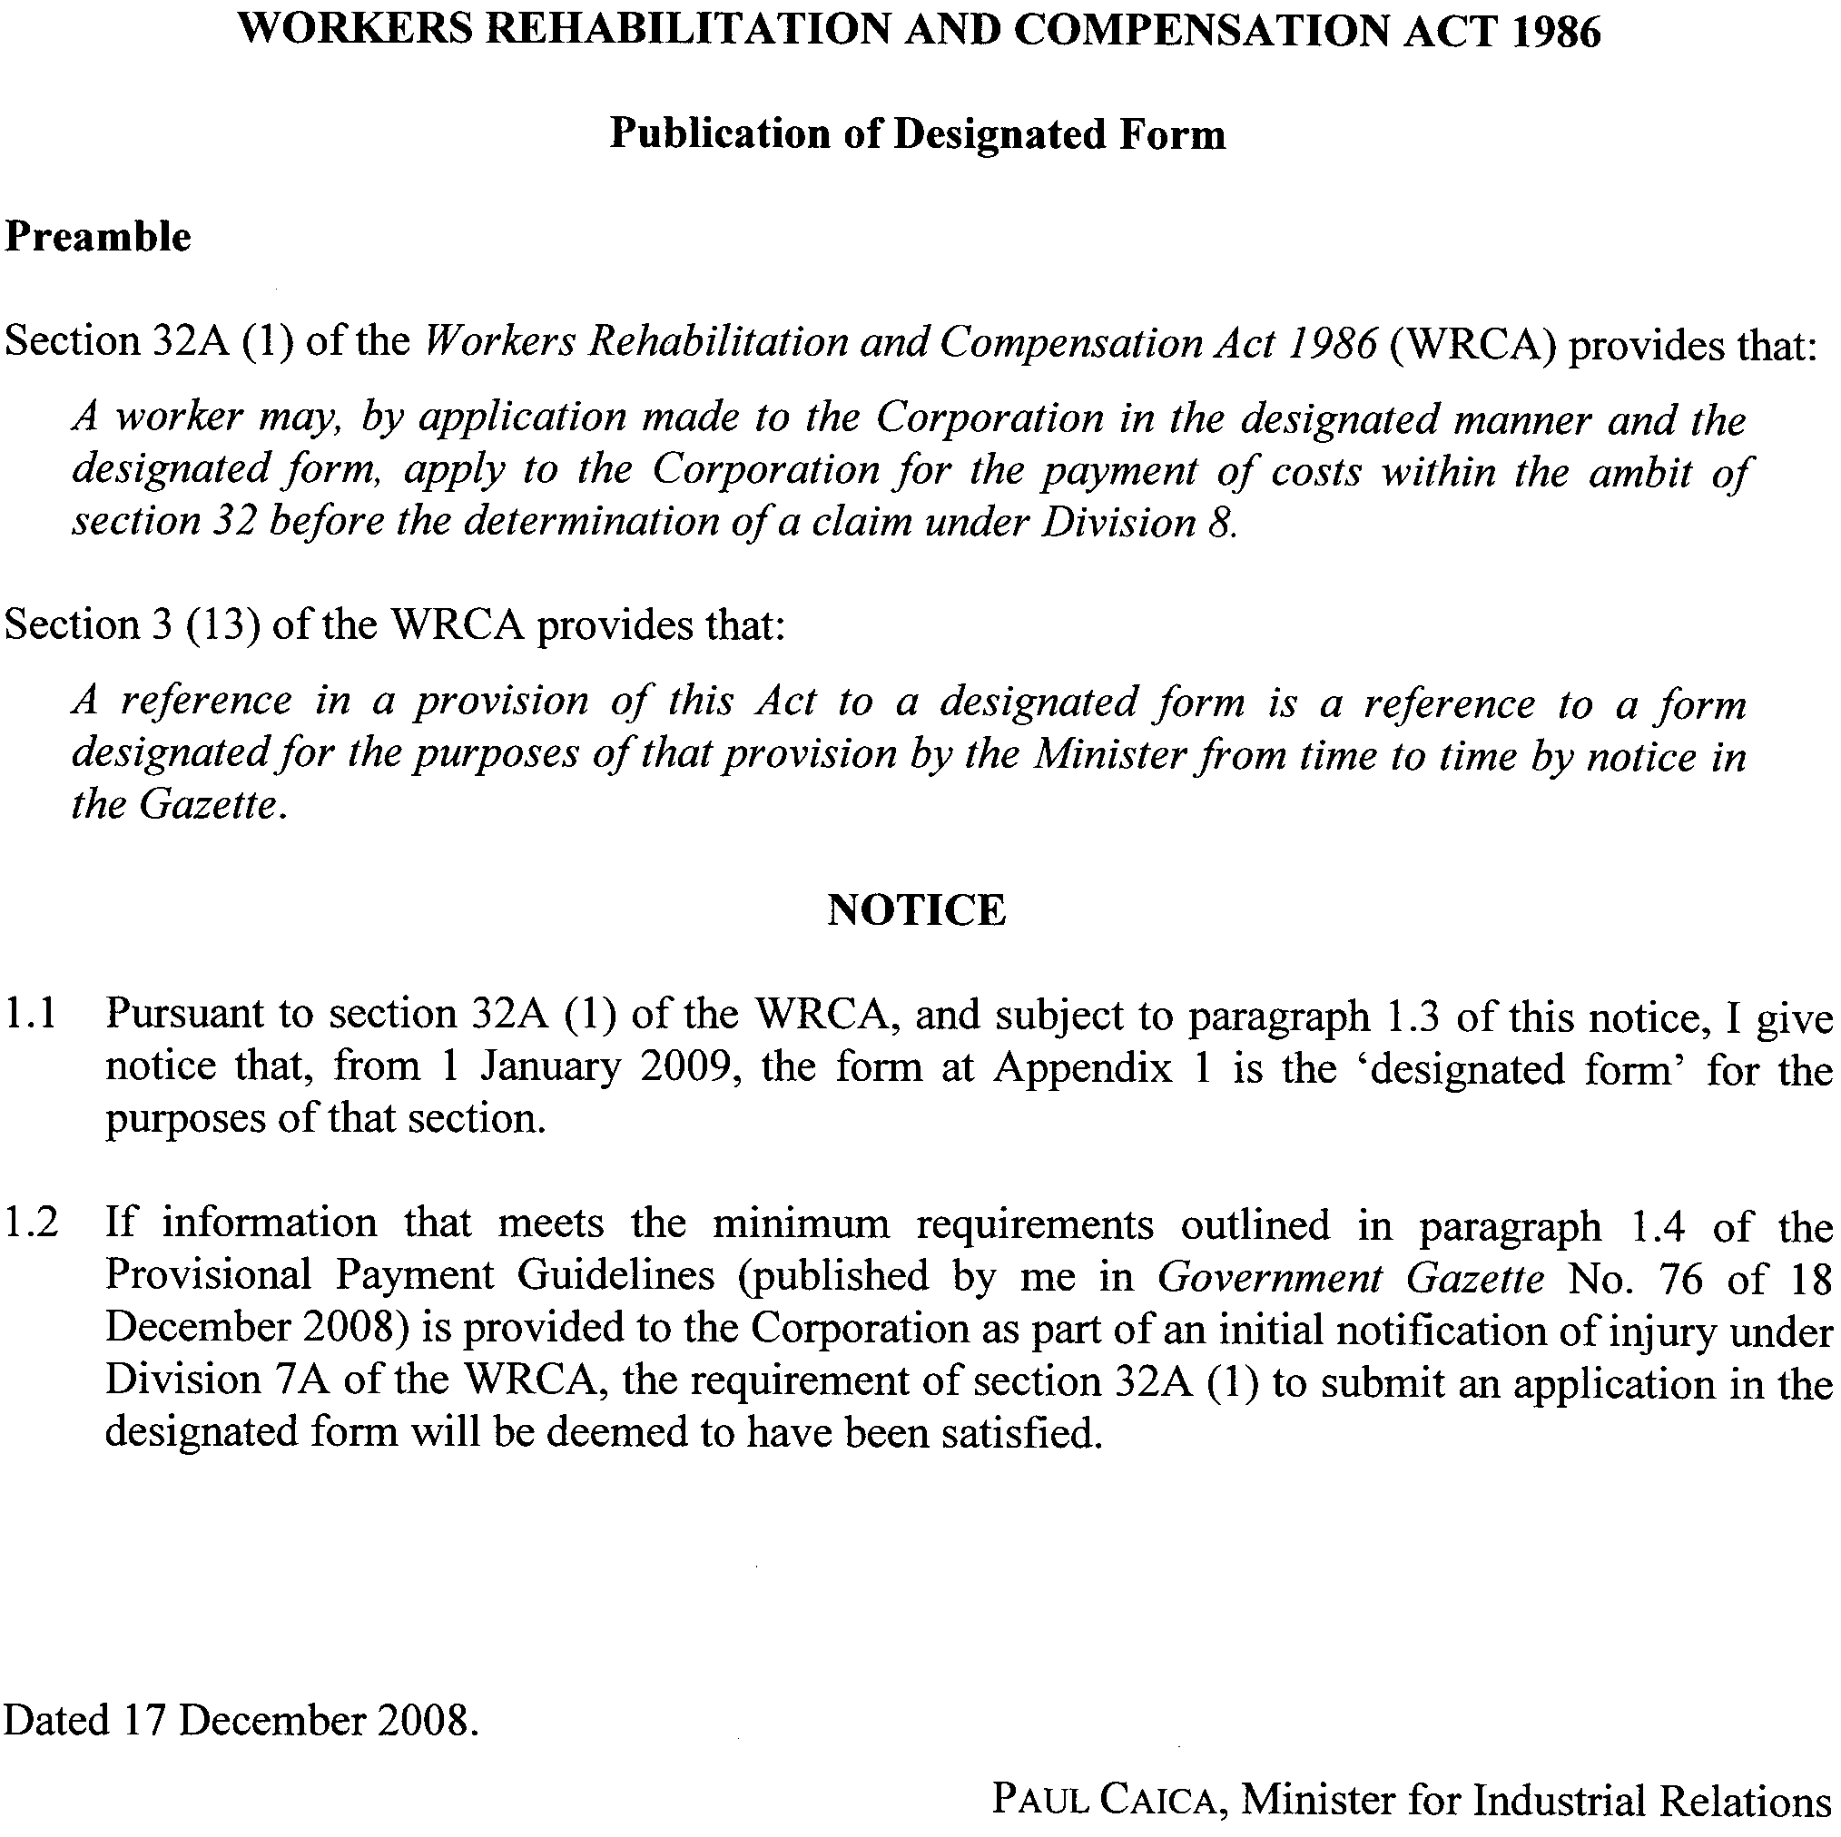

Appendix 1

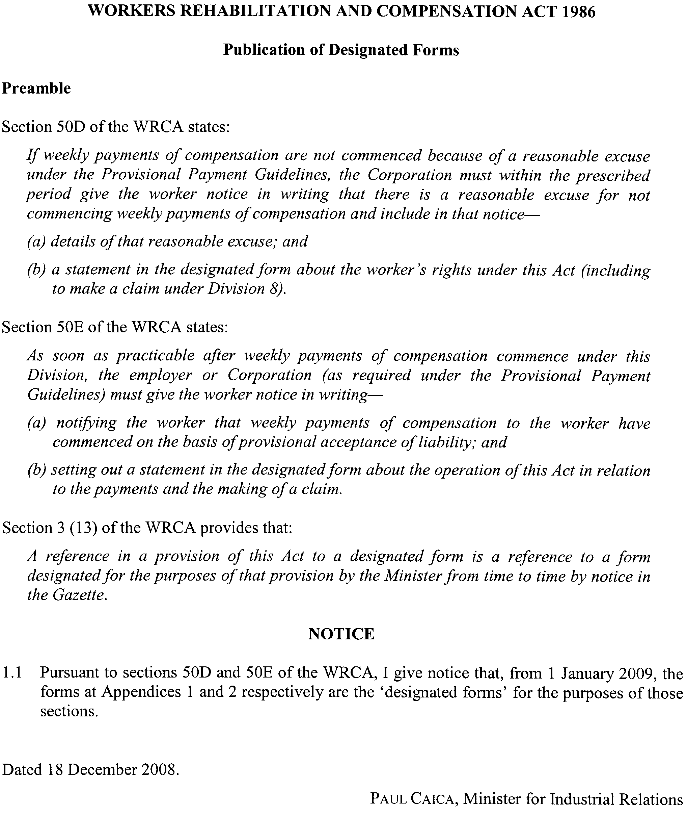

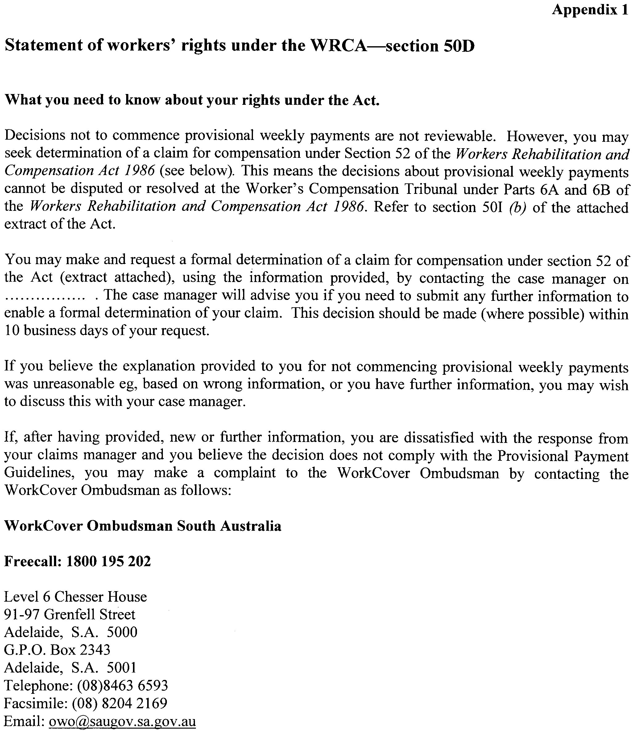
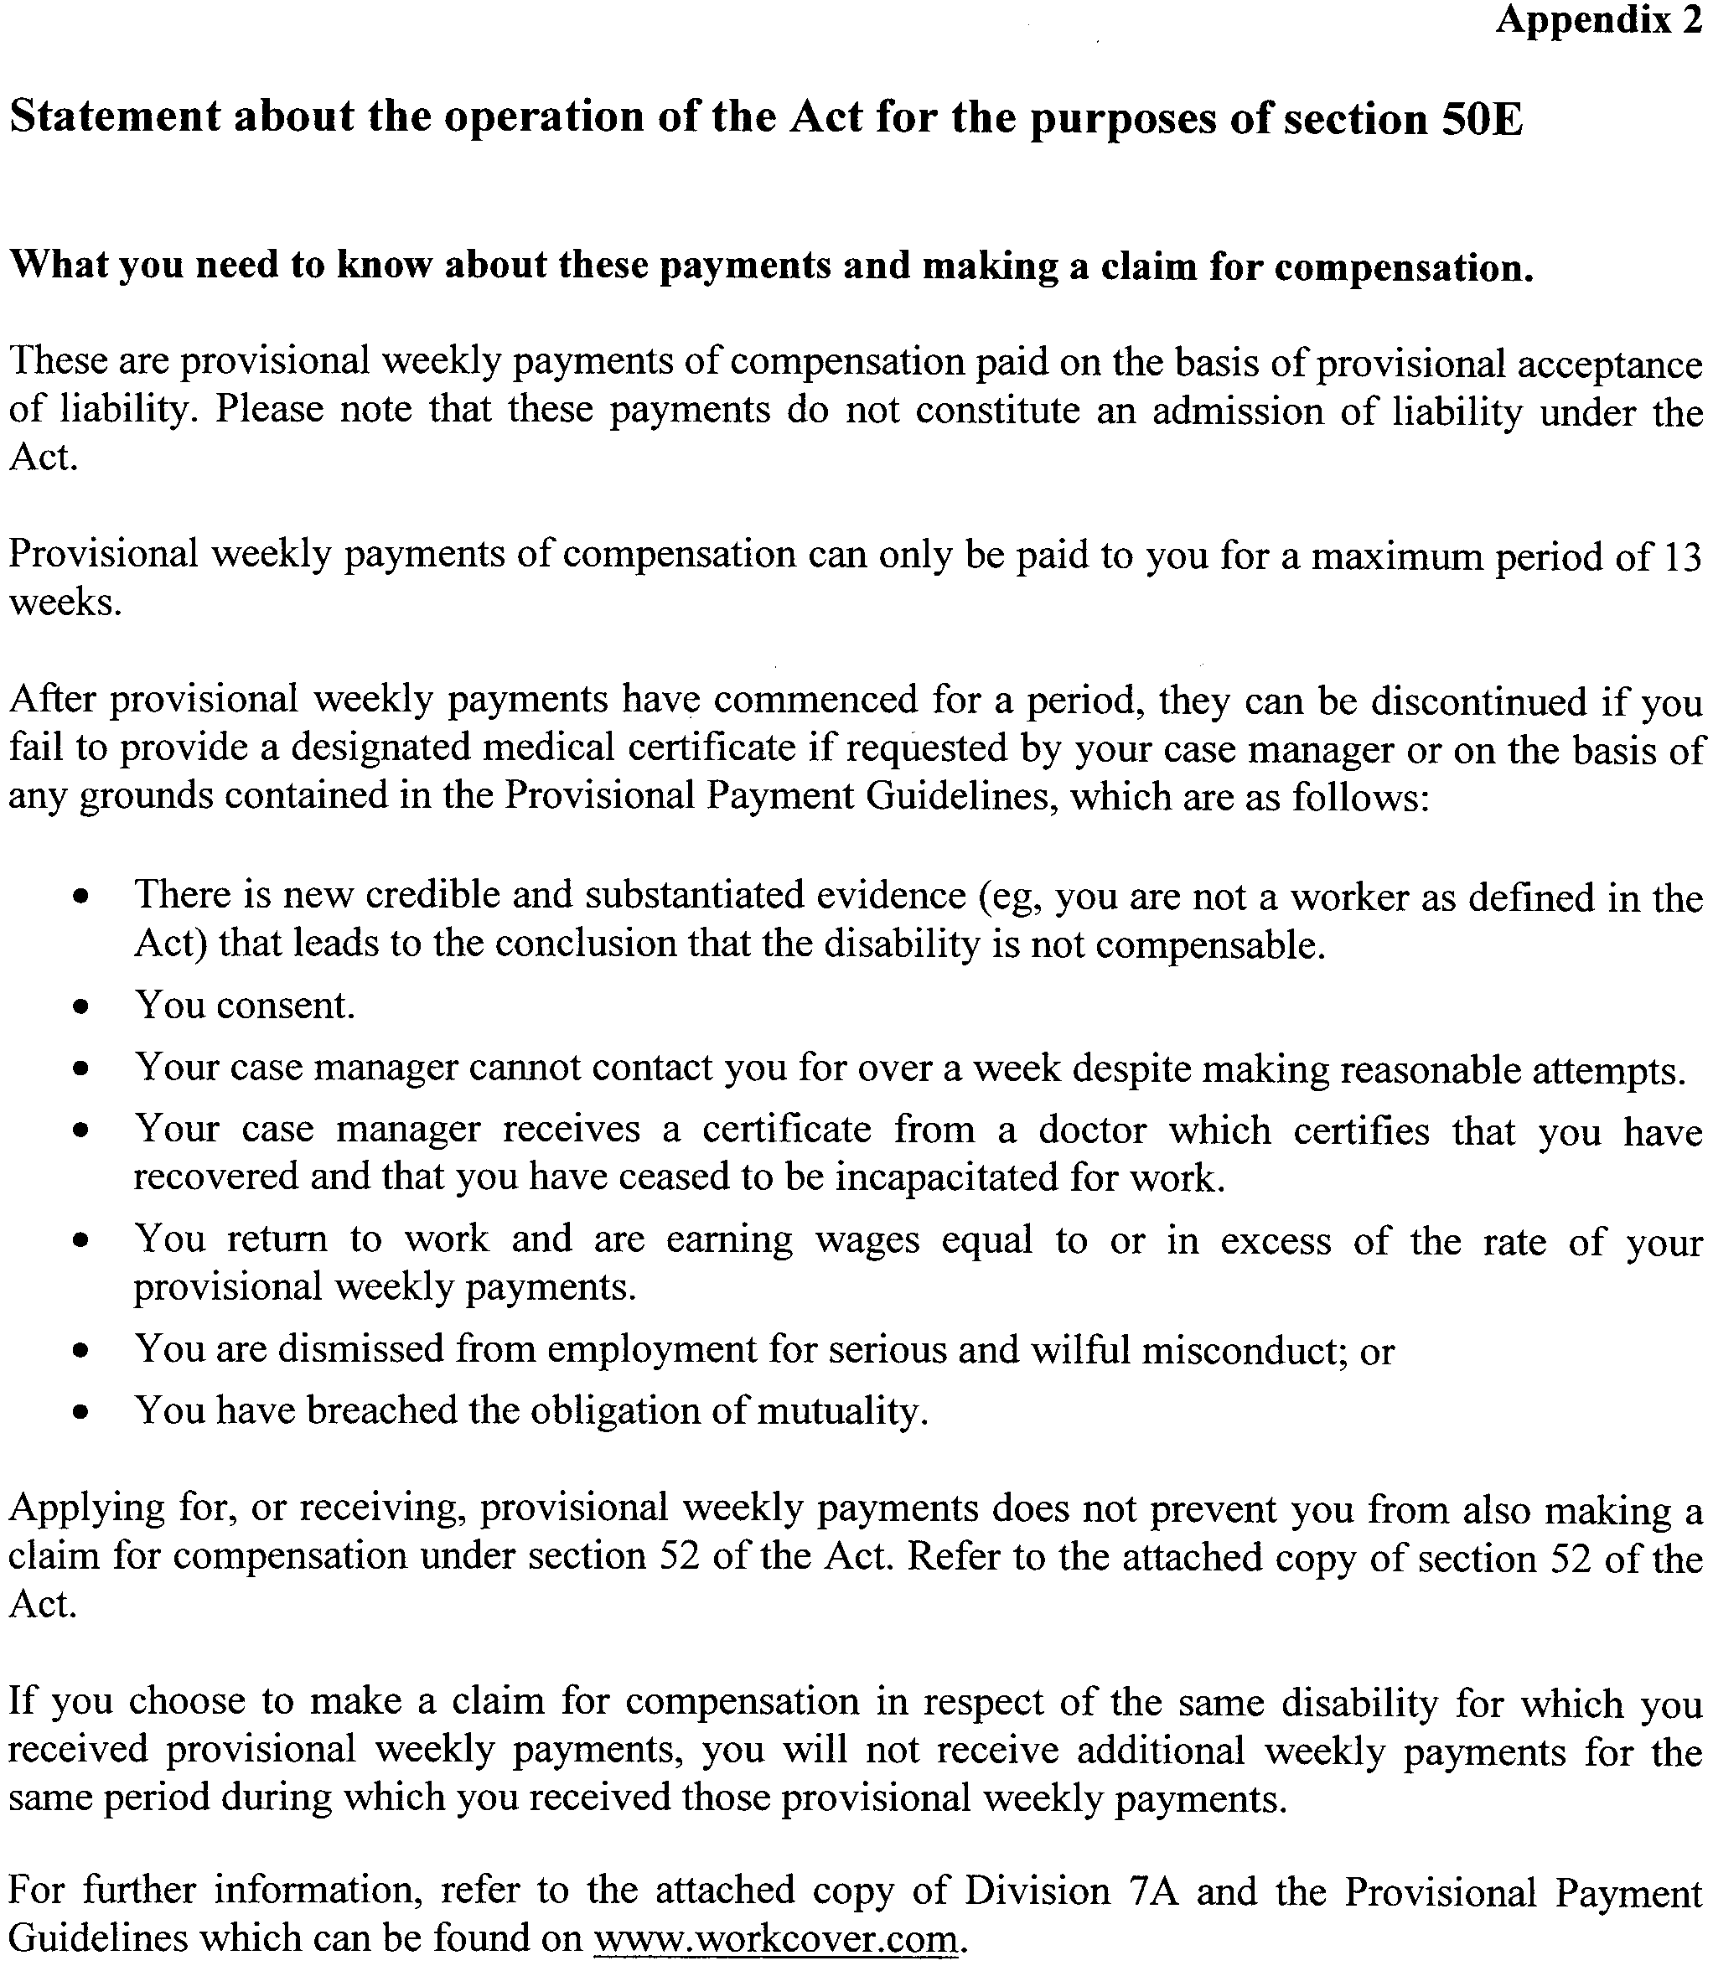

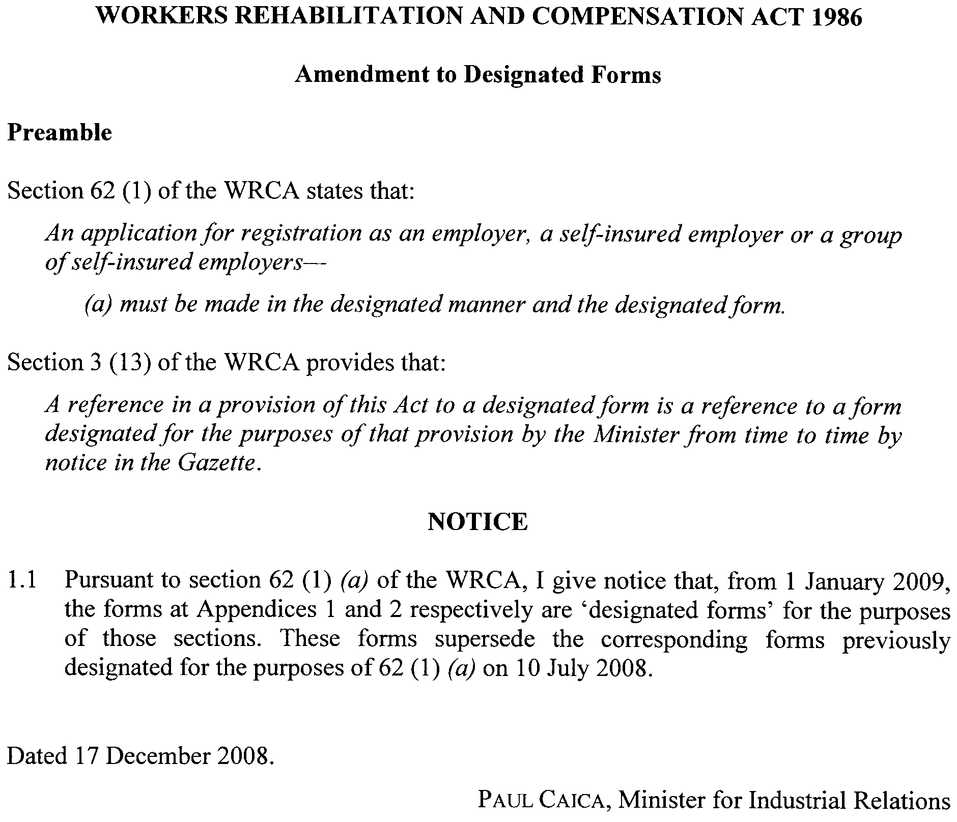

Appendix 1

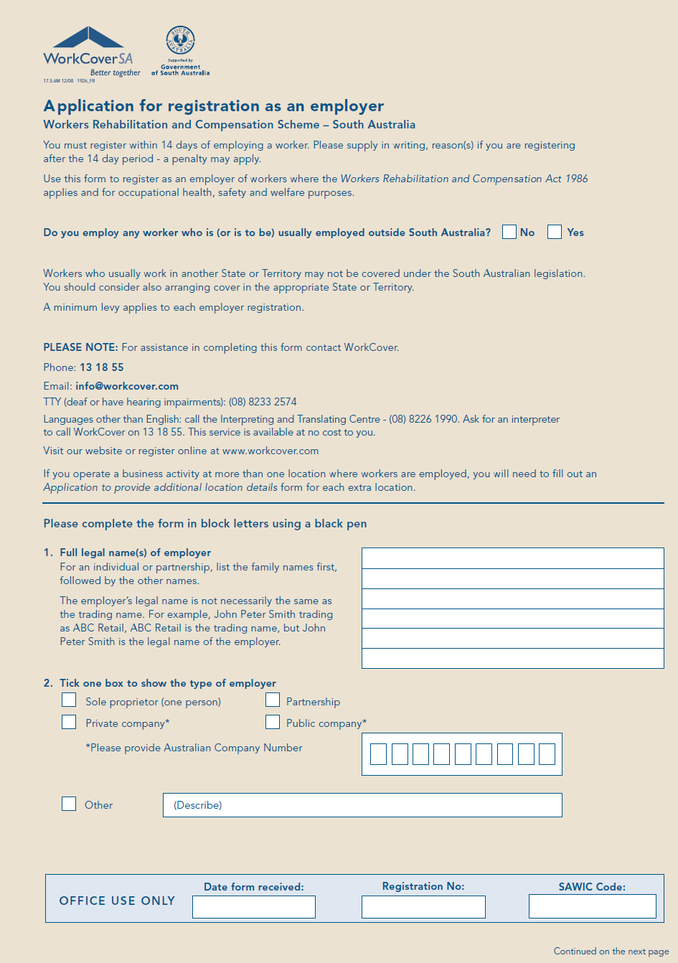
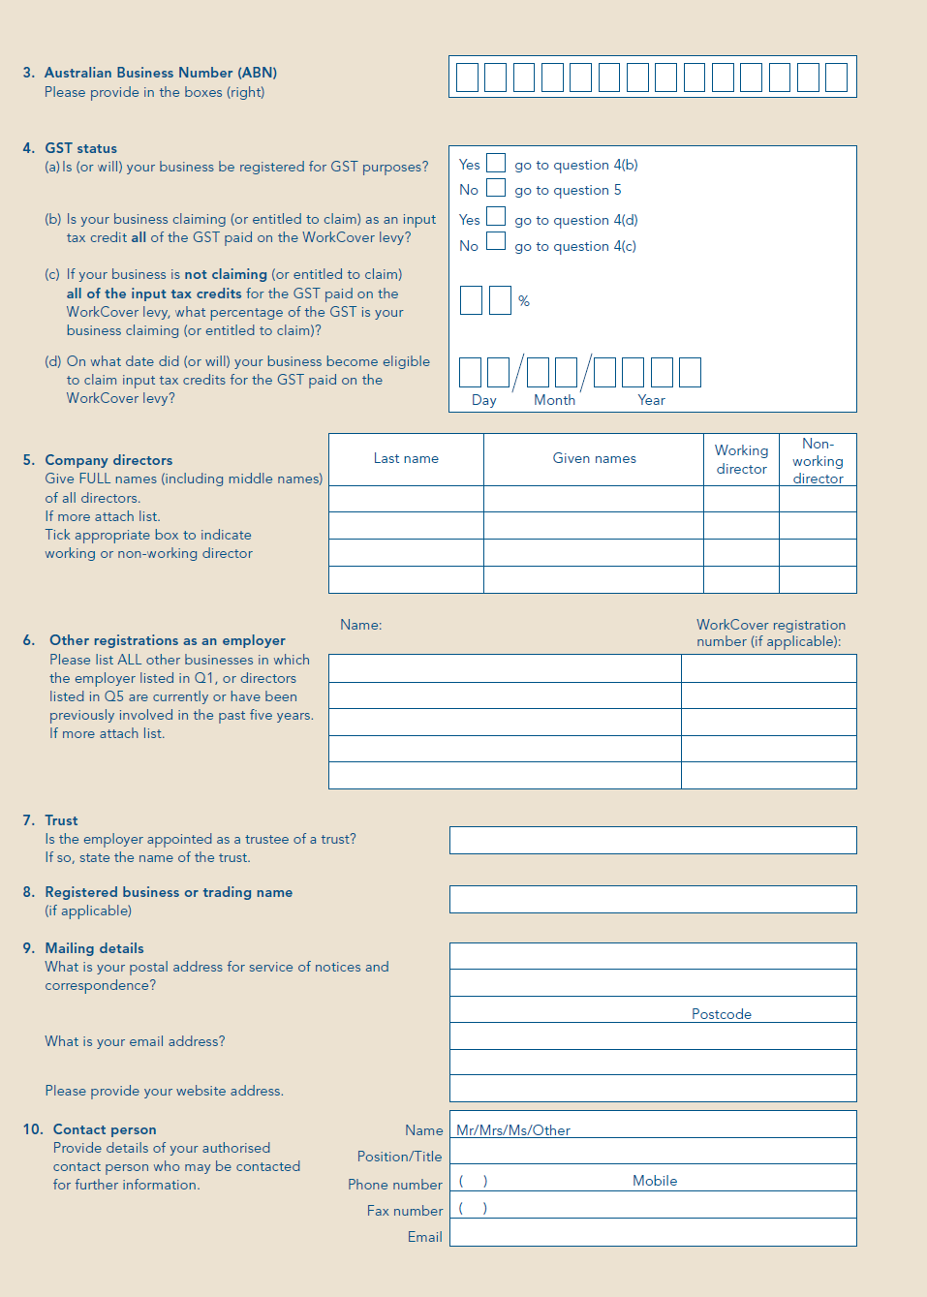
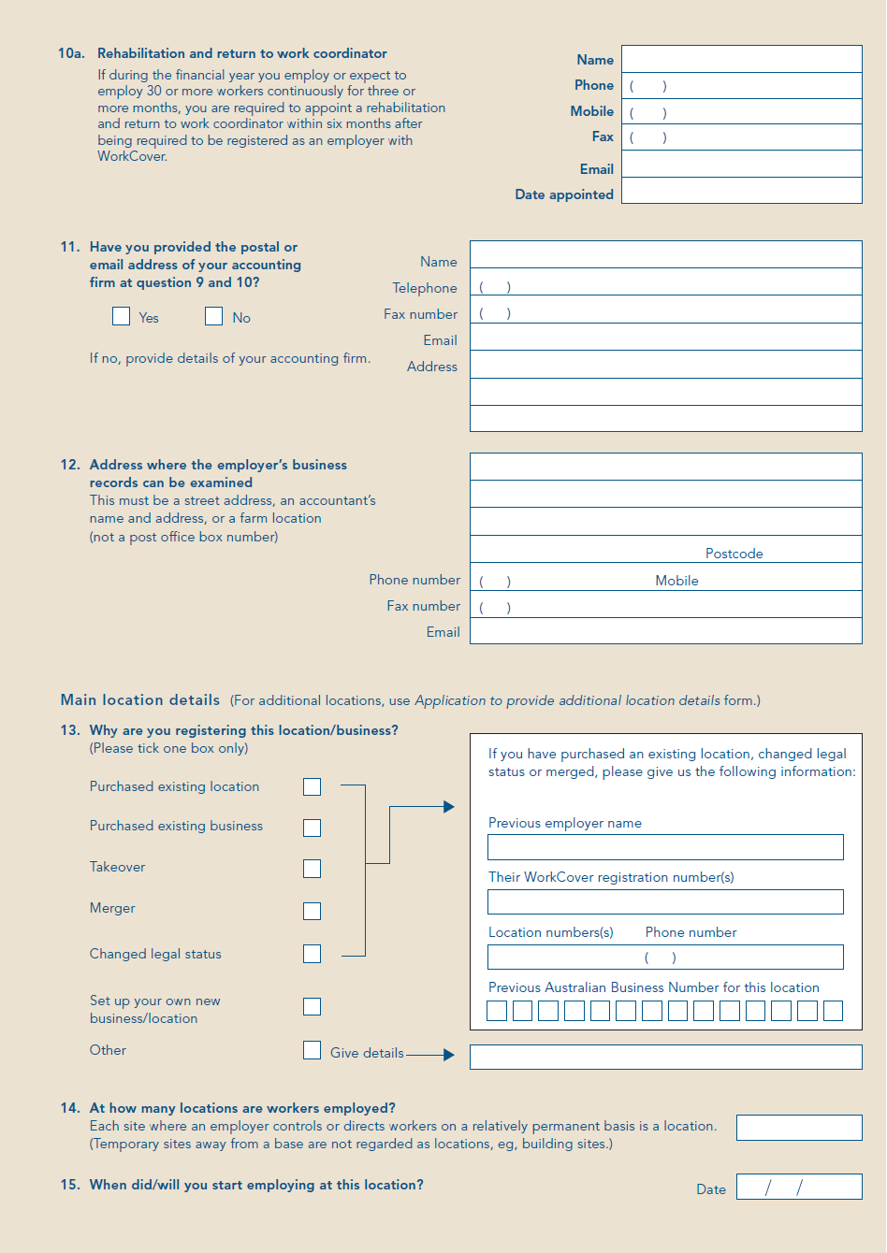
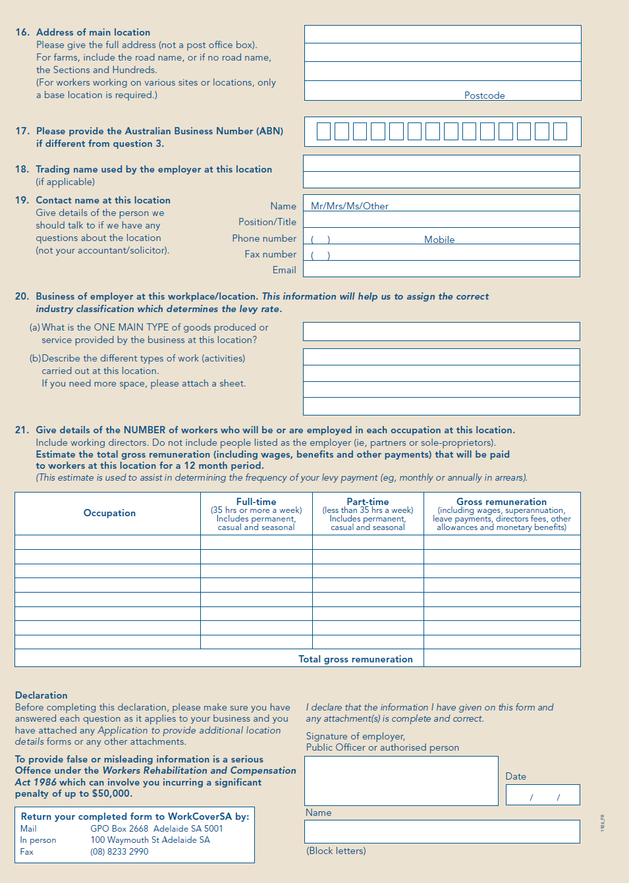
Appendix 2

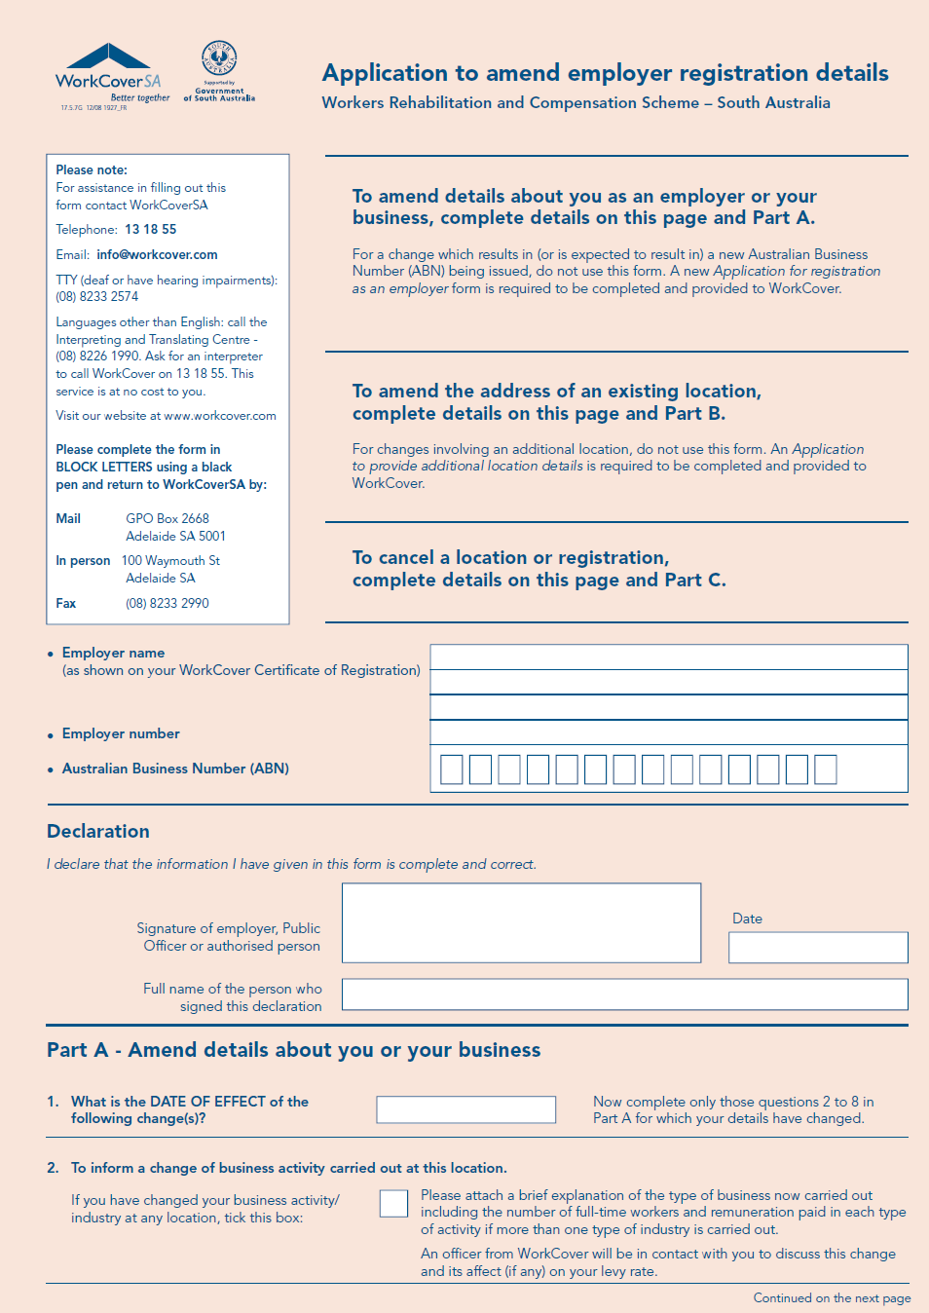
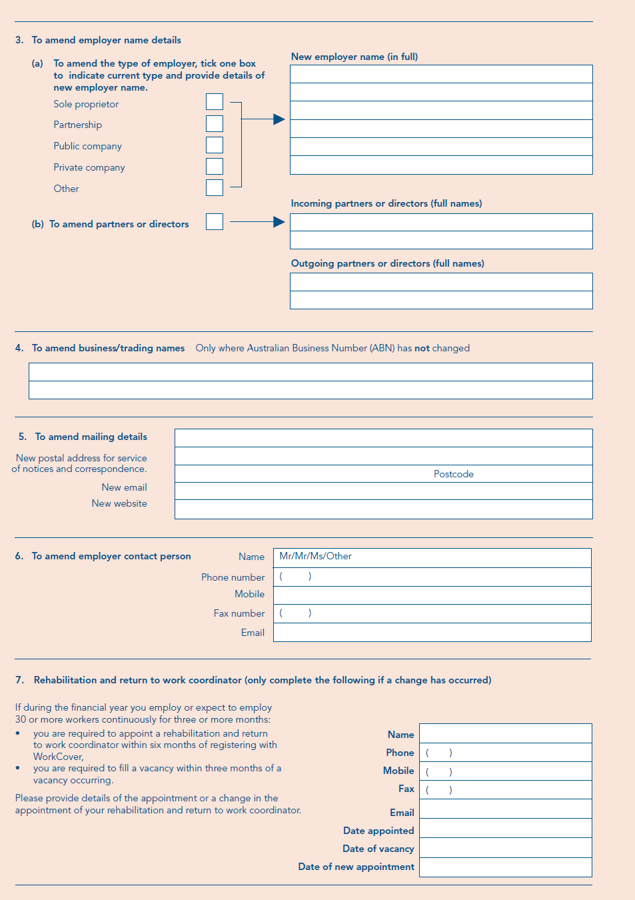
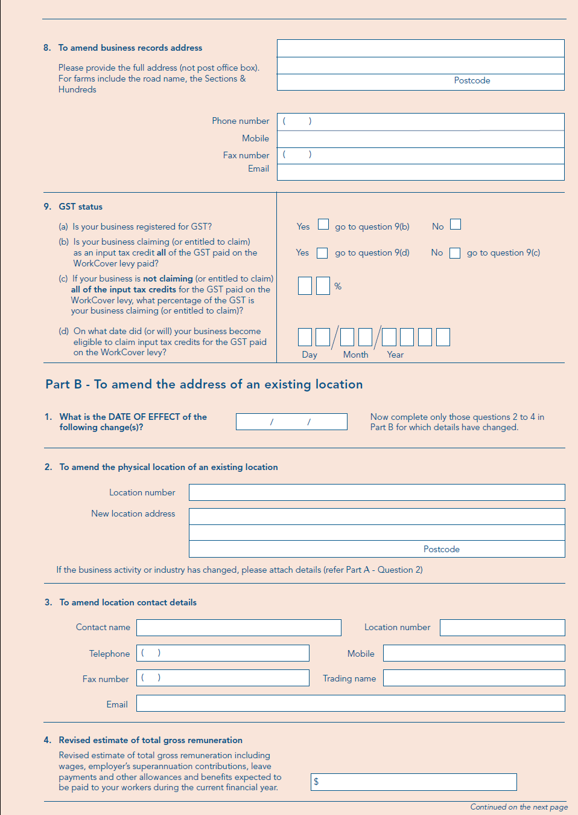
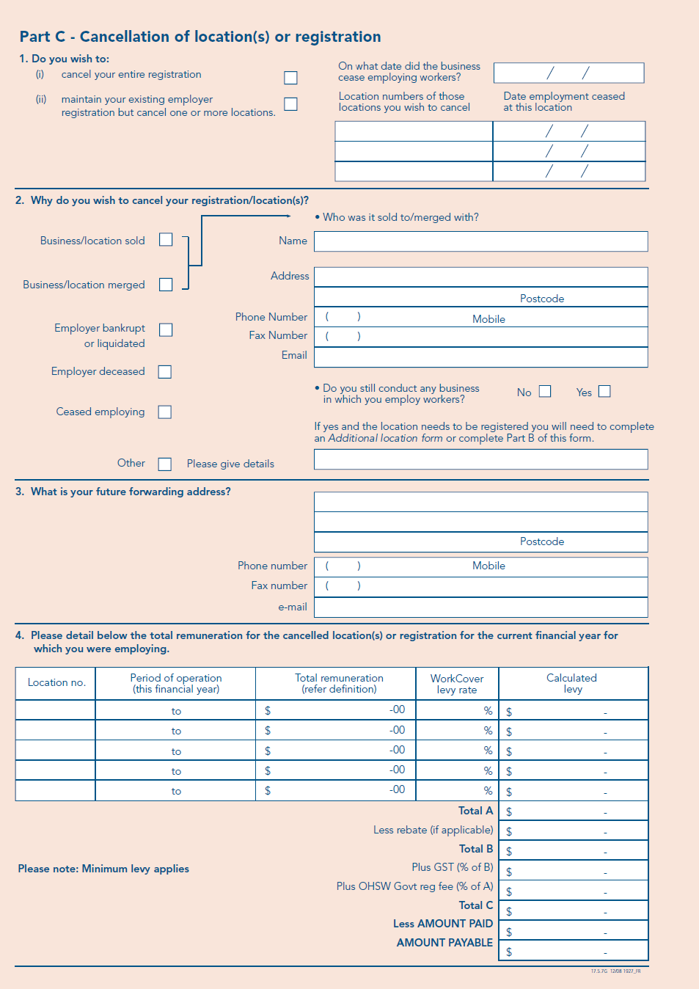

WORKERS REHABILITATION AND COMPENSATION ACT 1986
Publication of Designated Forms
Preamble
Section 3 (13) of the Workers Rehabilitation and Compensation Act 1986 (the WRCA), provides that ‘A reference in a provision of this Act to a designated form is a reference to a form designated for the purposes of that provision by the Minister from time to time by notice in the Gazette.’
Notice
PURSUANT to section 39 (1a) of the WRCA, the Minister for Industrial Relations gives notice that the template letter at Appendix 1 is a ‘designated form’ for the purposes of that provision, and replaces the template letter published in the South Australian Government Gazette on 10 July 2008.
Dated 18 November 2008.
Paul Caica, Minster for Industrial Relations

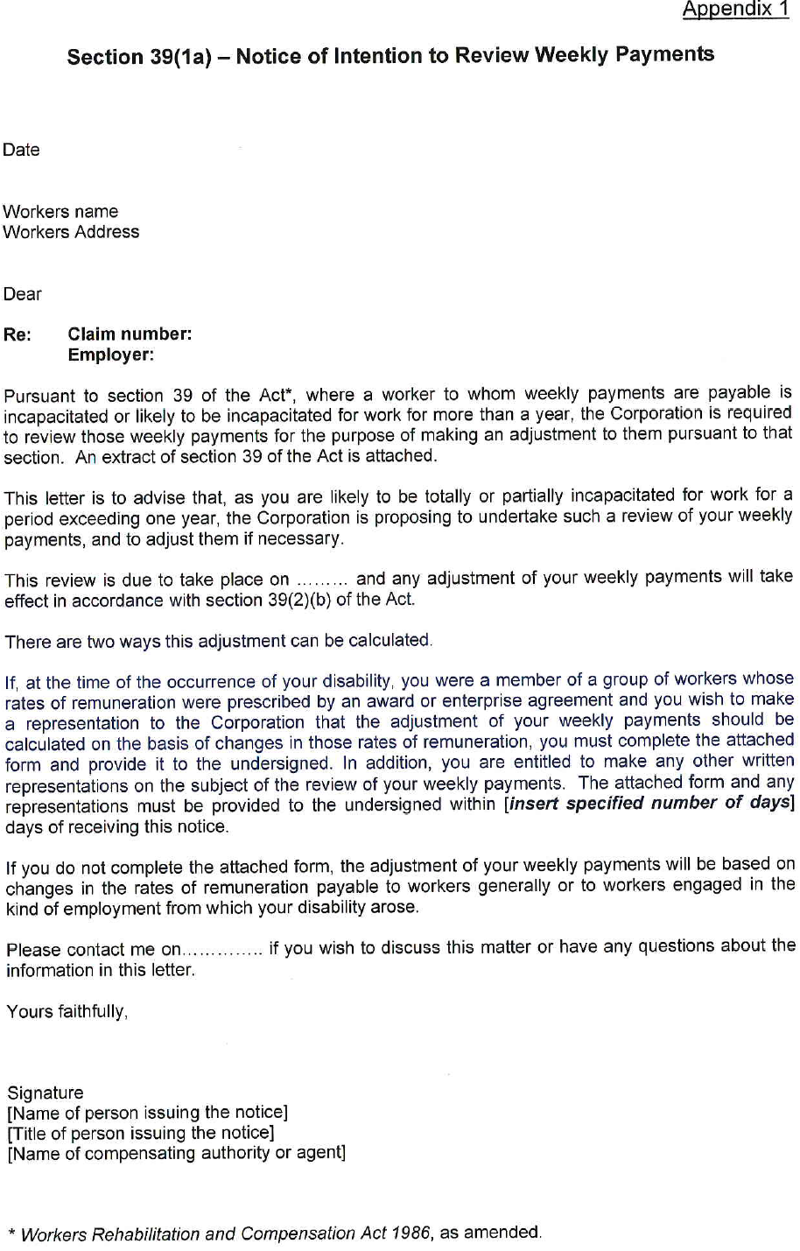

T. GOODES, Government Printer, South Australia

