No. 2 29

THE SOUTH AUSTRALIAN

GOVERNMENT GAZETTE
www.governmentgazette.sa.gov.au

PUBLISHED BY AUTHORITY

ALL PUBLIC ACTS appearing in this GAZETTE are to be considered official, and obeyed as such

ADELAIDE, THURSDAY, 10 JANUARY 2008

CONTENTS

Page
Brands Act 1933—Notice 30
Controlled Substances Act 1984—Notices 49
Corporations and District Councils—Notices 75
Crown Lands Act 1929—Notices 49
Environment Protection Authority—Notice 50
Fisheries Management Act 2007—Notice 50
Government Lands Sale—Notice 49
Housing Improvement Act 1940—
[Republished] 62
Land and Business (Sale and Conveyancing) Act 1994—
Notices 50
Liquor Licensing Act 1997—Notices 52
Mining Act 1971—Notices 58
Native Title (South Australia) Act 1994—Notice 59
Roads (Opening and Closing) Act 1991—Notices 60
Training and Skills Development Act 2003—
[Republished] 72
Treasurer’s Quarterly Statement 63
Unclaimed Moneys Act 1891—Notices 76
Water Mains and Sewers—Main Laid, Replace, Etc. 60

GOVERNMENT GAZETTE NOTICES
ALL poundkeepers’ and private advertisements forwarded for publication in the South Australian Government Gazette must be PAID FOR PRIOR TO INSERTION; and all notices, from whatever source, should be legibly written on one side of the paper only and sent to Government Publishing SA so as to be received no later
than 4 p.m. on the Tuesday preceding the day of publication. Phone 8207 1045 or Fax 8207 1040. E-mail: governmentgazette@dpc.sa.gov.au. Send as attachments in Word format and please confirm your transmission with a faxed copy of your document, including the date the notice is to be published and to whom the notice will be charged. The Government Gazette is available online at: www.governmentgazette.sa.gov.au

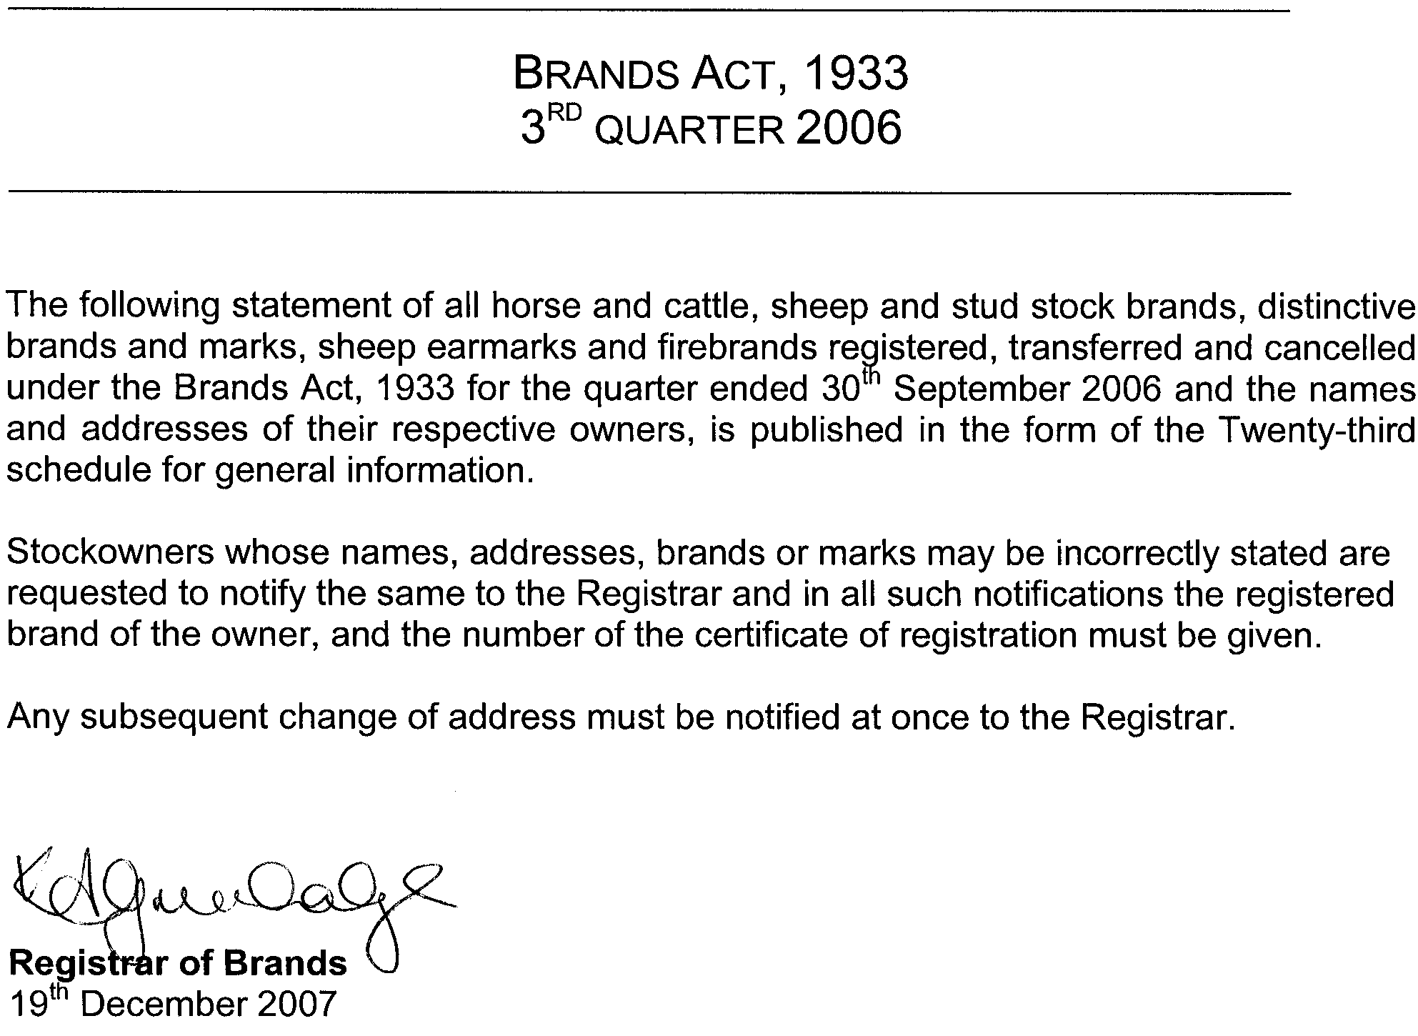
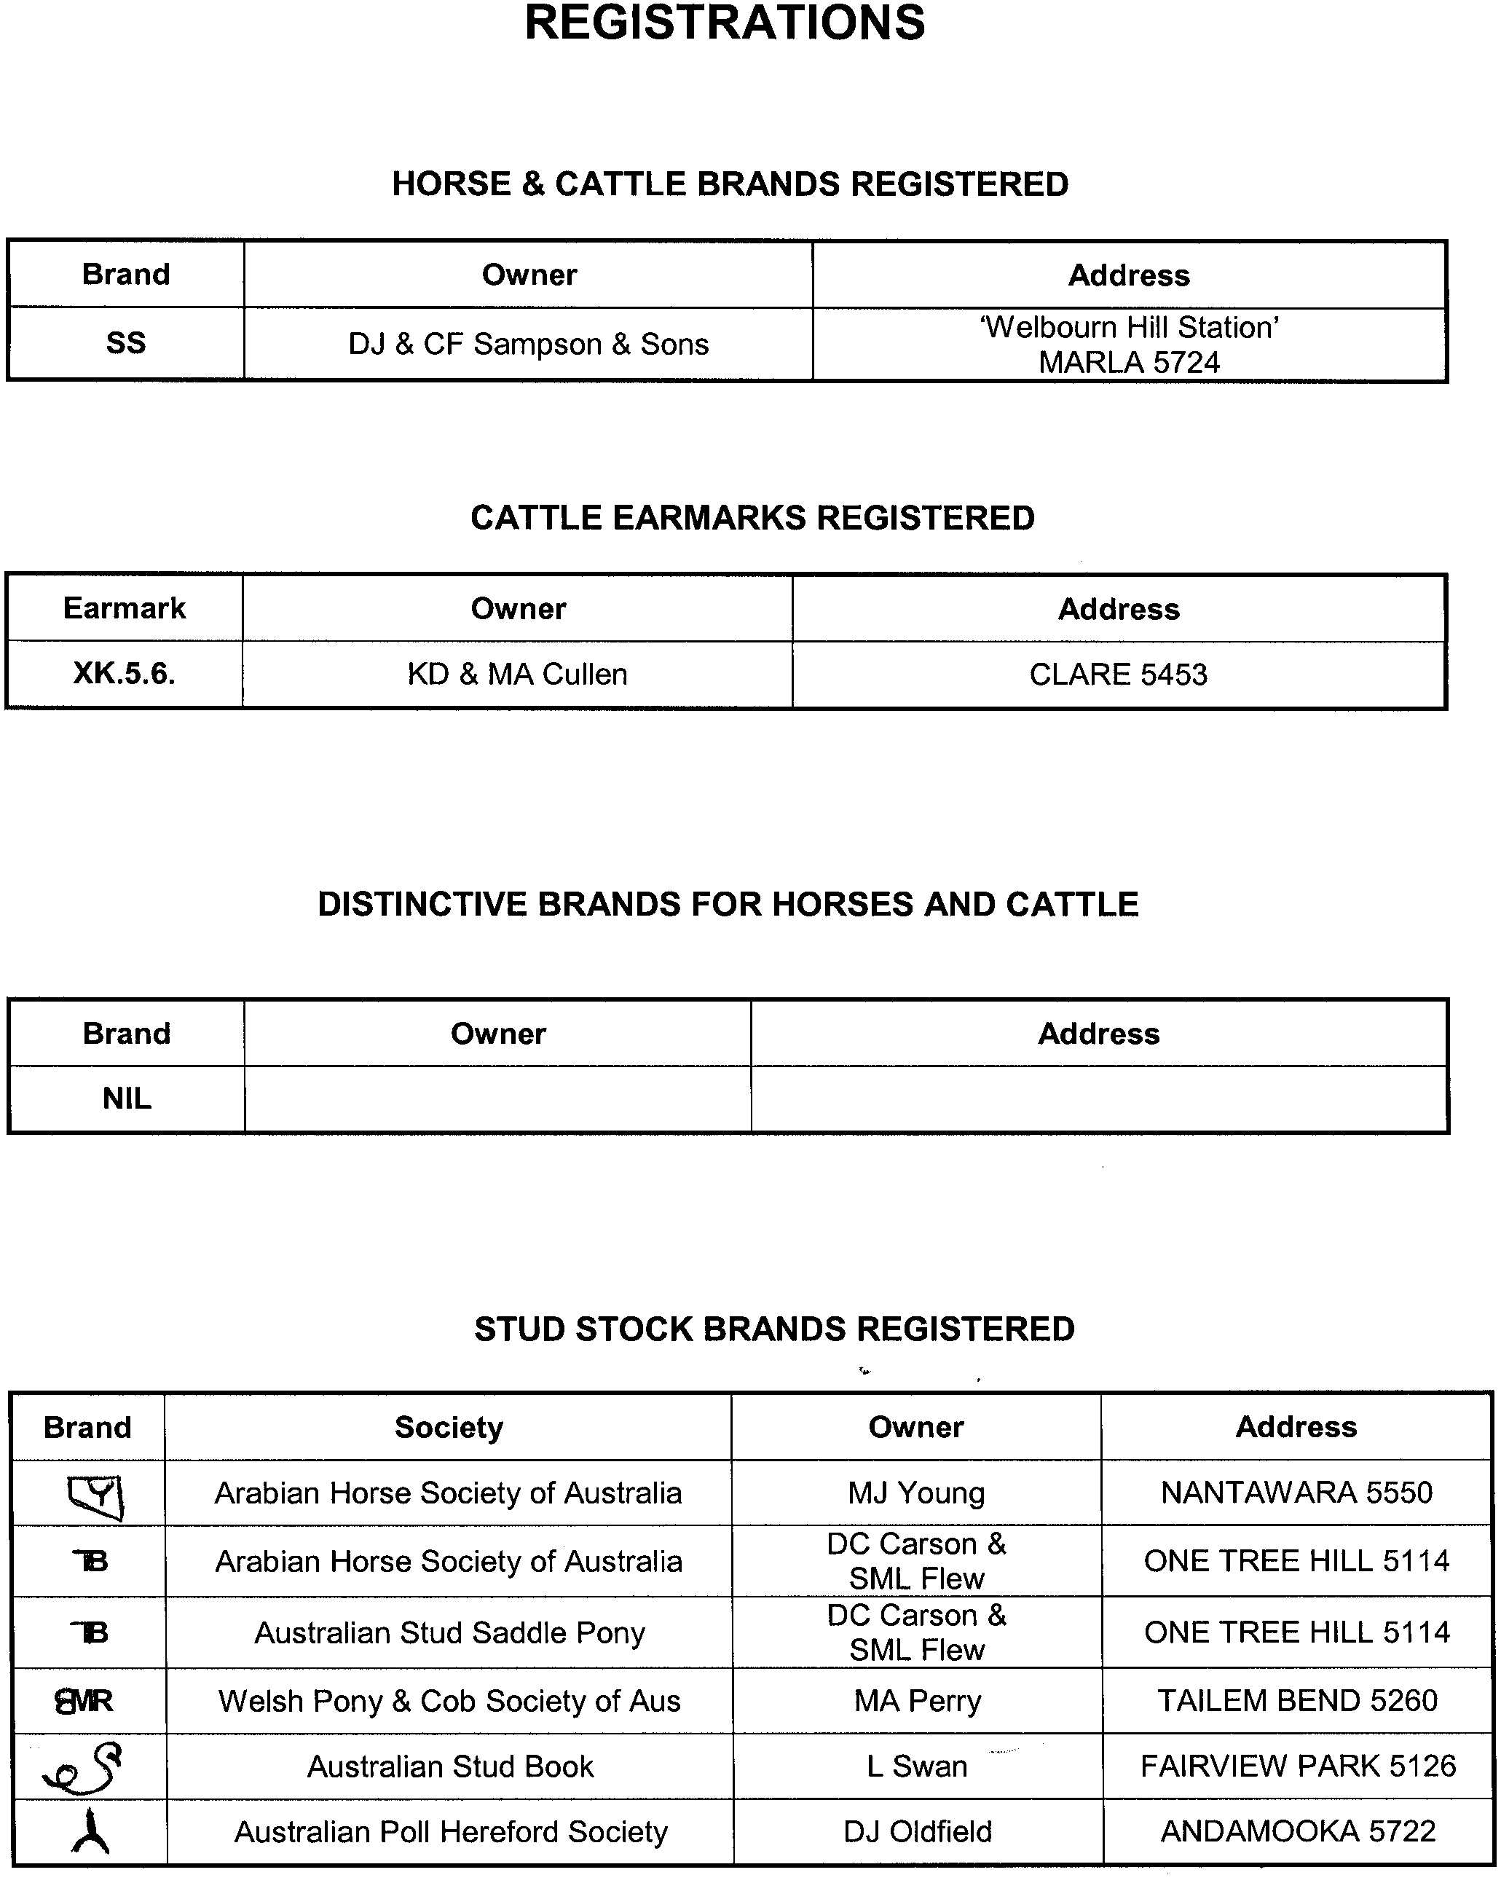
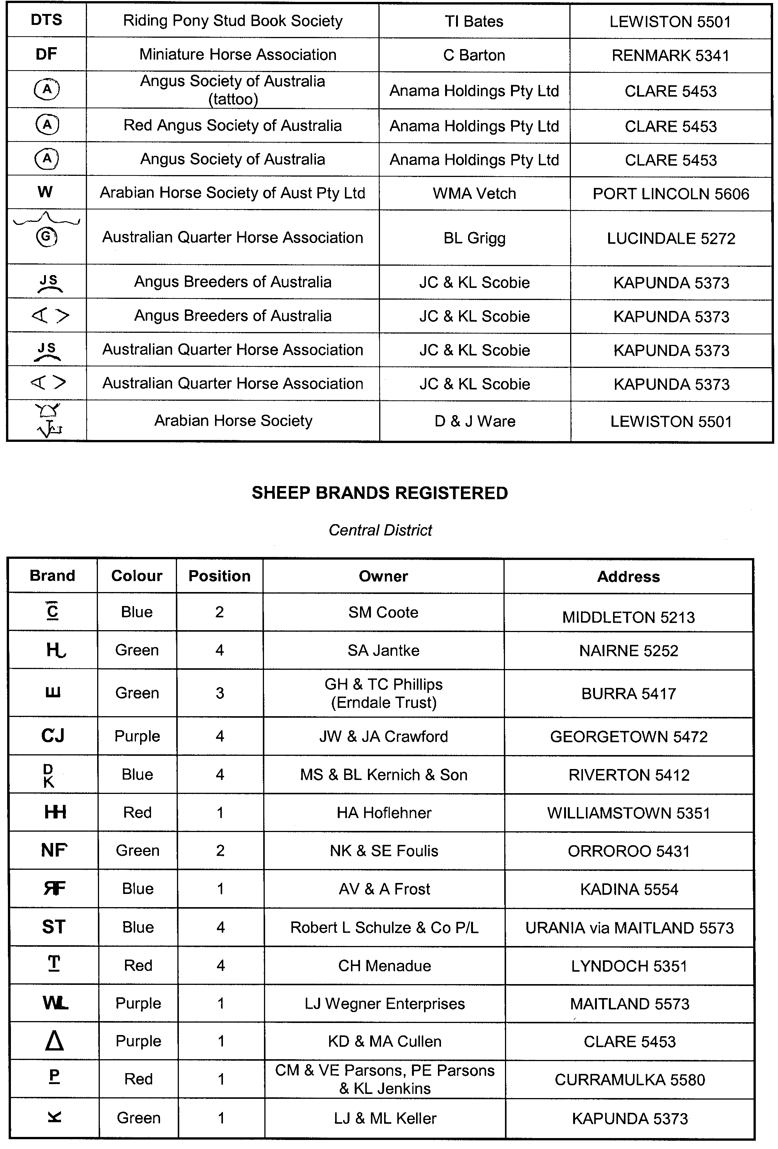
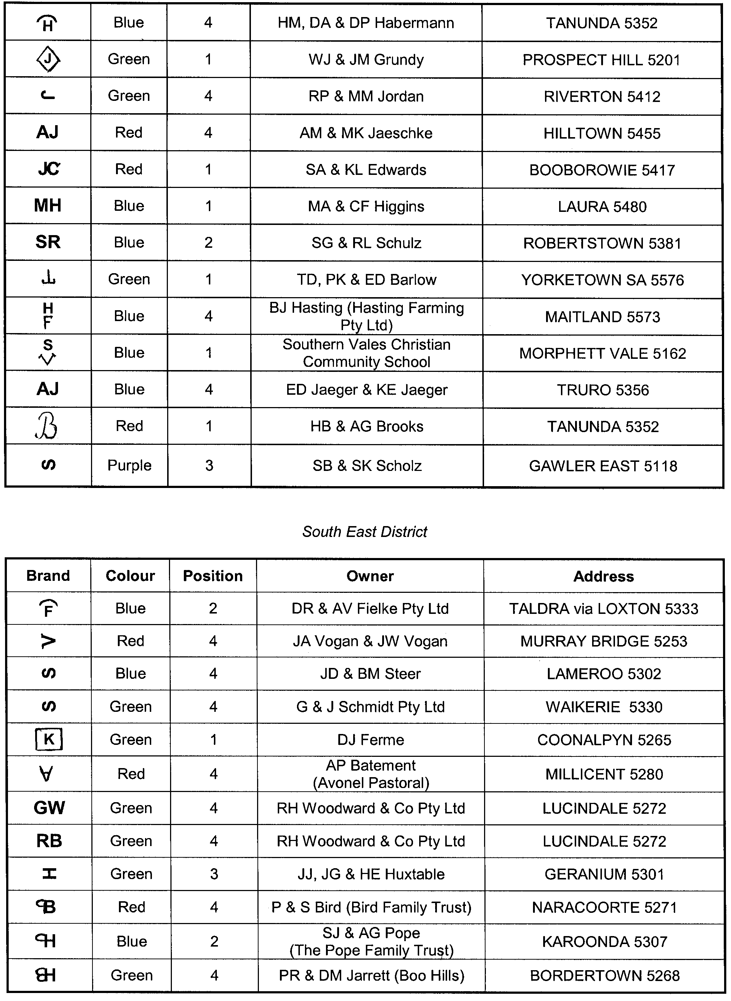
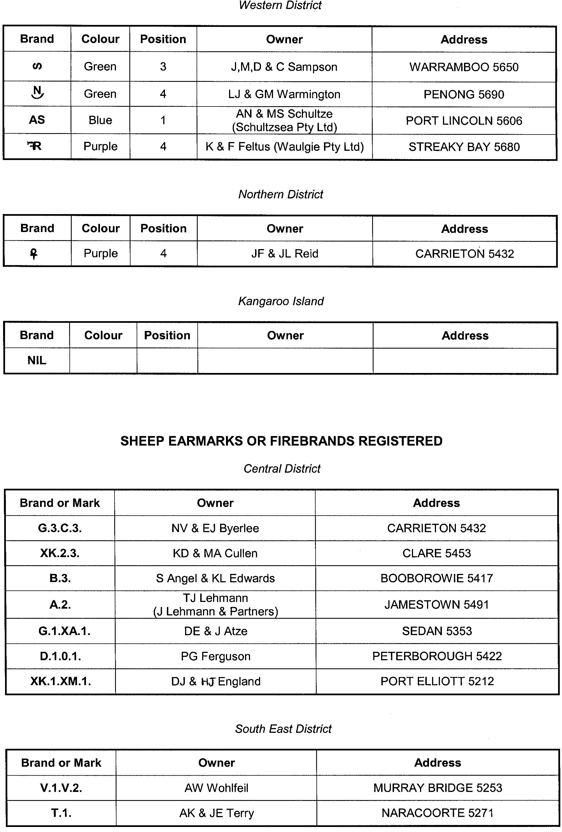
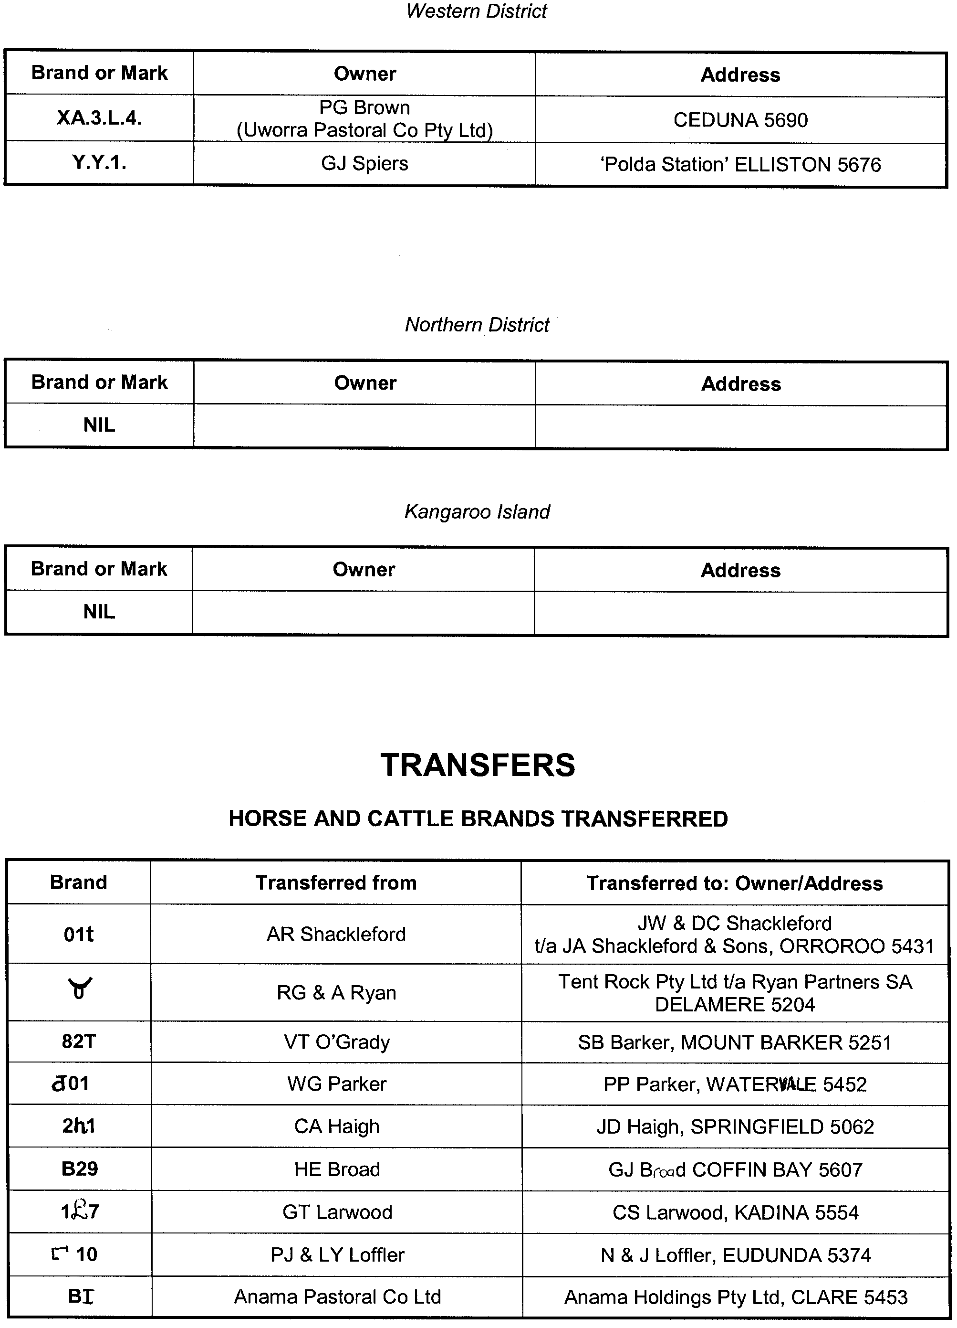
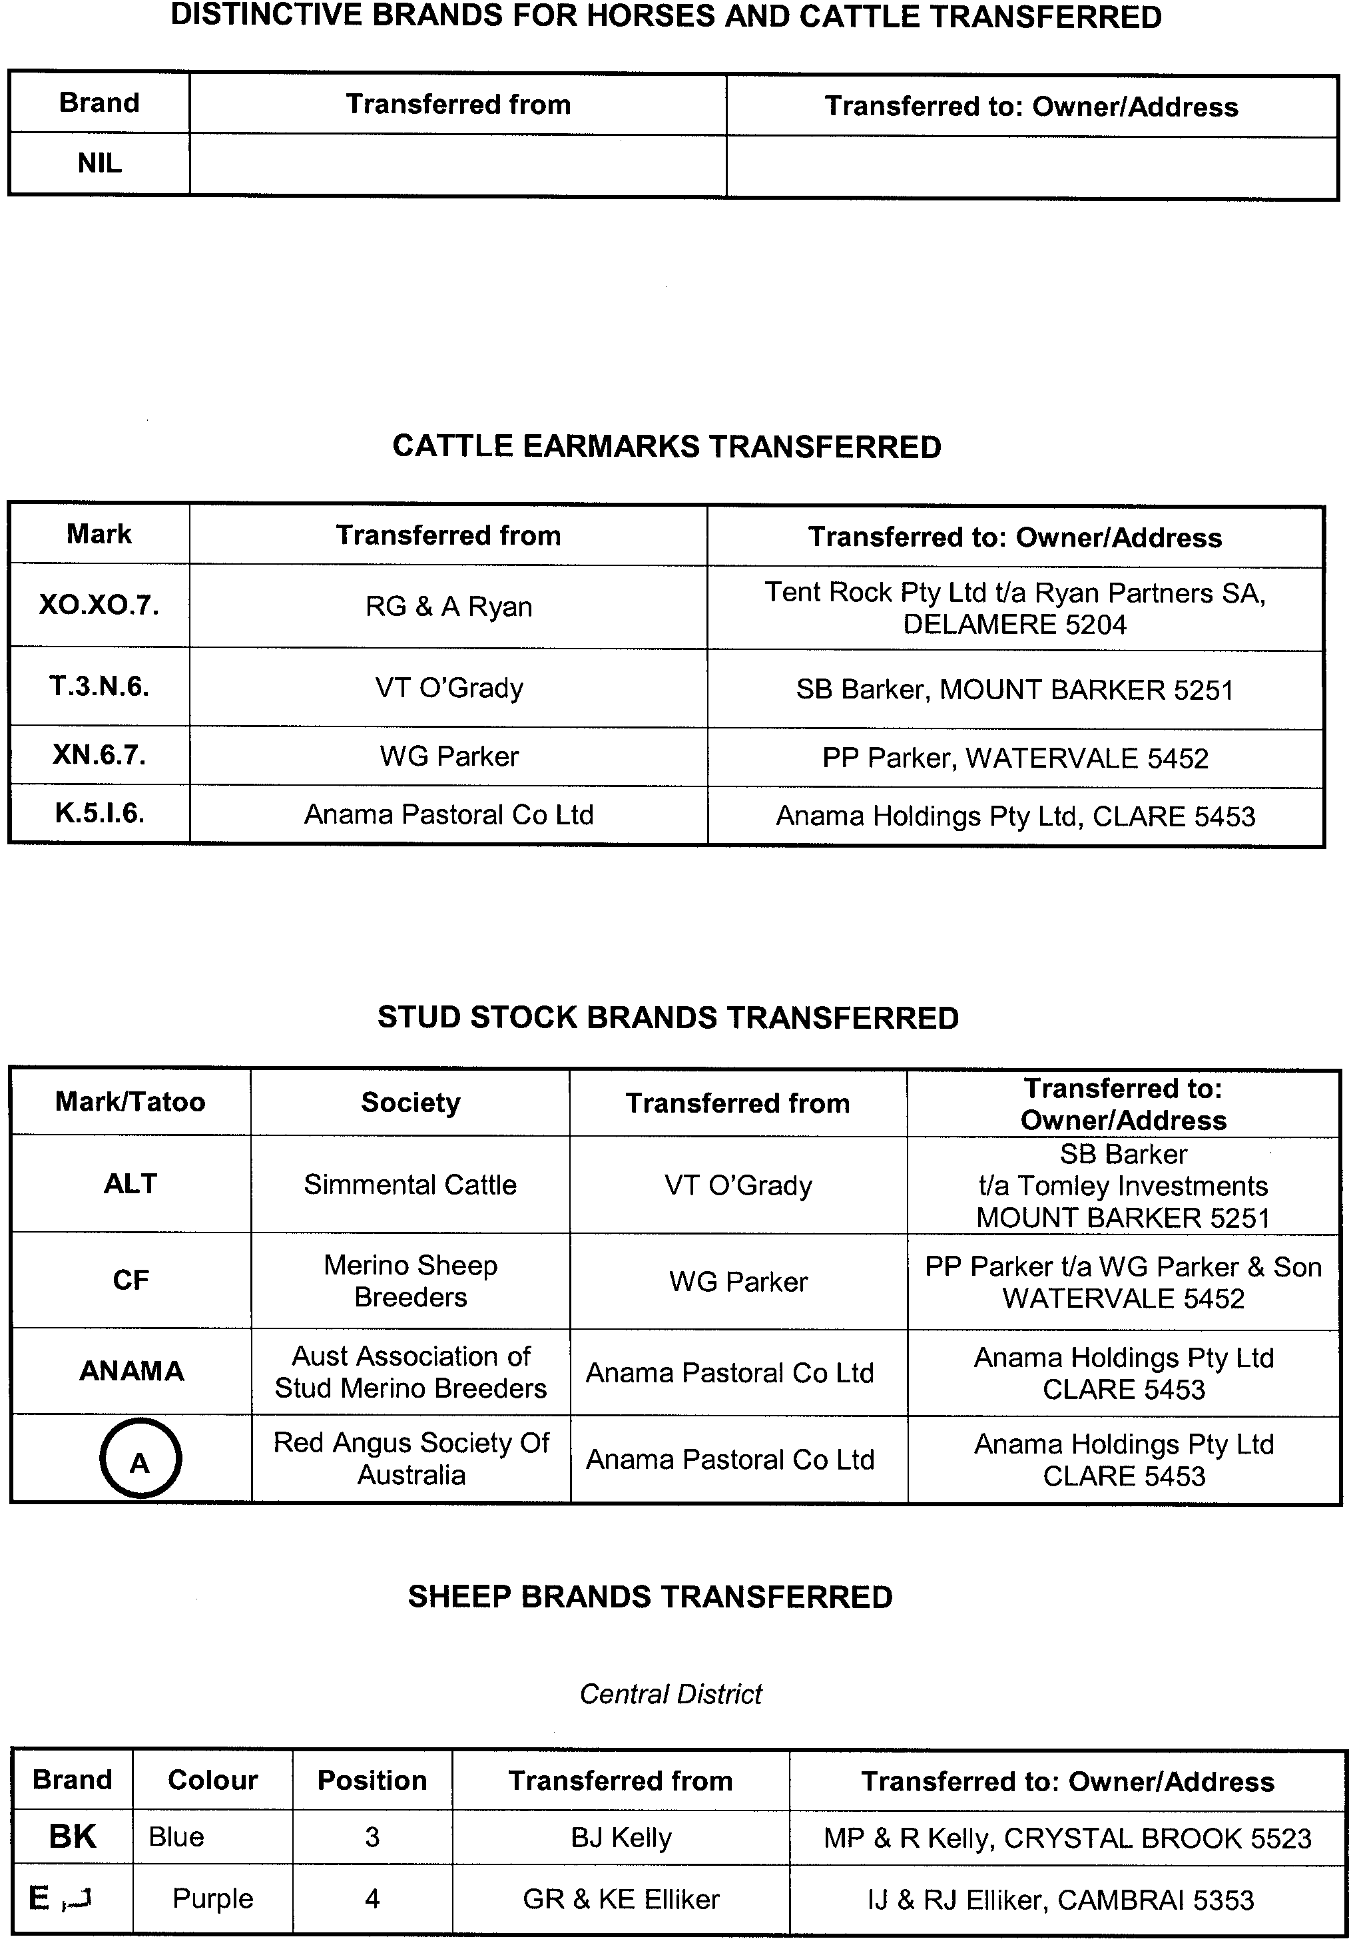
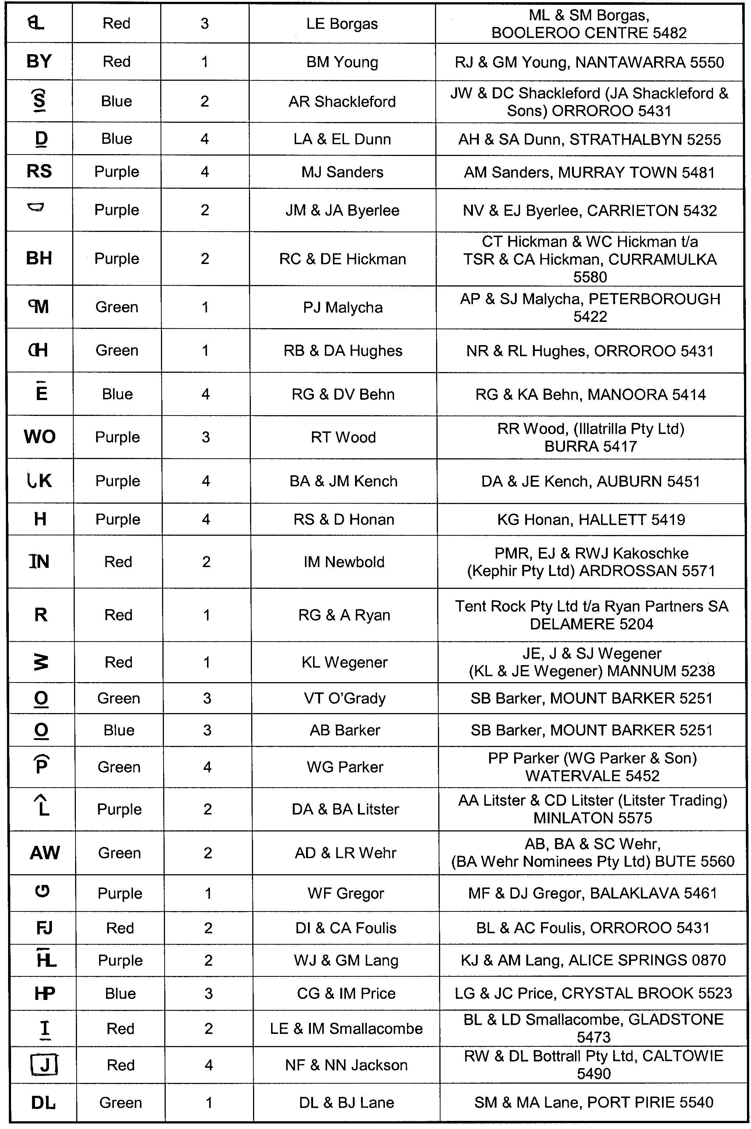
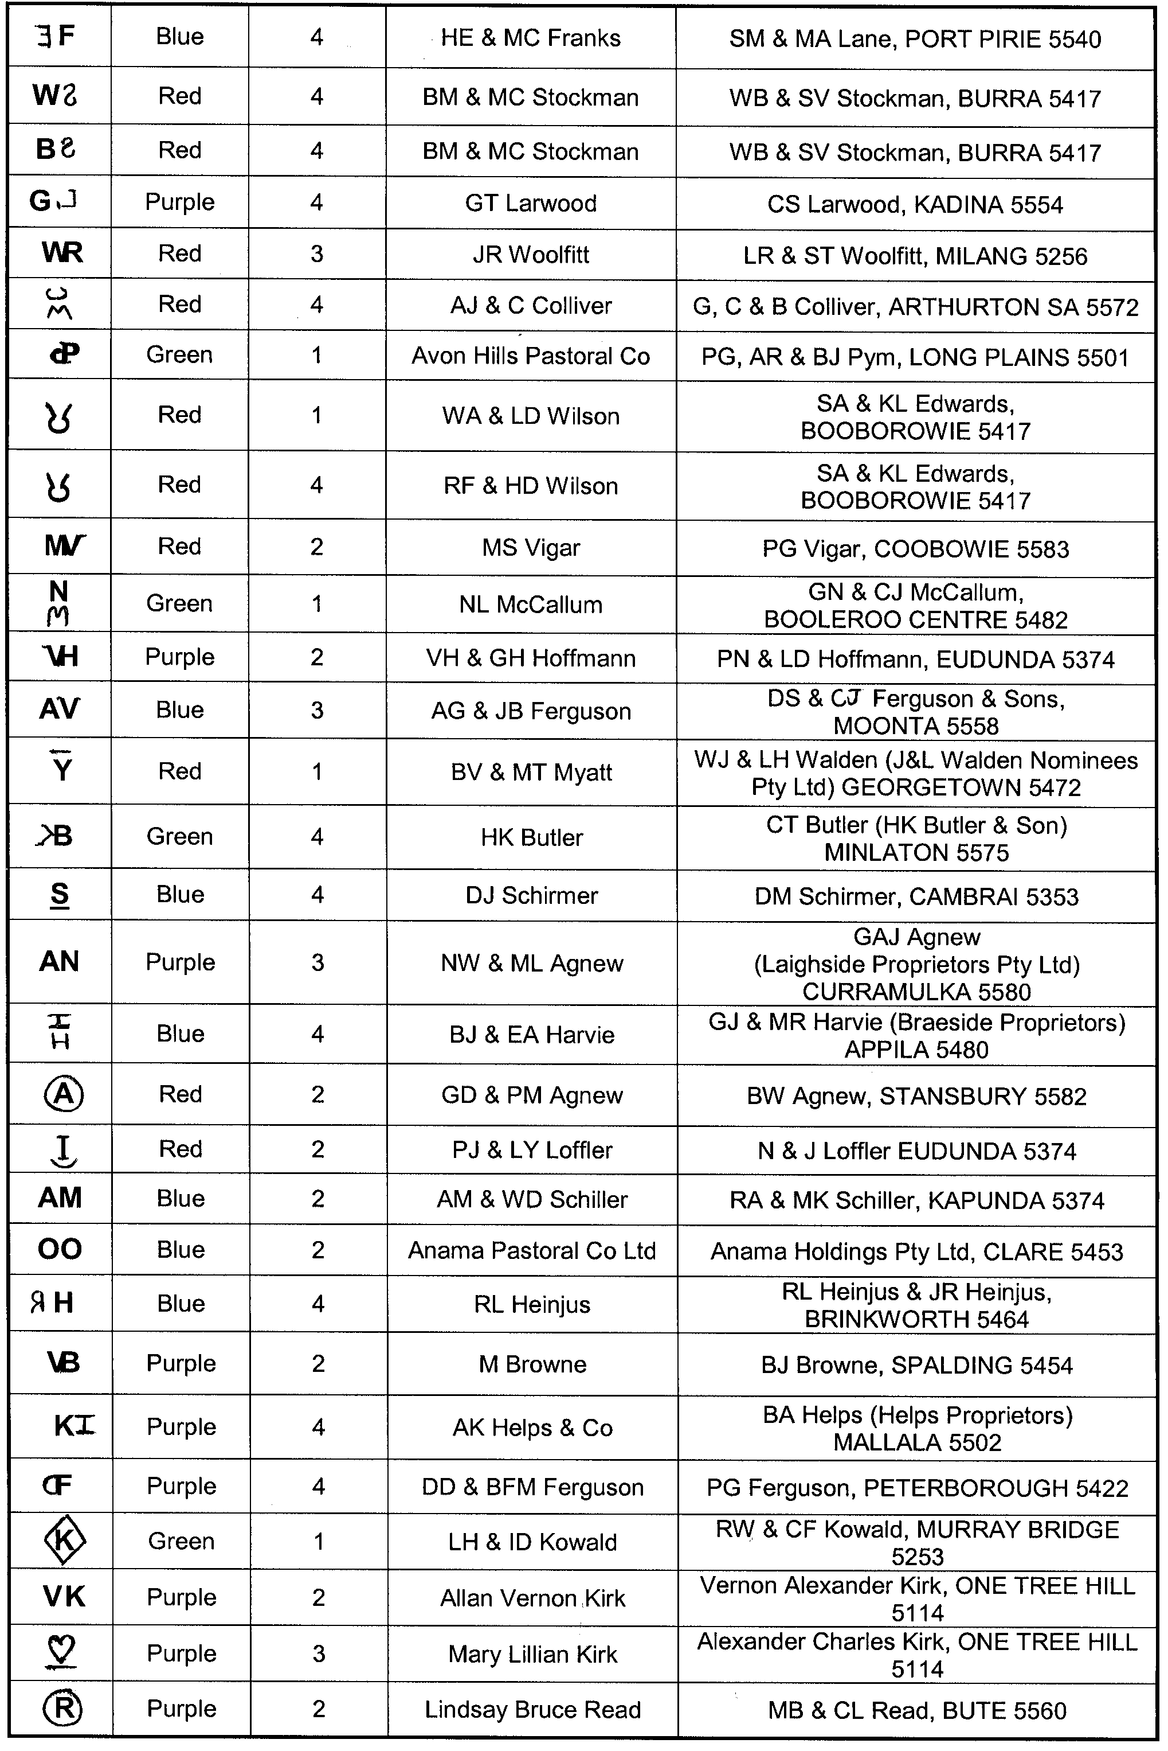
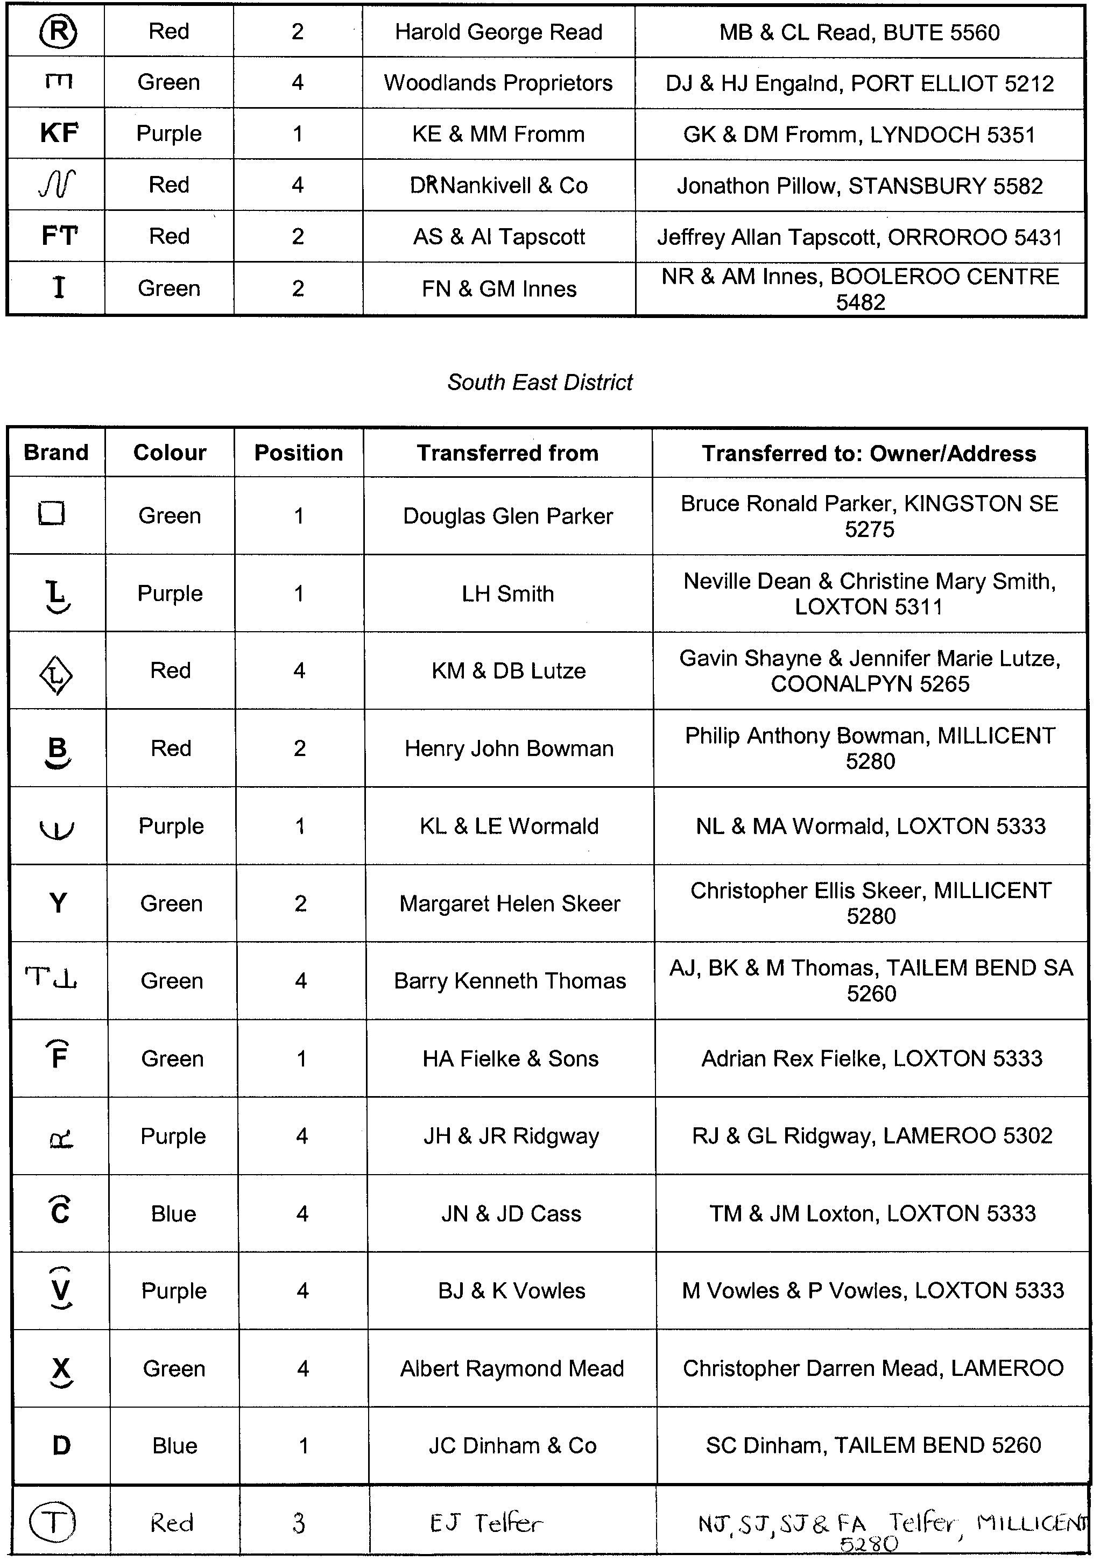
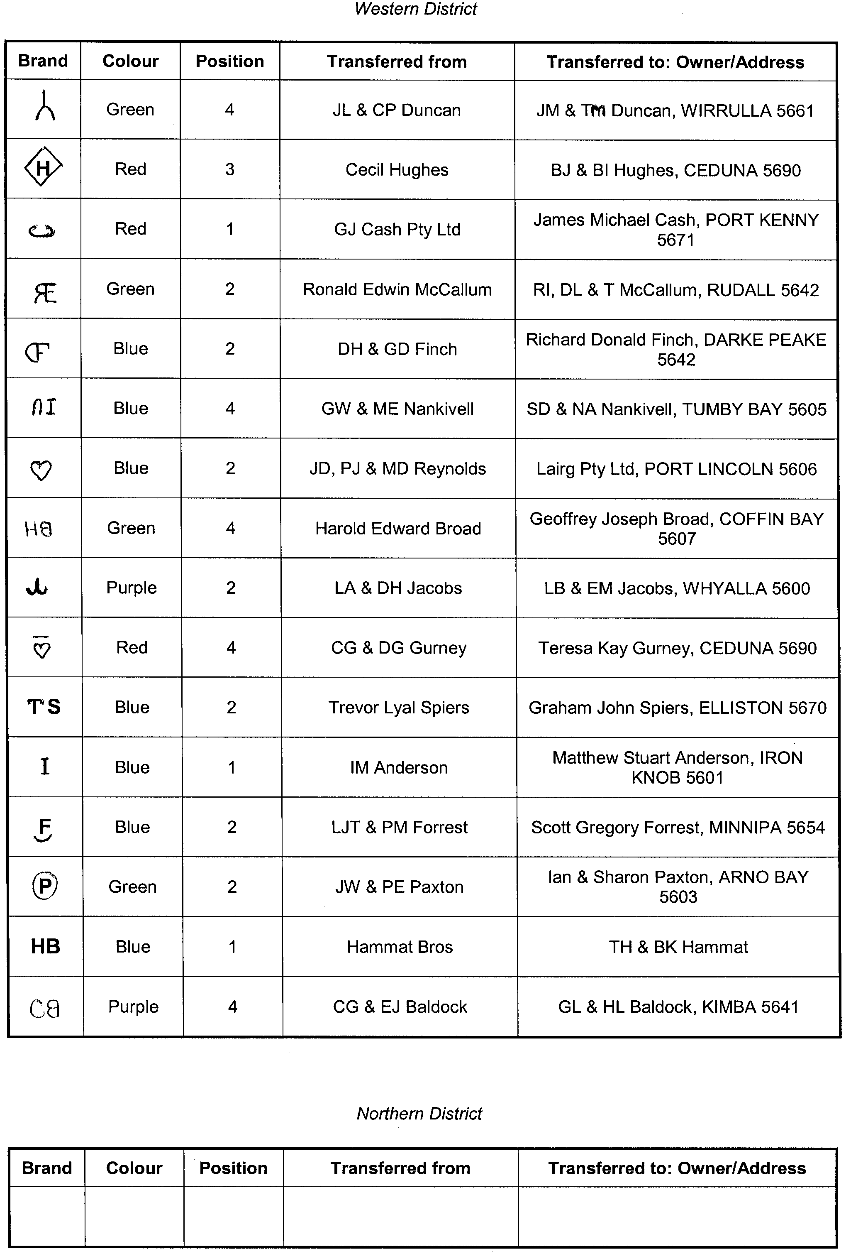
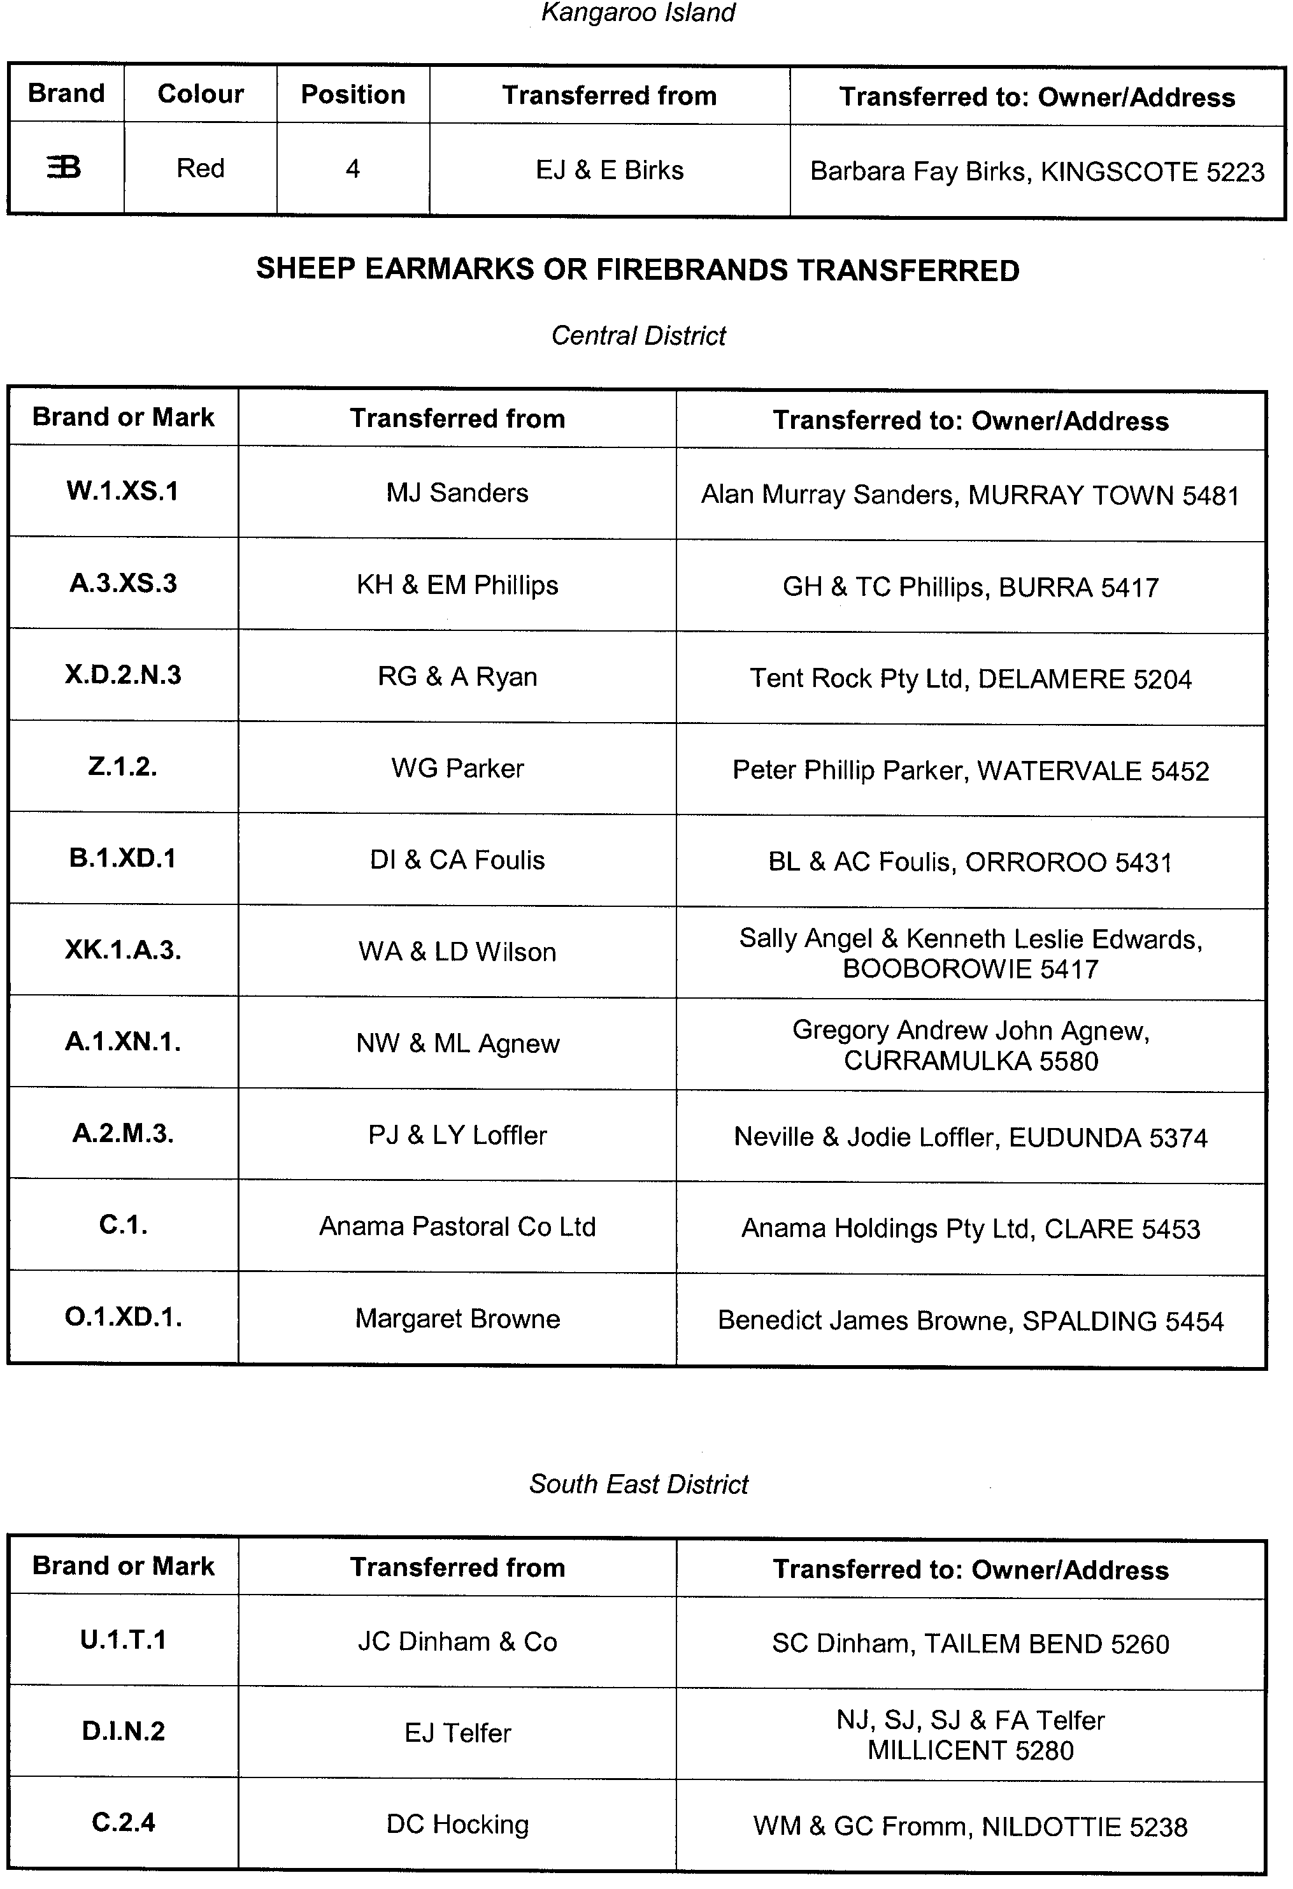
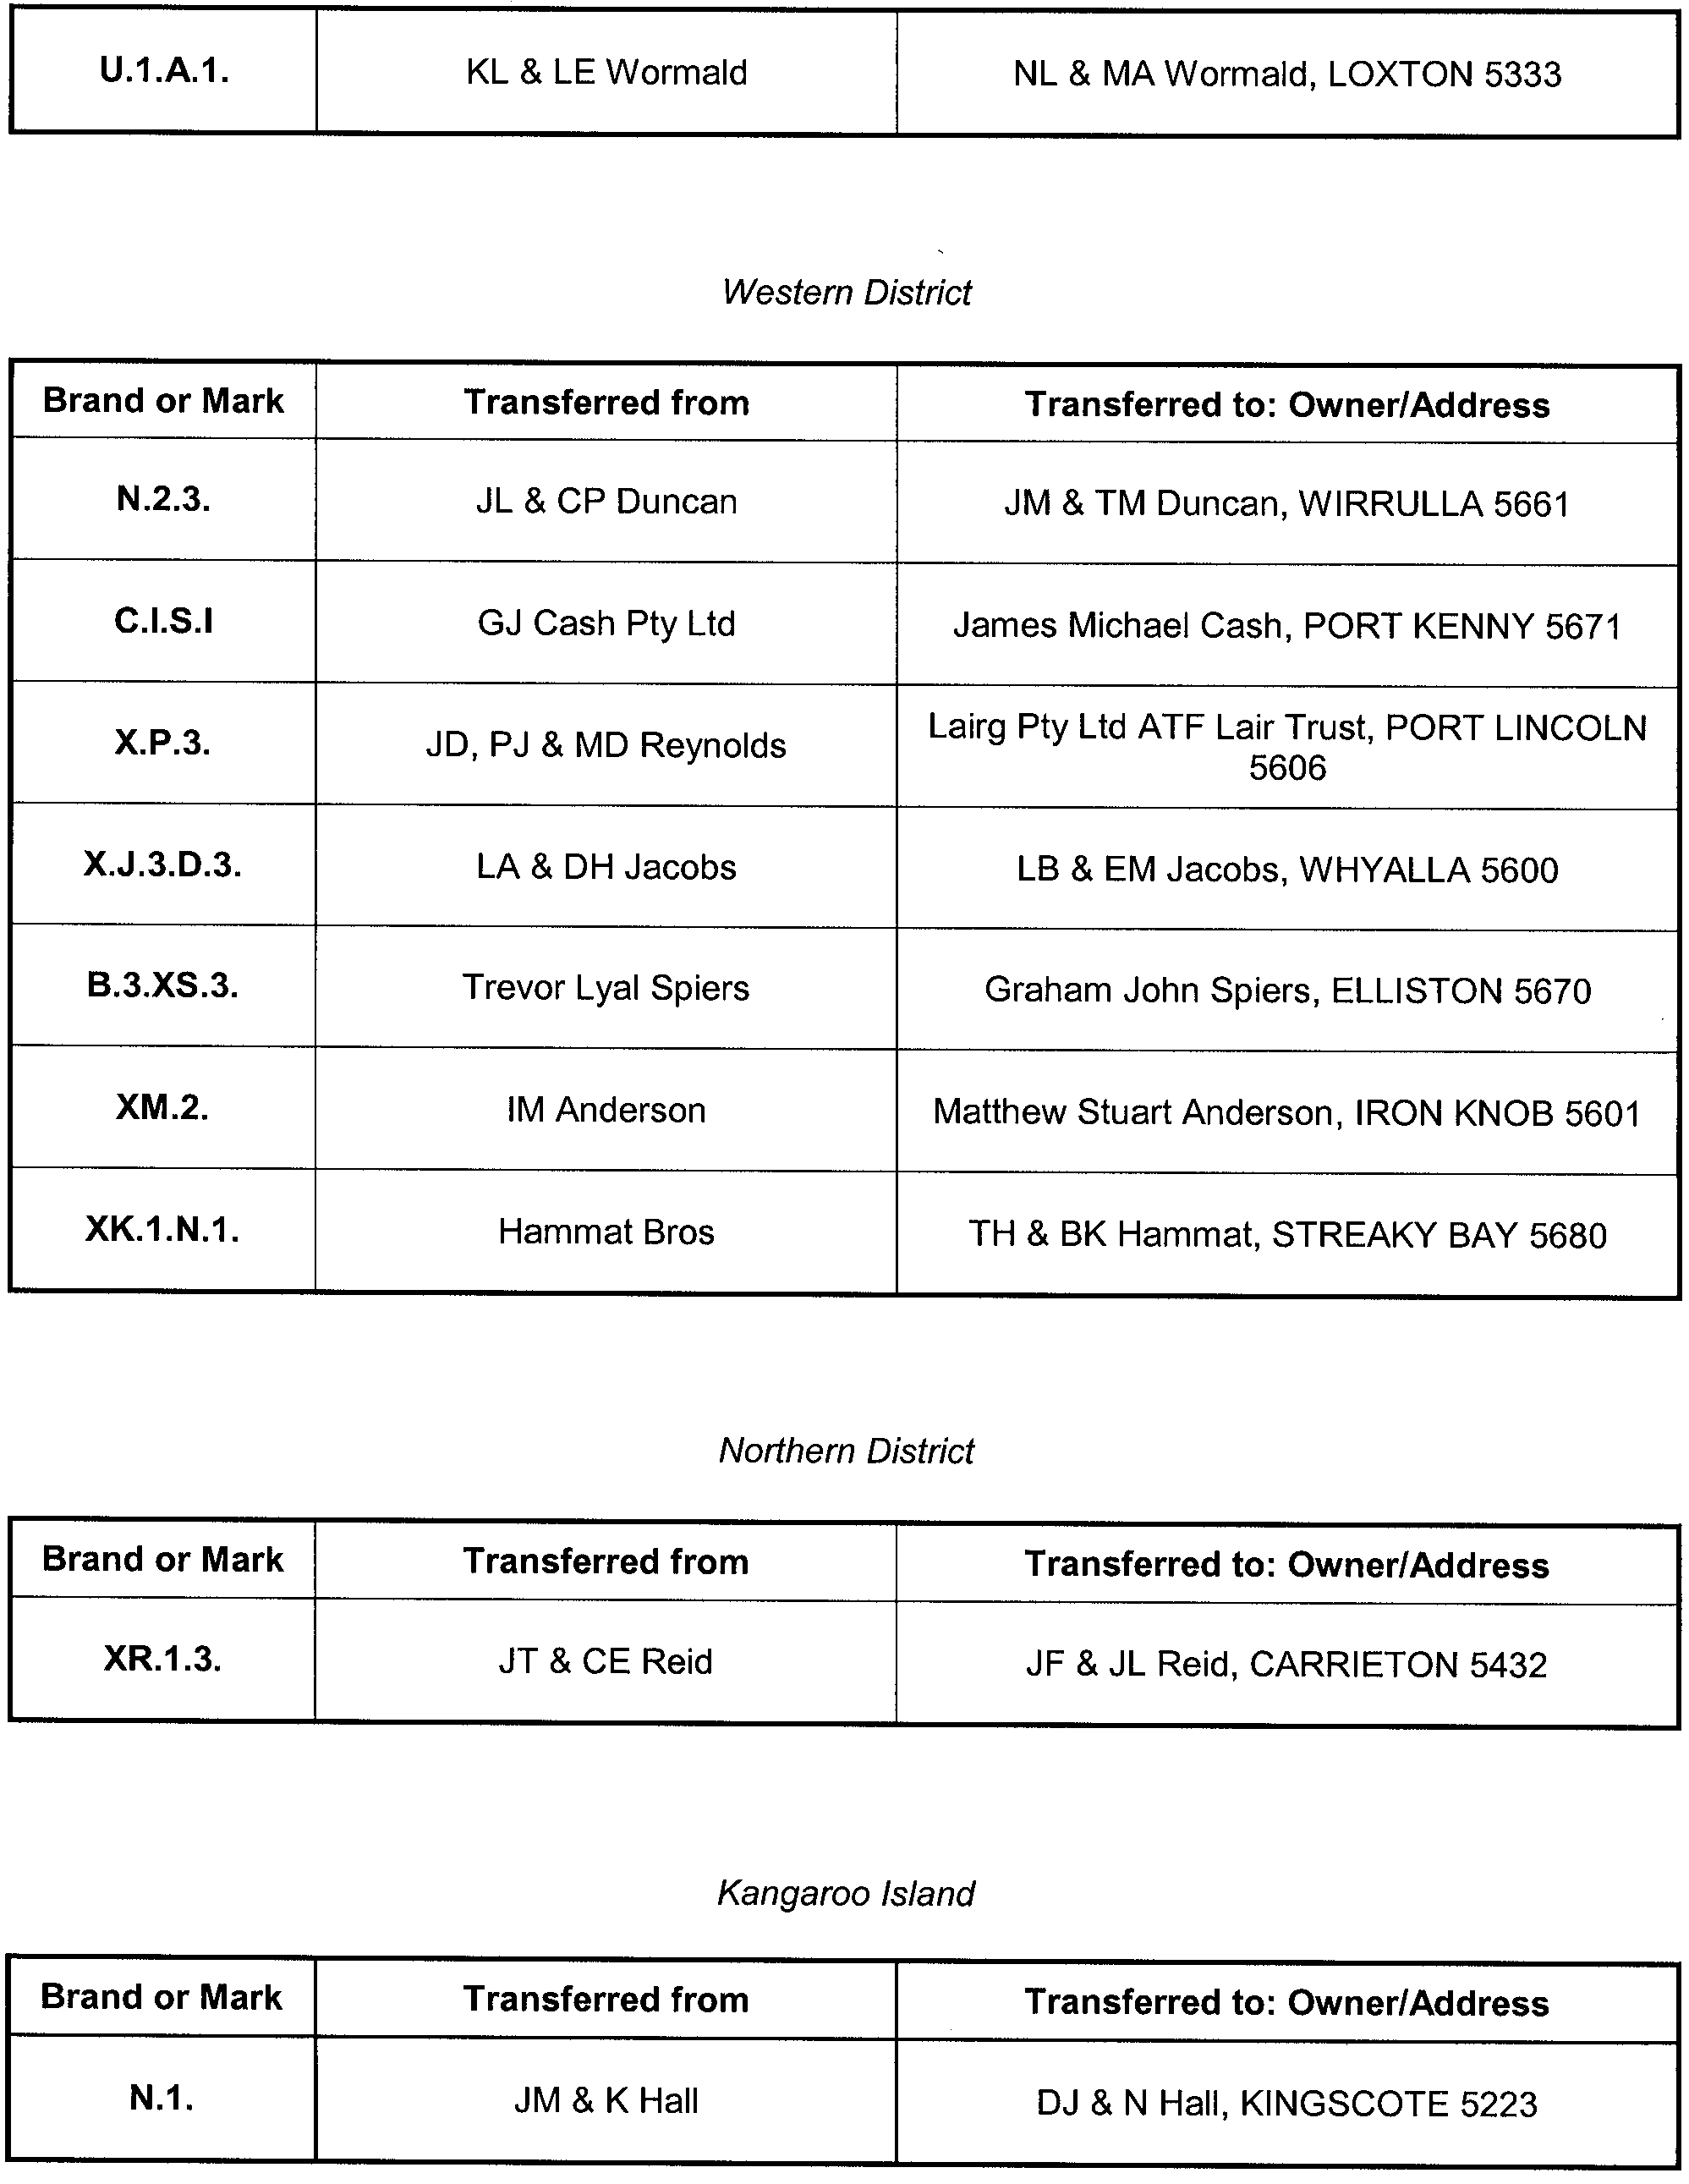
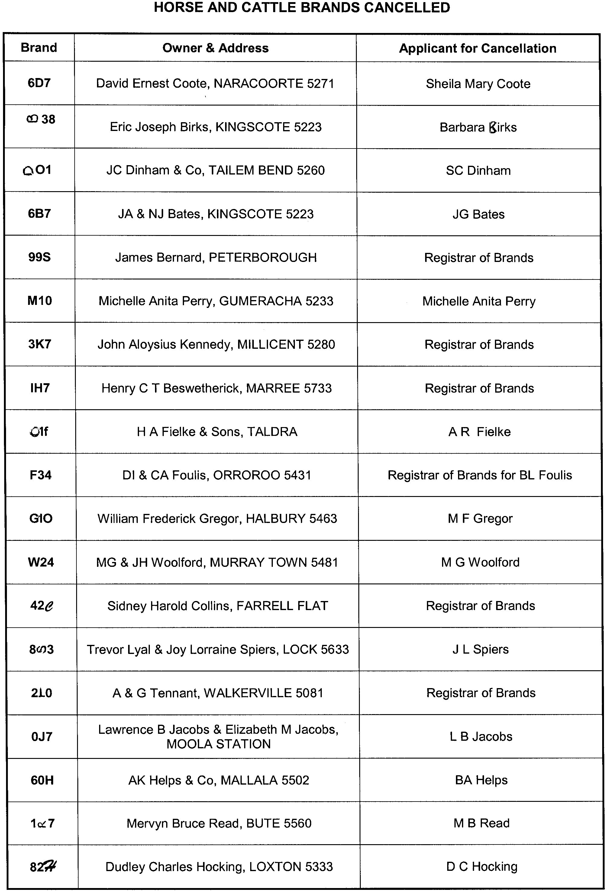
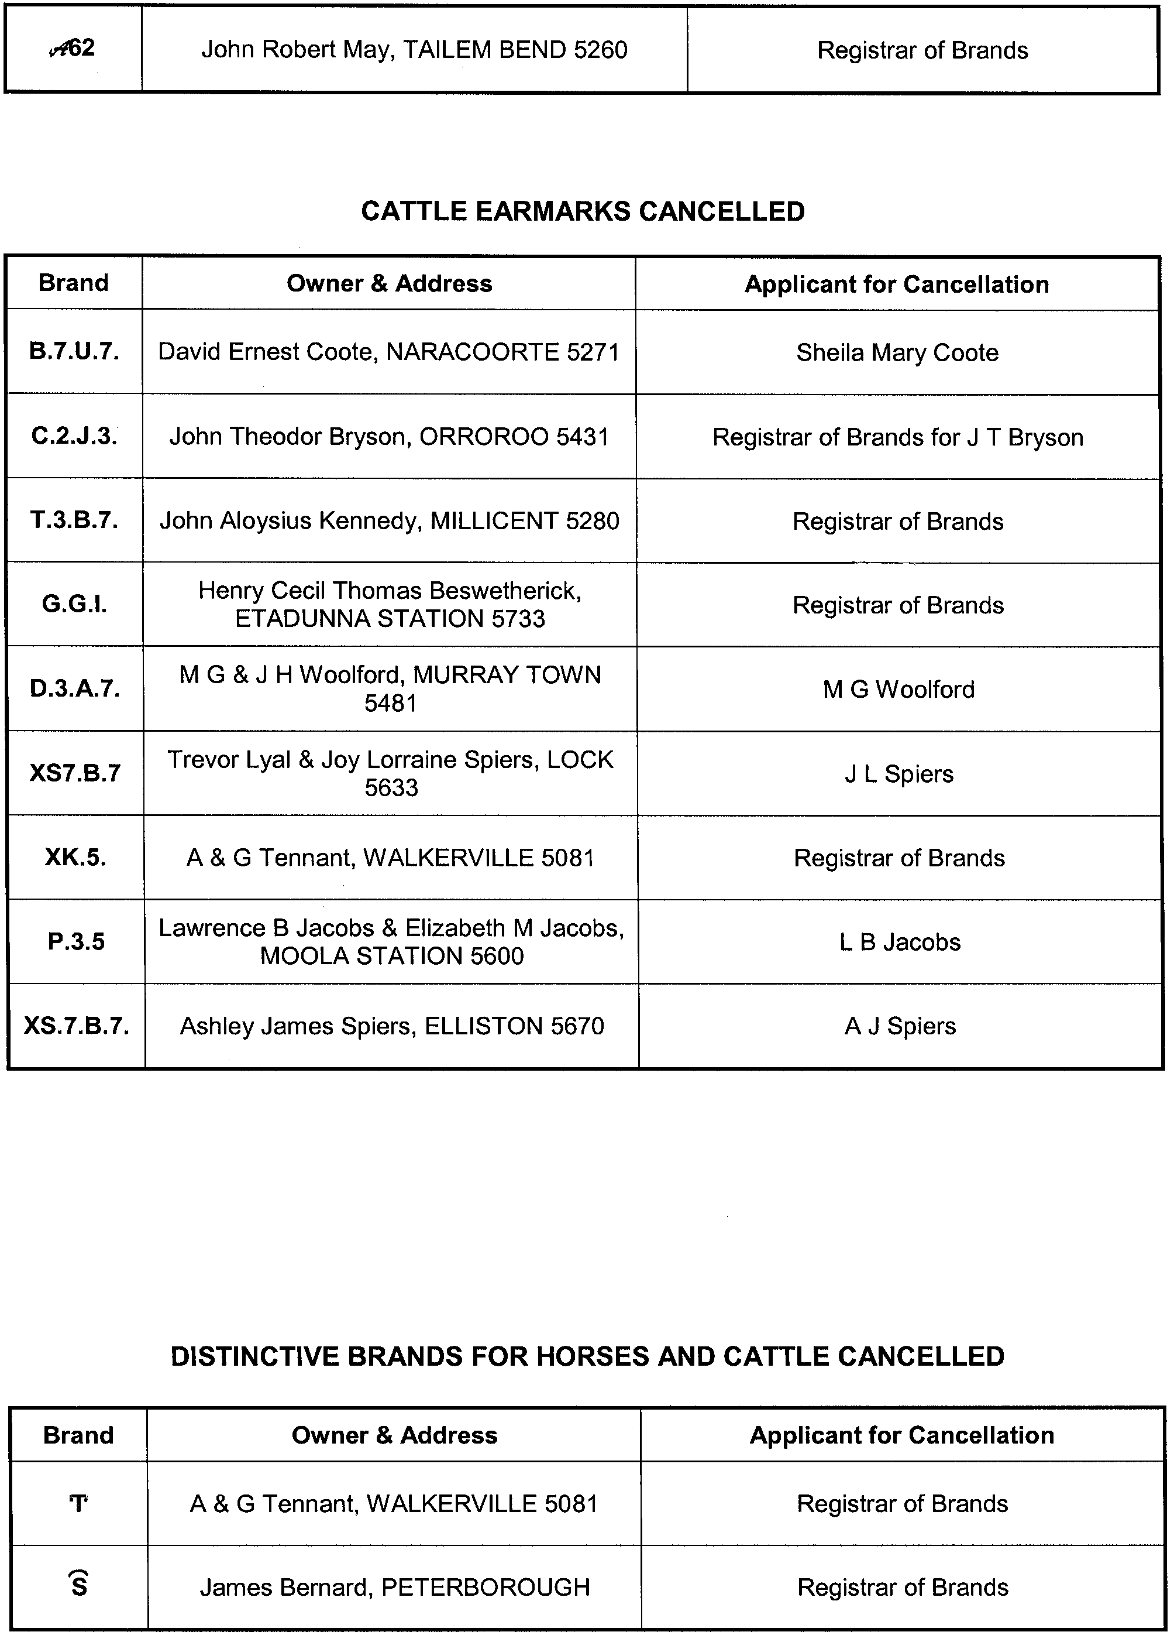
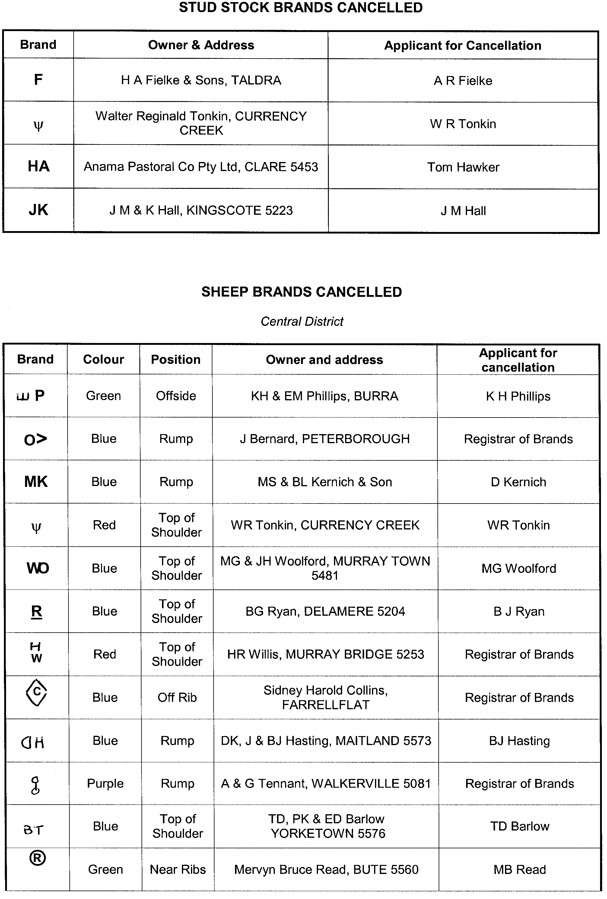
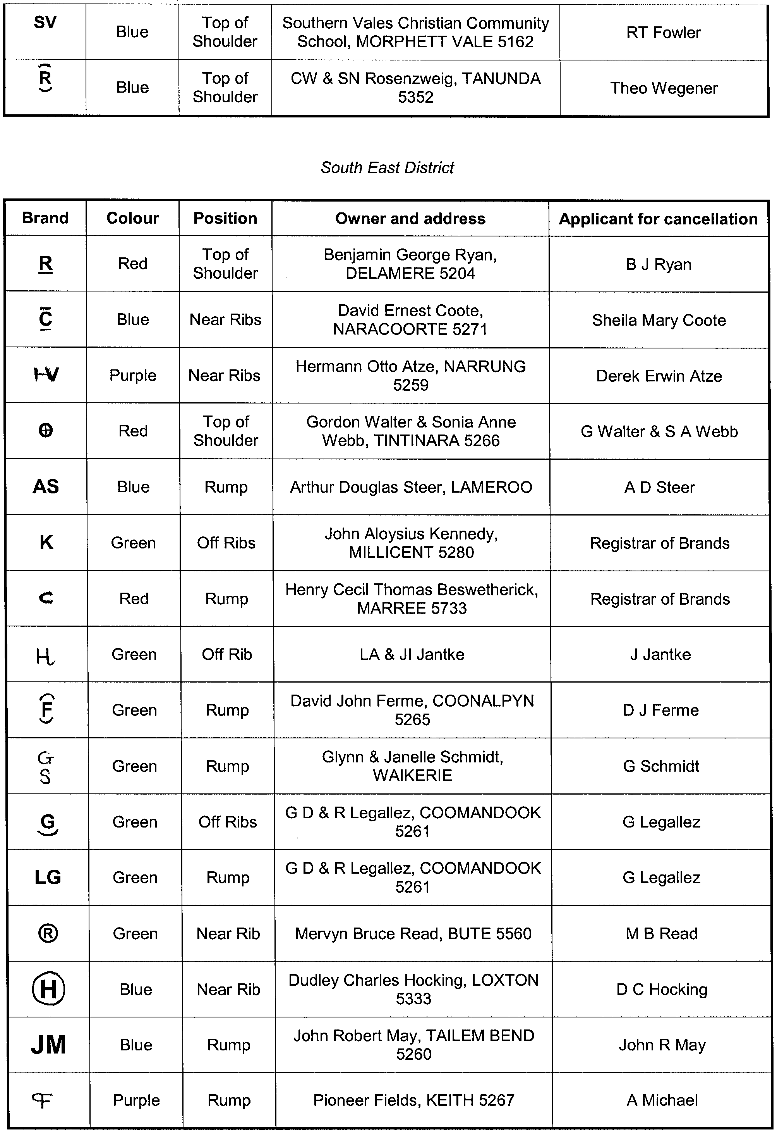
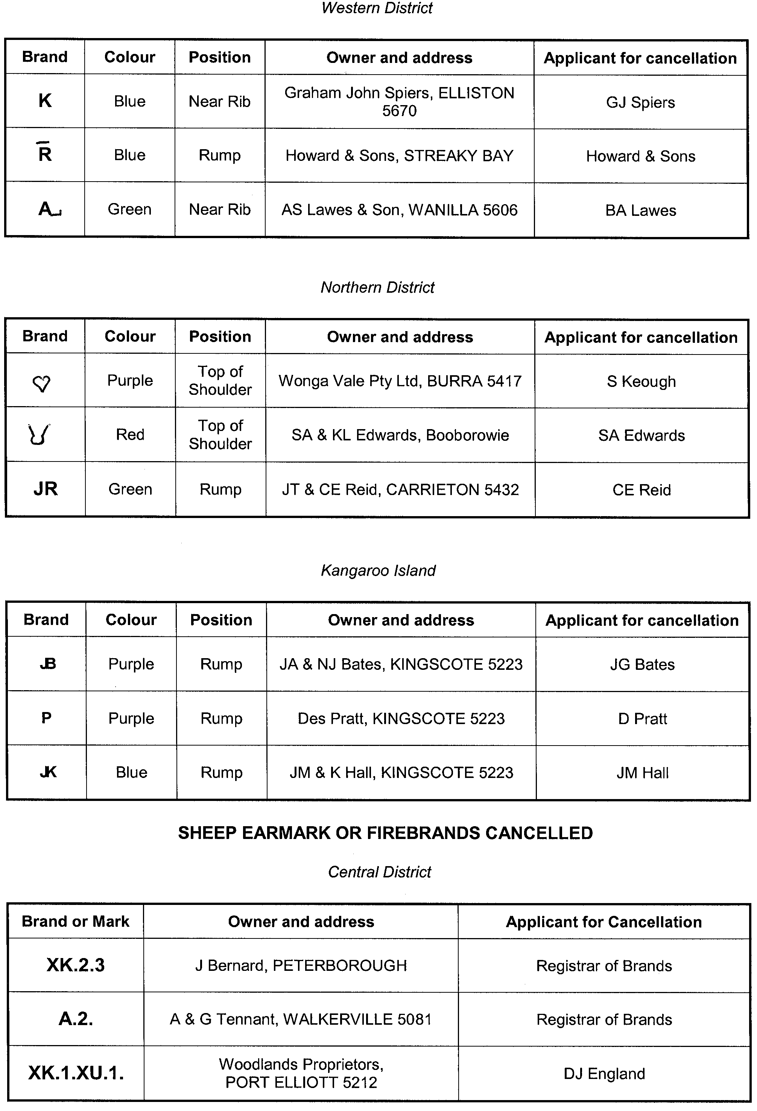
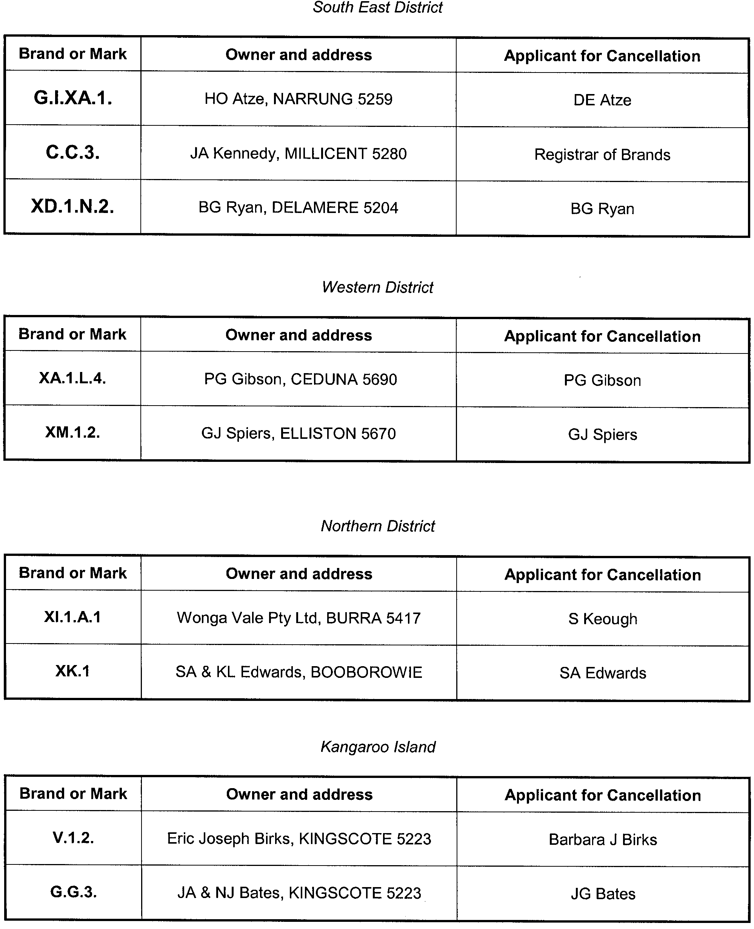

CONTROLLED SUBSTANCES ACT 1984
Revocation of Prohibition Order
TAKE notice that on 18 December 2007, I, Keith Evans, Executive Director, Drug and Alcohol Services South Australia and authorised delegate for the Minister responsible for the Controlled Substances Act 1984 (S.A.), acting pursuant to section 57 (2) of the Controlled Substances Act 1984 (S.A.), revoked the Prohibition Order I made on 13 December 2007 concerning:
Dr Ian Holden Buttfield,
90 Unley Road, Unley, S.A. 5061.
K. Evans, Executive Director, Drug and Alcohol Services S.A., Delegate for the Minister responsible for the Controlled Substances Act

CONTROLLED SUBSTANCES ACT 1984
Prohibition Order
TAKE notice that on 18 December 2007, I, Keith Evans, Executive Director, Drug and Alcohol Services South Australia and authorised delegate for the Minister responsible for the Controlled Substances Act 1984 (S.A.), (‘the Act’) acting pursuant to section 57 (1) of the Act, have formed the opinion that Dr Ian Holden Buttfield has, on a number of occasions, contravened or failed to comply with a condition of an authority granted to him under the Act and prescribed drugs of dependence in an irresponsible manner, and order that:
Dr Ian Holden Buttfield,
90 Unley Road, Unley, S.A. 5061,
is prohibited from supplying, prescribing, administering or having possession of any drug of dependence.
This Order does not apply to any drug of dependence legally supplied or prescribed for the treatment of Dr Buttfield by a dentist or other medical practitioner or by a veterinary surgeon for an animal in his care.
This Order remains in force until revoked by a subsequent Order by the Minister responsible for the Act.
K. Evans, Executive Director, Drug and Alcohol Services S.A., Delegate for the Minister responsible for the Controlled Substances Act

CROWN LANDS ACT 1929: SECTION 5
TAKE NOTICE that pursuant to the Crown Lands Act 1929, I, GAIL GAGO, Minister for Environment and Conservation, Minister of the Crown to whom the administration of the Crown Lands Act 1929 is committed DO HEREBY dedicate the Crown Land defined in The Schedule as Public Road.
The Schedule
Allotment 101 in Deposited Plan 75741, Cobdogla Irrigation Area, Nookamka Division, County of Hamley, being within the district of Berri and Barmera.
Dated 10 January 2008.
Gail Gago, Minister for Environment and Conservation
DEH 11/3742

CROWN LANDS ACT 1929: SECTION 5
TAKE NOTICE that pursuant to the Crown Lands Act 1929, I, GAIL GAGO, Minister for Environment and Conservation, Minister of the Crown to whom the administration of the Crown Lands Act 1929 is committed DO HEREBY resume the land defined in The Schedule.
The Schedule
Reserve for Police Purposes, Allotment 103 in Deposited Plan 59990, formerly identified as Section 357, Hundred of Book-purnong, the proclamation of which was published in the
Government Gazette of 31 January 1963 at page 195, The Second Schedule, being the whole of the land comprised in Crown Record Volume 5885, Folio 895.
Dated 10 January 2008.
Gail Gago, Minister for Environment and Conservation
DEH 11/3750

CROWN LANDS ACT 1929: SECTION 5
TAKE NOTICE that pursuant to the Crown Lands Act 1929, I, GAIL GAGO, Minister for Environment and Conservation, Minister of the Crown to whom the administration of the Crown Lands Act 1929 is committed DO HEREBY resume the land defined in The Schedule.
The Schedule
Reserve for Drainage Purposes, Section 717, Loxton Irrigation Area, Hundred of Bookpurnong, County of Alfred, the proclamation of which was published in the Government Gazette of 13 January 1972 at page 53, being the whole of the land comprised in Crown Record Volume 5755, Folio 625.
Dated 10 January 2008.
Gail Gago, Minister for Environment and Conservation
DEHAA 11/2923

GOVERNMENT LAND SALE
Under the Crown Lands Act 1929
Section 228
Department for Environment and Heritage
Adelaide, 3 January 2008
NOTICE is hereby given that the undermentioned Crown Lands will be offered for sale by public auction to be held on site, Thursday, 24 January 2008, at 12 p.m.
Conditions of Sale
Subject to a reserve price the Allotment shall be sold at the highest bid.
If any dispute arises at the fall of the hammer, the Allotment may be put up again at the discretion of the auctioneer.
The Allotment will not be sold to any person under the age of 18 years and no such person shall be entitled to obtain a Land Grant.
All biddings must be made in an audible voice and the name of the purchaser as declared by the highest bidder will be announced by the auctioneer, and immediately entered by him, against the Allotment sold. Such entry shall be taken as conclusive evidence of the Allotment having been bought by the person whose name has been so announced and entered and the Land Grant shall issue accordingly.
No advance of less than one dollar will be taken as a bid by the auctioneer.
If at the conclusion of the sale any deposit that is unpaid the Allotment may be at once re-offerred.
Time shall be deemed to be of the essence of the contract.
The sale is also subject to all Acts and Regulations now in force relating to the sale of Crown Lands.
The purchaser shall pay to the Department for Environment and Heritage the full purchase money or a deposit of at least 20 per centum thereof at the time of the sale and the balance, if any, within one calendar month.
The purchaser shall also pay within one calendar month of the date of sale the sum of $327.80 for the preparation and registration of each Land Grant.
Gail Gago, Minister for Environment and Conservation

The Schedule
ALLOTMENT 1
DEPOSITED PLAN 75757 HUNDRED OF DUDLEY
COUNTY OF CARNARVON
Limitation: Nil
In the event of expenses being incurred by the Department for Environment and Heritage, pursuant to the Fences Act 1975, in regard to the above Allotment such amounts will be added to the purchase money of the Allotment and will be payable with the deposit.
A. Holmes, Chief Executive, Department for Environment and Heritage
DEH DL/1883/1985

ENVIRONMENT PROTECTION AUTHORITY
Granting of Exemptions
THE Environment Protection Authority has issued an exemption to Motorcycling South Australia Inc. to be exempted from the Environment Protection (Industrial Noise) Policy 1994, to exceed the maximum permitted noise levels on a non-domestic premises.
This exemption relates to the event to be conducted at the Wayville Showgrounds from 22 November 2007 to 24 November 2007.
The Environment Protection Authority has issued an exemption to Nyrstar Port Pirie Pty Ltd in respect of the requirement of Clause 4 (1) of the Environment Protection (Air Quality) Policy 1994, to exceed carbon monoxide emission levels from the tall stacks and acid plant tailgas stack.
The Environment Protection Authority has issued an exemption to Bovis Lend Lease Pty Ltd to allow noise to exceed the maximum level permitted on a non-domestic premises in respect of the requirements of Clause 4 of the Environment Protection (Industrial Noise) Policy 1994. This Exemption relates to the demolition and construction works to be carried out at ‘Conservatory on Hindmarsh Square’ 131-139 Grenfell Street, Adelaide premises.
K. Vogelsang for S. Behrendt, Delegate, Environment Protection Authority

FISHERIES MANAGEMENT ACT 2007: SECTION 115
TAKE notice that pursuant to section 115 of the Fisheries Management Act 2007, Deborah Bower of the University of Canberra, 2 Phillips Road, Berri, S.A. 5343 (the ‘exemption holder’) or a person acting as her agent is exempt from the Fisheries Management Act 2007 but only insofar as they may engage in the use of restricted gear in the River Murray system while attempting to research broad-shelled turtles (the ‘exempted activity’), subject to the conditions set out in Schedule 2, from 21 December 2007 until 31 December 2008, unless varied or revoked earlier.
Schedule 1
• Seine nets
• Fyke nets
• Gill nets (not to be installed)
• Cathedral traps (modified crab pots)
• Crab pots
Schedule 2
1. All native fish species collected during the exemption activity must be immediately returned to the water. Non-native species must not be released into the water alive.
2. The exemption holder must notify PIRSA Fisheries on 1800 065 522 at least two hours prior to conducting the exempted activity and answer a series of questions about the exempted activity. The exemption holder will need to have a copy of the exemption notice at the time of making the call, and be able to provide information about the area and time of the exempted activity, the vehicles and boats involved, the number of agents undertaking the exempted activity and other related questions. Exemption No. 9902083.
3. While engaged in the exempted activity, the exemption holders must be in possession of a copy of this notice. Such notice must be produced to a PIRSA Fisheries Compliance Officer if requested.
4. The exemption holders must not contravene or fail to comply with the Fisheries Management Act 2007, or any regulations made under that Act, except where specifically exempted by this notice.
Dated 24 December 2007.
M. Smallridge, Director of Fisheries

LAND AND BUSINESS (SALE AND CONVEYANCING)
ACT 1994
Exemption
TAKE notice that, pursuant to section 23 (3) of the Land and Business (Sale and Conveyancing) Act 1994, I, Paul Caica, Acting Minister for Consumer Affairs, do hereby exempt the person named in Schedule 1 from the application of section 23 (2) of the Act in relation to the purchase of the land specified in Schedule 2.
Schedule 1
Belinda Sally MacDonald, an employee of Southern Australian Livestock Pty Ltd.
Schedule 2
The land described in a whole of certificate of title register book volume 5181, folio 947, situated at Lot 3, Glencoe Road, Glencoe, S.A. 5291.
Dated 3 January 2008.
Paul Caica, Acting Minister for Consumer Affairs

LAND AND BUSINESS (SALE AND CONVEYANCING)
ACT 1994
Exemption
TAKE notice that, pursuant to section 23 (3) of the Land and Business (Sale and Conveyancing) Act 1994, I, Paul Caica, Acting Minister for Consumer Affairs, do hereby exempt the person named in Schedule 1 from the application of section 23 (2) of the Act in relation to the purchase of the land specified in Schedule 2.
Schedule 1
Nicholas David Tolley, an employee of Lend Lease Realty Pty Ltd.
Schedule 2
The land described in a portion of certificate of title register book volume 5990, folio 762, situated at Lot 37, Franklin Street, Mawson Lakes, S.A. 5095.
Dated 3 January 2008.
Paul Caica, Acting Minister for Consumer Affairs

LAND AND BUSINESS (SALE AND CONVEYANCING)
ACT 1994
Exemption
TAKE notice that, pursuant to section 23 (3) of the Land and Business (Sale and Conveyancing) Act 1994, I, Paul Caica, Acting Minister for Consumer Affairs, do hereby exempt the person named in Schedule 1 from the application of section 23 (2) of the Act in relation to the purchase of the land specified in Schedule 2.
Schedule 1
Debra Ann Philps, an employee of Deborah F. Tucker Pty Ltd.
Schedule 2
The land described in a portion of certificate of title register book volume 5159, folio 529, situated at Lot 3, 45 Caffrey Street, McLaren Vale, S.A. 5171.
Dated 3 January 2008.
Paul Caica, Acting Minister for Consumer Affairs

LAND AND BUSINESS (SALE AND CONVEYANCING)
ACT 1994
Exemption
TAKE notice that, pursuant to section 23 (3) of the Land and Business (Sale and Conveyancing) Act 1994, I, Paul Caica, Acting Minister for Consumer Affairs, do hereby exempt the person named in Schedule 1 from the application of section 23 (2) of the Act in relation to the purchase of the land specified in Schedule 2.
Schedule 1
Vaughn Robert Pairman, an employee of Pairman Real Estate Pty Ltd.
Schedule 2
The land described in a whole of certificate of title register book volume 5937, folio 742, situated at 98 Penrice Road, Penrice, S.A. 5353.
Dated 3 January 2008.
Paul Caica, Acting Minister for Consumer Affairs

LAND AND BUSINESS (SALE AND CONVEYANCING)
ACT 1994
Exemption
TAKE notice that, pursuant to section 23 (3) of the Land and Business (Sale and Conveyancing) Act 1994, I, Paul Caica, Acting Minister for Consumer Affairs, do hereby exempt the person named in Schedule 1 from the application of section 23 (2) of the Act in relation to the purchase of the land specified in Schedule 2.
Schedule 1
Kellie Michelle Crosby, an employee of Elders Ltd.
Schedule 2
The land described in a portion of certificate of title register book volume 5973, folio 186, situated at 30A Cook Street, Port Lincoln, S.A. 5606.
Dated 3 January 2008.
Paul Caica, Acting Minister for Consumer Affairs

LAND AND BUSINESS (SALE AND CONVEYANCING)
ACT 1994
Exemption
TAKE notice that, pursuant to section 23 (3) of the Land and Business (Sale and Conveyancing) Act 1994, I, Paul Caica, Acting Minister for Consumer Affairs, do hereby exempt the persons named in Schedule 1 from the application of section 23 (2) of the Act in relation to the purchase of the land specified in Schedule 2.
Schedule 1
Valerie Jones and Milton Bruce Hamilton, employees of Sakjel Pty Ltd.
Schedule 2
The land described in a portion of certificate of title register book volume 5478, folio 132, situated at Lot 31, Geltwood Grove, Millicent, S.A. 5280.
Dated 3 January 2008.
Paul Caica, Acting Minister for Consumer Affairs

LAND AND BUSINESS (SALE AND CONVEYANCING)
ACT 1994
Exemption
TAKE notice that, pursuant to section 23 (3) of the Land and Business (Sale and Conveyancing) Act 1994, I, Paul Caica, Acting Minister for Consumer Affairs, do hereby exempt the person named in Schedule 1 from the application of section 23 (2) of the Act in relation to the purchase of the land specified in Schedule 2.
Schedule 1
Valerie Jones, an officer of Sakjel Pty Ltd.
Schedule 2
The whole of the land described in certificate of title register book volume 5837, folio 944, situated at Lot 10, Deposited Plan 55244, Hundred of Mount Muirhead, corner of Acacia Drive and Wattle Road, Millicent, S.A. 5280.
Dated 10 January 2008.
P. Caica, Acting Minister for Consumer Affairs

LAND AND BUSINESS (SALE AND CONVEYANCING)
ACT 1994
Exemption
TAKE notice that, pursuant to section 23 (3) of the Land and Business (Sale and Conveyancing) Act 1994, I, Paul Caica, Acting Minister for Consumer Affairs, do hereby exempt the person named in Schedule 1 from the application of section 23 (2) of the Act in relation to the purchase of the land specified in Schedule 2.
Schedule 1
James Reginald Pilkington, an employee of Sexton Glover Pty Ltd.
Schedule 2
The land described in a portion of certificate of title register book volume 5726, folio 134, situated at Lot 7, St Andrews Drive, Strathalbyn, S.A. 5255.
Dated 10 January 2008.
P. Caica, Acting Minister for Consumer Affairs

LAND AND BUSINESS (SALE AND CONVEYANCING)
ACT 1994
Exemption
TAKE notice that, pursuant to section 23 (3) of the Land and Business (Sale and Conveyancing) Act 1994, I, Paul Caica, Acting Minister for Consumer Affairs, do hereby exempt the person named in Schedule 1 from the application of section 23 (2) of the Act in relation to the purchase of the land specified in Schedule 2.
Schedule 1
Michael John Palm, an employee of Pinkerton Palm Hamlyn Steen Real Estate Pty Ltd.
Schedule 2
The land described in a whole of certificate of title register book volume 5992, folio 387, situated at 3 Ralston Street, Penola, S.A. 5277.
Dated 10 January 2008.
P. Caica, Acting Minister for Consumer Affairs

LAND AND BUSINESS (SALE AND CONVEYANCING)
ACT 1994
Exemption
TAKE notice that, pursuant to section 23 (3) of the Land and Business (Sale and Conveyancing) Act 1994, I, Paul Caica, Acting Minister for Consumer Affairs, do hereby exempt the persons named in Schedule 1 from the application of section 23 (2) of the Act in relation to the purchase of the land specified in Schedule 2.
Schedule 1
Leonard William Easther and Vickie Therese Easther, employees of M. A. Easther Nominees Pty Ltd.
Schedule 2
The land described in a whole of certificate of title register book volume 5589, folio 776, situated at 115 Marine Parade, Port Vincent, S.A. 5581.
Dated 10 January 2008.
P. Caica, Acting Minister for Consumer Affairs

LAND AND BUSINESS (SALE AND CONVEYANCING)
ACT 1994
Exemption
TAKE notice that, pursuant to section 23 (3) of the Land and Business (Sale and Conveyancing) Act 1994, I, Paul Caica, Acting Minister for Consumer Affairs, do hereby exempt the person named in Schedule 1 from the application of section 23 (2) of the Act in relation to the purchase of the land specified in Schedule 2.
Schedule 1
Ciaran Leahy, an employee of Kyzac Pty Ltd.
Schedule 2
The land described in a whole of certificate of title register book volume 5716, folio 640, situated at 9 Clayton Street, Moonta Bay, S.A. 5558.
Dated 10 January 2008.
P. Caica, Acting Minister for Consumer Affairs

LIQUOR LICENSING ACT 1997 AND GAMING MACHINES ACT 1992
Notice of Application
NOTICE is hereby given, pursuant to section 52 of the Liquor Licensing Act 1997 and section 29 of the Gaming Machines Act 1992, that B. J. Thommo Pty Ltd has applied to the Licensing Authority for the transfer of a Hotel and Gaming Machine Licence, variation to Entertainment Consent, Extended Trading Authorisation and a variation to Gaming Machine Hours in respect of premises situated at Daranda Terrace, Milang, S.A. 5256 and known as Pier Hotel.
The applications have been set down for callover on 8 February 2008 at 9 a.m.
Conditions
The following licence conditions are sought:
• Extended Trading Authorisation is sought for the following days and times:
Thursday to Saturday: Midnight to 2 a.m. the following day;
Sunday: 8 p.m. to midnight;
Maundy Thursday: Midnight to 2 a.m.;
Christmas Eve: 8 p.m. to 2 a.m. the following day;
Days preceding Public Holidays: Midnight to 2 a.m.; and
Sundays preceding Public Holidays: 8 p.m. to 2 a.m. the following day.
• Variation to the current Entertainment Consent:
From Areas 1-5 only:
Thursday to Saturday: 8.30 p.m. to midnight;
Sunday: Midday to 8 p.m.; and
New Year’s Eve: 8 p.m. to 2 a.m. the following day.
To Areas 1-5 only:
Thursday to Saturday: 8.30 p.m. to 2 a.m. the following day;
Sunday: Midday to midnight;
Maundy Thursday: 8.30 p.m. to 2 a.m. the following day;
Christmas Eve: 8.30 p.m. to 2 a.m. the following day;
Sunday Christmas Eve: 8.30 p.m. to 2 a.m. the following day;
Days preceding Public Holidays: 8.30 p.m. to 2 a.m. the following day; and
Sunday preceding Public Holidays: 8.30 p.m. to 2 a.m. the following day.
Any person may object to the application by lodging a notice of objection in the prescribed form with the Liquor and Gambling Commissioner and serving a copy of the notice on the applicant at the applicant’s address, at least seven days before the callover date (viz: 1 February 2008).
The applicant’s address for service is c/o Philip Foreman, Foreman Legal, 69 Mount Barker Road, Stirling, S.A. 5152.
Plans in respect of the premises the subject of the application are open to public inspection without fee at the Office of the Liquor and Gambling Commissioner, 9th Floor, East Wing, 50 Grenfell Street, Adelaide, S.A. 5000. Phone 8226 8410, Fax:
8226 8512. Email: olgc@agd.sa.gov.au.
Dated 28 December 2007.
Applicant

LIQUOR LICENSING ACT 1997
Notice of Application
NOTICE is hereby given, pursuant to section 52 (2) (b) of the Liquor Licensing Act 1997, that Ajisen (Adelaide) Pty Ltd has applied to the Licensing Authority for a Restaurant Licence with Section 34 (1) (c) in respect of premises situated at 23 Leigh Street, Adelaide, S.A. 5000 and to be known as Ajisen Ramen.
The application has been set down for callover on 25 January 2008 at 9 a.m.
Conditions
The following licence conditions are sought:
• Approval under Section 34 (1) (c) to sell liquor on any day except Good Friday and Christmas Day for consumption on the licensed premises by persons:
(a) seated at a table; or
(b) attending a function in which food is provided.
Any person may object to the application by lodging a notice of objection in the prescribed form with the Liquor and Gambling Commissioner and serving a copy of the notice on the applicant at the applicant’s address, at least seven days before the callover date (viz: 18 January 2008).
The applicant’s address for service is c/o Irene Lau Hui Ee, 11/7-9 L’estrange Street, Glenside, S.A. 5065.
Plans in respect of the premises the subject of the application are open to public inspection without fee at the Office of the Liquor and Gambling Commissioner, 9th Floor, East Wing, 50 Grenfell Street, Adelaide, S.A. 5000. Phone 8226 8410, Fax:
8226 8512. Email: olgc@agd.sa.gov.au.
Dated 18 December 2008.
Applicant

LIQUOR LICENSING ACT 1997
Notice of Application
NOTICE is hereby given, pursuant to section 52 (2) (b) of the Liquor Licensing Act 1997, that Shingleback Wine Pty Ltd has applied to the Licensing Authority for a Producer’s Licence in respect of the premises situated at Lot 11, Stump Hill Road, McLaren Vale, S.A. 5171 and to be known as Shingleback Cellar Door.
The application has been set down for callover on 25 January 2008 at 9 a.m.
Any person may object to the application by lodging a notice of objection in the prescribed form with the Liquor and Gambling Commissioner and serving a copy of the notice on the applicant at the applicant’s address, at least seven days before the callover date (viz: 18 January 2008).
The applicant’s address for service is c/o Craig Camm, P.O. Box 81, McLaren Vale, S.A. 5171.
Plans in respect of the premises the subject of the application are open to public inspection without fee at the Office of the Liquor and Gambling Commissioner, 9th Floor, East Wing, 50 Grenfell Street, Adelaide, S.A. 5000. Phone 8226 8410, Fax:
8226 8512. Email: olgc@agd.sa.gov.au.
Dated 19 December 2008.
Applicant

LIQUOR LICENSING ACT 1997
Notice of Application
NOTICE is hereby given, pursuant to section 52 (2) (b) of the Liquor Licensing Act 1997, that R. I. and G. S. Kennedy Pty Ltd has applied to the Licensing Authority for approval to licence the front verandah and the barn which abuts the rear Beer Garden in respect of the premises situated at Main Street, Nairne, S.A. 5252 and known as District Hotel.
The application has been set down for callover on 25 January 2008 at 9 a.m.
Conditions
The following licence conditions are sought:
• Vary the Extended Trading Authorisation to permit trading in the verandah and barn on the days and during the times currently applying to the internal areas of the hotel; and
• Vary the conditions of the Entertainment Consent to permit solo and duo artist and karaoke type entertainment in the barn during functions.
The current condition prohibiting entertainment after midnight will remain in on the licence.
Any person may object to the application by lodging a notice of objection in the prescribed form with the Liquor and Gambling Commissioner and serving a copy of the notice on the applicant at the applicant’s address, at least seven days before the callover date (viz: 18 January 2008).
The applicant’s address for service is c/o The Australian Hotels Association (S.A. Branch), 4th Floor, 60 Hindmarsh Square, Adelaide, S.A. 5000.
Plans in respect of the premises the subject of the application are open to public inspection without fee at the Office of the Liquor and Gambling Commissioner, 9th Floor, East Wing, 50 Grenfell Street, Adelaide, S.A. 5000. Phone 8226 8410, Fax:
8226 8512. Email: olgc@agd.sa.gov.au.
Dated 19 December 2007.
Applicant

LIQUOR LICENSING ACT 1997
Notice of Application
NOTICE is hereby given, pursuant to section 52 (2) (b) of the Liquor Licensing Act 1997, that Linda Knights has applied to the Licensing Authority for a Special Circumstances Licence in respect of premises situated at Lot 181, Shakes Road, Nairne, S.A. 5252 and known as Knights Catering.
The application has been set down for callover on 25 January 2008 at 9 a.m.
Conditions
The following licence conditions are sought:
• The licence will authorise the sale and supply of liquor on the licensed premises on any day at any time for consumption at a place other than the licensed premises provided that such consumption is only by persons attending a function with or ancillary to food provided by the licensee.
Any person may object to the application by lodging a notice of objection in the prescribed form with the Liquor and Gambling Commissioner and serving a copy of the notice on the applicant at the applicant’s address, at least seven days before the callover date (viz: 18 January 2008).
The applicant’s address for service is c/o David Watts & Associates, 1 Cator Street, Glenside, S.A. 5065.
Plans in respect of the premises the subject of the application are open to public inspection without fee at the Office of the Liquor and Gambling Commissioner, 9th Floor, East Wing, 50 Grenfell Street, Adelaide, S.A. 5000. Phone 8226 8410, Fax:
8226 8512. Email: olgc@agd.sa.gov.au.
Dated 19 December 2007.
Applicant

LIQUOR LICENSING ACT 1997
Notice of Application
NOTICE is hereby given, pursuant to section 52 (2) (b) of the Liquor Licensing Act 1997, that ECX Pty Ltd has applied to the Licensing Authority for a Retail Liquor Merchant’s Licence in respect of premises situated at 144 Penola Road, Mount Gambier, S.A. 5290 and to be known as the Sommelier Fine Wine and Liquor.
The application has been set down for callover on 25 January 2008 at 9 a.m.
Any person may object to the application by lodging a notice of objection in the prescribed form with the Liquor and Gambling Commissioner and serving a copy of the notice on the applicant at the applicant’s address, at least seven days before the callover date (viz: 18 January 2008).
The applicant’s address for service is c/o Ian Rice, G.P.O. Box 2077, Adelaide, S.A. 5001.
Plans in respect of the premises the subject of the application are open to public inspection without fee at the Office of the Liquor and Gambling Commissioner, 9th Floor, East Wing, 50 Grenfell Street, Adelaide, S.A. 5000. Phone 8226 8410, Fax:
8226 8512. Email: olgc@agd.sa.gov.au.
Dated 20 December 2007.
Applicant

LIQUOR LICENSING ACT 1997
Notice of Application
NOTICE is hereby given, pursuant to section 52 (2) (b) of the Liquor Licensing Act 1997, that Joymax Pty Ltd has applied to the Licensing Authority for the variation to an Entertainment Consent in respect of premises situated at 50 Main Road, Kapunda, S.A. 5373 and known as Sir Sidney Kidman Hotel.
The application has been set down for callover on 25 January 2008 at 9 a.m.
Conditions
The following licence conditions are sought:
• Variation to Entertainment Consent to include the Beer Garden for the following hours:
Friday: 8 p.m. to midnight;
Saturday: 8 p.m. to midnight;
Sunday: 11 a.m. to 8 p.m.;
Christmas Eve: 6 p.m. to midnight;
Sunday Christmas Eve: Midday to 8 p.m.;
New Year’s Eve: 8 p.m. to 2 a.m. the following day.
Any person may object to the application by lodging a notice of objection in the prescribed form with the Liquor and Gambling Commissioner and serving a copy of the notice on the applicant at the applicant’s address, at least seven days before the callover date (viz: 18 January 2008).
The applicant’s address for service is c/o Heather McGregor, 50 Main Road, Kapunda, S.A. 5373.
Plans in respect of the premises the subject of the application are open to public inspection without fee at the Office of the Liquor and Gambling Commissioner, 9th Floor, East Wing, 50 Grenfell Street, Adelaide, S.A. 5000. Phone 8226 8410, Fax:
8226 8512. Email: olgc@agd.sa.gov.au.
Dated 18 December 2007.
Applicant

LIQUOR LICENSING ACT 1997
Notice of Application
NOTICE is hereby given, pursuant to section 52 (2) (b) of the Liquor Licensing Act 1997, that Hurleys Arkaba Hotel Pty Ltd has applied to the Licensing Authority for approval to establish Beer Gardens adjacent to Sporty’s Bar and the Lounge Area on the eastern side of the premises situated at 150 Glen Osmond Road, Fullarton, S.A. 5063 and known as Arkaba Hotel Motel.
The application has been set down for hearing on 25 January 2008 at 9 a.m.
Conditions
The following licence conditions are sought:
• Approval is also sought for the Extended Trading Authorisation to apply to the proposed Beer Gardens on all days and during all times, currently authorised for Extended Trading in other areas of the premises.
• Entertainment will not be provided in the Beer Gardens.
Any person may object to the application by lodging a notice of objection in the prescribed form with the Liquor and Gambling Commissioner and serving a copy of the notice on the applicant at the applicant’s address, at least seven days before the hearing date (viz: 18 January 2008).
The applicant’s address for service is c/o Michael Jeffries, 4th Floor, 60 Hindmarsh Square, Adelaide, S.A. 5000.
Plans in respect of the premises the subject of the application are open to public inspection without fee at the Office of the Liquor and Gambling Commissioner, 9th Floor, East Wing, 50 Grenfell Street, Adelaide, S.A. 5000. Phone 8226 8410, Fax:
8226 8512. Email: olgc@agd.sa.gov.au.
Dated 20 December 2007.
Applicant

LIQUOR LICENSING ACT 1997
Notice of Application
NOTICE is hereby given, pursuant to section 52 (2) (b) of the Liquor Licensing Act 1997, that Roopena Football Club Inc. has applied to the Licensing Authority for the variation to an Entertainment Consent in respect of premises situated at Fisk Street, Whyalla Norrie, S.A. 5608 and known as Roopena Football Club.
The application has been set down for callover on 25 January 2008 at 9 a.m.
Conditions
The following licence conditions are sought:
• Variation to Entertainment Consent to include existing Outdoor Area known as Area 2 as per plans lodged with this office.
• Variation to Entertainment Consent for the areas currently approved with Entertainment Consent and to include the abovementioned area for the following hours:
Monday and Tuesday: 10 a.m. to 10 p.m.;
Wednesday and Thursday: 10 a.m. to midnight;
Friday and Saturday: 10 a.m. to 2 a.m. the following day; and
Sunday: 10 a.m. to 11.30 p.m.
Any person may object to the application by lodging a notice of objection in the prescribed form with the Liquor and Gambling Commissioner and serving a copy of the notice on the applicant at the applicant’s address, at least seven days before the callover date (viz: 18 January 2008).
The applicant’s address for service is c/o Roopena Football Club Inc., P.O. Box 2143, Whyalla Norrie, S.A. 5608.
Plans in respect of the premises the subject of the application are open to public inspection without fee at the Office of the Liquor and Gambling Commissioner, 9th Floor, East Wing, 50 Grenfell Street, Adelaide, S.A. 5000. Phone 8226 8410, Fax:
8226 8512. Email: olgc@agd.sa.gov.au.
Dated 19 December 2007.
Applicant

LIQUOR LICENSING ACT 1997
Notice of Application
NOTICE is hereby given, pursuant to section 52 (2) (b) of the Liquor Licensing Act 1997, that Kaleva Pty Ltd as trustee for Horlin-Smith Unit Trust has applied to the Licensing Authority for a Producer’s Licence in respect of premises situated at 170 Commercial Road, Salisbury, S.A. 5108 and known as Horlin-Smith Wines.
The application has been set down for hearing on 25 January 2008 at 9 a.m.
Any person may object to the application by lodging a notice of objection in the prescribed form with the Liquor and Gambling Commissioner and serving a copy of the notice on the applicant at the applicant’s address, at least seven days before the hearing date (viz: 18 January 2008).
The applicant’s address for service is c/o Donald Horlin-Smith, 170 Commercial Road, Salisbury, S.A. 5108.
Plans in respect of the premises the subject of the application are open to public inspection without fee at the Office of the Liquor and Gambling Commissioner, 9th Floor, East Wing, 50 Grenfell Street, Adelaide, S.A. 5000. Phone 8226 8410, Fax:
8226 8512. Email: olgc@agd.sa.gov.au.
Dated 21 December 2007.
Applicant

LIQUOR LICENSING ACT 1997
Notice of Application
NOTICE is hereby given, pursuant to section 52 (2) (b) of the Liquor Licensing Act 1997, that Eden Wine Road Company Pty Ltd has applied to the Licensing Authority for a Producer’s Licence in respect of premises situated at Lot 10, Hamiltons Road, Springton, S.A. 5235 and to be known as Eden Wine Company Pty Ltd.
The application has been set down for callover on 25 January 2008 at 9 a.m.
Any person may object to the application by lodging a notice of objection in the prescribed form with the Liquor and Gambling Commissioner and serving a copy of the notice on the applicant at the applicant’s address, at least seven days before the callover date (viz: 18 January 2008).
The applicant’s address for service is c/o Wallmans Lawyers, 173 Wakefield Street, Adelaide, S.A. 5000 (Attention: Scott Lumsden).
Plans in respect of the premises the subject of the application are open to public inspection without fee at the Office of the Liquor and Gambling Commissioner, 9th Floor, East Wing, 50 Grenfell Street, Adelaide, S.A. 5000. Phone 8226 8410, Fax:
8226 8512. Email: olgc@agd.sa.gov.au.
Dated 21 December 2007.
Applicant

LIQUOR LICENSING ACT 1997
Notice of Application
NOTICE is hereby given, pursuant to section 52 (2) (b) of the Liquor Licensing Act 1997, that Fourfans Pty Ltd as trustee for the Steve Clark Property Trust has applied to the Licensing Authority for a Producer’s Licence in respect of premises situated at 8 Ahern Street, Berri, S.A. 5343 and to be known as Fourfans Pty Ltd.
The application has been set down for callover on 25 January 2008 at 9 a.m.
Any person may object to the application by lodging a notice of objection in the prescribed form with the Liquor and Gambling Commissioner and serving a copy of the notice on the applicant at the applicant’s address, at least seven days before the callover date (viz: 18 January 2008).
The applicant’s address for service is c/o Wallmans Lawyers, 173 Wakefield Street, Adelaide, S.A. 5000 (Attention: Peter Hoban or Ben Allen).
Plans in respect of the premises the subject of the application are open to public inspection without fee at the Office of the Liquor and Gambling Commissioner, 9th Floor, East Wing, 50 Grenfell Street, Adelaide, S.A. 5000. Phone 8226 8410, Fax:
8226 8512. Email: olgc@agd.sa.gov.au.
Dated 21 December 2007.
Applicant

LIQUOR LICENSING ACT 1997
Notice of Application
NOTICE is hereby given, pursuant to section 52 (2) (b) of the Liquor Licensing Act 1997, that Pisces Partners Pty Ltd as trustee for Two Fish Trading Trust has applied to the Licensing Authority for the transfer of a Restaurant Licence in respect of premises situated at 34B Alfred Terrace, Streaky Bay, S.A. 5680 and known as Mocean Cafe Restaurant.
The application has been set down for hearing on 29 January 2008 at 9 a.m.
Any person may object to the application by lodging a notice of objection in the prescribed form with the Licensing Authority, and serving a copy of the notice on the applicant at the applicant’s address given above, at least seven days before the hearing date (viz: 22 January 2008).
The applicant’s address for service is c/o Margii Caldwell,
1 High Street, Parachilna, S.A. 5730.
Plans in respect of the premises the subject of the application are open to public inspection without fee at the Office of the Liquor and Gaming Commissioner, 9th Floor, East Wing, 50 Grenfell Street, Adelaide, S.A. 5000.
Dated 19 December 2007.
Applicant

LIQUOR LICENSING ACT 1997
Notice of Application
NOTICE is hereby given, pursuant to section 52 (2) (b) of the Liquor Licensing Act 1997, that JPE Trading Pty Ltd has applied to the Licensing Authority for the transfer of a Restaurant Licence in respect of premises situated at Shop 50-52, 264 Main North Road, Prospect, S.A. 5082 and known as Caffe Primo Northpark.
The application has been set down for hearing on 30 January 2008 at 9.30 a.m.
Any person may object to the application by lodging a notice of objection in the prescribed form with the Licensing Authority, and serving a copy of the notice on the applicant at the applicant’s address given above, at least seven days before the hearing date (viz: 23 January 2008).
The applicant’s address for service is c/o Paul Emery, 30 Barr-Smith Drive, Urrbrae, S.A. 5064.
Plans in respect of the premises the subject of the application are open to public inspection without fee at the Office of the Liquor and Gaming Commissioner, 9th Floor, East Wing, 50 Grenfell Street, Adelaide, S.A. 5000.
Dated 19 December 2007.
Applicant

LIQUOR LICENSING ACT 1997
Notice of Application
NOTICE is hereby given, pursuant to section 52 (2) (b) of the Liquor Licensing Act 1997, that Peter J. Kluge and Jennifer M. Kluge have applied to the Licensing Authority for the transfer of a Hotel and Gaming Machine Licence in respect of premises situated at 1 Minlaton Road, Yorketown, S.A. 5576 and known as Melville Hotel.
The application has been set down for hearing on 30 January 2008 at 10 a.m.
Any person may object to the application by lodging a notice of objection in the prescribed form with the Licensing Authority, and serving a copy of the notice on the applicants at the applicants’ address given above, at least seven days before the hearing date (viz: 23 January 2008).
The applicants’ address for service is c/o Ian Edgley, Edgley Lawyer, G.P.O. Box 468, Adelaide, S.A. 5001.
Plans in respect of the premises the subject of the application are open to public inspection without fee at the Office of the Liquor and Gaming Commissioner, 9th Floor, East Wing, 50 Grenfell Street, Adelaide, S.A. 5000.
Dated 21 December 2007.
Applicants

LIQUOR LICENSING ACT 1997
Notice of Application
NOTICE is hereby given, pursuant to section 52 (2) (b) of the Liquor Licensing Act 1997, that Waky Mute Pty Ltd has applied to the Licensing Authority for a Wholesale Liquor Merchant’s Licence in respect of premises situated at 147 Murray Street, Tanunda, S.A. 5352 and known as The Mute Vintners.
The application has been set down for hearing on 1 February 2008 at 9 a.m.
Any person may object to the application by lodging a notice of objection in the prescribed form with the Liquor and Gambling Commissioner and serving a copy of the notice on the applicant at the applicant’s address, at least seven days before the hearing date (viz: 25 January 2008).
The applicant’s address for service is c/o David Watts, 1 Cator Street, Glenside, S.A. 5065.
Plans in respect of the premises the subject of the application are open to public inspection without fee at the Office of the Liquor and Gambling Commissioner, 9th Floor, East Wing, 50 Grenfell Street, Adelaide, S.A. 5000. Phone 8226 8410, Fax:
8226 8512. Email: olgc@agd.sa.gov.au.
Dated 21 December 2007.
Applicant

LIQUOR LICENSING ACT 1997
Notice of Application
NOTICE is hereby given, pursuant to section 52 (2) (b) of the Liquor Licensing Act 1997, that Mallala Bowling Club Inc. has applied to the Licensing Authority for a Redefinition, variation to Conditions, variation to Extended Trading Authorisation and a conversion to a Limited Club Licence in respect of premises situated at the corner of Elizabeth and Joseph Streets, Mallala, S.A. 5502 and known as Mallala Bowling Club.
The application has been set down for callover on 1 February 2008 at 9 a.m.
Conditions
The following licence conditions are sought:
• Conversion from a Club to a Limited Club Licence.
• Redefinition to the current Licensed Premises to include the Outside Area as per plans lodged with this office.
• A variation to the Licence Conditions to remove the following condition:
If RSAB approved Tournaments, Adelaide Justices and Past Presidents Association Tournaments are conducted at the Club premises:
Sunday: 9 a.m. to 11 a.m. and 8 p.m. to midnight.
• A variation to the current Extended Trading Authorisation hours:
From:
Sunday: 8 p.m. to 9 p.m.
To:
Sunday: 9 a.m. to 11 a.m. and 8 p.m. to midnight.
Any person may object to the application by lodging a notice of objection in the prescribed form with the Liquor and Gambling Commissioner and serving a copy of the notice on the applicant at the applicant’s address, at least seven days before the callover date (viz: 25 January 2008).
The applicant’s address for service is c/o Anne Najjar, Johnston Withers, 17 Sturt Street, Adelaide, S.A. 5000.
Plans in respect of the premises the subject of the application are open to public inspection without fee at the Office of the Liquor and Gambling Commissioner, 9th Floor, East Wing, 50 Grenfell Street, Adelaide, S.A. 5000. Phone 8226 8410, Fax:
8226 8512. Email: olgc@agd.sa.gov.au.
Dated 24 December 2007.
Applicant

LIQUOR LICENSING ACT 1997
Notice of Application
NOTICE is hereby given, pursuant to section 52 (2) (b) of the Liquor Licensing Act 1997, that 101 Cafe Pty Ltd as trustee for Reaich Family Trust and Marchioro Family Trust has applied to the Licensing Authority for a Restaurant Licence with Section 34 (1) (c) and Extended Trading Authorisation in respect of premises situated at 72 The Broadway, Glenelg, S.A. 5045 and to be known as 101 Cafe.
The application has been set down for callover on 1 February 2008 at 9 a.m.
Conditions
The following licence conditions are sought:
• To sell liquor on any day except Good Friday and Christmas Day for consumption on the licensed premises by persons:
(a) seated at a table; or
(b) attending a function at which food is provided.
• Extended Trading Authorisation is sought for the following hours:
Sunday: 8 a.m. to 11 a.m. and 8 p.m. to midnight.
Any person may object to the application by lodging a notice of objection in the prescribed form with the Liquor and Gambling Commissioner and serving a copy of the notice on the applicant at the applicant’s address, at least seven days before the callover date (viz: 25 January 2008).
The applicant’s address for service is c/o Ian Rice, Griffin Hilditch Lawyers, G.P.O. Box 2077, Adelaide, S.A. 5001.
Plans in respect of the premises the subject of the application are open to public inspection without fee at the Office of the Liquor and Gambling Commissioner, 9th Floor, East Wing, 50 Grenfell Street, Adelaide, S.A. 5000. Phone 8226 8410, Fax:
8226 8512. Email: olgc@agd.sa.gov.au.
Dated 27 December 2007.
Applicant

LIQUOR LICENSING ACT 1997
Notice of Application
NOTICE is hereby given, pursuant to section 52 (2) (b) of the Liquor Licensing Act 1997, that D. S. and A. Cheng Pty Ltd has applied to the Licensing Authority for the transfer of a Restaurant Licence in respect of premises situated at Shop 3-4, 297 Payneham Road, Royston Park, S.A. 5070 and known as Jade View Inn Chinese Restaurant.
The application has been set down for hearing on 4 February 2008 at 10.30 a.m.
Any person may object to the application by lodging a notice of objection in the prescribed form with the Liquor and Gambling Commissioner and serving a copy of the notice on the applicant at the applicant’s address, at least seven days before the hearing date (viz: 28 January 2008).
The applicant’s address for service is c/o Arnold Laurencis, Shop 3-4, 297 Payneham Road, Royston Park, S.A. 5070.
Plans in respect of the premises the subject of the application are open to public inspection without fee at the Office of the Liquor and Gambling Commissioner, 9th Floor, East Wing, 50 Grenfell Street, Adelaide, S.A. 5000. Phone 8226 8410, Fax:
8226 8512. Email: olgc@agd.sa.gov.au.
Dated 27 December 2007.
Applicant

LIQUOR LICENSING ACT 1997
Notice of Application
NOTICE is hereby given, pursuant to section 52 (2) (b) of the Liquor Licensing Act 1997, that David John Strother and Julie Jay Strother have applied to the Licensing Authority for a Direct Sales Licence in respect of premises situated at 21 Julien Street West, Penola, S.A. 5277 and to be known as D. J. and J. J. Strother.
The application has been set down for callover on 8 February 2008 at 9 a.m.
Any person may object to the application by lodging a notice of objection in the prescribed form with the Liquor and Gambling Commissioner and serving a copy of the notice on the applicants at the applicants’ address, at least seven days before the callover date (viz: 1 February 2008).
The applicants’ address for service is c/o Julie Strother, 21 Julien Street West, Penola, S.A. 5277.
Plans in respect of the premises the subject of the application are open to public inspection without fee at the Office of the Liquor and Gambling Commissioner, 9th Floor, East Wing, 50 Grenfell Street, Adelaide, S.A. 5000. Phone 8226 8410, Fax:
8226 8512. Email: olgc@agd.sa.gov.au.
Dated 2 January 2008.
Applicants

LIQUOR LICENSING ACT 1997
Notice of Application
NOTICE is hereby given, pursuant to section 52 (2) (b) of the Liquor Licensing Act 1997, that Tian-Hang (Australia) Pty Ltd has applied to the Licensing Authority for a Special Circumstances Licence with Extended Trading Authorisation in respect of premises situated at 11-19 Wright Street, Adelaide, S.A. 5000 and known as Pot 147 Snooker Club.
The application has been set down for callover on 8 February 2008 at 9 a.m.
Conditions
The following licence conditions are sought:
• The following conditions are sought in this application:
(i) Liquor shall only be sold or supplied to or consumed by persons who are about to be in the process of or who have played a cue sport at the licensed premises, or by person accompanying those persons.
• Extended Trading Authorisation is sought for the following hours:
Monday to Thursday: Midnight to 2 a.m. the following day;
Friday and Saturday: Midnight to 5 a.m. the following day;
Sunday: 8 p.m. to 2 a.m. the following day;
Maundy Thursday: Midnight to 1 a.m. the following day;
Christmas Eve: Midnight to 1 a.m.;
Days preceding Public Holidays: Midnight to 1 a.m. the following day; and
Sundays preceding Public Holidays: Midnight to 1 a.m. the following day.
Any person may object to the application by lodging a notice of objection in the prescribed form with the Liquor and Gambling Commissioner and serving a copy of the notice on the applicant at the applicant’s address, at least seven days before the callover date (viz: 1 February 2008).
The applicant’s address for service is c/o Shuxia Zheng, 11-19 Wright Street, Adelaide, S.A. 5000.
Plans in respect of the premises the subject of the application are open to public inspection without fee at the Office of the Liquor and Gambling Commissioner, 9th Floor, East Wing, 50 Grenfell Street, Adelaide, S.A. 5000. Phone 8226 8410, Fax:
8226 8512. Email: olgc@agd.sa.gov.au.
Dated 2 January 2008.
Applicant

LIQUOR LICENSING ACT 1997
Notice of Application
NOTICE is hereby given, pursuant to section 52 (2) (b) of the Liquor Licensing Act 1997, that Lynne Taylor and Nicholas Taylor as trustee for the Taylor Family Trust have applied to the Licensing Authority for a Producer’s Licence in respect of premises situated at 175 Williamstown Road, Springton, S.A. 5235 and known as Suffield Vineyards.
The application has been set down for hearing on 8 February 2008 at 9 a.m.
Any person may object to the application by lodging a notice of objection in the prescribed form with the Liquor and Gambling Commissioner and serving a copy of the notice on the applicants at the applicants’ address, at least seven days before the hearing date (viz: 1 February 2008).
The applicants’ address for service is c/o Nicholas Taylor, RSD 175, Williamstown Road, Springton, S.A. 5235.
Plans in respect of the premises the subject of the application are open to public inspection without fee at the Office of the Liquor and Gambling Commissioner, 9th Floor, East Wing, 50 Grenfell Street, Adelaide, S.A. 5000. Phone 8226 8410, Fax:
8226 8512. Email: olgc@agd.sa.gov.au.
Dated 2 January 2008.
Applicants

LIQUOR LICENSING ACT 1997
Notice of Application
NOTICE is hereby given, pursuant to section 52 (2) (b) of the Liquor Licensing Act 1997, that Gopal Sharan Sharma has applied to the Licensing Authority for a Restaurant Licence with Extended Trading Authorisation and Section 34 (1) (c), in respect of premises situated at 2/66 Reservoir Road, Modbury, S.A. 5092 and to be known as Makhini Masala.
The application has been set down for callover on 8 February 2008 at 9 a.m.
Conditions
The following licence conditions are sought:
• Approval under Section 34 (1) (c) to authorise the sale of liquor on any day except Good Friday or Christmas Day for consumption on the licensed premises by persons:
(a) seated at a table; or
(b) attending a function at which food is provided.
• Extended Trading Authorisation is sought during the following hours:
Sunday: 8 a.m. to 11 a.m. and 8 p.m to midnight.
Any person may object to the application by lodging a notice of objection in the prescribed form with the Liquor and Gambling Commissioner and serving a copy of the notice on the applicant at the applicant’s address, at least seven days before the callover date (viz: 1 February 2008).
The applicant’s address for service is c/o Drew Woods, GSN Legal, P.O. Box 44, Christies Beach, S.A. 5165.
Plans in respect of the premises the subject of the application are open to public inspection without fee at the Office of the Liquor and Gambling Commissioner, 9th Floor, East Wing, 50 Grenfell Street, Adelaide, S.A. 5000. Phone 8226 8410, Fax:
8226 8512. Email: olgc@agd.sa.gov.au.
Dated 3 January 2008.
Applicant

LIQUOR LICENSING ACT 1997
Notice of Application
NOTICE is hereby given, pursuant to section 52 (2) (b) of the Liquor Licensing Act 1997, that Wolfgang Geert Viegever and Jacqueline Viegever have applied to the Licensing Authority for the removal of a Producer’s Licence in respect of premises situated at Lot 3, Stonewell Road, Nuriootpa, S.A. 5355 and to be situated at 21 Bilyara Road, Tanunda S.A. 5352, known as Lost Wolf Vineyards.
The application has been set down for callover on 8 February 2008 at 9 a.m.
Any person may object to the application by lodging a notice of objection in the prescribed form with the Liquor and Gambling Commissioner and serving a copy of the notice on the applicants at the applicants’ address, at least seven days before the callover date (viz: 1 February 2008).
The applicants’ address for service is c/o Wolf Viegever, P.O. Box 359, Nuriootpa, S.A. 5355.
Plans in respect of the premises the subject of the application are open to public inspection without fee at the Office of the Liquor and Gambling Commissioner, 9th Floor, East Wing, 50 Grenfell Street, Adelaide, S.A. 5000. Phone 8226 8410, Fax:
8226 8512. Email: olgc@agd.sa.gov.au.
Dated 4 January 2008.
Applicants

LIQUOR LICENSING ACT 1997
Notice of Application
NOTICE is hereby given, pursuant to section 52 (2) (b) of the Liquor Licensing Act 1997, that Tartan Pty Ltd has applied to the Licensing Authority for a variation to an Extended Trading Authorisation and variation to an Entertainment Consent in respect of premises situated at 647 North East Road, Gilles Plains, S.A. 5086 and known as Highlander Hotel.
The application has been set down for callover on 8 February 2008 at 9 a.m.
Conditions
The following licence conditions are sought:
• Variation to Extended Trading Authorisation in all areas:
From:
Areas 1, 2, 3 and 6:
Thursday to Saturday: Midnight to 3 a.m. the following day.
Areas 4, 5, 7 and 8:
Thursday to Saturday: Midnight to 2 a.m. the following day.
Areas 10 and 11:
Monday to Saturday: Midnight to 2 a.m. the following day.
To:
Areas 1, 2, 3 and 6:
Thursday: Midnight to 3 a.m. the following day; and
Friday and Saturday: Midnight to 4 a.m. the following day.
Areas 4, 5, 7 and 8:
Thursday: Midnight to 2 a.m. the following day; and
Friday and Saturday: Midnight to 4 a.m. the following day.
Areas 10 and 11:
Monday to Thursday: Midnight to 3 a.m. the following day; and
Friday and Saturday: Midnight to 4 a.m. the following day.
• Variation to Extended Trading Areas 1, 2, 3, 5, 6, 7, 8, 10 and 11 on the current licensing plan for trade between midnight and 5 a.m. for the Broadcast of the following events:
Live or first time Broadcasts of English Premier League, Premiership, League Cup Final or FA Cup matches;
World Cup Cricket Matches involving the Australian Cricket Team and all Finals matches whether or not the Australian Team is participating;
Ashes Test Cricket matches in England;
World Cup Rugby Union matches involving the Wallabies (Australian Team) and all Finals matches whether or not the Wallabies are involved;
Asian Soccer Cup matches involving the Australian ‘Socceroos’ Team;
World Cup Soccer matches;
European Cup Soccer matches; and
Grand Slam Tennis matches, being the French Open, U.S. Open or Wimbeldon Club.
• Variation to the current Entertainment Consent in Areas 1, 2, 3, 5, 6, 7, 8, 10 and 11 when the above Broadcast Sporting Events occur between midnight to 5 a.m. the following day.
• Variation to the Entertainment Consent for the Areas shown as 1, 2, 3 and 5 to:
Friday and Saturday: Midnight. to 3.30 a.m. the following day.
• This will replace the Condition:
Entertainment shall cease on Thursday to Saturday no later than 2 a.m. and Monday to Wednesday no later than midnight.
Any person may object to the application by lodging a notice of objection in the prescribed form with the Liquor and Gambling Commissioner and serving a copy of the notice on the applicant at the applicant’s address, at least seven days before the callover date (viz: 1 February 2008).
The applicant’s address for service is c/o Jarrod Ryan, Kelly & Co., G.P.O. Box 286, Adelaide, S.A. 5001.
Plans in respect of the premises the subject of the application are open to public inspection without fee at the Office of the Liquor and Gambling Commissioner, 9th Floor, East Wing, 50 Grenfell Street, Adelaide, S.A. 5000. Phone 8226 8410, Fax:
8226 8512. Email: olgc@agd.sa.gov.au.
Dated 3 January 2008.
Applicant

LIQUOR LICENSING ACT 1997
Notice of Application
NOTICE is hereby given, pursuant to section 52 (2) (b) of the Liquor Licensing Act 1997, that ACN 128 938 723 has applied to the Licensing Authority for the transfer of a Producer’s Licence in respect of premises situated at Lot 31, Pound Road, Macclesfield, S.A. 5153 and known as Longview Vineyards.
The application has been set down for hearing on 11 February 2008 at 10.30 a.m.
Any person may object to the application by lodging a notice of objection in the prescribed form with the Liquor and Gambling Commissioner and serving a copy of the notice on the applicant at the applicant’s address, at least seven days before the hearing date (viz: 1 February 2008).
The applicant’s address for service is c/o Leon McEvoy, Clelands, 208 Carrington Street, Adelaide, S.A. 5000.
Plans in respect of the premises the subject of the application are open to public inspection without fee at the Office of the Liquor and Gambling Commissioner, 9th Floor, East Wing, 50 Grenfell Street, Adelaide, S.A. 5000. Phone 8226 8410, Fax:
8226 8512. Email: olgc@agd.sa.gov.au.
Dated 2 January 2008.
Applicant

LIQUOR LICENSING ACT 1997
Notice of Application
NOTICE is hereby given, pursuant to section 52 (2) (b) of the Liquor Licensing Act 1997, that Chorta Pty Ltd as trustee for Naudin Superannuation Fund has applied to the Licensing Authority for the transfer of a Restaurant Licence in respect of premises situated at Shop 10, 374 Greenhill Road, Glenside, S.A. 5065, known as Didier Bistrot Patisserie and to be known as Bistrofrance.
The application has been set down for hearing on 11 February 2008 at 9.30 a.m.
Any person may object to the application by lodging a notice of objection in the prescribed form with the Liquor and Gambling Commissioner and serving a copy of the notice on the applicant at the applicant’s address, at least seven days before the hearing date (viz: 4 February 2008).
The applicant’s address for service is c/o Christine Naudin, 9 Egmont Terrace, Erindale, S.A. 5066.
Plans in respect of the premises the subject of the application are open to public inspection without fee at the Office of the Liquor and Gambling Commissioner, 9th Floor, East Wing, 50 Grenfell Street, Adelaide, S.A. 5000. Phone 8226 8410, Fax:
8226 8512. Email: olgc@agd.sa.gov.au.
Dated 2 January 2008.
Applicant

MINING ACT 1971
NOTICE is hereby given in accordance with section 28 (5) of the Mining Act 1971, that the Minister for Mineral Resources Development proposes to grant an Exploration Licence over the undermentioned area:
Applicant: Eromanga Uranium Ltd
Location: Mount Gordon area⎯Approximately 55 km east of Marla.
Term: 1 year
Area in km²: 292
Ref.: 2007/00532
Plan and co-ordinates can be found on the PIRSA Sarig website: http://www.minerals.pir.sa.gov.au/sarig or by phoning Mineral Tenements on (08) 8463 3103.
H. Tyrteos, Mining Registrar

MINING ACT 1971
NOTICE is hereby given in accordance with section 28 (5) of the Mining Act 1971, that the Minister for Mineral Resources Development proposes to grant an Exploration Licence over the undermentioned area:
Applicant: Swancove Enterprises Pty Ltd
Location: Mount Howe area⎯Approximately 130 km north of Marla.
Term: 1 year
Area in km²: 926
Ref.: 2007/00398
Plan and co-ordinates can be found on the PIRSA Sarig website: http://www.minerals.pir.sa.gov.au/sarig or by phoning Mineral Tenements on (08) 8463 3103.
H. Tyrteos, Mining Registrar

MINING ACT 1971
NOTICE is hereby given in accordance with section 28 (5) of the Mining Act 1971, that the Minister for Mineral Resources Development proposes to grant an Exploration Licence over the undermentioned area:
Applicant: Swancove Enterprises Pty Ltd
Location: Mount Irwin area⎯Approximately 110 km north-north-east of Marla.
Term: 1 year
Area in km²: 648
Ref.: 2007/00393
Plan and co-ordinates can be found on the PIRSA Sarig website: http://www.minerals.pir.sa.gov.au/sarig or by phoning Mineral Tenements on (08) 8463 3103.
H. Tyrteos, Mining Registrar

MINING ACT 1971
NOTICE is hereby given in accordance with section 28 (5) of the Mining Act 1971, that the Minister for Mineral Resources Development proposes to grant an Exploration Licence over the undermentioned area:
Applicant: Swancove Enterprises Pty Ltd
Location: De Rose Hill area⎯Approximately 70 km north-north-west of Marla.
Term: 1 year
Area in km²: 476
Ref.: 2007/00394
Plan and co-ordinates can be found on the PIRSA Sarig website: http://www.minerals.pir.sa.gov.au/sarig or by phoning Mineral Tenements on (08) 8463 3103.
H. Tyrteos, Mining Registrar

MINING ACT 1971
NOTICE is hereby given in accordance with section 28 (5) of the Mining Act 1971, that the Minister for Mineral Resources Development proposes to grant an Exploration Licence over the undermentioned area:
Applicant: Swancove Enterprises Pty Ltd
Location: Sundown Outstation area⎯Approximately 130 km north-north-west of Marla.
Term: 1 year
Area in km²: 975
Ref.: 2007/00395
Plan and co-ordinates can be found on the PIRSA Sarig website: http://www.minerals.pir.sa.gov.au/sarig or by phoning Mineral Tenements on (08) 8463 3103.
H. Tyrteos, Mining Registrar

MINING ACT 1971
NOTICE is hereby given in accordance with section 28 (5) of the Mining Act 1971, that the Minister for Mineral Resources Development proposes to grant an Exploration Licence over the undermentioned area:
Applicant: Swancove Enterprises Pty Ltd
Location: Agnes Creek area⎯Approximately 100 km north-north-west of Marla.
Term: 1 year
Area in km²: 860
Ref.: 2007/00396
Plan and co-ordinates can be found on the PIRSA Sarig website: http://www.minerals.pir.sa.gov.au/sarig or by phoning Mineral Tenements on (08) 8463 3103.
H. Tyrteos, Mining Registrar

MINING ACT 1971
NOTICE is hereby given in accordance with section 28 (5) of the Mining Act 1971, that the Minister for Mineral Resources Development proposes to grant an Exploration Licence over the undermentioned area:
Applicant: Swancove Enterprises Pty Ltd
Location: One Tree area⎯Approximately 100 km north-north-east of Marla.
Term: 1 year
Area in km²: 602
Ref.: 2007/00397
Plan and co-ordinates can be found on the PIRSA Sarig website: http://www.minerals.pir.sa.gov.au/sarig or by phoning Mineral Tenements on (08) 8463 3103.
H. Tyrteos, Mining Registrar

MINING ACT 1971
NOTICE is hereby given in accordance with section 28 (5) of the Mining Act 1971, that the Minister for Mineral Resources Development proposes to grant an Exploration Licence over the undermentioned area:
Applicant: Marathon Resources Ltd
Location: Blanchetown area⎯Approximately 120 km north-east of Adelaide.
Term: 1 year
Area in km²: 805
Ref.: 2007/00251
Plan and co-ordinates can be found on the PIRSA Sarig website: http://www.minerals.pir.sa.gov.au/sarig or by phoning Mineral Tenements on (08) 8463 3103.
H. Tyrteos, Mining Registrar

MINING ACT 1971
NOTICE is hereby given in accordance with section 28 (5) of the Mining Act 1971, that the Minister for Mineral Resources Development proposes to grant an Exploration Licence over the undermentioned area:
Applicant: Bemax Resources Limited
Location: Charra area⎯Approximately 30 km west-north-west of Streaky Bay.
Term: 1 year
Area in km²: 177
Ref.: 2007/00534
Plan and co-ordinates can be found on the PIRSA Sarig website: http://www.minerals.pir.sa.gov.au/sarig or by phoning Mineral Tenements on (08) 8463 3103.
H. Tyrteos, Mining Registrar

MINING ACT 1971
NATIVE TITLE (SOUTH AUSTRALIA) ACT 1994
NOTICE is hereby given in accordance with section 53 (2) of the Mining Act 1971 and Part 5 of the Native Title (South Australia) Act 1994 and the Regulations thereunder that applications for two Miscellaneous Purposes Licences has been received. Details of the proposal may be inspected at the Department of Primary Industries and Resources, Mineral Resources Group, Level 7, 101 Grenfell Street, Adelaide, S.A. 5000:
Applicant: Oxiana Prominent Hill Operations Pty Ltd
Location: Lot 2023, Deposited Plan 35056, Billa Kalina Station—Approximately 50 km north-west of Roxby Downs.
Lot 2023, Deposited Plan 35056, Out of Hundred (Andamooka), Block 273, Out of Hundred (Andamooka) and Piece 1, Deposited Plan 47722, Out of Hundred (Andamooka)—Approximately 35 km north-west of Roxby Downs.
Area: Totalling 382.4 hectares.
Purpose: Construction of an electricity transmission line for the purpose of supplying power to the Prominent Hill Operation.
Reference: T02718.
The Minister for Mineral Resources Development is required to have regard to any representations received from owners of the land (including native title holders) to which the application relates and/or any interested members of the public in determining the application or in fixing the conditions to be attached to the licence if granted.
Written submissions in relation to the granting of the Miscellaneous Purposes Licence are invited to be received at the Department of Primary Industries and Resources, Mineral Resources Group, Level 5, 101 Grenfell Street, Adelaide, S.A. 5000 or G.P.O. Box 1671, Adelaide, S.A. 5001 no later than 25 January 2008.
Copies of all submissions will be forwarded to the applicant, and may be made available for public inspection unless confidentiality is requested.
H. Tyrteos, Mining Registrar

ROADS (OPENING AND CLOSING) ACT 1991:
SECTION 24
NOTICE OF CONFIRMATION OF ROAD
PROCESS ORDER
Road Closure—Riverside Drive, Fulham
BY Road Process Order made on 17 April 2007, the City of West Torrens ordered that:
1. Portion of the public road (Riverside Drive) adjoining allotment 62 in Deposited Plan 4923, more particularly delineated and lettered ‘A’ in Preliminary Plan No. 06/0084 be closed.
2. The whole of the land subject to closure be transferred to Michael Kiriakakis and Antonia Kiriakakis in accordance with agreement for transfer dated 21 September 2006, entered into between the City of West Torrens and M. and A. Kiriakakis.
3. The following easement be granted over portion of the land subject to that closure:
Grant to the South Australian Water Corporation an easement for sewerage purposes.
On 7 January 2008 that order was confirmed by the Minister for Infrastructure conditionally upon the deposit by the Registrar-General of Deposited Plan 74813 being the authority for the new boundaries.
Pursuant to section 24 (5) of the Roads (Opening and Closing) Act 1991, NOTICE of the order referred to above and its confirmation is hereby given.
Dated 10 January 2008.
P. M. Kentish, Surveyor-General

ROADS (OPENING AND CLOSING) ACT 1991:
SECTION 24
NOTICE OF CONFIRMATION OF ROAD
PROCESS ORDER
Road Closure—Appila
BY Road Process Order made on 20 December 2006, The District Council of Mount Remarkable ordered that:
1. The whole of the unnamed public road adjoining Appila-Caltowie Road and the southern boundaries of sections 151, 149, 148, 147 and 300, Hundred of Appila, more particularly delineated and lettered ‘A’ in Preliminary Plan No. 06/0011 be closed.
2. Transfer the whole of the land subject to closure to Dalmore Nominees Pty Ltd in accordance with the agreement for transfer dated 3 November 2006, entered into between The District Council of Mount Remarkable and Dalmore Nominees Pty Ltd.
On 10 December 2007 that order was confirmed by the Minister for Infrastructure conditionally upon the deposit by the Registrar-General of Deposited Plan 74966 being the authority for the new boundaries.
Pursuant to section 24 (5) of the Roads (Opening and Closing) Act 1991, NOTICE of the order referred to above and its confirmation is hereby given.
Dated 10 January 2008.
P. M. Kentish, Surveyor-General

WATER MAINS AND SEWERS

Office of the South Australian Water Corporation
Adelaide, 10 January 2008

WATER MAINS LAID

Notice is hereby given that the following main pipes or parts of main pipes have been laid down by the South Australian Water Corporation in or near the undermentioned water districts and are now available for a constant supply of water to adjacent land.

BAROSSA COUNTRY LANDS WATER DISTRICT

THE BAROSSA COUNCIL
Balmoral Road, Sandy Creek. p7

MOOROOK COUNTRY LANDS WATER DISTRICT

DISTRICT COUNCIL OF LOXTON WAIKERIE
Peake Terrace, Waikerie. p6

RENMARK WATER DISTRICT

RENMARK PARINGA COUNCIL
Pyap Street, Renmark. p5

WATER MAINS ABANDONED

Notice is hereby given that the undermentioned water mains have been abandoned by the South Australian Water Corporation.

ADELAIDE WATER DISTRICT

THE CITY OF PROSPECT
Grassmere Road, Prospect. p22
Easement in lot 50 in LTRO DP 45567, Grassmere Road, Prospect. p22

PORT PIRIE WATER DISTRICT

PORT PIRIE REGIONAL COUNCIL
Vera Street, Port Pirie West. p24
Frances Street, Port Pirie West. p24

WATER MAINS LAID

Notice is hereby given that the undermentioned water mains have been laid down by the South Australian Water Corporation and are not available for a constant supply of water to adjacent land.

OUTSIDE OODLA WIRRA WATER DISTRICT

DISTRICT COUNCIL OF PETERBOROUGH
Waterworks land ( section 244, hundred of Parnaroo), Parnaroo. p1
Pine Creek Road, Parnaroo, Dawson and Oodla Wirra. p1
Across public road (west of section 18, hundred of Coglin), Dawson and Oodla Wirra. p1
Waterworks land (section 468, hundred of Coglin), Oodla Wirra. p1
Easements in sections 394 and 469, hundred of Coglin, Oodla Wirra. p1
Waterworks land (section 476, hundred of Coglin), Oodla Wirra. p1

OUTSIDE RENMARK WATER DISTRICT

RENMARK PARINGA COUNCIL
Pyap Street, Renmark. p5

OUTSIDE WARREN COUNTRY LANDS WATER DISTRICT

THE BAROSSA COUNCIL
Across Shannon Road, Moculta. This main is available for 5 litres per minute connection by agreement only. p10
Gumflat Road, Moculta. This main is available for 5 litres per minute connection by agreement only. p10
Across and in Keyneton Road, Moculta. This main is available for 5 litres per minute connection by agreement only. p10-12

MID MURRAY COUNCIL
Henschke Winery Road, Keyneton. This main is available for 5 litres per minute connection by agreement only. p12-14
In and across Eden Valley-Keyneton Road, Keyneton. This main is available for 5 litres per minute connection by agreement only. p14-16
In and across Sedan-Angaston Road, Keyneton. This main is available for 5 litres per minute connection by agreement only. p14, 16, 17 and 21
Easements in lot 33 and allotment piece 34 in LTRO FP 161157, allotment piece 91 in LTRO FP 212262, and lots 101 and 100 in LTRO DP 71475, Sedan-Angaston Road, Keyneton. This main is available for 5 litres per minute connection by agreement only. p17-21
Across and in Prongorong Road, Keyneton. This main is available for 5 litres per minute connection by agreement only. p21

DELETIONS

Deletion of notices in “Government Gazette” of 25 July 2002

“WATER MAINS LAID”

“Notice is hereby given that the following main pipes or parts of main pipes have been laid down by the South Australian Water Corporation in or near the undermentioned water districts and are now available for a constant supply of water to adjacent land.”

“OUTSIDE WATER DISTRICTS”

“THE BAROSSA COUNCIL”
“Gumflat Road, hundred of Moorooroo. This main is available on application only. p10”
“Mount Karinya Road, hundred of Moorooroo. This main is available on application only. p10”
“Keyneton Road, hundred of Moorooroo. This main is available on application only. p10-12”

“MID MURRAY COUNCIL”
“Henschke Winery Road, hundred of Jellicoe. This main is available on application only. p12-14”
“Eden Valley-Keyneton Road, hundred of Jellicoe. This main is available on application only. p14-16”
“Sedan-Angaston Road, hundred of Jellicoe. This main is available on application only. p14 and 16”
Delete these notices.

Deletion of notices in “Government Gazette” of 24 July 2003

“WATER MAINS LAID”

“Notice is hereby given that the following main pipes or parts of main pipes have been laid down by the South Australian Water Corporation in or near the undermentioned water districts and are now available for a constant supply of water to adjacent land.”

“OUTSIDE WATER DISTRICTS”

“MID MURRAY COUNCIL”
“In and across Sedan-Angaston Road, Keyneton. This main is available on application only. p70 and 74”
“Easements in lot 33 and allotment piece 34 in LTRO FP 161157, allotment piece 91 in LTRO FP 212262, and allotment pieces 1 and 2 in LTRO FP 149495, Sedan-Angaston Road, Keyneton. This main is available on application only. p70 and 74”
“Easements in section 322, Corks Hill Road, Keyneton. This main is available on application only. p74”
“Across and in Prongorong Road, Keyneton. This main is available on application only. p74”

Delete these notices.

SEWERS LAID

Notice is hereby given that the following sewers have been laid down by the South Australian Water Corporation in the undermentioned drainage areas and are now available for house connections.

ADELAIDE DRAINAGE AREA

CITY OF MARION
Easements in lots 205, 206, 209 and 210 in LTRO DP 72931, Woodford Court, Sheidow Park. FB 1164 p35, 36 and 40
Woodford Court, Sheidow Park. FB 1164 p35, 36 and 40
Easements in lots 220-216 in LTRO DP 72931, Woodford Court, Sheidow Park. FB 1164 p35, 36 and 39
In and across Heritage Drive, Sheidow Park. FB 1164 p35, 36, 38 and 40
Easements in allotment piece 902 in LTRO DP 72931, Branch Street, Sheidow Park. FB 1164 p35-39
Branch Street, Sheidow Park. FB 1164 p35, 36 and 40
Easements in lots 315-312 in LTRO DP 72931, Heritage Drive, Sheidow Park. FB 1164 p35, 36 and 39

CITY OF ONKAPARINGA
Easements in reserves (lot 705 in LTRO DP 65182, Plantation Avenue, and lot 730 in LTRO DP 74370, Scotch Avenue), Flagstaff Hill. FB 1166 p10-12
Bristlecone Street, Flagstaff Hill. FB 1166 p10-12
Ponderosa Walk, Flagstaff Hill. FB 1166 p10-12
Across Scotch Avenue, Flagstaff Hill. FB 1166 p10-12
Sugar Court, Flagstaff Hill. FB 1166 p10-12
Across and in Coulter Street, Flagstaff Hill. FB 1166 p10-13
Easements in lots 7-5 in LTRO DP 73755, Coulter Street, Flagstaff Hill. FB 1166 p10-12
Easements in reserves (lots 730 and 731 in LTRO DP 74370), Bristlecone Street and Lacebark Court, Flagstaff Hill. FB 1166 p32-34
Lacebark Court, Flagstaff Hill. FB 1166 p32-34
Across and in Bristlecone Street, Flagstaff Hill. FB 1166 p32-34
Easement in lots 100-104 in LTRO DP 74370, Lacebark Court, Flagstaff Hill. FB 1166 p32-34

CITY OF SALISBURY
Garden Terrace, Mawson Lakes. FB 1137 p5, 6 and 8
In and across Light Common, Mawson Lakes. FB 1137 p5, 6 and 8
In and across Main Street, Mawson Lakes. FB 1137 p5-9
Metro Parade, Mawson Lakes. FB 1137 p5, 7 and 9
Garden Terrace, Mawson Lakes. FB 1137 p10-12
In and across Hurtle Parade, Mawson Lakes. FB 1137 p10-12

Fisher Place, Mawson Lakes. FB 1137 p10-12
In and across Garden Terrace, Mawson Lakes. FB 1157 p11-13
Euston Walk, Mawson Lakes. FB 1157 p11-13
Goodall Parade, Mawson Lakes. FB 1157 p11-13
Metro Parade, Mawson Lakes. FB 1157 p11-13

CITY OF WEST TORRENS
Easements in lot 16 in LTRO DP 51221, Railway Terrace, Keswick Terminal. FB 1116 p56 and 57
In and across Railway Terrace, Keswick Terminal. FB 1116 p56 and 57
Easements in lot 50 in LTRO DP 53339, Railway Terrace, Keswick Terminal. FB 1116 p56 and 57

MOUNT GAMBIER COUNTRY DRAINAGE AREA

CITY OF MOUNT GAMBIER
Davison Street, Mount Gambier. FB 1163 p28

VICTOR HARBOR COUNTRY DRAINAGE AREA

ALEXANDRINA COUNCIL
Across Albatross Avenue, Hayborough. FB 1156 p1
Easements in lots 354 and 355 in LTRO DP 3207, Fifth Avenue, and lots 727 in LTRO FP 165976 and 728 in LTRO FP 165977, Seagull Avenue, Hayborough. FB 1156 p1

SEWERS LAID

Notice is hereby given that the undermentioned sewers have been laid down by the South Australian Water Corporation and are not available for house connections.

ADELAIDE DRAINAGE AREA

CITY OF MARION
Easements in allotment piece 902 in LTRO DP 72931, Branch Street, Sheidow Park. FB 1164 p35 and 37-39

CITY OF SALISBURY
Garden Terrace, Mawson Lakes—100 mm HDPE pumping main. FB 1157 p11-13

A. Howe, Chief Executive Officer, South Australian Water Corporation

[Republished]
HOUSING IMPROVEMENT ACT 1940
NOTICE is hereby given that the South Australian Housing Trust in the exercise of the powers conferred by the Housing Improvement Act 1940, does hereby declare the houses described in the table hereunder to be substandard for the purposes of Part 7 of the Housing Improvement Act 1940.
No. of House and Street | Locality | Allotment, Section, etc. | Certificate of Title  Volume Folio

311 The Parade |  | Beaulah Park | Allotment 4 in Filed Plan 141265, Hundred of Adelaide | 5701 | 770
5 Brussels Street |  | Broadview | Allotment 13 in Filed Plan 111221, Hundred of Yatala | 5926 | 56
17 Tennyson Street |  | Clearview | Allotment 49 in Deposited Plan 4672, Hundred of Yatala | 5602 | 692
18 Brixton Road |  | Elizabeth North | Allotment 865 in Deposited Plan 6449, Hundred of Munno Para | 5640 | 544
6 Ragless Avenue |  | Enfield | Allotment 84 in Filed Plan 127418, Hundred of Yatala | 5803 | 481
28 Daly Street |  | Kurralta Park | Allotment 120 in Deposited Plan 1983, Hundred of Adelaide | 5999 | 366
87 Thomas Street |  | Murray Bridge | Allotment 70 in Deposited Plan 2627, Hundred of Mobilong | 5818 | 372
12 Woodfull Street |  | Parafield Gardens | Allotment 216 in Deposited Plan 7816, Hundred of Yatala | 5586 | 315
99 Commercial Road |  | Port Noarlunga South | Allotment 761 in Filed Plan 210737, Hundred of Willunga | 5776 | 780
12 Charlotte Street |  | Smithfield | Allotment 741 in Deposited Plan 67100, Hundred of Munno Para | 5938 | 977

Dated at Adelaide, 20 December 2007. D. Huxley, Director, Corporate and Board Services

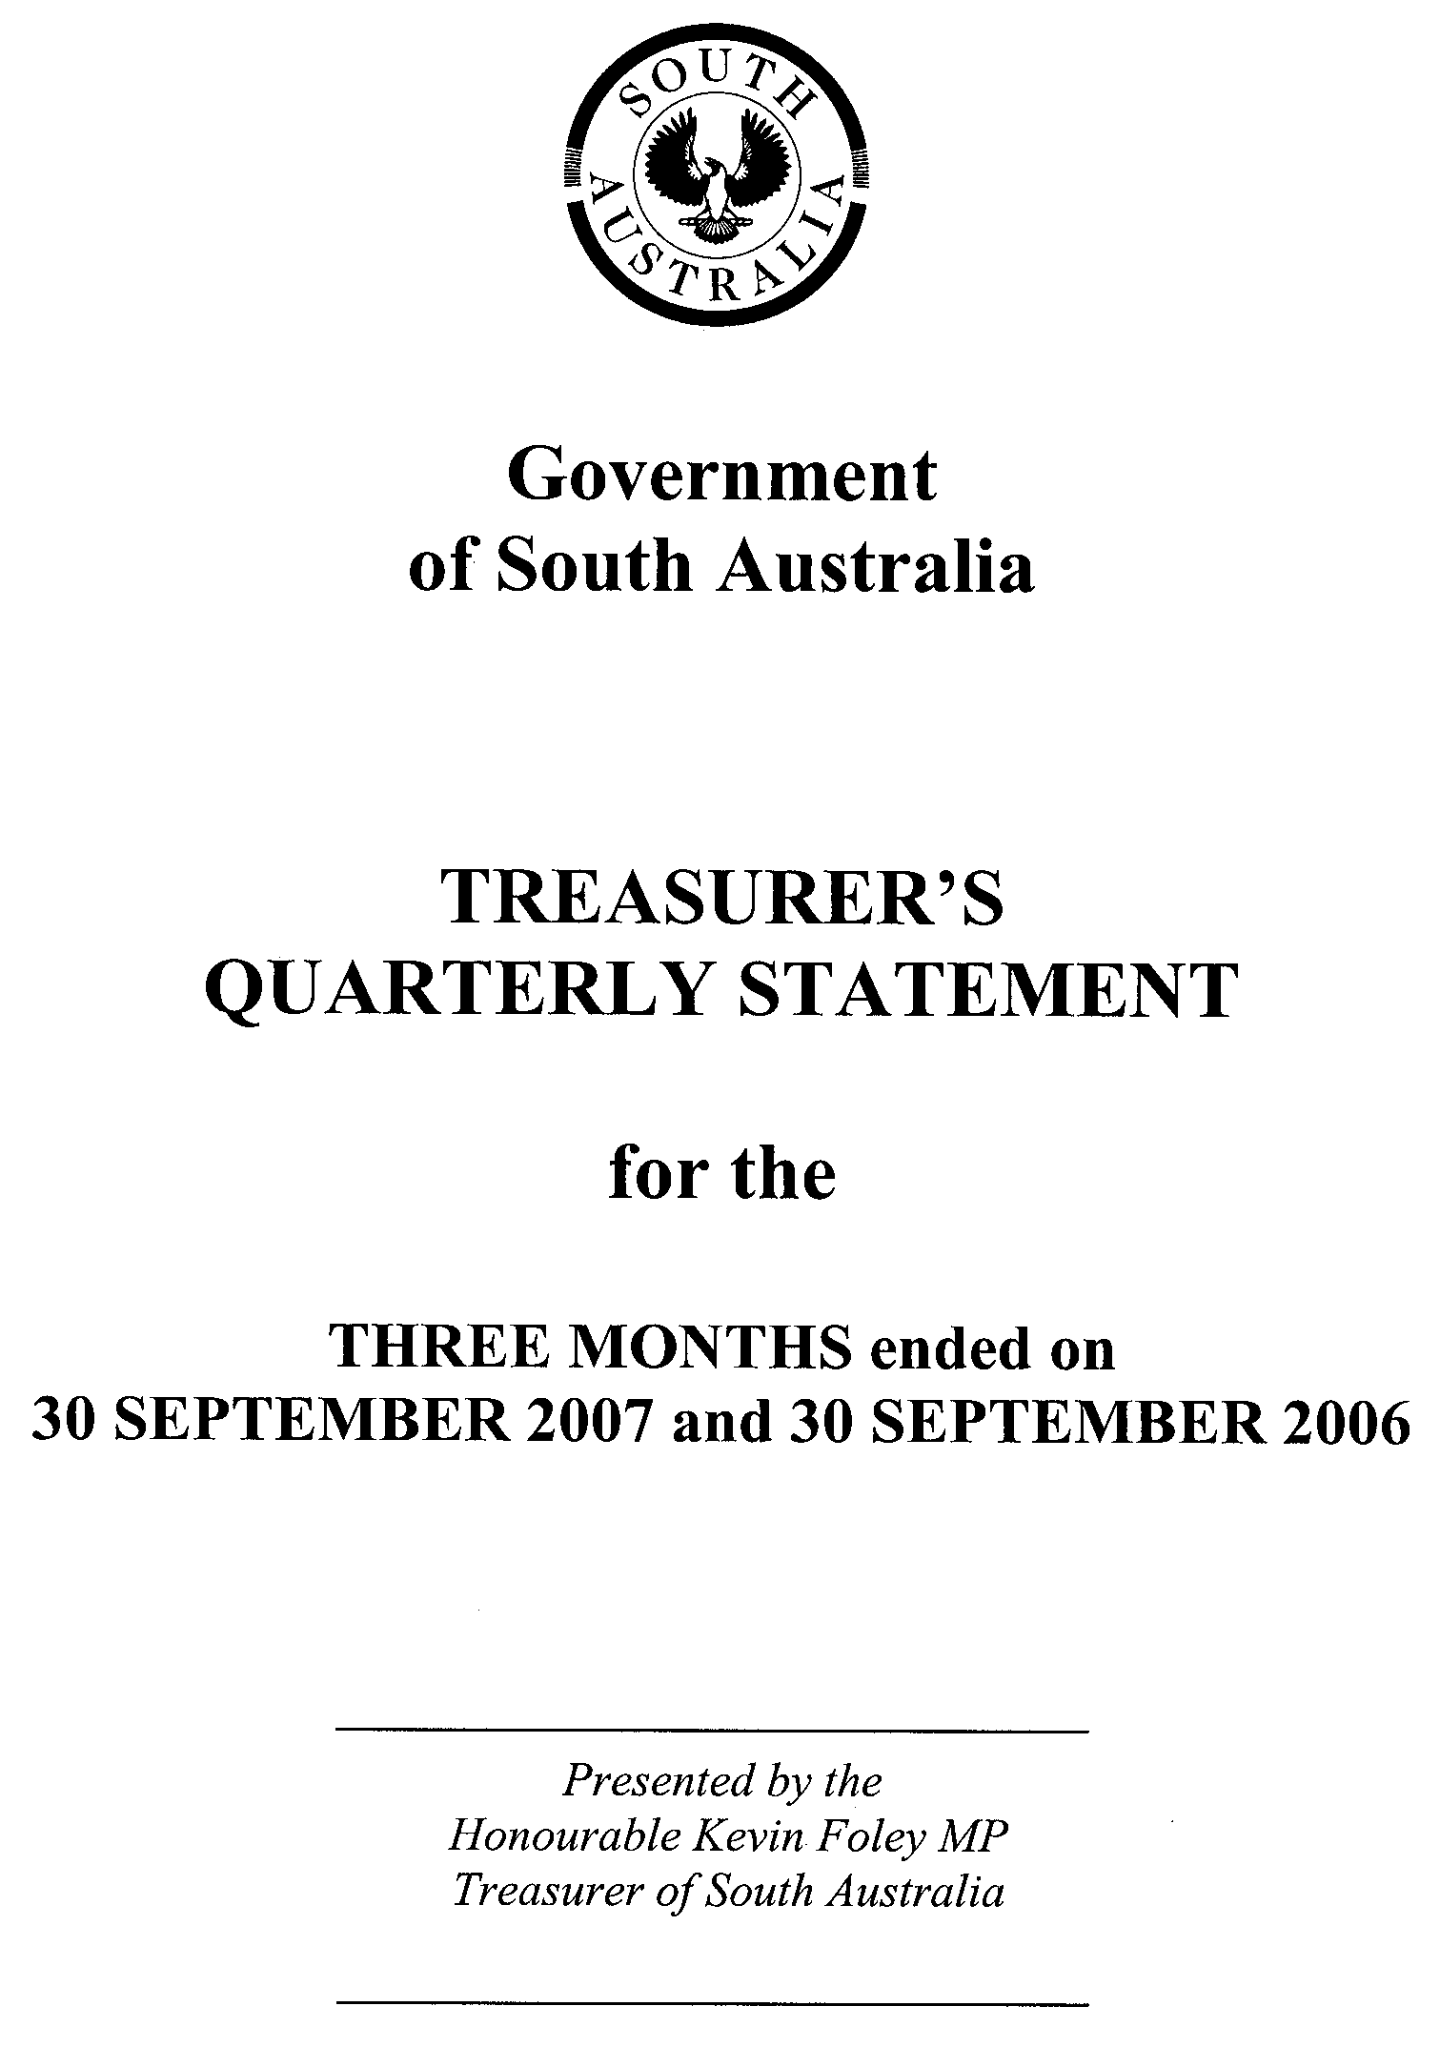
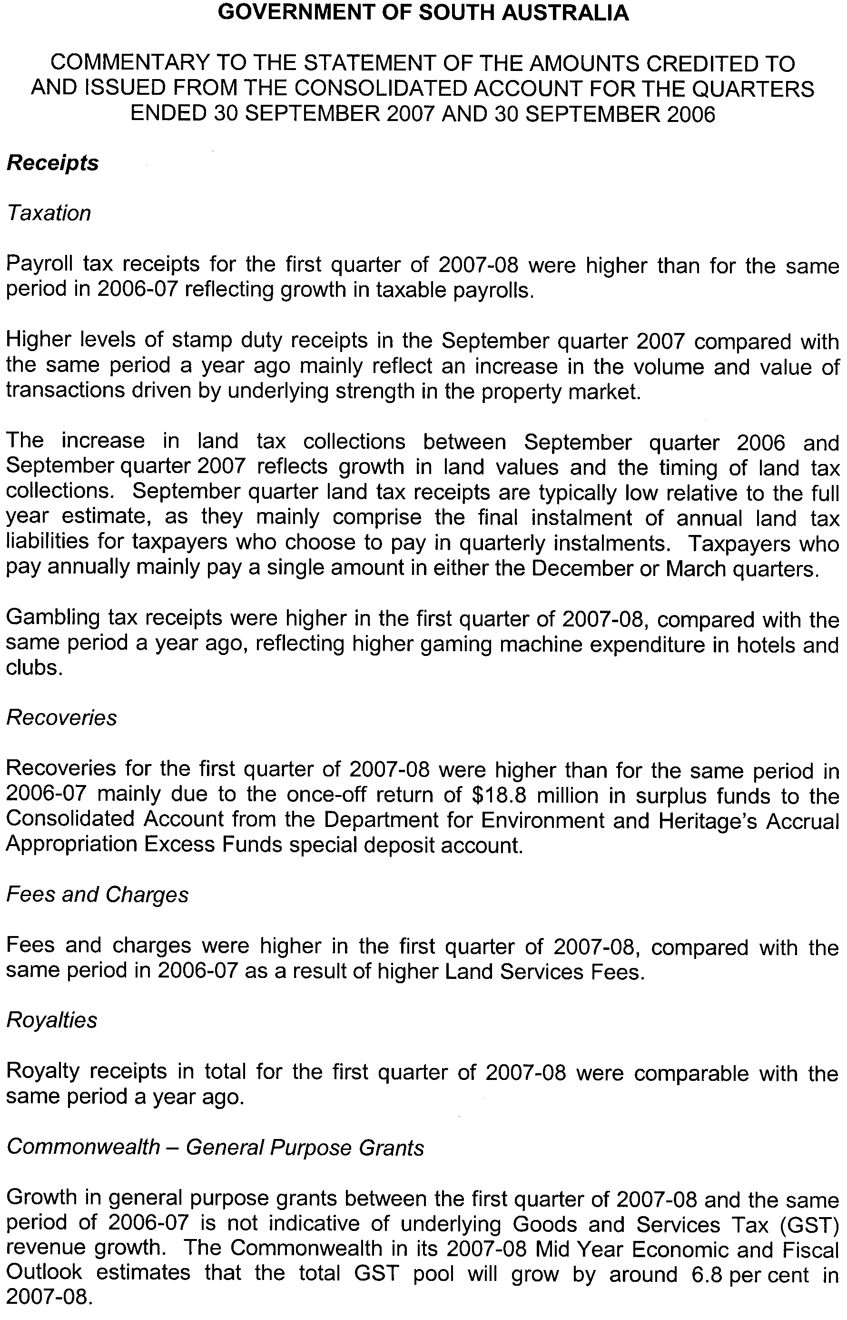
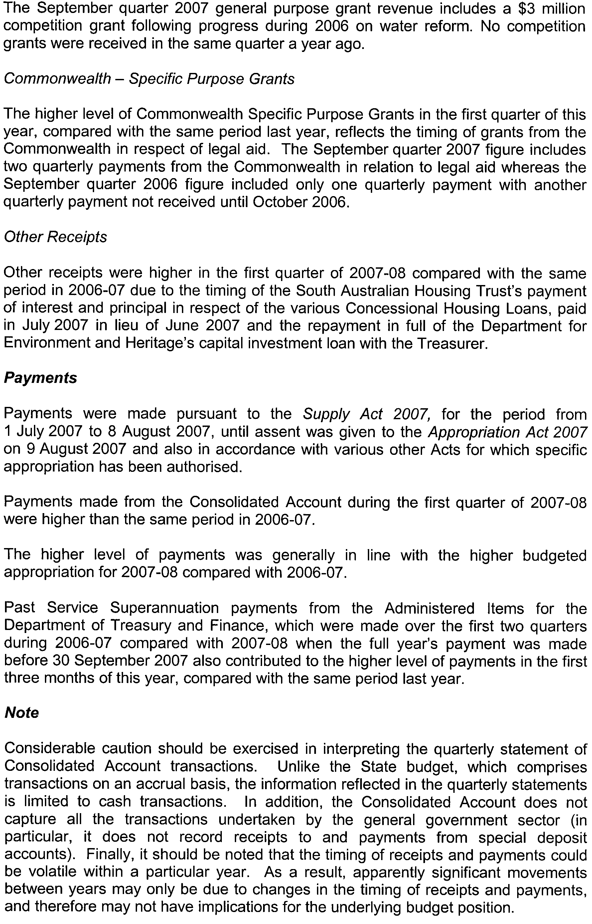
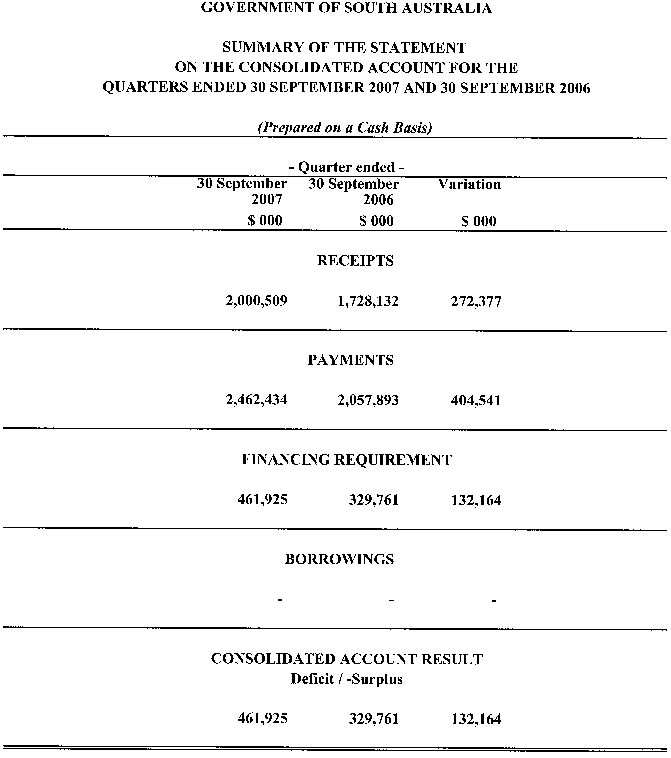
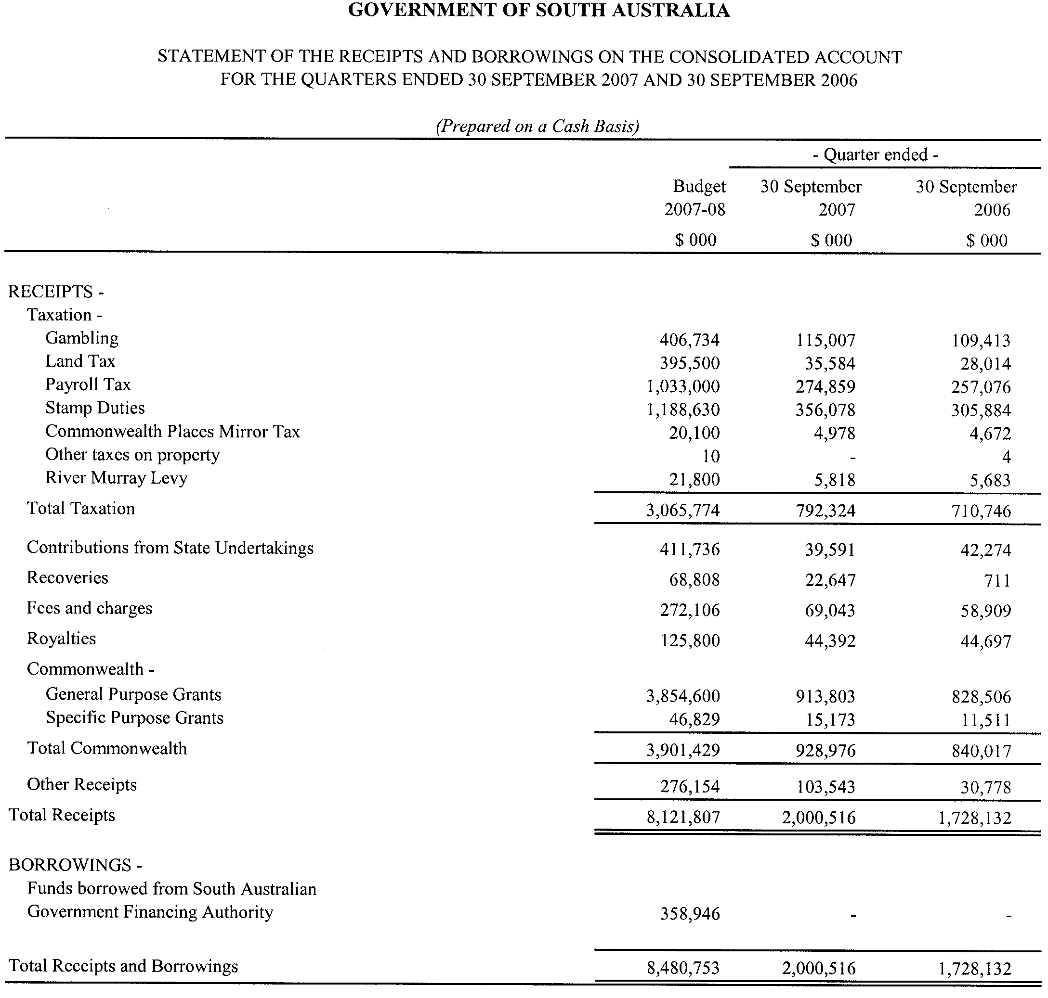
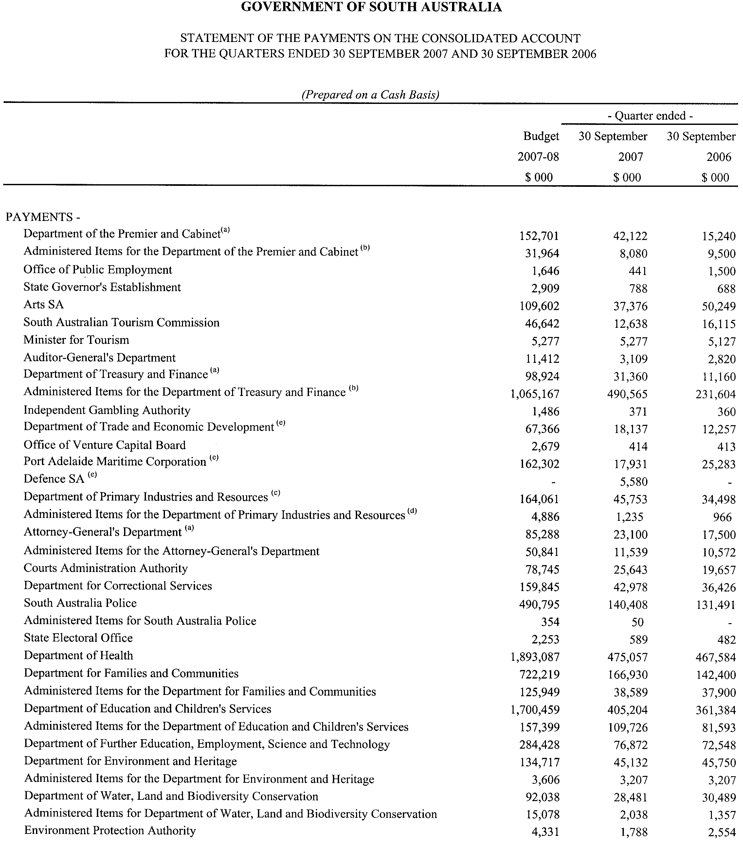
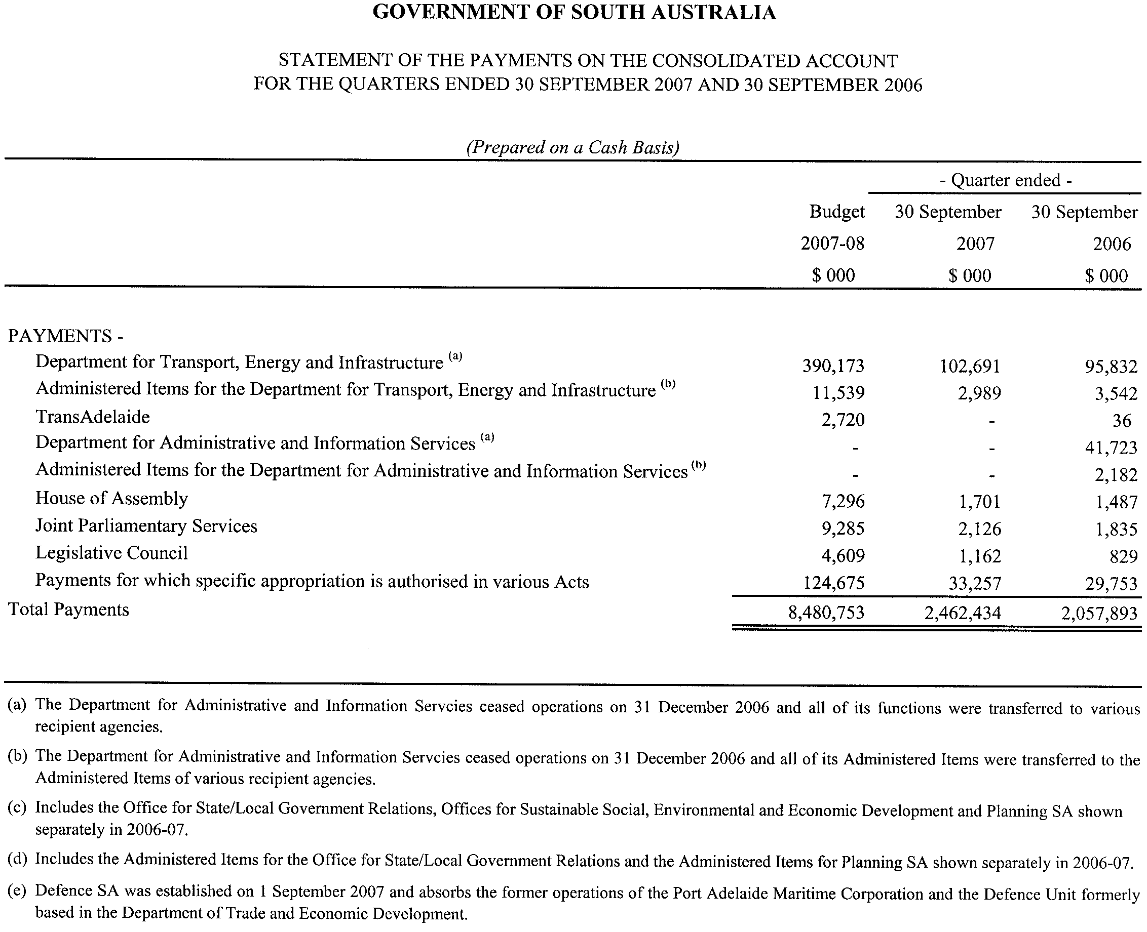

GOVERNMENT GAZETTE ADVERTISEMENT RATES

To apply from 1 July 2007

$  Agents, Ceasing to Act as 39.60  Associations:  Incorporation 20.10  Intention of Incorporation 49.75  Transfer of Properties 49.75  Attorney, Appointment of 39.60  Bailiff’s Sale 49.75  Cemetery Curator Appointed 29.45  Companies:  Alteration to Constitution 39.60  Capital, Increase or Decrease of 49.75  Ceasing to Carry on Business 29.45  Declaration of Dividend 29.45  Incorporation 39.60  Lost Share Certificates:  First Name 29.45  Each Subsequent Name 10.10  Meeting Final 33.10  Meeting Final Regarding Liquidator’s Report on  Conduct of Winding Up (equivalent to ‘Final  Meeting’)  First Name 39.60  Each Subsequent Name 10.10  Notices:  Call 49.75  Change of Name 20.10  Creditors 39.60  Creditors Compromise of Arrangement 39.60  Creditors (extraordinary resolution that ‘the Com-pany be wound up voluntarily and that a liquidator be appointed’) 49.75  Release of Liquidator⎯Application⎯Large Ad. 78.65  ⎯Release Granted 49.75  Receiver and Manager Appointed 45.85  Receiver and Manager Ceasing to Act 39.60  Restored Name 37.25  Petition to Supreme Court for Winding Up 69.30  Summons in Action 58.85  Order of Supreme Court for Winding Up Action 39.60  Register of Interests⎯Section 84 (1) Exempt 89.10  Removal of Office 20.10  Proof of Debts 39.60  Sales of Shares and Forfeiture 39.60  Estates:  Assigned 29.45  Deceased Persons⎯Notice to Creditors, etc. 49.75  Each Subsequent Name 10.10  Deceased Persons⎯Closed Estates 29.45  Each Subsequent Estate 1.30  Probate, Selling of 39.60  Public Trustee, each Estate 10.10 |  | $  Firms:  Ceasing to Carry on Business (each insertion) 26.30  Discontinuance Place of Business 26.30  Land⎯Real Property Act:  Intention to Sell, Notice of 49.75  Lost Certificate of Title Notices 49.75  Cancellation, Notice of (Strata Plan) 49.75  Mortgages:  Caveat Lodgement 20.10  Discharge of 21.05  Foreclosures 20.10  Transfer of 20.10  Sublet 10.10  Leases⎯Application for Transfer (2 insertions) each 10.10  Lost Treasury Receipts (3 insertions) each 29.45  Licensing 58.85  Municipal or District Councils:  Annual Financial Statement⎯Forms 1 and 2 554.35  Electricity Supply⎯Forms 19 and 20 393.90  Default in Payment of Rates:  First Name 78.65  Each Subsequent Name 10.10  Noxious Trade 29.45  Partnership, Dissolution of 29.45  Petitions (small) 20.10  Registered Building Societies (from Registrar-  General) 20.10  Register of Unclaimed Moneys⎯First Name 29.45  Each Subsequent Name 10.10  Registers of Members⎯Three pages and over:  Rate per page (in 8pt) 252.15  Rate per page (in 6pt) 333.45  Sale of Land by Public Auction 50.30  Advertisements 2.80  ¼ page advertisement 117.75  ½ page advertisement 235.50  Full page advertisement 461.60  Advertisements, other than those listed are charged at $2.80 per column line, tabular one-third extra.  Notices by Colleges, Universities, Corporations and District Councils to be charged at $2.80 per line.  Where the notice inserted varies significantly in length from that which is usually published a charge of $2.80 per column line will be applied in lieu of advertisement rates listed.  South Australian Government publications are sold on the condition that they will not be reproduced without prior permission from the Government Printer.
All the above prices include GST

GOVERNMENT GAZETTE NOTICES
ALL private advertisements forwarded for publication in the South Australian Government Gazette must be PAID FOR PRIOR TO INSERTION; and all notices, from whatever source, should be legibly written on one side of the paper only and sent to Government Publishing SA so as to be received no later than 4 p.m. Tuesday preceding the day of publication. Phone 8207 1045 or Fax 8207 1040. E-mail: governmentgazette@dpc.sa.gov.au. Send as attachments in Word format. Please include date the notice is to be published and to whom the notice will be charged. The Government Gazette is available online at: www.governmentgazette.sa.gov.au.

MISCELLANEOUS LEGISLATION AND GOVERNMENT PUBLICATIONS PRICES AS FROM 1 JULY 2007

Acts, Bills, Rules, Parliamentary Papers and Regulations
Pages | Main | Amends | Pages | Main | Amends

1-16 | 2.40 | 1.10 | 497-512 | 33.60 | 32.55
17-32 | 3.25 | 2.05 | 513-528 | 34.65 | 33.35
33-48 | 4.20 | 3.00 | 529-544 | 35.70 | 34.65
49-64 | 5.30 | 4.05 | 545-560 | 36.75 | 35.70
65-80 | 6.25 | 5.15 | 561-576 | 37.50 | 36.75
81-96 | 7.25 | 6.00 | 577-592 | 38.55 | 37.25
97-112 | 8.25 | 7.05 | 593-608 | 39.85 | 38.30
113-128 | 9.25 | 8.10 | 609-624 | 40.65 | 39.60
129-144 | 10.35 | 9.15 | 625-640 | 41.70 | 40.10
145-160 | 11.35 | 10.10 | 641-656 | 42.70 | 41.70
161-176 | 12.40 | 11.15 | 657-672 | 43.25 | 42.20
177-192 | 13.45 | 12.20 | 673-688 | 45.05 | 43.25
193-208 | 14.50 | 13.35 | 689-704 | 45.85 | 44.30
209-224 | 15.30 | 14.15 | 705-720 | 46.65 | 45.35
225-240 | 16.35 | 15.10 | 721-736 | 48.45 | 46.35
241-257 | 17.50 | 15.95 | 737-752 | 48.95 | 47.40
258-272 | 18.45 | 17.00 | 753-768 | 50.00 | 48.20
273-288 | 19.50 | 18.25 | 769-784 | 50.55 | 49.75
289-304 | 20.30 | 19.15 | 785-800 | 51.60 | 50.80
305-320 | 21.55 | 20.20 | 801-816 | 52.60 | 51.30
321-336 | 22.40 | 21.15 | 817-832 | 53.65 | 52.60
337-352 | 23.55 | 22.30 | 833-848 | 54.70 | 53.65
353-368 | 24.50 | 23.35 | 849-864 | 55.75 | 54.20
369-384 | 25.55 | 24.40 | 865-880 | 56.80 | 55.75
385-400 | 26.55 | 25.30 | 881-896 | 57.30 | 56.25
401-416 | 27.60 | 26.05 | 897-912 | 58.85 | 57.30
417-432 | 28.65 | 27.35 | 913-928 | 59.40 | 58.85
433-448 | 29.70 | 28.40 | 929-944 | 60.45 | 59.40
449-464 | 30.50 | 29.20 | 945-960 | 61.50 | 59.90
465-480 | 31.00 | 30.20 | 961-976 | 63.05 | 60.95
481-496 | 32.55 | 31.00 | 977-992 | 64.10 | 61.50

Legislation—Acts, Regulations, etc: $
Subscriptions:
Acts 207.00
All Bills as Laid 497.00
Rules and Regulations 497.00
Parliamentary Papers 497.00
Bound Acts 230.00
Index 115.00
Government Gazette
Copy 5.40
Subscription 274.00
Hansard
Copy 15.10
Subscription—per session (issued weekly) 431.00
Cloth bound—per volume 185.00
Subscription—per session (issued daily) 431.00
Legislation on Disk
Whole Database 3192.00
Annual Subscription for fortnightly updates 981.00
Individual Act(s) including updates POA
Compendium
Subscriptions:
Subscriptions 1891.00
Updates 667.00
(All the above prices include GST)

All Legislation, Government Gazette, Hansard and Legislation on disk are available from:
Counter Sales Service SA, Government Legislation⁺ Outlet
and Mail Orders: Lands Titles Office, 101 Grenfell Street, Adelaide, S.A. 5000
Phone: 13 23 24 (local call cost), Fax: (08) 8204 1909
Postal: G.P.O. Box 1707, Adelaide, S.A. 5001

Online Shop: www.shop.service.sa.gov.au

Subscriptions and Government Publishing SA
Standing Orders: Box 9, Plaza Level, Riverside Centre, North Terrace, Adelaide, S.A. 5000
Phone: (08) 8207 1043, (08) 8207 0910, Fax: (08) 8207 1040

[Republished]

TRAINING AND SKILLS DEVELOPMENT ACT 2003

Part 4—Apprenticeships/Traineeships

Pursuant to the provision of the Training and Skills Development Act 2003, the Training and
Skills Commission (TaSC) gives notice that determines the following
Trades, Declared Vocations or Other Occupations in addition to the gazettals of:

- 5 February 2004 | - 19 February 2004 | - 11 March 2004 | - 1 April 2004
- 1 July 2004 | - 15 July 2004 | - 22 July 2004 | - 30 September 2004
- 16 December 2004 | - 27 January 2005 | - 3 February 2005 | - 10 February 2005
- 10 March 2005 | - 24 March 2005 | - 5 May 2005 | - 12 May 2005
- 2 June 2005 | - 16 June 2005 | - 7 July 2005 | - 4 August 2005
- 18 August 2005 | - 1 September 2005 | - 15 September 2005 | - 22 September 2005
- 6 October 2005 | - 20 October 2005 | - 27 October 2005 | - 8 December 2005
- 22 December 2005 | - 9 March 2006 | - 6 April 2006 | - 20 April 2006
- 4 May 2006 | - 18 May 2006 | - 25 May 2006 | - 1 June 2006
- 3 August 2006 | - 10 August 2006 | - 31 August 2006 | - 7 September 2006
- 21 September 2006 | - 29 September 2006 | - 12 October 2006 | - 9 November 2006
- 23 November 2006 | - 30 November 2006 | - 7 December 2006 | - 21 December 2006
- 4 January 2007 | - 11 January 2007 | - 1 February 2007 | - 8 February 2007
- 15 February 2007 | - 19 April 2007 | - 10 May 2007 | - 26 July 2007
- 2 August 2007 | - 30 August 2007 | - 6 September 2007 | - 13 September 2007
- 8 November 2007 | - 22 November 2007 | - 7 December 2007

Trades, Declared Vocations or Other Occupations, required Qualifications and
Contract of Training Conditions for the
Electricity Supply Industry – Transmission, Distribution and Rail Sector Training
Package (UET06)

*Trade/  #Declared Vocation/  Other Occupation | National  Code | Qualification Title | Nominal Term  of Contract of  Training | Probationary  Period
# Assistant Trades Electrical Vegetation Control | UET20106 | Certificate II in ESI – Vegetation Control | 12 months | 1 month
# Assistant Electrical Tradesperson (ESI Transmission) | UET20206 | Certificate II in ESI – Transmission Line Assembly | 12 months | 1 month
* Electrical Tradesperson (Rail Traction) | UET30306 | Certificate III in ESI – Rail Traction | 48 months | 3 months
* Electrical Tradesperson (Power Cable) | UET30406 | Certificate III in ESI – Cable Jointing | 48 months | 3 months
* Advanced Electrical Trade (Power Systems) | UET40106 | Certificate IV in ESI – Power Systems | 24 months ¹ | 2 months
* Advanced Electrical Trade (ESI Substation) | UET40206 | Certificate IV in ESI – Substation | 24 months ¹ | 2 months
* Technical Specialist (ESI Networks) | UET40306 | Certificate IV in ESI – Network Infrastructure | 24 months ¹ | 2 months
# Technical Specialist (Power Systems) | UET50106 | Diploma of ESI – Power Systems | 24 months ¹ | 2 months
# Advanced Technical Specialist (Power Systems) | UET60106 | Advanced Diploma of ESI – Power Systems | 24 months ¹ | 2 months

¹ Term implies trainee has already completed appropriate Certificate III. If entering directly into qualification then the term will be 72 months with a 3 months probationary period.

Bold denotes new declared vocations and trades

FAXING COPY?
IF you fax copy to Government Publishing SA for inclusion in the Government Gazette, there is no need to send a Confirmation Copy to us as well.
This creates confusion and may well result in your notice being printed twice.
Please use the following fax number:
Fax transmission: (08) 8207 1040
Phone Inquiries: (08) 8207 1045
Please include a contact person, phone number and order number so that we can phone back with any queries we may have regarding the fax copy.
NOTE: Closing time for lodging new copy (fax, hard copy or email) is 4 p.m. on Tuesday preceding the day of publication.

Government Gazette notices can be E-mailed.
The address is:
governmentgazette@dpc.sa.gov.au
Documents should be sent as attachments in Word format.
When sending a document via E-mail, please confirm your transmission with a faxed copy of your document, including the date the notice is to be published.
Fax transmission: (08) 8207 1040
Enquiries: (08) 8207 1045
NOTE: Closing time for lodging new copy (fax, hard copy or email) is 4 p.m. on Tuesday preceding the day of publication.

CITY OF PLAYFORD
Roads (Opening And Closing) Act 1991
Road Opening and Closing—Short Road, Penfield
NOTICE is hereby given, pursuant to section 10 of the Roads (Opening and Closing) Act 1991, that the City of Playford proposes to make a Road Process Order to:
(i) open as road portion of allotment 22 in Filed Plan 114836, more particularly delineated and numbered ‘1’ on Preliminary Plan No. 070081; and
(ii) close and merge portion of Short Road adjoining the said allotment 22 and allotment 18 in Filed Plan 114832, in exchange for land taken for new road ‘1’ (above), more particularly delineated and lettered ‘A’ on Preliminary Plan No. 070081.
A copy of the plan and a statement of persons affected are available for public inspection at the offices of the Council, 12 Bishopstone Drive, Davoren Park and the Adelaide office of the Surveyor-General during normal office hours.
Any objection or application for easement must set out the full name, address and details of the submission and must be fully supported by reasons.
The objection or application must be made in writing to the Council, 12 Bishopstone Drive, Davoren Park, S.A. 5113 within 28 days of this notice and a copy must be forwarded to the Surveyor-General, G.P.O. Box 1354, Adelaide, S.A. 5001. Where a submission is made, the Council will give notification of a meeting at which the matter will be considered.
T. R. S. Jackson, Chief Executive Officer

THE CITY OF PROSPECT
Appointment
NOTICE is hereby given that pursuant to section 56A (22) of the Development Act 1993, the Council has appointed Mark Goldstone, Chief Executive Officer (and/or his delegate) to the role of Public Officer of The City of Prospect’s Development Assessment Panel. The Public Officer is responsible for ensuring the proper investigation of complaints about the conduct of a member of the Council’s Development Assessment Panel.
All written enquiries should be directed to:
Mark Goldstone
Chief Executive Officer
The City of Prospect
P.O. Box 171
Prospect, S.A. 5082.
Mark Goldstone, Chief Executive Officer

CITY OF SALISBURY
Road Name Change
NOTICE is hereby given, pursuant to section 219 of the Local Government Act 1999:
• Suburb boundary realignment between Parafield and Mawson Lakes to be along the centre of Lot 52 in Deposited Plan 69022 and the necessary statutory notifications take place.
S. Hains, City Manager

CITY OF TEA TREE GULLY
Final Adoption of a Community Land Management Plan
NOTICE is hereby given pursuant to Section 197 (3) of the Local Government Act 1999, that the Council of the City of Tea Tree Gully, at its meeting held on 11 December 2007, adopted Community Land Management Plan No. 0068/2007 for the Tea Tree Gully Memorial Garden, Tea Tree Gully.
G. Perkin, Chief Executive Officer

DISTRICT COUNCIL OF FRANKLIN HARBOUR
Conversion of Private Roads to Public Roads
NOTICE is hereby given pursuant to section 210 (5) of the Local Government Act 1999, that Council resolved at its meeting held on 12 December 2007:
That pursuant to the provisions contained within section 210 of the Local Government Act 1999, the District Council of Franklin Harbour hereby declares the private roads being shown as Keith Street, William Street and Edith Street in Deposited Plan 1940 contained within certificate of title volume 900, folio 162 to be public roads, and that pursuant to the provisions contained within section 210 of the Local Government Act 1999, the District Council of Franklin Harbour hereby declares the private roads shown as Moseley Street and McKenzie Street in Deposited Plan 2000 contained within certificate of title volume 5966, folio 389 to be public roads.
Dated 4 January 2008.
B. A. Francis, District Clerk

Appointments
NOTICE is hereby given that the District Council of Franklin Harbour at its meeting held on 12 December 2007, appointed Michael George Perkins and Robert William Inglis as Dog Management Officers, pursuant to the provisions of section 27 of the Dog and Cat Management Act 1995.
The appointment of Ronald Dunn is hereby revoked.
B. A. Francis, District Clerk

UNCLAIMED MONEYS ACT 1891
Register of Unclaimed Moneys held by Hutchison Telecommunications Australia

Rightful Owner |  |  |  | Last Known Address |  | Account  No. | Amount  Due  $ |  | Description  of Moneys
Graham R. Jones |  |  | P.O. Box 594, Blackwood, S.A. 5051 |  | 013699 |  |  | 23.18 |  | Overpayment
Sandra K. Freeman |  |  | 21 Angas Road, Hawthorn, S.A. 5062 |  | FRESAN |  |  | 21.33 |  | Overpayment
Imade M. Gunaksa |  |  | 5A Alexander Avenue, Campbelltown, S.A. 5074 |  | GUNIMA |  |  | 26.51 |  | Overpayment
Wah H. Lee |  |  | P.O. Box 297, Walkerville, S.A. 5081 |  | WAHLEE |  |  | 67.94 |  | Overpayment
Gordon I. Halliwell |  |  | 5 Pearce Street, O’Sullivan Beach, S.A. 5166 |  | GORHAL |  |  | 160.35 |  | Overpayment
Roberto Dubbioso |  |  | 47 Hilltop Avenue, Felixstow, S.A. 5070 |  | 1116ZX |  |  | 117.59 |  | Overpayment
Thor Adventure Equipment Pty Ltd |  |  | 228 Rundle Street, Adelaide, S.A. 5000 |  | THOADV |  |  | 41.18 |  | Overpayment
Steven J. Mckenzie |  |  | 17 Laught Avenue, Black Forest, S.A. 5035 |  | 015169 |  |  | 32.00 |  | Overpayment
Chris Van Schaik |  |  | 843 Ackland Hill Road, Coromandel East, S.A. 5157 |  | 112WXG |  |  | 26.30 |  | Overpayment
HHH Pty Ltd |  |  | P.O. Box 1658, Virginia, S.A. 5120 |  | HHHPTY |  |  | 21.30 |  | Overpayment
Walter J. Gurner |  |  | Glenrose Court, 550 Portrush Road, Glen Osmond, S.A. 5064 |  | GURWAL |  |  | 27.50 |  | Overpayment
Keith G. Koodrin |  |  | P.O. Box 252, Blair Athol, S.A. 5084 |  | KOOKEI |  |  | 27.50 |  | Overpayment
Erika J. Birrell |  |  | P.O. Box 1066, Mount Gambier, S.A. 5290 |  | BIRRER |  |  | 39.79 |  | Overpayment
Christine Calvaresi |  |  | P.O. Box 72, Virginia, S.A. 5120 |  | 111MFY |  |  | 62.70 |  | Overpayment
Tim Whicker |  |  | 40 Victoria Road, Birkenhead, S.A. 5015 |  | 1114QZ |  |  | 182.27 |  | Overpayment
Adele K. Oakley |  |  | P.O. Box 157, Pinnaroo, S.A. 5304 |  | OAKADE |  |  | 74.46 |  | Overpayment
Danny Cristrancig |  |  | 30 Wear Avenue, Marden, S.A. 5070 |  | CRIDAN |  |  | 91.80 |  | Overpayment
Philip E. Reedman |  |  | 33 Garrod Crescent, Stirling, S.A. 5152 |  | REEDMP |  |  | 23.33 |  | Overpayment
Robin Geddes |  |  | 19/174 Barton Terrace W, North Adelaide, S.A. 5006 |  | 113R9B |  |  | 121.95 |  | Overpayment
St Peters Collegiate Girls |  |  | School, Stonyfell Road, Stonyfell, S.A. 5066 |  | STPSCH |  |  | 74.54 |  | Overpayment
Centapak Pty Ltd |  |  | P.O. Box 261, Hindmarsh, S.A. 5007 |  | CENTAP |  |  | 125.84 |  | Overpayment
Flora P. Harpas |  |  | 23 Clare Avenue, Sheidow Park, S.A. 5158 |  | HARFLO |  |  | 23.51 |  | Overpayment
Aqua Technology Australia Pty Ltd |  |  | P.O. Box 591, North Adelaide, S.A. 5006 |  | AQUTEC |  |  | 213.22 |  | Overpayment
Leigh M. Hossack |  |  | 2/1 Barry Road, Oaklands Park, S.A. 5046 |  | HOSLEI |  |  | 22.50 |  | Overpayment
James B. Gray |  |  | 16 Bennett Street, Maylands, S.A. 5069 |  | 012571 |  |  | 24.17 |  | Overpayment
Glen Donhardt |  |  | 28 Taylor Terrace, Rosslyn Park, S.A. 5072 |  | DONGLE |  |  | 64.81 |  | Overpayment
Yong Yap |  |  | 3/4 Peel Street, Prospect, S.A. 5082 |  | 100DFX |  |  | 61.60 |  | Overpayment
Robert Stephens |  |  | 5 Dorothy Avenue, Paringa, S.A. 5340 |  | 100DPH |  |  | 70.81 |  | Overpayment
John Bruce Real Estate John Bruce |  |  | 5 Hugh Street, Torrens Park, S.A. 5062 |  | 025143 |  |  | 29.60 |  | Overpayment
Despina Papaemanouil |  |  | 247 Fullarton Road, Eastwood, S.A. 5063 |  | 100F0X |  |  | 30.04 |  | Overpayment
Philip M. Neill |  |  | 3 Stirling Avenue, Aberfoyle Park, S.A. 5159 |  | NELPHI |  |  | 28.93 |  | Overpayment
Minister of Primary Industry |  |  | Hon. Rob Kerin ‘17th Floor, 25 Grenfell Street’, Adelaide, S.A. 5000 |  | 027862 |  |  | 199.56 |  | Overpayment
Pei-Chen Hsu |  |  | 3/40 Albert Street, Goodwood, S.A. 5034 |  | HSUPEI |  |  | 165.39 |  | Overpayment
Patrick L. Walsh |  |  | 267 O’Sullivan Beach Road, Morphett Vale, S.A. 5162 |  | WALSPA |  |  | 25.31 |  | Overpayment
St Josephs School Hectorville |  |  | 30 Montacute Road, Hectorville, S.A. 5073 |  | STJOSH |  |  | 132.00 |  | Overpayment
T.T.G. Development Board |  |  | 15 Wicks Road, Highbury, S.A. 5089 |  | 114733 |  |  | 29.76 |  | Overpayment
AK Andrewartha Pty Ltd |  |  | 64 George Street, Thebarton, S.A. 5031 |  | AKANDR |  |  | 35.88 |  | Overpayment
Ricardian Automotive Pty Ltd |  |  | 15A Charles Street, Norwood, S.A. 5067 |  | RIAUTO |  |  | 262.31 |  | Overpayment
Bravo Nominees |  |  | 245 Grange Road, Findon, S.A. 5023 |  | 1162N5 |  |  | 23.19 |  | Overpayment
Greg Tansell |  |  | 523 Panalatinga Road, Woodcroft, S.A. 5162 |  | 017948 |  |  | 100.56 |  | Overpayment
Tony Gray |  |  | 1 Gurney Street, Edwardstown, S.A. 5039 |  | GRAYTO |  |  | 72.58 |  | Overpayment
Andrew Eleftheriadis |  |  | P.O. Box 767, Renmark, S.A. 5341 |  | ELEFAN |  |  | 409.42 |  | Overpayment
Lisa Darrell |  |  | P.O. Box 532, Willunga, S.A. 5172 |  | 011515 |  |  | 39.25 |  | Overpayment
Guyco Pty Ltd |  |  | P.O. Box 618, Melrose Park, S.A. 5039 |  | GUYCPL |  |  | 65.87 |  | Overpayment
Caroline L. Kraus |  |  | 16 Lexcen Grove, Happy Valley, S.A. 5159 |  | KRACAR |  |  | 104.42 |  | Overpayment
Peter Lucky |  |  | 9/62A Lewis Road, Glynde, S.A. 5070 |  | 114T8X |  |  | 22.00 |  | Overpayment
Chris Honeyman |  |  | 5 Workmaster Avenue, Sheidow Park, S.A. 5158 |  | HONEYC |  |  | 28.51 |  | Overpayment
Liz Tuglielmi |  |  | 120 Clairville Road, Newton, S.A. 5074 |  | TUGLIZ |  |  | 94.02 |  | Overpayment
RPM Solutions Australia Pty Ltd |  |  | P.O. Box 5, Welland, S.A. 5007 |  | RPMSOL |  |  | 33.10 |  | Overpayment
‘Susan Straschko Highgate Day, Night’ |  |  | Highgate Day/Night Pharmacy, 432 Fullarton Road, Myrtle Bank, S.A. 5064 |  | HIGDAY |  |  | 62.41 |  | Overpayment
Duo Art Productions Pty Ltd |  |  | 122 Grant Avenue, Toorak Gardens, S.A. 5065 |  | DUOART |  |  | 96.65 |  | Overpayment
Andrew Xenides |  |  | 23B Norseman Avenue, Hillcrest, S.A. 5086 |  | 1154XU |  |  | 49.50 |  | Overpayment
Helen Harvey |  |  | 27 Fife Avenue, Torrens Park, S.A. 5062 |  | 116763 |  |  | 83.45 |  | Overpayment
Killey Withy Punshon Advertising Pty |  |  | 6/14 Solomon Street, Adelaide, S.A. 5000 |  | KILADV |  |  | 121.92 |  | Overpayment
Jacques Meschemberg |  |  | 51 Heatherbank Terrace, Stonyfell, S.A. 5066 |  | MESCJA |  |  | 73.96 |  | Overpayment
Fanesi Family Trust Pty Ltd |  |  | 11 Hill Street, Campbelltown, S.A. 5074 |  | FANESI |  |  | 47.01 |  | Overpayment
Nicholas Allen |  |  | 47 North Terrace, Hackney, S.A. 5069 |  | 009562 |  |  | 35.20 |  | Overpayment
Ropeda Pty Ltd |  |  | T/A Hi Point Windows, P.O. Box 518, Morphett Vale, S.A. 5162 |  | PTYROP |  |  | 83.66 |  | Overpayment
Rosh |  |  | 7 East Terrace, Mile End, S.A. 5031 |  | 116NUC |  |  | 40.69 |  | Overpayment
Lee M. Kelly |  |  | 14 Kays Road, Torrens Park, S.A. 5062 |  | KELMLE |  |  | 63.81 |  | Overpayment
Rightful Owner |  |  |  | Last Known Address |  | Account  No. | Amount  Due  $ |  | Description  of Moneys
Janette Gunn |  |  | 9 Park Street, Campbelltown, S.A. 5074 |  | 1146HF |  |  | 66.01 |  | Overpayment
Leuralt Pty Ltd |  |  | 3/17 Langford Street, Pooraka, S.A. 5095 |  | LEURAL |  |  | 180.92 |  | Overpayment
Richard L. Henderson |  |  | 4 Cup Gum Grove, Heathfield, S.A. 5153 |  | RICHEN |  |  | 29.18 |  | Overpayment
Bruce Walker |  |  | Real Estate Institute, 163 Grand Junction Road, Ottoway, S.A. 5013 |  | 025026 |  |  | 211.74 |  | Overpayment
Miro D. Mitrovich |  |  | 20 Destroyer Street, Salisbury Heights, S.A. 5109 |  | MITMIR |  |  | 60.50 |  | Overpayment
Susan C. Chenery |  |  | Chapman Road, Inglewood, S.A. 5133 |  | SUSCHE |  |  | 106.33 |  | Overpayment
Jenny A. Richter |  |  | 11 Albert Road, Mount Barker, S.A. 5251 |  | 016893 |  |  | 25.63 |  | Overpayment
Bill Gonis |  |  | C/o Adelaide Independent Taxis, 99 Henley Beach Road, Mile End, S.A. 5031 |  | 100DSR |  |  | 276.10 |  | Overpayment
Michael Goldner |  |  | 8 Margaret Avenue, Somerton Park, S.A. 5044 |  | 012517 |  |  | 37.42 |  | Overpayment
Rita Marrone |  |  | 2/293 Montacute Road, Newton, S.A. 5074 |  | 111M3P |  |  | 61.60 |  | Overpayment
Adelaide Steam Cleaning |  |  | 47 Riverway, Kidman Park, S.A. 5025 |  | 114RDC |  |  | 24.74 |  | Overpayment
Colin Lock |  |  | 3/27 Military Road, West Beach, S.A. 5024 |  | 005113 |  |  | 113.71 |  | Overpayment
Rosemary David |  |  | 61 Northgate Street, Unley Park, S.A. 5061 |  | 111EFS |  |  | 59.43 |  | Overpayment
Kaz Computer Services Ltd |  |  | 182 Fullarton Road, Dulwich, S.A. 5065 |  | 010911 |  |  | 22.64 |  | Overpayment
Streamliner Business Products |  |  | 66 King William Street, Kent Town, S.A. 5064 |  | STREBP |  |  | 73.57 |  | Overpayment
Kevin V. Borick |  |  | P.O. Box 104, Burnside, S.A. 5066 |  | BORKEV |  |  | 204.26 |  | Overpayment
Adam Barich |  |  | 12/6 Albert Street, Payneham, S.A. 5070 |  | 1159G5 |  |  | 96.01 |  | Overpayment
Hamilton G. Heading Advertising |  |  | 91 Hutt Street, Adelaide, S.A. 5000 |  | 111AYT |  |  | 184.72 |  | Overpayment
Keith Wilkie |  |  | Unit 2/22 Broughton Avenue, Mitcham, S.A. 5062 |  | WILKEI |  |  | 69.80 |  | Overpayment
John Younger |  |  | P.O. Box 210, McLaren Vale, S.A. 5171 |  | 019410 |  |  | 81.21 |  | Overpayment
Colin Weinert |  |  | T/A E.L Weinert & Co., P.O. Box 40, Lobethal, S.A. 5241 |  | ELWEIN |  |  | 66.12 |  | Overpayment
Consolidated Bearing Co SA Pty Ltd |  |  | P.O. Box 2406, Regency Park, S.A. 5942 |  | 001606 |  |  | 70.40 |  | Overpayment
Wesley M. Edwards |  |  | 142 Tapleys Hill Road, Glenelg North, S.A. 5045 |  | EDWWES |  |  | 99.00 |  | Overpayment
Desmond N. Keller |  |  | 1 Pauline Drive, Surrey Downs, S.A. 5126 |  | KELDES |  |  | 86.91 |  | Overpayment
Russell Boreham |  |  | 2 Pine Avenue, Seacliff, S.A. 5049 |  | 100D84 |  |  | 30.28 |  | Overpayment
The Queen Elizabeth Hospital |  |  | Accounts Payable, Woodville, S.A. 5011 |  | 035162 |  |  | 58.29 |  | Overpayment
Robert Banks |  |  | 15/196 Morphett Road, Glengowrie, S.A. 5044 |  | 111X45 |  |  | 176.94 |  | Overpayment
Amalia Zipeto |  |  | 12 Springfield Avenue, Athelstone, S.A. 5076 |  | ZIPAMA |  |  | 61.60 |  | Overpayment
PL Legal Services |  |  | Level 2, 60 Waymouth Street, Adelaide, S.A 5000 |  | 100PH0 |  |  | 295.54 |  | Overpayment
Michael Altamura |  |  | 223 Hart Street, Glanville, S.A. 5015 |  | ALTAMI |  |  | 64.34 |  | Overpayment
Nick Meiers Electrical Pty Ltd |  |  | 12 Ackland Avenue, Clarence Gardens, S.A. 5039 |  | NICMEI |  |  | 33.88 |  | Overpayment
Michael Campbell |  |  | 11 Koongarra Crescent, Munno Para, S.A. 5115 |  | CAMCIC |  |  | 61.63 |  | Overpayment
Christine Bout |  |  | 135 Old Norton Summit Road, Norton Summit, S.A. 5136 |  | 111PUH |  |  | 100.10 |  | Overpayment
Pasquale Clemente Modern Salon |  |  | 17 Packer Crescent, Paradise, S.A. 5075 |  | CLEPAS |  |  | 180.58 |  | Overpayment
PKF Accounting |  |  | G.P.O. Box 2505, Adelaide, S.A. 5001 |  | 11156D |  |  | 231.60 |  | Overpayment
Alwyn Fisher |  |  | 5 Pymbrah Road, Mile End South, S.A. 5031 |  | 111577 |  |  | 257.96 |  | Overpayment
Celia M. Stuart |  |  | 2/25 Roslind Street, Kensington Gardens, S.A. 5068 |  | STUACE |  |  | 202.77 |  | Overpayment
Yu-Ching Liao |  |  | 29 Edward Street, Willaston, S.A. 5118 |  | 115GKX |  |  | 81.12 |  | Overpayment
Linda Baker |  |  | 1/13 Ship Street, Port Adelaide, S.A. 5015 |  | 115FNB |  |  | 62.37 |  | Overpayment
Callie James |  |  | 3 Yeldham Drive, Morphett Vale, S.A. 5162 |  | 111MNE |  |  | 80.00 |  | Overpayment
Mark A. Stevenson |  |  | P.O. Box 470, Barmera, S.A. 5345 |  | STEMAK |  |  | 28.19 |  | Overpayment
Nykola Wolianskyj |  |  | 6 Branston Avenue, Devon Park, S.A. 5008 |  | 008644 |  |  | 23.45 |  | Overpayment
Tonkin Radiators P/L |  |  | 2/20 Esplanade, Glenelg, S.A. 5045 |  | TONRAD |  |  | 110.50 |  | Overpayment
Ashley Gold |  |  | 5 Marlene Court, Newton, S.A. 5074 |  | 112YR6 |  |  | 20.12 |  | Overpayment
The Tiers Wine Co (Aust) P/L |  |  | P.O. Box 530, McLaren Vale, S.A. 5171 |  | TIEWIN |  |  | 22.78 |  | Overpayment
Rape & Sexual Assault Service |  |  | Level 1, 55 King William Road, North Adelaide, S.A. 5006 |  | 100MNY |  |  | 95.73 |  | Overpayment
Jacquie Schlesinger |  |  | 45 Brighton Parade, Blackwood, S.A. 5051 |  | 024752 |  |  | 29.68 |  | Overpayment
Nick Pana |  |  | 15 Holmeswood Court, Onkaparinga Hills, S.A. 5163 |  | 113S76 |  |  | 24.03 |  | Overpayment
The Door People |  |  | 10 Pambula Street, Regency Park, S.A. 5010 |  | 115QNZ |  |  | 32.55 |  | Overpayment
Grant Bressington |  |  | 231 Portrush Road, Norwood, S.A. 5067 |  | 010356 |  |  | 22.84 |  | Overpayment
Cootes Holdings Pty Ltd |  |  | P.O. Box 486, Port Adelaide, S.A. 5015 |  | 011361 |  |  | 82.25 |  | Overpayment
Annvers Vineyard Pty Ltd |  |  | P.O. Box 755, Mitcham Shopping Centre, S.A. 5062 |  | 113JGM |  |  | 28.22 |  | Overpayment
Neil Rayfield |  |  | A Better Cut Concrete Cutting, P.O. Box 1725, Gawler, S.A. 5118 |  | 008318 |  |  | 37.99 |  | Overpayment
Heysen CFS Group 4/G23 |  |  | P.O. Box 461, Echunga, S.A. 5153 |  | CFSHAH |  |  | 184.48 |  | Overpayment
James Toop |  |  | 577 Portrush Road, Glenunga, S.A. 5064 |  | 030874 |  |  | 20.25 |  | Overpayment
Holden Limited |  |  | P.O. Box 221, Elizabeth, S.A. 5112 |  | GMHGSM |  |  | 1 138.61 |  | Overpayment
Rightful Owner |  |  |  | Last Known Address |  | Account  No. | Amount  Due  $ |  | Description  of Moneys
Moto Foto |  |  | P.O. Box 53, Glenside, S.A. 5065 |  | 010287 |  |  | 27.79 |  | Overpayment
Glen Woodley Estate |  |  | 360 Glen Osmond Road, Myrtle Bank, S.A. 5064 |  | 100ME8 |  |  | 44.00 |  | Overpayment
Caperna Electrical Pty Ltd |  |  | 8 Armiger Court, Holden Hill, S.A. 5088 |  | 004950 |  |  | 27.34 |  | Overpayment
Gribbles Pathology Pty Ltd |  |  | 1 Goodwood Road, Wayville, S.A. 5034 |  | 014556 |  |  | 97.90 |  | Overpayment
Petet J. Neuhaus |  |  | 15 Robert Street, Unley, S.A. 5061 |  | NEUPET |  |  | 239.95 |  | Overpayment
Dimitrios Vithoulkas |  |  | P.O. Box 479, Cobdogla, S.A. 5346 |  | 1147JR |  |  | 30.80 |  | Overpayment
Michael Anderson |  |  | 36 Kerrin Avenue, Morphett Vale, S.A. 5162 |  | 001969 |  |  | 85.71 |  | Overpayment
IPEX Information Technology Group |  |  | 237 Glen Osmond Road, Frewville, S.A. 5063 |  | IPEXIN |  |  | 115.42 |  | Overpayment
Suzzane O’Neill |  |  | 115 Sherriff Street, Underdale, S.A. 5032 |  | 112AFG |  |  | 21.70 |  | Overpayment
Court Admin Dept Info Service |  |  | P.O. Box 1068, Adelaide, S.A. 5001 |  | 004162 |  |  | 34.42 |  | Overpayment
Action Plumbing Services P/L |  |  | 4 Ellis Street, Magill, S.A. 5072 |  | 005041 |  |  | 65.46 |  | Overpayment
Andrion Amusements |  |  | 2 Yelland Street, Hillcrest, S.A. 5086 |  | 013439 |  |  | 43.62 |  | Overpayment
Gothic City Video |  |  | 5 Haven Street, Ridgehaven, S.A. 5097 |  | PEDLEM |  |  | 23.73 |  | Overpayment
SAP Executive Services |  |  | Branch 224, P.O. Box 1539, Adelaide, S.A. 5001 |  | SAPEXE |  |  | 20.05 |  | Overpayment
Wei Zhong Zhao |  |  | 36 Nyonga Avenue, Croydon Park, S.A. 5008 |  | 1135BK |  |  | 100.00 |  | Overpayment
Murray Maintenance Services |  |  | 232 South Road, Mile End, S.A. 5031 |  | 001377 |  |  | 50.05 |  | Overpayment
The Smiths Snackfood Co Ltd |  |  | P.O. Box 2064, Regency Park, S.A. 5942 |  | SMIVEN |  |  | 86.03 |  | Overpayment
Moyes - Amertec Pty Ltd |  |  | P.O. Box 88, Dry Creek, S.A. 5094 |  | MOYAME |  |  | 137.75 |  | Overpayment

UNCLAIMED MONEYS ACT 1891
Register of Unclaimed Moneys Held by Hardy Wine Company Limited (ABN 86 008 273 907) over $10 as at January 2008

Name |  | Address | Total Amount  Due $ |  | Date Payable
Ashcroft, Eric Robert |  | 191A Omokoroa Beach Road, Tauranga, N.Z. | 72.50 |  | April 01
Ashcroft, Eric Robert |  | 191A Omokoroa Beach Road, Tauranga, N.Z. | 65.25 |  | October 01
Baimbridge, Colin John |  | 7 Kieandu Court, Ferntree Gully, Vic. 3156 | 49.50 |  | April 01
Baimbridge, Colin John |  | 7 Kieandu Court, Ferntree Gully, Vic. 3156 | 44.55 |  | October 01
Begg, Duncan Thomson |  | 18 Mill Street, Clare, S.A. 5453 | 15.00 |  | April 01
Butler, Jennifer Anne |  | 19 Gleneagles Drive, Sunbury, Vic. 3429 | 25.00 |  | April 01
Butler, Jennifer Anne |  | 19 Gleneagles Drive, Sunbury, Vic. 3429 | 22.50 |  | October 01
Dungey, Yasmin Ari |  | 12 Greenhill Drive, Blenheim, N.Z. | 66.00 |  | April 01
Dungey, Yasmin Ari |  | 12 Greenhill Drive, Blenheim, N.Z. | 59.40 |  | October 01
Gaunt, John |  | P.O. Box 243, North Melbourne, Vic. 3051 | 300.00 |  | April 01
Great Oaks Pty Ltd |  | 31 Outlook Drive, Eaglemont, Vic. 3084 | 69.30 |  | October 01
Greyful Pty Ltd (Dreyfus A/C) |  | Address unknown | 63.00 |  | October 01
Groove-On Productions Pty Ltd |  | Attention: P. Turner, U1, 31 Marlborough Street, Sandy Bay, Tas. 7005 | 64.44 |  | October 01
Hall, Wendy and Christopher |  | 104 Frederick Street, Welland, S.A. 5007 | 90.00 |  | October 01
Harris, Peter David |  | 117 Cathedral Street, Wooloomooloo, N.S.W. 2011 | 40.00 |  | April 01
Harris, Peter David |  | 117 Cathedral Street, Wooloomooloo, N.S.W. 2011 | 36.00 |  | October 01
Kleinig, Ben |  | 6 Boomerang Street, Haberfield, N.S.W. 2045 | 56.00 |  | April 01
Kleinig, Ben |  | 6 Boomerang Street, Haberfield, N.S.W. 2045 | 34.65 |  | October 01
Leith, Peter James (C/o Computer-share Registry Services P/L) |  | G.P.O. Box 1903, Adelaide, S.A. 5001 | 16.60 |  | April 01
Leith, Peter James (C/o Computer-share Registry Services P/L) |  | G.P.O. Box 1903, Adelaide, S.A. 5001 | 14.94 |  | October 01
Liebergreen, Christian and Yvette |  | 14 Evergreen Circle, Wentworth Falls, N.S.W. 2782 | 185.30 |  | April 01
Liebergreen, Christian and Yvette |  | 14 Evergreen Circle, Wentworth Falls, N.S.W. 2782 | 166.77 |  | October 01
McCulloch, Christian |  | 6/186 Forbes Street, Darlinghurst, N.S.W. 2010 | 115.00 |  | April 01
MCG Fund Nominees Pty Ltd |  | Address unknown | 130.50 |  | October 01
Palmer, Gregory James |  | Address unknown | 51.80 |  | April 01
Parkinson, David |  | P.O. Box 2151, Port Moresby, NCD Papua New Guinea | 66.60 |  | April 01
Parkinson, David |  | P.O. Box 2151, Port Moresby, NCD Papua New Guinea | 59.94 |  | October 01
Propstring, Susan Hadley |  | P.O. Box 371, Stanthorpe. Qld 4380 | 142.60 |  | April 01
Read Media Services Pty Ltd |  | Level 2, 66 King Street, Sydney, N.S.W 2000 | 124.65 |  | October 01
Robinson, Peter John Andrew |  | Address unknown | 45.00 |  | October 01
Rochford, Shirley |  | Address unknown | 50.00 |  | April 01
Rubira Investments Pty Ltd |  | C/o Reardon Ass, 15 Cobden Street, North Melbourne, Vic. 3051 | 160.00 |  | April 01
Simonds, Shelly Anne |  | 17 Glover Street, Lyneham, A.C.T. 2602 | 45.00 |  | October 01
Solomon, Aaron |  | 18 Kambala Road, Bellevue Hill, N.S.W. 2023 | 200.00 |  | April 01
Solomon, Aaron |  | 18 Kambala Road, Bellevue Hill, N.S.W. 2023 | 180.00 |  | October 01
Ure, George Anthony |  | 6 Augustine Street, Hunters Hill, N.S.W. 2110 | 130.00 |  | April 01
Vivco Rural Supplies Pty Ltd |  | Naracoorte, S.A. 5271 | 450.00 |  | October 01
Walsh, Carolyn Louise |  | 3 Elm Avenue, Mile End, S.A. 5031 | 75.00 |  | April 01
Wheelah, Brigid Margaret |  | Address unknown | 67.50 |  | October 01
Whitty, Dr Michael Rohan |  | P.O. Box 875, Lane Cove, N.S.W. 2066 | 50.00 |  | April 01
Whitty, Dr Michael Rohan |  | P.O. Box 875, Lane Cove, N.S.W. 2066 | 45.00 |  | October 01
Winan Investments P/L |  | Level 12, 55 Clarence Street, Sydney, N.S.W. 2000 | 330.00 |  | April 01
Winan Investments P/L |  | Level 12, 55 Clarence Street, Sydney, N.S.W. 2000 | 297.00 |  | October 01
Wise, Anthony Philip |  | Address unknown | 27.00 |  | October 01
Wright, Paul Aubrey |  | LL International Admin, Level 3, Plaza Building, Australia Square, Sydney, N.S.W. 2000 | 61.65 |  | October 01
 |  | Total | $4 460.94

UNCLAIMED MONEYS ACT 1891
Register of Unclaimed Moneys held by South Australian Film Corporation up to December 2007
Name and Address of Owner on Books | Total Amount Due  Owner  $
Guy Albert Abell, Mornington, Vic. 3931 | 11.57
Leo Murtho Abell, California, U.S.A. 94598 | 11.57
Brian R. Adams, Burnie, Tas. 7320 | 854.55
Lady Elizabeth May Aickin, Melbourne, Vic. 3000 | 19.44
Thorvald Joseph Andersen, Adelaide, S.A. 5001 | 429.81
Ross L. Andrews, Wodonga, Vic. 3690 | 341.82
Philip Brendon Angas-Parsons, Adelaide, S.A. 5000 | 47.95
Neil Angwin, Albert Park, Vic. 3206 | 3.73
Duncan Lloyd Ansell, Canterbury, Vic. 3126 | 266.00
Susan Mary Armstrong, Windsor, Qld 4030 | 15.75
Tony Charles Armstrong, Brookfield, Qld 4069 | 54.37
David Anthony Askew, Glenelg North, S.A. 5045 | 15.75
Lindy Astin, Burnside, S.A. 5066 | 200.63
John Atanaskovic, Sydney, N.S.W. 2000 | 7.29
William Edwin Baldwin, Broken Hill, N.S.W. 2880 | 111.43
Stanley Errol Banks, Adelaide, S.A. 5000 | 50.00
Ian William Barker, Parkdale, Vic. 3194 | 10.00
Douglas Barkley, Malvern, Vic. 3144 | 52.74
D. Barnes, Hendon, S.A. 5014 | 342.09
Robert Leslie Battersby, Port Elliot, S.A. 5212 | 224.72
Mari Baxter, Brighton Le Sands, N.S.W. 2216 | 197.93
Gordon Berner, Ludmilla, N.T. 0820 | 620.00
James Bidstrup, Rose Park, S.A. 5067 | 31.51
Flora Guthrie Billington, Main Beach, Qld 4215 | 157.53
Black Hill Pty Ltd, Cungena, S.A. 5660 | 40.27
Howard Edward Blackman, Pasadena, S.A. 5042 | 533.57
Brent Blanks, Kings Park, S.A. 5034 | 157.53
Bob Maher Associates P/L, Perth, W.A. 6000 | 429.81
Boban Enterprises, Potts Point, N.S.W. 2011 | 1 924.00
Richard August Boldys, Grovedale, Vic. 3216 | 31.51
Robert Courtney Bower, West Perth, W.A. 6005 | 140.00
Gavin Martin Braden, Brisbane, Qld 4001 | 15.75
Darcy Thomas Brennan, Ascot Vale, Vic. 3032 | 259.08
Kitchener William A. Bridges, Pymble, N.S.W. 2073 | 23.97
Evelyn Diane Broadley, Mosman Park, W.A. 6012 | 4.79
Evelyn Dianne Broadley, Mosman Park, W.A. 6012 | 14.53
Evelyn Dorothy Broadley, Mosman Park, W.A. 6012 | 5.75
Gary Brock, Fortitude Valley, Qld 4006 | 54.37
James Neville Brown, Tamworth, N.S.W. 2340 | 136.36
C. G. Miller & Son Pty Ltd, Wirrulla, S.A. 5661 | 217.48
Christopher Cain, East Prahran, Vic. 3181 | 123.50
Michael Francis Campbell, Hope Valley, S.A. 5090 | 87.14
Camsell Nominees Pty Ltd, Melbourne, Vic. 3001 | 57.83
John T. Carswell, Queenstown, Tas. 7467 | 4.79
Martin John Carter, Adelaide, S.A. 5000 | 171.93
F. Cass, Elsternwick, Vic. 3132 | 1 071.13
Robert Stirling Chapman, Mount Gambier, S.A. 5290 | 94.52
Colbron Pearse Chessell, Castlecrag, N.S.W. 2068 | 31.51
Anne Chew, Maryborough, Qld 4650 | 50.00
Ross Kingsley Chisholm, Mosman Park, W.A. 6012 | 561.82
John Henry Cleaver, Singleton, N.S.W. 2330 | 78.77
Margaret Beryl Clunies-Ross, Sydney, N.S.W. 2000 | 6.66
Deborah J. Collins, Gerringong, N.S.W. 2534 | 587.27
Collinswood Nominees P/L, Adelaide, S.A. 5000 | 400.00

Name and Address of Owner on Books | Total Amount Due  Owner  $
Leon C. Connor, Port Pirie, S.A. 5540 | 3.62
Deidra Conyngham-Power, Ocean Shores, N.S.W. 2483 | 47.26
David James N. Cook, Sydney, N.S.W. 2000 | 78.77
Gillian Cook, Queens Park, N.S.W. 2022 | 50.00
Theodore J. L. Cooke, Elizabeth East, S.A. 5112 | 4.86
Elizabeth Geraldine Cooper, Mont Albert, Vic. 3127 | 79.74
John Robert N. Cooper, Albany, W.A. 6330 | 252.05
Geoffrey Cormack, East Malvern, Vic. 3145 | 54.37
Richard Edward Cotter, Fitzroy, Vic. 3065 | 37.56
John Cowl, Richmond, Vic. 3121 | 518.00
Stephen Philip Cowling, Coromandel Valley, S.A. 5051 | 20.00
Enid Madge N. Cox, Tweed Heads, N.S.W. 2485 | 157.53
Jeanette Lilian Cox, Hendon, S.A. 5014 | 9.59
Jeanette Lillian Cox, Hendon, S.A. 5014 | 40.55
Andrew Douglas Craig, Naracoorte, S.A. 5271 | 31.51
Bonney Alma Crow, Hendon, S.A. 5014 | 49.32
Sonya Cullen, Dubbo, N.S.W. 2830 | 8.15
Leanne C. Daniels, Adelaide, S.A. 5000 | 90.62
Julie Christine Davey, Mooloolah, Qld 4553 | 157.53
Brian Roy Davies, Rostrevor, S.A. 5073 | 564.30
George Boswell Davies, Toorak, Vic. 3142 | 787.67
Peter Deegan, Magill, S.A. 5072 | 208.80
Dependable Motors Pty Ltd, Sydney, N.S.W. 2001 | 157.53
Frederick Andrew Dibden, St Georges, S.A. 5064 | 239.09
Neville George Dixon, Oakleigh, Vic. 3166 | 63.01
Augustine Stanislaus Donnelly, Graceville East, Qld 4075 | 21.82
Bernard James Donnelly, Sandy Bay, Tas. 7005 | 200.00
Melda Kay Donnelly, Hawthorn, Vic. 3122 | 186.00
William Donnelly, Stuart Park, N.T. 0820 | 47.26
Ronald G. Doull, Williamstown, Vic. 3016 | 21.10
Owen Winston Downs, Adelaide, S.A. 5000 | 90.01
Roderick Darcey C. Edwards, Flagstaff Hill, S.A. 5159 | 78.77
Joseph Thomas Elliott, Geraldton, W.A. 6530 | 372.01
Errichetti Nominees Pty Ltd, West Perth, W.A. 6005 | 787.67
Estate of the late Claire Benito, Ethelton, S.A. 5015 | 108.43
Geoffrey William Ewing, Hendon, S.A. 5014 | 468.25
Peter William Fenwick, Prospect, S.A. 5082 | 259.08
John Nicholas Feros, West End, Qld 4101 | 31.51
Charles Frederick R. Fitzhardinge, Unley Park, S.A. 5061 | 429.81
Jill Winona Fitzpatrick, Croydon, Vic. 3136 | 214.89
Malcolm Lionel Fitzpatrick, Croydon, Vic. 3136 | 214.89
Nola Flomersfeld, Adelaide, S.A. 5001 | 1 174.55
Thomas Michael Fogarty, Murray Bridge, S.A. 5253 | 60.75
Keith William Ford, Woody Point, Qld 4019 | 60.00
Francis Arthur Fraser, North Ward, Qld 4810 | 157.53
Tari Freeman, Joslin, S.A. 5070 | 44.58
James French, North Carlton, Vic. 3054 | 78.77
Walter M. French, Skye, Vic. 3977 | 465.00
Ian Leonard Frost, Bundall, Qld 4217 | 12.15
Geoffrey John Gadsdon, Perth, W.A. 6000 | 157.53
William Francis Garner, Pennant Hills, N.S.W. 2120 | 78.77
David Peter Garrott, East Ivanhoe, Vic. 3079 | 315.07
Geological & Film Consultants, Port Noarlunga, S.A. 5167 | 15.75
Jean D. Germano, Evandale, S.A. 5069 | 101.65
Joseph Gersh, Caulfield, Vic. 3162 | 315.07
Gordon Rodney F. Gibson, Bardon, Qld 4065 | 38.77
David Rodney Gillam, Hawthorn East, Vic. 3123 | 57.83
Florence K. Gizycki, Kensington, Vic. 3031 | 4.79
Harry Glynatsis, Ormond, Vic. 3204 | 53.97
Nirdosh Kumar Gogna, Darwin, N.T. 0800 | 7.25
Evelyn Foster Gordon, Paddington, Qld 4064 | 15.75
John Peter Gormley, Bangor, N.S.W. 2234 | 15.75
Sidney Douglas Gramp, Glenunga, S.A. 5064 | 40.00
Anthony Matthew Greenwood, Sydney, N.S.W. 2000 | 15.75
Peter Bernhard Grope, North Adelaide, S.A. 5006 | 126.03
Guardian Trust Co. Pty Ltd, Adelaide, S.A. 5000 | 54.37
David Ronald Gunn, Willunga, S.A. 5172 | 341.82
Charles Henry Gurd, Darwin, N.T. 0800 | 31.51
H. F. Stevenson (Aust.) Pty Ltd, Balwyn, Vic. 3103 | 945.21
Barry Hall, Hawthorn, Vic. 3122 | 133.72
Godfrey Foy Hall, Hendon, S.A. 5014 | 200.14
Nancy May Hall, Glenelg North, S.A. 5045 | 27.85
Robert Donald Hall, Glenelg North, S.A. 5045 | 27.85
Lola Hamer, Caulfield South, Vic. 3162 | 57.83
Robyn Joy Hamrozi, Tiwi, N.T. 0810 | 31.51
Maurice Hannan, Brisbane, Qld 4001 | 45.45
Richard W. Hannan, Randwick, N.S.W. 2031 | 4.79

Name and Address of Owner on Books | Total Amount Due  Owner  $
Neil J. Harbison, Gladstone, Qld 4680 | 4.53
Ethel Lee V. Hardie, Beaudesert, Qld 4285 | 15.75
Raylee J. Hart, Broken Hill, N.S.W. 2880 | 68.57
Geoffrey Hasenohr, Kent Town, S.A. 5067 | 40.78
Eric Hauge, Hendon, S.A. 5014 | 45.37
Norman Hawkins, Punchbowl, N.S.W. 2196 | 22.28
John Beilby Hawthorn, Toorak, Vic. 3142 | 20.14
John Bielby Hawthorn, Toorak, Vic. 3142 | 34.23
Trevor Michael Hayes, Hendon, S.A. 5014 | 56.25
Barry Michael Healy, Alexandria, N.S.W. 2015 | 45.86
Vincent A. Hebbard, Haigslea, Qld 4306 | 1.20
Vincent Joseph Hefferan, Brisbane, Qld 4000 | 78.77
Kia Song Heng, Whyalla, S.A. 5600 | 80.00
James C. Hill, Fullarton, S.A. 5063 | 4.79
William Harris Hobbs, Glen Osmond, S.A. 5064 | 157.53
John Hodsdon, Pullenvale, Qld 4069 | 40.27
Desmond Charles Hoffmann, Stirling, S.A. 5152 | 268.96
James Bradley Holmes, Spit Junction, N.S.W. 2088 | 54.37
Neale James Hooper, Moorooka, Qld 4105 | 3.94
Kim Marie House, Ballandean, Qld 4382 | 31.51
Robert James House, Ballarat, Vic. 3350 | 81.56
Household Directories P/L, Modbury North, S.A. 5092 | 334.28
Eric Maxwell Huggard, Middle Brighton, Vic. 3186 | 54.37
Rodney Charles Humphrey, South Melbourne, Vic. 3205 | 157.53
Lawrence Dean Hunt, Somerton Park, S.A. 5044 | 87.14
Gregory Derwent Hunter, Sandford, Tas. 7020 | 63.01
Keith Alfred Hyland, Bentleigh, Vic. 3204 | 15.75
Julie Patricia Ide, Westbourne Park, S.A. 5041 | 18.12
William Davidson Inglis, Stirling, S.A. 5152 | 57.83
Irish Harp Nominees P/L, Adelaide, S.A. 5001 | 400.00
Sharon Jackson, Daw Park, S.A. 5041 | 189.88
Jalinsons Pty Ltd, Melbourne, Vic. 3000 | 472.60
Elizabeth Jarrett, North Adelaide, S.A. 5006 | 55.72
Jenpet Pty Limited, Bulimba, Qld 4171 | 157.53
Damien Keith Johnson, Norwood, S.A. 5067 | 26.99
Renee Faith Johnson, Thebarton, S.A. 5031 | 26.99
Anne Maree Johnston, Miranda, N.S.W. 2228 | 15.75
Agnes Clarissa Johnstone, Mount Eliza, Vic. 3930 | 429.81
William Watson Johnstone, Mount Eliza, Vic. 3930 | 834.03
Bernard Thomas M. Jones, Cremorne, N.S.W. 2090 | 315.07
Cecil James Jones, Essendon, Vic. 3040 | 31.51
Ian Jones, Bentleigh, Vic. 3204 | 189.88
William Evan O. Jones, Port Macquarie, N.S.W. 2444 | 409.21
Eileen Dorothy Karutz, Hendon, S.A. 5014 | 780.42
Leighton Stanley Keast, Mornington, Vic. 3931 | 171.78
David Ward Kendell, Sydney, N.S.W. 2000 | 63.18
Joseph Kiers, Caulfield, Vic. 3162 | 207.20
Kathleen Mary Kirby, Deepdene, Vic. 3103 | 115.67
Geoffrey Knibbs, Chippendale, N.S.W. 2008 | 46.51
Malcolm Douglas Lake, Adelaide, S.A. 5000 | 214.89
James Donald Lamborn, Glen Iris, Vic. 3146 | 15.75
Hans David Larsen, Malvern East, Vic. 3144 | 214.89
Susan Dale Larsen, Malvern East, Vic. 3144 | 214.89
Roy Lee, Hendon, S.A. 5014 | 102.62
Alan Robert Letcher, Seaton, S.A. 5023 | 200.00
Graham Lewis, North Adelaide, S.A. 5006 | 206.47
Owen Darwin Lewis, Mount Gambier, S.A. 5290 | 110.27
Sylvia Linke, Renown Park, S.A. 5008 | 4.86
Lisban Pty Ltd, Glenside, S.A. 5065 | 315.07
Derek Clifford Lowings, Millswood, S.A. 5034 | 50.00
Derek Cliford Lowings, Millswood, S.A. 5034 | 28.77
Brian Nathan Luke, Millswood, S.A. 5034 | 34.29
James Macdonald, Alice Springs, N.T. 0870 | 24.30
James Andrew Mackenzie, Hong Kong | 9.73
Tracey Michelle Mackenzie, Hong Kong | 9.73
Dean Graham Mackie, North Adelaide, S.A. 5006 | 57.83
Leo James Mahon, Dalby, Qld 4405 | 17.94
Grant Robert Manypeney, Home Hill, Qld 4806 | 14.55
Grant Robert Manypenny, Home Hill, Qld 4806 | 25.45
Helen Joyce Marles, Hendon, S.A. 5014 | 184.36
Stanley Roger Marles, Hendon, S.A. 5014 | 138.94
Thomas George Marshall, Beverley, S.A. 5009 | 4.86
James Arthur Martin, Adelaide, S.A. 5000 | 115.67
Louise Martin, Lane Cove, N.S.W. 2066 | 252.72
Robert Garryt May, Adelaide, S.A. 5000 | 214.89
Norman Colburn Mayne, Bellbowrie, Qld 4070 | 105.48
Donald Johnson McCombie, Glenelg South, S.A. 5045 | 168.54

Name and Address of Owner on Books | Total Amount Due  Owner  $
John Robert McDonald, Dernancourt, S.A. 5075 | 429.81
Stuart James McGregor, Sandy Bay, Tas. 7005 | 47.26
William John McKay, Templestowe, Vic. 3106 | 110.27
David McKee, Adelaide, S.A. 5000 | 7.29
David McKinlay, Hendon, S.A. 5014 | 78.77
John Kingsborough Mclachlan, Kent Town, S.A. 5067 | 15.75
Colin C. McLeod, Unley Park, S.A. 5061 | 600.00
McMullin Nominees Pty Ltd, Melbourne, Vic. 3001 | 115.67
David B. McNeil, Highbury, S.A. 5089 | 393.73
Donald Bernard McRae, Ashburton, Vic. 3147 | 111.43
Robert Michael McTavish, Dee Why, N.S.W. 2099 | 157.53
Gordon George Miller, Karratha, W.A. 6714 | 8.15
Michael Lancelot Milne, Naracoorte, S.A. 5271 | 57.83
Penelope Jane Milne, Naracoorte, S.A. 5271 | 57.83
Clair Carson Mochrie, North Balwyn, Vic. 3104 | 429.81
Christopher J. Monaghan, Somerton Park, S.A. 5044 | 518.18
James Thomas Moore, Hendon, S.A. 5014 | 145.62
Peter Moran, West Lothian, Scotland | 9.72
John Jackson Morris, Birchgrove, N.S.W. 2041 | 72.73
Monica Morton, Indooroopilly, Qld 4068 | 94.52
Thomas James Mulcahy, Ringwood, Vic. 3134 | 443.29
John Raymond Murphy, Darwin, N.T. 0801 | 21.10
William Ernest Nalder, Hendon, S.A. 5014 | 79.17
Nathanael Enterprises Pty Ltd, Winnellie, N.T. 0820 | 100.00
John Henry W. Nicholl, Tangambalanga, Vic. 3691 | 15.75
David John Nicolle, Belair, S.A. 5052 | 213.63
Ronald Albert Nitschke, Bordertown, S.A. 5268 | 145.45
Ian David Nosworthy, Adelaide, S.A. 5000 | 55.72
C. C. O’Connell, Streaky Bay, S.A. 5680 | 54.37
Fran O’Donoghue, Edi Upper, Vic. 3678 | 26.99
Roslyn Agnes Oldfield, Clarendon, S.A. 5157 | 15.75
Terry John Oldroyd, Darwin, N.T. 0801 | 157.53
David John Olifent, Adelaide, S.A. 5001 | 57.83
Cyril Vernon Opie, Glenunga, S.A. 5064 | 472.60
Conrad Eric Otto, Mount Barker, S.A. 5251 | 213.63
Milton Bruce Page, Manunda, Qld 4870 | 15.75
Graham Clifford Parkinson, Blackwood, S.A. 5051 | 10.00
Grahan Clifford Parkinson, Blackwood, S.A. 5051 | 5.75
Paulsea Pty Ltd, Pendle Hill, N.S.W. 2145 | 222.85
Colin Maxwell Pepper, Norwood, S.A. 5067 | 157.53
Brian Randall Perkins, Lane Cove, N.S.W. 2066 | 55.72
Pexlo Pty Ltd, Moonee Ponds, Vic. 3039 | 343.15
Jolie Piper, Cannon Hill, Qld 4170 | 135.42
Darren James Pittard, Templestowe Lower, Vic. 3107 | 78.77
John Robert Polkinghorn, Mundaring, W.A. 6073 | 20.00
Graham Polkinghorne, Melbourne, Vic. 3000 | 115.67
Pamela Elizabeth Pollock, Casuarina, N.T. 0810 | 2.43
Polygram Filmed Entertainment, California, U.S.A. 90210 | 14 383.56
James Patrick Potts, Warradale, S.A. 5046 | 62.00
Precision Service Centre, Hendon, S.A. 5014 | 493.15
Richard Ewen Pringle-Jones, Hobart, Tas. 7001 | 40.00
Bettine Mary Pullen, Mount Eliza, Vic. 3930 | 561.82
Leslie James Pulman, Hendon, S.A. 5014 | 80.75
Ian Craine Ramsay, Camberwell, Vic. 3124 | 541.24
William Randell, Adelaide, S.A. 5001 | 55.72
Gregory John Rayner, Ashford, N.S.W. 2361 | 31.51
Susan Rechichi, Darraweit Guim, Vic. 3756 | 8.15
Betty Ray Rees, South Oakleigh, Vic. 3167 | 78.77
Region Nominees, City Beach, W.A. 6015 | 429.81
Alan Sydney Rich, Cheltenham, N.S.W. 2119 | 157.53
David Alan Richards, Brinkin, N.T. 0810 | 700.78
Lawford Richardson, Hendon, S.A. 5014 | 315.07
Christopher Roach, Woodville, S.A. 5011 | 12.15
Charles Kenneth Roberts, Turramurra, N.S.W. 2074 | 33.43
Alfred G. Robertson, New Town, Tas. 7008 | 8.15
Alfred Gordon Robertson, New Town, Tas. 7008 | 15.75
Richard Ian Robinson, Goodwood, S.A. 5034 | 133.72
Robert Stephen Robinson, Alderley, Qld 4051 | 47.26
Maryla Rose, Rozelle, N.S.W. 2039 | 273.29
Robert Arthur Rose, Wynnum West, Qld 4178 | 15.75
Charles M. Roseby, Richmond, N.S.W. 3121 | 78.77
Sandfly Nominees P/L, Naracoorte, S.A. 5271 | 422.14
Joan R. Sank, Parkwood, Qld 4214 | 19.27
Leonard John Scanlan, Ferny Grove, Qld 4055 | 4.79
Charles Anthony Schlink, Streaky Bay, S.A. 5680 | 163.11
Jeanette Maree Seabourne, Strathblane, Tas. 7116 | 134.92
Ross Lynley Seabourne, Strathblane, Tas. 7116 | 134.92

Name and Address of Owner on Books | Total Amount Due  Owner  $
Michelle Seawell, Paris, France, 75008 | 1 357.00
Eric J. Shaw, Greenwood, W.A. 6024 | 16.31
Judith R. Silver, Howrah, Tas. 7018 | 21.92
Judith Rae Silver, Howrah, Tas. 7018 | 9.59
Clive Maxwell Simpson, Brisbane, Qld 4001 | 78.77
Paul Simpson, Fulham, S.A. 5024 | 53.97
Sixth Avenue Holdings Pty Ltd, Southport, Qld 4215 | 157.53
Raymond John Smith, Mill Park, Vic. 3082 | 94.52
Timothy James Somers, Peregian Beach, Qld 4573 | 489.28
John Menzies Spark, Hendon, S.A. 5014 | 79.74
James Sidney Stevens, Middle Park, Vic. 3206 | 94.52
Peter Henry Strachan, Clifton Hill, Vic. 3068 | 78.77
Brenda Rose Strang, Toorak, Vic. 3142 | 44.23
Corinne Hsiao Yang Stuart, Hendon, S.A. 5014 | 72.81
Corrinne Hsiao Yang Stuart, Hendon, S.A. 5014 | 23.49
Maxine Sym Choon, Glenelg East, S.A. 5045 | 33.43
Gail Tammer, Torquay, Qld 4657 | 422.14
Graham Tardif, Truganina, Vic. 3029 | 189.88
Todd Telford, Adelaide, S.A. 5000 | 28.67
David Cowper Tennent, Brisbane, Qld 4000 | 181.23
Brian Mackie Thomas, Kilburn, S.A. 5084 | 108.74
Albert Thomason, Cooma, Vic. 3616 | 7.29
Norman Thompson, Eden Hills, S.A. 5050 | 9.72
Charles Napier Thomson, Taree, N.S.W. 3420 | 9.59
Kylie Ann Thomson, Templestowe, Vic. 3106 | 10.54
Michael Ross Thomson, Templestowe, Vic. 3106 | 15.75
Christopher Richard Tidemann, Lyons, A.C.T. 2606 | 2.42
Elizabeth Mary Tidemann, Colonel Light Gardens, S.A. 5041 | 6.66
Ruth Katherine Tidemann, Dunedin, New Zealand | 20.66
Tjilpi Pty Ltd, Wirrulla, S.A. 5661 | 108.74
Simon Tozer, Downer, A.C.T. 2602 | 31.51
Douglas Gordon Trigar, Sherwood, Qld 4075 | 40.00
David Craven Truscott, Wattle Park, S.A. 5066 | 55.72
Geoffrey Tull, Taree, N.S.W. 3420 | 52.74
Robert Gary Turnbull, Brighton, Vic. 3186 | 57.83
Raymond Stanmo Turner, North Adelaide, S.A. 5006 | 214.89
Vacol Pty Ltd, Rosanna, Vic. 3084 | 7.27
Virendra Kumar Verma, Sydney, N.S.W. 2001 | 492.12
Christopher John Wake, Darwin, N.T. 0800 | 214.40
Eunice Isobel Warden, Lawson, N.S.W. 2783 | 78.77
Ronald Greaves Waterhouse, St Peters, S.A. 5069 | 55.72
Nevin John Watson, Nightcliff, N.T. 0810 | 173.29
Kelvin Norevil Wegener, Adelaide, S.A. 5001 | 55.72
Elizabeth Anne Weir, Glenelg, S.A. 5045 | 2.43
Helen Christine Weir, Wanguri, N.T. 0810 | 56.18
Keith Francis Were, Whyalla, S.A. 5600 | 7.29
John R. West, Beechworth, Vic. 3747 | 4.79
Peter John Sydney West, Brisbane, Qld 4001 | 15.75
Richard Ross Westmoreland, Townsville, Qld 4810 | 157.53
Raymond Leonard Whear, Humpty Doo, N.T. 0836 | 78.77
Thomas John Whimpress, Hawthorndene, S.A. 5051 | 31.51
Gary Alan White, Bright, Vic. 3741 | 15.75
Sally Mary White, East Sydney, N.S.W. 2011 | 18.18
Jane Whiting, Fullarton, S.A. 5063 | 47.75
Margeurite E. M. Whitla, Bundaberg, Qld 4670 | 40.27
Alexander James Willett, Melbourne, Vic. 3000 | 271.84
Patricia Claire Willett, Deniliquin, N.S.W. 2710 | 271.84
Anne Williams, Norwood, S.A. 5067 | 27.13
Patricia Joan C. Williams, Kensington Gardens, S.A. 5068 | 72.73
George Williamson, Canterbury, Vic. 3126 | 55.72
Alexander Graeme Wilson, Somerton Park, S.A. 5044 | 7.27
Graeme Arnold Wilson, East Burwood, Vic. 3151 | 15.75
Mary Elizabeth Wilson, Beaumont, S.A. 5066 | 173.50
Richard Eric Woodroffe, Alderley, Qld 4051 | 94.52
Graham Lee Wright, Wynn Vale, S.A. 5125 | 15.75
Ian Charles Wright, Alice Springs, N.T. 0870 | 28.31
John Wright, Cronulla, N.S.W. 2230 | 31.51
Garry A. Wyatt, Sans Souci, N.S.W. 2219 | 4.86
Charles Yates, Mount Gambier, S.A. 5290 | 227.10
Quintin Anderson Young, Adelaide, S.A. 5001 | 57.83
Total for South Australian Film Corporation | $67 218.82

ATTENTION

CUSTOMERS requiring a proof of their notice for inclusion in the Government Gazette, please note that the onus is on you to inform Government Publishing SA of any subsequent corrections by 10 a.m. on Thursday, which is our publication deadline.

For any corrections to your notice please phone 8207 1045 or Fax 8207 1040 before 10 a.m. on Thursday.

If we do not receive any communication by 10 a.m. on Thursday (day of publication) we will presume the notice is correct and will print it as it is.

Remember—the onus is on you to inform us of any corrections necessary to your notice.

NOTE: Closing time for lodging new copy (electronically, fax or hard copy) is 4 p.m. on Tuesday preceding the day of publication. Phone 8207 1045—Fax 8207 1040.
Email: governmentgazette@dpc.sa.gov.au

Printed and published by authority every Thursday by T. GOODES, Government Printer, South Australia
Price: $5.40, plus postage; to subscribers, $274.00 per annum.
(The above prices are inclusive of GST)

