No. 7 327

THE SOUTH AUSTRALIAN

GOVERNMENT GAZETTE
www.governmentgazette.sa.gov.au

PUBLISHED BY AUTHORITY

ALL PUBLIC ACTS appearing in this GAZETTE are to be considered official, and obeyed as such

ADELAIDE, THURSDAY, 31 JANUARY 2008

CONTENTS

Page
Appointments, Resignations, Etc. 328
Australian Energy Regulator—Notice 329
Building Work Contractors Act 1995—Notices 329
Corporations and District Councils—Notices 365
Crown Lands Act 1929—Notice 329
Electoral Act 1985—Notice 329
Housing Improvement Act 1940—Notices 330
Liquor Licensing Act 1997—Notices 332
Livestock Act 1997—Notice 337
National Electricity Law—Notice 346
Proclamations 349
Public Trustee Office—Administration of Estates 366
Roads (Opening and Closing) Act 1991—Notice 346

Page
REGULATIONS
Motor Vehicles Act 1959 (No. 5 of 2008) 354
Road Traffic Act 1961—
(No. 6 of 2008) 356
(No. 7 of 2008) 358
Motor Vehicles Act 1959 (No. 8 of 2008) 360
Harbors and Navigation Act 1993 (No. 9 of 2008) 362
Road Traffic (Apparatus for Conducting Oral Fluid
Analyses) Notice 2008 348
Sale of Property—Notice 366
Sewerage Act 1929—Notice 346
Transport, Department of—Notices to Mariners 346
Waterworks Act 1932—Notices 336, 346

GOVERNMENT GAZETTE NOTICES
ALL poundkeepers’ and private advertisements forwarded for publication in the South Australian Government Gazette must be PAID FOR PRIOR TO INSERTION; and all notices, from whatever source, should be legibly written on one side of the paper only and sent to Government Publishing SA so as to be received no later
than 4 p.m. on the Tuesday preceding the day of publication. Phone 8207 1045 or Fax 8207 1040. E-mail: governmentgazette@dpc.sa.gov.au. Send as attachments in Word format and please confirm your transmission with a faxed copy of your document, including the date the notice is to be published and to whom the notice will be charged. The Government Gazette is available online at: www.governmentgazette.sa.gov.au

Department of the Premier and Cabinet
Adelaide, 31 January 2008
HIS Excellency the Governor in Executive Council has revoked the appointment of Andrew MacMichael as a Deputy Member (to David Warren Ward) of the Board of the South Australian Fire and Emergency Services Commission, having noted his resignation, pursuant to the provisions of the Fire and Emergency Services Act 2005 and Section 36 of the Acts Interpretation Act 1915.
By command,
Paul Caica, for Premier
MES08/002SC

Department of the Premier and Cabinet
Adelaide, 31 January 2008
HIS Excellency the Governor in Executive Council has revoked the appointment of Frances Magill as a Member of the TransAdelaide Board effective from 2 February 2008, having noted her resignation, pursuant to the provisions of the TransAdelaide (Corporate Structure) Act 1998 and Section 36 of the Acts Interpretation Act 1915.
By command,
Paul Caica, for Premier
MTR08/003CS

Department of the Premier and Cabinet
Adelaide, 31 January 2008
HIS Excellency the Governor in Executive Council has been please to appoint the undermentioned to the TransAdelaide Board, pursuant to the provisions of the TransAdelaide (Corporate Structure) Act 1998:
Member: (from 3 February 2008 until 2 February 2011)
Kevin Arthur Benger
John Alexander Hearsch
Margaret Mary Starrs
Member: (from 3 February 2008 until 2 February 2009)
Rodney George Hook
By command,
Paul Caica, for Premier
MTR08/003CS

Department of the Premier and Cabinet
Adelaide, 31 January 2008
HIS Excellency the Governor in Executive Council has been please to appoint the undermentioned to the Board of the South Australian Fire and Emergency Services Commission, pursuant to the provisions of the Fire and Emergency Services Act 2005:
Deputy Member: (from 31 January 2008 until 10 October 2008)
Warren Anthony Hicks (Deputy to Ward)
By command,
Paul Caica, for Premier
MES08/002SC

Department of the Premier and Cabinet
Adelaide, 31 January 2008
HIS Excellency the Governor in Executive Council has been please to appoint the undermentioned to the Council for the Care of Children, pursuant to the provisions of the Children’s Protection Act 1993:
Member: (from 1 February 2008 until 31 January 2010)
Jane Chapman
Diana Hetzel
Mellita Kimber
Jayne Ann Lehmann
Simon Andrew Schrapel
Daryle Rigney
Emily Rozee
By command,
Paul Caica, for Premier
MFC/CS/08/004

Department of the Premier and Cabinet
Adelaide, 31 January 2008
HIS Excellency the Governor in Executive Council has been pleased to appoint Hieu Van Le as Governor’s Deputy of South Australia for the period from 6 a.m. on Tuesday, 5 February 2008 until 12.30 p.m. on Monday, 11 February 2008.
By command,
Paul Caica, for Premier

Department of the Premier and Cabinet
Adelaide, 31 January 2008
HIS Excellency the Governor in Executive Council has been pleased to appoint the Honourable Paul Holloway, MLC, Minister for Police, Minister for Mineral Resources Development and Minister for Urban Development and Planning to be also Acting Deputy Premier, Acting Treasurer, Acting Minister for Industry and Trade and Acting Minister for Federal/State Relations for the period from 1 February 2008 to 9 February 2008 inclusive, during the absence of the Honourable Kevin Owen Foley, MP.
By command,
Paul Caica, for Premier
TF08/003CS

Department of the Premier and Cabinet
Adelaide, 31 January 2008
HIS Excellency the Governor in Executive Council has been pleased to appoint the people listed as Justices of the Peace for South Australia for a period of 10 years commencing from 31 January 2008 and expiring on 30 January 2018, pursuant to Section 4 of the Justices of the Peace Act 2005:
Shahzad Khayam Ali
Mathew Michael Deane
Mara Beatrice Di Francesco
Audrey Jean Edwards
Geoffrey Evans
Sharon Anne Ferguson
Heather Ann Hancock
Brenton Giles Hardy
Wendelina Gerdina Maria Bernadette Hawker
Shane Peter Hennessy
Gary Earl Hope
Gregory Brian Howard
James Stuart Lonergan
Lindsay Gordon Osborn
Rosalie Jean Schultz
By command,
Paul Caica, for Premier
JPS07/008CS

AUSTRALIAN ENERGY REGULATOR
Final Decision—Electricity Transmission Determination
2008-2014
THE AUSTRALIAN ENERGY REGULATOR (AER) will release its final decision on SP AusNet’s 2008-2014 electricity transmission determination on Thursday, 31 January 2008. The final decision and reports prepared by the AER’s consultants will be made available on the AER’s website: www.aer.gov.au.
Issues regarding the final decision can be directed to the AER on (03) 9290 1436 or at aerinquiry@aer.gov.au.

BUILDING WORK CONTRACTORS ACT 1995
Exemption
TAKE notice that pursuant to section 45 of the Building Work Contractors Act 1995, I, Mal Hemmerling, Commissioner for Consumer Affairs, do hereby exempt the licensees named in Schedule 1 from the application of Division 3 of Part 5 of the above Act in relation to domestic building work described in Schedule 2 and subject to the conditions specified in Schedule 3.
Schedule 1
David Francis Morris, BLD 203569 and Jane Louise Lawrence, BLD 205553.
Schedule 2
Construction of two dwellings and associated carports and verandahs on land situated at Allotment 267, Town of Andamooka, Out of Hundreds (Andamooka) (certificate of title volume 5428, folio 950).
Schedule 3
1. This exemption is limited to the domestic building work personally performed by the licensees for the construction of two dwellings and associated carports and verandahs on land situated at Allotment 267, Town of Andamooka, Out of Hundreds (Andamooka), (certificate of title volume 5428, folio 950).
2. This exemption does not apply to any domestic building work the licensee sub-contracts to another building work contractor, for which that contractor is required by law to hold building indemnity insurance.
3. That the licensees do not transfer their interest in the land prior to five years from the date of completion of the building work the subject of this exemption, without the prior authorisation of the Commissioner for Consumer Affairs. Before giving such authorisation, the Commissioner for Consumer Affairs may require the licensees to take any reasonable steps to protect the future purchaser(s) of the property, including but not limited to:
• providing evidence that an adequate policy of building indemnity insurance is in force to cover the balance of the five-year period from the date of completion of the building work the subject of this exemption;
• providing evidence of an independent expert inspection of the building work the subject of this exemption;
• making an independent expert report available to pros-pective purchasers of the property; and
• giving prospective purchasers of the property notice of the absence of a policy of building indemnity insurance.
Dated 29 January 2008.
M. Hemmerling, Commissioner for Consumer Affairs, Office of Consumer and Business Affairs, delegate of the Minister for Consumer Affairs
Ref.: 610/08-00004

BUILDING WORK CONTRACTORS ACT 1995
Exemption
TAKE notice that pursuant to section 45 of the Building Work Contractors Act 1995, I, Mal Hemmerling, Commissioner for Consumer Affairs, do hereby exempt the licensee named in Schedule 1 from the application of Division 3 of Part 5 of the above Act in relation to domestic building work described in Schedule 2 and subject to the conditions specified in Schedule 3.
Schedule 1
Bernard Joseph Steer, BLD 9844.
Schedule 2
Construction of a house on land situated at Allotment 162, Deposited Plan 63106 in the area named Blakiston, Hundred of Macclesfield (certificate of title volume 5907, folio 292).
Schedule 3
1. This exemption is limited to the domestic building work personally performed by the licensee for the construction of a house, the residential home of the licensee, on land situated at Allotment 162, Deposited Plan 63106 in the area named Blakiston, Hundred of Macclesfield (certificate of title volume 5907, folio 292).
2. This exemption does not apply to any domestic building work the licensee sub-contracts to another building work contractor, for which that contractor is required by law to hold building indemnity insurance.
3. That the licensee does not transfer his interest in the land prior to five years from the date of completion of the building work the subject of this exemption, without the prior authorisation of the Commissioner for Consumer Affairs. Before giving such authorisation, the Commissioner for Consumer Affairs may require the licensee to take any reasonable steps to protect the future purchaser(s) of the property, including but not limited to:
• providing evidence that an adequate policy of building indemnity insurance is in force to cover the balance of the five-year period from the date of completion of the building work the subject of this exemption;
• providing evidence of an independent expert inspection of the building work the subject of this exemption;
• making an independent expert report available to pros-pective purchasers of the property; and
• giving prospective purchasers of the property notice of the absence of a policy of building indemnity insurance.
Dated 29 January 2008.
M. Hemmerling, Commissioner for Consumer Affairs, Office of Consumer and Business Affairs, delegate of the Minister for Consumer Affairs
Ref.: 610/08-00005

CROWN LANDS ACT 1929: SECTION 5
TAKE NOTICE that pursuant to the Crown Lands Act 1929, I, GAIL GAGO, Minister for Environment and Conservation, Minister of the Crown to whom the administration of the Crown Lands Act 1929 is committed DO HEREBY dedicate the Crown Land defined in The Schedule as Public Road.
The Schedule
Allotment 6 in Deposited Plan 72567, Hundred of Sleaford, County of Flinders, being within the district of Lower Eyre Peninsula.
Dated 31 January 2008.
Gail Gago, Minister for Environment and Conservation
DENR 08/0710

ELECTORAL ACT 1985
Part 6—Registration of Political Parties
NOTICE is hereby given that from close of business on
1 February 2008 and in accordance with section 44 (1), I have deregistered the following political party:
Name of Party: Dignity for Disabled
Dated 31 January 2008.
K. Mousley, Electoral Commissioner, 134 Fullarton Road, Rose Park, S.A. 5067
SEO 129W/03

HOUSING IMPROVEMENT ACT 1940
WHEREAS by notice published in the Government Gazette on the dates mentioned in the following table the South Australian Housing Trust did declare the houses described in the said table to be substandard for the purposes of Part 7 of the Housing Improvement Act 1940, and whereas the South Australian Housing Trust is satisfied that each of the houses described hereunder has ceased to be substandard, notice is hereby given that, in exercise of the powers conferred by the said Part, the South Australian Housing Trust does hereby revoke the said declaration in respect of each house.
Address of House | Allotment, Section, etc. | Certificate of Title  Volume Folio | Date and page of Government Gazette in which notice declaring house to be substandard published

18 Brixton Road, Elizabeth North |  | Allotment 865 in Deposited Plan 6449, Hundred of Munno Para | 5640 | 544 |  | 20.12.07, page 4895
50 Tilshead Road, Elizabeth North |  | Allotment 162 in Deposited Plan 37151, Hundred of Munno Para | 5784 | 475 |  | 13.9.07, page 3676
3 Peter Court, Marden |  | Allotment 5 in Deposited Plan 6608, Hundred of Adelaide | 5165 | 781 |  | 24.10.96, page 1421
40 Norbury Drive, Salisbury Downs |  | Allotment 67 in Deposited Plan 10241, Hundred of Yatala | 5374 | 467 |  | 6.12.07, page 4676
Unit 2/177 Salisbury Highway, Salisbury |  | Allotment 212 in Deposited Plan 22541, Hundred of Yatala | 5397 | 759 |  | 27.10.05, page 3813

Dated at Adelaide, 31 January 2008. D. Huxley, Director, Corporate and Board Services

HOUSING IMPROVEMENT ACT 1940
NOTICE is hereby given that the South Australian Housing Trust in the exercise of the powers conferred by the Housing Improvement Act 1940, does hereby declare the houses described in the table hereunder to be substandard for the purposes of Part 7 of the Housing Improvement Act 1940.
No. of House and Street | Locality | Allotment, Section, etc. | Certificate of Title  Volume Folio

31 Ryan Avenue |  | Athelstone | Allotment 74 in Deposited Plan 6776, Hundred of Adelaide | 5455 | 759
13 Forestall Road |  | Elizabeth Downs | Allotment 19 in Deposited Plan 53921, Hundred of Munno Para | 5747 | 15
7 Westbrook Avenue |  | Loxton | Allotment 17, Town of Loxton West in the area named Loxton, Hundred of Pyap | 5205 | 995
18 Loral Street |  | Modbury | Allotment 53 in Deposited Plan 7086, Hundred of Yatala | 5158 | 644
Lot 290, Lobban Road |  | Monash | Section 290, Berri Irrigation Area | 5972 | 390
27 Gray Street |  | Norwood | Unit 2, Strata Plan 12145, Hundred of Adelaide | 5096 | 827
61 Kitchener Street |  | Peterborough | Allotment 105 in Deposited Plan 58947, Hundred of Yongala | 5874 | 976
181 Churchill Road |  | Prospect | Allotment 83 in Deposited Plan 1749, Hundred of Yatala | 5954 | 520
25 Breaker Street |  | St Morris | Allotment 27 in Deposited Plan 2477, Hundred of Adelaide | 5180 | 20
Section 92, Namoi Street |  | Renmark | Allotments 92 and 93 in Filed Plan 206923, Renmark Irrigation District | 5437 | 618
Section 347, Vogts Road (also known as Government Road) |  | Saddleworth | Sections 346 and 347, Hundred of Saddleworth, in and area named Saddleworth | 5297 | 852
19A Beaufort Street |  | Woodville | Allotment 101 in Deposited Plan 20115, Hundred of Yatala | 5088 | 112

Dated at Adelaide, 31 January 2008. D. Huxley, Director, Corporate and Board Services

HOUSING IMPROVEMENT ACT 1940
WHEREAS by notice published in the Government Gazette on the dates mentioned in the following table the South Australian Housing Trust did declare the houses described in the said table to be substandard for the purposes of Part 7 of the Housing Improvement Act 1940, the South Australian Housing Trust in the exercise of the powers conferred by the said Part, does hereby fix as the maximum rental per week which shall be payable subject to section 55 of the Residential Tenancies Act 1995, in respect of each house described in the following table the amount shown in the said table opposite the description of such house and this notice shall come into force on the date of this publication in the Gazette.
Address of House | Allotment, Section, etc. | Certificate of Title  Volume Folio | Date and page of Government Gazette in which notice declaring house to be substandard published | Maximum rental per week payable in respect of each house  $

Section 194, Gordon Road, Barmera |  | Section 194, Hundred of Cobdogla Irrigation Area | Cro  670 | wn Lease  67 |  | 8.11.07, page 4183 | 60.00
17 Day Terrace, Croydon |  | Allotment 64 in Filed Plan 115876, Hundred of Yatala | 5348 | 550 |  | 11.10.07, page 3907 | 130.00
9 Bertram Street, Hackney |  | Allotment 42 in Filed Plan 136393, Hundred of Adelaide | 5751 | 923 |  | 7.2.80, page 291 | 277.00
78 Avenue Road, Highgate |  | Allotment 20 in Filed Plan 14662, Hundred of Adelaide | 5664 | 110 |  | 20.12.01, page 5596 | 190.00
17 Bone Street, Morphett Vale |  | Allotment 56 in Deposited Plan 9217, Hundred of Noarlunga | 5375 | 141 |  | 11.10.07, page 3907 | 132.00
26 Kalina Avenue, Para Vista |  | Allotment 14 in Deposited Plan 7683, Hundred of Yatala | 5183 | 48 |  | 15.12.05, page 4282 | 141.00
12 Edith Road, Salisbury North |  | Allotment 268 in Deposited Plan 7214, Hundred of Munno Para | 5601 | 802 |  | 26.10.06, page 3774 | 91.00
386 Tapleys Hill Road, Seaton |  | Allotment 102 in Deposited Plan 36556, Hundred of Yatala | 5120 | 546 |  | 22.11.07, page 4266 | 130.00
7 Twelfth Avenue, Woodville North |  | Allotment 62 in Deposited Plan 4177, Hundred of Yatala | 5575 | 324 |  | 8.11.07, page 4183 | 185.00

Dated at Adelaide, 31 January 2007. D. Huxley, Director, Corporate and Board Services

LIQUOR LICENSING ACT 1997 AND GAMING MACHINES ACT 1992
Notice of Application
NOTICE is hereby given, pursuant to section 52 of the Liquor Licensing Act 1997 and section 29 of the Gaming Machines Act 1992, that Barrie William Heard and Janice Maude Heard have applied to the Licensing Authority for the transfer of a Hotel and Gaming Machine Licence in respect of premises situated at Main Street, Wilmington, S.A. 5485 and known as Wilmington Hotel.
The applications have been set down for hearing on 27 February 2008 at 10 a.m.
Any person may object to the application by lodging a notice of objection in the prescribed form with the Liquor and Gambling Commissioner and serving a copy of the notice on the applicants at the applicants’ address, at least seven days before the hearing date (viz: 20 February 2008).
The applicants’ address for service is c/o Fisher Jeffries, Level 15, 211 Victoria Square, Adelaide, S.A. 5000 (Attention: Adrian Battiston or Craig Vozzo).
Plans in respect of the premises the subject of the application are open to public inspection without fee at the Office of the Liquor and Gambling Commissioner, 9th Floor, East Wing, 50 Grenfell Street, Adelaide, S.A. 5000. Phone 8226 8410, Fax:
8226 8512. Email: olgc@agd.sa.gov.au.
Dated 22 January 2008.
Applicants

LIQUOR LICENSING ACT 1997
Notice of Application
NOTICE is hereby given, pursuant to section 52 (2) (b) of the Liquor Licensing Act 1997, that MQ Events Pty Ltd has applied to the Licensing Authority for Alterations, Redefinition, variation to an Extended Trading Authorisation and variation to Entertainment Consent in respect of premises situated at 186-188 Hindley Street, Adelaide, S.A. 5000 and known as CAOS Co.
The application has been set down for callover on 22 February 2008 at 9 a.m.
Conditions
The following licence conditions are sought:
• Alterations and Redefinition to include an Outdoor Area at the front of the premises, rear Dining Room and rear Courtyard as per plans lodged with this office.
• Variation to Extended Trading Authorisation to include the abovementioned areas.
• Variation to Entertainment Consent to include the rear Dining Room as per plans lodged with this office.
Any person may object to the application by lodging a notice of objection in the prescribed form with the Liquor and Gambling Commissioner and serving a copy of the notice on the applicant at the applicant’s address, before the callover date (viz: 21 February 2008).
The applicant’s address for service is c/o Wallmans Lawyers, 173 Wakefield Street, Adelaide, S.A. 5000. (Attention: Peter Hoban).
Plans in respect of the premises the subject of the application are open to public inspection without fee at the Office of the Liquor and Gambling Commissioner, 9th Floor, East Wing, 50 Grenfell Street, Adelaide, S.A. 5000. Phone 8226 8410, Fax:
8226 8512. Email: olgc@agd.sa.gov.au.
Dated 25 January 2008.
Applicant

LIQUOR LICENSING ACT 1997
Notice of Application
NOTICE is hereby given, pursuant to section 52 (2) (b) of the Liquor Licensing Act 1997, that MS Milano Pty Ltd as trustee for the Cafe Numero Uno Unit Trust has applied to the Licensing Authority for the transfer of a Special Circumstances Licence in respect of premises situated at Level 1, Building 1, Mawson Lakes Boulevard, Mawson Lakes, S.A. 5095 and known as Rob’s Aroma Cafe Mawson Lakes Campus.
The application has been set down for hearing on 25 February 2008 at 11 a.m.
Any person may object to the application by lodging a notice of objection in the prescribed form with the Liquor and Gambling Commissioner and serving a copy of the notice on the applicant at the applicant’s address, at least seven days before the hearing date (viz: 18 February 2008).
The applicant’s address for service is c/o Patsouris and Associates, Barristers and Solicitors, 82 Halifax Street, Adelaide, S.A. 5000.
Plans in respect of the premises the subject of the application are open to public inspection without fee at the Office of the Liquor and Gambling Commissioner, 9th Floor, East Wing, 50 Grenfell Street, Adelaide, S.A. 5000. Phone 8226 8410, Fax:
8226 8512. Email: olgc@agd.sa.gov.au.
Dated 22 January 2008.
Applicant

LIQUOR LICENSING ACT 1997
Notice of Application
NOTICE is hereby given, pursuant to section 52 (2) (b) of the Liquor Licensing Act 1997, that Gregory Allyn Hicks as trustee for My Little Friend Trust has applied to the Licensing Authority for the transfer of a Residential Licence in respect of premises situated at 152 River Lane, Mannum, S.A. 5238 and known as Baseby House Bed & Breakfast.
The application has been set down for hearing on 27 February 2008 at 11 a.m.
Any person may object to the application by lodging a notice of objection in the prescribed form with the Liquor and Gambling Commissioner and serving a copy of the notice on the applicant at the applicant’s address, at least seven days before the hearing date (viz: 20 February 2008).
The applicant’s address for service is c/o Paul Edwards, Carrington Conveyancers, P.O. Box 6193, Halifax Street, Adelaide, S.A. 5001.
Plans in respect of the premises the subject of the application are open to public inspection without fee at the Office of the Liquor and Gambling Commissioner, 9th Floor, East Wing, 50 Grenfell Street, Adelaide, S.A. 5000. Phone 8226 8410, Fax:
8226 8512. Email: olgc@agd.sa.gov.au.
Dated 22 January 2008.
Applicant

LIQUOR LICENSING ACT 1997
Notice of Application
NOTICE is hereby given, pursuant to section 52 (2) (b) of the Liquor Licensing Act 1997, that Ausescape Pty Ltd and S. & M. Family Pty Ltd as trustee for M. & M. Creed Family Trust and S. & M. Family Trust have applied to the Licensing Authority for the transfer of a Residential Licence in respect of premises situated at the corner of Barossa Valley Way and Hermann Thumm Drive, Lyndoch, S.A. 5351, known as Chateau Barossa Motel and to be known as Lyndoch Hill Retreat.
The application has been set down for hearing on 28 February 2008 at 10 a.m.
Any person may object to the application by lodging a notice of objection in the prescribed form with the Liquor and Gambling Commissioner and serving a copy of the notice on the applicants at the applicants’ address, at least seven days before the hearing date (viz: 21 February 2008).
The applicants’ address for service is c/o Mark Creed, P.O. Box 461, Lyndoch, S.A. 5351.
Plans in respect of the premises the subject of the application are open to public inspection without fee at the Office of the Liquor and Gambling Commissioner, 9th Floor, East Wing, 50 Grenfell Street, Adelaide, S.A. 5000. Phone 8226 8410, Fax:
8226 8512. Email: olgc@agd.sa.gov.au.
Dated 23 January 2008.
Applicants

LIQUOR LICENSING ACT 1997
Notice of Application
NOTICE is hereby given, pursuant to section 52 (2) (b) of the Liquor Licensing Act 1997, that Gaby Gerges Chahoud and Sahar El Skaf have applied to the Licensing Authority for the transfer of a Restaurant Licence in respect of premises situated at 164 King William Road, Hyde Park, S.A. 5061, known as Zoe’s Restaurant and to be known as Zoe’s Restaurant & Takeaway.
The application has been set down for hearing on 28 February 2008 at 10.30 a.m.
Any person may object to the application by lodging a notice of objection in the prescribed form with the Liquor and Gambling Commissioner and serving a copy of the notice on the applicants at the applicants’ address, at least seven days before the hearing date (viz: 21 February 2008).
The applicants’ address for service is c/o P.O. Box 21, Salisbury, S.A. 5108.
Plans in respect of the premises the subject of the application are open to public inspection without fee at the Office of the Liquor and Gambling Commissioner, 9th Floor, East Wing, 50 Grenfell Street, Adelaide, S.A. 5000. Phone 8226 8410, Fax:
8226 8512. Email: olgc@agd.sa.gov.au.
Dated 25 January 2008.
Applicants

LIQUOR LICENSING ACT 1997
Notice of Application
NOTICE is hereby given, pursuant to section 52 (2) (b) of the Liquor Licensing Act 1997, that Chad Steven Fenton-Smith has applied to the Licensing Authority for a Producer’s Licence in respect of premises situated at 4 Elizabeth Road, Christie Downs, S.A. 5164 and to be known as Charlatan Wines.
The application has been set down for callover on 29 February 2008 at 9 a.m.
Any person may object to the application by lodging a notice of objection in the prescribed form with the Liquor and Gambling Commissioner and serving a copy of the notice on the applicant at the applicant’s address, at least seven days before the callover date (viz: 22 February 2008).
The applicant’s address for service is c/o Chad Fenton-Smith, 4 Elizabeth Road, Christie Downs, S.A. 5164.
Plans in respect of the premises the subject of the application are open to public inspection without fee at the Office of the Liquor and Gambling Commissioner, 9th Floor, East Wing, 50 Grenfell Street, Adelaide, S.A. 5000. Phone 8226 8410, Fax:
8226 8512. Email: olgc@agd.sa.gov.au.
Dated 23 January 2008.
Applicant

LIQUOR LICENSING ACT 1997
Notice of Application
NOTICE is hereby given, pursuant to section 52 (2) (b) of the Liquor Licensing Act 1997, that Elizabeth Jacoba Simpson has applied to the Licensing Authority for a Redefinition and variation to Conditions in respect of premises situated at Railway Terrace, Wanbi, S.A. 5310 and known as Wanbi Hotel.
The application has been set down for callover on 29 February 2008 at 9 a.m.
Conditions
The following licence conditions are sought:
• Redefinition to include Verandah and Beer Garden as per plans lodged with this office.
• Variation to Entertainment Consent to include the above-mentioned areas.
Any person may object to the application by lodging a notice of objection in the prescribed form with the Liquor and Gambling Commissioner and serving a copy of the notice on the applicant at the applicant’s address, at least seven days before the callover date (viz: 22 February 2008).
The applicant’s address for service is c/o Elizabeth Simpson, P.O. Box 1127, Loxton, S.A. 5333.
Plans in respect of the premises the subject of the application are open to public inspection without fee at the Office of the Liquor and Gambling Commissioner, 9th Floor, East Wing, 50 Grenfell Street, Adelaide, S.A. 5000. Phone 8226 8410, Fax:
8226 8512. Email: olgc@agd.sa.gov.au.
Dated 23 January 2008.
Applicant

LIQUOR LICENSING ACT 1997
Notice of Application
NOTICE is hereby given, pursuant to section 52 (2) (b) of the Liquor Licensing Act 1997, that Pressco Services Pty Ltd as trustee for Pressco Services Trust has applied to the Licensing Authority for the transfer and removal of a Producer’s Licence in respect of premises situated at 38 Angas Street, Springton, S.A. 5235, to be situated at Lot 71, Eckerman Road, Lobethal, S.A. 5241 and to be known as Mike Press Wines.
The application has been set down for callover on 29 February 2008 at 9 a.m.
Any person may object to the application by lodging a notice of objection in the prescribed form with the Liquor and Gambling Commissioner and serving a copy of the notice on the applicant at the applicant’s address, at least seven days before the callover date (viz: 22 February 2008).
The applicant’s address for service is c/o Michael D. Press, P.O. Box 224, Lobethal, S.A. 5241.
Plans in respect of the premises the subject of the application are open to public inspection without fee at the Office of the Liquor and Gambling Commissioner, 9th Floor, East Wing, 50 Grenfell Street, Adelaide, S.A. 5000. Phone 8226 8410, Fax:
8226 8512. Email: olgc@agd.sa.gov.au.
Dated 24 January 2008.
Applicant

LIQUOR LICENSING ACT 1997
Notice of Application
NOTICE is hereby given, pursuant to section 52 (2) (b) of the Liquor Licensing Act 1997, that The Wallaby Wine Company Pty Ltd has applied to the Licensing Authority for a Direct Sales Licence in respect of premises situated at Section 513, Lamkins Road, Auburn, S.A. 5451 and to be known as The Wallaby Wine Company.
The application has been set down for callover on 29 February 2008 at 9 a.m.
Any person may object to the application by lodging a notice of objection in the prescribed form with the Liquor and Gambling Commissioner and serving a copy of the notice on the applicant at the applicant’s address, at least seven days before the callover date (viz: 22 February 2008).
The applicant’s address for service is c/o David Watts & Associates, 1 Cator Street, Glenside, S.A. 5065.
Plans in respect of the premises the subject of the application are open to public inspection without fee at the Office of the Liquor and Gambling Commissioner, 9th Floor, East Wing, 50 Grenfell Street, Adelaide, S.A. 5000. Phone 8226 8410, Fax:
8226 8512. Email: olgc@agd.sa.gov.au.
Dated 24 January 2008.
Applicant

LIQUOR LICENSING ACT 1997
Notice of Application
NOTICE is hereby given, pursuant to section 52 (2) (b) of the Liquor Licensing Act 1997, that Pressco Services Pty Ltd as trustee for Pressco Services Trust has applied to the Licensing Authority for the transfer and removal of a Producer’s Licence in respect of premises situated at 38 Angas Street, Springton, S.A. 5235 and to be situated at Lot 71, Eckerman Road, Lobethal, S.A. 5241, known as Kopparossa Wines and to be known as Mike Press Wines.
The application has been set down for callover on 29 February 2008 at 9 a.m.
Any person may object to the application by lodging a notice of objection in the prescribed form with the Liquor and Gambling Commissioner and serving a copy of the notice on the applicant at the applicant’s address, at least seven days before the callover date (viz: 22 February 2008).
The applicant’s address for service is c/o Michael Press, P.O. Box 224, Lobethal, S.A. 5241.
Plans in respect of the premises the subject of the application are open to public inspection without fee at the Office of the Liquor and Gambling Commissioner, 9th Floor, East Wing, 50 Grenfell Street, Adelaide, S.A. 5000. Phone 8226 8410, Fax:
8226 8512. Email: olgc@agd.sa.gov.au.
Dated 29 January 2008.
Applicant

LIQUOR LICENSING ACT 1997
Notice of Application
NOTICE is hereby given, pursuant to section 52 (2) (b) of the Liquor Licensing Act 1997, that Marie Jeanette Johnson as trustee for Hickorys Run Olive Grove Trust has applied to the Licensing Authority for a Special Circumstances Licence in respect of premises situated at Section 347, Hundred of Appila, Main North Road via Stone Hut, S.A. 5480 and to be known as Hickorys Run Oliveria & Cafe.
The application has been set down for callover on 29 February 2008 at 9 a.m.
Conditions
The following licence conditions are sought:
• Wines will be sourced from local Wine Producer’s as well as Small Boutique Australian Wineries.
• To enable the applicant to provide customers with tastings of, or purchase by the glass or bottle beer, wines and spirits for consumption on the licensed premises:
Monday to Sunday: 9 a.m. to 6 p.m.
Good Friday: 9 a.m. to 6 p.m.
• To sell beer, wines and spirits for consumption off the licensed premises:
Monday to Sunday: 9 a.m. to 6 p.m.
Good Friday: 9 a.m. to 6 p.m.
• To enable the supply of picnic baskets for purchase, these baskets may include beer, wine, spirits for customers to purchase for consumption along the river bank as per plans lodged with this office.
• These same picnic baskets will be available for purchase to customers for consumption at a place other than the licensed premises.
• Entertainment Consent:
Saturday and Sunday: 9 a.m. to 6 p.m.
Any person may object to the application by lodging a notice of objection in the prescribed form with the Liquor and Gambling Commissioner and serving a copy of the notice on the applicant at the applicant’s address, at least seven days before the callover date (viz: 22 February 2008).
The applicant’s address for service is c/o Marie Johnson, P.O. Box 5, Laura, S.A. 5480.
Plans in respect of the premises the subject of the application are open to public inspection without fee at the Office of the Liquor and Gambling Commissioner, 9th Floor, East Wing, 50 Grenfell Street, Adelaide, S.A. 5000. Phone 8226 8410, Fax:
8226 8512. Email: olgc@agd.sa.gov.au.
Dated 24 January 2008.
Applicant

LIQUOR LICENSING ACT 1997
Notice of Application
NOTICE is hereby given, pursuant to section 52 (2) (b) of the Liquor Licensing Act 1997, that Arrival Marketing Australia Pty Ltd has applied to the Licensing Authority for a Direct Sales Licence in respect of premises situated at 6/116 Rundle Street, Kent Town, S.A. 5067 and to be known as Smartvisit Solutions Australia.
The application has been set down for callover on 29 February 2008 at 9 a.m.
Any person may object to the application by lodging a notice of objection in the prescribed form with the Liquor and Gambling Commissioner and serving a copy of the notice on the applicant at the applicant’s address, at least seven days before the callover date (viz: 22 February 2008).
The applicant’s address for service is c/o Finlaysons, 81 Flinders Street, Adelaide, S.A. 5000 (Attention: Andrew Williams).
Plans in respect of the premises the subject of the application are open to public inspection without fee at the Office of the Liquor and Gambling Commissioner, 9th Floor, East Wing, 50 Grenfell Street, Adelaide, S.A. 5000. Phone 8226 8410, Fax:
8226 8512. Email: olgc@agd.sa.gov.au.
Dated 24 January 2008.
Applicant

LIQUOR LICENSING ACT 1997
Notice of Application
NOTICE is hereby given, pursuant to section 52 (2) (b) of the Liquor Licensing Act 1997, that Port Augusta City Council has applied to the Licensing Authority for a Special Circumstances Licence in respect of premises situated at 6 Beauchamps Lane, Port Augusta, S.A. 5700 and to be known as Port Augusta Cultural Hub.
The application has been set down for callover on 29 February 2008 at 9 a.m.
Conditions
The following licence conditions are sought:
• To sell liquor for consumption on the licensed premises between 11 a.m. and midnight as follows:
To persons attending a pre-booked function.
To persons attending entertainment or live performances, for the period of not more than one hour before and one hour after the conclusion of the entertainment or live performance.
To persons attending events conducted by licensee in the Galleries, being Areas 1 and 2.
• Entertainment Consent is sought for the abovementioned hours as per plans lodged with this office.
Any person may object to the application by lodging a notice of objection in the prescribed form with the Liquor and Gambling Commissioner and serving a copy of the notice on the applicant at the applicant’s address, at least seven days before the callover date (viz: 22 February 2008).
The applicant’s address for service is c/o Samantha Yates, P.O. Box 398, Port Augusta, S.A. 5700.
Plans in respect of the premises the subject of the application are open to public inspection without fee at the Office of the Liquor and Gambling Commissioner, 9th Floor, East Wing, 50 Grenfell Street, Adelaide, S.A. 5000. Phone 8226 8410, Fax:
8226 8512. Email: olgc@agd.sa.gov.au.
Dated 24 January 2008.
Applicant

LIQUOR LICENSING ACT 1997
Notice of Application
NOTICE is hereby given, pursuant to section 52 (2) (b) of the Liquor Licensing Act 1997, that Coomee Pty Ltd as trustee for the Panda Business Trust has applied to the Licensing Authority for a Restaurant Licence with Section 34 (1) (c) approval, Extended Trading Authorisation and Entertainment Consent in respect of premises situated at 90 Murray Street, Tanunda, S.A. 5352 and to be known as Jaspers Brasserie.
The application has been set down for callover on 29 February 2008 at 9 a.m.
Conditions
The following licence conditions are sought:
• Extended Trading Authorisation is sought as per plans lodged and for the following times:
Sunday: 8 a.m. to 11 a.m. and 8 p.m. to midnight.
• Approval under Section 34 (1) (c) to sell liquor for con-sumption on the licensed premises by persons:
(a) seated at a table; or
(b) attending a function at which food is provided.
• Entertainment Consent is sought as per plans lodged and for the following times:
Thursday to Sunday: 8 a.m. to midnight.
• Entertainment shall consist only of background music, jazz groups, acoustic guitar, vocalists or similar.
Any person may object to the application by lodging a notice of objection in the prescribed form with the Liquor and Gambling Commissioner and serving a copy of the notice on the applicant at the applicant’s address, at least seven days before the callover date (viz: 22 February 2008).
The applicant’s address for service is c/o Teusner and Co., P.O. Box 70, Tanunda, S.A. 5352 (Attention: Julia Woithe).
Plans in respect of the premises the subject of the application are open to public inspection without fee at the Office of the Liquor and Gambling Commissioner, 9th Floor, East Wing, 50 Grenfell Street, Adelaide, S.A. 5000. Phone 8226 8410, Fax:
8226 8512. Email: olgc@agd.sa.gov.au.
Dated 25 January 2008.
Applicant

LIQUOR LICENSING ACT 1997
Notice of Application
NOTICE is hereby given, pursuant to section 52 (2) (b) of the Liquor Licensing Act 1997, that Hannah Rantanen has applied to the Licensing Authority for a Direct Sales Licence in respect of premises situated at Lot 2, Saw Mill Road, Sevenhill, S.A. 5453 and to be known as the Clare.
The application has been set down for callover on 29 February 2008 at 9 a.m.
Any person may object to the application by lodging a notice of objection in the prescribed form with the Liquor and Gambling Commissioner and serving a copy of the notice on the applicant at the applicant’s address, at least seven days before the callover date (viz: 22 February 2008).
The applicant’s address for service is c/o T. J. Reilly Lawyer, P.O. Box 567, Goodwood, S.A. 5034.
Plans in respect of the premises the subject of the application are open to public inspection without fee at the Office of the Liquor and Gambling Commissioner, 9th Floor, East Wing, 50 Grenfell Street, Adelaide, S.A. 5000. Phone 8226 8410, Fax:
8226 8512. Email: olgc@agd.sa.gov.au.
Dated 25 January 2008.
Applicant

LIQUOR LICENSING ACT 1997
Notice of Application
NOTICE is hereby given, pursuant to section 52 (2) (b) of the Liquor Licensing Act 1997, that Susan Eldred Blum has applied to the Licensing Authority for a Redefinition and variation to an Extended Trading Authorisation in respect of premises situated at Main Road, Roseworthy, S.A. 5371 and known as Roseworthy Hotel.
The application has been set down for callover on 29 February 2008 at 9 a.m.
Conditions
The following licence conditions are sought:
• Redefinition to include the verandah adjacent to Area 3 as per plans lodged with this office.
• Variation to Extended Trading Authorisation to include the abovementioned area and the pergola/patio known as
Area 4 as per plans lodged with this office.
Any person may object to the application by lodging a notice of objection in the prescribed form with the Liquor and Gambling Commissioner and serving a copy of the notice on the applicant at the applicant’s address, at least seven days before the callover date (viz: 22 February 2008).
The applicant’s address for service is c/o Piper Alderman, 167 Flinders Street, Adelaide, S.A. 5000 (Attention: Geoff Forbes or Jonathan Dodd).
Plans in respect of the premises the subject of the application are open to public inspection without fee at the Office of the Liquor and Gambling Commissioner, 9th Floor, East Wing, 50 Grenfell Street, Adelaide, S.A. 5000. Phone 8226 8410, Fax:
8226 8512. Email: olgc@agd.sa.gov.au.
Dated 25 January 2008.
Applicant

LIQUOR LICENSING ACT 1997
Notice of Application
NOTICE is hereby given, pursuant to section 52 (2) (b) of the Liquor Licensing Act 1997, that Francast Pty Ltd as trustee for the Francast Trust and Gregory Winston as trustee for the Hanlan Trust have applied to the Licensing Authority for an Extended Trading Authorisation in respect of premises situated at 179 West Terrace, Adelaide, S.A. 5000 and known as Elephant & Castle Hotel.
The application has been set down for callover on 29 February 2008 at 9 a.m.
Conditions
The following licence conditions are sought:
• Extended Trading Authorisation is sought for the whole of the licensed premises and for the following times:
Sunday: 9 a.m. to 11 a.m. and 8 p.m. to midnight.
Any person may object to the application by lodging a notice of objection in the prescribed form with the Liquor and Gambling Commissioner and serving a copy of the notice on the applicants at the applicants’ address, at least seven days before the callover date (viz: 22 February 2008).
The applicants’ address for service is c/o Piper Alderman, 167 Flinders Street, Adelaide, S.A. 5000 (Attention: Geoff Forbes).
Plans in respect of the premises the subject of the application are open to public inspection without fee at the Office of the Liquor and Gambling Commissioner, 9th Floor, East Wing, 50 Grenfell Street, Adelaide, S.A. 5000. Phone 8226 8410, Fax:
8226 8512. Email: olgc@agd.sa.gov.au.
Dated 29 January 2008.
Applicants

LIQUOR LICENSING ACT 1997
Notice of Application
NOTICE is hereby given, pursuant to section 52 (2) (b) of the Liquor Licensing Act 1997, that T & C Duka Investments Pty Ltd as trustee for Parndana Hotel Unit Trust has applied to the Licensing Authority for the transfer of a Hotel Licence in respect of premises situated at Main Road, Parndana, S.A. 5220 and known as Parndana Hotel.
The application has been set down for hearing on 4 March 2008 at 9 a.m.
Any person may object to the application by lodging a notice of objection in the prescribed form with the Liquor and Gambling Commissioner and serving a copy of the notice on the applicant at the applicant’s address, at least seven days before the hearing date (viz: 26 February 2008).
The applicant’s address for service is c/o Mouldens Solicitors, 2/80 King William Street, Adelaide, S.A. 5000 (Attention: Karyn Bloxham or Theo Kadis).
Plans in respect of the premises the subject of the application are open to public inspection without fee at the Office of the Liquor and Gambling Commissioner, 9th Floor, East Wing, 50 Grenfell Street, Adelaide, S.A. 5000. Phone 8226 8410, Fax:
8226 8512. Email: olgc@agd.sa.gov.au.
Dated 29 January 2008.
Applicant

LIQUOR LICENSING ACT 1997
Notice of Application
NOTICE is hereby given, pursuant to section 52 (2) (b) of the Liquor Licensing Act 1997, that Stephen John Peter and Marilyn Jean Peter have applied to the Licensing Authority for the transfer of a Hotel Licence and variation to an Extended Trading Authorisation in respect of premises situated at Beach Road, Coobowie, S.A. 5583 and known as Coobowie Hotel.
The application has been set down for callover on 29 February 2008 at 9 a.m.
Conditions
The following licence conditions are sought:
• Variation to Extended Trading Authorisation:
Good Friday: Midnight to 2 a.m.;
Sunday, Christmas Eve: 8 p.m. to 2 a.m. the following day;
Days preceding other Public Holidays: Midnight to 2 a.m. the following day;
Sundays preceding Public Holidays: 8 p.m. to 2 a.m. the following day.
Any person may object to the application by lodging a notice of objection in the prescribed form with the Liquor and Gambling Commissioner and serving a copy of the notice on the applicants at the applicants’ address, at least seven days before the callover date (viz: 22 February 2008).
The applicants’ address for service is c/o Clelands Lawyers, 208 Carrington Street, Adelaide, S.A. 5000.
Plans in respect of the premises the subject of the application are open to public inspection without fee at the Office of the Liquor and Gambling Commissioner, 9th Floor, East Wing, 50 Grenfell Street, Adelaide, S.A. 5000. Phone 8226 8410, Fax:
8226 8512. Email: olgc@agd.sa.gov.au.
Dated 25 January 2008.
Applicants

LIQUOR LICENSING ACT 1997
Notice of Application
NOTICE is hereby given, pursuant to section 52 (2) (b) of the Liquor Licensing Act 1997, that University of Adelaide has applied to the Licensing Authority for the transfer of a Special Circumstances Licence in respect of premises situated at North Terrace, Adelaide, S.A. 5000 and known as Adelaide University Union.
The application has been set down for hearing on 5 March 2008 at 9 a.m.
Any person may object to the application by lodging a notice of objection in the prescribed form with the Liquor and Gambling Commissioner and serving a copy of the notice on the applicant at the applicant’s address, at least seven days before the hearing date (viz: 27 February 2008).
The applicant’s address for service is c/o Kelly & Co., Level 17, 91 King William Road, S.A. 5000 (Attention: Jarrod Ryan).
Plans in respect of the premises the subject of the application are open to public inspection without fee at the Office of the Liquor and Gambling Commissioner, 9th Floor, East Wing, 50 Grenfell Street, Adelaide, S.A. 5000. Phone 8226 8410, Fax:
8226 8512. Email: olgc@agd.sa.gov.au.
Dated 29 January 2008.
Applicant

WATERWORKS ACT 1932
Revocation of Restrictions on the use of Water on
Kangaroo Island
PURSUANT to section 33A of the Waterworks Act 1932, the South Australian Water Corporation with the approval of the Minister for Water Security with effect on and from 1 February 2008, revokes the notice of restrictions on the use of water on Kangaroo Island dated 15 December 2006 (published in the Government Gazette on 21 December 2006) and varies the notice of restriction on use of water dated 25 September 2007 (published in the Government Gazette on 27 September 2007) by deleting the words ‘and all properties on Kangaroo Island’.
Dated 31 January 2008.
Signed for and on behalf of the South Australian Water Corporation, by a person duly authorised so to do in the presence of:
Anne Howe, Chief Executive
Geoff Henstock, Corporation Secretary

LIVESTOCK ACT 1997: SECTION 37—PROHIBITION OF AGGREGATION OF HORSES AND OTHER EQUINE ANIMALS
FROM TWO OR MORE PROPERTIES
Notice under the Livestock Act 1997 for Preventing the Introduction and Spread of Equine Influenza
(Notice by Minister for Agriculture, Food and Fisheries)
BY virtue of the provisions of the Livestock Act 1997, and for the purpose of preventing the introduction to, and spread within, the State of South Australia of the declared exotic disease Equine Influenza, I do hereby prohibit the gathering of horses from two or more properties where the total number of horses gathered together exceeds 10 or more, except in the case of gatherings that have been registered with the Chief Inspector at least 48 hours prior to the gathering commencing. Persons taking a horse to any registered gathering, must provide either a completed ‘Event Participant Declaration’, as set out in Schedule 1 of this Notice, or a ‘Horse Health Statement’, as set out in Schedule 2 of this Notice, in the case of horses introduced from equine influenza non-infected jurisdictions interstate in the previous 48 hours, to the person or their agent who registered the gathering. Persons moving horses to Thoroughbred Racing SA or Harness Racing SA authorised gatherings are exempt from the requirement to provide a completed ‘Event Participant Declaration’.
This notice revokes the section 37 notice made by the Minister for Agriculture, Food and Fisheries on 19 November 2007.
For the purposes of this notice:
‘registered’ means submission of a completed event registration form, as set out in Schedule 3, to the Chief Inspector and receipt of acknowledgement of registration;
‘gathering’ includes but is not limited to a market, fair, sale, show, parade, rodeo, hunt, race meeting, social gathering, trail riding, horse sport and recreation activities, and includes the travelling of horses and related equines from one place to another to attend the gathering (but does not include an abattoir or slaughterhouse); and
‘horses’ means horses, donkeys, mules and other animals in the Equidae family.
This Notice shall remain in force for a period of 6 months commencing 12.30 p.m., Friday, 1 February 2008, unless amended or revoked by subsequent notice.
Dated 30 January 2008.
Rory McEwen, Minister for Agriculture, Food and Fisheries


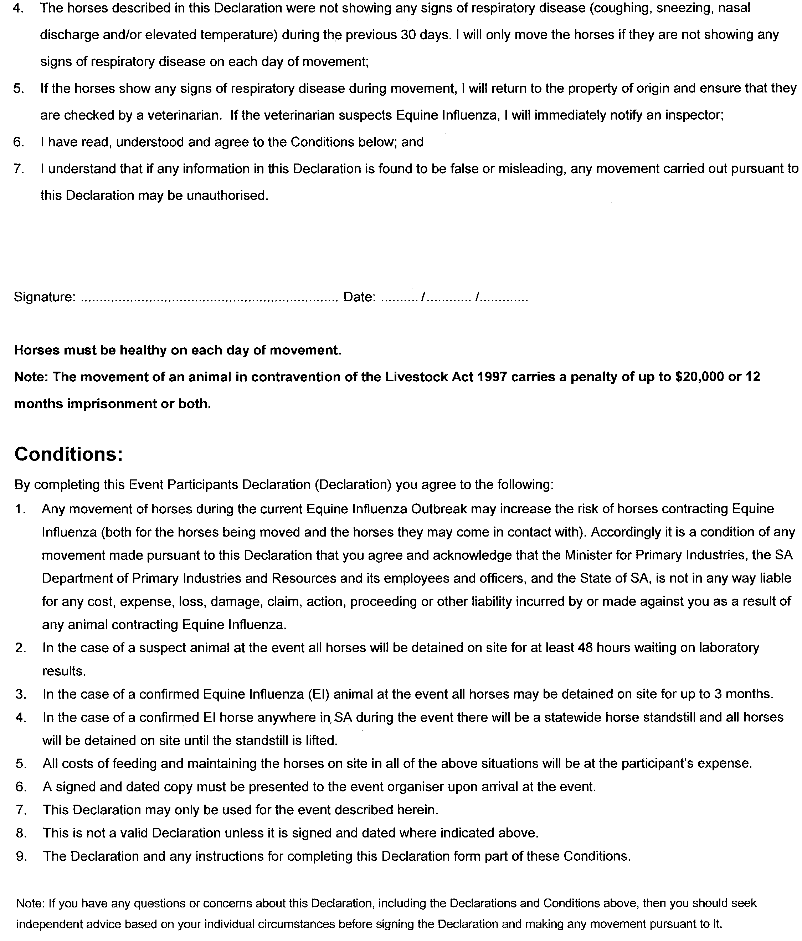
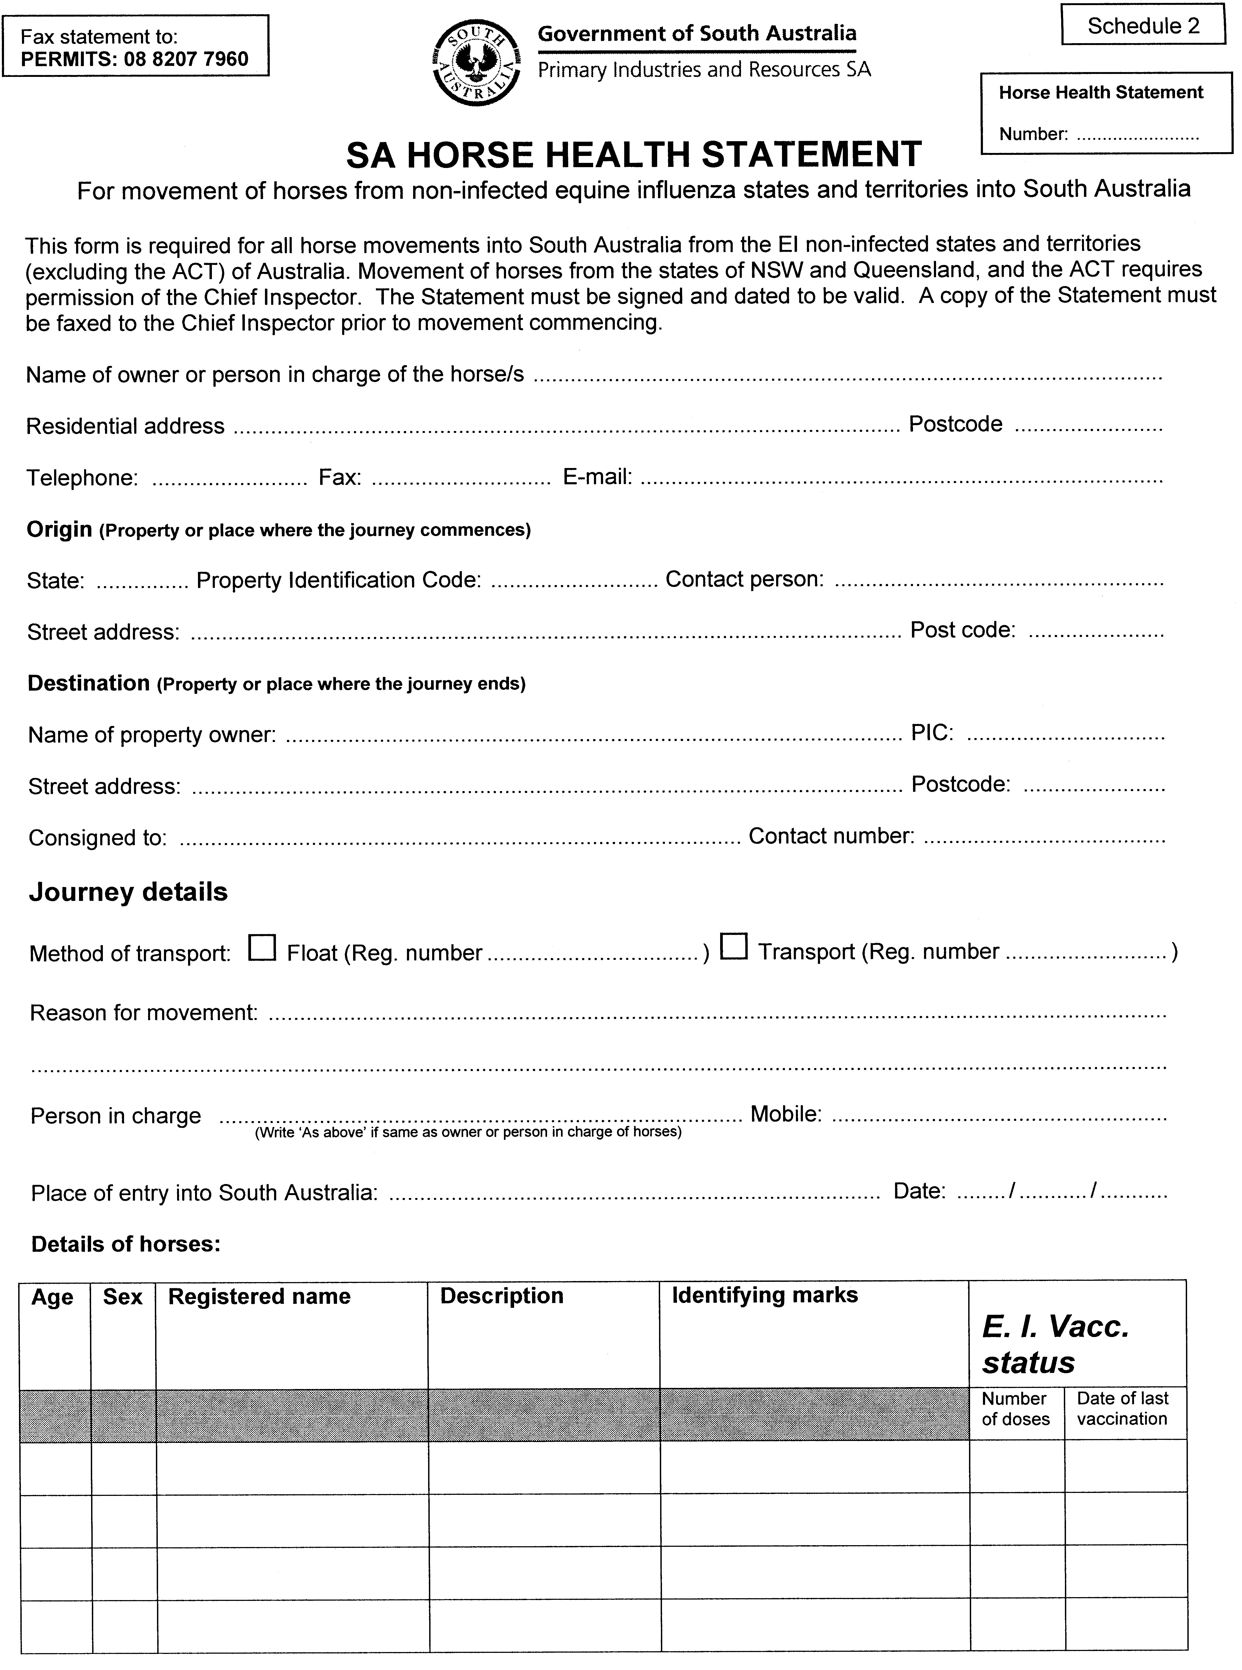
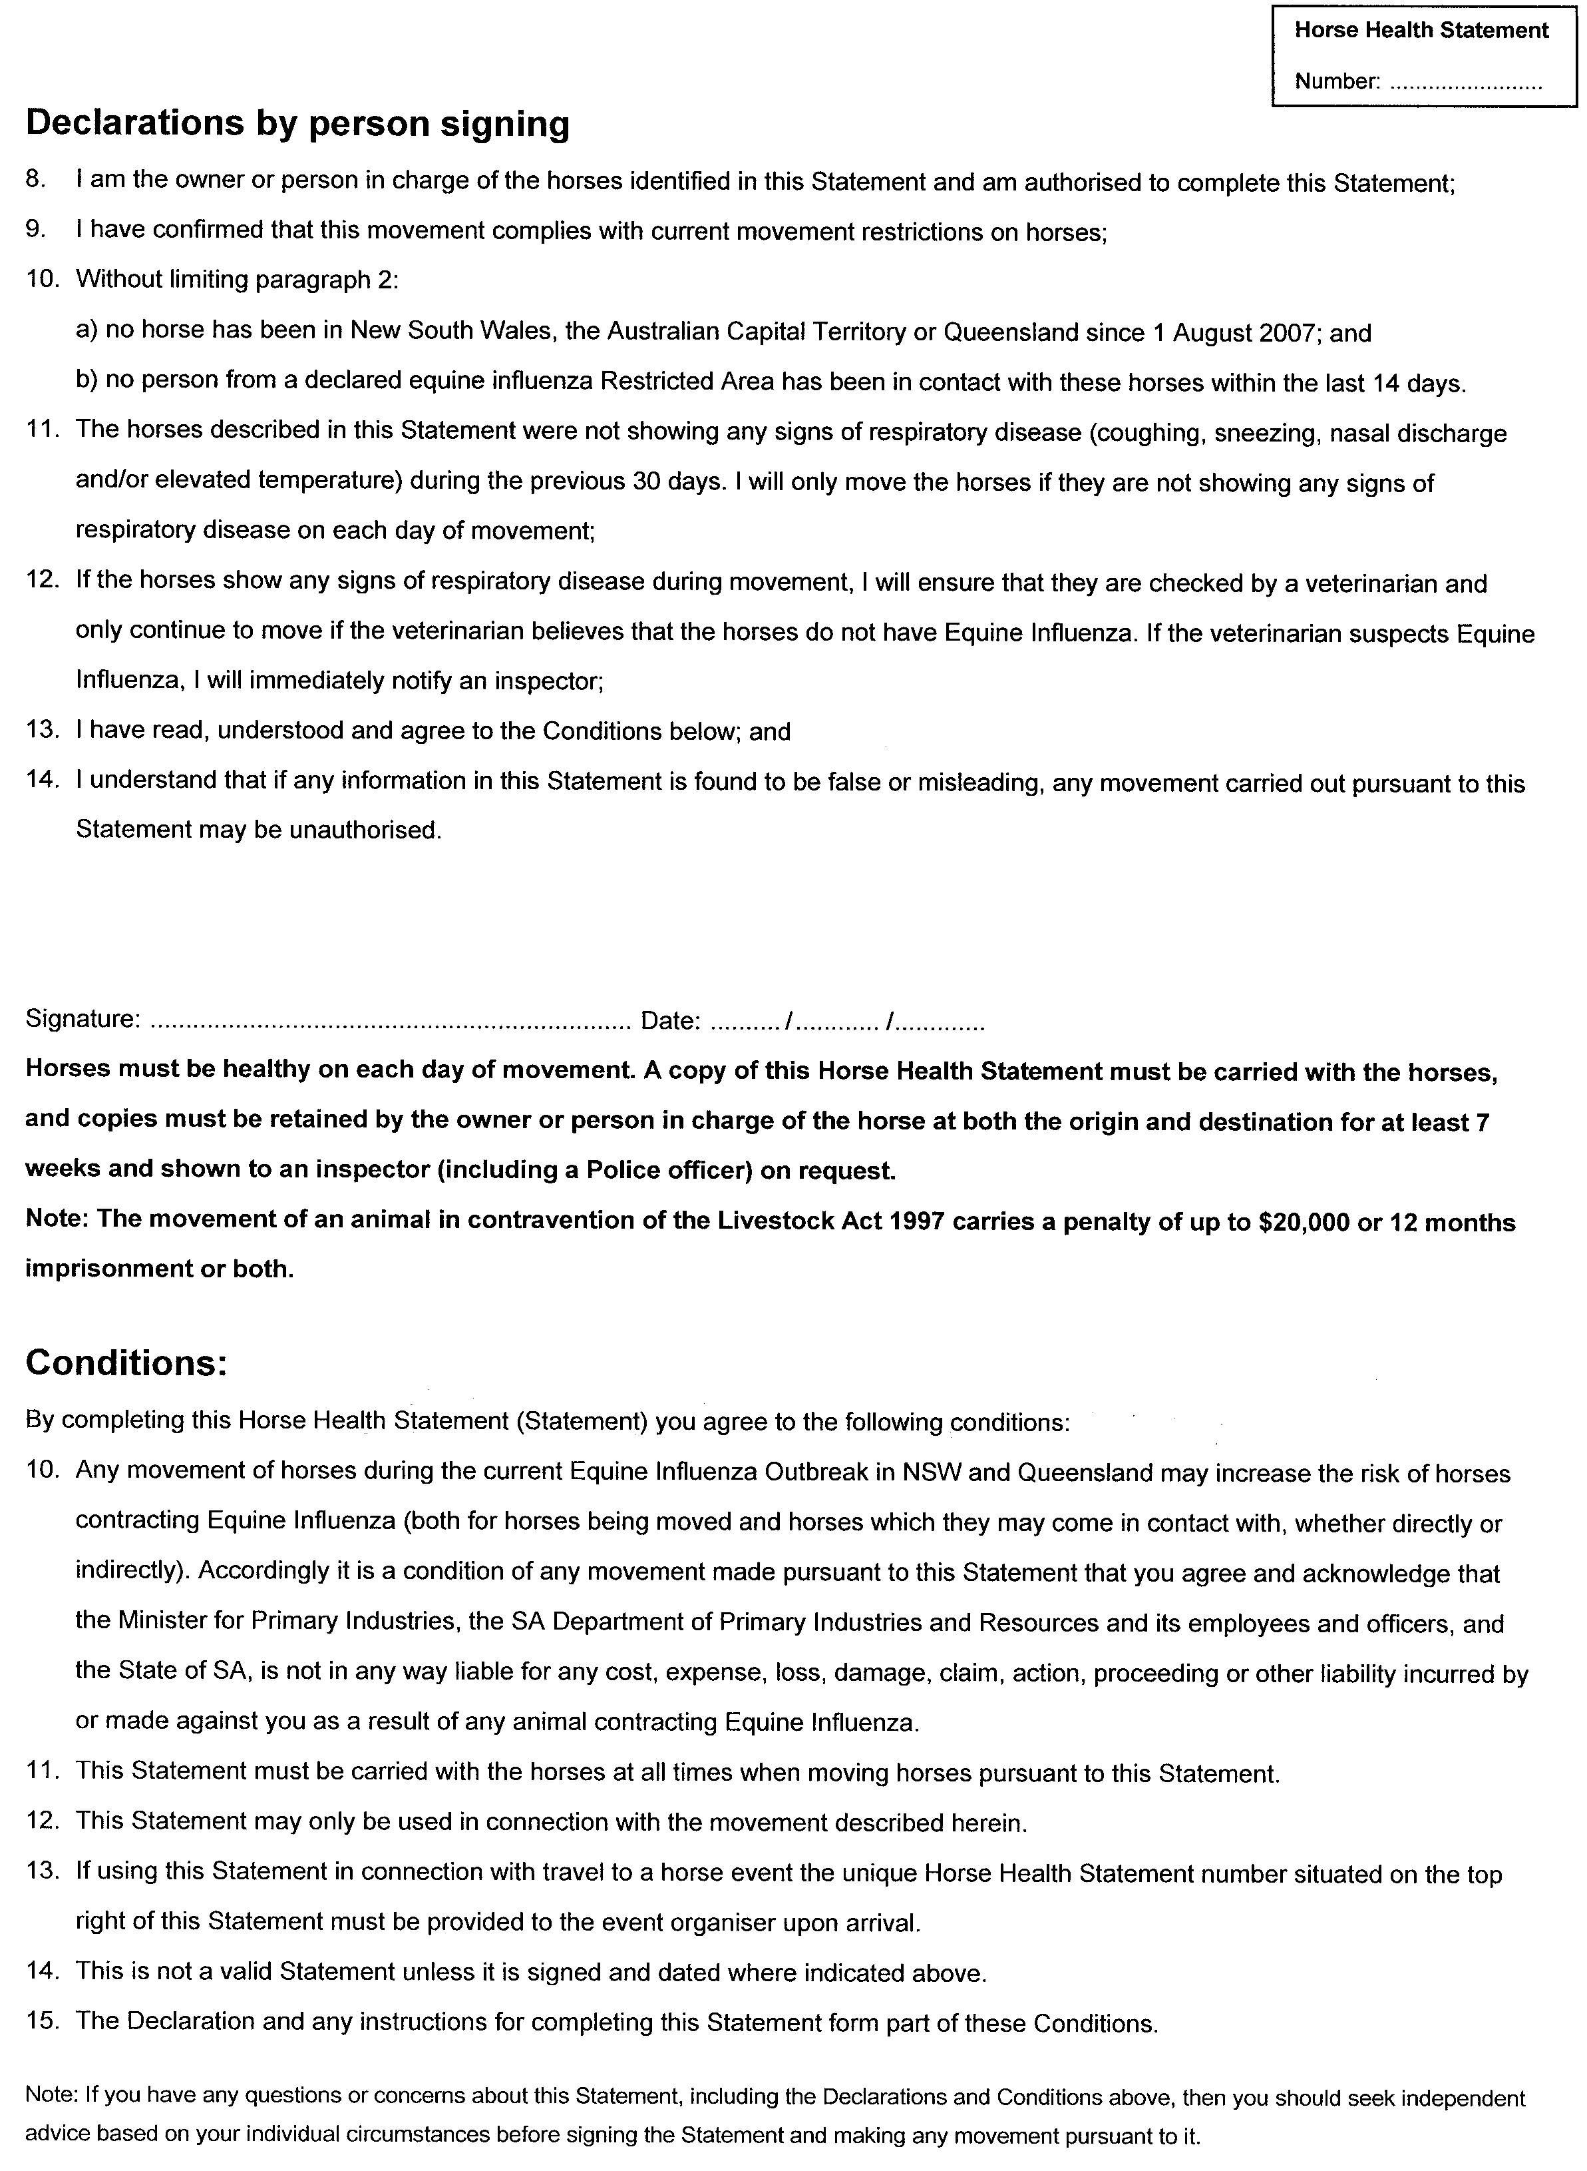
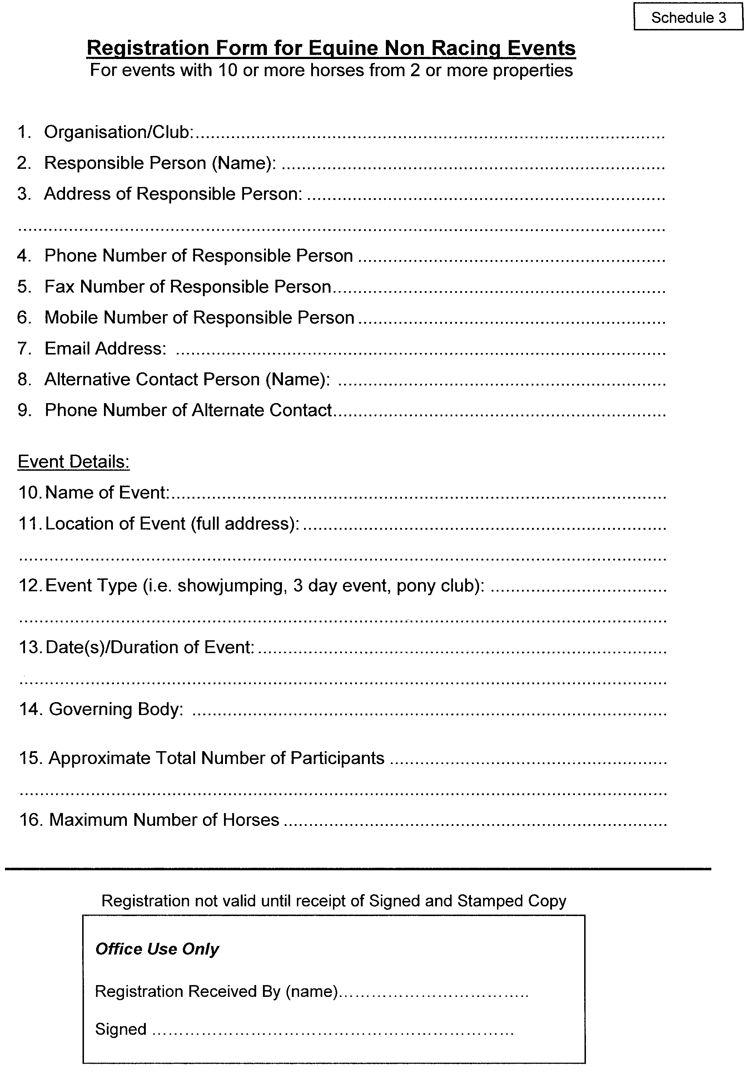
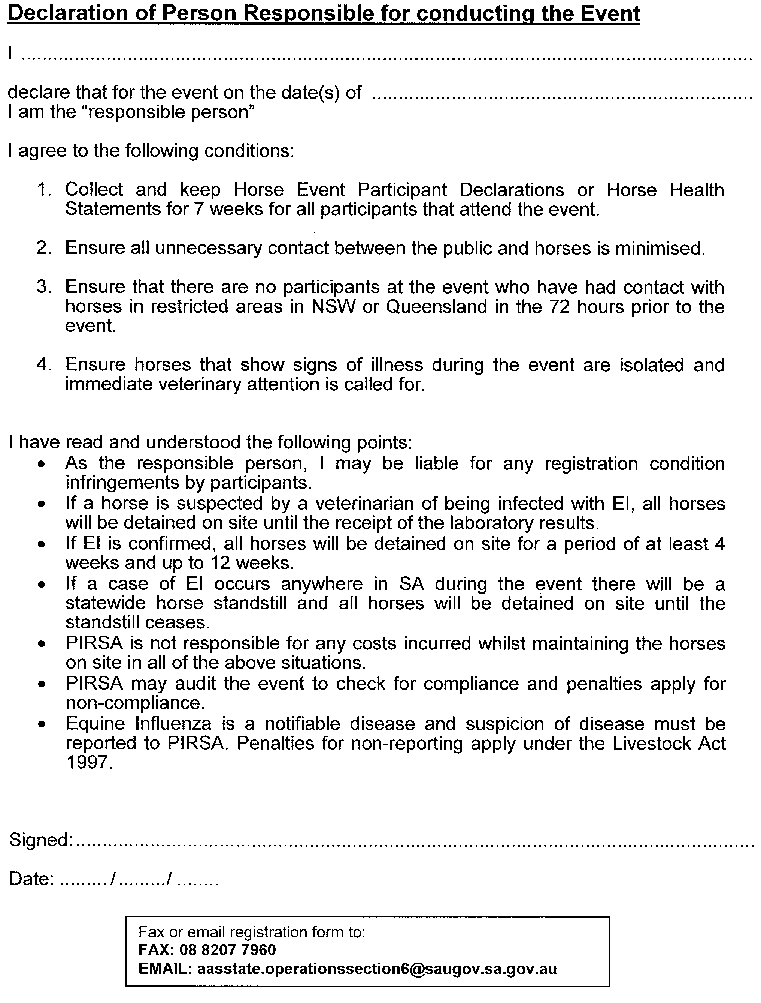

GOVERNMENT GAZETTE ADVERTISEMENT RATES

To apply from 1 July 2007

$  Agents, Ceasing to Act as 39.60  Associations:  Incorporation 20.10  Intention of Incorporation 49.75  Transfer of Properties 49.75  Attorney, Appointment of 39.60  Bailiff’s Sale 49.75  Cemetery Curator Appointed 29.45  Companies:  Alteration to Constitution 39.60  Capital, Increase or Decrease of 49.75  Ceasing to Carry on Business 29.45  Declaration of Dividend 29.45  Incorporation 39.60  Lost Share Certificates:  First Name 29.45  Each Subsequent Name 10.10  Meeting Final 33.10  Meeting Final Regarding Liquidator’s Report on  Conduct of Winding Up (equivalent to ‘Final  Meeting’)  First Name 39.60  Each Subsequent Name 10.10  Notices:  Call 49.75  Change of Name 20.10  Creditors 39.60  Creditors Compromise of Arrangement 39.60  Creditors (extraordinary resolution that ‘the Com-pany be wound up voluntarily and that a liquidator be appointed’) 49.75  Release of Liquidator⎯Application⎯Large Ad. 78.65  ⎯Release Granted 49.75  Receiver and Manager Appointed 45.85  Receiver and Manager Ceasing to Act 39.60  Restored Name 37.25  Petition to Supreme Court for Winding Up 69.30  Summons in Action 58.85  Order of Supreme Court for Winding Up Action 39.60  Register of Interests⎯Section 84 (1) Exempt 89.10  Removal of Office 20.10  Proof of Debts 39.60  Sales of Shares and Forfeiture 39.60  Estates:  Assigned 29.45  Deceased Persons⎯Notice to Creditors, etc. 49.75  Each Subsequent Name 10.10  Deceased Persons⎯Closed Estates 29.45  Each Subsequent Estate 1.30  Probate, Selling of 39.60  Public Trustee, each Estate 10.10 |  | $  Firms:  Ceasing to Carry on Business (each insertion) 26.30  Discontinuance Place of Business 26.30  Land⎯Real Property Act:  Intention to Sell, Notice of 49.75  Lost Certificate of Title Notices 49.75  Cancellation, Notice of (Strata Plan) 49.75  Mortgages:  Caveat Lodgement 20.10  Discharge of 21.05  Foreclosures 20.10  Transfer of 20.10  Sublet 10.10  Leases⎯Application for Transfer (2 insertions) each 10.10  Lost Treasury Receipts (3 insertions) each 29.45  Licensing 58.85  Municipal or District Councils:  Annual Financial Statement⎯Forms 1 and 2 554.35  Electricity Supply⎯Forms 19 and 20 393.90  Default in Payment of Rates:  First Name 78.65  Each Subsequent Name 10.10  Noxious Trade 29.45  Partnership, Dissolution of 29.45  Petitions (small) 20.10  Registered Building Societies (from Registrar-  General) 20.10  Register of Unclaimed Moneys⎯First Name 29.45  Each Subsequent Name 10.10  Registers of Members⎯Three pages and over:  Rate per page (in 8pt) 252.15  Rate per page (in 6pt) 333.45  Sale of Land by Public Auction 50.30  Advertisements 2.80  ¼ page advertisement 117.75  ½ page advertisement 235.50  Full page advertisement 461.60  Advertisements, other than those listed are charged at $2.80 per column line, tabular one-third extra.  Notices by Colleges, Universities, Corporations and District Councils to be charged at $2.80 per line.  Where the notice inserted varies significantly in length from that which is usually published a charge of $2.80 per column line will be applied in lieu of advertisement rates listed.  South Australian Government publications are sold on the condition that they will not be reproduced without prior permission from the Government Printer.
All the above prices include GST

GOVERNMENT GAZETTE NOTICES
ALL private advertisements forwarded for publication in the South Australian Government Gazette must be PAID FOR PRIOR TO INSERTION; and all notices, from whatever source, should be legibly written on one side of the paper only and sent to Government Publishing SA so as to be received no later than 4 p.m. Tuesday preceding the day of publication. Phone 8207 1045 or Fax 8207 1040. E-mail: governmentgazette@dpc.sa.gov.au. Send as attachments in Word format. Please include date the notice is to be published and to whom the notice will be charged. The Government Gazette is available online at: www.governmentgazette.sa.gov.au.

MISCELLANEOUS LEGISLATION AND GOVERNMENT PUBLICATIONS PRICES AS FROM 1 JULY 2007

Acts, Bills, Rules, Parliamentary Papers and Regulations
Pages | Main | Amends | Pages | Main | Amends

1-16 | 2.40 | 1.10 | 497-512 | 33.60 | 32.55
17-32 | 3.25 | 2.05 | 513-528 | 34.65 | 33.35
33-48 | 4.20 | 3.00 | 529-544 | 35.70 | 34.65
49-64 | 5.30 | 4.05 | 545-560 | 36.75 | 35.70
65-80 | 6.25 | 5.15 | 561-576 | 37.50 | 36.75
81-96 | 7.25 | 6.00 | 577-592 | 38.55 | 37.25
97-112 | 8.25 | 7.05 | 593-608 | 39.85 | 38.30
113-128 | 9.25 | 8.10 | 609-624 | 40.65 | 39.60
129-144 | 10.35 | 9.15 | 625-640 | 41.70 | 40.10
145-160 | 11.35 | 10.10 | 641-656 | 42.70 | 41.70
161-176 | 12.40 | 11.15 | 657-672 | 43.25 | 42.20
177-192 | 13.45 | 12.20 | 673-688 | 45.05 | 43.25
193-208 | 14.50 | 13.35 | 689-704 | 45.85 | 44.30
209-224 | 15.30 | 14.15 | 705-720 | 46.65 | 45.35
225-240 | 16.35 | 15.10 | 721-736 | 48.45 | 46.35
241-257 | 17.50 | 15.95 | 737-752 | 48.95 | 47.40
258-272 | 18.45 | 17.00 | 753-768 | 50.00 | 48.20
273-288 | 19.50 | 18.25 | 769-784 | 50.55 | 49.75
289-304 | 20.30 | 19.15 | 785-800 | 51.60 | 50.80
305-320 | 21.55 | 20.20 | 801-816 | 52.60 | 51.30
321-336 | 22.40 | 21.15 | 817-832 | 53.65 | 52.60
337-352 | 23.55 | 22.30 | 833-848 | 54.70 | 53.65
353-368 | 24.50 | 23.35 | 849-864 | 55.75 | 54.20
369-384 | 25.55 | 24.40 | 865-880 | 56.80 | 55.75
385-400 | 26.55 | 25.30 | 881-896 | 57.30 | 56.25
401-416 | 27.60 | 26.05 | 897-912 | 58.85 | 57.30
417-432 | 28.65 | 27.35 | 913-928 | 59.40 | 58.85
433-448 | 29.70 | 28.40 | 929-944 | 60.45 | 59.40
449-464 | 30.50 | 29.20 | 945-960 | 61.50 | 59.90
465-480 | 31.00 | 30.20 | 961-976 | 63.05 | 60.95
481-496 | 32.55 | 31.00 | 977-992 | 64.10 | 61.50

Legislation—Acts, Regulations, etc: $
Subscriptions:
Acts 207.00
All Bills as Laid 497.00
Rules and Regulations 497.00
Parliamentary Papers 497.00
Bound Acts 230.00
Index 115.00
Government Gazette
Copy 5.40
Subscription 274.00
Hansard
Copy 15.10
Subscription—per session (issued weekly) 431.00
Cloth bound—per volume 185.00
Subscription—per session (issued daily) 431.00
Legislation on Disk
Whole Database 3192.00
Annual Subscription for fortnightly updates 981.00
Individual Act(s) including updates POA
Compendium
Subscriptions:
Subscriptions 1891.00
Updates 667.00
(All the above prices include GST)

All Legislation, Government Gazette, Hansard and Legislation on disk are available from:
Counter Sales Service SA, Government Legislation⁺ Outlet
and Mail Orders: Lands Titles Office, 101 Grenfell Street, Adelaide, S.A. 5000
Phone: 13 23 24 (local call cost), Fax: (08) 8204 1909
Postal: G.P.O. Box 1707, Adelaide, S.A. 5001

Online Shop: www.shop.service.sa.gov.au

Subscriptions and Government Publishing SA
Standing Orders: Box 9, Plaza Level, Riverside Centre, North Terrace, Adelaide, S.A. 5000
Phone: (08) 8207 1043, (08) 8207 0910, Fax: (08) 8207 1040

NATIONAL ELECTRICITY LAW
THE Australian Energy Market Commission (AEMC) gives notice under the National Electricity Law (NEL) of the following matter.
Under section 107, the period of time for preparing the draft determination for the proposed National Electricity Amendment (Economic Regulation of Transmission Services Undertaken by Distributors) Rule 2008 has been extended to 10 April 2008.
Further details on the above matter are available on the AEMC’s website www.aemc.gov.au. All documents in relation to the above matter are published on the AEMC’s website and are available for inspection at the offices of the AEMC.
John Tamblyn
Chairman
Australian Energy Market Commission
Level 5, 201 Elizabeth Street
Sydney, N.S.W. 2000
Telephone: (02) 8296 7800
Facsimile: (02) 8296 7899
31 January 2008.

ROADS (OPENING AND CLOSING) ACT 1991:
SECTION 24
NOTICE OF CONFIRMATION OF ROAD
PROCESS ORDER
Road Closure—Tatura Road, Munno Para West
BY Road Process Order made on 14 June 2007, the City of Playford ordered that:
1. Portion of Tatura Road between allotments 102 and 120 in Deposited Plan 73477 and allotment 38 in Deposited Plan 66345, more particularly delineated and lettered ‘A’ in Preliminary Plan No. 07/0028 be closed.
2. Issue a Certificate of Title to the City of Playford for the whole of the land subject to closure which land is being retained by Council for public purposes.
3. The following easements are granted over portions of the land subject to that closure:
Grant to the South Australian Water Corporation easements for water supply and sewerage purposes.
On 23 January 2008 that order was confirmed by the Minister for Infrastructure conditionally upon the deposit by the Registrar-General of Deposited Plan 75177 being the authority for the new boundaries.
Pursuant to section 24 (5) of the Roads (Opening and Closing) Act 1991, NOTICE of the order referred to above and its confirmation is hereby given.
Dated 31 January 2008.
P. M. Kentish, Surveyor-General

SEWERAGE ACT 1929
Addition of Land to Adelaide Drainage Area
PURSUANT to section 18 of the Sewerage Act 1929, the South Australian Water Corporation:
(a) adds to the Adelaide Drainage Area all the land contained in allotments 79 to 91 inclusive, 93 to 95 inclusive, 97 to 99 inclusive, 104 to 116 inclusive, 118 to 120 inclusive, 128, 129, 706 to 708 inclusive (roads) and 850 and 853 (reserves) in Deposited Plan 75159; and
(b) declares that this notice will have effect from 1 July 2008.
Dated 25 January 2008.
Signed for and on behalf of the South Australian Water Corporation by a person duly authorised so to do:
P. M. Rucioch, Manager Shared Services
In the presence of:
C. J. McNamara, Billing Manager
SAWATER 07/08900 D1368

NOTICE TO MARINERS
No. 2 of 2008
South Australia—Spencer Gulf—Wallaroo—No. 1 Starboard Hand Channel Beacon Missing
MARINERS are advised that the No. 1 Starboard Hand Channel Beacon (F Fl.G 6s) in WGS84 position latitude 33°54.40′S, longitude 137°33.80′E, has been reported missing.
Mariners are advised to proceed with caution in the vicinity.
Navy Chart affected: Aus 777.
Publications affected: Australian Pilot, Volume 1 (1st Edition, 2005) page 359. Admiralty List of Lights and Fog Signals, Volume K (2007/08 Edition) No. 1974.4.
Adelaide, 15 January 2008.
Patrick Conlon, Minister for Transport
FP 2001/1439
DTEI 2008/00767

NOTICE TO MARINERS
No. 6 of 2008
South Australia—Gulf St Vincent—Aquatic Event
MARINERS are advised that the Henley Surf Life Saving Club intends to stage a fundraising aquatic event by rowing a surf boat in a direct route across Gulf St Vincent from Stansbury on Yorke Peninsula to Henley Beach on the Metropolitan coastline on Saturday, 2 February 2008.
The surf boat will depart Stansbury at approximately 5 a.m. and arrive at Henley Beach at approximately 2 p.m. There will be several tender vessels in support during the crossing.
Mariners are advised to proceed with caution in the vicinity of this flotilla.
Navy Chart affected: Aus 780.
Publications affected: Australian Pilot, Volume 1 (First Edi-tion, 2005) pages 383-393.
Adelaide, 29 January 2008.
Patrick Conlon, Minister for Transport
FP 2001/1439
DTEI 2008/00767

WATERWORKS ACT 1932
Addition of Land to Bordertown Water District
PURSUANT to section 6 of the Waterworks Act 1932, the South Australian Water Corporation:
(a) adds to the Bordertown Water District all the land contained in:
(i) allotment 1 in Deposited Plan 15640;
(ii) allotments 1 to 5 inclusive in Deposited Plan 71047; and
(b) declares that this notice will have effect from 1 July 2007.
Dated 25 January 2008.
Signed for and on behalf of the South Australian Water Corporation by a person duly authorised so to do:
P. M. Rucioch, Manager Shared Services
In the presence of:
C. J. McNamara, Billing Manager
SAWATER 07/06815 W1362

WATERWORKS ACT 1932
Removal of Land from Mundallio Country Lands Water District and Addition to Port Augusta Water District
PURSUANT to section 6 of the Waterworks Act 1932, the South Australian Water Corporation:
(a) removes from the Mundallio Country Lands Water District and adds to the Port Augusta Water District all the land contained in allotment 95 in Deposited Plan 49214; and
(b) declares that this notice has effect from the commence-ment of the financial year in which it is published in the Gazette.
Dated 25 January 2008.
Signed for and on behalf of the South Australian Water Corporation by a person duly authorised so to do:
P. M. Rucioch, Manager Shared Services
In the presence of:
C. J. McNamara, Billing Manager
SAWATER 07/06816 W1363

WATERWORKS ACT 1932
Removal of Land from Beetaloo Country Lands Water District and Addition to Moonta Water District
PURSUANT to section 6 of the Waterworks Act 1932, the South Australian Water Corporation:
(a) removes from the Beetaloo Country Lands Water District and adds to the Moonta Water District all the land contained in:
(i) section 166 in the Hundred of Wallaroo;
(ii) allotment 567 in Filed Plan 198749; and
(b) declares that this notice has effect from the commence-ment of the financial year in which it is published in the Gazette.
Dated 25 January 2008.
Signed for and on behalf of the South Australian Water Corporation by a person duly authorised so to do:
P. M. Rucioch, Manager Shared Services
In the presence of:
C. J. McNamara, Billing Manager
SAWATER 07/08901 W1370

WATERWORKS ACT 1932
Removal of Land from Blue Lake Country Lands Water District and Addition to Mount Gambier Water District
PURSUANT to section 6 of the Waterworks Act 1932, the South Australian Water Corporation:
(a) removes from the Blue Lake Country Lands Water District and adds to the Mount Gambier Water District all the land contained in allotment 10 in Deposited Plan 671657 (except the portion of that land already in the Mount Gambier Water District); and
(b) declares that this notice will have effect from the commencement of the financial year in which it is published in the Gazette.
Dated 25 January 2008.
Signed for and on behalf of the South Australian Water Corporation by a person duly authorised so to do:
P. M. Rucioch, Manager Shared Services
In the presence of:
C. J. McNamara, Billing Manager
SAWATER 07/06814 W1361

WATERWORKS ACT 1932
Removal of Land from Streaky Bay Country Lands Water District and Addition to Streaky Bay Township Water District
PURSUANT to section 6 of the Waterworks Act 1932, the South Australian Water Corporation:
(a) removes from the Streaky Bay Country Lands Water District and adds to the Streaky Bay Township Water District all the land contained in Deposited Plan 75818; and
(b) declares that this notice has effect from the commence-ment of the financial year in which it is published in the Gazette.
Dated 25 January 2008.
Signed for and on behalf of the South Australian Water Corporation by a person duly authorised so to do:
P. M. Rucioch, Manager Shared Services
In the presence of:
C. J. McNamara, Billing Manager
SAWATER 07/09478 W1381

WATERWORKS ACT 1932
Removal of Land from Beetaloo Country Lands Water District and Addition to Port Pirie Water District
PURSUANT to section 6 of the Waterworks Act 1932, the South Australian Water Corporation:
(a) removes from the Beetaloo Country Lands Water District and adds to the Port Pirie Water District all the land contained in:
(i) allotment 99 in Deposited Plan 74944;
(ii) allotments 1 to 35 inclusive in Deposited Plan 74944;
(iii) allotments 700 to 703 (roads) inclusive in Deposited Plan 74944; and
(b) declares that this notice has effect from 1 July 2008.
Dated 25 January 2008.
Signed for and on behalf of the South Australian Water Corporation by a person duly authorised so to do:
P. M. Rucioch, Manager Shared Services
In the presence of:
C. J. McNamara, Billing Manager
SAWATER 07/09473 W1373

WATERWORKS ACT 1932
Removal of Land from Mundallio Country Lands Water District and Addition to Port Augusta Water District
PURSUANT to section 6 of the Waterworks Act 1932, the South Australian Water Corporation:
(a) removes from the Mundallio Country Lands Water District and adds to the Port Augusta Water District all the land contained in allotment 5 in Deposited Plan 65715; and
(b) declares that this notice has effect from the commence-ment of the financial year in which it is published in the Gazette.
Dated 25 January 2008.
Signed for and on behalf of the South Australian Water Corporation by a person duly authorised so to do:
P. M. Rucioch, Manager Shared Services
In the presence of:
C. J. McNamara, Billing Manager
SAWATER 07/06817 W1364

South Australia
Road Traffic (Apparatus for Conducting Oral Fluid Analyses) Notice 2008
under section 47H of the Road Traffic Act 1961
1—Short title
This notice may be cited as the Road Traffic (Apparatus for Conducting Oral Fluid Analyses) Notice 2008.
2—Commencement
This notice comes into operation on the day on which it is made.
3—Apparatus for conducting oral fluid analyses
Apparatuses of the following kind are approved for the purpose of conducting oral fluid analyses:
Cozart DDS
Made by the Governor
with the advice and consent of the Executive Council
on 31 January 2008

South Australia
Statutes Amendment (Young Offenders) Act (Commencement) Proclamation 2008
1—Short title
This proclamation may be cited as the Statutes Amendment (Young Offenders) Act (Commencement) Proclamation 2008.
2—Commencement of Act
The Statutes Amendment (Young Offenders) Act 2007 (No 57 of 2007) will come into operation on 3 February 2008.
Made by the Governor
with the advice and consent of the Executive Council
on 31 January 2008
AGO0100/07CSTEMP1

South Australia
Forestry (Forest Reserve) Variation Proclamation 2008
under section 3(3) of the Forestry Act 1950

Preamble
1 The following land is forest reserve under the Forestry Act 1950 (see proclamation, Gazette 19.3.1992 p877, as varied) and forms part of the Mount Burr Forest District:
Portion of Section 206, Hundred of Mount Muirhead, now identified as portion of allotment 22 of approved plan No. DP 73835, Hundred of Mount Muirhead, lodged in the Lands Titles Registration Office at Adelaide;
Portion of Lot 10 of Plan No. DP 51077, Hundred of Mount Muirhead, accepted for deposit in the Lands Titles Registration Office at Adelaide, now identified as portion of allotment 22 of approved plan No. DP 73835, Hundred of Mount Muirhead, lodged in the Lands Titles Registration Office at Adelaide.
2 It is now intended that this land cease to be forest reserve.

Part 1—Preliminary
1—Short title
This proclamation may be cited as the Forestry (Forest Reserve) Variation Proclamation 2008.
2—Commencement
This proclamation comes into operation on the day on which it is made.
3—Variation provisions
In this proclamation, a provision under a heading referring to the variation of a specified proclamation varies the proclamation so specified.
Part 2—Variation of proclamation under Forestry Act 1950 declaring forest reserve (Gazette 19.3.1992 p877) as varied
4—Variation of Schedule
(1) Schedule, clause 7(d)—delete "206,"
(2) Schedule, clause 7(d)—delete "Lot 10 of Plan No. DP 51077, accepted for deposit in the Lands Titles Registration Office at Adelaide,"
(3) Schedule, clause 7(d)—after "Lots 200 and 201 Deposited Plan 50492" insert:
, Lot 21 of approved plan No. DP 73835, lodged in the Lands Titles Registration Office at Adelaide
Made by the Governor
with the advice and consent of the Executive Council
on 31 January 2008
MFOR08/001CS

South Australia
Mining (Revocation of Private Mine) Proclamation 2008
under section 73N of the Mining Act 1971

Preamble
1 The following area was declared to be a private mine by proclamation on 3 May 1973 (Gazette 3.5.1973 p1926):
All those portions of sections 5661, 2167 and 2166, hundred of Yatala, county of Adelaide, described in General Registry Office number 146, book 536, and closed road described in certificate of title, register book, volume 3768, folio 118.
2 The Warden's Court has declared (on 31 August 2006 in Action No 329 of 2006) that proper grounds exist for revoking the declaration referred to in clause 1.

1—Short title
This proclamation may be cited as the Mining (Revocation of Private Mine) Proclamation 2008.
2—Commencement
This proclamation comes into operation on the day on which it is made.
3—Revocation of private mine
The declaration referred to in clause 1 of the preamble is revoked.
Made by the Governor
on the basis of the declaration of the Warden's Court referred to in clause 2 of the preamble and with the advice and consent of the Executive Council
on 31 January 2008
AGO0047/02CS

South Australia
Mining (Revocation of Private Mine) Proclamation 2008
under section 73N of the Mining Act 1971

Preamble
1 The following area was declared to be a private mine by proclamation on 19 July 1973 (Gazette 19.7.1973 p288):
Section 344, hundred of Jellicoe, county of Eyre.
2 The Warden's Court has declared (on 10 May 2007 in Action No 42 of 2007) that proper grounds exist for revoking the declaration referred to in clause 1.

1—Short title
This proclamation may be cited as the Mining (Revocation of Private Mine) Proclamation 2008.
2—Commencement
This proclamation comes into operation on the day on which it is made.
3—Revocation of private mine
The declaration referred to in clause 1 of the preamble is revoked.
Made by the Governor
on the basis of the declaration of the Warden's Court referred to in clause 2 of the preamble and with the advice and consent of the Executive Council
on 31 January 2008
AGO0047/02CS

South Australia
Motor Vehicles Variation Regulations 2008
under the Motor Vehicles Act 1959

Contents
Part 1—Preliminary
1 Short title
2 Commencement
3 Variation provisions
Part 2—Variation of Motor Vehicles Regulations 1996
4 Variation of regulation 13—Exemptions from duty to carry number plates
5 Variation of regulation 13A—Exemptions from section 47D of Act
6 Substitution of regulation 51
51 Corresponding laws declared for purposes of demerit points scheme
7 Insertion of Schedule 5A
Schedule 5A—Corresponding laws declared for purposes of demerit points scheme

Part 1—Preliminary
1—Short title
These regulations may be cited as the Motor Vehicles Variation Regulations 2008.
2—Commencement
These regulations come into operation on the day on which they are made.
3—Variation provisions
In these regulations, a provision under a heading referring to the variation of specified regulations varies the regulations so specified.
Part 2—Variation of Motor Vehicles Regulations 1996
4—Variation of regulation 13—Exemptions from duty to carry number plates
Regulation 13—after its present contents (now to be designated as subregulation (1)) insert:
(2) An officer or employee of the South Australian Police Department or the Transport Department who drives a motor vehicle on a road, or causes a motor vehicle to stand on a road, is exempt from the operation of section 47(1) of the Act if—
(a) the vehicle is being used for the purpose of testing the legibility of number plates; and
(b) the vehicle displays a sign bearing the word "test".
5—Variation of regulation 13A—Exemptions from section 47D of Act
Regulation 13A—after its present contents (now to be designated as subregulation (1)) insert:
(2) An officer or employee of the South Australian Police Department or the Transport Department who drives a motor vehicle on a road, or causes a motor vehicle to stand on a road, is exempt from the operation of section 47D(1)(a), (b) and (c) of the Act if—
(a) the vehicle is being used for the purpose of testing the legibility of number plates; and
(b) the vehicle displays a sign bearing the word "test".
6—Substitution of regulation 51
Regulation 51—delete the regulation and substitute:
51—Corresponding laws declared for purposes of demerit points scheme
The laws specified in Schedule 5A, as amended or substituted from time to time, are declared to be corresponding laws for the purposes of Part 3B of the Act.
7—Insertion of Schedule 5A
After Schedule 5 insert:
Schedule 5A—Corresponding laws declared for purposes of demerit points scheme
Motor Vehicles Act of the Northern Territory and regulations made under that Act
Road Safety Act 1986 of Victoria and regulations made under that Act
Road Transport (Driver Licensing) Act 1998 of New South Wales and regulations made under that Act
Road Transport (Driver Licensing) Act 1999 of the Australian Capital Territory and regulations made under that Act
Transport Operations (Road Use Management) Act 1995 of Queensland and regulations made under that Act
Vehicle and Traffic Act 1999 of Tasmania and regulations made under that Act
Note—
As required by section 10AA(2) of the Subordinate Legislation Act 1978, the Minister has certified that, in the Minister's opinion, it is necessary or appropriate that these regulations come into operation as set out in these regulations.
Made by the Governor
with the advice and consent of the Executive Council
on 31 January 2008
No 5 of 2008
MTR07/047CS

South Australia
Road Traffic (Road Rules—Ancillary and Miscellaneous Provisions) Variation Regulations 2008
under the Road Traffic Act 1961

Contents
Part 1—Preliminary
1 Short title
2 Commencement
3 Variation provisions
Part 2—Variation of Road Traffic (Road Rules—Ancillary and Miscellaneous Provisions) Regulations 1999
4 Insertion of regulation 26A
26A Responsibility of drivers for wearing of seatbelts by passengers 16 years old, or older

Part 1—Preliminary
1—Short title
These regulations may be cited as the Road Traffic (Road Rules—Ancillary and Miscellaneous Provisions) Variation Regulations 2008.
2—Commencement
These regulations will come into operation on 1 March 2008.
3—Variation provisions
In these regulations, a provision under a heading referring to the variation of specified regulations varies the regulations so specified.
Part 2—Variation of Road Traffic (Road Rules—Ancillary and Miscellaneous Provisions) Regulations 1999
4—Insertion of regulation 26A
After regulation 26 insert:
26A—Responsibility of drivers for wearing of seatbelts by passengers 16 years old, or older
The driver of a motor vehicle (except a bus or taxi) that is moving, or that is stationary but not parked, must ensure that each passenger in or on the vehicle who is 16 years old or older complies with rule 265 (Wearing of seatbelts by passengers 16 years old, or older).
Maximum penalty: $2 500.
Note—
As required by section 10AA(2) of the Subordinate Legislation Act 1978, the Minister has certified that, in the Minister's opinion, it is necessary or appropriate that these regulations come into operation as set out in these regulations.
Made by the Governor
with the advice and consent of the Executive Council
on 31 January 2008
No 6 of 2008
MRS07/010SC

South Australia
Road Traffic (Miscellaneous) Variation Regulations 2008
under the Road Traffic Act 1961

Contents
Part 1—Preliminary
1 Short title
2 Commencement
3 Variation provisions
Part 2—Variation of Road Traffic (Miscellaneous) Regulations 1999
4 Variation of regulation 8—Offences included in prescribed circumstances
5 Variation of Schedule 9—Expiation fees

Part 1—Preliminary
1—Short title
These regulations may be cited as the Road Traffic (Miscellaneous) Variation Regulations 2008.
2—Commencement
These regulations will come into operation on 1 March 2008.
3—Variation provisions
In these regulations, a provision under a heading referring to the variation of specified regulations varies the regulations so specified.
Part 2—Variation of Road Traffic (Miscellaneous) Regulations 1999
4—Variation of regulation 8—Offences included in prescribed circumstances
Regulation 8(e)—delete "or 10A" and substitute:
, 10A or 26A
5—Variation of Schedule 9—Expiation fees
(1) Schedule 9, Part 3, item relating to rule 264(1)—delete "$195" and substitute:
$230
(2) Schedule 9, Part 3, item relating to rule 265(1)—delete "$195" and substitute:
$230
(3) Schedule 9, Part 3, item relating to rule 266(1)—delete the item and substitute:

266(1) | Failing to ensure passengers under 16 years old are wearing seatbelts or approved child restraints—
 | failure in relation to 1 such passenger | $230
 | failure in relation to more than 1 such passenger | $280
(4) Schedule 9, Part 6—after item relating to regulation 10A(1) insert:

26A | Failing to ensure passengers 16 years old or older are wearing seatbelts
 | failure in relation to 1 such passenger | $230
 | failure in relation to more than 1 such passenger | $280
Note—
As required by section 10AA(2) of the Subordinate Legislation Act 1978, the Minister has certified that, in the Minister's opinion, it is necessary or appropriate that these regulations come into operation as set out in these regulations.
Made by the Governor
with the advice and consent of the Executive Council
on 31 January 2008
No 7 of 2008
MRS07/010SC

South Australia
Motor Vehicles Variation Regulations 2008
under the Motor Vehicles Act 1959

Contents
Part 1—Preliminary
1 Short title
2 Commencement
3 Variation provisions
Part 2—Variation of Motor Vehicles Regulations 1996
4 Variation of Schedule 7—Demerit points

Part 1—Preliminary
1—Short title
These regulations may be cited as the Motor Vehicles Variation Regulations 2008.
2—Commencement
These regulations will come into operation on 1 March 2008.
3—Variation provisions
In these regulations, a provision under a heading referring to the variation of specified regulations varies the regulations so specified.
Part 2—Variation of Motor Vehicles Regulations 1996
4—Variation of Schedule 7—Demerit points
(1) Schedule 7, Part 1, Division 2, item relating to rule 266(1)—delete the item and substitute:

266(1) | Failing to ensure passengers under 16 years old are wearing seatbelts or approved child restraints—
 | driver who is a person referred to in section 98BI(1)(a)(i) or (ii) of the Motor Vehicles Act 1959 | 3
 | all other drivers | see Part 2 Division 2
(2) Schedule 7, Part 2, Division 2—after item relating to rule 265(1) insert:

266(1) | Failing to ensure passengers under 16 years old are wearing seatbelts or approved child restraints—
 | driver who is a person referred to in section 98BI(1)(a)(i) or (ii) of the Motor Vehicles Act 1959 | see Part 1 Division 2
 | all other drivers—
 | failure in relation to 1 such passenger | 3
 | failure in relation to more than 1 such passenger | 5
(3) Schedule 7, Part 2, Division 3—after item relating to regulation 9A(2) insert:

26A | Failing to ensure passengers 16 years old or older are wearing seatbelts—
 | failure in relation to 1 such passenger | 3
 | failure in relation to more than 1 such passenger | 5
Note—
As required by section 10AA(2) of the Subordinate Legislation Act 1978, the Minister has certified that, in the Minister's opinion, it is necessary or appropriate that these regulations come into operation as set out in these regulations.
Made by the Governor
with the advice and consent of the Executive Council
on 31 January 2008
No 8 of 2008
MRS07/010SC

South Australia
Harbors and Navigation Variation Regulations 2008
under the Harbors and Navigation Act 1993

Contents
Part 1—Preliminary
1 Short title
2 Commencement
3 Variation provisions
Part 2—Variation of Harbors and Navigation Regulations 1994
4 Variation of regulation 125E—Modification of ABP Standard

Part 1—Preliminary
1—Short title
These regulations may be cited as the Harbors and Navigation Variation Regulations 2008.
2—Commencement
These regulations will come into operation on 4 February 2008, immediately after the Harbors and Navigation Variation Regulations 2007 (No 249 of 2007).
3—Variation provisions
In these regulations, a provision under a heading referring to the variation of specified regulations varies the regulations so specified.
Part 2—Variation of Harbors and Navigation Regulations 1994
4—Variation of regulation 125E—Modification of ABP Standard
Regulation 125E(c)—delete paragraph (c) and substitute:
(c) delete the following words from clause 8.1(h):
In addition, if the boat has a build date prior to 1 July 2006, the term "inadequate flotation" may be used.
Note—
As required by section 10AA(2) of the Subordinate Legislation Act 1978, the Minister has certified that, in the Minister's opinion, it is necessary or appropriate that these regulations come into operation as set out in these regulations.
Made by the Governor
with the advice and consent of the Executive Council
on 31 January 2008
No 9 of 2008
MTR07/040CS

FAXING COPY?
IF you fax copy to Government Publishing SA for inclusion in the Government Gazette, there is no need to send a Confirmation Copy to us as well.
This creates confusion and may well result in your notice being printed twice.
Please use the following fax number:
Fax transmission: (08) 8207 1040
Phone Inquiries: (08) 8207 1045
Please include a contact person, phone number and order number so that we can phone back with any queries we may have regarding the fax copy.
NOTE: Closing time for lodging new copy (fax, hard copy or email) is 4 p.m. on Tuesday preceding the day of publication.

Government Gazette notices can be E-mailed.
The address is:
governmentgazette@dpc.sa.gov.au
Documents should be sent as attachments in Word format.
When sending a document via E-mail, please confirm your transmission with a faxed copy of your document, including the date the notice is to be published.
Fax transmission: (08) 8207 1040
Enquiries: (08) 8207 1045
NOTE: Closing time for lodging new copy (fax, hard copy or email) is 4 p.m. on Tuesday preceding the day of publication.

ADELAIDE CITY COUNCIL
Adelaide Park Lands Authority
(a Subsidiary of Adelaide City Council)
Appointments
NOTICE is hereby given that Adelaide City Council, pursuant to Division 2 of Part 2 of the Adelaide Park Lands Act 2005, appoints the following persons as members of the Board of Management of the Adelaide Park Lands Authority:
For the purposes of section 6 (1) (a) (i) of the Act:
The Lord Mayor, the Honourable Michael Harbison, who will be the Presiding Member of the Board.
For the purposes of section 6 (1) (a) (ii) of the Act:
Councillor Anne Moran;
Councillor Ralph Clarke;
Councillor Michael Henningsen; and
Councillor David Plumridge.
Pursuant to section 7 (2) of the Act, Council appoints the above members for a 12 month term expiring 13 December 2008.
Dated 31 January 2008.
S. Moseley, Chief Executive Officer

CITY OF HOLDFAST BAY
Declaration of Public Roads
NOTICE is hereby given pursuant to section 210 of the Local Government Act 1999, that the City of Holdfast Bay at its meeting held on 15 January 2008, declared allotments 48, 49, 50, 52, 53, 54, 55, 56, 57 and 59 in Deposited Plan 2880 being portions of Alfreda Street, Almond Grove, Indra Terrace, Sandhurst Court, King George Avenue, Torr Avenue and Right of Way off Alfreda Street, Brighton, to be public roads.
R. Donaldson, Chief Executive Officer

ALEXANDRINA COUNCIL
Declaration of Public Road—Christina Street, Ashbourne
Erratum
IN Government Gazette, dated 2 November 2006, at page 3894, first notice appearing, section 208 of the Local Government Act 1999, should read Section 210 of the Local Government Act 1999.
J. Coombe, Chief Executive

ALEXANDRINA COUNCIL
Local Government Act 1999
Declaration of Public Roads—Goolwa North
NOTICE is hereby given that pursuant to section 210 of the Local Government Act 1999, the Alexandrina Council at its meeting held on 17 December 2007, declared that Franklin Street, Boston Street, New Orleans Street, Washington Street, Quebec Street, Fenchurch Street between Washington Street and Bricknell Road, un-named road adjacent to Lot 151 between Byrnes Road and Boston Street, Burt Avenue and Bricknell Road all in GRO Plan 21 of 1854, Goolwa North, be declared public roads.
J. Coombe, Chief Executive

DISTRICT COUNCIL OF LOWER EYRE PENINSULA
Allocation of Road Names
NOTICE is hereby given that the District Council of Lower Eyre Peninsula issued a resolution pursuant to section 219 (1) of the Local Government Act 1999, to allocate the following:
Meeting held on 15 June 2007:
• For the un-named road between sections 79 and 91 and sections 92 and 93 in the Hundred of Lincoln, be named Wallis Road.
Meeting held on 20 July 2007:
• For the un-named road on the coast side of Proper Bay Road, north of the old railway line crossing in the Hundred of Lincoln, be named Investigator Road.
• For the un-named road running between Farm Beach Road and Weashir Street in the Hundred of Wangary, be named Taylor Road.
Meeting held on 16 November 2007:
• For the un-named road on the eastern side of section 291, Hundred of Lake Wangary, be named Kewell Road.
• For the un-named road running along the northern boundary of section 269 and the eastern boundaries of sections 224, 225 and 226, all the Hundred of Warrow, be named Googs Lane.
Meeting held on 14 December 2007:
• For the un-named road from Moonlight Bay Road heading in a south-easterly direction for approximately 1 km to the un-constructed road heading south from Moonlight Bay road at the southern most point of section 404, Hundred of Louth, be named Myalpa Road.
Naming Adjustment
Meeting held on 15 June 2007:
• That Greenpatch Road commences at Hyde Road and heads north and Wine Shanty Road extends northwards terminating at Hyde Road.
• Blue Fin Road be extended to include the road from Kathai Road to the north-west corner of Allotment 1 of Deposited Plan 56556.
P. Aird, Chief Executive Officer

DISTRICT COUNCIL OF LOWER EYRE PENINSULA
Allocation of Road Names
NOTICE is hereby given that the District Council of Lower Eyre Peninsula issued a resolution at a meeting held on 18 January 2008, pursuant to section 219 (1) of the Local Government Act 1999, to allocate the following:
• For the three roads west of Coulta Township off Flinders Highway, to be named ‘Old Cemetery Road’, ‘Spring Road’ and ‘Marble Creek Road’.
P. Aird, Chief Executive Officer

DISTRICT COUNCIL OF MOUNT BARKER
Assignment of Road Names
NOTICE is hereby given that pursuant to section 219 of the Local Government Act 1999, Council has resolved to assign road names within the District Council of Mount Barker to the following un-named Government roads:
• That the road name Glen Brae Road, be assigned to a previously unknown public road at Mount Barker. The road runs in a west-east direction from Daniel Road to intersect an unknown and un-made road reserve.
• That the road name Cockatoo Ridge, be assigned to a previously unknown public road segment at Harrogate. The road runs in a north-south direction from Tungkillo Road to the Bremer River.
• That the road name Reserve Lane, be assigned to a previously unknown public road segment at Harrogate. The road runs in a south-north direction from Mail Road to the Bremer River.
• That the road name Beneva Road, be assigned to a previously unknown public road at Mount Barker. The road runs in a south-north direction from Old Mount Barker Road to link with Hawthorn Road at the North.
• That the road name Hillview Road, be assigned to a previously unknown public road at Callington. The road runs in a north-south direction from Back Callington Road to intersect the unknown road segment being named Hollamby Road.
• That the road name Hollamby Road, be assigned to a previously unknown public road at Callington. The road runs in a west-east direction from Back Callington-Railway intersection, ending up at an un-made road reserve.
• That the road name Hillside Lane, be assigned to a previously unknown public road at Mount Barker-Wistow. The road runs in a south-north direction from Hender Road to intersect Blue Wren Road across the Mount Barker Creek.
• That the road name Pollard Road, be assigned to a previously unknown public road at Harrogate. The road runs in an east-west direction from Snake Gully Road to Jones Road
• That the road name Criffin Lane, be assigned to a previously unknown public road at Echunga. The road runs in an eastern-western direction from Mosel Road to a Cul-de-sac.
• That the road name Reimann Lane, be assigned to a previously unknown public road at Littlehampton. The road runs in a south-north direction from Kookaburra Lane to end up at a Cul-de-sac.
• That the road name Farmer Road, be assigned to a previously unknown public road at Mount Barker-Wistow. The road runs in a north-south direction from Hender Road to end up intersecting the Wiles Fire Track and the Blight Reserve Road.
• That the road name Westley Court, be assigned to a previously known public road at Mount Barker that was named Ray Orr Court. The road runs in a south-north-east direction from Ray Orr Drive to end up at a Cul-de-sac.
All relevant Government agencies and Emergency Services are being notified as are the residents affected by these changes. For more information, please contact Council on 8391 7200 or in person at the Local Government Centre, 23 Mann Street, Mount Barker.
A. Stuart, Chief Executive Officer

DISTRICT COUNCIL OF STREAKY BAY
Appointment
NOTICE is hereby given that Council at its meeting held on
17 January 2008, appointed Francois d’Hotman de Villiers as Acting Chief Executive Officer for the period 4 February 2008 to 8 February 2008 (both dates inclusive).
J. Rumbelow, Chief Executive Officer

IN the matter of the estates of the undermentioned deceased persons:
Batsis, Evdoxia, late of 110 Strathfield Terrace, Largs North, of no occupation, who died on 3 October 2007.
Bessell, Ida Lillian, late of 54 Northcote Street, Kilburn, home duties, who died on 4 September 2007.
Bremner, Margaret, late of 39 Campus Drive, Aberfoyle Park, of no occupation, who died on 8 July 2007.
Callow, Olive Constance, late of 1 Myzantha Street, Lockleys, of no occupation, who died on 1 December 2007.
Coffey, Michael James, late of 3 Inderi Street, Gepps Cross, retired public servant, who died on 26 November 2007.
Crawford, Christine Ann, late of 16 Inverloch Avenue, Torrens Park, Occupational Health and Safety manager, who died on 31 October 2007.
Cundy, John Henry Garth, late of 193 Ladywood Road, Modbury Heights, retired credit manager, who died on 1 August 2007.
Deuschle, Gerhard Christian, late of 34 Molesworth Street, North Adelaide, retired toolmaker, who died on 19 November 2007.
Doddridge, Hugh Francis Sheridan, late of 333 Marion Road, North Plympton, retired foreman storeman, who died on 9 September 2007.
Gottsche, Gwendoline Mary, late of 2 Kalyra Road, Belair, retired dressmaker, who died on 16 October 2007.
Hawkins, Nora Ethel, late of 84 Valley View Drive, McLaren Vale, retired switchboard operator, who died on 23 November 2007.
Howard, Patricia Martina, late of 47 Glen Osmond Road, Eastwood, retired opera singer, who died on 24 February 2003.
Hull, Kenneth Roy, late of Kennedy Court, Largs Bay, retired clerk, who died on 4 December 2007.
Kaim, Martin, late of 9 Kramm Avenue, Hahndorf, retired teacher, who died on 22 November 2007.
Malgorzewicz, Lynette Margaret, late of 25 Roopena Street, Ingle Farm, of no occupation, who died on 28 April 2007.
Matz, Barry Clyde, late of Hazel Grove, Ridgehaven, retired stockman, who died on 6 October 2007.
Messner, Vanetta Jean, late of 16 Fresian Drive, Strathalbyn, home duties, who died on 5 November 2007.
Palmer, Robert Alan, late of 2 Fourth Avenue, Moana, retired butcher, who died on 15 November 2007.
Sanderson, Muriel Emlyn, late of 11 Dawson Street, Fullarton, retired publican, who died on 5 December 2007.
Shepherdson, Edith Beatrice, late of 32 Cross Road, Myrtle Bank, of no occupation, who died on 13 April 2007.
Wight, Kelvin William, late of Sturdee Street, Linden Park, retired supervisor, who died on 29 November 2007.
Wimshurst, Shayne Francis, late of 14 Deakin Street, Blair Athol, storeman, who died on 24 November 2007.
Notice is hereby given pursuant to the Trustee Act 1936, as amended, the Inheritance (Family Provision) Act 1972, and the Family Relationships Act 1975, that all creditors, beneficiaries, and other persons having claims against the said estates are required to send, in writing, to the Public Trustee, 25 Franklin Street, Adelaide, S.A. 5000, full particulars and proof of such claims, on or before 29 February 2008, otherwise they will be excluded from the distribution of the said estate; and notice is also hereby given that all persons who are indebted to the said estates are required to pay the amount of their debts to the Public Trustee or proceedings will be taken for the recovery thereof; and all persons having any property belonging to the said estates are forthwith to deliver the same to the Public Trustee.
Dated 31 January 2008.
M. I. Bodycoat, Public Trustee

SALE OF PROPERTY
Auction Date: Friday, 22 February 2008 at 11 a.m.
Location: Lot 71, Nottingham Street, Kapunda
NOTICE is hereby given that on the above date at the time and place stated, by virtue of the Warrant of Sale issued out of the Magistrates Court of South Australia, Action No. 4359 of 2007, directed to the Sheriff of South Australia in an action wherein Australian Central Credit Union Ltd. are the Plaintiffs and Troy William Moxham as the Defendant, I, Mark Stokes, Sheriff of the State of South Australia, will by my auctioneers, Griffin Real Estate, make sale of the estate, right, title or interest whatsoever it may be of the Defendant, Troy William Moxham as the registered proprietors of an estate in fee simple in the following:
That piece of land situated in the area named Kapunda, being Lot 71, Nottingham Street, being the property comprised in certificate of title register book volume 5918, folio 234.
Further particulars from the auctioneers:
Griffin Real Estate,
8 Greenhill Road,
Wayville, S.A. 5034.
Telephone: (08) 8372 7872

ATTENTION

CUSTOMERS requiring a proof of their notice for inclusion in the Government Gazette, please note that the onus is on you to inform Government Publishing SA of any subsequent corrections by 10 a.m. on Thursday, which is our publication deadline.

For any corrections to your notice please phone 8207 1045 or Fax 8207 1040 before 10 a.m. on Thursday.

If we do not receive any communication by 10 a.m. on Thursday (day of publication) we will presume the notice is correct and will print it as it is.

Remember—the onus is on you to inform us of any corrections necessary to your notice.

NOTE: Closing time for lodging new copy (electronically, fax or hard copy) is 4 p.m. on Tuesday preceding the day of publication. Phone 8207 1045—Fax 8207 1040.
Email: governmentgazette@dpc.sa.gov.au

Printed and published by authority every Thursday by T. GOODES, Government Printer, South Australia
Price: $5.40, plus postage; to subscribers, $274.00 per annum.
(The above prices are inclusive of GST)

