No. 42 3409

THE SOUTH AUSTRALIAN

GOVERNMENT GAZETTE
www.governmentgazette.sa.gov.au

PUBLISHED BY AUTHORITY

ALL PUBLIC ACTS appearing in this GAZETTE are to be considered official, and obeyed as such

ADELAIDE, THURSDAY, 24 JULY 2008

CONTENTS

Page
Appointments, Resignations, Etc. 3410
Co-operatives Act 1997—Notice 3412
Corporations and District Councils—Notices 3482
Crown Lands Act 1929—Notices 3412
Development Act 1993—Notices 3413
Electricity Act 1996—Notice 3415
Environment Protection Authority—Notice 3413
Fisheries Management Act 2007—Notices 3417
Gas Act 1997—Notice 3427
Geographical Names Act 1991—Notice 3425
Harbors and Navigation Act 1993—Notices 3430
Land and Business (Sale and Conveyancing) Act 1994—
Notice 3430
Liquor Licensing Act 1997—Notices 3430
Mining Act 1971—
Erratum 3436
Notices 3436
National Electricity Law—Notice 3435

Page
National Parks and Wildlife Act 1972—Notice 3436
Petroleum Act 2000—Notices 3436
Proclamations 3465
Public Trustee Office—Administration of Estates 3490

REGULATION
Trade Standards Act 1979 (No. 213 of 2008) 3477
Roads (Opening and Closing) Act 1991—Notices 3439

RULES OF COURT
Magistrates Court (Civil) Rules 1992—
Amendment No. 30 3440
Magistrates Court Rules 1992—
Amendment No. 31 3451
Water Mains and Sewers—Main Laid, Replaced, Etc 3462
Waterworks Act 1932—Notice 3461
Workers Rehabilitation and Compensation Act 1986—
Notice 3463

GOVERNMENT GAZETTE NOTICES
ALL poundkeepers’ and private advertisements forwarded for publication in the South Australian Government Gazette must be PAID FOR PRIOR TO INSERTION; and all notices, from whatever source, should be legibly written on one side of the paper only and sent to Government Publishing SA so as to be received no later
than 4 p.m. on the Tuesday preceding the day of publication. Phone 8207 1045 or Fax 8207 1040. E-mail: governmentgazette@dpc.sa.gov.au. Send as attachments in Word format and please confirm your transmission with a faxed copy of your document, including the date the notice is to be published and to whom the notice will be charged. The Government Gazette is available online at: www.governmentgazette.sa.gov.au

Government House, Adelaide, 24 July 2008
HIS Excellency the Governor has accepted the following resignations:
The Honourable Paul Holloway, MLC
Minister for Police
The Honourable Michael John Wright, MP
Minister for Industrial Relations
Minister for Finance
Minister for Government Enterprises
The Honourable Jane Diane Lomax-Smith, MP
Minister for Education and Children’s Services
The Honourable Jay Wilson Weatherill, MP
Minister for Families and Communities
Minister for Housing
Minister for Ageing
Minister for Disability
The Honourable Karlene Ann Maywald, MP
Minister for Regional Development
Minister for Small Business
Minister Assisting the Minister for Industry and Trade
The Honourable Carmel Zollo, MLC
Minister for Emergency Services
The Honourable Jennifer Mary Rankine, MP
Minister for State/Local Government Relations
Minister for the Status of Women
Minister for Volunteers
Minister for Consumer Affairs
Minister Assisting in Early Childhood Development
The Honourable Paul Caica, MP
Minister for Gambling
The Honourable Gail Elizabeth Gago, MLC
Minister for Environment and Conservation
Minister for Mental Health and Substance Abuse
Minister Assisting the Minister for Health
By Command,
Penelope M. Stratmann, Official Secretary

Government House, Adelaide, 24 July 2008
HIS Excellency the Governor has been pleased to make the following appointments:
The Honourable Paul Holloway, MLC
Minister for Small Business
The Honourable Michael John Wright, MP
Minister for Police
Minister for Emergency Services
The Honourable Jane Diane Lomax-Smith, MP
Minister for Education
Minister for Mental Health and Substance Abuse
The Honourable Jay Wilson Weatherill, MP
Minister for Environment and Conservation
Minister for Early Childhood Development
The Honourable Rory John McEwen, MP
Minister for Regional Development
The Honourable Carmel Zollo, MLC
Minister for Gambling
The Honourable Jennifer Mary Rankine, MP
Minister for Families and Communities
Minister for the Northern Suburbs
Minister for Housing
Minister for Ageing
Minister for Disability
The Honourable Paul Caica, MP
Minister for Industrial Relations
Minister for Volunteers
The Honourable Gail Elizabeth Gago, MLC
Minister for State/Local Government Relations
Minister for the Status of Women
Minister for Consumer Affairs
Minister for Government Enterprises
Minister Assisting the Minister for Transport, Infrastructure and Energy
By Command,
Penelope M. Stratmann, Official Secretary

Department of the Premier and Cabinet
Adelaide, 24 July 2008
HIS Excellency the Governor in Executive Council has been pleased to appoint the undermentioned to the Pharmacy Board of South Australia, pursuant to the provisions of the Pharmacy Practice Act 2007:
Deputy Member: (from 24 July 2008 until 7 May 2009)
Ann Furbank (Deputy to Sumner)
By command,
Paul Caica, for Premier
HEACS/08/271

Department of the Premier and Cabinet
Adelaide, 24 July 2008
HIS Excellency the Governor in Executive Council has been pleased to appoint the undermentioned to the Dental Board of South Australia, pursuant to the provisions of the Dental Practice Act 2001:
Deputy Member: (from 24 July 2008 until 18 June 2009)
Claudius Cezar Grigore (Deputy to Spencer)
By command,
Paul caica, for Premier
HEACS/08/298

Department of the Premier and Cabinet
Adelaide, 24 July 2008
HIS Excellency the Governor in Executive Council has been pleased to appoint the undermentioned to the Chiropractic and Osteopathy Board of South Australia, pursuant to the provisions of the Chiropractic and Osteopathy Practice Act 2005:
Member: (from 27 July 2008 until 26 July 2011)
Norman Forest
Anne Burgess
By command,
Paul Caica, for Premier
HEACS/08/296

Department of the Premier and Cabinet
Adelaide, 24 July 2008
HIS Excellency the Governor in Executive Council has been pleased to appoint the undermentioned to the South Australian Murray-Darling Basin Natural Resources Management Board, pursuant to the provisions of the Natural Resources Management Act 2004:
Member: (from 24 July 2008 until 13 April 2011)
Sheridan Alm
By command,
Paul Caica, for Premier
MRMCS08/066

CO-OPERATIVES ACT 1997
Deregistration of a Co-operative
PURSUANT to section 310 of the Co-operatives Act 1997, the Corporate Affairs Commission (‘the Commission’) hereby gives notice of the deregistration of the co-operative:
Loveday Traders Co-operative Limited,
lodged with the Commission on 22 March 2006.
Issued at Adelaide on 16 July 2008.
I. A. Johnston, Delegate for the Corporate Affairs Commission

CROWN LANDS ACT 1929: SECTION 5
TAKE NOTICE that pursuant to the Crown Lands Act 1929, I, GAIL GAGO, Minister for Environment and Conservation, Minister of the Crown to whom the administration of the Crown Lands Act 1929 is committed DO HEREBY:
1. Resume the land defined in The First Schedule.
2. Dedicate the Crown Land defined in The Second Schedule as an Emergency Services Reserve and declare that such land shall be under the care, control and management of the Minister for Emergency Services.
3. Dedicate the Crown Land defined in The Third Schedule as a Recreation Reserve and declare that such land shall be under the care, control and management of the City of Port Lincoln.
The First Schedule
Recreation Reserve, Allotment 201 in Deposited Plan 74231, Hundred of Lincoln, County of Flinders, the notice of which was published in the Government Gazette of 19 July 2007 at page 3082, The Third Schedule, being the whole of the land comprised in Crown Record Volume 5999 Folio 672.
The Second Schedule
Allotment 300 in Deposited Plan 77953, Hundred of Lincoln, County of Flinders, exclusive of all necessary roads.
The Third Schedule
Allotment comprising Pieces 301 and 302 in Deposited Plan 77953, Hundred of Lincoln, County of Flinders, exclusive of all necessary roads.
Dated 24 July 2008.
Gail Gago, Minister for Environment and Conservation
DENR 08/0843

CROWN LANDS ACT 1929: SECTION 5
TAKE NOTICE that pursuant to the Crown Lands Act 1929, I, GAIL GAGO, Minister for Environment and Conservation, Minister of the Crown to whom the administration of the Crown Lands Act 1929 is committed DO HEREBY:
1. Dedicate the Crown Land defined in The First Schedule as a Reserve for Drainage Purposes and declare that such land shall be under the care, control and management of the Municipal Council of Roxby Downs.
2. Dedicate the Crown Land defined in The Second Schedule as a Reserve for Community Purposes and declare that such land shall be under the care, control and management of the Municipal Council of Roxby Downs.
3. Dedicate the Crown Land defined in The Third Schedule as Public Road.
4. Dedicate the Crown Land defined in The Fourth Schedule as a Reserve for Pump Station Purposes and declare that such land shall be under the care, control and management of the Municipal Council of Roxby Downs.
5. Dedicate the Crown Land defined in The Fifth Schedule as a Walkway Reserve and declare that such land shall be under the care, control and management of the Municipal Council of Roxby Downs.
The First Schedule
Allotments 2094, 2096 and 2097 in Deposited Plan 77524, Town of Roxby Downs, Out of Hundreds (Andamooka), exclusive of all necessary roads, subject to easements to the Municipal Council of Roxby Downs for Electricity Supply Purposes over those portions of Allotment 2094 marked A and C(T/F) on Deposited Plan 77524.
The Second Schedule
Allotment 2095 in Deposited Plan 77524, Town of Roxby Downs, Out of Hundreds (Andamooka), exclusive of all necessary roads.

The Third Schedule
Allotments 2098, 2099, 2100, 2101, 2102, 2108 and 2109 in Deposited Plan 77524, Town of Roxby Downs, Out of Hundreds (Andamooka), being within the Municipality of Roxby Downs.
The Fourth Schedule
Allotment 2110 in Deposited Plan 77524, Town of Roxby Downs, Out of Hundreds (Andamooka), exclusive of all necessary roads.
The Fifth Schedule
Allotment 2126 in Deposited Plan 77524, Town of Roxby Downs, Out of Hundreds (Andamooka), exclusive of all necessary roads, subject to easements to the Municipal Council of Roxby Downs for Electricity Supply Purposes over those portions of Allotment 2126 marked A and C(T/F) on Deposited Plan 77524.
Dated 24 July 2008.
Gail Gago, Minister for Environment and Conservation
DEH 14/0377

ENVIRONMENT PROTECTION AUTHORITY
Granting of Exemptions
THE Environment Protection Authority has issued an exemption to Coffey Environments Pty Ltd to be exempted from section 34 of the Environment Protection Act 1993, in respect of the requirements of Clause 13 of the Environment Protection (Water Quality) Policy 2003.
This exemption allows Coffey Environments Pty Ltd to exceed the water quality criteria, as set out in Schedule 2 of the Water Quality Policy, for the specified activity or remediation of contaminated ground water from the premises prior to discharge into the marine environment, subject to specific operating conditions imposed in the authorisation.
The Environment Protection Authority has issued an exemption to BHP Billiton Olympic Dam Corporation Pty Ltd to be exempted from section 34 of the Environment Protection Act 1993, in respect of the requirements of Clause 13 of the Environ-ment Protection (Water Quality) Policy 2003.
S. Behrendt, Delegate, Environment Protection Authority

DEVELOPMENT ACT 1993, SECTION 29 (2) (b) (ii): AMEND-MENT TO THE PROSPECT (CITY) DEVELOPMENT PLAN
Preamble
It is necessary to amend the Prospect (City) Development Plan dated 10 January 2008.
Notice
PURSUANT to section 29 (2) (b) (ii) of the Development Act 1993, I, Paul Holloway, being the Minister administering the Act, amend the Prospect (City) Development Plan dated 10 January 2008 as follows:
• Amending the heading above PDC 155 to be shown in italics as ‘Traffic Management and Car Parking’.
• Amending the heading above PDC 159 to be shown in italics as ‘Outdoor Storage and Service Areas’.
• Delete Light Industry Zone PDC 2; and
• Renumber the remaining Light Industry Zone PDCs accordingly.
• Change the Policy Area 3 descriptor that appears twice in Residential Zone PDC 13 to ‘Policy Area RB200’.
• Amend Council Wide PDC 79 (j) to read ‘provision of verandahs to outdoor living areas’.
• Change the word ‘floor level’ in Design Technique 96.1 (b) (ii) to ‘floor area’.
Dated 24 July 2008.
Paul Holloway, Minister for Urban Development and Planning

DEVELOPMENT ACT 1993, SECTION 46 (4)
Preamble
1. On 17 April 2008, the Minister for Urban Development and Planning, by notice in the Gazette (see Gazette 17 April 2008, page 1307) declared that section 46 of the Development Act 1993, applied to a development of a kind specified in Schedule 1 of that notice. The declaration applied to activities and works associated with the construction and operation of a Desalination Plant at Port Stanvac.
2. It has been decided to vary the declaration.
Notice
PURSUANT to section 46 (4) of the Development Act 1993, I—
(a) vary the declaration referred to in the preamble, by deleting Schedule 3 (Proposed Adelaide Desalination Project Port Stanvac Site); and
(b) substituting new Schedule 3 with revised co-ordinates.
Schedule 3
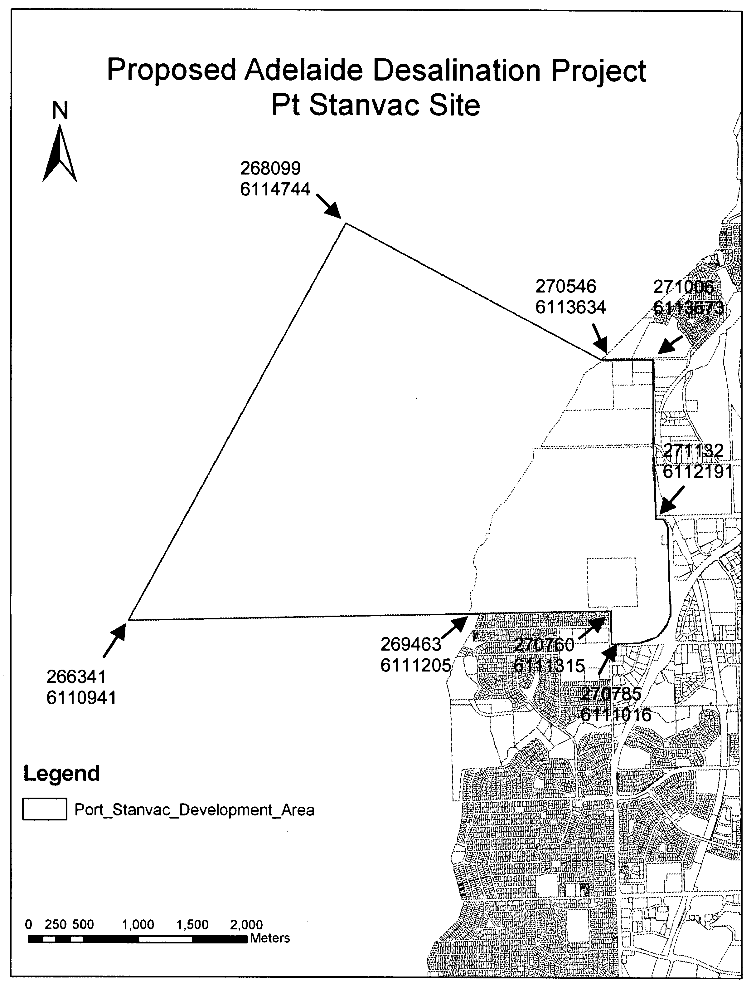

Dated 20 July 2008.
Paul Holloway, Minister for Urban Development and Planning

ELECTRICITY ACT 1996
Notice under the Electricity Act 1996 by TRUenergy Pty Ltd (ABN 99 086 014 968) of Default Contract Prices for Small Customers
IN accordance with section 36AB of the Electricity Act 1996 (SA), TRUenergy Pty Ltd (ABN 99 086 014 968) (formerly known as CLP Australia Retail Pty Ltd and SPI Retail Pty Ltd) (‘TRUenergy’) hereby publishes its default electricity contract prices for customers who are consuming less than 160MWh per annum of electricity (‘small customers’). The default contract prices are set out below in this notice and will apply on and from 12 August 2008.
The prices detailed in this notice apply for small customers only of TRUenergy who are purchasing electricity under TRUenergy’s Default Contract Terms and Conditions published in the Government Gazette on 1 April 2005.
TRUenergy reserves the right to change its default electricity contract price from time to time acting in accordance with all applicable regulations.
Justification Statement
The default contract prices set out in this notice mirror the electricity standing contract retailer tariffs approved by the Essential Services Commission of South Australia (‘ESCOSA’) on 11 June 2008 and ETSA Utilities’ distribution tariff approved by ESCOSA pursuant to the 2005-2010 Electricity Distribution Price Determination Part B as varied on 25 May 2007. The setting by TRUenergy of these default contract prices is in accordance with ESCOSA’s Electricity Retail Price Justification Guideline of December 2003.
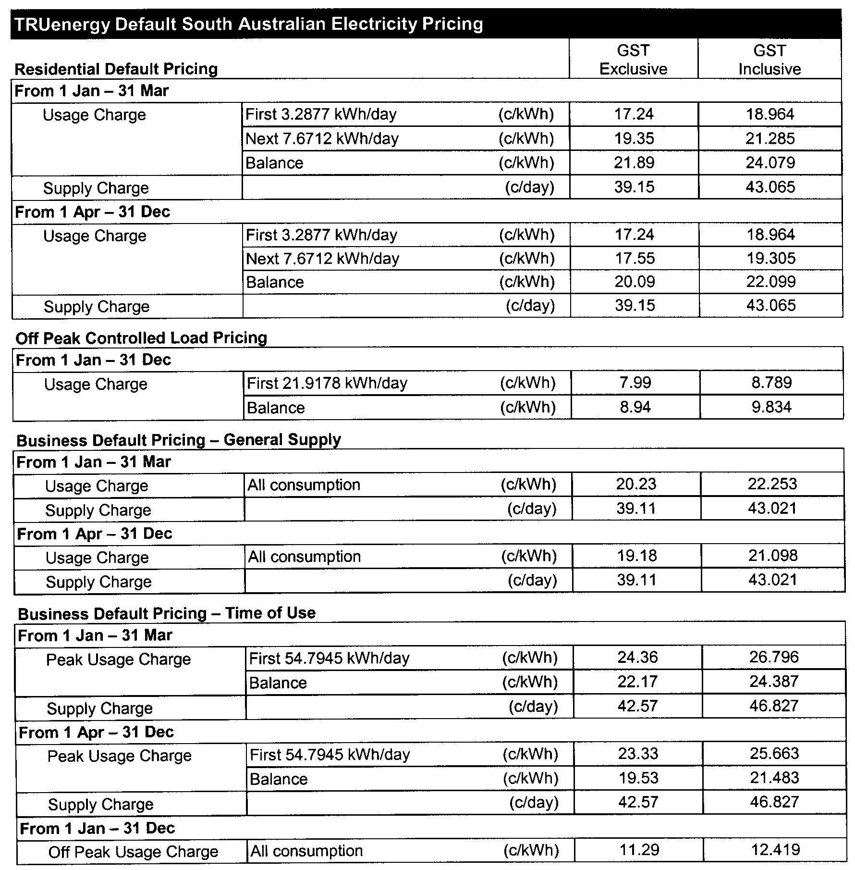

Explanatory Notes:
1. Default contract price categories will only apply to small customers (that is, those customers who consume less than 160MWh of electricity per annum) who are purchasing electricity under TRUenergy’s default contract terms and conditions. The above default contract prices apply in accordance with the following principles:
(a) Daily Consumption is the total electricity consumption for the period to which the customer’s bill relates, divided by the number of days in that period.
(b) Residential Default Pricing applies to residential customers in premises used wholly or principally as private residences based on Domestic 110 tariff* meter configuration and, in the case of off peak, Off Peak Controlled Load Domestic 116 tariff* meter configuration (refer to explanatory note 1 (e) below for the circumstances in which off peak rates apply).
(c) Business Default Pricing—General Supply applies to non-residential customers in premises that are not used wholly or principally as private residences based on General Supply 126 tariff* meter configuration.
(d) Business Default Pricing—Time of Use applies to non-residential customers in premises that are not used wholly or principally as private residences based on General Supply Time of Use 128 tariff* meter configuration.
(e) Off Peak Controlled Load for electricity used in permanently installed storage water heaters with a rated delivery of not less than 125 litres, storage space heaters and other approved thermal storage applications. The hours of application are fixed from time to time with control by time switch or other means. This price does not apply to electricity used outside those hours.
2. The term ‘peak’ used in the above table means 0700 hours to 2100 hours from Monday to Friday (Central Standard Time) for all tariffs other than Domestic 110 tariff* meter configuration, except where the network meters do not recognise specific tariff days. In these situations ‘peak’ means 0700 hours to 2100 hours (Central Standard Time) each day for meter types other than Domestic 110 tariff* meter configuration.
3. The term ‘Off peak’ used in the above table means all times other than peak period which is described in explanatory note 2.
4. Where prices change during a billing cycle the bill for that billing cycle will be calculated on a pro rata basis using:
(a) the old price up to and including the date of change; and
(b) the new price from the date of change to the end of the billing cycle.
* These tariff descriptions refer to tariffs published by AGL South Australia Pty Limited.

FISHERIES MANAGEMENT ACT 2007: SECTION 115
TAKE notice that, pursuant to section 115 of the Fisheries Management Act 2007, Juan Matias Braccini of Marine and Freshwater Fisheries Research Institute, Department of Primary Industries Victoria, P.O. Box 114, Queenscliff, Vic. 3255 (the ‘exemption holder’) or a person acting as his agent, is exempt from section 52 of the Fisheries Management Act 2007 and Regulations 7 (b) and 18 of the Fisheries Management (General) Regulations 2007, but only insofar as they may take fish for research purposes (the ‘exempted activity’), in the waters specified in Schedule 1, subject to the conditions in Schedule 2, from 16 July 2008 until 31 October 2008, unless varied or revoked earlier.
Schedule 1
South Australian Coastal waters within the following co-ordinates:
Region | NW | NE | SE | SW
SA West | 32°35′S, 133°45′E | 32°35′S, 133°59′E | 32°50′S, 134°05′E | 32°50′S, 133°51′E
 | 33°01′S, 134°08′E | 33°09′S, 134°28′E | Not Available | 33°25′S, 134°05′E
SA Eyre | 34°58′S, 135°20′E | 34°58′S, 135°40′E | 35°22′S, 135°43′E | 35°22′S, 135°20′E
 | 35°08′S, 136°04′E | 35°17′S, 136°17′E | 35°36′S, 136°18′E | 35°30′S, 135°52′E
SA East | 36°01′S, 137°05′E | 36°04′S, 137°25′E | 36°15′S, 137°25′E | 36°15′S, 137°05′E
 | 35°32′S, 138°42′E | 35°38′S, 139°00′E | 35°53′S, 139°00′E | 35°53′S, 138°42′E
 | 35°57′S, 139°10′E | shore | shore | 36°14′S, 139°10′E
 | 36°25′S, 139°30′E | shore | shore | 36°45′S, 139°30′E
 | 36°50′S, 139°10′E | 36°50′S, 139°30′E | 37°05′S, 139°30′E | 37°05′S, 139°10′E

The following waters are excluded from within the South Australian Coastal waters listed above:
Region | NW | NE | SE | SW
Neptune Island North | 35°11′S, 136°04′E | 35°14′S, 136°07′E | 35°17′S, 136°04′E | 35°14′S, 136°01′E
Neptune Island South | 35°07′S, 136°07′E | 35°20′S, 136°10′E | 35°23′S, 136°08′E | 35°20′S, 136°04′E

Schedule 2
1. The exemption holder or a person acting as an agent may only use mesh nets with a minimum mesh size of 100 mm to take fish from the areas listed in Schedule 1. A maximum length of 2 500 m of survey gill nets may be used at anyone time.
2. The exemption holder or a person acting as an agent may mutilate fish at sea for the purpose of collecting research samples.
3. The exemption holder or a person acting as an agent must not undertake the exempted activity within the waters excluded within Schedule 1.
4. A maximum of 4 shots may be taken in any one area specified in in Schedule 1 during the term of this notice.
5. Research fishing activities are to be undertaken from the following State/Commonwealth registered commercial fishing boats; the FV Lutarna, Registration No. M490 and the FV Jean Bryant, Registration No. M008.
6. The exemption holder or a person acting as an agent must notify PIRSA Fisheries on 1800 065 522 at least two hours prior to conducting the exempted activity and answer a series of questions about the exempted activity. The exemption holder will need to have a copy of the exemption notice at the time of making the call, and be able to provide information about the location and time where the exempted activity is being undertaken and other related questions. Exemption No. 9902122.
7. While engaged in the exempted activity, the exemption holder or an agent must be in possession of a copy of this notice. Such notice must be produced to a PIRSA Fisheries Compliance Officer if requested.
8. The exemption holder or a person acting as his agent must not contravene or fail to comply with the Fisheries Management Act 2007, or any regulations made under that Act, except where specifically exempted by this notice.
Dated 18 July 2008.
M. Smallridge, Director of Fisheries

DEPARTMENT OF PRIMARY INDUSTRIES AND RESOURCES SA—FISHERIES DIVISION
NOTICE is hereby given pursuant to section 90 (2) of the Fisheries Management Act 2007, that the following items have been seized by officers of the Department of Primary Industries and Resources SA, Fisheries Division at Pelican Point, on 10 January 2008:
1 rock lobster pot, red plastic neck
1 black bait basket
1 green rope
1 4 L red float
1 1 L white float
1 1 L blue float.
The above items were suspected to have been used or intended to be used, in contravention of the Fisheries Management Act 2007, and were taken into possession at Pelican Point.
After the expiration of one month from the date of this notice the items listed above shall, on the order of the Minister for Agriculture, Food and Fisheries, be forfeited to the Crown and shall be either disposed of by sale or destruction.
The above items may be viewed at the Mount Gambier office of the Department of Primary Industries and Resources SA, Fisheries Division.
Dated 11 July 2008.
M. Smallridge, General Manager, Fisheries Services

DEPARTMENT OF PRIMARY INDUSTRIES AND RESOURCES SA—FISHERIES DIVISION
NOTICE is hereby given pursuant to section 90 (2) of the Fisheries Management Act 2007, that the following items have been seized by officers of the Department of Primary Industries and Resources SA, Fisheries Division at Danger Point, on 16 March 2008:
1 rock lobster pot, red plastic neck
1 4 L red buoy
1 4 L white buoy
1 red bait basket
Green nylon mesh
Yellow/blue rope.
The above items were suspected to have been used or intended to be used, in contravention of the Fisheries Management Act 2007, and were taken into possession at Danger Point.
After the expiration of one month from the date of this notice the items listed above shall, on the order of the Minister for Agriculture, Food and Fisheries, be forfeited to the Crown and shall be either disposed of by sale or destruction.
The above items may be viewed at the Mount Gambier office of the Department of Primary Industries and Resources SA, Fisheries Division.
Dated 11 July 2008.
M. Smallridge, General Manager, Fisheries Services

DEPARTMENT OF PRIMARY INDUSTRIES AND RESOURCES SA—FISHERIES DIVISION
NOTICE is hereby given pursuant to section 90 (2) of the Fisheries Management Act 2007, that the following items have been seized by officers of the Department of Primary Industries and Resources SA, Fisheries Division at Danger Point, on 16 March 2008:
1 rock lobster pot, red plastic neck
Stainless steel mesh
1 4 L red buoy
1 4 L white buoy
1 black bait basket
PIRSA tag 080389.
The above items were suspected to have been used or intended to be used, in contravention of the Fisheries Management Act 2007, and were taken into possession at Danger Point.
After the expiration of one month from the date of this notice the items listed above shall, on the order of the Minister for Agriculture, Food and Fisheries, be forfeited to the Crown and shall be either disposed of by sale or destruction.
The above items may be viewed at the Mount Gambier office of the Department of Primary Industries and Resources SA, Fisheries Division.
Dated 11 July 2008.
M. Smallridge, General Manager, Fisheries Services

DEPARTMENT OF PRIMARY INDUSTRIES AND RESOURCES SA—FISHERIES DIVISION
NOTICE is hereby given pursuant to section 90 (2) of the Fisheries Management Act 2007, that the following items have been seized by officers of the Department of Primary Industries and Resources SA, Fisheries Division at Pelican Point, on 10 January 2008:
3 rock lobster pots, 2 with black plastic neck, 1 with red plastic neck
3 4 L red floats
1 4 L white float
3 bait baskets, 1 red and 2 black
2 2 L red floats
3 red lengths of rope.
The above items were suspected to have been used or intended to be used, in contravention of the Fisheries Management Act 2007, and were taken into possession at Pelican Point.
After the expiration of one month from the date of this notice the items listed above shall, on the order of the Minister for Agriculture, Food and Fisheries, be forfeited to the Crown and shall be either disposed of by sale or destruction.
The above items may be viewed at the Mount Gambier office of the Department of Primary Industries and Resources SA, Fisheries Division.
Dated 11 July 2008.
M. Smallridge, General Manager, Fisheries Services

DEPARTMENT OF PRIMARY INDUSTRIES AND RESOURCES SA—FISHERIES DIVISION
NOTICE is hereby given pursuant to section 90 (2) of the Fisheries Management Act 2007, that the following items have been seized by officers of the Department of Primary Industries and Resources SA, Fisheries Division at Blackfellows Caves, on 12 January 2008:
1 rock lobster pot, red neck, white rope.
The above items were suspected to have been used or intended to be used, in contravention of the Fisheries Management Act 2007, and were taken into possession at Blackfellows Caves.
After the expiration of one month from the date of this notice the items listed above shall, on the order of the Minister for Agriculture, Food and Fisheries, be forfeited to the Crown and shall be either disposed of by sale or destruction.
The above items may be viewed at the Mount Gambier office of the Department of Primary Industries and Resources SA, Fisheries Division.
Dated 11 July 2008.
M. Smallridge, General Manager, Fisheries Services

DEPARTMENT OF PRIMARY INDUSTRIES AND RESOURCES SA—FISHERIES DIVISION
NOTICE is hereby given pursuant to section 90 (2) of the Fisheries Management Act 2007, that the following items have been seized by officers of the Department of Primary Industries and Resources SA, Fisheries Division at Robe, on 31 December 2007:
1 rock lobster pot, red plastic neck
1 pink float
1 orange float marked ‘+8’
1 white popper
Orange nylon rope.
2 black bait baskets with wooden handles
The above items were suspected to have been used or intended to be used, in contravention of the Fisheries Management Act 2007, and were taken into possession at Robe.
After the expiration of one month from the date of this notice the items listed above shall, on the order of the Minister for Agriculture, Food and Fisheries, be forfeited to the Crown and shall be either disposed of by sale or destruction.
The above items may be viewed at the Kingston office of the Department of Primary Industries and Resources SA, Fisheries Division.
Dated 11 July 2008.
M. Smallridge, General Manager, Fisheries Services

DEPARTMENT OF PRIMARY INDUSTRIES AND RESOURCES SA—FISHERIES DIVISION
NOTICE is hereby given pursuant to section 90 (2) of the Fisheries Management Act 2007, that the following items have been seized by officers of the Department of Primary Industries and Resources SA, Fisheries Division at Robe, on 31 December 2007:
1 rock lobster pot, red plastic neck
1 pink float
1 white float
1 white popper
1 cylindrical bait basket
Orange nylon rope.
The above items were suspected to have been used or intended to be used, in contravention of the Fisheries Management Act 2007, and were taken into possession at Robe.
After the expiration of one month from the date of this notice the items listed above shall, on the order of the Minister for Agriculture, Food and Fisheries, be forfeited to the Crown and shall be either disposed of by sale or destruction.
The above items may be viewed at the Kingston office of the Department of Primary Industries and Resources SA, Fisheries Division.
Dated 11 July 2008.
M. Smallridge, General Manager, Fisheries Services

DEPARTMENT OF PRIMARY INDUSTRIES AND RESOURCES SA—FISHERIES DIVISION
NOTICE is hereby given pursuant to section 90 (2) of the Fisheries Management Act 2007, that the following items have been seized by officers of the Department of Primary Industries and Resources SA, Fisheries Division at Edithburgh, on 12 March 2008:
A monofilament mesh net 25 m in length, 50 mm mesh, headline floats flat, being oval shaped, orange in colour and 75 mm in length.
The above items were suspected to have been used or intended to be used, in contravention of the Fisheries Management Act 2007, and were taken into possession at Edithburgh.
After the expiration of one month from the date of this notice the items listed above shall, on the order of the Minister for Agriculture, Food and Fisheries, be forfeited to the Crown and shall be either disposed of by sale or destruction.
The above items may be viewed at the Kadina office of the Department of Primary Industries and Resources SA, Fisheries Division.
Dated 11 July 2008.
M. Smallridge, General Manager, Fisheries Services

DEPARTMENT OF PRIMARY INDUSTRIES AND RESOURCES SA—FISHERIES DIVISION
NOTICE is hereby given pursuant to section 90 (2) of the Fisheries Management Act 2007, that the following items have been seized by officers of the Department of Primary Industries and Resources SA, Fisheries Division at Cygnet River, Kangaroo Island, on 13 June 2008:
1 35 m brown cotton mesh net
2 white rope headlines.
The above items were suspected to have been used or intended to be used, in contravention of the Fisheries Management Act 2007, and were taken into possession at Cygnet River, Kangaroo Island.
After the expiration of one month from the date of this notice the items listed above shall, on the order of the Minister for Agriculture, Food and Fisheries, be forfeited to the Crown and shall be either disposed of by sale or destruction.
The above items may be viewed at the Kingscote office of the Department of Primary Industries and Resources SA, Fisheries Division.
Dated 11 July 2008.
M. Smallridge, General Manager, Fisheries Services

DEPARTMENT OF PRIMARY INDUSTRIES AND RESOURCES SA—FISHERIES DIVISION
NOTICE is hereby given pursuant to section 90 (2) of the Fisheries Management Act 2007, that the following items have been seized by officers of the Department of Primary Industries and Resources SA, Fisheries Division at Robe, on 5 January 2008:
1 rock lobster pot with a milk bottle as a float, bearing no tag or licence number.
The above items were suspected to have been used or intended to be used, in contravention of the Fisheries Management Act 2007, and were taken into possession at Robe.
After the expiration of one month from the date of this notice the items listed above shall, on the order of the Minister for Agriculture, Food and Fisheries, be forfeited to the Crown and shall be either disposed of by sale or destruction.
The above items may be viewed at the Ceduna office of the Department of Primary Industries and Resources SA, Fisheries Division.
Dated 11 July 2008.
M. Smallridge, General Manager, Fisheries Services

DEPARTMENT OF PRIMARY INDUSTRIES AND RESOURCES SA—FISHERIES DIVISION
NOTICE is hereby given pursuant to section 90 (2) of the Fisheries Management Act 2007, that the following items have been seized by officers of the Department of Primary Industries and Resources SA, Fisheries Division at Evans Island, on 19 January 2008:
2 brown plastic rock lobster pots with white buoys.
The above items were suspected to have been used or intended to be used, in contravention of the Fisheries Management Act 2007, and were taken into possession at Evans Island.
After the expiration of one month from the date of this notice the items listed above shall, on the order of the Minister for Agriculture, Food and Fisheries, be forfeited to the Crown and shall be either disposed of by sale or destruction.
The above items may be viewed at the Ceduna office of the Department of Primary Industries and Resources SA, Fisheries Division.
Dated 11 July 2008.
M. Smallridge, General Manager, Fisheries Services

DEPARTMENT OF PRIMARY INDUSTRIES AND RESOURCES SA—FISHERIES DIVISION
NOTICE is hereby given pursuant to section 90 (2) of the Fisheries Management Act 2007, that the following items have been seized by officers of the Department of Primary Industries and Resources SA, Fisheries Division at Wedge Island, on 3 March 2008:
1 rock lobster pot with red plastic neck
1 length of orange/white rope
1 4L orange buoy.
The above items were suspected to have been used or intended to be used, in contravention of the Fisheries Management Act 2007, and were taken into possession at Wedge Island.
After the expiration of one month from the date of this notice the items listed above shall, on the order of the Minister for Agriculture, Food and Fisheries, be forfeited to the Crown and shall be either disposed of by sale or destruction.
The above items may be viewed at the Port Lincoln office of the Department of Primary Industries and Resources SA, Fisheries Division.
Dated 11 July 2008.
M. Smallridge, General Manager, Fisheries Services

DEPARTMENT OF PRIMARY INDUSTRIES AND RESOURCES SA—FISHERIES DIVISION
NOTICE is hereby given pursuant to section 90 (2) of the Fisheries Management Act 2007, that the following items have been seized by officers of the Department of Primary Industries and Resources SA, Fisheries Division at Port Lincoln, on 10 January 2008:
1 mesh net, being 61 m in length with a ball and chain attached.
The above items were suspected to have been used or intended to be used, in contravention of the Fisheries Management Act 2007, and were taken into possession at Port Lincoln.
After the expiration of one month from the date of this notice the items listed above shall, on the order of the Minister for Agriculture, Food and Fisheries, be forfeited to the Crown and shall be either disposed of by sale or destruction.
The above items may be viewed at the Port Lincoln office of the Department of Primary Industries and Resources SA, Fisheries Division.
Dated 11 July 2008.
M. Smallridge, General Manager, Fisheries Services

DEPARTMENT OF PRIMARY INDUSTRIES AND RESOURCES SA—FISHERIES DIVISION
NOTICE is hereby given pursuant to section 90 (2) of the Fisheries Management Act 2007, that the following items have been seized by officers of the Department of Primary Industries and Resources SA, Fisheries Division at Smoky Bay, on 11 February 2008:
1 rectangular mesh fish trap with green plastic entrance funnels
1 white square piece of styrene as a float.
The above items were suspected to have been used or intended to be used, in contravention of the Fisheries Management Act 2007, and were taken into possession at Smoky Bay.
After the expiration of one month from the date of this notice the items listed above shall, on the order of the Minister for Agriculture, Food and Fisheries, be forfeited to the Crown and shall be either disposed of by sale or destruction.
The above items may be viewed at the Streaky Bay office of the Department of Primary Industries and Resources SA, Fisheries Division.
Dated 11 July 2008.
M. Smallridge, General Manager, Fisheries Services

DEPARTMENT OF PRIMARY INDUSTRIES AND RESOURCES SA—FISHERIES DIVISION
NOTICE is hereby given pursuant to section 90 (2) of the Fisheries Management Act 2007, that the following items have been seized by officers of the Department of Primary Industries and Resources SA, Fisheries Division at Semaphore, on 9 April 2008:
1 black double hoop crab net.
The above items were suspected to have been used or intended to be used, in contravention of the Fisheries Management Act 2007, and were taken into possession at Semaphore Jetty.
After the expiration of one month from the date of this notice the items listed above shall, on the order of the Minister for Agriculture, Food and Fisheries, be forfeited to the Crown and shall be either disposed of by sale or destruction.
The above items may be viewed at the Birkenhead office of the Department of Primary Industries and Resources SA, Fisheries Division.
Dated 11 July 2008.
M. Smallridge, General Manager, Fisheries Services

DEPARTMENT OF PRIMARY INDUSTRIES AND RESOURCES SA—FISHERIES DIVISION
NOTICE is hereby given pursuant to section 90 (2) of the Fisheries Management Act 2007, that the following items have been seized by officers of the Department of Primary Industries and Resources SA, Fisheries Division at Victor Harbor, on 10 January 2008:
1 rock lobster pot without a current registration tag for the 2007/2008 season.
The above items were suspected to have been used or intended to be used, in contravention of the Fisheries Management Act 2007, and were taken into possession at Victor Harbor.
After the expiration of one month from the date of this notice the items listed above shall, on the order of the Minister for Agriculture, Food and Fisheries, be forfeited to the Crown and shall be either disposed of by sale or destruction.
The above items may be viewed at the Birkenhead office of the Department of Primary Industries and Resources SA, Fisheries Division.
Dated 11 July 2008.
M. Smallridge, General Manager, Fisheries Services

DEPARTMENT OF PRIMARY INDUSTRIES AND RESOURCES SA—FISHERIES DIVISION
NOTICE is hereby given pursuant to section 90 (2) of the Fisheries Management Act 2007, that the following items have been seized by officers of the Department of Primary Industries and Resources SA, Fisheries Division at Victor Harbor, on 10 January 2008:
1 rock lobster pot without a current registration tag for the 2007/2008 season.
The above items were suspected to have been used or intended to be used, in contravention of the Fisheries Management Act 2007, and were taken into possession at Victor Harbor.
After the expiration of one month from the date of this notice the items listed above shall, on the order of the Minister for Agriculture, Food and Fisheries, be forfeited to the Crown and shall be either disposed of by sale or destruction.
The above items may be viewed at the Birkenhead office of the Department of Primary Industries and Resources SA, Fisheries Division.
Dated 11 July 2008.
M. Smallridge, General Manager, Fisheries Services

DEPARTMENT OF PRIMARY INDUSTRIES AND RESOURCES SA—FISHERIES DIVISION
NOTICE is hereby given pursuant to section 90 (2) of the Fisheries Management Act 2007, that the following items have been seized by officers of the Department of Primary Industries and Resources SA, Fisheries Division at Victor Harbor, on 10 January 2008:
1 rock lobster pot without a current registration tag for the 2007/2008 season.
The above items were suspected to have been used or intended to be used, in contravention of the Fisheries Management Act 2007, and were taken into possession at Victor Harbor.
After the expiration of one month from the date of this notice the items listed above shall, on the order of the Minister for Agriculture, Food and Fisheries, be forfeited to the Crown and shall be either disposed of by sale or destruction.
The above items may be viewed at the Birkenhead office of the Department of Primary Industries and Resources SA, Fisheries Division.
Dated 11 July 2008.
M. Smallridge, General Manager, Fisheries Services

DEPARTMENT OF PRIMARY INDUSTRIES AND RESOURCES SA—FISHERIES DIVISION
NOTICE is hereby given pursuant to section 90 (2) of the Fisheries Management Act 2007, that the following items have been seized by officers of the Department of Primary Industries and Resources SA, Fisheries Division at Murray River (438 km mark), on 23 March 2008:
3 Opera House nets with black mesh and yellow ropes attached to plastic bottles.
1 Opera House net with black mesh and green rope attached to plastic bottle. No names or addresses on bottles.
The above items were suspected to have been used or intended to be used, in contravention of the Fisheries Management Act 2007, and were taken into possession at Murray River (438 km mark).
After the expiration of one month from the date of this notice the items listed above shall, on the order of the Minister for Agriculture, Food and Fisheries, be forfeited to the Crown and shall be either disposed of by sale or destruction.
The above items may be viewed at the Birkenhead office of the Department of Primary Industries and Resources SA, Fisheries Division.
Dated 11 July 2008.
M. Smallridge, General Manager, Fisheries Services

DEPARTMENT OF PRIMARY INDUSTRIES AND RESOURCES SA—FISHERIES DIVISION
NOTICE is hereby given pursuant to section 90 (2) of the Fisheries Management Act 2007, that the following items have been seized by officers of the Department of Primary Industries and Resources SA, Fisheries Division at Pelican Point, on 20 April 2008:
1 Green mesh Opera House net
1 black plastic shrimp trap.
The above items were suspected to have been used or intended to be used, in contravention of the Fisheries Management Act 2007, and were taken into possession at Pelican Point.
After the expiration of one month from the date of this notice the items listed above shall, on the order of the Minister for Agriculture, Food and Fisheries, be forfeited to the Crown and shall be either disposed of by sale or destruction.
The above items may be viewed at the Birkenhead office of the Department of Primary Industries and Resources SA, Fisheries Division.
Dated 11 July 2008.
M. Smallridge, General Manager, Fisheries Services

DEPARTMENT OF PRIMARY INDUSTRIES AND RESOURCES SA—FISHERIES DIVISION
NOTICE is hereby given pursuant to section 90 (2) of the Fisheries Management Act 2007, that the following items have been seized by officers of the Department of Primary Industries and Resources SA, Fisheries Division at Murray River (282 km mark), on 20 April 2008:
1 black plastic shrimp trap
2 green plastic shrimp traps
1 black Opera House net.
The above items were suspected to have been used or intended to be used, in contravention of the Fisheries Management Act 2007, and were taken into possession at Murray River (282 km mark).
After the expiration of one month from the date of this notice the items listed above shall, on the order of the Minister for Agriculture, Food and Fisheries, be forfeited to the Crown and shall be either disposed of by sale or destruction.
The above items may be viewed at the Birkenhead office of the Department of Primary Industries and Resources SA, Fisheries Division.
Dated 11 July 2008.
M. Smallridge, General Manager, Fisheries Services

DEPARTMENT OF PRIMARY INDUSTRIES AND RESOURCES SA—FISHERIES DIVISION
NOTICE is hereby given pursuant to section 90 (2) of the Fisheries Management Act 2007, that the following items have been seized by officers of the Department of Primary Industries and Resources SA, Fisheries Division at Murray River (284 km mark), on 20 April 2008:
1 green plastic shrimp trap with orange cord.
The above items were suspected to have been used or intended to be used, in contravention of the Fisheries Management Act 2007, and were taken into possession at Murray River (284 km mark).
After the expiration of one month from the date of this notice the items listed above shall, on the order of the Minister for Agriculture, Food and Fisheries, be forfeited to the Crown and shall be either disposed of by sale or destruction.
The above items may be viewed at the Birkenhead office of the Department of Primary Industries and Resources SA, Fisheries Division.
Dated 11 July 2008.
M. Smallridge, General Manager, Fisheries Services

DEPARTMENT OF PRIMARY INDUSTRIES AND RESOURCES SA—FISHERIES DIVISION
NOTICE is hereby given pursuant to section 90 (2) of the Fisheries Management Act 2007, that the following items have been seized by officers of the Department of Primary Industries and Resources SA, Fisheries Division at Murray River (300 km mark), on 20 April 2008:
1 Opera House net
1 shrimp trap (plastic)
1 set line
1 20 L white bucket.
The above items were suspected to have been used or intended to be used, in contravention of the Fisheries Management Act 2007, and were taken into possession at Murray River (300 km mark).
After the expiration of one month from the date of this notice the items listed above shall, on the order of the Minister for Agriculture, Food and Fisheries, be forfeited to the Crown and shall be either disposed of by sale or destruction.
The above items may be viewed at the Birkenhead office of the Department of Primary Industries and Resources SA, Fisheries Division.
Dated 11 July 2008.
M. Smallridge, General Manager, Fisheries Services

DEPARTMENT OF PRIMARY INDUSTRIES AND RESOURCES SA—FISHERIES DIVISION
NOTICE is hereby given pursuant to section 90 (2) of the Fisheries Management Act 2007, that the following items have been seized by officers of the Department of Primary Industries and Resources SA, Fisheries Division at Murray River (262 km mark), on 21 April 2008:
1 black mesh opera house yabbie pot with orange rope attached.
The above items were suspected to have been used or intended to be used, in contravention of the Fisheries Management Act 2007, and were taken into possession at Murray River (262 km mark).
After the expiration of one month from the date of this notice the items listed above shall, on the order of the Minister for Agriculture, Food and Fisheries, be forfeited to the Crown and shall be either disposed of by sale or destruction.
The above items may be viewed at the Birkenhead office of the Department of Primary Industries and Resources SA, Fisheries Division.
Dated 11 July 2008.
M. Smallridge, General Manager, Fisheries Services

DEPARTMENT OF PRIMARY INDUSTRIES AND RESOURCES SA—FISHERIES DIVISION
NOTICE is hereby given pursuant to section 90 (2) of the Fisheries Management Act 2007, that the following items have been seized by officers of the Department of Primary Industries and Resources SA, Fisheries Division at Murray River (302 km mark), on 20 April 2008:
1 black plastic shrimp trap
1 green mesh shrimp trap.
The above items were suspected to have been used or intended to be used, in contravention of the Fisheries Management Act 2007, and were taken into possession at Murray River (302 km mark).
After the expiration of one month from the date of this notice the items listed above shall, on the order of the Minister for Agriculture, Food and Fisheries, be forfeited to the Crown and shall be either disposed of by sale or destruction.
The above items may be viewed at the Birkenhead office of the Department of Primary Industries and Resources SA, Fisheries Division.
Dated 11 July 2008.
M. Smallridge, General Manager, Fisheries Services

DEPARTMENT OF PRIMARY INDUSTRIES AND RESOURCES SA—FISHERIES DIVISION
NOTICE is hereby given pursuant to section 90 (2) of the Fisheries Management Act 2007, that the following items have been seized by officers of the Department of Primary Industries and Resources SA, Fisheries Division at Murray River (302 km mark), on 20 April 2008:
2 green mesh opera house nets.
The above items were suspected to have been used or intended to be used, in contravention of the Fisheries Management Act 2007, and were taken into possession at Murray River (302 km mark).
After the expiration of one month from the date of this notice the items listed above shall, on the order of the Minister for Agriculture, Food and Fisheries, be forfeited to the Crown and shall be either disposed of by sale or destruction.
The above items may be viewed at the Birkenhead office of the Department of Primary Industries and Resources SA, Fisheries Division.
Dated 11 July 2008.
M. Smallridge, General Manager, Fisheries Services

DEPARTMENT OF PRIMARY INDUSTRIES AND RESOURCES SA—FISHERIES DIVISION
NOTICE is hereby given pursuant to section 90 (2) of the Fisheries Management Act 2007, that the following items have been seized by officers of the Department of Primary Industries and Resources SA, Fisheries Division at Blanchetown, on 22 April 2008:
1 red mesh shrimp trap with rope attached.
The above items were suspected to have been used or intended to be used, in contravention of the Fisheries Management Act 2007, and were taken into possession at Blanchetown.
After the expiration of one month from the date of this notice the items listed above shall, on the order of the Minister for Agriculture, Food and Fisheries, be forfeited to the Crown and shall be either disposed of by sale or destruction.
The above items may be viewed at the Birkenhead office of the Department of Primary Industries and Resources SA, Fisheries Division.
Dated 11 July 2008.
M. Smallridge, General Manager, Fisheries Services

DEPARTMENT OF PRIMARY INDUSTRIES AND RESOURCES SA—FISHERIES DIVISION
NOTICE is hereby given pursuant to section 90 (2) of the Fisheries Management Act 2007, that the following items have been seized by officers of the Department of Primary Industries and Resources SA, Fisheries Division at Blanchetown, on 22 April 2008:
1 red mesh shrimp trap with rope attached.
The above items were suspected to have been used or intended to be used, in contravention of the Fisheries Management Act 2007, and were taken into possession at Blanchetown.
After the expiration of one month from the date of this notice the items listed above shall, on the order of the Minister for Agriculture, Food and Fisheries, be forfeited to the Crown and shall be either disposed of by sale or destruction.
The above items may be viewed at the Birkenhead office of the Department of Primary Industries and Resources SA, Fisheries Division.
Dated 11 July 2008.
M. Smallridge, General Manager, Fisheries Services

DEPARTMENT OF PRIMARY INDUSTRIES AND RESOURCES SA—FISHERIES DIVISION
NOTICE is hereby given pursuant to section 90 (2) of the Fisheries Management Act 2007, that the following items have been seized by officers of the Department of Primary Industries and Resources SA, Fisheries Division at Blanchetown, on 21 April 2008:
1 red mesh collapsible shrimp trap
1 black plastic mesh shrimp trap
1 green mesh Opera House yabbie trap.
The above items were suspected to have been used or intended to be used, in contravention of the Fisheries Management Act 2007, and were taken into possession at Blanchetown.
After the expiration of one month from the date of this notice the items listed above shall, on the order of the Minister for Agriculture, Food and Fisheries, be forfeited to the Crown and shall be either disposed of by sale or destruction.
The above items may be viewed at the Birkenhead office of the Department of Primary Industries and Resources SA, Fisheries Division.
Dated 11 July 2008.
M. Smallridge, General Manager, Fisheries Services

DEPARTMENT OF PRIMARY INDUSTRIES AND RESOURCES SA—FISHERIES DIVISION
NOTICE is hereby given pursuant to section 90 (2) of the Fisheries Management Act 2007, that the following items have been seized by officers of the Department of Primary Industries and Resources SA, Fisheries Division at Blanchetown, on 21 April 2008:
1 green plastic shrimp trap with a length of rope attached.
The above items were suspected to have been used or intended to be used, in contravention of the Fisheries Management Act 2007, and were taken into possession at Blanchetown.
After the expiration of one month from the date of this notice the items listed above shall, on the order of the Minister for Agriculture, Food and Fisheries, be forfeited to the Crown and shall be either disposed of by sale or destruction.
The above items may be viewed at the Birkenhead office of the Department of Primary Industries and Resources SA, Fisheries Division.
Dated 11 July 2008.
M. Smallridge, General Manager, Fisheries Services

DEPARTMENT OF PRIMARY INDUSTRIES AND RESOURCES SA—FISHERIES DIVISION
NOTICE is hereby given pursuant to section 90 (2) of the Fisheries Management Act 2007, that the following items have been seized by officers of the Department of Primary Industries and Resources SA, Fisheries Division at Murray River (371 km mark), on 26 April 2008:
1 green Opera House net with faded orange rope.
The above items were suspected to have been used or intended to be used, in contravention of the Fisheries Management Act 2007, and were taken into possession at Murray River (371 km mark).
After the expiration of one month from the date of this notice the items listed above shall, on the order of the Minister for Agriculture, Food and Fisheries, be forfeited to the Crown and shall be either disposed of by sale or destruction.
The above items may be viewed at the Birkenhead office of the Department of Primary Industries and Resources SA, Fisheries Division.
Dated 11 July 2008.
M. Smallridge, General Manager, Fisheries Services

DEPARTMENT OF PRIMARY INDUSTRIES AND RESOURCES SA—FISHERIES DIVISION
NOTICE is hereby given pursuant to section 90 (2) of the Fisheries Management Act 2007, that the following items have been seized by officers of the Department of Primary Industries and Resources SA, Fisheries Division at Murray River (371 km mark), on 22 April 2008:
1 green Opera House net and a short piece of orange rope.
The above items were suspected to have been used or intended to be used, in contravention of the Fisheries Management Act 2007, and were taken into possession at Murray River (371 km mark).
After the expiration of one month from the date of this notice the items listed above shall, on the order of the Minister for Agriculture, Food and Fisheries, be forfeited to the Crown and shall be either disposed of by sale or destruction.
The above items may be viewed at the Birkenhead office of the Department of Primary Industries and Resources SA, Fisheries Division.
Dated 11 July 2008.
M. Smallridge, General Manager, Fisheries Services

DEPARTMENT OF PRIMARY INDUSTRIES AND RESOURCES SA—FISHERIES DIVISION
NOTICE is hereby given pursuant to section 90 (2) of the Fisheries Management Act 2007, that the following items have been seized by officers of the Department of Primary Industries and Resources SA, Fisheries Division at Scotts Creek, Murray River, on 23 April 2008:
1 black mesh shrimp trap with black rope attached
1 green plastic shrimp trap with orange rope attached.
The above items were suspected to have been used or intended to be used, in contravention of the Fisheries Management Act 2007, and were taken into possession at Scotts Creek, Murray River.
After the expiration of one month from the date of this notice the items listed above shall, on the order of the Minister for Agriculture, Food and Fisheries, be forfeited to the Crown and shall be either disposed of by sale or destruction.
The above items may be viewed at the Birkenhead office of the Department of Primary Industries and Resources SA, Fisheries Division.
Dated 11 July 2008.
M. Smallridge, General Manager, Fisheries Services

DEPARTMENT OF PRIMARY INDUSTRIES AND RESOURCES SA—FISHERIES DIVISION
NOTICE is hereby given pursuant to section 90 (2) of the Fisheries Management Act 2007, that the following items have been seized by officers of the Department of Primary Industries and Resources SA, Fisheries Division at Scotts Creek, Murray River, on 23 April 2008:
1 brown mesh shrimp trap with green cord attached.
The above items were suspected to have been used or intended to be used, in contravention of the Fisheries Management Act 2007, and were taken into possession at Scotts Creek, Murray River.
After the expiration of one month from the date of this notice the items listed above shall, on the order of the Minister for Agriculture, Food and Fisheries, be forfeited to the Crown and shall be either disposed of by sale or destruction.
The above items may be viewed at the Birkenhead office of the Department of Primary Industries and Resources SA, Fisheries Division.
Dated 11 July 2008.
M. Smallridge, General Manager, Fisheries Services

DEPARTMENT OF PRIMARY INDUSTRIES AND RESOURCES SA—FISHERIES DIVISION
NOTICE is hereby given pursuant to section 90 (2) of the Fisheries Management Act 2007, that the following items have been seized by officers of the Department of Primary Industries and Resources SA, Fisheries Division at Scotts Creek, Murray River, on 23 April 2008:
1 green mesh shrimp trap with white cord attached.
The above items were suspected to have been used or intended to be used, in contravention of the Fisheries Management Act 2007, and were taken into possession at Scotts Creek, Murray River.
After the expiration of one month from the date of this notice the items listed above shall, on the order of the Minister for Agriculture, Food and Fisheries, be forfeited to the Crown and shall be either disposed of by sale or destruction.
The above items may be viewed at the Birkenhead office of the Department of Primary Industries and Resources SA, Fisheries Division.
Dated 11 July 2008.
M. Smallridge, General Manager, Fisheries Services

DEPARTMENT OF PRIMARY INDUSTRIES AND RESOURCES SA—FISHERIES DIVISION
NOTICE is hereby given pursuant to section 90 (2) of the Fisheries Management Act 2007, that the following items have been seized by officers of the Department of Primary Industries and Resources SA, Fisheries Division at Scotts Creek, Murray River, on 23 April 2008:
1 black mesh Opera House net with blue cord attached.
The above items were suspected to have been used or intended to be used, in contravention of the Fisheries Management Act 2007, and were taken into possession at Scotts Creek, Murray River.
After the expiration of one month from the date of this notice the items listed above shall, on the order of the Minister for Agriculture, Food and Fisheries, be forfeited to the Crown and shall be either disposed of by sale or destruction.
The above items may be viewed at the Birkenhead office of the Department of Primary Industries and Resources SA, Fisheries Division.
Dated 11 July 2008.
M. Smallridge, General Manager, Fisheries Services

DEPARTMENT OF PRIMARY INDUSTRIES AND RESOURCES SA—FISHERIES DIVISION
NOTICE is hereby given pursuant to section 90 (2) of the Fisheries Management Act 2007, that the following items have been seized by officers of the Department of Primary Industries and Resources SA, Fisheries Division at Ewes Island, Coorong, on 25 June 2008:
1 50 m fishing net
2 black floats
1 red float
2 anchors.
The above items were suspected to have been used or intended to be used, in contravention of the Fisheries Management Act 2007, and were taken into possession at Ewes Island, Coorong.
After the expiration of one month from the date of this notice the items listed above shall, on the order of the Minister for Agriculture, Food and Fisheries, be forfeited to the Crown and shall be either disposed of by sale or destruction.
The above items may be viewed at the Birkenhead office of the Department of Primary Industries and Resources SA, Fisheries Division.
Dated 11 July 2008.
M. Smallridge, General Manager, Fisheries Services

DEPARTMENT OF PRIMARY INDUSTRIES AND RESOURCES SA—FISHERIES DIVISION
NOTICE is hereby given pursuant to section 90 (2) of the Fisheries Management Act 2007, that the following items have been seized by officers of the Department of Primary Industries and Resources SA, Fisheries Division at Berri, on 27 June 2008:
1 plastic drum net.
The above items were suspected to have been used or intended to be used, in contravention of the Fisheries Management Act 2007, and were taken into possession at Berri.
After the expiration of one month from the date of this notice the items listed above shall, on the order of the Minister for Agriculture, Food and Fisheries, be forfeited to the Crown and shall be either disposed of by sale or destruction.
The above items may be viewed at the Birkenhead office of the Department of Primary Industries and Resources SA, Fisheries Division.
Dated 11 July 2008.
M. Smallridge, General Manager, Fisheries Services

DEPARTMENT OF PRIMARY INDUSTRIES AND RESOURCES SA—FISHERIES DIVISION
NOTICE is hereby given pursuant to section 90 (2) of the Fisheries Management Act 2007, that the following items have been seized by officers of the Department of Primary Industries and Resources SA, Fisheries Division at Burrows Creek, on 22 May 2008:
9 75 m mesh nets
1 20 m bait net
1 metal hand spear
2 green waders
1 green bag
11 white feed bags
2 metal poles
1 blue and yellow rope.
The above items were suspected to have been used or intended to be used, in contravention of the Fisheries Management Act 2007, and were taken into possession at Burrows Creek.
After the expiration of one month from the date of this notice the items listed above shall, on the order of the Minister for Agriculture, Food and Fisheries, be forfeited to the Crown and shall be either disposed of by sale or destruction.
The above items may be viewed at the Birkenhead office of the Department of Primary Industries and Resources SA, Fisheries Division.
Dated 11 July 2008.
M. Smallridge, General Manager, Fisheries Services

DEPARTMENT OF PRIMARY INDUSTRIES AND RESOURCES SA—FISHERIES DIVISION
NOTICE is hereby given pursuant to section 90 (2) of the Fisheries Management Act 2007, that the following items have been seized by officers of the Department of Primary Industries and Resources SA, Fisheries Division at Big Bend, Murray River, on 22 April 2008:
2 black mesh shrimp traps with orange cord
1 black mesh shrimp trap with green cord
2 opera house yabbie nets
1 green plastic shrimp trap
1 brown mesh shrimp trap with black cord.
The above items were suspected to have been used or intended to be used, in contravention of the Fisheries Management Act 2007, and were taken into possession at Big Bend, Murray River.
After the expiration of one month from the date of this notice the items listed above shall, on the order of the Minister for Agriculture, Food and Fisheries, be forfeited to the Crown and shall be either disposed of by sale or destruction.
The above items may be viewed at the Birkenhead office of the Department of Primary Industries and Resources SA, Fisheries Division.
Dated 11 July 2008.
M. Smallridge, General Manager, Fisheries Services

DEPARTMENT OF PRIMARY INDUSTRIES AND RESOURCES SA—FISHERIES DIVISION
NOTICE is hereby given pursuant to section 90 (2) of the Fisheries Management Act 2007, that the following items have been seized by officers of the Department of Primary Industries and Resources SA, Fisheries Division at 328 km mark Murray River, on 24 April 2008:
1 blue mesh shrimp trap with line attached
1 blue mesh shrimp trap with blue rope attached.
The above items were suspected to have been used or intended to be used, in contravention of the Fisheries Management Act 2007, and were taken into possession at 328 km mark Murray River.
After the expiration of one month from the date of this notice the items listed above shall, on the order of the Minister for Agriculture, Food and Fisheries, be forfeited to the Crown and shall be either disposed of by sale or destruction.
The above items may be viewed at the Birkenhead office of the Department of Primary Industries and Resources SA, Fisheries Division.
Dated 11 July 2008.
M. Smallridge, General Manager, Fisheries Services

DEPARTMENT OF PRIMARY INDUSTRIES AND RESOURCES SA—FISHERIES DIVISION
NOTICE is hereby given pursuant to section 90 (2) of the Fisheries Management Act 2007, that the following items have been seized by officers of the Department of Primary Industries and Resources SA, Fisheries Division at Morgan, on 24 April 2008:
1 Opera House pot.
The above items were suspected to have been used or intended to be used, in contravention of the Fisheries Management Act 2007, and were taken into possession at Morgan.
After the expiration of one month from the date of this notice the items listed above shall, on the order of the Minister for Agriculture, Food and Fisheries, be forfeited to the Crown and shall be either disposed of by sale or destruction.
The above items may be viewed at the Birkenhead office of the Department of Primary Industries and Resources SA, Fisheries Division.
Dated 11 July 2008.
M. Smallridge, General Manager, Fisheries Services

DEPARTMENT OF PRIMARY INDUSTRIES AND RESOURCES SA—FISHERIES DIVISION
NOTICE is hereby given pursuant to section 90 (2) of the Fisheries Management Act 2007, that the following items have been seized by officers of the Department of Primary Industries and Resources SA, Fisheries Division at Big Bend, Murray River, on 22 April 2008:
1 black shrimp trap with green cord
1 black mesh Opera trap with red rope
2 black mesh shrimp traps
1 wire mesh home-made trap
1 cylindrical metal mesh shrimp trap
1 green plastic shrimp trap.
The above items were suspected to have been used or intended to be used, in contravention of the Fisheries Management Act 2007, and were taken into possession at Big Bend, Murray River.
After the expiration of one month from the date of this notice the items listed above shall, on the order of the Minister for Agriculture, Food and Fisheries, be forfeited to the Crown and shall be either disposed of by sale or destruction.
The above items may be viewed at the Birkenhead office of the Department of Primary Industries and Resources SA, Fisheries Division.
Dated 11 July 2008.
M. Smallridge, General Manager, Fisheries Services

GEOGRAPHICAL NAMES ACT 1991
Notice of Declaration of Names of Places
NOTICE is hereby given pursuant to section 11A of the Geographical Names Act 1991, that the names of those places
set out in The Schedule hereunder shall be the geographical
names of those said places. Precise location of the said features can be obtained from the South Australian Government Gazette at www.placenames.sa.gov.au or by contacting the Geographical Name Unit, DTEI on (08) 8204 8539.
The Schedule

Mapsheet |  | Feature
1:50 000 Mapsheet 6526-4 (Cape Jervis) | Tree Hill
1:50 000 Mapsheet Pts 6426-1 and 2 (Penneshaw) | Blue Gum Gully
1:50 000 Mapsheet 6326-2 | Pelorus Islet
(Seddon) | Quin Rock
1:50 000 Mapsheet 7022-4 | Botts Swamp
(Kalangadoo) | Cat Swamp
 | Hundred Line Swamp
 | Lake Letty
 | Osborne Swamp
 | Paddy Swamp
 | Pear Tree Hill
 | Pott Boy Swamp
 | Tantanoola Cave
 | The Black Hole
 | The Blue Gum Waterhole
 | The Marshes
 | The Mern
 | The Yard Swamp
1:50 000 Mapsheet 6326-3 | Fernandez Creek
(Vivonne) | Stun’Sail Boom Beach
1:50 000 Mapsheet 6922-4 | Abyssinia Bay
(Buffon) | Boozy Gully
 | Cameron Rocks
 | Canunda Rock
 | Cascade Rock
 | Cullen Bay

Mapsheet | Feature
 | Devils Gap
 | Devils Wash
 | Double Island
 | Eddy Bay
 | Lonely Reef
 | McIntyre Beach
 | McIntyre Rocks
 | Mounce and Battye Rock
 | Mullins Swamp
 | Pether Rock
 | Shag Rock
 | Stanway Point
 | Sweep Rock
 | The Twins (Rock)
 | Watt Rocks
 | West Rock
1:50 000 Mapsheet 7023-2 | Racecourse Swamp
(Penola) | Reedy Lagoon
 | Sawpit Swamp
 | Wire Swamp
 | Woolwash Swamp
1:50 000 Mapsheet 7024-4 | Wonarah Trig
(Keppoch) | Moorex Trig
1:50 000 Mapsheet 7024-1 (Frances) | Whip Spring
1:50 000 Mapsheet 6824-3 (Jaffa) | Jaffa Trig
 | Hog Tower
1:50 000 Mapsheet 7023-3 | Emu Flat
(Monbulla) | Red Gum Swamp
 | Sheepwash Swamp
1:50 000 Mapsheet 7023-1 | Deadmans Swamp
(Struan) | Kay Swamp
1:50 000 Mapsheet 6823-1 (Robe) | Snewin Rock
1:50 000 Mapsheet 7023-4 (Bool Lagoon) | Goose Neck Swamp  Green Swamp
 | Little Bool Lagoon
1:50 000 Mapsheet 6823-2 (Beachport) | Dolly Lake  Five Mile Rocks
 | Foster Islands
 | Foster Point
 | Mular Point
 | Packin Point
 | Perch Hole
 | Pigeon Cove
 | Post Office Rock
 | Pud Lake
 | Salmon Hole
 | Sea Lake
 | Three Mile Rocks
 | Two Lakes
1:50 000 Mapsheet 6923-3 (Hatherleigh) | Cockies Point

NOTE: Words shown in parentheses are not part of the name.
Dated 17 July 2008.
P. M. Kentish, Surveyor-General, Department for Transport, Energy and Infrastructure
DDTEI.22-413/07/0032

GAS ACT 1997
Notice under the Gas Act 1997 by TRUenergy Pty Ltd (ABN 99 086 014 968) of Default Contract Prices for
Small Customers
IN accordance with section 34B of the Gas Act 1997 (SA), TRUenergy Pty Ltd (ABN 99 086 014 968) (formerly known as CLP Australia Retail Pty Ltd and SPI Retail Pty Ltd) (‘TRUenergy’) hereby publishes its default gas contract prices for customers who are consuming less than one terajoule per annum of gas (‘small customers’).
The default contract prices are set out below in this notice and will apply on and from 12 August 2008.
The prices detailed in this notice apply for small customers only of TRUenergy who are purchasing gas under TRUenergy’s Default Contract Terms and Conditions published in the Government Gazette on 1 April 2005.
TRUenergy reserves the right to change its default gas contract price from time to time acting in accordance with all applicable regulations.
Justification Statement
The default contract prices set out in this notice are the same as the standing contract prices for small customers as approved on 24 June 2008 by the Essential Services Commission of South Australia in accordance with its Gas Standing Contract Price Determination made in June 2008.
TRUenergy Default South Australian Gas Pricing
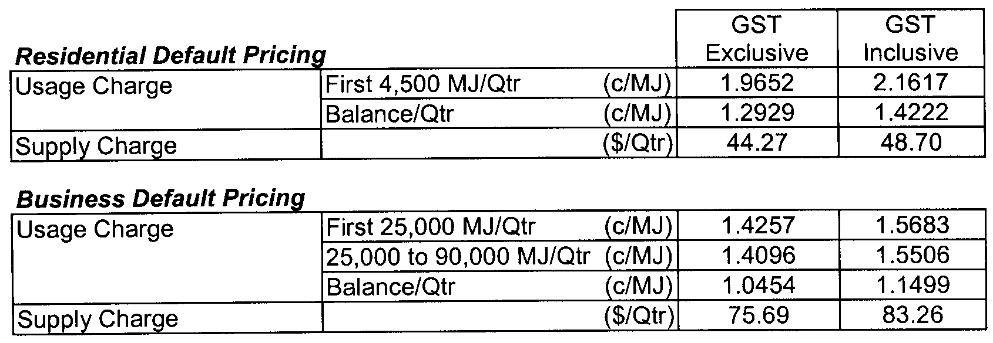
Explanatory Notes:
1. Residential Default Pricing applies to residential customers in premises used wholly or principally as private residences.
2. Business Default Pricing applies to business customers in premises that are not used wholly or principally as private residences.

GOVERNMENT GAZETTE ADVERTISEMENT RATES

To apply from 1 July 2008

$  Agents, Ceasing to Act as 41.00  Associations:  Incorporation 20.80  Intention of Incorporation 51.50  Transfer of Properties 51.50  Attorney, Appointment of 41.00  Bailiff’s Sale 51.50  Cemetery Curator Appointed 30.50  Companies:  Alteration to Constitution 41.00  Capital, Increase or Decrease of 51.50  Ceasing to Carry on Business 30.50  Declaration of Dividend 30.50  Incorporation 41.00  Lost Share Certificates:  First Name 30.50  Each Subsequent Name 10.50  Meeting Final 34.25  Meeting Final Regarding Liquidator’s Report on  Conduct of Winding Up (equivalent to ‘Final  Meeting’)  First Name 41.00  Each Subsequent Name 10.50  Notices:  Call 51.50  Change of Name 20.80  Creditors 41.00  Creditors Compromise of Arrangement 41.00  Creditors (extraordinary resolution that ‘the Com-pany be wound up voluntarily and that a liquidator be appointed’) 51.50  Release of Liquidator⎯Application⎯Large Ad. 81.50  ⎯Release Granted 51.50  Receiver and Manager Appointed 47.50  Receiver and Manager Ceasing to Act 41.00  Restored Name 38.50  Petition to Supreme Court for Winding Up 71.50  Summons in Action 61.00  Order of Supreme Court for Winding Up Action 41.00  Register of Interests⎯Section 84 (1) Exempt 92.00  Removal of Office 20.80  Proof of Debts 41.00  Sales of Shares and Forfeiture 41.00  Estates:  Assigned 30.50  Deceased Persons⎯Notice to Creditors, etc. 51.50  Each Subsequent Name 10.50  Deceased Persons⎯Closed Estates 30.50  Each Subsequent Estate 1.35  Probate, Selling of 41.00  Public Trustee, each Estate 10.50 |  | $  Firms:  Ceasing to Carry on Business (each insertion) 27.25  Discontinuance Place of Business 27.25  Land⎯Real Property Act:  Intention to Sell, Notice of 51.50  Lost Certificate of Title Notices 51.50  Cancellation, Notice of (Strata Plan) 51.50  Mortgages:  Caveat Lodgement 20.80  Discharge of 21.80  Foreclosures 20.80  Transfer of 20.80  Sublet 10.50  Leases⎯Application for Transfer (2 insertions) each 10.50  Lost Treasury Receipts (3 insertions) each 30.50  Licensing 61.00  Municipal or District Councils:  Annual Financial Statement⎯Forms 1 and 2 574.00  Electricity Supply⎯Forms 19 and 20 408.00  Default in Payment of Rates:  First Name 81.50  Each Subsequent Name 10.50  Noxious Trade 30.50  Partnership, Dissolution of 30.50  Petitions (small) 20.80  Registered Building Societies (from Registrar-  General) 20.80  Register of Unclaimed Moneys⎯First Name 30.50  Each Subsequent Name 10.50  Registers of Members⎯Three pages and over:  Rate per page (in 8pt) 261.00  Rate per page (in 6pt) 345.00  Sale of Land by Public Auction 52.00  Advertisements 2.90  ¼ page advertisement 122.00  ½ page advertisement 244.00  Full page advertisement 478.00  Advertisements, other than those listed are charged at $2.90 per column line, tabular one-third extra.  Notices by Colleges, Universities, Corporations and District Councils to be charged at $2.90 per line.  Where the notice inserted varies significantly in length from that which is usually published a charge of $2.90 per column line will be applied in lieu of advertisement rates listed.  South Australian Government publications are sold on the condition that they will not be reproduced without prior permission from the Government Printer.
All the above prices include GST

GOVERNMENT GAZETTE NOTICES
ALL private advertisements forwarded for publication in the South Australian Government Gazette must be PAID FOR PRIOR TO INSERTION; and all notices, from whatever source, should be legibly written on one side of the paper only and sent to Government Publishing SA so as to be received no later than 4 p.m. Tuesday preceding the day of publication. Phone 8207 1045 or Fax 8207 1040. E-mail: governmentgazette@dpc.sa.gov.au. Send as attachments in Word format. Please include date the notice is to be published and to whom the notice will be charged. The Government Gazette is available online at: www.governmentgazette.sa.gov.au.

MISCELLANEOUS LEGISLATION AND GOVERNMENT PUBLICATIONS PRICES AS FROM 1 JULY 2008

Acts, Bills, Rules, Parliamentary Papers and Regulations
Pages | Main | Amends | Pages | Main | Amends

1-16 | 2.50 | 1.15 | 497-512 | 34.75 | 33.75
17-32 | 3.35 | 2.10 | 513-528 | 35.75 | 34.50
33-48 | 4.35 | 3.10 | 529-544 | 37.00 | 35.75
49-64 | 5.50 | 4.20 | 545-560 | 38.00 | 37.00
65-80 | 6.45 | 5.35 | 561-576 | 38.75 | 38.00
81-96 | 7.50 | 6.20 | 577-592 | 40.00 | 38.50
97-112 | 8.55 | 7.30 | 593-608 | 41.25 | 39.75
113-128 | 9.55 | 8.40 | 609-624 | 42.00 | 41.00
129-144 | 10.70 | 9.45 | 625-640 | 43.25 | 41.50
145-160 | 11.70 | 10.50 | 641-656 | 44.25 | 43.25
161-176 | 12.80 | 11.50 | 657-672 | 44.75 | 43.75
177-192 | 13.90 | 12.60 | 673-688 | 46.75 | 44.75
193-208 | 15.00 | 13.80 | 689-704 | 47.50 | 45.70
209-224 | 15.80 | 14.60 | 705-720 | 48.25 | 47.00
225-240 | 16.90 | 15.60 | 721-736 | 50.00 | 48.00
241-257 | 18.10 | 16.50 | 737-752 | 50.50 | 49.00
258-272 | 19.10 | 17.60 | 753-768 | 51.50 | 50.00
273-288 | 20.20 | 18.90 | 769-784 | 52.50 | 51.50
289-304 | 21.00 | 19.80 | 785-800 | 53.50 | 52.50
305-320 | 22.30 | 20.90 | 801-816 | 54.50 | 53.00
321-336 | 23.20 | 21.90 | 817-832 | 55.50 | 54.50
337-352 | 24.40 | 23.10 | 833-848 | 56.50 | 55.50
353-368 | 25.25 | 24.20 | 849-864 | 57.50 | 56.00
369-384 | 26.50 | 25.25 | 865-880 | 59.00 | 57.50
385-400 | 27.50 | 26.25 | 881-896 | 59.50 | 58.00
401-416 | 28.50 | 27.00 | 897-912 | 61.00 | 59.50
417-432 | 29.75 | 28.25 | 913-928 | 61.50 | 61.00
433-448 | 30.75 | 29.50 | 929-944 | 62.50 | 61.50
449-464 | 31.50 | 30.25 | 945-960 | 63.50 | 62.00
465-480 | 32.00 | 31.25 | 961-976 | 65.50 | 63.00
481-496 | 33.75 | 32.00 | 977-992 | 66.50 | 63.50

Legislation—Acts, Regulations, etc: $
Subscriptions:
Acts 214.00
All Bills as Laid 514.00
Rules and Regulations 514.00
Parliamentary Papers 514.00
Bound Acts 238.00
Index 119.00
Government Gazette
Copy 5.60
Subscription 284.00
Hansard
Copy 15.60
Subscription—per session (issued weekly) 446.00
Cloth bound—per volume 191.00
Subscription—per session (issued daily) 446.00
Legislation on Disk
Whole Database 3 304.00
Annual Subscription for fortnightly updates 1 015.00
Individual Act(s) including updates POA
Compendium
Subscriptions:
Subscriptions 1 957.00
Updates 690.00
(All the above prices include GST)

All Legislation, Government Gazette, Hansard and Legislation on disk are available from:
Counter Sales Government Legislation⁺ Outlet
and Mail Orders: Service SA Customer Service Centre,
Ground Floor—EDS Centre, 108 North Terrace, Adelaide, S.A. 5000
Phone: 13 23 24 (local call cost), Fax: (08) 8204 1909
Postal: G.P.O. Box 1707, Adelaide, S.A. 5001

Online Shop: www.shop.service.sa.gov.au

Subscriptions and Government Publishing SA
Standing Orders: Box 9, Plaza Level, Riverside Centre, North Terrace, Adelaide, S.A. 5000
Phone: (08) 8207 1043, (08) 8207 0910, Fax: (08) 8207 1040

HARBORS AND NAVIGATION ACT 1993
Determination of the State Crewing Committee
THE following determination is made by the State Crewing Committee pursuant to part 6, section 45 of the Harbors and Navigation Act 1993, was convened on 13 March 2008, in respect of the Ol’ Mate ‘Hoodlum’.
Patrick Conlon, Minister for Transport
V29396

HARBORS AND NAVIGATION ACT 1993
Determination of the State Crewing Committee in respect of the M.V. Ol’ Mate ‘Hoodlum’
THE following determination is made by the State Crewing Committee pursuant to part 6, section 45 of the Harbors and Navigation Act 1993, in respect of the Ol’ Mate ‘Hoodlum’ whilst operating within five nautical miles from the Coast of South Australia.
Minimum Complement
One Person—Master.
Please note: the Master to be the holder of the Marine Engine Driver Grade 3.
Minimum Qualifications of Crew
Master—Certificate of Competency as a Coxswain.
Engineer—Certificate of Competency as a Marine Engine Driver Grade 3.
Please note: the Master to be the holder of the Marine Engine Driver Grade 3.
Capt. W. Ferrao, Presiding Member, State Crewing Committee

HARBORS AND NAVIGATION ACT 1993
Determination of the State Crewing Committee
THE following determination is made by the State Crewing Committee pursuant to part 6, section 45 of the Harbors and Navigation Act 1993, in respect of the Silver Back.
Patrick Conlon, Minister for Transport
TSA V28984

HARBORS AND NAVIGATION ACT 1993
Determination of the State Crewing Committee in respect of the M.V. ‘Silver Back’
THE following determination is made by the State Crewing Committee pursuant to part 6, section 45 of the Harbors and Navigation Act 1993, in respect of the Silver Back whilst operating within the following limits:
Operational Limits
Limit 1—Within Smooth Waters limits of South Australia as per Schedule 1 of the Harbors and Navigation Regulations 1994.
Limit 2—Within Partially Smooth Waters limits of South Australia as per Schedule 1 of the Harbors and Navigation Regulations 1994.
Limit 3—Within 15 nautical miles of the Coast of South Australia.
Limit 4—Within 30 nautical miles of the Coast of South Australia.
Minimum Complement
Limit 1—Master endorsed to River Murray and Inland Waters.
Limits 2 and 3—Master.
Limit 4—Master.
Minimum Qualifications of Crew
Limit 1—Master Certificate of Competency as a Coxswain endorsed to River Murray and Inland Waters.
Limits 2 and 3—Master Certificate of Competency as a Coxs-wain and has successfully completed approved Occupational Health and Safety at Sea and Restricted Radio Telephony courses.
Limit 4—Master Certificate of Competency as Master Class 5 and to be the holder of a Marine Engine Driver Grade 111.
Capt. W. Ferrao, Presiding Member, State Crewing Committee

HARBORS AND NAVIGATION ACT 1993
Determination of the State Crewing Committee
THE following determination is made by the State Crewing Committee pursuant to part 6, section 45 of the Harbors and Navigation Act 1993, was convened on 13 March 2008, in respect of the Deky Zane.
Patrick Conlon, Minister for Transport
V29116

HARBORS AND NAVIGATION ACT 1993
Determination of the State Crewing Committee in respect of the M.V. ‘Deky Zane’
THE following determination is made by the State Crewing Committee pursuant to part 6, section 45 of the Harbors and Navigation Act 1993, in respect of the Deky Zane whilst operating within sheltered waters—within declared partially smooth waters as per Schedule 1 of the Harbors and Navigation Act.
Minimum Complement
One Person—Master
Minimum Qualifications of Crew
Master—Certificate of Competency as a Coxswain.
Capt. W. Ferrao, Presiding Member, State Crewing Committee

LAND AND BUSINESS (SALE AND CONVEYANCING)
ACT 1994
Exemption
TAKE notice that, pursuant to section 23 (3) of the Land and Business (Sale and Conveyancing) Act 1994, I, Jennifer Rankine, Minister for Consumer Affairs, do hereby exempt the person named in Schedule 1 from the application of section 23 (2) of the Act in relation to the purchase of the land specified in Schedule 2.
Schedule 1
Matthew John Sergeant, an employee of Shizas Real Estate Pty Ltd.
Schedule 2
The land described in a whole of certificate of title register book volume 5361, folio 982, situated at 21 Suffolk Avenue, Brahma Lodge, S.A. 5109.
Dated 11 July 2008.
J. Rankine, Minister for Consumer Affairs

LIQUOR LICENSING ACT 1997 AND GAMING MACHINES ACT 1992
Notice of Application
NOTICE is hereby given, pursuant to section 52 of the Liquor Licensing Act 1997 and section 29 of the Gaming Machines Act 1992, that Metro Adelaide Pty Ltd as trustee for Metro Adelaide Unit Trust has applied to the Licensing Authority for the transfer of a Hotel and Gaming Machine Licence, extension of Trading Area and variation to an Extended Trading Authorisation in respect of premises situated at 46 Grote Street, Adelaide, S.A. 5000 and known as Metropolitan Hotel.
The application has been set down for callover on 22 August 2008 at 9 a.m.
Conditions
The following licence conditions are sought:
• Extension of Trading Area to include the Outdoor Area at the front of the premises as per plans lodged with this office.
• Variation to Extended Trading Authorisation to include the abovementioned area.
Any person may object to the application by lodging a notice of objection in the prescribed form with the Liquor and Gambling Commissioner and serving a copy of the notice on the applicant at the applicant’s address, at least seven days before the callover date (viz: 15 August 2008).
The applicant’s address for service is c/o Clelands Solicitors, 208 Carrington Street, Adelaide, S.A. 5000 (Attention: Leon McEvoy).
Plans in respect of the premises the subject of the application are open to public inspection without fee at the Office of the Liquor and Gambling Commissioner, 9th Floor, East Wing, 50 Grenfell Street, Adelaide, S.A. 5000. Phone 8226 8410, Fax:
8226 8512. Email: olgc@agd.sa.gov.au.
Dated 21 July 2008.
Applicant

LIQUOR LICENSING ACT 1997 AND GAMING MACHINES ACT 1992
Notice of Application
NOTICE is hereby given, pursuant to section 52 of the Liquor Licensing Act 1997 and section 29 of the Gaming Machines Act 1992, that Australian Property Projects Pty Ltd as trustee for Red Centre Unit Trust has applied to the Licensing Authority for the transfer of a Special Circumstances Licence and Gaming Machine Licence in respect of premises situated at Commercial Street, Kingscote, S.A. 5223 and known as Ozone Hotel Motel.
The application has been set down for hearing on 25 August 2008 at 9 a.m.
Any person may object to the application by lodging a notice of objection in the prescribed form with the Liquor and Gambling Commissioner and serving a copy of the notice on the applicant at the applicant’s address, at least seven days before the hearing date (viz: 18 August 2008).
The applicant’s address for service is c/o DLA Phillips Fox,
100 King William Street, Adelaide, S.A. 5000 (Attention: Sue Chenery).
Plans in respect of the premises the subject of the application are open to public inspection without fee at the Office of the Liquor and Gambling Commissioner, 9th Floor, East Wing, 50 Grenfell Street, Adelaide, S.A. 5000. Phone 8226 8410, Fax:
8226 8512. Email: olgc@agd.sa.gov.au.
Dated 15 July 2008.
Applicant

LIQUOR LICENSING ACT 1997 AND GAMING MACHINES ACT 1992
Notice of Application
NOTICE is hereby given, pursuant to section 52 of the Liquor Licensing Act 1997 and section 29 of the Gaming Machines Act 1992, that D. & K. Transport Services Pty Ltd has applied to the Licensing Authority for the transfer of a Hotel and Gaming Machine Licence in respect of premises situated at Main Road, Eden Valley, S.A. 5235 and known as Eden Valley Hotel.
The application has been set down for hearing on 25 August 2008 at 9.30 a.m.
Any person may object to the application by lodging a notice of objection in the prescribed form with the Liquor and Gambling Commissioner and serving a copy of the notice on the applicant at the applicant’s address, at least seven days before the hearing date (viz: 18 August 2008).
The applicant’s address for service is c/o Camatta Lempens Solicitors, Level 1, 345 King William Street, Adelaide, S.A. 5000 (Attention: Bob Lempens).
Plans in respect of the premises the subject of the application are open to public inspection without fee at the Office of the Liquor and Gambling Commissioner, 9th Floor, East Wing, 50 Grenfell Street, Adelaide, S.A. 5000. Phone 8226 8410, Fax:
8226 8512. Email: olgc@agd.sa.gov.au.
Dated 14 July 2008.
Applicant

LIQUOR LICENSING ACT 1997
Notice of Application
NOTICE is hereby given, pursuant to section 52 (2) (b) of the Liquor Licensing Act 1997, that Hotel Tivoli Pty Ltd as trustee for Hotel Tivoli Trust has applied to the Licensing Authority for the transfer of a Hotel Licence, Redefinition, variation to an Extended Trading Authorisation and variation to Entertainment Consent in respect of premises situated at 261 Pirie Street, Adelaide, S.A. 5000 and known as Tivoli Hotel.
The application has been set down for callover on 15 August 2008 at 9 a.m.
Conditions
The following licence conditions are sought:
• Redefinition and extension of Trading Area to include foot-path as per plans lodged.
• Variation to Extended Trading Authorisation to include new footpath area for the abovementioned area.
• Variation to Extended Trading Authorisation:
To reduce the Extended Trading Authorisation from 5 a.m. to 3 a.m. on the mornings following Friday and Saturday nights.
• Variation to Extended Trading Authorisation to include the whole of the licensed premises and the footpath area for the following times:
Good Friday: Midnight to 2 a.m.;
Christmas Day: Midnight to 2 a.m.;
Sunday Christmas Eve: 8 p.m. to 2 a.m. the following day;
Days preceeding other Public Holidays: Midnight to 3 a.m. the following day;
Sundays preceeding Public Holidays: 8 p.m. to 2 a.m. the following day.
• Variation to conditions:
To remove the following conditions from the licence:
A minimum door charge of $8 shall apply to any person entering the premises after 3 a.m. on Saturdays or Sundays until the close of trading on these mornings and shall not be in any way related to any liquor promotion being conducted on the premises at the time.
That 100 offstreet carparking spaces be available within 50 m of the premises for the use of persons attending the premises on any Saturday or Sunday morning.
No live amplified music shall be permitted within the Hotel and associated restaurant.
To add the following condition to the licence:
There will be no live bands after 1 a.m.
Any person may object to the application by lodging a notice of objection in the prescribed form with the Liquor and Gambling Commissioner and serving a copy of the notice on the applicant at the applicant’s address, at least seven days before the callover date (viz: 8 August 2008).
The applicant’s address for service is c/o Foreman Legal, 69 Mount Barker Road, Stirling, S.A. 5152.
Plans in respect of the premises the subject of the application are open to public inspection without fee at the Office of the Liquor and Gambling Commissioner, 9th Floor, East Wing, 50 Grenfell Street, Adelaide, S.A. 5000. Phone 8226 8410, Fax:
8226 8512. Email: olgc@agd.sa.gov.au.
Dated 16 July 2008.
Applicant

LIQUOR LICENSING ACT 1997
Notice of Application
NOTICE is hereby given, pursuant to section 52 (2) (b) of the Liquor Licensing Act 1997, that Thachi Operations Pty Ltd has applied to the Licensing Authority for the transfer of a Wholesale Liquor Merchant’s Licence in respect of premises situated at Nixon Road, Monash, S.A. 5342 and known as Thachi Wines.
The application has been set down for hearing on 20 August 2008 at 8.30 a.m.
Any person may object to the application by lodging a notice of objection in the prescribed form with the Liquor and Gambling Commissioner and serving a copy of the notice on the applicant at the applicant’s address, at least seven days before the hearing date (viz: 13 August 2008).
The applicant’s address for service is c/o Finlaysons, 81 Flinders Street, Adelaide, S.A. 5000 (Attention: Andrew Williams).
Plans in respect of the premises the subject of the application are open to public inspection without fee at the Office of the Liquor and Gambling Commissioner, 9th Floor, East Wing, 50 Grenfell Street, Adelaide, S.A. 5000. Phone 8226 8410, Fax:
8226 8512. Email: olgc@agd.sa.gov.au.
Dated 16 July 2008.
Applicant

LIQUOR LICENSING ACT 1997
Notice of Application
NOTICE is hereby given, pursuant to section 52 (2) (b) of the Liquor Licensing Act 1997, that Thachi Operations Pty Ltd has applied to the Licensing Authority for the transfer of a Producer’s Licence in respect of premises situated at Nixon Road, Monash, S.A. 5342 and known as Thachi Wines.
The application has been set down for hearing on 20 August 2008 at 9 a.m.
Any person may object to the application by lodging a notice of objection in the prescribed form with the Liquor and Gambling Commissioner and serving a copy of the notice on the applicant at the applicant’s address, at least seven days before the hearing date (viz: 13 August 2008).
The applicant’s address for service is c/o Finlaysons, 81 Flinders Street, Adelaide, S.A. 5000 (Attention: Andrew Williams).
Plans in respect of the premises the subject of the application are open to public inspection without fee at the Office of the Liquor and Gambling Commissioner, 9th Floor, East Wing, 50 Grenfell Street, Adelaide, S.A. 5000. Phone 8226 8410, Fax:
8226 8512. Email: olgc@agd.sa.gov.au.
Dated 16 July 2008.
Applicant

LIQUOR LICENSING ACT 1997
Notice of Application
NOTICE is hereby given, pursuant to section 52 (2) (b) of the Liquor Licensing Act 1997, that Thachi Operations Pty Ltd has applied to the Licensing Authority for the transfer of a Producer’s Licence in respect of premises situated at Lot 188, Vine Vale Road, Tanunda, S.A. 5352 and known as Vinecrest Fine Barossa Wine.
The application has been set down for hearing on 20 August 2008 at 9.30 a.m.
Any person may object to the application by lodging a notice of objection in the prescribed form with the Liquor and Gambling Commissioner and serving a copy of the notice on the applicant at the applicant’s address, at least seven days before the hearing date (viz: 13 August 2008).
The applicant’s address for service is c/o Finlaysons, 81 Flinders Street, Adelaide, S.A. 5000 (Attention: Andrew Williams).
Plans in respect of the premises the subject of the application are open to public inspection without fee at the Office of the Liquor and Gambling Commissioner, 9th Floor, East Wing, 50 Grenfell Street, Adelaide, S.A. 5000. Phone 8226 8410, Fax:
8226 8512. Email: olgc@agd.sa.gov.au.
Dated 16 July 2008.
Applicant

LIQUOR LICENSING ACT 1997
Notice of Application
NOTICE is hereby given, pursuant to section 52 (2) (b) of the Liquor Licensing Act 1997, that Pinnaroo Football Club Inc. has applied to the Licensing Authority for a Limited Club Licence in respect of premises situated at Homburg Terrace, Pinnaroo, S.A. 5304 and to be known as Pinnaroo Football Club.
The application has been set down for callover on 22 August 2008 at 9 a.m.
Any person may object to the application by lodging a notice of objection in the prescribed form with the Liquor and Gambling Commissioner and serving a copy of the notice on the applicant at the applicant’s address, at least seven days before the callover date (viz: 15 August 2008).
The applicant’s address for service is c/o O’Briens Solicitors, Riverview Drive, Berri, S.A. 5343 (Attention: Tim O’Brien).
Plans in respect of the premises the subject of the application are open to public inspection without fee at the Office of the Liquor and Gambling Commissioner, 9th Floor, East Wing, 50 Grenfell Street, Adelaide, S.A. 5000. Phone 8226 8410, Fax:
8226 8512. Email: olgc@agd.sa.gov.au.
Dated 12 July 2008.
Applicant

LIQUOR LICENSING ACT 1997
Notice of Application
NOTICE is hereby given, pursuant to section 52 (2) (b) of the Liquor Licensing Act 1997, that Simon Alexander Greenleaf and William Robert Finlayson have applied to the Licensing Authority for the removal of a Producer’s Licence and variation to Conditions in respect of premises situated at 45 Marian Place, Prospect, S.A. 5082 and to be situated at 5A/1 Adelaide Lobethal Road, Lobethal, S.A. 5241 and known as Cloudbreak Wines.
The application has been set down for callover on 22 August 2008 at 9 a.m.
Conditions
The following licence conditions are sought:
• Variation to Conditions to delete the following:
That use of the premises shall accord with the definition of ‘Home Activity’ as set out in the Develop-ment Regulations 1993 and requirements of the City of Prospect.
• Redefinition to include a sampling area.
Any person may object to the application by lodging a notice of objection in the prescribed form with the Liquor and Gambling Commissioner and serving a copy of the notice on the applicants at the applicants’ address, at least seven days before the callover date (viz: 15 August 2008).
The applicants’ address for service is c/o Cloudbreak Wines, 45 Marian Place, Prospect, S.A. 5082 (Attention: Simon Greenleaf).
Plans in respect of the premises the subject of the application are open to public inspection without fee at the Office of the Liquor and Gambling Commissioner, 9th Floor, East Wing, 50 Grenfell Street, Adelaide, S.A. 5000. Phone 8226 8410, Fax:
8226 8512. Email: olgc@agd.sa.gov.au.
Dated 15 July 2008.
Applicants

LIQUOR LICENSING ACT 1997
Notice of Application
NOTICE is hereby given, pursuant to section 52 (2) (b) of the Liquor Licensing Act 1997, that The Australian Experience Touring Co. Pty Ltd has applied to the Licensing Authority to vary an Extended Trading Authorisation in respect of premises situated at 489 Esplanade, Grange, S.A. 5022 and known as Grange Hotel.
The application has been set down for callover on 22 August 2008 at 9 a.m.
Conditions
The following licence conditions are sought:
Approval is sought to Extended Trading in the Dining Area and Gaming Room from 11 p.m. until midnight each Sunday and to permit trading on Good Friday from midnight until 2 a.m. (an extension of Maundy Thursday trading) in all internal areas.
Any person may object to the application by lodging a notice of objection in the prescribed form with the Liquor and Gambling Commissioner and serving a copy of the notice on the applicant at the applicant’s address, at least seven days before the callover date (viz: 15 August 2008).
The applicant’s address for service is c/o The Australian Hotels Association (S.A. Branch), 4th Floor, 60 Hindmarsh Square, Adelaide, S.A. 5000.
Plans in respect of the premises the subject of the application are open to public inspection without fee at the Office of the Liquor and Gambling Commissioner, 9th Floor, East Wing, 50 Grenfell Street, Adelaide, S.A. 5000. Phone 8226 8410, Fax:
8226 8512. Email: olgc@agd.sa.gov.au.
Dated 15 July 2008.
Applicant

LIQUOR LICENSING ACT 1997
Notice of Application
NOTICE is hereby given, pursuant to section 52 (2) (b) of the Liquor Licensing Act 1997, that Mount Compass Community Sports Club Incorporated has applied to the Licensing Authority for a Club Licence in respect of premises situated at Peters Terrace, Mount Compass, S.A. 5210 and to be known as Mount Compass Community Sports Club.
The application has been set down for callover on 22 August 2008 at 9 a.m.
Conditions
The following licence conditions are sought:
• Extended Trading Authorisation to apply to areas as per plans lodged with this office for the following hours:
Friday and Saturday: Midnight to 1 a.m. the following day;
Sunday: 8 p.m. to 10 p.m.
• Entertainment Consent to apply to the areas as per plans lodged with this office.
Any person may object to the application by lodging a notice of objection in the prescribed form with the Liquor and Gambling Commissioner and serving a copy of the notice on the applicant at the applicant’s address, at least seven days before the callover date (viz: 15 August 2008).
The applicant’s address for service is c/o Mount Compass Community Sports Club, P.O. Box 644, Mount Compass, S.A. 5210 (Attention: Janet Cunningham).
Plans in respect of the premises the subject of the application are open to public inspection without fee at the Office of the Liquor and Gambling Commissioner, 9th Floor, East Wing, 50 Grenfell Street, Adelaide, S.A. 5000. Phone 8226 8410, Fax:
8226 8512. Email: olgc@agd.sa.gov.au.
Dated 16 July 2008.
Applicant

LIQUOR LICENSING ACT 1997
Notice of Application
NOTICE is hereby given, pursuant to section 52 (2) (b) of the Liquor Licensing Act 1997, that Gawler River Estate Pty Ltd as trustee for Gawler River Estate Trust has applied to the Licensing Authority for a Direct Sales Licence in respect of premises situated at 9 Dudley Avenue, Prospect, S.A. 5082 and known as Gawler River Estate Pty Ltd.
The application has been set down for callover on 22 August 2008 at 9 a.m.
Any person may object to the application by lodging a notice of objection in the prescribed form with the Liquor and Gambling Commissioner and serving a copy of the notice on the applicant at the applicant’s address, at least seven days before the callover date (viz: 15 August 2008).
The applicant’s address for service is c/o Cheryl Howe, G.P.O. Box 1660, Adelaide, S.A. 5001.
Plans in respect of the premises the subject of the application are open to public inspection without fee at the Office of the Liquor and Gambling Commissioner, 9th Floor, East Wing, 50 Grenfell Street, Adelaide, S.A. 5000. Phone 8226 8410, Fax:
8226 8512. Email: olgc@agd.sa.gov.au.
Dated 18 July 2008.
Applicant

LIQUOR LICENSING ACT 1997
Notice of Application
NOTICE is hereby given, pursuant to section 52 (2) (b) of the Liquor Licensing Act 1997, that Gawler River Estate Pty Ltd as trustee for Gawler River Estate Trust has applied to the Licensing Authority for a Producer’s Licence in respect of premises situated at 9 Dudley Avenue, Prospect, S.A. 5082 and known as Gawler River Estate Pty Ltd.
The application has been set down for callover on 22 August 2008 at 9 a.m.
Any person may object to the application by lodging a notice of objection in the prescribed form with the Liquor and Gambling Commissioner and serving a copy of the notice on the applicant at the applicant’s address, at least seven days before the callover date (viz: 15 August 2008).
The applicant’s address for service is c/o Cheryl Howe, G.P.O. Box 1660, Adelaide, S.A. 5001.
Plans in respect of the premises the subject of the application are open to public inspection without fee at the Office of the Liquor and Gambling Commissioner, 9th Floor, East Wing, 50 Grenfell Street, Adelaide, S.A. 5000. Phone 8226 8410, Fax:
8226 8512. Email: olgc@agd.sa.gov.au.
Dated 18 July 2008.
Applicant

LIQUOR LICENSING ACT 1997
Notice of Application
NOTICE is hereby given, pursuant to section 52 (2) (b) of the Liquor Licensing Act 1997, that Zak Grooming For Men Pty Ltd as trustee for Zak Family Trust has applied to the Licensing Authority for a Special Circumstances Licence in respect of premises situated at 3/72 The Broadway, Glenelg South, S.A. 5045 and to be known as Zak Grooming For Men.
The application has been set down for callover on 22 August 2008 at 9 a.m.
Conditions
The following licence conditions are sought:
• The sale of liquor for consumption on the premises for the following trading hours:
Monday to Sunday: Midday to 9 p.m.
• No liquor will be offered for sale to the general public.
• Hairdressing activities are to be the predominant activity at all times in the premises.
• There will be no promotion of liquor for sale on the licensed premises.
• No more than three drinks per person.
• The first drink will be on a complimentary basis to hairdressing customers.
Any person may object to the application by lodging a notice of objection in the prescribed form with the Liquor and Gambling Commissioner and serving a copy of the notice on the applicant at the applicant’s address, at least seven days before the callover date (viz: 15 August 2008).
The applicant’s address for service is c/o Kerry Zacharia, 49 Narinna Avenue, Cumberland Park, S.A. 5041.
Plans in respect of the premises the subject of the application are open to public inspection without fee at the Office of the Liquor and Gambling Commissioner, 9th Floor, East Wing, 50 Grenfell Street, Adelaide, S.A. 5000. Phone 8226 8410, Fax:
8226 8512. Email: olgc@agd.sa.gov.au.
Dated 16 July 2008.
Applicant

LIQUOR LICENSING ACT 1997
Notice of Application
NOTICE is hereby given, pursuant to section 52 (2) (b) of the Liquor Licensing Act 1997, that John Wills Heyward and Mary Elizabeth Heyward have applied to the Licensing Authority for a variation to an Extended Trading Authorisation in respect of premises situated at 31 Church Street, Penola, S.A. 5277 and known as Heyward’s Royal Oak Hotel.
The application has been set down for callover on 22 August 2008 at 9 a.m.
Conditions
The following licence conditions are sought:
• That the licensee be permitted to sell liquor for consumption on the licensed premises from midnight to 1 a.m. the following morning each Monday to Saturday inclusive and from 9 p.m. to midnight each Sunday.
• That the Extended Trading Authorisation shall apply to the whole of the licensed premises during the days and times sought in this application and all other days and times previously authorised for extended trading.
Any person may object to the application by lodging a notice of objection in the prescribed form with the Liquor and Gambling Commissioner and serving a copy of the notice on the applicants at the applicants’ address, at least seven days before the callover date (viz: 15 August 2008).
The applicants’ address for service is c/o The Australian Hotels Association (S.A. Branch), 4th Floor, 60 Hindmarsh Square, Adelaide, S.A. 5000.
Plans in respect of the premises the subject of the application are open to public inspection without fee at the Office of the Liquor and Gambling Commissioner, 9th Floor, East Wing, 50 Grenfell Street, Adelaide, S.A. 5000. Phone 8226 8410, Fax:
8226 8512. Email: olgc@agd.sa.gov.au.
Dated 21 July 2008.
Applicants

LIQUOR LICENSING ACT 1997
Notice of Application
NOTICE is hereby given, pursuant to section 52 (2) (b) of the Liquor Licensing Act 1997, that Brothers Parade Pty Ltd has applied to the Licensing Authority for a Direct Sales Licence in respect of premises situated at Brentnalls SA Chartered Accountants, 255 Port Road, Hindmarsh, S.A. 5007 and known as Brothers Parade Pty Ltd.
The application has been set down for callover on 22 August 2008 at 9 a.m.
Any person may object to the application by lodging a notice of objection in the prescribed form with the Liquor and Gambling Commissioner and serving a copy of the notice on the applicant at the applicant’s address, at least seven days before the callover date (viz: 15 August 2008).
The applicant’s address for service is c/o Hunt & Hunt Lawyers, Level 12, 26 Flinders Street, Adelaide, S.A. 5000.
Plans in respect of the premises the subject of the application are open to public inspection without fee at the Office of the Liquor and Gambling Commissioner, 9th Floor, East Wing, 50 Grenfell Street, Adelaide, S.A. 5000. Phone 8226 8410, Fax:
8226 8512. Email: olgc@agd.sa.gov.au.
Dated 21 July 2008.
Applicant

LIQUOR LICENSING ACT 1997
Notice of Application
NOTICE is hereby given, pursuant to section 52 (2) (b) of the Liquor Licensing Act 1997, that Bedford Industries has applied to the Licensing Authority for a variation to Conditions in respect of premises situated at 46 Strathcona Avenue, Clapham, S.A. 5062 and known as Balyana Conference Centre.
The application has been set down for callover on 22 August 2008 at 9 a.m.
Conditions
The following licence conditions are sought:
To add the following condition to the licence:
• The licence authorises the sale of liquor on the licensed premises at any time for consumption at a place other than the licensed premises, provided that such consump-tion is only by persons (other than a minor) attending a pre-booked function and liquor is consumed with or ancillary to food provided by the licensee.
Any person may object to the application by lodging a notice of objection in the prescribed form with the Liquor and Gambling Commissioner and serving a copy of the notice on the applicant at the applicant’s address, at least seven days before the callover date (viz: 15 August 2008).
The applicant’s address for service is c/o Bedford Industries, 46 Strathcona Avenue, Clapham, S.A. 5062.
Plans in respect of the premises the subject of the application are open to public inspection without fee at the Office of the Liquor and Gambling Commissioner, 9th Floor, East Wing, 50 Grenfell Street, Adelaide, S.A. 5000. Phone 8226 8410, Fax:
8226 8512. Email: olgc@agd.sa.gov.au.
Dated 21 July 2008.
Applicant

LIQUOR LICENSING ACT 1997
Notice of Application
NOTICE is hereby given, pursuant to section 52 (2) (b) of the Liquor Licensing Act 1997, that Chi Kim Thi Pham has applied to the Licensing Authority for a Restaurant Licence in respect of premises situated at 22 Belmore Terrace, Woodville Park, S.A. 5011 and to be known as Ramsey’s Kitchen.
The application has been set down for callover on 22 August 2008 at 9 a.m.
Any person may object to the application by lodging a notice of objection in the prescribed form with the Liquor and Gambling Commissioner and serving a copy of the notice on the applicant at the applicant’s address, at least seven days before the callover date (viz: 15 August 2008).
The applicant’s address for service is c/o Chi Pham, 22 Belmore Terrace, Woodville Park, S.A. 5011.
Plans in respect of the premises the subject of the application are open to public inspection without fee at the Office of the Liquor and Gambling Commissioner, 9th Floor, East Wing, 50 Grenfell Street, Adelaide, S.A. 5000. Phone 8226 8410, Fax:
8226 8512. Email: olgc@agd.sa.gov.au.
Dated 21 July 2008.
Applicant

LIQUOR LICENSING ACT 1997
Notice of Application
NOTICE is hereby given, pursuant to section 52 (2) (b) of the Liquor Licensing Act 1997, that Michael Wines Pty Ltd as trustee for Michael Hill Wines Trust has applied to the Licensing Authority for a Producer’s Licence in respect of premises situated at Lot 147, Sturt Highway, Nuriootpa, S.A. 5355 and to be known as Michael Hill Wines.
The application has been set down for callover on 22 August 2008 at 9 a.m.
Any person may object to the application by lodging a notice of objection in the prescribed form with the Liquor and Gambling Commissioner and serving a copy of the notice on the applicant at the applicant’s address, at least seven days before the callover date (viz: 15 August 2008).
The applicant’s address for service is c/o Clelands Solicitors, 208 Carrington Street, Adelaide, S.A. 5000 (Attention: Rinaldo D’Aloia).
Plans in respect of the premises the subject of the application are open to public inspection without fee at the Office of the Liquor and Gambling Commissioner, 9th Floor, East Wing, 50 Grenfell Street, Adelaide, S.A. 5000. Phone 8226 8410, Fax:
8226 8512. Email: olgc@agd.sa.gov.au.
Dated 21 July 2008.
Applicant

LIQUOR LICENSING ACT 1997
Notice of Application
NOTICE is hereby given, pursuant to section 52 (2) (b) of the Liquor Licensing Act 1997, that Lisa Jane Herbert has applied to the Licensing Authority for the transfer of a Restaurant Licence and variation to Conditions in respect of premises situated at Tango’s Cafe, 4/220 Mount Barker Road, Aldgate, S.A. 5154, known as Tangos Cafe and to be known as Aldgate Providore & Cafe.
The application has been set down for callover on 22 August 2008 at 9 a.m.
Conditions
The following licence conditions are sought:
• Variation to Conditions:
To delete the following condition:
The upstairs seating shall only be used after 6 p.m., Thursday to Sunday.
Any person may object to the application by lodging a notice of objection in the prescribed form with the Liquor and Gambling Commissioner and serving a copy of the notice on the applicant at the applicant’s address, at least seven days before the callover date (viz: 15 August 2008).
The applicant’s address for service is c/o Foreman Legal, 69 Mount Barker Road, Stirling, S.A. 5152.
Plans in respect of the premises the subject of the application are open to public inspection without fee at the Office of the Liquor and Gambling Commissioner, 9th Floor, East Wing, 50 Grenfell Street, Adelaide, S.A. 5000. Phone 8226 8410, Fax:
8226 8512. Email: olgc@agd.sa.gov.au.
Dated 21 July 2008.
Applicant

NATIONAL ELECTRICITY LAW
THE Australian Energy Market Commission (AEMC) gives notice under the National Electricity Law of the following matters.
Under section 107, the period of time for the making of the draft determination on the proposed National Electricity Amendment (Cost Allocation Arrangements for Transmission Services) Rule 2008 has been extended to 28 August 2008.
Under section 95, the Minister for Energy and Resources (Victoria) has requested the making of the proposed National Electricity Amendment (Total Factor Productivity for Distribution Network Regulation) Rule 2008. The proposal seeks to introduce the total factor productivity methodology as an alternative to the existing economic regulatory methodology applied by the Australian Energy Regulator for approving or amending determinations for distributors. Submissions must be received by 22 August 2008. Under section 107, the period of time for the making of the draft determination on this proposed Rule has been extended to 13 January 2009.
Under section 95, Energy Australia has requested the making of the proposed National Electricity Amendment (Transmission Network Prices Publication Date) Rule 2008. The proposal seeks to change the publication date for transmission network prices from 15 May to 15 March each year. The AEMC intends to expedite the making of the proposed Rule under section 96 on the grounds that the proposed Rule is non-controversial, subject to the receipt of written objections.
In relation to this proposal:
• written objections must be received by 8 August 2008; and
• submissions must be received by 22 August 2008.
All written objections and submissions should be forwarded to submissions@aemc.gov.au. Submissions should be submitted in accordance with the AEMC’s Guidelines for making written submissions on Rule change proposals. The AEMC publishes all submissions on its website subject to a claim of confidentiality.
Further details on the above matters are available on the AEMC’s website www.aemc.gov.au. All documents in relation to the above matters are published on the AEMC’s website and are available for inspection at the offices of the AEMC.
John Tamblyn
Chairman
Australian Energy Market Commission
Level 5, 201 Elizabeth Street
Sydney, N.S.W. 2000
Telephone: (02) 8296 7800
Facsimile: (02) 8296 7899
24 July 2008.

NATIONAL PARKS AND WILDLIFE ACT 1972
Appointment of Wardens
I, EDWARD GREGORY LEAMAN, Director, National Parks and Wildlife hereby appoint each of the following persons as listed in Schedule 1, as Wardens, pursuant to section 20 of the National Parks and Wildlife Act 1972, for the whole of the State of South Australia, unless otherwise stated, for the period commencing on 1 July 2008 and ending on 31 December 2008.
Schedule 1

Card No. | Name of Warden | Organisation | Special Conditions
325 | Kerri Anne Villiers | DEH | Nil
442 | Adrian Joseph Robb | DEH | Nil
445 | Justin Holmes | DEH | Nil
410 | Isobel Campbell | MACAI | Section 22 (1) (d) of the National Parks and Wildlife Act 1972 only. Restricted to Ngaut Ngaut Conservation Park only.
417 | Cynthia Hutchinson | MACAI | Section 22 (1) (d) of the National Parks and Wildlife Act 1972 only. Restricted to Ngaut Ngaut Conservation Park only.
Dated 1 July 2008.
E. G. Leaman, Director of Natural and Cultural Heritage

MINING ACT 1971
Erratum
NOTICE is hereby given in accordance with section 53 (2) of the Mining Act 1971, that an application for a Miscellaneous Purposes Licence has been received. Details of the proposal may be inspected at the Department of Primary Industries and Resources, Mineral Resources Group, Level 5, 101 Grenfell Street, Adelaide, S.A. 5000:
Applicant: Penrice Soda Products Pty Ltd
Location: Allotment 91 in Filed Plan 170490, Allotment 2 in Deposited Plan 66829 and Piece 3 in Deposited Plan 66829, Hundred of Moorooroo—Approximately 3.5 km north-north-west of Angaston.
Area: 24.1 hectares
Purpose: Overburden stockpiling, reclaim stockpile, crushing and general sales yard activity associated with aggregates.
Reference: T02728
A copy of the proposal has been provided to The Barossa Council.
Written submissions in relation to the granting of the Miscellaneous Purposes Licence are invited for an additional week to be received at the Department of Primary Industries and Resources, Mineral Resources Group, Level 5, 101 Grenfell Street, Adelaide, S.A. 5000 or G.P.O. Box 1671, Adelaide, S.A. 5001 no later than 21 August 2008.
Copies of all submissions will be forwarded to the applicant and may be made available for public inspection unless confidentiality is requested.
H. Thomas, Mining Registrar

MINING ACT 1971
Declaration of a New Mine
PURSUANT to section 17A of the Mining Act 1971, I declare that the Mineral Lease(s) that may be granted over Mineral Claims 3953, 3510, 3833, 3834 and 3835 will be taken to be a new mine for the purposes of this section:
Reference: T02733, T02502, T02670.
Paul Holloway, Minister for Mineral Resources Development

MINING ACT 1971
NOTICE is hereby given in accordance with section 28 (5) of the Mining Act 1971, that the Minister for Mineral Resources Development proposes to grant an Exploration Licence over the undermentioned area:
Applicant: South Australian Iron Ore Group Pty Ltd
Location: Ironstone Hill area⎯Approximately 50 km west-south-west of Whyalla.
Pastoral Lease: Cooyerdoo and Shirrocoe Stations
Term: 1 year
Area in km²: 52
Ref.: 2008/00244
Plan and co-ordinates can be found on the PIRSA Sarig website: http://www.minerals.pir.sa.gov.au/sarig or by phoning Mineral Tenements on (08) 8463 3103.
H. Thomas, Mining Registrar

MINING ACT 1971
NOTICE is hereby given in accordance with section 28 (5) of the Mining Act 1971, that the Minister for Mineral Resources Development proposes to grant an Exploration Licence over the undermentioned area:
Applicant: Eyre Energy Ltd
Location: Lake Acraman area⎯Approximately 140 km north-east of Streaky Bay.
Pastoral Lease: Lake Everard, Yarna and Moonaree Stations
Term: 1 year
Area in km²: 256
Ref.: 2008/00251
Plan and co-ordinates can be found on the PIRSA Sarig website: http://www.minerals.pir.sa.gov.au/sarig or by phoning Mineral Tenements on (08) 8463 3103.
H. Thomas, Mining Registrar

PETROLEUM ACT 2000
Suspension of Geothermal Exploration Licence—GEL 207
PURSUANT to section 90 of the Petroleum Act 2000, notice is hereby given that the abovementioned Geothermal Exploration Licence has been suspended under the provisions of the Petroleum Act 2000, from and including 3 July 2008 until 2 January 2009, pursuant to delegated powers dated 28 March 2002, Gazetted
11 April 2002, page 1573.
The expiry date of Exploration Licence GEL 207 is now determined to be 18 January 2011.
Dated 18 July 2008.
B. A. Goldstein,
Director Petroleum and Geothermal
Minerals and Energy Resources
Primary Industries and Resources SA
Delegate of the Minister for Mineral
Resources Development

PETROLEUM ACT 2000
Surrender of Associated Facilities Licences—AFLs 101, 102,
103, 104, 105, 106, 107, 108, 109 and 110
(Adjunct to Petroleum Exploration Licence—PEL 255)
NOTICE is hereby given that I have accepted surrender of the abovementioned Associated Facilities Licences with effect from 18 July 2008, under the provisions of the Petroleum Act 2000, pursuant to delegated powers dated 28 March 2002, Gazetted 11 April 2002, page 1573. The description of areas which have been surrendered are as published in Government Gazette No. 1 dated
3 January 2008, pages 19 and 20.
Dated 18 July 2008.
B. A. Goldstein,
Director Petroleum and Geothermal
Minerals and Energy Resources
Primary Industries and Resources SA
Delegate of the Minister for Mineral
Resources Development

PETROLEUM ACT 2000
Section 25 (5) (b)
Variation of Petroleum Exploration Licence—PEL 255
NOTICE is hereby given that under the provisions of the Petroleum Act 2000, pursuant to delegated powers dated 28 March 2002, Gazetted 11 April 2002, page 1573, the conditions of the abovementioned Exploration Licence have been varied as follows:
Condition 1 of the licence is omitted and the following substituted:
‘1. During the term of the licence, the licensee shall carry out or cause to be carried out exploratory operations on the area comprised in the licence in accordance with such work programs as are approved by the Minister from time to time. Years one to two exploratory operations are guaranteed and any subsequent licence year becomes guaranteed upon entry into that licence year. These exploratory operations shall include but not necessarily be limited to:

Year of Term of Licence |  | Minimum Work Requirements
One |  | One well; 48.6 km² 3D seismic; Geological and Geophysical studies
Two |  | One well; Geological and Geophysical studies
Three |  | One well; Geological and Geophysical studies
Four |  | One well
Five |  | Geological and Geophysical studies
 |  |  | ’
The revised work requirements as a result of this variation would not have altered the outcome of the original competitive tender process.
Dated 17 July 2008.
B. A. Goldstein,
Director Petroleum and Geothermal
Minerals and Energy Resources
Primary Industries and Resources SA
Delegate of the Minister for Mineral
Resources Development

PETROLEUM ACT 2000
Grant of Geothermal Exploration Licences—GEL 407, 408, 409 and 410
NOTICE is hereby given that the undermentioned Geothermal Exploration Licences have been granted with effect from and including
5 July 2008 under the provisions of the Petroleum Act 2000, pursuant to delegated powers dated 28 March 2002, Gazetted 11 April 2002, page 1573.
No. of Licence | Licensee | Locality | Date of Expiry | Reference
GEL 407  GEL 408  GEL 409  GEL 410 | Torrens Energy Ltd | Lake Torrens area, South Australia | 4 July 2013 | 27/2/526

Description of Area—GEL 407
All that part of the State of South Australia, bounded as follows:
Commencing at a point being the intersection of latitude 30°50′54″S GDA94 and longitude 138°16′39″E GDA94, thence east to longitude 138°30′25″E GDA94, south to latitude 30°54′18″S GDA94, west to longitude 138°26′40″E GDA94, south to latitude 30°57′46″S GDA94, west to longitude 138°23′45″E GDA94, south to latitude 31°02′31″S GDA94, east to longitude 138°27′22″E GDA94, south to latitude 31°07′25″S GDA94, west to longitude 138°16′39″E GDA94 and north to the point of commencement.
Area: 494 km² approximately.
Description of Area—GEL 408
All that part of the State of South Australia, bounded as follows:
Commencing at a point being the intersection of longitude 138°16′39″E GDA94 and latitude 30°50′54″S GDA94, thence south to latitude 31°07′25″S GDA94, west to longitude 138°13′55″E GDA94, north to latitude 31°05′15″S GDA94, west to longitude 138°10′50″E GDA94, north to latitude 31°01′40″S GDA94, west to longitude 138°08′20″E GDA94, north to latitude 30°57′30″S GDA94, west to the eastern boundary of Lake Torrens National Park, thence generally northerly along the boundary of the said National Park to latitude 30°50′54″S GDA94 and east to the point of commencement.
Area: 494 km² approximately.
Description of Area—GEL 409
All that part of the State of South Australia, bounded as follows:
Commencing at a point being the intersection of longitude 138°08′30″E GDA94 and latitude 30°37′32″S GDA94, thence south to latitude 30°50′54″S GDA94, west to the eastern boundary of Lake Torrens National Park, thence generally north-westerly along the boundary of the said National Park to latitude 30°37′32″S GDA94 and east to the point of commencement.
Area: 472 km² approximately.
Description of Area—GEL 410
All that part of the State of South Australia, bounded as follows:
Commencing at a point being the intersection of latitude 30°37′32″S GDA94 and longitude 138°08′30″E GDA94, thence east to longitude 138°19′36″E GDA94, south to latitude 30°38′33″S GDA94, east to longitude 138°21′27″E GDA94, south to latitude 30°39′46″S GDA94, east to longitude 138°23′10″E GDA94, south to latitude 30°44′04″S GDA94, west to longitude 138°22′07″E GDA94, south to latitude 30°44′51″S GDA94, west to longitude 138°21′11″E GDA94, south to latitude 30°45′29″S GDA94, west to longitude 138°20′06″E GDA94, south to latitude 30°46′21″S GDA94, west to longitude 138°19′09″E GDA94, south to latitude 30°47′11″S GDA94, west to longitude 138°18′13″E GDA94, south to latitude 30°50′54″S GDA94, west to longitude 138°08′30″E GDA94 and north to the point of commencement.
Area: 484 km² approximately.
Dated 17 July 2008.
B. A. Goldstein, Director Petroleum and Geothermal
Minerals and Energy Resources
Primary Industries and Resources SA
Delegate of the Minister for Mineral Resources Development

ROADS (OPENING AND CLOSING) ACT 1991:
SECTION 24
NOTICE OF CONFIRMATION OF ROAD
PROCESS ORDER
Road Closure
Shepherdson Road, Parafield Gardens
BY Road Process Order made on 17 December 2007, the City of Salisbury ordered that:
1. Portion of Shepherdson Road adjoining the north eastern boundary of allotment 2 in Filed Plan 13780, more particularly lettered ‘A’ in Preliminary Plan No. 07/0029 be closed.
2. The whole of the land subject to closure be transferred to Distribution Lessor Corporation in accordance with agreement for transfer dated 17 December 2007 entered into between the City of Salisbury and Distribution Lessor Corporation.
On 3 July 2008 that order was confirmed by the Minister for Infrastructure conditionally upon the deposit by the Registrar-General of Deposited Plan 78055 being the authority for the new boundaries.
Pursuant to section 24 (5) of the Roads (Opening and Closing) Act 1991, NOTICE of the order referred to above and its confirmation is hereby given.
Dated 24 July 2008.
P. M. Kentish, Surveyor-General

ROADS (OPENING AND CLOSING) ACT 1991:
SECTION 24
NOTICE OF CONFIRMATION OF ROAD
PROCESS ORDER
Road Closure
Esplanade, Brighton
BY Road Process Order made on 2 April 2008, the City of Holdfast Bay ordered that:
1. Portion of Esplanade adjoining allotment 14 in Filed Plan 145842, more particularly lettered ‘A’ in Preliminary Plan No. 07/0042 be closed.
2. The whole of the land subject to closure be transferred to Noel Joseph Hurley and Mary Patricia Hurley in accordance with agreement for transfer dated 20 March 2008 entered into between the City of Holdfast Bay and N. J. and M. P. Hurley.
On 23 June 2008 that order was confirmed by the Minister for Infrastructure conditionally upon the deposit by the Registrar-General of Deposited Plan 77578 being the authority for the new boundaries.
Pursuant to section 24 (5) of the Roads (Opening and Closing) Act 1991, NOTICE of the order referred to above and its confirmation is hereby given.
Dated 24 July 2008.
P. M. Kentish, Surveyor-General

ROADS (OPENING AND CLOSING) ACT 1991:
SECTION 24
NOTICE OF CONFIRMATION OF ROAD
PROCESS ORDER
Road Opening and Closing,
Cordes Road, Kingscote
BY Road Process Order made on 28 June 2007, the Kangaroo Island Council ordered that:
1. Portions of piece 5 in Deposited Plan 17704 more particularly delineated and numbered ‘1’ and ‘2’ on Preliminary Plan No. 07/0005 be opened as road, forming a realignment of the adjoining Cordes Road.
2. Portions of Cordes Road situate south of section 398, Hundred of Menzies adjoining pieces 5 and 6 in Deposited Plan 17704, more particularly delineated and lettered ‘A’, ‘B’ and ‘C’ on Preliminary Plan No. 07/0005 be closed.
3. The whole of the land subject to closure be transferred to Lacy Gates Investments Pty Ltd in accordance with agreement for exchange dated 28 May 2007 entered into between the Kangaroo Island Council and Lacy Gates Investments Pty Ltd.
On 22 February 2008 that order was confirmed by the Minister for Infrastructure conditionally upon the deposit by the Registrar-General of Deposited Plan 75867 being the authority for the new boundaries.
Pursuant to section 24 (5) of the Roads (Opening and Closing) Act 1991, NOTICE of the order referred to above and its confirmation is hereby given.
Dated 24 July 2008.
P. M. Kentish, Surveyor-General

ROADS (OPENING AND CLOSING) ACT 1991:
SECTION 24
NOTICE OF CONFIRMATION OF ROAD
PROCESS ORDER
Road Closure
Monbulla/Wattle Range East
BY Road Process Order made on 11 February 2008, the Wattle Range Council ordered that:
1. The whole of the unnamed public road between Atlantic Heath and Old Millicent Roads and adjoining sections 207, 322, 331 and 197, Hundred of Monbulla, more particularly lettered ‘A’ to ‘G’ inclusive in Preliminary Plan No. 07/0012 be closed.
2. The whole of the land subject to closure lettered ‘A’, ‘B’, ‘C’, ‘E’, ‘F’ and ‘G’ be transferred to Ian Elliott Teakle and Lynette Mary Teakle in accordance with agreement for transfer dated 11 February 2008 entered into between the Wattle Range Council and I. E. and L. M. Teakle.
3. Vest the whole of the land subject to closure lettered ‘D’ in the Crown.
On 30 April 2008 that order was confirmed by the Minister for Infrastructure conditionally upon the deposit by the Registrar-General of Deposited Plan 76776 being the authority for the new boundaries.
Pursuant to section 24 (5) of the Roads (Opening and Closing) Act 1991, NOTICE of the order referred to above and its confirmation is hereby given.
Dated 24 July 2008.
P. M. Kentish, Surveyor-General

ROADS (OPENING AND CLOSING) ACT 1991:
SECTION 24
NOTICE OF CONFIRMATION OF ROAD
PROCESS ORDER
Road Closure—McBrides Lane, Caveton
BY Road Process Order made on 29 January 2008, the District Council of Grant ordered that:
1. Portion of McBrides Lane situate adjoining section 16, Hundred of Caroline, more particularly lettered ‘A’ in Preliminary Plan No. 07/0033 be closed.
2. The whole of the land subject to closure be transferred to Green Triangle Forest Products Limited in accordance with agreement for transfer dated 16 January 2008 entered into between the District Council of Grant and Green Triangle Forest Products Limited.
On 17 July 2008 that order was confirmed by the Minister for Infrastructure conditionally upon the deposit by the Registrar-General of Deposited Plan 77792 being the authority for the new boundaries.
Pursuant to section 24 (5) of the Roads (Opening and Closing) Act 1991, NOTICE of the order referred to above and its confirmation is hereby given.
Dated 24 July 2008.
P. M. Kentish, Surveyor-General

RULES OF COURT
The Magistrates Court of South Australia
Amendment No. 30 of the Magistrates Court (Civil) Rules 1992
PURSUANT to section 49 of the Magistrates Court Act 1991 and all other enabling powers, we the undersigned do make the following amendments to the MAGISTRATES COURT (CIVIL) RULES 1992:

Rule 37A will come into effect on the date of commencement of the Serious and Organised Crime (Control) Act 2008, the replacement of form 15 will come into effect on the date of commencement of the Statutes Amendment (Real Property) Act 2008 and the other amendments are effective upon gazettal.

The inclusion of new Rule 37A as follows:

37A. (1) Under the Serious and Organised Crime (Control) Act 2008, the following forms must be used:
An application under section 14 or 25 Form 38
A Control Order under section 14 Form 39
A Notice of Objection under sections 17 and 26 Form 40
An Authorisation Order under section 25 Form 41
An application under section 20 Form 21
(2) When filing an application for a control order or an authorisation order, the applicant must also file with the court an affidavit verifying the grounds for the application and if leave to have application heard without notice to any person is sought, reasons for that.
(3) On the filing of an application to commence an action under the Serious and Organised Crime (Control) Act 2008, the Registrar must list it for a directions hearing at the earliest possible time.
(4) The Court may give directions as to service and as to any other matter.
(5) When an authorisation order is made by telephone, and the Magistrate is satisfied that the making of the order is of sufficient urgency, the applicant must forward to the Magistrate an affidavit verifying the facts which have justified the making of the order, by delivering it in person or through a delegate, or by sending a signed copy by facsimile or email. Upon receipt of the affidavit, the Magistrate must forward to the applicant a copy of the order. The order, or a copy of the order, and the affidavit must be filed in the Registry of the Adelaide Magistrates Court or such other registry as may be designated on the next working day.

Rule 67 (2) is deleted and replaced with the following:
(2) A request by a party to attend by telephone, video link or email must be made to the Trial Court in sufficient time prior to the hearing to allow the Court to decide whether to allow the request, and if it is granted, to put appropriate arrangements in place.

In the Second Schedule, Form No. 15 is deleted and replaced with the following. Form No 17 is deleted and replaced with the following. The following forms are prescribed:

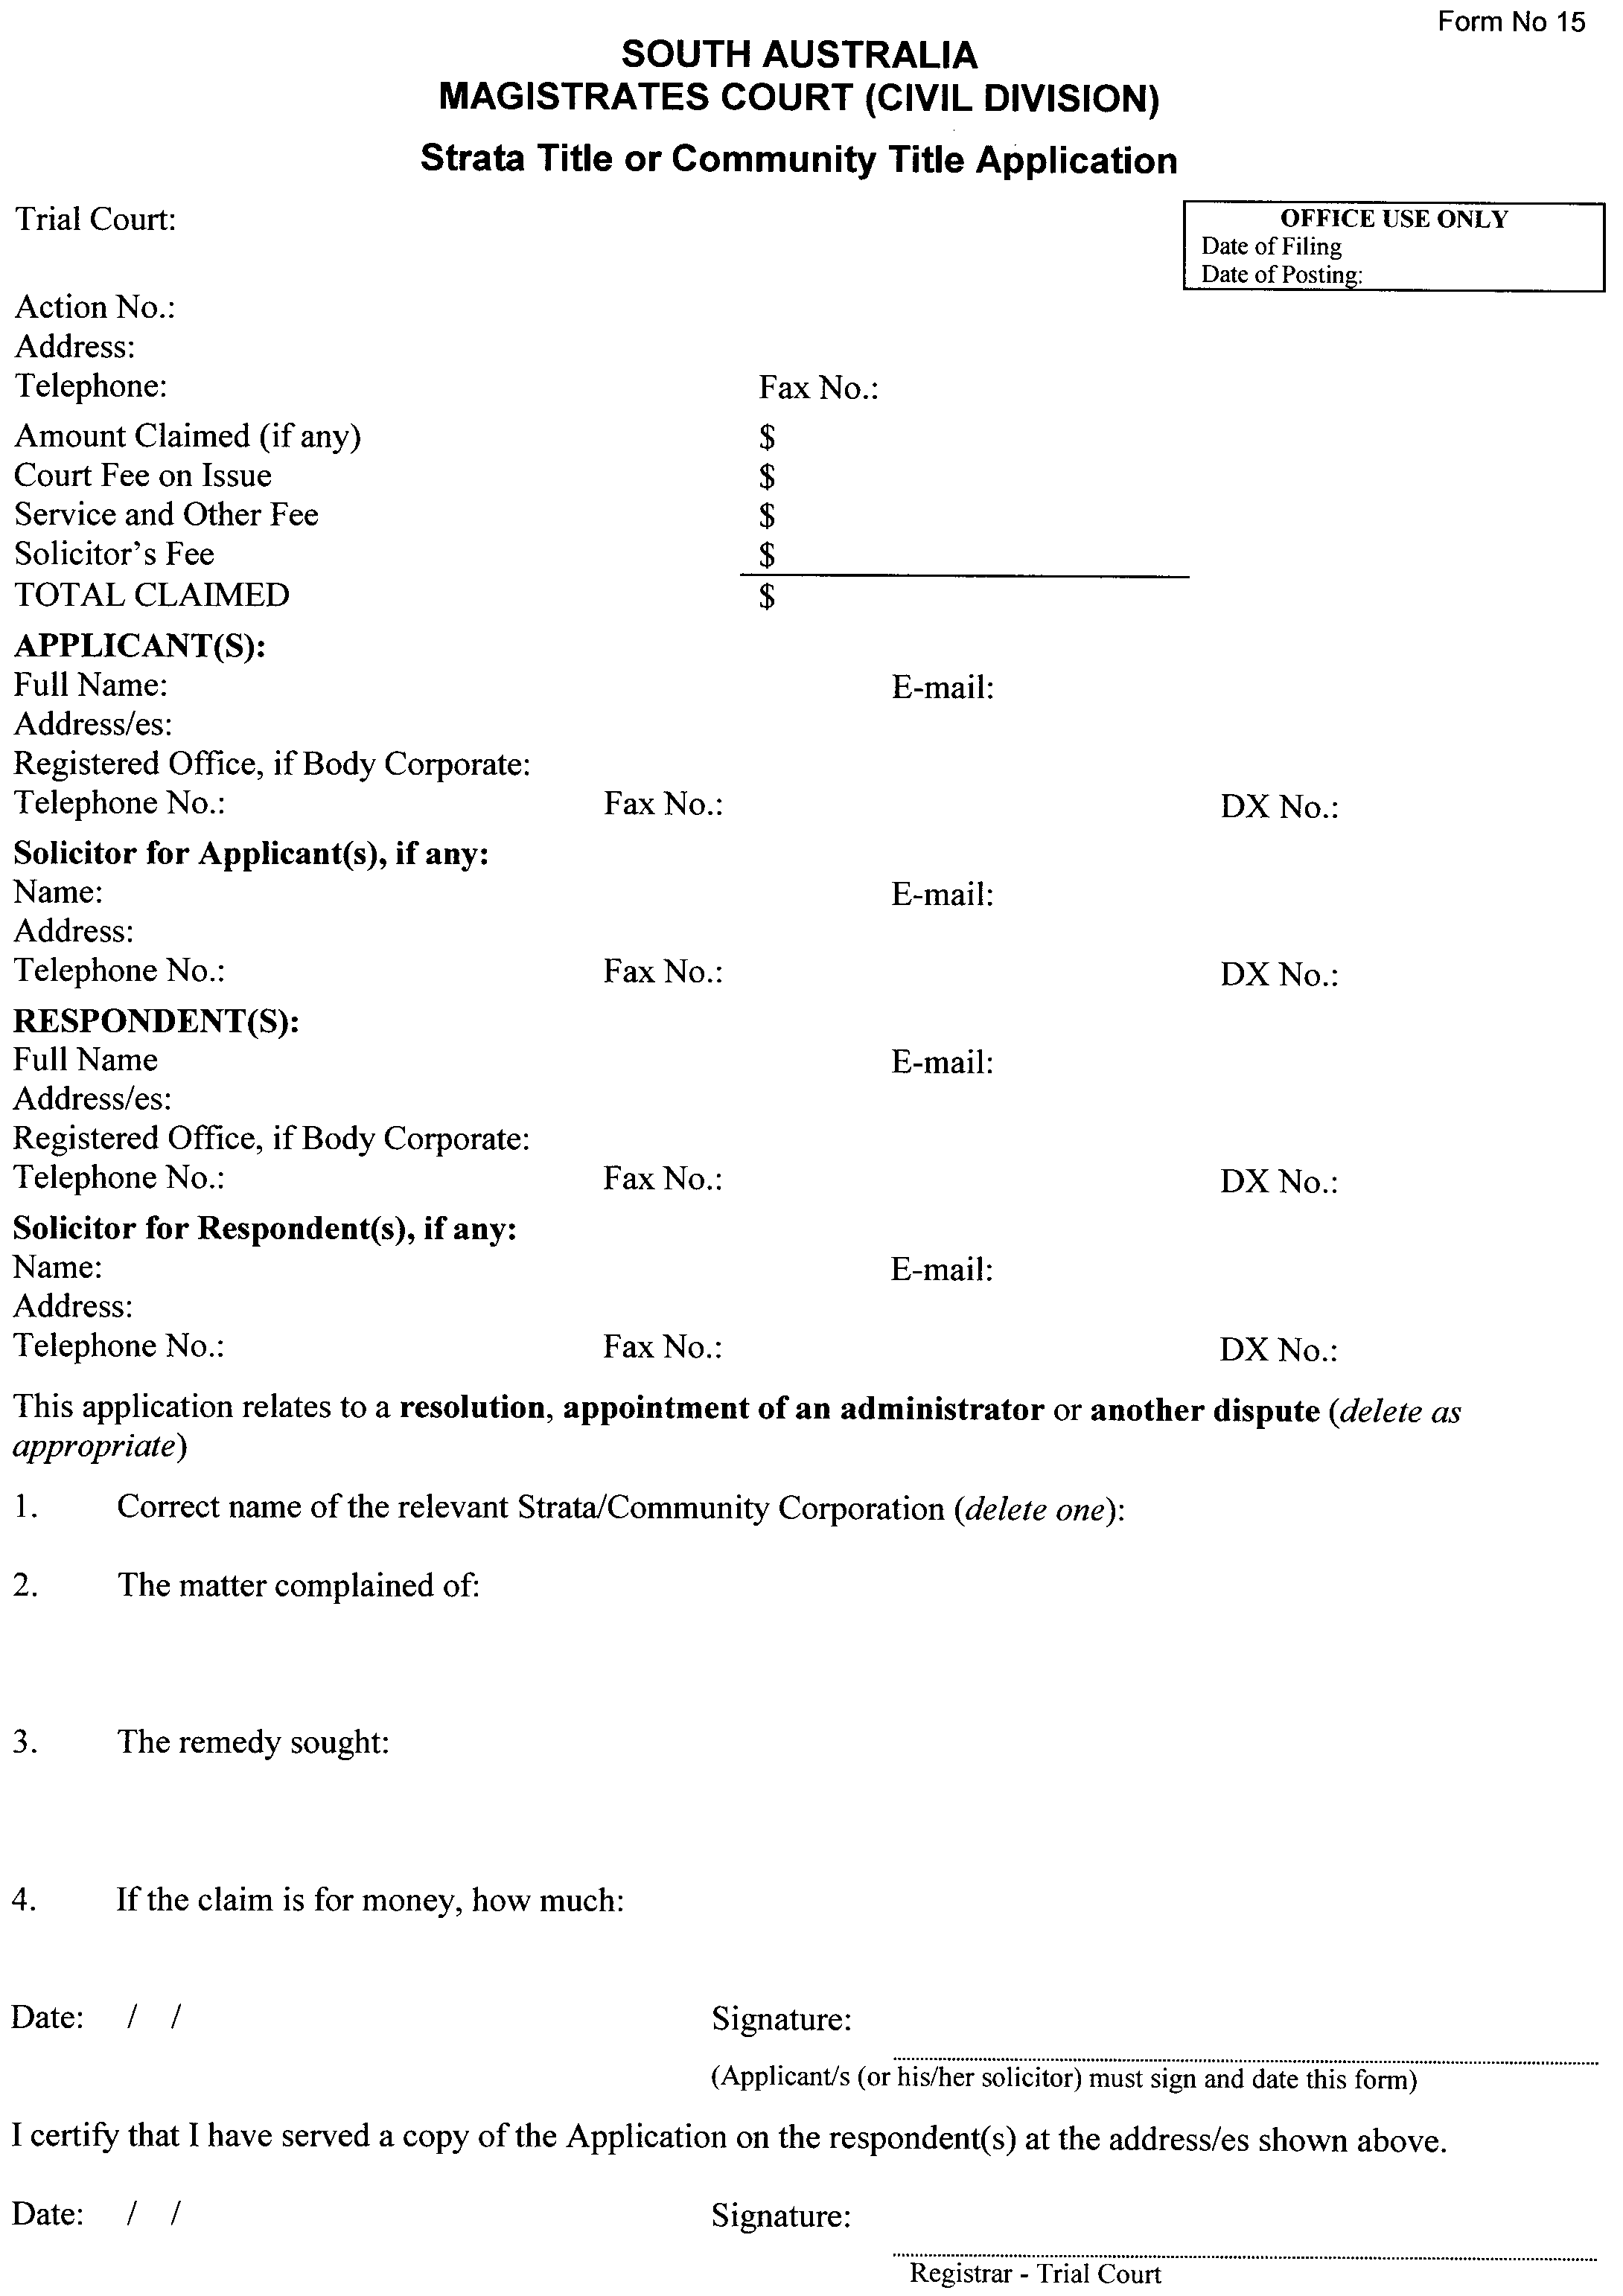
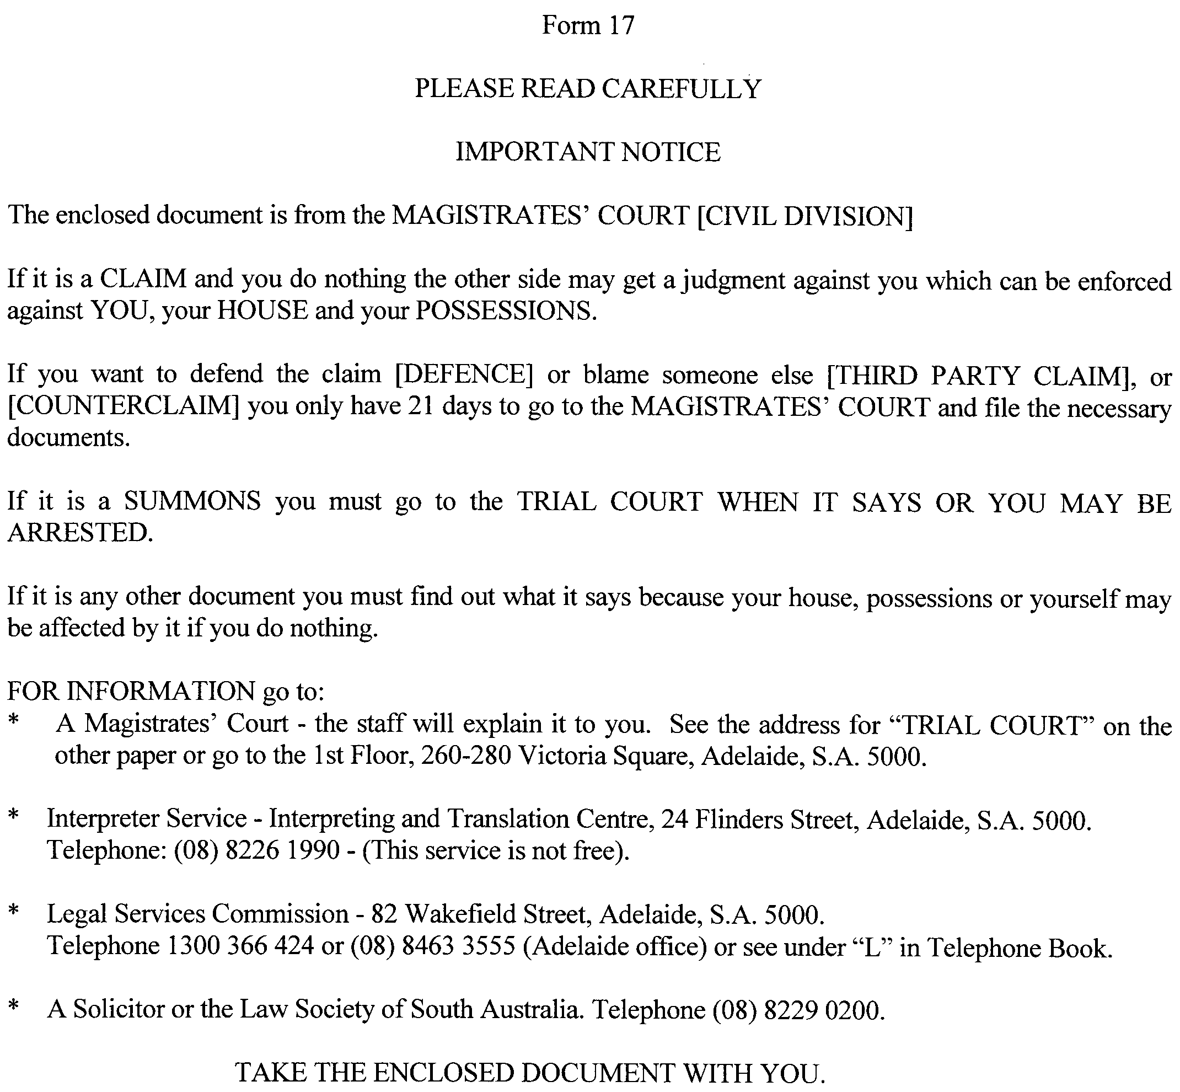
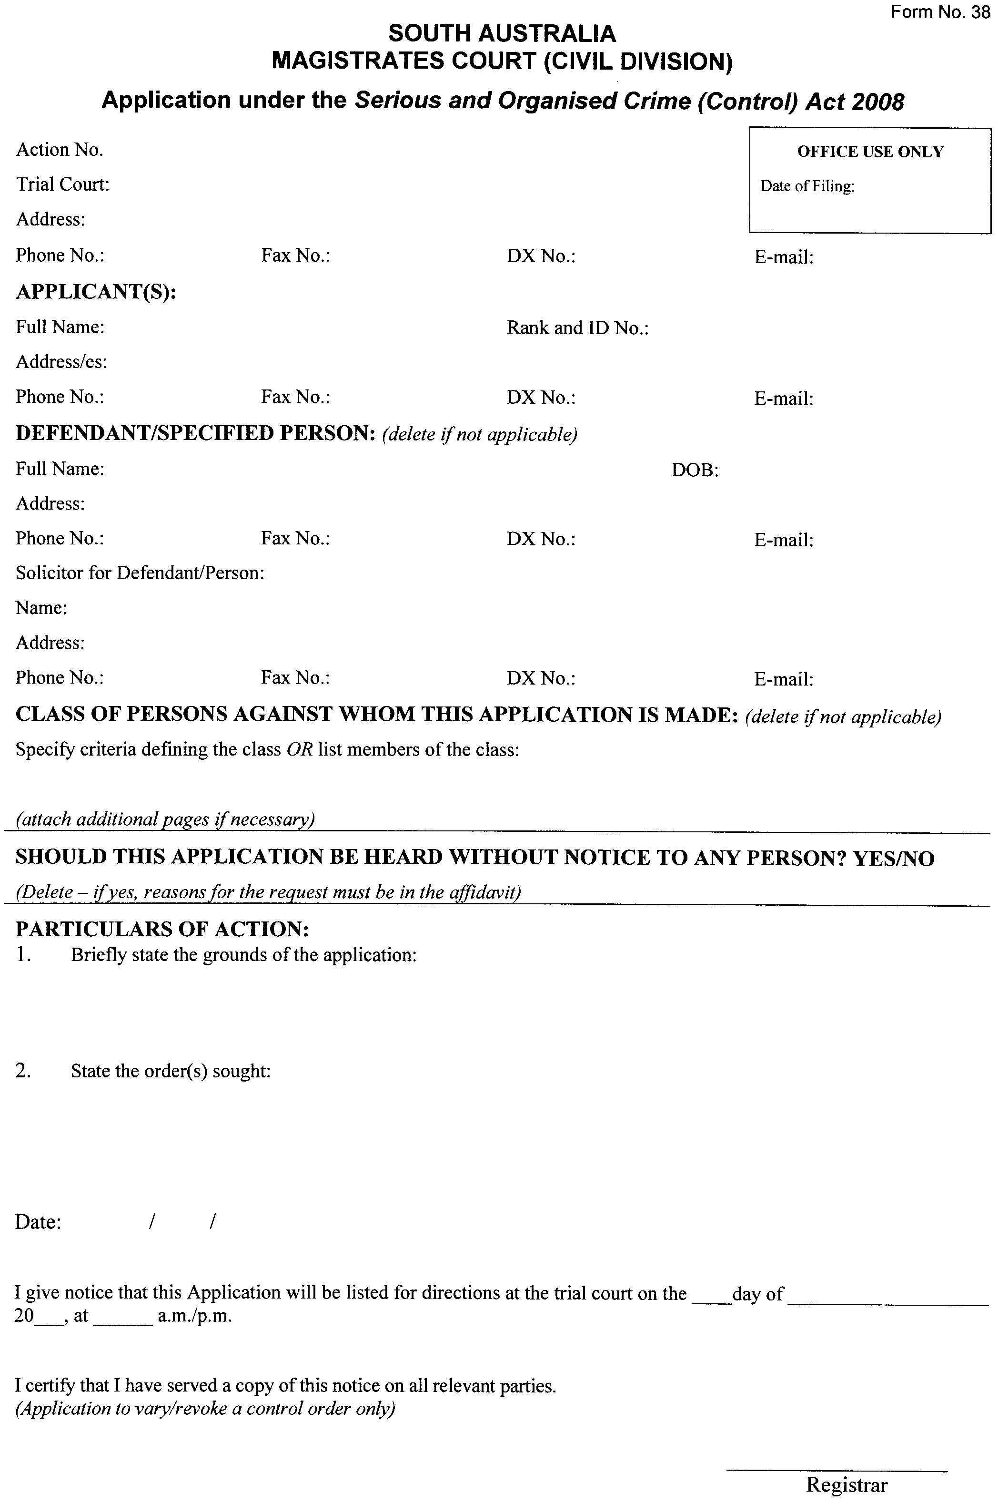
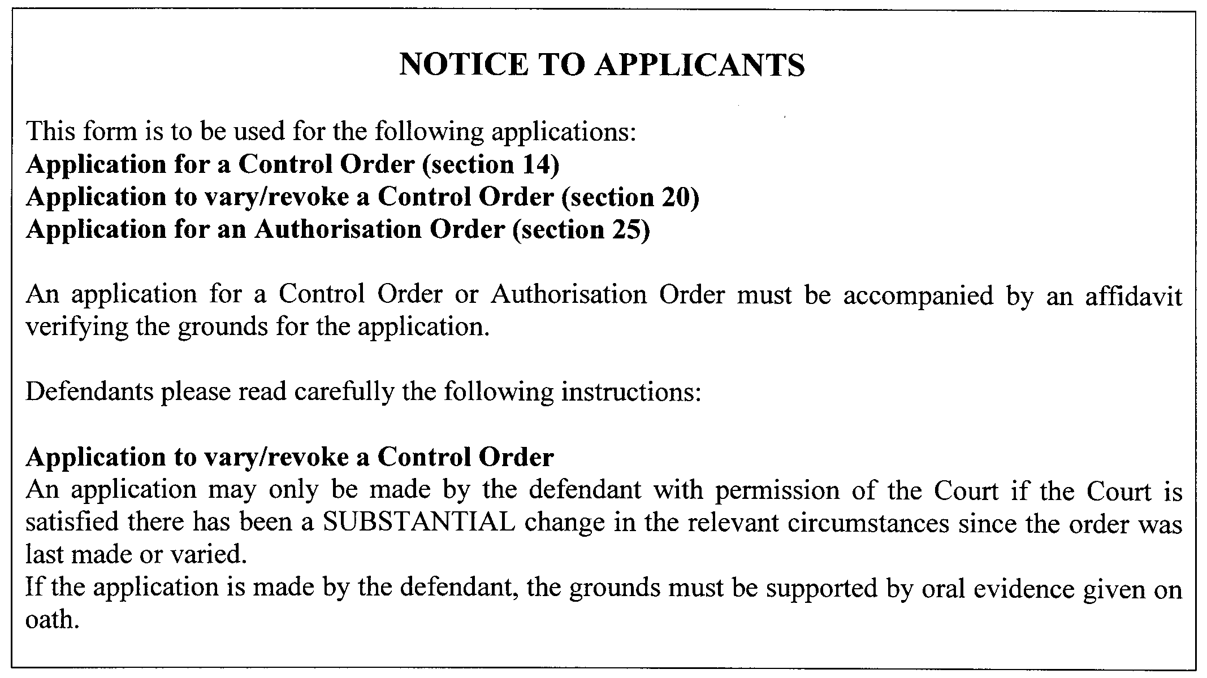
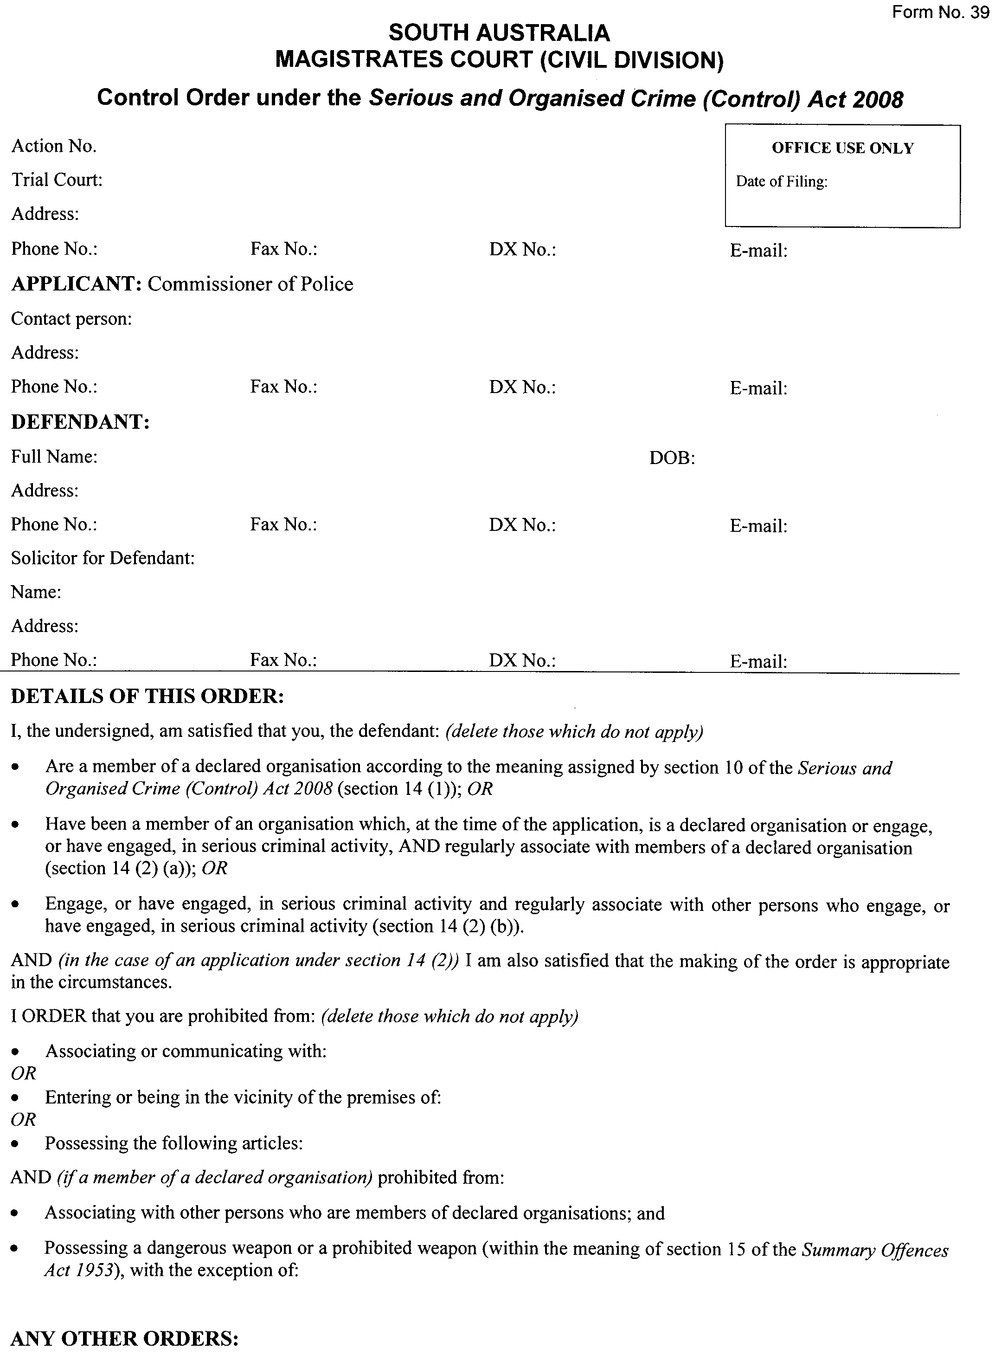
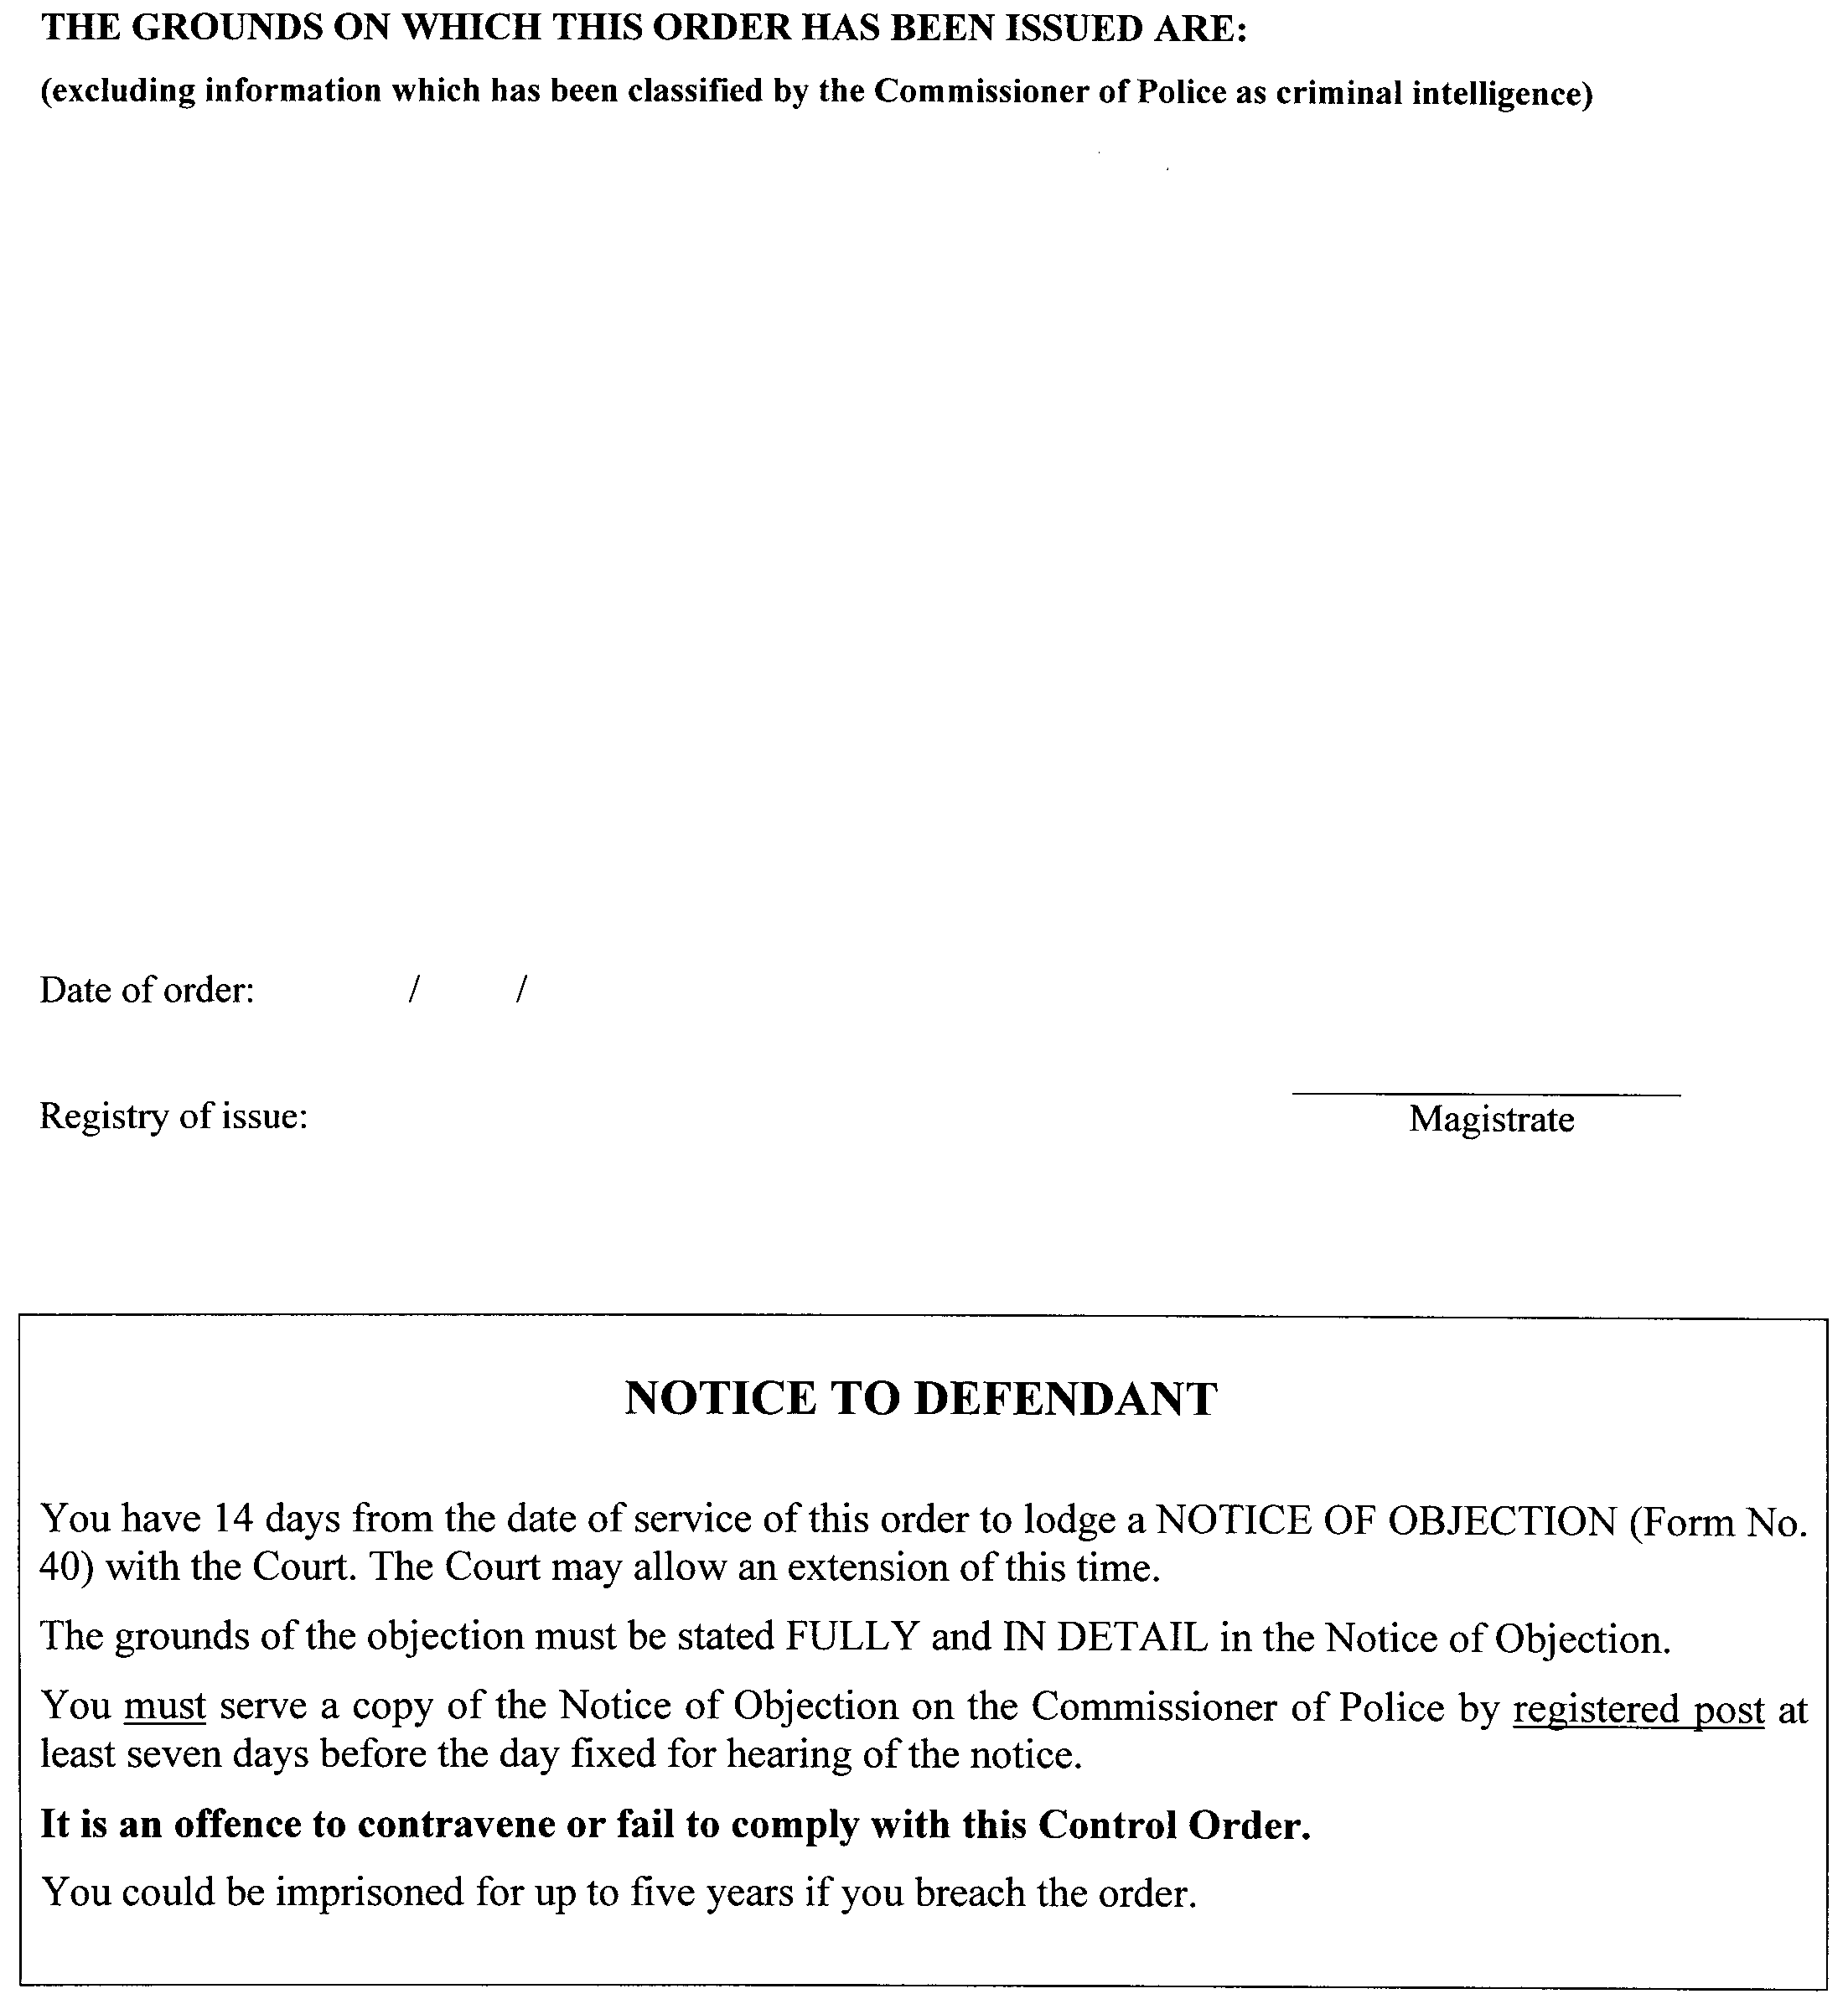
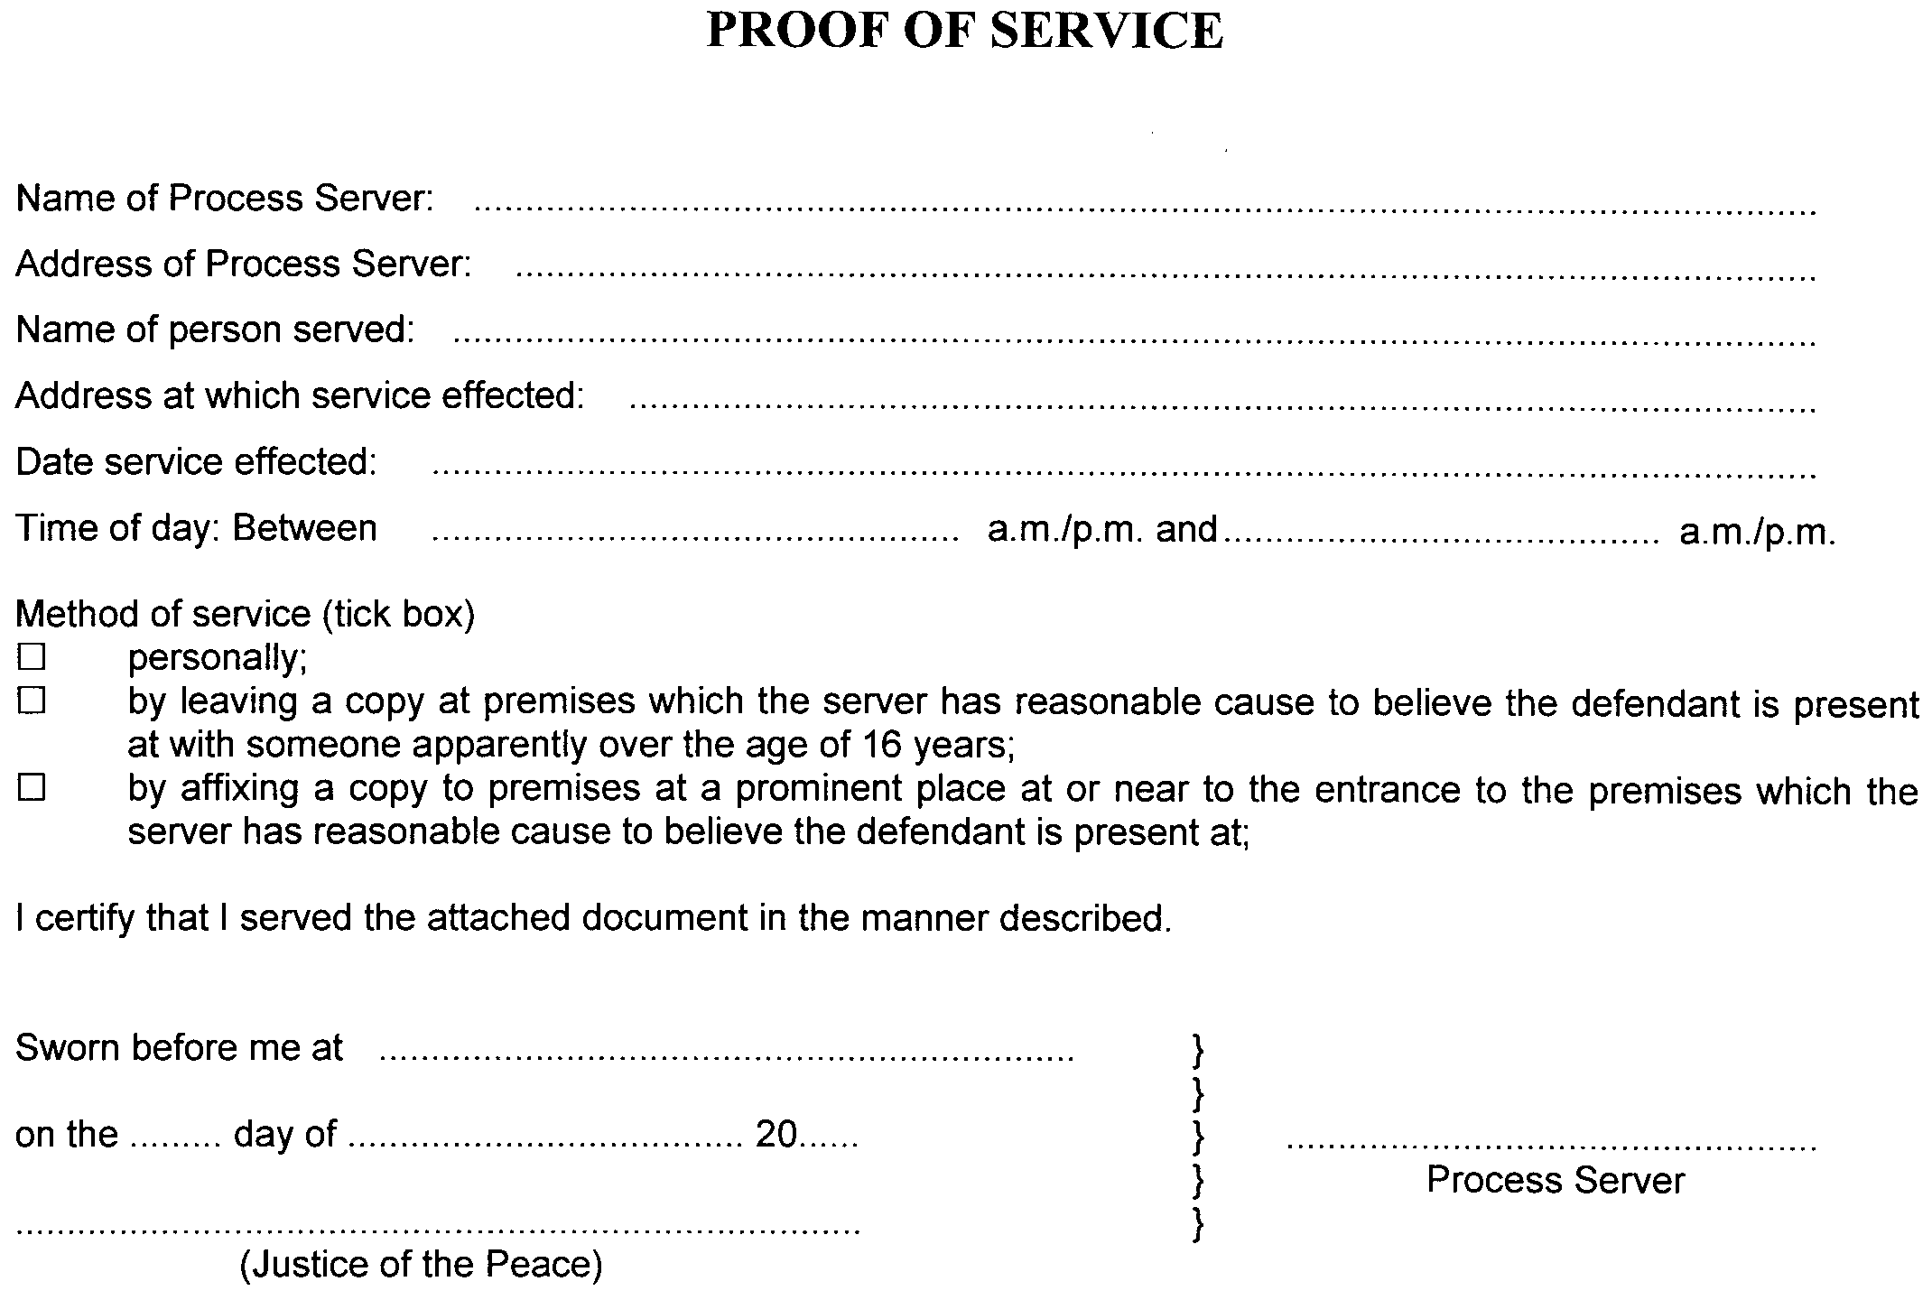
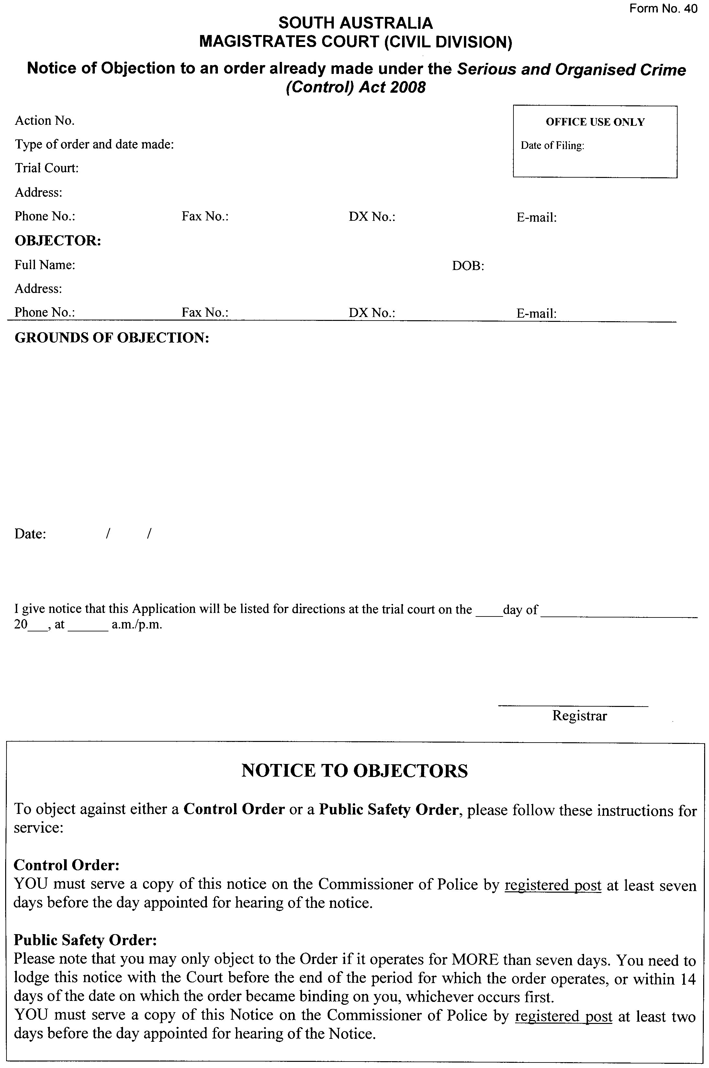
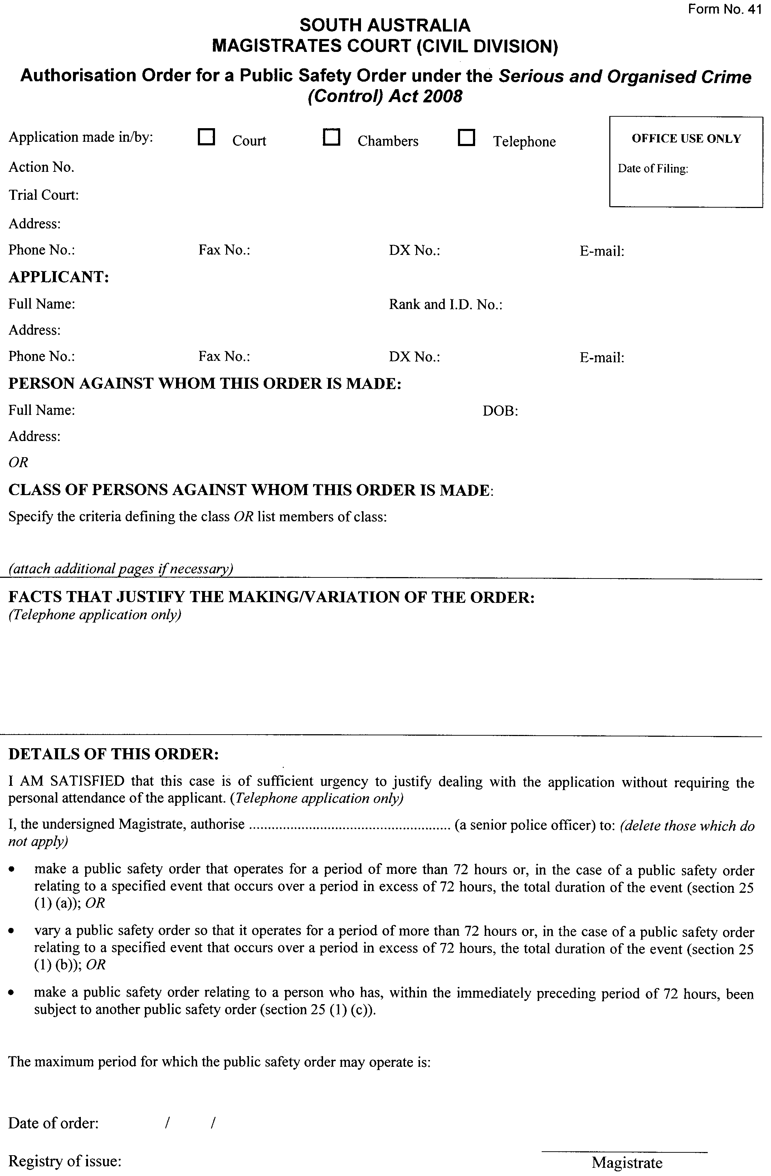
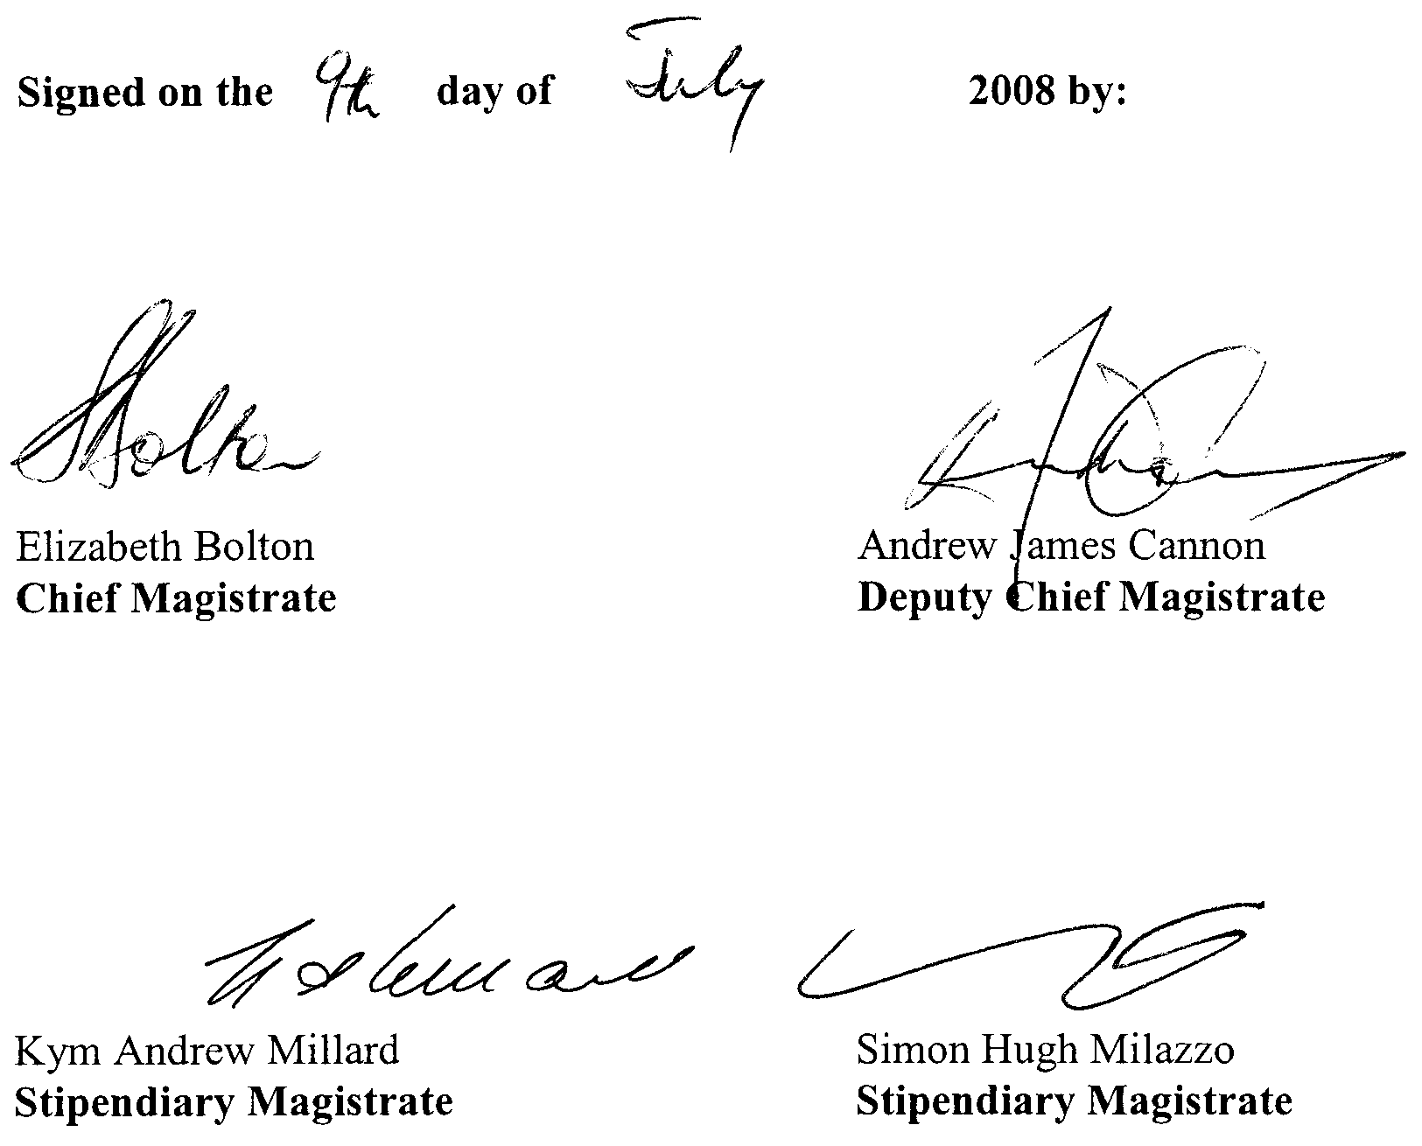

RULES OF COURT
The Magistrates Court of South Australia
Amendment No. 31 to the Magistrates Court
Rules 1992
PURSUANT to section 49 of the Magistrates Court Act 1991 and all other enabling powers, we the undersigned do hereby make the following amendments to the MAGISTRATES COURT RULES 1992:

Rule 4.06 will come into effect on the date of the commencement of the Serious and Organised Crime (Control) Act 2008, Rule 10A and Forms 80 and 81 will come into effect on the date of the commencement of the Statutes Amendment (Evidence and Procedure) Act 2008 and the other amendments are effective upon gazettal.

Rule 4 is amended by the inclusion of this new subrule:
4.06 The jurisdiction conferred on the Court by the Serious and Organised Crime (Control) Act 2008, shall vest in the Civil (General Claims) Division of the Court.

The inclusion of new Rule 10A as follows:
10A.00 VULNERABLE WITNESSES
10A.01 An Application for Special Arrangements for a vulnerable witness made pursuant to section 13A of the Evidence Act 1929, shall comply with Form 80.
10A.02 A Notice of Objection shall comply with Form 81.
10A.03 Subject to any Act and these Rules, on the filing of an application under Rule 10A.01, the Registrar must fix a date, time and place for the hearing of the application and give at least 21 days notice of the hearing by providing a copy of the application to the person(s) nominated by the applicant to be the person(s) to be served.

Rule 15.03 is deleted and Rule 15 is amended with the inclusion of the following subrules:
15.03 Where a complainant or informant seeks an order in the nature of for-feiture, compensation, additional penalty or destruction, the complaint or information must so state.
15.04 A summons under section 168 (2) of the Road Traffic Act 1961, shall comply with Form No. 15A.

Rule 20.03 is deleted and replaced with the following:
20.03 A statement referred to in section 104 (3) (a) of the Act must be verified as follows:
‘This statement consisting of ... page/s signed by me is true to the best of my knowledge and belief. I know that this statement is to be used for the purposes of a prosecution and that if it contains material which I know to be false or misleading, I will be guilty of an offence.
Dated the ..... of .......... 20.….
Signature ..........................
Witnessed by ....................... (name) of ....................... (address)
Signature of Witness .......................’

Rule 26 is amended by the inclusion of the following subrules:
26.07 Nothing said by or on behalf of a defendant at a pre-trial conference and no failure by a defendant or the defendant’s representative to answer a question at a pre-trial conference shall be used in any subsequent trial or shall be made the subject of any comment at that trial.
26.08 Where in the course of any criminal proceedings:
(a) a person seeks separate trials of different charges alleged against him or her in the same complaint or information;
(b) a person seeks a separate trial from that of another person and charged in the same complaint or information;
(c) a party desires to make an application which, if granted, would have the effect of postponing or delaying a trial which has been listed for hearing;
(d) a Magistrate directs that a written application should be made,
the application shall be made by issuing and serving an application in Form No. 23.
26.09 Where an application is made under Rule 26.08 it shall state:
(a) the order or orders sought;
(b) sufficient particulars of the grounds relied upon to enable any other party to have proper notice of whether the calling of evidence will be necessary in order to resolve the issues raised;
(c) the nature of any question of law sought to be raised.
26.10 An application under Rule 26.08 shall be filed and served on all other parties not less than 14 days prior to the date fixed for the hearing of the trial in such proceedings.
26.11 Subject to any Act and these Rules, on the filing of an application under Rule 26.08, the Registrar must fix a date, time and place for the hearing of the application and give at least 21 days notice of the hearing by providing a copy of the application to the person(s) nominated by the applicant to be the person(s) to be served.
26.12 Where a date for trial has already been fixed, the Registrar may endorse the application that it is to be heard by the trial Magistrate at or immediately prior to the commencement of the trial.

Rule 49 is deleted and replaced with the following:
49.00 CRIMINAL LAW (FORENSIC PROCEDURES) ACT 2007
49.01 A warrant issued pursuant to section 29 (4) of the Criminal Law (Forensic Procedures) Act 2007, shall comply with Form No. 74.

Form 49 is deleted and replaced with the following Form 49. Forms 53 and 54 are deleted. Form 74 is deleted and replaced with the following Form 74. Forms 15A, 80 and 81 are prescribed:

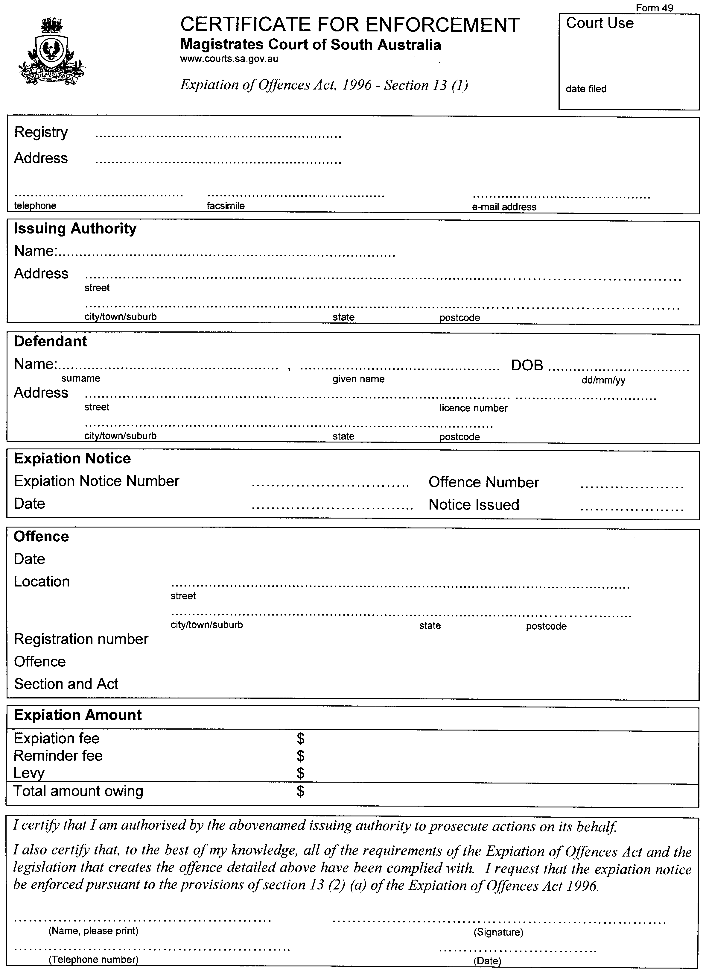



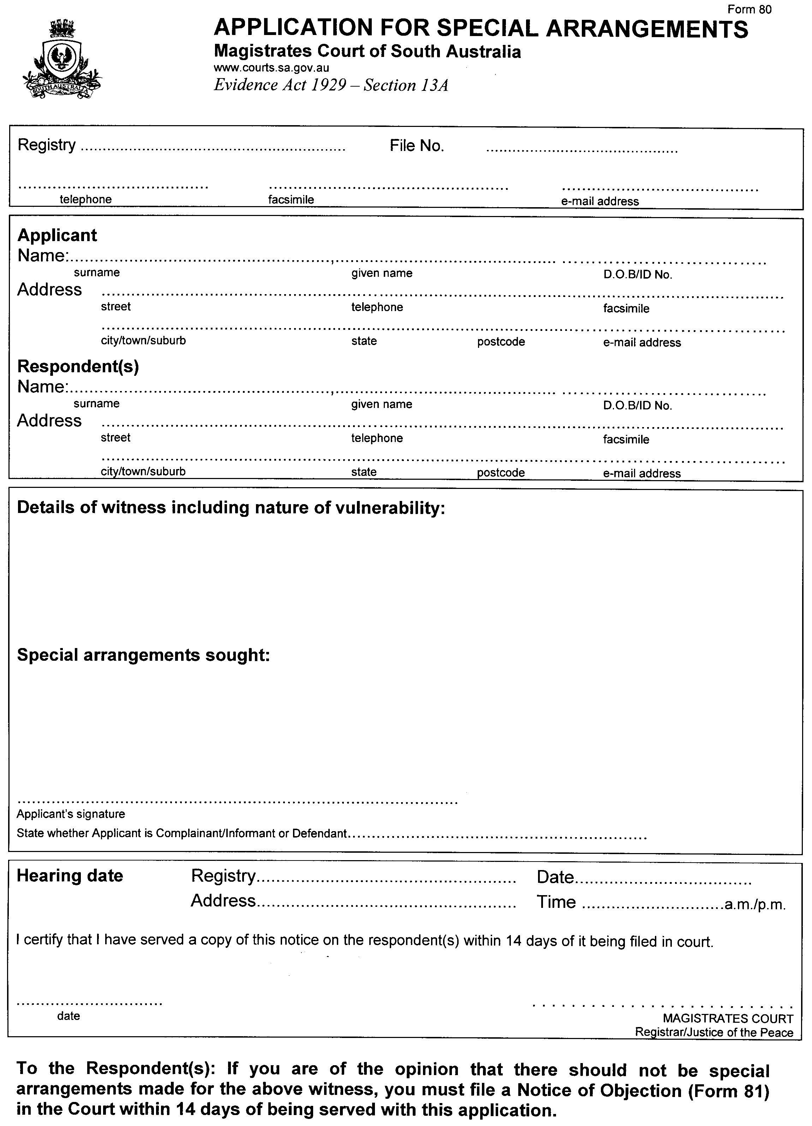
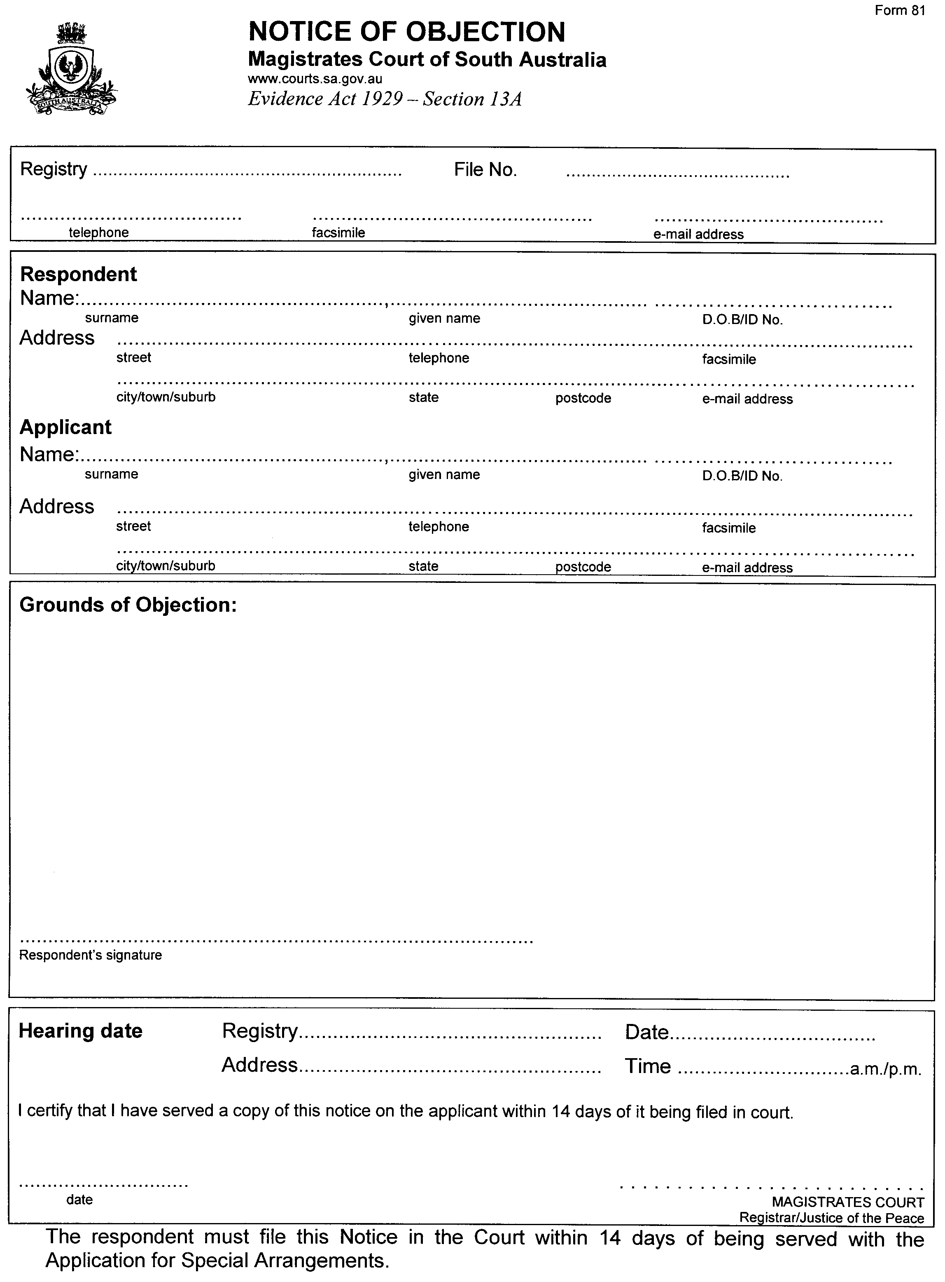
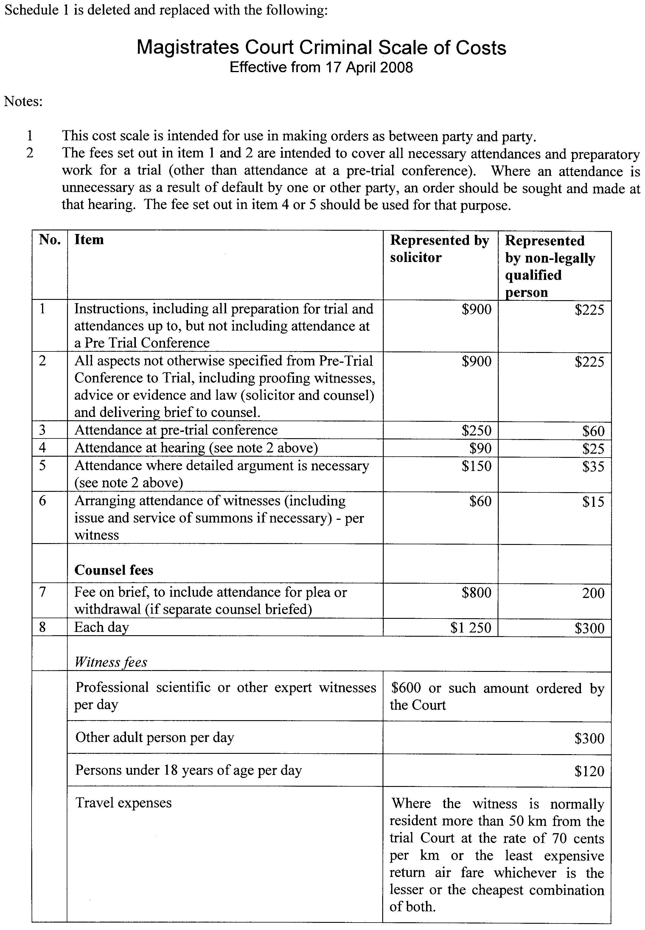

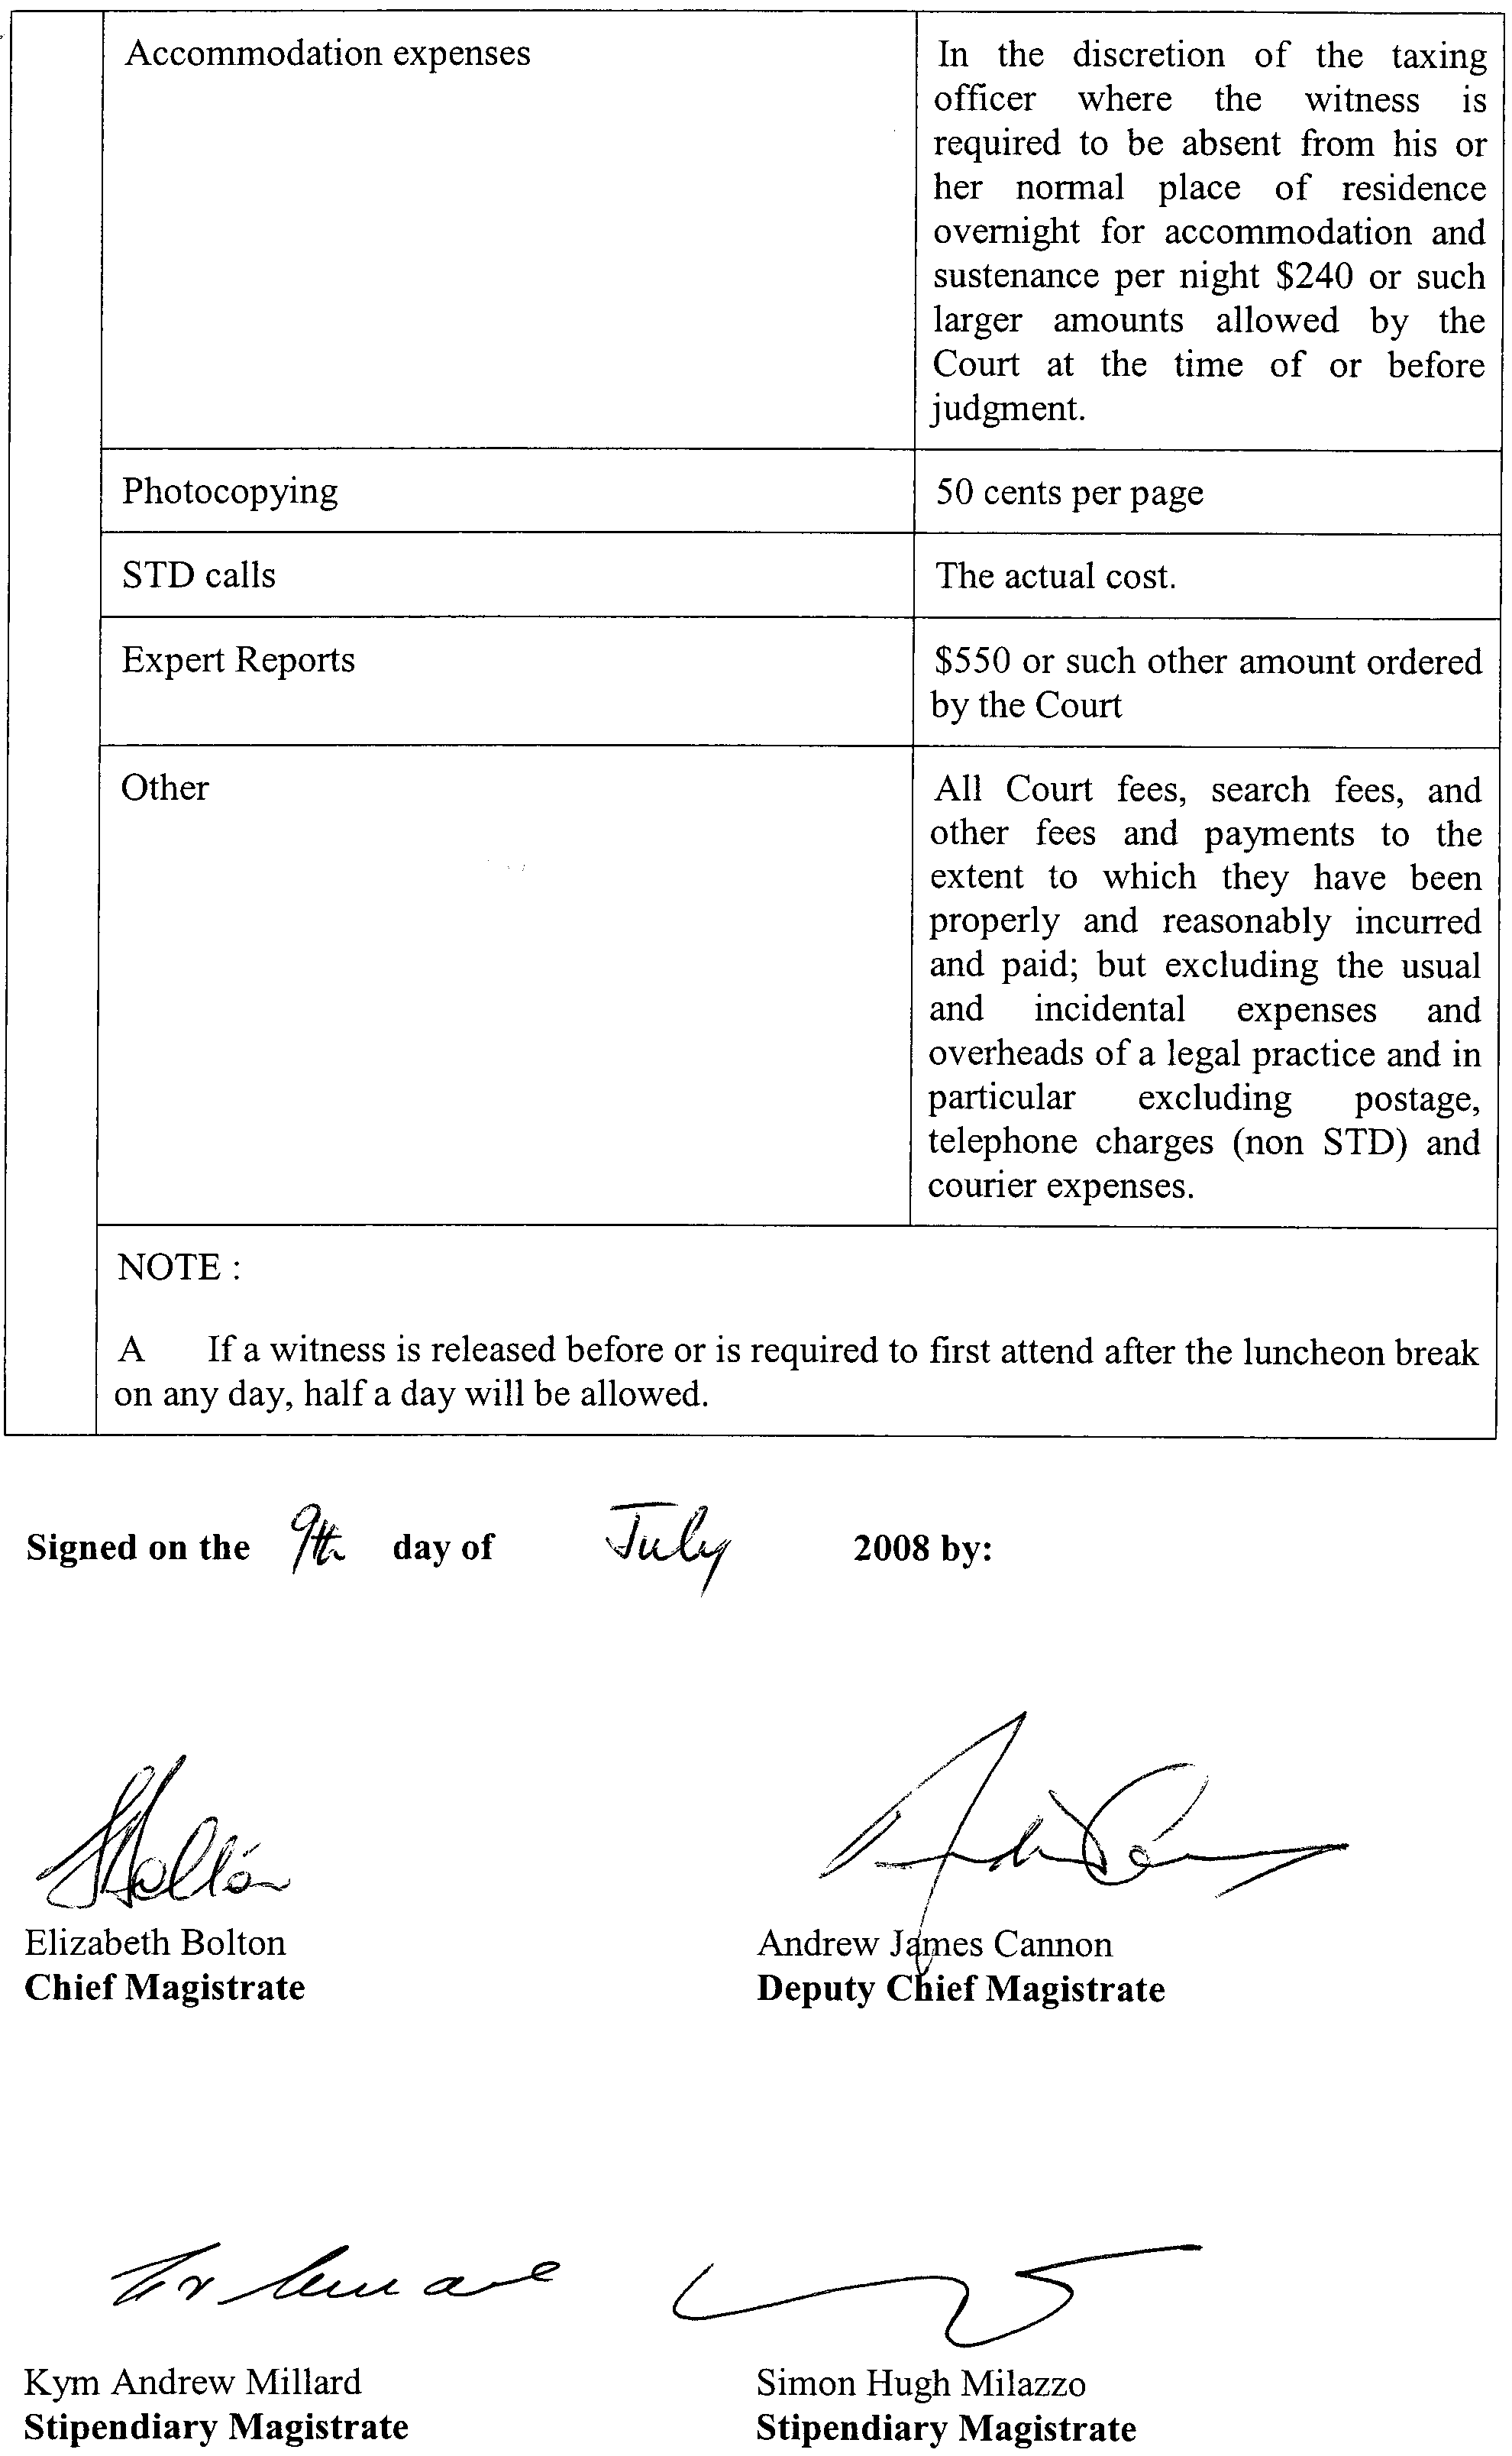

WATERWORKS ACT 1932
Instrument of Authority to Give Expiation Notices and to Make Enquiries Under Regulation 46 of the Waterworks Regulations 1996
PURSUANT to a delegation by the former Minister for Infrastructure (now the Minister for Water Security) dated 4 May 1997, the South Australian Water Corporation authorises the officers named in the Schedule to give expiation notices under the Waterworks Act 1932.
Pursuant to Regulation 46 of the Waterworks Regulations 1996, the South Australian Water Corporation also authorises the officers named in the Schedule to undertake the duties covered by Regulation 46.
This instrument revokes all previous authorities in regard to the giving of expiation notices and undertaking the duties covered by Regulation 46 under the Waterworks Act 1932.
Schedule

Adkins, Stephen Charles
Allan, Vivian Jumbo
Amos, Robert John
Baker, David Michael
Baldock, Cameron Keith
Ball, Geoffrey Alan
Barratt, Wesley John
Battle, Jamie Leonard
Beard, Robert Malcolm Roland
Bell, Bryce Rodney
Bell, Stephen Roy
Bennetts, Wayne Victor
Binney, Sharon Monica
Bishop, Lynton Andrew John
Boakes, Mark Matthew
Bollenhagen, Julianne Anne
Boothey, Rodney Deane
Bottrell, David James
Bowman, Kelvin Daryl
Bozsoki, Laszlo
Brooks, Clara
Brooks, Mark David
Bruniges, Keith Edward
Bryowsky, Steven Ronald
Budgen, Paula Jane
Butcher, Brian Charles
Butler, Peter John
Caddy, Joel Robert
Calabria, Amy Ellen
Calio, Gaetano Anthony
Campbell, Mark Charles
Carmen, David Ian
Causby, Jason Bruce
Celentano, Carmelina Lucia
Centofanti, Alfonso
Chapman, Mark Raymond
Cheesman, Alexandra Marie
Cherini, Andrew
Clark, Jeffrey Don
Cornelius, Paul Herbert
Cousins, Jason Andrew
Cragen, Peter Charles
Crawford, Warwick Graham
Curtis, Gary Frank
Dal Santo, Dino
Daly, David Gerard
Dearman, Herbert Bruce
Dellaverde, Paolo
Dennehy, Dianne
Di Mella, Antoinette
Dimitriadis, Evangelos
Dislers, Maris Eriks
Donnellan, Leo Francis
Douglass, Timothy James
Dowling, Robin David
Eakins, James David
Edwards, Darryl Gene
Eerden, Lambertus Hendricus
Ellis, Neil Jeffery
Ettridge, Brian James
Evans, Roger Francis
Faulkner, Martin Paul
Fitzpatrick, Lee Kent
Flynn, Shona Linda
Ford, Mark Robert
Fountain, Tony Walter
Frick, Neville Kenneth
Froud, Mark Ainsley
Galama, James Alexander
Gill, Roger Colin
Green, Matthew James
Hadfield, John Joseph
Hall, John Allan
Hall, Natasha Jane
Hamden, Lynda Rae
Hannan, David James
Hannant, Lisa
Harris, Steven
Hartwell, Luke John
Harvey, Neil Roy
Hawken, Graham Robert
Hendry, Andrew Clive
Heneker, Graham Clifton
Hoffrichter, Kym
Hogan, Susan Margaret
Hogben, Noel John
Hollitt, Wayne Ronald
Hucks, Anthony Walter
Huffa, Lewis John
Hughes, Robert Edward
Hutchins, David George
Irvine, Patrick John
Jenner, Anne-Marie Debra
Jenner, Brenton Jared
Jenner, Travis John
Jones, Darryl Lee
Katschner, Suzanna Slavica
Knevitt, Kimberley Sasha
Knowles, Robert John
Kobelt, Trevor John
Kohn, Raymond Bruce
Kraft, Scott Michael
Kruger, Timothy Regan
Lambert, Philip Graham
Langman, David John
Lehmann, Derek Allan
Mann, Richard Anthony
Marschall, Mark Matthew
Martin, Nicholas Geoffrey
Matheson, Donald Ian
Maxwell, Leah
McLean, Neil John
McMahon, Richard John
McPharlin, Andrew Ferguson
Meakin, John Francis
Melito, Cesare
Michelmore, Keith Edward
Mikuzis, Jon Vytantas
Minagall, Matthew John
Minagall, Shannon Lee
Murray, Brian John
Neeson, James Michael
Neumeister, Herbert Franz Georg
Nikolajevic, Jovan
Palmer, Paul Leslie
Pavy, Peter
Penny, Amy Dawn-Marie
Perotti, Fulvio
Perriam, Christopher Ian
Perry, Roger Neil
Persinos, John
Phillips, Peter Warren
Pickett, John William
Pratt, Ingrid
Radecki, Steven Anthony
Raneberg, Rebecca Jayne
Rann, Anthony John
Richards, Douglas Thomas
Richardson, Gavin Lindsay
Riddell, Amanda Jane
Rishworth, James Philip
Roberts, Keith John
Roberts, Wayne Eric
Rose, Steven John
Rucioch, Paul Michael
Samuel, Peter Ronald
Sandlant, Timothy James
Sargent, Ford Stanley
Saunders, Steven Sydney
Seal, Benjamin Andrew
Sharman, Steven James
Shiel, William Vincent
Shuttleworth, Peter James
Simpson, Jamie Patrick
Skelton, Mark Adam
Skipworth, Neville Brian
Smart, Ian Robert
Smith, Antony James
Spence, Andrew William
Spencer, Mark John
Stark, Julie-Anne Thomson
Sterzl, Paul Gregory
Szyndler, George
Szyndler, Stanley
Tapscott, Sallyann
Telford, Terence John
Thornton, Marcus John
Tilly, David Maynard
Trout, Noel David
Van Rooyen Jakobus
Veldhoen, Ben Peter
Walden, Jeffrey Charles
Walker, John Frederick
Warner, Scott
Whelan, Shane Lee
Wilkinson, Brian
Williams, Barry John
Williams, Richard Mark
Williamson, Brian Lewis
Wolter, Trevor John

Dated 16 July 2008.
Signed for and on behalf of the South Australian Water Corporation by a person duly authorised so to do:
A. D. Howe, Chief Executive
In the presence of:
G. M. Henstock, Head of Regulation and Governance
SAW 97/02783 Pt 4
SAW 05/00306

WATER MAINS AND SEWERS

Office of the South Australian Water Corporation
Adelaide, 24 July 2008

WATER MAINS LAID

Notice is hereby given that the following main pipes or parts of main pipes have been laid down by the South Australian Water Corporation in or near the undermentioned water districts and are now available for a constant supply of water to adjacent land.

ADELAIDE WATER DISTRICT

CITY OF CHARLES STURT
Birch Avenue, Flinders Park. p6
Harriet Street, Croydon. p10

CITY OF PORT ADELAIDE ENFIELD
Deakin Street, Blair Athol. p3
Across Ways Road, Hampstead Gardens and Manningham. p4
Melbourne Crescent, Manningham. p4

THE CITY OF PROSPECT
Jacaranda Avenue, Nailsworth. p5

CITY OF TEA TREE GULLY
Across Glenere Drive, Modbury. p7
Loral Street, Modbury. p7

MOONTA WATER DISTRICT

DISTRICT COUNCIL OF THE COPPER COAST
In and across Kitto Road, Moonta Bay and Moonta. p9

PORT AUGUSTA WATER DISTRICT

PORT AUGUSTA CITY COUNCIL
McConnel Road, Stirling North. p8

TUMBY BAY WATER DISTRICT

DISTRICT COUNCIL OF TUMBY BAY
Across Bratten Way, Tumby Bay. p1
Easements in lot 1031 in LTRO DP 73980 Bratten Way, Tumby Bay. p1 and 2

WATER MAINS ABANDONED

Notice is hereby given that the undermentioned water main has been abandoned by the South Australian Water Corporation.

MOONTA WATER DISTRICT

DISTRICT COUNCIL OF THE COPPER COAST
In and across Kitto Road, Moonta Bay and Moonta. p9

WATER MAINS LAID

Notice is hereby given that the undermentioned water mains have been laid down by the South Australian Water Corporation and are not available for a constant supply of water to adjacent land.

MANNUM-ADELAIDE COUNTRY LANDS WATER DISTRICT

MID MURRAY COUNCIL
In and across Zadow Road, Wall Flat. This main is available on application only—not available for constant rateable supply. p12
In and across Talinga Road, Wall Flat. This main is available on application only—not available for constant rateable supply. p12 and 13
In and across Rathjen Road, Wall Flat. This main is available on application only—not available for constant rateable supply. p14
Kittelty Road, Wall Flat. This main is available on application only—not available for constant rateable supply. p14

THE RURAL CITY OF MURRAY BRIDGE
Kittelty Road, Wall Flat. This main is available on application only—not available for constant rateable supply. p14-17
White Hut Road, Wall Flat. This main is available on application only—not available for constant rateable supply. p17 and 18

OUTSIDE MANNUM-ADELAIDE COUNTRY LANDS WATER DISTRICT

MID MURRAY COUNCIL
In and across Martin Road, Wall Flat. This main is available on application only—not available for constant rateable supply. p11
Holland Road, Wall Flat. This main is available on application only—not available for constant rateable supply. p11 and 12

THE RURAL CITY OF MURRAY BRIDGE
White Hut Road, Wall Flat. This main is available on application only—not available for constant rateable supply. p18-21
Rathjen Road, Wall Flat, Woodlane and Mypolonga. This main is available on application only—not available for constant rateable supply. p21-24
Across Mypolonga Road, Mypolonga. This main is available on application only—not available for constant rateable supply. p24
Easement in lot 4 in LTRO DP 46761, Carawatha Drive, Mypolonga. This main is available on application only—not available for constant rateable supply. p24
In and across Carawatha Drive, Mypolonga. This main is available on application only—not available for constant rateable supply. p24-27
Waterworks land (lot 125 in LTRO FP 39547), Carawatha Drive, Mypolonga. This main is available on application only—not available for constant rateable supply. p27

SEWERS LAID

Notice is hereby given that the following sewers have been laid down by the South Australian Water Corporation in the undermentioned drainage areas and are now available for house connections.

ADELAIDE DRAINAGE AREA

CITY OF CHARLES STURT
Angley Avenue, Findon. FB 1173 p27
Marinoff Street, Seaton. FB 1173 p31
Birch Avenue, Flinders Park. FB 1173 p33

CITY OF PORT ADELAIDE ENFIELD
Deakin Street, Blair Athol. FB 1173 p26
Melbourne Crescent, Manningham. FB 1173 p28
Lindsay Avenue, Valley View. FB 1173 p32

THE CITY OF PROSPECT
Jacaranda Avenue, Nailsworth. FB 1173 p29

CITY OF SALISBURY
Sharp Court, Cavan. FB 1173 p34
Across Research Road, Pooraka. FB 1173 p36
Easements in lot 1 in LTRO FP 3265, Research Road, lot 62 in LTRO DP 72192 and lot 150 in LTRO DP 67377, Bridge Road, Pooraka. FB 1173 p36

CITY OF TEA TREE GULLY
Anne Street, Ridgehaven. FB 1173 p30
Loral Street, Modbury. FB 1173 p35

MILLICENT COUNTRY DRAINAGE AREA

WATTLE RANGE COUNCIL
Degaris Street, Millicent. FB 1163 p41
Easement in lot 1 in LTRO DP 17767, Degaris Street, Millicent. FB 1163 p41

MURRAY BRIDGE COUNTRY DRAINAGE AREA

THE RURAL CITY OF MURRAY BRIDGE
Swanport Road, Murray Bridge. FB 1173 p25

NARACOORTE COUNTRY DRAINAGE AREA

NARACOORTE LUCINDALE COUNCIL
In and across Flinders Lane, Naracoorte. FB 1163 p40
Easement in lot 2 in LTRO DP 76236, Freeling Street, Naracoorte. FB 1163 p40

STIRLING COUNTRY DRAINAGE AREA

ADELAIDE HILLS COUNCIL
Yatina Road, Aldgate. FB 1173 p23
Across and in Onkaparinga Road, Bridgewater. FB 1173 p24
In and across Wilpena Terrace, Aldgate. FB 1172 p44-47 and 49
Easements in lot 12 in LTRO FP 159176, Wilpena Terrace, Aldgate. FB 1172 p44, 45, 47 and 50
In and across Mount Barker Road, Aldgate. FB 1172 p44, 45, 48, 50 and 51
Across and in Conifers Close, Aldgate. FB 1172 p44-46, 49 and 50
Lewis Avenue, Aldgate. FB 1172 p44, 45, 48 and 50
Easements in lot 21 in LTRO DP 41529, Mount Barker Road, and lot 20 in LTRO DP 41529, Ludgate Hill Road, Aldgate. FB 1172 p44, 45, 48 and 51

WHYALLA COUNTRY DRAINAGE AREA

THE CORPORATION OF THE CITY OF WHYALLA
Duncan Street, Whyalla. FB 1173 p22

SEWERS LAID

Notice is hereby given that the undermentioned sewer has been laid down by the South Australian Water Corporation and is not available for house connections.

STIRLING COUNTRY DRAINAGE AREA

ADELAIDE HILLS COUNCIL
Railway land (lot 97 in LTRO DP 12569), Mount Barker Road, Aldgate. FB 1172 p44, 45, 48 and 50

A. Howe, Chief Executive Officer, South Australian Water Corporation.

WORKERS REHABILITATION AND COMPENSATION
ACT 1986
Determinations to Designate ‘Manners’
Preamble
Section 3 (14) of the Workers Rehabilitation and Compensation Act 1986 (the Act), provides that ‘A reference in a provision of this Act to a designated manner is a reference to a manner designated for the purposes of that provision by the Corporation from time to time by notice in the Gazette’.
In accordance with the delegation provided under the Instrument of Delegation of the WorkCover Corporation of South Australia, June 2008, I, Julia Davison, Chief Executive Officer, designate the following manners:
Notice
1. Determination designating the manner of a request by a worker for adjustment of average weekly earnings.
Pursuant to section 37 (2) of the Act, the Corporation deter-mines that:
1.1 The relevant form designated by Government Gazette No. 38, published on 10 July 2008, may be provided
to WorkCover’s appointed claims agent, currently Employers Mutual, in any one of the following manners:
• in person at 15th Floor, 26 Flinders Street, Adelaide, S.A.;
• via post to 26 Flinders Street, Adelaide, S.A. 5000 or G.P.O. Box 2575, Adelaide, S.A. 5001 or DX 270, Adelaide;
• via facsimile to (08) 8127 1200; or
• via email to your case manager, (if you do not know your case manager’s name or email address contact Employers Mutual on (08) 8127 1100).
1.2 The Corporation does not require this form to be signed when submitted via email.
1.3 That notice of this determination be published in the South Australian Government Gazette.
Confirmed as a true and accurate decision of the Corporation.
Dated 18 July 2008.
J. Davison, Chief Executive Officer

2. Determination designating manner of a request by a worker for a review of weekly payments.
Pursuant to section 38 (1b) of the Act, the Corporation determines that:
2.1 The relevant form designated by Government Gazette No. 38, published on 10 July 2008, may be provided
to WorkCover’s appointed claims agent, currently Employers Mutual, in any one of the following manners:
• in person at 15th Floor, 26 Flinders Street, Adelaide, S.A.;
• via post to 26 Flinders Street, Adelaide, S.A. 5000 or G.P.O. Box 2575, Adelaide, S.A. 5001 or DX 270, Adelaide;
• via facsimile to (08) 8127 1200; or
• via email to your case manager, (if you do not know your case manager’s name or email address contact Employers Mutual on (08) 8127 1100).
2.2 The Corporation does not require this form to be signed when submitted via email.
2.3 That notice of this determination be published in the South Australian Government Gazette.
Confirmed as a true and accurate decision of the Corporation.
Dated 18 July 2008.
J. Davison, Chief Executive Officer

3. Determination designating manner of an application from a worker for economic adjustment to weekly payments.
Pursuant to section 39 (2) (a) (ii) of the Act, the Corporation determines that:
3.1 The relevant form designated by Government Gazette No. 38, published on 10 July 2008, may be provided
to WorkCover’s appointed claims agent, currently Employers Mutual, in any one of the following manners:
• in person at 15th Floor, 26 Flinders Street, Adelaide, S.A.;
• via post to 26 Flinders Street, Adelaide, S.A. 5000 or G.P.O. Box 2575, Adelaide, S.A. 5001 or DX 270, Adelaide;

• via facsimile to (08) 8127 1200; or
• via email to your case manager, (if you do not know your case manager’s name or email address contact Employers Mutual on (08) 8127 1100).
3.2 The Corporation does not require this form to be signed when submitted via email.
3.3 That notice of this determination be published in the South Australian Government Gazette.
Confirmed as a true and accurate decision of the Corporation.
Dated 18 July 2008.
J. Davison, Chief Executive Officer

4. Determination designating manner of an ‘application for registration as an employer, a self-insured employer or a group of self-insured employers’.
Pursuant to section 62 (1) (a) of the Act, the Corporation determines that:
4.1 The relevant form designated by Government Gazette No. 38, published on 10 July 2008, may be provided to WorkCover in any one of the following manners:
• in person at 100 Waymouth Street, Adelaide, S.A.;
• via post to 100 Waymouth Street, Adelaide, S.A. 5000 or G.P.O. Box 2668, Adelaide, S.A. 5001 or DX 660, Adelaide;
• via facsimile to (08) 8233 2990;
• via electronic lodgement at WorkCover’s website www.workcover.com; or
• via email to info@workcover.com.
4.2 The submission of the ‘Application for Registration as an Employer’ form electronically must comply with any process stipulated by the Corporation from time to time on its website at www.workcover.com.
4.3 The Corporation does not require this form to be signed when submitted via email or electronic lodgement.
4.4 That notice of this determination be published in the South Australian Government Gazette.
Confirmed as a true and accurate decision of the Corporation.
Dated 18 July 2008.
J. Davison, Chief Executive Officer

South Australia
Training and Skills Development Act (Commencement) Proclamation 2008
1—Short title
This proclamation may be cited as the Training and Skills Development Act (Commencement) Proclamation 2008.
2—Commencement of Act
The Training and Skills Development Act 2008 (No 30 of 2008) will come into operation on 1 September 2008.
Made by the Governor
with the advice and consent of the Executive Council
on 24 July 2008
METAFE09/08CS

South Australia
Administrative Arrangements (Administration of Training and Skills Development Act) Proclamation 2008
under section 5 of the Administrative Arrangements Act 1994
1—Short title
This proclamation may be cited as the Administrative Arrangements (Administration of Training and Skills Development Act) Proclamation 2008.
2—Commencement
This proclamation comes into operation on the day on which it is made.
3—Administration of Act committed to Minister for Employment, Training and Further Education
The administration of the Training and Skills Development Act 2008 is committed to the Minister for Employment, Training and Further Education.
Made by the Governor
with the advice and consent of the Executive Council
on 24 July 2008
METAFE09/08CS

South Australia
Administrative Arrangements (Committal of Acts) Proclamation 2008
under section 5 of the Administrative Arrangements Act 1994
1—Short title
This proclamation may be cited as the Administrative Arrangements (Committal of Acts) Proclamation 2008.
2—Commencement
This proclamation comes into operation on the day on which it is made.
3—Committal of Acts
The administration of an Act referred to in Schedule 1 is committed to the Minister whose title appears at the head of the list in which the Act appears.
Schedule 1—Acts committed to Ministers
Minister for Early Childhood Development
Children's Services Act 1985
Minister for Education
Education Act 1972
SACE Board of South Australia Act 1983
Teachers Registration and Standards Act 2004
Treasurer
State Procurement Act 2004
Minister Assisting the Premier in Cabinet Business and Public Sector Management
Freedom of Information Act 1991
State Records Act 1997
Made by the Governor
with the advice and consent of the Executive Council
on 24 July 2008
DPC08/014CS

South Australia
Administrative Arrangements (Constitution of Ministers
as Bodies Corporate) Proclamation 2008
under section 7 of the Administrative Arrangements Act 1994
1—Short title
This proclamation may be cited as the Administrative Arrangements (Constitution of Ministers as Bodies Corporate) Proclamation 2008.
2—Commencement
This proclamation comes into operation on the day on which it is made.
3—Dissolution of certain bodies corporate
The bodies corporate referred to in Schedule 1 are dissolved.
4—Constitution of certain Ministers as bodies corporate
The Ministers referred to in Schedule 2 are constituted as bodies corporate.
5—Vesting of certain assets, rights and liabilities
(1) The assets, rights and liabilities of the former body corporate known as the Minister for Education and Children's Services are vested in and attached to the Minister for Education and the Minister for Early Childhood Development according to the distribution of Ministerial responsibilities and functions between the relevant Ministers so that assets, rights and liabilities appropriate to particular responsibilities or functions vest in, or attach to, the appropriate body corporate.
(2) The assets, rights and liabilities of the former body corporate known as the Minister for Finance are vested in and attached to the Treasurer and the Minister Assisting the Premier in Cabinet Business and Public Sector Management according to the distribution of Ministerial responsibilities and functions between the relevant Ministers so that assets, rights and liabilities appropriate to particular responsibilities or functions vest in, or attach to, the appropriate body corporate.
Schedule 1—Bodies corporate dissolved
Minister for Education and Children's Services
Minister for Finance
Schedule 2—Ministers incorporated
Minister for Early Childhood Development
Minister for Education
Minister Assisting the Premier in Cabinet Business and Public Sector Management
Minister for the Northern Suburbs
Made by the Governor
with the advice and consent of the Executive Council
on 24 July 2008
DPC08/014CS

South Australia
Administrative Arrangements (References to Ministers) Proclamation 2008
under section 8 of the Administrative Arrangements Act 1994
1—Short title
This proclamation may be cited as the Administrative Arrangements (References to Ministers) Proclamation 2008.
2—Commencement
This proclamation comes into operation on the day on which it is made.
3—Interpretative provision
(1) A reference to the Minister for Education and Children's Services in an Act or a statutory instrument under an Act will, if the Act was on the day immediately before the effective date, committed to the administration of that Minister, have effect as if it were a reference to the Minister to whom the administration of the Act is for the time being committed.
(2) A reference to the Minister for Education and Children's Services in a statutory instrument or any other kind of instrument, or a contract, agreement or other document, made or entered into before the effective date (other than a reference to which subclause (1) is applicable) will have effect as if it were a reference to the Minister for Education or the Minister for Early Childhood Development according to the distribution of Ministerial responsibilities and functions between the relevant Ministers so that the reference will have effect as if it were a reference to the Minister to whom the relevant responsibilities or functions are currently assigned.
(3) A reference to the Minister for Finance in an Act or a statutory instrument under an Act will, if the Act was on the day immediately before the effective date, committed to the administration of that Minister, have effect as if it were a reference to the Minister to whom the administration of the Act is for the time being committed.
(4) A reference to the Minister for Finance in a statutory instrument or any other kind of instrument, or a contract, agreement or other document, made or entered into before the effective date (other than a reference to which subclause (3) is applicable) will have effect as if it were a reference to the Treasurer or the Minister Assisting the Premier in Cabinet Business and Public Sector Management according to the distribution of Ministerial responsibilities and functions between the relevant Ministers so that the reference will have effect as if it were a reference to the Minister to whom the relevant responsibilities or functions are currently assigned.
(5) In this clause—
effective date means the date on which this proclamation is made.
Made by the Governor
with the advice and consent of the Executive Council
on 24 July 2008
DPC08/014CS
South Australia
National Parks and Wildlife (Billiatt Conservation
Park—Mining Rights) Proclamation 2008
under section 43 of the National Parks and Wildlife Act 1972

Preamble
1 The Crown land described in Schedule 1, together with other land, is, by another proclamation made on this day, added to the Billiatt Conservation Park under section 29(3) of the National Parks and Wildlife Act 1972.
2 It is intended that, by this proclamation, certain existing and future rights of entry, prospecting, exploration or mining be preserved in relation to the land described in
Schedule 1.

1—Short title
This proclamation may be cited as the National Parks and Wildlife (Billiatt Conservation Park—Mining Rights) Proclamation 2008.
2—Commencement
This proclamation comes into operation on the day on which it is made.
3—Interpretation
In this proclamation—
Environment Minister means the Minister for the time being administering the National Parks and Wildlife Act 1972;
Mining Minister means the Minister for the time being administering the Mining Act 1971.
4—Existing rights to continue
Subject to clause 6, existing rights of entry, prospecting, exploration or mining under the Mining Act 1971 may continue to be exercised in respect of the land described in
Schedule 1.
5—New rights may be acquired
Rights of entry, prospecting, exploration or mining may, with the approval of the Mining Minister and the Environment Minister, be acquired pursuant to the Mining Act 1971 in respect of the land described in Schedule 1 and may, subject to clause 6, be exercised in respect of that land.
6—Conditions for exercise of rights
A person in whom rights of entry, prospecting, exploration or mining are vested pursuant to the Mining Act 1971 (whether those rights were acquired before or after the making of this proclamation) must not exercise those rights in respect of the land described in Schedule 1 unless the person complies with the following conditions:
(a) if work to be carried out in relation to the land in the exercise of those rights has not previously been authorised, the person must give at least 3 months notice of the proposed work to the Mining Minister and the Environment Minister and must supply each Minister with such information relating to the proposed work as the Minister may require;
(b) if directions are agreed between the Mining Minister and the Environment Minister and given to the person in writing in relation to—
(i) carrying out work in relation to the land in a manner that minimises damage to the land (including the land's vegetation and wildlife) and the environment generally; or
(ii) preserving objects, structures or sites of historical, scientific or cultural interest; or
(iii) rehabilitating the land (including the land's vegetation and wildlife) on completion of the work; or
(iv) (where the work is being carried out in the exercise of rights acquired after the making of this proclamation) prohibiting or restricting access to any specified area of the land that the Ministers believe would suffer significant detriment as a result of carrying out the work,
the person must comply with those directions in carrying out the work;
(c) if a plan of management is in operation under section 38 of the National Parks and Wildlife Act 1972 in respect of the land, the person must have regard to the provisions of the plan of management;
(d) in addition to complying with the other requirements of this proclamation, the person—
(i) must take such steps as are reasonably necessary to ensure that objects, structures and sites of historical, scientific or cultural interest and the land's vegetation and wildlife are not unduly affected by any work; and
(ii) must maintain all work areas in a clean and tidy condition; and
(iii) must, on the completion of any work, obliterate or remove all installations and structures (other than installations and structures designated by the Mining Minister and the Environment Minister as suitable for retention) used exclusively for the purposes of that work;
(e) if no direction has been given by the Mining Minister and the Environment Minister under paragraph (b)(iii), the person must rehabilitate the land (including its vegetation and wildlife) on completion of any work to the satisfaction of the Environment Minister.
7—Governor may give approvals, directions
If the Mining Minister and the Environment Minister cannot agree as to whether—
(a) approval should be granted or refused under clause 5; or
(b) a direction should be given under clause 6(b),
the Governor may, with the advice and consent of the Executive Council—
(c) grant or refuse the necessary approval under clause 5; or
(d) give a direction in writing under clause 6(b).
Schedule 1—Description of land
Allotment 101 of Deposited Plan 51151, Hundred of Auld.
Made by the Governor
with the advice and consent of the Executive Council
on 24 July 2008
EHCS08/0022

South Australia
National Parks and Wildlife (Billiatt Conservation Park) Proclamation 2008
under section 29(3) of the National Parks and Wildlife Act 1972
1—Short title
This proclamation may be cited as the National Parks and Wildlife (Billiatt Conservation Park) Proclamation 2008.
2—Commencement
This proclamation comes into operation on the day on which it is made.
3—Alteration of boundaries of Billiatt Conservation Park
The boundaries of the Billiatt Conservation Park are altered by adding to the Park the following Crown land:
Sections 14 and 16, Hundred of Billiatt;
Allotment 101 of Deposited Plan 51151, Hundred of Auld.
Made by the Governor
with the advice and consent of the Executive Council
on 24 July 2008
EHCS08/0022

South Australia
Public Sector Management (Shared Services SA (3)) Proclamation 2008
under section 7 of the Public Sector Management Act 1995
1—Short title
This proclamation may be cited as the Public Sector Management (Shared Services SA (3)) Proclamation 2008.
2—Commencement
This proclamation will come into operation on 28 July 2008.
3—Transfer of employees to Department of Treasury and Finance (for Shared Services SA)
(1) The employees referred to in Schedule 1 are transferred from the Department for Families and Communities to the Department of Treasury and Finance.
(2) If an employee whose employment is subject to a contract under section 34 or 40 of the Public Sector Management Act 1995 is transferred under this clause, the provisions of the contract continue to apply in relation to the employee's employment in the administrative unit to which the employee is transferred as if the contract had been entered into between the employee and the Chief Executive of that administrative unit, subject to any necessary modifications or further agreement between the employee and the Chief Executive.
Schedule 1—Employees being transferred from Department for Families and Communities to Department of Treasury and Finance
Di Adam
Connie Amato
Eric Balogh
Andre Barca
Greg Buttfield
Margaret Carosella
Nikki Collins
Susan Collins
Labri Fitzgerald
Karin Gaard
Marlene Gallacher
Helen Haddin
Margaret Harris
Jutta Kelly
Di Lambert
Judith McDougall
Naomi Medlycott
Arthur Moraitis
Tina Naylor
Barb Northway
Michael Nuske
Phil Petch
Tatiana Pirone
Kim Pyne
Kaly Ragnelli
Therese Rayment
Leila Saitova
David Sarsam
Kathy Sinfield
Julia Smith
Joanna Sobczak
Jeff Southgate
Kay Southgate
Carolyn Spain
Emma Steele
Peter Stigwood
Sylvia Strilchuk
Carol Tsoumbris
Made by the Governor
with the advice and consent of the Executive Council
on 24 July 2008
T&F08/010CS

South Australia
Wilderness Protection (Billiatt Wilderness Protection Area) Proclamation 2008
under section 22(1) of the Wilderness Protection Act 1992

Preamble
1 The land described in Schedule 1 forms part of a reserve (the Billiatt Conservation Park) under the National Parks and Wildlife Act 1972.
2 It is intended that, by this proclamation, the land be constituted as a wilderness protection area under the Wilderness Protection Act 1992.
3 On being so constituted, the land will cease to form part of a reserve under the National Parks and Wildlife Act 1972 (see section 22(7) of the Wilderness Protection Act 1992).

1—Short title
This proclamation may be cited as the Wilderness Protection (Billiatt Wilderness Protection Area) Proclamation 2008.
2—Commencement
This proclamation comes into operation on the day on which it is made.
3—Constitution of Billiatt Wilderness Protection Area
The land described in Schedule 1 is constituted as a wilderness protection area and is assigned the name Billiatt Wilderness Protection Area.
Schedule 1—Description of land
Sections 13, 26, 27 and 28, Hundred of Auld;
Sections 14, 15, 16, 18, 19, 21, 22, 23, 24, 25, 26, 27, 28, 29 and 30, Hundred of Billiatt;
Sections 42, 43, 44, 45, 48, 49 and 53, Hundred of Kingsford.
Made by the Governor
on the recommendation of the Minister for Environment and Conservation and with the advice and consent of the Executive Council
on 24 July 2008
EHCS08/0022

South Australia
Trade Standards Variation Regulations 2008
under the Trade Standards Act 1979

Contents
Part 1—Preliminary
1 Short title
2 Commencement
3 Variation provisions
Part 2—Variation of Trade Standards Regulations 2000
4 Variation of Schedule 1—Safety standard—children's folding chairs
5 Substitution of Schedule 2
Schedule 2—Adoption of Commonwealth consumer product safety standards
6 Substitution of Schedule 4
Schedule 4—Adoption of Commonwealth consumer product information standards

Part 1—Preliminary
1—Short title
These regulations may be cited as the Trade Standards Variation Regulations 2008.
2—Commencement
These regulations come into operation on the day on which they are made.
3—Variation provisions
In these regulations, a provision under a heading referring to the variation of specified regulations varies the regulations so specified.
Part 2—Variation of Trade Standards Regulations 2000
4—Variation of Schedule 1—Safety standard—children's folding chairs
(1) Schedule 1, heading—delete the heading and substitute:
Schedule 1—Safety standards
(2) Schedule 1—before clause 1 insert:
Part 1—Children's folding chairs
(3) Schedule 1—after clause 3 insert:
Part 2—Candle accessories
4—Interpretation
In this Schedule—
candle accessory means an object intended to hold or decorate a candle.
5—Safety
A candle accessory must be so constructed that, when subjected to flame or heat emanating from a candle being held or decorated by the accessory, the accessory does not ignite and continue to flame for a period of 5 seconds or more after ignition.
5—Substitution of Schedule 2
Schedule 2—delete the Schedule and substitute:
Schedule 2—Adoption of Commonwealth consumer product safety standards

Goods (description included for information purposes only) | Commonwealth regulation or consumer protection notice
babies' dummies | Consumer Protection Notice No. 4 of 2006
baby bath aids | Trade Practices (Consumer Product Safety Standard) (Baby Bath Aids) Regulations 2005
baby walkers | Trade Practices (Consumer Product Safety Standard) (Baby Walkers) Regulations 2002
balloon-blowing kits | Regulations 5 and 10 of the Trade Practices (Consumer Product Safety Standards) Regulations 1979
basketball rings and blackboards | Trade Practices (Consumer Product Safety Standard) (Basketball Rings and Backboards) Regulations 2005
bean bags | Regulations 5 and 11 of the Trade Practices (Consumer Product Safety Standards) Regulations 1979
bicycle helmets | Trade Practices (Consumer Product Safety Standard) (Bicycle Helmets) Regulations 2001
bunk beds | Consumer Protection Notice No 1 of 2003
children's flotation toys and swimming aids | Consumer Protection Notice No 4 of 1992
children's household cots | Consumer Protection Notice No 6 of 2005
children's nightwear and paper patterns for children's nightwear | Trade Practices (Consumer Product Safety Standards) (Children's Nightwear and Paper Patters for Children's Nightwear) Regulations 2007
children's portable folding cots | Consumer Protection Notice No 4 of 2008
child restraint systems for use in motor vehicles | Consumer Protection Notice No 12 of 2007
disposable cigarette lighters | Trade Practices (Consumer Product Safety Standard) (Disposable Cigarette Lighters) Regulations 1997
elastic luggage straps | Regulations 5, 11A, 11B and 11C of the Trade Practices (Consumer Product Safety Standards) Regulations 1979
exercise cycles | Consumer Protection Notice No 9 of 1997
hot water bottles | Trade Practices (Consumer Product Safety Standard) (Hot Water Bottles) Regulations 2008
pedal bicycles | Consumer Protection Notice No 6 of 2004
portable fire extinguishers—aerosol type | Consumer Protection Notice No 9 of 2004
portable fire extinguishers—non-aerosol type | Consumer Protection Notice No 3 of 2004
portable ramps for vehicles | Consumer Protection Notice No 6 of 1997
prams and strollers | Consumer Protection Notice No 8 of 2007
protective helmets for motor cyclists | Consumer Protection Notice No 9 of 1990
sunglasses and fashion spectacles | Consumer Protection Notice No 13 of 2003
toys for children up to and including 36 months of age | Consumer Protection Notice No 14 of 2003
trolley jacks | Consumer Protection Notice No 4 of 1997
vehicle jacks | Consumer Protection Notice No 15 of 2003
vehicle support stands | Consumer Protection Notice No 7 of 1997
6—Substitution of Schedule 4
Schedule 4—delete the Schedule and substitute:
Schedule 4—Adoption of Commonwealth consumer product information standards

Goods (description included for information purposes only) | Commonwealth regulation or consumer protection notice
clothing and textile products—care labelling | Consumer Protection Notice No. 16 of 2003
cosmetic and toiletries products—ingredient labelling | Trade Practices (Consumer Product Information Standards) (Cosmetics) Regulations 1991 modified as follows:  (a) regulation 2—delete "on or after 31 October 1993"  (b) regulation 7—after its present contents (now to be designated as subregulation (1)) insert:  (2) In this regulation—  Minister means the Minister to whom the administration of the Trade Standards Act 1979 is committed.  (c) regulation 8—delete the regulation
Note—
As required by section 10AA(2) of the Subordinate Legislation Act 1978, the Minister has certified that, in the Minister's opinion, it is necessary or appropriate that these regulations come into operation as set out in these regulations.
Made by the Governor
with the advice and consent of the Executive Council
on 24 July 2008
No 213 of 2008
MCA08/010CS

FAXING COPY?
IF you fax copy to Government Publishing SA for inclusion in the Government Gazette, there is no need to send a Confirmation Copy to us as well.
This creates confusion and may well result in your notice being printed twice.
Please use the following fax number:
Fax transmission: (08) 8207 1040
Phone Inquiries: (08) 8207 1045
Please include a contact person, phone number and order number so that we can phone back with any queries we may have regarding the fax copy.
NOTE: Closing time for lodging new copy (fax, hard copy or email) is 4 p.m. on Tuesday preceding the day of publication.

Government Gazette notices can be E-mailed.
The address is:
governmentgazette@dpc.sa.gov.au
Documents should be sent as attachments in Word format.
When sending a document via E-mail, please confirm your transmission with a faxed copy of your document, including the date the notice is to be published.
Fax transmission: (08) 8207 1040
Enquiries: (08) 8207 1045
NOTE: Closing time for lodging new copy (fax, hard copy or email) is 4 p.m. on Tuesday preceding the day of publication.

CITY OF BURNSIDE
Roads (Opening and Closing) Act 1991
Road Closure—Sherwood Terrace, Beaumont
NOTICE is hereby given, pursuant to section 10 of the Roads (Opening and Closing) Act 1991, that the City of Burnside proposes to make a Road Process Order to close, sell and transfer to Maria Rita Snook portion of the public road (Sherwood Terrace) on the north-eastern corner of Caithness Avenue and Sherwood Terrace adjoining allotment 92 in Deposited Plan 3863, more particularly delineated and lettered ‘A’ on Preliminary Plan No. 08/0033.
A copy of the plan and a statement of persons affected are available for public inspection at the office of the City of Burnside situated at Civic Centre, 401 Greenhill Road, Tusmore and the office of the Surveyor-General, 101 Grenfell Street, Adelaide during normal office hours.
Any application for easement or objections must be made in writing within 28 days of this notice, to the Council, P.O. Box 9, Glenside, S.A. 5065 and the Surveyor-General, G.P.O. Box 1354, Adelaide, S.A. 5001, setting out full details. Where a submission is made, Council will give notification of a meeting to deal with the matter.
Dated 23 July 2008.
N. Jacobs, Chief Executive Officer

CITY OF ONKAPARINGA
By-law Made Under The Dog and Cat Management Act 1995 and the Local Government Act 1999
By-law No. 7—Dogs
TO regulate activities of dogs on the foreshore, any jetty, parks, playgrounds, reserves and walkways under the care, control and management of the Council and to manage and limit the number of dogs kept on premises.
1. Definitions
In this by-law:
(1) ‘dog’ has the same meaning as in the Dog and Cat Management Act 1995;
(2) ‘dog exercise area’ means any foreshore area referred to in clause 3 of this by-law;
(3) ‘Dog Management Officer’ is a person appointed by Council as such, pursuant to the Dog and Cat Manage-ment Act 1995;
(4) ‘effective control of a dog’ means exercising effective control of a dog either:
(i) by means of a physical restraint;
(ii) by command, the dog being in close proximity to the person and the person being able to see the dog at all times;
(5) ‘foreshore’ means the area between the low water mark on the seashore and the nearest boundary of a road, section, public reserve or land comprised in a land grant, Crown lease, or Crown licence. For the purposes of this by-law it includes any sand dunes and any reserve adjacent to the foreshore under the care, control and management of the Council, all boat ramps, pedestrian ramps, steps and other entrances or means of access whether wholly or partly situated to it;
(6) ‘Local Government Land’ means land owned by a Council or under the Council’s care, control and manage-ment;
(7) ‘Park’ or ‘Reserve’ includes any parkland, public square, ornamental ground, plantation, pond, lake, oval, sports ground, or part thereof but does not include the foreshore;
(8) ‘playground’ means an area of a park or reserve con-taining play equipment that is allocated for the use of persons under the age of 12 years old;
(9) ‘premises’ means any domestic and non-domestic premises, except a kennel in respect of which a develop-ment authorisation is in force under the Development Act 1993;
(10) ‘rural dwelling’ means a dwelling not in an area zoned residential in accordance with the City of Onkaparinga Development Plan and on an allotment (or combination of allotments) that is greater than two hectares in area;
(11) ‘shared path’ has the same meaning as in the Australian Road Rules provided that it is marked with signs or painted symbols as a shared path;
(12) ‘small dwelling’ means a self contained dwelling either:
(i) commonly known as a flat, home unit or the like; or
(ii) on an allotment less than 400 m² in area.
2. Number of Dogs Permitted
(1) The number of dogs which may be kept in any small dwelling is limited to one, in a rural dwelling is limited to three and in any other premises is limited to two.
(2) The Council may permit more than those prescribed in clause 2 (1) above.
3. Foreshore Areas Set Aside for the Exercise of Dogs
Provided that a dog is under effective control, it is permitted in the following areas:
(1) an area bounded on the north by an imaginary line continued westerly from the southern street alignment of Selway Terrace, O’Sullivan Beach and on the south by an imaginary line continued westerly from the northern street alignment of Heather Street, Christies Beach, at any time;
(2) an area bounded on the north by an imaginary line continued westerly from the southern alignment of Tiller Drive, Seaford and on the south by an imaginary line continued westerly from the northern street alignment of Robertson Road, Moana, at any time;
(3) an area bounded on the north by the centre line of the Onkaparinga River mouth, Port Noarlunga South and on the south by an imaginary line continued westerly from the northern alignment of Cliff Avenue, Port Noarlunga South, at any time;
(4) an area bounded by an imaginary line west of the northern side of Ocean Street, Aldinga Beach and heading in a northerly direction to stairs situated 100 m north of Butterworth Road, Aldinga Beach (Snapper Point), at any time;
(5) an area bounded by an imaginary line from the northern side of Robert Street and the Esplanade at Sellicks Beach and heading in a southerly direction to the southern boundary of the Council area (Cactus Canyon), at any time;
(6) an area bounded by an imaginary line from the northern side of Broadbeach Drive, Maslin Beach and heading in a northerly direction to Ochre Point at any time;
(7) on any foreshore excepting the foreshore at Maslin Beach referred to in paragraph 5 (4) between 8 p.m. and 10 a.m. of the following day on any day that daylight saving is in force;
(8) on any foreshore when daylight saving is not in force;
(9) any other Local Government land that the Council by resolution directs.
4. Dogs on Leashes Areas
No person will permit a dog to be:
(1) in a dog exercise area at any time other than the times specified in clause 3;
(2) on any shared path;
(3) subject to paragraph 4 (2) of this by-law, on any park or reserve designated by signs indicating this restriction (Council may by resolution declare restricted areas for the purposes of paragraph 4 (3));
(4) on any other Local Government land that the Council by resolution directs,
unless it is at all times on a leash not exceeding 2 m in length held by a person capable of controlling the dog.
5. Dogs Prohibited Areas
Dogs are prohibited in the following areas:
(1) Playgrounds;
(2) within 20 m of play equipment or a skate facility in a park or a reserve;
(3) any jetty;
(4) at Maslin Beach between the southern boundary of the lower carpark adjacent to the Maslin Creek and the landmark known as Blanche Point between the hours of 9 a.m. and 6 p.m. on any day that daylight saving is in force;
(5) A. E. Young Reserve Port Noarlunga South (Sec. Pt 522, HP 106000) (also known as Jubilee Playground reserve);
(6) any other area that Council by resolution directs.
6. Parks and Reserves
Dogs under effective control are permitted on parks and reserves except for those areas specified in clauses 4 (3), 5 (1) and 5 (2).
7. Dog Faeces
No person will on Local Government land, while walking or being in charge of a dog, fail to carry a bag or other object for the purpose of picking up and lawfully disposing of any faeces that the dog may deposit on Local Government land.
8. Construction
This by-law is subject to any Act of Parliament and Regulations made thereunder.
The foregoing by-law was duly made and passed at a meeting of the City of Onkaparinga held on 15 July 2008, by an absolute majority of the members for the time being constituting the Council, there being at least two-thirds of the members present.
J. Tate, Chief Executive Officer

CITY OF PORT ADELAIDE ENFIELD
Erratum
Adoption of Valuations and Declaration of Rates
NOTICE is hereby given that due to a typographical error, the differential general rate for ‘Residential’ previously gazetted and advertised in a notice on 17 July 2008, of $0.00523 in the dollar, should have read $0.00253 in the dollar.
H. J. Wierda, City Manager

PORT AUGUSTA CITY COUNCIL
Adoption of Valuation and Declaration of Rates
NOTICE is hereby given that at a special meeting of the Council held on 9 July 2008, it was resolved that the Council of the Corporation of the City of Port Augusta for the 2008-2009 financial year, as follows:
Adoption of Valuation
Council adopts the valuations of the Valuer-General of site values for all rateable property in the area of the Council which amounts in total to a value of $488 813 360 and specifies 9 July 2008, as the day upon which such valuations shall become the valuations of the Council.
Declaration of Rates
1. Council, declares differential general rates according to the locality and the use of the land based upon the site value of the land as follows:
(a) In that area of the City zoned in the Development Plan as Residential, Highway Services, Residential Stables, Neighbourhood Centre, Urban Coastal, District Centre, Local Centre, Industry, Airport, Recreation:
(i) 2.24 cents in the dollar on rateable land with land use Categories 1, 8 and 9;
(ii) 3.142 cents in the dollar on all rateable land with land use Categories 2, 3, 4, 5 and 6; and
(iii) 0.437 cents in the dollar for all rateable land with a land use Category 7.
(b) In that area of the City zoned in the Development Plan as Public Purposes, Defence, Conservation, Rural Living, Coastal Conservation, Primary Industry:
(i) 1.493 cents in the dollar on rateable land with land use Categories 1 and 9.
(ii) 3.142 cents in the dollar on all rateable land with land use Categories 2, 3, 4, 5 and 6.
(iii) 0.437 cents in the dollar for all rateable land within a land use Category 7.
(iv) 0.747 cents in the dollar on all rateable land with a land use Category 8.
(c) In the area of the City zoned in the Development Plan as Coastal Holiday Settlement:
(i) 0.49 cents in the dollar on all rateable land with land use Categories 1, 2, 3, 4, 5 and 6.
(ii) 0.437 cents in the dollar on all rateable land with a land use Category 7.
(iii) 0.747 cents in the dollar on all rateable land with a land use Category 8.
(iv) 1.493 cents in the dollar on all rateable land with a land use Category 9.
(d) In all other areas not specifically referred to in sub-paragraphs (a), (b) and (c) above, 2.24 cents in the dollar on all other rateable land irrespective of its land use Category.
2. Council, fixes a minimum amount payable by way of rates of $840 in respect of all rateable land in its area except rateable land with land use Categories 7 or 8 located in the Development Plan Zones of Public Purposes, Defence, Con-servation, Coastal Conservation, Coastal Holiday Settlement, Primary Industry or Rural Living.
3. Council, declares an annual service charge of $270 per unit for all vacant and occupied properties to which the Effluent Drainage Disposal Services is made available within the City of Port Augusta for the 2008-2009 financial year in the Willsden, Augusta Park, Hospital Road, Zanuckville, Conwaytown, Transcontinental Estate and Stirling North Effluent Disposal Schemes.
4. Council, declares an annual service charge of $150 for the purpose of a kerbside waste collection and recycling service for all occupied properties within the City of Port Augusta to which the service is made available in the 2008-2009 financial year.
5. In order to reimburse the Council for amounts contributed to the Northern and Yorke Natural Resources Management Board totalling $152 172, declares a separate rate based on a fixed charge of $23.50 on all rateable properties within the area of the Council.
J. G. Stephens, City Manager

REGIONAL COUNCIL OF GOYDER
Adoption of Valuations and Declaration of Rates
NOTICE is hereby given that at a meeting of Council held on Tuesday, 15 July 2008, the Council resolved as follows:
Adoption of Valuations
1. Pursuant to section 167 (2) (a) of the Local Government Act 1999, Council adopted for the financial year ending 30 June 2009, capital valuations made by the Valuer-General being $869 633 460 in relation to the area of the Council for the purpose of rating.
Annual Service Charge—Community Wastewater
Management Systems
2. Pursuant to section 155 of the Local Government Act 1999, Council adopted the following annual service charges for the year ending 30 June 2009:
(a) for all properties included in the area serviced by the Burra Community Wastewater Management System, an annual service charge of $275 per property unit for occupied property and $206 per property unit for vacant allotments;
(b) for all properties included in the Upper Thames Street and Welsh Place extensions in 2005 serviced by the Burra Community Wastewater Management System, an annual service charge of $425 per property unit for occupied property;
(c) for all properties included in the area serviced by
the Eudunda Community Wastewater Management System, an annual service charge of $275 per property unit for occupied property and $206 per property unit for vacant allotments.
Annual Service Rate—Waste Collection
3. Pursuant to section 155 of the Local Government Act 1999, Council adopted the following annual service rate for the year ending 30 June 2009, for Waste Collection Services:
(a) for all residences and businesses in the townships of Terowie, Whyte Yarcowie, Hallett, Mount Bryan, Burra, Robertstown, Point Pass, Eudunda, Farrell Flat and Booborowie, an annual service rate of $90 per property unit for occupied property and an annual service rate of $0.00 per unit for unoccupied properties;
(b) for all properties outside of the above townships that have made application and have access to the waste collection service, an annual service rate of $90 per property unit.
Natural Resources Management Levy
4. Pursuant to section 154 of the Local Government Act 1999 and section 95 of the Natural Resources Management Act 2004, Council adopted the following Natural Resources Management Levies for the year ending 30 June 2009, based upon the capital value of the land:
(a) for all properties located within the boundaries (as defined by the Minister for Environment and Conser-vation) of the South Australian Murray-Darling Basin Natural Resources Management Region, a levy of 0.0054 cents in the dollar;
(b) for all properties located within the boundaries (as defined by the Minister for Environment and Conser-vation) of the Northern and Yorke Natural Resources Management Region, a levy of 0.0170 cents in the dollar.
Fixed Charge
5. Pursuant to sections 151 and 152 of the Local Government Act 1999, Council declares a fixed charge of $265 for the 2008-2009 financial year.
Differential General Rates
6. Pursuant to section 156 of the Local Government Act 1999, the following differential general rates for the year ending 30 June 2009, were declared with reference to the locality and use of the land:
(a) 0.5063 cents in the dollar for land located within the Burra township area (as defined by gazettal notice);
(b) 0.2637 cents in the dollar for land located within the Farrell Flat township area (as defined);
(c) 0.2687 cents in the dollar for land located within the Booborowie township area (as defined);
(d) 0.2637 cents in the dollar for land located within the Mount Bryan township area (as defined);
(e) 0.2637 cents in the dollar for land located outside the Burra, Farrell Flat, Booborowie and Mount Bryan township areas, but within the Burra Ward area (excluding land use 1—Residential);
(f) 0.2637 cents in the dollar for land located outside the Burra, Farrell Flat, Booborowie and Mount Bryan township areas, but within the Burra Ward area with a land use 1—Residential;
(g) 0.3554 cents in the dollar for land located within the Eudunda township area (as defined by gazettal notice dated 10 March 1994);
(h) 0.2637 cents in the dollar for land located within the Hampden township area (as defined);
(i) 0.2637 cents in the dollar for land located outside the Eudunda and Hampden township areas but within
the Eudunda Ward area (excluding land use 1—Residential);
(j) 0.2637 cents in the dollar for land located outside the Eudunda and Hampden township areas but within the Eudunda Ward area with a land use 1—Residential;
(k) 0.3412 cents in the dollar for land located within the Hallett township area (as defined);
(l) 0.3753 cents in the dollar for land located within the Terowie township area (as defined);
(m) 0.4199 cents in the dollar for land located within the Whyte Yarcowie township area (as defined);
(n) 0.2637 cents in the dollar for land located outside the Hallett, Terowie and Whyte Yarcowie township areas but within the Hallett Ward area (excluding land use 1—Residential);
(o) 0.2637 cents in the dollar for land located outside the Hallett, Terowie and Whyte Yarcowie township areas but within the Hallett Ward area with a land use 1—Residential;
(p) 0.2729 cents in the dollar for all land located within the Robertstown township area (as defined);
(q) 0.2720 cents in the dollar for all land located within the Point Pass township area (as defined);
(r) 0.2637 cents in the dollar for all land located outside the Robertstown and Point Pass township areas but within the Robertstown Ward area (excluding land use 1—Residential); and
(s) 0.2637 cents in the dollar for all land located outside the Robertstown and Point Pass township areas but within the Robertstown Ward area with a land use 1—Residential.
Payment of Rates
7. Pursuant to section 181 (1) of the Local Government Act 1999, rates are payable by four instalments due on 5 September 2008, 5 December 2008, 6 March 2009 and 5 June 2009.
Early Payment Discount
8. That pursuant to section 181 (1) of the Local Government Act 1999, all rates (general, separate and service) for 2008-2009 paid in full on or before the due date of the first instalment date (5 September 2008) will attract a 5% discount.
J. Brak, Chief Executive Officer

DISTRICT COUNCIL OF GRANT
Adoption of Valuations and Declaration of Rates
NOTICE is hereby given that at its meeting held on 14 July 2008, Council in exercise of the powers contained in Part 1 of Chapter 10 of the Local Government Act 1999, for the financial year ending 30 June 2009:
1. Pursuant to section 167 (2) (a) of the Local Government Act 1999, adopted for rating purposes capital valuations of land within the Council’s area made by the Valuer-General, totalling $2 214 812 040 comprising $2 150 126 354 in respect of rateable land and $64 685 686 in respect of non-rateable land before alteration.
2. Pursuant to section 153 (1) (a) of the Local Government Act 1999, declared a general rate on all rateable land within the Council’s area of 0.2336 cents in the dollar based on the capital value of rateable land.
3. Pursuant to section 158 (1) (a) of the Local Government Act 1999, fixed a minimum amount of $435 payable by way of general rates on rateable land within the Council’s area.
4. Pursuant to section 155 of the Local Government Act 1999, imposed an annual service charge based on the nature of the service of $185 for the prescribed service of collection and disposal (including recycling) of waste (Mobile Garbage Bins) on all land to which it provides or makes available the service as follows:
(a) in the townships of Port MacDonnell, Racecourse Bay, Donovans, Caveton, Carpenter Rocks, Blackfellows Caves, Nene Valley, Kongorong, Allendale East and the Pelican Point/Carpenter Rocks Shacks area;
(b) in the following streets and roads at Moorak: Kilsby Road, Orchard Road, Florence Street, Berkefeld Road, Johnston Road, Thompson Court, Northumberland Avenue and Bay Road (from the boundary of the City of Mount Gambier to Tarrant Road);
(c) in the following streets and roads at Yahl: Brim Brim Road, Church Street, Yahl Road (from Square Mile Road to Yahl Hall Road), Yahl Hall Road (from Brim Brim Road to Yahl Road), Lange Road (from Yahl Road to the eastern Boundary of property A5325, Lot 1, FP9406);
(d) in the following streets and roads at Tarpeena: bounded by McEnroe Road (from Riddoch Highway to Bailey Road), Bailey Road (from McEnroe Road to Clezy Road), Clezy Road (from Bailey Road to Quarry Road), Quarry Road (from Clezy Road to Medhurst Road), Medhurst Road (from Quarry Road to Riddoch Highway), Riddoch Highway (from Medhurst Road to Albinia Terrace West), Albinia Terrace West (from Riddoch Highway to Marion Terrace), Marion Terrace (from Albinia Terrace West to Boully Road) and Boully Road (from Marion Terrace to Riddoch Highway);
(e) in the following streets and roads at Worrolong: bounded by Hawkins Road (from Worrolong Road to Buchanan Road), Buchanan Road (from Hawkins Road to Triangle Road), Triangle Road (from Buchanan Road to Worrolong Road), Worrolong Road (from Triangle Road to Hawkins Road), including Williams Road, Kavanagh Road, Cutting Court, Billing Road, McMahon Road, Leggett Road and O’Neil Road (from Triangle Road to Worrolong Road);
(f) in the following streets and roads at Cafpirco Road area including Cafpirco Road (from Princes Highway to Burnda Road), Burnda Road (from Mitchell Road to Railway line), Bells Lane, Alie Drive, John Fallas Drive, Bill James Court and Mulwala Road (from Cafpirco Road to the southern boundary of Lot 11 in division of Lots 22 and 23, DP1755); and
(g) in the following streets and roads at Attamarra including Eldridge Drive, Albatross Terrace, Eagle Court, Fairway Court, Stableford Court, Ambrose Court and Turnbull Drive.
5. Pursuant to section 155 of the Local Government Act 1999, imposed an annual service charge based on the nature of the service on any land to which the Council provides or makes available the Community Wastewater Management Systems being prescribed services for the collection, treatment and disposal of waste as follows:
(a) $130 per annum on all vacant land and $345 per annum on all occupied land in that part of the township of Port MacDonnell served by the Community Waste-water Management System;
(b) $120 per annum on all vacant land and $190 per annum on all occupied land in that part of the township of Tarpeena served by the Community Wastewater Management System;
(c) $1 390 per annum on all occupied land in that part of the Pelican Point area from sections 690 to 700, sections 702 to 726, Hundred of Kongorong, Lot 8, (DP5111) Newton Road and Lot 651, Newton Road, served by the Community Wastewater Management System;
(d) $340 per annum on all vacant land and $395 per annum on all occupied land in that part of the township of Allendale East served by the Community Waste-water Management System.
6. Pursuant to section 95 of the Natural Resources Manage-ment Act 2004 and section 152 of the Local Government Act 1999, in order to reimburse the Council for amounts contributed to the South East Natural Resources Management Board, declared a separate rate (Regional Natural Resources Manage-ment Levy) of $35.65 on all rateable land within the region of the Board and within the Council area, based on a fixed charge of the same amount on all rateable land.
7. Pursuant to section 181 (1) of the Local Government Act 1999, declared that all rates shall be payable in four equal or approximately equal instalments with the first instalment payable on or before 5 September 2008, the second instalment payable on or before 5 December 2008, the third instalment payable on or before 6 March 2009 and the fourth instalment payable on or before 5 June 2009.
Dated 14 July 2008.
R. J. Peate, Chief Executive Officer

DISTRICT COUNCIL OF GRANT
Roads (Opening and Closing) Act 1991
Road Opening and Closing—Sewarts Road, Allendale East
NOTICE is hereby given, pursuant to section 10 of the Roads (Opening and Closing) Act 1991, that the District Council of Grant proposes to make a Road Process Order to open as road, portion of allotment 92 in Filed Plan 213391 more particularly delineated and numbered ‘1’ (to be named Sewarts Road West) on Preliminary Plan No. 08/0032 and close portion of Sewarts Road and merge with the adjoining allotment 2 in Deposited Plan 27603 more particularly delineated and lettered ‘A’ on Preliminary Plan No. 08/0032.
A copy of the plan and a statement of persons affected are available for public inspection at the office of the Council, 324 Commercial Street West, Mount Gambier and the Adelaide office of the Surveyor-General during normal office hours.
Any application for easement or objection must set out the full name, address and details of the submission and must be fully supported by reasons.
The application for easement or objection must be made in writing to the Council, 324 Commercial Street West, Mount Gambier, S.A. 5290 within 28 days of this notice and a copy must be forwarded to the Surveyor-General, G.P.O. Box 1354, Adelaide, S.A. 5001.
Where a submission is made, the Council will give notification of a meeting at which the matter will be considered.
R. Peate, Chief Executive Officer

DISTRICT COUNCIL OF KIMBA
Adoption of Valuation and Declaration of Rates 2008-2009
NOTICE is hereby given that the District Council of Kimba at its meeting held on 9 July 2008, for the financial year ending 30 June 2009:
1. Adopted for rating purposes the Valuer-General’s valuation of site values applicable to land within the Council area totalling $124 969 320.
2. Declared differential general rates based upon the locality of the land as follows:
(1) 3.81 cents in the dollar on the site value of all rateable land in the township of Kimba; and
(2) 0.5975 cents in the dollar on the site value of all other rateable land in the Council area.
3. Fixed a minimum amount payable by way of general rates of $150.
4. Imposed annual service charges as follows:
(1) In respect of land serviced by the Kimba Township Community Wastewater Management Scheme, $90 for vacant allotments and $130 for occupied allotments.
(2) In respect of land serviced by the Council’s waste management (collection) service, $120 for properties with a commercial land use and $70 for properties with a residential or other land use.
5. Declared a separate rate of a fixed amount of $74.60 per assessment on all rateable land in the Council area to recover the amount of $46 841 payable to the Eyre Peninsula Natural Resources Management Board.
D. Cearns, Chief Executive Officer

KINGSTON DISTRICT COUNCIL
Adoption of Valuation and Declaration of Rates 2008-2009
NOTICE is hereby given that in accordance with section 167 (2) (a) of the Local Government Act 1999, the Kingston District Council hereby adopts, for the financial year ending
30 June 2009, the capital values made by the Valuer-General totalling $790 716 260 of which $760 276 380 is in respect to rateable land and that 18 July 2008 shall be the day as and from when such valuations shall become the valuation of the Council.
Declaration of Rates
That, having taken into account the general principles of rating contained in section 150 of the Local Government Act 1999 and the requirements of section 153 (2) of the Local Government Act 1999, pursuant to and in accordance with sections 153 (1) (b) and 156 (1) (b) of the Local Government Act 1999, Council hereby declares, for the financial year ending 30 June 2009, the following differential general rates varying according to locality and based on the capital value of all rateable land within the Council’s area:
(a) a differential general rate of 0.3243 cents in the dollar (Urban Rate) on the capital value of all rateable land within the townships of Kingston, Rosetown and Cape Jaffa;
(b) a differential general rate of 0.3125 cents in the dollar (Rural Living Rate) on the capital value of all rateable land within the Rural Living Zone (RuL) abutting the township of Kingston, as identified in maps King/17, King/18, King/19, King/21, King/23, King/24, King/27 and King/28 of Council’s Development Plan Consoli-dated 11 January 2007; and
(c) a differential general rate of 0.3079 cents in the dollar (Rural Rate) on the capital value of all other rateable land within the Council’s area.
Declaration of Minimum Rate
That pursuant to section 158 (1) (a) of the Local Government Act 1999, Council hereby fixes, in respect of the financial year ending 30 June 2009, a minimum amount payable by way of rates of $410.
Declaration of Separate Rate—Regional Natural Resources Management Levy
That pursuant to section 95 of the Natural Resources Manage-ment Act 2004 and section 154 of the Local Government Act 1999, in order to reimburse to the Council the amount contributed to the South East Natural Resources Management Board, a separate rate of $35.35 be declared on all rateable land in the Council’s area, in respect of the financial year ending 30 June 2009, based on a fixed charge of the same amount on all rateable land.
Declaration of Annual Service Charges—Kingston Community Wastewater Management Scheme
That pursuant to and in accordance with section 155 of the Local Government Act 1999 and Regulation 9A of the Local Government (General) Regulations 1999, Council hereby imposes, in respect of the financial year ending 30 June 2009, an annual service charge on all land to which Council provides or makes available the prescribed service known as the Kingston Community Wastewater Management System as follows:
• $320 per unit on each occupied allotment;
• $215 per unit on each vacant allotment,
based upon the nature of the service and varying according to the CWMS Property Units Code.
Declaration of Annual Service Charge—Mobile Garbage Bin Collection and Disposal Service
That pursuant to and in accordance with section 155 of the Local Government Act 1999, Council hereby imposes, in respect of the financial year ending 30 June 2009, an annual service charge on all land to which the Council provides the prescribed service of Mobile Garbage Bin Collection and Disposal of $88 per 240 litre mobile garbage bin collected from each allotment, based upon the level of usage of the service and being charged in accordance with Council’s Mobile Garbage Bin Collection and Disposal Policy.
Payment of Rates
That pursuant to section 181 (1) of the Local Government Act 1999, Council hereby declares that rates declared for the financial year ending 30 June 2009, will fall due in four equal or approximately equal instalments payable on the following dates:
1 September 2008;
1 December 2008;
2 March 2009;
1 June 2009.
M. R. McCarthy, Chief Executive Officer

LIGHT REGIONAL COUNCIL
Adoption of Valuation and Declaration of Rates and Charges
NOTICE is hereby given that at its meeting held on 1 July 2008, in relation to the financial year ending 30 June 2009, the Light Regional Council, in exercise of the powers contained within Chapters 8 and 10 of the Local Government Act 1999, made the following resolutions:
Adoption of Valuation
Pursuant to section 167 (2) (a) of the Local Government Act 1999, to adopt for rating purposes the most recent valuations of the Valuer-General of capital value in relation to all land within the area of the Council, such valuations to apply to that land from 1 July 2008 and specifies that the total of the values that are to apply within the area of the Council is $2 465 727 320 of which $2 426 371 992 is rateable.
Declaration of Differential General Rates
Pursuant to sections 153 (1) (b) and 156 (1) of the Local Government Act 1999, to declare the following differential general rates in respect of rateable land within its area based upon the capital value of rateable land, varying according to Land Use Category:
(a) on rateable land attributed Land Use Category 1 (Residential) or Land Use Category 9 (Other), a rate of 0.343 cents in the dollar of the capital value of such land;
(b) on rateable land attributed Land Use Category 2 (Commercial—Shop) or Land Use Category 3 (Commercial—Office), a rate of 0.60025 cents in the dollar of the capital value of such land;
(c) on rateable land attributed Land Use Category 4 (Commercial—Other), a rate of 0.686 cents in the dollar of the capital value of such land;
(d) on rateable land attributed Land Use Category 5 (Industry—Light), or Category 6 (Industry—Other), a rate of 0.94325 cents in the dollar of the capital value of such land;
(e) on rateable land attributed Land Use Category 7 (Primary Production), a rate of 0.2744 cents in the dollar of the capital value of such land;
(f) on rateable land attributed Land Use Category 8 (Vacant Land), a rate of 0.42875 cents in the dollar of the capital value of such land.
Imposition of a Minimum Rate
Pursuant to section 158 (1) (a) of the Local Government Act 1999, to declare that the minimum amount payable by way of general rates in respect of all rateable land within the Council area shall be $600.
Imposition of Waste Collection Service Charge
Pursuant to section 155 of the Local Government Act 1999, to impose an annual service charge based on the nature of the service for refuse collection and recycling of $209.80 on each assessment in respect of all land to which the Council provides or makes available the 3-bin service and of $140.75 on each assessment in respect of all land to which the Council provides or makes available the 2-bin service.
Imposition of Community Wastewater Management System
Annual Service Charge
Pursuant to section 155 of the Local Government Act 1999, to impose the following annual service charges based on the nature of the service on each assessment in respect of all land to which the Council provides or makes available a Community Wastewater Management System:
$
Kapunda 368
Freeling 368
Greenock 368
Roseworthy 368
Declaration of Separate Rate for Natural Resources
Management Board Levies
Pursuant to section 95 of the Natural Resources Management Act 2004 and section 154 of the Local Government Act 1999, to declare the following separate rates in order to reimburse the Council for amounts contributed to the Regional Natural Resources Management Boards based upon the capital value of the land, as follows:
(a) in respect of all rateable land within the area of the Council and the area of the Adelaide and Mount Lofty Ranges Natural Resources Management Board, 0.00787 cents in the dollar of the capital value of such land; and
(b) in respect of all rateable land within the area of the Northern and Yorke Peninsula Natural Resources Management Board, 0.01533 cents in the dollar of the capital value of such land.
B. Carr, Chief Executive Officer

LIGHT REGIONAL COUNCIL
Road Closure—Hill Street, Kapunda
NOTICE is hereby given that, pursuant to the provisions of section 359 of the Local Government Act 1934, as amended, all vehicles are excluded from the section of Hill Street, Kapunda between
the Main Road and Blyth Street, effective from 8 a.m. on
13 September 2008 until 5 p.m. on 14 September 2008 for the hosting of the Kapunda Celtic Festival.
B. Carr, Chief Executive Officer

DISTRICT COUNCIL LOXTON WAIKERIE
Roads (Opening and Closing) Act 1991
Public Roads, Moorook South
NOTICE is hereby given pursuant to section 10 of the said Act, that the District Council of Loxton Waikerie proposes to make a Road Process Order to close, sell and transfer to Robert James Cordy the portion of public road adjoining allotments 35 and 36, Town of Moorook South and the public road adjoining allotments 25 and 200 in Deposited Plan 76682, shown marked ‘A’, ‘B’ and ‘C’ on Preliminary Plan No. 08/0030.
A copy of the plan and statement of persons affected are available for public inspection at Council’s Office, 29 East Terrace, Loxton and the office of the Surveyor-General, 101 Grenfell Street, Adelaide during normal office hours.
Any application for easement or objection must be made in writing within 28 days from 25 July 2008, to the Council, P.O. Box 409, Loxton, S.A. 5333 and the Surveyor-General, G.P.O. Box 1354, Adelaide, S.A. 5001, setting out full details. Where a submission is made, Council will give notification of a meeting to deal with the matter.
Dated 25 July 2008.
P. Ackland, Chief Executive Officer

DISTRICT COUNCIL OF MOUNT REMARKABLE
Roads (Opening and Closing) Act 1991
Melrose-Orroroo Road, Booleroo Centre
NOTICE is hereby given, pursuant to section 10 of the Roads (Opening and Closing) Act 1991, that the District Council of Mount Remarkable proposes to make a Road Process Order to open as road portion of section 49, Hundred of Willowie more particularly delineated and numbered ‘1’ on Preliminary Plan No. 08/0055.
A copy of the plan and a statement of persons affected are available for public inspection at the office of the Council, 3 to 5 Stuart Street, Melrose and the Adelaide office of the Surveyor-General, during normal office hours.
Any objection to the Road Opening must set out the full name, address and details of the submission and must be fully supported by reasons.
Any objection must be made in writing to the Council, P.O. Box 94, Melrose, S.A. 5483 within 28 days of this notice and a copy must be forwarded to the Surveyor-General, G.P.O. Box 1354, Adelaide, S.A. 5001.
Where a submission is made, the Council will give notification of a meeting at which the matter will be considered.
S. Cheriton, Chief Executive Officer

NORTHERN AREAS COUNCIL
Adoption of Valuations and Declaration of Rates
NOTICE is hereby given that on 15 July 2008 the Northern Areas Council made the following resolutions for the year ending
30 June 2009:
1. Pursuant to and in accordance with section 167 (2) (a) of the Local Government Act 1999, adopted capital valuations to apply to all land in its area for rating purposes for the 2008-2009 financial year as supplied by the Valuer-General as at 14 July 2008, totalling $1 107 059 080 ($1 083 259 460 in respect of rateable land).
2. Pursuant to and in accordance with sections 153 (1) (b) and 156 (1) (b) of the Local Government Act 1999, declared differential general rates varying by reference to the locality of rateable land as follows:
2.1 0.2235 cents in the dollar on rateable land in the ‘Rural’ location, being all land zoned as ‘General Farming’ or ‘Rangelands’ in the Council’s Develop-ment Plan; and
2.2 0.2380 cents in the dollar on rateable land in the ‘Urban’ location being all land not zoned as ‘General Farming’ or ‘Rangelands’ in the Council’s Develop-ment Plan.
3. Pursuant to section 152 (1) (c) (ii) of the Local Government Act 1999, declared a fixed charge of $220 on each piece of separately assessed rateable land.
4. Pursuant to section 155 of the Local Government Act 1999, declared an annual service charge of $65 per mobile garbage bin in respect of all land to which the Council provides the service of collection and disposal of domestic and commercial waste.
5. Pursuant to section 155 of the Local Government Act 1999 and in accordance with the CWMS Property Units Code as provided by Regulation 9A of the Local Government (General) Regulations 1999, declared annual service charges for all properties to which the Council provides or makes available the prescribed service known as Community Waste Water Management Schemes (CWMS) as follows:
5.1 Jamestown CWMS—$174 per unit for occupied land and $144 per unit for vacant land;
5.2 Laura CWMS—$233 per unit for occupied land and $211 per unit for vacant land;
5.3 Moyletown CWMS—$233 per unit for occupied land and $140 per unit for vacant land;
5.4 Gladstone CWMS—$346 per unit for occupied land and $300 per unit for vacant land.
6. Pursuant to section 95 of the Natural Resources Manage-ment Act 2004 and section 154 of the Local Government Act 1999, declared separate rates to reimburse Council for the amount contributed to the Natural Resource Management Boards as follows
6.1 0.0059 cents in the dollar on the capital value of all rateable land within the area of the Council and of the SA Murray Darling Basin Natural Resources Manage-ment Board; and
6.2 0.0164 cents in the dollar on the capital value of all rateable land within the area of the Council and the Northern Yorke Natural Resources Management Board.
7. Determined that rates will fall due on the first day of September and December in 2008 and March and June in 2009.
K. A. Hope, Chief Executive Officer

DISTRICT COUNCIL OF TUMBY BAY
Adoption of Valuations and Declaration of Rates
NOTICE is hereby given that the District Council of Tumby Bay at its meeting held on 14 July 2008, for the financial year ending 30 June 2009, in exercise of its powers contained in Chapters 8, 9 and 10 of the Local Government Act 1999 and the Natural Resources Management Act 2004, resolved as follows:
Adoption of Valuations
That the District Council of Tumby Bay in accordance with section 167 (2) (a) of the Local Government Act 1999, adopts for the financial year ending 30 June 2009, the most recent site valuations made by the Valuer-General and available to Council in respect of land within the area of Council totalling $434 203 780, and hereby specifies 14 July 2008, as the day from which such valuations shall become and be the valuations of the Council.
General Rate
That having taken into account the general principles of rating in section 150 of the Local Government Act 1999 and the requirements of section 153 (2) of the Local Government Act 1999 and pursuant to section 152 (1) (c) of the Local Government Act 1999, Council declares that the General Rate for the financial year ending 30 June 2009, will be a rate that consists of two components as follows:
(i) one being based on the value of the land subject to the rate; and
(ii) the other being a fixed charge.
Differential General Rate
That pursuant to sections 153 (1) (b) and 156 (1) (b) of the Local Government Act 1999, Council declares Differential General Rates for the financial year ending 30 June 2009, based on the site value of rateable land varying according to the locality of the land as follows:
• 0.316286 cents in the dollar in respect of rateable land within the defined townships of Tumby Bay, Port Neill, Lipson and Ungarra other than rateable land within the Commercial Bulk Handling Zone, within the Ungarra Township as defined in Council’s Development Plan.
• 7.635583 cents in the dollar in respect of rateable land within the Commercial Bulk Handling Zones as defined in Council’s Development Plan.
• 0.367987 cents in the dollar for all other land within the Council area.
Fixed Charge
That pursuant to section 152 (1) (c) (ii) of the Local Government Act 1999 and in accordance with the provisions of section 152 of the Local Government Act 1999, Council declares a fixed charge of $330 in respect of all rateable land in the Council area for the financial year ending 30 June 2009.
Separate Rate
That pursuant to section 154 of the Local Government Act 1999, Council declares a Separate Rate for the financial year ending 30 June 2009 in respect of rateable land in the following parts of the Council areas based on the site value of the land:
(a) For the purpose of making available and maintaining the Port Neill Soldiers Memorial Hall in respect of rateable land within:
Port Neill Township—0.016903 cents in the dollar;
Hundred of Dixson—0.013686 cents in the dollar.
(b) For the purpose of making available and maintaining the Tumby Bay Oval in respect of rateable land within:
Tumby Bay Township—0.003786 cents in the dollar;
Hundred of Hutchison and Louth—0.001660 cents in the dollar.
Natural Resources Management Levy
That pursuant to section 95 of the Natural Resources Manage-ment Act 2004 and section 154 of the Local Government Act 1999, Council declares a fixed charge of $57.20 in respect of rateable land in the area of the Eyre Peninsula Natural Resources Management Board (‘the Board’) in order to reimburse the Council the amount contributed to the Board for the financial year ending 30 June 2009.
Annual Service Charge—Refuse Collection
That pursuant to section 155 of the Local Government Act 1999, Council declares an Annual Service Charge based on the nature of the service for the collection and disposal of waste in respect of all land within the townships of Tumby Bay, Port Neill, Lipson and Ungarra to which it provides or makes available that service of $123 per 140 litre Bin and $210 per 240 litre Bin for the financial year ending 30 June 2009.
Tumby Bay CWMS Annual Service Charge
That pursuant to section 155 of the Local Government Act 1999 and Regulation 9A (3) (b) of the Local Government (General) Regulations 1999, Council declares an annual service charge based on the level of usage of the service in respect of all land to which it provides or makes available for the Tumby Bay Common Effluent Drainage Scheme of $393.60 per property unit for the financial year ending 30 June 2009.
Instalment Payment Dates
That pursuant to the provisions of section 181 (1) of the Local Government Act 1999, Council declares that payment of all rates imposed in respect of the financial year ending 30 June 2009 shall fall due in four equal or approximately equal instalments on 12 September 2008, 12 December 2008, 13 March 2009 and 12 June 2009.
E. A. Roberts, District Clerk

WUDINNA DISTRICT COUNCIL
Adoption of Assessment
NOTICE is hereby given that the Wudinna District Council in accordance with section 167 of the Local Government Act 1999, as amended, at a meeting held on 15 July 2008, adopted for rating purposes for the year ending 30 June 2009, the Valuer-General’s valuation of capital value in relation to the area of the Council.
Declaration of Rates
Notice is hereby given that the Wudinna District Council at a meeting held on 15 July 2008, pursuant to sections 156 of the Local Government Act 1999, declared differential general rates on rateable land within its area, which rates vary by reference to land use and locality as follows:
(a) In respect of land within the Township of Minnipa the boundaries of which were defined by notice in the Government Gazette of 24 August 1989, a rate of 0.494 cents in the dollar on land which is designated by Regulation 10 of the Local Government (General) Regulations 1999, as residential and a rate of 0.494 cents in the dollar on land which is designated by Regulation 10 of the Local Government (General) Regulations 1999, as all categories other than residential.
(b) In respect of land within the Township of Wudinna the boundaries of which were defined by notice in the Government Gazette of 22 October 1981, a rate of 0.494 cents in the dollar in respect of land which is designated by Regulation 10 of the Local Government (General) Regulation 1999, as residential and a rate of 0.494 cents in the dollar on land which is designated by Regulation 10 of the Local Government (General) Regulations 1999, as all categories other than residential.
Notice is hereby given that the Wudinna District Council at a meeting held on 15 July 2008, pursuant to sections 156 of the Local Government Act 1999, declared differential general rates on rateable land within its area, which rates vary by reference to locality as follows:
(1) The whole of the Town of Kyancutta, Hundred of Wannamanna, County of Le Hunte, the boundaries of which were proclaimed in the Government Gazette of 31 May 1917, at page 886, a differential rate of 0.494 cents in the dollar.
(2) The whole of the Town of Warramboo, Hundred of Warramboo, County of Le Hunte, the boundaries of which were proclaimed in the Government Gazette of 19 July 1917, at page 109, a differential general rate of 0.494 cents in the dollar.
(3) The whole of the Town of Yaninee, Hundred of Yaninee, County of Le Hunte, the boundaries of which were proclaimed in the Government Gazette of 21 May 1987, at page 568, a differential general rate of 0.494 cents in the dollar.
(4) The whole of the Town of Pygery, Hundred of Pygery, County of Le Hunte, the boundaries of which were proclaimed in the Government Gazette of 22 May 1922, at page 1161 and amended be proclamation published in the Government Gazette of 7 December 1944, at pages 779 and 780, a differential general rate of 0.494 cents in the dollar.
(5) In respect of all land within the area of the Council not otherwise included as above, a differential general rate of 0.5743 cents in the dollar.
Minimum Rate
Notice is hereby given that pursuant to powers vested in it under section 158 of the Local Government Act 1999, the Council at the aforesaid meeting fixed $269 as a minimum amount that shall be payable by way of rates on rateable land within the area of Council in respect of the year ending 30 June 2009.
Annual Service Charge
Notice is hereby given that pursuant to section 155 of the Local Government Act 1999 and in accordance with the CWMS Property Units Code as provided at Regulation 9A of the Act, Council hereby imposes an annual service charge in respect to rateable and non-rateable land where a septic effluent disposal connection is provided within the Township of Wudinna. The annual service charge of $150 per unit in respect of land serviced by the scheme and further fixes an annual service charge of $120 in respect of each vacant allotment to which the scheme is available for the year ending 30 June 2009.
Separate Rate
Notice is hereby given that in accordance with section 154 (2) (b) of the Local Government Act 1999 and the prescribed authority of the Minister for Local Government, the Wudinna District Council at a meeting held on 15 July 2008, imposed a separate rate of $150 based on a proportional basis of expenditure incurred in maintaining the area. The cottage home units within portion of section 175 of Pygery-Wudinna Homes for the Aged identified as being assessments:
9270269019: 9270272015; 9270275013; 9270278011; 9270278310; 927027001*; 9270273018; 9270276016; 9270278118; 9270278417; 9270271012; 9270274010; 9270277019; 9270278214, 927027861*
Natural Resources Management Levy
Notice is hereby given that pursuant to section 95 of the Natural Resources Management Act 2004 and section 154 of the Local Government Act 1999, the Council declared a separate rate being a fixed Natural Resources Management Levy of $76 upon all rateable property in the Council area. The fixed Natural Resources Management levy was declared in order to reimburse the Council the amount of $53 308 which Council is required to contribute towards the costs of operating the Eyre Peninsula Natural Resources Management Board for the 2008-2009 year.
A. F. McGuire, Chief Executive Officer

DISTRICT COUNCIL OF YORKE PENINSULA
Adoption of Valuations and Declaration of Rates
NOTICE is hereby given that at a meeting of the District Council of Yorke Peninsula held on 8 July 2008, the Council resolved for the 2008-2009 financial year:
Adoption of Valuations
That pursuant to section 167 (2) (a) of the Local Government Act 1999, the most recent valuations of the Valuer-General available to the Council of the capital value of land within the Council’s area totalling $4 291 181 480 be adopted for rating purposes.
Declaration of Differential General Rates
That pursuant to sections 152 (1) (c), 153 (1) (b) and 156 (1) (a) of the Local Government Act 1999, differential general rates be declared on rateable land within the Council area as follows:
(1) on land of Category 7 use (Primary Production), a rate of 0.139 cents in the dollar of the capital value of such land;
(2) on land of Category 8 use (Vacant Land) and Category 9 use (Other), a rate of 0.187 cents in the dollar of the capital value of such land;
(3) on all other land within the Council area, a rate of 0.174 cents in the dollar of the capital value of such land;
(4) a fixed charge component of the general rate of $285 be imposed.
Service Charges
That pursuant to section 155 of the Local Government Act 1999, service charges be imposed as follows on each assessment of rateable and non-rateable land in the following areas:
(1) to which land the Council makes available a Com-munity Wastewater Management System:
Per Unit
Ardrossan area: $
• occupied land 275
• vacant allotment 215
Maitland area:
• occupied land 275
Tiddy Widdy Beach area:
• occupied land 265
Black Point area:
• occupied land 265
• vacant allotment 215
Yorketown and Port Victoria areas:
• occupied land 325
• vacant allotment 260
Port Vincent Marina, Port Vincent Rise and
Stansbury areas:
• occupied land 300
• vacant allotment 245
Sultana Point area:
• all land 325
Bluff Beach, Hardwicke Bay and
Rogues Point areas:
• all land 375
Chinaman Wells area:
• all land 340
Foul Bay and Point Turton areas:
• all land 360
(2) to which land the Council makes available a water supply service:
$
Black Point area 100
Balgowan area 350
Hardwicke Bay area 350

and that in recognition of the contributions of infrastructure and funding for future augmentation at Balgowan received from the developers of allotments created under Deposited Plan Numbers 60463, 64246, 66679, 75581 and 75582, these allotments be levied at a maintenance only component of $75.
Separate Rate
That pursuant to section 95 of the Natural Resources Manage-ment Act 2004 and section 154 of the Local Government Act 1999, a separate rate of 0.016 cents in the dollar be declared on all rateable land in the area of the Council to raise the amount of $658 645 payable to the Northern and Yorke Natural Resources Management Board.
R. K. Bruhn, Chief Executive Officer

IN the matter of the estates of the undermentioned deceased persons:
Ashhurst, Kenneth George, late of 157 Beulah Road, Norwood, retired public transport cleaner, who died on 20 April 2008.
Burden, James, late of Kennedy Court, Largs Bay, retired boiler maker, who died on 23 February 2008.
Cornish, Kristy Michelle, late of 16 Hedgerow Drive, Gulfview Heights, salesperson, who died on 22 June 2003.
Curnow, Shirley Lorraine, late of 470 Churchill Road, Kilburn, widow, who died on 9 June 2008.
Darling, Harry Joseph, late of 35 Hulbert Street, Hove, retired inspector, who died on 5 March 2008.
Donald, Lois June, late of 142 Woodford Road, Elizabeth North, home duties, who died on 30 May 2008.
Howarth, Betty, late of 32 Cross Road, Myrtle Bank, retired kitchen hand, who died on 20 January 2008.
Japp-Loerincz, Edna, late of 333 Marion Road, North Plympton, of no occupation, who died on 31 May 2008.
Lovell, Marjorie, late of 2 Jelley Street, Woodville, of no occupation, who died on 11 April 2008.
Martin, Mary Ellen, late of Grainger Road, Somerton Park, of no occupation, who died on 2 May 2008.
Mead, Myra Olga, late of 66 Nelson Road, Valley View, of no occupation, who died on 23 May 2008.
Oppermann, Esther Joan, late of 39 Fisher Street, Myrtle Bank, retired school principal, who died on 30 April 2008.
Palmer, Edith Joan, late of 1217 Grand Junction Road, Hope Valley, of no occupation, who died on 10 June 2008.
Penhale, Ann Marie, late of King George Avenue, North Brighton, of no occupation, who died on 21 November 2007.
Pluskota, Leokadia, late of 31 Ashford Road, Keswick, home duties, who died on 26 May 2008.
Simek, Lubor, late of King Road, Virginia, retired driver, who died on 9 April 2008.
Notice is hereby given pursuant to the Trustee Act 1936, as amended, the Inheritance (Family Provision) Act 1972, and the Family Relationships Act 1975, that all creditors, beneficiaries, and other persons having claims against the said estates are required to send, in writing, to the Public Trustee, 25 Franklin Street, Adelaide, S.A. 5000, full particulars and proof of such claims, on or before 22 August 2008, otherwise they will be excluded from the distribution of the said estate; and notice is also hereby given that all persons who are indebted to the said estates are required to pay the amount of their debts to the Public Trustee or proceedings will be taken for the recovery thereof; and all persons having any property belonging to the said estates are forthwith to deliver the same to the Public Trustee.
Dated 24 July 2008.
M. I. Bodycoat, Public Trustee

ATTENTION

CUSTOMERS requiring a proof of their notice for inclusion in the Government Gazette, please note that the onus is on you to inform Government Publishing SA of any subsequent corrections by 10 a.m. on Thursday, which is our publication deadline.

For any corrections to your notice please phone 8207 1045 or Fax 8207 1040 before 10 a.m. on Thursday.

If we do not receive any communication by 10 a.m. on Thursday (day of publication) we will presume the notice is correct and will print it as it is.

Remember—the onus is on you to inform us of any corrections necessary to your notice.

NOTE: Closing time for lodging new copy (electronically, fax or hard copy) is 4 p.m. on Tuesday preceding the day of publication. Phone 8207 1045—Fax 8207 1040.
Email: governmentgazette@dpc.sa.gov.au

Printed and published by authority every Thursday by T. GOODES, Government Printer, South Australia
Price: $5.40, plus postage; to subscribers, $274.00 per annum.
(The above prices are inclusive of GST)

