No. 29 1821

THE SOUTH AUSTRALIAN

GOVERNMENT GAZETTE
www.governmentgazette.sa.gov.au

PUBLISHED BY AUTHORITY

ALL PUBLIC ACTS appearing in this GAZETTE are to be considered official, and obeyed as such

ADELAIDE, THURSDAY, 5 JUNE 2008

CONTENTS

Page
Ambulance Services Act 1992—Notice 1823
Appointments, Resignations, Etc.—
Erratum 1822
Notices 1822
Authorised Betting Operations Act 2000—Notice 1823
Building Work Contractors Act 1995—Notice 1823
Consumer and Business Affairs, Office of—Notice 1825
Corporations and District Councils—Notices 1875
Crown Lands Act 1929—Notices 1824
Development Act 1993—Notices 1827
Disability SA—Notice 1829
Domiciliary Care SA—Notice 1826
Environment Protection Act 1993—Notices 1832
Fisheries Management Act 2007—Notices 1840
Health Care Act 2008—Notice 1842
Housing Improvement Act 1940—Notices 1844
Libraries Board of South Australia—Notice 1846
Page
Liquor Licensing Act 1997—Notices 1852
Mining Act 1971—Notices 1854
National Parks and Wildlife (National Parks)
Regulations 2001—Notices 1855
Passenger Transport Act 1994—Notice 1857
Petroleum Act 2000—Notices 1859
Police Service Fees and Charges—Notice 1863
Proclamations 1869
Proof of Sunrise and Sunset Act 1923—Notice 1865
Public Trustee Office—Administration of Estates 1877
Radiation Protection and Control Act 1982—
Notice 1866
Roads (Opening and Closing) Act 1991—Notice 1866
Sewerage Act 1929—Notices 1866
Transport, Department of—Notices to Mariners 1866
Waterworks Act 1932—Notices 1867
Wilderness Protection Regulations 2006—Notices 1867

GOVERNMENT GAZETTE NOTICES
ALL poundkeepers’ and private advertisements forwarded for publication in the South Australian Government Gazette must be PAID FOR PRIOR TO INSERTION; and all notices, from whatever source, should be legibly written on one side of the paper only and sent to Government Publishing SA so as to be received no later
than 4 p.m. on the Tuesday preceding the day of publication. Phone 8207 1045 or Fax 8207 1040. E-mail: governmentgazette@dpc.sa.gov.au. Send as attachments in Word format and please confirm your transmission with a faxed copy of your document, including the date the notice is to be published and to whom the notice will be charged. The Government Gazette is available online at: www.governmentgazette.sa.gov.au

Department of the Premier and Cabinet
Adelaide, 5 June 2008
HIS Excellency the Governor’s Deputy in Executive Council has been pleased to appoint the undermentioned to the Board of Examiners for Mine Managers, pursuant to the provisions of the Mines and Works Inspection Regulations 1998 made under the Mines and Works Inspection Act 1920:
Member: (from 16 June 2008 until 15 June 2011)
Peter John Reynolds
By command,
Gail Gago, for Premier
MMRD08/004CS

Department of the Premier and Cabinet
Adelaide, 5 June 2008
HIS Excellency the Governor’s Deputy in Executive Council has been pleased to appoint the undermentioned to the Workers Rehabilitation and Compensation Advisory Committee, pursuant to the provisions of the Workers Rehabilitation and Compensation Act 1986:
Member: (from 5 June 2008 until 30 November 2008)
Robin Shaw
David Frith
Sonia Romeo
By command,
Gail Gago, for Premier
08WKC0006CS

Department of the Premier and Cabinet
Adelaide, 5 June 2008
HIS Excellency the Governor’s Deputy in Executive Council has been pleased to appoint the undermentioned to the State Procurement Board, pursuant to the provisions of the State Procurement Act 2004:
Member: (from 5 June 2008 until 4 June 2010)
Virginia Deegan
Jean Heather Haselgrove
Steven John Archer
By command,
Gail Gago, for Premier
FIN08/007CS

Department of the Premier and Cabinet
Adelaide, 5 June 2008
HIS Excellency the Governor’s Deputy in Executive Council has been pleased to appoint the undermentioned to the South Australian Water Corporation Board, pursuant to the provisions of the South Australian Water Corporation Act 1994:
Director: (from 1 July 2008 until 30 June 2011)
Philip Wayne Pledge
Frank Trevor Blevins
Graham Bruce Allison
Annabel Faith Catford Digance
Sybella Blencowe
Catherine Sheree Cooper
Chair: (from 1 July 2008 until 30 June 2011)
Philip Wayne Pledge
By command,
Gail Gago, for Premier
MWSCS08/040

Department of the Premier and Cabinet
Adelaide, 5 June 2008
HIS Excellency the Governor’s Deputy in Executive Council has revoked the appointment as officers of the Crown for the purpose of providing the range of custodial services for Prisoner Movement and In-Court Management Services, the former staff of GSL Custodial Services Pty Ltd, listed below, pursuant to section 68 of the Constitution Act 1934 and section 36 of the Acts Interpretation Act 1915:
Tatia Lynn Walters
Irma Elizabeth Mustey
Hayden Patrick Brooker
Peter Michael Grimshaw
Jeremy Gordon Vos
Caroline Marie Reynolds
By command,
Gail Gago, for Premier
MCS08/012SC

Department of the Premier and Cabinet
Adelaide, 5 June 2008
HIS Excellency the Governor’s Deputy in Executive Council has been pleased to appoint as officers of the Crown for the purpose of providing the range of custodial services for Prisoner Movement and In-Court Management Services, in accordance with the South Australian Prisoner Movement and In-Court Management Contract, without pay or other industrial entitlement, staff of GSL Custodial Services Pty Ltd, listed below, pursuant to section 68 of the Constitution Act 1934:
Tamaryn Kate Bean
Stacey Leanne Cumming
Dirk Johannes Crafford
Dylan Cory Delcampo
Ronald Allen Harris
Ricky Mulyono
Trevor Alan Richards
Mark Andrew Schulz
Tanya Marie Sweet
Victoria Anne White
Paul Anthony Williams
Leif Adam Wilson
By command,
Gail Gago, for Premier
MCS08/012SC

Department of the Premier and Cabinet
Adelaide, 5 June 2008
Erratum
IN the Government Gazette dated 29 May 2008 on page 1784, an error was made in relation to the name of the person appointed as Chief Advisor in Psychiatry.
The name Dr Margaret Edith Catherine Honeymoon should have read Dr Margaret Edith Catherine Honeyman.
By command,
Gail Gago, for Premier
HEACS/08/284

AMBULANCE SERVICES ACT 1992
Fees and Charges
I, JOHN HILL, Minister for Health, hereby give notice pursuant to section 17 of the Ambulance Services Act 1992, of the following fees to apply for ambulance services.
These charges will operate from 1 July 2008 to 30 June 2009:
$
Emergency 1 call out fee 712.00
Emergency 2 call out fee 513.00
Non emergency fee 158.00
Per km charge 4.15
These charges will be GST-free where the service is in the course of treatment of a patient who pays for the supply of the ambulance service. GST may be charged in addition to the above amounts in circumstances where the Commissioner of Taxation has ruled that the services are not GST-free, for example, for services contracted by a hospital.
Dated 17 March 2008.
John Hill, Minister for Health

AUTHORISED BETTING OPERATIONS ACT 2000
Section 4 (1) (b)
Notice of approval of contingencies
No. 1 of 2008
INDEPENDENT GAMBLING AUTHORITY, by this notice, approves contingencies relating to sporting or other events within Australia:
1. Citation
This notice may be cited as the Approved Contingencies (Marree Picnic Races—Galloping) Notice 2008.
2. Approval
(1) The contingencies listed in the table are approved in respect of fixed odds betting by licensed bookmakers.
(2) This approval is subject to the provisions of the Authorised Betting Operations Act 2000, the Bookmakers Licensing Rules 2000, any other rules made under section 62 of the Act, and the conditions to which a licence or permit are subject.
(3) This approval of contingencies may be amended or revoked by further notice.
3. Definitions
In this Notice—
‘Event’—
(a) means a race on the flat for horses where each animal is ridden by a person;
(b) includes, in relation to an event mentioned in paragraph (a) for which there were more accepters than places, a division of that event offering the same prize as the event;
‘place’ means the contingency that a specified Entrant will place either first or second (or, if applicable, third or fourth) in a specified Event (including where different odds are offered by a bookmaker for first place vis-a-vis any of second or, if applicable, third or fourth place);
‘race’, with respect to horses, includes—
(a) a race conducted by a licensed racing club; and
(b) a race at a picnic race meeting or a gymkhana;
‘win’ means the contingency that a specified Entrant will place first in, or win, a specified Event.
Table
Picnic race meeting conducted by or on behalf of the Marree Picnic Race Club at the Marree racecourse on 7 June 2008 and such later date to which the meeting may be adjourned
No. | Description of Event | Prizes | Approved  Contingencies
1. | District bred race over  600 metres for horses—open only to horses bred in the district | First—$300  Second—$150  Third—$50 | Win, place or derivative
2. | Open sprint over 400 metres for horses | First—$300  and trophy  Second—$150  Third—$50 | Win, place or derivative
3. | Open race over 1 000 metres for horses | First—$800  and bracelet  Second—$400  Third—$200 | Win, place or derivative
4. | District bred race over  600 metres for horses—open only to horses bred in the district | First—$250  Second—$150  Third—$50 | Win, place or derivative
5. | Open sprint over 400 metres for horses | First—$300  Second—$150  Third—$50 | Win, place or derivative
6. | Open race over 1 600 metres for horses | First—$1 500  and Cup  Second—$500  Third—$300 | Win, place or derivative
7. | District bred race over  800 metres for horses—open only to horses bred in the district | First—$300  and Cup  Second—$150  Third—$50 | Win, place or derivative
8. | Open race over 1 200 metres for horses | First—$500  Second—$300  Third—$150 | Win, place or derivative
9. | Consolation race over  600 metres for horses—open to horses which have started, but not won, on the day | First—$200  Second—$100 | Win, place or derivative
Dated 3 June 2008.
R. C. J. Chappell, Secretary to the Independent Gambling Authority

BUILDING WORK CONTRACTORS ACT 1995
Exemption
TAKE notice that, pursuant to section 45 of the Building Work Contractors Act 1995, I, Mal Hemmerling, Commissioner for Consumer Affairs, do hereby exempt the licensee named in Schedule 1 from the application of Division 3 of Part 5 of the above Act in relation to domestic building work described in Schedule 2 and subject to the conditions specified in Schedule 3.
Schedule 1
Ronald Alan Foster, BLD 30941.
Schedule 2
Construction of a house on land situated at Lot 20, Stock Drive, Port Elliot, S.A. 5212 (Allotment 20 in Deposited Plan 40224) in the area named Port Elliot, Hundred of Goolwa (certificate of title volume 5205, folio 579).
Schedule 3
1. This exemption is limited to domestic building work personally performed by the licensee for the construction of a house on land situated at Lot 20, Stock Drive, Port Elliot, S.A. 5212 (Allotment 20 in Deposited Plan 40224) in the area named Port Elliot, Hundred of Goolwa (certificate of title volume 5205, folio 579).
2. This exemption does not apply to any domestic building work the licensee sub-contracts to another building work contractor, for which that contractor is required by law to hold building indemnity insurance.
3. That the licensee does not transfer his interest in the land prior to five years from the date of completion of the building work the subject of this exemption, without the prior authorisation of the Commissioner for Consumer Affairs. Before giving such authorisation, the Commissioner for Consumer Affairs may require the licensee to take any reasonable steps to protect the future purchaser(s) of the property, including but not limited to:
• providing evidence that an adequate policy of building indemnity insurance is in force to cover the balance of the five-year period from the date of completion of the building work the subject of this exemption;
• providing evidence of an independent expert inspection of the building work the subject of this exemption;
• making an independent expert report available to pros-pective purchasers of the property; and
• giving prospective purchasers of the property notice of the absence of a policy of building indemnity insurance.
Dated 29 May 2008.
M. Hemmerling, Commissioner for Consumer Affairs, Office of Consumer and Business Affairs, Delegate of the Minister for Consumer Affairs
Ref.: 610/08-00033

CROWN LANDS ACT 1929: SECTION 5
TAKE NOTICE that pursuant to the Crown Lands Act 1929, I, GAIL GAGO, Minister for Environment and Conservation, Minister of the Crown to whom the administration of the Crown Lands Act 1929 is committed DO HEREBY:
1. Resume the land defined in The First Schedule.
2. Dedicate the Crown Land defined in The Second Schedule as Park Lands and declare that such land shall be under the care, control and management of The Flinders Ranges Council.
The First Schedule
Park Lands, Allotment comprising Pieces 37, 38 and 39 in Deposited Plan 46882, adjacent to the Town of Quorn, Hundred of Pichi Richi, County of Newcastle, the notice of which, together with other land was published in the Government Gazette of 10 April 1997 at page 1459, The Second Schedule, being the whole of the land comprised in Crown Record Volume 5427 Folio 124.
The Second Schedule
Allotment comprising Pieces 10, 11 and 12 in Deposited Plan 74127, Hundred of Pichi Richi, County of Newcastle, exclusive of all necessary roads, subject to an existing easement over the land marked B and C on Deposited Plan 74127 to Distribution Lessor Corporation (Certificate of Title Volume 5430 Folio 417).
Dated 5 June 2008.
Gail Gago, Minister for Environment and Conservation
DEH 13/1148

CROWN LANDS ACT 1929: SECTION 5
TAKE NOTICE that pursuant to the Crown Lands Act 1929, I, GAIL GAGO, Minister for Environment and Conservation, Minister of the Crown to whom the administration of the Crown Lands Act 1929 is committed DO HEREBY:
1. Resume the land defined in The First Schedule.
2. Dedicate the Crown Land defined in The Second Schedule as a Reserve for Office Purposes and declare that such land shall be under the care, control and management of the Minister for Infrastructure.
3. Dedicate the Crown Land defined in The Third Schedule as a Reserve for Cultural Purposes and declare that such land shall be under the care, control and management of The Corporation of the City of Port Augusta.
The First Schedule
Reserve for Public Purposes, Allotment 37, Town of Port Augusta, Hundred of Davenport, County of Frome, the proclamation of which was published in the Government Gazette of 5 November 1981 at page 1430, The Second Schedule, being the whole of the land comprised in Crown Record Volume 5761 Folio 146.
The Second Schedule
Allotment 50 in Deposited Plan 77257, Town of Port Augusta, Hundred of Davenport, County of Frome, exclusive of all necessary roads.
The Third Schedule
Allotment 51 in Deposited Plan 77257, Town of Port Augusta, Hundred of Davenport, County of Frome, exclusive of all necessary roads.
Dated 5 June 2008.
Gail Gago, Minister for Environment and Conservation
DEH 13/1191

CROWN LANDS ACT 1929: SECTION 5
TAKE NOTICE that pursuant to the Crown Lands Act 1929, I, GAIL GAGO, Minister for Environment and Conservation, Minister of the Crown to whom the administration of the Crown Lands Act 1929 is committed DO HEREBY:
1. Resume the land defined in The First Schedule.
2. Vary the care, control and management of the Stone Reserve as described in The Second Schedule by declaring that the said Stone Reserve shall cease to be under the care, control and management of the City of Tea Tree Gully and by further declaring that the said Stone Reserve shall be under the care, control and management of the Adelaide Hills Council.
The First Schedule
1. Water Reserve, Section 2297, Hundred of Yatala, declared to be a Water Reserve pursuant to the Waste Lands Act 1857, being the whole of the land comprised in Crown Record Volume 5764 Folio 702.
2. Land for the preservation of water for the use of the inhabitants of the Hundred of Yatala, Section 5823, Hundred of Yatala, the notice of which was published in the Government Gazette of 17 January 1878 at page 76, being the whole of the land comprised in Crown Record Volume 5754 Folio 375.
The Second Schedule
Stone Reserve, Section 5822, Hundred of Yatala, the notice of which was published in the Government Gazette of 17 January 1878 at page 76, being the whole of the land comprised in Crown Record Volume 5754 Folio 374.
Dated 5 June 2008.
Gail Gago, Minister for Environment and Conservation
DEH 17/1657

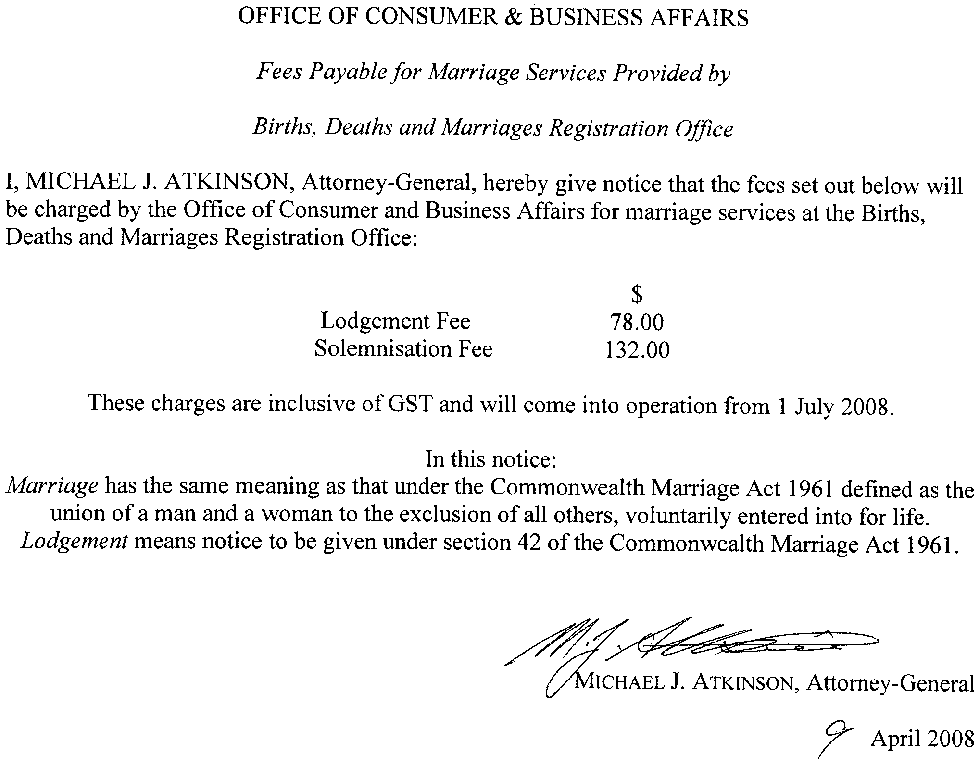



DEVELOPMENT ACT 1993: SECTION 48
Decision by the Development Assessment Commission
Preamble
1. The decision by the Governor under section 48 of the Development Act 1993, to approve the development of a waste management facility in the form of a solid waste landfill (Northward Fill (Inkerman Landfill Depot)) at Inkerman was published in the Gazette on 21 January 1999.
2. The development was the subject of an Environmental Impact Statement under section 46 of the Development Act 1993 and amended under section 47 of the Development Act 1993.
3. Amendments to the development authorisation were granted by the Development Assessment Commission as delegate of the Governor on 17 June 2004, 14 October 2004, 13 April 2006 and 20 September 2007.
4. A further variation has been under consideration by the Development Assessment Commission as delegate of the Governor under Division 2 of Part 4 of the Development Act 1993.
5. The proposed variation relates to the recycling of waste materials and is contained in the application and letter from QED Pty Ltd dated 13 March 2008.
7. The Development Assessment Commission is satisfied that the variation does not require the preparation of a further or amended Environmental Impact Statement.
8. The Development Assessment Commission has, in considering the matter, had regard to all relevant matters under section 48 (5) of the Development Act 1993.
Decision
PURSUANT to section 48 of the Development Act 1993, the Development Assessment Commission, as delegate of the Governor, grants development authorisation to the amended waste management facility in the form of a solid waste landfill (Northward Fill (Inkerman Landfill Depot)) at Inkerman, subject to conditions.
Conditions
1. Except where minor amendments may be required by other legislation, or by conditions imposed herein, proposed the solid waste landfill (Northward Fill (Inkerman Landfill Depot)) shall be undertaken in accordance with the plans in the application (dated 4 March 1997 and ‘Supporting Documentation for Development Application’ dated 24 November 1998), except as varied by the conditions listed below, the letters from Waste Management Pacific Pty Ltd dated 19 April 2004 and 19 May 2004, the application from Transpacific Waste Management Pty Ltd dated May 2007 and letter from QED Pty Ltd dated 16 July 2007 and the following drawings:
• Drawing No. 40033003/005C—dated 1 September 2003;
• Drawing No. 40033003/0080—dated 27 April 2004;
• Drawing No. 40033003/009—dated 27 April 2004;
• Drawing No. 40033003/013—dated 27 April 2004;
• Drawing No. 40033003/014—dated 27 April 2004,
or as amended by the following drawings:
• Northward Fill Detailed Design, Central Leachate Sump Details, Sheet 10 (Revision F)—dated 10 May 2005;
• Northward Fill Detailed Design, Leachate Management—Edge Sump Arrangement, Sheet 13 (Revision D)—dated 10 May 2005;
• Northward Fill Stage 2 and 3, Detailed Design Pipework Layout, Sheet 15 (Revision A)—dated 7 February 2006.
Groundwater
2. Monitoring shall be undertaken over two successive winter seasons to determine the maximum seasonal watertable level for that period starting prior to the landfill operations starting.
3. An internal leachate-level monitoring bore network within each stage of the landfill shall be established to allow early identification of any problem with the leachate collection system before excessive leachate heads develop.
4. Groundwater monitoring bores shall be established down gradient of the leachate collection ponds to the satisfaction of the Environment Protection Authority.
Leachate Management
5. A construction report shall be provided to the Environment Protection Authority by a geotechnical consultant certifying that the liner and drainage system has been constructed in accordance with the design principles together with in-situ testing to demonstrate that the required permeability has been achieved prior to operations commencing, except as varied by conditions 5a, 5b, 5c and 5d.
5a. The high density polyethylene (HDPE) membrane and geotextile portion of the liner shall extend a minimum of 5 m laterally from the sump (measured from the toe of the sump side slope to the outer edge of the lining system) and the underlying clay outside the sump area must have a minimum thickness of
1 m.
5b. The drainage slopes towards drainage lines and along drainage lines shall be a minimum of 2% and 1% respectively.
5c. Construction of the landfill liner and polylock system shall be undertaken and certified in accordance with Level 1 supervision and Construction Quality Assurance (CQA) procedures. A report documenting the results of the Level 1 supervision and construction quality control tests for the compacted clay liner, HDPE membrane and polylock system shall be prepared to the reasonable satisfaction of the Environment Protection Authority.
5d. Appropriate procedures and controls shall be implemented on site to address potential risks or damage which may compromise the integrity of the leachate extraction system, including from vehicle traffic, Ultraviolet Radiation, and any movements of the overland pipework including interim flexible pipework used while cells are operational.
5e. Contingency procedures shall be developed to address the potential for and response to any pipe rupture and leachate emission from the leachate pipes and extraction system.
5f. The LEMP shall be updated to incorporate conditions 5d. and 5e.
Landfill Gas
6. Landfill gas extraction wells shall be installed progressively as filling of the cell proceeds, to the satisfaction of the Environment Protection Authority.
7. All fire control measures proposed at the site shall be approved by the Country Fire Service prior to operations commencing.
Buffers and Landscaping
8. The maximum height of the landfill including rehabilitation shall be restricted to 27 m AHD (generally 7 m above the existing natural surface) to be consistent with the existing maximum topographic levels in the region.
9. All perimeter plantings shall be started as early as practicable after the date of this approval to achieve maximum amelioration of visual impacts.
10. Screening by suitable plantings where adequate natural screening is not provided, shall be provided for the perimeter fence, all built structures, stockpiles and internal roads (where practicable) using suitable species in accordance with the Vegetation Management and Revegetation Plan proposed as part of the Landfill Environmental Management Plan (LEMP).
Noise and Dust
11. The proponent shall comply with the provisions of the Environment Protection (Industrial Noise) Policy (1994, SA Government).
12a. The maximum hours of operation shall be 6 a.m. to 7.30 p.m. seven days per week and waste shall only be received between 6 a.m. and 7 p.m.
12b. The Applicant shall ensure that close proximity and low impact directional reverse beepers are installed and utilised on all mobile plant associated with waste disposal operations.
12c. Noise levels shall not exceed 40 dB(A) in accordance with EPA Fact Sheet 424/04 between the hours of 10 p.m. and 7 a.m.
Infrastructure
13. The proponent shall pay all reasonable costs of the detailed design and construction of any public roadworks made necessary by this development and to the satisfaction of Transport SA.
Building Rules
14. Work constituting building work under the Development Act 1993, shall be certified by the Wakefield District Council or a private certifier, as complying with the Building Rules. Copies of the relevant certification documentation shall be provided to the Minister for Urban Development & Planning, as outlined in Regulation 64 of the Development Act 1993. No building works shall commence until a favourable decision has been notified in writing to the applicant by the Governor or the Development Assessment Commission as delegate of the Governor.
Heritage
15. The party with the benefit of this approval shall ensure that operators and construction personnel are made aware of the requirements under the Aboriginal Heritage Act 1988 that any burial site skeletal material or significant artefact discovery is reported to the Division of State Aboriginal Affairs, Department of Environment, Heritage and Aboriginal Affairs.
Wastes
16. No Listed Waste as prescribed in Schedule 1, Part B of the Environment Protection Act 1993, or contaminated soil and material or asbestos containing material, shall be permitted to be disposed of without further development authorisation except as varied by the conditions listed below.
17. The proponent may receive and dispose of wastes from different regions as follows:
(a) Waste from the Adelaide Metropolitan Area that has gone through a Resource Recovery and Waste Transfer Facility; or
(b) Waste from regional areas outside the Metropolitan area that:
has been through a kerbside recycling service comprising at least 2 mobile garbage bins with a maximum 140 litre weekly waste collection and a minimum 240 litre fortnightly recycling collection; or
has been through a mobile garbage bin kerbside recycling system that yields at least 4 kg per household per week for recycling, excluding contamination; or
has been processed through a resource recovery facility / transfer station for the purposes of removing recyclable material prior to being transported for disposal.
18. The proponent may receive and dispose of the following additional wastes:
(a) Shredded tyres with other approved waste for a period of 3 years after which the proponent must apply for additional development approval
(b) Non-friable asbestos subject to handling and disposal procedures for non-friable asbestos, including the Environmental Management procedures as discussed in detail in Appendix F of the variation proposal
(c) Quarantine waste subject to approval from AQIS to receive and dispose of quarantine waste. In addition, the proponent shall:
(i) Receive quarantine waste that is accompanied by a completed Quarantine Waste Form developed by the Licensee
(ii) Dispose of quarantine waste immediately upon receipt
(iii) Ensure a minimum of 2 m of cover is placed over the waste immediately after disposal
(iv) Dispose of waste in accordance with requirements of AQIS (including supervision, deep burial and tracking)
(v) Maintain records that describe details for each load of quarantine waste received and disposed including the following items:
—Location of disposal;
—Date and time of receipt and disposal;
—Volume of waste;
—Type of waste;
—Producer of the waste;
—Transporter of the waste and driver name; and
—Name of person supervising disposal of waste,
(vi) Maintain procedures for the notification, handling, supervision, records management and disposal of quarantine waste and tracking systems to prevent the re-excavation of quarantine wastes.
(d) Foundry sands—the proponent shall:
(i) Assess the Used Foundry Sand in accordance with EPA Guidelines for Used Foundry Sand (UFS)—classification and disposal (EPA 329/03 - September 2003).
(ii) Ensure that the Used Foundry Sands have been classified prior to disposal according to the maximum concentrations in mg/kg (dry weight), and the maximum leachate concentration in mg/L, of the contaminants listed in the above referenced Guideline.
(iii) Ensure that only Used Foundry Sand classified and certified as Class 1 (or with lower contaminant levels) is received and disposed at the Premises.
Notes
1. The Environment Protection Authority will require the proponent to prepare a Landfill Environmental Management Plan (LEMP) to satisfy the Authority’s licensing requirements. Such a plan will be required to include provisions for the review, from time to time, of waste treatment and disposal methods to facilitate implementation of continuous improvement programs. The LEMP will be required to incorporate specific plans in relation to groundwater and leachate management, surface water management, vegetation and revegetation, soil erosion and drainage and the management of pest plants and animals as outlined in the amendment to the Assessment Report. It will also be required to include provisions for implementation of corrective actions in the event of any failure of the leachate and groundwater management systems.
2. Control over the types of waste to be received at the site will be exercised by the Environment Protection Authority. This will be done through conditions of environmental authorisation or requirements under a relevant Environment Protection Policy rather than through conditions of development authorisation (see Condition 16).
3. A financial assurance in accordance with the provisions of section 51 of the Environment Protection Act 1993 will be required by the Environment Protection Authority as a condition of licence.
4. The outstanding stormwater management issues discussed in relation to section 25 of the Environment Protection Act 1993 must be clarified as part of the LEMP if approval is given to the project.
5. A comprehensive proposed groundwater monitoring and protection system would need to be finalised in the LEMP.
6. A landfill gas monitoring program should be prepared to the satisfaction of the Environment Protection Authority and incorporated into the LEMP.
7. As part of the LEMP a contingency plan for landfill gas extraction and combustion systems would be required.
8. A low flame multi-burn flaring system to be incorporated in the landfill gas management system would be required. The flaring system should be enclosed in a cage unit to prevent debris from going through the flame.
9. The acceptance criteria and frequency of monitoring for odours needs to be specified in the development of the LEMP based on the conduct of modelling and approved management practices.
10. In order to achieve satisfactory environmental outcomes the use of a force-fed mechanical waste shredding system at the transfer station (as a means of reducing the potential for litter) is recommended. The Authority will require all waste to go through an Environment Protection Authority approved resource recovery centre which has a high percentage of re-use and resource recovery.
11. The Environment Protection Authority as part of the licence condition will state that litter will not be allowed to discharge off the proponent’s property.
12. As part of the LEMP a surface water management system, which collects run-off from road surfaces, stockpile areas and other locations where saline water has been used for dust suppression, should be prepared. This water is to be directed to specific ponds for collection and disposal into the leachate collection system or alternative treatment approved by the Environment Protection Authority.
13. The polylock system for anchoring the HDPE membrane may form part of the liner if the design and proposed construction method can demonstrate that the performance of the liner system is not compromised.
14. The proponent is reminded of its general environmental duty, as required by section 25 of the Environment Protection Act, to take all reasonable and practical measures to ensure that the activities on the whole site, including during construction, do not pollute the environment in a way which causes or may cause environmental harm.
Dated 5 June 2008.
R. Barua, Secretary, Development Assessment Commission

DEVELOPMENT ACT 1993, SECTION 25 (17): THE CITY OF PORT LINCOLN—MARINE COMMERCIAL ZONE DE-VELOPMENT PLAN AMENDMENT
Preamble
1. The Development Plan amendment entitled ‘The City of Port Lincoln—Marine Commercial Zone Development Plan Amend-ment’ has been finalised in accordance with the provisions of the Development Act 1993.
2. The Minister for Urban Development and Planning has decided to approve the Plan Amendment.
Notice
PURSUANT to section 25 of the Development Act 1993, I—
(a) approve the Plan Amendment; and
(b) fix the day on which this notice is published in the Gazette as the day on which the Plan Amendment will come into operation.
Dated 5 June 2008.
Paul Holloway, Minister for Urban Development and Planning

DISABILITY SA
Notice by the Minister for Disability
Fees Payable for Services Provided by Disability SA
THE fees set out in the table below will be charged by Disability SA for services specified in the table where the services are provided to a patient:
(a) who is a compensable patient; or
(b) who is not a Medicare patient.
The Chief Executive of the department may waive payment of, or remit, the whole or any part of a fee payable under this notice.
Table of Fees
$
1. Disability SA—Campus based fee for
inpatient accommodation—per day or part day 265
2. Disability SA—Other than campus based
services—fee for inpatient or residential
accommodation—per day or part day 382
3. Disability SA—Fee for arrangement or
co-ordination of access of patient to disability
services—per hour or part hour 31
4. Disability SA—Fee for preparation of report
on access of patient to disability services (for
purpose of compensation or legal proceedings)—
per report 308
5. In addition, where transportation is provided
or arranged by Disability SA, an additional fee
equal to the cost of providing, or arranging for
the provision of that transportation is payable.
In this notice:
Department means the Department for Families and Communities;
Disability SA means the division of the department known as Disability SA;
Client means a person with a disability who is eligible for Disability SA services;
Compensable patient means a patient receiving services who is, or may be, entitled to payment, or has received payment, by way of compensation in respect of the injury, illness or disease for which the patient is receiving those services;
Day means 24 hours (whether a continuous period or in aggregate);
Medicare patient means a patient who is an eligible person for the purposes of receiving medical benefits under the Health Insurance Act 1973 of the Commonwealth; and
Patient means a person to whom treatment or care is provided (including outreach services or domiciliary maintenance and care).
This notice will come into operation on 1 July 2008.
Jay Weatherill, Minister for Disability

GOVERNMENT GAZETTE ADVERTISEMENT RATES

To apply from 1 July 2007

$  Agents, Ceasing to Act as 39.60  Associations:  Incorporation 20.10  Intention of Incorporation 49.75  Transfer of Properties 49.75  Attorney, Appointment of 39.60  Bailiff’s Sale 49.75  Cemetery Curator Appointed 29.45  Companies:  Alteration to Constitution 39.60  Capital, Increase or Decrease of 49.75  Ceasing to Carry on Business 29.45  Declaration of Dividend 29.45  Incorporation 39.60  Lost Share Certificates:  First Name 29.45  Each Subsequent Name 10.10  Meeting Final 33.10  Meeting Final Regarding Liquidator’s Report on  Conduct of Winding Up (equivalent to ‘Final  Meeting’)  First Name 39.60  Each Subsequent Name 10.10  Notices:  Call 49.75  Change of Name 20.10  Creditors 39.60  Creditors Compromise of Arrangement 39.60  Creditors (extraordinary resolution that ‘the Com-pany be wound up voluntarily and that a liquidator be appointed’) 49.75  Release of Liquidator⎯Application⎯Large Ad. 78.65  ⎯Release Granted 49.75  Receiver and Manager Appointed 45.85  Receiver and Manager Ceasing to Act 39.60  Restored Name 37.25  Petition to Supreme Court for Winding Up 69.30  Summons in Action 58.85  Order of Supreme Court for Winding Up Action 39.60  Register of Interests⎯Section 84 (1) Exempt 89.10  Removal of Office 20.10  Proof of Debts 39.60  Sales of Shares and Forfeiture 39.60  Estates:  Assigned 29.45  Deceased Persons⎯Notice to Creditors, etc. 49.75  Each Subsequent Name 10.10  Deceased Persons⎯Closed Estates 29.45  Each Subsequent Estate 1.30  Probate, Selling of 39.60  Public Trustee, each Estate 10.10 |  | $  Firms:  Ceasing to Carry on Business (each insertion) 26.30  Discontinuance Place of Business 26.30  Land⎯Real Property Act:  Intention to Sell, Notice of 49.75  Lost Certificate of Title Notices 49.75  Cancellation, Notice of (Strata Plan) 49.75  Mortgages:  Caveat Lodgement 20.10  Discharge of 21.05  Foreclosures 20.10  Transfer of 20.10  Sublet 10.10  Leases⎯Application for Transfer (2 insertions) each 10.10  Lost Treasury Receipts (3 insertions) each 29.45  Licensing 58.85  Municipal or District Councils:  Annual Financial Statement⎯Forms 1 and 2 554.35  Electricity Supply⎯Forms 19 and 20 393.90  Default in Payment of Rates:  First Name 78.65  Each Subsequent Name 10.10  Noxious Trade 29.45  Partnership, Dissolution of 29.45  Petitions (small) 20.10  Registered Building Societies (from Registrar-  General) 20.10  Register of Unclaimed Moneys⎯First Name 29.45  Each Subsequent Name 10.10  Registers of Members⎯Three pages and over:  Rate per page (in 8pt) 252.15  Rate per page (in 6pt) 333.45  Sale of Land by Public Auction 50.30  Advertisements 2.80  ¼ page advertisement 117.75  ½ page advertisement 235.50  Full page advertisement 461.60  Advertisements, other than those listed are charged at $2.80 per column line, tabular one-third extra.  Notices by Colleges, Universities, Corporations and District Councils to be charged at $2.80 per line.  Where the notice inserted varies significantly in length from that which is usually published a charge of $2.80 per column line will be applied in lieu of advertisement rates listed.  South Australian Government publications are sold on the condition that they will not be reproduced without prior permission from the Government Printer.
All the above prices include GST

GOVERNMENT GAZETTE NOTICES
ALL private advertisements forwarded for publication in the South Australian Government Gazette must be PAID FOR PRIOR TO INSERTION; and all notices, from whatever source, should be legibly written on one side of the paper only and sent to Government Publishing SA so as to be received no later than 4 p.m. Tuesday preceding the day of publication. Phone 8207 1045 or Fax 8207 1040. E-mail: governmentgazette@dpc.sa.gov.au. Send as attachments in Word format. Please include date the notice is to be published and to whom the notice will be charged. The Government Gazette is available online at: www.governmentgazette.sa.gov.au.

MISCELLANEOUS LEGISLATION AND GOVERNMENT PUBLICATIONS PRICES AS FROM 1 JULY 2007

Acts, Bills, Rules, Parliamentary Papers and Regulations
Pages | Main | Amends | Pages | Main | Amends

1-16 | 2.40 | 1.10 | 497-512 | 33.60 | 32.55
17-32 | 3.25 | 2.05 | 513-528 | 34.65 | 33.35
33-48 | 4.20 | 3.00 | 529-544 | 35.70 | 34.65
49-64 | 5.30 | 4.05 | 545-560 | 36.75 | 35.70
65-80 | 6.25 | 5.15 | 561-576 | 37.50 | 36.75
81-96 | 7.25 | 6.00 | 577-592 | 38.55 | 37.25
97-112 | 8.25 | 7.05 | 593-608 | 39.85 | 38.30
113-128 | 9.25 | 8.10 | 609-624 | 40.65 | 39.60
129-144 | 10.35 | 9.15 | 625-640 | 41.70 | 40.10
145-160 | 11.35 | 10.10 | 641-656 | 42.70 | 41.70
161-176 | 12.40 | 11.15 | 657-672 | 43.25 | 42.20
177-192 | 13.45 | 12.20 | 673-688 | 45.05 | 43.25
193-208 | 14.50 | 13.35 | 689-704 | 45.85 | 44.30
209-224 | 15.30 | 14.15 | 705-720 | 46.65 | 45.35
225-240 | 16.35 | 15.10 | 721-736 | 48.45 | 46.35
241-257 | 17.50 | 15.95 | 737-752 | 48.95 | 47.40
258-272 | 18.45 | 17.00 | 753-768 | 50.00 | 48.20
273-288 | 19.50 | 18.25 | 769-784 | 50.55 | 49.75
289-304 | 20.30 | 19.15 | 785-800 | 51.60 | 50.80
305-320 | 21.55 | 20.20 | 801-816 | 52.60 | 51.30
321-336 | 22.40 | 21.15 | 817-832 | 53.65 | 52.60
337-352 | 23.55 | 22.30 | 833-848 | 54.70 | 53.65
353-368 | 24.50 | 23.35 | 849-864 | 55.75 | 54.20
369-384 | 25.55 | 24.40 | 865-880 | 56.80 | 55.75
385-400 | 26.55 | 25.30 | 881-896 | 57.30 | 56.25
401-416 | 27.60 | 26.05 | 897-912 | 58.85 | 57.30
417-432 | 28.65 | 27.35 | 913-928 | 59.40 | 58.85
433-448 | 29.70 | 28.40 | 929-944 | 60.45 | 59.40
449-464 | 30.50 | 29.20 | 945-960 | 61.50 | 59.90
465-480 | 31.00 | 30.20 | 961-976 | 63.05 | 60.95
481-496 | 32.55 | 31.00 | 977-992 | 64.10 | 61.50

Legislation—Acts, Regulations, etc: $
Subscriptions:
Acts 207.00
All Bills as Laid 497.00
Rules and Regulations 497.00
Parliamentary Papers 497.00
Bound Acts 230.00
Index 115.00
Government Gazette
Copy 5.40
Subscription 274.00
Hansard
Copy 15.10
Subscription—per session (issued weekly) 431.00
Cloth bound—per volume 185.00
Subscription—per session (issued daily) 431.00
Legislation on Disk
Whole Database 3192.00
Annual Subscription for fortnightly updates 981.00
Individual Act(s) including updates POA
Compendium
Subscriptions:
Subscriptions 1891.00
Updates 667.00
(All the above prices include GST)

All Legislation, Government Gazette, Hansard and Legislation on disk are available from:
Counter Sales Service SA, Government Legislation⁺ Outlet
and Mail Orders: Lands Titles Office, 101 Grenfell Street, Adelaide, S.A. 5000
Phone: 13 23 24 (local call cost), Fax: (08) 8204 1909
Postal: G.P.O. Box 1707, Adelaide, S.A. 5001

Online Shop: www.shop.service.sa.gov.au

Subscriptions and Government Publishing SA
Standing Orders: Box 9, Plaza Level, Riverside Centre, North Terrace, Adelaide, S.A. 5000
Phone: (08) 8207 1043, (08) 8207 0910, Fax: (08) 8207 1040

ENVIRONMENT PROTECTION ACT 1993
Approval of Category B Containers
I, STEPHEN RICHARD SMITH, Senior Adviser, Container Deposit Legislation and Delegate of the Environment Protection Authority (‘the Authority’), pursuant to section 69 of the Environment Protection Act 1993 (SA) (‘the Act’) hereby:
Approval of Category B Containers:
Approve as Category B Containers, subject to the conditions in subclauses (i) and (ii) below, each of the classes of containers identified by reference to the following matters described in the first 4 columns of Schedule 1 of this Notice which are sold in South Australia:
(a) the product which each class of containers shall contain;
(b) the size of the containers;
(c) the type of containers; and
(d) the name of the holders of these approvals.
(i) Subsection 69 (3) Arrangements:
The holders of these approvals must ensure that the empty containers which belong to their respective class of containers hereby approved as Category B Containers are collected from collection depots approved under section 69 of the Act by the party named in Column 5 of Schedule 1 of this Notice; and
(ii) Approved Refund Markings:
(a) The holders of these approvals must ensure that each container which belongs to their respective class of containers hereby approved as Category B Containers bears the refund marking approved by the Authority in respect of that class of containers.
(b) The refund marking that appears on each container that belongs to the class of containers hereby approved, must be a minimum 1.5 mm for the smallest letter in the statement and a minimum 3 mm for the numeric (‘5’) in the statement.
(c) The holder of these approvals must ensure that if a sticker bearing the refund marking has been approved, and is applied to the container, then the sticker must not be placed on any portion of the opening mechanism or in any other place that would require complete or partial removal of the sticker before the contents may be consumed.
Schedule 1

Column 1 |  | Column 2 |  | Column 3 |  | Column 4 |  | Column 5
Product Name |  | Container  Size (mL) |  | Container Type |  | Approval Holder |  | Collection  Arrangements
Mount Macedon Natural Spring Water | 600 |  | PET |  | Aquaco Water Pty Ltd |  | Statewide Recycling
Mount Macedon Natural Spring Water | 350 |  | PET |  | Aquaco Water Pty Ltd |  | Statewide Recycling
Mount Macedon Natural Spring Water | 1 500 |  | PET |  | Aquaco Water Pty Ltd |  | Statewide Recycling
Praga Lager | 500 |  | Glass |  | Australasian Import Group Pty Ltd |  | Statewide Recycling
St Helier Apple Cider 5% | 500 |  | Glass |  | Australasian Import Group Pty Ltd |  | Statewide Recycling
St Helier Pear Cider 5% | 500 |  | Glass |  | Australasian Import Group Pty Ltd |  | Statewide Recycling
St Helier Pear Cider 5% | 1 000 |  | Glass |  | Australasian Import Group Pty Ltd |  | Statewide Recycling
St Helier Pear Raspberry & Lime 5% | 500 |  | Glass |  | Australasian Import Group Pty Ltd |  | Statewide Recycling
Leather Jacket Lager | 330 |  | Glass |  | Balog Holdings Pty Ltd |  | Marine Stores Ltd
Red Emperor Amber Ale | 330 |  | Glass |  | Balog Holdings Pty Ltd |  | Marine Stores Ltd
Blue Bottle Beer | 330 |  | Glass |  | Bluebottle Beer Pty Ltd |  | Statewide Recycling
Fire Fly Beer | 330 |  | Glass |  | Bluebottle Beer Pty Ltd |  | Statewide Recycling
Zip Beer Meets Cola | 330 |  | Glass |  | Capocol Pty Ltd |  | Statewide Recycling
Charlies Honest Antioxidant Smoothie Blackcurrants Acai Berries | 300 |  | PET |  | Charlies Group Australia Pty Ltd |  | Statewide Recycling
Charlies Honest Energy Smoothie Orange Mango Guarana | 300 |  | PET |  | Charlies Group Australia Pty Ltd |  | Statewide Recycling
Charlies Honest Superfood Smoothie Spirulina | 300 |  | PET |  | Charlies Group Australia Pty Ltd |  | Statewide Recycling
Charlies Honest Vitamin C Smoothie Feijoa Acerola Berries | 300 |  | PET |  | Charlies Group Australia Pty Ltd |  | Statewide Recycling
Charlies Lemonade Quencher | 300 |  | PET |  | Charlies Group Australia Pty Ltd |  | Statewide Recycling
Charlies Mango Orange Quencher | 300 |  | PET |  | Charlies Group Australia Pty Ltd |  | Statewide Recycling
Charlies Raspberry Lemonade Quencher | 300 |  | PET |  | Charlies Group Australia Pty Ltd |  | Statewide Recycling
Coca Cola | 450 |  | PET |  | Coca Cola Amatil (Aust) Pty Ltd |  | Statewide Recycling
Coca Cola Zero | 450 |  | PET |  | Coca Cola Amatil (Aust) Pty Ltd |  | Statewide Recycling
Diet Coca Cola | 450 |  | PET |  | Coca Cola Amatil (Aust) Pty Ltd |  | Statewide Recycling
Diet Coca Cola Caffeine Free | 450 |  | PET |  | Coca Cola Amatil (Aust) Pty Ltd |  | Statewide Recycling
Fanta Orange Flavour | 450 |  | PET |  | Coca Cola Amatil (Aust) Pty Ltd |  | Statewide Recycling
Lift Lemon | 450 |  | PET |  | Coca Cola Amatil (Aust) Pty Ltd |  | Statewide Recycling
Mother | 500 |  | Can—Aluminium |  | Coca Cola Amatil (Aust) Pty Ltd |  | Statewide Recycling
Nestea Green Tea Lemon | 345 |  | Glass |  | Coca Cola Amatil (Aust) Pty Ltd |  | Statewide Recycling
Nestea Green Tea Lemon | 500 |  | PET |  | Coca Cola Amatil (Aust) Pty Ltd |  | Statewide Recycling
Nestea Green Tea Mango | 1 000 |  | PET |  | Coca Cola Amatil (Aust) Pty Ltd |  | Statewide Recycling
Nestea Green Tea Mango | 345 |  | Glass |  | Coca Cola Amatil (Aust) Pty Ltd |  | Statewide Recycling
Nestea Green Tea Mango | 500 |  | PET |  | Coca Cola Amatil (Aust) Pty Ltd |  | Statewide Recycling
Nestea Iced Tea Lemon Lime | 1 000 |  | PET |  | Coca Cola Amatil (Aust) Pty Ltd |  | Statewide Recycling
Nestea Iced Tea Lemon Lime | 345 |  | Glass |  | Coca Cola Amatil (Aust) Pty Ltd |  | Statewide Recycling
Nestea Iced Tea Lemon Lime | 500 |  | PET |  | Coca Cola Amatil (Aust) Pty Ltd |  | Statewide Recycling
Nestea Iced Tea Peach Mango | 1 000 |  | PET |  | Coca Cola Amatil (Aust) Pty Ltd |  | Statewide Recycling
Nestea Iced Tea Peach Mango | 500 |  | PET |  | Coca Cola Amatil (Aust) Pty Ltd |  | Statewide Recycling
Nestea Iced Tea Peach Mango | 345 |  | Glass |  | Coca Cola Amatil (Aust) Pty Ltd |  | Statewide Recycling
Nestea Iced Tea Tropical Flavour | 345 |  | Glass |  | Coca Cola Amatil (Aust) Pty Ltd |  | Statewide Recycling
Nestea Iced Tea Tropical Flavour | 500 |  | PET |  | Coca Cola Amatil (Aust) Pty Ltd |  | Statewide Recycling
Sprite | 450 |  | PET |  | Coca Cola Amatil (Aust) Pty Ltd |  | Statewide Recycling
Sprite Zero | 450 |  | PET |  | Coca Cola Amatil (Aust) Pty Ltd |  | Statewide Recycling
Amp d Vodka Guarana Soda 9% | 250 |  | Can—Aluminium |  | Copack Properties Pty Ltd |  | Flagcan Distributors
Kentucky State Bourbon & Cola 5% | 440 |  | Can—Aluminium |  | Copack Properties Pty Ltd |  | Flagcan Distributors
Kentucky State Bourbon & Cola 8% | 440 |  | Can—Aluminium |  | Copack Properties Pty Ltd |  | Flagcan Distributors
UP Vodka + Guarana + Soda %5 | 250 |  | Can—Aluminium |  | Copack Properties Pty Ltd |  | Flagcan Distributors
Ya Bom Herbal Liqueur & Energy 7% | 250 |  | Can—Aluminium |  | Copack Properties Pty Ltd |  | Flagcan Distributors
Bulleit Bourbon & Cola 6.9% | 375 |  | Can—Aluminium |  | Diageo Australia Pty Ltd |  | Statewide Recycling
Bundaberg OP Rum & Cola 6.9% | 375 |  | Can—Aluminium |  | Diageo Australia Pty Ltd |  | Statewide Recycling
Bundaberg OP Rum & Cola 6.9% | 345 |  | Glass |  | Diageo Australia Pty Ltd |  | Statewide Recycling
Gordons G&T Gin & Tonic 4.8% | 375 |  | Can—Aluminium |  | Diageo Australia Pty Ltd |  | Statewide Recycling
Haig Extra Scotch Whisky & Cola 6.9% | 375 |  | Can—Aluminium |  | Diageo Australia Pty Ltd |  | Statewide Recycling
Smirnoff Ice Double Black 6.9% | 375 |  | Can—Aluminium |  | Diageo Australia Pty Ltd |  | Statewide Recycling
Smirnoff Ice Double Black 6.9% | 335 |  | Glass |  | Diageo Australia Pty Ltd |  | Statewide Recycling
Smirnoff Premium Ice 4.8% | 375 |  | Can—Aluminium |  | Diageo Australia Pty Ltd |  | Statewide Recycling
Douglas Park Organic Apple & Blackcurrant Juice | 200 |  | PET |  | Douglas Park Organics |  | Statewide Recycling
Douglas Park Organic Apple & Blackcurrant Juice | 300 |  | Glass |  | Douglas Park Organics |  | Statewide Recycling
Douglas Park Organic Apple & Carrot Juice | 200 |  | PET |  | Douglas Park Organics |  | Statewide Recycling
Douglas Park Organic Apple Juice | 200 |  | PET |  | Douglas Park Organics |  | Statewide Recycling
Douglas Park Organic Apple Juice | 300 |  | Glass |  | Douglas Park Organics |  | Statewide Recycling
Douglas Park Organic Carrot Juice With Ginger | 300 |  | Glass |  | Douglas Park Organics |  | Statewide Recycling
Douglas Park Organic Orange Juice | 300 |  | Glass |  | Douglas Park Organics |  | Statewide Recycling
Douglas Park Organic Orange juice | 200 |  | PET |  | Douglas Park Organics |  | Statewide Recycling
Henry Dawson Sparkling Red Grape Juice Non Alcoholic | 750 |  | Glass |  | Douglas Park Organics |  | Statewide Recycling
Henry Dawson Sparkling White Grape Juice Non Alcoholic | 750 |  | Glass |  | Douglas Park Organics |  | Statewide Recycling
Henry Dawson Still Red Grape Juice Non Alcoholic | 750 |  | Glass |  | Douglas Park Organics |  | Statewide Recycling
Henry Dawson Still White Grape Juice Non Alcoholic | 750 |  | Glass |  | Douglas Park Organics |  | Statewide Recycling
Absolute Organic Apple Clear Juice | 1 000 |  | Glass |  | Eco Farms Pty Ltd |  | Statewide Recycling
Absolute Organic Cloudy Apple Juice | 1 000 |  | Glass |  | Eco Farms Pty Ltd |  | Statewide Recycling
Absolute Organic Orange Juice | 1 000 |  | Glass |  | Eco Farms Pty Ltd |  | Statewide Recycling
Pomegreat Pomegranate & Acai Berry Super Juice Drink | 1 000 |  | LPB—Aseptic |  | Eco Farms Pty Ltd |  | Statewide Recycling
Pomegreat Pomegranate & Blueberry Super Juice Drink | 1 000 |  | LPB—Aseptic |  | Eco Farms Pty Ltd |  | Statewide Recycling
Pomegreat Pomegranate & Raspberry Super Juice Drink | 1 000 |  | LPB—Aseptic |  | Eco Farms Pty Ltd |  | Statewide Recycling
Pomegreat The Original Pomegranate Super Juice Drink | 1 000 |  | LPB—Aseptic |  | Eco Farms Pty Ltd |  | Statewide Recycling
Steaz Diet Energy Organic Fuel Berry Flavour | 355 |  | Can—Aluminium |  | Eco Farms Pty Ltd |  | Statewide Recycling
Steaz Energy Organic Fuel Berry Flavour | 355 |  | Can—Aluminium |  | Eco Farms Pty Ltd |  | Statewide Recycling
Steaz Energy Organic Fuel Green Tea Drink | 355 |  | Can—Aluminium |  | Eco Farms Pty Ltd |  | Statewide Recycling
Steaz Energy Organic Fuel Lime Flavour | 355 |  | Can—Aluminium |  | Eco Farms Pty Ltd |  | Statewide Recycling
Steaz Energy Organic Fuel Orange Flavour | 355 |  | Can—Aluminium |  | Eco Farms Pty Ltd |  | Statewide Recycling
Lucky Beer 4.8% | 330 |  | Glass |  | Empire Liquor |  | Statewide Recycling
Mercury Artisan Apple Cider Original | 345 |  | Glass |  | Fosters Australia |  | Marine Stores Ltd
Black & Gold Natural Spring Water | 1 500 |  | PET |  | H2O Springwater Pty Ltd |  | Statewide Recycling
Black & Gold Natural Spring Water | 600 |  | PET |  | H2O Springwater Pty Ltd |  | Statewide Recycling
Crystal Peak Natural Spring Water | 600 |  | PET |  | H2O Springwater Pty Ltd |  | Statewide Recycling
H2O Natural Spring Water | 1 500 |  | PET |  | H2O Springwater Pty Ltd |  | Statewide Recycling
H2O Natural Spring Water | 350 |  | PET |  | H2O Springwater Pty Ltd |  | Statewide Recycling
H2O Natural Spring Water | 600 |  | PET |  | H2O Springwater Pty Ltd |  | Statewide Recycling
IGA Evita Natural Spring Water | 1 500 |  | PET |  | H2O Springwater Pty Ltd |  | Statewide Recycling
IGA Evita Natural Spring Water | 600 |  | PET |  | H2O Springwater Pty Ltd |  | Statewide Recycling
Plateau Australian Natural Spring Water | 1 500 |  | PET |  | H2O Springwater Pty Ltd |  | Statewide Recycling
Plateau Australian Natural Spring Water | 600 |  | PET |  | H2O Springwater Pty Ltd |  | Statewide Recycling
IC Juice Fruit Juice Drink Apple | 215 |  | Guala Pack |  | Holmac Sales Pty Ltd |  | Marine Stores Ltd
IC Juice Fruit Juice Drink Grape | 215 |  | Guala Pack |  | Holmac Sales Pty Ltd |  | Marine Stores Ltd
IC Juice Fruit Juice Drink Orange | 215 |  | Guala Pack |  | Holmac Sales Pty Ltd |  | Marine Stores Ltd
IC Juice Fruit Juice Drink Strawberry | 215 |  | Guala Pack |  | Holmac Sales Pty Ltd |  | Marine Stores Ltd
Nekta Liquid Kiwi Fruit | 2 000 |  | PET |  | Holmac Sales Pty Ltd |  | Marine Stores Ltd
Nekta Liquid Kiwi Fruit | 250 |  | PET |  | Holmac Sales Pty Ltd |  | Marine Stores Ltd
Nekta Liquid Kiwi Fruit | 1 000 |  | Glass |  | Holmac Sales Pty Ltd |  | Marine Stores Ltd
Nekta Liquid Kiwi Fruit | 1 000 |  | PET |  | Holmac Sales Pty Ltd |  | Marine Stores Ltd
Nekta Liquid Kiwi Fruit with Aloe Vera | 1 000 |  | PET |  | Holmac Sales Pty Ltd |  | Marine Stores Ltd
Nekta Liquid Kiwi Fruit with Aloe Vera | 250 |  | PET |  | Holmac Sales Pty Ltd |  | Marine Stores Ltd
Original Apple Natural Drink | 1 000 |  | PET |  | Jubba Super Mart |  | Statewide Recycling
Original Guava Natural Drink | 1 000 |  | PET |  | Jubba Super Mart |  | Statewide Recycling
Original Mixed Fruit Drink | 1 000 |  | PET |  | Jubba Super Mart |  | Statewide Recycling
Original Orange & Carrot Drink | 1 000 |  | PET |  | Jubba Super Mart |  | Statewide Recycling
Original Orange & Carrot Drink | 1 500 |  | PET |  | Jubba Super Mart |  | Statewide Recycling
Lakewood Mangosteen Juice | 946 |  | Glass |  | Kadac Pty Ltd |  | Statewide Recycling
Organic Mangrove Mt Spring Water Natural Lemon Flavour | 600 |  | PET |  | Mangrove Mountain Springs Pty Ltd |  | Statewide Recycling
Organic Mangrove Mt Springs Water | 600 |  | PET |  | Mangrove Mountain Springs Pty Ltd |  | Statewide Recycling
Organic Mangrove Mt Springs Water | 3 000 |  | PET |  | Mangrove Mountain Springs Pty Ltd |  | Statewide Recycling
Organic Mangrove Mt Springs Water | 1 500 |  | PET |  | Mangrove Mountain Springs Pty Ltd |  | Statewide Recycling
Organic Mangrove Mt Springs Water | 350 |  | PET |  | Mangrove Mountain Springs Pty Ltd |  | Statewide Recycling
Chin Chin Aloe Vera Juice | 500 |  | PET |  | New World Trading Company Pty Ltd |  | Statewide Recycling
Chin Chin Aloe Vera Juice | 1 500 |  | PET |  | New World Trading Company Pty Ltd |  | Statewide Recycling
Chin Chin Basil Seed Drink | 350 |  | Can—Aluminium |  | New World Trading Company Pty Ltd |  | Statewide Recycling
Chin Chin Birds Nest | 240 |  | Can—Steel |  | New World Trading Company Pty Ltd |  | Statewide Recycling
Chin Chin Cappuccino Coffee | 270 |  | Can—Steel |  | New World Trading Company Pty Ltd |  | Statewide Recycling
Chin Chin Grass Jelly Banana Flavore | 320 |  | Can—Aluminium |  | New World Trading Company Pty Ltd |  | Statewide Recycling
Chin Chin Grass Jelly Coconut Flavore | 320 |  | Can—Aluminium |  | New World Trading Company Pty Ltd |  | Statewide Recycling
Chin Chin Grass Jelly Drink | 320 |  | Can—Aluminium |  | New World Trading Company Pty Ltd |  | Statewide Recycling
Chin Chin Grass Jelly Lychee Flavore | 320 |  | Can—Aluminium |  | New World Trading Company Pty Ltd |  | Statewide Recycling
Chin Chin Green Tea with Honey | 500 |  | PET |  | New World Trading Company Pty Ltd |  | Statewide Recycling
Chin Chin Guava Juice | 350 |  | Can—Steel |  | New World Trading Company Pty Ltd |  | Statewide Recycling
Chin Chin Lychee Juice | 350 |  | Can—Steel |  | New World Trading Company Pty Ltd |  | Statewide Recycling
Chin Chin Mango Juice | 350 |  | Can—Steel |  | New World Trading Company Pty Ltd |  | Statewide Recycling
Chin Chin Mix Fruit Juice | 350 |  | Can—Steel |  | New World Trading Company Pty Ltd |  | Statewide Recycling
Chin Chin Sarsaparilla Soda | 350 |  | Can—Aluminium |  | New World Trading Company Pty Ltd |  | Statewide Recycling
Chin Chin Sterchila with Basil Seed | 350 |  | Can—Steel |  | New World Trading Company Pty Ltd |  | Statewide Recycling
Chin Chin Wax Gourd Juice | 350 |  | Can—Aluminium |  | New World Trading Company Pty Ltd |  | Statewide Recycling
Kong Master Grape Juice | 500 |  | PET |  | New World Trading Company Pty Ltd |  | Statewide Recycling
Kong Master Green Tea | 500 |  | PET |  | New World Trading Company Pty Ltd |  | Statewide Recycling
Kong Master Green Tea | 1 250 |  | PET |  | New World Trading Company Pty Ltd |  | Statewide Recycling
Kong Master Ice Tea | 490 |  | PET |  | New World Trading Company Pty Ltd |  | Statewide Recycling
Kong Master Ice Tea | 1 250 |  | PET |  | New World Trading Company Pty Ltd |  | Statewide Recycling
Kong Master Jasmine Tea | 500 |  | PET |  | New World Trading Company Pty Ltd |  | Statewide Recycling
Kong Master Orange Juice | 500 |  | PET |  | New World Trading Company Pty Ltd |  | Statewide Recycling
Ridgy Didge Original Still Water | 1 500 |  | PET |  | Northern Beverages Pty ltd |  | Statewide Recycling
Ridgy Didge Original Still Water | 600 |  | PET |  | Northern Beverages Pty ltd |  | Statewide Recycling
Yeos Chrysanthemum Tea | 500 |  | PET |  | Oriental Merchant Pty Ltd |  | Statewide Recycling
Yeos Green Tea Honey Lemon Flavour | 500 |  | PET |  | Oriental Merchant Pty Ltd |  | Statewide Recycling
Yeos Ice Lemon Tea Drink | 500 |  | PET |  | Oriental Merchant Pty Ltd |  | Statewide Recycling
Yeos Japanese Green Tea Without sugar | 500 |  | PET |  | Oriental Merchant Pty Ltd |  | Statewide Recycling
Yeos Lemon Barley Drink | 500 |  | PET |  | Oriental Merchant Pty Ltd |  | Statewide Recycling
Yeos Lychee Drink | 500 |  | PET |  | Oriental Merchant Pty Ltd |  | Statewide Recycling
Yeos Sugar Cane Drink | 500 |  | PET |  | Oriental Merchant Pty Ltd |  | Statewide Recycling
Yeos Winter Melon Tea | 500 |  | PET |  | Oriental Merchant Pty Ltd |  | Statewide Recycling
Brewers Choice Ginger Beer | 1 250 |  | PET |  | P & N Beverages Australia Pty Ltd |  | Flagcan Distributors
Ceda Creaming Soda | 1 250 |  | PET |  | P & N Beverages Australia Pty Ltd |  | Flagcan Distributors
Club Dry Ginger Ale | 1 250 |  | PET |  | P & N Beverages Australia Pty Ltd |  | Flagcan Distributors
Club Lemon Lime Bitters | 1 250 |  | PET |  | P & N Beverages Australia Pty Ltd |  | Flagcan Distributors
Club Soda Water | 1 250 |  | PET |  | P & N Beverages Australia Pty Ltd |  | Flagcan Distributors
Club Tonic Water | 1 250 |  | PET |  | P & N Beverages Australia Pty Ltd |  | Flagcan Distributors
Crush Lime | 1 250 |  | PET |  | P & N Beverages Australia Pty Ltd |  | Flagcan Distributors
Crush Orange | 1 250 |  | PET |  | P & N Beverages Australia Pty Ltd |  | Flagcan Distributors
Crush Passion | 1 250 |  | PET |  | P & N Beverages Australia Pty Ltd |  | Flagcan Distributors
Crush Pine | 1 250 |  | PET |  | P & N Beverages Australia Pty Ltd |  | Flagcan Distributors
Diet Crush Orange | 1 250 |  | PET |  | P & N Beverages Australia Pty Ltd |  | Flagcan Distributors
Diet Crush Passion | 1 250 |  | PET |  | P & N Beverages Australia Pty Ltd |  | Flagcan Distributors
Diet Pub Squash Lemon Soda Squash | 1 250 |  | PET |  | P & N Beverages Australia Pty Ltd |  | Flagcan Distributors
LA Ice Cola | 1 250 |  | PET |  | P & N Beverages Australia Pty Ltd |  | Flagcan Distributors
LA Maxi Ice Cola | 1 250 |  | PET |  | P & N Beverages Australia Pty Ltd |  | Flagcan Distributors
Lido Lemonade | 1 250 |  | PET |  | P & N Beverages Australia Pty Ltd |  | Flagcan Distributors
The Original Pub Squash Lemon Lime | 1 250 |  | PET |  | P & N Beverages Australia Pty Ltd |  | Flagcan Distributors
The Original Pub Squash Lemon Soda Squash | 1 250 |  | PET |  | P & N Beverages Australia Pty Ltd |  | Flagcan Distributors
Parkers Organic Sparkling Apple With A Twist Of Lime | 330 |  | PET |  | Parkers Organic Juices Pty Ltd |  | Statewide Recycling
Parkers Organic Sparkling Blood Orange | 330 |  | PET |  | Parkers Organic Juices Pty Ltd |  | Statewide Recycling
Parkers Organic Sparkling Guava And Cranberry | 330 |  | PET |  | Parkers Organic Juices Pty Ltd |  | Statewide Recycling
Parkers Organic Sparkling Lemon | 330 |  | PET |  | Parkers Organic Juices Pty Ltd |  | Statewide Recycling
Parkers Organic Sparkling Mango And Orange | 330 |  | PET |  | Parkers Organic Juices Pty Ltd |  | Statewide Recycling
Parkers Organic Sparkling Passionfruit And Orange | 330 |  | PET |  | Parkers Organic Juices Pty Ltd |  | Statewide Recycling
Parkers Organic Sparkling Pink Lemonade | 330 |  | PET |  | Parkers Organic Juices Pty Ltd |  | Statewide Recycling
James Squire Limited Release Pepperberry Winter Ale | 345 |  | Glass |  | South Australian Brewing Company Pty Ltd |  | Marine Stores Ltd
Ame Grape & Apricots | 1 000 |  | Glass |  | Thirst For Life |  | Statewide Recycling
Ame Red | 1 000 |  | Glass |  | Thirst For Life |  | Statewide Recycling
Ame Rose | 1 000 |  | Glass |  | Thirst For Life |  | Statewide Recycling
Ame White | 1 000 |  | Glass |  | Thirst For Life |  | Statewide Recycling
Belvoir Cranberry Presse | 250 |  | Glass |  | Thirst For Life |  | Statewide Recycling
Belvoir Cranberry Presse | 750 |  | Glass |  | Thirst For Life |  | Statewide Recycling
Belvoir Lime & Lemongrass Presse | 250 |  | Glass |  | Thirst For Life |  | Statewide Recycling
Belvoir Organic Blood Orange & Mandarin Presse | 250 |  | Glass |  | Thirst For Life |  | Statewide Recycling
Belvoir Organic Blood Orange & Mandarin Presse | 750 |  | Glass |  | Thirst For Life |  | Statewide Recycling
Belvoir Pomegranate & Raspberry Presse | 250 |  | Glass |  | Thirst For Life |  | Statewide Recycling
Belvoir Pomegranate & Raspberry Presse | 750 |  | Glass |  | Thirst For Life |  | Statewide Recycling
Purdeys Silver | 325 |  | Glass |  | Thirst For Life |  | Statewide Recycling
Zest Ale Fusion Lemon | 330 |  | Glass |  | Zest Beverages Pty Ltd |  | Marine Stores Ltd
Zest Ale Fusion Lime | 330 |  | Glass |  | Zest Beverages Pty Ltd |  | Marine Stores Ltd

ENVIRONMENT PROTECTION ACT 1993
Approval of Category A Containers
I, STEPHEN RICHARD SMITH, Senior Adviser, Container Deposit Legislation and Delegate of the Environment Protection Authority (‘the Authority’), pursuant to section 69 of the Environment Protection Act 1993 (SA) (‘the Act’) hereby:
Approval of Category A Containers:
Approve as Category A Containers, as identified in Column 5 of the Schedule, subject to the conditions in sub-clauses (i) and (ii) below, each of the classes of containers identified by reference to the following matters described in the first 4 columns of Schedule 1 of this Notice which are sold in South Australia:
(a) the product which each class of containers shall contain;
(b) the size of the containers;
(c) the type of containers; and
(d) the name of the holders of these approvals.
(i) Subsection 69 (3) Arrangements:
The holders of these approvals must ensure that the empty containers which belong to their respective class of containers hereby approved as Category A Containers, are collected from the retailers that sell them, and recycled in an appropriate manner. Disposal at landfill is not considered an appropriate method of disposal.
(ii) Approved Refund Markings:
(a) The holders of these approvals must ensure that each container which belongs to their respective class of containers hereby approved as Category A Containers bears the refund marking approved by the Authority in respect of that class of containers.
(b) The refund marking that appears on each container that belongs to the class of containers hereby approved, must be a minimum 1.5 mm for the smallest letter in the statement and a minimum 3 mm for the numeric (‘5’) in the statement.
(c) The holder of these approvals must ensure that if a sticker bearing the refund marking has been approved, and is applied to the container, then the sticker must not be placed on any portion of the opening mechanism or in any other place that would require complete or partial removal of the sticker before the contents may be consumed.
Schedule 1

Column 1 | Column 2 | Column 3 | Column 4 | Column 5
Product Name | Container  Size (mL) | Container Type | Approval Holder | Collection  Arrangements
Naab Natural Yoghurt Drink | 1 250 | PET | Persian Grocery | N/A—See Notes
Naab Natural Yoghurt Drink | 350 | PET | Persian Grocery | N/A—See Notes
Naab Natural Yoghurt Drink | 600 | PET | Persian Grocery | N/A—See Notes
Saravneh Mango Drink | 200 | Guala Pack | Persian Grocery | N/A—See Notes
Saravneh Orange Drink | 200 | Guala Pack | Persian Grocery | N/A—See Notes
Saravneh Pomegranate Drink | 200 | Guala Pack | Persian Grocery | N/A—See Notes
Saravneh Sourcherry Drink | 200 | Guala Pack | Persian Grocery | N/A—See Notes
Saravneh Tropical Drink | 200 | Guala Pack | Persian Grocery | N/A—See Notes
Takdaneh Mango | 240 | Can—Aluminium | Persian Grocery | N/A—See Notes
Takdaneh Orange | 240 | Can—Aluminium | Persian Grocery | N/A—See Notes
Takdaneh Peach | 240 | Can—Aluminium | Persian Grocery | N/A—See Notes
Takdaneh Pineapple | 240 | Can—Aluminium | Persian Grocery | N/A—See Notes

ENVIRONMENT PROTECTION ACT 1993
Revocation of Approval of Category B Containers
I, STEPHEN RICHARD SMITH, Senior Adviser, Container Deposit Legislation and Delegate of the Environment Protection Authority (‘the Authority’), pursuant to section 69 (8) of the Environment Protection Act 1993 (SA) (‘the Act’) hereby revoke the approvals of the classes of Category B Containers sold in South Australia as identified by reference to the following matters, which are described in the first 4 columns of Schedule 1 of this Notice:
(a) the product which each class of containers shall contain;
(b) the size of the containers;
(c) the type of containers; and
(d) the name of the holders of these approvals.
These approvals are revoked as the Authority is satisfied that the subsection 69 (3) arrangement between the approval holder and the party named in Column 5 of Schedule 1 of this Notice has been cancelled.

Column 1 | Column 2 |  | Column 3 |  | Column 4 |  | Column 5
Product Name | Container  Size (mL) |  | Container Type |  | Approval Holder |  | Collection  Arrangements
Aventinus Germanys Original Wheat Doppelbock Ale |  | 500 |  | Glass |  | Food Service Marketing & Distribution Pty Ltd |  | Marine Stores Ltd
Aventinus Weizen Eisbock Ale |  | 330 |  | Glass |  | Food Service Marketing & Distribution Pty Ltd |  | Marine Stores Ltd
Paulaner Hefe Weisbier |  | 330 |  | Glass |  | Food Service Marketing & Distribution Pty Ltd |  | Marine Stores Ltd
Paulaner Oktoberfest Marzen Amber |  | 330 |  | Glass |  | Food Service Marketing & Distribution Pty Ltd |  | Marine Stores Ltd
Paulaner Original Munchner Hell |  | 330 |  | Glass |  | Food Service Marketing & Distribution Pty Ltd |  | Marine Stores Ltd
Paulaner Premium Pils |  | 330 |  | Glass |  | Food Service Marketing & Distribution Pty Ltd |  | Marine Stores Ltd
Reissdorf Kolsch |  | 330 |  | Glass |  | Food Service Marketing & Distribution Pty Ltd |  | Marine Stores Ltd
Schneider Weisse Kristall |  | 500 |  | Glass |  | Food Service Marketing & Distribution Pty Ltd |  | Marine Stores Ltd
Schneider Weisse The Original |  | 500 |  | Glass |  | Food Service Marketing & Distribution Pty Ltd |  | Marine Stores Ltd
Wiesen Edel Weisse |  | 500 |  | Glass |  | Food Service Marketing & Distribution Pty Ltd |  | Marine Stores Ltd
Goodnight European Style Nightcap |  | 750 |  | Glass |  | Lloyds Vineyard Pty Ltd |  | Visy Recycling CDL Services
Lloyds Apricot Fruit Drink |  | 750 |  | Glass |  | Lloyds Vineyard Pty Ltd |  | Visy Recycling CDL Services
Lloyds Black Muscatel Pure Grape Juice |  | 750 |  | Glass |  | Lloyds Vineyard Pty Ltd |  | Visy Recycling CDL Services
Lloyds Black Muscatel Pure Grape Juice |  | 300 |  | Glass |  | Lloyds Vineyard Pty Ltd |  | Visy Recycling CDL Services
Lloyds Cornechon Pure Grape Juice |  | 750 |  | Glass |  | Lloyds Vineyard Pty Ltd |  | Visy Recycling CDL Services
Lloyds Grenache Pure Grape Juice |  | 300 |  | Glass |  | Lloyds Vineyard Pty Ltd |  | Visy Recycling CDL Services
Lloyds Grenache Pure Grape Juice |  | 750 |  | Glass |  | Lloyds Vineyard Pty Ltd |  | Visy Recycling CDL Services
Lloyds Italia Pure Grape Juice |  | 750 |  | Glass |  | Lloyds Vineyard Pty Ltd |  | Visy Recycling CDL Services
Lloyds Matara Pure Grape Juice |  | 300 |  | Glass |  | Lloyds Vineyard Pty Ltd |  | Visy Recycling CDL Services
Lloyds Matara Pure Grape Juice |  | 750 |  | Glass |  | Lloyds Vineyard Pty Ltd |  | Visy Recycling CDL Services
Lloyds Prune Juice |  | 300 |  | Glass |  | Lloyds Vineyard Pty Ltd |  | Visy Recycling CDL Services
Lloyds Quench Apricot Fruit Juice Drink |  | 300 |  | Glass |  | Lloyds Vineyard Pty Ltd |  | Visy Recycling CDL Services
Lloyds Quench Dark Grape Fruit Juice Drink |  | 300 |  | Glass |  | Lloyds Vineyard Pty Ltd |  | Visy Recycling CDL Services
Lloyds Quench Light Grape Fruit Juice Drink |  | 300 |  | Glass |  | Lloyds Vineyard Pty Ltd |  | Visy Recycling CDL Services
Lloyds Quench Peach Fruit Juice Drink |  | 300 |  | Glass |  | Lloyds Vineyard Pty Ltd |  | Visy Recycling CDL Services
Lloyds Shiraz Pure Grape Juice |  | 750 |  | Glass |  | Lloyds Vineyard Pty Ltd |  | Visy Recycling CDL Services
Lloyds Shiraz Pure Grape Juice |  | 300 |  | Glass |  | Lloyds Vineyard Pty Ltd |  | Visy Recycling CDL Services
Lloyds Sultana Pure Grape Juice |  | 300 |  | Glass |  | Lloyds Vineyard Pty Ltd |  | Visy Recycling CDL Services
Lloyds Sultana Pure Grape Juice |  | 750 |  | Glass |  | Lloyds Vineyard Pty Ltd |  | Visy Recycling CDL Services
Lloyds Waltham Cross Pure Grape Juice |  | 300 |  | Glass |  | Lloyds Vineyard Pty Ltd |  | Visy Recycling CDL Services
Lloyds Waltham Cross Pure Grape Juice |  | 750 |  | Glass |  | Lloyds Vineyard Pty Ltd |  | Visy Recycling CDL Services
Lloyds White Muscatel Pure Grape Juice |  | 750 |  | Glass |  | Lloyds Vineyard Pty Ltd |  | Visy Recycling CDL Services
Lloyds White Muscatel Pure Grape Juice |  | 300 |  | Glass |  | Lloyds Vineyard Pty Ltd |  | Visy Recycling CDL Services
Inner Circle Pot Still Rum & Cola 6% |  | 375 |  | Can—Aluminium |  | Miranda Wines Pty Ltd |  | Visy Recycling CDL Services
Inner Circle Pot Still Rum & Cola 9% |  | 375 |  | Can—Aluminium |  | Miranda Wines Pty Ltd |  | Visy Recycling CDL Services
IRN BRU Original & Best |  | 1 250 |  | PET |  | Occasio Australia Pty Ltd |  | Visy Recycling CDL Services
IRN BRU Original & Best |  | 500 |  | PET |  | Occasio Australia Pty Ltd |  | Visy Recycling CDL Services
IRN BRU Original & Best Diet |  | 500 |  | PET |  | Occasio Australia Pty Ltd |  | Visy Recycling CDL Services
IRN BRU Original & Best Diet |  | 1 250 |  | PET |  | Occasio Australia Pty Ltd |  | Visy Recycling CDL Services
Tizer |  | 1 250 |  | PET |  | Occasio Australia Pty Ltd |  | Visy Recycling CDL Services
Tizer |  | 500 |  | PET |  | Occasio Australia Pty Ltd |  | Visy Recycling CDL Services
Maharajahs Premium Lager |  | 330 |  | Glass |  | Ostindo International Pty Ltd |  | Visy Recycling CDL Services
Marble Hill Spring Water |  | 350 |  | Plastic |  | Pascon Pty Ltd trading as Marble Hill Spring Water |  | Statewide Recycling
Marble Hill Spring Water |  | 300 |  | Glass |  | Pascon Pty Ltd trading as Marble Hill Spring Water |  | Statewide Recycling
Marble Hill Spring Water |  | 500 |  | Plastic |  | Pascon Pty Ltd trading as Marble Hill Spring Water |  | Statewide Recycling
Hakin Stout |  | 330 |  | Glass |  | Solomon Worcou trading as Harar Beer Direct |  | Visy Recycling CDL Services
Harar Lager |  | 330 |  | Glass |  | Solomon Worcou trading as Harar Beer Direct |  | Visy Recycling CDL Services
Harar Soft Drink |  | 330 |  | Glass |  | Solomon Worcou trading as Harar Beer Direct |  | Visy Recycling CDL Services
Meta Abo Beer |  | 330 |  | Glass |  | Solomon Worcou trading as Harar Beer Direct |  | Visy Recycling CDL Services
Lakewood Juices Black Cherry |  | 946 |  | Glass |  | Steves Organics |  | Visy Recycling CDL Services
Lakewood Juices Blueberry |  | 946 |  | Glass |  | Steves Organics |  | Visy Recycling CDL Services
Lakewood Juices Cranberry |  | 946 |  | Glass |  | Steves Organics |  | Visy Recycling CDL Services
Lakewood Juices Grape |  | 946 |  | Glass |  | Steves Organics |  | Visy Recycling CDL Services
Lakewood Juices Pineapple |  | 946 |  | Glass |  | Steves Organics |  | Visy Recycling CDL Services
Lakewood Juices Pomegranate |  | 946 |  | Glass |  | Steves Organics |  | Visy Recycling CDL Services
Lakewood Juices Prune |  | 946 |  | Glass |  | Steves Organics |  | Visy Recycling CDL Services
Riverside Foods Organic Blackberry Juice |  | 250 |  | Glass |  | Steves Organics |  | Visy Recycling CDL Services
Riverside Foods Organic Blueberry Juice |  | 250 |  | Glass |  | Steves Organics |  | Visy Recycling CDL Services
Riverside Foods Organic Cherry Juice |  | 250 |  | Glass |  | Steves Organics |  | Visy Recycling CDL Services
Riverside Foods Organic Peach Juice |  | 250 |  | Glass |  | Steves Organics |  | Visy Recycling CDL Services
Riverside Foods Organic Plum Juice |  | 250 |  | Glass |  | Steves Organics |  | Visy Recycling CDL Services
Riverside Foods Organic Raspberry Juice |  | 250 |  | Glass |  | Steves Organics |  | Visy Recycling CDL Services
Riverside Foods Organic Vegecana Juice |  | 250 |  | Glass |  | Steves Organics |  | Visy Recycling CDL Services
Santa Cruz Ginger Ale |  | 355 |  | Can—Aluminium |  | Steves Organics |  | Visy Recycling CDL Services
Santa Cruz Lemon Lime |  | 355 |  | Can—Aluminium |  | Steves Organics |  | Visy Recycling CDL Services
Santa Cruz Lemonade |  | 355 |  | Can—Aluminium |  | Steves Organics |  | Visy Recycling CDL Services
Santa Cruz Orange & Mango |  | 355 |  | Can—Aluminium |  | Steves Organics |  | Visy Recycling CDL Services
Santa Cruz Raspberry Lemonade |  | 355 |  | Can—Aluminium |  | Steves Organics |  | Visy Recycling CDL Services
Santa Cruz Root Beer |  | 355 |  | Can—Aluminium |  | Steves Organics |  | Visy Recycling CDL Services
Whole Earth Cola |  | 355 |  | Can—Aluminium |  | Steves Organics |  | Visy Recycling CDL Services
Whole Earth Cranberry |  | 355 |  | Can—Aluminium |  | Steves Organics |  | Visy Recycling CDL Services
Whole Earth Elderflower |  | 355 |  | Can—Aluminium |  | Steves Organics |  | Visy Recycling CDL Services
Whole Earth Ginger |  | 355 |  | Can—Aluminium |  | Steves Organics |  | Visy Recycling CDL Services
Whole Earth Lemonade |  | 355 |  | Can—Aluminium |  | Steves Organics |  | Visy Recycling CDL Services
Purdeys Gold |  | 325 |  | Glass |  | Sydney Waterfront Estates trading as Thirst For Life Premium Waters |  | Visy Recycling CDL Services
Purdeys Green |  | 325 |  | Glass |  | Sydney Waterfront Estates trading as Thirst For Life Premium Waters |  | Visy Recycling CDL Services
Purdeys Silver |  | 325 |  | Glass |  | Sydney Waterfront Estates trading as Thirst For Life Premium Waters |  | Visy Recycling CDL Services
Lucky Beer |  | 330 |  | Glass |  | The Lucky Drink Company Pty Ltd |  | Visy Recycling CDL Services
Ame Red |  | 750 |  | Glass |  | Thirst For Life |  | Visy Recycling CDL Services
Ame Red |  | 330 |  | Glass |  | Thirst For Life |  | Visy Recycling CDL Services
Ame Rose |  | 750 |  | Glass |  | Thirst For Life |  | Visy Recycling CDL Services
Ame Rose |  | 330 |  | Glass |  | Thirst For Life |  | Visy Recycling CDL Services
Ame White |  | 750 |  | Glass |  | Thirst For Life |  | Visy Recycling CDL Services
Ame White |  | 330 |  | Glass |  | Thirst For Life |  | Visy Recycling CDL Services
Aqua Libra Original |  | 750 |  | Glass |  | Thirst For Life |  | Visy Recycling CDL Services
Aqua Libra Original |  | 200 |  | Glass |  | Thirst For Life |  | Visy Recycling CDL Services
Aqua Libra Original |  | 250 |  | Can |  | Thirst For Life |  | Visy Recycling CDL Services
Aqua Libra Summer Fruits |  | 750 |  | Glass |  | Thirst For Life |  | Visy Recycling CDL Services
Aqua Libra Summer Fruits |  | 250 |  | Can |  | Thirst For Life |  | Visy Recycling CDL Services
Purdeys Gold |  | 250 |  | Glass |  | Thirst For Life |  | Visy Recycling CDL Services
Purdeys Silver |  | 250 |  | Glass |  | Thirst For Life |  | Visy Recycling CDL Services
Thirst For Life Elderflower |  | 300 |  | Glass |  | Thirst For Life |  | Statewide Recycling
Thirst For Life Kiwi Fruit Herbal Soda |  | 300 |  | Glass |  | Thirst For Life |  | Statewide Recycling
Thirst For Life Lemon Lime |  | 300 |  | Glass |  | Thirst For Life |  | Statewide Recycling
Ty Nant |  | 750 |  | Glass |  | Thirst For Life |  | Visy Recycling CDL Services
Ty Nant |  | 330 |  | Glass |  | Thirst For Life |  | Visy Recycling CDL Services
Unique Water |  | 600 |  | Plastic |  | Unique Water Australia Pty Ltd trading as Bertshell Pty Ltd |  | Visy Recycling CDL Services

FISHERIES MANAGEMENT ACT 2007: SECTION 79
TAKE note that the notice made under section 79 of the Fisheries Management Act 2007, dated 28 May 2008, referring to the Spencer Gulf Prawn Fishery, is hereby revoked.
Take note that the notice made under section 79 of the Fisheries Management Act 2007, dated 7 December 2007, referring to the Spencer Gulf Prawn Fishery, is hereby varied such that it will not be unlawful for a person fishing pursuant to a Spencer Gulf Prawn Fishery Licence to use prawn trawl nets in the areas specified in Schedule 1 during the period specified in Schedule 2.
Schedule 1
1. The waters of the Spencer Gulf Prawn Fishery that are in the Musgrave region, within the following co-ordinates:
Commencing at position latitude 33°15.00′S, longitude 137°50.00′E, then to position latitude 33°15.00′S, longitude 137°37.00′E, then to position latitude 33°19.00′S, longitude 137°35.50′E, then to position latitude 33°24.00′S, longitude 137°35.50′E, then to position latitude 33°24.20′S, longitude 137°54.00′E.
2. The waters of the Spencer Gulf Prawn Fishery that are south of the following co-ordinates:
Commencing at position latitude 33°46.00′S, longitude 137°44.00′E, then to position latitude 33°38.00′S, longitude 137°34.00′E, then to position latitude 33°29.00′S, longitude 137°34.00′E, then to position latitude 33°29.00′S, longitude 137°31.00′E, then to position latitude 33°34.00′S, longitude 137°30.30′E, then to position latitude 33°34.00′S, longitude 137°29.30′E, then to position latitude 33°44.00′S, longitude 137°23.70′E, then to position latitude 33°41.00′S, longitude 137°20.00′E, then to position latitude 33°47.00′S, longitude 137°11.00′E, then to position latitude 33°52.00′S, longitude 137°15.00′E, then to position latitude 33°54.40′S, longitude 137°10.20′E, then to position latitude 33°58.00′S, longitude 137°12.80′E, then to position latitude 34°27.00′S, longitude 136°49.00′E, then to position latitude 34°27.00′S, longitude 136°41.00′E, then to position latitude 34°04.00′S, longitude 136°49.00′E, then to position latitude 33°52.00′S, longitude 136°40.00′E.
Except within the following area adjacent to Wallaroo, which is closed to fishing:
Commencing at position latitude 33°46.70′S, longitude 137°26.60′E, then to position latitude 33°49.80′S, longitude 137°31.00′E, then to position latitude 33°54.40′S, longitude 137°27.00′E, then to position latitude 33°51.90′S, longitude 137°22.70′E.
Except within the area adjacent to Wardang Island, which is closed to fishing:
Commencing at position latitude 34°19.00′S, longitude 137°30.00′E, then to position latitude 34°19.00′S, longitude 137°20.00′E, then to position latitude 34°23.00′S, longitude 137°15.00′E, then to position latitude 34°54.00′S, longitude 137°15.00′E.
Schedule 2
From 1830 hours on 1 June 2008 to 0630 hours on 11 June 2008.
Dated 1 June 2008.
S. Sloan, Senior Fisheries Manager

FISHERIES MANAGEMENT ACT 2007: SECTION 79
TAKE notice that pursuant to section 79 of the Fisheries Management Act 2007, it is hereby declared that it shall be unlawful for any person to engage in the class of fishing activity specified in Schedule 1, in the area specified in Schedule 2, during the period specified in Schedule 3.
Schedule 1
The act of taking or an act preparatory to or involved in the taking of abalone (Haliotis spp).
Schedule 2
All the waters of Waterloo Bay (Elliston) contained within the geodesic commencing at the high water mark on the shore of Wellington Point, latitude 33°39.23′S, longitude 134°52.53′E and terminating at the high water mark on the shore at Salmon Point, latitude 33°38.72′S, longitude 134°51.58′E
Schedule 3
From 2 June 2008 until 31 May 2009.
Dated 1 June 2008.
W. Zacharin, Director of Fisheries

FISHERIES MANAGEMENT ACT 2007: SECTION 79
TAKE note that the notice made under section 79 of the Fisheries Management Act 2007, dated 7 December 2007, referring to the Spencer Gulf Prawn Fishery, is hereby varied such that it will not be unlawful for a person fishing pursuant to a Spencer Gulf Prawn Fishery licence to use prawn trawl nets in the areas specified in Schedule 1 during the period specified in Schedule 2.
SCHEDULE 1
The waters of the Spencer Gulf Prawn Fishery that are south of the following coordinates commencing at latitude 33°46.00S longitude 137°44.00′E, then to position latitude 33°37.00′S longitude 137°33.00′E, then to position latitude 33°34.00′S longitude 137°33.00′E, then to position latitude 33°34.00′S longitude 137°26.30′E, then to position latitude 33°39.20′S longitude 137°26.30′E, then to position latitude 33°43.70′S longitude 137°22.70′E, then to position latitude 33°41.00′S longitude 137°20.00′E, then to position latitude 33°47.00′S longitude 137°11.00′E, then to position latitude 33°52.00′S longitude 137°15.00′E, then to position latitude 33°55.00′S longitude 137°09.00′E, then to position latitude 33°59.00′S longitude 137°12.00′E, then to position latitude 34°27.00′S longitude 136°49.00′E, then to position latitude 34°27.00′S longitude 136°41.00′E, then to position latitude 34°04.00′S longitude 136°49.00′E, then to position latitude 33°52.00′S longitude 136°40.00′E.
Except within the following area adjacent to Wallaroo, which is closed to fishing commencing at latitude 33°46.70′S longitude 137°26.60′E, then to position latitude 33°49.80′S longitude 137°31.00′E, then to position latitude 33°54.40′S longitude 137°27.00′E, then to position latitude 33°51.90′S longitude 137°22.70′E.
Except within the area adjacent to Wardang Island, which is closed to fishing commencing at latitude 34°19.00′S longitude 137°30.00′E, then to position latitude 34°19.00′S longitude 137°20.00′E, then to position latitude 34°23.00′S longitude 137°15.00′E, then to position latitude 34°54.00′S longitude 137°15.00′E.
SCHEDULE 2
From 1830 hours on 1 June 2008 to 0630 hours on 11 June 2008.
Dated 28 May 2008.
S. Sloan, Senior Fisheries Manager

FISHERIES MANAGEMENT ACT 2007: SECTION 115
TAKE notice that pursuant to section 115 of the Fisheries Management Act 2007, the holder of a Prawn Fishery Licence issued pursuant to the Fisheries Management (Prawn Fisheries) Regulations 2006 for the West Coast Prawn Fishery listed in Schedule 1 (the ‘exemption holders’) or their registered master are exempt from the closure notice made under section 79 of the Fisheries Management Act 2007, published in the South Australian Government Gazette, dated 4 March 2008, referring to the West Coast Prawn Fishery. The exemption holders shall not be guilty of an offence when using prawn trawl nets in accordance with the conditions of their fishery licence for the purpose of undertaking a prawn survey (the ‘exempted activity’) subject to the conditions contained in Schedule 2.
Schedule 1
Licence Number | Licence Holder | Vessel Name | Survey  Area
D01 | West Coast Prawn Fisheries Pty Ltd | Lincoln Lady | Ceduna
D03 | Konstantine Paleologoudias | Limnos | Venus Bay
Schedule 2
1. This exemption is valid from 1800 hours on 4 June 2008 until 0630 hours on 5 June 2008.
2. The exemption holder must operate within the trawl survey area nominated in Schedule 1.
3. The registered master must keep a ‘skippers log’ to record catch information during the survey.
4. All fish, other than prawns, southern calamary, arrow squid, scallops, octopus and slipper lobster taken during the exempted activity for survey purposes, are to be returned to the water immediately after capture.
5. While engaged in the exempted activity or unloading the survey catch, the exemption holder must have a copy of this notice on board the vessel or near his person. This notice must be produced to a PIRSA Fisheries Compliance Officer if requested.
6. The exemption holder must not contravene or fail to comply with the Fisheries Management Act 2007, or any other regulations made under that Act except where specifically exempted by this notice.
Dated 28 May 2008
S. Sloan, Programme Leader, Fisheries Management

FISHERIES MANAGEMENT ACT 2007: SECTION 79
TAKE note that the notice made under section 79 of the Fisheries Management Act 2007, published in the South Australian Government Gazette, dated 4 March 2008, referring to the West Coast Prawn Fishery, is hereby varied such that it will not be unlawful for a person fishing pursuant to a West Coast Prawn Fishery Licence to use prawn trawl nets in the waters specified in Schedule 1, under the conditions specified in Schedule 2, during the period specified in Schedule 3.
Schedule 1
The waters of the west coast prawn fishery within Venus Bay and Coffin Bay.
Schedule 2
1. Each licence holder must ensure that a representative sample of the catch (a ‘bucket count’) is taken for each trawl shot carried out during the fishing activity.
2. Each ‘bucket count’ sample must be accurately weighed to 7kg where possible and the total number of prawns contained in the bucket must be recorded on the attached data sheet, marked ‘West Coast Prawn Fishery Bucket Count Data Sheet’.
3. The information recorded on the ‘WCPF Bucket Count Data Sheet’ must be returned to SARDI Aquatic Sciences within 15 days of the fishing activity being completed.
4. Fishing must cease if one or both of the following limits are reached:
(a) The average catch per vessel, per night (for all three vessels) drops below 300kg for two consecutive nights.
(b) The average prawn ‘bucket count’ for all three vessels exceeds 240 prawns per bucket on any single fishing night.
5. The fleet must nominate a licence holder to provide a daily update by telephone or SMS message to the PIRSA Fisheries Manager, to report the total prawn catch per night and the average prawn ‘bucket count’ information.
Schedule 3
From 1830 hours on 1 June 2008 to 0630 hours on 4 June 2008.
Dated 28 May 2008
S. Sloan, Programme Leader, Fisheries Management

FISHERIES MANAGEMENT ACT 2007: SECTION 115
TAKE notice that pursuant to section 115 of the Fisheries Management Act 2007, David Wiltshire of ENSR, 76 Waymouth Street, Adelaide, S.A. 5000 (the ‘exemption holder’), or a person acting as his agent, is exempt from the notice issued on 28 May 2008 under section 79 of the Fisheries Management Act 2007, but only insofar as the exemption holder shall not be guilty of an offence when collecting giant cuttlefish (Sepia apama) from the waters specified in Schedule 1 using a dip net (the ‘exempted activity’) subject to the conditions specified in Schedule 2, from
1 June 2008 until 10 June 2008, unless varied or revoked earlier.
Schedule 1
Whyalla cuttlefish closure, as described in the notice made under section 79 of the Fisheries Management Act 2007 dated
28 May 2008.
Schedule 2
1. All fish collected pursuant to this notice may only be used for research purposes and must be returned to the water as soon as possible after length measurements have been recorded.
2. The exemption holder or a person acting as an agent must notify PIRSA Fisheries on 1800 065 522 at least two hours prior to conducting the exempted activity and answer a series of questions about the exempted activity. The exemption holder will need to have a copy of the exemption notice at the time of making the call, and be able to provide information about the area and time of the exempted activity, the vehicles and boats involved, the number of agents undertaking the exempted activity and other related questions. Exemption No. 9902127.
3. The exemption holder must provide a written report to the Director of Fisheries (G.P.O. Box 1625, Adelaide, S.A. 5001) within 14 days of the expiry of this exemption, providing the following details:
• Location of collection;
• Date and time of the collection;
• Number of fish collected;
• Size of fish collected;
• Any mortalities in relation to the exempted activity.
4. While engaged in the exempted activity the exemption holder or agent must be in possession of a copy of this notice and such a notice must be produced to a PIRSA Fisheries Compliance Officer if requested.
5. The exemption holder must not contravene or fail to comply with the Fisheries Management Act 2007, or any regulations made under that Act, except where specifically exempted by this notice.
Dated 28 May 2008.
W. Zacharin, Director of Fisheries

FISHERIES MANAGEMENT ACT 2007: SECTION 79
TAKE notice that pursuant to section 79 of the Fisheries Management Act 2007, it is hereby declared that it shall be unlawful for any persons to engage in the act of, or an act preparatory to or involved in, taking species of the family cephalopoda (squid, cuttlefish and octopus) from those waters specified in Schedule 1, during the period specified in Schedule 2.
Schedule 1
All waters of Spencer Gulf within an area bounded by a line commencing at Point Lowly lighthouse, then following the geodesic between that point and the southern end of the Port Bonython jetty, then following the geodesic between that point and the eastern most point of the BHP jetty near Whyalla, position latitude 33°02.3′S, longitude 137°35.95′E, then following the jetty to the high water mark at the base of the jetty, then following the high water mark along the shoreline in a generally easterly direction back to the point of commencement.
Schedule 2
From 28 May 2008 to 28 May 2009.
Dated 28 May 2008.
W. Zacharin, Director of Fisheries

HEALTH CARE ACT 2008
Section 15
Notice by the Minister
TAKE notice that I, John Hill, Minister for Health, do hereby:
1. Pursuant to section 15 (1) of the Health Care Act 2008, establish each of the bodies listed in Column A of the Schedule as Health Advisory Councils (‘HAC’s’).
2. Pursuant to section 15 (3) (a) of the Health Care Act 2008, designate the corresponding entity or entities listed in Column B of the Schedule to be the entity or entities in relation to which the HAC’s listed in Column A are established.
3. Pursuant to section 15 (3) (c) of the Health Care Act 2008, assign the name appearing in the Schedule to be the name of the HAC and declare those of the Health Advisory Councils referred to in Column A with ‘Inc.’ appearing after their names to be incorporated bodies and declare that the remaining HAC’s listed in the Schedule will be unincorporated.
4. Pursuant to section 15 (3) (b) and 15 (3) (d) of the Health Care Act 2008, provide that each incorporated HAC and each unincorporated HAC will have the powers and functions set out respectively in the constitution or rules determined by me for each HAC in accordance with section 17 of the Health Care Act 2008.
Schedule
A (HAC) | B (entity/entities in relation to which HAC is established)
Country Health SA Board Health Advisory Council Inc. | The Minister; the Chief Executive; any hospital incorporated under Part 5 of the Act and the SA Ambulance Service Inc.
Balaklava Riverton Health Advisory Council Inc. | The Minister and Country Health SA Hospital Incorporated
Barossa and Districts Health Advisory Council Inc. | The Minister and Country Health SA Hospital Incorporated
Bordertown and District Health Advisory Council Inc. | The Minister and Country Health SA Hospital Incorporated
Ceduna District Health Services Health Advisory Council Inc. | The Minister and Country Health SA Hospital Incorporated
Ceduna Koonibba Aboriginal Health Advisory Council Inc. | The Minister and Country Health SA Hospital Incorporated
Coorong Health Service Health Advisory Council Inc. | The Minister and Country Health SA Hospital Incorporated
Eastern Eyre Health Advisory Council Inc. | The Minister and Country Health SA Hospital Incorporated

Eudunda Kapunda Health Advisory Council Inc. | The Minister and Country Health SA Hospital Incorporated
Gawler District Health Advisory Council Inc. | The Minister and Country Health SA Hospital Incorporated
Hills Area Health Advisory Council Inc. | The Minister and Country Health SA Hospital Incorporated
Kangaroo Island Health Advisory Council Inc. | The Minister and Country Health SA Hospital Incorporated
Kingston/Robe Health Advisory Council Inc. | The Minister and Country Health SA Hospital Incorporated
Lower Eyre Health Advisory Council Inc. | The Minister and Country Health SA Hospital Incorporated
Lower North Health Advisory Council Inc. | The Minister and Country Health SA Hospital Incorporated
Loxton and Districts Health Advisory Council Inc. | The Minister and Country Health SA Hospital Incorporated
Mallee Health Service Health Advisory Council Inc. | The Minister and Country Health SA Hospital Incorporated
Mannum District Hospital Health Advisory Council Inc. | The Minister and Country Health SA Hospital Incorporated
Mid North Health Advisory Council Inc. | The Minister and Country Health SA Hospital Incorporated
Mid-West Health Advisory Council Inc. | The Minister and Country Health SA Hospital Incorporated
Millicent and Districts Health Advisory Council Inc. | The Minister and Country Health SA Hospital Incorporated
Mount Gambier and Districts Health Advisory Council Inc. | The Minister and Country Health SA Hospital Incorporated
The Murray Bridge Soldiers’ Memorial Hospital Health Advisory Council Inc. | The Minister and Country Health SA Hospital Incorporated
Naracoorte Area Health Advisory Council Inc. | The Minister and Country Health SA Hospital Incorporated
Northern Yorke Peninsula Health Advisory Council Inc. | The Minister and Country Health SA Hospital Incorporated
Penola and Districts Health Advisory Council Inc. | The Minister and Country Health SA Hospital Incorporated
Pika Wiya Health Advisory Council Inc. | The Minister and Country Health SA Hospital Incorporated
Port Broughton District Hospital and Health Services Health Advisory Council Inc. | The Minister and Country Health SA Hospital Incorporated
Renmark Paringa District Health Advisory Council Inc. | The Minister and Country Health SA Hospital Incorporated
Berri Barmera District Health Advisory Council Inc. | The Minister and Country Health SA Hospital Incorporated

South Coast Health Advisory Council Inc. | The Minister and Country Health SA Hospital Incorporated
Waikerie and Districts Health Advisory Council Inc. | The Minister and Country Health SA Hospital Incorporated
Yorke Peninsula Health Advisory Council Inc. | The Minister and Country Health SA Hospital Incorporated
Far North Health Advisory Council | The Minister and Country Health SA Hospital Incorporated
Hawker District Memorial Health Advisory Council | The Minister and Country Health SA Hospital Incorporated
Leigh Creek Health Services Health Advisory Council | The Minister and Country Health SA Hospital Incorporated
Port Augusta, Roxby Downs, Woomera Health Advisory Council | The Minister and Country Health SA Hospital Incorporated
Port Lincoln Health Advisory Council | The Minister and Country Health SA Hospital Incorporated
Port Pirie Health Service Advisory Council | The Minister and Country Health SA Hospital Incorporated
Quorn Health Services Health Advisory Council | The Minister and Country Health SA Hospital Incorporated
Southern Flinders Health Advisory Council | The Minister and Country Health SA Hospital Incorporated
The Whyalla Hospital and Health Services Health Advisory Council | The Minister and Country Health SA Hospital Incorporated
SAAS Volunteers Health Advisory Council | SA Ambulance Service Incorporated
Dated 2 June 2008.
John Hill, Minister for Health

HOUSING IMPROVEMENT ACT 1940
WHEREAS by notice published in the Government Gazette on the dates mentioned in the following table the South Australian Housing Trust did declare the houses described in the said table to be substandard for the purposes of Part 7 of the Housing Improvement Act 1940, and whereas the South Australian Housing Trust is satisfied that each of the houses described hereunder has ceased to be substandard, notice is hereby given that, in exercise of the powers conferred by the said Part, the South Australian Housing Trust does hereby revoke the said declaration in respect of each house.
Address of House | Allotment, Section, etc. | Certificate of Title  Volume Folio | Date and page of Government Gazette in which notice declaring house to be substandard published

Section 91, Short Road, Barmera (a detached single fronted concrete block house) |  | Pieces 7 and 8 in Deposited Plan 44805, Cobdogla Irrigation Area (Nookamka Division) | 5915 | 150 |  | 14.7.88, page 378
15 Jetty Road, Larges Bay (upstairs flat) |  | Allotment 16 in Fled Plan 4238, Hundred of Port Adelaide | 5160 | 321 |  | 10.4.75, page 1474
112 Cedar Avenue, Royal Park |  | Allotment 128 in Deposited Plan 1375, Hundred of Yatala | 5133 | 782 |  | 16.12.04, page 4534
15 Main North Road, Willaston |  | Allotment 83 in Filed Plan 154584, Hundred of Mudla Wirra | 5928 | 719 |  | 24.11.77, page 1627
17 Main North Road, Willaston |  | Allotment 83 in Filed Plan 154584, Hundred of Mudla Wirra | 5928 | 719 |  | 24.11.77, page 1627
19 Main North Road, Willaston |  | Allotment 83 in Filed Plan 154584, Hundred of Mudla Wirra | 5928 | 719 |  | 24.11.77, page 1627

Dated at Adelaide, 5 June 2008. D. Huxley, Director, Corporate and Board Services

HOUSING IMPROVEMENT ACT 1940
NOTICE is hereby given that the South Australian Housing Trust in the exercise of the powers conferred by the Housing Improvement Act 1940, does hereby declare the houses described in the table hereunder to be substandard for the purposes of Part 7 of the Housing Improvement Act 1940.
No. of House and Street | Locality | Allotment, Section, etc. | Certificate of Title  Volume Folio

283 Semaphore Road |  | Birkenhead | Allotment 13 in Filed Plan 4202, Hundred of Port Adelaide | 5551 | 733
31 Donnington Road |  | Elizabeth North | Allotment 352 in Deposited Plan 46296, Hundred of Munno Para | 5383 | 379
6 Abbey Road (Carport) |  | Mitchell Park | Allotment 25 in Deposited Plan 46300, Hundred of Adelaide | 5387 | 349
7 Devon Avenue |  | Newton | Allotment 23 in Deposited Plan 7476, Hundred of Adelaide | 5221 | 984
32 Milne Road |  | Para Hills | Allotment 4 in Deposited Plan 7443, Hundred of Yatala | 5173 | 457
249 Whites Road |  | Paralowie | Allotment 9 in Filed Plan 803, Hundred of Munno Para | 5123 | 181
135 Ral Ral Avenue |  | Renmark | Allotment 586 in Filed Plan 177792, Out of Hundreds (Renmark) | 5641 | 644
11 Taylors Road, (also known as Lot 11, Stanley Road) |  | Waterloo Corner | Allotment 11 in Deposited Plan 4843, Hundred of Munno Para | 5342 | 381

Dated at Adelaide, 5 June 2008. D. Huxley, Director, Corporate and Board Services

HOUSING IMPROVEMENT ACT 1940
WHEREAS by notice published in the Government Gazette on the dates mentioned in the following table the South Australian Housing Trust did declare the houses described in the said table to be substandard for the purposes of Part 7 of the Housing Improvement Act 1940, the South Australian Housing Trust in the exercise of the powers conferred by the said Part, does hereby fix as the maximum rental per week which shall be payable subject to section 55 of the Residential Tenancies Act 1995, in respect of each house described in the following table the amount shown in the said table opposite the description of such house and this notice shall come into force on the date of this publication in the Gazette.
Address of House | Allotment, Section, etc. | Certificate of Title  Volume Folio | Date and page of Government Gazette in which notice declaring house to be substandard published | Maximum rental per week payable in respect of each house  $

1 Bridges Street, Broadview |  | Allotment 59 in Filed Plan 111367, Hundred of Yatala | 5805 | 127 |  | 26.7.07, page 3177 | 198.00
1 Hocking Street, Brompton |  | Allotments 199, 200 and 201 in Deposited Plan 459, Hundred of Yatala | 5106 | 284 |  | 24.6.93, page 2152 | 185.00
7 Friedrich Street, Freeling |  | Allotment 14 in Deposited Plan 69775, Hundred of Light | 5964 | 796 |  | 26.9.91, page 901 | 55.00
57 Clare Road, Kapunda |  | Allotment 93 part of Section 1479 in Filed Plan 162263, Hundred of Kapunda | 5303 | 437 |  | 25.6.81, page 2006 | 160.00
38 Galloway Road, O’Sullivan Beach |  | Allotment 118 in Deposited Plan 9001, Hundred of Noarlunga | 5220 | 961 |  | 25.10.07, page 4033 | 271.00
10 Andrew Smith Drive, Parafield Gardens |  | Allotment 22, portion of Section 2267, Hundred of Yatala | 5517 | 365 |  | 30.11.95, page 1513 | 141.00
25 Marian Road, Payneham South |  | Allotment 3 in Filed Plan 100614, Hundred of Adelaide | 5153 | 849 |  | 21.6.07, page 2639 | 229.00
61 Kitchener Street, Peterborough |  | Allotment 105 in Deposited Plan 58947, Hundred of Yongala | 5874 | 976 |  | 31.1.08, page 330 | 82.00
137 Three Chain Road, Port Pirie South |  | Allotment 36 in Deposited Plan 635, Hundred of Pirie | 5655 | 115 |  | 27.10.05, page 3813 | 233.00

Dated at Adelaide, 5 June 2008. D. Huxley, Director, Corporate and Board Services

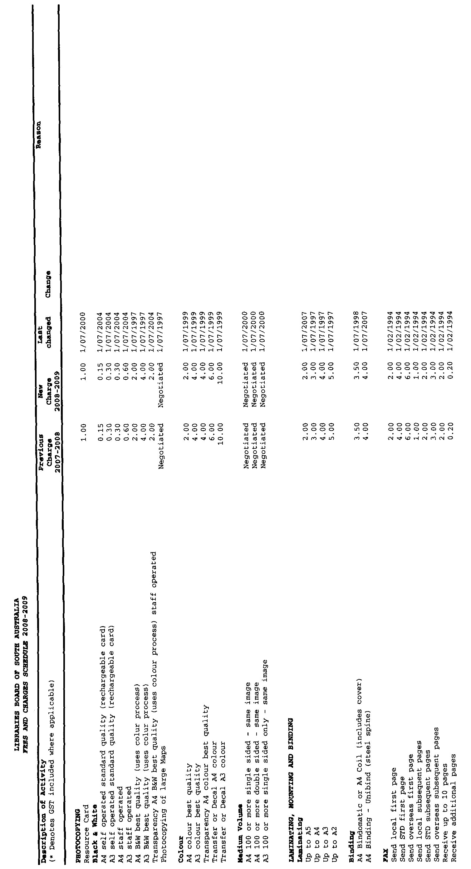
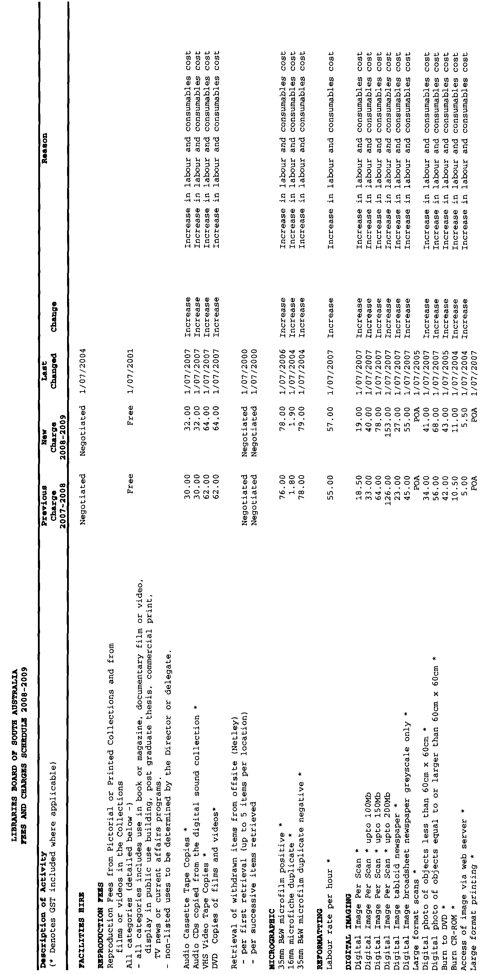
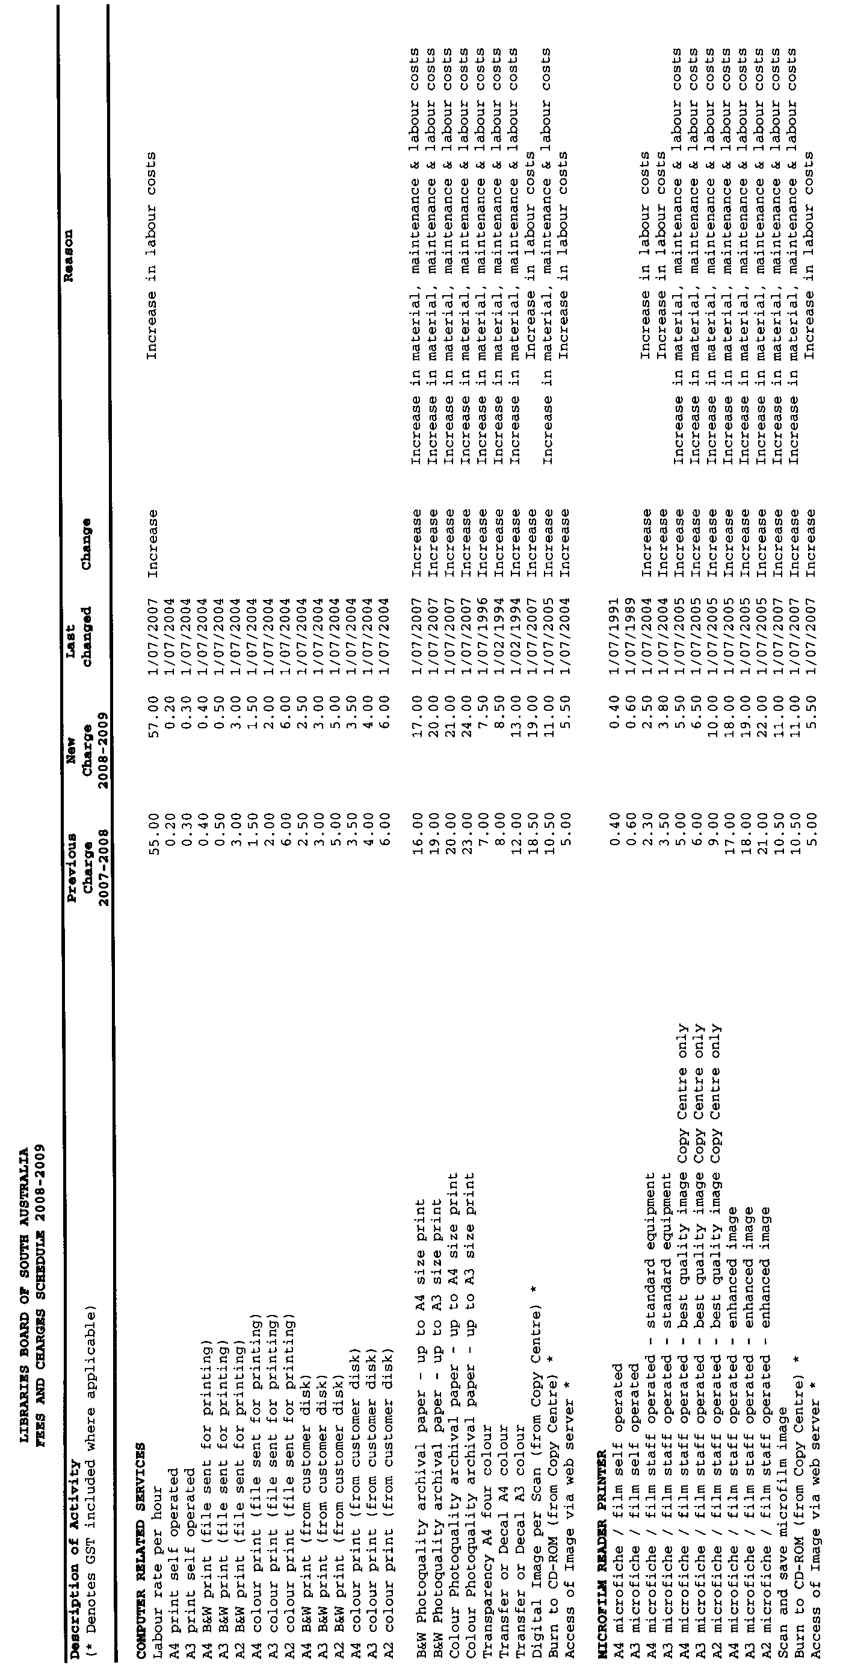
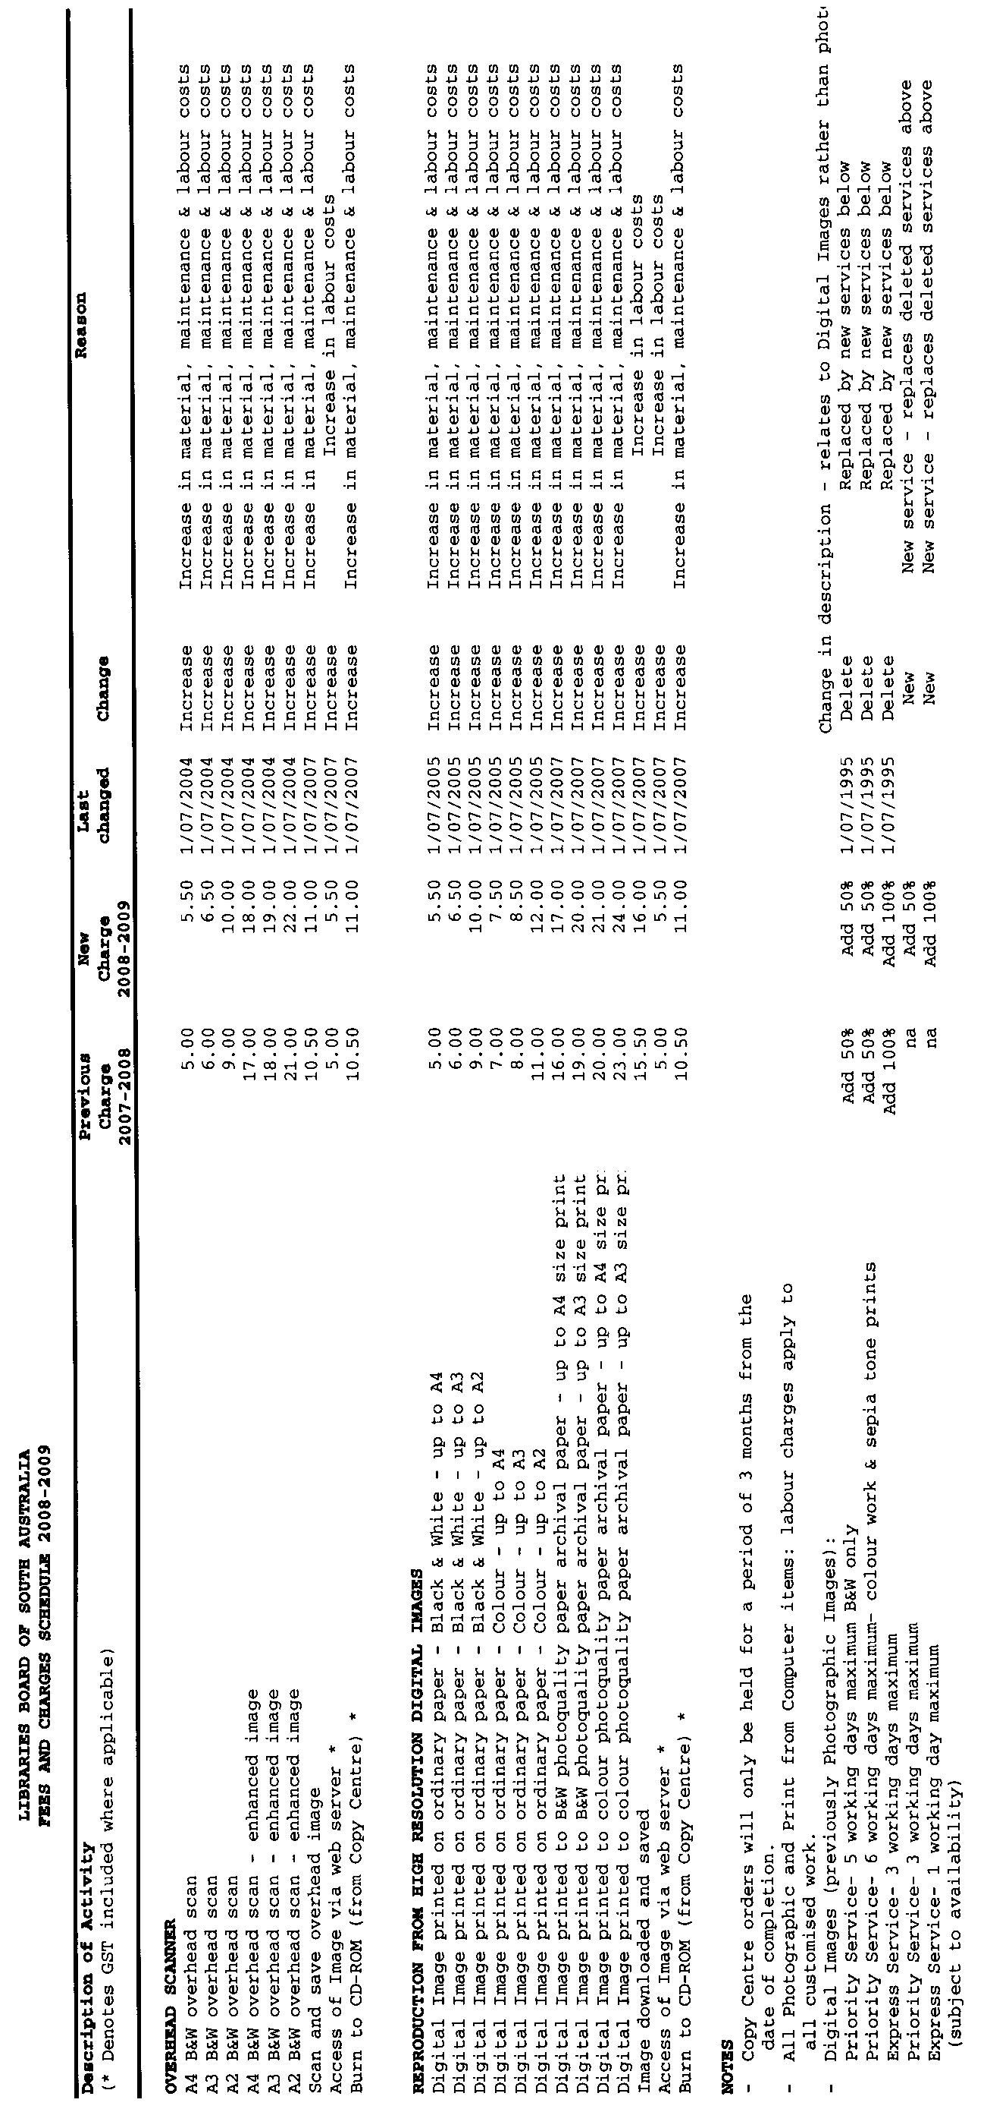
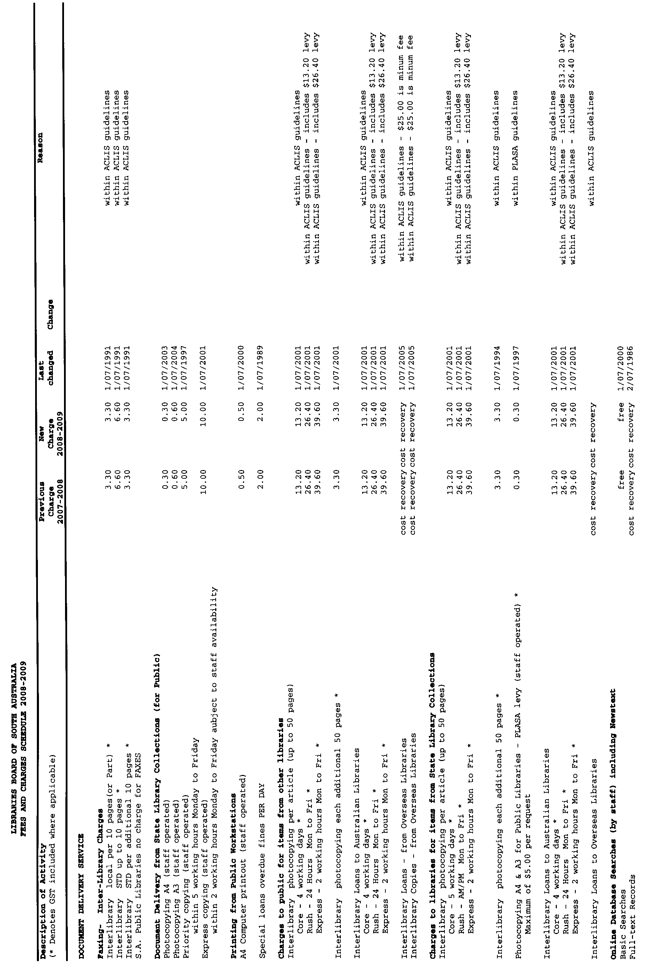
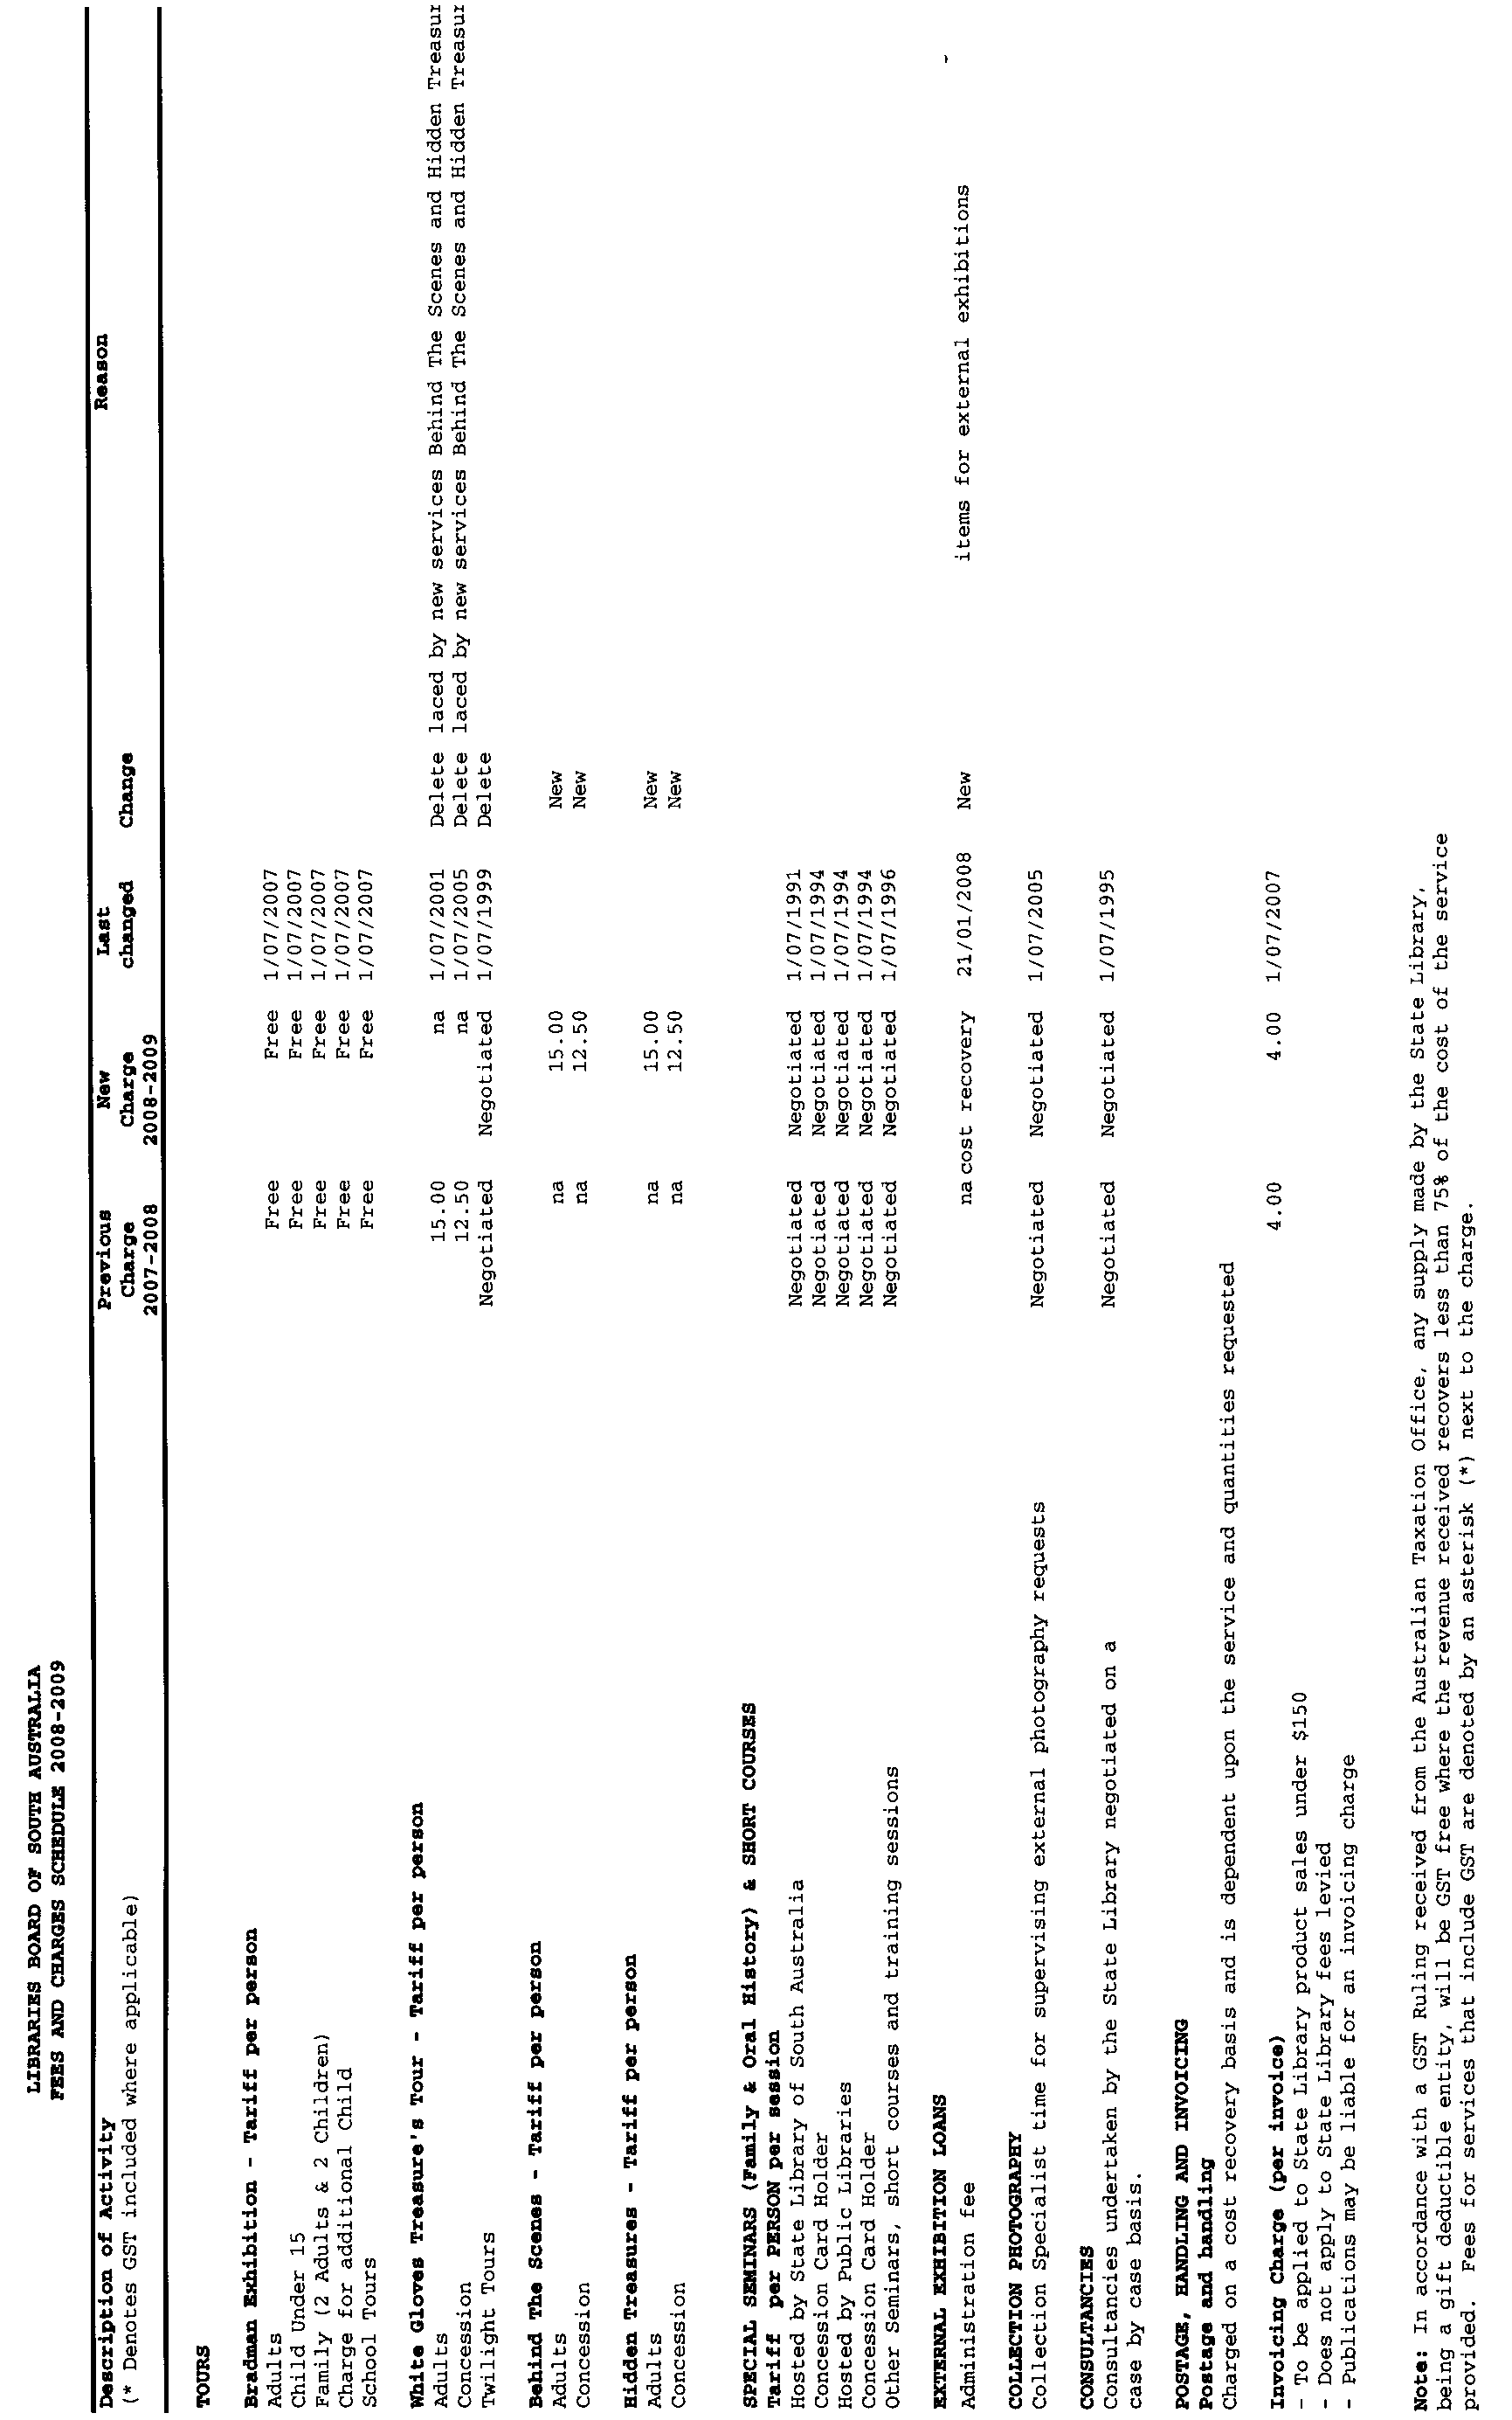

LIQUOR LICENSING ACT 1997
Notice of Application
NOTICE is hereby given, pursuant to section 52 (2) (b) of the Liquor Licensing Act 1997, that Stephen James Simpson and Catherine Rose Simpson have applied to the Licensing Authority for a Producer’s Licence in respect of premises situated at Lot 22, Saddleworth Road, Auburn, S.A. 5451 and to be known as Simpson Rices Creek.
The application has been set down for callover on 4 July 2008 at 9 a.m.
Any person may object to the application by lodging a notice of objection in the prescribed form with the Liquor and Gambling Commissioner and serving a copy of the notice on the applicants at the applicants’ address, at least seven days before the callover date (viz: 27 June 2008).
The applicants’ address for service is c/o Cathy Simpson, P.O. Box 126, Auburn, S.A. 5451.
Plans in respect of the premises the subject of the application are open to public inspection without fee at the Office of the Liquor and Gambling Commissioner, 9th Floor, East Wing, 50 Grenfell Street, Adelaide, S.A. 5000. Phone 8226 8410, Fax:
8226 8512. Email: olgc@agd.sa.gov.au.
Dated 26 May 2008.
Applicants

LIQUOR LICENSING ACT 1997
Notice of Application
NOTICE is hereby given, pursuant to section 52 (2) (b) of the Liquor Licensing Act 1997, that Mario Cutri has applied to the Licensing Authority for a Direct Sales Licence in respect of premises situated at 66 Julian Road, MacDonald Park, S.A. 5121 and to be known as Cutri Vineyards.
The application has been set down for callover on 4 July 2008 at 9 a.m.
Any person may object to the application by lodging a notice of objection in the prescribed form with the Liquor and Gambling Commissioner and serving a copy of the notice on the applicant at the applicant’s address, at least seven days before the callover date (viz: 27 June 2008).
The applicant’s address for service is c/o Mario Cutri, 24 McKenzie Crescent, Gulfview Heights, S.A. 5096.
Plans in respect of the premises the subject of the application are open to public inspection without fee at the Office of the Liquor and Gambling Commissioner, 9th Floor, East Wing, 50 Grenfell Street, Adelaide, S.A. 5000. Phone 8226 8410, Fax:
8226 8512. Email: olgc@agd.sa.gov.au.
Dated 26 May 2008.
Applicant

LIQUOR LICENSING ACT 1997
Notice of Application
NOTICE is hereby given, pursuant to section 52 (2) (b) of the Liquor Licensing Act 1997, that Dong Min Kim has applied to the Licensing Authority for a Retail Liquor Merchant’s Licence in respect of premises situated at 10A/291 Unley Road, Malvern, S.A. 5061 and to be known as Smile Grocery Mart.
The application has been set down for callover on 4 July 2008 at 9 a.m.
Any person may object to the application by lodging a notice of objection in the prescribed form with the Liquor and Gambling Commissioner and serving a copy of the notice on the applicant at the applicant’s address, at least seven days before the callover date (viz: 27 June 2008).
The applicant’s address for service is c/o Dong Min Kim, 10A/291 Unley Road, Malvern, S.A. 5061.
Plans in respect of the premises the subject of the application are open to public inspection without fee at the Office of the Liquor and Gambling Commissioner, 9th Floor, East Wing, 50 Grenfell Street, Adelaide, S.A. 5000. Phone 8226 8410, Fax:
8226 8512. Email: olgc@agd.sa.gov.au.
Dated 27 May 2008.
Applicant

LIQUOR LICENSING ACT 1997
Notice of Application
NOTICE is hereby given, pursuant to section 52 (2) (b) of the Liquor Licensing Act 1997, that R.S.L. Victor Harbor Sub-Branch Inc. has applied to the Licensing Authority for the removal of a Limited Club Licence in respect of premises situated at 7 Flinders Parade, Victor Harbor, S.A. 5211 and to be situated at 10 Coral Street, Victor Harbor, S.A. 5211 and known as RSL Victor Harbor Sub-Branch.
The application has been set down for callover on 4 July 2008 at 9 a.m.
Any person may object to the application by lodging a notice of objection in the prescribed form with the Liquor and Gambling Commissioner and serving a copy of the notice on the applicant at the applicant’s address, at least seven days before the callover date (viz: 27 June 2008).
The applicant’s address for service is c/o R.S.L. Victor Harbor Sub-Branch Inc., P.O. Box 170, Victor Harbor, S.A. 5211.
Plans in respect of the premises the subject of the application are open to public inspection without fee at the Office of the Liquor and Gambling Commissioner, 9th Floor, East Wing, 50 Grenfell Street, Adelaide, S.A. 5000. Phone 8226 8410, Fax:
8226 8512. Email: olgc@agd.sa.gov.au.
Dated 28 May 2008.
Applicant

LIQUOR LICENSING ACT 1997
Notice of Application
NOTICE is hereby given, pursuant to section 52 (2) (b) of the Liquor Licensing Act 1997, that Blaxland Vineyards Limited has applied to the Licensing Authority for a Wholesale Liquor Merchant’s Licence in respect of premises situated at 26 Greenock Road, Nuriootpa, S.A. 5355 and to be known as Blaxland Vineyards.
The application has been set down for callover on 4 July 2008 at 9 a.m.
Any person may object to the application by lodging a notice of objection in the prescribed form with the Liquor and Gambling Commissioner and serving a copy of the notice on the applicant at the applicant’s address, at least seven days before the callover date (viz: 27 June 2008).
The applicant’s address for service is c/o Blaxland Vineyards, 26 Greenock Road, Nuriootpa, S.A. 5355.
Plans in respect of the premises the subject of the application are open to public inspection without fee at the Office of the Liquor and Gambling Commissioner, 9th Floor, East Wing, 50 Grenfell Street, Adelaide, S.A. 5000. Phone 8226 8410, Fax:
8226 8512. Email: olgc@agd.sa.gov.au.
Dated 28 May 2008.
Applicant

LIQUOR LICENSING ACT 1997
Notice of Application
NOTICE is hereby given, pursuant to section 52 (2) (b) of the Liquor Licensing Act 1997, that The Sands Lifestyle Village Residents Association Inc. has applied to the Licensing Authority for a Limited Club Licence and Entertainment Consent in respect of premises situated at 670 Grand Boulevard, Seaford, S.A. 5169 and to be known as The Sands Lifestyle Village Residents Association Inc.
The application has been set down for callover on 4 July 2008 at 9 a.m.
Conditions
The following licence conditions are sought:
• Entertainment Consent:
Monday to Friday: Noon to 10.30 p.m.
Saturday: Noon to midnight
Sunday: Noon to 10.30 p.m.
Any person may object to the application by lodging a notice of objection in the prescribed form with the Liquor and Gambling Commissioner and serving a copy of the notice on the applicant at the applicant’s address, at least seven days before the callover date (viz: 27 June 2008).
The applicant’s address for service is c/o The Sands Lifestyle Village Residents Association Inc., 58/670 Grand Boulevard, Seaford, S.A. 5169.
Plans in respect of the premises the subject of the application are open to public inspection without fee at the Office of the Liquor and Gambling Commissioner, 9th Floor, East Wing, 50 Grenfell Street, Adelaide, S.A. 5000. Phone 8226 8410, Fax:
8226 8512. Email: olgc@agd.sa.gov.au.
Dated 29 May 2008.
Applicant

LIQUOR LICENSING ACT 1997
Notice of Application
NOTICE is hereby given, pursuant to section 52 (2) (b) of the Liquor Licensing Act 1997, that Australian Leisure and Hospitality Group Limited has applied to the Licensing Authority for variation to an Extended Trading Authorisation, Alterations and Redefinition in respect of premises situated at 130 Martins Road, Parafield Gardens, S.A. 5107 and known as Slug’N’Lettuce Tavern.
The application has been set down for callover on 4 July 2008 at 9 a.m.
Conditions
The following licence conditions are sought:
• Alterations and Redefinition to create an Outdoor Smoking Area as per plans lodged with this office.
• Currently approved Extended Trading Authorisation to apply to the abovementioned areas.
Any person may object to the application by lodging a notice of objection in the prescribed form with the Liquor and Gambling Commissioner and serving a copy of the notice on the applicant at the applicant’s address, at least seven days before the callover date (viz: 27 June 2008).
The applicant’s address for service is c/o Australian Leisure and Hospitality Group Limited, Level 1, 660-668 Port Road, Beverley, S.A. 5009.
Plans in respect of the premises the subject of the application are open to public inspection without fee at the Office of the Liquor and Gambling Commissioner, 9th Floor, East Wing, 50 Grenfell Street, Adelaide, S.A. 5000. Phone 8226 8410, Fax:
8226 8512. Email: olgc@agd.sa.gov.au.
Dated 30 May 2008.
Applicant

LIQUOR LICENSING ACT 1997
Notice of Application
NOTICE is hereby given, pursuant to section 52 (2) (b) of the Liquor Licensing Act 1997, that P. & J. Hurley Pty Ltd, Roo Pty Ltd, Goodthing Ent. Pty Ltd, Hurley/Symons Pty Ltd, Brien Marmion Pty Ltd, C. J. & K. J. Eitzenpty Pty Ltd have applied to the Licensing Authority for variation to an Extended Trading Authorisation, Redefinition and Alterations in respect of premises situated at 23 Regent Street, Kensington, S.A. 5068 and known as Kensington Hotel.
The application has been set down for callover on 4 July 2008 at 9 a.m.
Conditions
The following licence conditions are sought:
• Alterations and Redefinition to create an Outdoor Smokers Court on the north-western side of the hotel as per plans lodged with this office.
• Variation to Extended Trading Authorisation to include Area 8 and the abovementioned area.
• Extended Trading Authorisation Area 8 and the Outdoor Smokers Court is sought for the following times:
Sunday: 8 p.m. to 9 p.m.
Any person may object to the application by lodging a notice of objection in the prescribed form with the Liquor and Gambling Commissioner and serving a copy of the notice on the applicants at the applicants’ address, at least seven days before the callover date (viz: 27 June 2008).
The applicants’ address for service is c/o Fisher Jefferies, Craig Vozzo, G.P.O. Box 544, Adelaide, S.A. 5001.
Plans in respect of the premises the subject of the application are open to public inspection without fee at the Office of the Liquor and Gambling Commissioner, 9th Floor, East Wing, 50 Grenfell Street, Adelaide, S.A. 5000. Phone 8226 8410, Fax:
8226 8512. Email: olgc@agd.sa.gov.au.
Dated 2 June 2008.
Applicants

LIQUOR LICENSING ACT 1997
Notice of Application
NOTICE is hereby given, pursuant to section 52 (2) (b) of the Liquor Licensing Act 1997, that Belair Hotel (SA) Pty Ltd has applied to the Licensing Authority for Alterations, Redefinition, variation to an Extended Trading Authorisation, variation to Entertainment Consent and variation to Conditions in respect of premises situated at 141 Main Road, Blackwood, S.A. 5051 and known as Belair Hotel.
The application has been set down for callover on 4 July 2008 at 9 a.m.
Conditions
The following licence conditions are sought:
It is intended to relocate the existing Gaming Room to the south-western corner of the premises adjacent to the drive through and to extend the Dining Area to incorporate the existing Outdoor Area at the rear. A children’s room, lounge and new entry foyer will be provided on the southern side, adjacent to the Dining Area. Outdoor Smoking Courtyards are to be established at the rear of the Dining Area and at the western end of the Gaming Room.
The Extended Trading Authorisation is to include the front Outdoor Smoking Couryard on the days and during the times currently applying to Area 9, the new Gaming Room and lounge on the days and during the times currently applying to Area 4 and Area 6, to permit extended trading in the Dining Area each Sunday to Wednesday, inclusive to 1 a.m. the following morning in addition to the existing trading hours and to include the rear Outdoor Smoking Courtyard for the same extended trading days and times. The Extended Trading Authorisation is also to include Good Friday from midnight to 2 a.m. (an extension of Maundy Thursday trading).
The Entertainment Consent is to include the new Gaming Room, but entertainment will not be provided in the Outdoor Smoking Courtyards.
It is proposed to remove the conditions which relate to security and noise levels and which prohibit entertainment in Area 6 and to amend the condition referring to patrons in Areas 8, 9 and 10 to require them to be seated only when consuming liquor. All other licence conditions are to remain.
Any person may object to the application by lodging a notice of objection in the prescribed form with the Liquor and Gambling Commissioner and serving a copy of the notice on the applicant at the applicant’s address, at least seven days before the callover date (viz: 27 June 2008).
The applicant’s address for service is c/o Australian Hotels Association (SA Branch), 4th Floor, 60 Hindmarsh Square, Adelaide, S.A. 5000.
Plans in respect of the premises the subject of the application are open to public inspection without fee at the Office of the Liquor and Gambling Commissioner, 9th Floor, East Wing, 50 Grenfell Street, Adelaide, S.A. 5000. Phone 8226 8410, Fax:
8226 8512. Email: olgc@agd.sa.gov.au.
Dated 28 May 2008.
Applicant

LIQUOR LICENSING ACT 1997
Notice of Application
NOTICE is hereby given, pursuant to section 52 (2) (b) of the Liquor Licensing Act 1997, that Souphab Pty as trustee for the
D. & V. Family Trust has applied to the Licensing Authority for a Restaurant Licence in respect of premises situated at 211 Henley Beach Road, Torrensville, S.A. 5031 and to be known as Silk & Spice Thai Restaurant.
The application has been set down for callover on 4 July 2008 at 9 a.m.
Any person may object to the application by lodging a notice of objection in the prescribed form with the Liquor and Gambling Commissioner and serving a copy of the notice on the applicant at the applicant’s address, at least seven days before the callover date (viz: 27 June 2008).
The applicant’s address for service is c/o Vanthana Louaneviseth, 32 Kew Drive, Oakden, S.A. 5086.
Plans in respect of the premises the subject of the application are open to public inspection without fee at the Office of the Liquor and Gambling Commissioner, 9th Floor, East Wing, 50 Grenfell Street, Adelaide, S.A. 5000. Phone 8226 8410, Fax:
8226 8512. Email: olgc@agd.sa.gov.au.
Dated 28 May 2008.
Applicant

LIQUOR LICENSING ACT 1997
Notice of Application
NOTICE is hereby given, pursuant to section 52 (2) (b) of the Liquor Licensing Act 1997, that Helen Joy Hartwig and Brandon Myles Zeunert have applied to the Licensing Authority for the transfer of a Restaurant Licence in respect of premises situated at 37A Murray Street, Angaston, S.A. 5353 and known as Barossa Bistro.
The application has been set down for hearing on 7 July 2008 at 9 a.m.
Any person may object to the application by lodging a notice of objection in the prescribed form with the Liquor and Gambling Commissioner and serving a copy of the notice on the applicants at the applicants’ address, at least seven days before the hearing date (viz: 30 June 2008).
The applicants’ address for service is c/o Helen Hartwig, 66 Moculta Road, Angaston, S.A. 5353.
Plans in respect of the premises the subject of the application are open to public inspection without fee at the Office of the Liquor and Gambling Commissioner, 9th Floor, East Wing, 50 Grenfell Street, Adelaide, S.A. 5000. Phone 8226 8410, Fax:
8226 8512. Email: olgc@agd.sa.gov.au.
Dated 29 May 2008.
Applicants

LIQUOR LICENSING ACT 1997
Notice of Application
NOTICE is hereby given, pursuant to section 52 (2) (b) of the Liquor Licensing Act 1997, that Riji Company Pty Ltd has applied to the Licensing Authority for the transfer of a Restaurant Licence in respect of premises situated at 18A Jetty Road, Glenelg, S.A. 5045 and known as Yiros 777 Restaurant and to be known as Taiyangdao Chinese Restaurant.
The application has been set down for hearing on 7 July 2008 at 9.30 a.m.
Any person may object to the application by lodging a notice of objection in the prescribed form with the Liquor and Gambling Commissioner and serving a copy of the notice on the applicant at the applicant’s address, at least seven days before the hearing date (viz: 30 June 2008).
The applicant’s address for service is c/o Riji Company Pty Ltd, 6/94 Tynte Street, North Adelaide, S.A. 5006.
Plans in respect of the premises the subject of the application are open to public inspection without fee at the Office of the Liquor and Gambling Commissioner, 9th Floor, East Wing, 50 Grenfell Street, Adelaide, S.A. 5000. Phone 8226 8410, Fax:
8226 8512. Email: olgc@agd.sa.gov.au.
Dated 29 May 2008.
Applicant

MINING ACT 1971
NOTICE is hereby given in accordance with section 28 (5) of the Mining Act 1971, that the Minister for Mineral Resources Development proposes to grant an Exploration Licence over the undermentioned area:
Applicant: Athena Mines Pty Ltd
Location: Intercept Hill Area—Approximately 30 km north-east of Woomera.
Pastoral Lease: Lake Everard, Arcoona Station.
Term: 2 years
Area in km²: 423
Ref.: 2008/00170
Plan and co-ordinates can be found on the PIRSA Sarig website: http://www.minerals.pir.sa.gov.au/sarig or by phoning Mineral Tenements on (08) 8463 3103.
H. Tyrteos, Mining Registrar

MINING ACT 1971
NOTICE is hereby given in accordance with section 28 (5) of the Mining Act 1971, that the Minister for Mineral Resources Development proposes to grant an Exploration Licence over the undermentioned area:
Applicant: Minotaur Operations Pty Ltd
Location: Glyde Hill Area—Approximately 130 km north-east of Ceduna.
Pastoral Lease: Lake Everard and Kondoolka Stations.
Term: 1 year
Area in km²: 58
Ref.: 2008/00204
Plan and co-ordinates can be found on the PIRSA Sarig website: http://www.minerals.pir.sa.gov.au/sarig or by phoning Mineral Tenements on (08) 8463 3103.
H. Tyrteos, Mining Registrar

MINING ACT 1971
NOTICE is hereby given in accordance with section 28 (5) of the Mining Act 1971, that the Minister for Mineral Resources Development proposes to grant an Exploration Licence over the undermentioned area:
Applicant: Minotaur Operations Pty Ltd
Location: Chitanilga Hill Area—Approximately 150 km west of Woomera.
Pastoral Lease: Lake Everard, Wilgena and Kokatha Stations.
Term: 1 year
Area in km²: 335
Ref.: 2008/00205
Plan and co-ordinates can be found on the PIRSA Sarig website: http://www.minerals.pir.sa.gov.au/sarig or by phoning Mineral Tenements on (08) 8463 3103.
H. Tyrteos, Mining Registrar

MINING ACT 1971
PURSUANT to section 15 (5) of the Mining Act 1971 (‘Act’), I advise that the Minerals and Energy Division of Primary Industries and Resources SA, will continue to undertake geoscientific investigations over an area of approximately 390 km² in the Old Ediacara area, approximately 25 km west of Leigh Creek. The investigations commenced on 7 December 2006 (refer Government Gazette 7 December 2006), and the expected completion date has been extended to 30 June 2009.
Pursuant to section 15 (7) of the Act, I hereby advise that applications for mining tenements may not be received or considered in respect of the land described above until the completion date of 30 June 2009.
Please note that the completion date may be extended by further notice in the Gazette. Copies of the plan are available by phoning the Mining Registrar on telephone (08) 8463 3097.
Reference: T2632.
H. Tyrteos, Mining Registrar

NATIONAL PARKS AND WILDLIFE (NATIONAL PARKS) REGULATIONS 2001
Closure of Flinders Chase National Park
PURSUANT to Regulations 8 (3) (a), 8 (3) (d) of the National Parks and Wildlife (National Parks) Regulations 2001, I, Edward Gregory Leaman, Director of National Parks and Wildlife close to the public, the following part of Flinders Chase National Park from 4 p.m. on Tuesday, 17 June 2008 until 9 a.m. on Friday, 20 June 2008:
Breakneck River Mouth to Sandy Creek Mouth area, closed within the following co-ordinates:
Breakneck River Mouth to Sandy Creek Mouth⎯
642400N, 6022400E to 646700N, 6019500E following coastline at low water mark.
Sandy Creek Mouth to Sandy Creek Hike trailhead⎯
646700N, 6019500E to 647500N, 6020650E following a line defined by Sandy Creek Hike.
Sandy Creek Hike trailhead to 646300N line⎯
647500N, 6020650E to 646300N, 6021300E direct line between two co-ordinates.
646300N line to Breakneck River Hike trailhead⎯
646300N, 6021300E to 645300N, 6022900E direct line between two co-ordinates.
Breakneck River Hike trailhead to Breakneck River Mouth⎯
645300N, 6022900E to 642400N, 6022400E following a line defined by Breakneck River Hike.
West Bay Road:
Sandy Creek Crossing to Breakneck River Hike trailhead⎯
647500N, 6020650E to 645300N, 6022900E following a line defined by West Bay Road.
Northings and Eastings are in Universal Transverse Mercator Projection, Zone 53, Datum: Geocentric Datum of Australia 1994.
The purpose of the closure is to ensure the safety of the public during a pest control and monitoring program within the reserve during the period indicated.
Use of Firearms within the Reserve
Pursuant to Regulations 8 (4), 20 (1) and 41 of the National Parks Regulations 2001, I, Edward Gregory Leaman, Director of National Parks and Wildlife grant permission to staff employed by the Kangaroo Island Natural Resources Management Board, in possession of both a current hunting permit and a firearm to enter and remain in Flinders Chase National Park from 4 p.m. on Tuesday, 17 June 2008 until 9 a.m. on Friday, 20 June 2008 for the purpose of taking feral animals.
This permission is conditional upon the observance by each of those persons of the requirements of the National Parks and Wildlife Act 1972, National Parks Regulations 2001, and the National Parks and Wildlife (Hunting) Regulations 1996, including those requiring compliance with the Director’s requests, requirements and orders of a Warden.
Dated 3 June 2008.
E. G. Leaman, Director of National Parks and Wildlife

NATIONAL PARKS AND WILDLIFE (NATIONAL PARKS) REGULATIONS 2001
Closure of Flinders Chase National Park
PURSUANT to Regulations 8 (3) (a), 8 (3) (d) of the National Parks and Wildlife (National Parks) Regulations 2001, I, Edward Gregory Leaman, Director of National Parks and Wildlife close to the public, the following part of Flinders Chase National Park from 4 p.m. on Monday, 16 June 2008 until 9 a.m. on Thursday, 19 June 2008:
Sandy Creek Mouth to Rocky River Mouth area, closed within the following co-ordinates:
Sandy Creek Mouth to Rocky River Mouth⎯
646700N, 6019500E to 648900N, 6018400E following coastline at low water mark.
Rocky River Mouth to Snake Lagoon turnoff⎯
648900N, 6018400E to 649650N, 6020700E following a line defined by Snake Lagoon Hike and vehicle access road into Snake Lagoon.
Snake Lagoon turnoff to Sandy Creek Hike trailhead⎯
649650N, 6020700E to 647500N, 6020650E direct line between two co-ordinates.
Sandy Creek Hike trailhead to Sandy Creek Mouth ⎯
647500N, 6020650E to 646700N, 6019500E following a line defined by Sandy Creek Hike
Northings and Eastings are in Universal Transverse Mercator Projection, Zone 53, Datum: Geocentric Datum of Australia 1994.
The purpose of the closure is to ensure the safety of the public during a pest control and monitoring program within the reserve during the period indicated.
Use of Firearms within the Reserve
Pursuant to Regulations 8 (4), 20 (1) and 41 of the National Parks Regulations 2001, I, Edward Gregory Leaman, Director of National Parks and Wildlife grant permission to staff employed by the Kangaroo Island Natural Resources Management Board, in possession of both a current hunting permit and a firearm to enter and remain in Flinders Chase National Park from 4 p.m. on Monday, 16 June 2008 until 9 a.m. on Thursday, 19 June 2008 for the purpose of taking feral animals.
This permission is conditional upon the observance by each of those persons of the requirements of the National Parks and Wildlife Act 1972, National Parks Regulations 2001, and the National Parks and Wildlife (Hunting) Regulations 1996, including those requiring compliance with the Director’s requests, requirements and orders of a Warden.
Dated 3 June 2008.
E. G. Leaman, Director of National Parks and Wildlife

NATIONAL PARKS AND WILDLIFE (NATIONAL PARKS) REGULATIONS 2001
Closure of Flinders Chase National Park
PURSUANT to Regulations 8 (3) (a), 8 (3) (d) of the National Parks and Wildlife (National Parks) Regulations 2001, I, Edward Gregory Leaman, Director of National Parks and Wildlife close to the public, the following part of Flinders Chase National Park from 4 p.m. on Sunday, 15 June 2008 until 9 a.m. on Wednesday, 18 June 2008:
Cape du Couedic North to Rocky River Mouth area, closed within the following co-ordinates:
Cape du Couedic North to Rocky River Mouth⎯
653650N, 6010000E to 648900N, 6018400E following coastline at low water mark.
Rocky River Mouth to Snake Lagoon turnoff⎯
648900N, 6018400E to 649650N, 6020700E following a line defined by Snake Lagoon Hike and vehicle access road into Snake Lagoon.
Snake Lagoon turnoff to 654000N line⎯
649650N, 6020700E to 654000N, 6019800E direct line between two co-ordinates.
654000N line (North to South)⎯
654000N, 6019800E to 654000N, 6010000E direct line between two co-ordinates.
6010000E line (East to West)⎯
654000N, 6010000E to 653650N, 6010000E direct line between two co-ordinates.
Northings and Eastings are in Universal Transverse Mercator Projection, Zone 53, Datum: Geocentric Datum of Australia 1994.
The purpose of the closure is to ensure the safety of the public during a pest control and monitoring program within the reserve during the period indicated.
Use of Firearms within the Reserve
Pursuant to Regulations 8 (4), 20 (1) and 41 of the National Parks Regulations 2001, I, Edward Gregory Leaman, Director of National Parks and Wildlife grant permission to staff employed by the Kangaroo Island Natural Resources Management Board, in possession of both a current hunting permit and a firearm to enter and remain in Flinders Chase National Park from 4 p.m. on Sunday, 15 June 2008 until 9 a.m. on Wednesday, 18 June 2008 for the purpose of taking feral animals.
This permission is conditional upon the observance by each of those persons of the requirements of the National Parks and Wildlife Act 1972, National Parks Regulations 2001, and the National Parks and Wildlife (Hunting) Regulations 1996, including those requiring compliance with the Director’s requests, requirements and orders of a Warden.
Dated 3 June 2008.
E. G. Leaman, Director of National Parks and Wildlife

NATIONAL PARKS AND WILDLIFE (NATIONAL PARKS) REGULATIONS 2001
Closure of Flinders Chase National Park
PURSUANT to Regulations 8 (3) (a), 8 (3) (d) of the National Parks and Wildlife (National Parks) Regulations 2001, I, Edward Gregory Leaman, Director of National Parks and Wildlife close to the public, the following part of Flinders Chase National Park from 4 p.m. on Wednesday, 18 June 2008 until 9 a.m. on Saturday, 21 June 2008:
West Bay Beach to Breakneck River Mouth area, closed within the following co-ordinates:
West Bay Beach to Breakneck River Mouth⎯
639850N, 6027250E to 642400N, 6022400E following coastline at low water mark.
Breakneck River Mouth to Breakneck River Hike trailhead⎯
642400N, 6022400E to 645300N, 6022900E following a line defined by Breakneck River Hike.
Breakneck River Hike trailhead to West Bay Beach⎯
645300N, 6022900E to 639850N, 6027250E following a line defined by West Bay Road.
West Bay Road:
Sandy Creek Crossing to Breakneck River Hike trailhead⎯
647500N, 6020650E to 645300N, 6022900E following a line defined by West Bay Road.
Northings and Eastings are in Universal Transverse Mercator Projection, Zone 53, Datum: Geocentric Datum of Australia 1994.
The purpose of the closure is to ensure the safety of the public during a pest control and monitoring program within the reserve during the period indicated.
Use of Firearms within the Reserve
Pursuant to Regulations 8 (4), 20 (1) and 41 of the National Parks Regulations 2001, I, Edward Gregory Leaman, Director of National Parks and Wildlife grant permission to staff employed by the Kangaroo Island Natural Resources Management Board, in possession of both a current hunting permit and a firearm to enter and remain in Flinders Chase National Park from 4 p.m. on Wednesday, 18 June 2008 until 9 a.m. on Saturday, 21 June 2008 for the purpose of taking feral animals.
This permission is conditional upon the observance by each of those persons of the requirements of the National Parks and Wildlife Act 1972, National Parks Regulations 2001, and the National Parks and Wildlife (Hunting) Regulations 1996, including those requiring compliance with the Director’s requests, requirements and orders of a Warden.
Dated 3 June 2008.
E. G. Leaman, Director of National Parks and Wildlife

PASSENGER TRANSPORT ACT 1994
Passenger Transport (Regular Passenger Services—
Fares and Charges)
Notice
PURSUANT to its powers under the Passenger Transport Act 1994 and Regulations, the Minister has determined that the fares and charges to be paid by passengers on regular passenger services within Metropolitan Adelaide will be the fares and charges in Schedule 1 below.
These fares and charges will be effective from 6 July 2008.

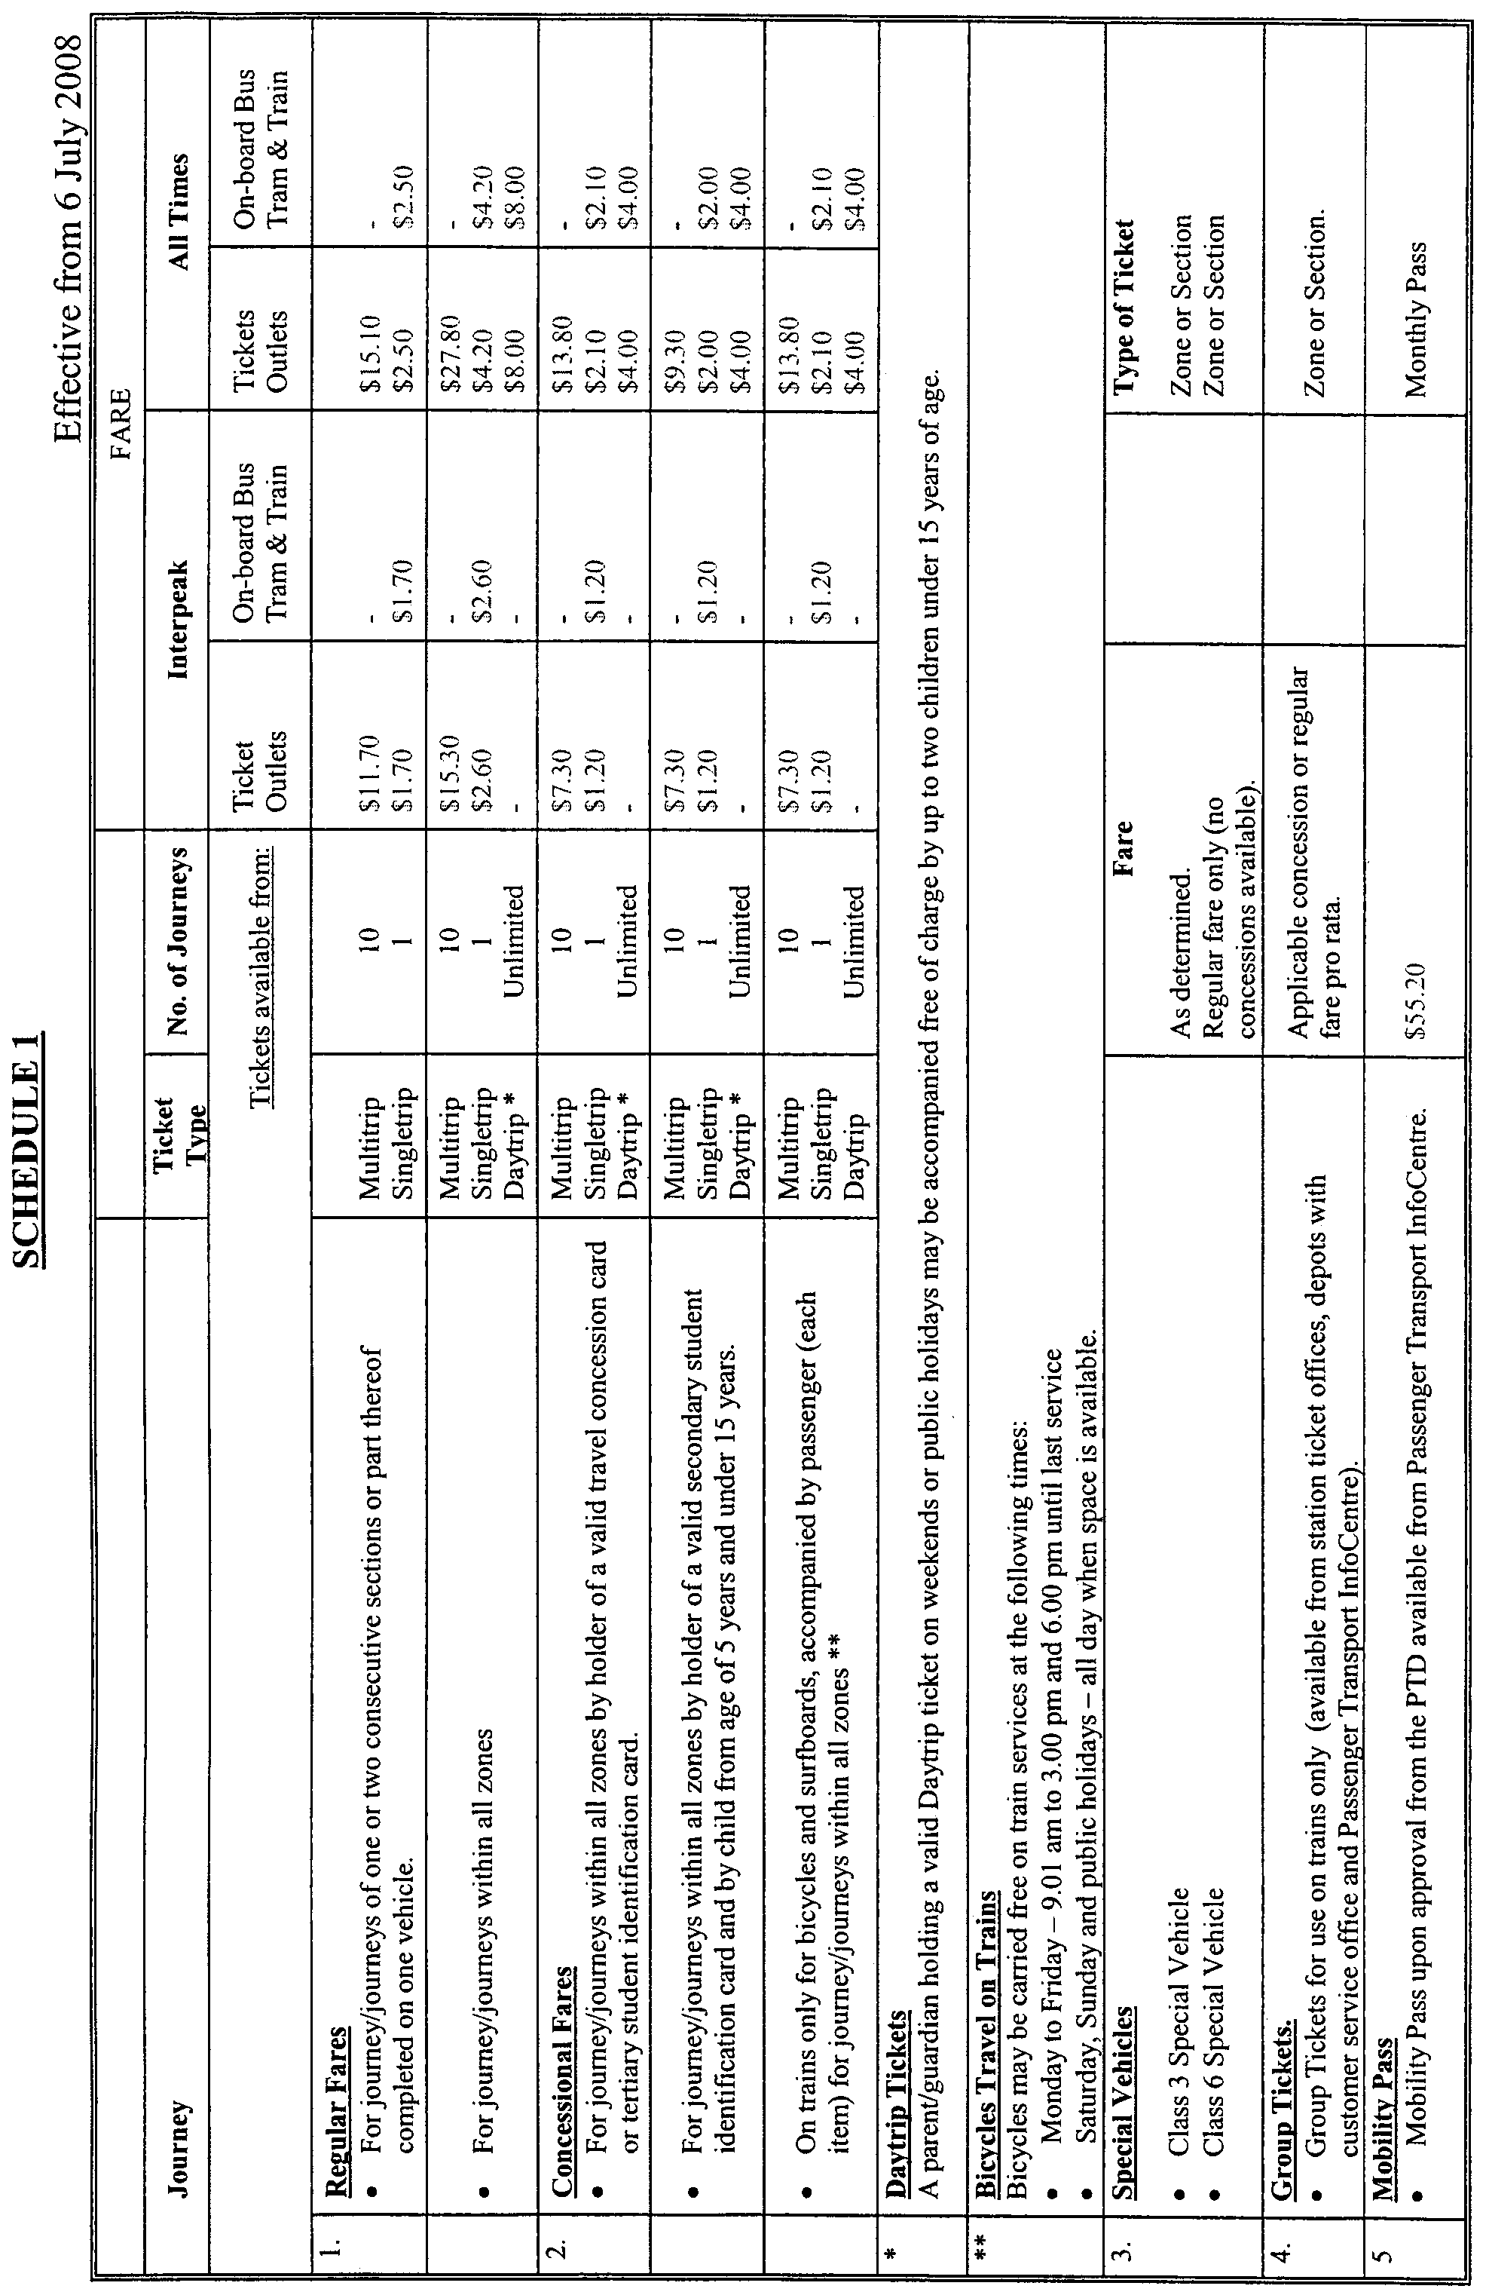
H. Webster, Executive Director, Public Transport Division, DTEI

PETROLEUM ACT 2000
Notice of Invitation of Applications for an Exploration Licence
I, BARRY ALAN GOLDSTEIN, Director Petroleum and Geothermal, Minerals and Energy Resources, Department of Primary Industries and Resources in the State of South Australia, pursuant to the provisions of the Petroleum Act 2000, and pursuant to delegated powers dated 28 March 2002, gazetted 11 April 2002, page 1573 and in accordance with section 22 (1) of the Petroleum Act 2000, on behalf of the Minister for Mineral Resources Development (Minister) hereby invite applications for the grant of an Exploration Licence in respect of the areas described below and shown on the attached plan.
OT2008-D
Description of Area
All that part of the State of South Australia, bounded as follows:
Area 1—Commencing at a point being the intersection of latitude 37°42′20″S GDA94 and longitude 140°32′30″E GDA94, thence east to longitude 140°41′00″E GDA94, south to latitude 37°43′00″S GDA94, east to longitude 140°44′00″E GDA94, south to latitude 37°44′00″S GDA94, east to longitude 140°45′00″E GDA94, south to latitude 37°45′00″S GDA94, thence east to the eastern border of the State of South Australia, thence southerly along the border of the said State to latitude 37°49′00″S GDA94, west to longitude 140°51′00″E GDA94, south to latitude 37°50′00″S GDA94, west to longitude 140°45′00″E GDA94, south to latitude 37°51′00″S GDA94, west to longitude 140°37′30″E GDA94, north to latitude 37°45′30″S GDA94, west to longitude 140°32′30″E GDA94 and north to point of commencement.
Area 2—Commencing at a point being the intersection of latitude 38°00′00″S AGD66 and longitude 140°52′30″E AGD66, thence east to the eastern border of the State of South Australia, thence southerly along the border of the said State to the Territorial Sea Baseline, Southern Ocean, thence generally westerly along the said Baseline to longitude 140°52′30″E AGD66 and north to the point of commencement but excluding the Lower Glenelg River Conservation Park and the Piccaninnie Ponds Conservation Park.
Area: 408 km² approximately.
Special Conditions
Licence Term
The PEL will be offered for a five-year term with a right of renewal for a further five-year term at the end of the initial five-year term, with a compulsory relinquishment of 50% of initial area at renewal.
Security
A minimum $50 000 security (amount subject to review) will be required to be lodged by the licensee prior to entering the guaranteed licence term in which seismic or well activities are planned.
Applications
Applications lodged under section 65 (1) of the Petroleum Act 2000, are required to be made in the approved form as identified on the DVD ‘Otway Basin Acreage Release OT 2008-A, B, C and D’ (can be ordered from: www.petroleum.pir.sa.gov.au or the Director Petroleum and Geothermal at the address below):
Applications:
• must satisfy the requirements of Regulation 4 of the Regulations under the Petroleum Act 2000;
• must be accompanied by a proposed work program for the first 5 year term of the licence;
• must be accompanied by a statement of the financial and technical resources available to the applicant; and
• must be accompanied by the scheduled application fee.
Applications close at 4 p.m. on Thursday, 27 November 2008 (Australian Central Daylight Time).
The following special instructions for lodgement of applications should be observed:
• the application and supporting data, together with the scheduled application fee of $3 328, payable to the Department of Primary Industries and Resources SA, should be sealed in a plain envelope or package and clearly marked as ‘Application for Area OT 2008-D—Commercial-in-Confidence’;
• the envelope or package should then be enclosed in another envelope and posted, or delivered by hand to:
Director Petroleum and Geothermal
Minerals and Energy Resources
Department of Primary Industries and Resources SA
Level 7, 101 Grenfell Street
Adelaide, S.A. 5000
Copies of the basic exploration data pertaining to the area comprising this notice are available from the Petroleum and Geothermal Group of the Department of Primary Industries and Resources SA. Enquiries may be directed to Barry Goldstein, Director Petroleum and Geothermal (Telephone (08) 8463 3200; email: Goldstein.Barry@saugov.sa.gov.au).
Criteria for Assessment of Applications
The winning bidder will be selected on the basis of the five year work program bid. The work program must include a statement of exploratory operations the applicant proposes to carry out in each year of the first five-year licence term. The aim of the work program is to evaluate the prospectivity of the licence area and discover regulated resources. It is expected that at least one petroleum exploration well would be included in the five-year work program.
Bids will be assessed taking account of the criteria listed below. It is important to note that the timing of well drilling and seismic acquisition will be taken into account. The most important criteria for assessment of OT2008-D work program is:
• the number of exploration wells to be drilled in the licence area (development wells are not considered);
• the number of years the applicant is prepared to guarantee the program;
• the extent to which proposed wells are supported by seismic data;
• the amount and nature of seismic surveying to be carried out and its timing;
• other data acquisition (e.g. gravity, aeromagnetic or geochemical surveys);
• seismic reprocessing to be carried out;
• adequacy of financial resources and technical expertise available to the applicant; and
• the applicant’s past performance in fulfilling work program commitments elsewhere in Australia.
The Minister will announce the winning bidder, together with details of the work program.
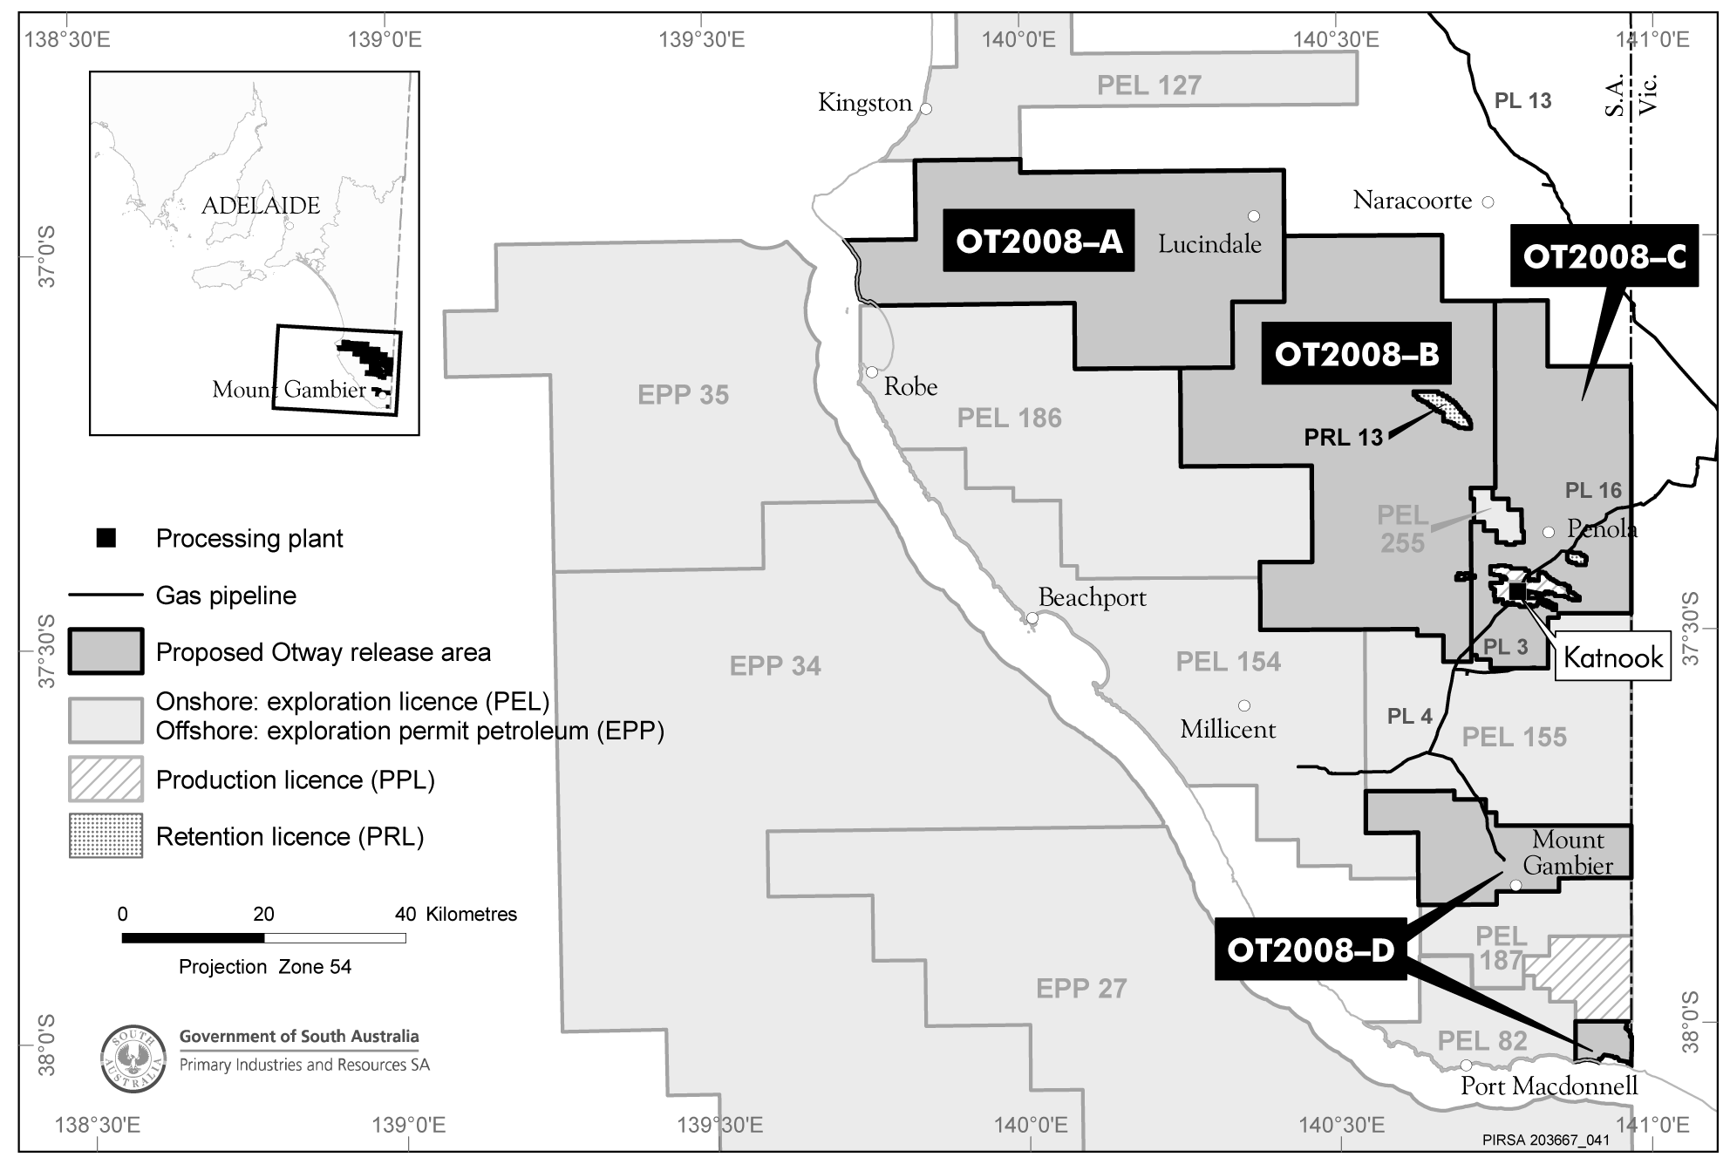
Dated 3 June 2008.
B. A. Goldstein, Director Petroleum and Geothermal
Minerals and Energy Resources
Primary Industries and Resources SA
Delegate of the Minister for Mineral Resources Development

PETROLEUM ACT 2000
Grant of Geothermal Exploration Licences
NOTICE is hereby given that the undermentioned Geothermal Exploration Licences have been granted with effect from and including
24 January 2007, under the provisions of the Petroleum Act 2000, pursuant to delegated powers dated 28 March 2002, Gazetted 11 April 2002, page 1573.
No. of  Licence | Licensee | Locality | Date of Expiry | Reference
GEL 316 | Clean Energy Australasia Pty Ltd | Cooper Basin, South Australia | 1 June 2013 | 27/2/489
GEL 317 | Clean Energy Australasia Pty Ltd | Cooper Basin, South Australia | 1 June 2013 | 27/2/489
GEL 318 | Clean Energy Australasia Pty Ltd | Cooper Basin, South Australia | 1 June 2013 | 27/2/489
GEL 319 | Clean Energy Australasia Pty Ltd | Cooper Basin, South Australia | 1 June 2013 | 27/2/489
GEL 320 | Clean Energy Australasia Pty Ltd | Cooper Basin, South Australia | 1 June 2013 | 27/2/489
GEL 322 | Clean Energy Australasia Pty Ltd | Cooper Basin, South Australia | 1 June 2013 | 27/2/489
GEL 323 | Clean Energy Australasia Pty Ltd | Cooper Basin, South Australia | 1 June 2013 | 27/2/489
GEL 324 | Clean Energy Australasia Pty Ltd | Cooper Basin, South Australia | 1 June 2013 | 27/2/525
GEL 390 | Clean Energy Australasia Pty Ltd | Cooper Basin, South Australia | 1 June 2013 | 27/2/525
GEL 391 | Clean Energy Australasia Pty Ltd | Cooper Basin, South Australia | 1 June 2013 | 27/2/525
GEL 392 | Clean Energy Australasia Pty Ltd | Cooper Basin, South Australia | 1 June 2013 | 27/2/525
Description of Area—GEL 316
All that part of the State of South Australia, bounded as follows:
Commencing at a point being the intersection of latitude 27°19′00″S GDA94 and longitude 140°47′00″E GDA94, thence east to longitude 140°52′00″E GDA94, south to latitude 27°22′00″S GDA94, east to longitude 140°53′00″E GDA94, south to latitude 27°23′00″S GDA94, east to the eastern border of the State of South Australia, thence southerly along the border of the said State to latitude 27°35′00″S GDA94, west to longitude 140°50′00″E GDA94, north to latitude 27°33′00″S GDA94, west to longitude 140°49′30″E GDA94, north to latitude 27°30′00″S GDA94, west to longitude 140°47′00″E GDA94 and north to point of commencement.
Area: 496 km² approximately.
Description of Area—GEL 317
All that part of the State of South Australia, bounded as follows:
Commencing at a point being the intersection of latitude 28°19′00″S GDA94 and longitude 140°41′00″E GDA94, thence east to longitude 140°45′00″E GDA94, south to latitude 28°30′00″S GDA94, east to longitude 140°51′00″E GDA94, north to latitude 28°20′00″S GDA94, east to longitude 140°56′00″E GDA94, south to latitude 28°25′00″S GDA94, east to longitude 140°57′00″E GDA94, south to latitude 28°26′00″S GDA94, east to the eastern border of the State of South Australia, thence southerly along the border of the said State to latitude 28°32′00″S GDA94, west to longitude 140°57′00″E GDA94, south to latitude 28°33′00″S GDA94, west to longitude 140°41′00″E GDA94 and north to point of commencement.
Area: 496 km² approximately.
Description of Area—GEL 318
All that part of the State of South Australia, bounded as follows:
Commencing at a point being the intersection of latitude 28°19′00″S GDA94 and longitude 140°33′00″E GDA94, thence east to longitude 140°41′00″E GDA94, south to latitude 28°40′00″S GDA94, west to longitude 140°35′00″E GDA94, north to latitude 28°39′00″S GDA94, west to longitude 140°34′00″E GDA94, north to latitude 28°38′00″S GDA94, west to longitude 140°33′00″E GDA94 and north to the point of commencement.
Area: 497 km² approximately.
Description of Area—GEL 319
All that part of the State of South Australia, bounded as follows:
Commencing at a point being the intersection of latitude 28°24′30″S GDA94 and longitude 140°02′00″E GDA94, thence east to longitude 140°27′00″E GDA94, south to latitude 28°28′00″S GDA94, west to longitude 140°14′00″E GDA94, south to latitude 28°32′00″S GDA94, west to longitude 140°08′00″E GDA94, south to latitude 28°33′00″S GDA94, west to longitude 139°57′00″E GDA94, north to latitude 28°31′00″S GDA94, east to longitude 139°57′30″E GDA94, north to latitude 28°28′00″S GDA94, east to longitude 140°02′00″E GDA94 and north to the point of commencement.
Area: 497 km² approximately.
Description of Area—GEL 320
All that part of the State of South Australia, bounded as follows:
Commencing at a point being the intersection of latitude 28°09′00″S GDA94 and longitude 139°47′00″E GDA94, thence east to longitude 140°02′00″E GDA94, south to latitude 28°18′00″S GDA94, west to longitude 139°52′00″E GDA94, south to latitude 28°20′00″S GDA94, west to longitude 139°46′00″E GDA94, north to latitude 28°12′00″S GDA94, east to longitude 139°47′00″E GDA94 and north to the point of commencement.
Area: 462 km² approximately.
Description of Area—GEL 322
All that part of the State of South Australia, bounded as follows:
Commencing at a point being the intersection of latitude 28°06′00″S GDA94 and longitude 139°35′00″E GDA94, thence east to longitude 139°52′00″E GDA94, south to latitude 28°09′00″S GDA94, west to longitude 139°47′00″E GDA94, south to latitude 28°12′00″S GDA94, west to longitude 139°46′00″E GDA94, south to latitude 28°20′00″S GDA94, west to longitude 139°41′00″E GDA94, north to latitude 28°17′00″S GDA94, west to longitude 139°37′00″E GDA94, north to latitude 28°16′00″S GDA94, west to longitude 139°35′00″E GDA94 and north to the point of commencement.
Area: 468 km² approximately.
Description of Area—GEL 323
All that part of the State of South Australia, bounded as follows:
Commencing at a point being the intersection of latitude 27°27′00″S GDA94 and longitude 140°16′00″E GDA94, thence east to longitude 140°22′00″E GDA94, south to latitude 27°33′00″S GDA94, east to longitude 140°23′00″E GDA94, south to latitude 27°39′00″S GDA94, west to longitude 140°22′00″E GDA94, south to latitude 27°40′00″S GDA94, west to longitude 140°21′00″E GDA94, south to latitude 27°41′00″S GDA94, west to longitude 140°20′00″E GDA94, south to latitude 27°42′00″S GDA94, west to longitude 140°17′00″E GDA94, south to latitude 27°43′00″S GDA94, west to longitude 140°15′00″E GDA94, south to latitude 27°44′00″S GDA94, west to longitude 140°14′00″E GDA94, south to latitude 27°45′00″S GDA94, west to longitude 140°13′00″E GDA94, north to latitude 27°42′00″S GDA94, west to longitude 140°10′00″E GDA94, north to latitude 27°32′00″S GDA94, east to longitude 140°14′00″E GDA94, north to latitude 27°30′00″S GDA94, east to longitude 140°16′00″E GDA94 and north to the point of commencement.
Area: 498 km² approximately.
Description of Area—GEL 324
All that part of the State of South Australia, bounded as follows:
Commencing at a point being the intersection of latitude 27°25′00″S GDA94 and longitude 140°39′00″E GDA94, thence east to longitude 140°47′00″E GDA94, south to latitude 27°30′00″S GDA94, west to longitude 140°36′00″E GDA94, south to latitude 27°31′00″S GDA94, west to longitude 140°35′00″E GDA94, south to latitude 27°37′00″S GDA94, west to longitude 140°33′00″E GDA94, south to latitude 27°38′00″S GDA94, west to longitude 140°23′00″E GDA94, north to latitude 27°33′00″S GDA94, west to longitude 140°22′00″E GDA94, north to latitude 27°29′00″S GDA94, east to longitude 140°35′00″E GDA94, north to latitude 27°27′00″S GDA94, east to longitude 140°38′00″E GDA94, north to latitude 27°26′00″S GDA94, east to longitude 140°39′00″E GDA94 and north to the point of commencement.
Area: 498 km² approximately.
Description of Area—GEL 390
All that part of the State of South Australia, bounded as follows:
Commencing at a point being the intersection of latitude 27°49′00″S GDA94 and longitude 139°16′00″E GDA94, thence east to longitude 139°30′00″E GDA94, south to latitude 27°57′00″S GDA94, west to longitude 139°25′00″E GDA94, south to latitude 28°00′00″S GDA94, west to longitude 139°18′00″E GDA94, north to latitude 27°59′00″S GDA94, west to longitude 139°13′00″E GDA94, north to latitude 27°50′00″S GDA94, east to longitude 139°16′00″E GDA94 and north to the point of commencement.
Area: 497 km² approximately.
Description of Area—GEL 391
All that part of the State of South Australia, bounded as follows:
Commencing at a point being the intersection of latitude 27°49′00″S GDA94 and longitude 139°30′00″E GDA94, thence east to longitude 139°42′00″E GDA94, south to latitude 28°00′00″S GDA94, west to longitude 139°36′00″E GDA94, south to latitude 28°05′00″S AGD66, west to longitude 139°29′00″E GDA94, north to latitude 28°03′00″S GDA94, east to longitude 139°30′00″E GDA94 and north to the point of commencement.
Area: 495 km² approximately.
Description of Area—GEL 392
All that part of the State of South Australia, bounded as follows:
Commencing at a point being the intersection of latitude 27°57′00″S GDA94 and longitude 139°25′00″E GDA94, thence east to longitude 139°30′00″E GDA94, south to latitude 28°03′00″S GDA94, west to longitude 139°29′00″E GDA94, south to latitude 28°05′00″S AGD66, west to longitude 139°25′00″E AGD66, south to latitude 28°10′00″S GDA94, west to longitude 139°13′00″E GDA94, north to latitude 27°59′00″S GDA94, east to longitude 139°18′00″E GDA94, south to latitude 28°00′00″S GDA94, east to longitude 139°25′00″E GDA94 and north to the point of commencement.
Area: 493 km² approximately.
Dated 2 June 2008.
B. A. Goldstein, Director Petroleum and Geothermal
Minerals and Energy Resources
Primary Industries and Resources SA
Delegate of the Minister for Mineral Resources Development

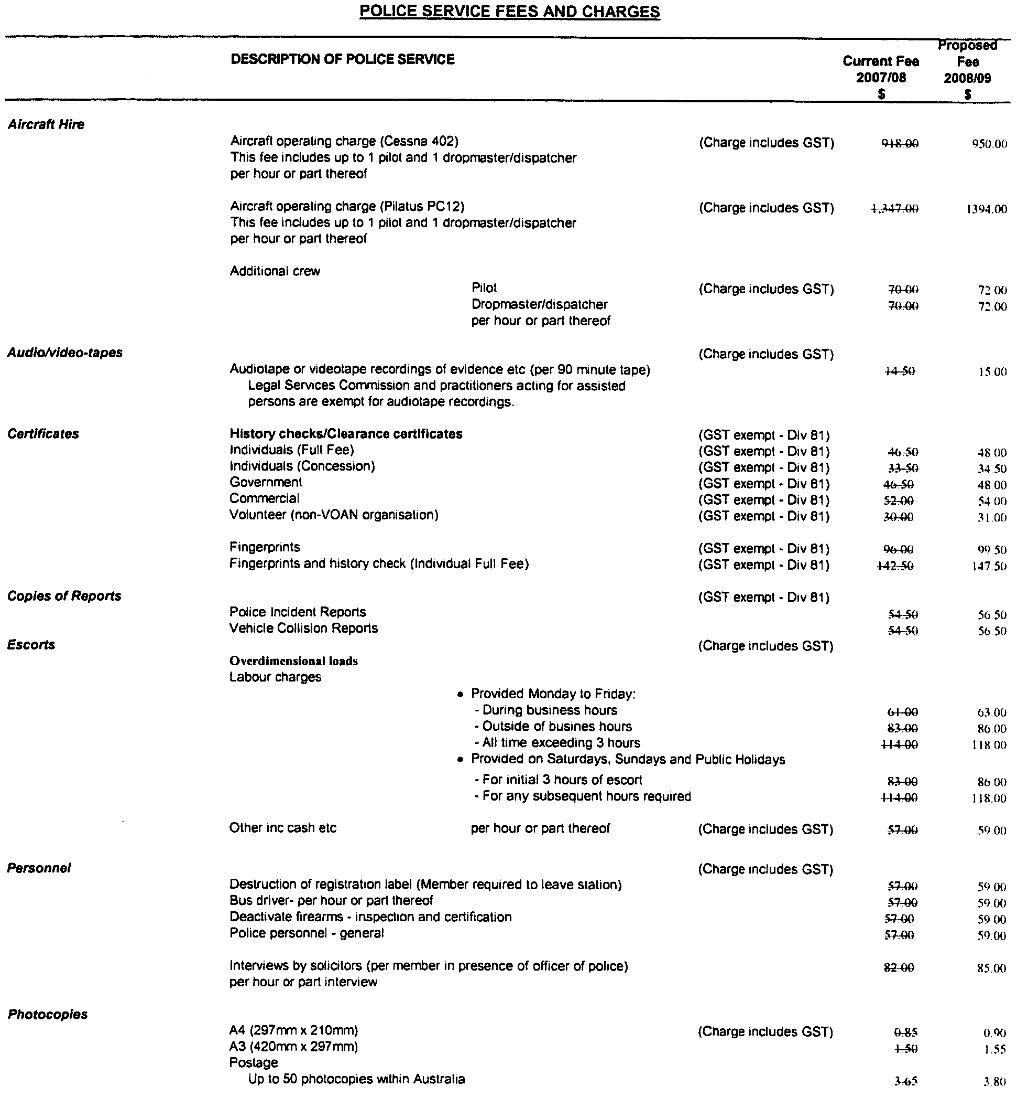
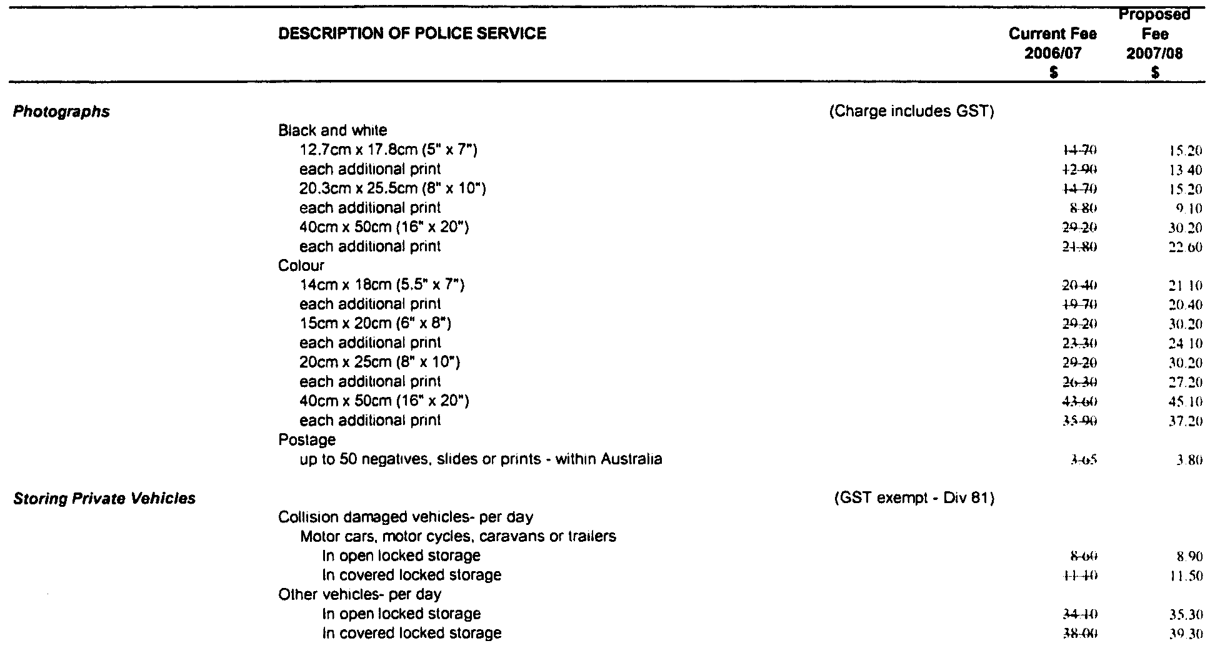
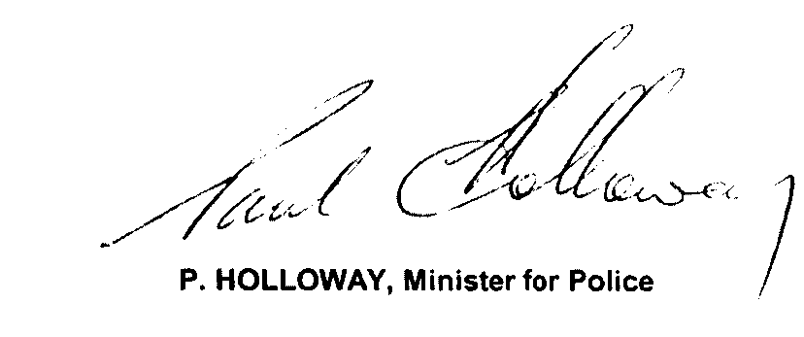

PROOF OF SUNRISE AND SUNSET ACT 1923—ALMANAC FOR JULY, AUGUST AND SEPTEMBER 2008
PURSUANT to the requirements of the Proof of Sunrise and Sunset Act 1923, I, Jim Hallion, Commissioner of Highways, at the direction of the Honourable the Minister for Transport and Urban Planning, publish in the Schedule hereto an almanac setting out the times of sunrise and sunset on every day for the three calendar months of July, August and September 2008.
Dated at Adelaide, 2 June 2008.

J. Hallion, Commissioner of Highways
97/03263

The Schedule
Times of sunrise and sunset during the months of July, August and September 2008 for Adelaide: latitude 34°56′S, longitude 138°36′E, GMT + 9.50 hours (Daylight saving GMT + 10.50).
Month | July |  | August |  | September
Date | Sunrise  hr min | Sunset  hr min | Sunrise  hr min | Sunset  hr min | Sunrise  hr min | Sunset  hr min

1  2  3  4  5  6  7  8  9  10  11  12  13  14  15  16  17  18  19  20  21  22  23  24  25  26  27  28  29  30  31 | 07 24  07 24  07 24  07 24  07 24  07 24  07 23  07 23  07 23  07 23  07 22  07 22  07 22  07 21  07 21  07 20  07 20  07 19  07 19  07 18  07 18  07 17  07 17  07 16  07 15  07 15  07 14  07 13  07 12  07 11  07 11 | 17 15  17 15  17 16  17 16  17 17  17 17  17 18  17 18  17 19  17 19  17 20  17 20  17 21  17 22  17 22  17 23  17 24  17 24  17 25  17 26  17 26  17 27  17 28  17 28  17 29  17 30  17 30  17 31  17 32  17 33  17 33 | 07 10  07 09  07 08  07 07  07 06  07 05  07 04  07 03  07 02  07 01  07 00  06 59  06 58  06 57  06 56  06 55  06 54  06 52  06 51  06 50  06 49  06 47  06 46  06 45  06 44  06 42  06 41  06 40  06 39  06 37  06 36 | 17 34  17 35  17 35  17 36  17 37  17 38  17 38  17 39  17 40  17 41  17 41  17 42  17 43  17 44  17 44  17 45  17 46  17 46  17 47  17.48  17 49  17 49  17 50  17 51  17 52  17 52  17 53  17 54  17 54  17 55  17 56 | 06 35  06 33  06 32  06 30  06 29  06 28  06 26  06 25  06 23  06 22  06 21  06 19  06 18  06 16  06 15  06 13  06 12  06 11  06 09  06 08  06 06  06 05  06 03  06 02  06 01  05 59  05 58  05 56  05 55  05 53 | 17 57  17 57  17 58  17 59  18 00  18 00  18 01  18 02  18 02  18 03  18 04  18 05  18 05  18 06  18 07  18 07  18 08  18 09  18 10  18 10  18 11  18 12  18 13  18 13  18 14  18 15  18 16  18 16  18 17  18 18

*Note: Daylight saving time is subject to change.
Sunrise and Sunset times calculated on 12 November 2007.

RADIATION PROTECTION AND CONTROL ACT 1982:
SECTION 44
Notice by Delegate of the Minister for Environment and Conservation
PURSUANT to section 44 of the Radiation Protection and Control Act 1982, I, Keith Baldry, Director of the Radiation Protection Division of the Environment Protection Authority, being a person to whom the powers of the Minister under that section have been delegated under the Act, exempt veterinary assistants at the Hills Veterinary Centre from the requirement to hold a licence under section 28 of the Radiation Protection and Control Act 1982, to the extent that they may use or handle radioactive iodine-131 for the purposes of assisting veterinarians in therapy procedures involving administration of radioactive iodine-131 capsules to cats, caring for the cats and handling radioactive waste resulting from the procedures. The exemption is subject to the following conditions:
1. A veterinary assistant to which this exemption applies must have received appropriate training in the principles and practices of radiation protection in relation to the use or handling of the radioactive iodine-131; and
2. The veterinary assistant must only use or handle the radioactive iodine-131 under the supervision of a veterinarian who holds a licence under section 28 of the Act.
Dated 3 June 2008.
K. Baldry, Delegate of the Minister for Environment and Conservation

ROADS (OPENING AND CLOSING) ACT 1991:
SECTION 24
NOTICE OF CONFIRMATION OF ROAD
PROCESS ORDER
Road Closure
Public Road, adjacent to Callington Road, Strathalbyn
BY Road Process Order made on 5 December 2007, the Alexandrina Council ordered that:
1. Portion of Public Road dividing sections 828 and 829 from section 830, Hundred of Strathalbyn, more particularly delineated and lettered ‘A’ on Preliminary Plan No. 07/0047 be closed.
2. The whole of the land subject to closure be transferred to Terramin Australia Limited in accordance with agreement for transfer dated 22 August 2007 entered into between the Alexandrina Council and Terramin Australia Limited.
On 4 April 2008 that order was confirmed by the Minister for Infrastructure conditionally upon the deposit by the Registrar-General of Deposited Plan 76574 being the authority for the new boundaries.
Pursuant to section 24 (5) of the Roads (Opening and Closing) Act 1991, NOTICE of the order referred to above and its confirmation is hereby given.
Dated 5 June 2008.
P. M. Kentish, Surveyor-General

SEWERAGE ACT 1929
Addition of Land to Adelaide Drainage Area
PURSUANT to section 18 of the Sewerage Act 1929, the South Australian Water Corporation:
(a) Adds to the Adelaide Drainage Area all the land contained in allotment 1 in Deposited Plan 75086; and
(b) declares that this notice will have effect from 1 July 2009.
Dated 12 May 2008.
Signed for and on behalf of the South Australian Water Corporation by a person duly authorised so to do:
P. M. Rucioch, Manager Shared Services
In the presence of:
A. Stasoullis, Billing Manager
SAWATER 08/09474 D1379

SEWERAGE ACT 1929
Addition of Land to Victor Harbor Country Drainage Area
PURSUANT to section 18 of the Sewerage Act 1929, the South Australian Water Corporation:
(a) Adds to the Victor Harbor Country Drainage Area all the land contained in allotments 1 to 50 inclusive, allotments 300 to 304 inclusive (reserves), allotments 400 to 403 inclusive (roads), allotments 500 to 503 inclusive in Deposited Plan 75057; and
(b) declares that this notice will have effect from 1 July 2009.
Dated 12 May 2008.
Signed for and on behalf of the South Australian Water Corporation by a person duly authorised so to do:
P. M. Rucioch, Manager Shared Services
In the presence of:
A. Stasoullis, Billing Manager
SAWATER 08/03814 D1382

NOTICE TO MARINERS
No. 31 of 2008
South Australia—Port Wakefield—Department of Defence—
Lights installed on Beacons
THE existing beacons marking the boundary of the exclusion zone (Inner Prohibited Area) for the Department of Defence have been numbered and lit as follows:
No. | Location—AGD 66 Datum | Characteristic | Range
14 | 34°17′14″S, 138°10′32″E | Fixed Yellow | 5 miles
15 | 34°18′10″S, 138°10′30″E | Fixed Yellow | 5 miles
16 | 34°20′04″S, 138°10′26″E | Fixed Yellow | 5 miles
17 | 34°21′01″S, 138°10′24″E | Fixed Yellow | 5 miles
18 | 34°22′54″S, 138°10′20″E | Fixed Yellow | 5 miles
19 | 34°23′51″S, 138°10′18″E | Fixed Yellow | 5 miles
20 | 34°25′23″S, 138°11′05″E | Fixed Yellow | 5 miles
21 | 34°25′58″S, 138°11′55″E | Fixed Yellow | 5 miles
22 | 34°26′10″S, 138°13′55″E | Fixed Yellow | 5 miles
23 | 34°25′39″S, 138°14′26″E | Fixed Yellow | 5 miles
Each beacon is also fitted with a reflective tape on the platform facia.
Mariners are advised that the Department of Defence regularly carry out firing practice exercises in the prohibited area and must keep well clear of the area at all times Trespassers will be prosecuted by the Department of Defence.
Charts affected: Aus 781.
Adelaide, 4 June 2008.
Patrick Conlon, Minister for Transport
DTEI 2008/00767

NOTICE TO MARINERS
No. 32 of 2008
South Australia—East side of River Murray—Shallow water reported between Nildottie and Greenways Landing at the
226 River mark
AN area of reduced depth exists on the River Murray approximately 500 metres downstream of Greenways Landing, and one kilometre upstream of Nildottie on the Eastern half of the river.
Two conical (Starboard hand) lateral marker buoys, and seven smaller green intermediate buoys have been installed to indicate the safe channel on the Port (West) side of the River.
The location of the most downstream to the most upstream buoys are as follows:
UTM 54H 0376439E, 6163147N.
Upstream to 0376767E, 6163981N.
Mariners are advised to exercise extreme caution when navigating in the area.
Adelaide, 3 June 2008.
Patrick Conlon, Minister for Transport.
DTEI 2008/00767

WATERWORKS ACT 1932
Removal of Land from Morgan-Whyalla Country Lands Water District and Addition to Clare Water District
PURSUANT to section 6 of the Waterworks Act 1932, the South Australian Water Corporation:
(a) removes from the Morgan-Whyalla Country Lands Water District and adds to the Clare Water District all the land contained in:
(i) allotments 1 to 3 inclusive in Deposited Plan 76917; and
(ii) declares that this notice will have effect from 1 July 2009.
Dated 12 May 2008.
Signed for and on behalf of the South Australian Water Corporation by a person duly authorised so to do:
P. M. Rucioch, Manager Shared Services
In the presence of:
A. Stasoullis, Billing Manager
SAWATER 08/09475 W1380

WATERWORKS ACT 1932
Removal of Land from Mount Barker Country Lands Water District and Addition to Adelaide Water District
PURSUANT to section 6 of the Waterworks Act 1932, the South Australian Water Corporation:
(a) removes from the Mount Barker Country Lands Water District and adds to the Adelaide Water District all the land contained in:
(i) allotment 98 in Filed Plan 215216; and
(b) declares that this notice will have effect from 1 July 2009.
Dated 12 May 2008.
Signed for and on behalf of the South Australian Water Corporation by a person duly authorised so to do:
P. M. Rucioch, Manager Shared Services
In the presence of:
A. Stasoullis, Billing Manager
SAWATER 08/03816 W1376

WATERWORKS ACT 1932
Removal of Land from Blue Lake Country Lands Water District and Addition to Mount Gambier Water District
PURSUANT to section 6 of the Waterworks Act 1932, the South Australian Water Corporation:
(a) removes from the Blue Lake Country Lands Water District and adds to the Mount Gambier Water District all the land contained in:
(i) allotment 203 in Deposited Plan 74063;
(ii) allotment 204 in Deposited Plan 74063; and
(b) declares that this notice will have effect from 1 July 2009.
Dated 12 May 2008.
Signed for and on behalf of the South Australian Water Corporation by a person duly authorised so to do:
P. M. Rucioch, Manager Shared Services
In the presence of:
A. Stasoullis, Billing Manager
SAWATER 08/03817 W1377

WILDERNESS PROTECTION REGULATIONS 2006
Closure of Cape Torrens Wilderness Protection Area
PURSUANT to Regulation 6 (2) (c) of the Wilderness Protection Regulations 2006, I, Edward Gregory Leaman, Director of National Parks and Wildlife, close to the public, the whole of Cape Torrens Wilderness Protection Area from:
4 p.m. on Tuesday, 24 June 2008 until 9 a.m. on Friday, 27 June 2008.
The purpose of the closure is to ensure the safety of the public during a pest control and monitoring program within the reserve during the period indicated.
Use of Firearms within the Reserve
Pursuant to Regulations 6 (4), 16 (1) and 34 of the Wilderness Protection Regulations 2006, I, Edward Gregory Leaman, Director of National Parks and Wildlife grant permission to staff employed by the Kangaroo Island Natural Resources Management Board in possession of both a current Hunting Permit and a firearm to enter and remain in the whole of Cape Torrens Wilderness Protection Area from 4 p.m. on Tuesday, 24 June 2008 until 9 a.m. on Friday, 27 June 2008 for the purpose of taking feral animals.
This permission is conditional upon the observance by each of those persons of the requirements of the Wilderness Protection Act 1992, Wilderness Protection Regulations 2006 and the National Parks and Wildlife (Hunting) Regulations 1996, including those requiring compliance with the Director’s requests, requirements and orders of a Warden.
Dated 3 June 2008.
E. G. Leaman, Director of National Parks and Wildlife

WILDERNESS PROTECTION REGULATIONS 2006
Closure of Ravine des Casoars Wilderness Protection Area
PURSUANT to Regulation 6 (2) (c) of the Wilderness Protection Regulations 2006, I, Edward Gregory Leaman, Director of National Parks and Wildlife, close to the public, the whole of Ravine des Casoars Wilderness Protection Area from 4 p.m. on Thursday, 19 June 2008 until 9 a.m. on Friday, 27 June 2008 with the following exception:
Shackle Road (open for through traffic only—no stopping).
The purpose of the closure is to ensure the safety of the public during a pest control and monitoring program within the reserve during the period indicated.
Use of Firearms within the Reserve
Pursuant to Regulations 6 (4), 16 (1) and 34 of the Wilderness Protection Regulations 2006, I, Edward Gregory Leaman, Director of National Parks and Wildlife grant permission to staff employed by the Kangaroo Island Natural Resources Management Board in possession of both a current Hunting Permit and a firearm to enter and remain in the whole of Ravine des Casoars Wilderness Protection Area from 4 p.m. on Thursday, 19 June 2008 until 9 a.m. on Friday, 27 June 2008 for the purpose of taking feral animals.
This permission is conditional upon the observance by each of those persons of the requirements of the Wilderness Protection Act 1992, Wilderness Protection Regulations 2006 and the National Parks and Wildlife (Hunting) Regulations 1996, including those requiring compliance with the Director’s requests, requirements and orders of a Warden.
Dated 3 June 2008.
E. G. Leaman, Director of National Parks and Wildlife

South Australia
Health Care Act (Commencement of Suspended Provisions) Proclamation 2008
1—Short title
This proclamation may be cited as the Health Care Act (Commencement of Suspended Provisions) Proclamation 2008.
2—Commencement of suspended provisions
Sections 18, 19, 26 and 27 of the Health Care Act 2008 (No 3 of 2008) will come into operation on 5 June 2008.
Made by the Governor’s Deputy
with the advice and consent of the Executive Council
on 5 June 2008
HEACS/08/277TC1

South Australia
Motor Vehicles (National Transport Commission) Amendment Act (Commencement) Proclamation 2008
1—Short title
This proclamation may be cited as the Motor Vehicles (National Transport Commission) Amendment Act (Commencement) Proclamation 2008.
2—Commencement of Act
The Motor Vehicles (National Transport Commission) Amendment Act 2007 (No 14 of 2007) will come into operation on 5 June 2008.
Made by the Governor’s Deputy
with the advice and consent of the Executive Council
on 5 June 2008
MTR08/026CS

South Australia
Statutes Amendment (Public Order Offences) Act (Commencement) Proclamation 2008
1—Short title
This proclamation may be cited as the Statutes Amendment (Public Order Offences) Act (Commencement) Proclamation 2008.
2—Commencement of Act
The Statutes Amendment (Public Order Offences) Act 2008 (No 8 of 2008) will come into operation on 8 June 2008.
Made by the Governor’s Deputy
with the advice and consent of the Executive Council
on 5 June 2008
AGO0063/07CS

South Australia
Summary Offences (Drug Paraphernalia) Amendment Act (Commencement) Proclamation 2008
1—Short title
This proclamation may be cited as the Summary Offences (Drug Paraphernalia) Amendment Act (Commencement) Proclamation 2008.
2—Commencement of Act
The Summary Offences (Drug Paraphernalia) Amendment Act 2008 (No 11 of 2008) will come into operation on 8 June 2008.
Made by the Governor’s Deputy
with the advice and consent of the Executive Council
on 5 June 2008
AGO0031/07CSTEMP2

South Australia
Public Sector Management (Abolition of Office of the Venture Capital Board and Transfer of Employees) Proclamation 2008
under section 7 of the Public Sector Management Act 1995
1—Short title
This proclamation may be cited as the Public Sector Management (Abolition of Office of the Venture Capital Board and Transfer of Employees) Proclamation 2008.
2—Commencement
This proclamation will come into operation on 1 July 2008.
3—Abolition of Office of the Venture Capital Board
The Office of the Venture Capital Board is abolished.
4—Transfer of employees
The employees of the Office of the Venture Capital Board referred to in Schedule 1 are transferred to the Department of Trade and Economic Development.
Schedule 1—Employees being transferred
Richard Cooper
Rachel Danjkov
Hugh Higgins
William W. Price
Michael Richards
Made by the Governor’s Deputy
with the advice and consent of the Executive Council
on 5 June 2008
MIT08/003CS

FAXING COPY?
IF you fax copy to Government Publishing SA for inclusion in the Government Gazette, there is no need to send a Confirmation Copy to us as well.
This creates confusion and may well result in your notice being printed twice.
Please use the following fax number:
Fax transmission: (08) 8207 1040
Phone Inquiries: (08) 8207 1045
Please include a contact person, phone number and order number so that we can phone back with any queries we may have regarding the fax copy.
NOTE: Closing time for lodging new copy (fax, hard copy or email) is 4 p.m. on Tuesday preceding the day of publication.

Government Gazette notices can be E-mailed.
The address is:
governmentgazette@dpc.sa.gov.au
Documents should be sent as attachments in Word format.
When sending a document via E-mail, please confirm your transmission with a faxed copy of your document, including the date the notice is to be published.
Fax transmission: (08) 8207 1040
Enquiries: (08) 8207 1045
NOTE: Closing time for lodging new copy (fax, hard copy or email) is 4 p.m. on Tuesday preceding the day of publication.

RURAL CITY OF MURRAY BRIDGE
Exclusion from Classification as Community Land
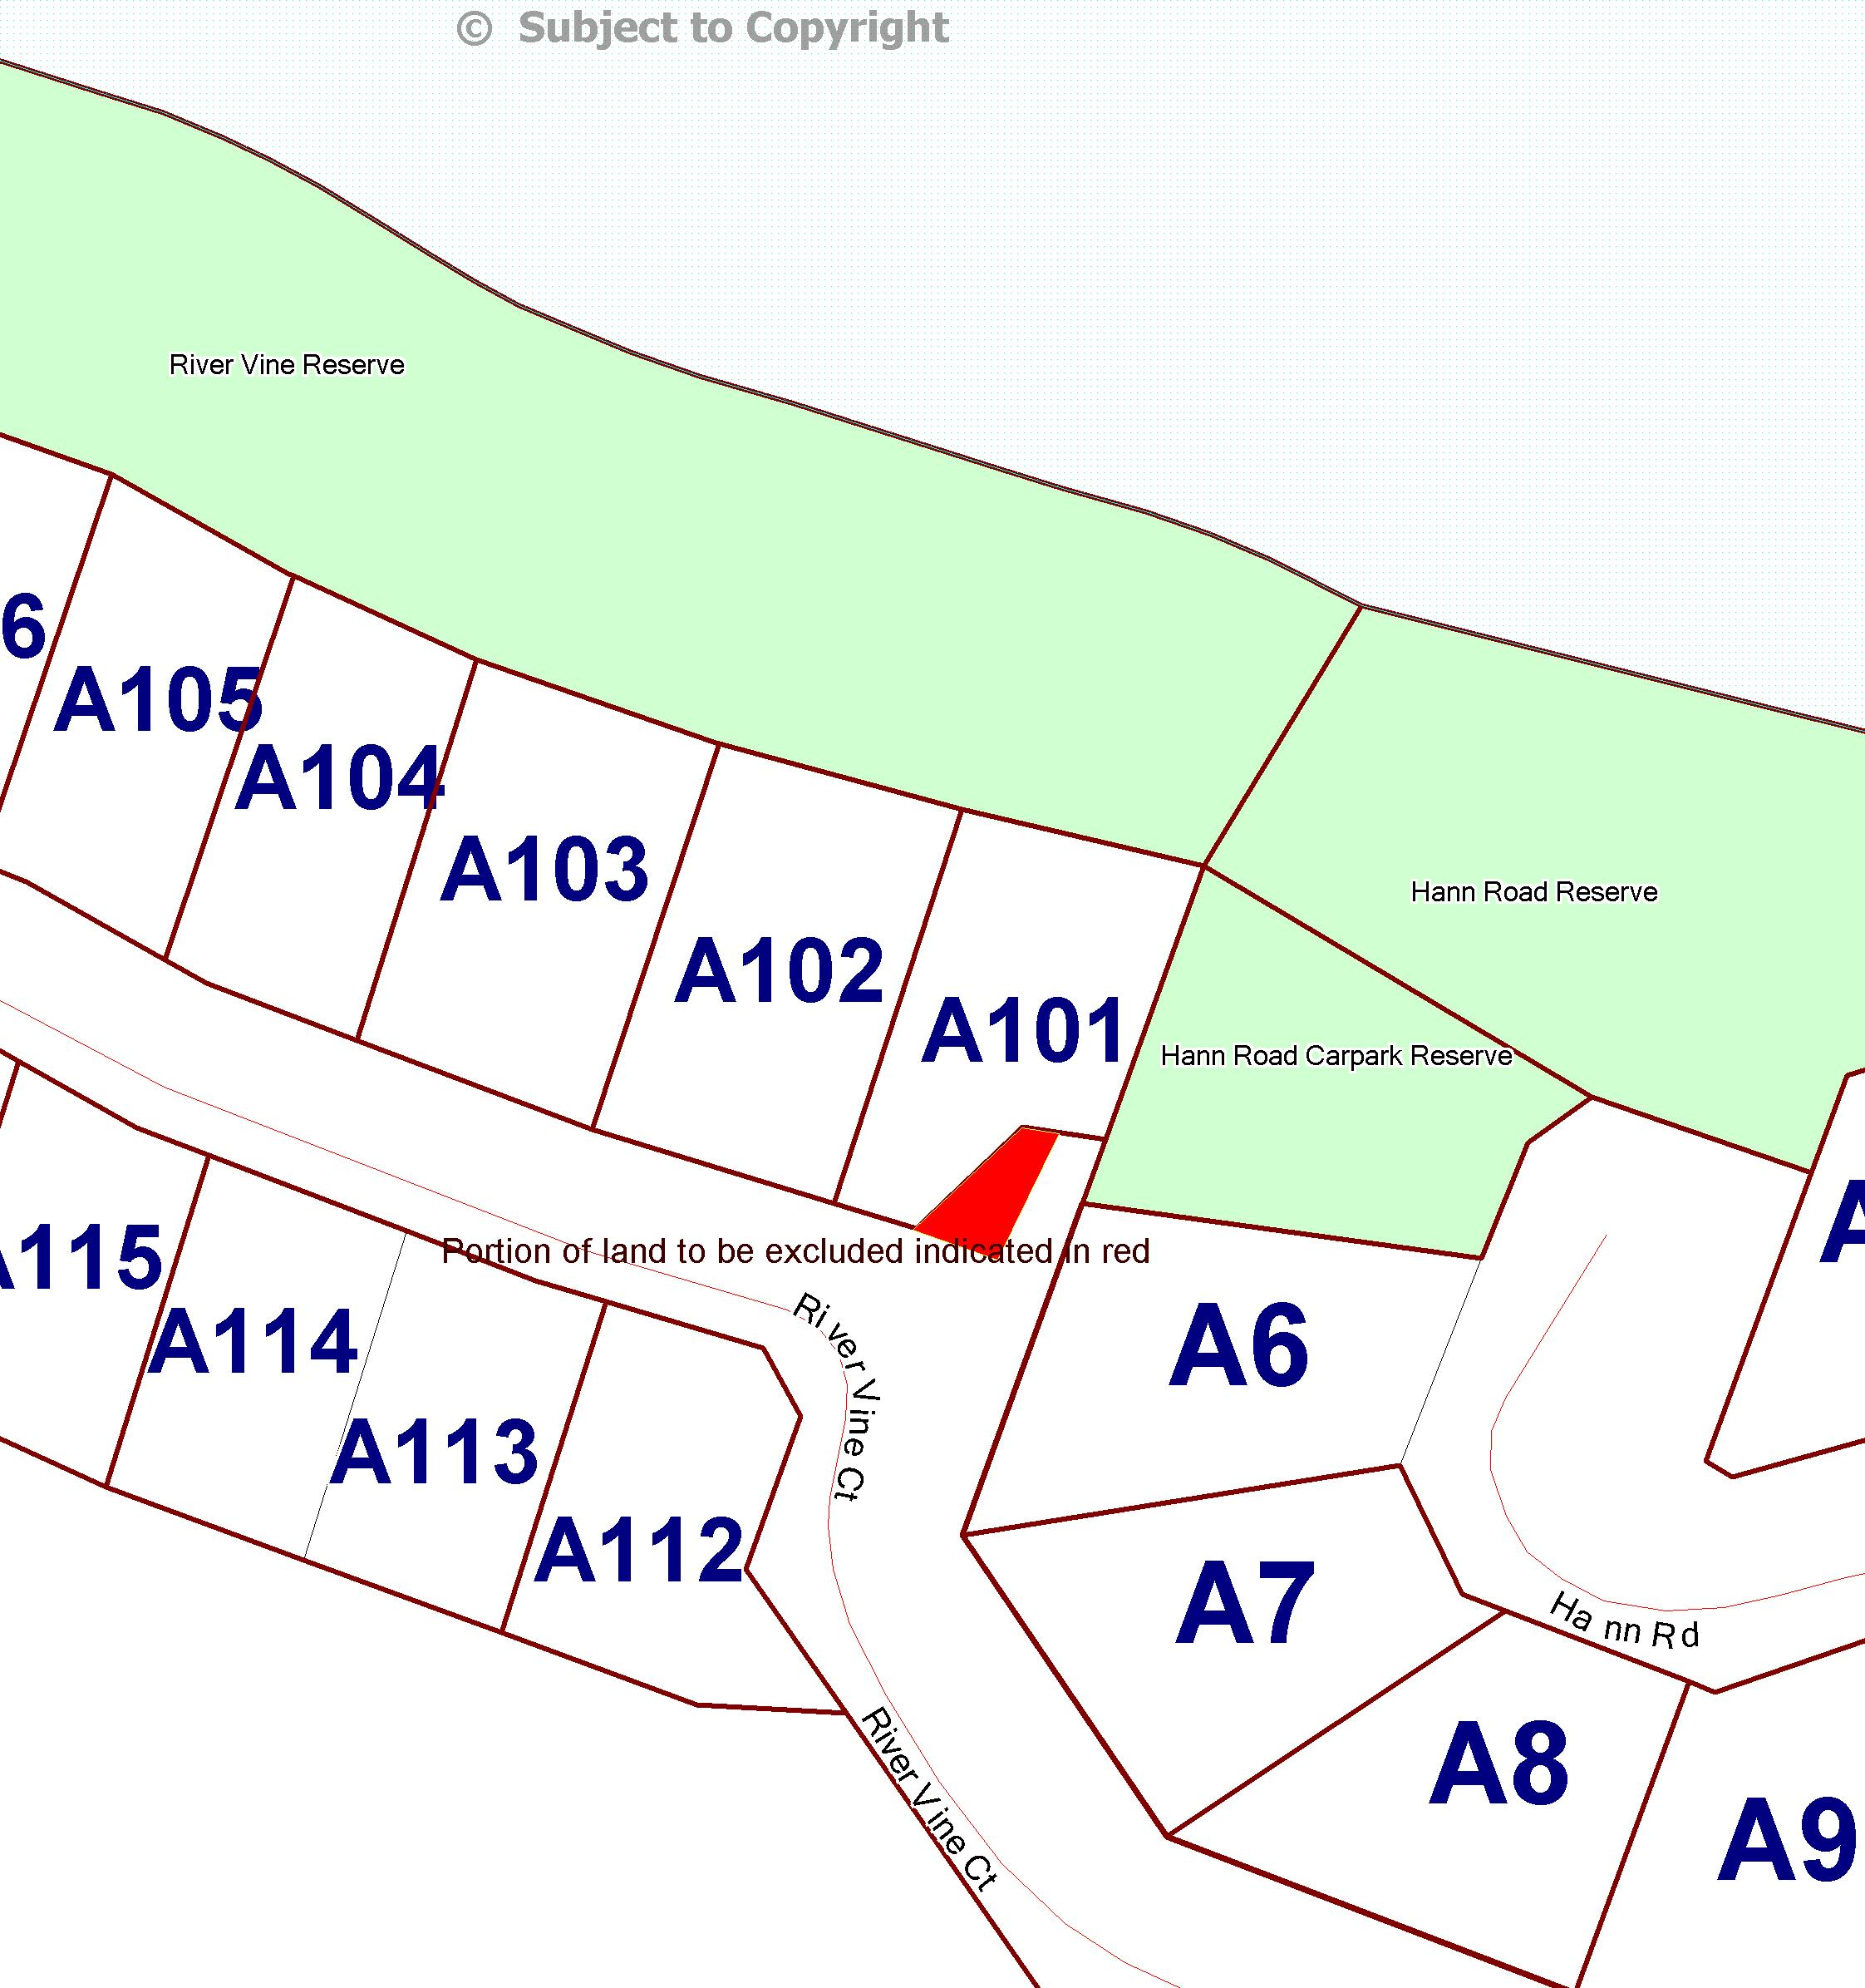
NOTICE is hereby given that the Rural City of Murray Bridge, at its meeting held on 14 April 2008 resolved, that in accordance with section 193 (4a) of the Local Government Act 1999, a portion of the current road reserve section (walkway) (as per map and indicated in red) adjacent to Allotment 101, River Vine Court, traversing between River Vine Court and Council’s car park reserve (adjacent to Hann Road) in the area of White Sands, be excluded from Classification as Community Land.

D. J. Altmann, Chief Executive Officer

CITY OF ONKAPARINGA
Roads (Opening And Closing) Act 1991
Roads Opening and Closure—Right of Way, Aldinga Beach
NOTICE is hereby given, pursuant to section 10 of the Roads (Opening and Closing) Act 1991, that the City of Onkaparinga proposes to make a Road Process Order to close portions of the Right of Way north of Wurlie Road adjoining allotments 98, 99 and 100 in Deposited Plan 3724 and allotment 2 in Deposited Plan 15098 more particularly delineated and lettered ‘A’, ‘B’, ‘C’ and ‘D’ on Preliminary Plan No. 08/0028. Closed road ‘A’ to be merged with the adjoining allotment 98 in Deposited Plan 3724, closed road ‘B’ to be merged with the adjoining allotment 99 in Deposited Plan 3724, closed road ‘C’ to be merged with the adjoining allotment 100 in Deposited Plan 3724 and closed road ‘D’ to be merged with the adjoining allotment 2 in Deposited Plan 15098.
A copy of the plan and a statement of persons affected are available for public inspection at the offices of the Council, City of Onkaparinga, Ramsay Place, Noarlunga Centre and the Adelaide office of the Surveyor-General during normal office hours.
Any application for easement or objection must set out the full name, address and details of the submission and must be fully supported by reasons.
The application for easement or objection must be made in writing to the Council, City of Onkaparinga, P.O. Box 1, Noarlunga Centre, S.A. 5168 within 28 days of this notice and a copy must be forwarded to the Surveyor-General, G.P.O. Box 1354, Adelaide, S.A. 5001. Where a submission is made, the Council will give notification of a meeting at which the matter will be considered.
Dated 5 June 2008.
J. Tate, Chief Executive Officer

CITY OF PORT LINCOLN
Development Assessment Panel Meeting
NOTICE is hereby given that the next Development Assessment Panel meeting for the City of Port Lincoln will be held on Monday, 16 June 2008 at 7 p.m. due to the Public Holiday on Monday, 9 June 2008.
G. Dodd, Chief Executive Officer

CITY OF VICTOR HARBOR
Appointment of Authorised Officers
NOTICE is herby given that at a meeting of Council held on 26 May 2008, Council revoked all previous appointments and resolved to appoint the following Officers for the City of Victor Harbor:
Local Government Act 1999, (Section 260)
Baillie, Matthew Ian (Compliance Officer)
Bately, Kevin Crawford (Infrastructure Asset Co-ordinator)
Bohnsack, Jane (Director of Corporate & Community Services)
Bond, Peter Andrew (Director of Environment & Infrastructure Services)
Buckley, David Mark (Technical Support Co-ordinator)
Budarick, Roger Donald (Manager, Infrastructure)
Button, Trevor Wayne (Senior General Inspector)
Ciric, Andrew (Infrastructure Asset Co-ordinator)
Comas, Andrew Thomas (Group Leader Open Space)
Coventry, Ben (Planning Officer)
Detchon, David (General Inspector)
Doman, Brian William (Manager, Open Space)
Henderson, Bruce James (Co-ordinator Waste & Environment)
Lintern, Malcolm Brian (Group Leader Operations)
Maxwell, Graeme Keith (City Manager)
Overall, Kym Matthew (Senior Building Officer)
Parkinson, Timothy James (IRGC Environmental Projects Officer)
Price, Bronte Leland (Director of Planning & Regulatory Services)
Read, David Andrew (Principal Planning Officer)
Read, Timothy John (General Inspector)
Roberts, Malinda Jane (Project Officer/Sustainable Water)
Rose, Norman William (Environmental Health Officer)
Vacant (Senior Planner)
Walker, Kyla Jade (Para Planning Officer)
Development Act, 1993, (Section 18)
Baillie, Matthew (Compliance Officer)
Bohnsack, Jane (Director of Corporate & Community Services)
Bond, Peter Andrew (Director of Environment & Infrastructure Services)
Budarick, Roger Donald (Manager, Infrastructure)
Coventry, Ben (Planning Officer )
Doman, Brian William (Manager, Open Space)
Henderson, Bruce James (Co ordinator Waste & Environment)
Maxwell, Graeme Keith (City Manager)
Overall, Kym Matthew (Senior Building Officer)
Parkinson, Timothy James (IRGC Environmental Projects Officer)
Price, Bronte Leland (Director of Planning & Regulatory Services)
Read, David Andrew (Principal Planning Officer)
Roberts, Malinda Jane (Project Officer/Sustainable Water)
Rose, Norman William (Environmental Health Officer)
Vacant (Senior Planner)
Walker, Kyla Jade (Para Planning Officer)
Dog and Cat Management Act 1995, (Section 27(1) and
Section 68 (1))
Baillie, Matthew Ian (Compliance Officer)
Bohnsack, Jane (Director of Corporate & Community Services)
Button, Trevor Wayne (Senior General Inspector)
Detchon, David (General Inspector)
Maxwell, Graeme Keith (City Manager)
Price, Bronte Leland (Director of Planning & Regulatory Services)
Read, Timothy John (General Inspector)
Environment Protection Act 1993, (Part 10, Division 1)
Baillie, Matthew Ian (Compliance Officer)
Bohnsack, Jane (Director of Corporate & Community Services)
Bond, Peter Andrew (Director of Environment & Infrastructure Services)
Budarick, Roger Donald (Manager Infrastructure)
Button, Trevor Wayne (Senior General Inspector)
Detchon, David (General Inspector)
Henderson, Bruce James (Co-ordinator Waste & Environment)
Maxwell, Graeme Keith (City Manager)
Overall, Kym Matthew (Senior Building Officer)
Parkinson, Timothy James (IRCG Environmental Projects Officer)
Price, Bronte Leland (Director of Planning & Regulatory Services)
Read, Timothy John (General Inspector)
Roberts, Malinda Jane (Project Officer/Sustainable Water)
Expiation of Offences Act 1996 [4(1) Issuing Authority (b)]
Baillie, Matthew Ian (Compliance Officer)
Bohnsack, Jane (Director of Corporate & Community Services)
Button, Trevor Wayne (Senior General Inspector)
Detchon, David (General Inspector)
Maxwell, Graeme Keith (City Manager)
Price, Bronte Leland (Director of Planning & Regulatory Services)
Read, Timothy John (General Inspector)
Rose, Norman William (Environmental Health Officer)
Fire and Emergency Services Act 2005 (Part 3, Division 8 and Part 4, Divisions 7 and 8)
Baillie, Matthew Ian (Compliance Officer)
Bohnsack, Jane (Director of Corporate & Community Services)
Button, Trevor Wayne (Senior General Inspector/Fire Prevention Officer)
Maxwell, Graeme Keith (City Manager)
Price, Bronte Leland (Director of Planning & Regulatory Services)
Read, Timothy John (General Inspector)
Food Act 2001, (Division 3, Section 94)
Rose, Norman William (Environmental Health Officer)
Freedom of Information—FOI Officer ({4(1)}
Bohnsack, Jane (Director of Corporate & Community Services)
Impounding Act 1920 (Gazettal Notice Required)
Baillie, Matthew Ian (Compliance Officer)
Bohnsack, Jane (Director of Corporate & Community Services)
Button, Trevor Wayne (Senior General Inspector)
Detchon, David (General Inspector)
Maxwell, Graeme Keith (City Manager)
Price, Bronte Leland (Director of Planning & Regulatory Services)
Read, Timothy John (General Inspector)
Harbors and Navigation Act 1993
Baillie, Matthew Ian (Compliance Officer)
Bohnsack, Jane (Director of Corporate & Community Services)
Button, Trevor Wayne (Senior General Inspector)
Detchon, David (General Inspector)
Maxwell, Graeme Keith (City Manager)
Price, Bronte Leland (Director of Planning & Regulatory Services)
Read, Timothy John (General Inspector)
Public & Environmental Health Act 1987 [Division 1,
Section 7(1)]
Rose, Norman William (Environmental Health Officer)
Road Traffic Act 1961 [Section 35 (1a)]
Bately, Kevin Crawford (Infrastructure Asset Co-ordinator)
Bond, Peter Andrew (Director of Environment & Infrastructure Services)
Bohnsack, Jane (Director of Corporate & Community Services)
Buckley, David Mark (Technical Support Co-ordinator)
Budarick, Roger Donald (Manager, Infrastructure)
Ciric, Andrew (Infrastructure Asset Co-ordinator)
Lintern, Malcolm Brian (Group Leader Operations)
Maxwell, Graeme Keith (City Manager)
Supported Residential Facilities Act 1992 [Division 4,
Section 21]
Price, Bronte Leland (Director of Planning & Regulatory Services)
Rose, Norman William (Environmental Health Officer)
G. Maxwell, City Manager

CLARE & GILBERT VALLEYS COUNCIL
Ratification of Road Names and Naming of a Road
NOTICE is hereby given that the Clare & Gilbert Valleys Council at its meeting held on 21 April 2008 resolved that, pursuant to section 219 (1) of the Local Government Act 1999, ratify the following road names:
Bayes Road, Sevenhill;
Craig Hill Road and Dolan Road, north of Clare;
Hannaford Avenue, Riverton; and
Pawelski Road, Sevenhill.
At its meeting held on 19 May 2008 to assign the name of Kelly Road to the road being adjacent to the southern boundary of Section 343, Hundred of Mintaro.
R. D. Blight, Chief Executive Officer

CLARE & GILBERT VALLEYS COUNCIL
Revocation of Community Land Classification
NOTICE is hereby given that Council at its meeting held on Monday, 19 May 2008, resolved to revoke the Community Land Classification for allotment 138 in Deposited Plan 11110, comprised in certificate of title volume 5544, folio 84, Christison Avenue, Clare, having complied with all requirements in relation to section 194 of the Local Government Act 1999.
R. D. Blight, Chief Executive Officer

IN the matter of the estates of the undermentioned deceased persons:
Bunting, Stanley, late of 774 Marion Road, Marion, retired cost clerk, who died on 5 January 2008.
Butler, Isabella Vera, late of 160 Walkerville Terrace, Walkerville, of no occupation, who died on 13 April 2008.
Cameron, John, late of 103 Fisher Street, Fularton, of no occupation, who died on 21 September 2007.
Cobham, Frank, late of 1 Duffield Street, Gawler East, retired machinery operator, who died on 19 April 2008.
Edwards, Anthony, late of 44 Kingston Avenue, Daw Park, retired engineer, who died on 28 September 2007.
Gilbert, Hilda Mary, late of 50 Gulfview Road, Christies Beach, of no occupation, who died on 24 February 2008.
Goode, Constance Doreen, late of 22 Norman Street, Port Pirie, widow, who died on 7 April 2008.
Huston, Dorothy Edith, late of 6 Buccleuch Avenue, Findon, home duties, who died on 2 April 2008.
Kimber, Marion Rietta, late of 251 Payneham Road, Joslin, retired clerk, who died on 25 November 2007.
Lewis, Eugenio Patrick Carlo, late of 13 Ena Street, Croydon Park, of no occupation, who died on 3 May 2007.
Mansfield, Winifred, late of 342 Marion Road, North Plympton, widow, who died on 8 February 2008.
Medlow, Mavis Rosalind, late of Baillie Street, Horsham, of no occupation, who died on 12 February 2008.
Morony, Eugene Wayne, late of 179 North East Road, Manningham, retired hotel manager, who died on 25 March 2008.
O’Donoghue, Verna Lorraine, late of 24-28 Wayford Street, Elizabeth Vale, home duties, who died on 22 March 2008.
Pearce, Audrey, late of 7 Warwick Street, Westbourne Park, widow, who died on 8 December 2007.
Penhearow, Hazel Maud, late of 150 Adams Road, Craigmore, of no occupation, who died on 31 March 2008.
Polidano, Emmanuel Anthony, late of 9 Albert Street, Semaphore, retired plumber, who died on 29 January 2007.
Reilly, Sheila Mary, late of 206 Sir Donald Bradman Drive, Cowandilla, of no occupation, who died on 25 March 2008.
Schram, Albert Anthony, late of 38 Nairne Road, Woodside, retired secondhand dealer, who died on 15 March 2008.
Notice is hereby given pursuant to the Trustee Act 1936, as amended, the Inheritance (Family Provision) Act 1972, and the Family Relationships Act 1975, that all creditors, beneficiaries, and other persons having claims against the said estates are required to send, in writing, to the Public Trustee, 25 Franklin Street, Adelaide, S.A. 5000, full particulars and proof of such claims, on or before 4 July 2008, otherwise they will be excluded from the distribution of the said estate; and notice is also hereby given that all persons who are indebted to the said estates are required to pay the amount of their debts to the Public Trustee or proceedings will be taken for the recovery thereof; and all persons having any property belonging to the said estates are forthwith to deliver the same to the Public Trustee.
Dated 5 June 2008.
M. I. Bodycoat, Public Trustee

ATTENTION

CUSTOMERS requiring a proof of their notice for inclusion in the Government Gazette, please note that the onus is on you to inform Government Publishing SA of any subsequent corrections by 10 a.m. on Thursday, which is our publication deadline.

For any corrections to your notice please phone 8207 1045 or Fax 8207 1040 before 10 a.m. on Thursday.

If we do not receive any communication by 10 a.m. on Thursday (day of publication) we will presume the notice is correct and will print it as it is.

Remember—the onus is on you to inform us of any corrections necessary to your notice.

NOTE: Closing time for lodging new copy (electronically, fax or hard copy) is 4 p.m. on Tuesday preceding the day of publication. Phone 8207 1045—Fax 8207 1040.
Email: governmentgazette@dpc.sa.gov.au

Printed and published by authority every Thursday by T. GOODES, Government Printer, South Australia
Price: $5.40, plus postage; to subscribers, $274.00 per annum.
(The above prices are inclusive of GST)

