No. 34 2343

THE SOUTH AUSTRALIAN

GOVERNMENT GAZETTE
www.governmentgazette.sa.gov.au

PUBLISHED BY AUTHORITY

ALL PUBLIC ACTS appearing in this GAZETTE are to be considered official, and obeyed as such

ADELAIDE, THURSDAY, 19 JUNE 2008

CONTENTS

Page
Acts Assented To 2344
Appointments, Resignations, Etc. 2344
Compulsory Third Party Insurance—Notice 2348
Corporations and District Councils—Notices 2408
Crown Lands Act 1929—Notices 2345
Development Act 1993—Notice 2345
Emergency Services Funding (Declaration of Levy and
Area and Land Use Factors) Notice 2008 2375
Emergency Services Funding (Declaration of Levy for
Vehicles and Vessels) Notice 2008 2377
Equal Opportunity Tribunal—Notices 2346
Housing Improvement Act 1940—Notices 2353
Land Acquisition Act 1969—Notices 2355
Land and Business (Sale and Conveyancing) Act 1994—
Notice 2356
Liquor Licensing Act 1997—Notices 2356
Mining Act 1971—Notices 2359
Mount Gambier Circuit Court—Notice 2346
Natural Resources Management Act 2004—Notices 2360
Proclamations 2381
Public Finance and Audit Act 1987—Notice 2361
Public Trustee Office—Administration of Estates 2411
Page
Radiation Protection and Control Act 1982—Notice 2361

REGULATIONS
Senior Secondary Assessment Board of South
Australia Act 1983 (No. 163 of 2008) 2382
Waterworks Act 1932 (No. 164 of 2008) 2385
Emergency Services Funding Act 1998
(No. 165 of 2008) 2387
Motor Vehicles Act 1959 (No. 166 of 2008) 2389
Liquor Licensing Act 1997 (No. 167 of 2008) 2392
Natural Resources Management Act 2004
(No. 168 of 2008) 2399
South Australian Health Commission Act 1976
(No. 169 of 2008) 2401
Primary Industry Funding Schemes Act 1998
(No. 170 of 2008) 2404
Roads (Opening and Closing) Act 1991—Notices 2362

RULES OF COURT
Corporations Rules 2003 2352
Trade Standards Act 1979—Notice 2363
Training and Skills Development Act 2003—Notices 2364
Treasury—Quarterly Statement 2368

GOVERNMENT GAZETTE NOTICES
ALL poundkeepers’ and private advertisements forwarded for publication in the South Australian Government Gazette must be PAID FOR PRIOR TO INSERTION; and all notices, from whatever source, should be legibly written on one side of the paper only and sent to Government Publishing SA so as to be received no later
than 4 p.m. on the Tuesday preceding the day of publication. Phone 8207 1045 or Fax 8207 1040. E-mail: governmentgazette@dpc.sa.gov.au. Send as attachments in Word format and please confirm your transmission with a faxed copy of your document, including the date the notice is to be published and to whom the notice will be charged. The Government Gazette is available online at: www.governmentgazette.sa.gov.au

Department of the Premier and Cabinet
Adelaide, 19 June 2008
HIS Excellency the Governor directs it to be notified for general information that he has in the name and on behalf of Her Majesty The Queen, this day assented to the undermentioned Acts passed by the Legislative Council and House of Assembly in Parliament assembled, viz.:
No. 16 of 2008—WorkCover Corporation (Governance Review) Amendment Act 2008. An Act to amend the WorkCover Corporation Act 1994.
No. 17 of 2008—Workers Rehabilitation and Compensation (Scheme Review) Amendment Act 2008. An Act to amend the Workers Rehabilitation and Compensation Act 1986.
By command,
Paul Caica, for Premier
DPC06/0875

Department of the Premier and Cabinet
Adelaide, 19 June 2008
HIS Excellency the Governor in Executive Council has been pleased to appoint the undermentioned to the Dental Professional Conduct Tribunal, pursuant to the provisions of the Dental Practice Act 2001:
Member: (from 23 June 2008 until 22 June 2011)
Janet Fiona Scott
Janet Megan Fuss
Frank John Van der Linden
Barry James Newman
Lesley Steele
Annabel Faith Catford Digance
By command,
Paul Caica, for Premier
HEACS/08/291

Department of the Premier and Cabinet
Adelaide, 19 June 2008
HIS Excellency the Governor in Executive Council has been pleased to appoint the undermentioned to the Public and Environmental Health Council, pursuant to the provisions of the Public and Environmental Health Act 1987:
Member: (from 23 June 2008 until 22 June 2011)
John Lynton Coombe
Deputy Member: (from 23 June 2008 until 22 June 2011)
Helen Wright (Deputy to Coombe)
By command,
Paul Caica, for Premier
HEACS/08/272

Department of the Premier and Cabinet
Adelaide, 19 June 2008
HIS Excellency the Governor in Executive Council has been pleased to appoint the undermentioned to the Dental Board of South Australia, pursuant to the provisions of the Dental Practice Act 2001:
Member: (from 23 June 2008 until 22 June 2011)
Patrick Collette
David Sinclair Mann
Erika Vinczer
Richard Martin Logan
Joanna Catherine Richardson
Member: (from 23 June 2008 until 23 December 2009)
Donald Wilson
Deputy Member: (from 23 June 2008 until 22 June 2011)
Adut Zita Ngor (Deputy to Richardson)
By command,
Paul Caica, for Premier
HEACS/08/290

Department of the Premier and Cabinet
Adelaide, 19 June 2008
HIS Excellency the Governor in Executive Council has been pleased to appoint the undermentioned to the Adelaide Festival Corporation Board, pursuant to the provisions of the Adelaide Festival Corporation Act 1998:
Chair: (from 19 June 2008 until 25 April 2010)
Richard Vincent Ryan
By command,
Paul Caica, for Premier
ASACAB001/02

Department of the Premier and Cabinet
Adelaide, 19 June 2008
HIS Excellency the Governor in Executive Council has been pleased to appoint Hieu Van Le as Governor's Deputy of South Australia for the period from 9 a.m. on Monday, 23 June 2008 until 6 p.m. on Tuesday, 24 June 2008 and for the period from 9 a.m. on Monday, 30 June 2008 until 5 p.m. on Tuesday, 1 July 2008.
By command,
Paul Caica, for Premier

Department of the Premier and Cabinet
Adelaide, 19 June 2008
HIS Excellency the Governor in Executive Council has revoked the appointment as officers of the Crown for the purpose of providing the range of custodial services for the management of the Mount Gambier Prison, the former staff of GSL Custodial Services Pty Ltd listed, pursuant to section 68 of the Constitution Act 1934 and the Acts Interpretation Act 1915:
Glenn Ahern
Craig Gull
Leah Griffin
Michael Griffiths
Linclon Hannet
Anthony Pevitt
Nathan Hammond
Brenton Primmer
Kylie Schultz (now known as Allen)
Deborah Winterfield
Wendy Lunsmann
Dale Harris-Walker
Trevor Buckell
Russell Petty
Curt Miller
Michael Evans
Andrea Knight
Allan Bridges
Simon Ruwoldt
Colin Crafter
Wayne Richardson
John Wing
Scott O’Dea
Peter Watson
Matthew Luke Wehrman
Giovanna Meyer (now known as Reato)
Phillip Gleed
John Lacey
Ken Diedrich
Nevyn Wilson
Christine Richardson
Rodney Wewer
Ian Forbes
By command,
Paul Caica, for Premier
MCS08/014SC

Department of the Premier and Cabinet
Adelaide, 19 June 2008
HIS Excellency the Governor in Executive Council has been pleased to appoint as officers of the Crown for the purpose of providing the range of custodial services for Prisoner Movement and In-Court Management services and for the management and operation of the Mount Gambier Prison, in accordance with the South Australian Prisoner Movement and In-Court Management contract and the contract for the management and operation of the Mount Gambier Prison, without pay or other industrial entitlement, staff of GSL Custodial Services Pty Ltd listed, pursuant to section 68 of the Constitution Act 1934:
Glenn Ahern
Craig Gull
Leah Griffin
Michael Griffiths
Linclon Hannet
Anthony Pevitt
Nathan Hammond
Brenton Primmer
Kylie Schultz (now known as Allen)
Deborah Winterfield
Wendy Lunsmann
Dale Harris-Walker
Trevor Buckell
Russell Petty
Curt Miller
Michael Evans
Andrea Knight
Stephen Altus
Nathan Tidy
Allan Bridges
Simon Ruwoldt
Colin Crafter
Wayne Richardson
John Wing
Scott O’Dea
Peter Watson
Matthew Luke Wehrman
Giovanna Meyer (now known as Reato)
Phillip Gleed
John Lacey
Ken Diedrich
Nevyn Wilson
Christine Richardson
Rodney Wewer
Ian Forbes
Denise Suto
Lisa Hawkins
Murray Horrigan
By command,
Paul Caica, for Premier
MCS08/014SC

CROWN LANDS ACT 1929: SECTION 5
TAKE NOTICE that pursuant to the Crown Lands Act 1929, I, GAIL GAGO, Minister for Environment and Conservation, Minister of the Crown to whom the administration of the Crown Lands Act 1929 is committed DO HEREBY:
1. Resume the land defined in The First Schedule.
2. Dedicate the Crown Land defined in The Second Schedule as a Reserve for Boat Ramp, Marine, Public Recreation and Vehicle Parking Purposes and declare that such land shall be under the care, control and management of The District Council of Ceduna.
The First Schedule
Marine and Harbors Reserve, Section 247, Hundred of Bonython, County of Way, the proclamation of which was published in the Government Gazette of 24 March 1983 at pages 738 and 739, The Second Schedule, being the whole of the land comprised in Crown Record Volume 5757, Folio 759.
The Second Schedule
Section 247, Hundred of Bonython, County of Way, exclusive of all necessary roads, being the whole of the land comprised in Crown Record Volume 5757, Folio 759.
Dated 19 June 2008.
Gail Gago, Minister for Environment and Conservation
DENR 08/0580

CROWN LANDS ACT 1929: SECTION 5
TAKE NOTICE that pursuant to the Crown Lands Act 1929, I, GAIL GAGO, Minister for Environment and Conservation, Minister of the Crown to whom the administration of the Crown Lands Act 1929 is committed DO HEREBY dedicate the Crown Land defined in The Schedule as Public Road.
The Schedule
Allotments 67 and 68 in Deposited Plan 77171, Town of Coober Pedy, Out of Hundreds (Coober Pedy), being within the district of Coober Pedy.
Dated 19 June 2008.
Gail Gago, Minister for Environment and Conservation
DEH 14/0355

DEVELOPMENT ACT 1993, SECTION 29 (2) (b) (ii): AMENDMENT TO THE KANGAROO ISLAND COUNCIL DEVELOPMENT PLAN
Preamble
It is necessary to amend the Kangaroo Island Council Develop-ment Plan dated 1 November 2007.
Notice
PURSUANT to section 29 (2) (b) (ii) of the Development Act 1993, I, Paul Holloway, being the Minister administering the Act, amend the Kangaroo Island Council Development Plan dated 1 November 2007 as follows:
• Amend cross-referencing contained in the following Principles of Development Control (PDC), as per instruc-tions below:
Council Wide Policies
PDC 81—delete ‘73’ and ‘74’ and replace with ‘79’ and ‘80’ respectively.
PDC 233—delete ‘239’ and replace with ‘245’.
PDC 242 (a)—delete ‘234’ and ‘238’ and replace with ‘240’ and ‘244’ respectively.
PDC 242 (b)—delete ‘238’ and ‘234’ and replace with ‘240’ and ‘244’ respectively.
PDC 246—delete ‘230’ and replace with ‘233’.
PDC 248—delete ‘238’ and replace with ‘244’.
PDC 303—delete ‘74’ and replace with ‘80’.
Residential Zone
PDC 6 (Land Division)—delete ‘73 to 77’ and replace with ‘79 to 81’ respectively.
PDC 7 (Building Height and Bulk)—delete ‘80’ and replace with ‘86’.
Country Township Zone
PDC 6 (Building Height and Bulk)—delete ‘80’ and replace with ‘86’.
Country Living Zone
PDC 3 (Building Height and Bulk)—delete ‘80’ and replace with ‘86’.
Rural Living Zone
PDC 7 (Building Height and Bulk)—delete ‘80’ and replace with ‘86’.
Holiday House Zone
PDC 2 (Building Height and Bulk)—delete ‘80’ and replace with ‘86’.
Deferred Urban Zone
PDC 2 (Building Height and Bulk)—delete ‘80’ and replace with ‘86’.
PDC 44 (i) of the Coastal Zone
Deleting the words ‘Principle 5 (d)’ at the end of the entry ‘dwelling’ and replace with ‘Principle 5 (c)’.
Dated 19 June 2008.
Paul Holloway, Minister for Urban Development and Planning

MOUNT GAMBIER CIRCUIT COURT
DISTRICT COURT OF SOUTH AUSTRALIA
Sheriff’s Office, Adelaide, 12 June 2008
IN pursuance of a precept from the District Court to me directed, I do hereby give notice that the said Court will sit as a Court of Oyer and Terminer and General Gaol Delivery at the Courthouse at Mount Gambier on the day and time undermentioned and all parties bound to prosecute and give evidence and all jurors summoned and all others having business at the said Court are required to attend the sittings thereof and the order of such business will be unless a Judge otherwise orders, as follows:
Monday, 7 July 2008 at 10 a.m. on the first day of the sittings the only business taken will be the arraignment of prisoners in gaol and the passing of sentences on prisoners in gaol committed for sentence; the surrender of prisoners on bail committed for sentence; the surrender of persons in response to ex officio informations or of persons on bail and committed for trial who have signified their intentions to plead guilty and the passing of sentences for all matters listed for disposition by the District Court.
Juries will be summoned for Tuesday, 8 July 2008 and persons will be tried on this and subsequent days of the sittings.
Prisoners in H.M. Gaol and on Bail for Sentence and for Trial at the Sittings of the Mount Gambier Courthouse, commencing Monday, 7 July 2008.
Beck, Joshua |  | Commit assault that causes harm; resist police; threaten to harm person—aggravated offence | In gaol
Betterman, Richard Shane |  | Selling a controlled  substance (5); possessing a controlled substance for sale | On bail
Davidson, Mark William |  | Aggravated assault against a child or spouse; threaten to harm person—aggravated offence | On bail
Jackway, Shirley Patricia |  | Selling a controlled  substance (6) | On bail
Plunkett, Percy Gordon |  | Selling a controlled  substance (6) | On bail
Kasparian, Jakob |  | Indecent assault (3); carnally know a female between 12  and 13 years; gross indecency (2); inciting a child to commit an indecent act | On bail
K |  | Causing serious harm with intent to | On bail
Krause, Benjamin Manfred |  | Serious criminal trespass-residential; commit assault | On bail
Kviesitis, George John |  | Serious criminal trespass-residence unoccupied; cause serious harm to another; damage property | In gaol
Matthews, Dayna Moana |  | Serious criminal trespass-residence occupied | On bail
Nash, Nathan Adam John |  | Have sexual intercourse with a person under 14 years | On bail
Perry, Nathan John |  | Supplying a controlled substance; possess a firearm without a licence; owner firearm not registered in own name | On bail
Perryman, Luke |  | Threaten to kill or endanger life; commit assault commit an assault that causes harm | On bail
Pink, Darren John |  | Possessing a controlled substance for sale | On bail
Plunkett, Percy Gordon |  | Selling a controlled substance; sell a controlled drug (2) | On bail
Rigney, Anthony John |  | Cause serious harm to another | In gaol
Rigney, Jonathon Howard |  | Cause serious harm to another | In gaol
Rowe, Craig Brenton |  | Indecently assault a person (2) | On bail
Smith, Graham Bruce |  | Application for enforcement of a breached bond; aggravated serious criminal trespass-residence occupied; common assault on person other than family member (2) | On bail
Prisoners on bail must surrender at 10 a.m. of the day appointed for their respective trials. If they do not appear when called upon their recognizances and those of their bail will be estreated and a bench warrant will be issued forthwith.
By Order of the Court,
M. A. Stokes, Sheriff

EQUAL OPPORTUNITY TRIBUNAL
No. 88 of 2007
Notice of Exemption
Before Deputy Presiding Officer Beazley
Members Shetliffe and Bachmann
I HEREBY certify that on 31 March 2007, the Equal Opportunity Tribunal of South Australia on the application of Raytheon Australia Pty Ltd, Aerospace Technical Services Pty Ltd, Australian Maritime Surveillance Pty Ltd and Aeronautical Consulting, Training & Engineering Pty Ltd made the following orders for exemption:
A. Pursuant to section 92 (6) (b) of the Act, the applicants are exempted from compliance with the provisions of sections 52 and 54 of the Act to the extent that they may:
1.1 request nationality information from existing and potential employees and contractors;
1.2 take a person’s nationality into account in determining who should be offered employment or contract work in areas requiring access to ITAR-controlled material and when making decisions as to the participation of employees or contractors in such work;
1.3 maintain records of the nationalities of all employees and contractors who have or may have access to ITAR-controlled material;
1.4 ensure that ITAR-controlled material is disclosed only to persons who are authorised by ITAR controls to receive it;
1.5 impose limitations or prohibitions on persons of particular nationalities having access to ITAR-controlled material;
1.6 disclose to other defence contractors for whom the applicants perform work and to the USA and Australian Governments, the nationalities of all employees and contractors who will have access to ITAR-controlled material in the performance of their work;
1.7 establish security systems which will prevent the unauthorised re-export or re-transfer of ITAR-controlled material.
B. This exemption will be granted for a period of three years from the date of this Order, but will be subject to the following conditions:
1.1 It will apply only to conduct by the applicants where:
(a) that conduct is necessary to enable them to enter into and/or perform contractual undertakings requiring access to ITAR-controlled material;
(b) they have taken all steps that are reasonably available (including steps which might be taken in negotiating and performing the terms of their agreements with contractors in the USA) to avoid the necessity for engaging in conduct which would otherwise be in breach of sections 52 and 54 of the Act.
1.2 Where, in the exercise of this exemption, an employee or contract worker is moved from a project involving the use of ITAR-controlled material to any other work controlled by the applicants or any of their related entities, the applicants must through a duly authorised officer explain to the person why he or she is being transferred and must otherwise take all reasonable steps to avoid or limit harm or loss to that person.
1.3 Where the applicants use a system of security passes to reflect the fact of access to ITAR-controlled material or levels of access to any security-sensitive material by employees and contract workers, the passes may be coded but not in such a way as to identify the nationality of the person or the reasons for that person’s level of access.
1.4 All information relating to security passes, security clearance levels and access to ITAR-controlled material shall be restricted to designated ‘Contracts Company’ personnel with responsibility for export/ import operations and compliance, or their properly appointed nominee, on a ‘need to know’ basis.
1.5 The applicants’ employment policies shall be amended as soon as reasonably possible so as to refer to the terms of this exemption, including all conditions attaching to it, and to make it clear that the purpose of the request for information regarding nationality is made solely for the purposes of compliance with the laws of the USA.
Dated 19 May 2008.
(l.s.) J. Davoli for I. Phillips, Registrar Equal Opportunity Tribunal

EQUAL OPPORTUNITY TRIBUNAL
No. 404 of 2006
Notice of Exemption
Before Deputy Presiding Officer Herriman
Members Bachmann and Yapp
I HEREBY certify that on 21 January 2008, the Equal Opportunity Tribunal of South Australia, on the application of BAE Systems Australia Limited made the following orders for exemption:
1. Pursuant to section 92 (6) (b) of the Equal Opportunity Act 1984, the applicant is exempted from compliance with the provisions of sections 52 and 54 of the Act to the extent that it may:
(1) request nationality information from existing and potential employees and contractors;
(2) take a person’s nationality into account in determining who should be offered employment or contract work in areas requiring access to ITAR-controlled material and when making decisions as to the participation of employees or contractors in such work;
(3) maintain records of the nationalities of all employees and contractors who have or may have access to ITAR-controlled material;
(4) ensure that ITAR-controlled material is disclosed only to persons who are authorised by ITAR controls to receive it;
(5) impose limitations or prohibitions on persons of particular nationalities having access to ITAR-controlled material;
(6) disclose to the ADF the nationalities of all employees and contractors who will have access to ITAR-controlled material in the performance of their work;
(7) disclose to USA-based contractors for whom the applicant performs work under subcontract and to the USA Government, the nationalities of all employees and contractors who will have access to ITAR-controlled material in the performance of their work;
(8) establish security systems which will prevent the unauthorised re-export or re-transfer of ITAR-controlled material.
2. The exemption is subject to the following conditions:
(1) It will apply only to conduct by the applicant where:
(a) that conduct is necessary to enable it to enter into and/or perform contractual undertakings requiring access to ITAR-controlled material;
(b) it has taken all steps that are reasonably available (including steps which might be taken in negotiating and performing the terms of its agreements with contractors in the USA) to avoid the necessity for engaging in conduct which would otherwise be in breach of sections 52 and 54 of the Act.
(2) Where, in the exercise of this exemption, an employee or contract worker is moved from a project involving the use of ITAR-controlled material to any other work controlled by the applicant or any of its related entities, the applicant must through a duly authorised officer explain to the person why he or she is being transferred and must otherwise take all reasonable steps to avoid or limit harm or loss to that person.
(3) Where the applicant uses a system of security passes to reflect the fact of access to ITAR-controlled material or levels of access to any security-sensitive material by employees and contract workers, the passes may be coded but not in such a way as to identify the nationality of the person or the reasons for that person’s level of access.
(4) All information relating to security passes, security clearance levels and access to ITAR-controlled material shall be restricted to the company secretary and human resources officer of the applicant or their properly appointed nominees on a ‘need to know’ basis.
(5) The applicant’s employment policies shall be amended as soon as reasonably possible so as to refer to the terms of this exemption, including all conditions attaching to it, and to make it clear that the purpose of the request for information regarding nationality is made solely for the purposes of compliance with the laws of the USA.
3. The exemption is granted for a period of three years from this day, 21 January 2008.
Dated 19 May 2008.
(l.s.) J. Davoli for I. Phillips, Registrar Equal Opportunity Tribunal

GOVERNMENT GAZETTE ADVERTISEMENT RATES

To apply from 1 July 2007

$  Agents, Ceasing to Act as 39.60  Associations:  Incorporation 20.10  Intention of Incorporation 49.75  Transfer of Properties 49.75  Attorney, Appointment of 39.60  Bailiff’s Sale 49.75  Cemetery Curator Appointed 29.45  Companies:  Alteration to Constitution 39.60  Capital, Increase or Decrease of 49.75  Ceasing to Carry on Business 29.45  Declaration of Dividend 29.45  Incorporation 39.60  Lost Share Certificates:  First Name 29.45  Each Subsequent Name 10.10  Meeting Final 33.10  Meeting Final Regarding Liquidator’s Report on  Conduct of Winding Up (equivalent to ‘Final  Meeting’)  First Name 39.60  Each Subsequent Name 10.10  Notices:  Call 49.75  Change of Name 20.10  Creditors 39.60  Creditors Compromise of Arrangement 39.60  Creditors (extraordinary resolution that ‘the Com-pany be wound up voluntarily and that a liquidator be appointed’) 49.75  Release of Liquidator⎯Application⎯Large Ad. 78.65  ⎯Release Granted 49.75  Receiver and Manager Appointed 45.85  Receiver and Manager Ceasing to Act 39.60  Restored Name 37.25  Petition to Supreme Court for Winding Up 69.30  Summons in Action 58.85  Order of Supreme Court for Winding Up Action 39.60  Register of Interests⎯Section 84 (1) Exempt 89.10  Removal of Office 20.10  Proof of Debts 39.60  Sales of Shares and Forfeiture 39.60  Estates:  Assigned 29.45  Deceased Persons⎯Notice to Creditors, etc. 49.75  Each Subsequent Name 10.10  Deceased Persons⎯Closed Estates 29.45  Each Subsequent Estate 1.30  Probate, Selling of 39.60  Public Trustee, each Estate 10.10 |  | $  Firms:  Ceasing to Carry on Business (each insertion) 26.30  Discontinuance Place of Business 26.30  Land⎯Real Property Act:  Intention to Sell, Notice of 49.75  Lost Certificate of Title Notices 49.75  Cancellation, Notice of (Strata Plan) 49.75  Mortgages:  Caveat Lodgement 20.10  Discharge of 21.05  Foreclosures 20.10  Transfer of 20.10  Sublet 10.10  Leases⎯Application for Transfer (2 insertions) each 10.10  Lost Treasury Receipts (3 insertions) each 29.45  Licensing 58.85  Municipal or District Councils:  Annual Financial Statement⎯Forms 1 and 2 554.35  Electricity Supply⎯Forms 19 and 20 393.90  Default in Payment of Rates:  First Name 78.65  Each Subsequent Name 10.10  Noxious Trade 29.45  Partnership, Dissolution of 29.45  Petitions (small) 20.10  Registered Building Societies (from Registrar-  General) 20.10  Register of Unclaimed Moneys⎯First Name 29.45  Each Subsequent Name 10.10  Registers of Members⎯Three pages and over:  Rate per page (in 8pt) 252.15  Rate per page (in 6pt) 333.45  Sale of Land by Public Auction 50.30  Advertisements 2.80  ¼ page advertisement 117.75  ½ page advertisement 235.50  Full page advertisement 461.60  Advertisements, other than those listed are charged at $2.80 per column line, tabular one-third extra.  Notices by Colleges, Universities, Corporations and District Councils to be charged at $2.80 per line.  Where the notice inserted varies significantly in length from that which is usually published a charge of $2.80 per column line will be applied in lieu of advertisement rates listed.  South Australian Government publications are sold on the condition that they will not be reproduced without prior permission from the Government Printer.
All the above prices include GST

GOVERNMENT GAZETTE NOTICES
ALL private advertisements forwarded for publication in the South Australian Government Gazette must be PAID FOR PRIOR TO INSERTION; and all notices, from whatever source, should be legibly written on one side of the paper only and sent to Government Publishing SA so as to be received no later than 4 p.m. Tuesday preceding the day of publication. Phone 8207 1045 or Fax 8207 1040. E-mail: governmentgazette@dpc.sa.gov.au. Send as attachments in Word format. Please include date the notice is to be published and to whom the notice will be charged. The Government Gazette is available online at: www.governmentgazette.sa.gov.au.

MISCELLANEOUS LEGISLATION AND GOVERNMENT PUBLICATIONS PRICES AS FROM 1 JULY 2007

Acts, Bills, Rules, Parliamentary Papers and Regulations
Pages | Main | Amends | Pages | Main | Amends

1-16 | 2.40 | 1.10 | 497-512 | 33.60 | 32.55
17-32 | 3.25 | 2.05 | 513-528 | 34.65 | 33.35
33-48 | 4.20 | 3.00 | 529-544 | 35.70 | 34.65
49-64 | 5.30 | 4.05 | 545-560 | 36.75 | 35.70
65-80 | 6.25 | 5.15 | 561-576 | 37.50 | 36.75
81-96 | 7.25 | 6.00 | 577-592 | 38.55 | 37.25
97-112 | 8.25 | 7.05 | 593-608 | 39.85 | 38.30
113-128 | 9.25 | 8.10 | 609-624 | 40.65 | 39.60
129-144 | 10.35 | 9.15 | 625-640 | 41.70 | 40.10
145-160 | 11.35 | 10.10 | 641-656 | 42.70 | 41.70
161-176 | 12.40 | 11.15 | 657-672 | 43.25 | 42.20
177-192 | 13.45 | 12.20 | 673-688 | 45.05 | 43.25
193-208 | 14.50 | 13.35 | 689-704 | 45.85 | 44.30
209-224 | 15.30 | 14.15 | 705-720 | 46.65 | 45.35
225-240 | 16.35 | 15.10 | 721-736 | 48.45 | 46.35
241-257 | 17.50 | 15.95 | 737-752 | 48.95 | 47.40
258-272 | 18.45 | 17.00 | 753-768 | 50.00 | 48.20
273-288 | 19.50 | 18.25 | 769-784 | 50.55 | 49.75
289-304 | 20.30 | 19.15 | 785-800 | 51.60 | 50.80
305-320 | 21.55 | 20.20 | 801-816 | 52.60 | 51.30
321-336 | 22.40 | 21.15 | 817-832 | 53.65 | 52.60
337-352 | 23.55 | 22.30 | 833-848 | 54.70 | 53.65
353-368 | 24.50 | 23.35 | 849-864 | 55.75 | 54.20
369-384 | 25.55 | 24.40 | 865-880 | 56.80 | 55.75
385-400 | 26.55 | 25.30 | 881-896 | 57.30 | 56.25
401-416 | 27.60 | 26.05 | 897-912 | 58.85 | 57.30
417-432 | 28.65 | 27.35 | 913-928 | 59.40 | 58.85
433-448 | 29.70 | 28.40 | 929-944 | 60.45 | 59.40
449-464 | 30.50 | 29.20 | 945-960 | 61.50 | 59.90
465-480 | 31.00 | 30.20 | 961-976 | 63.05 | 60.95
481-496 | 32.55 | 31.00 | 977-992 | 64.10 | 61.50

Legislation—Acts, Regulations, etc: $
Subscriptions:
Acts 207.00
All Bills as Laid 497.00
Rules and Regulations 497.00
Parliamentary Papers 497.00
Bound Acts 230.00
Index 115.00
Government Gazette
Copy 5.40
Subscription 274.00
Hansard
Copy 15.10
Subscription—per session (issued weekly) 431.00
Cloth bound—per volume 185.00
Subscription—per session (issued daily) 431.00
Legislation on Disk
Whole Database 3192.00
Annual Subscription for fortnightly updates 981.00
Individual Act(s) including updates POA
Compendium
Subscriptions:
Subscriptions 1891.00
Updates 667.00
(All the above prices include GST)

All Legislation, Government Gazette, Hansard and Legislation on disk are available from:
Counter Sales Service SA, Government Legislation⁺ Outlet
and Mail Orders: Lands Titles Office, 101 Grenfell Street, Adelaide, S.A. 5000
Phone: 13 23 24 (local call cost), Fax: (08) 8204 1909
Postal: G.P.O. Box 1707, Adelaide, S.A. 5001

Online Shop: www.shop.service.sa.gov.au

Subscriptions and Government Publishing SA
Standing Orders: Box 9, Plaza Level, Riverside Centre, North Terrace, Adelaide, S.A. 5000
Phone: (08) 8207 1043, (08) 8207 0910, Fax: (08) 8207 1040

CORPORATIONS RULES 2003
(South Australia)
Amendment No. 4
BY virtue and in pursuance of section 72 of the Supreme Court Act 1935 and all other enabling powers, We, Judges of the Supreme Court of South Australia, do hereby make the following Rules to take effect as amendments to the Corporations Rules 2003 (South Australia):

1. These Rules may be cited as the ‘Corporations Rules 2003 (South Australia) Amendment No. 4’.

2. The Corporations Rules 2003 (South Australia), as amended by these Rules, may be cited as the ‘Corporations Rules 2003 (South Australia)’.

3. These Rules come into operation on 1 July 2008, or upon their gazettal, whichever is the later.

4. Rule 2.8 (3) is amended by deleting from Item 2 of column 2 in the table the words ‘of a compulsory’ and inserting in their place the words ‘or termination of a’.

5. Rule 9.2 (2) (d) is amended by deleting the word ‘members’ and inserting in its place the word ‘member’.

6. Rule 9.3 (8) is amended by deleting ‘subsection 473 (1)’ and inserting in its place ‘subsection 473 (10)’.

GIVEN under our hands and the Seal of the Supreme Court of South Australia this 26th day of May 2008.
(l.s.) J. DOYLE, CJ
B. M. DEBELLE, J
D. J. BLEBY, J
T. A. GRAY, J
J. R. SULAN, J
A. M. VANSTONE, J
R. C. WHITE, J
M. DAVID, J
P. KELLY, J

HOUSING IMPROVEMENT ACT 1940
NOTICE is hereby given that the South Australian Housing Trust in the exercise of the powers conferred by the Housing Improvement Act 1940, does hereby declare the houses described in the table hereunder to be substandard for the purposes of Part 7 of the Housing Improvement Act 1940.
No. of House and Street | Locality | Allotment, Section, etc. | Certificate of Title  Volume Folio

65A Broadway |  | Glenelg South | Allotment 19 in Filed Plan 15386, Hundred of Noarlunga | 5810 | 465
11 Rogers Street |  | Goodwood | Allotment 1 in Filed Plan 9768, Hundred of Adelaide | 5319 | 741
467 South Road |  | Keswick | Allotment 314 in Filed Plan 19503, Hundred of Adelaide | 5919 | 727
Lot 454, Sturt Highway (Nissan Hut) |  | Nuriootpa | Allotment 454 in Deposited Plan 72170, Hundred of Belvidere | 5981 | 907

Dated at Adelaide, 19 June 2008. D. Huxley, Director, Corporate and Board Services

HOUSING IMPROVEMENT ACT 1940
WHEREAS by notice published in the Government Gazette on the dates mentioned in the following table the South Australian Housing Trust did declare the houses described in the said table to be substandard for the purposes of Part 7 of the Housing Improvement Act 1940, and whereas the South Australian Housing Trust is satisfied that each of the houses described hereunder has ceased to be substandard, notice is hereby given that, in exercise of the powers conferred by the said Part, the South Australian Housing Trust does hereby revoke the said declaration in respect of each house.
Address of House | Allotment, Section, etc. | Certificate of Title  Volume Folio | Date and page of Government Gazette in which notice declaring house to be substandard published

Unit 1/11 Williams Avenue, Dulwich (also known as Street) |  | Common Property in Strata Plan 5389, Hundred of Adelaide | 5028 | 347 |  | 29.10.98, page 1289
Unit 2/11 Williams Avenue, Dulwich (also known as Street) |  | Unit 2 in Strata Plan 5389, Hundred of Adelaide | 5028 | 348 |  | 30.9.99, page 1348
37 Caroline Drive, Fulham Gardens |  | Allotment 72 in Filed Plan 120491, Hundred of Yatala | 5991 | 703 |  | 14.2.08, page 469
2 Ninth Street, Gawler South |  | Allotment 91 in Filed Plan 204009, Hundred of Mudla Wirra | 5385 | 385 |  | 23.8.73, page 1039
1 Chisholm Court, Golden Grove |  | Allotment 104 in Deposited Plan 25392, Hundred of Yatala | 5311 | 836 |  | 27.3.08, page 1102
12 Tutt Avenue, Kingswood |  | Part of Section 244 of Allotment 261, Hundred of Adelaide | 5094 | 204 |  | 30.8.90, page 759
24 Scott Street, Pooraka |  | Allotment 61 in Filed Plan 113070, Hundred of Yatala | 5447 | 906 |  | 12.12.74, page 3722
36 David Street, Port Pirie |  | Allotment 572 in Filed Plan 184654, Hundred of Pirie | 5759 | 505 |  | 25.10.07, page 4033
24-26 Sixth Street, Quorn |  | Allotments 248 and 257, Town of Quorn, Hundred of Pichi Richi | 5311 | 226 |  | 28.5.92, page 1571
141 (also known as 137) Winzor Street, Salisbury Downs |  | Allotment 40 in Deposited Plan 51402, Hundred of Yatala | 5696 | 755 |  | 28.9.95, page 831

Dated at Adelaide, 19 June 2008. D. Huxley, Director, Corporate and Board Services

HOUSING IMPROVEMENT ACT 1940
WHEREAS by notice published in the Government Gazette on the dates mentioned in the following table the South Australian Housing Trust did declare the houses described in the said table to be substandard for the purposes of Part 7 of the Housing Improvement Act 1940, the South Australian Housing Trust in the exercise of the powers conferred by the said Part, does hereby fix as the maximum rental per week which shall be payable subject to section 55 of the Residential Tenancies Act 1995, in respect of each house described in the following table the amount shown in the said table opposite the description of such house and this notice shall come into force on the date of this publication in the Gazette.
Address of House | Allotment, Section, etc. | Certificate of Title  Volume Folio | Date and page of Government Gazette in which notice declaring house to be substandard published | Maximum rental per week payable in respect of each house  $

6 Hart Street, Elizabeth Park |  | Allotment 471 in Deposited Plan 6709, Hundred of Munno Para | 5487 | 875 |  | 27.3.08, page 1102 | 120.00
28 Morris Street, Evandale |  | Allotment 36 in Filed Plan 135187, Hundred of Adelaide | 5412 | 95 |  | 21.1.71, page 253 | 148.00
Unit 1/16 Jellicoe Street, Linden Park |  | Unit 1 in Strata Plan 12738, Hundred of Adelaide | 5160 | 61 |  | 27.3.08, page 1102 | 180.00
19 Princess Street, Peterborough |  | Allotment 419 in Deposited Plan 3873, Hundred of Yongala | 5244 | 851 |  | 26.5.05, page 1334 | 74.00
336 Anzac Highway, Plympton |  | Allotment 8 in Deposited Plan 2658, Hundred of Adelaide | 5773 | 687 |  | 24.4.08, page 1422 | 180.00
54 Goode Road, Port Pirie West (54-56 also known as flat at rear of 56) |  | Allotment 1 in Filed Plan 147572, Hundred of Pirie | 5267 | 384 |  | 24.4.08, page 1422 | 40.00
13 Ponsonby Street, West Hindmarsh |  | Allotment 22 in Deposited Plan 1342, Hundred of Yatala | 5715 | 895 |  | 30.11.06, page 4104 | 67.00
19A Beaufort Street, Woodville |  | Allotment 101 in Deposited Plan 20115, Hundred of Yatala | 5088 | 112 |  | 31.1.08, page 330 | 140.00

Dated at Adelaide, 19 June 2008. D. Huxley, Director, Corporate and Board Services

LAND ACQUISITION ACT 1969
(Section 16)
Notice of Acquisition
THE COMMISSIONER OF HIGHWAYS (the ‘Authority’), 33 Warwick Street, Walkerville, S.A. 5081, acquires the following interests in the following land:
Definition of Land Acquired
Comprising an unencumbered estate in fee simple in that piece of land situated at Allotment 50, Sturt Highway, Shea-Oak Log, being portion of allotment 50 in Deposited Plan 40467 comprised in certificate of title volume 5227, folio 909 and being the whole of the land numbered 533 in an unapproved plan numbered D76712 that has been lodged in the Lands Titles Office.
This notice is given under section 16 of the Land Acquisition Act 1969.
Compensation
A person who has or had an interest in the land that is divested or diminished by the acquisition or the enjoyment of which is adversely affected by the acquisition who does not receive an offer of compensation from the Authority may apply to the Authority for compensation.
Inquiries
Inquiries should be directed to:
Hanna Samuels,
P.O. Box 1,
Walkerville, S.A. 5081
Telephone: (08) 8402 1805
Dated 16 June 2008.
The Common Seal of the Commissioner of Highways was hereto affixed by direction of the Commissioner of Highways in the presence of:
A. Hartley, Acting Manager, Property Planning and Management Services, Department for Transport, Energy and Infrastructure
2008/05204/01

LAND ACQUISITION ACT 1969
(Section 16)
Notice of Acquisition
THE COMMISSIONER OF HIGHWAYS (the ‘Authority’), 33 Warwick Street, Walkerville, S.A. 5081, acquires the following interests in the following land:
Definition of Land Acquired
Comprising an unencumbered estate in fee simple in that piece of land situated at Lot 21, Sturt Highway, Shea-Oak Log, being portion of allotment 21 in Deposited Plan 40795 comprised in certificate of title volume 5244, folio 263 and being the whole of the land numbered 529 on an unapproved plan numbered D76716 that has been lodged in the Land Titles Office.
This notice is given under section 16 of the Land Acquisition Act 1969.
Compensation
A person who has or had an interest in the land that is divested or diminished by the acquisition or the enjoyment of which is adversely affected by the acquisition who does not receive an offer of compensation from the Authority may apply to the Authority for compensation.
Inquiries
Inquiries should be directed to:
Hanna Samuels,
P.O. Box 1,
Walkerville, S.A. 5081
Telephone: (08) 8402 1805
Dated 16 June 2008.
The Common Seal of the Commissioner of Highways was hereto affixed by direction of the Commissioner of Highways in the presence of:
A. Hartley, Acting Manager, Property Planning and Management Services, Department for Transport, Energy and Infrastructure
2008/05205/01

LAND ACQUISITION ACT 1969
(Section 16)
Notice of Acquisition
THE COMMISSIONER OF HIGHWAYS (the ‘Authority’), 33 Warwick Street, Walkerville, S.A. 5081, acquires the following interests in the following land:
Definition of Land Acquired
First: Comprising an unencumbered estate in fee simple in that piece of land situated at Lot 207, Sturt Highway, Shea-Oak Log, being portion of allotment 207 in Deposited Plan 43367 comprised in certificate of title volume 5514, folio 374 and being the whole of the land numbered 543 in an unapproved plan numbered D76714 that has been lodged in the Lands Titles Office; and
Secondly: Comprising an unencumbered estate in fee simple in that piece of land situated at Lot 209, Sturt Highway, Shea-Oak Log, being portion of allotment 209 in Deposited Plan 43367 comprised in certificate of title volume 5514, folio 375 and being the whole of the land numbered 541 in an unapproved plan numbered D76714 that has been lodged in the Lands Titles Office.
This notice is given under section 16 of the Land Acquisition Act 1969.
Compensation
A person who has or had an interest in the land that is divested or diminished by the acquisition or the enjoyment of which is adversely affected by the acquisition who does not receive an offer of compensation from the Authority may apply to the Authority for compensation.
Inquiries
Inquiries should be directed to:
Hanna Samuels,
P.O. Box 1,
Walkerville, S.A. 5081
Telephone: (08) 8402 1805
Dated 16 June 2008.
The Common Seal of the Commissioner of Highways was hereto affixed by direction of the Commissioner of Highways in the presence of:
A. Hartley, Acting Manager, Property Planning and Management Services, Department for Transport, Energy and Infrastructure
2007/11312/01

LAND ACQUISITION ACT 1969
(Section 16)
Notice of Acquisition
THE COMMISSIONER OF HIGHWAYS (the ‘Authority’), 33 Warwick Street, Walkerville, S.A. 5081, acquires the following interests in the following land:
Definition of Land Acquired
Comprising an unencumbered estate in fee simple in that piece of land situated at Lot 103, Sturt Highway, Kingsford, being portion of allotment 103 in Deposited Plan 56218 comprised in certificate of title volume 5855, folio 997 and being the whole of the land numbered 523 in an unapproved plan numbered D76643 that has been lodged in the Lands Titles Office.
This notice is given under section 16 of the Land Acquisition Act 1969.
Compensation
A person who has or had an interest in the land that is divested or diminished by the acquisition or the enjoyment of which is adversely affected by the acquisition who does not receive an offer of compensation from the Authority may apply to the Authority for compensation.
Inquiries
Inquiries should be directed to:
Hanna Samuels,
P.O. Box 1,
Walkerville, S.A. 5081
Telephone: (08) 8402 1805
Dated 16 June 2008.
The Common Seal of the Commissioner of Highways was hereto affixed by direction of the Commissioner of Highways in the presence of:
A. Hartley, Acting Manager, Property Planning and Management Services, Department for Transport, Energy and Infrastructure
2007/11534/01

LAND ACQUISITION ACT 1969
(Section 16)
Notice of Acquisition
THE COMMISSIONER OF HIGHWAYS (the ‘Authority’), 33 Warwick Street, Walkerville, S.A. 5081, acquires the following interests in the following land:
Definition of Land Acquired
Comprising an unencumbered estate in fee simple in that piece of land situated at Lot 105, Sturt Highway, Kingsford, being portion of allotment 105 in Deposited Plan 41295 comprised in certificate of title volume 5986, folio 543 and being the whole of the land numbered 511 on an unapproved plan numbered D76636 lodged in the Lands Titles Office.
This notice is given under section 16 of the Land Acquisition Act 1969.
Compensation
A person who has or had an interest in the land that is divested or diminished by the acquisition or the enjoyment of which is adversely affected by the acquisition who does not receive an offer of compensation from the Authority may apply to the Authority for compensation.
Inquiries
Inquiries should be directed to:
Hanna Samuels,
P.O. Box 1,
Walkerville, S.A. 5081
Telephone: (08) 8402 1805
Dated 16 June 2008.
The Common Seal of the Commissioner of Highways was hereto affixed by direction of the Commissioner of Highways in the presence of:
A. Hartley, Acting Manager, Property Planning and Management Services, Department for Transport, Energy and Infrastructure
2007/11648/01

LAND ACQUISITION ACT 1969
(Section 16)
Notice of Acquisition
THE COMMISSIONER OF HIGHWAYS (the ‘Authority’), 33 Warwick Street, Walkerville, S.A. 5081, acquires the following interests in the following land:
Definition of Land Acquired
Comprising an estate in fee simple in that piece of land situated at Lot 31, Martins Road, Daveyston, being portion of allotment 31 in Deposited Plan 48236 comprised in certificate of title volume 5855, folio 958 and being the whole of the land numbered 61 on the plan numbered DP 76493 that has been lodged in the Lands Titles Office, subject to the existing easement created by T2820279.
This notice is given under section 16 of the Land Acquisition Act 1969.
Compensation
A person who has or had an interest in the land that is divested or diminished by the acquisition or the enjoyment of which is adversely affected by the acquisition who does not receive an offer of compensation from the Authority may apply to the Authority for compensation.
Inquiries
Inquiries should be directed to:
Hanna Samuels,
P.O. Box 1,
Walkerville, S.A. 5081
Telephone: (08) 8402 1805
Dated 16 June 2008.
The Common Seal of the Commissioner of Highways was hereto affixed by direction of the Commissioner of Highways in the presence of:
A. Hartley, Acting Manager, Property Planning and Management Services, Department for Transport, Energy and Infrastructure
2007/03697/01

LAND AND BUSINESS (SALE AND CONVEYANCING)
ACT 1994
Exemption
TAKE notice that, pursuant to section 23 (3) of the Land and Business (Sale and Conveyancing) Act 1994, I, Jennifer Rankine, Minister for Consumer Affairs, do hereby exempt the person named in Schedule 1 from the application of section 23 (2) of the Act in relation to the purchase of the land specified in Schedule 2.
Schedule 1
Alisha Jane Nagel an employee of Elders Ltd.
Schedule 2
The land described in a whole of certificate of title register book volume 5803, folio 434, situated at 11 Station Drive, Tailem Bend, S.A. 5260.
Dated 12 June 2008.
J. Rankine, Minister for Consumer Affairs

LIQUOR LICENSING ACT 1997 AND GAMING MACHINES ACT 1992
Notice of Application
NOTICE is hereby given, pursuant to section 52 of the Liquor Licensing Act 1997 and section 29 of the Gaming Machines Act 1992, that La’Marc Pty Ltd has applied to the Licensing Authority for the transfer of a Hotel and Gaming Machine Licence in respect of premises situated at 23 Stanley Street, North Adelaide, S.A. 5006 and known as Kentish Arms Hotel.
The application has been set down for hearing on 21 July 2008 at 10 a.m.
Any person may object to the application by lodging a notice of objection in the prescribed form with the Liquor and Gambling Commissioner and serving a copy of the notice on the applicant at the applicant’s address, at least seven days before the hearing date (viz: 14 July 2008).
The applicant’s address for service is c/o Griffin Hilditch Lawyers, 49 Flinders Street, Adelaide, S.A. 5000 (Attention: Greg Griffin).
Plans in respect of the premises the subject of the application are open to public inspection without fee at the Office of the Liquor and Gambling Commissioner, 9th Floor, East Wing, 50 Grenfell Street, Adelaide, S.A. 5000. Phone 8226 8410, Fax:
8226 8512. Email: olgc@agd.sa.gov.au.
Dated 17 June 2008.
Applicant

LIQUOR LICENSING ACT 1997 AND GAMING MACHINES ACT 1992
Notice of Application
NOTICE is hereby given, pursuant to section 52 of the Liquor Licensing Act 1997 and section 29 of the Gaming Machines Act 1992, that Bonsung Pty Ltd has applied to the Licensing Authority for the transfer of a Hotel and Gaming Machine Licence in respect of premises situated at 95 Belair Road, Kingswood, S.A. 5062 and known as Torrens Arms Hotel.
The application has been set down for hearing on 21 July 2008 at 9.30 a.m.
Any person may object to the application by lodging a notice of objection in the prescribed form with the Liquor and Gambling Commissioner and serving a copy of the notice on the applicant at the applicant’s address, at least seven days before the hearing date (viz: 14 July 2008).
The applicant’s address for service is c/o Piper Alderman, G.P.O. Box 65, Adelaide, S.A. 5001 (Attention: Geoff Forbes).
Plans in respect of the premises the subject of the application are open to public inspection without fee at the Office of the Liquor and Gambling Commissioner, 9th Floor, East Wing, 50 Grenfell Street, Adelaide, S.A. 5000. Phone 8226 8410, Fax:
8226 8512. Email: olgc@agd.sa.gov.au.
Dated 13 June 2008.
Applicant

LIQUOR LICENSING ACT 1997
Notice of Application
NOTICE is hereby given, pursuant to section 52 (2) (b) of the Liquor Licensing Act 1997, that Promotion in Motion Pty Ltd has applied to the Licensing Authority for a Special Circumstances Licence in respect of premises situated at corner South Road and Aruma Street, Regency Park, S.A. 5010 and to be known as Wyndham Estate Mobile Cellar Door.
The application has been set down for callover on 18 July 2008 at 9 a.m.
Conditions
The following licence conditions are sought:
The drivers are to be totally alcohol free while in charge of the vehicle.
All liquor in the vehicle shall be securely stored while a minor is in the vehicle unless the minor is in the company of an adult guardian or an adult spouse of the minor. A guardian in relation to the minor means a parent including a step parent or legal guardian of the minor.
The vehicle shall at all times be fitted with a telephone or like instrument to enable immediate contact with the police, if that be necessary.
The licensed area shall include the area immediately outside of and adjacent to the vehicle and which will be surrounded by a portable fence monitored by the licensee, or security, or an approved representative of the licensee. The fenced area will provide for a single palace of entry and egress from the vehicle and area adjacent to the vehicle and in addition, provide for both standing room and chairs and tables for attendees.
The responsible person(s) must regulate the supply of liquor and remove and dispose of all empty containers from the licensed area in an appropriate manner.
The licensed premises shall only be for the purpose of the supply of and education and training in the produce of Wyndham Estate Wines.
Any person may object to the application by lodging a notice of objection in the prescribed form with the Liquor and Gambling Commissioner and serving a copy of the notice on the applicant at the applicant’s address, at least seven days before the callover date (viz: 11 July 2008).
The applicant’s address for service is c/o Ryan Commercial Lawyers, P.O. Box 530, Collins Street West, Melbourne, Vic. 8007.
Plans in respect of the premises the subject of the application are open to public inspection without fee at the Office of the Liquor and Gambling Commissioner, 9th Floor, East Wing, 50 Grenfell Street, Adelaide, S.A. 5000. Phone 8226 8410, Fax:
8226 8512. Email: olgc@agd.sa.gov.au.
Dated 17 June 2008.
Applicant

LIQUOR LICENSING ACT 1997
Notice of Application
NOTICE is hereby given, pursuant to section 52 (2) (b) of the Liquor Licensing Act 1997, that Earth To Wine Pty Ltd has applied to the Licensing Authority for a Producer’s Licence in respect of premises situated at 35 West Terrace, Laura, S.A. 5480 and to be known as Earth To Wine Pty Ltd.
The application has been set down for callover on 18 July 2008 at 9 a.m.
Any person may object to the application by lodging a notice of objection in the prescribed form with the Liquor and Gambling Commissioner and serving a copy of the notice on the applicant at the applicant’s address, at least seven days before the callover date (viz: 11 July 2008).
The applicant’s address for service is c/o Earth To Wine Pty Ltd, 35 West Terrace, Laura, S.A. 5480 (Attention: Anthony Matulick).
Plans in respect of the premises the subject of the application are open to public inspection without fee at the Office of the Liquor and Gambling Commissioner, 9th Floor, East Wing, 50 Grenfell Street, Adelaide, S.A. 5000. Phone 8226 8410, Fax:
8226 8512. Email: olgc@agd.sa.gov.au.
Dated 17 June 2008.
Applicant

LIQUOR LICENSING ACT 1997
Notice of Application
NOTICE is hereby given, pursuant to section 52 (2) (b) of the Liquor Licensing Act 1997, that The Vines Lifestyle Residents Association has applied to the Licensing Authority for a Limited Club Licence with Entertainment Consent in respect of premises situated at 35 Coleman Parade, Evanston Park, S.A. 5116 and to be known as The Vines Lifestyle Residents Association.
The application has been set down for callover on 18 July 2008 at 9 a.m.
Conditions
The following licence conditions are sought:
• Entertainment Consent is sought as per plans lodged with this office.
Any person may object to the application by lodging a notice of objection in the prescribed form with the Liquor and Gambling Commissioner and serving a copy of the notice on the applicant at the applicant’s address, at least seven days before the callover date (viz: 11 July 2008).
The applicant’s address for service is c/o The Vines Lifestyle Residents Association, c/o Dudley James, Unit 69, 35 Coleman Parade, Evanston Park, S.A. 5116.
Plans in respect of the premises the subject of the application are open to public inspection without fee at the Office of the Liquor and Gambling Commissioner, 9th Floor, East Wing, 50 Grenfell Street, Adelaide, S.A. 5000. Phone 8226 8410, Fax:
8226 8512. Email: olgc@agd.sa.gov.au.
Dated 10 June 2008.
Applicant

LIQUOR LICENSING ACT 1997
Notice of Application
NOTICE is hereby given, pursuant to section 52 (2) (b) of the Liquor Licensing Act 1997, that BMPG Pty Ltd has applied to the Licensing Authority for a Restaurant Licence in respect of premises situated at 930 South Road, Edwardstown, S.A. 5039 and to be known as BMPG Pty Ltd.
The application has been set down for callover on 18 July 2008 at 9 a.m.
Any person may object to the application by lodging a notice of objection in the prescribed form with the Liquor and Gambling Commissioner and serving a copy of the notice on the applicant at the applicant’s address, at least seven days before the callover date (viz: 11 July 2008).
The applicant’s address for service is c/o Wallmans Lawyers, 173 Wakefield Street, Adelaide, S.A. 5000.
Plans in respect of the premises the subject of the application are open to public inspection without fee at the Office of the Liquor and Gambling Commissioner, 9th Floor, East Wing, 50 Grenfell Street, Adelaide, S.A. 5000. Phone 8226 8410, Fax:
8226 8512. Email: olgc@agd.sa.gov.au.
Dated 12 June 2008.
Applicant

LIQUOR LICENSING ACT 1997
Notice of Application
NOTICE is hereby given, pursuant to section 52 (2) (b) of the Liquor Licensing Act 1997, that Godfrey Wines Pty Ltd has applied to the Licensing Authority for a Producer’s Licence in respect of premises situated at 1/20 King Street, Gawler, S.A. 5118 and to be known as Godfrey Wines.
The application has been set down for callover on 18 July 2008 at 9 a.m.
Any person may object to the application by lodging a notice of objection in the prescribed form with the Liquor and Gambling Commissioner and serving a copy of the notice on the applicant at the applicant’s address, at least seven days before the callover date (viz: 11 July 2008).
The applicant’s address for service is c/o Godfrey Wines Pty Ltd, 1/20 King Street, Gawler, S.A. 5118.
Plans in respect of the premises the subject of the application are open to public inspection without fee at the Office of the Liquor and Gambling Commissioner, 9th Floor, East Wing, 50 Grenfell Street, Adelaide, S.A. 5000. Phone 8226 8410, Fax:
8226 8512. Email: olgc@agd.sa.gov.au.
Dated 12 June 2008.
Applicant

LIQUOR LICENSING ACT 1997
Notice of Application
NOTICE is hereby given, pursuant to section 52 (2) (b) of the Liquor Licensing Act 1997, that Some Young Punks Pty Ltd has applied to the Licensing Authority for a Wholesale Liquor Merchant’s Licence in respect of premises situated at Lot 2, Wendouree Road East, Clare, S.A. 5453 and to be known as Some Young Punks Pty Ltd.
The application has been set down for callover on 18 July 2008 at 9 a.m.
Any person may object to the application by lodging a notice of objection in the prescribed form with the Liquor and Gambling Commissioner and serving a copy of the notice on the applicant at the applicant’s address, at least seven days before the callover date (viz: 11 July 2008).
The applicant’s address for service is c/o Some Young Punks Pty Ltd, P.O. Box 75, Sevenhill, S.A. 5453.
Plans in respect of the premises the subject of the application are open to public inspection without fee at the Office of the Liquor and Gambling Commissioner, 9th Floor, East Wing, 50 Grenfell Street, Adelaide, S.A. 5000. Phone 8226 8410, Fax:
8226 8512. Email: olgc@agd.sa.gov.au.
Dated 13 June 2008.
Applicant

LIQUOR LICENSING ACT 1997
Notice of Application
NOTICE is hereby given, pursuant to section 52 (2) (b) of the Liquor Licensing Act 1997, that Beach Road Wines Pty Ltd has applied to the Licensing Authority for a Producer’s Licence in respect of premises situated at Lot 53, Barytes Road, McLaren Vale, S.A. 5171 and to be known as Beach Road Wines Pty Ltd.
The application has been set down for callover on 18 July 2008 at 9 a.m.
Any person may object to the application by lodging a notice of objection in the prescribed form with the Liquor and Gambling Commissioner and serving a copy of the notice on the applicant at the applicant’s address, at least seven days before the callover date (viz: 11 July 2008).
The applicant’s address for service is c/o Beach Road Wines Pty Ltd, P.O. Box 1106, McLaren Flat, S.A. 5171.
Plans in respect of the premises the subject of the application are open to public inspection without fee at the Office of the Liquor and Gambling Commissioner, 9th Floor, East Wing, 50 Grenfell Street, Adelaide, S.A. 5000. Phone 8226 8410, Fax:
8226 8512. Email: olgc@agd.sa.gov.au.
Dated 13 June 2008.
Applicant

LIQUOR LICENSING ACT 1997
Notice of Application
NOTICE is hereby given, pursuant to section 52 (2) (b) of the Liquor Licensing Act 1997, that Dangerous Reef Pty Ltd has applied to the Licensing Authority for the removal of a Licence and variation to Conditions in respect of premises situated at 27 North Parade, Port Adelaide, S.A. 5015 and to be situated at Berth 37, North Quay Boulevard, Port Lincoln, S.A. 5067 and known as Rodney Fox Shark Expeditions.
The application has been set down for callover on 18 July 2008 at 9 a.m.
Conditions
The following licence conditions are sought:
• Variation to Conditions from:
When the Faile vessel is in Port Adelaide and the persons on the licensed premises are attending an organised function not to open to the general public.
For consumption on the licensed premises in conjunc-tion with accommodation and food to ships passengers and crew 24 hours per day only when the ship is outside of Port Adelaide or other South Australian port limits.
To:
For consumption on the licensed premises—Monday to Sunday: 9 a.m. to midnight, at any time with or ancillary to a meal.
• To remove the following conditions:
(1) The business conducted on the licensed premises will consist primarily and predominantly of the regular supply of meals to the public.
(2) There will be no application made to the Licensing Court to vary the above authorisation and conditions above without prior written notice being given by the licensee to the Australian Hotels Association (S.A. Branch).
(3) The licensee may on not more than six days per year, conduct an ‘open day’ when liquor can be supplied to the general public without a meal when the Faile vessel is in Port Adelaide (the date of those ‘open days’ to be notified in writing to the Liquor and Gambling Commissioner at least 14 days to each such occasion).
Any person may object to the application by lodging a notice of objection in the prescribed form with the Liquor and Gambling Commissioner and serving a copy of the notice on the applicant at the applicant’s address, at least seven days before the callover date (viz: 11 July 2008).
The applicant’s address for service is c/o Duncan Basheer Hannon, 66 Wright Street, Adelaide, S.A. 5000 (Attention: David Tillett).
Plans in respect of the premises the subject of the application are open to public inspection without fee at the Office of the Liquor and Gambling Commissioner, 9th Floor, East Wing, 50 Grenfell Street, Adelaide, S.A. 5000. Phone 8226 8410, Fax:
8226 8512. Email: olgc@agd.sa.gov.au.
Dated 13 June 2008.
Applicant

LIQUOR LICENSING ACT 1997
Notice of Application
NOTICE is hereby given, pursuant to section 52 (2) (b) of the Liquor Licensing Act 1997, that Man To and Kwok Way Sze have applied to the Licensing Authority for the transfer of a Restaurant Licence in respect of premises situated at Shop 3, 31-39 Gouger Street, Adelaide, S.A. 5000, known as Jiving Monkey and to be known as Noodle Kingdom.
The application has been set down for hearing on 21 July 2008 at 10.30 a.m.
Any person may object to the application by lodging a notice of objection in the prescribed form with the Liquor and Gambling Commissioner and serving a copy of the notice on the applicants at the applicants’ address, at least seven days before the hearing date (viz: 14 July 2008).
The applicants’ address for service is c/o Windevere Bellman Solicitors, 24-26 Halifax Street, Adelaide, S.A. 5000 (Attention: Jenny Matthews).
Plans in respect of the premises the subject of the application are open to public inspection without fee at the Office of the Liquor and Gambling Commissioner, 9th Floor, East Wing, 50 Grenfell Street, Adelaide, S.A. 5000. Phone 8226 8410, Fax:
8226 8512. Email: olgc@agd.sa.gov.au.
Dated 13 June 2008.
Applicants

LIQUOR LICENSING ACT 1997
Notice of Application
NOTICE is hereby given, pursuant to section 52 (2) (b) of the Liquor Licensing Act 1997, that Urban Render Pty Ltd as trustee for Serves You Right Trust has applied to the Licensing Authority for the transfer of a Special Circumstances Licence in respect of premises situated at 139 Unley Road, Unley, S.A. 5061 and known as Serves You Right.
The application has been set down for hearing on 22 July 2008 at 10 a.m.
Any person may object to the application by lodging a notice of objection in the prescribed form with the Liquor and Gambling Commissioner and serving a copy of the notice on the applicant at the applicant’s address, at least seven days before the hearing date (viz: 15 July 2008).
The applicant’s address for service is c/o Urban Render Pty Ltd, 139 Unley Road, Unley, S.A. 5061.
Plans in respect of the premises the subject of the application are open to public inspection without fee at the Office of the Liquor and Gambling Commissioner, 9th Floor, East Wing, 50 Grenfell Street, Adelaide, S.A. 5000. Phone 8226 8410, Fax:
8226 8512. Email: olgc@agd.sa.gov.au.
Dated 13 June 2008.
Applicant

LIQUOR LICENSING ACT 1997
Notice of Application
NOTICE is hereby given, pursuant to section 52 (2) (b) of the Liquor Licensing Act 1997, that Portlin No. 4 Pty Ltd, Azif Pty Ltd and Nikola Marjanovic as trustee for the Portlin Trust No. 4, Anthony Smith Family Trust and the Marjanovic Family Trust have applied to the Licensing Authority for the transfer of a Hotel Licence in respect of premises situated at 410 North East Road, Windsor Gardens, S.A. 5087 and known as Windsor Hotel.
The application has been set down for hearing on 23 July 2008 at 9 a.m.
Any person may object to the application by lodging a notice of objection in the prescribed form with the Liquor and Gambling Commissioner and serving a copy of the notice on the applicants at the applicants’ address, at least seven days before the hearing date (viz: 16 July 2008).
The applicants’ address for service is c/o Fisher Jeffries, Level 15, 211 Victoria Square, Adelaide, S.A. 5000.
Plans in respect of the premises the subject of the application are open to public inspection without fee at the Office of the Liquor and Gambling Commissioner, 9th Floor, East Wing, 50 Grenfell Street, Adelaide, S.A. 5000. Phone 8226 8410, Fax:
8226 8512. Email: olgc@agd.sa.gov.au.
Dated 16 June 2008.
Applicants

MINING ACT 1971
NOTICE is hereby given in accordance with section 28 (5) of the Mining Act 1971, that the Minister for Mineral Resources Development proposes to grant an Exploration Licence over the undermentioned area:
Applicant: Hiltaba Gold Pty Ltd
Location: Tarcoola area⎯Approximately 170 km south of Coober Pedy.
Pastoral Lease: Wilgena, Collading, Pinding and Malbooma Stations.
Term: 1 year
Area in km²: 1 249
Ref.: 2008/00174
Plan and co-ordinates can be found on the PIRSA Sarig website: http://www.minerals.pir.sa.gov.au/sarig or by phoning Mineral Tenements on (08) 8463 3103.
H. Tyrteos, Mining Registrar

MINING ACT 1971
NOTICE is hereby given in accordance with section 28 (5) of the Mining Act 1971, that the Minister for Mineral Resources Development proposes to grant an Exploration Licence over the undermentioned area:
Applicant: Eyre Energy Ltd
Location: Pinkawillinie area⎯Approximately 60 km north-west of Kimba.
Pastoral Lease: Pt Thurlga Station
Term: 1 year
Area in km²: 186
Ref.: 2008/00212
Plan and co-ordinates can be found on the PIRSA Sarig website: http://www.minerals.pir.sa.gov.au/sarig or by phoning Mineral Tenements on (08) 8463 3103.
H. Tyrteos, Mining Registrar

MINING ACT 1971
NOTICE is hereby given in accordance with section 28 (5) of the Mining Act 1971, that the Minister for Mineral Resources Development proposes to grant an Exploration Licence over the undermentioned area:
Applicant: Tasman Resources NL
Location: Stuart Creek area⎯Approximately 80 km west of Marree.
Pastoral Lease: Stuarts Creek Station
Term: 1 year
Area in km²: 533
Ref.: 2008/00213
Plan and co-ordinates can be found on the PIRSA Sarig website: http://www.minerals.pir.sa.gov.au/sarig or by phoning Mineral Tenements on (08) 8463 3103.
H. Tyrteos, Mining Registrar

NATURAL RESOURCES MANAGEMENT ACT 2004
Declaration of Penalty in Relation to the Unauthorised
Taking of Water
I, GAIL GAGO, Minister for Environment and Conservation, to whom administration of the Natural Resources Management Act 2004 (the Act) is committed, hereby declare that pursuant to section 115 (1) (c) and (d) of the Act, the following rate will apply during the financial year commencing on 1 July 2007, in relation to the taking of water by a person who is not the holder of a water licence and is not authorised under section 128 of the Act to take water from a prescribed water resource, or a person who uses water in contravention of a notice declared under section 132 of the Act:
• a rate of $17.70 per kilolitre of water determined or assessed to have been taken in accordance with section 106 of the Act.
Dated 16 June 2008.
Gail Gago, Minister for Environment and Conservation

NATURAL RESOURCES MANAGEMENT ACT 2004
Notice of Assessment of Quantity of Water Taken when Meter Readings are not used
I, GAIL GAGO, Minister for Environment and Conservation, pursuant to section 106 of the Natural Resources Management Act 2004, hereby declare that the basis of assessment of water use rates and the method by which the assessment of water use where meter readings are not used or when water is taken without licence or authorisation will be as set out in Schedule 1.
Schedule 1
The basis of the assessment of water use will be the estimation of water requirements for a crop.
The method by which the estimation of water requirements for crops will be used is the methodology of Doorenbos and Pruitt (1977), as refined by Allen et al, (1998) and set out in the PIRSA Technical Report No. 263, second edition (the Report). Crop factors will be calculated from Kc (crop coefficient) values from Food and Agriculture Organisation of the United Nations, Rome Irrigation and Drainage Paper 56 (Allen, Pereira et al, 1998) (‘FAO 56’) and using site specific monthly Kp (pan coefficient) values and average monthly Kg values (bird guard coefficient) set out in the Report.
The methodology incorporates the use of Bureau of Meteorology evaporation data, the application of crop specific factors to evaporation figures to calculate crop evapotranspiration for the crop and location in question, subtraction of effective rainfall and an allowance for leaching for salinity control and irrigation efficiency.
The water requirement calculated by this method is expressed as depth of water required in millimetres for a particular crop grown over a particular season. Depth multiplied by the number of hectares of that crop grown (in each specified season for short season crops), multiplied by 10 gives the volume of water required for each crop in kilolitres.
A copy of the Report and FAO 56 can be accessed at the GEO Science Library at the Department of Primary Industries and Resources South Australia. The reference number for the Report is ISBN No. 07308-4349-1 and the reference number for FAO 56 is Kinetica/Amicus No. 000020037000 or ISBN No. 92-5-104219-5.
This notice has effect in relation to the financial year commencing on 1 July 2008.
Dated 16 June 2008.
Gail Gago, Minister for Environment and Conservation

NATURAL RESOURCES MANAGEMENT ACT 2004
Notice of Restriction on the Taking of Water from the River Murray Prescribed Watercourse
PURSUANT to section 132 (1) of the Natural Resources Management Act 2004 (‘the Act’) and pursuant to the delegation of the powers under section 132 of the Act made to me by the Minister for Environment and Conservation (under section 9 (1) of the Administrative Arrangements Act 1994 and by the notice published in the Government Gazette (page 3307) of 15 September 2005) I, Karlene Maywald, Minister for the River Murray being of the opinion that due to reduced River Murray flow to South Australia, the rate at which water is being taken from the River Murray Prescribed Watercourse as described in Schedule 1:
• is such that the quantity of water available can no longer meet the demand;
• is such that there is a risk that the available water will not be sufficient to meet future demand; and
• is affecting the quality of water in the watercourse,
hereby restrict the taking of water from the River Murray Prescribed Watercourse in the manner and subject to the conditions specified in Schedule 2.
Schedule 1
The River Murray Prescribed Watercourse established by proclamation under the Water Resources Act 1976 and continued in existence as if it had been proclaimed under the Water Resources Act 1990 and continued in existence by virtue of Clause 2 (1) (a) of Schedule 3 of the Water Resources Act 1997 and Clause 52 (a) of Schedule 4 of the Natural Resources Management Act 2004 and described in the General Registry Office Plan No. 926/78, sheets 1-13.
Schedule 2
1. Water may only be taken from the River Murray Prescribed Watercourse in the following circumstances:
(a) If a person holds a water licence endorsed with a water (taking) allocation to take water from the River Murray Prescribed Watercourse for purposes other than domestic, stock, intensive farming, industrial or industrial-dairy purposes, as defined in the Act and the Water Allocation Plan for the River Murray Prescribed Watercourse adopted on 1 July 2002 (as amended on 12 January 2004), that person is entitled to take a quantity of water equivalent to 2% of the water (taking) allocation endorsed on the water licence, subject to the provisions of paragraphs 2-9 inclusive of this Schedule.
(b) In respect of its water licence (Metropolitan Adelaide) for the taking of water for urban water supply through reticulated water supply infrastructure under the Waterworks Act 1932, the South Australian Water Corporation is entitled to take 150 gigalitres.
(c) In respect of its water licence (Country Towns) for the taking of water for urban water supply through reticulated water supply infrastructure under the Water-works Act 1932, the South Australian Water Corporation is entitled to take 31 gigalitres.
(d) If, during the period of this Notice, a person receives approval under the Act to permanently convert a water (holding) allocation to a water (taking) allocation, that person is entitled to take a quantity of water equivalent to 2% of the resultant water (taking) allocation.
(e) If, during the period of this Notice, a person receives approval under the Act to convert, for 2008-2009 only, a water (holding) allocation (that has been transferred to the licence from another South Australian water licence holder and the allocation transferred is identified on the prescribed transfer application form as an ‘entitlement transfer’ (as defined on the prescribed application form)) to a water (taking) allocation, that person is entitled to take a quantity of water equivalent to 2% of the resultant water (taking) allocation.
(f) If, during the period of this Notice, a person receives approval under the Act to convert, for 2008-2009 only, a water (holding) allocation (that has been transferred to the licence from another South Australian water licence holder for 2008-2009 and the allocation transferred is identified on the prescribed transfer application form as an ‘allocation transfer’ (as defined on the prescribed application form)) to a water (taking) allocation, that person is entitled to take a quantity of water equivalent to 100% of the resultant water (taking) allocation.
(g) If, during the period of this Notice, a person receives approval under the Act to convert, for 2008-2009 only, a water (holding) allocation (that has been transferred to the licence from interstate during 2008-2009) to a water (taking) allocation, that person is entitled to take a quantity of water equivalent to 100% of the resultant water (taking) allocation.
(h) If a person holds a water licence endorsed with a water (taking) allocation for carry-over purposes to take water from the River Murray Prescribed Watercourse, that person is entitled to take a quantity of water equivalent to 50% of that water allocation in accordance with the carry-over arrangements adopted by the Minister for Environment and Conservation.
(i) If a person has been authorised in writing by myself, or my agent, to take a quantity of water to maintain existing genetic resource material, that person is entitled to take the quantity of water stated on the written authorisation, subject to any conditions stated on the written authorisation.
2. Where a South Australian water licence holder permanently or temporarily transfers a water (taking) allocation during the term of this Notice to another South Australian water licence holder (the transferee), and the allocation transferred is identified on the prescribed application form as an ‘entitlement transfer’ (as defined on the prescribed application form), the transferee is entitled to take a quantity of water equivalent to 2% of the water (taking) allocation transferred.
3. Where a South Australian water licence holder temporarily transfers a water (taking) allocation during the term of this Notice to another South Australian water licence holder (the transferee), and the allocation transferred is identified on the prescribed application form as an ‘allocation transfer’ (as defined on the prescribed application form), the transferee is entitled to take a quantity of water equivalent to 100% of the water transferred.
4. Where an annual water allocation is temporarily transferred to the State of South Australia from interstate for 2008-2009 only and is endorsed on the South Australian water licence as a water (taking) allocation, the transferee is entitled to take a quantity of water equivalent to 100% of volume transferred.
5. Where an annual water allocation is temporarily transferred to the State of South Australia from interstate for 2008-2009 only and is endorsed on the South Australian water licence as a water (holding) allocation, the volume transferred cannot be taken by the South Australian licence holder, unless converted to a water (taking) allocation.
6. Where a South Australian water licence holder (the transferor) temporarily transfers a water (taking) allocation (including an allocation for carry-over purposes) for use in New South Wales or Victoria during 2008-2009 only, a volume that is the equal to or less than the volume of water able to be taken under Clauses 1 (a), (b), (c), (d), (e), (f), (g) or (h) of this Schedule can be transferred.
7. Where a South Australian water licence holder (the transferor) temporarily transfers a water (holding) allocation for use in New South Wales or Victoria during 2008-2009 only, a volume that is equal to or less than the volume that would be authorised for use following conversion under Clauses 1 (d), (e), (f) or (g) of this Schedule, can be transferred.
8. Where a water (taking) allocation for carry-over purposes is temporarily transferred within South Australia, the transferee is entitled to take a quantity of water equivalent to 50% volume transferred.
9. Where water is transferred to or from a South Australian water licence subject to the provisions of paragraphs 2-8 inclusive of this Schedule, the volume of water authorised to be taken under this Schedule will be adjusted to reflect the transfer.
10. Where water is approved for use in the State of South Australia under an Interstate Water Entitlement Transfer Scheme, 100% of the water allocation authorised for use in the State of Origin may be taken.
11. The following condition applies to the taking of all water in accordance with this Notice:
• The water may only be taken through a meter that accurately measures the quantity of water taken and is at all times in good working condition, unless otherwise authorised by the Minister for Environment and Conservation or that Minister’s agents.
12. This Notice of Restriction does not apply to the taking of water for fire fighting, road making, stock, domestic, intensive farming, industrial or industrial-dairy purposes, or for the application of chemicals for the control of pest plants and animals to non-irrigated crops or non-irrigated pasture.
This restriction on the taking of water from the River Murray Prescribed Watercourse will remain in effect up to and including 30 June 2009, unless earlier varied or revoked.
Dated 19 June 2008.
K. Maywald, Minister for the River Murray

PUBLIC FINANCE AND AUDIT ACT 1987
Regulation 5a—Governor’s Appropriation Fund
Form 1
Approval to Appropriate Funds from the Consolidated Account
PURSUANT to section 12 of the Act, I appropriate from the Consolidated Account to the public purposes of the State an amount of $250 682 000 for the financial year ending 30 June 2009.
Given under my hand this 19th day of June 2008.
Kevin Scarce, Governor

RADIATION PROTECTION AND CONTROL ACT 1982
SECTION 44
Notice by Delegate of the Minister for Environment
and Conservation
PURSUANT to section 44 of the Radiation Protection and Control Act 1982, I, Graeme Robert Palmer, Acting Director of the Radiation Protection Division of the Environment Protection Authority, being a person to whom the powers of the Minister under that section have been delegated under the Act, exempt any person who has been authorised to conduct in vivo research involving the use of ionising radiation on a human being at the Spencer Gulf Rural Health School, University of South Australia Whyalla Campus (‘the University’) from Regulation 45 of the Radiation Protection and Control (Ionising Radiation) Regulations 2000, subject to the conditions appearing in the Schedule.
The Schedule
1. Such person shall only be exempted if the Human Research Ethics Committee (‘the Committee’) of the University has considered and approved such research, and the exemption is limited to the extent specifically approved by the Committee.
2. Such person so exempted shall have provided the following written details to the Committee for consideration at the time of making an application for approval of such research:
(a) full details of the research that the applicant intends to undertake;
(b) the reasons why it is necessary to expose a person to ionising radiation for the purposes of the research;
(c) an independent assessment or verification by a medical physicist of the radiation doses and risks associated with the radiation exposure;
(d) the written information to be given to the persons who may be exposed relating to the radiation doses and risks associated with the radiation exposure;
(e) the number of persons who may be exposed in the course of the research; and
(f) the precautions that the applicant will be taking to keep such exposure to a minimum.
3. In considering whether or not to approve an application of research by a person seeking exemption under this notice, the Committee shall have regard to:
(a) the purpose of the research;
(b) the balance between the likely benefits and risks that may be caused by the exposure of a person to ionising radiation;
(c) the radiation doses to which any person may be exposed and the associated radiation risks;
(d) the manner in which the radiation doses and risks are provided to the persons who may be exposed in the information sheet;
(e) the steps to be taken by the applicant to keep such exposure to a minimum;
(f) the number of persons who may be exposed;
(g) the general objective as specified in section 23 of the Radiation Protection and Control Act 1982; and
(h) the Australian Radiation Protection and Nuclear Safety Agency (ARPANSA) ‘Code of Practice for the Exposure of Humans to Ionizing Radiation for Research Purposes (2005)’ published as Radiation Protection Series No. 8 on 27 May 2005, and as subsequently amended from time to time.
4. The University shall notify the Radiation Protection Division of the Environment Protection Authority (EPA) in writing of the Committee’s approval of any such application. Such notification to the EPA shall be made within seven days of the approval being given.
5. Any research undertaken by a person exempted under this notice shall be conducted so as to ensure that estimates of the effective dose to any individual shall not exceed the following values:
(a) from conception to birth—0.1 millisievert;
(b) from birth to 18 years—0.5 millisievert in any year; and
(c) in any other case—5 millisieverts in any year.
Dated 16 June 2008.
G. Palmer, Delegate of the Minister for Environment and Conservation

ROADS (OPENING AND CLOSING) ACT 1991:
SECTION 24
NOTICE OF CONFIRMATION OF ROAD
PROCESS ORDER
Road Closure—Berkshire Street and Gateshead Street,
Athol Park
BY Road Process Order made on 24 April 2008, the Development Assessment Commission ordered that:
1. Portions of the public roads (Gateshead Street and Berkshire Street) generally adjoining allotments 9, 24 to 26, and 44 in Deposited Plan 7469 and allotment 12 in Deposited Plan 23016, more particularly delineated and lettered ‘C’ and portion of the land ‘B’ in Preliminary Plan No. 07/0025 be closed.
2. The whole of the land subject to closure be transferred to the South Australian Housing Trust in accordance with agreement for transfer dated 17 April 2008 entered into between the City of Charles Sturt and South Australian Housing Trust.
On 19 May 2008 that order was confirmed by the Minister for Infrastructure conditionally upon the deposit by the Registrar-General of Deposited Plan 77548 being the authority for the new boundaries.
Pursuant to section 24 (5) of the Roads (Opening and Closing) Act 1991, NOTICE of the order referred to above and its confirmation is hereby given.
Dated 19 June 2008.
P. M. Kentish, Surveyor-General

ROADS (OPENING AND CLOSING) ACT 1991:
SECTION 24
NOTICE OF CONFIRMATION OF ROAD
PROCESS ORDER
Road Closure—Walkway, Elizabeth Grove
BY Road Process Order made on 18 January 2008, the City of Playford ordered that:
1. The whole of the walkway between Argent Street and Deptford Street (being Allotment 727 in Deposited Plan 6244), more particularly delineated and lettered ‘A’ in Preliminary Plan No. 07/0070 be closed.
2. Issue a certificate of title to City of Playford for the whole of the land subject to closure which land is being retained by Council for public purposes.
3. The following easements are granted over of the land subject to that closure:
Grant to Distribution Lessor Corporation (subject to Lease 8890000) an easement for underground electricity supply purposes over the whole of the land.
Grant to the South Australian Water Corporation an easement for sewerage purposes over portion of the land.
On 7 May 2008 that order was confirmed by the Minister for Infrastructure conditionally upon the deposit by the Registrar-General of Deposited Plan 76894 being the authority for the new boundaries.
Pursuant to section 24 (5) of the Roads (Opening and Closing) Act 1991, NOTICE of the order referred to above and its confirmation is hereby given.
Dated 19 June 2008.
P. M. Kentish, Surveyor-General

ROADS (OPENING AND CLOSING) ACT 1991:
SECTION 24
NOTICE OF CONFIRMATION OF ROAD
PROCESS ORDER
Road Closure—Clampett and Joseph Roads, Blakiston
BY Road Process Order made on 31 January 2008, The District Council of Mount Barker ordered that:
1. The whole of Clampett Road adjoining allotment 16 in Deposited Plan 27738, and portions of Joseph Road adjoining allotments 14 and 15 in Deposited Plan 27738, more particularly delineated and lettered ‘B’, ‘C’ and ‘D’ in Preliminary Plan No. 06/0034 be closed.
2. The whole of the land subject to closure be transferred to Clampett Properties Pty Ltd in accordance with the agreement for transfer dated 27 August 2007 entered into between the District Council of Mount Barker and Clampett Properties Pty Ltd.
3. The following easement be granted over portion of the land subject to that closure:
Grant to Distribution Lessor Corporation an easement for electricity supply purposes.
On 14 May 2008 that order was confirmed by the Minister for Infrastructure conditionally upon the deposit by the Registrar-General of Deposited Plan 76865 being the authority for the new boundaries.
Pursuant to section 24 (5) of the Roads (Opening and Closing) Act 1991, NOTICE of the order referred to above and its confirmation is hereby given.
Dated 19 June 2008.
P. M. Kentish, Surveyor-General

TRADE STANDARDS ACT 1979
Discretionary Exemption
TAKE notice that, pursuant to Part 7, Section 36 (1) (b) and (c) of the Trade Standards Act 1979, I, Jennifer Rankine, Minister for Consumer Affairs, do hereby exempt the article named in Schedule 1 from the Declaration of Dangerous Goods.
Schedule 1
The expanding foam novelty toy, known as ‘The Frog to Prince’ toy, is exempted from the requirements of the Declaration of Dangerous Goods, which was signed by the Minister for Consumer Affairs on 9 August 1990 and published in the Government Gazette on 30 August 1990. ‘The Frog to Prince’ toy is characterised by its clear plastic container housing a green frog.
Dated 17 June 2008.
Jennifer Rankine, Minister for Consumer Affairs

TRAINING AND SKILLS DEVELOPMENT ACT 2003

Part 4 – Apprenticeships/Traineeships

Pursuant to the provision of the Training and Skills Development Act 2003, the Training and Skills Commission (TaSC) gives notice that determines the following:
Trades, Declared Vocations or Other Occupations in addition to the gazettals of:

- 5 February 2004 | - 19 February 2004 | - 11 March 2004 | - 1 April 2004
- 1 July 2004 | - 15 July 2004 | - 22 July 2004 | - 30 September 2004
- 16 December 2004 | - 27 January 2005 | - 3 February 2005 | - 10 February 2005
- 10 March 2005 | - 24 March 2005 | - 5 May 2005 | - 12 May 2005
- 2 June 2005 | - 16 June 2005 | - 7 July 2005 | - 4 August 2005
- 18 August 2005 | - 1 September 2005 | - 15 September 2005 | - 22 September 2005
- 6 October 2005 | - 20 October 2005 | - 27 October 2005 | - 8 December 2005
- 22 December 2005 | - 9 March 2006 | - 6 April 2006 | - 20 April 2006
- 4 May 2006 | - 18 May 2006 | - 25 May 2006 | - 1 June 2006
- 3 August 2006 | - 10 August 2006 | - 31 August 2006 | - 7 September 2006
- 21 September 2006 | - 29 September 2006 | - 12 October 2006 | - 9 November 2006
- 23 November 2006 | - 30 November 2006 | - 7 December 2006 | - 21 December 2006
- 4 January 2007 | - 11 January 2007 | - 1 February 2007 | - 8 February 2007
- 15 February 2007 | - 19 April 2007 | - 10 May 2007 | - 26 July 2007
- 2 August 2007 | - 30 August 2007 | - 6 September 2007 | - 13 September 2007
- 8 November 2007 | - 22 November 2007 | - 6 December 2007 | - 3 January 2008
- 10 January 2008 | - 24 January 2008 | - 3 April 2008 | - 1 May 2008
- 8 may 2008 | - 15 May 2008 | - 12 June 2008

which set out the Trades, Declared Vocations or Other Occupations and the terms and conditions applicable to the Trades, Declared Vocations or other Occupations.

Trades, Declared Vocations or Other Occupations, required Qualifications and
Contract of Training Conditions for the

Financial Services Training Package (FNS04)

*Trade/  #Declared Vocation/  Other Occupation | National Code | Qualification Title | Nominal Term of Contract of Training | Probationary Period
# Bookeeper | FNS40207 | Certificate IV in Financial Services (Bookkeeping) | 24 months | 2 months

Bold denotes new declared vocation

TRAINING AND SKILLS DEVELOPMENT ACT 2003

Part 4 – Apprenticeships/Traineeships

Pursuant to the provision of the Training and Skills Development Act 2003, the Training
and Skills Commission gives notice that determines the following Apprenticeship and
Traineeship conditions in addition to the gazettals of:

- 5 February 2004 | - 19 February 2004 | - 11 March 2004 | - 1 April 2004
- 1 July 2004 | - 15 July 2004 | - 22 July 2004 | - 30 September 2004
- 16 December 2004 | - 27 January 2005 | - 3 February 2005 | - 10 February 2005
- 10 March 2005 | - 24 March 2005 | - 5 May 2005 | - 12 May 2005
- 2 June 2005 | - 16 June 2005 | - 7 July 2005 | - 4 August 2005
- 18 August 2005 | - 1 September 2005 | - 15 September 2005 | - 22 September 2005
- 6 October 2005 | - 20 October 2005 | - 27 October 2005 | - 8 December 2005
- 22 December 2005 | - 9 March 2006 | - 6 April 2006 | - 20 April 2006
- 4 May 2006 | - 18 May 2006 | - 25 May 2006 | - 1 June 2006
- 3 August 2006 | - 10 August 2006 | - 31 August 2006 | - 7 September 2006
- 21 September 2006 | - 29 September 2006 | - 12 October 2006 | - 9 November 2006
- 23 November 2006 | - 30 November 2006 | - 7 December 2006 | - 21 December 2006
- 4 January 2007 | - 11 January 2007 | - 1 February 2007 | - 8 February 2007
- 15 February 2007 | - 19 April 2007 | - 10 May 2007 | - 26 July 2007
- 2 August 2007 | - 30 August 2007 | - 6 September 2007 | - 13 September 2007
- 8 November 2007 | - 22 November 2007 | - 6 December 2007 | - 3 January 2008
- 10 January 2008 | - 24 January 2008 | - 3 April 2008 | - 1 May 2008
- 8 May 2008

Trades, Declared Vocations or Other Occupations, required Qualifications and
Contract of Training Conditions for the

Asset Maintenance Training Package (PRM04)

*Trade/ #Declared Vocation/Other Occupation | Code | Title | Nominal  term of  contract of training | Nominal  hours  range | Probationary Period
#Asset  Maintenance | PRM20406  PRM20404 | Certificate II in Asset  Maintenance (Fire Protection  Equipment)  No new contracts of training to commence in the superseded qualification identified in  italics below after 1 July 2005.  Certificate II in Asset Maintenance (Fire Protection Equipment) | 12 months  12 months | 220-295  210-290 | 1 month  1 month
 | PRM30406  PRM30404 | Certificate III in Asset  Maintenance (Fire Protection  Equipment)  No new contracts of training to commence in the superseded qualification identified in  italics below after 1 July 2005.  Certificate III in Asset Maintenance (Fire Protection Equipment) | 24 months  24 months | 310-530  298-485 | 2 months  2 months

TRAINING AND SKILLS DEVELOPMENT ACT 2003

Part 4 – Apprenticeships/Traineeships

Pursuant to the provision of the Training and Skills Development Act 2003, the Training and Skills Commission (TaSC) gives notice that determines the following:
Trades, Declared Vocations or Other Occupations in addition to the gazettals of:

- 5 February 2004 | - 19 February 2004 | - 11 March 2004 | - 1 April 2004
- 1 July 2004 | - 15 July 2004 | - 22 July 2004 | - 30 September 2004
- 16 December 2004 | - 27 January 2005 | - 3 February 2005 | - 10 February 2005
- 10 March 2005 | - 24 March 2005 | - 5 May 2005 | - 12 May 2005
- 2 June 2005 | - 16 June 2005 | - 7 July 2005 | - 4 August 2005
- 18 August 2005 | - 1 September 2005 | - 15 September 2005 | - 22 September 2005
- 6 October 2005 | - 20 October 2005 | - 27 October 2005 | - 8 December 2005
- 22 December 2005 | - 9 March 2006 | - 6 April 2006 | - 20 April 2006
- 4 May 2006 | - 18 May 2006 | - 25 May 2006 | - 1 June 2006
- 3 August 2006 | - 10 August 2006 | - 31 August 2006 | - 7 September 2006
- 21 September 2006 | - 29 September 2006 | - 12 October 2006 | - 9 November 2006
- 23 November 2006 | - 30 November 2006 | - 7 December 2006 | - 21 December 2006
- 4 January 2007 | - 11 January 2007 | - 1 February 2007 | - 8 February 2007
- 15 February 2007 | - 19 April 2007 | - 10 May 2007 | - 26 July 2007
- 2 August 2007 | - 30 August 2007 | - 6 September 2007 | - 13 September 2007
- 8 November 2007 | - 22 November 2007 | - 7 December 2007 | - 3 January 2008
- 10 January 2008 | - 24 January 2008 | - 3 April 2008 | - 1 May 2008-06-17
- 8 May 2008 | - 15 May 2008 | - 12 June 2008

which set out the Trades, Declared Vocations or Other Occupations and the terms and conditions applicable to the Trades, Declared Vocations or other Occupations.

Trades, Declared Vocations or Other Occupations, required Qualifications and
Contract of Training Conditions for the
Electrotechnology Training Package (UEE07)

*Trade/  #Declared Vocation/  Other Occupation | National  Code | Qualification Title | Nominal  Term of Contract of Training | Probationary Period
*Advanced Tradesperson  (Electrical Instrumentation) | UEE40407 | Certificate IV in  Electrical –  Instrumentation | 24 months¹ | 2 months
*Advanced Tradesperson  (Systems Electrician) | UEE40607 | Certificate IV in Electrotechnology –  Systems Electrician | 24 months¹ | 2 months
Advanced Tradesperson  (Industrial Electronics and  Control) | UEE40907 | Certificate IV in  Industrial Electronics  and Control | 24 months¹ | 2 months
*Advanced Tradesperson (Television/Radio/Electronics) | UEE40707 | Certificate IV in  Electronics and  Communications | 24 months¹ | 2 months
*Advanced Tradesperson (Refrigeration and/or Air Conditioning) | UEE41307 | Certificate IV in  Refrigeration & Air  Conditioning  Servicing | 24 months¹ | 2 months

*Trade/  #Declared Vocation/  Other Occupation | National  Code | Qualification Title | Nominal  Term of Contract of Training | Probationary Period
*Advanced Tradesperson (Refrigeration and/or Air Conditioning) | UEE41407 | Certificate IV in Refrigeration & Air Conditioning Systems | 24 months¹ | 2 months
*Advanced Tradesperson  (Video and Audio Systems) | UEE41507 | Certificate IV in  Video & Audio  Systems | 48 months¹ | 3 months
#Engineering Technician | UEE50507 | Diploma of  Electronics and Communications  Engineering | 48 months² | 3 months
#Engineering Technician | UEE60207 | Advanced Diploma of  Electronics & Communications Engineering | 48 months² | 3 months

¹ The nominal term of contract implies that the trainee/apprentice has already completed the appropriate Certificate III.
If entering directly into the qualification the term will be 60 months with a 3 month probationary period.

² Term implies direct entry into Diploma/Advanced Diploma. If trainee/apprentice has already completed appropriate Certificate III the nominal term will be 24 months with a 2 month probationary period.

Bold denotes new declared vocations and trades

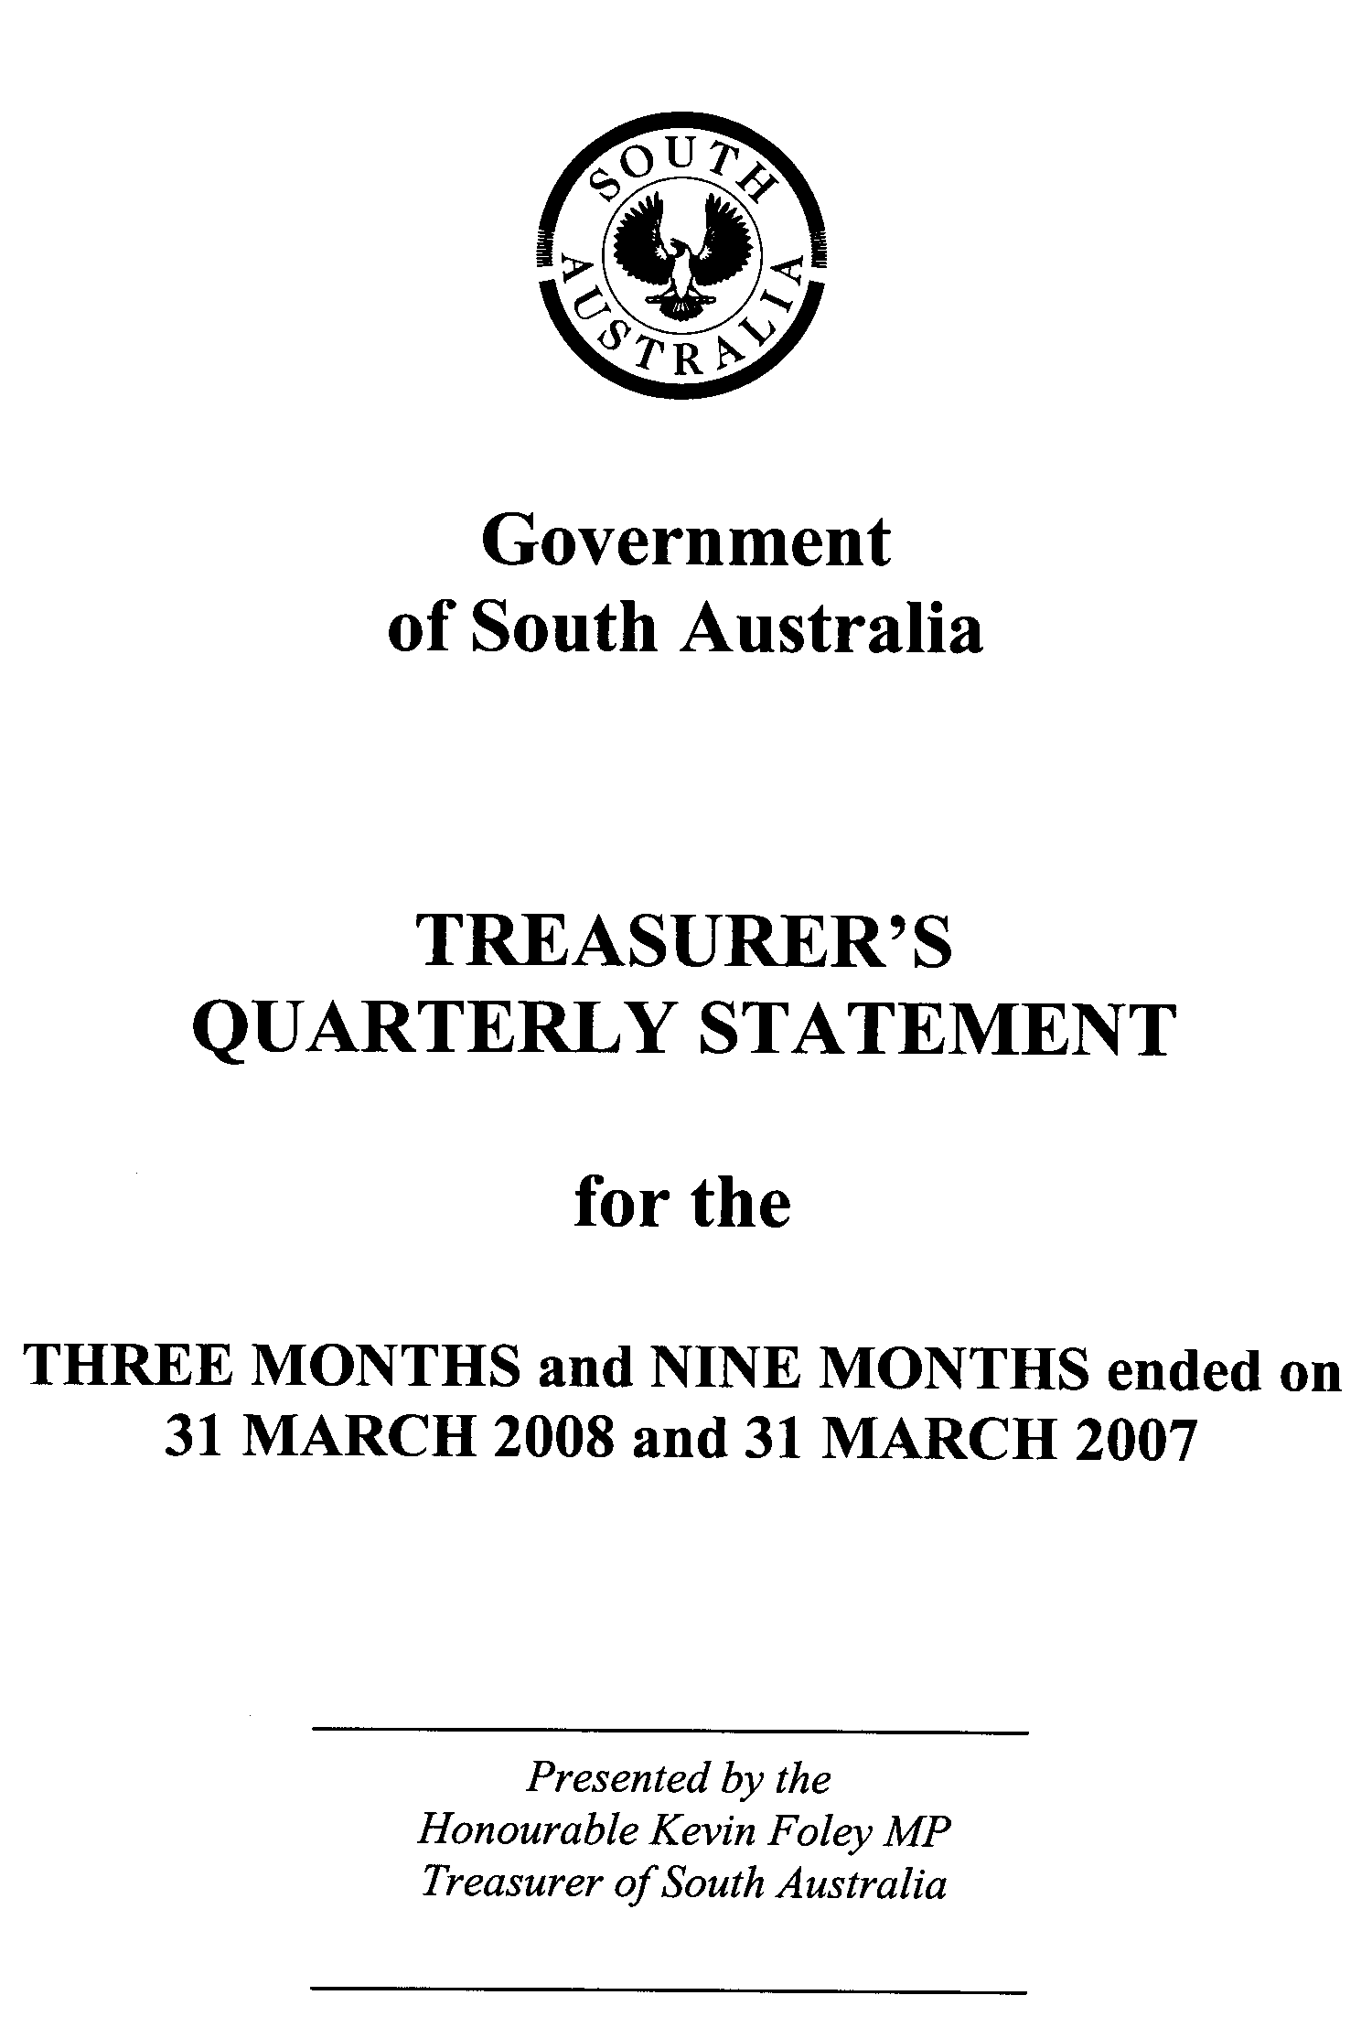
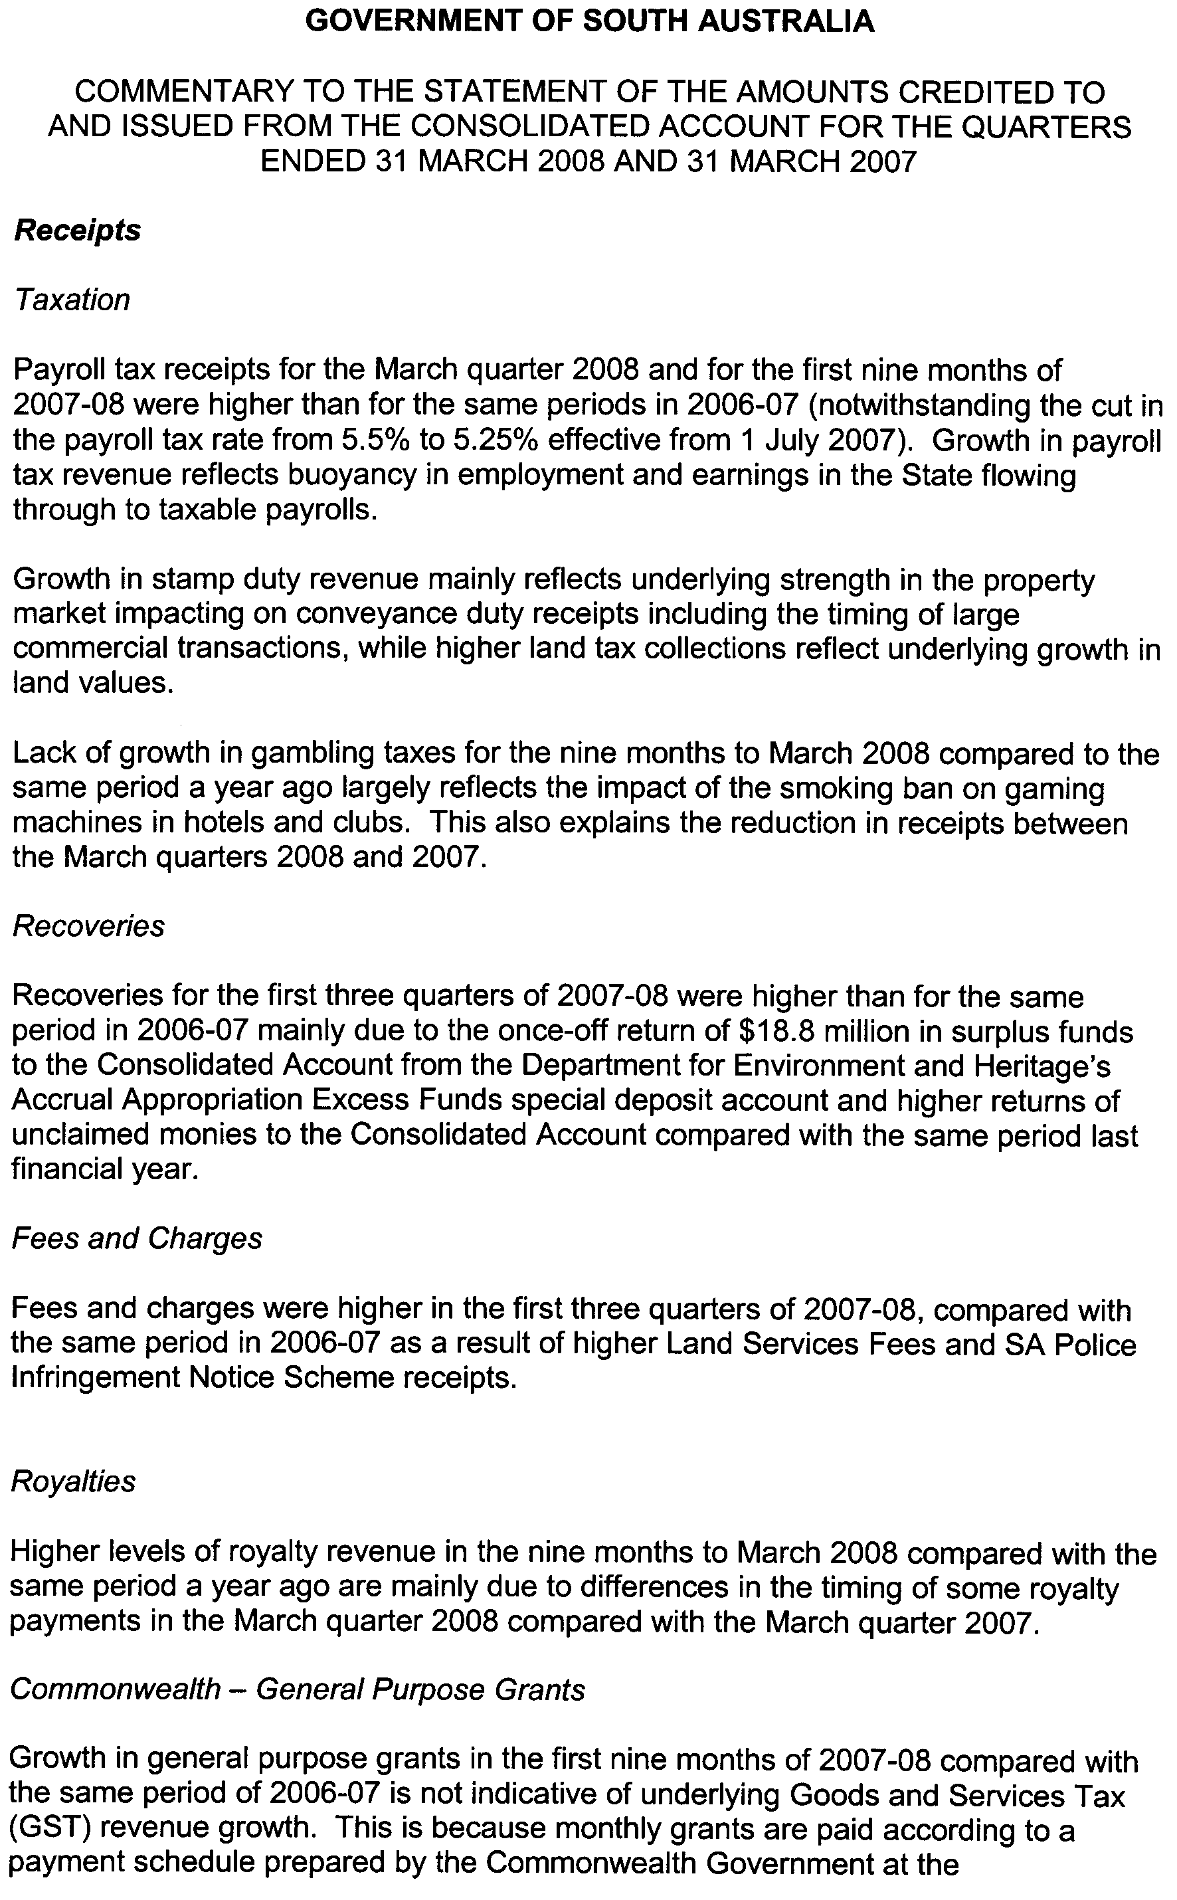
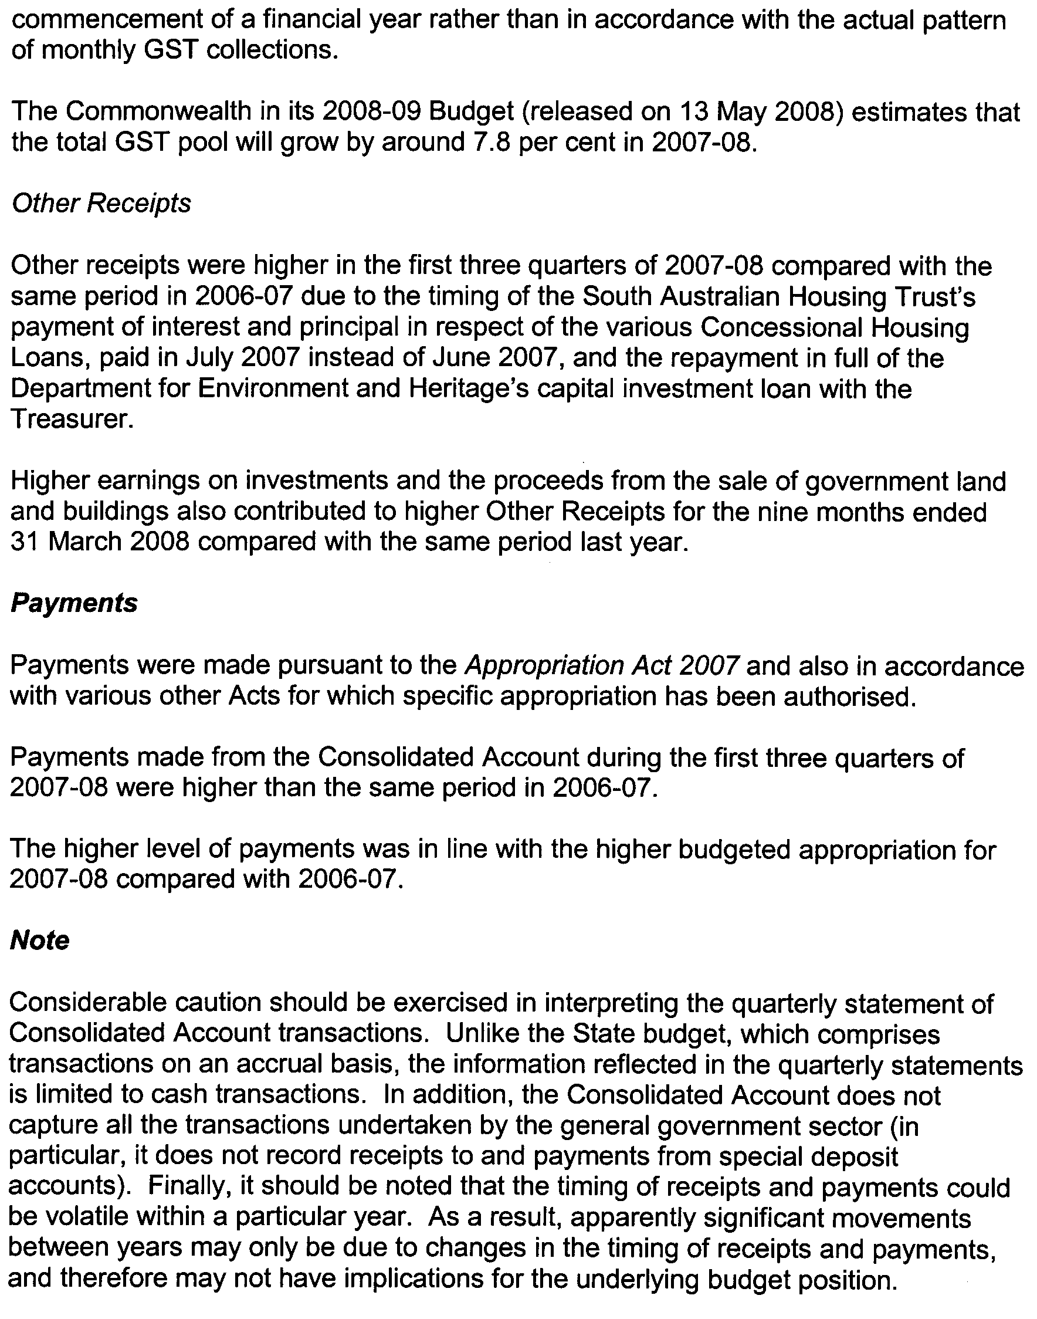
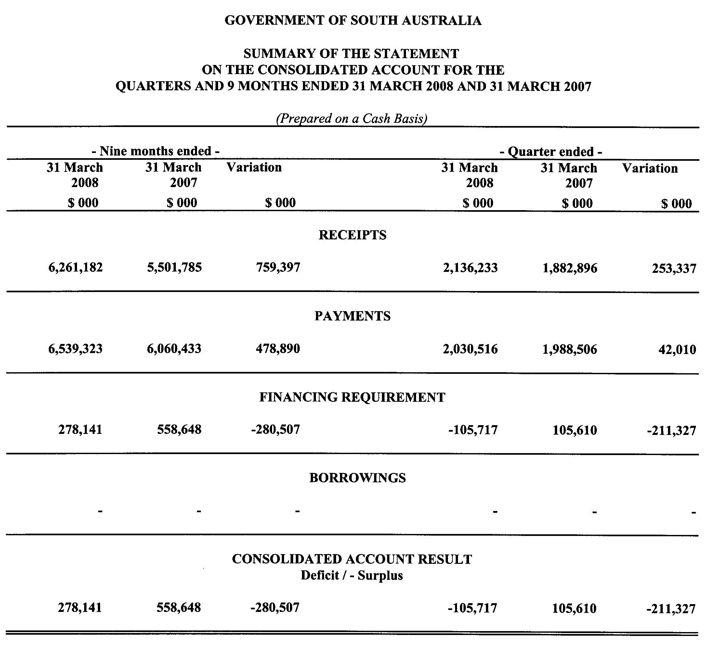
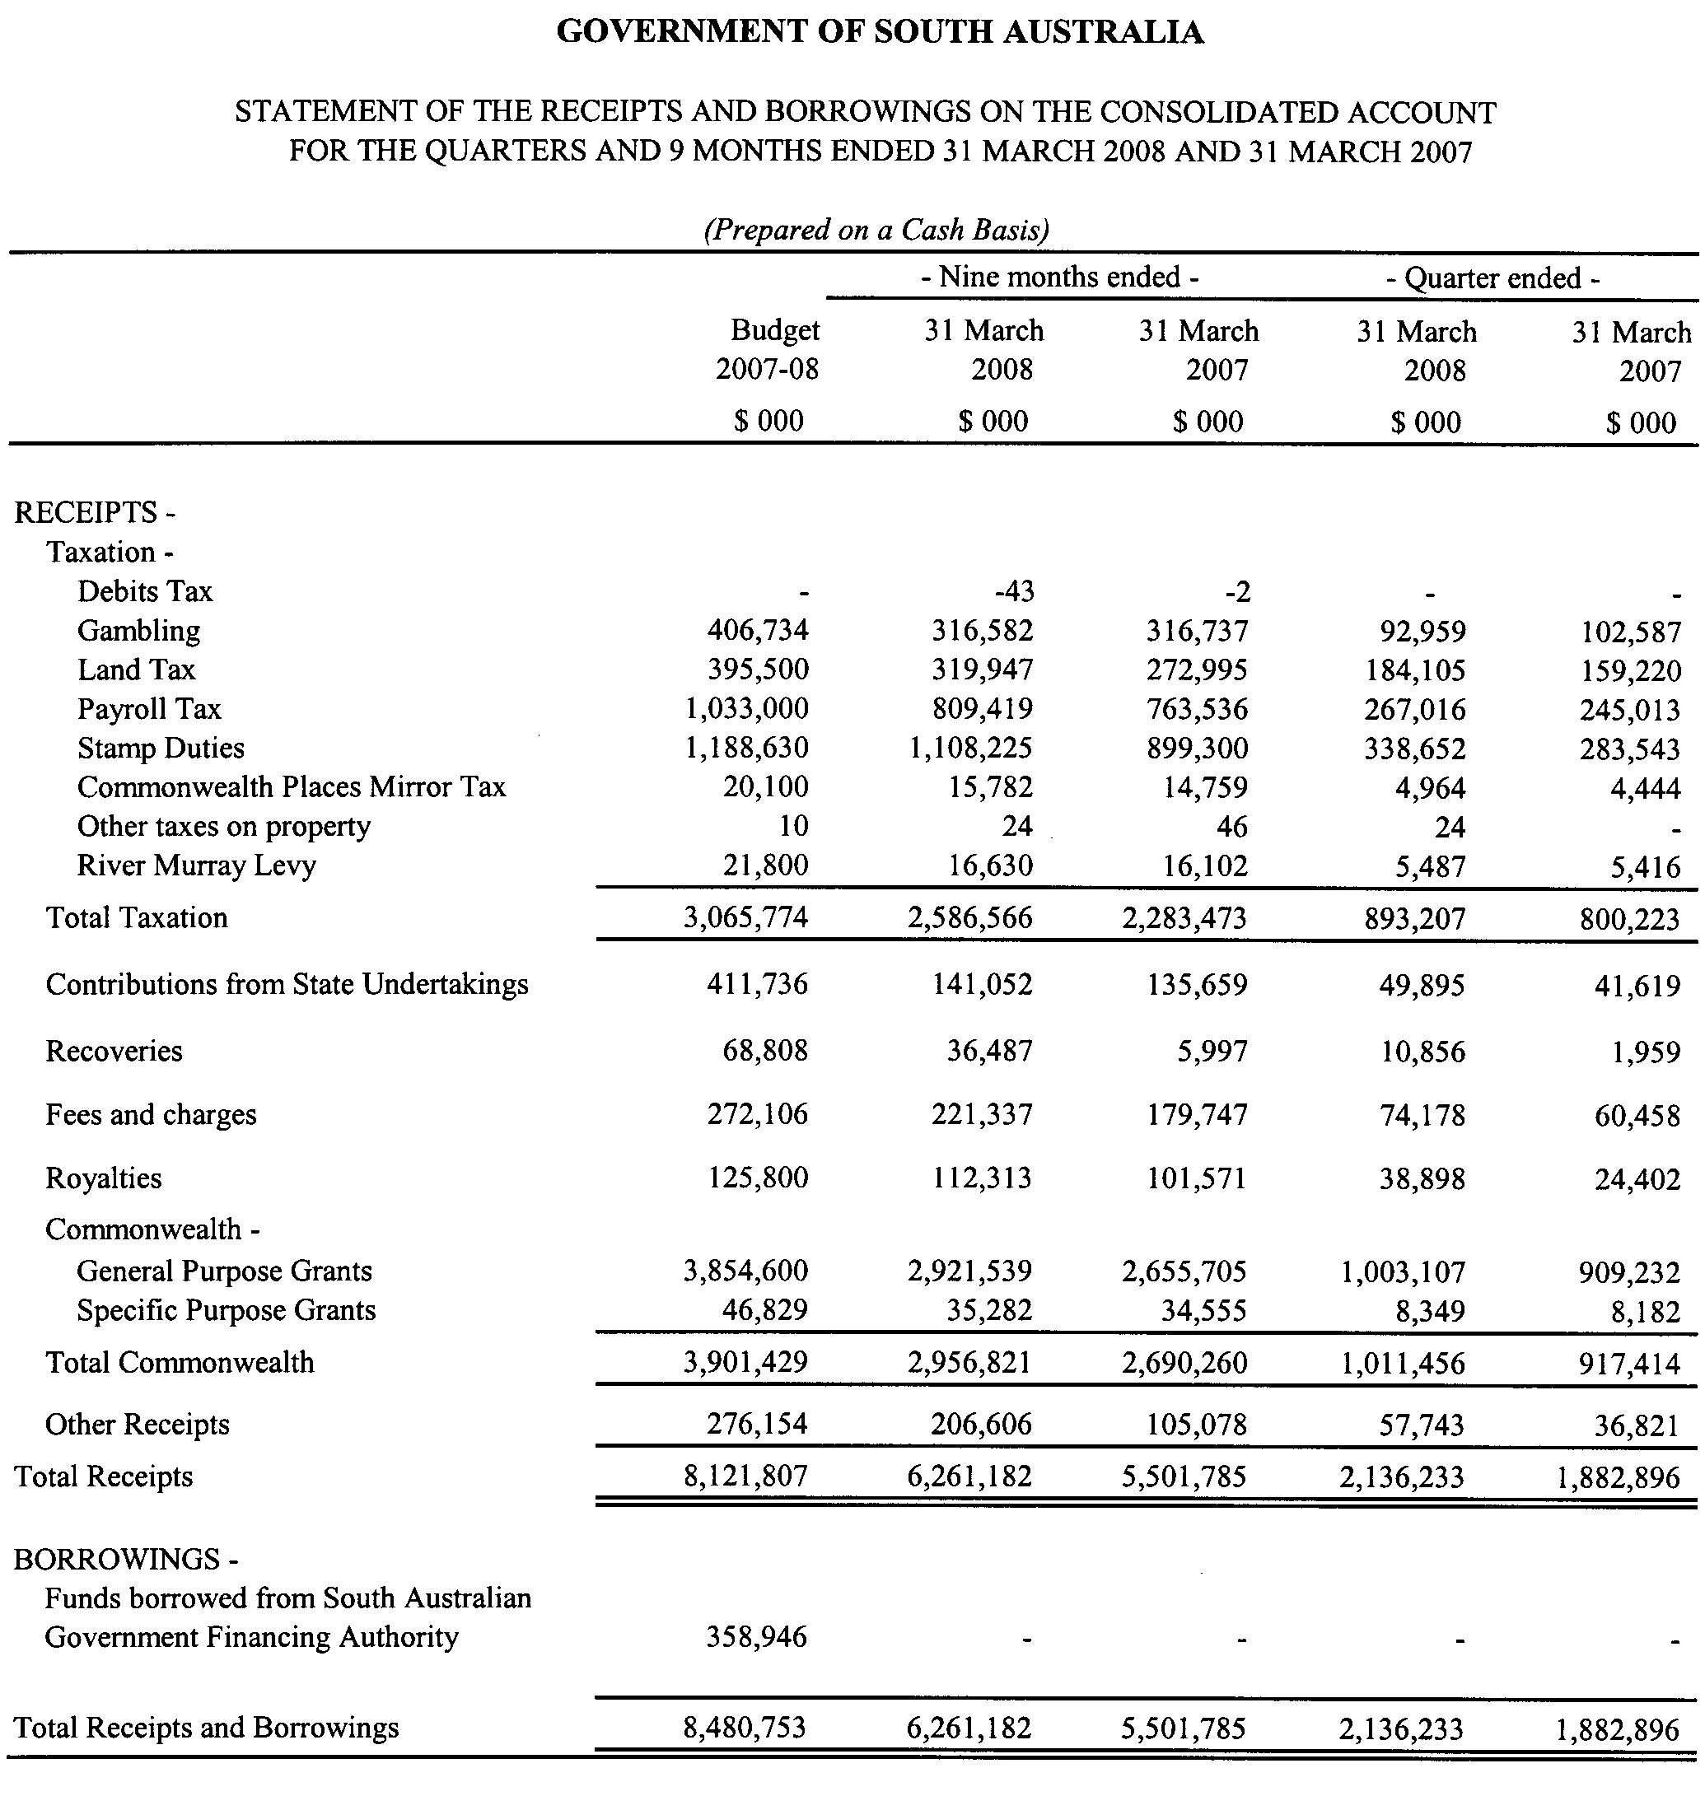
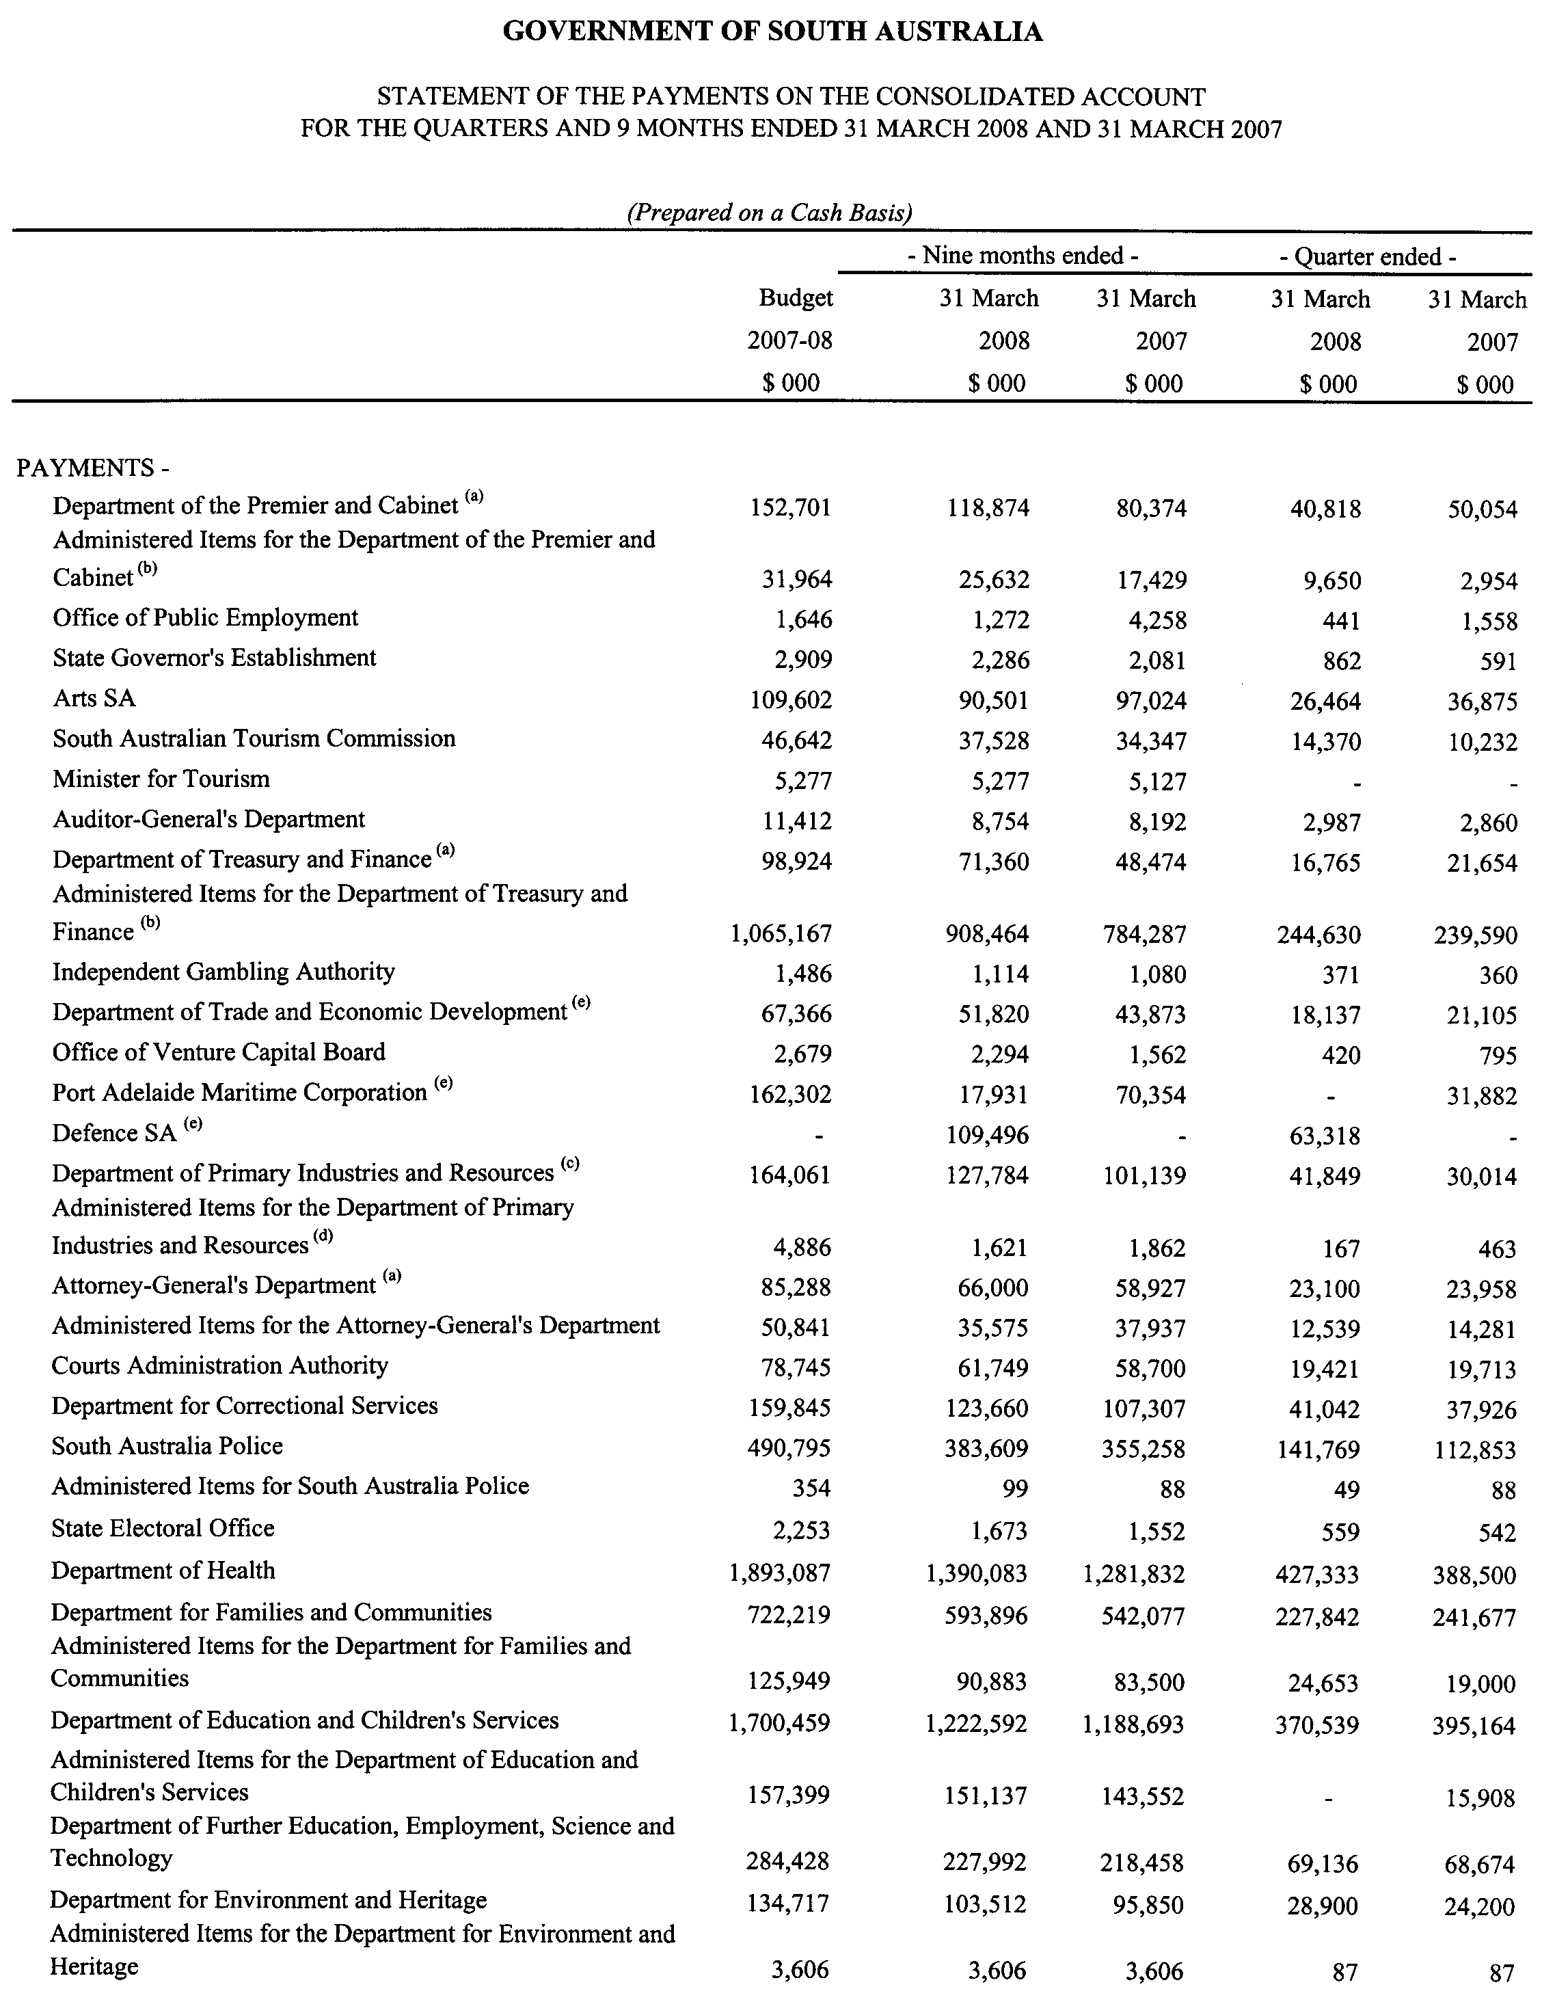
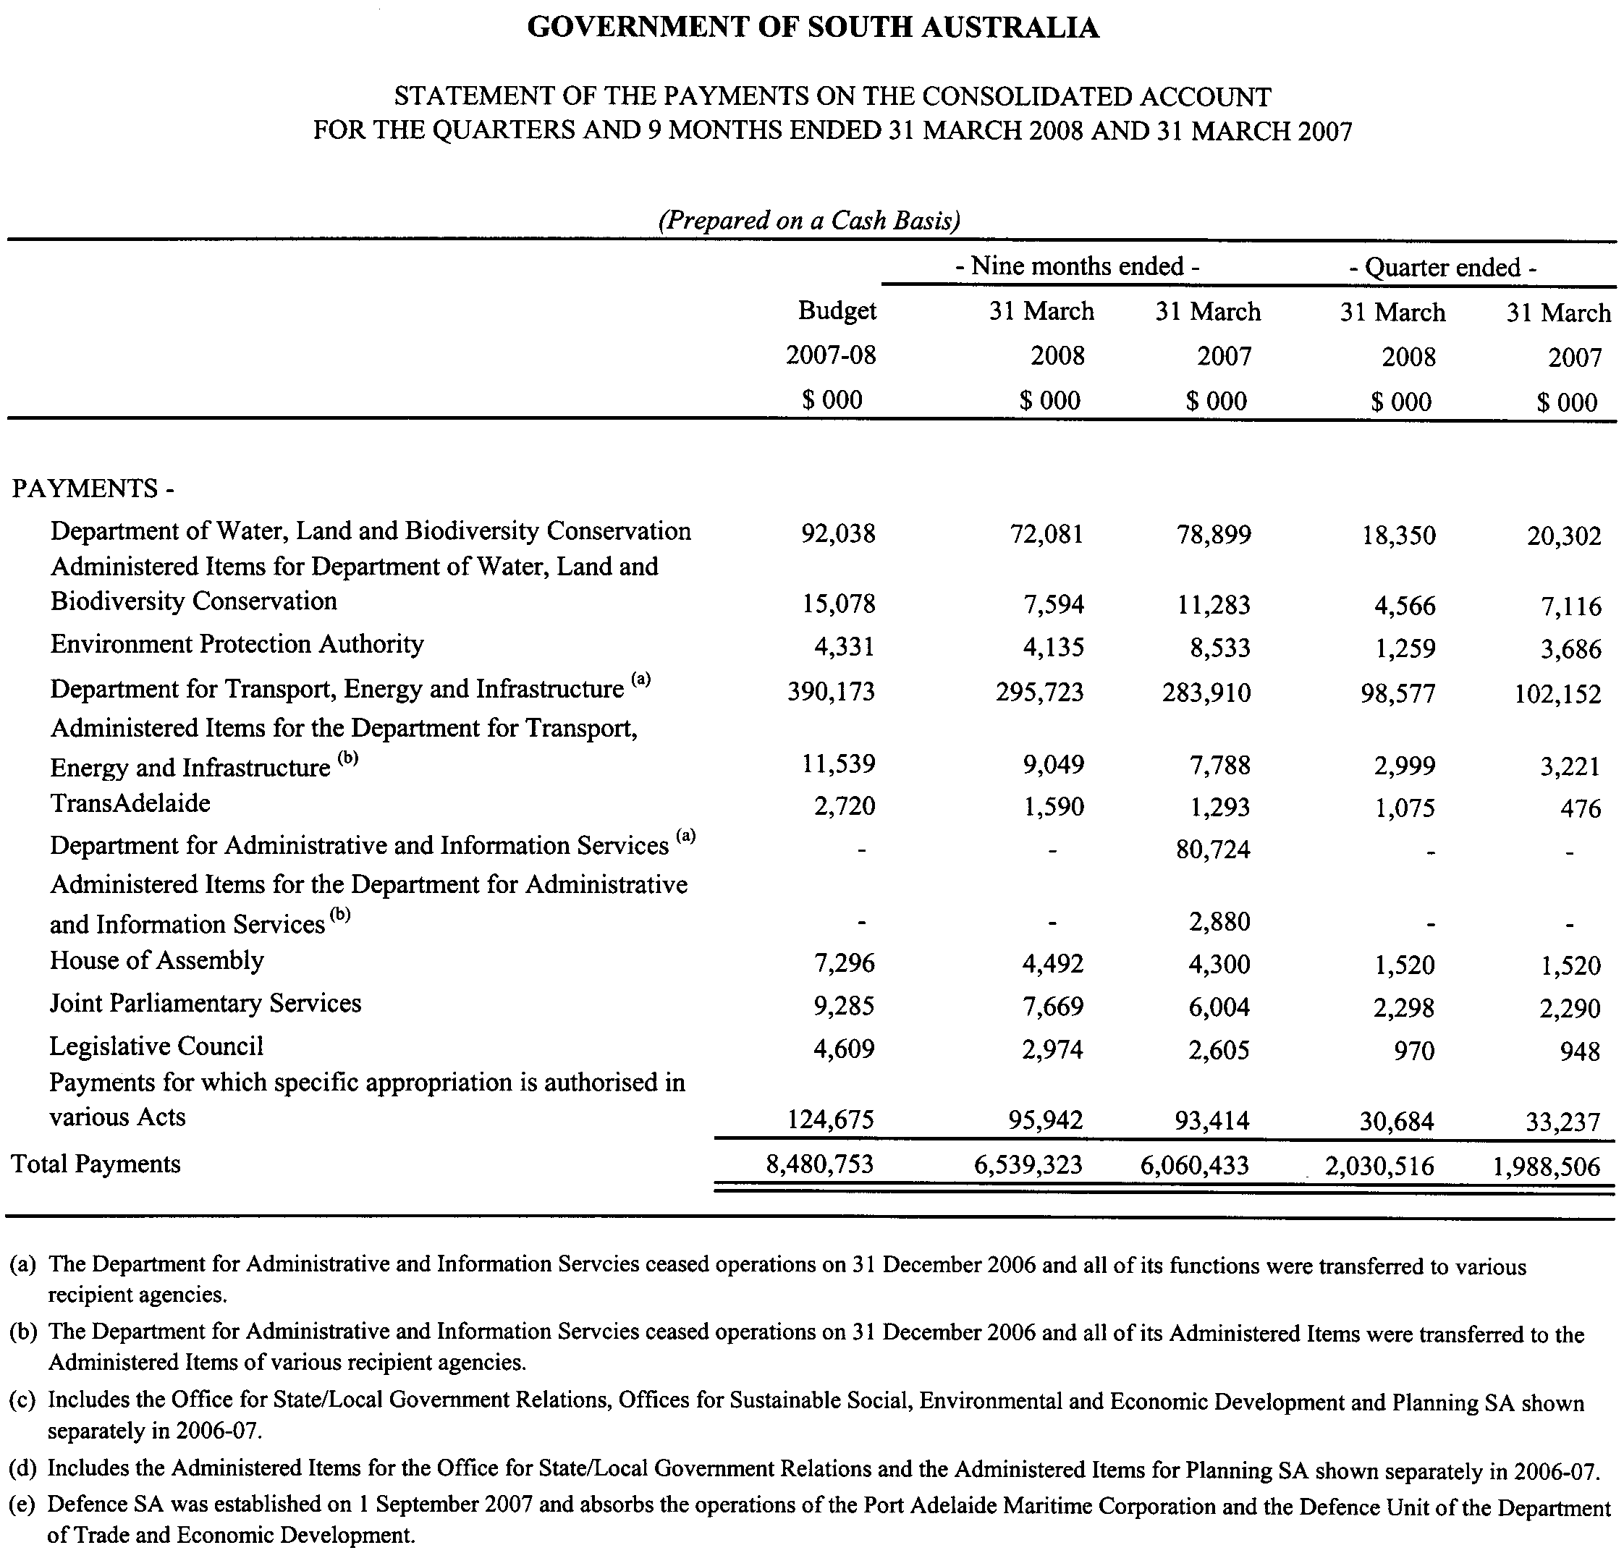

South Australia
Emergency Services Funding (Declaration of Levy and Area and Land Use Factors) Notice 2008
under section 10 of the Emergency Services Funding Act 1998
1—Short title
This notice may be cited as the Emergency Services Funding (Declaration of Levy and Area and Land Use Factors) Notice 2008.
2—Commencement
This notice comes into operation on the day on which it is made.
3—Interpretation
In this notice—
Act means the Emergency Services Funding Act 1998.
4—Declaration of levy
The levy under Part 3 Division 1 of the Act for the 2008/2009 financial year comprises—
(a) an amount of 0.1171 cents in respect of each dollar of the value of land subject to assessment; and
(b) a fixed charge of $50 for each piece, section or aggregation of contiguous or non-contiguous land subject to separate assessment.
5—Declaration of area factors
The area factors for each of the emergency services areas for the 2008/2009 financial year are as follows:
(a) Regional area 1—0.8;
(b) Regional area 2—0.5;
(c) Regional area 3—0.2;
(d) Regional area 4—1.0.
6—Declaration of land use factors
The land use factors for each of the land uses referred to in section 8(1) of the Act for the 2008/2009 financial year are as follows:
(a) commercial—1.0;
(b) industrial—1.5;
(c) residential—0.4;
(d) rural—0.3;
(e) all other uses—0.5.
7—Relevant day
The relevant day for the purposes of section 8 of the Act in respect of the 2008/2009 financial year is 30 June 2008.
8—Required statement of amount and description of method used to determine amount
The following information is provided in accordance with section 10(6) of the Act:
(a) the Minister has determined under section 10(4)(a) of the Act that $173.5 million needs to be raised by means of the levy under Part 3 Division 1 of the Act to fund emergency services in the 2008/2009 financial year, of which $81.8 million (net of remissions) needs to be raised from private and local government property ownerships;
(b) the method used for determining the amount referred to in paragraph (a) is as follows:
(i) a strategic and business planning process was undertaken to establish a strategic context for assessing amounts to be expended for the kinds of emergency services and other purposes referred to in section 28(4) of the Act;
(ii) the amount to be raised from the levy under Part 3 Division 1 of the Act was determined on the basis of—
(A) forward estimates of expenditure for emergency services during the 2008/2009 financial year, excluding expenditure carried over from previous years, consistent with the 2008/2009 budget; and
(B) the shortfall between projected 2008/2009 emergency services expenditure and projected 2008/2009 revenue from the levy under Part 3 Division 2 of the Act and non-levy revenue (such as interest earnings) paid into the Community Emergency Services Fund.
Made by the Governor
on the recommendation of the Treasurer and with the advice and consent of the Executive Council
on 19 June 2008
T&F08/019CS

South Australia
Emergency Services Funding (Declaration of Levy for Vehicles and Vessels) Notice 2008
under section 24 of the Emergency Services Funding Act 1998
1—Short title
This notice may be cited as the Emergency Services Funding (Declaration of Levy for Vehicles and Vessels) Notice 2008.
2—Commencement
This notice comes into operation on the day on which it is made.
3—Application of Notice
This notice applies in relation to the 2008/2009 financial year.
4—Declaration of levy in respect of vehicles and vessels
For the purposes of section 24 of the Emergency Services Funding Act 1998—
(a) motor vehicles are divided into classes referred to in Schedule 1 (being the same classes as the Premium Class Code published by the Motor Accident Commission); and
(b) the amount of the levy in respect of each such class of motor vehicle is as specified in Schedule 1; and
(c) the amount of the levy in respect of vessels is $12.
Schedule 1—Classes of motor vehicles

 | Premium Class Code |  | Amount of levy
Tier One | 1—District 1 | Cars, multi passenger or motor homes seating up to 12 No ITC Entitlement | $32
 | 2—District 1 | Light goods No ITC Entitlement
 | 3—District 1 | Medium goods ITC Entitled
 | 4—District 1 | Primary production—goods ITC Entitled
 | 5—District 1 | Taxis
 | 6—District 1 | Hire and drive yourself
 | 7—District 1 | Public passenger—up to 12 passengers ITC Entitled
 | 8—District 1 | Public passenger—13-35 passengers ITC Entitled
 | 9—District 1 | Public passenger—35+ passengers ITC Entitled
 | 10—District 1 | Public passenger, no fare No ITC Entitlement
 | 15—District 1 | Motorcycle—51cc-250cc No ITC Entitlement
 | 16—District 1 | Motorcycle—251cc-660cc No ITC Entitlement
 | 20—District 1 | Motorcycle—661cc+ No ITC Entitlement
 | 21—District 1 | Heavy goods (over 35 tonnes GVM) ITC Entitled
 | 22—District 1 | Light car carrier ITC Entitled
 | 23—District 1 | Medium car carrier ITC Entitled
 | 24—District 1 | Heavy car carrier ITC Entitled
 | 25—District 1 | Trailer car carrier ITC Entitled
 | 26—District 1 | Light car carrier No ITC Entitlement
 | 27—District 1 | Medium car carrier No ITC Entitlement
 | 28—District 1 | Heavy car carrier No ITC Entitlement
 | 29—District 1 | Special purpose/miscellaneous ITC Entitled
 | 30—District 1 | Trailer car carrier No ITC Entitlement
 | 32—District 1 | Municipal bus ITC Entitled
 | 33—District 1 | Special purpose/miscellaneous No ITC Entitlement
 | 35—District 1 | Motorcycle—51cc-250cc ITC Entitled
 | 36—District 1 | Motorcycle—251cc-660cc ITC Entitled
 | 40—District 1 | Motorcycle—661cc+ ITC Entitled
 | 41—District 1 | Cars, multi passenger or motor homes seating up to 12 ITC Entitled
 | 42—District 1 | Light goods ITC Entitled
 | 43—District 1 | Medium goods No ITC Entitlement
 | 44—District 1 | Goods carrying, primary producers No ITC Entitlement
 | 45—District 1 | Public passenger, no fare ITC Entitled
 | 46—District 1 | Heavy goods No ITC Entitlement
 | 47—District 1 | Public passenger—up to 12 passengers No ITC Entitlement
 | 48—District 1 | Public passenger—13-35 passengers No ITC Entitlement
 | 49—District 1 | Public passenger—35+ passengers No ITC Entitlement
 | 51—District 2 | Cars, multi passenger or motor home seating up to 12 No ITC Entitlement
 | 52—District 2 | Light goods carrier No ITC Entitlement
 | 53—District 2 | Medium goods carrier ITC Entitled
 | 55—District 2 | Taxis
 | 56—District 2 | Hire and drive yourself ITC Entitled
 | 57—District 2 | Public passenger—up to 12 passengers ITC Entitled
 | 58—District 2 | Public passenger —13-35 passengers ITC Entitled
 | 59—District 2 | Public passenger —35+ passengers ITC Entitled
 | 66—District 2 | Motorcycle—251cc-660cc No ITC Entitlement
 | 70—District 2 | Motorcycle—661cc+ No ITC Entitlement
 | 71—District 2 | Heavy goods ITC Entitled
 | 72—District 2 | Light car carrier ITC Entitled
 | 73—District 2 | Medium car carrier ITC Entitled
 | 74—District 2 | Heavy car carrier ITC Entitled
 | 76—District 2 | Light car carrier No ITC Entitlement
 | 77—District 2 | Medium car carrier No ITC Entitlement
 | 78—District 2 | Heavy car carrier No ITC Entitlement
 | 86—District 2 | Motorcycle—251cc-660cc ITC Entitled
 | 90—District 2 | Motorcycle—661cc+ ITC Entitled
 | 91—District 2 | Cars, multi passenger or motor homes seating up to 12 ITC Entitled
 | 92—District 2 | Light goods ITC Entitled
 | 93—District 2 | Medium goods carrier No ITC Entitlement
 | 96—District 2 | Heavy goods No ITC Entitlement
 | 97—District 2 | Public passenger—up to 12 passengers No ITC Entitlement
 | 98—District 2 | Public passenger—13-35 passengers No ITC Entitlement
 | 99—District 2 | Public passenger—35+ passengers No ITC Entitlement
Tier Two | 14—District 1 | Motorcycle—not exceeding 50cc No ITC Entitlement | $12
 | 34—District 1 | Motorcycle—not exceeding 50cc ITC Entitled
 | 54—District 2 | Primary producer's goods carrying vehicles ITC Entitled
 | 60—District 2 | Public passenger no fare No ITC Entitlement
 | 64—District 2 | Motorcycle—not exceeding 50cc No ITC Entitlement
 | 65—District 2 | Motorcycle—51cc-250cc No ITC Entitlement
 | 75—District 2 | Car carrier—trailers ITC Entitled
 | 79—District 2 | Special purpose/miscellaneous ITC Entitled
 | 80—District 2 | Car carrier—trailers No ITC Entitlement
 | 83—District 2 | Special purpose/miscellaneous No ITC Entitlement
 | 84—District 2 | Motorcycle—not exceeding 50cc ITC Entitled
 | 85—District 2 | Motorcycle—51cc-250cc ITC Entitled
 | 94—District 2 | Goods carrying, primary producers No ITC Entitlement
 | 95—District 2 | Public passenger no fare ITC Entitled
Tier Three | 11—District 1 | Trailers No ITC Entitlement | $8
 | 19—District 1 | Historic and left hand drive ITC Entitled
 | 31—District 1 | Trailers ITC Entitled
 | 39—District 1 | Historic and left hand drive No ITC Entitlement
 | 61—District 2 | Trailers No ITC Entitlement
 | 69—District 2 | Historic and left hand drive ITC Entitled
 | 81—District 2 | Trailers ITC Entitled
 | 89—District 2 | Historic and left hand drive No ITC Entitlement
 | 68—District 2 | Conditionally registered farm tractors No ITC Entitlement | $0
 | 18—District 1 | Conditionally registered farm tractors No ITC Entitlement
 | 88—District 2 | Conditionally registered farm tractors ITC Entitled
 | 38—District 1 | Conditionally registered farm tractors ITC Entitled
 | 67—District 2 | Permit No ITC Entitlement
 | 17—District 1 | Permit No ITC Entitlement
 | 87—District 2 | Permit ITC Entitled
 | 37—District 1 | Permit ITC Entitled
Made by the Governor
on the recommendation of the Treasurer and with the advice and consent of the Executive Council
on 19 June 2008
T&F08/019CS

South Australia
Electricity (Feed-In Scheme—Solar Systems) Amendment Act (Commencement) Proclamation 2008
1—Short title
This proclamation may be cited as the Electricity (Feed-In Scheme—Solar Systems) Amendment Act (Commencement) Proclamation 2008.
2—Commencement of Act
The Electricity (Feed-In Scheme—Solar Systems) Amendment Act 2008 (No 1 of 2008) will come into operation on 1 July 2008.
Made by the Governor
with the advice and consent of the Executive Council
on 19 June 2008
MEN08/003CS

South Australia
Motor Vehicles (Miscellaneous) Amendment Act (Commencement) Proclamation 2008
1—Short title
This proclamation may be cited as the Motor Vehicles (Miscellaneous) Amendment Act (Commencement) Proclamation 2008.
2—Commencement of Act
The Motor Vehicles (Miscellaneous) Amendment Act 2007 (No 59 of 2007) will come into operation on 23 June 2008.
Made by the Governor
with the advice and consent of the Executive Council
on 19 June 2008
MTR08/036CS

South Australia
Senior Secondary Assessment Board of South Australia Variation Regulations 2008
under the Senior Secondary Assessment Board of South Australia Act 1983

Contents
Part 1—Preliminary
1 Short title
2 Commencement
3 Variation provisions
Part 2—Variation of Senior Secondary Assessment Board of South Australia Regulations 2000
4 Variation of regulation 1—Short title
5 Substitution of regulations 4 and 5
2 Interpretation
3 Transitional arrangements associated with existing and future qualifications
4 Designated entities
6 Revocation of Schedules 1 and 2

Part 1—Preliminary
1—Short title
These regulations may be cited as the Senior Secondary Assessment Board of South Australia Variation Regulations 2008.
2—Commencement
These regulations will come into operation on the day on which the Senior Secondary Assessment Board of South Australia (Review) Amendment Act 2008 comes into operation.
3—Variation provisions
In these regulations, a provision under a heading referring to the variation of specified regulations varies the regulations so specified.
Part 2—Variation of Senior Secondary Assessment Board of South Australia Regulations 2000
4—Variation of regulation 1—Short title
Regulation 1—delete "Senior Secondary Assessment Board of South Australia Regulations 2000" and substitute:
SACE Board of South Australia Regulations 2000
5—Substitution of regulations 4 and 5
Regulations 4 and 5—delete the regulations and substitute:
2—Interpretation
In these regulations, unless the contrary intention appears—
Act means the SACE Board of South Australia Act 1983;
prescribed qualification requirements means any qualification requirements for the achievement of the SACE—
(a) prescribed by these regulations (including before the commencement of the 2008 Amendment Act); or
(b) determined by the Board;
2008 Amendment Act means the Senior Secondary Assessment Board of South Australia (Review) Amendment Act 2008.
3—Transitional arrangements associated with existing and future qualifications
(1) The Board may continue to award the qualification in existence on the commencement of the 2008 Amendment Act on such basis as the Board may determine from time to time.
(2) The certification requirements prescribed by these regulations before the commencement of the 2008 Amendment Act will continue to apply (as may be relevant) for students undertaking senior secondary education (as defined immediately before the commencement of the 2008 Amendment Act) until otherwise determined by the Board.
(3) All approvals given or other steps taken by the Board before the commencement of the 2008 Amendment Act (and still having force or effect immediately before that commencement) will continue to have effect in all respects on and after that commencement unless or until the Board determines otherwise.
(4) All achievements recognised by the Board before the commencement of the 2008 Amendment Act (and being so recognised at the time of that commencement) will continue to have effect in all respects on or after that commencement (unless the Board has valid grounds to revoke the recognition of an achievement in a particular case after that commencement).
4—Designated entities
Pursuant to clause 2 of Schedule 1 of the Act, clause 1 of that Schedule is amended by adding after paragraph (v) the following paragraph:
(w) The Association of Independent Schools of South Australia Incorporated.
6—Revocation of Schedules 1 and 2
Schedules 1 and 2—delete the Schedules
Note—
As required by section 10AA(2) of the Subordinate Legislation Act 1978, the Minister has certified that, in the Minister's opinion, it is necessary or appropriate that these regulations come into operation as set out in these regulations.
Made by the Governor
with the advice and consent of the Executive Council
on 19 June 2008
No 163 of 2008

South Australia
Waterworks Variation Regulations 2008
under the Waterworks Act 1932

Contents
Part 1—Preliminary
1 Short title
2 Commencement
3 Variation provisions
Part 2—Variation of Waterworks Regulations 1996
4 Variation of regulation 17—Directions

Part 1—Preliminary
1—Short title
These regulations may be cited as the Waterworks Variation Regulations 2008.
2—Commencement
These regulations come into operation on the date on which they are made.
3—Variation provisions
In these regulations, a provision under a heading referring to the variation of specified regulations varies the regulations so specified.
Part 2—Variation of Waterworks Regulations 1996
4—Variation of regulation 17—Directions
(1) Regulation 17(1)—delete "In order to ensure the safe and proper operation of the waterworks and the pipes, fittings, appliances and apparatus connected to it, the Corporation may publish written directions" and substitute:
The Corporation may publish written directions relating to the waterworks and the pipes, fittings, appliances and apparatus connected to it
(2) Regulation 17(1)—after paragraph (e) insert:
and
(f) specifying performance or other standards that must be met by pipes, fittings, appliances or apparatus that may be connected to the waterworks (and, in so doing, specifying methodologies or other processes or criteria for assessing compliance with those standards, including as to the efficiency, impact or effectiveness of any such pipes, fittings, appliances or apparatus).
(3) Regulation 17—after subregulation (1) insert:
(1a) A direction under these regulations may—
(a) be of general or limited application;
(b) make different provision according to the matters or circumstances to which it is expressed to apply;
(c) provide that a matter or thing is to be determined according to the discretion of the Corporation.
Note—
As required by section 10AA(2) of the Subordinate Legislation Act 1978, the Minister has certified that, in the Minister's opinion, it is necessary or appropriate that these regulations come into operation as set out in these regulations.
Made by the Governor
with the advice and consent of the Executive Council
on 19 June 2008
No 164 of 2008
MEN07/006CS

South Australia
Emergency Services Funding (Remissions—Land) Variation Regulations 2008
under the Emergency Services Funding Act 1998

Contents
Part 1—Preliminary
1 Short title
2 Commencement
3 Variation provisions
Part 2—Variation of Emergency Services Funding (Remissions—Land) Regulations 2000
4 Variation of regulation 4—Interpretation

Part 1—Preliminary
1—Short title
These regulations may be cited as the Emergency Services Funding (Remissions—Land) Variation Regulations 2008.
2—Commencement
These regulations will come into operation on 1 July 2008.
3—Variation provisions
In these regulations, a provision under a heading referring to the variation of specified regulations varies the regulations so specified.
Part 2—Variation of Emergency Services Funding (Remissions—Land) Regulations 2000
4—Variation of regulation 4—Interpretation
Regulation 4, definition of relevant financial year—delete "2007/2008" and substitute:
2008/2009
Note—
As required by section 10AA(2) of the Subordinate Legislation Act 1978, the Minister has certified that, in the Minister's opinion, it is necessary or appropriate that these regulations come into operation as set out in these regulations.
Made by the Governor
on the recommendation of the Treasurer and with the advice and consent of the Executive Council
on 19 June 2008
No 165 of 2008
T&F08/019CS

South Australia
Motor Vehicles Variation Regulations 2008
under the Motor Vehicles Act 1959

Contents
Part 1—Preliminary
1 Short title
2 Commencement
3 Variation provisions
Part 2—Variation of Motor Vehicles Regulations 1996
4 Variation of regulation 38—Fees
5 Variation of regulation 47—Remission and reduction of fees
6 Substitution of regulation 51A
51A Manner of giving Registrar notice of election under section 98BE of Act
51B Manner of giving Registrar notice of change of name, address etc under section 136 of Act
7 Insertion of regulation 52AA
52AA Places at which receipt of notice of disqualification may be personally acknowledged
8 Variation of Schedule 5—Fees

Part 1—Preliminary
1—Short title
These regulations may be cited as the Motor Vehicles Variation Regulations 2008.
2—Commencement
These regulations will come into operation on the day on which the Motor Vehicles (Miscellaneous) Amendment Act 2007 comes into operation.
3—Variation provisions
In these regulations, a provision under a heading referring to the variation of specified regulations varies the regulations so specified.
Part 2—Variation of Motor Vehicles Regulations 1996
4—Variation of regulation 38—Fees
Regulation 38—after subregulation (1) insert:
(1aa) For the purposes of section 81BA(3) of the Act, the fee payable for the issue of a P2 licence under that section is an amount equal to the fee that would be payable for the issue of a licence under section 75 of the Act.
5—Variation of regulation 47—Remission and reduction of fees
Regulation 47—after its present contents (now to be designated as subregulation (1)) insert:
(2) The Registrar may, for reasonable cause, reduce a fee payable under section 139BD of the Act for personal service of a notice of disqualification.
6—Substitution of regulation 51A
Regulation 51A—delete the regulation and substitute:
51A—Manner of giving Registrar notice of election under section 98BE of Act
Notice of an election under section 98BE(2) of the Act is to be given by a person to the Registrar by lodging the notice of disqualification sent to or served on the person, completed in accordance with the instructions contained in the notice and signed by the person, at a place of a kind prescribed for the purposes of section 139BD(3)(a)(i) of the Act.
51B—Manner of giving Registrar notice of change of name, address etc under section 136 of Act
Notice under section 136 of the Act is to be given by a person to the Registrar in a following manner:
(a) in writing;
(b) by telephone to a telephone number nominated by the Registrar for the purposes of giving notice;
(c) by fax transmission to a fax number nominated by the Registrar for the purpose of giving notice by fax;
(d) by other telephonic or electronic means made available by the Registrar to members of the public for the purpose of giving notice in such manner.
7—Insertion of regulation 52AA
After regulation 52 insert:
52AA—Places at which receipt of notice of disqualification may be personally acknowledged
For the purposes of section 139BD(3)(a)(i) of the Act, places of the following kinds are prescribed:
(a) offices of the Transport Department known as Registration and Licensing Centres or Service SA Customer Service Centres;
(b) Australia Post outlets that have electronic point of sale (EPOS) systems.

8—Variation of Schedule 5—Fees
Schedule 5—after clause 39 insert:

39A—Fees payable in connection with service of notices of disqualification
(1) | Administration fee payable under section 139BD of the Act | $24
(2) | Service fee payable under section 139BD of the Act | $60
Note—
As required by section 10AA(2) of the Subordinate Legislation Act 1978, the Minister has certified that, in the Minister's opinion, it is necessary or appropriate that these regulations come into operation as set out in these regulations.
Made by the Governor
with the advice and consent of the Executive Council
on 19 June 2008
No 166 of 2008
MTR06/040CS

South Australia
Liquor Licensing (Dry Areas—Long Term) Variation Regulations 2008
under the Liquor Licensing Act 1997

Contents
Part 1—Preliminary
1 Short title
2 Commencement
3 Variation provisions
Part 2—Variation of Liquor Licensing (Dry Areas—Long Term) Regulations 1997
4 Variation of Schedule 1—Long term dry areas
5 Variation of Schedule 2—Plans of long term dry areas
Schedule 1—Plan to be inserted

Part 1—Preliminary
1—Short title
These regulations may be cited as the Liquor Licensing (Dry Areas—Long Term) Variation Regulations 2008.
2—Commencement
These regulations come into operation on the day on which they are made.
3—Variation provisions
In these regulations, a provision under a heading referring to the variation of specified regulations varies the regulations so specified.
Part 2—Variation of Liquor Licensing (Dry Areas—Long Term) Regulations 1997
4—Variation of Schedule 1—Long term dry areas
Schedule 1—after the item headed "Port Pirie—Area 3" insert:

Port Vincent—Area 1
(see Schedule 2: Port Vincent—Plan No 1)
The area in Port Vincent bounded as follows: commencing at the point at which the eastern boundary of Lot 47 DP 61751 meets the western boundary of Marina Drive, then generally south-westerly along that boundary of Marina Drive and of Marine Parade North to the point at which the western boundary of Marine Parade North meets the southern boundary of Lot 1 FP 128918, then westerly along the southern boundary of Lot 1 to the eastern boundary of Lot 26 FP 3593, then southerly along that eastern boundary of Lot 26 and of the adjoining Lots to the northern boundary of Lot 32 FP 17100, then easterly along that northern boundary of Lot 32 to the western boundary of Marine Parade North, then southerly along that boundary of Marine Parade North to the north-eastern boundary of Lime Kiln Road, then north-westerly along that boundary of Lime Kiln Road to the point at which it intersects the prolongation in a straight line of the western boundary of Kempe Street, then south-easterly along that prolongation and boundary of Kempe Street to the northern boundary of Parsons Street, then south-westerly along that boundary of Parsons Street to its intersection with the prolongation in a straight line of the western boundary of Talbot Road, then south-easterly along that prolongation and boundary of Talbot Road to the northern boundary of Cameron Street, then south-westerly along that boundary of Cameron Street to the eastern boundary of Adonis Road, then generally north-westerly, westerly and south-easterly around the boundary of Adonis Road back to the northern boundary of Cameron Street, then generally south-westerly, southerly and north-easterly around the boundary of Cameron Street back to the western boundary of Adonis Road, then south-easterly and south-westerly along that boundary of Adonis Road to the northern boundary of Lulu Court, then generally north-westerly, southerly and south-easterly around the boundary of Lulu Court back to the western boundary of Adonis Road, then south-westerly along that boundary of Adonis Road to the northern boundary of Ventnor Street, then generally westerly to the western end of Ventnor Street (the point at which it meets the eastern boundary of Lot 202 DP 62958), then southerly, easterly and south-easterly along the western and south-western boundaries of Ventnor Street to the north-western boundary of Main Street, then in a straight line by the shortest route across Main Street to the northern corner of Lot 152 DP 6070 (Bennett Park), then south-westerly, south-easterly and north-easterly along the north-western, south-western and south-eastern boundaries of Lot 152 to the south-western boundary of Wauraltee Road, then south-easterly along that boundary of Wauraltee Road to the north-western boundary of The Esplanade, then south-westerly along that boundary of The Esplanade to the north-eastern boundary of McPharlin Avenue, then north-westerly along that boundary of McPharlin Avenue to its intersection with the prolongation in a straight line of the south-eastern boundary of Ponder Parade, then south-westerly along that prolongation and boundary of Ponder Parade to the south-western end of that boundary, then in a straight line by the shortest route to the point at which the south-western boundary of Bennett Street meets the north-western boundary of The Esplanade, then south-westerly along that boundary of The Esplanade to the point at which it meets the boundary between Lot 6 DP 40247 and Lot 14 DP 43811, then south-easterly along the prolongation in a straight line of that common boundary to the point at which it intersects the low water mark on the western side of Gulf St Vincent, then generally north-easterly, easterly, north-westerly, westerly, north-westerly, northerly and north-easterly along the low water mark to the southern side of the entrance to the Port Vincent Marina, then along the low water mark inside the marina back to the entrance on the northern side of the marina, then generally north-westerly along the low water mark on the outer side of the northern breakwater of the marina to the point at which the breakwater continues north-westerly inland above the low water mark, then north-westerly along the outer boundary of the breakwater as it continues north-westerly inland to the eastern boundary of Lot 103 DP 54608, then generally south-westerly, north-westerly, south-westerly and north-westerly along the eastern and southern boundaries of Lot 103 to the eastern boundary of Lot 47 DP 61751, then southerly along that boundary of Lot 47 to the point of commencement. The area includes the public boat ramp and pontoon inside the Port Vincent Marina and any wharf or jetty outside the marina extending from the area described above, but does not include the Port Vincent Caravan Park (Lot 4 DP 24058) or any part of a jetty or mooring (other than the public boat ramp and pontoon) inside the Port Vincent Marina. | 10 p.m. on each day to 8 a.m. on the following day, until 8 a.m. on 19 June 2009. | The consumption and possession of liquor are prohibited.

Port Vincent—Area 2
(see Schedule 2: Port Vincent—Plan No 1)
The reserve in Port Vincent that lies between Chester Avenue and Ford Avenue, being the whole of the land contained in Lot 145 DP 6071. | 10 p.m. on each day to 8 a.m. on the following day, until 8 a.m. on 19 June 2009. | The consumption and possession of liquor are prohibited.
5—Variation of Schedule 2—Plans of long term dry areas
Schedule 2—after the plan headed "Port Pirie—Plan No 3" insert the plan headed "Port Vincent—Plan No 1" in Schedule 1 of these regulations
Schedule 1—Plan to be inserted
Port Vincent—Plan No 1
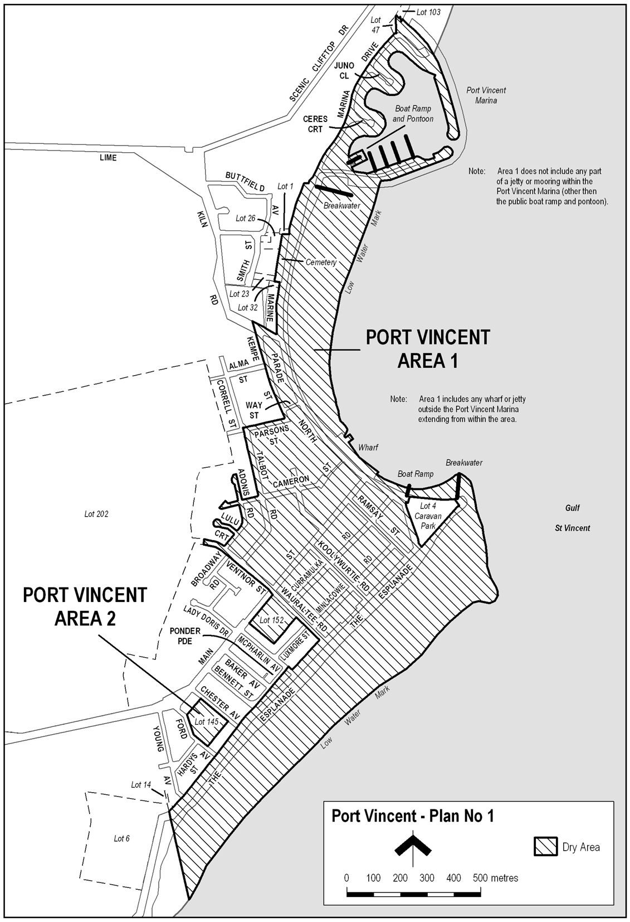
Note—
As required by section 10AA(2) of the Subordinate Legislation Act 1978, the Minister has certified that, in the Minister's opinion, it is necessary or appropriate that these regulations come into operation as set out in these regulations.
Made by the Governor
with the advice and consent of the Executive Council
on 19 June 2008
No 167 of 2008
MCA08/007CS

South Australia
Natural Resources Management (Baroota Prescribed Water Resources Area) Regulations 2008
under the Natural Resources Management Act 2004

Contents
1 Short title
2 Commencement
3 Interpretation
4 Declaration of prescribed water resources
5 Establishment and prescribed periods
6 Operation of section 124(4)

1—Short title
These regulations may be cited as the Natural Resources Management (Baroota Prescribed Water Resources Area) Regulations 2008.
2—Commencement
These regulations come into operation on the day on which they are made.
3—Interpretation
In these regulations—
Act means the Natural Resources Management Act 2004;
Baroota Prescribed Water Resources Area means the area bounded by the bold line in GRO Plan No 170/2004.
4—Declaration of prescribed water resources
(1) All watercourses in the Baroota Prescribed Water Resources Area are declared to be prescribed watercourses.
(2) All wells in the Baroota Prescribed Water Resources Area are declared to be prescribed wells.
(3) The Baroota Prescribed Water Resources Area is declared to be a surface water prescribed area.
5—Establishment and prescribed periods
(1) The establishment period in relation to the prescribed water resources declared under regulation 4 commenced on 30 June 2000 and ended at the commencement of the prescribed period (13 June 2002).
(2) The prescribed period in relation to the prescribed water resources declared under regulation 4 commenced on 13 June 2002 and will end on the day that coincides with the third anniversary of the commencement of this regulation.
6—Operation of section 124(4)
The operation of section 124(4) of the Act is not excluded in relation to the prescribed water resources declared under regulation 4.
Note—
As required by section 10AA(2) of the Subordinate Legislation Act 1978, the Minister has certified that, in the Minister's opinion, it is necessary or appropriate that these regulations come into operation as set out in these regulations.
Made by the Governor
on the recommendation of the Minister for Environment and Conservation and with the advice and consent of the Executive Council
on 19 June 2008
No 168 of 2008
WBCS07/0031

South Australia
South Australian Health Commission (Recognised Hospital—Medicare Patients Fees) Variation Regulations 2008
under the South Australian Health Commission Act 1976

Contents
Part 1—Preliminary
1 Short title
2 Commencement
3 Variation provisions
Part 2—Variation of South Australian Health Commission (Recognised Hospital—Medicare Patients Fees) Regulations 2002
4 Variation of regulation 4—Interpretation
5 Substitution of Schedule
Schedule—Fees for services provided to Medicare patients by recognised hospitals

Part 1—Preliminary
1—Short title
These regulations may be cited as the South Australian Health Commission (Recognised Hospital—Medicare Patients Fees) Variation Regulations 2008.
2—Commencement
These regulations will come into operation on 1 July 2008.
3—Variation provisions
In these regulations, a provision under a heading referring to the variation of specified regulations varies the regulations so specified.
Part 2—Variation of South Australian Health Commission (Recognised Hospital—Medicare Patients Fees) Regulations 2002
4—Variation of regulation 4—Interpretation
(1) Regulation 4(1)—after the definition of Commonwealth benefit insert:
hospital in the home service, in relation to a recognised hospital, means treatment or care provided by the hospital to a patient at a location outside the hospital premises (being treatment or care provided as a direct substitute for treatment or care that would normally be provided as an inpatient service on the hospital premises);
(2) Regulation 4(1), definition of outreach service—delete the definition
5—Substitution of Schedule
Schedule—delete the Schedule and substitute:
Schedule—Fees for services provided to Medicare patients by recognised hospitals

 |  | Fee (per day)
1 | For the accommodation, maintenance, care and treatment at a recognised hospital of a public overnight stay patient | no fee
2 | For the accommodation, maintenance and care at a recognised hospital of a private overnight stay patient—
 | (a) where the patient requests and subsequently receives single room accommodation | $494.00
 | (b) in any other case | $287.00
3 | For the accommodation, maintenance, care and treatment at a recognised hospital of a public patient who is a same day patient | no fee
4 | For the accommodation, maintenance and care at a recognised hospital of a private patient who is a same day patient—
 | (a) for gastro-intestinal endoscopy or other minor surgical and non-surgical procedures that do not normally require an anaesthetic (Band 1) | $208.00
 | (b) for procedures (other than Band 1 procedures) carried out under local anaesthetic with no sedation given where the actual time in the theatre is less than 1 hour (Band 2) | $237.00
 | (c) for procedures (other than Band 1 procedures) carried out under general or regional anaesthesia or intravenous sedation where the actual time in the theatre is less than 1 hour (Band 3) | $261.00
 | (d) for any procedures carried out under general or regional anaesthesia or intravenous sedation where the actual time in the theatre is 1 hour or more (Band 4) | $287.00
5 | For the accommodation, maintenance, care and treatment at a recognised hospital of a public long stay patient who is acutely ill | no fee
6 | For the accommodation, maintenance, care and treatment at a recognised hospital of a public long stay patient who is not acutely ill | 87.5 per cent of the Commonwealth benefit
7 | For the accommodation, maintenance and care at a recognised hospital of a private long stay patient who is not acutely ill | $97.50 plus 87.5 per cent of the Commonwealth benefit
8 | For hospital in the home services provided by a recognised hospital to a private patient | $173.00 (maximum fee per day)
Note—
As required by section 10AA(2) of the Subordinate Legislation Act 1978, the Minister has certified that, in the Minister's opinion, it is necessary or appropriate that these regulations come into operation as set out in these regulations.
Made by the Governor
with the advice and consent of the Executive Council
on 19 June 2008
No 169 of 2008
HEACS/08/286

South Australia
Primary Industry Funding Schemes (Rock Lobster Fishing Industry Fund) Regulations 2008
under the Primary Industry Funding Schemes Act 1998

Contents
1 Short title
2 Commencement
3 Interpretation
4 Establishment of Fund
5 Contributions to Fund
6 Application of Fund
7 Exclusion from benefits of person in default in relation to contributions
8 False or misleading statements

1—Short title
These regulations may be cited as the Primary Industry Funding Schemes (Rock Lobster Fishing Industry Fund) Regulations 2008.
2—Commencement
These regulations come into operation on the day on which they are made.
3—Interpretation
In these regulations—
Fund—see regulation 4;
rock lobster fishery means—
(a) the Northern Zone Rock Lobster Fishery; or
(b) the Southern Zone Rock Lobster Fishery,
constituted by the Fisheries Management (Rock Lobster Fisheries) Regulations 2006;
rock lobster fishery licence means a licence in respect of a rock lobster fishery issued under the Fisheries Management Act 2007.
4—Establishment of Fund
(1) The Rock Lobster Fishing Industry Fund (the Fund) is established.
(2) The Fund will be administered by the Minister.
(3) The Fund consists of—
(a) contributions paid under these regulations; and
(b) income of the Fund from investment; and
(c) any other money received by the Minister for payment into the Fund.
5—Contributions to Fund
(1) A contribution of $1 200 is payable on or before 1 July in each year to the Minister for payment into the Fund by a person who holds a rock lobster fishery licence.
(2) A person may elect to pay a contribution in equal instalments at intervals fixed by the Minister by notice in writing to the person.
(3) A refund of a contribution may be claimed by notice in writing to the Minister within 12 months after it became payable.
(4) A person claiming a refund must supply the Minister with evidence acceptable to the Minister of the amount paid as a contribution by the claimant in respect of which the claim for refund is made.
(5) If a person satisfies the Minister that the person is entitled to a refund, the Minister must refund to the person the amount of the contribution (or each instalment) paid by the person in respect of the financial year to which the claim for refund relates, together with interest on that amount calculated at the short term interest rate (as published by the Reserve Bank of Australia for the financial year immediately preceding the date the contribution became payable) on a monthly basis for the number of whole months in the period commencing on the date of payment of the contribution (or each instalment) and ending on the date of the refund.
6—Application of Fund
The Fund may be applied by the Minister for any of the following purposes:
(a) payments to the South Australian Rock Lobster Advisory Council Incorporated (the Council) for—
(i) implementation or facilitation of projects for the benefit of the rock lobster fishing industry in accordance with a 5 year strategic plan developed by the Council in consultation with industry and reviewed by the Council in consultation with industry on an annual basis, including—
(A) research projects;
(B) industry development and management projects;
(C) marketing projects;
(D) projects designed for gathering and disseminating information about resource management;
(ii) the reasonable operating and management expenses of the Council;
(b) payments for other purposes for the benefit of the rock lobster fishing industry;
(c) payment of the expenses of administering the Fund;
(d) repayment of contributions to the Fund under regulation 5.
7—Exclusion from benefits of person in default in relation to contributions
(1) A person who is in default in relation to contributions to the Fund is not entitled to receive direct benefits or services funded by payments from the Fund.
(2) A person is in default in relation to contributions to the Fund if, within the immediately preceding 2 financial years—
(a) all or some of the contributions payable to the Fund by the person have not been paid; or
(b) the person has been refunded a contribution from the Fund.
8—False or misleading statements
A person must not make a statement that is false or misleading in a material particular (whether by reason of the inclusion or omission of any particular) in any information provided, or record kept, for the purposes of these regulations.
Maximum penalty: $5 000.
Note—
As required by section 10AA(2) of the Subordinate Legislation Act 1978, the Minister has certified that, in the Minister's opinion, it is necessary or appropriate that these regulations come into operation as set out in these regulations.
Made by the Governor
with the advice and consent of the Executive Council
on 19 June 2008
No 170 of 2008
MAFF08/012CS

FAXING COPY?
IF you fax copy to Government Publishing SA for inclusion in the Government Gazette, there is no need to send a Confirmation Copy to us as well.
This creates confusion and may well result in your notice being printed twice.
Please use the following fax number:
Fax transmission: (08) 8207 1040
Phone Inquiries: (08) 8207 1045
Please include a contact person, phone number and order number so that we can phone back with any queries we may have regarding the fax copy.
NOTE: Closing time for lodging new copy (fax, hard copy or email) is 4 p.m. on Tuesday preceding the day of publication.

Government Gazette notices can be E-mailed.
The address is:
governmentgazette@dpc.sa.gov.au
Documents should be sent as attachments in Word format.
When sending a document via E-mail, please confirm your transmission with a faxed copy of your document, including the date the notice is to be published.
Fax transmission: (08) 8207 1040
Enquiries: (08) 8207 1045
NOTE: Closing time for lodging new copy (fax, hard copy or email) is 4 p.m. on Tuesday preceding the day of publication.

ADELAIDE CITY COUNCIL
Roads (Opening and Closing) Act 1991
Road Closure—Coglin Street, Adelaide
NOTICE is hereby given, pursuant to section 10 of the Roads (Opening and Closing) Act 1991, that the Corporation of the City of Adelaide proposes to make a Road Process Order to close and transfer to Kyren Pty Ltd, Theo Samaras Pty Ltd and Theodoras Samaras a portion of Coglin Street adjoining allotment 8 in Filed Plan 35606, more particularly delineated as ‘B’ on Preliminary Plan No. 08/0044.
A copy of the plan and statement of persons affected are available for public inspection at the offices of the Council, Customer Centre, 25 Pirie Street, Adelaide and the office of the Surveyor-General, 101 Grenfell Street, Adelaide during normal office hours.
Any application for an easement must set out the full name, address and details of the submission and must be fully supported by reasons.
The application for an easement or objections must be made in writing to the Council, G.P.O. Box 2252, Adelaide, S.A. 5001 within 28 days of this notice and a copy shall be forwarded to the Surveyor-General, G.P.O. Box 1354, Adelaide, S.A. 5001. Where a submission is made, the Council will give notification of a meeting at which the matter will be considered.
S. Moseley, Chief Executive Officer

CITY OF CHARLES STURT
Adoption of Valuations and Declaration of Rates
NOTICE is hereby given that at its meeting held on 10 June 2008, the Council:
1. Adopted the most recent valuations of the Valuer-General available to the Council of the Capital Value of all land within the Council’s area, totalling $21 356 845 900 of which $20 008 961 900 is the capital value of all rateable land within the area for rating purposes for the financial year ending on 30 June 2009, in accordance with section 167 (2) (a) of the Local Government Act 1999.
2. Declared differential general rates on rateable land within its area pursuant to and in accordance with sections 153 (1) (b) and 156 (1) (a) of the Local Government Act 1999, varying according to land use as follows:
(a) 0.25398 cents in the dollar on rateable land of Category 1 use;
(b) 0.6596 cents in the dollar on rateable land of Categories 2, 3 and 4 use;
(c) 0.7812 cents in the dollar on rateable land of Categories 5 and 6 use;
(d) 0.3723 cents in the dollar on rateable land of Category 7 use;
(e) 0.757 cents in the dollar on rateable land of Category 8 use;
(f) 0.462 cents in the dollar on rateable land of Category 9 use.
3. Declared a minimum rate of $740 for rateable land within its area pursuant to section 158 (1) (a) of the Local Government Act 1999.
4. Declared the following separate rates in accordance with section 95 of the Natural Resources Management Act 2004 and section 154 of the Local Government Act 1999, in order to reimburse to the Council the amount contributed to the Adelaide and Mount Lofty Ranges Natural Resources Management Board for the Council’s area, being $1 366 881, a separate rate of $0.007191 cents in the dollar, based on the capital value of rated land, on all rateable land in the Council’s area, the capital value of such land comprising $19 026 288 560.
M. Withers, Chief Executive

RURAL CITY OF MURRAY BRIDGE
Roads (Opening and Closing) Act 1991
Road Closure—Mannum Road, Murray Bridge
NOTICE is hereby given, pursuant to section 10 of the Roads (Opening and Closing) Act 1991, that the Rural City of Murray Bridge proposes to make a Road Process Order to close portion of Mannum Road (also known as Rocky Gully Road) between Allotment 670 in Filed Plan 167485 and Allotment 1 in Deposited Plan 40450, as delineated and lettered ‘A’ on Preliminary Plan No. 08/0039.
A copy of the plan and a statement of persons affected are available for public inspection at the Local Government Centre,
2 Seventh Street, Murray Bridge, S.A. 5253 and the Adelaide office of the Surveyor-General during normal office hours.
Any application for easement or objection must set out the full name, address and details of the submission and must be fully supported by reasons.
The application for easement or objection must be made in writing to the Council, P.O. Box 421, Murray Bridge, S.A. 5253 within 28 days of this notice and a copy must be forwarded to the Surveyor-General, G.P.O. Box 1354, Adelaide, S.A. 5001. Where a submission is made, the Council will give notification of a meeting at which the matter will be considered.
Dated 19 June 2008.
D. Altmann, Chief Executive Officer

CITY OF SALISBURY
Results of Supplementary Election for Councillor in Para Ward
Conducted on Tuesday, 10 June 2008
Formal Ballot Papers: 2 550
Informal Ballot Papers: 8
Quota: 1 276
Candidates | First  Preference  Votes | Result after Distribution  of Preferences
Haidar, Gaby | 155
Jobson, Phillip Scott | 212
Duffy, Brendan | 1 580 | Elected
Clarke, Sharon | 189
Biddlecombe, Tamika | 205
Edwards, Pat | 209
K. Mousley, Returning Officer

DISTRICT COUNCIL OF BARUNGA WEST
Adoption of Valuations for Rating
NOTICE is hereby given that at a meeting of Council held on
10 June 2008, it was resolved that the Council of the District Council of Barunga West adopts the capital valuations of the Valuer-General, dated 23 May 2008, that are to apply for the area of rating purposes for the 2008-2009 financial year, being capital valuations totalling $802 894 280, comprising $773 575 760 for ratable land and $29 318 520 for non-rateable land.
Adoption of Budget and Declaration of Rates
Notice is hereby given that by virtue of the powers vested in it by the Local Government Act 1999, and all other powers there unto enabling the Council of the District Council of Barunga West (hereinafter called ‘the Council’) at a meeting on 10 June 2008:
1. Adopts the Annual Budget as prepared pursuant to section 123 of the Local Government Act 1999 and Regulation 5B of the Local Government (Financial Management) Regulations 1999, including Estimates of Income (excluding general rate income) totalling $1 439 643 as amended and the Estimates of Expenditure of $3 870 409 as amended for the financial year ending 30 June 2009.
2. Declared differential general rates on rateable land with the area of the Council for the financial year ended 30 June 2009, which differential general rates are pursuant to section 152 (1) (c) based on two components—(1) one being the value of the rateable land and (2) the other being the fixed charge applicable to the rateable land and which general rates vary according to the use in accordance with section 156 (1) (a) of the Local Government Act 1999.
3. Declared that an amount of $240 as a fixed charge on each separate piece of rateable land in the area of the Council for the purposes of rates, pursuant to section 152 of the Local Govern-ment Act 1999, for the year ending 30 June 2009.
4. That the amounts of differential general rates are as follows:
(a) that the differential general rate for all rateable land within the area of the Council which has a land use of Residential be declared at 0.2406 cents in the dollar; and
(b) that the differential general rate for all rateable land within the area of the Council which has a land use of Commercial—Shop—Office or Other, Industrial—Light or Other be declared at 0.4468 cents in the dollar; and
(c) that the differential general rate for all rateable land within the area of the Council which has a land use of Primary Production be declared at 0.2156 cents in the dollar; and
(d) that the differential general rate for all rateable land within the area of the Council which has a land use of Vacant be declared at 0.1844 cents in the dollar.
Community Wastewater Management System (STEDS) Schemes
1. PORT BROUGHTON SCHEME
(1) Adopts the Estimates of Expenditure totalling $204 615 (excluding depreciation), relating to the operation, main-tenance, replacement and improvements and residual balance being allocated to reserves for the financial year 2008-2009.
(2) Pursuant to section 155 of the Local Government Act 1999, imposes annual service charges on rateable and non-rateable land within the District to which this service is provided as specified:
• in respect of each effluent unit applying to occupied allotments a charge of $290; and
• in respect of each vacant allotment, a charge of $205.
2. BUTE SCHEME
(1) Adopts the Estimates of Expenditure totalling $30 445 (excluding depreciation), relating to the operation, main-tenance, replacement and improvements and residual balance being allocated to reserves for the financial year 2008-2009.
(2) Pursuant to section 155 of the Local Government Act 1999, imposes annual service charges on rateable and non-rateable land within the District to which this service is provided as specified:
• in respect of each effluent unit applying to occupied allotments a charge of $210; and
• in respect of each vacant allotment, a charge of $55.
3. Any reference to a ‘unit’ being as defined in the CWMS Property Units Code in accordance with Regulation 9A of the Local Government (General) Regulations 1999.
Natural Resources Management Levy
That pursuant to section 95 of the Natural Resources Manage-ment Act 2004 and section 154 of the Local Government Act 1999 and in order to reimburse the Council the amount contributed to the Northern and Yorke Natural Resources Management Board for the year ending 30 June 2009, being $127 639 a separate rate in the dollar of 0.0165 is declared on all rateable land in the Council’s area.
Payment of Rates
That Notice is hereby given that the requirements for the payments of rates are as follows:
1. Rates (i.e. Differential General Rates plus Fixed Charges, Service Charges and Separate Rates) declared by Council for the financial year ending 30 June 2009, will fall due in four equal or approximately equal instalments.
2. The said instalments shall be payable on or before 3 September 2008, 3 December 2008, 3 March 2009 and 3 June 2009, failing which the said rates shall be regarded as being in arrears and subject to the imposition of fines, as prescribed.
N. Hand, District Manager

DISTRICT COUNCIL OF CLEVE
Adoption of 2008-2009 Annual Business Plan
NOTICE is hereby given that at its meeting held on 11 June 2008, the Council, in accordance with section 123 of the Local Government Act 1999, adopted the 2008-2009 Annual Business Plan.
Adoption of Valuations
Notice is hereby given that the District Council of Cleve in accordance with section 167 (2) (a) of the Local Government Act 1999, hereby adopt for the year ending 30 June 2009, the site valuations made by the State Valuation Office in relation to the area of the Council, being the most recent valuations available and totalling $228 218 180.
Declaration of Rates and Charges
Notice is hereby given pursuant to section 170 of the Local Government Act 1999, that the District Council of Cleve at a meeting held on 11 June 2008, declared the following rates and charges for the year ending 30 June 2009:
1. Pursuant to section 153 of the Local Government Act 1999, differential general rates be hereby declared for the financial year ending 30 June 2009, on the assessed site value of all rateable land within the area of the Council as follows:
Cents in
the $
Arno Bay—Town 1.3632
Arno Bay—Coastal Zone 0.6311
Cleve—Town 2.6067
Cleve—Rural Living/Fringe Zone 1.7932
Other Towns—Rudall, Darke Peak, etc. 46.6800
Outside Towns—Rural 0.5901
Special Industry Zone (Grain Storage Silos) 18.5490
2. Pursuant to section 158 (1) (a) of the Local Government Act 1999, a minimum amount that shall be payable by way of rates on rateable properties of $350.
3. Pursuant to section 155 of the Local Government Act 1999, annual service charges payable on land serviced by prescribed services as hereunder:
Per Unit
$
Cleve Community Wastewater Management
Scheme 280
Arno Bay Community Wastewater Management
Scheme 280
Per Unit
(GST inc.)
$
Common Antenna TV Retransmission Service:
Elson Subdivision 81.20
Whyte Street/Cottages Division 188.20
4. Pursuant to section 154 of the Local Government Act 1999,
a separate rate of 1.4273 cents in the dollar payable on the site value of the following specified land at Arno Bay undergoing the shack site freeholding process, which activity, the Council has agreed to support. Allotment Nos 1, 4, 7, 10, 14, 16, 19 and 21 of DP35669, Hundred of Boothby, Arno Bay.
5. Pursuant to section 154 of the Local Government Act 1999, a separate rate of 0.2647 cents in the dollar payable on the site value of all rateable properties abutting the Arno Bay Centenary Lane Kerbing and Sealing Project, together with discretionary rebates pursuant to section 166 (1) (a) and (i) and (ii), on all such properties where valuation anomalies would result in any property ratepayers paying any more than $180 per year, to assist in defraying the capital cost of the works directly benefiting those properties.
6. Pursuant to section 154 of the Local Government Act 1999, a separate rate of 0.5715 cents in the dollar on the site value of
2 Hauschild Road, Cleve, to recoup approximately $180 per year, to assist in defraying the capital cost of the works directly benefiting these properties.
7. Pursuant to section 95 of the Natural Resources Manage-ment Act 2004 and section 154 of the Local Government Act 1999, the Council declared a separate rate being a fixed NRM levy of $76.10 upon all rateable property in the Council area. The fixed NRM levy was declared in order to reimburse the Council the amount of $80 615 which Council is required to contribute towards the costs of operating the Eyre Peninsula Natural Resources Management Board for the 2008-2009 financial year.
Payment of Rates and Discounts
The District Council of Cleve has resolved pursuant to section 181 of the Local Government Act 1999, that rates shall be payable in four equal or approximately equal instalments due on 15 September 2008, 15 December 2008, 13 March 2009 and 15 June 2009 for the 2008-2009 financial year.
Pursuant to section 181 (11) of the Act, a discount of 2% is offered if the annual rates amount is paid in full prior to 15 September 2008.
A. C. Siviour, Chief Executive Officer

DISTRICT COUNCIL OF KAROONDA EAST MURRAY
Adoption of Valuations and Declaration of Rates
NOTICE is hereby given that the District Council of Karoonda East Murray at its meeting held on Tuesday, 10 June 2008, resolved the following:
Adoption of Valuations
That in accordance with provision of section 167 (2) (a) of the Local Government Act 1999, the Council adopt the most recent valuation of the Valuer-General capital values that is to apply for rating purposes for the year ending 30 June 2009, being capital valuation totalling $210 944 020 of which $202 639 420 represents rateable land.
Declaration of General Rates
Pursuant to section 153 of the Local Government Act 1999, the Council declare a general rate of 0.4051 cents in the dollar on the capital value of all rateable land within the area for the 2008-2009 financial year.
Minimum Amount Payable
Pursuant to section 158 (1) (a) of the Local Government Act 1999, the Council declare a minimum rate of $145 to be fixed for rateable land within the whole of the Council area for the 2008-2009 financial year.
Service Charge
Pursuant to section 155 of the Local Government Act 1999, the Council declare a service charge for the Community Waste Water Management System of $150 per unit and $125 for vacant allotment in Karoonda, for properties serviced by the system for the 2008-2009 financial year.
Payment of Rates
Pursuant to section 181 (2) (a) of the Local Government Act 1999, the Council declare that the Council rates for the financial year ending 30 June 2009, shall be payable in four equal instalments with instalments falling due on 18 September 2008,
18 December 2008, 18 March 2009 and 18 June 2009.
P. Smithson, Chief Executive Officer

DISTRICT COUNCIL OF KIMBA
Appointment of Authorised Officer
NOTICE is hereby given that at a Council meeting held on Wednesday, 11 June 2008, Council revoked all previous delegations to Mike Thompson and resolved to appoint Keith Simmonds as the Environmental Health Officer for the District Council of Kimba with the following authorisations and delegations:
• Local Government Act 1999—Section 260 (1).
• Public and Environmental Health Act 1987, as amended—Section 7.
• Food Act 2001—Section 95 (1).
• Expiation of Offences—to issue Expiation Notices Act 1997.
D. A. Cearns, Chief Executive Officer

DISTRICT COUNCIL OF KIMBA
Temporary Road Closure
NOTICE is hereby given that the District Council of Kimba at its meeting held on Wednesday, 11 June 2008, made the following order:
That pursuant to section 33 of the Road Traffic Act 1961 and the instrument of approval given by the Minister dated 17 June 2006, to:
1. Pursuant to section 33 (1) of the Road Traffic Act 1961, declare that the event described below (‘The Event’) that is to take place on the roads described below is an event to which section 33 of the Road Traffic Act applies; and
2. Pursuant to section 33 (1) (a) of the Road Traffic Act 1961, make an order directing that the roads on which the event is to be held and any adjacent or adjoining roads specified below be closed to traffic (except Council and Emergency Services Vehicles) from 9 a.m. to 12 noon on Wednesday, 27 August 2008:
— ‘The Event’ Emergency Services mock accident;
— ‘the roads’ the intersection of Cross Street and West Terrace (50 m in each direction).
3. Pursuant to section 33 (1) (b) of the Road Traffic Act 1961, make an order directing persons taking part in the event be exempted, in relation to the roads, from the duty to observe the Australian Road Rules described below:
— Rule 230 Crossing a Road—General.
D. A. Cearns, Chief Executive Officer

DISTRICT COUNCIL OF YORKE PENINSULA
Roads (Opening and Closing) Act 1991
Road Closure, Portion of South Terrace, Wool Bay
NOTICE is hereby given pursuant to section 10 of the Roads (Opening and Closing) Act 1991, that Council proposes to make a Road Process Order to close and sell to G. E. and L. M. Vine the portion of public road adjoining the southern boundary of allotment 50 shown as ‘A’ on Preliminary Plan No. 08/0049.
A copy of the plan and statement of persons affected are available for public inspection at Council’s Office, 8 Elizabeth Street, Maitland, and the office of the Surveyor-General, 101 Grenfell Street, Adelaide, during normal office hours.
Any application for easement or objections must be made in writing by 17 July 2008, to the Council, P.O. Box 88, Minlaton, S.A. 5575 and the Surveyor-General, G.P.O. Box 1354, Adelaide, S.A. 5001, setting out full details.
Where a submission is made, Council will give notification of a meeting to deal with the matter.
R. Bruhn, Chief Executive Officer

MID MURRAY COUNCIL
Mannum Township Boundary
NOTICE is hereby given that at a meeting of Mid Murray Council held on 14 April 2008, Council resolved pursuant to the provisions of section 4 of the Local Government Act 1999, that the area of the township of Mannum shall be that land situate in the Hundred of Finniss, County of Sturt bounded as follows:
Commencing at the south-eastern corner of the land contained in allotment 52; thence north-easterly along north-eastern boundary of the said land; north-easterly along north-eastern boundary of section 802, allotment 1; north-westerly along north-east boundary of allotment 1; south-westerly along north-western boundary across a one chain road to north-eastern boundary of allotment 8; north-westerly along north-eastern boundary and then north-westerly along northern boundary; north-westerly along north-eastern boundary of allotment 9; north-westerly along north-eastern boundary of part section 770, allotment 61 and allotment 62 to the northern point of allotment 62; south-westerly along north-western boundary of allotment 62 to north-western boundary of allotment 61; across Belvedere Road to south-eastern boundary of allotment 42; northerly along eastern boundary of allotments 42 and 331 to south-eastern boundary of 336, north-easterly along north-eastern boundary of allotment 336 to south-eastern boundary of allotment 1; north-easterly along north-eastern boundaries of allotments 1, 2 and 3; north-easterly then north-westerly along north-eastern boundary of allotment 4; north-westerly along north-eastern boundaries of allotments 1002, 5, 6, 7, 8, 9, 10, 11, 12, 13, 14, 15, 16, 17, 18, 19, 20, 21 and 22; across Adelaide Road to the south-western boundary of section 124; south-easterly along south-western boundary of sections 124, 224 and 225 to south-western boundary of allotments 1 and 2; north-easterly along south-eastern boundary then north-westerly on north-eastern boundary of allotments 1 and 2; across Male Road to north-west boundary of section 127; north-easterly along north-western boundaries of sections 127 and 128; south-easterly along north-eastern boundaries of section 128 and allotments 479 and 91 and the land contained in L.T.R.O. Deposited Plan 9166 to the intersection of Walker Avenue, Wanke Road, Gass Road and Dollard Avenue; across this intersection to the south-western corner of section 714; north-easterly along north-western boundaries of section 714 and allotment 51; south-easterly along north-eastern boundary of allotment 51; south-easterly along north-eastern boundary of allotment 1; north-easterly along south-eastern boundary of section 143/231, allotment 1; north-easterly along north-western boundary of allotment 25;
south-easterly and then easterly and then south-easterly then north-easterly along the south, south-easterly boundary of allotment 26 to the north-western point of allotment 13; east then south-easterly along north-eastern and eastern boundary of allotment 13; south then south-westerly along south-eastern boundary of allotment 12; south-westerly along south-eastern boundaries of allotments 11, 483, 484, 1, 2, 1, 39, 40, 41, 42, 43, 44 and 45; across Purnong Road to north-western boundary of section 286; then south-easterly along the north-eastern boundaries of sections 286 and 844 to the River Murray.
D. H. Gollan, Chief Executive Officer

IN the matter of the estates of the undermentioned deceased persons:
Darroch, Hilda Elizabeth, late of corner of Fort Street and Sylvan Way, Grange, of no occupation, who died on 27 April 2008.
Davis, Marjorie Constance, late of 13 Fitzroy Terrace, Fitzroy, retired secretary, who died on 21 March 2008.
Gainer, David William, late of Leighton Avenue, Klemzig, retired manager of industrial therapy, who died on 17 March 2008.
Inkenharg, Shirlee Helen, late of 122 Reid Avenue, Magill, retired secretary, who died on 9 April 2008.
Nolan, Anthony Wayne, late of Webb Street, Clare, of no occupation, who died on 10 May 2008.
Stewart, George Black, late of 3 Codd Street, Para Hills West, retired storeman, who died on 19 April 2008.
Warren, Alfred Hedlee, late of 43 Boord Street, Semaphore South, toolmaker, who died on 14 March 2008.
Notice is hereby given pursuant to the Trustee Act 1936, as amended, the Inheritance (Family Provision) Act 1972, and the Family Relationships Act 1975, that all creditors, beneficiaries, and other persons having claims against the said estates are required to send, in writing, to the Public Trustee, 25 Franklin Street, Adelaide, S.A. 5000, full particulars and proof of such claims, on or before 18 July 2008, otherwise they will be excluded from the distribution of the said estate; and notice is also hereby given that all persons who are indebted to the said estates are required to pay the amount of their debts to the Public Trustee or proceedings will be taken for the recovery thereof; and all persons having any property belonging to the said estates are forthwith to deliver the same to the Public Trustee.
Dated 19 June 2008.
M. I. Bodycoat, Public Trustee

ATTENTION

CUSTOMERS requiring a proof of their notice for inclusion in the Government Gazette, please note that the onus is on you to inform Government Publishing SA of any subsequent corrections by 10 a.m. on Thursday, which is our publication deadline.

For any corrections to your notice please phone 8207 1045 or Fax 8207 1040 before 10 a.m. on Thursday.

If we do not receive any communication by 10 a.m. on Thursday (day of publication) we will presume the notice is correct and will print it as it is.

Remember—the onus is on you to inform us of any corrections necessary to your notice.

NOTE: Closing time for lodging new copy (electronically, fax or hard copy) is 4 p.m. on Tuesday preceding the day of publication. Phone 8207 1045—Fax 8207 1040.
Email: governmentgazette@dpc.sa.gov.au

Printed and published by authority every Thursday by T. GOODES, Government Printer, South Australia
Price: $5.40, plus postage; to subscribers, $274.00 per annum.
(The above prices are inclusive of GST)

