No. 22 1517

THE SOUTH AUSTRALIAN

GOVERNMENT GAZETTE
www.governmentgazette.sa.gov.au

PUBLISHED BY AUTHORITY

ALL PUBLIC ACTS appearing in this GAZETTE are to be considered official, and obeyed as such

ADELAIDE, THURSDAY, 1 MAY 2008

CONTENTS

Page
Administrative Arrangements Act 1994—Notice 1518
ANZAC Day Commemoration Act 2005—Notice 1518
Appointments, Resignations, Etc. 1518
Commission of Inquiry (Children in State Care and
Children on APY Lands) Act 2004—Notice 1519
Corporations and District Councils—Notices 1546
Development Act 1993—Notice 1519
Electricity Act 1996—Notice 1519
Fisheries Management Act 2007—Notices 1519
Gaming Machines Act 1992—Notice 1520
Gas Act 1997—Notice 1519
Land Acquisition Act 1969—Notices 1520
Land and Business (Sale and Conveyancing) Act 1994—
Notices 1522
Liquor Licensing Act 1997—Notices 1522
Mining Act 1971—Notices 1524
Motor Vehicles Act 1959—Notice 1524
National Electricity Law—Notice 1524

Page
Partnership Act 1891-1975—Notice 1547
Passenger Transport Act 1994—Notices 1524
Proclamations 1537
Public Trustee Office—Administration of Estates 1547
Real Property Act 1886—Notice 1527

REGULATIONS
Development Act 1993 (No. 42 of 2008) 1539
Workers Rehabilitation and Compensation Act 1986
(No. 43 of 2008) 1541
Public and Environmental Health Act 1987
(No. 44 of 2008) 1543
Remuneration Tribunal—Determinations 1530
Roads (Opening and Closing) Act 1991—Notice 1525
Road Traffic Act 1961—Notice 1534
Survey Act 1992—Notice 1525
Training and Skills Development Act 2003—Notice 1536
Water Mains and Sewers—Mains Laid, Replaced, Etc. 1525

GOVERNMENT GAZETTE NOTICES
ALL poundkeepers’ and private advertisements forwarded for publication in the South Australian Government Gazette must be PAID FOR PRIOR TO INSERTION; and all notices, from whatever source, should be legibly written on one side of the paper only and sent to Government Publishing SA so as to be received no later
than 4 p.m. on the Tuesday preceding the day of publication. Phone 8207 1045 or Fax 8207 1040. E-mail: governmentgazette@dpc.sa.gov.au. Send as attachments in Word format and please confirm your transmission with a faxed copy of your document, including the date the notice is to be published and to whom the notice will be charged. The Government Gazette is available online at: www.governmentgazette.sa.gov.au

Government House, Adelaide, 1 May 2008
HIS Excellency the Governor has been pleased to make the following appointment:
The Honourable Michael John Atkinson, MP:
Minister for Veterans’ Affairs
By Command,
P. M. Stratmann, Official Secretary

Department of the Premier and Cabinet
Adelaide, 1 May 2008
HIS Excellency the Governor in Executive Council has been pleased to appoint the undermentioned to the South Australian Psychological Board, pursuant to the provisions of the Psychological Practices Act 1973:
Member: (from 4 May 2008 until 31 December 2009)
Meredith Gwendoline Dickson
Peter Nicholas Gilchrist
Anthony Harold Winefield
Angela Marie Davis
Anne Gannoni
Marie Jose O’Neill
Radomir Stratil
Deputy Member: (from 4 May 2008 until 31 December 2009)
Lesley Hastwell (Deputy to Dickson)
Chair: (from 4 May 2008 until 31 December 2009)
Meredith Gwendoline Dickson
By command,
Jennifer Rankine, for Premier
HEACS/08/265

Department of the Premier and Cabinet
Adelaide, 1 May 2008
HIS Excellency the Governor in Executive Council has been pleased to appoint Hieu Van Le as Governor’s Deputy of South Australia for the period from 11 a.m. on Monday, 5 May 2008 until 5 p.m. on Wednesday, 7 May 2008.
By command,
Jennifer Rankine, for Premier

Department of the Premier and Cabinet
Adelaide, 1 May 2008
HIS Excellency the Governor in Executive Council has been pleased to appoint the Honourable Gail Elizabeth Gago, MP, Minister for Environment and Conservation, Minster for Mental Health and Substance Abuse and Minister Assisting the Minister for Health to be also Acting Minister for Families and Communities, Acting Minister for Aboriginal Affairs and Reconciliation, Acting Minister for Housing, Acting Minister for Ageing, Acting Minister for Disability and Acting Minister Assisting the Premier in Cabinet Business and Public Sector Management for the period from 8 May 2008 until 18 May 2008 inclusive, during the absence of the Honourable Jay Wilson Weatherill, MP.
By command,
Jennifer Rankine, for Premier
MFC/CS/08/007

Department of the Premier and Cabinet
Adelaide, 1 May 2008
HIS Excellency the Governor in Executive Council has been pleased to appoint the Honourable Paul Caica, MP, Minister for Employment, Training and Further Education, Minister for Science and Information Economy, Minister for Youth and Minister for Gambling to be also Acting Minister for Families and Communities, Acting Minister for Aboriginal Affairs and Reconciliation, Acting Minister for Housing, Acting Minister for Ageing, Acting Minister for Disability and Acting Minister Assisting the Premier in Cabinet Business and Public Sector Management for the period from 19 May 2008 until 25 May 2008 inclusive, during the absence of the Honourable Jay Wilson Weatherill, MP.
By command,
Jennifer Rankine, for Premier
MFC/CS/08/007

Department of the Premier and Cabinet
Adelaide, 1 May 2008
HIS Excellency the Governor in Executive Council has amended the instrument of appointment of Ian Robert Gant to the positions of Deputy Registrar-General and as Deputy Registrar-General of Deeds signed on 24 April 2008 and the Minutes of the Executive Council meeting held on 24 April 2008, by changing Ian Robert Gant’s surname from Grant to Gant.
By command,
Jennifer Rankine, for Premier
AGO0018/08CS

ADMINISTRATIVE ARRANGEMENTS ACT 1994
Delegation
I, MICHAEL DAVID RANN, Premier, hereby delegate, pursuant to section 9 of the Administrative Arrangements Act 1994, all of my powers and functions under sections 13, 14 and 18 of the ANZAC Day Commemoration Act 2005, to the Minister for Veterans’ Affairs.
Dated 1 May 2008.
Mike Rann, Premier

ANZAC DAY COMMEMORATION ACT 2005
Assignment of Functions
I, MICHAEL DAVID RANN, Premier, hereby assign to the ANZAC Day Commemoration Council, pursuant to section 11 of the ANZAC Day Commemoration Act 2005, the function of advising the Minister for Veterans’ Affairs on matters relating to the recognition and commemoration of the service of veterans and to the welfare of veterans and their dependants.
Dated 1 May 2008.
Mike Rann, Premier

ELECTRICITY ACT 1996 AND GAS ACT 1997
Notice under section 36AB of the Electricity Act 1996 and section 34B of the Gas Act 1997 by Simply Energy
(ABN 67 269 241 237)
SIMPLY ENERGY gives notice that it fixes its default electricity and gas contract prices for small customers as the prices that will be in force from time to time as the relevant standing contract prices, with effect on and from 14 days after the date of this notice.
Justification Statement
These default contract prices are justified on the basis that the Essential Services Commission of South Australia has approved these prices for the incumbent retailers in respect of standing contract customers.

COMMISSION OF INQUIRY (CHILDREN IN STATE CARE AND CHILDREN ON APY LANDS) ACT 2004
End of Term of Office
PURSUANT to section 4 (5) of the Commission of Inquiry (Children in State Care and Children on APY Lands) Act 2004, the term of office of the Commissioner appointed under the Act, Justice Edward Picton Mullighan, is fixed to come to an end on
30 April 2008.
Dated 24 April 2008.
Mike Rann, Acting Attorney-General

DEVELOPMENT ACT 1993, SECTION 28 (1): DECLARA-TION OF INTERIM OPERATION OF DISTRICT COUNCIL OF MOUNT BARKER—SIGNIFICANT TREES DEVELOPMENT PLAN AMENDMENT
Notice
PURSUANT to section 28 (1) of the Development Act 1993, I, Paul Holloway, Minister for Urban Development and Planning, am of the opinion that it is necessary in the interest of the orderly and proper development of the area affected by the ‘District Council of Mount Barker—Significant Trees Development Plan Amendment’ that the Plan Amendment should come into operation without delay on an interim basis on 1 May 2008.
Dated 1 May 2008.
Paul Holloway, Minister for Urban Development and Planning

FISHERIES MANAGEMENT ACT 2007: SECTION 79
TAKE note that the notice made under section 79 of the Fisheries Management Act 2007, dated 7 December 2007, referring to the Spencer Gulf Prawn Fishery, is hereby varied such that it will be unlawful for a person fishing pursuant to a Spencer Gulf Prawn Fishery Licence to use prawn trawl nets in the areas specified in Schedule 1 during the period specified in Schedule 2.
Schedule 1
The waters of the Spencer Gulf Prawn Fishery that are:
1. North of the following co-ordinates: Commencing at position latitude 34°10.00′S, longitude 137°28.00′E, then to position latitude 33°42.00′S, longitude 137°19.00′E, then to position latitude 33°47.00′S, longitude 137°11.00′E, then to
position latitude 33°52.00′S, longitude 137°15.00′E, then to position latitude 33°55.00′S, longitude 137°09.00′E, then to position latitude 33°59.00′S, longitude 137°12.00′E, then to position latitude 34°17.00′S, longitude 136°54.00′E, then to position latitude 34°17.00′S, longitude 136°45.00′E, then to position latitude 34°04.00′S, longitude 136°49.00′E, then to position latitude 33°52.00′S, longitude 136°40.00′E.
Except within the following area: Commencing at position latitude 33°46.00′S, longitude 137°44.00′E, then to position latitude 33°37.00′S, longitude 137°33.00′E, then to position latitude 33°47.00′S, longitude 137°30.00′E, then to position latitude 33°48.50′S, longitude 137°33.50′E, then to position latitude 33°51.50′S, longitude 137°31.00′E, then to position latitude 33°56.00′S, longitude 137°39.00′E.
2. Within the Wardang Island area, commencing at position latitude 34°19.00′S, longitude 137°30.00′E, then to position latitude 34°19.00′S, longitude 137°20.00′E, then to position latitude 34°23.00′S, longitude 137°15.00′E, then to position latitude 34°54.00′S, longitude 137°15.00′E.
Schedule 2
From 1830 hours on 1 May 2008 to 0630 hours on 4 May 2008.
Dated 23 April 2008.
S. Sloan, Senior Fisheries Manager

FISHERIES MANAGEMENT ACT 2007: SECTION 115
TAKE notice that pursuant to section 115 of the Fisheries Management Act 2007, Matthew Jones of the Victorian Depart-ment of Sustainability & Environment, P.O. Box 137, Heidelberg, Vic. 3084 (the ‘exemption holder’), or a person acting as his agent, is exempt from the provision of section 70 of the Fisheries Management Act 2007 and the Fisheries Management (General) Regulations 2007, but only insofar as he may engage in the collection of fish (the ‘exempted activity’) from waters of the River Murray in the vicinity of Lock 1 (including within the existing exclusion zone) and down stream to Walkers Flat, using the gear specified in Schedule 1, subject to the conditions set out in Schedule 2, from 29 April 2008 until 2 May 2008, unless varied or revoked earlier.
Schedule 1
• Fish traps;
• Elecrofishing gear.
Schedule 2
1. All specimens collected pursuant to this exemption notice are for scientific and research purposes only and must not be sold.
2. All native fish taken pursuant to the exempted activity must be immediately returned to the water as soon as information is collected. All native fish may be tagged prior to returning to the water.
3. All non-native fish must be destroyed and disposed of appropriately.
4. At least one hour before conducting the exempted activity, the exemption holder must contact the PIRSA Fisheries Compliance Unit on 1800 065 522 and answer a series of questions about the exempted activity. You will need to have a

copy of your exemption with you at the time of making the call and be able to provide information about the area and time of the exempted activity, the vehicles and/or boats involved, the names the agents undertaking the exempted activity, a contact telephone number and other related issues. Exemption No. 9902120.
5. While engaged in the exempted activity, the exemption holder or a person acting as an agent must be in possession of a copy of this notice. Such notice must be produced to a PIRSA Fisheries Compliance Officer if requested.
6. The exemption holder must not contravene or fail to comply with the Fisheries Management Act 2007, or any regulations made under that Act, except where specifically exempted by this notice.
Dated 28 April 2008.
W. Zacharin, Director of Fisheries

GAMING MACHINES ACT 1992
Notice of Application
NOTICE is hereby given, pursuant to section 29 of the Gaming Machines Act 1992, that Gramar Pty Ltd has applied to the Licensing Authority for a Gaming Machine Licence for the approval of 10 machines in respect of premises situated at High Street, Port Germein, S.A. 5495 and known as Port Germein Hotel.
The application has been set down for callover on 30 May 2008 at 9 a.m.
Any person may object to the application by lodging a notice of objection in the prescribed form with the Liquor Licensing Commissioner and serving a copy of the notice on the applicant at the applicant’s address given above, at least seven days before the callover date (viz: 23 May 2008).
The applicant’s address for service is c/o Jaak Oks Lawyers, 137 MacKinnon Parade, North Adelaide, S.A. 5006 (Attention: Vi Nguyen).
Plans in respect of the premises the subject of the application are open to public inspection without fee at the Office of the Liquor Licensing Commissioner, 9th Floor, East Wing, G.R.E. Building, 50 Grenfell Street, Adelaide 5000.
Dated 24 April 2008.
Applicant

LAND ACQUISITION ACT 1969
(Section 16)
Notice of Acquisition
THE COMMISSIONER OF HIGHWAYS (the ‘Authority’), 33 Warwick Street, Walkerville, S.A. 5081, acquires the following interests in the following land:
Definition of Land Acquired
Comprising an unencumbered estate in fee simple in that piece of land situated at Lot 2, Whitelaw/Ward Belt Road, Buchfelde, being portion of allotment 2 in Filed Plan 5883, comprised in certificate of title volume 5489, folio 328 and being the whole of the land numbered 820 in plan D76386 lodged at the Lands Titles Office.
This notice is given under section 16 of the Land Acquisition Act 1969.
Compensation
A person who has or had an interest in the land that is divested or diminished by the acquisition or the enjoyment of which is adversely affected by the acquisition who does not receive an offer of compensation from the Authority may apply to the Authority for compensation.
Inquiries
Inquiries should be directed to:
Jim Tuppin,
P.O. Box 1,
Walkerville, S.A. 5081
Telephone: (08) 8343 2760
Dated 29 April 2008.
The Common Seal of the Commissioner of Highways was hereto affixed by direction of the Commissioner of Highways in the presence of:
A. Hartley, Acting Manager, Property Planning and Management Services, Department for Transport, Energy and Infrastructure
DTEI 2007/11942/01

LAND ACQUISITION ACT 1969
(Section 16)
Notice of Acquisition
THE COMMISSIONER OF HIGHWAYS (the ‘Authority’), 33 Warwick Street, Walkerville, S.A. 5081, acquires the following interests in the following land:
Definition of Land Acquired
Comprising an unencumbered estate in fee simple in that piece of land situated at Whitelaw Road, Buchfelde, being portion of section 734, Hundred of Mudla Wirra, comprised in certificate of title volume 5881, folio 555 and being the whole of the land numbered 823 in plan D76382 lodged at the Lands Titles Office.
This notice is given under section 16 of the Land Acquisition Act 1969.
Compensation
A person who has or had an interest in the land that is divested or diminished by the acquisition or the enjoyment of which is adversely affected by the acquisition who does not receive an offer of compensation from the Authority may apply to the Authority for compensation.
Inquiries
Inquiries should be directed to:
Jim Tuppin,
P.O. Box 1,
Walkerville, S.A. 5081
Telephone: (08) 8343 2760
Dated 29 April 2008.
The Common Seal of the Commissioner of Highways was hereto affixed by direction of the Commissioner of Highways in the presence of:
A. Hartley, Acting Manager, Property Planning and Management Services, Department for Transport, Energy and Infrastructure
DTEI 2007/11943/01

LAND ACQUISITION ACT 1969
(Section 16)
Notice of Acquisition
THE COMMISSIONER OF HIGHWAYS (the ‘Authority’), 33 Warwick Street, Walkerville, S.A. 5081, acquires the following interests in the following land:
Definition of Land Acquired
Comprising an estate in fee simple in that piece of land situated at Lot 346, Petherton Road, Penfield, being portion of allotment 346 in Filed Plan 162695, comprised in certificate of title volume 5753, folio 512 and being the whole of the land numbered 213 in plan D76498 lodged at the Lands Titles Office, subject to the existing easement created in T3766425.
This notice is given under section 16 of the Land Acquisition Act 1969.
Compensation
A person who has or had an interest in the land that is divested or diminished by the acquisition or the enjoyment of which is adversely affected by the acquisition who does not receive an offer of compensation from the Authority may apply to the Authority for compensation.
Inquiries
Inquiries should be directed to:
Jim Tuppin,
P.O. Box 1,
Walkerville, S.A. 5081
Telephone: (08) 8343 2760
Dated 29 April 2008.
The Common Seal of the Commissioner of Highways was hereto affixed by direction of the Commissioner of Highways in the presence of:
A. Hartley, Acting Manager, Property Planning and Management Services, Department for Transport, Energy and Infrastructure
DTEI 2007/11922/01

LAND ACQUISITION ACT 1969
(Section 16)
Notice of Acquisition
THE COMMISSIONER OF HIGHWAYS (the ‘Authority’), 33 Warwick Street, Walkerville, S.A. 5081, acquires the following interests in the following land:
Definition of Land Acquired
Comprising an unencumbered estate in fee simple in that piece of land being allotment 101 in Deposited Plan 15583 in the area named Buchfelde, Hundred of Mudla Wirra and being the whole of the land comprised in certificate of title volume 5684, folio 320, situated at Allotment 101, Weaver Road, Buchfelde.
This notice is given under section 16 of the Land Acquisition Act 1969.
Compensation
A person who has or had an interest in the land that is divested or diminished by the acquisition or the enjoyment of which is adversely affected by the acquisition who does not receive an offer of compensation from the Authority may apply to the Authority for compensation.
Inquiries
Inquiries should be directed to:
Jim Tuppin,
P.O. Box 1,
Walkerville, S.A. 5081
Telephone: (08) 8343 2760
Dated 29 April 2008.
The Common Seal of the Commissioner of Highways was hereto affixed by direction of the Commissioner of Highways in the presence of:
A. Hartley, Acting Manager, Property Planning and Management Services, Department for Transport, Energy and Infrastructure
DTEI 2007/03360/01

LAND ACQUISITION ACT 1969
(Section 16)
Notice of Acquisition
THE COMMISSIONER OF HIGHWAYS (the ‘Authority’), 33 Warwick Street, Walkerville, S.A. 5081, acquires the following interests in the following land:
Definition of Land Acquired
Comprising an estate in fee simple in that piece of land situated at Lot 198, Angle Vale Road, Hillier, being the whole of allotment 198 in Filed Plan 163166, comprised in certificate of title volume 5652, folio 720, subject to an easement to ETSA Corporation over the land marked ‘A’ on certificate of title volume 5652, folio 720.
This notice is given under section 16 of the Land Acquisition Act 1969.
Compensation
A person who has or had an interest in the land that is divested or diminished by the acquisition or the enjoyment of which is adversely affected by the acquisition who does not receive an offer of compensation from the Authority may apply to the Authority for compensation.
Inquiries
Inquiries should be directed to:
Jim Tuppin,
P.O. Box 1,
Walkerville, S.A. 5081
Telephone: (08) 8343 2760
Dated 29 April 2008.
The Common Seal of the Commissioner of Highways was hereto affixed by direction of the Commissioner of Highways in the presence of:
A. Hartley, Acting Manager, Property Planning and Management Services, Department for Transport, Energy and Infrastructure
DTEI 2007/11757/01

LAND ACQUISITION ACT 1969
(Section 16)
Notice of Acquisition
THE COMMISSIONER OF HIGHWAYS (the ‘Authority’), 33 Warwick Street, Walkerville, S.A. 5081, acquires the following interests in the following land:
Definition of Land Acquired
Comprising an estate in fee simple in that piece of land situated at Lot 344, Petherton Road, Penfield, being portion of allotment 344 in Filed Plan 162693, comprised in certificate of title volume 5753, folio 513 and being the whole of the land numbered 217 on plan numbered D76495, but subject to the easement held by the City of Playford for stormwater purposes.
This notice is given under section 16 of the Land Acquisition Act 1969.
Compensation
A person who has or had an interest in the land that is divested or diminished by the acquisition or the enjoyment of which is adversely affected by the acquisition who does not receive an offer of compensation from the Authority may apply to the Authority for compensation.
Inquiries
Inquiries should be directed to:
Jim Tuppin,
P.O. Box 1,
Walkerville, S.A. 5081
Telephone: (08) 8343 2760
Dated 29 April 2008.
The Common Seal of the Commissioner of Highways was hereto affixed by direction of the Commissioner of Highways in the presence of:
A. Hartley, Acting Manager, Property Planning and Management Services, Department for Transport, Energy and Infrastructure
DTEI 2007/11935/01

LAND AND BUSINESS (SALE AND CONVEYANCING)
ACT 1994
Exemption
TAKE notice that, pursuant to section 23 (3) of the Land and Business (Sale and Conveyancing) Act 1994, I, Jennifer Rankine, Minister for Consumer Affairs, do hereby exempt the person named in Schedule 1 from the application of section 23 (2) of the Act in relation to the purchase of the land specified in Schedule 2.
Schedule 1
Melanie Ann Carmody, an employee of Elders Ltd.
Schedule 2
The land described in a whole of certificate of title register book volume 5778, folio 516, situated at 33 Tumby Terrace, Tumby Bay, S.A. 5605.
Dated 17 April 2008.
J. Rankine, Minister for Consumer Affairs

LAND AND BUSINESS (SALE AND CONVEYANCING)
ACT 1994
Exemption
TAKE notice that, pursuant to section 23 (3) of the Land and Business (Sale and Conveyancing) Act 1994, I, Jennifer Rankine, Minister for Consumer Affairs, do hereby exempt the person named in Schedule 1 from the application of section 23 (2) of the Act in relation to the purchase of the land specified in Schedule 2.
Schedule 1
Pamela Tilden, an employee of Brock Real Estate Pty Ltd.
Schedule 2
The land described in a whole of certificate of title register book volume 5929, folio 828, situated at 10/7 Patawalonga Frontage, Glenelg North, S.A. 5045.
J. Rankine, Minister for Consumer Affairs

LAND AND BUSINESS (SALE AND CONVEYANCING)
ACT 1994
Exemption
TAKE notice that, pursuant to section 23 (3) of the Land and Business (Sale and Conveyancing) Act 1994, I, Jennifer Rankine, Minister for Consumer Affairs, do hereby exempt the person named in Schedule 1 from the application of section 23 (2) of the Act in relation to the purchase of the land specified in Schedule 2.
Schedule 1
Darrylyne Anne Fraser, an employee of Seabright Real Estate Pty Ltd.
Schedule 2
The land described in a whole of certificate of title register book volume 5961, folio 542, situated at Lot 21, Playford Highway, Parndana, Kangaroo Island, S.A. 5220.
Dated 24 April 2008.
J. Rankine, Minister for Consumer Affairs

LIQUOR LICENSING ACT 1997
Notice of Application
NOTICE is hereby given, pursuant to section 52 (2) (b) of the Liquor Licensing Act 1997, that Happy Valley Tennis Club Incorporated has applied to the Licensing Authority for a Limited Club Licence in respect of premises situated at Taylors Road West, Aberfoyle Park, S.A. 5159 and to be known as Happy Valley Tennis Club.
The application has been set down for callover on 30 May 2008 at 9 a.m.
Any person may object to the application by lodging a notice of objection in the prescribed form with the Liquor and Gambling Commissioner and serving a copy of the notice on the applicant at the applicant’s address, at least seven days before the callover date (viz: 23 May 2008).
The applicant’s address for service is c/o Jim Dickson, P.O. Box 779, Happy Valley, S.A. 5159.
Plans in respect of the premises the subject of the application are open to public inspection without fee at the Office of the Liquor and Gambling Commissioner, 9th Floor, East Wing, 50 Grenfell Street, Adelaide, S.A. 5000. Phone 8226 8410, Fax:
8226 8512. Email: olgc@agd.sa.gov.au.
Dated 21 April 2008.
Applicant

LIQUOR LICENSING ACT 1997
Notice of Application
NOTICE is hereby given, pursuant to section 52 (2) (b) of the Liquor Licensing Act 1997, that Atorch Nominees Pty Ltd as trustee for C. J. Atkins Family Trust has applied to the Licensing Authority for a Producer’s Licence in respect of premises situated at Level 8, 70 Pirie Street, Adelaide, S.A. 5000 and to be known as C. J. Atkins Family Trust.
The application has been set down for callover on 30 May 2008 at 9 a.m.
Any person may object to the application by lodging a notice of objection in the prescribed form with the Liquor and Gambling Commissioner and serving a copy of the notice on the applicant at the applicant’s address, at least seven days before the callover date (viz: 23 May 2008).
The applicant’s address for service is c/o Clelands Lawyers, 208 Carrington Street, Adelaide, S.A. 5000 (Attention: Leon McEvoy).
Plans in respect of the premises the subject of the application are open to public inspection without fee at the Office of the Liquor and Gambling Commissioner, 9th Floor, East Wing, 50 Grenfell Street, Adelaide, S.A. 5000. Phone 8226 8410, Fax:
8226 8512. Email: olgc@agd.sa.gov.au.
Dated 22 April 2008.
Applicant

LIQUOR LICENSING ACT 1997
Notice of Application
NOTICE is hereby given, pursuant to section 52 (2) (b) of the Liquor Licensing Act 1997, that Zenith Estates Pty Ltd has applied to the Licensing Authority for a Producer’s Licence in respect of premises situated at 1/458 Payneham Road, Glynde, S.A. 5070 and to be known as Zenith Estates.
The application has been set down for callover on 30 May 2008 at 9 a.m.
Any person may object to the application by lodging a notice of objection in the prescribed form with the Liquor and Gambling Commissioner and serving a copy of the notice on the applicant at the applicant’s address, at least seven days before the callover date (viz: 23 May 2008).
The applicant’s address for service is c/o Lou Razzano, 240 Portrush Road, Beulah Park, S.A. 5067.
Plans in respect of the premises the subject of the application are open to public inspection without fee at the Office of the Liquor and Gambling Commissioner, 9th Floor, East Wing, 50 Grenfell Street, Adelaide, S.A. 5000. Phone 8226 8410, Fax:
8226 8512. Email: olgc@agd.sa.gov.au.
Dated 22 April 2008.
Applicant

LIQUOR LICENSING ACT 1997
Notice of Application
NOTICE is hereby given, pursuant to section 52 (2) (b) of the Liquor Licensing Act 1997, that Para Hills West Workers Club Incorporated has applied to the Licensing Authority for a Limited Club Licence with an Extended Trading Authorisation and Entertainment Consent in respect of premises situated at 31 Ayfield Road, Para Hills West, S.A. 5096 and to be known as the Para Hills West Workers Club.
The application has been set down for callover on 30 May 2008 at 9 a.m.
Conditions
The following licence conditions are sought:
• Extended Trading Authorisation is sought for the following hours:
Sundays preceding Public Holidays: 8 a.m. to midnight.
• Entertainment Consent is sought for the following hours:
Monday to Thursday: 4 p.m. to 10 p.m.;
Friday: 4 p.m. to midnight;
Saturday: 11 a.m. to midnight;
Sunday: 11 a.m. to 8 p.m.;
Sundays preceding Public Holidays: 11 a.m. to midnight.
Any person may object to the application by lodging a notice of objection in the prescribed form with the Liquor and Gambling Commissioner and serving a copy of the notice on the applicant at the applicant’s address, at least seven days before the callover date (viz: 23 May 2008).
The applicant’s address for service is c/o Camatta Lempens Solicitors, Level 1, 345 King William Street, Adelaide, S.A. 5000 (Attention: Bob Lempens).
Plans in respect of the premises the subject of the application are open to public inspection without fee at the Office of the Liquor and Gambling Commissioner, 9th Floor, East Wing, 50 Grenfell Street, Adelaide, S.A. 5000. Phone 8226 8410, Fax:
8226 8512. Email: olgc@agd.sa.gov.au.
Dated 23 April 2008.
Applicant

LIQUOR LICENSING ACT 1997
Notice of Application
NOTICE is hereby given, pursuant to section 52 (2) (b) of the Liquor Licensing Act 1997, that Spotless Services Australia Limited has applied to the Licensing Authority for a Special Circumstances Licence in respect of premises situated at 290 South Road, Hilton, S.A. 5033 and to be known as Spotless Services Australia Limited.
The application has been set down for callover on 30 May 2008 at 9 a.m.
Conditions
The following licence conditions are sought:
• The licence will authorise the sale and supply of liquor in the licensed premises for consumption at a place other than the licensed premises provided the consumption is only by persons attending a pre-booked function.
• Alcohol may only be served with or ancillary to a meal being served.
Any person may object to the application by lodging a notice of objection in the prescribed form with the Liquor and Gambling Commissioner and serving a copy of the notice on the applicant at the applicant’s address, at least seven days before the callover date (viz: 23 May 2008).
The applicant’s address for service is c/o Paul Reynolds, 350 Queen Street, Melbourne, Vic. 3000.
Plans in respect of the premises the subject of the application are open to public inspection without fee at the Office of the Liquor and Gambling Commissioner, 9th Floor, East Wing, 50 Grenfell Street, Adelaide, S.A. 5000. Phone 8226 8410, Fax:
8226 8512. Email: olgc@agd.sa.gov.au.
Dated 24 April 2008.
Applicant

LIQUOR LICENSING ACT 1997
Notice of Application
NOTICE is hereby given, pursuant to section 52 (2) (b) of the Liquor Licensing Act 1997, that Adelaide Fu Feng Pty Ltd as trustee for Xiu Yu Chen Family Trust has applied to the Licensing Authority for the transfer of a Restaurant Licence in respect of premises situated at Shop 122, Level 1, Myer Centre, Rundle Mall, Adelaide, S.A. 5000 and known as Billy Baxter’s Coffee House.
The application has been set down for hearing on 2 June 2008 at 10 a.m.
Any person may object to the application by lodging a notice of objection in the prescribed form with the Liquor and Gambling Commissioner and serving a copy of the notice on the applicant at the applicant’s address, at least seven days before the hearing date (viz: 26 May 2008).
The applicant’s address for service is c/o Winters Solicitors, P.O. Box 7070, Hutt Street, Adelaide, S.A. 5000 (Attention: Lillian Lin).
Plans in respect of the premises the subject of the application are open to public inspection without fee at the Office of the Liquor and Gambling Commissioner, 9th Floor, East Wing, 50 Grenfell Street, Adelaide, S.A. 5000. Phone 8226 8410, Fax:
8226 8512. Email: olgc@agd.sa.gov.au.
Dated 23 April 2008.
Applicant

LIQUOR LICENSING ACT 1997
Notice of Application
NOTICE is hereby given, pursuant to section 52 (2) (b) of the Liquor Licensing Act 1997, that Wen Tin Pty Ltd has applied to the Licensing Authority for the transfer of a Restaurant Licence in respect of premises situated at Shops 18-19, Unley Shopping Centre, 204 Unley Road, Unley, S.A. 5061 and known as Lunch Club Cafe Bistro.
The application has been set down for hearing on 4 June 2008 at 10 a.m.
Any person may object to the application by lodging a notice of objection in the prescribed form with the Liquor and Gambling Commissioner and serving a copy of the notice on the applicant at the applicant’s address, at least seven days before the hearing date (viz: 28 May 2008).
The applicant’s address for service is c/o Rusak Corporate Conveyancers, P.O. Box 154, Ingle Farm, S.A. 5098.
Plans in respect of the premises the subject of the application are open to public inspection without fee at the Office of the Liquor and Gambling Commissioner, 9th Floor, East Wing, 50 Grenfell Street, Adelaide, S.A. 5000. Phone 8226 8410, Fax:
8226 8512. Email: olgc@agd.sa.gov.au.
Dated 24 April 2008.
Applicant

MINING ACT 1971
NOTICE is hereby given in accordance with section 28 (5) of the Mining Act 1971, that the Minister for Mineral Resources Development proposes to grant an Exploration Licence over the undermentioned area:
Applicant: Challenger West Holdings Pty Ltd
Location: Commonwealth Hill area—Approximately 110 km north-west of Tarcoola.
Pastoral Lease: Commonwealth Hill, Pt Woorong Downs and Muckanippie Stations.
Term: 1 year
Area in km²: 526
Ref.: 2008/00077
Plan and co-ordinates can be found on the PIRSA Sarig website: http://www.minerals.pir.sa.gov.au/sarig or by phoning Mineral Tenements on (08) 8463 3103.
H. Tyrteos, Mining Registrar

MINING ACT 1971
NOTICE is hereby given in accordance with section 28 (5) of the Mining Act 1971, that the Minister for Mineral Resources Development proposes to grant an Exploration Licence over the undermentioned area:
Applicant: Monax Mining Ltd
Location: Western River area—Approximately 55 km west of Kingscote.
Term: 1 year
Area in km²: 188
Ref.: 2008/00133
Plan and co-ordinates can be found on the PIRSA Sarig website: http://www.minerals.pir.sa.gov.au/sarig or by phoning Mineral Tenements on (08) 8463 3103.
H. Tyrteos, Mining Registrar

MOTOR VEHICLES ACT 1959
Recognised as an Historic Motor Vehicle Club
NOTICE is hereby given that the undermentioned club is recognised as an historic motor vehicle club in accordance with Schedule 1, Clause 3 (3) (a) of the Motor Vehicles Regulations, for the purpose of section 25 of the Motor Vehicles Act 1959:
Gawler Tractor and Engine Association Incorporated
Dated 18 April 2008.
M. Small, Registrar of Motor Vehicles

NATIONAL ELECTRICITY LAW
THE Australian Energy Market Commission (AEMC) gives notice under the National Electricity Law (NEL) of the following matters.
Under sections 102 and 103, the making of the National Electricity Amendment (Central Dispatch and Integration of Wind and Other Intermittent Generation) Rule 2008 No. 2 and corresponding final determination. All provisions of Schedule 1 commence on 1 May 2008.
Further details on the above matter are available on the AEMC’s website www.aemc.gov.au. All documents in relation to the above matter are published on the AEMC’s website and are available for inspection at the offices of the AEMC.
John Tamblyn
Chairman
Australian Energy Market Commission
Level 5, 201 Elizabeth Street
Sydney, N.S.W. 2000
Telephone: (02) 8296 7800
Facsimile: (02) 8296 7899
1 May 2008.

PASSENGER TRANSPORT ACT 1994
Appointment of Authorised Officer
NOTICE is hereby given that the following person has been appointed by the Minister for Transport as an Authorised Officer under section 53 of the Passenger Transport Act 1994:
Stephen James Buss
Dated 22 April 2008.
B. E. Hemming, Acting Executive Director, Safety and Regulation Division

PASSENGER TRANSPORT ACT 1994
Authorisation of Person to Issue Expiation Notices
NOTICE is hereby given that the following person has been authorised by the Minister for Transport to issue expiation notices under Regulation 90A of the Passenger Transport (General) Regulations 1994 and Regulation 39 of the Passenger Transport (Regular Passenger Services: Conduct of Passengers) Regulations 1994:
Stephen James Buss
Dated 22 April 2008.
B. E. Hemming, Acting Executive Director, Safety and Regulation Division

PASSENGER TRANSPORT ACT 1994
Appointment of Prescribed Officer
NOTICE is hereby given that the following person has been appointed by the Minister for Transport as a Prescribed Officer under section 57 of the Passenger Transport Act 1994:
Stephen James Buss
Dated 22 April 2008.
B. E. Hemming, Acting Executive Director, Safety and Regulation Division

PASSENGER TRANSPORT ACT 1994
Authorisation of Persons to Issue Expiation Notices
NOTICE is hereby given that the following persons have been authorised by the Minister for Transport to issue expiation notices under Regulation 90A of the Passenger Transport (General) Regulations 1994 and Regulation 39 of the Passenger Transport (Regular Passenger Services: Conduct of Passengers) Regulations 1994:
Timothy David James
Todd Anthony Graham
Martin O’Connell
Dated 22 April 2008.
B. E. Hemming, Acting Executive Director, Safety and Regulation Division

PASSENGER TRANSPORT ACT 1994
Appointment of Approved Vehicle Inspectors
NOTICE is hereby given that the following persons have been appointed by the Minister for Transport as Approved Vehicle Inspectors under section 54 of the Passenger Transport Act 1994:
Timothy David James
Todd Anthony Graham
Martin O’Connell
Dated 22 April 2008.
B. E. Hemming, Acting Executive Director, Safety and Regulation Division

SURVEY ACT 1992
Revocation of Confused Boundary Area
PURSUANT to section 50 (3) of the Survey Act 1992, notice is given that the Confused Boundary Area at Encounter Bay bounded by Fountain Avenue, Franklin Parade, Whalers Road and Lord Hobart Crescent is revoked.
Dated 1 May 2008.
P. M. Kentish, Surveyor-General
REF.: LTO 85/2006
Filed Plan 49629

ROADS (OPENING AND CLOSING) ACT 1991:
SECTION 24
NOTICE OF CONFIRMATION OF ROAD
PROCESS ORDER
Road Closure
Earls Road/Border Road South, Wye
BY Road Process Order made on 12 November 2007, the District Council of Grant ordered that:
1. Portions of the public roads (Earls Road and Border Road South) adjoining sections 598, 599, 600 and 601 in Hundred of Caroline, more particularly delineated and lettered ‘A’, ‘B’ and ‘C’ on Preliminary Plan No. 06/0104 be closed.
2. Vest the whole of the land subject to closure in the Crown.
On 23 April 2008 that order was confirmed by the Minister for Infrastructure conditionally upon the deposit by the Registrar-General of Deposited Plan 76229 being the authority for the new boundaries.
Pursuant to section 24 (5) of the Roads (Opening and Closing) Act 1991, NOTICE of the order referred to above and its confirmation is hereby given.
Dated 1 May 2008.
P. M. Kentish, Surveyor-General

WATER MAINS AND SEWERS

Office of the South Australian Water Corporation
Adelaide, 1 May 2008

WATER MAINS LAID

Notice is hereby given that the following main pipes or parts of main pipes have been laid down by the South Australian Water Corporation in or near the undermentioned water districts and are now available for a constant supply of water to adjacent land.

ADELAIDE WATER DISTRICT

LIGHT REGIONAL COUNCIL
Main North Road, Gawler Belt. p13 and 14
In and across Sturt Highway, Gawler Belt and Hewett. p15 and 16
Gawler Bypass, Gawler Belt. p17-19

CITY OF PORT ADELAIDE ENFIELD
Across Elder Road, Largs North. p6

BAROSSA COUNTRY LANDS WATER DISTRICT

THE BAROSSA COUNCIL
Easements in lot 500 in LTRO DP 53667, Martin Road, Concordia. p28-33

LIGHT REGIONAL COUNCIL
Easements in lot 500 in LTRO DP 53667, Kemp Road, Kingsford. p28-33

KADINA WATER DISTRICT

DISTRICT COUNCIL OF THE COPPER COAST
Waring Street, Kadina. p44
Christie Street, Kadina. p44
No. 1 Lane, Kadina. p44

MOUNT BURR WATER DISTRICT

WATTLE RANGE COUNCIL
In and across Thomas Drive, Mount Burr. p27

MOUNT GAMBIER WATER DISTRICT

CITY OF MOUNT GAMBIER
Bengalee Crescent, Mount Gambier. p9
Easement in lot 300 in LTRO DP 76180, Kennedy Avenue, Mount Gambier. p9
In and across Jubilee Highway, Mount Gambier. p26

STOCKPORT WATER DISTRICT

CLARE AND GILBERT VALLEYS COUNCIL
Across Murray Street, Stockport. p10-12
Government road north-west of lot 27 in LTRO DP 157, Stockport. p10-12

WARREN COUNTRY LANDS WATER DISTRICT

LIGHT REGIONAL COUNCIL
Pine Creek Road, Bethel. p45 and 46
Wattle Tree Hill Road, Bethel. p45 and 46

WATER MAINS ABANDONED

Notice is hereby given that the undermentioned water mains have been abandoned by the South Australian Water Corporation.

ADELAIDE WATER DISTRICT

LIGHT REGIONAL COUNCIL
Main North Road, Gawler Belt. p14
Gawler Bypass, Gawler Belt. p17-19

BAROSSA COUNTRY LANDS WATER DISTRICT

THE BAROSSA COUNCIL
Easement in lot 500 in LTRO DP 53667, Martin Road, Concordia. p29 and 32

LIGHT REGIONAL COUNCIL
Easement in lot 500 in LTRO DP 53667, Kemp Road, Kingsford. p29 and 32

KADINA WATER DISTRICT

DISTRICT COUNCIL OF THE COPPER COAST
Waring Street, Kadina. p44
Christie Street, Kadina. p44
No. 1 Lane, Kadina. p44

MOUNT BURR WATER DISTRICT

WATTLE RANGE COUNCIL
Thomas Drive, Mount Burr. p27.

MOUNT GAMBIER WATER DISTRICT

CITY OF MOUNT GAMBIER
Jubilee Highway, Mount Gambier. p26

WARREN COUNTRY LANDS WATER DISTRICT

LIGHT REGIONAL COUNCIL
Pine Creek Road, Bethel. p45 and 46
Wattle Tree Hill Road, Bethel. p45 and 46

SEWERS LAID

Notice is hereby given that the following sewers have been laid down by the South Australian Water Corporation in the undermentioned drainage areas and are now available for house connections.

ADELAIDE DRAINAGE AREA

CITY OF CHARLES STURT
Across Grange Road, Findon and Kidman Park. FB 1169 p60
Easement in lot 331 in LTRO DP 73488, Frogmore Road, Kidman Park. FB 1169 p60

CITY OF PORT ADELAIDE ENFIELD
Bishops Avenue, Alberton. FB 1171 p29
Easement in lot 2 in LTRO FP 45863, Elder Road, Birkenhead. FB 1170 p34
Francis Street, Port Adelaide. FB 1170 p35

MOUNT GAMBIER COUNTRY DRAINAGE AREA

CITY OF MOUNT GAMBIER
Aramanta Drive, Mount Gambier. FB 1163 p30 and 31
Mayflower Court, Mount Gambier. FB 1163 p30 and 31
Easements in lot 27 in LTRO DP 75674, Mayflower Court, and reserve (lot 201 in LTRO DP 75674), Kennedy Avenue, Mount Gambier. FB 1163 p30 and 31
Across and in Loch Iver Drive, Mount Gambier. FB 1163 p30
and 32
Easement in reserve (lot 301 in LTRO DP 76180), Kennedy Avenue, and lot 47 in LTRO DP 76180, Bengalee Crescent, Mount Gambier. FB 1163 p30 and 31
Bengalee Crescent, Mount Gambier. FB 1163 p30 and 32
Bengalee Crescent, Mount Gambier. FB 1163 p33
Easement in lot 300 in LTRO DP 76180, Kennedy Avenue, Mount Gambier. FB 1163 p33
Easement in lots 47 and 48 in LTRO DP 76180, Bengalee Crescent, Mount Gambier. FB 1163 p33

VICTOR HARBOR COUNTRY DRAINAGE AREA

ALEXANDRINA COUNCIL
Across and in Hindmarsh Esplanade, Hayborough—63 mm MDPE pressure sewer system. This main is available on application only. FB 1171 p30
Lot 436 in LTRO DP 3207, Hindmarsh Esplanade, Hayborough—40 mm MDPE pressure sewer system. This main is available on application only. FB 1171 p31
LTRO SP 8056, Hindmarsh Esplanade, Hayborough—40 mm MDPE pressure sewer system. This main is available on application only. FB 1171 p32
Lot 454 in LTRO DP 3482, Hindmarsh Esplanade, Hayborough—40 mm MDPE pressure sewer system. This main is available on application only. FB 1171 p33

SEWERS ABANDONED

Notice is hereby given that the undermentioned sewers have been abandoned by the South Australian Water Corporation.

ADELAIDE DRAINAGE AREA

LIGHT REGIONAL COUNCIL
Main North Road, Gawler Belt and Willaston—100 mm PVC pumping main. FB 1171 p 34-36

CITY OF PORT ADELAIDE ENFIELD
Easement in lot 2 in LTRO FP 45863, Elder Road, Birkenhead. FB 1170 p34

SEWERS LAID

Notice is hereby given that the undermentioned sewers have been laid down by the South Australian Water Corporation and are not available for house connections.

ADELAIDE DRAINAGE AREA

LIGHT REGIONAL COUNCIL
Main North Road, Gawler Belt and Willaston—100 mm DCTJ pumping main. FB 1171 p34-36

PRIVATE SEWERS ABANDONED

Notice is hereby given that the undermentioned sewer has been abandoned by the South Australian Water Corporation.

ADELAIDE DRAINAGE AREA

CITY OF CHARLES STURT
Across Grange Road, Findon and Kidman Park. FB 1169 p60
Easement in lot 331 in LTRO DP 73488, Frogmore Road, Kidman Park. FB 1169 p60

A. Howe, Chief Executive Officer, South Australian Water Corporation

REAL PROPERTY ACT NOTICE
WHEREAS the persons named at the foot hereof have each respectively for himself made application to have the land set forth and described before his name at the foot hereof brought under the operation of the Real Property Act: Notice is hereby given that unless caveat be lodged with the Registrar-General by some person having estate or interest in the said lands on or before the expiration of the period herein below for each case specified, the said several pieces of land will be brought under the operation of the said Act as by law directed. Diagrams delineating these parcels of land may be inspected at the Lands Titles Registration Office, Adelaide, and in the offices of the several corporations or district councils in which the lands are situated.

The Schedule
No. of  Applica-  tion | Description of Property |  | Name |  | Residence | Date up to and  inclusive of which  caveat may be  lodged

31057 | Allotments 1, 2 and 3 in Lands Titles Registration Office, Filed Plan No. 45833 being portions of Sections 355, 370 and 371, Hundred of Yatala |  | TransAdelaide |  | Adelaide 5000 | 30 May 2008

Dated 29 April 2008, at the Lands Titles Registration Office, Adelaide. J. Zaccaria, Deputy Registrar-General

GOVERNMENT GAZETTE ADVERTISEMENT RATES

To apply from 1 July 2007

$  Agents, Ceasing to Act as 39.60  Associations:  Incorporation 20.10  Intention of Incorporation 49.75  Transfer of Properties 49.75  Attorney, Appointment of 39.60  Bailiff’s Sale 49.75  Cemetery Curator Appointed 29.45  Companies:  Alteration to Constitution 39.60  Capital, Increase or Decrease of 49.75  Ceasing to Carry on Business 29.45  Declaration of Dividend 29.45  Incorporation 39.60  Lost Share Certificates:  First Name 29.45  Each Subsequent Name 10.10  Meeting Final 33.10  Meeting Final Regarding Liquidator’s Report on  Conduct of Winding Up (equivalent to ‘Final  Meeting’)  First Name 39.60  Each Subsequent Name 10.10  Notices:  Call 49.75  Change of Name 20.10  Creditors 39.60  Creditors Compromise of Arrangement 39.60  Creditors (extraordinary resolution that ‘the Com-pany be wound up voluntarily and that a liquidator be appointed’) 49.75  Release of Liquidator⎯Application⎯Large Ad. 78.65  ⎯Release Granted 49.75  Receiver and Manager Appointed 45.85  Receiver and Manager Ceasing to Act 39.60  Restored Name 37.25  Petition to Supreme Court for Winding Up 69.30  Summons in Action 58.85  Order of Supreme Court for Winding Up Action 39.60  Register of Interests⎯Section 84 (1) Exempt 89.10  Removal of Office 20.10  Proof of Debts 39.60  Sales of Shares and Forfeiture 39.60  Estates:  Assigned 29.45  Deceased Persons⎯Notice to Creditors, etc. 49.75  Each Subsequent Name 10.10  Deceased Persons⎯Closed Estates 29.45  Each Subsequent Estate 1.30  Probate, Selling of 39.60  Public Trustee, each Estate 10.10 |  | $  Firms:  Ceasing to Carry on Business (each insertion) 26.30  Discontinuance Place of Business 26.30  Land⎯Real Property Act:  Intention to Sell, Notice of 49.75  Lost Certificate of Title Notices 49.75  Cancellation, Notice of (Strata Plan) 49.75  Mortgages:  Caveat Lodgement 20.10  Discharge of 21.05  Foreclosures 20.10  Transfer of 20.10  Sublet 10.10  Leases⎯Application for Transfer (2 insertions) each 10.10  Lost Treasury Receipts (3 insertions) each 29.45  Licensing 58.85  Municipal or District Councils:  Annual Financial Statement⎯Forms 1 and 2 554.35  Electricity Supply⎯Forms 19 and 20 393.90  Default in Payment of Rates:  First Name 78.65  Each Subsequent Name 10.10  Noxious Trade 29.45  Partnership, Dissolution of 29.45  Petitions (small) 20.10  Registered Building Societies (from Registrar-  General) 20.10  Register of Unclaimed Moneys⎯First Name 29.45  Each Subsequent Name 10.10  Registers of Members⎯Three pages and over:  Rate per page (in 8pt) 252.15  Rate per page (in 6pt) 333.45  Sale of Land by Public Auction 50.30  Advertisements 2.80  ¼ page advertisement 117.75  ½ page advertisement 235.50  Full page advertisement 461.60  Advertisements, other than those listed are charged at $2.80 per column line, tabular one-third extra.  Notices by Colleges, Universities, Corporations and District Councils to be charged at $2.80 per line.  Where the notice inserted varies significantly in length from that which is usually published a charge of $2.80 per column line will be applied in lieu of advertisement rates listed.  South Australian Government publications are sold on the condition that they will not be reproduced without prior permission from the Government Printer.
All the above prices include GST

GOVERNMENT GAZETTE NOTICES
ALL private advertisements forwarded for publication in the South Australian Government Gazette must be PAID FOR PRIOR TO INSERTION; and all notices, from whatever source, should be legibly written on one side of the paper only and sent to Government Publishing SA so as to be received no later than 4 p.m. Tuesday preceding the day of publication. Phone 8207 1045 or Fax 8207 1040. E-mail: governmentgazette@dpc.sa.gov.au. Send as attachments in Word format. Please include date the notice is to be published and to whom the notice will be charged. The Government Gazette is available online at: www.governmentgazette.sa.gov.au.

MISCELLANEOUS LEGISLATION AND GOVERNMENT PUBLICATIONS PRICES AS FROM 1 JULY 2007

Acts, Bills, Rules, Parliamentary Papers and Regulations
Pages | Main | Amends | Pages | Main | Amends

1-16 | 2.40 | 1.10 | 497-512 | 33.60 | 32.55
17-32 | 3.25 | 2.05 | 513-528 | 34.65 | 33.35
33-48 | 4.20 | 3.00 | 529-544 | 35.70 | 34.65
49-64 | 5.30 | 4.05 | 545-560 | 36.75 | 35.70
65-80 | 6.25 | 5.15 | 561-576 | 37.50 | 36.75
81-96 | 7.25 | 6.00 | 577-592 | 38.55 | 37.25
97-112 | 8.25 | 7.05 | 593-608 | 39.85 | 38.30
113-128 | 9.25 | 8.10 | 609-624 | 40.65 | 39.60
129-144 | 10.35 | 9.15 | 625-640 | 41.70 | 40.10
145-160 | 11.35 | 10.10 | 641-656 | 42.70 | 41.70
161-176 | 12.40 | 11.15 | 657-672 | 43.25 | 42.20
177-192 | 13.45 | 12.20 | 673-688 | 45.05 | 43.25
193-208 | 14.50 | 13.35 | 689-704 | 45.85 | 44.30
209-224 | 15.30 | 14.15 | 705-720 | 46.65 | 45.35
225-240 | 16.35 | 15.10 | 721-736 | 48.45 | 46.35
241-257 | 17.50 | 15.95 | 737-752 | 48.95 | 47.40
258-272 | 18.45 | 17.00 | 753-768 | 50.00 | 48.20
273-288 | 19.50 | 18.25 | 769-784 | 50.55 | 49.75
289-304 | 20.30 | 19.15 | 785-800 | 51.60 | 50.80
305-320 | 21.55 | 20.20 | 801-816 | 52.60 | 51.30
321-336 | 22.40 | 21.15 | 817-832 | 53.65 | 52.60
337-352 | 23.55 | 22.30 | 833-848 | 54.70 | 53.65
353-368 | 24.50 | 23.35 | 849-864 | 55.75 | 54.20
369-384 | 25.55 | 24.40 | 865-880 | 56.80 | 55.75
385-400 | 26.55 | 25.30 | 881-896 | 57.30 | 56.25
401-416 | 27.60 | 26.05 | 897-912 | 58.85 | 57.30
417-432 | 28.65 | 27.35 | 913-928 | 59.40 | 58.85
433-448 | 29.70 | 28.40 | 929-944 | 60.45 | 59.40
449-464 | 30.50 | 29.20 | 945-960 | 61.50 | 59.90
465-480 | 31.00 | 30.20 | 961-976 | 63.05 | 60.95
481-496 | 32.55 | 31.00 | 977-992 | 64.10 | 61.50

Legislation—Acts, Regulations, etc: $
Subscriptions:
Acts 207.00
All Bills as Laid 497.00
Rules and Regulations 497.00
Parliamentary Papers 497.00
Bound Acts 230.00
Index 115.00
Government Gazette
Copy 5.40
Subscription 274.00
Hansard
Copy 15.10
Subscription—per session (issued weekly) 431.00
Cloth bound—per volume 185.00
Subscription—per session (issued daily) 431.00
Legislation on Disk
Whole Database 3192.00
Annual Subscription for fortnightly updates 981.00
Individual Act(s) including updates POA
Compendium
Subscriptions:
Subscriptions 1891.00
Updates 667.00
(All the above prices include GST)

All Legislation, Government Gazette, Hansard and Legislation on disk are available from:
Counter Sales Service SA, Government Legislation⁺ Outlet
and Mail Orders: Lands Titles Office, 101 Grenfell Street, Adelaide, S.A. 5000
Phone: 13 23 24 (local call cost), Fax: (08) 8204 1909
Postal: G.P.O. Box 1707, Adelaide, S.A. 5001

Online Shop: www.shop.service.sa.gov.au

Subscriptions and Government Publishing SA
Standing Orders: Box 9, Plaza Level, Riverside Centre, North Terrace, Adelaide, S.A. 5000
Phone: (08) 8207 1043, (08) 8207 0910, Fax: (08) 8207 1040

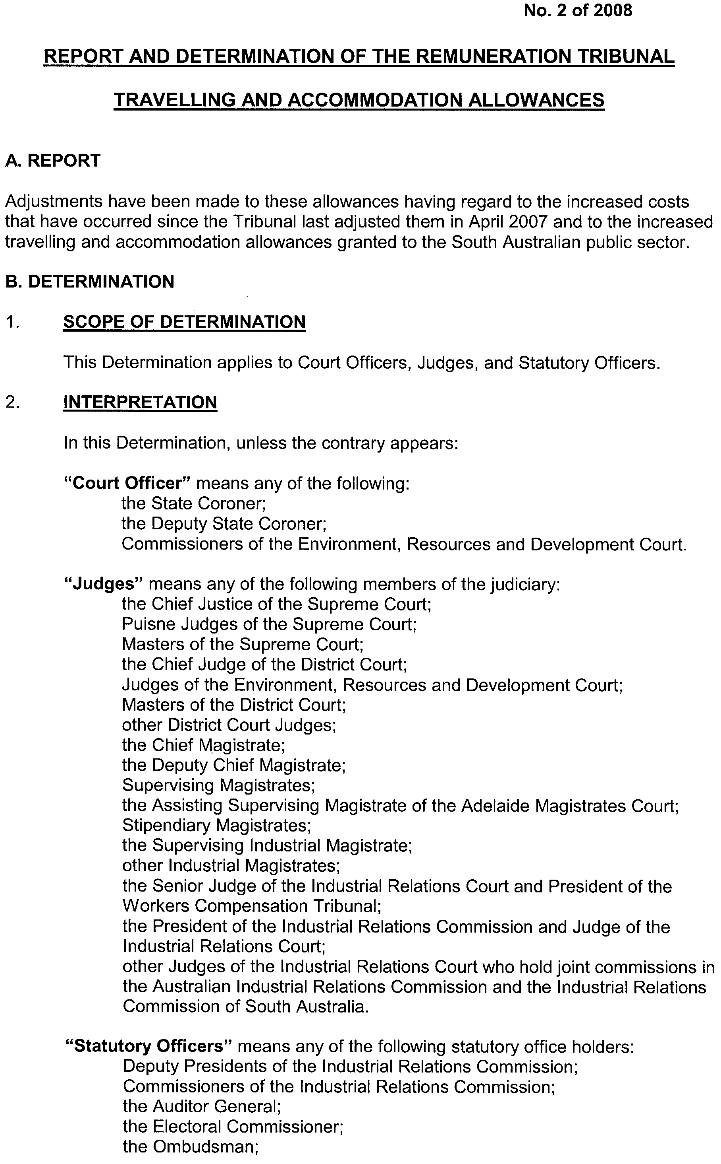
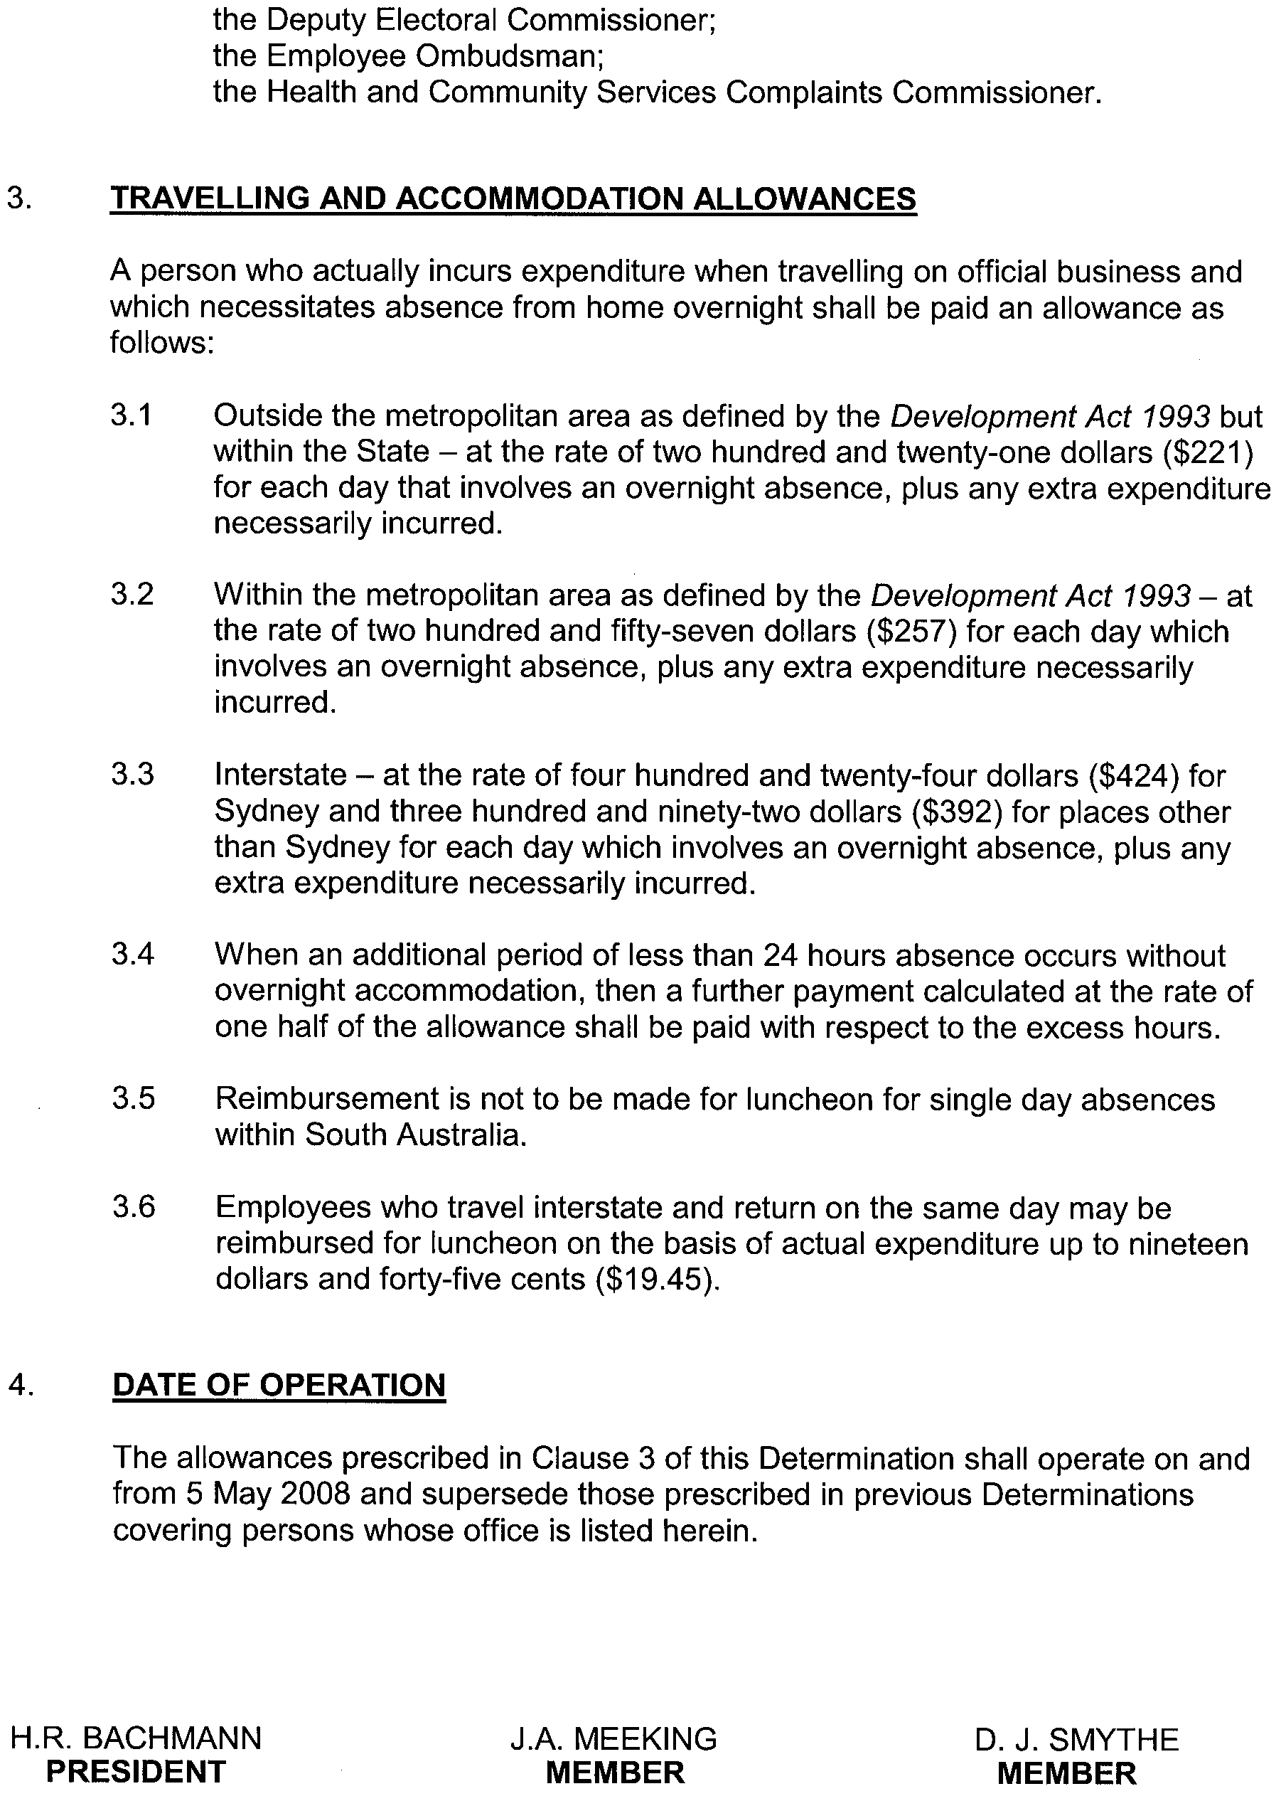

Dated 29 April 2008.
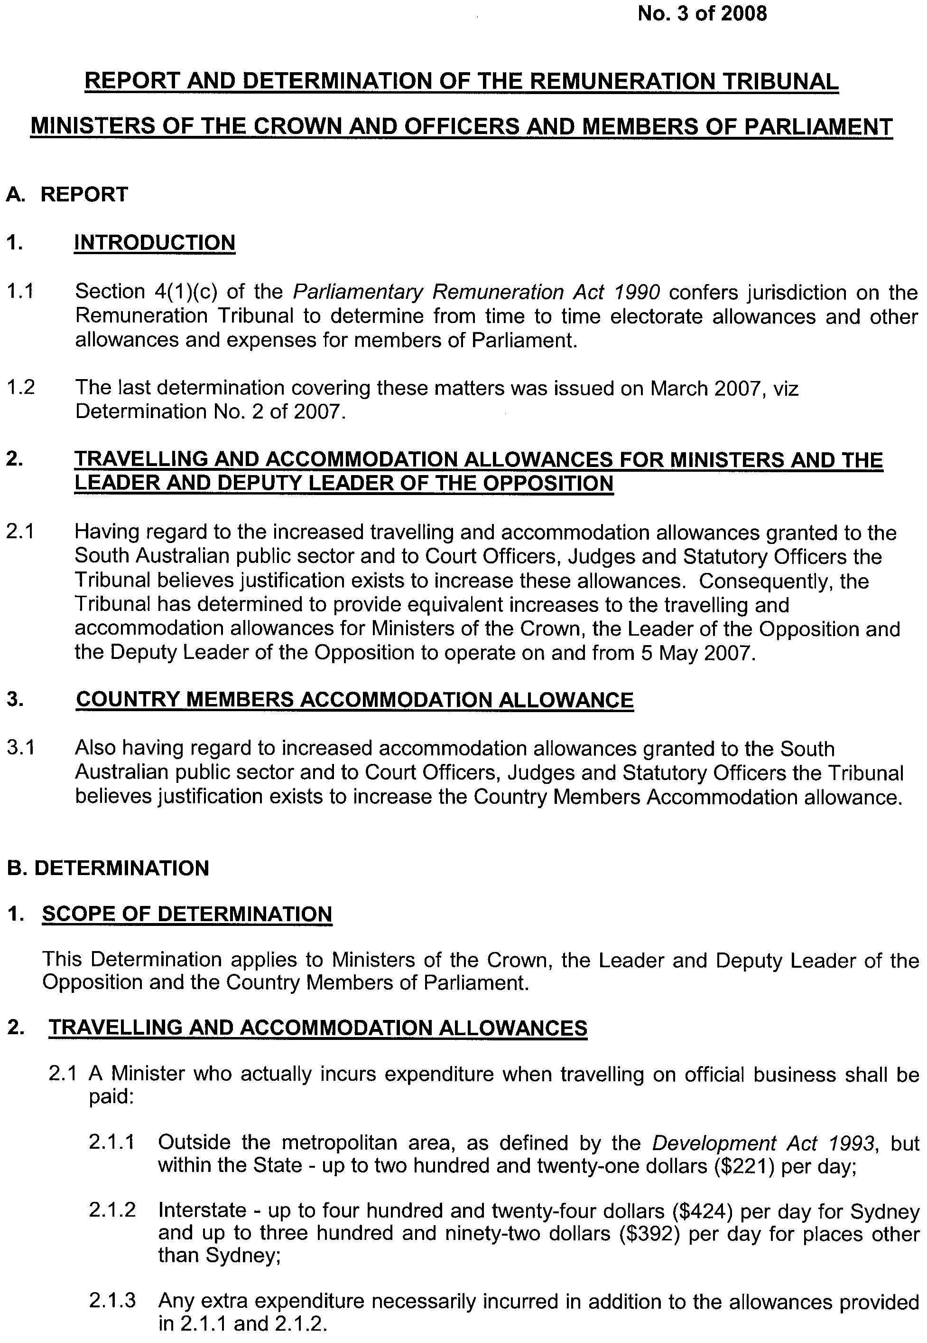
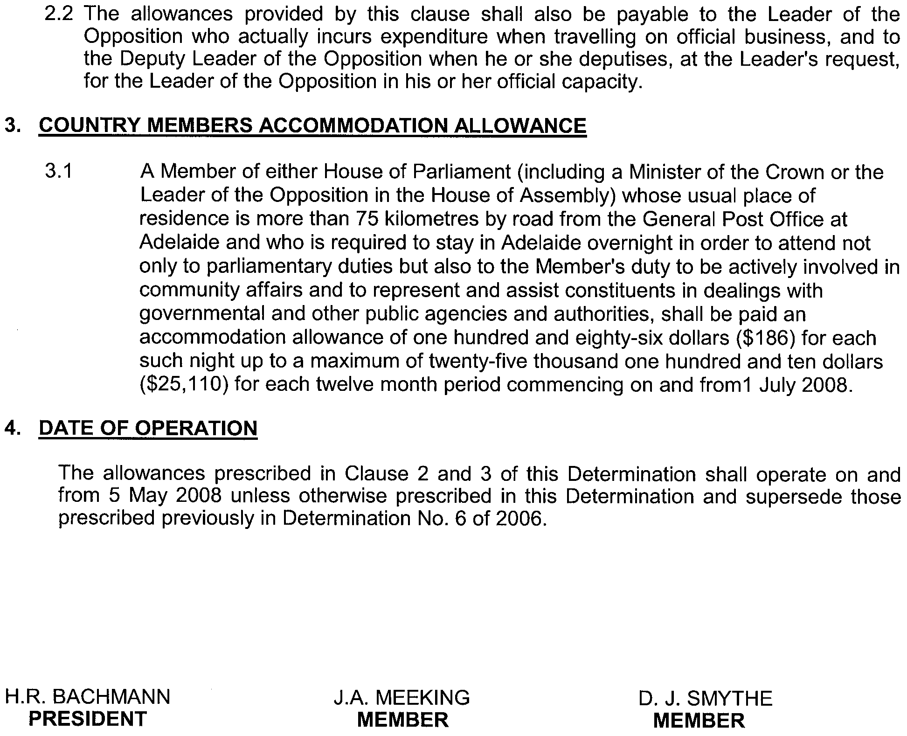

Dated 29 April 2008.

ROAD TRAFFIC ACT 1961

NOTICE OF APPROVAL AND EXEMPTION
Pursuant to Sections 161A and 163AA of the Road Traffic Act 1961

Operation of ROAD TRAIN VEHICLES IN SOUTH AUSTRALIA

1. REVOCATION OF PREVIOUS NOTICE AND OTHER EXEMPTION INSTRUMENTS

1.1 I hereby revoke the Notice of Approval and Exemption, titled ‘Operation of Road Train Vehicles in South Australia’ published in the South Australian Government Gazette on 30 June 2005. This revocation will take effect from 12 a.m. on 2 June 2008.

1.2 I hereby revoke all Supplementary Notices of Approval, titled ‘Operation of Road Train Vehicles in South Australia’ as published in the South Australian Government Gazette that vary the conditions to and are read in conjunction with the Notice of Approval and Exemption identified in Clause 1.1 above. All Supplementary Notices of Approval will be revoked from 12 a.m. on 2 June 2008.

2. DEFINITIONS

2.1 For the purposes of this Notice:
2.1.1 A ‘Road Train’ is a vehicle combination consisting of a prime mover towing:
a semi trailer and a converter dolly; or
two trailers, where a converter dolly supporting a semi trailer is counted as a single trailer (double road train); or
two trailers as described above (double road train) and an additional converter dolly (considered to be a triple road train); or
three trailers, where a converter dolly supporting a semi trailer is counted as a single trailer (triple road train).
2.1.2 ‘Approved Routes’ are roads that the Minister for Transport (or the Minister’s Delegate) has approved for the operation of Road Trains in accordance with section 161A of the Road Traffic Act 1961.
2.1.3 ‘DTEI’ means the Department for Transport, Energy and Infrastructure.

3. APPROVAL

3.1 I hereby approve Road Trains to operate on Approved Routes subject to the conditions and limitations specified in this Notice.

4. EXEMPTION

4.1 I hereby exempt Road Trains from the following provisions of the:
4.1.1 Road Traffic (Mass and Loading Requirements) Regulations 1999 Schedule 1, Table 1, in so far as it relates to:
(i) tandem axle group fitted with dual tyres (8 tyres—for any vehicle other than a pig trailer 16.5 tonnes); and
(ii) triaxle group fitted with dual tyres (12 tyres—for any vehicle other than a pig trailer 20 tonnes); and
4.1.2 Road Traffic (Vehicle Standards) Rules 1999 Rule 72 (1)—Height (4.3 metres).
4.1.3 Road Traffic (Vehicle Standards) Rules 1999 Rule 169 (c)—Coupling Height.
4.1.4 Road Traffic (Vehicle Standards) Rules 1999 Rule 66 (1)—Width (2.5 metres).

4.2 This exemption is subject to the conditions and limitations specified in this Notice.

5. CONDITIONS AND LIMITATIONS APPLYING TO THIS NOTICE

5.1 When you are operating under this Notice you must:
5.1.1 Operate at all times in accordance with the conditions and limitations specified in the ‘Code of Practice for Road Trains’, dated April 2008, issued by the DTEI.
5.1.2 Only travel on the Approved Routes for Road Trains as indicated in the maps specific to Road Trains or Converter Dollies (where the combination is being operated as a prime mover and semi trailer towing a converter dolly) posted on the DTEI Internet Site and in accordance with any conditions and limitations specified in those maps.
5.1.3 Carry at all times a legible, current and complete copy of:
(i) this Notice;
(ii) the ‘Code of Practice for Road Trains’, dated April 2008;
(iii) all current approved Road Train and Converter Dolly route network map(s) (as appropriate) specific to the entire route being travelled/operated on during the particular journey being undertaken, including more specific detailed maps of routes and townships where available; and
(iv) a current driver medical certificate where you are required to undergo and pass a medical examination.

Information Note
The current approved route network maps for Road Trains are available from the DTEI Internet site at: www.transport.sa.gov.au/freight/road/vehicle_configuration/road_train.asp
or a DTEI or Service SA Customer Service Centre

5.1.4 Produce any or all of the documents indicated in 5.1.3 above when requested by a DTEI Authorised Officer appointed under the Road Traffic Act 1961 or a Police Officer.

6. COMMENCEMENT OF THIS NOTICE

6.1 This Notice is valid from 12.01 a.m. on 2 June 2008.

7. AUTHORISATION

Executive Director,
Safety and Regulation Division
Department for Transport, Energy and Infrastructure
Authorised Delegate for the Minister for Transport

TRAINING AND SKILLS DEVELOPMENT ACT 2003

Part 4 – Apprenticeships/Traineeships

Pursuant to the provision of the Training and Skills Development Act 2003, the Training and Skills Commission gives notice that determines the following Apprenticeship and
Traineeship conditions in addition to the gazettals of:

- 5 February 2004 | - 19 February 2004 | - 11 March 2004 | - 1 April 2004
- 1 July 2004 | - 15 July 2004 | - 22 July 2004 | - 30 September 2004
- 16 December 2004 | - 27 January 2005 | - 3 February 2005 | - 10 February 2005
- 10 March 2005 | - 24 March 2005 | - 5 May 2005 | - 12 May 2005
- 2 June 2005 | - 16 June 2005 | - 7 July 2005 | - 4 August 2005
- 18 August 2005 | - 1 September 2005 | - 15 September 2005 | - 22 September 2005
- 6 October 2005 | - 20 October 2005 | - 27 October 2005 | - 8 December 2005
- 22 December 2005 | - 9 March 2006 | - 6 April 2006 | - 20 April 2006
- 4 May 2006 | - 18 May 2006 | - 25 May 2006 | - 1 June 2006
- 3 August 2006 | - 10 August 2006 | - 31 August 2006 | - 7 September 2006
- 21 September 2006 | - 29 September 2006 | - 12 October 2006 | - 9 November 2006
- 23 November 2006 | - 30 November 2006 | - 7 December 2006 | - 21 December 2006
- 4 January 2007 | - 11 January 2007 | - 1 February 2007 | - 8 February 2007
- 15 February 2007 | - 19 April 2007 | - 10 May 2007 | - 26 July 2007
- 2 August 2007 | - 30 August 2007 | - 6 September 2007 | - 13 September 2007
- 8 November 2007 | - 22 November 2007 | - 6 December 2007 | - 3 January 2008
- 10 January 2008 | - 24 January 2008 | - 3 April 2008

Trades, Declared Vocations or Other Occupations, required Qualifications and
Contract of Training Conditions for the

Financial Services Training Package (FNS04)

*Trade  #Declared Vocation  Other Occupation | Code | Title | Nominal Term of  Contract of  Training | Probationary  Period
# Customer Servicing  (Financial Institutions) | FNS30107 | Certificate III in  Financial Services | 24 months | 2 months
# Customer Servicing  (Financial Institutions) | FNS40107 | Certificate IV in  Financial Services | 24 months | 2 months
# Customer Servicing  (Financial Institutions) | FNS50107 | Diploma of  Financial Services | 36 months | 3 months

South Australia
Administrative Arrangements (Constitution of Minister as Body Corporate) Proclamation 2008
under section 7 of the Administrative Arrangements Act 1994
1—Short title
This proclamation may be cited as the Administrative Arrangements (Constitution of Minister as Body Corporate) Proclamation 2008.
2—Commencement
This proclamation comes into operation on the day on which it is made.
3—Constitution of Minister for Veterans' Affairs as body corporate
The Minister for Veterans' Affairs is constituted as a body corporate.
Made by the Governor
with the advice and consent of the Executive Council
on 1 May 2008
DPC08/014CS

South Australia
Highways (Road Closure—Old Port Wakefield Road, Two Wells) Proclamation 2008
under section 27AA of the Highways Act 1926
1—Short title
This proclamation may be cited as the Highways (Road Closure—Old Port Wakefield Road, Two Wells) Proclamation 2008.
2—Commencement
This proclamation comes into operation on the day on which it is made.
3—Road closure
The portion of public road delineated as allotment 20 in approved Plan No FP 50358 lodged in the Lands Titles Registration Office is closed.
Made by the Governor
on the recommendation of the Commissioner of Highways and with the advice and consent of the Executive Council
on 1 May 2008
MTR08/021CS

South Australia
Development (Significant Trees) Variation Regulations 2008
under section 4(1) of the Development Act 1993

Contents
Part 1—Preliminary
1 Short title
2 Commencement
3 Variation provisions
Part 2—Variation of Development Regulations 1993
4 Variation of regulation 6A—Significant trees

Part 1—Preliminary
1—Short title
These regulations may be cited as the Development (Significant Trees) Variation Regulations 2008.
2—Commencement
These regulations come into operation on the day on which they are made.
3—Variation provisions
In these regulations, a provision under a heading referring to the variation of specified regulations varies the regulations so specified.
Part 2—Variation of Development Regulations 1993
4—Variation of regulation 6A—Significant trees
Regulation 6A(1a)—after paragraph (b) insert:
(c) the whole of the District Council of Mount Barker other than those parts of the area of the District Council of Mount Barker within the Industry (Kanmantoo) Zone, the Rural Watershed Protection Zone, the Rural (Mount Barker) Zone, the Rural (Kanmantoo) Zone or the Rural (Kondoparinga) Zone in the Development Plan that relates to that area.
Note—
As required by section 10AA(2) of the Subordinate Legislation Act 1978, the Minister has certified that, in the Minister's opinion, it is necessary or appropriate that these regulations come into operation as set out in these regulations.
Made by the Governor
with the advice and consent of the Executive Council
on 1 May 2008
No 42 of 2008

South Australia
Workers Rehabilitation and Compensation (Scales of Medical and Other Charges) Variation Regulations 2008
under the Workers Rehabilitation and Compensation Act 1986

Contents
Part 1—Preliminary
1 Short title
2 Commencement
3 Variation provisions
Part 2—Variation of Workers Rehabilitation and Compensation (Scales of
Medical and Other Charges) Regulations 1995
4 Variation of regulation 3A—Scales of charges—public hospitals

Part 1—Preliminary
1—Short title
These regulations may be cited as the Workers Rehabilitation and Compensation
(Scales of Medical and Other Charges) Variation Regulations 2008.
2—Commencement
These regulations will come into operation on 1 May 2008.
3—Variation provisions
In these regulations, a provision under a heading referring to the variation of specified regulations varies the regulations so specified.
Part 2—Variation of Workers Rehabilitation and Compensation (Scales of Medical and Other Charges) Regulations 1995
4—Variation of regulation 3A—Scales of charges—public hospitals
Regulation 3A—delete "16 January 2006" and substitute:
1 March 2008
Note—
As required by section 10AA(2) of the Subordinate Legislation Act 1978, the Minister has certified that, in the Minister's opinion, it is necessary or appropriate that these regulations come into operation as set out in these regulations.
Made by the Governor
following consultation as required under section 32(13) of the Workers Rehabilitation and Compensation Act 1986 and with the advice and consent of the Executive Council
on 1 May 2008
No 43 of 2008
08WKC0001CS

South Australia
Public and Environmental Health (Notifiable Diseases) Variation Regulations 2008
under the Public and Environmental Health Act 1987

Contents
Part 1—Preliminary
1 Short title
2 Commencement
3 Variation provisions
Part 2—Variation of Public and Environmental Health (Notifiable Diseases) Regulations 2004
4 Variation of regulation 4—Notifiable diseases and controlled notifiable diseases (section 3)

Part 1—Preliminary
1—Short title
These regulations may be cited as the Public and Environmental Health (Notifiable Diseases) Variation Regulations 2008.
2—Commencement
These regulations come into operation on the day on which they are made.
3—Variation provisions
In these regulations, a provision under a heading referring to the variation of specified regulations varies the regulations so specified.
Part 2—Variation of Public and Environmental Health (Notifiable Diseases) Regulations 2004
4—Variation of regulation 4—Notifiable diseases and controlled notifiable diseases (section 3)
(1) Regulation 4(1)—after "Infection caused by Escherichia coli capable of producing Shiga toxin" insert:
Influenza
(2) Regulation 4(1)—after "Pandemic influenza" insert:
Rotavirus
Note—
As required by section 10AA(2) of the Subordinate Legislation Act 1978, the Minister has certified that, in the Minister's opinion, it is necessary or appropriate that these regulations come into operation as set out in these regulations.
Made by the Governor
with the advice and consent of the Executive Council
on 1 May 2008
No 44 of 2008
HEACS/07/233

FAXING COPY?
IF you fax copy to Government Publishing SA for inclusion in the Government Gazette, there is no need to send a Confirmation Copy to us as well.
This creates confusion and may well result in your notice being printed twice.
Please use the following fax number:
Fax transmission: (08) 8207 1040
Phone Inquiries: (08) 8207 1045
Please include a contact person, phone number and order number so that we can phone back with any queries we may have regarding the fax copy.
NOTE: Closing time for lodging new copy (fax, hard copy or email) is 4 p.m. on Tuesday preceding the day of publication.

Government Gazette notices can be E-mailed.
The address is:
governmentgazette@dpc.sa.gov.au
Documents should be sent as attachments in Word format.
When sending a document via E-mail, please confirm your transmission with a faxed copy of your document, including the date the notice is to be published.
Fax transmission: (08) 8207 1040
Enquiries: (08) 8207 1045
NOTE: Closing time for lodging new copy (fax, hard copy or email) is 4 p.m. on Tuesday preceding the day of publication.

CITY OF CAMPBELLTOWN
Election Results
Supplementary Election for Councillor in River Ward—Conducted on Monday, 14 April 2008
Formal Ballot Papers: 1 498
Informal Ballot Papers: 6
Quota: 750
Candidates | First  Preference  Votes | Result after Distribution  of Preferences
Dymit, Tony | 394
Cotton, John E. | 202
Ryan, Marijka | 520 | Elected
Brown, Lily | 127
Mormina, Michael | 68
Rebane, Felix | 70
Reddrop, Alan | 117
K. Mousley, Returning Officer

CITY OF TEA TREE GULLY
Roads (Opening and Closing) Act 1991
Road Closure—Portion of Ladywood Road, Modbury North
Erratum
In NOTICE appearing in the Government Gazette dated 17 April 2008 on page 1413, pursuant to section 10 of the Roads (Opening and Closing) Act 1991, the section reading:
“as delineated and lettered ‘A’ on Preliminary Plan No. 08/0026.”
should read as follows:
“as delineated and lettered ‘A’ and ‘B’ on Preliminary Plan No. 08/0026.”
G. J. Perkin, Chief Executive Officer

ALEXANDRINA COUNCIL
Roads (Opening and Closing) Act 1991
Re-advertisement
Barton Street/Channon Street and thoroughfare, Port Elliot
NOTICE is hereby given pursuant to section 10 of the said Act, that the Council proposes to make a Road Process Order to close and sell to G. J. and E. A. Hodge an irregular-shaped strip of Barton and Channon Streets and portion of the thoroughfare adjoining allotment 274 in DP 7881 shown as ‘A’ on Preliminary Plan No. 04/0133.
A copy of the plan and statement of persons affected are available for public inspection at Council’s Office, 11 Cadell Street, Goolwa and the office of the Surveyor-General, 101 Grenfell Street, Adelaide, during normal office hours.
Any application for easement or objection must be made in writing within 28 days from 1 May 2008, to the Council, P.O. Box 21, Goolwa, S.A. 5214 and the Surveyor-General, G.P.O. Box 1354, Adelaide, S.A. 5001, setting out full details.
Where a submission is made, Council will give notification of a meeting to deal with the matter.
J. Coombe, Chief Executive Officer

DISTRICT COUNCIL OF MOUNT BARKER
Significant Trees Development Plan Amendment (DPA)
Draft for Public Consultation
NOTICE is hereby given that the District Council of Mount Barker has prepared a Significant Trees Development Plan Amendment (DPA) for the purposes of introducing planning controls for mature native and exotic trees under threat from development pressures, which meet the definition of ‘significant tree’. Through the introduction of this DPA any tree damaging activity is considered development and requires the approval of Council.
The Significant Trees DPA introduces provisions which outline under what circumstances tree damaging activity is permissible and under which circumstances preservation of trees should occur.
Significant tree controls apply throughout the whole of the District Council of Mount Barker, except for those areas zoned Rural Mount Barker Zone, Rural Kanmantoo and Kondoparinga Zones, Rural Watershed Protection Zone and Industry (Kanmantoo) Zone.
In order to prevent inappropriate development and promote orderly planning, the DPA has been granted ‘Interim Development Control’ by the Minister, giving the amendment immediate effect.
The draft Significant Trees DPA will be available for public inspection during normal office hours, at the Council’s Offices,
6 Dutton Road, Mount Barker, from Thursday, 1 May 2008 until Tuesday, 1 July 2008. Copies of the DPA will also be available for public inspection at the Mount Barker Library and Council’s website www.dcmtbarker.sa.gov.au.
Written submissions regarding the DPA should be submitted no later than 5 p.m. on Tuesday, 1 July 2008. All submissions should be addressed to the Chief Executive Officer, District Council of Mount Barker, 6 Dutton Road, Mount Barker, S.A. 5251. The written submissions should also clearly indicate whether you wish to speak at the public meeting.
Copies of all written submissions will be available for inspection by interested persons at Council’s Offices, 6 Dutton Road, Mount Barker from Wednesday, 2 July 2008 until the date of the public meeting to be held at 7 p.m. on Wednesday, 16 July 2008. If no requests are made to be heard at the public meeting, the public meeting will not be held.
Community information sessions on the Significant Trees DPA are scheduled for 10 a.m. on Wednesday, 28 May 2008 at the Keith Stephenson Park (meet at Car Park entrance off Flaxley Road, Mount Barker) and 7 p.m. on Thursday, 29 May 2008 at the District Council of Mount Barker’s Civic Centre (6 Dutton Road, Mount Barker). Further information about the Significant Trees DPA can be obtained by contacting Council’s Policy Officer on (08) 8391 7244 or by email at council@dcmtbarker.sa.gov.au.
Dated 1 May 2008.
A. Stuart, Chief Executive Officer

NARACOORTE LUCINDALE COUNCIL
Appointments
NOTICE is hereby given that at a meeting of Council held on 22 April 2008, Council made the following appointments:
• Bradley James Lang is appointed as an Authorised Officer, pursuant to section 18 (1) of the Development Act 1993;
• Bradley James Lang is appointed as an Authorised Person, pursuant to section 260 (1) of the Local Government Act 1999;
• Paul Laurence McRostie is appointed an an Authorised Officer, pursuant to section 18 (1) of the Development Act 1993;
• Paul Laurence McRostie is appointed as an Authorised Person, pursuant to section 260 (1) of the Local Govern-ment Act 1999;
• Vicki Frances Modistach is appointed as an Authorised Person, pursuant to section 260 (1) of the Local Govern-ment Act 1999;
• Russell William Rehn is appointed as a Dog Management Officer, pursuant to section 27 of the Dog and Cat Manage-ment Act 1995;
• Russell William Rehn is appointed as a Ranger, pursuant to section 14 of the Impounding Act 1920; and
• Russell William Rehn is appointed as an Authorised Person, pursuant to section 260 (1) of the Local Govern-ment Act 1999.
A. Evans, Chief Executive Officer

IN the matter of the estates of the undermentioned deceased persons:
Bennett, Ursula Alma Marie, late of Bransby Avenue Extension, North Plympton, home duties, who died on 7 March 2008.
Brown, Margaret Irene, late of 7 Harvey Avenue, Westbourne Park, home duties, who died on 2 February 2008.
Doddridge, Erika Sybilla, late of Grant Avenue, Gilles Plains, of no occupation, who died on 13 October 2006.
Farquharson, Alexander, late of 73 Barry Road, Oaklands Park, retired driver, who died on 25 February 2008.
Hardwick, Keith, late of 8 Elmgrove Road, Salisbury North, retired bus driver, who died on 2 March 2008.
Iredale, Alfred, late of 150-164 Bay Road, Encounter Bay, retired architectural draftsman, who died on 19 December 2006.
Lane, Jack Albert, late of 67 Porter Street, Salisbury, retired foundry worker, who died on 17 December 2007.
Przibilla, Merle, late of 72 Baker Street, Glengowrie, home duties, who died on 30 January 2008.
Thackray Terence, late of 14 Adelaide Road, Mannum, retired boat builder, who died on 18 February 2008.
von Blumental, Arvids, late of Seventeen Mile Road, Coober Pedy, retired crocodile hunter, who died on 13 October 2006.
Notice is hereby given pursuant to the Trustee Act 1936, as amended, the Inheritance (Family Provision) Act 1972, and the Family Relationships Act 1975, that all creditors, beneficiaries, and other persons having claims against the said estates are required to send, in writing, to the Public Trustee, 25 Franklin Street, Adelaide, S.A. 5000, full particulars and proof of such claims, on or before 30 May 2008, otherwise they will be excluded from the distribution of the said estate; and notice is also hereby given that all persons who are indebted to the said estates are required to pay the amount of their debts to the Public Trustee or proceedings will be taken for the recovery thereof; and all persons having any property belonging to the said estates are forthwith to deliver the same to the Public Trustee.
Dated 1 May 2008.
M. I. Bodycoat, Public Trustee

PARTNERSHIP ACT 1891-1975
Notice of Discontinuance of Partnership
TAKE notice that as from Monday, 21 April 2008 the partnership of Kristie St John, P.O. Box 256, Clarendon, S.A. 5157 and Debby Barton, 74 Main Road, Hahndorf, S.A. 5245, who traded as Stables Hahndorf Pty Ltd was dissolved.
Kristie St John has retired from the partnership.
Debby Barton will continue to operate the business under the name of Stables Hahndorf Pty Ltd and shall be responsible for all the debts and liabilities thereof.
Dated 21 April 2008.
Kristie St John
Debby Barton

ATTENTION

CUSTOMERS requiring a proof of their notice for inclusion in the Government Gazette, please note that the onus is on you to inform Government Publishing SA of any subsequent corrections by 10 a.m. on Thursday, which is our publication deadline.

For any corrections to your notice please phone 8207 1045 or Fax 8207 1040 before 10 a.m. on Thursday.

If we do not receive any communication by 10 a.m. on Thursday (day of publication) we will presume the notice is correct and will print it as it is.

Remember—the onus is on you to inform us of any corrections necessary to your notice.

NOTE: Closing time for lodging new copy (electronically, fax or hard copy) is 4 p.m. on Tuesday preceding the day of publication. Phone 8207 1045—Fax 8207 1040.
Email: governmentgazette@dpc.sa.gov.au

Printed and published by authority every Thursday by T. GOODES, Government Printer, South Australia
Price: $5.40, plus postage; to subscribers, $274.00 per annum.
(The above prices are inclusive of GST)

