No. 24 1551

THE SOUTH AUSTRALIAN

GOVERNMENT GAZETTE
www.governmentgazette.sa.gov.au

PUBLISHED BY AUTHORITY

ALL PUBLIC ACTS appearing in this GAZETTE are to be considered official, and obeyed as such

ADELAIDE, THURSDAY, 8 MAY 2008

CONTENTS

Page
Acts Assented To 1552
Appointments, Resignations, Etc. 1552
Associations Incorporation Act 1985—Notice 1553
Corporations and District Councils—Notices 1619
Department for Families and Communities Disability SA—
Notice 1553
Fisheries Management Act 2007—Notices 1553
Geographical Names Act 1991—
Corrigendum 1555
Notice 1555
Housing Improvement Act 1940—
Erratum 1557
Notice 1556
Land and Business (Sale and Conveyancing) Act 1994—
Notice 1557
Liquor Licensing Act 1997—Notices 1557
Mining Act 1971—Notices 1562
National Electricity Law—Notice 1563

Page
National Parks and Wildlife (National Parks) Regulations
2001—Notice 1563
Passenger Transport Act 1994—Notices 1565
Proclamation 1612
Public Trustee Office—Administration of Estates 1619
REGULATIONS
Liquor Licensing Act 1997 (No. 45 of 2008) 1613
Controlled Substances Act 1984 (No. 46 of 2008) 1615
Revocation of Regulations as to Queen’s Counsel 1617
Roads (Opening and Closing) Act 1991—Notices 1563
RULES OF COURT
Rules of the Legal Practitioners Education and Admission
Council 2004—
Amendment No. 3 1578
Training and Skills Development Act 2003—Notice 1579
Veterinary Surgeons Board of South Australia—
Register 1580

GOVERNMENT GAZETTE NOTICES
ALL poundkeepers’ and private advertisements forwarded for publication in the South Australian Government Gazette must be PAID FOR PRIOR TO INSERTION; and all notices, from whatever source, should be legibly written on one side of the paper only and sent to Government Publishing SA so as to be received no later
than 4 p.m. on the Tuesday preceding the day of publication. Phone 8207 1045 or Fax 8207 1040. E-mail: governmentgazette@dpc.sa.gov.au. Send as attachments in Word format and please confirm your transmission with a faxed copy of your document, including the date the notice is to be published and to whom the notice will be charged. The Government Gazette is available online at: www.governmentgazette.sa.gov.au

Department of the Premier and Cabinet
Adelaide, 8 May 2008
HIS Excellency the Governor directs it to be notified for general information that he has in the name and on behalf of Her Majesty The Queen, this day assented to the undermentioned Acts passed by the Legislative Council and House of Assembly in Parliament assembled, viz.:
No. 11 of 2008—Summary Offences (Drug Paraphernalia) Amendment Act 2008. An Act to amend the Summary Offences Act 1953; and to make related amendments to the Controlled Substances Act 1984.
No. 12 of 2008—Statutes Amendment (Real Property) Act 2008. An Act to amend the Bills of Sale Act 1886, the Community Titles Act 1996, the Real Property Act 1886, the Stock Mortgages and Wool Liens Act 1924 and the Strata Titles Act 1988.
By command,
Paul Caica, for Premier
DPC06/0875

Department of the Premier and Cabinet
Adelaide, 8 May 2008
HIS Excellency the Governor in Executive Council has been pleased to appoint the undermentioned to the Physiotherapy Board of South Australia, pursuant to the provisions of the Physiotherapy Practice Act 2005:
Deputy Member: (from 8 May 2008 until 31 August 2008)
Elizabeth Sheppard (Deputy to Graham-King)
By command,
Paul Caica, for Premier
HEACS/08/269

Department of the Premier and Cabinet
Adelaide, 8 May 2008
HIS Excellency the Governor in Executive Council has been pleased to appoint the undermentioned to the Coast Protection Board, pursuant to the provisions of the Coast Protection Act 1972:
Presiding Member: (from 8 May 2008 until 7 May 2012)
Graham Foreman
Member: (from 8 May 2008 until 7 May 2012)
Brian Caton
Mary-Lou Corcoran
Member: (from 8 May 2008 until 7 May 2011)
Peri Sharon Jane Coleman
By command,
Paul Caica, for Premier
EHCS08/0010

Department of the Premier and Cabinet
Adelaide, 8 May 2008
HIS Excellency the Governor in Executive Council has been pleased to appoint the Honourable the Chief Justice John Jeremy Doyle, AC, as Governor’s Deputy of South Australia for the period from 7 a.m. on Monday, 12 May 2008 until 4 p.m. on Thursday, 15 May 2008 and for the period from 9 a.m. on Saturday, 17 May 2008 until 2 p.m. on Sunday, 18 May 2008.
By command,
Paul Caica, for Premier

Department of the Premier and Cabinet
Adelaide, 8 May 2008
HIS Excellency the Governor in Executive Council has been pleased to appoint Hieu Van Le as Governor’s Deputy of South Australia for the period from 2 p.m. on Sunday, 18 May 2008 until 2 p.m. on Sunday, 8 June 2008.
By command,
Paul Caica, for Premier

Department of the Premier and Cabinet
Adelaide, 8 May 2008
HIS Excellency the Governor in Executive Council has been pleased to appoint the Honourable Kevin Owen Foley, MP, Deputy Premier, Treasurer, Minister for Industry and Trade and Minister for Federal/State Relations to be also Acting Premier, Acting Minister for Economic Development, Acting Minister for Social Inclusion and Acting Minister for Sustainability and Climate Change for the period from 15 May 2008 to 30 May 2008 inclusive, during the absence of the Honourable Michael David Rann, MP.
By command,
Paul Caica, for Premier
DPC030/96PT4CS

Department of the Premier and Cabinet
Adelaide, 8 May 2008
HIS Excellency the Governor in Executive Council has been pleased to appoint the Honourable Jane Diane Lomax-Smith, MP, Minister for Education and Children’s Services, Minister for Tourism and Minister for the City of Adelaide to be also Acting Minister for the Arts for the period from 15 May 2008 to 18 May 2008 inclusive, during the absence of the Honourable Michael David Rann, MP.
By command,
Paul Caica, for Premier
DPC030/96PT4CS

Department of the Premier and Cabinet
Adelaide, 8 May 2008
HIS Excellency the Governor in Executive Council has been pleased to appoint the Honourable John David Hill, MP, Minister for Health, Minister for the Southern Suburbs and Minister Assisting the Premier in the Arts to be also Acting Minister for the Arts for the period from 19 May 2008 to 30 May 2008 inclusive, during the absence of the Honourable Michael David Rann, MP.
By command,
Paul Caica, for Premier
DPC030/96PT4CS

Department of the Premier and Cabinet
Adelaide, 8 May 2008
HIS Excellency the Governor in Executive Council has been pleased to appoint the Honourable Gail Elizabeth Gago, MLC, Minister for Environment and Conservation, Minister for Mental Health and Substance Abuse and Minister Assisting the Minister for Health to be also Acting Minister for Health, Acting Minister for the Southern Suburbs and Acting Minister Assisting the Premier in the Arts for the period from 12 May 2008 until 18 May 2008 inclusive, during the absence of the Honourable John David Hill, MP.
By command,
Paul Caica, for Premier
HEACS/08/278

Department of the Premier and Cabinet
Adelaide, 8 May 2008
HIS Excellency the Governor in Executive Council has been pleased to appoint the Honourable Michael John Atkinson, MP, Attorney-General, Minister for Justice, Minister for Multicultural Affairs and Minister for Veterans’ Affairs to be also Acting Minister for State/Local Government Relations, Acting Minister for Volunteers, Acting Minister for Consumer Affairs and Acting Minister Assisting in Early Childhood Development for the period from 21 May 2008 to 24 May 2008 inclusive, during the absence of the Honourable Jennifer Mary Rankine, MP.
By command,
Paul Caica, for Premier
MCA08/012CS

Department of the Premier and Cabinet
Adelaide, 8 May 2008
HIS Excellency the Governor in Executive Council has been pleased to appoint the Honourable Gail Elizabeth Gago, MLC, Minister for Environment and Conservation, Minister for Mental Health and Substance Abuse and Minister Assisting the Minister for Health to be also Acting Minister for the Status of Women for the period from 21 May 2008 to 24 May 2008 inclusive, during the absence of the Honourable Jennifer Mary Rankine, MP.
By command,
Paul Caica, for Premier
MCA08/012CS

Department of the Premier and Cabinet
Adelaide, 8 May 2008
HIS Excellency the Governor in Executive Council has been pleased to appoint Robyn Pak-Poy as a Commissioner of Charitable Funds for a term of three years commencing on 11 July 2008 and expiring on 10 July 2011, pursuant to the Public Charities Funds Act 1935.
By command,
Paul Caica, for Premier
HEACS/07/250

ASSOCIATIONS INCORPORATION ACT 1985
Deregistration of Associations
NOTICE is hereby given that the Corporate Affairs Commission approves the applications for deregistration received from the associations named below, pursuant to section 43A of the Associations Incorporation Act 1985. Deregistration takes effect on the date of publication of this notice:
Australian Meals on Wheels Association Incorporated
Cleve Coffee & Arts Incorporated
Eudunda and Districts B.M.X. Club Incorporated
Extractive Industries Association of South Australia Incorporated
Future Links Birth to Flight Early Childhood Forum Incorporated
Kingston Supported Accommodation Incorporated
Lions Club of Pasadena Incorporated
Mitchell Park Day Club Incorporated
Neighbours in Action (Victor Harbor) Incorporated
Penola District Caledonian Society Incorporated
Port Pirie Theatre Guild Incorporated
Regular Defence Force Welfare Association, South Australia Branch Incorporated
Returned Sailors’ Soldiers’ and Airmen’s Imperial League of Australia Tintinara Sub-Branch Incorporated
River Murray Locks & Barrages Reunion Committee Incorporated
Secondhand Booksellers Association (S.A.) Incorporated
Schuss Ski Club Incorporated
Solar Cities Adelaide Incorporated
Spiritual Assembly of the Baha’is of Murray Bridge Incorporated
The Spiritual Assembly of the Baha’is of Renmark Incorporated
The Spiritual Assembly of the Baha’is of Port Adelaide Incorporated
The Apex Club of Pine City Incorporated
Dated 5 May 2008.
B. I. Colquist, a delegate of the Corporate Affairs Commission

DEPARTMENT FOR FAMILIES AND COMMUNITIES DISABILITY SA
Notice by the Minister for Disability
NOTICE is hereby given that I, Jay Weatherill, the responsible Minister of the Crown for Disability portfolio, do hereby rescind the notice in the Government Gazette dated 29 November 2007 on page 4379, second column, third notice appearing ‘Fees Payable for Equipment Provided by the Department for Families and Communities for People with Disabilities’.
This notice will come into operation on 8 May 2008.
Jay Weatherill, Minister for Disability

FISHERIES MANAGEMENT ACT 2007: SECTION 115
TAKE notice that pursuant to section 115 of the Fisheries Management Act 2007, the holder of a prawn fishery licence issued pursuant to the Fisheries Management (Prawn Fisheries) Regulations 2006, for the Gulf St Vincent Prawn Fishery listed in Schedule 1 (the ‘exemption holders’) or their registered master are exempt from the notices made under section 79 of the Fisheries Management Act 2007, that prohibit the taking of western king prawns (Melicertus latisulcatus). The exemption holders shall not be guilty of an offence when using prawn trawl nets in accordance with the conditions of their fishery licence for the purpose of stock assessment survey (the ‘exempted activity’), subject to the conditions contained in Schedule 2.
Schedule 1
Licence Number | Licence Holder | Boat Name
V06 | Todreel Pty Ltd | Anna Pearl
Schedule 2
1. The exemption is valid from 1830 hours on 1 May 2008 until 0630 hours on 2 May 2008.
2. All trawling activity must be completed by 0630 hours with nets out of the water.
3. The exemption holder must comply with instructions from the SARDI Stock Assessment Co-ordinator and work within the allotted survey trawl stations.
4. All fish, other than prawns, southern calamary (Sepioteuthis australis) and slipper lobster (Ibacus spp.) taken during the exempted activity for stock assessment purposes, are to be returned to the water immediately after capture.
5. Prawns, southern calamary and slipper lobster taken pursuant to the exempted activity must not be retained by the exemption holder, his agent, crew or any other person.
6. Prawns, southern calamary and slipper lobster taken pursuant to the exempted activity must be disposed of by the exemption holders in accordance with the ‘GSV Prawn Fishery Survey Participation Agreement’ and must not be retained by the exemption holder, his agent, crew or any other person.
7. While engaged in the exempted activity or while unloading the survey catch, the exemption holder must have on board his boat or near his person a copy of this notice. Such notice must be produced to a PIRSA Fisheries Compliance Officer if requested.
8. The exemption holder must not contravene or fail to comply with the Fisheries Management Act 2007, or any other regulations made under that Act except where specifically exempted by this notice.
Dated 28 April 2008.
S. Sloan, Senior Fisheries Manager

FISHERIES MANAGEMENT ACT 2007: SECTION 115
TAKE notice that pursuant to section 115 of the Fisheries Management Act 2007, the holder of a prawn fishery licence issued pursuant to the Fisheries Management (Prawn Fisheries) Regulations 2006, for the Gulf St Vincent Prawn Fishery listed in Schedule 1 (the ‘exemption holders’) or their registered master are exempt from the notices made under section 79 of the Fisheries Management Act 2007, that prohibit the taking of western king prawns (Melicertus latisulcatus). The exemption holders shall not be guilty of an offence when using prawn trawl nets in accordance with the conditions of their fishery licence for the purpose of stock assessment survey (the ‘exempted activity’), subject to the conditions contained in Schedule 2.
Schedule 1
Licence Number | Licence Holder | Boat Name
V01 | Ganelon Pty Ltd | Falcon
V02 | St Vincent Gulf Fisheries & Investments Pty Ltd | Angela Kaye
V03 | Brzic Fisheries Pty Ltd | Cavalier
V04 | Ledo Pty Ltd | Miss Venus
V05 | Maurice J. Corigliano | Frank Cori
V06 | Todreel Pty Ltd | Anna Pearl
V08 | Haralambos Paleologoudias | Shenandoah II
V09 | Hamid Huseljic | Candice K
V10 | N. Wayne Justice | Silda
V14 | S. V. Gulf Fisheries Pty Ltd | Zadar
Schedule 2
1. The exemption is valid from 1830 hours on 5 May 2008 until 0630 hours on 6 May 2008.
2. All trawling activity must be completed by 0630 hours with nets out of the water.
3. The exemption holder must comply with instructions from the SARDI Stock Assessment Co-ordinator and work within the allotted survey trawl stations.
4. All fish, other than prawns, southern calamary (Sepioteuthis australis) and slipper lobster (Ibacus spp.) taken during the exempted activity for stock assessment purposes, are to be returned to the water immediately after capture.
5. Prawns, southern calamary and slipper lobster taken pursuant to the exempted activity must not be retained by the exemption holder, his agent, crew or any other person.
6. Prawns, southern calamary and slipper lobster taken pursuant to the exempted activity must be disposed of by the exemption holders in accordance with the ‘GSV Prawn Fishery Survey Participation Agreement’ and must not be retained by the exemption holder, his agent, crew or any other person.
7. While engaged in the exempted activity or while unloading the survey catch, the exemption holder must have on board his boat or near his person a copy of this notice. Such notice must be produced to a PIRSA Fisheries Compliance Officer if requested.
8. The exemption holder must not contravene or fail to comply with the Fisheries Management Act 2007, or any other regulations made under that Act except where specifically exempted by this notice.
Dated 30 April 2008.
S. Sloan, Senior Fisheries Manager

FISHERIES MANAGEMENT ACT 2007: SECTION 79
TAKE note that the notice made under section 79 of the Fisheries Management Act 2007, published in the South Australian Government Gazette, dated 7 December 2007, referring to the Gulf St Vincent Prawn Fishery, is hereby varied such that it will not be unlawful for a person fishing pursuant to a Gulf St Vincent Prawn Fishery Licence to use prawn trawl nets in the area specified in Schedule 1 during the period specified in Schedule 2.
Schedule 1
1. The waters of the Gulf St Vincent Prawn Fishery, within the following co-ordinates: Commencing at position latitude 34°43.90′S, longitude 138°11.20′E, then to position latitude 34°51.70′S, longitude 138°17.30′E, then to position latitude 34°52.50′S, longitude 138°15.00′E, then to position latitude 34°50.70′S, longitude 138°12.00′E, then to position latitude 34°45.60′S, longitude 138°07.00′E, then returning to position latitude 34°43.90′S, longitude 138°11.20′E.
Schedule 2
From 1830 hours on 2 May 2008 to 0630 hours on 4 May 2008.
Dated 2 May 2008.
S. Sloan, Senior Fisheries Manager

FISHERIES MANAGEMENT ACT 2007: SECTION 79
TAKE note that the notice made under section 79 of the Fisheries Management Act 2007, published in the South Australian Government Gazette, dated 7 December 2007, referring to the Gulf St Vincent Prawn Fishery, is hereby varied such that it will not be unlawful for a person fishing, pursuant to a Gulf St Vincent Prawn Fishery Licence, to use prawn trawl nets in the area specified in Schedule 1 during the period specified in Schedule 2.
Schedule 1
The waters of the Gulf St Vincent Prawn Fishery, within the following co-ordinates: Commencing at position latitude 34°53.00′S, longitude 138°08.50′E, then to position latitude 34°52.50′S, longitude 138°02.75′E, then to position latitude 34°48.00′S, longitude 138°03.50′E, then to position latitude 34°48.25′S, longitude 138°09.25′E, then returning to position latitude 34°53.00′S, longitude 138°08.50′E.
Schedule 2
From 2100 hours on 6 May 2008 to 0630 hours on 7 May 2008.
Dated 6 May 2008.
S. Sloan, Senior Fisheries Manager

FISHERIES MANAGEMENT ACT 2007: SECTION 79
TAKE note that the notice made under section 79 of the Fisheries Management Act 2007, published in the South Australian Government Gazette, dated 7 December 2007, referring to the Gulf St Vincent Prawn Fishery, is hereby varied such that it will not be unlawful for a person fishing, pursuant to a Gulf St Vincent Prawn Fishery Licence, to use prawn trawl nets in the area specified in Schedule 1 during the period specified in Schedule 2.
Schedule 1
The waters of the Gulf St Vincent Prawn Fishery, within the following co-ordinates: Commencing at position latitude 34°53.00′S, longitude 138°08.50′E, then to position latitude 34°52.50′S, longitude 138°02.75′E, then to position latitude 34°48.00′S, longitude 138°03.50′E, then to position latitude 34°48.25′S, longitude 138°09.25′E, then returning to position latitude 34°53.00′S, longitude 138°08.50′E.
Schedule 2
From 1830 hours on 7 May 2008 to 0630 hours on 8 May 2008.
Dated 7 May 2008.
S. Sloan, Senior Fisheries Manager

FISHERIES MANAGEMENT ACT 2007: SECTION 79
TAKE note that the notice made under section 79 of the Fisheries Management Act 2007, dated 7 December 2007, referring to the Spencer Gulf Prawn Fishery, is hereby varied such that it will not be unlawful for a person fishing pursuant to a Spencer Gulf Prawn Fishery licence to use prawn trawl nets in the areas specified in Schedule 1 during the period specified in Schedule 2.
Schedule 1
The waters of the Spencer Gulf Prawn Fishery that are south of the following co-ordinates: Commencing at position latitude 33°46.00′S, longitude 137°44.00′E, then to position latitude 33°37.00′S, longitude 137°33.00′E, then to position latitude 33°34.00′S, longitude 137°33.00′E, then to position latitude 33°34.00′S, longitude 137°26.00′E, then to position latitude 33°39.00′S, longitude 137°26.00′E, then to position latitude 33°43.50′S, longitude 137°22.50′E, then to position latitude 33°41.00′S, longitude 137°20.00′E, then to position latitude 33°47.00′S, longitude 137°11.00′E, then to position latitude 33°52.00′S, longitude 137°15.00′E, then to position latitude 33°55.00′S, longitude 137°09.00′E, then to position latitude 33°59.00′S, longitude 137°12.00′E, then to position latitude 34°17.00′S, longitude 136°54.00′E, then to position latitude 34°17.00′S, longitude 136°45.00′E, then to position latitude 34°04.00′S, longitude 136°49.00′E, then to position latitude 33°52.00′S, longitude 136°40.00′E.
Except within the following area adjacent to Wallaroo, which is closed to fishing: Commencing at position latitude 33°47.50′S, longitude 137°26.50′E, then to position latitude 33°50.00′S, longitude 137°30.00′E, then to position latitude 33°53.50′S, longitude 137°27.00′E, then to position latitude 33°51.50′S, longitude 137°23.50′E.
Except within the area adjacent to Wardang Island, which is closed to fishing: Commencing at position latitude 34°19.00′S, longitude 137°30.00′E, then to position latitude 34°19.00′S, longitude 137°20.00′E, then to position latitude 34°23.00′S, longitude 137°15.00′E, then to position latitude 34°54.00′S, longitude 137°15.00′E.
Schedule 2
From 2000 hours on 5 May 2008 to 0630 hours on 6 May 2008.
Dated 5 May 2008.
S. Sloan, Senior Fisheries Manager

FISHERIES MANAGEMENT ACT 2007: SECTION 79
TAKE note that the notice made under section 79 of the Fisheries Management Act 2007, dated 7 December 2007, referring to the Spencer Gulf Prawn Fishery, is hereby varied such that it will not be unlawful for a person fishing pursuant to a Spencer Gulf Prawn Fishery licence to use prawn trawl nets in the areas specified in Schedule 1 during the period specified in Schedule 2.
Schedule 1
The waters of the Spencer Gulf Prawn Fishery that are south of the following co-ordinates: Commencing at position latitude 33°46.00′S, longitude 137°44.00′E, then to position latitude 33°37.00′S, longitude 137°33.00′E, then to position latitude 33°34.00′S, longitude 137°33.00′E, then to position latitude 33°34.00′S, longitude 137°26.00′E, then to position latitude 33°39.00′S, longitude 137°26.00′E, then to position latitude 33°43.50′S, longitude 137°22.50′E, then to position latitude 33°41.00′S, longitude 137°20.00′E, then to position latitude 33°47.00′S, longitude 137°11.00′E, then to position latitude 33°52.00′S, longitude 137°15.00′E, then to position latitude 33°55.00′S, longitude 137°09.00′E, then to position latitude 33°59.00′S, longitude 137°12.00′E, then to position latitude 34°17.00′S, longitude 136°54.00′E, then to position latitude 34°17.00′S, longitude 136°45.00′E, then to position latitude 34°04.00′S, longitude 136°49.00′E, then to position latitude 33°52.00′S, longitude 136°40.00′E.
Except within the following area adjacent to Wallaroo, which is closed to fishing: Commencing at position latitude 33°47.50′S, longitude 137°26.50′E, then to position latitude 33°50.00′S, longitude 137°30.00′E, then to position latitude 33°53.50′S, longitude 137°27.00′E, then to position latitude 33°51.50′S, longitude 137°23.50′E.
Except within the area adjacent to Wardang Island, which is closed to fishing: Commencing at position latitude 34°19.00′S, longitude 137°30.00′E, then to position latitude 34°19.00′S, longitude 137°20.00′E, then to position latitude 34°23.00′S, longitude 137°15.00′E, then to position latitude 34°54.00′S, longitude 137°15.00′E.
Schedule 2
From 1830 hours on 6 May 2008 to 0630 hours on 13 May 2008.
Dated 5 May 2008.
S. Sloan, Senior Fisheries Manager

GEOGRAPHICAL NAMES ACT 1991
Notice to Alter the Boundaries of Places
NOTICE is hereby given pursuant to the provisions of the above Act, that I, PETER MACLAREN KENTISH, Surveyor-General and Delegate appointed by Patrick Conlon, Minister for Infrastructure, Minister of the Crown to whom the administration of the Geographical Names Act 1991 is committed DO HEREBY exclude from the bounded locality of SUNNYSIDE and include into the bounded locality of WILLOW BANKS that area marked (A) as shown on the plan below.
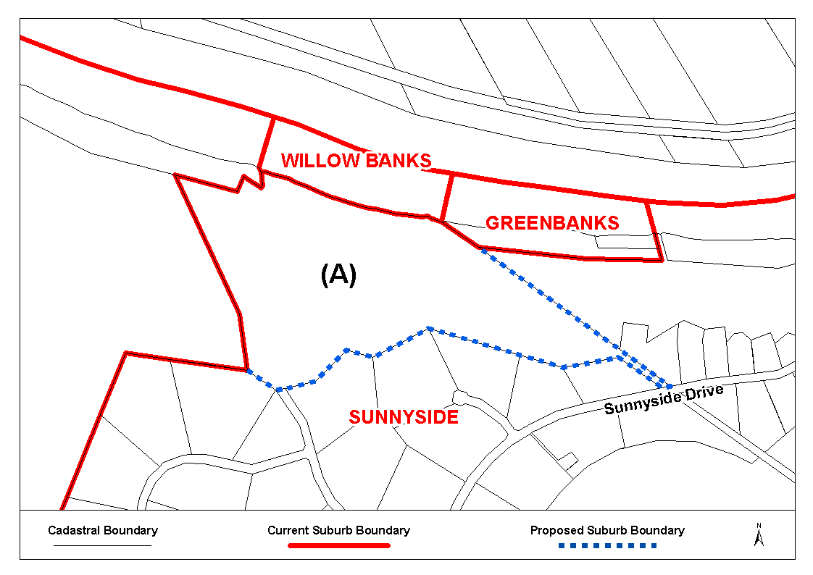
The Plan

Dated 5 May 2008.
P. M. Kentish, Surveyor-General, Department for Transport, Energy and Infrastructure
DAIS.22-413/07/0035

GEOGRAPHICAL NAMES ACT 1991
Corrigendum
Notice of Declaration of Names of Places
IN the Government Gazette of 11 November 1999, page 2321 third notice appearing, the declared name shown as COPE-VILLE, should have been shown as COPEVILLE.
Dated 2 May 2008.
P. M. Kentish, Surveyor-General
DTEI.22-413/07/0032

HOUSING IMPROVEMENT ACT 1940
WHEREAS by notice published in the Government Gazette on the dates mentioned in the following table the South Australian Housing Trust did declare the houses described in the said table to be substandard for the purposes of Part 7 of the Housing Improvement Act 1940, and whereas the South Australian Housing Trust is satisfied that each of the houses described hereunder has ceased to be substandard, notice is hereby given that, in exercise of the powers conferred by the said Part, the South Australian Housing Trust does hereby revoke the said declaration in respect of each house.
Address of House | Allotment, Section, etc. | Certificate of Title  Volume Folio | Date and page of Government Gazette in which notice declaring house to be substandard published

Section 1513, Minnis Road (also known as Jellett Road), Berri Irrigation Area |  | Section 1513 in the Berri Irrigation Area in the County of Hamley | 5980 | 172 |  | 30.7.92, page 759
21 Twelfth Street, Gawler South |  | Allotment 1 of portion of Section 2, Hundred of Mudla Wirra | 5949 | 254 |  | 23.12.92, page 2295
13 Hill Street, Hamley Bridge |  | Allotment 19 in Deposited Plan 1694, Hundred of Alma  Allotment 20 in Deposited Plan 1694, Hundred of Alma | 5352  5352 | 113  116 |  | 28.3.02, page 1451
58 Shipsters Road, Kensington Park |  | Portion of Allotment 101 in Filed Plan 27994, Hundred of Adelaide | 5643 | 862 |  | 3.6.65, page 1400
27 Cairns Street, Norwood |  | Allotments 6 and 12 in Deposited Plan 2120, Hundred of Adelaide | 5257 | 937 |  | 24.10.02, page 3892
43 First Avenue, Payneham South |  | Allotment 66 in Deposited Plan 1946, Hundred of Adelaide | 5657 | 288 |  | 29.5.75, page 2147
Unit 3/9 Irwin Street, Wallaroo |  | Allotment 3 in Filed Plan 158872, Hundred of Wallaroo | 5287 | 975 |  | 26.7.07, page 3177
Unit 9/9 Irwin Street, Wallaroo |  | Allotment 3 in Filed Plan 158872, Hundred of Wallaroo | 5287 | 975 |  | 26.7.07, page 3177
5 Headdey Court, Woodville South |  | Allotments 2 and 3 in Filed Plan 118884, Hundred of Yatala | 5502 | 766 |  | 27.9.07, page 3771

Dated at Adelaide, 8 May 2008. D. Huxley, Director, Corporate and Board Services

HOUSING IMPROVEMENT ACT 1940
WHEREAS by notice published in the Government Gazette on the dates mentioned in the following table the South Australian Housing Trust did declare the houses described in the said table to be substandard for the purposes of Part 7 of the Housing Improvement Act 1940, the South Australian Housing Trust in the exercise of the powers conferred by the said Part, does hereby fix as the maximum rental per week which shall be payable subject to section 55 of the Residential Tenancies Act 1995, in respect of each house described in the following table the amount shown in the said table opposite the description of such house and this notice shall come into force on the date of this publication in the Gazette.
Address of House | Allotment, Section, etc. | Certificate of Title  Volume Folio | Date and page of Government Gazette in which notice declaring house to be substandard published | Maximum rental per week payable in respect of each house  $

36 Maxwell Street, Adelaide |  | Allotment 258 of portion of Town Acre 621, Hundred of Adelaide | 5873 | 939 |  | 24.2.66, page 1208 | 70.00
Unit 1/22 Weller Street, Goodwood |  | Unit 1 in Strata Plan 4932, Hundred of Adelaide | 5025 | 407 |  | 24.2.05, page 523 | 315.00
19 Fourth Street, Quorn |  | Allotment 220, Hundred of Pichi Richi | 5337 | 307 |  | 21.4.94, page 1083 | 108.00
Lot 3, Orient Street, North Quorn |  | Allotment 3 of portion of Section 209, Hundred Pichi Richi | 5291 | 750 |  | 30.9.93, page 1370 | 109.00

Dated at Adelaide, 8 May 2008. D. Huxley, Director, Corporate and Board Services

HOUSING IMPROVEMENT ACT 1940
NOTICE is hereby given that the South Australian Housing Trust in the exercise of the powers conferred by the Housing Improvement Act 1940, does hereby declare the houses described in the table hereunder to be substandard for the purposes of Part 7 of the Housing Improvement Act 1940.
No. of House and Street | Locality | Allotment, Section, etc. | Certificate of Title  Volume Folio

Unit 7/11 Barcoo Road |  | Para Hills | Unit 7 in Strata Plan 1684, Hundred of Yatala | 5054 | 74
90C Nelson Road (Unit at back of No. 90) |  | Valley View | Allotment 98 in Deposited Plan 7012, Hundred of Yatala | 5269 | 840

Dated at Adelaide, 8 May 2008. D. Huxley, Director, Corporate and Board Services

HOUSING IMPROVEMENT ACT 1940
Erratum
IN Government Gazette No. 21 on page 1421, fifth entry below was printed in error and will be added at a later date.
Address of House | Allotment, Section, etc. | Certificate of Title  Volume Folio | Date and page of Government Gazette in which notice declaring house to be substandard published | Maximum rental per week payable in respect of each house  $

37 Caroline Drive, Fulham Gardens |  | Allotment 72 in Filed Plan 120491, Hundred of Yatala | 5991 | 703 |  | 14.2.08, page 469 | 230.00

Dated at Adelaide, 24 April 2008. D. Huxley, Director, Corporate and Board Services

LAND AND BUSINESS (SALE AND CONVEYANCING)
ACT 1994
Exemption
TAKE notice that, pursuant to section 23 (3) of the Land and Business (Sale and Conveyancing) Act 1994, I, Jennifer Rankine, Minister for Consumer Affairs, do hereby exempt the person named in Schedule 1 from the application of section 23 (2) of the Act in relation to the purchase of the land specified in Schedule 2.
Schedule 1
Kayleen Joy O’Brien, an employee of GBJ Smith Real Estate Pty Ltd.
Schedule 2
The land described in a whole of certificate of title register book volume 5693, folio 795, situated at 28 McKay Street, Port Broughton, S.A. 5522.
Dated 30 April 2008.
J. Rankine, Minister for Consumer Affairs

LIQUOR LICENSING ACT 1997 AND GAMING MACHINES ACT 1992
Notice of Application
NOTICE is hereby given, pursuant to section 52 of the Liquor Licensing Act 1997 and section 29 of the Gaming Machines Act 1992, that Lisa Cove Pty Ltd, M. J. Lunnis Investments Pty Ltd and Kirra Consulting Pty Ltd have applied to the Licensing Authority for the transfer of a Hotel and Gaming Machine Licence in respect of premises situated at 286 Commercial Road, Port Adelaide, S.A. 5015 and known as Portland Hotel.
The applications have been set down for hearing on 10 June 2008 at 11 a.m.
Any person may object to the application by lodging a notice of objection in the prescribed form with the Liquor and Gambling Commissioner and serving a copy of the notice on the applicants at the applicants’ address, at least seven days before the hearing date (viz: 3 June 2008).
The applicants’ address for service is c/o Kelly & Co., Level 17, Westpac House, 91 King William Street, Adelaide, S.A. 5000 (Attention: Caroline Beeston for Graham Hobbs).
Plans in respect of the premises the subject of the application are open to public inspection without fee at the Office of the Liquor and Gambling Commissioner, 9th Floor, East Wing, 50 Grenfell Street, Adelaide, S.A. 5000. Phone 8226 8410, Fax:
8226 8512. Email: olgc@agd.sa.gov.au.
Dated 2 May 2008.
Applicants

LIQUOR LICENSING ACT 1997 AND GAMING MACHINES ACT 1992
Notice of Application
NOTICE is hereby given, pursuant to section 52 of the Liquor Licensing Act 1997 and section 29 of the Gaming Machines Act 1992, that Mark Eric Anders and Annabel Mary Anders have applied to the Licensing Authority for the transfer of a Hotel and Gaming Machine Licence in respect of premises situated at 36 Chief Street, Brompton, S.A. 5007 and known as Gaslight Tavern.
The applications have been set down for hearing on 10 June 2008 at 9.30 a.m.
Any person may object to the application by lodging a notice of objection in the prescribed form with the Liquor and Gambling Commissioner and serving a copy of the notice on the applicants at the applicants’ address, at least seven days before the hearing date (viz: 3 June 2008).
The applicants’ address for service is c/o Adrian Battiston, G.P.O. Box 544, Adelaide, S.A. 5001.
Plans in respect of the premises the subject of the application are open to public inspection without fee at the Office of the Liquor and Gambling Commissioner, 9th Floor, East Wing, 50 Grenfell Street, Adelaide, S.A. 5000. Phone 8226 8410, Fax:
8226 8512. Email: olgc@agd.sa.gov.au.
Dated 28 April 2008.
Applicants

LIQUOR LICENSING ACT 1997
Notice of Application
NOTICE is hereby given, pursuant to section 52 (2) (b) of the Liquor Licensing Act 1997, that Agrisa Industries Pty Ltd has applied to the Licensing Authority for a Direct Sales Licence in respect of premises situated at Lot 1, Meadows Road, Willunga, S.A. 5172 and to be known as Agrisa Industries.
The application has been set down for callover on 6 June 2008 at 9 a.m.
Any person may object to the application by lodging a notice of objection in the prescribed form with the Liquor and Gambling Commissioner and serving a copy of the notice on the applicant at the applicant’s address, at least seven days before the callover date (viz: 30 May 2008).
The applicant’s address for service is c/o David Watts & Associates, 1 Cator Street, Glenside, S.A 5065.
Plans in respect of the premises the subject of the application are open to public inspection without fee at the Office of the Liquor and Gambling Commissioner, 9th Floor, East Wing, 50 Grenfell Street, Adelaide, S.A. 5000. Phone 8226 8410, Fax:
8226 8512. Email: olgc@agd.sa.gov.au.
Dated 1 May 2008.
Applicant

LIQUOR LICENSING ACT 1997
Notice of Application
NOTICE is hereby given, pursuant to section 52 (2) (b) of the Liquor Licensing Act 1997, that Off the Vine Wine Merchant’s Pty Ltd has applied to the Licensing Authority for the transfer of a Wholesale Liquor Merchant’s Licence in respect of premises situated at Main Adelaide Road, Gumeracha, S.A. 5233 and known as Off the Vine Wine Merchants (S.A.).
The application has been set down for hearing on 20 May 2008 at 9.30 a.m.
Any person may object to the application by lodging a notice of objection in the prescribed form with the Liquor and Gambling Commissioner and serving a copy of the notice on the applicant at the applicant’s address, at least seven days before the hearing date (viz: 19 May 2008).
The applicant’s address for service is c/o Chris Milner, P.O. Box 167, Gumeracha, S.A. 5233.
Plans in respect of the premises the subject of the application are open to public inspection without fee at the Office of the Liquor and Gambling Commissioner, 9th Floor, East Wing, 50 Grenfell Street, Adelaide, S.A. 5000. Phone 8226 8410, Fax:
8226 8512. Email: olgc@agd.sa.gov.au.
Dated 30 April 2008.
Applicant

LIQUOR LICENSING ACT 1997
Notice of Application
NOTICE is hereby given, pursuant to section 52 (2) (b) of the Liquor Licensing Act 1997, that Royal South Australian Yacht Squadron Inc. has applied to the Licensing Authority for a variation to an Entertainment Consent to the Club Licence in respect of premises situated at 161 Oliver Rogers Road, Outer Harbour, S.A. 5018 and known as Royal South Australian Yacht Squadron.
The application has been set down for callover on 6 June 2008 at 9 a.m.
Conditions
The following licence conditions are sought:
• Variation to the current Entertainment Consent to include the dinghy shed, verandah, balcony, quarter deck and lawn area beside clubrooms as per plans lodged with this office.
Any person may object to the application by lodging a notice of objection in the prescribed form with the Liquor and Gambling Commissioner and serving a copy of the notice on the applicant at the applicant’s address, at least seven days before the callover date (viz: 30 May 2008).
The applicant’s address for service is c/o Nigel Gibson, 161 Oliver Rogers Road, Outer Harbour, S.A. 5018.
Plans in respect of the premises the subject of the application are open to public inspection without fee at the Office of the Liquor and Gambling Commissioner, 9th Floor, East Wing, 50 Grenfell Street, Adelaide, S.A. 5000. Phone 8226 8410, Fax:
8226 8512. Email: olgc@agd.sa.gov.au.
Dated 29 April 2008.
Applicant

LIQUOR LICENSING ACT 1997
Notice of Application
NOTICE is hereby given, pursuant to section 52 (2) (b) of the Liquor Licensing Act 1997, that Harlow and Herring Enterprises Pty Ltd as trustee for Beard and Brau Family Trust has applied to the Licensing Authority for a Producer’s Licence in respect of premises situated at Unit 3, 1265 Main North Road, Para Hills West, S.A. 5096 and to be known as Beard and Brau.
The application has been set down for callover on 6 June 2008 at 9 a.m.
Any person may object to the application by lodging a notice of objection in the prescribed form with the Liquor and Gambling Commissioner and serving a copy of the notice on the applicant at the applicant’s address, at least seven days before the callover date (viz: 30 May 2008).
The applicant’s address for service is c/o Harlow and Herring Enterprises, 174 Churchill Road, Prospect, S.A. 5082.
Plans in respect of the premises the subject of the application are open to public inspection without fee at the Office of the Liquor and Gambling Commissioner, 9th Floor, East Wing, 50 Grenfell Street, Adelaide, S.A. 5000. Phone 8226 8410, Fax:
8226 8512. Email: olgc@agd.sa.gov.au.
Dated 30 April 2008.
Applicant

LIQUOR LICENSING ACT 1997
Notice of Application
NOTICE is hereby given, pursuant to section 52 (2) (b) of the Liquor Licensing Act 1997, that Winton Maxwell Lee and Denise Joan Lee have applied to the Licensing Authority for a Direct Sales Licence in respect of premises situated at Lot 12, Old Coach Road, Aldinga, S.A. 5173 and to be known as Winton Lodge.
The application has been set down for callover on 6 June 2008 at 9 a.m.
Any person may object to the application by lodging a notice of objection in the prescribed form with the Liquor and Gambling Commissioner and serving a copy of the notice on the applicants at the applicants’ address, at least seven days before the callover date (viz: 30 May 2008).
The applicants’ address for service is c/o David Watts & Associates, 1 Cator Street, Glenside, S.A. 5065.
Plans in respect of the premises the subject of the application are open to public inspection without fee at the Office of the Liquor and Gambling Commissioner, 9th Floor, East Wing, 50 Grenfell Street, Adelaide, S.A. 5000. Phone 8226 8410, Fax:
8226 8512. Email: olgc@agd.sa.gov.au.
Dated 1 May 2008.
Applicants

LIQUOR LICENSING ACT 1997
Notice of Application
NOTICE is hereby given, pursuant to section 52 (2) (b) of the Liquor Licensing Act 1997, that La Cantina Pty Ltd as trustee for La Cantina Trust has applied to the Licensing Authority for a Wholesale Liquor Merchant’s Licence in respect of premises situated at 3 Orange Lane, Norwood, S.A. 5067 and to be known as La Cantina.
The application has been set down for callover on 6 June 2008 at 9 a.m.
Any person may object to the application by lodging a notice of objection in the prescribed form with the Liquor and Gambling Commissioner and serving a copy of the notice on the applicant at the applicant’s address, at least seven days before the callover date (viz: 30 May 2008).
The applicant’s address for service is c/o Clelands Lawyers, 208 Carrington Street, Adelaide, S.A. 5000 (Attention: Leon McEvoy).
Plans in respect of the premises the subject of the application are open to public inspection without fee at the Office of the Liquor and Gambling Commissioner, 9th Floor, East Wing, 50 Grenfell Street, Adelaide, S.A. 5000. Phone 8226 8410, Fax:
8226 8512. Email: olgc@agd.sa.gov.au.
Dated 2 May 2008.
Applicant

LIQUOR LICENSING ACT 1997
Notice of Application
NOTICE is hereby given, pursuant to section 52 (2) (b) of the Liquor Licensing Act 1997, that Francast Pty Ltd and Gregory Winston have applied to the Licensing Authority for an Extension of Trading Area and variation to Extended Trading Authorisation in respect of premises situated at 179 West Terrace, Adelaide, S.A. 5000 and known as Elephant & Castle Hotel.
The application has been set down for callover on 6 June 2008 at 9 a.m.
Conditions
The following licence conditions are sought:
• Extension of Trading Area to include an outdoor area adjacent to Area 3 as per plans lodged with this office for the following hours (including Extended Trading Authorisation):
Monday to Saturday: 10 a.m. to midnight;
Sunday: 11 a.m. to midnight.
• Variation to Extended Trading Authorisation for consump-tion off the licensed premises:
Sunday: 9 a.m. to 11 a.m. and 8 p.m. to 9 p.m.
Any person may object to the application by lodging a notice of objection in the prescribed form with the Liquor and Gambling Commissioner and serving a copy of the notice on the applicants at the applicants’ address, at least seven days before the callover date (viz: 30 May 2008).
The applicants’ address for service is c/o Piper Alderman Lawyers, 167 Flinders Street, Adelaide, S.A. 5000 (Attention: Geoff Forbes or Jonathan Dodd).
Plans in respect of the premises the subject of the application are open to public inspection without fee at the Office of the Liquor and Gambling Commissioner, 9th Floor, East Wing, 50 Grenfell Street, Adelaide, S.A. 5000. Phone 8226 8410, Fax:
8226 8512. Email: olgc@agd.sa.gov.au.
Dated 5 May 2008.
Applicants

LIQUOR LICENSING ACT 1997
Notice of Application
NOTICE is hereby given, pursuant to section 52 (2) (b) of the Liquor Licensing Act 1997, that Natasha Mooney Wine Architect Pty Ltd has applied to the Licensing Authority for a Wholesale Liquor Merchant’s Licence in respect of premises situated at Lot 57, Yettie Road, Williamstown, S.A. 5351 and known as Natasha Mooney Wine Architect.
The application has been set down for callover on 6 June 2008 at 9 a.m.
Any person may object to the application by lodging a notice of objection in the prescribed form with the Liquor and Gambling Commissioner and serving a copy of the notice on the applicant at the applicant’s address, at least seven days before the callover date (viz: 30 May 2008).
The applicant’s address for service is c/o Natasha Mooney, P.O. Box 918, Williamstown, S.A. 5351.
Plans in respect of the premises the subject of the application are open to public inspection without fee at the Office of the Liquor and Gambling Commissioner, 9th Floor, East Wing, 50 Grenfell Street, Adelaide, S.A. 5000. Phone 8226 8410, Fax:
8226 8512. Email: olgc@agd.sa.gov.au.
Dated 30 April 2008.
Applicant

LIQUOR LICENSING ACT 1997
Notice of Application
NOTICE is hereby given, pursuant to section 52 (2) (b) of the Liquor Licensing Act 1997, that A. Giannitto & Sons Pty Ltd has applied to the Licensing Authority for approval of Alterations, redefinition of Licensed Area and variation to the conditions of the Entertainment Consent and Extended Trading Authorisation in respect of premises situated at 102 Murray Street, Gawler, S.A. 5118 and known as Gawler Arms Hotel.
The application has been set down for callover on 6 June 2008 at 9 a.m.
Conditions
The following licence conditions are sought:
The alterations are to occur to the western end of the first floor and involve the establishment of a lounge, pre-dinner drinks area, a ‘Break-out’ area with bar, two smoking areas and new toilet facilities.
The Entertainment Consent is sought to apply to the pre-dinner drinks area and ‘Break-out’ area. No entertainment will be provided in the smoking areas. The Extended Trading Authorisation is sought to include all of the additional areas on the day and times currently authorised for Extended Trading in other areas of the premises.
All existing licence conditions will remain in force.
Any person may object to the application by lodging a notice of objection in the prescribed form with the Liquor and Gambling Commissioner and serving a copy of the notice on the applicant at the applicant’s address, at least seven days before the callover date (viz: 30 May 2008).
The applicant’s address for service is c/o The Australian Hotels Association (S.A. Branch) 4th Floor, 60 Hindmarsh Square, Adelaide, S.A. 5000.
Plans in respect of the premises the subject of the application are open to public inspection without fee at the Office of the Liquor and Gambling Commissioner, 9th Floor, East Wing, 50 Grenfell Street, Adelaide, S.A. 5000. Phone 8226 8410, Fax:
8226 8512. Email: olgc@agd.sa.gov.au.
Dated 2 May 2008.
Applicant

LIQUOR LICENSING ACT 1997
Notice of Application
NOTICE is hereby given, pursuant to section 52 (2) (b) of the Liquor Licensing Act 1997, that Riverton, Saddleworth, Marrabel United Football Club Inc. has applied to the Licensing Authority for an Extended Trading Authorisation in respect of premises situated at Recreation Park Oval, Oxford Terrace, Riverton, S.A. 5412 and known as Riverton, Saddleworth, Marrabel United Football Club.
The application has been set down for callover on 6 June 2008 at 9 a.m.
Conditions
The following licence conditions are sought:
• Extended Trading Authorisation:
Friday: Midnight to 1 a.m. the following day.
Saturday: Midnight to 1 a.m. the following day.
Any person may object to the application by lodging a notice of objection in the prescribed form with the Liquor and Gambling Commissioner and serving a copy of the notice on the applicant at the applicant’s address, at least seven days before the callover date (viz: 30 May 2008).
The applicant’s address for service is c/o Andrew Parkinson, P.O. Box 132, Riverton, S.A. 5412.
Plans in respect of the premises the subject of the application are open to public inspection without fee at the Office of the Liquor and Gambling Commissioner, 9th Floor, East Wing, 50 Grenfell Street, Adelaide, S.A. 5000. Phone 8226 8410, Fax:
8226 8512. Email: olgc@agd.sa.gov.au.
Dated 5 May 2008.
Applicant

LIQUOR LICENSING ACT 1997
Notice of Application
NOTICE is hereby given, pursuant to section 52 (2) (b) of the Liquor Licensing Act 1997, that 3 Roses Pty Ltd as trustee for Gray Family Trust has applied to the Licensing Authority for the transfer of a Hotel Licence in respect of premises situated at Stenhouse Bay Road, Stenhouse Bay, S.A. 5577 and known as Rhino’s Tavern.
The application has been set down for hearing on 10 June 2008 at 9 a.m.
Any person may object to the application by lodging a notice of objection in the prescribed form with the Liquor and Gambling Commissioner and serving a copy of the notice on the applicant at the applicant’s address, at least seven days before the hearing date (viz: 3 June 2008).
The applicant’s address for service is c/o Sophie Gray, P.O. Box 52, Marion Bay, S.A. 5575.
Plans in respect of the premises the subject of the application are open to public inspection without fee at the Office of the Liquor and Gambling Commissioner, 9th Floor, East Wing, 50 Grenfell Street, Adelaide, S.A. 5000. Phone 8226 8410, Fax:
8226 8512. Email: olgc@agd.sa.gov.au.
Dated 28 April 2008.
Applicant

LIQUOR LICENSING ACT 1997
Notice of Application
NOTICE is hereby given, pursuant to section 52 (2) (b) of the Liquor Licensing Act 1997, that Dimitrios Nikolau has applied to the Licensing Authority for the transfer of a Restaurant Licence in respect of premises situated at Lot 454, corner Hutchinson and Wright Streets, Coober Pedy, S.A. 5723 and known as Ampol Coober Pedy Roadhouse.
The application has been set down for hearing on 10 June 2008 at 10 a.m.
Any person may object to the application by lodging a notice of objection in the prescribed form with the Liquor and Gambling Commissioner and serving a copy of the notice on the applicant at the applicant’s address, at least seven days before the hearing date (viz: 3 June 2008).
The applicant’s address for service is c/o Wallmans Lawyers, G.P.O Box 1018, Adelaide, S.A. 5001 (Attention: Peter Hoban).
Plans in respect of the premises the subject of the application are open to public inspection without fee at the Office of the Liquor and Gambling Commissioner, 9th Floor, East Wing, 50 Grenfell Street, Adelaide, S.A. 5000. Phone 8226 8410, Fax:
8226 8512. Email: olgc@agd.sa.gov.au.
Dated 1 May 2008.
Applicant

LIQUOR LICENSING ACT 1997
Notice of Application
NOTICE is hereby given, pursuant to section 52 (2) (b) of the Liquor Licensing Act 1997, that Shark’s Alehouse Pty Ltd as trustee for Shark’s Alehouse Unit Trust has applied to the Licensing Authority for a variation to an Extended Trading Authorisation and variation to Conditions in respect of premises situated at T2052C, Westfield, 297 Diagonal Road, Oaklands Park, S.A. 5046 and known as Shenannigans Irish Pub.
The application has been set down for callover on 6 June 2008 at 9 a.m.
Conditions
The following licence conditions are sought:
• Variation to Trading Hours (including Extended Trading Authorisation) for areas 3 and 4 from:
Monday to Saturday: 7 a.m. to 10 p.m.
Sunday: 7 a.m. to 10 p.m.
To:
Monday to Saturday: 7 a.m. to 2 a.m. the following day.
Sunday: 7 a.m. to midnight
• Variation to conditions to delete Condition 13:
Trading in areas 3 and 4 shall cease by 10 p.m. on any day with all the furniture removed.
Any person may object to the application by lodging a notice of objection in the prescribed form with the Liquor and Gambling Commissioner and serving a copy of the notice on the applicant at the applicant’s address, at least seven days before the callover date (viz: 30 May 2008).
The applicant’s address for service is c/o Shark’s Alehouse Pty Ltd, T2052C, Westfield, 297 Diagonal Road, Oaklands Park, S.A. 5046.
Plans in respect of the premises the subject of the application are open to public inspection without fee at the Office of the Liquor and Gambling Commissioner, 9th Floor, East Wing, 50 Grenfell Street, Adelaide, S.A. 5000. Phone 8226 8410, Fax:
8226 8512. Email: olgc@agd.sa.gov.au.
Dated 5 May 2008.
Applicant

LIQUOR LICENSING ACT 1997
Notice of Application
NOTICE is hereby given, pursuant to section 52 (2) (b) of the Liquor Licensing Act 1997, that Adelaide Hospitality Group Pty Ltd has applied to the Licensing Authority for the transfer of a Special Circumstances Licence in respect of premises situated at 69 Light Square, Adelaide, S.A. 5000 and known as Disco Nightclub and to be known as Spearmint Rhino.
The application has been set down for hearing on 11 June 2008 at 10 a.m.
Any person may object to the application by lodging a notice of objection in the prescribed form with the Liquor and Gambling Commissioner and serving a copy of the notice on the applicant at the applicant’s address, at least seven days before the hearing date (viz: 4 June 2008).
The applicant’s address for service is c/o Kelly & Co., Level 17, 91 King William Street, Adelaide, S.A. 5000 (Attention: Jarrod Ryan).
Plans in respect of the premises the subject of the application are open to public inspection without fee at the Office of the Liquor and Gambling Commissioner, 9th Floor, East Wing, 50 Grenfell Street, Adelaide, S.A. 5000. Phone 8226 8410, Fax:
8226 8512. Email: olgc@agd.sa.gov.au.
Dated 2 May 2008.
Applicant

LIQUOR LICENSING ACT 1997
Notice of Application
NOTICE is hereby given, pursuant to section 52 (2) (b) of the Liquor Licensing Act 1997, that Andrew Ian Summerton and Andrew John Jelonek as trustee for A. and A. Multisports Trust have applied to the Licensing Authority for the transfer of a Special Circumstances Licence in respect of premises situated at Innes Road, Windsor Gardens, S.A. 5087 and known as ICA Sportzworx Windsor Gardens.
The application has been set down for hearing on 12 June 2008 at 9 a.m.
Any person may object to the application by lodging a notice of objection in the prescribed form with the Liquor and Gambling Commissioner and serving a copy of the notice on the applicants at the applicants’ address, at least seven days before the hearing date (viz: 5 June 2008).
The applicants’ address for service is c/o Andrew Summerton,
1 Freebairn Street, Windsor Gardens, S.A. 5087.
Plans in respect of the premises the subject of the application are open to public inspection without fee at the Office of the Liquor and Gambling Commissioner, 9th Floor, East Wing, 50 Grenfell Street, Adelaide, S.A. 5000. Phone 8226 8410, Fax:
8226 8512. Email: olgc@agd.sa.gov.au.
Dated 5 May 2008.
Applicants

LIQUOR LICENSING ACT 1997
Notice of Application
NOTICE is hereby given, pursuant to section 52 (2) (b) of the Liquor Licensing Act 1997, that Gilbert Street Hotel (S.A.) Pty Ltd as trustee for Gilbert Trust has applied to the Licensing Authority for the transfer of a Hotel Licence, variation to an Extended Trading Authorisation, variation to Entertainment Consent and variation to Conditions in respect of premises situated at 88 Gilbert Street, Adelaide, S.A. 5000 and known as Gilbert Street Hotel.
The application has been set down for callover on 6 June 2008 at 9 a.m.
Conditions
The following licence conditions are sought:
• Variation to Extended Trading Authorisation:
Good Friday: Midnight to 1.30 a.m.;
Christmas Day: Midnight to 1.30 a.m.;
Sunday Christmas Eve: 8 p.m. to 1.30 a.m. the following day;
Days preceding Public Holidays: Midnight to 1.30 a.m. the following day;
Sundays preceding Public Holidays: 8 p.m. to 1.30 a.m. the following day.
• Variation to Entertainment Consent to include the above-mentioned hours.
• Variation to Conditions:
Variation to the following Condition from:
The hours of operation of Area 6 shall be Monday to Sunday, 11 a.m. to 10 p.m. each day;
To:
The hours of operation of Area 6 shall be Monday to Sunday, 9 a.m. to midnight.
• Variation to Condition 13 from:
The licensee is to provide the following licensed security to regularly patrol within a 100 m radius from the hotel to ensure patrons arriving at and departing the licensed premises do not cause undue noise and disturbance to local residents:
(a) when live entertainment is provided beyond mid-night but not beyond 1 a.m., one security person is to be provided from 10 p.m.;
(b) when live entertainment is provided beyond 1 a.m. a second security person is to be provided from midnight until half an hour after patrons have left the premises and the vicinity;
To:
The licensee is to provide the following licensed security to regularly patrol within a 100 m radius from the hotel to ensure patrons arriving at and departing the licensed premises do not cause undue noise and disturbance to local residents:
(a) when live entertainment is provided beyond midnight but not beyond 1 a.m., one security person is to be provided from 10 p.m.
• Variation to Condition 14 from:
The licensee is to provide the following licensed security on Friday and Saturday nights whose duties shall include the areas and responsibilities referred to in Condition 13 as follows:
(a) when the hotel trades beyond midnight but not beyond 1 a.m., one security person is to be prrovided from 10 p.m.;
(b) when the hotel trades beyond 1 a.m. a second security person is to be provided from midnight until half an hour after patrons have left the premises and the vicinity;
To:
The licensee is to provide the following licensed security on Friday and Saturday nights whose duties shall include the areas and responsibilities referred to in Condition 13 as follows:
(a) when the hotel trades beyond midnight but not beyond 1 a.m., one security person is to be provided from 10 p.m.
Any person may object to the application by lodging a notice of objection in the prescribed form with the Liquor and Gambling Commissioner and serving a copy of the notice on the applicant at the applicant’s address, at least seven days before the callover date (viz: 30 May 2008).
The applicant’s address for service is c/o Clelands Lawyers, 208 Carrington Street, Adelaide, S.A. 5000.
Plans in respect of the premises the subject of the application are open to public inspection without fee at the Office of the Liquor and Gambling Commissioner, 9th Floor, East Wing, 50 Grenfell Street, Adelaide, S.A. 5000. Phone 8226 8410, Fax:
8226 8512. Email: olgc@agd.sa.gov.au.
Dated 6 May 2008.
Applicant

MINING ACT 1971
NOTICE is hereby given in accordance with section 28 (5) of the Mining Act 1971, that the Minister for Mineral Resources Development proposes to grant an Exploration Licence over the undermentioned area:
Applicant: Makris Corporation Pty Ltd
Location: Carey Hill Area—Approximately 80 km south-east of Leigh Creek.
Pastoral Lease: Angorichina and Gum Creek Stations.
Term: 1 year
Area in km²: 88
Ref.: 2007/00674
Plan and co-ordinates can be found on the PIRSA Sarig website: http://www.minerals.pir.sa.gov.au/sarig or by phoning Mineral Tenements on (08) 8463 3103.
H. Tyrteos, Mining Registrar

MINING ACT 1971
NOTICE is hereby given in accordance with section 28 (5) of the Mining Act 1971, that the Minister for Mineral Resources Development proposes to grant an Exploration Licence over the undermentioned area:
Applicant: Makris Corporation Pty Ltd
Location: Gammon Ranges Area—Approximately 80 km east-north-east of Leigh Creek.
Pastoral Lease: Wooltana, Wertaloona, Umberatana and Yankaninna Stations.
Term: 1 year
Area in km²: 114
Ref.: 2007/00675
Plan and co-ordinates can be found on the PIRSA Sarig website: http://www.minerals.pir.sa.gov.au/sarig or by phoning Mineral Tenements on (08) 8463 3103.
H. Tyrteos, Mining Registrar

MINING ACT 1971
NOTICE is hereby given in accordance with section 28 (5) of the Mining Act 1971, that the Minister for Mineral Resources Development proposes to grant an Exploration Licence over the undermentioned area:
Applicant: Makris Corporation Pty Ltd
Location: Jubilee Hill Area—Approximately 90 km north-east of Port Augusta.
Pastoral Lease: Mulga View, Mulga View South, Narrina and Wirrealpa Stations.
Term: 1 year
Area in km²: 144
Ref.: 2007/00676
Plan and co-ordinates can be found on the PIRSA Sarig website: http://www.minerals.pir.sa.gov.au/sarig or by phoning Mineral Tenements on (08) 8463 3103.
H. Tyrteos, Mining Registrar

MINING ACT 1971
NOTICE is hereby given in accordance with section 28 (5) of the Mining Act 1971, that the Minister for Mineral Resources Development proposes to grant an Exploration Licence over the undermentioned area:
Applicant: Makris Corporation Pty Ltd
Location: Kennebery Creek Area—Approximately 25 km west of Marree.
Pastoral Lease: Lake Letty and Callanna Stations.
Term: 1 year
Area in km²: 146
Ref.: 2007/00677
Plan and co-ordinates can be found on the PIRSA Sarig website: http://www.minerals.pir.sa.gov.au/sarig or by phoning Mineral Tenements on (08) 8463 3103.
H Tyrteos, Mining Registrar

MINING ACT 1971
NOTICE is hereby given in accordance with section 28 (5) of the Mining Act 1971, that the Minister for Mineral Resources Development proposes to grant an Exploration Licence over the undermentioned area:
Applicant: St Barbara Limited
Location: Canegrass Ridge Area—Approximately 80 km south-east of Oodnadatta.
Pastoral Lease: The Peake Station.
Term: 1 year
Area in km²: 287
Ref.: 2008/00071
Plan and co-ordinates can be found on the PIRSA Sarig website: http://www.minerals.pir.sa.gov.au/sarig or by phoning Mineral Tenements on (08) 8463 3103.
H Tyrteos, Mining Registrar

MINING ACT 1971
NOTICE is hereby given in accordance with section 28 (5) of the Mining Act 1971, that the Minister for Mineral Resources Development proposes to grant an Exploration Licence over the undermentioned area:
Applicant: Challenger West Holdings Pty Ltd 80%,
CMH Resources Pty Ltd 20%
Location: Garford Area—Approximately 140 km south-west of Coober Pedy.
Pastoral Lease: Pt Commonwealth Hill and Mobella Stations.
Term: 1 year
Area in km²: 497
Ref.: 2008/00122
Plan and co-ordinates can be found on the PIRSA Sarig website: http://www.minerals.pir.sa.gov.au/sarig or by phoning Mineral Tenements on (08) 8463 3103.
H Tyrteos, Mining Registrar

MINING ACT 1971
NOTICE is hereby given in accordance with section 28 (5) of the Mining Act 1971, that the Minister for Mineral Resources Development proposes to grant an Exploration Licence over the undermentioned area:
Applicant: Eagle Bay Resources NL
Location: Whyalla Area—Approximately 200 km north-west of Adelaide.
Pastoral Lease: Tregalana and Lincoln Park Stations.
Term: 1 year
Area in km²: 160
Ref.: 2008/00157
Plan and co-ordinates can be found on the PIRSA Sarig website: http://www.minerals.pir.sa.gov.au/sarig or by phoning Mineral Tenements on (08) 8463 3103.
H Tyrteos, Mining Registrar

MINING ACT 1971
NATIVE TITLE (SOUTH AUSTRALIA) ACT 1994
NOTICE is hereby given in accordance with section 35A (1) of the Mining Act 1971 and Part 5 of the Native Title (South Australia) Act 1994 and the Regulations thereunder that an application for a mining lease has been received. Details of the proposal may be inspected at the Department of Primary Industries and Resources, Mineral Resources Group, Level 5, 101 Grenfell Street, Adelaide, S.A. 5000:
Applicant: Iluka (Eucla Basin) Pty Ltd
Claim Nos: 3575-3592 inclusive
Location: Allotment 100 DP 67929, Out of Hundred (Barton), approximately 200 km north-west of Ceduna.
Area: 4 500 ha
Purpose: For the recovery of Limestone, Calcrete, Ironstone, Sand, Gravel and Sandstone.
Reference: T02551
The Minister for Mineral Resources Development is required to have regard to any representations received from owners of the land (including native title holders) to which the application relates and/or any interested members of the public in determining the application or in fixing the conditions to be attached to the lease if granted.
Written submissions in relation to the granting of the mining lease are invited to be received at the Department of Primary Industries and Resources, Mineral Resources Group, Level 5, 101 Grenfell Street, Adelaide, S.A. 5000 or G.P.O. Box 1671, Adelaide, S.A. 5001 no later than 22 May 2008.
Copies of all submissions will be forwarded to the applicant and may be made available for public inspection unless confidentiality is requested.
H. Tyrteos, Mining Registrar

NATIONAL ELECTRICITY LAW
THE Australian Energy Market Commission (AEMC) gives notice under the National Electricity Law (NEL) of the following matters.
Under section 95, the National Generators Forum has requested the making of the proposed National Electricity Amendment (Confidentiality Arrangements in Respect of Information Required for Power System Studies) Rule 2008. The proposal relates to the disclosure of information to Registered Participants for planning and other purposes under certain conditions. Submissions can be forwarded to submissions@aemc.gov.au and must be received by 6 June 2008.
Further details on the above matter are available on the AEMC’s website www.aemc.gov.au. All documents in relation to the above matter are published on the AEMC’s website and are available for inspection at the offices of the AEMC.
John Tamblyn
Chairman
Australian Energy Market Commission
Level 5, 201 Elizabeth Street
Sydney, N.S.W. 2000
Telephone: (02) 8296 7800
Facsimile: (02) 8296 7899
8 May 2008.

NATIONAL PARKS AND WILDLIFE (NATIONAL PARKS) REGULATIONS 2001
Closure of Chowilla Game Reserve
PURSUANT to Regulations 8 (3) (a) and 8 (3) (d) of the National Parks and Wildlife (National Parks) Regulations 2001, I, Edward Gregory Leaman, Director of National Parks and Wildlife, close to the public, the whole of Chowilla Game Reserve from 12 noon on Friday, 23 May 2008 until 12 noon on Monday, 26 May 2008.
The purpose of the closure is to ensure the safety of the public during a pest control and monitoring program within the reserve during the period indicated.
Use of Firearms within the Reserve
Pursuant to Regulations 8 (4), 20 (1) and 41 of the National Parks and Wildlife (National Parks) Regulations 2001, I, Edward Gregory Leaman, Director of National Parks and Wildlife, grant permission to members of the Sporting Shooters Association of South Australia (S.A. Branch) in possession of both a current Hunting Permit and a firearm to enter and remain in Chowilla Game Reserve from 12 noon on Friday, 23 May 2008 until 12 noon on Monday, 26 May 2008, for the purpose of taking feral animals.
This permission is conditional upon the observance by each of those persons of the requirements of the National Parks and Wildlife Act 1972, National Parks and Wildlife (National Parks) Regulations 2001 and the National Parks and Wildlife (Hunting) Regulations 1996, including those requiring compliance with the Director’s requests, requirements and orders of a Warden.
Dated 6 May 2008.
E. G. Leaman, Director of National Parks and Wildlife

ROADS (OPENING AND CLOSING) ACT 1991:
SECTION 24
NOTICE OF CONFIRMATION OF ROAD
PROCESS ORDER
Road Closure
Glen Yallum Lane, Monbulla
BY Road Process Order made on 3 October 2007, the Wattle Range Council ordered that:
1. The whole of Glen Yallum Lane separating pieces 91 and 93 from pieces 92 and 94 in Filed Plan 200035, more particularly lettered ‘D’ and ‘E’ in Preliminary Plan No. 06/0058 be closed.
2. The whole of the land subject to closure be transferred to Lyndon Andrew Eason in accordance with agreement for transfer dated 27 July 2006 entered into between the Wattle Range Council and L. A. Eason.
3. The following easement is granted over portion of the land subject to that closure:
Grant to Distribution Lessor Corporation an easement for overhead electricity supply purposes.
On 14 March 2008 that order was confirmed by the Minister for Infrastructure conditionally upon the deposit by the Registrar-General of Deposited Plan 75800 being the authority for the new boundaries.
Pursuant to section 24 (5) of the Roads (Opening and Closing) Act 1991, NOTICE of the order referred to above and its confirmation is hereby given.
Dated 8 May 2008.
P. M. Kentish, Surveyor-General

ROADS (OPENING AND CLOSING) ACT 1991:
SECTION 24
NOTICE OF CONFIRMATION OF ROAD
PROCESS ORDER
Road Closure
Wingfield Road, Wingfield
BY Road Process Order made on 20 August 2007, the City of Port Adelaide Enfield ordered that:
1. The greater portion of Wingfield Road between South Terrace and Railway Terrace and adjoining allotment 702 in Deposited Plan 67923 and piece 517 in Deposited Plan 58861, more particularly delineated and lettered ‘A’ and ‘B’ in Preliminary Plan No. 06/0037 be closed.
2. The whole of the land subject to closure lettered ‘A’ be transferred to Rickey James O’Neill and Ross John O’Neill in accordance with agreement for transfer dated 16 April 2007 entered into between the City of Port Adelaide Enfield and R. J. and R. J. O’Neill.

3. The whole of the land subject to closure lettered ‘B’ be transferred to the Australian Rail Track Corporation Ltd in accordance with agreement for transfer dated 20 August 2007 entered into between the City of Port Adelaide Enfield and Australian Rail Track Corporation Ltd.
4. The following easements are granted over portions of the land subject to that closure:
Grant to Distribution Lessor Corporation an easement for electricity supply purposes (subject to L8890000).
Grant to South Australian Water Corporation an easement for water supply purposes.
Grant to Envestra (SA) Limited an easement for gas supply purposes.
On 14 April 2008 that order was confirmed by the Minister for Infrastructure conditionally upon the deposit by the Registrar-General of Deposited Plan 76539 being the authority for the new boundaries.
Pursuant to section 24 (5) of the Roads (Opening and Closing) Act 1991, NOTICE of the order referred to above and its confirmation is hereby given.
Dated 8 May 2008.
P. M. Kentish, Surveyor-General

ROADS (OPENING AND CLOSING) ACT 1991:
SECTION 24
NOTICE OF CONFIRMATION OF ROAD
PROCESS ORDER
Road Closure—Melrose
BY Road Process Order made on 12 March 2008, The District Council of Mount Remarkable ordered that:
1. Portion of the unnamed public road between Girdhams and Hundred Line Roads and adjoining the western boundaries of Sections 114 and 171, Hundred of Booleroo, more particularly delineated and lettered ‘B’ and ‘C’ respectively in Preliminary Plan No. 06/0010 be closed.
2. Transfer the whole of the land subject to closure marked ‘B’ to Jeffrey Kenneth McCallum and David John McCallum in accordance with the agreement for transfer dated 3 November 2006 entered into between The District Council of Mount Remarkable and J. K. and D. J. McCallum.
3. Transfer the whole of the land subject to closure marked ‘C’ to Kevin Ralph Girdham and Muriel Caroline Girdham in accordance with the agreement for transfer dated 28 June 2006 entered into between The District Council of Mount Remarkable and K. R. and M. C. Girdham.
4. The following easement be granted over portion of the land subject to that closure:
Grant to Transmission Lessor Corporation of 1 undivided 2nd part (Subject to L9061500) and ElectraNet Pty Ltd of 1 undivided 2nd part, an easement for electricity supply purposes.
On 30 April 2008 that order was confirmed by the Minister for Infrastructure conditionally upon the deposit by the Registrar-General of Deposited Plan 74968 being the authority for the new boundaries.
Pursuant to section 24 (5) of the Roads (Opening and Closing) Act 1991, NOTICE of the order referred to above and its confirmation is hereby given.
Dated 8 May 2008.
P. M. Kentish, Surveyor-General












GOVERNMENT GAZETTE ADVERTISEMENT RATES

To apply from 1 July 2007

$  Agents, Ceasing to Act as 39.60  Associations:  Incorporation 20.10  Intention of Incorporation 49.75  Transfer of Properties 49.75  Attorney, Appointment of 39.60  Bailiff’s Sale 49.75  Cemetery Curator Appointed 29.45  Companies:  Alteration to Constitution 39.60  Capital, Increase or Decrease of 49.75  Ceasing to Carry on Business 29.45  Declaration of Dividend 29.45  Incorporation 39.60  Lost Share Certificates:  First Name 29.45  Each Subsequent Name 10.10  Meeting Final 33.10  Meeting Final Regarding Liquidator’s Report on  Conduct of Winding Up (equivalent to ‘Final  Meeting’)  First Name 39.60  Each Subsequent Name 10.10  Notices:  Call 49.75  Change of Name 20.10  Creditors 39.60  Creditors Compromise of Arrangement 39.60  Creditors (extraordinary resolution that ‘the Com-pany be wound up voluntarily and that a liquidator be appointed’) 49.75  Release of Liquidator⎯Application⎯Large Ad. 78.65  ⎯Release Granted 49.75  Receiver and Manager Appointed 45.85  Receiver and Manager Ceasing to Act 39.60  Restored Name 37.25  Petition to Supreme Court for Winding Up 69.30  Summons in Action 58.85  Order of Supreme Court for Winding Up Action 39.60  Register of Interests⎯Section 84 (1) Exempt 89.10  Removal of Office 20.10  Proof of Debts 39.60  Sales of Shares and Forfeiture 39.60  Estates:  Assigned 29.45  Deceased Persons⎯Notice to Creditors, etc. 49.75  Each Subsequent Name 10.10  Deceased Persons⎯Closed Estates 29.45  Each Subsequent Estate 1.30  Probate, Selling of 39.60  Public Trustee, each Estate 10.10 |  | $  Firms:  Ceasing to Carry on Business (each insertion) 26.30  Discontinuance Place of Business 26.30  Land⎯Real Property Act:  Intention to Sell, Notice of 49.75  Lost Certificate of Title Notices 49.75  Cancellation, Notice of (Strata Plan) 49.75  Mortgages:  Caveat Lodgement 20.10  Discharge of 21.05  Foreclosures 20.10  Transfer of 20.10  Sublet 10.10  Leases⎯Application for Transfer (2 insertions) each 10.10  Lost Treasury Receipts (3 insertions) each 29.45  Licensing 58.85  Municipal or District Councils:  Annual Financial Statement⎯Forms 1 and 2 554.35  Electricity Supply⎯Forms 19 and 20 393.90  Default in Payment of Rates:  First Name 78.65  Each Subsequent Name 10.10  Noxious Trade 29.45  Partnership, Dissolution of 29.45  Petitions (small) 20.10  Registered Building Societies (from Registrar-  General) 20.10  Register of Unclaimed Moneys⎯First Name 29.45  Each Subsequent Name 10.10  Registers of Members⎯Three pages and over:  Rate per page (in 8pt) 252.15  Rate per page (in 6pt) 333.45  Sale of Land by Public Auction 50.30  Advertisements 2.80  ¼ page advertisement 117.75  ½ page advertisement 235.50  Full page advertisement 461.60  Advertisements, other than those listed are charged at $2.80 per column line, tabular one-third extra.  Notices by Colleges, Universities, Corporations and District Councils to be charged at $2.80 per line.  Where the notice inserted varies significantly in length from that which is usually published a charge of $2.80 per column line will be applied in lieu of advertisement rates listed.  South Australian Government publications are sold on the condition that they will not be reproduced without prior permission from the Government Printer.
All the above prices include GST

GOVERNMENT GAZETTE NOTICES
ALL private advertisements forwarded for publication in the South Australian Government Gazette must be PAID FOR PRIOR TO INSERTION; and all notices, from whatever source, should be legibly written on one side of the paper only and sent to Government Publishing SA so as to be received no later than 4 p.m. Tuesday preceding the day of publication. Phone 8207 1045 or Fax 8207 1040. E-mail: governmentgazette@dpc.sa.gov.au. Send as attachments in Word format. Please include date the notice is to be published and to whom the notice will be charged. The Government Gazette is available online at: www.governmentgazette.sa.gov.au.

MISCELLANEOUS LEGISLATION AND GOVERNMENT PUBLICATIONS PRICES AS FROM 1 JULY 2007

Acts, Bills, Rules, Parliamentary Papers and Regulations
Pages | Main | Amends | Pages | Main | Amends

1-16 | 2.40 | 1.10 | 497-512 | 33.60 | 32.55
17-32 | 3.25 | 2.05 | 513-528 | 34.65 | 33.35
33-48 | 4.20 | 3.00 | 529-544 | 35.70 | 34.65
49-64 | 5.30 | 4.05 | 545-560 | 36.75 | 35.70
65-80 | 6.25 | 5.15 | 561-576 | 37.50 | 36.75
81-96 | 7.25 | 6.00 | 577-592 | 38.55 | 37.25
97-112 | 8.25 | 7.05 | 593-608 | 39.85 | 38.30
113-128 | 9.25 | 8.10 | 609-624 | 40.65 | 39.60
129-144 | 10.35 | 9.15 | 625-640 | 41.70 | 40.10
145-160 | 11.35 | 10.10 | 641-656 | 42.70 | 41.70
161-176 | 12.40 | 11.15 | 657-672 | 43.25 | 42.20
177-192 | 13.45 | 12.20 | 673-688 | 45.05 | 43.25
193-208 | 14.50 | 13.35 | 689-704 | 45.85 | 44.30
209-224 | 15.30 | 14.15 | 705-720 | 46.65 | 45.35
225-240 | 16.35 | 15.10 | 721-736 | 48.45 | 46.35
241-257 | 17.50 | 15.95 | 737-752 | 48.95 | 47.40
258-272 | 18.45 | 17.00 | 753-768 | 50.00 | 48.20
273-288 | 19.50 | 18.25 | 769-784 | 50.55 | 49.75
289-304 | 20.30 | 19.15 | 785-800 | 51.60 | 50.80
305-320 | 21.55 | 20.20 | 801-816 | 52.60 | 51.30
321-336 | 22.40 | 21.15 | 817-832 | 53.65 | 52.60
337-352 | 23.55 | 22.30 | 833-848 | 54.70 | 53.65
353-368 | 24.50 | 23.35 | 849-864 | 55.75 | 54.20
369-384 | 25.55 | 24.40 | 865-880 | 56.80 | 55.75
385-400 | 26.55 | 25.30 | 881-896 | 57.30 | 56.25
401-416 | 27.60 | 26.05 | 897-912 | 58.85 | 57.30
417-432 | 28.65 | 27.35 | 913-928 | 59.40 | 58.85
433-448 | 29.70 | 28.40 | 929-944 | 60.45 | 59.40
449-464 | 30.50 | 29.20 | 945-960 | 61.50 | 59.90
465-480 | 31.00 | 30.20 | 961-976 | 63.05 | 60.95
481-496 | 32.55 | 31.00 | 977-992 | 64.10 | 61.50

Legislation—Acts, Regulations, etc: $
Subscriptions:
Acts 207.00
All Bills as Laid 497.00
Rules and Regulations 497.00
Parliamentary Papers 497.00
Bound Acts 230.00
Index 115.00
Government Gazette
Copy 5.40
Subscription 274.00
Hansard
Copy 15.10
Subscription—per session (issued weekly) 431.00
Cloth bound—per volume 185.00
Subscription—per session (issued daily) 431.00
Legislation on Disk
Whole Database 3192.00
Annual Subscription for fortnightly updates 981.00
Individual Act(s) including updates POA
Compendium
Subscriptions:
Subscriptions 1891.00
Updates 667.00
(All the above prices include GST)

All Legislation, Government Gazette, Hansard and Legislation on disk are available from:
Counter Sales Service SA, Government Legislation⁺ Outlet
and Mail Orders: Lands Titles Office, 101 Grenfell Street, Adelaide, S.A. 5000
Phone: 13 23 24 (local call cost), Fax: (08) 8204 1909
Postal: G.P.O. Box 1707, Adelaide, S.A. 5001

Online Shop: www.shop.service.sa.gov.au

Subscriptions and Government Publishing SA
Standing Orders: Box 9, Plaza Level, Riverside Centre, North Terrace, Adelaide, S.A. 5000
Phone: (08) 8207 1043, (08) 8207 0910, Fax: (08) 8207 1040

RULES OF THE LEGAL PRACTITIONERS EDUCATION
AND ADMISSION COUNCIL 2004
Amendment No. 3
PURSUANT to sections 14C, 14J and 17A of the Legal Practitioners Act 1981, as amended, and to all other enabling powers, the Legal Practitioners Education and Admission Council makes the following Rules to take effect as amendments to the LPEAC Rules 2004:
1. These Rules may be cited as the ‘LPEAC Rules 2004’, Amendment No. 3.
2. The LPEAC Rules 2004, as amended by these Rules may be cited as the ‘LPEAC Rules 2004’.
3. Rule 2.1 is amended by deleting the words ‘subject to subrule 2.3’.
4. Delete Rule 2.3.
5. Appendix A is amended by deleting ‘Professional Conduct (including Basic Trust Accounting)’ and substituting in its place the following:
‘Ethics and Professional Responsibility
Professional and personal conduct in respect of a practitioner’s duty:
(a) to the law;
(b) to the Courts;
(c) to clients, including a basic knowledge of the principles relating to the holding of money on trust; and
(d) to fellow practitioners.
OR
Topics of such breadth and depth as to satisfy the following guidelines:
The topics should include knowledge of the various pertinent rules con-cerning a practitioner’s duty to the law, the Courts, clients and fellow practitioners, and a basic knowledge of the principles relating to the holding of money on trust.’
6. Rule 6.1 is amended by deleting the words ‘an officer authorised by the Secretary to the Commonwealth Attorney-General’s Department to act in the name of the Australian Government Solicitor in the State’, and substituting therefor the words ‘an AGS lawyer (as defined under the Judiciary Act 1903 of the Commonwealth) who is designated by the Australian Government Solicitor as a senior executive who may act as a principal’.
7. Rule 6.3 is amended by deleting the words ‘an officer authorised by the Secretary to the Commonwealth Attorney-General’s Department to act in the name of the Australian Government Solicitor in the State’, and substituting therefor the words ‘the Australian Government Solicitor’.
Dated 25 March 2008.
J. Doyle, Chief Justice

TRAINING AND SKILLS DEVELOPMENT ACT 2003

Part 4—Apprenticeships/Traineeships

Pursuant to the provision of the Training and Skills Development Act 2003, the Training and Skills Commission (TaSC) gives notice that determines the following:

Trades, Declared Vocations or Other Occupations

The following schedule is additional to the gazettals of:

- 5 February 2004 | - 19 February 2004 | - 11 March 2004 | - 1 April 2004
- 1 July 2004 | - 15 July 2004 | - 22 July 2004 | - 30 September 2004
- 16 December 2004 | - 27 January 2005 | - 3 February 2005 | - 10 February 2005
- 10 March 2005 | - 24 March 2005 | - 5 May 2005 | - 12 May 2005
- 2 June 2005 | - 16 June 2005 | - 7 July 2005 | - 4 August 2005
- 18 August 2005 | - 1 September 2005 | - 15 September 2005 | - 22 September 2005
- 6 October 2005 | - 20 October 2005 | - 27 October 2005 | - 8 December 2005
- 22 December 2005 | - 9 March 2006 | - 6 April 2006 | - 20 April 2006
- 4 May 2006 | - 18 May 2006 | - 25 May 2006 | - 1 June 2006
- 3 August 2006 | - 10 August 2006 | - 31 August 2006 | - 7 September 2006
- 21 September 2006 | - 29 September 2006 | - 12 October 2006 | - 9 November 2006
- 23 November 2006 | - 30 November 2006 | - 7 December 2006 | - 21 December 2006
- 4 January 2007 | - 11 January 2007 | - 1 February 2007 | - 8 February 2007
- 15 February 2007 | - 19 April 2007 | - 10 May 2007 | - 26 July 2007
- 2 August 2007 | - 30 August 2007 | - 6 September 2007 | - 13 September 2007
- 8 November 2007 | - 22 November 2007 | - 6 December 2007 | - 3 January 2008
- 10 January 2008 | - 24 January 2008 | - 3 April 2008 | - 1 May 2008

which set out the Trades, Declared Vocations or Other Occupations and the terms and conditions applicable to the Trades, Declared Vocations or other Occupations.

*Trade/  #Declared  Vocation/Other Occupation | National  Code | Qualification Title | Nominal Term of Contract of Training | Probationary Period
# Lay Worker | 30268QLD | Certificate IV in Christian Ministry | 24 months | 2 months

Bold denotes new declared vocation

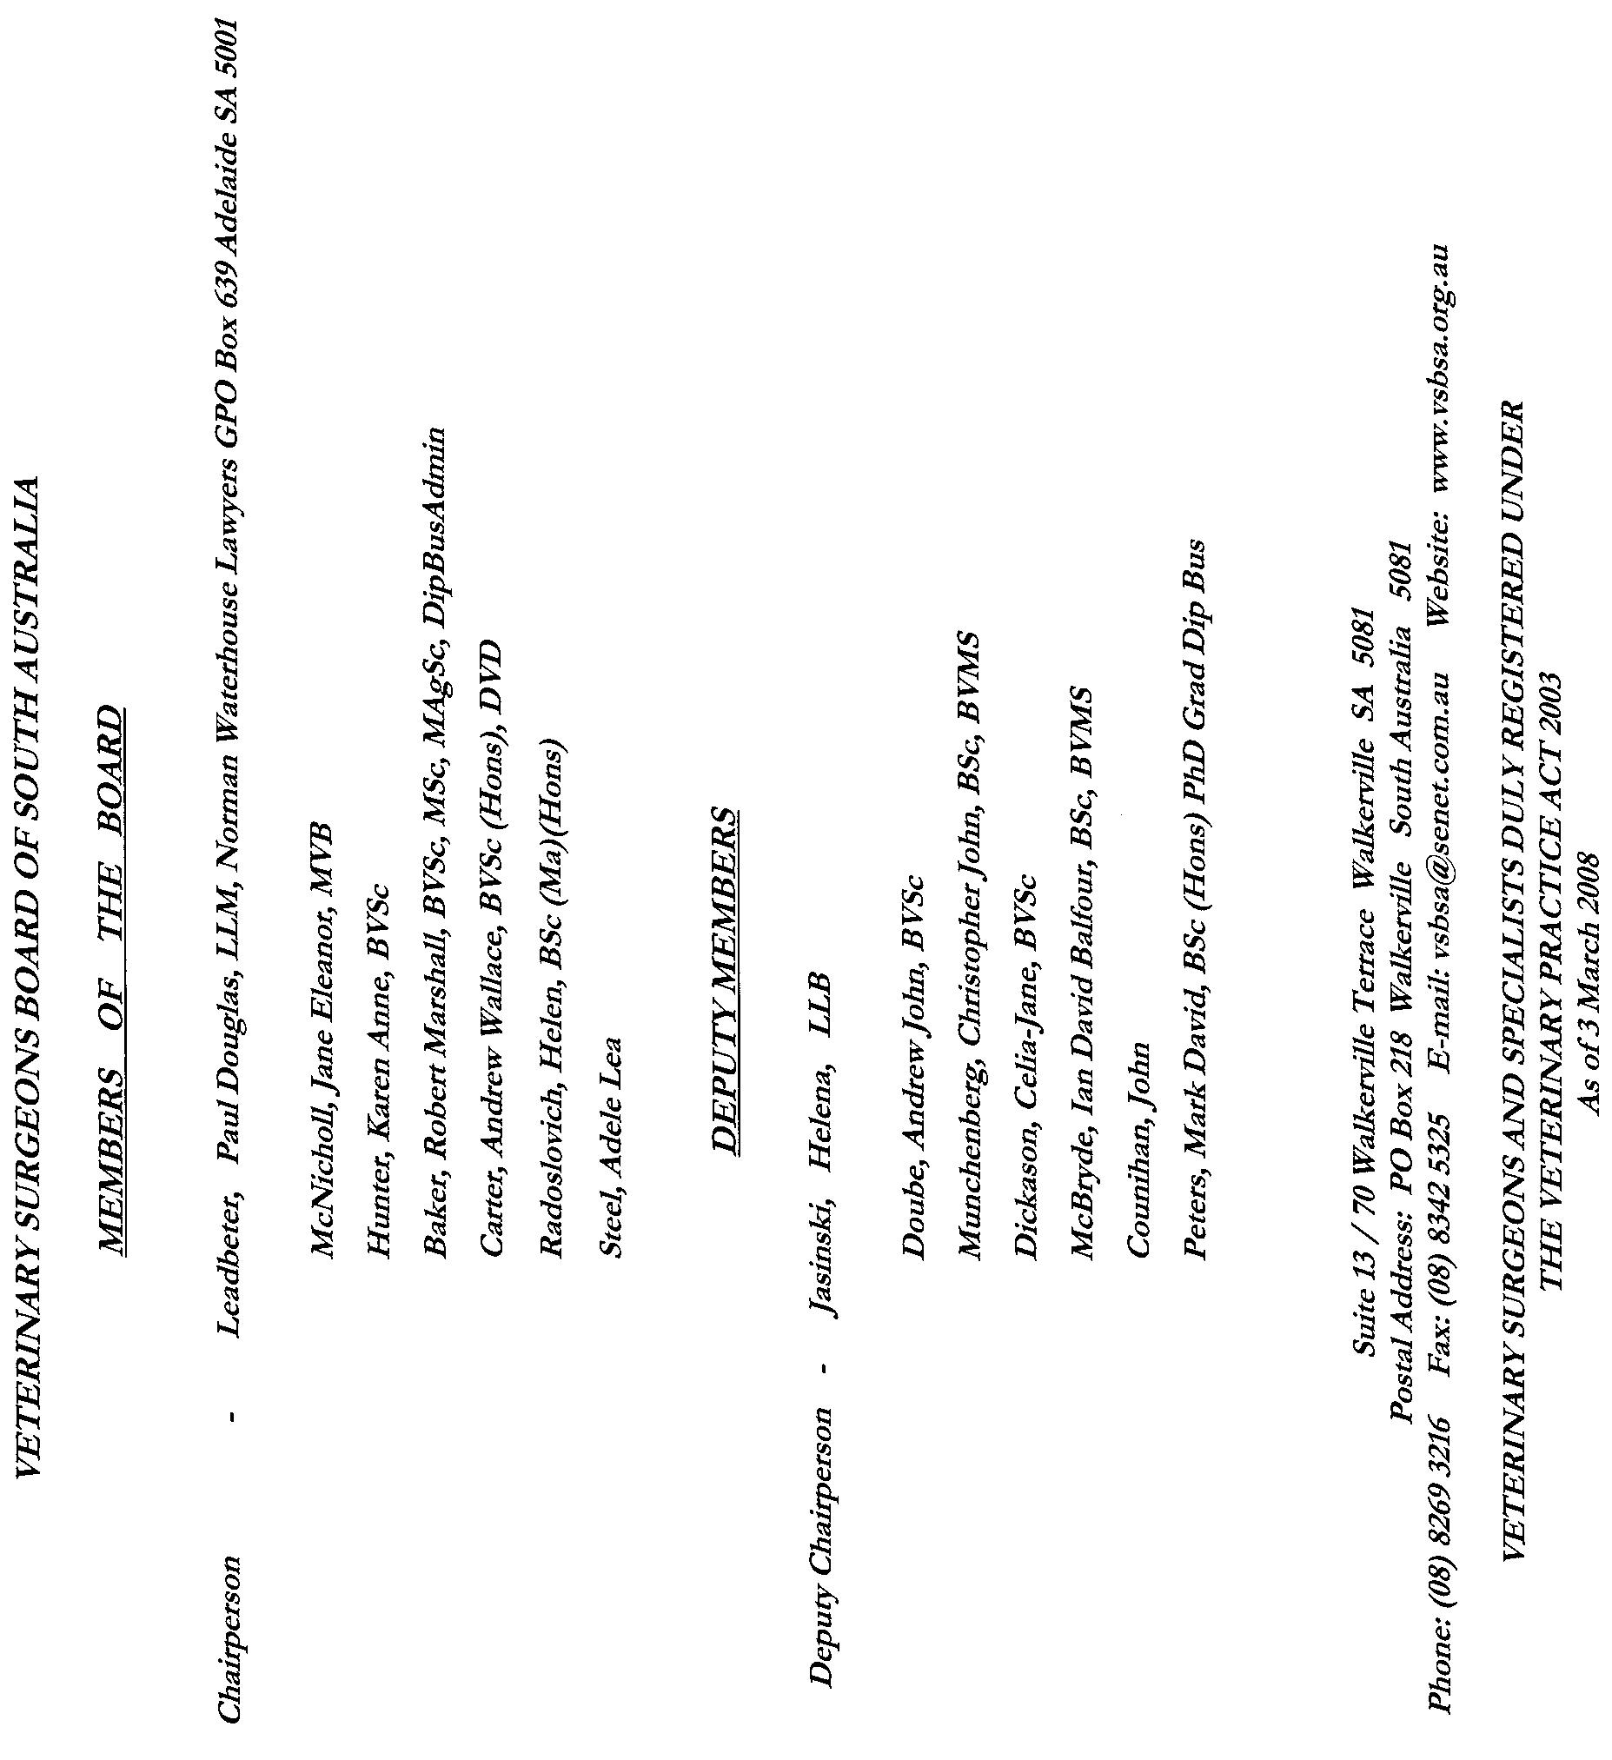
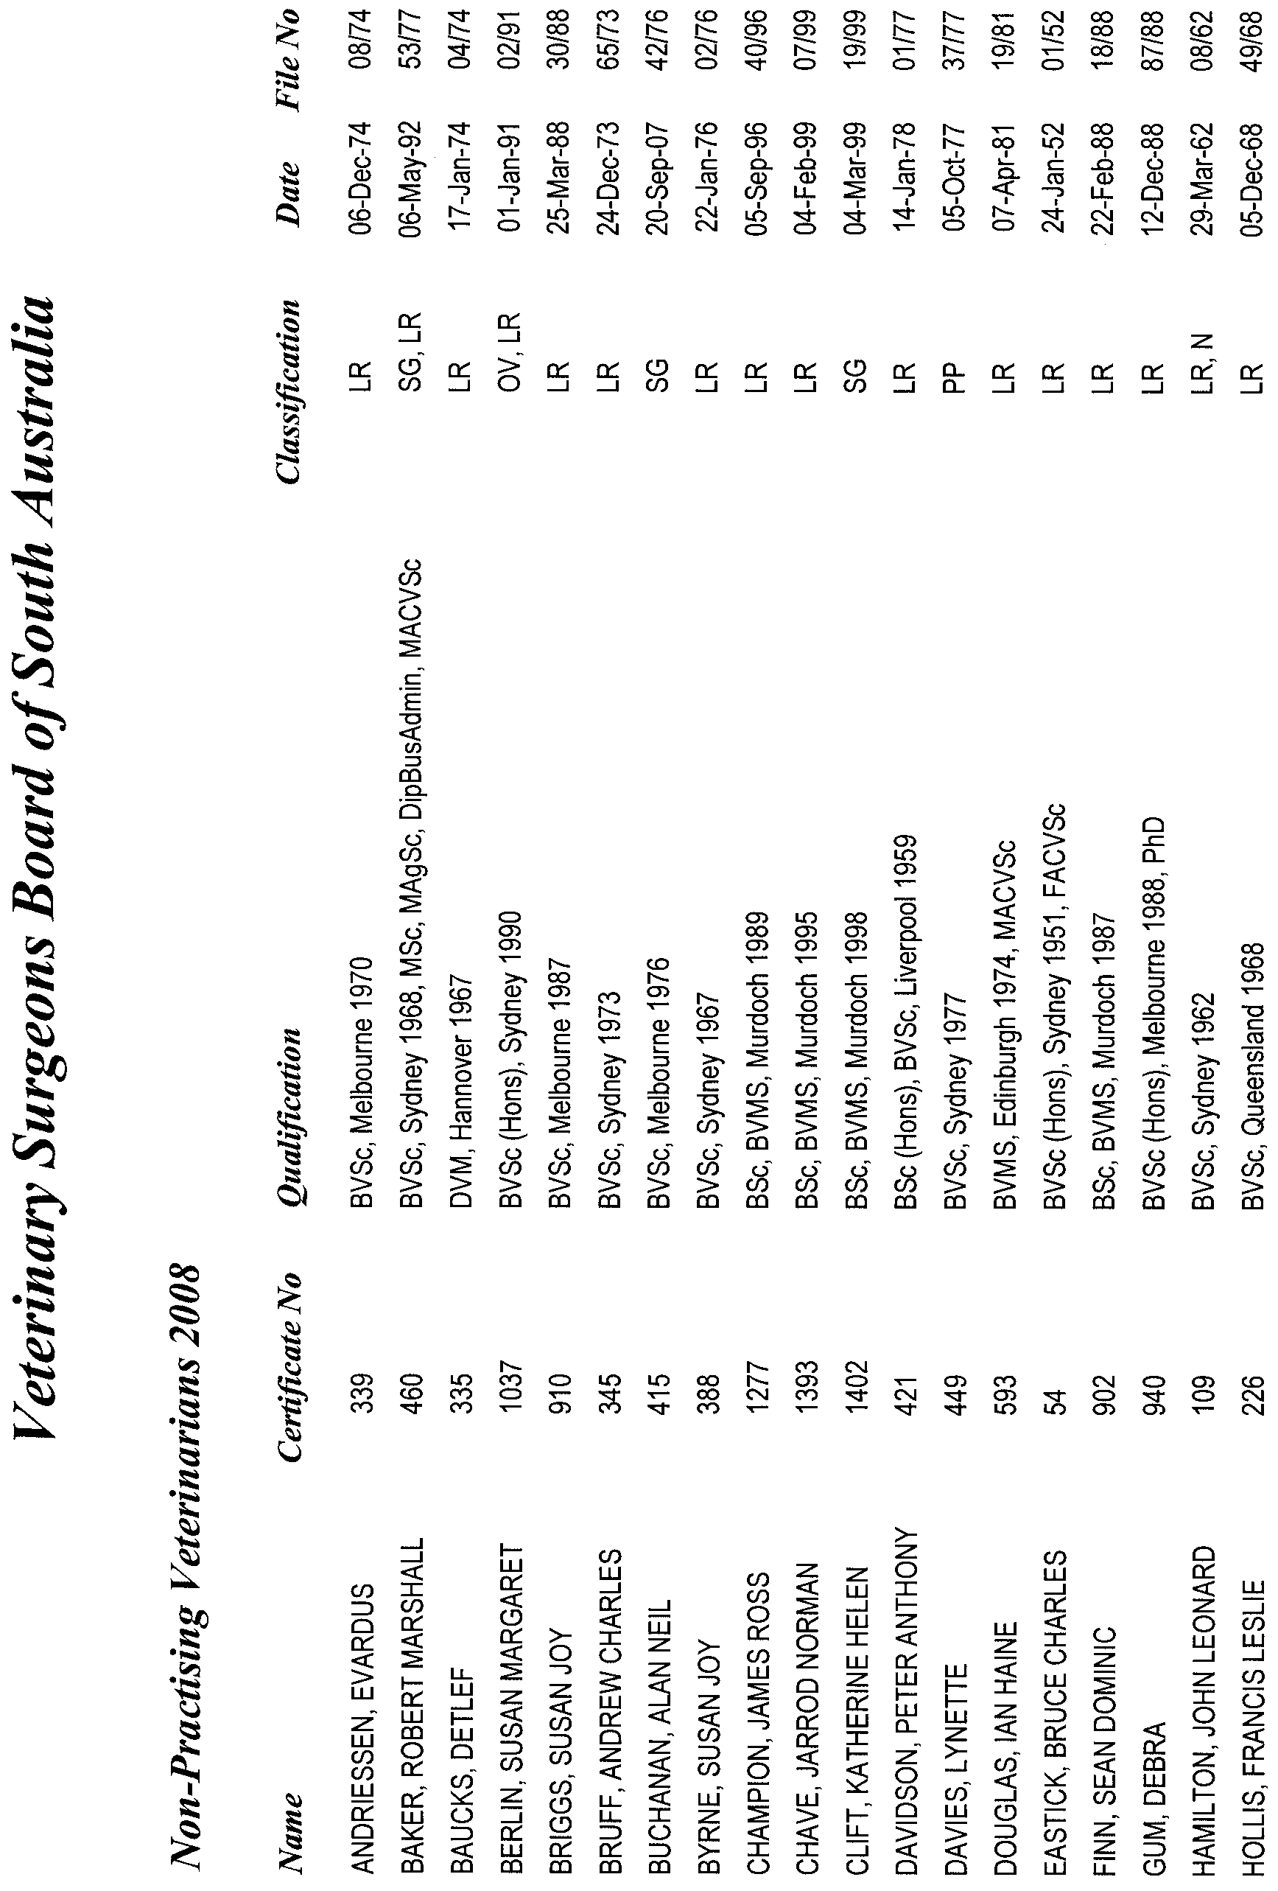
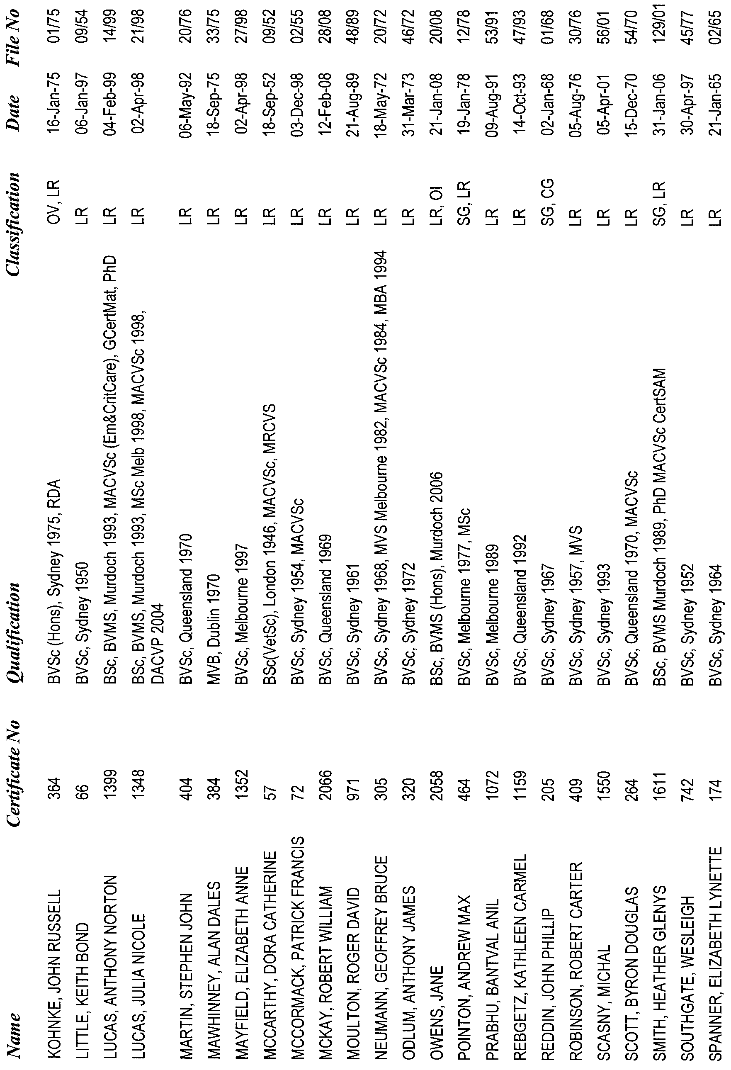
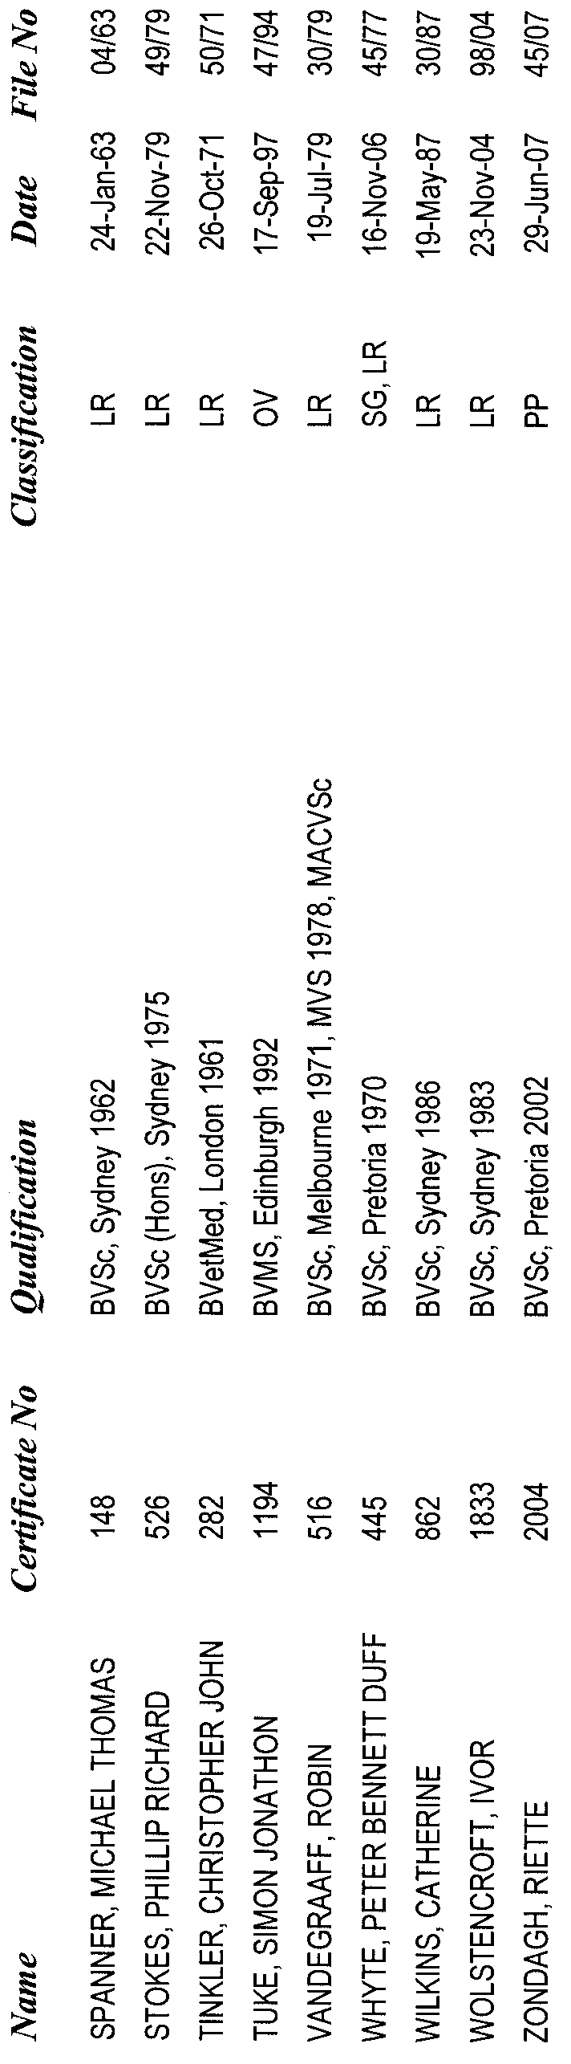
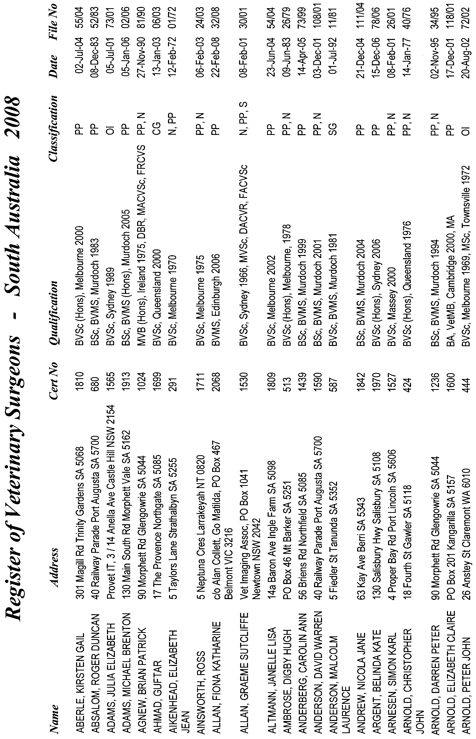
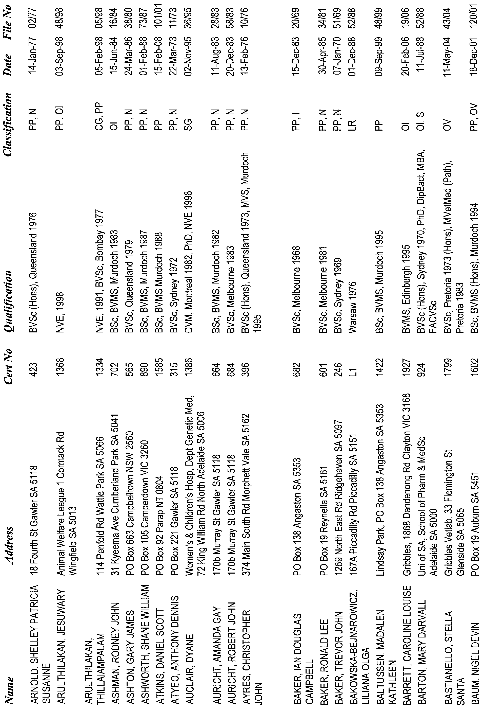
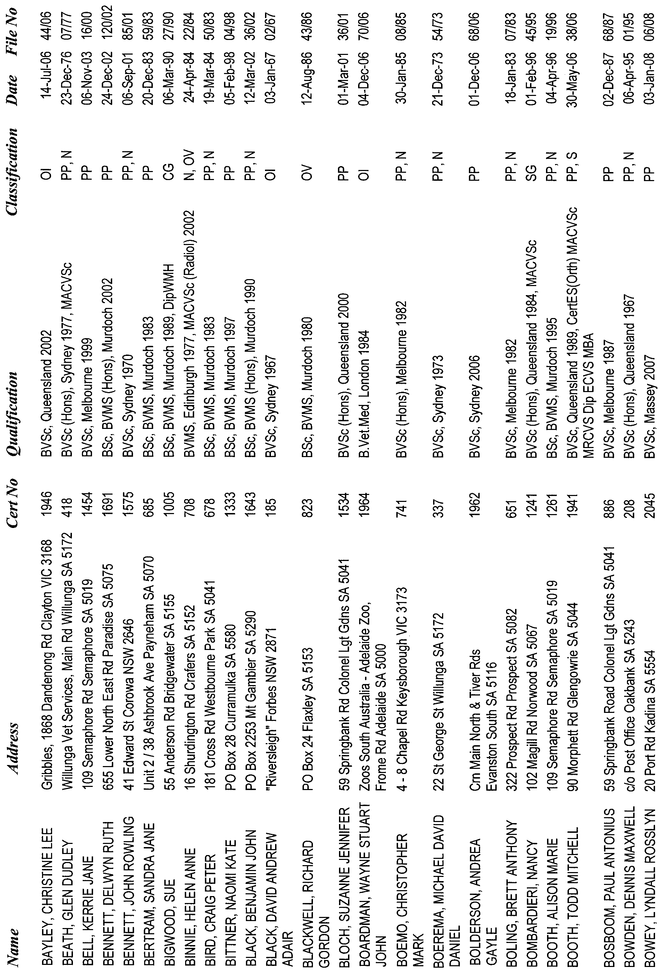
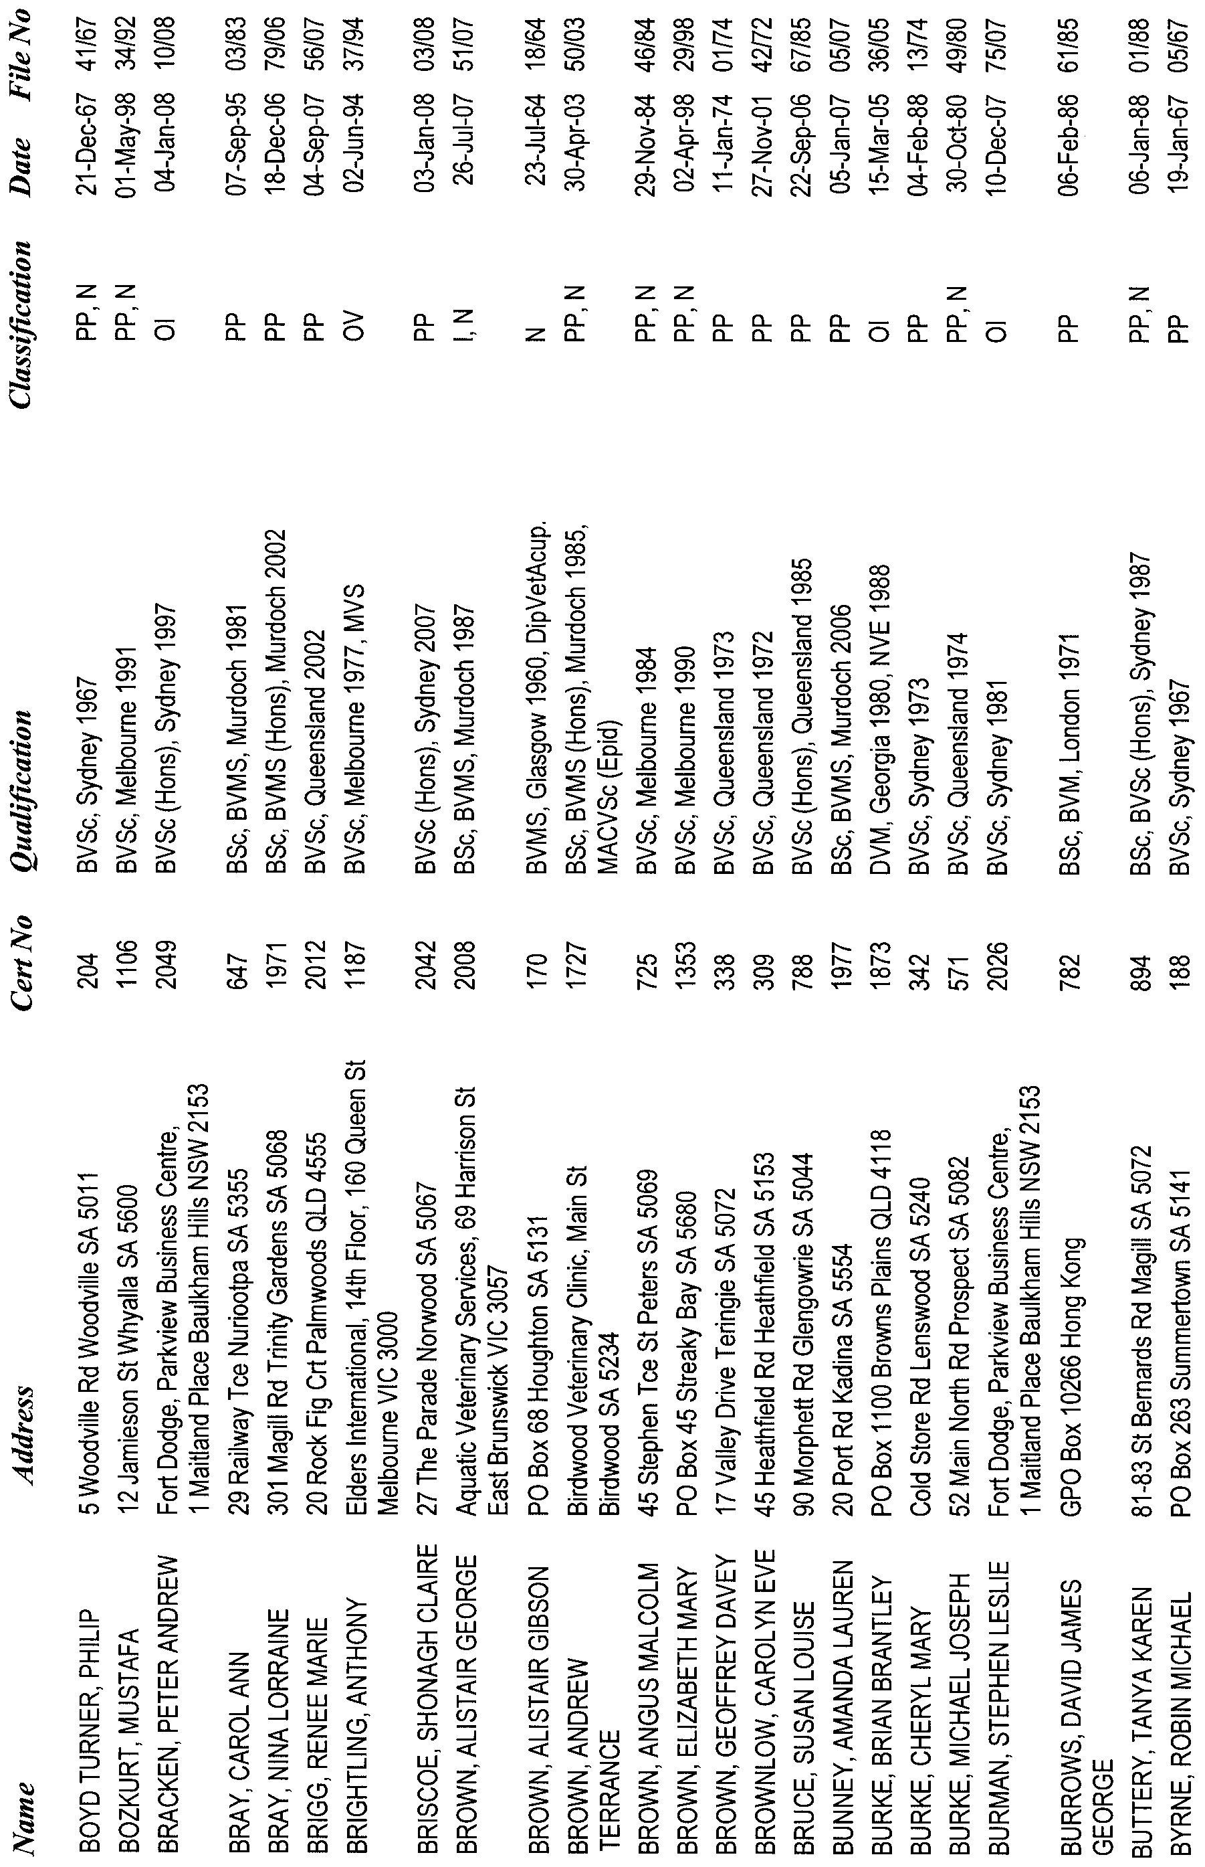
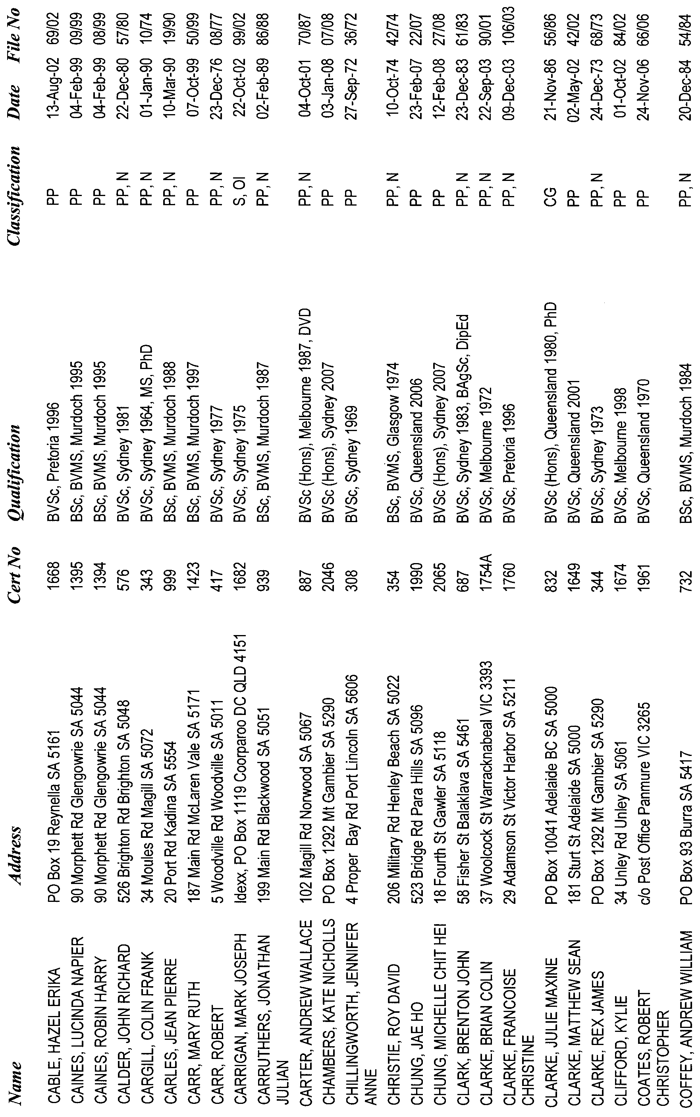
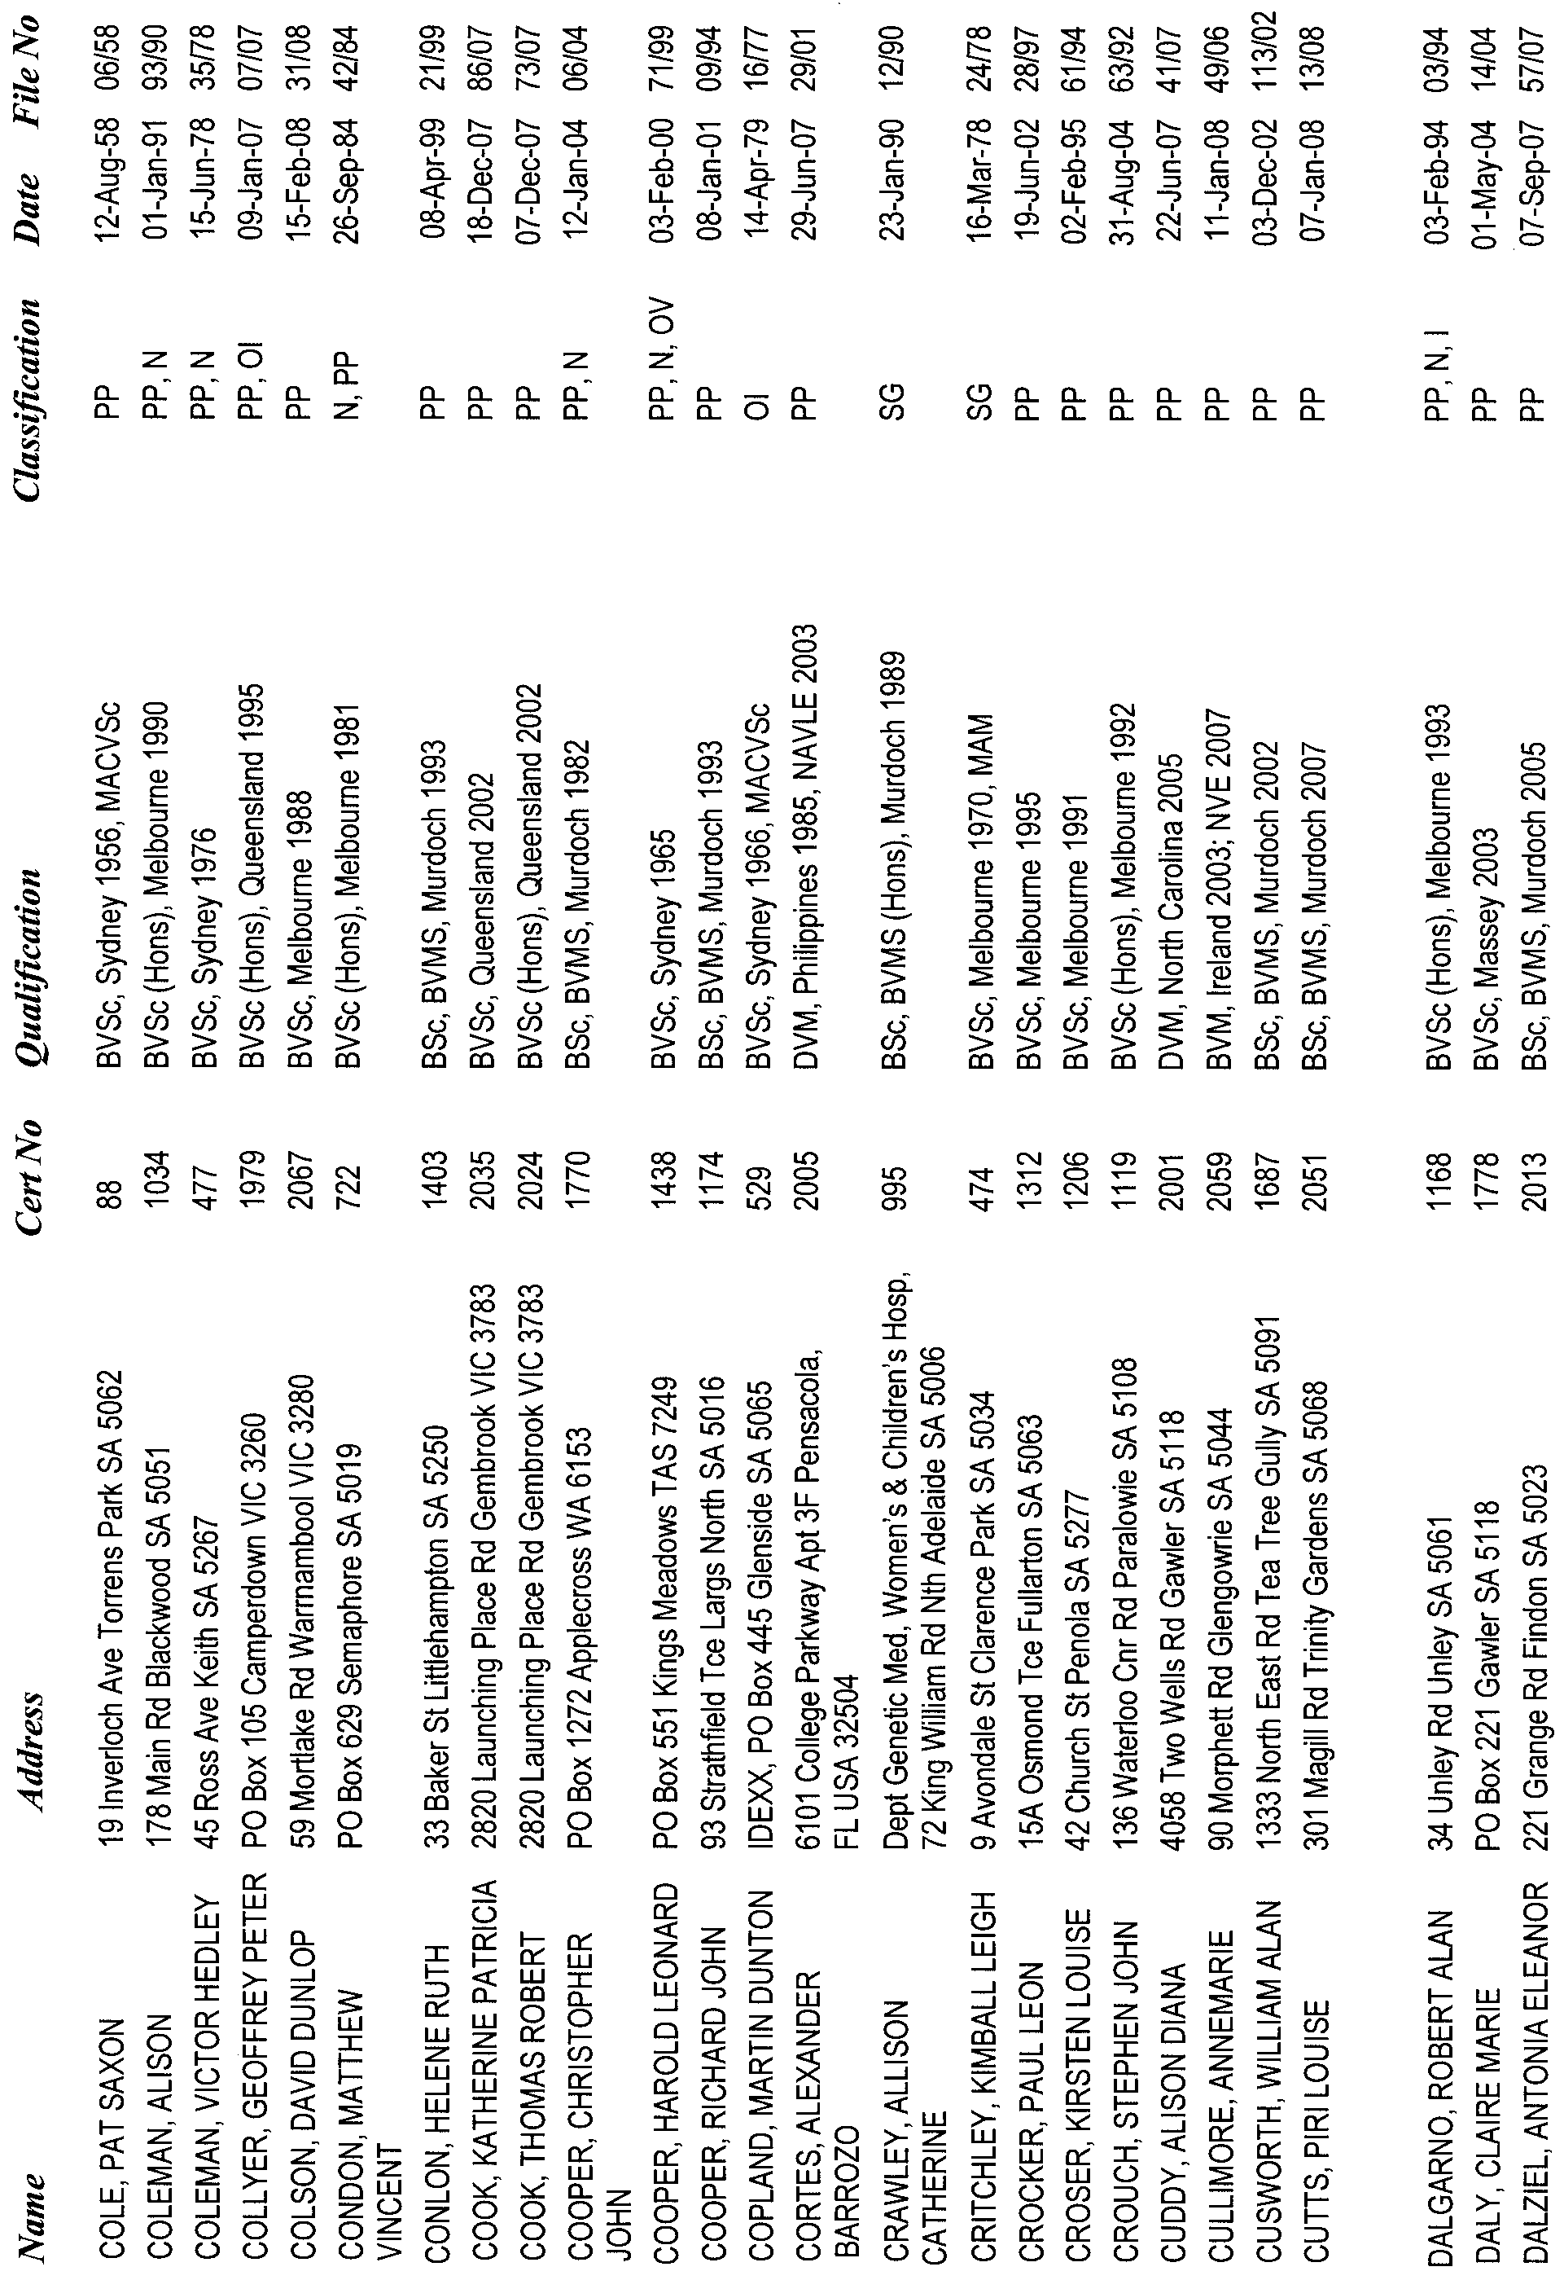
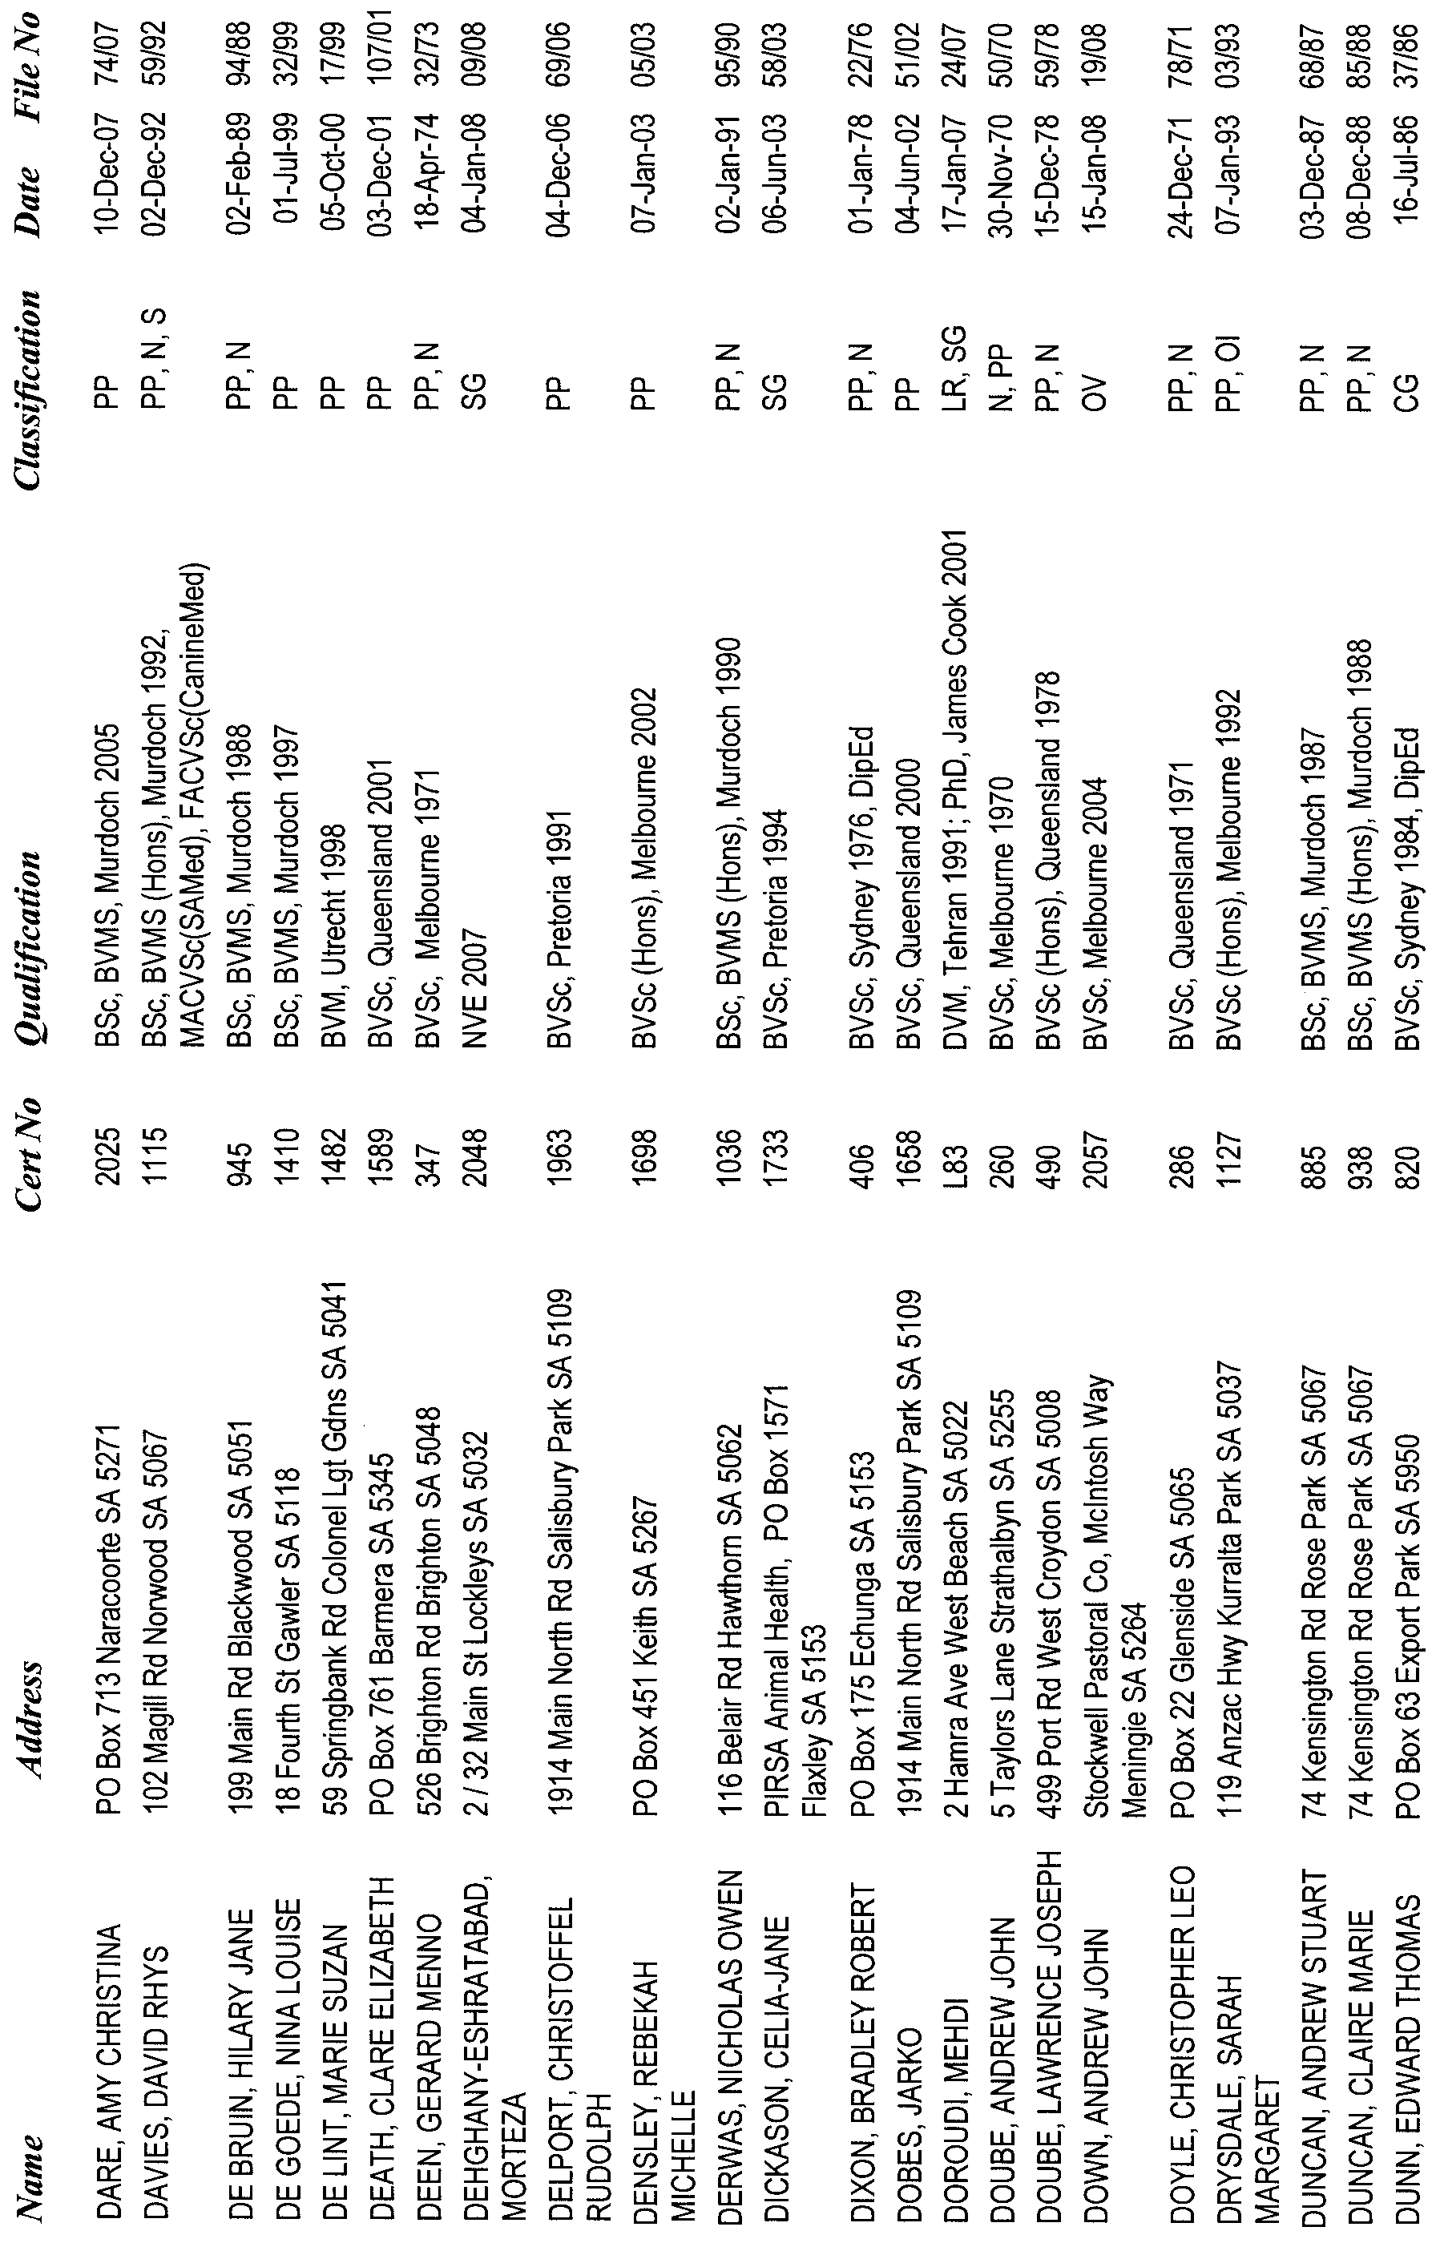
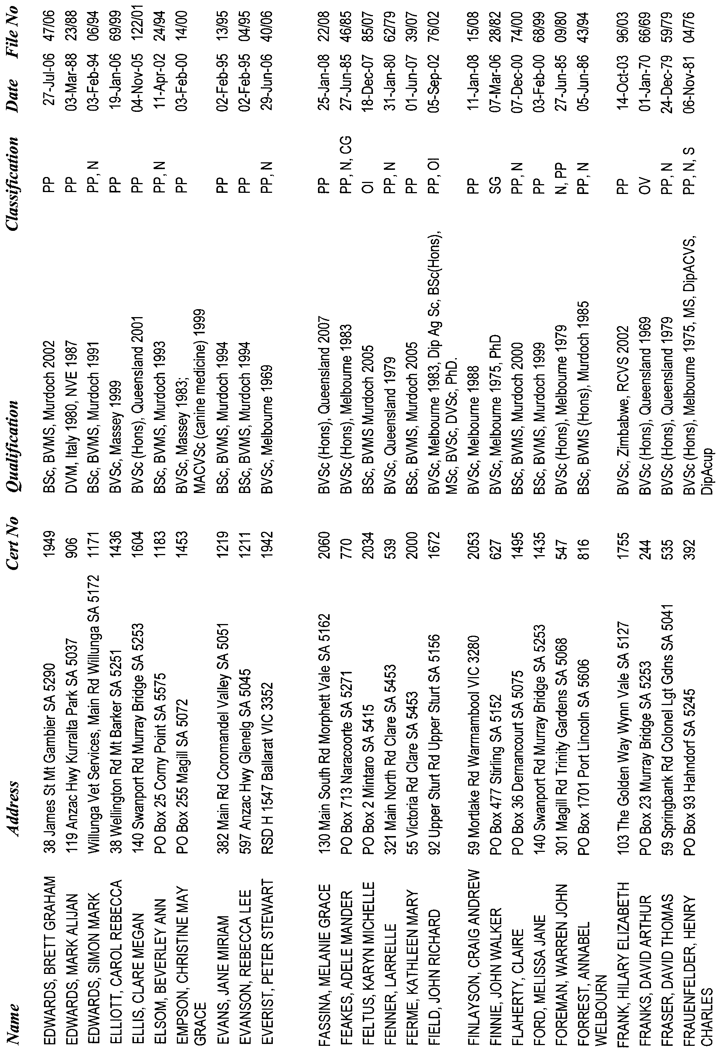
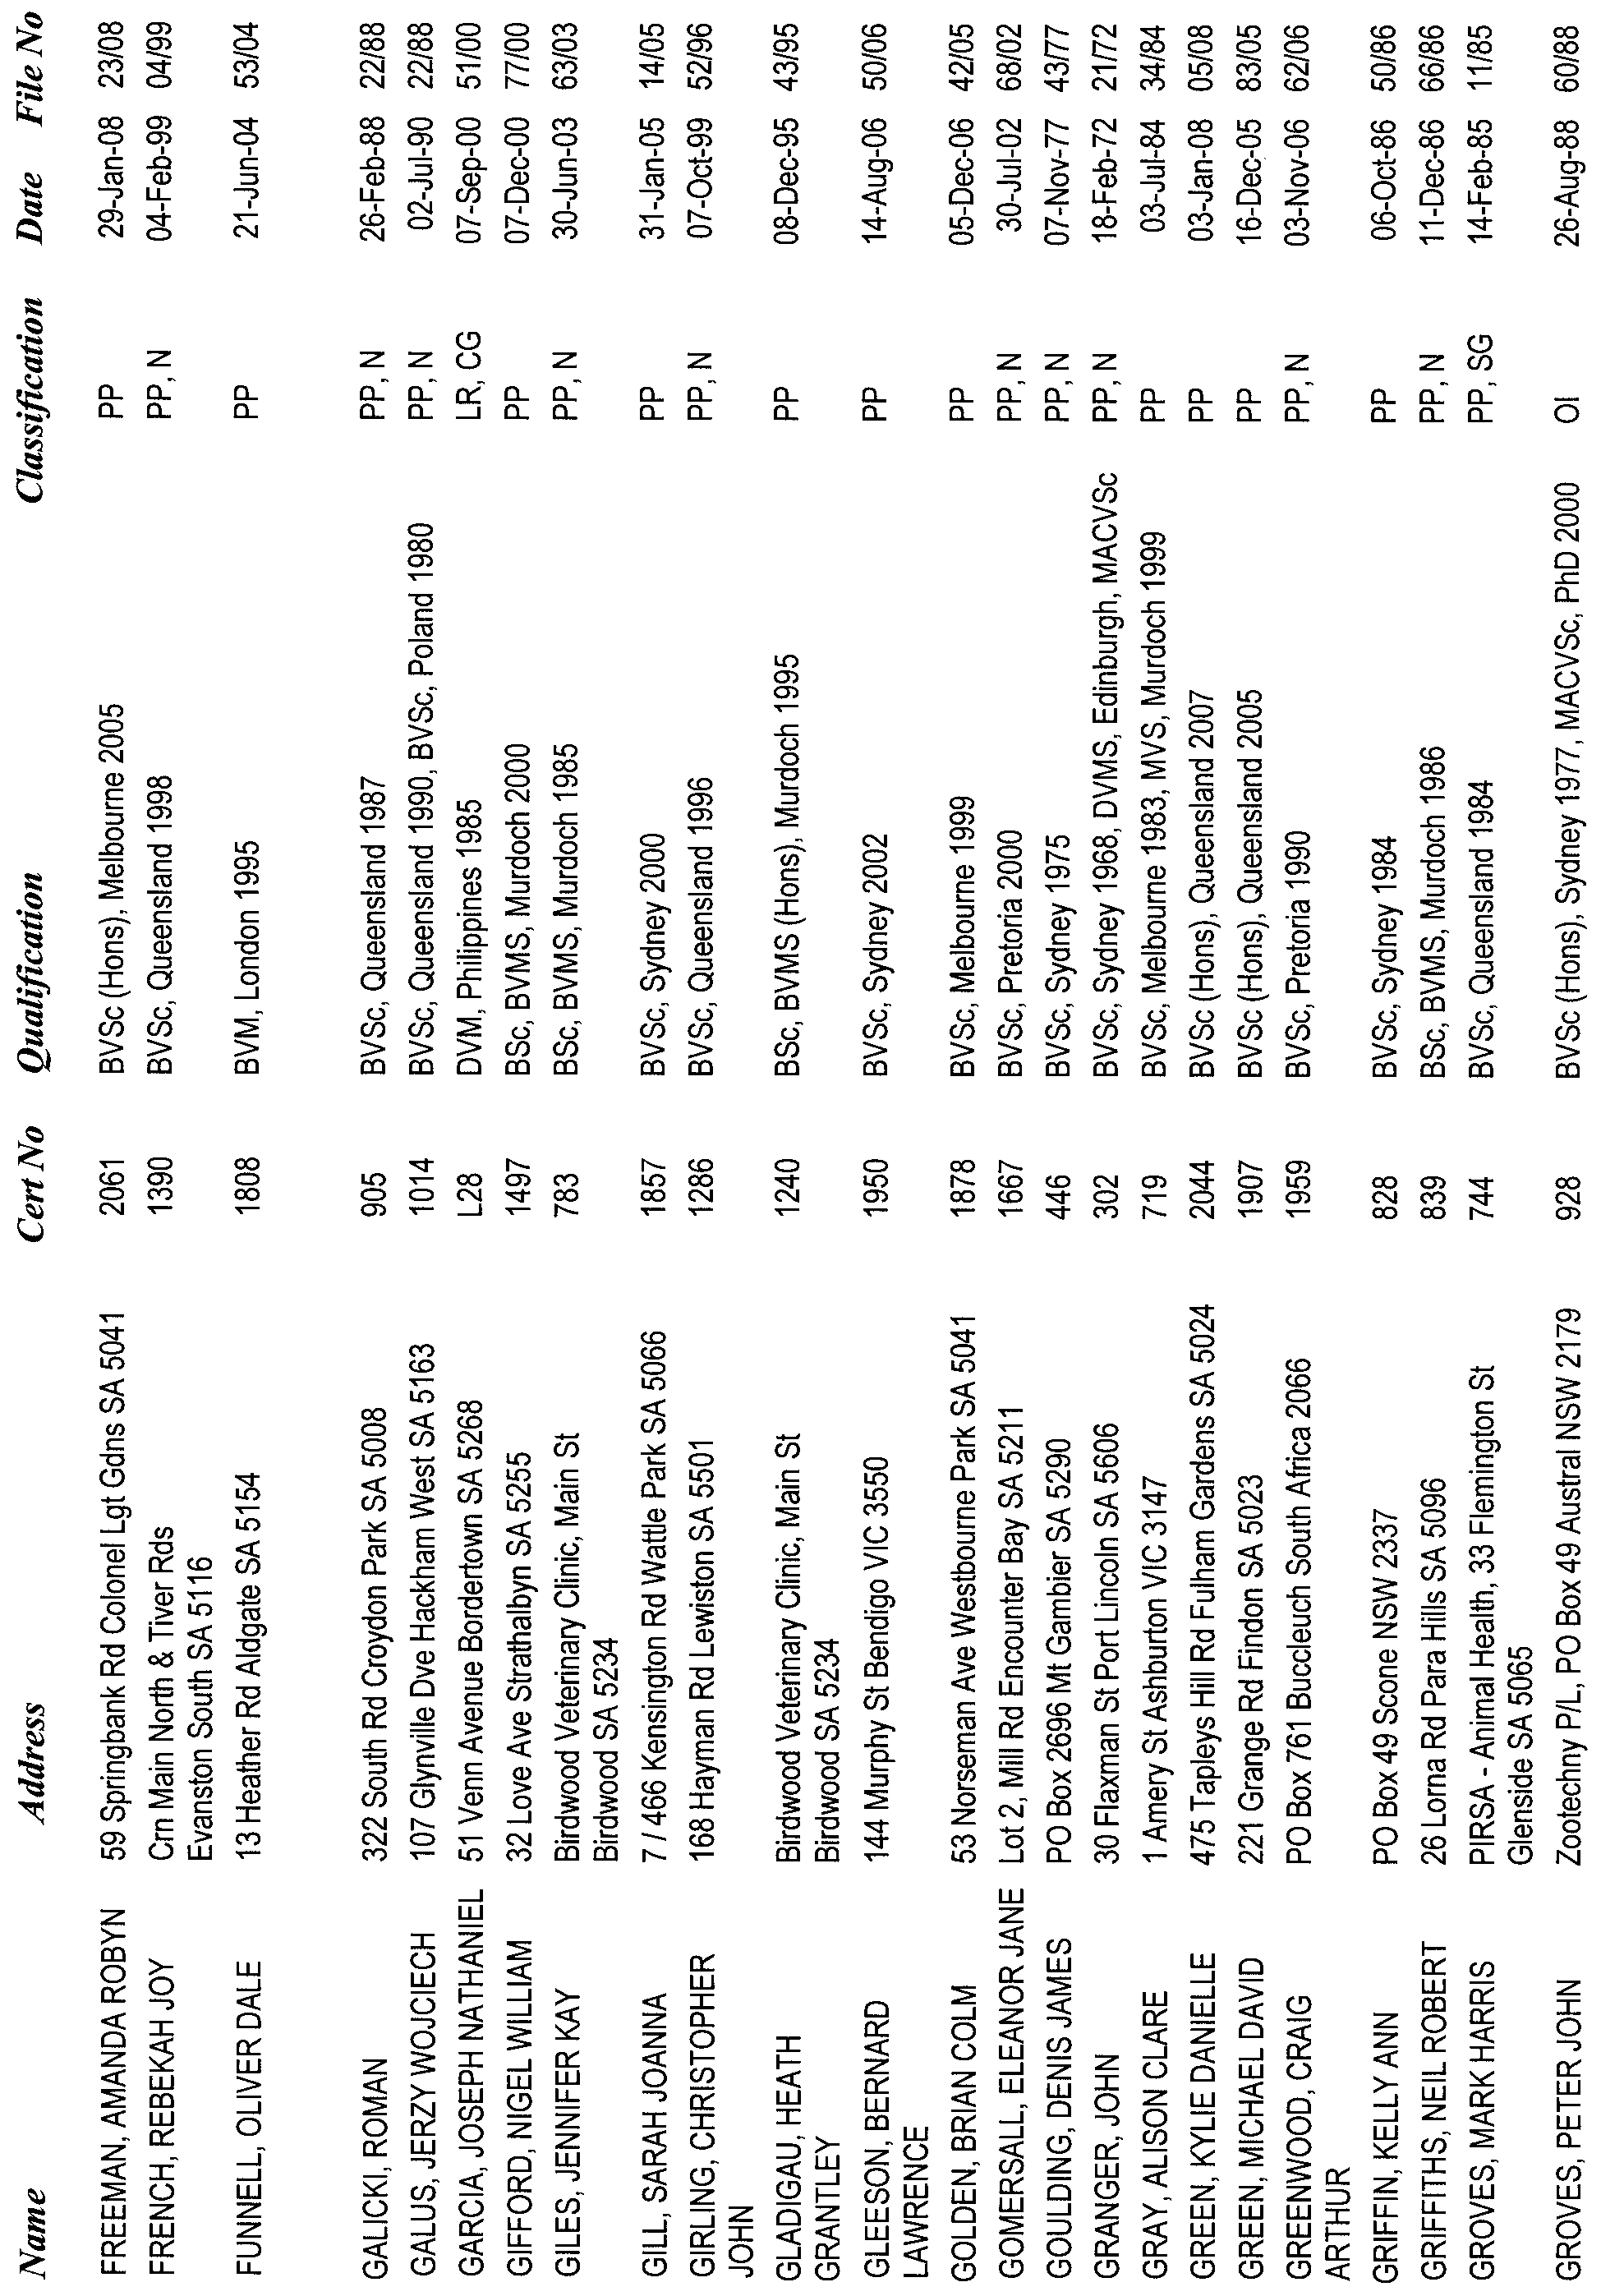
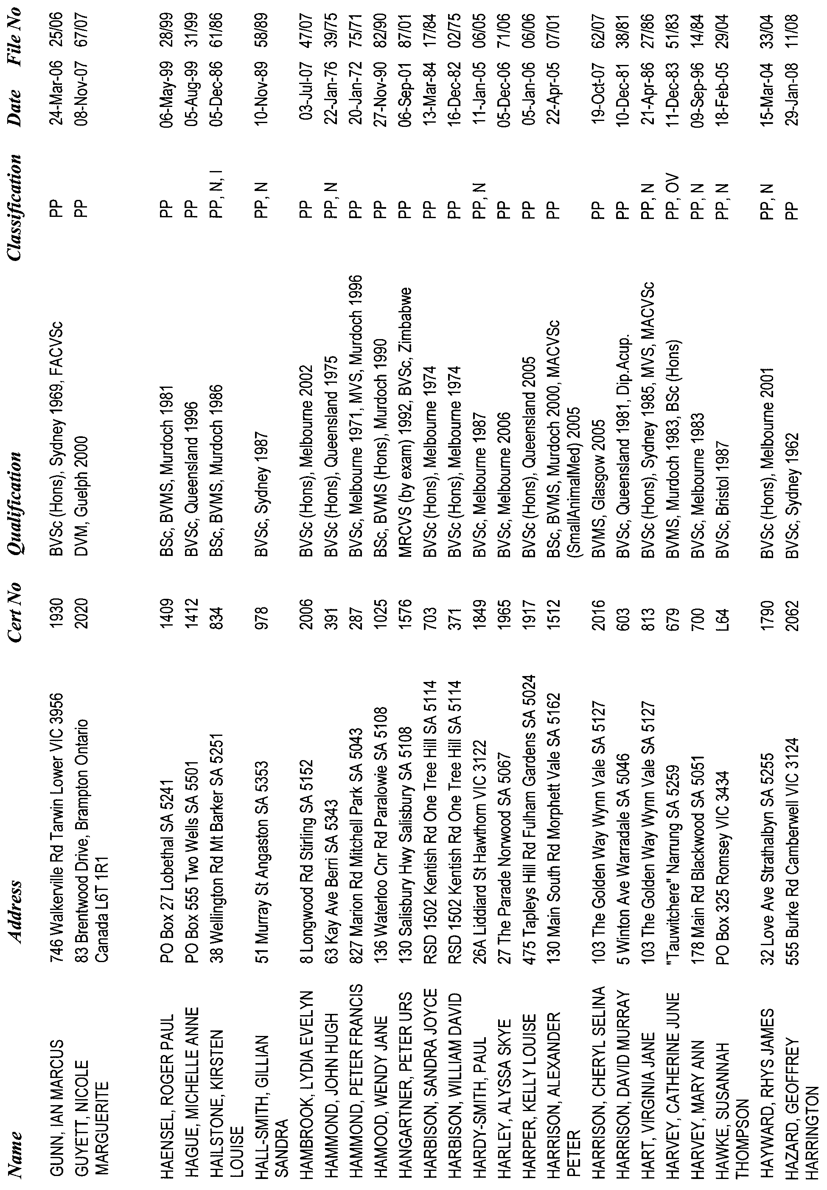
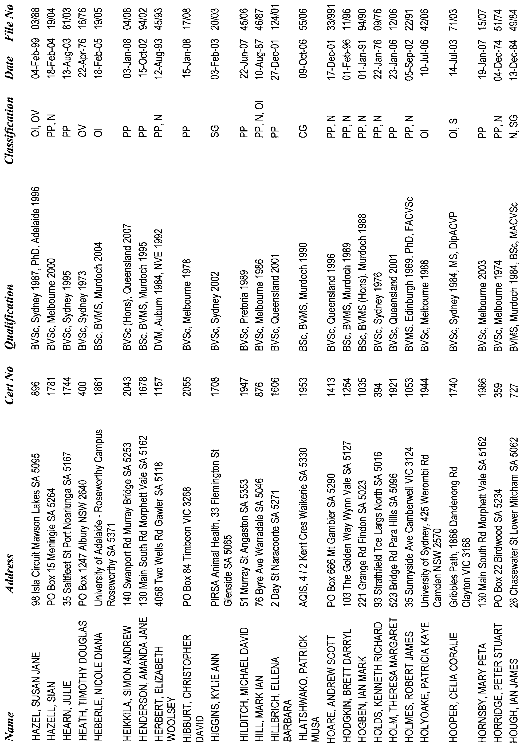
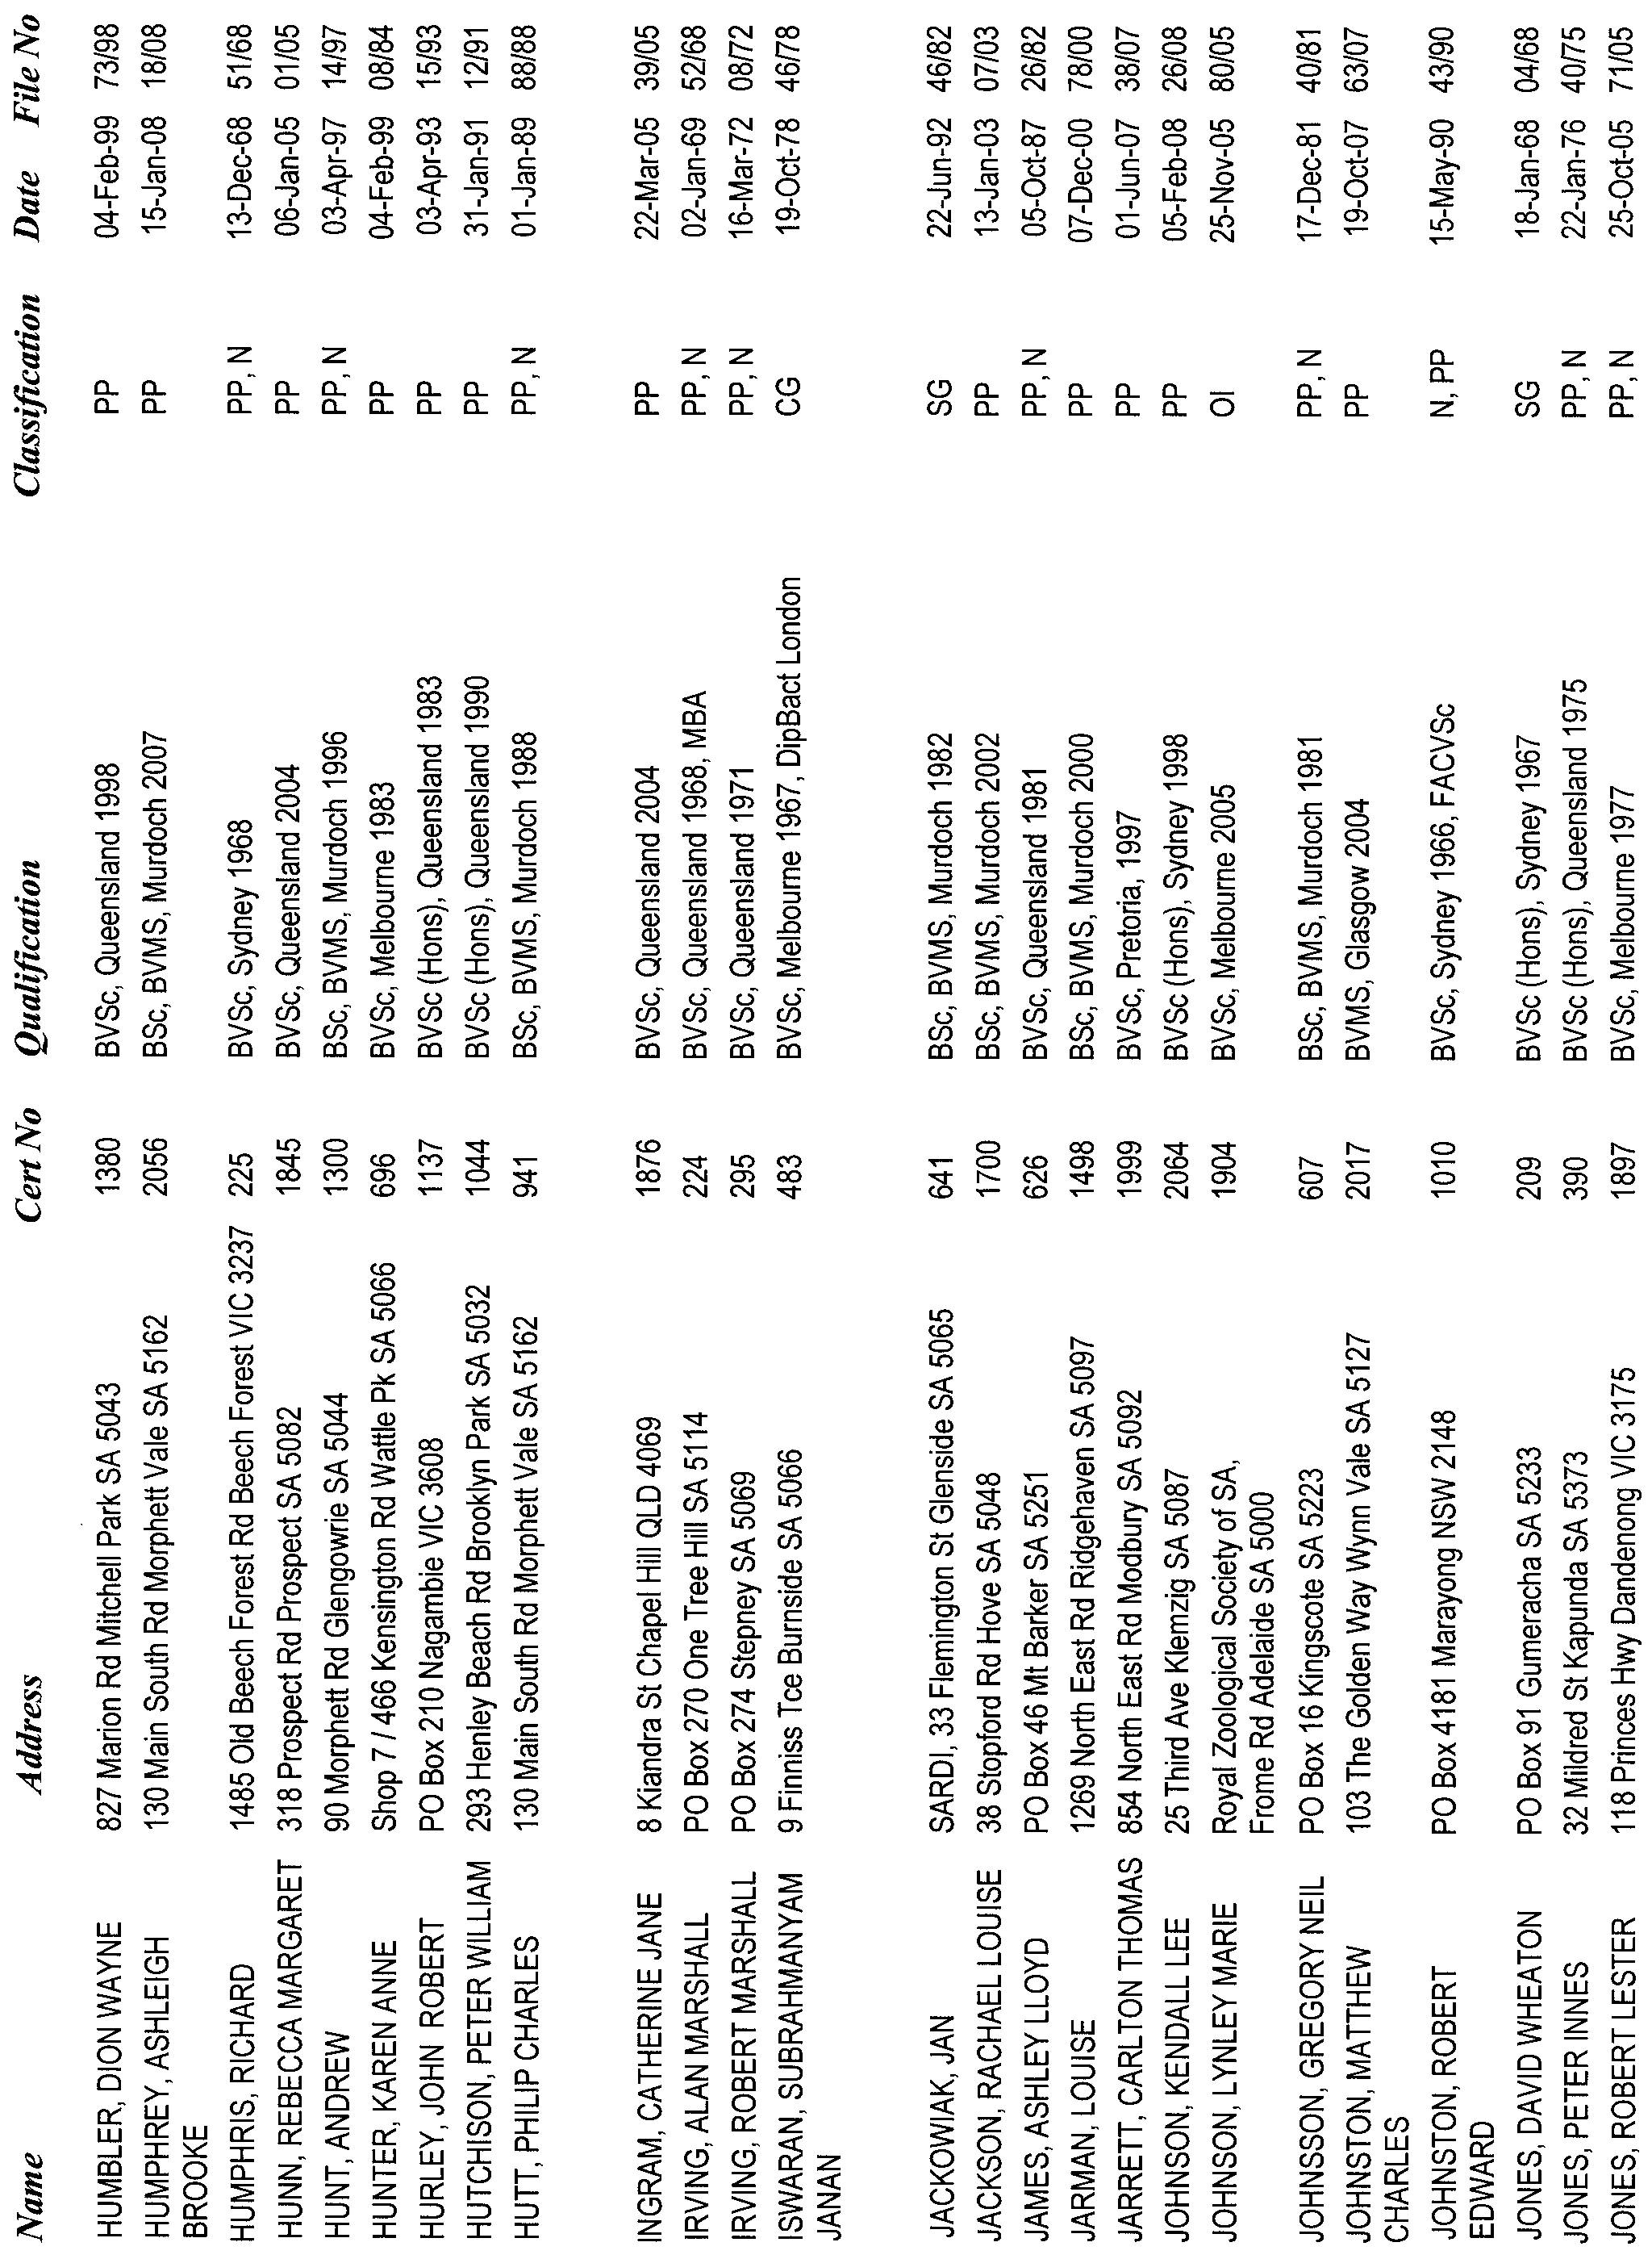
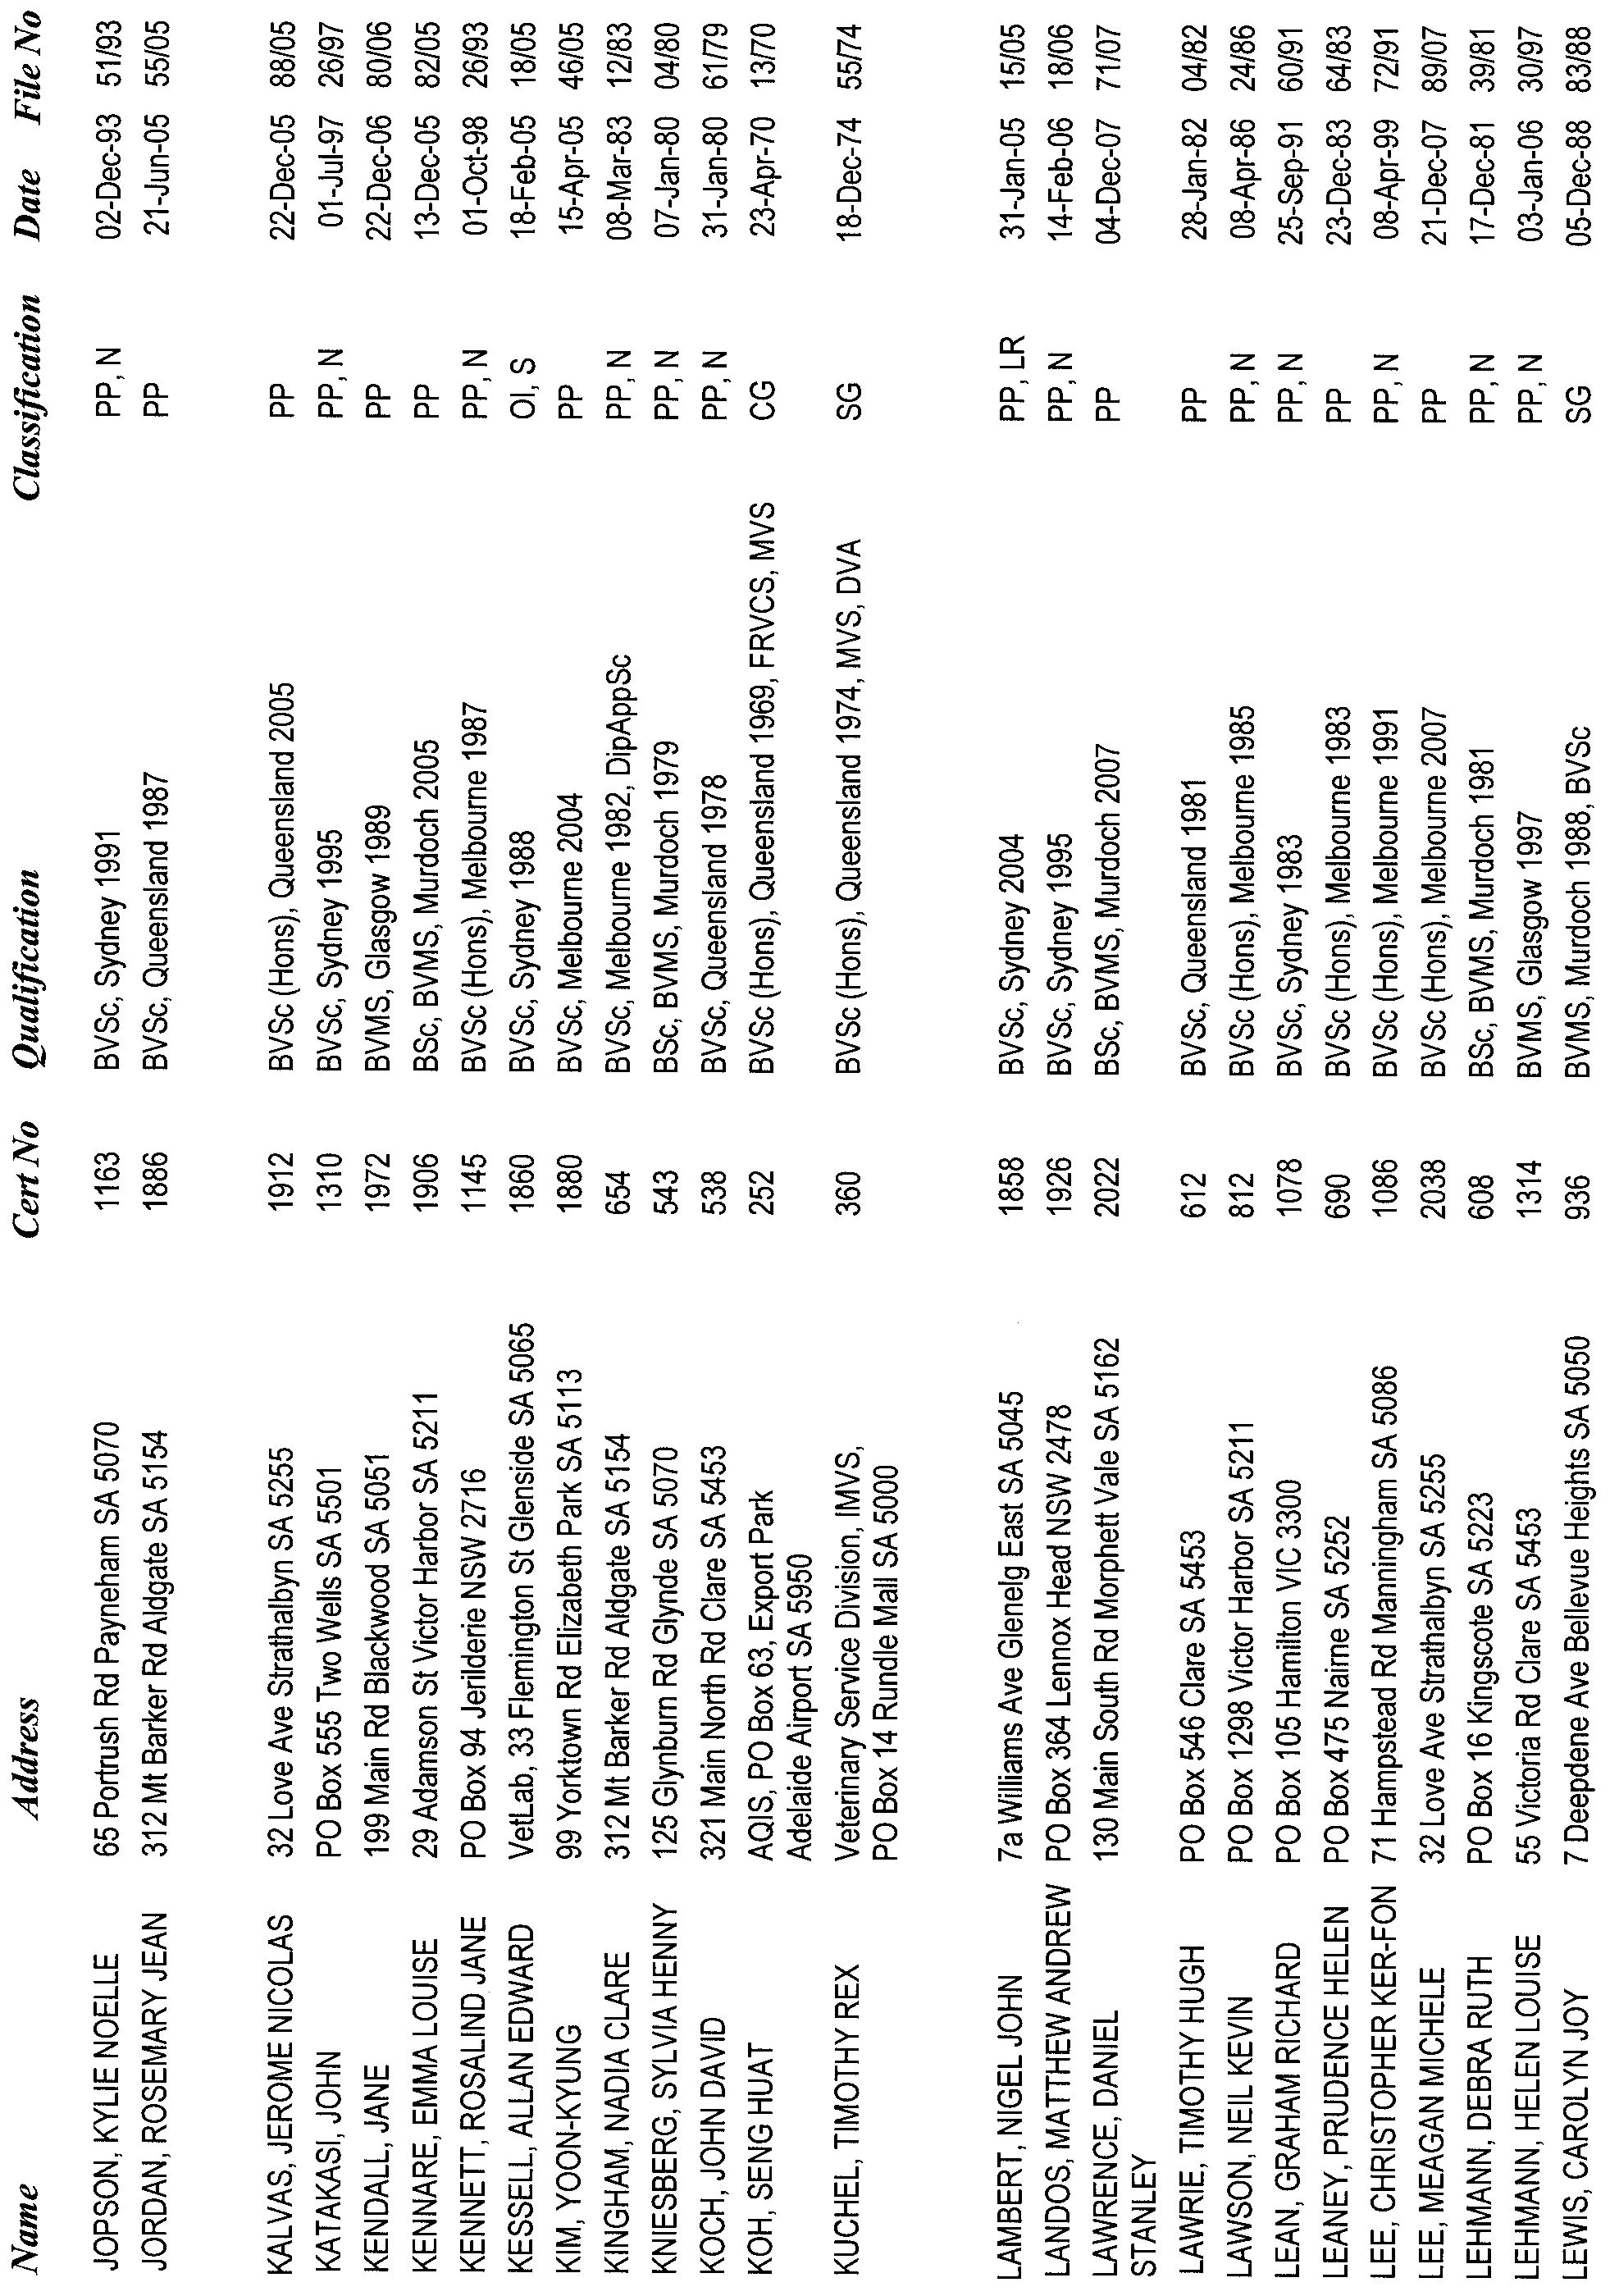
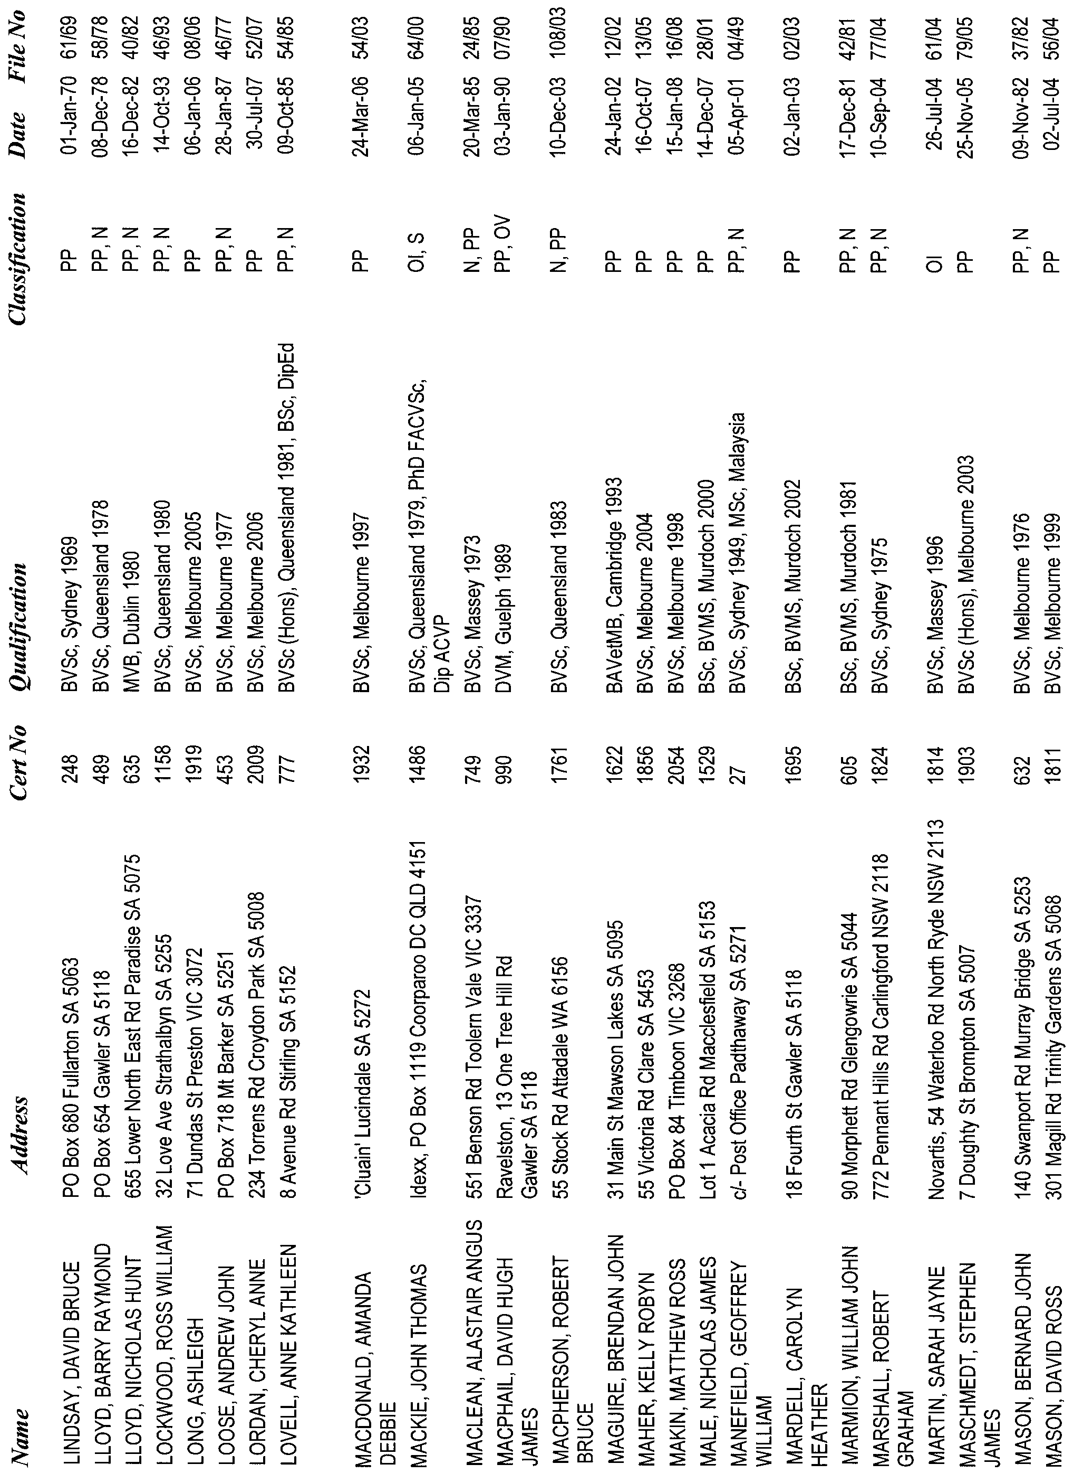
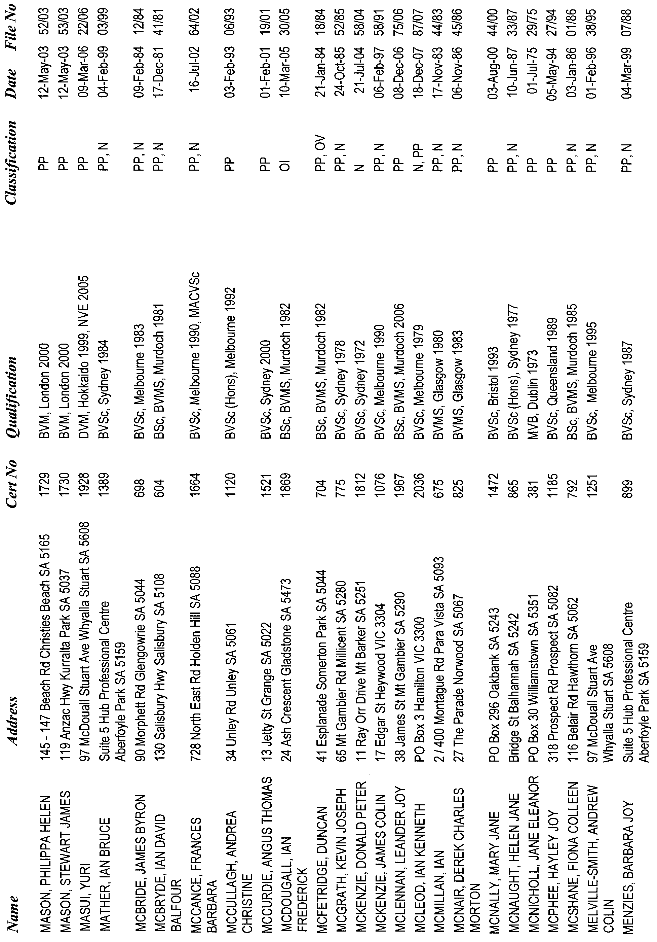
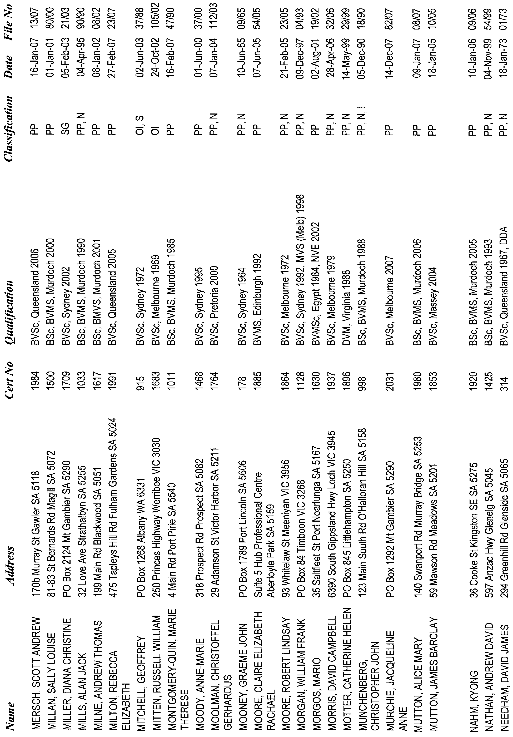
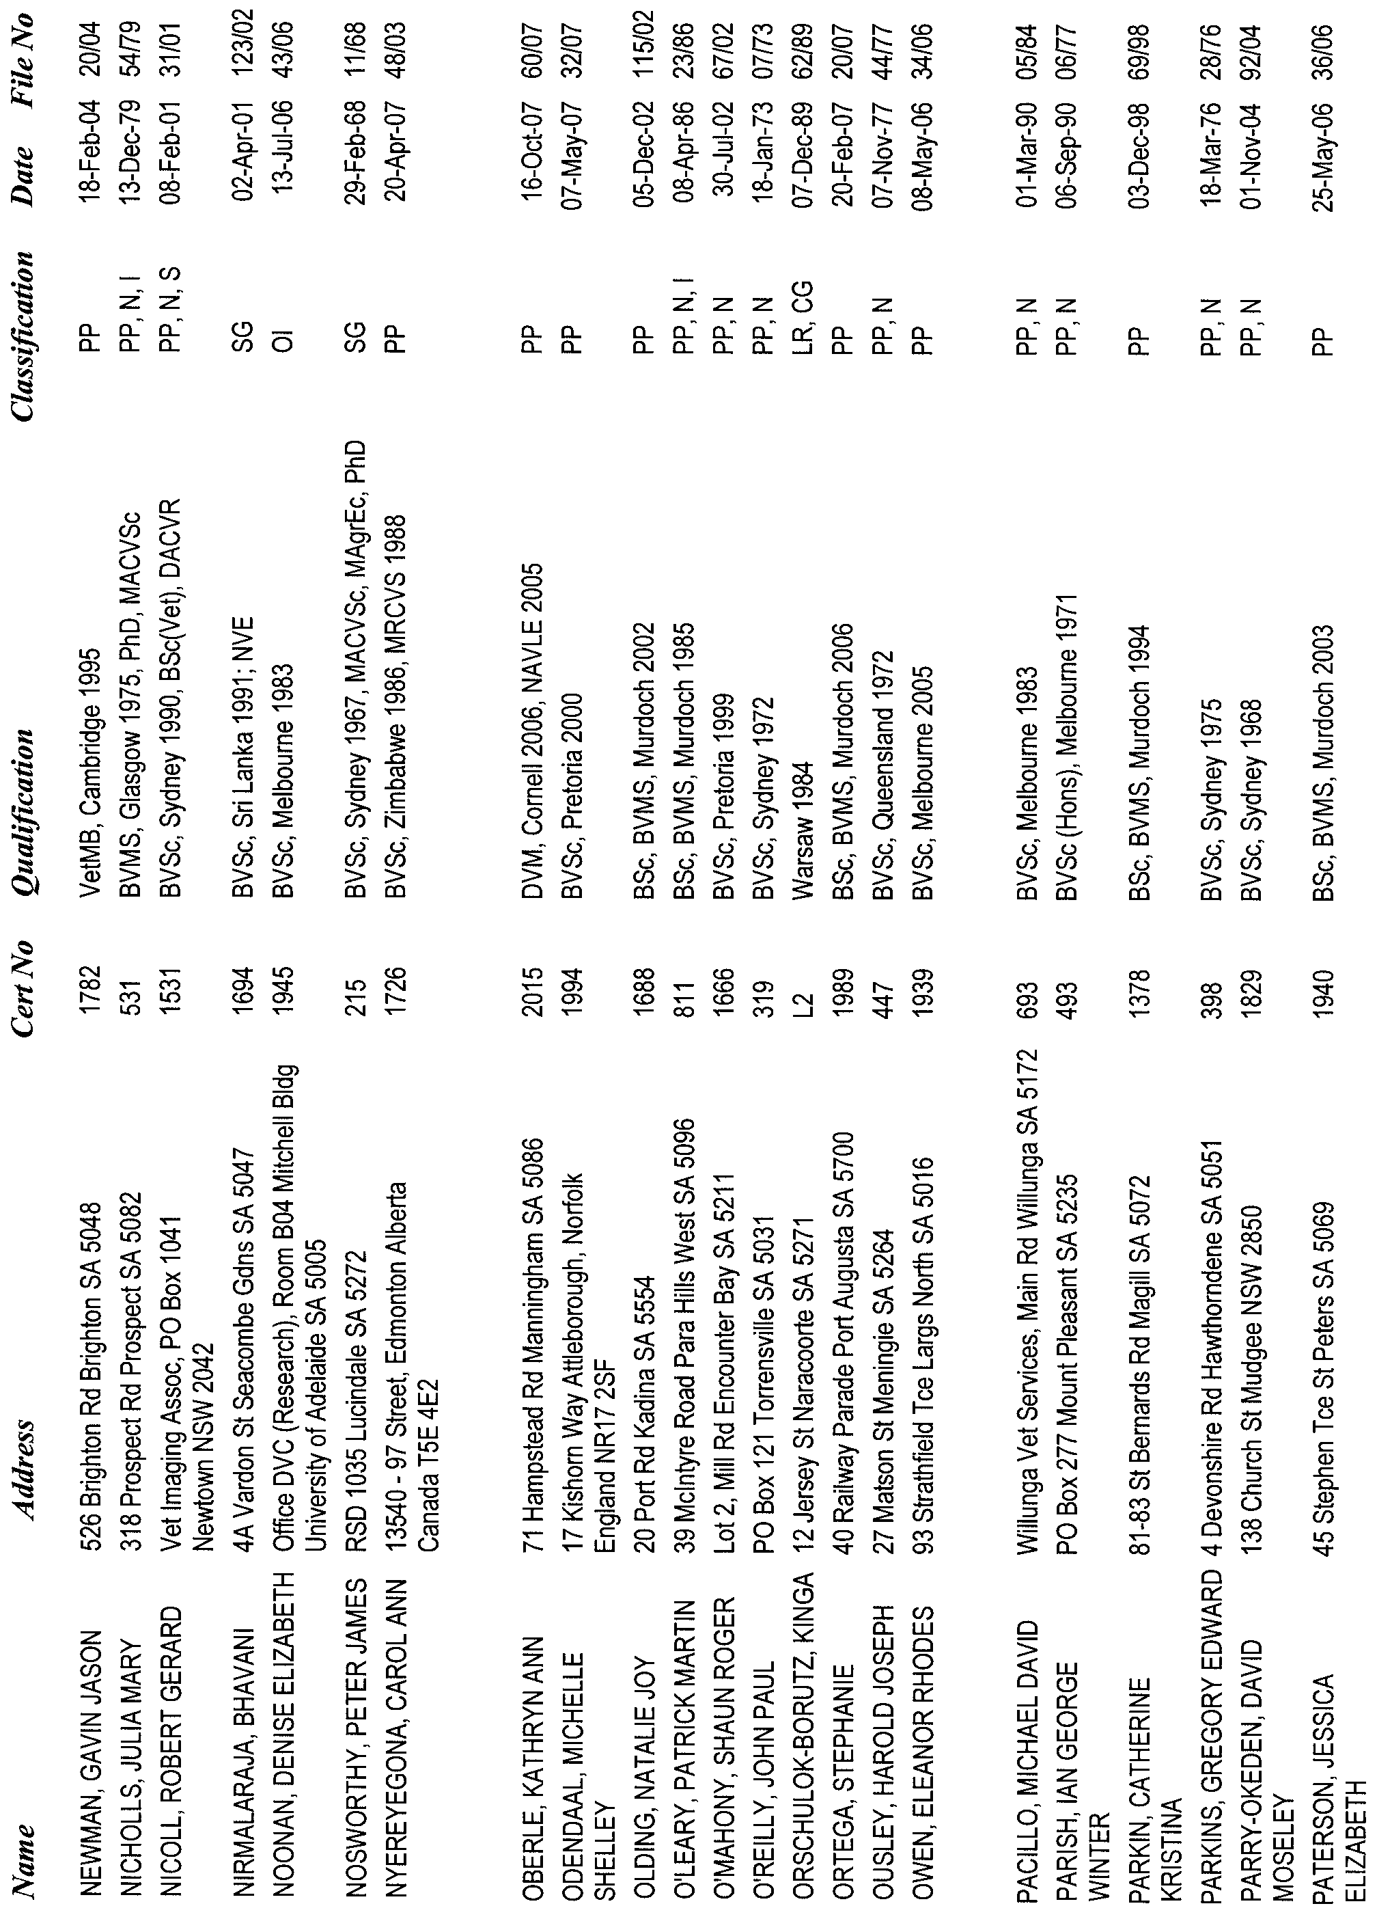
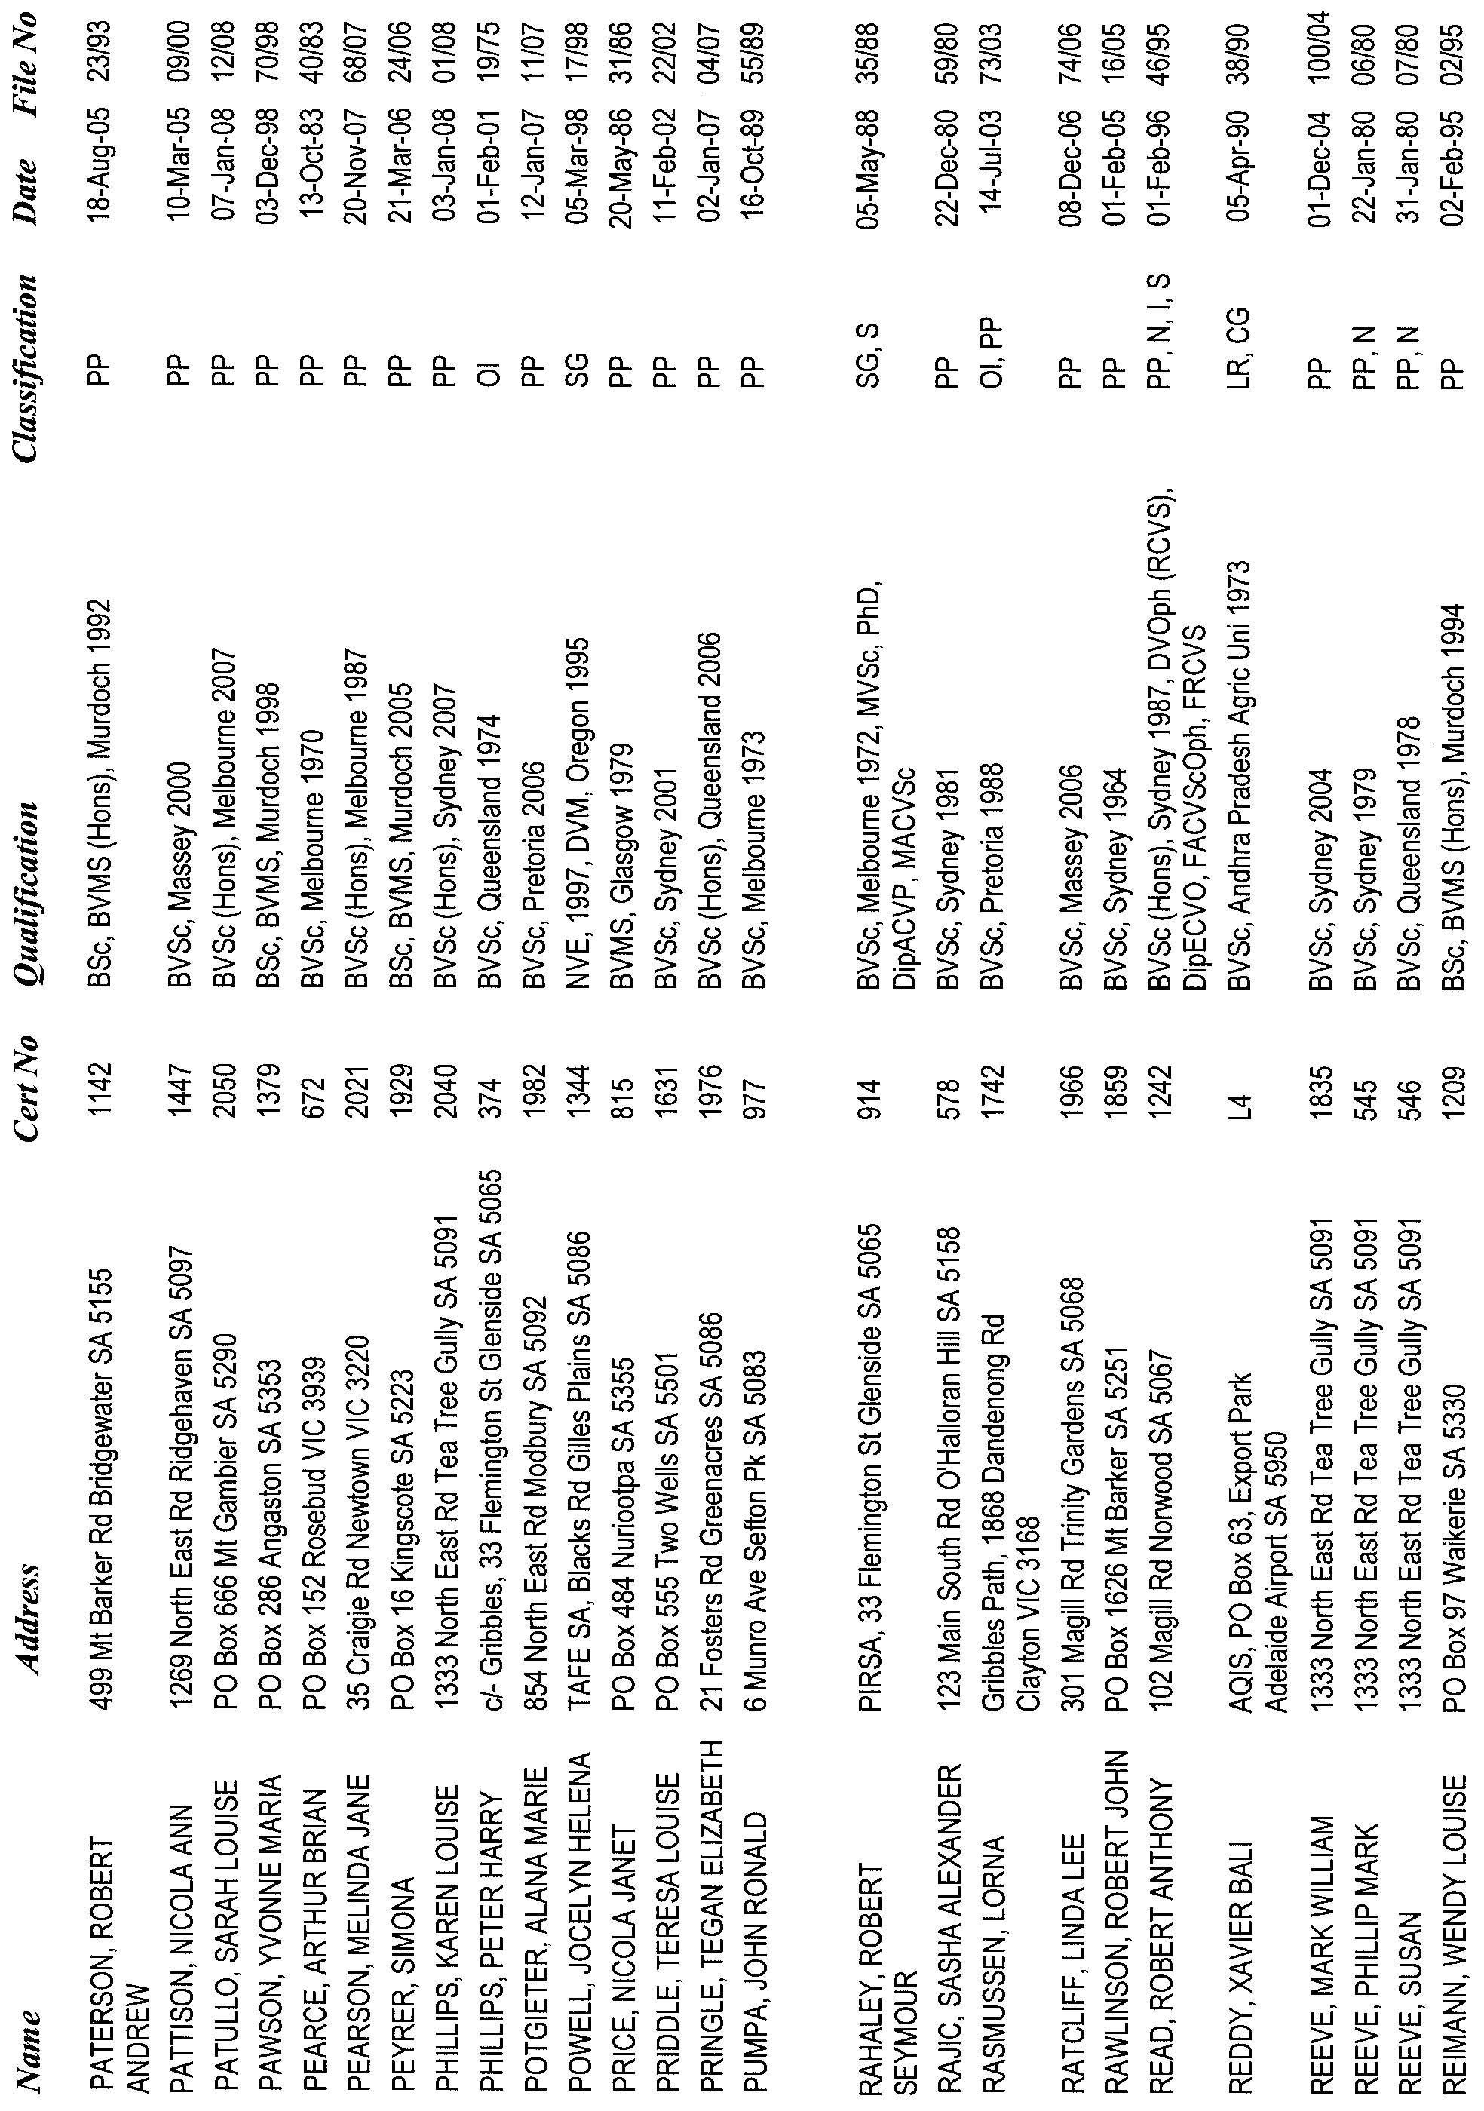
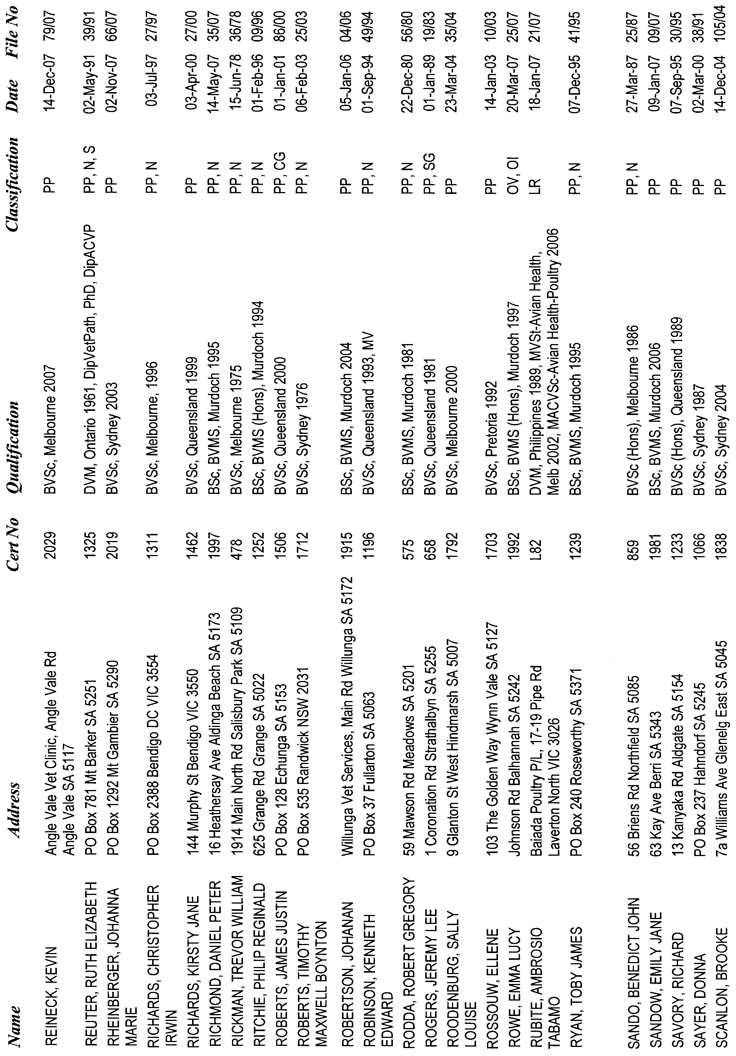
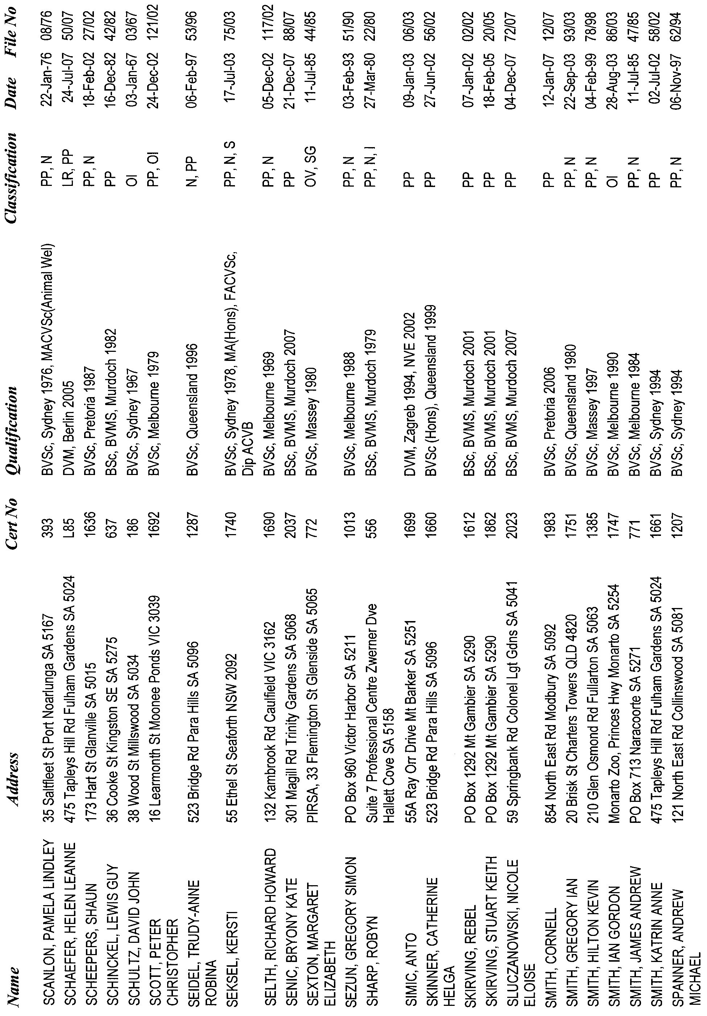
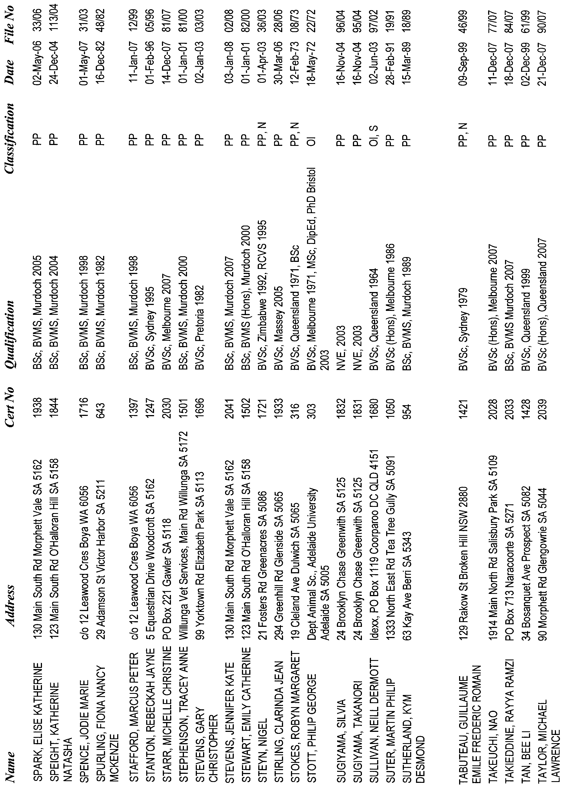
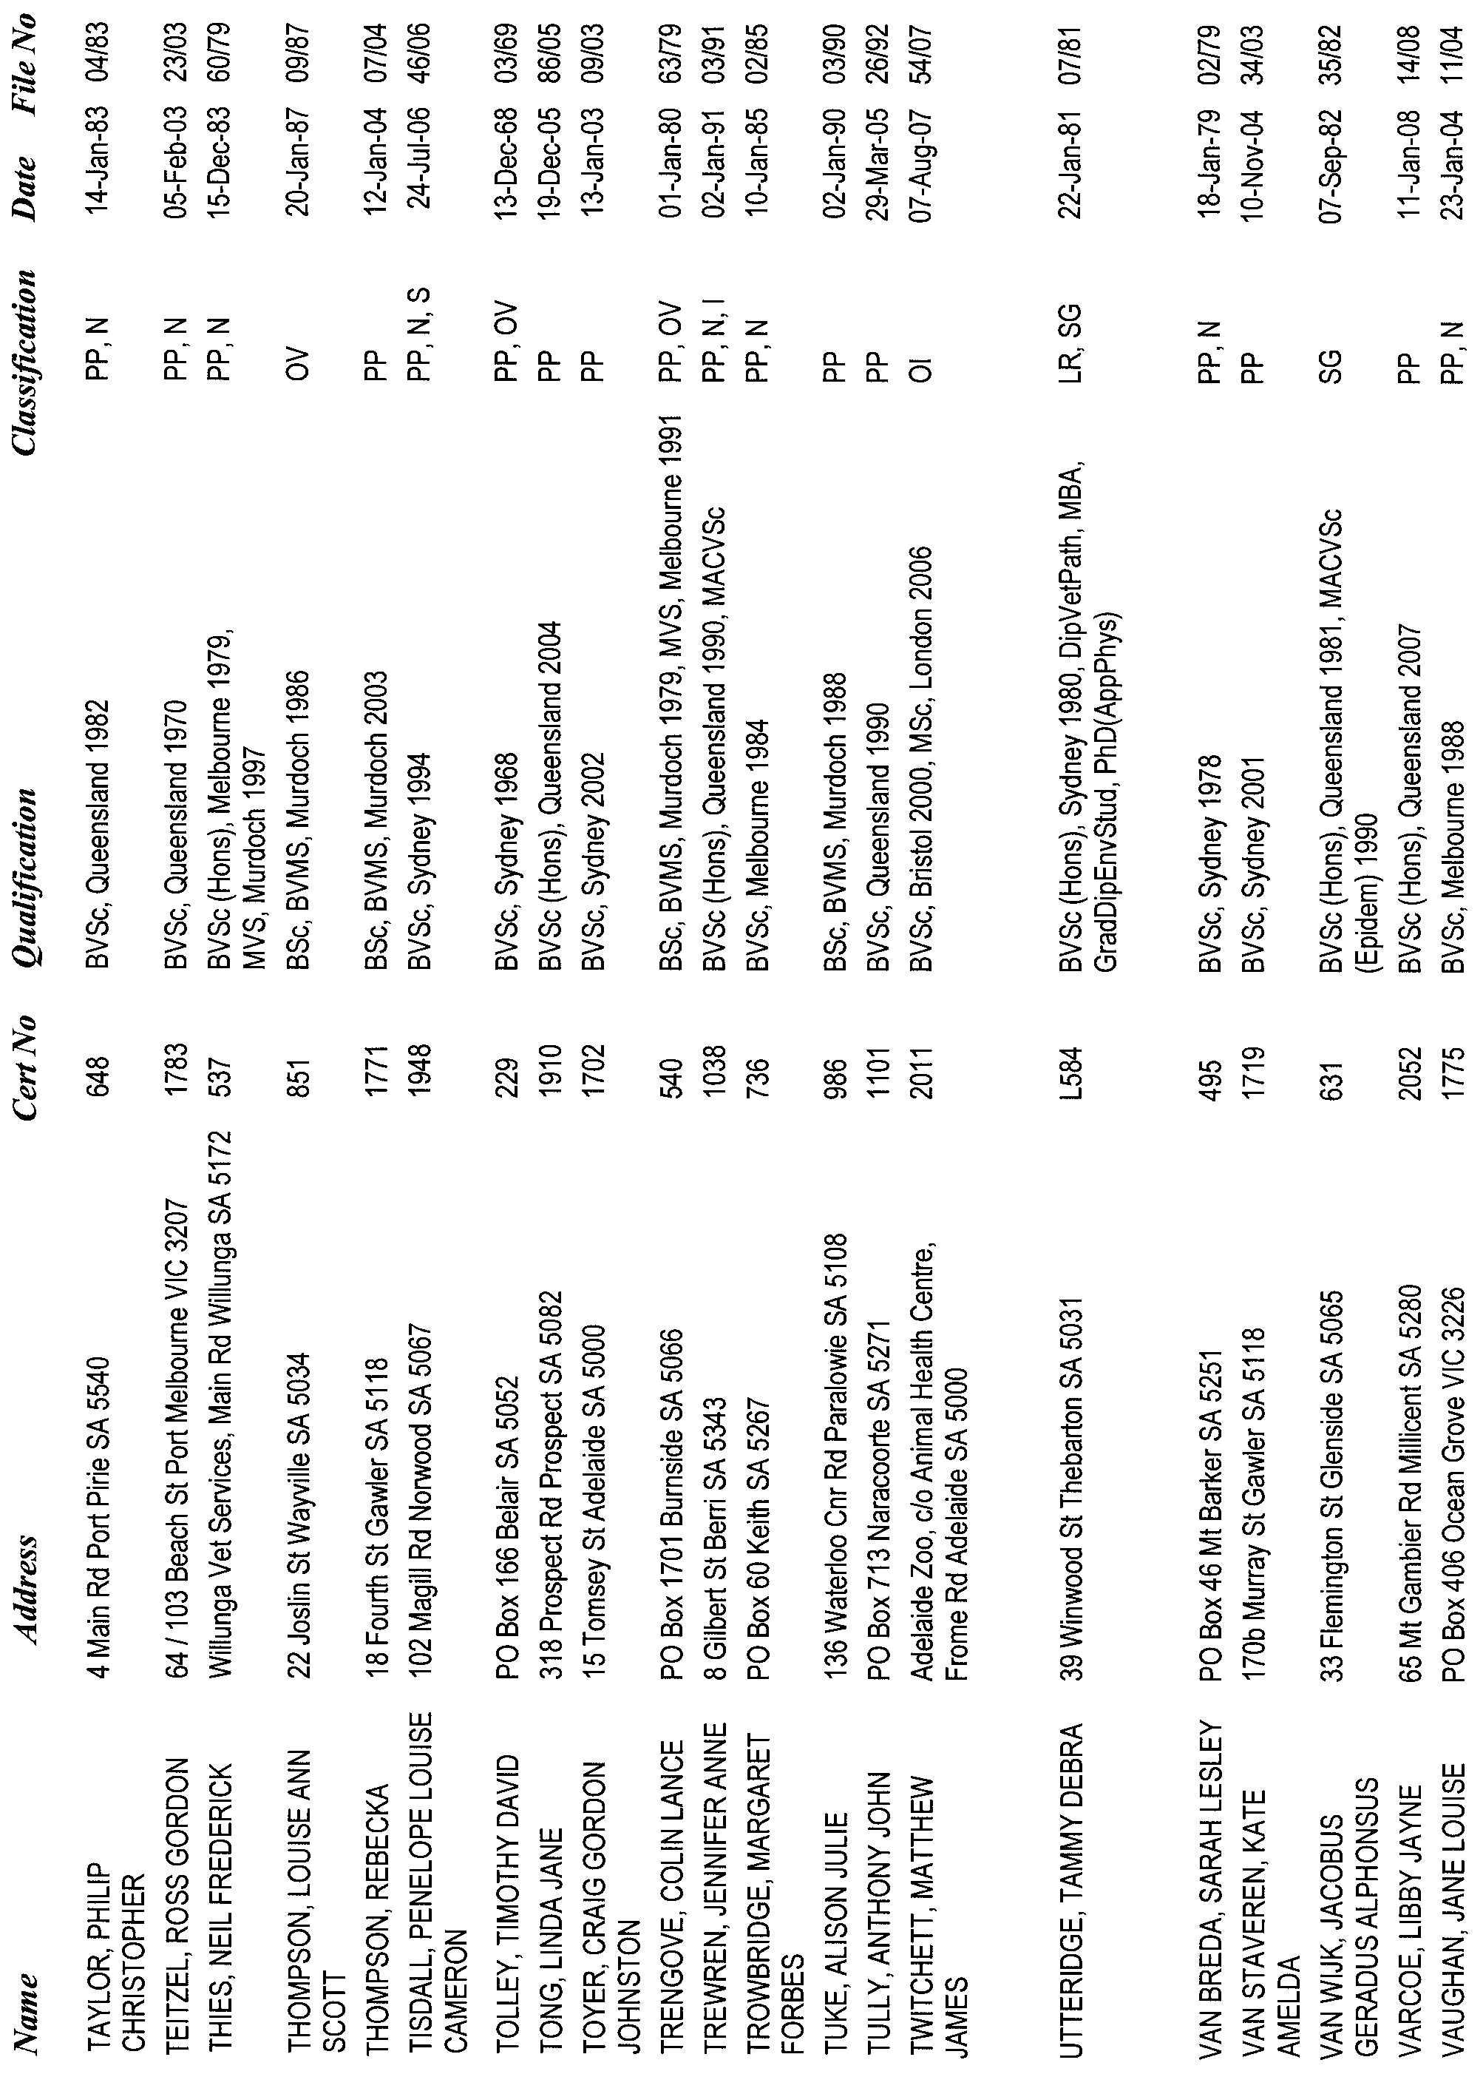
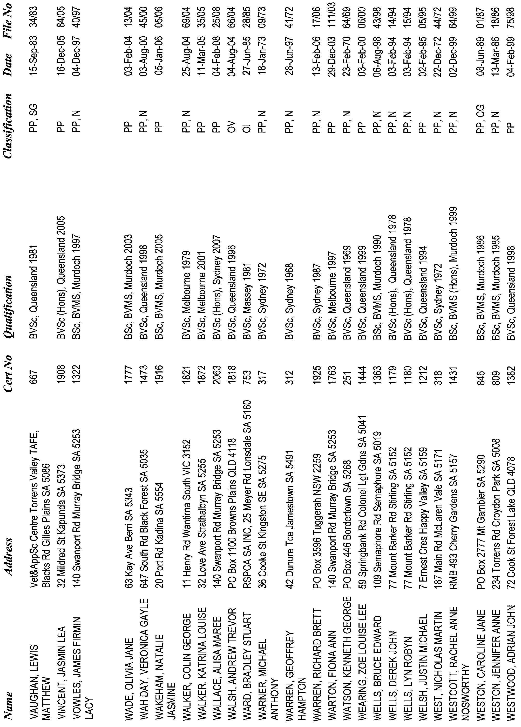
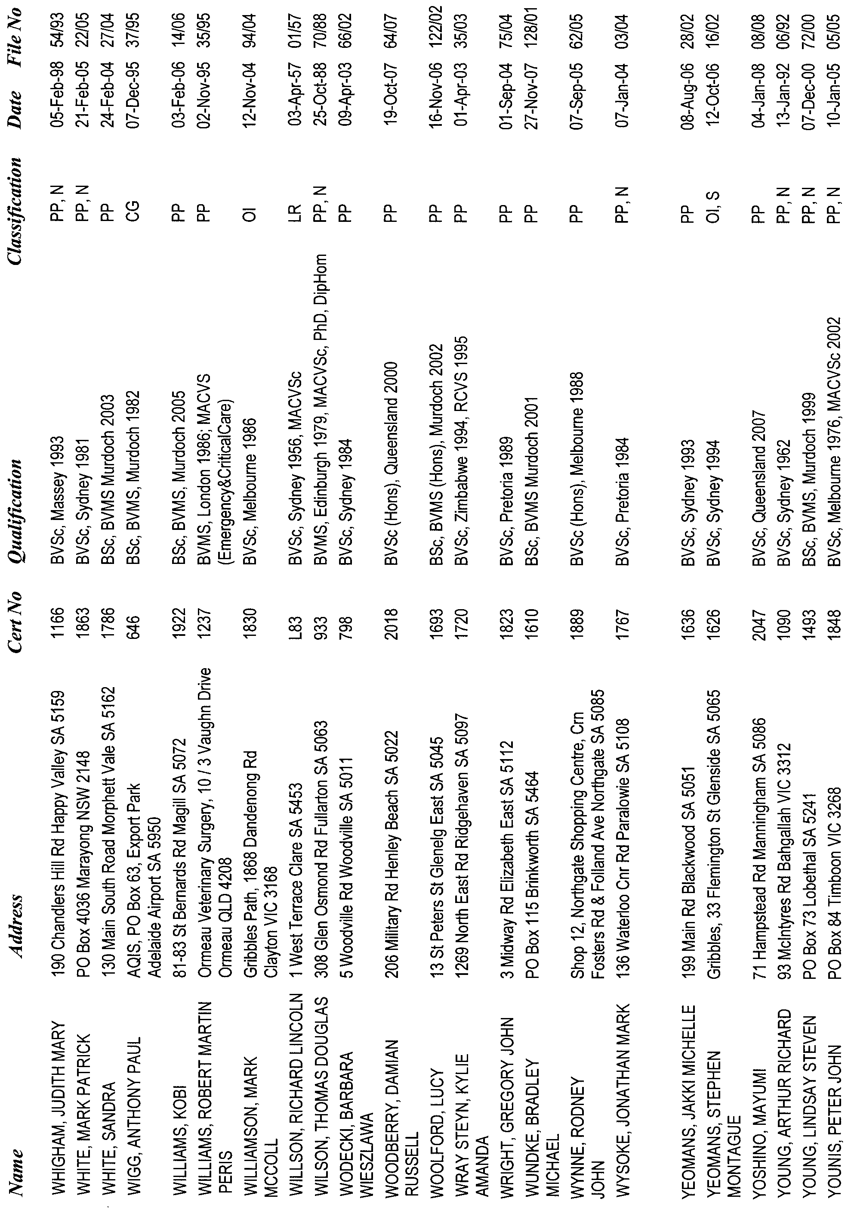
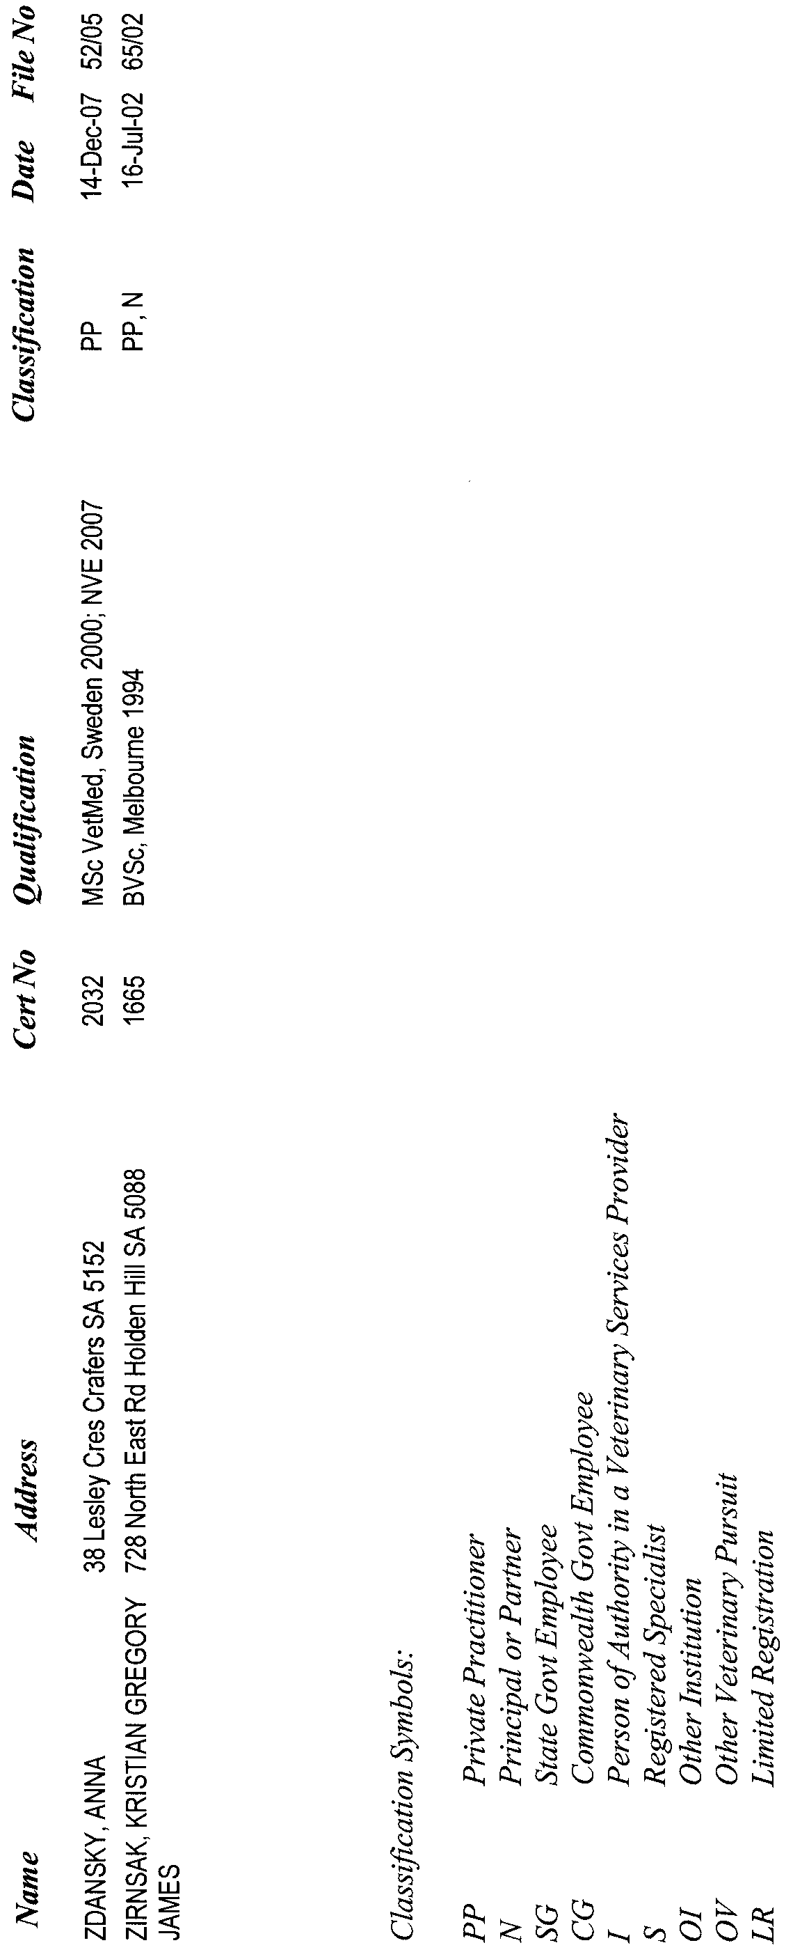
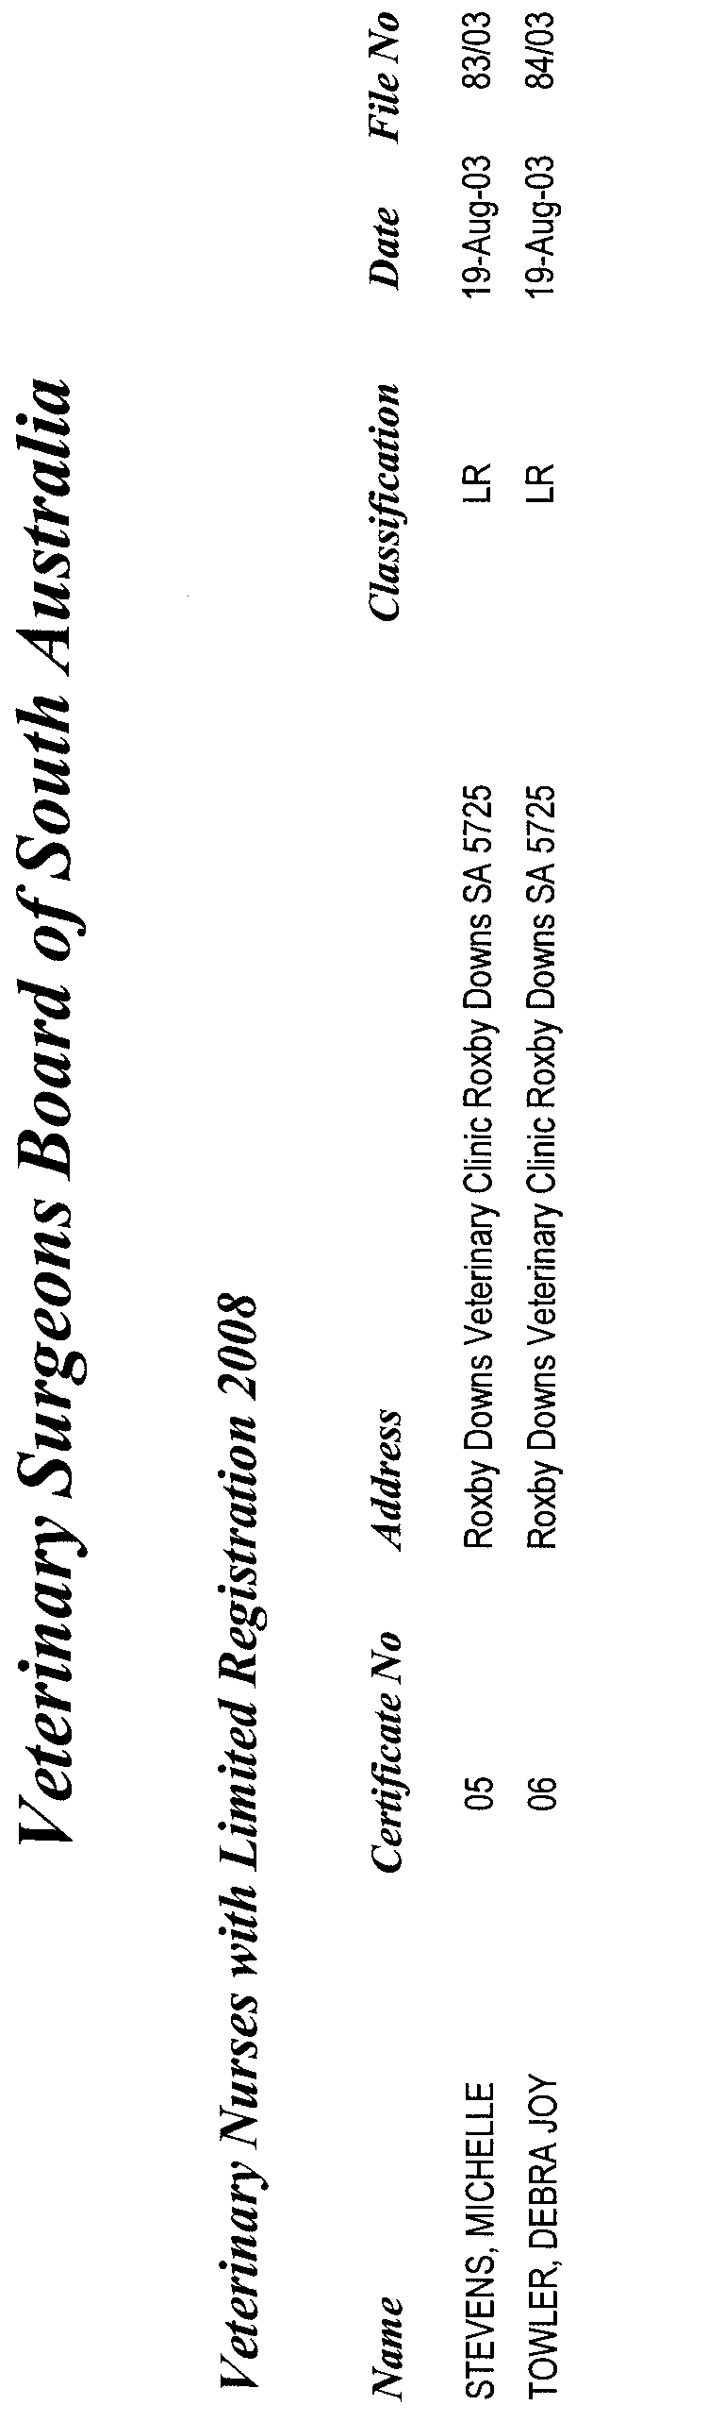


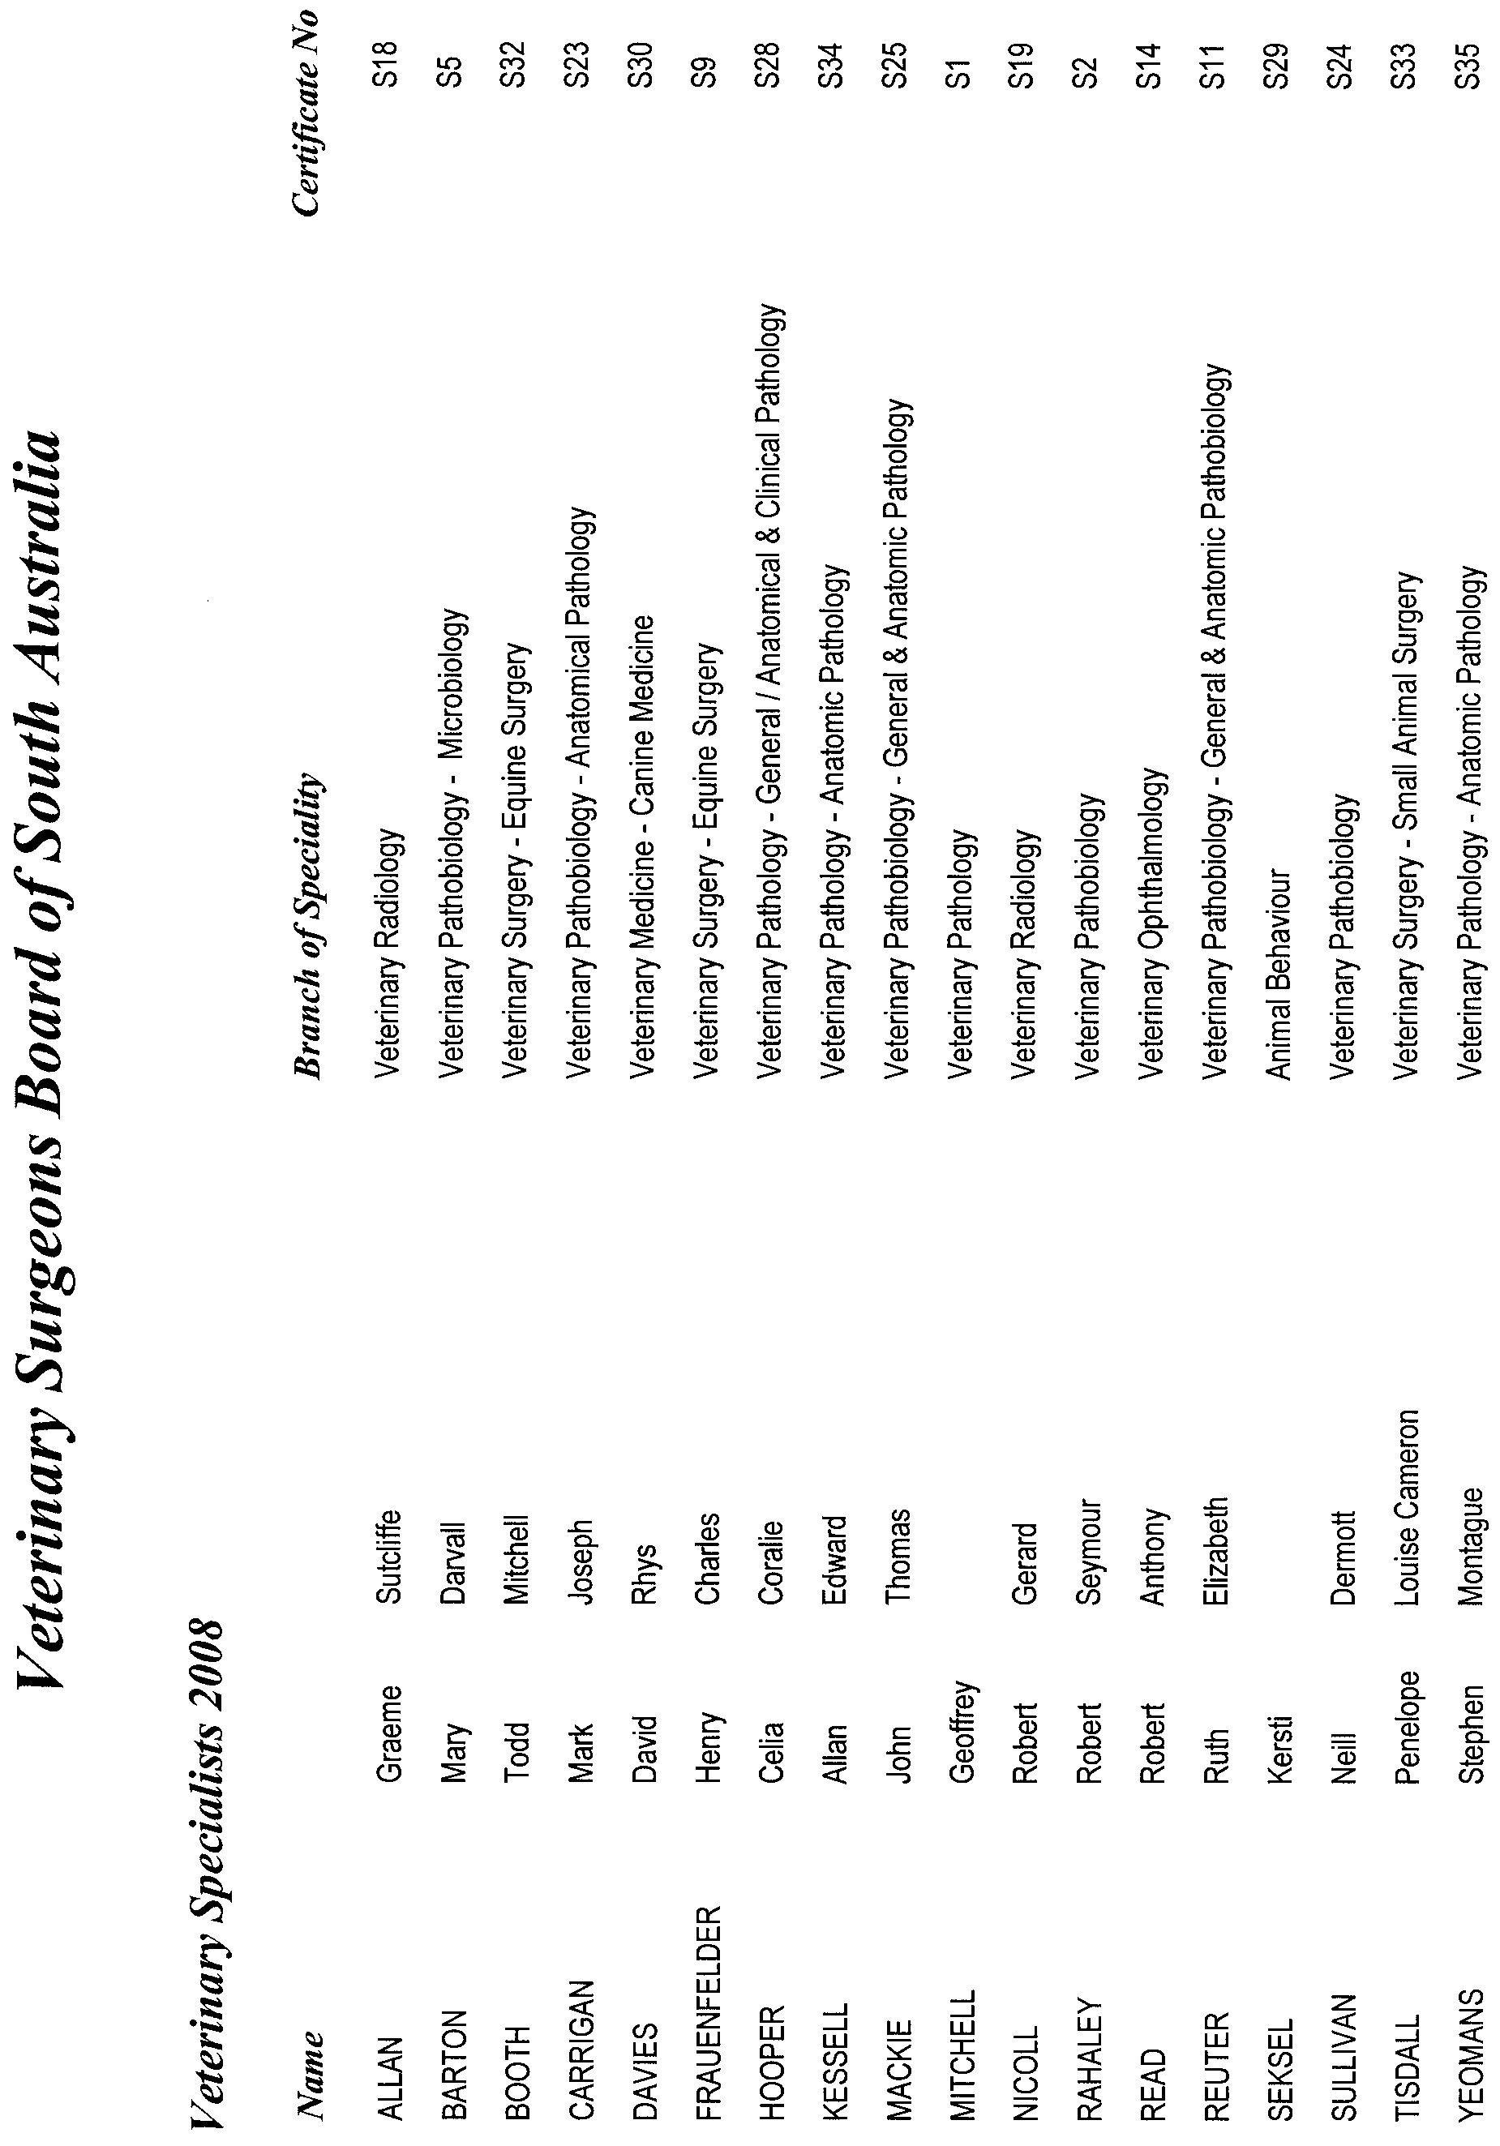

South Australia
Crown Lands (Resumption of Dedicated Land) Proclamation 2008
under section 5AA(1)(c) of the Crown Lands Act 1929

Preamble
1 The following land is dedicated for Harbors Board purposes (Gazette 3.7.1952 p1):
Section 477, Hundred of Lacepede, being the whole of the land contained in Certificate of Title Register Book Volume 5679 Folio 558.
2 The registered proprietor of the land has consented to the resumption of the land.

1—Short title
This proclamation may be cited as the Crown Lands (Resumption of Dedicated Land) Proclamation 2008.
2—Commencement
This proclamation comes into operation on the day on which it is made.
3—Resumption of dedicated land
The land defined in the preamble to this proclamation is resumed.
4—Cancellation of grant of land
The grant of the land defined in the preamble to this proclamation is cancelled.
Made by the Governor
with the advice and consent of the Executive Council
on 8 May 2008
EHCS08/0008

South Australia
Liquor Licensing (Dry Areas—Long Term) Variation Regulations 2008
under the Liquor Licensing Act 1997

Contents
Part 1—Preliminary
1 Short title
2 Commencement
3 Variation provisions
Part 2—Variation of Liquor Licensing (Dry Areas—Long Term)
Regulations 1997
4 Variation of Schedule 1—Long term dry areas

Part 1—Preliminary
1—Short title
These regulations may be cited as the Liquor Licensing (Dry Areas—Long Term)
Variation Regulations 2008.
2—Commencement
These regulations come into operation on the day on which they are made.
3—Variation provisions
In these regulations, a provision under a heading referring to the variation of specified regulations varies the regulations so specified.
Part 2—Variation of Liquor Licensing (Dry Areas—Long Term) Regulations 1997
4—Variation of Schedule 1—Long term dry areas
(1) Schedule 1, item headed "Mannum—Area 1", column headed "Period"—delete "2008" and substitute:
2009
(2) Schedule 1, item headed "Mannum—Area 2", column headed "Period"—delete "2008" and substitute:
2009
(3) Schedule 1, item headed "Mannum—Area 3", column headed "Period"—delete "2008" and substitute:
2009
(4) Schedule 1, item headed "Mannum—Area 4", column headed "Period"—delete "2008" and substitute:
2009
(5) Schedule 1, item headed "Mannum—Area 5", column headed "Period"—delete "2008" and substitute:
2009
Note—
As required by section 10AA(2) of the Subordinate Legislation Act 1978, the Minister has certified that, in the Minister's opinion, it is necessary or appropriate that these regulations come into operation as set out in these regulations.
Made by the Governor
with the advice and consent of the Executive Council
on 8 May 2008
No 45 of 2008
MCA08/003CS

South Australia
Controlled Substances (Poisons) Variation Regulations 2008
under the Controlled Substances Act 1984

Contents
Part 1—Preliminary
1 Short title
2 Commencement
3 Variation provisions
Part 2—Variation of Controlled Substances (Poisons) Regulations 1996
4 Variation of regulation 31I—Additional requirements for administration of drugs of dependence in health service

Part 1—Preliminary
1—Short title
These regulations may be cited as the Controlled Substances (Poisons) Variation Regulations 2008.
2—Commencement
These regulations come into operation on the day on which they are made.
3—Variation provisions
In these regulations, a provision under a heading referring to the variation of specified regulations varies the regulations so specified.
Part 2—Variation of Controlled Substances (Poisons) Regulations 1996
4—Variation of regulation 31I—Additional requirements for administration of drugs of dependence in health service
Regulation 31I(1)(a)—delete paragraph (a) and substitute:
(a) the medical practitioner or dentist principally responsible for the treatment of the person while in the health service or a registered nurse acting in accordance with a standing order prepared or endorsed by the health service and approved by the Minister must—
(i) ensure that the prescribed instructions in respect of the drug are entered in the person's medication record; and
(ii) endorse the relevant entries with his or her name and signature;
Note—
As required by section 10AA(2) of the Subordinate Legislation Act 1978, the Minister has certified that, in the Minister's opinion, it is necessary or appropriate that these regulations come into operation as set out in these regulations.
Made by the Governor
after consultation by the Minister with the Controlled Substances Advisory Council and with the advice and consent of the Executive Council
on 8 May 2008
No 46 of 2008
HEACS/06/130

South Australia
Revocation of Regulations as to Queen's Counsel Regulations 2008

Contents
Part 1—Preliminary
1 Short title
2 Commencement
Part 2—Revocation of Regulations as to Queen's Counsel
3 Revocation of regulations

Part 1—Preliminary
1—Short title
These regulations may be cited as the Revocation of Regulations as to Queen's Counsel Regulations 2008.
2—Commencement
These regulations come into operation on the day on which they are made.
Part 2—Revocation of Regulations as to Queen's Counsel
3—Revocation of regulations
The Regulations as to Queen's Counsel made on 26 March 1970 (Gazette 26.3.1970 p1246) are revoked.
Made by the Governor
with the advice and consent of the Executive Council
on 8 May 2008

FAXING COPY?
IF you fax copy to Government Publishing SA for inclusion in the Government Gazette, there is no need to send a Confirmation Copy to us as well.
This creates confusion and may well result in your notice being printed twice.
Please use the following fax number:
Fax transmission: (08) 8207 1040
Phone Inquiries: (08) 8207 1045
Please include a contact person, phone number and order number so that we can phone back with any queries we may have regarding the fax copy.
NOTE: Closing time for lodging new copy (fax, hard copy or email) is 4 p.m. on Tuesday preceding the day of publication.

Government Gazette notices can be E-mailed.
The address is:
governmentgazette@dpc.sa.gov.au
Documents should be sent as attachments in Word format.
When sending a document via E-mail, please confirm your transmission with a faxed copy of your document, including the date the notice is to be published.
Fax transmission: (08) 8207 1040
Enquiries: (08) 8207 1045
NOTE: Closing time for lodging new copy (fax, hard copy or email) is 4 p.m. on Tuesday preceding the day of publication.

CITY OF MARION
Exclusion of Vehicular Traffic—Portion of Shakes Crescent,
Hallett Cove
NOTICE is hereby given that at its meeting held on 22 April 2008, the Corporation of the City of Marion resolved, pursuant to section 359 of the Local Government Act 1934, as amended, to exclude all motorised vehicles from that portion of Shakes Crescent, Hallett Cove, within 8 metres of its junction with Gledsdale Road, Hallett Cove.
Dated 2 May 2008.
M. Searle, Chief Executive Officer

CITY OF PLAYFORD
Adoption of Amendments to Management Plans for
Community Land
NOTICE is hereby given that in accordance with section 198 of the Local Government Act 1999, Council has amended Manage-ment Plans for Community Land held under its ownership by including additional properties in the following reserve categories:
Plan  Number | Reserve Category
6.1 | Neighbourhood Park
7.1 | Local Park
9.1 | Corridor/Linear Reserve
10.1 | Walkway Reserve
11.1 | Drainage Reserve
12.1 | Dry Land Reserve, Windbreak and Road Reserve
14.1 | Natural Area Wetland/Watercourse
T. Jackson, Chief Executive Officer

ALEXANDRINA COUNCIL
(Re-advertisement)
Roads (Opening and Closing) Act 1991
Road Opening and Closure—Public Road, Mount Compass
NOTICE is hereby given, pursuant to section 10 of the Roads (Opening and Closing) Act 1991, that the Alexandrina Council proposes to make a Road Process Order to close portion of the Public Road adjoining allotments 23 and 24 in Deposited Plan 29346 more particularly delineated and lettered ‘A’ on Preliminary Plan No. 05/0053. Closed road ‘A’ to be merged with the adjoining allotment 23 in Deposited Plan 29346.
A copy of the plan and a statement of persons affected are available for public inspection at the offices of the Alexandrina Council, 11 Cadell Street, Goolwa and the Adelaide office of the Surveyor-General during normal office hours.
Any application for easement or objection must set out the full name, address and details of the submission and must be fully supported by reasons.
The application for easement or objection must be made in writing to the Alexandrina Council, P.O. Box 21, Goolwa, S.A. 5214 within 28 days of this notice and a copy must be forwarded to the Surveyor-General, G.P.O. Box 1354, Adelaide, S.A. 5001. Where a submission is made, the Council will give notification of a meeting at which the matter will be considered.
Dated 7 May 2008.
J. Coombe, Chief Executive Officer

DISTRICT COUNCIL OF LOWER EYRE PENINSULA
Amendment to Description of Road Name
NOTICE is hereby given that the District Council of Lower Eyre Peninsula issued a resolution at a meeting held on 18 April 2008, pursuant to section 219 (1) of the Local Government Act 1999, to allocate the following:
‘The road running between sections 79 and 91 and sections 92 and 93 in the Hundred of Lincoln be named Wallis Road.’
P. Aird, Chief Executive Officer

IN the matter of the estates of the undermentioned deceased persons:
Blackmore, Florence Caroline Winifred, late of 47 Eve Road, Bellevue Heights, of no occupation, who died on 17 March 2008.
Caporn, Laurel Gwen, late of 3-17 Watson Avenue, Netley, home duties, who died on 27 February 2008.
Crimes, Ernest Henry, late of 1 Myzantha Street, Lockleys, retired member of parliament, who died on 17 January 2008.
Emery, Jessie Margaret, late of 56 High Street, Grange, retired secretary, who died on 12 March 2008.
Hall, Ruth, late of Blamey Road, Elizabeth East, of no occupation, who died on 8 January 2008.
Hill, Margaret Florence, late of 13 Scole Place, Huntingdale, Western Australia, home duties, who died on 8 February 2008.
Jones, Reuben Joseph, late of 3 Albany Street, Grange, retired stevedore foreman, who died on 25 February 2008.
Patten, Donald Frederick, late of 9 Northfield Road, Northfield, retired service manager, who died on 8 March 2008.
Radford, Cedric Francis, late of 333 Marion Road, North Plympton, retired storekeeper, who died on 17 February 2008.
Robertson, Vera Adelaide, late of 27 Moresby Avenue, Broadview, retired dining room supervisor, who died on 14 December 2007.
Saat, Senta, late of 10 Franklin Avenue, Bedford Park, home duties, who died on 12 February 2008.
Whenan, Leslie, late of 38 Buxton Street, North Adelaide, retired transport driver, who died on 17 February 2008.
Notice is hereby given pursuant to the Trustee Act 1936, as amended, the Inheritance (Family Provision) Act 1972, and the Family Relationships Act 1975, that all creditors, beneficiaries, and other persons having claims against the said estates are required to send, in writing, to the Public Trustee, 25 Franklin Street, Adelaide, S.A. 5000, full particulars and proof of such claims, on or before 6 June 2008, otherwise they will be excluded from the distribution of the said estate; and notice is also hereby given that all persons who are indebted to the said estates are required to pay the amount of their debts to the Public Trustee or proceedings will be taken for the recovery thereof; and all persons having any property belonging to the said estates are forthwith to deliver the same to the Public Trustee.
Dated 8 May 2008.
M. I. Bodycoat, Public Trustee

ATTENTION

CUSTOMERS requiring a proof of their notice for inclusion in the Government Gazette, please note that the onus is on you to inform Government Publishing SA of any subsequent corrections by 10 a.m. on Thursday, which is our publication deadline.

For any corrections to your notice please phone 8207 1045 or Fax 8207 1040 before 10 a.m. on Thursday.

If we do not receive any communication by 10 a.m. on Thursday (day of publication) we will presume the notice is correct and will print it as it is.

Remember—the onus is on you to inform us of any corrections necessary to your notice.

NOTE: Closing time for lodging new copy (electronically, fax or hard copy) is 4 p.m. on Tuesday preceding the day of publication. Phone 8207 1045—Fax 8207 1040.
Email: governmentgazette@dpc.sa.gov.au

Printed and published by authority every Thursday by T. GOODES, Government Printer, South Australia
Price: $5.40, plus postage; to subscribers, $274.00 per annum.
(The above prices are inclusive of GST)

