No. 64 5023

THE SOUTH AUSTRALIAN

GOVERNMENT GAZETTE
www.governmentgazette.sa.gov.au

PUBLISHED BY AUTHORITY

ALL PUBLIC ACTS appearing in this GAZETTE are to be considered official, and obeyed as such

ADELAIDE, THURSDAY, 6 NOVEMBER 2008

CONTENTS

Page
Acts Assented To 5024
Appointments, Resignations, Etc. 5024
Corporations and District Councils—Notices 5069
Development Act 1993—Notice 5042
Education Act 1972—Notice 5025
Fisheries Management Act 2007—Notices 5042
Gaming Machines Act 1992—Notice 5045
Housing Improvement Act 1940—Notices 5044
Liquor Licensing Act 1997—Notices 5045
Mining Act 1971—Notices 5048
National Electricity Law—Notice 5049
National Parks and Wildlife Act 1972—Notice 5049
National Parks and Wildlife (National Parks) Regulations
2001—Notice 5049
Petroleum Act 2000—Notices 5050
Proclamations 5055
Public Trustee Office—Administration of Estates 5075
REGULATIONS
Public Corporations Act 1993 (No. 282 of 2008) 5060
Liquor Licensing Act 1997 (No. 283 of 2008) 5062
Marine Parks Act 2007 (No. 284 of 2008) 5066
Transport, Department of—Notice to Mariners 5050

GOVERNMENT GAZETTE NOTICES
ALL poundkeepers’ and private advertisements forwarded for publication in the South Australian Government Gazette must be PAID FOR PRIOR TO INSERTION; and all notices, from whatever source, should be legibly written on one side of the paper only and sent to Government Publishing SA so as to be received no later
than 4 p.m. on the Tuesday preceding the day of publication. Phone 8207 1045 or Fax 8207 1040. E-mail: governmentgazette@dpc.sa.gov.au. Send as attachments in Word format and please confirm your transmission with a faxed copy of your document, including the date the notice is to be published and to whom the notice will be charged. The Government Gazette is available online at: www.governmentgazette.sa.gov.au

Department of the Premier and Cabinet
Adelaide, 6 November 2008
HIS Excellency the Governor directs it to be notified for general information that she has in the name and on behalf of Her Majesty The Queen, this day assented to the undermentioned Acts passed by the Legislative Council and House of Assembly in Parliament assembled, viz.:
No. 40 of 2008—Long Service Leave (Unpaid Leave) Amendment Act 2008. An Act to amend the Long Service Leave Act 1987.
No. 41 of 2008—Murray-Darling Basin Act 2008. An Act to facilitate the operation of an agreement entered into between the Commonwealth, New South Wales, Victoria, Queensland, South Australia and the Australian Capital Territory to promote and co-ordinate effective planning and management for the equitable, efficient and sustainable use of the water and other natural resources of the Murray-Darling Basin; to make related amendments to the Development Act 1993, the Ground Water (Qualco-Sunlands) Control Act 2000, the Natural Resources Management Act 2004, the River Murray Act 2003 and the Waterworks Act 1932; to repeal the Murray-Darling Basin Act 1993 and for other purposes.
No. 42 of 2008—Summary Offences (Indecent Filming) Amendment Act 2008. An Act to amend the Summary Offences Act 1953.
No. 43 of 2008—Water (Commonwealth Powers) Act 2008. An Act to refer certain matters relating to water management to the Commonwealth Parliament for the purposes of section 51 (xxxvii) of the Constitution of the Commonwealth.
By command,
Gail Gago, for Premier
DPC06/0875

Department of the Premier and Cabinet
Adelaide, 6 November 2008
HIS Excellency the Governor in Executive Council has been pleased to appoint the undermentioned to the Legal Services Commission, pursuant to the provisions of the Legal Services Commission Act 1977:
Member: (from 6 November 2008 until 5 November 2011)
Tracee Ann Micallef
By command,
Gail Gago, for Premier
AGO0249/02CS

Department of the Premier and Cabinet
Adelaide, 6 November 2008
HIS Excellency the Governor in Executive Council has been pleased to appoint the undermentioned to the Legal Practitioners Disciplinary Tribunal, pursuant to the provisions of the Legal Practitioners Act 1981:
Member: (from 7 November 2008 until 6 November 2011)
Maurine Pyke
Member: (from 28 November 2008 until 27 November 2011)
Jillian Freda Cooper
By command,
Gail Gago, for Premier
AGO0067/07CS

Department of the Premier and Cabinet
Adelaide, 6 November 2008
HIS Excellency the Governor in Executive Council has been pleased to appoint the undermentioned to the State Emergency Management Committee, pursuant to the provisions of the Emergency Management Act 2004:
Member: (from 6 November 2008 until 11 June 2011)
Raymond Paul Creen
Joslene Mazel
Scott William Ashby
Helen Margaret Fulcher
Deputy Member: (from 6 November 2008 until 11 June 2011)
Lynda Forrest (Deputy to Mazel)
Peter O’Neill (Deputy to Ashby)
Tony Circelli (Deputy to Fulcher)
Karen Michelle Braunack (Deputy to Creen)
Matthew Paul Maywald (Deputy to McLeod)
Deputy Member: (from 6 November 2008 until 5 December 2010)
Annette Jean Ferris (Deputy to Place)
By command,
Gail Gago, for Premier
DPC038/04CS

Department of the Premier and Cabinet
Adelaide, 6 November 2008
HIS Excellency the Governor in Executive Council has been pleased to appoint the undermentioned to the Safework SA Advisory Committee, pursuant to the provisions of the Occupational Health, Safety and Welfare Act 1986:
Member: (from 1 December 2008 until 30 November 2011)
Thomas Robin Phillips
Presiding Member: (from 1 December 2008 until 30 November 2011)
Thomas Robin Phillips
By command,
Gail Gago, for Premier
MIR33/08CS

Department of the Premier and Cabinet
Adelaide, 6 November 2008
HIS Excellency the Governor in Executive Council has been pleased to appoint the people listed as Justices of the Peace for South Australia for a period of 10 years commencing from 6 November 2008 and expiring on 5 November 2018, pursuant to section 4 of the Justices of the Peace Act 2005:
David Robert Cocker
Trudy-Anne Gregory
Hanumka Hibeljic
Carolyn Lois Hogarth
Suzanne Mary Kellow
Matthew Grant Kruschel
James Heinz Lange
Ann Louise Parker
Joylene Cheryl Potter
Christopher Procter
Nicholas Edward Halsall Seager
Patricia Sealey
Glynn Barry Slade
Judith Dian Sutton
Jeanette Elizabeth Terry
By command,
Gail Gago, for Premier
JP08/035CS

Department of the Premier and Cabinet
Adelaide, 6 November 2008
HIS Excellency the Governor in Executive Council has been pleased to appoint the people listed as Special Justices of the Peace for South Australia for a term of one year commencing on 6 November 2008 and expiring on 5 November 2009, pursuant to section 7 (1) of the Justices of the Peace Act 2005:
Bryan Kenneth Hearn
Geoffrey Kenneth Penhall
Margot Ross Radford
Robert John Peebles Shaw
By command,
Gail Gago, for Premier
JP/08/052CS


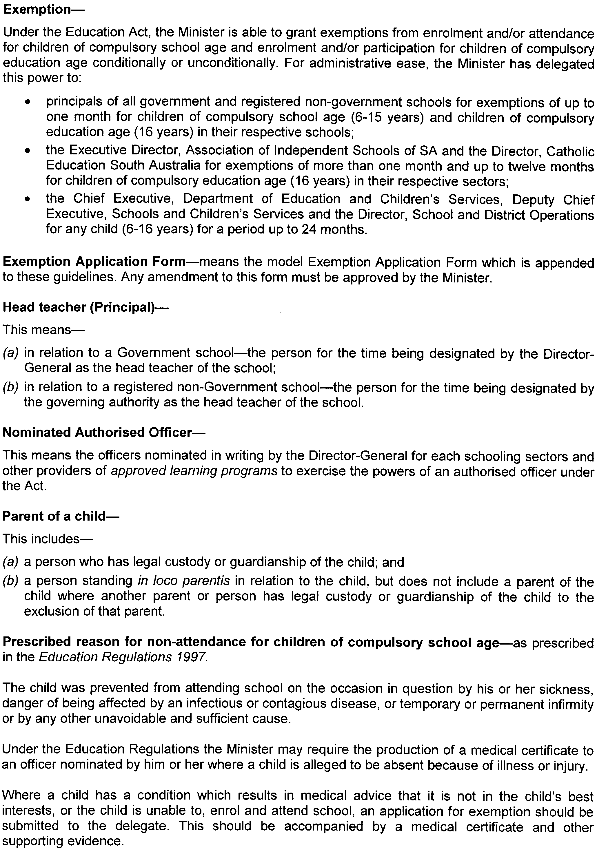
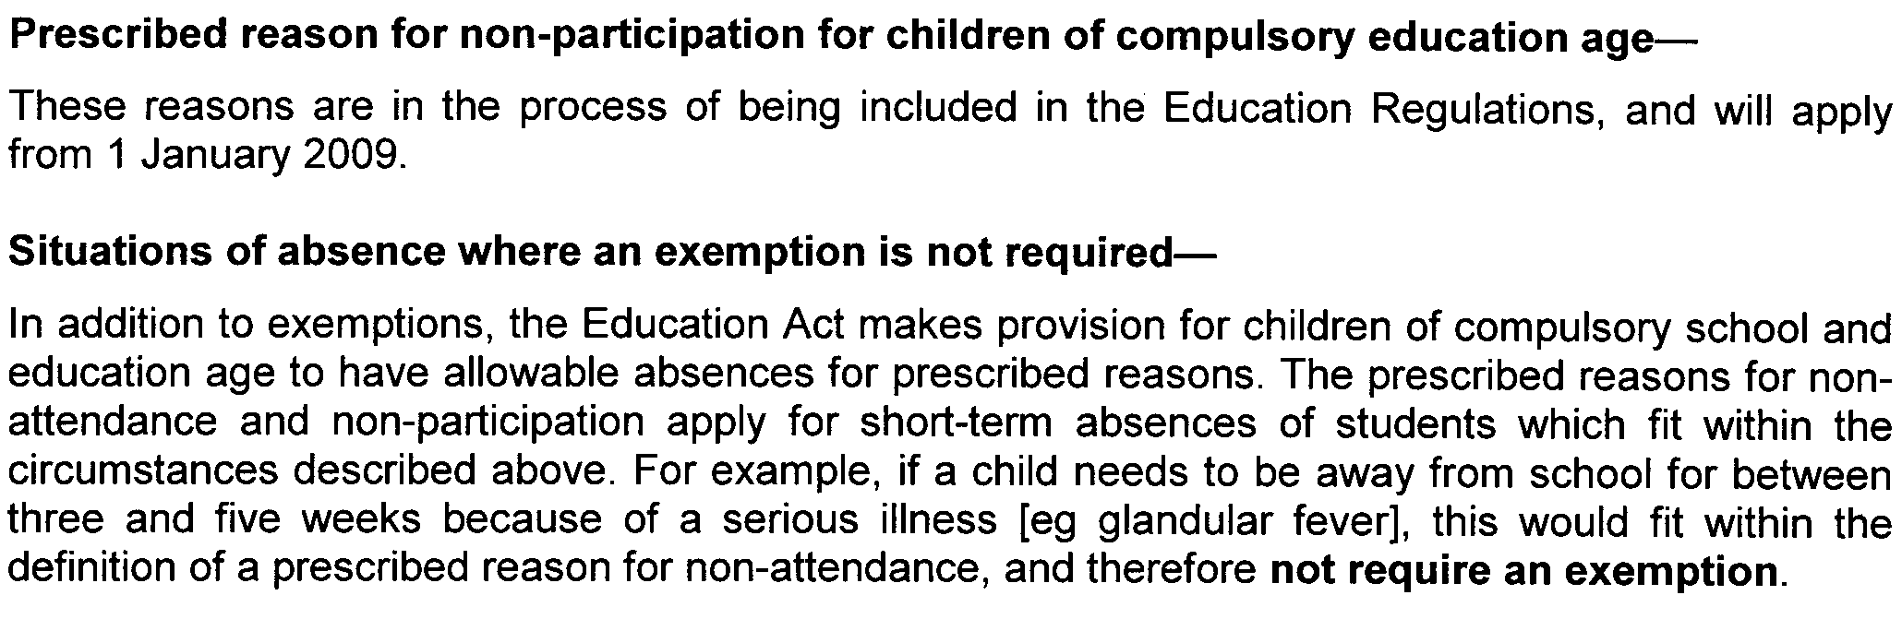
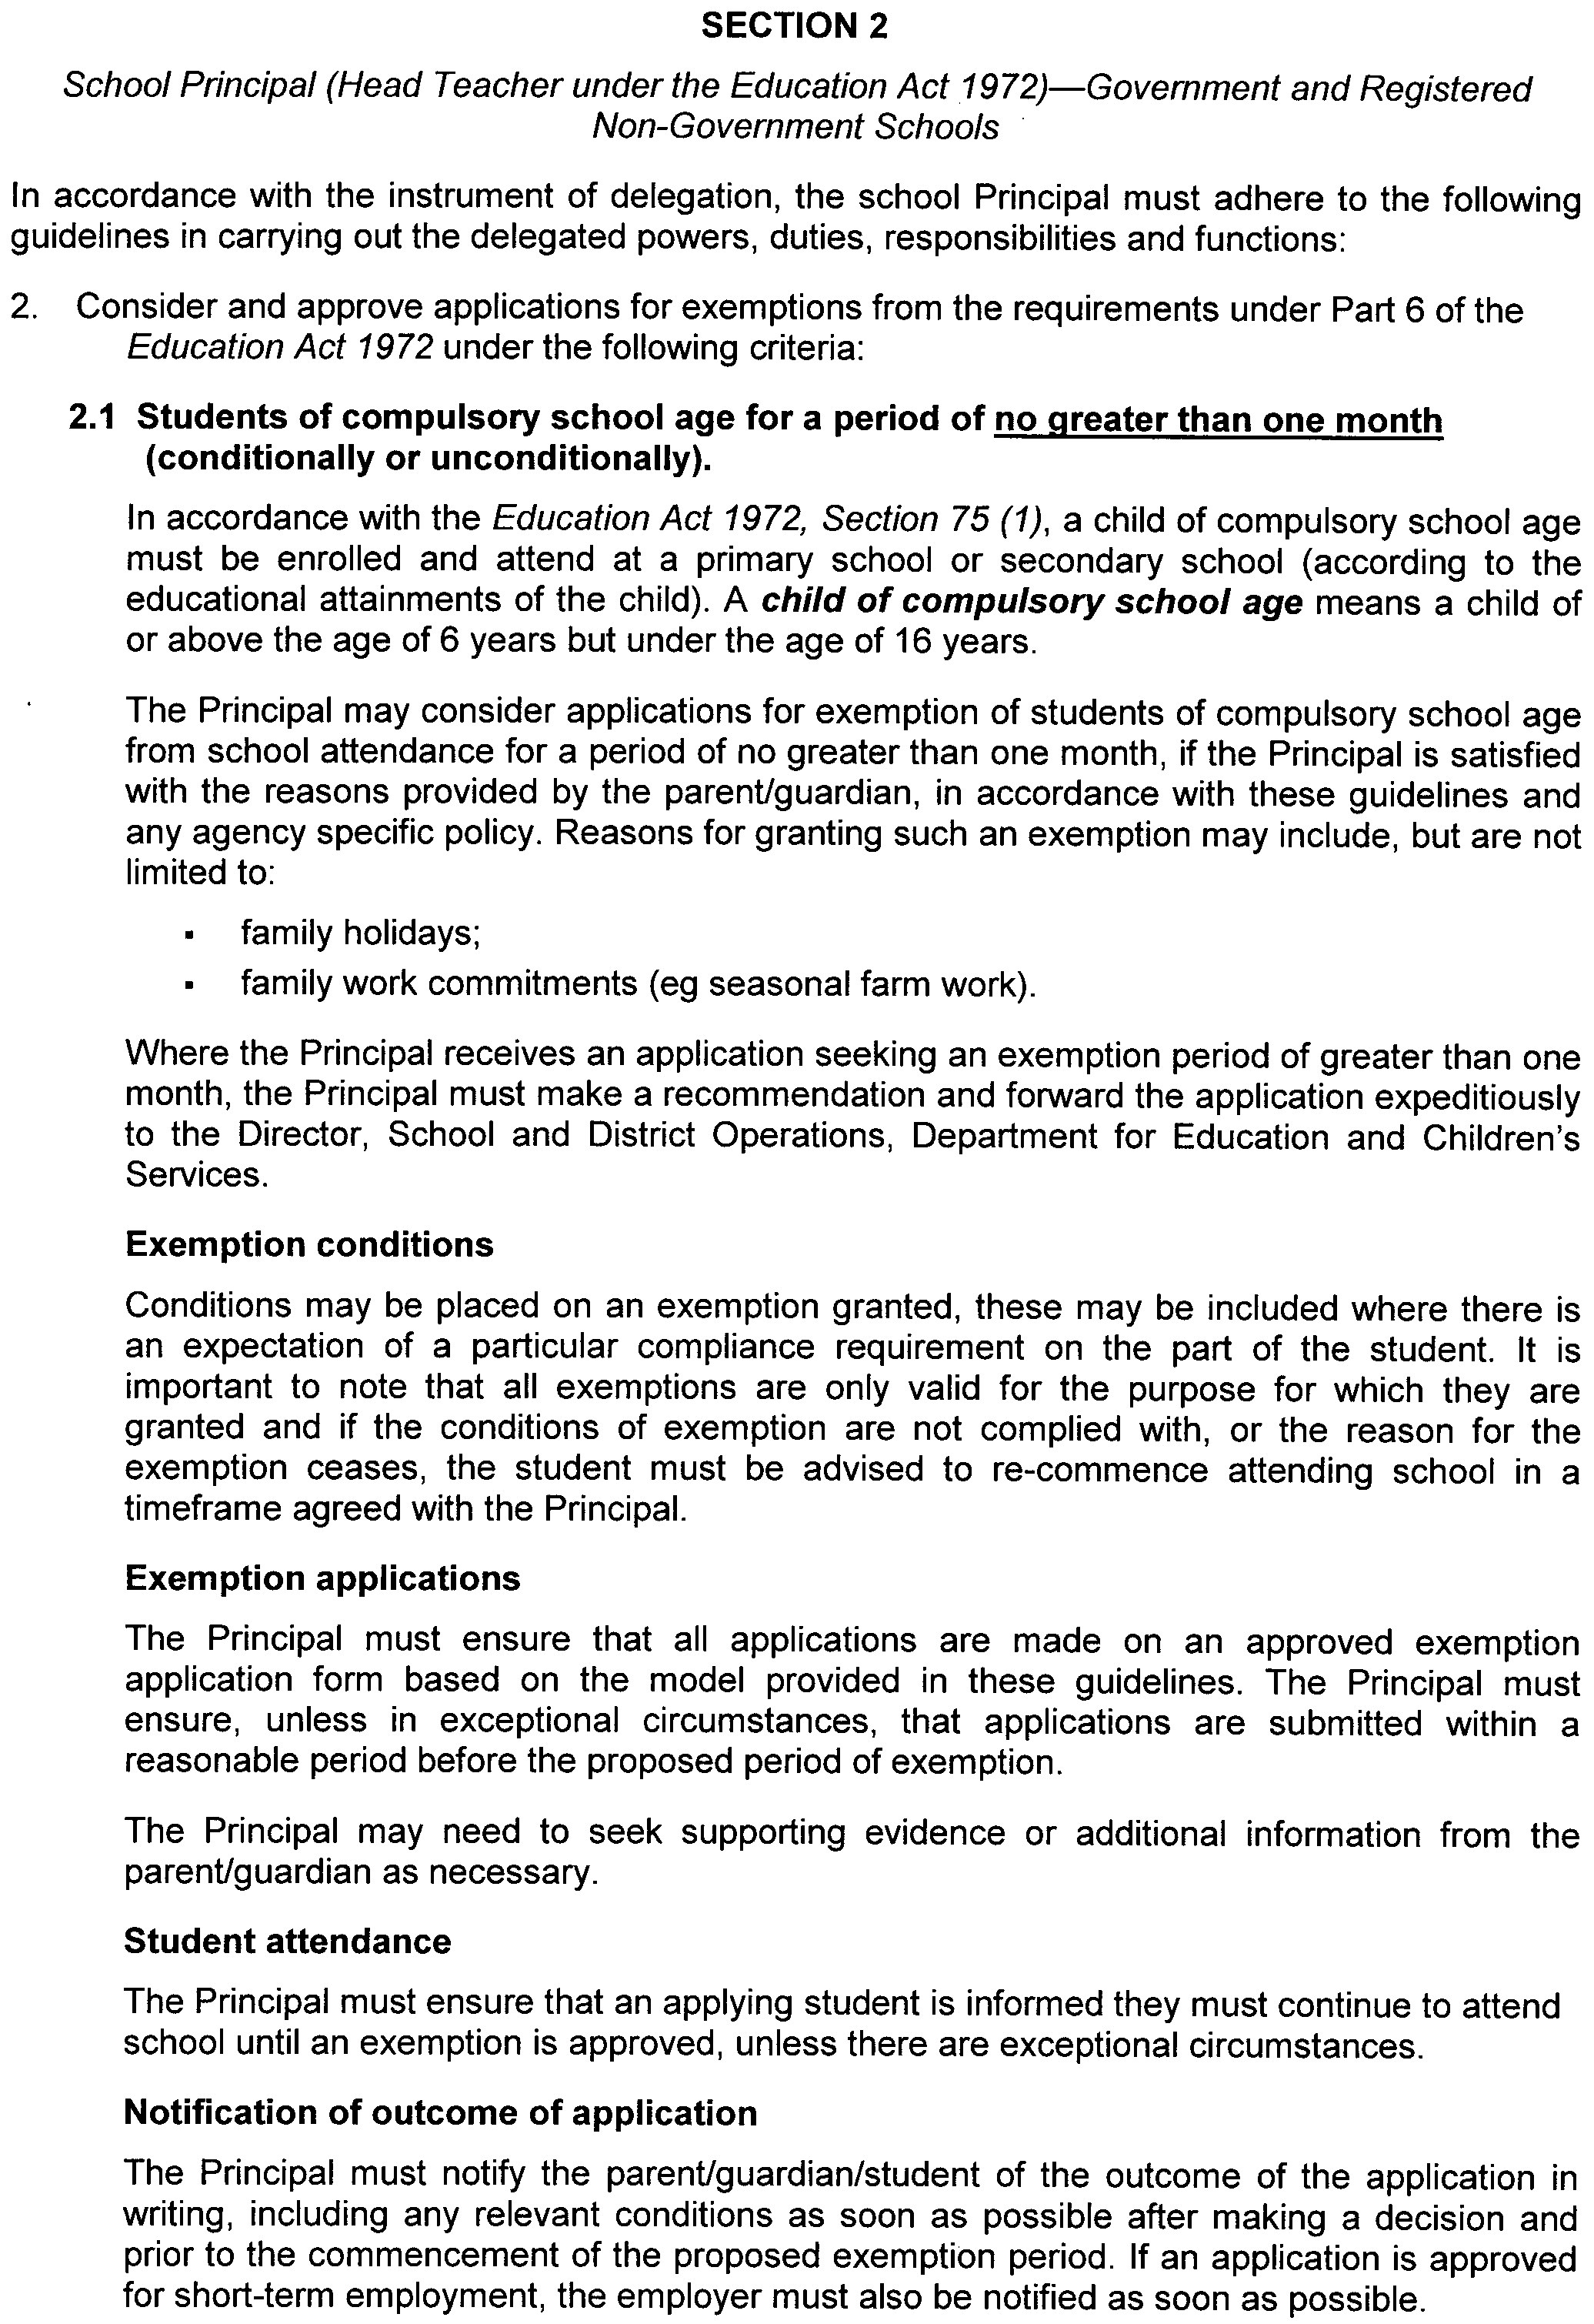
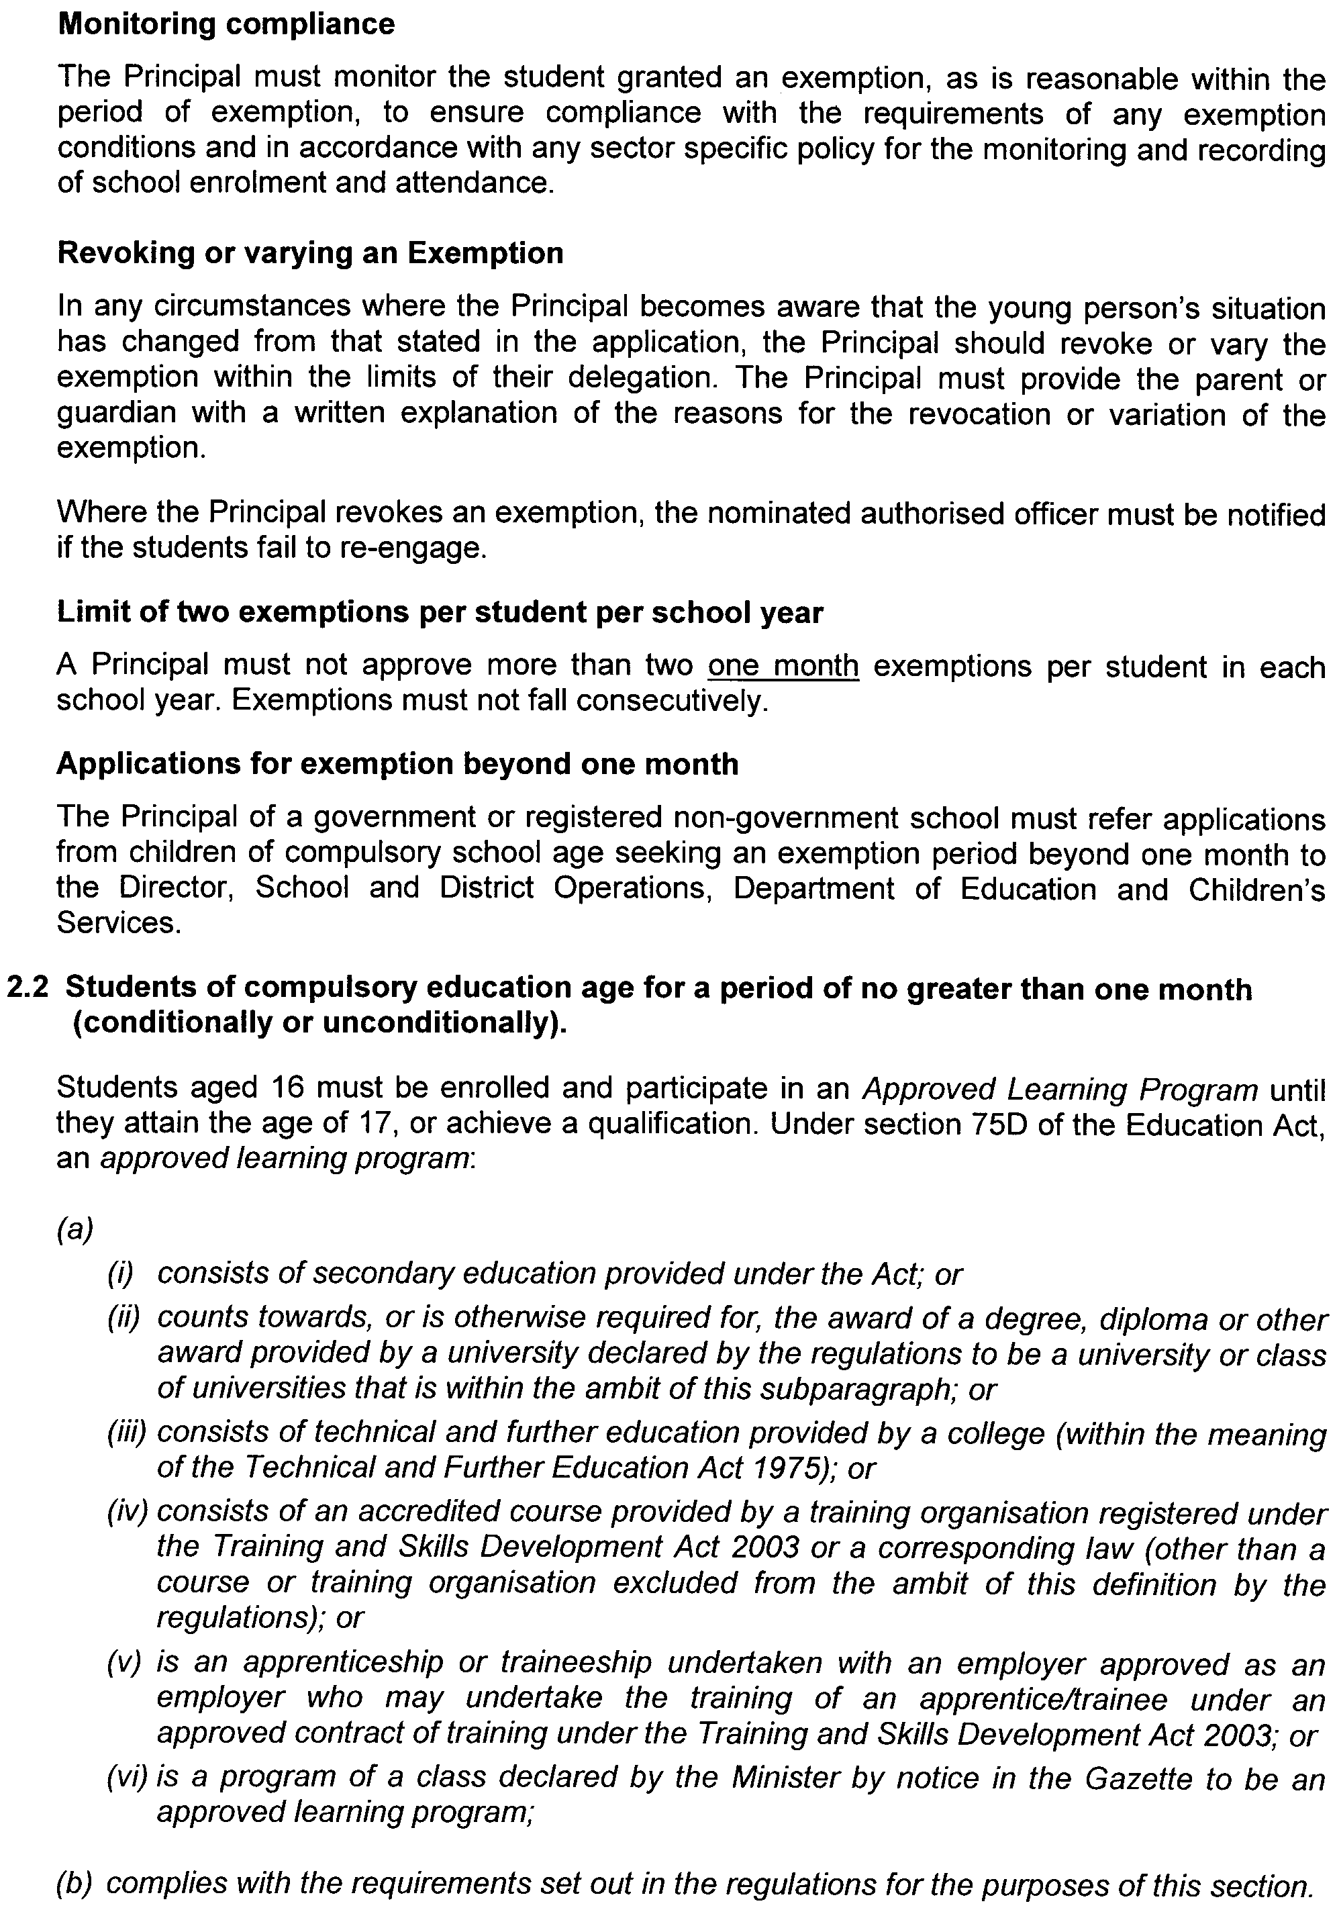
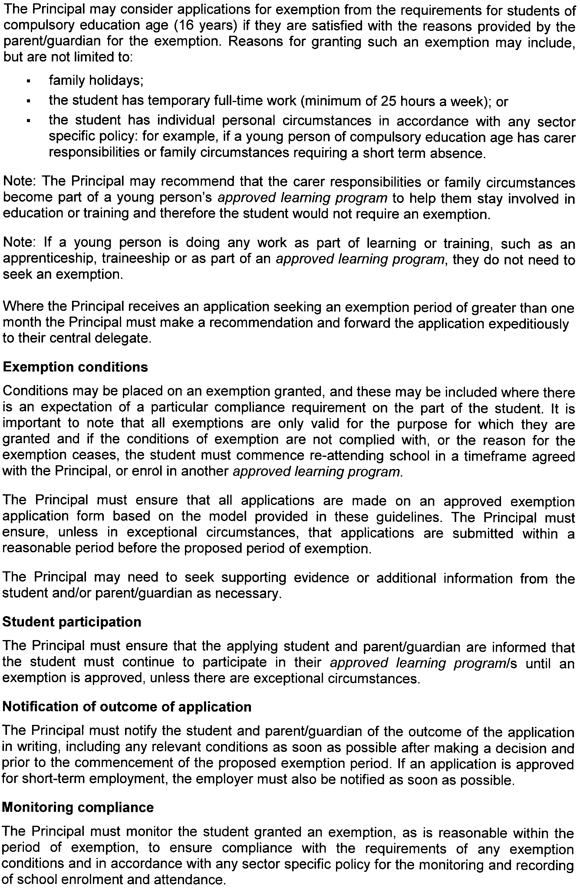
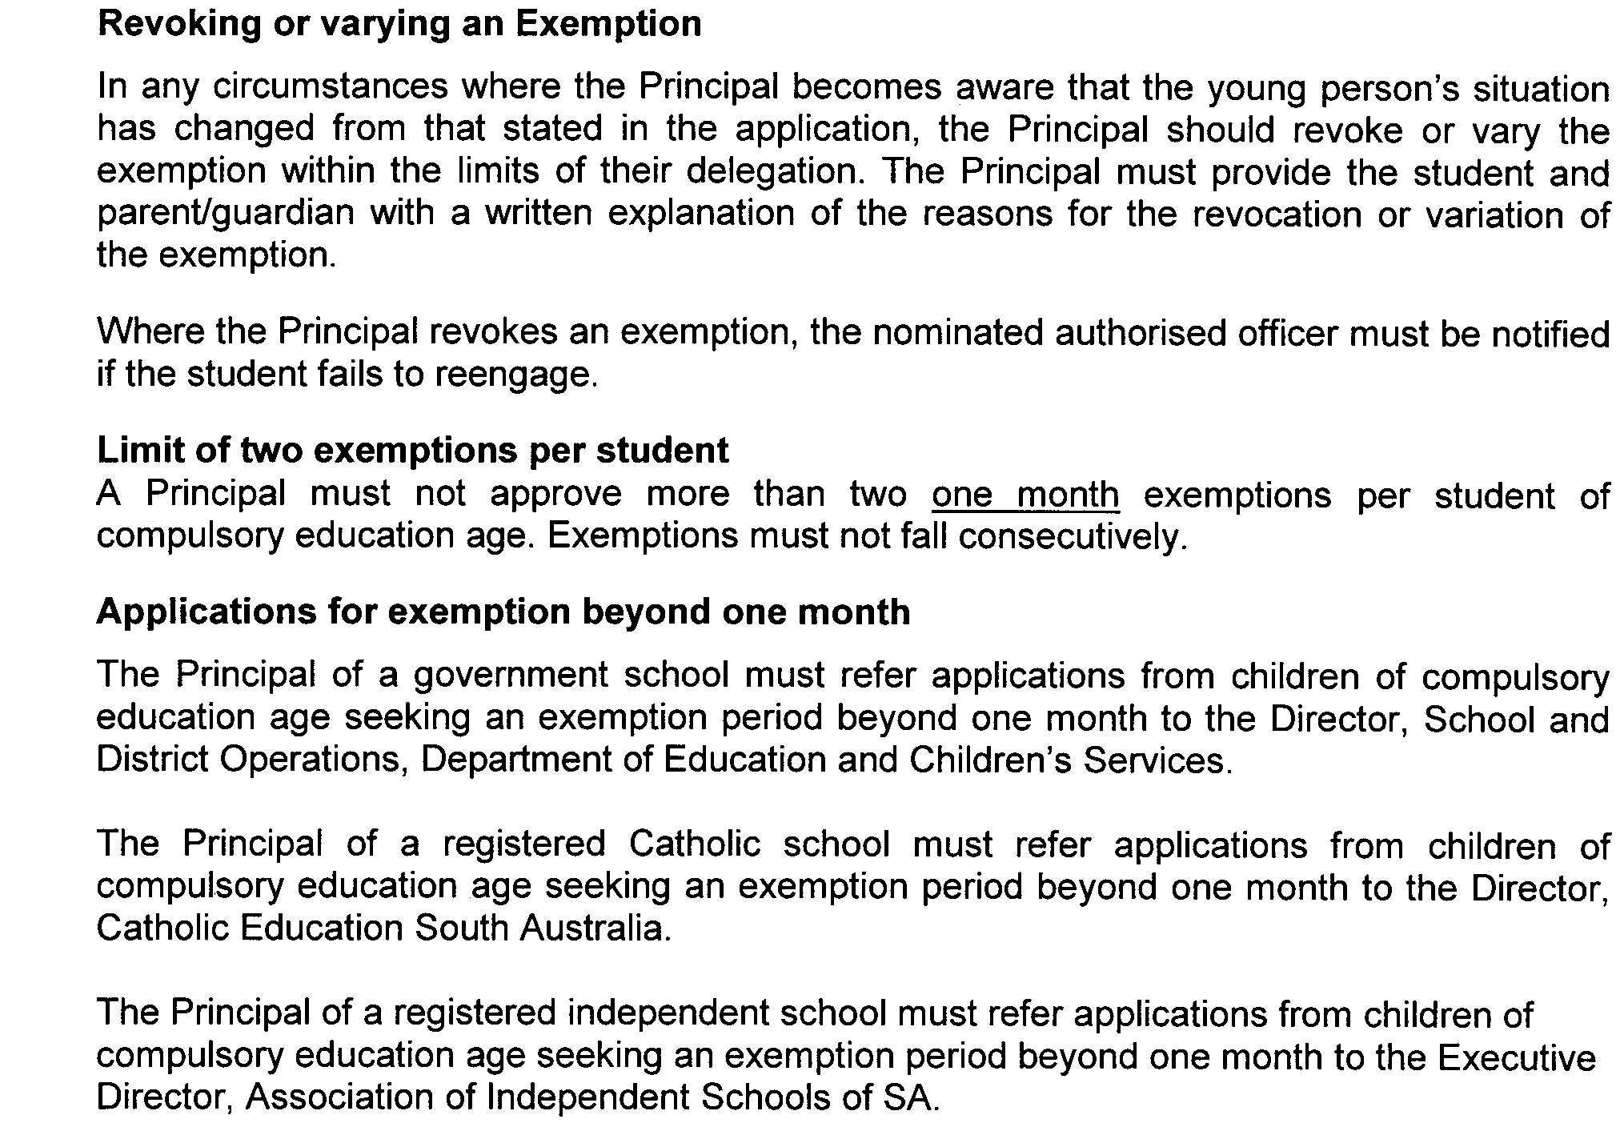
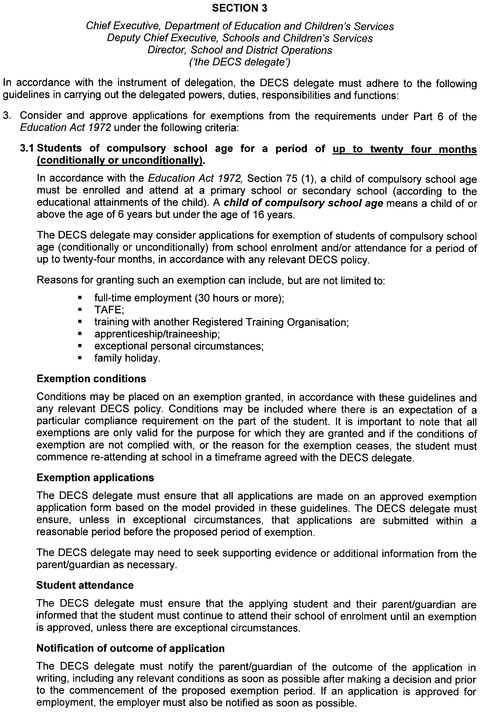
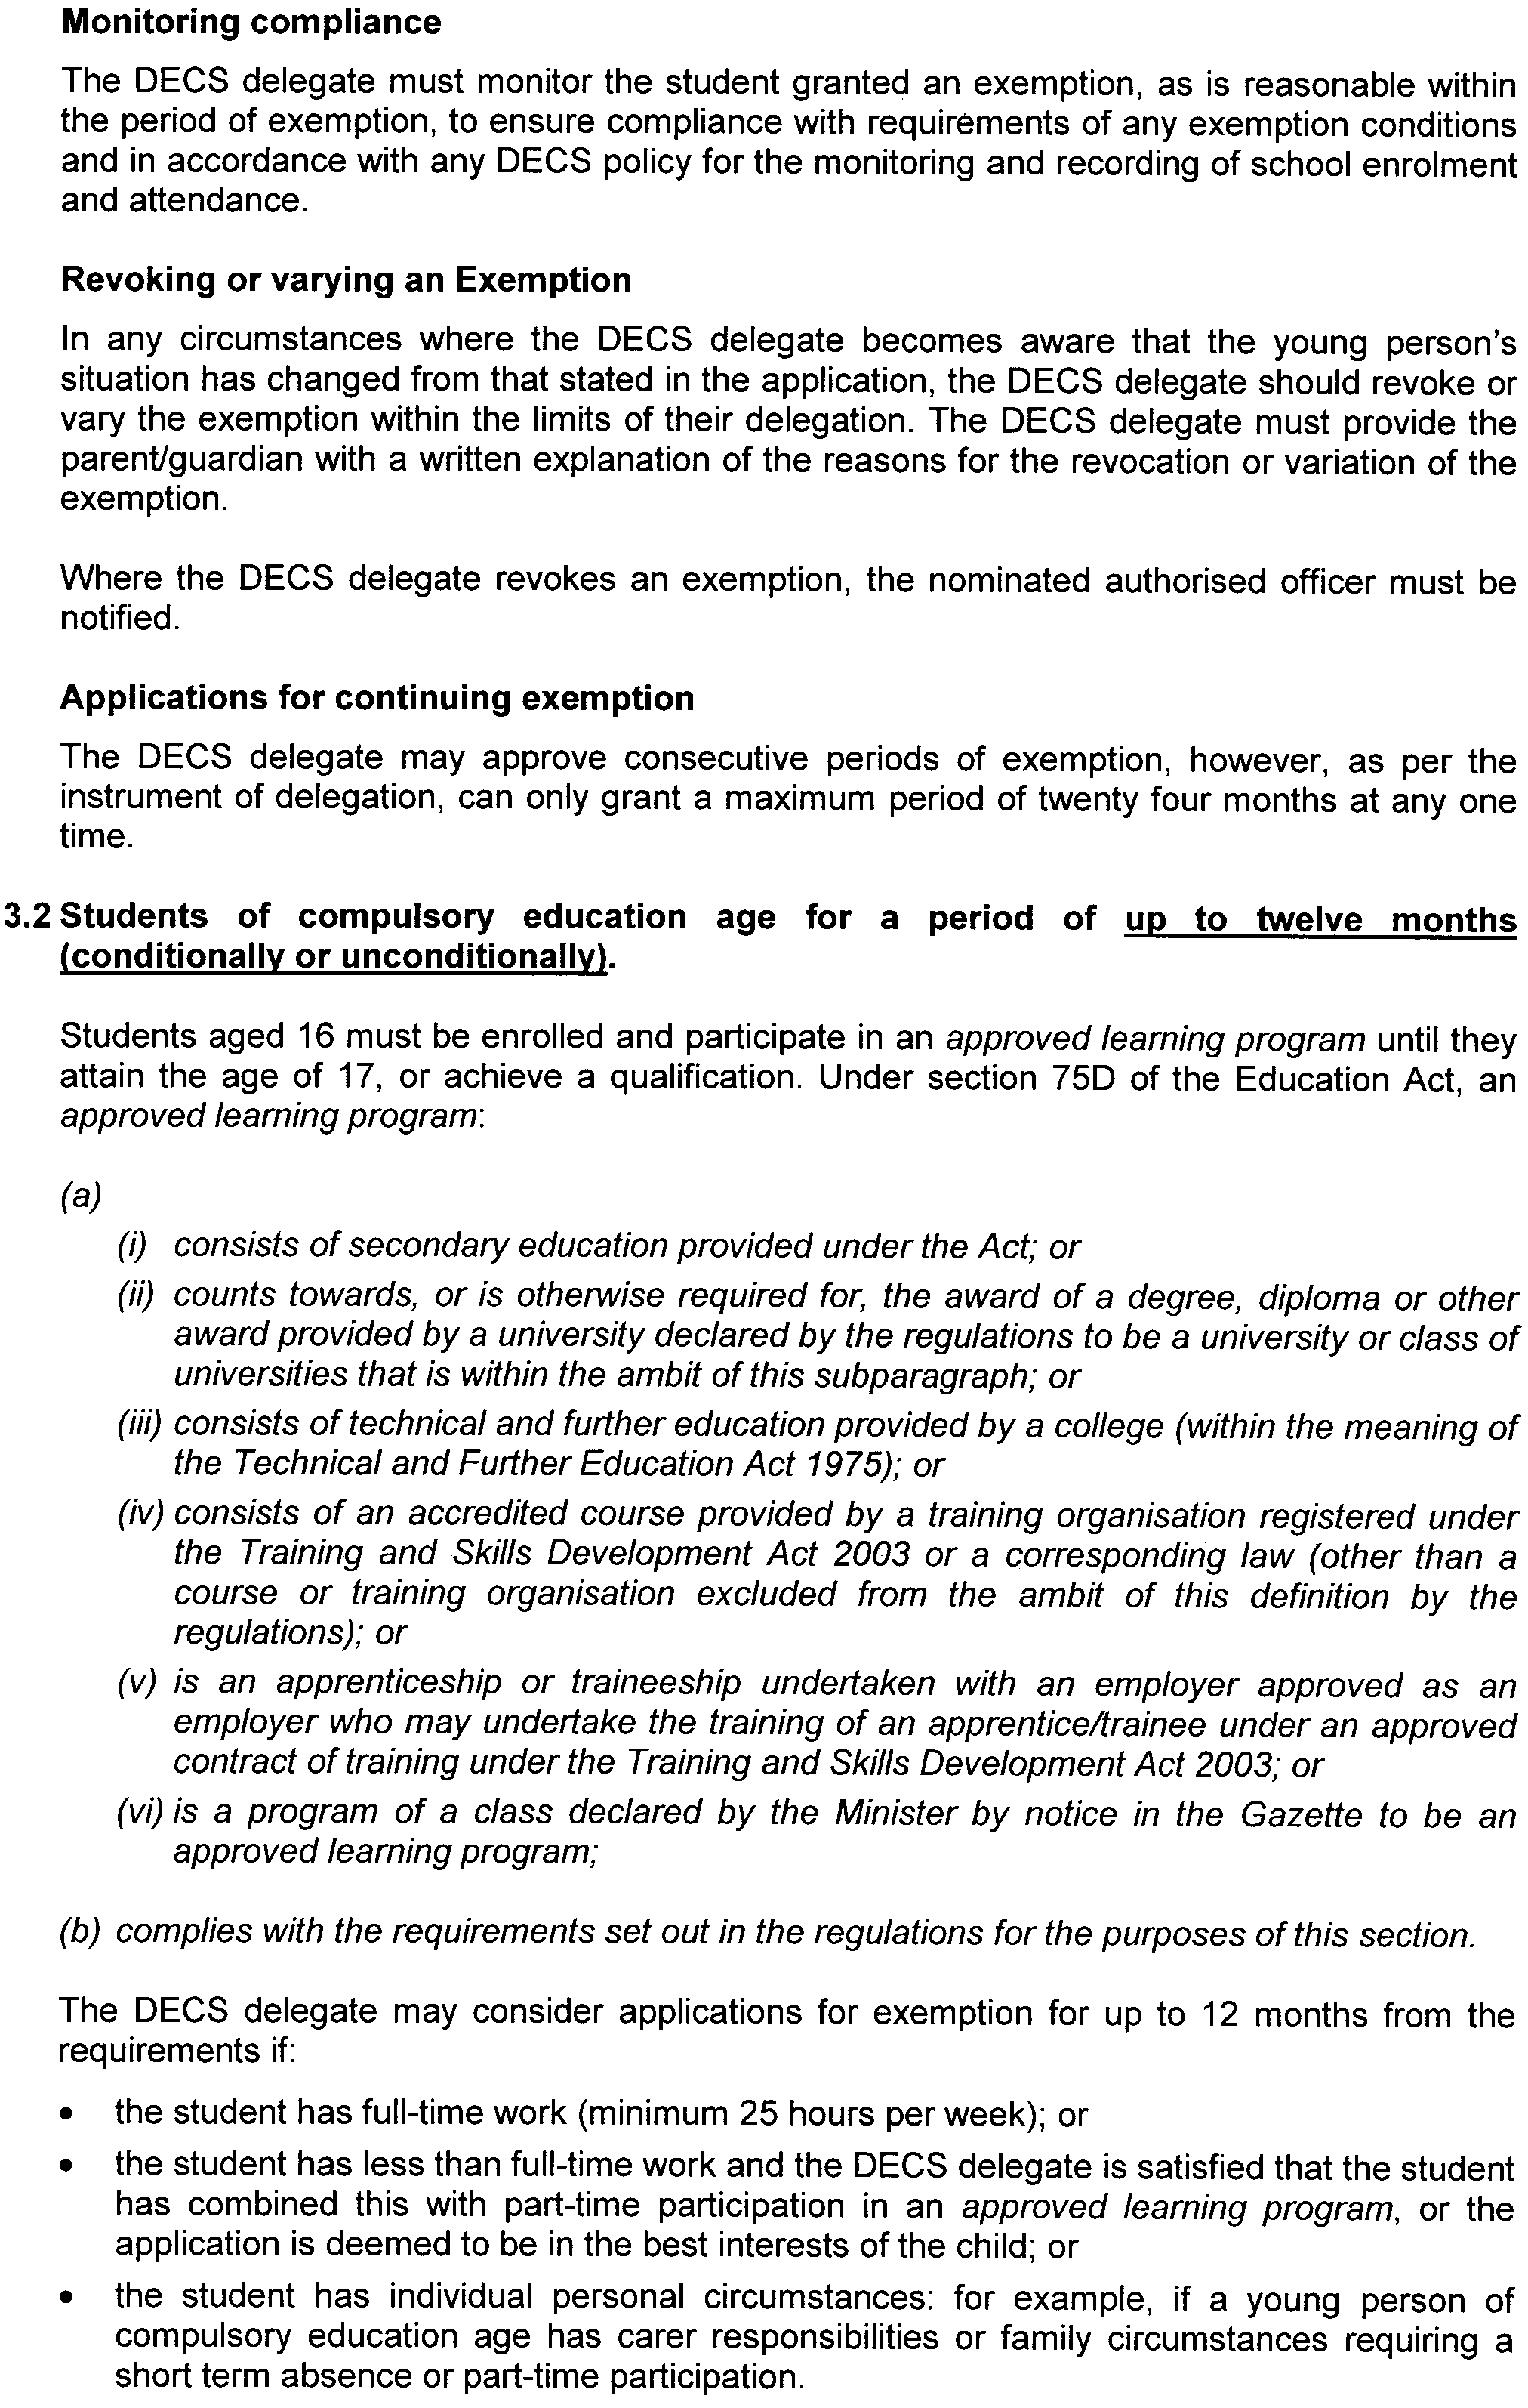
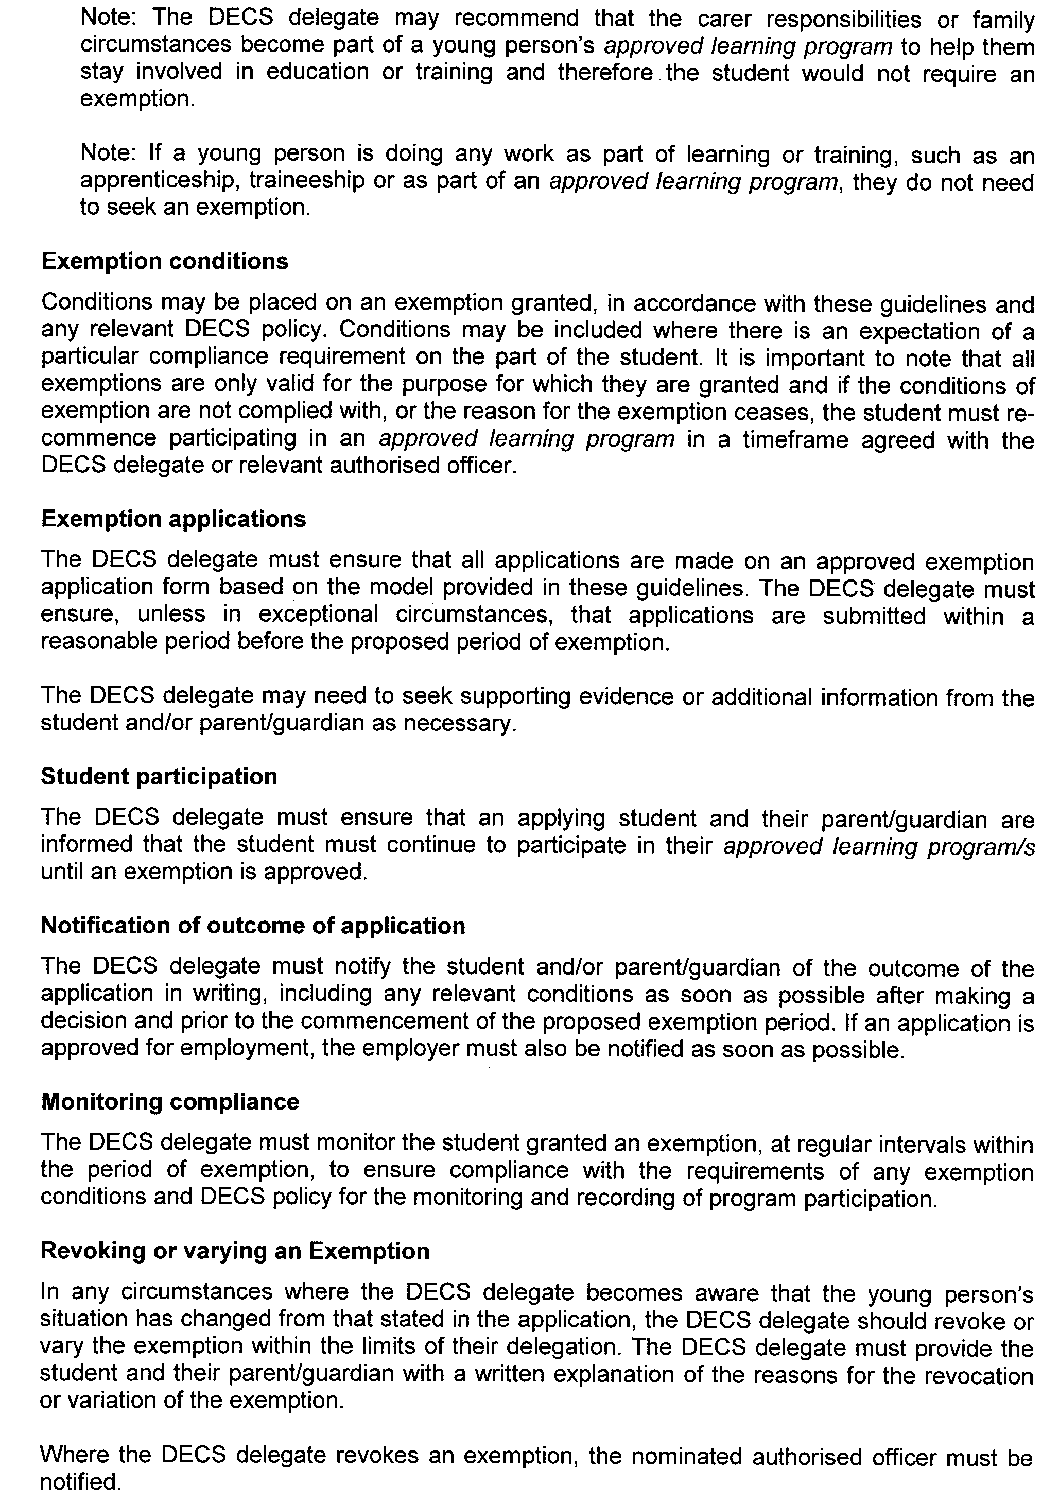

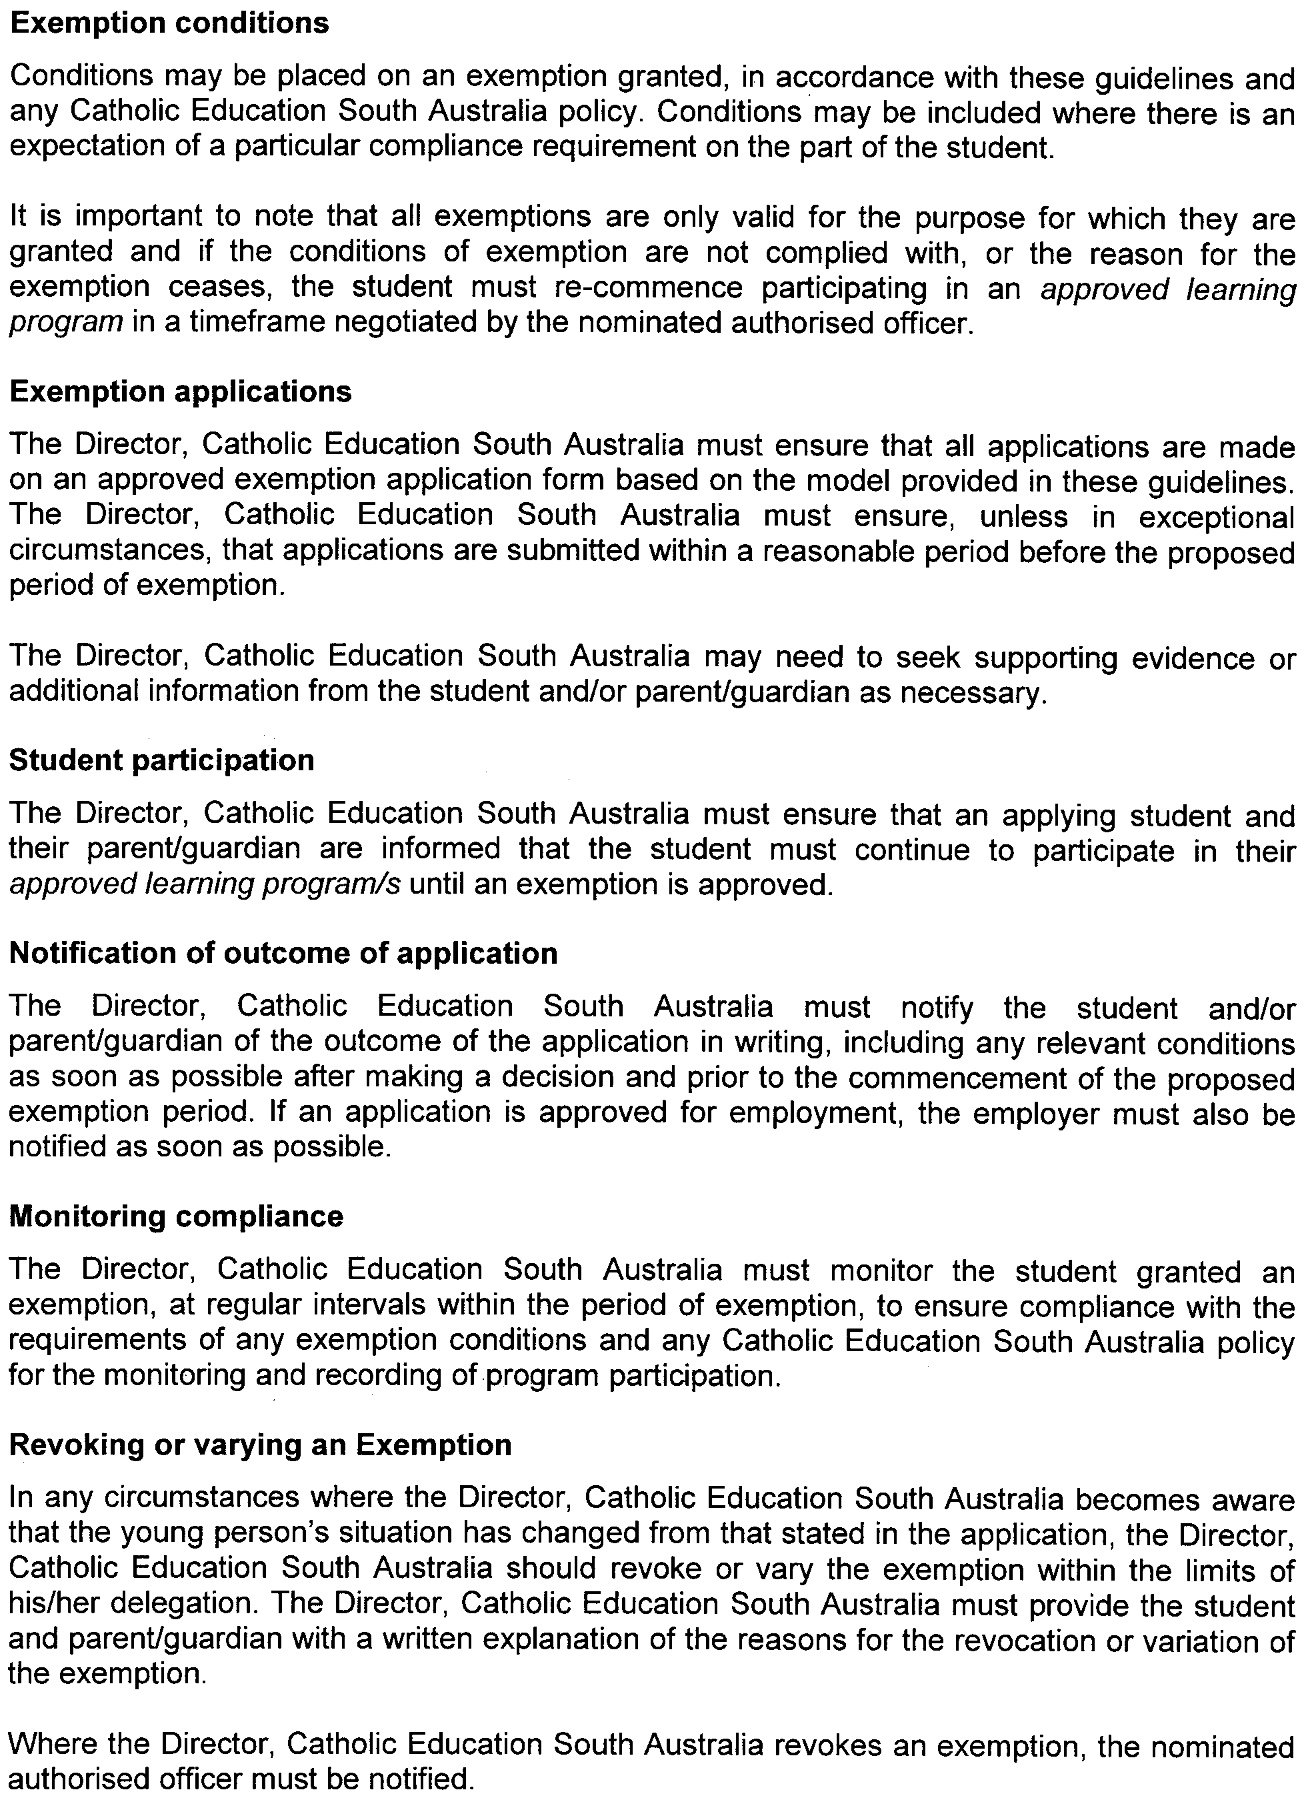
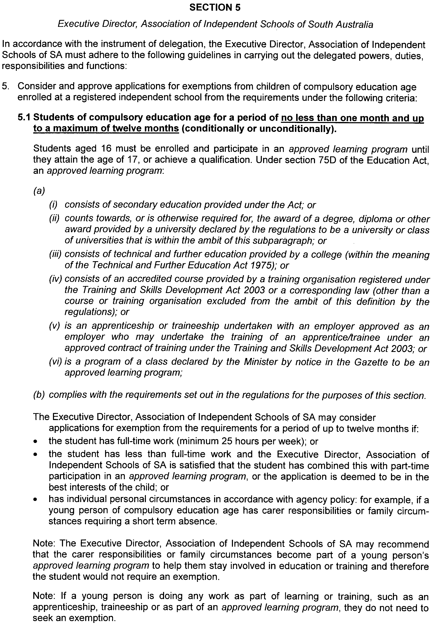
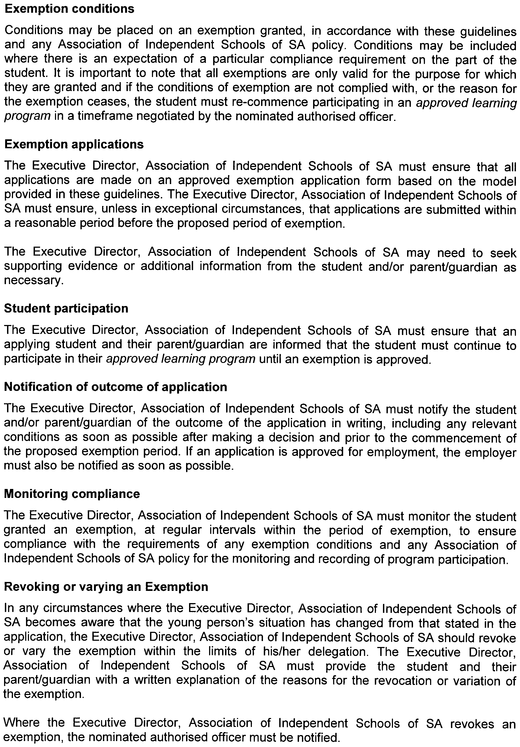
Dated 29 October 2008.
Jane Lomax-Smith, Minister for Education

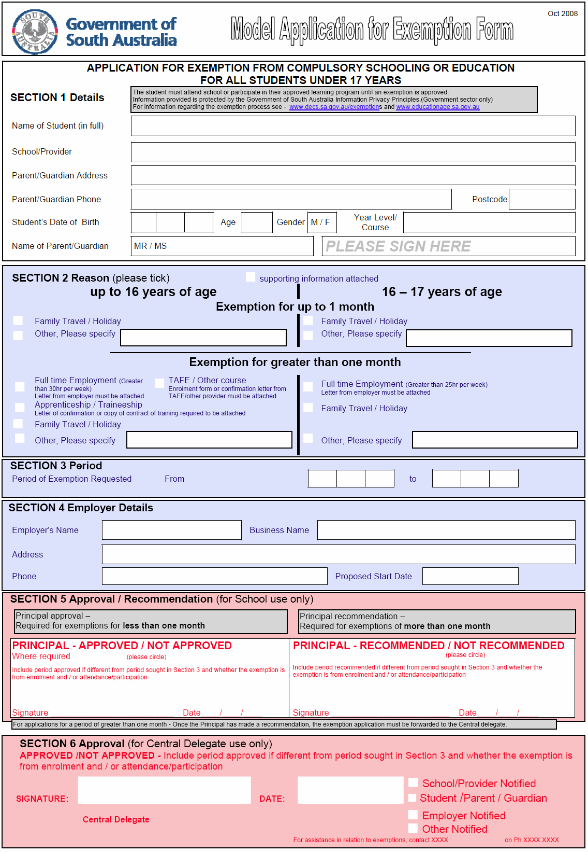

GOVERNMENT GAZETTE ADVERTISEMENT RATES

To apply from 1 July 2008

$  Agents, Ceasing to Act as 41.00  Associations:  Incorporation 20.80  Intention of Incorporation 51.50  Transfer of Properties 51.50  Attorney, Appointment of 41.00  Bailiff’s Sale 51.50  Cemetery Curator Appointed 30.50  Companies:  Alteration to Constitution 41.00  Capital, Increase or Decrease of 51.50  Ceasing to Carry on Business 30.50  Declaration of Dividend 30.50  Incorporation 41.00  Lost Share Certificates:  First Name 30.50  Each Subsequent Name 10.50  Meeting Final 34.25  Meeting Final Regarding Liquidator’s Report on  Conduct of Winding Up (equivalent to ‘Final  Meeting’)  First Name 41.00  Each Subsequent Name 10.50  Notices:  Call 51.50  Change of Name 20.80  Creditors 41.00  Creditors Compromise of Arrangement 41.00  Creditors (extraordinary resolution that ‘the Com-pany be wound up voluntarily and that a liquidator be appointed’) 51.50  Release of Liquidator⎯Application⎯Large Ad. 81.50  ⎯Release Granted 51.50  Receiver and Manager Appointed 47.50  Receiver and Manager Ceasing to Act 41.00  Restored Name 38.50  Petition to Supreme Court for Winding Up 71.50  Summons in Action 61.00  Order of Supreme Court for Winding Up Action 41.00  Register of Interests⎯Section 84 (1) Exempt 92.00  Removal of Office 20.80  Proof of Debts 41.00  Sales of Shares and Forfeiture 41.00  Estates:  Assigned 30.50  Deceased Persons⎯Notice to Creditors, etc. 51.50  Each Subsequent Name 10.50  Deceased Persons⎯Closed Estates 30.50  Each Subsequent Estate 1.35  Probate, Selling of 41.00  Public Trustee, each Estate 10.50 |  | $  Firms:  Ceasing to Carry on Business (each insertion) 27.25  Discontinuance Place of Business 27.25  Land⎯Real Property Act:  Intention to Sell, Notice of 51.50  Lost Certificate of Title Notices 51.50  Cancellation, Notice of (Strata Plan) 51.50  Mortgages:  Caveat Lodgement 20.80  Discharge of 21.80  Foreclosures 20.80  Transfer of 20.80  Sublet 10.50  Leases⎯Application for Transfer (2 insertions) each 10.50  Lost Treasury Receipts (3 insertions) each 30.50  Licensing 61.00  Municipal or District Councils:  Annual Financial Statement⎯Forms 1 and 2 574.00  Electricity Supply⎯Forms 19 and 20 408.00  Default in Payment of Rates:  First Name 81.50  Each Subsequent Name 10.50  Noxious Trade 30.50  Partnership, Dissolution of 30.50  Petitions (small) 20.80  Registered Building Societies (from Registrar-  General) 20.80  Register of Unclaimed Moneys⎯First Name 30.50  Each Subsequent Name 10.50  Registers of Members⎯Three pages and over:  Rate per page (in 8pt) 261.00  Rate per page (in 6pt) 345.00  Sale of Land by Public Auction 52.00  Advertisements 2.90  ¼ page advertisement 122.00  ½ page advertisement 244.00  Full page advertisement 478.00  Advertisements, other than those listed are charged at $2.90 per column line, tabular one-third extra.  Notices by Colleges, Universities, Corporations and District Councils to be charged at $2.90 per line.  Where the notice inserted varies significantly in length from that which is usually published a charge of $2.90 per column line will be applied in lieu of advertisement rates listed.  South Australian Government publications are sold on the condition that they will not be reproduced without prior permission from the Government Printer.
All the above prices include GST

GOVERNMENT GAZETTE NOTICES
ALL private advertisements forwarded for publication in the South Australian Government Gazette must be PAID FOR PRIOR TO INSERTION; and all notices, from whatever source, should be legibly written on one side of the paper only and sent to Government Publishing SA so as to be received no later than 4 p.m. Tuesday preceding the day of publication. Phone 8207 1045 or Fax 8207 1040. E-mail: governmentgazette@dpc.sa.gov.au. Send as attachments in Word format. Please include date the notice is to be published and to whom the notice will be charged. The Government Gazette is available online at: www.governmentgazette.sa.gov.au.

MISCELLANEOUS LEGISLATION AND GOVERNMENT PUBLICATIONS PRICES AS FROM 1 JULY 2008

Acts, Bills, Rules, Parliamentary Papers and Regulations
Pages | Main | Amends | Pages | Main | Amends

1-16 | 2.50 | 1.15 | 497-512 | 34.75 | 33.75
17-32 | 3.35 | 2.10 | 513-528 | 35.75 | 34.50
33-48 | 4.35 | 3.10 | 529-544 | 37.00 | 35.75
49-64 | 5.50 | 4.20 | 545-560 | 38.00 | 37.00
65-80 | 6.45 | 5.35 | 561-576 | 38.75 | 38.00
81-96 | 7.50 | 6.20 | 577-592 | 40.00 | 38.50
97-112 | 8.55 | 7.30 | 593-608 | 41.25 | 39.75
113-128 | 9.55 | 8.40 | 609-624 | 42.00 | 41.00
129-144 | 10.70 | 9.45 | 625-640 | 43.25 | 41.50
145-160 | 11.70 | 10.50 | 641-656 | 44.25 | 43.25
161-176 | 12.80 | 11.50 | 657-672 | 44.75 | 43.75
177-192 | 13.90 | 12.60 | 673-688 | 46.75 | 44.75
193-208 | 15.00 | 13.80 | 689-704 | 47.50 | 45.70
209-224 | 15.80 | 14.60 | 705-720 | 48.25 | 47.00
225-240 | 16.90 | 15.60 | 721-736 | 50.00 | 48.00
241-257 | 18.10 | 16.50 | 737-752 | 50.50 | 49.00
258-272 | 19.10 | 17.60 | 753-768 | 51.50 | 50.00
273-288 | 20.20 | 18.90 | 769-784 | 52.50 | 51.50
289-304 | 21.00 | 19.80 | 785-800 | 53.50 | 52.50
305-320 | 22.30 | 20.90 | 801-816 | 54.50 | 53.00
321-336 | 23.20 | 21.90 | 817-832 | 55.50 | 54.50
337-352 | 24.40 | 23.10 | 833-848 | 56.50 | 55.50
353-368 | 25.25 | 24.20 | 849-864 | 57.50 | 56.00
369-384 | 26.50 | 25.25 | 865-880 | 59.00 | 57.50
385-400 | 27.50 | 26.25 | 881-896 | 59.50 | 58.00
401-416 | 28.50 | 27.00 | 897-912 | 61.00 | 59.50
417-432 | 29.75 | 28.25 | 913-928 | 61.50 | 61.00
433-448 | 30.75 | 29.50 | 929-944 | 62.50 | 61.50
449-464 | 31.50 | 30.25 | 945-960 | 63.50 | 62.00
465-480 | 32.00 | 31.25 | 961-976 | 65.50 | 63.00
481-496 | 33.75 | 32.00 | 977-992 | 66.50 | 63.50

Legislation—Acts, Regulations, etc: $
Subscriptions:
Acts 214.00
All Bills as Laid 514.00
Rules and Regulations 514.00
Parliamentary Papers 514.00
Bound Acts 238.00
Index 119.00
Government Gazette
Copy 5.60
Subscription 284.00
Hansard
Copy 15.60
Subscription—per session (issued weekly) 446.00
Cloth bound—per volume 191.00
Subscription—per session (issued daily) 446.00
Legislation on Disk
Whole Database 3 304.00
Annual Subscription for fortnightly updates 1 015.00
Individual Act(s) including updates POA
Compendium
Subscriptions:
Subscriptions 1 957.00
Updates 690.00
(All the above prices include GST)

All Legislation, Government Gazette, Hansard and Legislation on disk are available from:
Counter Sales Government Legislation⁺ Outlet
and Mail Orders: Service SA Customer Service Centre,
Ground Floor—EDS Centre, 108 North Terrace, Adelaide, S.A. 5000
Phone: 13 23 24 (local call cost), Fax: (08) 8204 1909
Postal: G.P.O. Box 1707, Adelaide, S.A. 5001

Online Shop: www.shop.service.sa.gov.au

Subscriptions and Government Publishing SA
Standing Orders: Box 9, Plaza Level, Riverside Centre, North Terrace, Adelaide, S.A. 5000
Phone: (08) 8207 1043, (08) 8207 0910, Fax: (08) 8207 1040

DEVELOPMENT ACT 1993: SECTION 46 (1) and (4)
Preamble
As the Minister for Urban Development and Planning, I recently made a declaration under section 46 (1) (b) of the Development Act 1993, which was gazetted in the Gazette of 30 October 2008 at page 4960, and which I am satisfied ought to be revoked.
Section 46 (4) of the said Act allows me as the Minister for Urban Development and Planning to revoke the notice.
Subsection (1) of section 46 of the Development Act 1993, further allows me as the Minister for Urban Development and Planning to make a declaration if I am of the opinion that a declaration is appropriate or necessary for the proper assessment of development of major environmental, social or economic significance.
Notice
PURSUANT to section 46 (4) of the Development Act 1993, I hereby revoke the declaration gazetted in the Gazette of 30 October 2008 at page 4960.
Pursuant to subsection (1) (c) of section 46 of the Development Act 1993, being of the opinion that a declaration under section 46 of the Act is appropriate for the proper assessment of development of major social importance, I declare that section 46 of the Act applies to development as specified in Schedule 1.
Paul Holloway, Minister for Urban Development and Planning

Schedule 1
All development on land contained in the following certificate of titles, in the Hundred of Noarlunga in the area of Marino; namely, CT 5316/857, 5316/858, 5316/859, 5316/860.

FISHERIES MANAGEMENT ACT 2007: SECTION 79
TAKE notice that it will be unlawful for any person to engage in the class of fishing activity specified in Schedule 1, during the period specified in Schedule 2.
Schedule 1
The act of taking or the act preparatory to or involved in the taking of western king prawn (Melicertus latisulcatus) in all waters of the Spencer Gulf Prawn Fishery.
Schedule 2
From 2000 hours on 30 October 2008 to 0600 hours on 30 December 2009.
Dated 29 October 2008.
S. Sloan, Program Leader, Fisheries Management

FISHERIES MANAGEMENT ACT 2007: SECTION 79
TAKE note that the notice made under section 79 of the Fisheries Management Act 2007, dated 29 October 2008, referring to the Spencer Gulf Prawn Fishery, is hereby varied such that it will be unlawful for a person fishing pursuant to a Spencer Gulf Prawn Fishery Licence to use prawn trawl nets in the areas specified in Schedule 1 during the period specified in Schedule 2.
schedule 1
The waters of the Spencer Gulf Prawn Fishery that are:
1. North of the following co-ordinates: latitude 33°30.00′S, longitude 137°17.00′E, then to position latitude 33°30.00′S, longitude 137°30.00′E, then to position latitude 33°26.00′S, longitude 137°30.00′E, then to position latitude 33°26.00′S, longitude 137°34.00′E, then to position latitude 33°38.00′S, longitude 137°34.00′E, then to position latitude 33°46.00′S, longitude 137°44.00′E.
Except within the northern area commencing at position latitude 33°15.00′S, longitude 137°50.00′E, then to position latitude 33°15.00′S, longitude 137°37.00′E, then to position latitude 33°19.00′S, longitude 137°35.50′E, then to position latitude 33°24.00′S, longitude 137°35.50′E, then to position latitude 33°24.00′S, longitude 137°53.00′E.
2. South of the following co-ordinates: latitude 33°37.00′S, longitude 137°13.00′E, then to position latitude 33°47.00′S, longitude 137°23.00′E, then to position latitude 33°55.00′S, longitude 137°09.00′E, then to position latitude 33°59.00′S, longitude 137°12.00′E, then to position latitude 33°59.00′S, longitude 137°36.00′E.
Schedule 2
From 2030 hours on 31 October 2008 to 0600 hours on 6 November 2008.
Dated 31 October 2008.
S. Sloan, Program Leader, Fisheries Management

FISHERIES MANAGEMENT ACT 2007: SECTION 79
TAKE note that the notice made under section 79 of the Fisheries Management Act 2007, published in the South Australian Government Gazette, dated 7 December 2007, referring to the Spencer Gulf Prawn Fishery, is hereby revoked.
Dated 30 October 2008.
S. Sloan, Program Leader, Fisheries Management

FISHERIES MANAGEMENT ACT 2007: SECTION 79
TAKE note that the notice made under section 79 of the Fisheries Management Act 2007, dated 31 October 2008, referring to the Spencer Gulf Prawn Fishery, is hereby revoked.
Take note that the notice made under section 79 of the Fisheries Management Act 2007, dated 29 October 2008, referring to the Spencer Gulf Prawn Fishery, is hereby varied such that it will be unlawful for a person fishing pursuant to a Spencer Gulf Prawn Fishery Licence to use prawn trawl nets in the areas specified in Schedule 1 during the period specified in Schedule 2.
Schedule 1
The waters of the Spencer Gulf Prawn Fishery that are:
1. North of the following co-ordinates: latitude 33°30.00′S, longitude 137°17.00′E, then to position latitude 33°30.00′S, longitude 137°30.00′E, then to position latitude 33°26.00′S, longitude 137°30.00′E, then to position latitude 33°26.00′S, longitude 137°34.00′E, then to position latitude 33°38.00′S, longitude 137°34.00′E, then to position latitude 33°46.00′S, longitude 137°44.00′E.
Except within the northern area commencing at position latitude 33°15.20′S, longitude 137°50.00′E, then to position latitude 33°20.00′S, longitude 137°37.00′E, then to position latitude 33°19.00′S, longitude 137°35.90′E, then to position latitude 33°24.00′S, longitude 137°35.90′E, then to position latitude 33°24.00′S, longitude 137°53.00′E.
2. South of the following co-ordinates: latitude 33°37.00′S, longitude 137°13.00′E, then to position latitude 33°47.00′S, longitude 137°23.00′E, then to position latitude 33°55.00′S, longitude 137°09.00′E, then to position latitude 33°59.00′S, longitude 137°12.00′E, then to position latitude 33°59.00′S, longitude 137°36.00′E.
Schedule 2
From 2030 hours on 4 November 2008 to 0600 hours on 6 November 2008.
Dated 4 November 2008.
S. Sloan, Program Leader, Fisheries Management

FISHERIES MANAGEMENT ACT 2007: SECTION 79
TAKE note that the notice made under section 79 of the Fisheries Management Act 2007, published in the South Australian Govern-ment Gazette, dated 4 March 2008, referring to the West Coast Prawn Fishery, is hereby varied such that it will not be unlawful for a person fishing pursuant to a West Coast Prawn Fishery Licence to use prawn trawl nets in the waters specified in Schedule 1, under the conditions specified in Schedule 2, during the period specified in Schedule 3.
Schedule 1
The waters of the West Coast Prawn Fishery adjacent to Ceduna.
Schedule 2
1. Each licence holder must ensure that a representative sample of the catch (a ‘bucket count’) is taken for each trawl shot carried out during the fishing activity.
2. Each ‘bucket count’ sample must be accurately weighed to 7 kg where possible and the total number of prawns contained in the bucket must be recorded on the attached data sheet, marked ‘West Coast Prawn Fishery Bucket Count Data Sheet’.
3. The information recorded on the ‘WCPF Bucket Count Data Sheet’ must be returned to SARDI Aquatic Sciences within 15 days of the fishing activity being completed.
4. Fishing must cease if one or both of the following limits are reached:
(a) The average catch per vessel, per night (for all three vessels) drops below 300 kg for two consecutive nights.
(b) The average prawn ‘bucket count’ for all three vessels exceeds 250 prawns per bucket on any single fishing night in the Ceduna fishing area.
5. The fleet must nominate a licence holder to provide a daily update by telephone or SMS message to the PIRSA Fisheries Manager, to report the total prawn catch per night and the average prawn ‘bucket count’ information.
Schedule 3
From 2015 hours on 31 October 2008 to 0600 hours on 7 November 2008.
Dated 30 October 2008.
S. Sloan, Program Leader, Fisheries Management

FISHERIES MANAGEMENT ACT 2007: SECTION 79
TAKE note that the notice made under section 79 of the Fisheries Management Act 2007, dated 4 November 2008, referring to the Spencer Gulf Prawn Fishery, is hereby revoked.
Take note that the notice made under section 79 of the Fisheries Management Act 2007, dated 29 October 2008, referring to the Spencer Gulf Prawn Fishery, is hereby varied such that it will be unlawful for a person fishing pursuant to a Spencer Gulf Prawn Fishery Licence to use prawn trawl nets in the areas specified in Schedule 1 during the period specified in Schedule 2.
Schedule 1
The waters of the Spencer Gulf Prawn Fishery that are:
1. North of the following co-ordinates: latitude 33°30.20′S, longitude 137°17.00′E, then to position latitude 33°30.20′S, longitude 137°30.20′E, then to position latitude 33°26.20′S, longitude 137°30.20′E, then to position latitude 33°26.20′S, longitude 137°33.80′E, then to position latitude 33°38.00′S, longitude 137°33.80′E, then to position latitude 33°46.00′S, longitude 137°44.00′E.
Except within the northern area commencing at position latitude 33°15.40′S, longitude 137°50.00′E, then to position latitude 33°15.40′S, longitude 137°37.00′E, then to position latitude 33°19.00′S, longitude 137°36.10′E, then to position latitude 33°23.80′S, longitude 137°36.10′E, then to position latitude 33°23.80′S, longitude 137°53.00′E.
2. South of the following co-ordinates: latitude 33°37.00′S, longitude 137°13.00′E, then to position latitude 33°47.00′S, longitude 137°23.00′E, then to position latitude 33°55.00′S, longitude 137°09.00′E, then to position latitude 33°59.00′S, longitude 137°12.00′E, then to position latitude 33°59.00′S, longitude 137°36.00′E.
Schedule 2
From 2030 hours on 5 November 2008 to 0600 hours on 6 November 2008.
Dated 5 November 2008.
S. Sloan, Program Leader, Fisheries Management

FISHERIES MANAGEMENT ACT 2007: SECTION 115
TAKE notice that pursuant to section 115 of the Fisheries Management Act 2007, the holder of a prawn fishery licence issued pursuant to the Fisheries Management (Prawn Fisheries) Regulations 2006, for the Spencer Gulf Prawn Fishery listed in Schedule 1 (the ‘exemption holders’) or their registered master are exempt from sections 71, 72 and 79 of the Fisheries Management Act 2007, but only insofar as the exemption holders may undertake fishing activities within the Spencer Gulf Prawn Fishery for the purpose of a stock assessment survey and may retain berried female Bugs (Ibacus spp.) (the ‘exempted activity’), subject to the conditions contained in Schedule 2, from 29 October 2008 until 31 October 2008 inclusive, unless varied or revoked earlier.
Schedule 1
Licence  No. | Licence Holder | Boat Name
P03 | Ajka Pty Ltd | Kali II
P08 | Anton Blaslov | Grozdana B
P09 | Bartolomeo Puglisi | Angelina
P25 | Josip Mezic | Jadran
P29 | Mateo Ricov | Miss Rylee
P30 | Clarence Hood | Roslyn Ann
P32 | Peter Parissos | Australis II
P33 | Wellmet Pty Ltd | Beauie J
P37 | Rhyona Pty Ltd | Liberty V
Schedule 2
1. All trawling activity must be completed by 0600 hours on each day with nets out of the water.
2. The exempted activity may only be undertaken whilst undertaking a stock assessment survey for the Spencer Gulf Prawn Fishery.
3. The exemption holder must comply with instructions from the SARDI Stock Assessment Co-ordinator and work in the allotted trawl station.
4. All fish, other than prawns, southern calamari (Sepioteuthis australis) and bugs (Ibacus spp.) taken during the exempted activity for stock assessment purposes, are to be returned to the water immediately after capture.
5. All prawns, southern calamari and slipper lobster taken pursuant to this notice are to be processed in accordance with the instructions of the SARDI Stock Assessment Co-ordinator.
6. All berried female bugs must be provided to the South Australian Research and Development Institute in accordance with instructions from the SARDI Stock Assessment Co-ordinator and must not be retained by the exemption holder.
7. No berried female bugs may be removed from the boat unless provided directly to a SARDI employee.
8. The exemption holder must not contravene or fail to comply with the Fisheries Management Act 2007, or any other regulations made under that Act except where specifically exempted by this notice.
Dated 29 October 2008.
W. Zacharin, Director of Fisheries

HOUSING IMPROVEMENT ACT 1940
WHEREAS by notice published in the Government Gazette on the dates mentioned in the following table the South Australian Housing Trust did declare the houses described in the said table to be substandard for the purposes of Part 7 of the Housing Improvement Act 1940, the South Australian Housing Trust in the exercise of the powers conferred by the said Part, does hereby fix as the maximum rental per week which shall be payable subject to section 55 of the Residential Tenancies Act 1995, in respect of each house described in the following table the amount shown in the said table opposite the description of such house and this notice shall come into force on the date of this publication in the Gazette.
Address of House | Allotment, Section, etc. | Certificate of Title  Volume Folio | Date and page of Government Gazette in which notice declaring house to be substandard published | Maximum rental per week payable in respect of each house  $

42 New Road, Clare |  | Allotment 438 in Filed Plan 191000, Hundred of Clare | 5561 | 853 |  | 28.8.08, page 3840 | 125.00
3 Threlfall Avenue, Norwood |  | Allotment 78 in Filed Plan 100113, Hundred of Adelaide | 5093 | 102 |  | 26.11.87, page 1708 | 88.00  un-furnished  92.00 furnished

Dated at Adelaide, 4 November 2008. D. Huxley, Director, Corporate and Board Services

HOUSING IMPROVEMENT ACT 1940
WHEREAS by notice published in the Government Gazette on the dates mentioned in the following table the South Australian Housing Trust did declare the houses described in the said table to be substandard for the purposes of Part 7 of the Housing Improvement Act 1940, and whereas the South Australian Housing Trust is satisfied that each of the houses described hereunder has ceased to be substandard, notice is hereby given that, in exercise of the powers conferred by the said Part, the South Australian Housing Trust does hereby revoke the said declaration in respect of each house.
Address of House | Allotment, Section, etc. | Certificate of Title  Volume Folio | Date and page of Government Gazette in which notice declaring house to be substandard published

18 Gladstone Street, Adelaide |  | Allotment 115 in Filed Plan 182577, Hundred of Adelaide | 5575 | 122 |  | 14.1.65, page 89
Unit 4, 9 Irwin Street, Wallaroo |  | Allotment 3 in Filed Plan 158872, Hundred of Wallaroo | 5287 | 975 |  | 26.7.07, page 3177
Unit 7, 9 Irwin Street, Wallaroo |  | Allotment 3 in Filed Plan 158872, Hundred of Wallaroo | 5287 | 975 |  | 26.7.07, page 3177
31 Scotia Street, West Croydon |  | Allotment 132 in Deposited Plan 4001, Hundred of Yatala | 5721 | 365 |  | 24.11.05, page 3997
20 King Street, Norwood |  | Allotment 72, Hundred of Adelaide | 5248 | 940 |  | 29.4.93, page 1556

Dated at Adelaide, 4 November 2008. D. Huxley, Director, Corporate and Board Services

HOUSING IMPROVEMENT ACT 1940
NOTICE is hereby given that the South Australian Housing Trust in the exercise of the powers conferred by the Housing Improvement Act 1940, does hereby declare the houses described in the table hereunder to be substandard for the purposes of Part 7 of the Housing Improvement Act 1940.
No. of House and Street | Locality | Allotment, Section, etc. | Certificate of Title  Volume Folio

7 Farmer Street |  | Barmera | Allotment 402, Town of Barmera, Cobdogla Irrigation Area | 5938 | 540

Dated at Adelaide, 4 November 2008. D. Huxley, Director, Corporate and Board Services

GAMING MACHINES ACT 1992
Notice of Application for Gaming Machine Licence
NOTICE is hereby given, pursuant to section 29 of the Gaming Machines Act 1992, that M.G.G. Investments Pty Ltd as trustee for Royal Oak Hotel Unit Trust has applied to the Licensing Authority fo a Gaming Machine Licence in respect of premises situated at Main Road, Clarendon, S.A. 5157 and known as Royal Oak Hotel.
The application has been set down for callover on 5 December 2008 at 9 a.m.
Any person may object to the application by lodging a notice of objection in the prescribed form with the Liquor Licensing Commissioner, and serving a copy of the notice on the applicant at the applicant’s address given above, at least seven days before the callover date (viz: 28 November 2008).
The applicant’s address for service is c/o M.G.G. Investments Pty Ltd as trustee for Royal Oak Hotel Unit Trust, 47 Grants Gully Road, Clarendon, S.A. 5157.
Plans in respect of the premises the subject of the application are open to public inspection without fee at the Office of the Liquor Licensing Commissioner, 9th Floor, East Wing, G.R.E. Building, 50 Grenfell Street, Adelaide 5000.
Dated 30 October 2008.
Applicant

LIQUOR LICENSING ACT 1997 AND GAMING MACHINES ACT 1992
Notice of Application
NOTICE is hereby given, pursuant to section 52 of the Liquor Licensing Act 1997 and section 29 of the Gaming Machines Act 1992, that McPub Pty Ltd as trustee for the Gothic Unit Trust and John Quin Investments Pty Ltd as trustee for Avonlea Investments Trust have applied to the Licensing Authority for the transfer of a Hotel and Gaming Machine Licence in respect of premises situated at 317 Morphett Street, Adelaide, S.A. 5000, known as B.T’Z Hotel on Whitmore and to be known as The Whitmore Hotel.
The applications have been set down for hearing on 2 December 2008 at 9 a.m.
Any person may object to the application by lodging a notice of objection in the prescribed form with the Liquor and Gambling Commissioner and serving a copy of the notice on the applicants at the applicants’ address, at least seven days before the hearing date (viz: 25 November 2008).
The applicants’ address for service is c/o Duncan Basheer Hannon, G.P.O. Box 2, Adelaide, S.A. 5001 (Attention: David Tillett or Max Basheer).
Plans in respect of the premises the subject of the application are open to public inspection without fee at the Office of the Liquor and Gambling Commissioner, 9th Floor, East Wing, 50 Grenfell Street, Adelaide, S.A. 5000. Phone 8226 8410, Fax:
8226 8512. Email: olgc@agd.sa.gov.au.
Dated 28 October 2008.
Applicants

LIQUOR LICENSING ACT 1997 AND GAMING MACHINES ACT 1992
Notice of Application
NOTICE is hereby given, pursuant to section 52 of the Liquor Licensing Act 1997 and section 29 of the Gaming Machines Act 1992, that Alti Co. Pty Ltd as trustee for Alti Co. Trust has applied to the Licensing Authority for the transfer of a Hotel and Gaming Machine Licence in respect of premises situated at Railway Terrace, Wolseley, S.A. 5269 and known as Wolseley Hotel.
The applications have been set down for hearing on 8 December 2008 at 9 a.m.
Any person may object to the application by lodging a notice of objection in the prescribed form with the Liquor and Gambling Commissioner and serving a copy of the notice on the applicant at the applicant’s address, at least seven days before the hearing date (viz: 1 December 2008).
The applicant’s address for service is c/o Clelands Lawyers, 208 Carrington Street, Adelaide, S.A. 5000 (Attention: Leon McEvoy).
Plans in respect of the premises the subject of the application are open to public inspection without fee at the Office of the Liquor and Gambling Commissioner, 9th Floor, East Wing, 50 Grenfell Street, Adelaide, S.A. 5000. Phone 8226 8410, Fax:
8226 8512. Email: olgc@agd.sa.gov.au.
Dated 31 October 2008.
Applicant

LIQUOR LICENSING ACT 1997 AND GAMING MACHINES ACT 1992
Notice of Application
NOTICE is hereby given, pursuant to section 52 of the Liquor Licensing Act 1997 and section 29 of the Gaming Machines Act 1992, that Daly Hotel Group Pty Ltd as trustee for Daly Hotel Unit Trust has applied to the Licensing Authority for the transfer of a Hotel and Gaming Machine Licence in respect of premises situated at 126 Port Road, Hindmarsh, S.A. 5007 and known as Lady Daly Hotel.
The applications have been set down for hearing on 10 December 2008 at 9 a.m.
Any person may object to the application by lodging a notice of objection in the prescribed form with the Liquor and Gambling Commissioner and serving a copy of the notice on the applicant at the applicant’s address, at least seven days before the hearing date (viz: 3 December 2008).
The applicant’s address for service is c/o Duncan Basheer Hannon, Barristers and Solicitors, G.P.O. Box 2, Adelaide, S.A. 5001 (Attention: Max Basheer or David Tillett).
Plans in respect of the premises the subject of the application are open to public inspection without fee at the Office of the Liquor and Gambling Commissioner, 9th Floor, East Wing, 50 Grenfell Street, Adelaide, S.A. 5000. Phone 8226 8410, Fax:
8226 8512. Email: olgc@agd.sa.gov.au.
Dated 3 November 2008.
Applicant

LIQUOR LICENSING ACT 1997
Notice of Application
NOTICE is hereby given, pursuant to section 52 (2) (b) of the Liquor Licensing Act 1997, that Henley District & Old Scholars Football Club Inc. has applied to the Licensing Authority for Alterations, Redefinition and variation to an Extended Trading Authorisation in respect of premises situated at Atkins Street, Henley Beach, S.A. 5022 and known as Henley Football Club.
The application has been set down for callover on 5 December 2008 at 9 a.m.
Conditions
The following licence conditions are sought:
• Alterations and Redefinition to include a verandah adjoining the club rooms and paved area in front of the verandah as per plans lodged with this office.
• Variation to Extended Trading Authorisation to include the abovementioned areas.
Any person may object to the application by lodging a notice of objection in the prescribed form with the Liquor and Gambling Commissioner and serving a copy of the notice on the applicant at the applicant’s address, at least seven days before the callover date (viz: 28 November 2008).
The applicant’s address for service is c/o Henley District & Old Scholars Football Club Inc., P.O. Box 54, Henley Beach, S.A. 5022.
Plans in respect of the premises the subject of the application are open to public inspection without fee at the Office of the Liquor and Gambling Commissioner, 9th Floor, East Wing, 50 Grenfell Street, Adelaide, S.A. 5000. Phone 8226 8410, Fax:
8226 8512. Email: olgc@agd.sa.gov.au.
Dated 28 October 2008.
Applicant

LIQUOR LICENSING ACT 1997
Notice of Application
NOTICE is hereby given, pursuant to section 52 (2) (b) of the Liquor Licensing Act 1997, that the Murray Bridge & District Italian Association Inc. has applied to the Licensing Authority for a variation to an Extended Trading Authorisation in respect of premises situated at the corner of Grassmere and Lincoln Avenue, Murray Bridge, S.A. 5253 and known as Murray Bridge & District Italian Association.
The application has been set down for callover on 5 December 2008 at 9 a.m.
Conditions
The following licence conditions are sought:
• Variation to an Extended Trading Authorisation:
Friday: Midnight to 2 a.m. the following day; and
Saturday: Midnight to 2 a.m. the following day.
Any person may object to the application by lodging a notice of objection in the prescribed form with the Liquor and Gambling Commissioner and serving a copy of the notice on the applicant at the applicant’s address, at least seven days before the callover date (viz: 28 November 2008).
The applicant’s address for service is c/o The Murray Bridge & District Italian Association Inc., 3 Todd Avenue, Murray Bridge, S.A. 5253.
Plans in respect of the premises the subject of the application are open to public inspection without fee at the Office of the Liquor and Gambling Commissioner, 9th Floor, East Wing, 50 Grenfell Street, Adelaide, S.A. 5000. Phone 8226 8410, Fax:
8226 8512. Email: olgc@agd.sa.gov.au.
Dated 28 October 2008.
Applicant

LIQUOR LICENSING ACT 1997
Notice of Application
NOTICE is hereby given, pursuant to section 52 (2) (b) of the Liquor Licensing Act 1997, that Chrabaszcz W. Trzczinie Pty Ltd as trustee for R. & I. Patynowski Family Trust has applied to the Licensing Authority for a Producer’s Licence in respect of premises situated at 22 Fourth Street, Loxton, S.A. 5333 and to be known as Chrabaszcz W. Trzczinie Pty Ltd.
The application has been set down for callover on 5 December 2008 at 9 a.m.
Any person may object to the application by lodging a notice of objection in the prescribed form with the Liquor and Gambling Commissioner and serving a copy of the notice on the applicant at the applicant’s address, at least seven days before the callover date (viz: 28 November 2008).
The applicant’s address for service is c/o Chrabaszcz W. Trzczinie Pty Ltd, 22 Fourth Street, Loxton, S.A. 5333.
Plans in respect of the premises the subject of the application are open to public inspection without fee at the Office of the Liquor and Gambling Commissioner, 9th Floor, East Wing, 50 Grenfell Street, Adelaide, S.A. 5000. Phone 8226 8410, Fax:
8226 8512. Email: olgc@agd.sa.gov.au.
Dated 29 October 2008.
Applicant

LIQUOR LICENSING ACT 1997
Notice of Application
NOTICE is hereby given, pursuant to section 52 (2) (b) of the Liquor Licensing Act 1997, that South Adelaide Footballers’ Club Inc. has applied to the Licensing Authority for a variation to an Extended Trading Authorisation in respect of premises situated at 1 Lovelock Drive, Noarlunga Downs, S.A. 5158 and known as South Adelaide Footballers’ Club.
The application has been set down for callover on 5 December 2008 at 9 a.m.
Conditions
The following licence conditions are sought:
• Variation to an Extended Trading Authorisation:
Monday: Midnight to 2 a.m. the following day;
Tuesday: Midnight to 2 a.m. the following day;
Sunday: 8 a.m. to 11 a.m. and 8 p.m. to 2 a.m. the following day;
Christmas Day: Midnight to 2 a.m.;
Sunday Christmas Eve: 8 p.m. to 2 a.m. the following day;
Days preceding other Public Holidays: Midnight to 2 a.m. the following day; and
Sundays preceding Public Holidays: 8 p.m. to 2 a.m. the following day.
Any person may object to the application by lodging a notice of objection in the prescribed form with the Liquor and Gambling Commissioner and serving a copy of the notice on the applicant at the applicant’s address, at least seven days before the callover date (viz: 28 November 2008).
The applicant’s address for service is c/o South Adelaide Footballers’ Club Inc., 1 Lovelock Drive, Noarlunga Downs, S.A. 5168.
Plans in respect of the premises the subject of the application are open to public inspection without fee at the Office of the Liquor and Gambling Commissioner, 9th Floor, East Wing, 50 Grenfell Street, Adelaide, S.A. 5000. Phone 8226 8410, Fax:
8226 8512. Email: olgc@agd.sa.gov.au.
Dated 30 October 2008.
Applicant

LIQUOR LICENSING ACT 1997
Notice of Application
NOTICE is hereby given, pursuant to section 52 (2) (b) of the Liquor Licensing Act 1997, that Geunsoo So has applied to the Licensing Authority for a variation to an Extended Trading Authorisation in respect of premises situated at Basement 15, Hindley Street, Adelaide, S.A. 5000 and known as Jurohunghal.
The application has been set down for callover on 5 December 2008 at 9 a.m.
Conditions
The following licence conditions are sought:
• Variation to an Extended Trading Authorisation to apply to the whole of the premises for the following days and times:
Monday to Saturday: Midnight to 4 a.m. the following day;
Sunday: 8 p.m. to 4 a.m. the following day;
Maundy Thursday: Midnight to 2 a.m. the following day;
Christmas Eve: Midnight to 2 a.m.;
Sunday Christmas Eve: 8 p.m. to 2 a.m. the following day;
Days preceding other Public Holidays: Midnight to 4 a.m. the following day; and
Sundays preceding Public Holidays: 8 p.m. to 4 a.m. the following day.
Any person may object to the application by lodging a notice of objection in the prescribed form with the Liquor and Gambling Commissioner and serving a copy of the notice on the applicant at the applicant’s address, at least seven days before the callover date (viz: 28 November 2008).
The applicant’s address for service is c/o Martin Lee, Suite 412, 33 Pirie Street, Adelaide, S.A. 5000.
Plans in respect of the premises the subject of the application are open to public inspection without fee at the Office of the Liquor and Gambling Commissioner, 9th Floor, East Wing, 50 Grenfell Street, Adelaide, S.A. 5000. Phone 8226 8410, Fax:
8226 8512. Email: olgc@agd.sa.gov.au.
Dated 30 October 2008.
Applicant

LIQUOR LICENSING ACT 1997
Notice of Application
NOTICE is hereby given, pursuant to section 52 (2) (b) of the Liquor Licensing Act 1997, that Barossa Brauhaus Pty Ltd has applied to the Licensing Authority for Alterations and Redefinition in respect of premises situated at 41 Murray Street, Angaston, S.A. 5353 and known as Barossa Brauhaus.
The application has been set down for callover on 5 December 2008 at 9 a.m.
Conditions
The following licence conditions are sought:
• Alterations and Redefinition to include a new external store room and access ramp.
Any person may object to the application by lodging a notice of objection in the prescribed form with the Liquor and Gambling Commissioner and serving a copy of the notice on the applicant at the applicant’s address, at least seven days before the callover date (viz: 28 November 2008).
The applicant’s address for service is c/o Andrew Plush, 41 Murray Street, Angaston, S.A. 5353.
Plans in respect of the premises the subject of the application are open to public inspection without fee at the Office of the Liquor and Gambling Commissioner, 9th Floor, East Wing, 50 Grenfell Street, Adelaide, S.A. 5000. Phone 8226 8410, Fax:
8226 8512. Email: olgc@agd.sa.gov.au.
Dated 30 October 2008.
Applicant

LIQUOR LICENSING ACT 1997
Notice of Application
NOTICE is hereby given, pursuant to section 52 (2) (b) of the Liquor Licensing Act 1997, that Cynthia Diem Thuy Truong has applied to the Licensing Authority for a Restaurant Licence, Section 34 (1) (c) and Extended Trading Authorisation in respect of premises situated at Shop 2, Brooklyn Shopping Centre, 285 Henley Beach Road, Brooklyn Park, S.A. 5032 and to be known as Vietnam Sunrise.
The application has been set down for callover on 5 December 2008 at 9 a.m.
Conditions
The following licence conditions are sought:
• Approval under Section 34 (1) (c) to sell liquor for con-sumption on the licensed premises by persons:
(a) seated at a table; or
(b) attending a function at which food is provided.
• Extended Trading Authorisation:
Sunday: 8 p.m. to 11 p.m.
Any person may object to the application by lodging a notice of objection in the prescribed form with the Liquor and Gambling Commissioner and serving a copy of the notice on the applicant at the applicant’s address, at least seven days before the callover date (viz: 28 November 2008).
The applicant’s address for service is c/o Cynthia Truong, 1/44 Elizabeth Street, Torrensville, S.A. 5031.
Plans in respect of the premises the subject of the application are open to public inspection without fee at the Office of the Liquor and Gambling Commissioner, 9th Floor, East Wing, 50 Grenfell Street, Adelaide, S.A. 5000. Phone 8226 8410, Fax:
8226 8512. Email: olgc@agd.sa.gov.au.
Dated 30 October 2008.
Applicant

LIQUOR LICENSING ACT 1997
Notice of Application
NOTICE is hereby given, pursuant to section 52 (2) (b) of the Liquor Licensing Act 1997, that McLaren Vale Wine Company Pty Ltd has applied to the Licensing Authority for a Producer’s Licence in respect of premises situated at 22 Old Coach Road, Aldinga, S.A. 5173 and to be known as the Orchard Cafe.
The application has been set down for callover on 5 December 2008 at 9 a.m.
Any person may object to the application by lodging a notice of objection in the prescribed form with the Liquor and Gambling Commissioner and serving a copy of the notice on the applicant at the applicant’s address, at least seven days before the callover date (viz: 28 November 2008).
The applicant’s address for service is c/o McLaren Vale Wine Company Pty Ltd, 22 Old Coach Road, Aldinga, S.A. 5173.
Plans in respect of the premises the subject of the application are open to public inspection without fee at the Office of the Liquor and Gambling Commissioner, 9th Floor, East Wing, 50 Grenfell Street, Adelaide, S.A. 5000. Phone 8226 8410, Fax:
8226 8512. Email: olgc@agd.sa.gov.au.
Dated 30 October 2008.
Applicant

LIQUOR LICENSING ACT 1997
Notice of Application
NOTICE is hereby given, pursuant to section 52 (2) (b) of the Liquor Licensing Act 1997, that McLaren Vale Wine Company Pty Ltd has applied to the Licensing Authority for a Special Circumstances Licence in respect of premises situated at 22 Old Coach Road, Aldinga, S.A. 5173 and to be known as the Orchard Cafe.
The application has been set down for callover on 5 December 2008 at 9 a.m.
Conditions
The following licence conditions are sought:
• On Monday to Saturday from 8 a.m. to midnight and Sundays from 8 a.m. to 10 p.m., any liquor to a diner with or ancillary to a meal, or to a person attending a reception.
• Good Friday only with or ancillary to a meal provided by the licensee.
• Samples of liquor produced by McLaren Vale Wine Company Pty Ltd may be sold or supplied from Areas 4, 13 and 7 in disposable containers only, unless suitable glass washing facilities are provided.
• For consumption off the licensed premises restricted to liquor produced by McLaren Vale Wine Company Pty Ltd on Monday to Saturday from 8 a.m. to midnight and Sundays and Good Friday from 8 a.m. to 10 p.m.
Any person may object to the application by lodging a notice of objection in the prescribed form with the Liquor and Gambling Commissioner and serving a copy of the notice on the applicant at the applicant’s address, at least seven days before the callover date (viz: 28 November 2008).
The applicant’s address for service is c/o McLaren Vale Wine Company Pty Ltd, 22 Old Coach Road, Aldinga, S.A. 5173.
Plans in respect of the premises the subject of the application are open to public inspection without fee at the Office of the Liquor and Gambling Commissioner, 9th Floor, East Wing, 50 Grenfell Street, Adelaide, S.A. 5000. Phone 8226 8410, Fax:
8226 8512. Email: olgc@agd.sa.gov.au.
Dated 30 October 2008.
Applicant

LIQUOR LICENSING ACT 1997
Notice of Application
NOTICE is hereby given, pursuant to section 52 (2) (b) of the Liquor Licensing Act 1997, that Stuart William Robertson and Thomas Patrick McDonnell have applied to the Licensing Authority for a Special Circumstances Licence in respect of premises situated at Shop 3/155 King William Road, Hyde Park, S.A. 5061 and to be known as Tart Cafe and Catering.
The application has been set down for callover on 5 December 2008 at 9 a.m.
Conditions
The following licence conditions are sought:
• To authorise the sale, supply and consumption of liquor on the licensed premises by persons with or ancillary to a meal, seated at a table or attention a function at which food is provided between the hours of 8 a.m. to midnight on any day.
• To authorise the sale, supply and consumption of liquor at any time on any day at a place other than the licensed premises provided that such consumption is only by persons attending a pre-booked function at which food is provided.
Any person may object to the application by lodging a notice of objection in the prescribed form with the Liquor and Gambling Commissioner and serving a copy of the notice on the applicants at the applicants’ address, at least seven days before the callover date (viz: 28 November 2008).
The applicants’ address for service is c/o Wallmans Lawyers, 173 Wakefield Street, Adelaide, S.A. 5001 (Attention: Ben Allen or Sam Ngai).
Plans in respect of the premises the subject of the application are open to public inspection without fee at the Office of the Liquor and Gambling Commissioner, 9th Floor, East Wing, 50 Grenfell Street, Adelaide, S.A. 5000. Phone 8226 8410, Fax:
8226 8512. Email: olgc@agd.sa.gov.au.
Dated 30 October 2008.
Applicants

LIQUOR LICENSING ACT 1997
Notice of Application
NOTICE is hereby given, pursuant to section 52 (2) (b) of the Liquor Licensing Act 1997, that Parker Ministries Pty Ltd as trustee for MJP Family Trust has applied to the Licensing Authority for the transfer of a Special Circumstances Licence in respect of premises situated at Sturt Highway, Tanunda, S.A. 5325 and known as Barossa Junction.
The application has been set down for hearing on 9 December 2008 at 10 a.m.
Any person may object to the application by lodging a notice of objection in the prescribed form with the Liquor and Gambling Commissioner and serving a copy of the notice on the applicant at the applicant’s address, at least seven days before the hearing date (viz: 2 December 2008).
The applicant’s address for service is c/o Foreman Legal, 69 Mount Barker Road, Stirling, S.A. 5152.
Plans in respect of the premises the subject of the application are open to public inspection without fee at the Office of the Liquor and Gambling Commissioner, 9th Floor, East Wing, 50 Grenfell Street, Adelaide, S.A. 5000. Phone 8226 8410, Fax:
8226 8512. Email: olgc@agd.sa.gov.au.
Dated 31 October 2008.
Applicant

LIQUOR LICENSING ACT 1997
Notice of Application
NOTICE is hereby given, pursuant to section 52 (2) (b) of the Liquor Licensing Act 1997, that Callen Rex Medhurst has applied to the Licensing Authority for the transfer of a Hotel Licence in respect of premises situated at 3 Belvidere Road, Saddleworth, S.A. 5413 and known as Hotel Saddleworth.
The application has been set down for hearing on 10 December 2008 at 11 a.m.
Any person may object to the application by lodging a notice of objection in the prescribed form with the Liquor and Gambling Commissioner and serving a copy of the notice on the applicant at the applicant’s address, at least seven days before the hearing date (viz: 3 December 2008).
The applicant’s address for service is c/o Mellor Olsson Lawyers, Level 5, 80 King William Street, Adelaide, S.A. 5000.
Plans in respect of the premises the subject of the application are open to public inspection without fee at the Office of the Liquor and Gambling Commissioner, 9th Floor, East Wing, 50 Grenfell Street, Adelaide, S.A. 5000. Phone 8226 8410, Fax:
8226 8512. Email: olgc@agd.sa.gov.au.
Dated 3 November 2008.
Applicant

LIQUOR LICENSING ACT 1997
Notice of Application
NOTICE is hereby given, pursuant to section 52 (2) (b) of the Liquor Licensing Act 1997, that Harry Aristides Nestor, Angela Nestor, Dimitrios Nestor and Jennifer Mary Nestor have applied to the Licensing Authority for the transfer of a Restaurant Licence in respect of premises situated at 6 Lower Portrush Road, Marden, S.A. 5070 and known as Barnacle Bill Seafood Restaurant.
The application has been set down for hearing on 11 December 2008 at 10 a.m.
Any person may object to the application by lodging a notice of objection in the prescribed form with the Liquor and Gambling Commissioner and serving a copy of the notice on the applicants at the applicants’ address, at least seven days before the hearing date (viz: 4 December 2008).
The applicants’ address for service is c/o Harry Nestor, 6 Lower Portrush Road, Marden, S.A. 5070.
Plans in respect of the premises the subject of the application are open to public inspection without fee at the Office of the Liquor and Gambling Commissioner, 9th Floor, East Wing, 50 Grenfell Street, Adelaide, S.A. 5000. Phone 8226 8410, Fax:
8226 8512. Email: olgc@agd.sa.gov.au.
Dated 3 November 2008.
Applicants

MINING ACT 1971
NOTICE is hereby given in accordance with section 35A (1) of the Mining Act 1971, that two applications for mining leases over the undermentioned mineral claims have been received. Details of the proposal may be inspected at the Department of Primary Industries and Resources, Mineral Resources Group, Level 7, 101 Grenfell Street, Adelaide, S.A. 5000:
Applicant: Noel Richard Barrett
Claim Numbers: 4025 and 4026
Location: Section 3, Hundred of Cotton, approximately 21 km south-west of Lameroo.
Area: 16.9 hectares (MC 4025) and 28.2 hectares (MC 4026).
Purpose: For the recovery of calcrete and limestone.
Reference: T02747
A copy of the proposal has been provided to the Southern Mallee District Council.
Written submissions in relation to the granting of the mining leases are invited to be received at the Department of Primary Industries and Resources, Mineral Resources Group, Level 7, 101 Grenfell Street, Adelaide, S.A. 5000 or G.P.O. Box 1671, Adelaide, S.A. 5001 no later than 5 December 2008.
Copies of all submissions will be forwarded to the applicant and may be made available for public inspection unless confidentiality is requested.
H. Thomas, Mining Registrar

MINING ACT 1971
NOTICE is hereby given in accordance with section 35A (1) of the Mining Act 1971, that an application for a mining lease over the undermentioned mineral claims have been received. Details of the proposal may be inspected at the Department of Primary Industries and Resources, Mineral Resources Group, Level 7, 101 Grenfell Street, Adelaide, S.A. 5000:
Applicant: Centrex Metals Ltd
Claim Number: 3947 to 3950 (inclusive)
Location: Sections 38, 42 and 43, Hundred of Tooligie, approximately 57 km west of Cleve.
Area: Totalling 916 hectares.
Purpose: For the recovery of iron ore.
Reference: T02724
A copy of the proposal has been provided to the Elliston District Council and to the Cleve District Council.
Written submissions in relation to the granting of the mining leases are invited to be received at the Department of Primary Industries and Resources, Mineral Resources Group, Level 7, 101 Grenfell Street, Adelaide, S.A. 5000 or G.P.O. Box 1671, Adelaide, S.A. 5001 no later than 18 December 2008.
Copies of all submissions will be forwarded to the applicant and may be made available for public inspection unless confidentiality is requested.
H. Thomas, Mining Registrar

MINING ACT 1971
NOTICE is hereby given in accordance with section 28 (5) of the Mining Act 1971, that the Minister for Mineral Resources Development proposes to grant an Exploration Licence over the undermentioned area:
Applicant: Lynch Mining Pty Ltd
Location: Sheringa area⎯Approximately 110 km north-west of Port Lincoln.
Pastoral Lease: Hornes Lookout Station.
Term: 1 year
Area in km²: 342
Ref.: 2008/00407
Plan and co-ordinates can be found on the PIRSA Sarig website: http://www.minerals.pir.sa.gov.au/sarig or by phoning Mineral Tenements on (08) 8463 3103.
H. Thomas, Mining Registrar

MINING ACT 1971
NOTICE is hereby given in accordance with section 28 (5) of the Mining Act 1971, that the Minister for Mineral Resources Development proposes to grant an Exploration Licence over the undermentioned area:
Applicant: Red Metal Ltd
Location: Ooldea area⎯Approximately 250 km north-west of Ceduna.
Term: 1 year
Area in km²: 148
Ref.: 2008/00408
Plan and co-ordinates can be found on the PIRSA Sarig website: http://www.minerals.pir.sa.gov.au/sarig or by phoning Mineral Tenements on (08) 8463 3103.
H. Thomas, Mining Registrar

NATIONAL ELECTRICITY LAW
THE Australian Energy Market Commission (AEMC) gives notice under the National Electricity Law of the following matter.
Under section 95, the NGF has requested the making of the proposed National Electricity Amendment (Contingency Administered Price Cap Following a Physical Trigger Event) Rule 2008 (Project No. ERC0075). The proposal seeks to establish a Contingency Administered Price Period that would be triggered by certain types of disruptive events and incidents of the power system.
Submissions on this proposal can be forwarded to submissions@aemc.gov.au and must cite the Project No. in its title. Submissions must be received by 23 January 2008.
Submissions should be submitted in accordance with the AEMC’s Guidelines for making written submissions on Rule change proposals. The AEMC publishes all submissions on its website subject to a claim of confidentiality.
Further details on the above matter are available on the AEMC’s website www.aemc.gov.au. All documents in relation to the above matter are published on the AEMC’s website and are available for inspection at the offices of the AEMC.
John Tamblyn
Chairman
Australian Energy Market Commission
Level 5, 201 Elizabeth Street
Sydney, N.S.W. 2000
Telephone: (02) 8296 7800
Facsimile: (02) 8296 7899
6 November 2008.

NATIONAL PARKS AND WILDLIFE ACT 1972
Ngaut Ngaut Conservation Park Management Plan
I, JAY WEATHERILL, Minister for Environment and Conser-vation, hereby give notice under the provisions of section 38 of the National Parks and Wildlife Act 1972, that on 24 September 2008, I adopted a plan of management for Ngaut Ngaut Conservation Park.
Copies of the plan may be inspected at or obtained from the offices of the Department for Environment and Heritage at:
• DEH Information Line:
Level 1, 100 Pirie Street, Adelaide, S.A. 5000,
G.P.O. Box 1047, Adelaide, S.A. 5001,
Email: dehinformation@saugov.sa.gov.au,
Telephone 8204 1910;
• http://www.environment.sa.gov.au/parks/management/
plans.html
• DEH Murraylands/Riverland District Office, 28 Vaughan Terrace, Berri, Telephone 8854 3200.
Copies of this publication can be purchased at a cost of $10 per copy (plus $2 postage within South Australia) from the addresses above.
Jay Weatherill, Minister for Environment and Conservation

NATIONAL PARKS AND WILDLIFE (NATIONAL PARKS) REGULATIONS 2001
Closure of Simpson Desert Regional Reserve and
Simpson Desert Conservation Park
PURSUANT to Regulations 8 (3) (a) and 8 (3) (d) of the National Parks and Wildlife (National Parks) Regulations 2001, I, Edward Gregory Leaman, Director of National Parks and Wildlife, close to the public the whole of Simpson Desert Regional Reserve and
the whole of Simpson Desert Conservation Park from 6 p.m. on
Sunday, 30 November 2008 until 6 p.m. on Sunday, 15 March 2009.
The purpose of the closure is in the interest of public safety as a result of the anticipated high daytime temperatures likely to be experienced in the reserves during the closure period.
Dated 4 November 2008.
E. G. Leaman, Director of National Parks and Wildlife

NOTICE TO MARINERS
No. 57 of 2008
South Australia—Scientific Research Moorings Deployed
THE South Australian Research Development Institute have deployed two scientific research moorings in approximately 100 m depth of water in the following positions:
1. Latitude 35°50.166′S, longitude 136°26.826′E.
2. Latitude 35°16.213′S, longitude 135°41.095′E.
Each of the moorings is marked with a surface medium orange buoy with SARDI markings, one small white float and one small green float.
Mariners are advised to exercise caution when navigating within 500 m of the area.
Charts affected: Aus 343.
Adelaide, 28 October 2008.
Patrick Conlon, Minister for Transport
DTEI 2008/00767

PETROLEUM ACT 2000
Section 25 (5) (b)
Variation of Petroleum Exploration Licence—PEL 218
NOTICE is hereby given that under the provisions of the Petroleum Act 2000, pursuant to delegated powers dated 28 March 2002, Gazetted 11 April 2002, page 1573, the conditions of the abovementioned Exploration Licence have been varied as follows:
Condition 1 of the licence is omitted and the following substituted:
‘1. During the term of the licence, the licensee shall carry out or cause to be carried out exploratory operations on the area comprised in the licence in accordance with such work programs as are approved by the Minister from time to time. Years one to three exploratory operations are guaranteed and any subsequent licence year becomes guaranteed upon entry into any such licence year. These exploratory operations shall include but not necessarily be limited to:

Year of Term of Licence |  | Minimum Work Requirements
One |  | Acquire 180 km 2D seismic survey; and  Geological and Geophysical studies.
Two |  | Drill 2 wells; and  Acquire 100 km 2D seismic survey; and  Geological and Geophysical studies.
Three |  | Drill 2 wells; and  Acquire 100 km 2D seismic survey; and  Geological and Geophysical studies.
Four |  | Drill 2 wells
Five |  | Drill 2 wells
 |  |  | ’
The revised work requirements as a result of this variation would not have altered the outcome of the original competitive tender process.
Dated 30 October 2008.
B. A. Goldstein,
Director Petroleum and Geothermal
Minerals and Energy Resources
Primary Industries and Resources SA
Delegate of the Minister for Mineral
Resources Development

PETROLEUM ACT 2000
Grant of Geothermal Exploration Licences
NOTICE is hereby given that the undermentioned Geothermal Exploration Licences have been granted under the provisions of the Petroleum Act 2000, pursuant to delegated powers dated 28 March 2002, Gazetted 11 April 2002, page 1573.
No of  Licence | Licensee | Locality | Date of Expiry | Reference
GEL 378 | Stuart Petroleum  Limited | Cooper Basin, South Australia | 28 October 2013 | 27/2/524
GEL 379
GEL 380
GEL 381
GEL 382
GEL 383
GEL 384
GEL 385
GEL 386
GEL 387
GEL 388
GEL 389

Description of Area—GEL 378
All that part of the State of South Australia, bounded as follows:
Commencing at a point being the intersection of latitude 28°05′00″S AGD66 and longitude 139°25′00″E AGD66, thence east to longitude 139°36′00″E GDA94, south to latitude 28°06′00″S GDA94, west to longitude 139°35′00″E GDA94, south to latitude 28°16′00″S GDA94, east to longitude 139°37′00″E GDA94, south to latitude 28°17′00″S GDA94, east to longitude 139°41′00″E GDA94, south to latitude 28°19′00″S GDA94, west to longitude 139°25′00″E AGD66 and north to the point of commencement.
Area: 468 km² approximately.
Description of Area—GEL 379
All that part of the State of South Australia, bounded as follows:
Commencing at a point being the intersection of latitude 28°19′00″S GDA94 and longitude 139°30′00″E GDA94, thence east to longitude 139°41′00″E GDA94, south to latitude 28°31′00″S GDA94, east to longitude 139°45′00″E GDA94, south to latitude 28°40′00″S AGD66, west to longitude 139°38′00″E GDA94, north to latitude 28°32′00″S GDA94, west to longitude 139°37′00″E GDA94, north to latitude 28°27′00″S GDA94, west to longitude 139°31′00″E GDA94, north to latitude 28°20′00″S GDA94, west to longitude 139°30′00″E GDA94 and north to the point of commencement.
Area: 483 km² approximately.
Description of Area—GEL 380
All that part of the State of South Australia, bounded as follows:
Commencing at a point being the intersection of latitude 28°31′00″S GDA94 and longitude 139°45′00″E GDA94, thence east to longitude 139°57′00″E GDA94, south to latitude 28°33′00″S GDA94, east to longitude 140°04′00″E GDA94, south to latitude 28°40′00″S AGD66, west to longitude 139°45′00″E GDA94 and north to the point of commencement.
Area: 467 km² approximately.
Description of Area—GEL 381
All that part of the State of South Australia, bounded as follows:
Commencing at a point being the intersection of latitude 28°32′00″S GDA94 and longitude 140°08′00″E GDA94, thence east to longitude 140°15′00″E GDA94, south to latitude 28°33′00″S GDA94, east to longitude 140°16′00″E GDA94, south to latitude 28°34′00″S GDA94, west to longitude 140°09′00″E GDA94, south to latitude 28°40′00″S AGD66, west to longitude 140°04′00″E GDA94, north to latitude 28°33′00″S GDA94, east to longitude 140°08′00″E GDA94 and north to the point of commencement.
Area: 146 km² approximately.
Description of Area—GEL 382
All that part of the State of South Australia, bounded as follows:
Commencing at a point being the intersection of latitude 26°49′00″S GDA94 and longitude 140°45′00″E GDA94, east to the eastern border of the State of South Australia, thence southerly along the border of the said State to latitude 27°00′00″S GDA94, west to longitude 140°50′00″E GDA94, north to latitude 26°59′00″S GDA94, west to longitude 140°45′00″E GDA94 and north to the point of commencement.
Area: 488 km² approximately.
Description of Area—GEL 383
All that part of the State of South Australia, bounded as follows:
Commencing at a point being the intersection of latitude 27°00′00″S GDA94 and longitude 140°50′00″E GDA94, thence east to the eastern border of the State of South Australia, thence southerly along the border of the said State to latitude 27°15′00″S GDA94, west to longitude 140°49′00″E GDA94, north to latitude 27°02′00″S GDA94, east to longitude 140°50′00″E GDA94 and north to the point of commencement.
Area: 496 km² approximately.
Description of Area—GEL 384
All that part of the State of South Australia, bounded as follows:
Commencing at a point being the intersection of latitude 26°57′30″S GDA94 and longitude 140°32′00″E GDA94, thence east to longitude 140°45′00″E GDA94, south to latitude 26°59′00″S GDA94, east to longitude 140°50′00″E GDA94, south to latitude 27°02′00″S GDA94, west to longitude 140°49′00″E GDA94, south to latitude 27°07′00″S GDA94, west to longitude 140°32′00″E GDA94 and north to the point of commencement.
Area: 484 km² approximately.
Description of Area—GEL 385
All that part of the State of South Australia, bounded as follows:
Commencing at a point being the intersection of latitude 27°07′00″S GDA94 and longitude 140°29′00″E GDA94, thence east to longitude 140°49′00″E GDA94, south to latitude 27°15′00″S GDA94, west to longitude 140°29′00″E GDA94 and north to the point of commencement.
Area: 488 km² approximately.
Description of Area—GEL 386
All that part of the State of South Australia, bounded as follows:
Commencing at a point being the intersection of latitude 26°49′00″S GDA94 and longitude 140°20′00″E GDA94, thence east to longitude 140°30′00″E GDA94, south to latitude 26°57′30″S GDA94, east to longitude 140°32′00″E GDA94, south to latitude 27°07′00″S GDA94, west to longitude 140°20′00″E GDA94, north to latitude 27°03′30″S GDA94, east to longitude 140°26′00″E GDA94, north to latitude 27°00′00″S GDA94, west to longitude 140°25′00″E GDA94, north to latitude 26°59′00″S GDA94, west to longitude 140°24′00″E GDA94, north to latitude 26°56′00″S GDA94, west to longitude 140°20′00″E GDA94 and north to the point of commencement.
Area: 492 km² approximately.
Description of Area—GEL 387
All that part of the State of South Australia, bounded as follows:
Commencing at a point being the intersection of latitude 27°07′00″S GDA94 and longitude 140°20′00″E GDA94, thence east to longitude 140°29′00″E GDA94, south to latitude 27°15′00″S GDA94, west to longitude 140°27′00″E GDA94, south to latitude 27°26′00″S GDA94, west to longitude 140°26′00″E GDA94, south to latitude 27°29′00″S GDA94, west to longitude 140°22′00″E GDA94, north to latitude 27°27′00″S GDA94, west to longitude 140°20′00″E GDA94 and north to the point of commencement.
Area: 496 km² approximately.
Description of Area—GEL 388
All that part of the State of South Australia, bounded as follows:
Commencing at a point being the intersection of latitude 27°15′00″S GDA94 and longitude 140°39′00″E GDA94, thence east to the eastern border of the State of South Australia, thence southerly along the border of the said State to latitude 27°23′00″S GDA94, west to longitude 140°53′00″E GDA94, north to latitude 27°22′00″S GDA94, west to longitude 140°52′00″E GDA94, north to latitude 27°19′00″S GDA94, west to longitude 140°47′00″E GDA94, south to latitude 27°25′00″S GDA94, west to longitude 140°39′00″E GDA94 and north to the point of commencement.
Area: 496 km² approximately.
Description of Area—GEL 389
All that part of the State of South Australia, bounded as follows:
Commencing at a point being the intersection of latitude 27°15′00″S GDA94 and longitude 140°27′00″E GDA94, thence east to longitude 140°39′00″E GDA94, south to latitude 27°26′00″S GDA94, west to longitude 140°38′00″E GDA94, south to latitude 27°27′00″S GDA94, west to longitude 140°35′00″E GDA94, south to latitude 27°29′00″S GDA94, west to longitude 140°26′00″E GDA94, north to latitude 27°26′00″S GDA94, east to longitude 140°27′00″E GDA94 and north to the point of commencement.
Area: 493 km² approximately.
Dated 29 October 2008.
B. A. Goldstein, Director Petroleum and Geothermal
Minerals and Energy Resources
Primary Industries and Resources SA
Delegate of the Minister for Mineral Resources Development

PETROLEUM ACT 2000
Grant of Geothermal Exploration Licences
NOTICE is hereby given that the undermentioned Geothermal Exploration Licences have been granted under the provisions of the Petroleum Act 2000, pursuant to delegated powers dated 28 March 2002, Gazetted 11 April 2002, page 1573.

No of  Licence | Licensee | Locality | Date of Expiry | Reference
GEL 366 | Green Rock Energy  Limited | Cooper Basin, South Australia | 29 October 2013 | 27/2/521
GEL 367
GEL 368
GEL 369
GEL 370
GEL 371
GEL 372
GEL 373
GEL 374
GEL 375
GEL 376

Description of Area—GEL 366
All that part of the State of South Australia, bounded as follows:
Commencing at a point being the intersection of latitude 26°30′00″S GDA94 and longitude 138°11′00″E GDA94, thence east to longitude 138°21′00″E GDA94, south to latitude 26°46′00″S GDA94, west to longitude 138°11′00″E GDA94 and north to the point of commencement.
Area: 491 km² approximately.
Description of Area—GEL 367
All that part of the State of South Australia, bounded as follows:
Commencing at a point being the intersection of latitude 26°30′00″S GDA94 and longitude 138°21′00″E GDA94, thence east to longitude 138°31′00″E GDA94, south to latitude 26°46′00″S GDA94, west to longitude 138°21′00″E GDA94 and north to the point of commencement.
Area: 491 km² approximately.
Description of Area—GEL 368
All that part of the State of South Australia, bounded as follows:
Commencing at a point being the intersection of latitude 26°30′00″S GDA94 and longitude 138°31′00″E GDA94, thence east to longitude 138°41′00″E GDA94, south to latitude 26°46′00″S GDA94, west to longitude 138°31′00″E GDA94 and north to the point of commencement.
Area: 491 km² approximately.
Description of Area—GEL 369
All that part of the State of South Australia, bounded as follows:
Commencing at a point being the intersection of latitude 26°26′00″S GDA94 and longitude 138°41′00″E GDA94, thence east to longitude 138°51′00″E GDA94, south to latitude 26°42′00″S GDA94, west to longitude 138°41′00″E GDA94 and north to the point of commencement.
Area: 491 km² approximately.
Description of Area—GEL 370
All that part of the State of South Australia, bounded as follows:
Commencing at a point being the intersection of latitude 26°26′00″S GDA94 and longitude 138°51′00″E GDA94, thence east to longitude 139°01′00″E GDA94, south to latitude 26°42′00″S GDA94, west to longitude 138°51′00″E GDA94 and north to the point of commencement.
Area: 491 km² approximately.
Description of Area—GEL 371
All that part of the State of South Australia, bounded as follows:
Commencing at a point being the intersection of latitude 26°26′00″S GDA94 and longitude 139°01′00″E GDA94, thence east to longitude 139°10′00″E GDA94, south to latitude 26°36′30″S GDA94, east to longitude 139°11′00″E GDA94, south to latitude 26°42′00″S GDA94, west to longitude 139°01′00″E GDA94 and north to the point of commencement.
Area: 458 km² approximately.
Description of Area—GEL 372
All that part of the State of South Australia, bounded as follows:
Commencing at a point being the intersection of latitude 26°36′30″S GDA94 and longitude 139°11′00″E GDA94, thence east to longitude 139°21′00″E GDA94, south to latitude 26°42′00″S GDA94, west to longitude 139°11′00″E GDA94 and north to the point of commencement.
Area: 169 km² approximately.
Description of Area—GEL 373
All that part of the State of South Australia, bounded as follows:
Commencing at a point being the intersection of latitude 26°46′00″S GDA94 and longitude 138°21′00″E GDA94, thence east to longitude 138°31′00″E GDA94, south to latitude 27°02′00″S GDA94, west to longitude 138°21′00″E GDA94 and north to the point of commencement.
Area: 490 km² approximately.
Description of Area—GEL 374
All that part of the State of South Australia, bounded as follows:
Commencing at a point being the intersection of latitude 26°46′00″S GDA94 and longitude 138°31′00″E GDA94, thence east to longitude 138°41′00″E GDA94, south to latitude 27°02′00″S GDA94, west to longitude 138°31′00″E GDA94 and north to the point of commencement.
Area: 490 km² approximately.
Description of Area—GEL 375
All that part of the State of South Australia, bounded as follows:
Commencing at a point being the intersection of latitude 27°02′00″S GDA94 and longitude 138°21′00″E GDA94, thence east to longitude 138°31′00″E GDA94, south to latitude 27°18′00″S GDA94, west to longitude 138°21′00″E GDA94 and north to the point of commencement.
Area: 488 km² approximately.
Description of Area—GEL 376
All that part of the State of South Australia, bounded as follows:
Commencing at a point being the intersection of latitude 27°02′00″S GDA94 and longitude 138°31′00″E GDA94, thence east to longitude 138°41′00″E GDA94, south to latitude 27°18′00″S GDA94, west to longitude 138°31′00″E GDA94 and north to the point of commencement.
Area: 488 km² approximately.
Dated 31 October 2008.
B. A. Goldstein, Director Petroleum and Geothermal
Minerals and Energy Resources
Primary Industries and Resources SA
Delegate of the Minister for Mineral Resources Development

PETROLEUM ACT 2000
Grant of Preliminary Survey Licence—PSL 19
NOTICE is hereby given that the abovementioned Preliminary Survey Licence has been granted with effect from 29 October 2008, under the provisions of the Petroleum Act 2000, pursuant to delegated powers dated 28 March 2002, Gazetted 11 April 2002, page 1573.

No. of  Licence | Licensee | Locality | Date of Expiry | Approx. Area  in km² | Reference
PSL 19 | Adelaide Energy Ltd | Otway Basin | 28 October 2009 | 350 | 27/2/547

General Description of Preliminary Survey Licence Area
All that part of the State of South Australia, bounded as follows:
Commencing at a point being the intersection of latitude 37°19′04″S GDA94 and longitude 140°41′18″E GDA94, thence east to longitude 140°54′01″E GDA94, south to latitude 37°29′10″S GDA94, west to longitude 140°41′18″E GDA94 and north to the point of commencement but excluding Penola Conservation Park and Mining Production Tenement Regulation Area SE 19 (Wetlands of the South East).
Dated 29 October 2008.
B. A. Goldstein, Director Petroleum and Geothermal
Minerals and Energy Resources
Primary Industries and Resources SA
Delegate of the Minister for Mineral Resources Development

South Australia
Marine Parks Act (Commencement) Proclamation 2008
1—Short title
This proclamation may be cited as the Marine Parks Act (Commencement) Proclamation 2008.
2—Commencement of suspended provisions
The remaining provisions of the Marine Parks Act 2007 (No 60 of 2007) will come into operation on 6 November 2008.
Made by the Governor
with the advice and consent of the Executive Council
on 6 November 2008
EHCS08/0025

South Australia
Highways (Road Closure—Princes Highway,
Burrungule) Proclamation 2008
under section 27AA of the Highways Act 1926
1—Short title
This proclamation may be cited as the Highways (Road Closure—Princes Highway, Burrungule) Proclamation 2008.
2—Commencement
This proclamation comes into operation on the day on which it is made.
3—Road closure
The portion of public road delineated as allotment 12 in approved Plan No FP 51199 lodged in the Lands Titles Registration Office is closed.
Made by the Governor
on the recommendation of the Commissioner of Highways and with the advice and consent of the Executive Council
on 6 November 2008
MTR08/054
South Australia
Highways (Road Closure—Sheoak Road, Crafers West) Proclamation 2008
under section 27AA of the Highways Act 1926
1—Short title
This proclamation may be cited as the Highways (Road Closure—Sheoak Road, Crafers West) Proclamation 2008.
2—Commencement
This proclamation comes into operation on the day on which it is made.
3—Road closure
The portion of public road delineated as allotment 10 in approved Plan No FP 50547 lodged in the Lands Titles Registration Office is closed.
Made by the Governor
on the recommendation of the Commissioner of Highways and with the advice and consent of the Executive Council
on 6 November 2008
MTR08/047

South Australia
Law of Property (Declaration of Body)
Proclamation 2008
under section 41A of the Law of Property Act 1936
1—Short title
This proclamation may be cited as the Law of Property (Declaration of Body) Proclamation 2008.
2—Commencement
This proclamation comes into operation on the day on which it is made.
3—Declaration of body
Marathon Water Pty Ltd (ACN 128 713 780) is declared to be a body for the purposes of section 41A(1)(a)(iii) of the Law of Property Act 1936.
Made by the Governor
with the advice and consent of the Executive Council
on 6 November 2008
AGO0077/08CS

South Australia
Tobacco Products Regulation (Exemption)
Proclamation 2008
under section 71 of the Tobacco Products Regulation Act 1997
1—Short title
This proclamation may be cited as the Tobacco Products Regulation (Exemption) Proclamation 2008.
2—Interpretation
In this proclamation—
Act means the Tobacco Products Regulation Act 1997;
prescribed production means the stage production of Rigoletto produced by the South Australian Opera Company and performed during the period ending 31 December 2008.
3—Application of proclamation
This proclamation applies to the following persons:
(a) a person employed by, or in relation to, the prescribed production;
(b) an occupier of the Adelaide Festival Centre; and
(c) an employer with responsibility for a workplace consisting of the Adelaide Festival Centre in relation to the prescribed production.
4—Exemption from section 46 of the Act
(1) A person to whom this proclamation applies is exempt from the operation of section 46 of the Act in relation to smoking occurring in the course of a performance, or rehearsal, of the prescribed production.
(2) An exemption under this clause is subject to the following conditions:
(a) smoking may only occur on a stage on which the prescribed production is being performed or rehearsed, or in a rehearsal room used in relation to the prescribed production;
(b) the area in which smoking may occur under the exemption must be well ventilated;
(c) a person may only smoke a tobacco product of a kind contemplated by paragraph (g) of the definition of tobacco product in section 4 of the Act.
(3) If a person contravenes or fails to comply with a condition of an exemption specified in subclause (2), the exemption does not, while the contravention or non-compliance continues, operate in that person's favour.
Made by the Governor
with the advice and consent of the Executive Council
on 6 November 2008
HEACS/08/321
South Australia
Youth Court (Designation and Classification of Special
Justices) Proclamation 2008
under section 9 of the Youth Court Act 1993
1—Short title
This proclamation may be cited as the Youth Court (Designation and Classification of Special Justices) Proclamation 2008.
2—Commencement
This proclamation comes into operation on the day on which it is made.
3—Designation and classification of special justices
The special justices named in Schedule 1 are—
(a) designated as special justices of the Youth Court of South Australia; and
(b) classified as members of the Court's ancillary judiciary; and
(c) declared to be members of the Court's ancillary judiciary for a term of 1 year.
Schedule 1—Special justices of the Court
Bryan Kenneth Hearn
Geoffrey Kenneth Penhall
Margot Ross Radford
Robert John Peebles Shaw
Made by the Governor
with the advice and consent of the Executive Council
on 6 November 2008
JP/08/052CS

South Australia
Public Corporations (General) Regulations 2008
under the Public Corporations Act 1993

Contents
1 Short title
2 Commencement
3 Interpretation
4 Disclosure of pecuniary interests

1—Short title
These regulations may be cited as the Public Corporations (General)
Regulations 2008.
2—Commencement
These regulations will come into operation 21 days after they are made.
3—Interpretation
In these regulations—
Act means the Public Corporations Act 1993.
4—Disclosure of pecuniary interests
(1) The table below specifies—
(a) the pecuniary interests to be disclosed by the following persons:
(i) a senior executive of a public corporation for the purposes of
section 36B of the Act;
(ii) a senior executive of a subsidiary for the purposes of clause 14B of
the Schedule to the Act; and
(b) the information that must be disclosed by the senior executive in respect of
any such pecuniary interest.

 | Pecuniary Interest | Information Required
1 | A contract of service, office, trade, vocation, business or profession in respect of which the person receives or is entitled to receive any remuneration, fee or other pecuniary sum (not being payable under the Act) | A description of the contract, office, trade, vocation, business or profession and the amount and source of the remuneration, fee or other pecuniary sum.
2 | An office held by the person (whether as a director or otherwise) in a company or other body (whether or not incorporated) in respect of which the person received or is entitled to receive any remuneration, fee or other pecuniary sum | The name and address of the company or other body and the amount of the remuneration, fee or other pecuniary sum.
3 | A company, partnership, association or other body in which the person is an investor | The name and address or description of the company, partnership, association or other body.
4 | Land in which the person has a beneficial interest (other than by way of security for a debt) | The address or description of the land.
5 | A trust (other than a testamentary trust) of which the person is a beneficiary or trustee | A description of the trust and the name and address of each trustee.
6 | Any other pecuniary interest of the person of a kind determined by the Minister | The information required by the Minister to be disclosed in respect of that pecuniary interest.
(2) For the purposes of this regulation—
(a) a reference to a beneficial interest in land includes a reference to a right to reacquire land;
(b) a person who is an object of a discretionary trust is to be taken to be a beneficiary of that trust;
(c) a person is an investor in a body if—
(i) the person has deposited money with, or lent money to, the body that has not been repaid and the amount not repaid equals or exceeds $10 000; or
(ii) the person holds, or has a beneficial interest in, shares in, or debentures of, the body or a policy of life insurance issued by the body.
Note—
As required by section 10AA(2) of the Subordinate Legislation Act 1978, the Minister has certified that, in the Minister's opinion, it is necessary or appropriate that these regulations come into operation as set out in these regulations.
Made by the Governor
with the advice and consent of the Executive Council
on 6 November 2008
No 282 of 2008
T&F08/063CS

South Australia
Liquor Licensing (Dry Areas—Short Term) Variation
Regulations 2008
under the Liquor Licensing Act 1997

Contents
Part 1—Preliminary
1 Short title
2 Commencement
3 Variation provisions
Part 2—Variation of Liquor Licensing (Dry Areas—Short Term) Regulations 1997
4 Variation of Schedule 1—Short term dry areas
5 Variation of Schedule 2—Plans of short term dry areas
Schedule 1—Plan to be substituted

Part 1—Preliminary
1—Short title
These regulations may be cited as the Liquor Licensing (Dry Areas—Short Term) Variation Regulations 2008.
2—Commencement
These regulations come into operation on the day on which they are made.
3—Variation provisions
In these regulations, a provision under a heading referring to the variation of specified regulations varies the regulations so specified.
Part 2—Variation of Liquor Licensing (Dry Areas—Short Term) Regulations 1997
4—Variation of Schedule 1—Short term dry areas
(1) Schedule 1, item headed "Victor Harbor—Area 1", column headed "Period"—delete "From 3 p.m. on 31 December 2007 to 8 a.m. on 1 January 2008." and substitute:
From 3 p.m. on 31 December 2008 to 8 a.m. on 1 January 2009.
(2) Schedule 1, item headed "Victor Harbor—Area 2", column headed "Area", description of area—delete "then south-easterly along that boundary of George Main Road to the north-western boundary of Victoria Street, then north-easterly along that boundary of Victoria Street to the north-eastern boundary of Oval Road, then generally northerly and north-westerly along that boundary of Oval Road to the south-eastern boundary of Lindsay Street," and substitute:
then north-westerly along that boundary of George Main Road to the point at which the north-eastern boundary of George Main Road meets the eastern boundary of Lot 11 DP 14245 (Victor Harbor High School), then north-easterly, north-westerly, north-easterly, north-westerly and south-westerly along that boundary of Lot 11 to the point at which it meets the south-eastern boundary of Kullaroo Road, then north-easterly along the south-eastern boundary of Kullaroo Road and the prolongation in a straight line of that boundary to the north-eastern boundary of Oval Road, then south-easterly along that boundary of Oval Road to the south-eastern boundary of Lindsay Street,
(3) Schedule 1, item headed "Victor Harbor—Area 2", column headed "Period"—delete "From 8 a.m. on 23 November 2007 to 10 p.m. on 1 December 2007." and substitute:
From 8 a.m. on 21 November 2008 to 10 p.m. on 29 November 2008.
(4) Schedule 1, item headed "Victor Harbor—Area 3", column headed "Period", (a), (b)—delete paragraphs (a) and (b) and substitute:
(a) From 8 a.m. on 21 November 2008 to 10 p.m. on 29 November 2008;
(b) From 3 p.m. on 31 December 2008 to 8 a.m. on 1 January 2009.
5—Variation of Schedule 2—Plans of short term dry areas
Schedule 2, plan headed "Victor Harbor—Plan 2"—delete the plan and substitute the plan headed "Victor Harbor—Plan 2" in Schedule 1 of these regulations
Schedule 1—Plan to be substituted
Victor Harbor—Plan 2
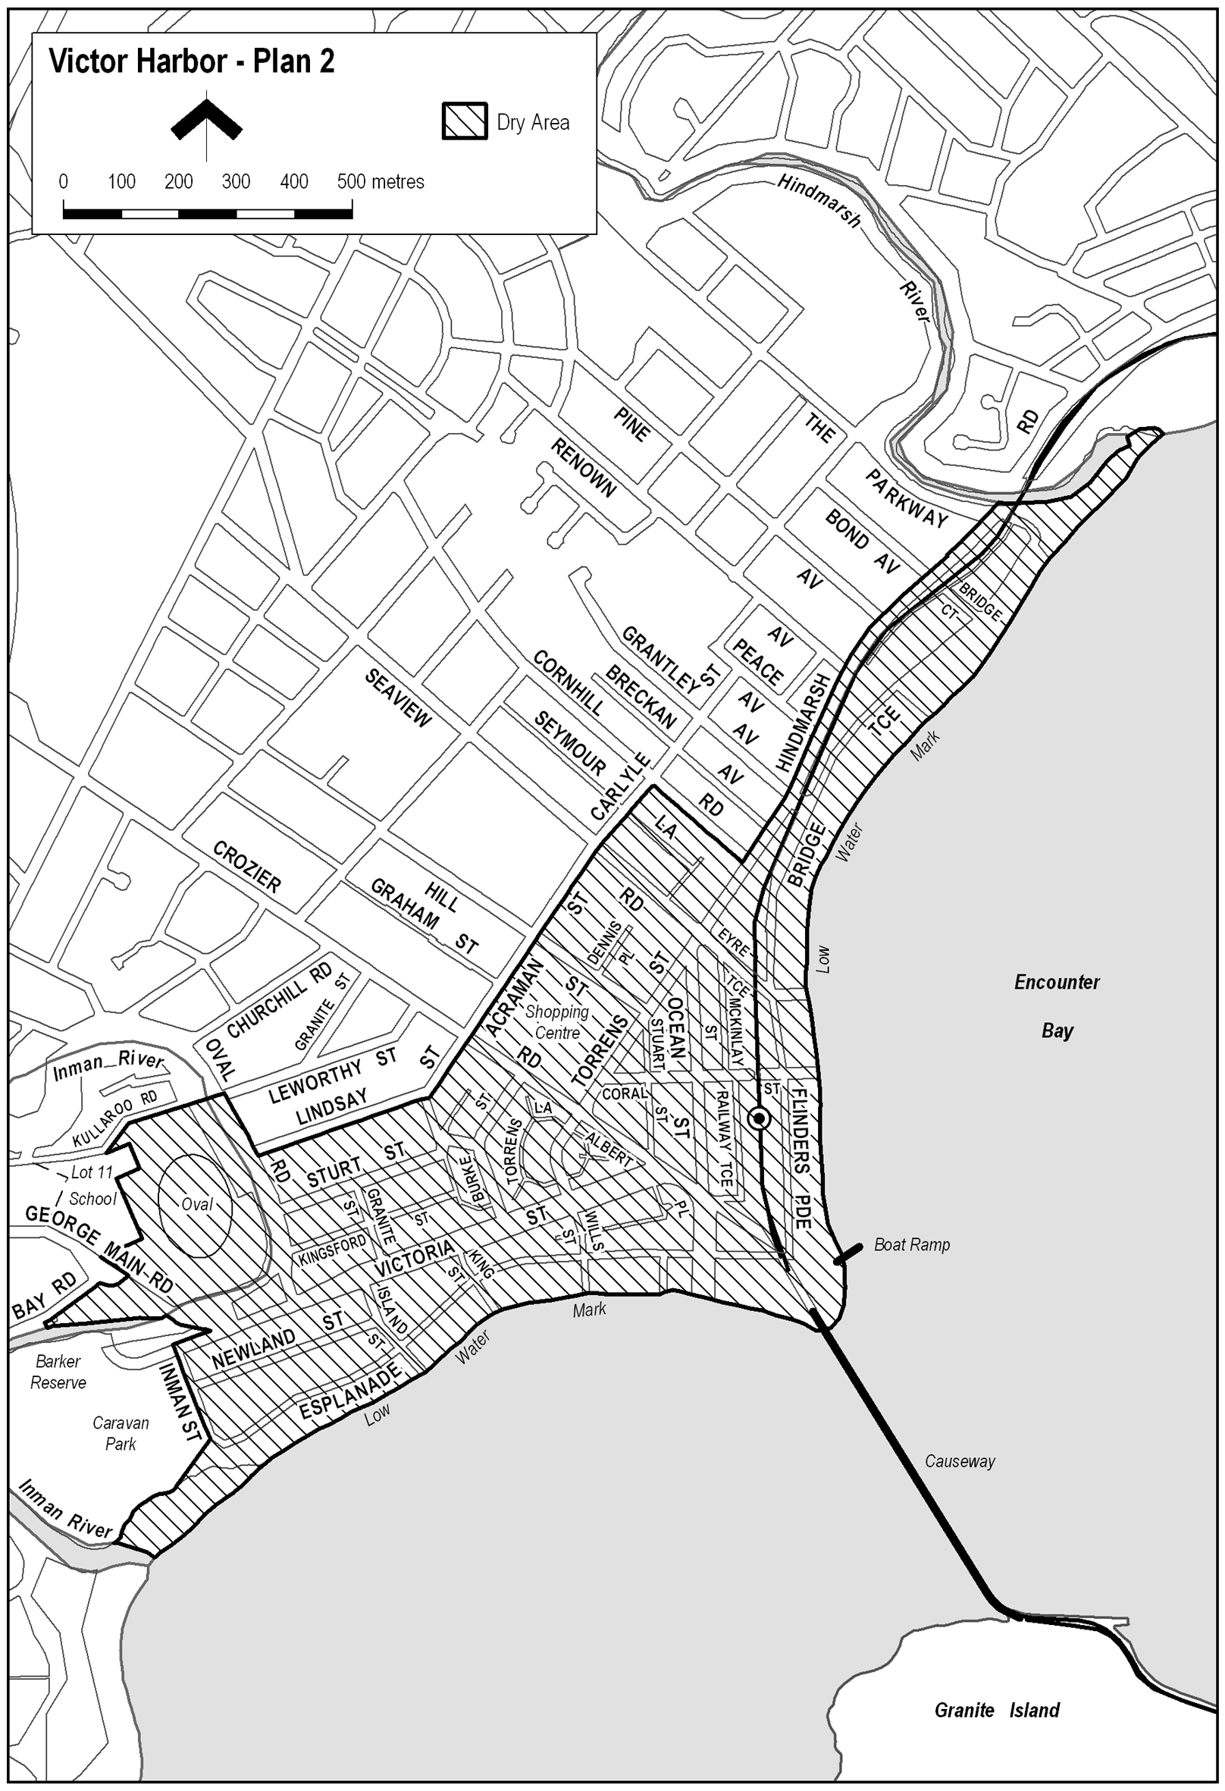
Note—
As required by section 10AA(2) of the Subordinate Legislation Act 1978, the Minister has certified that, in the Minister's opinion, it is necessary or appropriate that these regulations come into operation as set out in these regulations.
Made by the Governor
with the advice and consent of the Executive Council
on 6 November 2008
No 283 of 2008
OLGCCS0271/97

South Australia
Marine Parks Regulations 2008
under the Marine Parks Act 2007

Contents
1 Short title
2 Commencement
3 Interpretation
4 Notice of establishment of marine park (section 10(7))
5 Applications for warrants (section 34(6))
6 General duty of care—prescribed circumstances (section 37(3))
7 Action on non-compliance with order etc—prescribed rate of interest (sections 39, 41 and 42)

1—Short title
These regulations may be cited as the Marine Parks Regulations 2008.
2—Commencement
These regulations will come into operation on the day on which section 10 of the Marine Parks Act 2007 comes into operation.
3—Interpretation
In these regulations—
Act means the Marine Parks Act 2007.
4—Notice of establishment of marine park (section 10(7))
For the purposes of section 10(7) of the Act, the Minister must give notice of the making of a proclamation to establish a marine park by notice in the Gazette, in a newspaper circulating generally within the State and on a website determined by the Minister.
5—Applications for warrants (section 34(6))
(1) The grounds of an application for a warrant under section 34 of the Act made personally must be verified by affidavit.
(2) If an application for a warrant is made by telephone—
(a) the applicant must inform the magistrate of the applicant's name and identify the position that he or she holds for the purposes of the Act, and the magistrate, on receiving that information, is entitled to assume, without further inquiry, that the applicant holds that position; and
(b) the applicant must inform the magistrate of the purpose for which the warrant is required and the grounds on which it is sought; and
(c) if it appears to the magistrate from the information given by the applicant that there are proper grounds to issue a warrant, the magistrate must inform the applicant of the facts that justify, in the magistrate's opinion, the issue of the warrant, and must not proceed to issue the warrant unless the applicant undertakes to make an affidavit verifying those facts; and
(d) if the applicant gives such an undertaking, the magistrate may then make out and sign a warrant, noting on the warrant the facts that justify, in the magistrate's opinion, the issue of the warrant; and
(e) the warrant is taken to have been issued, and comes into force, when signed by the magistrate; and
(f) the magistrate must inform the applicant of the terms of the warrant; and
(g) the applicant must, as soon as practicable after the issue of the warrant, forward to the magistrate an affidavit verifying the facts referred to in paragraph (c).
6—General duty of care—prescribed circumstances (section 37(3))
For the purposes of section 37(3) of the Act, any circumstance involving the exercise of a statutory power by a public authority in an emergency situation is prescribed.
7—Action on non-compliance with order etc—prescribed rate of interest
(sections 39, 41 and 42)
(1) For the purposes of sections 39(5)(a), 41(5)(a) and 42(8)(a) of the Act, the prescribed rate of interest per annum on an unpaid amount will be the prime bank rate for any financial year for which the amount remains unpaid.
(2) In this regulation—
prime bank rate for a particular financial year means the corporate loan reference rate applied by the Commonwealth Bank of Australia for corporate lending on the first trading day of the Bank in that financial year.
Note—
As required by section 10AA(2) of the Subordinate Legislation Act 1978, the Minister has certified that, in the Minister's opinion, it is necessary or appropriate that these regulations come into operation as set out in these regulations.
Made by the Governor
with the advice and consent of the Executive Council
on 6 November 2008
No 284 of 2008
EHCS08/0025

FAXING COPY?
IF you fax copy to Government Publishing SA for inclusion in the Government Gazette, there is no need to send a Confirmation Copy to us as well.
This creates confusion and may well result in your notice being printed twice.
Please use the following fax number:
Fax transmission: (08) 8207 1040
Phone Inquiries: (08) 8207 1045
Please include a contact person, phone number and order number so that we can phone back with any queries we may have regarding the fax copy.
NOTE: Closing time for lodging new copy (fax, hard copy or email) is 4 p.m. on Tuesday preceding the day of publication.

Government Gazette notices can be E-mailed.
The address is:
governmentgazette@dpc.sa.gov.au
Documents should be sent as attachments in Word format.
When sending a document via E-mail, please confirm your transmission with a faxed copy of your document, including the date the notice is to be published.
Fax transmission: (08) 8207 1040
Enquiries: (08) 8207 1045
NOTE: Closing time for lodging new copy (fax, hard copy or email) is 4 p.m. on Tuesday preceding the day of publication.

CITY OF MITCHAM
Appointment of Development Assessment Panel Public Officer
NOTICE is hereby given pursuant to section 56A (22) of the Development Act 1993, that Council at its meeting held on 28 October 2008, appointed Rodney Donne, Acting Chief Executive Officer as the Public Officer for the Development Assessment Panel until 30 November 2008 and Helen Dyer, Chief Executive Officer as the Public Officer for the Development Assessment Panel from 1 December 2008. The Development Assessment Panel’s Public Officer can be contacted at the City of Mitcham, 131 Belair Road, Torrens Park, telephone 8372 8851 and email:
mitcham@mitchamcouncil.sa.gov.au.
R. Donne, Acting Chief Executive Officer

PORT AUGUSTA CITY COUNCIL
Declaration of Public Road
NOTICE is hereby given pursuant to section 210 of the Local Government Act 1999, that the Port Augusta City Council at its meeting held on 27 October 2008, declared all roads identified within Deposited Plan 12 and contained within partially cancelled certificate of title volume 596, folio 155, as public roads. These roads located within the Stirling North area include Maule Avenue, Zanker Avenue, Michael Avenue, Kite Street, Prosser Road, Whiting Street, Willoughby Street, Mosely Street, Smoker Street, Hedger Street, Edwards Street, Callier Avenue, Smith Street, Barett Street, Nestor Street, Howden Street.
M. J. Dunemann, Acting City Manager

CITY OF PROSPECT
By-law Made Under the Local Government Act 1999
By-law No. 1—Permits and Penalties
TO provide for a permit system and penalties for Council by-laws, to clarify the construction of Council by-laws, and to repeal Council by-laws.
1. Definitions
In any by-law of Council, unless the contrary intention appears:
1.1 ‘Council’ means City of Prospect;
1.2 ‘person’ includes a body corporate.
2. Repeal
All previous by-laws made by Council prior to the date this by-law is made, are repealed.
3. Permits
3.1 In any by-law of Council, unless the contrary intention is clearly indicated, the word ‘permission’ means the permission of Council granted in writing.
3.2 Council may attach such conditions to a grant of permission as it thinks fit, and may vary or revoke such conditions or impose new conditions by notice in writing to the person granted permission.
3.3 Any person granted permission must comply with every such condition.
3.4 Council may revoke a grant of permission at any time by notice in writing to the person granted permission.
4. Penalties
Any person who commits a breach of any by-law of Council will be guilty of an offence and will be liable to a penalty being the maximum amount referred to in the Local Government Act 1999 and, in addition, will be liable to a further penalty for each day that the offence continues, being the maximum amount referred to in the Local Government Act 1999.
5. Construction
Every by-law of Council is subject to any Act of Parliament and Regulations made under any Act of Parliament.
This by-law was duly made and passed at a meeting of the Council of the City of Prospect held on 28 October 2008, by an absolute majority of the members for the time being constituting the Council, there being at least two-thirds of the members present.
M. Goldstone, Chief Executive Officer

CITY OF PROSPECT
By-law Made Under the Local Government Act 1999
By-law No. 2—Moveable Signs
TO set standards for moveable signs on roads and to provide conditions for and the placement of such signs.
1. Definitions
In this by-law, unless the contrary intention appears:
1.1 ‘authorised person’ means a person appointed an authorised person pursuant to section 260 of the Local Government Act 1999;
1.2 ‘business premises’ means premises from which a business, trade or calling is conducted;
1.3 ‘footpath area’ means:
(a) a footway, lane or other place made or constructed for the use of pedestrians and not for the use of vehicles; or
(b) that part of the road between the boundary of the road and the edge of the carriageway on the same side as that boundary;
1.4 ‘moveable sign’ has the same meaning as in the Local Government Act 1999;
1.5 ‘road’ has the same meaning as in the Local Government Act 1999.
2. Construction
A moveable sign must:
2.1 be of a kind known as an ‘A’ frame or sandwich board sign, an ‘inverted “T”’ sign, or a flat sign;
2.2 be constructed and maintained in good quality and condition;
2.3 be of strong construction with no sharp or jagged edges or corners;
2.4 not be unsightly or offensive in appearance;
2.5 not be illuminated from a light source in or on the sign itself;
2.6 not move when in position or contain an animated display;
2.7 be constructed of timber, metal, plastic or a mixture of such materials;
2.8 not exceed 1 000 mm in height, 600 mm in width and 600 mm in depth;
2.9 be stable when in position including during adverse weather conditions;
2.10 in the case of an ‘A’ frame or sandwich board sign:
(a) be hinged or joined at the top;
(b) have sides which are securely fixed or locked in position when erected;
2.11 in the case of an ‘inverted “T”’ sign, contain no struts or members that run between the display area and the base of the sign.
3. Placement
A moveable sign must:
3.1 not be placed anywhere except on the footpath area and no closer to the carriageway than 300 mm;
3.2 not be placed on the sealed part of a footpath area unless the sealed part is wide enough to contain the sign and still leave a clear thoroughfare of at least 1.2 m;
3.3 not be placed on a landscaped area (other than when landscaping comprises only lawn);
3.4 not be placed within 1 m of an entrance to or exit from premises;
3.5 not be placed within 1 m of a building line or adjacent fence line;
3.6 not, without permission, be fixed, tied or chained to, or leaned against or placed closer than 2 m to any other structure, object (including another moveable sign), plant or tree;
3.7 not, without permission, be placed within 10 m of an intersection of a road;
3.8 not unreasonably restrict the use of the footpath area or road or endanger the safety of members of the public;
3.9 only be placed:
(a) directly in front of the business premises to which it relates; and
(b) within the projections of the side boundaries of the business premises to which it relates.
4. Restrictions
4.1 Business premises are limited to the display of one moveable sign.
4.2 A moveable sign must not be placed on a footpath area:
(a) unless it only displays material which advertises business premises (or goods or services available within those business premises), being conducted adjacent to the sign;
(b) unless the business premises to which it relates is open to the public;
(c) in windy conditions unless it is securely anchored down with an appropriate device such that it cannot be blown over or swept away;
(d) during the hours of darkness unless it is clearly visible.
5. Appearance
A moveable sign displayed on a footpath area must:
5.1 be painted or otherwise detailed in a competent and professional manner;
5.2 be attractive, legible and simply worded to convey a precise message;
5.3 be of such design and contain such colours which are compatible with the architectural design of the premises adjacent to the sign, and which relate well to the townscape and overall amenity of the locality in which it is situated;
5.4 contain combinations of colour and typographical styles which blend in with and reinforce the heritage qualities of the locality and building where it is situated;
5.5 not have balloons, flags, streamers or other things attached to it.
6. Removal of Signs
Where an authorised person has removed a sign placed on a road in contravention of this by-law or a provision of the Local Government Act 1999, the owner of the sign will not be entitled to reclaim the sign until they have paid Council the reasonable costs of the removal and storage of the sign.
7. Exemptions
7.1 Subparagraphs 3.9 and 4.2 (a) of this by-law do not apply to any of the following moveable signs:
(a) a sign designed to direct people to a charitable function being held on the day the sign is being displayed;
(b) a sign used with permission from an authorised person;
(c) a sign advertising a garage sale taking place from residential premises.
7.2 This by-law does not apply to a moveable sign:
(a) designed to direct people to the open inspection of any land or building that is available for purchase or lease;
(b) which is related to a State or Commonwealth election and is displayed during the period commencing on the issue for the writ or writs for the election at the close of polls on polling day;
(c) which is related to an election held under the Local Government Act 1999 or the Local Government (Elections) Act 1999 and is displayed during the period commencing four weeks immediately before the date that has been set (either by or under either Act) for polling day and ending at the close of voting on polling day.
This by-law was duly made and passed at a meeting of the Council of the City of Prospect held on 28 October 2008, by an absolute majority of the members for the time being constituting the Council, there being at least two-thirds of the members present.
M. Goldstone, Chief Executive Officer

CITY OF PROSPECT
By-law Made Under the Local Government Act 1999
By-law No. 3—Local Government Land
FOR the management and regulation of the use of and access to local government land (other than roads) vested in or under the control of Council, including the prohibition and regulation of particular activities on local government land and public places.
1. Definitions
In this by-law, unless the contrary intention appears:
1.1 ‘authorised person’ means a person appointed an authorised person pursuant to section 260 of the Local Government Act 1999;
1.2 ‘children’s playground’ means an area of local government land within 5 m of any equipment installed for the purpose of children’s play;
1.3 ‘electoral matter’ has the same meaning as in the Electoral Act 1985, provided that such electoral matter is not capable of causing physical damage or injury to any person within its immediate vicinity;
1.4 ‘liquor’ has the same meaning as defined in the Liquor Licensing Act 1997;
1.5 ‘local government land’ means land owned by Council or under Council’s care, control and management (except roads);
1.6 ‘open container’ means a container which:
(a) after the contents thereof have been sealed at the time of manufacture and:
(i) being a bottle, has had its cap, cork or top removed (whether or not it has since been replaced);
(ii) being a can, it has been opened or punctured;
(iii) being a cask, has had its tap placed in a position to allow it to be used;
(iv) being any form of container, that has been opened, broken, punctured or manipulated in such a way as to allow access to the contents thereof; or
(b) is a flask, glass or mug or other container used for drinking purposes;
1.7 ‘public place’ means a place (including a place on private land) to which the public has access (except a road) but does not include any part of a community parcel divided by a plan or community division under the Community Titles Act 1996;
1.8 ‘road’ has the same meaning as in the Local Government Act 1999;
1.9 ‘tobacco product’ has the same meaning as in the Tobacco Products Regulation Act 1997;
1.10 ‘vehicle’ has the same meaning as in the Local Government Act 1999.
2. Activities Requiring Permission
A person must not without permission on any local government land:
Working on Vehicles
2.1 repair, wash, paint, panel beat or perform work of any nature on or to any vehicle, except for running repairs in the case of breakdown;
Busking
2.2 sing, busk or play a musical instrument for the purpose of, or so as to appear to be for the purpose of, entertaining others or receiving money;
Horses, Cattle and Sheep
2.3 lead or drive any horse, cattle or sheep, except where Council has set aside a track or other area for use by or in connection with the animal of that kind;
Note: Please refer to Paragraph 9—Application of Paragraphs.
Donations
2.4 ask for or receive or indicate that he or she desires a donation of money or any other thing;
Amplification
2.5 use an amplifier or other device whether mechanical or electrical for the purpose of amplifying sound;
Distribution
2.6 give out or distribute to any bystander or passer by any handbill, book, notice or other printed matter, provided that this restriction does not apply to any electoral matter given out or distributed by or with the authority of a candidate during the course of a Federal, State or Local Government Election or Referendum;
Preaching
2.7 preach or harangue; provided that this restriction does not apply to a person legitimately canvassing public opinion during the course of a Local, State, Federal Government election or during a Referendum;
Canvassing
2.8 convey any advertising, religious or other message to any bystander, passer by or person provided that this restriction does not apply to any electoral matter given out or distributed with the authority of a candidate during the course of a Federal, State or Local Government Election or Referendum;
Advertising
2.9 display any sign for the purpose of commercial advertising;
Fires
2.10 light or maintain any fire except:
(a) in a place provided by Council for that purpose; or
(b) in a portable barbeque, as long as the barbeque is used in an area that is clear of flammable material;
Fireworks
2.11 use, ignite, discharge or explode any fireworks;
Removing soil
2.12 carry away or remove any soil, sand, timber, stones, pebbles, other organic or inorganic materials or any part of the land;
Picking Fruit
2.13 pick fruit, nuts or berries from any trees or bushes;
Digging Soil
2.14 dig the soil for, or disturb or remove grubs, insects, coins or artefacts or any other thing;
Trees and plants
2.15 (a) take, uproot or damage any tree, plant or flower;
(b) remove, take or disturb any soil, stone, wood, timber or bark;
(c) collect or take any dead wood or timber; or
(d) enter onto any flower bed or garden plot;
Fauna
2.16 (a) take, interfere with or disturb any animal or bird or the eggs or young of any animal or bird;
(b) damage, interfere with or disturb any burrow, nest or habitat of any animal or bird; or
(c) use, possess or have control of any device for the purpose of killing or capturing any animal or bird;
Games
2.17 (a) to which this subparagraph applies, participate in any game, recreation or amusement which involves the use of a ball, missile or other object which the use of may cause injury or discomfort to any person being on or in the vicinity of that land; or
Note: Please refer to Paragraph 9—Application of Paragraphs.
(b) play any organised competition sport;
Swimming
2.18 swim, bathe in any pond, stream or lake to which this subparagraph applies;
Note: Please refer to Paragraph 9—Application of Paragraphs.
Fishing
2.19 fish in any pond, stream or lake to which this subparagraph applies;
Note: Please refer to Paragraph 9—Application of Paragraphs.
Liquor
2.20 (a) consume, carry or be in possession or charge of any liquor on any local government land to which this subparagraph applies (provided the land constitutes a park or reserve);
(b) excepting sealed containers, consume, carry, be in possession or charge of any liquor in an open container on any local government land to which this subparagraph applies (provided the land constitutes a park or reserve);
Note: Please refer to Paragraph 9—Application of Paragraphs.
Weddings
2.21 conduct or participate in a marriage ceremony on any park or reserve;
Closed Lands
2.22 enter or remain on any part of local government land:
(a) at any time during which Council has declared that it is closed to the public and which is indicated by a sign to that effect;
(b) where the land is enclosed with fences and/or walls and gates, at any time when the gates have been closed and locked; or
(c) where admission charges are payable, to enter without paying those charges;
Camping
2.23 camp or stay overnight;
Tents
2.24 erect any tent, booth, marquee or other structure;
Posting of Bills
2.25 post any bills, advertisements or other papers or items on a building, structure, pole or tree on local government land, or other public place provided that this paragraph does not apply to any electoral matter posted on a building or structure with the authority of a candidate during the course of a Federal, State or Local Government Election or Referendum.
3. Prohibited Activities
A person must not on local government land:
Smoking
3.1 smoke tobacco or any other substance in any building, or part of any building, or in an area defined as a children’s playground to which this subparagraph applies;
Note: Please refer to Paragraph 9—Application of Paragraphs.
Missiles
3.2 throw, roll or discharge any stone, substance or missile to the danger of any person or animal;
Glass
3.3 wilfully break any glass, china or other brittle material;
Defacing Property
3.4 deface, paint, write, cut names or make marks on any tree, rock, gate, fence, building, sign or other property of Council therein provided that this paragraph does not apply to any electoral matter posted on a building or structure with the authority of a candidate during the course of a Federal, State or Local Government Election or Referendum and in accordance with the Electoral Act 1995;
Use of Equipment
3.5 use any item of equipment and/or facilities or other Council property other than in the manner and for the purpose for which it was designed or set aside;
Annoyances
3.6 annoy or unreasonably interfere with any other person’s use of the land by making a noise or by creating a disturbance that has not been authorised by Council;
Interference with Permitted Use
3.7 interrupt or disrupt or interfere with any person’s use of local government land for which permission has been granted;
Encroachment
3.8 erect or place any fencing, posts or other structures or any other items or substances such as to encroach onto the land that have not been authorised by Council.
4. Removal of Encroachment or Interference
Any person who encroaches onto or interferes with local government land contrary to this by-law must at the request of an authorised person, cease the encroachment or interference and remove the source of the encroachment or interference and reinstate the land to the same standard as the state of the land prior to the encroachment or interference.
5. Council May Do Work
If a person fails to remove an encroachment or interference on local government land in accordance with a request of an authorised person pursuant to paragraph 4 of this by-law, then Council may:
(a) undertake the work itself; and
(b) recover the cost of doing so from that person.
6. Directions
Any person on local government land must comply with any reasonable direction or request from an authorised person relating to:
(a) the person’s use of the land;
(b) that person’s conduct and behaviour on the land;
(c) that person’s safety on the land;
(d) the safety and enjoyment of the land by other persons.
7. Removal of Animals
If any animal is found on the local government land in breach of a by-law:
(a) any person in charge of the animal must remove it on the request of an authorised person; and
(b) an authorised person may remove the animal if a person fails to comply with the request, or if no person is apparently in charge of the animal.
8. Exemptions
The restrictions in this by-law do not apply to any Police Officer, Council Officer or employee acting in the course and within the scope of that person’s normal duties, or to a contractor while performing work for Council or to the driver of an emergency vehicle (as defined in the Road Traffic (Road Rules—Ancillary and Miscellaneous Provisions) Regulations 1999 and the Australian Road Rules)—while driving that vehicle in relation to an emergency.
9. Application of Paragraphs
Any of paragraphs 2.3, 2.17 (a), 2.18, 2.19, 2.20 and 3.1 of this by-law will apply only in such part of parts of the area as Council may by resolution direct (in accordance with section 246 (3) (e) of the Local Government Act 1999).
This by-law was duly made and passed at a meeting of the Council of the City of Prospect held on 28 October 2008, by an absolute majority of the members for the time being constituting the Council, there being at least two-thirds of the members present.
M. Goldstone, Chief Executive Officer

CITY OF PROSPECT
By-law Made Under the Local Government Act 1999
and the Local Government Act (Implementation)
Regulations 1999
By-law No. 4—Roads
FOR the management, control and regulation of activities on roads in the Council area.
1. Definitions
In this by-law, unless the contrary intention appears:
1.1 ‘authorised person’ means a person appointed an authorised person pursuant to section 260 of the Local Government Act 1999;
1.2 ‘road’ has the same meaning as in the Local Government Act 1999.
2. Activities Requiring Permission
A person must not without permission on any road:
Working on Vehicles
2.1 repair, wash, paint, panel beat or perform other work on or to any vehicle, except for running repairs in the case of breakdown;
Amplification
2.2 use an amplifier or other device whether mechanical or electrical for the purpose of amplifying sound or broadcasting announcements or advertisements;
Preaching
2.3 preach or harangue, provided that this restriction does not apply to a person legitimately canvassing public opinion, during the course of a Local, State or Federal Government election or during a Referendum;
Movement of Animals
2.4 drive, lead any horse, cattle, sheep or goats on to a road or allow any horse, cattle, sheep or goats to stray on to a road;
Advertising
2.5 erect or display any sign, or hoarding for the purpose of commercial advertising, other than a moveable sign which is displayed on a public street or road in accordance with any by-law of Council concerning moveable signs;
Donations
2.6 ask for or receive or indicate a desire for a donation of money or any other thing;
Posting
2.7 post any bills, advertisements or other papers or items on a building, structure, pole or tree on a road, provided that this paragraph does not apply to electoral matters posted with the authority of a candidate during the course of the Local, State or Federal Government election, or during the course of a Referendum;
Obstruction
2.8 obstruct any footway or road.
3. Removal of Animals
If any animal is found on a road in breach of a by-law:
(a) any person in charge of the animal must remove it on the request of an authorised person; and
(b) an authorised person may remove the animal if a person fails to comply with the request, or if no person is in charge of the animal.
4. Exemptions
The restrictions in this by-law do not apply to any Police Officer, Council Officer or employee acting in the course and within the scope of that person’s normal duties, or to a contractor while performing work for Council and while acting under the supervision of a Council Officer, or to an emergency worker when driving an emergency vehicle as defined in the Road Traffic (Road Rules—Ancillary and Miscellaneous Provisions) Regulations 1999 and the Australian Road Rules.
This by-law was duly made and passed at a meeting of the Council of the City of Prospect held on 28 October 2008, by an absolute majority of the members for the time being constituting the Council, there being at least two-thirds of the members present.
M. Goldstone, Chief Executive Officer

CITY OF PROSPECT
By-law Made Under the Dog and Cat Management Act 1995 and Local Government Act 1999
By-law No. 5—Dogs
FOR the control of dogs within the Council area and to limit the number of dogs kept on premises.
1. Definitions
In this by-law, unless the contrary intention appears:
1.1 ‘approved kennel establishment’ means a building, structure, premises or area approved by the relevant authority pursuant to the Development Act 1993, for the keeping of dogs on a temporary or permanent basis;
1.2 ‘dog’ has the same meaning as defined in the Dog and Cat Management Act 1995;
1.3 ‘effective control’ means a person exercising effective control of a dog either:
(a) by means of physical restraint; or
(b) by command, the dog being in close proximity to the person and the person being able to see the dog at all times;
1.4 ‘guide dog’, ‘hearing dog’ and ‘disability dog’ have the same meanings as defined in the Dog and Cat Management Act 1995;
1.5 ‘local government land’ means land owned by Council or under Council’s care, control and management (except roads);
1.6 ‘small dwelling’ means the premises of a self-contained dwelling either:
(a) commonly known as a flat, serviced flat, home unit or the like; or
(b) which is contained in a separate strata title or community title.
2. Limit of Dog Numbers
2.1 A person must not, without Council’s permission, keep:
(a) in a small dwelling, more than one dog;
(b) in premises other than a small dwelling, more than two dogs.
2.2 No person may keep any dog on any premises where the number of dogs on those premises exceeds the limit without permission, unless the premises are an approved kennel establishment and any kennel business operating from those premises is registered in accordance with the Dog and Cat Management Act 1995.
3. Dog on Leash Areas
A person must not without permission on local government land to which this subparagraph applies, cause, suffer or permit any dog under that person’s control, charge or authority to be or remain on that local government land unless the dog is restrained by a strong leash not exceeding 2 m in length and either tethered securely to a fixed object or held by a person capable of controlling the dog and preventing it from being a nuisance or a danger to other persons.
Note: Please refer to Paragraph 7—Application of Paragraphs.
4. Dog Exercise Areas
4.1 Any person may enter upon any local government land to which this paragraph applies for the purpose of exercising a dog under that person’s control.
4.2 Where a person enters upon local government land to which this paragraph applies for that purpose, that person must ensure that any dog under that person’s control, charge or authority remains under effective control.
Note: Please refer to Paragraph 7—Application of Paragraphs.
5. Dog Free Areas
A person must not without permission on local government land to which this paragraph applies, cause, suffer or permit any dog (except a guide dog, hearing dog or disability dog) under the person’s control, charge or authority to be in, or remain on that local government land.
Note: Please refer to Paragraph 7—Application of Paragraphs.
6. Signs
Signs will be erected in accordance with section 238 (3) of the Local Government Act 1999, to denote local government land to which paragraphs 3, 4 and 5 apply, and information will be provided in a manner determined by the Chief Executive Officer of Council to inform the public about such local government land.
7. Application of Paragraphs
Paragraphs 3, 4 and 5 of this by-law will apply in such part or parts of the area as Council may by resolution direct (in accordance with section 246 (3) (e) of the Local Government Act 1999).
This by-law was duly made and passed at a meeting of the Council of the City of Prospect held on 28 October 2008, by an absolute majority of the members for the time being constituting the Council, there being at least two-thirds of the members present.
M. Goldstone, Chief Executive Officer

CITY OF PROSPECT
By-law Made Under the Local Government Act 1999
By-law No. 6—Waste Management
TO regulate and control the removal of domestic, recyclable and green organic waste and hard waste from premises and for the prevention and suppression of nuisances.
1. Definitions
In this by-law, unless the contrary intention appears:
1.1 ‘approved container’ means any type of container approved by Council for holding household waste, recyclables or green organics;
1.2 ‘green organics’ means any clean organic matter consisting of lawn clippings, plants, vegetables, leaves, prunings, horse manure or other materials for which permission has been given by Council but no item larger than 15 cm in diameter;
1.3 ‘hard waste’ means any internal and external household items such as fridges, television sets, mattresses, furniture, carpets, electrical appliances/tools and scrap metal, but excludes any household waste and building materials, containers with liquids, hazardous waste, engine parts and green organics;
1.4 ‘household waste’ means any kind of domestic and kitchen waste generated from residences or commercial premises, but excludes liquids, metals (other than food containers), building materials, stones, bricks, soil, lead, acid batteries and any dangerous or toxic waste;
1.5 ‘recyclables’ means newspapers, magazines, clean paper and cardboard, clean plastic containers of a type specified by Council, clean tins and cans, clean glass containers and clean milk and juice containers and their lids and any other types of materials specified by Council.
2. Approved Containers
2.1 An occupier of domestic premises must keep on the premises approved containers for the reception of household waste and recyclables.
2.2 An occupier of domestic premises who uses Council’s green organics collection service must use an authorised container for the reception of green organics.
3. Management of Waste Collection Services
An occupier of premises must:
Use of Approved Containers
3.1 ensure only household waste is placed in that part of an approved container designed for holding household waste;
3.2 ensure only recyclables are placed in that part of an approved container designed for holding recyclables;
3.3 ensure only green organics are placed in an approved container designed for holding green organics;
Keep Container Clean
3.4 ensure any approved container kept on the premises is kept in a clean and sanitary condition, maintained in good order and repair, and kept watertight at all times;
Sealing of Container
3.5 ensure any approved container kept on the premises is continuously and securely covered or sealed except when waste is being deposited in or removed from the container;
Damage
3.6 ensure, subject to ordinary wear and tear, any approved container kept on the premises is maintained so that it:
(a) is robust and water tight;
(b) is able to be moved on its wheels efficiently;
(c) has a lid that seals the container when closed;
(d) keeps separate any household waste and recyclables that it is designed to keep separate; and
(e) is otherwise unimpaired;
Collection Services
3.7 where collection is required, ensure that prior to, and on the day of, the time appointed by Council for the collection of household waste, recyclables and green organics from the premises, or on the night before (but no earlier), any approved container kept on the premises containing household waste, recyclables or green organics is placed out for collection:
(a) on the road in front of and on the same side as the premises, abutting the edge of (but not on) the carriageway and positioned so that the side of the container on which the hinges of the lid are situated, faces the premises; or
(b) in a position as approved by Council; and
(c) not under the overhanging branches of street trees;
Return of Approved Container
3.8 ensure any approved container placed out for collection is returned to that person’s premises on the same day after the collection of household waste, recyclables or green organics has taken place.
4. Interference with Waste and Recyclables
A person must not remove, disperse or interfere with any household waste, hard waste, recyclables (including bottles, newspapers, cans, containers or packaging) or green organics that have been placed:
(a) for disposal in or near an approved container; or
(b) on a road for collection by Council, its agents or contractors, except with the permission of Council or the authority of the owner.
This by-law was duly made and passed at a meeting of the Council of the City of Prospect held on 28 October 2008, by an absolute majority of the members for the time being constituting the Council, there being at least two-thirds of the members present.
M. Goldstone, Chief Executive Officer

THE BAROSSA COUNCIL
Roads (Opening and Closing) Act 1991
Light Pass and Penrice
NOTICE is hereby given that pursuant to section 10 of the Roads (Opening and Closing) Act 1991, the Barossa Council gives notice of its intent to make a Road Process Order to close portion of
the public road adjoining Allotment 2 in D 66829, Allotment 91 in F 170490, Allotment 512 in F 172773 and Allotment 7 in
F 108205 more particularly delineated and marked ‘A’ on Preliminary Plan No. 08/0108. The closed road is to be transferred to Penrice Soda Products Pty Ltd and merged with Allotment 7 in F 108205.
A copy of the preliminary plan and statement of persons affected are available for public inspection at the Council Office, 43-51 Tanunda Road, Nuriootpa or at the Adelaide office of the Surveyor-General during normal office hours.
An application for easement or objection must set out the full name, address and details of the submission and must be fully supported by reasons.
The application for easement or objection must be made in writing to the Council, P.O. Box 867, Nuriootpa, S.A. 5355 within 28 days of this notice and a copy must be forwarded to the Surveyor-General, G.P.O. Box 1354, Adelaide, S.A. 5001. Where a submission is made, the Council will give notification of a meeting at which the matter will be considered.
D. Morcom, Chief Executive Officer

REGIONAL COUNCIL OF GOYDER
Declaration of an Area of the State in which a Person may Operate an Electric Element for Cooking Purposes in the Open Air Contrary to the Terms of a Total Fire Ban
NOTICE is hereby given that pursuant to regulations under the Fire and Emergency Services Act 2005, The Regional Council of Goyder declares that persons may operate electric elements for cooking purposes in the open air contrary to the terms of a total fire ban at the following places:
Eudunda: Centenary Park, Gunn Street extension and Eudunda Oval Reserve, Morgan Road.
Point Pass: Standpipe Reserve, Stock Route Road.
Robertstown: Civic Centre, Commercial Street.
Burra: Burra Creek Reserve, Bridge Terrace; Pickett Reserve, Bridge Terrace and the Caravan Park, Bridge Terrace.
Booborowie: Swimming Pool/Football Club, North Terrace.
Mount Bryan: Sir Hubert Wilkins Reserve, Railway Parade.
Terowie: Pioneer Park (Section 451), Main Street.
This notice applies to fixed electric barbeques only and operates at all times until revoked.
The operation of an electric element under this notice is subject to the following conditions:
(1) The space immediately around and above the gas fire or electric element must be cleared of all flammable material to a distance of at least 4 m.
(2) A person who is able to control the gas fire or electric element must be present at all times while it is lighted or charged.
(3) An appropriate agent adequate to extinguish any fire must be at hand.
Dated 21 October 2008.
J. P. Brak, Chief Executive Officer

DISTRICT COUNCIL OF MOUNT BARKER
Development Act 1993
Mount Barker Regional Town Centre Car Parking Fund
NOTICE is hereby given, pursuant to section 50A (6) (b) of the Development Act 1993, that the District Council of Mount Barker has determined that the contribution rate for the car parking fund be set at $13 500 per car parking space.
Funds will be applied in a manner consistent with section 50A of the Development Act 1993.
Should anyone need further clarification please contact Rachael Finn on 8391 7275 or in person at the Local Government Centre, 23 Mann Street, Mount Barker.
A. Stuart, Chief Executive Officer

RENMARK PARINGA COUNCIL
Declaration of Private Road to Public Road
NOTICE is hereby given that pursuant to section 210 of the Local Government Act 1999, the Renmark Paringa Council at its meeting held on 28 October 2008, declared the private road being shown as Hale Street in Deposited Plan 2695 contained within the certificate of title volume 5897, folio 581, to be a public road.
B. C. Hurst, Chief Executive Officer

IN the matter of the estates of the undermentioned deceased persons:
Bald, Frank Bertram, late of 18 West Terrace, Quorn, retired stockman, who died on 9 September 2008.
Bianco, Marcella, late of 6 Mumford Avenue, St Agnes, of no occupation, who died on 15 September 2008.
Black, Valerie Gertrude, late of 42 Judith Crescent, Morphett Vale, retired shop assistant, who died on 12 August 2008.
Childs, Margaret, late of 67 Porter Street, Salisbury, of no occupation, who died on 2 August 2008.
Colbert, Reginald Stephen, late of Blende Street, Broken Hill, New South Wales, retired shift manager, who died on 25 August 2008.
Conyers, Dorothy Vivienne, late of 156 Main North Road, Prospect, widow, who died on 25 August 2008.
Couzens, Lawrence Walter, late of 1 Steele Street, Camp-belltown, retired shopfitter, who died on 8 June 2008.
Crisp, Denis Olley, late of 45 Milner Street, Prospect, retired school principal, who died on 19 July 2008.
Dunn, Helen Margaret, late of 14 St Lawrence Avenue, Edwardstown, home duties, who died on 25 August 2008.
Dunn, Ralph Alder, late of 12 Harbour Court, West Lakes, retired asphalt manager, who died on 28 March 2008.
Edwards, Albert Ernest, late of 84 Reservoir Road, Modbury, retired industrial relations manager, who died on 28 July 2008.
Hanson, Muriel Elizabeth, late of 88-94 Robert Street, West Croydon, of no occupation, who died on 8 September 2008.
Hendry, Constance, late of 20 Norseman Avenue, Westbourne Park, of no occupation, who died on 20 August 2008.
Hunt, Maxwell John Mark, late of 1099 Grand Junction Road, Hope Valley, retired custodian of plans and records, who died on 8 September 2008.
Jarrad, Una Mary, late of 150 Adams Road, Craigmore, of no occupation, who died on 21 September 2008.
Latinovic, Ivan, late of 37 Fifth Street, Ardrossan, retired painter, who died on 27 September 2008.
Rumbelow, Thelma Josephine, late of 16 Simpson Avenue, Encounter Bay, home duties, who died on 14 September 2008.
Russ, Allen Ernest, late of 112 Acre Avenue, Morphett Vale, retired farmer, who died on 4 August 2008.
Sandercock, Colin Heath, late of 1 Cooper Angus Grove, Wattle Park, retired carpenter, who died on 8 August 2008.
Singer, Spencer Samuel, late of 53 Geddes Road, Solomontown, retired painter, who died on 25 January 2007.
Stewart, John Albert, late of 84A Sherriffs Road, Morphett Vale, retired metal worker, who died on 24 August 2008.
Stokes, Phyllis Emily, late of 60 States Road, Morphett Vale, of no occupation, who died on 16 September 2008.
Wadas, Norbert Hans, late of 27 Barndoo Street, Hallett Cove, accountant, who died on 25 July 2008.
Wilkinson, Anita Maud, late of 324 Military Road, Semaphore Park, of no occupation, who died on 30 August 2008.
Williams, Barbara Elder, late of 160 Walkerville Terrace, Walkerville, of no occupation, who died on 4 September 2008.
Notice is hereby given pursuant to the Trustee Act 1936, as amended, the Inheritance (Family Provision) Act 1972, and the Family Relationships Act 1975, that all creditors, beneficiaries, and other persons having claims against the said estates are required to send, in writing, to the Public Trustee, 25 Franklin Street, Adelaide, S.A. 5000, full particulars and proof of such claims, on or before 5 December 2008, otherwise they will be excluded from the distribution of the said estate; and notice is also hereby given that all persons who are indebted to the said estates are required to pay the amount of their debts to the Public Trustee or proceedings will be taken for the recovery thereof; and all persons having any property belonging to the said estates are forthwith to deliver the same to the Public Trustee.
Dated 6 November 2008.
M. I. Bodycoat, Public Trustee

ATTENTION

CUSTOMERS requiring a proof of their notice for inclusion in the Government Gazette, please note that the onus is on you to inform Government Publishing SA of any subsequent corrections by 10 a.m. on Thursday, which is our publication deadline.

For any corrections to your notice please phone 8207 1045 or Fax 8207 1040 before 10 a.m. on Thursday.

If we do not receive any communication by 10 a.m. on Thursday (day of publication) we will presume the notice is correct and will print it as it is.

Remember—the onus is on you to inform us of any corrections necessary to your notice.

NOTE: Closing time for lodging new copy (electronically, fax or hard copy) is 4 p.m. on Tuesday preceding the day of publication. Phone 8207 1045—Fax 8207 1040.
Email: governmentgazette@dpc.sa.gov.au

Printed and published by authority every Thursday by T. GOODES, Government Printer, South Australia
Price: $5.40, plus postage; to subscribers, $274.00 per annum.
(The above prices are inclusive of GST)

