No. 66 5117

THE SOUTH AUSTRALIAN

GOVERNMENT GAZETTE
www.governmentgazette.sa.gov.au

PUBLISHED BY AUTHORITY

ALL PUBLIC ACTS appearing in this GAZETTE are to be considered official, and obeyed as such

ADELAIDE, THURSDAY, 20 NOVEMBER 2008

CONTENTS

Page
Acts Assented To 5118
Appointments, Resignations, Etc. 5118
Corporations and District Councils—Notices 5208
Electoral Act 1985—Notice 5118
Fisheries Management Act 2007—Notices 5118
Housing Improvement Act 1940—Notices 5120
Land Acquisition Act 1969—Notice 5124
Liquor Licensing Act 1997—Notices 5124
Local Government Act 1999—Notice 5128
Mining Act 1971—Notice 5126
National Electricity Law—Notice 5127
Optometry Practice Act 2007—Notice 5139
Petroleum Act 2000—Notice 5166
Proclamations 5171
Public Trustee Office—Administration of Estates 5210
Radiation Protection and Control Act 1982—Notices 5166
REGULATIONS
Environment Protection Act 1993 (No. 285 of 2008) 5173
Aquaculture Act 2001 (No. 286 of 2008) 5200
Roads (Opening and Closing) Act 1991—Notices 5167
Sewerage Act 1929—Notice 5168
Trade Standards Act 1979—Notice 5169
Workers Rehabilitation and Compensation Act 1986—
Notice 5169

GOVERNMENT GAZETTE NOTICES
ALL poundkeepers’ and private advertisements forwarded for publication in the South Australian Government Gazette must be PAID FOR PRIOR TO INSERTION; and all notices, from whatever source, should be legibly written on one side of the paper only and sent to Government Publishing SA so as to be received no later
than 4 p.m. on the Tuesday preceding the day of publication. Phone 8207 1045 or Fax 8207 1040. E-mail: governmentgazette@dpc.sa.gov.au. Send as attachments in Word format and please confirm your transmission with a faxed copy of your document, including the date the notice is to be published and to whom the notice will be charged. The Government Gazette is available online at: www.governmentgazette.sa.gov.au

Department of the Premier and Cabinet
Adelaide, 20 November 2008
HIS Excellency the Governor directs it to be notified for general information that he has in the name and on behalf of Her Majesty The Queen, this day assented to the undermentioned Acts passed by the Legislative Council and House of Assembly in Parliament assembled, viz.:
No. 44 of 2008—Partnership (Venture Capital) Amendment Act 2008. An Act to amend the Partnership Act 1891.
No. 45 of 2008—Plastic Shopping Bags (Waste Avoidance) Act 2008. An Act to restrict the supply of single use plastic shopping bags.
No. 46 of 2008—Gene Technology (Miscellaneous) Amend-ment Act 2008. An Act to amend the Gene Technology Act 2001.
By command,
Gail Gago, for Premier
DPC06/0875

Department of the Premier and Cabinet
Adelaide, 20 November 2008
HIS Excellency the Governor in Executive Council has been pleased to appoint the undermentioned to the Dairy Authority of South Australia, pursuant to the provisions of the Primary Produce (Food Safety Schemes) (Dairy Industry) Regulations 2005 under the Primary Produce (Food Safety Schemes) Act 2004:
Member: (from 1 January 2009 until 31 December 2010)
Catherine Sheree Cooper
Kenneth Ross Smith
Trevor David Keele
Presiding Member: (from 1 January 2009 until 31 December 2010)
Catherine Sheree Cooper
By command,
Gail Gago, for Premier
MAFF08/027SC

Department of the Premier and Cabinet
Adelaide, 20 November 2008
HIS Excellency the Governor in Executive Council has been pleased to appoint the undermentioned to the Supported Residential Facilities Advisory Committee, pursuant to the provisions of the Supported Residential Facilities Act 1992:
Member: (from 20 November 2008 until 19 November 2010)
Jane Chapman
Shaunee Fox
Angela Wang
Debra Petrys
Phillip Beddall
Susan Wilkes
Peter David Hans Heysen
Kevin Duke
Sue Whitington
Penelope Grace Richardson
Paul Nikolettos
Deputy Member: (from 20 November 2008 until 19 November 2010)
Evanne Margaret Megaw (Deputy to Petrys)
Monika Baker (Deputy to Beddall)
Natasha Miliotis (Deputy to Wilkes)
Helen Wright (Deputy to Heysen)
Michael Livori (Deputy to Duke)
Ann Irving (Deputy to Whitington)
Joyce Yeomans (Deputy to Richardson)
Kirin Moat (Deputy to Nikolettos)
By command,
Gail Gago, for Premier
DFCCS/08/015

Department of the Premier and Cabinet
Adelaide, 20 November 2008
HIS Excellency the Governor in Executive Council has been pleased to appoint the people listed as Justices of the Peace for South Australia for a period of 10 years commencing from 20 November 2008 and expiring on 19 November 2018, pursuant to section 4 of the Justices of the Peace Act 2005:
Rocco Luigi Callisto
Graham Kenneth Coulter
Brent Andrew Fletcher
Margaret Foster
Susan Marie Haylock
Glen Jones
Timothy Dean Langmaid
Jamieson James McClurg
Tanya Michelle Tweden
By command,
Gail Gago, for Premier
JP08/039CS

ELECTORAL ACT 1985: PART 9, DIVISION 5
Declared Institutions
PURSUANT to section 83 of the Electoral Act 1985, I, Kay Marie Mousley, Electoral Commissioner, hereby revoke the Schedule of declared institutions on page 4036 of the Government Gazette dated 1 December 2005 and pronounce the following as declared institutions:
The Schedule
Barunga Village, 11 Edmund Street, PORT BROUGHTON, 5522.
Gilbert Valley Senior Citizens Homes, 20 Masters Street, RIVERTON, 5412.
Helping Hand Aged Care Carinya, 17-19 Victoria Road, CLARE, 5453.
Helping Hand Aged Care Lealholme, 15 Halliday Street, PORT PIRIE, 5540.
Helping Hand Aged Care Lealholme, 360 Senate Road, PORT PIRIE, 5540.
Lower North Health—Snowtown Site, South Terrace, SNOWTOWN, 5520.
Port Broughton District Hospital and Health Services Inc., Bay Street, PORT BROUGHTON, 5522.
Port Pirie Regional Health Service, The Terrace, PORT PIRIE, 5540.
Riverton Hospital, 23 Moorhouse Terrace, RIVERTON, 5412.
Southern Flinders Health, 1 Edmund Terrace, CRYSTAL BROOK, 5523.
The Willochra Home, Allan Street, CRYSTAL BROOK, 5523.
Dated 18 November 2008.
K. M. Mousley, Electoral Commissioner
SEO 267/2008

FISHERIES MANAGEMENT ACT 2007: SECTION 115
TAKE notice that pursuant to section 115 of the Fisheries Management Act 2007, Eric von Wielligh of the South Australian Water Corporation, G.P.O. Box 1751, Adelaide, S.A. 5001 (the ‘exemption holder’), or a person acting as his agent, is exempt from the provisions of sections 70, 71 and 72 (2) (9b) of the Fisheries Management Act 2007, but only insofar as he may engage in the draining of wetlands specified in Schedule 1 and the loss of aquatic organisms for the purpose of construction of a water disposal system (the ‘exempted activity’), subject to the conditions set out in Schedule 2, from 14 November 2008 until 30 June 2009, unless varied or revoked earlier.
Schedule 1
The wetlands at the Murray Bridge Wastewater Treatment Plant located within the Murray Bridge Army Firing Range (Department of Defence land).
Schedule 2
1. Any specimens collected pursuant to this exemption notice may only be returned to a pond or wetland located within the wetlands specified in Schedule 1 and must not be sold or moved to any other site, except with the permission of the Director of Fisheries.
2. All non-native fish must be destroyed and disposed of appropriately.
3. While engaged in the exempted activity, the exemption holder or a person acting as an agent must be in possession of a copy of this notice. Such notice must be produced to a PIRSA Fisheries Compliance Officer if requested.
4. The exemption holder must not contravene or fail to comply with the Fisheries Management Act 2007, or any regulations made under that Act, except where specifically exempted by this notice.
Dated 10 November 2008.
W. Zacharin, Director of Fisheries

FISHERIES MANAGEMENT ACT 2007: SECTION 115
TAKE notice that pursuant to section 115 of the Fisheries Management Act 2007, Tracy Warland, 20 Divett Street, Port Adelaide, S.A. 5015 (the ‘exemption holder’), or a person acting as her agent, is exempt from sections 52 and 72 of the Fisheries Management Act 2007, but only insofar as the exemption holder shall not be guilty of an offence when taking one male gravid leafy seadragon and selling any hatchlings from that leafy seadragon (the ‘exempted activity’) from the waters described in Schedule 1, subject to the conditions specified in Schedule 2, from 14 November 2008 until 30 June 2009, unless varied or revoked earlier.
Schedule 1
South Australian coastal waters excluding aquatic reserves and waters within one nautical mile of the jetties at Rapid Bay and Second Valley.
Schedule 2
1. The specimen collected pursuant to this exemption must be retained by the exemption holder.
2. The exemption holder or an agent must notify PIRSA Fisheries on 1800 065 522 at least two hours prior to conducting the exempted activity and answer a series of questions about the exempted activity. The exemption holder will need to have a copy of the exemption at the time of making the call, and be able to provide information about the area and time of the exempted activity, the vehicles and boats involved, the number of agents undertaking the exempted activity and other related questions. Exemption No. 9902176.
3. The exemption holder must provide a written report to the Director of Fisheries, G.P.O. Box 1625, Adelaide, S.A. 5001, within seven days of collecting a leafy seadragon pursuant to this exemption, providing details of the location, time and conditions of the collection.
4. The exemption holder must also provide a written report to the Director of Fisheries, G.P.O. Box 1625, Adelaide, S.A. 5001, by 30 April 2009, providing the following information:
• The number of eggs hatched from the specimen collected pursuant to this notice.
• The number of animals hatched from these eggs and an indication of survival rate.
• The number of surviving animals kept as broodstock and the number of animals sold domestically, exported or given away.
• A status report on the breeding program of the leafy sea-dragon.
5. While engaged in the exempted activity the exemption holder or his agents must be in possession of a copy of this notice and must be produced to a PIRSA Fisheries Compliance Officer if requested.
6. The exemption holder must not contravene or fail to comply with the Fisheries Management Act 2007, or any regulations made under that Act, except where specifically exempted by this notice.
Dated 13 November 2008.
W. Zacharin, Director of Fisheries

FISHERIES MANAGEMENT ACT 2007: SECTION 115
TAKE notice that pursuant to section 115 of the Fisheries Management Act 2007, the holder of a prawn fishery licence issued pursuant to the Fisheries Management (Prawn Fisheries) Regulations 2006, for the Gulf St Vincent Prawn Fishery listed in Schedule 1 (the ‘exemption holders’) or their registered master are exempt from the notices made under section 79 of the Fisheries Management Act 2007, prohibiting the taking of western king prawns (Melicertus latisulcatus). The exemption holders shall not be guilty of an offence when using prawn trawl nets in accordance with the conditions of their fishery licence for the purpose of stock assessment survey (the ‘exempted activity’) subject to the conditions contained in Schedule 2.
Schedule 1
Schedule 2
Licence  No. | Licence Holder | Boat Name
V02 | St Vincent Gulf Fisheries and Investments Pty  Ltd | Angela Kaye
V03 | Brzic Fisheries Pty Ltd | Josephine K
V05 | Maurice J. Corigliano | Frank Cori
V06 | Todreel Pty Ltd | Anna Pearl
V09 | Hamid Huseljic | Candice K
1. The exemption is valid from 2030 hours on 21 November 2008 until 0600 hours on 23 November 2008.
2. All trawling activity must be completed by 0600 hours on each day with nets out of the water.
3. The exemption holder must comply with instructions from the SARDI Stock Assessment Co-ordinator and work within the allotted survey trawl stations.
4. All fish, other than prawns, southern calamary (Sepioteuthis australis) and slipper lobster (Ibacus spp.) taken during the exempted activity for stock assessment purposes, are to be returned to the water immediately after capture.
5. Prawns, southern calamary and slipper lobster taken pursuant to the exempted activity must not be retained by the exemption holder, his agent, crew or any other person.
6. Prawns, southern calamary and slipper lobster taken pursuant to the exempted activity must be disposed of by the exemption holders in accordance with the ‘GSV Prawn Fishery Survey Participation Agreement’ and must not be retained by the exemption holder, his agent, crew or any other person.
7. While engaged in the exempted activity or while unloading the survey catch, the exemption holder must have on board his boat or near his person a copy of this notice. Such notice must be produced to a PIRSA Fisheries Compliance Officer if requested.
8. The exemption holder must not contravene or fail to comply with the Fisheries Management Act 2007, or any other regulations made under that Act except where specifically exempted by this notice.
Dated 13 November 2008.
S. Sloan, Program Leader, Fisheries Management

HOUSING IMPROVEMENT ACT 1940
WHEREAS by notice published in the Government Gazette on the dates mentioned in the following table, the South Australian Housing Trust did declare the houses described in the following table to be substandard for the purposes of Part 7 of the Housing Improvement Act 1940, and whereas the South Australian Housing Trust is satisfied that each of the houses described hereunder has ceased to be substandard, notice is hereby given that, in exercise of the powers conferred by the said Part, the South Australian Housing Trust does hereby revoke the said declaration in respect of each house.
Address of House | Allotment, Section, etc. | Certificate of Title  Volume Folio | Date and page of Government Gazette in which notice declaring house to be substandard published

3 Bristol Street, Eastwood |  | Allotment 2 in Deposited Plan 39202, Hundred of Adelaide | 5850 | 509 |  | 24.12.70, page 2927
9 Musgrave Avenue, West Hindmarsh |  | Allotment 255 in Deposited Plan 1243, Hundred of Yatala | 5414 | 116 |  | 9.10.08, page 4766
6 Waldron Street, Elizabeth East |  | Allotment 297 in Deposited Plan 6419, Hundred of Munno Para | 5960 | 89 |  | 9.10.08, page 4766
8 Railway Terrace, Hamley Bridge |  | Allotment 25 of portion of sections 223 and 382, Hundred of Alma | 6008 | 517 |  | 7.5.92, page 1352

Dated at Adelaide, 20 November 2008. D. Huxley, Director, Corporate and Board Services

HOUSING IMPROVEMENT ACT 1940
NOTICE is hereby given that the South Australian Housing Trust in the exercise of the powers conferred by the Housing Improvement Act 1940, does hereby declare the houses described in the table hereunder to be substandard for the purposes of Part 7 of the Housing Improvement Act 1940.
No. of House and Street | Locality | Allotment, Section, etc. | Certificate of Title  Volume Folio

19 Albert Street |  | Windsor Gardens | Allotment 30 in Filed Plan 128464, Hundred of Yatala | 5806 | 343
12 Canis Avenue |  | Hope Valley | Allotment 177 in Deposited Plan 7485, Hundred of Yatala | 5148 | 815
28 Coolah Terrace |  | Marion | Allotment 323 in Deposited Plan 3054, Hundred of Adelaide | 5731 | 431
73 Gail Crescent |  | Murray Bridge | Allotment 78 in Deposited Plan 9827, Hundred of Mobilong | 5846 | 577
25 Hutchison Crescent |  | Naracoorte | Allotment 1 in Filed Plan 114294, Hundred of Naracoorte | 5208 | 567
Lot 16, Lacey Road |  | Flaxley (also known as Bugle Ranges) | Allotment 16 in Filed Plan 19151, Hundred of Macclesfield | 5653 | 564
5 Mary Road |  | Coonawarra | Allotment 715 in Filed Plan 191277, Hundred of Comaum | 5831 | 404

Dated at Adelaide, 20 November 2008. D. Huxley, Director, Corporate and Board Services

HOUSING IMPROVEMENT ACT 1940
WHEREAS by notice published in the Government Gazette on the dates mentioned in the following table the South Australian Housing Trust did declare the houses described in the said table to be substandard for the purposes of Part 7 of the Housing Improvement Act 1940, the South Australian Housing Trust in the exercise of the powers conferred by the said Part, does hereby fix as the maximum rental per week which shall be payable subject to section 55 of the Residential Tenancies Act 1995, in respect of each house described in the following table the amount shown in the said table opposite the description of such house and this notice shall come into force on the date of this publication in the Gazette.
Address of House | Allotment, Section, etc. | Certificate of Title  Volume Folio | Date and page of Government Gazette in which notice declaring house to be substandard published | Maximum rental per week payable in respect of each house  $

41 Branson Avenue, Clearview |  | Allotment 7 in Deposited Plan 6076, Hundred of Yatala | 5659 | 99 |  | 25.9.08, page 4700 | 98.00
16 Cockshell Street, Davoren Park |  | Allotment 556 in Deposited Plan 7654, Hundred of Munno Para | 5728 | 861 |  | 14.8.08, page 3608 | 100.00
Unit 2, 18 Fosters Road, Hillcrest |  | Unit 2, Strata Plan 10641, Hundred of Yatala | 5339 | 222 |  | 25.9.08, page 4700 | 120.00
7 Gayland Road, Elizabeth Downs |  | Allotment 166 in Deposited Plan 7075, Hundred of Munno Para | 5280 | 873 |  | 25.9.08, page 4700 | 112.00
54 Harvey Street, Ethelton |  | Allotment 64 of subdivision of section 905, Hundred of Port Adelaide | 5221 | 113 |  | 11.9.08, page 4259 | 90.00
247 Hogarth Road, Elizabeth Grove |  | Allotment 23 in Filed Plan 18197, Hundred of Munno Para | 5120 | 474 |  | 25.9.08, page 4700 | 132.00
28 Loveday Street, Goolwa |  | Allotment 12, Town of Goolwa, Hundred of Goolwa | 5824 | 217 |  | 31.7.08, page 3501 | 215.00
53 Nimitz Road, Elizabeth East |  | Allotment 140 in Deposited Plan 6415, Hundred of Munno Para | 5208 | 160 |  | 25.9.08, page 4700 | 92.00
Section 134, Pearce Road, Gladstone |  | Section 134, Hundred of Booyoolie in the area named Huddlestone | 5743 | 934 |  | 14.8.08, page 3608 | 60.00
34 Pegasi Avenue, Hope Valley |  | Allotment 153 in Deposited Plan 7485, Hundred of Yatala | 5422 | 644 |  | 14.8.08, page 3608 | 138.00
8 Radnor Street, Port Pirie South |  | Allotment 11 in Deposited Plan 1486, Hundred of Pirie | 5537 | 863 |  | 31.7.08, page 3501 | 87.00
5 Strathcona Avenue, Panorama |  | Allotment 151 in Deposited Plan 3692, Hundred of Adelaide | 5281 | 161 |  | 25.9.08, page 4700 | 170.00
23 Tindall Road, Enfield |  | Allotment 227 in Deposited Plan 4451, Hundred of Yatala | 5401 | 132 |  | 17.7.08, page 3361 | 138.00

Dated at Adelaide, 20 November 2008. D. Huxley, Director, Corporate and Board Services

GOVERNMENT GAZETTE ADVERTISEMENT RATES

To apply from 1 July 2008

$  Agents, Ceasing to Act as 41.00  Associations:  Incorporation 20.80  Intention of Incorporation 51.50  Transfer of Properties 51.50  Attorney, Appointment of 41.00  Bailiff’s Sale 51.50  Cemetery Curator Appointed 30.50  Companies:  Alteration to Constitution 41.00  Capital, Increase or Decrease of 51.50  Ceasing to Carry on Business 30.50  Declaration of Dividend 30.50  Incorporation 41.00  Lost Share Certificates:  First Name 30.50  Each Subsequent Name 10.50  Meeting Final 34.25  Meeting Final Regarding Liquidator’s Report on  Conduct of Winding Up (equivalent to ‘Final  Meeting’)  First Name 41.00  Each Subsequent Name 10.50  Notices:  Call 51.50  Change of Name 20.80  Creditors 41.00  Creditors Compromise of Arrangement 41.00  Creditors (extraordinary resolution that ‘the Com-pany be wound up voluntarily and that a liquidator be appointed’) 51.50  Release of Liquidator⎯Application⎯Large Ad. 81.50  ⎯Release Granted 51.50  Receiver and Manager Appointed 47.50  Receiver and Manager Ceasing to Act 41.00  Restored Name 38.50  Petition to Supreme Court for Winding Up 71.50  Summons in Action 61.00  Order of Supreme Court for Winding Up Action 41.00  Register of Interests⎯Section 84 (1) Exempt 92.00  Removal of Office 20.80  Proof of Debts 41.00  Sales of Shares and Forfeiture 41.00  Estates:  Assigned 30.50  Deceased Persons⎯Notice to Creditors, etc. 51.50  Each Subsequent Name 10.50  Deceased Persons⎯Closed Estates 30.50  Each Subsequent Estate 1.35  Probate, Selling of 41.00  Public Trustee, each Estate 10.50 |  | $  Firms:  Ceasing to Carry on Business (each insertion) 27.25  Discontinuance Place of Business 27.25  Land⎯Real Property Act:  Intention to Sell, Notice of 51.50  Lost Certificate of Title Notices 51.50  Cancellation, Notice of (Strata Plan) 51.50  Mortgages:  Caveat Lodgement 20.80  Discharge of 21.80  Foreclosures 20.80  Transfer of 20.80  Sublet 10.50  Leases⎯Application for Transfer (2 insertions) each 10.50  Lost Treasury Receipts (3 insertions) each 30.50  Licensing 61.00  Municipal or District Councils:  Annual Financial Statement⎯Forms 1 and 2 574.00  Electricity Supply⎯Forms 19 and 20 408.00  Default in Payment of Rates:  First Name 81.50  Each Subsequent Name 10.50  Noxious Trade 30.50  Partnership, Dissolution of 30.50  Petitions (small) 20.80  Registered Building Societies (from Registrar-  General) 20.80  Register of Unclaimed Moneys⎯First Name 30.50  Each Subsequent Name 10.50  Registers of Members⎯Three pages and over:  Rate per page (in 8pt) 261.00  Rate per page (in 6pt) 345.00  Sale of Land by Public Auction 52.00  Advertisements 2.90  ¼ page advertisement 122.00  ½ page advertisement 244.00  Full page advertisement 478.00  Advertisements, other than those listed are charged at $2.90 per column line, tabular one-third extra.  Notices by Colleges, Universities, Corporations and District Councils to be charged at $2.90 per line.  Where the notice inserted varies significantly in length from that which is usually published a charge of $2.90 per column line will be applied in lieu of advertisement rates listed.  South Australian Government publications are sold on the condition that they will not be reproduced without prior permission from the Government Printer.
All the above prices include GST

GOVERNMENT GAZETTE NOTICES
ALL private advertisements forwarded for publication in the South Australian Government Gazette must be PAID FOR PRIOR TO INSERTION; and all notices, from whatever source, should be legibly written on one side of the paper only and sent to Government Publishing SA so as to be received no later than 4 p.m. Tuesday preceding the day of publication. Phone 8207 1045 or Fax 8207 1040. E-mail: governmentgazette@dpc.sa.gov.au. Send as attachments in Word format. Please include date the notice is to be published and to whom the notice will be charged. The Government Gazette is available online at: www.governmentgazette.sa.gov.au.

MISCELLANEOUS LEGISLATION AND GOVERNMENT PUBLICATIONS PRICES AS FROM 1 JULY 2008

Acts, Bills, Rules, Parliamentary Papers and Regulations
Pages | Main | Amends | Pages | Main | Amends

1-16 | 2.50 | 1.15 | 497-512 | 34.75 | 33.75
17-32 | 3.35 | 2.10 | 513-528 | 35.75 | 34.50
33-48 | 4.35 | 3.10 | 529-544 | 37.00 | 35.75
49-64 | 5.50 | 4.20 | 545-560 | 38.00 | 37.00
65-80 | 6.45 | 5.35 | 561-576 | 38.75 | 38.00
81-96 | 7.50 | 6.20 | 577-592 | 40.00 | 38.50
97-112 | 8.55 | 7.30 | 593-608 | 41.25 | 39.75
113-128 | 9.55 | 8.40 | 609-624 | 42.00 | 41.00
129-144 | 10.70 | 9.45 | 625-640 | 43.25 | 41.50
145-160 | 11.70 | 10.50 | 641-656 | 44.25 | 43.25
161-176 | 12.80 | 11.50 | 657-672 | 44.75 | 43.75
177-192 | 13.90 | 12.60 | 673-688 | 46.75 | 44.75
193-208 | 15.00 | 13.80 | 689-704 | 47.50 | 45.70
209-224 | 15.80 | 14.60 | 705-720 | 48.25 | 47.00
225-240 | 16.90 | 15.60 | 721-736 | 50.00 | 48.00
241-257 | 18.10 | 16.50 | 737-752 | 50.50 | 49.00
258-272 | 19.10 | 17.60 | 753-768 | 51.50 | 50.00
273-288 | 20.20 | 18.90 | 769-784 | 52.50 | 51.50
289-304 | 21.00 | 19.80 | 785-800 | 53.50 | 52.50
305-320 | 22.30 | 20.90 | 801-816 | 54.50 | 53.00
321-336 | 23.20 | 21.90 | 817-832 | 55.50 | 54.50
337-352 | 24.40 | 23.10 | 833-848 | 56.50 | 55.50
353-368 | 25.25 | 24.20 | 849-864 | 57.50 | 56.00
369-384 | 26.50 | 25.25 | 865-880 | 59.00 | 57.50
385-400 | 27.50 | 26.25 | 881-896 | 59.50 | 58.00
401-416 | 28.50 | 27.00 | 897-912 | 61.00 | 59.50
417-432 | 29.75 | 28.25 | 913-928 | 61.50 | 61.00
433-448 | 30.75 | 29.50 | 929-944 | 62.50 | 61.50
449-464 | 31.50 | 30.25 | 945-960 | 63.50 | 62.00
465-480 | 32.00 | 31.25 | 961-976 | 65.50 | 63.00
481-496 | 33.75 | 32.00 | 977-992 | 66.50 | 63.50

Legislation—Acts, Regulations, etc: $
Subscriptions:
Acts 214.00
All Bills as Laid 514.00
Rules and Regulations 514.00
Parliamentary Papers 514.00
Bound Acts 238.00
Index 119.00
Government Gazette
Copy 5.60
Subscription 284.00
Hansard
Copy 15.60
Subscription—per session (issued weekly) 446.00
Cloth bound—per volume 191.00
Subscription—per session (issued daily) 446.00
Legislation on Disk
Whole Database 3 304.00
Annual Subscription for fortnightly updates 1 015.00
Individual Act(s) including updates POA
Compendium
Subscriptions:
Subscriptions 1 957.00
Updates 690.00
(All the above prices include GST)

All Legislation, Government Gazette, Hansard and Legislation on disk are available from:
Counter Sales Government Legislation⁺ Outlet
and Mail Orders: Service SA Customer Service Centre,
Ground Floor—EDS Centre, 108 North Terrace, Adelaide, S.A. 5000
Phone: 13 23 24 (local call cost), Fax: (08) 8204 1909
Postal: G.P.O. Box 1707, Adelaide, S.A. 5001

Online Shop: www.shop.service.sa.gov.au

Subscriptions and Government Publishing SA
Standing Orders: Box 9, Plaza Level, Riverside Centre, North Terrace, Adelaide, S.A. 5000
Phone: (08) 8207 1043, (08) 8207 0910, Fax: (08) 8207 1040

LAND ACQUISITION ACT 1969
(Section 16)
Notice of Acquisition
THE COMMISSIONER OF HIGHWAYS (the ‘Authority’), 33 Warwick Street, Walkerville, S.A. 5081, acquires the following interests in the following land:
Definition of Land Acquired
Comprising an unencumbered estate in fee simple in that piece of land situated at 1165-1171 Port Wakefield Road, Waterloo Corner, being portion of allotment 18 in Filed Plan 114679 comprised in certificate of title volume 5220, folio 573 and being the whole of the land numbered 139 on the plan numbered D76629 that has been lodged in the Lands Titles Office.
This notice is given under section 16 of the Land Acquisition Act 1969.
Compensation
A person who has or had an interest in the land that is divested or diminished by the acquisition or the enjoyment of which is adversely affected by the acquisition who does not receive an offer of compensation from the Authority may apply to the Authority for compensation.
Inquiries
Inquiries should be directed to:
Chris Southam,
P.O. Box 1,
Walkerville, S.A. 5081
Telephone: (08) 8402 1730
Dated 18 November 2008.
The Common Seal of the Commissioner of Highways was hereto affixed by direction of the Commissioner of Highways in the presence of:
A. Hartley, Acting Manager, Property Planning and Management Services, Department for Transport, Energy and Infrastructure
DTEI 2007/12886/01

LIQUOR LICENSING ACT 1997 AND GAMING MACHINES ACT 1992
Notice of Application
NOTICE is hereby given, pursuant to section 52 of the Liquor Licensing Act 1997 and section 29 of the Gaming Machines Act 1992, that Thalia Constante Pty Ltd as trustee for Thalia Constante Unit Trust has applied to the Licensing Authority for the transfer of a Hotel and Gaming Machine Licence in respect of premises situated at 25 Railway Terrace, Quorn, S.A. 5433 and known as Grand Junction Hotel.
The applications have been set down for hearing on 17 December 2008 at 9 a.m.
Any person may object to the application by lodging a notice of objection in the prescribed form with the Liquor and Gambling Commissioner and serving a copy of the notice on the applicant at the applicant’s address, at least seven days before the hearing date (viz: 10 December 2008).
The applicant’s address for service is c/o Foreman Legal, 69 Mount Barker Road, Stirling, S.A. 5152.
Plans in respect of the premises the subject of the application are open to public inspection without fee at the Office of the Liquor and Gambling Commissioner, 9th Floor, East Wing, 50 Grenfell Street, Adelaide, S.A. 5000. Phone 8226 8410, Fax:
8226 8512. Email: olgc@agd.sa.gov.au.
Dated 11 November 2008.
Applicant

LIQUOR LICENSING ACT 1997
Notice of Application
NOTICE is hereby given, pursuant to section 52 (2) (b) of the Liquor Licensing Act 1997, that Heka Pty Ltd, Brenton Paul Quirini and Cheryl Lee Quirini have applied to the Licensing Authority for the removal of a Wholesale Liquor Merchant’s Licence in respect of premises situated at 185 Holbrooks Road, Underdale, S.A. 5032 and to be situated at Unit 5, 900 South Road, Edwardstown, S.A. 5039 and known as Empire Liquor.
The application has been set down for callover on 12 December 2008 at 9 a.m.
Any person may object to the application by lodging a notice of objection in the prescribed form with the Liquor and Gambling Commissioner and serving a copy of the notice on the applicants at the applicants’ address, before the callover date (viz: 11 December 2008).
The applicants’ address for service is c/o Brenton Quirini, P.O. Box 299, Edwardstown, S.A. 5039.
Plans in respect of the premises the subject of the application are open to public inspection without fee at the Office of the Liquor and Gambling Commissioner, 9th Floor, East Wing, 50 Grenfell Street, Adelaide, S.A. 5000. Phone 8226 8410, Fax:
8226 8512. Email: olgc@agd.sa.gov.au.
Dated 17 November 2008.
Applicants

LIQUOR LICENSING ACT 1997
Notice of Application
NOTICE is hereby given, pursuant to section 52 (2) (b) of the Liquor Licensing Act 1997, that Thomas John McCready and Margaret Mary McCready have applied to the Licensing Authority for a Redefinition and variation to an Extended Trading Authorisation in respect of premises situated at 195 Main Street, Peterborough, S.A. 5422 and known as Hotel Peterborough.
The application has been set down for callover on 19 December 2008 at 9 a.m.
Conditions
The following licence conditions are sought:
• Redefinition to include the verandah as per plans lodged with this office.
• Variation to an Extended Trading Authorisation to include the abovementioned area.
Any person may object to the application by lodging a notice of objection in the prescribed form with the Liquor and Gambling Commissioner and serving a copy of the notice on the applicants at the applicants’ address, at least seven days before the callover date (viz: 12 December 2008).
The applicants’ address for service is c/o John McCready, 195 Main Street, Peterborough, S.A. 5422.
Plans in respect of the premises the subject of the application are open to public inspection without fee at the Office of the Liquor and Gambling Commissioner, 9th Floor, East Wing, 50 Grenfell Street, Adelaide, S.A. 5000. Phone 8226 8410, Fax:
8226 8512. Email: olgc@agd.sa.gov.au.
Dated 7 November 2008.
Applicants

LIQUOR LICENSING ACT 1997
Notice of Application
NOTICE is hereby given, pursuant to section 52 (2) (b) of the Liquor Licensing Act 1997, that The New Edinburgh Castle Hotel Pty Ltd has applied to the Licensing Authority for a Redefinition and variation to an Extended Trading Authorisation in respect of premises situated at 233 Currie Street, Adelaide, S.A. 5000 and known as Edinburgh Castle Hotel.
The application has been set down for callover on 19 December 2008 at 9 a.m.
Conditions
The following licence conditions are sought:
• Redefinition to the licensed premises to include an outdoor area at the front of the premises.
• Variation to Extended Trading Authorisation to include the abovementioned area.
Any person may object to the application by lodging a notice of objection in the prescribed form with the Liquor and Gambling Commissioner and serving a copy of the notice on the applicant at the applicant’s address, at least seven days before the callover date (viz: 12 December 2008).
The applicant’s address for service is c/o The New Edinburgh Castle Hotel Pty Ltd, 233 Currie Street, Adelaide, S.A. 5000.
Plans in respect of the premises the subject of the application are open to public inspection without fee at the Office of the Liquor and Gambling Commissioner, 9th Floor, East Wing, 50 Grenfell Street, Adelaide, S.A. 5000. Phone 8226 8410, Fax:
8226 8512. Email: olgc@agd.sa.gov.au.
Dated 11 November 2008.
Applicant

LIQUOR LICENSING ACT 1997
Notice of Application
NOTICE is hereby given, pursuant to section 52 (2) (b) of the Liquor Licensing Act 1997, that Grumpy’s Brewhaus Holdings Pty Ltd has applied to the Licensing Authority for a Restaurant Licence with Entertainment Consent in respect of premises situated at 115 Mount Barker Road, Verdun, S.A. 5245 and known as Grumpy’s Brewhaus.
The application has been set down for callover on 19 December 2008 at 9 a.m.
Conditions
The following licence conditions are sought:
• Entertainment Consent to apply for the following days and times:
Monday to Thursday: 7 p.m. to 10 p.m.;
Friday and Saturday: 7 p.m. to 10.30 p.m.;
Sunday: Noon to 5 p.m.;
Sundays preceding Public Holidays: 7 p.m. to 10 p.m.
Any person may object to the application by lodging a notice of objection in the prescribed form with the Liquor and Gambling Commissioner and serving a copy of the notice on the applicant at the applicant’s address, at least seven days before the callover date (viz: 12 December 2008).
The applicant’s address for service is c/o Andrew Schultz, 76 Wembley Avenue, Bridgewater, S.A. 5155.
Plans in respect of the premises the subject of the application are open to public inspection without fee at the Office of the Liquor and Gambling Commissioner, 9th Floor, East Wing, 50 Grenfell Street, Adelaide, S.A. 5000. Phone 8226 8410, Fax:
8226 8512. Email: olgc@agd.sa.gov.au.
Dated 12 November 2008.
Applicant

LIQUOR LICENSING ACT 1997
Notice of Application
NOTICE is hereby given, pursuant to section 52 (2) (b) of the Liquor Licensing Act 1997, that Tatiara Karting Club Incorporated has applied to the Licensing Authority for a Limited Club Licence with an Extended Trading Authorisation in respect of premises situated at Dukes Highway, Bordertown, S.A. 5268 and to be known as Tatiara Karting Club Inc.
The application has been set down for hearing on 19 December 2008 at 9 a.m.
Conditions
The following licence conditions are sought:
• Extended Trading Authorisation to apply to the following days and times:
Sunday: 8 p.m. to midnight;
Sundays preceding Public Holidays: 8 p.m. to 1 a.m. the following day.
Any person may object to the application by lodging a notice of objection in the prescribed form with the Liquor and Gambling Commissioner and serving a copy of the notice on the applicant at the applicant’s address, at least seven days before the hearing date (viz: 12 December 2008).
The applicant’s address for service is c/o Lawrie Tucker, 61 Binnie Street, Bordertown, S.A. 5268.
Plans in respect of the premises the subject of the application are open to public inspection without fee at the Office of the Liquor and Gambling Commissioner, 9th Floor, East Wing, 50 Grenfell Street, Adelaide, S.A. 5000. Phone 8226 8410, Fax:
8226 8512. Email: olgc@agd.sa.gov.au.
Dated 13 November 2008.
Applicant

LIQUOR LICENSING ACT 1997
Notice of Application
NOTICE is hereby given, pursuant to section 52 (2) (b) of the Liquor Licensing Act 1997, that Anniversary Hill Pty Ltd as trustee for Bailey Hastings Trust has applied to the Licensing Authority for a Wholesale Liquor Merchant’s Licence in respect of premises situated at 71 Beulah Road, Norwood, S.A. 5067 and to be known as Anniversary Hill Pty Ltd.
The application has been set down for callover on 19 December 2008 at 9 a.m.
Any person may object to the application by lodging a notice of objection in the prescribed form with the Liquor and Gambling Commissioner and serving a copy of the notice on the applicant at the applicant’s address, at least seven days before the callover date (viz: 12 December 2008).
The applicant’s address for service is c/o Finlaysons, 81 Flinders Street, Adelaide, S.A. 5000 (Attention: Andrew Williams).
Plans in respect of the premises the subject of the application are open to public inspection without fee at the Office of the Liquor and Gambling Commissioner, 9th Floor, East Wing, 50 Grenfell Street, Adelaide, S.A. 5000. Phone 8226 8410, Fax:
8226 8512. Email: olgc@agd.sa.gov.au.
Dated 13 November 2008.
Applicant

LIQUOR LICENSING ACT 1997
Notice of Application
NOTICE is hereby given, pursuant to section 52 (2) (b) of the Liquor Licensing Act 1997, that Australian Export Wines Pty Ltd has applied to the Licensing Authority for a Wholesale Liquor Merchant’s Licence in respect of premises situated at Stonyfell Winery Complex, Stonyfell Road, Stonyfell, S.A. 5066 and to be known as Australian Export Wines.
The application has been set down for callover on 19 December 2008 at 9 a.m.
Any person may object to the application by lodging a notice of objection in the prescribed form with the Liquor and Gambling Commissioner and serving a copy of the notice on the applicant at the applicant’s address, at least seven days before the callover date (viz: 12 December 2008).
The applicant’s address for service is c/o David Watts and Associates, 1 Cator Street, Glenside, S.A. 5065.
Plans in respect of the premises the subject of the application are open to public inspection without fee at the Office of the Liquor and Gambling Commissioner, 9th Floor, East Wing, 50 Grenfell Street, Adelaide, S.A. 5000. Phone 8226 8410, Fax:
8226 8512. Email: olgc@agd.sa.gov.au.
Dated 13 November 2008.
Applicant

LIQUOR LICENSING ACT 1997
Notice of Application
NOTICE is hereby given, pursuant to section 52 (2) (b) of the Liquor Licensing Act 1997, that Charles Greenock and Pamela Joy Greenock have applied to the Licensing Authority for a Restaurant Licence in respect of premises situated at 69B Main Road, Normanville, S.A. 5204 and to be known as Cafe Asis.
The application has been set down for callover on 19 December 2008 at 9 a.m.
Any person may object to the application by lodging a notice of objection in the prescribed form with the Liquor and Gambling Commissioner and serving a copy of the notice on the applicants at the applicants’ address, at least seven days before the callover date (viz: 12 December 2008).
The applicants’ address for service is c/o Charles Greenock, P.O. Box 2129, Normanville, S.A. 5204.
Plans in respect of the premises the subject of the application are open to public inspection without fee at the Office of the Liquor and Gambling Commissioner, 9th Floor, East Wing, 50 Grenfell Street, Adelaide, S.A. 5000. Phone 8226 8410, Fax:
8226 8512. Email: olgc@agd.sa.gov.au.
Dated 17 November 2008.
Applicants

LIQUOR LICENSING ACT 1997
Notice of Application
NOTICE is hereby given, pursuant to section 52 (2) (b) of the Liquor Licensing Act 1997, that Thi Thu Tam Tran as trustee for Tam Tran Investments Trust has applied to the Licensing Authority for the transfer of a Restaurant Licence in respect of premises situated at 306 Glen Osmond Road, Fullarton, S.A. 5063 and known as Red Rock Noodle Bar & Restaurant—Glen Osmond and to be known as Chopstix Glen Osmond.
The application has been set down for hearing on 22 December 2008 at 10 a.m.
Any person may object to the application by lodging a notice of objection in the prescribed form with the Liquor and Gambling Commissioner and serving a copy of the notice on the applicant at the applicant’s address, at least seven days before the hearing date (viz: 15 December 2008).
The applicant’s address for service is c/o Phong Nguyen, 306 Glen Osmond Road, Fullarton, S.A. 5063.
Plans in respect of the premises the subject of the application are open to public inspection without fee at the Office of the Liquor and Gambling Commissioner, 9th Floor, East Wing, 50 Grenfell Street, Adelaide, S.A. 5000. Phone 8226 8410, Fax:
8226 8512. Email: olgc@agd.sa.gov.au.
Dated 13 November 2008.
Applicant

LIQUOR LICENSING ACT 1997
Notice of Application
NOTICE is hereby given, pursuant to section 52 (2) (b) of the Liquor Licensing Act 1997, that Royali Pty Ltd has applied to the Licensing Authority for the transfer of a Special Circumstances Licence in respect of premises situated at 286-288 Rundle Street, Adelaide, S.A. 5000 and known as Distill Health.
The application has been set down for hearing on 22 December 2008 at 11 a.m.
Any person may object to the application by lodging a notice of objection in the prescribed form with the Liquor and Gambling Commissioner and serving a copy of the notice on the applicant at the applicant’s address, at least seven days before the hearing date (viz: 15 December 2008).
The applicant’s address for service is c/o Tindall Gask Bentley, 76 Light Square, Adelaide, S.A. 5000.
Plans in respect of the premises the subject of the application are open to public inspection without fee at the Office of the Liquor and Gambling Commissioner, 9th Floor, East Wing, 50 Grenfell Street, Adelaide, S.A. 5000. Phone 8226 8410, Fax:
8226 8512. Email: olgc@agd.sa.gov.au.
Dated 17 November 2008.
Applicant

LIQUOR LICENSING ACT 1997
Notice of Application
NOTICE is hereby given, pursuant to section 52 (2) (b) of the Liquor Licensing Act 1997, that Zimfield Wines Pty Ltd has applied to the Licensing Authority for the removal of a Wholesale Liquor Merchant’s Licence in respect of premises situated at 26 Greenhill Road, Wayville, S.A. 5034, to be situated at 50 Commercial Road, Hyde Park, S.A. 5061 and known as Zimfield Wines.
The application has been set down for callover on 19 December 2008 at 9 a.m.
Any person may object to the application by lodging a notice of objection in the prescribed form with the Liquor and Gambling Commissioner and serving a copy of the notice on the applicant at the applicant’s address, at least seven days before the callover date (viz: 12 December 2008).
The applicant’s address for service is c/o Lance Bradfield, 26 Greenhill Road, Wayville, S.A. 5034.
Plans in respect of the premises the subject of the application are open to public inspection without fee at the Office of the Liquor and Gambling Commissioner, 9th Floor, East Wing, 50 Grenfell Street, Adelaide, S.A. 5000. Phone 8226 8410, Fax:
8226 8512. Email: olgc@agd.sa.gov.au.
Dated 14 November 2008.
Applicant

MINING ACT 1971
NOTICE is hereby given in accordance with section 35A (1) of the Mining Act 1971, that an application for a mining lease over the undermentioned mineral claim has been received. Details of the proposal may be inspected at the Department of Primary Industries and Resources, Mineral Resources Group, Level 7, 101 Grenfell Street, Adelaide, S.A. 5000:
Applicant: Hillgrove Copper Pty Ltd
Claim Number: 4024
Location: Allotment 25 in Deposited Plan 60948, Hundred of Kanmantoo, approximately 4 km north-west of Callington.
Area: 45.1 hectares.
Purpose: For the recovery of extractive minerals (clay).
Reference: T02746
A copy of the proposal has been provided to the Mount Barker District Council.
Written submissions in relation to the granting of the mining lease are invited to be received at the Department of Primary Industries and Resources, Mineral Resources Group, Level 7, 101 Grenfell Street, Adelaide, S.A. 5000 or G.P.O. Box 1671, Adelaide, S.A. 5001 no later than 5 December 2008.
Copies of all submissions will be forwarded to the applicant and may be made available for public inspection unless confidentiality is requested.
H. Thomas, Mining Registrar

NATIONAL ELECTRICITY LAW
THE Australian Energy Market Commission (AEMC) gives notice under the National Electricity Law (NEL) of the following matters.
Under sections 102 and 103, the making of the National Electricity Amendment (Setting VoLL Following the Shedding of Interruptible Load) Rule 2008 and related final determination. All provisions commence on 20 November 2008.
Under section 99, the making of a draft determination on the proposed National Electricity Amendment (Transmission Network Prices Publication Date) Rule 2008 (Project No. ERC0069). In relation to the draft determination:
• requests for a pre-determination hearing must be received by 28 November 2008;
• submissions must be received by 23 January 2009; and
• submissions and requests for a hearing should be forwarded to submissions@aemc.gov.au and must cite the Project No. in its title.
Submissions should be submitted in accordance with the AEMC’s Guidelines for making written submissions on Rule change proposals. The AEMC publishes all submissions on its website subject to a claim of confidentiality.
Further details on the above matters are available on the AEMC’s website www.aemc.gov.au. All documents in relation to the above matters are published on the AEMC’s website and are available for inspection at the offices of the AEMC.
John Tamblyn
Chairman
Australian Energy Market Commission
Level 5, 201 Elizabeth Street
Sydney, N.S.W. 2000
Telephone: (02) 8296 7800
Facsimile: (02) 8296 7899
20 November 2008.

[Republished]
LOCAL GOVERNMENT ACT 1999
THE Constituent Councils of the Southern Region Waste Resource Authority, a regional subsidiary established pursuant to section 43 of the Local Government Act 1999, have resolved to amend the Charter. The amended Charter is as follows:

Southern Region Waste Resource Authority Regional Subsidiary
Charter—2008
1. INTRODUCTION
1.1 Name
The name of the subsidiary is Southern Region Waste Resource Authority (referred to as ‘the Authority’ in this Charter).
1.2 Definitions
1.2.1 ‘absolute majority’ means a majority of the whole number of the Board members or of the Constituent Councils as the case may be;
1.2.2 ‘Constituent Councils’ means the Councils identified at Clause 1.3 of this Charter;
1.2.3 ‘Gazette’ means the South Australian Government Gazette;
1.2.4 ‘net assets’ means total assets (current and non-current) less total liabilities (current and non-current) as reported in the annual audited financial statements of the Authority together with the net present value of the projected future cash inflows net of cash outflows of the remaining useable airspace over the SRWRA Landfill Operation as licensed by the Environment Protection Authority;
1.2.5 ‘simple majority’ means a majority of those present and entitled to vote;
1.2.6 ‘SRWRA Landfill Operation’ means that land which is held by the Authority under certificates of title volume 5822, folio 967; volume 5822, folio 966; volume 5299, folio 719; volume 5299, folio 720; volume 5479, folio 871 and volume 5696, folio 771;
1.2.7 ‘waste’ means any or all waste as approved under the Environment Protection Act licence held by the Authority or its contractor.
1.3 Establishment
The Authority is a regional subsidiary established pursuant to section 43 of the Local Government Act 1999 by the:
1.3.1 City of Marion;
1.3.2 City of Onkaparinga; and
1.3.3 City of Holdfast Bay.
1.4 Local Government Act 1999
This Charter must be read in conjunction with Parts 2 and 3 of Schedule 2 to the Act. The Authority shall conduct its affairs in accordance with Schedule 2 to the Act except as modified by this Charter in a manner permitted by Schedule 2.
1.5 Objects and Purposes
1.5.1 The Authority is established to:
1.5.1.1 provide and operate services at a place or places for the management of waste by or on behalf of the Constituent Councils and/or any other approved Councils;
1.5.1.2 undertake anything relevant (including educational programmes and processes) to the management of waste;
1.5.1.3 provide a forum for discussion and/or research for the ongoing improvement of management of waste;
1.5.1.4 undertake management of waste on behalf of the Constituent Councils on a competitive basis;
1.5.1.5 fulfil, on behalf of the Constituent Councils, any ongoing obligation in relation to rehabilitation and monitoring of waste management facilities under its control;
1.5.1.6 develop or facilitate activities or enterprises that result in a beneficial use of waste;
1.5.1.7 be financially self sufficient; and
1.5.1.8 develop or facilitate activities or enterprises that result in a beneficial use of the landfill site or infrastructure.
1.5.2 The Authority must in the performance of its role and functions and in all of its plans, policies and activities operate in a sustainable manner by giving due weight to economic, social and environmental considerations.
1.6 Powers and Functions of the Authority
The powers, functions and duties of the Authority are to be exercised in the performance of the Authority’s Objects and Purposes. The Authority shall have those powers, functions and duties delegated to it by the Constituent Councils from time to time which include but are not limited to:
1.6.1 accumulation of surplus funds for investment purposes;
1.6.2 investment of any of the funds of the Authority in any investment authorised by the Trustee Act 1936, or with the Local Government Finance Authority provided that:
1.6.2.1 in exercising this power of investment the Authority must exercise the care, diligence and skill that a prudent person of business would exercise in managing the affairs of other persons; and
1.6.2.2 the Authority must avoid investments that are speculative or hazardous in nature;
1.6.3 distribution of all or any surplus funds and/or making payment of a dividend to the Constituent Councils provided that such distribution or payment will be made to the Constituent Councils in the proportions of their equitable interest in the Authority in accordance with Clause 5.1 of this Charter;
1.6.4 setting aside a reserve fund or funds clearly identified for the upkeep and/or replacement of fixed assets of the Authority or meeting any deferred liability of the Authority;
1.6.5 borrowing money and/or to incurring expenditure in accordance with Clause 1.7 of this Charter;
1.6.6 opening and operating bank accounts;
1.6.7 entering into contracts, purchasing, selling, leasing, hiring, renting or otherwise acquiring or disposing of any personal property or interests therein;
1.6.8 purchasing, selling, leasing, hiring, renting or otherwise acquiring or disposing of any real property or interests therein, provided that it shall be a condition precedent, that in any such transaction where the Authority will incur a singular or a total liability of $500 000 or more that the prior written approval of two-thirds of the Constituent Councils is obtained;
1.6.9 employing, engaging or dismissing the Executive Officer of the Authority;
1.6.10 employing, engaging or retaining professional advisers to the Authority;
1.6.11 charging whatever fees the Authority considers appropriate for services rendered to any person, body or Council;
1.6.12 determining the types of waste which shall be received and the method of collection treatment, recycling and disposal of that waste;
1.6.13 undertaking all manner of things relating and incidental to the collection, treatment, recycling and disposal of waste;
1.6.14 pursuing the concept of co-operative regionalism in the collection, treatment, recycling and disposal of waste for which the Constituent Councils are or may become responsible and to cause all waste collected by the Authority to be treated, recycled and disposed of in a sanitary and environmentally acceptable way;
1.6.15 providing a forum for the discussion and consideration of topics related to the Constituent Councils’ obligations and responsibilities in respect of waste;
1.6.16 adopting and using a trading name provided that the Authority shall first register the trading name with the Office of Consumer and Business Affairs in accordance with the requirements of the Business Names Act 1996; and
1.6.17 anything else necessary or convenient for or incidental to the exercise, performance or discharge of its powers, functions or duties.
1.7 Borrowings and Expenditure
1.7.1 The Authority has the power to incur expenditure and/or to borrow money:
(a) in accordance with the approved budget of the Authority;
(b) for the purposes of unbudgeted expenditure in accordance with (c) and (d) below or otherwise in cases of genuine emergency or hardship;
(c) pursuant to the provisions of subclauses 1.6.8, 1.7.2 and 1.7.4 of this Charter; and
(d) with the prior approval of two-thirds of the Constituent Councils which approval must be evidenced by formal resolution of the Councils.
1.7.2 The Authority has the power to borrow money from the Local Government Finance Authority or from a registered bank or financial institution within Australia without the prior approval of the Constituent Councils to a level which does not exceed 25% of the net assets of the Authority.
1.7.3 For the purposes of Clause 1.7.2 such borrowings:
(a) must not be used for the purpose of funding operational costs; and
(b) where the borrowings are undertaken with the prior approval of the Constituent Councils, must be drawn down within a period of 24 months from the date of approval.
1.7.4 The Authority may operate an overdraft facility or facilities as required provided that the overdrawn balance must not exceed $100 000 in total without the prior approval of two-thirds of the Constituent Councils.
1.8 Delegation by the Authority
The Authority may by resolution delegate to the Executive Officer of the Authority any of its powers or functions under this Charter but may not delegate:
1.8.1 the power to impose charges;
1.8.2 the power to enter into transactions in excess of $50 000;
1.8.3 the power to borrow money or obtain any other form of financial accommodation;
1.8.4 the power to approve expenditure of money on the works, services or operations of the Authority not set out in a budget approved by the Authority or where required by this Charter approved by the Constituent Councils;
1.8.5 the power to approve the reimbursement of expenses or payment of allowances to members of the Board of Management;
1.8.6 the power to adopt or revise a budget or any financial estimates and reports; and
1.8.7 the power to make any application or recommendation to the Minister.
A delegation is revocable at will and does not prevent the Board from acting in a matter.
1.9 National Competition Policy
The Authority does not undertake any commercial activities which constitute a significant business activity of the Authority and to which the principles of competitive neutrality must be applied.
2. BOARD OF MANAGEMENT
The Authority is a body corporate and is governed by a Board of Management (referred to as ‘the Board’ in this Charter) which shall have the responsibility to manage the business and other affairs of the Authority ensuring that the Authority acts in accordance with this Charter.
2.1 Functions of the Board
2.1.1 The formulation of strategic plans and strategies aimed at improving the business of the Authority.
2.1.2 To provide professional input and policy direction to the Authority.
2.1.3 Monitoring, overseeing and measuring the performance of the Executive Officer of the Authority.
2.1.4 Ensuring that a code of ethical behaviour and integrity is established and implemented in all business dealing of the Authority.
2.1.5 Assisting in the development of business plans.
2.1.6 Exercising the care, diligence and skill that a prudent person of business would exercise in managing the affairs of other persons.
2.1.7 Observe all plans, targets, structures, systems and practices required or applied to the Authority by the Constituent Councils.
2.1.8 Ensure that all information furnished to a Constituent Council is accurate.
2.1.9 Ensure that the Constituent Councils are advised, as soon as practicable, of any material development that affects the financial or operating capacity of the Authority or gives rise to the expectation that the Authority may not be able to meet its debts as and when they fall due.
2.2 Membership of the Board
2.2.1 The Board shall consist of seven members appointed as follows:
2.2.1.1 two persons appointed by each Constituent Council;
2.2.1.2 one person appointed jointly by the Constituent Councils who is not a member or officer of a Constituent Council but who, in the opinion of the Constituent Councils, has expertise in waste management and/or business.
This person will be chosen from a list of persons circulated to the Constituent Councils and appointed by a panel comprising the Chief Executive Officer (or nominee) and one other person from each Constituent Council.
2.2.2 With the exception of the person appointed pursuant to subclause 2.2.1.2, a Board Member shall, subject to this Charter, be appointed for a term not exceeding the term of the Constituent Council and specified in the instrument of appointment and at the expiration of the term of office will be eligible for re-appointment.
2.2.3 The Constituent Councils may appoint either a specific Deputy for each Board Member appointed pursuant to subclause 2.2.1.1 or, as an alternative, may appoint one non specific Deputy for both such Board Members and a second Deputy to that Deputy. In the absence of a Board Member the specific Deputy or the non specific Deputy will be deemed to be the Board Member for that time or, where a non specific Deputy and second Deputy have been appointed and both Board Members are absent then both Deputies will be deemed to be the Board Members for that time, exercising all of the rights and privileges and being subject to all of the obligations and liabilities of the Board Member(s) during the absence of the Board Member(s).
2.2.4 The office of a Board Member will become vacant upon:
2.2.4.1 the death of the Board Member; or
2.2.4.2 the Council providing written notice of termination to the Board Member and the Board; or
2.2.4.3 if the Board Member is an elected member of a Constituent Council upon ceasing to be an elected member; or
2.2.4.4 if the Board Member is an officer of a Constituent Council, upon ceasing to be employed by the Council which appointed him/her; or
2.2.4.5 upon the Board Member providing his/her resignation in writing to one or more of the Constituent Councils; or
2.2.4.6 upon the happening of any other event through which the Board Member would be ineligible to remain as a member of the Board; or
2.2.4.7 upon the Board Member becoming a bankrupt or applying for the benefit of a law for the relief of insolvent debtors; or
2.2.4.8 if the Board Member has been appointed pursuant to subclause 2.2.1.1, upon the Constituent Council withdrawing from the Authority.
2.2.5 The Board may by a two-thirds majority vote of the Board Members present (excluding the Board Member subject to this subclause 2.2.5) make a recommendation to the relevant Constituent Council requesting the Constituent Council to terminate the appointment of a Board Member that it has appointed under subclause 2.2.1.1 or to all of the Constituent Councils to terminate the appointment of the Board Member appointed under subclause 2.2.1.2 for:
2.2.5.1 any behaviour of the Board Member which in the opinion of the Board amounts to impropriety;
2.2.5.2 serious neglect of duty in attending to his/her responsibilities as a Board Member;
2.2.5.3 breach of fiduciary duty to the Authority or the Constituent Council(s);
2.2.5.4 breach of the duty of confidentiality to the Authority and/or the Constituent Council(s);
2.2.5.5 breach of the conflict of interest provisions; or
2.2.5.6 any other behaviour which may discredit the Authority.
2.2.6 A Board Member may be removed from office as a Board Member prior to the expiration of a term of appointment only in accordance with the following:
2.2.6.1 a Board Member appointed by a Constituent Council pursuant to subclause 2.2.1.1, by resolution of the Constituent Council which originally appointed the Board Member; and
2.2.6.2 the Board Member appointed jointly by the Constituent Councils pursuant to subclause 2.2.1.2 by a joint resolution being a resolution passed by each of the Constituent Councils.
2.2.7 If any casual vacancy occurs in the membership of the Board it will be filled in the same manner as the original appointment. The person appointed to the Board to fill a casual vacancy will be appointed for the balance of the term of the original appointment.
2.2.8 The Board Member appointed pursuant to subclause 2.2.1.2 shall be eligible for such allowance from the funds of the Authority as the Board shall determine from time to time.
2.3 Propriety of Members of the Board
2.3.1 The principles regarding conflict of interest prescribed in the Act apply to all Board Members in the same manner as if they were elected members of a Council.
(See Chapter 5, Part 4, Division 3 of the Act for conflict of interest provisions)
2.3.2 The Board Members are not required to comply with Division 2, Chapter 5 (Register of Interests) of the Act.
2.3.3 The Board Members will at all times act in accordance with their duties of confidence and confidentiality and individual fiduciary duties including honesty and the exercise of reasonable care and diligence with respect to the performance and discharge of official functions and duties as required by Part 4, Division 1, Chapter 5 of the Act and Clause 23 of Part 2 of Schedule 2 to the Act.
2.4 Chair of the Board
2.4.1 The Chair of the Board shall be the person appointed pursuant to subclause 2.2.1.2, who shall hold office for a term of three years, unless he/she resigns or is removed from office pursuant to subclause 2.2.5 or is otherwise no longer eligible to act as a Board Member.
2.4.2 The Chair is eligible for re-appointment at the expiration of the term of office.
2.4.3 In the event that the appointed Chair either resigns or is no longer eligible to act as a Board Member prior to the expiration of that persons term, the Board shall elect from amongst the other Board Members a new Chair who shall hold office until a further appointment is made pursuant to subclause 2.2.1.2 whereupon the person so appointed will hold office for the duration of the original appointment.
2.4.4 The Board may choose a person appointed pursuant to subclause 2.2.1.1 to be the Deputy Chair of the Board for a term determined by the Board.
2.4.5 The Chair shall preside at all meetings of the Board and, in the event of the Chair being absent from a meeting, the Deputy Chair shall preside and in the event of both the Chair and the Deputy Chair being absent from a meeting the Board Members present shall appoint a person from amongst them, who shall preside for that meeting or until the Chair or the Deputy Chair is present.
2.5 Meetings of the Board
2.5.1 The provisions of Part 2 of the Local Government (Procedures at Meetings) Regulations 2000 shall, insofar as the same may be applicable and not inconsistent with this Charter, apply to the proceedings at and conduct of all meetings of the Board.
2.5.2 Ordinary meetings of the Board must take place at such times and places as may be fixed by the Board or the Executive Officer of the Authority from time to time. There shall be at least six ordinary meeting of the Board held in each financial year. Meetings shall not be held before 5 p.m. unless the Board resolves otherwise by resolution supported unanimously by all of the Board Members present at the meeting which determines the issue.
2.5.3 An ordinary meeting of the Board will constitute an ordinary meeting of the Authority. The Board shall administer the business of the ordinary meeting.
2.5.4 For the purposes of this subclause, the contemporary linking together by telephone, audio-visual or other instantaneous means (‘telecommunications meeting’) of a number of the Board Members provided that at least a quorum is present, is deemed to constitute a meeting of the Board. Each of the Board Members taking part in the meeting, must at all times during the
telecommunications meeting be able to hear and be heard by each of the other Board Members present. At the commencement of the meeting, each Board Member must announce his/her presence to all other Board Members taking part in the meeting. A Board Member must not leave a telecommunications meeting by disconnecting his/her telephone, audio visual or other communication equipment, unless that Board Member has previously notified the Chair of the meeting.
2.5.5 A proposed resolution in writing and given to all Board Members in accordance with proceedings determined by the Board will be a valid decision of the Board where a majority of Board Members vote in favour of the resolution by signing and returning the resolution to the Executive Officer or otherwise giving written notice of their consent and setting out the terms of the resolution to the Executive Officer. The resolution shall thereupon be as valid and effectual as if it had been passed at a meeting of the Board duly convened and held.
2.5.6 Notice of ordinary meetings of the Board must be given by the Executive Officer to each Board Member not less than three clear days prior to the holding of the meeting.
2.5.7 Notice of any meeting of the Board must:
(a) be in writing; and
(b) set out the date, time and place of the meeting; and
(c) be signed by the Executive Officer; and
(d) contain, or be accompanied by, the agenda for the meeting; and
(e) be accompanied by a copy of any documents or reports that are to be considered at the meeting (so far as this is practicable).
All documents or reports delivered to Board Members in accordance with this subclause are confidential unless indicated otherwise.
2.5.8 The Executive Officer must maintain a record of all notices of meetings given under subclause 2.5.7 to Board Members.
2.5.9 Notice under subclause 2.5.7 may be given to a Board Member:
(a) personally; or
(b) by delivering the notice (whether by post or otherwise) to the usual place of residence of the Board Member or to another place authorised in writing by the Board Member; or
(c) by leaving the notice for a Board Member appointed under subclause 2.2.1.1 at an appropriate place at the principal office of the Constituent Council which appointed the Board Member; or
(d) by a means authorised in writing by the Board Member as being an available means of giving notice.
2.5.10 A notice that is not given in accordance with subclause 2.5.9 will be taken to have been validly given if the Executive Officer considers it impracticable to give the notice in accordance with the subclause and takes action that the Executive Officer considers reasonably practicable in the circumstances to bring the notice to the Board Member’s attention.
2.5.11 Any Constituent Council or Board Member may by delivering a written request to the Executive Officer of the Authority require a special meeting of the Board to be held. The request will only be valid if it is accompanied by the agenda for the special meeting. On receipt of the request the Executive Officer shall send a notice of the special meeting to all Board Members at least 24 hours prior to the commencement of the special meeting. Such notice shall comply with subclauses 2.5.7 and 2.5.9 of this Charter.
2.5.12 The quorum for any meeting of the Board is a simple majority of the number of members in office.
2.5.13 Every Board Member, including the Chair, shall have a deliberative vote. The Chair shall not in the event of an equality of votes have a casting vote.
2.5.14 All matters will be decided by a simple majority of votes of the Board Members present except where this Charter provides otherwise. In the event of an equality of votes the matter will lapse.
2.5.15 Subject to subclause 2.3.1, all Board Members present at a meeting shall vote.
2.5.16 Any meeting of the Board may be adjourned from time to time and from place to place.
2.5.17 Subject to Clause 2.6 and to the absolute discretion of the Board to conduct any meeting or part of any meeting in public, meetings of the Board will not be conducted in a place open to the public.
2.5.18 The Executive Officer must cause minutes to be kept of the proceedings at every meeting of the Board.
2.5.19 If the Executive Officer is excluded from attendance at a meeting of the Board, the person presiding at the meeting shall cause the minutes to be kept.
2.5.20 Each Board Member must, be supplied with a copy of all minutes of the proceedings of a meeting within five days of the meeting.
2.5.21 All documents presented to, received at or derived from a Board Meeting, including but not limited to:
minutes of a Board Meeting;
reports to the Board received at a meeting of the Board; and
recommendations presented to the Board in writing and adopted by resolution of the Board,
will remain confidential and not available for public inspection unless the Board otherwise resolves.
2.5.22 Prior to the conclusion of each meeting of the Board, the Board must identify which agenda items considered by the Board at that meeting will be the subject of an information report to the Constituent Councils.
2.5.23 Subject to this Charter and to any direction of the Constituent Councils the Board may determine its own procedures.
2.6 Annual General Meeting
2.6.1 An Annual General Meeting of the Board shall be held prior to November in each year at a place and time determined by a resolution of the Board.
2.6.2 In addition to the requirements of subclause 2.5.6 of this Charter, notice of the Annual General Meeting will also be given by:
(a) placing a copy of the notice and agenda on public display at the principal office of the Authority and of each Constituent Council;
(b) by giving notice in newspapers which circulate in the areas of the Constituent Councils;
(c) in such other manner as the Executive Officer considers appropriate taking into account:
(i) the characteristics of the community and area of the Constituent Councils; and
(ii) the best ways to bring notice of the Annual General Meeting to the attention of the public; and
(iii) such other matters as the Executive Officer thinks fit.
2.6.3 The notice and agenda must be placed on public display at least 14 clear days before the Annual General Meeting and must be available to the public:
(a) for inspection, without charge;
(b) by way of a copy, upon payment of a fee fixed by the Authority,
and must be kept on public display until the completion of the Annual General Meeting.
2.6.4 A reasonable number of copies of the notice and agenda and any document or report supplied to Board Members for the Annual General Meeting must be available for members of the public at the meeting.
2.6.5 The Annual General Meeting will be conducted in a place open to the public and will consider and deal with business of a general nature aimed at reviewing the progress and direction of the Authority over the immediately preceding financial year and shall include the following:
(a) Chair’s report;
(b) Executive Officer’s report;
(c) the annual budget for the ensuing financial year;
(d) the audited financial statements for the previous financial year;
(e) any other general business determined by the Board to be considered at the Annual General Meeting.
2.6.6 The minutes of the Annual General Meeting must, in addition to the requirements of subclause 2.5.20 be available to the public within five days of the Meeting for inspection or by provision of a copy upon payment of a fee fixed by the Board.
3. STAFFING ISSUES
3.1 The Board must appoint an Executive Officer of the Authority to manage the business of the Board on terms agreed between the Executive Officer and the Board. The Executive Officer may be a natural person or a body corporate.
3.2 The Executive Officer shall cause records to be kept of the business and financial affairs of the Authority in accordance with this Charter, in addition to other duties provided for by this Charter and those specified in the terms and conditions of appointment.
3.3 In the absence of the Executive Officer for any period exceeding two weeks a suitable person to act in the position of Executive Officer of the Authority must be appointed by the Board.
3.4 The Board shall delegate responsibility for the day to day management of the Authority to the Executive Officer, who will ensure that sound business and human resource management practices are applied in the efficient and effective management of the operations of the Authority.
3.5 The functions of the Executive Officer shall be specified in the terms and conditions of appointment and shall include but are not limited to:
3.5.1 attending at all meetings of the Board unless excluded by resolution of the Board;
3.5.2 ensuring that the decisions of the Board are implemented in a timely and efficient manner;
3.5.3 providing information to assist the Board to assess the Authority’s performance against its Strategic and Business Plans;
3.5.4 appointing, managing, suspending and dismissing other employees of the Authority;
3.5.5 determining the conditions of employment of employees of the Authority, within budgetary constraints set by the Board;
3.5.6 providing advice and reports to the Board on the exercise and performance of its powers and functions under this Charter or any Act;
3.5.7 ensuring that the Authority is at all times complying with Schedule 2 to the Act and all other relevant statutory obligations;
3.5.8 co-ordinating and initiating proposals for consideration of the Board including but not limited to continuing improvement of the operations of the Authority;
3.5.9 ensuring that the assets and resources of the Authority are properly managed and maintained;
3.5.10 ensuring that records required under the Act or any other legislation are properly kept and maintained;
3.5.11 exercising, performing or discharging other powers, functions or duties conferred on the Executive Officer by or under the Act or any other Act, and performing other functions lawfully directed by the Board;
3.5.12 achieving financial outcomes in accordance with adopted plans and budgets of the Authority;
3.5.13 inviting any person to attend at a meeting of the Board to act in an advisory capacity; and
3.5.14 providing reports to the Constituent Councils in accordance with subclause 2.5.22.
3.6 The Executive Officer may delegate or sub-delegate to an employee of the Authority or a committee comprising employees of the Authority, any power or function vested in the Executive Officer. Such delegation or sub-delegation may be subject to any conditions or limitations as determined by the Executive Officer.
3.7 Where a power or function is delegated to an employee, the employee is responsible to the Executive Officer for the efficient and effective exercise or performance of that power or function.
3.8 A written record of all delegations and sub-delegations must be kept by the Executive Officer at all times.
3.9 The Executive Officer and any other officer declared by the Board to be subject to this provision is required to comply with Division 2 of Part 4 of Chapter 7 (Register of Interests) of the Act. Section 118 (Inspection of Register) of the Act and Section 119 (Restrictions on disclosure) of the Act will apply.
4. MANAGEMENT
4.1 Financial Management
4.1.1 The Authority shall keep proper books of accounts in accordance with the requirements of the Local Government (Financial Management) Regulations 1999.
4.1.2 The Authority’s books of account must be available for inspection by any Board Member or authorised representative of any Constituent Council at any reasonable time on request.
4.1.3 The Authority must establish and maintain a bank account with such banking facilities and at a bank to be determined by the Board.
4.1.4 All cheques must be signed by two persons authorised by resolution of the Board.
4.1.5 Any payments made by Electronic Funds Transfer must be made in accordance with procedures which have received the prior written approval of the Auditor.
The Executive Officer must act prudently in the handling of all financial transactions for the Authority and must provide quarterly financial and corporate reports to the Board and if requested, the Constituent Councils.
4.2 Audit
4.2.1 The Authority shall appoint an auditor in accordance with the Local Government (Financial Management) Regulations 1999, on terms and conditions set by the Board.
4.2.2 The Auditor will have the same powers and responsibilities as set out in the Local Government Act 1999, in relation to a Council.
4.2.3 The audit of Financial Statements of the Authority, together with the accompanying report from the Auditor, shall be submitted to both the Board and the Constituent Councils.
4.2.4 The books of account and financial statements shall be audited at least once per year.
4.2.5 The Authority is not required to establish an audit committee.
4.3 Business Plan
The Authority shall:
4.3.1 prepare a three year Business Plan linking the core business activities of the Authority to strategic, operational and organisational requirements with supporting financial projections setting out the estimates of revenue and expenditure as necessary for the period; and
4.3.2 review the Business Plan annually; and
4.3.3 consult with the Constituent Councils prior to adopting or amending the Business Plan.
(See Clause 24, Part 2, Schedule 2 to the Act for the contents of the Business Plan)
4.4 Annual Budget
4.4.1 The Authority shall, after 31 May but before the end of June in each financial year, prepare and adopt an annual budget for the ensuing financial year in accordance with the Local Government Act 1999.
4.4.2 The proposed annual budget must be referred to Constituent Councils at the same time as the Executive Officer submits it to the Board Members.
4.4.3 A Constituent Council may comment in writing to the Executive Officer on the budget at least three business days before the meeting at which it will be considered by the Board or, alternatively, may comment through its Board Member at the meeting of the Board.
4.4.4 The Authority must provide a copy of its annual budget to the Constituent Councils within five business days after adoption by the Board.
4.4.5 Reports summarising the financial position and performance of the Authority against the annual budget shall be prepared and presented to the Board every three calendar months and copies provided to the Constituent Councils within five days of the Board meeting to which they have been presented.
(See Clause 25, Part 2, Schedule 2 to the Act and Clauses 5B, 6 and 7, Part 2 to the Local Government (Financial Management) Regulations 1999 for the contents of the budget)
4.5 Reporting
4.5.1 The Authority must submit to the Constituent Councils by 30 September in each year in respect of the immediately preceding financial year, a report on the work and operations of the Authority detailing achievement of the aims and objectives of its Business Plan and incorporating the audited Financial Statements of the Authority and any other information or reports as required by the Constituent Councils.
4.5.2 The Board shall present a balance sheet and full financial report to the Constituent Councils at the end of each financial year.
4.5.3 The Board shall present audited financial statements to the Constituent Councils in accordance with the requirements of the Local Government (Financial Management) Regulations 1999.
5. MISCELLANEOUS
5.1 Equitable Interest
5.1.1 Subject to subclause 5.1.2 the equitable interest of the Constituent Councils in the Authority is agreed as follows:
(a) City of Holdfast Bay: 15%.
(b) City of Marion: 30%.
(c) City of Onkaparinga: 55%.
5.1.2 The equitable interest of the Constituent Councils in the Authority as set out at subclause 5.1.1 may be varied by agreement of the Constituent Councils and will be varied where a new Constituent Council or Councils is admitted pursuant to Clause 5.3.
5.2 Withdrawal
5.2.1 A Constituent Council may not withdraw from the Authority except with the approval of the Minister and subject to the Local Government Act and this Charter.
5.2.2 A Constituent Council which intends to withdraw from the Authority shall give to the Board and the other Constituent Councils written notice of such intention, specifying the date of intended withdrawal. The notice shall be a minimum of 24 months notice expiring on 30 June of the relevant financial year.
5.2.3 The withdrawal of any Constituent Council does not extinguish the liability of that Constituent Council for the payment of its contribution towards any actual or contingent deficiency in the net assets of the Authority at the end of the financial year in which such withdrawal occurs.
5.2.4 The withdrawal of any Constituent Council does not extinguish the liability of that Constituent Council to contribute to any loss or liability incurred by the Authority at any time before or after such withdrawal in respect of any act or omission by the Authority prior to such withdrawal.
5.2.5 Payment by or to the withdrawing Constituent Council must be fully paid by 30 June of the financial year following 30 June of the year in which the withdrawal occurs unless there is common agreement of alternative payment arrangements by the Constituent Councils.
5.3 New Members
Subject to the provisions of the Act, this Charter may be amended by the unanimous agreement of the Constituent Councils to provide for the admission of a new Constituent Council or Councils, with or without conditions of membership.
5.4 Insurance and Superannuation Requirements
5.4.1 The Authority shall register with the Local Government Mutual Liability Scheme and comply with the Rules of that Scheme.
5.4.2 The Authority shall advise Local Government Risk Management Services of its insurance requirements relating to Local Government Special Risks including buildings, structures, vehicles and equipment under the management, care and control of the Authority.
5.4.3 If the Authority employs any person it shall register with the Local Government Superannuation Scheme and the Local Government Workers Compensation Scheme and comply with the Rules of those Schemes.
5.5 Winding Up and Statutory Guarantee
5.5.1 The Authority may be wound up by unanimous resolution of the Constituent Councils and with the consent of the Minister.
5.5.2 On winding up of the Authority, the surplus assets or liabilities of the Authority, as the case may be, shall be distributed between or become the responsibility of the Constituent Councils in the proportions of their equitable interest in the Authority in accordance with Clause 5.1.
5.5.3 If there are insufficient funds to pay all expenses due by the Authority on winding up (or at any other time there are unfunded liabilities which the Authority cannot meet), a call shall be made upon all of the Constituent Councils in proportion to their equity share for the purpose of satisfying their statutory guarantee of the liabilities of the Authority.
5.6 Direction by Constituent Councils
5.6.1 The establishment of the Authority does not derogate from the power of any of the Constituent Councils to act independently in relation to a matter within the jurisdiction of the Authority.
5.6.2 Provided that all of the Constituent Councils have first agreed as to the action to be taken, the Constituent Councils may direct and control the Authority.
5.6.3 For the purpose of this Clause, any decision of the Constituent Councils under subclause 5.6.1 and/or direction given or control exercised by the Constituent Councils must be given in writing to the Executive Officer of the Authority.
5.7 Review of Charter
5.7.1 This Charter will be reviewed by the Constituent Councils acting in concurrence at least once in every three years.
5.7.2 This Charter may be amended by unanimous agreement expressed by resolution of the Constituent Councils.
5.7.3 The Executive Officer must ensure that the amended Charter is published in the Gazette and a copy of the amended Charter provided to the Minister.
5.7.4 Before the Constituent Councils vote on a proposal to alter this Charter they must take into account any recommendation of the Board.
5.8 Disputes Between Constituent Councils
5.8.1 The Constituent Councils agree to work together in good faith to resolve any matter requiring their direction or resolution.
5.8.2 Where the Constituent Councils are unable to resolve a matter within 28 days of the matter being presented to them, the matter will be referred for arbitration by the President (or his/her nominee) of the Institute of Arbitration.
5.8.3 Notwithstanding subclause 5.8.2 the Constituent Councils agree to be bound by the decision of the Arbitrator (except in relation to any decision relating to the acquisition or disposal of any real property) and will endeavour to work together in good faith in the implementation of that decision.
5.8.4 The costs of arbitration shall be borne equally by the Constituent Councils.
5.9 Committees
5.9.1 The Board may establish a committee comprised of any persons for the purpose of enquiring into and reporting to the Board on any matter within the Authority’s functions and powers and as detailed in the terms of reference given by the Board to the committee.
5.9.2 The Board may establish a committee comprised only of Board Members for the purpose of exercising, performing or discharging delegated powers, functions or duties.
5.9.3 A member of a committee established under this Clause holds office at the pleasure of the Board.
5.9.4 The Chair of the Board is an ex-officio a member of any committee established by the Board.
5.10 Common Seal
5.10.1 The Authority will have a common seal, which may be affixed to documents requiring execution under seal and where affixed must be witnessed by two Board Members or where authority has been conferred by instrument executed under the common seal of the Authority, by the Chair of the Board and the Executive Officer.
5.10.2 The common seal must not be affixed to a document except to give effect to a resolution of the Board.
5.10.3 The Executive Officer must maintain a register which records the resolutions of the Board giving authority to affix the common seal and details of the documents to which the common seal has been affixed with the particulars of persons who witnessed the fixing of the seal and the date that the seal was affixed.
5.10.4 The Board may by instrument under seal authorise a person to execute documents on behalf of the Authority.
5.11 Circumstances Not Provided For
If any circumstances arise about which this Charter is silent, incapable of taking effect or being implemented according to its strict provisions, the Board has the power to consider the circumstance and determine the action to be taken.
Nick Brown, Executive Officer

OPTOMETRY PRACTICE ACT 2007

OPTOMETRY BOARD OF
SOUTH AUSTRALIA

PROTOCOLS AND GUIDELINES

FOR THERAPEUTIC DRUG USE

BY REGISTERED OPTOMETRISTS

September 2008

CONTENTS

SECTION ONE: OVERVIEW

1.1 Introduction
1.2 Background
1.3 Significance of Endorsement
1.4 Optometry Practice Act 2007
1.5 Requirements for Endorsement
1.6 Supply of Medicines by Endorsed Optometrists
1.7 Mechanism for Identification of Appropriately Endorsed Optometrists

SECTION TWO: SUMMARY OF REQUIREMENTS FOR OPTOMETRISTS
UNDER CONTROLLED SUBSTANCES (POISONS) REGULATIONS 1996

2.1 Introduction
  - Schedule 4 (Prescription-Only) Drugs Permitted to be
used by Optometrists
2.3 Prescribing/Supplying Schedule 4 Drugs (Endorsed Optometrists Only)
2.4 Storage
2.5 Records
2.6 General

SECTION THREE: GUIDELINES FOR SALE AND SUPPLY OF S4 DRUGS BY OPTOMETRISTS

SECTION FOUR: GENERAL PROTOCOLS FOR THE USE OF TOPICAL S4 DRUGS

4.1 Introduction
4.2 Expectations of Endorsed Optometrists
4.3 Limitations on Disease Management
4.4 Knowledge and Skills
4.5 Clinical Assessment
4.6 Selection of Appropriate S4 Drugs
4.7 Patient Information and Review
4.8 Indications for Referral for Specialist Medical Treatment

SECTION FIVE: GUIDELINES FOR THE USE OF TOPICAL OCULAR ANTIBIOTICS

5.3 Microbial Resistance
5.4 Repeat Prescriptions
SECTION SIX: GUIDELINES FOR USE OF TOPICAL OCULAR STEROID
PREPARATIONS

SECTION SEVEN: PROTOCOLS FOR SHARED CARE

7.1 Introduction
  - Ethical and Legal Obligations Associated with
Shared Patient Care
7.3 Roles and Responsibilities in Shared Patient Care
7.4 Communication in Shared Patient Care
7.5 Patient Involvement in Shared Care

SECTION EIGHT: GUIDELINES FOR POST SURGICAL CARE

SECTION NINE: GUIDELINES FOR SHARED CARE OF GLAUCOMA PATIENTS

9.1 Introduction
9.2 Patient Management Plan and Review Protocols
9.3 Knowledge and skills required for Glaucoma Shared Care
9.4 Initial Referral to Ophthalmologist

APPENDIX 1: SCHEDULE OF S4 DRUGS APPROVED FOR USE BY ALL
REGISTERED OPTOMETRISTS

APPENDIX 2: SCHEDULE OF S4 DRUGS AUTHORISED FOR PRESCRIPTION,
SUPPLY OR ADMINISTRATION BY REGISTERED ENDORSED OPTOMETRISTS
(OPTOMETRISTS WITH A THERAPEUTIC DRUGS AUTHORISATION UNDER
SECTION 33 OF THE OPTOMETRY PRACTICE ACT 2007) ONLY

APPENDIX 3: A MODEL FOR GLAUCOMA SHARED CARE

APPENDIX 4: THE CONTROLLED SUBSTANCES ACT 1984—OPTOMETRISTS’
OBLIGATIONS
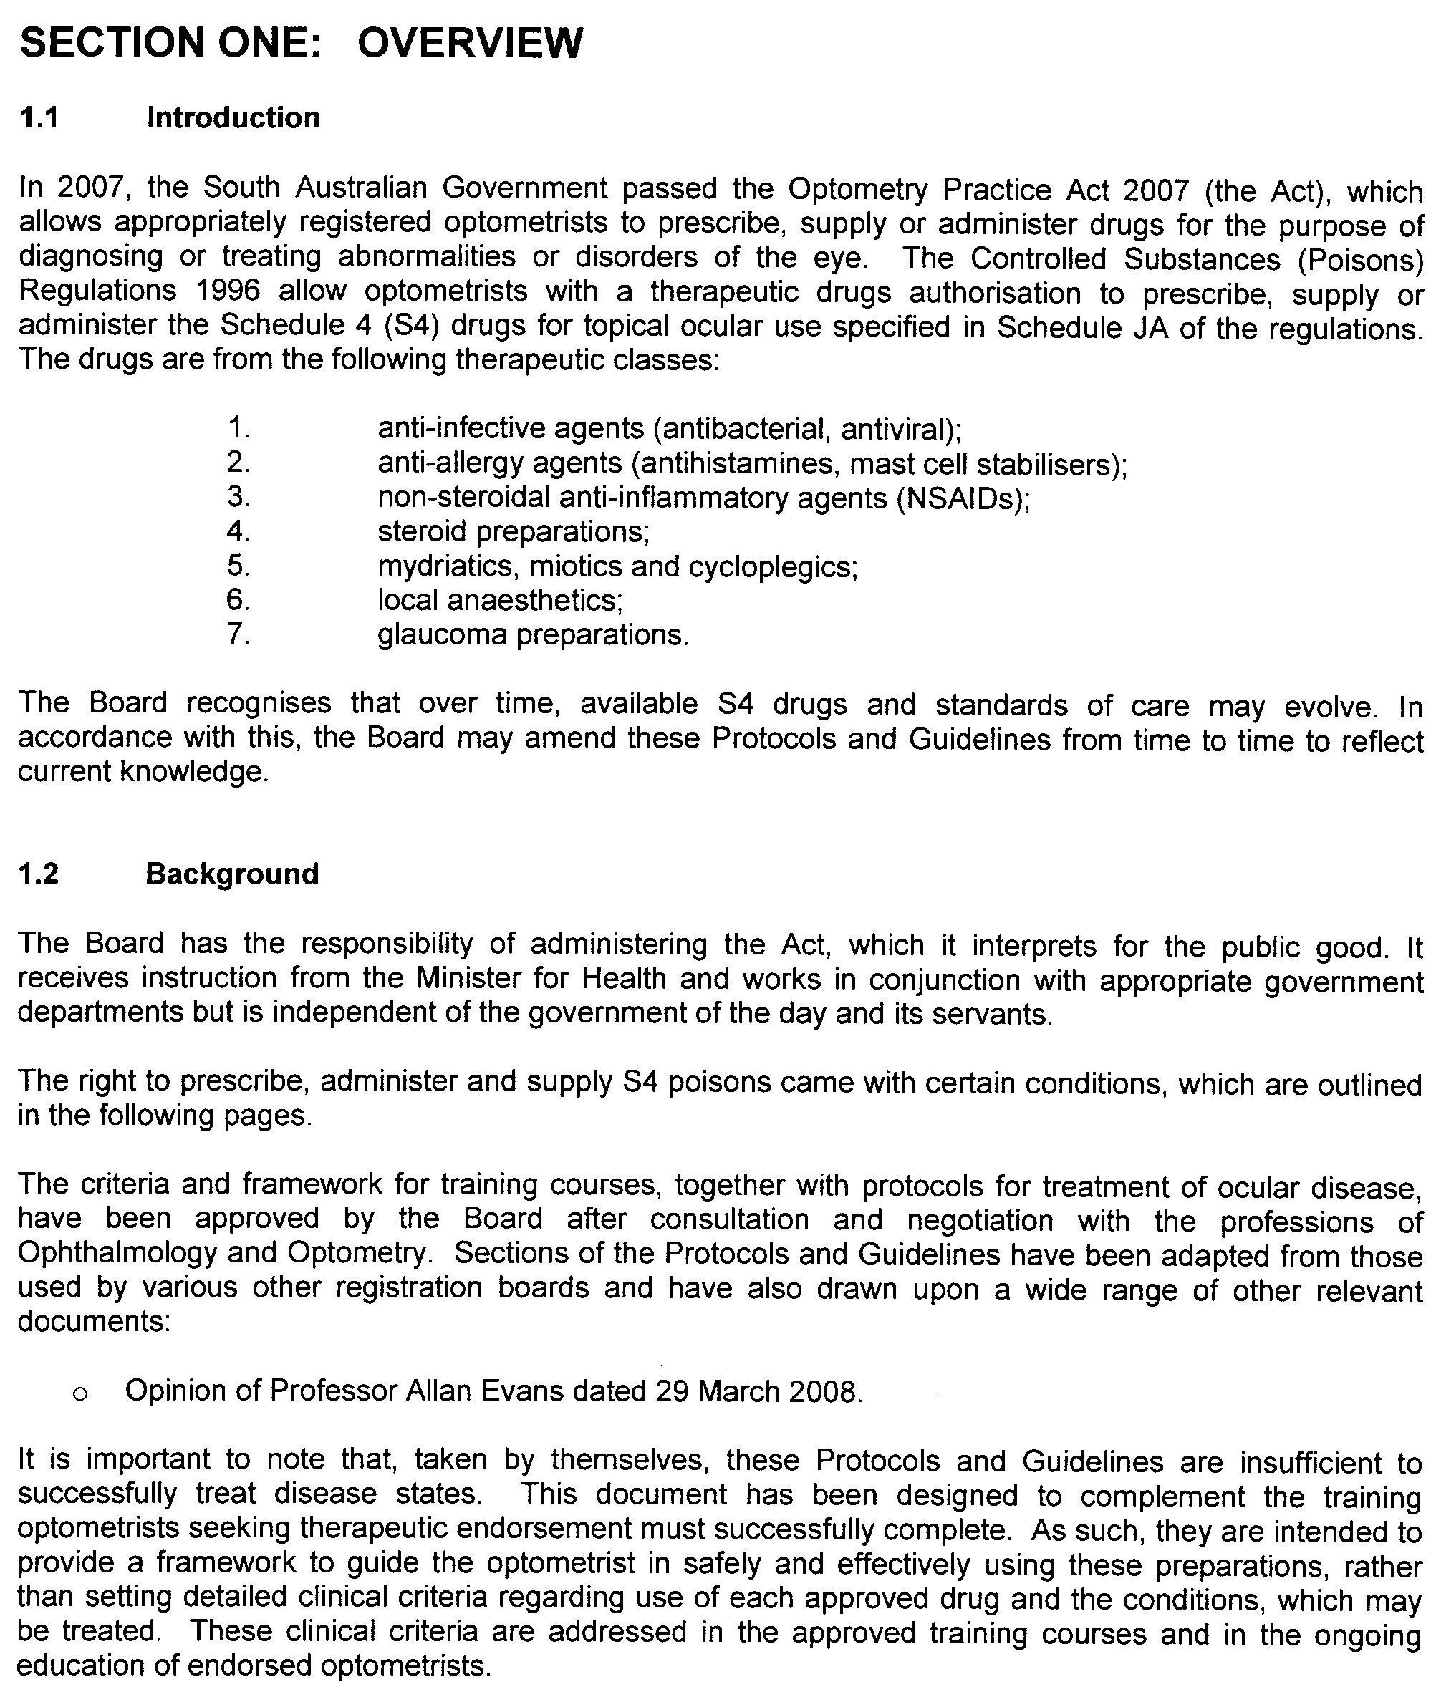
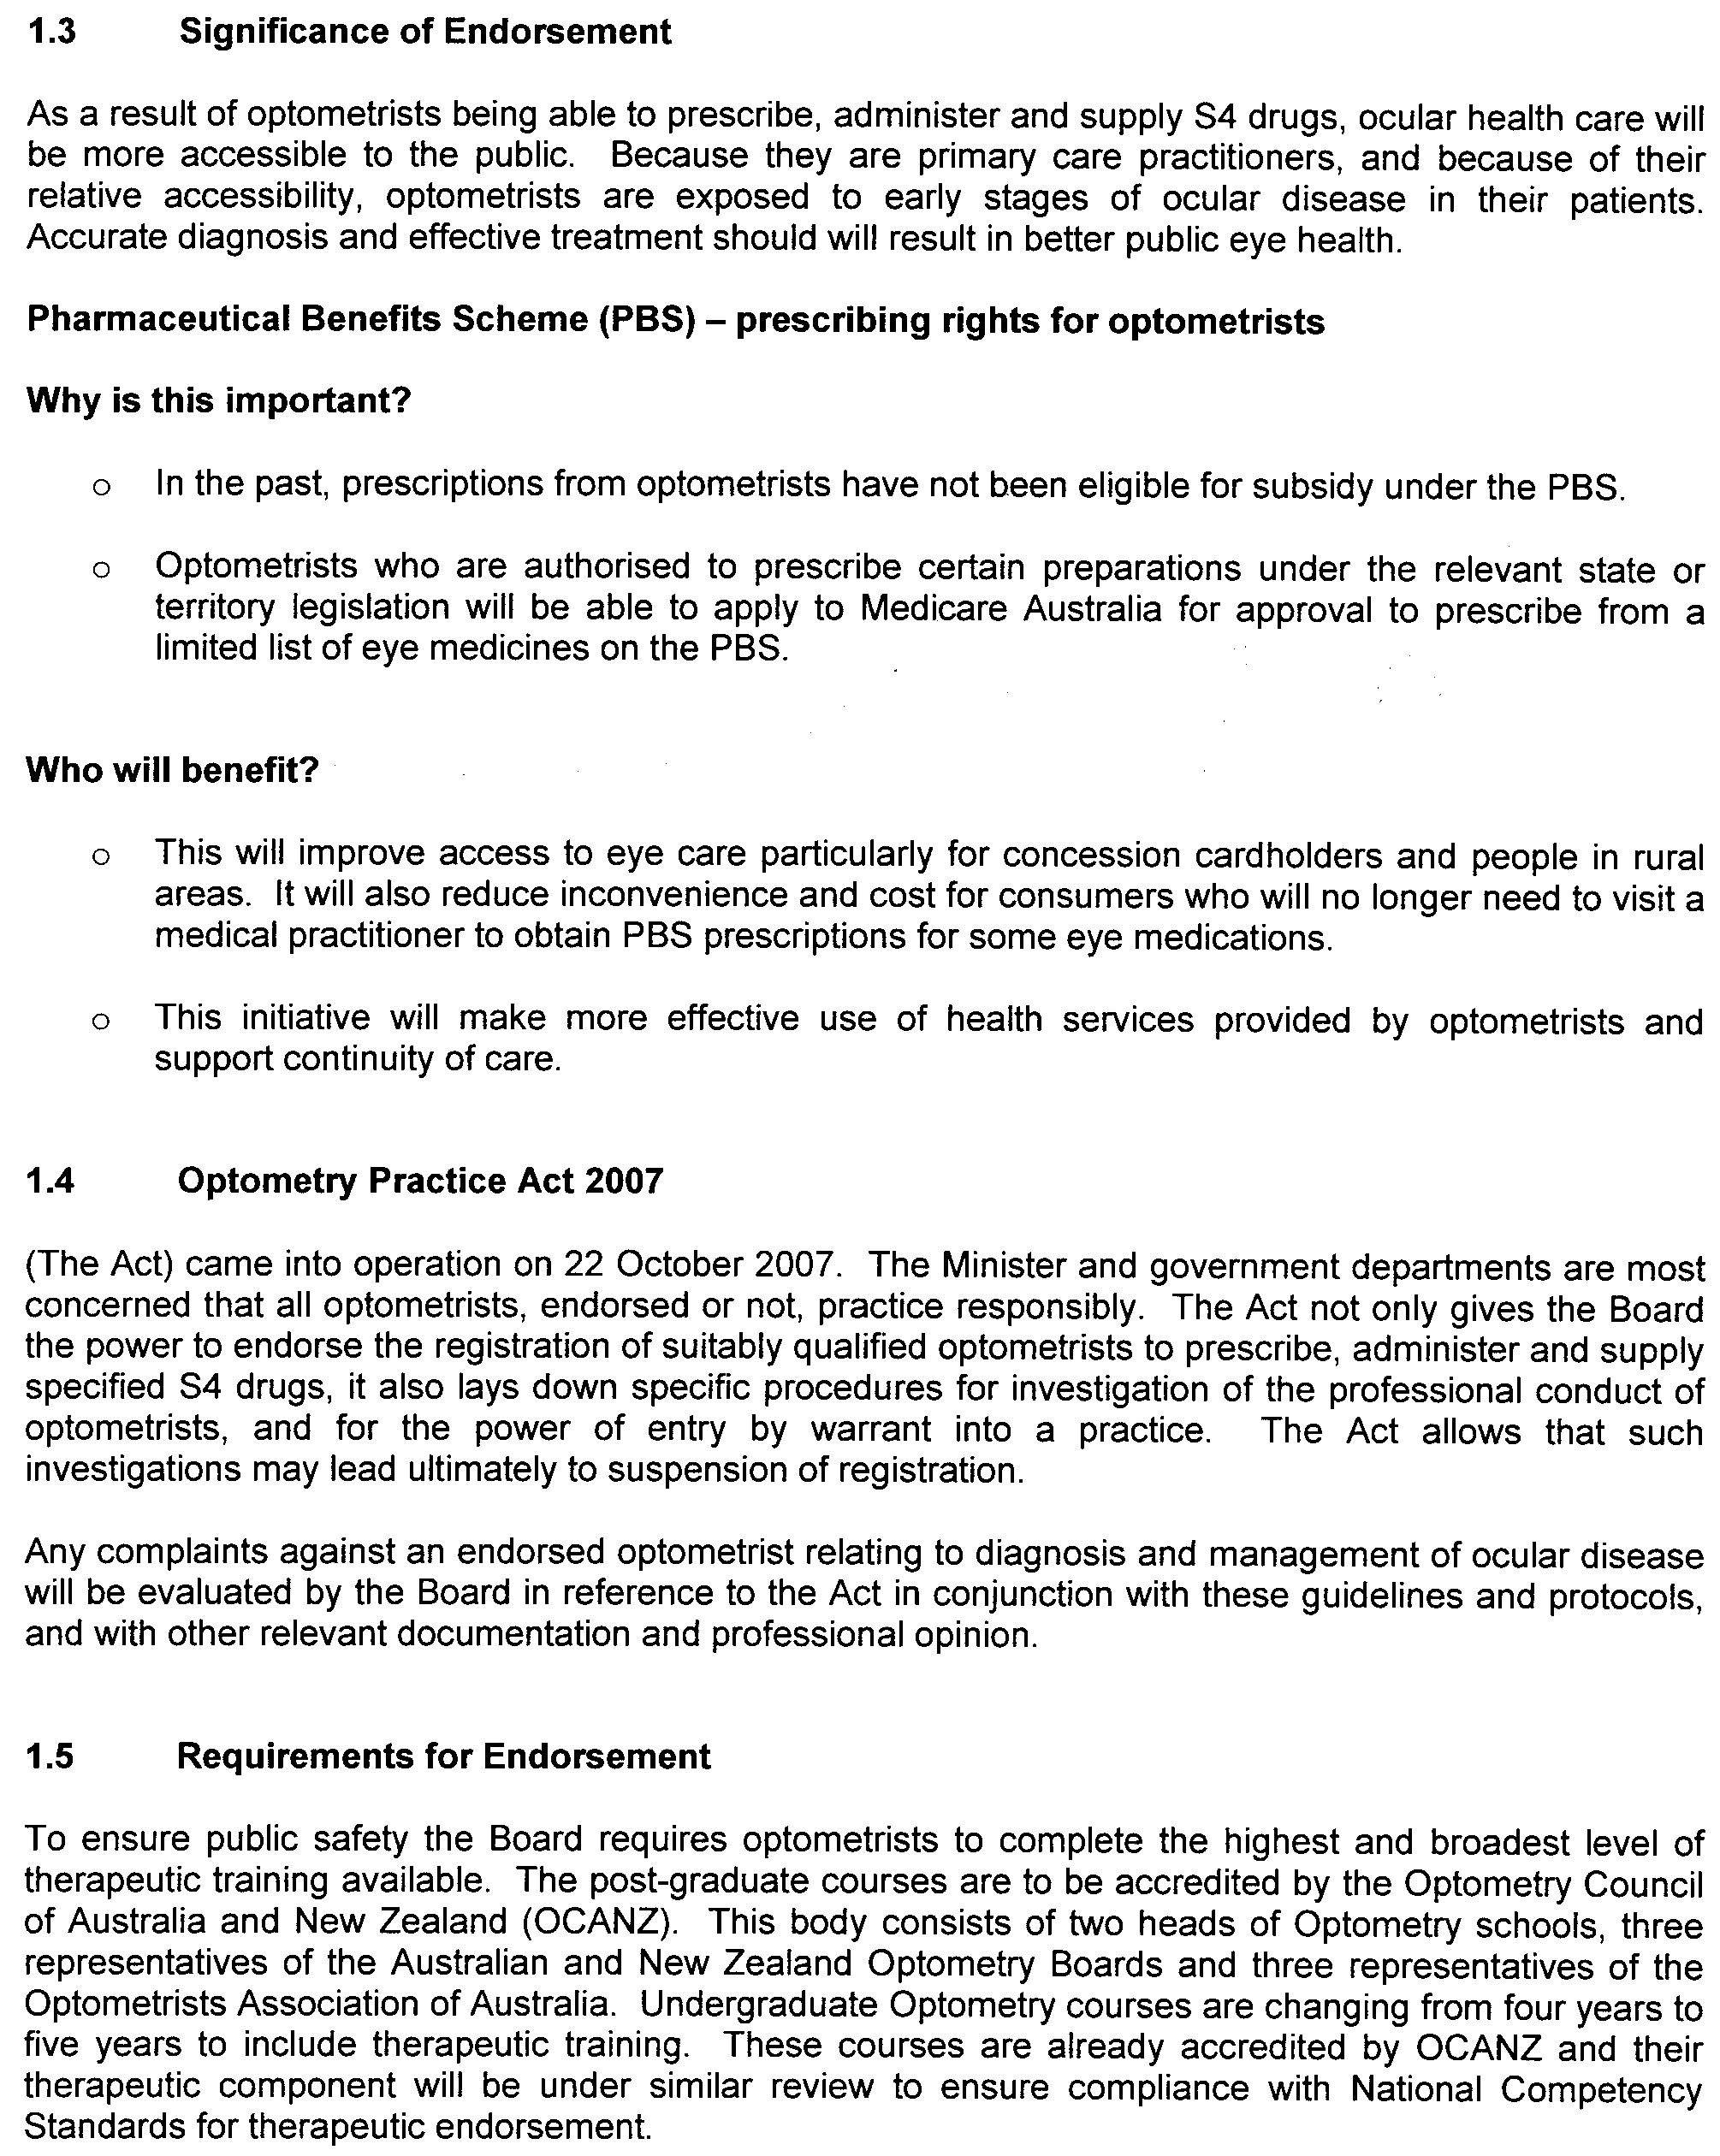
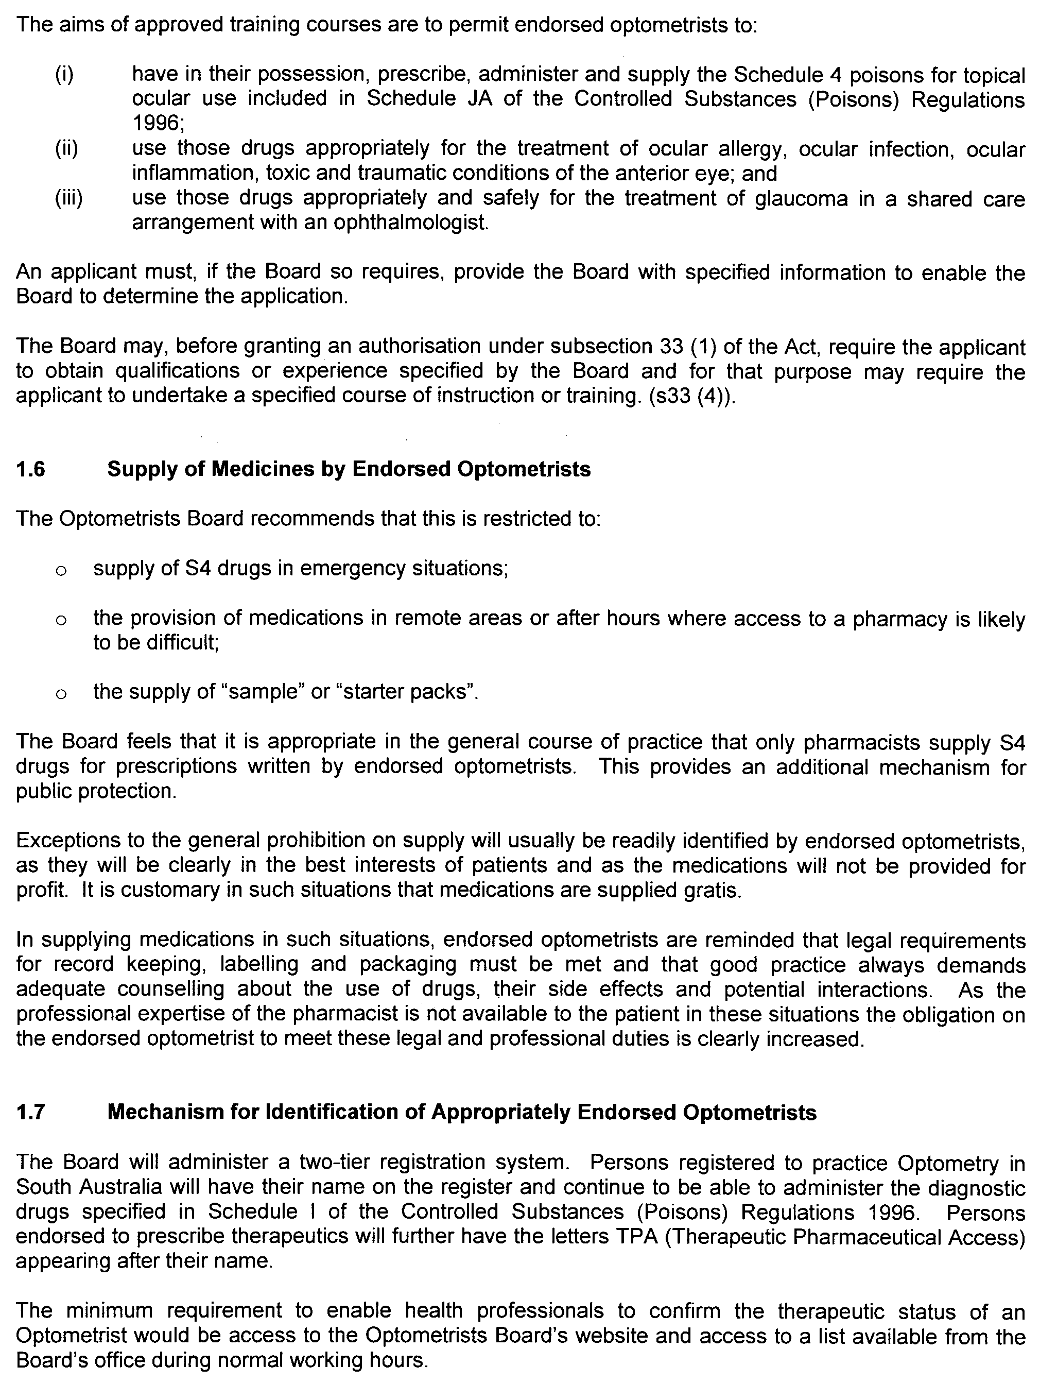
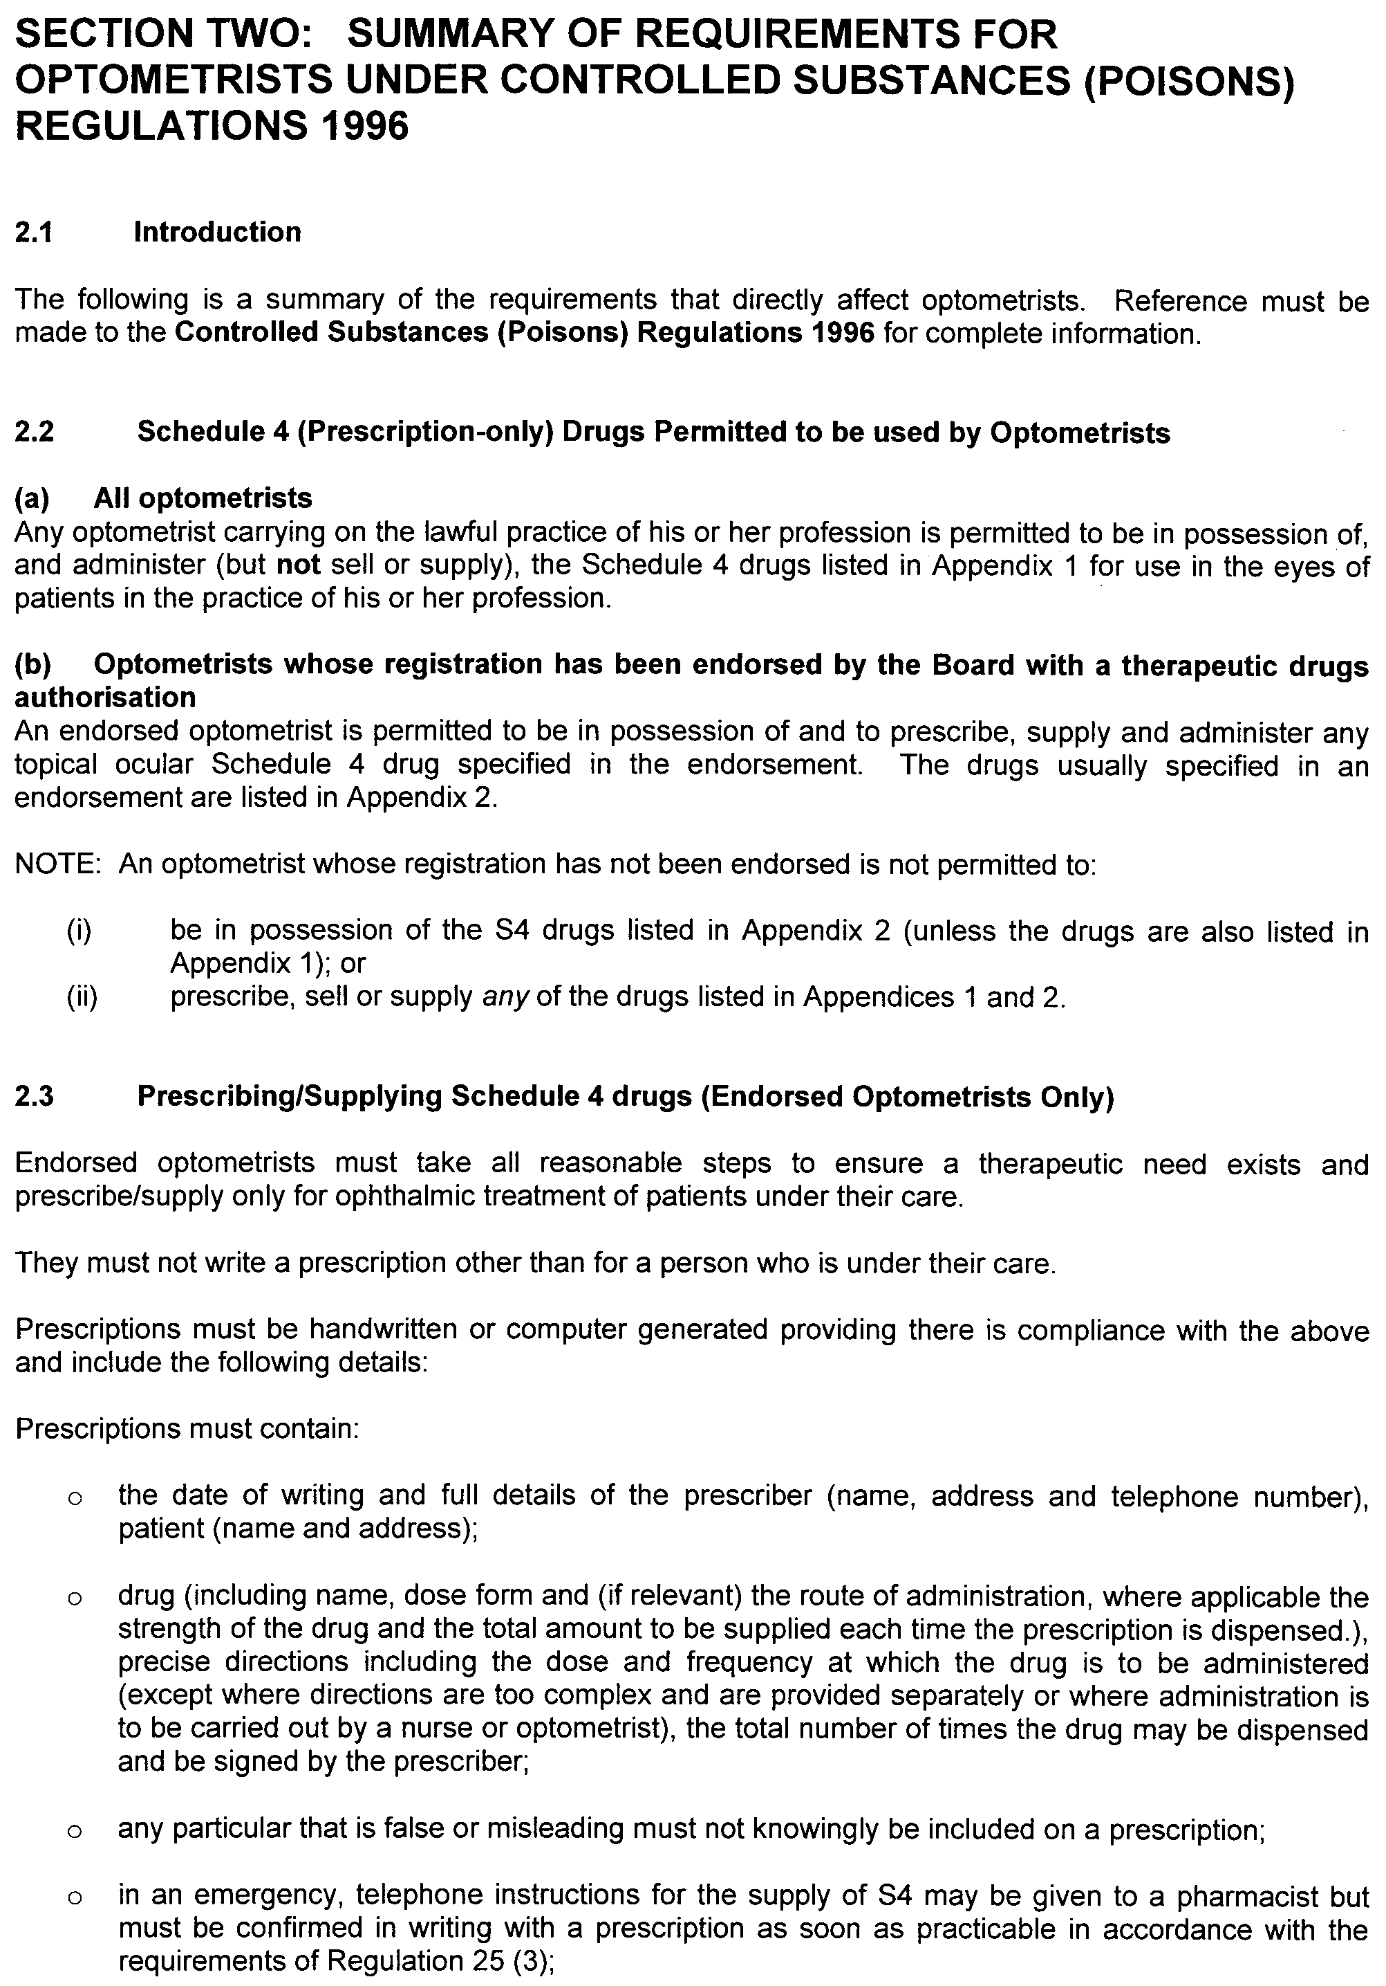
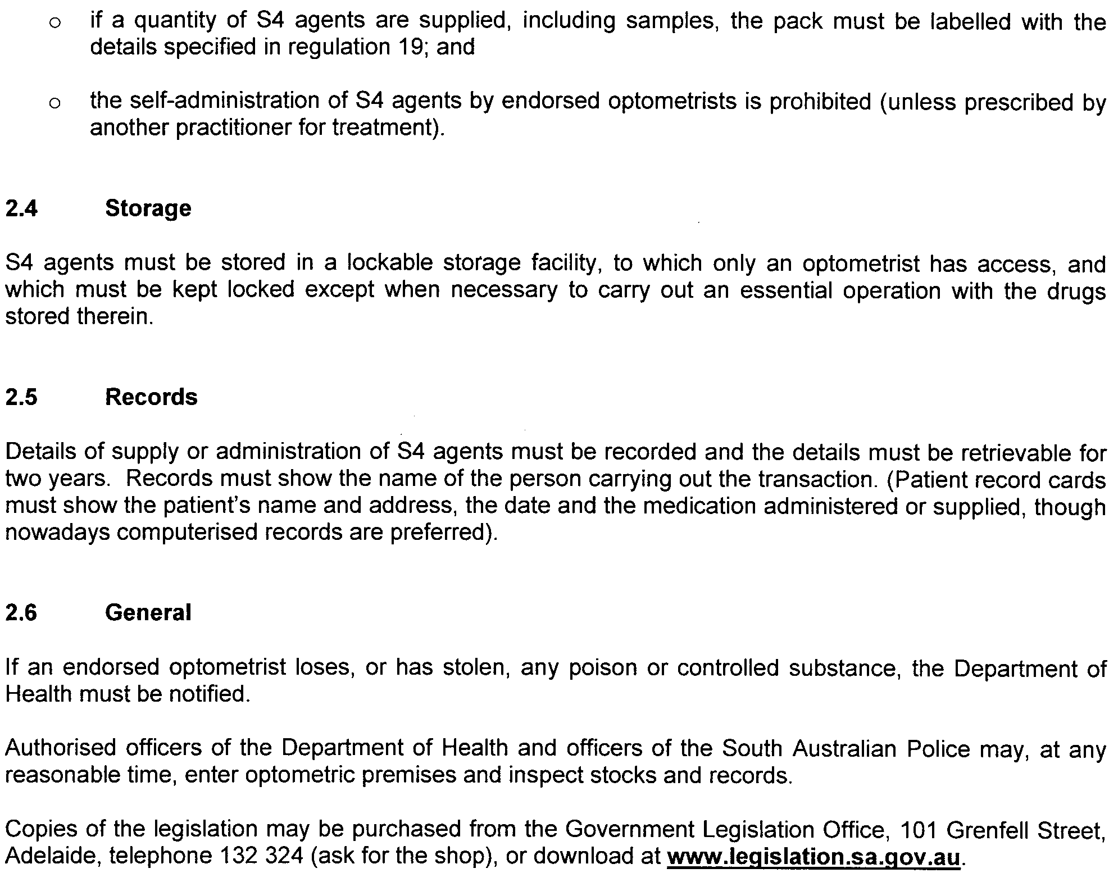
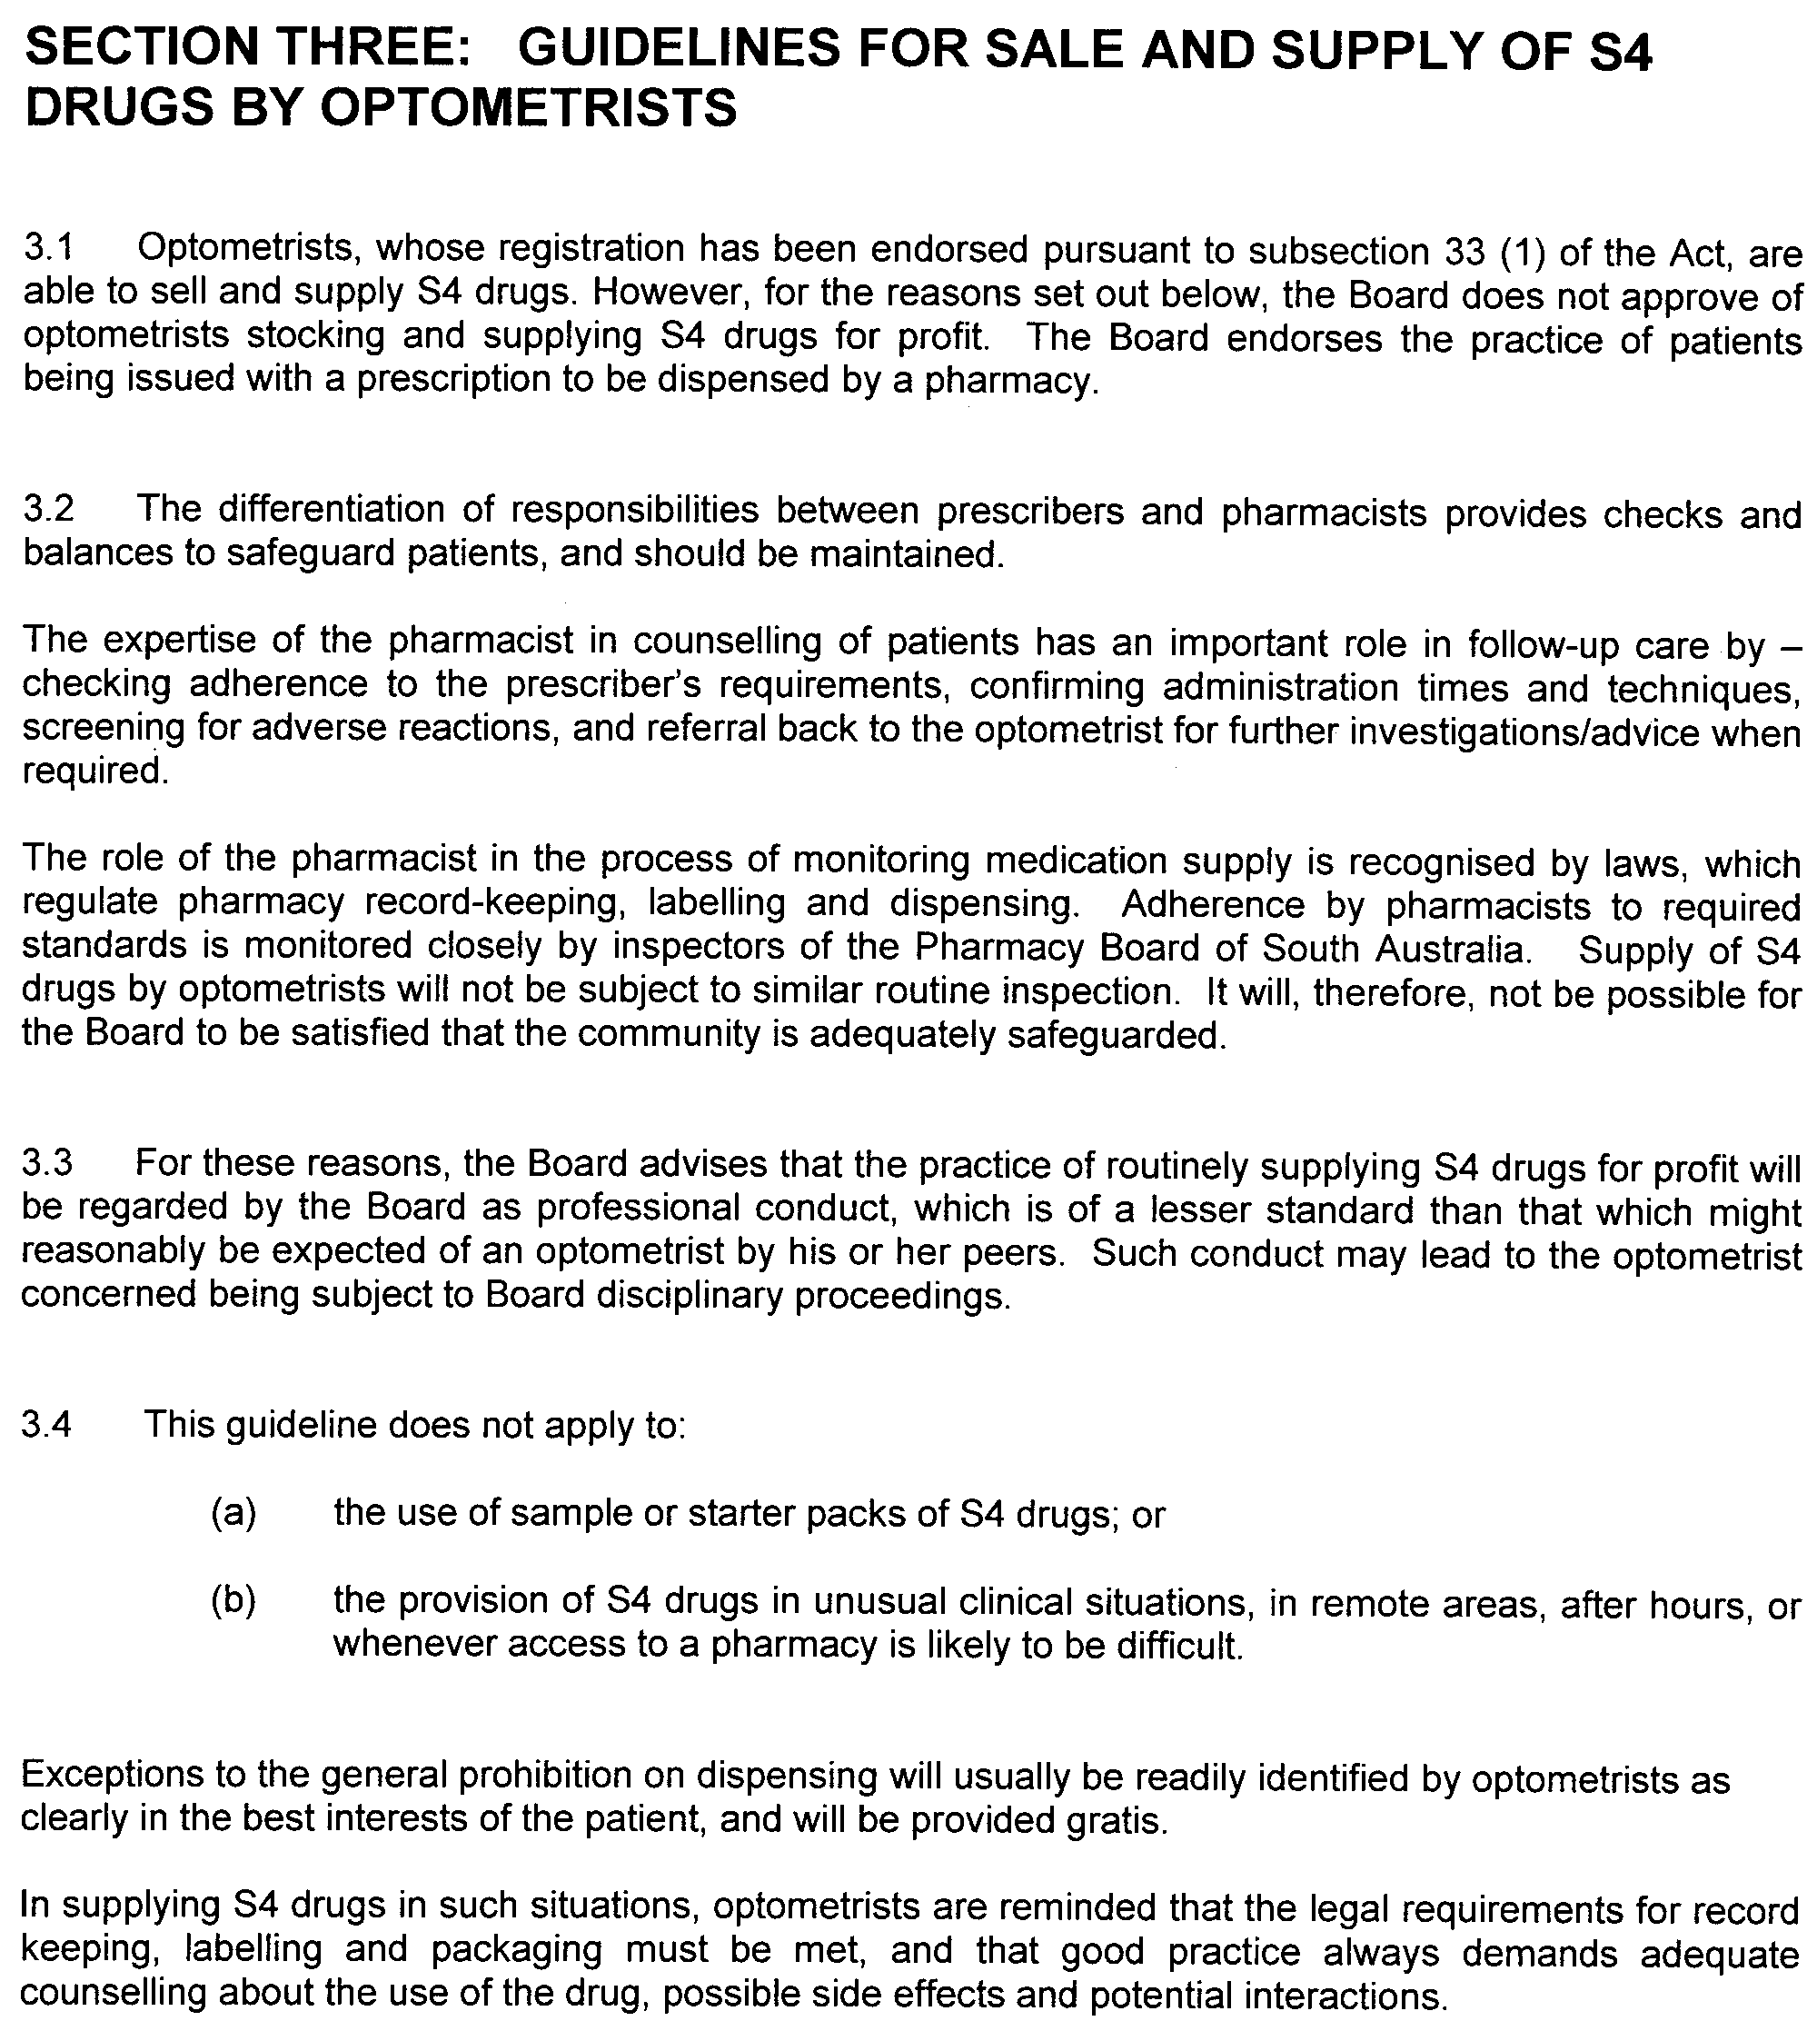
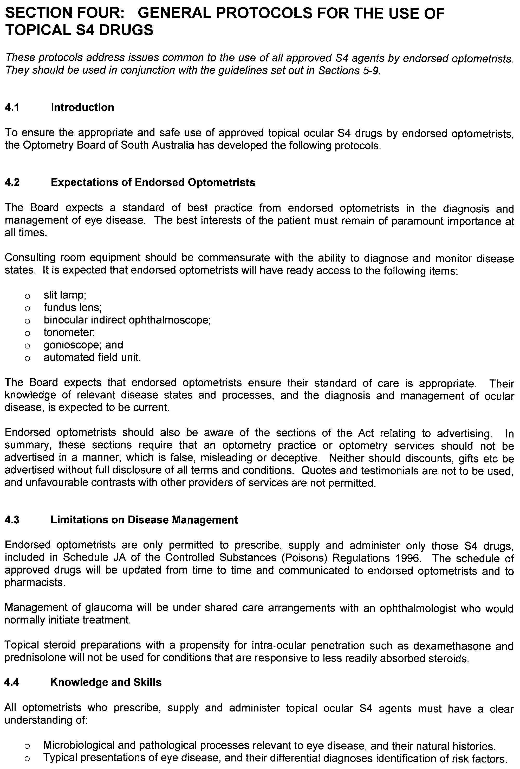
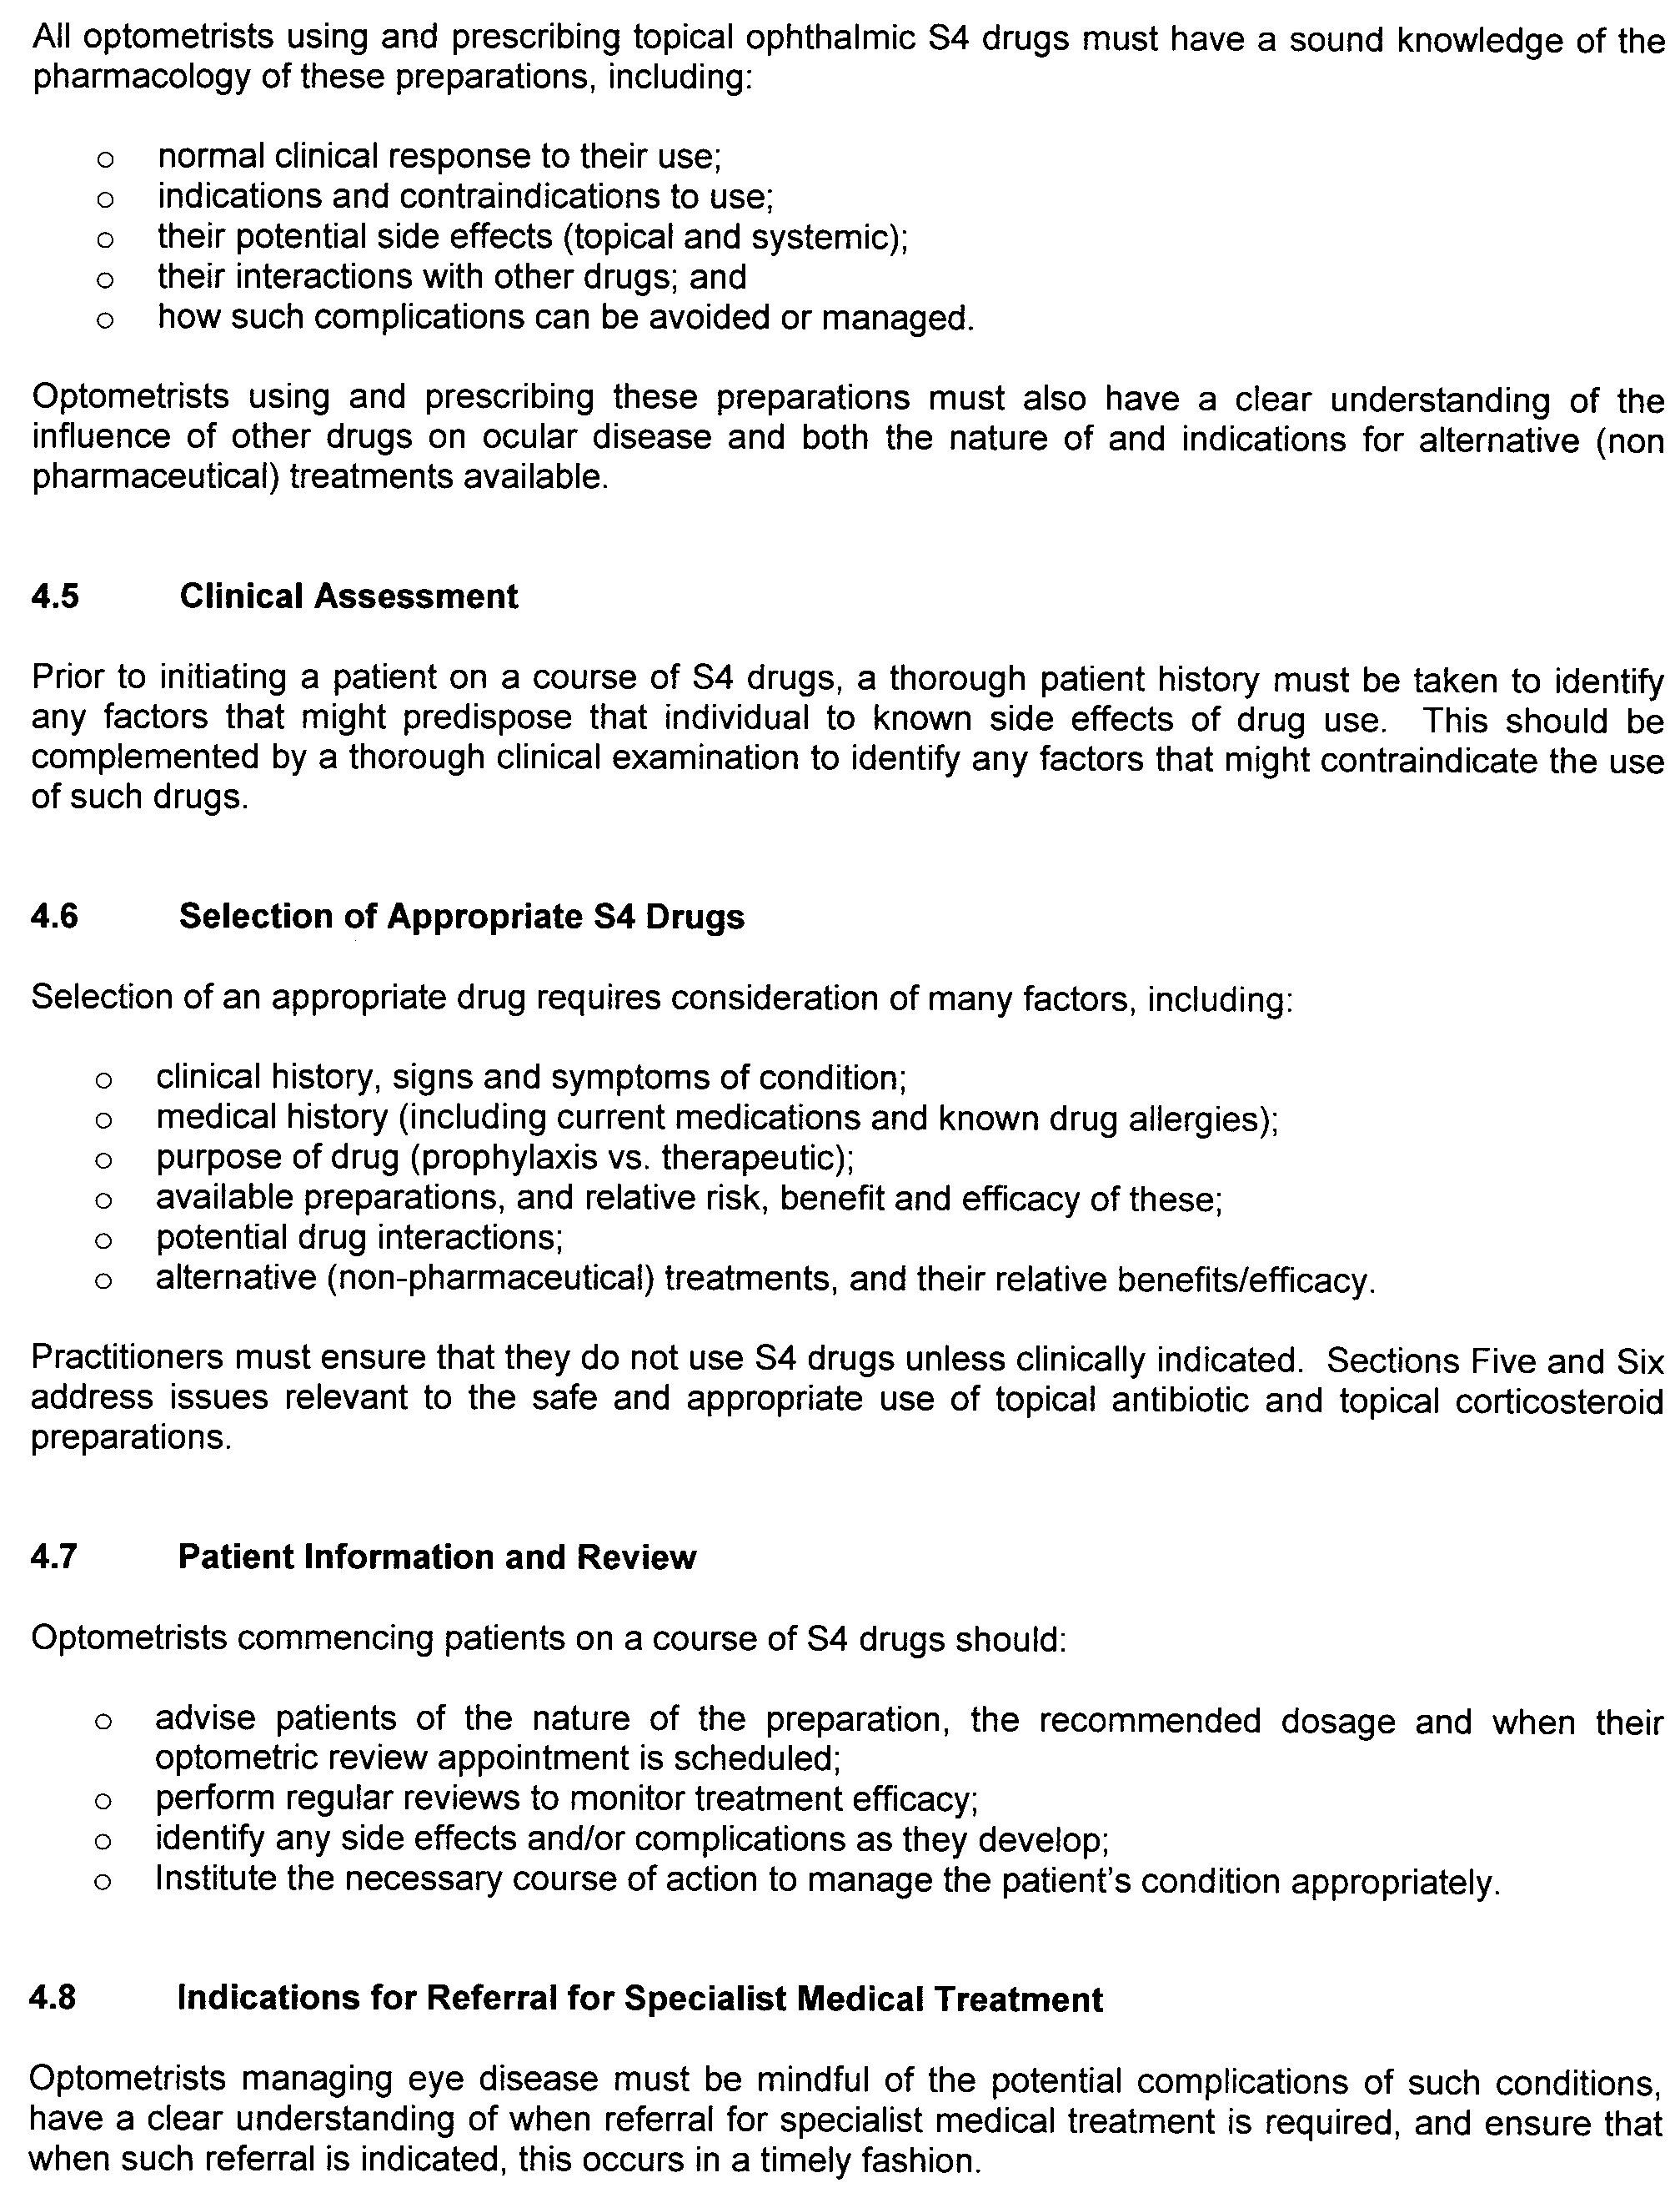
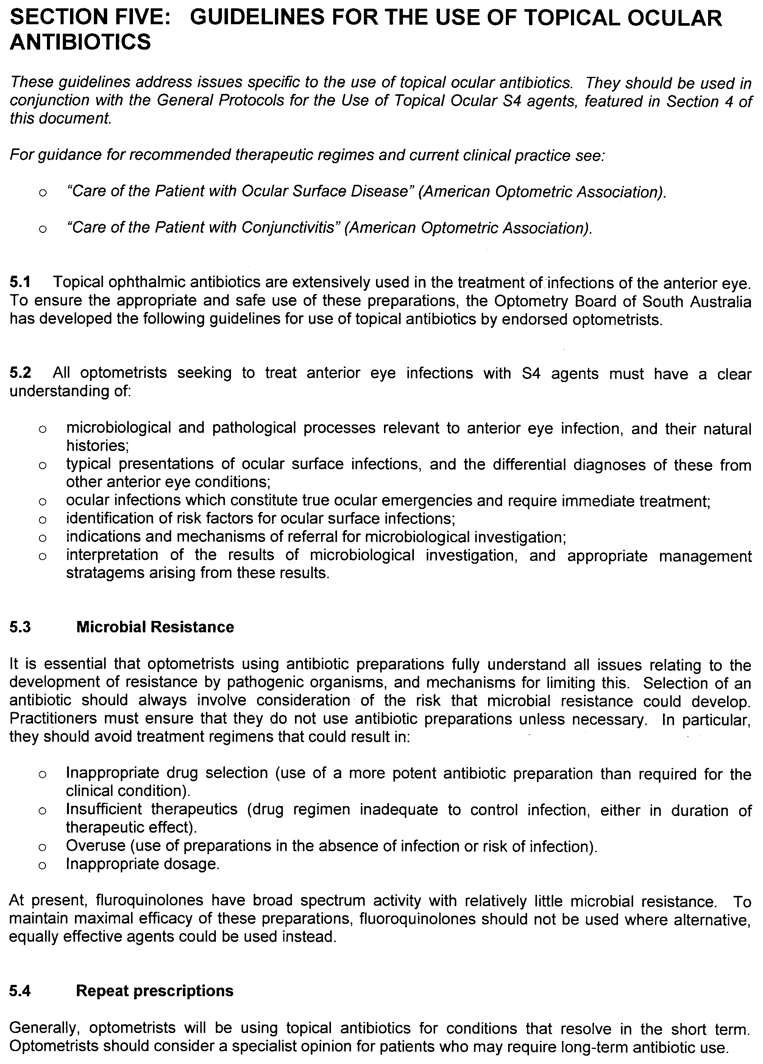
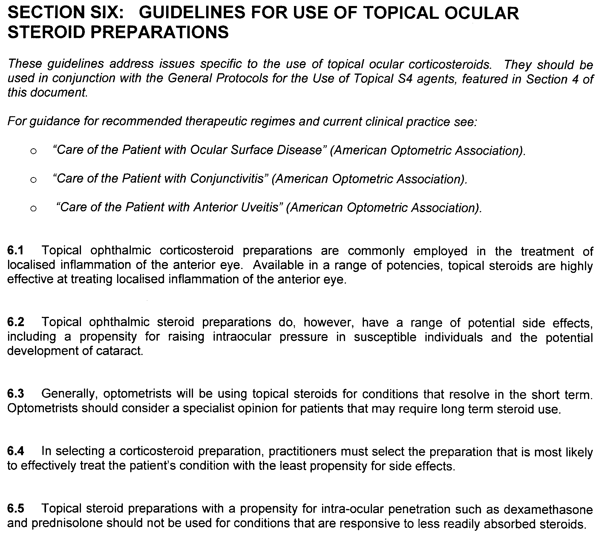
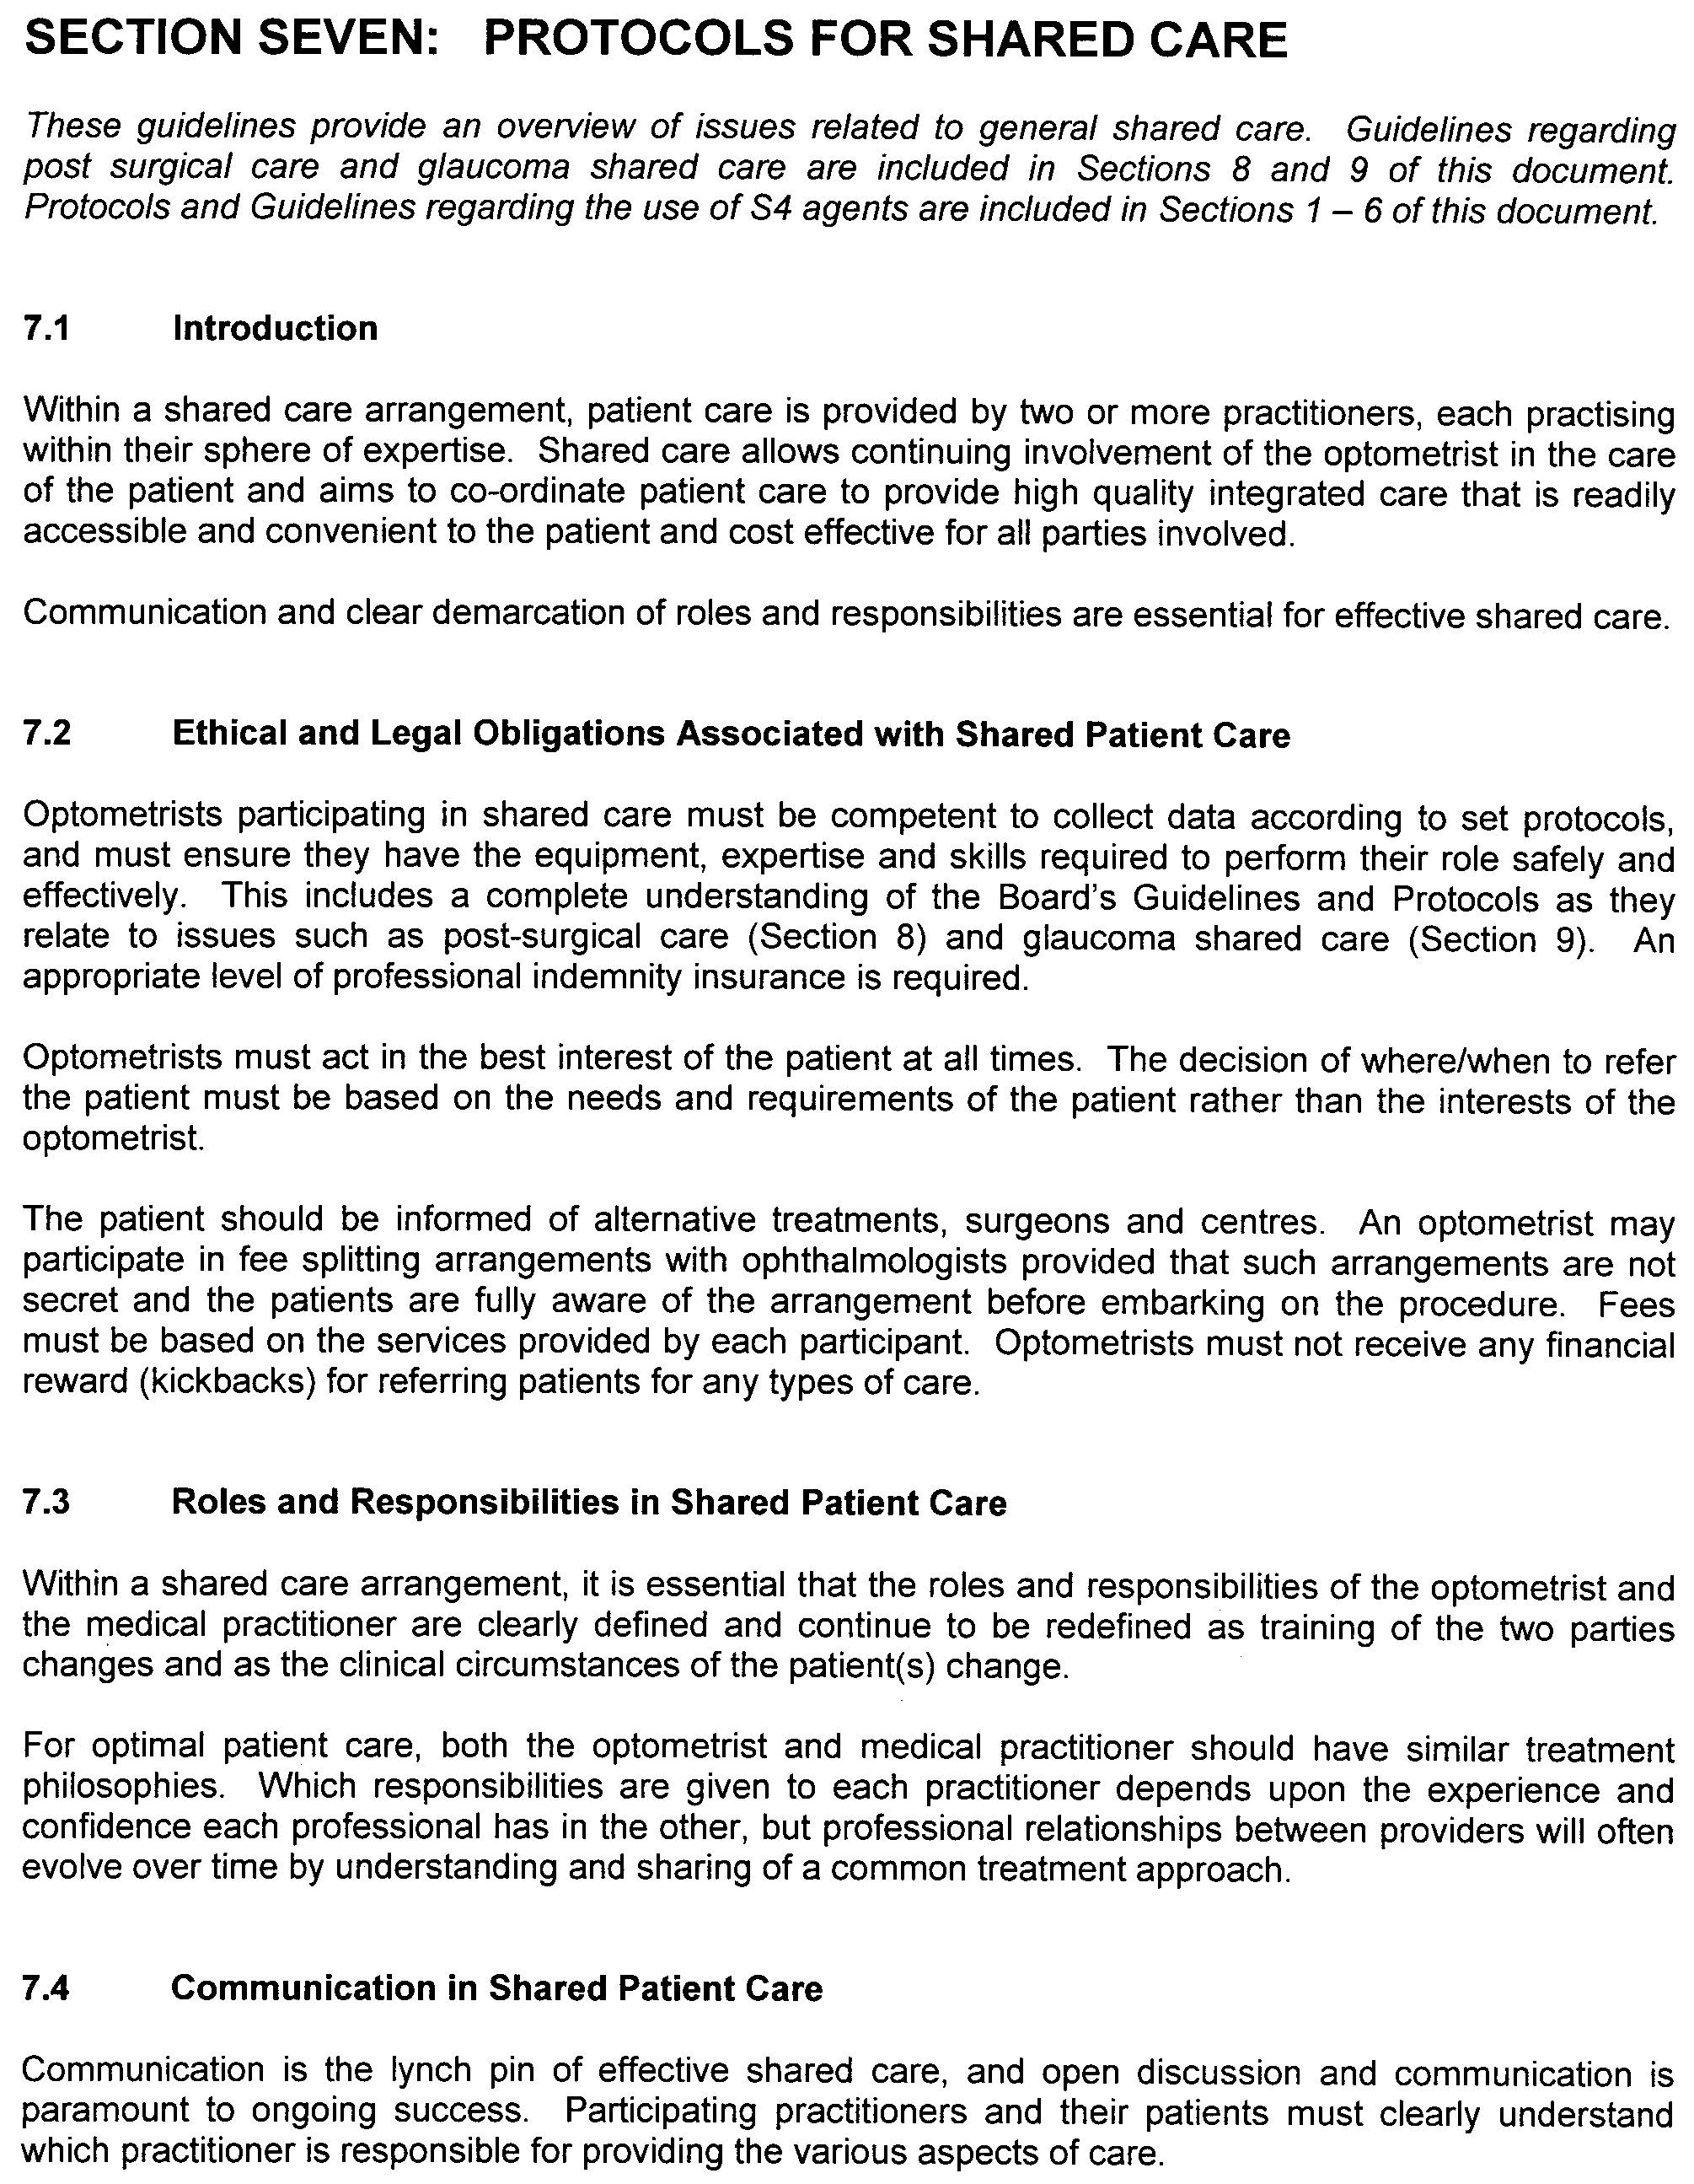
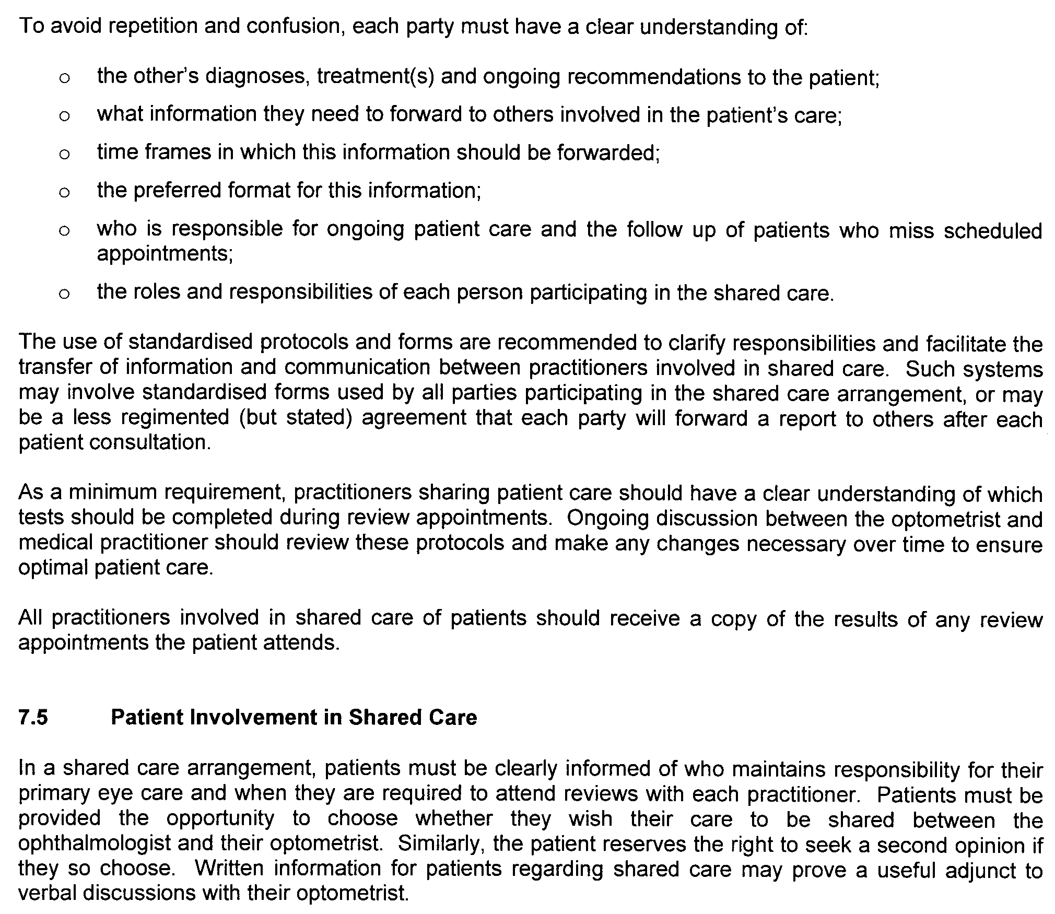
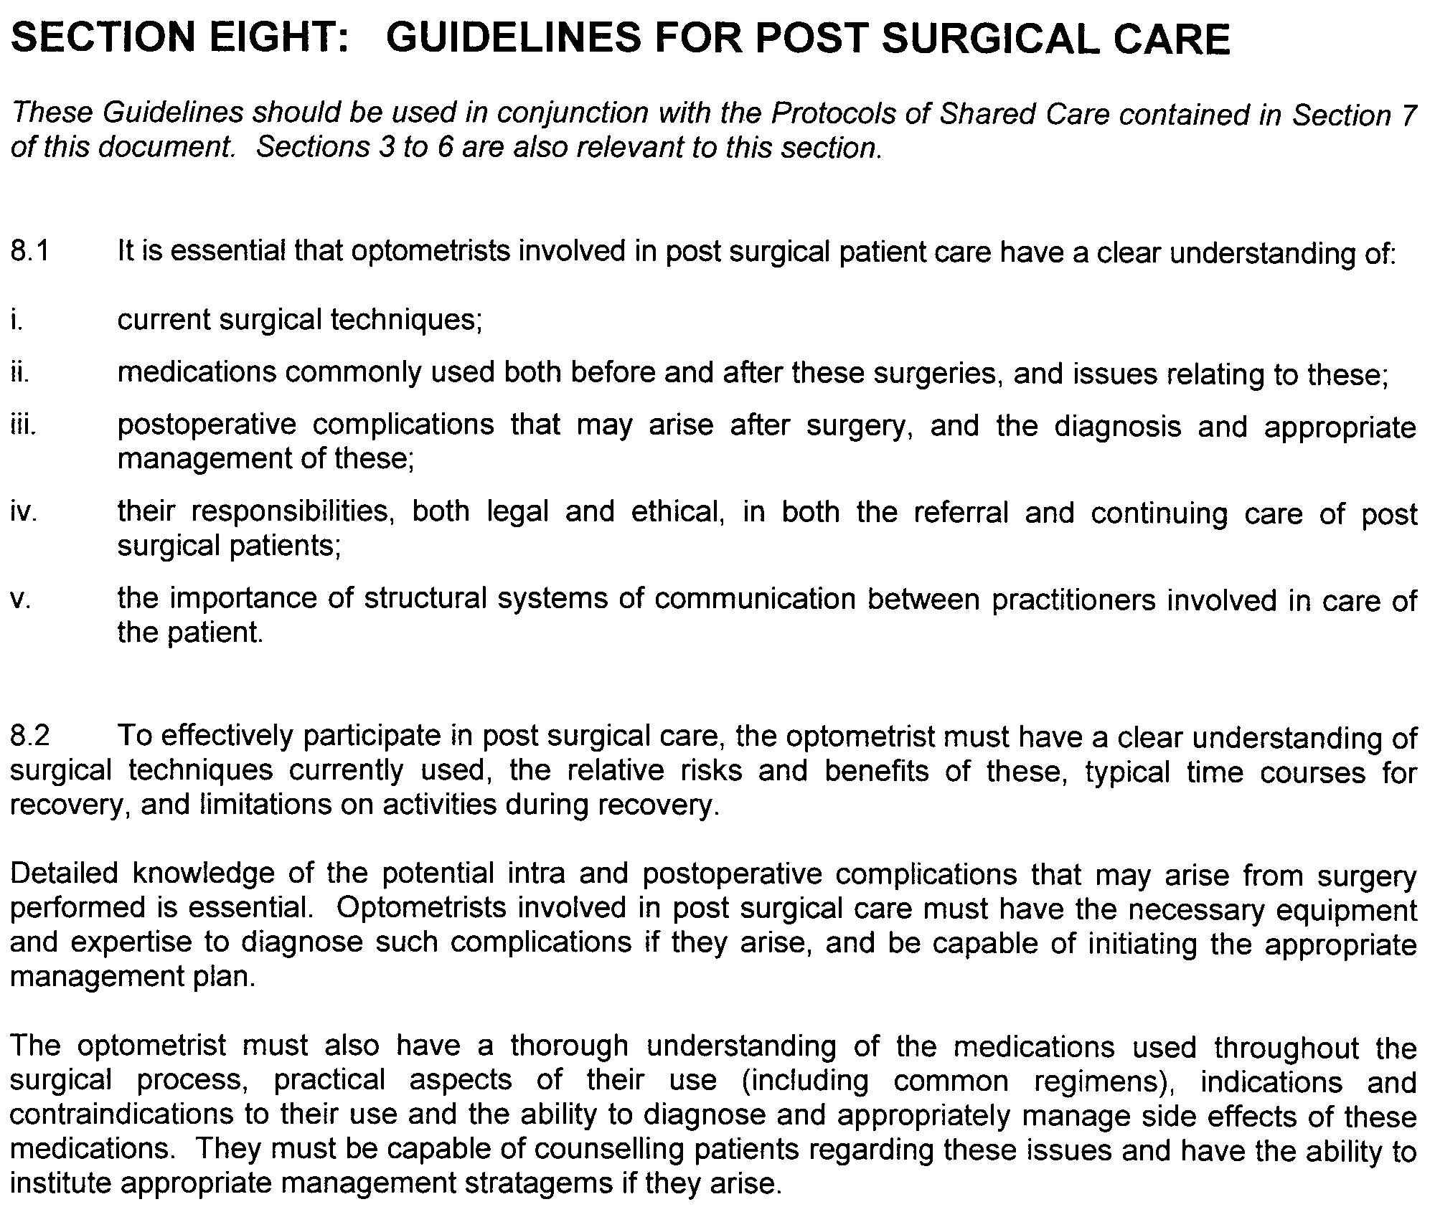
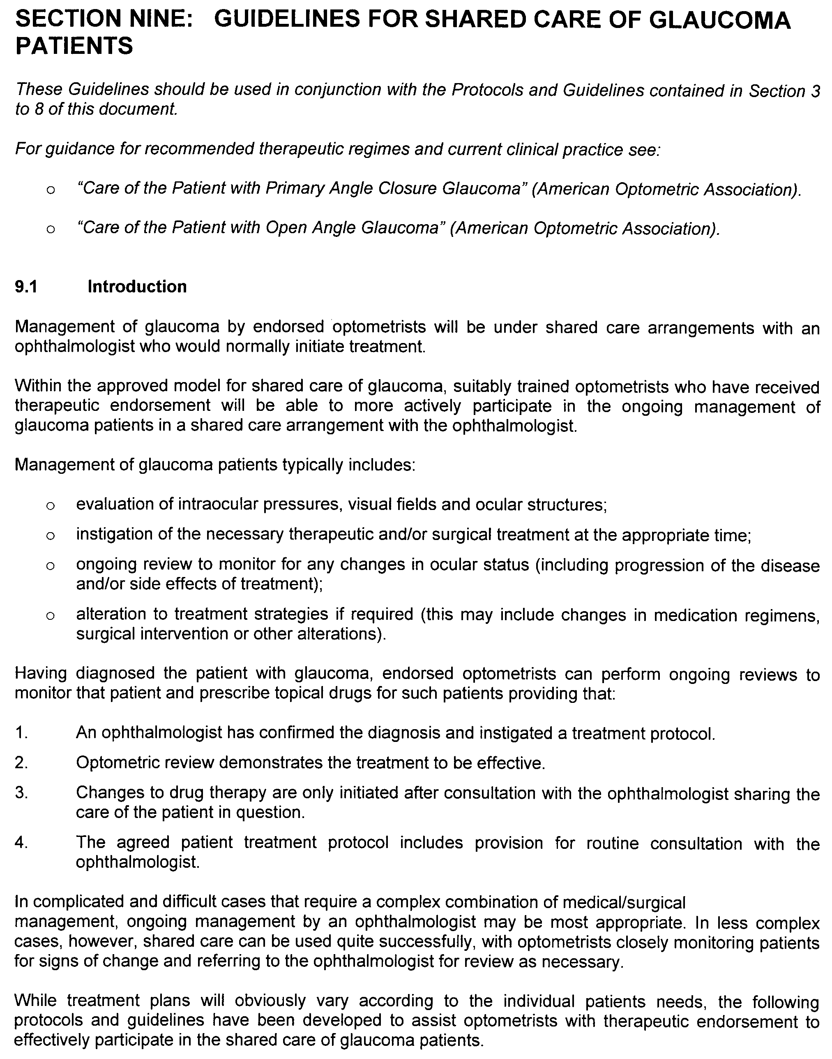
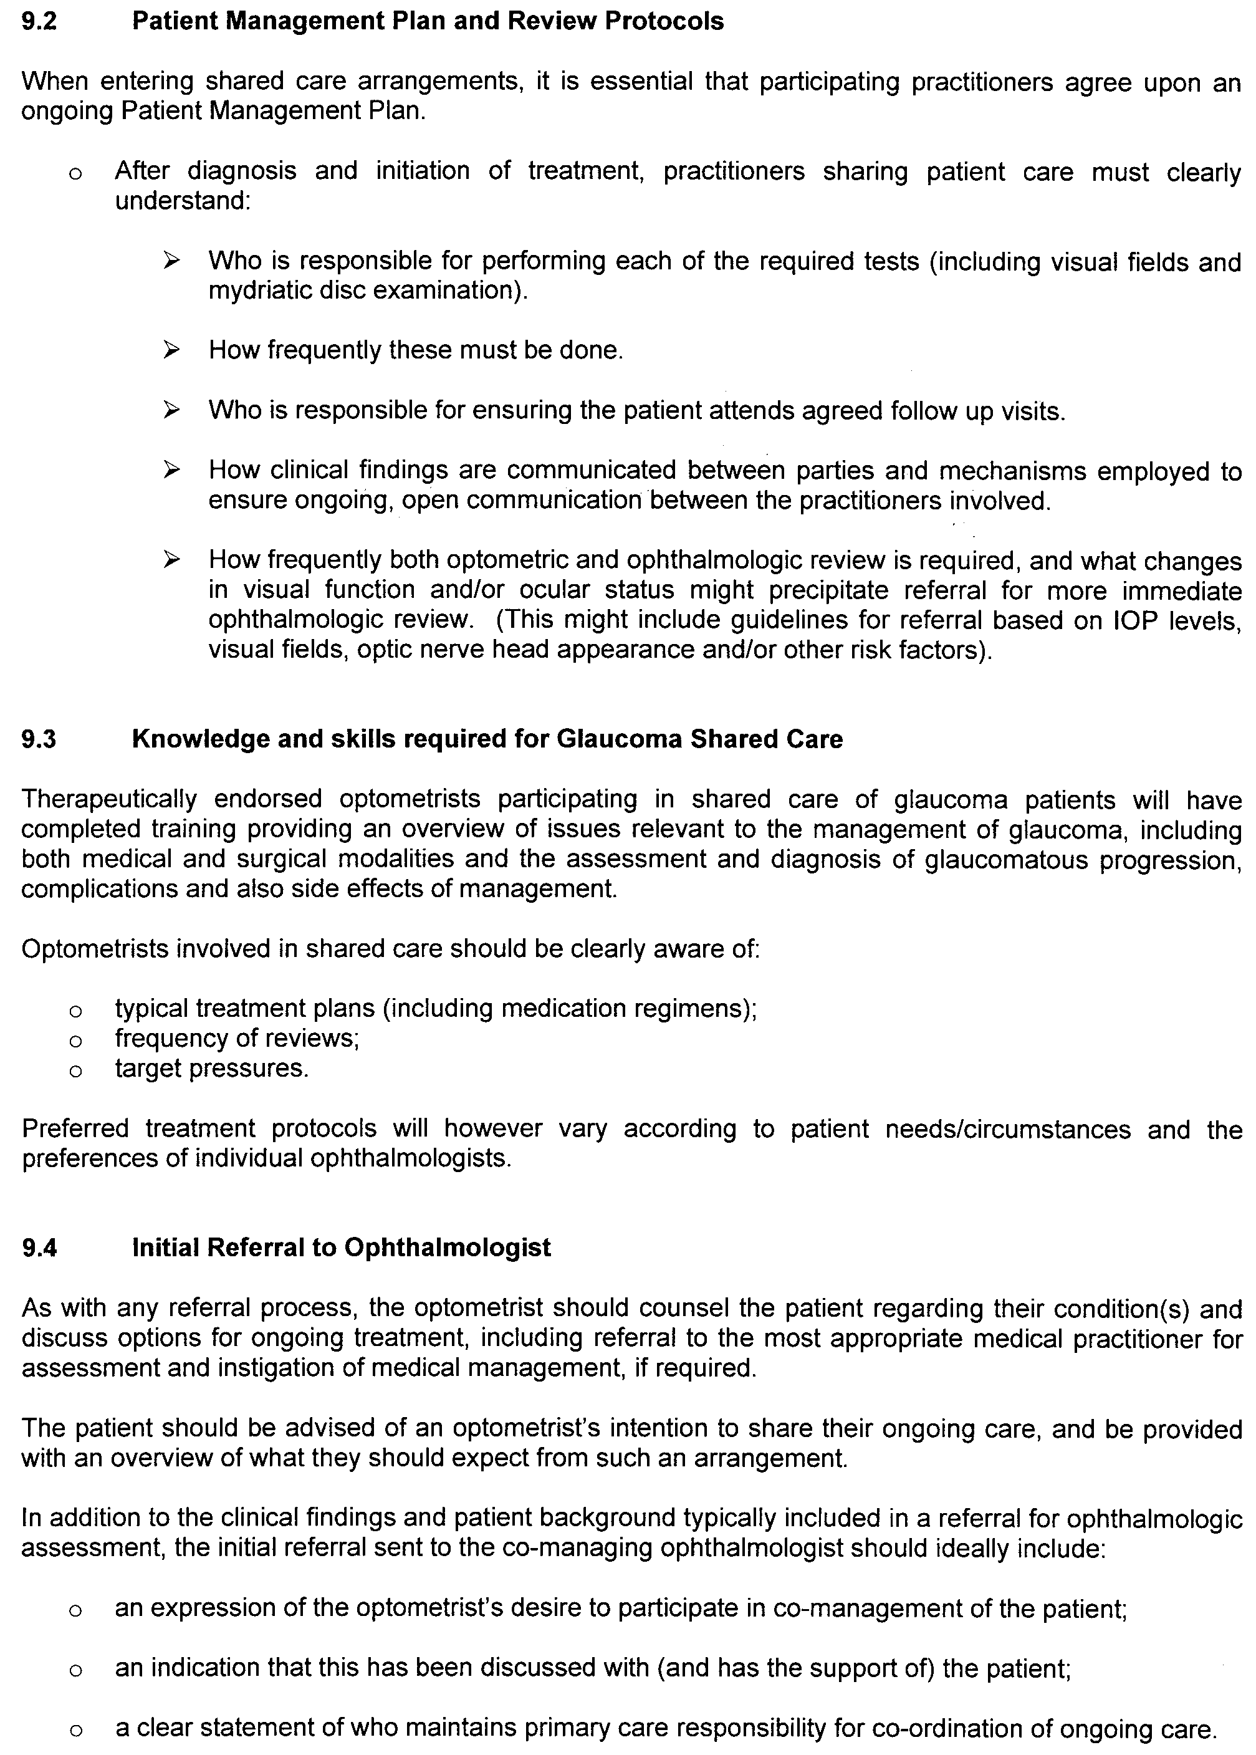
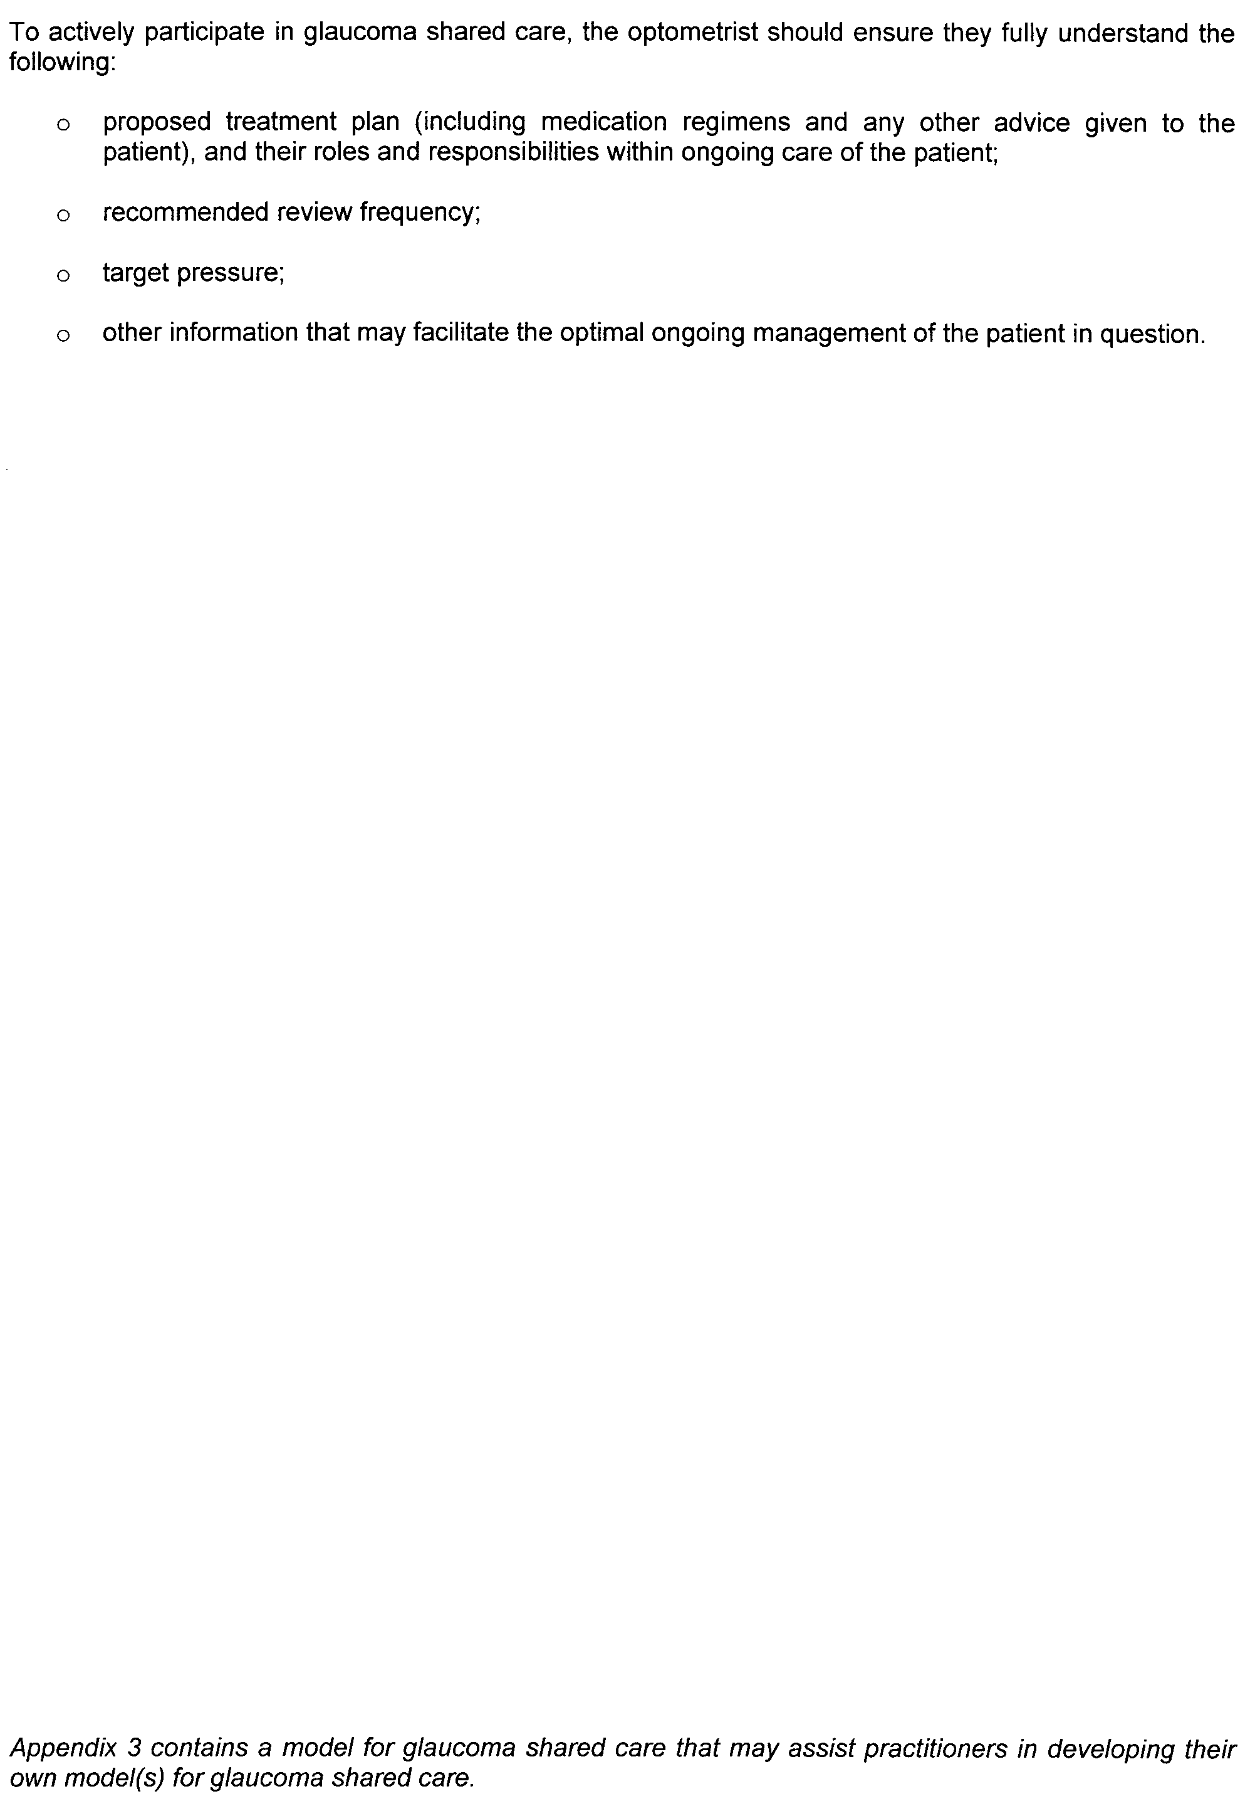
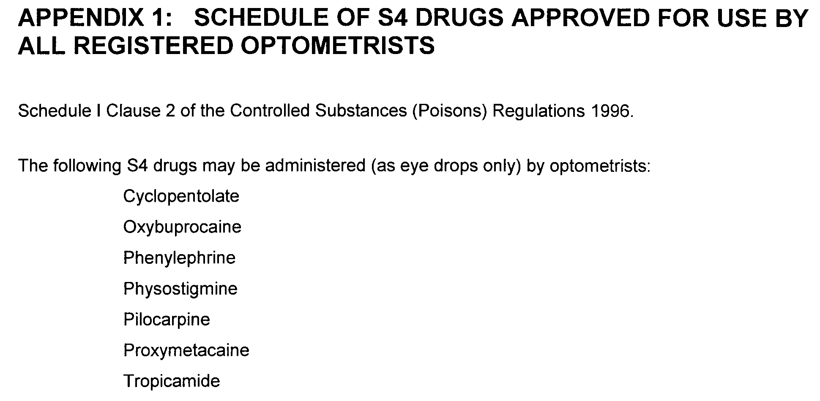
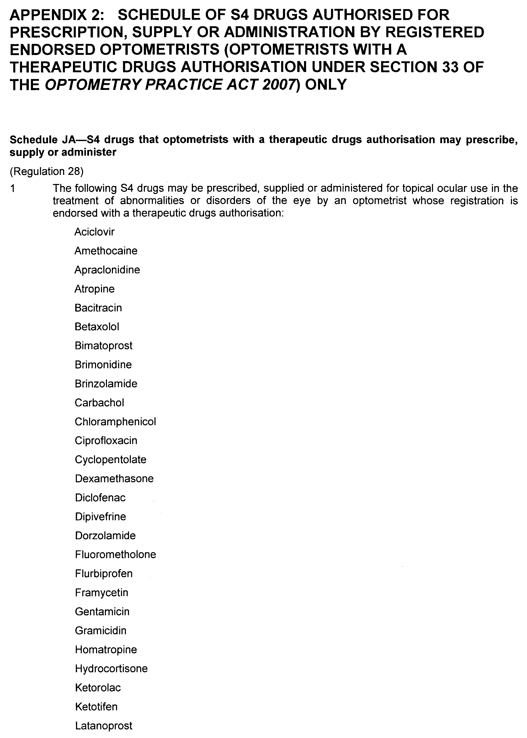
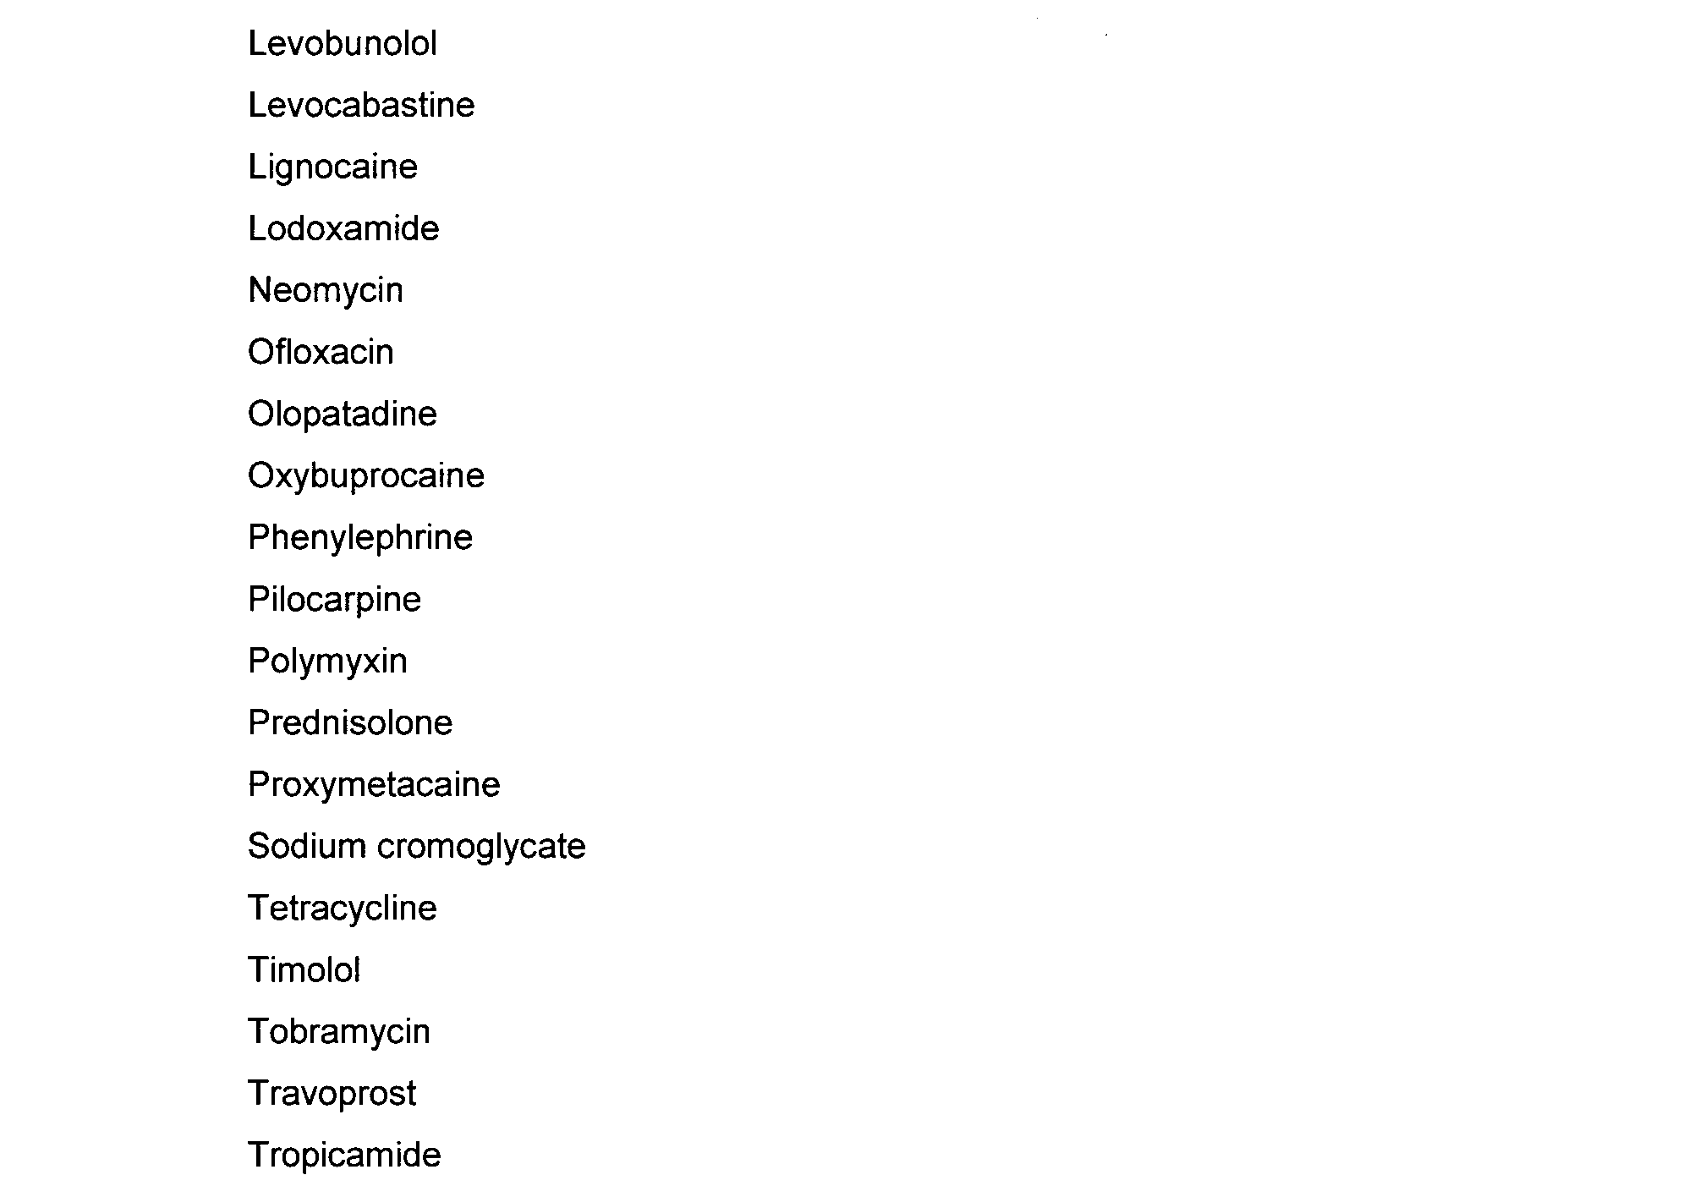
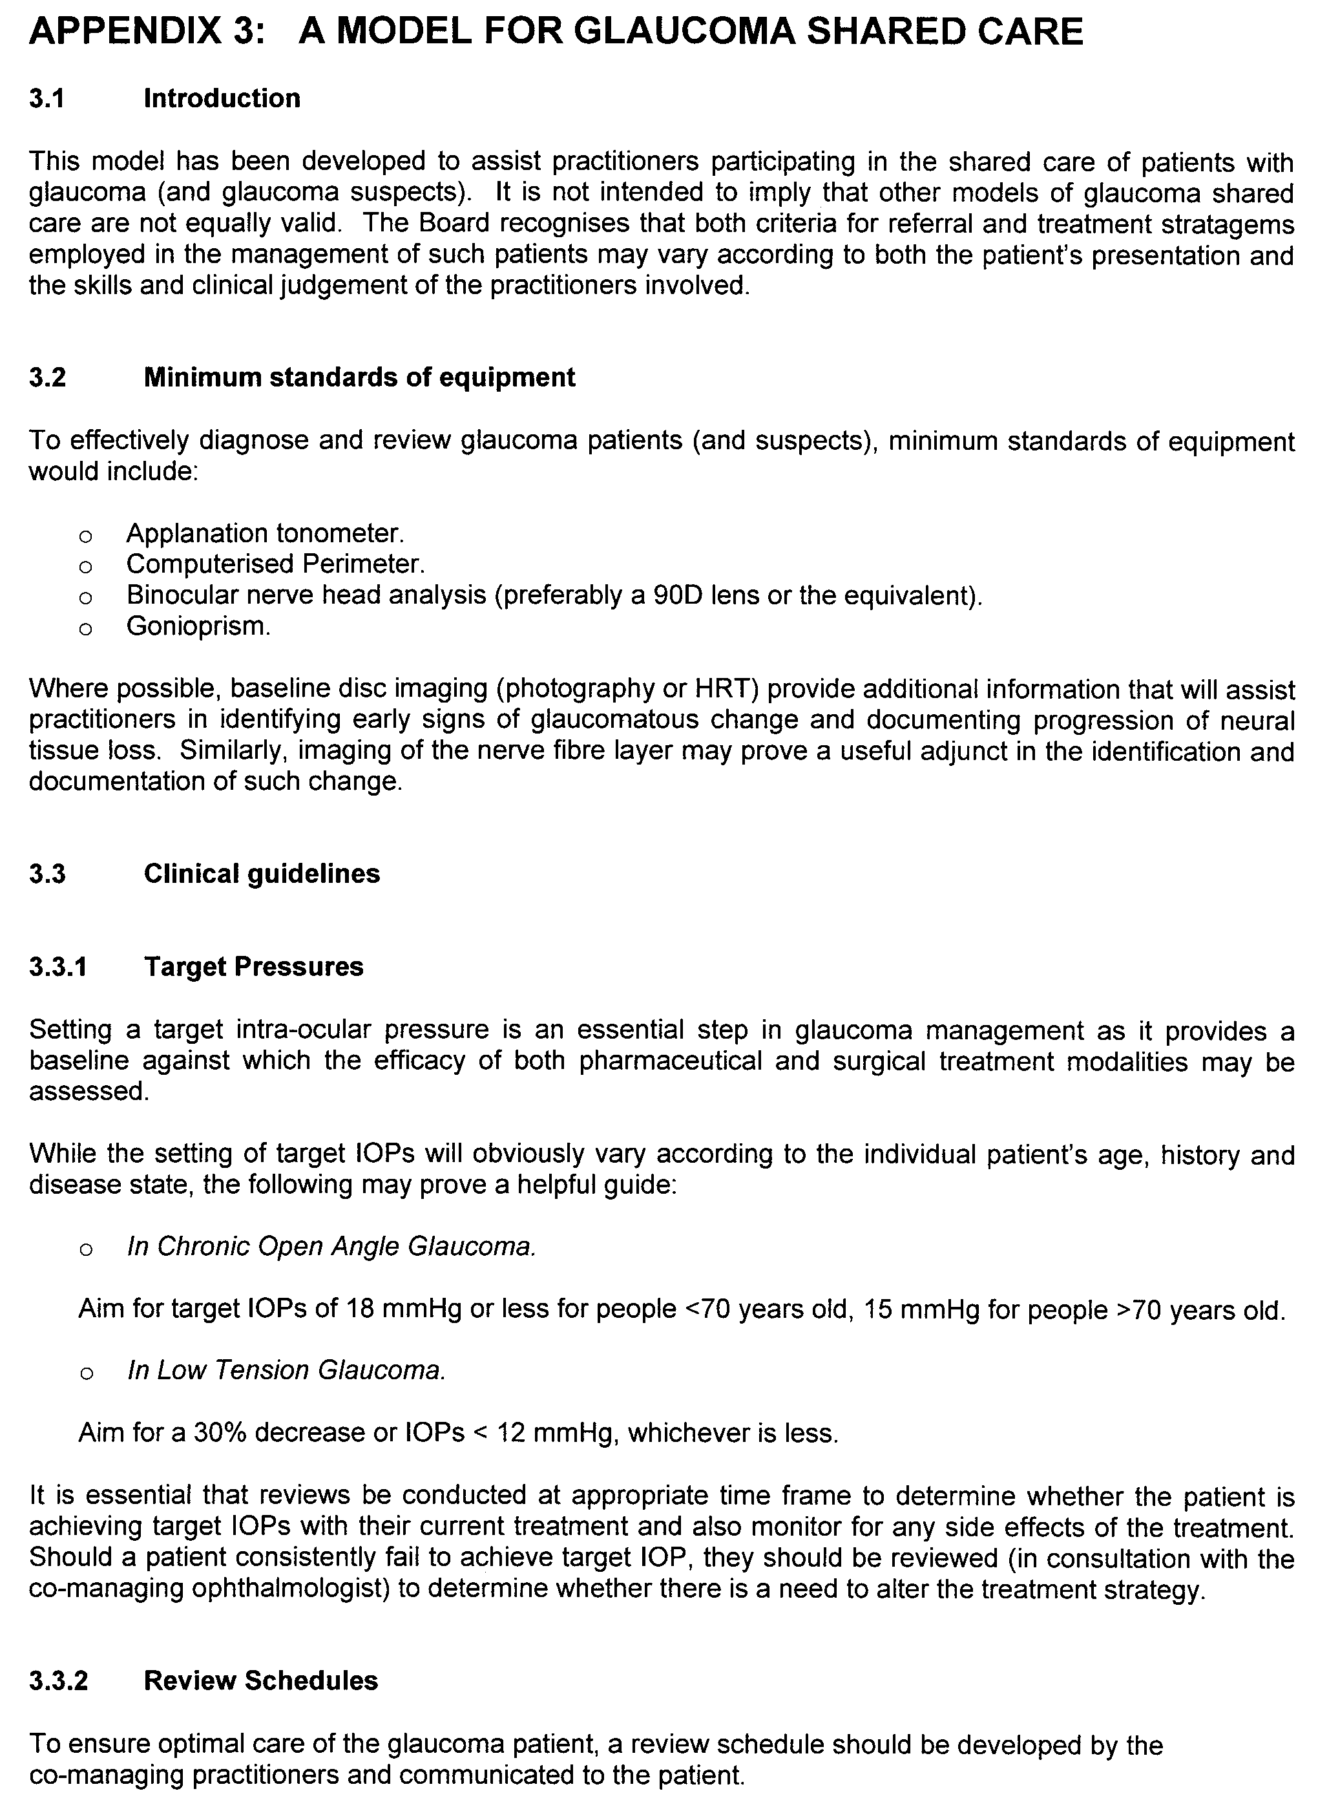
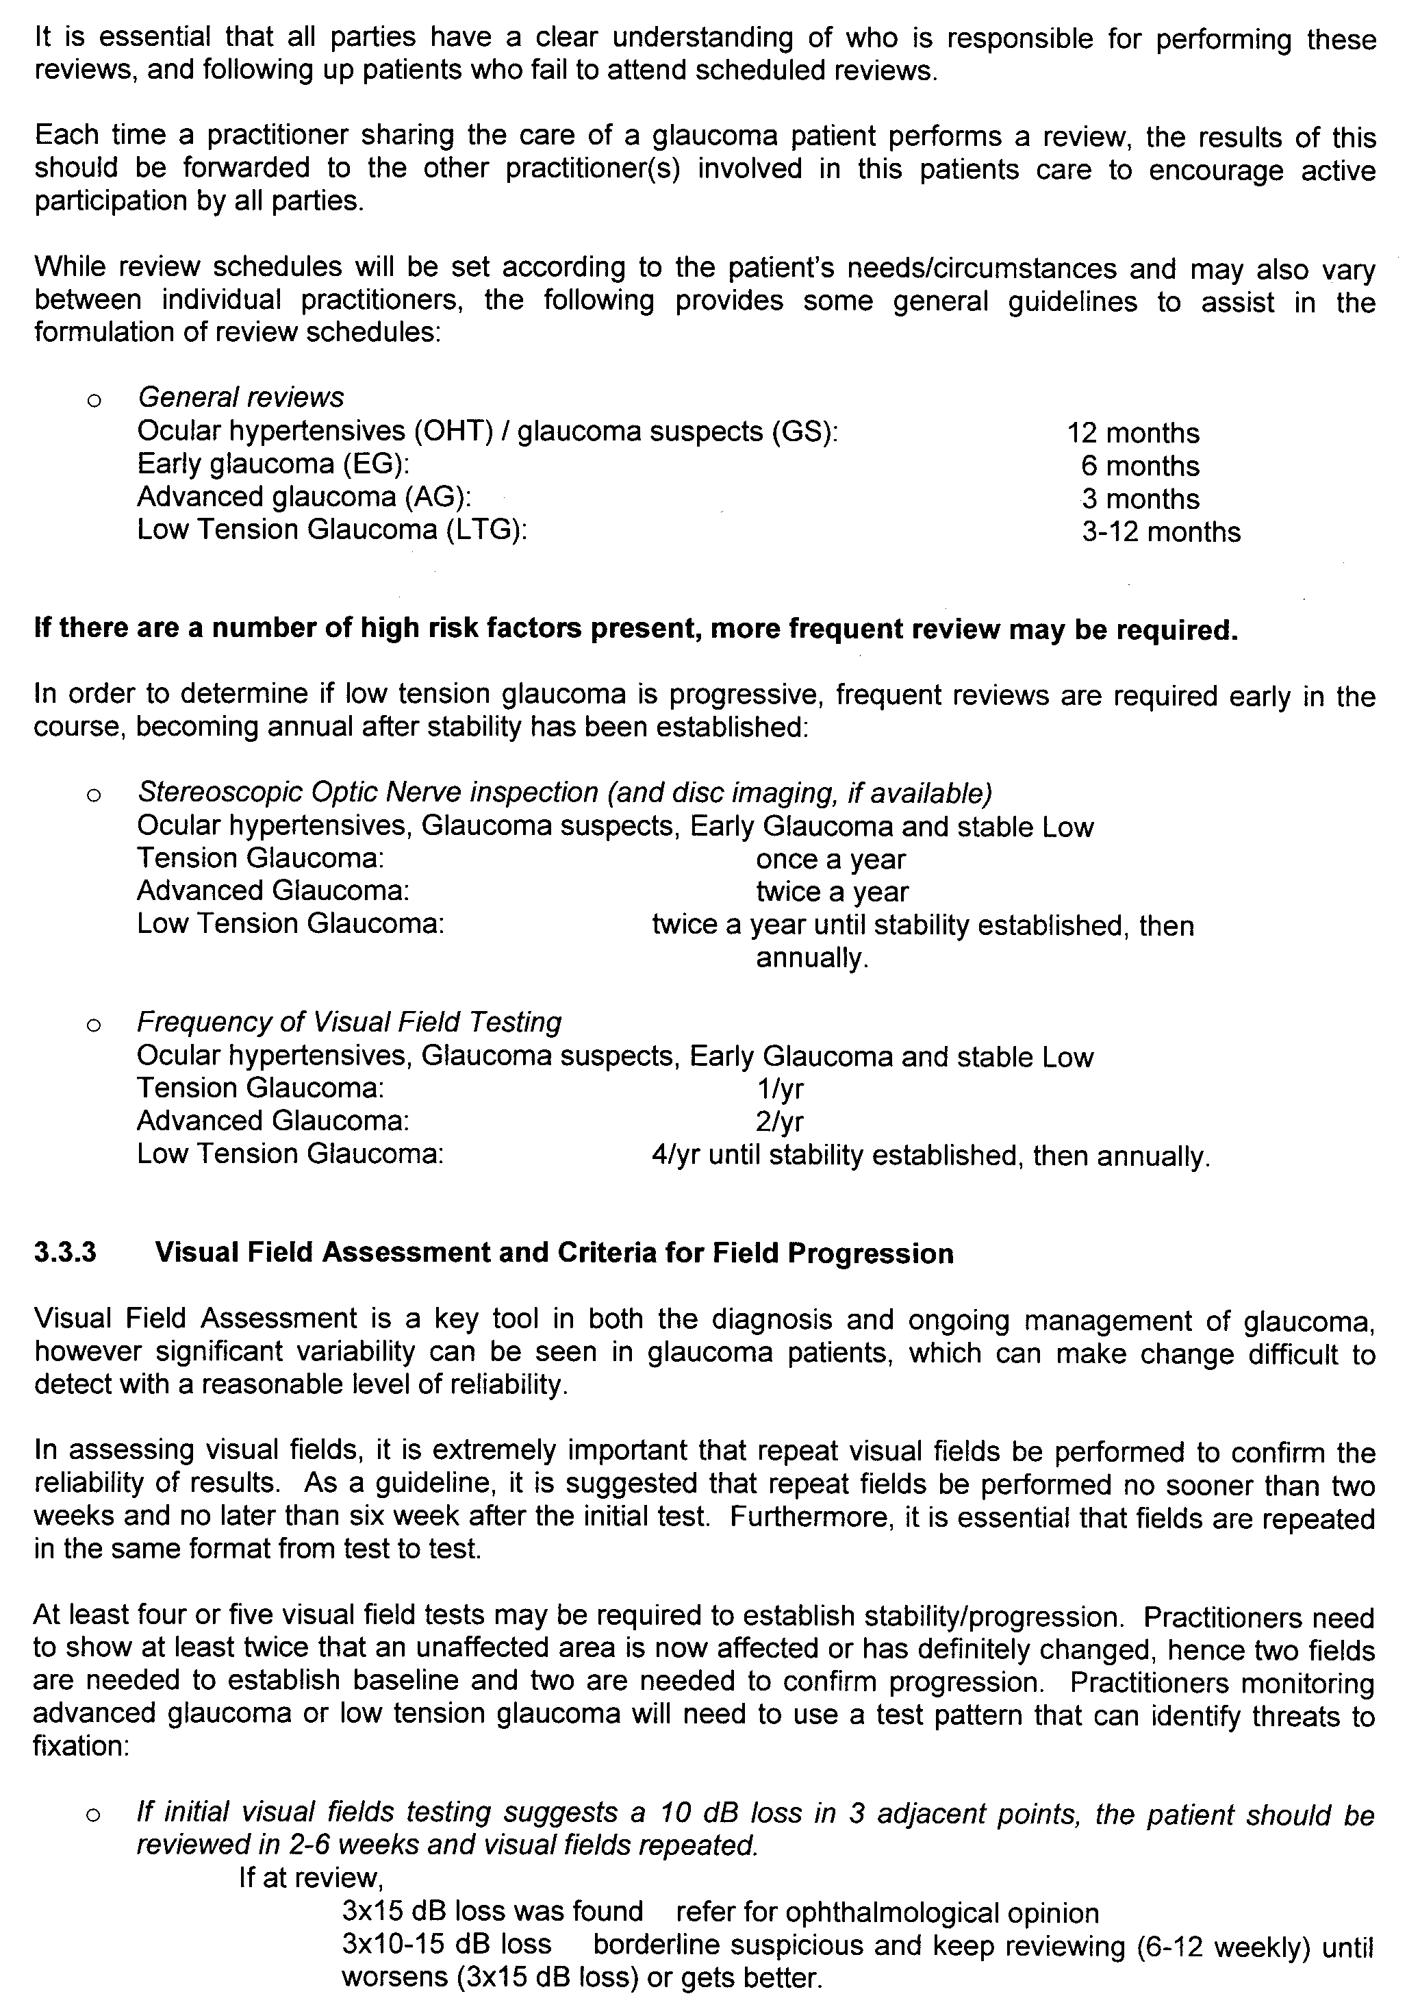
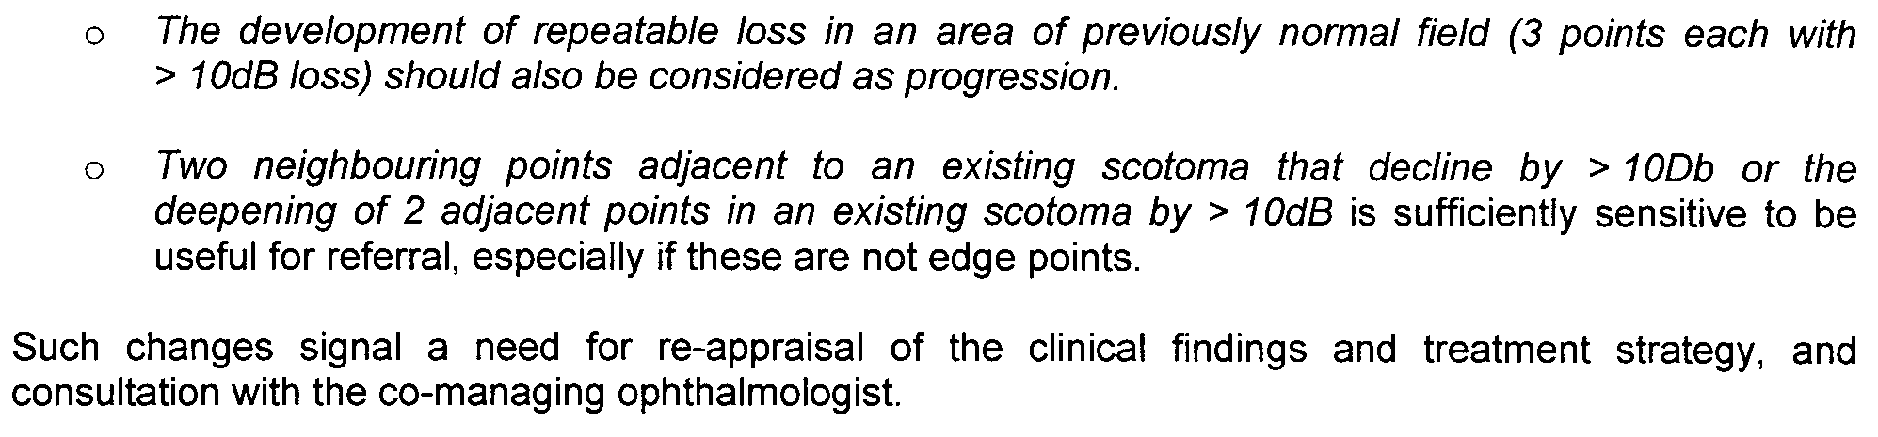
APPENDIX 4

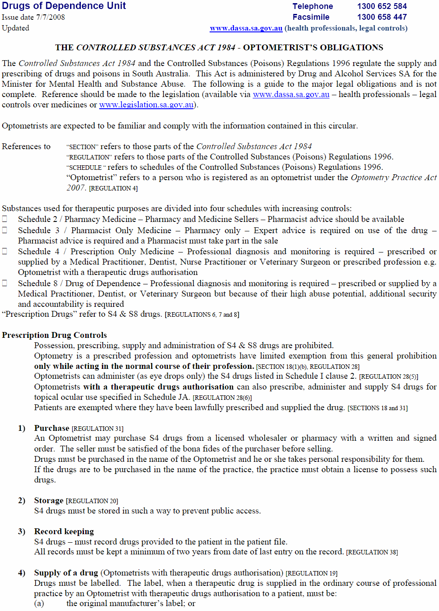
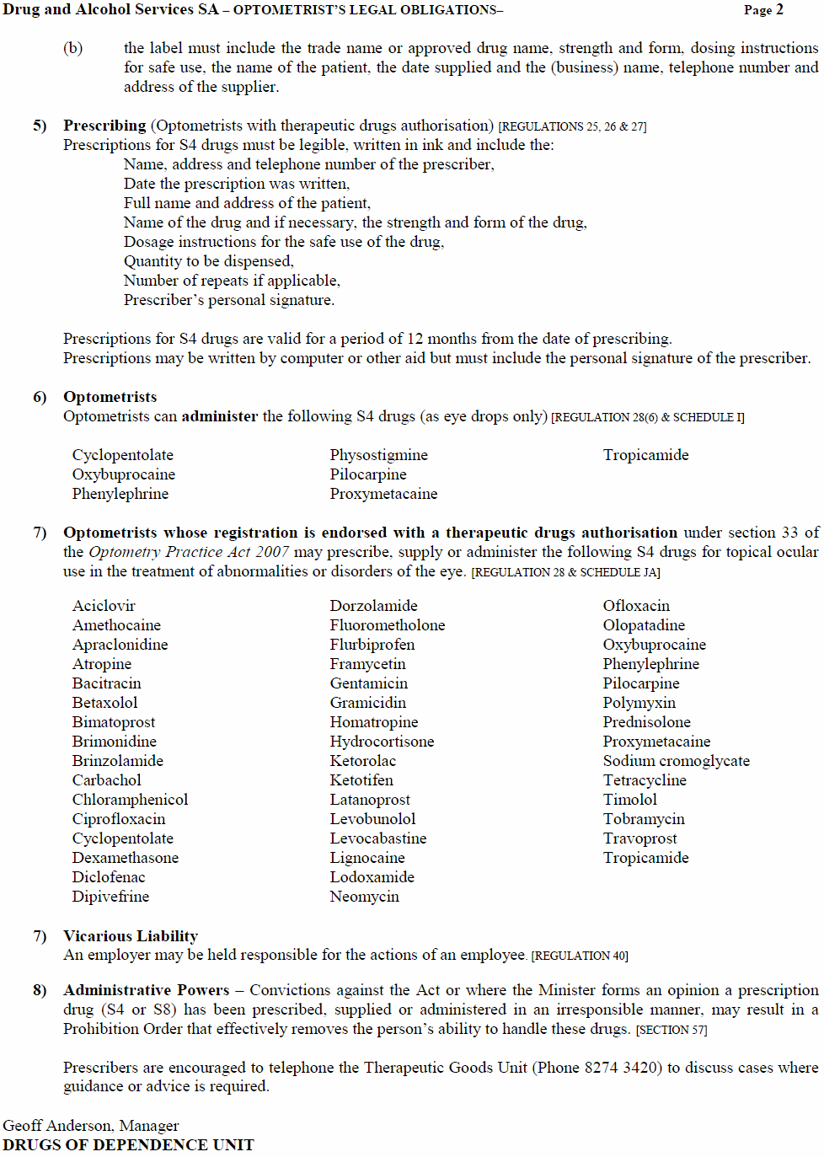

PETROLEUM ACT 2000
Surrender of Geothermal Exploration Licence—GEL 158
NOTICE is hereby given that I have accepted surrender of the abovementioned Geothermal Exploration Licence under the provisions of the Petroleum Act 2000, pursuant to delegated powers dated 28 March 2002, Gazetted 11 April 2002, page 1573.
No. of Licence | Licensee | Locality | Date of Surrender | Area in km² | Reference
158 | MNGI Pty Ltd | Arrowie East | 3 November 2008 | 499 | 27/2/267
Description of Area
All that part of the State of South Australia, bounded as follows:
Commencing at a point being the intersection of latitude 29°45′00″S GDA94 and longitude 136°38′00″E GDA94, thence east to longitude 136°45′00″E GDA94, south to latitude 29°46′00″S GDA94, east to longitude 136°48′00″E GDA94, south to latitude 29°47′00″S GDA94, east to longitude 136°49′00″E GDA94, south to latitude 29°48′00″S GDA94, east to longitude 136°51′00″E GDA94, south to latitude 29°49′00″S GDA94, east to longitude 136°52′00″E GDA94, south to latitude 29°52′00″S GDA94, west to longitude 136°51′00″E GDA94, south to latitude 29°53′00″S GDA94, west to longitude 136°49′00″E GDA94, south to latitude 30°00′00″S GDA94, west to the eastern boundary of the Woomera Prohibited Area, thence northerly, westerly and northerly along the boundary of the said Prohibited Area to latitude 29°56′00″S GDA94, east to longitude 136°40′00″E GDA94, north to latitude 29°53′00″S GDA94, west to the eastern boundary of the Woomera Prohibited Area, thence generally northerly along the boundary of the said Prohibited Area to latitude 29°46′00″S GDA94, east to longitude 136°38′00″E GDA94 and north to point of commencement.
Area: 499 km² approximately.
Dated 17 November 2008.
B. A. Goldstein, Director Petroleum and Geothermal
Minerals and Energy Resources
Primary Industries and Resources SA
Delegate of the Minister for Mineral Resources Development

RADIATION PROTECTION AND CONTROL ACT 1982
SECTION 44
Notice by Delegate of the Minister for Environment and Conservation
PURSUANT to section 44 of the Radiation Protection and Control Act 1982, I, Keith Baldry, Director of the Radiation Protection Division of the Environment Protection Authority, being a person to whom the powers of the Minister under that section have been delegated under the Act, exempt diagnostic radiographers from the requirements of Regulation 40 of the Radiation Protection and Control (Ionising Radiation) Regulations 2000, subject to the following conditions:
1. This exemption only applies to the exposure of a person to ionising radiation for the purposes of plain radiography where the exposure has been directed by Amy Schafer while engaged in the capacity of Physician Assistant at The Queen Elizabeth Hospital; and
2. The direction referred to in Condition 1 must comply with the following requirements:
(a) it must be in writing;
(b) it must contain details of the examination or treatment being undertaken;
(c) it must contain the clinical indications for the examination or treatment;
(d) it must contain a statement by Amy Schafer that she has due authority to give the direction;
(e) it must be signed by Amy Schafer; and
(f) it must be signed by the radiographer who is performing the examination or treatment.
3. Amy Schafer must, when directed to do so by the Radiation Protection Division, provide the Radiation Protection Division with a written report on diagnostic radiography authorised by her during a period specified by the Radiation Protection Division. The report must contain statistics of diagnostic radiography authorised and details of any radiation safety issues associated with the examinations during the specified period.
4. The exemption shall take effect commencing on the date of publication of this Notice in the Government Gazette.
Dated 13 November 2008.
K. Baldry, Delegate of the Minister for Environment and Conservation

RADIATION PROTECTION AND CONTROL ACT 1982
SECTION 44
Notice by Delegate of the Minister for Environment and Conservation
PURSUANT to section 44 of the Radiation Protection and Control Act 1982, I, Keith Baldry, Director of the Radiation Protection Division of the Environment Protection Authority, being a person to whom the powers of the Minister under that section have been delegated under the Act, exempt diagnostic radiographers from the requirements of Regulation 40 of the Radiation Protection and Control (Ionising Radiation) Regulations 2000, subject to the following conditions:
1. This exemption only applies to the exposure of a person to ionising radiation for the purposes of plain radiography where the exposure has been directed by Dawanda Pesicka while engaged in the capacity of Physician Assistant at The Queen Elizabeth Hospital; and
2. The direction referred to in Condition 1 must comply with the following requirements:
(a) it must be in writing;
(b) it must contain details of the examination or treatment being undertaken;
(c) it must contain the clinical indications for the examination or treatment;
(d) it must contain a statement by Dawanda Pesicka that she has due authority to give the direction;
(e) it must be signed by Dawanda Pesicka; and
(f) it must be signed by the radiographer who is performing the examination or treatment.
3. Dawanda Pesicka must, when directed to do so by the Radiation Protection Division, provide the Radiation Protection Division with a written report on diagnostic radiography authorised by her during a period specified by the Radiation Protection Division. The report must contain statistics of diagnostic radiography authorised and details of any radiation safety issues associated with the examinations during the specified period.
4. The exemption shall take effect commencing on the date of publication of this Notice in the Government Gazette.
Dated 13 November 2008.
K. Baldry, Delegate of the Minister for Environment and Conservation

ROADS (OPENING AND CLOSING) ACT 1991:
SECTION 24
NOTICE OF CONFIRMATION OF ROAD
PROCESS ORDER
Road Opening
River Road, Hahndorf
BY Road Process Order made on 29 December 2006, The District Council of Mount Barker ordered that:
Portion of allotment 80 in Filed Plan 159457 situate at the intersection of River Road and Sawmill Gully Road, more particularly delineated and numbered ‘1’ in Preliminary Plan No. 05/0067 be opened as road forming a widening of River Road.
On 17 November 2008 that order was confirmed by the Minister for Infrastructure conditionally upon the deposit by the Registrar-General of Deposited Plan 73364 being the authority for the new boundaries.
Pursuant to section 24 (5) of the Roads (Opening and Closing) Act 1991, NOTICE of the order referred to above and its confirmation is hereby given.
Dated 20 November 2008.
P. M. Kentish, Surveyor-General

ROADS (OPENING AND CLOSING) ACT 1991:
SECTION 24
NOTICE OF CONFIRMATION OF ROAD
PROCESS ORDER
Road Closure
Fore Street, Burra
BY Road Process Order made on 12 September 2008, the Regional Council of Goyder ordered that:
1. The whole of Fore Street situate between Illogan Street and Truro Street adjoining allotment 1 in Deposited Plan 15603, more particularly lettered ‘A’, ‘B’ and ‘C’ in Preliminary Plan No. 07/0068, be closed.
2. The whole of the land subject to closure lettered ‘A’ be transferred to Robert Stanley Coathupe and Jennifer Enid Coathupe in accordance with agreement for transfer dated 29 August 2008 entered into between the Regional Council of Goyder and R. S. and J. E. Coathupe.
3. The whole of the land subject to closure lettered ‘B’ and ‘C’ be transferred to Barry John Wright and Maureen Annette Wright in accordance with agreement for transfer dated 29 August 2008 entered into between the Regional Council of Goyder and B. J. and M. A. Wright.
On 6 November 2008 that order was confirmed by the Minister for Infrastructure conditionally upon the deposit by the Registrar-General of Deposited Plan 78983 being the authority for the new boundaries.
Pursuant to section 24 (5) of the Roads (Opening and Closing) Act 1991, NOTICE of the order referred to above and its confirmation is hereby given.
Dated 20 November 2008.
P. M. Kentish, Surveyor-General

ROADS (OPENING AND CLOSING) ACT 1991:
SECTION 24
NOTICE OF CONFIRMATION OF ROAD
PROCESS ORDER
Road Closure
Marine Avenue, Hallett Cove
BY Road Process Order made on 17 September 2008, The Corporation of the City of Marion ordered that:
1. Portion of Marine Parade situate south of Grand Central Avenue adjoining allotments 153, 154 and 155 in Deposited Plan 63571 more particularly delineated and lettered ‘A’, ‘B’ and ‘C’ in Preliminary Plan No. 08/0022 be closed.
2. The whole of the land subject to closure lettered ‘A’ be transferred to Ian Michael Mullan in accordance with agreement for transfer dated 10 September 2008 entered into between The Corporation of the City of Marion and I. M. Mullan.
3. The whole of the land subject to closure lettered ‘B’ be transferred to Colin McLean Thorburn and Linda Rose Thorburn in accordance with agreement for transfer dated 10 September 2008 entered into between The Corporation of the City of Marion and C. M. and L. R. Thorburn.
4. The whole of the land subject to closure lettered ‘C’ be transferred to Michael Charles Noble and Diane Autio in accordance with agreement for transfer dated 10 September 2008 entered into between The Corporation of the City of Marion and M. C. Noble and D. Autio.
5. The following easements are granted over portions of the land subject to that closure:
Grant an easement for underground electricity supply purposes appurtenant to Certificates of Title Volume 5913, Folio 131 and Volume 5913, Folio 132.
On 3 November 2008 that order was confirmed by the Minister for Infrastructure conditionally upon the deposit by the Registrar-General of Deposited Plan 78944 being the authority for the new boundaries.
Pursuant to section 24 (5) of the Roads (Opening and Closing) Act 1991, NOTICE of the order referred to above and its confirmation is hereby given.
Dated 20 November 2008.
P. M. Kentish, Surveyor-General

SEWERAGE ACT 1929
Addition of Land to Port Lincoln Drainage Area
PURSUANT to section 18 of the Sewerage Act 1929, the South Australian Water Corporation:
(a) Adds to the Port Lincoln Drainage Area all the land contained in Allotments 16 and 256.
(b) Declares that this notice will have effect from 1 July 2008.

D1387
SA Water 08/12126
Mapsheets: 602824Q3
Information Plan Only

PORT LINCOLN
HUNDRED OF LINCOLN
N
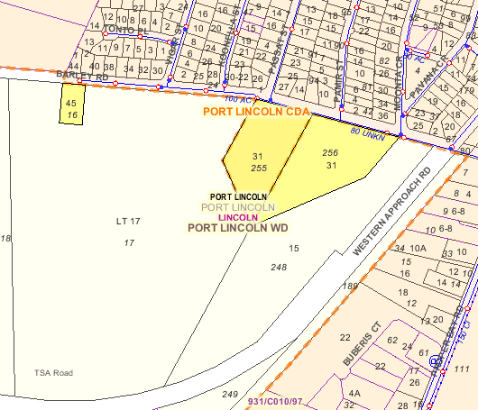
NOT TO SCALE

BOUNDARY OF PORT LINCOLN DRAINAGE AREA PREVIOUSLY PROCLAIMED SHOWN AS DASHED LINES

LAND TO BE ADDED TO PORT LINCOLN DRAINAGE AREA MARGINED YELLOW

Dated 11 November 2008.
Signed for and on behalf of the South Australian Water Corporation by a person duly authorised so to do:
A. Sheedy, General Manager Shared Services
In the presence of:
N. Morales, Billing Manager
SAWATER 08/12126 D1387

TRADE STANDARDS ACT 1979
Discretionary Exemption
TAKE notice that I, Gail Gago, Minister for Consumer Affairs in the State of South Australia, do hereby exempt the goods named in Schedule 1 below from the Declaration of Dangerous Goods previously made and described in Schedule 2 below, pursuant to Part 7, section 36 (1) (b) and (c) of the Trade Standards Act 1979.
Schedule 1
Expanding foam novelty toys known as ‘Hatching Crocodile Eggs—Growing Pets’ and ‘Hatching Chicken Eggs—Growing Pets’. The ‘Growing Pet’ toys are characterised by clear packaging containing the toy inside a dissolvable egg.
Schedule 2
The goods described in Schedule 1 above are exempt from the requirements of the Declaration of Dangerous Goods signed by the Minister for Consumer Affairs on 9 August 1990 and published in the Government Gazette of 30 August 1990.
Dated 12 November 2008.
Gail Gago, Minister for Consumer Affairs

WORKERS REHABILITATION AND COMPENSATION
ACT 1986
Workers Compensation Tribunal Rules 2005
I, WILLIAM DAVID JENNINGS, President of the Workers Compensation Tribunal of South Australia, by virtue of the provisions of section 88E of the Workers Rehabilitation and Compensation Act 1986 and all the enabling powers, do hereby amend Rule 23 by deleting the existing Rule in its entirety and inserting new Rule 23A and Rule 23B as set out below, to commence on Monday, 5 January 2009.
Given under my hand and the seal of the Workers Compen-sation Tribunal of South Australia.
Dated 12 November 2008.
(l.s.) Judge W. D. Jennings, President, Workers Compensation Tribunal

RULE 23A
Summons to Produce Documents of Things to the Tribunal
(1) The Registrar shall not issue a summons to produce documents or things to the Tribunal that requires the production of medical notes, medical records or the results of diagnostics tests relating to a worker unless directed to do so by a Conciliation Officer or Presidential Member.
(2) In any other case, and subject to Rule 23A (3) hereof the Registrar may upon the application of a party and shall at the direction of a Conciliation Officer or Presidential Member issue a summons to produce documents of things to the Tribunal.
(3) Where a party has made an application for the issue of a summons under Rule 23A (2) the Registrar may decline to issue the summons if he or she considers the issue may be unreasonable, vexatious, oppressive, an abuse of process, or inappropriate for any other reason, in which case the Registrar shall refer the matter to a Presidential Member for directions.
(4) A summons issued pursuant to this Rule:
(a) shall be in accordance with the form titled ‘Summons to Produce Documents or Things’ and the date for compliance with the summons shall be a date 28 days after the issue of a summons or such earlier date as directed by a Conciliation Officer or Presidential Member;
(b) must be filed with sufficient copies and sufficient details to enable the Registrar to serve the summons; and
(c) must be accompanied with a cheque or money order in the sum of $50 made payable to the person upon who the summons is to be served. Such sum is intended to allay any costs associated with copying the documents or things and forwarding them to the Registrar.
(5) The Registrar shall serve a summons requiring the production of documents or things by registered mail to the address nominated in the summons.
(6) The recipient of a summons to produce documents or things shall comply with the summons by making accurate and legible copies of the documents or things and forwarding the copies by registered mail or secure courier to the Registrar prior to the stipulated date of compliance.
(7) The recipient of the summons to produce documents or things may use the sum of $50 accompanying the summons to allay any costs associated with copying the documents or things and forwarding them to the Registrar in the manner described.
(8) If the recipient of the summons to produce documents or things contends that the sum of $50 is insufficient to allay any costs associated with copying the documents or things and forwarding them to the Registrar that person may make application to the Registrar to seek an order that the party issuing the summons pay a greater amount prior to its compliance.
(9) Upon compliance with a summons to produce documents or things and subject to any contrary ruling by a Conciliation Officer or Presidential Member parties may apply to the Registrar to inspect the documents or things and absent an order to the contrary shall, not less than seven days after the documents or things are produced be given unrestricted access subject to the giving of under-takings that the documents or things shall be returned to the Registrar in the same order and state as they were at the time access was taken and if copies of the documents or things are made that upon the conclusion of the hearing they will be destroyed and not used in connection with any other proceedings.
(10) If a party, or the recipient of a summons to produce documents or things or some other relevant and interested party seeks an order restricting access to the documents or things produced in compliance with the summons, that person should file an application for directions seeking the appropriate relief whereupon the application shall be referred to a Presidential Member to determine the application. If no such application is filed within seven days after the stipulated date of compliance all relevant persons shall be deemed to consent to all other relevant parties having unrestricted access to the documents or things subject to these rules. During that seven-day period only the worker and his or her representative shall have access to the documents or things.
(11) If a party or a recipient of the summons takes objection
to the issue of the summons or to the production of particular documents or things, the party or recipient should advise the Registrar in writing seeking the appropriate relief whereupon the application shall be referred to a Presidential Member to determine the application.
(12) Unless otherwise ordered, all documents or things produced on the return of the summons to which this rule relates shall be kept in proper custody by the Registrar and clearly marked to indicate the proceedings to which they relate.
(13) (a) Unless the Tribunal orders otherwise, the Registrar may in his or her absolute discretion destroy any documents or things produced in response to a summons issued under this Rule.
(b) Unless the Tribunal orders otherwise, the Registrar must not destroy any documents or things under sub-rule (a) unless the Registrar has given to the issuing party at least 14 days notice of the intention to do so.
(14) Failure by a person to comply with any summons issued pursuant to this Rule may be regarded as contempt of the Tribunal.
RULE 23B
Summons to Attend or Appear or a Summons to Attend or Appear and Produce Documents or Things
(1) This Rule applies where a party requires a witness to attend and give evidence at a hearing or trial or to attend and produce documents or things at a hearing or trial.
(2) The Registrar may upon the application of a party and shall at the direction of a Conciliation Officer or Presidential Member issue a summons to attend or appear at the Tribunal or a summons to attend or appear at the Tribunal and produce documents or things to it.
(3) A summons issued pursuant to this Rule shall be in accordance with the form titled ‘Summons to attend or appear’ or ‘Summons to attend or appear and produce documents or things’ as the case may be and the date for compliance with the summons shall be the date of the hearing.
(4) A summons to attend or appear or a summons to attend or appear and produce documents or things shall be served by the issuing party and should be served personally and where requested the original should be produced. If on tender of such summons to the person named that the person refuses to accept it, the summons may be served by putting it down in the persons presence after the person has been told of the nature of the summons. Such summons shall be served within 12 weeks after the date of issue and not later than 14 days before the date of compliance and shall remain in force until the trial or hearing is concluded. Service of such summons may be proved by affidavit.
(5) If a party or a recipient of a summons to attend or appear or a summons to attend or appear and produce documents or things takes objection to the issue of the summons or to the production to particular documents or things the party or recipient should file an application for directions seeking the appropriate relief whereupon the application should be referred to a Presidential Member to determine the application.
(6) (a) Where a person served with a summons to attend or appear or a summons to attend or appear and produce documents or things such a summons does not come before the Tribunal in answer to the summons because the matter is not called on for hearing, and a further date is set for the commencement of the hearing the person served with the summons shall answer the summons as if it had inserted therein a further date for the commencement of the hearing provided that within a reasonable time before that further date the party serving the summons upon the person is served on him or her by certified mail, notice of the further hearing date and is tendered to him or her reasonable expenses for his or her attendance at the Tribunal on the further date having taken into account what, if any, part of the amount previously tendered to him or her for reasonable expenses has been properly applied towards any expense incurred by him or her in answering the summons for its original return date.
(b) A person served with such a summons is entitled to a payment from the person issuing the summons of an amount equal to the reasonable expenses incurred by the person in complying with the summons.
(c) The Tribunal may make orders to ensure that the person complying with such a summons receives the exact amount of the person’s reasonable expenses in so complying and may in appropriate case direct that such a payment be made in advance.
(d) The Tribunal may fix the amount of costs or direct the Registrar to fix the amount of such costs.
(7) Failure by a person to comply with any summons issued pursuant to this Rule may be regarded as contempt of the Tribunal.

South Australia
Criminal Law Consolidation (Rape and Sexual Offences) Amendment Act (Commencement) Proclamation 2008
1—Short title
This proclamation may be cited as the Criminal Law Consolidation (Rape and Sexual Offences) Amendment Act (Commencement) Proclamation 2008.
2—Commencement of Act
The Criminal Law Consolidation (Rape and Sexual Offences) Amendment Act 2008
(No 10 of 2008) will come into operation on 23 November 2008.
Made by the Governor
with the advice and consent of the Executive Council
on 20 November 2008
AGO 0116/06 CS

South Australia
Statutes Amendment (Evidence and Procedure) Act (Commencement) Proclamation 2008
1—Short title
This proclamation may be cited as the Statutes Amendment (Evidence and Procedure) Act (Commencement) Proclamation 2008.
2—Commencement of Act and suspension of certain provisions
(1) The Statutes Amendment (Evidence and Procedure) Act 2008 (No 7 of 2008) (the Statutes Amendment Act) will come into operation on 23 November 2008.
(2) The operation of sections 13A, 13C and 13D of the Evidence Act 1929 (inserted into the Evidence Act 1929 by section 12 of the Statutes Amendment Act) is suspended until a day or time or days or times to be fixed by subsequent proclamation or proclamations.
Made by the Governor
with the advice and consent of the Executive Council
on 20 November 2008
AGO0228/04CS

South Australia
Environment Protection (Site Contamination) Amendment Act (Commencement of Suspended Provisions) Proclamation 2008
1—Short title
This proclamation may be cited as the Environment Protection (Site Contamination) Amendment Act (Commencement of Suspended Provisions) Proclamation 2008.
2—Commencement of suspended provisions
The following provisions of the Environment Protection (Site Contamination) Amendment Act 2007 (No 44 of 2007) (the Amendment Act) will come into operation on 20 November 2008:
(a) section 4(6) and (7) of the Amendment Act;
(b) the definitions of site contamination audit, site contamination audit report and site contamination audit statement of the Environment Protection Act 1993 inserted into that Act by section 4(8) of the Amendment Act;
(c) sections 103T, 103V, 103X, 103Y and 103Z of Division 4 of Part 10A of the Environment Protection Act 1993, and the heading to that Division, inserted into that Act by section 11 of the Amendment Act;
(d) section 109(3)(ie) and (if) of the Environment Protection Act 1993 inserted by section 14 of the Amendment Act.
Made by the Governor
with the advice and consent of the Executive Council
on 20 November 2008
EPCS08/0001

South Australia
Environment Protection (Site Contamination) Regulations 2008
under the Environment Protection Act 1993

Contents
Part 1—Preliminary
1 Short title
2 Commencement
3 Interpretation
Part 2—General provisions
4 Interpretation—occupier
5 Potentially contaminating activities
6 Causing site contamination
7 Liability for property damage etc caused by person entering land
8 Recovery of costs and expenses incurred by the Authority
Part 3—Site contamination auditors
Division 1—Accreditation
9 Eligibility for accreditation
10 Application for accreditation
11 Grant of accreditation
12 Conditions of accreditation
13 Offence to contravene certain conditions of accreditation
14 Annual fee
15 Term and renewal of accreditation
16 Disciplinary action against site contamination auditors and voluntary suspension
17 Surrender of accreditation
18 Return of certificate of accreditation and identity card
19 Appeals
20 Register of site contamination auditors
21 No application fee for person entitled to accreditation under Mutual Recognition (South Australia) Act 1993
Division 2—Requirements applying to auditors
22 Annual returns by auditors
23 Notifications by auditors after commencement or termination of audit
24 Site contamination audit report summary and statement
25 Site contamination audit statements to be provided to prescribed bodies
Schedule 1—Potentially contaminating activities
Part 1—Activities undertaken in course of business
Part 2—Domestic activities
Part 3—Listed substances
Schedule 2—Fees
Schedule 3—Annual returns by auditors
Schedule 4—Notifications by auditors after commencement or termination of audit
Part 1—Notification by auditor after commencement of audit
Part 2—Notification by auditor after termination (before completion) of audit
Schedule 5—Site contamination audit statement

Part 1—Preliminary
1—Short title
These regulations may be cited as the Environment Protection (Site Contamination) Regulations 2008.
2—Commencement
(1) Subject to subregulation (2), these regulations will come into operation on the day on which section 4(6) of the Environment Protection (Site Contamination) Amendment Act 2007 comes into operation.
(2) Part 2 and Schedule 1 will come into operation on the day on which Division 2 of Part 10A of the Environment Protection Act 1993, to be inserted by the Environment Protection (Site Contamination) Amendment Act 2007, comes into operation.
3—Interpretation
In these regulations, unless the contrary intention appears—
accreditation means accreditation under these regulations;
accreditation committee means a committee established by the Board under section 17 of the Act to advise the Authority in relation to accreditation;
Act means the Environment Protection Act 1993;
agriculture includes horticulture;
asbestos includes unbound or friable asbestos and bound or non-friable asbestos;
liquid organic chemical substances means oil, petroleum or biofuels, other than when stored in the fuel tank of a motor vehicle for the purposes of powering the vehicle;
listed substance means a substance listed in Schedule 1 Part 3;
motor vehicle means a vehicle that is built to be propelled by a motor that forms part of the vehicle;
pesticides includes herbicides and fungicides;
recycling includes reprocessing, recovery and purification;
responsible auditor, in relation to a site contamination audit, means the site contamination auditor who personally carried out or directly supervised the work involved in the audit;
septic tank effluent means effluent that is ordinarily collected by means of a septic tank, waterless composting toilet, aerated wastewater treatment system or similar on-site waste collection system;
vessel means—
(a) a ship or boat; or
(b) an air-cushion vehicle, or other similar craft, used wholly or primarily in transporting passengers or goods by water; or
(c) a structure that is designed to float in water and is used for commercial, industrial or research purposes;
wastewater includes—
(a) sewage, and septic tank effluent, whether treated or untreated; and
(b) water containing commercial or industrial waste.
Part 2—General provisions
4—Interpretation—occupier
(1) For the purposes of the definition of occupier in section 103A of the Act, a person is to be taken to be an occupier of land if the person owns or is in operational control of a tank or pipeline, or any works or structure, that—
(a) is installed on or traverses the land, whether below or above the ground; and
(b) is used to store or convey chemical substances or for some process employing chemical substances.
(2) For the purposes of subregulation (1), a person has operational control over a tank, pipeline, works or a structure if the person has the authority to introduce and implement environmental or health and safety policies or any other operating policies for the tank, pipeline, works or structure.
5—Potentially contaminating activities
(1) For the purposes of sections 103C and 103H of the Act, the following activities are prescribed as potentially contaminating activities:
(a) an activity of a kind set out in Schedule 1 Part 1, undertaken in the course of a business;
(b) any other activity (other than an activity of a kind excluded under Schedule 1 Part 1 from the ambit of potentially contaminating activities) undertaken in the course of a business involving—
(i) the manufacture, production (including as a by-product or waste) or recycling of a listed substance or a product containing a listed substance; or
(ii) the storage at a discrete premises of the business of—
(A) 500 litres or more of a liquid listed substance; or
(B) 500 kilograms or more of a listed substance other than a liquid;
(c) a domestic activity of a kind set out in Schedule 1 Part 2.
(2) However—
(a) the Authority may determine that an activity of a kind referred to in subregulation (1)(a) is not a prescribed potentially contaminating activity if the Authority is satisfied that the activity has been carried on in such a manner or on such a scale as to present a negligible risk of site contamination; and
(b) the Authority may determine that an activity of a kind referred to in subregulation (1)(b) is not a prescribed potentially contaminating activity if the Authority is satisfied that the relevant listed substance has, at all times while at the premises of the business, been contained or incorporated in a product (other than a product that itself is or comprises a listed substance) or container—
(i) in insignificant concentrations; or
(ii) in such a way as to present a negligible risk of escape of the substance to the environment.
(3) For the purposes of this regulation, a reference to a discrete premises of a business is, in the case of activities authorised by a licence—
(a) a reference to each location specified in the licence at which activities authorised by the licence may be undertaken; or
(b) if various places are specified in the licence as a single location at which activities authorised by the licence may be undertaken—a reference to the various places taken together.
(4) To avoid doubt, an activity of a kind referred to in subregulation (1)(a) or (b) is not precluded from being undertaken in the course of a business merely because it is undertaken for the purposes of research.
6—Causing site contamination
Changes in the use of land within the meaning of the Development Act 1993 are a prescribed kind of change of use for the purposes of section 103D(2) of the Act.
7—Liability for property damage etc caused by person entering land
(1) A person is exempt from the application of section 103M(2) of the Act if the person enters or does anything on land on behalf of the occupier of the land in order to carry out—
(a) the requirements of a site contamination assessment order or site remediation order that has been issued to the occupier; or
(b) a voluntary site contamination assessment proposal or voluntary site remediation proposal that has been approved by the Authority on the application of the occupier.
(2) A person is exempt from the application of section 103M(3) of the Act if the person enters or does anything on land on behalf of the owner of the land in order to carry out—
(a) the requirements of a site contamination assessment order or site remediation order that has been issued to the owner; or
(b) a voluntary site contamination assessment proposal or voluntary site remediation proposal that has been approved by the Authority on the application of the owner.
8—Recovery of costs and expenses incurred by the Authority
(1) For the purposes of section 103R(2) of the Act—
(a) the prescribed amount recoverable in respect of the registration of a site contamination assessment order or site remediation order in relation to land from the person to whom the order was issued is—
(i) for the first entry made by the Registrar-General in registering the order—18 fee units; and
(ii) for each subsequent entry made by the Registrar-General in registering the order—5 fee units; and
(b) the prescribed amount recoverable in respect of the cancellation of registration of a site contamination assessment order or site remediation order in relation to land from the person to whom the order was issued is—
(i) for the first endorsement made by the Registrar-General in cancelling the registration of the order—13 fee units; and
(ii) for each subsequent endorsement made by the Registrar-General in cancelling the registration of the order—1 fee unit.
(2) For the purposes of section 103R(4)(a) of the Act, the prescribed rate of interest per annum on an amount recoverable by the Authority but not paid within the period fixed by the Authority is 24% calculated in respect of each month (or part of a month) for which the amount remains unpaid.
Part 3—Site contamination auditors
Division 1—Accreditation
9—Eligibility for accreditation
(1) A person is eligible for accreditation as a site contamination auditor if the person—
(a) has the qualifications, experience, knowledge, understanding and ability set out in subregulation (2); and
(b) is a fit and proper person to be accredited.
(2) An applicant for accreditation must—
(a) have a tertiary qualification approved by the Authority in a relevant discipline; and
(b) have a total of at least 8 years of experience in the assessment and remediation of site contamination; and
(c) have knowledge and understanding at a level satisfactory to the Authority of—
(i) the provisions of the Act and these regulations relating to site contamination assessment, remediation, audits and auditors; and
(ii) codes of practice, guidelines and standards prepared or approved by the Authority that apply to site contamination assessment, remediation, audits and auditors; and
(iii) the field of site contamination assessment and remediation; and
(d) have a demonstrated ability to put the knowledge and understanding referred to in paragraph (c) into practice, to a degree satisfactory to the Authority.
(3) For the purposes of determining whether a person is eligible for accreditation under subregulation (1), the Authority may, without limitation, take into account—
(a) any recommendations made in relation to the person by an accreditation committee; or
(b) any offence committed by the person against the Act, these regulations or legislation similar to these regulations in force in another State or a Territory of the Commonwealth; or
(c) any offence punishable by imprisonment committed by the person; or
(d) the cancellation or suspension of accreditation or similar authority held by the person, or the disqualification of the person from practising as a site contamination auditor, under these regulations or under legislation similar to these regulations in force in another State or a Territory of the Commonwealth; or
(e) whether, during the period of 10 years preceding the application for accreditation, the person has been an undischarged bankrupt or subject to a composition or deed or scheme of arrangement with or for the benefit of creditors.
10—Application for accreditation
(1) An application for accreditation must—
(a) be made to the Authority in the manner and form approved by the Authority; and
(b) be signed by the applicant and completed in accordance with the instructions contained in the form; and
(c) be accompanied by the fee set out in Schedule 2 as the fee for an application for accreditation.
(2) An applicant for accreditation must—
(a) consent to the conduct by the Authority of inquiries relating to any accreditation or similar authority held at any time by the person under these regulations or under legislation similar to these regulations in force in another State or Territory of the Commonwealth; and
(b) provide the Authority with any information required by the Authority (verified, if the Authority so requires, by statutory declaration) for the purposes of determining the application including (without limitation) criminal record checks relating to the applicant; and
(c) supply the Authority with 1 or more digital photographs of the applicant as specified by the Authority.
(3) The Authority may, on receipt of an application for accreditation under this regulation, refer the application to an accreditation committee and request the committee's written recommendations in relation to the application within a period specified in the notice (being not less than 14 days after referral of the application to the committee).
11—Grant of accreditation
(1) The Authority may refuse an application for accreditation if—
(a) the person has not made due application for accreditation under this Division; or
(b) the applicant has not complied with a requirement of these regulations or a requirement of the Authority made in connection with the application; or
(c) the Authority is not satisfied that the applicant is eligible for accreditation.
(2) The Authority is not required, if it has assessed a person's qualifications, experience, knowledge, understanding or ability to be appropriate for accreditation, to assess the person's qualifications, experience, knowledge, understanding or ability again on a subsequent application by the person for accreditation (or renewal of accreditation).
(3) The Authority may decline to grant accreditation unless or until the fee for the grant of accreditation is paid.
12—Conditions of accreditation
(1) The Authority may impose—
(a) a condition requiring the person to undertake ongoing professional development; and
(b) any other conditions the Authority thinks fit.
(2) Without limiting the effect of subregulation (1), the Authority must make it a condition of every accreditation that—
(a) the holder of the accreditation will, when acting as a site contamination auditor, act diligently, impartially and conscientiously; and
(b) the holder of the accreditation will maintain arrangements enabling him or her to have access, from time to time as necessary in the course of carrying out site contamination audits, to a team of persons, constituted in a manner approved by the Authority, to provide technical expertise in fields outside his or her personal expertise; and
(c) the holder of the accreditation will not, when acting as a site contamination auditor, fail to comply with any guidelines issued from time to time by the Authority (insofar as they may be relevant in the circumstances of any particular case); and
(d) the holder of the accreditation will hold or be covered by a professional indemnity insurance policy approved by the Authority; and
(e) the holder of the accreditation will have an identity card issued by the Authority available for inspection at all times when present as a site contamination auditor at a site the subject of site contamination assessment or remediation; and
(f) if the holder of the accreditation is charged with or convicted of—
(i) an offence against the Act, these regulations or legislation similar to these regulations in force in another State or a Territory of the Commonwealth; or
(ii) an offence punishable by imprisonment,
he or she will, within 14 days, give written notice of the charge or conviction to the Authority containing details of the offence; and
(g) if the holder of the accreditation—
(i) is dismissed from employment in response to allegations of misconduct; or
(ii) resigns from employment following allegations of misconduct;
he or she will, within 14 days, give written notice of that fact to the Authority.
(3) The Authority may, by written notice, vary or revoke a condition, or impose a condition, of a person's accreditation as a site contamination auditor.
(4) A condition may only be imposed or varied—
(a) on application by the site contamination auditor or with the auditor's agreement; or
(b) after giving the site contamination auditor reasonable notice of the proposed condition or variation and allowing the auditor at least 14 days within which to make submissions to the Authority in relation to the proposed condition or variation.
13—Offence to contravene certain conditions of accreditation
If a site contamination auditor contravenes a condition of the person's accreditation that requires the Authority to be notified of a matter or imposes a restriction on the work undertaken by the person, the person is guilty of an offence.
Maximum penalty: $4 000.
Expiation fee: $315.
14—Annual fee
(1) A site contamination auditor must, on or before the date falling 1 month after each anniversary of the grant of accreditation (other than in a year in which the accreditation is due to expire), pay to the Authority the fee set out as the annual accreditation fee in Schedule 2.
(2) If an accredited site contamination auditor fails to pay a fee in accordance with this regulation, the Authority may, by written notice, require the auditor to make good the default and, in addition, to pay to the Authority as a penalty for default $20.00 plus 1% of the annual accreditation fee for the first month (or part of a month) for which the default continues and 2% of the annual accreditation fee for each further month (or part of a month) for which the default continues.
15—Term and renewal of accreditation
(1) Subject to these regulations, accreditation remains in force for a term not exceeding 5 years determined by the Authority and specified in the accreditation on its grant or renewal.
(2) An application for renewal of accreditation must—
(a) be made not less than 90 days before the expiry of the accreditation; and
(b) be made to the Authority in the manner and form approved by the Authority; and
(c) be signed by the applicant and completed in accordance with the instructions contained in the form; and
(d) be accompanied by the fee set out as the fee for renewal of accreditation in Schedule 2.
(3) The Authority may, at the Authority's discretion, determine a late application for renewal provided that the applicant pays, in addition to the fee for renewal of accreditation, a late fee comprised of $20.00 plus 1% of the fee for renewal of accreditation for the first month (or part of a month) for which the application is late and 2% of the fee for renewal of accreditation for each further month (or part of a month) for which the application is late.
(4) The Authority may, on receipt of an application for renewal under this regulation—
(a) refer the application to an accreditation committee and request the committee's written recommendations in relation to the application within a period specified in the notice (being not less than 14 days after referral of the application to the committee); and
(b) require the applicant to provide any information required by the Authority (verified, if the Authority so requires, by statutory declaration) for the purposes of determining the application including (without limitation) criminal record checks relating to the applicant; and
(c) refuse to renew the applicant's accreditation on any ground on which an application for accreditation may be refused under regulation 11 or on which accreditation may be cancelled under regulation 16.
16—Disciplinary action against site contamination auditors and voluntary suspension
(1) The Authority may, if satisfied that there is cause for disciplinary action against a site contamination auditor, do 1 or more of the following:
(a) suspend any accreditation held by the person;
(b) cancel any accreditation held by the person;
(c) disqualify the person from obtaining accreditation.
(2) There is cause for disciplinary action against a site contamination auditor if the Authority is satisfied that—
(a) the person—
(i) obtained accreditation improperly; or
(ii) has contravened the Act or these regulations; or
(iii) has contravened a condition of accreditation; or
(iv) has ceased to undertake the activities authorised by accreditation; or
(v) has not paid fees or charges payable under these regulations to the Authority within the required time; or
(b) events have occurred such that the person would not, if he or she were to apply for accreditation, be eligible for accreditation.
(3) A suspension under this regulation—
(a) may be for a specified period, or until the fulfilment of specified conditions, or until further order of the Authority; and
(b) may be expressed to have effect at a specified future time, or to have effect at a specified future time unless a specified condition is fulfilled.
(4) A disqualification under this regulation may disqualify a person from obtaining accreditation—
(a) permanently; or
(b) for a specified period or until the fulfilment of specified conditions; or
(c) until further order of the Authority.
(5) The Authority must, before acting under this regulation—
(a) give written notice to the site contamination auditor of the proposed action specifying the reasons for the proposed action; and
(b) allow the site contamination auditor at least 14 days within which to make submissions to the Authority in relation to the proposed action.
(6) The Authority may, on application by a site contamination auditor, suspend the auditor's accreditation for a specified period of not less than 3 months and not more than 2 years or the term of the accreditation, whichever is the shorter period, if the Authority is satisfied that the auditor does not intend to undertake site contamination audits during that period.
(7) A person whose accreditation is suspended is taken not to hold accreditation for the period of the suspension.
(8) However—
(a) the person is taken to continue to hold accreditation for the purposes of the requirements of section 103Y of the Act (relating to furnishing the Authority with an annual return and notifying the Authority of a change in the person's particulars); and
(b) the date of expiry of the person's accreditation remains unchanged despite the suspension.
(9) In this regulation—
site contamination auditor means—
(a) a person who is the holder of accreditation; or
(b) a person who was formerly the holder of accreditation; or
(c) a person who, although not the holder of accreditation, engaged in an activity for which accreditation was required (under section 103Y of the Environment Protection Act 1993).
17—Surrender of accreditation
A person may, with the approval of the Authority, surrender the person's accreditation.
18—Return of certificate of accreditation and identity card
(1) If accreditation of a person as a site contamination auditor is surrendered, suspended or cancelled, the person must, within 14 days, return the certificate of accreditation and any identity card to the Authority.
Maximum penalty: $2 500.
Expiation fee: $160.
(2) If, on an application under regulation 10, a certificate of accreditation or identity card has been issued to a person but the fee payable in respect of the person's application or accreditation has not been paid (whether because of the dishonouring of a cheque or otherwise), the person must, at the direction of the Authority, return the certificate or card to the Authority.
Maximum penalty: $2 500.
Expiation fee: $160.
(3) The Authority may issue to the holder of accreditation, on payment by the person of the fee set out in Schedule 2 as the fee for replacement of the certificate of accreditation or identity card, a certificate of accreditation or identity card in replacement of a current certificate of accreditation or identity card if satisfied that—
(a) the current certificate or card has been lost, destroyed or damaged; or
(b) any particulars appearing on the current certificate or card are incorrect.
(4) If the Authority issues a replacement certificate of accreditation or identity card to a person, the person must, at the direction of the Authority, return any original (or previous duplicate) certificate of accreditation or identity card in the person's possession to the Authority.
Maximum penalty: $2 500.
Expiation fee: $160.
19—Appeals
(1) A person may appeal to the Administrative and Disciplinary Division of the District Court against a decision of the Authority—
(a) refusing to grant an application by the person for accreditation or renewal of accreditation; or
(b) determining the term of the person's accreditation; or
(c) imposing or varying a condition of the person's accreditation or determining a matter in relation to such a condition; or
(d) suspending or cancelling the person's accreditation or imposing a disqualification on the person.
(2) Subject to this regulation, an appeal must be made within 1 month after the making of the decision.
(3) The Authority must, if so required by the person to whom an appealable decision relates, state in writing the reasons for the Authority's decision.
(4) If the reasons of the Authority are not given in writing at the time of making the decision and the person to whom the decision relates (within 1 month of the making of the decision) requires the Authority to state the reasons in writing, the time for instituting an appeal runs from the time at which the person receives the written statement of those reasons.
20—Register of site contamination auditors
(1) The Authority must keep a register of persons accredited under this Division.
(2) The register must include, in relation to each accredited person—
(a) the person's full name, personal address and business address (if any); and
(b) the qualifications for accreditation held by the person; and
(c) details of any specialist qualifications held by the person and determined by the Authority to be appropriate for inclusion on the register; and
(d) details of any condition of the person's accreditation requiring supervision of the person or restricting the scope or type of work the person may undertake as site contamination auditor; and
(e) the expiry date of the person's accreditation; and
(f) the person's accreditation number; and
(g) details concerning any disciplinary action taken against the person by the Authority under regulation 16,
and may include other information as the Authority thinks fit.
(3) The Authority may remove or correct an entry in the register as required without giving notice to any person.
(4) The Authority must—
(a) make a record of the full name of each site contamination auditor and the information entered in the register under subregulation (2)(b), (c), (d), (e) and (f) in relation to the auditor available for inspection on application to the Authority; and
(b) make a record of the full name of each site contamination auditor and the information entered in the register under subregulation (2)(e) and (f) in relation to the auditor available for inspection on a website established by the Authority.
(5) An apparently genuine document purporting to be signed by the Authority stating that, at a specified date, or during a specified period—
(a) a specified person was accredited under this Division unconditionally or subject to specified conditions; or
(b) a specified person was not accredited under this Division,
will, in any legal proceedings, constitute proof of the matters stated in the document in the absence of proof to the contrary.
21—No application fee for person entitled to accreditation under Mutual Recognition (South Australia) Act 1993
The application fee referred to in regulation 10(1)(c) is not payable in respect of a person entitled under the Mutual Recognition Act 1992 of the Commonwealth, as adopted by the Mutual Recognition (South Australia) Act 1993, to be registered (as defined in that Commonwealth Act) in this State as a site contamination auditor.
Division 2—Requirements applying to auditors
22—Annual returns by auditors
For the purposes of section 103Y(2) of the Act, an annual return relating to site contamination audits for which a site contamination auditor is or was the responsible auditor must be in the form set out in Schedule 3.
23—Notifications by auditors after commencement or termination of audit
For the purposes of section 103Z(3) of the Act—
(a) a notification by a site contamination auditor after the commencement of a site contamination audit for which the auditor is or was the responsible auditor must be in the form set out in Schedule 4 Part 1; and
(b) a notification by a site contamination auditor of the termination before completion of a site contamination audit for which the auditor is or was the responsible auditor must be in the form set out in Schedule 4 Part 2.
24—Site contamination audit report summary and statement
(1) A site contamination audit report required under section 103Z(4)(a) and (b)(i) of the Act must include a summary of the findings of the site contamination audit to which it relates that—
(a) is in the form set out in Schedule 5 for site contamination audit statements; and
(b) is certified by the responsible auditor in accordance with the directions contained in the form set out in Schedule 5.
(2) A site contamination audit statement required under section 103Z(4)(b)(ii) of the Act in relation to a site contamination audit must—
(a) be a copy of the summary in the site contamination audit report relating to the audit and itself be certified by the responsible auditor in accordance with the directions contained in the form set out in Schedule 5; or
(b) be a photocopy, facsimile copy or electronic copy of the summary as certified by the responsible auditor in accordance with the directions contained in the form set out in Schedule 5.
25—Site contamination audit statements to be provided to prescribed bodies
For the purposes of section 103Z(4)(b)(ii) of the Act, if—
(a) an application for approval of a proposed development under the Development Act 1993 relates to land the subject of a site contamination audit; and
(b) a body other than the council for the area in which the land is situated is a relevant authority for the purposes of assessment of the proposed development under the Development Act 1993,
that body is a prescribed body to which a site contamination audit statement must be provided in relation to that audit.
Schedule 1—Potentially contaminating activities
Part 1—Activities undertaken in course of business

Activity | Definition
Abrasive blasting | Operation of works for abrasive blast cleaning or disposal of abrasive blasting material (including mobile abrasive blasting works and abrasive blast cleaning carried out in fully enclosed booths but excluding abrasive blast cleaning undertaken for residential purposes)
Acid sulphate soil generation | Oxidation of iron sulphide in potential acid sulphate soil material (sulphidic material) resulting in formation of actual acid sulphate soil material or sulphuric material
Agricultural activities | Any of the following activities undertaken in the course of agriculture:  (a) burial of animals or parts of animals;  (b) burial of other waste;  (c) irrigation using wastewater;  (d) intensive application or administration of a listed substance to animals, plants, land or water (excluding routine spraying, in accordance with manufacturers' instructions, of pesticides used in broad-acre farming)
Airports, aerodromes or aerospace industry | Operation of premises for commercial or charter aircraft take-off and landing or manufacture, repair or maintenance of commercial or charter aircraft or aircraft equipment
Animal burial | Burial of animals or parts of animals other than in the course of agriculture
Animal dips or spray race facilities | Operation of animal dips or spray race facilities
Animal feedlots | Operation of confined yards or areas for holding of animals and feeding of animals principally by mechanical means or by hand
Animal saleyards | Operation of yards at which cattle, sheep or other animals are gathered and confined for the purpose of their sale, auction or exchange (including associated transport loading facilities and associated wastewater disposal)
Asbestos disposal | Disposal of asbestos or asbestos products
Asphalt or bitumen works | Operation of works for manufacture of asphalt or bitumen
Battery manufacture, recycling or disposal | Assembly, disassembly, manufacture or recycling of batteries (excluding storage of batteries for sale)
Breweries | Production of beer by infusion, boiling or fermentation
Brickworks | Production of bricks (including glazing of bricks)
Bulk shipping facilities | Operation of facilities for bulk handling of agricultural crop products, rock, ores, minerals or liquid organic chemical substances to or from wharf or wharfside facility (including sea-port grain terminals)
Cement works | Operation of works for production of cement clinker or grinding of cement clinker using argillaceous and calcareous materials
Ceramic works | Operation of works for manufacture of tiles, pipes, pottery goods, refractories or other ceramic products
Charcoal manufacture | Manufacture of charcoal
Coal handling or storage | Handling of coal, coke or carbonaceous material by any means or storage of coal, coke or carbonaceous reject material
Coke works | Production, quenching, cutting, crushing or grading of coke
Compost or mulch production or storage | Production or storage of compost, mulch or garden soils
Concrete batching works | Operation of works for production of concrete or concrete products manufactured by inclusion of cement, sand, rock, aggregate or similar materials
Curing or drying works | Operation of works for smoking, drying or curing meat, fish or other edible products by application of heat or smoke
Defence works | Operation of military defence establishments (including training areas)
Desalination plants | Operation of desalination plants
Dredge spoil disposal or storage | Disposal of dredge spoil onto land or storage of dredge spoil
Drum reconditioning or recycling works | Operation of works for reconditioning or recycling of metal or plastic drums
Dry cleaning | Operation of premises for dry cleaning
Electrical or electronics component manufacture | Manufacture of electrical or electronics components
Electrical substations | Operation of electrical substations
Electrical transformer or capacitor works | Operation of works for manufacture, repair, storage or disposal of electrical transformers, capacitors or associated equipment or fluids
Electricity generation or power plants | Operation of electricity generation or power plants
Explosives or pyrotechnics facilities | Operation of facilities for manufacture of explosives or pyrotechnics
Fertiliser manufacture | Manufacture of agricultural fertiliser
Fibreglass manufacture | Manufacture of fibreglass products
Fill or soil importation | Importation, to premises of a business, of soil or other fill originating from a site at which another potentially contaminating activity has taken place
Fire extinguisher or retardant manufacture | Manufacture of fire extinguishers or fire retardants
Fire stations | Underground storage of fuel at fire stations
Fire training areas | Operation of premises for fire training involving the use of liquid fuel, fire accelerants, aqueous film forming foam or similar substances
Foundry | Manufacture of metal products by injecting or pouring molten metal into moulds
Fuel burning facilities | Burning of solid or liquid fuel (including for generation of power or steam at rate of heat release exceeding 1MW)
Furniture restoration | Restoration of furniture
Gasworks | Operation of gasworks or gas holders
Glass works | Operation of works for manufacture of glass products
Glazing | Glazing of ceramics or pottery
Hat manufacture or felt processing | Manufacture of hats or processing of felt
Incineration | Incineration within the meaning of Schedule 1, Part A, clause 3(1) of the Act
Iron or steel works | Operation of works for manufacture of iron or steel
Laboratories | Operation of laboratories
Landfill sites | Operation of sites for disposal of waste onto or into land
Lime burner | Manufacture (by means of kiln) of cement or lime from limestone (including associated storage of waste)
Metal coating, finishing or spray painting | Finishing, treating or coating of metal (including anodising, galvanising, pickling, electroplating, heat treatment, powder coating, enamelling and spray painting)
Metal forging | Forging of metal products
Metal processing, smelting, refining or metallurgical works | Operation of works for melting (by means of furnace) of ferrous or non-ferrous metal or smelting or reduction of ores to produce metal
Mineral processing, metallurgical laboratories or mining or extractive industries | Chemical or physical extraction or processing of metalliferous ores, storage of mining or exploration waste (for example, in tailings dams, overburden or waste rock dumps) mining or processing of minerals or operation of laboratories or pilot facilities for processing or testing of minerals
Mirror manufacture | Manufacture of mirrors
Motor vehicle manufacture | Manufacture of motor vehicles
Motor vehicle racing or testing venues | Operation of facilities designed and used for motor vehicle competitions or motor vehicle speed or performance trials
Motor vehicle repair or maintenance | Operation of premises for repair or maintenance of motor vehicles or parts of motor vehicles (including engine reconditioning works)
Motor vehicle wrecking yards | Operation of yards for wrecking or dismantling of motor vehicles or parts of motor vehicles
Mushroom farming | Farming of mushrooms
Oil recycling works | Operation of works for recycling of oil
Oil refineries | Operation of works for refining of crude petroleum oil or shale
Paint manufacture | Manufacture (including blending, mixing and formulation) of paint
Pest control works | Operation of premises for storage of pesticides or filling or washing of tanks used in pest control operations
Plastics manufacture works | Operation of works for manufacture (including blending, mixing and formulation) of plastics or plastic components (excluding processing and moulding of plastics manufactured elsewhere)
Printing works | Operation of printing works
Pulp or paper works | Operation of works for manufacture of timber pulp or paper
Railway operations | Railway operations within the meaning of Schedule 1 Part A clause 7(2) of Act
Rubber manufacture or processing | Manufacture or processing of rubber or rubber products
Scrap metal recovery | Recovery (including cleaning) of scrap metal
Service stations | Operation of retail fuel outlets
Ship breaking | Wrecking or dismantling of ships
Spray painting | Spray painting other than spray painting of metal
Tannery, fellmongery or hide curing | Operation of works for preservation or treatment of animal skins or hides
Textile operations | Manufacture or dyeing of fabrics or materials
Transport depots or loading sites | Operation of transport depots or loading sites
Tyre manufacture or retreading | Manufacture or retreading of tyres
Vermiculture | Cultivation of earthworms for production of earthworms or earthworm castings
Vessel construction, repair or maintenance | Operation of works or facilities (whether on water or land) for construction, repair or maintenance of vessels
Waste depots | Reception, storage or treatment (including recycling) of waste or disposal of waste to land or water
Wastewater treatment, storage or disposal | Treatment, storage (including in tanks, lagoons and ponds) or disposal (to land or water) of wastewater
Water discharge to underground aquifer | Direct discharge of water from surface of land to underground aquifer
Wetlands or detention basins | Operation of bodies of water less than 6 metres deep for collection and management of stormwater or other wastewater for urban amenity, flood mitigation or ecological or other environmental purposes
Wineries or distilleries | Operation of works for processing grapes or other produce to make wine or spirits
Wood preservation works | Operation of works involving treatment or preservation of timber using chemicals
Woolscouring or wool carbonising works | Operation of works involving cleaning or carbonising of wool other than in course of handicraft business where wool is further processed for retail sale
Works depots | Operation of works depots by councils or utilities
Part 2—Domestic activities

Activity | Definition
Fill or soil importation | Importation, to domestic premises, of soil or other fill originating from a site at which another potentially contaminating activity has taken place
Liquid organic chemical substances—storage | Storage of more than 500 litres of liquid organic chemical substances in underground or aboveground tanks or vessels at a discrete premises (excluding storage of oil for domestic heating at the premises)
Part 3—Listed substances
Acidic solutions
Acids
Adhesives (excluding solid inert polymeric materials)
Alkali metals
Alkaline earth metals
Alkaline solutions
Alkalis
Antimony
Antimony compounds
Antimony solutions
Arsenic
Arsenic compounds
Arsenic solutions
Asbestos
Barium compounds
Barium solutions
Beryllium
Beryllium compounds
Boron
Boron compounds
Cadmium
Cadmium compounds
Cadmium solutions
Calcium carbide
Carbon disulphide
Carcinogens
Chlorates
Chromium compounds
Chromium solutions
Copper compounds
Copper solutions
Cyanide complexes
Cyanides
Cyanide solutions
Cytotoxic wastes
Dangerous substances within the meaning of the Dangerous Substances Act 1979
Distillation residues
Equipment containing mercury
Fluoride compounds
Halogens
Heterocyclic organic compounds containing oxygen, nitrogen or sulphur
Isocyanate compounds (excluding solid inert polymeric materials)
Laboratory chemicals
Lead compounds
Lead solutions
Lime sludges or slurries
Liquid organic chemical substances
Manganese compounds
Medical waste within the meaning of Schedule 1 Part B of the Act
Mercaptans
Mercury compounds
Mutagens
Nickel compounds
Nickel solutions
Nitrates
Organic halogen compounds (excluding solid inert polymeric materials)
Organic phosphates
Organic solvents
Organometallic residues
Oxidising agents
Paint sludges or residues
Perchlorates
Peroxides
Pesticides
Pharmaceutical wastes or residues
Phenolic compounds (excluding solid inert polymeric materials)
Phosphorus
Phosphorus compounds
Poisons within the meaning of the Drugs Act 1908
Polychlorinated biphenyls
Radionuclides
Reactive chemicals
Reducing agents
Selenium
Selenium compounds
Selenium solutions
Silver compounds
Silver solutions
Solvent recovery residues
Sulphides
Sulphide solutions
Surfactants
Teratogens
Thallium
Thallium compounds
Thallium solutions
Vanadium compounds
Zinc compounds
Zinc solutions
Schedule 2—Fees

1 | Fee for application for accreditation | $380
2 | Fee for grant or renewal of accreditation | $3 910
3 | Annual accreditation fee | $2 260
4 | Fee for replacement of certificate of accreditation or identity card | $50
Schedule 3—Annual returns by auditors
Annual returns by auditors
(under section 103Y of the Environment Protection Act 1993)
Name of auditor*:
Auditor’s accreditation number:
Term of auditor’s accreditation: to
Name of auditor’s company or business:
Auditor’s business address:
Auditor’s business telephone number(s):
Auditor’s facsimile number:
Auditor’s email address:
Provide details** of each audit undertaken during the period to which the return relates*** for which the auditor was the responsible auditor* including the following details for each audit:
• the EPA reference and site location;
• if the person for whom the audit has been commissioned is different to the person last notified to the EPA, the name of the new person and his or her commissioning authority
(eg. EPA, owner, occupier, developer or other);
• whether the audit was, during that period, commenced, ongoing, completed or terminated before completion;
• if the audit was commenced, completed or terminated during that period, the date of commencement, completion or termination
Has the auditor, during the period to which the return relates***, under these regulations or under legislation similar to these regulations in force in another State or Territory of the Commonwealth—
• been the subject of disciplinary action (or any preliminary investigations preceding such possible action)? Yes/No
• had his or her accreditation or similar authority suspended or cancelled? Yes/No
• been disqualified from acting as a site contamination auditor? Yes/No
• had conditions imposed on his or her accreditation or similar authority limiting the range of activities that he or she may undertake? Yes/No
• had an application for such accreditation or similar authority refused? Yes/No
If yes to any of the above questions, provide details**:
What is the amount and the expiry date of the policy of professional indemnity insurance held by the auditor or by which the auditor is covered?
Indicate auditor’s current employment status:
Employee Yes/No
Self employed Yes/No
Partner Yes/No
Unemployed Yes/No
Other [provide details]:
Indicate auditor’s current accreditation status under these regulations:
Accredited Yes/No
Under suspension other than voluntary suspension Yes/No
Under voluntary suspension Yes/No
Previously accredited Yes/No
Other [provide details]:
Declaration
To the best of my knowledge, all information provided in this form is current and correct at the time of signing and dating.
Signed: [auditor must personally sign the form]
Dated:
* This form must be completed by the responsible auditor, being, under the Environment Protection Act 1993 and these regulations, the auditor who personally carried out or directly supervised the work involved in the audits.
** If insufficient space, details may be annexed to this form.
*** The period to which the return relates is set out in section 103Y of the Environment Protection Act 1993.
This annual return must be lodged with the EPA in accordance with section 103Y of the Environment Protection Act 1993.
Schedule 4—Notifications by auditors after commencement or termination of audit
Part 1—Notification by auditor after commencement of audit
Notification by auditor after commencement of audit
(under section 103Z of the Environment Protection Act 1993)
Name of auditor*:
Auditor’s accreditation number:
Term of auditor’s accreditation: to
Name of auditor’s company or business:
Auditor’s project reference:
Name of audit site [if applicable]:
Address of audit site:
Name of council for area in which audit site is situated [if within council area]:
Provide the following particulars** relating to the relevant land and the audit site:
• certificates of title of all the relevant land and an indication of whether the audit site comprises all or part only of the land shown on or described in the certificates of title;
• details sufficient to identify the location of the land, including section or allotment numbers, area and hundred and AMG co-ordinates (GDA 94, UTM 53 and 54);
• audit plans indicating the location and extent of the audit site (which must comply with the guidelines issued by the EPA from time to time)
Name of owner of audit site:
Name of occupier of audit site:
Name, business address and position of person who commissioned audit:
Indicate authority of person who commissioned audit:
EPA Yes/No
Owner Yes/No
Occupier Yes/No
Developer Yes/No
Other [please specify]:
Indicate reasons for audit [indicate all reasons]:
Required under the Development Act 1993 Yes/No
Required under the Environment Protection Act 1993 Yes/No
Other [please specify]:
If audit is required under the Environment Protection Act 1993, provide EPA reference number:
Indicate audit purposes [indicate all purposes]:
Determining the nature and extent of any site contamination present or remaining on or below the surface of the site Yes/No
Determining the suitability of the site for a sensitive use or another use or range of uses Yes/No
Determining what remediation is or remains necessary for a specified use or range of uses Yes/No
[Nb: An audit under the Development Act 1993 may be required for all of the above purposes.]
Date of commencement of audit:
Estimated date of completion of audit:
If this audit is one of a series of audits to be undertaken in relation to the audit site, indicate the total number of audits proposed to be undertaken (if known) and the completion or estimated completion dates for those audits (if known)**:
Indicate:
• proposed site use:
• current site use, or, if currently unoccupied, most recent site use:
If audit is required for development consent under the Development Act 1993, indicate:
• relevant planning authority:
• development application number [if known]:
• site zoning:
Declaration
I am not aware of any conflict of interest within the meaning of section 103X of the Environment Protection Act 1993 that would preclude me from undertaking this audit.
To the best of my knowledge, all information provided in this form is current and correct at the time of signing and dating.
Signed: [auditor must personally sign the form]
Dated:
* This form must be completed by the “responsible auditor”, being, under the Environment Protection Act 1993 and these regulations, the auditor who personally carried out or directly supervised the work involved in the audit.
** If insufficient space, details may be annexed to this form.
This notification must be lodged with the EPA.
Details of this notification will be recorded in the public register kept by the EPA under section 109 of the Environment Protection Act 1993.
Part 2—Notification by auditor after termination (before completion) of audit
Notification by auditor after termination (before completion) of audit
(under section 103Z of the Environment Protection Act 1993)
Name of auditor*:
Auditor’s accreditation number:
Name of auditor’s company or business:
EPA reference:
Name of audit site [if applicable]:
Address of audit site:
Name, business address and position of person who terminated audit:
Indicate authority of person who terminated audit:
EPA Yes/No
Owner Yes/No
Occupier Yes/No
Developer Yes/No
Auditor Yes/No
Other [please specify]:
Date audit terminated:
Reasons for termination**:
Declaration
To the best of my knowledge, all information provided in this form is current and correct at the time of signing and dating.
Signed: [auditor must personally sign the form]
Dated:
* This form must be completed by the “responsible auditor”, being, under the Environment Protection Act 1993 and these regulations, the auditor who personally carried out or directly supervised the work involved in the audit.
** If insufficient space, details may be annexed to this form.
This notification must be lodged with the EPA.
Details of this notification will be recorded in the public register kept by the EPA under section 109 of the Environment Protection Act 1993.
Schedule 5—Site contamination audit statement
Site contamination audit statement
(under section 103Z of the Environment Protection Act 1993)
This statement contains the summary of the findings of the site contamination audit set out in the site contamination audit report titled: [insert title of site contamination audit report] (referred to in this form as "the report") dated: [insert report date]
Name of auditor*:
Auditor’s accreditation number:
Name of auditor’s company or business:
Auditor’s project reference:
EPA reference:
Name of audit site [if applicable]:
Address of audit site:
Name of council for area in which audit site is situated [if within council area]:
Provide the following particulars** relating to the relevant land and the audit:
• certificates of title of all the relevant land and an indication of whether the audit site comprises all or part only of the land shown on or described in the certificates of title;
• details sufficient to identify the location of the land, including section or allotment numbers, area and hundred and AMG co-ordinates (GDA 94, UTM 53 and 54);
• if the audit site comprises part only of the land described in the certificates of title, or if there is no certificate of title for the land comprising the audit site—survey plans prepared by a licensed surveyor;
• audit plans indicating the location and extent of the audit site (which must comply with the guidelines issued by the EPA from time to time)
Name of owner of audit site:
Name of occupier of audit site:
Name, business address and position of person who commissioned audit:
Indicate authority of person who commissioned audit:
EPA Yes/No
Owner Yes/No
Occupier Yes/No
Developer Yes/No
Other [please specify]:
Reasons for audit [indicate all reasons]:
Required under the Development Act 1993 Yes/No
Required under the Environment Protection Act 1993 Yes/No
Other [please specify]:
If audit was required under the Environment Protection Act 1993, provide EPA reference number:
Audit purposes [indicate all purposes]:
Determining the nature and extent of any site contamination present or remaining on or below the surface of the site Yes/No
Determining the suitability of the site for a sensitive use or another use or range of uses Yes/No
Determining what remediation is or remains necessary for a specified use or range of uses Yes/No
[Nb: An audit under the Development Act 1993 may be required for all of the above purposes.]
If audit was required for development consent under the Development Act 1993, provide:
• name of relevant planning authority:
• development application number [if known]:
• site zoning:
• proposed site use:
Date of commencement of audit:
Date of notification of commencement of audit to EPA:
Date of completion of audit:
Summary of findings
Provide the summary of the findings of the site contamination audit as set out in the report.
If there is insufficient space on this form, provide the summary as an annexure to this form.
[Nb: A site contamination audit report must comply with the guidelines from time to time issued by the EPA.]
Certification of copy of summary of findings
I certify that the summary of findings contained within or annexed to this statement represents a true and accurate summary of the findings of the site contamination audit set out in the report.
Signed: [auditor must personally sign the statement]
Dated:
* This form must be completed by the “responsible auditor”, being, under the Environment Protection Act 1993 and these regulations, the auditor who personally carried out or directly supervised the work involved in the audit.
** If insufficient space, details may be annexed to this form.
This site contamination audit statement must be lodged, on completion of the audit, with the council for the area in which the audit site is situated and any prescribed body (see regulation 25 of these regulations).
The report (including the summary of findings) will be recorded in the public register kept by the EPA under section 109 of the Environment Protection Act 1993.
Note—
As required by section 10AA(2) of the Subordinate Legislation Act 1978, the Minister has certified that, in the Minister's opinion, it is necessary or appropriate that these regulations come into operation as set out in these regulations.
Made by the Governor
with the advice and consent of the Executive Council
on 20 November 2008
No 285 of 2008
EPCS08/0001

South Australia
Aquaculture Variation Regulations 2008
under the Aquaculture Act 2001

Contents
Part 1—Preliminary
1 Short title
2 Commencement
3 Variation provisions
Part 2—Variation of Aquaculture Regulations 2005
4 Variation of regulation 3—Interpretation
5 Variation of regulation 24—Environmental monitoring and reporting—farming of finfish
6 Variation of regulation 27—Environmental monitoring and reporting—general
7 Variation of regulation 31—Exemptions
8 Variation of regulation 32—Fees
9 Substitution of Schedule 1—Fees
Schedule 1—Fees
10 Substitution of Schedule 2
Schedule 2—Aquaculture (Standard Lease Conditions) Amendment Policy 2008
Part 1—Preliminary
1 Short title
2 Amendment provisions
Part 2—Amendment of Aquaculture (Zones—Standard Lease Conditions) Policy 2005
2 Amendment of clause 2—Standard conditions of aquaculture lease
3 Insertion of clause 2A
4 Amendment of clause 3—Variation of lease or lease conditions

Part 1—Preliminary
1—Short title
These regulations may be cited as the Aquaculture Variation Regulations 2008.
2—Commencement
These regulations come into operation on the day on which they are made.
3—Variation provisions
In these regulations, a provision under a heading referring to the variation of specified regulations varies the regulations so specified.
Part 2—Variation of Aquaculture Regulations 2005
4—Variation of regulation 3—Interpretation
(1) Regulation 3(1)—after the definition of large marine vertebrates insert:
lease area means the area of the lease described on the public register under
section 80 of the Act;
(2) Regulation 3(1)—after the definition of licensee insert:
prescribed wild caught tuna means members of the genera Allothunnus, Auxis, Euthunnus, Katsuwonus, and Thunnus that have been taken from the wild;
(3) Regulation 3(1), definition of tuna—delete the definition
5—Variation of regulation 24—Environmental monitoring and reporting—farming of finfish
Regulation 24(2)—delete "tuna" and substitute:
prescribed wild caught tuna
6—Variation of regulation 27—Environmental monitoring and reporting—general
(1) Regulation 27(1)—delete "is designated by the Minister (in the licence or by notice in writing to the licensee) as having a medium or high environmental risk profile," and substitute:
has been classified, under regulation 32(10), as a medium risk (category B) or high risk (category C) licence,
(2) Regulation 27(1)(a)—delete "designated as having a medium environmental risk profile" and substitute:
that has been classified as a medium risk (category B) licence
(3) Regulation 27(1)(b)—delete "designated as having a high environmental risk profile" and substitute:
that has been classified as a high risk (category C) licence
7—Variation of regulation 31—Exemptions
Regulation 31(1)—delete "standard conditions of lease" and substitute:
amendment of the Aquaculture (Standard Lease Conditions) Policy 2005
8—Variation of regulation 32—Fees
(1) Regulation 32(3)—delete subregulation (3)
(2) Regulation 32—after subregulation (8) insert:
(9) The amount of an application fee in Schedule 1 comprising an advertising component must be refunded to the extent that it is not used for advertising in respect of the application.
(10) For the purposes of Schedule 1—
(a) the Minister must classify each licence other than a corresponding licence as a low risk (category A), medium risk (category B) or high risk (category C) licence having regard to factors affecting the ecological sustainability of aquaculture authorised by the licence, including—
(i) any discharge of water from the licence area and the treatment of that water prior to discharge; and
(ii) whether or not the species to be farmed are native to the locality of the licence area; and
(iii) the susceptibility of the species to be farmed to notifiable disease within the meaning of the Livestock Act 1997; and
(b) the Minister may vary the classification of a licence by written notice to the licensee; and
(c) the Minister must classify each variation of licence conditions as a simple, standard or complex variation having regard to the extent to which the variation involves factors affecting the ecological sustainability of aquaculture authorised by the licence, including—
(i) whether the variation involves any of the following:
(A) a change in the species to be farmed;
(B) an increase in the scale or intensity of farming;
(C) a change in the type of farming structures or method used;
(D) a change that will require reclassification of the licence as a low risk (category A), medium risk (category B) or high risk (category C) licence; and
(ii) in the case of a corresponding licence, a consideration of the following:
(A) whether the licence area is in an aquaculture zone (where risks affecting ecological sustainability have been more generally assessed);
(B) whether the licence area has previously been farmed;
(C) whether the licence area is being varied.
9—Substitution of Schedule 1—Fees
Schedule 1—delete the Schedule and substitute:
Schedule 1—Fees

Part 1—Application fees
1 | On application for consent to transfer a development lease (section 36) | $525
2 | On application for an aquaculture licence (section 49)—
 | (a) in the case of a corresponding licence within an aquaculture zone—
 | (i) administrative component | $2 015
 | (ii) advertising component | $1 100
 | (b) in the case of a corresponding licence outside of an aquaculture zone—
 | (i) administrative component | $3 435
 | (ii) advertising component | $1 100
 | (c) in the case of a licence other than a corresponding licence—
 | (i) for a low risk (category A) licence—
 | (A) administrative component | $1 350
 | (B) advertising component | $560
 | (ii) for a medium risk (category B) licence—
 | (A) administrative component | $1 615
 | (B) advertising component | $560
 | (iii) for a high risk (category C) licence—
 | (A) administrative component | $2 545
 | (B) advertising component | $560
3 | On application to vary the conditions of an aquaculture licence (section 52)—
 | (a) in the case of a corresponding licence—
 | (ii) for a simple variation | $850
 | (ii) for a standard variation | $1 125
 | (ii) for a complex variation | $2 130
 | (b) in the case of a licence other than a corresponding licence—
 | (ii) for a simple variation | $605
 | (ii) for a standard variation | $710
 | (ii) for a complex variation | $1 815
4 | On application for renewal of an aquaculture licence (section 53) | $420
5 | On application for consent to transfer an aquaculture licence (section 55)—
 | (a) in the case of a corresponding licence | $485
 | (b) in the case of a licence other than a corresponding licence | $400
6 | On application for consent to surrender an aquaculture licence other than a corresponding licence (section 56) | $295
7 | On application for the division of a lease area into separate lease areas (regulation 28A) | $1 005
8 | On application for the division of a licence area into separate licence areas (regulation 28B) | $765
9 | On application for renewal of an aquaculture lease (Aquaculture (Standard Lease Conditions) Policy 2005) | $440
10 | On application to vary an aquaculture lease or its conditions (Aquaculture (Standard Lease Conditions) Policy 2005)—
 | (a) for a variation consisting of or involving—
 | (i) the substitution of the lease area (within or outside of an aquaculture zone) where at least 80% of the lease area will remain the same | $1 065
 | (ii) the substitution of the lease area within an aquaculture zone (other than a variation of a kind referred to in subparagraph (i)) | $1 795
 | (iii) the substitution of the lease area outside of an aquaculture zone (other than a variation of a kind referred to in subparagraph (i)) | $2 540
 | (b) for a variation of any other kind | $650
Part 2—Periodic fees for corresponding licences for the financial year 2008/09 and for each subsequent financial year
11 | For an aquaculture licence to farm prescribed wild caught tuna | $1 630
12 | For an aquaculture licence to farm finfish other than prescribed wild caught tuna | $1 701
13 | For an aquaculture licence to farm abalone in a subtidal area | $1 673
14 | For an aquaculture licence to farm molluscs other than abalone in a subtidal area | $1 673
15 | For an aquaculture licence to farm molluscs (including abalone) in an intertidal area | $1 644
16 | For an aquaculture licence to farm algae | $1 526
17 | For an aquaculture licence authorising the storage of sea cages | $1 526
Part 3—Periodic fees for licences other than corresponding licences for the financial year 2008/09 and for each subsequent financial year
18 | For a low risk (category A) licence | $282
19 | For a medium risk (category B) licence—
 | (a) in the case of a licence authorising the carrying on of aquaculture on a navigable vessel as it operates within an area of State waters or the use of a farming structure designed to be transported by road or rail | $311
 | (b) in any other case | $296
20 | For a high risk (category C) licence—
 | (a) in the case of a licence authorising the carrying on of aquaculture on a navigable vessel as it operates within an area of State waters or the use of a farming structure designed to be transported by road or rail | $4 121
 | (b) in any other case | $311
10—Substitution of Schedule 2
Schedule 2—delete the Schedule and substitute:
Schedule 2—Aquaculture (Standard Lease Conditions) Amendment Policy 2008
Part 1—Preliminary
1—Short title
This policy may be cited as the Aquaculture (Standard Lease Conditions) Amendment Policy 2008.
2—Amendment provisions
In this policy, a provision under a heading referring to the amendment of specified policy amends the policy so specified.
Part 2—Amendment of Aquaculture (Zones—Standard Lease Conditions) Policy 2005
2—Amendment of clause 2—Standard conditions of aquaculture lease
Clause 2—after its present contents (now to be designated as
subclause (1)) insert:
(2) In the event of an inconsistency between the provisions of this policy and any other conditions of a lease, the provisions of this policy will prevail to the extent of the inconsistency.
3—Insertion of clause 2A
After clause 2 insert:
2A—Renewal of lease
An application for renewal of an aquaculture lease—
(a) must be made to the Minister in the manner and form determined by the Minister; and
(b) must be accompanied by the amount of the fee fixed for an application for renewal of an aquaculture lease in the Aquaculture Regulations 2005.
4—Amendment of clause 3—Variation of lease or lease conditions
(1) Clause 3(1)—delete "at the request" and substitute:
on application by
(2) Clause 3—after subclause (1) insert:
(1a) An application for a variation under subclause (1)—
(a) must be made to the Minister in the manner and form determined by the Minister; and
(b) must be accompanied by the amount of the relevant fee fixed for an application to vary an aquaculture lease or its conditions in the Aquaculture Regulations 2005.
Note—
As required by section 10AA(2) of the Subordinate Legislation Act 1978, the Minister has certified that, in the Minister's opinion, it is necessary or appropriate that these regulations come into operation as set out in these regulations.
Made by the Governor
with the advice and consent of the Executive Council
on 20 November 2008
No 286 of 2008
MAFF08/023CS

FAXING COPY?
IF you fax copy to Government Publishing SA for inclusion in the Government Gazette, there is no need to send a Confirmation Copy to us as well.
This creates confusion and may well result in your notice being printed twice.
Please use the following fax number:
Fax transmission: (08) 8207 1040
Phone Inquiries: (08) 8207 1045
Please include a contact person, phone number and order number so that we can phone back with any queries we may have regarding the fax copy.
NOTE: Closing time for lodging new copy (fax, hard copy or email) is 4 p.m. on Tuesday preceding the day of publication.

Government Gazette notices can be E-mailed.
The address is:
governmentgazette@dpc.sa.gov.au
Documents should be sent as attachments in Word format.
When sending a document via E-mail, please confirm your transmission with a faxed copy of your document, including the date the notice is to be published.
Fax transmission: (08) 8207 1040
Enquiries: (08) 8207 1045
NOTE: Closing time for lodging new copy (fax, hard copy or email) is 4 p.m. on Tuesday preceding the day of publication.

CITY OF NORWOOD PAYNEHAM & ST PETERS
Roads (Opening and Closing) Act 1991
Road Re-alignment Gage Street and Seventh Avenue, St Morris
NOTICE is hereby given, pursuant to section 10 of the said Act, that Council proposes to make a Road Process Order to open as road portion of Allotment 112 in Filed Plan 19263 shown as numbered ‘1’ on Preliminary Plan No. 08/0110 and to close and retain portions of Gage Street rendered superfluous shown as ‘A’ and ‘B’ on Preliminary Plan No. 08/0110.
A copy of the plan and statement of persons affected are available for public inspection at Council’s Office, 175 The Parade, Norwood and the office of the Surveyor-General, 101 Grenfell Street, Adelaide during normal office hours.
Any application for easement or objections must be made in writing within 28 days from 20 November 2008, to the Council, P.O. Box 2041, Kent Town, S.A. 5071 and the Surveyor-General, G.P.O. Box 1354, Adelaide, S.A. 5001, setting out full details.
Where a submission is made, Council will give notification of a meeting to deal with the matter.
M. Barone, Chief Executive Officer

CITY OF NORWOOD, PAYNEHAM & ST PETERS
Roads (Opening and Closing) Act 1991
Road Opening—Cypress Street, Norwood
NOTICE is hereby given, pursuant to section 10 of the Roads (Opening and Closing) Act 1991, that the City of Norwood Payneham & St Peters proposes to make a Road Process Order to open as road portion of closed road A in Road Plan 8376 situated at the western end of Cypress Street more particularly delineated and numbered ‘1’ in Preliminary Plan No. 08/0117.
A copy of the plan and a statement of persons affected are available for public inspection at the offices of the Council, 175 The Parade, Norwood, S.A. 5067 and at the Adelaide office of the Surveyor-General during normal working hours.
Any objection must set out the full name, address and details of the submission and must be fully supported by reasons. The objection must be made in writing to the Council, P.O. Box 204, Kent Town, S.A. 5071 within 28 days of this notice and a copy must be forwarded to the Surveyor-General, G.P.O. Box 1354, Adelaide, S.A. 5001. Where a submission is made, the Council will give notification of a meeting at which time the matter will be considered.
Dated 13 November 2008.
M. Barone, Chief Executive Officer

CITY OF PORT LINCOLN
Appointment of Public Officer
NOTICE is hereby given that at its meeting held on 3 November 2008, Council resolved pursuant to section 56A (23) of the Development Act 1993, to appoint Geoffrey Phillip Dodd, P.O. Box 1787, Port Lincoln as Public Officer of the Council Development Assessment Panel.
G. Dodd, Chief Executive Officer

CITY OF PROSPECT
Appointment of Public Officer
NOTICE is hereby given that at its meeting held on 23 September 2008, Council resolved to appoint the Chief Executive Officer to the position of Public Officer of the City of Prospect Development Assessment Panel, pursuant to section 56A (22) of the Develop-ment Act 1993.
All written enquiries should be directed to:
Chief Executive Officer
City of Prospect
P.O. Box 171,
Prospect, S.A. 5082
M. Goldstone, Chief Executive Officer

CITY OF PROSPECT
Resignation of Councillor
NOTICE is hereby given in accordance with section 54 (6) of the Local Government Act 1999, that a vacancy has occurred in the office of Councillor for Highbury Ward, due to the resignation of Councillor Brian Wellby, to take effect from 27 October 2008.
M. Goldstone, Chief Executive Officer

CITY OF PROSPECT
Close of Roll for Supplementary Election
DUE to the resignation of a member of the Council, a Supplementary Election will be necessary to fill the vacancy of Councillor for Highbury Ward.
The voters roll for this Supplementary Election will close at 5 p.m. on Thursday, 18 December 2008.
You are entitled to vote in the election if you are on the State electoral roll. If you have recently turned 18 or changed your residential or postal address you must complete an electoral enrolment form, available from post offices or online at www.seo.sa.gov.au.
If you are not eligible to enrol on the State electoral roll you may still be entitled to enrol to vote if you own or occupy a property. Contact the Council to find out how.
Nominations to fill the vacancy will open on Thursday,
15 January 2009 and will be received until 12 noon on Thursday, 29 January 2009.
The election will be conducted entirely by post with the return of ballot material to reach the Returning Officer no later than
12 noon on Monday, 2 March 2009.
K. Mousley, Returning Officer

ADELAIDE HILLS COUNCIL
Development Act 1993
Adelaide Hills Council Development Plan
Stirling District Centre Development Plan Amendment—
Draft for Public Consultation
NOTICE is hereby given that the Adelaide Hills Council has prepared a draft Development Plan Amendment (DPA) to amend the Adelaide Hills Council Development Plan.
The DPA affects all the land in the existing District Centre (Stirling) Zone and the District Centre Fringe (Stirling) Zone, 1-7 Pomona Road, 2, 4 and 8 Avenue Road, 8 Garrod Crescent and 10 Garrod Place, Stirling. The DPA adjusts the boundaries of the District Centre, introduces a new District Centre Zone and Policy Areas and associated policies.
The DPA is available for inspection from Thursday, 20 November 2008 until Thursday, 29 January 2009, at the following locations:
• Coventry Library, 63 Mount Barker Road, Stirling (8.30 a.m. to 5 p.m.).
• Woodside Service Centre, 28 Onkaparinga Valley Road, Woodside (Monday to Friday, 8.30 a.m. to 5 p.m.).
• Woodside Library, 26 Onkaparinga Valley Road, Woodside (Tuesday, 10 a.m. to 6 p.m.; Wednesday, 10 a.m. to 5 p.m.; Thursday, 1 p.m. to 8 p.m.; Friday, 10 a.m. to 5 p.m.; Saturday, 9 a.m. to 4 p.m.).
• Gumeracha Library, 47 Albert Street, Gumeracha (Tuesday, 11 a.m. to 7 p.m.; Friday, 9 a.m. to 5 p.m.; Saturday, 9 a.m. to 1 p.m.).
• Council’s website at www.ahc.sa.gov.au (all times).
Copies of the DPA documents are available free of charge at each of the above locations.
Anyone may make a written submission on the DPA. Submissions must be sent to the Chief Executive Officer by no later than Thursday, 29 January 2009:
• by post to P.O. Box 44, Woodside, S.A. 5244; or
• by email mail@ahc.sa.gov.au; or
• by fax on (08) 8389 7440.
Submissions must indicate if the author wishes to speak in support of their submission at a public meeting about the DPA.
The public meeting will be held on Monday, 16 February 2009 at 6.30 p.m. at the Stirling Community Meeting Room, 63 Mount Barker Road, Stirling. If no-one requests to be heard, there will be no public meeting.
Copies of all submissions received will be made available to the public for inspection by interested persons at the above locations from 30 January 2009, until the date of the public meeting.
Dated 20 November 2008.
P. Peppin, Chief Executive Officer

CLARE & GILBERT VALLEYS COUNCIL
Temporary Road Closure
NOTICE is hereby given that pursuant to section 33 of the Road Traffic Act 1961, the following temporary road closure has been approved:
• Paul Street, Riverton (between Swinden Street and Paul Street) between the hours of 3.30 p.m. and 7 p.m. on Friday, 21 November 2008, for the purpose of the Riverton Primary School Spring Fair.
Dated 17 November 2008.
R. Blight, Chief Executive Officer

DISTRICT COUNCIL OF KIMBA
Acting Chief Executive Officer
NOTICE is hereby given that Council, at its meeting held on 12 November 2008 and pursuant to section 102 (b) of the Local Government Act 1999, agreed that Debra Larwood, Manager Administration Services, act in the position of Chief Executive Officer from Monday, 8 December 2008 to Friday, 12 December 2008 (both dates inclusive).
And that further for the purpose of the Council delegations made on 10 September 2008, all delegations to the Chief Executive Officer extend to Debra Larwood appointed to act in the position of Chief Executive Officer for this period of leave.
D. A. Cearns, Chief Executive Officer

DISTRICT COUNCIL OF KIMBA
Change of Meeting Date and Time
NOTICE is hereby given that the December meeting of Council will be held on Monday, 8 December 2008, commencing at 8 a.m. in lieu of the normal time of 2 p.m. on Wednesday, 10 December 2008.
D. A. Cearns, Chief Executive Officer

DISTRICT COUNCIL OF KIMBA
Temporary Road Closure
NOTICE is hereby given that at a Council meeting held on 12 November 2008, Council resolved the following that:
(1) The District Council of Kimba exercise the power subject to section 33 of the Road Traffic Act 1961 and Clause F of the instrument of general approval of the Minister dated 17 June 2006, to make an order that High Street from Martin Terrace to the southern side of North Terrace be closed between 4.45 p.m. and 8 p.m. and that High Street between Cross Street and the southern side of North Terrace remain closed between 8 p.m. and 10 p.m. on Saturday, 20 December 2008 for the purpose of holding Kimba’s Christmas pageant and festivities.
(2) Pursuant to section 33 (1) (b) of the Road Traffic Act 1961, make an order directing that persons taking part in the event be exempted, in relation to roads, from the duty to observe the Australian Road Rules specified and attached to the exemption:
Rule 230—Crossing a Road—General.
Rule 298—Driving with a person in a trailer provided the speed of the vehicle does not exceed 25 km/h.
D. A. Cearns, Chief Executive Officer

LIGHT REGIONAL COUNCIL
Development Act 1993, Section 30
Development Plan Review
NOTICE is hereby given that the Light Regional Council has commenced a review of its Development Plan, the legislative tool that it uses to make decisions about development in the Council area.
This review will influence future decisions regarding township growth, residential development, infrastructure, industry develop-ment, community facilities and environmental management in particular by informing the strategic directions contained in Council’s Development Plan.
Residents, ratepayers and stakeholders are invited to review the ‘Draft Strategic Directions Report’ available at Council’s website (www.light.sa.gov.au) or via request by telephoning Council on 8525 3200.
A public information session will be held regarding this review at the Principal Office of Council located at 93 Main Street, Kapunda, S.A. 5373 on Wednesday, 14 January 2009, com-mencing at 6.30 p.m.
Written submissions regarding the Development Plan Review will be accepted by Council until 5 p.m. on Friday, 13 February 2009. Submissions should be marked ‘Section 30 Review’ and addressed to the Chief Executive Officer of the Light Regional Council, c/o P.O. Box 72, Kapunda, S.A. 5373. Written sub-missions should also clearly indicate whether you wish to speak to your submission at the public hearing.
A public hearing will be held at 7 p.m. at the Council Chamber, 93 Main Street, Kapunda, S.A. 5373 on Wednesday, 18 February 2009.
A public hearing may not be held if submissions indicate no interest in speaking at the public hearing.
For further information please contact Council’s Principal Project Planner, Craig Doyle at the Council Office (telephone 8525 3200) or on cdoyle@light.sa.gov.au.
Dated 19 November 2008.
B. Carr, Chief Executive Officer

TATIARA DISTRICT COUNCIL
Appointment of Mayor
NOTICE is hereby given that Council at it meeting held on
11 November 2008, elected Councillor Richard Vickery as its Principal Member and Councillor John Ross remains in the role of Deputy. Council also resolved to change the title of its Principal Member from Chairman to Mayor.
R. J. Harkness, Chief Executive Officer

WATTLE RANGE COUNCIL
Closure and Establishment of Pounds
NOTICE is hereby given that pursuant to section 6 of the Impounding Act 1920, all pounds previously established by Council are closed as from 11 November 2008.
Notice is hereby given that pursuant to section 4 of the Impounding Act 1920, pounds are established at the following locations:
• Portion of allotment 11 in File Plan 216404, Saleyards Road, Millicent; and
• Allotment 55 in DP 26050, South Terrace, Penola.

Revocation and Appointment of Poundkeeper
Notice is hereby given that pursuant to section 4 of the Impounding Act 1920, all previous appointments of poundkeepers are revoked as from 11 November 2008.
Notice is hereby given that pursuant to section 4 of the Impounding Act 1920, that Paul Kym Whitford is appointed as a poundkeeper as from 11 November 2008.
F. N. Brennan, Chief Executive Officer

DISTRICT COUNCIL OF YORKE PENINSULA
Elector Representation Review
NOTICE is hereby given that, pursuant to the provisions of section 12 (7) of the Local Government Act 1999, the District Council of Yorke Peninsula is undertaking a review, to determine whether a change of arrangements in respect to elector representation, including ward boundaries and the composition of Council, will result in the electors of the area being more adequately and fairly represented.
Information regarding the nature of the review including a Representation Review Options Paper is available from all four Council Offices located at Maitland, Minlaton, Yorketown and Warooka or via the Council’s website at www.yorke.sa.gov.au.
Interested persons are invited to make a written submission to Ricki Bruhn, Chief Executive Officer, District Council of Yorke Peninsula, P.O. Box 88, Minlaton, S.A. 5575, fax: 8853 2494 or email: admin@yorke.sa.gov.au by 10 a.m. on Tuesday, 13 January 2009.
R. K. Bruhn, Chief Executive Officer

IN the matter of the estates of the undermentioned deceased persons:
Beeching, Patricia Margaret, late of 47 Eve Road, Bellevue Heights, of no occupation, who died on 21 September 2008.
Bennett, Constance Mary, late of 342 Marion Road, North Plympton, retired school teacher, who died on 5 August 2008.
Conway, Constance Mary, late of 156 Main North Road, Prospect, of no occupation, who died on 22 July 2008.
Cook, Maureen, late of 25 Roopena Street, Ingle Farm, of no occupation, who died on 21 September 2008.
Cox, Eve Lucy, late of 1-13 Deland Avenue, Gawler East, widow, who died on 21 August 2008.
Cut, Eugenie Ilene, late of 181-193 Days Road, Regency Park, of no occupation, who died on 24 September 2008.
Hope, Helen Barclay, late of 6 Mumford Avenue, St Agnes, widow, who died on 24 August 2008.
Jakubowski, Marion, late of 88-94 Robert Street, West Croydon, of no occupation, who died on 8 August 2008.
Janovskis, Mirdza, late of 3 Farne Terrace, Marion, home duties, who died on 22 September 2008.
Karklins, Visvaldis, late of 60 States Road, Morphett Vale, retired transport operator, who died on 14 June 2008.
Lehmann, Norman Reginald, late of 15 Halliday Street, Risdon Park, retired plant operator, who died on 12 April 2008.
Lunau, Lieselotte, late of 32 Coppleridge Drive, Elizabeth Vale, home duties, who died on 12 September 2008.
McGurk, Frederick, late of 14 Pemberton Street, Oaklands Park, retired motor mechanic, who died on 14 September 2008.
Poellmann, Lorraine Catherine, late of 8 Hanson Road, Elizabeth Downs, home duties, who died on 2 May 2008.
Ryan, Rowena Mary, late of 47 Glen Osmond Road, Eastwood, of no occupation, who died on 24 August 2008.
Schwark, Charles Arnold, late of 52-56 Tenth Street, Renmark, retired farmer, who died on 3 June 2008.
Smith, Vera Gertrude Patricia, late of 13 Seavista Court, Wynn Vale, home duties, who died on 30 September 2008.
Trousse, Evan Mark, late of Princes Highway, White Hill, retired bookshop proprietor, who died on 17 July 2008.
Whipp, Betty Marjory, late of 1 Cumnock Street, Jamestown, widow, who died on 16 September 2008.
Williams, Eileen Marie, late of 251 Payneham Road, Joslin, of no occupation, who died on 14 October 2008.
Notice is hereby given pursuant to the Trustee Act 1936, as amended, the Inheritance (Family Provision) Act 1972, and the Family Relationships Act 1975, that all creditors, beneficiaries, and other persons having claims against the said estates are required to send, in writing, to the Public Trustee, 25 Franklin Street, Adelaide, S.A. 5000, full particulars and proof of such claims, on or before 19 December 2008, otherwise they will be excluded from the distribution of the said estate; and notice is also hereby given that all persons who are indebted to the said estates are required to pay the amount of their debts to the Public Trustee or proceedings will be taken for the recovery thereof; and all persons having any property belonging to the said estates are forthwith to deliver the same to the Public Trustee.
Dated 20 November 2008.
M. I. Bodycoat, Public Trustee

ATTENTION

CUSTOMERS requiring a proof of their notice for inclusion in the Government Gazette, please note that the onus is on you to inform Government Publishing SA of any subsequent corrections by 10 a.m. on Thursday, which is our publication deadline.

For any corrections to your notice please phone 8207 1045 or Fax 8207 1040 before 10 a.m. on Thursday.

If we do not receive any communication by 10 a.m. on Thursday (day of publication) we will presume the notice is correct and will print it as it is.

Remember—the onus is on you to inform us of any corrections necessary to your notice.

NOTE: Closing time for lodging new copy (electronically, fax or hard copy) is 4 p.m. on Tuesday preceding the day of publication. Phone 8207 1045—Fax 8207 1040.
Email: governmentgazette@dpc.sa.gov.au

Printed and published by authority every Thursday by T. GOODES, Government Printer, South Australia
Price: $5.60, plus postage; to subscribers, $284.00 per annum.
(The above prices are inclusive of GST)

