No. 67 5213

THE SOUTH AUSTRALIAN

GOVERNMENT GAZETTE
www.governmentgazette.sa.gov.au

PUBLISHED BY AUTHORITY

ALL PUBLIC ACTS appearing in this GAZETTE are to be considered official, and obeyed as such

ADELAIDE, THURSDAY, 27 NOVEMBER 2008

CONTENTS

Page
Agricultural and Veterinary Products (Control of Use)
Regulations 2004—Notice 5214
Appointments, Resignations, Etc. 5214
Associations Incorporation Act 1985—Notice 5214
Brands Act 1933—
2nd Quarter, 2008 5215
3rd Quarter, 2008 5229
Controlled Substances Act 1984—Notice 5244
Corporations and District Councils—Notices 5287
Crown Lands Act 1929—Notices 5244
Development Act 1993—Notices 5244
Education Act 1972—Notices 5251
Electricity Act 1996—Notice 5245
Environment Protection Act 1993—Notices 5246
Fisheries Management Act 2007—Notices 5251
Geographical Names Act 1991—Notice 5257
Liquor Licensing Act 1997—Notices 5257
Local Government Act 1999—Notice 5261

Page
Mining Act 1971—Notices 5259
Motor Vehicles Act 1959—Notice 5260
National Electricity Law—Notice 5260
Natural Resources Management Act 2004—Notice 5262
Petroleum Act 2000—Notice 5263
Proclamations 5277
Public Trustee Office—Administration of Estates 5288
REGULATIONS
Development Act 1993 (No. 287 of 2008) 5278
Firearms Act 1977 (No. 288 of 2008) 5281
Roads (Opening and Closing) Act 1991—Notices 5264
RULES OF COURT
Corporations Rules 2003 (South Australia)—
Amendment No. 5 5265
Supreme Court Criminal Rules 1992—
Amendment No. 23 5273
Transport, Department of—Notice to Mariners 5276

GOVERNMENT GAZETTE NOTICES
ALL poundkeepers’ and private advertisements forwarded for publication in the South Australian Government Gazette must be PAID FOR PRIOR TO INSERTION; and all notices, from whatever source, should be legibly written on one side of the paper only and sent to Government Publishing SA so as to be received no later
than 4 p.m. on the Tuesday preceding the day of publication. Phone 8207 1045 or Fax 8207 1040. E-mail: governmentgazette@dpc.sa.gov.au. Send as attachments in Word format and please confirm your transmission with a faxed copy of your document, including the date the notice is to be published and to whom the notice will be charged. The Government Gazette is available online at: www.governmentgazette.sa.gov.au

Department of the Premier and Cabinet
Adelaide, 27 November 2008
HIS Excellency the Governor in Executive Council has been pleased to appoint the undermentioned to the Teachers Registration Board, pursuant to the provisions of the Teachers Registration and Standards Act 2004:
Registrar: (from 22 January 2009 until 21 January 2012)
Wendy Ann Hastings
By command,
John Hill, for Premier
MEDU08/018CS

Department of the Premier and Cabinet
Adelaide, 27 November 2008
HIS Excellency the Governor in Executive Council has been pleased to appoint the Honourable Paul Holloway, MLC, Minister for Mineral Resources Development, Minister for Urban Development and Planning and Minister for Small Business to be also Acting Minister for Police, Acting Minister for Emergency Services and Acting Minister for Recreation, Sport and Racing for the period from 29 November 2008 to 6 December 2008 inclusive, during the absence of the Honourable Michael John Wright, MP.
By command,
John Hill, for Premier
MES08/008CS

Department of the Premier and Cabinet
Adelaide, 27 November 2008
HIS Excellency the Governor in Executive Council has been pleased to appoint the people listed as Justices of the Peace for South Australia for a period of 10 years commencing from 27 November 2008 and expiring on 26 November 2018, pursuant to section 4 of the Justices of the Peace Act 2005.
Karyn Anne Bradford
Peter Thomas Chambers
Debra Kay Cooper
Belinda Kaye Dowling
Liam Derek Bertram Golding
Richard John Shaiel Gosling
Lyn Gregory
Anthony James Hill
Robert Mark Larking
Lucia Marinelli
Dean Wayne McFarlane
Jason Paul Sargent
Suzanne Marguerite Suarez
Shane Tongerie
Garry Whitelock
By command,
John Hill, for Premier
JP08/040CS

ASSOCIATIONS INCORPORATION ACT 1985
Dissolution of Association
WHEREAS the Corporate Affairs Commission (‘the Commis-sion’) pursuant to section 42 (1) of the Associations Incorporation Act 1985 (‘the Act’) is of the opinion that the undertaking or operations of the Earthmoving Contractors Association of SA Incorporated (‘the Association’) being an incorporated association under the Act are being carried on, or would more appropriately be carried on by a body corporate incorporated under the Workplace Relations Act 1996 and whereas the Commission was on 4 November 2008, requested by the Association to transfer its undertaking to the Civil Contractors Federation organisation number 267V, the Commission pursuant to section 42 (2) of the Act does hereby order that on 19 December 2008, the undertaking of the Earthmoving Contractors Association of SA Incorporated be transferred to Civil Contractors Federation organisation number 267V.
On 19 December 2008, the Association will be dissolved, the property of the Association becomes the property of the Civil Contractors Federation and the rights and liabilities of the Association become the rights and liabilities of the Civil Contractors Federation.
Given at Adelaide, 25 November 2008.
B. I. Colquist, a Delegate of the Corporate Affairs Commission

AGRICULTURAL AND VETERINARY PRODUCTS (CONTROL OF USE) REGULATIONS 2004
Approval of Quality Assurance Schemes
NOTICE is hereby given that pursuant to Regulation 7 (2) of the Agricultural and Veterinary Products (Control of Use) Regulations 2004, the quality assurance scheme listed in Column A is approved by the Minister for Agriculture, Food and Fisheries for the specified crop listed opposite in Column B. A person is an accredited participant of a particular scheme only if he or she satisfies the requirements specified in Column C.
Column A | Column B | Column C
A scheme established by the Freshcare Code of Practice On-farm Food Safety Program for Fresh Produce, based on HACCP Principles, published by Freshcare Ltd, N.S.W., Australia. | Seed potatoes | A current certification of Freshcare for the supply of a crop of a kind for which the scheme is approved, issued by Freshcare Ltd (ABN 45 092 879 082).

Dated 21 November 2008.
Don Plowman, Executive Director, Agriculture and Wine for and on behalf of Rory McEwen, Minister for Agriculture, Food and Fisheries

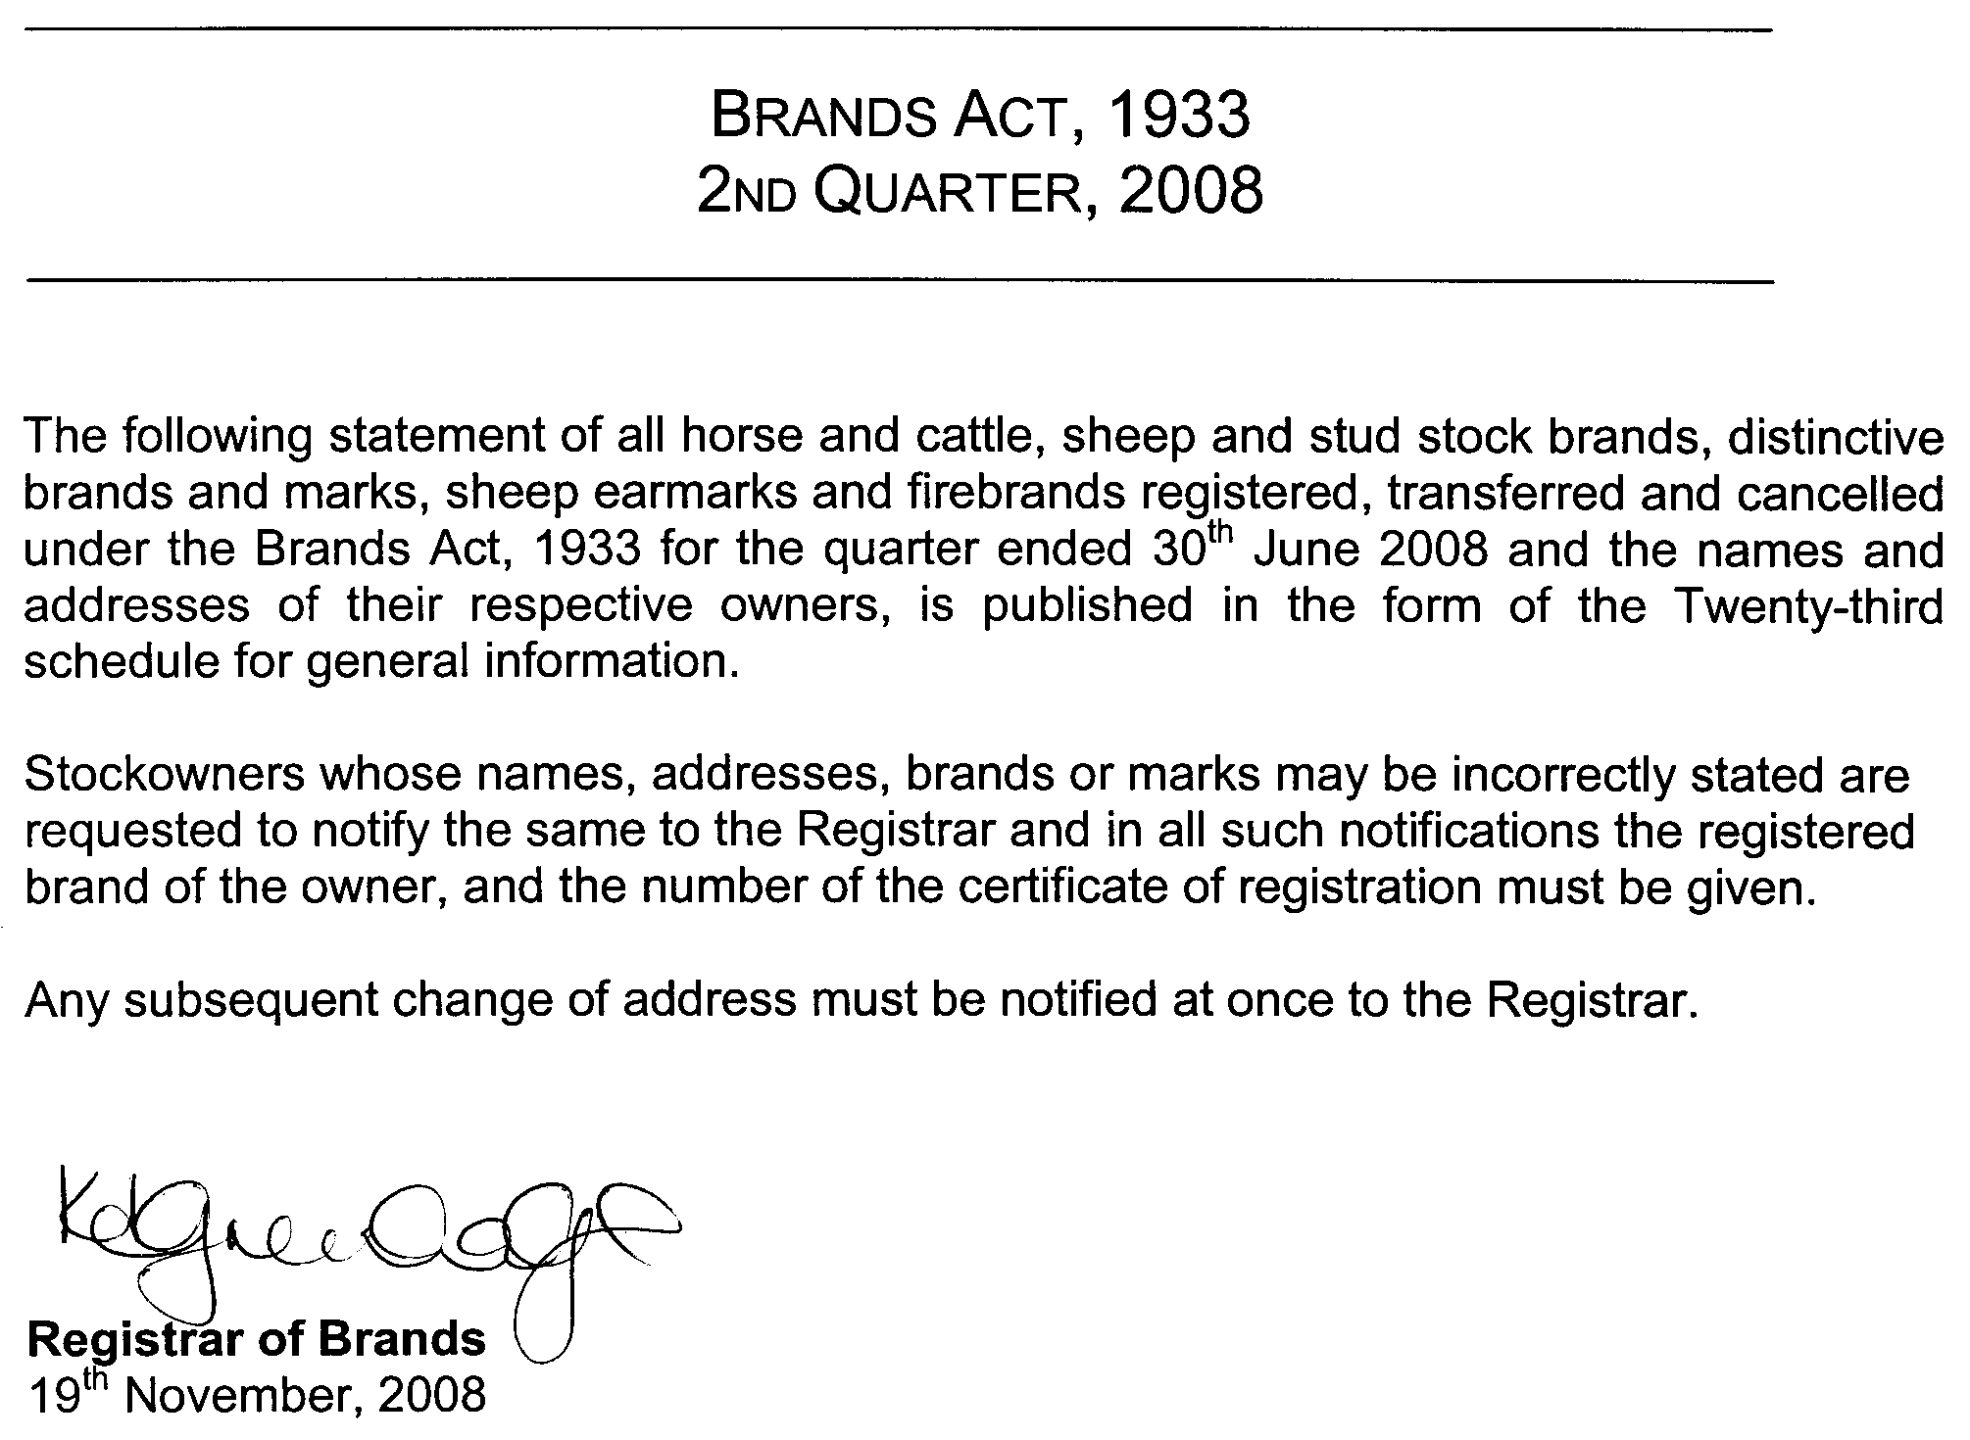
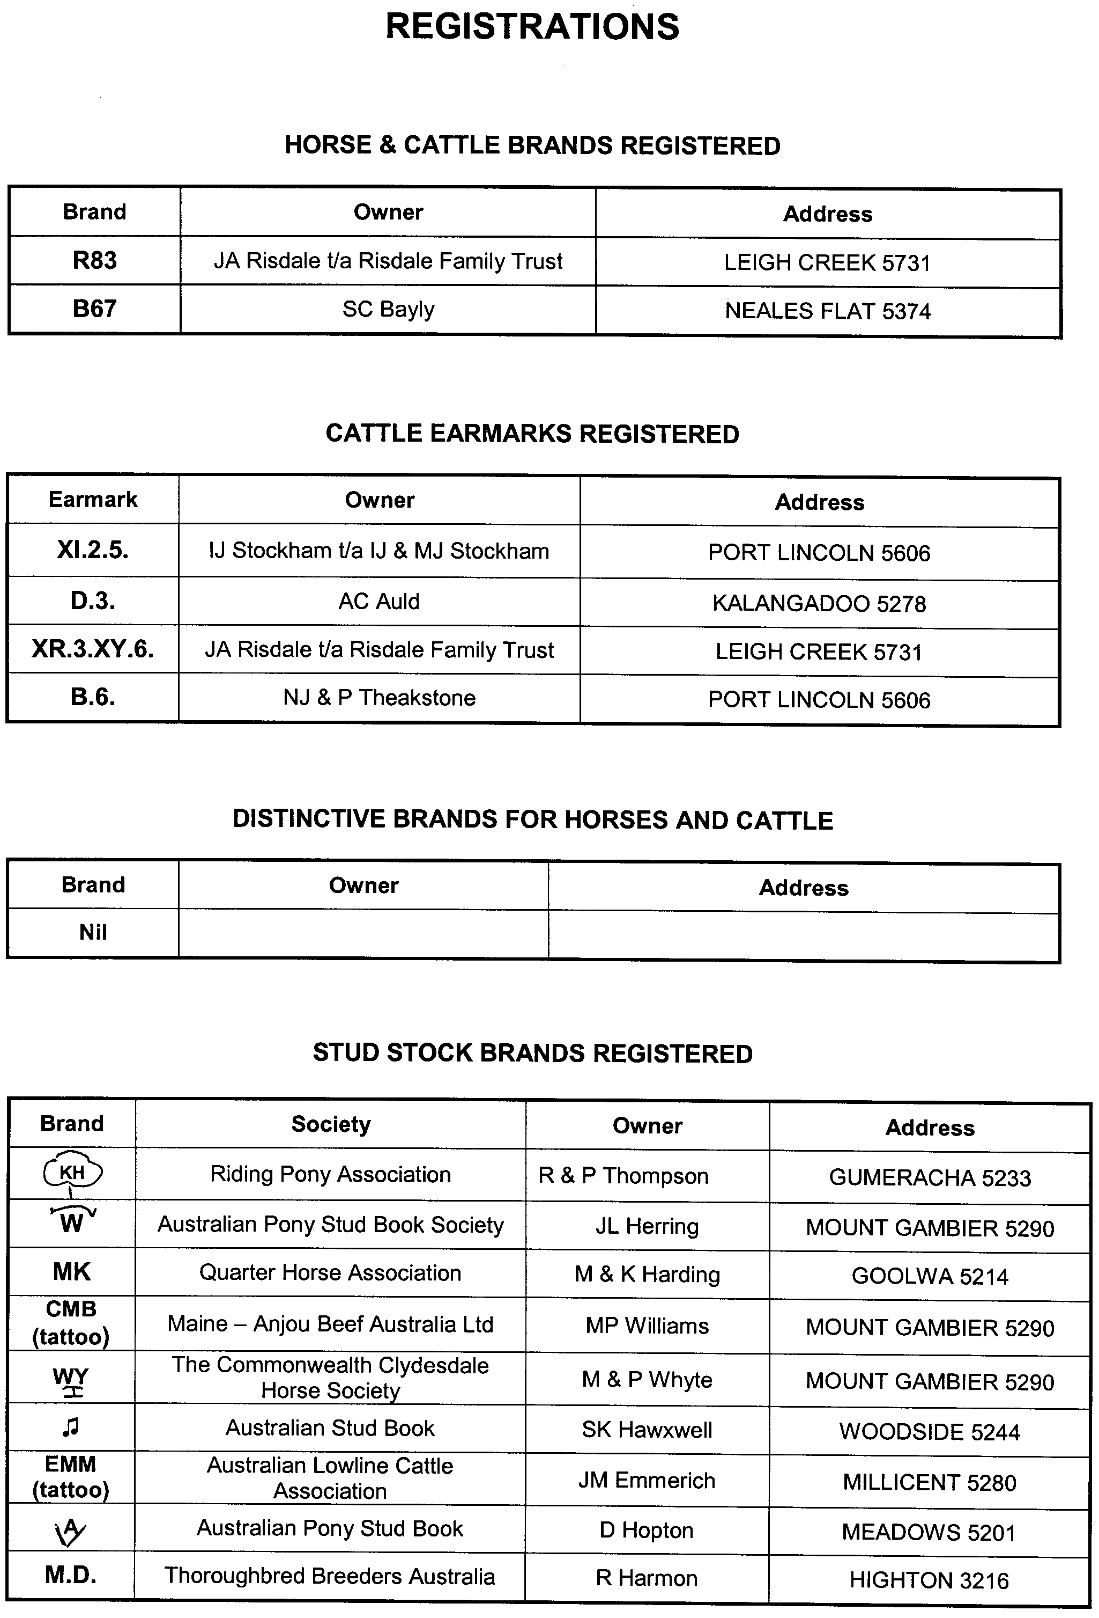
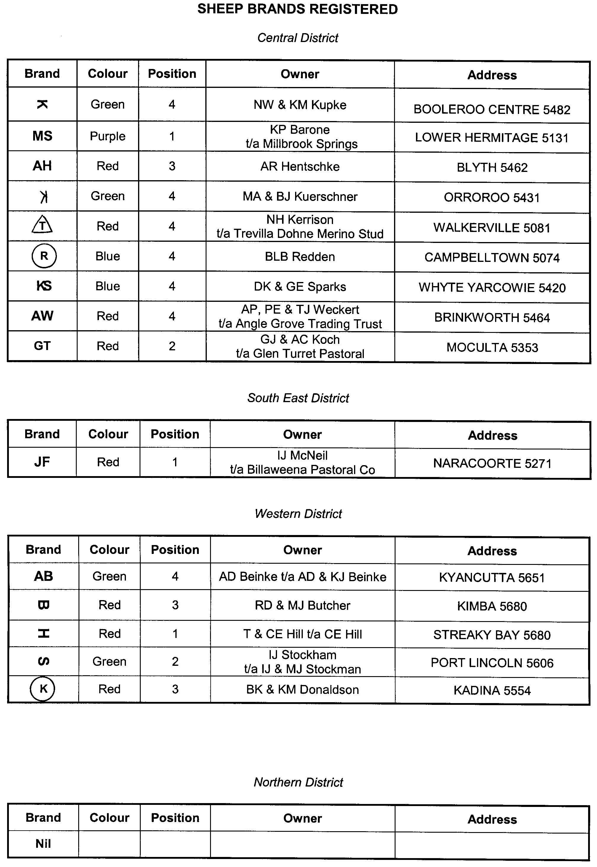
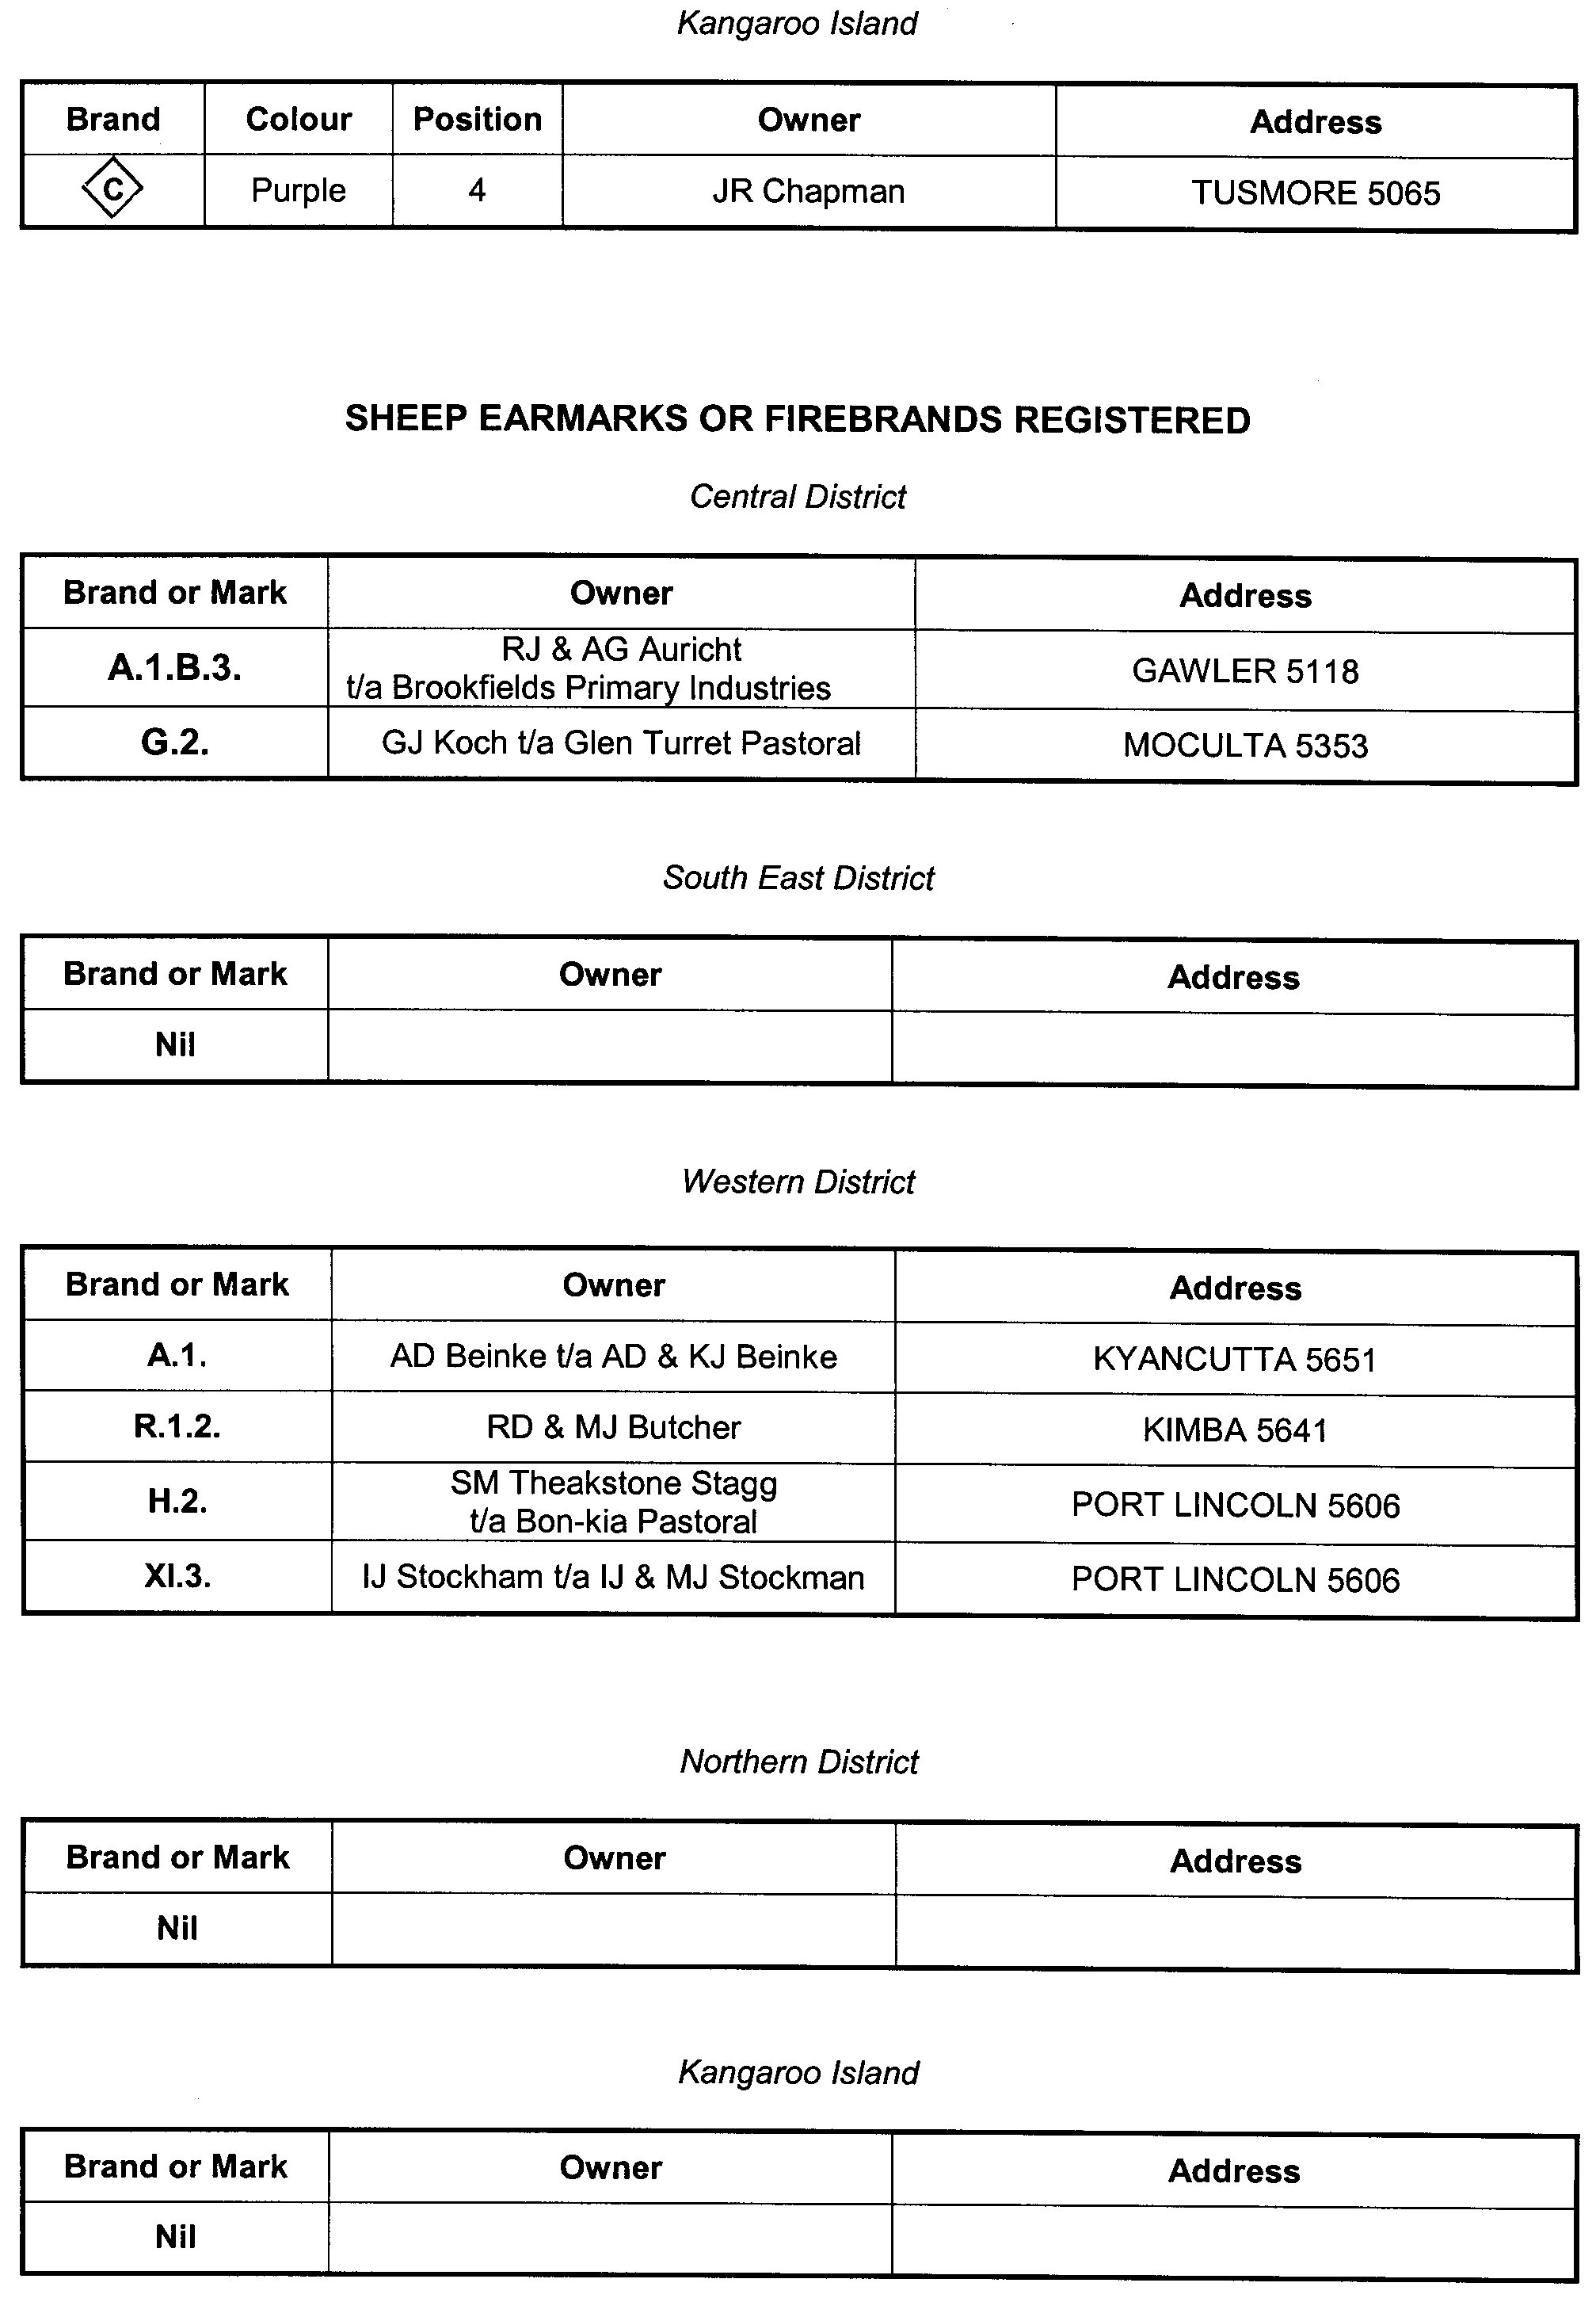
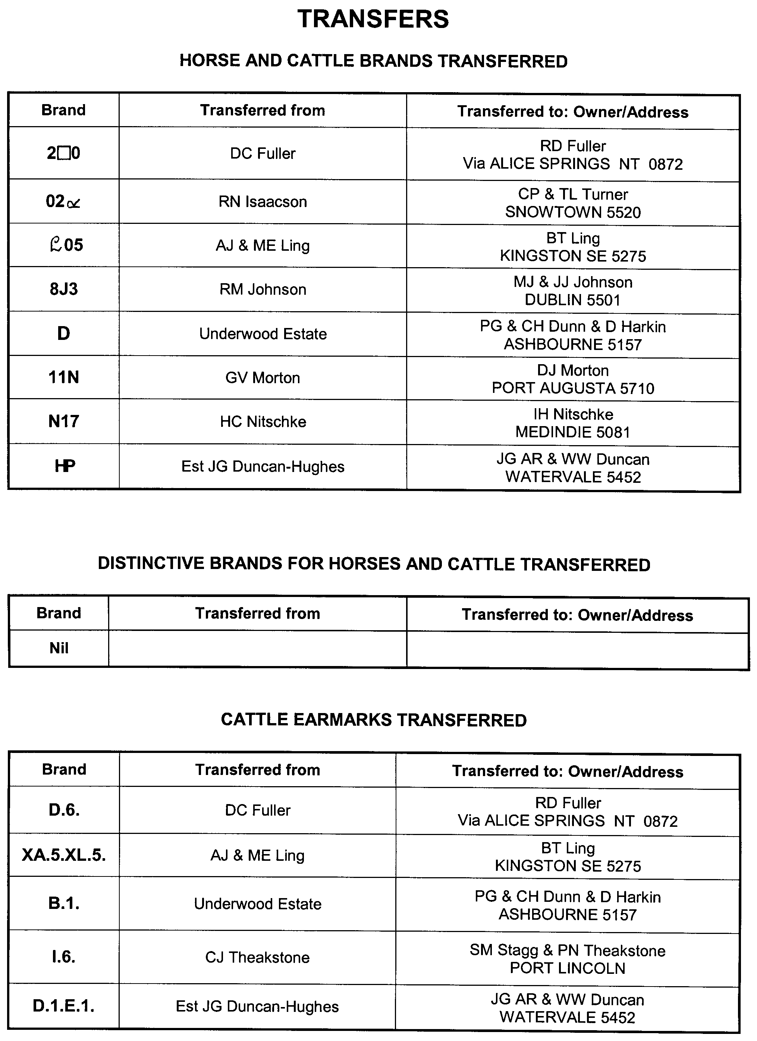
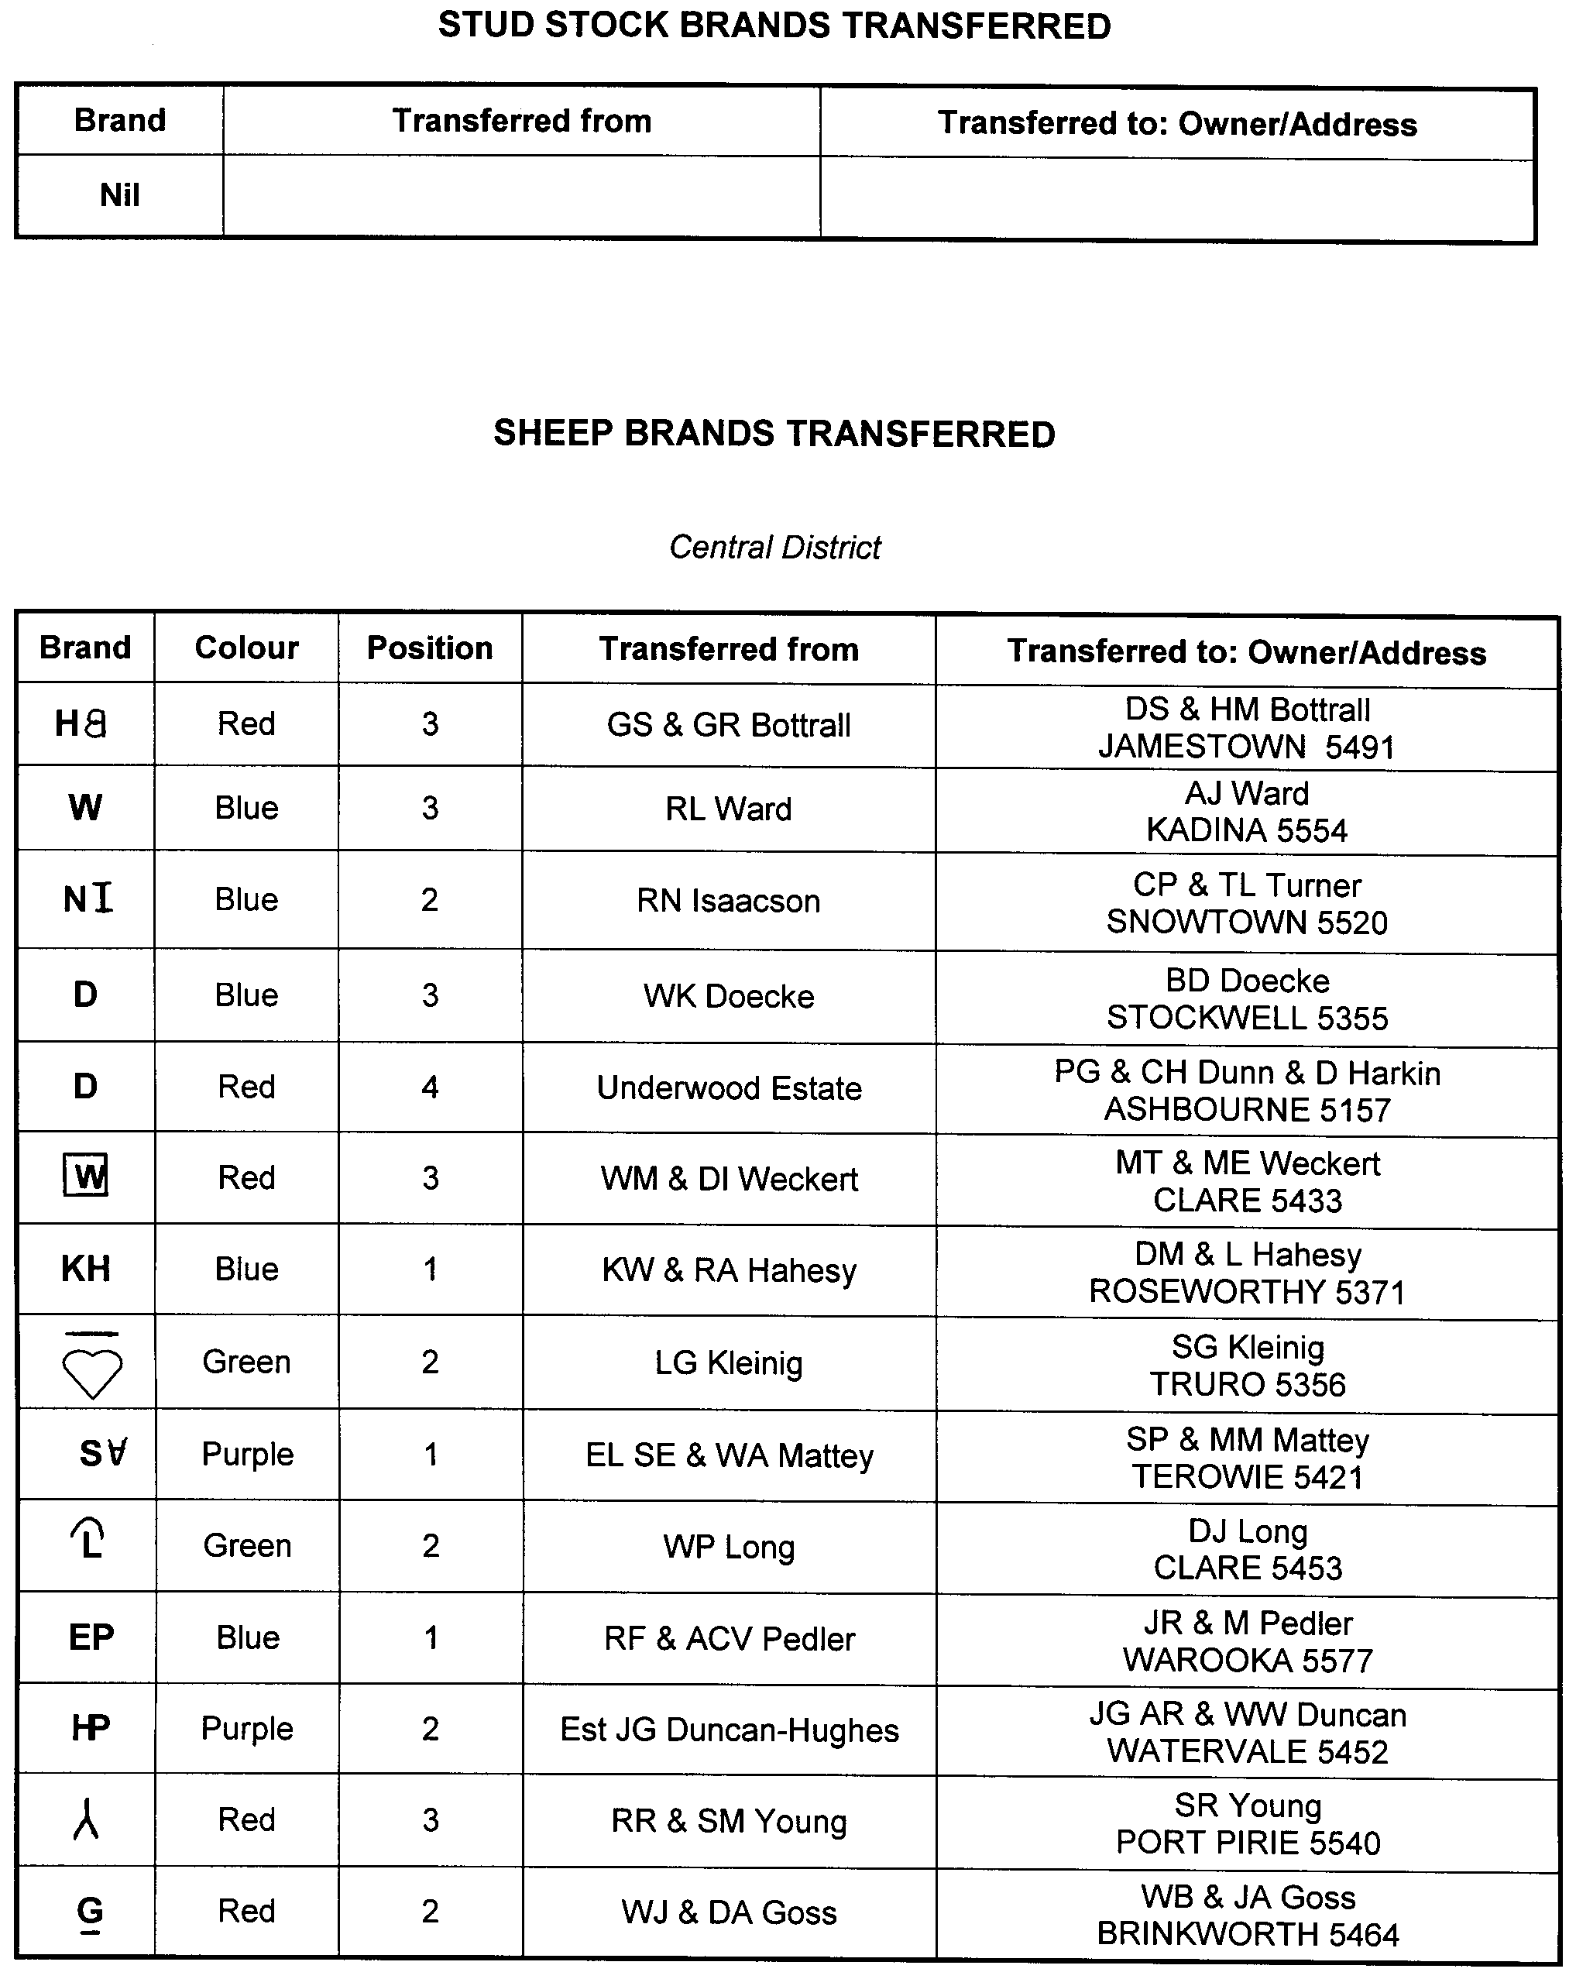
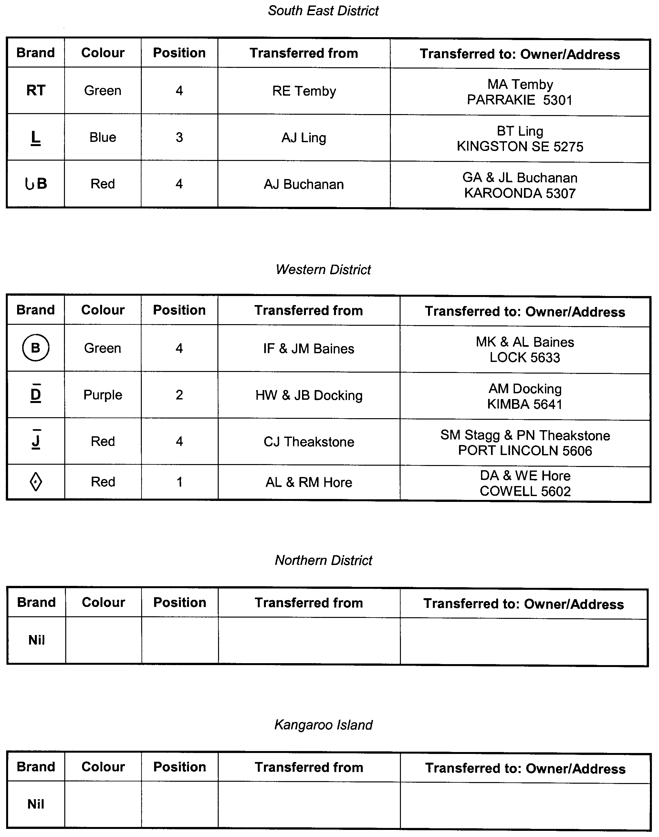
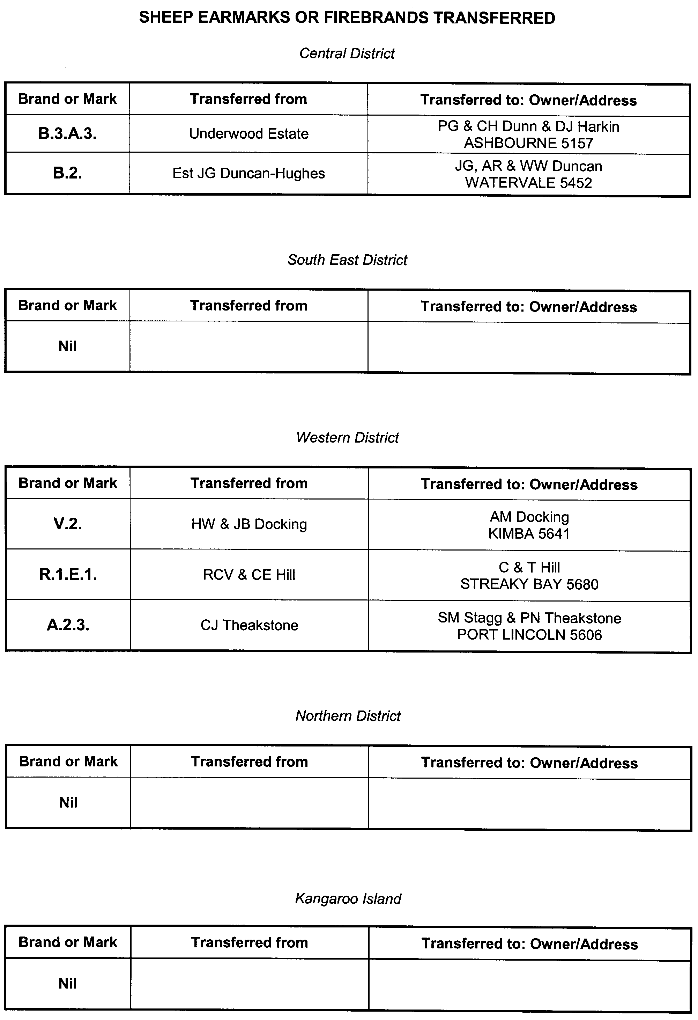
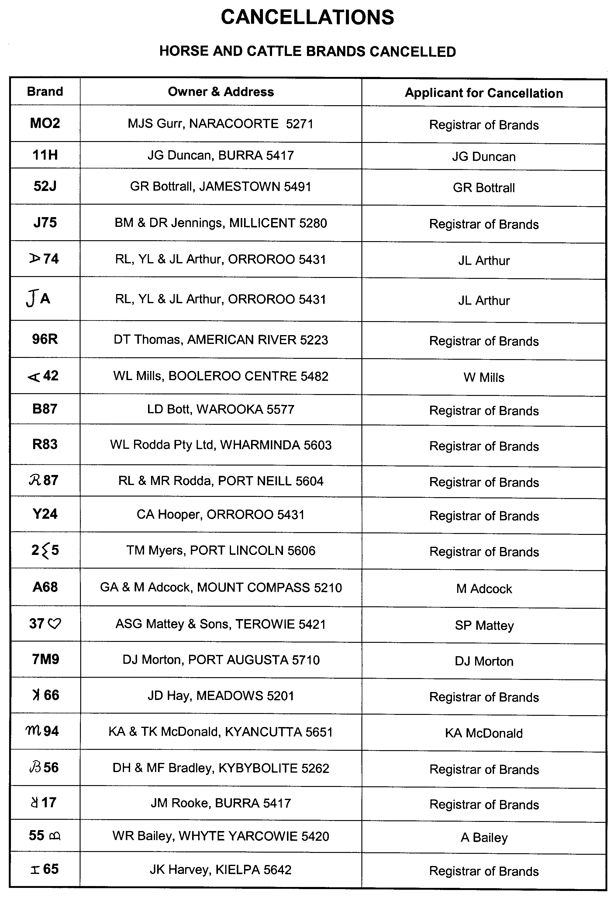

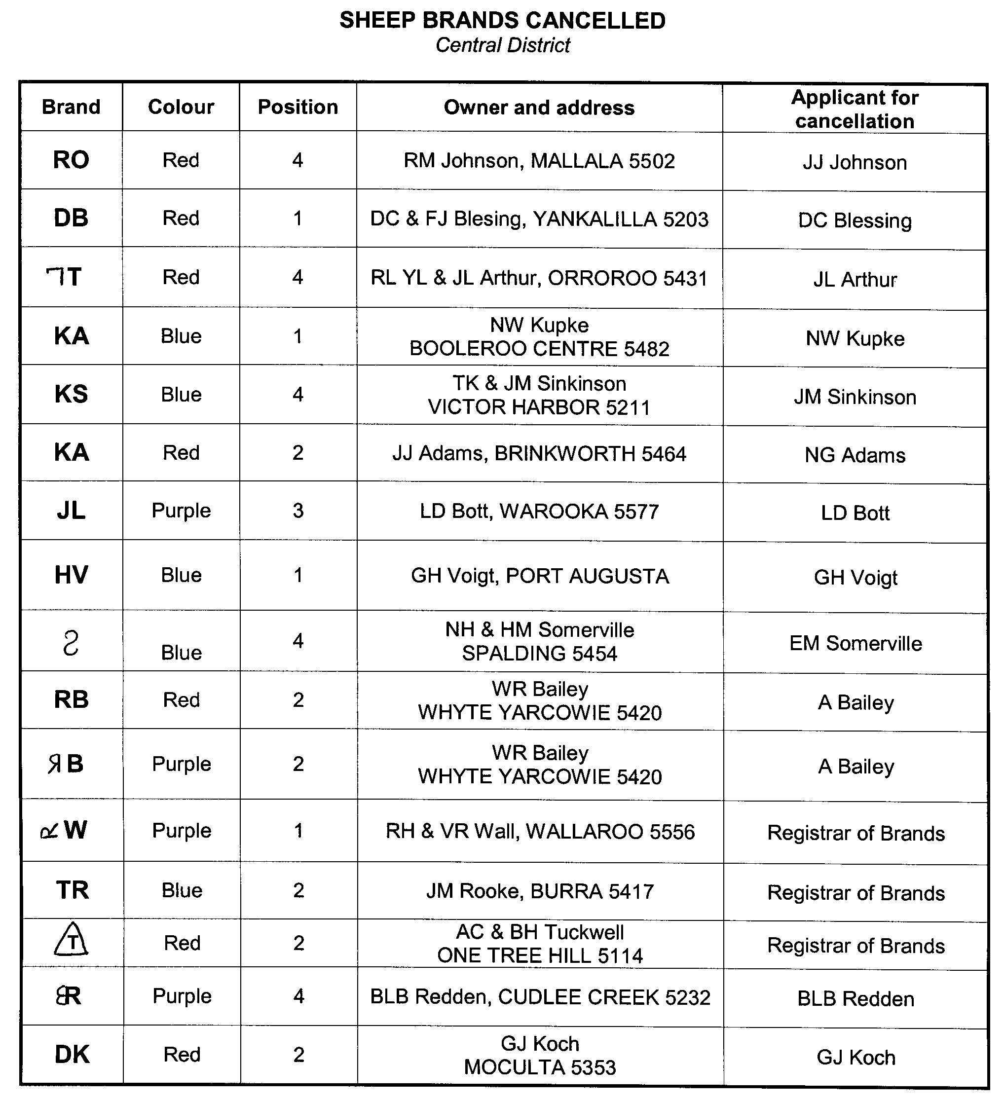
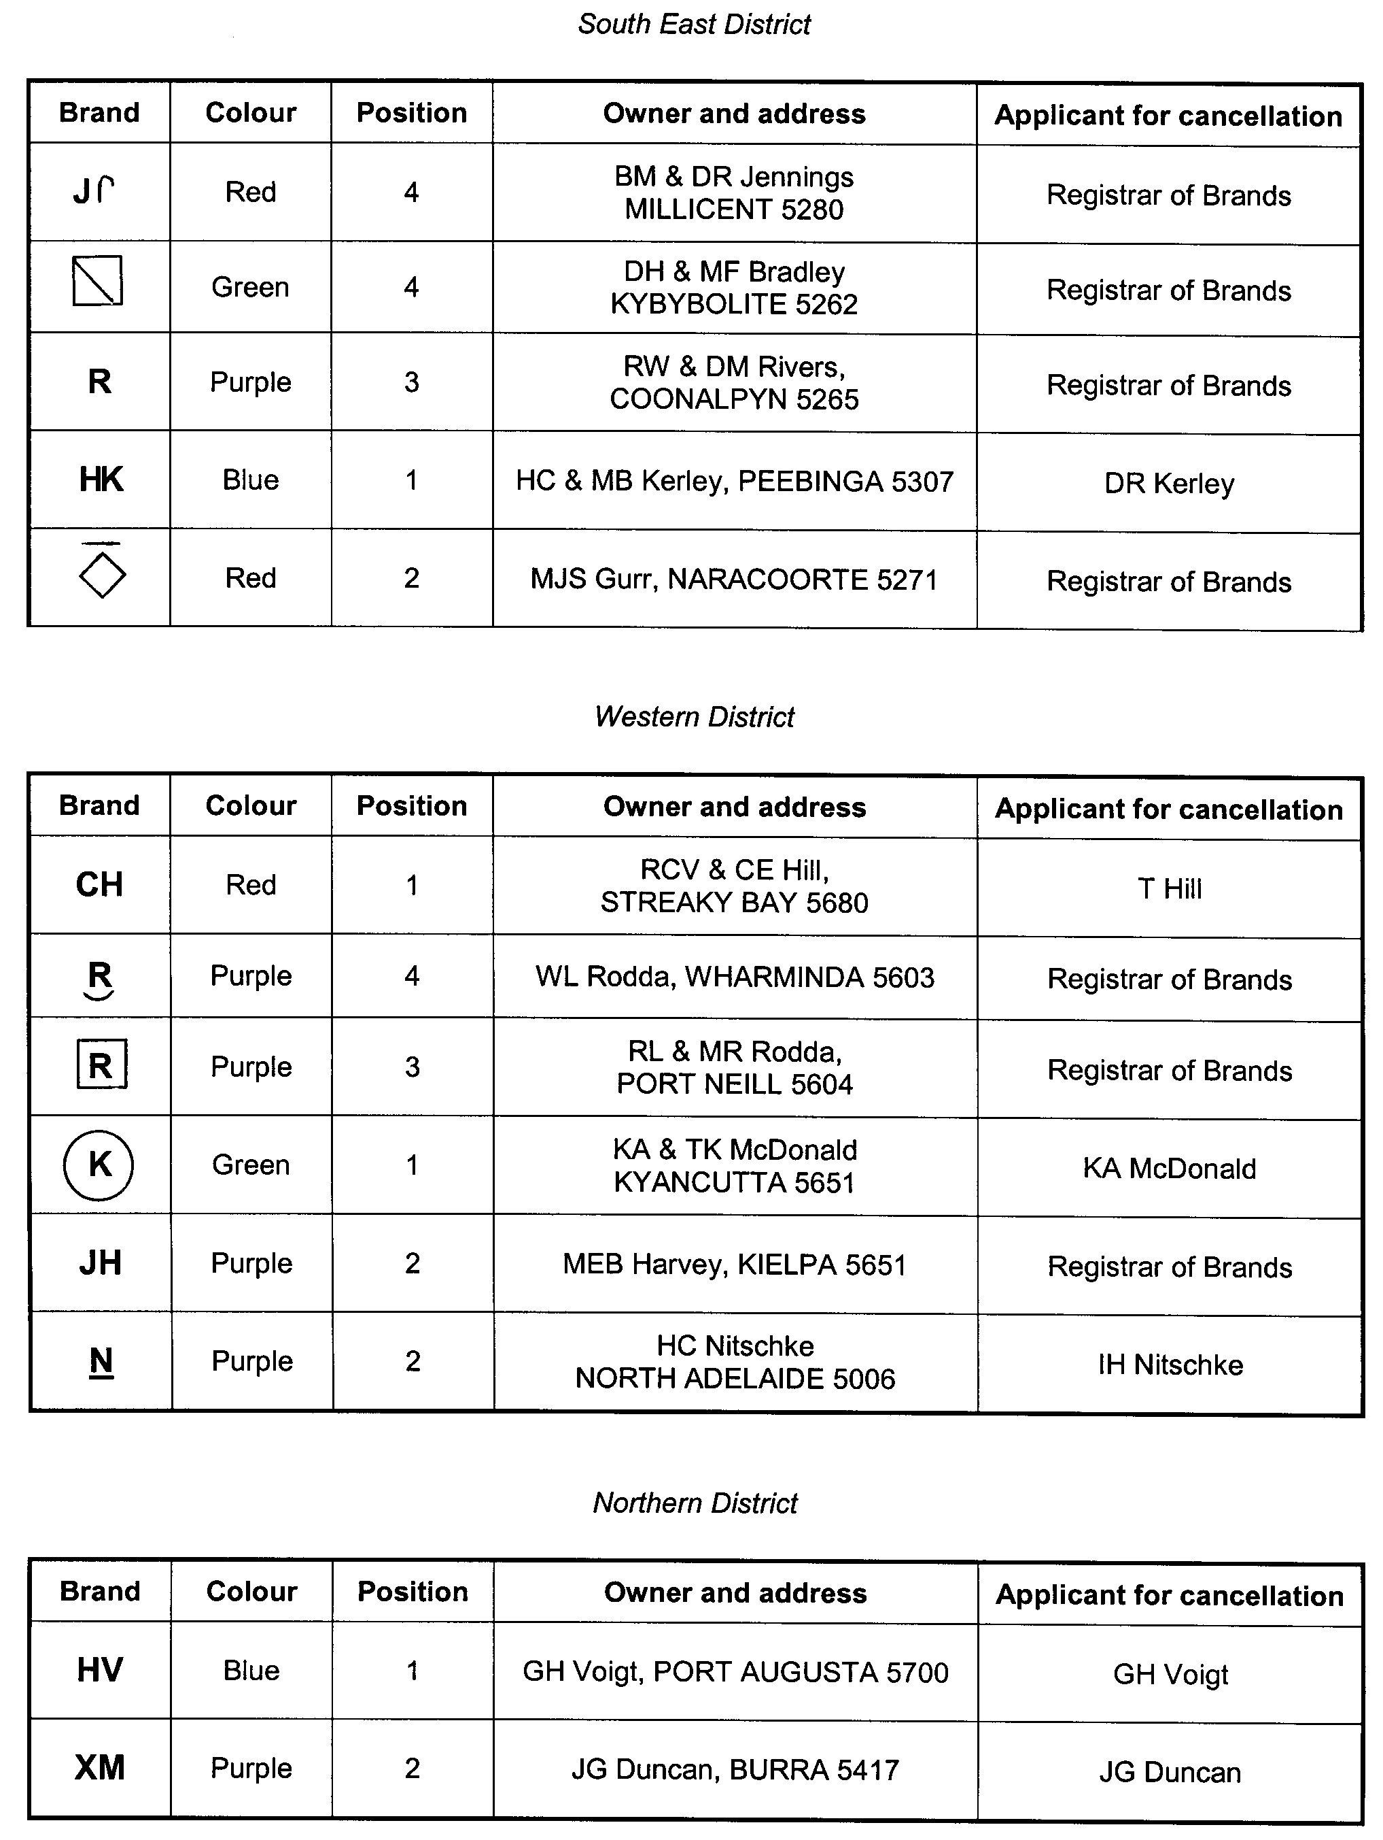
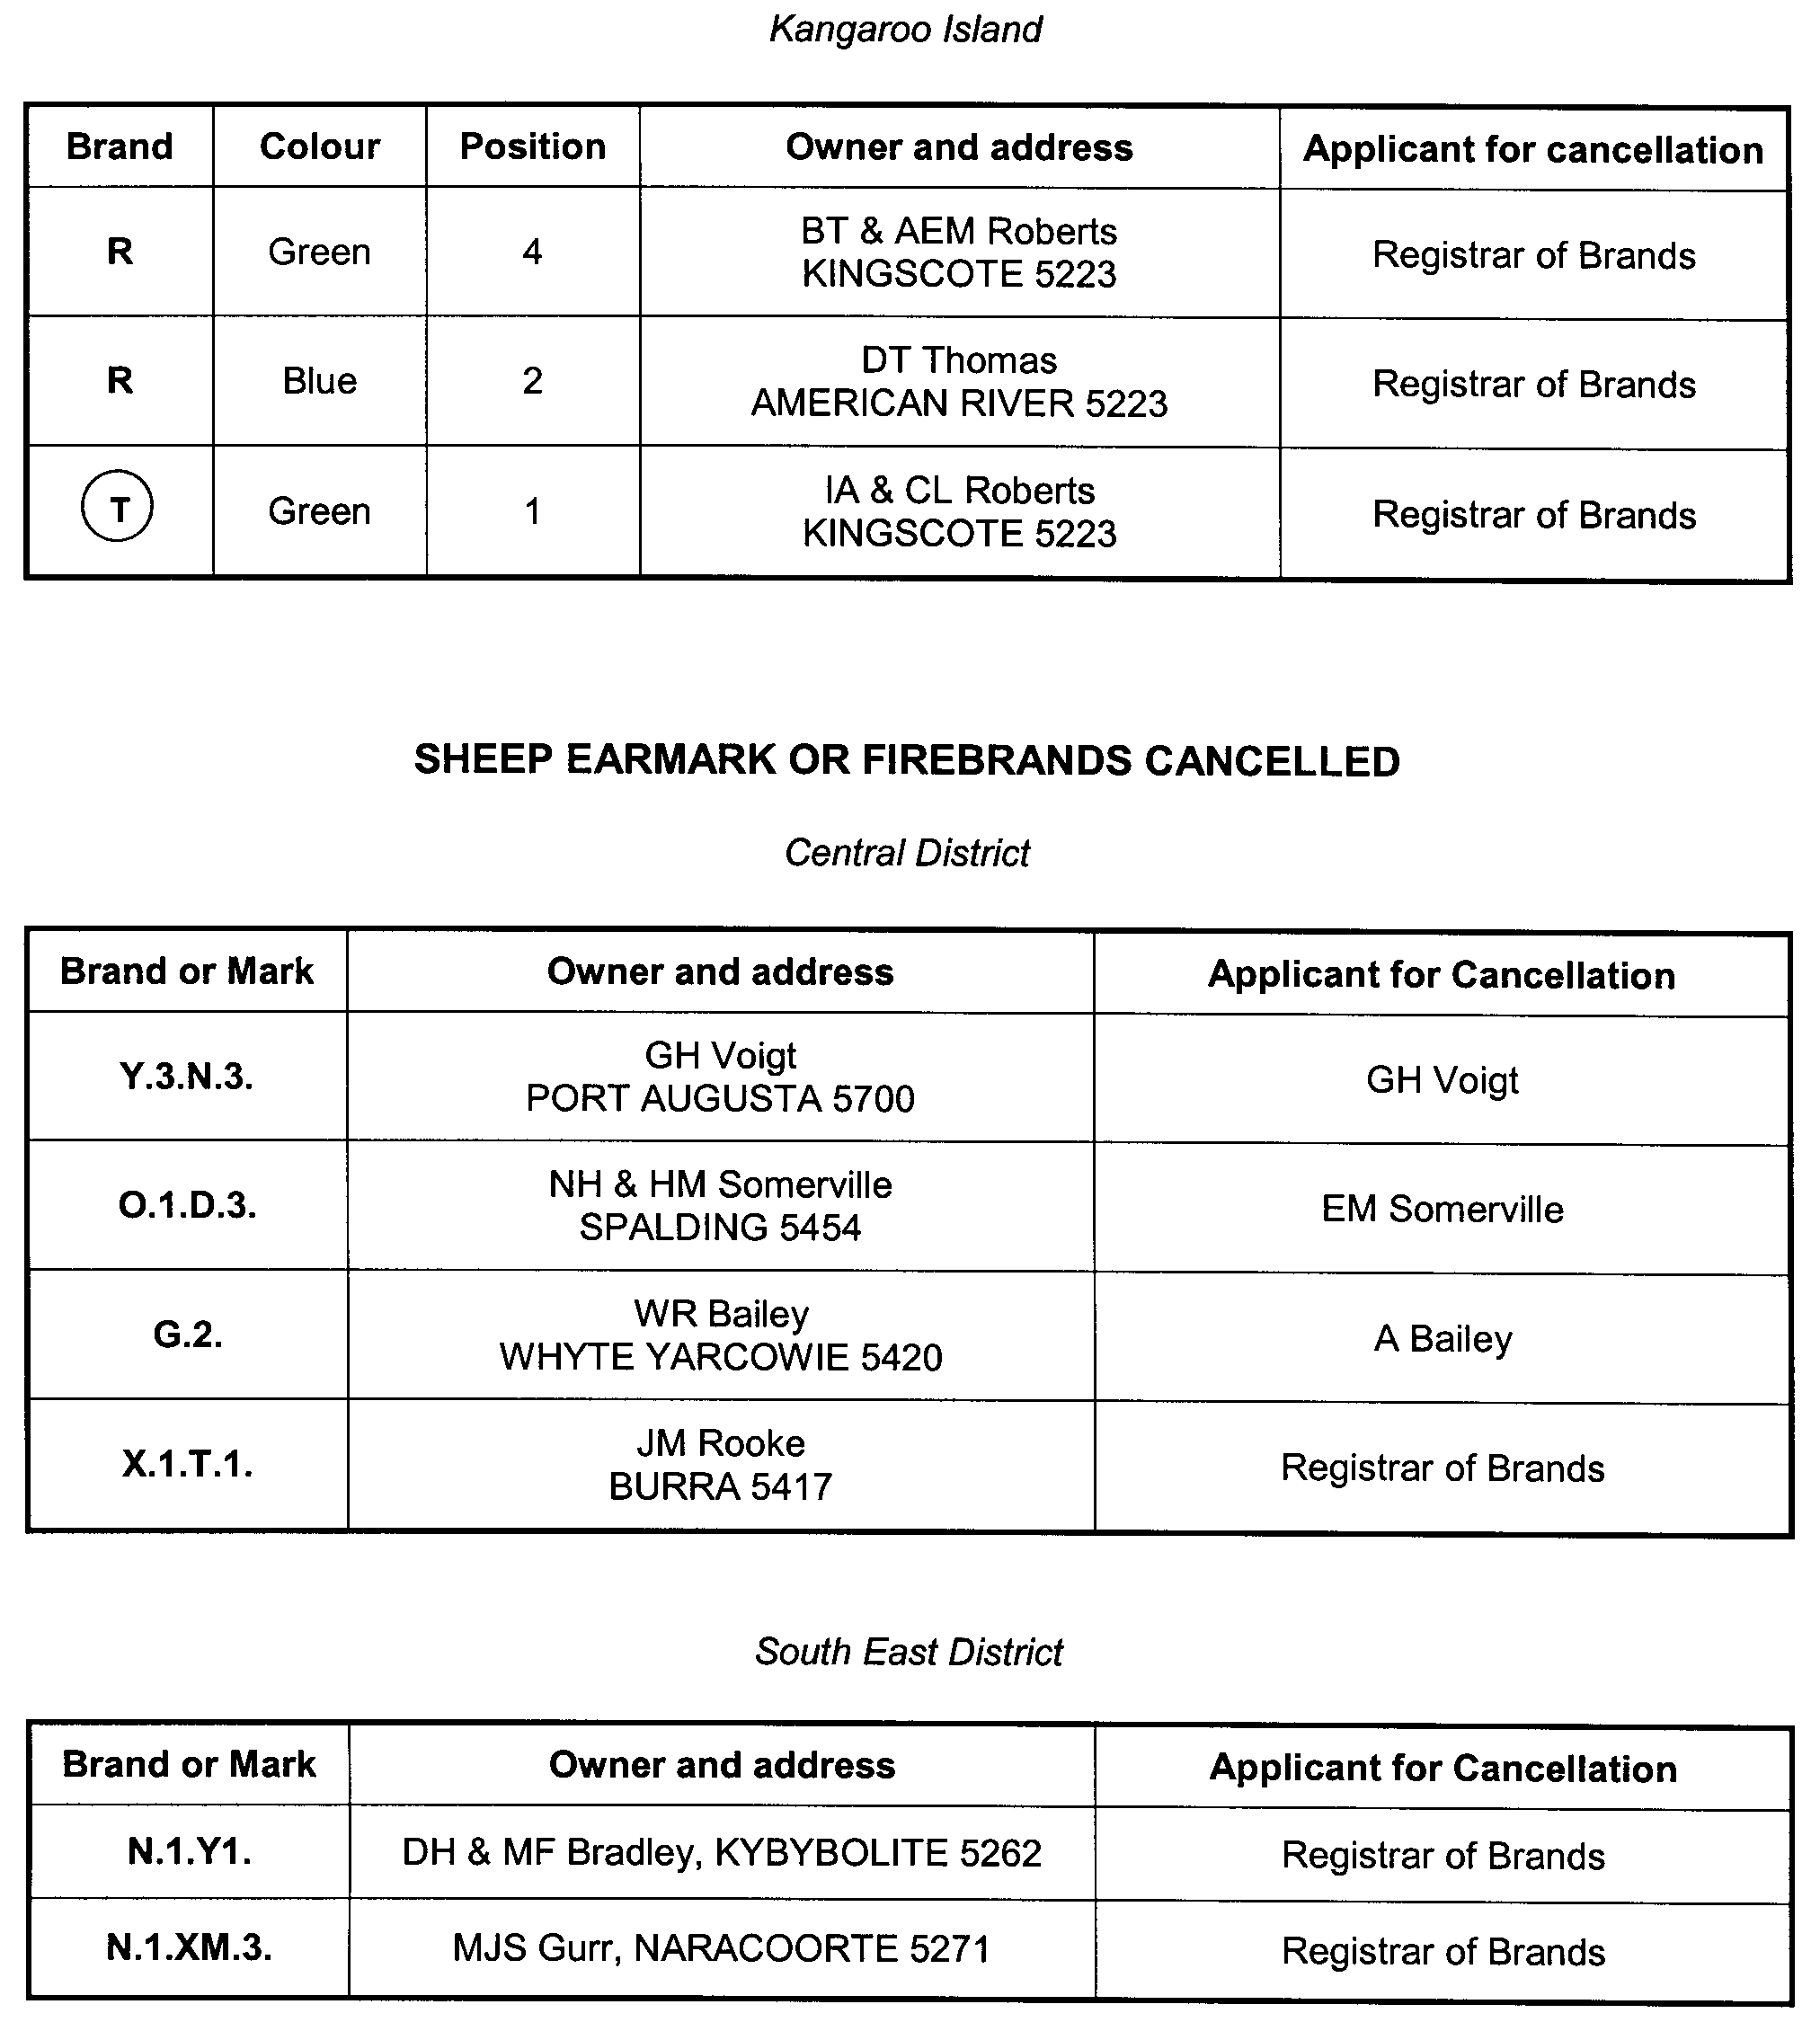

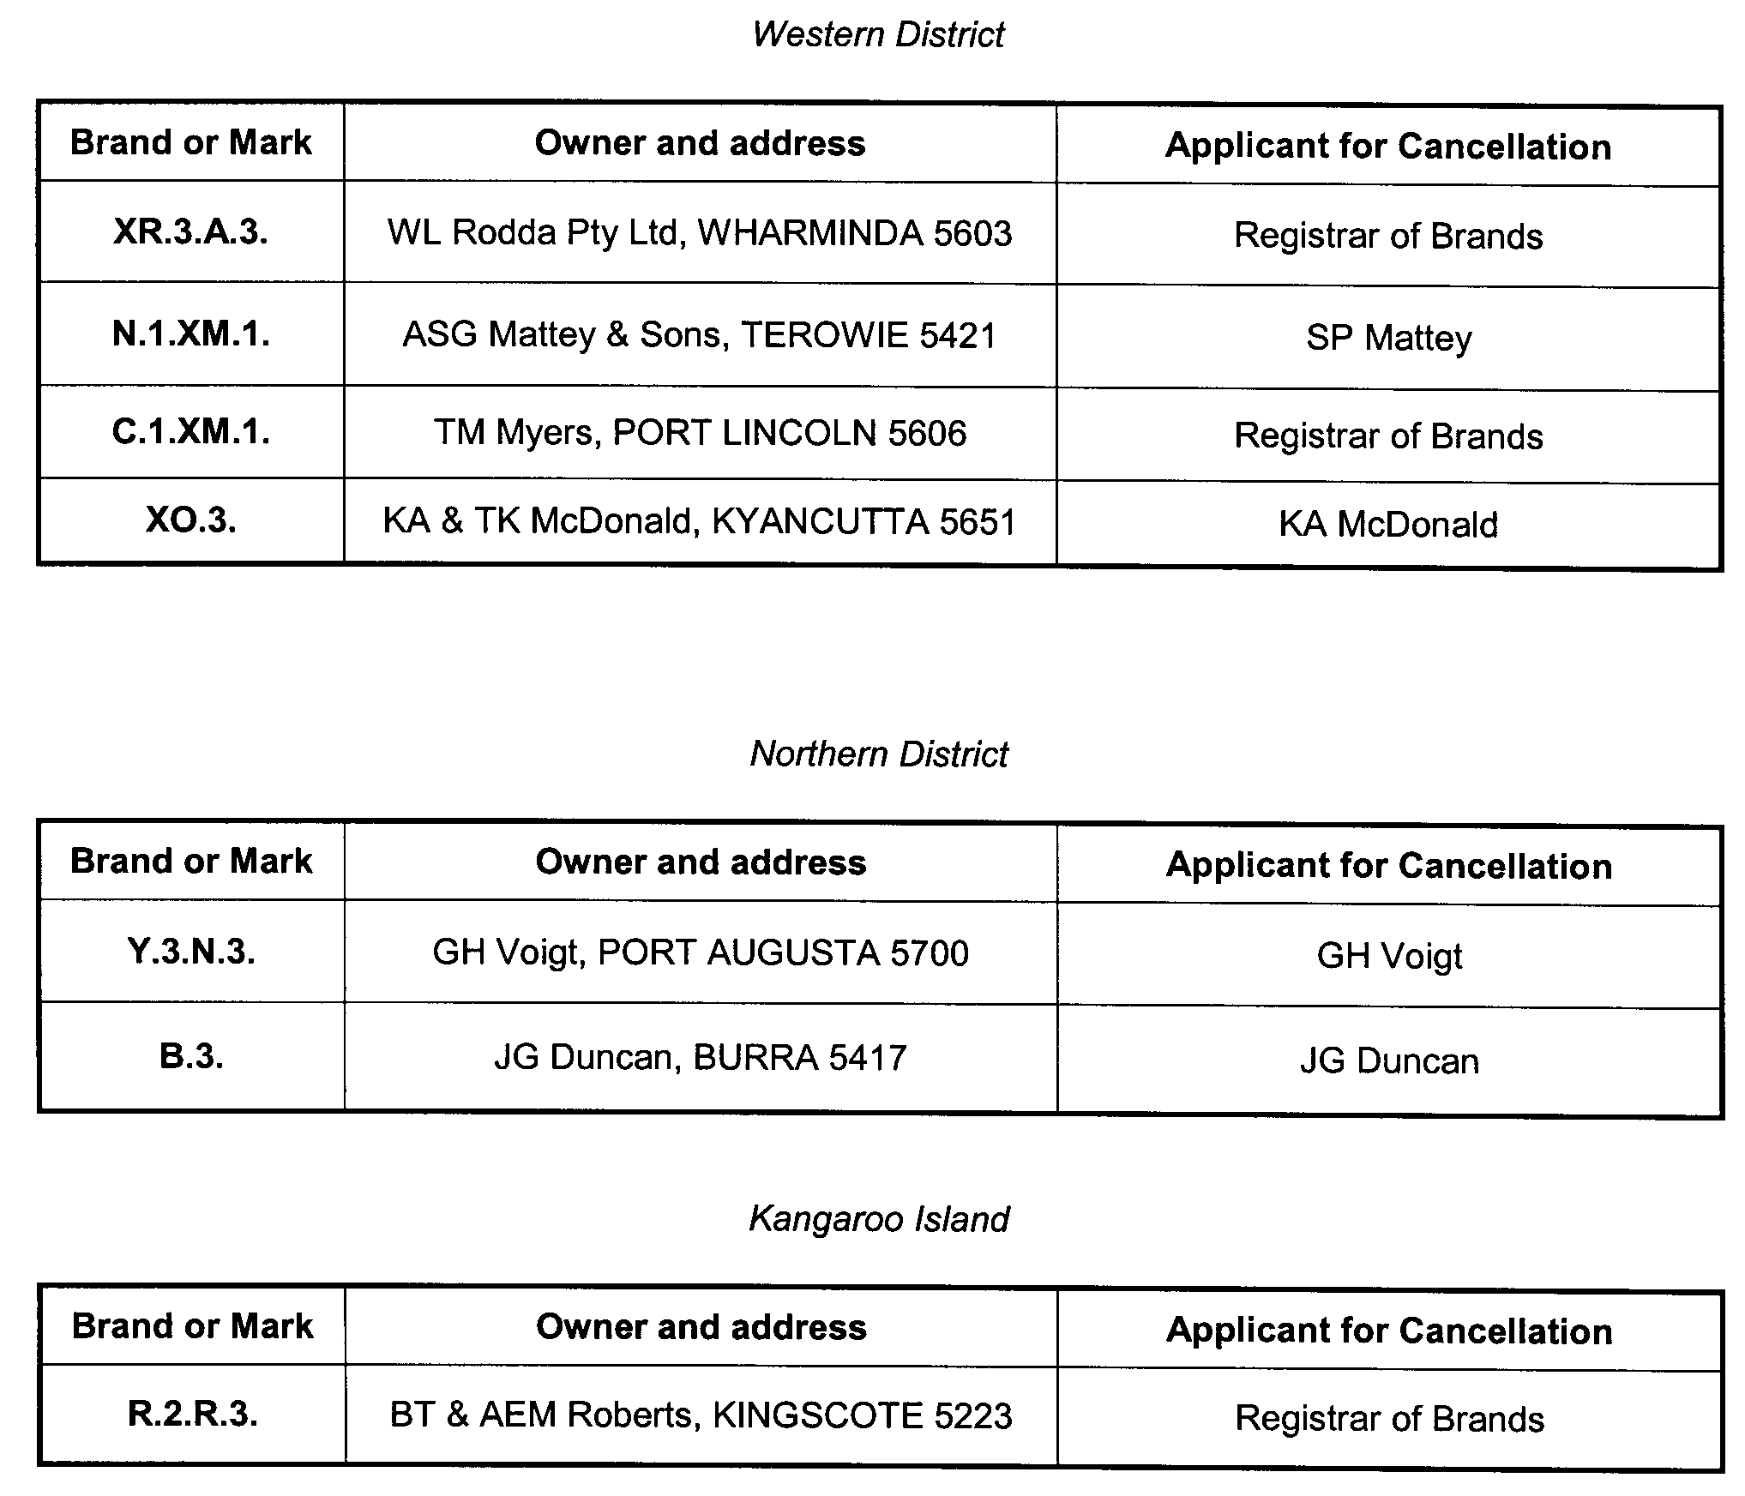

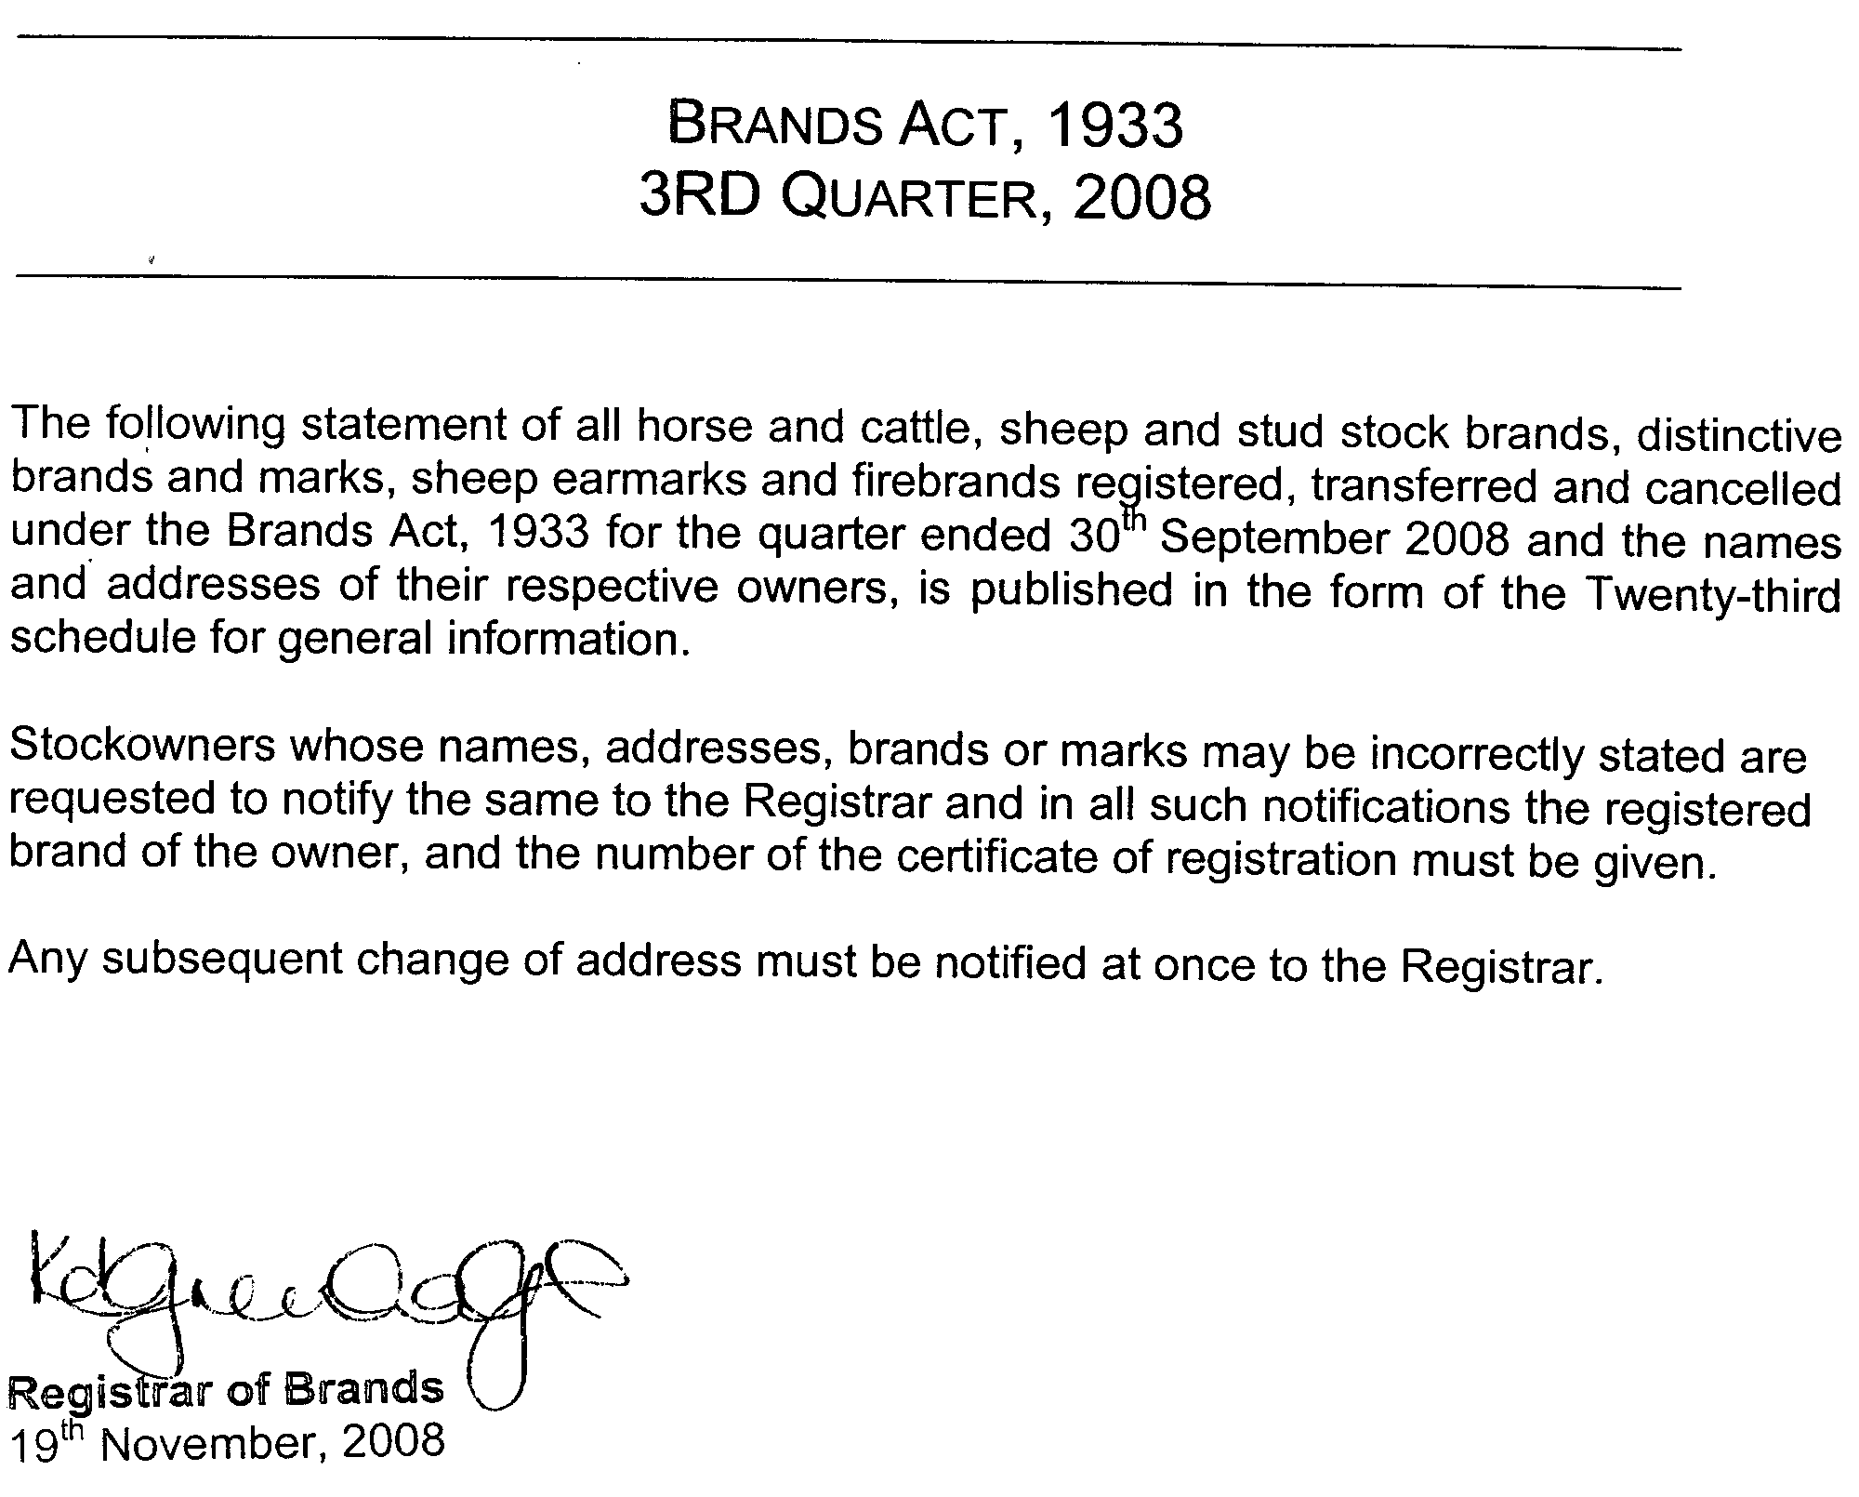
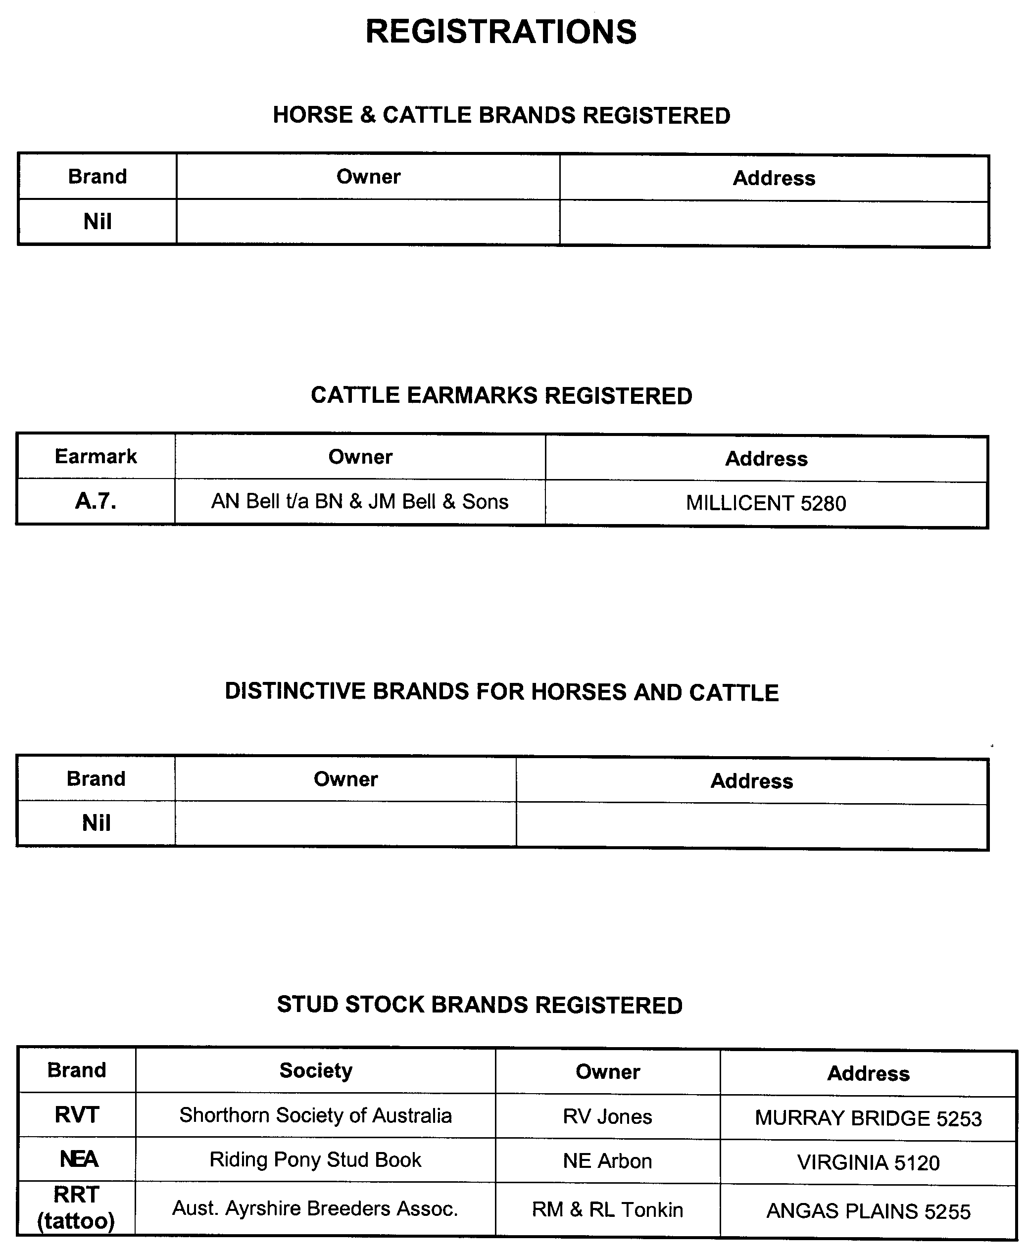
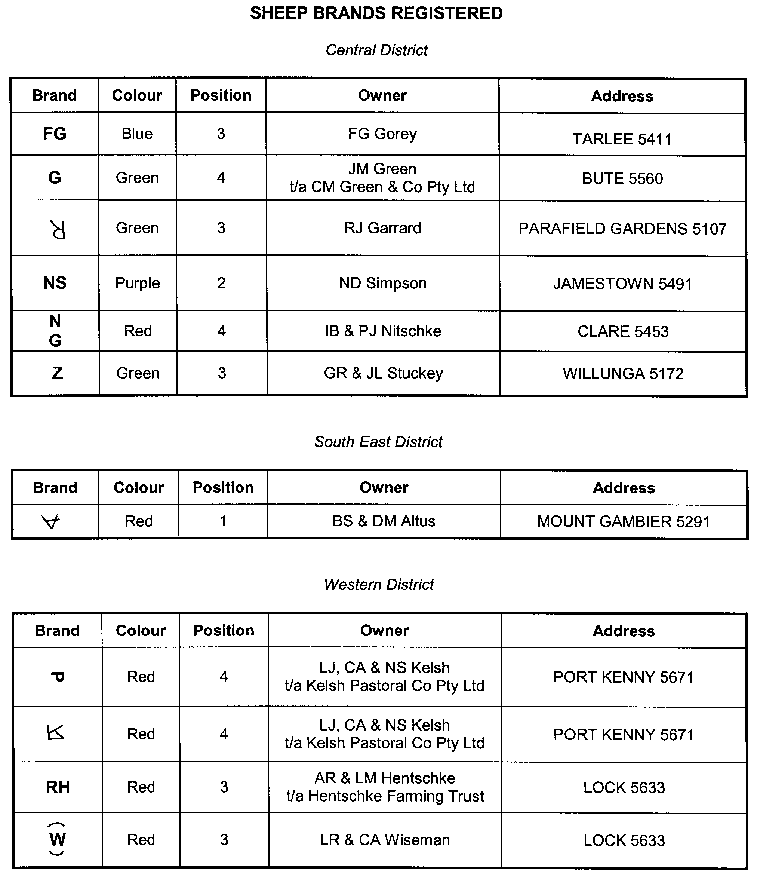
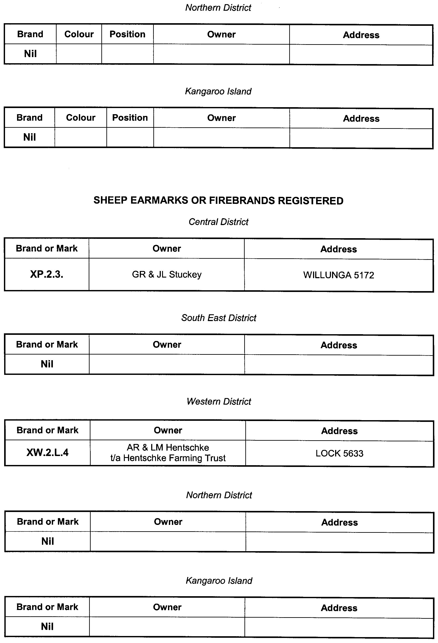
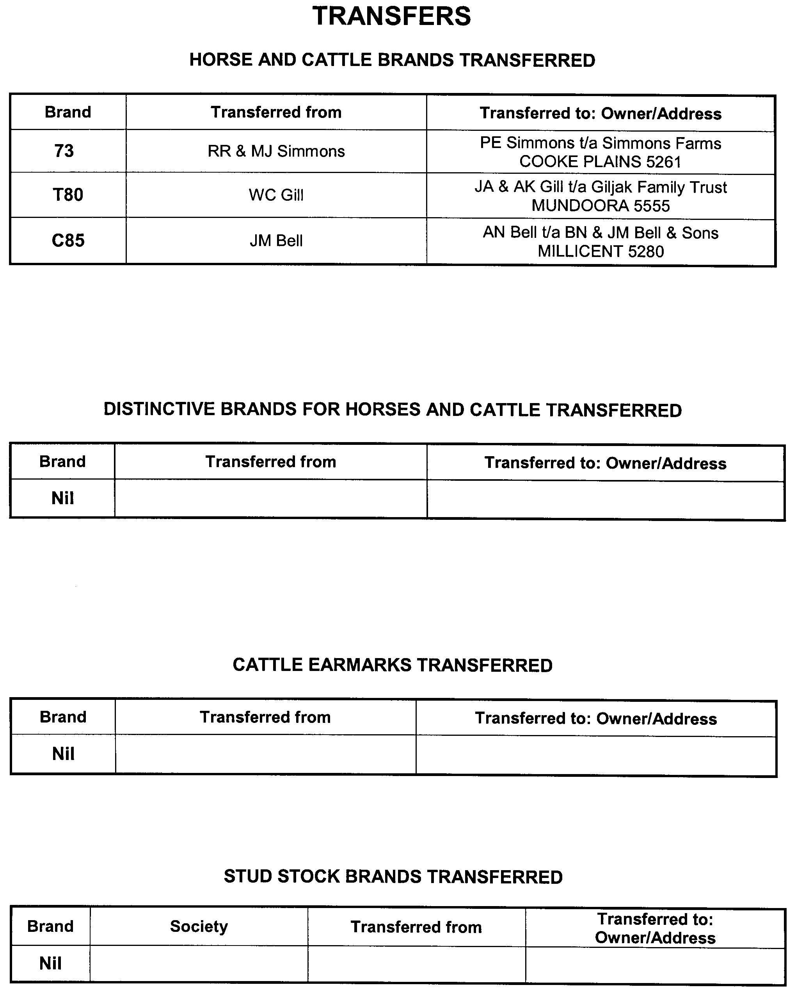
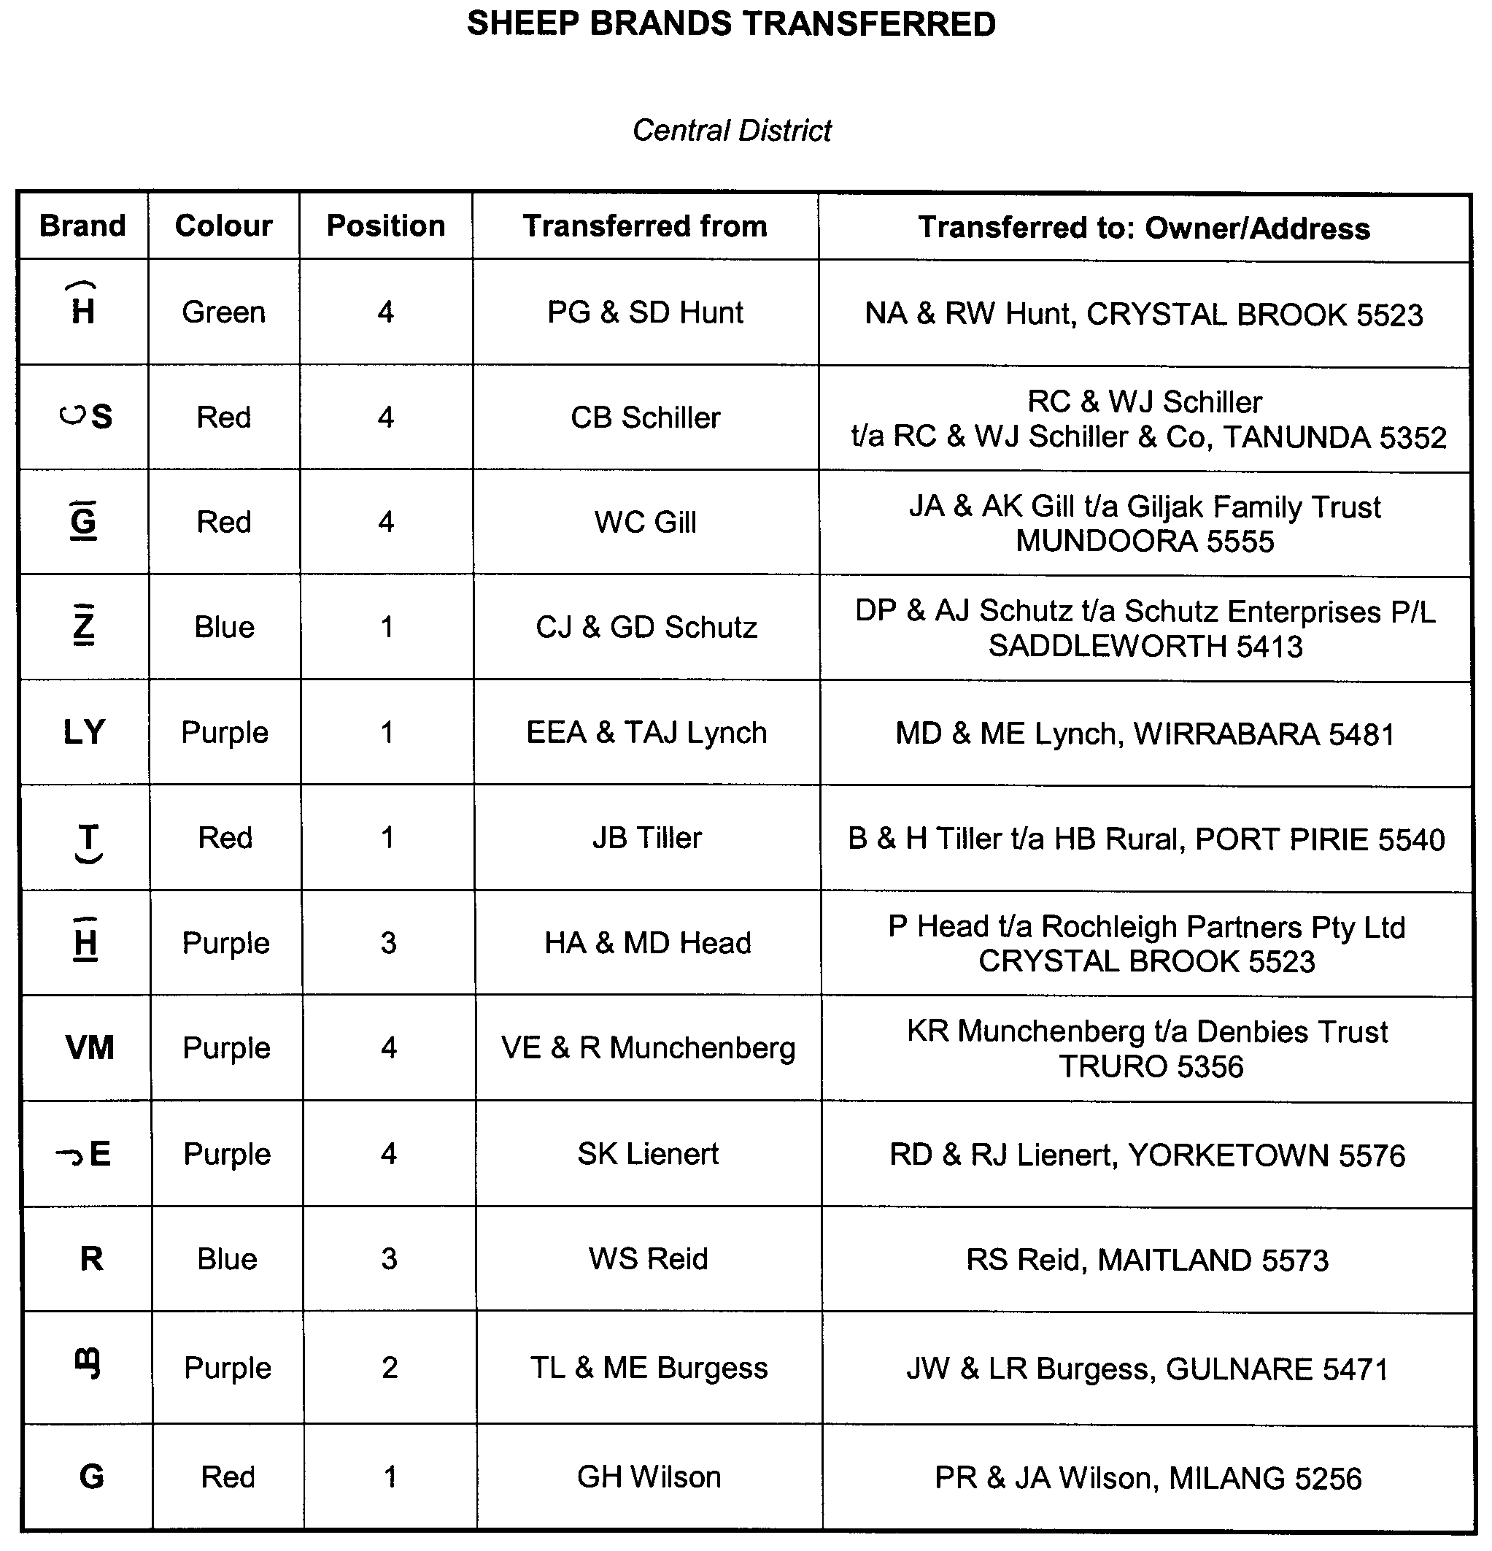
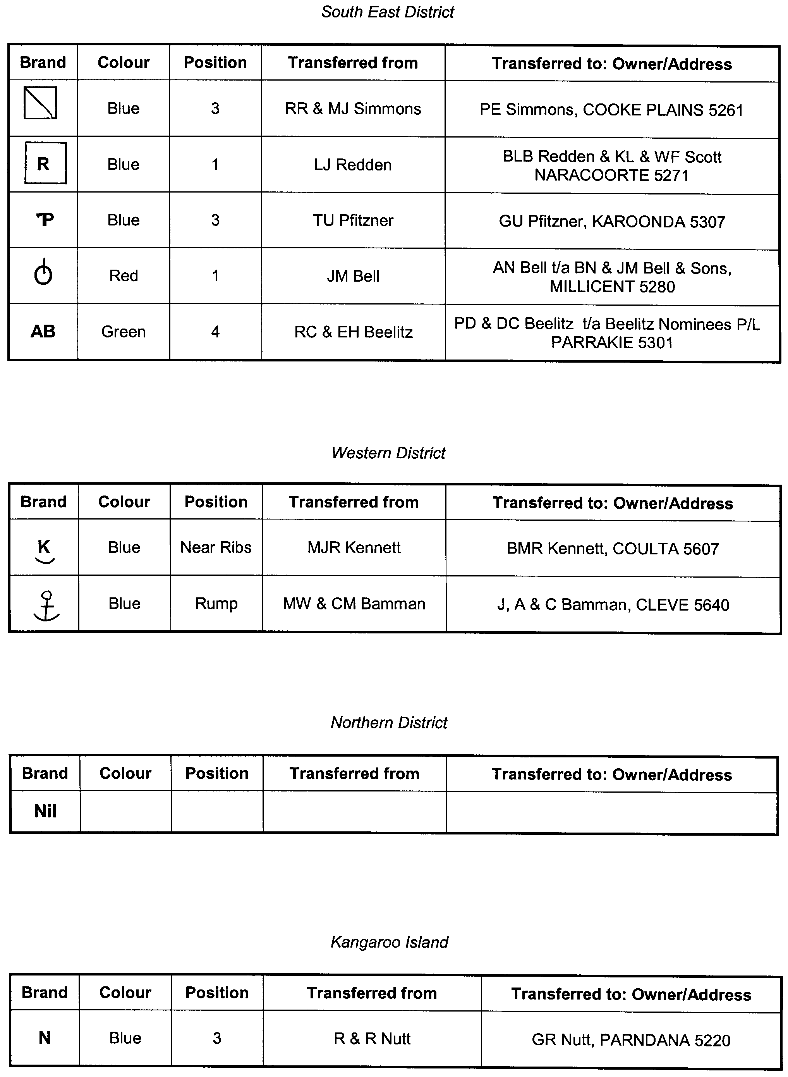
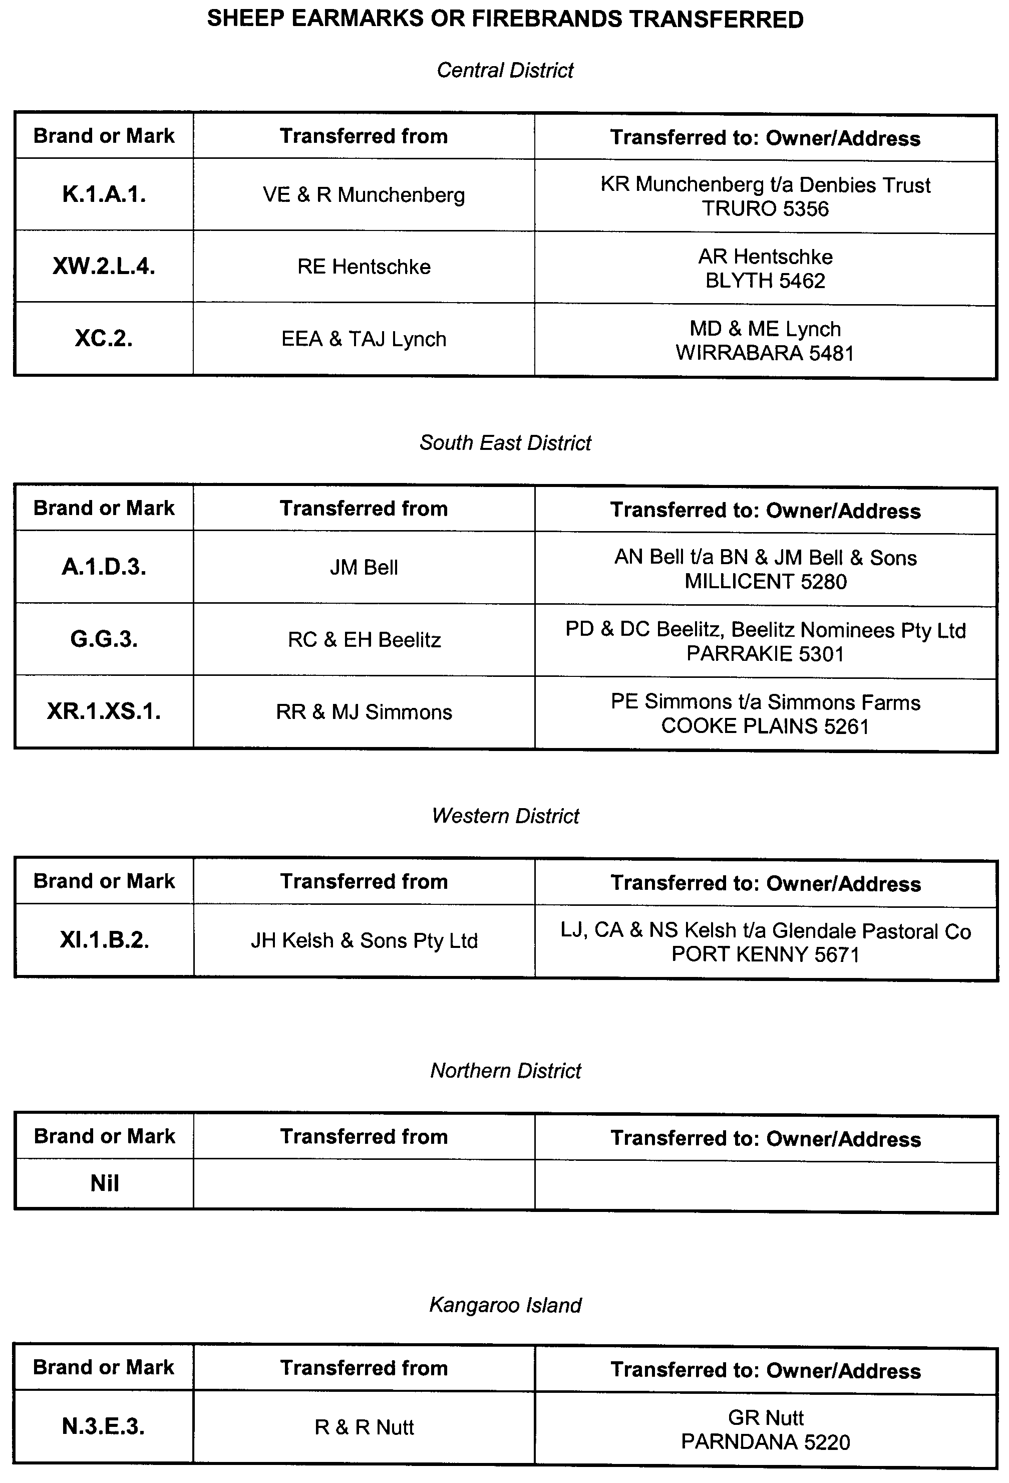
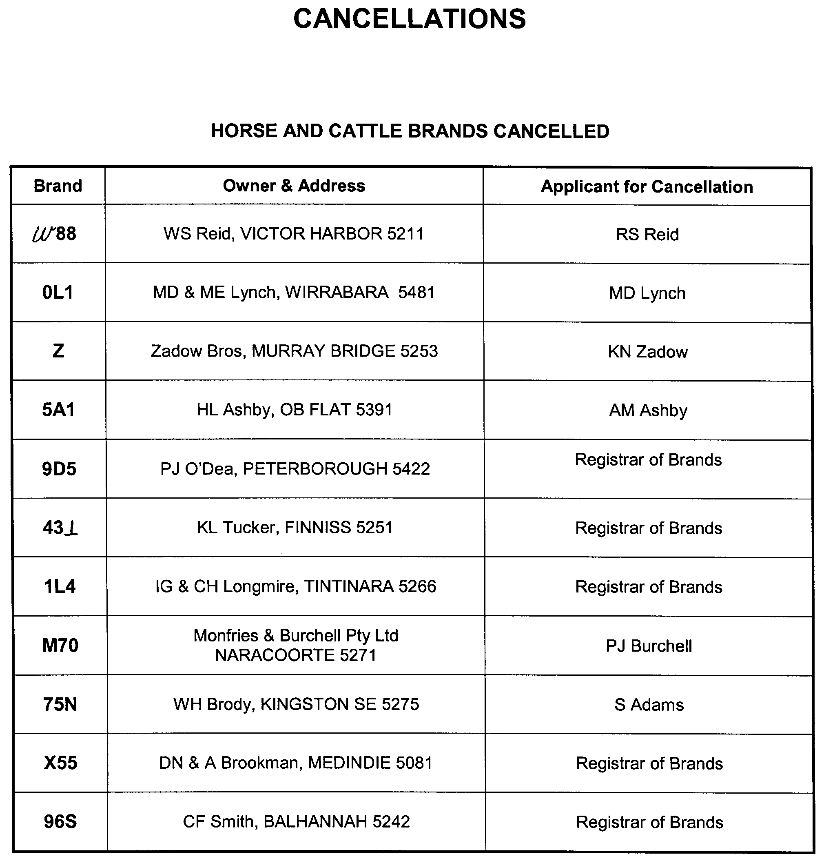
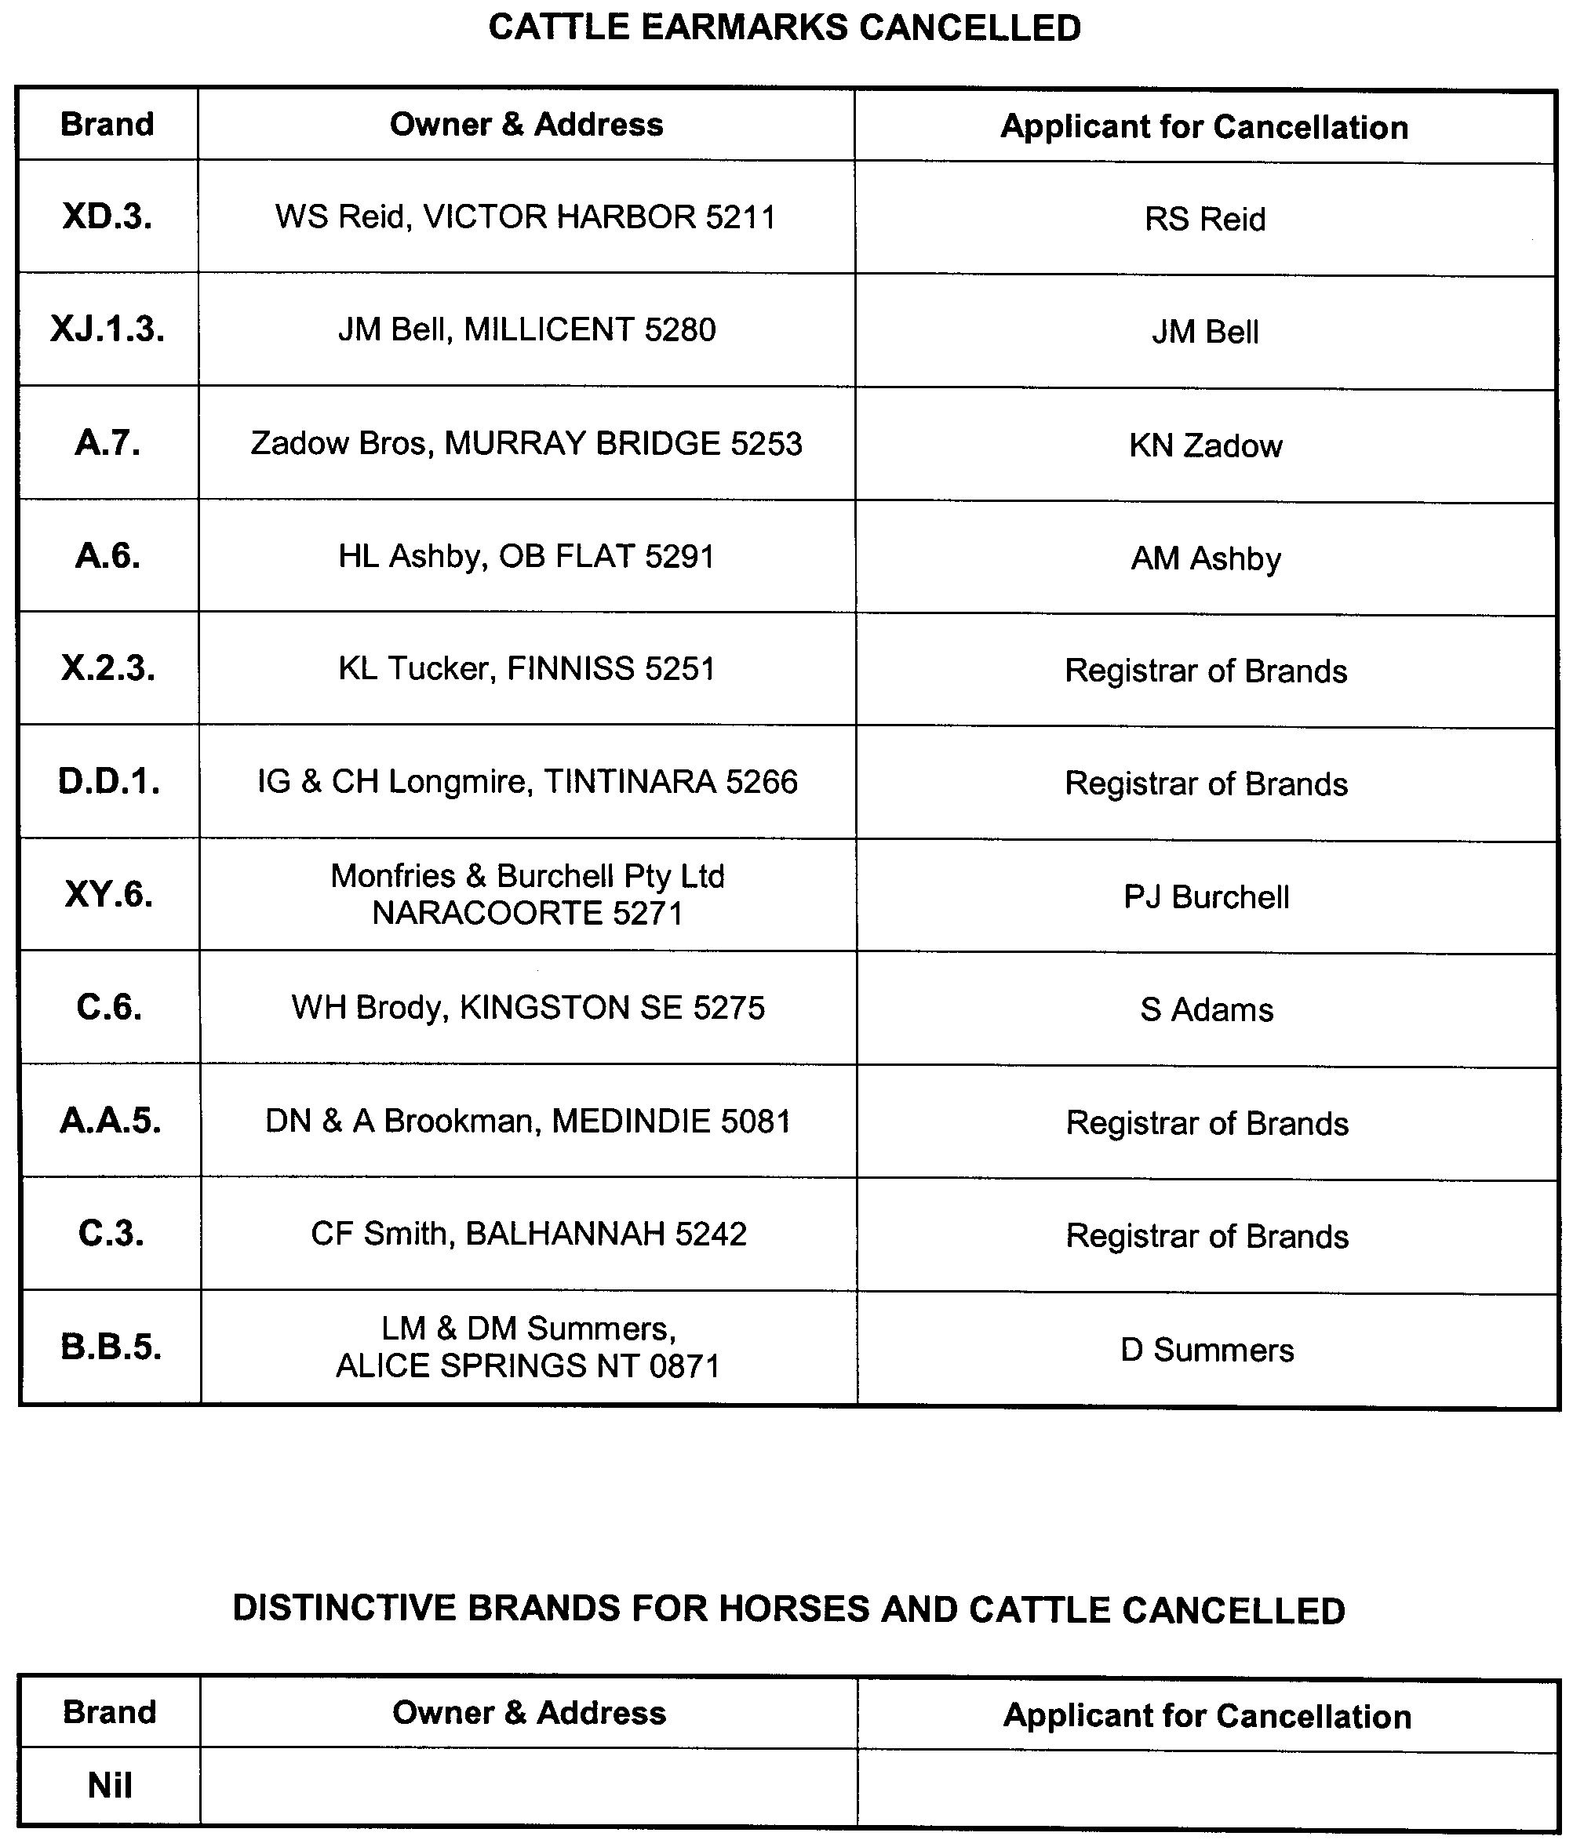
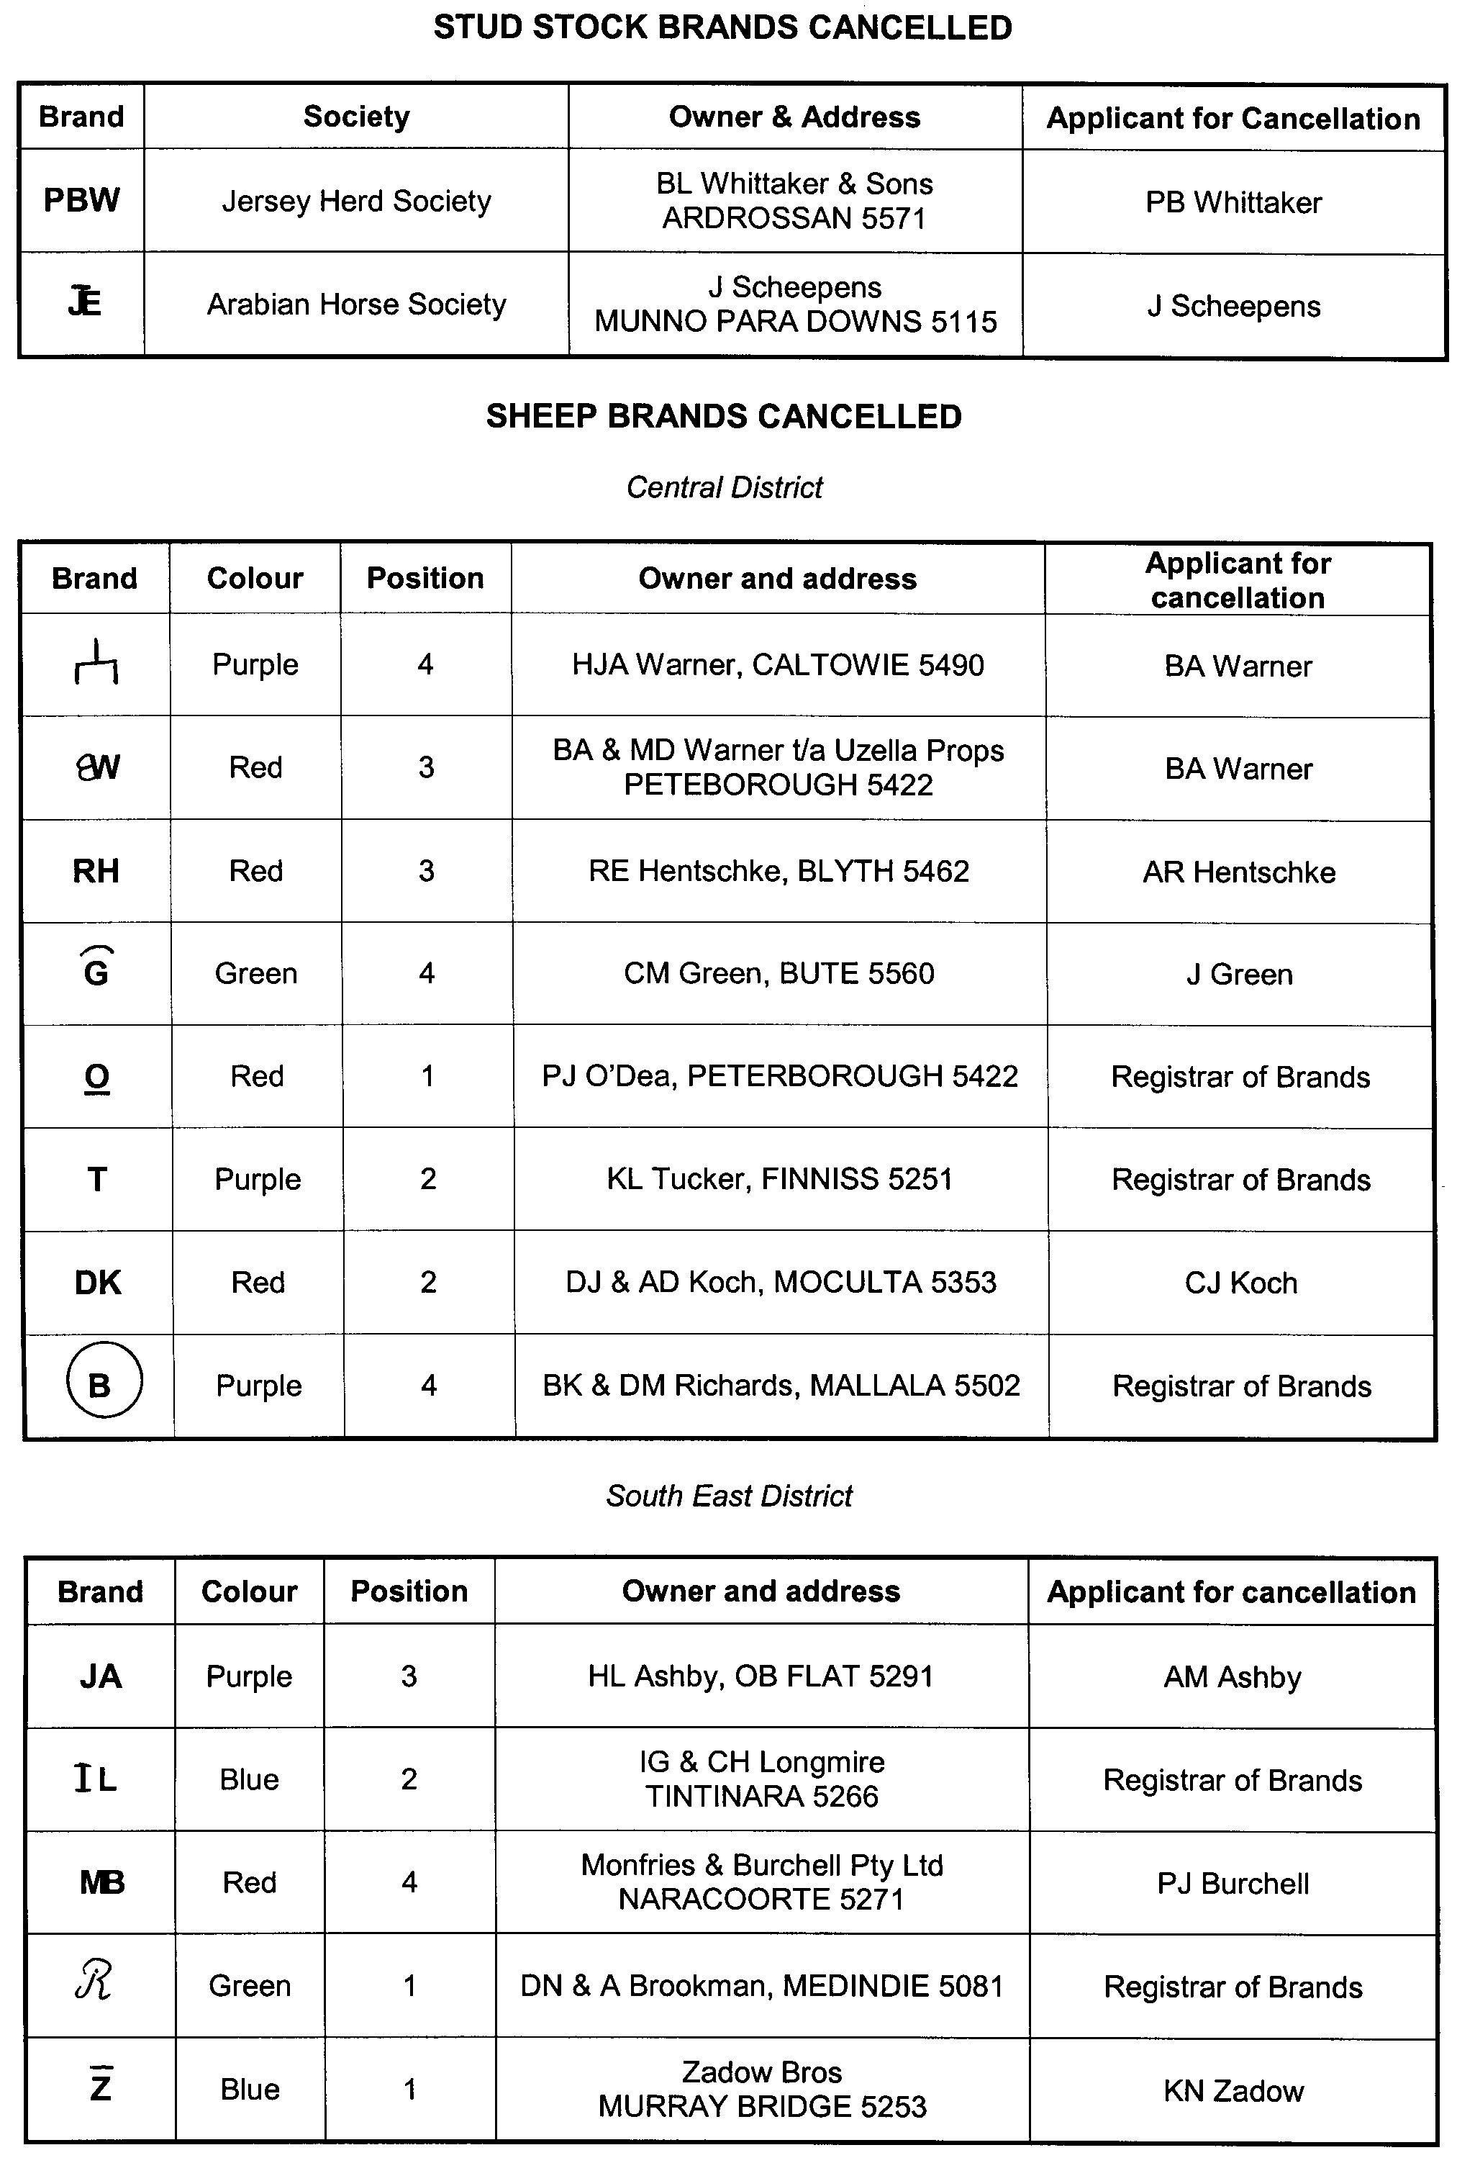
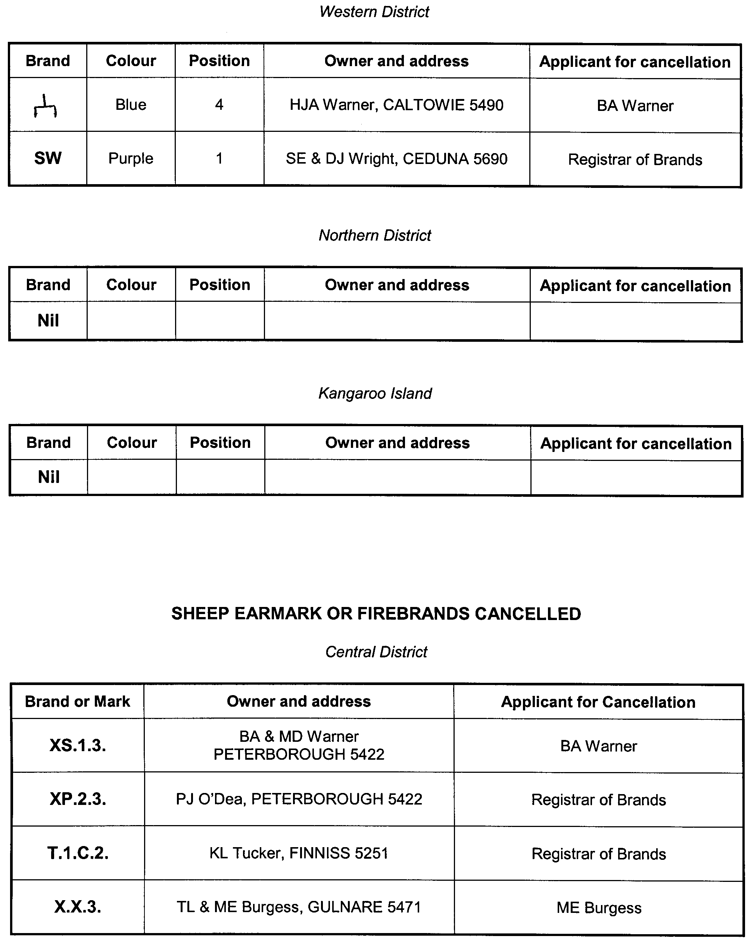
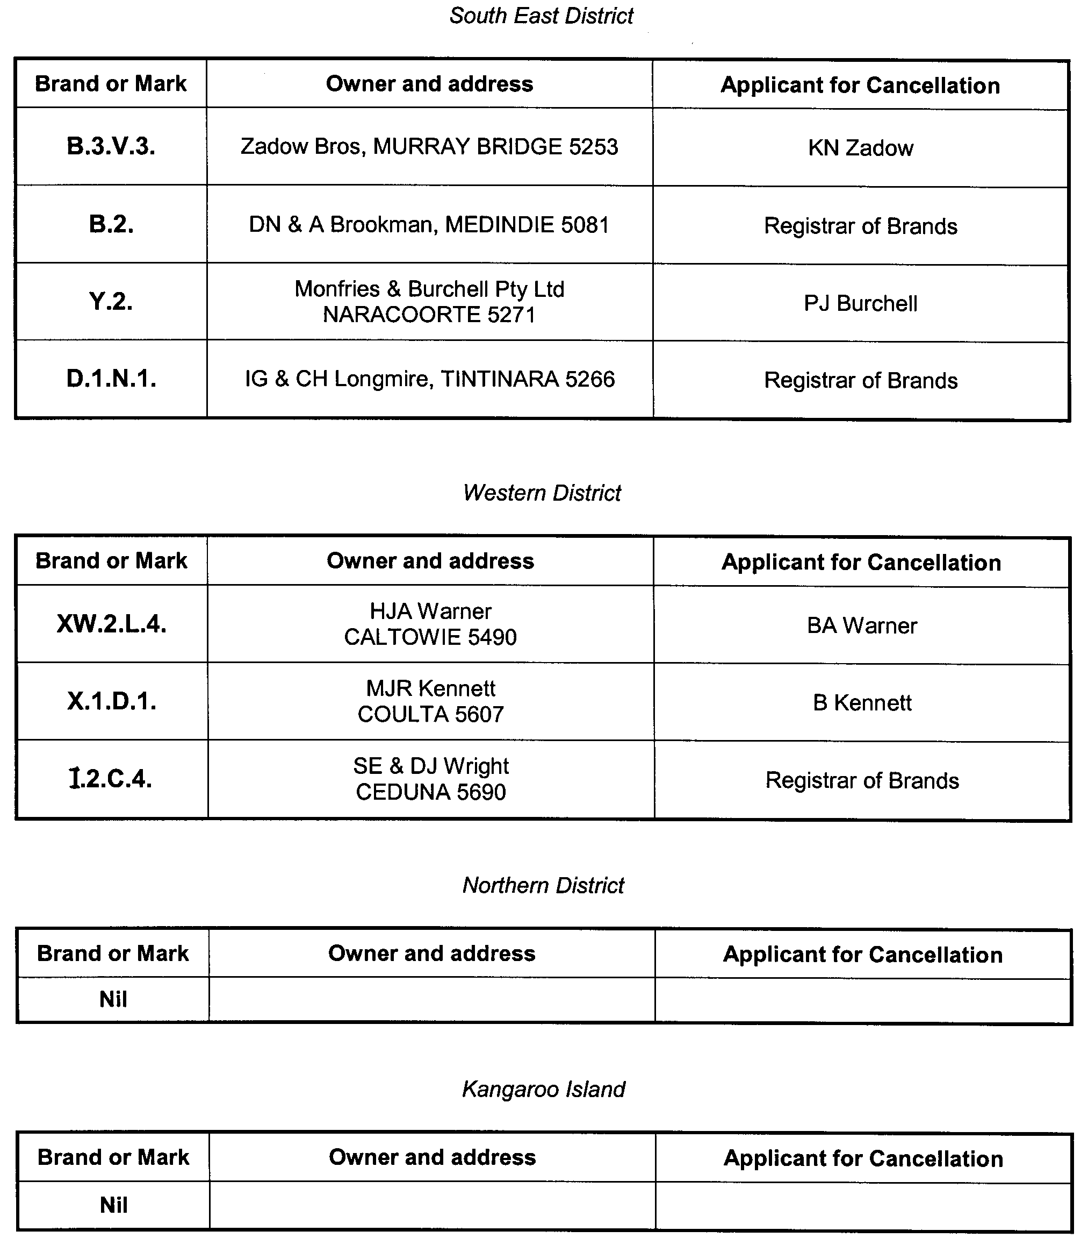

GOVERNMENT GAZETTE ADVERTISEMENT RATES

To apply from 1 July 2008

$  Agents, Ceasing to Act as 41.00  Associations:  Incorporation 20.80  Intention of Incorporation 51.50  Transfer of Properties 51.50  Attorney, Appointment of 41.00  Bailiff’s Sale 51.50  Cemetery Curator Appointed 30.50  Companies:  Alteration to Constitution 41.00  Capital, Increase or Decrease of 51.50  Ceasing to Carry on Business 30.50  Declaration of Dividend 30.50  Incorporation 41.00  Lost Share Certificates:  First Name 30.50  Each Subsequent Name 10.50  Meeting Final 34.25  Meeting Final Regarding Liquidator’s Report on  Conduct of Winding Up (equivalent to ‘Final  Meeting’)  First Name 41.00  Each Subsequent Name 10.50  Notices:  Call 51.50  Change of Name 20.80  Creditors 41.00  Creditors Compromise of Arrangement 41.00  Creditors (extraordinary resolution that ‘the Com-pany be wound up voluntarily and that a liquidator be appointed’) 51.50  Release of Liquidator⎯Application⎯Large Ad. 81.50  ⎯Release Granted 51.50  Receiver and Manager Appointed 47.50  Receiver and Manager Ceasing to Act 41.00  Restored Name 38.50  Petition to Supreme Court for Winding Up 71.50  Summons in Action 61.00  Order of Supreme Court for Winding Up Action 41.00  Register of Interests⎯Section 84 (1) Exempt 92.00  Removal of Office 20.80  Proof of Debts 41.00  Sales of Shares and Forfeiture 41.00  Estates:  Assigned 30.50  Deceased Persons⎯Notice to Creditors, etc. 51.50  Each Subsequent Name 10.50  Deceased Persons⎯Closed Estates 30.50  Each Subsequent Estate 1.35  Probate, Selling of 41.00  Public Trustee, each Estate 10.50 |  | $  Firms:  Ceasing to Carry on Business (each insertion) 27.25  Discontinuance Place of Business 27.25  Land⎯Real Property Act:  Intention to Sell, Notice of 51.50  Lost Certificate of Title Notices 51.50  Cancellation, Notice of (Strata Plan) 51.50  Mortgages:  Caveat Lodgement 20.80  Discharge of 21.80  Foreclosures 20.80  Transfer of 20.80  Sublet 10.50  Leases⎯Application for Transfer (2 insertions) each 10.50  Lost Treasury Receipts (3 insertions) each 30.50  Licensing 61.00  Municipal or District Councils:  Annual Financial Statement⎯Forms 1 and 2 574.00  Electricity Supply⎯Forms 19 and 20 408.00  Default in Payment of Rates:  First Name 81.50  Each Subsequent Name 10.50  Noxious Trade 30.50  Partnership, Dissolution of 30.50  Petitions (small) 20.80  Registered Building Societies (from Registrar-  General) 20.80  Register of Unclaimed Moneys⎯First Name 30.50  Each Subsequent Name 10.50  Registers of Members⎯Three pages and over:  Rate per page (in 8pt) 261.00  Rate per page (in 6pt) 345.00  Sale of Land by Public Auction 52.00  Advertisements 2.90  ¼ page advertisement 122.00  ½ page advertisement 244.00  Full page advertisement 478.00  Advertisements, other than those listed are charged at $2.90 per column line, tabular one-third extra.  Notices by Colleges, Universities, Corporations and District Councils to be charged at $2.90 per line.  Where the notice inserted varies significantly in length from that which is usually published a charge of $2.90 per column line will be applied in lieu of advertisement rates listed.  South Australian Government publications are sold on the condition that they will not be reproduced without prior permission from the Government Printer.
All the above prices include GST

GOVERNMENT GAZETTE NOTICES
ALL private advertisements forwarded for publication in the South Australian Government Gazette must be PAID FOR PRIOR TO INSERTION; and all notices, from whatever source, should be legibly written on one side of the paper only and sent to Government Publishing SA so as to be received no later than 4 p.m. Tuesday preceding the day of publication. Phone 8207 1045 or Fax 8207 1040. E-mail: governmentgazette@dpc.sa.gov.au. Send as attachments in Word format. Please include date the notice is to be published and to whom the notice will be charged. The Government Gazette is available online at: www.governmentgazette.sa.gov.au.

MISCELLANEOUS LEGISLATION AND GOVERNMENT PUBLICATIONS PRICES AS FROM 1 JULY 2008

Acts, Bills, Rules, Parliamentary Papers and Regulations
Pages | Main | Amends | Pages | Main | Amends

1-16 | 2.50 | 1.15 | 497-512 | 34.75 | 33.75
17-32 | 3.35 | 2.10 | 513-528 | 35.75 | 34.50
33-48 | 4.35 | 3.10 | 529-544 | 37.00 | 35.75
49-64 | 5.50 | 4.20 | 545-560 | 38.00 | 37.00
65-80 | 6.45 | 5.35 | 561-576 | 38.75 | 38.00
81-96 | 7.50 | 6.20 | 577-592 | 40.00 | 38.50
97-112 | 8.55 | 7.30 | 593-608 | 41.25 | 39.75
113-128 | 9.55 | 8.40 | 609-624 | 42.00 | 41.00
129-144 | 10.70 | 9.45 | 625-640 | 43.25 | 41.50
145-160 | 11.70 | 10.50 | 641-656 | 44.25 | 43.25
161-176 | 12.80 | 11.50 | 657-672 | 44.75 | 43.75
177-192 | 13.90 | 12.60 | 673-688 | 46.75 | 44.75
193-208 | 15.00 | 13.80 | 689-704 | 47.50 | 45.70
209-224 | 15.80 | 14.60 | 705-720 | 48.25 | 47.00
225-240 | 16.90 | 15.60 | 721-736 | 50.00 | 48.00
241-257 | 18.10 | 16.50 | 737-752 | 50.50 | 49.00
258-272 | 19.10 | 17.60 | 753-768 | 51.50 | 50.00
273-288 | 20.20 | 18.90 | 769-784 | 52.50 | 51.50
289-304 | 21.00 | 19.80 | 785-800 | 53.50 | 52.50
305-320 | 22.30 | 20.90 | 801-816 | 54.50 | 53.00
321-336 | 23.20 | 21.90 | 817-832 | 55.50 | 54.50
337-352 | 24.40 | 23.10 | 833-848 | 56.50 | 55.50
353-368 | 25.25 | 24.20 | 849-864 | 57.50 | 56.00
369-384 | 26.50 | 25.25 | 865-880 | 59.00 | 57.50
385-400 | 27.50 | 26.25 | 881-896 | 59.50 | 58.00
401-416 | 28.50 | 27.00 | 897-912 | 61.00 | 59.50
417-432 | 29.75 | 28.25 | 913-928 | 61.50 | 61.00
433-448 | 30.75 | 29.50 | 929-944 | 62.50 | 61.50
449-464 | 31.50 | 30.25 | 945-960 | 63.50 | 62.00
465-480 | 32.00 | 31.25 | 961-976 | 65.50 | 63.00
481-496 | 33.75 | 32.00 | 977-992 | 66.50 | 63.50

Legislation—Acts, Regulations, etc: $
Subscriptions:
Acts 214.00
All Bills as Laid 514.00
Rules and Regulations 514.00
Parliamentary Papers 514.00
Bound Acts 238.00
Index 119.00
Government Gazette
Copy 5.60
Subscription 284.00
Hansard
Copy 15.60
Subscription—per session (issued weekly) 446.00
Cloth bound—per volume 191.00
Subscription—per session (issued daily) 446.00
Legislation on Disk
Whole Database 3 304.00
Annual Subscription for fortnightly updates 1 015.00
Individual Act(s) including updates POA
Compendium
Subscriptions:
Subscriptions 1 957.00
Updates 690.00
(All the above prices include GST)

All Legislation, Government Gazette, Hansard and Legislation on disk are available from:
Counter Sales Government Legislation⁺ Outlet
and Mail Orders: Service SA Customer Service Centre,
Ground Floor—EDS Centre, 108 North Terrace, Adelaide, S.A. 5000
Phone: 13 23 24 (local call cost), Fax: (08) 8204 1909
Postal: G.P.O. Box 1707, Adelaide, S.A. 5001

Online Shop: www.shop.service.sa.gov.au

Subscriptions and Government Publishing SA
Standing Orders: Box 9, Plaza Level, Riverside Centre, North Terrace, Adelaide, S.A. 5000
Phone: (08) 8207 1043, (08) 8207 0910, Fax: (08) 8207 1040

CONTROLLED SUBSTANCES ACT 1984
Prohibition of Administering Prescription Drugs
TAKE notice that on 18 November 2008, I, Keith Evans, Executive Director of Drug and Alcohol Services South Australia, having formed the opinion that Dr The Hao Nguyen has prescribed prescription drugs in an irresponsible manner, exercised the authority delegated by the Minister for Mental Health and Substance Abuse under section 62A of the Controlled Substances Act 1984 and made the following order under section 57 (1) (c) of the Act:
Dr The Hao Nguyen, 441 Torrens Road, Woodville Park, South Australia,
is prohibited from prescribing, supplying or administering any preparation that contains the drug pseudoephedrine.
This order does not apply to an preparation that contains pseudoephedrine that has been legally supplied or prescribed for treatment of Dr The Hao Nguyen by a dentist or medical practitioner or by a veterinary surgeon for administration to an animal in his care.
K. Evans, Delegate for the Minister, Mental Health and Substance Abuse

CROWN LANDS ACT 1929: SECTION 5
TAKE NOTICE that pursuant to the Crown Lands Act 1929, I, JAY WEATHERILL, Minister for Environment and Conservation, Minister of the Crown to whom the administration of the Crown Lands Act 1929 is committed DO HEREBY vary the notice as described in The Schedule by declaring that the Reserve for Telecommunication Purposes as defined in The Schedule shall cease to be under the care, control and management of Telstra Corporation Limited and by further declaring that the said Reserve for Telecommunication Purposes shall be under the care, control and management of the Minister for Transport.
The Schedule
Reserve for Telecommunication Purposes, Allotment 10 in Deposited Plan 40104, Hundred of Dudley, County of Carnarvon, the notice of which was published in the Government Gazette of 29 February 1996 at page 1322, being the whole of the land comprised in Crown Record Volume 5382, Folio 468.
Dated 27 November 2008.
Jay Weatherill, Minister for Environment and Conservation
DL 3673/1993

CROWN LANDS ACT 1929: SECTION 5
TAKE NOTICE that pursuant to the Crown Lands Act 1929, I, JAY WEATHERILL, Minister for Environment and Conservation, Minister of the Crown to whom the administration of the Crown Lands Act 1929 is committed DO HEREBY resume the land defined in The Schedule.
The Schedule
Portion of Reserve for Government Employee Housing, Allotment 169, Town of Coober Pedy, Out of Hundreds (Coober Pedy), the notice of which, together with other land was published in the Government Gazette of 26 January 1989 at page 223, being the whole of the land comprised in Crown Record Volume 5990, Folio 303.
Dated 27 November 2008.
Jay Weatherill, Minister for Environment and Conservation
DEH 14/0346

DEVELOPMENT ACT 1993, SECTION 25 (17): CITY OF HOLDFAST BAY—BUCKLE STREET, GLENELG NORTH AND SURROUNDS DEVELOPMENT PLAN AMENDMENT
Preamble
1. The Development Plan amendment entitled ‘City of Holdfast Bay—Buckle Street, Glenelg North and Surrounds Development Plan Amendment’ (the Plan Amendment) has been finalised in accordance with the provisions of the Development Act 1993.
2. The Minister for Urban Development and Planning has decided to approve the Plan Amendment.
Notice
PURSUANT to section 25 of the Development Act 1993, I—
(a) approve the Plan Amendment; and
(b) fix the day on which this notice is published in the Gazette as the day on which the Plan Amendment will come into operation.
Dated 27 November 2008.
Paul Holloway, Minister for Urban Development and Planning

DEVELOPMENT ACT 1993, SECTION 28 (1): DECLARA-TION OF INTERIM OPERATION OF CITY OF UNLEY—VILLAGE LIVING & DESIRABLE NEIGHBOURHOOD DEVELOPMENT PLAN AMENDMENT STAGE 1 (RESI-DENTIAL HISTORIC CONSERVATION & STREET-SCAPE CHARACTER AREAS PILOT) DEVELOPMENT PLAN AMENDMENT
Notice
PURSUANT to section 28 (1) of the Development Act 1993, I, Paul Holloway, Minister for Urban Development and Planning, am of the opinion that it is necessary in the interest of the orderly and proper development of the area affected by the ‘City of Unley—Village Living & Desirable Neighbourhood Development Plan Amendment Stage 1 (Residential Historic Conservation & Streetscape Character Areas Pilot) Development Plan Amend-ment’ that the Plan Amendment should come into operation without delay on an interim basis on 27 November 2008.
Paul Holloway, Minister for Urban Development and Planning

DEVELOPMENT ACT 1993
Notice under Schedule 4, Part 1, Section 1—Building Works, Subclause (2) Development Regulations 2008
Preamble
1. The Unley (City) Development Plan designates areas of Unley as being within the Streetscape (Built Form) Zone.
2. The Minister for Urban Development and Planning has decided to declare the demolition of a building within the above zone as a merit form of development.
Notice
PURSUANT to Schedule 4, Part 1, Clause 1 (2) of the Develop-ment Regulations 2008, I—
(a) declare that all applications for demolition within the Streetscape (Built Form) Zone of the Unley (City) Development Plan are merit forms of development; and
(b) fix the day on which this notice is published in the Gazette as the day on which this notice will come into operation.
Dated 25 November 2008.
Paul Holloway, Minister for Urban Development and Planning

ELECTRICITY ACT 1996

Notice under the Electricity Act 1996 by Aurora Energy Pty Ltd (ABN 85 082 464 622) of Default Contract Prices for Aurora PAY AS YOU GO Customers

IN accordance with section 36AB of the Electricity Act 1996 (SA), Aurora Energy Pty Ltd (ABN 85 082 464 622) (‘Aurora Energy’) hereby publishes its default electricity contract prices for customers who are consuming less than 160 MWh per annum of electricity (‘small customers’). The default contract prices are set out below in this notice and will apply on and from 1 January 2009. These price changes will also be reflected on the Aurora PAYG website http://www.apayg.com.au.
The prices detailed in this notice apply for small customers only of Aurora Energy who are purchasing electricity under Aurora PAY AS YOU GO Default Contract Terms and Conditions published in the Government Gazette on 1 December 2005.
Aurora Energy reserves the right to change its default electricity contract price from time to time acting in accordance with all applicable regulations.
Justification Statement
The default contract prices set out in this notice reflect an increase in the cost of sourcing electricity, increasing distribution costs and CPI that have been absorbed by Aurora Energy since 1 December 2005, when these prices were last changed.

Domestic Light/Power | Prices (GST inclusive)

From 1 January to 31 March
For all consumption (c/kWh) | 31.25
Supply charge (c/day) | 55.00

From 1 April to 31 December
For all consumption (c/kWh) | 25.00
Supply charge (c/day) | 55.00
Controlled Load – Off Peak | Prices (GST inclusive)

From 1 January to 31 March
For all consumption (c/kWh) | 11.25
Supply charge (c/day) | 12.00

From 1 April to 31 December
For all consumption (c/kWh) | 10.63
Supply charge (c/day) | 12.00

Explanatory Notes:
1. ‘Control Load—Off Peak’ tariffs are for electricity used in permanently installed storage water heaters with a rated delivery of not less than 125 litres, storage space heaters and other approved thermal storage applications. The hours of application are fixed from time to time with control by time switch or other means.
2. Peak period is 0700 hours to 2100 hours from Monday to Friday (Central Standard Time). Off Peak period is all times other than peak period.

ENVIRONMENT PROTECTION ACT 1993
Approval of Additional Collection Depots
I, ANDREA KAYE WOODS, Team Leader, Container Deposit Legislation and Delegate of the Environment Protection Authority (‘the Authority’), pursuant to section 69 of the Environment Protection Act 1993 (SA) (‘the Act’) hereby:
Approval of Additional Collection Depots
1. Approval of Collection Depots:
Approve the collection depot identified by reference to the following matters, to receive all containers belonging to a class of containers which is, at or subsequent to, the date of this Notice, approved as Category B Containers:
(a) the name of the collection depot described in Column 1 of Schedule 1 of this Notice;
(b) the name of the proprietor of the depot identified in Column 3 of Schedule 1 of this Notice; and
(c) the location of the depot described in Columns 4-6 of Schedule 1 of this Notice.
2. Conditions of Approval:
Impose the following conditions of these approvals:
(a) The person in charge of a collection depot shall ensure the depot premises complies with Council planning regulations and shall be kept in an orderly condition.
(b) The person in charge of a collection depot who wishes to transfer the operation of a depot to another person or intends to change the location of a depot shall notify the Authority in writing within one month of the change occurring.
(c) The person in charge of a collection depot who wishes to cease operation of that depot shall give notice in writing to the Authority.
(d) The person in charge of a collection depot shall take such measures as are necessary in the operation and maintenance of the depot to prevent or control:
(i) a nuisance or offensive condition;
(ii) a risk to health or safety; and
(iii) damage to the environment.
(e) The person in charge of a collection depot is reminded of the general environmental duty, as required by section 25 of the Environment Protection Act, to take all reasonable and practical measures to ensure that the activities on the whole site, do not pollute the environment in a way which causes or may cause environmental harm.
Schedule 1

Column 1 | Column 2 | Column 3 | Column 4 | Column 5 | Column 6
Depot Name | Company/Trading Name | Proprietors | Depot Location  Street | Depot Location  Suburb | Certificate of Title No.  Volume No.
Parnham Feeding Services | Parham Feeding Services | Michael Parham | Birdwood Road | Gumeracha | 5157/526
YP Recycling Ardrossan | YP Recycling | Neil Drogemuller,  Sue Drogemuller | 28 Coast Road | Ardrossan | n/a
YP Recycling Maitland | YP Recycling | Neil Drogemuller,  Sue Drogemuller | 4 Bagnall Street | Maitland | n/a

ENVIRONMENT PROTECTION ACT 1993
Revocation of Approval of Category B Containers
I, ANDREA KAYE WOODS, Team Leader, Container Deposit Legislation and Delegate of the Environment Protection Authority (‘the Authority’), pursuant to section 68 of the Environment Protection Act 1993 (SA) (‘the Act’) hereby revoke the approvals of the classes of Category B containers sold in South Australia as identified by reference to the following matters, which are described in the first 4 columns of Schedule 1 of this Notice:
(a) the product which each class of containers shall contain;
(b) the size of the containers;
(c) the type of containers; and
(d) the name of the holders of these approvals.
These approvals are revoked as the Authority is satisfied that the waste management arrangement between the approval holder and the party named in Column 5 of Schedule 1 of this Notice has been cancelled.
Schedule 1

Column 1 |  | Column 2 |  | Column 3 |  | Column 4 |  | Column 5
Product Name |  | Container  Size (mL) |  | Container Type |  | Approval Holder |  | Collection  Arrangements
Geelong Bitter | 375 |  | Glass |  | Adam Street Tavern Pty Ltd |  | Statewide Recycling
Geelong Bitter | 375 |  | Can—Aluminium |  | Adam Street Tavern Pty Ltd |  | Statewide Recycling
Geelong Brewing Sparkling Ale | 330 |  | Glass |  | Adam Street Tavern Pty Ltd |  | Statewide Recycling
Geelong Draught | 330 |  | Glass |  | Adam Street Tavern Pty Ltd |  | Statewide Recycling
Geelong Draught | 375 |  | Glass |  | Adam Street Tavern Pty Ltd |  | Statewide Recycling
Geelong Draught | 375 |  | Can—Aluminium |  | Adam Street Tavern Pty Ltd |  | Statewide Recycling
Geelong Draught Beer | 330 |  | Glass |  | Adam Street Tavern Pty Ltd |  | Statewide Recycling
Geelong Lager | 375 |  | Glass |  | Adam Street Tavern Pty Ltd |  | Statewide Recycling
Geelong Lager | 375 |  | Can—Aluminium |  | Adam Street Tavern Pty Ltd |  | Statewide Recycling
Geelong Midstrength | 330 |  | Glass |  | Adam Street Tavern Pty Ltd |  | Statewide Recycling
Geelong Original Light Ale | 330 |  | Glass |  | Adam Street Tavern Pty Ltd |  | Statewide Recycling
Geelong Original Pale Ale | 330 |  | Glass |  | Adam Street Tavern Pty Ltd |  | Statewide Recycling
Geelong Original Pale Ale Light | 375 |  | Glass |  | Adam Street Tavern Pty Ltd |  | Statewide Recycling
Geelong Original Pale Ale Light | 375 |  | Can—Aluminium |  | Adam Street Tavern Pty Ltd |  | Statewide Recycling
Geelong Premium Beer | 330 |  | Glass |  | Adam Street Tavern Pty Ltd |  | Statewide Recycling
Geelong Premium Light | 375 |  | Glass |  | Adam Street Tavern Pty Ltd |  | Statewide Recycling
Geelong Premium Light | 375 |  | Can—Aluminium |  | Adam Street Tavern Pty Ltd |  | Statewide Recycling
Geelong Premium Light Beer | 330 |  | Glass |  | Adam Street Tavern Pty Ltd |  | Statewide Recycling
Geelong Soda Water | 330 |  | Glass |  | Adam Street Tavern Pty Ltd |  | Statewide Recycling
Schonbrauhaus Premium Lager | 330 |  | Glass |  | Adam Street Tavern Pty Ltd |  | Statewide Recycling
Southern Bay Brewing Co Bearings Ale | 330 |  | Glass |  | Adam Street Tavern Pty Ltd |  | Statewide Recycling
Southern Bay Brewing Co Bearings Draught | 330 |  | Glass |  | Adam Street Tavern Pty Ltd |  | Statewide Recycling
Southern Bay Brewing Co Bearings Light | 330 |  | Glass |  | Adam Street Tavern Pty Ltd |  | Statewide Recycling
Southern Bay Brewing Co Platinum Premium Lager | 330 |  | Glass |  | Adam Street Tavern Pty Ltd |  | Statewide Recycling
Dandelion & Burdock | 310 |  | Glass |  | AllNew Corporation trading as Thistle Imports |  | Statewide Recycling
Irn Bru | 310 |  | Glass |  | AllNew Corporation trading as Thistle Imports |  | Statewide Recycling
Tizer | 310 |  | Glass |  | AllNew Corporation trading as Thistle Imports |  | Statewide Recycling
XS Energy Citrus Blast Drink | 250 |  | Can—Aluminium |  | Amway of Australia & New Zealand |  | Visy Recycling CDL Services
XS Energy Drink Tropical Blast | 250 |  | Can—Aluminium |  | Amway of Australia & New Zealand |  | Visy Recycling CDL Services
XS Energy Grape Berry Drink | 250 |  | Can—Aluminium |  | Amway of Australia & New Zealand |  | Visy Recycling CDL Services
Regia Beer | 946 |  | Glass |  | Ausal Import Export Pty Ltd |  | Statewide Recycling
Suprema Beer | 355 |  | Glass |  | Ausal Import Export Pty Ltd |  | Statewide Recycling
V8 100% Vegetable Juice | 665 |  | Can—Steel |  | Campbells Soups Australia |  | Statewide Recycling
V8 V Plenish Apple & Berry | 250 |  | Glass |  | Campbells Soups Australia |  | Statewide Recycling
V8 V Plenish Apple & Berry Juice | 250 |  | LPB—Aseptic |  | Campbells Soups Australia |  | Statewide Recycling
Revive Pure Australian Spring Water | 600 |  | PET |  | Cellbrand Pty Ltd |  | Statewide Recycling
Revive Pure Australian Spring Water | 1 500 |  | PET |  | Cellbrand Pty Ltd |  | Statewide Recycling
Black & Gold Cola Flavoured Soft Drink | 350 |  | PET |  | Chandru International Pty Ltd |  | Visy Recycling CDL Services
Black & Gold Lemonade Flavoured Soft Drink | 350 |  | PET |  | Chandru International Pty Ltd |  | Visy Recycling CDL Services
Black & Gold Lime Flavoured Soft Drink | 350 |  | PET |  | Chandru International Pty Ltd |  | Visy Recycling CDL Services
Black & Gold Orange Flavoured Soft Drink | 350 |  | PET |  | Chandru International Pty Ltd |  | Visy Recycling CDL Services
Black & Gold Pineapple Flavoured Soft Drink | 350 |  | PET |  | Chandru International Pty Ltd |  | Visy Recycling CDL Services
Black & Gold Raspberry Flavoured Soft Drink | 350 |  | PET |  | Chandru International Pty Ltd |  | Visy Recycling CDL Services
Absolute Organic Apple Clear Juice | 1 000 |  | Glass |  | Eco Farms Pty Ltd |  | Statewide Recycling
Absolute Organic Cloudy Apple Juice | 1 000 |  | Glass |  | Eco Farms Pty Ltd |  | Statewide Recycling
Absolute Organic Orange Juice | 1 000 |  | Glass |  | Eco Farms Pty Ltd |  | Statewide Recycling
Eco Organics Clear Apple Juice | 250 |  | Glass |  | Eco Farms Pty Ltd |  | Statewide Recycling
Eco Organics Cloudy Apple Juice | 250 |  | Glass |  | Eco Farms Pty Ltd |  | Statewide Recycling
Eco Organics Orange Juice | 250 |  | Glass |  | Eco Farms Pty Ltd |  | Statewide Recycling
Eco Organics Still Spring Water | 1 000 |  | PET |  | Eco Farms Pty Ltd |  | Statewide Recycling
Eco Organics Still Spring Water | 600 |  | PET |  | Eco Farms Pty Ltd |  | Statewide Recycling
Fonte S Luigi Acqua Minerale Naturale | 1 000 |  | Glass |  | Gleneagles Quality Food Distributors |  | Statewide Recycling
Fonte S Luigi Acqua Minerale Naturale | 500 |  | Glass |  | Gleneagles Quality Food Distributors |  | Statewide Recycling
Fonte S Luigi Acqua Minerale Naturale Frizzante | 500 |  | Glass |  | Gleneagles Quality Food Distributors |  | Statewide Recycling
Fonte S Luigi Acqua Minerale Naturale Frizzante | 1 000 |  | Glass |  | Gleneagles Quality Food Distributors |  | Statewide Recycling
Fonte S Luigi Natural Mineral Water | 500 |  | PET |  | Gleneagles Quality Food Distributors |  | Statewide Recycling
Fonte S Luigi Natural Mineral Water | 1 500 |  | PET |  | Gleneagles Quality Food Distributors |  | Statewide Recycling
Fonte S Luigi Natural Mineral Water Sparkling | 500 |  | PET |  | Gleneagles Quality Food Distributors |  | Statewide Recycling
Fonte S Luigi Natural Mineral Water Sparkling | 1 500 |  | PET |  | Gleneagles Quality Food Distributors |  | Statewide Recycling
Grand Ridge Black & Tan | 350 |  | Glass |  | Grand Ridge Brewing Company |  | Statewide Recycling
Grand Ridge Brewers Pilsener | 350 |  | Glass |  | Grand Ridge Brewing Company |  | Statewide Recycling
Grand Ridge Gippsland Gold | 350 |  | Glass |  | Grand Ridge Brewing Company |  | Statewide Recycling
Grand Ridge Hatlifter Stout | 350 |  | Glass |  | Grand Ridge Brewing Company |  | Statewide Recycling
Grand Ridge Moonlight Dark Scotch Ale | 350 |  | Glass |  | Grand Ridge Brewing Company |  | Statewide Recycling
Grand Ridge Moonshine Mild Strength Ale | 350 |  | Glass |  | Grand Ridge Brewing Company |  | Statewide Recycling
Grand Ridge Natural Blonde Wheat Beer | 350 |  | Glass |  | Grand Ridge Brewing Company |  | Statewide Recycling
Grand Ridge Supershine Extra Strong Ale | 350 |  | Glass |  | Grand Ridge Brewing Company |  | Statewide Recycling
Grand Ridge White Light | 350 |  | Glass |  | Grand Ridge Brewing Company |  | Statewide Recycling
Grand Ridge Yarra Valley Gold | 350 |  | Glass |  | Grand Ridge Brewing Company |  | Statewide Recycling
Supershine | 330 |  | Glass |  | Grand Ridge Brewing Company |  | Statewide Recycling
Buskers | 350 |  | PET |  | ISMVDS |  | Statewide Recycling
Go Acqua | 600 |  | PET |  | ISMVDS |  | Statewide Recycling
The Oyster Bar Natural Spring Water | 350 |  | PET |  | ISMVDS |  | Statewide Recycling
Beamish Irish Ale | 440 |  | Can |  | J Boag & Son Brewing Ltd |  | Visy Recycling CDL Services
Beamish Irish Stout | 440 |  | Can |  | J Boag & Son Brewing Ltd |  | Visy Recycling CDL Services
Boags Honey Porter | 375 |  | Glass |  | J Boag & Son Brewing Ltd |  | Visy Recycling CDL Services
Boags Wizard Smiths Ale | 375 |  | Glass |  | J Boag & Son Brewing Ltd |  | Visy Recycling CDL Services
Carlsberg Elephant | 330 |  | Glass |  | J Boag & Son Brewing Ltd |  | Visy Recycling CDL Services
Carlsberg Lager | 330 |  | Glass |  | J Boag & Son Brewing Ltd |  | Visy Recycling CDL Services
Classic Bitter | 500 |  | Can |  | J Boag & Son Brewing Ltd |  | Visy Recycling CDL Services
Classic Bitter | 375 |  | Glass |  | J Boag & Son Brewing Ltd |  | Visy Recycling CDL Services
J Boags Original Bitter | 375 |  | Glass |  | J Boag & Son Brewing Ltd |  | Visy Recycling CDL Services
McEwans Export | 330 |  | Glass |  | J Boag & Son Brewing Ltd |  | Visy Recycling CDL Services
McEwans Scotch Ale | 330 |  | Glass |  | J Boag & Son Brewing Ltd |  | Visy Recycling CDL Services
Newcastle Brown Ale | 550 |  | Glass |  | J Boag & Son Brewing Ltd |  | Visy Recycling CDL Services
Newcastle Brown Ale | 330 |  | Glass |  | J Boag & Son Brewing Ltd |  | Visy Recycling CDL Services
Samuel Adams Boston Lager | 355 |  | Glass |  | J Boag & Son Brewing Ltd |  | Visy Recycling CDL Services
StrongArm Bitter | 375 |  | Glass |  | J Boag & Son Brewing Ltd |  | Visy Recycling CDL Services
B 52 Energy Drink | 250 |  | Can—Aluminium |  | JMJ Distribution Aust. Pty Ltd |  | Statewide Recycling
Curlwaa Orange Juice | 500 |  | HDPE |  | Jandoway Pty Ltd trading as Curlwaa Fresh |  | Statewide Recycling
Curlwaa Orange Juice | 250 |  | HDPE |  | Jandoway Pty Ltd trading as Curlwaa Fresh |  | Statewide Recycling
Zywiec Beer | 500 |  | Glass |  | Leco Pty Ltd |  | Statewide Recycling
BA Beer Full Strength | 330 |  | Glass |  | Liquor Traders Australia Pty Ltd |  | Statewide Recycling
BA Beer Light Beer | 330 |  | Glass |  | Liquor Traders Australia Pty Ltd |  | Statewide Recycling
BA Beer Mid Strength | 330 |  | Glass |  | Liquor Traders Australia Pty Ltd |  | Statewide Recycling
Becks Bier | 330 |  | Glass |  | McWilliams Wines Pty Ltd |  | Statewide Recycling
Fiji Natural Spring Water | 1 000 |  | PET |  | McWilliams Wines Pty Ltd |  | Statewide Recycling
Fiji Natural Spring Water | 500 |  | PET |  | McWilliams Wines Pty Ltd |  | Statewide Recycling
Mirage Orange Juice | 300 |  | HDPE |  | Mirage Beverages |  | Statewide Recycling
Mirage Orange Juice | 500 |  | HDPE |  | Mirage Beverages |  | Statewide Recycling
Life Force | 1 500 |  | Plastic |  | Rainfarms Australia Pty Ltd |  | Statewide Recycling
Life Force | 350 |  | Plastic |  | Rainfarms Australia Pty Ltd |  | Statewide Recycling
Life Force | 600 |  | Plastic |  | Rainfarms Australia Pty Ltd |  | Statewide Recycling
Supre Natural Spring Water | 350 |  | PET |  | Supre |  | Statewide Recycling
Niksicko Pivo | 330 |  | Glass |  | Swisslion |  | Statewide Recycling
Chi Herbal Mineral Water Drink | 1 250 |  | PET |  | Sydneywide Beverage |  | Statewide Recycling
Tuborg Gold Label De Luxe Beer | 500 |  | Can—Aluminium |  | The Tetleys Company Pty Ltd |  | Visy Recycling CDL Services
Bluetongue Alcoholic Ginger Beer | 330 |  | Glass |  | Tyrrells Vineyards Pty Ltd |  | Statewide Recycling
Bluetongue Premium Lager | 330 |  | Glass |  | Tyrrells Vineyards Pty Ltd |  | Statewide Recycling
Bluetongue Traditional Pilsener | 330 |  | Glass |  | Tyrrells Vineyards Pty Ltd |  | Statewide Recycling
Bohemia beer | 330 |  | Glass |  | World Wide Beers of Australia |  | Statewide Recycling
Lobkov | 330 |  | Glass |  | World Wide Beers of Australia |  | Statewide Recycling

ENVIRONMENT PROTECTION ACT 1993
Variation to Existing Approval of Collection Depot
I, ANDREA KAYE WOODS, Team Leader, Container Deposit Legislation and Delegate of the Environment Protection Authority (‘the Authority’), pursuant to section 69 of the Environment Protection Act 1993 (SA) (‘the Act’) hereby:
Variation to Existing Approval of Collection Depot
Vary the approval of the collection depot listed at Schedule 1 of this notice, that was granted under the Act prior to the date of this Notice and impose the conditions of this approval to be as follows:
(i) Approval of Collection Depot:
The collection depot identified by reference to the following matters is approved:
(a) the name of the collection depot described in Column 1 of Schedule 1 of this Notice;
(b) the company name and name of the proprietor of the depot identified in Columns 2-3 of Schedule 1 of this Notice; and
(c) the location of the depot described in Columns 4-5 of Schedule 1 of this Notice.
The collection depot listed at Schedule 1 of this Notice is approved in relation to all classes of containers, which were approved under the Act, at or subsequent to the date of this Notice, as Category B Containers.
(ii) Conditions of Approval:
Impose the following conditions on the approval:
(a) The person in charge of a collection depot shall ensure the depot premises complies with Council planning regulations and shall be kept in an orderly condition.
(b) The person in charge of a collection depot who wishes to transfer the operation of a depot to another person or intends to change the location of a depot shall notify the Authority in writing within one month of the change occurring.
(c) The person in charge of a collection depot who wishes to cease operation of that depot shall give notice in writing to the Authority.
(d) The person in charge of a collection depot shall take such measures as are necessary in the operation and maintenance of the depot to prevent or control:
(i) a nuisance or offensive condition;
(ii) a risk to health or safety; and
(iii) damage to the environment.
(e) The person in charge of a collection depot is reminded of the general environmental duty, as required by section 25 of the Environment Protection Act, to take all reasonable and practical measures to ensure that the activities on the whole site, do not pollute the environment in a way which causes or may cause environmental harm.
Schedule 1

Column 1 | Column 2 | Column 3 | Column 4 | Column 5 | Column 6
Depot Name | Company/Trading Name | Proprietors | Depot Location  Street | Depot Location  Suburb | Certificate of Title No.  Volume/Folio No.
Port Neill Receival Centre | Cleve, Arno Bay and Port Neill Recyclers | R. J. and R. M. Carrick | 19 Wallis Street | Port Neill | n/a

EDUCATION ACT 1972
Dissolution of School Council
TAKE notice that pursuant to section 85 (1) (e) of the Education Act, I, Jane Lomax-Smith, Minister for Education, Minister of the Crown to whom the administration of the Education Act 1972, is committed, do hereby dissolve the School Governing Council of Morphett Vale High School which has been permanently closed.
Dated 25 November 2008.
Jane Lomax-Smith, Minister for Education

EDUCATION ACT 1972
Dissolution of School Council
TAKE notice that pursuant to section 85 (1) (e) of the Education Act, I, Jane Lomax-Smith, Minister for Education, Minister of the Crown to whom the administration of the Education Act 1972, is committed, do hereby dissolve the School Governing Council of Sedan Primary School which has been permanently closed.
Dated 25 November 2008.
Jane Lomax-Smith, Minister for Education

FISHERIES MANAGEMENT ACT 2007: SECTION 115
TAKE notice that pursuant to section 115 of the Fisheries Management Act 2007, Tim O’Hara of the Museum Victoria, G.P.O. 666, Melbourne, Vic. 3001, (the ‘exemption holder’), or a person acting as his agent, is exempt from Clause 118 of Schedule 6 of the Fisheries Management (General) Regulations 2007, but only insofar as they may engage in the collection of marine invertebrates in the waters specified in Schedule 1 (the ‘exempted activity’), subject to the conditions set out in Schedule 2, from 20 November 2008 until 31 December 2008, unless this notice is varied or revoked earlier.
Schedule 1
South Australian coastal waters including intertidal ‘rocky’ reef areas, excluding aquatic reserves.
Schedule 2
1. The specimens collected by the exemption holder are for scientific and research purposes only and must not be sold. Any unwanted specimens must be returned to the water immediately.
2. Specimens may only be collected by hand and either by snorkelling or diving.
3. The exemption holder or a person acting as his agent must not collect any protected species pursuant to this exemption.
4. A maximum of 5 specimens from each species may be collected from any one site.
5. Any species collected that are not returned to the water must be lodged as voucher specimens with Museum Victoria.
6. The exemption holder must notify PIRSA Fishwatch on 1800 065 522 at least two hours prior to conducting the exempted activity and answer a series of questions about the exempted activity. The exemption holder will need to have a copy of the exemption at the time of making the call, and be able to provide information about the area and time of the exempted activity, the vehicles and boats involved, the number of agents undertaking the exempted activity and other related questions. Exemption No. 9902189.
7. The exempted activity may only be conducted on the exemption holder’s behalf by Dr Robin Wilson, Kate Naughton and Elizabeth Dare.
8. The exemption holder must provide a written report to the Director of Fisheries, (G.P.O. Box 1625, Adelaide, S.A. 5001) within 14 days of the completion of each collection made pursuant to this exemption, providing details of the numbers, location and time of the collection.
9. While engaged in the exempted activity, the exemption holder or an agent of the exemption holder must be in possession of a copy of this notice. Such notice must be produced to a PIRSA Fisheries Officer upon request.
10. A person undertaking the exempted activity must not contravene or fail to comply with the Fisheries Management Act 2007 or any regulations made under that Act, except where specifically exempted by this notice.
Dated 21 November 2008.
K. Crosthwaite, General Manager, Fisheries Policy and Programs

FISHERIES MANAGEMENT ACT 2007: SECTION 79
TAKE note that the notice made under section 79 of the Fisheries Management Act 2007, dated 29 October 2008, referring to the Spencer Gulf Prawn Fishery, is hereby varied such that it will be unlawful for a person fishing pursuant to a Spencer Gulf Prawn Fishery licence to use prawn trawl nets in the areas specified in Schedule 1 during the period specified in Schedule 2.
Schedule 1
The waters of the Spencer Gulf Prawn Fishery that are:
1. North of the following co-ordinates: 33°29.00′S, longitude 137°16.00′E, then to position latitude 33°29.00′S, longitude 137°34.00′E, then to position latitude 33°38.00′S, longitude 137°34.00′E, then to position latitude 33°46.00′S, longitude 137°44.00′E.
2. South of the following co-ordinates: 33°41.00′S, longitude 137°06.00′E, then to position latitude 33°52.00′S, longitude 137°15.00′E, then to position latitude 33°55.00′S, longitude 137°09.00′E, then to position latitude 33°59.00′S, longitude 137°12.00′E, then to position latitude 34°05.00′S, longitude 137°04.00′E, then to position latitude 34°05.00′S, longitude 137°35.00′E.
Schedule 2
From 2030 hours on 24 November 2008 to 0600 hours on 3 December 2008.
Dated 24 November 2008.
S. Sloan, Program Leader, Fisheries Management

FISHERIES MANAGEMENT ACT 2007: SECTION 79
TAKE note that the notice made under section 79 of the Fisheries Management Act 2007, published in the South Australian Government Gazette, dated 4 March 2008, referring to the West Coast Prawn Fishery, is hereby varied such that it will not be unlawful for a person fishing pursuant to a West Coast Prawn Fishery licence to use prawn trawl nets in the waters specified in Schedule 1, under the conditions specified in Schedule 2, during the period specified in Schedule 3.
Schedule 1
1. The waters of the West Coast Prawn Fishery adjacent to Ceduna.
Schedule 2
1. Each licence holder must ensure that a representative sample of the catch (a ‘bucket count’) is taken for each trawl shot carried out during the fishing activity.
2. Each ‘bucket count’ sample must be accurately weighed to 7 kg where possible and the total number of prawns contained in the bucket must be recorded on the attached data sheet, marked ‘West Coast Prawn Fishery Bucket Count Data Sheet’.
3. The information recorded on the ‘WCPF Bucket Count Data Sheet’ must be returned to SARDI Aquatic Sciences within 15 days of the fishing activity being completed.
4. Fishing must cease if one or both of the following limits are reached:
(a) the average catch per vessel, per night (for all three vessels) drops below 300 kg for two consecutive nights;
(b) the average prawn ‘bucket count’ for all three vessels exceeds 250 prawns per bucket on any single fishing night in the Ceduna fishing area.
5. The fleet must nominate a licence holder to provide a daily update by telephone or SMS message to the PIRSA Fisheries Manager, to report the total prawn catch per night and the average prawn ’bucket count’ information.
Schedule 3
From 2030 hours on 25 November 2008 to 0630 hours on
1 December 2008.
Dated 24 November 2008.
S. Sloan, Program Leader, Fisheries Management

FISHERIES MANAGEMENT ACT 2007: SECTION 79
TAKE note that the notice made under section 79 of the Fisheries Management Act 2007, dated 29 October 2008, referring to the Spencer Gulf Prawn Fishery, is hereby varied such that it will be unlawful for a person fishing pursuant to a Spencer Gulf Prawn Fishery Licence to use prawn trawl nets in the areas specified in Schedule 1 during the period specified in Schedule 2.
Schedule 1
The waters of the Spencer Gulf Prawn Fishery that are:
1. North of the following co-ordinates: latitude 33°29.00′S, longitude 137°16.00′E, then to position latitude 33°29.00′S, longitude 137°34.00′E, then to position latitude 33°38.00′S, longitude 137°34.00′E, then to position latitude 33°46.00′S, longitude 137°44.00′E.
2. South of the following co-ordinates: latitude 33°41.00′S, longitude 137°06.00′E, then to position latitude 33°52.00′S, longitude 137°15.00′E, then to position latitude 33°55.00′S, longitude 137°09.00′E, then to position latitude 33°59.00′S, longitude 137°12.00′E, then to position latitude 34°05.00′S, longitude 137°04.00′E, then to position latitude 34°05.00′S, longitude 137°35.00′E.
Schedule 2
From 2030 hours on 24 November 2008 to 0600 hours on 3 December 2008.
Dated 24 November 2008.
S. Sloan, Program Leader, Fisheries Management

FISHERIES MANAGEMENT ACT 2007: SECTION 115
TAKE notice that pursuant to section 115 of the Fisheries Management Act 2007 a person in the class of persons specified in Schedule 1 (the ‘exemption holder’) is exempt from sections 52, 53 and 70 of the Fisheries Management Act 2007, but only insofar as the exemption holder may undertake the fishing activity described in Schedule 2 within coastal waters adjacent to South Australia (excluding State internal waters), subject to the conditions set out in Schedule 3, from 21 November 2008 until 30 June 2009.
Schedule 1
A person who is engaged in a fishing activity pursuant to a fishing concession granted under the Commonwealth Fisheries Management Act 1991, that authorises fishing in the Western Tuna and Billfish Fishery, the Western Skipjack Tuna Fishery or the Southern Bluefin Tuna Fishery, including a scientific permit.
Schedule 2
The taking of fish of the genera or species set out below, using a lift net or a small purse seine net, for the purposes of collecting live bait for tuna fishing:
• Emmelichthyes;
• Trachurus;
• Sardinops;
• Clupe;
• Scomber australiasicus;
• Engraulis.
Schedule 3
1. The exempted activity may only be undertaken from a boat that is nominated against the fishing concession pursuant to which the tuna fishing is to be undertaken.
2. Fish taken pursuant to this exemption may only be used as live bait or dead bait and must not be sold.
3. A maximum of three tonnes per trip of fish may be taken pursuant to this exemption for use as dead bait.
4. Fish taken pursuant to this exemption must not be transferred to another boat.
5. A purse seine net used pursuant to this exemption must not exceed 300 m.
6. Fishing activity must not be undertaken pursuant to this exemption in waters less than 10 m in depth.
7. An exemption holder must report on any interaction with any threatened, endangered or protected species in accordance with any requirements under the concession they are fishing pursuant to.
8. The exemption holder must not contravene or fail to comply with the Fisheries Management Act 2007, or any regulations made under the Act, except where specifically exempted by this notice.
Dated 24 November 2008.
W. Zacharin, Director of Fisheries

FISHERIES MANAGEMENT ACT 2007: SECTION 115
TAKE notice that pursuant to section 115 of the Fisheries Management Act 2007, Michael Harper of the Department of Environment and Heritage, 28 Vaughan Terrace, Berri, S.A. 5343 (the ‘exemption holder’), or persons acting as his agent, are exempt from section 70 of the Fisheries Management Act 2007 and Regulation 10 of the Fisheries Management (General) Regulations 2007, but only insofar as they may engage in the collection of fish from the waters described in Schedule 1, using the gear specified in Schedule 2 (the ‘exempted activity’), subject to the conditions set out in Schedule 3, from 24 November 2008 until 31 October 2009, unless varied or revoked earlier.
Schedule 1
River Murray wetlands and tributaries.
Schedule 2
• 12 fyke nets (minimum mesh of 5 mm, maximum leader of 5 m and maximum opening of 60 cm).
• 1 seine net (minimum mesh of 5 mm and maximum length of 12 m).
• 12 shrimp traps.
• 1 dip net per person.
• 10 snorkel traps.
Schedule 3
1. The specimens collected by the exemption holders are for scientific and research purposes only and must not be sold.
2. All native fish taken pursuant to the exempted activity must be immediately returned to the water.
3. All non-native species of fish must not be returned alive to the water and must be disposed of appropriately.
4. Before conducting the exempted activity, the exemption holder must contact the PIRSA Fisheries Compliance Unit on 1800 065 522 and answer a series of questions about the exempted activity. You will need to have a copy of your exemption with you at the time of making the call, and be able to provide information about the area and time of the exempted activity, the vehicles and/or boats involved, the number of agents undertaking the exempted activity and other related issues. Exemption No. 9902183.
5. The exemption holder must provide a written report detailing the outcomes of the collection of organisms pursuant to this notice to the Director of Fisheries, (G.P.O. Box 1625, Adelaide, S.A. 5001) upon completion, giving the following details:
• the date and time of collection;
• the description of all species collected; and
• the number of each species collected.
6. While engaged in the exempted activity, the exemption holder must be in possession of a copy of this notice. Such notice must be produced to a PIRSA Fisheries Compliance Officer if requested.
7. The exemption holder must not contravene or fail to comply with the Fisheries Management Act 2007, or any regulations made under that Act, except where specifically exempted by this notice.
Dated 24 November 2008.
W. Zacharin, Director of Fisheries

FISHERIES MANAGEMENT ACT 2007: SECTION 115
TAKE notice that, pursuant to section 115 of the Fisheries Management Act 2007, Zorica Lukin, P.O. Box 2073, Port Lincoln, S.A. 5607 or a registered master endorsed on Marine Scalefish Fishery Licence No. M324 (the ‘exemption holder’) is exempt from sections 52 and 53 of the Fisheries Management Act 2007, but only insofar as the exemption holder shall not be guilty of an offence when taking red bait (Emmelichthys nitidus) and mackerel (Trachurus declivis, T. symmetricus, T. novaezelandiae and Scomber australasicus) for the purpose of trade or business in the waters described in Schedule 1 (the ‘exempted activity'), subject to the conditions contained in Schedule 2.
Schedule 1
Waters adjacent to South Australia extending out to three nautical miles from the territorial sea baseline, but excluding the following internal waters:
• the waters of Gulf St Vincent north of the geodesic from the location on Mean High Water Springs closest to latitude 35°10′04.74″S, longitude 137°40′38.64″E (Troubridge Point, Yorke Peninsula) to the location on Mean High Water Springs closest to latitude 35°36′48.51″S, longitude 138°05′44.01″E (Cape Jervis, Fleurieu Peninsula); and
• the waters of Spencer Gulf north of the geodesic from the location on Mean High Water Springs closest to latitude 34°59′07.15″S, longitude 136°00′11.06″E (Cape Catast-rophe, Eyre Peninsula) to the location on Mean High Water Springs closest to latitude 35°17′59.60″S, longitude 136°52′50.11″E (Cape Spencer, Yorke Peninsula).
Schedule 2
1. The exempted activity may be undertaken from 1 January 2009 until 31 December 2009, unless this notice is varied or revoked earlier.
2. This exemption is valid only in respect of the fishing boat Violet (the ‘permitted boat’) and only while that boat is registered and endorsed on the exemption holder’s Marine Scalefish Fishery Licence No. M324.
3. The exempted activity may only be undertaken using a registered sardine net that is endorsed on Marine Scalefish Fishery Licence No. M324 and is being used pusuant to that licence and the conditions of that licence.
4. The exempted activity must not be undertaken in waters less than 10 m in depth.
5. The exempted activity may only be undertaken using one sardine net at any one time.
6. While engaged in the exempted activity the exemption holder must not use any other registered devices endorsed on Marine Scalefish Fishery Licence No. M324.
7. The exemption holder must provide a separate statistical catch and effort written report, clearly marked with catches of redbait and mackerel (Emmelichthys nitidus, Trachurus declivis,
T. symmetricus, T. novaezelandiae and Scomber australasicus) (including zero returns if no fish have been taken during that calendar month) for each calendar month. The report must be submitted within 15 days of the completion of each calendar month. This report is to include the following information:
• dates of fishing activity;
• exact locations of fishing activity;
• total weight of fish collected;
• mean size of fish collected;
• weight and use of any fish sold; and
• any other information as requested from time to time by the Director of Fisheries.
8. The exemption holder must notify the PIRSA Fisheries Compliance Unit on 1800 065 522 prior to conducting the exempted activity and provide the following information:
• the intended area of conducting the exempted activity;
• the place and time of departure and landing; and
• Exemption No. 9902192.
9. While engaged in the exempted activity the exemption holder must have in his possession a copy of this notice, and produce that notice to a PIRSA Fisheries Compliance Officer upon request.
10. The exemption holder must not contravene or fail to comply with the Fisheries Management Act 2007, or any regulations made under that Act, except where specifically exempted by this notice.
Dated 24 November 2008.
W. Zacharin, Director of Fisheries

FISHERIES MANAGEMENT ACT 2007: SECTION 115
TAKE notice that, pursuant to section 115 of the Fisheries Management Act 2007, Brendan G. Sheehy, P.O. Box 2073, Port Lincoln, S.A. 5607 or a registered master endorsed on Marine Scalefish Fishery Licence No. M274 (the ‘exemption holder’) is exempt from sections 52 and 53 of the Fisheries Management Act 2007, but only insofar as the exemption holder shall not be guilty of an offence when taking red bait (Emmelichthys nitidus) and mackerel (Trachurus declivis, T. symmetricus, T. novaezelandiae and Scomber australasicus) for the purpose of trade or business in the waters described in Schedule 1 (the ‘exempted activity'), subject to the conditions contained in Schedule 2.
Schedule 1
Waters adjacent to South Australia extending out to three nautical miles from the territorial sea baseline, but excluding the following internal waters:
• the waters of Gulf St Vincent north of the geodesic from the location on Mean High Water Springs closest to latitude 35°10′04.74″S, longitude 137°40′38.64″E (Troubridge Point, Yorke Peninsula) to the location on Mean High Water Springs closest to latitude 35°36′48.51″S, longitude 138°05′44.01″E (Cape Jervis, Fleurieu Peninsula); and
• the waters of Spencer Gulf north of the geodesic from the location on Mean High Water Springs closest to latitude 34°59′07.15″S, longitude 136°00′11.06″E (Cape Catast-rophe, Eyre Peninsula) to the location on Mean High Water Springs closest to latitude 35°17′59.60″S, longitude 136°52′50.11″E (Cape Spencer, Yorke Peninsula).
Schedule 2
1. The exempted activity may be undertaken from 1 January 2009 until 31 December 2009, unless this notice is varied or revoked earlier.
2. This exemption is valid only in respect of the fishing boat Kiana (the ‘permitted boat’) and only while that boat is registered and endorsed on the exemption holder’s Marine Scalefish Fishery Licence No. M274.
3. The exempted activity may only be undertaken using a registered sardine net that is endorsed on Marine Scalefish Fishery Licence No. M274 and is being used pusuant to that licence and the conditions of that licence.
4. The exempted activity must not be undertaken in waters less than 10 m in depth.
5. The exempted activity may only be undertaken using one sardine net at any one time.
6. While engaged in the exempted activity the exemption holder must not use any other registered devices endorsed on Marine Scalefish Fishery Licence No. M274.
7. The exemption holder must provide a separate statistical catch and effort written report, clearly marked with catches of redbait and mackerel (Emmelichthys nitidus, Trachurus declivis, T. symmetricus, T. novaezelandiae and Scomber australasicus)
(including zero returns if no fish have been taken during that calendar month) for each calendar month. The report must be submitted within 15 days of the completion of each calendar month. This report is to include the following information:
• dates of fishing activity;
• exact locations of fishing activity;
• total weight of fish collected;
• mean size of fish collected;
• weight and use of any fish sold; and
• any other information as requested from time to time by the Director of Fisheries.
8. The exemption holder must notify the PIRSA Fisheries Compliance Unit on 1800 065 522 prior to conducting the exempted activity and provide the following information:
• the intended area of conducting the exempted activity;
• the place and time of departure and landing; and
• Exemption No. 9902191.
9. While engaged in the exempted activity the exemption holder must have in his possession a copy of this notice, and produce that notice to a PIRSA Fisheries Compliance Officer upon request.
10. The exemption holder must not contravene or fail to comply with the Fisheries Management Act 2007, or any regulations made under that Act, except where specifically exempted by this notice.
Dated 24 November 2008.
W. Zacharin, Director of Fisheries

FISHERIES MANAGEMENT ACT 2007: SECTION 115
TAKE notice that pursuant to section 115 of the Fisheries Management Act 2007, Andrew Plastow of the Alberton Primary School, 14 Broad Street, Queenstown, S.A. 5014 (the ‘exemption holder’), or a person acting as his agent, is exempt from section 71 of the Fisheries Management Act 2007, but only insofar as the exemption holder may be in possession of Southern purple-spotted gudgeons (Mogurnda adspersa) (the ‘exempted activity’), subject to the conditions specified in Schedule 1, from 1 December 2008 until 30 November 2009, unless varied or revoked earlier.
Schedule 1
1. The exemption holder must not sell or trade species pursuant to this exemption notice.
2. All fish must only come from an existing captive breeding program.
3. All fish must be provided to the exemption holder by Michael Hammer.
4. The fish must remain at the premises at 14 Broad Street, Queenstown, S.A. 5014, unless written approval is provided from the Director of Fisheries for the fish to be located at another address prior to the fish being moved.
5. While engaged in the exempted activity, the exemption holder must be in possession of a copy of this notice. Such notice must be produced to a PIRSA Fisheries Compliance Officer if requested.
6. The exemption holder must not contravene or fail to comply with the Fisheries Management Act 2007, or any regulations made under that Act, except where specifically exempted by this notice.
Dated 24 November 2008.
W. Zacharin, Director of Fisheries

FISHERIES MANAGEMENT ACT 2007: SECTION 115
TAKE notice that pursuant to section 115 of the Fisheries Management Act 2007, Deborah Bower of the University of Canberra, c/o 2 Phillips Road, Berri, S.A. 5343 (the ‘exemption holder’) or a person acting as her agent is exempt from section 70 of the Fisheries Management Act 2007 and Regulation 10 of the Fisheries Management (General) Regulations 2007, but only insofar as the exemption holders may engage in the use of restricted gear in the waters of the River Murray (including its wetlands, tributaries and anabranches) while attempting to research broad-shelled turtles (the ‘exempted activity’), subject to the conditions set out in Schedule 2, from 1 January 2009 until 30 June 2009, unless varied or revoked earlier.
Schedule 1
• Seine nets.
• Fyke nets.
• Cathedral traps (modified crap pots).
• Crab pots.
Schedule 2
1. All specimens collected pursuant to this exemption notice are for scientific and research purposes only and must not be sold.
2. All native fish species collected during the exempted activity must be immediately returned to the water.
3. All non-native species of fish must not be returned alive to the water and must be disposed off appropriately.
4. All turtles collected pursuant to this notice must be returned to the water as soon as information is collected unless retained for the taking of blood samples. Those turtles retained for the taking of blood samples must be returned to the point of collection on the same day as collection.
5. The exemption holder must notify PIRSA Fisheries on 1800 065 522 at least two hours prior to conducting the exempted activity and answer a series of questions about the exempted activity. The exemption holder will need to have a copy of the exemption notice at the time of making the call, and be able to provide information about the area and time of the exempted activity, the vehicles and boats involved, the number of agents undertaking the exempted activity and other related questions. Exemption No. 9902184.
6. The exemption holder must provide a written report detailing the outcomes of the collection of organisms pursuant to this notice to the Director of Fisheries, (G.P.O. Box 1625, Adelaide, S.A. 5001) upon completion, giving the following details:
• the date and time of collection;
• the description of all species collected; and
• the number of each species collected.
7. While engaged in the exempted activity, the exemption holder or a person acting as an agent must be in possession of a copy of this notice. Such notice must be produced to a PIRSA Fisheries Compliance Officer if requested.
8. The exemption holders must not contravene or fail to comply with the Fisheries Management Act 2007, or any regulations made under that Act, except where specifically exempted by this notice.
Dated 24 November 2008.
W. Zacharin, Director of Fisheries

FISHERIES MANAGEMENT ACT 2007: SECTION 115
TAKE notice that pursuant to section 115 of the Fisheries Management Act 2007, Mel Tucker of the Murray-Darling Freshwater Research Centre, P.O. Box 3428, Mildura, Vic. 3500 (the ‘exemption holder’), or a person acting as her agent, is exempt from the provision of section 70 of the Fisheries Management Act 2007 and the Regulation 10 of the Fisheries Management (General) Regulations 2007, but only insofar as she may engage in the collection of fish (the ‘exempted activity’) from the area described in Schedule 2, using the gear specified in Schedule 1, subject to the conditions set out in Schedule 3, from 24 November 2008 until 31 October 2009, unless varied or revoked earlier.
Schedule 1
• 1 gill net of 38 mm mesh.
• 1 gill net of 67 mm mesh.
• 1 gill net of 100 mm mesh.
• Small fyke nets (dual wing 2.5 m x 1.2 m, 2 mm stretch mesh).
• Large fyke nets (central wing 8 m x 0.65 m, 32 mm stretch mesh).
• Electro fishing gear.
Schedule 2
Wetlands of the River Murray between Wellington and Victorian border.
Schedule 3
1. All specimens collected pursuant to this exemption notice are for scientific and research purposes only and must not be sold.
2. All native fish taken pursuant to the exempted activity must be immediately returned to the water as soon as information is collected unless kept as voucher specimens. All non-native fish must be destroyed and disposed of appropriately.
3. No more than two fish of any species may be retained for voucher specimens from any one site.
4. No Murray Cod (Maccullochella peelii) may be retained pursuant to this notice.
5. Gill nets must not be used in the main river channel of the River Murray.
6. Electro fishing gear must not be used in the main river channel of the River Murray.
7. The exempted activity may only be conducted on the exemption holder’s behalf by the following people—Peter Fraser, Iain Ellis, Rohan Rehwinkel, Dr Daryl Nielsen and Adam Richardson.
8. Before conducting the exempted activity, the exemption holder must contact PIRSA Fisheries on 1800 065 522 and answer a series of questions about the exempted activity. You will need to have a copy of your exemption with you at the time of making the call and be able to provide information about the area and time of the exempted activity, the vehicles and/or boats involved, the number of agents undertaking the exempted activity and other related issues. Exemption No. 9902179.
9. While engaging in the exempted activity, the exemption holder or a person acting as an agent must be in possession of a copy of this notice. Such notice must be produced to a PIRSA Fisheries Compliance Officer if requested.
10. The exemption holder must not contravene or fail to comply with the Fisheries Management Act 2007, or any regulations made under that Act, except where specifically exempted by this notice.
Dated 24 November 2008.
W. Zacharin, Director of Fisheries

FISHERIES MANAGEMENT ACT 2007: SECTION 115
TAKE notice that pursuant to section 115 of the Fisheries Management Act 2007, Dr Simon Bryars of Department for Environment and Heritage, Plant Biodiversity Centre, Hackney Road, Adelaide, S.A. 5000 (the ‘exemption holder’), or a person acting as his agent, is exempt from sections 71, 72 (2) (b) and 72 (2) (c) of the Fisheries Management Act 2007, but only insofar as the exemption holder shall not be guilty of an offence when collecting western blue groper (Achoerodus gouldii) from the waters specified in Schedule 1 using a hand line or rod and line (the ‘exempted activity’), subject to the conditions specified in Schedule 2, from 1 January 2009 until 28 February 2009 inclusive, unless varied or revoked earlier.
Schedule 1
The waters of or near Spencer Gulf and Gulf St Vincent contained within and bounded by a line commencing at Mean High Water Springs closest to latitude 34°56′46.59″S, longitude 135°37′33.92″E (Cape Carnot, Eyre Peninsula), then beginning north-easterly following the line of Mean High Water Springs to the location closest to latitude 35°38′33.80″S, longitude 138°31′20.83″E (Newland Head, Fleurieu Peninsula), then south-westerly to the location on Mean High Water Springs closest to latitude 35°50′32.70″S, longitude 138°08′03.59″E (Cape Willoughby, Kangaroo Island), then beginning north-easterly following the line of Mean High Water Springs to the location closest to latitude 35°53′11.31″S, longitude 136°32′03.88″E (Vennachar Point, Kangaroo Island), then north-westerly to the point of commencement.
Schedule 2
1. All fish collected pursuant to this notice may only be used for research purposes and must be returned to the water as soon as possible after implanting acoustic transmitters and attaching external dart tags.
2. The exemption holder must not retain any fish during any trip undertaking the exempted activity.
3. The exemption holder or a person acting as an agent must notify PIRSA Fisheries on 1800 065 522 at least two hours prior to conducting the exempted activity and answer a series of questions about the exempted activity. The exemption holder will need to have a copy of the exemption notice at the time of making the call and be able to provide information about the area and time of the exempted activity, the vehicles and boats involved, the number of agents undertaking the exempted activity and other related questions. Exemption No. 9902196.
4. The exemption holder must provide a written report to the Director of Fisheries, G.P.O. Box 1625, Adelaide, S.A. 5001, within 14 days of the expiry of this exemption, providing the following detail in relation to the collection activities:
• location of collection;
• date and time of the collection;
• number of fish collected; and
• any mortalities in relation to the exempted activity.
5. The exemption holder must provide a written report to the Director of Fisheries, G.P.O. Box 1625, Adelaide, S.A. 5001, by 31 December 2009, outlining the outcomes of the research undertaken using the acoustic transmitters.
6. While engaged in the exempted activity the exemption holder or agent must be in possession of a copy of this notice and such a notice must be produced to a PIRSA Fisheries Compliance Officer if requested.
7. The exemption holder must not contravene or fail to comply with the Fisheries Management Act 2007, or any regulations made under that Act, except where specifically exempted by this notice.
Dated 24 November 2008.
W. Zacharin, Director of Fisheries

FISHERIES MANAGEMENT ACT 2007: SECTION 115
TAKE notice that, pursuant to section 115 of the Fisheries Management Act 2007, licence holders or registered masters of a Southern Zone Abalone Fishery Licence (the ‘exemption holders’) are exempt from sections 70 and 72 (2) (c) of the Fisheries Management Act 2007 and Regulations 8 and 19 (4) of the Fisheries Management (General) Regulations 2007, but only insofar as the exemption holders shall not be guilty of an offence when taking undersized blacklip abalone (Haliotis rubra) from waters described in Schedule 1 (the ‘exempted activity’), subject to the conditions specified in Schedule 2, from 23 October 2008 and 31 January 2009 inclusive, unless this notice is varied or revoked earlier.
Schedule 1
Those waters within the Southern Zone Abalone Fishing Areas.
Schedule 2
Height/length trial sample collection
1. Each licence holder pursuant to this exemption may collect a maximum of eight bins of blacklip abalone where the shell length is at least 125 mm or a shell height of at least 40 mm. A maximum of two bins may be taken per sample site.
2. For the purpose of this notice, shell height is the longest vertical length of the shell (distance from the shell lip/edge to the highest point measured where the shell sitting flat on the shell lip/edge and excluding the meat). The shell must be free of fouling.
Additional stunted population sample collection
3. Each licence holder pursuant to this exemption may collect a maximum of 16 bins of blacklip abalone where the shell length is at least 110 mm. A maximum of two bins may be taken per sampled site.
4. These samples must not be collected from map codes 39B or 39D or Ringwood Reef or Salmon Hole.
5. No more than two samples (i.e. four bins of blacklip abalone), per licence holder, may be taken from map code 39G.
All samples
6. The weight of all blacklip abalone taken pursuant to this notice shall be deducted from the quota remaining on the respective licence for this species of the Southern Zone Abalone Fishery.
7. The shells of all blacklip abalone collected pursuant to this notice must be kept for measurement and analysis. The shells of all blacklip abalone collected pursuant to this notice must be separated by sample and be clearly labelled with the completed label for each bin provided by SARDI.
8. All abalone taken pursuant to this notice must be retained in a labelled and sealed abalone bin. The bins must be sealed and the label completed prior to leaving the sample area.
9. All abalone shells collected pursuant to this notice from each sample (maximum of two bins per sample) and the corresponding completed label must be provided to Andrew Hogg, SARDI, within two weeks of receipt by the nominated fish processor.
10. Dive loggers must be used when undertaking activities relating to the collection of abalone pursuant to this notice.
11. Boats undertaking fishing pursuant to this notice must use GPS data loggers, running for the duration of the fishing activity undertaken pursuant to this exemption (i.e. from port to port).
12. The exemption holder must notify PIRSA Fisheries Compliance on 1800 065 522 prior to departing on a fishing trip to engage in the exempted activity and provide the following information:
(a) that they are fishing pursuant to this exemption;
(b) the name of the person making the call;
(c) licence number;
(d) name of the boat;
(e) name of the master;
(f) Exemption No. 9902177; and
(g) any other information requested.
13. At least 30 minutes prior to landing any abalone taken pursuant to the exemption, the exemption holder must notify PIRSA Fisheries Compliance on 1800 065 522 and supply the following information:
(a) that they are fishing pursuant to this exemption;
(b) the name of the person making the call;
(c) licence number;
(d) name of the boat;
(e) name of the master;
(f) Exemption No. 9902177;
(g) port of landing; and
(h) any other information requested.
14. While engaged in the exempted activity, the exemption holder must have in their possession a copy of this notice and produce a copy of this notice if requested by a PIRSA Fisheries Compliance Officer.
15. The exemption holder must not contravene or fail to comply with the Fisheries Management Act 2007, or any regulations made under that Act, except where specifically exempted by this notice.
Dated 24 November 2008.
W. Zacharin, Director of Fisheries

FISHERIES MANAGEMENT ACT 2007: SECTION 115
TAKE notice that, pursuant to section 115 of the Fisheries Management Act 2007, the registered fish processors specified in Schedule 1 (the ‘exemption holders’) are exempt from section 72 (2) (c) of the Fisheries Management Act 2007 and Regulation 8 of the Fisheries Management (General) Regulations 2007, but only insofar as exemption holders shall not be guilty of an offence when in possession of undersize blacklip abalone (Haliotis rubra)
(the ‘exempted activity’), subject to the conditions specified in Schedule 2, from 23 October 2008 and 31 January 2009 inclusive, unless this notice is varied or revoked earlier.
Schedule 1
• FP0005 Dover Fisheries Pty Ltd.
• FP0125 Sou’West Seafoods Pty Ltd.
• FP0030 SAFCOL Australia Pty Ltd.
• FP0533 Fitzgerald, Ian.
• FP0379 Hot Dog Fisheries Pty Ltd.
• FP0127 Kelly, Peter.
• FP0103 First Class Australasia Pty Ltd.
Schedule 2
1. The exemption holder may only take possession of undersize abalone from a person who holds a licence issued for the Southern Zone Abalone Fishery pursuant to the Fisheries Management (Abalone Fisheries) Regulations 2006 and an Exemption No. 9902177.
2. A maximum of eight sealed bins of blacklip abalone from each licence holder may be received for processing pursuant to this notice where the shell length is at least 125 mm or a shell height of at least 40 mm.
3. A maximum of 16 sealed bins of blacklip abalone from each licence holder may be received for processing pursuant to this notice where the shell length is at least 110 mm.
4. The bins received pursuant to this notice must be labelled with a label provided by SARDI and sealed with a tag provided by PIRSA Fisheries.
5. The exemption holder must notify PIRSA Fisheries Compliance on 1800 065 522 immediately upon receiving under-sized blacklip abalone and supply the following information:
• the name of the person making the call and the name and address of the processor;
• the time and date of delivery of the undersize blacklip abalone;
• the Southern Zone Abalone Fishery Licence number from which the abalone was received;
• the number of the corresponding CDR1 form attached; and
• Exemption No. 9902178.
6. Where an exemption holder is involved in collecting and transporting a consignment of abalone, the exemption holder must notify PIRSA Fisheries Compliance on 1800 065 522 immediately upon taking consignment.
7. The exemption holder must wait a minimum of 30 minutes after notifying PIRSA Fisheries Compliance before opening the sealed bins and processing the abalone.
8. The shells of all blacklip abalone collected pursuant to this notice must be kept for measurement and analysis. The shells of all blacklip abalone collected pursuant to this notice must be separated and be clearly labelled with the completed label for each bin provided by SARDI.
9. All abalone shells collected pursuant to this notice from each sample and the corresponding completed label must be provided to Andrew Hogg, SARDI, within two weeks of receipt by the nominated fish processor.
10. While engaged in the exempted activity the exemption holder must have in his/her possession a copy of this notice and produce a copy of the notice if required by a PIRSA Fisheries Compliance Officer.
11. The exemption holder shall not contravene or fail to comply with Fisheries Management Act 2007, or any regulations made under that Act except where specifically exempted by this notice.
Dated 24 November 2008.
W. Zacharin, Director of Fisheries

GEOGRAPHICAL NAMES ACT 1991
Notice to Alter Boundaries of Places
NOTICE is hereby given pursuant to the provisions of the above Act that I, PETER MACLAREN KENTISH, Surveyor-General and Delegate appointed by Patrick Conlon, Minister for Infrastructure, Minister of the Crown to whom the administration of the Geographical Names Act 1991 is committed DO HEREBY:
1. Exclude from the bounded locality of TARCOWIE and include into the bounded locality of APPILA that area marked (A) as shown on Rack Plan 911.
2. Exclude from the bounded locality of HORNSDALE and include into the bounded locality of APPILA that area marked (B) as shown on Rack Plan 911.
3. Exclude from the bounded locality of CALTOWIE NORTH and include into the bounded locality of APPILA that area marked (C) as shown on Rack Plan 911.
A copy of the plan showing the extent of the subject area can be viewed at:
www.landservices.sa.gov.au/1Online_Services/55Place_Names/
Dated 19 November 2008.
P. M. Kentish, Surveyor-General, Department for Transport, Energy and Infrastructure
DTEI.22-413/07/0027

LIQUOR LICENSING ACT 1997 AND GAMING MACHINES ACT 1992
Notice of Application
NOTICE is hereby given, pursuant to section 52 of the Liquor Licensing Act 1997 and section 29 of the Gaming Machines Act 1992, that Bronwyn Kaye Treacy as trustee for Treacy Family Trust, Cornelis Gerrit Johan Schaftenaar as trustee for CGJ Schaftenaar Family Trust, Vennachar Pty Ltd as trustee for the RW Black Family Trust, Jomantom Pty Ltd, James Henry Buckoke as trustee for J.H. Buckoke Family Trust and Steven Khaw as trustee for the Steve Khaw Family Trust have applied to the Licensing Authority for the transfer of a Hotel and Gaming Machine Licence in respect of premises situated at 31-33 Barwell Avenue, Barmera, S.A. 5345 and known as Barmera Hotel Motel.
The application has been set down for hearing on 22 December 2008 at 9.30 a.m.
Any person may object to the application by lodging a notice of objection in the prescribed form with the Liquor and Gambling Commissioner and serving a copy of the notice on the applicants at the applicants’ address, on or before 18 December 2008.
The applicants’ address for service is c/o Piper Alderman, 167 Flinders Street, Adelaide, S.A. 5000 (Attention: Geoff Forbes).
Plans in respect of the premises the subject of the application are open to public inspection without fee at the Office of the Liquor and Gambling Commissioner, 9th Floor, East Wing, 50 Grenfell Street, Adelaide, S.A. 5000. Phone 8226 8410, Fax:
8226 8512. Email: olgc@agd.sa.gov.au.
Dated 24 November 2008.
Applicants

LIQUOR LICENSING ACT 1997
Notice of Application
NOTICE is hereby given, pursuant to section 52 (2) (b) of the Liquor Licensing Act 1997, that Association of Totally & Permanently Incapacitated Ex-service Men & Women Inc. has applied to the Licensing Authority for the removal of a Limited Club Licence in respect of premises situated at 318 South Terrace, Adelaide, S.A. 5000, to be situated at 169-171 Richmond Road, Richmond, S.A. 5033, known as TPI and to be known as TPI House.
The application has been set down for callover on 19 December 2008 at 9 a.m.
Any person may object to the application by lodging a notice of objection in the prescribed form with the Liquor and Gambling Commissioner and serving a copy of the notice on the applicant at the applicant’s address, at least one day before the callover date (viz: 18 December 2008).
The applicant’s address for service is c/o Tony Mogridge, 318 South Terrace, Adelaide, S.A. 5000.
Plans in respect of the premises the subject of the application are open to public inspection without fee at the Office of the Liquor and Gambling Commissioner, 9th Floor, East Wing, 50 Grenfell Street, Adelaide, S.A. 5000. Phone 8226 8410, Fax:
8226 8512. Email: olgc@agd.sa.gov.au.
Dated 19 November 2008.
Applicant

LIQUOR LICENSING ACT 1997
Notice of Application
NOTICE is hereby given, pursuant to section 52 (2) (b) of the Liquor Licensing Act 1997, that Pivot Investment Group Pty Ltd has applied to the Licensing Authority for a Special Circumstances Licence in respect of premises situated at 91-95 Gouger Street, Adelaide, S.A. 5000 and to be known as Spoon, by Aramis Vineyards.
The application has been set down for callover on 5 December 2008 at 9 a.m.
Conditions
The following licence conditions are sought:
• To sell liquor in accordance with section 40 of the Liquor Licensing Act 1997.
• For consumption on the licensed premises for the following days and times:
Monday to Thursday: 7 a.m. to midnight;
Friday: 7 a.m. to 2 a.m. the following day;
Saturday: 7 a.m. to 3 a.m. the following day;
Sunday: 7 a.m. to 2 a.m. the following day;
Sunday preceding Public Holidays: 7 a.m. to 3 a.m. the following day.
• For consumption off the licensed premises:
Monday to Sunday: 11 a.m. to midnight;
Liquor produced by the licensee (or related company);
Liquor available for consumption on the licensed premises.
• Entertainment Consent to apply to the whole premises for the following days and times:
Friday: 7 p.m. to 2 a.m. the following day;
Saturday: 7 p.m. to 3 a.m. the following day;
Sundays preceding Public Holidays: 7 p.m. to 3 a.m. the following day.
Any person may object to the application by lodging a notice of objection in the prescribed form with the Liquor and Gambling Commissioner and serving a copy of the notice on the applicant at the applicant’s address, at least one day before the callover date (viz: 4 December 2008).
The applicant’s address for service is c/o Kelly and Co., Level 21, Westpac House, 91 King William Street, Adelaide, S.A. 5000 (Attention: Dimitris Parhas).
Plans in respect of the premises the subject of the application are open to public inspection without fee at the Office of the Liquor and Gambling Commissioner, 9th Floor, East Wing, 50 Grenfell Street, Adelaide, S.A. 5000. Phone 8226 8410, Fax:
8226 8512. Email: olgc@agd.sa.gov.au.
Dated 19 November 2008.
Applicant

LIQUOR LICENSING ACT 1997
Notice of Application
NOTICE is hereby given, pursuant to section 52 (2) (b) of the Liquor Licensing Act 1997, that Great Potential Pty Ltd as trustee for the Armstrong Unit Trust has applied to the Licensing Authority for a Producer’s Licence in respect of premises situated at 1 Hunters Road, Basket Range, S.A. 5138 and to be known as Great Potential.
The application has been set down for callover on 19 December 2008 at 9 a.m.
Any person may object to the application by lodging a notice of objection in the prescribed form with the Liquor and Gambling Commissioner and serving a copy of the notice on the applicant at the applicant’s address, at least seven days before the callover date (viz: 12 December 2008).
The applicant’s address for service is c/o Great Potential Pty Ltd, 1 Hunters Road, Basket Range, S.A. 5138.
Plans in respect of the premises the subject of the application are open to public inspection without fee at the Office of the Liquor and Gambling Commissioner, 9th Floor, East Wing, 50 Grenfell Street, Adelaide, S.A. 5000. Phone 8226 8410, Fax:
8226 8512. Email: olgc@agd.sa.gov.au.
Dated 13 November 2008.
Applicant

LIQUOR LICENSING ACT 1997
Notice of Application
NOTICE is hereby given, pursuant to section 52 (2) (b) of the Liquor Licensing Act 1997, that Kellyvale (No. 50) Pty Ltd as trustee for the Dansie Family Trust Number 3 and Dpack Pty Ltd as trustee for the Packer Family Trust have applied to the Licensing Authority for the transfer of a Restaurant Licence in respect of premises situated at 200 Hutt Street, Adelaide, S.A. 5000 and known as Biga Panificio.
The application has been set down for hearing on 23 December 2008 at 9.30 a.m.
Any person may object to the application by lodging a notice of objection in the prescribed form with the Liquor and Gambling Commissioner and serving a copy of the notice on the applicants at the applicants’ address, at least seven days before the hearing date (viz: 16 December 2008).
The applicants’ address for service is c/o Wallmans Lawyers, G.P.O. Box 1018, Adelaide, S.A. 5001 (Attention: Sam Ngai).
Plans in respect of the premises the subject of the application are open to public inspection without fee at the Office of the Liquor and Gambling Commissioner, 9th Floor, East Wing, 50 Grenfell Street, Adelaide, S.A. 5000. Phone 8226 8410, Fax:
8226 8512. Email: olgc@agd.sa.gov.au.
Dated 24 November 2008.
Applicants

LIQUOR LICENSING ACT 1997
Notice of Application
NOTICE is hereby given, pursuant to section 52 (2) (b) of the Liquor Licensing Act 1997, that John Robert Rollison and Suzanne Elizabeth Rollison have applied to the Licensing Authority for Alterations, Redefinition and variation to an Extended Trading Authorisation in respect of premises situated at 40 Commercial Street East, Mount Gambier, S.A. 5290 and known as Jens Town Hall Hotel.
The application has been set down for callover on 12 December 2008 at 9 a.m.
Conditions
The following licence conditions are sought:
• Redefinition for the designation of part of Area 2 as a Dining Area.
• Alterations and Redefinition to include an Outdoor Area adjacent to Areas 1 and 2 as per plans lodged with this office.
• Variation to the existing Extended Trading Authorisation to include the abovementioned areas.
• Variation to Extended Trading Authorisation for the areas currently approved with Extended Trading Authorisation and to include the abovementioned areas for the following hours:
Monday to Wednesday: Midnight to 3 a.m. the following day;
Sunday: 8 p.m. to 3 a.m. the following day;
Sunday Christmas Eve: 8 p.m. to midnight;
New Year’s Eve: 2 a.m. the following day to 3 a.m. the following day;
Days preceding Public Holidays: Midnight to 3 a.m. the following day;
Sundays preceding Public Holidays: 8 p.m. to 3 a.m. the following day.
Any person may object to the application by lodging a notice of objection in the prescribed form with the Liquor and Gambling Commissioner and serving a copy of the notice on the applicants at the applicants’ address, at least seven days before the callover date (viz: 5 December 2008).
The applicants’ address for service is c/o John Rollison, 40 Commercial Street East, Mount Gambier, S.A. 5290.
Plans in respect of the premises the subject of the application are open to public inspection without fee at the Office of the Liquor and Gambling Commissioner, 9th Floor, East Wing, 50 Grenfell Street, Adelaide, S.A. 5000. Phone 8226 8410, Fax:
8226 8512. Email: olgc@agd.sa.gov.au.
Dated 11 November 2008.
Applicants

LIQUOR LICENSING ACT 1997
Notice of Application
NOTICE is hereby given, pursuant to section 52 (2) (b) of the Liquor Licensing Act 1997, that Hog Bay Hotel as trustee for the Hog Bay Hotel Trust has applied to the Licensing Authority for the transfer of a Retail Liquor Merchant’s Licence in respect of premises situated at Lot 149, Middle Terrace, Penneshaw, S.A. 5222 and known as Hog Bay Liquor Store.
The application has been set down for hearing on 22 December 2008 at 9 a.m.
Any person may object to the application by lodging a notice of objection in the prescribed form with the Liquor and Gambling Commissioner and serving a copy of the notice on the applicant at the applicant’s address, at least the day before the hearing date (viz: 21 December 2008).
The applicant’s address for service is c/o Wallmans Lawyers, G.P.O. Box 1018, Adelaide, S.A. 5001 (Attention: Sam Ngai).
Plans in respect of the premises the subject of the application are open to public inspection without fee at the Office of the Liquor and Gambling Commissioner, 9th Floor, East Wing, 50 Grenfell Street, Adelaide, S.A. 5000. Phone 8226 8410, Fax:
8226 8512. Email: olgc@agd.sa.gov.au.
Dated 24 November 2008.
Applicant

LIQUOR LICENSING ACT 1997
Notice of Application
NOTICE is hereby given, pursuant to section 52 (2) (b) of the Liquor Licensing Act 1997, that Historian Hotel (SA) Pty Ltd as trustee for Historian Hotel Trust has applied to the Licensing Authority for the transfer of a Hotel Licence in respect of premises situated at 18 Coromandel Place, Adelaide, S.A. 5000 and known as Historian Hotel.
The application has been set down for hearing on 23 December 2008 at 9 a.m.
Any person may object to the application by lodging a notice of objection in the prescribed form with the Liquor and Gambling Commissioner and serving a copy of the notice on the applicant at the applicant’s address, at least seven days before the hearing date (viz: 16 December 2008).
The applicant’s address for service is c/o Duncan Basheer Hannon, Barristers and Solicitors, G.P.O. Box 2, Adelaide, S.A. 5001 (Attention: Max Basheer or David Tillett).
Plans in respect of the premises the subject of the application are open to public inspection without fee at the Office of the Liquor and Gambling Commissioner, 9th Floor, East Wing, 50 Grenfell Street, Adelaide, S.A. 5000. Phone 8226 8410, Fax:
8226 8512. Email: olgc@agd.sa.gov.au.
Dated 18 November 2008.
Applicant

LIQUOR LICENSING ACT 1997
Notice of Application
NOTICE is hereby given, pursuant to section 52 (2) (b) of the Liquor Licensing Act 1997, that Draze Coosit Pty Ltd has applied to the Licensing Authority for a Redefinition, Alterations and variation to an Extended Trading Authorisation in respect of premises situated at 493 Henley Beach Road, Fulham, S.A. 5024 and known as Lockleys Hotel.
The application has been set down for callover on 12 December 2008 at 9 a.m.
Conditions
The following licence conditions are sought:
• Redefinition and Alterations to create a new Outdoor Area adjacent to the Gaming Lounge as per plans lodged with this office.
• Currently approved Extended Trading Authorisation hours to apply to the new area.
Any person may object to the application by lodging a notice of objection in the prescribed form with the Liquor and Gambling Commissioner and serving a copy of the notice on the applicant at the applicant’s address, at least one day before the callover date (viz: 11 December 2008).
The applicant’s address for service is c/o Wallmans Lawyers, G.P.O. Box 1018, Adelaide, S.A. 5001 (Attention: Peter Hoban or Ben Allen).
Plans in respect of the premises the subject of the application are open to public inspection without fee at the Office of the Liquor and Gambling Commissioner, 9th Floor, East Wing, 50 Grenfell Street, Adelaide, S.A. 5000. Phone 8226 8410, Fax:
8226 8512. Email: olgc@agd.sa.gov.au.
Dated 20 November 2008.
Applicant

MINING ACT 1971
NOTICE is hereby given in accordance with section 28 (5) of the Mining Act 1971, that the Minister for Mineral Resources Development proposes to grant an Exploration Licence over the undermentioned area:
Applicant: Tasman Resources NL
Location: Ferguson Hill area⎯Approximately 120 km north-west of Andamooka.
Pastoral Lease: Stuarts Creek and Billa Kalina.
Term: 1 year
Area in km²: 298
Ref.: 2008/00434
Plan and co-ordinates can be found on the PIRSA website: http://www.pir.sa.gov.au/minerals/public notices or by phoning Mineral Tenements on (08) 8463 3103.
H. Thomas, Mining Registrar

MINING ACT 1971
NOTICE is hereby given in accordance with section 28 (5) of the Mining Act 1971, that the Minister for Mineral Resources Development proposes to grant an Exploration Licence over the undermentioned area:
Applicant: Tasman Resources NL
Location: Andamooka area⎯Immediately east-north-east of Andamooka.
Pastoral Lease: Andamooka
Term: 1 year
Area in km²: 12
Ref.: 2008/00435
Plan and co-ordinates can be found on the PIRSA website: http://www.pir.sa.gov.au/minerals/public notices or by phoning Mineral Tenements on (08) 8463 3103.
H. Thomas, Mining Registrar

MINING ACT 1971
NOTICE is hereby given in accordance with section 28 (5) of the Mining Act 1971, that the Minister for Mineral Resources Development proposes to grant an Exploration Licence over the undermentioned area:
Applicant: Tasman Resources NL
Location: Todds Dam area⎯Approximately 45 km west of Andamooka.
Pastoral Lease: Billa Kalina, Roxby Downs and Parakylia.
Term: 1 year
Area in km²: 402
Ref.: 2008/00436
Plan and co-ordinates can be found on the PIRSA website: http://www.pir.sa.gov.au/minerals/public notices or by phoning Mineral Tenements on (08) 8463 3103.
H. Thomas, Mining Registrar

MINING ACT 1971
NOTICE is hereby given in accordance with section 35A (1) of the Mining Act 1971, that an application for a mining lease over the undermentioned mineral claim has been received. Details of the proposal may be inspected at the Department of Primary Industries and Resources, Mineral Resources Group, Level 7, 101 Grenfell Street, Adelaide, S.A. 5000:
Applicant: Paul Gerard Cave
Claim No.: 3932
Location: Allotment 2 in Deposited Plan 59778, Hundred of Hutchison—Approximately 4 km south-west of Tumby Bay.
Area: 16.5 hectares.
Purpose: For the recovery of limestone.
Ref.: T02711
A copy of the proposal has been provided to the District Council of Tumby Bay.
Written submissions in relation to the granting of the mining lease are invited to be received at the Department of Primary Industries and Resources, Mineral Resources Group, Level 7, 101 Grenfell Street, Adelaide, S.A. 5000 or G.P.O. Box 1671, Adelaide, S.A. 5001, no later than 18 December 2008.
Copies of all submissions will be forwarded to the applicant, and may be made available for public inspection unless confidentiality is requested.
H. Thomas, Mining Registrar

MOTOR VEHICLES ACT 1959
Recognised as an Historic Motor Vehicle Club
NOTICE is hereby given that the undermentioned club is recognised as an historic motor vehicle club in accordance with Schedule 1 Clause 3 (3) (a) of the Motor Vehicles Regulations, for the purposes of section 25 of the Motor Vehicles Act 1959:
Lambretta Club of Australia Inc.
Dated 20 November 2008.
M. Small, Registrar of Motor Vehicles

NATIONAL ELECTRICITY LAW
THE Australian Energy Market Commission (AEMC) gives notice under the National Electricity Law of the following matters.
Under section 107, the period of time for the making of the draft determination on the proposed National Electricity Amendment (Total Factor Productivity for Distribution Network Regulation) Rule 2008 has been extended to 31 December 2009.
Under sections 102 and 103, the making of:
• the National Electricity Amendment (Easement Land Tax Pass Through) Rule 2008 No. 11 and related final determination;
• the National Electricity Amendment (Clarification of Market Information Requirements for Market Ancillary Services) Rule 2008 No. 13 and related final determination; and
• the National Electricity Amendment (Preservation of Prudential Margin Through Call Notices) Rule 2008 No. 14 and related final determination.
All provisions commence on 1 January 2009.
Further details on the above matters are available on the AEMC’s website www.aemc.gov.au. All documents in relation to the above matters are published on the AEMC’s website and are available for inspection at the offices of the AEMC.
John Tamblyn
Chairman
Australian Energy Market Commission
Level 5, 201 Elizabeth Street
Sydney, N.S.W. 2000
Telephone: (02) 8296 7800
Facsimile: (02) 8296 7899
27 November 2008.

LOCAL GOVERNMENT ACT 1999
Naming of Roads
NOTICE is hereby given, pursuant to section 26 (6) of the Highways Act 1926 and section 219 (1) of the Local Government Act 1999, that on 28 August 2008, the Commissioner of Highways assigned names to roads associated with the Port River Expressway project, as follows:
• The road from the junction with Victoria Road and Nelson Street across the Port River to the junction with Salisbury Highway and South Road to be known as ‘Port River Expressway’. The section of Port River Expressway between Wauwa Street and Eastern Parade to retain the local name ‘Francis Street’ for address purposes.
• The road from the junction with Victoria Road and Port River Expressway across Semaphore Road and the Port River to St Vincent Street to be known as ‘Nelson Street’.
The above roads are shown on the map below.

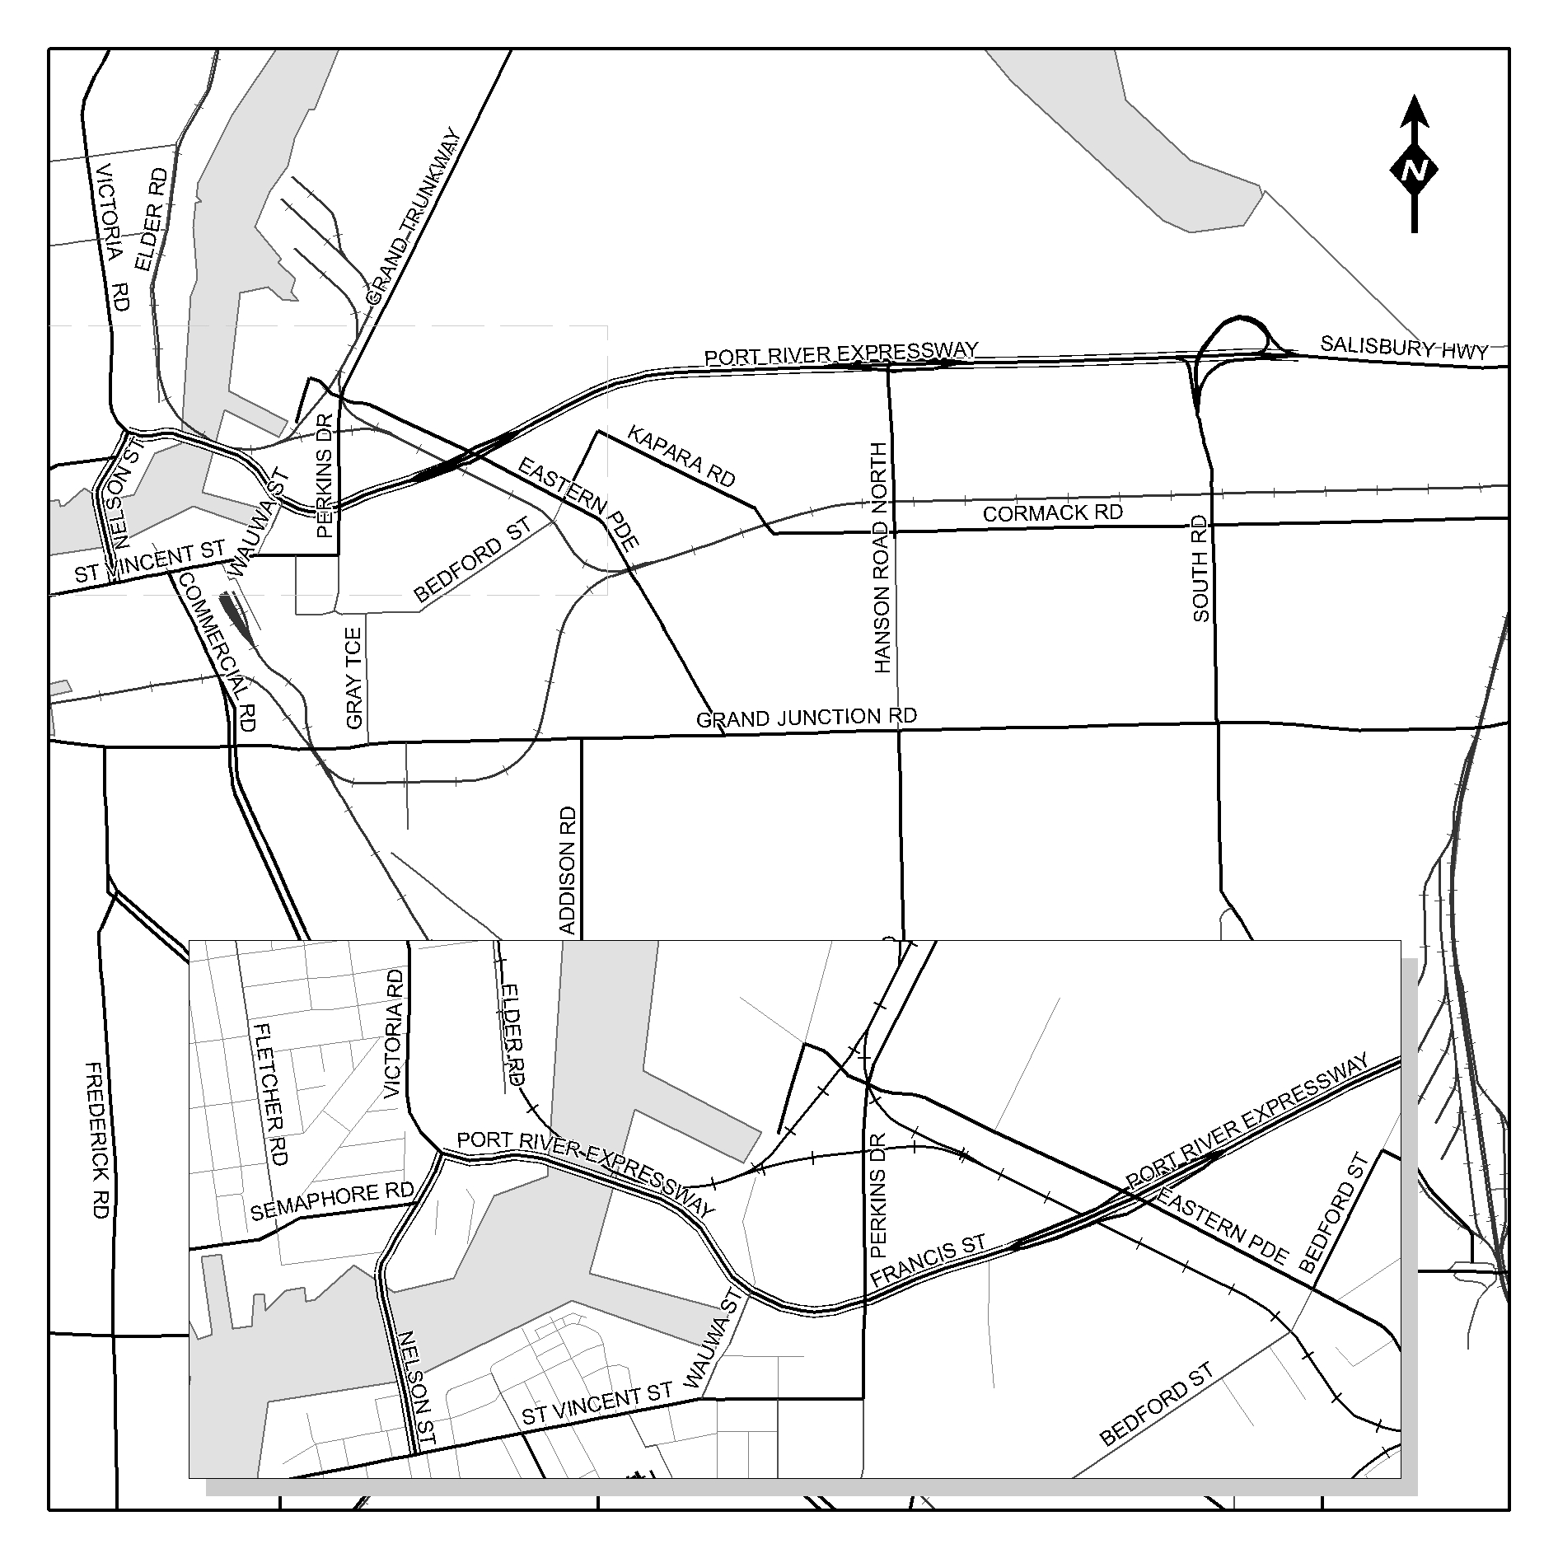
A. J. Milazzo, Commissioner of Highways Delegate

NATURAL RESOURCES MANAGEMENT ACT 2004
Notice of Prohibition on Water Use in the Polda Basin in the Musgrave Prescribed Wells Area
PURSUANT to section 132 (1) of the Natural Resources Manage-ment Act 2004, I, Jay Weatherill, Minister for Environment and Conservation in the State of South Australia, being of the opinion that the rate at which water is taken from wells that take underground water from the Quaternary Limestone aquifer in the Polda Basin in the Musgrave Prescribed Wells Area is such that the quantity of water available can no longer meet the demand, hereby prohibit the taking of water from wells in the area labelled ‘Polda’ on the attached map, except in the circumstances specified in Schedule 1.
This Notice does not apply to the taking of water for domestic purposes or for watering stock (other than stock subject to intensive farming).
Schedule 1
1. Subject to clause 2, a person may take water from a well pursuant to Water Licence 9603, 9604 or 9608.
2. The maximum volume of water that may be taken, pursuant to a water licence in a water-use year, is the maximum volume of water that was taken pursuant to that water licence in any water-use year in the period between 1 July 2005 and 30 June 2008.
For the purposes of this notice, a ‘water-use year’ means the period between 1 July in any calendar year and 30 June in the following calendar year.
This notice will remain in effect for a period of two years, unless earlier varied or revoked.
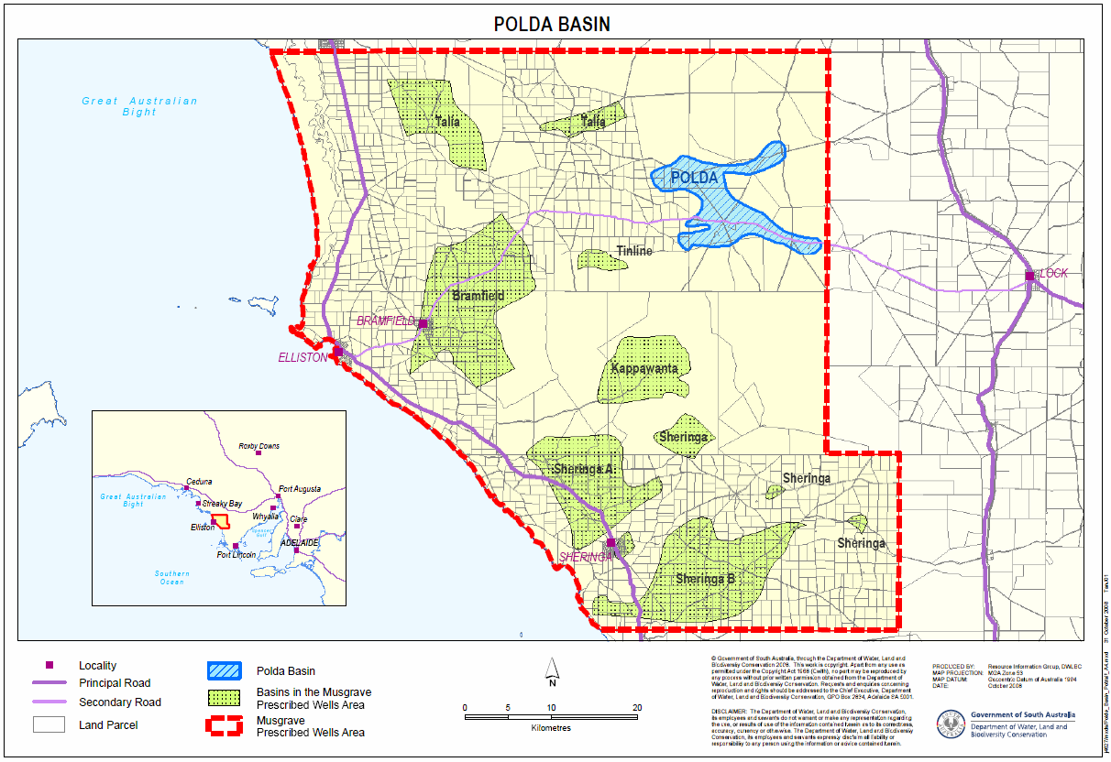
Dated 24 November 2008.
Jay Weatherill, Minister for Environment and Conservation

PETROLEUM ACT 2000
Amendment of ‘Description of Area’ of Petroleum Production Licence—PPL 209
NOTICE is hereby given that under the provisions of section 82 of the Petroleum Act 2000, pursuant to delegated powers dated 28 March 2002, Gazetted 11 April 2002, page 1573, the ‘description of area’ of the abovementioned Petroleum Production Licence held by Stuart Petroleum Limited and Beach Oil and Gas Pty Limited has been amended to consolidate the area of Petroleum Production Licence Application PPLA 223 as follows:
The petroleum production licence granted 2 June 2005, is hereby amended by substituting the ‘Description of Area’ with the following:
‘All that part of the State of South Australia, bounded as follows:
Commencing at a point being the intersection of latitude 28°36′39″S GDA94 and longitude 140°06′40″E GDA94, thence east to longitude 140°07′44″E GDA94, south to latitude 28°36′55″S GDA94, west to longitude 140°07′40″E GDA94, south to latitude 28°36′57″S GDA94, west to longitude 140°07′35″E GDA94, south to latitude 28°37′00″S GDA94, west to longitude 140°07′32″E GDA94, south to latitude 28°37′02″S GDA94, west to longitude 140°07′30″E GDA94, south to latitude 28°37′15″S GDA94, west to longitude 140°07′27″E GDA94, south to latitude 28°37′40″S GDA94, west to longitude 140°07′25″E GDA94, south to latitude 28°37′55″S GDA94, west to longitude 140°07′10″E GDA94, south to latitude 28°38′15″S GDA94, west to longitude 140°06′20″E GDA94, north to latitude 28°38′05″S GDA94, west to longitude 140°06′15″E GDA94, north to latitude 28°37′55″S GDA94, east to longitude 140°06′20″E GDA94, north to latitude 28°37′50″S GDA94, east to longitude 140°06′40″E GDA94, north to latitude 28°37′45″S GDA94, east to longitude 140°06′45″E GDA94, north to latitude 28°37′40″S GDA94, west to longitude 140°06′22″E GDA94, north to latitude 28°37′10″S GDA94, west to longitude 140°06′20″E GDA94, north to latitude 28°36′50″S GDA94, east to longitude 140°06′25″E GDA94, north to latitude 28°36′45″S GDA94, east to longitude 140°06′35″E GDA94, north to latitude 28°36′40″S GDA94, east to longitude 140°06′40″E GDA94 and north to the point of commencement.
Area: 5.08 km² approximately.’
Dated 24 November 2008.
B. A. Goldstein, Director Petroleum and Geothermal
Minerals and Energy Resources
Primary Industries and Resources SA
Delegate of the Minister for Mineral Resources Development

ROADS (OPENING AND CLOSING) ACT 1991
Road Opening—North Terrace and Port Road,
Adelaide Park Lands, Adelaide
NOTICE is hereby given, pursuant to section 34G of the Roads (Opening and Closing) Act 1991, that an application has been made to the Minister for Infrastructure by the Commissioner of Highways, to make an order to open as road portions of Adelaide Park Lands, more particularly described as:
(i) portions of Certificate of Title CT 5522/14 and Crown Record CR 5999/483, numbered ‘1’ and ‘2’ on Preliminary Plan No. 08/0112 (sheet 1) forming a widening of North Terrace and Port Road adjacent to the intersection with West Terrace;
(ii) portions of Crown Record CR 5999/483, Certificate of Title CT 5999/485, Certificate of Title CT 5999/484, Crown Record CR 5999/488, situated between West Terrace and Deviation Road, numbered ‘3’, ‘4’, ‘5’ and ‘6’ on Preliminary Plan No. 08/0112 (sheet 2) forming a widening of Port Road;
(iii) portion of section 739, Hundred of Adelaide, Crown Record CR 5999/491, situated between Deviation Road and James Congdon Drive, numbered ‘7’ on Preliminary Plan No. 08/0112 (sheet 3) forming a widening of Port Road;
(iv) portions of Crown Record CR 5999/483, Crown Record 5807/961, Crown Record CR 5452/84, situated south of Park Terrace, numbered ‘8’, ‘9’ and ‘10’ on Preliminary Plan No. 08/0112 (sheet 4) forming a widening of Port Road.
A copy of the application is available for public inspection at the offices of the Department for Transport Energy and Infrastructure, 33-37 Warwick Street, Walkerville and at Roma Mitchell House, 136 North Terrace, Adelaide and the Adelaide office of the Surveyor-General, 101 Grenfell Street, Adelaide, during normal office hours and can be viewed at:
www.infrastructure.sa.gov.au/coast_to_coast_lightrail.
Any person wishing to make a representation in relation to the proposal must do so in writing by Thursday, 8 January 2009. Representations should be forwarded to: Project Director, CCLR City West to AEC, Department for Transport, Energy and Infrastructure, P.O. Box 1, Walkerville, S.A. 5081 and marked ‘ROADS OPENING’.
DTEI Contact: Project Enquiry Line on 1800 726 500.
Dated 27 November 2008.
Jim Hallion, Commissioner of Highways

ROADS (OPENING AND CLOSING) ACT 1991:
SECTION 24
NOTICE OF CONFIRMATION OF ROAD
PROCESS ORDER
Road Closure
South Terrace, Wool Bay
BY Road Process Order made on 2 September 2008, The District Council of Yorke Peninsula ordered that:
1. Portion of the public road (South Terrace) situate adjoining Sixth Street and the southern boundary of allotment 50 in the Town of Wool Bay, more particularly delineated and lettered ‘A’ on Preliminary Plan No. 08/0049 be closed.
2. Transfer the whole of the land subject to closure to Gary Elwyne Vine and Joan Marie Vine in accordance with the agreement for transfer dated 19 June 2008 entered into between The District Council of Yorke Peninsula and G. E. and J. M. Vine.
On 17 November 2008 that order was confirmed by the Minister for Infrastructure conditionally upon the deposit by the Registrar-General of Deposited Plan 79197 being the authority for the new boundaries.
Pursuant to section 24 (5) of the Roads (Opening and Closing) Act 1991, NOTICE of the order referred to above and its confirmation is hereby given.
Dated 27 November 2008.
P. M. Kentish, Surveyor-General

ROADS (OPENING AND CLOSING) ACT 1991:
SECTION 24
NOTICE OF CONFIRMATION OF ROAD
PROCESS ORDER
Road Closure
Taylors Road, Penfield
BY Road Process Order made on 4 July 2008, the City of Playford ordered that:
1. Portion of the public road (Taylors Road) situate at the junction of Taylors Road and Womma Road more particularly delineated ‘A’ in Preliminary Plan No. 08/0005 be closed.
2. Sell/Transfer the whole of the land subject to closure to the South Australian Water Corporation for use for beneficial public purposes.
On 12 September 2008 that order was confirmed by the Minister for Infrastructure conditionally upon the deposit by the Registrar-General of Deposited Plan 78531 being the authority for the new boundaries.
Pursuant to section 24 (5) of the Roads (Opening and Closing) Act 1991, NOTICE of the order referred to above and its confirmation is hereby given.
Dated 27 November 2008.
P. M. Kentish, Surveyor-General

CORPORATIONS RULES 2003
(South Australia)
Amendment No. 5
BY virtue and in pursuance of section 72 of the Supreme Court Act 1935 and all other enabling powers, We, Judges of the Supreme Court of South Australia, do hereby make the following Rules to take effect as amendments to the Corporations Rules 2003 (South Australia).

1. These Rules may be cited as the ‘Corporations Rules 2003 (South Australia) Amendment No. 5’.

2. The Corporations Rules 2003 (South Australia), as amended by these Rules, may be cited as the ‘Corporations Rules 2003 (South Australia)’.

3. These Rules come into operation on 1 December 2008, or upon their gazettal, whichever is the later.

4. Rule 1.3 is amended by deleting subrules (1) and (2) and by inserting in their place the following:

‘(1) Unless the Court otherwise orders:

(a) these Rules apply to a proceeding in the Court under the Corporations Act, or the ASIC Act, that is commenced on or after the commence-ment of these Rules; and

(b) Division 15A applies to a proceeding in the Court under the Cross-Border Insolvency Act.

(2) The other Rules of the Court apply, to the extent that they are relevant and not inconsistent with these Rules:

(a) to a proceeding in the Court under the Corporations Act, or the ASIC Act, that is commenced on or after the commencement of these Rules; and

(b) to a proceeding in the Court under the Cross-Border Insolvency Act that is commenced on or after the commencement of Division 15A.’

5. Rule 1.5 is amended by:

(1) inserting after the definition of Corporations Regulations the following definition:

‘Cross-Border Insolvency Act means the Cross-Border Insolvency Act 2008 (Cth) including, unless the contrary intention appears, the Model Law.’

(2) deleting from definition of defendant the words ‘Corporations Act or the ASIC Act,’ and inserting in their place the words ‘Corporations Act, the ASIC Act or the Cross-Border Insolvency Act,’.

(3) inserting after the definition of interlocutory process the following definition:

‘Model Law means the Model Law on Cross-Border Insolvency of the United Nations Commission on International Trade Law, the English text of which is set out in Schedule 1 to the Cross-Border Insolvency Act, with the modifications set out in Part 2 of that Act.’

(4) deleting from the definition of plaintiff the words ‘Corporations Act or the ASIC Act’ and inserting in their place ‘Corporations Act, the ASIC Act or the Cross-Border Insolvency Act,’.

6. The following new Division 15A is inserted immediately after Division 15:

‘15A.1 Application of this Division and other Rules of the Court

Unless the Court otherwise orders:

(a) this Division applies to a proceeding in the Court, under the Cross-Border Insolvency Act, involving a debtor other than an individual; and

(b) the Rules in the other Divisions of these Rules, and the other Rules of the Court, apply to a proceeding in the Court under the Cross-Border Insolvency Act if they are relevant and not inconsistent with this Division.

Note: See Rule 1.5 for definitions of Cross-Border Insolvency Act and Model Law.

15A.2 Expressions used in the Cross-Border Insolvency Act

(1) Unless the contrary intention appears, an expression that is used in this Division and in the Cross-Border Insolvency Act, whether or not a particular meaning is given to the expression by the Cross-Border Insolvency Act, has the same meaning in this Division as it has in the Cross-Border Insolvency Act.

Note: The following expressions used in this Division (including in the notes to this Division) are defined in the Model Law as having the following meanings:

establishment means any place of operations where the debtor carries out a non-transitory economic activity with human means and goods or services.

foreign court means a judicial or other authority competent to control or supervise a foreign proceeding.

foreign main proceeding means a foreign proceeding taking place in the State where the debtor has the centre of its main interests.

foreign non-main proceeding means a foreign proceeding, other than a foreign main proceeding, taking place in a State where the debtor has an establishment within the meaning of subparagraph (f) of the present article.

foreign proceeding means a collective judicial or administrative proceeding in a foreign State, including an interim proceeding, pursuant to a law relating to insolvency in which proceeding the assets and affairs of the debtor are subject to control or supervision by a foreign court, for the purpose of reorganization or liquidation.

foreign representative means a person or body, including one appointed on an interim basis, authorized in a foreign proceeding to administer the reorganization or the liquidation of the debtor’s assets or affairs or to act as a representative of the foreign proceeding.

(2) This Division is to be interpreted in a manner which gives effect to the Cross-Border Insolvency Act.

15A.3 Application for recognition

(1) An application by a foreign representative for recognition of a foreign proceeding under article 15 of the Model Law must be made by filing an originating process in accordance with Form 2.

(2) The originating process must:

(a) be accompanied by the statements referred to in article 15 of the Model Law and in section 13 of the Cross-Border Insolvency Act; and

(b) name the foreign representative as the plaintiff and the debtor as the defendant; and

(c) be accompanied by an affidavit verifying the matters mentioned in paragraphs 2 and 3 of article 15 of the Model Law and in section 13 of the Cross-Border Insolvency Act.

(3) When filing the originating process, the foreign representative must file, but need not serve, an interlocutory process seeking directions as to service, and the Court may give any directions about service, and make any incidental orders, which it thinks just.

(4) The plaintiff must serve a copy of the originating process and the other documents mentioned in subrule (2):

(a) unless the Court otherwise orders, in accordance with subrule 2.7 (1); and

(b) on any other persons the Court may direct at the hearing of the interlocutory process.

(5) A person who intends to appear before the Court at the hearing of an application for recognition must file and serve the documents mentioned in Rule 2.9.

15A.4 Application for provisional relief under article 19 of the Model Law

(1) Any application by the plaintiff for provisional relief under article 19 of the Model Law must be made by filing an interlocutory process in accordance with Form 3.

(2) Unless the Court otherwise orders, the interlocutory process and any supporting affidavit must be served in accordance with subrule 2.7 (2).

15A.5 Official liquidator’s consent to act

If the relief sought in an application under article 15 of the Model Law includes an application for an order under article 19 or 21 to entrust the distribution of the debtor’s assets to a person designated by the Court (other than the foreign representative) then, unless the Court otherwise orders, that person must:

(a) be an official liquidator; and

(b) have filed a Consent to Act, in accordance with Form 19, which specifies an address for service for the person within the State of South Australia.

15A.6 Notice of filing of application for recognition

(1) Unless the Court otherwise orders, the plaintiff in a proceeding mentioned in Rule 15A.3 must:

(a) send a notice of the filing of the application in accordance with
Form 20 to each person whose claim to be a creditor of the defendant is known to the plaintiff; and

(b) publish a notice of the filing of the application for recognition of a foreign proceeding in accordance with Form 20, in accordance with Rule 2.11.

(2) The Court may direct the plaintiff to publish a notice in accordance with Form 20 in a daily newspaper circulating generally in any State or Territory not described in Rule 2.11.

15A.7 Notice of order for recognition, withdrawal etc.

(1) If the Court makes an order for recognition of a foreign proceeding under article 17 of the Model Law, or makes any order under article 19 or 21 of the Model Law, the plaintiff must, as soon as practicable after the order is made, do all of the following:

(a) have the order entered;

(b) serve a copy of the entered order on the defendant;

(c) send a notice of the making of the order in accordance with Form 21 to each person whose claim to be a creditor of the defendant is known to the plaintiff;

(d) publish a notice of the making of the order in accordance with
Form 21, in accordance with Rule 2.11.

(2) The Court may direct the plaintiff to publish the notice in accordance with
Form 21 in a daily newspaper circulating generally in any State or Territory not described in Rule 2.11.

(3) If the application for recognition is withdrawn or dismissed, the plaintiff must, as soon as practicable, do all of the following:

(a) for a dismissal, have the order of dismissal entered;

(b) serve a copy of the entered order of dismissal or notice of the withdrawal, on the defendant;

(c) send a notice of the dismissal or withdrawal in accordance with
Form 22 to each person whose claim to be a creditor of the defendant is known to the plaintiff;

(d) publish a notice of the dismissal or withdrawal in accordance with
Form 22, in accordance with Rule 2.11.

(4) The Court may direct the plaintiff to publish the notice in accordance with
Form 22 in a daily newspaper circulating generally in any State or Territory not described in Rule 2.11.

15A.8 Relief after recognition

(1) If the Court has made an order for recognition of a foreign proceeding, any application by the plaintiff for relief under paragraph 1 of article 21 of the Model Law must be made by filing an interlocutory process, and any supporting affidavit, in accordance with Form 3.

(2) Unless the Court otherwise orders, an interlocutory process under sub-
rule (1) and any supporting affidavit must be served, in accordance with subrule 2.7 (2), but on the following persons:

(a) the defendant;

(b) any person that the Court directed be served with the originating process by which the application for recognition was made;

(c) any other person that the Court directs.

(3) A person who intends to appear before the Court at the hearing of an application under subrule (1) must file and serve the documents mentioned in Rule 2.9.

15A.9 Application to modify or terminate an order for recognition or other relief

(1) This Rule applies to:

(a) an application under paragraph 4 of article 17 of the Model Law for an order modifying or terminating an order for recognition of a foreign proceeding; and

(b) an application under paragraph 3 of article 22 of the Model Law for an order modifying or terminating relief granted under article 19 or 21 of the Model Law.

(2) An application mentioned in subrule (1) must be made by filing an interlocutory process in accordance with Form 3.

(3) An interlocutory process for an application under subrule (1) and any supporting affidavit must be served on:

(a) for an application under paragraph (1) (a)—the defendant and other persons who were served with, or filed a notice of appearance in relation to, the application for recognition; and

(b) for an application under paragraph (1) (b)—the defendant and other persons who were served with, or filed a notice of appearance in relation to, the application for relief under article 19 or 21.

(4) Unless the Court otherwise orders, a plaintiff who applies for an order under subrule (1) must:

(a) send a notice of the filing of the application in accordance with
Form 23 to each person whose claim to be a creditor of the defendant is known to the plaintiff; and

(b) publish a notice of the filing of the application in accordance with
Form 23, in accordance with Rule 2.11.

(5) The Court may direct the applicant to publish the notice in accordance with Form 23 in a daily newspaper circulating generally in any State or Territory not described in Rule 2.11.

(6) A person who intends to appear before the Court at the hearing of an application under subrule (1) must file and serve the documents mentioned in Rule 2.9.’

7. Schedule 1, Form 2 is amended by:

(1) deleting the entry ‘Rule 2.2’ appearing immediately under the heading ‘Originating process’ and inserting in its place ‘(Rules 2.2 and 15A.3)’.

(2) deleting the words ‘This application is made under *section/*regulation [number] of the *Corporations Act/*ASIC Act/*Corporations Regulations.’ and inserting in their place ‘This application is made under *section/*regulation [number] of the *Corporations Act/*ASIC Act/
*Cross-Border Insolvency Act/*Corporations Regulations.’

8. Schedule 1, Form 3 is amended by:

(1) deleting the entry ‘(Rule 2.2)’ appearing immediately under the heading ‘Interlocutory process’ and inserting in its place ‘(Rules 2.2, 15A.4, 15A.8 and 15A.9)’.

(2) deleting the words ‘*This application is made under *section/*regulation [number] of the *Corporations Act/* ASIC Act/*Corporations Regulations.’ and inserting in their place ‘This application is made under *section /*regulation [number] of the *Corporations Act /*ASIC Act/
*Cross-Border Insolvency Act/*Corporations Regulations.’

9. Schedule 1 is amended by adding after Form 18 the following new forms numbered 19, 20, 21, 22 and 23:

‘Form 19
Consent to act as designated person
(Rule 15A.5)

[Title]

I, [name], of [address], an official liquidator, consent to be appointed by the Court and to act as the person designated by the Court under *article 19/*article 21 of the Model Law to distribute the assets of [name of company].

I am not aware of any conflict of interest or duty that would make it improper for me to act as the person designated by the Court.

Date:
……………………………………..
Signature of official liquidator
* Omit if not applicable

Form 20
Notice of filing of application for recognition of foreign proceeding
(Rule 15A.6)

IN THE [name of Court] No. of [year]

[Name of company]

ABN or ACN: [ABN or ACN of company to which proceeding relates]

TO all the creditors of [name of company].

TAKE NOTICE that:

1. An application under the Cross-Border Insolvency Act 2008 for recognition of a foreign proceeding in relation to [name of company] was commenced by the plaintiff, [name of plaintiff], on [date of filing of originating process] and will be heard by . . . . . . . . . . . . . . . . . . . . . . . . . . . . . . . . . . . . . . . . . . . . . . . . . . . . . . .
at [address of Court] at . . . . . . . . *a.m./*p.m. on . . . . . . . .

Copies of documents filed may be obtained from the plaintiff’s address for service.

2. The plaintiff’s address for service is [name and address of plaintiff’s legal practitioner or, if there is no legal practitioner, address of the plaintiff].

3. Any person intending to appear at the hearing must file a notice of appearance, in accordance with the prescribed form, together with any affidavit on which the person intends to rely, and serve a copy of the notice and any affidavit on the plaintiff at the plaintiff’s address for service at least three days before the date fixed for the hearing.

4. If you are a foreign creditor you must file in the registry of the Court at the address mentioned in paragraph 1 an affidavit setting out the details of any claim, secured or unsecured, which you may have against the company above at least three days before the date fixed for the hearing.

Date:

Name of plaintiff or plaintiff’s legal practitioner: [name]

* Omit if not applicable

Form 21
Notice of making of order under the Cross-Border Insolvency Act 2008
(Rule 15A.7)

IN THE [name of Court] No. of [year]

[Name of company]

ABN or ACN: [ABN or ACN of company to which proceeding relates]

TO all the creditors of [name of company].

TAKE NOTICE that:

1. On [date], the [name of Court] in Proceeding No. of [year], commenced by the plaintiff [name of plaintiff], made the following orders under the Cross-Border Insolvency Act 2008 in relation to [name of company]: [insert details of order].

2. The plaintiff’s address for service is [name and address of plaintiff’s legal practitioner or, if there is no legal practitioner, address of the plaintiff].

3. The name and address of the foreign representative is [insert name and address].

4. The name and address of the person entrusted with distribution of the company’s assets is [insert name and address].*

Date:

Name of plaintiff or plaintiff’s legal practitioner: [name]

* Omit if not applicable

Form 22
Notice of dismissal or withdrawal of application
for recognition of foreign proceeding
(Rule 15A.7)

IN THE [name of Court] No. of [year]

[Name of company]

ABN or ACN: [ABN or ACN of company to which proceeding relates]

TO all the creditors of [name of company].

TAKE NOTICE that the application under the Cross-Border Insolvency Act 2008 for recognition of a foreign proceeding in relation to [name of company] commenced by the plaintiff, [name of plaintiff], on [date of filing of originating process] was dismissed*/withdrawn* on [date of dismissal/withdrawal]

Date:

Name of person giving notice or of person’s legal practitioner [name]

* Omit if not applicable

Form 23
Notice of filing of application to modify or terminate an order
for recognition or other relief
(Rule 15A.9)

IN THE [name of Court] No. of [year]

[Name of company]

ABN or ACN: [ABN or ACN of company to which proceeding relates]

TO all the creditors of [name of company].

TAKE NOTICE that:

*1. An application under the Cross-Border Insolvency Act 2008 for an order *modifying/*terminating an order for recognition of a foreign proceeding in relation to [name of company] was filed by the applicant, [name of applicant], on [date of filing of interlocutory process] and will be heard by . . . . . . . . . . . . . . . . . . . . . . . . . . . . . . . . . . . . . . . . . . . . . . . . . . . . . at [address of Court] at . . . . . . . . *a.m./*p.m.
on . . . . . . . .

Copies of documents filed may be obtained from the applicant’s address for service.

*1. An application under the Cross-Border Insolvency Act 2008 for an order *modifying/*terminating relief granted under *article 19/*article 21 of the Model Law in relation to [name of company] was filed by the applicant, [name of applicant], on [date of filing of interlocutory process] and will be heard by . . . . . . . . . . . . . . . . . . . . . . . . . . . . . . . . . . . . . . . . . . . . . . . . . . . . . at [address of Court]
at . . . . . . . . *a.m./*p.m. on . . . . . . . . Copies of documents filed may be obtained from the applicant’s address for service.

2. The applicant’s address for service is [name and address of applicant’s legal practitioner or of applicant].

3. Any person intending to appear at the hearing must file a notice of appearance (if the person has not already done so), in accordance with the prescribed form, together with any affidavit on which the person intends to rely, and serve a copy of the notice (if applicable) and any affidavit on the applicant at the applicant’s address for service at least three days before the date fixed for the hearing.

Date:

Name of applicant or applicant’s legal practitioner: [name]

* Omit if not applicable’

GIVEN under our hands and the Seal of the Supreme Court of South Australia this 27th day of October 2008.
(l.s.) J. J. DOYLE, CJ
K. P. DUGGAN, J
D. J. BLEBY, J
T. A. GRAY, J
J. R. SULAN, J
T. R. ANDERSON, J
R. C. WHITE, J
R. A. LAYTON, J
M. DAVID, J
C. KOURAKIS, J

RULES OF COURT
Amending the Supreme Court Criminal Rules 1992
Amendment No. 23
to the Supreme Court Criminal Rules
BY virtue and in pursuance of section 72 of the Supreme Court Act 1935, and all other enabling powers, We, Judges of the Supreme Court of South Australia, make the following Rules to take effect as amendments to the Supreme Court Criminal Rules 1992, as amended:
1. These Rules may be cited as the ‘Supreme Court Criminal Rules 1992, (Amendment No. 23)’.
2. The Supreme Court Criminal Rules 1992, as amended by these Rules may be cited as the ‘Supreme Court Criminal Rules 1992’.
3. The amendments made by these Rules are to come into effect on 1 December 2008, or on their gazettal, whichever is the later.
4. The following new Rule is inserted after Rule 29:
‘Applications for Special Arrangements for the Giving of Evidence by
Vulnerable Witnesses under Section 13A of the Evidence Act 1929
30.01 An application for special arrangements for the giving of evidence by a vulnerable witness shall be made by issuing and serving on the other party (‘the respondent’) an application in Form 21.
30.02 The application shall be filed in the Court not less than 28 days before the commencement of the trial, or at such earlier time as may be directed by the Court at a directions hearing, and must be served on the respondent within 14 days of being filed.
30.03 When the respondent objects to the application, a notice of objection shall be made in Form 22.
30.04 The notice of objection must be filed in the Court and served on the applicant within 14 days of the service of the application on the respondent.’
5. The Schedule is amended by adding after Form 20 the following new Forms:

‘Form No. 21

File No.:

The Queen v ………………………

APPLICATION FOR A VULNERABLE WITNESS PROTECTION ORDER
UNDER SECTION 13A OF THE EVIDENCE ACT 1929

[Insert name of party] applies to the Court for an order that special arrangements be made for taking the evidence of [insert name of witness].

The applicant seeks the following order:

[Set out the special arrangements which are sought]

The application is made on the following grounds:

[Set out the nature of the vulnerability of the witness and the reasons for the special arrangements which are sought]

Dated the day of , 20 .

……………………………………..
[Signed by the applicant]

NOTE:
This application must be filed in the Court not less than 28 days before the commence-ment of the trial, or at such earlier time as may be directed by the Court at a directions hearing, and served on the respondent within 14 days of being filed.

The respondent may file a notice in Form 22 objecting to the application on the ground that the witness is not a vulnerable witness as defined in Section 4 of the Evidence
Act 1929. The notice must be filed within 14 days of the service of the application.
Form No. 22

File No.:

The Queen v ………………………

OBJECTION TO APPLICATION FOR A VULNERABLE WITNESS
PROTECTION ORDER UNDER SECTION 13A OF THE EVIDENCE
ACT 1929

[Insert name of respondent] objects to the application of [insert name of applicant] for an order that special arrangements be made for taking the evidence of [insert name of witness].

The grounds of the objection are as follows:

[Set out the grounds of objection]

Dated the day of , 20 .

……………………………………..
[Signed by the respondent]

NOTE:
This notice of objection must be filed in the Court and served on the applicant within
14 days of the service of the application on the respondent.’

GIVEN under our hands and the Seal of the Supreme Court of South Australia this 27th day of October 2008.
(l.s.) J. J. DOYLE, CJ
K. P. DUGGAN, J
D. J. BLEBY, J
T. A. GRAY, J
J. R. SULAN, J
T. R. ANDERSON, J
R. C. WHITE, J
R. A. LAYTON, J
M. DAVID, J
C. KOURAKIS, J

NOTICE TO MARINERS
No. 58 of 2008
South Australia—Port Adelaide—Port River Expressway Bridges—Navigation Lights Installed
THE following lights have been installed in WGS datum at fender level in the main navigation pass of the Port Expressway Bridges. Please refer to attached sketch:
Western Fender:
B3 Starboard: Latitude 34°50′15.507″S, longitude 138°30′24.853″E—Flashing Green every two seconds.
B11 Starboard: Latitude 34°50′16.923″S, longitude 138°30′24.309″E—Fixed Green.
B12 Starboard: Latitude 34°50′18.327″S, longitude 138°30′23.775″E—Flashing Green every three seconds.
Eastern Fender:
B4 Port: Latitude 34°50′15.412″S, longitude 138°30′26.159″E—Flashing Red every two seconds.
B10 Port: Latitude 34°50′17.319″S, longitude 138°30′25.427″E—Fixed Red.
B9 Port: Latitude 34°50′19.248″S, longitude 138°30′24.696″E—Flashing Red every three seconds.
Eight Special Markers-yellow coloured beacons (four on the northern side and four on the southern side), each with a yellow flashing light every four seconds are also installed to mark the piers as follows:
Northern Side:
B1 Latitude 34°50′14.605″S, longitude 138°30′22.096″E.
B2 Latitude 34°50′15.158″S, longitude 138°30′23.287″E.
B5 Latitude 34°50′16.770″S, longitude 138°30′26.663″E.
B6 Latitude 34°50′17.269″S, longitude 138°30′27.700″E.
Southern Side:
B7 Latitude 34°50′18.763″S, longitude 138°30′27.136″E.
B8 Latitude 34°50′18.546″S, longitude 138°30′25.847″E.
B13 Latitude 34°50′17.592″S, longitude 138°30′22.611″E.
B14 Latitude 34°50′17.292″S, longitude 138°30′21.458″E.
All of the above lights have a range of two miles.
A Vega sector light flashing Green, White and Red has also been installed on McLaren Parade Wharf in position latitude 34°50′30.15″S, longitude 138°30′19.90″E.
The sectors are as follows:
Green—195°13′50″ to 195°46′30″ (0°32′40″ of arc).
White—195°46′30″ to 196°17′20″ (0°30′50″ of arc).
Red—196°17′20″ to 197°00′20″ (0°43′00″ of arc).
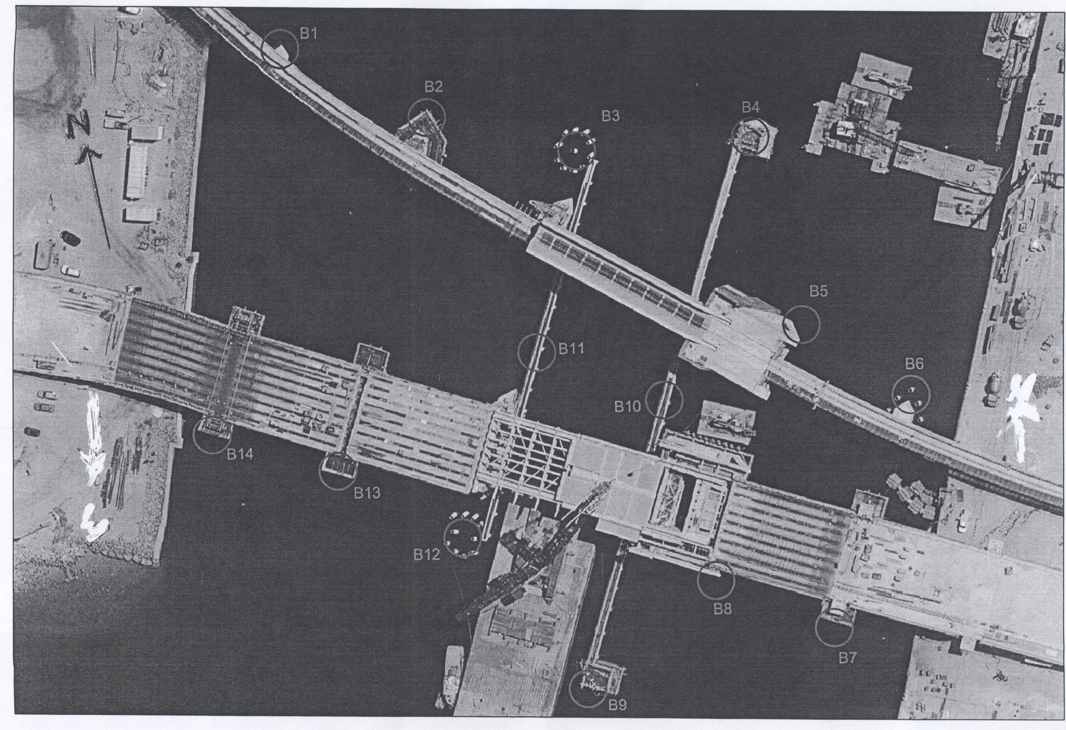
Charts affected: Aus 137.
Adelaide, 19 November 2008.
Patrick Conlon, Minister for Transport
DTEI 2008/007676

South Australia
Firearms (Firearms Prohibition Orders) Amendment
Act (Commencement) Proclamation 2008
1—Short title
This proclamation may be cited as the Firearms (Firearms Prohibition Orders)
Amendment Act (Commencement) Proclamation 2008.
2—Commencement of Act
The Firearms (Firearms Prohibition Orders) Amendment Act 2008 (No 15 of 2008)
will come into operation on 27 November 2008.
Made by the Governor
with the advice and consent of the Executive Council
on 27 November 2008
MPOL08/010CS

South Australia
Long Service Leave (Unpaid Leave) Amendment Act (Commencement) Proclamation 2008
1—Short title
This proclamation may be cited as the Long Service Leave (Unpaid Leave)
Amendment Act (Commencement) Proclamation 2008.
2—Commencement of Act
The Long Service Leave (Unpaid Leave) Amendment Act 2008 (No 40 of 2008) will
come into operation on 1 January 2009.
Made by the Governor
with the advice and consent of the Executive Council
on 27 November 2008
MIR06/020CS

South Australia
Development (Unley Development Plan) Variation Regulations 2008
under the Development Act 1993

Contents
Part 1—Preliminary
1 Short title
2 Commencement
3 Variation provisions
Part 2—Variation of Development Regulations 2008
4 Variation of Schedule 3—Acts and activities which are not development
5 Variation of Schedule 5—Requirements as to plans and specifications
2B Additional requirements for City of Unley in certain cases

Part 1—Preliminary
1—Short title
These regulations may be cited as the Development (Unley Development Plan) Variation Regulations 2008.
2—Commencement
These regulations come into operation on the day on which they are made.
3—Variation provisions
In these regulations, a provision under a heading referring to the variation of specified regulations varies the regulations so specified.
Part 2—Variation of Development Regulations 2008
4—Variation of Schedule 3—Acts and activities which are not development
Schedule 3, clause 4(1)(f)(i)—after subsubparagraph (D) insert:
(E) a Streetscape (Built Form) Zone in the area of The Corporation of the City of Unley if the fence is situated between the building line of the main face of a building and the road on to which the building faces; or
5—Variation of Schedule 5—Requirements as to plans and specifications
Schedule 5—after clause 2A insert:
2B—Additional requirements for City of Unley in certain cases
(1) An application for the assessment of development within a Historic (Conservation) Zone or a Streetscape (Built Form) Zone in the area of The Corporation of the City of Unley consisting of or involving—
(a) the construction of a new building; or
(b) —
(i) an addition to an existing building; or
(ii) an alteration in the form or appearance of an existing building,
that—
(iii) affects a facade of the building, or is not more than
5 metres back from a facade of the building; and
(iv) is visible from a street frontage,
must be accompanied by—
(c) a report describing the prevailing character attributes and design elements within the locality of the site and the extent to which the proposed development is consistent with these attributes and elements with particular reference to the desired characteristics identified in the relevant Development Plan; and
(d) drawings demonstrating how the proposed development relates to the buildings on adjoining sites (other than any site to the rear of the site of the proposed development) by providing an elevation and site plan, drawn to a scale of not less than 1:100, that shows the proposed development on the site within the context of the buildings on those adjoining sites and includes information showing:
(i) topography (according to existing and proposed ground levels);
(ii) the form, scale, height and floor levels of all relevant buildings;
(iii) spacing between buildings;
(iv) materials and colours of all relevant buildings;
(v) driveways (as they will exist after the development);
(vi) fences (as they will exist after the development);
(vii) landscaping (as it will exist after the development);
(viii) visible services and street furniture.
(2) In this clause—
facade includes a facade that may not be the principal front of a building.
Note—
As required by section 10AA(2) of the Subordinate Legislation Act 1978, the Minister has certified that, in the Minister's opinion, it is necessary or appropriate that these regulations come into operation as set out in these regulations.
Made by the Governor
with the advice and consent of the Executive Council
on 27 November 2008
No 287 of 2008
MUDP06/031CS

South Australia
Firearms Variation Regulations 2008
under the Firearms Act 1977

Contents
Part 1—Preliminary
1 Short title
2 Commencement
3 Variation provisions
Part 2—Variation of Firearms Regulations 2008
4 Insertion of regulations 5A and 5B
5A Fit and proper person
5B Prescribed health professional
5 Variation of regulation 7—International visitor firearms permits
6 Variation of regulation 8—Exemption of persons from outside the State
7 Insertion of regulations 55A and 55B
55A Disposal of forfeited or surrendered firearms etc
55B Register of firearms prohibition orders
8 Variation of regulation 60—Fees

Part 1—Preliminary
1—Short title
These regulations may be cited as the Firearms Variation Regulations 2008.
2—Commencement
These regulations will come into operation on the day on which the Firearms (Firearms Prohibition Orders) Amendment Act 2008 comes into operation.
3—Variation provisions
In these regulations, a provision under a heading referring to the variation of specified regulations varies the regulations so specified.
Part 2—Variation of Firearms Regulations 2008
4—Insertion of regulations 5A and 5B
After regulation 5 insert:
5A—Fit and proper person
For the purposes of section 5(11)(ca) of the Act, an offence against any of the following provisions is a prescribed offence:
(a) Controlled Substances Act 1984—
an indictable offence against section 32 as in force immediately before the commencement of the Controlled Substances (Serious Drug Offences) Amendment Act 2005;
an offence against section 32 (Trafficking) as in force following the commencement of the Controlled Substances (Serious Drug Offences) Amendment Act 2005;
section 33 (Manufacture of controlled drugs for sale);
section 33A (Sale, manufacture etc of controlled precursor);
section 33B (Cultivation of controlled plants for sale);
section 33C (Sale of controlled plants);
section 33F (Sale, supply or administration of controlled drug to child);
section 33G (Sale, supply or administration of controlled drug in school zone);
section 33H (Procuring child to commit offence);
an indictable offence against section 33I (Supply or administration of controlled drug);
section 33J (Manufacture of controlled drugs);
section 33K (Cultivation of controlled plants);
(b) Criminal Law Consolidation Act 1935—
section 19AA (Unlawful stalking);
section 31 (Possession of object with intent to kill or cause serious harm);
section 32 (Possession of a firearm with intent to commit an offence);
an aggravated offence against section 169 (Serious criminal trespass—non-residential buildings);
an aggravated offence against section 170 (Serious criminal trespass—places of residence);
section 248 (Threats or reprisals relating to persons involved in criminal investigations or judicial proceedings);
section 250 (Threats or reprisals against public officers);
section 270D (Going equipped for commission of offence against the person);
(c) Serious and Organised Crime (Control) Act 2008—
section 22 (Offence to contravene or fail to comply with control order);
section 32 (Offence to contravene or fail to comply with public safety order);
section 35 (Criminal associations);
(d) Summary Offences Act 1953—
section 15A (Possession of body armour);
section 74BJ (Hindering removal or modification of fortifications);
(e) offences consisting of a conspiracy or an attempt to commit an offence referred to in a preceding paragraph.
5B—Prescribed health professional
For the purposes of paragraph (c) of the definition of health professional in section 6B(3) of the Act, a nurse registered under the Nurses Act 1999 is a person of a prescribed class.
5—Variation of regulation 7—International visitor firearms permits
(1) Regulation 7(1)—delete subregulation (1) and substitute:
(1) The Registrar may, on the application of a person who is visiting, or who intends visiting, Australia, issue an international visitor firearms permit to the applicant authorising the applicant to possess and use a firearm for 1 or more of the following purposes as specified in the permit:
(a) competitive shooting;
(b) hunting;
(c) providing personal security services for a foreign dignitary or official.
(2) Regulation 7(6) to (9) (inclusive)—delete subregulations (6) to (9) and substitute:
(6) A person who holds an international visitor firearms permit or a permit under the law of another State or a Territory of the Commonwealth corresponding with this regulation is exempt from the application of the Act and these regulations provided that the person complies with the conditions of the permit.
6—Variation of regulation 8—Exemption of persons from outside the State
(1) Regulation 8(1) to (4) (inclusive)—delete subregulations (1) to (4) and substitute:
(1) This regulation authorises the possession or use of a firearm for a purpose in South Australia only if the possession or use of that firearm for that purpose could be authorised by a firearms licence (disregarding a purpose with which a firearms licence may be endorsed under regulation 11(2)(h)).
(2) Subject to this regulation, a person whose usual place of residence is in another State or a Territory of the Commonwealth may possess or use a firearm for a purpose in South Australia, without holding a firearms licence, if the person is authorised to possess or use that firearm for that purpose under the law of his or her usual place of residence.
(3) Subject to this regulation, a person who moves his or her usual place of residence to South Australia may, for the period of 3 months after moving, possess or use a firearm for a purpose in South Australia, without holding a firearms licence, if the person could possess or use that firearm for that purpose under the law of his or her former place of residence.
(4) Subregulation (3) does not authorise a person to use a class C, D or
H firearm in South Australia.
(2) Regulation 8(5)—delete "subregulation (1)" and substitute:
subregulation (2)
(3) Regulation 8(6)—delete "subregulation (1) or (4)" and substitute:
subregulation (2) or (3)
(4) Regulation 8(6)—after "licence" wherever occurring insert:
or other authority
7—Insertion of regulations 55A and 55B
Before regulation 56 insert:
55A—Disposal of forfeited or surrendered firearms etc
(1) For the purposes of section 35(5)(b)(i)(A) of the Act, the following requirements govern the sale or disposal of a firearm, firearm part or ammunition:
(a) a sale is to be by public auction or public tender (and the Registrar may, but need not, fix a reserve price for the purpose);
(b) the firearm, firearm part or ammunition may be disposed of otherwise than by sale if the Registrar believes on reasonable grounds that the firearm, firearm part or ammunition has no monetary value or that the proceeds of the sale would be unlikely to exceed the costs of the sale or if the firearm, firearm part or ammunition has been offered for sale and was not sold.
(2) Before paying the proceeds of a sale or disposal of a firearm, firearm part or ammunition to a person under section 35(5)(b)(i)(B) or (e) of the Act, the Registrar may deduct expenses incurred in connection with the sale or disposal and storage and other expenses incurred in relation to the firearm, firearm part or ammunition.
(3) For the purposes of section 35(5)(d) of the Act, the period for which a firearm, firearm part or ammunition must be made available for collection is 1 month.
55B—Register of firearms prohibition orders
The register of firearms prohibition orders maintained for the purposes of section 6A of the Act must contain the following information in relation to each order:
(a) the full name of the person to whom the order applies;
(b) the date on which the order was issued;
(c) the details of any exemption from a provision of section 10C of the Act (including any conditions that apply to the exemption) granted by the Registrar under section 10C(15) of the Act.
8—Variation of regulation 60—Fees
Regulation 60—after its present contents (now to be designated as subregulation (1)) insert:
(2) The Registrar may waive or reduce (in a particular case or classes of cases) fees that would otherwise be payable under these regulations.
Note—
As required by section 10AA(2) of the Subordinate Legislation Act 1978, the Minister has certified that, in the Minister's opinion, it is necessary or appropriate that these regulations come into operation as set out in these regulations.
Made by the Governor
with the advice and consent of the Executive Council
on 27 November 2008
No 288 of 2008
MPOL08/010CS

FAXING COPY?
IF you fax copy to Government Publishing SA for inclusion in the Government Gazette, there is no need to send a Confirmation Copy to us as well.
This creates confusion and may well result in your notice being printed twice.
Please use the following fax number:
Fax transmission: (08) 8207 1040
Phone Inquiries: (08) 8207 1045
Please include a contact person, phone number and order number so that we can phone back with any queries we may have regarding the fax copy.
NOTE: Closing time for lodging new copy (fax, hard copy or email) is 4 p.m. on Tuesday preceding the day of publication.

Government Gazette notices can be E-mailed.
The address is:
governmentgazette@dpc.sa.gov.au
Documents should be sent as attachments in Word format.
When sending a document via E-mail, please confirm your transmission with a faxed copy of your document, including the date the notice is to be published.
Fax transmission: (08) 8207 1040
Enquiries: (08) 8207 1045
NOTE: Closing time for lodging new copy (fax, hard copy or email) is 4 p.m. on Tuesday preceding the day of publication.

CAMPBELLTOWN CITY COUNCIL
Exclusion of Land from Classification of Community Land
NOTICE is hereby given that pursuant to section 193 (4) of the Local Government Act 1999, the Council resolved at its meeting held on 18 November 2008, that the whole of the land in certificate of title volume 6002, folio 804, be excluded from Classification as Community Land.
P. Di Iulio, Chief Executive Officer

CITY OF CHARLES STURT
Change of Street Name
NOTICE is hereby given that the Council of the City of Charles Sturt, at its meeting held on 10 November 2008, resolved that, pursuant to section 219 (1) of the Local Government Act 1999, that the lane known as 32A Lavinia Street, Athol Park be changed to Lavinia Court, Athol Park.
A plan which delineates the lane which is subject to the change of name, together with a copy of the Council’s resolution, is available for inspection at the Council’s Civic Centre, 72 Woodville Road, Woodville, S.A. 5011, during the hours of 9 a.m. and 5 p.m. on weekdays.
M. Withers, Chief Executive

CITY OF MARION
Roads (Opening and Closing) Act 1991
Grey Road, Hallett Cove-Marino
NOTICE is hereby given, pursuant to section 10 of the Roads (Opening and Closing) Act 1991, that the Corporation of the City of Marion proposes to make a Road Process Order to close portion of the public road (Grey Road) adjoining the northern boundaries of Allotment 138 in Deposited Plan 2132 and 3 in Deposited Plan 39803 and the southern boundaries of Allotment 39 in Deposited Plan 22669 and Allotment 27 in Deposited Plan 22560 shown more particularly delineated and lettered ‘A’ in Preliminary Plan No. 08/0115.
Closed road ‘A’ is to be transferred to Konstantinos Petrinlolis and Efstathia Petrinlolis.
A copy of the plan and a statement of persons affected are available for public inspection at the offices of the Council, 245 Sturt Road, Sturt and the Adelaide office of the Surveyor-General during normal office hours.
Any application for easement or objection must set out the full name, address and details of the submission and must be fully supported by reasons.
The application for easement or objection must be made in writing to the Council, P.O. Box 21, Oaklands Park, S.A. 5046 within 28 days of this notice and a copy must be forwarded to the Surveyor-General, G.P.O. Box 1354, Adelaide, S.A. 5001. Where a submission is made, the Council will give notification of a meeting at which the matter will be considered.
Dated 17 November 2008.
M. Searle, Chief Executive Officer

CITY OF ONKAPARINGA
Appointment of Public Officer—Development Assessment Panel
NOTICE is hereby given that at the City of Onkaparinga meeting held on 3 June 2008, pursuant to section 56A (22) of the Development Act 1993, Council resolved to appoint Robert Fuss to the position of Public Officer of the City of Onkaparinga Development Assessment Panel for a period of three years until 3 June 2011. The appointment became effective on 20 October 2008. The Public Officer can be contacted by writing to c/o City of Onkaparinga, P.O. Box 1, Noarlunga Centre, S.A. 5068.
J. Tate, Chief Executive Officer

CITY OF PLAYFORD
Periodical Review of Elector Representation
PURSUANT to the provisions of section 12 (7) of the Local Government Act 1999, the City of Playford is to carry out a review to determine whether alterations are required in respect to elector representation, including ward boundaries and the composition of Council. This will result in the election of the council being more adequately and fairly represented.
Representation Options Paper
A representation options paper, detailing information regarding the review is available from:
• The Playford Civic Centre, 10 Playford Boulevard, Elizabeth.
• The City of Playford website, www.playford.sa.gov.au.
• The City of Playford’s Community Engagement Officer, Rachel Paterson, phone 8256 0210 or email:
rpaterson@playford.sa.gov.au.
Written Submissions
Written submissions are invited from interested persons and should be directed to Rachel Paterson, Community Engagement Officer, the City of Playford, 12 Bishopstone Road, Davoren Park, S.A. 5113.
Any submissions received may be made publicly available unless specifically advised otherwise by community residents.
Submissions should be received by close of business on Friday, 30 January 2009 (date extended from 11 December until 30 January).
Dated 27 November 2008.
T. Jackson, Chief Executive Officer

CITY OF UNLEY
Unley (City) Village Living and Desirable Neighbourhoods Development Plan Amendment—Stage 1 (Residential Historic Conservation and Streetscape Character Areas Pilot) Development Plan Amendment—Draft for Public Consultation
NOTICE is hereby given that the City of Unley has prepared a Development Plan Amendment (DPA) to amend the Unley (City) Development Plan by introducing revised and new policies affecting approximately half of the residential area.
The DPA is subject to interim authorisation, to avoid speculative development contrary to the new policy, making it immediately operational while consultation and review for permanent authorisation is conducted.
Changes include:
• Expansion and revision of the Residential Historic Conservation Zone.
• Introduction of a new Residential Streetscape (Built Form) Zone.
• Revision and introduction of policies for assessing demolition of buildings in respective zones.
• Refined design criteria to ensure new development complements and reinforces an areas ‘desired character’.
• Allowance for existing valued buildings to be adapted to incorporate smaller dwellings.
• A new ‘Unley Strategic Vision’ section.
• Revised policies for Local Heritage Places.
• Minor edits to land division and residential development policies and relevant maps to reflect the new zones.
For further information:
• Read the brochure explaining the DPA being sent to every resident and property owner affected.
• View the DPA (or purchase a copy for $20) at the Council office or libraries, or on-line at www.unley.sa.gov.au.
• Attend an Information Session at Unley Civic Centre to speak personally about the changes. Drop in anytime during the nominated times:
1 p.m. to 5 p.m. on Saturday, 6 December 2008;
3 p.m. to 7 p.m. on Tuesday, 9 December 2008.
To comment on the DPA:
• Complete the Feedback Sheet included in the brochure (Also available at Council office, libraries and on-line).
• Provide a written submission by Thursday, 12 February 2009 marked ‘Submission—Village Living and Desirable Neighbourhoods DPA Program—Stage 1’ and addressed to City of Unley, P.O. Box 1, Unley, S.A. 5061, Fax 8271 4886 or email POBox1@Unley.sa.gov.au.
Copies of all submissions received will be available for inspection by interested persons at the Council office from Wednesday, 18 February 2009, until the Public Meeting.
• Indicate if you wish to speak at the Public Meeting to be held at 7 p.m. on Monday, 16 March 2009 at the Unley Civic Centre, Oxford Terrace, Unley. The public meeting may not be held if no submission indicates an interest in speaking at the public meeting.
Dated 27 November 2008.
R. Pincombe, Chief Executive Officer

ADELAIDE HILLS COUNCIL
Development Act 1993
Adelaide Hills Council Development Plan
Stirling District Centre Development Plan Amendment—
Draft for Public Consultation
Erratum
NOTICE is hereby given that a notice published in the Government Gazette on 20 November 2008, concerning the above Development Plan Amendment (DPA) indicated that 8 Garrod Crescent, Stirling, was affected by the DPA. The correct address is 7 Garrod Crescent, Stirling.
Dated 27 November 2008.
P. Peppin, Chief Executive Officer

ALEXANDRINA COUNCIL
January 2009 Council Meeting
NOTICE is hereby given that Council resolved at its meeting held on Monday, 17 November 2008, that there will only be one Council Meeting held in January 2009, with this being held on Monday, 12 January 2009, commencing at 1.30 p.m. in the Council Community Chambers, ‘Wal Yuntu Warrin’ in Goolwa.
J. L. Coombe, Chief Executive

DISTRICT COUNCIL OF GRANT
Roads (Opening and Closing) Act 1991
Road Closure—Cape Douglas Road, Cape Douglas
NOTICE is hereby given pursuant to section 10 of the said Act, that Council proposes to make a Road Process Order to close, sell and transfer to Christine Gaye Sims a portion of Cape Douglas Road on the northern side adjoining piece 25 in Deposited Plan 53261 more particularly delineated ‘A’ on Preliminary Plan No. 08/0056.
A copy of the plan and statement of persons affected are available for public inspection at Council’s Office, 324 Com-mercial Street West, Mount Gambier and the office of the Surveyor-General, 101 Grenfell Street, Adelaide, during normal office hours.
Any application for easement or objections must set out the full name, address and details of the submission with fully supported reasons.
Any submissions must be in writing within 28 days from 28 November 2008 to the Council, P.O. Box 724, Mount Gambier, S.A. 5290 and the Surveyor-General, G.P.O. Box 1354, Adelaide, S.A. 5001, setting out full details.
Where a submission is made, council will give notification of a meeting at which the matter will be considered.
Dated 27 November 2008.
R. Peate, Chief Executive Officer

DISTRICT COUNCIL OF YORKE PENINSULA
Development Act 1993
Parsons Beach Development Plan Amendment, (DPA)
by the District Council of Yorke Peninsula—
Draft for Public Consultation
NOTICE is hereby given that the District Council of Yorke Peninsula has, pursuant to section 25 of the Development Act 1993, prepared a draft Parsons Beach DPA to amend the District Council of Yorke Peninsula Development Plan.
The draft DPA proposes to amend the District Council of Yorke Peninsula Development Plan by providing a general review of zoning within Parsons Beach to investigate the appropriateness of extending the existing Holiday Settlement Zone.
The investigations have identified a need to provide additional holiday settlement land within Parsons Beach; as a result this DPA proposes to rezone the subject land from Rural Living to Holiday Settlement, in order to achieve the orderly and economical expansion of the existing settlement and to assist in meeting demand for coastal living land within the area. The draft DPA will provide an extension on the existing Holiday Settlement Zoned land east of the Parsons Beach settlement.
The draft DPA will be on public consultation from Thursday, 27 November 2008 to Thursday, 29 January 2009.
Copies (both hard copy and electronic) of the draft DPA are available during normal office hours at the offices of the District Council of Yorke Peninsula, or can be viewed on the internet at www.yorke.sa.gov.au:
• 8 Elizabeth Street, Maitland;
• 18 Main Street, Minlaton;
• 15 Edithburgh Road, Yorketown;
• Player Street, Warooka.
Written submissions regarding the draft DPA should be submitted not later than 5 p.m. on Thursday, 29 January 2009. All submissions should be addressed to the Director Development and Community Services, District Council of Yorke Peninsula, P.O. Box 88, Minlaton, S.A. 5575, marked attention to Rick Wilkinson, and should clearly indicate whether you wish to be heard in support of your submission at the public meeting. If you wish to lodge your submission electronically, could you please email the electronic submission to admin@yorke.sa.gov.au.
R. Bruhn, Chief Executive Officer

IN the matter of the estates of the undermentioned deceased persons:
Bartel, Mavis Joan, late of 24-34 Avenue Road, Glynde, of no occupation, who died on 24 September 2008.
Bartlett, Lindsay Francis, late of 182 Railway Terrace, Taperoo, retired carpenter and joiner, who died on 19 August 2008.
Dooly, Terrence, late of 3 Vardon Terrace, Lameroo, retired pastry chef, who died on 19 August 2008.
French, Gisela Charlotte, late of 150-164 Bay Road, Encounter Bay, retired nurse, who died on 1 June 2008.
Goodwin, Clifford Robert, late of 57 Caroline Street, Moonta, retired cleaner, who died on 13 August 2008.
Harris, Amanda, late of 93 Folkestone Road, Dover Gardens, retired salesperson, who died on 16 August 2008.

Kolb, Rudolf Hans, late of 87 Flinders Avenue, Whyalla Stuart, retired draftsman, who died on 17 May 2003.
Leahy, Paul John, late of 41 Brighton Road, Glenelg, director of operations and finance, who died on 6 June 2007.
Lloyd, Lawrence Arthur, late of 52 Dunrobin Road, Hove, retired business manager, who died on 9 September 2008.
Masters, Roma Jean, late of 18 Cudmore Terrace, Marleston, of no occupation, who died on 28 September 2008.
Sells, Robert Harrold, late of 79 Ways Road, Hampstead Gardens, retired insurance manager, who died on 16 September 2008.
Shakeshift, Clara Helen, late of 71 Boandik Terrace, Mount Gambier, of no occupation, who died on 27 July 2008.
Walker, Stephen Arthur, late of 95-97 Awoonga Road, Hope Valley, of no occupation, who died on 3 May 2008.
Notice is hereby given pursuant to the Trustee Act 1936, as amended, the Inheritance (Family Provision) Act 1972, and the Family Relationships Act 1975, that all creditors, beneficiaries, and other persons having claims against the said estates are required to send, in writing, to the Public Trustee, 25 Franklin Street, Adelaide, S.A. 5000, full particulars and proof of such claims, on or before 9 January 2009, otherwise they will be excluded from the distribution of the said estate; and notice is also hereby given that all persons who are indebted to the said estates are required to pay the amount of their debts to the Public Trustee or proceedings will be taken for the recovery thereof; and all persons having any property belonging to the said estates are forthwith to deliver the same to the Public Trustee.
Dated 27 November 2008.
M. I. Bodycoat, Public Trustee

ATTENTION

CUSTOMERS requiring a proof of their notice for inclusion in the Government Gazette, please note that the onus is on you to inform Government Publishing SA of any subsequent corrections by 10 a.m. on Thursday, which is our publication deadline.

For any corrections to your notice please phone 8207 1045 or Fax 8207 1040 before 10 a.m. on Thursday.

If we do not receive any communication by 10 a.m. on Thursday (day of publication) we will presume the notice is correct and will print it as it is.

Remember—the onus is on you to inform us of any corrections necessary to your notice.

NOTE: Closing time for lodging new copy (electronically, fax or hard copy) is 4 p.m. on Tuesday preceding the day of publication. Phone 8207 1045—Fax 8207 1040.
Email: governmentgazette@dpc.sa.gov.au

Printed and published by authority every Thursday by T. GOODES, Government Printer, South Australia
Price: $5.40, plus postage; to subscribers, $274.00 per annum.
(The above prices are inclusive of GST)

