No. 58 4703

THE SOUTH AUSTRALIAN

GOVERNMENT GAZETTE
www.governmentgazette.sa.gov.au

PUBLISHED BY AUTHORITY

ALL PUBLIC ACTS appearing in this GAZETTE are to be considered official, and obeyed as such

ADELAIDE, THURSDAY, 2 OCTOBER 2008

CONTENTS

Page
Appointments, Resignations, Etc. 4704
Corporations and District Councils—Notices 4756
Crown Lands Act 1929—Notice 4704
Development Act 1993—Notices 4705, 4717
Fisheries Management Act 2007—Notices 4705
Geographical Names Act 1991—Notices 4707
Corrigendum 4708
Harbors and Navigation Act 1993—Notices 4708
Land Acquisition Act 1969—Notice 4709
Liquor Licensing Act 1997—Notices 4712
Livestock Act 1997—Notice 4716
Mining Act 1971—Notices 4716
National Electricity Law—Notice 4717
National Parks and Wildlife (National Parks) Regulations
2001—Notice 4717
Petroleum Act 2000—Notices 4717

Page
POLICY
Aquaculture (Approval of Coffin Bay Zones Policy)
Notice 2008 4728
Proclamation 4749
Public Trustee Office—Administration of Estates 4757
Rail Safety Act 2007—Notice 4719
REGULATIONS
Workers Rehabilitation and Compensation Act 1986—
(No. 269 of 2008) 4750
(No. 270 of 2008) 4753
South Australia Fire and Emergency Services
Act 2005—Notice 4719
Water Mains and Sewers—Main Laid, Replaced, Etc 4720
Waterworks Act 1932—Notice 4722
Workers Rehabilitation and Compensation
Act 1986—Notice 4724

GOVERNMENT GAZETTE NOTICES
ALL poundkeepers’ and private advertisements forwarded for publication in the South Australian Government Gazette must be PAID FOR PRIOR TO INSERTION; and all notices, from whatever source, should be legibly written on one side of the paper only and sent to Government Publishing SA so as to be received no later
than 4 p.m. on the Tuesday preceding the day of publication. Phone 8207 1045 or Fax 8207 1040. E-mail: governmentgazette@dpc.sa.gov.au. Send as attachments in Word format and please confirm your transmission with a faxed copy of your document, including the date the notice is to be published and to whom the notice will be charged. The Government Gazette is available online at: www.governmentgazette.sa.gov.au

Department of the Premier and Cabinet
Adelaide, 2 October 2008
HIS Excellency the Governor in Executive Council has been pleased to appoint the undermentioned to the Board of Examiners for Mine Managers, pursuant to the provisions of the Mines and Works Inspection Regulations 1998 under the Mines and Works Inspection Act 1920:
Member: (from 28 October 2008 until 27 October 2011)
Josephine Jane Coker
Mark Andrew Van Leuven
By command,
Gail Gago, for Premier
MMRD08/009CS

Department of the Premier and Cabinet
Adelaide, 2 October 2008
HIS Excellency the Governor in Executive Council has been pleased to appoint the undermentioned to the Board of the Environment Protection Authority, pursuant to the provisions of the Environment Protection Act 1993:
Member: (from 21 October 2008 until 20 October 2011)
Stephen Charles Hains
Deputy Presiding Member: (from 21 October 2008 until 20 October 2011)
Stephen Charles Hains
By command,
Gail Gago, for Premier
EPCS08/0015

Department of the Premier and Cabinet
Adelaide, 2 October 2008
HIS Excellency the Governor in Executive Council has been pleased to appoint the undermentioned to the Nurses Board of South Australia, pursuant to the provisions of the Nurses Act 1999:
Member: (from 7 October 2008 until 6 October 2011)
Marion Eckert
Linda Anne Saunders
Wendy Harvey
Jennifer Byrne
Michael Salt
Jeannette Hall
Noelene Patricia Wadham
Nicolle Shelley Rantanen
Deputy Presiding Member: (from 7 October 2008 until 6 October 2011)
Linda Anne Saunders
Special Member: (from 7 October 2008 until 6 October 2011)
Franco Camatta
By command,
Gail Gago, for Premier
HEACS/08/304

Department of the Premier and Cabinet
Adelaide, 2 October 2008
HIS Excellency the Governor in Executive Council has been pleased to appoint the Honourable Kevin Owen Foley, MP, Deputy Premier, Treasurer, Minister for Industry and Trade and Minister for Federal/State Relations to be also Acting Premier, Acting Minister for Economic Development, Acting Minister for Social Inclusion and Acting Minister for Sustainability and Climate Change for the period from 6 October 2008 to 14 October 2008 inclusive, during the absence of the Honourable Michael David Rann, MP.
By command,
Gail Gago, for Premier
DPC030/96PT4CS

Department of the Premier and Cabinet
Adelaide, 2 October 2008
HIS Excellency the Governor in Executive Council has been pleased to appoint the Honourable John David Hill, MP, Minister for Health, Minister for the Southern Suburbs and Minister Assisting the Premier in the Arts to be also Acting Minister for the Arts for the period from 6 October 2008 to 14 October 2008 inclusive, during the absence of the Honourable Michael David Rann, MP.
By command,
Gail Gago, for Premier
DPC030/96PT4CS

Department of the Premier and Cabinet
Adelaide, 2 October 2008
HIS Excellency the Governor in Executive Council has suspended from the office of Justice of the Peace Therese Ananda Butler, from 2 October 2008 until 18 August 2009, pursuant to section 10 of the Justices of the Peace Act 2005.
By command,
Gail Gago, for Premier
JPS08/048CS

CROWN LANDS ACT 1929: SECTION 5
TAKE NOTICE that pursuant to the Crown Lands Act 1929, I, JAY WEATHERILL, Minister for Environment and Conservation, Minister of the Crown to whom the administration of the Crown Lands Act 1929 is committed DO HEREBY:
1. Dedicate the Crown Land defined in The First Schedule as Reserves for Water Supply Purposes and declare that such land shall be under the care, control and management of the Cadell Irrigation Trust Incorporated.
2. Dedicate the Crown Land defined in The Second Schedule as Reserves for Drainage Purposes and declare that such land shall be under the care, control and management of the Cadell Irrigation Trust Incorporated.
The First Schedule
Allotment 8 in Deposited Plan 51656, Allotment 37 in Deposited Plan 56964, Allotment 58 in Deposited Plan 56963, Allotment 56 in Deposited Plan 56963, Section 434, Section 440, Section 454, Section 457, Section 458 and Section 461, Hundred of Cadell, County of Albert, exclusive of all necessary roads, being the whole of the land comprised in Crown Record Volume 5691, Folio 359; Crown Record Volume 5913, Folio 10; Crown Record Volume 5889, Folio 131; Crown Record Volume 5889, Folio 130; Crown Record Volume 5439, Folio 250; Crown Record Volume 5440, Folio 746; Crown Record Volume 5440, Folio 701; Crown Record Volume 5584, Folio 815; Crown Record Volume 5443, Folio 162 and Crown Record Volume 5502, Folio 673 (respectively), subject to:
1. An existing easement over Allotment 37 in Deposited Plan 56964 (RLG 9733306).
2. An existing easement over Allotments 56 and 58 in Deposited Plan 56963 (RLG 9445637).
3. An existing easement to Distribution Lessor Corporation (subject to Lease 8890000) over portion of Section 457, Hundred of Cadell marked A on Filed Plan 39402 (RLG 8561729).
The Second Schedule
Section 281, Section 411, Section 443, Section 451 and Section 436, Hundred of Cadell, County of Albert, exclusive of all necessary roads, being the whole of the land comprised in Crown Record Volume 5439, Folio 259; Crown Record Volume 5439, Folio 255; Crown Record Volume 5439, Folio 246; Crown Record Volume 5440, Folio 698 and Crown Record Volume 5439, Folio 248 (respectively).
Dated 2 October 2008.
Jay Weatherill, Minister for Environment and Conservation
DEH 11/4313

DEVELOPMENT ACT 1993, SECTION 25 (21): MID MURRAY COUNCIL—RIVER SETTLEMENT POLICY AREA AND MISCELLANEOUS AMENDMENTS DEVELOPMENT PLAN AMENDMENT
Preamble
1. The Development Plan Amendment entitled ‘Mid Murray Council—River Settlement Policy Area and Miscellaneous Amendments DPA’ (the Plan Amendment) was commenced on
8 October 2003, when the delegate for the Minister for Urban Development and Planning, pursuant to section 25 of the Develop-ment Act 1993, agreed to the Statement of Intent for the proposed Plan Amendment, five years since commencement will have elapsed on 8 October 2008.
2. The Minister for Urban Development and Planning has decided to exempt this Plan Amendment from lapsing by force.
Notice
PURSUANT to section 25 (21) of the Development Act 1993, I exempt the Plan Amendment from lapsing by force. If the Plan Amendment is not approved by 31 July 2009, the DPA will lapse.
Dated 2 October 2008.
Paul Holloway, Minister for Urban Development and Planning

DEVELOPMENT ACT 1993
Marjorie Jackson-Nelson Hospital Development Plan Amendment Prepared by the Minister—Draft for Public Consultation
NOTICE is hereby given that the Minister for Urban Development and Planning has, pursuant to sections 24 and 26 of the Development Act 1993, prepared a draft Marjorie Jackson-Nelson Hospital Development Plan Amendment (DPA) to amend the Adelaide (City) Development Plan.
The draft DPA proposes to rezone land north of North Terrace, Adelaide, which includes the Adelaide railyards, to create a new Institutional (Metropolitan Hospital) Zone that will guide the development of a metropolitan scale hospital and a range of associated and complementary activities.
The draft DPA will be on public consultation from 2 October 2008 to 27 November 2008.
Copies of the draft DPA are available during normal office hours at Planning SA, Level 5, 136 North Terrace, Adelaide and the Adelaide City Council, Pirie Street, Adelaide.
The DPA can also be viewed on the internet at:
www.planning.sa.gov.au/go/MJNHospitalDPA.
Written submissions regarding the draft DPA should be sub-mitted no later than 5 p.m. on 27 November 2008. All submissions should be addressed to:
The Presiding Member, Development Policy Advisory Committee, Marjorie Jackson-Nelson Hospital DPA:
• Post: G.P.O. Box 1815, Adelaide, S.A. 5001.
• Email: plnsa.dpac@saugov.sa.gov.au.
Your submission should clearly indicate whether you wish to be heard at the public meeting.
Copies of all submissions will be available for inspection by interested persons at Planning SA, Level 5, 136 North Terrace, Adelaide, from 28 November 2008, until the conclusion of the public meeting, and will also be available for viewing on the Planning SA website.
The public meeting will be held on Tuesday, 16 December 2008 at 7 p.m. at the Mercure Grosvenor Hotel (Glenroy Room), 125 North Terrace, Adelaide, at which time interested persons may appear to be heard in relation to the draft DPA and the submissions. The public meeting will not be held if no sub-missions are received or if no-one requests to be heard. Please check Planning SA’s website before the scheduled date of the meeting to find out whether it is being held.
If you would like further information about the draft DPA, please contact Steven Copus on telephone 8303 0659 or via email at copus.steven@saugov.sa.gov.au.
Sharon Underwood, Secretary, Development Policy Advisory Committee

DEVELOPMENT ACT 1993
Northern Lefevre Peninsula Industry and Open Space Development Plan Amendment—Public Consultation
NOTICE is hereby given that the Minister for Urban Development and Planning, pursuant to sections 24 and 26 of the Development Act 1993, has prepared a Development Plan Amendment (DPA) to change the following Development Plans:
• Port Adelaide Enfield (City) Development Plan.
• Land Not Within a Council Area (Metropolitan) Develop-ment Plan.
Land use zoning changes to some areas on the northern Lefevre Peninsula have been proposed to assist in the co-ordinated development and strategic release of land for port and industrial activities.
The DPA will be on public consultation from 2 October 2008 until 27 November 2008.
Copies of the DPA are available during normal office hours at Planning SA, Level 5, 136 North Terrace, Adelaide and the Port Adelaide Enfield Civic Centre, 163 St Vincent Street, Port Adelaide.
The DPA can also be viewed on the internet at:
www.planning.sa.gov.au/go/NorthernLefevreDPA.
Written submissions about the DPA should be submitted no later than 5 p.m. on 27 November 2008. Submissions should be addressed to:
The Presiding Member, Development Policy Advisory Committee, Northern Lefevre Peninsula Industry and Open Space DPA:
• Post: G.P.O. Box 1815, Adelaide, S.A. 5001.
• Email: plnsa.dpac@saugov.sa.gov.au.
Your submission should clearly indicate whether you wish to be heard at the public meeting.
Copies of all public submissions will be available for inspection at Planning SA, Level 5, 136 North Terrace, Adelaide from 28 November 2008, until the conclusion of the public meeting, and will also be available for viewing on the Planning SA website.
The public meeting will be held on Thursday, 18 December 2008 at 7 p.m. at the Lefevre Community Centre, 541 Victoria Road, Osborne at which time interested persons may be heard in relation to the DPA and their submissions. The public meeting will not be held if no submissions are received or if no-one requests to be heard. Please check Planning SA’s website before the scheduled date of the meeting to find out whether it is being held.
If you would like more information about the DPA, please contact Susan Lewis, Principal Project Officer, (08) 8303 0754 or via email at lewis.susan4@saugov.sa.gov.au.
Sharon Underwood, Secretary, Development Policy Advisory Committee

FISHERIES MANAGEMENT ACT 2007: SECTION 115
TAKE notice that, pursuant to section 115 of the Fisheries Management Act 2007, licence holders or registered masters of a Central Zone Abalone Fishery Licence (the ‘exemption holders’) are exempt from sections 70 and 72 (2) (c) of the Fisheries Management Act 2007 and Regulations 8 and 19 (4) of the Fisheries Management (General) Regulations 2007, but only insofar as the exemption holders shall not be guilty of an offence when taking undersized greenlip abalone (Haliotis laevigata) from waters described in Schedule 1 (the ‘exempted activity’), subject to the conditions specified in Schedule 2, from 25 September 2008 and 31 October 2008 inclusive, unless this notice is varied or revoked earlier.
Schedule 1
Fishing areas 22B, 24B and 24C on the eastern side of Yorke Peninsula.
Schedule 2
1. All greenlip abalone taken pursuant to this notice must have a shell length of at least 120 mm.
2. The exempted activity may only be undertaken for no more than 30 minutes fishing time or a maximum of 100 abalone may be collected from each assigned grid cell, whichever occurs first.
3. The weight of all greenlip abalone taken pursuant to this notice shall be deducted from the quota remaining on the respective licence for this species of the Central Zone Abalone Fishery.
4. The shells of all greenlip abalone collected pursuant to this notice must be kept for measurement and analysis. The shells of all greenlip abalone collected pursuant to this notice must be separated from those collected as part of any other information requirements, and be clearly labelled separate bags for each grid cell, with ‘YP survey 2008’ licence number, date and block reference on the label provided by Abalone Management SA Ltd.
5. The meat of all greenlip abalone collected pursuant to this notice must be clearly labelled with ‘YP survey 2008’ licence number, date and block reference on the label.
6. The total catch per day collected pursuant to this notice must be recorded clearly labelled ‘YP survey 2008’ on the appropriate CDRs.
7. The exemption holder must fulfil all other requirements of the exempted activity in line with the Central Zone Abalone Fishery 2008 Eastern Yorke Peninsula Research Survey Agreement.
8. The exemption holder must notify PIRSA Fisheries Com-pliance on 1800 065 522 prior to departing on a fishing trip to engage in the exempted activity and provide the following information:
• the name of the person making the call;
• licence number;
• boat;
• master;
• Exemption No. 9902158; and
• any other information requested.
9. At least 30 minutes prior to landing any abalone onshore taken pursuant to the exemption, the exemption holder must notify PIRSA Fisheries Compliance on 1800 065 522 and supply the following information:
• the name of the person making the call;
• licence number;
• boat;
• master;
• Exemption No. 9902158;
• port of landing; and
• any other information requested.
10. While engaged in the exempted activity, the exemption holder must have in their possession a copy of this notice and produce a copy of this notice if requested by a PIRSA Fisheries Compliance Officer.
11. The exemption holder must not contravene or fail to comply with the Fisheries Management Act 2007, or any regulations made under that Act, except where specifically exempted by this notice.
Dated 23 September 2008.
W. Zacharin, Director of Fisheries

FISHERIES MANAGEMENT ACT 2007: SECTION 115
TAKE notice that, pursuant to section 115 of the Fisheries Management Act 2007, the registered fish processors specified in Schedule 1 (the ‘exemption holders’) are exempt from section 72 (2) (c) of the Fisheries Management Act 2007 and Regulation 8 of the Fisheries Management (General) Regulations 2007, but only insofar as exemption holders shall not be guilty of an offence when in possession of undersize greenlip abalone (Haliotis laevigata) (the ‘exempted activity’), subject to the conditions specified in Schedule 2, from 25 September 2008 and 31 October 2008 inclusive, unless this notice is varied or revoked earlier.
Schedule 1
• FP0005 Dover Fisheries Pty Ltd.
• FP0379 Hot Dog Fisheries Pty Ltd.
Schedule 2
1. The exemption holder may only take possession of undersize abalone from the holder of a licence issued for the Central Zone Abalone Fishery pursuant to the Fisheries Management (Abalone Fisheries) Regulations 2006.
2. All greenlip abalone received for processing pursuant to this notice must have a shell length of at least 120 mm.
3. The exemption holder must notify PIRSA Fisheries Com-pliance on 1800 065 522 immediately upon receiving undersized greenlip abalone and supply the following information:
• the name of the person making the call and the name and address of the processor;
• the time and date of delivery of the undersize greenlip abalone;
• the Central Zone Abalone Fishery Licence number from which the abalone was received;
• the number of the corresponding CDR1 form attached; and
• Exemption No. 9902159.
4. Where an exemption holder is involved in collecting and transporting a consignment of abalone, the exemption holder must notify PIRSA Fisheries Compliance on 1800 065 522 immediately upon taking consignment.
5. The exemption holder must wait a minimum of 30 minutes after notifying PIRSA Fisheries Compliance before processing the abalone.
6. While engaged in the exempted activity the exemption holder must have in his/her possession a copy of this notice and produce a copy of the notice if required by a PIRSA Fisheries Compliance Officer.
7. The exemption holder shall not contravene or fail to comply with the Fisheries Management Act 2007, or any regulations made under that Act except where specifically exempted by this notice.
Dated 23 September 2008.
W. Zacharin, Director of Fisheries

FISHERIES MANAGEMENT ACT 2007: SECTION 115
TAKE notice that pursuant to section 115 of the Fisheries Management Act 2007, the holder of a Northern Zone Rock Lobster Fishery Licence issued pursuant to the Fisheries Management (Rock Lobster Fisheries) Regulations 2006 (the ‘exemption holders’) are exempted from the provisions of Regulation 5 of the Fisheries Management (Vessel Monitoring Scheme) Regulations 2007, but only insofar as an exemption holder shall not be guilty of an offence when using a registered boat that is endorsed on the licence to undertake fishing activity for the sole purpose of fishing for species other than southern rock lobster (Jasus edwardsii) and giant crabs (Pseudocarinus gigas) without having a fitted and operational vessel monitoring system (the ‘exempted activity’), subject to the conditions specified in Schedule 1, from 1 November 2008 until 31 May 2009, unless this notice is varied or revoked earlier.
Schedule 1
1. The exemption holder may only conduct the exempted activity from a boat that is registered and endorsed on their Northern Zone Rock Lobster Fishery Licence and that is less than 5 m in length.
2. The exemption holder must ensure that only a master registered on their Northern Zone Rock Lobster Fishery Licence undertakes the exempted activity.
3. The exemption holder must notify PIRSA Fisheries by calling 1800 065 522 prior to engaging in the exempted activity and providing the following information:
• the name of the licence holder making the call;
• the fishery licence number of the licence on which the registered boat is endorsed;
• the name of the boat and the commercial boat registration number;
• the time and date the exempted activity will commence; and
• the time and date the exempted activity will cease.
4. An exemption holder must ensure that no rock lobster pots are on board the registered boat at any time during the exempted activity.
5. An exemption holder must not take or have on board the registered boat any rock lobster during the exempted activity.
6. An exemption holder must not contravene or fail to comply with the Fisheries Management Act 2007, or any other regulations made under that Act, except where specifically exempted by this notice.
Dated 29 September 2008.
W. Zacharin, Director of Fisheries

FISHERIES MANAGEMENT ACT 2007: SECTION 115
TAKE notice that pursuant to section 115 of the Fisheries Management Act 2007, Paul Brown of Ocean View College R-12, Gedville Road, Taperoo, S.A. 5017 (the ‘exemption holder’), or a person acting as his agent, is exempt from Clause 118 of Schedule 6 of the Fisheries Management (General) Regulations 2007, but only insofar as the exemption holder shall not be guilty of an offence when engaging in the taking, possessing and subsequent release of aquatic organisms (excluding species protected pursuant to section 71 of the Fisheries Management Act 2007) using hand nets for education purposes at the Ocean View College R-12 School (the ‘exempted activity’), from the waters specified in Schedule 1, subject to the conditions specified in Schedule 2, from 15 August 2008 until 30 June 2009, unless varied or revoked earlier.
Schedule 1
South Australian marine coastal waters and intertidal ‘rocky’ reef areas (excluding aquatic reserves and the waters of the Adelaide Dolphin Sanctuary) within Gulf St Vincent.
Schedule 2
1. All organisms taken by the exemption holder are for display purposes only and must not be sold.
2. All organisms taken pursuant to this notice may be taken using a hand net or collected by hand.
3. An employee of the Ocean View College R-12 School must be present at all times while conducting the exempted activity.
4. No more than five of any species may be taken or possessed at any one time.
5. All organisms released must be released as near as practicable to the point of capture.
6. No organism may be removed and kept separate from its original environment and returned to the water at a later date or time.
7. The exempted activity must be undertaken in a manner that ensures minimal disturbance of any reef.
8. Within 14 days of the collection of organisms pursuant to this notice, the exemption holder must provide a report in writing to the Director of Fisheries (G.P.O. Box 1625, Adelaide, S.A. 5001), giving the following details:
• the date and time of collection;
• the name and number of each species taken, including any mortalities resulting from collecting; and
• details of any organisms released.
9. The exemption holder must notify PIRSA Fishwatch on 1800 065 522 at least two hours prior to conducting the exempted activity and answer a series of questions about the exempted activity. The exemption holder will need to have a copy of the exemption at the time of making the call, and be able to provide information about the area and time of the exempted activity, the vehicles and boats involved, the number of agents undertaking the exempted activity and other related questions. Exemption No. 9902154.
10. While engaged in the exempted activity, the exemption holder must have in their possession of a copy of this notice and produce a copy of the notice if required by a PIRSA Fisheries Compliance Officer.
11. The exemption holder shall not contravene or fail to comply with the Fisheries Management Act 2007, or any regulations made under that Act, except where specifically exempted by the notice.
Dated 29 September 2008.
W. Zacharin, Director of Fisheries

FISHERIES MANAGEMENT ACT 2007
Fisheries Management Act (Temporary Prohibition of Fishing Activities—Revocation of Declaration) Notice 2008
Preamble
1. By notice published on 24 April 1998 (Gazette 24 April 1998, page 2009), a declaration under section 43 of the Fisheries Act 1982, made it unlawful for persons to engage in certain fishing activities for a specified period.
2. Under Clause 7 (1) of Schedule 1 of the Fisheries Manage-ment Act 2007, the declaration referred to in Clause 1 has continued in force as if it were a declaration under section 79 (1) of that Act.
Short Title
1. This notice may be cited as the Fisheries Management Act (Temporary Prohibition of Fishing Activities—Revocation of Declaration) Notice 2008.
Revocation of Declaration
2. The declaration referred to in Clause 1 of the Preamble is revoked.
Dated 22 September 2008.
W. Zacharin, Director of Fisheries

GEOGRAPHICAL NAMES ACT 1991
Notice to Alter Boundaries of Places
NOTICE is hereby given pursuant to the provisions of the above Act that I, PETER STUART SMITH, Acting Surveyor-General and Delegate appointed by Patrick Conlon, Minister for Infrastructure, Minister of the Crown to whom the administration of the Geographical Names Act 1991 is committed DO HEREBY exclude from WOODCHESTER and include into BLETCHLEY the area marked (A) as shown on the plan.
The Plan
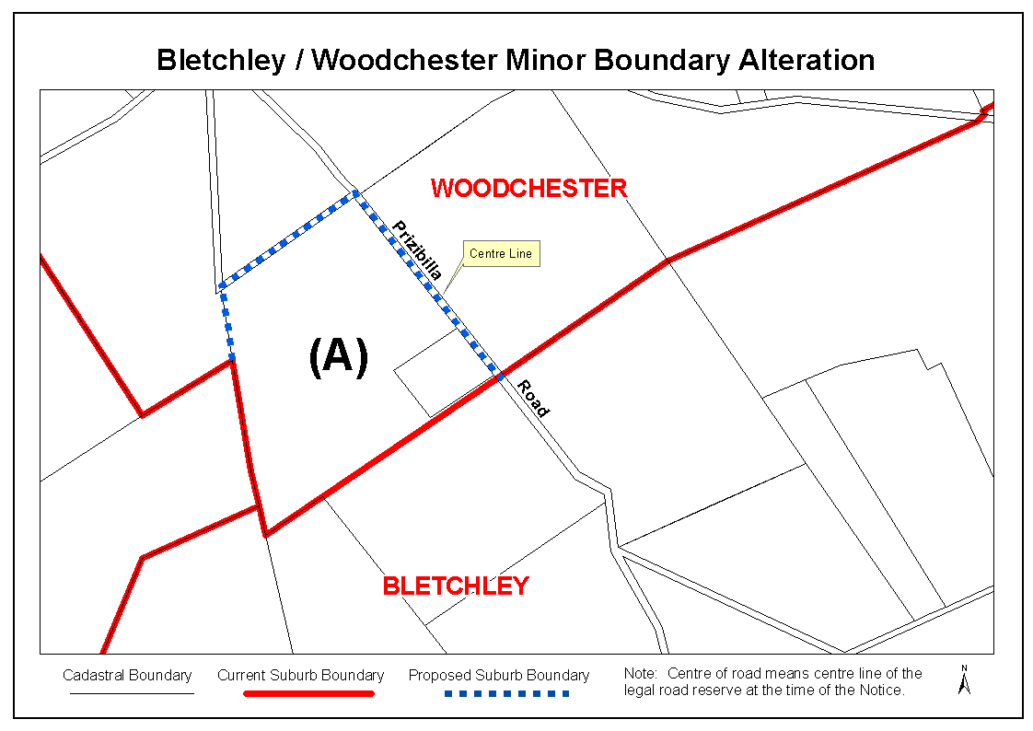
Dated 23 September 2008.
P. S. Smith, Acting Surveyor-General, Department for Transport, Energy and Infrastructure
DTEI.22-413/08/0007

GEOGRAPHICAL NAMES ACT 1991
Corrigendum
Notice of Declaration of Names of Places
IN the Government Gazette of 24 August 2000, page 596, fifth notice appearing, the declared name shown as GERANIUM PLAIN, should have been shown as GERANIUM PLAINS.
Dated 23 September 2008.
P. S. Smith, Acting Surveyor-General, Department for Transport, Energy and Infrastructure
DTEI.22-413/07/0032

GEOGRAPHICAL NAMES ACT 1991
Notice to Discontinue the Use of Declared Names
NOTICE is hereby given pursuant to section 11C of the Geographical Names Act 1991, that the geographical names
of those places set out in The Schedule hereunder shall be rescinded and said places shall now be listed as recorded or historical names. Precise location of the said features can be obtained from the South Australian Government Gazette at www.placenames.sa.gov.au or by contacting the Geographical Names Unit, DAIS on (08) 8204 8539.
The Schedule

Mapsheet | Feature | Docket Reference
1:50 000 Mapsheet 6628-3 (Adelaide) | Parafield Airport (now to be a recorded name) | DAIS.22-413/07/0032
1:50 000 Mapsheet 7029-3 (Loxton) | Shallow Reach  (now to be recorded as an historical name) | DTEI.22-413/08/0022
1:50 000 Mapsheet 7029-3 (Loxton) | Shoal Reach  (now to be recorded as an historical name) | DTEI.22-413/08/0022

Note: Words shown in parentheses are not part of the name.
Certified that the above names have been examined in line with the policies of the Geographical Names Unit, and that they comply with section 11C of the Geographical Names Act 1991.
Dated 23 September 2008.
P. S. Smith, Acting Surveyor-General, Department for Transport, Energy and Infrastructure

GEOGRAPHICAL NAMES ACT 1991
Notice of Declaration of Names of Places
NOTICE is hereby given pursuant to section 11A of the Geographical Names Act 1991, that the names of those places set out in The Schedule hereunder shall be the geographical names of those said places. Precise location of the said features can be obtained from the South Australian Government Gazette at www.placenames.sa.gov.au or by contacting the Geographical Names Unit, DTEI on (08) 8204 8539.
The Schedule

Mapsheet | Feature
1:50 000 Mapsheet 6828-3 (Caurnamont) | New Bowhill Trig
1:50 000 Mapsheet 7029-2 (Yamba) | Kopi Trig
1:50 000 Mapsheet 7029-4 (Renmark) | Coolaltit Bend  Mucklemuck Bend
1:50 000 Mapsheet 6730-2 (Florieton) | Burra Creek Plain
1:50 000 Mapsheet 6729-1 (Mount Mary) | Spring Hut Creek
1:50 000 Mapsheet 6829-1 (Cadell) | Stockyard Plain
1:50 000 Mapsheet 6729-4 (Eudunda) | Foote Creek
1:50 000 Mapsheet 6629-1 (Riverton) | Tothill Creek
1:50 000 Mapsheet 6531-4 (Pirie) | Emu Spring  Ippinitchie Creek  Whites Creek
1:50 000 Mapsheet 6629-4 (Halbury) | Pine Creek  Sheaok Hill  Woolshed Flat Creek

Note: Words shown in parentheses are not part of the name.
Certified that the above names have been examined in line with the policies of the Geographical Names Unit, and that they comply with section 11A of the Geographical Names Act 1991.
Dated 23 September 2008.
P. S. Smith, Acting Surveyor-General, Department for Transport, Energy and Infrastructure
DAIS.22-413/07/0032

HARBORS AND NAVIGATION ACT 1993
Determination of the State Crewing Committee
THE following determination is made by the State Crewing Committee pursuant to part 6, section 45 of the Harbors and Navigation Act 1993, was convened on 13 March 2008, in respect of the Ol’ Mate ‘Hoodlum’.
Patrick Conlon, Minister for Transport
V29396

HARBORS AND NAVIGATION ACT 1993
Determination of the State Crewing Committee in respect of the M.V. Ol’ Mate ‘Hoodlum’
THE following determination is made by the State Crewing Committee pursuant to part 6, section 45 of the Harbors and Navigation Act 1993, in respect of the Ol’ Mate ‘Hoodlum’ whilst operating within Gulf St Vincent which lie towards the shore from a line commencing at Troubridge Point then to Troubridge Shoal lighthouse then through middle spit beacon at Port Vincent to join a line drawn eastwards from the silo at Ardrossan which joins a line drawn northerly from long spit beacon then from long spit beacon to Port Adelaide fairway beacon then to Onkaparinga point:
Minimum Complement
One Person—Master.
Please note: the Master to be the holder of the Marine Engine Driver Grade 3.
Minimum Qualifications of Crew
Master—Certificate of Competency as a Coxswain.
Engineer—Certificate of Competency as a Marine Engine Driver Grade 3.
Please note: the Master to be the holder of the Marine Engine Driver Grade 3.
Capt. W. Ferrao, Presiding Member, State Crewing Committee

HARBORS AND NAVIGATION ACT 1993
Determination of the State Crewing Committee
THE following determination is made by the State Crewing Committee pursuant to part 6, section 45 of the Harbors and Navigation Act 1993, in respect of Champagne.
Patrick Conlon, Minister for Transport
V29077

HARBORS AND NAVIGATION ACT 1993
Determination of the State Crewing Committee in respect of the M.V. ‘Champagne’
THE following determination is made by the State Crewing Committee pursuant to part 6, section 45 of the Harbors and Navigation Act 1993, in respect of the Champagne whilst operating within smooth waters as per Schedule 1 of the Harbors and Navigation Regulations 1994:
Minimum Complement
Two Persons—Master, GP (General Purpose Person).
Please note: the Master or General Purpose Person can be the holder of the Marine Engine Driver Grade 3.
Minimum Qualifications of Crew
Master—Certificate of Competency as a Master Class V.
MED—Marine Engine Driver Grade 3.
GP—General Purpose Person, an able bodied person not less than 16 years of age with not less than three months experience and has successfully completed an approved Occupational Health and Safety at Sea course.
Please note: the Master or General Purpose Person can be the holder of the Marine Engine Driver Grade 3.
Capt. W. Ferrao, Presiding Member, State Crewing Committee

HARBORS AND NAVIGATION ACT 1993
Determination of the State Crewing Committee
THE following determination is made by the State Crewing Committee pursuant to part 6, section 45 of the Harbors and Navigation Act 1993, in respect of the Southern Ranger.
Patrick Conlon, Minister for Transport
V28967

HARBORS AND NAVIGATION ACT 1993
Determination of the State Crewing Committee in respect of the M.V. ‘Southern Ranger’
THE following determination is made by the State Crewing Committee pursuant to part 6, section 45 of the Harbors and Navigation Act 1993, in respect of the Southern Ranger whilst operating within the following limits:
Operational Limits
Limit 1—200 nautical miles of the Coast of South Australia.
Limit 2—100 nautical miles of the Coast of South Australia.
Limit 3—30 nautical miles of the Coast of South Australia.
Minimum Complement
Limit 1—Master, Mate, Engineer, 2nd Engineer and GP.
Limit 2—Master, Mate, Engineer, 2nd Engineer and GP.
Limit 3—Master, Mate, Engineer (1), GP.
Minimum Qualifications of Crew
Limit 1:
Master—Master Class 4 or Master Class 5 with a 200 nautical miles endorsement.
Mate—Master Class 5.
Engineer—Marine Engine Driver Grade 1.
2nd Engineer—Marine Engine Driver Grade 2.
GP (1).
Limit 2:
Master—Master Class 5.
Mate—Master Class 5.
Engineer—Marine Engine Driver Grade 1.
2nd Engineer—Marine Engine Driver Grade 2.
GP (1).
Limit 3:
Master—Master Class 5.
Mate—Master Class 5.
Marine Engine Driver Grade 1 (1).
GP (1).
GP—General Purpose Person, an able bodied person not less than 16 years of age with not less than three months experience and has successfully completed an approved Occupational Health and Safety at Sea course.
Capt. W. Ferrao, Presiding Member, State Crewing Committee

LAND ACQUISITION ACT 1969
(Section 16)
Notice of Acquisition
THE COMMISSIONER OF HIGHWAYS (the ‘Authority’), 33 Warwick Street, Walkerville, S.A. 5081, acquires the following interests in the following land:
Definition of Land Acquired
Comprising the fee simple of that piece of land being part of Lot 12 in Deposited Plan 45615 comprised in certificate of title volume 5353, folio 876 and situated at the corner of Veitch Road and Victoria Road, Osborne.
This notice is given under section 16 of the Land Acquisition Act 1969.
Compensation
A person who has or had an interest in the land that is divested or diminished by the acquisition or the enjoyment of which is adversely affected by the acquisition who does not receive an offer of compensation from the Authority may apply to the Authority for compensation.
Inquiries
Inquiries should be directed to:
Brenton Wilkinson,
P.O. Box 1,
Walkerville, S.A. 5081
Telephone: (08) 8343 2460
Dated 29 September 2008.
The Common Seal of the Commissioner of Highways was hereto affixed by direction of the Commissioner of Highways in the presence of:
A. Hartley, Acting Manager, Property Planning and Management Services, Department for Transport, Energy and Infrastructure

GOVERNMENT GAZETTE ADVERTISEMENT RATES

To apply from 1 July 2008

$  Agents, Ceasing to Act as 41.00  Associations:  Incorporation 20.80  Intention of Incorporation 51.50  Transfer of Properties 51.50  Attorney, Appointment of 41.00  Bailiff’s Sale 51.50  Cemetery Curator Appointed 30.50  Companies:  Alteration to Constitution 41.00  Capital, Increase or Decrease of 51.50  Ceasing to Carry on Business 30.50  Declaration of Dividend 30.50  Incorporation 41.00  Lost Share Certificates:  First Name 30.50  Each Subsequent Name 10.50  Meeting Final 34.25  Meeting Final Regarding Liquidator’s Report on  Conduct of Winding Up (equivalent to ‘Final  Meeting’)  First Name 41.00  Each Subsequent Name 10.50  Notices:  Call 51.50  Change of Name 20.80  Creditors 41.00  Creditors Compromise of Arrangement 41.00  Creditors (extraordinary resolution that ‘the Com-pany be wound up voluntarily and that a liquidator be appointed’) 51.50  Release of Liquidator⎯Application⎯Large Ad. 81.50  ⎯Release Granted 51.50  Receiver and Manager Appointed 47.50  Receiver and Manager Ceasing to Act 41.00  Restored Name 38.50  Petition to Supreme Court for Winding Up 71.50  Summons in Action 61.00  Order of Supreme Court for Winding Up Action 41.00  Register of Interests⎯Section 84 (1) Exempt 92.00  Removal of Office 20.80  Proof of Debts 41.00  Sales of Shares and Forfeiture 41.00  Estates:  Assigned 30.50  Deceased Persons⎯Notice to Creditors, etc. 51.50  Each Subsequent Name 10.50  Deceased Persons⎯Closed Estates 30.50  Each Subsequent Estate 1.35  Probate, Selling of 41.00  Public Trustee, each Estate 10.50 |  | $  Firms:  Ceasing to Carry on Business (each insertion) 27.25  Discontinuance Place of Business 27.25  Land⎯Real Property Act:  Intention to Sell, Notice of 51.50  Lost Certificate of Title Notices 51.50  Cancellation, Notice of (Strata Plan) 51.50  Mortgages:  Caveat Lodgement 20.80  Discharge of 21.80  Foreclosures 20.80  Transfer of 20.80  Sublet 10.50  Leases⎯Application for Transfer (2 insertions) each 10.50  Lost Treasury Receipts (3 insertions) each 30.50  Licensing 61.00  Municipal or District Councils:  Annual Financial Statement⎯Forms 1 and 2 574.00  Electricity Supply⎯Forms 19 and 20 408.00  Default in Payment of Rates:  First Name 81.50  Each Subsequent Name 10.50  Noxious Trade 30.50  Partnership, Dissolution of 30.50  Petitions (small) 20.80  Registered Building Societies (from Registrar-  General) 20.80  Register of Unclaimed Moneys⎯First Name 30.50  Each Subsequent Name 10.50  Registers of Members⎯Three pages and over:  Rate per page (in 8pt) 261.00  Rate per page (in 6pt) 345.00  Sale of Land by Public Auction 52.00  Advertisements 2.90  ¼ page advertisement 122.00  ½ page advertisement 244.00  Full page advertisement 478.00  Advertisements, other than those listed are charged at $2.90 per column line, tabular one-third extra.  Notices by Colleges, Universities, Corporations and District Councils to be charged at $2.90 per line.  Where the notice inserted varies significantly in length from that which is usually published a charge of $2.90 per column line will be applied in lieu of advertisement rates listed.  South Australian Government publications are sold on the condition that they will not be reproduced without prior permission from the Government Printer.
All the above prices include GST

GOVERNMENT GAZETTE NOTICES
ALL private advertisements forwarded for publication in the South Australian Government Gazette must be PAID FOR PRIOR TO INSERTION; and all notices, from whatever source, should be legibly written on one side of the paper only and sent to Government Publishing SA so as to be received no later than 4 p.m. Tuesday preceding the day of publication. Phone 8207 1045 or Fax 8207 1040. E-mail: governmentgazette@dpc.sa.gov.au. Send as attachments in Word format. Please include date the notice is to be published and to whom the notice will be charged. The Government Gazette is available online at: www.governmentgazette.sa.gov.au.

MISCELLANEOUS LEGISLATION AND GOVERNMENT PUBLICATIONS PRICES AS FROM 1 JULY 2008

Acts, Bills, Rules, Parliamentary Papers and Regulations
Pages | Main | Amends | Pages | Main | Amends

1-16 | 2.50 | 1.15 | 497-512 | 34.75 | 33.75
17-32 | 3.35 | 2.10 | 513-528 | 35.75 | 34.50
33-48 | 4.35 | 3.10 | 529-544 | 37.00 | 35.75
49-64 | 5.50 | 4.20 | 545-560 | 38.00 | 37.00
65-80 | 6.45 | 5.35 | 561-576 | 38.75 | 38.00
81-96 | 7.50 | 6.20 | 577-592 | 40.00 | 38.50
97-112 | 8.55 | 7.30 | 593-608 | 41.25 | 39.75
113-128 | 9.55 | 8.40 | 609-624 | 42.00 | 41.00
129-144 | 10.70 | 9.45 | 625-640 | 43.25 | 41.50
145-160 | 11.70 | 10.50 | 641-656 | 44.25 | 43.25
161-176 | 12.80 | 11.50 | 657-672 | 44.75 | 43.75
177-192 | 13.90 | 12.60 | 673-688 | 46.75 | 44.75
193-208 | 15.00 | 13.80 | 689-704 | 47.50 | 45.70
209-224 | 15.80 | 14.60 | 705-720 | 48.25 | 47.00
225-240 | 16.90 | 15.60 | 721-736 | 50.00 | 48.00
241-257 | 18.10 | 16.50 | 737-752 | 50.50 | 49.00
258-272 | 19.10 | 17.60 | 753-768 | 51.50 | 50.00
273-288 | 20.20 | 18.90 | 769-784 | 52.50 | 51.50
289-304 | 21.00 | 19.80 | 785-800 | 53.50 | 52.50
305-320 | 22.30 | 20.90 | 801-816 | 54.50 | 53.00
321-336 | 23.20 | 21.90 | 817-832 | 55.50 | 54.50
337-352 | 24.40 | 23.10 | 833-848 | 56.50 | 55.50
353-368 | 25.25 | 24.20 | 849-864 | 57.50 | 56.00
369-384 | 26.50 | 25.25 | 865-880 | 59.00 | 57.50
385-400 | 27.50 | 26.25 | 881-896 | 59.50 | 58.00
401-416 | 28.50 | 27.00 | 897-912 | 61.00 | 59.50
417-432 | 29.75 | 28.25 | 913-928 | 61.50 | 61.00
433-448 | 30.75 | 29.50 | 929-944 | 62.50 | 61.50
449-464 | 31.50 | 30.25 | 945-960 | 63.50 | 62.00
465-480 | 32.00 | 31.25 | 961-976 | 65.50 | 63.00
481-496 | 33.75 | 32.00 | 977-992 | 66.50 | 63.50

Legislation—Acts, Regulations, etc: $
Subscriptions:
Acts 214.00
All Bills as Laid 514.00
Rules and Regulations 514.00
Parliamentary Papers 514.00
Bound Acts 238.00
Index 119.00
Government Gazette
Copy 5.60
Subscription 284.00
Hansard
Copy 15.60
Subscription—per session (issued weekly) 446.00
Cloth bound—per volume 191.00
Subscription—per session (issued daily) 446.00
Legislation on Disk
Whole Database 3 304.00
Annual Subscription for fortnightly updates 1 015.00
Individual Act(s) including updates POA
Compendium
Subscriptions:
Subscriptions 1 957.00
Updates 690.00
(All the above prices include GST)

All Legislation, Government Gazette, Hansard and Legislation on disk are available from:
Counter Sales Government Legislation⁺ Outlet
and Mail Orders: Service SA Customer Service Centre,
Ground Floor—EDS Centre, 108 North Terrace, Adelaide, S.A. 5000
Phone: 13 23 24 (local call cost), Fax: (08) 8204 1909
Postal: G.P.O. Box 1707, Adelaide, S.A. 5001

Online Shop: www.shop.service.sa.gov.au

Subscriptions and Government Publishing SA
Standing Orders: Box 9, Plaza Level, Riverside Centre, North Terrace, Adelaide, S.A. 5000
Phone: (08) 8207 1043, (08) 8207 0910, Fax: (08) 8207 1040

LIQUOR LICENSING ACT 1997 AND GAMING MACHINES ACT 1992
Notice of Application
NOTICE is hereby given, pursuant to section 52 of the Liquor Licensing Act 1997 and section 29 of the Gaming Machines Act 1992, that Swearse Investments Pty Ltd as trustee for W. C. and M. A. Swearse No. 2 Family Trust has applied to the Licensing Authority for the transfer of a Hotel and Gaming Machine Licence in respect of premises situated at 22 Commercial Road, Burra, S.A. 5417 and known as Commercial Hotel.
The application has been set down for hearing on 5 November 2008 at 10 a.m.
Any person may object to the application by lodging a notice of objection in the prescribed form with the Liquor and Gambling Commissioner and serving a copy of the notice on the applicant at the applicant’s address, at least seven days before the hearing date (viz: 29 October 2008).
The applicant’s address for service is c/o Foreman Legal, 69 Mount Barker Road, Stirling, S.A. 5152.
Plans in respect of the premises the subject of the application are open to public inspection without fee at the Office of the Liquor and Gambling Commissioner, 9th Floor, East Wing, 50 Grenfell Street, Adelaide, S.A. 5000. Phone 8226 8410, Fax:
8226 8512. Email: olgc@agd.sa.gov.au.
Dated 29 September 2008.
Applicant

LIQUOR LICENSING ACT 1997
Notice of Application
NOTICE is hereby given, pursuant to section 52 (2) (b) of the Liquor Licensing Act 1997, that Loxton Community Hotel Motel has applied to the Licensing Authority for a variation to an Extended Trading Authorisation, Redefinition and Alterations in respect of premises situated at 45 East Terrace, Loxton, S.A. 5333 and known as Hotel Loxton.
The application has been set down for hearing on 16 October 2008 at 11 a.m.
Conditions
The following licence conditions are sought:
• Alterations and Redefinition to extend the Beer Garden and create a designated smoking area for the Gaming Room as per plans lodged in this office.
• Variation to Extended Trading Authorisation to include the abovementioned areas.
Any person may object to the application by lodging a notice of objection in the prescribed form with the Liquor and Gambling Commissioner and serving a copy of the notice on the applicant at the applicant’s address, before the hearing date (viz: 15 October 2008).
The applicant’s address for service is c/o Karen Kilsby, P.O. Box 386, Loxton, S.A. 5333.
Plans in respect of the premises the subject of the application are open to public inspection without fee at the Office of the Liquor and Gambling Commissioner, 9th Floor, East Wing, 50 Grenfell Street, Adelaide, S.A. 5000. Phone 8226 8410, Fax:
8226 8512. Email: olgc@agd.sa.gov.au.
Dated 25 September 2008.
Applicant

LIQUOR LICENSING ACT 1997
Notice of Application
NOTICE is hereby given, pursuant to section 52 (2) (b) of the Liquor Licensing Act 1997, that Cinema Investments Pty Ltd has applied to the Licensing Authority for a Special Circumstances Licence in respect of premises situated at 181 O’Connell Street, North Adelaide, S.A. 5006 and to be known as Piccadilly Cinemas.
The application has been set down for callover on 31 October 2008 at 9 a.m.
Conditions
The following licence condition is sought:
• Liquor is only to be sold supplied to persons (other than minors) who have a cinema ticket or voucher for the premises, for consumption ancillary to their attendance at a cineatographic entertainment, or to persons (other than minors) attending a general pre-booked function or reception at the premises.
Any person may object to the application by lodging a notice of objection in the prescribed form with the Liquor and Gambling Commissioner and serving a copy of the notice on the applicant at the applicant’s address, at least seven days before the callover date (viz: 24 October 2008).
The applicant’s address for service is c/o Cinema Investments Pty Ltd, 139 Richmond Road, Richmond, S.A. 5033.
Plans in respect of the premises the subject of the application are open to public inspection without fee at the Office of the Liquor and Gambling Commissioner, 9th Floor, East Wing, 50 Grenfell Street, Adelaide, S.A. 5000. Phone 8226 8410, Fax:
8226 8512. Email: olgc@agd.sa.gov.au.
Dated 24 September 2008.
Applicant

LIQUOR LICENSING ACT 1997
Notice of Application
NOTICE is hereby given, pursuant to section 52 (2) (b) of the Liquor Licensing Act 1997, that Yankalilla Football Club Inc. has applied to the Licensing Authority for a Limited Club Licence and Entertainment Consent in respect of premises situated at Main Road, Yankalilla, S.A. 5203 and to be known as Yankalilla Football Club.
The application has been set down for callover on 31 October 2008 at 9 a.m.
Conditions
The following licence condition is sought:
• Entertainment Consent is sought in the areas shown on the plans lodged with this office.
Any person may object to the application by lodging a notice of objection in the prescribed form with the Liquor and Gambling Commissioner and serving a copy of the notice on the applicant at the applicant’s address, at least seven days before the callover date (viz: 24 October 2008).
The applicant’s address for service is c/o Roger Sweetman, P.O. Box 160, Yankalilla, S.A. 5203.
Plans in respect of the premises the subject of the application are open to public inspection without fee at the Office of the Liquor and Gambling Commissioner, 9th Floor, East Wing, 50 Grenfell Street, Adelaide, S.A. 5000. Phone 8226 8410, Fax:
8226 8512. Email: olgc@agd.sa.gov.au.
Dated 25 September 2008.
Applicant

LIQUOR LICENSING ACT 1997
Notice of Application
NOTICE is hereby given, pursuant to section 52 (2) (b) of the Liquor Licensing Act 1997, that The New Holland Wine Company Pty Ltd has applied to the Licensing Authority for a Wholesale Liquor Merchant’s Licence in respect of premises situated at 26 Greenhill Road, Wayville, S.A. 5034 and to be known as The New Holland Wine Company.
The application has been set down for callover on 31 October 2008 at 9 a.m.
Any person may object to the application by lodging a notice of objection in the prescribed form with the Liquor and Gambling Commissioner and serving a copy of the notice on the applicant at the applicant’s address, at least seven days before the callover date (viz: 24 October 2008).
The applicant’s address for service is c/o The New Holland Wine Company Pty Ltd, 26 Greenhill Road, Wayville, S.A. 5034.
Plans in respect of the premises the subject of the application are open to public inspection without fee at the Office of the Liquor and Gambling Commissioner, 9th Floor, East Wing, 50 Grenfell Street, Adelaide, S.A. 5000. Phone 8226 8410, Fax:
8226 8512. Email: olgc@agd.sa.gov.au.
Dated 25 September 2008.
Applicant

LIQUOR LICENSING ACT 1997
Notice of Application
NOTICE is hereby given, pursuant to section 52 (2) (b) of the Liquor Licensing Act 1997, that Samuel David Valderrama Escobar and Gustavo Eduardo Trujillo Cedeno, 2 Corbin Road, Medindie Gardens, S.A. 5081 have applied to the Licensing Authority for a Direct Sales Licence in respect of the business to be known as IDI Importers Distributors and Investment Group.
The application has been set down for callover on 31 October 2008 at 9 a.m.
Any person may object to the application by lodging a notice of objection in the prescribed form with the Liquor and Gambling Commissioner and serving a copy of the notice on the applicants at the applicants’ address, at least seven days before the callover date (viz: 24 October 2008).
The applicants’ address for service is c/o David Watts and Associates, 1 Cator Street, Glenside, S.A. 5065.
Plans in respect of the premises the subject of the application are open to public inspection without fee at the Office of the Liquor and Gambling Commissioner, 9th Floor, East Wing, 50 Grenfell Street, Adelaide, S.A. 5000. Phone 8226 8410, Fax:
8226 8512. Email: olgc@agd.sa.gov.au.
Dated 25 September 2008.
Applicants

LIQUOR LICENSING ACT 1997
Notice of Application
NOTICE is hereby given, pursuant to section 52 (2) (b) of the Liquor Licensing Act 1997, that World Wine Export Enterprises Pty Ltd has applied to the Licensing Authority for the removal of a Wholesale Liquor Merchant’s Licence in respect of premises situated at Stonyfell Function Centre, Stonyfell Road, Stonyfell, S.A. 5066 and to be situated at 8 Martin Avenue, Maslins Beach, S.A. 5170 and known as World Wine Export Enterprises.
The application has been set down for callover on 31 October 2008 at 9 a.m.
Any person may object to the application by lodging a notice of objection in the prescribed form with the Liquor and Gambling Commissioner and serving a copy of the notice on the applicant at the applicant’s address, at least seven days before the callover date (viz: 24 October 2008).
The applicant’s address for service is c/o David Watts and Associates, 1 Cator Street, Glenside, S.A. 5065.
Plans in respect of the premises the subject of the application are open to public inspection without fee at the Office of the Liquor and Gambling Commissioner, 9th Floor, East Wing, 50 Grenfell Street, Adelaide, S.A. 5000. Phone 8226 8410, Fax:
8226 8512. Email: olgc@agd.sa.gov.au.
Dated 25 September 2008.
Applicant

LIQUOR LICENSING ACT 1997
Notice of Application
NOTICE is hereby given, pursuant to section 52 (2) (b) of the Liquor Licensing Act 1997, that D.I. Cleaning Services Pty Ltd as trustee for the Sherrah Family Trust has applied to the Licensing Authority for a Restaurant Licence in respect of premises situated at 41 Bartel Boulevard, Victor Harbor, S.A. 5211 and to be known as The Boulevard.
The application has been set down for callover on 31 October 2008 at 9 a.m.
Any person may object to the application by lodging a notice of objection in the prescribed form with the Liquor and Gambling Commissioner and serving a copy of the notice on the applicant at the applicant’s address, at least seven days before the callover date (viz: 24 October 2008).
The applicant’s address for service is c/o D.I. Cleaning Services Pty Ltd, P.O. Box 592, Victor Harbor, S.A. 5211.
Plans in respect of the premises the subject of the application are open to public inspection without fee at the Office of the Liquor and Gambling Commissioner, 9th Floor, East Wing, 50 Grenfell Street, Adelaide, S.A. 5000. Phone 8226 8410, Fax:
8226 8512. Email: olgc@agd.sa.gov.au.
Dated 25 September 2008.
Applicant

LIQUOR LICENSING ACT 1997
Notice of Application
NOTICE is hereby given, pursuant to section 52 (2) (b) of the Liquor Licensing Act 1997, that Nievole Distributors Pty Ltd has applied to the Licensing Authority for a Wholesale Liquor Merchant’s Licence in respect of premises situated at 2 Boden Court, Windsor Gardens, S.A. 5087 and to be known as Nievole Distributors Pty Ltd.
The application has been set down for callover on 31 October 2008 at 9 a.m.
Any person may object to the application by lodging a notice of objection in the prescribed form with the Liquor and Gambling Commissioner and serving a copy of the notice on the applicant at the applicant’s address, at least seven days before the callover date (viz: 24 October 2008).
The applicant’s address for service is c/o Wallmans Lawyers, 173 Wakefield Street, Adelaide, S.A. 5000 (Attention: Peter Hoban or Ben Allen).
Plans in respect of the premises the subject of the application are open to public inspection without fee at the Office of the Liquor and Gambling Commissioner, 9th Floor, East Wing, 50 Grenfell Street, Adelaide, S.A. 5000. Phone 8226 8410, Fax:
8226 8512. Email: olgc@agd.sa.gov.au.
Dated 26 September 2008.
Applicant

LIQUOR LICENSING ACT 1997
Notice of Application
NOTICE is hereby given, pursuant to section 52 (2) (b) of the Liquor Licensing Act 1997, that Homewares Direct (SA) Pty Ltd has applied to the Licensing Authority for a Special Circum-stances Licence in respect of premises situated at 91 Unley Road, Parkside, S.A. 5063 and to be known as Homewares Direct.
The application has been set down for callover on 31 October 2008 at 9 a.m.
Conditions
The following licence conditions are sought:
• To sell and supply liquor for consumption on the licensed premises by persons who have enrolled in and are under-taking a bona fide cooking course or class on any day between the hours of noon and midnight.
Any person may object to the application by lodging a notice of objection in the prescribed form with the Liquor and Gambling Commissioner and serving a copy of the notice on the applicant at the applicant’s address, at least seven days before the callover date (viz: 24 October 2008).
The applicant’s address for service is c/o David Watts and Associates, 1 Cator Street, Glenside, S.A. 5065.
Plans in respect of the premises the subject of the application are open to public inspection without fee at the Office of the Liquor and Gambling Commissioner, 9th Floor, East Wing, 50 Grenfell Street, Adelaide, S.A. 5000. Phone 8226 8410, Fax:
8226 8512. Email: olgc@agd.sa.gov.au.
Dated 26 September 2008.
Applicant

LIQUOR LICENSING ACT 1997
Notice of Application
NOTICE is hereby given, pursuant to section 52 (2) (b) of the Liquor Licensing Act 1997, that Mannum Lions Club Inc. has applied to the Licensing Authority for a Limited Club Licence in respect of premises situated at Lot 124, Hundred of Finniss, North Terrace, Mannum, S.A. 5238 and to be known as Mannum Lions Club.
The application has been set down for callover on 31 October 2008 at 9 a.m.
Any person may object to the application by lodging a notice of objection in the prescribed form with the Liquor and Gambling Commissioner and serving a copy of the notice on the applicant at the applicant’s address, at least seven days before the callover date (viz: 24 October 2008).
The applicant’s address for service is c/o David Dowley, P.O. Box 92, Mannum, S.A. 5238.
Plans in respect of the premises the subject of the application are open to public inspection without fee at the Office of the Liquor and Gambling Commissioner, 9th Floor, East Wing, 50 Grenfell Street, Adelaide, S.A. 5000. Phone 8226 8410, Fax:
8226 8512. Email: olgc@agd.sa.gov.au.
Dated 26 September 2008.
Applicant

LIQUOR LICENSING ACT 1997
Notice of Application
NOTICE is hereby given, pursuant to section 52 (2) (b) of the Liquor Licensing Act 1997, that Unicorn Brewery Pty Ltd has applied to the Licensing Authority for a Producer’s Licence in respect of premises situated at Bridge Terrace, Burra, S.A. 5417 and to be known as Unicorn Brewery.
The application has been set down for callover on 31 October 2008 at 9 a.m.
Any person may object to the application by lodging a notice of objection in the prescribed form with the Liquor and Gambling Commissioner and serving a copy of the notice on the applicant at the applicant’s address, at least seven days before the callover date (viz: 24 October 2008).
The applicant’s address for service is c/o Wallmans Lawyers, 173 Wakefield Street, Adelaide, S.A. 5000 (Attention: Ben Allen or Peter Hoban).
Plans in respect of the premises the subject of the application are open to public inspection without fee at the Office of the Liquor and Gambling Commissioner, 9th Floor, East Wing, 50 Grenfell Street, Adelaide, S.A. 5000. Phone 8226 8410, Fax:
8226 8512. Email: olgc@agd.sa.gov.au.
Dated 26 September 2008.
Applicant

LIQUOR LICENSING ACT 1997
Notice of Application
NOTICE is hereby given, pursuant to section 52 (2) (b) of the Liquor Licensing Act 1997, that McBrowns Wines Pty Ltd and Sweeny Wines Pty Ltd have applied to the Licensing Authority for a Wholesale Liquor Merchant’s Licence in respect of premises situated at 6 Pegler Street, Beverley, S.A. 5009 and to be known as Brown and Sweeny Vintners.
The application has been set down for callover on 31 October 2008 at 9 a.m.
Any person may object to the application by lodging a notice of objection in the prescribed form with the Liquor and Gambling Commissioner and serving a copy of the notice on the applicants at the applicants’ address, at least seven days before the callover date (viz: 24 October 2008).
The applicants’ address for service is c/o Andrew Brown, P.O. Box 345, Hindmarsh, S.A. 5007.
Plans in respect of the premises the subject of the application are open to public inspection without fee at the Office of the Liquor and Gambling Commissioner, 9th Floor, East Wing, 50 Grenfell Street, Adelaide, S.A. 5000. Phone 8226 8410, Fax:
8226 8512. Email: olgc@agd.sa.gov.au.
Dated 26 September 2008.
Applicants

LIQUOR LICENSING ACT 1997
Notice of Application
NOTICE is hereby given, pursuant to section 52 (2) (b) of the Liquor Licensing Act 1997, that Huyen Thi Tran has applied to the Licensing Authority for a Restaurant Licence in respect of premises situated at Shop 3, 107 Military Road, Semaphore, S.A. 5019 and to be known as Buddhas Kitchen.
The application has been set down for callover on 31 October 2008 at 9 a.m.
Any person may object to the application by lodging a notice of objection in the prescribed form with the Liquor and Gambling Commissioner and serving a copy of the notice on the applicant at the applicant’s address, at least seven days before the callover date (viz: 24 October 2008).
The applicant’s address for service is c/o Huyen Tran, Shop 3, 107 Military Road, Semaphore, S.A. 5019.
Plans in respect of the premises the subject of the application are open to public inspection without fee at the Office of the Liquor and Gambling Commissioner, 9th Floor, East Wing, 50 Grenfell Street, Adelaide, S.A. 5000. Phone 8226 8410, Fax:
8226 8512. Email: olgc@agd.sa.gov.au.
Dated 26 September 2008.
Applicant

LIQUOR LICENSING ACT 1997
Notice of Application
NOTICE is hereby given, pursuant to section 52 (2) (b) of the Liquor Licensing Act 1997, that Rob Kolencik Catering Pty Ltd has applied to the Licensing Authority for the transfer of a Restaurant Licence and an Extended Trading Authorisation in respect of premises situated at 150 Main Road, McLaren Vale, S.A. 5171 and known as Blessed Cheese.
The application has been set down for callover on 31 October 2008 at 9 a.m.
Conditions
The following licence conditions are sought:
• Extended Trading Authorisation to apply to the following day and times:
Sunday: 8 a.m. to 11 a.m.
Any person may object to the application by lodging a notice of objection in the prescribed form with the Liquor and Gambling Commissioner and serving a copy of the notice on the applicant at the applicant’s address, at least seven days before the callover date (viz: 24 October 2008).
The applicant’s address for service is c/o Wallmans Lawyers, 173 Wakefield Street, Adelaide, S.A. 5000 (Attention: Peter Hoban or Ben Allen).
Plans in respect of the premises the subject of the application are open to public inspection without fee at the Office of the Liquor and Gambling Commissioner, 9th Floor, East Wing, 50 Grenfell Street, Adelaide, S.A. 5000. Phone 8226 8410, Fax:
8226 8512. Email: olgc@agd.sa.gov.au.
Dated 26 September 2008.
Applicant

LIQUOR LICENSING ACT 1997
Notice of Application
NOTICE is hereby given, pursuant to section 52 (2) (b) of the Liquor Licensing Act 1997, that Bluestone Vineyard Pty Ltd as trustee for the Bluestone Vineyard Trust has applied to the Licensing Authority for a Producer’s Licence in respect of premises situated at 339 South Terrace, Adelaide, S.A. 5000 and to be known as Three Eights Wines.
The application has been set down for callover on 31 October 2008 at 9 a.m.
Any person may object to the application by lodging a notice of objection in the prescribed form with the Liquor and Gambling Commissioner and serving a copy of the notice on the applicant at the applicant’s address, at least seven days before the callover date (viz: 24 October 2008).
The applicant’s address for service is c/o Kain Corporate and Commercial Lawyers, 315 Wakefield Street, Adelaide, S.A. 5000 (Attention: Meghan Eyre).
Plans in respect of the premises the subject of the application are open to public inspection without fee at the Office of the Liquor and Gambling Commissioner, 9th Floor, East Wing, 50 Grenfell Street, Adelaide, S.A. 5000. Phone 8226 8410, Fax:
8226 8512. Email: olgc@agd.sa.gov.au.
Dated 29 September 2008.
Applicant

LIQUOR LICENSING ACT 1997
Notice of Application
NOTICE is hereby given, pursuant to section 52 (2) (b) of the Liquor Licensing Act 1997, that Kiet Vo has applied to the Licensing Authority for the transfer of a Restaurant Licence in respect of premises situated at Findon Shopping Centre, 303 Grange Road, Findon, S.A. 5023 and known as Le Creme Cafe & Gourmet.
The application has been set down for hearing on 3 November 2008 at 9.30 a.m.
Any person may object to the application by lodging a notice of objection in the prescribed form with the Liquor and Gambling Commissioner and serving a copy of the notice on the applicant at the applicant’s address, at least seven days before the hearing date (viz: 27 October 2008).
The applicant’s address for service is c/o Kiet Vo, 39 Hooking Terrace, Woodville Gardens, S.A. 5012.
Plans in respect of the premises the subject of the application are open to public inspection without fee at the Office of the Liquor and Gambling Commissioner, 9th Floor, East Wing, 50 Grenfell Street, Adelaide, S.A. 5000. Phone 8226 8410, Fax:
8226 8512. Email: olgc@agd.sa.gov.au.
Dated 23 September 2008.
Applicant

LIQUOR LICENSING ACT 1997
Notice of Application
NOTICE is hereby given, pursuant to section 52 (2) (b) of the Liquor Licensing Act 1997, that Taya Kathryn Renyard has applied to the Licensing Authority for the transfer of a Restaurant Licence in respect of premises situated at 69 Main Street, Woodside, S.A. 5244 and known as Woodside Providore.
The application has been set down for hearing on 3 November 2008 at 10 a.m.
Any person may object to the application by lodging a notice of objection in the prescribed form with the Liquor and Gambling Commissioner and serving a copy of the notice on the applicant at the applicant’s address, at least seven days before the hearing date (viz: 27 October 2008).
The applicant’s address for service is c/o Taya Renyard, 16 Molens Road, Hahndorf, S.A. 5245.
Plans in respect of the premises the subject of the application are open to public inspection without fee at the Office of the Liquor and Gambling Commissioner, 9th Floor, East Wing, 50 Grenfell Street, Adelaide, S.A. 5000. Phone 8226 8410, Fax:
8226 8512. Email: olgc@agd.sa.gov.au.
Dated 23 September 2008.
Applicant

LIQUOR LICENSING ACT 1997
Notice of Application
NOTICE is hereby given, pursuant to section 52 (2) (b) of the Liquor Licensing Act 1997, that ACT Education Group Pty Ltd has applied to the Licensing Authority for the transfer of a Special Circumstances Licence in respect of premises situated at 157 Waymouth Street, Adelaide, S.A. 5000, known as Saso and to be known as India at Light Square.
The application has been set down for hearing on 3 November 2008 at 10.30 a.m.
Any person may object to the application by lodging a notice of objection in the prescribed form with the Liquor and Gambling Commissioner and serving a copy of the notice on the applicant at the applicant’s address, at least seven days before the hearing date (viz: 27 October 2008).
The applicant’s address for service is c/o Georgiadis Lawyers, 3rd Floor, 185 Victoria Square, Adelaide, S.A. 5000 (Attention: Brenton Grant).
Plans in respect of the premises the subject of the application are open to public inspection without fee at the Office of the Liquor and Gambling Commissioner, 9th Floor, East Wing, 50 Grenfell Street, Adelaide, S.A. 5000. Phone 8226 8410, Fax:
8226 8512. Email: olgc@agd.sa.gov.au.
Dated 26 September 2008.
Applicant

LIQUOR LICENSING ACT 1997
Notice of Application
NOTICE is hereby given, pursuant to section 52 (2) (b) of the Liquor Licensing Act 1997, that Fern E’Lise-Elliott has applied to the Licensing Authority for the transfer of a Restaurant Licence in respect of premises situated at Lots 677 and 678, Mason Street, Wellington, S.A. 5259 and known as Wellington Courthouse.
The application has been set down for hearing on 5 November 2008 at 9 a.m.
Any person may object to the application by lodging a notice of objection in the prescribed form with the Liquor and Gambling Commissioner and serving a copy of the notice on the applicant at the applicant’s address, at least seven days before the hearing date (viz: 29 October 2008).
The applicant’s address for service is c/o Fern E’Lise-Elliott, Lots 677 and 678, Mason Street, Wellington, S.A. 5259.
Plans in respect of the premises the subject of the application are open to public inspection without fee at the Office of the Liquor and Gambling Commissioner, 9th Floor, East Wing, 50 Grenfell Street, Adelaide, S.A. 5000. Phone 8226 8410, Fax:
8226 8512. Email: olgc@agd.sa.gov.au.
Dated 24 September 2008.
Applicant

LIQUOR LICENSING ACT 1997
Notice of Application
NOTICE is hereby given, pursuant to section 52 (2) (b) of the Liquor Licensing Act 1997, that Teresa Mary Cruttenden has applied to the Licensing Authority for the transfer of a Restaurant Licence in respect of premises situated at 206-208 Port Road, Aldinga, S.A. 5173, known as Harts and to be known as Shivers.
The application has been set down for hearing on 5 November 2008 at 11 a.m.
Any person may object to the application by lodging a notice of objection in the prescribed form with the Liquor and Gambling Commissioner and serving a copy of the notice on the applicant at the applicant’s address, at least seven days before the hearing date (viz: 29 October 2008).
The applicant’s address for service is c/o Teresa Cruttendan, 2 Hunt Street, Port Willunga, S.A. 5173.
Plans in respect of the premises the subject of the application are open to public inspection without fee at the Office of the Liquor and Gambling Commissioner, 9th Floor, East Wing, 50 Grenfell Street, Adelaide, S.A. 5000. Phone 8226 8410, Fax:
8226 8512. Email: olgc@agd.sa.gov.au.
Dated 26 September 2008.
Applicant

LIVESTOCK ACT 1997
Sections 37 and 40
Instrument of Delegation
I, RORY McEWEN, Minister for Agriculture, Food and Fisheries, do hereby delegate, pursuant to section 66 of the Livestock Act 1997 (the Act), the powers specified in sections 37 and 40 of the Act, for the purpose of assisting in the implementation of closures in marine waters under section 79 of the Fisheries Management Act 2007, to the Director of Fisheries, who is also a person appointed as a Deputy Chief Inspector under the Act.
Any or all of the powers delegated by this instrument remain exercisable by me and are revocable at any time by written instrument.
The exercise of the powers delegated by this instrument may be subject to my direction from time to time.
Dated 24 September 2008.
Rory McEwen, Minister for Agriculture, Food and Fisheries

MINING ACT 1971
NOTICE is hereby given in accordance with section 28 (5) of the Mining Act 1971, that the Minister for Mineral Resources Development proposes to grant an Exploration Licence over the undermentioned area:
Applicant: Quasar Resources Pty Ltd
Location: Tanners Dam area⎯Approximately 160 km north-east of Streaky Bay.
Pastoral Lease: Koweridda, Moonaree and Yardea Stations.
Term: 1 year
Area in km²: 238
Ref.: 2008/00120
Plan and co-ordinates can be found on the PIRSA Sarig website: http://www.minerals.pir.sa.gov.au/sarig or by phoning Mineral Tenements on (08) 8463 3103.
H. Thomas, Mining Registrar

MINING ACT 1971
NOTICE is hereby given in accordance with section 28 (5) of the Mining Act 1971, that the Minister for Mineral Resources Development proposes to grant an Exploration Licence over the undermentioned area:
Applicant: Quasar Resources Pty Ltd
Location: Garford area⎯Approximately 160 km south-west of Coober Pedy.
Pastoral Lease: Mobella Station.
Term: 1 year
Area in km²: 286
Ref.: 2008/00230
Plan and co-ordinates can be found on the PIRSA Sarig website: http://www.minerals.pir.sa.gov.au/sarig or by phoning Mineral Tenements on (08) 8463 3103.
H. Thomas, Mining Registrar

MINING ACT 1971
NOTICE is hereby given in accordance with section 28 (5) of the Mining Act 1971, that the Minister for Mineral Resources Development proposes to grant an Exploration Licence over the undermentioned area:
Applicant: Pirie Resources Pty Ltd
Location: Pinda area⎯Approximately 35 km east of Port Augusta.
Term: 1 year
Area in km²: 367
Ref.: 2008/00115
Plan and co-ordinates can be found on the PIRSA Sarig website: http://www.minerals.pir.sa.gov.au/sarig or by phoning Mineral Tenements on (08) 8463 3103.
H. Thomas, Mining Registrar

MINING ACT 1971
NOTICE is hereby given in accordance with section 28 (5) of the Mining Act 1971, that the Minister for Mineral Resources Development proposes to grant an Exploration Licence over the undermentioned area:
Applicant: Pirie Resources Pty Ltd
Location: Baroota area⎯Approximately 60 km south-east of Port Augusta.
Term: 1 year
Area in km²: 335
Ref.: 2008/00114
Plan and co-ordinates can be found on the PIRSA Sarig website: http://www.minerals.pir.sa.gov.au/sarig or by phoning Mineral Tenements on (08) 8463 3103.
H. Thomas, Mining Registrar

MINING ACT 1971
NOTICE is hereby given in accordance with section 28 (5) of the Mining Act 1971, that the Minister for Mineral Resources Development proposes to grant an Exploration Licence over the undermentioned area:
Applicant: Millridge Holdings Pty Ltd
Location: Mistaken Hill area⎯Approximately 70 km north-east of Leigh Creek.
Pastoral Lease: Mount Lyndhurst Station.
Term: 1 year
Area in km²: 291
Ref.: 2008/00094
Plan and co-ordinates can be found on the PIRSA Sarig website: http://www.minerals.pir.sa.gov.au/sarig or by phoning Mineral Tenements on (08) 8463 3103.
H. Thomas, Mining Registrar

MINING ACT 1971
NOTICE is hereby given in accordance with section 28 (5) of the Mining Act 1971, that the Minister for Mineral Resources Development proposes to grant an Exploration Licence over the undermentioned area:
Applicant: Millridge Holdings Pty Ltd
Location: Balcanoona area⎯Approximately 70 km east-south-east of Leigh Creek.
Term: 1 year
Area in km²: 482
Ref.: 2008/00096
Plan and co-ordinates can be found on the PIRSA Sarig website: http://www.minerals.pir.sa.gov.au/sarig or by phoning Mineral Tenements on (08) 8463 3103.
H. Thomas, Mining Registrar

MINING ACT 1971
NOTICE is hereby given in accordance with section 28 (5) of the Mining Act 1971, that the Minister for Mineral Resources Development proposes to grant an Exploration Licence over the undermentioned area:
Applicant: Millridge Holdings Pty Ltd
Location: Castle Rock area⎯Approximately 35 km east-south-east of Leigh Creek.
Pastoral Lease: Puttapa, North Moolooloo, Warraweena, Manners Well, Angepena, Mount Serle and Burr Well Stations.
Term: 1 year
Area in km²: 449
Ref.: 2008/00131
Plan and co-ordinates can be found on the PIRSA Sarig website: http://www.minerals.pir.sa.gov.au/sarig or by phoning Mineral Tenements on (08) 8463 3103.
H. Thomas, Mining Registrar

DEVELOPMENT ACT 1993, SECTION 25 (17): CITY OF WEST TORRENS LOCAL HERITAGE DEVELOPMENT PLAN AMENDMENT
Preamble
1. The Development Plan amendment entitled ‘City of West Torrens—Local Heritage Development Plan Amendment’ (the Plan Amendment) has been finalised in accordance with the provisions of the Development Act 1993.
2. The Minister for Urban Development and Planning has decided to approve the Plan Amendment.
Notice
PURSUANT to section 25 of the Development Act 1993, I—
(a) approve the Plan Amendment; and
(b) fix the day on which this notice is published in the Gazette as the day on which the Plan Amendment will come into operation.
Dated 1 October 2008.
Paul Holloway, Minister for Urban Development and Planning

NATIONAL ELECTRICITY LAW
THE Australian Energy Market Commission (AEMC) gives notice under the National Electricity Law of the following matters.
Under section 107, the period of time for the making of the draft determination on the proposed National Electricity Amendment (Futures Offset Arrangements) Rule 2008 has been extended to 11 December 2008.
Under sections 102 and 103, the making of the National Electricity Amendment (Reclassification of Contingency Events) Rule 2008 No. 8 and corresponding final determination. All provisions commence on 23 October 2008.
Under section 95, NEMMCO has requested the making of the proposed National Electricity Amendment (Registration Changes for Traders, Reallocators and Transfer of Registration) Rule 2008 (Project No. ERC0071). The proposal seeks to provide for eligibility requirements for Traders and Reallocators and the transfer of registered facilities to another party. The AEMC intends to expedite the making of the proposed Rule under section 96 on the grounds that the proposed Rule is non-controversial, subject to the receipt of written objections.
In relation to the proposal:
• written objections must be received by 17 October 2008;
• submissions must be received by 31 October 2008; and
• written objections and submissions may be forwarded to submissions@aemc.gov.au and must cite the Project No. in its title.
Submissions should be submitted in accordance with the AEMC’s Guidelines for making written submissions on Rule change proposals. The AEMC publishes all submissions on its website subject to a claim of confidentiality.
Further details on the above matters are available on the AEMC’s website www.aemc.gov.au. All documents in relation to the above matters are published on the AEMC’s website and are available for inspection at the offices of the AEMC.
John Tamblyn
Chairman
Australian Energy Market Commission
Level 5, 201 Elizabeth Street
Sydney, N.S.W. 2000
Telephone: (02) 8296 7800
Facsimile: (02) 8296 7899
2 October 2008.

NATIONAL PARKS AND WILDLIFE (NATIONAL PARKS) REGULATIONS 2001
Re-opening of Coorong National Park
PURSUANT to Regulations 8 (3) (a), 8 (3) (d) and 11 (1) of the National Parks and Wildlife (National Parks) Regulations 2001, I, Edward Gregory Leaman, Director of National Parks and Wildlife, advise that the current closure to vehicular traffic, of part of the Coorong National Park which commenced at 9 a.m. on Friday, 11 July 2008 will end at 11.59 p.m. on Thursday, 2 October 2008.
The closure applies to the whole of the Younghusband Peninsula north of a line traversing the Peninsula from east to west commencing 3 km north of 42 Mile Crossing.
Effective from midnight Friday, 3 October 2008 at Ocean Beach on the Younghusband Peninsula 3 km north of 42 Mile Crossing to its most northern tip at the mouth of the Murray River (latitude 35°33′21.95″S, longitude 138°52′53.34″E) will be re-opened to vehicles.
The purpose of the closure was in the interest of public safety following severe erosion within this part of the reserve due to weather events.
Dated 30 September 2008.
E. G. Leaman, Director of National Parks and Wildlife

PETROLEUM ACT 2000
Surrender of Associated Facilities Licences—AFLs 56, 57, 58, 59, 60, 61, 62, 63, 64, 65, 66, 67, 68 and 69
(Adjunct to Petroleum Production Licence—PPL 20)
NOTICE is hereby given that I have accepted surrender of the abovementioned Associated Facilities Licences with effect from 31 December 2007, under the provisions of the Petroleum Act 2000, pursuant to delegated powers dated 28 March 2002, Gazetted 11 April 2002, page 1573. The description of areas which have been surrendered are as published in Government Gazette No. 61 dated 19 October 2006, pages 3737 and 3738.
Dated 24 September 2008.
E. M. Alexander, Acting Director
Petroleum and Geothermal
Minerals and Energy Resources
Primary Industries and Resources SA
Delegate of the Minister for Mineral
Resources Development

PETROLEUM ACT 2000
Grant of Associated Facilities Licences—AFLs 129, 130, 131, 132, 133, 134, 135, 136, 137, 138 and 139
(Adjunct to Petroleum Production Licence—PPL 122)
NOTICE is hereby given that with effect from 23 September 2008, the undermentioned Associated Facilities Licences have been granted to Santos Limited, Vamgas Pty Ltd, Delhi Petroleum Pty Ltd, Origin Energy Resources Ltd and Santos (NARNL Cooper) Pty Ltd under the provisions of the Petroleum Act 2000, pursuant to delegated powers dated 28 March 2002, Gazetted 11 April 2002, page 1573.
Description of Areas
AFL 129
All that part of the State of South Australia, bounded as follows:
Commencing at a point being the intersection of latitude 27°33′30″S GDA94 and longitude 140°18′50″E AGD66, thence east to longitude 140°20′30″E GDA94, south to latitude 27°34′10″S AGD66, west to longitude 140°20′00″E AGD66, south to latitude 27°34′20″S AGD66, west to longitude 140°19′40″E AGD66, south to latitude 27°34′30″S AGD66, west to longitude 140°19′20″E AGD66, south to latitude 27°34′30″S GDA94, west to longitude 140°18′10″E AGD66, north to latitude 27°34′30″S AGD66, east to longitude 140°18′20″E AGD66, north to latitude 27°34′20″S AGD66, east to longitude 140°18′30″E AGD66, north to latitude 27°34′10″S AGD66, east to longitude 140°18′40″E AGD66, north to latitude 27°33′50″S AGD66, east to longitude 140°18′50″E AGD66 and north to the point of commencement.
Area: 4.71 km² approximately.
AFL 130
All that part of the State of South Australia, bounded as follows:
Commencing at a point being the intersection of latitude 27°34′30″S GDA94 and longitude 140°18′10″E AGD66, thence east to longitude 140°19′20″E AGD66, south to latitude 27°35′15″S AGD66, east to longitude 140°19′25″E AGD66, south to latitude 27°35′25″S AGD66, east to longitude 140°19′35″E AGD66, south to latitude 27°35′40″S AGD66, east to longitude 140°20′30″E GDA94, south to latitude 27°36′00″S GDA94, west to longitude 140°19′00″E GDA94, north to latitude 27°35′00″S GDA94, west to longitude 140°18′00″E GDA94, north to latitude 27°34′50″S AGD66, east to longitude 140°18′10″E AGD66 and north to the point of commencement.
Area: 4.84 km² approximately.
AFL 131
All that part of the State of South Australia, bounded as follows:
Commencing at a point being the intersection of latitude 27°34′50″S AGD66 and longitude 140°17′30″E GDA94, thence east to longitude 140°18′00″E GDA94, south to latitude 27°35′00″S GDA94, east to longitude 140°19′00″E GDA94, south to latitude 27°36′00″S GDA94, west to longitude 140°17′30″E GDA94 and north to the point of commencement.
Area: 4.95 km² approximately.
AFL 132
All that part of the State of South Australia, bounded as follows:
Commencing at a point being the intersection of latitude 27°34′30″S GDA94 and longitude 140°16′30″E GDA94, thence east to longitude 140°17′20″E AGD66, south to latitude 27°34′50″S AGD66, east to longitude 140°17′30″E GDA94, south to latitude 27°36′00″S GDA94, west to longitude 140°16′30″E GDA94 and north to the point of commencement.
Area: 4.49 km² approximately.
AFL 133
All that part of the State of South Australia, bounded as follows:
Commencing at a point being the intersection of latitude 27°34′00″S GDA94 and longitude 140°16′00″E GDA94, thence east to longitude 140°17′20″E AGD66, south to latitude 27°34′30″S GDA94, west to longitude 140°16′30″E GDA94, south to latitude 27°36′00″S GDA94, west to longitude 140°16′00″E GDA94 and north to the point of commencement.
Area: 4.42 km² approximately.
AFL 134
All that part of the State of South Australia, bounded as follows:
Commencing at a point being the intersection of latitude 27°33′00″S GDA94 and longitude 140°16′00″E GDA94, thence east to longitude 140°17′50″E AGD66, south to latitude 27°33′10″S AGD66, west to longitude 140°17′40″E AGD66, south to latitude 27°33′30″S AGD66, west to longitude 140°17′30″E AGD66, south to latitude 27°33′40″S AGD66, west to longitude 140°17′20″E AGD66, south to latitude 27°34′00″S GDA94, west to longitude 140°16′00″E GDA94 and north to the point of commencement.
Area: 4.82 km² approximately.
AFL 135
All that part of the State of South Australia, bounded as follows:
Commencing at a point being the intersection of latitude 27°31′30″S GDA94 and longitude 140°16′00″E GDA94, thence east to longitude 140°17′00″E GDA94, south to latitude 27°33′00″S GDA94, west to longitude 140°16′00″E GDA94 and north to the point of commencement.
Area: 4.56 km² approximately.
AFL 136
All that part of the State of South Australia, bounded as follows:
Commencing at a point being the intersection of latitude 27°31′30″S GDA94 and longitude 140°17′00″E GDA94, thence east to longitude 140°18′00″E GDA94, south to latitude 27°33′00″S AGD66, west to longitude 140°17′50″E AGD66, south to latitude 27°33′00″S GDA94, west to longitude 140°17′00″E GDA94 and north to the point of commencement.
Area: 4.53 km² approximately.
AFL 137
All that part of the State of South Australia, bounded as follows:
Commencing at a point being the intersection of latitude 27°31′30″S GDA94 and longitude 140°18′00″E GDA94, thence east to longitude 140°19′00″E GDA94, south to latitude 27°33′00″S GDA94, west to longitude 140°18′40″E AGD66, north to latitude 27°33′00″S AGD66, west to longitude 140°18′00″E GDA94 and north to the point of commencement.
Area: 4.35 km² approximately.
AFL 138
All that part of the State of South Australia, bounded as follows:
Commencing at a point being the intersection of latitude 27°31′30″S GDA94 and longitude 140°19′00″E GDA94, thence east to longitude 140°20′30″E GDA94, south to latitude 27°32′30″S GDA94, west to longitude 140°19′00″E GDA94 and north to the point of commencement.
Area: 4.56 km² approximately.
AFL 139
All that part of the State of South Australia, bounded as follows:
Commencing at a point being the intersection of latitude 27°32′30″S GDA94 and longitude 140°19′00″E GDA94, thence east to longitude 140°20′30″E GDA94, south to latitude 27°33′30″S GDA94, west to longitude 140°18′50″E AGD66, north to latitude 27°33′10″S AGD66, west to longitude 140°18′40″E AGD66, north to latitude 27°33′00″S GDA94, east to longitude 140°19′00″E GDA94 and north to the point of commencement.
Area: 4.74 km² approximately.
Dated 23 September 2008.
B. A. Goldstein, Director Petroleum and Geothermal
Minerals and Energy Resources
Primary Industries and Resources SA
Delegate of the Minister for Mineral Resources Development

RAIL SAFETY ACT 2007
Notice of Appointment of Authorised Officer
I, PHILLIP THOMAS ALLAN, Rail Safety Regulator in the State of South Australia, pursuant to my powers under section 22 of the Rail Safety Act 2007 (‘the Act’) hereby appoint the persons referred to in the Schedule to be Authorised Officers for the purposes of the Act subject to the following conditions:
1. The appointment of persons referred to in the Schedule as Authorised Officers pursuant to this notice shall be auto-matically revoked without the necessity for a further notice in the event that the persons cease to hold a position in the Rail Safety Section (RSS) or any succeeding section or unit performing similar functions to the RSS.
2. This appointment may be revoked or varied by me at any time by further notice in writing.
Schedule
Derek Heneker
Phillip N. Scottney-Turbill
Philip Burrows
Susan Swincer
Wayne Robertson
Nicholas Doncaster
Benjamin Hannant
Kym Smith
Dated 29 September 2008.
P. T. Allan, Rail Safety Regulator

SOUTH AUSTRALIA FIRE AND EMERGENCY SERVICES
ACT 2005
Constitution of Brigade
NOTICE is hereby given pursuant to Division 5, section 68 (1) (a) of the South Australia Fire and Emergency Services Act 2005, that the Chief Officer, constitutes the Ernabella (Pukatja) CFS Brigade, effective 29 August 2008.
Dated 29 September 2008.
E. Ferguson, Chief Officer

WATER MAINS AND SEWERS

Office of the South Australian Water Corporation
Adelaide, 2 October 2008

WATER MAINS LAID

Notice is hereby given that the following main pipes or parts of main pipes have been laid down by the South Australian Water Corporation in or near the undermentioned water districts and are now available for a constant supply of water to adjacent land.

ADELAIDE WATER DISTRICT

TOWN OF GAWLER
Drury Street, Willaston. p113

CITY OF MITCHAM
Across Blythewood Road, Mitcham. p120
Neweys Road, Mitcham. p120
Panorama Drive, Panorama. p124

DISTRICT COUNCIL OF MOUNT BARKER
Across Gawler Street, Mount Barker. p12
Easements in lot 505 in LTRO FP 9987, Gawler Street, Mount Barker. p12
Across Dutton Road, Mount Barker. p12
Railway Place, Mount Barker. p12

CITY OF ONKAPARINGA
Hollitt Road, Clarendon. p111
Overland Terrace, Christies Beach. p114

CITY OF PLAYFORD
Lyndon Road, MacDonald Park. p93
Thyer Road, MacDonald Park. p112

CITY OF PORT ADELAIDE ENFIELD
Hamley Street, Peterhead. p1
Bluebell Road, Windsor Gardens. p108
Bluebell Road, Windsor Gardens. p117

CITY OF SALISBURY
Hawker Road, Burton. p91
Russell Row, Paralowie. p105
Rhyne Avenue, Salisbury. p106
Across Balmoral Road, Salisbury East. p107
Leeds Street, Salisbury East. p107

CITY OF TEA TREE GULLY
Lamb Street, Tea Tree Gully. p109

TOWNSHIP OF CLARE WATER DISTRICT

CLARE AND GILBERT VALLEYS COUNCIL
Archer Street, Clare. p122
Powell Place, Clare. p122

CRYSTAL BROOK WATER DISTRICT

PORT PIRIE REGIONAL COUNCIL
In and across Stanley Street, Crystal Brook. p94
Little Street, Crystal Brook. p94
Manfred Street, Crystal Brook. p110

EDEN VALLEY WATER DISTRICT

THE BAROSSA COUNCIL
Across Rushlea Road, Eden Valley. p92
Rogaschs Road, Eden Valley. p92
KIMBA WATER DISTRICT

DISTRICT COUNCIL OF KIMBA
Tola Road, Kimba. This main is available on application only. p70
Seal Road, Kimba. This main is available on application only. p70
Across Haskett Road, Kimba. This main is available on application only. p70
Easement in reserve (section 224, hundred of Solomon), Haskett Road, Kimba. This main is available on application only. p70
and 71
Across Buckleboo Road, Kimba. This main is available on application only. p71
In and across Cant Road, Kimba. This main is available on application only. p71
Across and in Cant Road, Kimba. This main is available on application only. p84 and 85
Freeth Road, Kimba. This main is available on application only. p85-87
Across Eyre Highway, Kimba. This main is available on application only. p87

MILLICENT WATER DISTRICT

WATTLE RANGE COUNCIL
Battye Street, Millicent. p119

MOUNT GAMBIER WATER DISTRICT

CITY OF MOUNT GAMBIER
Jubilee Highway, Mount Gambier and Suttontown. p123

PENOLA WATER DISTRICT

WATTLE RANGE COUNCIL
Petticoat Lane, Penola. p115

PORT ELLIOT WATER DISTRICT

ALEXANDRINA COUNCIL
Hill Street, Port Elliot. p116

STRATHALBYN WATER DISTRICT

ALEXANDRINA COUNCIL
Donnithorne Road, Willyaroo. p118
Blacker Road, Willyaroo. p118

TOD RIVER COUNTRY LANDS WATER DISTRICT

DISTRICT COUNCIL OF KIMBA
Eyre Highway, Moseley, Kelly and Kimba. This main is available on application only. p61-69
Tola Road, Kimba. This main is available on application only. p69 and 70

WARREN COUNTRY LANDS WATER DISTRICT

LIGHT REGIONAL COUNCIL
In and across Boundary Road, Greenock. p2-4
Moppa Springs Road, Greenock. p2-4
Nitschke Road, Greenock. p2-4
Boundary Road, Greenock. p2-5
Government road north-east of section 210, hundred of Nuriootpa, lot 3 in LTRO FP 712, section 217, hundred of Nuriootpa, and lot 747 in LTRO FP 173838, Greenock and Nuriootpa. p2, 3, and
5-10
Across Old Sturt Highway, Daveyston. p121
Mattschoss Road, Daveyston. p121

WATER MAINS ABANDONED

Notice is hereby given that the undermentioned water mains have been abandoned by the South Australian Water Corporation.

ADELAIDE WATER DISTRICT

CITY OF MITCHAM
Neweys Road, Mitcham. p120

TOWNSHIP OF CLARE WATER DISTRICT

CLARE AND GILBERT VALLEYS COUNCIL
Archer Street, Clare. p122

CRYSTAL BROOK WATER DISTRICT

PORT PIRIE REGIONAL COUNCIL
Stanley Street, Crystal Brook. p94

WARREN COUNTRY LANDS WATER DISTRICT

LIGHT REGIONAL COUNCIL
Boundary Road, Greenock. p4 and 5
Moppa Springs Road, Greenock. p4
Nitschke Road, Greenock. p4
Government road north-east of section 210, hundred of Nuriootpa, lot 3 in LTRO FP 712, section 217, hundred of Nuriootpa, and lot 747 in LTRO FP 173838, Greenock and Nuriootpa. p2, 3, and
5-10

WATER MAINS LAID

Notice is hereby given that the undermentioned water mains have been laid down by the South Australian Water Corporation and are not available for a constant supply of water to adjacent land.

KIMBA WATER DISTRICT

DISTRICT COUNCIL OF KIMBA
Waterworks land (section 194, hundred of Solomon), Roora Road, Kimba. p71, 72 and 78-84

OUTSIDE WATER DISTRICTS

OUTSIDE DISTRICT COUNCILS
Waterworks land (section 14, out of hundreds (Port Augusta)), Iron Knob. p15 and 16
Easements in lots 102 and allotment piece 103 in LTRO DP 71557, Eyre Highway, Iron Knob. p15 and 17
Waterworks land (lot 100 in LTRO DP 71557), Eyre Highway, Iron Knob. p15 and 17-19
Across and in Eyre Highway, Iron Knob. p20
Eyre Highway, out of hundreds (Port Augusta). p20-47
Eyre Highway, hundred of Oconnor. p48-61

SEWERS LAID

Notice is hereby given that the following sewers have been laid down by the South Australian Water Corporation in the undermentioned drainage areas and are now available for house connections.

ADELAIDE DRAINAGE AREA

CAMPBELLTOWN CITY COUNCIL
Hill Street, Campbelltown. FB 1177 p24
Stock Avenue, Campbelltown. FB 1177 p25

CITY OF CHARLES STURT
Easement in lot 25 in LTRO DP 6010, and lot 242 in LTRO DP 55834, Fletcher Road, Henley Beach South. FB 1177 p27
Shackleton Place, Flinders Park. FB 1177 p39

CITY OF HOLDFAST BAY
Easement in lot 22 in LTRO DP 58345, South Esplanade, Glenelg South. FB 1177 p36

CITY OF MARION
Hazelmere Road, Glengowrie. FB 1177 p19

CITY OF MITCHAM
Panorama Drive, Panorama. FB 1177 p40

CITY OF NORWOOD PAYNEHAM & ST PETERS
John Street, Firle. FB 1177 p18

CITY OF ONKAPARINGA
Taylors Road, Aberfoyle Park. FB 1177 p22
Hilton Street, Christies Beach. FB 1177 p26
Dodd Avenue, Port Noarlunga. FB 1177 p30
Easement in lot 71 in LTRO DP 30353, and lot 1 in LTRO DP 77642, Tamarind Walk, Aberfoyle Park. FB 1177 p33
Arthur Street, Darlington. FB 1177 p35
Chynoweth Avenue, Hackham. FB 1177 p37

CITY OF PORT ADELAIDE ENFIELD
Hamley Street, Peterhead. FB 1177 p20
Down Drive, Valley View. FB 1177 p21
Bluebell Road, Windsor Gardens. FB 1177 p38

CITY OF SALISBURY
Janet Street, Para Vista. FB 1177 p28
Russell Row, Paralowie. FB 1177 p29
Rhyne Avenue, Salisbury. FB 1177 p31
Leeds Street, Salisbury East. FB 1177 p32

ALDINGA DRAINAGE AREA

CITY OF ONKAPARINGA
Kitto Crescent, Aldinga Beach. FB 1177 p23

BALHANNAH COUNTRY DRAINAGE AREA

ADELAIDE HILLS COUNCIL
Easement in lot 11 in LTRO DP 3744, and lot 101 in LTRO DP 78101, Junction Road, Balhannah. FB 1177 p34

MILLICENT COUNTRY DRAINAGE AREA

WATTLE RANGE COUNCIL
In and across Fensom Crescent, Millicent. FB 1163 p48
Easements in lot 350 in LTRO DP 42881, Sutherland Road, Millicent. FB 1163 p48

A. Howe, Chief Executive Officer, South Australian Water Corporation.

WATERWORKS ACT 1932
Restrictions on the Use of Water from the River Murray and Myponga Reservoir
PURSUANT to section 33A of the Waterworks Act 1932, the South Australian Water Corporation (SA Water) with the approval of the Minister for Water Security with effect from midnight on 4 October 2008 revokes the notice of Level 3 water restrictions imposed by notice dated 1 April 2008 (published in the Government Gazette on 3 April 2008) and, further pursuant to section 33A of the Waterworks Act 1932, SA Water with the approval of the Minister for Water Security with effect from 5 October 2008, until further notice hereby prohibits, restricts and regulates the purposes for which water supplied to properties by SA Water may be used, the manner in which water may be used, and the means by which water may be used, and the times at which water may be used as set out in the Schedule within the following Water Districts (‘WD’) and Country Lands Water Districts (‘CLWD’): Adelaide WD, Alford WD, Angaston WD, Appila WD, Ardrossan WD, Arthurton WD, Balaklava WD, Barmera WD, Barossa CLWD, Beetaloo CLWD, Berri WD, Birdwood WD, Blanchetown WD, Blyth WD, Booborowie WD, Booleroo Centre WD, Bowmans WD, Brinkley CLWD, Brinkworth WD, Bundaleer CLWD, Burdett CLWD, Burra WD, Bute WD, Cadell WD, Callington WD, Caltowie WD, Cambrai WD, Clayton WD, Clinton WD, Cobdogla WD, Coobowie WD, Cooltong WD, Coonalpyn Downs CLWD, Coonalpyn WD, Crystal Brook WD, Cudlee Creek WD, Curramulka WD, Dublin WD, Eden Valley WD, Edithburgh WD, Encounter Bay CLWD, Eudunda WD, Farrell Flat WD, Georgetown WD, Gladstone WD, Glossop WD, Goolwa WD, Greenock WD, Gulnare WD, Gumeracha WD, Halbury WD, Hamley Bridge WD, Hampden WD, Hoyleton WD, Iron Knob CLWD, Jamestown CLWD, Jervois WD, Jutland CLWD, Kadina WD, Kanmantoo CLWD, Kanmantoo WD, Kapunda WD, Karoonda WD, Keith WD, Kersbrook WD, Kingston-on-Murray WD, Koolunga WD, Laura WD, Loxton CLWD, Lyndoch WD, Maitland WD, Mallala WD, Mannum WD, Mannum-Adelaide CLWD, Marrabel WD, Meningie WD, Middleton WD, Milang WD, Minlaton WD, Moculta WD, Monash WD, Monteith WD, Moonta Mines WD, Moonta WD, Moorook CLWD, Moorook WD, Morgan WD, Morgan-Whyalla CLWD, Mount Compass WD, Mount Pleasant WD, Mundallio CLWD, Mundoora WD, Murray Bridge WD, Mypolonga WD, Myponga WD, Napperby WD, Narrung WD, Nectar Brook CLWD, Neeta-Cowirra WD, Nuriootpa WD, Owen WD, Palmer WD, Paringa Township WD, Paskeville WD, Peterborough WD, Pine Point WD, Point Pass WD, Pompoota WD, Port Augusta WD, Port Broughton WD, Port Elliot WD, Port Germein WD, Port Hughes WD, Port Parham/Webb Beach WD, Port Pirie WD, Port Victor WD, Port Victoria WD, Port Vincent WD, Price WD, Redbanks WD, Redhill WD, Renmark WD, Rhynie WD, Riverton WD, Robertstown WD, Roseworthy WD, Rowland Flat WD, Saddleworth WD, Sedan WD, Seppeltsfield WD, Snowtown WD, South Kilkerran WD, Spalding WD, Springton WD, St Kilda WD, Stansbury WD, Stockport WD, Stockwell WD, Strathalbyn CLWD, Strathalbyn WD, Sutherlands WD, Swan Reach WD, Tailem Bend WD, Tanunda WD, Tarlee WD, The Township of Freeling WD, Tintinara WD, Township of Auburn WD, Township of Clare WD, Township of Jamestown WD, Township of Loxton WD, Truro WD, Tungkillo WD, Two Wells WD, Virginia WD, Waikerie WD, Wakefield WD, Wall WD, Wallaroo Mines WD, Wallaroo WD, Warnertown WD, Warren CLWD, Wasley WD, Whyalla WD, Williamstown WD, Windsor WD, Wirrabara WD, Wool Bay WD, Yacka WD, Yongala WD, Yorke Peninsula CLWD, Yorketown WD, Township of Leasingham WD, Township of Mintaro WD, Township of Penwortham WD, Township of Sevenhill WD, Township of Watervale WD, together with all properties under a Supply by Measure Agreement connected directly or indirectly to any of the following trunk mains: Morgan-Whyalla No. 1, Morgan-Whyalla No. 2, Swan Reach-Stockwell, Mannum-Adelaide, Murray Bridge-Onkaparinga, Tailem Bend-Keith, or from a pipeline situated within any of the above Water Districts or Country Lands Water Districts (either directly or indirectly).
Schedule
WATER RESTRICTIONS—LEVEL 3—VARIED
PURPOSE | WATER RESTRICTIONS
GARDENS and LAWNS | Watering cans and buckets may be used at any time to water outdoor trees, shrubs, plants and lawns.  Hand-held hoses fitted with a trigger nozzle or drip-watering system may be used for a maximum of 3 hours per week to water outdoor trees, shrubs, plants and lawns in accordance with the following:  • Even numbered properties on Saturday between either 6-9 a.m. or 6-9 p.m.  • Odd numbered properties on Sunday between either 6-9 a.m. or 6-9 p.m.  All sprinkler systems are prohibited for use in watering outdoor trees, shrubs, plants and lawns.
SPORTS GROUNDS and RECREATIONAL FACILITIES | Hand-held hoses fitted with a trigger nozzle may be used on any day but only before 8 a.m. or after 8 p.m.  Watering cans and buckets may be used at any time.  Sprinkler systems may be used once a week between the hours of 8 p.m. and 8 a.m. The day of the week and time of operation for each of the sprinkler systems is to be determined in conjunction with SA Water and subject to a permit.  Testing of sprinklers will not be permitted without prior approval of SA Water.
HARD SURFACES | Water must not be used to wash paved or concreted areas, decking, walls or roofs of a building at any time unless it is necessary to do so to protect public health, ensure safety of people using the area, ensure the health and welfare of animals using the area or in case of accident, fire or other emergency.  Windows may be cleaned from a bucket filled directly from a tap.
FOUNTAINS and PONDS | A fountain, pond or water feature that does not recycle water must not be operated and must not be topped up unless it supports fish.  The level of water in a fountain, pond or water feature that recycles water may be topped up only with water from a hand-held hose or bucket.
SWIMMING POOLS and SPAS | Existing pools and spas must not be refilled from empty.  The level of water in a swimming pool or spa that has been previously filled with water may be topped up or maintained only with water from a hand-held hose or bucket.  New pools or spas may be filled only under the authority of a permit from SA Water. A permit will not be granted unless there is proof a cover has been purchased to prevent water loss through evaporation.  Children’s wading pools must not be filled with more than 250 litres of water.
WASHING CARS and BOATS | Water must not be used to wash a vehicle except by means of a commercial car wash or a bucket filled directly from a tap.  Hoses are not to be used.  Boat owners are permitted to flush out motors and rinse off metal parts to prevent corrosion.
BUILDING DEVELOPMENT/  CONSTRUCTION ACTIVITIES | Water must not be used for dust suppression and compaction unless it is applied from a hand-held hose fitted with a trigger nozzle or directly from a motor vehicle designed and approved to carry/deposit water.
FARMS or RURAL PROPERTIES USING SA WATER SUPPLY | A farm dam or tank must not be filled with water unless it is being used for domestic or stock consumption or fire-fighting. A permit is required to fill a dam or tank for any other reason.  If a rainwater tank has been plumbed directly into a house by a licensed plumbing contractor it is acceptable to have a quantity of mains water in the tank.
COMMERCIAL NURSERIES and GARDEN CENTRES | Hand-held hoses fitted with a trigger nozzle, watering cans, buckets and drip-watering systems may be used at any time to water plants in commercial nurseries and garden centres. Sprinkler systems may be used between the hours of 8 p.m. and 8 a.m.  On days when the maximum temperature is forecast to exceed 30 degrees sprinkler systems may also be used between the hours of 1 p.m. and 2 p.m.
CARAVAN and CAMPING SITES | PERMITS ARE REQUIRED TO WATER OUTSIDE THE GARDEN AND LAWN GUIDELINES.  Permits allow watering under the following conditions:  October-March  Grassed sites that have been damaged by cars, caravans and/or tents may be watered with a sprinkler for not more than 30 minutes on the day the area is vacated. If grassed areas are not being used then they may be watered with a sprinkler no more than once per week, for no more than 30 minutes at any time.  April-September  Grassed sites that have been damaged by cars, caravans and tents may be watered with a sprinkler no more than once per week at any time for no more than 30 minutes at any time.
Using water in a manner other than in accordance with the specified restricted use of water above is prohibited except under authority of a permit issued by SA Water pursuant to the Waterworks Regulations 1996.
Dated 30 September 2008.
SIGNED for and on behalf of the SOUTH AUSTRALIAN WATER CORPORATION, by a person duly authorised so to do in the presence of:
Anne Howe, Chief Executive
Geoff Henstock, Corporation Secretary

WORKERS REHABILITATION AND COMPENSATION ACT 1986

Scale of charges—Injury Recovery Care Plans

Preamble
Section 32 (11) of the Workers Rehabilitation and Compensation Act 1986, provides that the Minister for Industrial Relations may, by notice in the Gazette, on the recommendation of the Corporation, publish ‘scales of charges for the purposes of this section (ensuring as far as practicable that the scales comprehensively cover the various kinds of services to which this section applies)’.

Notice

I declare that the following two charges, and the terms and conditions pertaining thereto, constitute a ‘scale’ for the purposes of section 32 of the WRCA, setting charges payable by the South Australian WorkCover Scheme for services provided to injured workers by general practitioners under injury recovery care plans (IRCPs).

Dated 2 October 2008.
Paul Caica, Minister for Industrial Relations

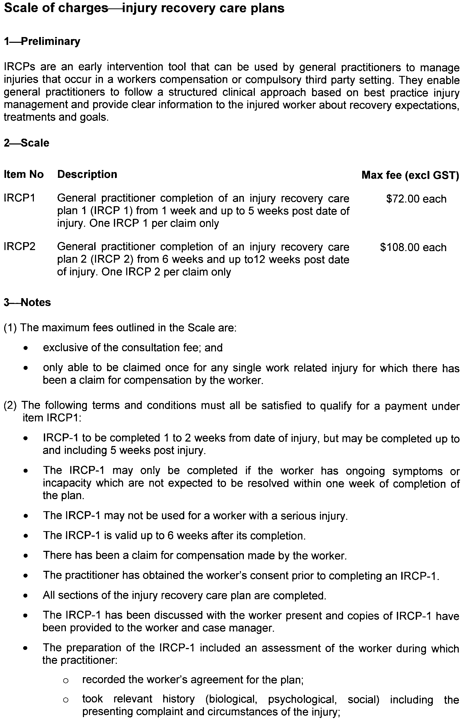
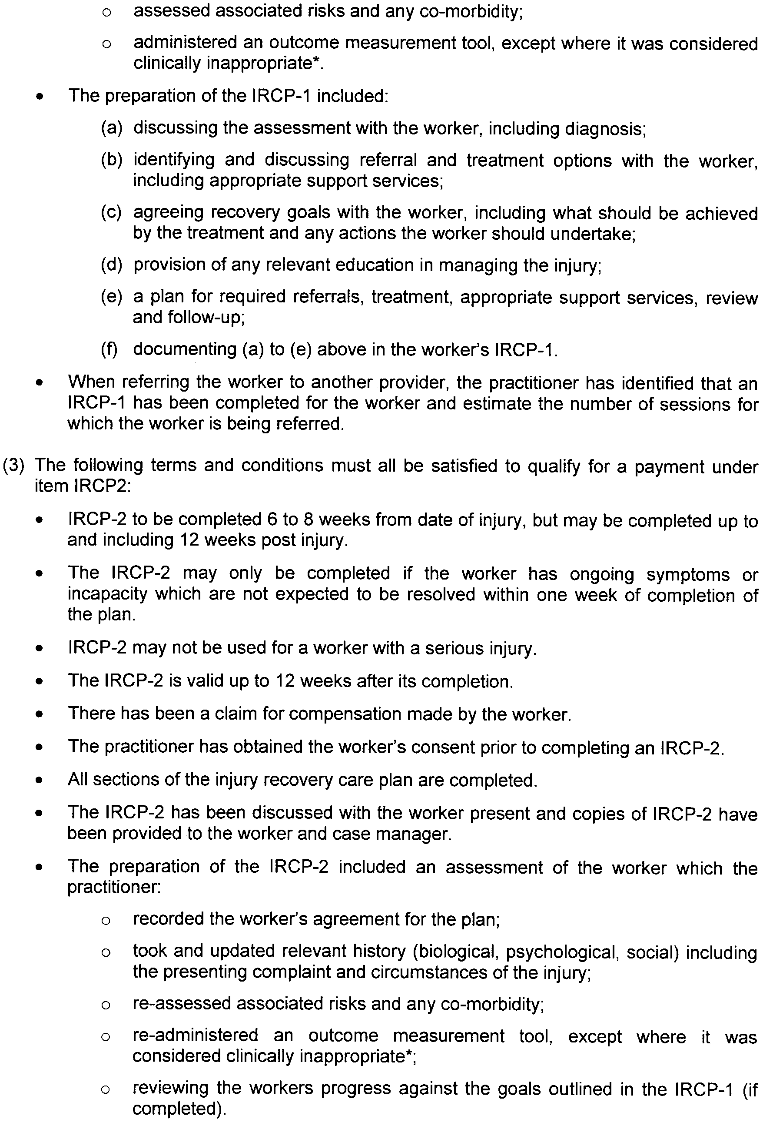
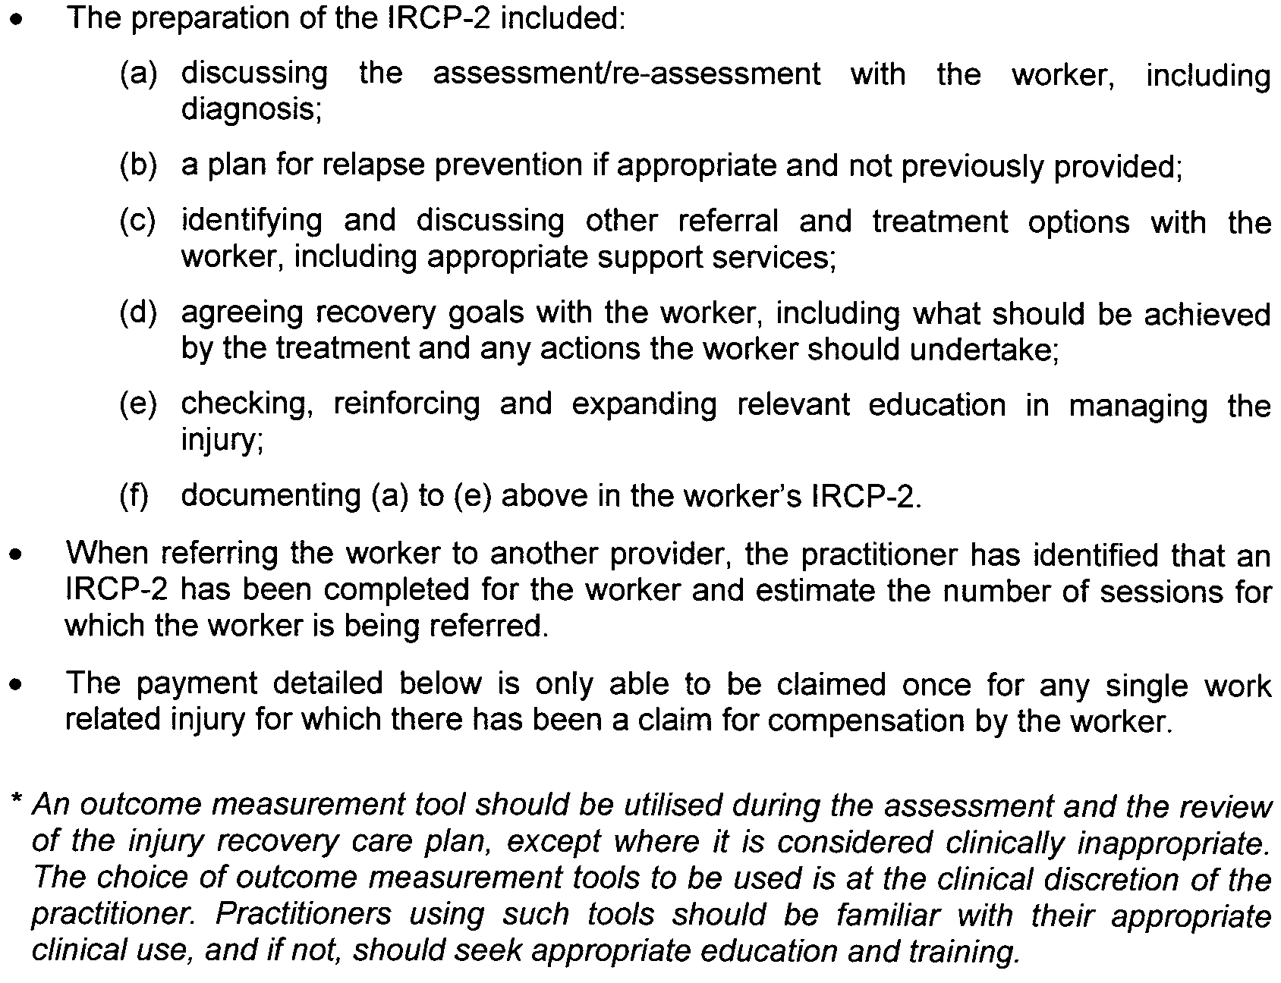

South Australia
Aquaculture (Approval of Coffin Bay Zones Policy) Notice 2008
under section 12 of the Aquaculture Act 2001
1—Short title
This notice may be cited as the Aquaculture (Approval of Coffin Bay Zones Policy) Notice 2008.
2—Commencement
This notice comes into operation on the day on which it is made.
3—Approval of aquaculture policy
(1) The Aquaculture (Zones—Coffin Bay) Policy 2008 is approved.
(2) The policy comes into operation on the day on which this notice is published in the Gazette.
Made by the Minister for Agriculture, Food and Fisheries
On 16 September 2008

South Australia
Aquaculture (Zones—Coffin Bay) Policy 2008
under the Aquaculture Act 2001

Contents
Part 1—Preliminary
1 Short title
2 Interpretation
3 Object of policy
4 Prescription of criteria does not limit matters that may be taken into account
5 Certain amendments may be made by Gazette notice only
Part 2—Coffin Bay aquaculture exclusion zone
6 Identification of aquaculture exclusion zone
Part 3—Kellidie Bay aquaculture zone
7 Identification of aquaculture zone
8 Class of permitted aquaculture
9 Prescribed criteria
Part 4—Mount Dutton Bay aquaculture zone
10 Identification of aquaculture zone
11 Class of permitted aquaculture
12 Prescribed criteria
Part 5—Point Longnose aquaculture zone
13 Identification of aquaculture zone
14 Class of permitted aquaculture
15 Prescribed criteria
Part 6—Port Douglas (central) aquaculture zone
16 Identification of aquaculture zone
17 Class of permitted aquaculture
18 Prescribed criteria
Part 7—Port Douglas (east) aquaculture zone
19 Identification of aquaculture zone
20 Class of permitted aquaculture
21 Prescribed criteria
Part 8—Port Douglas (west) aquaculture zone
22 Identification of aquaculture zone
23 Class of permitted aquaculture
24 Prescribed criteria
Part 9—Miscellaneous
25 Prescribed criteria for all aquaculture zones—area set aside for research purposes
Schedule 1—Descriptions of zones
1 Description of Coffin Bay aquaculture exclusion zone
2 Description of Kellidie Bay aquaculture zone
3 Description of Mount Dutton Bay aquaculture zone
4 Description of Point Longnose aquaculture zone
5 Description of Port Douglas (central) aquaculture zone
6 Description of Port Douglas (east) aquaculture zone
7 Description of Port Douglas (west) aquaculture zone
Schedule 2—Maps of zones
Schedule 3—Amendment of policy by Gazette notice
1 Insertion of Part 2A
Part 2A—Frenchman Bluff aquaculture zone
6A Identification of aquaculture zone
6B Class of permitted aquaculture
6C Prescribed criteria
6D Variation or revocation of Gazette notice
2 Amendment of Schedule 1
2A Description of Frenchman Bluff aquaculture zone
3 Amendment of Schedule 2

Part 1—Preliminary
1—Short title
This policy may be cited as the Aquaculture (Zones—Coffin Bay) Policy 2008.
2—Interpretation
(1) In this policy, unless the contrary intention appears—
Act means the Aquaculture Act 2001;
algae means eukaryotic macroalgae;
finfish means all members of the classes Actinopterygii, Elasmobranchii and Myxini;
lease means an aquaculture lease;
leased area, in an aquaculture zone, means the total area in the zone subject to lease;
licence means an aquaculture licence.
(2) For the purposes of identification of zones in this policy, unless the contrary intention appears, all lines are geodesics based on the Geocentric Datum of Australia 1994 (GDA94) as defined in the Commonwealth of Australia Gazette GN35 of 6 September 1995 and all co-ordinates are expressed in terms of GDA94.
Note—
Unless the contrary intention appears, terms used in this policy that are defined in the Act have the respective meanings assigned to those terms by the Act.
3—Object of policy
Pursuant to section 11 of the Act, this policy—
(a) identifies aquaculture zones and an aquaculture exclusion zone; and
(b) specifies for an aquaculture zone—
(i) the classes of aquaculture permitted in the zone; and
(ii) prescribed criteria to be taken into account in the determination of applications for licences or in the making of other decisions under the Act in relation to the zone.
4—Prescription of criteria does not limit matters that may be taken into account
This policy does not limit the matters that may be taken into account in the determination of applications for licences or in the making of other decisions under the Act.
5—Certain amendments may be made by Gazette notice only
Pursuant to section 14 of the Act, the Minister may, by notice in the Gazette, amend this policy as prescribed in Schedule 3.
Part 2—Coffin Bay aquaculture exclusion zone
6—Identification of aquaculture exclusion zone
The Coffin Bay aquaculture exclusion zone comprises the State waters described in Schedule 1 clause 1.
Part 3—Kellidie Bay aquaculture zone
7—Identification of aquaculture zone
The Kellidie Bay aquaculture zone comprises the State waters described in Schedule 1 clause 2.
8—Class of permitted aquaculture
The class of aquaculture permitted in the Kellidie Bay aquaculture zone is the farming of bivalve molluscs other than mussels.
9—Prescribed criteria
In the determination of applications for licences and in the making of other decisions under the Act in relation to the Kellidie Bay aquaculture zone, it must be taken into account that the leased area in the zone must not exceed 23 hectares, of which 3 hectares must be used or available for use for the storage, for a period not exceeding 2 weeks, of bivalve molluscs other than mussels—
(a) before being farmed in another aquaculture zone identified in this policy; or
(b) as part of the harvesting process after being farmed in another aquaculture zone identified in this policy,
by the holder of a licence authorised to farm molluscs in that other zone.
Part 4—Mount Dutton Bay aquaculture zone
10—Identification of aquaculture zone
The Mount Dutton Bay aquaculture zone comprises the State waters described in Schedule 1 clause 3.
11—Class of permitted aquaculture
The class of aquaculture permitted in the Mount Dutton Bay aquaculture zone is the farming of bivalve molluscs other than mussels.
12—Prescribed criteria
In the determination of applications for licences and in the making of other decisions under the Act in relation to the Mount Dutton Bay aquaculture zone, it must be taken into account that the leased area in the zone must not exceed 32 hectares.
Part 5—Point Longnose aquaculture zone
13—Identification of aquaculture zone
The Point Longnose aquaculture zone comprises the State waters described in Schedule 1 clause 4.
14—Class of permitted aquaculture
The classes of aquaculture permitted in the Point Longnose aquaculture zone are—
(a) the farming of bivalve molluscs other than mussels; and
(b) the farming of algae.
15—Prescribed criteria
In the determination of applications for licences and in the making of other decisions under the Act in relation to the Point Longnose aquaculture zone, it must be taken into account that the leased area in the zone must not exceed 63 hectares, of which—
(a) 61 hectares must be used or available for use for the farming of bivalve molluscs; and
(b) 2 hectares must be used or available for use for the farming of algae.
Part 6—Port Douglas (central) aquaculture zone
16—Identification of aquaculture zone
The Port Douglas (central) aquaculture zone comprises the State waters described in Schedule 1 clause 5.
17—Class of permitted aquaculture
The class of aquaculture permitted in the Port Douglas (central) aquaculture zone is the farming of bivalve molluscs other than mussels.
18—Prescribed criteria
In the determination of applications for licences and in the making of other decisions under the Act in relation to the Port Douglas (central) aquaculture zone, it must be taken into account that the leased area in the zone must not exceed 50 hectares.
Part 7—Port Douglas (east) aquaculture zone
19—Identification of aquaculture zone
The Port Douglas (east) aquaculture zone comprises the State waters described in
Schedule 1 clause 6.
20—Class of permitted aquaculture
The class of aquaculture permitted in the Port Douglas (east) aquaculture zone is the farming of bivalve molluscs other than mussels.
21—Prescribed criteria
In the determination of applications for licences and in the making of other decisions under the Act in relation to the Port Douglas (east) aquaculture zone, it must be taken into account that the leased area in the zone must not exceed 4 hectares.
Part 8—Port Douglas (west) aquaculture zone
22—Identification of aquaculture zone
The Port Douglas (west) aquaculture zone comprises the State waters described in
Schedule 1 clause 7.
23—Class of permitted aquaculture
The class of aquaculture permitted in the Port Douglas (west) aquaculture zone is the farming of bivalve molluscs other than mussels.
24—Prescribed criteria
In the determination of applications for licences and in the making of other decisions under the Act in relation to the Port Douglas (west) aquaculture zone, it must be taken into account that the leased area in the zone must not exceed 10 hectares.
Part 9—Miscellaneous
25—Prescribed criteria for all aquaculture zones—area set aside for research purposes
In the determination of applications for licences and in the making of other decisions under the Act in relation to the aquaculture zones identified in this policy, it must be taken into account that, of the area leased or available for lease in those zones, 5 hectares must be used or available for use for the farming of aquatic organisms for the purposes of research or for the purposes of trade, or a business, established for educational purposes.
Schedule 1—Descriptions of zones
1—Description of Coffin Bay aquaculture exclusion zone
The Coffin Bay aquaculture exclusion zone comprises the State waters contained within and bounded by a line commencing at the location on mean high water springs closest to 34°25′45.56″ South, 135°12′19.92″ East (Point 88), then north-easterly to 34°25′08.02″ South, 135°12′28.83″ East (Point 89), then south-easterly to 34°25′29.71″ South, 135°13′47.99″ East (Point 90), then southerly to 34°29′14.62″ South, 135°13′53.69″ East (Point 91), then north-westerly to 34°29′09.37″ South, 135°13′37.05″ East (Point 92), then south-westerly to 34°29′16.04″ South, 135°13′33.98″ East (Point 93), then south-easterly to 34°29′21.29″ South, 135°13′50.62″ East (Point 94), then easterly to 34°29′20.88″ South, 135°14′41.54″ East (Point 95), then south-easterly to 34°30′17.76″ South, 135°20′14.9″ East (Point 96), then north-easterly to 34°29′49.31″ South, 135°21′13.31″ East (Point 97), then northerly to 34°28′56.85″ South, 135°21′13.1″ East (Point 98), then easterly to 34°28′56.15″ South, 135°22′37.36″ East (Point 99), then north-westerly to 34°26′36.6″ South, 135°22′19.61″ East (Point 100), then north-easterly to the location on mean high water springs closest to 34°26′02.64″ South, 135°22′51.12″ East (Point 101), then beginning southerly following the line of mean high water springs to the point of commencement, but does not include the aquaculture zones identified in this policy.
Note—
The point references in this description are references to the corresponding points in the map in Schedule 2 showing the Coffin Bay aquaculture exclusion zone.
2—Description of Kellidie Bay aquaculture zone
The Kellidie Bay aquaculture zone comprises the State waters contained within and
bounded by—
(a) a line commencing at mean high water springs closest to 34°35′55.4″ South, 135°30′01.73″ East (Point 77), then southerly to 34°36′10.19″ South, 135°30′00.07″ East (Point 78), then south-westerly to the location on mean high water springs closest to 34°36′30.69″ South, 135°27′49.01″ East (Point 79), then beginning north-westerly following the line of mean high water springs to the point of commencement; and
(b) a line commencing at 34°36′30.72″ South, 135°28′26.03″ East (Point 80), then easterly to 34°36′30.5″ South, 135°29′23.01″ East (Point 81), then southerly to 34°36′43.1″ South, 135°29′23.09″ East (Point 82), then westerly to 34°36′43.32″ South, 135°28′26.41″ East (Point 83), then northerly to the point of commencement; and
(c) a line commencing at 34°37′11.43″ South, 135°28′31.31″ East (Point 84), then south-easterly to 34°37′15.86″ South, 135°28′36.23″ East (Point 85), then south-westerly to 34°37′20.54″ South, 135°28′28.67″ East (Point 86), then north-westerly to 34°37′16.71″ South, 135°28′24.74″ East (Point 87), then north-easterly to the point of commencement.
Note—
The point references in this description are references to the corresponding points in the map in Schedule 2 showing the Kellidie Bay aquaculture zone.
3—Description of Mount Dutton Bay aquaculture zone
The Mount Dutton Bay aquaculture zone comprises the State waters contained within and bounded by—
(a) a line commencing at 34°31′30.76″ South, 135°24′25.99″ East (Point 52), then south-easterly to 34°31′38.35″ South, 135°24′35.13″ East (Point 53), then south-westerly to 34°31′44.12″ South, 135°24′27.21″ East (Point 54), then north-westerly to 34°31′36.8″ South, 135°24′17.9″ East (Point 55), then north-easterly to the point of commencement; and
(b) a line commencing at mean high water springs closest to 34°31′39.37″ South, 135°23′50.07″ East (Point 56), then south-easterly to 34°31′40.87″ South, 135°24′05.55″ East (Point 57), then south-easterly to 34°32′25.64″ South, 135°24′27.21″ East (Point 58), then south-easterly to 34°32′30.73″ South, 135°24′50.87″ East (Point 59), then easterly to 34°32′29.96″ South, 135°25′10.96″ East (Point 60), then south-easterly to 34°32′38.94″ South, 135°25′19.68″ East (Point 61), then south-westerly to the location on mean high water springs closest to 34°32′45.92″ South, 135°25′11.99″ East (Point 62), then beginning north-westerly following the line of mean high water springs to the point of commencement; and
(c) a line commencing at mean high water springs closest to 34°33′06.74″ South, 135°24′29.91″ East (Point 63), then easterly to 34°33′06.78″ South, 135°25′15.51″ East (Point 64), then southerly to 34°34′54.21″ South, 135°25′16.06″ East (Point 65), then westerly to the location on mean high water springs closest to 34°34′51.03″ South, 135°24′39.96″ East (Point 66), then generally northerly following the line of mean high water springs to the point of commencement; and
(d) a line commencing at mean high water springs closest to 34°35′04.31″ South, 135°24′36.89″ East (Point 67), then north-easterly to 34°35′01.43″ South, 135°24′40.77″ East (Point 68), then south-easterly to 34°35′08.6″ South, 135°24′48.89″ East (Point 69), then south-westerly to the location on mean high water springs closest to 34°35′11.48″ South, 135°24′44.33″ East (Point 70), then generally north-westerly following the line of mean high water springs to the point of commencement; and
(e) a line commencing at 34°35′27.19″ South, 135°24′39.89″ East (Point 71), then south-easterly to the location on mean high water springs closest to 34°35′29.02″ South, 135°24′45.99″ East (Point 72), then beginning southerly following the line of mean high water springs to the location closest to 34°35′29.43″ South, 135°24′47.35″ East (Point 73), then south-easterly to 34°35′37.77″ South, 135°25′15.13″ East (Point 74), then south-westerly to 34°35′53.54″ South, 135°25′00.44″ East (Point 75), then north-westerly to 34°35′42.79″ South, 135°24′25.4″ East (Point 76), then north-easterly to the point of commencement.
Note—
The point references in this description are references to the corresponding points in the map in Schedule 2 showing the Mount Dutton Bay aquaculture zone.
4—Description of Point Longnose aquaculture zone
The Point Longnose aquaculture zone comprises the State waters contained within and bounded by—
(a) a line commencing at 34°31′59.94″ South, 135°19′23.73″ East (Point 5), then easterly to 34°31′59.92″ South, 135°19′32.29″ East (Point 6), then southerly to 34°32′07.77″ South, 135°19′32.32″ East (Point 7), then easterly to 34°32′07.70″ South, 135°19′48.95″ East (Point 8), then north-easterly to 34°31′59.44″ South, 135°20′26.82″ East (Point 9), then easterly to 34°31′59.45″ South, 135°20′44.56″ East (Point 10), then southerly to 34°32′07.43″ South, 135°20′44.43″ East (Point 11), then south-easterly to 34°32′11.26″ South, 135°20′57.02″ East (Point 12), then northerly to 34°32′02.84″ South, 135°20′56.99″ East (Point 13), then easterly to 34°32′02.86″ South, 135°21′04.56″ East (Point 14), then southerly to 34°32′10.67″ South, 135°21′04.67″ East (Point 15), then easterly to 34°32′10.48″ South, 135°21′17.21″ East (Point 16), then southerly to 34°32′14.65″ South, 135°21′17″ East (Point 17), then easterly to 34°32′14.56″ South, 135°21′41.93″ East (Point 18), then southerly to 34°32′23.15″ South, 135°21′41.93″ East (Point 19), then westerly to 34°32′23.84″ South, 135°21′16.78″ East (Point 20), then south-westerly to 34°33′02.24″ South, 135°19′20″ East (Point 21), then northerly to 34°32′38.12″ South, 135°19′20″ East (Point 22), then north-easterly to 34°32′25.02″ South, 135°19′33.19″ East (Point 23), then northerly to 34°32′13.57″ South, 135°19′33.14″ East (Point 24), then westerly to 34°32′13.59″ South, 135°19′23.89″ East (Point 25), then northerly to the point of commencement; and
(b) a line commencing at 34°32′52.52″ South, 135°20′50.81″ East (Point 102), then southerly to 34°33′02.50″ South, 135°20′50.93″ East (Point 103), then south-westerly to 34°33′08.83″ South, 135°20′20.98″ East (Point 104), then north-westerly to 34°33′04.70″ South, 135°20′19.35″ East (Point 105), then north-easterly to the point of commencement; and
(c) a line commencing at 34°32′48.03″ South, 135°21′17.80″ East (Point 106), then south-westerly to 34°33′02.25″ South, 135°21′06.46″ East (Point 107), then north-westerly to 34°32′55.80″ South, 135°20′58.88″ East (Point 108), then northerly to 34°32′47.78″ South, 135°20′59.74″ East (Point 109), then easterly to the point of commencement.
Note—
The point references in this description are references to the corresponding points in the map in Schedule 2 showing the Point Longnose aquaculture zone.
5—Description of Port Douglas (central) aquaculture zone
The Port Douglas (central) aquaculture zone comprises the State waters contained within and bounded by a line commencing at 34°32′57.68″ South, 135°21′55.55″ East (Point 36), then north-easterly to 34°32′28.3″ South, 135°22′48.39″ East (Point 39), then south-easterly to 34°32′55.61″ South, 135°23′06.66″ East (Point 40), then south-easterly to 34°33′04.06″ South, 135°23′12.32″ East (Point 41), then south-westerly to 34°33′09.74″ South, 135°23′08.22″ East (Point 42), then south-westerly to 34°33′14.96″ South, 135°23′00.39″ East (Point 43), then south-westerly to 34°33′16.31″ South, 135°22′58.13″ East (Point 44), then southerly to 34°33′28.83″ South, 135°22′57.47″ East (Point 45), then easterly to 34°33′28.81″ South, 135°23′04.38″ East (Point 46), then southerly to 34°33′39.62″ South, 135°23′04.43″ East (Point 47), then westerly to 34°33′39.64″ South, 135°22′57.52″ East (Point 48), then south-easterly to 34°34′07.79″ South, 135°23′02.66″ East (Point 49), then north-westerly to 34°33′49.68″ South, 135°21′40.12″ East (Point 37), then north-easterly to the point of commencement.
Note—
The point references in this description are references to the corresponding points in the map in Schedule 2 showing the Port Douglas (central) aquaculture zone.
6—Description of Port Douglas (east) aquaculture zone
The Port Douglas (east) aquaculture zone comprises the State waters contained within and bounded by a line commencing at 34°32′28.3″ South, 135°22′48.39″ East (Point 39), then north-easterly to 34°32′13.67″ South, 135°22′54.21″ East (Point 50), then south-easterly to 34°32′18.69″ South, 135°23′06.49″ East (Point 51), then southerly to 34°32′55.61″ South, 135°23′06.66″ East (Point 40), then north-westerly to the point of commencement.
Note—
The point references in this description are references to the corresponding points in the map in Schedule 2 showing the Port Douglas (east) aquaculture zone.
7—Description of Port Douglas (west) aquaculture zone
The Port Douglas (west) aquaculture zone comprises the State waters contained within and bounded by a line commencing at 34°33′12.93″ South, 135°21′13.64″ East (Point 35), then north-easterly to 34°32′57.68″ South, 135°21′55.55″ East (Point 36), then south-westerly to 34°33′49.68″ South, 135°21′40.12″ East (Point 37), then north-westerly to 34°33′30.26″ South, 135°21′16.46″ East (Point 38), then north-westerly to the point of commencement.
Note—
The point references in this description are references to the corresponding points in the map in Schedule 2 showing the Port Douglas (west) aquaculture zone.
Schedule 2—Maps of zones
The maps in this Schedule are provided for convenience of reference only.
Overview
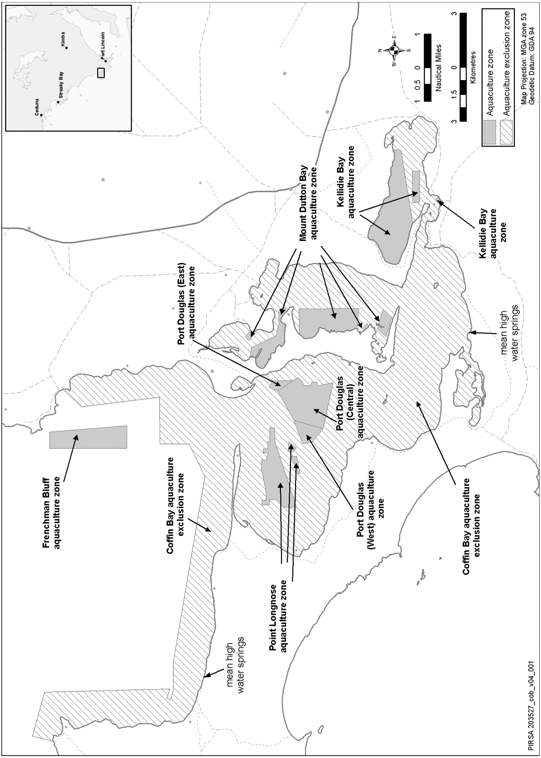
Coffin Bay aquaculture exclusion zone
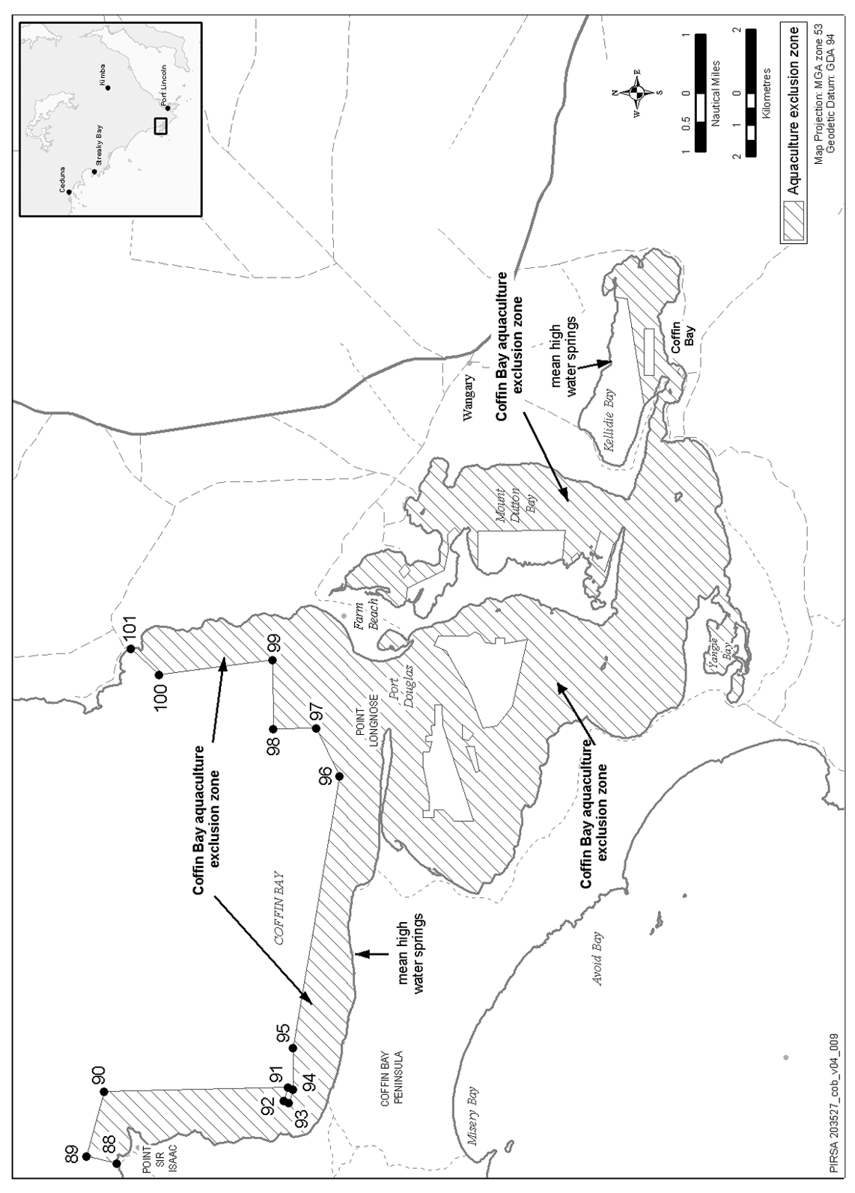
Kellidie Bay aquaculture zone
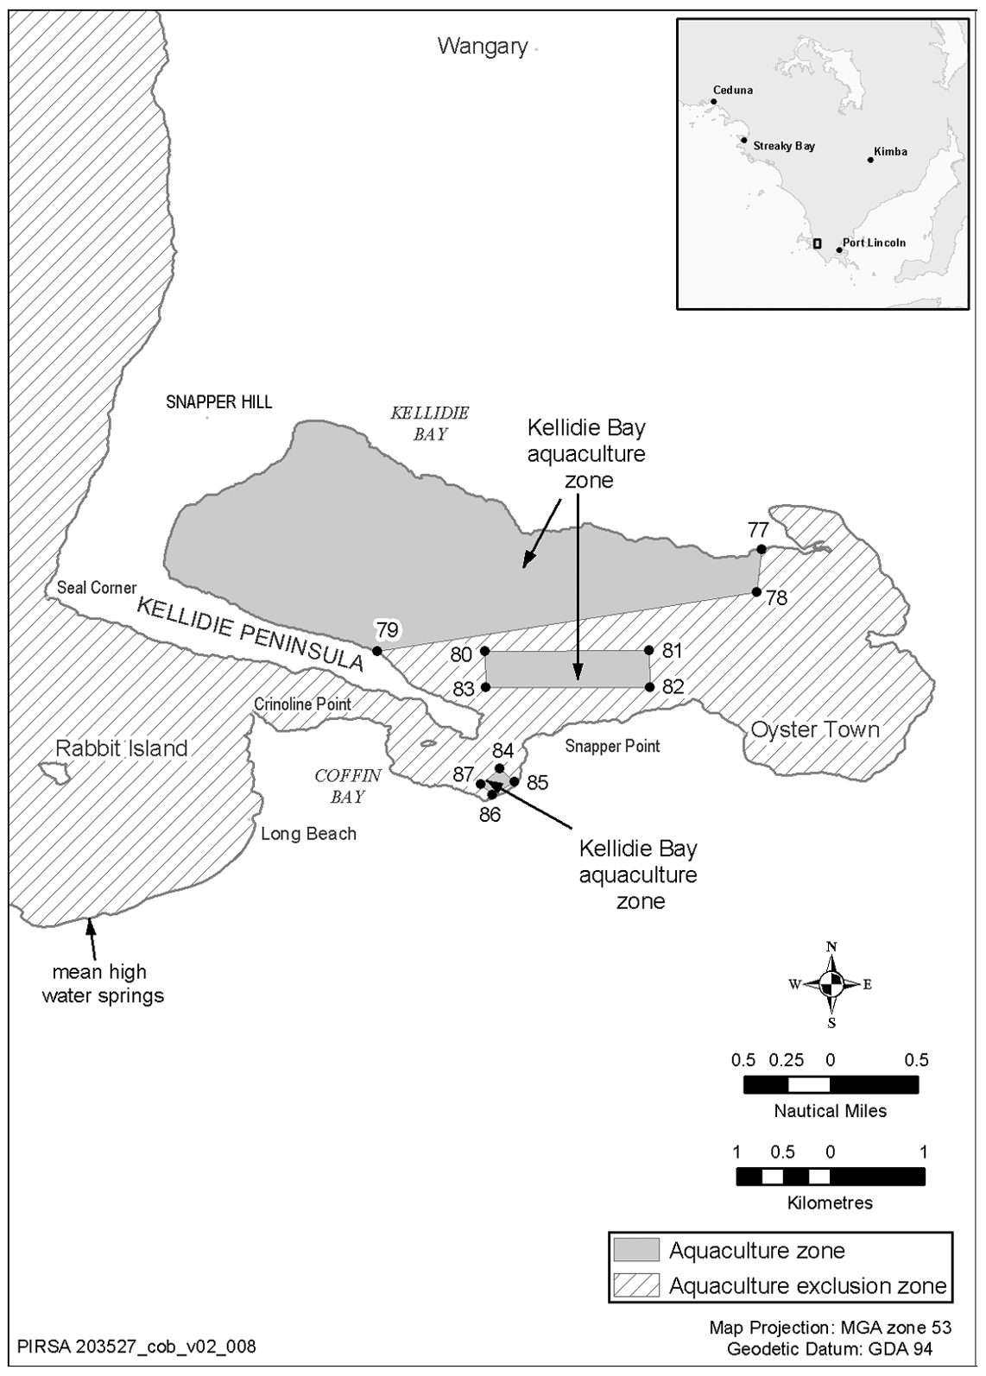
Mount Dutton Bay aquaculture zone
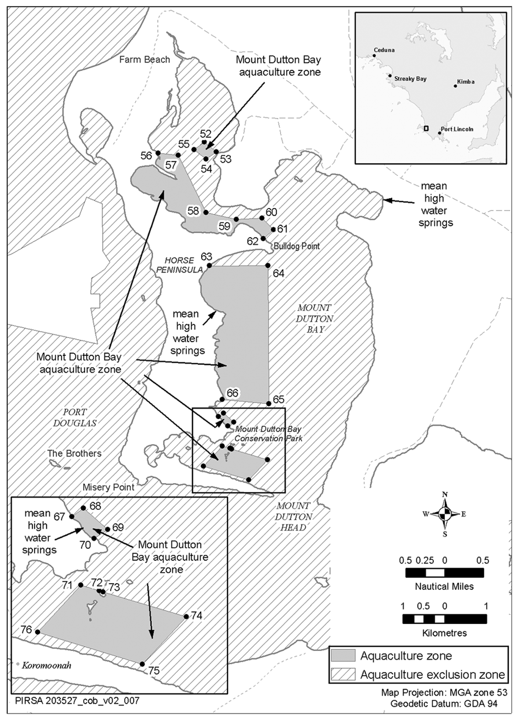
Point Longnose aquaculture zone
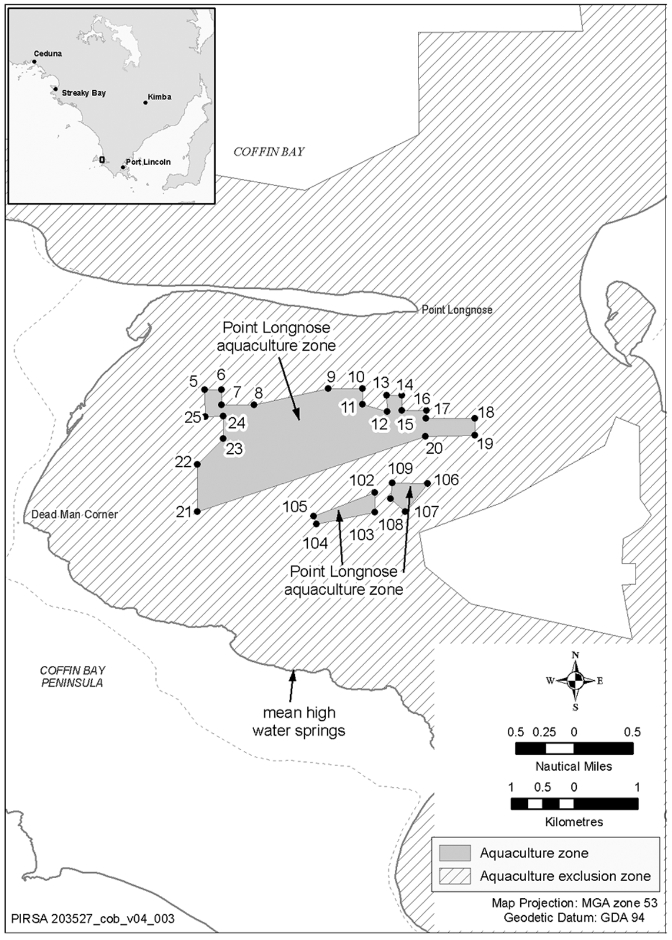
Port Douglas (central) aquaculture zone
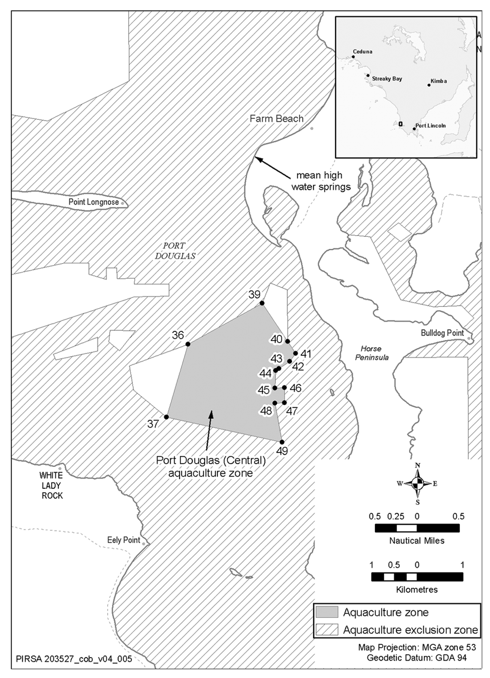
Port Douglas (east) aquaculture zone
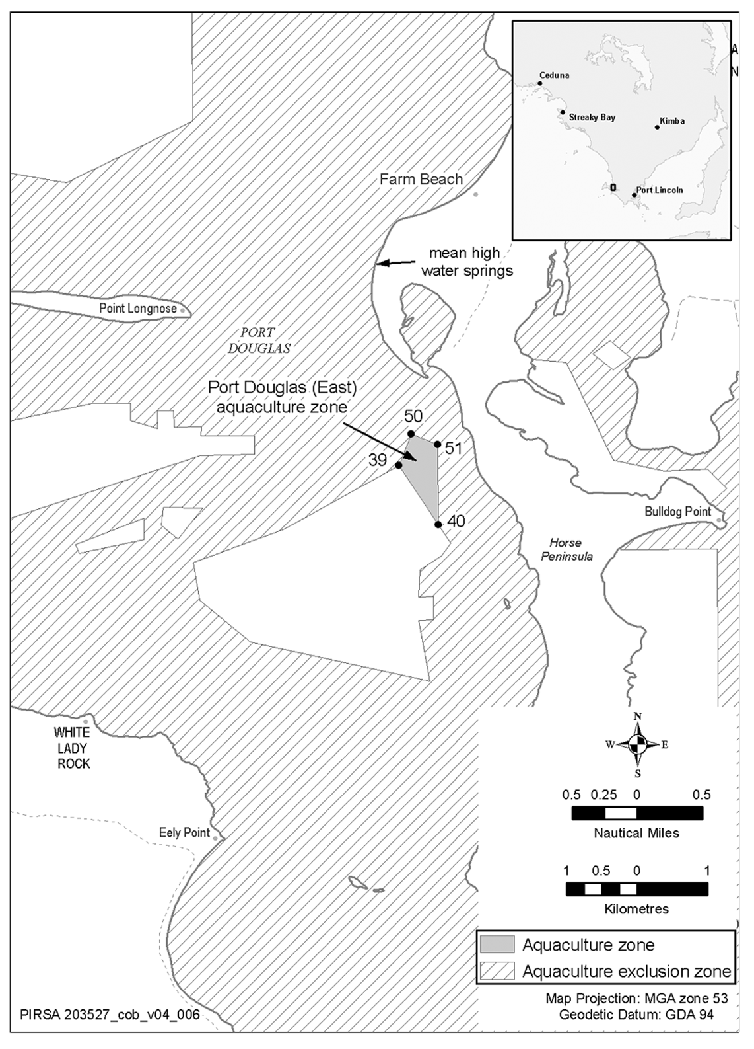
Port Douglas (west) aquaculture zone
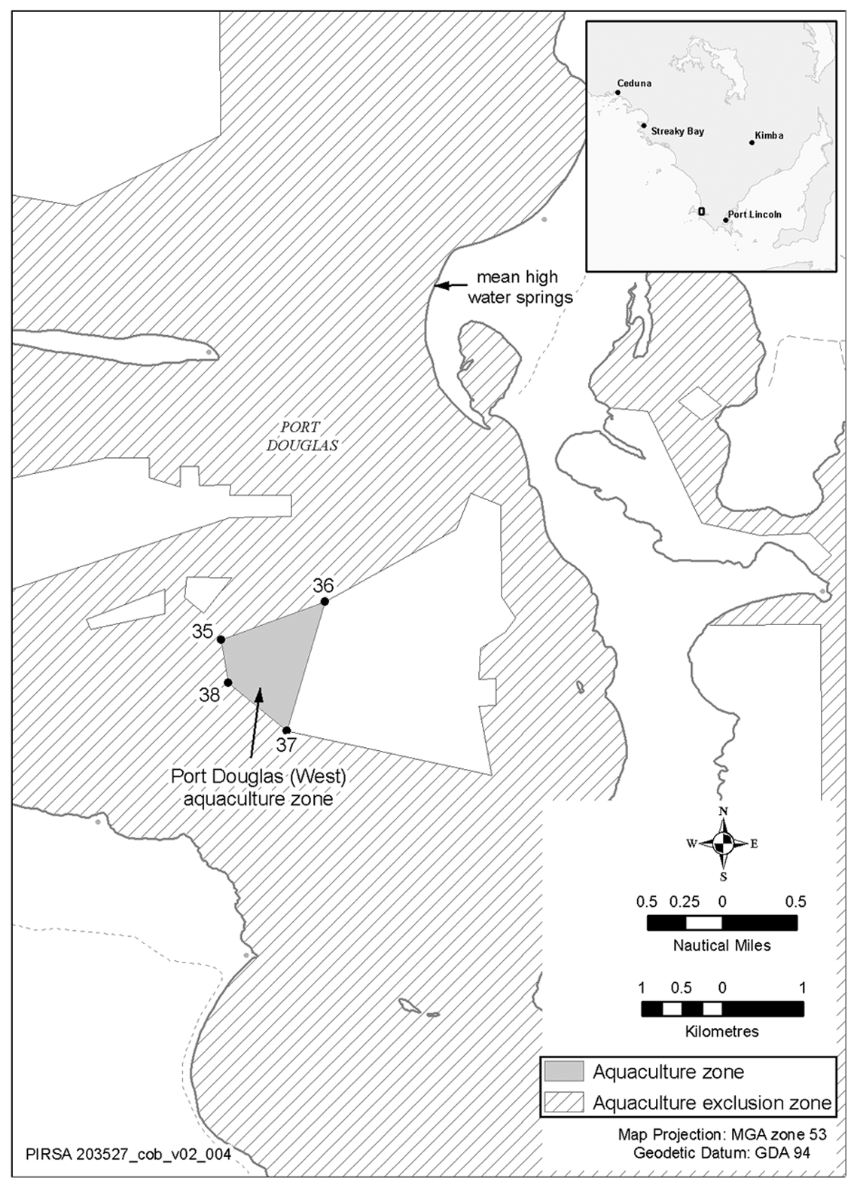
Schedule 3—Amendment of policy by Gazette notice
1—Insertion of Part 2A
After Part 2 insert:
Part 2A—Frenchman Bluff aquaculture zone
6A—Identification of aquaculture zone
The Frenchman Bluff aquaculture zone comprises the State waters described in Schedule 1 clause 2A.
6B—Class of permitted aquaculture
The classes of aquaculture permitted in the Frenchman Bluff aquaculture zone are—
(a) the farming of aquatic animals (other than finfish) in a manner that involves regular feeding; and
(b) the farming of algae.
6C—Prescribed criteria
In the determination of applications for licences and in the making of other decisions under the Act in relation to the Frenchman Bluff aquaculture zone, the following prescribed criteria must be taken into account:
(a) the leased area in the zone must not exceed 90 hectares, of which—
(i) 85 hectares must be used or available for use for the farming of aquatic animals; and
(ii) 5 hectares must be used or available for use for the farming of algae;
(b) the biomass of the aquatic animals (other than finfish) being farmed in the zone in a manner that involves regular feeding must not exceed 680 tonnes or, if some other amount is specified by the Minister by notice in the Gazette, that other amount.
6D—Variation or revocation of Gazette notice
(1) The Minister may vary or revoke a notice in the Gazette made under clause 6C by subsequent notice in the Gazette.
(2) The power to vary or revoke a notice under subclause (1) is exercisable in the same way, and subject to the same conditions, as the power to make the notice.
2—Amendment of Schedule 1
Schedule 1—after clause 1 insert:
2A—Description of Frenchman Bluff aquaculture zone
The Frenchman Bluff aquaculture zone comprises the State waters contained within and bounded by a line commencing at 34°25′39″ South, 135°21′05″ East (Point 1), then easterly to 34°25′39″ South, 135°21′35″ East (Point 2), then south-easterly to 34°27′57.94″ South, 135°21′46.11″ East (Point 3), then westerly to 34°27′58″ South, 135°21′05″ East (Point 4), then northerly to the point of commencement.
Note—
The point references in this description are references to the corresponding points in the map in Schedule 2 showing the Frenchman Bluff aquaculture zone.
3—Amendment of Schedule 2
Schedule 2—after the map titled Coffin Bay aquaculture exclusion zone insert:
Frenchman Bluff aquaculture zone
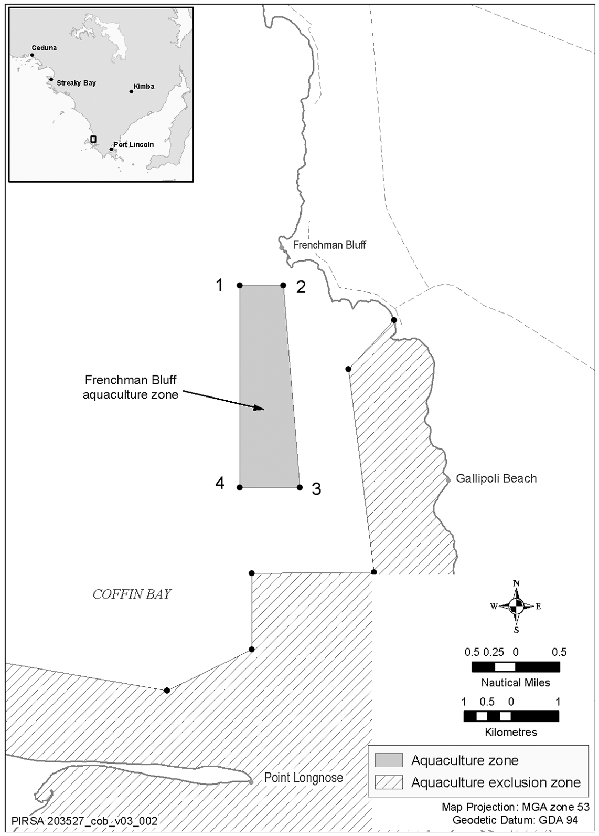

South Australia
Workers Rehabilitation and Compensation (Scheme
Review) Amendment Act (Commencement) Proclamation 2008
1—Short title
This proclamation may be cited as the Workers Rehabilitation and Compensation
(Scheme Review) Amendment Act (Commencement) Proclamation 2008.
2—Commencement of suspended provisions
Sections 9 and 11 of the Workers Rehabilitation and Compensation (Scheme Review) Amendment Act 2008 (No 17 of 2008) will come into operation on 2 October 2008.
Made by the Governor
with the advice and consent of the Executive Council
on 2 October 2008
MIR23/08CS

South Australia
Workers Rehabilitation and Compensation (General) Variation Regulations 2008
under the Workers Rehabilitation and Compensation Act 1986

Contents
Part 1—Preliminary
1 Short title
2 Commencement
3 Variation provisions
Part 2—Variation of Workers Rehabilitation and Compensation (General) Regulations 1999
4 Variation of regulation 5—Transportation for initial treatment
5 Variation of regulation 6—Compensation for property damage
6 Insertion of regulations 29 and 30
29 Transitional provision—Rehabilitation and return to work co-ordinators
30 Transitional provision—Compensation for medical expenses

Part 1—Preliminary
1—Short title
These regulations may be cited as the Workers Rehabilitation and Compensation (General) Variation Regulations 2008.
2—Commencement
These regulations will come into operation on the day on which section 11 of the Workers Rehabilitation and Compensation (Scheme Review) Amendment Act 2008 comes into operation.
3—Variation provisions
In these regulations, a provision under a heading referring to the variation of specified regulations varies the regulations so specified.
Part 2—Variation of Workers Rehabilitation and Compensation (General) Regulations 1999
4—Variation of regulation 5—Transportation for initial treatment
(1) Regulation 5—delete "$150" and substitute:
$240
(2) Regulation 5—after its present contents (as varied by this regulation and now to be designated as subregulation (1)) insert:
(2) The amount prescribed by subregulation (1) will be indexed so that it is adjusted on 1 January of each year, beginning on 1 January 2010, by multiplying the stated amount by a proportion obtained by dividing the Consumer Price Index for the September quarter of the immediately preceding year by the Consumer Price Index for the September quarter 2008 (with the amount so adjusted being rounded up to the nearest multiple of $5).
5—Variation of regulation 6—Compensation for property damage
(1) Regulation 6(1)(b)—delete "$1 500" and substitute:
$1 970
(2) Regulation 6(2)—delete subregulation (2) and substitute:
(2) The amount prescribed by subregulation (1) will be indexed so that it is adjusted on 1 January of each year, beginning on 1 January 2009, by multiplying the stated amount by a proportion obtained by dividing the Consumer Price Index for the September quarter of the immediately preceding financial year by the Consumer Price Index for the September quarter 2007 (with the amount so adjusted being rounded up to the nearest multiple of $10).
6—Insertion of regulations 29 and 30
After regulation 28 insert:
29—Transitional provision—Rehabilitation and return to work co-ordinators
(1) In this regulation—
co-ordinator means a rehabilitation and return to work co-ordinator under the designated section;
designated section means section 28D of the principal Act, as enacted by the 2008 Amendment Act;
principal Act means the Workers Rehabilitation and Compensation Act 1986;
2008 Amendment Act means the Workers Rehabilitation and Compensation (Scheme Review) Amendment Act 2008.
(2) Subject to subregulation (3), the designated section will apply to employers registered under the principal Act on and from 1 December 2008 (including employers whose registration commenced before that date).
(3) An employer is not required to appoint a co-ordinator under the designated section until 1 July 2009 (and may appoint a co-ordinator before that date subject to complying with any training or operational guidelines published by the Corporation from time to time for the purposes of the designated section but otherwise not derogating from the full operation of the designated section from that date).
30—Transitional provision—Compensation for medical expenses
(1) In this regulation—
designated set of regulations means—
(a) the Workers Rehabilitation and Compensation (Scales of Charges—Medical Practitioners) Regulations 1999; or
(b) the Workers Rehabilitation and Compensation (Scales of Medical and Other Charges) Regulations 1995;
principal Act means the Workers Rehabilitation and Compensation Act 1986;
2008 Amendment Act means the Workers Rehabilitation and Compensation (Scheme Review) Amendment Act 2008.
(2) Subject to subregulations (3) and (4), a designated set of regulations, as in force immediately before the commencement of section 11 of the 2008 Amendment Act, remains in force after that commencement.
(3) If the Minister, by notice published under section 32 of the principal Act as amended by the 2008 Amendment Act, sets a scale of charges that is expressed to supersede any part of—
(a) the Workers Rehabilitation and Compensation (Scales of Charges—Medical Practitioners) Regulations 1999; or
(b) the Workers Rehabilitation and Compensation (Scales of Medical and Other Charges) Regulations 1995,
then the relevant regulations will be taken to be superseded to the extent provided by the notice insofar as the regulations apply in relation to workers who have suffered compensable disabilities under the principal Act.
(4) A designated set of regulations will cease to have effect when entirely superseded by 1 or more notices published by the Minister under section 32 of the principal Act.
Note—
As required by section 10AA(2) of the Subordinate Legislation Act 1978, the Minister has certified that, in the Minister's opinion, it is necessary or appropriate that these regulations come into operation as set out in these regulations.
Made by the Governor
with the advice and consent of the Executive Council
on 2 October 2008
No 269 of 2008
MIR23/08CS

South Australia
Workers Rehabilitation and Compensation (Claims and Registration) Variation Regulations 2008
under the Workers Rehabilitation and Compensation Act 1986

Contents
Part 1—Preliminary
1 Short title
2 Commencement
3 Variation provisions
Part 2—Variation of Workers Rehabilitation and Compensation (Claims and Registration) Regulations 1999
4 Substitution of heading to Schedule 3

Part 1—Preliminary
1—Short title
These regulations may be cited as the Workers Rehabilitation and Compensation (Claims and Registration) Variation Regulations 2008.
2—Commencement
These regulations come into operation on the day on which they are made.
3—Variation provisions
In these regulations, a provision under a heading referring to the variation of specified regulations varies the regulations so specified.
Part 2—Variation of Workers Rehabilitation and Compensation (Claims and Registration) Regulations 1999
4—Substitution of heading to Schedule 3
Heading to Schedule 3—delete the heading and substitute:
Schedule 3—Additional information to accompany application for registration as a self-insured employer or group of self-insured employers
Note—
As required by section 10AA(2) of the Subordinate Legislation Act 1978, the Minister has certified that, in the Minister's opinion, it is necessary or appropriate that these regulations come into operation as set out in these regulations.
Made by the Governor
with the advice and consent of the Executive Council
on 2 October 2008
No 270 of 2008
MIR23/08CS

FAXING COPY?
IF you fax copy to Government Publishing SA for inclusion in the Government Gazette, there is no need to send a Confirmation Copy to us as well.
This creates confusion and may well result in your notice being printed twice.
Please use the following fax number:
Fax transmission: (08) 8207 1040
Phone Inquiries: (08) 8207 1045
Please include a contact person, phone number and order number so that we can phone back with any queries we may have regarding the fax copy.
NOTE: Closing time for lodging new copy (fax, hard copy or email) is 4 p.m. on Tuesday preceding the day of publication.

Government Gazette notices can be E-mailed.
The address is:
governmentgazette@dpc.sa.gov.au
Documents should be sent as attachments in Word format.
When sending a document via E-mail, please confirm your transmission with a faxed copy of your document, including the date the notice is to be published.
Fax transmission: (08) 8207 1040
Enquiries: (08) 8207 1045
NOTE: Closing time for lodging new copy (fax, hard copy or email) is 4 p.m. on Tuesday preceding the day of publication.

ADELAIDE CITY COUNCIL
Victoria Street—Temporary Street Closure
NOTICE is hereby given that the Council, at its meeting held on Monday, 8 September 2008, adopted the following resolution:
Pursuant to section 359 (1) of the Local Government Act 1934, as amended, all vehicles other than those vehicles identified in Column 3 below shall be excluded from the road so named in Column 1 and as described in Column 2.
Column 1  Street |  | Column 2  Location |  | Column 3  Class of Vehicles Exempt
Victoria Street |  | From the northern building alignment of Hindley Street to a point 65 m south of the southern building alignment of North Terrace. |  | Any vehicle travelling in a northerly direction from Hindley Street to a point 65 m south of the southern building alignment of North Terrace.  Any vehicles owned or operated by or on behalf of the Adelaide City Council for the purpose of street cleaning and maintenance.
Further information can be obtained from John Hanchett, Asset Management, telephone 8203 7433, or email at:
j.hanchett@adelaidecitycouncil.com
M. Sedgman, Acting Chief Executive Officer

CITY OF MITCHAM
Declaration of Public Roads
NOTICE is hereby given that pursuant to section 210 of the Local Government Act 1999, as amended, the City of Mitcham resolved that Railway Terrace and Burfield Street, Belair, as laid out in Deposited Plan 1423 contained in certificate of title volume 489, folio 81, are hereby declared to be public roads.
R. Malcolm, Chief Executive Officer

CITY OF PLAYFORD
Roads (Opening and Closing) Act 1991
Road Opening and Closing Un-named Road, adjoining Glenburnie Road, Yattalunga
NOTICE is hereby given pursuant to section 10 of the said Act, that Council proposes to make a Road Process Order to open as road portion of piece 3 in Deposited Plan 61398 shown as ‘10’ on Preliminary Plan No. 08/0059 and close and exchange with P. J. and J. M. Ween, the portion of road (rendered superfluous by the new road), shown as ‘B’ on the said Preliminary Plan No. 08/0059.
A copy of the plan and statement of persons affected are available for public inspection at Playford Civic Centre, 10 Playford Boulevard, Elizabeth, and the office of the Surveyor-General, 101 Grenfell Street, Adelaide, during normal office hours.
Any application for easement or objections must be made in writing within 28 days from 2 October 2008, to the Council at 12 Bishopstone Road, Davoren Park, S.A. 5113 and the Surveyor-General, G.P.O. Box 1354, Adelaide, S.A. 5001, setting out full details.
Where a submission is made, Council will give notification of a meeting to deal with the matter.
Council contact: Graedon Dickson, phone 8256 0279.
T. R. S. Jackson, Chief Executive Officer

CITY OF PORT ADELAIDE ENFIELD
Change of Name for Portions of Public Roads
NOTICE is hereby given that the Council of the City of Port Adelaide Enfield at its meeting held 10 June 2008, resolved pursuant to section 219 (1) of the Local Government Act 1999, that the names of portions of certain public roads be changed to the names assigned as follows:
• Subject to written approval of the Commissioner of Highways being received a portion of Oceans Steamers Road, Port Adelaide, be changed and assigned the name Wauwa Street, Port Adelaide shown as ‘A’ on Map 3.
• A portion of Elder Road, Birkenhead, be changed and assigned the name Riverview Street, Birkenhead, shown as ‘B’ on Map 5.
• Subject to written approval of the Commissioner of Highways being received a portion of Victoria Road, Birkenhead, be changed and assigned the name Dickenson Close, Birkenhead, shown as ‘C’ on Map 6.
Maps that delineate the portions of public roads that are subject to the change of names, together with copies of the Council’s resolution and the Commissioner of Highways written approval for Wauwa Street and Dickenson Close, are all available for inspection at the Council’s Principal Office, 163 St Vincent Street, Port Adelaide; Parks Library, Council Office, 2-46 Cowan Street, Angle Park; Enfield Library, Council Office, 1-9 Kensington Crescent, Enfield and Greenacres Library, Council Office, 2 Fosters Road, Greenacres, during their normal business hours.
H. J. Wierda City Manager

PORT AUGUSTA CITY COUNCIL
Roads (Opening and Closing) Act 1991
Road Closure, Port Augusta
NOTICE is hereby given, pursuant to section 10 of the Roads (Opening and Closing) Act 1991, that Port Augusta City Council proposes to make a Road Process Order to close, retain and merge with the adjoining allotment 1000 in Deposited Plan 72887, portion of the unnamed public road west of Footner Road, more particularly delineated and lettered ‘A’ on Preliminary Plan No. 08/0085.
A copy of the plan and a statement of persons affected are available for public inspection at the office of the Council, 4 Mackay Street, Port Augusta and the Adelaide office of the Surveyor-General during normal office hours.
Any application for easement or objection must set out the full name, address and details of the submission and must be fully supported by reasons.
The application for easement or objection must be made in writing to the Council, P.O. Box 1704, Port Augusta, S.A. 5700, within 28 days of this notice and a copy must be forwarded to the Surveyor-General, G.P.O. Box 1354, Adelaide, S.A. 5001. Where a submission is made, the Council will give notification of a meeting at which the matter will be considered.
M. Dunemann, Acting Chief Executive Officer

ADELAIDE HILLS COUNCIL
Roads (Opening and Closing) Act 1991
Road Closure—Un-named Road off Downers Road, Oakbank
NOTICE is hereby given pursuant to section 10 of the said Act, that Council proposes to make a Road Process Order to close and sell to Bendarra (Management) Pty Ltd the un-named road adjoining allotment 4 in Filed Plan 8823, shown as ‘A’ on Preliminary Plan No. 08/0095.
A copy of the plan and statement of persons affected are available for public inspection at the Council’s Office, 28 Onkaparinga Valley Road, Woodside and the office of the
Surveyor-General, 101 Grenfell Street, Adelaide, during normal office hours.
Any application for easement or objection must set out the full name, address and give details of the submission with fully supported reasons.
Any submissions must be made in writing within 28 days from 2 October 2008, to the Council, P.O. Box 44, Woodside, S.A. 5244 and the Surveyor-General, G.P.O. Box 1354, Adelaide, S.A. 5001.
Where submissions are made, Council will give notification of a meeting to deal with the matter.
P. Peppin, Chief Executive Officer

DISTRICT COUNCIL OF BARUNGA WEST
Roads (Opening and Closing) Act 1991
Road Closure—Kulpara
NOTICE is hereby given, pursuant to section 10 of the Roads (Opening and Closing) Act 1991, that the District Council of Barunga West proposes to make a Road Process Order to close and merge with the adjoining section 197 the whole of the unnamed public road west of Yarroo Road between sections 197, 435 and 436, Hundred of Kulpara, as delineated and lettered ‘A’ on Preliminary Plan No. 08/0081.
A copy of the plan and a statement of persons affected are available for public inspection at the Council Office, Bay Street, Port Broughton, S.A. 5522 and the Adelaide office of the Surveyor-General during normal office hours.
Any application for easement or objection must set out the full name, address and details of the submission and must be fully supported by reasons.
The application for easement or objection must be made in writing to the Council, P.O. Box 3, Port Broughton, S.A. 5522 within 28 days of this notice and a copy must be forwarded to the Surveyor-General, G.P.O. Box 1354, Adelaide, S.A. 5001. Where a submission is made, the Council will give notification of a meeting at which the matter will be considered.
Dated 30 September 2008.
N. Hand, District Manager

CLARE & GILBERT VALLEYS COUNCIL
Assignment of Road Names
NOTICE is hereby given that pursuant to section 219 (1) of the Local Government Act 1999, the Clare & Gilbert Valleys Council resolved the following:
At its meeting held on 18 October 2004, to name the roads in the Hanlins Rise Estate, Clare—Roscrow Court, Trezise Way, Tamblyn Drive, Gooding Court, Pandappa Drive and to name the last cul-de-sac in Golf View Heights that runs off of Norman Drive, Hill Court.
At its meeting held on 15 November 2004, to name the roads in the James Masters Estate, Riverton—Gordon Street and Cairns Crescent.
At its meeting held on 21 February 2005, to name the street off of Hentschke Road, Clare—Rocky Glen Court.
At its meeting held on 17 October 2005, to name the road that runs off of North Street, Auburn—Bleechmore Street.
At its meeting held on 15 May 2006, to name the new street off of Farrell Flat Road, Clare—Glebe Close.
At its meeting held on 18 December 2006, to name the newly formed road between New Road and East Terrace, Clare— Station Road.
At its meeting held on 16 April 2007, to name the roads in the subdivision off of Blyth Road, Beal Drive, Beal Close, Heath Drive and Heath Close.
At its meeting held on 20 August 2007, to name the road to the southern end of Pawelski Road, Penwortham—Bagshaw Close.
At its meeting held on 15 September 2008, to name the road that runs between Hentschke Road and Main North Road, Riverton—Slape Road.
R. D. Blight, Chief Executive Officer

KINGSTON DISTRICT COUNCIL
Naming of Public Road
NOTICE is hereby given that pursuant to section 219 of the Local Government Act 1999, Council at its monthly meeting held on 19 September 2008, resolved to change the name of Bunker Hill Road in the Hundred of Murrabinna to Blackford Road.
M. McCarthy, Chief Executive Officer

NARACOORTE LUCINDALE COUNCIL
Change of Council/Key Committee Meeting Venue
NOTICE is hereby given that at a meeting held on 23 September 2008, it was resolved that the Council/Key Committee meetings for October 2008, be held at Joanna Community Hall, Joanna, on Tuesday, 28 October 2008, commencing at 4.30 p.m.
A. Evans, Chief Executive Officer

NARACOORTE LUCINDALE COUNCIL
Appointments
NOTICE is hereby given that at a meeting of Council held on 23 September 2008, Council made the following appointments:
Stephen John Loane and Richard Desmond James are appointed as Poundkeepers pursuant to section 4 (1) of the Impounding Act 1920.
A. Evans, Chief Executive Officer

IN the matter of the estates of the undermentioned deceased persons:
Bokay, Ludwig, late of 642 Morphett Road, Seaview Downs, retired kitchen designer, who died on 9 February 2008.
Braendler, Dudley George, late of 59-67 Joyce Street, Murray Bridge, retired farmer, who died on 7 June 2008.
Brown, Cyril Charles, late of 30 Ernest Terrace, Wallaroo, retired waterside worker, who died on 3 June 2008.
Fridd, Marguerita Ellen, late of 9 Sutherland Avenue, Hayborough, home duties, who died on 17 May 2008.
Hall, Stephen, late of 14 Frew Street, Fullarton, retired supply manager, who died on 22 July 2008.
Harrison, Eliza, late of 15 Halliday Street, Risdon Park, of no occupation, who died on 1 August 2008.
Lloyd, Ernest George, late of 20 Barnett Avenue, Glynde, retired window frame maker, who died on 2 August 2008.
Lovett, Hazel Fay, late of 7 Lancelot Drive, Daw Park, retired pharmacy assistant, who died on 16 July 2008.
Sherman, Dorothy Jean, late of 39 Finniss Street, Marion, of no occupation, who died on 25 July 2008.
Steicke, Leonard Gordon, late of Grainger Road, Somerton Park, retired railway employee, who died on 20 July 2008.
Turner, Steven Leonard, late of 1612 Main North Road, Brahma Lodge, furniture maker, who died on 20 May 2008.
Weatherspoon, Trevor, late of 17 South Street, Henley Beach, of no occupation, who died on 25 June 2008.
Notice is hereby given pursuant to the Trustee Act 1936, as amended, the Inheritance (Family Provision) Act 1972, and the Family Relationships Act 1975, that all creditors, beneficiaries, and other persons having claims against the said estates are required to send, in writing, to the Public Trustee, 25 Franklin Street, Adelaide, S.A. 5000, full particulars and proof of such claims, on or before 31 October 2008, otherwise they will be excluded from the distribution of the said estate; and notice is also hereby given that all persons who are indebted to the said estates are required to pay the amount of their debts to the Public Trustee or proceedings will be taken for the recovery thereof; and all persons having any property belonging to the said estates are forthwith to deliver the same to the Public Trustee.
Dated 2 October 2008.
M. I. Bodycoat, Public Trustee

ATTENTION

CUSTOMERS requiring a proof of their notice for inclusion in the Government Gazette, please note that the onus is on you to inform Government Publishing SA of any subsequent corrections by 10 a.m. on Thursday, which is our publication deadline.

For any corrections to your notice please phone 8207 1045 or Fax 8207 1040 before 10 a.m. on Thursday.

If we do not receive any communication by 10 a.m. on Thursday (day of publication) we will presume the notice is correct and will print it as it is.

Remember—the onus is on you to inform us of any corrections necessary to your notice.

NOTE: Closing time for lodging new copy (electronically, fax or hard copy) is 4 p.m. on Tuesday preceding the day of publication. Phone 8207 1045—Fax 8207 1040.
Email: governmentgazette@dpc.sa.gov.au

Printed and published by authority every Thursday by T. GOODES, Government Printer, South Australia
Price: $5.40, plus postage; to subscribers, $274.00 per annum.
(The above prices are inclusive of GST)

