No. 62 4947

THE SOUTH AUSTRALIAN

GOVERNMENT GAZETTE
www.governmentgazette.sa.gov.au

PUBLISHED BY AUTHORITY

ALL PUBLIC ACTS appearing in this GAZETTE are to be considered official, and obeyed as such

ADELAIDE, THURSDAY, 30 OCTOBER 2008

CONTENTS

Page
Appointments, Resignations, Etc. 4948
Associations Incorporation Act 1985—Notice 4948
Corporations and District Councils—Notices 5016
Crown Lands Act 1929—Notice 4948
Development Act 1993—Notices 4948
Electricity Act 1996—Notices 4964
Environment Protection Act 1993—Notice 4990
Fair Work Act 1994—Notice 4991
Fisheries Management Act 2007—Notices 4992
Fruit and Plant Protection Act 1992—Notice 4961
Gas Act 1997—Notices 4964
Liquor Licensing Act 1997—Notices 4995
Mining Act 1971—Notices 5000
Motor Vehicles Act 1959—Notices 5000
National Parks and Wildlife (National Parks) Regulations
2001—Notice 5001

Page
Occupational Health, Safety and Welfare Act 1986—
Notice 5001
Petroleum Act 2000—Notices 5002
Private Advertisement 5018
Proclamations 5006
Public Trustee Office—Administration of Estates 5017

REGULATIONS
Native Vegetation Act 1991
(No. 279 of 2008) 5009
Liquor Licensing Act 1997—
(No. 280 of 2008) 5011
(No. 281 of 2008) 5013
Road Traffic Act 1961—Notice 5004
Transport, Department of—Notice to Mariners 5000
Wilderness Protection Regulations 2006—Notice 5005

GOVERNMENT GAZETTE NOTICES
ALL poundkeepers’ and private advertisements forwarded for publication in the South Australian Government Gazette must be PAID FOR PRIOR TO INSERTION; and all notices, from whatever source, should be legibly written on one side of the paper only and sent to Government Publishing SA so as to be received no later
than 4 p.m. on the Tuesday preceding the day of publication. Phone 8207 1045 or Fax 8207 1040. E-mail: governmentgazette@dpc.sa.gov.au. Send as attachments in Word format and please confirm your transmission with a faxed copy of your document, including the date the notice is to be published and to whom the notice will be charged. The Government Gazette is available online at: www.governmentgazette.sa.gov.au

Department of the Premier and Cabinet
Adelaide, 30 October 2008
HIS Excellency the Governor in Executive Council has been pleased to appoint the undermentioned to the Police Superan-nuation Board, pursuant to the provisions of the Police Superan-nuation Act 1990:
Member: (from 30 October 2008 until 29 October 2011)
Michael Anthony Ramm
Keryl Louise Howie
Trevor James Haskell
Bernadette Zimmermann
Deputy Member: (from 30 October 2008 until 29 October 2011)
Garry Wayne Powell (Deputy to Ramm)
John Edward Bruhn (Deputy to Howie)
James Richard Tappin (Deputy to Haskell)
Michael John Edwin Standing (Deputy to Zimmermann)
Presiding Member: (from 30 October 2008 until 29 October 2011)
Michael Anthony Ramm
By command,
Jennifer Rankine, for Premier
TF08/067CS

Department of the Premier and Cabinet
Adelaide, 30 October 2008
HIS Excellency the Governor in Executive Council has been pleased to appoint the Honourable Paul Holloway, MLC, Minister for Mineral Resources Development, Minister for Urban Development and Planning and Minister for Small Business to be also Acting Deputy Premier, Acting Treasurer, Acting Minister for Industry and Trade and Acting Minister for Federal/State Relations for the period from 1 November 2008 to 10 November 2008 inclusive, during the absence of the Honourable Kevin Owen Foley, MP.
By command,
Jennifer Rankine, for Premier
TF08/072CS

Department of the Premier and Cabinet
Adelaide, 30 October 2008
His Excellency the Governor in Executive Council has been pleased to appoint the people listed as Justices of the Peace for South Australia for a period of 10 years commencing from 30 October 2008 and expiring on 29 October 2018, pursuant to section 4 of the Justices of the Peace Act 2005:
Ghassan Abimosleh
Olga Aginartzis
Anthony James Beck
Bernard Eastwood
Trevor Brian Gill
Darren Wayne Harris
Glen Edwin Heaysman
Kate Patricia Melrose
Frank Michelon
John O’Rourke
Peter Pavan
Julie Katherine Roberts
Paul Anthony Rosenzweig
Rodney Lester Tyney
Nevyn Rex Wilson
By command,
Jennifer Rankine, for Premier
JPS08/045CS

CROWN LANDS ACT 1929: SECTION 5
TAKE NOTICE that pursuant to the Crown Lands Act 1929, I, JAY WEATHERILL, Minister for Environment and Conservation, Minister of the Crown to whom the administration of the Crown Lands Act 1929 is committed DO HEREBY dedicate the Crown Land defined in The Schedule as Public Road.
The Schedule
Allotment 104 in Deposited Plan 73083, Hundred of Cadell, Cadell Irrigation Area, County of Albert, being within the Mid Murray district.
Dated 30 October 2008.
Jay Weatherill, Minister for Environment and Conservation
DEH 11/4027

ASSOCIATIONS INCORPORATION ACT 1985
Order Pursuant to Section 42 (2)
Dissolution of Association
WHEREAS the Corporate Affairs Commission (‘the Commis-sion’), pursuant to section 42 (1) of the Associations Incorporation Act 1985 (‘the Act’) is of the opinion that the undertaking or operations of Australian Citrus Growers Incorporated (‘the Association’) being an incorporated association under the Act are being carried on, or would more appropriately be carried on by a body corporate incorporated under the Corporations Act 2001, and whereas the Commission was on 21 October 2008, requested by the Association to transfer its undertaking to Citrus Australia Limited (ACN 130 238 792), the Commission, pursuant to section 42 (2) of the Act does hereby order that at 1 November 2008,
the undertaking of Australian Citrus Growers Incorporated be transferred to Citrus Australia Limited (ACN 130 238 792). On 1 November 2008, the Association will be dissolved, the property of the Association becomes the property of Citrus Australia Limited and the rights and liabilities of the Association become the rights and liabilities of Citrus Australia Limited.
Given at Adelaide, 27 October 2008.
B. I. Colquist, A Delegate of the Corporate Affairs Commission

DEVELOPMENT ACT 1993: SECTION 48
Notice by the Governor
Preamble
1. I have given a provisional development authorisation pursuant to section 48 of the Development Act 1993, for the Mannum Waters Marina and Residential Development by Tallwood Pty Ltd, which authorisation is published in the Gazette of 2008.
2. I wish to delegate certain of my powers under section 48 to the Development Assessment Commission and to the Minister for Urban Development and Planning.
Delegation
PURSUANT to section 48 (8) of the Development Act 1993 and with the advice and consent of the Executive Council I make the following delegations:
1. I delegate to the Development Assessment Commission:
(a) my power to assess and approve the reserved matters specified in the said provisional development authori-sation (provided the essential nature of the development is not changed);
(b) my power under section 48 (7a) to grant or permit any variation associated with the said provisional develop-ment authorisation (provided the essential nature of the development is not changed);
(c) in relation to the said provisional development authori-sation, or any variation thereof—my power to vary or revoke conditions, or to attach new conditions, under section 48 (7) (provided the essential nature of the development is not changed); and
(d) if the Development Assessment Commission approves all reserved matters specified in the said provisional development authorisation, my power to grant the development authorisation required under section 48 (2) (b) (i) (provided there has been no alteration to the Environmental Impact Statement to which section 47 (2) (b) has applied).
2. I delegate to the Minister for Urban Development and Planning:
(a) my power under section 48 (2) (a) to indicate that a development authorisation will not be granted, should there be any amendment to the Environmental Impact Statement to which section 47 (2) (b) has applied; and
(b) my power to grant the development authorisation required under section 48 (2) (b) (i) if there has been any amendment to the Environmental Impact Statement to which section 47 (2) (b) has applied.
Given under my hand at Adelaide, 30 October 2008.
Kevin Scarce, Governor

DEVELOPMENT ACT 1993: SECTION 48
Decision by the Governor
Preamble
1. On 31 March 2005 the Minister for Urban Development and Planning gave notice in the Government Gazette that he was of the opinion that it was appropriate for the proper assessment of development of major environmental, social or economic import-ance that section 46 of the Development Act 1993 applied to any development of a kind listed in Schedule 1 of that notice in the parts of the State listed in Schedule 2 of that notice.
2. A proposal from Tallwood Pty Ltd (hereafter ‘the proponent’) to develop a multi-component residential marina at Mannum, on the River Murray, was the subject of a development application lodged on 28 June 2005.
3. In accordance with the declaration referred to in paragraph 1 of this Preamble, the application has been under consideration under Division 2 of Part 4 of the Development Act 1993. The proposal has been the subject of an Environmental Impact Statement and an Assessment Report under sections 46 and 46B of the Development Act 1993, and is hereafter referred to as the ‘proposed Major Development’.
4. I am satisfied that an appropriate Environmental Impact Statement and an Assessment Report have been prepared in relation to the proposed Major Development, in accordance with sections 46 and 46B, Division 2 of Part 4 of the Development Act 1993, and have had regard, when considering the proposed Major Development, to all relevant matters under section 48 (5) of the Development Act 1993.
5. I have decided to grant a provisional development consent to the proposed Major Development under section 48 (6) of the Development Act 1993 whilst reserving the decision on specified matters until further assessment of the development.
6. Contemporaneously with the issuing of this Notice, I intend pursuant to section 48 (8) of the Development Act to delegate to the Development Assessment Commission amongst other things my power to assess the reserve matters and to issue a final development authorisation for the purposes of section 48 (2) (b) (i) of the Act.
Decision
PURSUANT to section 48 of the Development Act 1993 and with the advice and consent of the Executive Council, and having due regard to the matters set out in section 48 (5) and all other relevant matters, I:
(a) grant a provisional development authorisation in relation to the proposed Major Development under section 48 (6) subject to the Conditions set out in Part B below;
(b) pursuant to section 48 (6) reserve my decision on the reserved matters specified in Part A below;
(c) specify all matters relating to this provisional develop-ment authorisation as matters in respect of which con-ditions of this authorisation may be varied or revoked, or new conditions attached;
(d) specify for the purposes of section 48 (11) (b) the period of two years from the date of this provisional develop-ment authorisation as the time within which substantial work must be commenced on site, failing which I may cancel this authorisation.
Part A: Reserved Matters
The following are the matters I have reserved for further assessment:
(a) Detailed designs, drawings and specifications for each of the following matters:
(i) Land division to create certificates of title.
(ii) Marina moorings and other marina facilities.
(iii) Public boat ramp, boat lift, hard stand, wash down, boat maintenance facilities and car park areas.
(iv) Boat refuelling facility.
(v) Navigational aids.
(vi) Pedestrian Bridge.
(b) Compliance with the Building Rules in relation to all aspects of the proposed Major Development.
(c) The arrangements for the relocation and upgrade of the Mannum Waste Water Treatment Plant to cater for the demand from the development and the Mannum Town-ship.
(d) The final Site Audit Report and Remediation Plan.
(e) The finalised plans, drawings and specifications for the Constructed Anabranch/Wetland System.
(f) A Land Management Agreement pursuant to section 57 of the Development Act 1993 in regard to the provision of affordable housing in the land division.
(g) A Management, Maintenance, and Monitoring Agree-ment between the Mid-Murray Council and the proponent.
(h) A Construction Environmental Management and Monitoring Plan (CEMMP) covering preconstruction and construction phases.
(i) An Environmental Management Implementation Plan (EMIP).
(j) An Operational Environmental Management and Moni-toring Plan (OEMMP).
(k) Stormwater Management Plan.
(l) A Site Preparation, Revegetation, Hydrology and Management Plan.
(m) Compaction specifications for areas designated resi-dential allotments, commercial development, retail development, tourist development, carparks, public boat ramp, boat hardstand and boat maintenance area.
(n) Engineering construction plans for roads, drainage, footpaths and intersections.
(o) Engineering designs for entrance channel, edge treat-ments, other waterway related structures, pedestrian bridge, marina moorings, public boat ramp (including associated car parking and access), boat lift, hardstand, wash-down, boat refuelling facility and boat effluent/
greywater pump-out connection points.
(p) A permanent weather monitoring station.
(q) A Management Plan for the land referred to in condition 8 hereof.
Part B: Conditions of Provisional Development Authorisation
1. The development authorisation granted hereunder is provisional only, does not operate as a final development authorisation, and does not therefore authorise implementation of the proposed Major Development. Only an authorisation granted under section 48 (2) (b) (i) can operate to authorise implement-ation of the proposed Major Development, which authorisation will only be granted after the reserved matters have been assessed and approved.
1a. Except where minor amendments may be required by other legislation, or by conditions imposed herein, the proposed Major Development shall be undertaken in strict accordance with the following documents:
• Development application dated 28 June 2005 (except to the extent that it may be varied by a subsequent document in this paragraph).
• Environmental Impact Statement (Volumes 1 and 2), Mannum Waters Marina and Residential Development by Tallwood Pty Ltd dated May 2007 (except to the extent that it may be varied by a subsequent document in this paragraph).
• Response to Submissions, Mannum Waters Marina and Residential Development by Tallwood Pty Ltd dated November 2007 (except to the extent that it may be varied by a subsequent document in this paragraph).
• Correspondence from Tallwood Pty Ltd to Planning SA dated 1 February 2008 and 18 February 2008 containing additional information and modified plans.
• Assessment Report prepared by the Minister for Urban Development and Planning dated October 2008.
2. All works and site activities shall be undertaken in accordance with an approved Construction Environmental Management and Monitoring Plan and an approved Environmental Management Implementation Plan.
3. Waterways shall not be flooded with water from the River Murray for a period of two years from the date of this develop-ment authorisation.
4. All contamination management or remediation works shall be undertaken in accordance with an approved Remediation Plan and to the reasonable satisfaction of the Environment Protection Authority.
5. Transport routes for the delivery of construction materials shall be selected to the reasonable satisfaction of the Mid Murray Council.
6. Stockpiled soils shall be suitably managed to control dust emissions, erosion and weed infestation.
7. Armour rock used for waterway revetments shall not be contaminated by fine sediment.
8. The proponent must maintain a 50-metre wide strip of land adjacent the river’s edge as public land.
9. The wastewater collection and treatment system shall be designed to ensure that the general obligations of the Environment Protection (Water Quality) Policy 2004 are met, and to ensure that effluent does not overflow or escape from any drains, pipes, sumps, tanks, storage/treatment basins into any watercourse, or into stormwater drains which do not drain into the effluent collection, treatment and disposal system; except where the effluent complies with criteria in the above policy.
10. All marina moorings and waterfront residential allotments shall be connected to a vacuum sewer system.
11. The proponent shall provide underground public lighting, power supply, water supply and telephone supply to each allotment in accordance with, and to engineering design standard plans approved by the electricity, mains water and telephone public utility authorities.
12. The proponent shall ensure that all waters discharged to the River Murray are equal to, or better than, the quality of water in the River Murray at the point of discharge.
13. The land to be used for land-based allotments shall be formed to prevent stormwater flows entering into the waterways without suitable treatment.
14. Water-sensitive urban design measures and practices shall be adopted for the management of run-off, including stormwater capture and reuse.
15. All buildings shall have a floor level above the 1956 flood level.
16. All infrastructure relating to the management of stormwater (including rainwater tanks) shall be located above the 1956 flood level and/or be designed so as not to be affected by flooding.
17. All residential allotments that are a minimum of 40 metres in length shall be constructed to have a finished slope of approximately 1:16 (3.6 degrees).
18. All residential allotments that are a minimum of 70 metres in length shall be constructed to have a finished slope of approximately 1:42 (1.4 degrees).
19. Setbacks from building envelopes to pool level shall be no less than 19 metres for all residential allotments that are a minimum of 40 metres in length and 40 metres for all residential allotments that are a minimum of 70 metres in length.
20. Undeveloped allotments shall be left in a neat and tidy condition, with soil surfaces stabilised to minimise erosion.
21. Riparian buffer strips shall be established by the proponent for all waterfront allotments, prior to titles being issued for residential allotments. The buffer shall be a minimum of five metres wide and be planted with suitable species of native vegetation.
22. The edges of all residential waterways shall be designed and constructed to replicate a natural river bank as far as practicable.
23. Road designs shall not affect existing natural lines in such a way as to cause flooding. All roads and drainage works shall be built according to approved designs.
24. Appropriate navigational aids shall be erected in prominent locations, in consultation with the Department for Transport, Energy and Infrastructure, prior to use of the facility for boating purposes.
25. Access systems for all floating boat moorings shall be capable of adjustment or be readily adaptable to variable river levels and all marina mooring structures shall be designed in accordance with the Australian Standard AS 3962-2001 Guidelines for Design of Marinas and AS 4997-2005 Guidelines for the Design of Maritime Structures.
26. The public boat ramp facility shall be designed in accordance with the South Australian Boating Advisory Committee’s Guidelines for Planning, Design and Construction of Boat Launching Facilities.
27. The boat refuelling area and boat effluent/greywater pump-out connection points shall be designed to meet the requirements of the Environment Protection Authority, the Department for Transport, Energy and Infrastructure and the Country Fire Service (CFS) respectively, and shall be in place prior to commencement of operation of the marina.
28. The proponent shall ensure satisfactory oil-spill and fire-fighting facilities and contingency plans, determined in consul-tation with responsible officers within the Department for Transport, Energy and Infrastructure and the Metropolitan Fire Service (MFS) or the Country Fire Service (CFS) (as applicable), are in place prior to commencement of operation of the marina.
29. The water contained in the marina basin shall be kept as a minimum to a quality appropriate for secondary contact recreation, public amenity and the maintenance of aquatic ecosystems, as stipulated from time to time by the ANZECC Australian Water Quality Guidelines for Fresh and Marine Waters.
30. Normal operating hours for construction activities and truck movements to and from the site shall be from 7 a.m. to 7 p.m., Monday to Saturday inclusive. Only if it is considered necessary by the proponent, shall construction be undertaken on Sundays, in which case construction hours shall be from 9 a.m. to 6 p.m.
31. The Environment Protection (Noise) Policy 2007 shall be complied with during construction activities and truck movements.
32. Landscaping and street scaping of the site shall commence prior to the issuing of Certificates of Title for each stage of the land division, and when established shall be maintained in good health and condition at all times. A plant shall be replaced if or when it dies or becomes seriously diseased within the first growing season after the plant dies or becomes seriously diseased. A weed control program shall also be implemented.
33. Permanent water flow and water quality monitoring stations shall be established at suitable sites within the development, to the reasonable satisfaction of the Minister for Environment and Conservation prior to the commencement of operation.
34. All water pumps within the development must be metered to the reasonable satisfaction of Minister for Environment and Conservation.
35. The Mid Murray Council shall be given seven days notice, prior to the commencement of works, and be provided with the name and contact facilities for the person responsible for co-ordinating site works by this approval.
36. A site audit report, completed by an Environmental Auditor (Contaminated Land), must be presented to all purchasers of allotments.
37. The proponent shall address the reserved matters and submit relevant documentation to the Development Assessment Commis-sion for its approval.
Part C: Notes to Proponent
1. In respect of the reserved matters, the following is advised to the proponent:
(a) Detailed designs, drawings and specifications for each of the following matters:
(vii) Land division to create certificates of title.
(viii) Marina moorings and other marina facilities.
(ix) Public boat ramp, boat lift, hard stand, wash down, boat maintenance facilities and car park areas.
(x) Boat refuelling facility.
(xi) Navigational aids.
(xii) Pedestrian Bridge.
Appropriately detailed designs, drawings and specifi-cations for each of the abovementioned should be provided to enable their proper assessment.
In respect of land division documentation, surveyed plans sufficient to satisfy Lands Titles Office procedure should be provided.
(b) Building Rules
The proponent must obtain a Building Rules assessment and certification from either the Mid-Murray Council or a private certifier (at the proponent’s option) and forward to the Development Assessment Commission all relevant certification documents as outlined in Regulation 64 of the Development Regulations 1993.
Pursuant to Development Regulation 64, the proponent is especially advised that the Mid-Murray Council or private certifier conducting a Building Rules assessment must:
• provide to the Minister for urban Development and Planning a certification in the form set out in Schedule 12A of the Development Regulations 1993 in relation to the building works in question;
• to the extent that may be relevant and appropriate:
(i) issue a Schedule of Essential Safety Provisions under Division 4 of Part 12; and
(ii) assign a classification of the building under these regulations; and
(iii) ensure that the appropriate levy has been paid under the Construction Industry Training Fund 1993.
Regulation 64 of the Development Regulations 1993 provides further information about the type and quantity of all Building Rules certification documentation for Major Developments required for referral to the Minister for Urban Development and Planning. The Mid Murray Council or private certifier undertaking Building Rules assessments must ensure that the assessment and certification are consistent with this provisional development authorisation (including its Conditions and Notes).
(c) Arrangements for the relocation and upgrade of the Mannum Waste Water Treatment Plant
The plans, drawings, specifications and financial arrangements for the provision of an adequate Waste Water Treatment Plant (including the disposal of
reclaimed water) for the development site and the Mannum Township shall be finalised to the reasonable satisfaction of SA Water prior to their submission to the Development Assessment Commission for approval.
Furthermore, the proponent and SA Water must enter a binding agreement for the relocation and upgrade of the Mannum Waste Water Treatment Plant to cater for the demand from the development and the Mannum Township and seek approval for the agreement from the Mid Murray Council, the Environment Protection Authority and the Minister for Health prior to its submission to the Development Assessment Commission for approval.
(d) Site Audit Report and Remediation Plan
These must be prepared to the satisfaction of an Environmental Auditor (Contaminated Land) and the Environment Protection Authority before submission to the Development Assessment Commission for approval. Both the auditor and the EPA will need to certify that the Remediation Plan addresses adequately any soil or groundwater contamination that could affect the develop-ment of the River Murray. The proponent is advised that additional investigations are required to assess the extent of soil and groundwater contamination at the proposed development site and to assess the potential impacts from off-site contamination on the proposed development.
(e) The finalised plans, drawings and specifications for the Constructed Anabranch/Wetland System
These must be prepared to the satisfaction of the Environment Protection Authority, the Minister for Environment and Heritage, and the Mid-Murray Council before their submission to the Development Assessment Commission for approval.
(f) A Land Management Agreement pursuant to section 57 of the Development Act 1993 in regard to the provision of affordable housing in the land division
This must be approved by the Minister for Families and Communities before its submission to the Development Assessment Commission for approval.
(g) A Management, Maintenance, and Monitoring Agree-ment between the Mid Murray Council and the proponent
This must be submitted to the Development Assessment Commission for approval.
(h) A Construction, Environmental Management and Moni-toring Plan covering preconstruction and construction phases
A Construction Environmental Management and Moni-toring Plan (CEMMP) covering both pre-construction and construction phases shall be prepared in consultation with and approved by the Environment Protection Authority, the Minister for Environment and Heritage, and the South Australian Murray Darling Basin Natural Resources Management Board before its submission to the Development Assessment Commission for approval.
(i) An Environmental Management Implementation Plan
This must be prepared in conjunction with the Environ-ment Protection Authority and the South Australian Murray Darling Basin Natural Resources Management Board before its submission to the Development Assessment Commission for approval.
(j) An Operational Environmental Management and Moni-toring Plan
This shall be approved by the Environment Protection Authority, the Mid-Murray Council, the South Australian Murray Darling Basin Natural Resources Management Board and the Minister for Environment and Heritage, prior to its submission to the Development Assessment Commission for approval.
(k) Stormwater Management Plan
A Stormwater Management Plan detailing the approach to the collection, storage, treatment and reuse of storm-water run-off for all components of the development during the operational phase of the development, shall be
prepared to the reasonable satisfaction of the Environ-ment Protection Authority, the Mid Murray Council before its submission to the Development Assessment Commission for approval.
(l) A Site Preparation, Revegetation, Hydrology and Man-agement Plan for the Constructed Anabranch/Wetland System
This shall be approved by the Environment Protection Authority, the Mid-Murray Council and the Minister for Environment and Heritage prior to its submission to the Development Assessment Commission for approval.
(m) Compaction specifications for areas designated resi-dential allotments, commercial development, retail development, tourist development, carparks, public boat ramp, boat hardstand and boat maintenance area
These shall be approved by the Mid-Murray Council before their submission to the Development Assessment Commission for approval.
(n) Engineering construction plans for roads, drainage, foot-paths and intersections
These plans shall be finalised in accordance with the requirements of the Department for Transport, Energy and Infrastructure and the Mid Murray Council prior to their submission to the Development Assessment Commission for approval. Road and drainage designs shall include water table levels, drainage inverts and pavement details.
(o) Engineering designs for entrance channel, edge treat-ments, other waterway related structures, pedestrian bridge, marina moorings, public boat ramp (including associated car parking and access), boat lift, hardstand, wash-down, boat refuelling facility and boat effluent/
greywater pump-out connection points
A certificate from a registered engineer (certifying the soundness of the designs) shall accompany these designs on their submission to the Development Assessment Commission for approval.
(p) Permanent weather monitoring station
This station is to be installed on site to collect rainfall and evaporation data for the purposes of calculating the annual River Murray water allocation required. Its design shall be submitted to the Development Assessment Commission for approval.
(q) A Management Plan for the land referred to in condition 8 hereof
This is to be approved by the Minister for Environment and Conservation before its submission to the Develop-ment Assessment Commission for approval. This should be prepared in consultation with the Mid Murray Council, and responsible officers of the Department for Environment and Heritage, the Department of Water, Land and Biodiversity Conservation and the South Australian Murray Darling Basin Natural Resources Management Board.
2. Should the proponent wish to vary the Major Development or any of the components of the Major Development, an application may be submitted, provided that the development application variation remains within the ambit of the Environmental Impact Statement and Assessment Report referred to in this provisional development authorisation. If an application for variation involves substantial changes to the proposal, it will be processed pursuant to section 47 (2) (b) of the Development Act 1993.
3. The proponent is advised that a suitable water licence and water allocation would need to be secured under the Natural Resources Management Act 2004 for the initial filling of the marina basin, waterways and the constructed anabranch/wetland system and for the on-going maintenance of water levels.
4. The proponent’s Construction Environmental Management and Monitoring Plan (CEMMP), Environmental Management Implementation Plan (EMIP) and Operational Environmental Management and Monitoring Plan (OEMMP) should be prepared taking into consideration, and with explicit reference to, relevant Environment Protection Authority policies and guideline documents, including but not limited to: the Code of Practice for Vessel and Facility Management: Marina and Inland Waters
(2007); Environment Protection (Water Quality) Policy 2003; Environment Protection (Air Quality) Policy 1994; Guidelines on Odour Assessment: Using Odour Source Modelling 2003, EPA Handbook for Pollution Avoidance on Commercial and Residential Building Sites 2004, EPA Bunding and Spill Management Guidelines 2004 and the EPA Stormwater Pollution Prevention Codes of Practice, in addition to other legislative requirements and Guidelines/Australian Standards requiring compliance.
5. The following management and monitoring plans may be incorporated into the CEMMP, EMIP or OEMMP as appropriate:
• Remediation Plan.
• Soil Erosion and Drainage Management Plan.
• Stormwater Management and Monitoring Plan.
• Groundwater Monitoring and Management Plan.
• Waste and Pollutant Source Management and Monitoring Plan.
• Riverine and Wetland Management and Monitoring Plan.
• Flood Management Plan.
• Site Preparation, Revegetation, Hydrology and Manage-ment Plan for the Constructed Anabranch/Wetland System.
• Revegetation Plan.
• Landscaping Plan.
• Weed and Feral Animal Management Plan.
• Spill Contingency Plan.
• Traffic Management Plan.
• Entrance Channel, Marina Basin and Waterways Manage-ment and Monitoring Plan.
• Wastewater Environmental Management Plan.
• Irrigation Management Plan.
6. The following activities in relation to the components of the development hereby approved and/or requiring future approval will require licences under the Environment Protection Act 1993:
• Earthworks Drainage: the conduct of earthworks operations in the course of which more than 100 kilolitres of waste water containing suspended solids in a concentration exceeding 25 milligrams per litre is discharged directly or indirectly to marine waters or inland waters.
• Marinas and Boating Facilities: the conduct of:
(a) facilities comprising pontoons, jetties, piers or other structures (whether on water or land) designed or used to provide moorings or dry storage for 50 or more powered vessels at any one time; or
(b) works for the repair or maintenance of vessels with the capacity to handle five or more vessels at any one time or vessels 12 metres or more in length.
• Dredging: removing solid matter from the bed or any marine waters by any digging or suction apparatus, but excluding works carried out for the establishment of a visual aid to navigation and any lawful fishing or recreational activity.
It is likely that as a condition of such licences the Environment Protection Authority will require the licensee to carry out specified environmental monitoring of water quality and to make reports of the results of such monitoring to it.
7. All works associated with the rehabilitation and remediation of the site are required by law to be undertaken in accordance with section 25 (1) of the Environment Protection Act 1993 which requires that a person must not undertake any activity, which pollutes, or may pollute without taking all reasonable and practical measures to prevent or minimise harm to the environment); the Environment Protection (Water Quality) Policy 2004; other relevant Environment Protection Policies made under Part 5 of the Environment Protection Act 1993. Works should also be under-taken in accordance with the ANZECC Best Practice Guidelines for Waste Reception Facilities at Ports, Marinas and Boat Harbours in Australia and New Zealand, guideline Environmental Management of On-Site Remediation and other relevant Environment Protection and Authorisation publications and guidelines.
8. The proponent is advised of the Duty of Care under the River Murray Act 2003, which requires that a person shall ensure that their actions do not cause harm to the River Murray.
9. The proponent is advised of the requirement under the Native Vegetation Act 1991 to obtain permission under that Act for any clearance of native vegetation or otherwise to bring itself within an exemption under that Act. Neither this development authorisation nor any final development authorisation granted under section 48 (2) (b) (i) of the Development Act operates as an authorisation to clear native vegetation.
10. The proponent is reminded of its obligations under the Aboriginal Heritage Act 1988 whereby any ‘clearance’ work, which may require permission to disturb damage or destroy Aboriginal Sites, must be undertaken with the full authorisation of the Minister for Aboriginal Affairs and Reconciliation, according to section 23 of the Aboriginal Heritage Act 1988.
11. The proponent, and all agents, employees and contractors, such as construction crews, should be conversant with the provisions of the Aboriginal Heritage Act 1988, particularly the requirement to immediately contact the Department of Premier and Cabinet (Aboriginal Affairs and Reconciliation) in the event that archaeological items (especially skeletal material) are uncovered during earthmoving.
12. The proponent, and the Council after hand-over, should comply with the Public and Environmental Health Act 1987 in regard to the maintenance of suitable water quality within the marina basin, residential waterways, stormwater retention ponds and the constructed anabranch/wetland system to protect public health and amenity.
13. For the purposes of condition 29, it is noted that the expression ‘secondary contact recreation’ includes activities such as wading, boating and fishing in which some human contact with the water may occur, but in which the probability of bodily immersion or the intake of significant amounts of water is minimal.
14. It is recommended that the proponent approach the Mid-Murray District Council with a view to the Council enacting by-laws to manage activities associated with the:
• Entrance channel and waterways to ensure safe navigation and to protect water quality.
• Boat ramp, boat lift, hard stand and boat maintenance facilities (including car parking and access).
• Refuelling facility and boat effluent/greywater pump-out connection points.
• Residential development and reserves (including storm-water management devices and the pedestrian bridge).
• Constructed anabranch/wetland system.
• Crown land reserve along the river bank and associated wetlands and buffer zones.
15. The Mid Murray Council will need to review and amend the zoning policies in the relevant Development Plan to reflect any development approved by the Governor and for future assessment and decision-making for buildings and structures not forming part of this provisional development authorisation. In particular, policies will need to address sustainability matters (especially water and energy efficiency), environmental protection require-ments, flood protection requirements and amenity aspects.
16. A common building scheme encumbrance or equivalent device for the purpose of ensuring compliance with design standards for residential and other buildings will be required at the land division stage.
17. Binding legal arrangements (e.g. easements, encumbrances, charge-back arrangements etc., as appropriate) between the proponent and allotment owners must be put in place, prior to application to the Registrar-General for the issue of new Certificates of Title, to ensure financial and management respon-sibilities related to the maintenance of edge treatments, the maintenance of the riparian buffer strip and the design and appearance of structures are clearly allocated. These arrangements must be to the reasonable satisfaction of the Development Assessment Commission.
18. The proponent will need to satisfy the requirements of the Mid Murray Council relating to the provision of 12.5% Open Space as part of any land division application.
19. The Marina Owner’s Charter and House Owner’s Charter documents should be finalised to the satisfaction of Planning SA, prior to application to the Registrar-General for the issue of new Certificates of Title. The relevant Charters should be presented to purchasers of marina berths or allotments.
20. Approvals from the Environment Protection Authority and the Department of Health would need to be sought for the Waste Water Treatment Plant and the use of reclaimed water for irrigation purposes. An Environmental Management Plan for Wastewater and an Irrigation Plan would be required.
21. The Minister has a specific power to require testing, monitoring and auditing under section 48C of the Development Act 1993.
22. It is noted that the provisional development authorisation granted herein does not apply to any residential, commercial, retail, tourist-related or other buildings, for which a separate application for approval, addressed to Council, will be required. Additional design and infrastructure/service plans will be required by Council when application is made for approval for any such buildings.
Given under my hand at Adelaide, 30 October 2008.
Kevin Scarce, Governor

DEVELOPMENT ACT 1993, SECTION 48: DECISION BY THE DEVELOPMENT ASSESSMENT COMMISSION AS DELEGATE OF THE GOVERNOR
Preamble
1. The decision of the Governor under section 51 of the Planning Act 1982 to approve the development of the Marina Goolwa including a marina extension and stages of waterfront development situated on the south-western end of Hindmarsh Island was made on 12 April 1990.
2. Following various amendments to the proposal for the development of a marina extension and stages of waterfront development, approval for Stages 2-6 of the Marina Goolwa, now known as The Marina Hindmarsh Island, was granted by the Governor on 1 July 1993.
3. Application to amend the design of the original proposal was approved by the Governor as a Major Development, pursuant to section 48 of the Development Act 1993, on 21 December 2000. The proposal was the subject of an amended Environmental Impact Statement and an amended Assessment Report, pursuant to section 47 of the Act.
4. Further applications for amendments to The Marina Hind-marsh Island were approved by the Development Assessment Commission, as delegate of the Governor, pursuant to section 48 of the Development Act 1993, on 10 July 2003, 28 April 2005, 9 February 2006 and 16 August 2007.
5. Application has now been made to the Development Assessment Commission, as delegate of the Governor, pursuant to section 48 of the Development Act 1993, for approval of further amendments to The Marina Hindmarsh Island.
6. The proposed amendments are for changes to the approved layout plans and conceptual building designs for the proposed Convention Centre and Hotel and plans for an upgrade and expansion of the existing Waste Water Treatment Plant.
7. The proposed amendments to the development are contained in letters from The Marina Hindmarsh Island to Planning SA dated 11 December 2006 and 3 October 2007.
8. The Development Assessment Commission is satisfied that the amended development does not require the preparation of a further or amended Environmental Impact Statement and that the amended proposal does not change the essential nature of the development.
9. The Development Assessment Commission has, in con-sidering the application, had regard to all relevant matters under section 48 (5) of the Development Act 1993.
10. Application for a variation to the existing approved conceptual layout plan and building designs for the Resort Village. The changes are for the Resort Village to be replaced by a ‘gated community’.
Decision
PURSUANT to section 48 of the Development Act 1993, the Development Assessment Commission, as delegate of the Governor:
(a) grants provisional development authorisation for the amended Marina Hindmarsh Island and waterfront development proposal situated on the south-western end of Hindmarsh Island, subject to the conditions and notes to the applicant below;
(b) specifies all matters relating to this provisional development plan authorisation as matters in respect of which conditions of this authorisation may be varied or revoked, or new conditions attached; and
(c) pursuant to section 48 and Regulation 64 (1) of the Development Act 1993 and as noted in the Preamble to this provisional development authorisation, reserves the following matters for further decision-making at a later stage (refer ‘notes to the applicant’):
(i) further assessment and certification in respect of the Building Rules, in relation to construction of the:
• the Central building facility in the Active Aged Community Development;
• the Yacht Club Building; and
• Convention Centre and Hotel.
Conditions of Approval
1. The Marina Hindmarsh Island proposal shall be undertaken in accordance with:
(a) the drawings contained in the application by Binalong Pty Ltd dated March 1990, except to the extent that they are varied by the drawings described in Conditions 1 (b)-(j) and the documents described in Condition 1 (k)-(l);
(b) the following drawings contained in the draft Environ-mental Impact Statement by Binalong Pty Ltd dated January 1990, except to the extent that they are varied by the drawings described in Conditions 1 (c)-(j) and the documents described in Condition 1 (k)-(l);
(c) the drawing entitled ‘Marina Goolwa. Proposed Lagoon Development Stage 2. Hindmarsh Island’ granted approval by the Governor on 22 April 1993, except to the extent that it is amended by the drawings in Conditions 1 (d)-(j);
(d) the following drawings contained in the amended EIS:
(i) Part Site Plan, Project No. 86-1512K Sheet No. P2A dated 26 October 1999;
(ii) Part Site Plan, Project No. 86-1512K Sheet No. P18A dated 26 October 1999;
(iii) Residential Sales Centre. Plan and Elevation, Project No. 86-1512K Sheet No. P18 dated 26 October 1999; and
(iv) Redesign of Stages 4 and 5, Reference No. G20037 Revision 01 dated May 2000;
(e) the following drawings contained in the amended Assessment Report dated November 2000:
(i) Figure 3: Proposed Amended Staging Plan (General Layout); and
(ii) Figure 4: Amended Staging Plan (Residential Component);
(f) the following drawings contained in the letters from The Marina Hindmarsh Island to Planning SA dated 7 April 2003, 9 April 2003 and 8 May 2003:
(i) Part Site Plan, Project No. 86-1512K Sheet No. P2D dated 7 April 2003;
(ii) Boat Repair Facility, Project No. 86-1512K Sheet No. P19 dated March 2003;
(iii) Boat Storage Shed Elevations and Section, Project No. 86-1512K Sheet No. P18 dated 10 March 2003;
(iv) Boat Storage Shed, Project No. 86-1512K Sheet No. P18 dated April 2003;
(v) Jetty Construction Facility, Project No. 86-1512K Sheet No. P20 dated April 2003;
(vi) Marine Dry Stand Servicing, Project No. 86-1512K Sheet No. P15 dated April 2003;
(vii) Proposed Retirement Estate Development, Project No. 86-1512K Sheet No. SD01 dated 25 March 2003;
(viii) Proposed Retirement Estate Development, Project No. 86-1512K Sheet No. SD02 dated 1 April 2003;
(ix) Hindmarsh Island Marina—Stage 7 Roadworks and Drainage Overall Layout Plan, Job No. 2100250A Drawing No. SK1 dated March 2003;
(x) The Marina Hindmarsh Island Stages 6 and 8 Lagoon Residential Area, Cad File MRN2003C dated April 2003;
(xi) The Marina Hindmarsh Island—Stage 7 Proposed New Design, Cad File STAGE7NEW dated May 2003; and
(xii) The Marina Hindmarsh Island Staging Plan, Cad File STAGEPLAN dated May 2003;
(g) the following drawings contained in the letters from The Marina Hindmarsh Island to Planning SA dated 9 June 2004, 16 August 2004, 9 December 2004, 16 December 2004, 3 January 2005 and 5 April 2005:
(i) Location Plan, Proposed Design amendments. Drawn by L. Veska dated June 2004;
(ii) Amendment A—Plan showing proposed adjust-ment of boundaries of Allotment 1 in Develop-ment Plan 28183. Drawn by L. Veska dated June 2004;
(iii) Amendment B—Proposed Land Division Allot-ment 2036 in Development Plan 60446 of Nangkita. Drawn by L. Veska Version 3—July 2004;
(iv) Amendment C—Stage 7, Proposed New Design. Drawn by L. Veska dated May 2004;
(v) Amendment D—Proposed Land Division, Stage 9. Drawn by L. Veska dated May 2004;
(vi) Proposed Apartment Complex Vesta Drive, Hind-marsh Island. South and north elevation. Walter Brooke dated 24 August 2004;
(vii) Proposed Apartment Complex Vesta Drive, Hind-marsh Island. East and west elevation. Walter Brooke dated 24 August 2004;
(viii) Proposed Apartment Complex Vesta Drive, Hind-marsh Island. Typical Apartment Plans. Walter Brooke dated 24 August 2004;
(ix) Proposed Apartment Complex Vesta Drive, Hind-marsh Island. Floor Plans. Walter Brooke dated 24 August 2004;
(x) Proposed Apartment Complex Vesta Drive, Hind-marsh Island. Site Plan. Walter Brooke dated 24 August 2004;
(xi) Proposed Retirement Estate Vesta Drive, Hind-marsh Island. Site Plan—Central Facility. Walter Brooke dated 24 August 2004;
(xii) Proposed Retirement Estate Vesta Drive, Hind-marsh Island. Ground Floor and First Floor Plan and West Elevation—Central Facility. Walter Brooke dated 24 August 2004;
(xiii) Proposed Retirement Estate Vesta Drive, Hind-marsh Island. Part Site Plan-1. Walter Brooke dated 24 August 2004;
(xiv) Proposed Retirement Estate Vesta Drive, Hind-marsh Island. Part Site Plan-2. Walter Brooke dated 24 August 2004;
(xv) Proposed Yacht Club Facility Vesta Drive, Hind-marsh Island. Site Plan, Ground Floor and Upper Floor Plan and south-east elevation. Walter Brooke dated 24 August 2004;
(xvi) Marine Servicing Area. Part Site Plan. Walter Brooke dated 27 May 2004;
(xvii) Proposed Marine Servicing. Section AA, Floor Plan, south, north and west elevations. Walter Brooke dated 24 August 2004;
(xiii) Proposed Enviro Shed. Section AA, Floor Plan, south and east elevations. Walter Brooke dated 24 August 2004;
(xix) Amendment D—Proposed Land Division, Stage 9/Section Locations. Parsons Brinckerhoff/Drawn by L. Veska dated May 2004;
(xx) Sections A and B—Amendment D—Proposed Land Division, Stage 9. Parsons Brinckerhoff. December 2004;
(xxi) Retirement Estate Typical Residential Units. Unit Type E. Walter Brooke—undated;
(xxii) Plan Showing Possible Exchange of Reserves. Drawn by L. Veska dated November 2004;
(xxiii) Staging Plan. Drawn by L. Veska dated April 2005; and
(xxiv) Current Reserve Areas—Ownership status on Staging Plan. Drawn by L. Veska—undated;
(h) the following drawing contained in the letters from The Marina Hindmarsh Island to Planning SA dated 9 June 2004:
(i) Amendment C—The Marina Hindmarsh Island, Stage 7, Proposed New Design. Drawn by L. Veska dated May 2004;
(i) the following drawings and plans contained in the letters from The Marina Hindmarsh Island to Planning SA dated 9 May 2006, 11 December 2006 and 15 December 2006:
(i) The Marina Hindmarsh Island, Plan of Proposed Amendment—Portion of Stage 7. Drawn by L. Veska dated May 2006;
(ii) The Marina Hindmarsh Island, Proposed Retire-ment Estate—Vesta Drive, Hindmarsh Island. Overall Site Plan. Walter Brooke dated 24 November 2006;
(iii) Retirement Estate—Typical Residential Units. Unit Type A. Walter Brooke—undated;
(iv) Retirement Estate—Typical Residential Units. Unit Type B. Walter Brooke—undated;
(v) Retirement Estate—Typical Residential Units. Unit Type C. Walter Brooke—undated;
(vi) Retirement Estate—Typical Residential Units. Unit Type D. Walter Brooke—undated;
(vii) Retirement Estate—Typical Residential Units. Unit Type F. Walter Brooke—undated;
(viii) Retirement Estate—Typical Residential Units. Two-storey Unit—Front Elevation. Walter Brooke—undated;
(ix) Retirement Estate—Typical Residential Units. Two-storey Unit. Walter Brooke—undated;
(x) Retirement Estate—Typical Residential Units. Unit Type F—Three Bedroom. Walter Brooke—undated;
(xi) Retirement Estate—Typical Residential Units. Two-storey four Bedroom Unit—Front Elevation/ Upper Floor. Walter Brooke—undated;
(xii) Retirement Estate—Typical Residential Units. Two-storey Unit. Walter Brooke—undated;
(xiii) The Marina Hindmarsh Island, Amended Land Division of Allotments 128 to 140 in Stage 7. Drawn by L. Veska dated June 2006;
(xiv) Plan Titled: ‘WAREHOUSE UNITS’—undated;
(xv) Plan Titled: ‘DUELLED KEY UNITS’—undated;
(xvi) Plan Titled: Marina Apartment, Hindmarsh Island. Walter Brooke—undated;
(xvii) Retirement Estate—Typical Residential Units. Two-storey four Bedroom Unit—Front Elevation. Walter Brooke—undated;
(xviii) Retirement Estate—Typical Residential Units. Two-storey four Bedroom Unit. Walter Brooke—undated;
(xix) Retirement Estate—Typical Residential Units. Unit—Special (Lot 62). Walter Brooke—undated; and
(xx) Retirement Estate—Typical Residential Units. Unit Type AA. Walter Brooke—undated;
(j) the following drawings and plans contained in the letters from The Marina Hindmarsh Island to Planning SA dated 11 December 2006 and 3 October 2007:
(i) Resort Hotel & Conference Centre—Site Plan SK-01. Walter Brooke—undated;
(ii) Resort Hotel & Conference Centre—Basement Plan SK-02. Walter Brooke—undated;
(iii) Resort Hotel & Conference Centre—Ground Floor Plan SK-03A. Walter Brooke—undated;
(iv) Resort Hotel & Conference Centre—Elevations SK-04. Walter Brooke—undated;
(v) Resort Hotel & Conference Centre—Second Floor Plan SK-05. Walter Brooke—undated;
(vi) Resort Hotel & Conference Centre—Typical Unit Layout Plans SK-06. Walter Brooke—undated;
(vii) The Marina WWTP, Hindmarsh Island, SA—Process Diagram Revision C. Factor Consulting Engineers Pty Ltd dated 31 July 2007; and
(viii) The Marina WWTP, Torlano Drive, Hindmarsh Island, SA—Proposed Site Plan Revision A. Factor Consulting Engineers Pty Ltd dated 19 September 2007;
(k) the following documents as they relate to the marina extension and waterfront development except to the extent that they are varied by the drawings described in Conditions 1 (c)-(j):
(i) the Draft Environmental Impact Statement by Binalong Pty Ltd dated November 1989;
(ii) the Supplement to the Draft Environmental Impact Statement by Binalong Pty Ltd dated January 1990;
(iii) the application by Binalong Pty Ltd dated March 1990;
(iv) the letter from QED Pty Ltd, on behalf of Kebaro Pty Ltd, to Planning SA dated 16 June 2000;
(v) the document entitled ‘Review and Amendment of the Environmental Impact Statement on the Hindmarsh Island Bridge Marina Extensions and Waterfront Development’ dated 16 June 2000 (‘the amended EIS’);
(vi) the letter from the Marina Hindmarsh Island to Planning SA dated 2 October 2000;
(vii) the letter from the Marina Hindmarsh Island to Planning SA dated 1 December 2000;
(viii) the letter from The Marina Hindmarsh Island to Planning SA dated 7 April 2003;
(ix) the letter from The Marina Hindmarsh Island to Planning SA dated 9 April 2003;
(x) the letter from The Marina Hindmarsh Island to Planning SA dated 8 May 2003;
(xi) the letter from The Marina Hindmarsh Island to Planning SA dated 9 June 2004;
(xii) the letter from The Marina Hindmarsh Island to Planning SA dated 16 August 2004;
(xiii) the letter from Lynch Meyer to Planning SA dated 25 November 2004;
(xiv) the letter from The Marina Hindmarsh Island to Planning SA dated 9 December 2004;
(xv) the letter from The Marina Hindmarsh Island to Planning SA dated 16 December 2004;
(xvi) the letter from The Marina Hindmarsh Island to Planning SA dated 3 January 2005;
(xvii) the letter from QED Pty Ltd to Tom Chapman, dated 1 April 2005;
(xviii) the letter from The Marina Hindmarsh Island to Planning SA dated 5 April 2005;
(xix) the letter from QED Pty Ltd to Planning SA dated 28 May 2004;
(xx) the letter from The Marina Hindmarsh Island to Planning SA dated 20 December 2005;
(xxi) the letter from The Marina Hindmarsh Island to Planning SA dated 9 May 2006;
(xxii) the letter from The Marina Hindmarsh Island to Planning SA dated 11 December 2006;
(xxiii) the letter from The Marina Hindmarsh Island to Planning SA dated 15 December 2006; and
(xxiv) the letter from The Marina Hindmarsh Island to Planning SA dated 3 October 2007;
(l) the following documents as they relate to the amendment to the layout plan of ‘gated community’—Stage 10:
(i) letter from The Marina Hindmarsh Island to Planning SA dated 24 July 2008;
(ii) Gated Community—New Layout Plan—SK-01 dated 24 July 2008;
(iii) Gated Community—Street elevation drawings of housing options A to C—SK-02 dated 24 July 2008; and
(iv) Gated Community—Street elevation drawings of housing options D—SK-02 dated 24 July 2008.
2. No works shall be commenced on a particular Stage of the proposal as depicted on the drawing entitled ‘The Marina Hindmarsh Island Staging Plan’ in the letter from The Marina Hindmarsh Island to Planning SA dated 8 May 2003 unless and until:
(a) a building certifier or the Alexandrina Council has certified to the Development Assessment Commission that any work in the Stage that constitutes building work under the Development Act 1993, complies with the Building Rules;
(b) compaction specifications (certified by a registered engineer) for the areas for any residential allotments, commercial development and carpark in the Stage have been produced to the Development Assessment Commission; and
(d) binding arrangements (to the reasonable satisfaction of the Development Assessment Commission) have been made for the permanent management and maintenance of any public reserves in the Stage.
3. No works shall commence on the ‘Gated Community’ until a Soil Erosion and Drainage Management Plan for the construction and operational stages has been prepared to the reasonable satisfaction of the Development Assessment Commission in consultation with the Environment Protection Authority. The Soil Erosion and Drainage Management Plan shall ensure that drainage practices are based on the principles outlined in the Stormwater Pollution Prevention Code of Practice for the Building and Construction Industry (1997) and the Stormwater Pollution Prevention Code of Practice for General Industry, Retail and Commercial Premises (1998) prepared by the Environment Protection Authority and shall include appropriate strategies for the collection, treatment, storage and disposal of stormwater from the boating hub area.
4. A Stormwater Management Plan (SMP) to be prepared following the requirements of the EPA’s Stormwater Pollution Prevention Code of Practice for the Building and Construction Industry, the EPA’s Handbook for Pollution Avoidance on Commercial and Residential Building Sites as well as Planning SA’s Water Sensitive Urban Design Technical Documents, Greater Adelaide Region, 2008.
5. A Traffic Impact Study be undertaken to determine the potential impact of the proposal on surrounding arterial road networks and infrastructure.
6. No works shall be commenced on the ‘Gated Community’ unless and until:
(a) a building certifier or the Alexandrina Council has certified to the Development Assessment Commission that any work that constitutes building work under the Development Act 1993, complies with the Building Rules; and
(b) compaction specifications (certified by a registered engineer) for the site have been produced to the Development Assessment Commission.
7. The final design of the ‘Gated Community’ shall include measures to minimise greenhouse gas emissions and resource use during the construction and operational phases to the reasonable satisfaction of Planning SA.
8. The final design of the Convention Centre and Hotel shall include measures to ensure environmental sustainability, particularly for energy and water conservation, to the reasonable satisfaction of Planning SA. Water-sensitive urban design measures and practices shall be adopted for the management of run-off, including stormwater capture and re-use.
9. No works shall be commenced on the Convention Centre and Hotel unless and until:
(a) a building certifier or the Alexandrina Council has certified to the Development Assessment Commission that any work that constitutes building work under the Development Act 1993, complies with the Building Rules; and
(b) compaction specifications (certified by a registered engineer) for the site have been produced to the Development Assessment Commission.
10. No works shall commence on the Convention Centre and Hotel until a Soil Erosion and Drainage Management Plan for the construction and operational stages has been prepared to the reasonable satisfaction of the Development Assessment Commis-sion in consultation with the Environment Protection Authority. The Soil Erosion and Drainage Management Plan shall ensure that drainage practices are based on the principles outlined in the Stormwater Pollution Prevention Code of Practice for the Building and Construction Industry and the Stormwater Pollution Prevention Code of Practice for General Industry, Retail and Commercial Premises prepared by the Environment Protection Authority and shall include appropriate strategies for the collection, treatment, storage and disposal of stormwater.
11. No works shall commence on the Convention Centre and Hotel until a Traffic Impact Study has been prepared, to the reasonable satisfaction of the Department of Transport, Energy and Infrastructure, to determine the potential impact on the surrounding arterial road network and any infrastructure improve-ments required.
12. No works shall commence on the Convention Centre and Hotel until a Noise Impact Study has been prepared, to the reasonable satisfaction of the Environment Protection Authority, to determine the impact on surrounding residents and suitable mitigation measures.
13. The final design of the Convention Centre and Hotel shall include measures to minimise greenhouse gas emissions and resource use during the construction and operational phases to the reasonable satisfaction of Planning SA.
14. The final design of the Convention Centre and Hotel shall include measures to ensure environmental sustainability, particularly for energy and water conservation, to the reasonable satisfaction of Planning SA. Water-sensitive urban design measures and practices shall be adopted for the management of run-off, including stormwater capture and re-use.
15. The children’s playground shall be relocated to a suitable site within the development to the reasonable satisfaction of the Alexandrina Council.
16. No works shall commence on the Convention Centre and Hotel until a Landscaping Plan has been prepared to the reason-able satisfaction of Planning SA.
17. An application pursuant to the Real Property Act 1886, for the deposit of a plan of division shall not be submitted for:
(a) Stage 3 until at least 50% of Stage 2 allotments have been sold and transferred;
(b) Stage 6 until at least 50% of Stage 3 allotments have been sold and transferred; and
(c) Stage 8 until at least 50% of Stage 6 allotments have been sold and transferred.
18. All water supply connections within the development shall satisfy the requirements of the South Australian Water Corporation.
19. Water contained in the marina basin and residential lagoons shall be maintained at not less than the quality of the water of the River Murray adjacent to the site at all times.
20. Edge treatments and the channel and basin depths shall be maintained to the specifications depicted on the plans in the application by Binalong Pty Ltd dated March 1990.
21. Any population of Wilsonia backhousei on the site shall be either:
(i) clearly identified by signposting and protected from damage; or
(ii) transplanted, at the applicant’s cost, to another location or locations on Hindmarsh Island specified in writing by the Chief Executive Officer of the Department for Environment and Heritage.
22. The expanded Waste Water Treatment Plant shall have sufficient capacity to cater for effluent generated by the Convention Centre and Hotel operating at full capacity.
23. The refurbishment of the effluent storage lagoons must be undertaken in accordance with the Environment Protection Authority Guideline Wastewater and Evaporation Lagoon Construction (2004) and have sufficient capacity to ensure that during long periods of rain, when irrigation is not required, all wastewater is able to be adequately stored.
24. Three years after the commissioning date of the upgraded/ expanded Waste Water Treatment Plant an odour assessment shall be undertaken, to the reasonable satisfaction of the Environment Protection Authority, using an appropriate odour source modelling package and in accordance with the Environment Protection Authority Guideline Odour Assessment Using Odour Source Modelling.
25. Three years after the commissioning date of the upgraded/ expanded Waste Water Treatment Plant a noise survey shall be undertaken, to the reasonable satisfaction of the Environment Protection Authority, to ensure that the requirements of the Environment Protection Authority Environment Protection (Noise) Policy (2007) are being met.
26. The woodlot depicted on the drawing entitled ‘Figure 3: Proposed Amended Staging Plan (General Layout)’ in the amended Assessment Report dated November 2000 and the drawing entitled ‘Figure 12: Design guidelines for woodlot’ in the draft Environmental Impact Statement by Binalong Pty Ltd dated January 1990 shall be established in the first growing season occurring after wastewater levels are sufficient, in the opinion of the Development Assessment Commission, to enable adequate irrigation of plantings. Sufficient land shall be made available for future expansion of the woodlot in order to cater for any increase in capacity of the Waste Water Treatment Plant.
27. Public access shall be provided from the entrance road to the reserve depicted as allotment 909 on Land Division Application plans, Job No. 88A7091, Sheets 20 and 21 dated 29 July 1988.
28. Public access shall be provided to the marina basin.
29. Public access shall be provided to Council owned or managed reserves along the Island foreshore.
30. A Waste Management Plan to cater for the existing marina facilities and the boating hub area that incorporates the findings of the Marine Wastes Reception Facilities Needs Analysis—Site Needs Analysis for the Marina Hindmarsh Island (2000) prepared by Sinclair Knight Merz for the Marine Group of Environment Australia (Commonwealth Government) shall be prepared and submitted to Planning SA (a branch of the Department for
Transport, Urban Planning and the Arts) by 30 June 2001. The waste management plan shall detail the different waste streams generated, outline any opportunities for recycling and allocate responsibilities for the collection and disposal of waste and recyclable materials. The Waste Management Plan shall be prepared in consultation with the Environment Protection Agency (a branch of the Department for Environment and Heritage) and the Alexandrina Council.
31. A salinity monitoring program for the marina basin and residential lagoons shall be prepared and submitted to Planning SA (a branch of the Department for Transport, Urban Planning and the Arts) by 30 June 2001.
32. All work shall be undertaken in accordance with:
(a) a Soil Erosion and Drainage Management Plan referred to in Condition 3;
(b) a Waste Management Plan referred to in Condition 13; and
(c) a salinity monitoring program referred to in Condition 14.
33. In lieu of exchanging reserve land, a hard court area shall be provided in the vicinity of the proposed carpark for the purpose of tennis and basketball activities. This shall be constructed and maintained by Kebaro Pty Ltd or an alternative body that Kebaro Pty Ltd chooses, other than Council.
34. Differential pavement texture and colour shall be installed at three locations immediately east, north and west of the T-Junction of Vesta Drive, to emphasise the pedestrian crossing between:
• the Yacht Club and the carpark;
• the car park and the Active Aged Development; and
• the Active Aged Development and eastern end of the Yacht Club.
35. Suitable bunding shall be installed to ensure that any storm-water run-off from development in the Country Living Estate, is captured within the bounds of the development site. The bund shall be established prior to any construction activity.
36. Native vegetation shall be established in order to provide a buffer area between the Country Living Estate and the samphire community. The vegetation shall be established within three months of the installation of the stormwater bund.
37. A monitoring program shall be established to ensure that there is no weed spread from properties in the Country Living Estate to the samphire community. The program shall be commenced following the construction of dwellings.
38. In relation to the amended land division components, that the financial, easement and internal drain requirements for water and sewerage services of the SA Water Corporation, if any, shall be met.
39. That two copies of a certified survey plan shall be lodged for certificate purposes, for each of the land divisions.
40. For the purposes of section 48 (7) of the Development Act 1993, I specify water quality, stormwater management and waste management to be matters in relation to which the Governor may vary, revoke or attach new conditions.
Notes:
1. Although the general concept of each of the following elements as amended is considered acceptable, no development approval is hereby granted for:
• the division of the land comprised in proposed allotments numbered 1272 to 1677 inclusive as depicted on the drawing entitled ‘The Marina Hindmarsh Island—Stages 6 and 8 Lagoon Residential Area’ in the letter from The Marina Hindmarsh Island to the Assessment Branch, Planning SA dated 8 May 2003;
• the trailer storage building;
• the jetty construction facility;
• the boat storage shed and dry standing/parking area;
• offices;
• the two caretaker accommodation dwellings;
• the additional slipway storage shed;
• the second storey on the marina office;
• the enlargement of buildings 7A, 7B and 7C in the marine service and boat construction facility area;
• the revised building design in the tree nursery, bulk store and marina construction and operations area;
• the additional timeshare unit building;
• convention centre and hotel; and
• the ‘gated community’.
These elements will require the approval of an amendment of the development hereby approved. Detailed plans and, except in relation to the land division, elevations of each of these elements will be required for assessment.
2. A common building scheme encumbrance or equivalent device for development on residential allotments with similar terms to the current Memorandum of Encumbrance between Kebaro Pty Ltd and purchasers of allotments in Stages 1 and 2 should be made with purchasers for each further stage to ensure compliance with consistent design standards.
3. Development approval under the Development Act 1993, only has been granted for the marina extension and waterfront development as amended. Compliance is still required with all other relevant legislation, including the Environment Protection Act 1993 (SA) and the Aboriginal Heritage Act 1988 (SA).
4. Further approvals for the Waste Water Treatment Plant and for the disposal of waste water will need to be sought from the Environment Protection Authority, the Department of Health and the Department of Water, Land and Biodiversity Conservation before construction can commence.
5. A decision on the reserved matters relating to Building Rules assessment and certification requirements will only be made by the Governor (or a delegate) after a Building Rules assessment and certification has been undertaken and issued by the Alexandrina Council, or a private certifier, as required by the Development Act 1993; and after the Minister for Urban Development and Planning receives a copy of all relevant certification documentation, as outlined in Regulation 64 of the Development Regulations 1993.
6. If the Building Rules assessment process demonstrates that the Hindmarsh Island Marina development complies with the Building Rules pursuant to the Development Act 1993 and Development Regulations 1993, the Alexandrina Council or private certifier conducting the Building Rules assessment, must:
(a) provide to the Minister the certification in the form set out in Schedule 12A of the Development Regulations 1993; and
(b) to the extent that may be relevant and appropriate:
(i) issue a schedule of essential safety provisions under Division 4 of Part 12;
(ii) assign a classification of the building under these regulations; and
(iii) ensure that the appropriate levy has been paid under the Construction Industry Training Fund 1993.
7. Regulation 64 of the Development Regulations 1993, provides further information about the type and quantity of all building certification documentation required for referral to the Minister.
8. Alexandrina Council or private certifier undertaking the Building Rules assessment and certification for the Hindmarsh Island Marina development, must ensure that any assessment and certification is consistent with this provisional development authorisation (including any conditions or notes that apply in relation to this provisional development authorisation).
Dated 30 October 2008.
R. Barua, Secretary, Development Assessment Commission

DEVELOPMENT ACT 1993, SECTION 48: DECISION BY THE DEVELOPMENT ASSESSMENT COMMISSION AS DELEGATE OF THE GOVERNOR
Preamble
1. On 25 January 2006 the Minister for Urban Development and Planning gave notice in the Government Gazette that he was of the opinion that it was appropriate for the proper assessment of development of major environmental, social or economic importance that section 46 of the Development Act 1993, applied to any development of a kind listed in Schedule 1 of that notice in the parts of the State listed in Schedule 2 of that notice.
2. A proposal from Bradken Resources Pty Ltd (hereafter ‘the proponent’) to upgrade and expand an existing foundry located on Cromwell Road in Kilburn was the subject of a development application lodged in March 2006.
3. In accordance with the declaration referred to in paragraph 1 of the preamble of this Notice, the application has been under consideration under Division 2 of Part 4 of the Development Act 1993. The proposal has been the subject of a Public Environmental Report and an Assessment Report under sections 46 and 46C of the Development Act 1993, and is hereafter referred to as the ‘proposed Major Development’.
4. Application was made to the Development Assessment Commission as delegate of the Governor, for a decision regarding a variation for the proposed development. The proponent sought to make several variations to the current development approval for the Bradken Foundry—Upgrade and Expansion project, primarily related to changes in construction timing, internal spaces, height and width reduction of some sheds and several technical details. Approval was granted on 20 October 2008.
5. The Development Assessment Commission is satisfied that the amended development does not require the preparation of a further or amended Environmental Impact Statement, and that the amended proposal does not change the essential nature of the development.
Decision
PURSUANT to section 48 of the Development Act 1993 and with the advice and consent of the Executive Council, and having due regard to the matters set out in section 48 (5) and all other relevant matters, I:
(a) grant a provisional development authorisation in relation to the proposed major development, subject to the conditions and notes to the proponent below;
(b) pursuant to section 48 (6) and Regulation 64 (1) reserve my decision on the following matters:
(i) compliance with the Building Rules in relation to all aspects of the proposed major development (refer
to Notes to the applicant below for further information);
(ii) additional information shall be provided to the Environment Protection Authority prior to the commencement of any demolition or construction related to this Provisional Development Authori-sation, to demonstrate that the proposed method of stormwater disposal via an infiltration basin on soils will not adversely impact on underlying soils and groundwater. In the event that this is not able to be demonstrated, the proponent will be required to install a lining system to the pond that is acceptable to the Environment Protection Authority and discharge excess stormwater to the North Arm East Channel;
(iii) construction shall not commence until an amended ‘Construction Environmental Management Plan’ and ‘Environmental Management and Monitoring Plan’ has been prepared by the proponent to the reasonable satisfaction of the Environment Protec-tion Authority and approved by Governor or his delegate;
(c) specify all matters relating to this provisional develop-ment authorisation as matters in respect of which con-ditions of this authorisation may be varied or revoked, or new conditions attached; and
(d) specify for the purposes of section 48 (11) (b) the period of two years from the date hereof as the time within which substantial work must be commenced on site, failing which I may cancel this authorisation.
Conditions of Approval
1. Except where minor amendments may be required by other legislation, or by conditions imposed herein, the proposed major development shall be undertaken in strict accordance with:
(a) The following documents:
• Development application dated March 2006 (except to the extent that it may be varied by a subsequent document in this paragraph).
• Public Environmental Report, Proposed Upgrading and Expansion of an Existing Foundry, 80 Cromwell Road, Kilburn, prepared by Bradken Resources Pty Ltd, dated February 2007 (except to the extent that it may be varied by a subsequent document in this paragraph).
• Response Document, prepared by Bradken Resources Pty Ltd for the Proposed Expansion and Upgrading of an Existing Foundry, 80 Cromwell Road, Kilburn, dated June 2007.
• Assessment Report prepared by the Minister for Urban Development and Planning, dated November 2007.
• Amendment to major development approval appli-cation letter dated 26 June 2008, File: F2618.
• Amendment to major development approval application letter dated 19 September 2008, Ref. No.: KG-SW-00-19092008.
2. The proponent shall submit further information and appli-cation(s) in relation to the matters that have been reserved.
3. Construction and overall operational noise shall not exceed:
(a) 58dB(A) between the hours of 7 a.m. and 10 p.m. when measured and adjusted at the nearest existing residential dwelling in accordance with the current environment protection noise policy; and
(b) 50dB(A) between the hours of 10 p.m. and 7 a.m. when measured and adjusted at the nearest existing residential dwelling in accordance with the current environment protection noise policy.
4. All reasonable and practicable measures shall be employed so that work practices achieve a short term maximum noise level of 60dB(A) when measured and adjusted at the nearest existing residential dwelling in accordance with the current environment protection noise policy.
5. The proponent shall submit a post construction noise compliance assessment report (to the reasonable satisfaction of the Environment Protection Authority) prepared by an acoustic engineer* to verify that the above noise criteria are achieved. This must be submitted to the Environment Protection Authority within three months of completion of the development.
(* an acoustic engineer is defined as someone who is eligible for membership of both the Australian Institute of Engineers and the Australian Acoustical Society).
6. The noise reduction measures specified in the following sections of the Bradken Public Environmental Report, February 2007, shall be implemented as per the specifications below:
(a) Volume 1, Section 5.4.2.1, pp. 51-53;
(b) Volume 2, Appendix Q, Section 3.1 ‘Assumptions’ of the ‘Preliminary Noise Model—Foundry Upgrade, Bradken, December 2006’; and
(c) the car park fence specified in page 3 of Sonus report S2048C2, 20 October 2006.
7. Construction shall be carried out in accordance with the following specifications:
• The Environment Protection Authority information sheet Construction Noise (http://www.environment.sa.gov.au/
epa/pdfs/info_construction.pdf); and
• Volume 2, Appendix M, ‘Construction Environmental Management Plan’, October 2006’.
8. Noisy construction activities shall be limited to the following times:
• Monday to Saturday: 7 a.m. to 7 p.m.
• Sunday and Public Holidays: If Sunday or Public Holiday work is essential, noise should be kept to a minimum. In these cases work shall not start before 9 a.m. and shall be finished by 7 p.m.
9. All on-site operations shall comply with Work Instruction BK3-E-005 Environmental Noise Control:
• scheduling of particularly noisy machines after 9 a.m. e.g. Jackhammers, Rock Breakers, Piling equipment;
• locating equipment so that impact on neighbouring premises is minimised;
• between work periods, shut down or throttle to a minimum, machines such as backhoes, cranes, bobcats, loaders and generators;
• all equipment to be properly maintained, with special attention to mufflers and other noise control devices. Equipment failing to meet acceptable noise levels shall not be used; and
• preparation of a Traffic Management Plan in conjunction with contractors, suppliers and the Local Government to minimise traffic impacts.
The above construction noise requirements shall be put into any tender contract conditions.
10. An Energy audit shall be undertaken and submitted to the Sustainability and Climate Change Division of the Department of Premier and Cabinet within 12 months of commencement of operation of the new plant, to assess:
(a) electricity consumption per tonne melted by the Electric Arc Furnace to confirm the performance claimed by the manufacturer; and
(b) total emissions per tonne of dressed casting.
11. Upon commissioning of the Electric Arc Furnace and plant equipment, appropriate testing shall be carried out to verify the data used to predict the ground level concentrations in the Public Environmental Report.
12. Scrap steel stored on-site shall be located within the designated scrap steel storage area within the Furnace Building.
13. The cutting of scrap steel shall only be carried out within an area whereby any generated fume or particulate is extracted to pollution control equipment.
14. Particulate monitoring (PM10) shall be undertaken to record the particulate levels at the site boundary pre and post expansion and during the construction phase.
15. The proponent shall demonstrate that the proposed ventilation system prevents the escape of fugitive material under all operating conditions.
16. The Furnace Building (incorporating the Electric Arc Furnace, mould pouring and mould cooling operations) shall be managed and extracted to an extent whereby the building remains under negative pressure to limit the generation of fugitive emissions.
17. Mould pouring and cooling shall occur within the Furnace Building whereby fumes, odours and particulates from cooling moulds are extracted to pollution control equipment.
18. Used foundry sand shall be stored within a designated bunker or within an enclosure.
19. Where material is stored within a bunker, the material shall remain below the height of the storage bunker walls.
20. The materials stored in bunkers shall be suitably con-ditioned by moisture or by some other means to prevent the generation of fugitive emissions during handling.
21. Landscaping of the site shall commence prior to demolition and construction activities and when established, must be main-tained in good health and condition at all times. Plants must be replaced when dead or become seriously diseased within the first growing season after death or becoming seriously distressed. Plants used shall be mature and quick growing to ensure screening is achieved in a timely manner.
22. Inert clay soil shall be used to cap the screening mounds.
23. All external lights shall be directed and shielded in such a way as to prevent undue glare from the site and any lighting that is not in use for operational or security reasons shall be switched off.
24. The applicant shall ensure that stormwater not complying with the Environment Protection (Water Quality) Policy 2003, criteria is not discharged from the site without prior effective treatment.
25. The following building finishes shall be used:
• the walls section to an elevation of up to 3 m from ground surface to be finished in colorbond ‘shale grey’;
• the wall sections above 3 m and up to the roof to be finished in colorbond ‘surf mist’; and
• detailed elements such as doors, canopies, downpipes etc., to be finished in colorbond ‘deep ocean’.
26. One secure bicycle park shall be established per 10 full-time employees.
Notes to Proponent
1. All matters relating to this provisional development authorisation are matters in respect of which conditions of this authorisation may be varied or revoked, or new conditions attached.
2. A decision on building rules will only be made after a Building Rules assessment and certification has been undertaken and issued by a Private Certifier or the City of Port Adelaide Enfield, in accordance with the provisions of the Development Act 1993 and after the Minister for Urban Development and Planning receives a copy of all relevant certification documentation, as outlined in Regulation 64 of the Development Regulations 1993.
3. Pursuant to Development Regulation 64, the applicant is advised that the City of Port Adelaide Enfield or private certifier conducting a Building Rules assessment must:
(a) provide to the Minister a certification in the form set out in Schedule 12A of the Development Regulations 1993, in relation to the building works in question; and
(b) to the extent that may be relevant and appropriate:
(i) issue a Schedule of Essential Safety Provisions under Division 4 of Part 12;
(ii) assign a classification of the buildings under these regulations;
(iii) ensure that the appropriate levy has been paid under the Construction Industry Training Fund 1993.
Regulation 64 of the Development Regulations 1993, provides further information about the type and quantity of all Building Rules certification documentation for Major Developments required for referral to the Minister for Urban Development and Planning.
4. The City of Port Adelaide Enfield or private certifier undertaking the Building Rules assessment must ensure that the assessment and certification are consistent with this provisional development authorisation (including Conditions or Notes that apply in relation to this provisional development authorisation).
5. An application to vary the Major Development or any of its components may be submitted. Whether a new Public Environ-mental Report and Assessment Report need to be prepared will depend on the nature of the variation and the lapse of time since the preparation of the Public Environmental Report.
6. The applicant is reminded of its general environmental duty, as required by section 25 of the Environment Protection Act 1993, to take all reasonable and practical measures to ensure that the activities on the whole site, including during construction, do not pollute the environment in a way which causes or may cause environmental harm.
7. An environmental authorisation exists for the foundry operation at this development site. The applicant is required to contact the Environment Protection Authority before acting on this development authorisation to ascertain the need for any additional or amended licensing requirements. Additional conditions may be attached to any amended licence granted by the Environment Protection Authority.
8. Any information sheets, guidelines documents, codes of practice, technical bulletins etc. that are referenced in this response have been provided to the planning authority or may be accessed on the following website:
http://www.environment.sa.gov.au/epa/pub.html
9. The ‘Construction Environmental Management Plan’ and ‘Environmental Management and Monitoring Plan’ should be prepared taking into consideration relevant Environment Protec-tion policies and guideline documents, including, the Environment Protection (Air Quality) Policy 1994, the Environment Protection (Water Quality) Policy 2003, the Occupational Health and Safety Regulations, Environment Protection Authority Guidelines on Odour Assessment, using odour source modelling 2003, Environ-ment Protection Authority Handbook for Pollution Avoidance
on Commercial and Resi-dential Building Sites 2004 and
the Environment Protection Authority Stormwater Pollution Prevention Code of Practice for the Building and Construction Industry.
10. Residents that are likely to be impacted by construction activities should be pre-warned of any planned construction activity which is likely to be particularly noisy. Notification should be in writing and not less than seven days in advance of the planned activity.
11. The Minister has a specific power to require testing, monitoring and auditing under section 48C of the Development Act 1993.
12. For the purposes of section 48 (11) (b) the period of two years from the date hereof as the time within which substantial work must be commenced on-site, failing which the Governor may cancel this authorisation.
Given under my hand at Adelaide, 24 October 2008.
R. Barua, Secretary, Development Assessment Commission
MUDP07/029CS

DEVELOPMENT ACT 1993: SECTION 46 (1) (b)
Preamble
Subsection (1) (b) of section 46 of the Development Act 1993 allows the Minister for Urban Development and Planning to apply that section to development if the Minister is of the opinion that a declaration under that section is appropriate or necessary for the proper assessment of development of major environmental, social or economic significance.
Notice
PURSUANT to subsection (1) (b) of section 46 of the Develop-ment Act 1993, being of the opinion that a declaration under section 46 of the Act is appropriate and necessary for the proper assessment of development of major environmental, social or economic importance, I declare that section 46 of the Act applies to the development specified in Schedule 1.
Schedule 1
Land division and associated works and activities and dwellings within the site specified in Schedule 2.

Schedule 2
The whole of the land contained in the following certificate of titles, in the Hundred of Noarlunga in the area of Marino.

ALLOTMENT SCHEDULE
PARCEL | CT
Allotment 385 in DP 2173 | 5316/857
Allotment 383 in DP 2713 | 5316/858
Allotment 386 in DP 2713 | 5316/859
Allotment 392 in DP 2173 | 5316/860
Dated 29 October 2008.
Paul Holloway, Minister for Urban Development and Planning

DEVELOPMENT ACT 1993, SECTION 25 (17): KANGAROO ISLAND COUNCIL—HERITAGE DEVELOPMENT PLAN AMENDMENT
Preamble
1. The Development Plan amendment entitled ‘Kangaroo Island Council—Heritage Development Plan Amendment’ (the Plan Amendment) has been finalised in accordance with the provisions of the Development Act 1993.
2. The Minister for Urban Development and Planning has decided to approve the Plan Amendment.
Notice
PURSUANT to section 25 of the Development Act 1993, I—
(a) approve the Plan Amendment; and
(b) fix the day on which this notice is published in the Gazette as the day on which the Plan Amendment will come into operation.
Dated 30 October 2008.
Paul Holloway, Minister for Urban Development and Planning

FRUIT AND PLANT PROTECTION ACT 1992
Appointment of Inspectors
I, JAY WEATHERILL, Minister for Environment and Conser-vation, hereby give notice under section 6 (1) of the Fruit and Plant Protection Act 1992 (the Act), that the following persons be appointed as Inspectors under the Act:
Lisa Gaye Blake | Adrian Peter Borchardt
Dianne Pamela Burbidge | Thomas James Connell
Roger Paul Davidson | Carol Rose Dawson
Michael De Nieuwe | Jim Donnelly
Joylene Helen Dunn | Peter Dean Evans
Jessica Lee Frahn | Matthew Koenig
Stewart Howie McIntosh | Gabrielle Ann Mackenzie
Michael Gordon Nagel | Russell Paul Norman
Donald Lance Reed | Hannah Frances Short
Andrew Paul Sleep | Christopher Joseph Smith
Gregory Barton Christopher Streeter | Nick John Wilson
Gregory Barton Christopher Streeter | John William Wynne
Dated 22 October 2008.
Jay Weatherill, Minister for Environment and Conservation

GOVERNMENT GAZETTE ADVERTISEMENT RATES

To apply from 1 July 2008

$  Agents, Ceasing to Act as 41.00  Associations:  Incorporation 20.80  Intention of Incorporation 51.50  Transfer of Properties 51.50  Attorney, Appointment of 41.00  Bailiff’s Sale 51.50  Cemetery Curator Appointed 30.50  Companies:  Alteration to Constitution 41.00  Capital, Increase or Decrease of 51.50  Ceasing to Carry on Business 30.50  Declaration of Dividend 30.50  Incorporation 41.00  Lost Share Certificates:  First Name 30.50  Each Subsequent Name 10.50  Meeting Final 34.25  Meeting Final Regarding Liquidator’s Report on  Conduct of Winding Up (equivalent to ‘Final  Meeting’)  First Name 41.00  Each Subsequent Name 10.50  Notices:  Call 51.50  Change of Name 20.80  Creditors 41.00  Creditors Compromise of Arrangement 41.00  Creditors (extraordinary resolution that ‘the Com-pany be wound up voluntarily and that a liquidator be appointed’) 51.50  Release of Liquidator⎯Application⎯Large Ad. 81.50  ⎯Release Granted 51.50  Receiver and Manager Appointed 47.50  Receiver and Manager Ceasing to Act 41.00  Restored Name 38.50  Petition to Supreme Court for Winding Up 71.50  Summons in Action 61.00  Order of Supreme Court for Winding Up Action 41.00  Register of Interests⎯Section 84 (1) Exempt 92.00  Removal of Office 20.80  Proof of Debts 41.00  Sales of Shares and Forfeiture 41.00  Estates:  Assigned 30.50  Deceased Persons⎯Notice to Creditors, etc. 51.50  Each Subsequent Name 10.50  Deceased Persons⎯Closed Estates 30.50  Each Subsequent Estate 1.35  Probate, Selling of 41.00  Public Trustee, each Estate 10.50 |  | $  Firms:  Ceasing to Carry on Business (each insertion) 27.25  Discontinuance Place of Business 27.25  Land⎯Real Property Act:  Intention to Sell, Notice of 51.50  Lost Certificate of Title Notices 51.50  Cancellation, Notice of (Strata Plan) 51.50  Mortgages:  Caveat Lodgement 20.80  Discharge of 21.80  Foreclosures 20.80  Transfer of 20.80  Sublet 10.50  Leases⎯Application for Transfer (2 insertions) each 10.50  Lost Treasury Receipts (3 insertions) each 30.50  Licensing 61.00  Municipal or District Councils:  Annual Financial Statement⎯Forms 1 and 2 574.00  Electricity Supply⎯Forms 19 and 20 408.00  Default in Payment of Rates:  First Name 81.50  Each Subsequent Name 10.50  Noxious Trade 30.50  Partnership, Dissolution of 30.50  Petitions (small) 20.80  Registered Building Societies (from Registrar-  General) 20.80  Register of Unclaimed Moneys⎯First Name 30.50  Each Subsequent Name 10.50  Registers of Members⎯Three pages and over:  Rate per page (in 8pt) 261.00  Rate per page (in 6pt) 345.00  Sale of Land by Public Auction 52.00  Advertisements 2.90  ¼ page advertisement 122.00  ½ page advertisement 244.00  Full page advertisement 478.00  Advertisements, other than those listed are charged at $2.90 per column line, tabular one-third extra.  Notices by Colleges, Universities, Corporations and District Councils to be charged at $2.90 per line.  Where the notice inserted varies significantly in length from that which is usually published a charge of $2.90 per column line will be applied in lieu of advertisement rates listed.  South Australian Government publications are sold on the condition that they will not be reproduced without prior permission from the Government Printer.
All the above prices include GST

GOVERNMENT GAZETTE NOTICES
ALL private advertisements forwarded for publication in the South Australian Government Gazette must be PAID FOR PRIOR TO INSERTION; and all notices, from whatever source, should be legibly written on one side of the paper only and sent to Government Publishing SA so as to be received no later than 4 p.m. Tuesday preceding the day of publication. Phone 8207 1045 or Fax 8207 1040. E-mail: governmentgazette@dpc.sa.gov.au. Send as attachments in Word format. Please include date the notice is to be published and to whom the notice will be charged. The Government Gazette is available online at: www.governmentgazette.sa.gov.au.

MISCELLANEOUS LEGISLATION AND GOVERNMENT PUBLICATIONS PRICES AS FROM 1 JULY 2008

Acts, Bills, Rules, Parliamentary Papers and Regulations
Pages | Main | Amends | Pages | Main | Amends

1-16 | 2.50 | 1.15 | 497-512 | 34.75 | 33.75
17-32 | 3.35 | 2.10 | 513-528 | 35.75 | 34.50
33-48 | 4.35 | 3.10 | 529-544 | 37.00 | 35.75
49-64 | 5.50 | 4.20 | 545-560 | 38.00 | 37.00
65-80 | 6.45 | 5.35 | 561-576 | 38.75 | 38.00
81-96 | 7.50 | 6.20 | 577-592 | 40.00 | 38.50
97-112 | 8.55 | 7.30 | 593-608 | 41.25 | 39.75
113-128 | 9.55 | 8.40 | 609-624 | 42.00 | 41.00
129-144 | 10.70 | 9.45 | 625-640 | 43.25 | 41.50
145-160 | 11.70 | 10.50 | 641-656 | 44.25 | 43.25
161-176 | 12.80 | 11.50 | 657-672 | 44.75 | 43.75
177-192 | 13.90 | 12.60 | 673-688 | 46.75 | 44.75
193-208 | 15.00 | 13.80 | 689-704 | 47.50 | 45.70
209-224 | 15.80 | 14.60 | 705-720 | 48.25 | 47.00
225-240 | 16.90 | 15.60 | 721-736 | 50.00 | 48.00
241-257 | 18.10 | 16.50 | 737-752 | 50.50 | 49.00
258-272 | 19.10 | 17.60 | 753-768 | 51.50 | 50.00
273-288 | 20.20 | 18.90 | 769-784 | 52.50 | 51.50
289-304 | 21.00 | 19.80 | 785-800 | 53.50 | 52.50
305-320 | 22.30 | 20.90 | 801-816 | 54.50 | 53.00
321-336 | 23.20 | 21.90 | 817-832 | 55.50 | 54.50
337-352 | 24.40 | 23.10 | 833-848 | 56.50 | 55.50
353-368 | 25.25 | 24.20 | 849-864 | 57.50 | 56.00
369-384 | 26.50 | 25.25 | 865-880 | 59.00 | 57.50
385-400 | 27.50 | 26.25 | 881-896 | 59.50 | 58.00
401-416 | 28.50 | 27.00 | 897-912 | 61.00 | 59.50
417-432 | 29.75 | 28.25 | 913-928 | 61.50 | 61.00
433-448 | 30.75 | 29.50 | 929-944 | 62.50 | 61.50
449-464 | 31.50 | 30.25 | 945-960 | 63.50 | 62.00
465-480 | 32.00 | 31.25 | 961-976 | 65.50 | 63.00
481-496 | 33.75 | 32.00 | 977-992 | 66.50 | 63.50

Legislation—Acts, Regulations, etc: $
Subscriptions:
Acts 214.00
All Bills as Laid 514.00
Rules and Regulations 514.00
Parliamentary Papers 514.00
Bound Acts 238.00
Index 119.00
Government Gazette
Copy 5.60
Subscription 284.00
Hansard
Copy 15.60
Subscription—per session (issued weekly) 446.00
Cloth bound—per volume 191.00
Subscription—per session (issued daily) 446.00
Legislation on Disk
Whole Database 3 304.00
Annual Subscription for fortnightly updates 1 015.00
Individual Act(s) including updates POA
Compendium
Subscriptions:
Subscriptions 1 957.00
Updates 690.00
(All the above prices include GST)

All Legislation, Government Gazette, Hansard and Legislation on disk are available from:
Counter Sales Government Legislation⁺ Outlet
and Mail Orders: Service SA Customer Service Centre,
Ground Floor—EDS Centre, 108 North Terrace, Adelaide, S.A. 5000
Phone: 13 23 24 (local call cost), Fax: (08) 8204 1909
Postal: G.P.O. Box 1707, Adelaide, S.A. 5001

Online Shop: www.shop.service.sa.gov.au

Subscriptions and Government Publishing SA
Standing Orders: Box 9, Plaza Level, Riverside Centre, North Terrace, Adelaide, S.A. 5000
Phone: (08) 8207 1043, (08) 8207 0910, Fax: (08) 8207 1040

ELECTRICITY ACT 1996
GAS ACT 1997

RESIDENTIAL ENERGY EFFICIENCY SCHEME

Threshold of Obligation for 2009, 2010 and 2011

I, PATRICK CONLON, Minister for Energy advise that, on 29 October 2008, pursuant to Subregulation 7AD (3) of Part 2AA Electricity (General) Regulations 1997 under the Electricity Act 1996 and Subregulation 8DA (3) of Part 2AA Gas Regulations 1997 under the Gas Act 1997, I hereby set 5 000 residential customers within South Australia to be the threshold number of residential customers supplied under a licence before a retail electricity entity or retail gas entity is required to comply with Part 2AA of the above regulations. This threshold number will apply for each of the following years - 2009, 2010 and 2011.

Patrick Conlon, Minister for Energy

ELECTRICITY ACT 1996
GAS ACT 1997

RESIDENTIAL ENERGY EFFICIENCY SCHEME

Annual Targets for 2009, 2010 and 2011

I, PATRICK CONLON, Minister for Energy advise that, on 29 October 2008, pursuant to Regulations 7AF, 7AG and 7AH of Part 2AA Electricity (General) Regulations 1997 under the Electricity Act 1996 and Regulations 8DC, 8DD and 8DE of Part 2AA Gas Regulations 1997 under the Gas Act 1997, I hereby set annual greenhouse gas reduction targets; the percentage of an annual greenhouse gas reduction target that is to be achieved in priority group households; and the annual energy audit targets for each of the following years - 2009, 2010 and 2011 - as follows:

Target | 2009 | 2010 | 2011
Annual greenhouse gas reduction target  (tonnes of carbon dioxide equivalent –  tCO2-e) | 155 000 | 235 000 | 255 000
Percentage of annual greenhouse gas  reduction target to be achieved in priority  group households | 35% | 35% | 35%
Annual energy audit target  (number of audits) | 3 000 | 5 000 | 5 000

Patrick Conlon, Minister for Energy

ELECTRICITY ACT 1996
GAS ACT 1997

RESIDENTIAL ENERGY EFFICIENCY SCHEME

Minimum Specification for an Energy Audit

I, PATRICK CONLON, Minister for Energy advise that, on 29 October 2008, pursuant to Subregulation 7AE (1) of Part 2AA Electricity (General) Regulations 1997 under the Electricity Act 1996 and Subregulation 8DB (1) of Part 2AA Gas Regulations 1997 under the Gas Act 1997, I hereby determine the specification contained in the following document to be the minimum specification for an energy audit for the purposes of Part 2AA of the above regulations.

Patrick Conlon, Minister for Energy

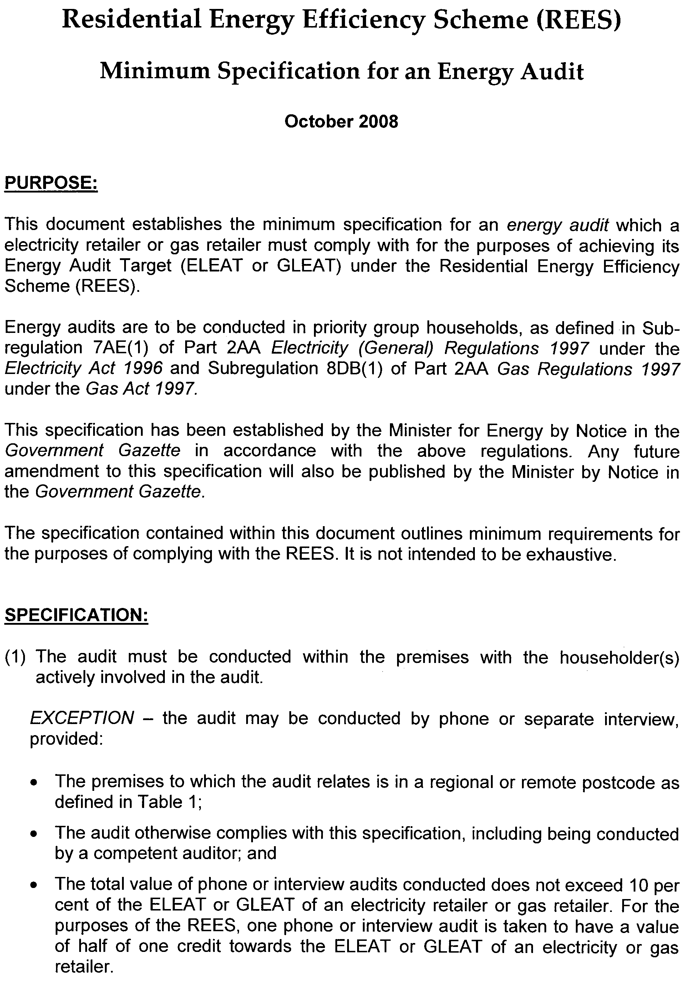
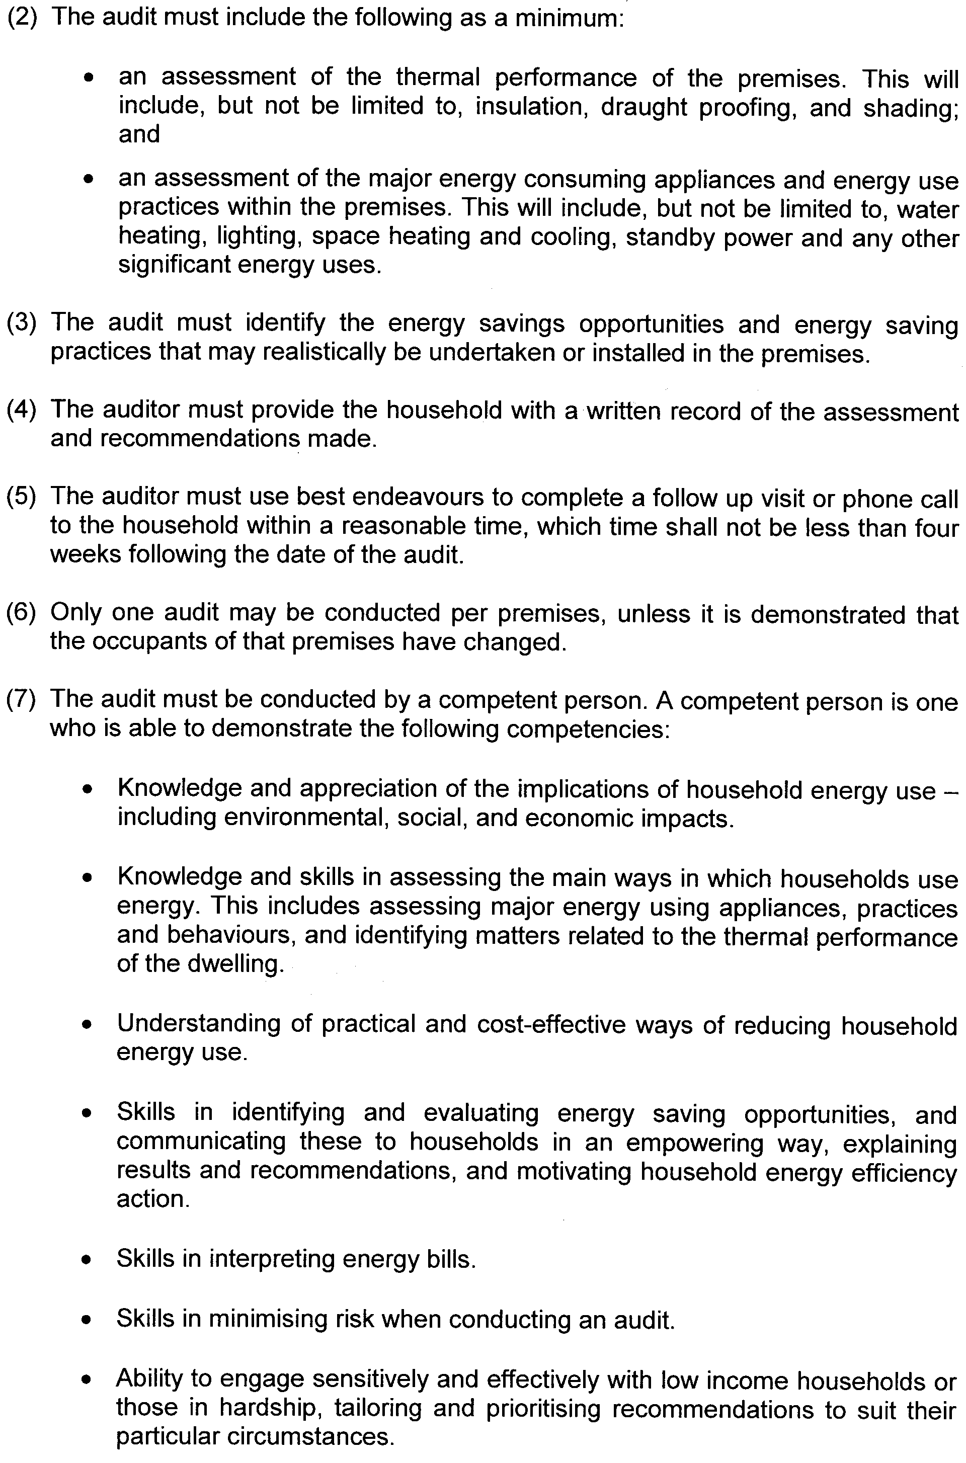
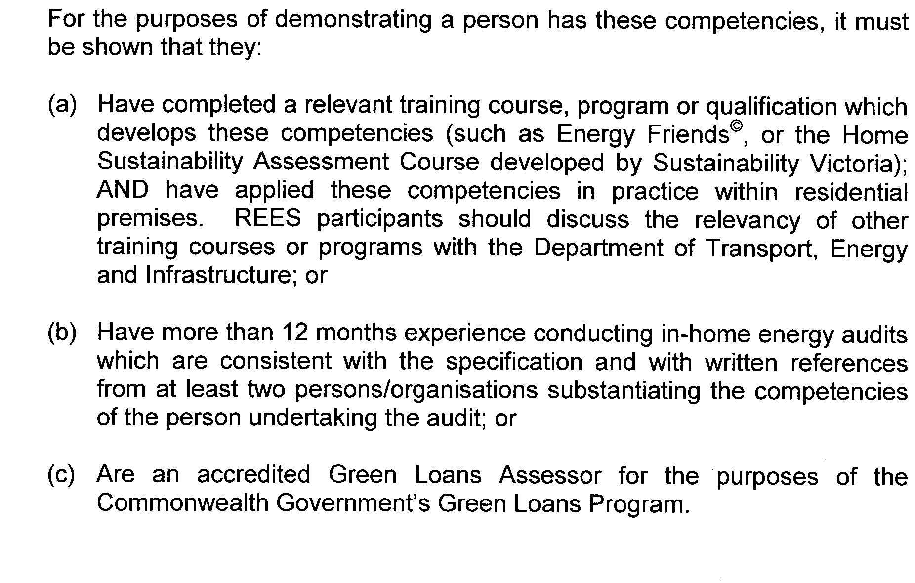
Table 1: Metropolitan/near Adelaide, Regional and Remote Areas
All unincorporated areas are regarded as Remote areas, regardless of the post code.
Post Code | Area |  | Post Code | Area
0872 | Remote |  | 5373 – 5374 | Regional
5000 – 5202 | Metro/near Adelaide |  | 5381 | Remote
5203 – 5204 | Regional |  | 5400 | Metro/near Adelaide
5210 – 5214 | Metro/near Adelaide |  | 5401 – 5416 | Regional
5220 – 5223 | Remote |  | 5417 – 5440 | Remote
5231 – 5236 | Metro/near Adelaide |  | 5451 – 5453 | Regional
5237 – 5238 | Regional |  | 5454 | Remote
5240 – 5252 | Metro/near Adelaide |  | 5455 – 5464 | Regional
5253 – 5263 | Regional |  | 5470 – 5493 | Remote
5264 – 5270 | Remote |  | 5495 – 5573 | Regional
5271 | Regional |  | 5575 – 5583 | Remote
5272 – 5276 | Remote |  | 5600 | Regional
5277 – 5291 | Regional |  | 5601 – 5605 | Remote
5301 – 5320 | Remote |  | 5606 | Regional
5321 – 5346 | Regional |  | 5607 | Remote
5350 – 5352 | Metro/near Adelaide |  | 5608 – 5609 | Regional
5353 – 5354 | Regional |  | 5630 – 5690 | Remote
5355 | Metro/near Adelaide |  | 5700 – 5710 | Regional
5356 – 5357 | Regional |  | 5720 – 5734 | Remote
5360 – 5372 | Metro/near Adelaide |  | 5800 – 5950 | Metro/near Adelaide

ELECTRICITY ACT 1996
GAS ACT 1997

RESIDENTIAL ENERGY EFFICIENCY SCHEME

Energy Efficiency Activities

I, PATRICK CONLON, Minister for Energy advise that, on 29 October 2008, pursuant to Subregulation 7AN (1) of Part 2AA Electricity (General) Regulations 1997 under the Electricity Act 1996 and Subregulation 8DK (1) of Part 2AA Gas Regulations 1997 under the Gas Act 1997, I hereby determine the activities within the following document to be energy efficiency activities for the purposes of Part 2AA of the above regulations.

Patrick Conlon, Minister for Energy

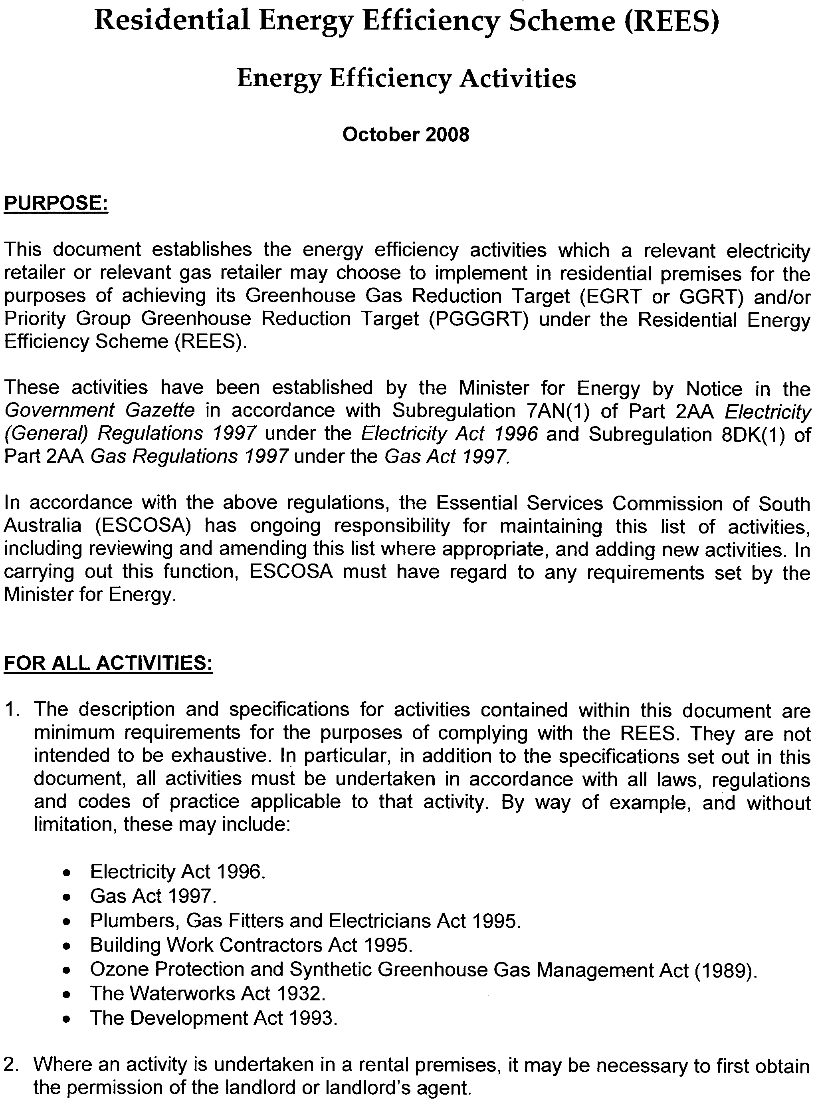
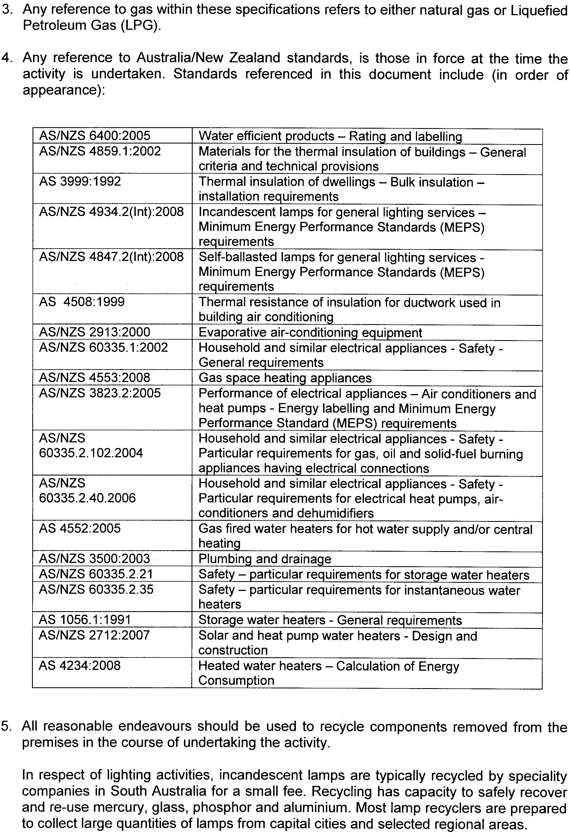
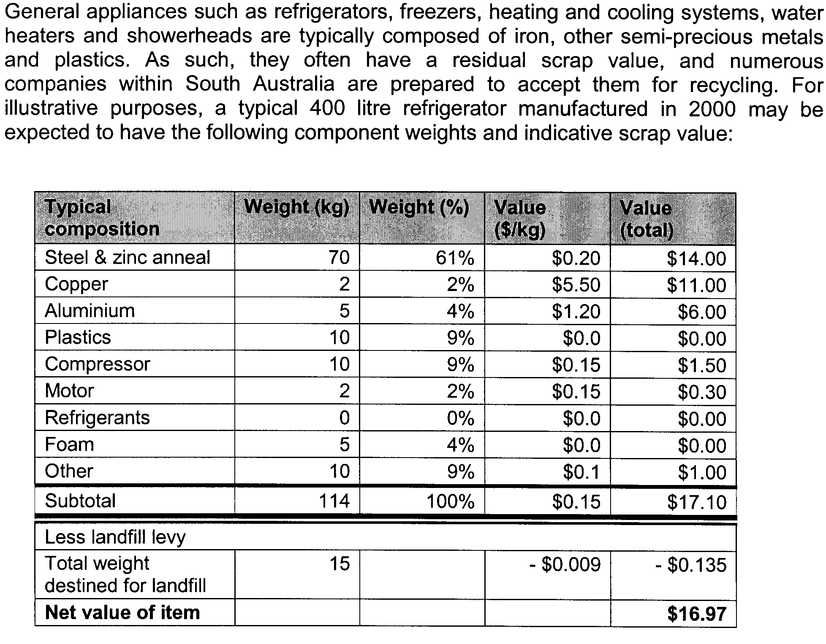
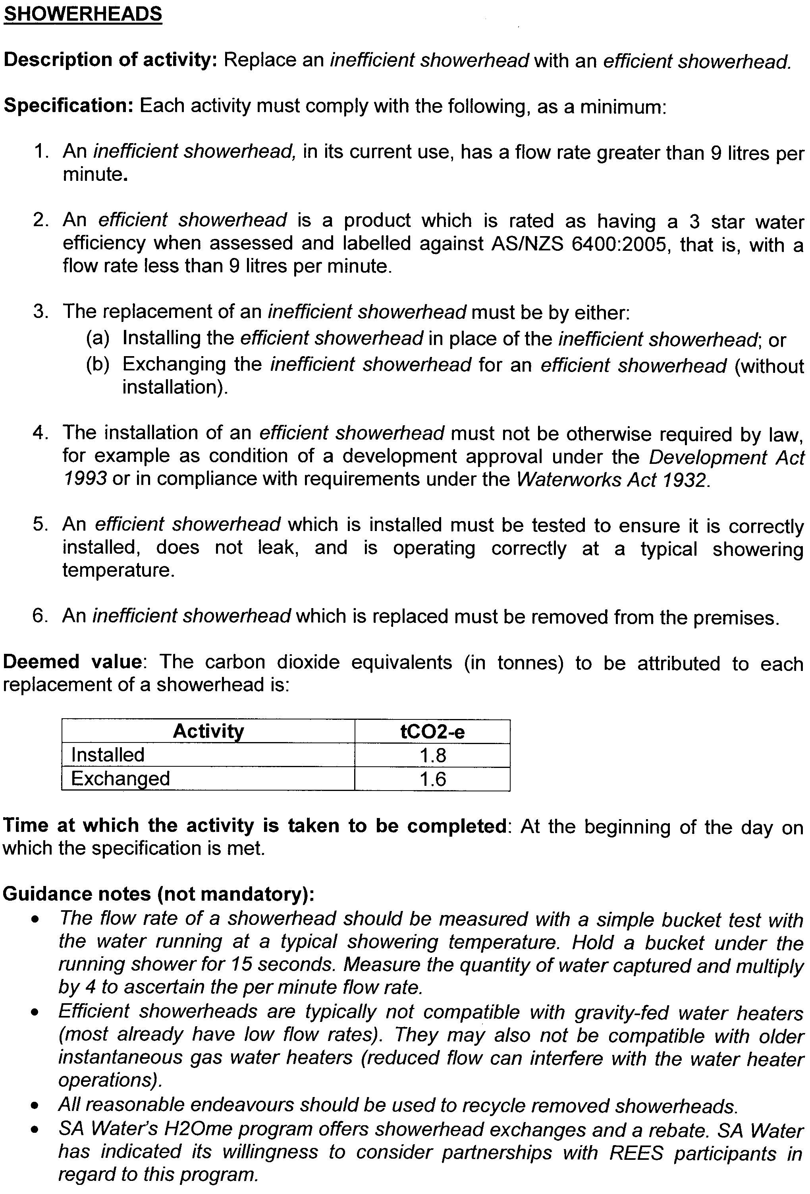
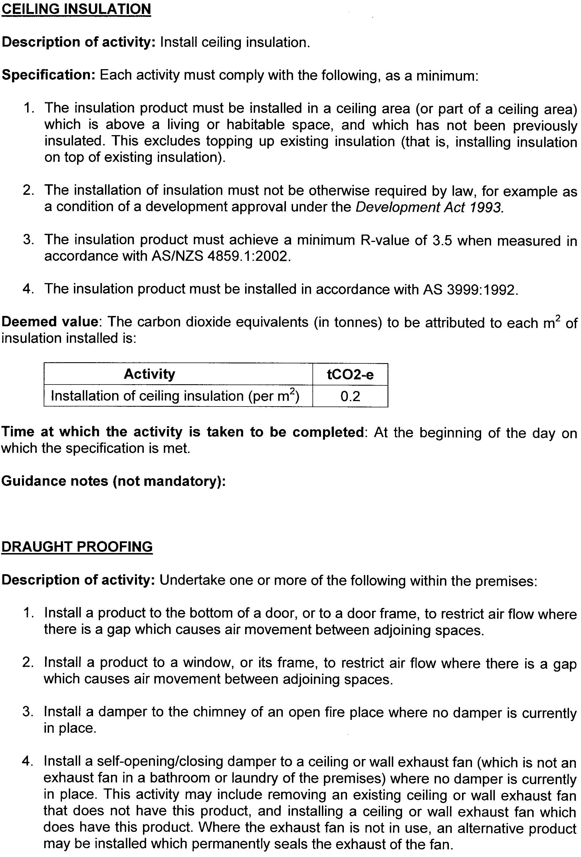
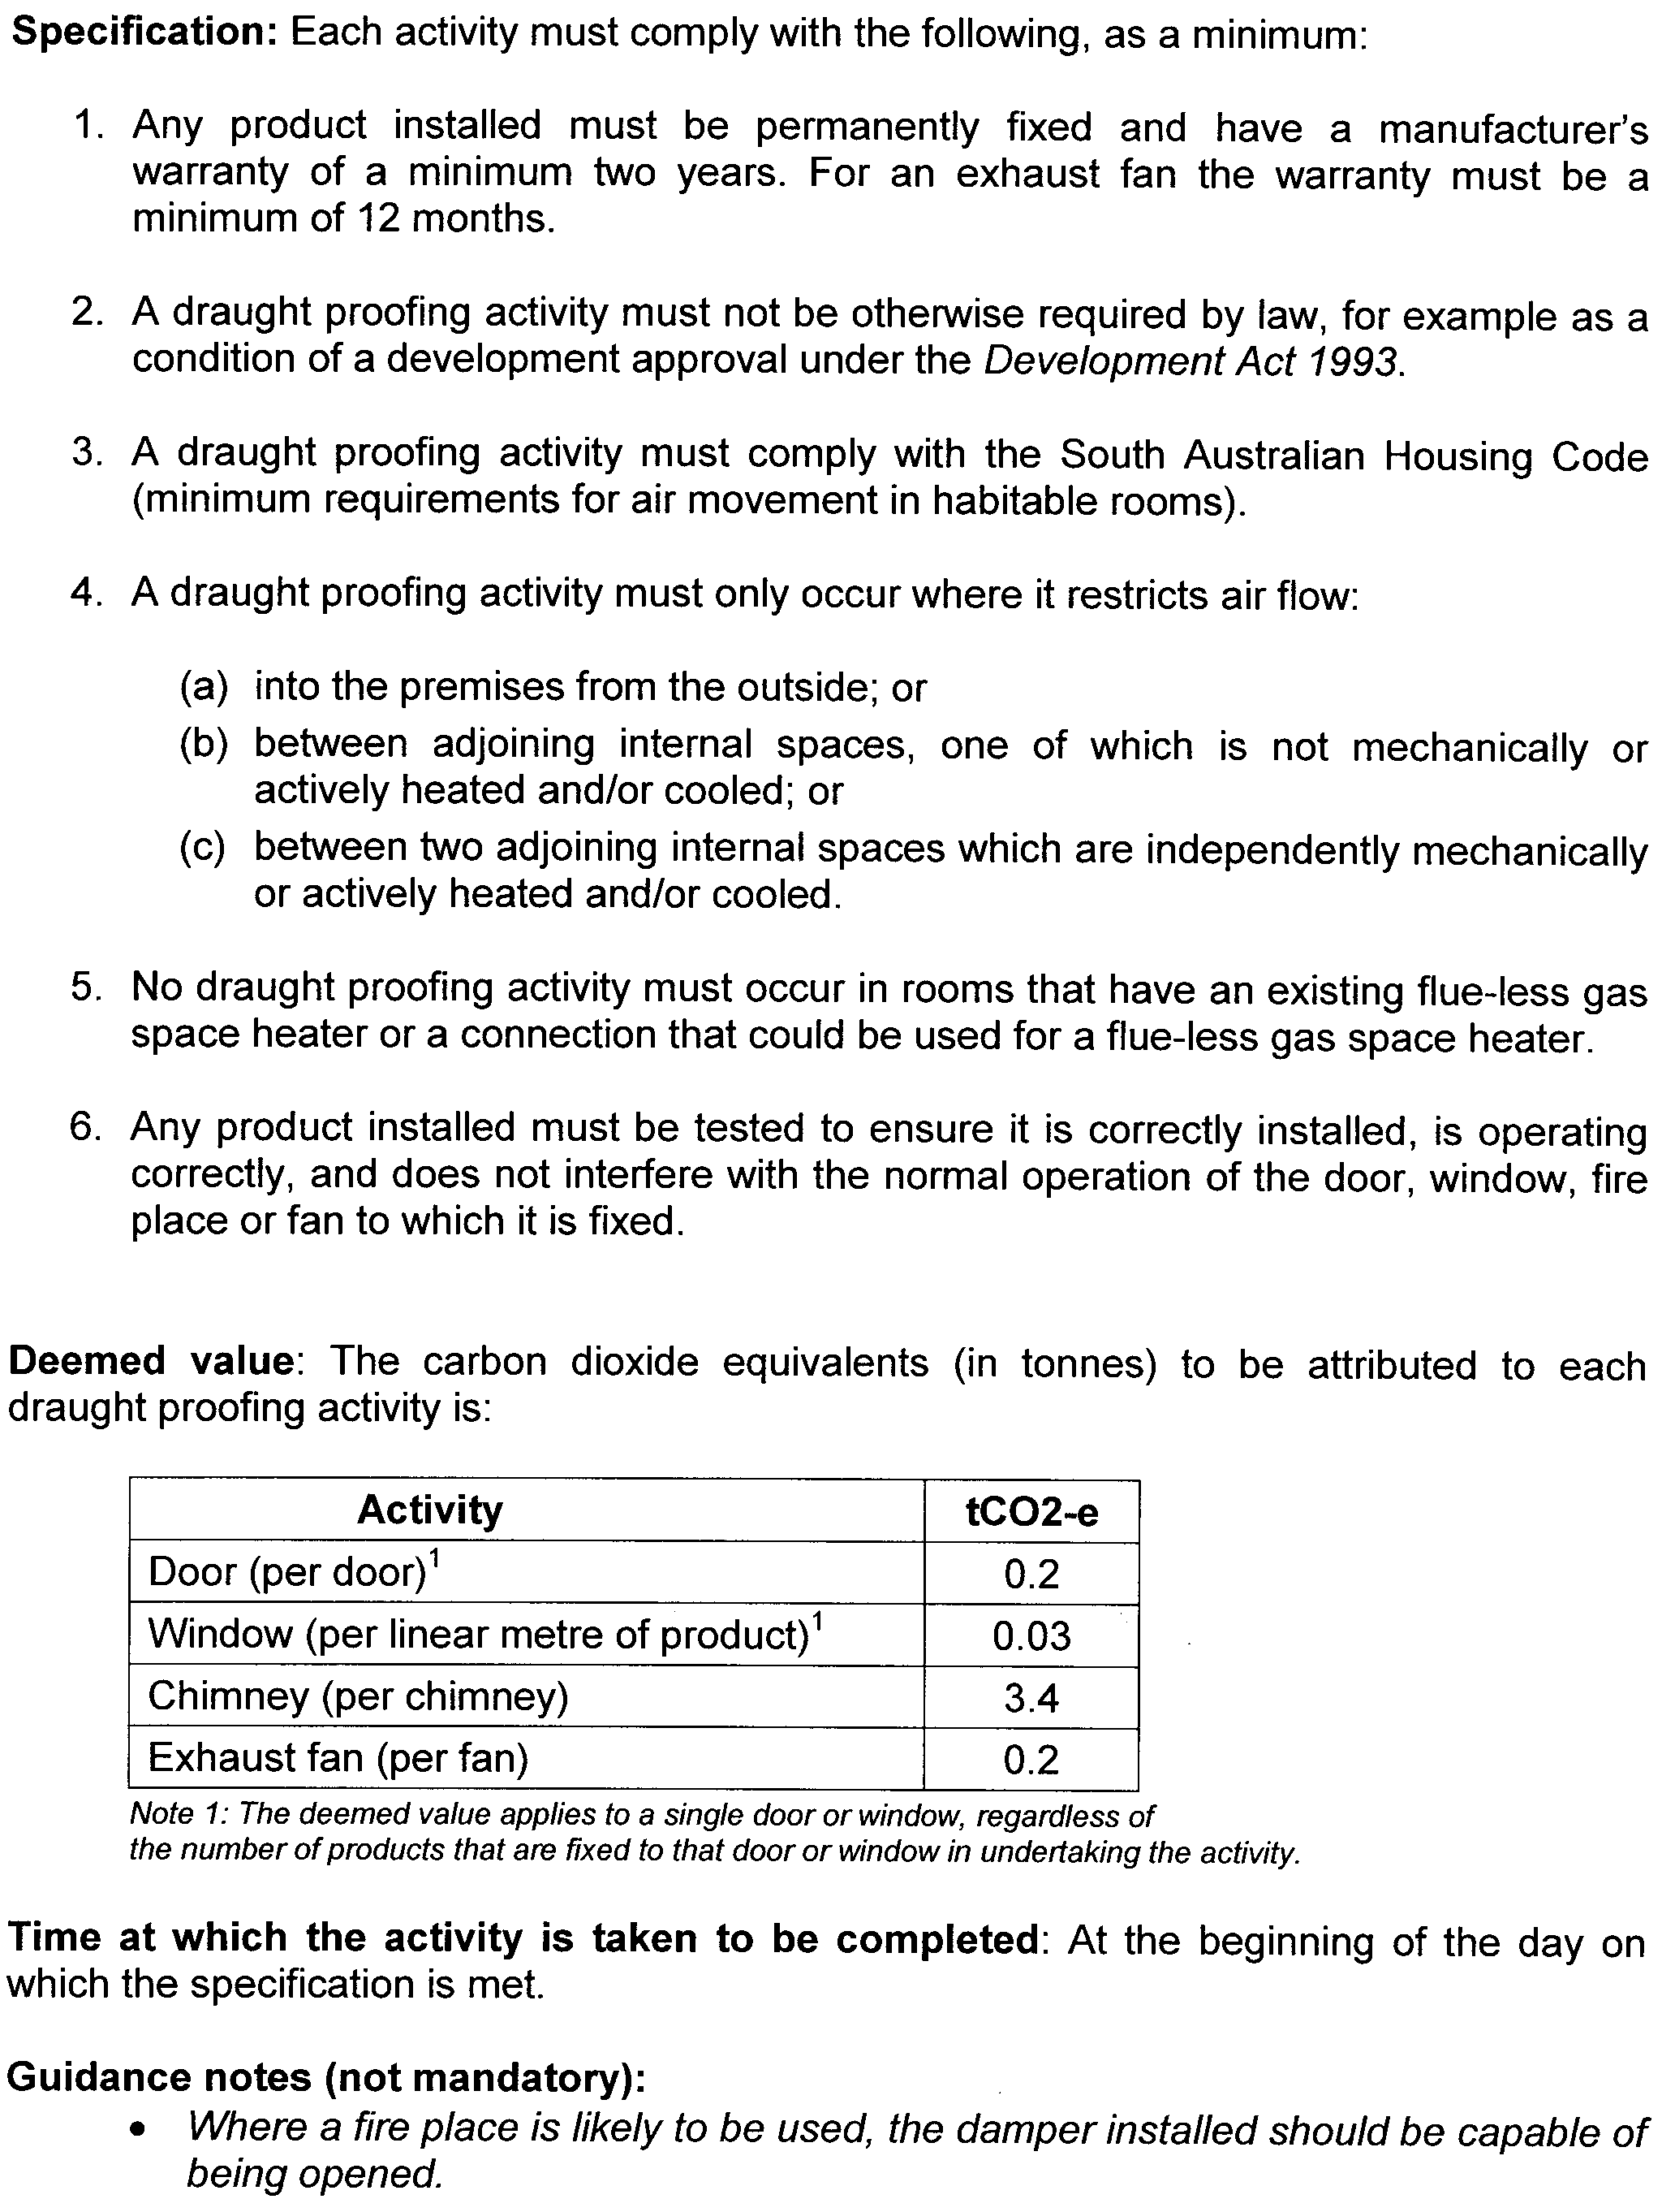
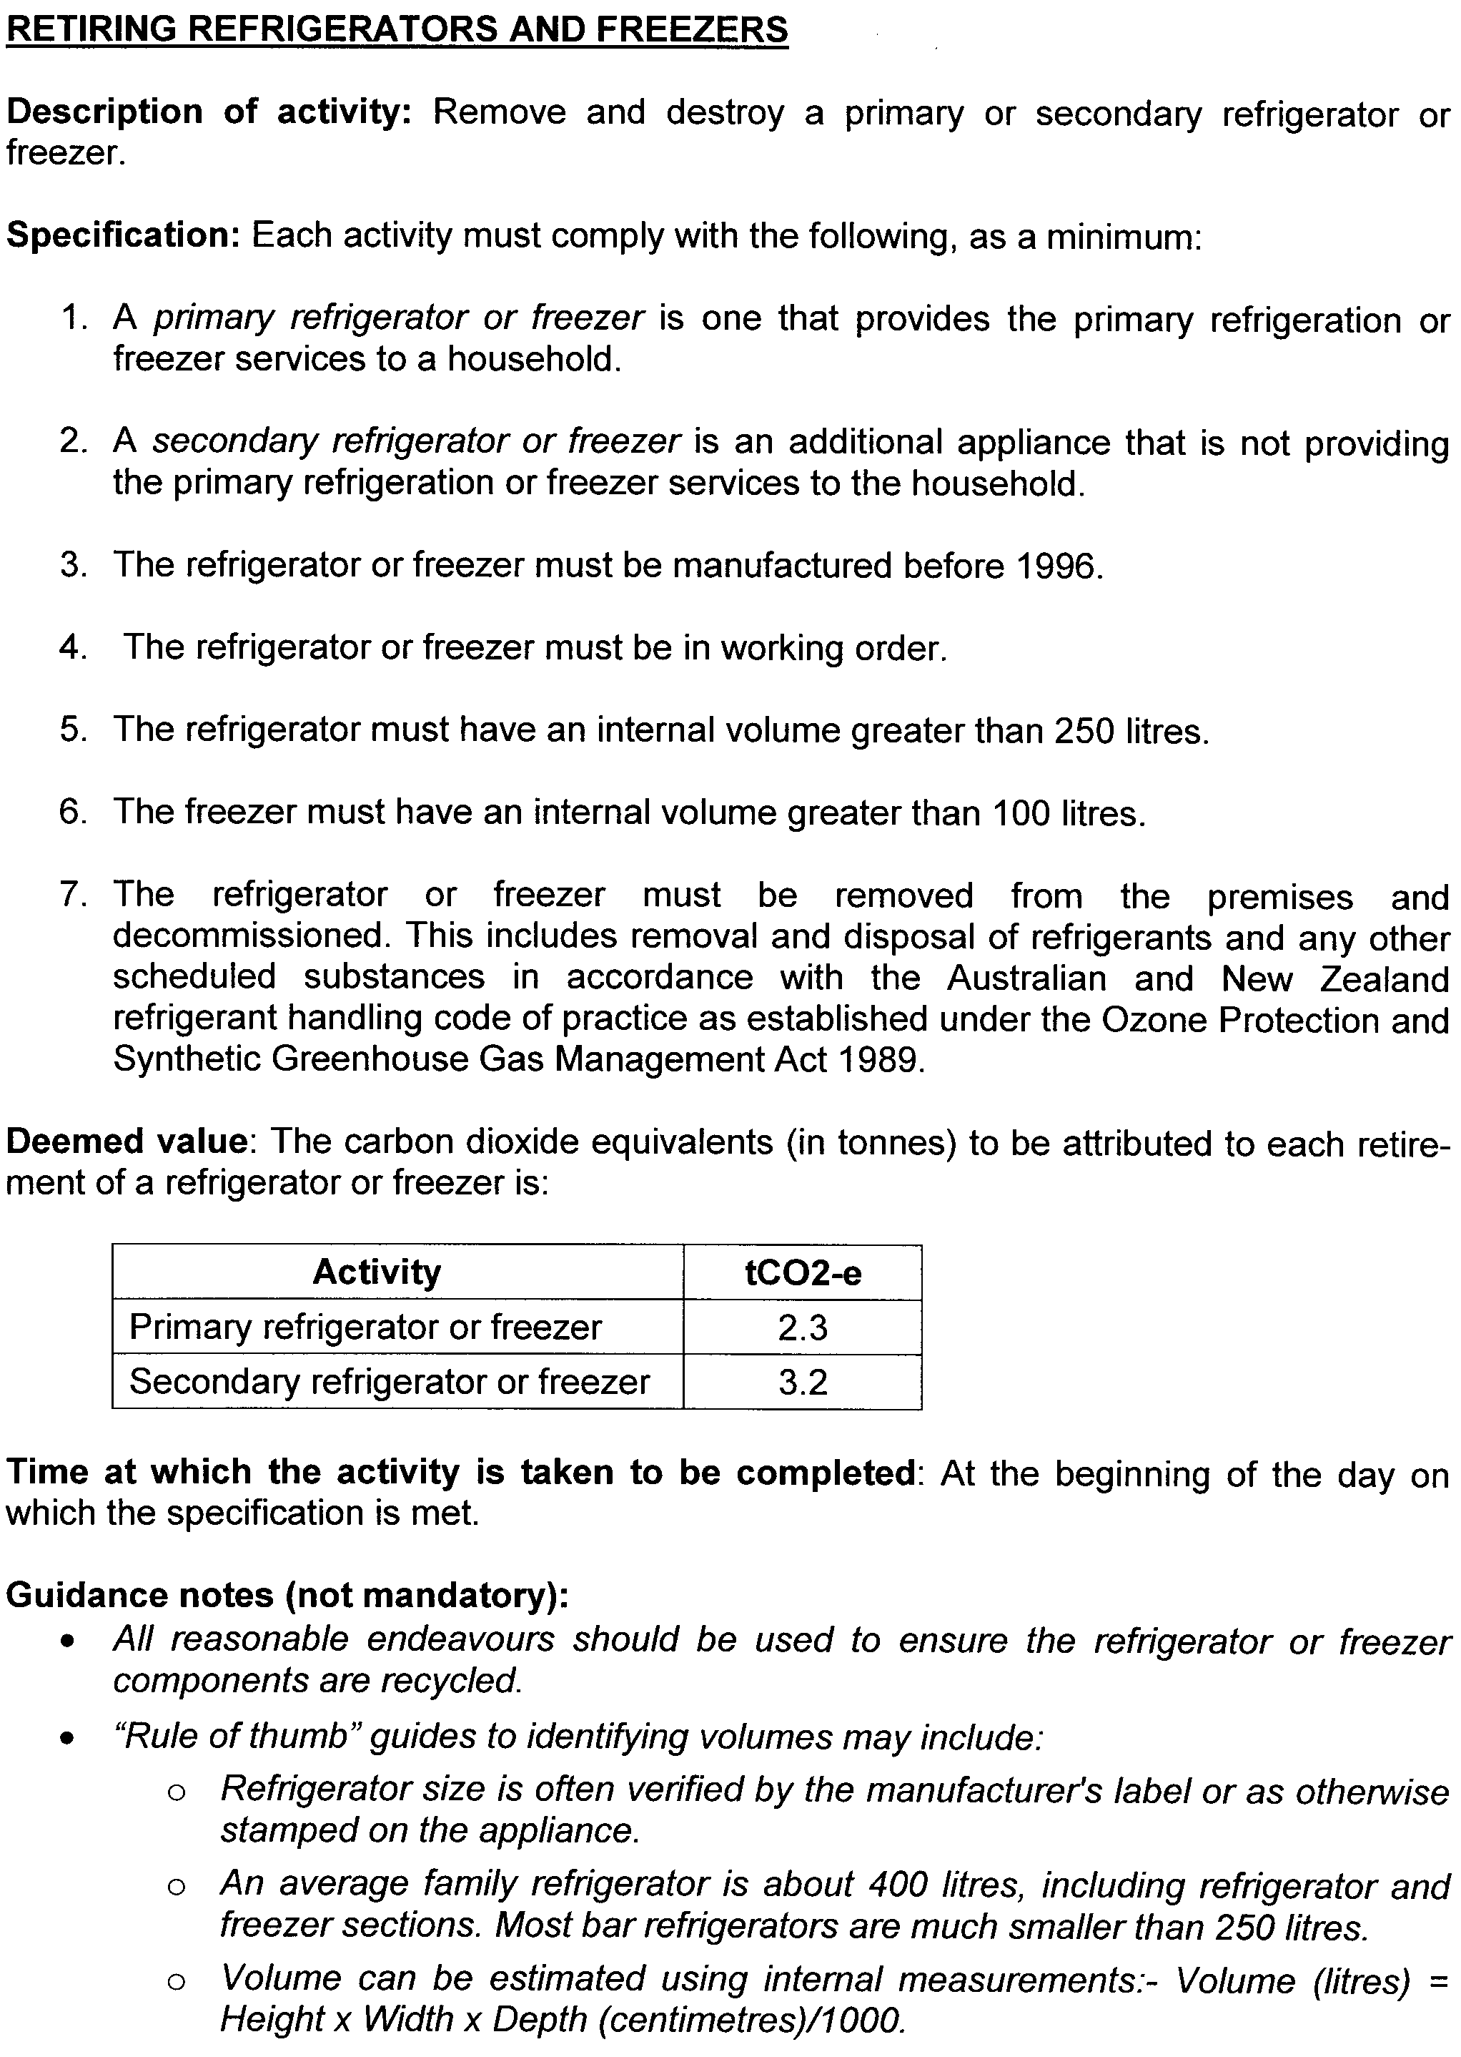
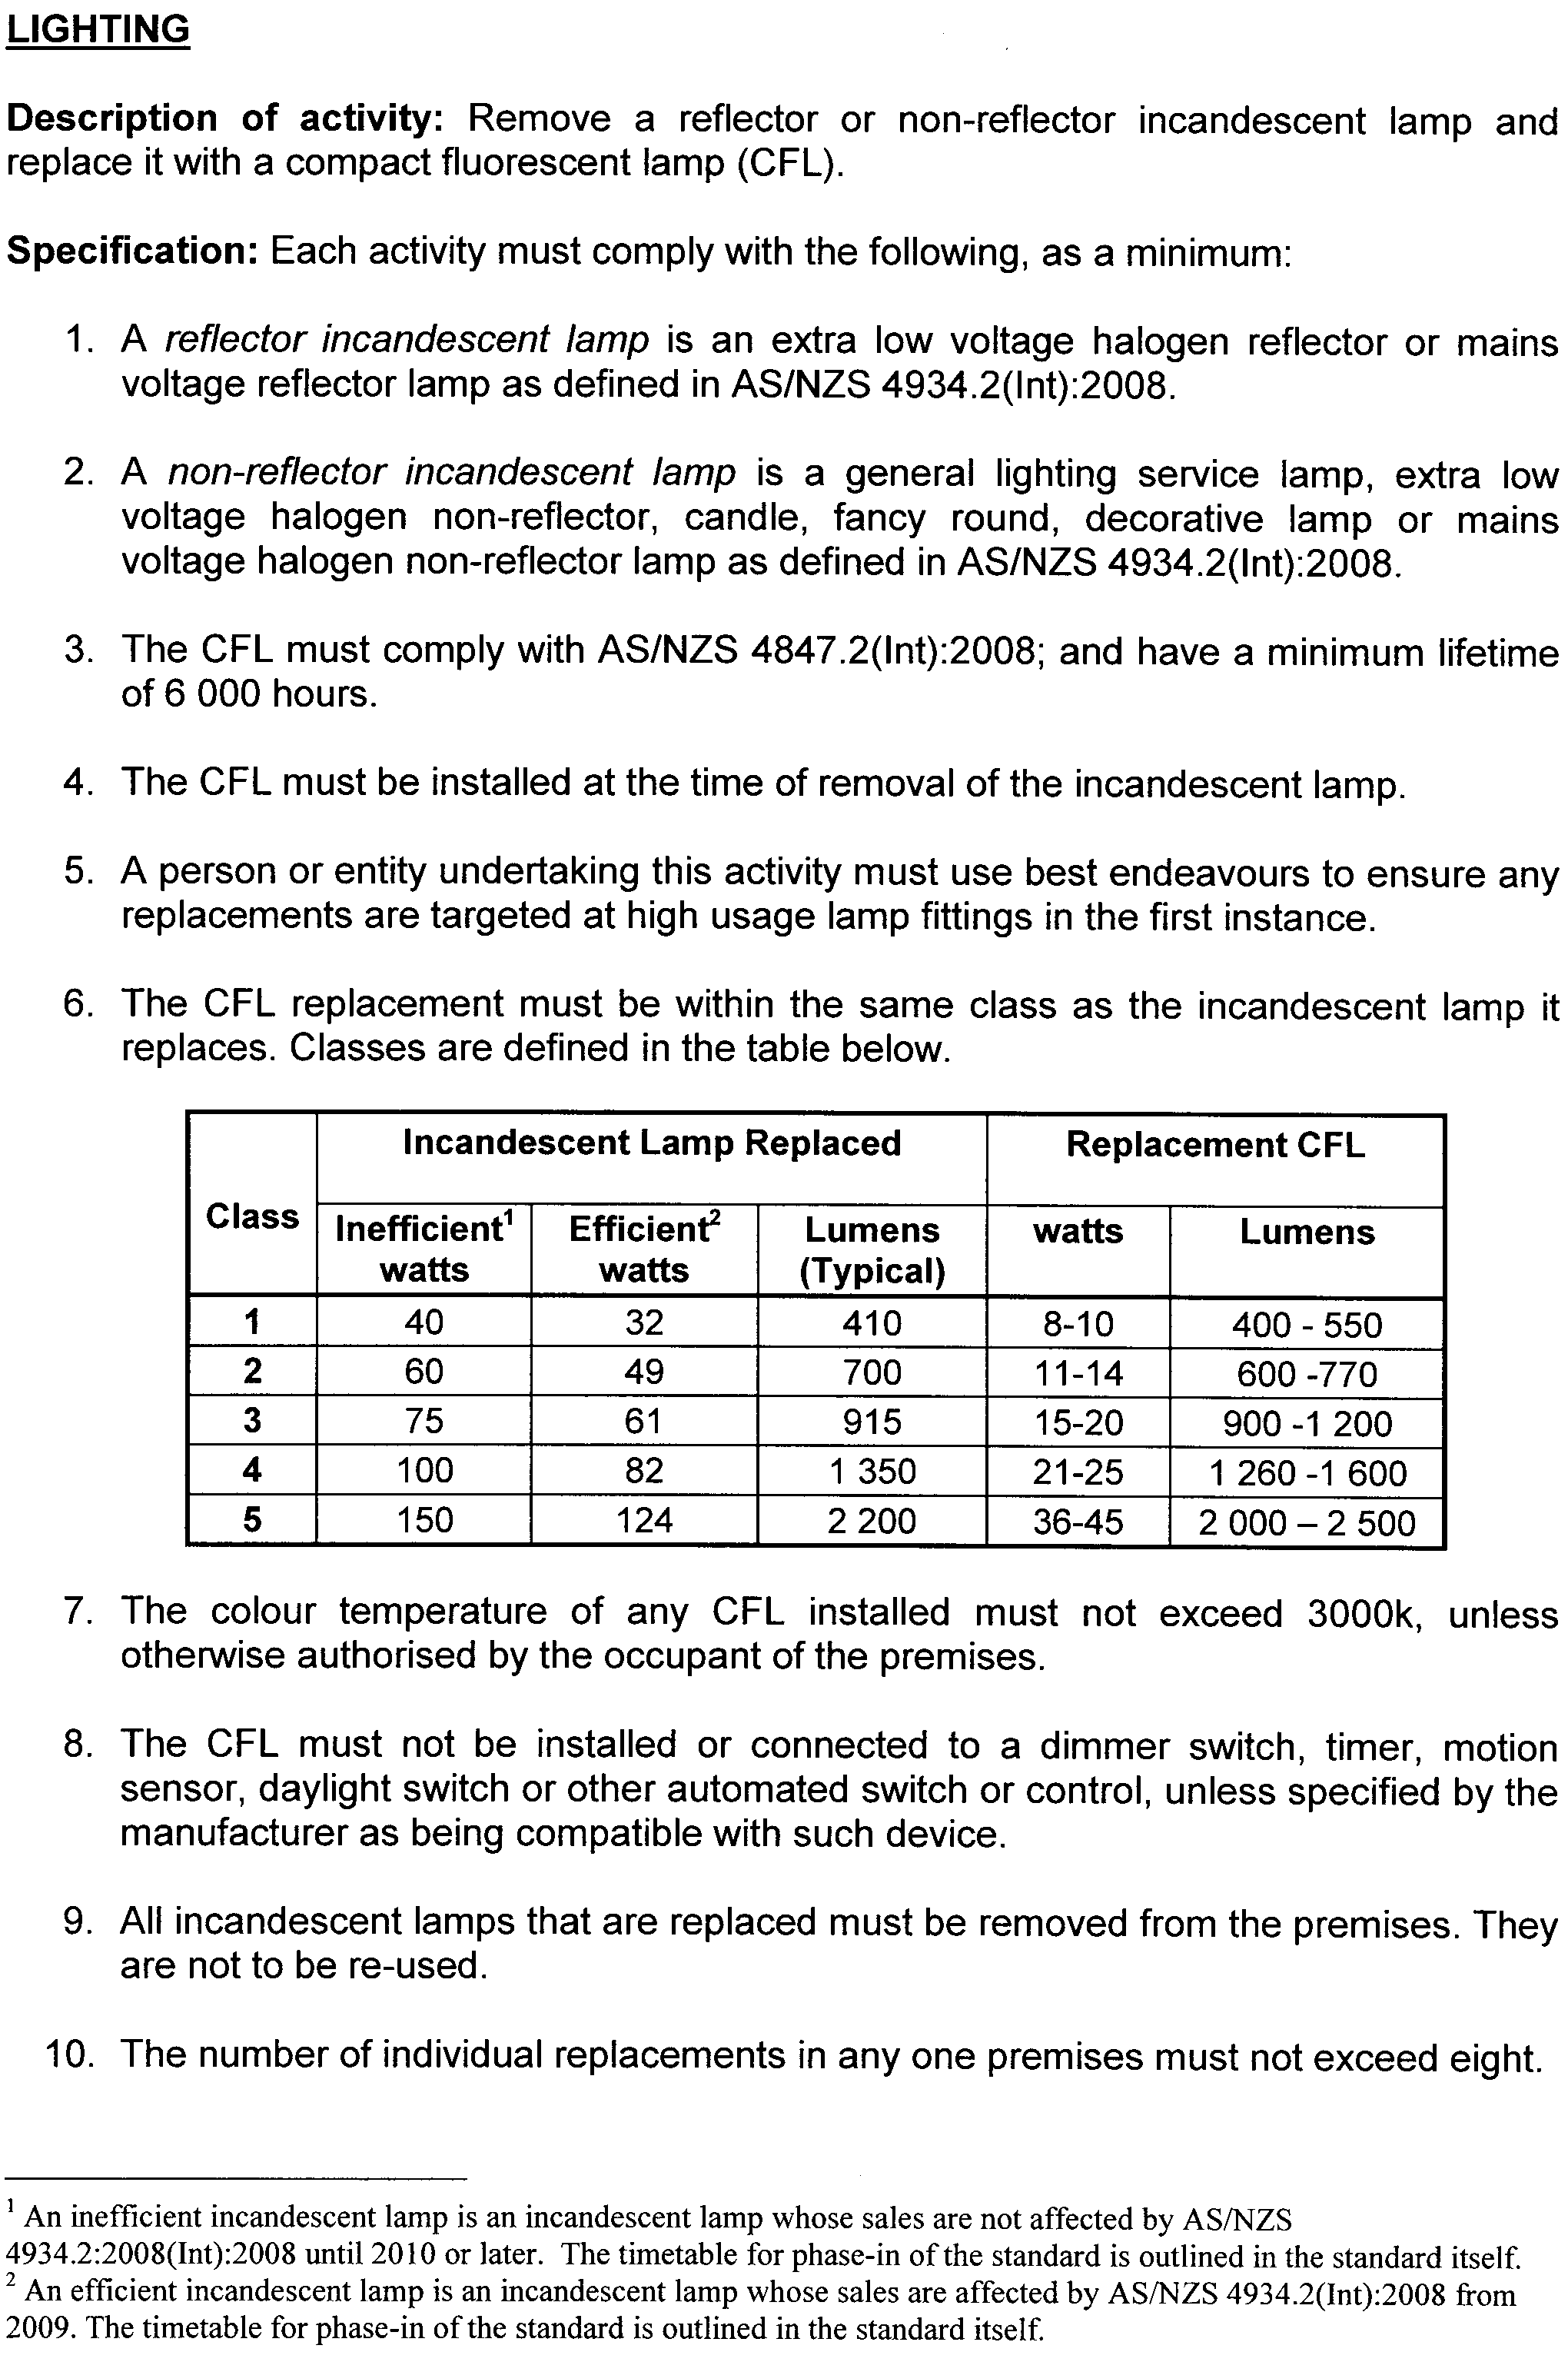
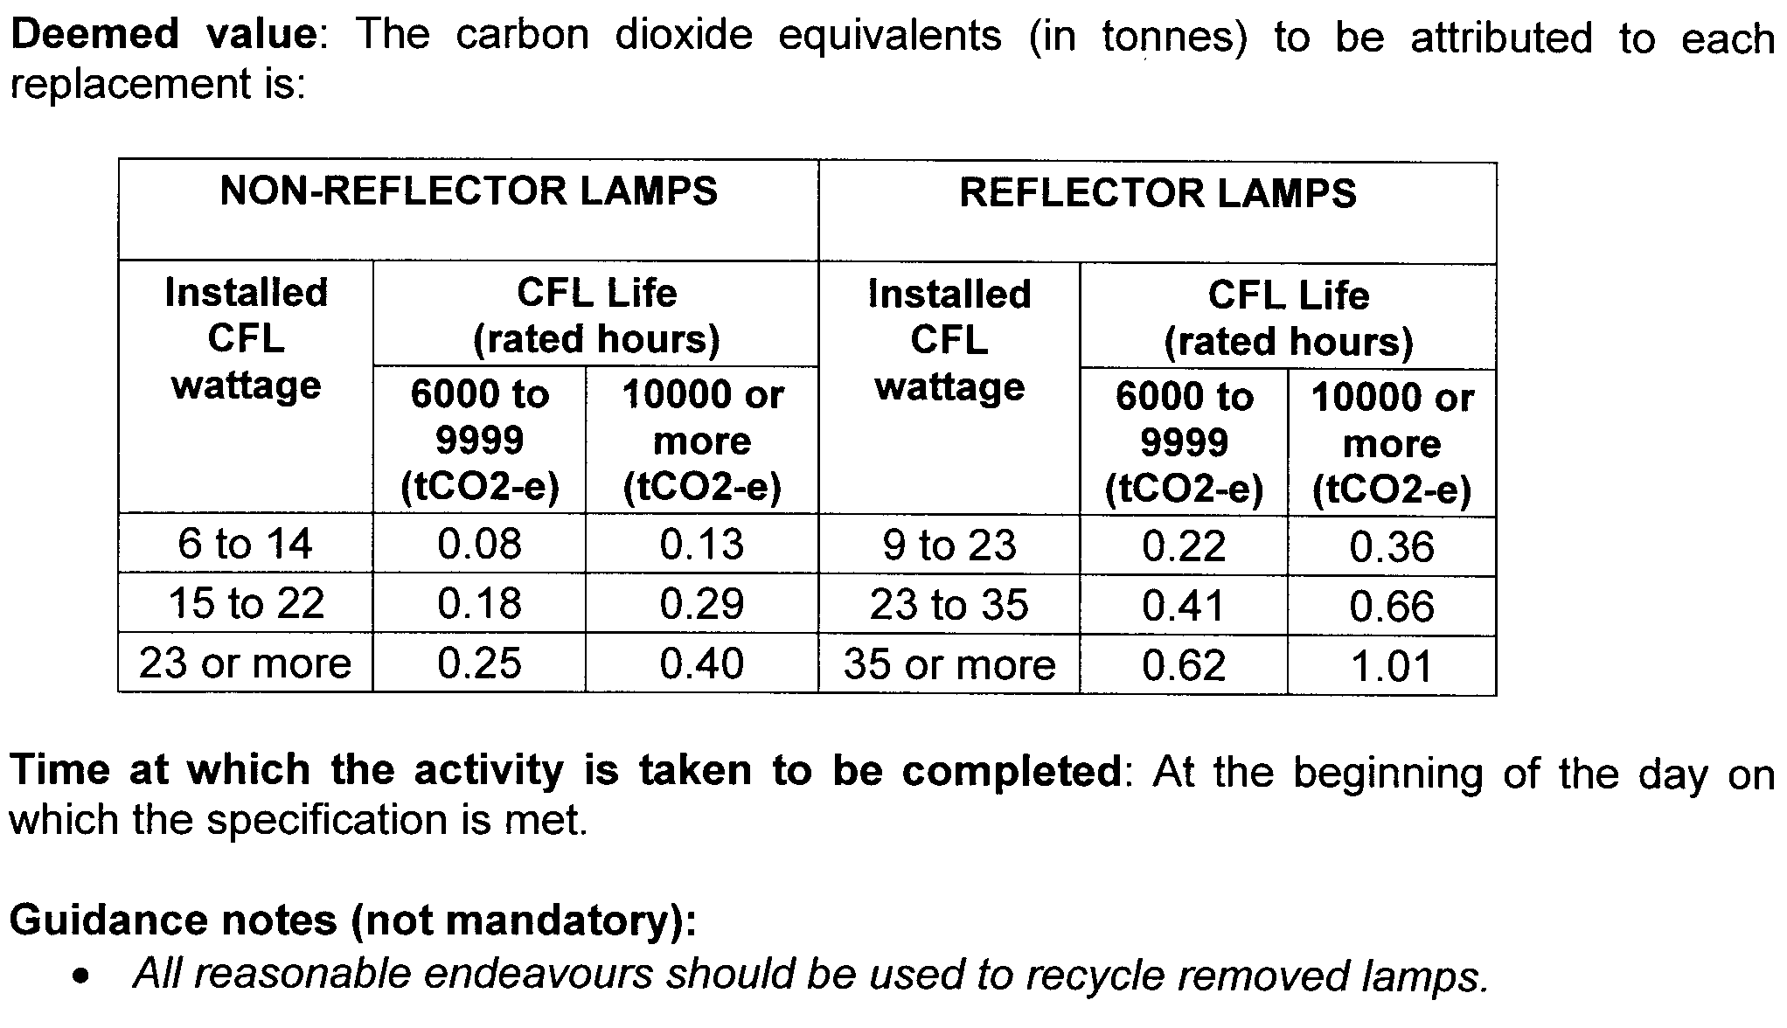
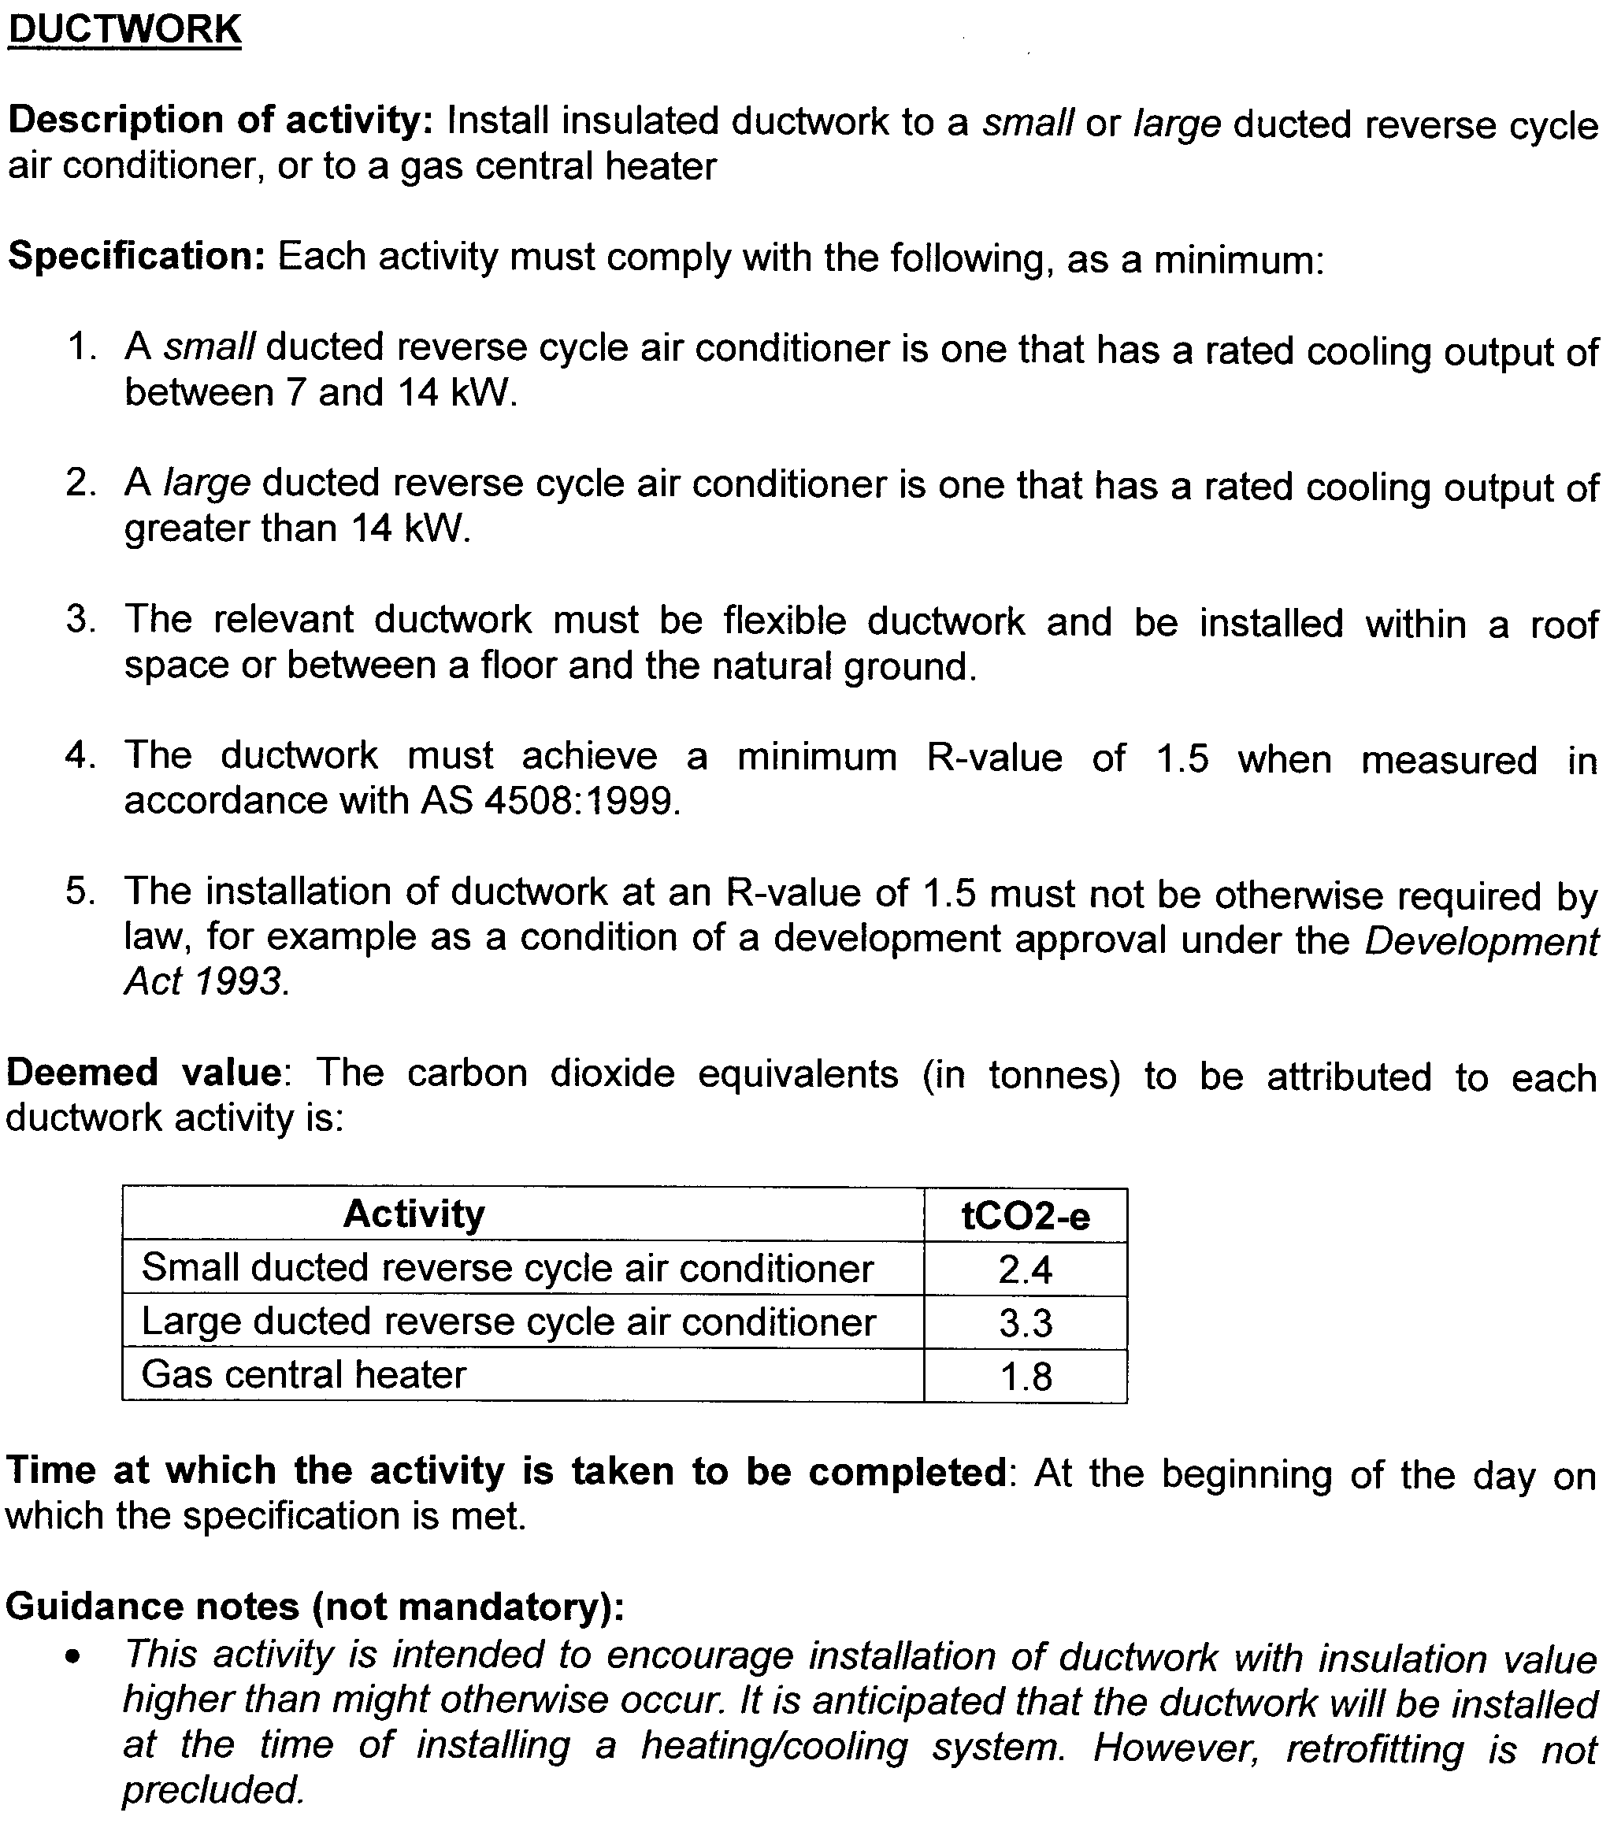
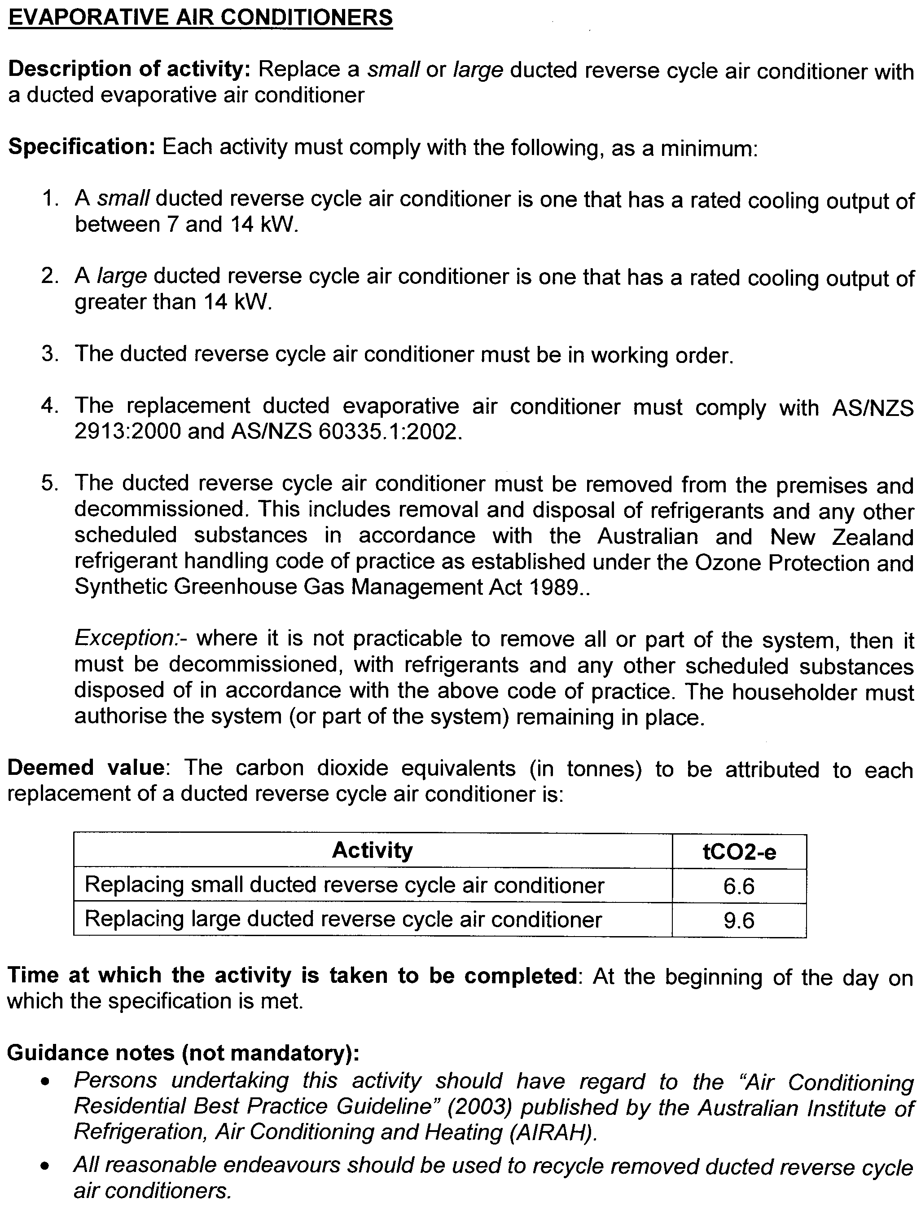
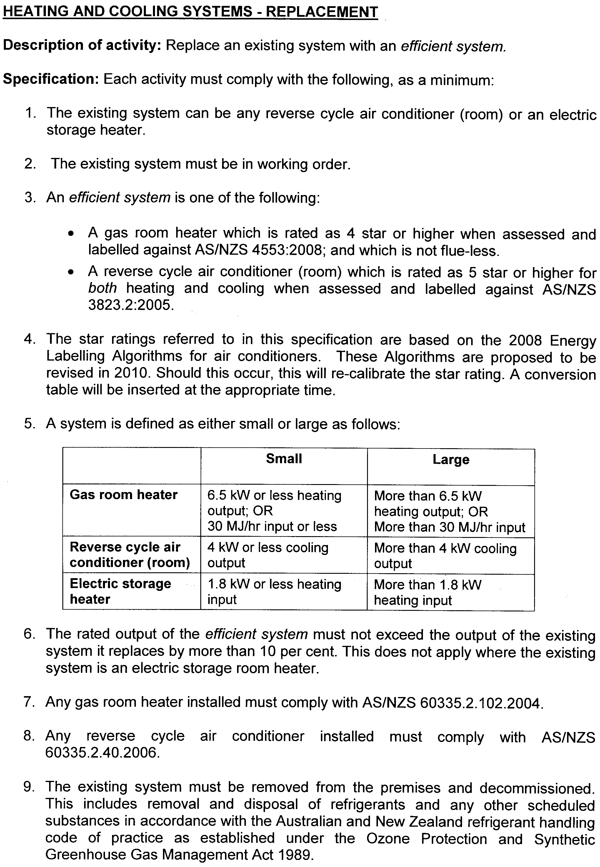
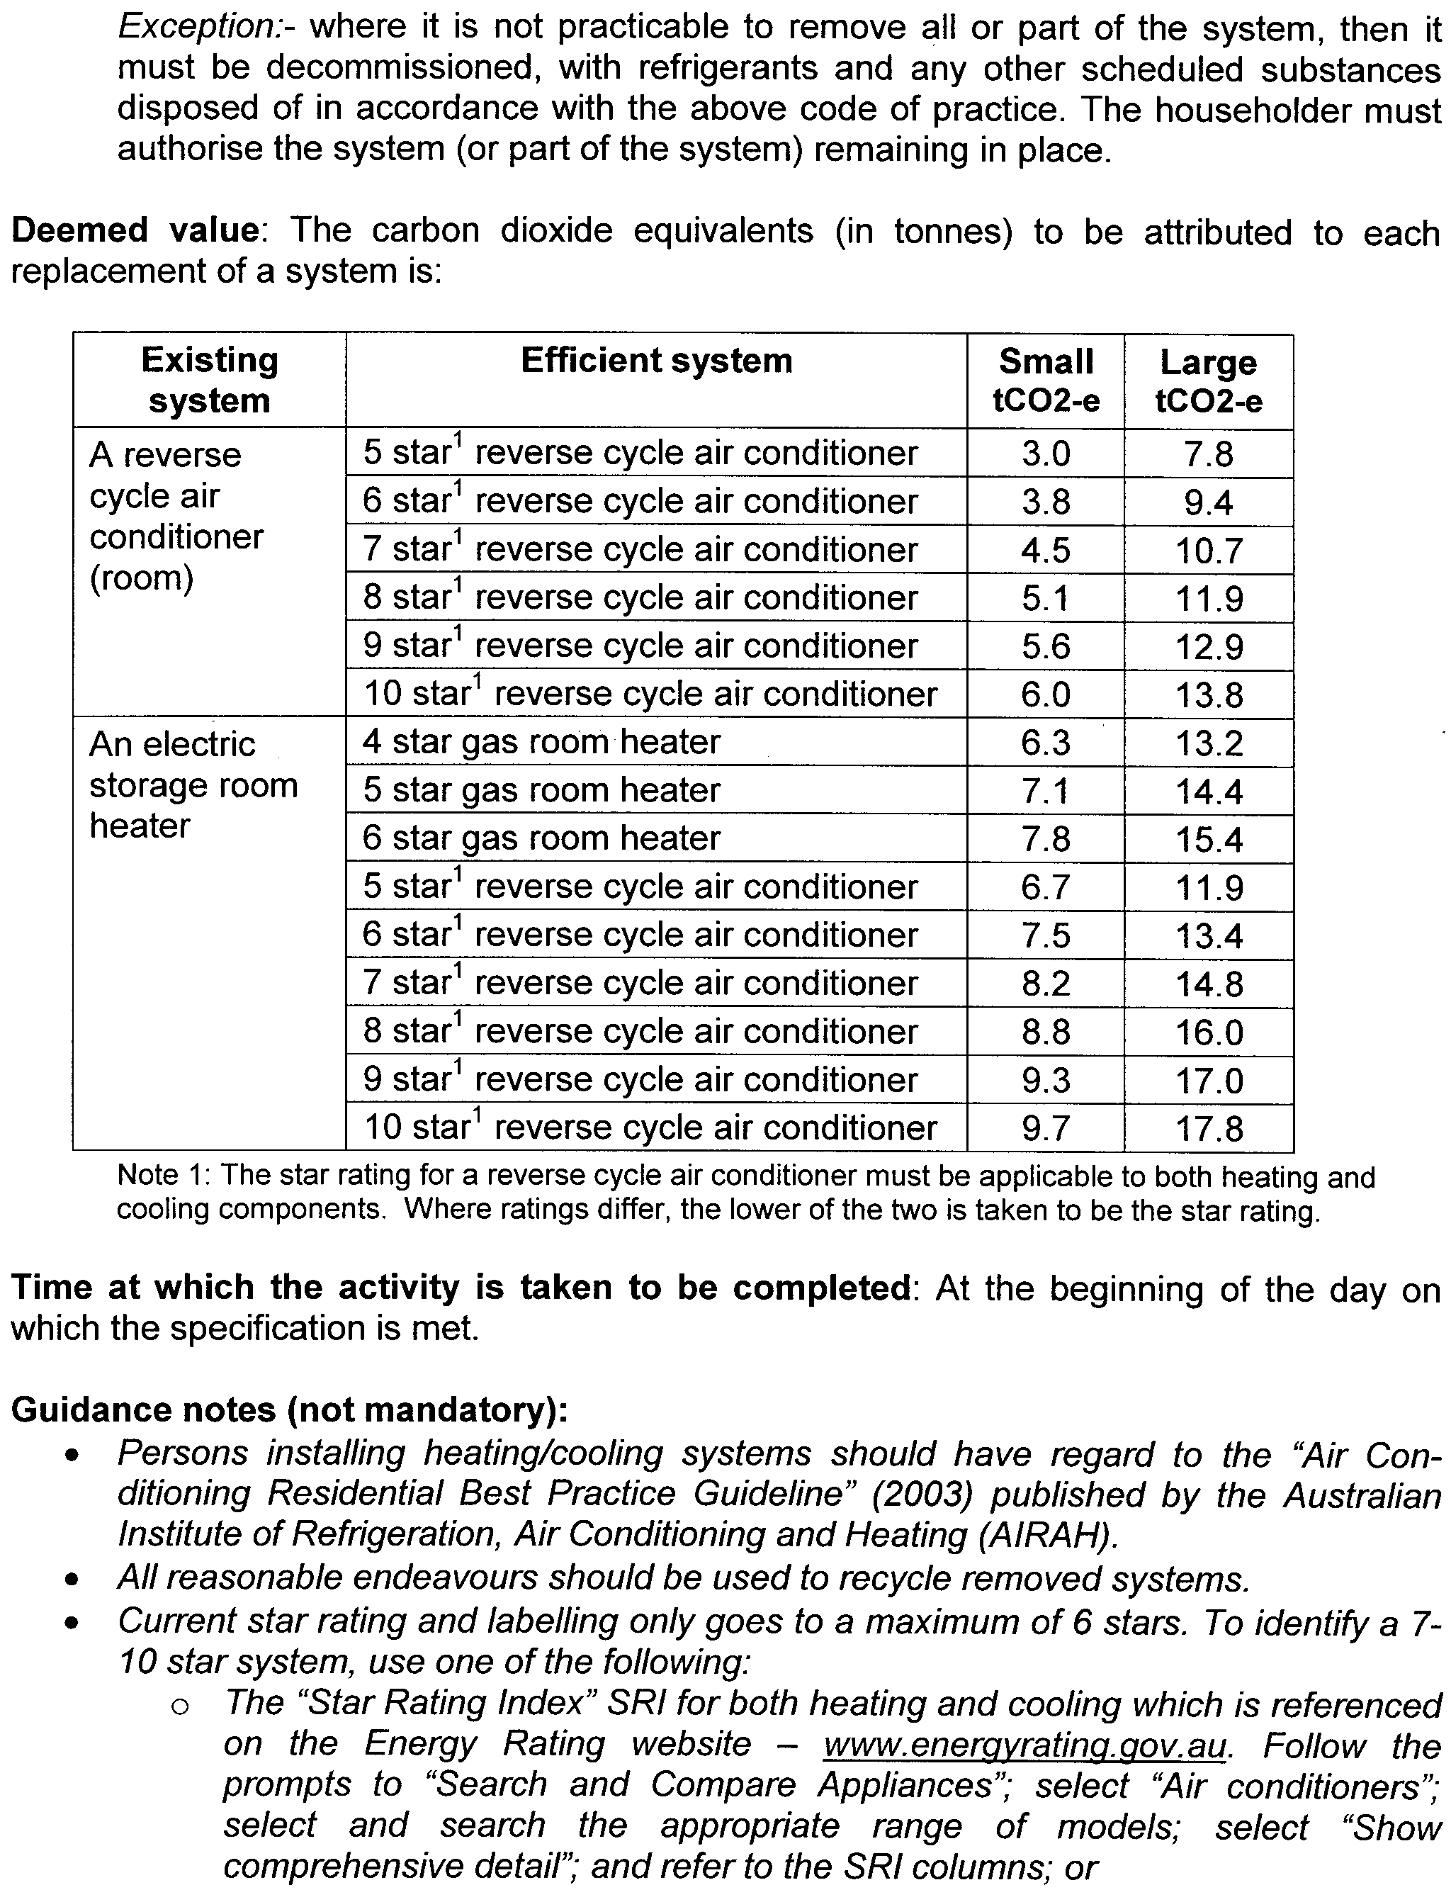
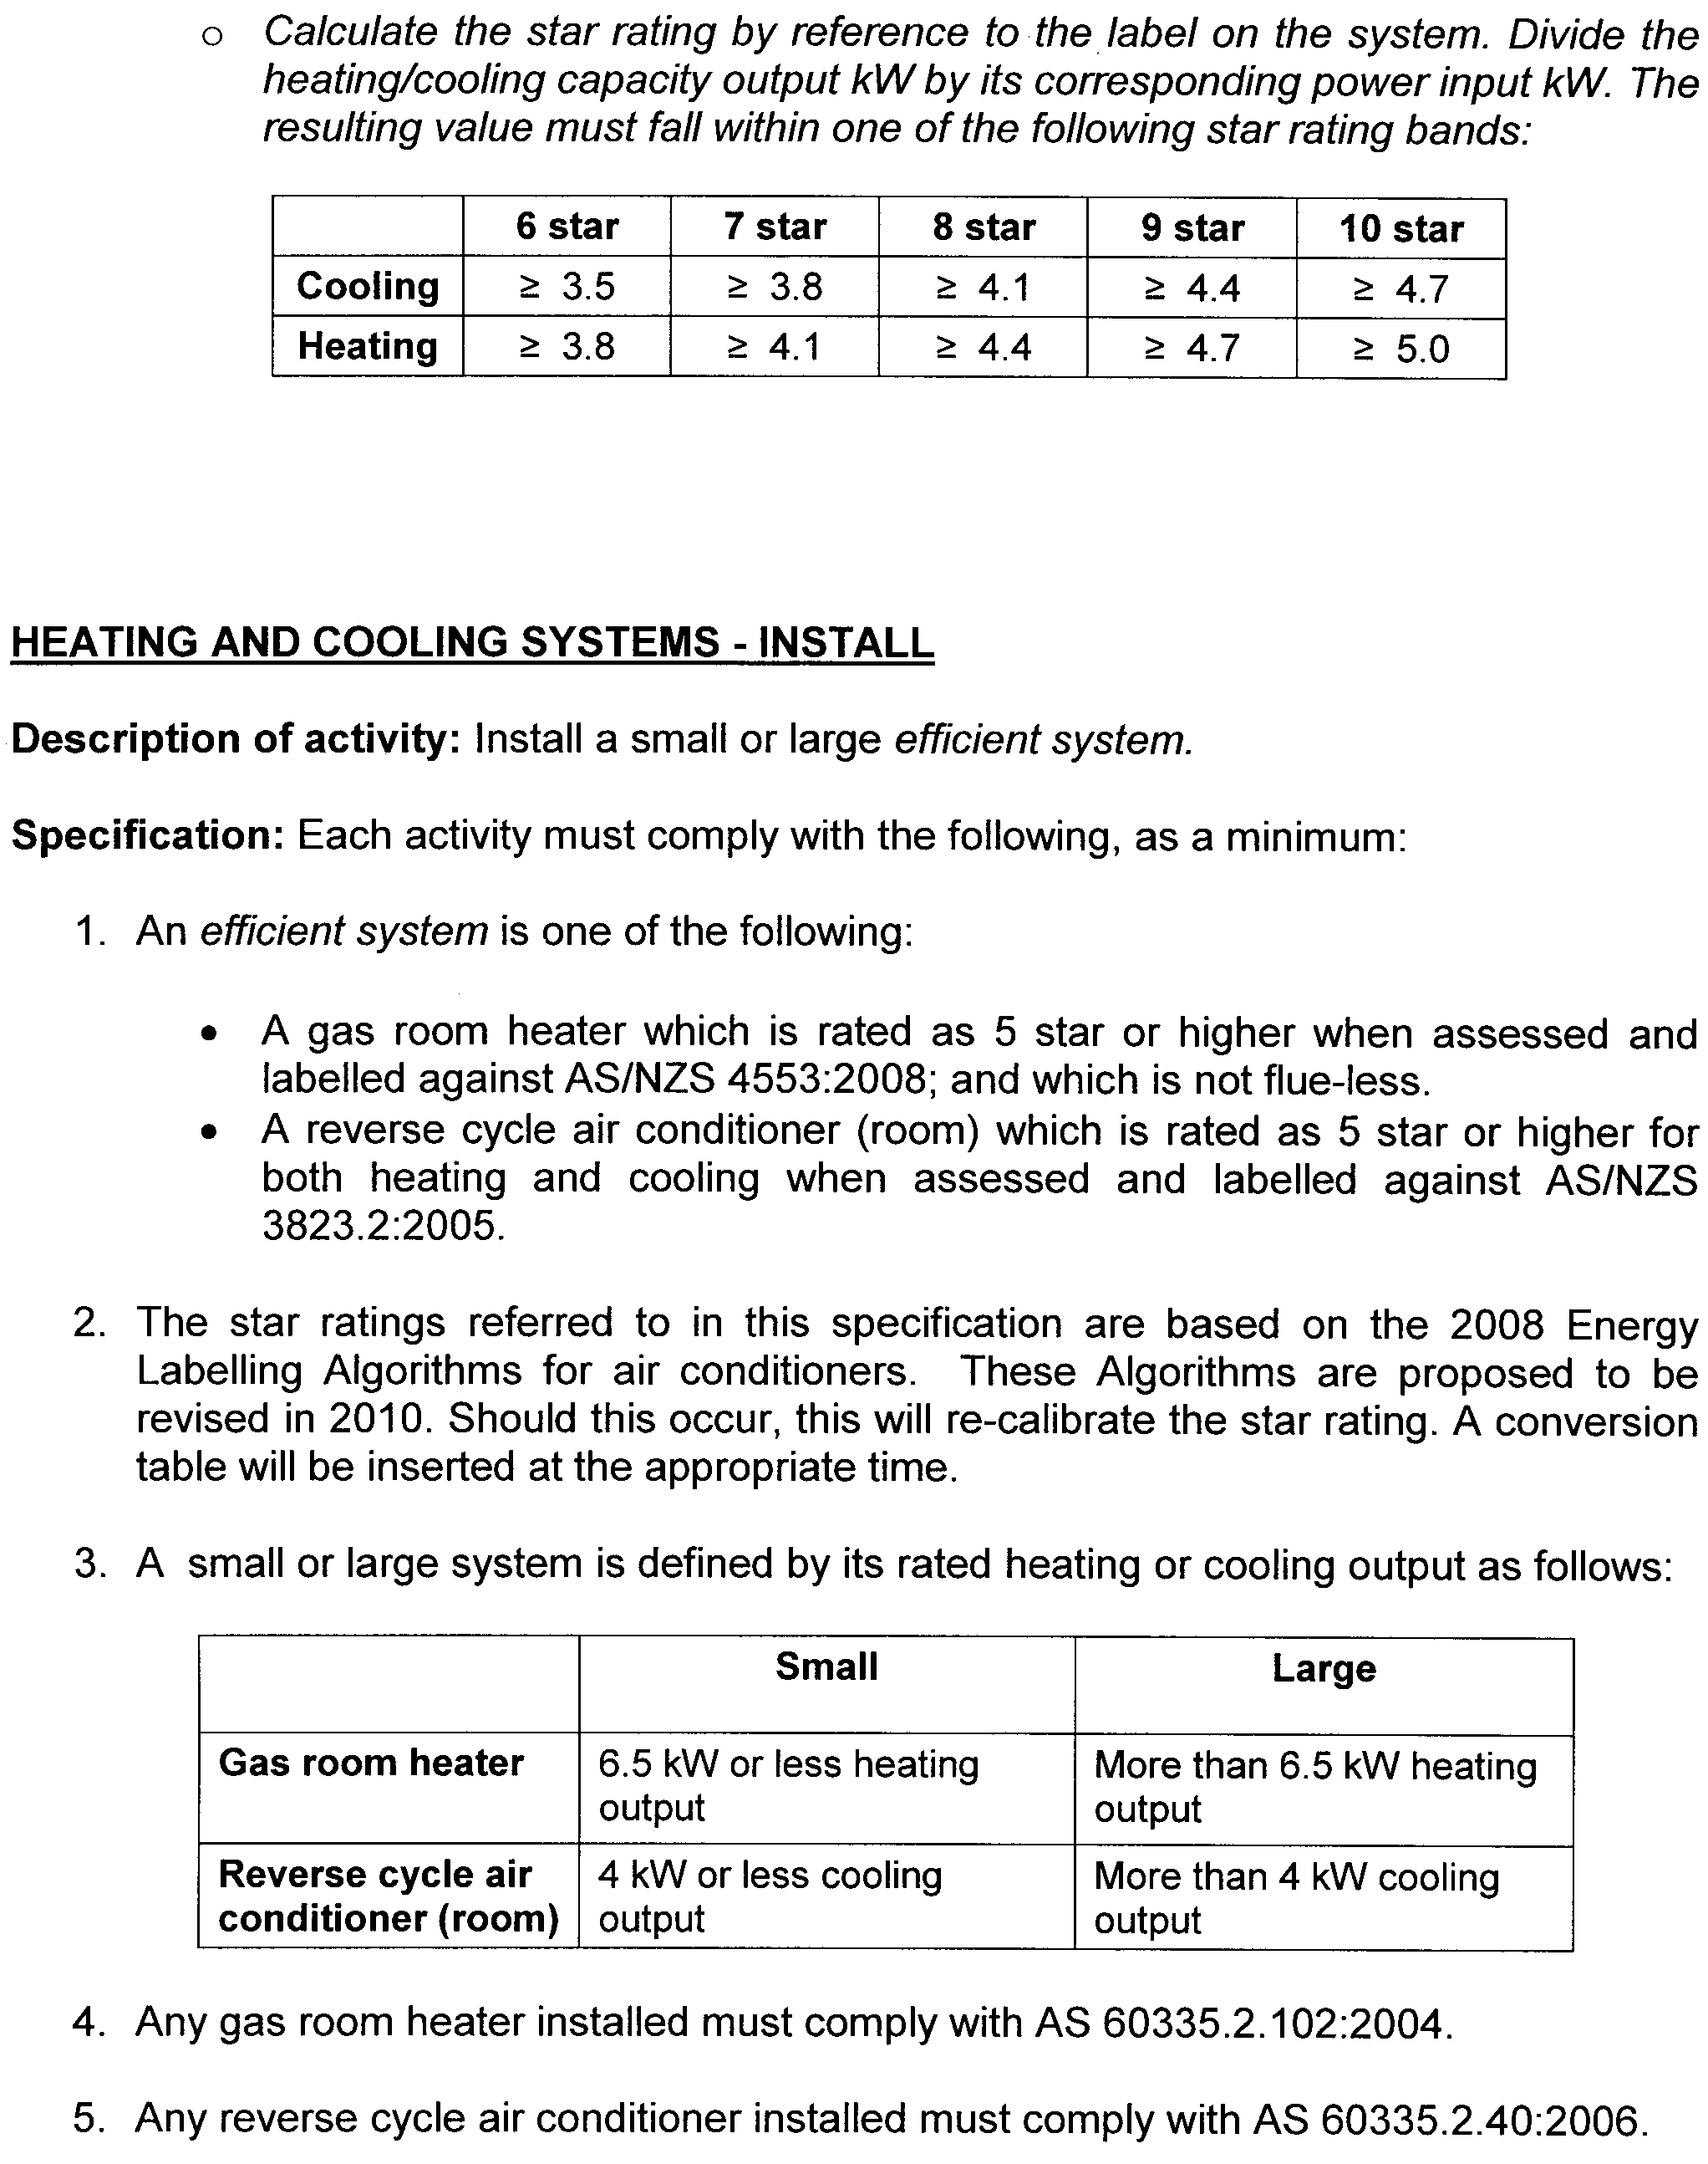
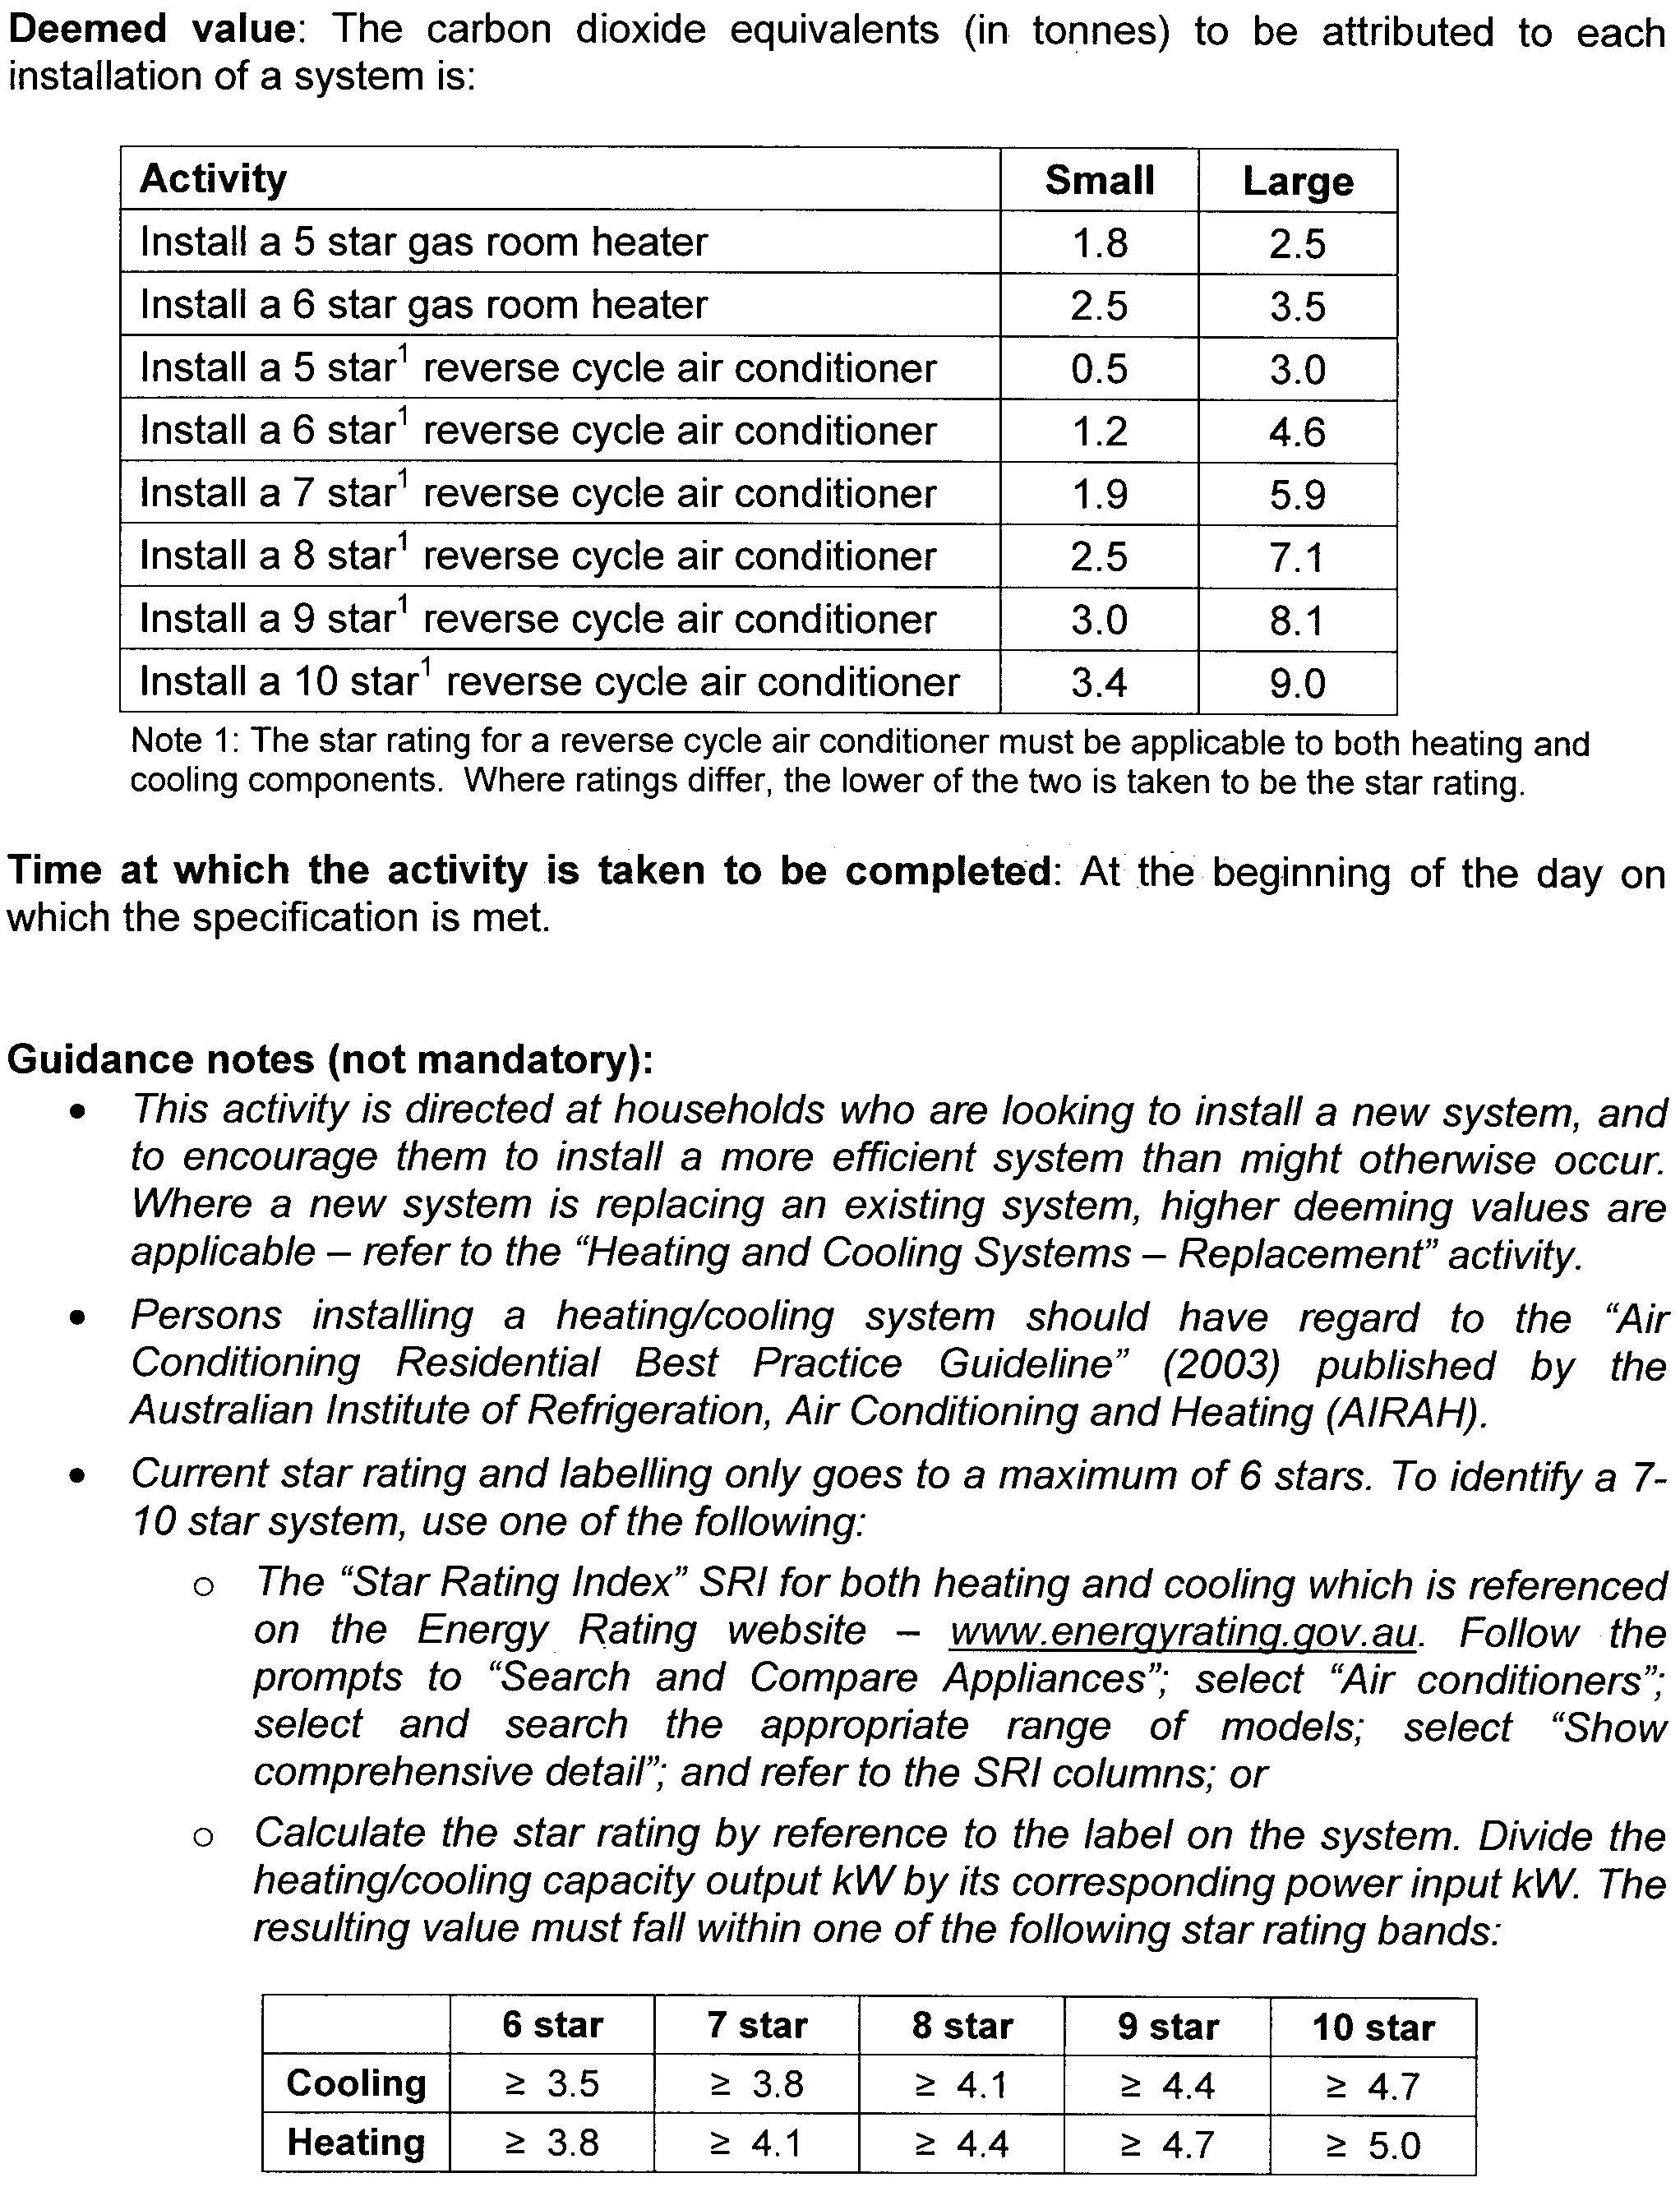
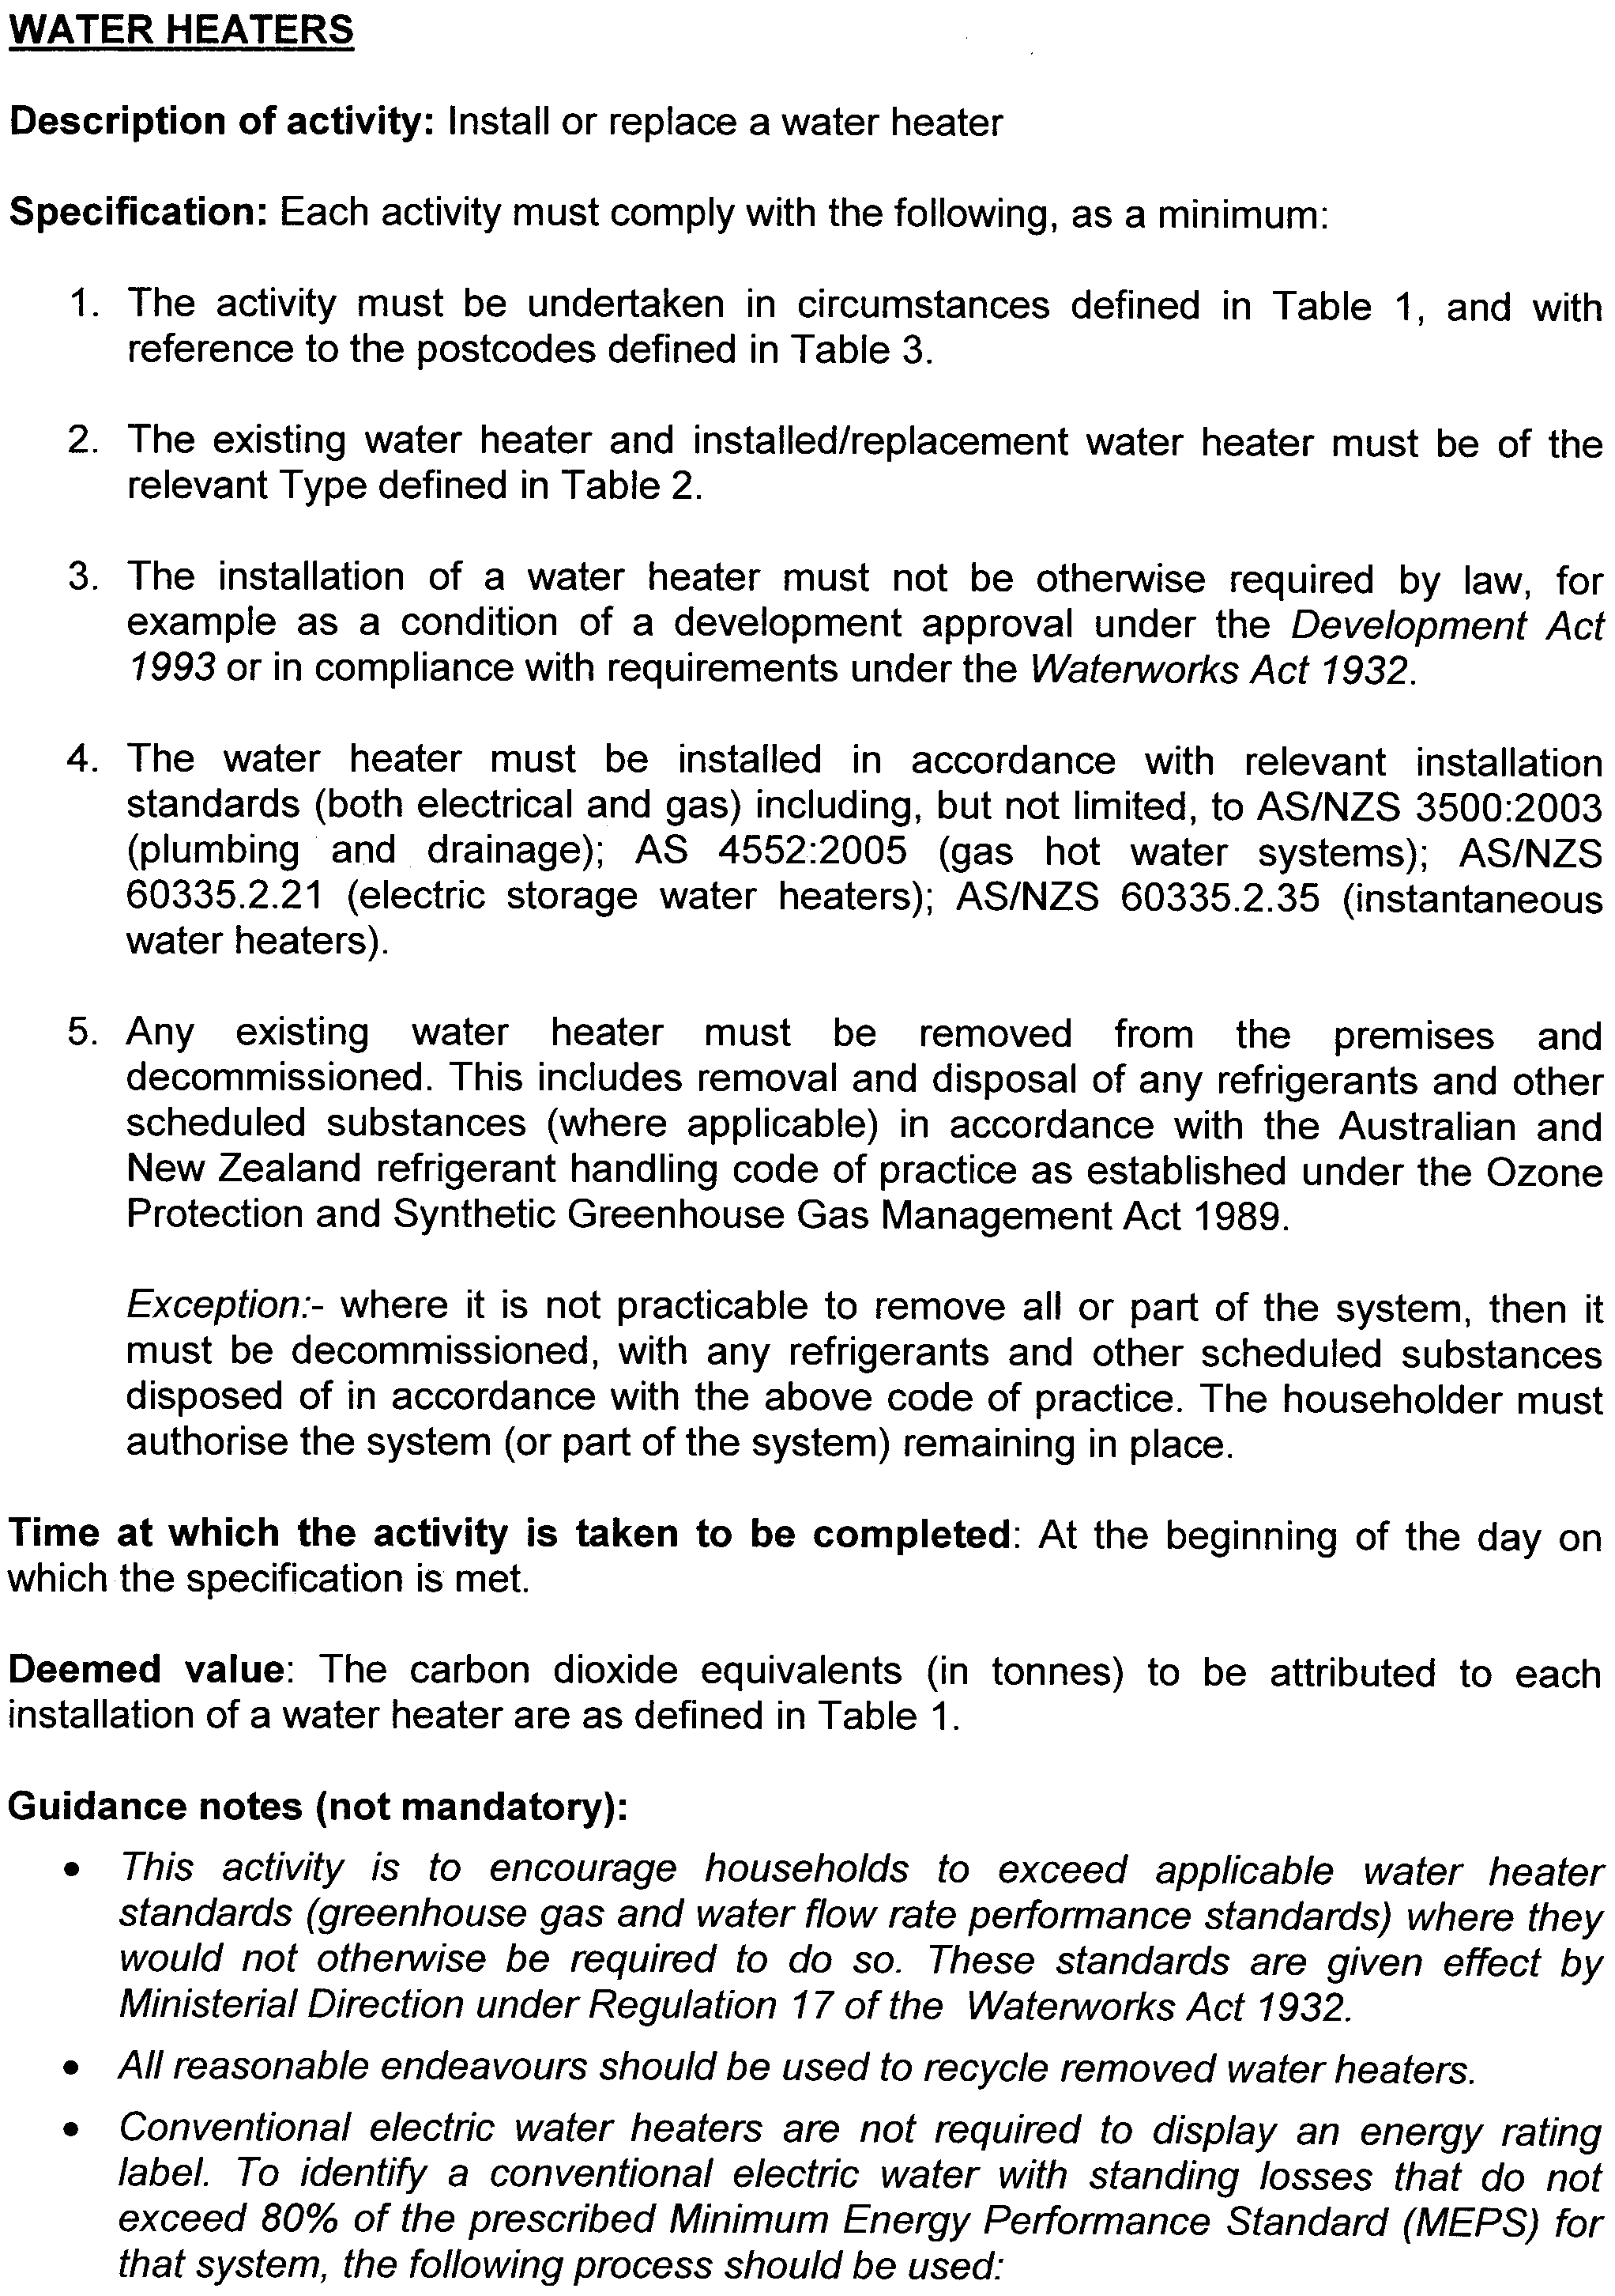
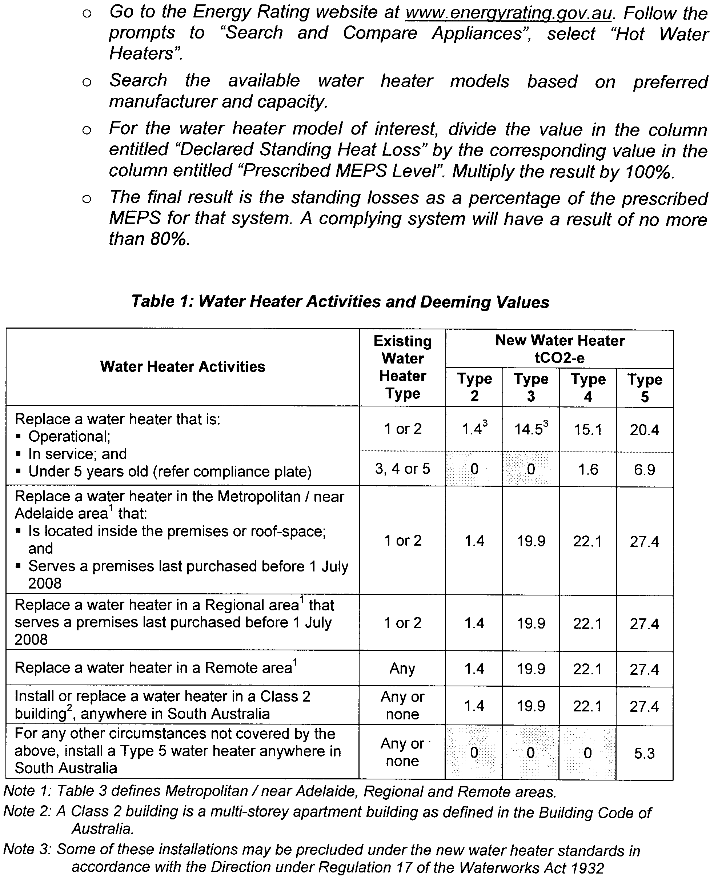
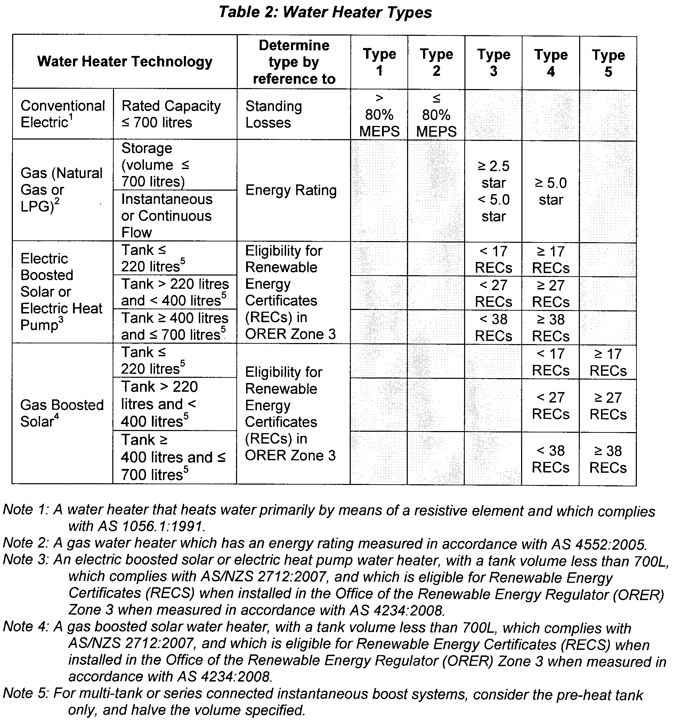

Table 3: Metropolitan/near Adelaide, Regional and Remote Areas
All unincorporated areas are regarded as Remote areas, regardless of the post code.
Post Code | Area |  | Post Code | Area
0872 | Remote |  | 5373 – 5374 | Regional
5000 – 5202 | Metro/near Adelaide |  | 5381 | Remote
5203 – 5204 | Regional |  | 5400 | Metro/near Adelaide
5210 – 5214 | Metro/near Adelaide |  | 5401 – 5416 | Regional
5220 – 5223 | Remote |  | 5417 – 5440 | Remote
5231 – 5236 | Metro/near Adelaide |  | 5451 – 5453 | Regional
5237 – 5238 | Regional |  | 5454 | Remote
5240 – 5252 | Metro/near Adelaide |  | 5455 – 5464 | Regional
5253 – 5263 | Regional |  | 5470 – 5493 | Remote
5264 – 5270 | Remote |  | 5495 – 5573 | Regional
5271 | Regional |  | 5575 – 5583 | Remote
5272 – 5276 | Remote |  | 5600 | Regional
5277 – 5291 | Regional |  | 5601 – 5605 | Remote
5301 – 5320 | Remote |  | 5606 | Regional
5321 – 5346 | Regional |  | 5607 | Remote
5350 – 5352 | Metro/near Adelaide |  | 5608 – 5609 | Regional
5353 – 5354 | Regional |  | 5630 – 5690 | Remote
5355 | Metro/near Adelaide |  | 5700 – 5710 | Regional
5356 – 5357 | Regional |  | 5720 – 5734 | Remote
5360 – 5372 | Metro/near Adelaide |  | 5800 – 5950 | Metro/near Adelaide

ENVIRONMENT PROTECTION ACT 1993
Variation to Existing Approval of Collection Depot
I, ANDREA KAYE WOODS, Team Leader, Container Deposit Legislation and Delegate of the Environment Protection Authority (‘the Authority’), pursuant to section 69 of the Environment Protection Act 1993 (SA) (‘the Act’) hereby:
Variation to Existing Approval of Collection Depot
Vary the approval of the collection depot, listed at Schedule 1 of this Notice, that was granted under the Act prior to the date of this Notice and impose the conditions of this approval to be as follows:
Approval of Collection Depot
The collection depot identified by reference to the following matters is approved:
(a) the name of the collection depot described in Column 1 of Schedule 1 of this Notice;
(b) the name of the proprietor of the depot identified in Column 3 of Schedule 1 of this Notice; and
(c) the location of the depot described in Columns 4-5 of Schedule 1 of this Notice.
The collection depot listed at Schedule 1 of this Notice is approved in relation to all classes of containers which were approved under the Act, at or subsequent to the date of this Notice, as Category B Containers.
Conditions of Approval
Impose the following conditions on the approval:
(a) The person in charge of the collection depot shall ensure the depot premises complies with Council Planning Regulations and shall be kept in an orderly condition.
(b) The person in charge of the collection depot who wishes to transfer the operation of a depot to another person or intends to change the location of a depot shall notify the Authority in writing within one month of the change occurring.
(c) The person in charge of the collection depot who wishes to cease operation of that depot shall give notice in writing to the Authority.
(d) The person in charge of the collection depot shall take such measures as are necessary in the operation and maintenance of the depot to prevent or control:
(i) a nuisance or offensive condition;
(ii) a risk to health or safety; and
(iii) damage to the environment.
(e) The person in charge of the collection depot is reminded of the general environmental duty, as required by section 25 of the Environment Protection Act 1993, to take all reasonable and practical measures to ensure that the activities on the whole site, do not pollute the environment in a way which causes or may cause environmental harm.
Schedule 1

Column 1 | Column 2 | Column 3 | Column 4 | Column 5 | Column 6
Depot Name | Company/Trading Name | Proprietors | Depot Location  Street | Depot Location  Suburb | Certificate of Title No. Volume/Folio No.
Burra Recycling Depot | Burra Recycling Depot | MJ Van Gasteren | Quarry Street | Burra | 5684/499

FAIR WORK ACT 1994

INDUSTRIAL PROCEEDINGS RULES 1995

WE, WILLIAM DAVID JENNINGS, Senior Judge of the Industrial Relations Court of South Australia and PETER DENNIS HANNON, President of the Industrial Relations Commission of South Australia, by virtue of the provisions of section 178 of the Fair Work Act 1994 and all other enabling powers, do hereby amend the Industrial Proceedings Rules 1995, to operate on and from 10 November 2008, as follows:

1. Subrule 83 (10):
Delete the existing subrule and insert a new subrule (10) as follows:
‘(10) If the application is not discontinued or settled, and the Member considers that further conciliation would not be appropriate, the Member will conclude the conference.’

2. Subrule 83 (11):
Delete the words, ‘subrule (10)’ where they appear in subrule (11) (b) and insert ‘subrule (9)’.

3. Subrule 83 (13):
Delete existing subrule 83 (13) and insert a new subrule (13) as follows:
‘(13) The Member who conducted the conciliation, in consultation with the Member who has been assigned to hear the application, will give the parties a notice of a directions hearing, in a form approved by the President and published by Practice Direction from time to time. At the directions hearing, the Member assigned to hear the matter may make such orders as necessary with respect to the hearing, including:
(a) an order requiring that either or both parties make disclosure of documents in accordance with Rule 25;
(b) an order requiring the parties to confirm their assertions and the basis of their respective positions and, where necessary, to file and serve one upon the other further particulars of their position; and
(c) allocate a date (or dates) and place for the hearing of the application by the Industrial Relations Commission sitting with Assessors.’

Given under our hands and the seals of the Industrial Relations Court and Commission of South Australia.

Dated 28 October 2008.

(l.s.) W. D. Jennings, Senior Judge

(l.s.) P. D. Hannon, President

FISHERIES MANAGEMENT ACT 2007: SECTION 115
TAKE notice that pursuant to section 115 of the Fisheries Management Act 2007, the Spencer Gulf and West Coast Prawn Fishermen’s Association (the ‘exemption holder’) or a person authorised by the Association to act as their agent to undertake fishing activity pursuant to this exemption (‘authorised licence holder’), are exempt from notices made under section 79 of the Fisheries Management Act 2007, prohibiting fishing pursuant to a Spencer Gulf Prawn Fishery Licence, insofar as the exemption holder or an authorised licence holder shall not be guilty of an offence when using prawn trawl nets pursuant to their fishery licence for the purpose of undertaking prawn surveys (the ‘exempted activity’), subject to the conditions contained in Schedule 1.
Schedule 1
1. The exempted activity may only be undertaken from 24 October 2008 until 30 September 2009, unless varied or revoked earlier.
2. The exemption holder may authorise the holder of a Spencer Gulf Prawn Fishery Licence to act as their agent and undertake the exempted activity pursuant to this notice. Authorised licence holders must comply with all regulations and conditions that apply to fishing activities undertaken pursuant to their licence, in addition to the conditions imposed by this exemption.
3. The exemption holder must accurately complete both of the tables attached as Schedules 2 and 3 to this notice and submit to PIRSA Fisheries by email to adsenior@qita.com.au at least one hour prior to the departure of the first vessel from port for each survey period.
4. The exemption holder and authorised licence holders must comply with the information submitted to PIRSA Fisheries in accordance with condition 3.
5. If a registered boat will return to port more than 30 minutes before or after the time reported in accordance with required fields 7 and 8 of Table 1 (A) and Table 1 (B), then the authorised licence holder (or the registered master in charge of the vessel) must make a new report at least one hour before the registered vessel returns to port.
6. All fish other than prawns, Southern calamari (Sepioteuthis australis) and bugs (Ibacus spp.) taken during the exempted activity must be returned to the water immediately after capture.
7. The exemption holder must provide a written report to the Executive Director, Fisheries within 15 days of the end of each prawn survey, specifying the total aggregated catch of slipper lobster and squid taken by all authorised licence holders during the survey.
8. The exemption holder or an authorised licence holder must not contravene or fail to comply with Fisheries Management Act 2007, or any other regulations made under that Act, except whereby specifically exempted by this notice.
Schedule 2
Table 1 (A): Survey Exemption Report for the Spencer Gulf Prawn Fishery

Required fields | Vessel 1 | Vessel 2 | Vessel 3 | Vessel 4 | Vessel 5 | Vessel 6 | Vessel 7 | Vessel 8 | Vessel 9
1. Licence Prefix
2. Licence No.
3. Port commencing from
4. Earliest date leaving port
5. Earliest time leaving port
6. Port of return
7. Date returning to port
8. Time returning to port
9. Activity undertaken
10. Name of person conducting activity
11. Dates of trawling commencement
12. Times of trawling
13. Where will activity take place?
Schedule 3
Table 1 (B): Survey Exemption Report for the Spencer Gulf Prawn Fishery

Required fields | Vessel 10 | Vessel 11 | Vessel 12 | Vessel 13 | Vessel 14 | Vessel 15 | Vessel 16 | Vessel 17 | Vessel 18
1. Licence Prefix
2. Licence No.
3. Port commencing from
4. Earliest date leaving port
5. Earliest time leaving port
6. Port of return
7. Date returning to port
8. Time returning to port
9. Activity undertaken
10. Name of person conducting activity
11. Dates of trawling commencement
12. Times of trawling
13. Where will activity take place?

Dated 23 October 2008.
S. Sloan, Program Leader, Fisheries Management

FISHERIES MANAGEMENT ACT 2007: SECTION 79
TAKE notice that pursuant to section 79 of the Fisheries Management Act 2007, it is hereby declared that it shall be unlawful for any person to engage in the class of fishing activity specified in Schedule 1 during the period specified in Schedule 2.
Schedule 1
The act of taking or an act preparatory to or involved in the taking of snapper (Pagrus auratus) in all waters of the State.
Schedule 2
1200 hours on 1 November 2008 until 1200 hours on 30 November 2008.
Dated 27 October 2008.
K. Crosthwaite, Director of Fisheries

FISHERIES MANAGEMENT ACT 2007: SECTION 79
Goolwa Beach Closure
Closure of Pipi Fishery—Commercial
TAKE notice that pursuant to section 79 of the Fisheries Management Act 2007, it is hereby declared that it shall be unlawful for any licensed person to engage in the class of fishing activity specified in Schedule 1, in the area specified in Schedule 2, during the period specified in Schedule 3.
Schedule 1
The act of taking or an act preparatory to the taking of pipi (Donax deltoides) for the purposes of trade or business.
Schedule 2
The Sir Richard Peninsula between the Murray Mouth and Beach Road, Goolwa.
Schedule 3
From midnight on 31 October 2008 until midnight on 31 May 2009.
Dated 27 October 2008.
Rory McEwen, Minister for Agriculture, Food and Fisheries

FISHERIES MANAGEMENT ACT 2007: SECTION 79
Coorong Beach Closure
Closure of Pipi Fishery—Recreational
TAKE notice that pursuant to section 79 of the Fisheries Management Act 2007, it is hereby declared that it shall be unlawful for any unlicensed person to engage in the class of fishing activity specified in Schedule 1, in the area specified in Schedule 2, during the period specified in Schedule 3.
Schedule 1
The act of taking or an act preparatory to the taking of pipi (Donax deltoides) for recreational purposes.
Schedule 2
The Younghusband Peninsula between the Murray Mouth and Kingston SE.
Schedule 3
From midnight on 31 October 2008 until midnight on 31 May 2009.
Dated 27 October 2008.
Rory McEwen, Minister for Agriculture, Food and Fisheries

FISHERIES MANAGEMENT ACT 2007: SECTION 115
TAKE notice that pursuant to section 115 of the Fisheries Management Act 2007, Darren Hoad, holder of Lakes and Coorong Fishery Licence Nos L37 and L45, P.O. Box 1047, Goolwa, S.A. 5214 and Kevin Hoad, P.O. Box 762, Murray Bridge, S.A. 5253 (the ‘exemption holders’), are exempt from section 79 of the Fisheries Management Act 2008, but only insofar as the exemption holders shall not be guilty of an offence when taking pipi (Donax spp.) during any temporary prohibition of taking of pipi (the ‘exempted activity’), subject to the conditions specified in Schedule 1, from 16 November 2008 until 20 November 2008, unless this notice is varied or revoked earlier.
Schedule 1
1. The pipi collected by the exemption holders are for research purposes only and must not be sold.
2. The exemption holders may only engage in the exempted activity at the direction of Ken Lee, Manager of the SASQAP Program, Department of Primary Industries and Resources South Australia.
3. All pipi collected by the exemption holders must be delivered to Ken Lee, Manager of the SASQAP Program.
4. The exemption holder must notify PIRSA Fishwatch on 1800 065 522 at least two hours prior to conducting the exempted activity and answer a series of questions about the exempted activity. The exemption holder will need to have a copy of the exemption notice at the time of making the call and be able to provide information about the area and time of the exempted activity, the vehicles involved and other related questions. Exemption No. 9902175.
5. While engaged in the exempted activity, the exemption holders must have in their possession a copy of this notice and produce a copy of this notice if requested by a PIRSA Fisheries Compliance Officer.
6. The exemption holders must not contravene or fail to comply with the Fisheries Management Act 2007, or any regulation made under that Act, except where specifically exempted by this notice.
Dated 24 October 2008.
K. Crosthwaite, Director of Fisheries

FISHERIES MANAGEMENT ACT 2007: SECTION 115
TAKE notice that pursuant to section 115 of the Fisheries Management Act 2007, the holder of a prawn fishery licence issued pursuant to the Fisheries Management (Prawn Fisheries) Regulations 2006, for the West Coast Prawn Fishery listed in Schedule 1 (the ‘exemption holders’) or their registered master are exempt from the closure notice made under section 79 of the Fisheries Management Act 2007, published in the South Australian Government Gazette, dated 4 March 2008, referring to the West Coast Prawn Fishery. The exemption holder shall not be guilty of an offence when using prawn trawl nets in accordance with the conditions of their fishery licence for the purpose of undertaking a prawn survey (the ‘exempted activity’) subject to the conditions contained in Schedule 2.
Schedule 1
Licence  No. | Licence Holder | Vessel Name | Survey Area
D01 | Nicholas Paleologoudias | Bosanquet Bay | Venus Bay
D02 | West Coast Prawn Fisheries Pty Ltd | Lincoln Lady | Coffin Bay
D03 | Konstantine Paleologoudias | Limnos | Ceduna
Schedule 2
1. This exemption is valid from 2015 hours on 29 October 2008 until 0600 hours on 30 October 2008.
2. The exemption holder must operate within the trawl survey area nominated in Schedule 1.
3. The registered master must keep a ‘skippers log’ to record catch information during the survey.
4. The registered master must conduct the exempted activity in the trawl survey areas provided by the SARDI Aquatic Sciences observer.
5. All fish, other than prawns, southern calamary, arrow squid, scallops, octopus and slipper lobster taken during the exempted activity for survey purposes, are to be returned to the water immediately after capture.
6. While engaged in the exempted activity or unloading the survey catch, the exemption holder must have a copy of this notice on board the vessel or near his person. This notice must be produced to a PIRSA Fisheries Compliance Officer if requested.
7. The exemption holder must not contravene or fail to comply with the Fisheries Management Act 2007, or any other regulations made under that Act except where specifically exempted by this notice.
Dated 22 October 2008.
S. Sloan, Program Leader, Fisheries Management

FISHERIES MANAGEMENT ACT 2007: SECTION 115
Exemption for SARDI Employees and Specified
Affiliates of SARDI
TAKE notice that pursuant to section 115 of the Fisheries Management Act 2007, the Chief Scientist and employees of the South Australian Research and Development Institute (SARDI) and in certain cases Specified Affiliates of SARDI (hereinafter referred to as the ‘exemption holder’), are exempt from sections 70, 71, 72, 73, 74 (1) (b), 76, 77, 79, 127, 128 and 129 of the Fisheries Management Act 2007 (the ‘exempted activity’), subject to the conditions specified in Schedule 1, from 23 October 2008 until 30 June 2009, unless varied or revoked earlier.
Schedule 1
1. All fish shall be taken, released or imported for research purposes only.
2. The exemption holder may take any species of fish using any type of device, except explosives, from any waters of the State, excluding waters of the Adelaide Dolphin Sanctuary, the River Murray and its tributaries and the River Murray Protection Area.
3. The exemption holder, whilst engaged in activities pursuant to this exemption, must carry an identification card issued by the SARDI.
4. At least one hour before conducting the exempted activity, the exemption holder must contact the PIRSA Fisheries Compliance Unit on 1800 065 522 and answer a series of questions about the exempted activity. The exemption holder will need to have a copy of this notice in their possession at the time of making the call and be able to provide information about the area and time of the exempted activity, the vehicles and/or boats involved and other related issues. Exemption No. 9902852.
5. While engaged in the exempted activity, the exemption holder must be in possession of a copy of this exemption. Such exemption must be produced to a PIRSA Fisheries Compliance Officer if requested.
6. The exemption holder must not contravene or fail to comply with the Fisheries Management Act 2007, or any regulations made under that Act, except where specifically exempted by this notice.
7. This exemption will only apply to Specified Affiliates of SARDI (including, but not limited to, independent contractors, research students, volunteers and other affiliates) provided the following additional pre-conditions are met:
• The affiliates are at all times in the presence of, and under the direct supervision, of a SARDI employee whilst undertaking the exempted activity.
• At least one clear business day (the ‘consideration period’) prior to undertaking the exempted activity the Chief Scientist of SARDI (or his delegate) notifies the Director of Fisheries (or his delegate) in writing of the names of the affiliates together with any other identifying information about the affiliates that may be specifically required from time to time.
• No objection is taken to the affiliates nominated by SARDI during the consideration period (with any such objection being communicated to the Chief Scientist of SARDI or his delegate during the consideration period).
8. For the purpose of this instrument the delegate of the Director of Fisheries is:
Mark Ayliffe
Project Officer
Phone: (08) 8226 2934
Fax: (08) 8226 0434
Dated 22 October 2008.
K. Crosthwaite, Director of Fisheries

FISHERIES MANAGEMENT ACT 2007: SECTION 115
TAKE notice that pursuant to section 115 of the Fisheries Management Act 2007, Letitia Dahl-Helm (the ‘exemption holder’) of the Adelaide and Mount Lofty Ranges Natural Resources Management Education Program, c/o City of Salisbury, P.O. Box 8, Salisbury, S.A. 5108 or a person acting as her agent is exempt from Clause 72 of Schedule 6 of the Fisheries Manage-ment (General) Regulations 2008, but only insofar as the exemp-tion holder may collect native fish species for research purposes (the ‘exempted activity’) from the areas specified in Schedule 1, using gear specified in Schedule 2, subject to the conditions set out in Schedule 3, from 28 October 2008 until 31 December 2008, unless varied or revoked earlier.
Schedule 1
The inland waters within the boundary of the Adelaide and Mount Lofty Ranges Natural Resources Management Board.
Schedule 2
• Fyke nets.
• Baited fish traps (small shrimp traps).
Schedule 3
1. The specimens collected by the exemption holder are for scientific and research purposes only and must not be sold.
2. All other native fish must be either returned to the water on completion of scientific evaluation or lodged with the South Australian Museum.
3. All non-native fish must be destroyed and disposed of appropriately.
4. Before conducting the exempted activity, the exemption holder must contact the PIRSA Fisheries Compliance Unit on 1800 065 522 and answer a series of questions about the exempted activity. You will need to have a copy of your exemption with you at the time of making the call, and be able to provide information about the area and time of the exempted activity, the vehicles and/or boats involved, the number of agents undertaking the exempted activity and other related issues. Exemption No. 9902188.
5. Within 14 days of the expiry of this notice, the exemption holder must provide a report in writing to the Director of Fisheries (G.P.O. Box 1625, Adelaide, S.A. 5001), of the results of the project to which this exemption is related.
6. While engaged in the exempted activity the exemption holder or a person acting as her agent must have in their possession a copy of this notice and such a notice must be produced to a PIRSA Fisheries Compliance Officer if requested.
7. The exemption holder must not contravene or fail to comply with the Fisheries Management Act 2007, or any regulations made under that Act or any condition of this notice, except where specifically exempted by this notice.
Dated 24 October 2008.
K. Crosthwaite, Director of Fisheries

LIQUOR LICENSING ACT 1997 AND GAMING MACHINES ACT 1992
Notice of Application
NOTICE is hereby given, pursuant to section 52 of the Liquor Licensing Act 1997 and section 29 of the Gaming Machines Act 1992, that Encore Hotels Pty Ltd as trustee for Hackney Hotel Trust and Azif Pty Ltd as trustee for Anthony Smith Family Trust No. 2 have applied to the Licensing Authority for Alterations, Redefinition, variation to an Extended Trading Authorisation and variation to Entertainment Consent in respect of premises situated at 95 Hackney Road, Hackney, S.A. 5069 and known as Hackney Hotel.
The application has been set down for callover on 14 November 2008 at 9 a.m.
Conditions
The following licence conditions are sought:
• Redefinition and Alterations to include internal and external works as per plans lodged with this office.
• The new Gaming Room, adjoining Dining, Alfresco Bars and Courtyard are to have the same extended trading hours as the current Areas 3 to 6, namely:
Monday: Midnight close without exception;
Tuesday to Sunday: Midnight to 3 a.m. the following day;
Christmas Day and Good Friday: Midnight to 2 a.m. the following day.
• Conditions 3.1, 3.2 and 3.3 below are to apply during the following extended trading hours for the new Gaming Room, adjoining Dining Room, Alfresco Bars and Court-yard (as is currently, and will continue to be the case in respect of Areas 3 to 6):
Monday: Midnight close without exception;
Tuesday to Thursday: 12.30 a.m. to 3 a.m. the following day;
Friday, Saturday and Sunday: 1.30 a.m. to 3 a.m. the following day;
Christmas Day and Good Friday: Midnight to 2 a.m. the following day.
3.1 The aggregate capacities for Areas 3 to 6, the new Gaming Room, adjoining Dining, Alfresco Bars and Courtyard shall not exceed 100 persons at any one time.
3.2 Entertainment to be provided in Areas 3 to 6, the new Gaming Room, adjoining Dining and Alfresco Bars shall be limited such that areas are not to be used as a Night Club, Dance Club, thrash band venue or the like.
3.3 No entertainment can be provided in the Alfresco Courtyard or the Gaming Smoking Court.
• The new Dining/Function Room which is currently licensed will have the same extended trading and entertain-ment rights as current Areas 1 and 2, namely:
Monday: Midnight close without exception;
Tuesday to Thursday: Midnight to 12.30 a.m. the following day;
Friday to Saturday: Midnight to 1.30 a.m. the following day;
Sunday: 8 a.m. to 11 a.m. and 8 p.m. to midnight with entertainment to cease at midnight.
• The total capacity of the premises is not to exceed 500 persons at any one time.
• All other licence conditions agreed to by the licensee and all resident objectors during the conciliation process in September/October 2007 will remain on the licence so as to regulate trading at the premises at all times.
Any person may object to the application by lodging a notice of objection in the prescribed form with the Liquor and Gambling Commissioner and serving a copy of the notice on the applicants at the applicants’ address, at least one day before the callover date (viz: 13 November 2008).
The applicants’ address for service is c/o DMAW Lawyers, Level 3, 80 King William Street, Adelaide, S.A. 5000 (Attention: Craig Vozzo or Adrian Battiston).
Plans in respect of the premises the subject of the application are open to public inspection without fee at the Office of the Liquor and Gambling Commissioner, 9th Floor, East Wing, 50 Grenfell Street, Adelaide, S.A. 5000. Phone 8226 8410, Fax:
8226 8512. Email: olgc@agd.sa.gov.au.
Dated 22 October 2008.
Applicants

LIQUOR LICENSING ACT 1997
Notice of Application
NOTICE is hereby given, pursuant to section 52 (2) (b) of the Liquor Licensing Act 1997, that Ross Virgara has applied to the Licensing Authority for a Producer’s Licence in respect of premises situated at Lyndoch Valley Road, Lyndoch, S.A. 5351 and to be known as The Grapes of Ross.
The application has been set down for callover on 21 November 2008 at 9 a.m.
Any person may object to the application by lodging a notice of objection in the prescribed form with the Liquor and Gambling Commissioner and serving a copy of the notice on the applicant at the applicant’s address, at least one day before the callover date (viz: 20 November 2008).
The applicant’s address for service is c/o Ross Virgara, Box 14, Lyndoch, S.A. 5351.
Plans in respect of the premises the subject of the application are open to public inspection without fee at the Office of the Liquor and Gambling Commissioner, 9th Floor, East Wing, 50 Grenfell Street, Adelaide, S.A. 5000. Phone 8226 8410, Fax:
8226 8512. Email: olgc@agd.sa.gov.au.
Dated 23 October 2008.
Applicant

LIQUOR LICENSING ACT 1997
Notice of Application
NOTICE is hereby given, pursuant to section 52 (2) (b) of the Liquor Licensing Act 1997, that Donald Hope, Diana Vivienne Laidlaw and Margaret Pauline Laidlaw have applied to the Licensing Authority for the removal of a Producer’s Licence in respect of premises situated at Room 215, 33 Pirie Street, Adelaide, S.A. 5000 and to be situated at Lot 1, Old Bethel Road, Williamstown, S.A. 5351 and known as Pancake Partners.
The application has been set down for callover on 28 November 2008 at 9 a.m.
Any person may object to the application by lodging a notice of objection in the prescribed form with the Liquor and Gambling Commissioner and serving a copy of the notice on the applicants at the applicants’ address, at least seven days before the callover date (viz: 22 November 2008).
The applicants’ address for service is c/o Diana Laidlaw, 45 Church Terrace, Walkerville, S.A. 5081.
Plans in respect of the premises the subject of the application are open to public inspection without fee at the Office of the Liquor and Gambling Commissioner, 9th Floor, East Wing, 50 Grenfell Street, Adelaide, S.A. 5000. Phone 8226 8410, Fax:
8226 8512. Email: olgc@agd.sa.gov.au.
Dated 20 October 2008.
Applicants

LIQUOR LICENSING ACT 1997
Notice of Application
NOTICE is hereby given, pursuant to section 52 (2) (b) of the Liquor Licensing Act 1997, that JJ Food Pty Ltd has applied to the Licensing Authority for a Restaurant Licence in respect of premises situated at 477C Payneham Road, Felixstow, S.A. 5070 and to be known as Yangtse River Chinese Restaurant.
The application has been set down for callover on 28 November 2008 at 9 a.m.
Any person may object to the application by lodging a notice of objection in the prescribed form with the Liquor and Gambling Commissioner and serving a copy of the notice on the applicant at the applicant’s address, at least seven days before the callover date (viz: 21 November 2008).
The applicant’s address for service is c/o JJ Food Pty Ltd, 477C Payneham Road, Felixstow, S.A. 5070.
Plans in respect of the premises the subject of the application are open to public inspection without fee at the Office of the Liquor and Gambling Commissioner, 9th Floor, East Wing, 50 Grenfell Street, Adelaide, S.A. 5000. Phone 8226 8410, Fax:
8226 8512. Email: olgc@agd.sa.gov.au.
Dated 22 October 2008.
Applicant

LIQUOR LICENSING ACT 1997
Notice of Application
NOTICE is hereby given, pursuant to section 52 (2) (b) of the Liquor Licensing Act 1997, that Mao Son has applied to the Licensing Authority for a Restaurant Licence in respect of premises situated at Shop 8, 128 Bridge Road, Pooraka, S.A. 5095 and to be known as Lion Thai.
The application has been set down for callover on 28 November 2008 at 9 a.m.
Any person may object to the application by lodging a notice of objection in the prescribed form with the Liquor and Gambling Commissioner and serving a copy of the notice on the applicant at the applicant’s address, at least seven days before the callover date (viz: 21 November 2008).
The applicant’s address for service is c/o David Romaldi Architecture, P.O. Box 638, North Adelaide, S.A. 5006.
Plans in respect of the premises the subject of the application are open to public inspection without fee at the Office of the Liquor and Gambling Commissioner, 9th Floor, East Wing, 50 Grenfell Street, Adelaide, S.A. 5000. Phone 8226 8410, Fax:
8226 8512. Email: olgc@agd.sa.gov.au.
Dated 23 October 2008.
Applicant

LIQUOR LICENSING ACT 1997
Notice of Application
NOTICE is hereby given, pursuant to section 52 (2) (b) of the Liquor Licensing Act 1997, that Amos Vignerons Pty Ltd has applied to the Licensing Authority for a Special Circumstances Licence in respect of premises situated at Lot 1, Bald Hills Road, Nairne, S.A. 5252 and to be known as Howard Vineyard.
The application has been set down for callover on 28 November 2008 at 9 a.m.
Conditions
The following licence conditions are sought:
• To sell or supply liquor.
• For consumption on the licensed premises:
Monday to Thursday: 7 a.m. and 10 p.m.;
Friday to Saturday: 7 a.m. and 11 p.m.;
Sunday: 8 a.m. to 6 p.m.
• To a diner with or ancillary to a meal provided by the licensee in a designated dining room or reception area.
• To a person seated at a table.
• To members of the public attending the premises for the purpose of:
• a prebooked function;
• a festival, exhibition, show or other special event held at the licensed premises by a given club or association;
• a food and wine festival or event held in conjunction with other licensees of licensed premises in the region;
• attending a wedding, birthday party or other special social function or event at which those persons attended by invitation of the organiser;
• by way of sample of liquor produced by the licensee such sales and tastings to be conducted in the area marked ‘Cellar Door Sales’ on the attached plan.
• For consumption off the licensed premises:
• where liquor is produced by or at the direction of the licensee or related body corporation;
• by way of direct sales transactions.
Any person may object to the application by lodging a notice of objection in the prescribed form with the Liquor and Gambling Commissioner and serving a copy of the notice on the applicant at the applicant’s address, at least seven days before the callover date (viz: 21 November 2008).
The applicant’s address for service is c/o Grope Hamilton Lawyers, Old Farmer’s Trustee Building, Level 2, 15 Bentham Street, Adelaide, S.A. 5000.
Plans in respect of the premises the subject of the application are open to public inspection without fee at the Office of the Liquor and Gambling Commissioner, 9th Floor, East Wing, 50 Grenfell Street, Adelaide, S.A. 5000. Phone 8226 8410, Fax:
8226 8512. Email: olgc@agd.sa.gov.au.
Dated 23 October 2008.
Applicant

LIQUOR LICENSING ACT 1997
Notice of Application
NOTICE is hereby given, pursuant to section 52 (2) (b) of the Liquor Licensing Act 1997, that Dennis John Liddy and Jennifer Fay Liddy have applied to the Licensing Authority for Alterations, Redefinition and variation to an Extended Trading Authorisation in respect of premises situated at 2 Ryan Street, Moonta, S.A. 5558 and known as Royal Hotel.
The application has been set down for callover on 28 November 2008 at 9 a.m.
Conditions
The following licence conditions are sought:
• Alterations and Redefinition for the relocation of the Gaming Room, creation of a new kitchen and to create an Outdoor Alfresco Dining Area and Courtyard.
• The Extended Trading Authorisation is sought to apply to the new outdoor areas on the days and during the times, currently applying to the internal areas of the premises.
• There will be no entertainment provided in the outdoor areas.
Any person may object to the application by lodging a notice of objection in the prescribed form with the Liquor and Gambling Commissioner and serving a copy of the notice on the applicants at the applicants’ address, at least seven days before the callover date (viz: 21 November 2008).
The applicants’ address for service is c/o Australian Hotels Association (S.A. Branch), 4th Floor, 60 Hindmarsh Square, Adelaide, S.A. 5000.
Plans in respect of the premises the subject of the application are open to public inspection without fee at the Office of the Liquor and Gambling Commissioner, 9th Floor, East Wing, 50 Grenfell Street, Adelaide, S.A. 5000. Phone 8226 8410, Fax:
8226 8512. Email: olgc@agd.sa.gov.au.
Dated 22 October 2008.
Applicants

LIQUOR LICENSING ACT 1997
Notice of Application
NOTICE is hereby given, pursuant to section 52 (2) (b) of the Liquor Licensing Act 1997, that Barreau Birkenhead Pty Ltd and Jake Barreau Investments Pty Ltd have applied to the Licensing Authority for Alterations, Redefinition and variation to an Extended Trading Authorisation in respect of premises situated at 3 Elder Road, Birkenhead, S.A. 5015 and known as Birkenhead Tavern.
The application has been set down for callover on 28 November 2008 at 9 a.m.
Conditions
The following licence conditions are sought:
• Alterations and Redefinition to extend the Front Bar on the south-eastern corner of the premises and create an Outdoor Decked Area on the northern side.
• Variation to an Extended Trading Authorisation is sought to apply to the abovementioned areas on the days and during the times, currently authorised in all other areas of the premises.
• Entertainment is not proposed in the outdoor area.
Any person may object to the application by lodging a notice of objection in the prescribed form with the Liquor and Gambling Commissioner and serving a copy of the notice on the applicants at the applicants’ address, at least seven days before the callover date (viz: 21 November 2008).
The applicants’ address for service is c/o Australian Hotels Association (S.A. Branch), 4th Floor, 60 Hindmarsh Square, Adelaide, S.A. 5000.
Plans in respect of the premises the subject of the application are open to public inspection without fee at the Office of the Liquor and Gambling Commissioner, 9th Floor, East Wing, 50 Grenfell Street, Adelaide, S.A. 5000. Phone 8226 8410, Fax:
8226 8512. Email: olgc@agd.sa.gov.au.
Dated 27 October 2008.
Applicants

LIQUOR LICENSING ACT 1997
Notice of Application
NOTICE is hereby given, pursuant to section 52 (2) (b) of the Liquor Licensing Act 1997, that Alexander James Head has applied to the Licensing Authority for a Producer’s Licence in respect of premises situated at Lot 1, Stonewell Road, Stone Well, S.A. 5352 and to be known as Head Wines.
The application has been set down for callover on 28 November 2008 at 9 a.m.
Any person may object to the application by lodging a notice of objection in the prescribed form with the Liquor and Gambling Commissioner and serving a copy of the notice on the applicant at the applicant’s address, at least seven days before the callover date (viz: 21 November 2008).
The applicant’s address for service is c/o Teusner & Co., 4 Elizabeth Street, Tanunda, S.A. 5352.
Plans in respect of the premises the subject of the application are open to public inspection without fee at the Office of the Liquor and Gambling Commissioner, 9th Floor, East Wing, 50 Grenfell Street, Adelaide, S.A. 5000. Phone 8226 8410, Fax:
8226 8512. Email: olgc@agd.sa.gov.au.
Dated 27 October 2008.
Applicant

LIQUOR LICENSING ACT 1997
Notice of Application
NOTICE is hereby given, pursuant to section 52 (2) (b) of the Liquor Licensing Act 1997, that Jung Hospitality Group Pty Ltd as trustee for Jung Hospitality Trust has applied to the Licensing Authority for Alterations, variation to an Extended Trading Authorisation and extension of Trading Area in respect of premises situated at 401 King William Street, Adelaide, S.A. 5000 and known as Brecknock Hotel.
The application has been set down for callover on 28 November 2008 at 9 a.m.
Conditions
The following licence conditions are sought:
• Internal alterations and extension of the Beer Garden as per plans lodged with this office.
• Variation to an Extended Trading Authorisation for the following days and times:
Sunday: Midnight to 3 a.m. the following day;
Maundy Thursday and Christmas Eve: Midnight to 2 a.m. the following day;
Sunday Christmas Eve: Midnight to 2 a.m. the following day;
New Year’s Eve: 2 a.m. to 3 a.m.;
Days preceding Public Holidays: Midnight to 3 a.m. the following day; and
Sundays preceding Public Holidays: 8 a.m. to 3 a.m. the following day.
Any person may object to the application by lodging a notice of objection in the prescribed form with the Liquor and Gambling Commissioner and serving a copy of the notice on the applicant at the applicant’s address, at least seven days before the callover date (viz: 21 November 2008).
The applicant’s address for service is c/o Duncan Basheer Hannon, G.P.O. Box 2, Adelaide, S.A. 5001 (Attention: David Tillett or Max Basheer).
Plans in respect of the premises the subject of the application are open to public inspection without fee at the Office of the Liquor and Gambling Commissioner, 9th Floor, East Wing, 50 Grenfell Street, Adelaide, S.A. 5000. Phone 8226 8410, Fax:
8226 8512. Email: olgc@agd.sa.gov.au.
Dated 27 October 2008.
Applicant

LIQUOR LICENSING ACT 1997
Notice of Application
NOTICE is hereby given, pursuant to section 52 (2) (b) of the Liquor Licensing Act 1997, that Roarvale Enterprises Pty Ltd as trustee for PJ & TB Fraser Trust has applied to the Licensing Authority for a variation to Conditions, Alterations, Redefinition and extension of Trading Area in respect of premises situated at 37 Broadway, Glenelg South, S.A. 5045 and known as The Organik Store.
The application has been set down for callover on 28 November 2008 at 9 a.m.
Conditions
The following licence conditions are sought:
• Variation to trading hours for the following days and times is sought to apply to the whole of the premises:
Monday to Sunday: 8 a.m. to 8 p.m. (except on Good Friday and Christmas Day).
• Alterations, Redefinition and Extension of Trading Area to include a proposed new restaurant and the footpath area as per plans lodged with this office.
• The following licence conditions are now sought for licence:
• The business conducted under the licence shall at all times be principally an organic fruit, vegetables and grocery shop, coffee, tea and juice bar including a restaurant with the sale of organic liquor for con-sumption off the premises being ancillary thereto.
• The licence:
• Authorises the consumption of liquor on the licensed premises during the time authorised with or ancillary to a meal provided by the licensee;
• Authorises the licensee to sell liquor during the times authorised for consumption on the licensed premises with or ancillary to a meal provided by the licensee; and
• Authorises the licensee to sell liquor during the times authorised for consumption on licensed premises by persons:
(a) seated at a table; or
(b) attending a function at which food is provided.
• Authorise the licensee to sell liquor by way of sample for consumption on the licensed premises.
• Authorise the licensee to sell liquor as referred to in the paragraph below herein during the times authorised for consumption off the licensed premises.
• All liquor sold or supplied off the licensed premises pursuant to the licence is to be organic or biodynamic liquor certified by the Australian Quarantine Inspec-tion Service (AQIS) as produced in accordance with the National Standard for organic and biodynamic products or which has been certified by any other Australian or Overseas Government Accredited Certification Body or the International Federation of Organic Agriculture movements.
• The licensee must hold copies of certification for each such liquor product which it offers for sale for consumption off the licensed premises in a register kept at the premises for inspections at all times by authorised officers.
• The range of liquor products sold for consumption off the licensed premises shall comprise of no more than 70 individual products.
• The licence shall not be transferred (sold) or removed to any other premises without obtaining the written consent of the licensee for the time being of Fassina Liquor Merchants, 33-39 Oaklands Road, Somerton Park, S.A. 5044.
• Should the licensee apply to vary the terms, conditions or approved area of the licensed premises, the notice of any such application must be given in writing to the licensee for the time being of Fassina Liquor Merchants, 33-39 Oaklands Road, Somerton Park, S.A. 5044, with the intent that the said Fassina Liquor Merchants shall have the right to object to such an application irrespective of whether it is publicly advertised, pursuant to section 52 of the Act.
Any person may object to the application by lodging a notice of objection in the prescribed form with the Liquor and Gambling Commissioner and serving a copy of the notice on the applicant at the applicant’s address, at least seven days before the callover date (viz: 21 November 2008).
The applicant’s address for service is c/o Duncan Basheer Hannon Barristers and Solicitors, G.P.O. Box 2, Adelaide S.A. 5001 (Attention: David Tillett or Max Basheer).
Plans in respect of the premises the subject of the application are open to public inspection without fee at the Office of the Liquor and Gambling Commissioner, 9th Floor, East Wing, 50 Grenfell Street, Adelaide, S.A. 5000. Phone 8226 8410, Fax:
8226 8512. Email: olgc@agd.sa.gov.au.
Dated 27 October 2008.
Applicant

LIQUOR LICENSING ACT 1997
Notice of Application
NOTICE is hereby given, pursuant to section 52 (2) (b) of the Liquor Licensing Act 1997, that Coligan Hotels Pty Ltd has applied to the Licensing Authority for a variation to an Extended Trading Authorisation and variation to Entertainment Consent in respect of premises situated at 32 Mawson Road, Meadows, S.A. 5201 and known as Meadows Hotel.
The application has been set down for callover on 28 November 2008 at 9 a.m.
Conditions
The following licence conditions are sought:
• Variation to an Extended Trading Authorisation to include the verandah known as Area 5 as per plans lodged with this office.
• Variation to an Extended Trading Authorisation for the areas currently approved with an Extended Trading Authorisation and to include the abovementioned area for the following hours:
Monday to Saturday: Midnight to 2 a.m. the following day;
Good Friday: Midnight to 2 a.m.;
Christmas Day: Midnight to 2 a.m.;
Sunday Christmas Eve: 8 p.m. to 2 a.m. the following day;
Days preceding other Public Holidays: Midnight to 2 a.m. the following day; and
Sundays preceding Public Holidays: 8 p.m. to 2 a.m. the following day.
• Variation to Entertainment Consent to include the front bar known as Area 4 as per plans lodged with this office.
Any person may object to the application by lodging a notice of objection in the prescribed form with the Liquor and Gambling Commissioner and serving a copy of the notice on the applicant at the applicant’s address, at least seven days before the callover date (viz: 21 November 2008).
The applicant’s address for service is c/o Coligan Hotels Pty Ltd, 32 Mawson Road, Meadows, S.A. 5201.
Plans in respect of the premises the subject of the application are open to public inspection without fee at the Office of the Liquor and Gambling Commissioner, 9th Floor, East Wing, 50 Grenfell Street, Adelaide, S.A. 5000. Phone 8226 8410, Fax:
8226 8512. Email: olgc@agd.sa.gov.au.
Dated 27 October 2008.
Applicant

LIQUOR LICENSING ACT 1997
Notice of Application
NOTICE is hereby given, pursuant to section 52 (2) (b) of the Liquor Licensing Act 1997, that Austral Hotel (S.A.) Pty Ltd has applied to the Licensing Authority for the transfer of a Hotel Licence in respect of premises situated at 205 Rundle Street, Adelaide, S.A. 5000 and known as Austral Hotel.
The application has been set down for hearing on 1 December 2008 at 10 a.m.
Any person may object to the application by lodging a notice of objection in the prescribed form with the Liquor and Gambling Commissioner and serving a copy of the notice on the applicant at the applicant’s address, at least seven days before the hearing date (viz: 24 November 2008).
The applicant’s address for service is c/o Clelands Lawyers, 208 Carrington Street, Adelaide, S.A. 5000.
Plans in respect of the premises the subject of the application are open to public inspection without fee at the Office of the Liquor and Gambling Commissioner, 9th Floor, East Wing, 50 Grenfell Street, Adelaide, S.A. 5000. Phone 8226 8410, Fax:
8226 8512. Email: olgc@agd.sa.gov.au.
Dated 22 October 2008.
Applicant

LIQUOR LICENSING ACT 1997
Notice of Application
NOTICE is hereby given, pursuant to section 52 (2) (b) of the Liquor Licensing Act 1997, that Ian Keith Johnston and Sandra Johnston have applied to the Licensing Authority for the transfer of a Residential Licence in respect of premises situated at the corner of The Parade and Second Street, Brownlow, Kangaroo Island, S.A. 5223 and known as Correa Corner Bed & Breakfast.
The application has been set down for hearing on 1 December 2008 at 10.30 a.m.
Any person may object to the application by lodging a notice of objection in the prescribed form with the Liquor and Gambling Commissioner and serving a copy of the notice on the applicants at the applicants’ address, at least seven days before the hearing date (viz: 24 November 2008).
The applicants’ address for service is c/o Teusner and Co., 4 Elizabeth Street, Tanunda, S.A. 5352 (Attention: Corey Miller).
Plans in respect of the premises the subject of the application are open to public inspection without fee at the Office of the Liquor and Gambling Commissioner, 9th Floor, East Wing, 50 Grenfell Street, Adelaide, S.A. 5000. Phone 8226 8410, Fax:
8226 8512. Email: olgc@agd.sa.gov.au.
Dated 23 October 2008.
Applicants

LIQUOR LICENSING ACT 1997
Notice of Application
NOTICE is hereby given, pursuant to section 52 (2) (b) of the Liquor Licensing Act 1997, that Jose Estrella and Oswaldo Estrella have applied to the Licensing Authority for the transfer of a Restaurant Licence in respect of premises situated at 24 Gawler Street, Mount Barker, S.A. 5251, known as Being Healthy and to be known as Boca Espresso.
The application has been set down for hearing on 1 December 2008 at 9.30 a.m.
Any person may object to the application by lodging a notice of objection in the prescribed form with the Liquor and Gambling Commissioner and serving a copy of the notice on the applicants at the applicants’ address, at least seven days before the hearing date (viz: 24 November 2008).
The applicants’ address for service is c/o Foreman Legal, 69 Mount Barker Road, Stirling, S.A. 5152 (Attention: Philip Foreman).
Plans in respect of the premises the subject of the application are open to public inspection without fee at the Office of the Liquor and Gambling Commissioner, 9th Floor, East Wing, 50 Grenfell Street, Adelaide, S.A. 5000. Phone 8226 8410, Fax:
8226 8512. Email: olgc@agd.sa.gov.au.
Dated 22 October 2008.
Applicants

LIQUOR LICENSING ACT 1997
Notice of Application
NOTICE is hereby given, pursuant to section 52 (2) (b) of the Liquor Licensing Act 1997, that M. and B. Wilkinson Pty Ltd as trustee for Wilkinson Trust has applied to the Licensing Authority for the transfer of a Restaurant Licence in respect of premises situated at Lot 16, Gorge Road, Cudlee Creek, S.A. 5253 and known as the Cudlee Cafe.
The application has been set down for hearing on 1 December 2008 at 9 a.m.
Any person may object to the application by lodging a notice of objection in the prescribed form with the Liquor and Gambling Commissioner and serving a copy of the notice on the applicant at the applicant’s address, at least seven days before the hearing date (viz: 24 November 2008).
The applicant’s address for service is c/o Carrington Conveyancers, 100 Carrington Street, Adelaide, S.A. 5000 (Attention: Paul Edwards).
Plans in respect of the premises the subject of the application are open to public inspection without fee at the Office of the Liquor and Gambling Commissioner, 9th Floor, East Wing, 50 Grenfell Street, Adelaide, S.A. 5000. Phone 8226 8410, Fax:
8226 8512. Email: olgc@agd.sa.gov.au.
Dated 28 October 2008.
Applicant

NOTICE TO MARINERS
No. 55 of 2008
South Australia—Gulf St Vincent—Geotechnical Studies for Adelaide Desalination Project
SA WATER will be conducting geotechnical studies in an area north of Port Stanvac exclusion zone in water depths of 5 m to 25 m for the Adelaide Desalination Project.
Work will commence on Monday, 27 October 2008 and is expected to last for three to four weeks. This will involve boring of holes in the sea bed using a drill rig mounted on a jack up barge.
The barge will display the required lights and shapes to comply with the International Regulations for Preventing Collisions at Sea.
Mariners are advised to exercise caution when navigating in the area.
Charts affected: Aus 125.
Adelaide, 23 October 2008.
Patrick Conlon, Minister for Transport
DTEI 2008/00767

MINING ACT 1971
NOTICE is hereby given in accordance with section 28 (5) of the Mining Act 1971, that the Minister for Mineral Resources Development proposes to grant an Exploration Licence over the undermentioned area:
Applicant: Flinders Mines Ltd
Location: Mount Torrens area⎯Approximately 40 km east of Adelaide.
Term: 1 year
Area in km²: 176
Ref.: 2008/00399
Plan and co-ordinates can be found on the PIRSA Sarig website: http://www.minerals.pir.sa.gov.au/sarig or by phoning Mineral Tenements on (08) 8463 3103.
H. Thomas, Mining Registrar

MINING ACT 1971
NOTICE is hereby given in accordance with section 28 (5) of the Mining Act 1971, that the Minister for Mineral Resources Development proposes to grant an Exploration Licence over the undermentioned area:
Applicant: Alphadale Pty Ltd
Location: Lock area⎯Approximately 110 km north of Port Lincoln.
Term: 1 year
Area in km²: 406
Ref.: 2008/00401
Plan and co-ordinates can be found on the PIRSA Sarig website: http://www.minerals.pir.sa.gov.au/sarig or by phoning Mineral Tenements on (08) 8463 3103.
H. Thomas, Mining Registrar

MINING ACT 1971
NOTICE is hereby given in accordance with section 28 (5) of the Mining Act 1971, that the Minister for Mineral Resources Development proposes to grant an Exploration Licence over the undermentioned area:
Applicant: Oz Minerals Prominent Hill Operations Pty Ltd
Location: White Hill area⎯Approximately 140 km north of Kingoonya.
Pastoral Lease: Balta Baltana, McDouall Peak and Millers Creek Stations.
Term: 2 years
Area in km²: 587
Ref.: 2008/00405
Plan and co-ordinates can be found on the PIRSA Sarig website: http://www.minerals.pir.sa.gov.au/sarig or by phoning Mineral Tenements on (08) 8463 3103.
H. Thomas, Mining Registrar

MINING ACT 1971
NOTICE is hereby given in accordance with section 28 (5) of the Mining Act 1971, that the Minister for Mineral Resources Development proposes to grant an Exploration Licence over the undermentioned area:
Applicant: Havilah Resources NL
Location: Lake Charles area⎯Approximately 120 km north-north-east of Olary.
Pastoral Lease: Quinyambie, Mulyungarie and Benagerie Stations.
Term: 2 years
Area in km²: 322
Ref.: 2008/00406
Plan and co-ordinates can be found on the PIRSA Sarig website: http://www.minerals.pir.sa.gov.au/sarig or by phoning Mineral Tenements on (08) 8463 3103.
H. Thomas, Mining Registrar

MOTOR VEHICLES ACT 1959
Recognised Historic Motor Vehicle Club
NOTICE is hereby given that the undermentioned club is recognised as an Historic Motor Vehicle Club in accordance with Schedule 1, Clause 3 (3) (a) of the Motor Vehicles Regulations, for the purposes of section 25 of the Motor Vehicles Act 1959:
The Vincent—HRD Club of South Australia Incorporated.
Dated 23 October 2008.
M. Small, Registrar of Motor Vehicles

MOTOR VEHICLES ACT 1959
Withdrawn from Recognition as an Historic Motor Vehicle Club
NOTICE is hereby given that the undermentioned club is withdrawn from recognition as an Historic Motor Vehicle Club in accordance with Schedule 1, Clause 3 (3) (a) of the Motor Vehicles Regulations, for the purposes of section 25 of the Motor Vehicles Act 1959:
The Vincent HRD Owners Club, South Australian Section.
Dated 23 October 2008.
M. Small, Registrar of Motor Vehicles

OCCUPATIONAL HEALTH, SAFETY AND WELFARE
ACT 1986
Approved Code of Practice for Pre-Cast Tilt Up and Concrete Elements in Building Construction
NOTICE is hereby given that pursuant to subsection 63 (1) of the Occupational Health, Safety and Welfare Act 1986, the following standard is an approved Code of Practice:
National Code of Practice for Pre-Cast Tilt Up and Concrete Elements in Building Construction.
The National Code of Practice for Pre-Cast Tilt Up and Concrete Elements in Building Construction shall be read as incorporating the ‘Foreword’, which is included in this notice and shall have effect from the date of Gazettal.
P. Caica, Minister for Industrial Relations

Foreword
The term ‘approved Code of Practice’ has a particular meaning under the South Australian Occupational Health, Safety and Welfare Act 1986.
An approved Code of Practice is designed to be used in addition to the Act and Regulations. In proceedings for an offence against the Act, where it is proved that a person failed to comply with a provision of a relevant approved Code of Practice, the person shall be taken to have failed to exercise the required standard of care, in the absence of proof to the contrary (section 63A of the Act).
Thus, a Code of Practice provides practical guidance on how a particular standard of health and safety can be achieved. It describes the preferred methods or courses of action for achieving this standard of health and safety. However, an approved Code of Practice allows the flexibility to show that an equivalent or better standard of health and safety is achieved by alternative action. An approved Code of Practice is therefore different from a regulation where the responsible person must meet the specific requirement of the regulation.
In summary, an approved Code of Practice:
• provides practical guidance;
• should be followed unless there is another solution which achieves the same or a better standard of health and safety; and
• can be used to support prosecution.
Codes of Practice are approved by the Minister for Industrial Relations, following recommendation from the SafeWork SA Advisory Committee which is constituted under the Occupational Health, Safety and Welfare Act 1986.

NATIONAL PARKS AND WILDLIFE (NATIONAL PARKS) REGULATIONS 2001
National Parks and Wildlife Reserves—Fire Restrictions
PURSUANT to Regulation 16 of the National Parks and Wildlife (National Parks) Regulations 2001, I, Edward Gregory Leaman, Director of National Parks and Wildlife and an authorised delegate of the co-management boards of both Vulkathunha-Gammon Ranges National Park and Witjira National Park, impose fire restrictions for National Parks and Wildlife Reserves as listed in Schedule 1 below.
The purpose of these fire restrictions is to ensure the safety of visitors using the Reserves and in the interests of protecting the Reserves and neighbouring properties.
Dated 28 October 2008.
E. G. Leaman, Director of National Parks and Wildlife

Schedule 1
1. ADELAIDE REGION
Lofty Districts
All Reserves: Wood fires or solid fuel fires and gas fires are prohibited throughout the year, other than as follows: Gas fires only are permitted within Morialta Conservation Park, Black Hill Conservation Park, Para Wirra Recreation Park, Mount George Conservation Park, Sandy Creek Conservation Park, Belair National Park, Cleland Conservation Park, Brownhill Creek Recreation Park, Mark Oliphant Conser-vation Park and Onkaparinga River National Park in designated areas only, other than on days of total fire ban.
Designated fixed gas barbeques in Belair National Park may be used on days of total fire ban except when the Director has formally closed the Reserve in accordance with Regulation 8 (3) (b) of the National Parks and Wildlife (National Parks) Regulations 2001.
Fleurieu District
Newland Head Conservation Park: Wood fires or solid fuel fires are prohibited throughout the year.
All other Reserves: All wood fires or solid fuel fires are prohibited from 1 November 2008 to 30 April 2009. Gas fires are permitted other than on days of total fire ban.
For further information, please contact the Adelaide Regional Office on (08) 8336 0901 or CFS Fire Bans Hotline 1300 362 361.
2. NORTHERN AND YORKE REGION
Southern Flinders District
All Reserves: All wood fires or solid fuel fires are prohibited throughout the year, other than as follows: Mambray Creek Campground; wood fires or solid fuel fires are prohibited from 1 November 2008 to 15 April 2009, fires are permitted outside these dates in designated areas only. Gas fires are permitted other than on days of total fire ban for all Reserves.
Mid North and Yorke Districts
All Reserves: All wood fires or solid fuel fires are prohibited from 15 November 2008 to 30 April 2009. Gas fires are permitted other than on days of total fire ban.
Red Banks Conservation Park, Spring Gully Conservation Park, Pandappa Conservation Park and Mokota Conservation Parks: All wood fires and solid fuel fires are prohibited throughout the year.
For further information, please contact the Northern and Yorke Regional Office on (08) 8841 3400 or CFS Fire Bans Hotline 1300 362 361.
3. OUTBACK REGION
Vulkathunha-Gammon Ranges National Park, Witjira National Park, Lake Eyre National Park, Simpson Desert Conservation Park, Simpson Desert Regional Reserve, Tallaringa Conservation Park and Innamincka Regional Reserve: All wood fires or solid fuel fires are prohibited from 1 November 2008 to 31 March 2009 other than for Aboriginal people using traditional use of fire for cooking. Gas fires are permitted other than on days of total fire ban.
Flinders Ranges National Park: All wood fires or solid fuel fires are prohibited from 1 November 2008 to 15 April 2009, fires are permitted outside of these dates in designated areas only. Gas fires and fuel stoves are permitted except on days of total fire ban.
Exception: Wilpena Pound—All wood fires, solid fuel fires or gas fires are prohibited throughout the year other than at Cooinda Camp where gas fires are permitted except on days of total fire ban.
For further information, please contact the Port Augusta Regional Office on (08) 8648 5300, the Wilpena Visitor Centre on (08) 8648 0048 or CFS Fire Bans Hotline 1300 362 361.
4. WEST REGION
Eyre and Far West Districts
All Reserves: All wood fires or solid fuel fires are prohibited from 1 November 2008 to 15 April 2009. Gas fires are permitted other than on days of total fire ban.
Exception: Lincoln National Park and Coffin Bay National Park—Wood fires are permitted between high water mark and low water mark, providing the following conditions are applied:
(a) it is not a total fire ban day;
(b) wood has been supplied from outside the park;
(c) an adult is in attendance; and
(d) the fire is extinguished before departure.
Gawler Ranges District
All Reserves: All wood fires or solid fuel fires are prohibited from 1 November 2008 to 31 March 2009. Gas fires are permitted other than on days of total fire ban.
For further information, please contact the Port Lincoln Office on (08) 8688 3111 or CFS Fire Bans Hotline 1300 362 361.
5. KANGAROO ISLAND REGION
All Reserves: All wood fires or solid fuel fires are prohibited throughout the year. Gas fires are permitted other than on days of total fire ban.
For further information, please contact the Kangaroo Island Office on (08) 8553 2381, Flinders Chase National Park on (08) 8559 7235 or CFS Fire Bans Hotline 1300 362 361.
6. SOUTH EAST REGION
All Reserves: All wood fires or solid fuel fires are prohibited from 15 November 2008 to 30 April 2009. Gas fires are permitted other than on days of total fire ban.
Exception: Piccaninnie Ponds Conservation Park, Little Dip Conservation Park and Coorong National Park—Wood fires are permitted between high water mark and low water mark of the ocean beach foreshores other than on days of total fire ban providing the following conditions are applied:
(a) it is not a total fire ban day;
(b) wood has been supplied from outside the park;
(c) an adult is in attendance; and
(d) the fire is extinguished before departure.
Aberdour Conservation Park, Bool Lagoon Game Reserve, Ewens Ponds Conservation Park, Lake Frome Conservation Park, Lower Glenelg River Conservation Park, Mount Monster Conservation Park, Piccaninnie Ponds Conservation Park (above high water mark), and Poocher Swamp Game Reserve: All wood fires or solid fuel fires are prohibited throughout the year.
For further information, please contact the Mount Gambier Office on (08) 8735 1177 or CFS Fire Bans Hotline 1300 362 361.
7. MURRAYLANDS REGION
All Reserves: All wood fires or solid fuel fires are prohibited from 1 November 2008 to 15 April 2009. Gas fires are permitted other than on days of total fire ban.
For further information, please contact the Murraylands Regional Office on (08) 8595 2111 or CFS Fire Bans Hotline 1300 362 361.

PETROLEUM ACT 2000
Suspension of Geothermal Exploration Licences—GELs 191, 192, 193, 194, 195, 196, 197, 198, 199, 200, 201, 202, 203, 204,
205, 236, 237 and 238
PURSUANT to section 90 of the Petroleum Act 2000, notice is hereby given that the abovementioned Geothermal Exploration Licences have been suspended under the provisions of the Petroleum Act 2000, from and including 8 November 2008 until 7 August 2009, pursuant to delegated powers dated 28 March 2002, Gazetted 11 April 2002, page 1573.
The expiry date of the GELs 191-205 is now determined to be 1 October 2011.
The expiry date of the GELs 236-238 is now determined to be 1 October 2012.
Dated 21 October 2008.
B. A. Goldstein,
Director Petroleum and Geothermal
Minerals and Energy Resources
Primary Industries and Resources SA
Delegate of the Minister for Mineral
Resources Development

PETROLEUM ACT 2000
Statements of Environmental Objectives for New
Regulated Activities
PURSUANT to section 104 (1) of the Petroleum Act 2000 (the Act) I, Barry Goldstein, Director Petroleum and Geothermal, Minerals and Energy Resources, Department of Primary Industries and Resources SA, Delegate of the Minister for Mineral Resources Development, pursuant to Delegation dated 28 March 2002, Gazetted 30 October 2008, do hereby publish the following document as having been approved as a statement of environ-mental objectives under the Act.
Documents:
1. Victoria Petroleum, Cooper Basin Petroleum Production Operations, Statement of Environmental Objectives, September 2008.
This document is available for public inspection on the Environmental Register section of PIRSA’s website (www.pir.sa.gov.au/petrol/envreg) or at the Public Office deter-mined pursuant to section 107 (1) of the Act to be at:
Office of Minerals and Energy Resources
Customer Services
Level 7, 101 Grenfell Street
Adelaide, S.A. 5000
Dated 30 October 2008.
B. A. Goldstein,
Director Petroleum and Geothermal
Delegate of the Minister for Mineral
Resources Development

PETROLEUM ACT 2000
Statements of Environmental Objectives for New
Regulated Activities
PURSUANT to section 104 (1) of the Petroleum Act 2000 (the Act) I, Barry Goldstein, Director Petroleum and Geothermal, Minerals and Energy Resources, Department of Primary Industries and Resources SA, Delegate of the Minister for Mineral Resources Development, pursuant to Delegation dated 28 March 2002, Gazetted 30 October 2008, do hereby publish the following document as having been approved as a statement of environ-mental objectives under the Act.
Documents:
1. Stuart Petroleum, Statement of Environmental Objectives, Cooper Basin Petroleum Production Operations (Dunefield and Floodplain), August 2008.
This document is available for public inspection on the Environmental Register section of PIRSA’s website (www.pir.sa.gov.au/petrol/envreg) or at the Public Office deter-mined pursuant to section 107 (1) of the Act to be at:
Office of Minerals and Energy Resources
Customer Services
Level 7, 101 Grenfell Street
Adelaide, S.A. 5000
Dated 30 October 2008.
B. A. Goldstein,
Director Petroleum and Geothermal
Delegate of the Minister for Mineral
Resources Development

PETROLEUM ACT 2000
Suspension of Geothermal Exploration Licences—
GELs 241 and 242
PURSUANT to section 90 of the Petroleum Act 2000, notice is hereby given that the abovementioned Geothermal Exploration Licences have been suspended under the provisions of the Petroleum Act 2000, for the period from and including 30 September 2008 to 29 March 2009, pursuant to delegated powers dated 28 March 2002, Gazetted 11 April 2002, page 1573.
The expiry date of Geothermal Exploration Licences GELs 241 and 242 is now determined to be 24 August 2012.
Dated 20 October 2008.
C. D. Cockshell,
Acting Director Petroleum and Geothermal
Minerals and Energy Resources
Primary Industries and Resources SA
Delegate of the Minister for Mineral
Resources Development

PETROLEUM ACT 2000
Section 25 (5) (b), Section 90
Variation and Suspension of Geothermal Exploration Licences—
GELs 157 and 179
NOTICE is hereby given that under the provisions of the Petroleum Act 2000, pursuant to delegated powers dated 28 March 2002, Gazetted 11 April 2002, page 1573, the conditions of the abovementioned Exploration Licences have been varied as follows:
1. Condition 1 of the licence is omitted and the following substituted:
‘1. During the term of the licence, the licensee shall carry out or cause to be carried out exploratory operations on the area comprised in the licence in accordance with such work programs as are approved by the Minister from time to time. Year one exploratory operations are guaranteed and any subsequent licence year work program becomes guaranteed upon entry into any such licence year. These exploratory
operations may be undertaken anywhere within the area covered by GELs 157 and 179 and shall include but not necessarily be limited to:

Year of Term of Licence |  | Minimum Work Requirements
One |  | Geological and Geophysical review;  Modelling and interpretation of geophysical data (including gravity and seismic data);  Historical bore hole thermal data collection (where possible) and analysis;  Shallow geothermal gradient test well (500 m depth);  Down hole temperature and wireline logging.
Two |  | Commercial negotiations for funding;  Magneto-tellurics trial survey;  MT modelling of basement;  Revised thermal modelling.
Three |  | Geological and Geophysical review.
Four |  | Magneto-telluric modelling of basement;  Revised thermal model;  Commercialisation plan;  Site deep well.
Five |  | Well engineering and design;  Drill injection/production well (3.5-4.5 km);  Well testing;  Commercial feasibility and development  study underway.
 |  |  | ’
2. The Exploration Licences have been suspended from and including 17 September 2008 to 16 September 2009.
The expiry date of Exploration Licences GELs 157 and 179 is now determined to be 16 February 2011.
Dated 24 October 2008.
B. A. Goldstein,
Director Petroleum and Geothermal
Minerals and Energy Resources
Primary Industries and Resources SA
Delegate of the Minister for Mineral
Resources Development

PETROLEUM ACT 2000
Surrender of Associated Facilities Licence—AFL 141
(Adjunct to Petroleum Exploration Licence—PEL 92)
NOTICE is hereby given that I have accepted surrender of the abovementioned Associated Facilities Licence with effect from 13 October 2008, under the provisions of the Petroleum Act 2000, pursuant to delegated powers dated 28 March 2002, Gazetted 11 April 2002, page 1573.
Description of Area
A 50 m buffer around line segments defined by the following pairs of co-ordinates (MGA Zone 54, GDA), adjacent to Petroleum Exploration Licence 92 in the State of South Australia:
From | To
335780mE, 6934946mN | 336418mE, 6934738mN
331650mE, 6938719mN | 331722mE, 6939225mN
330039mE, 6938701mN | 330116mE, 6939279mN
Area: 0.19 km² approximately.
Dated 21 October 2008.
B. A. Goldstein,
Director Petroleum and Geothermal
Minerals and Energy Resources
Primary Industries and Resources SA
Delegate of the Minister for Mineral
Resources Development

PETROLEUM ACT 2000
Suspension of Geothermal Exploration Licences—
GELs 166, 167 and 168
PURSUANT to section 90 of the Petroleum Act 2000, notice is hereby given that the abovementioned Geothermal Exploration Licences have been suspended under the provisions of the Petroleum Act 2000, for the period from and including 2 October 2008 to 1 April 2009, pursuant to delegated powers dated 28 March 2002, Gazetted 11 April 2002, page 1573.
The expiry date of Geothermal Exploration Licences GELs 166, 167 and 168 is now determined to be 12 April 2011.
Dated 22 October 2008.
B. A. Goldstein,
Director Petroleum and Geothermal
Minerals and Energy Resources
Primary Industries and Resources SA
Delegate of the Minister for Mineral
Resources Development

ROAD TRAFFIC ACT 1961

SUPPLEMENTARY NOTICE OF APPROVAL AND EXEMPTION
Pursuant to Sections 161A and 163AA of the Road Traffic Act 1961

OPERATION OF ROAD TRAIN VEHICLES IN SOUTH AUSTRALIA
GREATER THAN 25 M AND UP TO 30 M IN LENGTH

I hereby vary the conditions of the Notice of Approval and Exemption titled ‘Operation of Road Train Vehicles in South Australia’ (the ‘Primary Notice’) dated 2 June 2008 and published in the South Australian Government Gazette as detailed below.
Information Note
This Notice allows the use of Road Trains greater than 25 m and up to 30 m in length on approved routes in South Australia up until 31 December 2009.

1. DEFINITIONS
In this Notice:
1.1 ‘Primary Notice’ means the Notice of Approval and Exemption titled ‘Operation of Road Train Vehicles in South Australia’, dated 2 June 2008;
1.2 ‘Supplementary Notice’ means this Supplementary Notice for the Operation of Road Train vehicles in South Australia greater than 25 m and up to 30 m in length; and
1.3 ‘Code of Practice’ means the Code of Practice for Road Trains, dated April 2008 as issued by the Department for Transport, Energy and Infrastructure.

2. VARIATION OF CONDITIONS FOR APPROVED VEHICLES
4.1 The minimum length for a Road Train as prescribed in Clause 16.2 of the Code of Practice is hereby varied such that the overall length must be greater than 25 m and up to 30 m.

3. CONTINUED COMPLIANCE WITH THE PRIMARY NOTICE
3.1 A driver of an Approved Vehicle must continue to comply with all conditions and requirements of the Primary Notice, except as varied by this notice.

4. COMMENCEMENT OF THIS NOTICE
4.1 This Supplementary Notice is valid from 12.01 a.m. on 31 October 2008 until midnight on 31 December 2009.

5. AUTHORISATION

Executive Director, Safety and Regulation Division
Department for Transport, Energy and Infrastructure
Authorised Delegate for the Minister for Transport

WILDERNESS PROTECTION REGULATIONS 2006
Wilderness Protection Areas—Fire Restrictions
PURSUANT to Regulation 12 of the Wilderness Protection Regulations 2006, I, Edward Gregory Leaman, Director of National Parks and Wildlife, impose fire restrictions for Wilder-ness Protection Areas as listed in Schedule 1 below.
The purpose of these fire restrictions is to ensure the safety of visitors using the Wilderness Protection Areas and in the interests of protecting the Areas and neighbouring properties.
Dated 28 October 2008.
E. G. Leaman, Director of National Parks and Wildlife

Schedule 1
1. WEST REGION
Yellabinna Wilderness Protection Area, Hambidge Wilder-ness Protection Area and Hincks Wilderness Protection Area: All wood fires or solid fuel fires are prohibited from 1 November 2008 to 15 April 2009. Gas fires are permitted other than on days of total fire ban.
Memory Cove Wilderness Protection Area: All wood fires or solid fuel fires are prohibited to low water mark throughout the year. Gas fires are permitted other than on days of total fire ban.
For further information, please contact the Port Lincoln Office on (08) 8688 3111 or CFS Fire Bans Hotline 1300 362 361.
2. KANGAROO ISLAND REGION
All Wilderness Protection Areas: Wood fires or solid fuel fires are prohibited throughout the year. Gas fires are permitted other than on days of Total Fire Ban.
For further information, please contact the Kangaroo Island Office on (08) 8553 2381, Flinders Chase National Park on (08) 8559 7235 or CFS Fire Bans Hotline 1300 362 361.
3. MURRAYLANDS REGION
All Wilderness Protection Areas: All wood fires or solid fuel fires are prohibited from 1 November 2008 to 15 April 2009. Gas fires are permitted other than on days of Total Fire Ban.
For further information, please contact the Murraylands Regional Office on (08) 8595 2111 or CFS Fire Bans Hotline 1300 362 361.

South Australia
Public Sector Management (Department of Planning and Local Government—Transfer of Employees) Proclamation 2008
under section 7 of the Public Sector Management Act 1995
1—Short title
This proclamation may be cited as the Public Sector Management (Department of Planning and Local Government—Transfer of Employees) Proclamation 2008.
2—Commencement
This proclamation will come into operation on 3 November 2008.
3—Transfer of employees to Department of Planning and Local Government
(1) The employees referred to in Schedule 1 are transferred from the Department of Primary Industries and Resources to the Department of Planning and Local Government.
(2) If an employee whose employment is subject to a contract under section 34 or 40 of the Public Sector Management Act 1995 is transferred to the Department of Planning and Local Government under this clause, the provisions of the contract will continue to apply in relation to the employee's employment in the Department as if the contract had been entered into between the employee and the Chief Executive of the Department, subject to any necessary modifications or further agreement between the employee and the Chief Executive.
Schedule 1—Employees being transferred from Department of Primary Industries and Resources to Department of Planning and Local Government
AMJ Acorn
PH Archer
FE Barrett
CR Barrington-Kerr
W Brady
A Christopoulos
P Crocker
KSG Davey
L Flavel
SJ Forder
CJ Gascoigne
P Gekas
JA Gerlach
P Gnanachandran
LJ Graham
LK Gravelle
J Hanlon
WG Harris
AC Hart
MJ Hassam
BJ Honan
CR Hore
PJA Ilee
LC Jacka
RA McDonald
AC McKeegan
TM Nicholas
P Nikou
M Petrovski
N Ponting
KJ Pugh
PJ Rowett
WK Ryan
E Sarris
AJ Sgro
MA Shirley
LV Skouborg
PS Sody
TL Sutherland
MR Sutton
G Velardo
J Warde
CL Weedon
Made by the Governor
with the advice and consent of the Executive Council
on 30 October 2008
DPC08/020CS
South Australia
Remuneration (Ombudsman) Revocation
Proclamation 2008
under section 14(2) of the Remuneration Act 1990
1—Short title
This proclamation may be cited as the Remuneration (Ombudsman) Revocation Proclamation 2008.
2—Commencement
This proclamation comes into operation on the day on which it is made.
3—Revocation of proclamation
The proclamation made under the Remuneration Act 1990 conferring jurisdiction on the Remuneration Tribunal to determine the remuneration payable in respect of the office of the Ombudsman (Gazette 23.7.1998 p224) is revoked.
Made by the Governor
with the advice and consent of the Executive Council
on 30 October 2008
AGO0082/08CS

South Australia
Native Vegetation Variation Regulations 2008
under the Native Vegetation Act 1991

Contents
Part 1—Preliminary
1 Short title
2 Commencement
3 Variation provisions
Part 2—Variation of Native Vegetation Regulations 2003
4 Variation of regulation 3—Interpretation
5 Variation of regulation 5—Exemptions

Part 1—Preliminary
1—Short title
These regulations may be cited as the Native Vegetation Variation Regulations 2008.
2—Commencement
These regulations come into operation on the day on which they are made.
3—Variation provisions
In these regulations, a provision under a heading referring to the variation of specified regulations varies the regulations so specified.
Part 2—Variation of Native Vegetation Regulations 2003
4—Variation of regulation 3—Interpretation
Regulation 3—after the definition of infrastructure insert:
Mining Act means the Mining Act 1971, the Opal Mining Act 1995, the Petroleum Act 2000, the Offshore Minerals Act 2000 or the Roxby Downs (Indenture Ratification) Act 1982;
5—Variation of regulation 5—Exemptions
(1) Regulation 5(1)(d)(v)—delete "there will be a significant environmental benefit on the property where the clearance is being undertaken or within the same region of the State, or the owner of the land (or a person acting on his or her behalf) has, on application to the Council to proceed with clearing the vegetation in accordance with this provision, made a payment into the Fund of an amount considered by the Council to be sufficient to achieve a significant environmental benefit in the manner contemplated by section 21(6) of the Act;" and substitute:
—
(A) there will be a significant environmental benefit on the property where the clearance is being undertaken or within the same region of the State; or
(B) either—
• the owner of the land (or a person acting on his or her behalf); or
• a person connected with the construction or expansion of the building or infrastructure, or the provision of the infrastructure or services (as the case requires),
has, on application to the Council to proceed with clearing the vegetation in accordance with this provision, made a payment into the Fund of an amount considered by the Council to be sufficient to achieve a significant environmental benefit in the manner contemplated by section 21(6) of the Act;
(2) Regulation 5(1)(zd)(i)—delete subparagraph (i) and substitute:
(i) the clearance is incidental to operations authorised under a Mining Act; and
(3) Regulation 5(1)(zd)(ii)(A)—delete "the Mining Act 1971" and substitute:
a Mining Act (other than the Petroleum Act 2000)
(4) Regulation 5(1)(zda)(i)—delete subparagraph (i) and substitute:
(i) the clearance is incidental to operations authorised before 25 August 2003 under a Mining Act; and
(5) Regulation 5—after subregulation (7) insert:
(7a) To avoid doubt, subregulation (1)(zc), (zd) and (zda) does not apply in relation to mining operations at a private mine.
Note—
As required by section 10AA(2) of the Subordinate Legislation Act 1978, the Minister has certified that, in the Minister's opinion, it is necessary or appropriate that these regulations come into operation as set out in these regulations.
Made by the Governor
with the advice and consent of the Executive Council
on 30 October 2008
No 279 of 2008
WBCS08/0016
South Australia
Liquor Licensing (Dry Areas—Short Term) Variation Regulations 2008
under the Liquor Licensing Act 1997

Contents
Part 1—Preliminary
1 Short title
2 Commencement
3 Variation provisions
Part 2—Variation of Liquor Licensing (Dry Areas—Short Term) Regulations 1997
4 Variation of Schedule 1—Short term dry areas

Part 1—Preliminary
1—Short title
These regulations may be cited as the Liquor Licensing (Dry Areas—Short Term) Variation Regulations 2008.
2—Commencement
These regulations come into operation on the day on which they are made.
3—Variation provisions
In these regulations, a provision under a heading referring to the variation of specified regulations varies the regulations so specified.
Part 2—Variation of Liquor Licensing (Dry Areas—Short Term) Regulations 1997
4—Variation of Schedule 1—Short term dry areas
Schedule 1, item headed "Spalding—Area 1", column headed "Period"—delete "12 noon on 3 November 2007 to 12 noon on 4 November 2007." and substitute:
12 noon on 8 November 2008 to 12 noon on 9 November 2008.
Note—
As required by section 10AA(2) of the Subordinate Legislation Act 1978, the Minister has certified that, in the Minister's opinion, it is necessary or appropriate that these regulations come into operation as set out in these regulations.
Made by the Governor
with the advice and consent of the Executive Council
on 30 October 2008
No 280 of 2008
OLGCCS0153/06

South Australia
Liquor Licensing (Dry Areas—Short Term) Variation Regulations 2008
under the Liquor Licensing Act 1997

Contents
Part 1—Preliminary
1 Short title
2 Commencement
3 Variation provisions
Part 2—Variation of Liquor Licensing (Dry Areas—Short Term) Regulations 1997
4 Variation of Schedule 1—Short term dry areas

Part 1—Preliminary
1—Short title
These regulations may be cited as the Liquor Licensing (Dry Areas—Short Term) Variation Regulations 2008.
2—Commencement
These regulations come into operation on the day on which they are made.
3—Variation provisions
In these regulations, a provision under a heading referring to the variation of specified regulations varies the regulations so specified.
Part 2—Variation of Liquor Licensing (Dry Areas—Short Term) Regulations 1997
4—Variation of Schedule 1—Short term dry areas
Schedule 1, item headed "Beachport—Area 1", column headed "Period"—delete "12 noon on 31 December 2007 to 12 noon on 2 January 2008." and substitute:
12 noon on 31 December 2008 to 12 noon on 2 January 2009.
Note—
As required by section 10AA(2) of the Subordinate Legislation Act 1978, the Minister has certified that, in the Minister's opinion, it is necessary or appropriate that these regulations come into operation as set out in these regulations.
Made by the Governor
with the advice and consent of the Executive Council
on 30 October 2008
No 281 of 2008
OLGCCS0144/97

FAXING COPY?
IF you fax copy to Government Publishing SA for inclusion in the Government Gazette, there is no need to send a Confirmation Copy to us as well.
This creates confusion and may well result in your notice being printed twice.
Please use the following fax number:
Fax transmission: (08) 8207 1040
Phone Inquiries: (08) 8207 1045
Please include a contact person, phone number and order number so that we can phone back with any queries we may have regarding the fax copy.
NOTE: Closing time for lodging new copy (fax, hard copy or email) is 4 p.m. on Tuesday preceding the day of publication.

Government Gazette notices can be E-mailed.
The address is:
governmentgazette@dpc.sa.gov.au
Documents should be sent as attachments in Word format.
When sending a document via E-mail, please confirm your transmission with a faxed copy of your document, including the date the notice is to be published.
Fax transmission: (08) 8207 1040
Enquiries: (08) 8207 1045
NOTE: Closing time for lodging new copy (fax, hard copy or email) is 4 p.m. on Tuesday preceding the day of publication.

CITY OF MITCHAM
Opening and Closing of Roads
NOTICE is hereby given that in accordance with section 10 of the Roads (Opening and Closing) Act 1991, the City of Mitcham proposes to make a Road Process Order to close the following road:
In the Hundred of Adelaide, being a strip of Railway Terrace, Blackwood, generally situate dividing allotment 827 in Deposited Plan 53419 from allotment 1 in Deposited plan 1423 and marked ‘A’ in Preliminary Plan No. 08/0045.
It is proposed that the portion of road to be closed marked ‘A’ be transferred to Belair Freehold Pty Ltd and merged with said allotment 1 in Deposited Plan 1423 and allotment 5 in Filed Plan 104060.
A preliminary plan of the proposal, and a statement, are available for public inspection at the Mitcham Council Office, 131 Belair Road, Torrens Park, between the hours of 9 a.m. and 5 p.m., Monday to Friday or at the Adelaide office of the Surveyor-General during normal office hours.
Any person may object to the proposal (and any adjoining landowner or other person substantially affected by the proposed road closure may apply for an easement relative to the closure). Such objection (or application for an easement) must be made in writing to the City of Mitcham within 28 days of the date of this notice.
If a submission is made, the City of Mitcham is required to give notice of the time and place at which a meeting will be held to consider the matter, so that the person making the submission (or a representative) may attend to support the submission, if desired.
Any submission must set out the full name and address of the person making the submission and must be fully supported by reasons (and any application for the grant of an easement must give full particulars of the nature and location of the easement and where made by a person as the owner of adjoining or nearby land, specify the land to which the easement is to be annexed). A copy of the submission must be forwarded to the Surveyor-General at Adelaide.
Dated 30 October 2008.
R. Donne, Chief Executive Officer

CITY OF MOUNT GAMBIER
Development Act 1993
Penola Road District Centre Development Plan Amendment Prepared by the Council—For Public Consultation
NOTICE is hereby given that the City of Mount Gambier has prepared a Development Plan Amendment (DPA), to amend its current Development Plan to address site specific planning and development issues within the Deferred Urban (Northern Gateway) Zone.
Matters addressed in the DPA Report include:
• Re-zoning of lots 9, 50, 51, 104, 150 and 151 Penola Road, Mount Gambier from Deferred Urban (Northern Gateway) Zone to District Centre Zone.
• Re-zoning lot 100, which contains the Kalganyi Caravan Park from Deferred Urban (Northern Gateway) Zone to Caravan and Tourist Park Zone.
• Introducing policies associated with the District Centre Zone to facilitate the establishment of new retail, commercial and residential development within the District Centre Zone.
• Introducing new policies into the Development Plan for the Caravan and Tourist Park Zone.
The land is identified as allotment 104, certificate of title volume 5717, folio 502; allotment 150, certificate of title volume 5065, folio 594; allotment 151, certificate of title volume 5065, folio 595; allotment 9, certificate of title volume 5508, folio 803; allotment 100, certificate of title volume 5215, folio 750; allotment 51, certificate of title volume 5472, folio 658 and allotment 50, certificate of title volume 5472, folio 659.
The DPA Report and statement of investigations will be available for public inspection and purchase during normal office hours at the Civic Centre, 10 Watson Terrace, Mount Gambier or is available on Council’s website at www.mountgambier.sa.gov.au from 30 October 2008 until 8 January 2009.
Written submissions regarding the draft amendment should be lodged no later than 5 p.m. on 8 January 2009. All submissions should be addressed to the Chief Executive Officer, City of Mount Gambier, 10 Watson Terrace, Mount Gambier, S.A. 5290 and should clearly indicate whether you wish to be heard in support of your submission.
Copies of all submissions will be available for inspection by interested persons at the Council offices from 8 January 2009, until the public meeting on 22 January 2009.
Persons wishing to be heard in support of their submissions can do so at the public hearing to be held at 5 p.m. on Thursday, 22 January 2009 in the Civic Centre, 10 Watson Terrace, Mount Gambier, S.A. 5290.
Dated 30 October 2008.
G. Muller, Chief Executive Officer

CITY OF MOUNT GAMBIER
Road Name Change
NOTICE is hereby given pursuant to section 219 of the Local Government Act 1999 (‘the Act’) that the City of Mount Gambier at its meeting held on Wednesday, 22 October 2008, resolved to correct a technical error made in naming a street, to formally change the name of a street from ‘New Road’ to ‘McDonnell Drive’.
G. Muller, Chief Executive Officer

CITY OF MOUNT GAMBIER
Road Name Change
NOTICE is hereby given pursuant to section 219 of the Local Government Act 1999 (‘the Act’) that the City of Mount Gambier at its meeting held on Wednesday, 22 October 2008, resolved to change the names of the streets previously known as ‘Wireless Lane’ and ‘Kensen Court’ to be now called ‘Kensen Court’.
G. Muller, Chief Executive Officer

CITY OF PLAYFORD
Proposed Declaration of Public Roads—Blakeview
NOTICE is hereby given that pursuant to section 210 of the Local Government Act 1991, it is proposed to declare the private roads namely Scoular and Lawder described as allotments 17 and 18 in Deposited Plan 4837, certificate of title volume 5317, folio 603, Blakeview, as public roads.
T. Jackson, Chief Executive Officer

CITY OF SALISBURY
Development Act 1993
Section 30 Development Plan Review—Public Consultation
NOTICE is hereby given that the City of Salisbury has com-menced a review of its Development Plan in accordance with section 30 of the Development Act 1993.
A Section 30 Development Plan Review Discussion Paper, Overview Summary Paper and an Information Sheet has been prepared which provides a background to the review, identifies a number of planning issues and proposes suggestions to update Council’s Development Plan.
These documents will be available for public inspection during normal office hours from Thursday, 30 October 2008 until Thursday, 29 January 2009 at:
Community and Neighborhood Houses:
• Len Beadell Library, 55 John Street, Salisbury.
• Mawson Lakes Library, 2-8 Main Street, Mawson Lakes.
• Salisbury West Library, Hollywood Boulevard, Salisbury Downs.
• Ingle Farm Library, Beovich Road, Ingle Farm.
• Para Hills Library, Wilkinson Road, Para Hills.
• Salisbury East Neighourhood Centre, 28 Smith Road, Salisbury East.
• Bagster Community Centre, 17 Bagster Road, Salisbury North.
• Jack Young Community Centre, Orange Avenue, Salis-bury.
• Paddocks Centre, corner Kester and Bridge Roads, Para Hills.
• Pooraka Farm Community Centre, 126 Henderson Avenue, Pooraka.
• Twelve 25 Salisbury Youth Enterprise Centre, 17-19 Wiltshire Street, Salisbury.
• Morella Community Centre, 90 Kings Road, Parafield Gardens.
Recreation Centres:
• Farm Recreation Centre, corner Beovich and Roopena Streets, Ingle Farm.
• Gardens Recreation Centre, corner Kings and Martins Roads, Parafield Gardens.
• St Jays Recreation Centre, Brown Terrace, Salisbury.
• Salisbury North, Horwood Road and Hissar Avenue, Salisbury North.
• Salisbury Swimming Centre, Happy Home Reserve (off Waterloo Corner Road), Salisbury North.
Other:
• City of Salisbury Offices at James Street, Salisbury.
• The Watershed, Salisbury Highway, Greenfields Wet-lands.
• Salisbury Business & Export Centre, Innovation House West, First Avenue, Technology Park, Mawson Lakes.
These documents are also available on Council’s website www.salisbury.sa.gov.au.
Written submissions regarding the Development Plan Review will be accepted by the City of Salisbury until 5 p.m. on Thursday, 29 January 2009. The written submission should clearly indicate whether you wish to speak at the public hearing. All submissions should be addressed to the Chief Executive Officer, City of Salisbury, 12 James Street, Salisbury, S.A. 5108.
Copies of all submissions received will be available at the City of Salisbury Offices for inspection by interested persons from Friday, 30 January 2009, until the date of the public hearing.
A public hearing will be held at 6 p.m. on Monday, 16 February 2009 in the City of Salisbury Council Chambers, 12 James Street, Salisbury. The public hearing will not be held if no submission indicates an interest in speaking at the public hearing.
Any queries can be directed to Council’s Peter Jansen, tele-phone 8406 8228.
Dated 30 October 2008.
S. Hains, Chief Executive Officer

CITY OF TEA TREE GULLY
Periodical Review of Elector Representation
NOTICE is hereby given that pursuant to section 12 of the Local Government Act 1999, Council is required to periodically review its structure and composition to determine whether electors are being adequately and fairly represented.
Council has prepared an Elector Representation Options Paper that examines the advantages and disadvantages of the various options available in regards to the composition and structure of Council and the division of the Council area into wards. Copies of the Elector Representation Options Paper are available at the Council Civic Centre or on Council’s website:
www.teatreegully.sa.gov.au.
Written submissions are invited by 5 p.m. on Friday, 19 December 2008 and should be address to:
Elector Representation Review Submission
Jim Myhill
City of Tea Tree Gully,
P.O. Box 571, Modbury, S.A. 5092
or hand delivered in person to:
City of Tea Tree Gully Civic Centre
571 Montague Road, Modbury, S.A. 5092
or email to:
repreview@cttg.sa.gov.au.
Persons wishing to appear before Council on their submission may do so by advising Jim Myhill in writing. Please contact the Governance Department on 8397 7444 for further enquires.
J. Moyle, Acting Chief Executive Officer

DISTRICT COUNCIL OF KIMBA
Exclusion of Land from Classification of Community Land
NOTICE is hereby given that pursuant to section 193 (4) of the Local Government Act 1999, the Council resolved at its meeting held on 10 September 2008, that the whole of the land at section 197, Hundred of Solomon, as more particularly described in Crown Record volume 5755, folio 64, be excluded from Classification as Community Land.
D. Cearns, Chief Executive Officer

KINGSTON DISTRICT COUNCIL
Review of Elector Representation
NOTICE is hereby given that the Kingston District Council is undertaking a review to determine whether a change of arrange-ments in respect to elector representation will result in the electors of the area being more adequately and fairly represented.
Pursuant to the provisions of section 12 (7) of the Local Government Act 1999, notice is hereby given that Council has prepared a representation options paper that examines the advan-tages and disadvantages of the various options available in regards to the composition and structure of Council and the division of the Council area into wards. Copies of the representation options paper are available for inspection and/or purchase at the Council Office, 29 Holland Street, Kingston SE. The options paper can also be viewed on Council’s website www.kingstondc.sa.gov.au.
Interested persons are invited to make a written submission to the Chief Executive Officer, P.O. Box 321, Kingston, SE 5275 by close of business on Monday, 15 December 2008.
Information regarding the representation review can be obtained by contacting Heather Schinckel, Administration Manager on telephone 8767 2033.
M. McCarthy, Chief Executive Officer

IN the matter of the estates of the undermentioned deceased persons:
Adams, Barry John, late of 29 Richard Avenue, Mitchell Park, retired fire fighter, who died on 21 May 2008.
Buckerfield, Thelma Marion, late of Grainger Road, Somerton Park, widow, who died on 23 July 2008.
Caire, Malcolm Frank, late of 30 Clifton Street, Prospect, retired antique dealer, who died on 9 July 2008.
Clifford, Lawrence Augustine, late of 8-10 Arkaba Street, Taperoo, retired railway worker, who died on 8 August 2008.
Cole, Norman, late of 6 Ellis Street, Enfield, retired storeman, who died on 12 June 2008.
Cugley, Murray Henry, late of 8 Morton Avenue, Cumberland Park, retired lecturer, who died on 1 July 2008.
Fraser, Annie Margaret, late of 10 High Street, Gladstone, home duties, who died on 28 July 2008.
Fry, Violet Daphne, late of 26 River Road, Port Noarlunga, of no occupation, who died on 1 September 2008.
Gray, Edith Caroline, late of 251 Payneham Road, Joslin, retired cleaner, who died on 31 July 2008.
Haslam, Eric Lawrence, late of 5 Anderson Terrace, Glossop, retired horticulturalist, who died on 9 June 2008.
Heinrich, Muriel Blanche, late of 59-67 Joyce Street, Murray Bridge, of no occupation, who died on 24 August 2008.
Lockwood, Lindsay Gordon, late of 58 Avenue Road, Paradise, retired taxi driver, who died on 20 September 2008.
Luckhurst, Wilfred John, late of 175 Main Road, Yankalilla, retired service engineer, who died on 8 July 2008.
Peterson, Bryan Henry, late of 16 L’Estrange Street, Glenside, retired labourer, who died on 21 July 2008.
Searle, Walter Eustace, late of 45 Princes Road, Kingswood, retired buyers clerk, who died on 10 August 2008.
Sharley, Douglas Hurtle, late of 30 Sussex Terrace, Westbourne Park, retired publications officer, who died on 5 September 2008.
Smith, William Henry John, late of 29 Taunton Avenue, Salisbury, retired motor mechanic, who died on 7 July 2008.
Smoker, Rosalind, late of 8 Curbur Avenue, Pooraka, laundress, who died on 28 August 2008.
Stephens, William Frederick, late of 77 Brealey Street, Whyalla Playford, retired plant mechanic, who died on 13 July 2005.
Wallington, Joyce Brenda, late of 3 Ross Street, Paralowie, retired cleaner, who died on 18 June 2008.
Wood, Ruth Maxwell, late of 30 Sussex Terrace, Westbourne Park, of no occupation, who died on 11 August 2008.
Wylie, Agnes, late of 15 McIntyre Street, Mackay, Queensland, of no occupation, who died on 16 June 2008.
Notice is hereby given pursuant to the Trustee Act 1936, as amended, the Inheritance (Family Provision) Act 1972, and the Family Relationships Act 1975, that all creditors, beneficiaries, and other persons having claims against the said estates are required to send, in writing, to the Public Trustee, 25 Franklin Street, Adelaide, S.A. 5000, full particulars and proof of such claims, on or before 28 November 2008, otherwise they will be excluded from the distribution of the said estate; and notice is also hereby given that all persons who are indebted to the said estates are required to pay the amount of their debts to the Public Trustee or proceedings will be taken for the recovery thereof; and all persons having any property belonging to the said estates are forthwith to deliver the same to the Public Trustee.
Dated 30 October 2008.
M. I. Bodycoat, Public Trustee

SOUTH AUSTRALIA—In the Supreme Court. No. 1512 of 2008.
In the matter of QRY Pty Ltd (formerly Strautmann Australia Pty Ltd) (ACN 063 474 751) and in the matter of the Corporations
Act 2001.
Notice of Application of Winding Up Order
A proceeding for the winding up of QRY Pty Ltd (formerly Strautmann Australia Pty Ltd) was commenced by the plaintiff, Adelaide Bank Limited (ACN 061 461 550), on 14 October 2008 and will be heard by Judge Lunn at the Supreme Court of South Australia, 1 Gouger Street, Adelaide at 2.15 p.m. on Tuesday, 25 November 2008. Copies of documents filed may be obtained from the plaintiff’s address for service. The plaintiff’s address for service is c/o O’Loughlins Lawyers, Level 2, 99 Frome Street, Adelaide, S.A. 5000.
Any person intending to appear at the hearing must file a notice of appearance in accordance with the prescribed form, together with the affidavit on which the person intends to rely, and serve a copy of the notice and any affidavit on the plaintiff at the plaintiff’s address for service at least three days before the date fixed for the hearing.
Dated 28 October 2008.
K. D. Ryder, Solicitor for the Plaintiff

ATTENTION

CUSTOMERS requiring a proof of their notice for inclusion in the Government Gazette, please note that the onus is on you to inform Government Publishing SA of any subsequent corrections by 10 a.m. on Thursday, which is our publication deadline.

For any corrections to your notice please phone 8207 1045 or Fax 8207 1040 before 10 a.m. on Thursday.

If we do not receive any communication by 10 a.m. on Thursday (day of publication) we will presume the notice is correct and will print it as it is.

Remember—the onus is on you to inform us of any corrections necessary to your notice.

NOTE: Closing time for lodging new copy (electronically, fax or hard copy) is 4 p.m. on Tuesday preceding the day of publication. Phone 8207 1045—Fax 8207 1040.
Email: governmentgazette@dpc.sa.gov.au

Printed and published by authority every Thursday by T. GOODES, Government Printer, South Australia
Price: $5.40, plus postage; to subscribers, $274.00 per annum.
(The above prices are inclusive of GST)

