No. 54 4255

THE SOUTH AUSTRALIAN

GOVERNMENT GAZETTE
www.governmentgazette.sa.gov.au

PUBLISHED BY AUTHORITY

ALL PUBLIC ACTS appearing in this GAZETTE are to be considered official, and obeyed as such

ADELAIDE, THURSDAY, 11 SEPTEMBER 2008

CONTENTS

Page
Appointments, Resignations, Etc. 4256
Corporations and District Councils—Notices 4425
Environment Protection Act 1993—Notice 4257
Fisheries Management Act 2007—Notices 4258
Geographical Names Act 1991—Notice 4258
Housing Improvement Act 1940—Notices 4259
Liquor Licensing Act 1997—Notices 4260
Livestock Act 1997—Notice 4263
Motor Vehicles Act 1959—Notice 4264
Natural Resources Management Act 2004—Notice 4265
Occupational Therapy Practice Act 2005—Notice 4268
Petroleum Act 2000—Notice 4299
Private Advertisements 4428

Page
Proclamation 4302
Public Trustee Office—Administration of Estates 4428
REGULATIONS
Liquor Licensing Act 1997 (No. 249 of 2008) 4303
Road Traffic Act 1961—
(No. 250 of 2008) 4305
(No. 251 of 2008) 4390
(No. 252 of 2008) 4409
Motor Vehicles Act 1959 (No. 253 of 2008) 4418
Road Traffic Act 1961 (No. 254 of 2008) 4421
Roads (Opening and Closing) Act 1991—Notices 4265
Road Traffic (Heavy Vehicle Driver Fatigue)
(Transitional Class Exemption) Notice 2008 4300

GOVERNMENT GAZETTE NOTICES
ALL poundkeepers’ and private advertisements forwarded for publication in the South Australian Government Gazette must be PAID FOR PRIOR TO INSERTION; and all notices, from whatever source, should be legibly written on one side of the paper only and sent to Government Publishing SA so as to be received no later
than 4 p.m. on the Tuesday preceding the day of publication. Phone 8207 1045 or Fax 8207 1040. E-mail: governmentgazette@dpc.sa.gov.au. Send as attachments in Word format and please confirm your transmission with a faxed copy of your document, including the date the notice is to be published and to whom the notice will be charged. The Government Gazette is available online at: www.governmentgazette.sa.gov.au

Department of the Premier and Cabinet
Adelaide, 11 September 2008
HIS Excellency the Governor in Executive Council has been pleased to appoint the undermentioned to the Aquaculture Advisory Committee, pursuant to the provisions of the Aqua-culture Act 2001:
Member: (from 15 September 2008 until 14 September 2009)
Mary Mitchell
Bruce Lawrence Zippel
Brian Jeffriess
Julianne Marshall
Hagen Heinz Stehr
Barbara Felicja Nowak
Fred Pedler
Ian Nightingale
Peter Dolan
Wolfgang Zeidler
Deputy Member: (from 15 September 2008 until 14 September 2009)
Steven Cameron Mawer (Deputy to Zippel)
Andrew Christian (Deputy to Marshall)
Andrew James William Ferguson (Deputy to Jeffriess)
Steven Clarke (Deputy to Nowak)
Marcus Stehr (Deputy to H. Stehr)
David Hitchcock (Deputy to Pedler)
Heather Leanne Montgomerie (Deputy to Nightingale)
Jeffrey Paul Todd (Deputy to Dolan)
Presiding Member: (from 15 September 2008 until 14 September 2009)
Mary Mitchell
By command,
Gail Gago, for Premier
MAFF08/021CS

Department of the Premier and Cabinet
Adelaide, 11 September 2008
HIS Excellency the Governor in Executive Council has been pleased to appoint the undermentioned to the Protective Security Officers Disciplinary Tribunal, pursuant to the provisions of the Police (Complaints and Disciplinary Proceedings) Act 1985:
Panel Member: (from 11 September 2008 until 27 April 2011)
William John Ackland
Teresa Marie Anderson
Paul Bennett
Andrew James Cannon
Terence Frederick Forrest
Gary Clive Gumpl
Robert Bruce Harrap
Mary-Louise Hribal
Koula Kossiavelos
Lydia Makiv
Simon Hugh Milazzo
William Albert George Morris
Simon James Smart
Joanne Elizabeth Tracey
By command,
Gail Gago, for Premier
AGO0016/08CS

Department of the Premier and Cabinet
Adelaide, 11 September 2008
HIS Excellency the Governor in Executive Council has been pleased to appoint the undermentioned to the Workers Rehabili-tation and Compensation Advisory Committee, pursuant to the provisions of the Workers Rehabilitation and Compensation Act 1986:
Member: (from 11 September 2008 until 30 November 2010)
Jim Watson
Presiding Member: (from 11 September 2008 until 30 November 2010)
Jim Watson
By command,
Gail Gago, for Premier
MIR24/08CS

Department of the Premier and Cabinet
Adelaide, 11 September 2008
HIS Excellency the Governor in Executive Council has been pleased to appoint the undermentioned to the Adelaide Festival Centre Trust, pursuant to the provisions of the Adelaide Festival Centre Trust Act 1971:
Trustee: (from 11 September 2008 until 10 September 2011)
Peter Goers
By command,
Gail Gago, for Premier
ASACAB009/02

Department of the Premier and Cabinet
Adelaide, 11 September 2008
HIS Excellency the Governor in Executive Council has been pleased to appoint Hieu Van Le as Governor’s Deputy of South Australia for the period from 10 a.m. on Friday, 12 September 2008 until 11 a.m. on Sunday, 21 September 2008.
By command,
Gail Gago, for Premier

Department of the Premier and Cabinet
Adelaide, 11 September 2008
HIS Excellency the Governor in Executive Council has been pleased to appoint the Honourable Jane Diane Lomax-Smith, MP, Minister for Education, Minister for Mental Health and Substance Abuse, Minister for Tourism and Minister for the City of Adelaide to be also Acting Minister for Agriculture, Food and Fisheries, Acting Minister for Forests and Acting Minister for Regional Development for the period from 27 September 2008 until 12 October 2008 inclusive, during the absence of the Honourable Rory John McEwen, MP.
By command,
Gail Gago, for Premier
MAFF08/017CS

Department of the Premier and Cabinet
Adelaide, 11 September 2008
HIS Excellency the Governor in Executive Council has been pleased to appoint the people listed as Justices of the Peace for South Australia for a period of 10 years commencing from 11 September 2008 and expiring on 10 September 2018, pursuant to section 4 of the Justices of the Peace Act 2005:
Philip Francis Baillie
Monica Milunika Belosevic
Trevor Rodney Bornholm
Ricki Kevin Bruhn
Joanne Louise Culf
Beryl Lorraine Gilbert
Nigel John Hillier
Ann Owen
Sonya Lesley Porter
Rodney Layton Ralph
Shiralee Ann Reardon
Geoffrey Clyde Reynolds
Carmel Mary Rosier
Michael John Schuit
Vincent Ucci
By command,
Gail Gago, for Premier
JPS08/025CS

ENVIRONMENT PROTECTION ACT 1993
Variation to Existing Approval of Collection Depot
I, STEPHEN RICHARD SMITH, Senior Adviser, Container Deposit Legislation and Delegate of the Environment Protection Authority (‘the Authority’), pursuant to section 69 of the Environment Protection Act 1993 (SA) (‘the Act’) hereby:
Variation to Existing Approval of Collection Depot
Vary the approval of the collection depot, listed at Schedule 1 of this Notice, that was granted under the Act prior to the date of this Notice and impose the conditions of this approval to be as follows:
Approval of Collection Depot
The collection depot identified by reference to the following matters is approved:
(a) the name of the collection depot described in Column 1 of Schedule 1 of this Notice;
(b) the name of the proprietor of the depot identified in Column 3 of Schedule 1 of this Notice;
(c) the location of the depot described in Columns 4-5 of Schedule 1 of this Notice; and
(d) the collection area in relation to which the collection depot is approved referred to in Column 6 of Schedule 1 of this Notice.
The collection depot listed at Schedule 1 of this Notice is approved in relation to all classes of containers which were approved under the Act, at or subsequent to the date of this Notice, as Category B Containers.
Conditions of Approval
Impose the following conditions on the approval:
(a) The person in charge of the collection depot shall ensure the depot premises complies with Council Planning Regulations and shall be kept in an orderly condition.
(b) The person in charge of the collection depot who wishes to transfer the operation of a depot to another person or intends to change the location of a depot shall notify the Authority in writing within one month of the change occurring.
(c) The person in charge of the collection depot who wishes to cease operation of that depot shall give notice in writing to the Authority.
(d) The person in charge of the collection depot shall take such measures as are necessary in the operation and maintenance of the depot to prevent or control:
(i) a nuisance or offensive condition;
(ii) a risk to health or safety; and
(iii) damage to the environment.
(e) The person in charge of the collection depot is reminded of the general environmental duty, as required by section 25 of the Environment Protection Act 1993, to take all reasonable and practical measures to ensure that the activities on the whole site, do not pollute the environment in a way which causes or may cause environmental harm.
Schedule 1

Column 1 | Column 2 | Column 3 | Column 4 | Column 5 | Column 6 | Column 7
Depot Name | Company/Trading Name | Proprietors | Depot Location  Street | Depot Location  Suburb | Certificate of Title No. Volume/Folio No. | Collection  Area
Yankalilla Coastal Recycling Depot | South Coast Bottle & Can Co. Pty Ltd | Grant and Kate Levy | 3 Bartlett Place | Yankalilla | — | Southern

GEOGRAPHICAL NAMES ACT 1991
Notice to Alter the Boundaries of Places
NOTICE is hereby given pursuant to the provisions of the above Act, that I, PETER MACLAREN KENTISH, Surveyor-General and Delegate appointed by Patrick Conlon, Minister for Infrastructure, Minister of the Crown to whom the administration of the Geographical Names Act 1991 is committed DO HEREBY exclude from the suburb of BROWN HILL CREEK and include into the suburb of BELAIR that area marked (A) as shown on the plan below.
The Plan
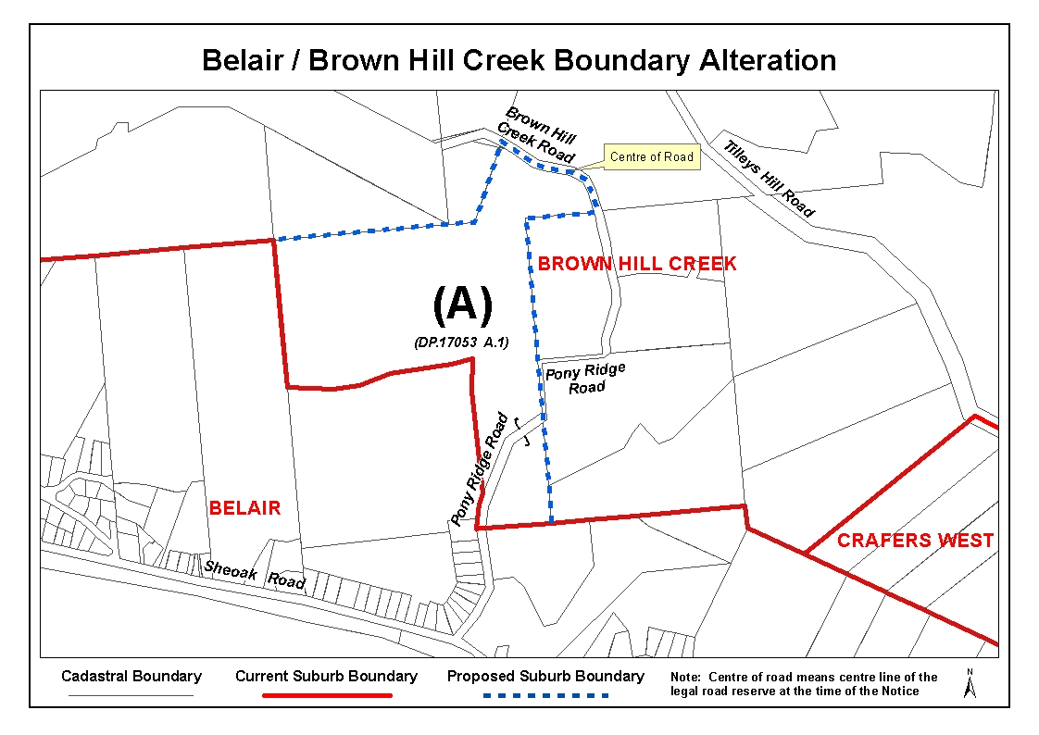
Dated 5 September 2008.
P. M. Kentish, Surveyor-General, Department for Transport, Energy and Infrastructure
DTEI 22-413/08/0026

FISHERIES MANAGEMENT ACT 2007: SECTION 115
TAKE notice that pursuant to section 115 of the Fisheries Management Act 2007, Dr Simon Bryars of Department for Environment and Heritage, Plant Biodiversity Centre, Hackney Road, Adelaide, S.A. 5000 (the ‘exemption holder’), or a person acting as his agent, is exempt from sections 71, 72 (2) (b) and 72 (2) (c) of the Fisheries Management Act 2007, but only insofar as the exemption holder shall not be guilty of an offence when collecting western blue groper (Achoerodus gouldii) from the waters specified in Schedule 1 using a hand line or rod and line (the ‘exempted activity’), subject to the conditions specified in Schedule 2, from 1 November 2008 until 31 December 2008 inclusive, unless varied or revoked earlier.
Schedule 1
The waters of or near Spencer Gulf and Gulf St Vincent contained within and bounded by a line commencing at Mean High Water Springs closest to 34°56′46.59″S, 135°37′33.92″E (Cape Carnot, Eyre Peninsula), then beginning north-easterly following the line of Mean High Water Springs to the location closest to 35°38′33.80″S, 138°31′20.83″E (Newland Head, Fleurieu Peninsula), then south-westerly to the location on Mean High Water Springs closest to 35°50′32.70″S, 138°08′03.59″E (Cape Willoughby, Kangaroo Island), then beginning north-easterly following the line of Mean High Water Springs to the location closest to 35°53′11.31″S, 136°32′03.88″E (Vennachar Point, Kangaroo Island), then north-westerly to the point of commencement.
Schedule 2
1. All fish collected pursuant to this notice may only be used for research purposes and must be returned to the water as soon as possible after implanting acoustic transmitters and attaching external dart tags.
2. The exemption holder must not retain any fish during any trip undertaking the exempted activity.
3. The exemption holder or a person acting as an agent must notify PIRSA Fisheries on 1800 065 522 at least two hours prior to conducting the exempted activity and answer a series of questions about the exempted activity. The exemption holder will
need to have a copy of the exemption notice at the time of making the call, and be able to provide information about the area and time of the exempted activity, the vehicles and boats involved, the number of agents undertaking the exempted activity and other related questions. Exemption No. 9902168.
4. The exemption holder must provide a written report to the Director of Fisheries, G.P.O. Box 1625, Adelaide, S.A. 5001, within 14 days of the expiry of this exemption, providing the following detail in relation to the collection activities:
• location of collection;
• date and time of the collection;
• number of fish collected;
• any mortalities in relation to the exempted activity.
5. The exemption holder must provide a written report to the Director of Fisheries, G.P.O. Box 1625, Adelaide, S.A. 5001, by 31 December 2009, outlining the outcomes of the research undertaken using the acoustic transmitters.
6. While engaged in the exempted activity the exemption holder or agent must be in possession of a copy of this notice and such a notice must be produced to a PIRSA Fisheries Compliance Officer if requested.
7. The exemption holder must not contravene or fail to comply with the Fisheries Management Act 2007, or any regulations made under that Act, except where specifically exempted by this notice.
Dated 8 September 2008.
W. Zacharin, Director of Fisheries

FISHERIES MANAGEMENT ACT 2007: SECTION 115
TAKE notice that pursuant to section 115 of the Fisheries Management Act 2007, licence holders in the Marine Scalefish Fishery endorsed with a condition fixing a sardine quota on the licence (the ‘exemption holders’) are exempt from Regulation 4 (1) of the Fisheries Management (Vessel Monitoring Scheme) Regulations 2007, but only insofar as the exemption holders are permitted to undertake fishing activities using a registered boat pursuant to the licence without a VMS unit installed (the ‘exempted activity’), subject to conditions specified in Schedule 1, from 5 September 2008 until 30 June 2009, unless varied or revoked earlier.
Schedule 1
1. The registered boat used pursuant to the exempted activity must be 7.5 m or less in length.
2. While engaged in the exempted activity, the registered boat may not be used for the taking of sardines using a sardine net or the holding or transport of any sardines.
3. While a registered boat is engaged in the exempted activity, other registered boats on the licence are prohibited from under-taking any sardine fishing activities pursuant to that licence.
4. The exemption holder must notify PIRSA Fisheries on 1800 065 522 at least two hours prior to conducting the exempted activity and answer a series of questions about the exempted activity. The exemption holder will need to have a copy of the exemption notice at the time of making the call, and be able to provide information about the area and time of the exempted activity, the vehicles and boats involved, the number of agents undertaking the exempted activity and other related questions. Exemption No. 9902166.
5. While engaged in the exempted activity, the exemption holder must have in their possession a copy of this notice and produce that notice to a PIRSA Fisheries Compliance Officer upon request.
6. The exemption holder must not contravene or fail to comply with the Fisheries Management Act 2007, or any regulations made under that Act, except where specifically exempted by this notice.
Dated 5 September 2008.
K. Crosthwaite, Director of Fisheries

HOUSING IMPROVEMENT ACT 1940
WHEREAS by notice published in the Government Gazette on the dates mentioned in the following table the South Australian Housing Trust did declare the houses described in the said table to be substandard for the purposes of Part 7 of the Housing Improvement Act 1940, the South Australian Housing Trust in the exercise of the powers conferred by the said Part, does hereby fix as the maximum rental per week which shall be payable subject to section 55 of the Residential Tenancies Act 1995, in respect of each house described in the following table the amount shown in the said table opposite the description of such house and this notice shall come into force on the date of this publication in the Gazette.
Address of House | Allotment, Section, etc. | Certificate of Title  Volume Folio | Date and page of Government Gazette in which notice declaring house to be substandard published | Maximum rental per week payable in respect of each house  $

28 Kate Court, Adelaide |  | Allotment 806 in Filed Plan 182458, Part Town Acre 511, Hundred of Adelaide | 5980 | 458 |  | 13.9.90, page 860 | 272.00
283 Semaphore Road, Birkenhead |  | Allotment 13 in Filed Plan 4202, Hundred of Port Adelaide | 5551 | 733 |  | 5.6.08, page 1844 | 87.00
24 Gould Road, Elizabeth Park |  | Allotment 703 in Deposited Plan 7005, Hundred of Munno Para | 5168 | 185 |  | 22.5.08, page 1690 | 166.00
24 Pavlich Street, Port Pirie West |  | Allotment 202 in Filed Plan 189144, Hundred of Pirie | 5701 | 848 |  | 3.7.08, page 3152 | 47.00
25 Breaker Street, St Morris |  | Allotment 27 in Deposited Plan 2477, Hundred of Adelaide | 5180 | 20 |  | 31.1.08, page 330 | 272.00

Dated at Adelaide, 11 September 2008. D. Huxley, Director, Corporate and Board Services

HOUSING IMPROVEMENT ACT 1940
NOTICE is hereby given that the South Australian Housing Trust in the exercise of the powers conferred by the Housing Improvement Act 1940, does hereby declare the houses described in the table hereunder to be substandard for the purposes of Part 7 of the Housing Improvement Act 1940.
No. of House and Street | Locality | Allotment, Section, etc. | Certificate of Title  Volume Folio

21 Stephen Crescent |  | Christie Downs | Allotment 92 in Deposited Plan 10163, Hundred of Noarlunga | 5349 | 483
54 Harvey Street |  | Ethelton | Allotment 64 of subdivision of section 905, Hundred of Port Adelaide | 5221 | 113
3 Attrill Avenue |  | Hilton | Allotment 49 in Filed Plan 143677, Hundred of Adelaide | 5764 | 24
92 Queen Street |  | Peterborough | Allotment 601 in Filed Plan 185493, Hundred of Yongala | 5664 | 92
37 Tottenham Court Road |  | Port Elliot | Allotment 91 in Filed Plan 162355, Hundred of Goolwa | 5301 | 576
143 Murray Road |  | Port Noarlunga | Allotment 1123 in Deposited Plan 4942, Hundred of Noarlunga | 5313 | 805
57 Kalgoorlie Avenue |  | Port Noarlunga South | Allotment 417 in Deposited Plan 6016, Hundred of Willunga | 5617 | 261

Dated at Adelaide, 11 September 2008. D. Huxley, Director, Corporate and Board Services

HOUSING IMPROVEMENT ACT 1940
WHEREAS by notice published in the Government Gazette on the dates mentioned in the following table the South Australian Housing Trust did declare the houses described in the said table to be substandard for the purposes of Part 7 of the Housing Improvement Act 1940, and whereas the South Australian Housing Trust is satisfied that each of the houses described hereunder has ceased to be substandard, notice is hereby given that, in exercise of the powers conferred by the said Part, the South Australian Housing Trust does hereby revoke the said declaration in respect of each house.
Address of House | Allotment, Section, etc. | Certificate of Title  Volume Folio | Date and page of Government Gazette in which notice declaring house to be substandard published

16 Ayredale Avenue, Clearview |  | Allotment 155 in Deposited Plan 3418, Hundred of Yatala | 5677 | 798 |  | 3.7.08, page 3152
19 Berryman Road, Smithfield Plains |  | Allotment 318 in Deposited Plan 7888, Hundred of Munno Para | 5822 | 479 |  | 30.11.06, page 4104

Dated at Adelaide, 11 September 2008. D. Huxley, Director, Corporate and Board Services

LIQUOR LICENSING ACT 1997 AND GAMING MACHINES ACT 1992
Notice of Application
NOTICE is hereby given, pursuant to section 52 of the Liquor Licensing Act 1997 and section 29 of the Gaming Machines Act 1992, that T. W. Searle Investments Pty Ltd has applied to the Licensing Authority for the transfer of a Hotel and Gaming Machine Licence in respect of premises situated at Dukes Highway, Bordertown, S.A. 5268 and known as Woolshed Inn Hotel Motel.
The applications have been set down for hearing on 2 October 2008 at 10.30 a.m.
Any person may object to the application by lodging a notice of objection in the prescribed form with the Liquor and Gambling Commissioner and serving a copy of the notice on the applicant at the applicant’s address, on or before 1 October 2008.
The applicant’s address for service is c/o Leon McEvoy, Cleland Lawyers, 208 Carrington Street, Adelaide, S.A. 5000.
Plans in respect of the premises the subject of the application are open to public inspection without fee at the Office of the Liquor and Gambling Commissioner, 9th Floor, East Wing, 50 Grenfell Street, Adelaide, S.A. 5000. Phone 8226 8410, Fax:
8226 8512. Email: olgc@agd.sa.gov.au.
Dated 5 September 2008.
Applicant

LIQUOR LICENSING ACT 1997 AND GAMING MACHINES ACT 1992
Notice of Application
NOTICE is hereby given, pursuant to section 52 of the Liquor Licensing Act 1997 and section 29 of the Gaming Machines Act 1992, that Norwood Community Club Inc. has applied to the Licensing Authority for the removal of a Club Licence with a variation to an Extended Trading Authorisation and the grant of a Gaming Machine Licence with an increase to the number of gaming machines in respect of premises situated at 137 The Parade, Norwood, S.A. 5067, to be situated at 134-140 Marion Road, West Richmond, S.A. 5033 and known as Norwood Community Club.
The applications have been set down for callover on 10 October 2008 at 9 a.m.
Conditions
The following licence conditions are sought:
• Variation to Extended Trading Authorisation:
Monday to Saturday (including days preceding Public Holidays): Midnight to 2 a.m. the following day;
Sunday (including Sundays preceding Public Holidays): 8 a.m. to 11 a.m. and 8 p.m. to 2 a.m. the following day.
• Applicant seeks to increase the number of gaming machines from 26 to 34 machines.
Any person may object to the application by lodging a notice of objection in the prescribed form with the Liquor and Gambling Commissioner and serving a copy of the notice on the applicant at the applicant’s address, at least seven days before the callover date (viz: 3 October 2008).
The applicant’s address for service is c/o Duncan Basheer Hannon, Barristers and Solicitors, G.P.O. Box 2, Adelaide, S.A. 5001 (Attention: David Tillett).
Plans in respect of the premises the subject of the application are open to public inspection without fee at the Office of the Liquor and Gambling Commissioner, 9th Floor, East Wing, 50 Grenfell Street, Adelaide, S.A. 5000. Phone 8226 8410, Fax:
8226 8512. Email: olgc@agd.sa.gov.au.
Dated 4 September 2008.
Applicant

LIQUOR LICENSING ACT 1997
Notice of Application
NOTICE is hereby given, pursuant to section 52 (2) (b) of the Liquor Licensing Act 1997, that ED Bourne Pty Ltd has applied to the Licensing Authority for the transfer of a Restaurant Licence in respect of premises situated at 9-11 Hindley Street, Adelaide, S.A. 5000 and known as Hotti Restaurant.
The application has been set down for hearing on 15 October 2008 at 11 a.m.
Any person may object to the application by lodging a notice of objection in the prescribed form with the Liquor and Gambling Commissioner and serving a copy of the notice on the applicant at the applicant’s address, at least seven days before the hearing date (viz: 8 October 2008).
The applicant’s address for service is c/o Edgley Lawyers, Level 8, 185 Victoria Square, Adelaide, S.A. 5000.
Plans in respect of the premises the subject of the application are open to public inspection without fee at the Office of the Liquor and Gambling Commissioner, 9th Floor, East Wing, 50 Grenfell Street, Adelaide, S.A. 5000. Phone 8226 8410, Fax:
8226 8512. Email: olgc@agd.sa.gov.au.
Dated 9 September 2008.
Applicant

LIQUOR LICENSING ACT 1997
Notice of Application
NOTICE is hereby given, pursuant to section 52 (2) (b) of the Liquor Licensing Act 1997, that Independant Pub Group Pty Ltd has applied to the Licensing Authority for Alterations, Redefi-nition and variation to an Extended Trading Authorisation in respect of premises situated at 12-34 Gulfview Road, Christies Beach, S.A. 5165 and known as Christies Beach Hotel.
The application has been set down for callover on 10 October 2008 at 9 a.m.
Conditions
The following licence conditions are sought:
• Alterations and Redefinition to create a new Outdoor Dining Area adjacent to Area 1 known as the Sports Bar as per plans lodged with this office.
• Variation to Extended Trading Authorisation to include the abovementioned area.
Any person may object to the application by lodging a notice of objection in the prescribed form with the Liquor and Gambling Commissioner and serving a copy of the notice on the applicant at the applicant’s address, at least seven days before the callover date (viz: 3 October 2008).
The applicant’s address for service is c/o Minter Ellison Lawyers, 25 Grenfell Street, Adelaide, S.A. 5000.
Plans in respect of the premises the subject of the application are open to public inspection without fee at the Office of the Liquor and Gambling Commissioner, 9th Floor, East Wing, 50 Grenfell Street, Adelaide, S.A. 5000. Phone 8226 8410, Fax:
8226 8512. Email: olgc@agd.sa.gov.au.
Dated 9 September 2008.
Applicant

LIQUOR LICENSING ACT 1997
Notice of Application
NOTICE is hereby given, pursuant to section 52 (2) (b) of the Liquor Licensing Act 1997, that Gotmix Pty Ltd has applied to the Licensing Authority for the transfer of a Special Circumstances Licence in respect of premises situated at 1st Floor, 106 O’Connell Street, North Adelaide, S.A. 5006 and known as Cambridge Balcony Bar.
The application has been set down for hearing on 15 October 2008 at 10 a.m.
Any person may object to the application by lodging a notice of objection in the prescribed form with the Liquor and Gambling Commissioner and serving a copy of the notice on the applicant at the applicant’s address, at least seven days before the hearing date (viz: 8 October 2008).
The applicant’s address for service is c/o Mellor Olsson, G.P.O. Box 74, Adelaide, S.A. 5001.
Plans in respect of the premises the subject of the application are open to public inspection without fee at the Office of the Liquor and Gambling Commissioner, 9th Floor, East Wing, 50 Grenfell Street, Adelaide, S.A. 5000. Phone 8226 8410, Fax:
8226 8512. Email: olgc@agd.sa.gov.au.
Dated 8 September 2008.
Applicant

LIQUOR LICENSING ACT 1997
Notice of Application
NOTICE is hereby given, pursuant to section 52 (2) (b) of the Liquor Licensing Act 1997, that Horner Pty Ltd as trustee for MT Bera Vineyard Trust has applied to the Licensing Authority for the transfer of a Producer’s Licence in respect of premises situated at Lot 11, Gorge Road, Cudlee Creek, S.A. 5253 and known as MT Bera Vineyards.
The application has been set down for hearing on 14 October 2008 at 10 a.m.
Any person may object to the application by lodging a notice of objection in the prescribed form with the Liquor and Gambling Commissioner and serving a copy of the notice on the applicant at the applicant’s address, at least seven days before the hearing date (viz: 7 October 2008).
The applicant’s address for service is c/o Horner Pty Ltd, P.O. Box 6193, Adelaide, S.A. 5000.
Plans in respect of the premises the subject of the application are open to public inspection without fee at the Office of the Liquor and Gambling Commissioner, 9th Floor, East Wing, 50 Grenfell Street, Adelaide, S.A. 5000. Phone 8226 8410, Fax:
8226 8512. Email: olgc@agd.sa.gov.au.
Dated 8 September 2008.
Applicant

LIQUOR LICENSING ACT 1997
Notice of Application
NOTICE is hereby given, pursuant to section 52 (2) (b) of the Liquor Licensing Act 1997, that Capoccia Pty Ltd as trustee for the Capoccia Unit Trust has applied to the Licensing Authority for a Restaurant Licence in respect of premises situated at 23 Ebenezer Place, Adelaide, S.A. 5000 and to be known as Nano (Ready To Go).
The application has been set down for callover on 10 October 2008 at 9 a.m.
Any person may object to the application by lodging a notice of objection in the prescribed form with the Liquor and Gambling Commissioner and serving a copy of the notice on the applicant at the applicant’s address, at least seven days before the callover date (viz: 3 October 2008).
The applicant’s address for service is c/o Clelands Lawyers, 208 Carrington Street, Adelaide, S.A. 5000 (Attention: Rinaldo D’Aloia).
Plans in respect of the premises the subject of the application are open to public inspection without fee at the Office of the Liquor and Gambling Commissioner, 9th Floor, East Wing, 50 Grenfell Street, Adelaide, S.A. 5000. Phone 8226 8410, Fax:
8226 8512. Email: olgc@agd.sa.gov.au.
Dated 8 September 2008.
Applicant

LIQUOR LICENSING ACT 1997
Notice of Application
NOTICE is hereby given, pursuant to section 52 (2) (b) of the Liquor Licensing Act 1997, that Olympic Dam Football Club Inc. has applied to the Licensing Authority for a Redefinition, Alterations and variation to an Extended Trading Authorisation in respect of premises situated at Lot 2025, Olympic Way, Olympic Dam, S.A. 5725 and known as Olympic Dam Football Club Inc.
The application has been set down for callover on 10 October 2008 at 9 a.m.
Conditions
The following licence conditions are sought:
• Redefinition and Alterations to include a new Outdoor Area as per plans lodged with this office.
• Current Extended Trading Authorisation to apply to the abovementioned area.
Any person may object to the application by lodging a notice of objection in the prescribed form with the Liquor and Gambling Commissioner and serving a copy of the notice on the applicant at the applicant’s address, at least seven days before the callover date (viz: 3 October 2008).
The applicant’s address for service is c/o Olympic Dam Football Club Inc., P.O. Box 110, Olympic Dam, S.A. 5725 (Attention: Kym Clarke).
Plans in respect of the premises the subject of the application are open to public inspection without fee at the Office of the Liquor and Gambling Commissioner, 9th Floor, East Wing, 50 Grenfell Street, Adelaide, S.A. 5000. Phone 8226 8410, Fax:
8226 8512. Email: olgc@agd.sa.gov.au.
Dated 5 September 2008.
Applicant

LIQUOR LICENSING ACT 1997
Notice of Application
NOTICE is hereby given, pursuant to section 52 (2) (b) of the Liquor Licensing Act 1997, that VHPM Pty Ltd has applied to the Licensing Authority for alterations to Licensed Premises in respect of premises situated at 40 Meylin Street, Port MacDonnell, S.A. 5291 and known as Victoria Hotel.
The application has been set down for hearing on 26 September 2008 at 9 a.m.
Conditions
The following licence conditions are sought:
• Extension of glass area at front of premises to enclose smoking area.
• Existing Trading Hours are to apply to the proposed area.
Any person may object to the application by lodging a notice of objection in the prescribed form with the Liquor and Gambling Commissioner and serving a copy of the notice on the applicant at the applicant’s address, at least the day before the hearing date (viz: 25 September 2008).
The applicant’s address for service is c/o Stephen Johnstone, 40 Meylin Street, Port MacDonnell, S.A. 5291.
Plans in respect of the premises the subject of the application are open to public inspection without fee at the Office of the Liquor and Gambling Commissioner, 9th Floor, East Wing, 50 Grenfell Street, Adelaide, S.A. 5000. Phone 8226 8410, Fax:
8226 8512. Email: olgc@agd.sa.gov.au.
Dated 5 September 2008.
Applicant

LIQUOR LICENSING ACT 1997
Notice of Application
NOTICE is hereby given, pursuant to section 52 (2) (b) of the Liquor Licensing Act 1997, that Angela Margaret Trevor has applied to the Licensing Authority for a variation to Conditions in respect of premises situated at 57A Gouger Street, Adelaide, S.A. 5000 and known as Wilson’s Organics.
The application has been set down for callover on 10 October 2008 at 9 a.m.
Conditions
The following licence conditions are sought:
• To delete the following condition from the licence:
‘To sell any “organic liquor” and “organic liquor” means any liquor that is produced in accordance with the national standard for organic and biodynamic produce [ISBN 0-646-35460-4] and has a certificate of authenticity recognised by the Australian Quarantine Inspection Service (AQUIS). The licensee must hold these certificates in a register kept at the licensed premises while the relevant “organic liquor” is being offered for sale. The register must be available for inspection on the request of an authorised inspector.’
Any person may object to the application by lodging a notice of objection in the prescribed form with the Liquor and Gambling Commissioner and serving a copy of the notice on the applicant at the applicant’s address, at least seven days before the callover date (viz: 3 October 2008).
The applicant’s address for service is c/o Angela Trevor, 57A Gouger Street, Adelaide, S.A. 5000.
Plans in respect of the premises the subject of the application are open to public inspection without fee at the Office of the Liquor and Gambling Commissioner, 9th Floor, East Wing, 50 Grenfell Street, Adelaide, S.A. 5000. Phone 8226 8410, Fax:
8226 8512. Email: olgc@agd.sa.gov.au.
Dated 5 September 2008.
Applicant

LIQUOR LICENSING ACT 1997
Notice of Application
NOTICE is hereby given, pursuant to section 52 (2) (b) of the Liquor Licensing Act 1997, that Mauro Carmine Travaglione has applied to the Licensing Authority for a Producer’s Licence in respect of premises situated at 1147 Sturt Highway, Waikerie, S.A. 5330 and to be known as Mirabella Vineyards.
The application has been set down for callover on 10 October 2008 at 9 a.m.
Any person may object to the application by lodging a notice of objection in the prescribed form with the Liquor and Gambling Commissioner and serving a copy of the notice on the applicant at the applicant’s address, at least seven days before the callover date (viz: 3 October 2008).
The applicant’s address for service is c/o Stuart Andrew Solicitors, 11 Ahern Street, Berri, S.A. 5343.
Plans in respect of the premises the subject of the application are open to public inspection without fee at the Office of the Liquor and Gambling Commissioner, 9th Floor, East Wing, 50 Grenfell Street, Adelaide, S.A. 5000. Phone 8226 8410, Fax:
8226 8512. Email: olgc@agd.sa.gov.au.
Dated 3 September 2008.
Applicant

LIQUOR LICENSING ACT 1997
Notice of Application
NOTICE is hereby given, pursuant to section 52 (2) (b) of the Liquor Licensing Act 1997, that Trevor Dusan Kordic has applied to the Licensing Authority for a Direct Sales Licence in respect of premises situated at 55 Scenic Drive, Old Noarlunga, S.A. 5168 and to be known as TR Kordic.
The application has been set down for callover on 10 October 2008 at 9 a.m.
Any person may object to the application by lodging a notice of objection in the prescribed form with the Liquor and Gambling Commissioner and serving a copy of the notice on the applicant at the applicant’s address, at least seven days before the callover date (viz: 3 October 2008).
The applicant’s address for service is c/o David Watts and Associates, 1 Cator Street, Glenside, S.A. 5065.
Plans in respect of the premises the subject of the application are open to public inspection without fee at the Office of the Liquor and Gambling Commissioner, 9th Floor, East Wing, 50 Grenfell Street, Adelaide, S.A. 5000. Phone 8226 8410, Fax:
8226 8512. Email: olgc@agd.sa.gov.au.
Dated 3 September 2008.
Applicant

LIQUOR LICENSING ACT 1997
Notice of Application
NOTICE is hereby given, pursuant to section 52 (2) (b) of the Liquor Licensing Act 1997, that Ross Kolouch and Radoslava Kolouchova have applied to the Licensing Authority for a Direct Sales Licence in respect of premises situated at 24 Barton Circuit, Mount Barker, S.A. 5251 and to be known as Bacchus Cellarius.
The application has been set down for callover on 10 October 2008 at 9 a.m.
Any person may object to the application by lodging a notice of objection in the prescribed form with the Liquor and Gambling Commissioner and serving a copy of the notice on the applicants at the applicants’ address, at least seven days before the callover date (viz: 3 October 2008).
The applicants’ address for service is c/o Ross Kolouch, P.O. Box 1196, Blackwood, S.A. 5051.
Plans in respect of the premises the subject of the application are open to public inspection without fee at the Office of the Liquor and Gambling Commissioner, 9th Floor, East Wing, 50 Grenfell Street, Adelaide, S.A. 5000. Phone 8226 8410, Fax:
8226 8512. Email: olgc@agd.sa.gov.au.
Dated 3 September 2008.
Applicants

LIQUOR LICENSING ACT 1997
Notice of Application
NOTICE is hereby given, pursuant to section 52 (2) (b) of the Liquor Licensing Act 1997, that Andamooka Football Club Inc. has applied to the Licensing Authority for a Limited Club Licence in respect of premises situated at Olympic Way, Roxby Downs, S.A. 5725 and known as Andamooka Football Club.
The application has been set down for callover on 10 October 2008 at 9 a.m.
Conditions
The following licence conditions are sought:
• The licence will authorise trade from 15 March to 30 September each year.
• The licence will apply to the grounds defined by the boundary fence on match days or occasional special club functions organised by the licensee.
Any person may object to the application by lodging a notice of objection in the prescribed form with the Liquor and Gambling Commissioner and serving a copy of the notice on the applicant at the applicant’s address, at least seven days before the callover date (viz: 3 October 2008).
The applicant’s address for service is c/o Ian Kenneth Tuohy, 3A Bolami Street, Roxby Downs, S.A. 5725.
Plans in respect of the premises the subject of the application are open to public inspection without fee at the Office of the Liquor and Gambling Commissioner, 9th Floor, East Wing, 50 Grenfell Street, Adelaide, S.A. 5000. Phone 8226 8410, Fax:
8226 8512. Email: olgc@agd.sa.gov.au.
Dated 2 September 2008.
Applicant

LIQUOR LICENSING ACT 1997
Notice of Application
NOTICE is hereby given, pursuant to section 52 (2) (b) of the Liquor Licensing Act 1997, that Onkaparinga Valley Sporting Club Inc. has applied to the Licensing Authority for a Redefinition in respect of premises situated at Main Road, Balhannah, S.A. 5242 and known as Onkaparinga Valley Sporting Club.
The application has been set down for callover on 10 October 2008 at 9 a.m.
Conditions
The following licence conditions are sought:
• Redefinition to include the oval and surrounding areas as per plans lodged with this office.
Any person may object to the application by lodging a notice of objection in the prescribed form with the Liquor and Gambling Commissioner and serving a copy of the notice on the applicant at the applicant’s address, at least seven days before the callover date (viz: 3 October 2008).
The applicant’s address for service is c/o Onkaparinga Valley Sporting Club Inc., P.O. Box 42, Woodside, S.A. 5244 (Attention: John Higginson).
Plans in respect of the premises the subject of the application are open to public inspection without fee at the Office of the Liquor and Gambling Commissioner, 9th Floor, East Wing, 50 Grenfell Street, Adelaide, S.A. 5000. Phone 8226 8410, Fax:
8226 8512. Email: olgc@agd.sa.gov.au.
Dated 2 September 2008.
Applicant

LIQUOR LICENSING ACT 1997
Notice of Application
NOTICE is hereby given, pursuant to section 52 (2) (b) of the Liquor Licensing Act 1997, that Morgan Dirt Kart Club Incorporated has applied to the Licensing Authority for a Limited Club Licence in respect of premises situated at Part Section 415, Hundred of EBA, Morgan, S.A. 5320 and to be known as Morgan Dirt Kart Club.
The application has been set down for callover on 10 October 2008 at 9 a.m.
Any person may object to the application by lodging a notice of objection in the prescribed form with the Liquor and Gambling Commissioner and serving a copy of the notice on the applicant at the applicant’s address, at least seven days before the callover date (viz: 3 October 2008).
The applicant’s address for service is c/o Morgan Dirt Kart Club Incorporated, Part Section 415, Hundred of EBA, Morgan, S.A. 5320.
Plans in respect of the premises the subject of the application are open to public inspection without fee at the Office of the Liquor and Gambling Commissioner, 9th Floor, East Wing, 50 Grenfell Street, Adelaide, S.A. 5000. Phone 8226 8410, Fax:
8226 8512. Email: olgc@agd.sa.gov.au.
Dated 22 August 2008.
Applicant

LIVESTOCK ACT 1997
Notice by the Minister
Notifiable Diseases
PURSUANT to section 4 of the Livestock Act 1997, I, Rory McEwen, Minister for Agriculture, Food and Fisheries, declare to be notifiable diseases those diseases listed as exotic diseases, plus the following diseases:
This notice revokes the notice made by the Minister for Agriculture, Food and Fisheries on 22 February 2007 and subsequent amendments to that notice.
Diseases of bees
American foul brood
European foul brood
small hive beetle
Diseases of aquatic species
abalone ganglioneuritis (viral)
Aeromonas salmonicida (atypical strains)
Boccardia knoxi
bonamiosis (Bonamia sp)
epizootic haematopoietic necrosis
epizootic ulcerative syndrome (Aphanomyces invaderis)
gill associated virus
marteiliosis (Marteilia sydneyi)
mikrocytosis (Mikrocytosis roughleyi)
Penaeus monodon—type baculovirus
perkinsosis (Perkinsus olseni)
spawner-isolated mortality virus disease
viral encephalopathy and retinopathy
Diseases of other species
Aino disease
Akabane disease
anaplasmosis
avian mycoplasmosis (M. synoviae)
babesiosis (bovines only)
bluetongue
Brucella suis
buffalo fly
Cysticercus bovis
enzootic bovine leucosis
ephemeral fever
equine herpes virus (abortigenic and neurological strains)
equine infectious anaemia
equine viral arteritis
footrot (sheep and goats only)
infectious laryngotracheitis
Johne’s disease
listeriosis
melioidosis
pullorum disease
sporadic bovine encephalomyelitis
strangles
tuberculosis (all species)
verotoxigenic E coli
Exotic Diseases
Diseases of bees
Acariasis tracheal mite (Acarapis woodi)
acute bee paralysis
Africanised honey bees
Asian honey bees
Braula coeca
Tropilaelaps mite
Varroasis (Varroa destructor)
Varroasis (Varroa jacobsoni)
Diseases of aquatic species
Aeromonas salmonicida (subsp salmonicida)
Akoya oyster disease
bacterial kidney disease (Renibacterium salmoninarum)
Baculoviral midgut gland necrosis
Baculovirus penaei
bonamiosis (Bonamia ostreae)
Channel catfish virus disease
Crayfish plague (Aphanomyces astaci)
enteric redmouth disease (Yersinia ruckeri)
enteric septicaemia of catfish (Edwardsiella ictaluri)
epizootic haematopoietic necrosis (European catfish virus/ European sheatfish virus)
grouper iridoviral disease
gyrodactylosis (Gyrodactylus salaris)
haplosporidiosis (Haplosporidium costale, H. nelsoni)
infection with Bonamia exitiosa
infection with Candidatus Xenohaliotis californiensis
infection with Koi herpesvirus
infectious haematopoietic necrosis virus
infectious hypodermal and haematopoietic necrosis
infectious pancreatic necrosis
infectious salmon anaemia
iridoviroses of molluscs
Koi herpesvirus
marteiliosis (Marteilia refringens)
Mikrocytosis (Mikrocytos mackini)
necrotising hepatopancreatitis
Oncorhynchus masou virus disease
oyster velar disease
Perkinsus spp. (exotic)
perkinsosis (Perkinsus marinus)
Piscirickettsia salmonis
Red sea bream iridoviral disease
spring viraemia of carp
Taura syndrome
viral haemorrhagic septicaemia
whirling disease (Myxobolus cerebralis)
white sturgeon iridoviral disease
whitespot disease
yellowhead disease
Diseases of other species
African horse sickness
African swine fever
anthrax
Aujeszky’s disease
avian influenza
babesiosis (equine only)
bat lyssavirus
bluetongue (in classical virulent form)
borna disease
bovine virus diarrhoea
Brucella abortus
Brucella canis
Brucella melitensis
Camelpox
Chaga’s disease
Circovirus (associated with Porcine Dermatitis/Nephropathy Syndrome and Post-weaning Multisystemic Wasting Syndrome only)
Coenurus cerebralis
contagious agalactia
contagious bovine pleuropneumonia
contagious caprine pleuropneumonia
contagious equine metritis
cow pox
Crimean Congo Haemorrhagic Fever
Cysticercus cellulosae
Devil Face Tumour Disease
dourine
duck plague
duck virus hepatitis
east coast fever
ehrlichiosis
Elaphostrongylus cervi
encephalitides (tick borne)
epizootic haemorrhagic disease
epizootic lymphangitis
equine encephalosis
equine influenza
equine viral encephalomyelitides
Fasciola gigantica
foot-and-mouth disease
Getah virus
glanders
haemorrhagic septicaemia
Hantann virus
heartwater
Hendra virus
horse pox
Ibaraki disease
infectious bursal disease (hypervirulent and exotic antigenic variant forms)
jaagsiekte
Japanese B encephalitis
Jembrana disease
leishmaniasis
Leptospira canicola
Louping ill
lumpy skin disease
Lyme disease
maedi-visna
malignant catarrhal fever (wildebeest-associated)
Menangle virus
Nagana
Nairobi sheep disease
Newcastle disease (in classical virulent form)
Nipah virus
peste des petits ruminants
porcine endemic diarrhoea
porcine myocarditis
porcine respiratory and reproductive syndrome
Potomac fever
proventricular dilatation syndrome
rabies
Rift Valley fever
rinderpest
Salmonella abortus-equi
Salmonella abortus-ovis
Salmonella enteriditis
screw worm fly
sheep and goat pox
sheep scab
Shopes fibroma virus
surra
swine fever
swine influenza
swine plague
swine vesicular disease
Teschen/Talfan disease
theileriasis
transmissible gastroenteritis
transmissible spongiform encephalopathies (including bovine spongiform encephalopathy; feline spongiform encephalo-pathy; chronic wasting disease of deer and elk, scrapie and transmissible mink encephalopathy)
trichinosis
trypanosomosis
tularaemia
turkey rhinotracheitis
vesicular exanthema
vesicular stomatitis
warbles
Wesselsbron disease
West Nile virus
Dated 9 September 2008.
R. McEwen, Minister for Agriculture, Food and Fisheries

MOTOR VEHICLES ACT 1959
Recognised as an Historic Motor Vehicle Club
NOTICE is hereby given that the undermentioned club is recognised as an historic motor vehicle club in accordance with Schedule 1, Clause 3 (3) (a) of the Motor Vehicles Regulations, for the purposes of section 25 of the Motor Vehicles Act 1959:
The Old Motor Company of South Australia.
Dated 9 September 2008.
M. Small, Registrar of Motor Vehicles

NATURAL RESOURCES MANAGEMENT ACT 2004
Notice of Authorisation to Take Water by Artificial Water Bodies
PURSUANT to section 128 of the Natural Resources Management Act 2004 (the Act), I, Jay Weatherill, Minister for Environment and Conservation (the Minister) in the State of South Australia and the Minister to whom the administration of the Act is committed, hereby authorise the taking of water by means of any excavation or infrastructure works adjacent to or within a prescribed watercourse for the purposes of:
(1) creating or enlarging an artificial water body with a surface area equal to or less than 190 m²; or
(2) maintaining the water level of an artificial water body with a surface area equal to or less than 190 m² (including to compensate for water lost from the artificial water body through evaporation),
where the water body is not used for the collection and subsequent taking of water, for example as a dam.
For the removal of doubt the taking of water as described in this authorisation is not authorised where the surface area of the artificial water body is greater than 190 m² (for example, marinas or canal estates).
Dated 21 August 2008.
Jay Weatherill, Minister for Environment and Conservation

ROADS (OPENING AND CLOSING) ACT 1991:
SECTION 24
NOTICE OF CONFIRMATION OF ROAD
PROCESS ORDER
Road Closure—Earls Road, Wye
BY Road Process Order made on 22 January 2008, the District Council of Grant ordered that:
1. The whole of the un-named public road dividing pieces 11, 12 and 13 in Deposited Plan 69812 and portion of Earls Road adjoining the western boundaries of section 692, Hundred of Caroline, more particularly delineated and lettered ‘A’ and ‘B’ in Preliminary Plan No. 07/0034 be closed.
2. Vest in the Crown the whole of the land subject to closure.
On 17 July 2008 that order was confirmed by the Minister for Infrastructure conditionally upon the deposit by the Registrar-General of Deposited Plan 77576 being the authority for the new boundaries.
Pursuant to section 24 (5) of the Roads (Opening and Closing) Act 1991, NOTICE of the order referred to above and its confirmation is hereby given.
Dated 11 September 2008.
P. S. Smith, Acting Surveyor-General

ROADS (OPENING AND CLOSING) ACT 1991:
SECTION 24
NOTICE OF CONFIRMATION OF ROAD
PROCESS ORDER
Road Closure, Rockleigh
BY Road Process Order made on 12 June 2008, the Rural City of Murray Bridge ordered that:
1. The whole of the un-named public road between sections 101 and 328, Hundred of Mobilong, more particularly lettered ‘A’ in Preliminary Plan No. 08/0011 be closed.
2. The whole of the land subject to closure be transferred to Jason Brock Adams in accordance with agreement for transfer dated 25 October 2007 entered into between the Rural City of Murray Bridge and J. B. Adams.
On 27 August 2008 that order was confirmed by the Minister for Infrastructure conditionally upon the deposit by the Registrar-General of Deposited Plan 78395 being the authority for the new boundaries.
Pursuant to section 24 (5) of the Roads (Opening and Closing) Act 1991, NOTICE of the order referred to above and its confirmation is hereby given.
Dated 11 September 2008.
P. S. Smith, Acting Surveyor-General

ROADS (OPENING AND CLOSING) ACT 1991
Review of the Roads (Opening and Closing) Act 1991
THE Roads (Opening and Closing) Act 1991, provides a statutory mechanism to alter the road pattern of the State, while simultaneously protecting the rights and interests of individuals, authorities and the community.
The Act came into operation on 11 November 1991, is com-mitted to the Minister for Infrastructure and administered by the Surveyor-General.
The Surveyor-General has started a review of the legislation and now seeks community views. To raise issues to be considered within the review write to:
Surveyor-General,
P.O. Box 1354
Adelaide, S.A. 5001,
before 31 October 2008. A copy of the Act can be viewed at www.legislation.sa.gov.au.
P. M. Kentish, Surveyor-General

GOVERNMENT GAZETTE ADVERTISEMENT RATES

To apply from 1 July 2008

$  Agents, Ceasing to Act as 41.00  Associations:  Incorporation 20.80  Intention of Incorporation 51.50  Transfer of Properties 51.50  Attorney, Appointment of 41.00  Bailiff’s Sale 51.50  Cemetery Curator Appointed 30.50  Companies:  Alteration to Constitution 41.00  Capital, Increase or Decrease of 51.50  Ceasing to Carry on Business 30.50  Declaration of Dividend 30.50  Incorporation 41.00  Lost Share Certificates:  First Name 30.50  Each Subsequent Name 10.50  Meeting Final 34.25  Meeting Final Regarding Liquidator’s Report on  Conduct of Winding Up (equivalent to ‘Final  Meeting’)  First Name 41.00  Each Subsequent Name 10.50  Notices:  Call 51.50  Change of Name 20.80  Creditors 41.00  Creditors Compromise of Arrangement 41.00  Creditors (extraordinary resolution that ‘the Com-pany be wound up voluntarily and that a liquidator be appointed’) 51.50  Release of Liquidator⎯Application⎯Large Ad. 81.50  ⎯Release Granted 51.50  Receiver and Manager Appointed 47.50  Receiver and Manager Ceasing to Act 41.00  Restored Name 38.50  Petition to Supreme Court for Winding Up 71.50  Summons in Action 61.00  Order of Supreme Court for Winding Up Action 41.00  Register of Interests⎯Section 84 (1) Exempt 92.00  Removal of Office 20.80  Proof of Debts 41.00  Sales of Shares and Forfeiture 41.00  Estates:  Assigned 30.50  Deceased Persons⎯Notice to Creditors, etc. 51.50  Each Subsequent Name 10.50  Deceased Persons⎯Closed Estates 30.50  Each Subsequent Estate 1.35  Probate, Selling of 41.00  Public Trustee, each Estate 10.50 |  | $  Firms:  Ceasing to Carry on Business (each insertion) 27.25  Discontinuance Place of Business 27.25  Land⎯Real Property Act:  Intention to Sell, Notice of 51.50  Lost Certificate of Title Notices 51.50  Cancellation, Notice of (Strata Plan) 51.50  Mortgages:  Caveat Lodgement 20.80  Discharge of 21.80  Foreclosures 20.80  Transfer of 20.80  Sublet 10.50  Leases⎯Application for Transfer (2 insertions) each 10.50  Lost Treasury Receipts (3 insertions) each 30.50  Licensing 61.00  Municipal or District Councils:  Annual Financial Statement⎯Forms 1 and 2 574.00  Electricity Supply⎯Forms 19 and 20 408.00  Default in Payment of Rates:  First Name 81.50  Each Subsequent Name 10.50  Noxious Trade 30.50  Partnership, Dissolution of 30.50  Petitions (small) 20.80  Registered Building Societies (from Registrar-  General) 20.80  Register of Unclaimed Moneys⎯First Name 30.50  Each Subsequent Name 10.50  Registers of Members⎯Three pages and over:  Rate per page (in 8pt) 261.00  Rate per page (in 6pt) 345.00  Sale of Land by Public Auction 52.00  Advertisements 2.90  ¼ page advertisement 122.00  ½ page advertisement 244.00  Full page advertisement 478.00  Advertisements, other than those listed are charged at $2.90 per column line, tabular one-third extra.  Notices by Colleges, Universities, Corporations and District Councils to be charged at $2.90 per line.  Where the notice inserted varies significantly in length from that which is usually published a charge of $2.90 per column line will be applied in lieu of advertisement rates listed.  South Australian Government publications are sold on the condition that they will not be reproduced without prior permission from the Government Printer.
All the above prices include GST

GOVERNMENT GAZETTE NOTICES
ALL private advertisements forwarded for publication in the South Australian Government Gazette must be PAID FOR PRIOR TO INSERTION; and all notices, from whatever source, should be legibly written on one side of the paper only and sent to Government Publishing SA so as to be received no later than 4 p.m. Tuesday preceding the day of publication. Phone 8207 1045 or Fax 8207 1040. E-mail: governmentgazette@dpc.sa.gov.au. Send as attachments in Word format. Please include date the notice is to be published and to whom the notice will be charged. The Government Gazette is available online at: www.governmentgazette.sa.gov.au.

MISCELLANEOUS LEGISLATION AND GOVERNMENT PUBLICATIONS PRICES AS FROM 1 JULY 2008

Acts, Bills, Rules, Parliamentary Papers and Regulations
Pages | Main | Amends | Pages | Main | Amends

1-16 | 2.50 | 1.15 | 497-512 | 34.75 | 33.75
17-32 | 3.35 | 2.10 | 513-528 | 35.75 | 34.50
33-48 | 4.35 | 3.10 | 529-544 | 37.00 | 35.75
49-64 | 5.50 | 4.20 | 545-560 | 38.00 | 37.00
65-80 | 6.45 | 5.35 | 561-576 | 38.75 | 38.00
81-96 | 7.50 | 6.20 | 577-592 | 40.00 | 38.50
97-112 | 8.55 | 7.30 | 593-608 | 41.25 | 39.75
113-128 | 9.55 | 8.40 | 609-624 | 42.00 | 41.00
129-144 | 10.70 | 9.45 | 625-640 | 43.25 | 41.50
145-160 | 11.70 | 10.50 | 641-656 | 44.25 | 43.25
161-176 | 12.80 | 11.50 | 657-672 | 44.75 | 43.75
177-192 | 13.90 | 12.60 | 673-688 | 46.75 | 44.75
193-208 | 15.00 | 13.80 | 689-704 | 47.50 | 45.70
209-224 | 15.80 | 14.60 | 705-720 | 48.25 | 47.00
225-240 | 16.90 | 15.60 | 721-736 | 50.00 | 48.00
241-257 | 18.10 | 16.50 | 737-752 | 50.50 | 49.00
258-272 | 19.10 | 17.60 | 753-768 | 51.50 | 50.00
273-288 | 20.20 | 18.90 | 769-784 | 52.50 | 51.50
289-304 | 21.00 | 19.80 | 785-800 | 53.50 | 52.50
305-320 | 22.30 | 20.90 | 801-816 | 54.50 | 53.00
321-336 | 23.20 | 21.90 | 817-832 | 55.50 | 54.50
337-352 | 24.40 | 23.10 | 833-848 | 56.50 | 55.50
353-368 | 25.25 | 24.20 | 849-864 | 57.50 | 56.00
369-384 | 26.50 | 25.25 | 865-880 | 59.00 | 57.50
385-400 | 27.50 | 26.25 | 881-896 | 59.50 | 58.00
401-416 | 28.50 | 27.00 | 897-912 | 61.00 | 59.50
417-432 | 29.75 | 28.25 | 913-928 | 61.50 | 61.00
433-448 | 30.75 | 29.50 | 929-944 | 62.50 | 61.50
449-464 | 31.50 | 30.25 | 945-960 | 63.50 | 62.00
465-480 | 32.00 | 31.25 | 961-976 | 65.50 | 63.00
481-496 | 33.75 | 32.00 | 977-992 | 66.50 | 63.50

Legislation—Acts, Regulations, etc: $
Subscriptions:
Acts 214.00
All Bills as Laid 514.00
Rules and Regulations 514.00
Parliamentary Papers 514.00
Bound Acts 238.00
Index 119.00
Government Gazette
Copy 5.60
Subscription 284.00
Hansard
Copy 15.60
Subscription—per session (issued weekly) 446.00
Cloth bound—per volume 191.00
Subscription—per session (issued daily) 446.00
Legislation on Disk
Whole Database 3 304.00
Annual Subscription for fortnightly updates 1 015.00
Individual Act(s) including updates POA
Compendium
Subscriptions:
Subscriptions 1 957.00
Updates 690.00
(All the above prices include GST)

All Legislation, Government Gazette, Hansard and Legislation on disk are available from:
Counter Sales Government Legislation⁺ Outlet
and Mail Orders: Service SA Customer Service Centre,
Ground Floor—EDS Centre, 108 North Terrace, Adelaide, S.A. 5000
Phone: 13 23 24 (local call cost), Fax: (08) 8204 1909
Postal: G.P.O. Box 1707, Adelaide, S.A. 5001

Online Shop: www.shop.service.sa.gov.au

Subscriptions and Government Publishing SA
Standing Orders: Box 9, Plaza Level, Riverside Centre, North Terrace, Adelaide, S.A. 5000
Phone: (08) 8207 1043, (08) 8207 0910, Fax: (08) 8207 1040

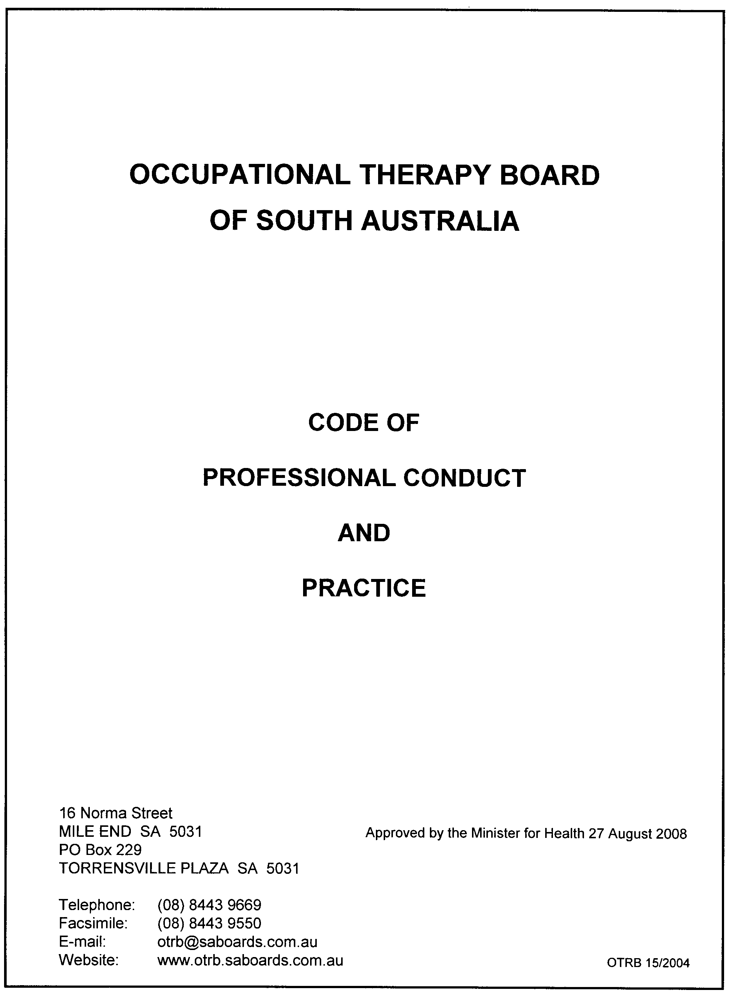




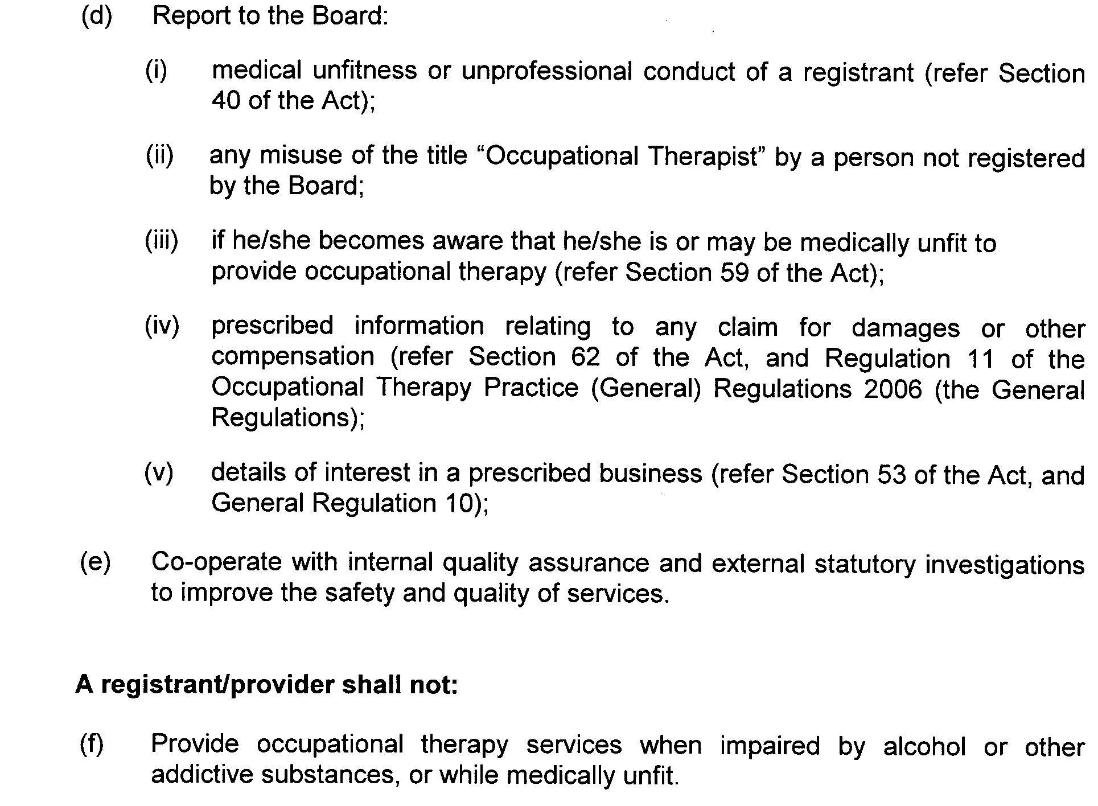

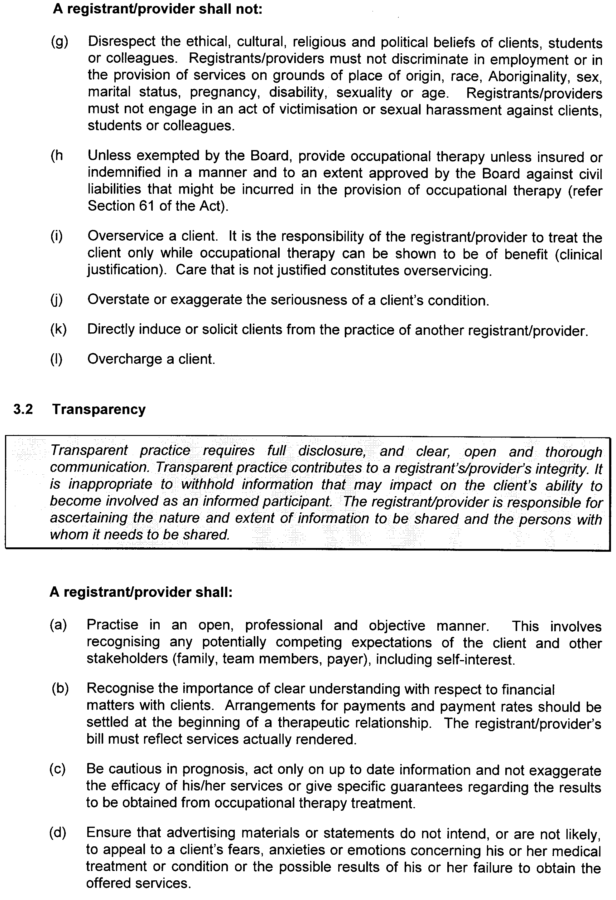

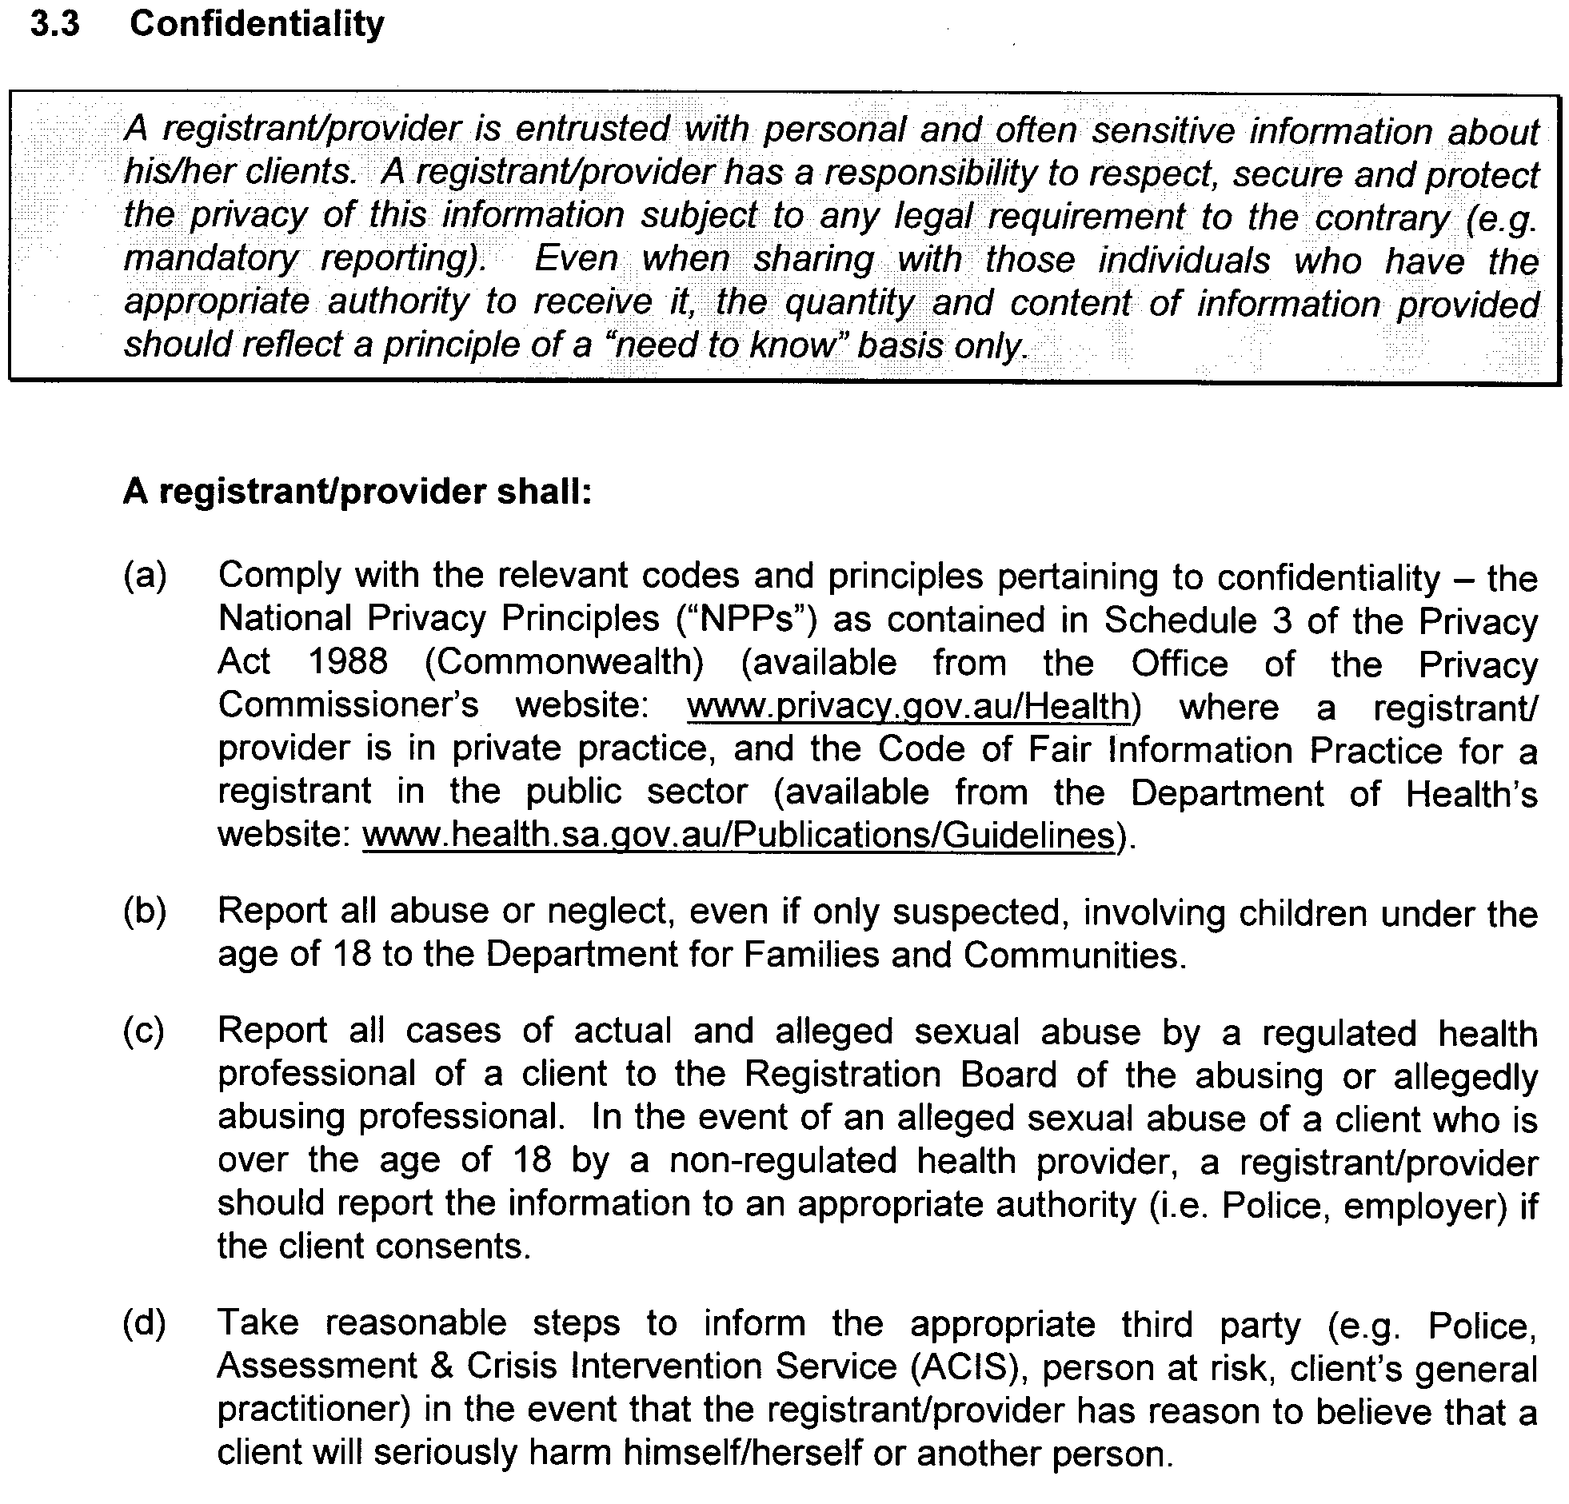
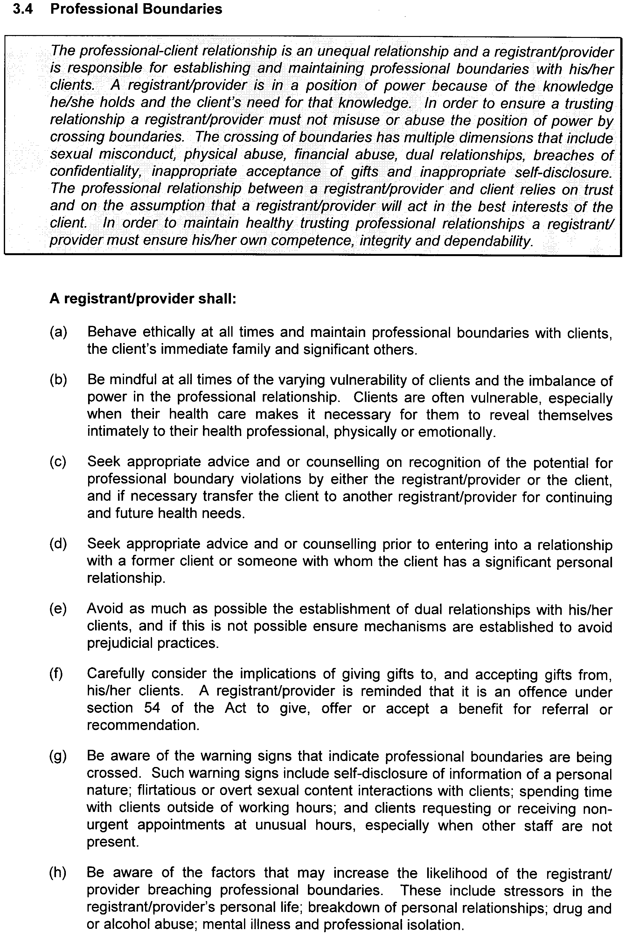
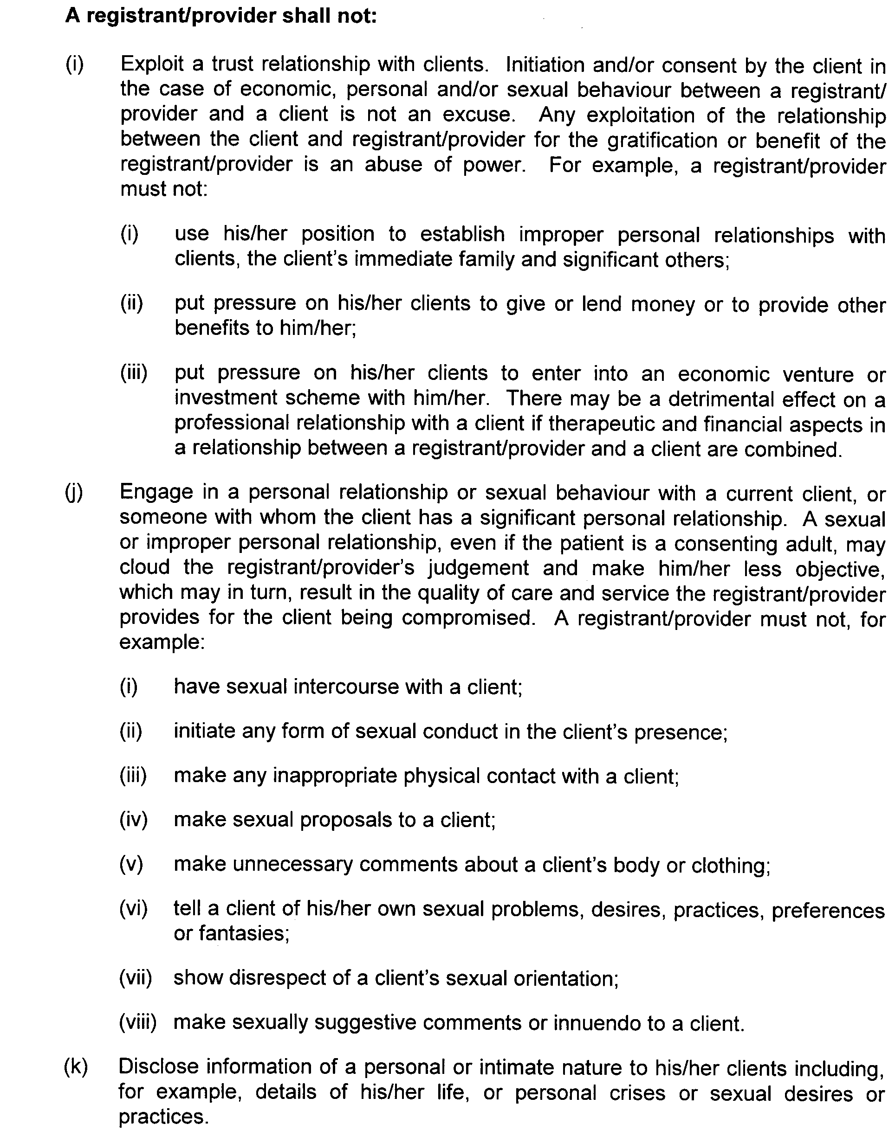

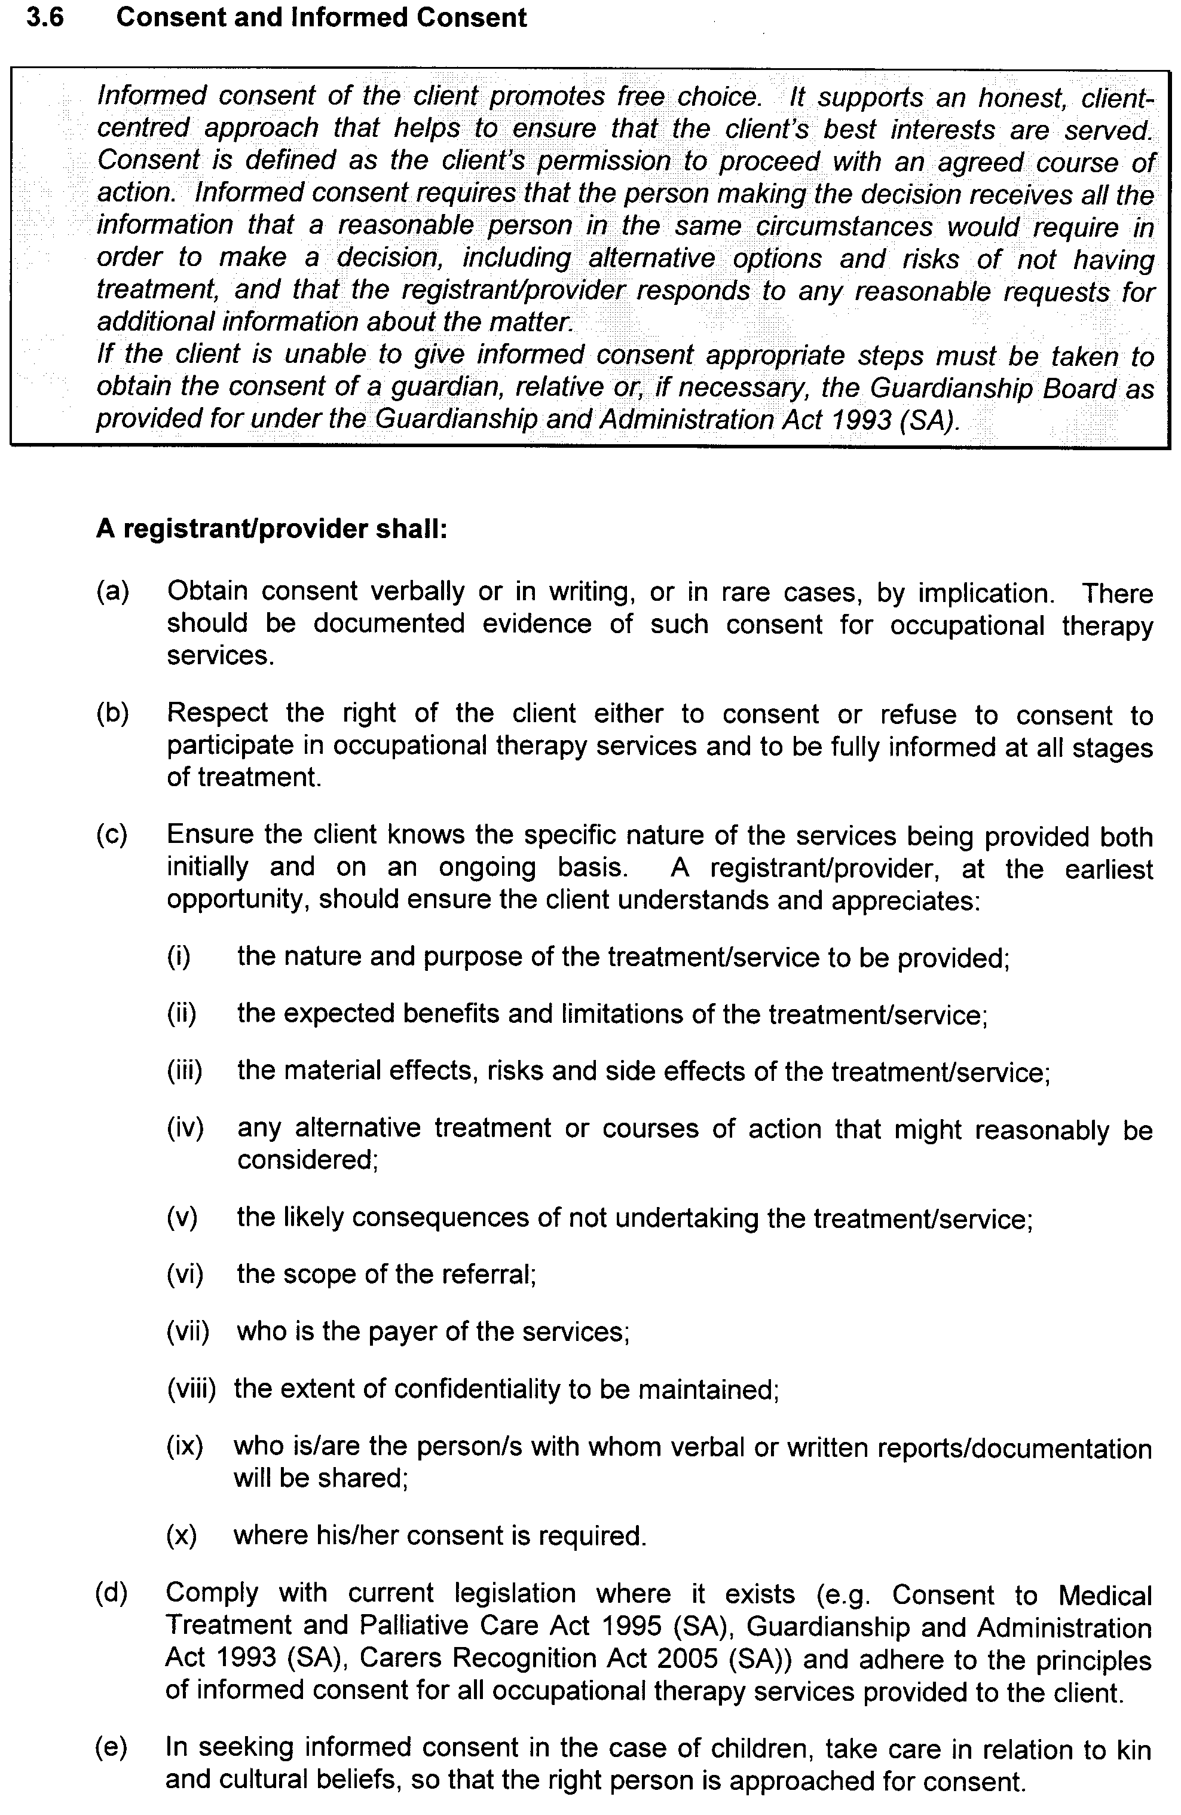
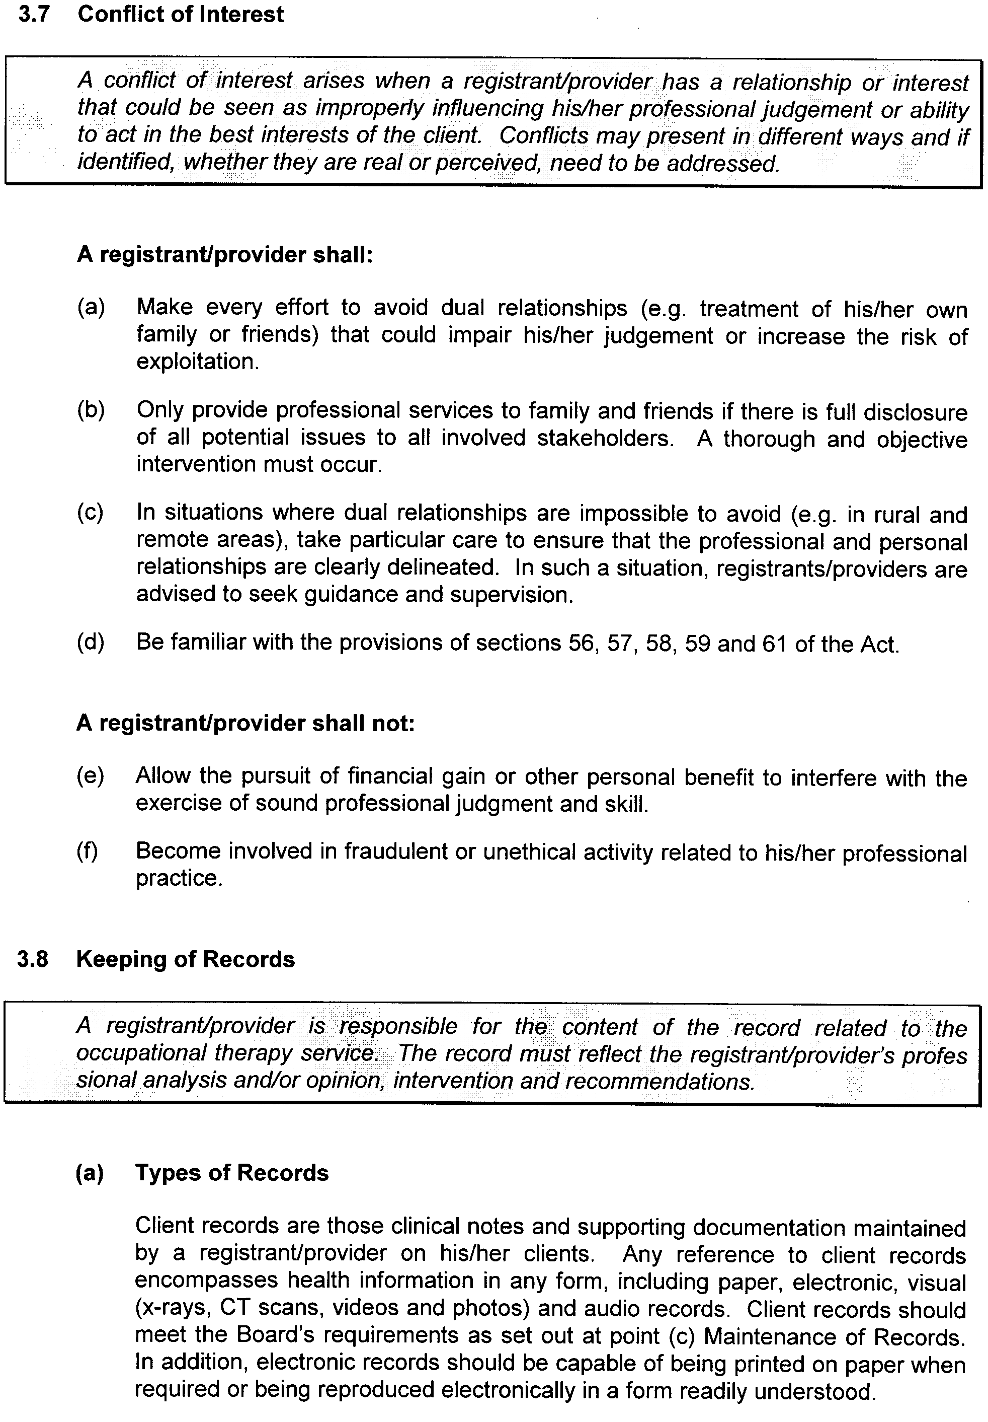
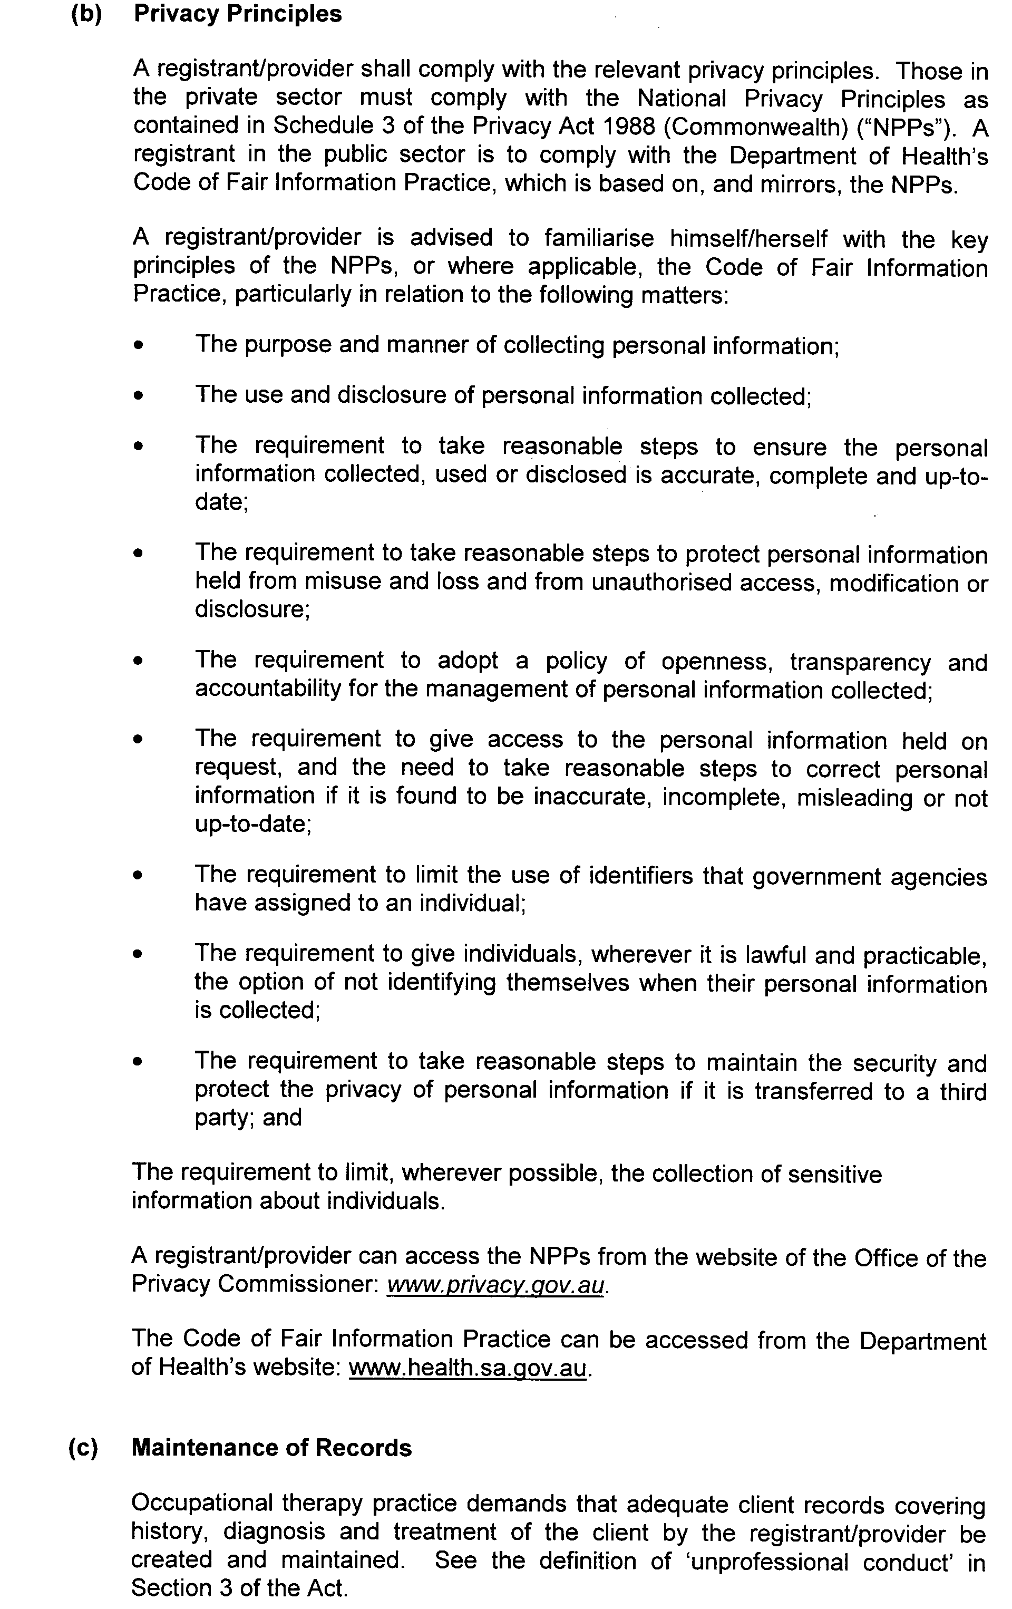
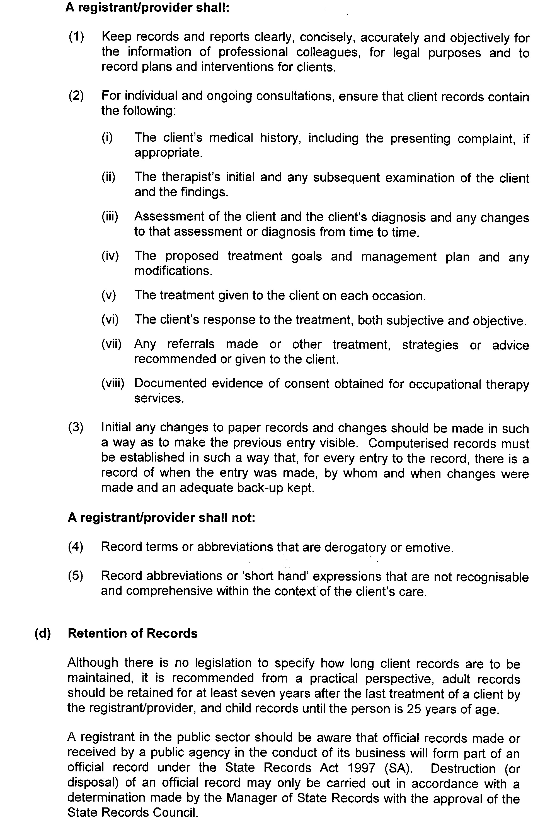
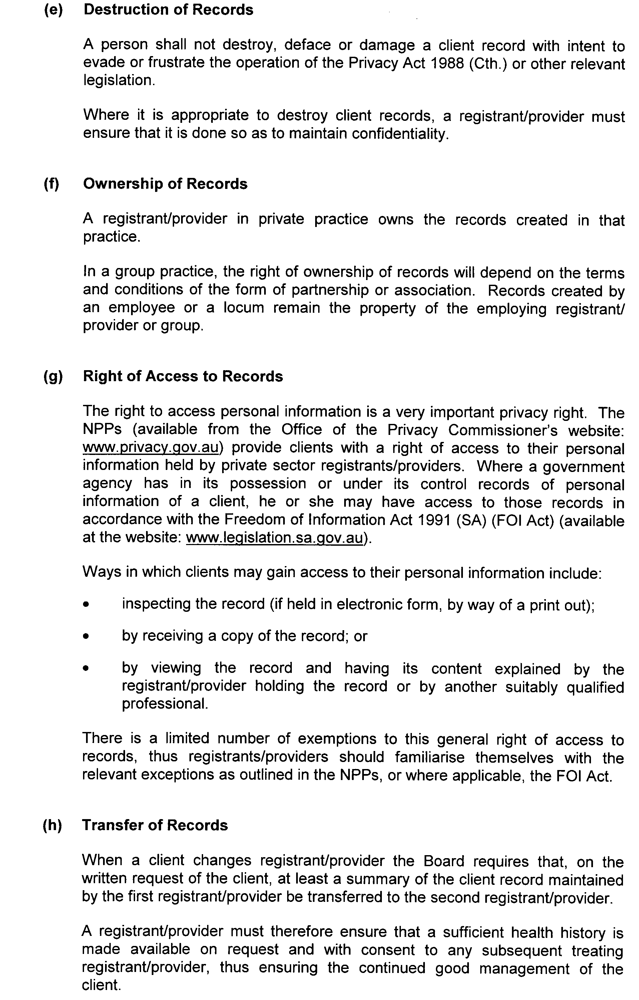
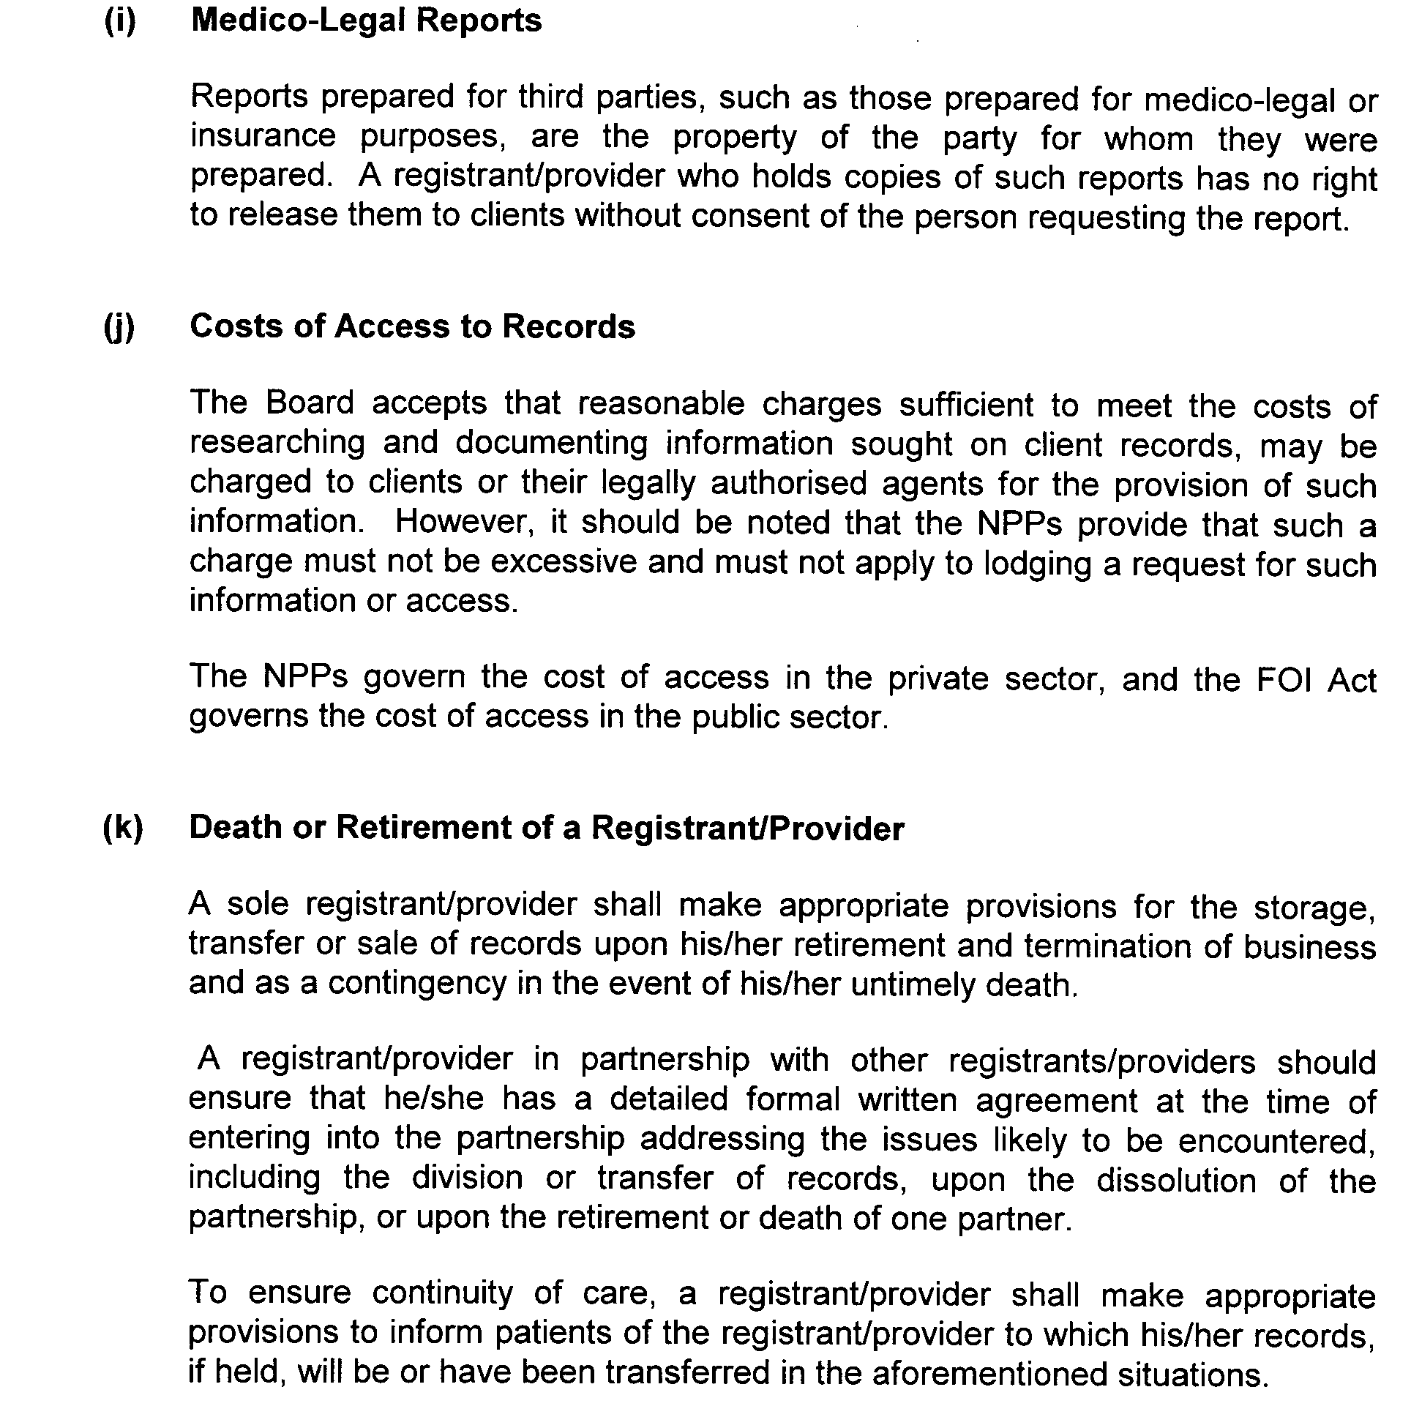
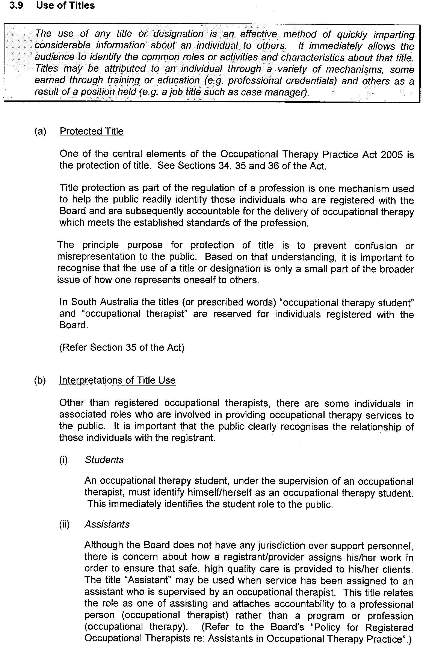
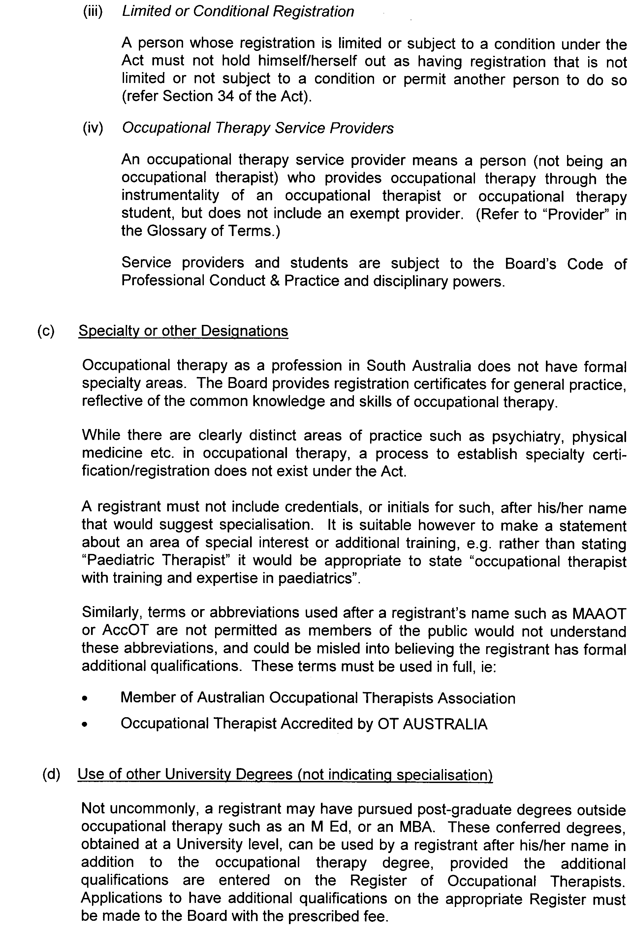
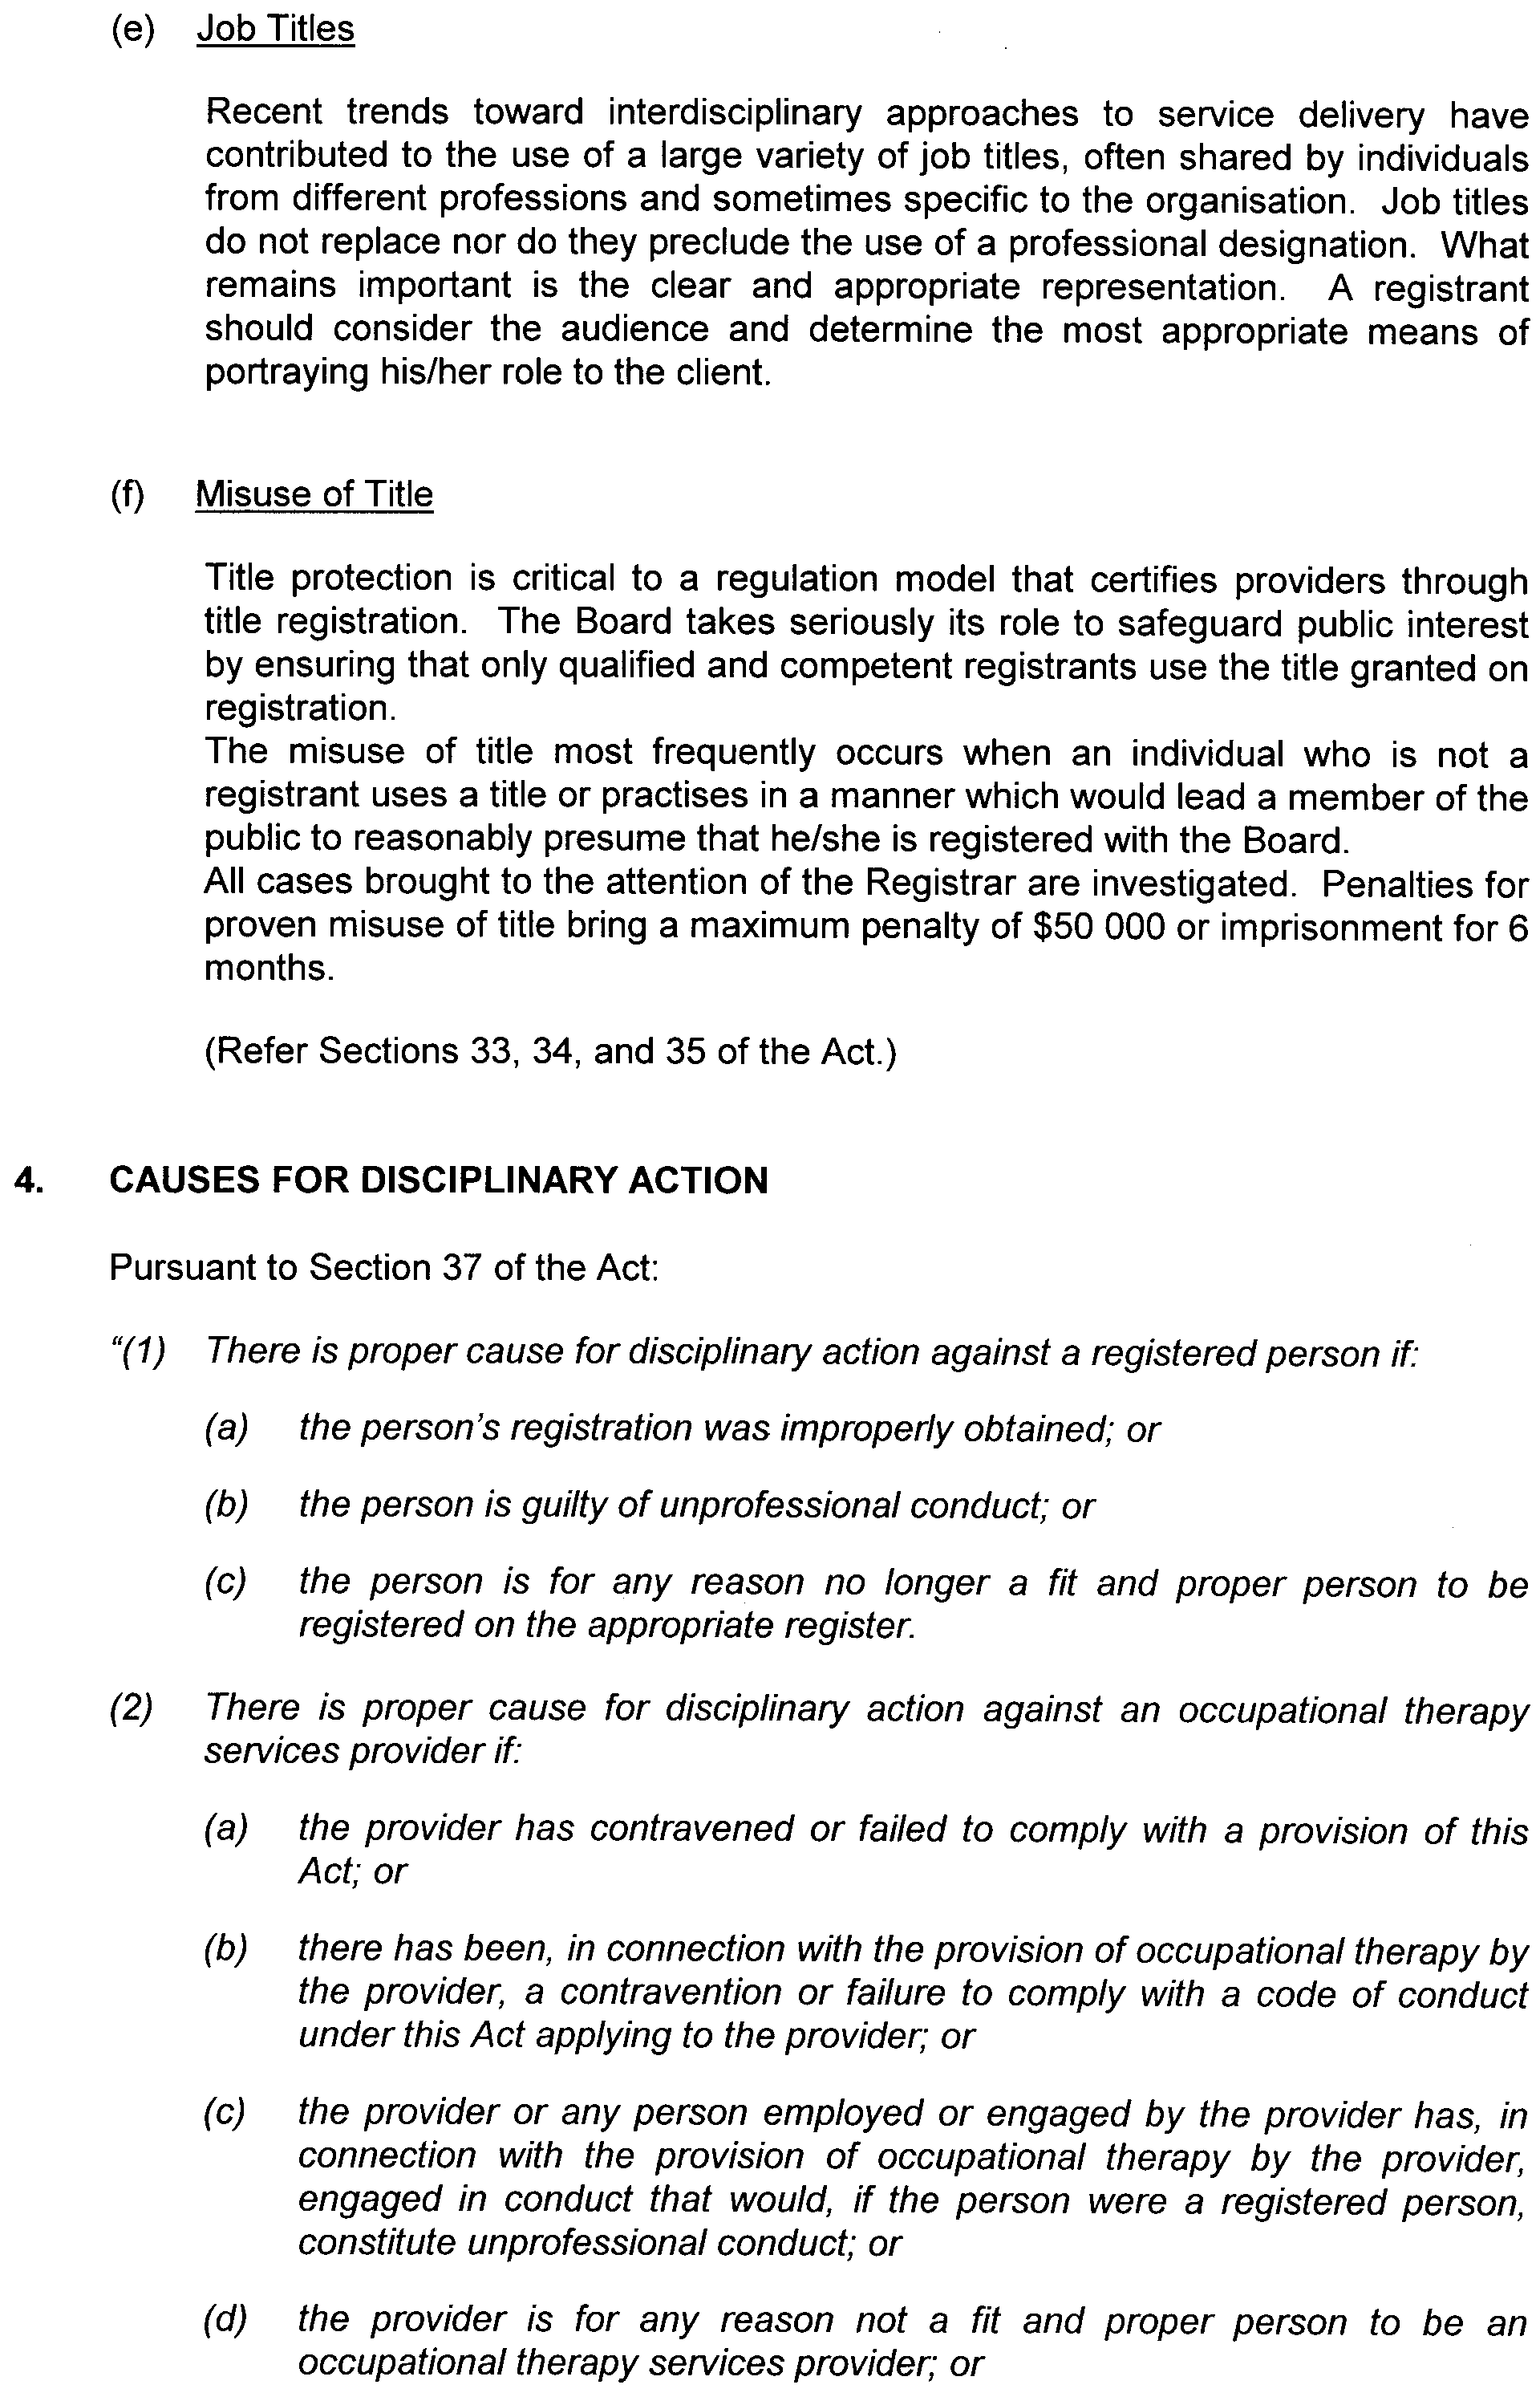
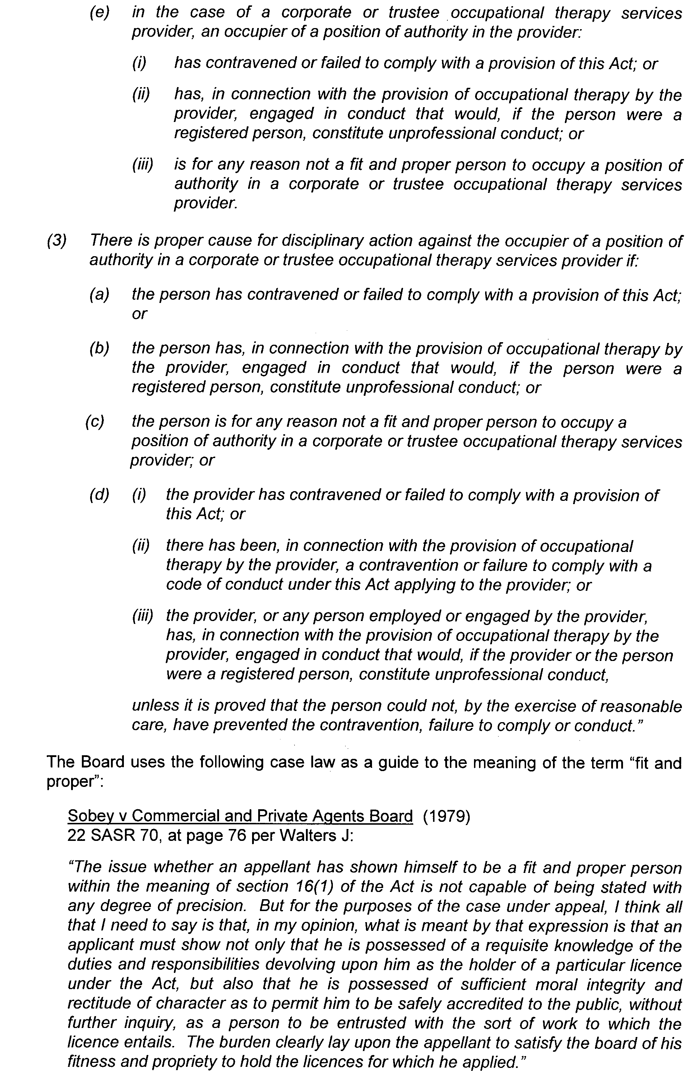



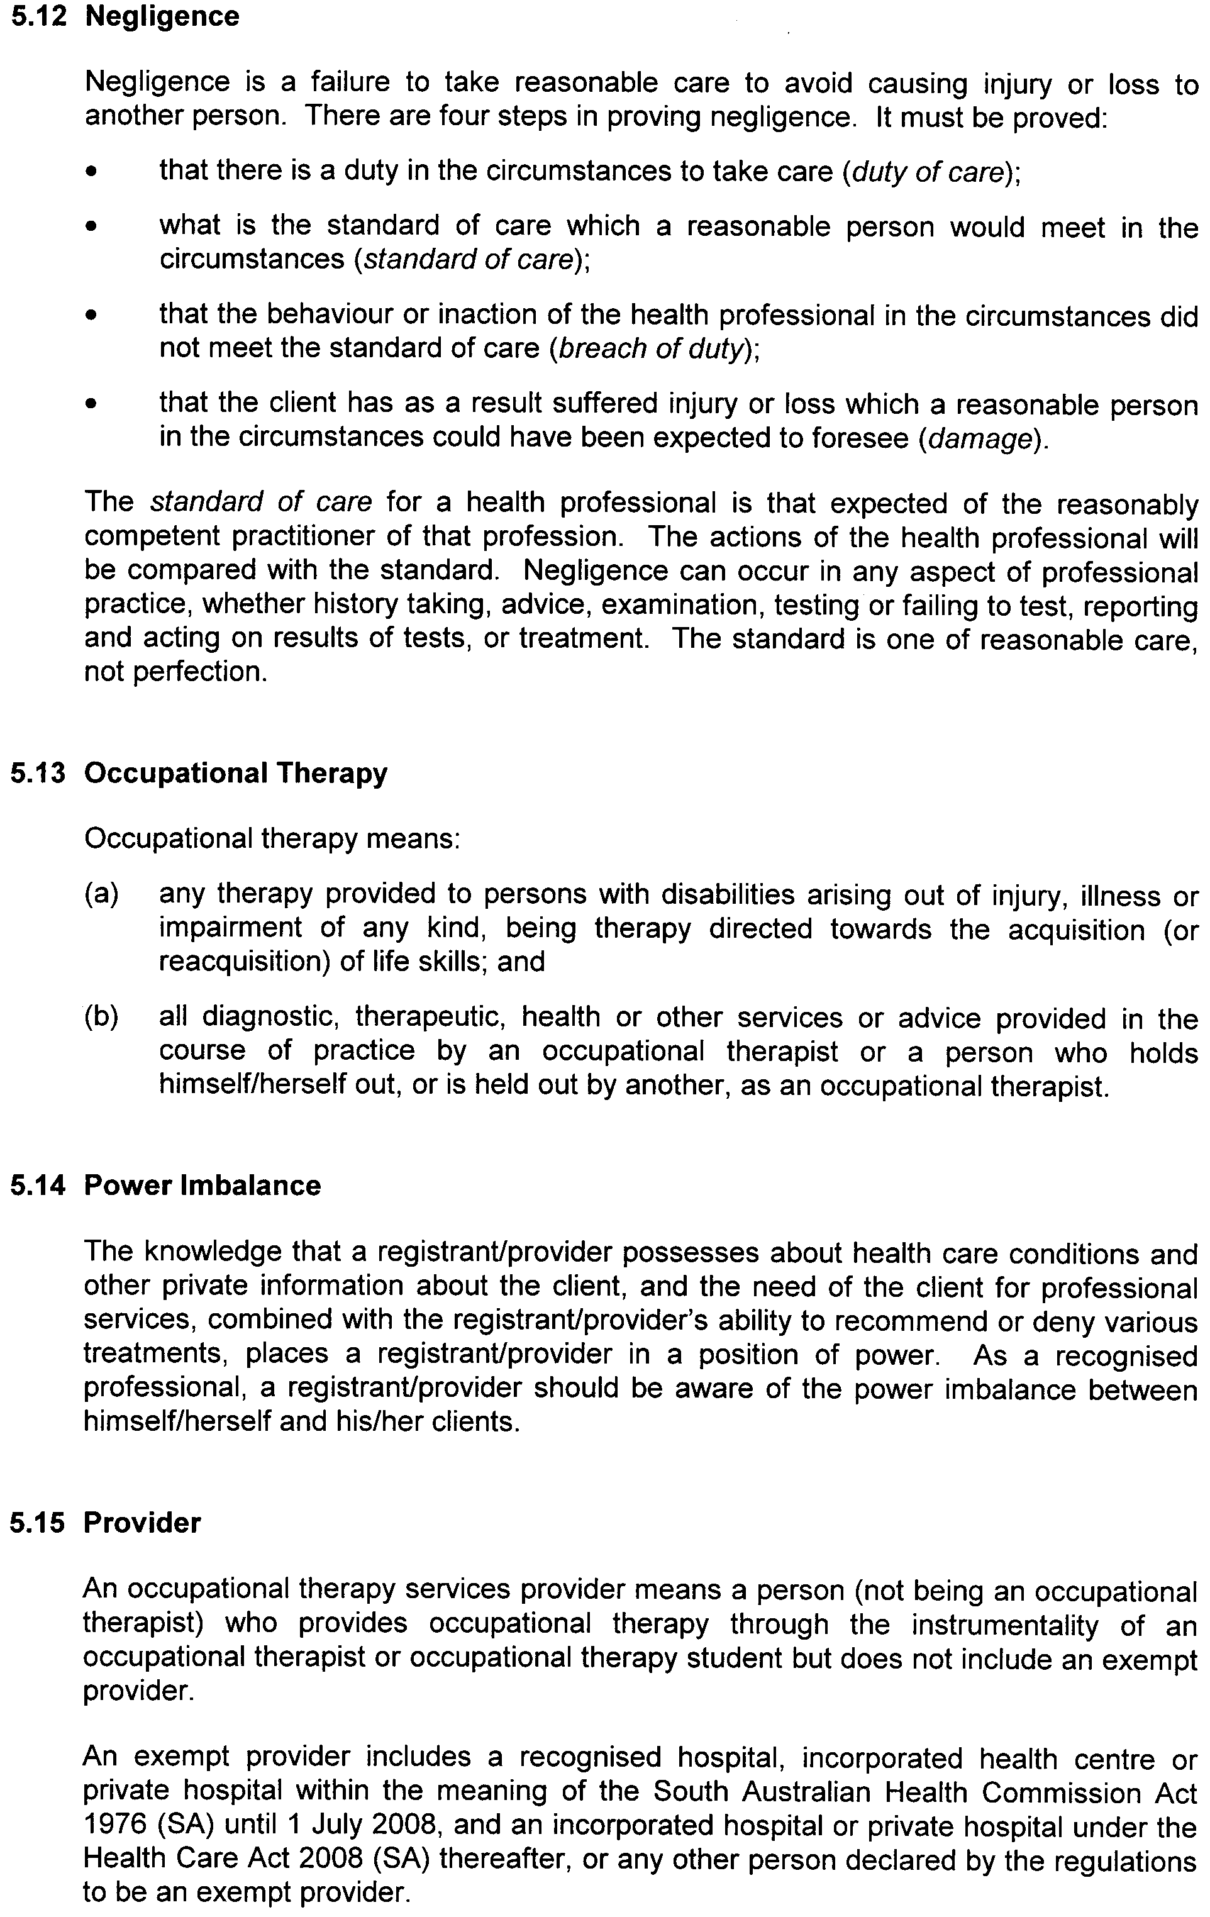
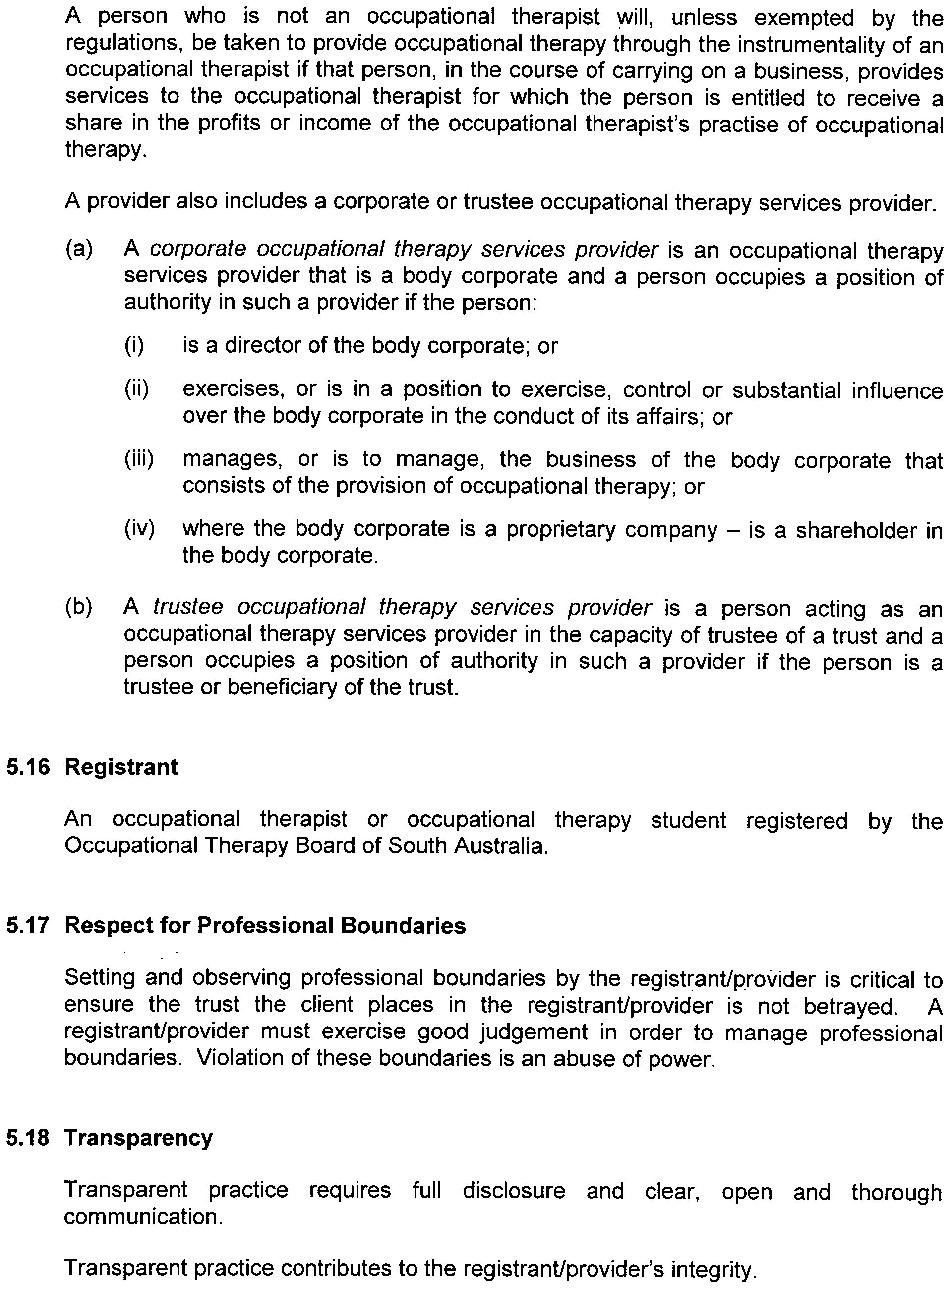


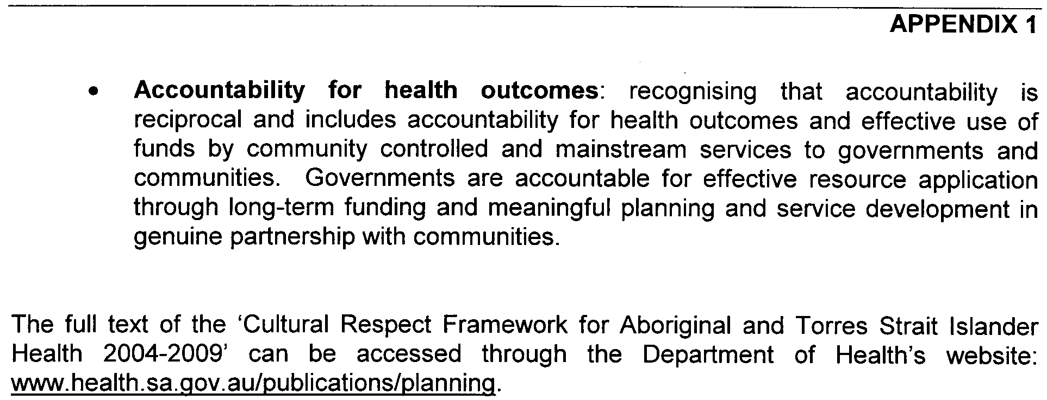

Dated 27 August 2008.
John Hill, Minister for Health

PETROLEUM ACT 2000
Grant of Geothermal Exploration Licences—GELs 337, 338 and 339
NOTICE is hereby given that the undermentioned Geothermal Exploration Licences have been granted under the provisions of the Petroleum Act 2000, pursuant to delegated powers dated 28 March 2002, Gazetted 11 April 2002, page 1573.
No. of  Licence | Licensee | Locality | Expiry
GEL 337 | Earth Heat Pty Ltd | Arrowie Basin | 31 August 2013
GEL 338 | Earth Heat Pty Ltd | Arrowie Basin | 31 August 2013
GEL 339 | Earth Heat Pty Ltd | Arrowie Basin | 31 August 2013

Description of Area—GEL 337
All that part of the State of South Australia, bounded as follows:
Commencing at a point being the intersection of latitude 32°45′00″S GDA94 and longitude 138°58′00″E GDA94, thence east to longitude 139°13′00″E GDA94, south to latitude 32°56′00″S GDA94, west to longitude 138°57′00″E GDA94, north to latitude 32°48′00″S GDA94, east to longitude 138°58′00″E GDA94 and north to the point of commencement.
Area: 499 km² approximately.
Description of Area—GEL 338
All that part of the State of South Australia, bounded as follows:
Commencing at a point being the intersection of latitude 32°40′00″S GDA94 and longitude 139°26′00″E GDA94, thence east to longitude 139°30′00″E GDA94, south to latitude 32°49′00″S GDA94, west to longitude 139°13′00″E GDA94, north to latitude 32°45′00″S GDA94, west to longitude 139°05′00″E GDA94, north to latitude 32°41′00″S GDA94, east to longitude 139°26′00″E GDA94 and north to the point of commencement.
Area: 497 km² approximately.
Description of Area—GEL 339
All that part of the State of South Australia, bounded as follows:
Commencing at a point being the intersection of latitude 32°24′00″S GDA94 and longitude 139°15′00″E GDA94, thence east to longitude 139°30′00″E GDA94, south to latitude 32°35′00″S GDA94, west to longitude 139°14′00″E GDA94, north to latitude 32°27′00″S GDA94, east to longitude 139°15′00″E GDA94 and north to the point of commencement.
Area: 500 km² approximately.
Dated 1 September 2008.
B. A. Goldstein, Director Petroleum and Geothermal
Minerals and Energy Resources
Primary Industries and Resources SA
Delegate of the Minister for Mineral Resources Development

South Australia
Road Traffic (Heavy Vehicle Driver Fatigue) (Transitional Class Exemption) Notice 2008
under Schedule 9 clause 2 of the Road Traffic (Heavy Vehicle Driver Fatigue) Regulations 2008

1—Short title
This notice may be cited as the Road Traffic (Heavy Vehicle Driver Fatigue) (Transitional Class Exemption) Notice 2008.
2—Commencement
This notice will come into operation on 29 September 2008.
3—Interpretation
(1) In this notice—
driving time means time spent by a driver driving a regulated heavy vehicle, whether or not the driving time is spent on a road or a road-related area;
regulations means the Road Traffic (Heavy Vehicle Driver Fatigue) Regulations 2008.
(2) A term or phrase defined in the regulations and used in this notice has the same meaning as in the regulations.
4—Regulations 16 not to apply in relation to certain drivers
(1) This exemption applies to a driver of a class comprising solo drivers of regulated heavy vehicles who would, but for this notice, be working under standard hours.
(2) Regulation 16 of the regulations does not apply in relation to a driver to whom this exemption applies.
5—Work times and rest times applicable under this exemption
During any period in column 1 of the following table, a driver working under this exemption—
(a) if a maximum driving time is specified in column 2 of the table in relation to the period—must not drive for more than that amount of driving time; and
(b) if a maximum work time is specified in column 3 of the table in relation to the period—must not work for more than that amount of work time; and
(c) must have the remainder of the period as rest time, including at least the period or periods of continuous rest time and stationary rest time specified in column 4 (if any),
(and if that specified period includes any lesser periods specified in column 1 of the table, he or she must also comply with paragraph (a), (b) and (c) in relation to each of those lesser periods):

Period | Max driving time | Max work time | Min rest time
5½ hours |  | 5 hours | 30 continuous minutes, or 2 blocks of 15 continuous minutes, of rest time
24 hours | 12 hours | 14 hours | 6 continuous hours of stationary rest time
168 hours (7 days) |  | 72 hours | 24 continuous hours of stationary rest time
6—Instructions for recording work/rest change in work diary
Without limiting any other requirement under the regulations in relation to completing a daily sheet in a work diary, a driver must record any change from work time that is driving time to work time that is not driving time, or from to work time that is not driving time to work time that is driving time, by drawing a vertical line through the work time record and writing "D", "Drive" or a similar annotation in the segment that is driving time.
7—Expiry of notice
This notice expires at the end of 28 March 2009.
Note—
This notice may be varied or revoked by subsequent notice in the Gazette.
The offences for breaching the work time and rest time requirements are set out in regulation 62 of the regulations.
A driver must carry a copy of this notice at all times while working under the exemption (see regulation 63 of the regulations).
Nothing in this notice affects the operation of regulation 6 of the regulations (which makes it an offence to drive a regulated heavy vehicle while impaired by fatigue).
Made by the Minister for Transport

MTR 08/053

South Australia
Road Traffic (Heavy Vehicle Driver Fatigue) Amendment Act (Commencement) Proclamation 2008
1—Short title
This proclamation may be cited as the Road Traffic (Heavy Vehicle Driver Fatigue) Amendment Act (Commencement) Proclamation 2008.
2—Commencement of Act
The Road Traffic (Heavy Vehicle Driver Fatigue) Amendment Act 2008 (No 22 of 2008) will come into operation on 29 September 2008.
Made by the Governor
with the advice and consent of the Executive Council
on 11 September 2008
MTR08/053

South Australia
Liquor Licensing (Dry Areas—Long Term) Variation Regulations 2008
under the Liquor Licensing Act 1997

Contents
Part 1—Preliminary
1 Short title
2 Commencement
3 Variation provisions
Part 2—Variation of Liquor Licensing (Dry Areas—Long Term) Regulations 1997
4 Variation of Schedule 1—Long term dry areas

Part 1—Preliminary
1—Short title
These regulations may be cited as the Liquor Licensing (Dry Areas—Long Term) Variation Regulations 2008.
2—Commencement
These regulations come into operation on the day on which they are made.
3—Variation provisions
In these regulations, a provision under a heading referring to the variation of specified regulations varies the regulations so specified.
Part 2—Variation of Liquor Licensing (Dry Areas—Long Term) Regulations 1997
4—Variation of Schedule 1—Long term dry areas
Schedule 1, item headed "Golden Grove—Area 1", column headed "Period"—delete "2008" and substitute:
2013
Note—
As required by section 10AA(2) of the Subordinate Legislation Act 1978, the Minister has certified that, in the Minister's opinion, it is necessary or appropriate that these regulations come into operation as set out in these regulations.
Made by the Governor
with the advice and consent of the Executive Council
on 11 September 2008
No 249 of 2008
CSOLGC0009/03

South Australia
Road Traffic (Heavy Vehicle Driver Fatigue) Regulations 2008
under the Road Traffic Act 1961

Contents
Part 1—Preliminary
1 Short title
2 Commencement
3 Interpretation
4 Regulated heavy vehicles
5 Relationship between duties under these regulations and OHS legislation
Part 2—Duties to avoid and prevent driving while fatigued
Division 1—Driving while fatigued
6 Driving while fatigued
7 Duty to prevent person driving while fatigued
Division 2—Additional duties on parties in chain of responsibility
8 Additional duty of employers, prime contractors and operators
9 Additional duty of schedulers
10 Additional duty of consignors and consignees
11 Additional duty of loading managers
Division 3—Miscellaneous
12 Certain requests etc prohibited
13 Certain contracts etc prohibited
Part 3—Work times and rest times
Division 1—Work times and rest times etc
14 Work times and rest times
15 Calculation of time periods
Division 2—Standard hours, BFM hours and AFM hours etc
16 Standard hours—solo drivers
17 Standard hours—solo drivers (buses)
18 Special provision for solo drivers of buses
19 Standard hours—two-up drivers
20 Additional defence related to short rest breaks
21 BFM hours—solo drivers working under BFM accreditation
22 Additional defence related to split rest breaks
23 BFM hours—two-up drivers working under BFM accreditation
24 AFM hours—driving hours for drivers working under AFM accreditation
25 AFM hours—offences related to AFM outer limits
26 Changing a work/rest hours option
Division 3—BFM and AFM documentation etc
27 Driver working under BFM accreditation to carry certain documentation
28 Driver working under AFM accreditation to carry certain documentation
Part 4—Record keeping
Division 1—Work diaries
Subdivision 1—Written work diaries
29 Form of written work diaries
30 Issue of written work diaries
Subdivision 2—Electronic work diaries
31 Approval of certain systems as electronic work diaries
32 Variation or revocation of approval
33 Notification of variation or revocation of approval
34 Labelling of electronic work diaries
35 Removal of labels
36 How electronic work diary to be operated and maintained
37 Authority may permit use of certain systems as electronic work diaries
Subdivision 3—Work diary requirements
38 Duty on certain persons to ensure compliance with Subdivision
39 Driver must carry work diary
40 Information that driver must record in work diary
41 Supplementary records
42 Notification of destruction etc of work diary
43 Odometers
Division 2—Records relating to drivers
44 Information that record keeper must keep
45 Driver must give certain information to record keepers
46 Further offences in relation to record keepers
Division 3—Offences related to work records
47 Interpretation
48 Offence to keep multiple written work diaries
49 Offence to record information in multiple work diaries
50 Offence to remove pages from written work diary
51 Offence to tamper with electronic work diary
52 Offence to change or deface entry in work record
53 Offence to possess certain documents
54 Offence to make entry in work record of another
55 Offence to hold out as having made entry
56 Offence to destroy certain documents
Part 5—Exemptions
Division 1—Emergency services
57 Exemption for emergency services
Division 2—Other exemptions
58 Work/rest hours exemptions
59 Work diary exemptions
60 Variation or revocation of exemption
61 Variation of conditions of exemption
Division 3—Miscellaneous
62 Offences relating to work time and rest time under work/rest hours exemption
63 Driver to carry written exemption
64 Driver to return exemption
65 Immediate suspension of exemption in public interest
66 Authority may require return of written exemptions
67 Replacement of written exemptions
68 Additional offences relating to exemptions
Part 6—Compliance and enforcement
Division 1—Additional enforcement powers etc
69 Additional powers of authorised officers and police officers
70 Formal warnings
71 Duty of authorised officers and police officers to annotate work diary
Division 2—Penalties for offences against these regulations
72 Meaning of minor, substantial, severe and critical risk offences
73 Penalties for offences
Division 3—Administrative decisions etc
74 Referral of matters to the Fatigue Authorities Panel
75 Mutual recognition and corresponding fatigue laws
76 Effect of certain administrative actions of corresponding authorities
77 Notification of corresponding Authorities about certain decisions
78 Register of decisions
Part 7—Miscellaneous
Division 1—Taking reasonable steps
79 Taking reasonable steps
Division 2—Reconsideration of decision by Authority
80 Application of Division
81 Review of decisions
82 Appeal to District Court
Division 3—Miscellaneous
83 Confidentiality
84 Evidentiary provision
85 Authority may grant exemption for purposes of certain trials
86 Minister may declare regulations not to apply
Schedule 1—Standard hours—solo drivers
Schedule 2—Standard hours—solo drivers (buses)
Schedule 3—Standard hours—two-up drivers
Schedule 4—BFM hours—solo drivers working under BFM accreditation
Schedule 5—BFM hours—two-up drivers working under BFM accreditation
Schedule 6—Offence categories in relation to AFM accreditation
Part 1—Offences against regulation 24 (driving hours for drivers working under AFM accreditation)
Part 2—Offences against regulation 25 (offences related to AFM outer limits)
Schedule 7—Offences against regulation 62 (offences relating to work time and rest time under work/rest hours exemption)
Schedule 8—Fees
Schedule 9—Transitional provisions
Part 1—Preliminary
1 Interpretation
Part 2—Transitional class exemptions
Division 1—Transitional work/rest hours class exemption
2 Special provisions related to transitional work/rest hours class exemption
Division 2—Other transitional class exemptions
3 Exemption in relation to the armed forces
4 Exemption in relation to transport of bees
5 Exemption in relation to regulated heavy vehicles used during emergencies
6 Exemption in relation to transport of fruit, vegetables and grain
7 Exemption in relation to transport of livestock
8 Exemption in relation to certain vehicles engaged construction or maintenance of infrastructure in remote area
9 Exemption in relation to certain ETSA Utilities vehicles
Part 3—Transitional TFMS
10 Transitional TFMS
Part 4—Miscellaneous transitional provisions
11 Provisions relating to logbooks
12 Compliance with transitional provision of corresponding fatigue law

Part 1—Preliminary
1—Short title
These regulations may be cited as the Road Traffic (Heavy Vehicle Driver Fatigue) Regulations 2008.
2—Commencement
These regulations will come into operation on 29 September 2008.
3—Interpretation
(1) In these regulations, unless the contrary intention appears—
100 kilometre work—a driver is engaged in 100 kilometre work if he or she is driving in an area not more than 100 kilometres from his or her base;
100-plus kilometre work—a driver is engaged in 100-plus kilometre work if he or she is driving in an area more than 100 kilometres from his or her base;
Act means the Road Traffic Act 1961;
AFM accreditation has the same meaning as in the Road Traffic (Approved Road Transport Compliance Schemes) Regulations 2008;
AFM hours—see regulation 24;
AFM outer limits has the same meaning as in the Road Traffic (Approved Road Transport Compliance Schemes) Regulations 2008;
AFM Standards has the same meaning as in the Road Traffic (Approved Road Transport Compliance Schemes) Regulations 2008;
another jurisdiction means a State or Territory of the Commonwealth other than this jurisdiction;
approved sleeper berth means—
(a) in relation to a regulated heavy vehicle that is a heavy truck—a driver's sleeper berth that complies with ADR 42 (as in force from time to time under the Motor Vehicle Standards Act 1989 of the Commonwealth) and which is able to be used by a driver of the vehicle when taking rest; or
(b) in relation to a regulated heavy vehicle that is a bus—a driver's sleeper berth that complies with the requirements (if any) determined by the Authority by notice in the Gazette and which is able to be used by a driver of the vehicle when taking rest;
ATC means the Australian Transport Council;
Authority means the Minister;
base—the base of a driver in relation to particular work means—
(a) the place from which the driver usually does the work and which is recorded in his or her work diary; or
(b) if that place is not recorded in the driver's work diary—the garage address of the regulated heavy vehicle being driven by the driver;
BFM accreditation has the same meaning as in the Road Traffic (Approved Road Transport Compliance Schemes) Regulations 2008;
BFM hours means the BFM hours for solo drivers working under BFM accreditation (see regulation 21) or the BFM hours for two-up drivers working under BFM accreditation (see regulation 23) as the case requires;
BFM Standards has the same meaning as in the Road Traffic (Approved Road Transport Compliance Schemes) Regulations 2008;
compliance purposes has the same meaning as in section 40F of the Act;
corresponding fatigue law means—
(a) an Act or law in force in another jurisdiction regulating fatigue in drivers of regulated heavy vehicles (other than a law primarily related to occupational health and safety); and
(b) any other Act or law declared by the Minister by notice in the Gazette to be a corresponding fatigue law;
critical risk offence—see regulation 72;
daily sheet means a daily sheet referred to in regulation 29(3)(b);
drive includes—
(a) being in the driver's seat of a regulated heavy vehicle while the engine is running; and
(b) being in a regulated heavy vehicle for the purpose of instructing or supervising the driver of the vehicle;
driver means a driver of a regulated heavy vehicle;
driver's licence means—
(a) a driver's licence under the Motor Vehicles Act 1959; or
(b) a licence issued under a law of another State or Territory of the Commonwealth that corresponds to such a driver's licence; or
(c) a licence of a kind contemplated by section 97A(1)(a) of the Motor Vehicles Act 1959;
Note—
Section 97A of the Motor Vehicles Act 1959 authorises visiting motorists to drive a motor vehicle on roads in this State without holding a licence under that Act.
electronic work diary means an electronic information recording system—
(a) approved under regulation 31 for use as an electronic work diary and labelled in accordance with regulation 34; or
(b) approved as an electronic work diary and labelled in accordance with a corresponding fatigue law;
employed driver means a driver who is employed by someone else to drive a regulated heavy vehicle;
employer means a person who employs persons under contracts of employment, apprenticeship or training, but does not include a person who employs persons under a contract for services;
exemption means a work/rest hours exemption or a work diary exemption, as varied from time to time, granted under Part 5;
fatigue includes tiredness, weariness, drowsiness, exhaustion and lack of energy;
Fatigue Authorities Panel means the body of that name established in accordance with the Fatigue Authorities Panel Rules made by the National Transport Commission and approved by the Australian Transport Council, as in force from time to time;
garage address, in relation to a regulated heavy vehicle, means—
(a) if the vehicle is usually kept at a depot when not in use—the address of the depot at which the vehicle is usually kept; or
(b) if the vehicle is usually kept at a particular place other than a depot when not in use—the home address of the registered operator of the vehicle whose home address is nearest that place; or
(c) in any other case—the home address of the registered operator of the vehicle who is listed first on the registration certificate for the vehicle;
heavy truck means—
(a) in the case of a combination—a motor vehicle (other than a bus or tram) that is part of the combination where the total of the GVM of the vehicles in the combination is more than 12 tonnes; or
(b) in any other case—a motor vehicle (other than a bus or tram) with a GVM of more than 12 tonnes;
loading manager means—
(a) a person who manages premises at which an average (calculated in accordance with subregulation (8)) of not less than 5 regulated heavy vehicles are loaded or unloaded on each day on which the premises are operating; or
(b) a person who supervises, manages or controls (whether directly or indirectly) the loading or unloading of regulated heavy vehicles at such premises;
long/night work time means any work time—
(a) in excess of 12 hours in any 24 hour period; or
(b) between the hours of midnight and 6 am;
major rest break means rest time of not less than 5 continuous hours;
minor risk offence—see regulation 72;
NHVAS business rules has the same meaning as in the Road Traffic (Approved Road Transport Compliance Schemes) Regulations 2008;
night rest break means a rest break consisting of—
(a) 7 continuous hours of stationary rest time taken between the hours of 10 pm on one day and 8 am on the following day; or
(b) 24 continuous hours of stationary rest time;
night rest time means rest time taken between the hours of 10 pm on one day and 8 am on the following day;
non-participating zone means all jurisdictions other than participating jurisdictions;
occupational health and safety legislation means the Occupational Health, Safety and Welfare Act 1986, or a law of the Commonwealth that relates to occupational health and safety declared by the Minister by notice in the Gazette to be within the ambit of this definition;
participating jurisdiction—a jurisdiction is a participating jurisdiction if it is—
(a) this jurisdiction; or
(b) another jurisdiction, if that jurisdiction has a corresponding fatigue law;
participating zone means all participating jurisdictions;
prime contractor, in relation to a driver, means a person who engages the driver to drive a regulated heavy vehicle under a contract for services;
record keeper, in relation to a driver, means—
(a) if the driver is an employed driver working under standard hours, or under a work/rest hours exemption (not being an exemption granted in combination with a BFM or AFM accreditation)—the driver's employer; or
(b) if the driver is a self-employed driver working under standard hours, or under a work/rest hours exemption (not being an exemption granted in combination with a BFM or AFM accreditation)—the driver; or
(c) if the driver is working under the BFM or AFM accreditation of the operator of a regulated heavy vehicle, or under a work/rest hours exemption granted in combination with the BFM or AFM accreditation of the operator—the operator; or
(d) if another person is engaged by a person referred to in a preceding paragraph to perform specified functions of a record keeper under these regulations under a contract for services—that other person (but only in relation to the specified functions);
record location, in relation to a driver, means—
(a) the location that the record keeper for the driver has nominated as the record location for the driver; or
(b) if the record keeper for the driver has not nominated such a location—the base of the driver;
regulated heavy vehicle means a motor vehicle that is declared to be a regulated heavy vehicle under regulation 4;
relevant BFM or AFM accreditation, in relation to a party in the chain of responsibility in relation to a regulated heavy vehicle, means the BFM or AFM accreditation granted to the operator of the regulated heavy vehicle;
rest time—see regulation 14(3);
scheduler means a person who schedules—
(a) the work time or rest time of a driver; or
(b) the transport of passengers or goods by road by regulated heavy vehicle;
self-employed driver means a driver who is not an employed driver;
severe risk offence—see regulation 72;
solo driver means a driver other than a two-up driver;
standard hours means—
(a) the standard hours for solo drivers as specified in regulation 16;
(b) the standard hours for solo drivers (buses) as specified in regulation 17;
(c) the standard hours for two-up drivers as specified in regulation 19;
stationary rest time means any rest time spent by a driver—
(a) in an approved sleeper berth of a stationary regulated heavy vehicle; or
(b) out of a regulated heavy vehicle;
substantial risk offence—see regulation 72;
supplementary record means a supplementary record made in accordance with regulation 41 or a corresponding fatigue law;
this jurisdiction means South Australia;
two-up driver means a driver working under a two-up driving arrangement;
two-up driving arrangement means an arrangement under which 2 drivers share the driving of a regulated heavy vehicle that has an approved sleeper berth;
unloader of goods that have been transported by road means a person who—
(a) unloads the goods from a vehicle that transported the goods by road; or
(b) unloads a freight container (whether or not containing goods) from a vehicle that transported the freight container by road; or
(c) without limiting the above, unloads the goods from a freight container in or on a vehicle that transported the goods by road; or
(d) supervises an activity mentioned in paragraph (a), (b) or (c); or
(e) manages or controls an activity mentioned in paragraph (a), (b), (c) or (d);
work diary means a written work diary or an electronic work diary;
work diary exemption—see regulation 59;
work record means a work diary, a supplementary record or any other record or document required to be kept under regulation 44;
work/rest change, in relation to a driver, means a change—
(a) from work time to rest time; or
(b) from rest time to work time; or
(c) from being a solo driver to being a two-up driver; or
(d) from being a two-up driver to being a solo driver;
work/rest hours exemption—see regulation 58;
work/rest hours option—a work/rest hours option is 1 of the following:
(a) standard hours for solo drivers (see regulation 16);
(b) standard hours for solo drivers (buses) (see regulation 17);
(c) standard hours for two-up drivers (see regulation 19);
(d) BFM hours for solo drivers working under BFM accreditation (see regulation 21);
(e) BFM hours for two-up drivers working under BFM accreditation (see regulation 23);
(f) AFM hours for drivers working under AFM accreditation (see regulation 24);
(g) the work and rest hours applicable to a driver as a condition of a work/rest hours exemption under Part 5 (whether or not the exemption was granted in combination with BFM or AFM accreditation);
work time—see regulation 14(1);
written exemption means a written exemption given to a person granted a work/rest hours exemption under regulation 58 or a work diary exemption under regulation 59 and includes—
(a) a revised written exemption given under regulation 60; and
(b) a replacement written exemption given under regulation 67;
written work diary means a written work diary issued to a driver under regulation 30 or under a corresponding fatigue law.
(2) For the purposes of these regulations, the following persons are parties in the chain of responsibility in relation to a regulated heavy vehicle:
(a) the employer of the driver of the vehicle;
(b) the prime contractor of the vehicle;
(c) the operator of the vehicle;
(d) a scheduler in relation to the driver of the vehicle, or the vehicle;
(e) the consignor of goods to be transported by the vehicle;
(f) the consignee of goods to be transported by the vehicle;
(g) the loading manager of goods to be transported by the vehicle;
(h) the loader of goods onto the vehicle;
(i) the unloader of goods from the vehicle.
(3) To avoid doubt, a person may be a party in a chain of responsibility in more than 1 capacity.
(4) For the purposes of these regulations, a driver who is at different times an employed driver and a self-employed driver may have a different base in each capacity.
(5) For the purposes of these regulations, a driver who has 2 or more employers may have a different base in relation to each employer.
(6) For the purposes of these regulations, a reference to the variation of an exemption includes a reference to a variation of a condition of the exemption.
(7) The Authority must, in determining requirements for the purposes of paragraph (b) of the definition of approved sleeper berth, have regard to, and seek to give effect to, any recommendation made by the Fatigue Authorities Panel in relation to the approval of sleeper berths.
(8) For the purposes of the definition of loading manager, an average of not less than 5 regulated heavy vehicles will be taken to be loaded or unloaded on each day the premises are operating if—
(a) in the case of premises that have been operating for not less than 12 months—during the previous 12 months, an average of not less than 5 regulated heavy vehicles were loaded or unloaded at the premises on each day the premises were operating; or
(b) in the case of premises that have been operating for less than 12 months—during the period the premises have been operating, an average of not less than 5 regulated heavy vehicles were loaded or unloaded at the premises on each day the premises were operating.
4—Regulated heavy vehicles
(1) For the purposes of section 110AA of the Act, a motor vehicle that is—
(a) a heavy truck; or
(b) a bus,
(other than plant or a motor home) is declared to be a regulated heavy vehicle.
(2) In this regulation—
motor home means a motor vehicle or combination, the primary purpose of which is to provide residential accommodation (but a motor vehicle is not a motor home merely because it has sleeping facilities);
plant means a motor vehicle or combination—
(a) that is intended to be used primarily—
(i) off-road; or
(ii) on a road-related area; or
(iii) on an area of road that is under construction,
as a machine or implement in an industrial or primary production application; and
(b) that is not intended to carry goods or passengers by road.
5—Relationship between duties under these regulations and OHS legislation
(1) Compliance with these regulations, or with any requirement imposed under these regulations, is not in itself a defence in any proceedings for an offence against occupational health and safety legislation.
(2) Evidence of a relevant contravention of these regulations is admissible in any proceedings for an offence against the occupational health and safety legislation.
Part 2—Duties to avoid and prevent driving while fatigued
Division 1—Driving while fatigued
6—Driving while fatigued
(1) A person must not—
(a) drive a regulated heavy vehicle on a road; or
(b) attempt to put a regulated heavy vehicle in motion on a road,
if he or she is impaired by fatigue.
(2) An offence against subregulation (1) is a severe risk offence.
(3) In proceedings for an offence against subregulation (1), a statement produced by the prosecution and purporting to be signed by a police officer or an authorised officer and stating that, at a specified time and place, he or she observed a specified driver of a specified regulated heavy vehicle behaving in a specified way is, in the absence of proof to the contrary, proof of the facts so stated.
(4) Despite any other Act or law, if a person is found guilty of an offence against subregulation (1) in relation to particular conduct—
(a) if the person has been charged with a prescribed offence arising out of the same conduct—a court must discharge the person in relation to the charge of that prescribed offence; or
(b) in any other case—the person may not be charged with a prescribed offence arising out of the same conduct.
(5) Despite any other Act or law, if a person is found guilty of a prescribed offence in relation to particular conduct—
(a) if the person has been charged with an offence against subregulation (1) arising out of the same conduct—a court must discharge the person in relation to the charge of that offence; or
(b) in any other case—the person may not be charged with an offence against subregulation (1) arising out of the same conduct.
(6) In this regulation—
impaired by fatigue—a person is impaired by fatigue if the use of any mental or physical faculty of that person is lost or appreciably impaired by fatigue;
prescribed offence means an offence against—
(a) section 45 or 46 of the Act; or
(b) section 21 or 22 of the Occupational Health, Safety and Welfare Act 1986.
7—Duty to prevent person driving while fatigued
(1) A party in the chain of responsibility in relation to a regulated heavy vehicle must take all reasonable steps to ensure that a driver of the vehicle does not contravene regulation 6.
(2) An offence against subregulation (1) is a critical risk offence.
(3) If the defendant in proceedings for an offence against subregulation (1) is an operator of a regulated heavy vehicle and the defendant proves that he or she complied with the requirements of a relevant BFM accreditation or AFM accreditation, he or she will be taken to have taken all reasonable steps to ensure that a driver of the vehicle did not contravene regulation 6.
(4) In proceedings for an offence against subregulation (1), it is not necessary to prove that a person did, in fact, contravene regulation 6.
Division 2—Additional duties on parties in chain of responsibility
8—Additional duty of employers, prime contractors and operators
(1) The employer or prime contractor of a driver must take all reasonable steps to ensure that the business practices of the employer or prime contractor do not cause the driver—
(a) to contravene regulation 6; or
(b) to contravene Part 3 Division 2 (other than regulation 26); or
(c) to contravene a condition of a work/rest hours exemption setting out the work times and rest times applicable to the driver under the exemption; or
(d) to contravene any other law for the purpose of avoiding a contravention of regulation 6, Part 3 Division 2 (other than regulation 26) or such a condition of a work/rest hours exemption.
(2) The operator of a regulated heavy vehicle must take all reasonable steps to ensure that the business practices of the operator do not cause a driver of the vehicle—
(a) to contravene regulation 6; or
(b) to contravene Part 3 Division 2 (other than regulation 26); or
(c) to contravene a condition of a work/rest hours exemption setting out the work times and rest times applicable to the driver under the exemption; or
(d) to contravene any other law for the purpose of avoiding a contravention of regulation 6, Part 3 Division 2 (other than regulation 26) or such a condition of a work/rest hours exemption.
(3) An offence against subregulation (1) or (2) is a severe risk offence.
(4) The employer or prime contractor of a driver must not cause the driver to drive a regulated heavy vehicle unless—
(a) the employer or prime contractor has complied with subregulation (1); and
(b) the scheduler in relation to the driver or vehicle has complied with regulation 9.
(5) The operator of a regulated heavy vehicle must not cause a driver to drive the vehicle unless—
(a) the operator has complied with subregulation (2); and
(b) the scheduler in relation to the driver or vehicle has complied with regulation 9.
(6) An offence against subregulation (4) or (5) is a substantial risk offence.
(7) In proceedings for an offence against subregulation (1) or (2), it is not necessary to prove that a driver did, in fact, contravene regulation 6, Part 3 Division 2, such a condition of a work/rest hours exemption or any other law.
(8) In this regulation—
business practices includes—
(a) the operating policies and procedures; and
(b) the human resource and contract management arrangements; and
(c) the occupational health and safety arrangements,
of the employer, prime contractor or operator (as the case requires).
9—Additional duty of schedulers
(1) A scheduler must take all reasonable steps to ensure that any schedule for the work time and rest time of the driver of a regulated heavy vehicle, or for the transport of goods or passengers by road by a regulated heavy vehicle, prepared by the scheduler does not cause the driver—
(a) to contravene regulation 6; or
(b) to contravene Part 3 Division 2 (other than regulation 26); or
(c) to contravene a condition of a work/rest hours exemption setting out the work times and rest times applicable to the driver under the exemption; or
(d) to contravene any other law for the purpose of avoiding a contravention of regulation 6, Part 3 Division 2 (other than regulation 26) or such a condition of a work/rest hours exemption.
(2) An offence against subregulation (1) is a severe risk offence.
(3) A scheduler must not cause a driver in relation to whom the scheduler has prepared a schedule to drive a regulated heavy vehicle unless—
(a) the scheduler has complied with subregulation (1); and
(b) any schedule for the work time and rest time of the driver of the vehicle, or for the transport of goods or passengers by the vehicle, prepared by the scheduler complies with subregulation (1).
(4) An offence against subregulation (3) is a substantial risk offence.
(5) In proceedings for an offence against subregulation (1), it is not necessary to prove that a driver did, in fact, contravene regulation 6, Part 3 Division 2, such a condition of a work/rest hours exemption or any other law.
10—Additional duty of consignors and consignees
(1) The consignor and consignee of goods that are to be transported by road by a regulated heavy vehicle must each take all reasonable steps to ensure the terms of consignment do not cause the driver of the regulated heavy vehicle—
(a) to contravene regulation 6; or
(b) to contravene Part 3 Division 2 (other than regulation 26); or
(c) to contravene a condition of a work/rest hours exemption setting out the work times and rest times applicable to the driver under the exemption; or
(d) to contravene any other law for the purpose of avoiding a contravention of regulation 6, Part 3 Division 2 (other than regulation 26) or such a condition of a work/rest hours exemption.
(2) The consignor and consignee of goods that are to be transported by road by a regulated heavy vehicle must each take all reasonable steps to ensure the terms of consignment do not encourage or provide an incentive to the employer or prime contractor of the driver of the vehicle, or to the operator of the vehicle, to cause the driver of the vehicle—
(a) to contravene regulation 6; or
(b) to contravene Part 3 Division 2 (other than regulation 26); or
(c) to contravene a condition of a work/rest hours exemption setting out the work times and rest times applicable to the driver under the exemption; or
(d) to contravene any other law for the purpose of avoiding a contravention of regulation 6, Part 3 Division 2 (other than regulation 26) or such a condition of a work/rest hours exemption.
(3) The consignor or consignee of goods that are to be transported by road by a regulated heavy vehicle must not allow the goods to be so transported unless satisfied on reasonable grounds that—
(a) in the case of a vehicle driven by an employed driver—the employer of the driver, and the operator of the vehicle, have complied with regulation 8; or
(b) in the case of a vehicle driven by a self-employed driver—the prime contractor (if any) of the driver, and the operator of the vehicle, have complied with regulation 8,
and, in any case, that the scheduler in relation to the driver or vehicle has complied with regulation 9.
(4) An offence against subregulation (3) is a substantial risk offence.
(5) The consignor or consignee of goods that are to be transported by road by a regulated heavy vehicle must not make a demand that affects, or that may affect, a time in a schedule for such transport and that may cause the driver of the vehicle—
(a) to contravene regulation 6; or
(b) to contravene Part 3 Division 2 (other than regulation 26); or
(c) to contravene a condition of a work/rest hours exemption setting out the work times and rest times applicable to the driver under the exemption; or
(d) to contravene any other law for the purpose of avoiding a contravention of regulation 6, Part 3 Division 2 (other than regulation 26) or such a condition of a work/rest hours exemption.
(6) It is a defence in proceedings for an offence against subregulation (5) if the person charged establishes that he or she—
(a) complied with subregulations (1) and (2); and
(b) was satisfied on reasonable grounds that the making of the demand would not cause the driver to contravene these regulations or any other law.
(7) An offence against subregulation (1), (2) or (5) is a severe risk offence.
(8) In proceedings for an offence against this regulation, it is not necessary to prove that a driver did, in fact, contravene regulation 6, Part 3 Division 2, such a condition of a work/rest hours exemption or any other law.
11—Additional duty of loading managers
(1) A loading manager must take all reasonable steps to ensure that the arrangements for loading and unloading regulated heavy vehicles at premises (of a kind referred to in paragraph (a) of the definition of loading manager in regulation 3) managed by the loading manager, or at which the loading manager supervises, manages or controls such loading or unloading, do not cause the driver of a regulated heavy vehicle—
(a) to contravene regulation 6; or
(b) to contravene Part 3 Division 2 (other than regulation 26); or
(c) to contravene a condition of a work/rest hours exemption setting out the work times and rest times applicable to the driver under the exemption; or
(d) to contravene any other law for the purpose of avoiding a contravention of regulation 6, Part 3 Division 2 (other than regulation 26) or such a condition of a work/rest hours exemption.
(2) An offence against subregulation (1) is a severe risk offence.
(3) A loading manager must—
(a) if—
(i) the loading manager, or a person under his or her supervision, has advised the driver of a regulated heavy vehicle of the time when loading or unloading of the vehicle is likely to commence or be completed (as the case requires); and
(ii) such loading or unloading is likely to commence, or be completed, more than 30 minutes later than that time; or
(b) if the loading manager, or a person under his or her supervision, is unable to advise the driver of a regulated heavy vehicle of the time when loading or unloading of the vehicle is likely to commence or be completed,
take all reasonable steps to ensure that the driver is able to take rest while waiting for such loading or unloading to commence or be completed.
(4) An offence against subregulation (3) is a substantial risk offence.
(5) In proceedings for an offence against subregulation (1), it is not necessary to prove that a driver did, in fact, contravene regulation 6, Part 3 Division 2, such a condition of a work/rest hours exemption or any other law.
Division 3—Miscellaneous
12—Certain requests etc prohibited
(1) A person must not request or direct (whether directly or indirectly) a driver, or a party in the chain of responsibility in relation to a regulated heavy vehicle, to do or not do anything that the person knows, or ought to know, may cause the driver—
(a) to contravene regulation 6; or
(b) to contravene Part 3 Division 2 (other than regulation 26); or
(c) to contravene a condition of a work/rest hours exemption setting out the work times and rest times applicable to the driver under the exemption; or
(d) to contravene any other law for the purpose of avoiding a contravention of regulation 6, Part 3 Division 2 (other than regulation 26) or such a condition of a work/rest hours exemption.
(2) An offence against subregulation (1) is a critical risk offence.
(3) In proceedings for an offence against subregulation (1), it is not necessary to prove that a driver did, in fact, contravene regulation 6, Part 3 Division 2, such a condition of a work/rest hours exemption or any other law.
13—Certain contracts etc prohibited
(1) A person must not enter into a contract or agreement with a driver, or a party in the chain of responsibility in relation to a regulated heavy vehicle, to do or not do anything that the person knows, or ought to know, may cause the driver—
(a) to contravene regulation 6; or
(b) to contravene Part 3 Division 2 (other than regulation 26); or
(c) to contravene a condition of a work/rest hours exemption setting out the work times and rest times applicable to the driver under the exemption; or
(d) to contravene any other law for the purpose of avoiding a contravention of regulation 6, Part 3 Division 2 (other than regulation 26) or such a condition of a work/rest hours exemption.
(2) A person must not enter into a contract or agreement with a party in the chain of responsibility in relation to a regulated heavy vehicle that would encourage or provide an incentive to the party in the chain of responsibility to cause the driver—
(a) to contravene regulation 6; or
(b) to contravene Part 3 Division 2 (other than regulation 26); or
(c) to contravene a condition of a work/rest hours exemption setting out the work times and rest times applicable to the driver under the exemption; or
(d) to contravene any other law for the purpose of avoiding a contravention of regulation 6, Part 3 Division 2 (other than regulation 26) or such a condition of a work/rest hours exemption.
(3) A term of a contract or agreement that contravenes this regulation is void and of no effect.
(4) An offence against this regulation is a critical risk offence.
(5) In proceedings for an offence against this regulation, it is not necessary to prove that a driver did, in fact, contravene regulation 6, Part 3 Division 2, such a condition of a work/rest hours exemption or any other law.
Part 3—Work times and rest times
Division 1—Work times and rest times etc
14—Work times and rest times
(1) For the purposes of these regulations, the following time will be taken to be the work time of a driver:
(a) any time spent driving a regulated heavy vehicle (whether on a road or otherwise);
(b) any time spent doing tasks related to the operation of a regulated heavy vehicle.
(2) Without limiting subregulation (1)(b), the following will be taken to be tasks related to the operation of a regulated heavy vehicle:
(a) loading or unloading the vehicle;
(b) inspecting, servicing or repairing the vehicle;
(c) inspecting or attending to the load on the vehicle;
(d) cleaning the vehicle;
(e) refuelling the vehicle;
(f) performing marketing tasks in relation to the operation of the vehicle;
(g) in the case of a bus—attending to the passengers;
(h) assisting with or supervising a task referred to above;
(i) recording information, or completing a document, in accordance with a requirement of the Act or any other Act in relation to the vehicle.
(3) For the purposes of these regulations, any time that is not work time of a driver will be taken to be rest time.
(4) In this regulation—
marketing tasks include—
(a) arranging for the transport of passengers or goods; and
(b) canvassing for orders for the transport of passengers or goods.
15—Calculation of time periods
(1) The following provisions apply when calculating periods of work time and rest time of a driver:
(a) a period of work time that is less than 15 minutes in total will be taken to be
15 minutes work time;
(b) a period of work time that is greater than 15 minutes will be rounded up to the nearest 15 minutes;
(c) a period of rest time that is less than 15 minutes in total will be taken not to be rest time;
(d) a period of rest time that is greater than 15 minutes will be rounded down to the nearest 15 minutes;
(e) when determining whether a driver has had the required rest time within a particular period of time, the period of time under consideration cannot commence from within a period of rest time.
(2) For the purposes of calculating whether a period of work time or rest time of a driver is night work time or night rest time, the period must be calculated by reference to the time zone in which the base of the driver is located (including, to avoid doubt, where the work time or rest time occurs in a different time zone to that of the base of the driver).
(3) For the purposes of these regulations, any time spent by a driver in another jurisdiction of the participating zone is to be treated in the same way as if the time had been spent in this jurisdiction.
(4) The following provisions apply in the case of a driver entering this jurisdiction from a non-participating jurisdiction:
(a) if, within the preceding 7 days, the driver has spent any period of work time in the participating zone—any time spent by the driver in the non-participating zone is to be treated in the same way as if the time had been spent in this jurisdiction;
(b) if, within the preceding 7 days, the driver has spent work time in the non-participating zone only—
(i) any time spent by the driver in a non-participating jurisdiction prior to his or her last major rest break is to be disregarded for the purposes of these regulations; and
(ii) any time spent by the driver in the non-participating jurisdiction after the commencement of his or her last major rest break is to be treated in the same way as if the time had been spent in this jurisdiction.
Division 2—Standard hours, BFM hours and AFM hours etc
16—Standard hours—solo drivers
(1) This regulation does not apply in relation to drivers working under—
(a) standard hours for a solo driver (buses) referred to in regulation 17; or
(b) BFM or AFM accreditation; or
(c) a work/rest hours exemption.
(2) The table in Schedule 1 sets out the standard hours for a solo driver.
(3) During any period specified in column 1 of the table in Schedule 1, a solo driver—
(a) if a maximum work time is specified in column 2 of the table in relation to the period—must not work for more than that amount of work time; and
(b) must have the remainder of the period as rest time, including at least the period or periods of continuous rest time and stationary rest time specified in column 3 (if any),
(and if that specified period includes any lesser periods specified in column 1 of the table, he or she must also comply with paragraphs (a) and (b) in relation to each of those lesser periods).
(4) An offence against subregulation (3) is an offence of the kind specified in column 4 of the table in Schedule 1 in relation to the conduct constituting the offence.
(5) A party in the chain of responsibility in relation to a regulated heavy vehicle must ensure that a solo driver of the vehicle does not contravene subregulation (3).
(6) An offence against subregulation (5) is an offence of the kind specified in column 4 of the table in Schedule 1 in relation to the conduct constituting the offence against subregulation (3) by the driver.
(7) A person charged has the benefit of the reasonable steps defence for an offence against this regulation.
17—Standard hours—solo drivers (buses)
(1) This regulation does not apply in relation to drivers working under—
(a) standard hours for a solo driver referred to in regulation 16; or
(b) BFM or AFM accreditation; or
(c) a work/rest hours exemption.
(2) The table in Schedule 2 sets out the standard hours for a solo driver of a regulated heavy vehicle that is a bus.
(3) During any period specified in column 1 of the table in Schedule 2, a solo driver of a regulated heavy vehicle that is a bus—
(a) if a maximum work time is specified in column 2 of the table in relation to the period—must not work for more than that amount of work time; and
(b) must have the remainder of the period as rest time, including at least the period or periods of continuous rest time and stationary rest time specified in column 3 (if any),
(and if that specified period includes any lesser periods specified in column 1 of the table, he or she must also comply with paragraphs (a) and (b) in relation to each of those lesser periods).
(4) An offence against subregulation (3) is an offence of the kind specified in column 4 of the table in Schedule 2 in relation to the conduct constituting the offence.
(5) A party in the chain of responsibility in relation to a regulated heavy vehicle that is a bus must ensure that a solo driver of the vehicle does not contravene subregulation (3).
(6) An offence against subregulation (5) is an offence of the kind specified in column 4 of the table in Schedule 2 in relation to the conduct constituting the offence against subregulation (3) by the driver.
(7) A person charged has the benefit of the reasonable steps defence for an offence against this regulation.
18—Special provision for solo drivers of buses
A solo driver of a regulated heavy vehicle that is a bus (other than a driver working under BFM or AFM accreditation or under a work/rest hours exemption) may choose to drive in accordance with—
(a) the standard hours for a solo driver under regulation 16; or
(b) the standard hours for a solo driver (buses) under regulation 17,
(but not both).
19—Standard hours—two-up drivers
(1) This regulation does not apply in relation to drivers working under—
(a) BFM or AFM accreditation; or
(b) a work/rest hours exemption.
(2) The table in Schedule 3 sets out the standard hours for a two-up driver.
(3) During any period specified in column 1 of the table in Schedule 3, a two-up driver—
(a) if a maximum work time is specified in column 2 of the table in relation to the period—must not work for more than that amount of work time; and
(b) must have the remainder of the period as rest time, including at least the period or periods of continuous rest time and stationary rest time specified in column 3 (if any),
(and if that specified period includes any lesser periods specified in column 1 of the table, he or she must also comply with paragraphs (a) and (b) in relation to each of those lesser periods).
(4) Despite any other provision of these regulations, a required period of stationary rest time of not more than 5 hours may be taken in an approved sleeper berth of the regulated heavy vehicle being driven under the two-up driving arrangement (whether or not the vehicle is stationary at the time such rest is taken).
(5) An offence against subregulation (3) is an offence of the kind specified in column 4 of the table in Schedule 3 in relation to the conduct constituting the offence.
(6) A party in the chain of responsibility in relation to a regulated heavy vehicle must ensure that a driver of the vehicle does not contravene subregulation (3).
(7) An offence against subregulation (6) is an offence of the kind specified in column 4 of the table in Schedule 3 in relation to the conduct constituting the offence against subregulation (3) by the driver.
(8) A person charged has the benefit of the reasonable steps defence for an offence against this regulation.
20—Additional defence related to short rest breaks
(1) In proceedings for an offence against regulation 16, 17 or 19, it is a defence if the person charged establishes that—
(a) the alleged offence could have been avoided if he or she had taken a short rest break; and
(b) at a time when he or she could have avoided committing the alleged offence by taking a short rest break there was no suitable rest place; and
(c) he or she took a short rest break at the next suitable rest place (and in any event took a short rest break within 45 minutes of the alleged commission of the offence).
(2) In this regulation—
short rest break means rest time of not more than 1 hour;
suitable rest place means—
(a) an area designated as a rest area for regulated heavy vehicles; or
(b) an area in which a regulated heavy vehicle can lawfully be parked,
and in which the person charged could in fact lawfully park the regulated heavy vehicle at the relevant time.
21—BFM hours—solo drivers working under BFM accreditation
(1) This regulation applies in relation to solo drivers working under BFM accreditation, but does not apply to a solo driver working under a work/rest hours exemption granted in combination with BFM accreditation.
(2) The table in Schedule 4 sets out the BFM hours for a solo driver.
(3) During any period specified in column 1 of the table in Schedule 4, a solo driver—
(a) if a maximum work time is specified in column 2 of the table in relation to the period—must not work for more than that amount of work time; and
(b) must have the remainder of the period as rest time, including at least the period or periods of continuous rest time and stationary rest time specified in column 3 (if any),
(and if that specified period includes any lesser periods specified in column 1 of the table, he or she must also comply with paragraphs (a) and (b) in relation to each of those lesser periods).
(4) An offence against subregulation (3) is an offence of the kind specified in column 4 of the table in Schedule 4 in relation to the conduct constituting the offence.
(5) A party in the chain of responsibility in relation to a regulated heavy vehicle must ensure that a solo driver of the vehicle does not contravene subregulation (3).
(6) An offence against subregulation (5) is an offence of the kind specified in column 4 of the table in Schedule 4 in relation to the conduct constituting the offence against subregulation (3) by the driver.
(7) A person charged has the benefit of the reasonable steps defence for an offence against this regulation.
22—Additional defence related to split rest breaks
(1) In proceedings for an offence against regulation 21(3), it is a defence if the person charged establishes that—
(a) he or she was, at the relevant time, driving under BFM hours for solo drivers; and
(b) the alleged offence could have been avoided if he or she had taken continuous rest time of not less than 7 hours; and
(c) he or she had taken a split rest break within the 24 hours preceding the commission of the alleged offence; and
(d) he or she had not taken a split rest break within the 24 hours preceding the period referred to in paragraph (c).
(2) In this regulation—
split rest break—a driver takes a split rest break if he or she has 2 periods of rest time within a period of 24 hours, with 1 such period consisting of not less than 6 continuous hours of rest time, and the other consisting of not less than 2 continuous hours of rest time.
23—BFM hours—two-up drivers working under BFM accreditation
(1) This regulation applies in relation to two-up drivers working under BFM accreditation, but does not apply to a two-up driver working under a work/rest hours exemption granted in combination with BFM accreditation.
(2) The table in Schedule 5 sets out the BFM hours for a two-up driver.
(3) During any period specified in column 1 of the table in Schedule 5, a two-up driver—
(a) if a maximum work time is specified in column 2 of the table in relation to the period—must not work for more than that amount of work time; and
(b) must have the remainder of the period as rest time, including at least the period or periods of continuous rest time and stationary rest time specified in column 3 (if any),
(and if that specified period includes any lesser periods specified in column 1 of the table, he or she must also comply with paragraphs (a) and (b) in relation to each of those lesser periods).
(4) An offence against subregulation (3) is an offence of the kind specified in column 4 of the table in Schedule 5 in relation to the conduct constituting the offence.
(5) A party in the chain of responsibility in relation to a regulated heavy vehicle must ensure that a two-up driver of the vehicle does not contravene subregulation (3).
(6) An offence against subregulation (5) is an offence of the kind specified in column 4 of the table in Schedule 5 in relation to the conduct constituting the offence against subregulation (3) by the driver.
(7) A person charged has the benefit of the reasonable steps defence for an offence against this regulation.
24—AFM hours—driving hours for drivers working under AFM accreditation
(1) This regulation applies in relation to drivers working under AFM accreditation, but does not apply to a driver working under a work/rest hours exemption granted in combination with AFM accreditation.
(2) The conditions of AFM accreditation set out the work times and rest times (the AFM hours) that apply to a driver working under the accreditation.
(3) In relation to a period specified in the AFM accreditation, a driver working under the accreditation—
(a) must not work for more than the maximum work time specified in the AFM hours for that period; and
(b) must have an amount of rest time not less than the minimum rest time specified in the AFM hours for that period.
(4) An offence against subregulation (3) is an offence of the kind specified in column 4 of the table in Schedule 6 Part 1 in relation to the conduct constituting the offence as specified in column 2 or 3 of that table (as the case requires).
(5) A party in the chain of responsibility in relation to a regulated heavy vehicle must ensure that a driver of the vehicle does not contravene subregulation (3).
(6) An offence against subregulation (5) is an offence of the kind specified in column 4 of the table in Schedule 6 Part 1 in relation to the conduct (as specified in column 2 or 3 of that table (as the case requires)) constituting the offence against subregulation (3) by the driver.
(7) A person charged has the benefit of the reasonable steps defence for an offence against this regulation.
25—AFM hours—offences related to AFM outer limits
(1) This regulation applies in relation to drivers working under AFM accreditation, but does not apply to a driver working under a work/rest hours exemption granted in combination with AFM accreditation.
(2) The table in Schedule 2 of the Road Traffic (Approved Road Transport Compliance Schemes) Regulations 2008 (the outer limits table) sets out the AFM outer limits for the maximum permitted amount of work time, and minimum required amount of rest time, in relation to a driver working under AFM accreditation.
(3) In relation to a period referred to in column 1 of the outer limits table, a driver working under AFM accreditation—
(a) must not exceed the amount of work time referred to in column 2 of the table; and
(b) must have the remainder of the period as rest time, including at least the period referred to in column 3 of the table which must be stationary rest time.
(4) Despite subregulation (3), in the case of a two-up driver, a required period of stationary rest time of 6 continuous hours, or 8 hours taken in no more than 2 blocks, may be taken in an approved sleeper berth of the regulated heavy vehicle being driven under the two-up driving arrangement (whether or not the vehicle is stationary at the time such rest is taken).
(5) An offence against subregulation (3) is an offence of the kind specified in column 4 of the table in Schedule 6 Part 2 in relation to the conduct constituting the offence as specified in column 2 or 3 of that table (as the case requires).
(6) A party in the chain of responsibility in relation to a regulated heavy vehicle must ensure that a driver of the vehicle does not contravene subregulation (3).
(7) An offence against subregulation (6) is an offence of the kind specified in column 4 of the table in Schedule 6 Part 2 in relation to the conduct (as specified in column 2 or 3 of that table (as the case requires)) constituting the offence against subregulation (3) by the driver.
(8) A person charged has the benefit of the reasonable steps defence for an offence against this regulation.
26—Changing a work/rest hours option
(1) A driver may only drive under 1 work/rest hours option at any particular time.
(2) Subject to this regulation, a driver may change from a particular work/rest hours option to a different work/rest hours option.
(3) A driver changing from 1 work/rest hours option to another must not drive a regulated heavy vehicle unless—
(a) in the case of a change from standard hours or from BFM hours—
(i) the driver has complied with any work time and rest time requirements of the work/rest hours option to which he or she has changed; or
(ii) the driver has had a reset rest break; or
(b) in the case of a change from AFM hours or the hours under a work/rest hours exemption—the driver has had a reset rest break,
and, in any case, the driver has complied with any other requirement of the work/rest hours option to which he or she has changed.
(4) An offence against subregulation (3) is a substantial risk offence.
(5) The employer or prime contractor (if any) of a driver, the operator of a regulated heavy vehicle driven by the driver and the scheduler in relation to the driver or vehicle must ensure—
(a) that the driver, if he or she has changed work/rest hours options, does not drive a regulated heavy vehicle unless he or she has complied with subregulation (3); and
(b) that the driver can comply with all of his or her obligations in relation to the change.
(6) An offence against subregulation (5) is a severe risk offence.
(7) A person charged has the benefit of the reasonable steps defence for an offence against this regulation.
(8) For the purposes of these regulations, if a driver has had a reset rest break when changing work/rest hours options, the period to which the new work/rest hours option relates will be taken to have commenced at the end of the reset rest break.
(9) In this regulation—
reset rest break means a period of at least 48 hours continuous rest time.
Division 3—BFM and AFM documentation etc
27—Driver working under BFM accreditation to carry certain documentation
(1) A driver working under an operator's BFM accreditation must, while driving a regulated heavy vehicle under the accreditation, have in his or her possession—
(a) a copy of the operator's current BFM accreditation certificate; and
(b) a statement signed by the operator stating—
(i) that the driver is working under the operator's BFM accreditation; and
(ii) that the driver has been inducted into the operator's BFM Fatigue Management System; and
(iii) that the driver meets any requirements relating to drivers under the accreditation.
Maximum penalty: $2 500.
(2) An operator granted BFM accreditation must take all reasonable steps to ensure that a driver working under the accreditation does not contravene subregulation (1).
Maximum penalty:
(a) if the offender is a natural person—$2 500;
(b) if the offender is a body corporate—$12 500.
(3) A driver who has a document of a kind referred to in subregulation (1) in his or her possession must, as soon as is reasonably practicable, return the document to the operator if—
(a) the driver ceases working under the operator's BFM accreditation; or
(b) the driver ceases to meet a requirement relating to drivers under the accreditation; or
(c) the driver is informed that the operator's BFM accreditation has been varied, suspended, revoked or has otherwise ceased to be in force.
Maximum penalty: $2 500.
(4) In this regulation—
accreditation certificate means an accreditation certificate (within the meaning of the Road Traffic (Approved Road Transport Compliance Schemes) Regulations 2008) issued under those regulations in relation to an operator's BFM accreditation.
28—Driver working under AFM accreditation to carry certain documentation
(1) A driver who is working under an operator's AFM accreditation must, while driving a regulated heavy vehicle under the accreditation, have the following documents in his or her possession:
(a) a copy of the operator's current AFM accreditation certificate;
(b) a document setting out the AFM hours that apply under the operator's AFM accreditation;
(c) a statement signed by the operator stating—
(i) that the driver is working under the operator's AFM accreditation; and
(ii) that the driver has been inducted into the operator's AFM Fatigue Management System; and
(iii) that the driver meets any requirements relating to drivers under the accreditation.
Maximum penalty: $2 500.
(2) An operator granted AFM accreditation must take all reasonable steps to ensure that a driver working under the accreditation does not contravene subregulation (1).
Maximum penalty:
(a) if the offender is a natural person—$2 500;
(b) if the offender is a body corporate—$12 500.
(3) A driver who has a document of a kind referred to in subregulation (1) in his or her possession must, as soon as is reasonably practicable, return the document to the operator if—
(a) the driver ceases working under the operator's AFM accreditation; or
(b) the driver ceases to meet a requirement relating to drivers under the accreditation; or
(c) the driver is informed that the operator's AFM accreditation has been varied, suspended, revoked or has otherwise ceased to be in force.
Maximum penalty: $2 500.
(4) In this regulation—
accreditation certificate means an accreditation certificate (within the meaning of the Road Traffic (Approved Road Transport Compliance Schemes) Regulations 2008) issued under those regulations in relation to an operator's AFM accreditation.
Part 4—Record keeping
Division 1—Work diaries
Subdivision 1—Written work diaries
29—Form of written work diaries
(1) A written work diary must be in a form determined by the Authority.
(2) The Authority must, in making a determination under subregulation (1), have regard to, and seek to give effect to, the format for written work diaries approved by the ATC by notice in the Commonwealth Government Gazette.
(3) Without limiting this regulation, a written work diary must contain—
(a) a unique identifying number for the written work diary; and
(b) sequentially numbered daily sheets for making daily records; and
(c) provision for recording information on the daily sheets; and
(d) 2 copies of each daily sheet (not including the original); and
(e) if an application form is contained in the diary—a duplicate of that form; and
(f) instructions for using the written work diary,
and may contain any other information or form the Authority thinks fit.
30—Issue of written work diaries
(1) The Authority must, on application by a driver made in accordance with this regulation, issue a written work diary to the driver.
(2) A driver making an application under subregulation (1) must identify himself or herself by producing his or her driver's licence to the Authority.
(3) An application under subregulation (1)—
(a) without limiting subregulation (2), must be made in a manner determined by the Authority and in a form approved by the ATC by notice in the Commonwealth Government Gazette; and
(b) must be accompanied by the fee set out in Schedule 8; and
(c) in the case of an application for a replacement written work diary (other than a replacement for a destroyed, lost or stolen diary)—must be accompanied by the previous diary; and
(d) in the case of an application for a replacement written work diary that is a replacement for a destroyed, lost or stolen diary—must be accompanied by a statement setting out the identifying number of the destroyed, lost or stolen diary and the circumstances surrounding its destruction, loss or theft; and
(e) must be accompanied by any other information reasonably required by the Authority.
(4) The Authority must, on issuing a written work diary under this regulation, record in the diary the date, time and place of issue.
(5) The Authority must, if an application under this regulation is accompanied by a previous diary in accordance with subregulation (3)(c), cancel any unused daily sheets in the diary by writing in large letters the word "cancelled" across each such sheet and return the diary to the applicant on issuing the new written work diary.
(6) The Authority must, if a written work diary is issued under this regulation to a driver whose base is in another jurisdiction in the participating zone—
(a) notify the corresponding Authority in that jurisdiction of the following:
(i) the identifying number of the diary;
(ii) the name and driver's licence number of the driver;
(iii) the date, time and place of issue; and
(b) provide the corresponding Authority with—
(i) a statement setting out the reasons why the Authority issued the diary; or
(ii) a copy of the driver's application for the issue of a written work diary.
Subdivision 2—Electronic work diaries
31—Approval of certain systems as electronic work diaries
(1) The Authority may, on application by a person, approve an electronic information recording system for use as an electronic work diary for the purposes of these regulations.
(2) However, the Authority may only approve an electronic information recording system for use as an electronic work diary if the Authority is satisfied that—
(a) the system is suitable for fitting to, or use in, a regulated heavy vehicle; and
(b) the system is fitted with a device that indicates to a driver of the regulated heavy vehicle whether the system is functioning properly; and
(c) the information required to be entered by a driver in his or her work diary under regulation 40 can be stored in, and retrieved from, the system; and
(d) the information required to be entered by a driver in his or her work diary under regulation 40 can be retrieved from the system by an authorised officer or police officer, while the regulated heavy vehicle is on the road—
(i) in a manner that is reasonably accessible to the officer; and
(ii) in a form that is reasonably capable of being understood by the officer; and
(iii) in a form that is capable of being used as evidence; and
(e) if the system is fitted to a regulated heavy vehicle that is driven, or likely to be driven, by more than 1 driver—
(i) the name of the driver to which particular information relates is displayed whenever that information is accessed; and
(ii) information recorded by, or in relation to, a particular driver is distinguishable from information recorded by, or in relation to, any other driver;
(iii) the information required to be entered by a driver in his or her work diary under regulation 40 can be separately accessed in relation to each driver of the vehicle;
(iv) a driver cannot record the information required to be entered by a driver in his or her work diary under regulation 40 in relation to another driver; and
(f) the system is fitted with a device that prevents a person from altering information recorded on the system once the driver of the regulated heavy vehicle at the relevant time has confirmed the accuracy of the information; and
(g) if the system is such as to allow information to be sent from the system to a record keeper of a driver of the regulated heavy vehicle—the system is fitted with a device that indicates to the driver whether particular information has in fact been sent.
(3) An approval under subregulation (1) may be conditional or unconditional.
(4) An approval under subregulation (1) will be taken to be an approval of any electronic information recording system that is identical to the approved system (and any condition imposed on the initial approval under this regulation, and any variation or revocation of the condition, will be taken to apply to any approval effected by the operation of this subregulation).
(5) In determining whether to grant an approval under subregulation (1), the Authority must have regard to, and seek to give effect to, any recommendation of, or guidelines published by, the ATC by notice in the Commonwealth Government Gazette in relation to the approval of electronic work diaries.
(6) The Authority must, on granting an approval under subregulation (1), issue a numbered certificate of approval to the person granted the approval (and, for the purposes of these regulations, the person to whom the certificate of approval is issued will be taken to the person holding the approval).
(7) An application under subregulation (1) must—
(a) be made in a manner determined by the Authority and in the form approved by the ATC by notice in the Commonwealth Government Gazette; and
(b) be accompanied by the fee set out in Schedule 8; and
(c) be accompanied by any other information reasonably required by the Authority.
(8) If the Authority refuses to grant an application under subregulation (1), the Authority must, by notice in writing, inform the applicant of that fact.
(9) A notice under subregulation (8) must state—
(a) the Authority's decision; and
(b) the reasons for the Authority's decision; and
(c) that the applicant may apply to have the decision reconsidered.
32—Variation or revocation of approval
(1) The Authority may—
(a) of its own motion; or
(b) on application by a person,
vary or revoke an approval granted under regulation 31.
(2) However, the Authority may only vary or revoke an approval under subregulation (1)(a) if the Authority is satisfied that—
(a) in the case of a variation—
(i) the application for approval was false or misleading in a material particular; or
(ii) after the approval was granted, a change has occurred in relation to a matter that the Authority must consider in determining whether to grant such an approval (and the approval, as varied by the proposed variation, would have been granted had such change occurred before the approval was granted); or
(b) in the case of a revocation—
(i) the application for approval was false or misleading in a material particular; or
(ii) after the approval was granted, a change has occurred in relation to a matter that the Authority must consider in determining whether to grant such an approval (and the approval would not have been granted had such change occurred before the approval was granted).
(3) Before varying or revoking an approval under subregulation (1)(a), the Authority must—
(a) give notice in writing of the proposed variation or revocation to the person holding the approval; and
(b) consider any submission provided by the person within the specified time in response to the notice.
(4) A notice under subregulation (3) must—
(a) detail the proposed variation or state that the approval is to be revoked (as the case requires); and
(b) detail the ground for the proposed variation or revocation (including any information forming the basis for the ground); and
(c) invite the person to make a submission in writing to the Authority within a specified time (being not less than 14 days after the notice is given to the person) as to why the proposed variation or revocation should not be made.
(5) An application under subregulation (1)(b) must—
(a) be made in a manner and form determined by the Authority; and
(b) be accompanied by the fee set out in Schedule 8; and
(c) be accompanied by any other information reasonably required by the Authority.
(6) The Authority may, by notice in writing, require an applicant under subregulation (1)(b) to provide the Authority with additional information reasonably required to determine the application.
(7) The Authority must determine an application made under subregulation (1)(b) as soon as is reasonably practicable after the application is received.
(8) If the Authority varies or revokes an approval under this regulation, or refuses to vary or revoke an approval, the Authority must, by notice in writing, inform—
(a) in the case of a variation or revocation under subregulation (1)(a)—the person holding the approval; or
(b) in the case of a variation or revocation under subregulation (1)(b)—the applicant under that paragraph,
of that fact.
(9) A notice under subregulation (8) must state—
(a) the Authority's decision; and
(b) the reasons for the Authority's decision; and
(c) that the person may apply to have the decision reconsidered.
(10) A variation or revocation under this regulation has effect—
(a) when the notice under subregulation (8) is given to the relevant person; or
(b) at such later time as may be specified in that notice.
33—Notification of variation or revocation of approval
(1) The Authority—
(a) may, if the Authority varies an approval under regulation 32 and is of the opinion that the variation will, or is likely to, significantly affect the way an electronic work diary the subject of the approval is to be used; and
(b) must, if the Authority revokes an approval under that regulation,
by notice in writing, direct the person holding the approval, or the person who held the approval immediately before it was varied or revoked, to notify in the specified manner and within the specified period each person to whom the person holding the approval has supplied an electronic work diary the subject of the approval of the variation or revocation (as the case requires).
(2) A person who refuses or fails to comply with a direction under this regulation is guilty of an offence.
Maximum penalty:
(a) if the offender is a natural person—$5 000;
(b) if the offender is a body corporate—$25 000.
(3) Without limiting this regulation, a notification required to be given under subregulation (1) may, with the written consent of the Authority, be given by the person publishing details of the variation or revocation (and any other information specified by the Authority in the written consent) using at least 2 of the following methods:
(a) by notice published in a newspaper or newspapers determined by the Authority;
(b) by notice published in a publication determined by the Authority;
(c) on a website determined by the Authority.
(4) Nothing in this regulation prevents the Authority from publishing details of a variation or revocation under regulation 32 in any manner it thinks fit.
(5) A failure to comply with this regulation does not invalidate a variation or revocation.
(6) A person charged has the benefit of the reasonable steps defence for an offence against this regulation.
34—Labelling of electronic work diaries
(1) A person holding an approval under regulation 31 may affix, or cause to be affixed, to each component of a system the subject of the approval, a label—
(a) that indicates that the component is, or forms part of, a system approved for use as an electronic work diary; and
(b) that states the number of the certificate of approval issued under that regulation in relation to the system.
(2) A label affixed under this regulation must be in a form, and be affixed in a manner, determined by the Authority.
(3) A person must not affix, or cause to be affixed, to a thing a label—
(a) that indicates that the thing is, or forms part of, an electronic work diary, or a system approved for use as an electronic work diary; or
(b) that purports to be the number of a certificate of approval issued under regulation 31,
if the person knows, or ought reasonably to have known, that the thing is not, in fact, a component of a system approved for use as an electronic work diary under regulation 31.
Maximum penalty: $5 000.
(4) For the purposes of these regulations, a person is entitled to rely on a label or labels apparently affixed in accordance with regulation as proof that the system is an electronic work diary unless he or she knows, or ought reasonably to have known, that the system is not, in fact, the subject of an approval under regulation 31.
35—Removal of labels
(1) If the Authority revokes an approval under regulation 32, the person holding the approval must, as soon as practicable after being notified of the revocation in accordance with that regulation—
(a) remove any labels affixed under regulation 34 from each component of each system the subject of the approval that is in his or her possession; and
(b) notify in writing each person to whom the person holding the approval has supplied an electronic work diary the subject of the approval of the revocation.
Maximum penalty:
(a) if the offender is a natural person—$5 000;
(b) if the offender is a body corporate—$25 000.
(2) A person notified under subregulation (1)(b) must, as soon as practicable after being notified of the revocation in accordance with that paragraph, remove any labels affixed under regulation 34 from each component of each system the subject of the approval that is in his or her possession.
Maximum penalty:
(a) if the offender is a natural person—$5 000;
(b) if the offender is a body corporate—$25 000.
36—How electronic work diary to be operated and maintained
(1) A driver using an electronic work diary must operate and maintain the diary—
(a) if the Authority has imposed conditions under these regulations in relation to the operation or maintenance of the diary—in accordance with those conditions; and
(b) to the extent that manufacturer's instructions relating to the operation or maintenance of the diary are not inconsistent with those conditions, or if there are no such conditions—in accordance with the manufacturer's instructions.
Maximum penalty: $5 000.
(2) A record keeper for a driver (not being the driver himself or herself) must ensure that the driver complies with subregulation (1).
Maximum penalty:
(a) if the offender is a natural person—$5 000;
(b) if the offender is a body corporate—$25 000.
(3) In proceedings for an offence against this regulation comprising, or related to, a failure to operate or maintain an electronic work diary in accordance with the manufacturer's instructions, it is a defence if the person charged establishes that—
(a) the instruction, or the activity related to the instruction, was not integral to the effective operation of the diary; or
(b) that what was done, or not done, in contravention of the manufacturer's instructions was in accordance with standard industry practice in relation to the operation or maintenance of a diary of that type from that manufacturer.
37—Authority may permit use of certain systems as electronic work diaries
(1) This regulation applies to a system approved for use as an electronic work diary under regulation 31 if the approval is subsequently revoked under regulation 32.
(2) The Authority may, despite the revocation, by notice in the Gazette, permit a system to which this regulation applies to be used as an electronic work diary for the period specified in the notice (being a period of not more than 1 year).
(3) A permission under this regulation may be conditional or unconditional.
(4) For the purposes of these regulations, a system the subject of a permission under this regulation will be taken to be an electronic work diary.
(5) The Authority may, by subsequent notice in the Gazette, vary or revoke a permission under this regulation.
Subdivision 3—Work diary requirements
38—Duty on certain persons to ensure compliance with Subdivision
(1) The following persons must ensure that a driver complies with the requirements under this Subdivision:
(a) if the driver is an employed driver—the driver's employer;
(b) the prime contractor of the driver;
(c) the operator of a regulated heavy vehicle driven, or to be driven, by the driver;
(d) the scheduler in relation to the driver or a regulated heavy vehicle driven, or to be driven, by the driver.
Maximum penalty:
(a) if the offender is a natural person—$5 000;
(b) if the offender is a body corporate—$25 000.
(2) A person charged has the benefit of the reasonable steps defence for an offence against this regulation.
39—Driver must carry work diary
(1) A driver must, when driving a regulated heavy vehicle, keep in the vehicle a work diary containing the information required under regulation 40 for the preceding 28 days if he or she—
(a) is, or was during the preceding 28 days, engaged in 100-plus kilometre work; or
(b) is, or was during the preceding 28 days, working under BFM or AFM hours; or
(c) is, or was during the preceding 28 days, working under a work/rest hours exemption (whether or not the exemption was granted in combination with BFM or AFM accreditation).
Maximum penalty: $5 000.
(2) For the purposes of this regulation, a reference to a work diary includes, in the case of a written work diary that has been filled during the relevant period, a reference to both that written work diary and any written work diary issued to replace it.
(3) In this regulation—
work diary means—
(a) if the driver has used only a written work diary during the relevant period—the written work diary; or
(b) if the driver has used only 1 electronic work diary during the relevant period—the electronic work diary; or
(c) if the driver has used more than 1 electronic work diary during the relevant period—
(i) the electronic work diary currently being used by the driver; and
(ii) a copy of any information related to the driver in respect of the relevant period that is contained in any other electronic work diary used by the driver during that period; or
(d) if the driver has used both a written work diary and an electronic work diary or diaries during the relevant period—
(i) the written work diary; and
(ii) the electronic work diary currently being used by the driver (if any); and
(iii) a copy of any information related to the driver in respect of the relevant period that is contained in any other electronic work diary used by the driver during that period,
and includes any supplementary record made during the relevant period.
40—Information that driver must record in work diary
(1) A driver must, for each day that the driver is engaged in 100-plus kilometre work, is working under BFM or AFM hours or is working under a work/rest hours exemption (whether or not the exemption was granted in combination with BFM or AFM accreditation), record in his or her work diary in accordance with this regulation—
(a) the following information, which is to be recorded immediately on commencing work for that day or on commencing a separate daily sheet (as the case requires):
(i) the day of the week and date;
(ii) his or her name;
(iii) his or her driver's licence number and the jurisdiction in which it was issued;
(iv) the address and time zone of his or her base at the time he or she commenced work (unless the driver has previously recorded that information and it has not changed since it was recorded);
(v) the address of his or her record location at the time he or she commenced work (unless the driver has previously recorded that information and it has not changed since it was recorded);
(vi) the work/rest hours option that he or she is working under;
(vii) if he or she is working under BFM or AFM accreditation, or under a work/rest hours exemption granted in combination with BFM or AFM accreditation—the BFM or AFM accreditation number; and
(b) the following information, which is to be recorded immediately before or after each work/rest change made during that day:
(i) the nature of the work/rest change;
(ii) the amount of work time or rest time spent anywhere by the driver since the driver's last work/rest change;
(iii) the time and place of the work/rest change;
(iv) the odometer reading of the regulated heavy vehicle at the time of the work/rest change;
(v) the registration number of any regulated heavy vehicle driven by the driver during that day;
(vi) if the driver is, or becomes, a two-up driver—
(A) the other driver's name and driver's licence number;
(B) if the other driver's work diary is a written work diary—
• the identifying number of the other driver's written work diary; and
• the jurisdiction in which the other driver's work diary was issued; and
(c) if the base or record location of the driver changes during the course of that day—the following information, which is to be recorded immediately following such a change:
(i) details of the new base or record location (as the case requires);
(ii) the time at which the change occurred; and
(d) the following information, which is to be recorded immediately before completing work for that day:
(i) the amount of work time spent by the driver for that day;
(ii) the amount of rest time spent by the driver for that day.
Maximum penalty: $2 500.
(2) However, a driver will only be taken to have complied with subregulation (1) if he or she complies with the following provisions in relation to the information required to be recorded under that subregulation:
(a) in the case of information recorded in a written work diary—
(i) subject to these regulations, the information for each day must be recorded on a separate daily sheet (not being a daily sheet that has been cancelled by the Authority) in accordance with any instructions contained in the work diary; and
(ii) if the driver changes from 1 work/rest hours option to another during the course of a day, he or she must record the information for that day that relates to the period after the change on a separate daily sheet; and
(iii) the daily sheets must be used in sequence commencing with the first daily sheet; and
(iv) each daily sheet must, once completed, be signed by the driver (and, if the driver is a two-up driver, each daily sheet must also be signed by the other driver); and
(v) the information recorded on a daily sheet must be legibly duplicated on the 2 copies of the daily sheet;
(b) in the case of information recorded in an electronic work diary—the information must be recorded—
(i) if the Authority has imposed conditions under these regulations in relation to the way such information is to be recorded—in accordance with those conditions; or
(ii) to the extent that manufacturer's instructions relating to the recording of such information are not inconsistent with those conditions, or if there are no such conditions—in accordance with the manufacturer's instructions;
(c) information consisting of, or related to, a particular time or times must be recorded by reference to the time zone in which the driver's base is located.
(3) In proceedings for an offence against this regulation comprising a failure of a driver engaged in 100-plus kilometre work to record information in accordance with subregulation (1)(a), it is a defence if the person charged establishes that he or she—
(a) was unaware at the time the information was required to be recorded that he or she would be engaged in 100-plus kilometre work on that day; and
(b) recorded the information in his or her work diary as soon as was reasonably practicable after becoming aware that he or she would be engaged in 100-plus kilometre work on that day.
(4) In proceedings for an offence against this regulation comprising a failure to record information in accordance with subregulation (1)(b)(iv), it is a defence if the person charged establishes that—
(a) at the time of the alleged offence the odometer was malfunctioning; and
(b) he or she complied with regulation 43(2).
41—Supplementary records
(1) If a driver's work diary is full, destroyed, lost, stolen or malfunctioning, he or she must record the information required to be recorded under regulation 40 in a supplementary record.
Maximum penalty: $2 500.
(2) A supplementary record under this regulation must be made in a similar form to a record made in a written work diary or electronic work diary.
(3) However, a driver may only record the information required to be recorded under regulation 40 in a supplementary record until his or her work diary is replaced or repaired in accordance with these regulations.
(4) For the purposes of this regulation, a reference to a work diary includes, in the case of an electronic work diary, a reference to a component of the electronic work diary.
42—Notification of destruction etc of work diary
(1) A driver must, as soon as practicable (but in any case within 2 business days) after becoming aware that his or her work diary has been filled, destroyed, lost or stolen, give notice of that fact to the Authority in the manner and form determined by the Authority.
Maximum penalty: $2 500.
(2) A driver must, as soon as practicable (but in any case within 2 business days) after becoming aware that his or her work diary has been filled, destroyed, lost or stolen, apply for a new work diary in accordance with these regulations.
Maximum penalty: $2 500.
(3) In proceedings for an offence against subregulation (2), it is a defence if the person charged establishes that he or she did not intend to drive a regulated heavy vehicle within the next
12 months.
(4) If a written work diary of a driver that was lost or stolen is subsequently found by, or recovered and returned to, the driver, the driver must—
(a) cancel any unused daily sheets by writing in large letters the word "cancelled" across each such sheet; and
(b) —
(i) if the work diary comes into the possession of the driver not more than
28 days after it was lost or stolen—
(A) give notice of that fact to the Authority in the manner and form determined by the Authority as soon as practicable after the work diary comes into the possession of the driver; and
(B) give the work diary to the Authority as soon as practicable after the end of that 28 day period; or
(ii) if the work diary comes into the possession of the driver more than 28 days after it was lost or stolen—give the work diary to the Authority as soon as practicable after the work diary comes into the possession of the driver.
Maximum penalty: $2 500.
(5) The Authority must, if a driver gives the Authority a work diary in accordance with subregulation (4), ensure that any unused daily sheets in the diary are cancelled in accordance with that subregulation and return the diary to the applicant.
(6) A driver of a regulated heavy vehicle must, as soon as practicable (but in any case within
2 business days) after becoming aware or reasonably suspecting that an electronic work diary fitted to the vehicle is malfunctioning, notify his or her record keeper of that fact.
Maximum penalty: $2 500.
(7) A record keeper must, as soon as practicable after being notified under subregulation (6)—
(a) ensure that the electronic work diary is examined and repaired or replaced; or
(b) ensure that each driver of the regulated heavy vehicle applies for the issue of a written work diary.
Maximum penalty:
(a) if the offender is a natural person—$2 500;
(b) if the offender is a body corporate—$12 500.
(8) A person charged has the benefit of the reasonable steps defence for an offence against this regulation.
(9) For the purposes of this regulation, a reference to a work diary includes, in the case of an electronic work diary, a reference to a component of the electronic work diary.
43—Odometers
(1) The owner of a regulated heavy vehicle must ensure that an odometer fitted to the vehicle is maintained to the standard approved by the ATC by notice published in the Commonwealth Government Gazette.
Maximum penalty:
(a) if the offender is a natural person—$2 500;
(b) if the offender is a body corporate—$12 500.
(2) A driver of a regulated heavy vehicle must, as soon as practicable (but in any case within
2 business days) after becoming aware or reasonably suspecting that an odometer fitted to the vehicle is malfunctioning, notify each of the following persons of that fact:
(a) the owner of the vehicle;
(b) if the driver is an employed driver—the driver's employer;
(c) the operator of the vehicle.
Maximum penalty: $2 500.
(3) The owner of a regulated heavy vehicle must, as soon as practicable after being notified under subregulation (2), ensure that the odometer is examined and repaired or replaced.
Maximum penalty:
(a) if the offender is a natural person—$2 500;
(b) if the offender is a body corporate—$12 500.
(4) The employer of an employed driver and the operator of a regulated heavy vehicle notified under subregulation (2) must ensure that the owner of the vehicle complies with subregulation (3).
Maximum penalty:
(a) if the offender is a natural person—$2 500;
(b) if the offender is a body corporate—$12 500.
(5) A person charged has the benefit of the reasonable steps defence for an offence against this regulation.
Division 2—Records relating to drivers
44—Information that record keeper must keep
(1) A record keeper for a driver engaged in 100 kilometre work under standard hours must—
(a) make a record of the following information:
(i) the name, driver's licence number and contact details of the driver;
(ii) the dates on which the driver drives a regulated heavy vehicle on a road;
(iii) the registration number of each regulated heavy vehicle driven by the driver on those dates;
(iv) the total work time and rest time of the driver on each day on which the driver drives a regulated heavy vehicle;
(v) the total work time and rest time for each week during which the driver drives a regulated heavy vehicle;
(vi) the driver's rosters and trip schedules (including details of any driver changeovers); and
(b) keep a copy of any payment record relating to the driver (including timesheet records if the driver is paid according to time spent at work).
Maximum penalty:
(a) if the offender is a natural person—$2 500;
(b) if the offender is a body corporate—$12 500.
(2) A record keeper for a driver engaged in 100-plus kilometre work under standard hours, working under BFM or AFM accreditation or working under a work/rest hours exemption (whether or not the exemption was granted in combination with BFM or AFM accreditation) must—
(a) make a record of the following information:
(i) the name, driver's licence number and contact details of the driver;
(ii) the driver's rosters and trip schedules (including details of any driver changeovers);
(iii) in the case of a driver working under BFM or AFM accreditation—any information required to be kept—
(A) as a condition of BFM or AFM accreditation; and
(B) under the NHVAS business rules and the BFM or AFM Standards (as the case requires); and
(b) keep—
(i) if the driver used a written work diary—a copy of each used daily sheet from the written work diary given to the record keeper under regulation 45; and
(ii) if the driver used an electronic work diary on that day—a copy of the information given to the record keeper under regulation 45; and
(iii) a copy of any supplementary record made by the driver and given to the record keeper under regulation 45; and
(iv) a copy of any payment records relating to the driver (including timesheet records if the driver is paid according to time spent at work).
Maximum penalty:
(a) if the offender is a natural person—$2 500;
(b) if the offender is a body corporate—$12 500.
(3) A record keeper must make a record required to be made under subregulation (1)(a) or (2)(a) as soon as practicable after the record keeper is given the relevant information by the driver.
Maximum penalty:
(a) if the offender is a natural person—$2 500;
(b) if the offender is a body corporate—$12 500.
(4) A record keeper must keep a record or document required to be made or kept under this regulation for a period of not less than 3 years after the date on which the record is made by, or given to, the record keeper (as the case requires).
Maximum penalty:
(a) if the offender is a natural person—$5 000;
(b) if the offender is a body corporate—$25 000.
(5) A record keeper must keep a record or document required to be kept under this regulation—
(a) at the record location of the driver to whom the record or document relates; and
(b) in a manner that ensures the record or document—
(i) is reasonably accessible to an authorised officer or police officer; and
(ii) remains legible and reasonably capable of being understood; and
(iii) is capable of being used as evidence.
Maximum penalty:
(a) if the offender is a natural person—$2 500;
(b) if the offender is a body corporate—$12 500.
(6) A person charged has the benefit of the reasonable steps defence for an offence against this regulation.
45—Driver must give certain information to record keepers
(1) A driver must, within 21 days after a day that he or she engaged in 100 kilometre work under standard hours, give to each record keeper for the driver the information required to be recorded by the record keeper under regulation 44(1)(a) in relation to that day (other than the driver's rosters and trip schedules referred to in regulation 44(1)(a)(vi)).
Maximum penalty: $2 500.
(2) A driver must, within 21 days after a day that he or she engaged in 100-plus kilometre work under standard hours, worked under BFM or AFM accreditation or worked under a work/rest hours exemption (whether or not the exemption was granted in combination with BFM or AFM accreditation), give to each record keeper for the driver—
(a) —
(i) if the driver used a written work diary on that day—a copy of the relevant daily sheet or sheets of the written work diary; or
(ii) if the driver used an electronic work diary on that day—a copy of the information required to be recorded in the electronic work diary under regulation 40; or
(iii) if the driver used both a written work diary and an electronic work diary or diaries on that day—
(A) a copy of the relevant daily sheet or sheets of the written work diary; and
(B) a copy of the information required to be recorded in the electronic work diary or diaries under regulation 40; and
(b) a copy of any supplementary record made,
in relation to that day.
Maximum penalty: $ 2 500.
(3) A person charged has the benefit of the reasonable steps defence for an offence against this regulation.
(4) For the purposes of this regulation, a requirement that a driver give a copy of information required to be recorded in the electronic work diary under regulation 40 to a record keeper will be satisfied if the information is transferred electronically from the electronic work diary to the record keeper.
46—Further offences in relation to record keepers
(1) A record keeper for a driver (not being the driver himself or herself) must ensure that the driver complies with regulation 45.
Maximum penalty:
(a) if the offender is a natural person—$2 500;
(b) if the offender is a body corporate—$12 500.
(2) If a driver gains a new record keeper (whether by changing from 1 record keeper to another or by gaining an additional record keeper), the driver must not drive a regulated heavy vehicle related to the new record keeper unless the driver has given the new record keeper a copy of any information required to be recorded in the driver's work diary under regulation 40 in relation to the 28 days prior to the new record keeper becoming a record keeper for the driver.
Maximum penalty: $2 500.
(3) A person who is a new record keeper for a driver must ensure that a driver complies with subregulation (2).
Maximum penalty:
(a) if the offender is a natural person—$2 500;
(b) if the offender is a body corporate—$12 500.
(4) A person charged has the benefit of the reasonable steps defence for an offence against this regulation.
(5) For the purposes of this regulation, a requirement that a driver give a copy of information required to be recorded in a work diary under regulation 40 to a record keeper will be satisfied if, in the case of an electronic work diary, the information is transferred electronically from the electronic work diary to the record keeper.
Division 3—Offences related to work records
47—Interpretation
For the purposes of this Division, a reference to an entry in a work record includes a reference to an entry in a work record made by an authorised officer or police officer.
48—Offence to keep multiple written work diaries
A driver must not have in his or her possession more than 1 written work diary containing unused daily sheets (other than daily sheets that have been cancelled in accordance with regulation 30(5) or regulation 42(4)).
Maximum penalty: $10 000.
49—Offence to record information in multiple work diaries
(1) Except as required under these regulations, and subject to subregulation (2), a driver must not record the information required to be kept under regulation 40 in relation to a particular day in more than 1 work diary.
Maximum penalty: $10 000.
(2) A driver who drives more than 1 regulated heavy vehicle on a particular day (at least 1 of which is fitted with an electronic work diary) may use any combination of his or her written work diary and the electronic work diary or diaries fitted to the vehicles, provided that information relating to a particular period during that day is not recorded in more than 1 work diary.
50—Offence to remove pages from written work diary
A person must not remove a daily sheet, or the copies of a daily sheet, from a written work diary except as required or authorised under these regulations or any Act.
Maximum penalty: $10 000.
51—Offence to tamper with electronic work diary
(1) A person must not tamper with an electronic work diary in a way that—
(a) results, or may result, in the electronic work diary malfunctioning; or
(b) alters, or may alter, any information recorded by the electronic work diary; or
(c) results, or may result, in the electronic work diary recording inaccurate information.
Maximum penalty: $10 000.
(2) For the purposes of this regulation, a person will be taken to tamper with an electronic work diary if the person tampers or otherwise interferes with an electronic signal being sent to, or from, the electronic work diary.
(3) Subregulation (1) does not apply to—
(a) a person repairing or replacing an electronic work diary in accordance with regulation 42; or
(b) a person authorised by the Authority to tamper with electronic work diaries; or
(c) an authorised officer or police officer.
(4) In proceedings for an offence against subregulation (1) allegedly consisting of tampering or otherwise interfering with an electronic signal being sent to, or from, an electronic work diary, it is a defence for the defendant (not being a driver using the electronic work diary or a record keeper of the driver) to prove that he or she did not know, and could not reasonably have been expected to have known, that the activity allegedly constituting the tampering or interference would, in fact, tamper or interfere with the signal.
(5) A driver—
(a) who uses an electronic work diary; or
(b) who drives a regulated heavy vehicle fitted with an electronic work diary,
and each record keeper for that driver must each ensure that a person does not tamper with the electronic work diary in contravention of subregulation (1).
Maximum penalty:
(a) if the offender is a natural person—$10 000;
(b) if the offender is a body corporate—$50 000.
(6) A person charged has the benefit of the reasonable steps defence for an offence against subregulation (5).
52—Offence to change or deface entry in work record
A person must not change or intentionally deface an entry in a work record that the person knows, or ought to know, is correct.
Maximum penalty: $10 000.
53—Offence to possess certain documents
A driver or record keeper must not have in his or her possession a document purporting to be a work record if the driver or record keeper knows, or ought to know, that the document is not, in fact, a work record.
Maximum penalty:
(a) if the offender is a natural person—$10 000;
(b) if the offender is a body corporate—$50 000.
54—Offence to make entry in work record of another
Except as may be authorised or required under these regulations or any Act, a person must not make an entry in a work record of another person.
Maximum penalty: $10 000.
55—Offence to hold out as having made entry
A person must not hold out that he or she made an entry in a work record unless he or she did, in fact, make the entry.
Maximum penalty: $10 000.
56—Offence to destroy certain documents
A person must not destroy a work record or other document required to be kept under this Part unless the period for which it must be kept under this Part has ended.
Maximum penalty: $10 000.
Part 5—Exemptions
Division 1—Emergency services
57—Exemption for emergency services
(1) A person who is a member of an emergency service and who is acting in the course of, or in relation to, an emergency is exempt from Part 3, Part 4 Division 1 and Part 4 Division 2 in relation to the journey to the emergency and any work time spent during the course of the emergency (but nothing in this subregulation exempts the person from those provisions in respect of the return journey from the emergency).
(2) In this regulation—
emergency means an event that causes, or threatens to cause—
(a) the death of, or injury or other damage to the health of, any person; or
(b) the destruction of, or damage to, any property; or
(c) a disruption to essential services or to services usually enjoyed by the community; or
(d) harm to the environment, or to flora or fauna;
emergency service means—
(a) the South Australian Metropolitan Fire Service; or
(b) the South Australian Country Fire Service; or
(c) South Australia Police; or
(d) SA Ambulance Service Inc; or
(e) the South Australian State Emergency Service; or
(f) an organisation in another jurisdiction corresponding to an organisation referred to in a preceding paragraph; or
(g) any other organisation declared by the Minister by notice in the Gazette to be included in the ambit of this definition.
Division 2—Other exemptions
58—Work/rest hours exemptions
(1) The Authority may, on application by an employer or prime contractor of a driver, an operator or by a self-employed driver, grant an exemption (a work/rest hours exemption) from a specified provision or provisions of Part 3 to a specified driver or class of drivers.
(2) The Authority may, of its own motion, by notice in the Gazette, grant an exemption (a work/rest hours exemption) from a specified provision or provisions of Part 3 to a specified class of persons.
(3) An exemption under this regulation may be granted on conditions specified by the Authority.
(4) Nothing in these regulations prevents an exemption under this regulation from being granted in combination with an operator's BFM or AFM accreditation (and, if an exemption is so granted, it is a condition of the exemption that a driver who is to be working under the exemption may only do so if the driver and the operator comply with—
(a) any requirement under that accreditation; and
(b) any requirement under these regulations or a corresponding fatigue law relating to such accreditation,
(not being a requirement that sets out the work times and rest times applicable under the accreditation)).
(5) A person who contravenes or fails to comply with a condition of a work/rest hours exemption is guilty of an offence.
Maximum penalty: $5 000.
(6) An exemption under this regulation must set out the work times and rest times that apply to a driver that is working under the exemption.
(7) An application under subregulation (1) must—
(a) be made in a manner and form determined by the Authority; and
(b) be accompanied by the fee set out in Schedule 8; and
(c) be accompanied by a statement setting out—
(i) the name of the applicant; and
(ii) the name of each driver, or a description of the class of drivers, to be covered by the exemption; and
(iii) the period for which the exemption is sought; and
(iv) the proposed work times and rest times that are to apply to a driver or class of drivers covered by the exemption; and
(v) in the case of an exemption seeking proposed work times and rest times that could be accommodated within BFM or AFM hours—
(A) the driver fatigue management practices that would be implemented by the applicant and any driver to be covered by the exemption; and
(B) an explanation of how those driver fatigue management practices would safely manage the fatigue risks; and
(C) the reasons why BFM or AFM accreditation would be unreasonable in the circumstances; and
(vi) in the case of an exemption seeking work times that exceed the maximum, or rest times that are less than the minimum, permitted by the AFM outer limits—
(A) the driver fatigue management practices that would be implemented by the applicant and any driver to be covered by the exemption; and
(B) an explanation of how those driver fatigue management practices would safely manage the fatigue risks; and
(d) be accompanied by any other information reasonably required by the Authority.
(8) The Authority must not grant an exemption under this regulation unless the Authority is satisfied that—
(a) compliance with the relevant provision or provisions of Part 3 would be an unreasonable restriction on operations conducted by the person or class of persons; and
(b) the driver fatigue management practices that are to apply to a person or class of persons under the exemption would, if implemented, safely manage the fatigue risks; and
(c) if the proposed work times and rest times under the exemption could be accommodated within BFM or AFM accreditation—such accreditation would be unreasonable in the circumstances.
(9) The Authority must, if the Authority grants an exemption under subregulation (1), give to the person to whom the exemption is granted a written exemption that sets out the details of, and conditions (if any) applying to, the exemption.
(10) A written exemption must be in a form determined by the Authority.
(11) An exemption under subregulation (1) takes effect when the written exemption is given to the person to whom the exemption is granted (or on such later date as may be specified in the written exemption) and, subject to these regulations, remains in force for the period (not exceeding 3 years) stated in the written exemption.
(12) An exemption under subregulation (2) takes effect on the day that the notice is published in the Gazette, or such later date as may be specified in the notice, and, subject to these regulations, remains in force for the period (not exceeding 3 years) stated in the notice.
(13) If the Authority refuses to grant an exemption under subregulation (1), the Authority must, by notice in writing, inform the applicant of that fact.
(14) A notice under subregulation (13) must state—
(a) the Authority's decision; and
(b) the reasons for the Authority's decision; and
(c) that the applicant may apply to have the decision reconsidered.
(15) The Authority must determine an application made under subregulation (1) as soon as is reasonably practicable after the application is received.
59—Work diary exemptions
(1) The Authority may, on application by a driver working under standard hours or the employer of such a driver, grant to the driver an exemption (a work diary exemption) from a specified provision or provisions of Part 4 Division 1 of these regulations.
(2) An exemption under subregulation (1) may be granted on conditions specified by the Authority.
(3) A person who contravenes or fails to comply with a condition of a work diary exemption is guilty of an offence.
Maximum penalty: $5 000.
(4) An application under subregulation (1) must—
(a) be made in a manner and form determined by the Authority; and
(b) be accompanied by the fee set out in Schedule 8; and
(c) be accompanied by a statement setting out—
(i) the name of the applicant; and
(ii) the name and base of the driver to be covered by the exemption; and
(iii) the address of the record location of the driver to be covered by the exemption; and
(iv) the period for which the exemption is sought; and
(d) nominate a person (the nominee) to make written work records for the driver, and be accompanied by the nominee's written agreement to the nomination; and
(e) be accompanied by any other information reasonably required by the Authority.
(5) The Authority must not grant an exemption under subregulation (1) unless the Authority is satisfied that—
(a) the driver cannot make records in his or her work diary because of inadequate English literacy; and
(b) the nominee will make records at least as complete and accurate as those required under Part 4 Division 1.
(6) The Authority must determine an application made under subregulation (1) as soon as is reasonably practicable after the application is received.
(7) The Authority must, if the Authority grants an exemption under subregulation (1), give to the driver a written exemption that sets out the details of, and conditions (if any) applying to, the exemption.
(8) A written exemption must be in a form determined by the Authority.
(9) An exemption under this regulation—
(a) takes effect when the written exemption is given to the driver (or on such later date as may be specified in the written exemption); and
(b) subject to these regulations, remains in force for the period (not exceeding 3 years) stated in the written exemption.
(10) If the Authority refuses to grant an exemption under subregulation (1), the Authority must, by notice in writing, inform the applicant of that fact.
(11) A notice under subregulation (10) must state—
(a) the Authority's decision; and
(b) the reasons for the Authority's decision; and
(c) that the applicant may apply to have the decision reconsidered.
60—Variation or revocation of exemption
(1) The Authority may—
(a) of its own motion; or
(b) on application by a person granted an exemption under this Division,
vary or revoke an exemption granted under this Division (not being an exemption under regulation 58(2)).
(2) The Authority may, of its own motion, by subsequent notice in the Gazette, vary or revoke an exemption granted under regulation 58(2) if the Authority is satisfied the exemption is no longer necessary or appropriate.
(3) However, the Authority may only vary or revoke an exemption under subregulation (1)(a) if the Authority is satisfied that—
(a) in the case of a variation of an exemption—
(i) the application for the exemption was false or misleading in a material particular; or
(ii) the person granted the exemption has contravened these regulations or a corresponding fatigue law; or
(iii) it is no longer appropriate that the person be covered by the exemption without variation; or
(iv) after the exemption was granted, a change has occurred in relation to a matter that the Authority must consider in determining whether to grant such an exemption (and the exemption, as varied by the proposed variation, would have been granted had such change occurred before the exemption was granted); or
(b) in the case of a revocation of an exemption—
(i) the application for the exemption was false or misleading in a material particular; or
(ii) the person granted the exemption has contravened these regulations or a corresponding fatigue law; or
(iii) it is no longer appropriate that the person be covered by the exemption; or
(iv) after the exemption was granted, a change has occurred in relation to a matter that the Authority must consider in determining whether to grant such an exemption (and the exemption would not have been granted had such change occurred before the exemption was granted).
(4) Before varying or revoking an exemption under subregulation (1)(a), the Authority must—
(a) give notice in writing of the proposed variation or revocation to the person granted the exemption; and
(b) consider any submission provided by the person within the specified time in response to the notice.
(5) A notice under subregulation (4) must—
(a) detail the proposed variation or state that the exemption is to be revoked (as the case requires); and
(b) detail the ground for the proposed variation or revocation (including any information forming the basis for the ground); and
(c) invite the person to make a submission in writing to the Authority within a specified time (being not less than 14 days after the notice is given to the person) as to why the proposed variation or revocation should not be made.
(6) An application under subregulation (1)(b) must—
(a) be made in a manner and form determined by the Authority; and
(b) be accompanied by the fee set out in Schedule 8; and
(c) be accompanied by the current written exemption issued to the applicant; and
(d) be accompanied by any other information reasonably required by the Authority.
(7) The Authority may, by notice in writing, require an applicant under subregulation (1)(b) to provide the Authority with additional information reasonably required to determine the application.
(8) The Authority must determine an application made under subregulation (1)(b) as soon as is reasonably practicable after the application is received.
(9) If the Authority varies or revokes an exemption under subregulation (1), or refuses to vary or revoke an exemption under that subregulation, the Authority must, by notice in writing, inform the person to whom the exemption was granted of that fact.
(10) A notice under subregulation (9) must state—
(a) the Authority's decision; and
(b) the reasons for the Authority's decision; and
(c) that the applicant may apply to have the decision reconsidered.
(11) The Authority must, if the Authority varies an exemption under subregulation (1), give to the person to whom the exemption was granted a revised written exemption that sets out the details of, and conditions (if any) applying to, the exemption as varied.
(12) A variation or revocation under this regulation has effect—
(a) in the case of a variation under subregulation (1)—when the revised written exemption is given to the person to whom the exemption was granted (or on such later date as may be specified in the revised written exemption); or
(b) in the case of a revocation under subregulation (1)—when the notice under subregulation (9) is given to the person to whom the exemption was granted (or on such later date as may be specified in the notice); or
(c) in the case of a variation or revocation under subregulation (2)—on the day that the notice is published in the Gazette (or on such later date as may be specified in the notice).
61—Variation of conditions of exemption
(1) A person granted an exemption under this Division may apply to the Authority for a variation of any condition to which the exemption is subject and that was imposed by the Authority.
(2) An application for variation of a condition must be made as if it were an application for variation of an exemption and regulation 60 applies accordingly.
Division 3—Miscellaneous
62—Offences relating to work time and rest time under work/rest hours exemption
(1) This regulation applies to a driver working under a work/rest hours exemption (whether or not the exemption was granted in combination with BFM or AFM accreditation).
(2) In relation to a period specified in an exemption under this regulation, a driver that is working under the exemption—
(a) must not work for more than the maximum work time specified in the exemption for that period; and
(b) must have an amount of rest time not less than the minimum rest time specified in the exemption for that period, including at least the period or periods of continuous rest time and stationary rest time specified in the exemption (if any),
(and if that specified period includes any lesser periods specified in the exemption, he or she must also comply with paragraphs (a) and (b) in relation to each of those lesser periods).
(3) An offence against subregulation (2) is an offence of the kind specified in column 4 of the table in Schedule 7 in relation to the conduct constituting the offence as specified in column 2 or 3 of that table (as the case requires).
(4) A party in the chain of responsibility in relation to a regulated heavy vehicle must ensure that a driver of the vehicle does not contravene subregulation (2).
(5) An offence against subregulation (4) is an offence of the kind specified in column 4 of the table in Schedule 7 in relation to the conduct (as specified in column 2 or 3 of that table (as the case requires)) constituting the offence against subregulation (2) by the driver.
(6) A person charged has the benefit of the reasonable steps defence for an offence against this regulation.
63—Driver to carry written exemption
(1) A driver who is working under a work/rest hours exemption (whether or not the exemption was granted in combination with BFM or AFM accreditation), or a work diary exemption, must, while driving a regulated heavy vehicle, have in his or her possession a copy of—
(a) in the case of an exemption granted under regulation 58(1) or regulation 59—the written exemption given to the person granted the exemption; or
(b) in the case of an exemption granted under regulation 58(2)—the Gazette notice by which the exemption was granted (and, if that notice is varied by subsequent notice in the Gazette in accordance with regulation 60(2), a copy of the variation notice).
Maximum penalty: $2 500.
(2) The employer or prime contractor (if any) of a driver, and the operator of a regulated heavy vehicle driven by the driver, must take all reasonable steps to ensure that the driver does not contravene subregulation (1).
Maximum penalty:
(a) if the offender is a natural person—$2 500;
(b) if the offender is a body corporate—$12 500.
64—Driver to return exemption
A driver who has a copy of a written exemption in his or her possession must return the copy to the person to whom the exemption was granted if—
(a) —
(i) in the case of an exemption granted to an employer—the driver ceases to be employed by the employer; or
(ii) in the case of an exemption granted to a prime contractor—the driver ceases to drive for the prime contractor under a contract for services; or
(b) the driver ceases working under the exemption; or
(c) the driver ceases to meet a requirement relating to drivers under the exemption.
Maximum penalty: $2 500.
65—Immediate suspension of exemption in public interest
(1) Despite any other provision of these regulations, the Authority may, by notice in writing given to the person to whom the exemption was granted, suspend an exemption granted under this Part (other than a work/rest hours exemption granted to a class of persons under regulation 58(2)) if the Authority considers that it is necessary in the interest of public safety to do so.
(2) The suspension of an exemption under subregulation (1) has effect—
(a) for the period specified in the notice (being of period of not more than 56 days after the notice under subregulation (1) is given to the person to whom the exemption was granted); or
(b) until the Authority varies or revokes the exemption under regulation 60,
whichever is the earlier.
(3) A suspension of an exemption under this regulation has effect when the notice under subregulation (1) is given to the person to whom the exemption was granted.
66—Authority may require return of written exemptions
(1) The Authority may, by notice in writing, require a person to whom an exemption was granted under this Part to return a written exemption given to the person if the exemption to which the written exemption relates has been varied or revoked.
(2) The person must comply with a notice under subregulation (1) within 7 days or such longer time as may be specified in the notice.
Maximum penalty: $5 000.
67—Replacement of written exemptions
(1) A person to whom a written exemption is given may, if the written exemption is lost, destroyed, stolen or defaced, apply to the Authority for a replacement written exemption.
(2) An application under subregulation (1) must—
(a) be made in a manner and form determined by the Authority; and
(b) be accompanied by the fee set out in Schedule 8; and
(c) be accompanied by any other information reasonably required by the Authority.
(3) The Authority must, if satisfied that a person's written exemption has been lost, destroyed, stolen or defaced, give a replacement written exemption to the person as soon as is reasonably practicable.
68—Additional offences relating to exemptions
A person must not—
(a) hold out that he or she has been granted a work/rest hours exemption or a work diary exemption under this Part when he or she has not, in fact, been granted such an exemption; or
(b) have in his or her possession a document purporting to be an exemption or written exemption under this Part if the person knows, or ought to know, that the document is not, in fact, an exemption or written exemption (as the case requires) under this Part.
Maximum penalty:
(a) if the offender is a natural person—$10 000;
(b) if the offender is a body corporate—$50 000.
Part 6—Compliance and enforcement
Division 1—Additional enforcement powers etc
69—Additional powers of authorised officers and police officers
(1) The provisions of this regulation are in addition to, and do not derogate from, the powers conferred on an authorised officer or police officer under the Act or any other Act.
(2) If a provision of these regulations, or a condition of a notice under these regulations, require a person to carry a particular document, or have a particular document in his or her possession, an authorised officer or police officer may require the person to produce the document.
(3) A person who refuses or fails to comply with a requirement under subregulation (2) is guilty of an offence.
Maximum penalty: $5 000.
(4) An authorised officer or police officer who reasonably suspects that a driver has committed an offence against these regulations—
(a) in the case of an offence that is a minor or substantial risk offence consisting of the driver not having had the minimum required amount of rest time—may direct the driver to immediately take such rest time as would, in the officer's opinion, be sufficient to enable the driver to complete the next stage of his or her journey unimpaired by fatigue; or
(b) in the case of an offence that is a minor or substantial risk offence consisting of the driver exceeding his or her permitted work time—may direct the driver to work reduced hours in the next relevant period sufficient to compensate for the excess; or
(c) in the case of an offence that is a severe or critical risk offence consisting of the driver not having had the minimum required amount of rest time—must direct the driver to take rest time immediately sufficient to compensate for the shortfall; or
(d) in the case of an offence that is a severe or critical risk offence consisting of the driver not having had the minimum amount of rest time required to constitute a required night rest break—must direct the driver to take the next night rest time sufficient to compensate for the shortfall; or
(e) in the case of an offence that is a severe or critical risk offence consisting of the driver exceeding his or her permitted work time—must direct the driver to work reduced hours in the next relevant period sufficient to compensate for the excess; or
(f) in the case of an offence against regulation 6—
(i) if the officer observed the driver driving in a way that the officer reasonably believes is dangerous—may move the vehicle, or authorise another person to move the vehicle, to a suitable rest place; and
(ii) in any case—may direct the driver to not work for a specified period of time (not exceeding 24 hours) and, on giving such a direction, must record the direction in the driver's work diary; or
(g) in the case of an offence consisting of the driver failing or refusing to produce his or her work diary, or producing a work diary that the officer reasonably believes is not an accurate record of the recent work time or rest time of the driver—may direct the driver to not work for 24 hours.
(5) A driver who refuses or fails to comply with a direction under this regulation is guilty of an offence.
Maximum penalty: $5 000.
(6) Despite subregulation (4)(c) and (d), an authorised officer or police officer may allow a driver to delay complying with a direction under those paragraphs for a period not exceeding 1 hour if the officer reasonably believes that—
(a) there is no suitable rest place in the immediate vicinity and it would be safe to allow the driver to continue to drive during that period in order to reach a suitable rest place; or
(b) it is reasonably necessary for the driver to be given time to attend to the load on the regulated heavy vehicle before taking rest.
(7) An authorised officer or police officer may, in exercising the power to inspect a vehicle for compliance purposes under section 40Q of the Act, access or download information stored in the vehicle's engine management system or any intelligent transport system fitted to the vehicle.
(8) For the purposes of giving a direction under subregulation (4)(b) or (e), the next relevant period means the next period of the same duration as the period in relation to which the alleged offence giving rise to the direction occurred.
(9) In this regulation—
suitable rest place means—
(a) an area designated as a rest area for regulated heavy vehicles; or
(b) an area in which a regulated heavy vehicle can lawfully be parked,
and in which the person charged could in fact lawfully park the regulated heavy vehicle at the relevant time.
70—Formal warnings
(1) An authorised officer or police officer may, instead of charging a person, or issuing an expiation notice to a person, for a minor risk offence against these regulations, formally warn the person if the officer believes—
(a) the person was unaware of the breach; and
(b) it is appropriate to deal with the breach by way of a formal warning under this regulation.
(2) A formal warning must be in writing.
(3) A formal warning may be withdrawn by the Minister or a police officer of or above the rank of sergeant by serving on the alleged offender a written notice of withdrawal within 21 days after the formal warning was given.
(4) After the formal warning has been withdrawn, the person may be charged, or issued with an expiation notice, for the breach.
71—Duty of authorised officers and police officers to annotate work diary
(1) If an authorised officer or police officer stops a regulated heavy vehicle for compliance purposes and detains the driver for not less than 5 minutes, the driver may request that the officer make an annotation in the driver's work diary stating—
(a) the officer's name or identification number; and
(b) the date, time and place the officer stopped the regulated heavy vehicle; and
(c) the length of time the driver was stopped in the course of the officer exercising a power under the Act.
(2) An authorised officer or police officer must comply with a request under subregulation (1).
(3) For the purpose of calculating the length of time an authorised officer or police officer has detained a driver, the time will be taken not to have commenced until the officer speaks to the driver, or takes some other action, in relation to the matter for which the officer stopped the regulated heavy vehicle.
Division 2—Penalties for offences against these regulations
72—Meaning of minor, substantial, severe and critical risk offences
(1) For the purposes of these regulations, an offence against a particular regulation is a minor risk offence if the offence is categorised as a minor risk offence under the regulation.
(2) For the purposes of these regulations, an offence against a particular regulation is a substantial risk offence if the offence is categorised as a substantial risk offence under the regulation.
(3) For the purposes of these regulations, an offence against a particular regulation is a severe risk offence if the offence is categorised as a severe risk offence under the regulation.
(4) For the purposes of these regulations, an offence against a particular regulation is a critical risk offence if the offence is categorised as a critical risk offence under the regulation.
73—Penalties for offences
(1) The following maximum penalties apply in relation to an offence against these regulations categorised as a minor, substantial, severe or critical risk offence:
(a) if the offence is a minor risk offence—
(i) for a first offence—
(A) if the offender is a natural person—$1 250;
(B) if the offender is a body corporate—$6 250;
(ii) for a second or subsequent offence—
(A) if the offender is a natural person—$1 250;
(B) if the offender is a body corporate—$6 250;
(b) if the offence is a substantial risk offence—
(i) for a first offence—
(A) if the offender is a natural person—$2 500;
(B) if the offender is a body corporate—$12 500;
(ii) for a second or subsequent offence—
(A) if the offender is a natural person—$5 000;
(B) if the offender is a body corporate—$25 000;
(c) if the offence is a severe risk offence—
(i) for a first offence—
(A) if the offender is a natural person—$5 000;
(B) if the offender is a body corporate—$25 000;
(ii) for a second or subsequent offence—
(A) if the offender is a natural person—$10 000;
(B) if the offender is a body corporate—$50 000;
(d) if the offence is a critical risk offence—
(i) if the offender is a natural person—$10 000;
(ii) if the offender is a body corporate—$50 000.
(2) In determining whether an offence is a first offence for the purposes of subregulation (1), any previous offence against—
(a) in the case where the offence under consideration is an offence against Part 3 Division 2—
(i) regulation 6; or
(ii) that Division (whether of the same risk category or otherwise); or
(iii) a similar provision of a corresponding fatigue law; or
(b) in the case where the offence under consideration is an offence against regulation 62—
(i) regulation 6; or
(ii) that regulation (whether of the same risk category or otherwise); or
(iii) a similar provision of a corresponding fatigue law; or
(c) in any other case—
(i) the same provision as the offence under consideration (whether of the same risk category or otherwise); or
(ii) a similar provision of a corresponding fatigue law,
for which the defendant has been convicted, or that the defendant has expiated, will be taken into account, but only if the previous offence was committed or alleged to have been committed within the 3 years immediately preceding the date on which the offence under consideration was allegedly committed.
Division 3—Administrative decisions etc
74—Referral of matters to the Fatigue Authorities Panel
(1) The Authority must, if the Authority proposes to make a decision under these regulations that—
(a) will have, or may have, application in another participating jurisdiction; and
(b) is a decision related to—
(i) granting an exemption under Part 5, the variation, revocation or suspension of such an exemption or the variation or revocation of a condition of such an exemption; or
(ii) the variation, revocation or suspension of an exemption granted by a corresponding Authority,
inform the Fatigue Authorities Panel of the proposed decision by notice in writing, and specify a period within which the Fatigue Authorities Panel may make recommendations in relation to the proposed decision.
(2) The Authority must have regard to any recommendation made by the Fatigue Authorities Panel within the period specified in the notice under subregulation (1) in relation to a proposed decision.
(3) The Authority may refer any other matter under these regulations to the Fatigue Authorities Panel for consideration.
75—Mutual recognition and corresponding fatigue laws
(1) For the purposes of section 41P of the Act, administrative actions of an administrative authority of the following kinds are prescribed:
(a) a decision related to the issue of written work diaries;
(b) a decision related to the approval of electronic work diaries;
(c) a decision related to the variation or revocation of an approval of an electronic work diary;
(d) a decision related to the variation, revocation or suspension of an exemption of a kind that corresponds to an exemption under Part 5.
(2) Nothing in this regulation prevents the Authority from giving effect to or otherwise recognising any other decision or administrative action of an administrative authority.
76—Effect of certain administrative actions of corresponding authorities
(1) Despite section 41P(4) of the Act, the Authority may, by notice in writing, determine that an administrative action, or a class of administrative actions—
(a) of a kind that may be made or done under these regulations or a corresponding fatigue law; and
(b) that is made or done by a corresponding Authority,
has the same effect in this State as it has in the other jurisdiction.
(2) A determination under subregulation (1) may be conditional or unconditional.
(3) The Authority may, by further notice in writing, vary or revoke a determination under subregulation (1).
77—Notification of corresponding Authorities about certain decisions
(1) The Authority must, if the Authority makes a decision of the following kind, give notice in writing of the decision to each corresponding Authority in the participating zone:
(a) a decision to grant, vary, revoke or suspend an exemption under Part 5;
(b) a decision to approve an electronic work diary, or to vary or revoke such an approval.
(2) If the Authority decides not to follow a recommendation of the Fatigue Authorities Panel in acting under these regulations, or to only follow such a recommendation subject to conditions or other variations, the Authority must give notice in writing of the reasons for that decision to each corresponding Authority in the participating zone.
78—Register of decisions
(1) The Authority must keep a register of the following kinds of decisions:
(a) a decision of the Authority under these regulations;
(b) a decision that has effect in this jurisdiction under section 41P of the Act and of which the Authority was notified under a provision of a corresponding fatigue law equivalent to regulation 77;
(c) a decision that has effect in this jurisdiction under section 41P(2a) of the Act.
(2) The register must contain details of any variation or revocation of a decision registered in the register.
(3) The register may be combined with any other register required to be kept under the Act.
Part 7—Miscellaneous
Division 1—Taking reasonable steps
79—Taking reasonable steps
(1) A requirement of these regulations that a person take all reasonable steps to ensure that a specified thing does not cause a specified outcome will be satisfied if the person—
(a) identifies which aspects of the specified thing might cause the specified outcome; and
(b) assesses the level of risk that such aspects will cause the specified outcome; and
(c) identifies what he or she can reasonably do to eliminate or minimise that risk; and
(d) repeats the steps referred to in paragraphs (a), (b) and (c) on becoming aware of a new or changed risk that the specified thing may cause the specified outcome, or on an annual basis (whichever is the soonest); and
(e) does the things identified under paragraph (c); and
(f) documents the actions that he or she has taken under this subregulation.
(2) In proceedings for an offence against these regulations a court may, in determining whether things done or omitted to be done by the person charged constitute reasonable steps, have regard to—
(a) the nature of the risk that the person was purporting to address; and
(b) the likelihood of the risk eventuating and the degree of harm that might result if the risk did eventuate; and
(c) the degree to which the person could have minimised the risk; and
(d) the expertise and knowledge of the person in relation to the risk and the minimisation of the risk; and
(e) the ways in which the risk may in fact have been minimised; and
(f) the cost of minimising a risk; and
(g) any other matter the court thinks fit.
(3) Nothing in this regulation limits the ways in which a person may take all reasonable steps in relation to a particular matter.
Division 2—Reconsideration of decision by Authority
80—Application of Division
This Division applies to decisions of the Authority under Part 4 or Part 5 of the following kinds:
(a) a decision not to approve an electronic information recording system for use as electronic work diary;
(b) a decision to vary or revoke, or to refuse to vary or revoke, the approval of an electronic information recording system for use as electronic work diary;
(c) a decision not to grant an exemption;
(d) a decision to grant an exemption for a period less than 3 years or less than the period sought by the applicant;
(e) a decision to impose a condition on an exemption;
(f) a decision to vary or revoke, or to refuse to vary or revoke, an exemption;
(g) a decision to vary or revoke, or to refuse to vary or revoke, a condition of an exemption.
81—Review of decisions
(1) A person affected by a decision to which this Division applies may, by notice in writing, ask the Authority to review the decision.
(2) An application under subregulation (1)—
(a) must be made within 28 days after notice of the decision was given to the relevant person in accordance with these regulations; and
(b) must be made in a manner and form determined by the Authority; and
(c) must be accompanied by a statement—
(i) outlining the decision that the person requests be reviewed; and
(ii) setting out the outcome sought by the person as a result of the review; and
(iii) setting out any information the person wishes the Authority to take into account in reviewing the decision.
(3) The Authority may, in the Authority's discretion, extend the time fixed for making an application for review of a decision, even if the time for making such an application has ended.
(4) If the initial decision was made in accordance with a recommendation or guideline of the Fatigue Authorities Panel or a corresponding Authority, the Authority must—
(a) advise the Fatigue Authorities Panel or corresponding Authority of the application and the proposed decision of the Authority under subregulation (5); and
(b) have regard to any recommendation made in relation to the proposed decision, by notice in writing, by the Fatigue Authorities Panel or corresponding Authority within 21 days of being so advised.
(5) The Authority must, within 28 days after receiving an application under subregulation (1), review the initial decision and—
(a) confirm the initial decision; or
(b) vary the initial decision; or
(c) set aside the initial decision and substitute a new decision.
(6) If an application under subregulation (1) is not determined within that period, the Authority is to be taken to have confirmed the initial decision.
(7) The Authority must, as soon as practicable after determining an application, by notice in writing, inform the applicant of, and give reasons for, the determination.
(8) In this regulation—
relevant person, in relation to a decision, means a person that the Authority was required to notify of the decision under these regulations.
82—Appeal to District Court
(1) An applicant for a review under regulation 81 who is not satisfied with the determination of the Authority on the review may appeal to the Administrative and Disciplinary Division of the District Court against the determination.
(2) An appeal must be instituted—
(a) if the review under regulation 81 was not determined within 28 days of the application being received by the Authority—within 28 days after the day on which the Authority is to be taken to have confirmed the initial decision; or
(b) in any other case—within 28 days of the applicant being notified in accordance with regulation 81(7) of the determination appealed against.
Division 3—Miscellaneous
83—Confidentiality
(1) This regulation applies to a person engaged or previously engaged in the administration of these regulations and (without limiting the foregoing) to—
(a) an authorised officer or a police officer;
(b) a person who is or was a delegate of the Authority of a power or function under these regulations;
(c) a person who is or was employed by, or engaged to provide services to or on behalf of, the Authority;
(d) a person who is or was employed by, or engaged to provide services to, a person or body engaged to provide services to the Authority.
(2) A person to whom this regulation applies must not disclose or communicate information obtained (whether by that person or otherwise) in the administration of these regulations except—
(a) as required or authorised by or under the Act or any other Act; or
(b) with the consent of the person from whom the information was obtained or to whom the information relates; or
(c) in connection with the administration of a road law, a corresponding road law or a corresponding fatigue law; or
(d) for law enforcement purposes or public safety; or
(e) to a court or in connection with any legal proceedings.
Maximum penalty:
(a) if the offender is a natural person—$10 000;
(b) if the offender is a body corporate—$50 000.
(3) Nothing in this regulation prevents information being used to enable the Authority to accumulate statistical information and to enable the Authority to authorise use of the statistical information for the purposes of research or education.
84—Evidentiary provision
An apparently genuine document purporting to be a certificate of approval issued under regulation 31 in relation to a particular electronic work diary must, in the absence of proof to the contrary, be accepted by any court as proof that the electronic work diary was approved by the Authority under that regulation.
85—Authority may grant exemption for purposes of certain trials
(1) The Authority may, on the application of a person or on the Authority's own motion, grant an exemption from a specified provision or provisions of these regulations to a specified person or class of persons for the purpose of conducting trials of equipment of a kind contemplated by, or to be used for a purpose associated with, these regulations.
(2) An exemption under this regulation may be granted on conditions specified by the Authority.
(3) An application under subregulation (1) must—
(a) be made in a manner and form determined by the Authority; and
(b) be accompanied by any information reasonably required by the Authority.
(4) The Authority may, by notice in writing, vary or revoke an exemption under subregulation (1).
86—Minister may declare regulations not to apply
(1) The Minister may, by notice in the Gazette, declare that these regulations, or specified provisions of these regulations, do not apply to, or in relation to, the use of vehicles of a specified class in the circumstances specified in the notice.
(2) A notice under this regulation may be conditional or unconditional.
(3) A person who contravenes or fails to comply with a condition specified in a notice under this regulation is guilty of an offence.
Maximum penalty: $5 000.
(4) The Minister may, by subsequent notice in the Gazette, vary or revoke a notice under subregulation (1).
Schedule 1—Standard hours—solo drivers

Period | Max work time | Min rest time | Offence category
5½ hours | 5¼ hours | 15 continuous minutes of rest time | if more than 5¼ hours work time—minor risk offence
8 hours | 7½ hours | 30 minutes rest time in blocks of not less than 15 continuous minutes | if more than 7½ hours work time—minor risk offence
11 hours | 10 hours | 60 minutes rest time in blocks of not less than 15 continuous minutes | if—  (a) not more than 10¾ hours work time—minor risk offence
 |  |  | (b) more than 10¾ hours work time—substantial risk offence
24 hours | 12 hours | 7 continuous hours of stationary rest time | if—  (a) not more than 12¾ hours work time—minor risk offence
 |  |  | (b) more than 12¾ but not more than 13¼ hours work time—substantial risk offence
 |  |  | (c) more than 13¼ but not more than 13½ hours work time—severe risk offence
 |  |  | (d) more than 13½ hours work time—critical risk offence
 |  |  | (e) less than 7 but not less than 6¼ continuous hours of stationary rest time—minor risk offence
 |  |  | (f) less than 6¼ but not less than 5¾ continuous hours of stationary rest time—substantial risk offence
 |  |  | (g) less than 5¾ but not less than 5½ continuous hours of stationary rest time—severe risk offence
 |  |  | (h) less than 5½ continuous hours of stationary rest time—critical risk offence
168 hours or 7 days | 72 hours | 24 continuous hours of stationary rest time | if—  (a) not more than 73½ hours work time—minor risk offence
 |  |  | (b) more than 73½ but not more than 74½ hours work time—substantial risk offence
 |  |  | (c) more than 74½ but not more than 75 hours work time—severe risk offence
 |  |  | (d) more than 75 hours work time—critical risk offence
 |  |  | (e) less than 24 but not less than 23¼ continuous hours of stationary rest time—minor risk offence
 |  |  | (f) less than 23¼ but not less than 22¾ continuous hours of stationary rest time—substantial risk offence
 |  |  | (g) less than 22¾ but not less than 22½ continuous hours of stationary rest time—severe risk offence
 |  |  | (h) less than 22½ continuous hours of stationary rest time—critical risk offence
336 hours or 14 days | 144 hours | 4 night rest breaks (2 of which must be taken on consecutive days) | if—  (a) not more than 145½ hours work time—minor risk offence
 |  |  | (b) more than 145½ but not more than 146½ hours work time—substantial risk offence
 |  |  | (c) more than 146½ but not more than 147 hours work time—severe risk offence
 |  |  | (d) more than 147 hours work time—critical risk offence
 |  |  | (e) less than 7 but not less than 6¼ continuous hours of stationary rest time in any required night rest break—minor risk offence
 |  |  | (f) less than 6¼ but not less than 5¾ continuous hours of stationary rest time in any required night rest break—substantial risk offence
 |  |  | (g) less than 5¾ but not less than 5½ continuous hours of stationary rest time in any required night rest break—severe risk offence
 |  |  | (h) less than 5½ continuous hours of stationary rest time in any required night rest break—critical risk offence
Schedule 2—Standard hours—solo drivers (buses)

Period | Max work time | Min rest time | Offence category
5½ hours | 5¼ hours | 15 continuous minutes of rest time | if more than 5¼ hours work time—minor risk offence
8 hours | 7½ hours | 30 minutes of rest time in blocks of not less than 15 continuous minutes | if more than 7½ hours work time—minor risk offence
11 hours | 10 hours | 60 minutes of rest time in blocks of not less than 15 continuous minutes | if—  (a) not more than 10¾ hours work time—minor risk offence
 |  |  | (b) more than 10¾ hours work time—substantial risk offence
24 hours | 12 hours | 7 continuous hours of stationary rest time | if—  (a) not more than 12¾ hours work time—minor risk offence
 |  |  | (b) more than 12¾ but not more than 13¼ hours work time—substantial risk offence
 |  |  | (c) more than 13¼ but not more than 13½ hours work time—severe risk offence
 |  |  | (d) more than 13½ hours work time—critical risk offence
 |  |  | (e) less than 7 but not less than 6¼ continuous hours of stationary rest time—minor risk offence
 |  |  | (f) less than 6¼ but not less than 5¾ continuous hours of stationary rest time—substantial risk offence
 |  |  | (g) less than 5¾ but not less than 5½ continuous hours of stationary rest time—severe risk offence
 |  |  | (h) less than 5½ continuous hours of stationary rest time—critical risk offence
168 hours or 7 days |  | 6 night rest breaks | if—  (a) less than 7 but not less than 6¼ continuous hours of stationary rest time in any required night rest break—minor risk offence
 |  |  | (b) less than 6¼ but not less than 5¾ continuous hours of stationary rest time in any required night rest break—substantial risk offence
 |  |  | (c) less than 5¾ but not less than 5½ continuous hours of stationary rest time in any required night rest break—severe risk offence
 |  |  | (d) less than 5½ continuous hours of stationary rest time in any required night rest break—critical risk offence
672 hours or 28 days | 288 hours | 4 blocks of 24 continuous hours of stationary rest time | if—  (a) not more than 289½ hours work time—minor risk offence
 |  |  | (b) more than 289½ but not more than 290½ hours work time—substantial risk offence
 |  |  | (c) more than 290½ but not more than 291 hours work time—severe risk offence
 |  |  | (d) more than 291 hours work time—critical risk offence
 |  |  | (e) less than 24 but not less than 23¼ continuous hours of stationary rest time in any required block of rest time—minor risk offence
 |  |  | (f) less than 23¼ but not less than 22¾ continuous hours of stationary rest time in any required block of rest time—substantial risk offence
 |  |  | (g) less than 22¾ but not less than 22½ continuous hours of stationary rest time in any required block of rest time—severe risk offence
 |  |  | (h) less than 22½ continuous hours of stationary rest time in any required block of rest time—critical risk offence
Schedule 3—Standard hours—two-up drivers

Period | Max work time | Min rest time | Offence category
5½ hours | 5¼ hours | 15 continuous minutes of rest time | if more than 5¼ hours work time—minor risk offence
8 hours | 7½ hours | 30 minutes of rest time in blocks of not less than 15 continuous minutes | if more than 7½ hours work time—minor risk offence
11 hours | 10 hours | 60 minutes of rest time in blocks of not less than 15 continuous minutes | if—  (a) not more than 10¾ hours work time—minor risk offence
 |  |  | (b) more than 10¾ hours work time—substantial risk offence
24 hours | 12 hours | 5 continuous hours of stationary rest time | if—  (a) not more than 12¾ hours work time—minor risk offence
 |  |  | (b) more than 12¾ but not more than 13¼ hours work time—substantial risk offence
 |  |  | (c) more than 13¼ but not more than 13½ hours work time—severe risk offence
 |  |  | (d) more than 13½ hours work time—critical risk offence
 |  |  | (e) less than 5 but not less than 4¼ continuous hours of stationary rest time—minor risk offence
 |  |  | (f) less than 4¼ but not less than 3¾ continuous hours of stationary rest time—substantial risk offence
 |  |  | (g) less than 3¾ but not less than 3½ continuous hours of stationary rest time—severe risk offence
 |  |  | (h) less than 3½ continuous hours of stationary rest time—critical risk offence
52 hours |  | 10 continuous hours of stationary rest time | if—  (a) less than 10 but not less than 9¼ continuous hours of stationary rest time—minor risk offence
 |  |  | (b) less than 9¼ but not less than 8¾ continuous hours of stationary rest time—substantial risk offence
 |  |  | (c) less than 8¾ but not less than 8½ continuous hours of stationary rest time—severe risk offence
 |  |  | (d) less than 8½ continuous hours of stationary rest time—critical risk offence
168 hours or 7 days | 60 hours | 24 continuous hours of stationary rest time; plus  24 hours of stationary rest time in blocks of not less than 7 continuous hours | if—  (a) not more than 61½ hours work time—minor risk offence
 |  |  | (b) more than 61½ but not more than 62½ hours work time—substantial risk offence
 |  |  | (c) more than 62½ but not more than 63 hours work time—severe risk offence
 |  |  | (d) more than 63 hours work time—critical risk offence
 |  |  | (e) less than 24 but not less than 23¼ continuous hours of stationary rest time—minor risk offence
 |  |  | (f) less than 23¼ but not less than 22¾ continuous hours of stationary rest time—substantial risk offence
 |  |  | (g) less than 22¾ but not less than 22½ continuous hours of stationary rest time—severe risk offence
 |  |  | (h) less than 22½ continuous hours of stationary rest time—critical risk offence
 |  |  | (i) less than 7 but not less than 6¼ continuous hours of stationary rest time in any required 7 hour block of rest time—minor risk offence
 |  |  | (j) less than 6¼ but not less than 5¾ continuous hours of stationary rest time in any required 7 hour block of rest time—substantial risk offence
 |  |  | (k) less than 5¾ but not less than 5½ continuous hours of stationary rest time in any required 7 hour block of rest time—severe risk offence
 |  |  | (l) less than 5½ continuous hours of stationary rest time in any required 7 hour block of rest time—critical risk offence
 |  |  | (m) less than 24 but not less than 23¼ hours of stationary rest time in total (not being a 24 continuous hour period)—minor risk offence
 |  |  | (n) less than 23¼ but not less than 22¾ hours of stationary rest time in total (not being a 24 continuous hour period)—substantial risk offence
 |  |  | (o) less than 22¾ but not less than 22½ hours of stationary rest time in total (not being a 24 continuous hour period)—severe risk offence
 |  |  | (p) less than 22½ hours of stationary rest time in total (not being a 24 continuous hour period)—critical risk offence
336 hours or 14 days | 120 hours | 4 night rest breaks (2 of which must be taken on consecutive days) | if—  (a) not more than 121½ hours work time—minor risk offence
 |  |  | (b) more than 121½ but not more than 122½ hours work time—substantial risk offence
 |  |  | (c) more than 122½ but not more than 123 hours work time—severe risk offence
 |  |  | (d) more than 123 hours work time—critical risk offence
 |  |  | (e) less than 7 but not less than 6¼ continuous hours of stationary rest time in any required night rest break—minor risk offence
 |  |  | (f) less than 6¼ but not less than 5¾ continuous hours of stationary rest time in any required night rest break—substantial risk offence
 |  |  | (g) less than 5¾ but not less than 5½ continuous hours of stationary rest time in any required night rest break—severe risk offence
 |  |  | (h) less than 5½ continuous hours of stationary rest time in any required night rest break—critical risk offence
Schedule 4—BFM hours—solo drivers working under BFM accreditation

Period | Max work time | Min rest time | Offence category
6¼ hours | 6 hours | 15 continuous minutes of rest time | if more than 6 hours work time—minor risk offence
9 hours | 8½ hours | 30 minutes of rest time in blocks of not less than 15 continuous minutes | if more than 8½ hours work time—minor risk offence
12 hours | 11 hours | 60 minutes of rest time in blocks of not less than 15 continuous minutes | if—  (a) not more than 11¾ hours work time—minor risk offence
 |  |  | (b) more than 11¾ hours work time—substantial risk offence
24 hours | 14 hours | 7 continuous hours of stationary rest time | if—  (a) not more than 14¾ hours work time—minor risk offence
 |  |  | (b) more than 14¾ but not more than 15¼ hours work time—substantial risk offence
 |  |  | (c) more than 15¼ but not more than 15½ hours work time—severe risk offence
 |  |  | (d) more than 15½ hours work time—critical risk offence
 |  |  | (e) less than 7 but not less than 6¼ continuous hours of stationary rest time—minor risk offence
 |  |  | (f) less than 6¼ but not less than 5¾ continuous hours of stationary rest time—substantial risk offence
 |  |  | (g) less than 5¾ but not less than 5½ continuous hours of stationary rest time—severe risk offence
 |  |  | (h) less than 5½ continuous hours of stationary rest time—critical risk offence
168 hours or 7 days | 36 hours long/night work time |  | if—  (a) not more than 36¾ hours long/night work time—minor risk offence
 |  |  | (b) more than 36¾ but not more than 37¼ hours long/night work time—substantial risk offence
 |  |  | (c) more than 37¼ but not more than 37½ hours long/night work time—severe risk offence
 |  |  | (d) more than 37½ hours long/night work time—critical risk offence
336 hours or 14 days | 144 hours | 24 continuous hours of stationary rest time taken after not more than 84 hours of work time; plus | if—  (a) not more than 145½ hours work time—minor risk offence
 |  | 24 continuous hours of stationary rest time; plus | (b) more than 145½ but not more than 146½ hours work time—substantial risk offence
 |  | 4 night rest breaks (2 of which must be taken on consecutive days) | (c) more than 146½ but not more than 147 hours work time—severe risk offence
 |  |  | (d) more than 147 hours work time—critical risk offence
 |  |  | (e) less than 24 but not less than 23¼ continuous hours of stationary rest time in any required block—minor risk offence
 |  |  | (f) less than 23¼ but not less than 22¾ continuous hours of stationary rest time in any required block—substantial risk offence
 |  |  | (g) less than 22¾ but not less than 22½ continuous hours of stationary rest time in any required block—severe risk offence
 |  |  | (h) less than 22½ continuous hours of stationary rest time in any required block—critical risk offence
 |  |  | (i) less than 7 but not less than 6¼ continuous hours of stationary rest time in any required night rest break—minor risk offence
 |  |  | (j) less than 6¼ but not less than 5¾ continuous hours of stationary rest time in any required night rest break—substantial risk offence
 |  |  | (k) less than 5¾ but not less than 5½ continuous hours of stationary rest time in any required night rest break—severe risk offence
 |  |  | (l) less than 5½ continuous hours of stationary rest time in any required night rest break—critical risk offence

Schedule 5—BFM hours—two-up drivers working under BFM accreditation

Period | Max work time | Min rest time | Offence category
24 hours | 14 hours |  | if—  (a) not more than 14¾ hours work time—minor risk offence
 |  |  | (b) more than 14¾ but not more than 15¼ hours work time—substantial risk offence
 |  |  | (c) more than 15¼ but not more than 15½ hours work time—severe risk offence
 |  |  | (d) more than 15½ hours work time—critical risk offence
82 hours |  | 10 continuous hours of stationary rest time | if—  (a) less than 10 but not less than 9¼ continuous hours of stationary rest time—minor risk offence
 |  |  | (b) less than 9¼ but not less than 8¾ continuous hours of stationary rest time—substantial risk offence
 |  |  | (c) less than 8¾ but not less than 8½ continuous hours of stationary rest time—severe risk offence
 |  |  | (d) less than 8½ continuous hours of stationary rest time—critical risk offence
168 hours or 7 days | 70 hours | 24 continuous hours of stationary rest time; plus  24 hours of stationary rest time in blocks of not less than 7 continuous hours | if—  (a) not more than 71½ hours work time—minor risk offence
 |  |  | (b) more than 71½ but not more than 72½ hours work time—substantial risk offence
 |  |  | (c) more than 72½ but not more than 73 hours work time—severe risk offence
 |  |  | (d) more than 73 hours work time—critical risk offence
 |  |  | (e) less than 24 but not less than 23¼ continuous hours of stationary rest time—minor risk offence
 |  |  | (f) less than 23¼ but not less than 22¾ continuous hours of stationary rest time—substantial risk offence
 |  |  | (g) less than 22¾ but not less than 22½ continuous hours of stationary rest time—severe risk offence
 |  |  | (h) less than 22½ continuous hours of stationary rest time—critical risk offence
 |  |  | (i) less than 7 but not less than 6¼ continuous hours of stationary rest time in any required 7 hour block of stationary rest time—minor risk offence
 |  |  | (j) less than 6¼ but not less than 5¾ continuous hours of stationary rest time in any required 7 hour block of stationary rest time—substantial risk offence
 |  |  | (k) less than 5¾ but not less than 5½ continuous hours of stationary rest time in any required 7 hour block of stationary rest time—severe risk offence
 |  |  | (l) less than 5½ continuous hours of stationary rest time in any required 7 hour block of stationary rest time—critical risk offence
 |  |  | (m) less than 24 but not less than 23¼ hours of stationary rest time in total (not being a 24 continuous hour period)—minor risk offence
 |  |  | (n) less than 23¼ but not less than 22¾ hours of stationary rest time in total (not being a 24 continuous hour period)—substantial risk offence
 |  |  | (o) less than 22¾ but not less than 22½ hours of stationary rest time in total (not being a 24 continuous hour period)—severe risk offence
 |  |  | (p) less than 22½ hours of stationary rest time in total (not being a 24 continuous hour period)—critical risk offence
336 hours or 14 days | 140 hours | 4 night rest breaks | if—  (a) not more than 141½ hours work time—minor risk offence
 |  |  | (b) more than 141½ but not more than 142½ hours work time—substantial risk offence
 |  |  | (c) more than 142½ but not more than 143 hours work time—severe risk offence
 |  |  | (d) more than 143 hours work time—critical risk offence
 |  |  | (e) less than 7 but not less than 6¼ continuous hours of stationary rest time in any required night rest break—minor risk offence
 |  |  | (f) less than 6¼ but not less than 5¾ continuous hours of stationary rest time in any required night rest break—substantial risk offence
 |  |  | (g) less than 5¾ but not less than 5½ continuous hours of stationary rest time in any required night rest break—severe risk offence
 |  |  | (h) less than 5½ continuous hours of stationary rest time in any required night rest break—critical risk offence
Schedule 6—Offence categories in relation to AFM accreditation
Part 1—Offences against regulation 24 (driving hours for drivers working under AFM accreditation)

Period | Maximum work time | Minimum rest time | Offence category
less than 7 days | exceeds work time by not more than 45 minutes | has not more than 45 minutes less rest time than required | minor risk offence
 | exceeds work time by more than 45 minutes but not more than 75 minutes | has more than 45 minutes but not more 75 minutes less rest time than required | substantial risk offence
 | exceeds work time by more than 75 minutes but not more than 90 minutes | has more than 75 minutes but not more than 90 minutes less rest time than required | severe risk offence
 | exceeds work time by more than 90 minutes | has more than 90 minutes less rest time than required | critical risk offence
not less than 7 days | exceeds work time by not more than 1½ hours |  | minor risk offence
 | exceeds work time by more than 1½ hours but not more than 2½ hours |  | substantial risk offence
 | exceeds work time by more than 2½ but not more than 3 hours |  | severe risk offence
 | exceeds work time by more than 3 hours |  | critical risk offence
Part 2—Offences against regulation 25 (offences related to AFM outer limits)

Period | Maximum work time | Minimum rest time | Offence category
less than 7 days | exceeds work time by not more than 15 minutes | has not more than 15 minutes less rest time than required | substantial risk offence
 | exceeds work time by more than 15 minutes but not more than 30 minutes | has more than 15 minutes but not more than 30 minutes less rest time than required | severe risk offence
 | exceeds work time by more than 30 minutes | has more than 30 minutes less rest time than required | critical risk offence
not less than 7 days | exceeds work time by not more than 30 minutes |  | substantial risk offence
 | exceeds work time by more than 30 minutes but not more than 1 hour |  | severe risk offence
 | exceeds work time by more than 1 hour |  | critical risk offence
Schedule 7—Offences against regulation 62 (offences relating to work time and rest time under work/rest hours exemption)

Period | Maximum work time | Minimum rest time | Offence category
less than 7 days | exceeds work time by not more than 45 minutes | has not more than 45 minutes less rest time than required | minor risk offence
 | exceeds work time by more than 45 minutes but not more than 75 minutes | has more than 45 minutes but not more 75 minutes less rest time than required | substantial risk offence
 | exceeds work time by more than 75 minutes but not more than 90 minutes | has more than 75 minutes but not more than 90 minutes less rest time than required | severe risk offence
 | exceeds work time by more than 90 minutes | has more than 90 minutes less rest time than required | critical risk offence
not less than 7 days | exceeds work time by not more than 1½ hours |  | minor risk offence
 | exceeds work time by more than 1½ hours but not more than 2½ hours |  | substantial risk offence
 | exceeds work time by more than 2½ but not more than 3 hours |  | severe risk offence
 | exceeds work time by more than 3 hours |  | critical risk offence
Schedule 8—Fees

 | Description | Fee
1 | Application for issue of written work diary | $18
2 | Application for approval of electronic work diary | $0
3 | Application for variation or revocation of approval of electronic work diary | $0
4 | Application for work/rest hours exemption | $0
5 | Application for work diary exemption | $0
6 | Application for variation or revocation of exemption | $0
7 | Application for replacement written exemption | $0
Schedule 9—Transitional provisions
Part 1—Preliminary
1—Interpretation
(1) In this Schedule—
revoked regulations means the Road Traffic (Driving Hours) Regulations 1999.
(2) In this Schedule, the following terms have the same meaning as in the revoked regulations:
(a) driver certification manual;
(b) driving time;
(c) logbook;
(d) TFMS.
Part 2—Transitional class exemptions
Division 1—Transitional work/rest hours class exemption
2—Special provisions related to transitional work/rest hours class exemption
(1) Despite regulation 58(8), the Authority may, for transitional purposes, grant a work/rest hours exemption under regulation 58(2) (a transitional work/rest hours class exemption) on any grounds the Authority thinks fit.
(2) Without limiting regulation 58(3), a transitional work/rest hours class exemption is subject to the following conditions:
(a) the maximum work times and the minimum required rest times in relation to a driver working under the exemption are those set out in the notice in the Gazette in which the exemption is granted;
(b) subject to clause 11, a driver working under the exemption must record (in accordance with the instructions (if any) specified in the notice in the Gazette in which the exemption is granted) in his or her work diary the portion of any work time that is driving time;
(c) despite any other provision of these regulations, a driver working under the exemption must record (in accordance with the instructions (if any) in the notice in the Gazette in which the exemption is granted) in his or her work diary any change from work time that is driving time to work time that is not driving time, or from work time that is not driving time to work time that is driving time.
Note—
The notice in the Gazette in which the exemption is granted may set out further conditions that apply in relation to the exemption.
A driver who fails to comply with a condition of this exemption will not be covered by the exemption, and may be liable to prosecution under regulation 58(5) or 62 of the regulations.
(3) For the purposes of classifying an offence against regulation 62 by a driver working under a transitional work/rest hours class exemption consisting of exceeding the maximum driving hours in a 24 hour period by a particular amount, the offence is to be classified as if the offence were an offence of exceeding the maximum work times by the amount.
Division 2—Other transitional class exemptions
3—Exemption in relation to the armed forces
(1) This clause applies to a regulated heavy vehicle being driven in this State that is—
(a) owned by the Australian Defence Force; or
(b) being operated by, or under the direction or at the request of, an authorised officer of the Australian Defence Force.
(2) The following provisions of these regulations do not apply in relation to a regulated heavy vehicle to which this clause applies:
(a) Part 4 Division 1 Subdivision 3 (Work diary requirements);
(b) Part 4 Division 2 (Records relating to drivers).
(3) This clause expires at the end of 28 September 2011.
4—Exemption in relation to transport of bees
(1) This clause applies to a regulated heavy vehicle being driven in this State by a solo driver who would, but for this clause, be working under standard hours.
(2) This clause only applies in the following circumstances:
(a) a regulated heavy vehicle to which this clause applies is being used to transport live bees in an area not more than 200 kilometres from the base of the driver driving the vehicle;
(b) a regulated heavy vehicle to which this clause applies is undertaking an unladen one way trip for a purpose directly related to the transportation of live bees in an area not more than 200 kilometres from the base of the driver driving the vehicle.
(3) The following provisions of these regulations do not apply in relation to a regulated heavy vehicle to which this clause applies in the circumstances set out in subclause (2):
(a) Part 3 Division 2 (Standard hours, BFM hours and AFM hours etc);
(b) Part 4 Division 1 Subdivision 3 (Work diary requirements);
(c) Part 4 Division 2 (Records relating to drivers).
(4) This clause expires at the end of 28 September 2011.
5—Exemption in relation to regulated heavy vehicles used during emergencies
(1) This clause applies to a regulated heavy vehicle being driven in this State that is—
(a) urgently required in response to an emergency; or
(b) under the direction of a supervisor of an emergency service who is controlling or assisting in the response to an emergency; or
(c) required in relation to the provision of an essential service, or for the repair or replacement of infrastructure related to an essential service.
(2) This clause only applies in the following circumstances:
(a) if a regulated heavy vehicle to which this clause applies is travelling to an emergency;
(b) if a regulated heavy vehicle to which this clause applies is being used in the course of, or in relation to, an emergency;
(c) if a regulated heavy vehicle to which this clause applies is returning from an emergency (the driver of the vehicle having ceased to be involved in the emergency).
(3) These regulations (other than regulation 6) do not apply in relation to a regulated heavy vehicle to which this clause applies in the circumstances set out in subclause (2)(a) or (b).
(4) The following provisions of these regulations do not apply in relation to a regulated heavy vehicle to which this clause applies in the circumstances set out in subclause (2)(c):
(a) Part 4 Division 1 Subdivision 3 (Work diary requirements);
(b) Part 4 Division 2 (Records relating to drivers).
(5) However, this clause will only apply in respect of the circumstances set out in subclause (2)(c) if the driver of the regulated heavy vehicle—
(a) before commencing the return journey, has had not less than 10 hours of rest time (including not less than 6 continuous hours of stationary rest time) during the
24 hours preceding commencement of the return journey; and
(b) makes—
(i) the following written records, to be made before commencing the return journey:
(A) a description of the emergency;
(B) an estimate of the driver's work time and rest time during the
24 hours preceding commencement of the return journey;
(C) the driver's name and driver's licence number, and the State or Territory in which the licence was issued; and
(ii) the following written records, to be made at the end of each day on which the driver drove a regulated heavy vehicle during the return journey:
(A) the registration number of the regulated heavy vehicle;
(B) the date for that day;
(C) an estimate of the driver's work time and rest time during that day;
(D) an estimate of the distance travelled on that day; and
(c) keeps a record referred to in paragraph (b) for a period of not less than 3 years after it is created (however this condition will be taken to have been complied with if the record keeper for the driver keeps the record for that period).
(6) This clause expires at the end of 28 September 2011.
(7) In this clause—
emergency means—
(a) an event that causes injury to any person; or
(b) a flood, fire, explosion, natural disaster or similar event; or
(c) a disruption to essential services;
emergency service has the same meaning as in regulation 57.
6—Exemption in relation to transport of fruit, vegetables and grain
(1) This clause applies to a regulated heavy vehicle being driven in this State by a solo driver who would, but for this clause, be working under standard hours.
(2) This clause only applies in circumstances where a regulated heavy vehicle to which this clause applies is being used to transport fresh fruit or vegetables, or grain, between a
farm and a receiving point for the fruit, vegetables or grain in an area not more than
100 kilometres from the base of the driver driving the vehicle.
(3) The following provisions of these regulations do not apply in relation to a regulated heavy vehicle to which this clause applies in the circumstances set out in subclause (2):
(a) Part 3 Division 2 (Standard hours, BFM hours and AFM hours etc);
(b) Part 4 Division 1 Subdivision 3 (Work diary requirements);
(c) Part 4 Division 2 (Records relating to drivers).
(4) This clause expires at the end of 28 September 2011.
7—Exemption in relation to transport of livestock
(1) This clause applies to a regulated heavy vehicle being driven in this State by a solo driver who would, but for this clause, be working under standard hours.
(2) This clause only applies in circumstances where—
(a) the primary load of the regulated heavy vehicle to which this clause applies is live cattle, sheep, goats or pigs; and
(b) due to unforeseen delays, the welfare of those animals is at risk.
(3) Regulation 16 does not apply in relation to a regulated heavy vehicle to which this clause applies in the circumstances set out in subclause (2).
(4) However, this clause will only apply if the driver of the regulated heavy vehicle complies with the following provisions:
(a) the driver must record—
(i) if the driver is required to record information in a work diary in relation to the day on which the driver drove under this clause—in that work diary; or
(ii) in any other case—in writing,
the reason why it was necessary or desirable to exceed the work times and rest times set out in regulation 16;
(b) if a record is made in accordance with paragraph (a)(ii)—the driver must keep that record for a period of not less than 3 years after it is created (however this condition will be taken to have been complied with if the record keeper for the driver keeps the record for that period);
(c) during any period in column 1 of the following table, the driver—
(i) if a maximum work time is specified in column 2 of the table in relation to the period—must not work for more than that amount of work time; and
(ii) must have the remainder of the period as rest time, including at least the period or periods of continuous rest time and stationary rest time specified in column 3 (if any),
(and if that specified period includes any lesser periods specified in column 1 of the table, he or she must also comply with subparagraph (i) and (ii) in relation to each of those lesser periods):

Period | Max work time | Min rest time
5½ hours | 5 hours | 30 continuous minutes, or 2 blocks of 15 continuous minutes, of rest time
24 hours | 16 hours | 6 continuous hours of stationary rest time
48 hours | 28½ hours | 13.5 hours of stationary rest time in 2 blocks of not less than 6 continuous hours and 1 block of not less than 1.5 continuous hours
(5) An exemption under this clause in respect of a particular load ceases to apply—
(a) 48 hours after the relevant unforeseen delay occurs; or
(b) when the welfare of the animals comprising the load is no longer at risk,
whichever is the earlier.
(6) This clause expires at the end of 28 September 2011.
8—Exemption in relation to certain vehicles engaged construction or maintenance of infrastructure in remote area
(1) This clause applies to a regulated heavy vehicle being driven in this State by a solo driver who would, but for this clause, be working under standard hours and that is—
(a) owned by the Department; or
(b) being operated by, or under the direction or at the request of, an officer of the Department.
(2) This clause only applies in circumstances where a regulated heavy vehicle to which this clause applies is being used in relation to the construction or maintenance of infrastructure in a remote area.
(3) Part 3 Division 2 of the regulations do not apply in relation to a regulated heavy vehicle to which this clause applies in the circumstances set out in subclause (2).
(4) However, this clause will only apply if the driver of the regulated heavy vehicle, during any period in column 1 of the following table—
(a) if a maximum driving time is specified in column 2 of the table in relation to the period—does not drive for more than that amount of driving time; and
(b) if a maximum work time is specified in column 3 of the table in relation to the period—does not work for more than that amount of work time; and
(c) has the remainder of the period as rest time, including at least the period or periods of continuous rest time and stationary rest time specified in column 4 (if any),
(and if that specified period includes any lesser periods specified in column 1 of the table, he or she also complies with paragraphs (a), (b) and (c) in relation to each of those lesser periods):

Period | Max driving time | Max work time | Min rest time
5½ hours |  | 5 hours | 30 continuous minutes, or 2 blocks of 15 continuous minutes, of rest time
24 hours | 12 hours | 14 hours | 6 continuous hours of stationary rest time
(5) This clause expires at the end of 31 December 2008.
(6) In this clause—
Department means the Department of Transport, Energy and Infrastructure.
9—Exemption in relation to certain ETSA Utilities vehicles
(1) This clause applies to a regulated heavy vehicle being driven in this State by a solo driver who would, but for this clause, be working under standard hours and that is—
(a) owned by ETSA Utilities Pty Ltd; or
(b) being operated by, or under the direction or at the request of, an officer or employee of ETSA Utilities Pty Ltd.
(2) This clause only applies in circumstances where a regulated heavy vehicle to which this clause applies is being used in relation to the construction of electricity infrastructure.
(3) Part 3 Division 2 of the regulations do not apply in relation to a regulated heavy vehicle to which this clause applies in the circumstances set out in subclause (2).
(4) However, this clause will only apply if the driver of the regulated heavy vehicle complies with the following provisions:
(a) the driver of the regulated heavy vehicle must operate in accordance with the ETSA field instructions;
(b) the driver of the regulated heavy vehicle must have a copy of the ETSA field instructions in his or her possession when working under this clause;
(c) during any period in column 1 of the following table, the driver—
(i) if a maximum driving time is specified in column 2 of the table in relation to the period—must not drive for more than that amount of driving time; and
(ii) if a maximum work time is specified in column 3 of the table in relation to the period—must not work for more than that amount of work time; and
(iii) must have the remainder of the period as rest time, including at least the period or periods of continuous rest time and stationary rest time specified in column 4 (if any),
(and if that specified period includes any lesser periods specified in column 1 of the table, he or she must also comply with subparagraphs (i), (ii) and (iii) in relation to each of those lesser periods):

Period | Max driving time | Max work time | Min rest time
5½ hours |  | 5 hours | 30 continuous minutes, or 2 blocks of 15 continuous minutes, of rest time
24 hours | 12 hours | 14 hours | 6 continuous hours of stationary rest time
(5) This clause expires at the end of 31 December 2008.
(6) In this clause—
ETSA field instructions means the following documents published by ETSA Utilities PTY Ltd and in force as at 18 June 2008:
(a) Field Instruction—Working Hours Fatigue Management (Reference Number FI:B15);
(b) Heavy Truck Driving Hours (Reference Number FI:C15).
Part 3—Transitional TFMS
10—Transitional TFMS
(1) This clause applies to a driver who, immediately before the commencement of the Road Traffic (Driving Hours) Revocation Regulations 2008, was registered as a driver participant in TFMS under the revoked regulations or a corresponding law.
(2) The TFMS registration of—
(a) a driver to whom this clause applies; and
(b) a person who was registered as employer participant in TFMS immediately before the commencement of the Road Traffic (Driving Hours) Revocation Regulations 2008,
will be taken to continue until the first anniversary of the commencement of this clause (unless the registration is cancelled earlier in accordance with these regulations or the Road Traffic (Driving Hours) Revocation Regulations 2008).
(3) Regulation 34, 35, 37, Part 3 Division 4, Part 7 Division 1 and Part 7 Division 2 of the revoked regulations continue to apply in relation to a driver to whom this clause applies as if those regulations had not been revoked (and a reference in regulations 34 and 39 to "this Part" will be taken to be a reference to BFM hours (within the meaning of these regulations).
(4) Subject to this clause, a driver to whom this clause applies may, during the prescribed period, drive at BFM hours (the transitional TFMS).
(5) However, subclause (4) only applies to a driver if—
(a) the driver—
(i) carries his or her driver certification manual at all times while working under transitional TFMS (and such carriage will be taken to satisfy the requirements relating to the documents required to be carried under regulation 27(1)); and
(ii) complies with any requirement applicable to the driver under regulations 34 and 35 of the revoked regulations as if those regulations had not been revoked; and
(b) if the driver is an employed driver—the employer—
(i) is registered as an employer participant in TFMS; and
(ii) complies with any requirement applicable to the employer under regulation 39 of the revoked regulations as if those regulations had not been revoked.
(6) For the purposes of these regulations, transitional TFMS will be taken to be a work/rest hours option.
(7) For the purposes of Part 4 of these regulations—
(a) a driver working under transitional TFMS will be taken to be working under BFM accreditation; and
(b) a reference in that Part to an operator's BFM accreditation number will be taken to be a reference to the relevant TFMS registration number.
(8) This clause ceases to apply to a driver if the driver commences working under BFM or AFM accreditation or under a work/rest hours exemption.
(9) In this clause—
corresponding law has the same meaning as in the revoked regulations;
prescribed period means the period ending at the end of 28 September 2009.
Part 4—Miscellaneous transitional provisions
11—Provisions relating to logbooks
(1) A driver to whom a logbook has been issued under the revoked regulations or a corresponding law and that has not been filled may—
(a) for a period—
(i) if the driver is working under standard hours, or a transitional work/rest hours class exemption or transitional TFMS, or is a driver working under an exemption under Part 2 Division 2 of this Schedule—of not more than 90 days after the commencement of this clause; or
(ii) if the driver is working under BFM or AFM accreditation, or a work/rest hours exemption (whether or not granted in combination with BFM or AFM accreditation)—of not more than 14 days after the day on which he or she first worked under the accreditation or exemption, or not more 90 days after the commencement of this clause, whichever is the earlier; or
(b) until the logbook is filled; or
(c) until a written work diary is issued to the driver under these regulations or a corresponding fatigue law,
(whichever occurs first) use the logbook for the purpose of satisfying the requirements relating to written work diaries under these regulations as if the logbook were a written work diary (and the logbook will be taken to be a written work diary for the purposes of these regulations).
(2) The following provisions apply in relation to a driver who, immediately before the commencement of this clause, was not required under the revoked regulations to have a logbook:
(a) the driver is, for the period ending—
(i) 14 days after the commencement of this clause; or
(ii) when a written work diary is issued to the driver under these regulations or a corresponding fatigue law,
(whichever is the earlier) (the relevant period), exempt from a requirement of Part 4 Division 1 Subdivision 3;
(b) the driver must, within 21 days after a day on which he or she drove a regulated heavy vehicle during the relevant period, give to his or her record keeper the following information:
(i) the driver's name;
(ii) the date of each day during the relevant period on which the driver drove a regulated heavy vehicle;
(iii) an estimate of the driver's total driving time, total work time and total rest time for each day during the relevant period on which the driver drove a regulated heavy vehicle;
(iv) an estimate of the driver's total driving time, total work time and total rest time for each week during the relevant period in which the driver drove a regulated heavy vehicle,
(and compliance with this paragraph will be taken to satisfy the requirements under regulation 45 in relation to the relevant period);
(c) for the purposes of regulation 38, a reference in that regulation to "this Subdivision" will be taken to be a reference to this subclause;
(d) for the purposes of regulation 44, the information required to be given to a record keeper under paragraph (b) will, in relation to the relevant period, be taken to be the information required to be kept under regulation 44(1) or (2) (as the case requires);
(e) regulation 46 does not apply in relation to the driver in respect of the relevant period.
(3) An application for a written work diary under regulation 30 must, if the driver has been issued a logbook under the revoked regulations or a corresponding law, be accompanied by the most recent logbook issued to the driver under those regulations.
(4) The Authority must, if an application for a written work diary is accompanied by a logbook in accordance with subclause (3), cancel any unused daily sheets in the logbook by writing in large letters the word "cancelled" across each such sheet and return the logbook to the applicant on issuing the written work diary.
(5) A requirement under subclause (3) or (4) is in addition to any requirement under regulation 30.
(6) A requirement under regulation 39(1) that a driver keep in a vehicle a work diary containing certain information for the preceding 28 days also applies to a driver who, during the preceding 28 days referred to in that subregulation, was required to record information in a logbook under the revoked regulations (and a reference in that subregulation to information required under regulation 40 will, in relation to the information required to be recorded in the logbook, be taken to be a reference to the information required to be kept under Part 4 Division 2 of the revoked regulations).
(7) For the purposes of regulation 39, a reference to a work diary includes, in the case of a driver who has used a logbook during the relevant period, a reference to the logbook.
(8) Regulation 48 does not apply in relation to unused daily sheets in a logbook cancelled in accordance with subclause (4).
(9) In this clause—
corresponding law has the same meaning as in the revoked regulations.
12—Compliance with transitional provision of corresponding fatigue law
For the purposes of these regulations, if a driver whose base is in another participating jurisdiction undertakes work in accordance with a provision of a transitional nature under a corresponding fatigue law of that jurisdiction, the driver, and any parties in the chain of responsibility in relation to the driver, will be taken to have complied with these regulations and the Road Traffic (Approved Road Transport Compliance Schemes) Regulations 2008 in relation to such work.
Note—
As required by section 10AA(2) of the Subordinate Legislation Act 1978, the Minister has certified that, in the Minister's opinion, it is necessary or appropriate that these regulations come into operation as set out in these regulations.
Made by the Governor
with the advice and consent of the Executive Council
on 11 September 2008
No 250 of 2008
MTR07/045

South Australia
Road Traffic (Approved Road Transport Compliance Schemes) Regulations 2008
under the Road Traffic Act 1961

Contents
Part 1—Preliminary
1 Short title
2 Commencement
3 Interpretation
Part 2—Approved road transport compliance schemes—NHVAS
4 Prescription of National Heavy Vehicle Accreditation Scheme
Part 3—Administration of approved road transport compliance schemes
5 Authority to have regard to ATC business rules
6 Accreditation
7 Variation, suspension or revocation of accreditation
8 Variation of conditions of accreditation
9 Immediate suspension of accreditation in public interest
10 Authority may require return of accreditation certificates
11 Replacement of accreditation certificates
12 Mutual recognition
13 Effect of certain administrative actions of corresponding authorities
14 Offences relating to accreditations
Part 4—Additional provisions in relation to BFM and AFM accreditation
Division 1—Preliminary
15 Interpretation
Division 2—BFM accreditation
16 Additional provisions relating to granting etc BFM accreditation
17 Duties on operator granted BFM accreditation
Division 3—AFM accreditation
18 Additional provisions relating to granting etc AFM accreditation
19 Duties on operator granted AFM accreditation
Division 4—Miscellaneous
20 Offence relating to auditors etc
21 Referral of matters to the Fatigue Authorities Panel
22 Notification of corresponding Authorities about certain decisions
23 Register of decisions
Part 5—Miscellaneous
24 Waiver of fees and payment in instalments
25 Review of decisions
26 Appeal to District Court
27 Confidentiality
Schedule 1—Fees
1 Calculation of fees
2 Other fees payable
Schedule 2—AFM outer limits
1 Interpretation
2 AFM outer limits

Part 1—Preliminary
1—Short title
These regulations may be cited as the Road Traffic (Approved Road Transport Compliance Schemes) Regulations 2008.
2—Commencement
These regulations will come into operation on 29 September 2008.
3—Interpretation
In these regulations, unless the contrary intention appears—
accreditation means accreditation under these regulations;
accreditation certificate means an accreditation certificate given to a person granted accreditation and includes—
(a) a revised accreditation certificate given under regulation 7; and
(b) a replacement certificate given under regulation 11;
Act means the Road Traffic Act 1961;
AFM accreditation means accreditation, as varied from time to time, in advanced fatigue management in the fatigue management module of the NHVAS granted under—
(a) regulation 6; or
(b) a corresponding fatigue law; or
(c) a law of a participating jurisdiction corresponding to these regulations;
AFM Standards means the Advanced Fatigue Management Standards approved by the ATC by notice in the Commonwealth Government Gazette, as in force from time to time;
ATC means the Australian Transport Council;
Authority means the Minister;
BFM accreditation means accreditation, as varied from time to time, in basic fatigue management in the fatigue management module of the NHVAS granted under—
(a) regulation 6; or
(b) a corresponding fatigue law; or
(c) a law of a participating jurisdiction corresponding to these regulations;
BFM Standards means the Basic Fatigue Management Standards approved by the ATC by notice in the Commonwealth Government Gazette, as in force from time to time;
corresponding fatigue law has the same meaning as in the Road Traffic (Heavy Vehicle Driver Fatigue) Regulations 2008;
driver's licence has the same meaning as in the Road Traffic (Heavy Vehicle Driver Fatigue) Regulations 2008;
NHVAS means the National Heavy Vehicle Accreditation Scheme approved by the ATC (including any changes to the Scheme approved by the ATC from time to time), comprised of the following modules:
(a) mass management;
(b) maintenance management;
(c) fatigue management, comprising—
(i) basic fatigue management; and
(ii) advanced fatigue management;
NHVAS Business Rules means the National Heavy Vehicle Accreditation Scheme Business Rules approved by the ATC, as in force from time to time;
participating jurisdiction has the same meaning as in the Road Traffic (Heavy Vehicle Driver Fatigue) Regulations 2008.
Part 2—Approved road transport compliance schemes—NHVAS
4—Prescription of National Heavy Vehicle Accreditation Scheme
For the purposes of the definition of approved road transport compliance scheme in section 5(1) of the Act, the NHVAS is an approved road transport compliance scheme.
Part 3—Administration of approved road transport compliance schemes
5—Authority to have regard to ATC business rules
The Authority must, in administering an approved road transport compliance scheme, have regard to, and seek to give effect to, any business rules approved by the ATC in relation to the scheme.
6—Accreditation
(1) The Authority may, on application by a person, accredit, or renew the accreditation of, a person as a member of an approved road transport compliance scheme.
(2) An accreditation may be granted or renewed on conditions specified by the Authority.
(3) A person who contravenes or fails to comply with a condition of the person's accreditation is guilty of an offence.
Maximum penalty:
(a) if the offender is a natural person—$5 000;
(b) if the offender is a body corporate—$25 000.
(4) Subject to these regulations, an application under subregulation (1) must—
(a) be made in a manner and form determined by the Authority; and
(b) be accompanied by any information reasonably required by the Authority.
(5) However, the Authority may only grant or renew accreditation under this regulation if the Authority is satisfied that—
(a) if the accreditation is, or includes, accreditation in a module of the National Heavy Vehicle Accreditation Scheme related to mass management—the person has in place a management and operating system that allows drivers and nominated vehicles to comply with mass limits determined by the Authority; or
(b) if the accreditation is, or includes, accreditation in a module of the National Heavy Vehicle Accreditation Scheme related to maintenance management—the person has in place a management and operating system in relation to nominated vehicles that allows the person to comply with any standard determined by the Authority to be relevant to this paragraph; or
(c) if the accreditation is, or includes, accreditation in a module of the National Heavy Vehicle Accreditation Scheme related to fatigue management—the person has in place a management and operating system that effectively manages driver fatigue in relation to nominated drivers (other than through compliance with a road law),
and, for the purposes of this subregulation, may take into account any matter it thinks fit.
(6) The Authority must, on granting or renewing an accreditation to a person, give to the person notice in writing that sets out the fee (calculated in accordance with Schedule 1) payable in relation to the accreditation or renewal.
(7) An accreditation, or renewal of accreditation, under this regulation—
(a) takes effect—
(i) on the date specified by the Authority; or
(ii) on payment of the fee set out in the notice under subregulation (6) (or, if the person is allowed to pay the fee in instalments, the first instalment of the fee),
whichever is the later; and
(b) subject to these regulations, remains in force for the period (not exceeding 3 years) stated in the accreditation certificate.
(8) The Authority must, on the payment of the fee set out in the notice under subregulation (6), give to the person an accreditation certificate that sets out the details of, and conditions (if any) applying to, the accreditation.
(9) The Authority must determine an application made under this regulation as soon as is reasonably practicable after the application is received.
7—Variation, suspension or revocation of accreditation
(1) The Authority may—
(a) of its own motion; or
(b) on the application of a person accredited under these regulations,
vary, suspend or revoke an accreditation.
(2) However, the Authority may only vary, suspend or revoke an accreditation under subregulation (1)(a) if the Authority is satisfied that—
(a) the application for accreditation or renewal of accreditation (as the case requires) by the accredited person was false or misleading in a material particular; or
(b) the accredited person has contravened a condition of his or her accreditation; or
(c) the accredited person has contravened a provision of a road law to which the accreditation relates and the contravention is—
(i) serious; or
(ii) part of a persistent series of contraventions by the person; or
(iii) taking into account the behaviour of all drivers relevant to the person's accreditation, amounts to a pattern of contravening behaviour on the part of the person; or
(d) the accredited person no longer meets the requirements set out in regulation 6(5); or
(e) in the case of a variation or revocation of the accreditation—it is no longer appropriate that the accredited person hold the accreditation without variation, or that he or she be accredited under these regulations (as the case requires); or
(f) the accredited person agrees to the variation, suspension or revocation; or
(g) a fee required to be paid under these regulations has not been paid.
(3) Before varying, suspending or revoking the accreditation of a person under subregulation (1)(a), the Authority must—
(a) give notice in writing of the proposed variation, suspension or revocation to the person; and
(b) consider any submission provided by the person within the specified time in response to the notice.
(4) A notice under subregulation (3) must—
(a) give the reasons for the variation, suspension or revocation; and
(b) detail the ground for the proposed variation, suspension or revocation (including any information forming the basis for the ground); and
(c) invite the person to make a submission in writing to the Authority within a specified time (being not less than 14 days after the notice is given to the person) as to why the proposed variation, suspension or revocation should not be made.
(5) An application under subregulation (1)(b) must—
(a) be made in a manner and form determined by the Authority; and
(b) be accompanied by the fee set out in Schedule 1; and
(c) be accompanied by the current accreditation certificate issued to the operator; and
(d) be accompanied by any other information reasonably required by the Authority.
(6) The Authority may, by notice in writing, require an applicant under subregulation (1)(b) to provide the Authority with additional information reasonably required to determine the application.
(7) The Authority must determine an application made under subregulation (1)(b) as soon as is reasonably practicable after the application is received.
(8) If the Authority varies, suspends or revokes an accreditation under this regulation, or refuses to vary, suspend or revoke an accreditation, the Authority must, by notice in writing, inform the person to whom the accreditation was granted of that fact.
(9) A notice under subregulation (8) must state—
(a) the Authority's decision; and
(b) the reasons for the Authority's decision; and
(c) that the person may apply to have the decision reconsidered.
(10) The Authority must, if the Authority varies an accreditation under this regulation, give to the person a revised accreditation certificate that sets out the details of, and conditions (if any) applying to, the accreditation as varied.
(11) A variation, suspension or revocation under this regulation has effect—
(a) in the case of a variation—when the revised accreditation certificate is given to the person to whom the exemption was granted (or on such later date as may be specified in the revised accreditation certificate); or
(b) in the case of a suspension or revocation—when the notice under subregulation (8) is given to the person to whom the accreditation was granted (or on such later date as may be specified in the notice).
8—Variation of conditions of accreditation
(1) A person granted accreditation under these regulations may apply to the Authority for a variation of any condition to which the accreditation is subject.
(2) An application for variation of a condition must be made as if it were an application for variation of an accreditation (and regulation 7 applies accordingly).
9—Immediate suspension of accreditation in public interest
(1) Despite any other provision of these regulations, the Authority may, by notice in writing, suspend the accreditation of a person if the Authority considers that it is necessary in the interest of public safety to do so.
(2) A notice under subregulation (1) must—
(a) give the reasons for the suspension; and
(b) set out that the person's accreditation will be revoked on the date specified in the notice unless he or she satisfies the Authority that the accreditation should not be revoked and that the notice should be withdrawn.
(3) A suspension of an accreditation under this regulation has effect when the notice under subregulation (1) is given to the accredited person and continues—
(a) for the period specified in the notice (being a period of not more than 56 days after the notice under subregulation (1) is given to the accredited person); or
(b) until the Authority varies, suspends or revokes the accreditation under regulation 7,
whichever is the earlier.
(4) The Authority may, by further notice in writing, vary or revoke a notice under subregulation (1).
10—Authority may require return of accreditation certificates
(1) The Authority may, by notice in writing, require an operator to return an accreditation certificate given to the operator if the accreditation to which the certificate relates has been varied, suspended or revoked.
(2) The operator must comply with a notice under subregulation (1) within 7 days or such longer time as may be specified in the notice.
Maximum penalty:
(a) if the offender is a natural person—$5 000;
(b) if the offender is a body corporate—$25 000.
11—Replacement of accreditation certificates
(1) A person to whom an accreditation certificate is given, may, if the certificate is lost, destroyed, stolen or defaced, apply to the Authority for a replacement certificate.
(2) An application under subregulation (1) must—
(a) be made in a manner and form determined by the Authority; and
(b) be accompanied by the fee set out in Schedule 1; and
(c) be accompanied by any other information reasonably required by the Authority.
(3) The Authority must, on the making of an application in accordance with this regulation, if satisfied that a person's accreditation certificate has been lost, destroyed, stolen or defaced, give a replacement certificate to the person as soon as is reasonably practicable.
12—Mutual recognition
(1) For the purposes of section 41P of the Act, administrative actions of an administrative authority of the following kinds are prescribed:
(a) a decision related to granting BFM accreditation;
(b) a decision related to the variation, suspension or revocation of AFM or BFM accreditation.
(2) Nothing in this regulation prevents the Authority from giving effect to or otherwise recognising any other decision or administrative action of an administrative authority.
13—Effect of certain administrative actions of corresponding authorities
(1) Despite section 41P(4) of the Act, the Authority may, by notice in writing, determine that an administrative action, or a class of administrative actions—
(a) of a kind that may be made or done under these regulations or a corresponding road law; and
(b) that is made or done by a corresponding Authority,
has the same effect in this State as it has in the other jurisdiction.
(2) A determination under subregulation (1) may be conditional or unconditional.
(3) The Authority may, by further notice in writing, vary or revoke a determination under subregulation (1).
14—Offences relating to accreditations
(1) A person must not—
(a) hold out that he or she is accredited under these regulations when he or she is not, in fact, so accredited; or
(b) hold out that he or she is working under an accreditation when he or she is not, in fact, working under such accreditation.
Maximum penalty:
(a) if the offender is a natural person—$10 000;
(b) if the offender is a body corporate—$50 000.
(2) A person must not have in his or her possession a document purporting to be a BFM or AFM accreditation certificate if the person knows, or ought to know, that the document is not, in fact, a BFM or AFM accreditation certificate.
Maximum penalty:
(a) if the offender is a natural person—$10 000;
(b) if the offender is a body corporate—$50 000.
Part 4—Additional provisions in relation to BFM and AFM accreditation
Division 1—Preliminary
15—Interpretation
(1) In this Part—
AFM fatigue management system means a system put in place by an operator for the purpose of ensuring compliance with the NHVAS Business Rules and the AFM Standards and incorporating at least the following components:
(a) the recording of the name, contact details and driver's licence number of each driver operating, or to be operating, under AFM accreditation (if granted);
(b) provisions to ensure that each such driver meets any medical requirements specified by the Authority in relation to AFM accreditation and is in a fit state to safely perform his or her duties;
(c) provisions to ensure that—
(i) each such driver; and
(ii) each person employed by the operator and who has responsibilities related to the scheduling of, or managing the fatigue of, such drivers,
has been inducted into the operator's AFM fatigue management system and is informed of the AFM hours applicable under the accreditation;
AFM outer limits—the table in Schedule 2 sets out the AFM outer limits for the maximum permitted amount of work time, and minimum required amount of rest time, in relation to a driver;
BFM fatigue management system means a system put in place by an operator for the purpose of ensuring compliance with the NHVAS Business Rules and the BFM Standards and incorporating at least the following components:
(a) the recording of the name, contact details and driver's licence number of each driver operating, or to be operating, under BFM accreditation (if granted);
(b) provisions to ensure that each such driver meets any medical requirements specified by the Authority in relation to BFM accreditation and is in a fit state to safely perform his or her duties;
(c) provisions to ensure that—
(i) each such driver; and
(ii) each person employed by the operator and who has responsibilities related to the scheduling of, or managing the fatigue of, such drivers,
has been inducted into the operator's BFM fatigue management system and is informed of the BFM hours.
(2) In this Part, the following terms have the same meaning as in the Road Traffic (Heavy Vehicle Driver Fatigue) Regulations 2008:
(a) AFM hours;
(b) Authority;
(c) BFM hours;
(d) driver;
(e) Fatigue Authorities Panel;
(f) participating zone;
(g) regulated heavy vehicle;
(h) rest time;
(i) scheduler;
(j) this jurisdiction;
(k) work time.
Division 2—BFM accreditation
16—Additional provisions relating to granting etc BFM accreditation
(1) The Authority may only grant BFM accreditation under these regulations to an operator of a regulated heavy vehicle.
(2) It is a condition of each BFM accreditation granted under these regulations that the operator must comply with the NHVAS Business Rules and the BFM Standards.
(3) A requirement that an applicant for BFM accreditation provide certain information under regulation 6(4)(b) may only be made in accordance with the NHVAS Business Rules and the BFM Standards.
(4) An application under regulation 6 for the granting or renewal of BFM accreditation must (in addition to any requirement of that regulation) be accompanied by—
(a) a statement by the operator that the operator has prepared a BFM fatigue management system to ensure compliance with the NHVAS Business Rules and the BFM Standards; and
(b) a statement by an auditor (of a class approved by the ATC by notice in the Commonwealth Government Gazette) that the auditor considers the operator's BFM fatigue management system will ensure compliance with the NHVAS Business Rules and the BFM Standards; and
(c) a statement containing the following information, made by the operator to the best of his or her knowledge after taking all reasonable steps to ascertain the information:
(i) whether in the 5 years immediately preceding the application, the operator or an associate of the operator has contravened these regulations, the Road Traffic (Heavy Vehicle Driver Fatigue) Regulations 2008, a corresponding fatigue law or an Australian road law (and, if so, details of any such contravention);
(ii) whether the operator or an associate of the operator has at any time had their BFM or AFM accreditation varied, suspended or revoked (and, if so, details of the variation, suspension or revocation).
(5) However, the Authority may only grant or renew BFM accreditation under regulation 6 if the Authority is satisfied that—
(a) the operator is able to comply with these regulations and the Road Traffic (Heavy Vehicle Driver Fatigue) Regulations 2008; and
(b) the operator is a fit and proper person to be granted BFM accreditation,
and, for the purposes of this subregulation, the Authority may take into account any matter it thinks fit.
(6) The Authority must, in making a determination to grant or refuse BFM accreditation to an operator, have regard to, and seek to give effect to, any recommendation made, or guidelines published in the Commonwealth Government Gazette, by the Fatigue Authorities Panel in relation to the granting of BFM accreditation.
(7) A BFM accreditation certificate given to a person under regulation 6(8) must be in a form approved by the ATC by notice in the Commonwealth Government Gazette.
17—Duties on operator granted BFM accreditation
(1) An operator granted BFM accreditation under these regulations must ensure that each driver who is to work under the operator's BFM accreditation—
(a) is inducted into the operator's BFM fatigue management system; and
(b) meets the requirements (if any) relating to drivers under the operator's BFM accreditation.
Maximum penalty:
(a) if the offender is a natural person—$5 000;
(b) if the offender is a body corporate—$25 000.
(2) An operator granted BFM accreditation under these regulations must make the following records:
(a) a list of the drivers currently working under the operator's BFM accreditation;
(b) records demonstrating the requirements under subregulation (1) have been satisfied.
Maximum penalty:
(a) if the offender is a natural person—$5 000;
(b) if the offender is a body corporate—$25 000.
(3) An operator must keep a record required to be made under subregulation (2) for a period of not less than 3 years after the date on which the record is made.
Maximum penalty:
(a) if the offender is a natural person—$5 000;
(b) if the offender is a body corporate—$25 000.
(4) A record required to be kept under subregulation (3) must be kept in a manner that ensures the record—
(a) is reasonably accessible to an authorised officer or police officer; and
(b) remains legible and reasonably capable of being understood; and
(c) is capable of being used as evidence.
Maximum penalty:
(a) if the offender is a natural person—$2 500;
(b) if the offender is a body corporate—$12 500.
(5) The Authority may, by notice in writing, require an operator granted BFM accreditation under these regulations to provide the Authority with the list of drivers currently working under the operator's BFM accreditation.
(6) A notice under subregulation (5) must specify the manner in which, and the period within which, the list of drivers is to be provided.
(7) An operator granted BFM accreditation under these regulations must not refuse or fail to comply with a requirement under subregulation (5).
Maximum penalty:
(a) if the offender is a natural person—$2 500;
(b) if the offender is a body corporate—$12 500.
(8) An operator granted BFM accreditation under these regulations must, as soon as practicable after the BFM accreditation is varied, suspended or revoked, inform each driver or scheduler who may be affected by the variation, suspension or revocation of that fact.
Maximum penalty:
(a) for a first offence—
(i) if the offender is a natural person—$2 500; or
(ii) if the offender is a body corporate—$12 500;
(b) for a second or subsequent offence—
(i) if the offender is a natural person—$5 000; or
(ii) if the offender is a body corporate—$25 000.
(9) A person charged has the benefit of the reasonable steps defence for an offence against subregulation (8).
Division 3—AFM accreditation
18—Additional provisions relating to granting etc AFM accreditation
(1) The Authority may only grant AFM accreditation under these regulations to an operator of a regulated heavy vehicle.
(2) It is a condition of each AFM accreditation granted under these regulations that the operator must comply with the NHVAS Business Rules and the AFM Standards.
(3) In imposing a condition related to the work time and rest time hours limits applicable under AFM accreditation, the Authority—
(a) must be satisfied that the limits provide a safe balance between work, rest, risk management and fatigue countermeasures; and
(b) must not set a limit or limits—
(i) that would allow a driver to undertake more work time, or less rest time, than that permitted by the AFM outer limits; or
(ii) that the Authority considers would be unsafe.
(4) A requirement that an applicant for AFM accreditation provide certain information under regulation 6(4)(b) may only be made in accordance with the NHVAS Business Rules and the AFM Standards.
(5) An application under regulation 6 for the granting or renewal of AFM accreditation must (in addition to any requirement of that regulation) be accompanied by—
(a) a copy of the operator's AFM fatigue management proposal; and
(b) a statement by the operator that the operator has prepared an AFM fatigue management system to ensure compliance with the NHVAS Business Rules and the AFM Standards; and
(c) a statement by an auditor (of a class approved by the ATC by notice in the Commonwealth Government Gazette) that the auditor considers the operator's AFM fatigue management system will ensure compliance with the NHVAS Business Rules and the AFM Standards; and
(d) a statement containing the following information, made by the operator to the best of his or her knowledge after taking all reasonable steps to ascertain the information:
(i) whether in the 5 years immediately preceding the application, the operator or an associate of the operator has contravened these regulations, the Road Traffic (Heavy Vehicle Driver Fatigue) Regulations 2008, a corresponding fatigue law or an Australian road law (and, if so, details of any such contravention);
(ii) whether the operator or an associate of the operator has at any time had their BFM or AFM accreditation varied, suspended or revoked (and, if so, details of the variation, suspension or revocation).
(6) However, the Authority may only grant or renew AFM accreditation under regulation 6 if the Authority is satisfied that—
(a) the operator is able to comply with these regulations and the Road Traffic (Heavy Vehicle Driver Fatigue) Regulations 2008; and
(b) the operator is a fit and proper person to be granted AFM accreditation; and
(c) the driver fatigue management practices stated in the operator's AFM fatigue management proposal would, if implemented, safely manage the risk of driver fatigue; and
(d) the operator, and the drivers of the operator's regulated heavy vehicles, are likely to implement the driver fatigue management practices stated in the operator's AFM fatigue management proposal,
and, for the purposes of this subregulation, the Authority may take into account any matter it thinks fit.
(7) The Authority must, in making a determination to grant or refuse AFM accreditation to an operator, have regard to, and seek to give effect to, any recommendation made, or guidelines published in the Commonwealth Government Gazette, by the Fatigue Authorities Panel in relation to the granting of AFM accreditation.
(8) An AFM accreditation certificate given to a person under regulation 6(8) must be in a form approved by the ATC by notice in the Commonwealth Government Gazette.
(9) In this regulation—
AFM fatigue management proposal means a proposal in writing setting out at least the following components:
(a) the proposed work time and rest time limits that are to apply to a driver working under the AFM accreditation (if granted);
(b) the risks involved in working under the proposed work time and rest time limits;
(c) any other information required to be set out in the proposal under the NHVAS Business Rules and the AFM Standards.
19—Duties on operator granted AFM accreditation
(1) An operator granted AFM accreditation under these regulations must ensure that each driver who is to work under the operator's AFM accreditation—
(a) is inducted into the operator's AFM fatigue management system; and
(b) is informed of the AFM hours under the operator's accreditation; and
(c) meets the requirements (if any) relating to drivers under the operator's AFM accreditation.
Maximum penalty:
(a) if the offender is a natural person—$5 000;
(b) if the offender is a body corporate—$25 000.
(2) An operator granted AFM accreditation under these regulations must make the following records:
(a) a list of the drivers currently working under the operator's AFM accreditation;
(b) records demonstrating the requirements under subregulation (1) have been satisfied.
Maximum penalty:
(a) if the offender is a natural person—$5 000;
(b) if the offender is a body corporate—$25 000.
(3) An operator must keep a record required to be made under subregulation (2) for a period of not less than 3 years after the date on which the record is made.
Maximum penalty:
(a) if the offender is a natural person—$5 000;
(b) if the offender is a body corporate—$25 000.
(4) A record required to be kept under subregulation (3) must be kept in a manner that ensures the record—
(a) is reasonably accessible to an authorised officer or police officer; and
(b) remains legible and reasonably capable of being understood; and
(c) is capable of being used as evidence.
Maximum penalty:
(a) if the offender is a natural person—$2 500;
(b) if the offender is a body corporate—$12 500.
(5) The Authority may, by notice in writing, require an operator granted AFM accreditation under these regulations to provide the Authority with the list of drivers currently working under the operator's AFM accreditation.
(6) A notice under subregulation (5) must specify the manner in which, and the period within which, the list of drivers is to be provided.
(7) An operator granted AFM accreditation under these regulations must not refuse or fail to comply with a requirement under subregulation (5).
Maximum penalty:
(a) if the offender is a natural person—$2 500;
(b) if the offender is a body corporate—$12 500.
(8) An operator granted AFM accreditation under these regulations must, as soon as practicable after the AFM accreditation is varied, suspended or revoked, inform each driver or scheduler who may be affected by the variation, suspension or revocation of that fact.
Maximum penalty:
(a) for a first offence—
(i) if the offender is a natural person—$2 500; or
(ii) if the offender is a body corporate—$12 500;
(b) for a second or subsequent offence—
(i) if the offender is a natural person—$5 000; or
(ii) if the offender is a body corporate—$25 000.
(9) A person charged has the benefit of the reasonable steps defence for an offence against subregulation (8).
Division 4—Miscellaneous
20—Offence relating to auditors etc
A person who—
(a) holds out that he or she is an auditor of a class approved by the ATC by notice in the Commonwealth Government Gazette for the purposes of regulation 16(4)(b) or 18(5)(c) when he or she is not, in fact, such an auditor; or
(b) states that he or she has audited an operator's BFM or AFM fatigue management system when he or she has not, in fact, done so,
is guilty of an offence.
Maximum penalty:
(a) if the offender is a natural person—$10 000;
(b) if the offender is a body corporate—$50 000.
21—Referral of matters to the Fatigue Authorities Panel
(1) The Authority must, if the Authority proposes to make a decision under these regulations that—
(a) will have, or may have, application in another participating jurisdiction; and
(b) is a decision related to—
(i) granting or renewing AFM accreditation under these regulations, the variation, suspension or revocation of such accreditation or the variation or revocation of a condition of such accreditation; or
(ii) the variation, suspension or revocation of BFM or AFM accreditation granted by a corresponding Authority,
inform the Fatigue Authorities Panel of the proposed decision by notice in writing, and specify a period within which the Fatigue Authorities Panel may make recommendations in relation to the proposed decision.
(2) The Authority must have regard to any recommendation made by the Fatigue Authorities Panel within the period specified in the notice under subregulation (1) in relation to a proposed decision.
(3) The Authority may refer any other relevant matter under these Regulations to the Fatigue Authorities Panel for consideration.
22—Notification of corresponding Authorities about certain decisions
(1) The Authority must, if the Authority makes a decision to grant, renew, vary, suspend or revoke BFM or AFM accreditation under these regulations, give notice in writing of the decision to each corresponding Authority in the participating zone.
(2) If the Authority decides not to follow a recommendation of the Fatigue Authorities Panel in acting under these regulations, or to only follow such a recommendation subject to conditions or other variations, the Authority must give notice in writing of the reasons for that decision to each corresponding Authority in the participating zone.
23—Register of decisions
(1) The Authority must keep a register of the following kinds of decisions:
(a) a decision of the Authority under these regulations;
(b) a decision that has effect in this jurisdiction under section 41P of the Act and of which the Authority was notified under a provision of a corresponding fatigue law equivalent to regulation 22;
(c) a decision that has effect in this jurisdiction under section 41P(2a) of the Act.
(2) The register must contain details of any variation or revocation of a decision registered in the register.
(3) The register may be combined with any other register required to be kept under the Act.
Part 5—Miscellaneous
24—Waiver of fees and payment in instalments
(1) The Authority may waive or reduce a fee payable by a person under these regulations.
(2) The Authority may allow a person to pay a fee in instalments.
25—Review of decisions
(1) A person affected by a decision of the Authority under these regulations may, by notice in writing, ask the Authority to review the decision.
(2) An application under subregulation (1) must—
(a) be made within 28 days after notice of the decision was given to the person in accordance with these regulations; and
(b) be made in a manner and form determined by the Authority; and
(c) be accompanied by a statement—
(i) outlining the decision that the person requests be reviewed; and
(ii) setting out the outcome sought by the person as a result of the review; and
(iii) setting out any information the person wishes the Authority to take into account in reviewing the decision.
(3) The Authority may, in the Authority's discretion, extend the time fixed for making an application for review of a decision, even if the time for making such an application has ended.
(4) The Authority must, within 28 days after receiving an application under subregulation (1), review the initial decision and—
(a) confirm the initial decision; or
(b) vary the initial decision; or
(c) set aside the initial decision and substitute a new decision.
(5) If an application under subregulation (1) is not determined within that period, the Authority is to be taken to have confirmed the initial decision.
(6) The Authority must, as soon as practicable after determining an application, by notice in writing, inform the applicant of, and give reasons for, the determination.
26—Appeal to District Court
(1) An applicant for a review under regulation 25 who is not satisfied with the determination of the Authority on the review may appeal to the Administrative and Disciplinary Division of the District Court against the determination.
(2) An appeal must be instituted—
(a) if the review under regulation 25 was not determined within 28 days of the application being received by the Authority—within 28 days after the day on which the Authority is to be taken to have confirmed the initial decision; or
(b) in any other case—within 28 days of the applicant being notified in accordance with regulation 25(6) of the determination appealed against.
27—Confidentiality
(1) This regulation applies to a person engaged or previously engaged in the administration of these regulations and (without limiting the foregoing) to—
(a) an authorised officer or a police officer;
(b) a person who is or was a delegate of the Authority of a power or function under these regulations;
(c) a person who is or was employed by, or engaged to provide services to or on behalf of, the Authority;
(d) a person who is or was employed by, or engaged to provide services to, a person or body engaged to provide services to the Authority.
(2) A person to whom this regulation applies must not disclose or communicate information obtained (whether by that person or otherwise) in the administration of these regulations except—
(a) as required or authorised by or under the Act or any other Act; or
(b) with the consent of the person from whom the information was obtained or to whom the information relates; or
(c) in connection with the administration of a road law, a corresponding road law or a corresponding fatigue law; or
(d) in connection with the administration of an approved road transport compliance scheme; or
(e) for law enforcement purposes or public safety; or
(f) to a court or in connection with any legal proceedings.
Maximum penalty:
(a) if the offender is a natural person—$10 000;
(b) if the offender is a body corporate—$50 000.
(3) Nothing in this regulation prevents information being used to enable the Authority to accumulate statistical information and to enable the Authority to authorise use of the statistical information for the purposes of research or education.
Schedule 1—Fees
1—Calculation of fees
(1) For the purposes of regulation 6(6), the fee payable on the grant or renewal of accreditation is the total of the administration fees payable in relation to each relevant module of accreditation as set out in the following table:

Module | Fee payable on grant or renewal of accreditation | Fee payable for each regulated heavy vehicle (other than trailers) in relation to each period of accreditation | Fee payable for each nominated trailer in relation to each period of accreditation
Mass management | $80 | $25 | $0
Maintenance management | $80 | $25 | $25
Fatigue management—
(a) basic fatigue management; | $80 | — | —
(b) advanced fatigue management | $80 | — | —
(2) In this Schedule—
regulated heavy vehicle has the same meaning as in the Road Traffic (Heavy Vehicle Driver Fatigue) Regulations 2008.
2—Other fees payable

Application for variation, suspension or revocation of accreditation | $0
Replacement of accreditation certificate | $0
Schedule 2—AFM outer limits
1—Interpretation
In this Schedule, the following terms have the same meaning as in the Road Traffic (Heavy Vehicle Driver Fatigue) Regulations 2008:
(a) approved sleeper berth;
(b) driver;
(c) night rest break;
(d) regulated heavy vehicle;
(e) rest time;
(f) stationary rest time;
(g) two-up driver;
(h) work time.
2—AFM outer limits
(1) In relation to a period referred to in column 1 of the following table, a driver of a regulated heavy vehicle—
(a) must not exceed the amount of work time referred to in column 2; and
(b) must have the remainder of the period as rest time, including at least the period referred to in column 3 which must be stationary rest time.

Period | Max work time | Min rest time
24 hours | 16 hours | Either:  (a) 6 continuous hours; or  (b) 8 hours taken in no more than 2 blocks
336 hours or 14 days | 154 hours | 2 night rest breaks
672 hours or 28 days | 288 hours | 4 blocks of 24 continuous hours
(2) Despite subclause (1), in the case of a two-up driver, a required period of stationary rest time of 6 continuous hours, or 8 hours taken in no more than 2 blocks, may be taken in an approved sleeper berth of the regulated heavy vehicle being driven under the two-up driving arrangement (whether or not the vehicle is stationary at the time such rest is taken).
Note—
As required by section 10AA(2) of the Subordinate Legislation Act 1978, the Minister has certified that, in the Minister's opinion, it is necessary or appropriate that these regulations come into operation as set out in these regulations.
Made by the Governor
with the advice and consent of the Executive Council
on 11 September 2008
No 251 of 2008
MTR07/045CS

South Australia
Road Traffic (Miscellaneous) Variation Regulations 2008
under the Road Traffic Act 1961

Contents
Part 1—Preliminary
1 Short title
2 Commencement
3 Variation provisions
Part 2—Variation of Road Traffic (Miscellaneous) Regulations 1999
4 Variation of regulation 4—Interpretation
5 Variation of Schedule 9—Expiation fees
Part 4—Offences against the Road Traffic (Heavy Vehicle Driver Fatigue) Regulations 2008
Part 4A—Offences against the Road Traffic (Approved Road Transport Compliance Schemes) Regulations 2008

Part 1—Preliminary
1—Short title
These regulations may be cited as the Road Traffic (Miscellaneous) Variation Regulations 2008.
2—Commencement
These regulations will come into operation on the day on which the Road Traffic (Heavy Vehicle Driver Fatigue) Regulations 2008 come into operation.
3—Variation provisions
In these regulations, a provision under a heading referring to the variation of specified regulations varies the regulations so specified.
Part 2—Variation of Road Traffic (Miscellaneous) Regulations 1999
4—Variation of regulation 4—Interpretation
Regulation 4(2)—delete subregulation (2)
5—Variation of Schedule 9—Expiation fees
Schedule 9 Part 4—delete Part 4 and substitute:
Part 4—Offences against the Road Traffic (Heavy Vehicle Driver Fatigue) Regulations 2008

Regulation | Description of offence against Road Traffic (Heavy Vehicle Driver Fatigue) Regulations 2008 | Fee
8(4) | Failing to comply with regulation 8(4)—Additional duty of employers and prime contractors
 | • if the employer or prime contractor is a natural person | $500
 | • if the employer or prime contractor is a body corporate | $650
8(5) | Failing to comply with regulation 8(5)—Additional duty of operators
 | • if the operator is a natural person | $500
 | • if the operator is a body corporate | $650
9(3) | Failing to comply with regulation 9(3)—Additional duty of schedulers
 | • if the scheduler is a natural person | $500
 | • if the scheduler is a body corporate | $650
10(3) | Failing to comply with regulation 10(3)—Additional duty of consignors and consignees
 | • if the consignor or consignee is a natural person | $500
 | • if the consignor or consignee is a body corporate | $650
11(3) | Failing to comply with regulation 11(3)—Additional duty of loading managers
 | • if the loading manager is a natural person | $500
 | • if the loading manager is a body corporate | $650
16(3) | Failing to comply with regulation 16(3)—standard hours—solo drivers
 | • minor risk offence—
 | • for failing to have the minimum required rest time (the required period of rest time being not more than 1 hour) | $200
 | • in any other case | $250
 | • substantial risk offence | $500
16(5) | Failing to ensure driver does not contravene regulation 16(3)
 | • minor risk offence—
 | • for failing to have the minimum required rest time (the required period of rest time being not more than 1 hour)—
 | • if the party in the chain of responsibility is a natural person | $200
 | • if the party in the chain of responsibility is a body corporate | $250
 | • in any other case—
 | • if the party in the chain of responsibility is a natural person | $250
 | • if the party in the chain of responsibility is a body corporate | $350
 | • substantial risk offence—
 | • if the party in the chain of responsibility is a natural person | $500
 | • if the party in the chain of responsibility is a body corporate | $650
17(3) | Failing to comply with regulation 17(3)—standard hours—solo drivers (buses)
 | • minor risk offence—
 | • for failing to have the minimum required rest time (the required period of rest time being not more than 1 hour) | $200
 | • in any other case | $250
 | • substantial risk offence | $500
17(5) | Failing to ensure driver does not contravene regulation 17(3)
 | • minor risk offence—
 | • for failing to have the minimum required rest time (the required period of rest time being not more than 1 hour)—
 | • if the party in the chain of responsibility is a natural person | $200
 | • if the party in the chain of responsibility is a body corporate | $250
 | • in any other case—
 | • if the party in the chain of responsibility is a natural person | $250
 | • if the party in the chain of responsibility is a body corporate | $350
 | • substantial risk offence—
 | • if the party in the chain of responsibility is a natural person | $500
 | • if the party in the chain of responsibility is a body corporate | $650
19(3) | Failing to comply with regulation 19(3)—standard hours —two-up drivers
 | • minor risk offence—
 | • for failing to have the minimum required rest time (the required period of rest time being not more than 1 hour) | $200
 | • in any other case | $250
 | • substantial risk offence | $500
19(6) | Failing to ensure driver does not contravene regulation 19(3)
 | • minor risk offence—
 | • for failing to have the minimum required rest time (the required period of rest time being not more than 1 hour)—
 | • if the party in the chain of responsibility is a natural person | $200
 | • if the party in the chain of responsibility is a body corporate | $250
 | • in any other case—
 | • if the party in the chain of responsibility is a natural person | $250
 | • if the party in the chain of responsibility is a body corporate | $350
 | • substantial risk offence—
 | • if the party in the chain of responsibility is a natural person | $500
 | • if the party in the chain of responsibility is a body corporate | $650
21(3) | Failing to comply with regulation 21(3)—solo drivers working under BFM accreditation
 | • minor risk offence—
 | • for failing to have the minimum required rest time (the required period of rest time being not more than 1 hour) | $200
 | • in any other case | $250
 | • substantial risk offence | $500
21(5) | Failing to ensure driver does not contravene regulation 21(3)
 | • minor risk offence—
 | • for failing to have the minimum required rest time (the required period of rest time being not more than 1 hour)—
 | • if the party in the chain of responsibility is a natural person | $200
 | • if the party in the chain of responsibility is a body corporate | $250
 | • in any other case—
 | • if the party in the chain of responsibility is a natural person | $250
 | • if the party in the chain of responsibility is a body corporate | $350
 | • substantial risk offence—
 | • if the party in the chain of responsibility is a natural person | $500
 | • if the party in the chain of responsibility is a body corporate | $650
23(3) | Failing to comply with regulation 23(3)—two-up drivers working under BFM accreditation
 | • minor risk offence—
 | • for failing to have the minimum required rest time (the required period of rest time being not more than 1 hour) | $200
 | • in any other case | $250
 | • substantial risk offence | $500
23(5) | Failing to ensure driver does not contravene regulation 23(3)—
 | • minor risk offence—
 | • if the party in the chain of responsibility is a natural person | $250
 | • if the party in the chain of responsibility is a body corporate | $350
 | • substantial risk offence—
 | • if the party in the chain of responsibility is a natural person | $500
 | • if the party in the chain of responsibility is a body corporate | $650
24(3) | Failing to comply with regulation 24(3)—AFM hours—driving hours for drivers working under AFM accreditation
 | • minor risk offence | $250
 | • substantial risk offence | $500
24(5) | Failing to ensure driver does not contravene regulation 24(3)
 | • minor risk offence—
 | • if the party in the chain of responsibility is a natural person | $250
 | • if the party in the chain of responsibility is a body corporate | $350
 | • substantial risk offence—
 | • if the party in the chain of responsibility is a natural person | $500
 | • if the party in the chain of responsibility is a body corporate | $650
25(3) | Failing to comply with regulation 25(3)—AFM hours—offences related to AFM outer limits
 | • substantial risk offence—
 | • if the party in the chain of responsibility is a natural person | $500
 | • if the party in the chain of responsibility is a body corporate | $650
25(6) | Failing to ensure driver does not contravene regulation 25(3)
 | • substantial risk offence—
 | • if the party in the chain of responsibility is a natural person | $500
 | • if the party in the chain of responsibility is a body corporate | $650
26(3) | Failing to comply with regulation 26(3) when changing work/rest hours option | $500
27(1) | Failing to have required documentation | $500
27(2) | Failing to ensure driver does not contravene regulation 27(1)
 | • if the operator is a natural person | $500
 | • if the operator is a body corporate | $650
27(3) | Failing to return documentation | $500
28(1) | Failing to have required documentation | $500
28(2) | Failing to ensure driver does not contravene regulation 28(1)
 | • if the operator is a natural person | $500
 | • if the operator is a body corporate | $650
28(3) | Failing to return documentation | $500
40(1) | Failing to record required information in work diary (driver engaged in 100-plus kilometre work or working under BFM or AFM accreditation or work/rest hours exemption) | $500
41(1) | Failing to make supplementary record | $500
42(1) | Failing to notify Authority that work diary destroyed, lost or stolen | $500
42(2) | Failing to apply for a new work diary | $500
42(4) | Failing to take required steps following recovery or return of lost or stolen work diary | $500
42(6) | Failing to notify record keeper of malfunctioning electronic work diary | $500
42(7) | Failing to ensure electronic work diary is repaired etc
 | • if the record keeper is a natural person | $500
 | • if the record keeper is a body corporate | $650
43(1) | Failing to ensure odometer is maintained
 | • if the owner is a natural person | $500
 | • if the owner is a body corporate | $650
43(2) | Failing to notify persons of malfunctioning odometer | $500
43(3) | Failing to ensure odometer examined etc
 | • if the owner is a natural person | $500
 | • if the owner is a body corporate | $650
43(4) | Failing to ensure owner of regulated heavy vehicle complies with regulation 43(3)
 | • if the employer or operator is a natural person | $500
 | • if the employer or operator is a body corporate | $650
44(1) | Failing to make or keep certain records (driver engaged in 100 kilometre work)
 | • if the record keeper is a natural person | $500
 | • if the record keeper is a body corporate | $650
44(2) | Failing to make or keep certain records (driver engaged in 100-plus kilometre work or working under BFM or AFM accreditation or work/rest hours exemption)
 | • if the record keeper is a natural person | $500
 | • if the record keeper is a body corporate | $650
44(3) | Failing to make record as soon as practicable
 | • if the record keeper is a natural person | $500
 | • if the record keeper is a body corporate | $650
44(5) | Failing to keep record at record location etc
 | • if the record keeper is a natural person | $500
 | • if the record keeper is a body corporate | $650
45(1) | Failing to give information to record keeper within 21 days (driver engaged in 100 kilometre work) | $500
45(2) | Failing to give information to record keeper within 21 days (driver engaged in 100-plus kilometre work or working under BFM or AFM accreditation or work/rest hours exemption) | $500
46(1) | Failing to ensure driver complies with regulation 45
 | • if the record keeper is a natural person | $500
 | • if the record keeper is a body corporate | $650
46(2) | Failing to give new record keeper required information | $500
46(3) | Failing to ensure driver complies with regulation 46(2)
 | • if the new record keeper is a natural person | $500
 | • if the record keeper is a body corporate | $650
62(2) | Failing to comply with regulation 62(2)—driver working under work/rest hours exemption
 | • minor risk offence | $250
 | • substantial risk offence | $500
62(4) | Failing to ensure driver complies with regulation 62(2)
 | • minor risk offence—
 | • if the party in the chain of responsibility is a natural person | $250
 | • if the party in the chain of responsibility is a body corporate | $350
 | • substantial risk offence—
 | • if the party in the chain of responsibility is a natural person | $500
 | • if the party in the chain of responsibility is a body corporate | $650
63(1) | Failing to have copy of written exemption | $500
63(2) | Failing to ensure driver does not contravene regulation 63(1)
 | • if the new record keeper is a natural person | $500
 | • if the record keeper is a body corporate | $650
64 | Failing to return copy of written exemption | $500
Part 4A—Offences against the Road Traffic (Approved Road Transport Compliance Schemes) Regulations 2008

Regulation | Description of offence against Road Traffic (Approved Road Transport Compliance Schemes) Regulations 2008 | Fee
17(4) | Operator of regulated heavy vehicle failing to keep records in required manner
 | • if the operator is a natural person | $500
 | • if the operator is a body corporate | $650
17(7) | Operator refusing or failing to comply with a requirement under regulation 17(5)
 | • if the operator is a natural person | $500
 | • if the operator is a body corporate | $650
17(8) | Operator of regulated heavy vehicle failing to inform driver or scheduler of variation, suspension or revocation of BFM accreditation
 | • if the operator is a natural person | $500
 | • if the operator is a body corporate | $650
19(4) | Operator of regulated heavy vehicle failing to keep records in required manner
 | • if the operator is a natural person | $500
 | • if the operator is a body corporate | $650
19(7) | Operator refusing or failing to comply with a requirement under regulation 19(5)
 | • if the operator is a natural person | $500
 | • if the operator is a body corporate | $650
19(8) | Operator of regulated heavy vehicle failing to inform driver or scheduler of variation, suspension or revocation of AFM accreditation
 | • if the operator is a natural person | $500
 | • if the operator is a body corporate | $650
Note—
As required by section 10AA(2) of the Subordinate Legislation Act 1978, the Minister has certified that, in the Minister's opinion, it is necessary or appropriate that these regulations come into operation as set out in these regulations.
Made by the Governor
with the advice and consent of the Executive Council
on 11 September 2008
No 252 of 2008
MTR07/045CS

South Australia
Motor Vehicles Variation Regulations 2008
under the Motor Vehicles Act 1959

Contents
Part 1—Preliminary
1 Short title
2 Commencement
3 Variation provisions
Part 2—Variation of Motor Vehicles Regulations 1996
4 Variation of Schedule 7—Demerit points
Division 3—Offences against the Road Traffic (Heavy Vehicle Driver Fatigue)
Regulations 2008

Part 1—Preliminary
1—Short title
These regulations may be cited as the Motor Vehicles Variation Regulations 2008.
2—Commencement
These regulations will come into operation on 29 September 2008.
3—Variation provisions
In these regulations, a provision under a heading referring to the variation of specified regulations varies the regulations so specified.
Part 2—Variation of Motor Vehicles Regulations 1996
4—Variation of Schedule 7—Demerit points
Schedule 7 Part 1—after Division 2 insert:

Division 3—Offences against the Road Traffic (Heavy Vehicle Driver Fatigue) Regulations 2008

Regulation | Description of offence against Road Traffic (Heavy Vehicle Driver Fatigue) Regulations 2008 | Demerit points
6(1) | Driving while fatigued | 3
16(3) | Failing to comply with regulation 16(3)—standard hours for solo drivers
 | severe risk offence | 3
 | critical risk offence | 4
17(3) | Failing to comply with regulation 17(3)—standard hours for solo drivers (buses)
 | severe risk offence | 3
 | critical risk offence | 4
19(3) | Failing to comply with regulation 19(3)—standard hours for two-up drivers
 | severe risk offence | 3
 | critical risk offence | 4
21(3) | Failing to comply with regulation 21(3)—solo drivers under BFM accreditation
 | severe risk offence | 3
 | critical risk offence | 4
23(3) | Failing to comply with regulation 23(3)—two-up drivers under BFM accreditation
 | severe risk offence | 3
 | critical risk offence | 4
24(3) | Failing to comply with regulation 24(3)—drivers under AFM accreditation
 | severe risk offence | 3
 | critical risk offence | 4
25(3) | Failing to comply with regulation 25(3)—offences related to AFM outer limits
 | severe risk offence | 3
 | critical risk offence | 4
62(2) | Failing to comply with regulation 62(2)—offences relating to work time and rest time under work/rest hours exemption
 | severe risk offence | 3
 | critical risk offence | 4
Note—
As required by section 10AA(2) of the Subordinate Legislation Act 1978, the Minister has certified that, in the Minister's opinion, it is necessary or appropriate that these regulations come into operation as set out in these regulations.
Made by the Governor
with the advice and consent of the Executive Council
on 11 September 2008
No 253 of 2008
MTR07/045CS

South Australia
Road Traffic (Driving Hours) Revocation Regulations 2008
under the Road Traffic Act 1961

Contents
Part 1—Preliminary
1 Short title
2 Commencement
Part 2—Revocation of Road Traffic (Driving Hours) Regulations 1999
3 Revocation of regulations
Schedule 1—Transitional provisions
1 Interpretation
2 Applications for TFMS registration
3 Exemptions
4 Record keeping
5 Review of decisions

Part 1—Preliminary
1—Short title
These regulations may be cited as the Road Traffic (Driving Hours) Revocation Regulations 2008.
2—Commencement
These regulations will come into operation on 29 September 2008.
Part 2—Revocation of Road Traffic (Driving Hours) Regulations 1999
3—Revocation of regulations
The Road Traffic (Driving Hours) Regulations 1999 are revoked.
Schedule 1—Transitional provisions
1—Interpretation
(1) In this Schedule—
revoked regulations means the Road Traffic (Driving Hours) Regulations 1999.
(2) In this Schedule, the following terms have the same meaning as in the revoked regulations:
(a) driving record;
(b) exemption;
(c) TFMS.
2—Applications for TFMS registration
Despite regulation 3, the Minister may register a person as a driver participant, or as an employer participant, in TFMS if—
(a) the application for registration was made before the commencement of that regulation but had not been determined at that time; or
(b) following a review of a decision not to register an applicant for TFMS under regulation 136 of the revoked regulations, or an appeal in relation to such a decision under regulation 137 of the revoked regulations, the Minister decides to register the applicant for TFMS,
(and, if the Minister so registers a person, Part 7 Divisions 1 and 2 of the revoked regulations continue to apply in relation to the registration as if those regulations had not been revoked).
3—Exemptions
(1) An exemption granted under the revoked regulations (other than an exemption under regulation 106 of those regulations) and in force immediately before the commencement of regulation 3 continues to have effect according to its terms—
(a) until the expiry date specified in the exemption; or
(b) if no such expiry date is specified—for a period of 3 years after the date on which this clause comes into operation,
whichever is the earlier.
(2) For the purposes of these regulations and the Road Traffic (Heavy Vehicle Driver Fatigue) Regulations 2008—
(a) an exemption referred to in subclause (1) will be taken to be an exemption granted under Part 5 Division 2 of the Road Traffic (Heavy Vehicle Driver Fatigue) Regulations 2008; and
(b) a written exemption issued under the revoked regulations in relation to such an exemption and in force immediately before the commencement of regulation 3 will be taken to be a written exemption (within the meaning of the Road Traffic (Heavy Vehicle Driver Fatigue) Regulations 2008).
(3) Subject to subclause (4), if—
(a) a person has made an application for an exemption in accordance with Part 8 of the revoked regulations before the commencement of regulation 3; and
(b) the Minister has not yet decided the application in accordance with the revoked regulations; and
(c) the application is for the grant of an exemption corresponding to the kind that may be granted under Part 5 Division 2 of the Road Traffic (Heavy Vehicle Driver Fatigue) Regulations 2008,
the application will, for the purposes of the Road Traffic (Heavy Vehicle Driver Fatigue) Regulations 2008, be taken to be an application for an exemption made to the Authority in accordance with Part 5 Division 2 of those regulations.
(4) The Authority may, by notice in writing, require an applicant under subclause (3) to provide the Authority with additional information reasonably required to determine the application.
4—Record keeping
(1) Despite regulation 3, Part 4 Divisions 4, 5 (other than regulation 60), 6 and 7 of the revoked regulations continue to apply to a driving record required to be made or kept under those Divisions as if the provisions had not been revoked.
(2) Despite a provision of Part 4 Divisions 4, 5 (other than regulation 60), 6 and 7 of the revoked regulations, a requirement under those Divisions that a driving record be kept by a driver or employer for a specified period will be satisfied if the driving record is kept by a driver's record keeper (within the meaning of the Road Traffic (Heavy Vehicle Driver Fatigue) Regulations 2008) for the specified period.
Note—
The specified period is a period of not less than 12 months for driving records for non-local area work and local area management records—see regulations 61 and 62 of the revoked regulations.
5—Review of decisions
(1) Despite regulation 3, regulation 136 of the revoked regulations continues to apply in relation to a decision of the Minister referred to in regulation 135 of those regulations as if the provisions had not been revoked.
(2) Despite regulation 3, regulation 137 of the revoked regulations continues to apply in relation to a decision that has been reviewed under regulation 136 of those regulations as if the provisions had not been revoked.
Note—
As required by section 10AA(2) of the Subordinate Legislation Act 1978, the Minister has certified that, in the Minister's opinion, it is necessary or appropriate that these regulations come into operation as set out in these regulations.
Made by the Governor
with the advice and consent of the Executive Council
on 11 September 2008
No 254 of 2008
MTR07/045CS

FAXING COPY?
IF you fax copy to Government Publishing SA for inclusion in the Government Gazette, there is no need to send a Confirmation Copy to us as well.
This creates confusion and may well result in your notice being printed twice.
Please use the following fax number:
Fax transmission: (08) 8207 1040
Phone Inquiries: (08) 8207 1045
Please include a contact person, phone number and order number so that we can phone back with any queries we may have regarding the fax copy.
NOTE: Closing time for lodging new copy (fax, hard copy or email) is 4 p.m. on Tuesday preceding the day of publication.

Government Gazette notices can be E-mailed.
The address is:
governmentgazette@dpc.sa.gov.au
Documents should be sent as attachments in Word format.
When sending a document via E-mail, please confirm your transmission with a faxed copy of your document, including the date the notice is to be published.
Fax transmission: (08) 8207 1040
Enquiries: (08) 8207 1045
NOTE: Closing time for lodging new copy (fax, hard copy or email) is 4 p.m. on Tuesday preceding the day of publication.

PORT AUGUSTA CITY COUNCIL
Acting Chief Executive Officer
NOTICE is hereby given that in accordance with sections 98 (2) and 102 (b) of the Local Government Act 1999, Michael John Dunemann shall act as the Chief Executive Officer from 5 p.m. on Friday, 12 September 2008 until the commencement of the new Chief Executive Officer, as approved by Council at its meeting held on Monday, 25 August 2008.
J. G. Stephens, City Manager

THE COORONG DISTRICT COUNCIL
Adoption of Valuation and Declaration of Rates
NOTICE is hereby given that at its meeting held on 12 August 2008, the Coorong District Council, for the financial year ending 30 June 2009, resolved as follows:
1. Adopted, for rating purposes, the Valuer-General’s valuation of the capital value of land within the Council’s area totalling $1 335 634 180.
2. Declared differential general rates by reference to locality of rateable land as follows:
2.1 0.002827 cents in the dollar of the land located within the townships of Coonalpyn, Tintinara; the Residential, Commercial Industry, Community, Tourist Accommodation, Town Centre and River Murray and Lakes Zones of the township of Tailem Bend; the Residential, Commercial Industry, Com-munity, Tourist Accommodation, Town Centre and River Murray and Lakes Zones of the township of Meningie; the Residential, Marina and Tourist Accom-modation Zones of East Wellington.
2.2 0.0024264 cents in the dollar for all other land in the Council area.
3. Imposed a fixed charge of $295 as part of the general rate upon each separate piece of rateable land.
4. Declared a separate rate of 0.000053 cents in the dollar on all rateable land in the Council area within the area of the SA Murray Darling Basin Natural Resources Management Board in order to raise the amount of $36 259 payable to the Board.
5. Declared a separate rate of $35.46 on all rateable land in the Council area within the area of the South East Natural Resources Management Board in order to raise the amount of $30 317 payable to the Board.
6. Imposed annual service charges for Community Waste-water Management Schemes as follows:
(a) $165 per unit for occupied land in the Meningie, Tailem Bend, Tintinara and East Wellington Schemes; and
(b) $33 per unit for vacant land in the Meningie, Tailem Bend, Tintinara and East Wellington Schemes.
7. Imposed annual service charges for the supply of water as follows:
(a) for the Narrung Water Scheme: $126 per connection and a water consumption charge for each connection of $1.20 per kilolitre;
(b) for the Wellington East Water Scheme: $178.20 per connection plus 93c per kilolitre for water usage in excess of 125 kilolitres per annum and a connection fee of $63 plus cost of meter;
(c) for the Peake Water Scheme: $129.80 per connection plus 93c per kilolitre for water usage in excess of 125 kilolitres per annum.
T. F. Drew, Chief Executive Officer

THE FLINDERS RANGES COUNCIL
Resignation of Councillor
NOTICE is hereby given in accordance with section 54 (6) of the Local Government Act 1999, that a vacancy has occurred in the office of Area Councillor, due to the resignation of Councillor Barry Lovegrove, to take effect from 18 August 2008.
L. Connors, Chief Executive Officer

THE FLINDERS RANGES COUNCIL
Close of Roll for Supplementary Election
DUE to the resignation of two members of the Council, a supple-mentary election will be necessary to fill the Area Councillor vacancies.
The voters roll for this supplementary election will close at 5 p.m. on Tuesday, 30 September 2008.
You are entitled to vote in the election if you are on the State electoral roll. If you have recently turned 18 or changed your residential or postal address you must complete an electoral enrolment form, available from post offices or online at www.seo.sa.gov.au.
If you are not eligible to enrol on the State electoral roll you may still be entitled to enrol to vote if you own or occupy a property. Contact the Council to find out how.
Nominations to fill the vacancy will open on Thursday,
23 October 2008 and will be received until 12 noon on Thursday,
6 November 2008.
The election will be conducted entirely by post with the return of ballot material to reach the Deputy Returning Officer no later than 12 noon on Monday, 8 December 2008.
K. Mousley, Returning Officer

DISTRICT COUNCIL OF FRANKLIN HARBOUR
Roads (Opening and Closing) Act 1991
Edith Street, Cowell
NOTICE is hereby given that pursuant to section 10 of the Roads (Opening and Closing) Act 1991, the District Council of Franklin Harbour hereby gives notice of its intention to implement a Road Process to close portion of Edith Street adjoining the western boundary of allotment 6 in Deposited Plan 1940, more particularly delineated and lettered ‘A’ on Preliminary Plan No. 06/0103. The closed road is to be transferred to Brian Andrew Smith and Linda Gaye Robinson and merged with allotment 6 in Deposited Plan 1940.
A statement of persons affected by the process together with a copy of the preliminary plan is available for public inspection at the offices of the District Council of Franklin Harbour, 6 Main Street, Cowell and at the Adelaide offices of the Surveyor-General during normal office hours.
Any person who may wish to object to the proposed Road Process, or any person who may wish to apply for an easement to be granted in that person’s favour over the land subject to the proposed closure must lodge with the said Council a notice of objection or an application for easement within 28 days of the date of the publication of this notice.
All objections shall be in writing stating the objector’s full name and address and the reasons for the objection and whether the objector wishes to appear in person or be represented at a meeting convened by the Council for the determination of objections.
An application for easement shall be in writing stating the applicant’s full name and address, the reasons for the application for the grant of easement, full details of the nature and location of the easement applied for and whether the easement will be in favour of adjoining or nearby land, and if so, specifying the land to which the easement will be annexed.
Where a submission is made the Council will give notification of a meeting at which the matter will be considered so that the person making the submission or their representative may attend if desired.
A copy of any notice or application shall, at the same time it is lodged with the District Council of Franklin Harbour, P.O. Box 71, Cowell, S.A. 5602, be forwarded to the Adelaide office of the Surveyor-General, P.O. Box 1354, Adelaide, S.A. 5001.
Dated 25 August 2008.
B. Francis, Chief Executive Officer

DISTRICT COUNCIL OF KAROONDA EAST MURRAY
Natural Resources Management Levy—Declaration of
Separate Rate
NOTICE is hereby given that pursuant to section 95 of the Natural Resources Management Act 2004 and section 154 of the Local Government Act 1999, in order to reimburse to the Council the amount contributed to the South Australian Murray Darling Basin Natural Resources Management Board being $10 711, the District Council of Karoonda East Murray on 10 June 2008, declared a separate rate of 0.00536 cents in the dollar, based on the capital value of all rateable land for the 2008-2009 financial year.
P. Smithson, Chief Executive Officer

LIGHT REGIONAL COUNCIL
Roads (Opening and Closing) Act 1991
Road Closing unmade portion, Moppa Road, Koonunga
NOTICE is hereby given pursuant to section 10 of the said Act, that Council proposes to make a Road Process Order to close and vest in E. E. Nielsen the unmade strip of Moppa Road, adjoining allotment 1 in Deposited Plan 69256, shown as ‘A’ on Preliminary Plan No. 07/0060.
A copy of the plan and statement of persons affected are available for public inspection at Council’s Office, 93 Main Street, Kapunda and the office of the Surveyor-General, 101 Grenfell Street, Adelaide during normal office hours.
Any objection or representation must be made in writing within 28 days from 11 September 2008, to the Council, P.O. Box 72, Kapunda, S.A. 5373 and the Surveyor-General, G.P.O. Box 1354, Adelaide, S.A. 5001, setting out full details.
Where a submission is made, Council will give notification of a meeting to deal with the matter.
B. Carr, Chief Executive Officer

DISTRICT COUNCIL OF MOUNT BARKER
Roads (Opening and Closing) Act 1991
Proposed Road Closure—Haines Road, Mount Barker
NOTICE is hereby given, pursuant to section 10 of the Roads (Opening and Closing) Act 1991, that the District Council of Mount Barker proposes to implement a Road Process Order to close portions of un-made Public Road named Haines Road adjoining Allotment 28 in Filed Plan 160105, Allotment 98 in Filed Plan 215216, Allotment 1 in Filed Plan 8847, Allotment 14 in Deposited Plan 46774 and section 132 in the Hundred of Macclesfield, more particularly delineated and lettered ‘A’ and ‘B’ in Preliminary Plan No. 07/0072. The portion of closed road lettered ‘A’ is proposed to be merged with Allotment 28 in Filed Plan 160105.
The portion of closed road lettered ‘B’ is proposed to be merged with Allotment 98 in Filed Plan 215216.
A copy of the preliminary plan and a statement of persons affected by the process are available for public inspection at the offices of the District Council of Mount Barker, located in Building 3 of the Homemaker Centre, 6 Dutton Road, Mount Barker, or Council’s website www.dcmtbarker.sa.gov.au and the Adelaide office of the Surveyor-General during normal office hours. Further information is available by contacting Council’s General Manager, Infrastructure & Projects, Brian Clancey on 8391 7218 or email bclancey@dcmtbarker.sa.gov.au.
Any application for easement or objection must set out the full name and address and details of the submission and must be fully supported by reasons. The application for easement or objection must be made in writing to the District Council of Mount Barker located in Building 3 of the Homemaker Centre, 6 Dutton Road, Mount Barker, within 28 days of the date of the publication of this notice and a copy must be forwarded to the Surveyor-General, G.P.O. Box 1354, Adelaide, S.A. 5001.
Where a submission is made, the Council will give notification of a meeting at which the matter will be considered.
Dated 8 September 2008.
A. Stuart, Chief Executive Officer

DISTRICT COUNCIL OF MOUNT REMARKABLE
Roads (Opening and Closing) Act 1991
Booleroo-Jamestown Road and Tarcowie Road,
Township of Appila
NOTICE is hereby given, pursuant to section 10 of the Roads (Opening and Closing) Act 1991, that the District Council of Mount Remarkable proposes to make a Road Process Order to:
(i) open as road portions of sections 178 and 179, Hundred of Appila more particularly delineated and numbered ‘1’ and ‘2’ on Preliminary Plan No. 08/0083 forming a widening of the intersection of Booleroo-Jamestown and Tarcowie Roads.
(ii) close and merge with the adjoining sections 178 and 179, Hundred of Appila the whole of the public road between Booleroo-Jamestown and Tarcowie Roads, in exchange for land taken for new roads ‘1’ and ‘2’ (above), more particularly delineated and lettered ‘A’ and ‘B’ on Preliminary Plan No. 08/0083.
A copy of the plan and a statement of persons affected are available for public inspection at the office of the Council, Melrose Place, Melrose and the Adelaide office of the Surveyor-General during normal office hours.
Any application for easement or objection must set out the full name, address and details of the submission and must be fully supported by reasons.
The application for easement or objection must be made in writing to the Council, P.O. Box 94, Melrose, S.A. 5483 within 28 days of this notice and a copy must be forwarded to the Surveyor-General, G.P.O. Box 1354, Adelaide, S.A. 5001. Where a submission is made, the Council will give notification of a meeting at which the matter will be considered.
Dated 11 September 2008.
S. Cheriton, Chief Executive Officer

WAKEFIELD REGIONAL COUNCIL
Resignation of Councillor
NOTICE is hereby given in accordance with section 54 (6) of the Local Government Act 1999, that a vacancy has occurred in the office of Councillor for Northern Ward, due to the resignation of Councillor Trevor Beare, to take effect from 28 August 2008.
P. Barry, Chief Executive Officer

WAKEFIELD REGIONAL COUNCIL
Close of Roll for Supplementary Election
DUE to the resignation of a member of the Council, a supplementary election will be necessary to fill the vacancy of Councillor for Northern Ward.
The voters roll for this supplementary election will close at 5 p.m. on Tuesday, 30 September 2008.
You are entitled to vote in the election if you are on the State electoral roll. If you have recently turned 18 or changed your residential or postal address you must complete an electoral enrolment form, available from post offices or online at www.seo.sa.gov.au.
If you are not eligible to enrol on the State electoral roll you may still be entitled to enrol to vote if you own or occupy a property. Contact the Council to find out how.
Nominations to fill the vacancy will open on Thursday,
23 October 2008 and will be received until 12 noon on Thursday, 6 November 2008.
The election will be conducted entirely by post with the return of ballot material to reach the Returning Officer no later than
12 noon on Monday, 8 December 2008.
K. Mousley, Returning Officer

WATTLE RANGE COUNCIL
Roads (Opening and Closing) Act 1991
Millicent Heavy Vehicle Detour Road Project
NOTICE is hereby given pursuant to section 10 of the said Act, that Council proposes to make Road Process Orders to open a new section of road for the Millicent Heavy Vehicle Detour Road at the northern side of the intersection of Mount Burr Road and the extension of Agricultural Bureau Drive, Millicent, as delineated on Preliminary Plan No. 08/0088.
PP 08/0088
Road opening numbered 10
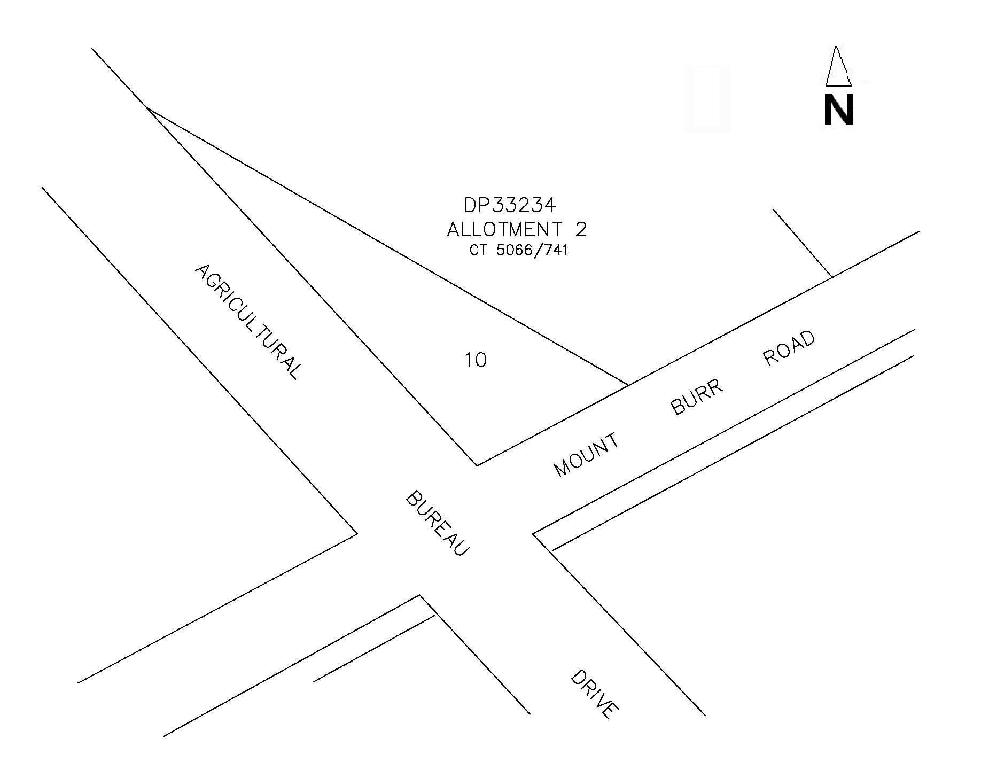
A copy of the plan and statement of persons affected are available for public inspection at Council’s office at the ‘Civic Centre’, George Street, Millicent and the office of the Surveyor-General, 101 Grenfell Street, Adelaide during normal office hours.
Any objection or representation must be made in writing within 28 days from 11 September 2008, to the Council, P.O. Box 27, Millicent, S.A. 5280 and the Surveyor-General, G.P.O. Box 1354, Adelaide, S.A. 5001, setting out full details. Where a submission is made, Council will give notification of the date and time of a Council meeting to deal with the matter.
F. N. Brennan, Chief Executive Officer

WATTLE RANGE COUNCIL
Roads (Opening and Closing) Act 1991
Millicent Heavy Vehicle Detour Road Project
NOTICE is hereby given pursuant to section 10 of the said Act, that Council proposes to make Road Process Orders to open new sections of road for the Millicent Heavy Vehicle Detour Road at the eastern and western sides of O’Toole’s Road from the Princes Highway to Powers Road, Millicent, as delineated on Preliminary Plan Nos 08/0089 to 08/0091 (inclusive).
PP 08/0089
Road openings numbered 1 to 2
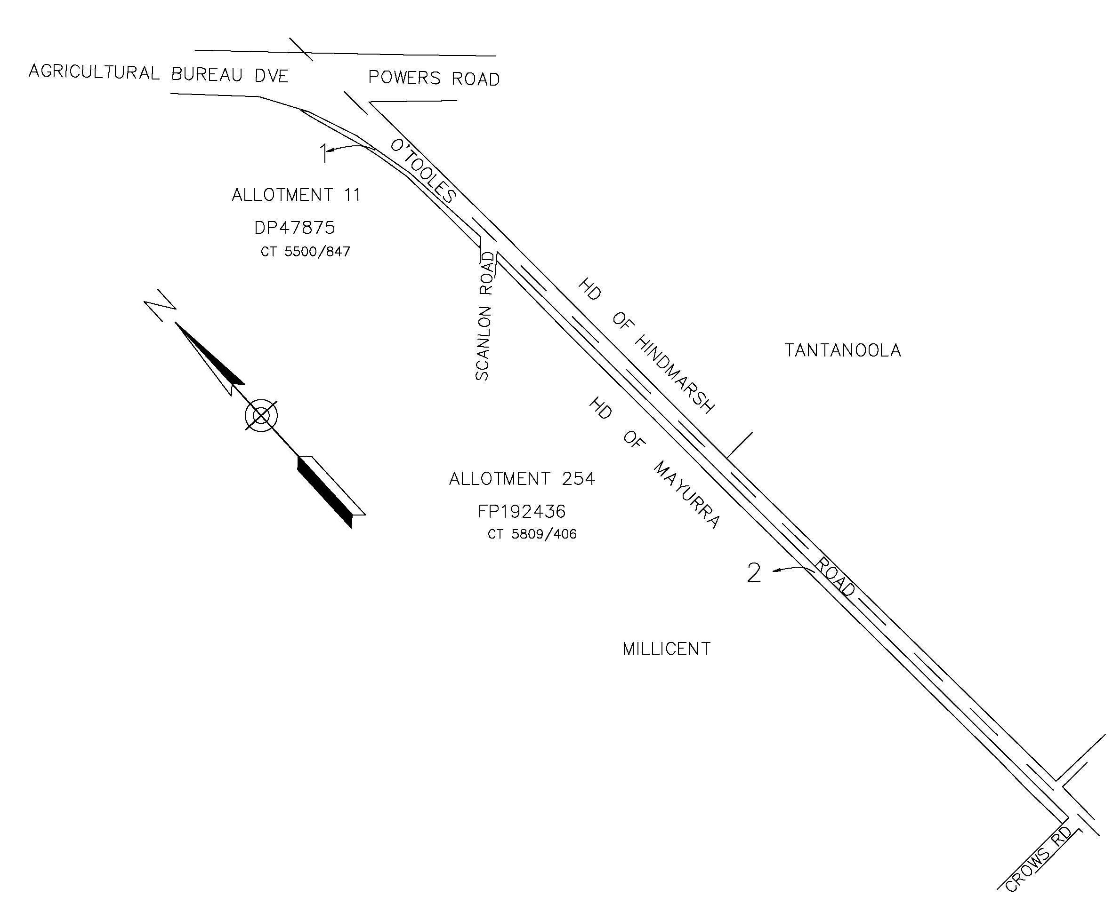
PP 08/0090
Road openings numbered 3 to 5
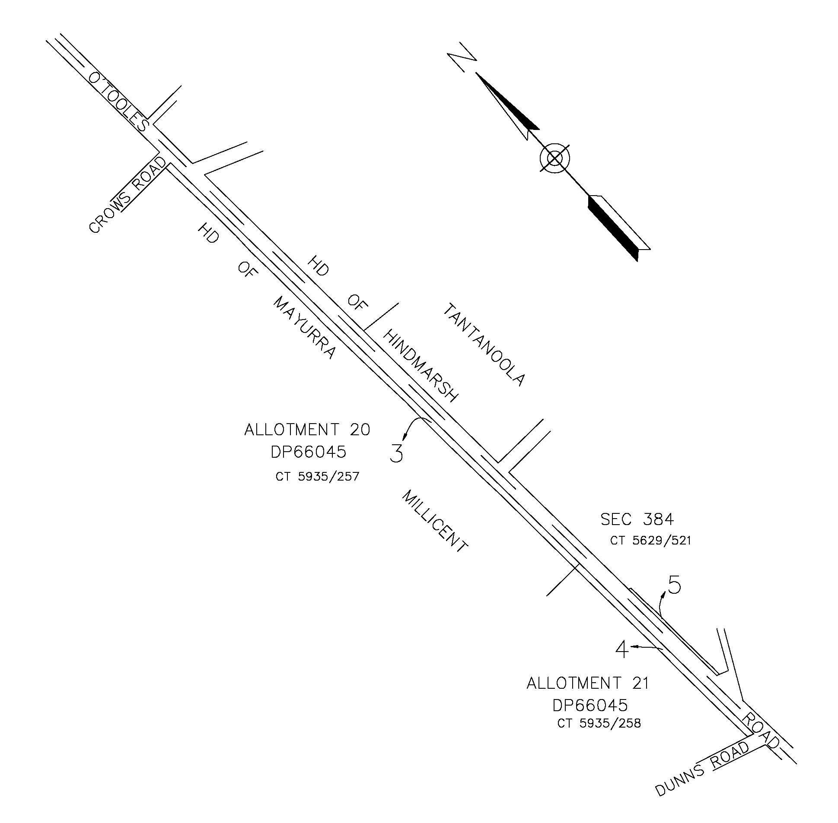
PP 08/0091
Road openings numbered 6 to 10

Copies of the plans and statements of persons affected are available for public inspection at Council’s office at the ‘Civic Centre’, George Street, Millicent and the office of the Surveyor-General, 101 Grenfell Street, Adelaide during normal office hours.
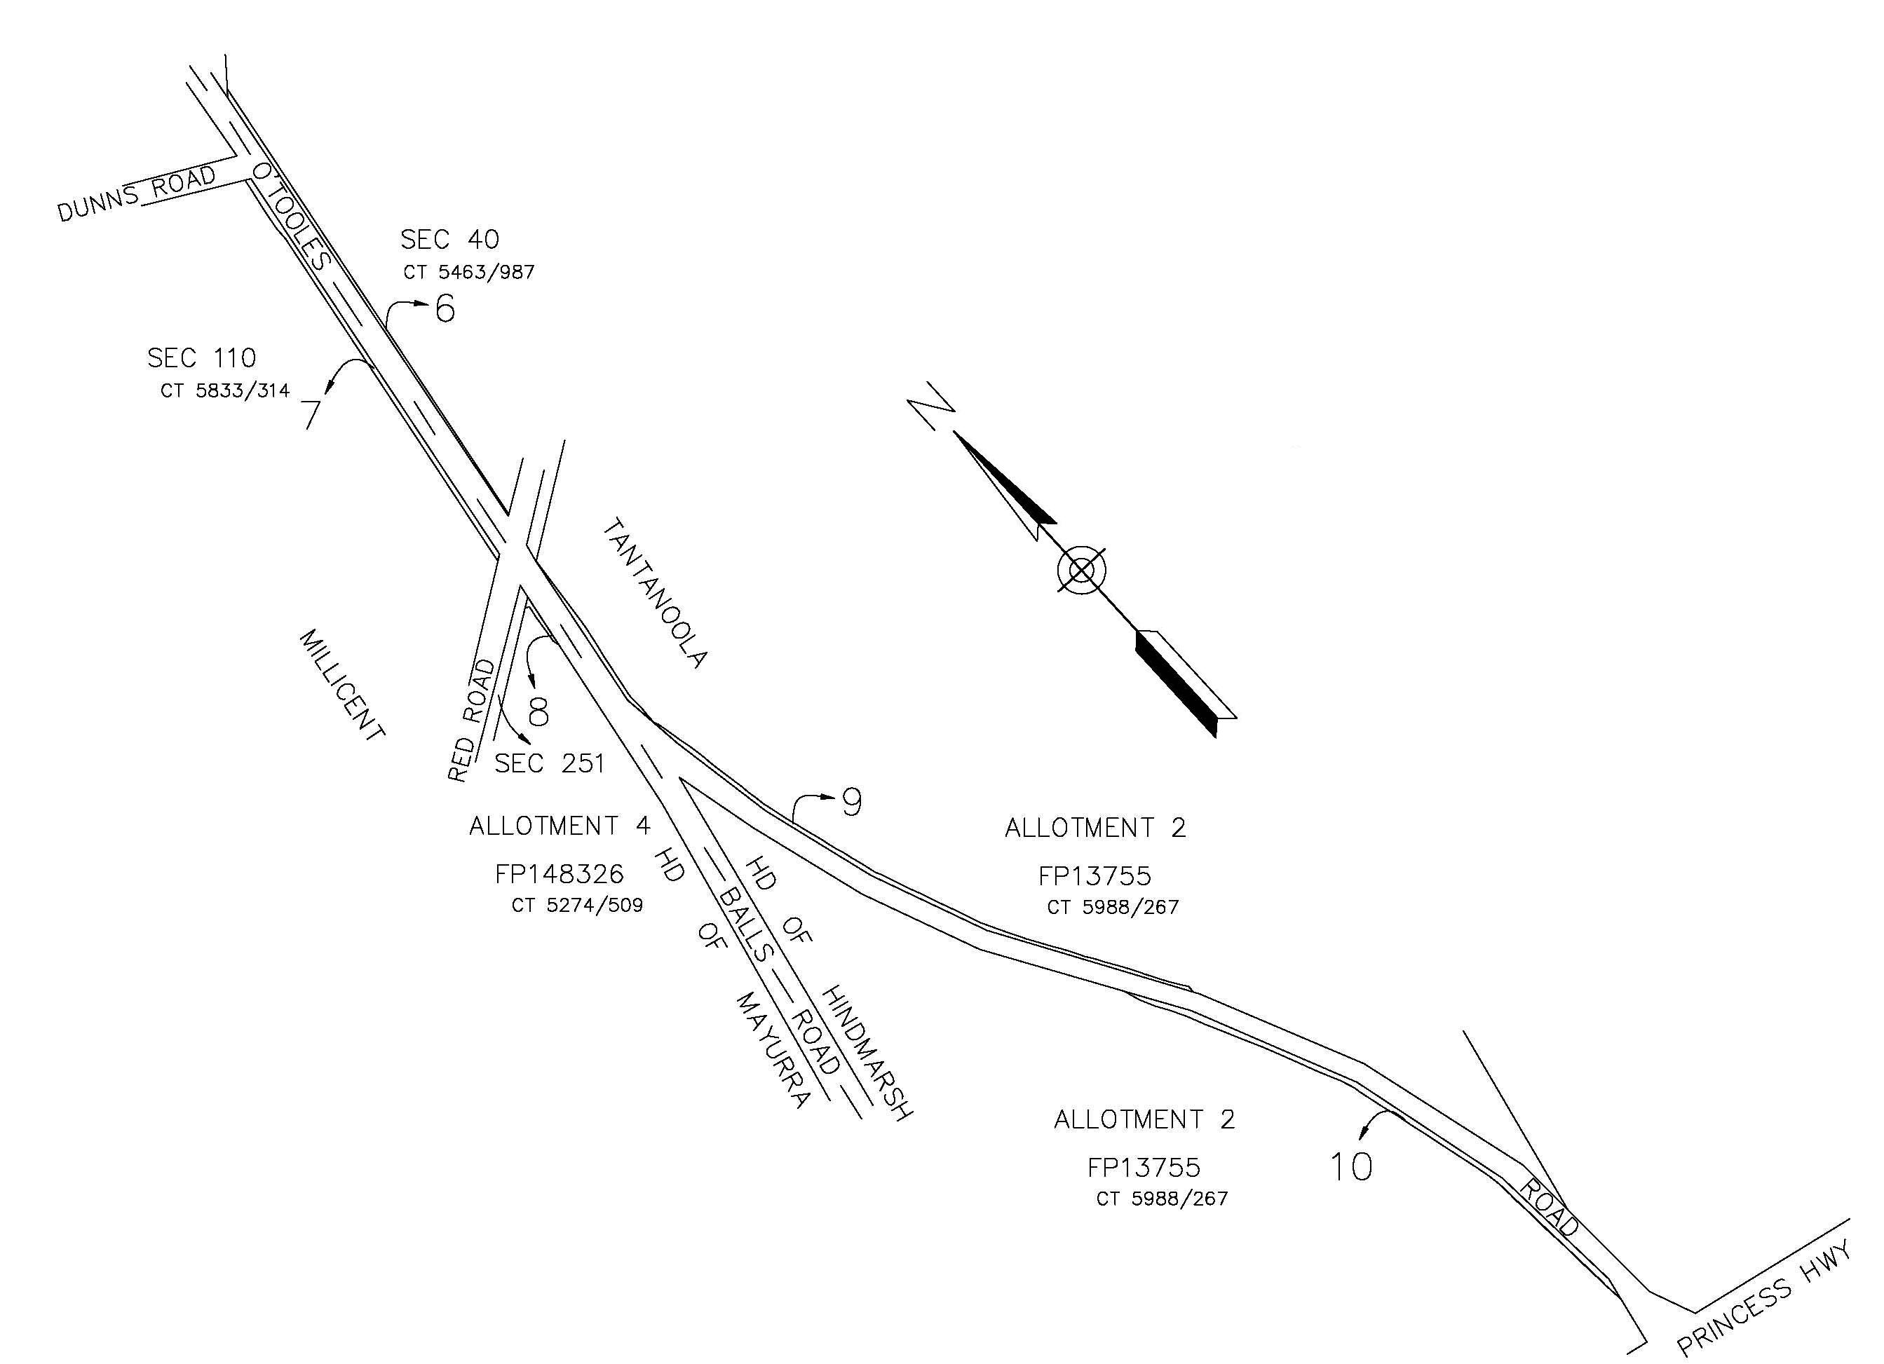
Any objection or representation must be made in writing within 28 days from 11 September 2008, to the Council, P.O. Box 27, Millicent, S.A. 5280 and the Surveyor-General, G.P.O. Box 1354, Adelaide, S.A. 5001, setting out full details. Where a submission is made, Council will give notification of the date and time of a Council meeting to deal with the matter.
F. N. Brennan, Chief Executive Officer

IN the matter of the estates of the undermentioned deceased persons:
Atkinson, Elisabeth, late of 9 Belgrave Street, Plympton, retired keyboard operator, who died on 4 June 2008.
Bowey, Clarence John, late of 61 Stanley Street, Morphett Vale, retired data base administrator, who died on 11 July 2008.
Davis, Robert Alexander, late of 43 Fourth Street, Orroroo, retired contractor, who died on 24 April 2008.
Glanfield, Winifred Joan, late of 95-97 Awoonga Road, Hope Valley, of no occupation, who died on 30 July 2008.
Hamilton, Keith John, late of 1 Duffield Street, Gawler East, retired machinist, who died on 11 July 2008.
Lawrence, Brian Sutcliffe, late of 19 Gordon Street, Mount Gambier, retired service mechanic, who died on 8 June 2008.
Lillecrapp, Bruce Lewis, late of 29 Campbell Road, Parkside, retired electrician, who died on 7 April 2008.
Locke, Patricia Joyce, late of 32 Grazing Avenue, Morphett Vale, retired shop assistant, who died on 22 July 2008.
Pearce, Mary Isobel, late of 21 Marina Avenue, Belair, retired kindergarten teacher, who died on 12 June 2008.
Rogers, John Eric, late of 16 Penarth Avenue, Beaumont, retired maintenance officer, who died on 12 July 2008.
Sampson, Ruth Audrey, late of 47 Glen Osmond Road, Eastwood, of no occupation, who died on 1 May 2008.
Stafford, Enid, late of 66 Nelson Road, Valley View, retired payroll clerk, who died on 10 July 2008.
Wade, Albert Victor, late of 22 Norman Street, Port Pirie, retired transport driver, who died on 3 July 2008.
Wise, Hilda Avela, late of 367-379 Waterloo Corner Road, Burton, of no occupation, who died on 22 July 2008.
Notice is hereby given pursuant to the Trustee Act 1936, as amended, the Inheritance (Family Provision) Act 1972, and the Family Relationships Act 1975, that all creditors, beneficiaries, and other persons having claims against the said estates are required to send, in writing, to the Public Trustee, 25 Franklin Street, Adelaide, S.A. 5000, full particulars and proof of such claims, on or before 10 October 2008, otherwise they will be excluded from the distribution of the said estate; and notice is also hereby given that all persons who are indebted to the said estates are required to pay the amount of their debts to the Public Trustee or proceedings will be taken for the recovery thereof; and all persons having any property belonging to the said estates are forthwith to deliver the same to the Public Trustee.
Dated 11 September 2008.
M. I. Bodycoat, Public Trustee

IN the matter of the estate of the undermentioned deceased person:
Churchill, Mary Louisa, late of Parkrose Village Nursing Home, Unit 66, 34 Norman Terrace, Everard Park, widow, deceased, who died on 22 September 2007.
NOTICE is hereby given pursuant to the Trustee Act 1936, as amended, the Inheritance (Family Provision) Act 1972 and the Family Relationships Act 1975, that all creditors, beneficiaries and other persons having claims in the above estate are required to send full particulars and proof of such claims in writing to Perpetual Trustees SA Limited at the address below on or before Friday, 10 October 2008, otherwise they will be excluded from the distribution of the said estate.
Perpetual Trustees SA Limited, G.P.O. Box 1098, Adelaide, S.A. 5000.

IN the matter of the estate of the undermentioned deceased person:
Cook, Colin Walter, late of 24 Burnell Drive, Belair, retired radiographer, deceased, who died on 17 October 2007.
NOTICE is hereby given pursuant to the Trustee Act 1936, as amended, the Inheritance (Family Provision) Act 1972 and the Family Relationships Act 1975, that all creditors, beneficiaries and other persons having claims in the above estate are required to send full particulars and proof of such claims in writing to Perpetual Limited at the address below on or before Friday, 10 October 2008, otherwise they will be excluded from the dis-tribution of the said estate.
Perpetual Limited, G.P.O. Box 4172, Sydney, N.S.W. 2001.

IN the matter of the estate of the undermentioned deceased person:
Enid Isabel Milsim Woolley, late of Unit 2, 177 Pimpala Road, Woodcroft, S.A. 5162, retired pharmacy assistant, who died on 31 July 2007.
Notice is hereby given pursuant to the Trustee Act 1936, as amended, the Inheritance (Family Provision) Act 1972 and the Family Relationships Act 1975, that all creditors, beneficiaries and other persons having claims against the said estate are required to send, in writing, to Robbert John Fox, c/o Fox O’Brien Solicitors, Suite 1, 49-51 Eton Street, Sutherland in the State of New South Wales, full particulars and proof of such claims on or before 11 October 2008, otherwise they will be excluded from the distribu-tion of the said estate; and notice is hereby given that all persons who are indebted to the said estate are required to pay the amount of their debts to Robbert John Fox, aforesaid or proceedings will be taken for the recovery thereof; and all persons having any property belonging to the said estate are forthwith to deliver the same to Robbert John Fox aforesaid.
Dated 11 September 2008.
R. J. Fox, Executor

ATTENTION

CUSTOMERS requiring a proof of their notice for inclusion in the Government Gazette, please note that the onus is on you to inform Government Publishing SA of any subsequent corrections by 10 a.m. on Thursday, which is our publication deadline.

For any corrections to your notice please phone 8207 1045 or Fax 8207 1040 before 10 a.m. on Thursday.

If we do not receive any communication by 10 a.m. on Thursday (day of publication) we will presume the notice is correct and will print it as it is.

Remember—the onus is on you to inform us of any corrections necessary to your notice.

NOTE: Closing time for lodging new copy (electronically, fax or hard copy) is 4 p.m. on Tuesday preceding the day of publication. Phone 8207 1045—Fax 8207 1040.
Email: governmentgazette@dpc.sa.gov.au

Printed and published by authority every Thursday by T. GOODES, Government Printer, South Australia
Price: $5.40, plus postage; to subscribers, $274.00 per annum.
(The above prices are inclusive of GST)

