EXTRAORDINARY GAZETTE



THE SOUTH AUSTRALIAN

GOVERNMENT GAZETTE
www.governmentgazette.sa.gov.au

PUBLISHED BY AUTHORITY

ALL PUBLIC ACTS appearing in this GAZETTE are to be considered official, and obeyed as such

ADELAIDE, THURSDAY, 25 SEPTEMBER 2008

CONTENTS
Page
Housing Improvement Act 1940—Notices 4700

REGULATION
Australian Road Rules Variation Rules 2008
(No. 261 of 2008) 4650

South Australia
Australian Road Rules Variation Rules 2008
under the Road Traffic Act 1961

Contents
Part 1—Preliminary
1 Short title
2 Commencement
3 Variation provisions
Part 2—Variation of Australian Road Rules
4 Substitution of heading to Part 4 Division 1
5 Substitution of rule 26
26 Application of Division to roundabouts, road-related areas and adjacent land
6 Variation of rule 27—Starting a left turn from a road (except a multi-lane road)
7 Variation of rule 28—Starting a left turn from a multi-lane road
8 Substitution of rule 29
29 Making a left turn as indicated by a turn line
9 Substitution of heading to Part 4 Division 2
10 Substitution of rule 30
30 Application of Division to certain right turns
11 Variation of rule 31—Starting a right turn from a road (except a multi-lane road)
12 Variation of rule 32—Starting a right turn from a multi-lane road
13 Substitution of rule 33
33 Making a right turn
14 Variation of rule 35—Optional hook turn by a bicycle rider
15 Revocation of Part 4 Division 5
16 Substitution of heading to Part 6
17 Variation of heading to Part 6 Division 1
18 Variation of rule 56—Stopping for a red traffic light or arrow
19 Variation of rule 57—Stopping for a yellow traffic light or arrow
20 Variation of rule 60—Proceeding through a red traffic arrow
21 Insertion of rule 60A
60A Proceeding through a bicycle storage area before a red traffic light or arrow
22 Variation of heading to Part 6 Division 2
23 Variation of rule 62—Giving way when turning at an intersection with traffic lights
24 Variation of rule 67—Stopping and giving way at a stop sign or stop line at an intersection without traffic lights
25 Variation of rule 68—Stopping and giving way at a stop sign or stop line at other places
26 Variation of rule 73—Giving way at a T-intersection
27 Variation of rule 80—Stopping at a children's crossing
28 Variation of rule 81—Giving way at a pedestrian crossing
29 Substitution of rule 85
85 Giving way on a painted island
30 Variation of rule 87—Giving way when moving from a side of a road or a median strip parking area
31 Substitution of heading to Part 8 Division 1
32 Variation of rule 91—No left turn and no right turn signs
33 Variation of rule 92—Traffic lane arrows
34 Variation of rule 98—One-way signs
35 Variation of rule 99—Keep left and keep right signs
36 Insertion of rule 101A
101A Safety ramp and arrester bed signs
37 Variation of rule 104—No trucks signs
38 Variation of rule 109—What is a roundabout
39 Variation of rule 115—Driving in a roundabout to the left of the central traffic island
40 Variation of rule 121—Stopping and giving way at a stop sign at a level crossing
41 Variation of rule 130—Keeping to the left on a multi-lane road
42 Variation of rule 131—Keeping to the left of oncoming vehicles
43 Variation of rule 132—Keeping to the left of the centre of a road or the dividing line
44 Variation of rule 134—Exceptions to keeping to the left of a dividing line
45 Variation of rule 138—Keeping off a painted island
46 Variation of rule 141—No overtaking etc to the left of a vehicle
47 Variation of rule 146—Driving within a single marked lane or line of traffic
48 Variation of rule 148—Giving way when moving from one marked lane or line of traffic to another marked lane or line of traffic
49 Insertion of rule 148A
148A Giving way when moving within a single marked lane
50 Variation of rule 150—Driving on or across a continuous white edge line
51 Variation of rule 154—Bus lanes
52 Variation of rule 155—Tram lanes
53 Insertion of rule 155A
155A Tramways
54 Variation of rule 168—No parking signs
55 Variation of rule 171—Stopping on or near a children's crossing
56 Variation of rule 176—Stopping on a clearway
57 Variation of rule 187—Stopping in a bicycle lane, bus lane, tram lane, tramway, transit lane, truck lane or on tram tracks
58 Variation of rule 196—Stopping at or near a tram stop
59 Variation of rule 197—Stopping on a path, dividing strip, nature strip or painted island
60 Variation of rule 205—Parking for longer than indicated
61 Insertion of rule 205A
205A Parking outside times indicated
62 Variation of rule 208—Parallel parking on a road (except in a median strip parking area)
63 Insertion of rule 208A
208A Parallel parking in a road-related area (except in a median strip parking area)
64 Variation of rule 210—Angle parking
65 Variation of rule 211—Parking in parking bays
66 Variation of rule 213—Making a motor vehicle secure
67 Variation of rule 217—Using fog lights
68 Variation of rule 221—Using hazard warning lights
69 Variation of rule 224—Using horns and similar warning devices
70 Variation of rule 225—Using radar detectors and similar devices
71 Variation of rule 238—Pedestrians travelling along a road (except in or on a wheeled recreational device or toy)
72 Variation of heading to Part 14 Division 2
73 Insertion of rule 239A
239A No wheeled recreational devices or toys sign
74 Variation of rule 240—Wheeled recreational devices and toys not to be used on certain roads
75 Insertion of rules 244A to 244C
244A Meanings of scooter and motorised scooter
244B Wearing of helmets by users of motorised scooters
244C Motorised scooters not to be used
76 Variation of rule 246—Carrying people on a bicycle
77 Insertion of rules 247A and 247B
247A Entering a bicycle storage area
247B Giving way while entering or in a bicycle storage area
78 Variation of rule 256—Bicycle helmets
79 Variation of rule 260—Stopping for a red bicycle crossing light
80 Variation of rule 261—Stopping for a yellow bicycle crossing light
81 Substitution of rule 262
262 Proceeding when bicycle crossing lights change to yellow or red
82 Variation of rule 271—Riding on motor bikes
83 Variation of heading to Part 17
84 Variation of heading to Part 17 Division 1
85 Substitution of rule 273
273 Division also applies to tram recovery vehicles and public buses travelling along tram tracks
86 Variation of rule 280—Application of Division
87 Variation of rule 297—Driver to have proper control of a vehicle etc
88 Substitution of rule 301
301 Leading an animal while driving a vehicle
89 Variation of rule 309—Exemption for drivers of trams etc
90 Variation of rule 313—Exemption for postal vehicles
91 Insertion of rule 323A
323A Audible lines
92 Variation of rule 334—How parking control signs apply to a length of road
93 Variation of rule 335—Traffic control devices applying to an area
94 Variation of rule 340—Traffic control devices (except road markings and parking control signs)
95 Variation of rule 341—Road markings
96 Insertion of rule 352
352 References to stopping as near as practicable to a place
97 Variation of Schedule 2—Standard or commonly used traffic signs
98 Variation of Schedule 3—Other permitted traffic signs
99 Variation of Dictionary

Part 1—Preliminary
1—Short title
These rules may be cited as the Australian Road Rules Variation Rules 2008.
2—Commencement
These rules will come into operation 4 months after the day on which they are made.
3—Variation provisions
In these rules, a provision under a heading referring to the variation of specified rules varies the rules so specified.
Part 2—Variation of Australian Road Rules
4—Substitution of heading to Part 4 Division 1
Heading to Part 4 Division 1—delete the heading to Division 1 and substitute:
Division 1—Left turns
5—Substitution of rule 26
Rule 26—delete the rule and substitute:
26—Application of Division to roundabouts, road-related areas and adjacent land
(1) This Division does not apply to a driver entering or leaving a roundabout.
Note 1—
Roundabout is defined in rule 109.
Note 2—
Part 9 deals with entering and leaving a roundabout.
(2) This Division applies to a driver turning left from a road into a road-related area or adjacent land, or from a road-related area into a road, as if the driver were turning left at an intersection.
Note 1—
Adjacent land and intersection are defined in the dictionary and road-related area is defined in rule 13. Adjacent land or a road-related area can include a driveway, service station or shopping centre—see the definitions.
Note 2—
Rule 74 deals with the give way rules applying to a driver entering a road from a road-related area or adjacent land, and rule 75 deals with the give way rules applying to a driver entering a road-related area or adjacent land from a road. Rule 212 deals with a driver entering and leaving a median strip parking area.
Note 3—
For the meaning of left, see rule 351 (1).
(3) In this rule:
road does not include a road-related area.
Note—
A road-related area includes the shoulder of a road—see rule 13.
6—Variation of rule 27—Starting a left turn from a road (except a multi-lane road)
Rule 27—after subrule (1) insert:
(1A) Subrule (1) also applies to a rider of a bicycle who approaches and enters an intersection from a bicycle storage area.
Note—
Bicycle storage area is defined in the dictionary.
(1B) Despite subrule (1), if there is space in a bicycle storage area for 2 riders of bicycles to be next to each other, the rider on the right may approach and enter the intersection as near as practicable to the right side of the other rider, but only if that other rider approaches and enters the intersection in accordance with this rule.
7—Variation of rule 28—Starting a left turn from a multi-lane road
(1) Rule 28(1)(c)—delete "subrule (2)" and substitute:
subrule (1A) or (2)
(2) Rule 28—after subrule (1), including the notes and example, insert:
(1A) A driver turning left at an intersection from a multi-lane road that has a slip lane must approach and enter the intersection:
(a) from within the slip lane; or
(b) if there is an obstruction that prevents the driver from entering the intersection from within the slip lane—from within the left lane.
Offence provision.
Note—
Obstruction and slip lane are defined in the dictionary.
(3) Rule 28—after subrule (2), including the notes and example, insert:
(2A) If there is a bicycle storage area before an intersection that extends across
1 or more marked lanes of a multi-lane road, a rider of a bicycle turning left must approach and enter the intersection from within the part of the bicycle storage area that is directly in front of the left marked lane or of a bicycle lane that is on the left side of the road.
Offence provision.
Note—
Bicycle storage area is defined in the dictionary.
(4) Rule 28(3), note 1—delete the note and substitute:
Note 1—
Special purpose lane is defined in the dictionary.
8—Substitution of rule 29
Rule 29—delete the rule and substitute:
29—Making a left turn as indicated by a turn line
(1) If a driver is turning left at an intersection and there is a turn line indicating how the turn is required to be made, the driver must make the turn as indicated by the turn line unless:
(a) the driver is turning, at B lights or traffic arrows, in accordance with Division 2 of Part 17; or
(b) subrule (2) applies to the driver.
Offence provision.
Note—
B lights, intersection, traffic arrows and turn line are defined in the dictionary.
Example—
Making a left turn as indicated by a turn line
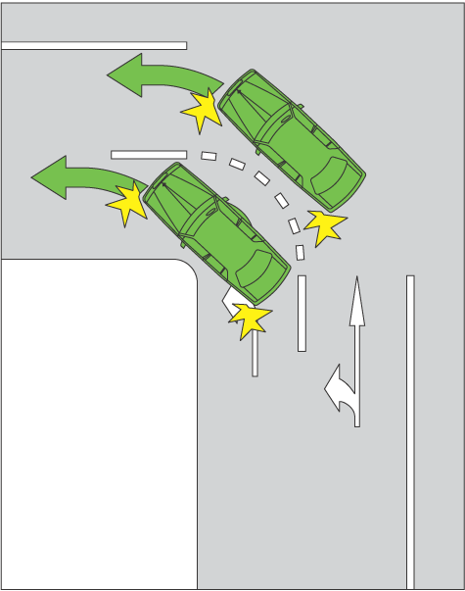
(2) A driver may turn left at an intersection other than as indicated by a turn line if:
(a) the driver’s vehicle, together with any load or projection, is
7.5 metres long, or longer; and
(b) the vehicle displays a do not overtake turning vehicle sign; and
(c) it is not practicable for the driver to turn left as indicated by the turn line; and
(d) the driver can safely turn left other than as indicated by the turn line.
Note 1—
Driver’s vehicle is defined in the dictionary.
Note 2—
Vehicle includes a combination—see rule 15 (d).
Note 3—
Under the law of this jurisdiction, only certain long vehicles may display a do not overtake turning vehicle sign.

Do not overtake turning vehicle signs
 | 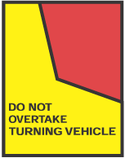
Note for diagrams—
These signs are displayed on certain long vehicles.
9—Substitution of heading to Part 4 Division 2
Heading to Part 4 Division 2—delete the heading to Division 2 and substitute:
Division 2—Right turns
10—Substitution of rule 30
Rule 30—delete the rule and substitute:
30—Application of Division to certain right turns
(1) This Division does not apply to:
(a) a driver turning right at an intersection where there is a hook turn only sign; or
(b) the rider of a bicycle making a hook turn under Division 3; or
(c) a driver making a U-turn; or
(d) a driver entering or leaving a roundabout.
Note 1—
Bicycle, intersection and U-turn are defined in the dictionary and roundabout is defined in rule 109.
Note 2—
Division 3 of this Part deals with hook turns, Division 4 deals with U-turns and Part 9 deals with entering and leaving a roundabout.
Note 3—
For the meaning of right, see rule 351 (2).
(2) This Division applies to a driver turning right from a road into a road-related area or adjacent land, or from a road-related area into a road, as if the driver were turning right at an intersection.
Note 1—
Adjacent land is defined in the dictionary and road-related area is defined in rule 13. Adjacent land or a road-related area can include a driveway, service station or shopping centre—see the definitions.
Note 2—
Rule 74 deals with the give way rules applying to a driver entering a road from a road-related area or adjacent land, and rule 75 deals with the give way rules applying to a driver entering a road-related area or adjacent land from a road. Rule 212 deals with a driver entering and leaving a median strip parking area.
(3) In this rule:
road does not include a road-related area.
Note—
A road-related area includes the shoulder of a road—see rule 13.
11—Variation of rule 31—Starting a right turn from a road (except a multi-lane road)
Rule 31—after subrule (4) insert:
(4A) Subrules (2), (3) and (4) also apply to a rider of a bicycle who approaches and enters an intersection from a bicycle storage area.
Note—
Bicycle storage area is defined in the dictionary.
(4B) Despite subrules (2), (3) and (4), if there is space in a bicycle storage area for 2 riders of bicycles to be next to each other, the rider on the left may approach and enter the intersection as near as practicable to the left side of the other rider, but only if that other rider approaches and enters the intersection in accordance with this rule.
12—Variation of rule 32—Starting a right turn from a multi-lane road
Rule 32—after subrule (2), including the notes, insert:
(2A) If there is a bicycle storage area before an intersection that extends across
1 or more marked lanes of a multi-lane road, a rider of a bicycle turning right (but not making a hook turn) must approach and enter the intersection from within the part of the bicycle storage area that is directly in front of the right marked lane or of a bicycle lane that is on the right side of the road.
Offence provision.
Note—
Bicycle storage area is defined in the dictionary.
13—Substitution of rule 33
Rule 33—delete the rule and substitute:
33—Making a right turn
(1) A driver turning right at an intersection must make the turn in accordance with this rule unless:
(a) the driver is turning, at B lights or traffic arrows, in accordance with Division 2 of Part 17; or
(b) subrule (4) applies to the driver.
Offence provision.
Note—
B lights, intersection and traffic arrows are defined in the dictionary.
(2) If there is a turn line indicating how the turn is required to be made, the driver must make the turn as indicated by the turn line.
Note—
Turn line is defined in the dictionary.
(3) If there is no turn line indicating how the turn is required to be made, the driver must make the turn so the driver:
(a) passes as near as practicable to the right of the centre of the intersection; and
(b) turns into the left of the centre of the road the driver is entering, unless the driver is entering a one-way road.
Note—
Centre of the road is defined in the dictionary.
Examples—
Example 1
Making a right turn as indicated by turn lines
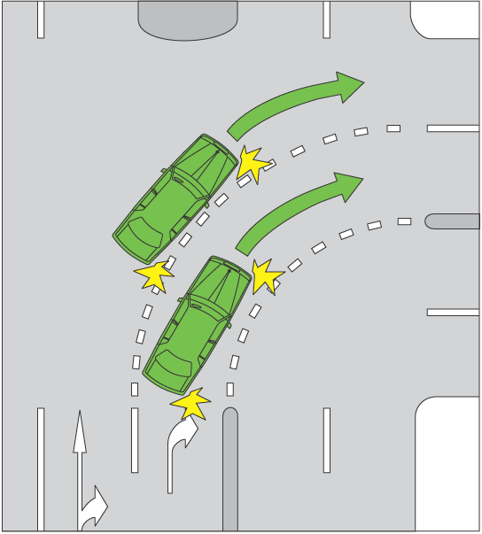
Example 2
Making a right turn from a road with no turn lines indicating how to make the turn
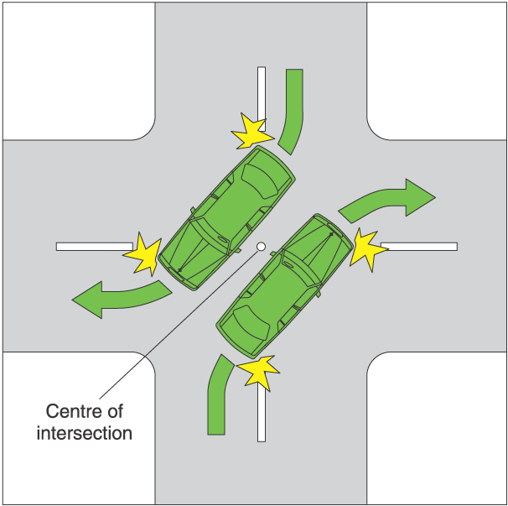
(4) A driver may turn right other than as indicated by a turn line if:
(a) the driver’s vehicle, together with any load or projection, is
7.5 metres long, or longer; and
(b) the vehicle displays a do not overtake turning vehicle sign; and
(c) it is not practicable for the driver to turn right as indicated by the turn line; and
(d) the driver can safely make the turn other than as indicated by the turn line.
Note 1—
Driver’s vehicle is defined in the dictionary.
Note 2—
Vehicle includes a combination—see rule 15 (d).
Note 3—
Under the law of this jurisdiction, only certain long vehicles may display a do not overtake turning vehicle sign.

Do not overtake turning vehicle signs
Note for diagrams—
These signs are displayed on certain long vehicles.
14—Variation of rule 35—Optional hook turn by a bicycle rider
(1) Rule 35—after subrule (3), including the note, but before the example insert:
(4) To make a hook turn under this rule at an intersection that has a bicycle hook turn storage area on the left side of the intersection as the rider approaches the intersection, the rider must take the following initial 2 steps instead of the initial 2 steps listed in subrule (3):
1 Approach the intersection from the far left side of the road the rider is leaving and enter the intersection by moving into the bicycle hook turn storage area, keeping clear of any marked foot crossing.
2 Move forward in the bicycle hook turn storage area until the rider is as near as practicable to the far side of the road that the rider is entering.
Note—
Bicycle hook turn storage area is defined in the dictionary.
(2) Rule 35—before the example insert:
Example—
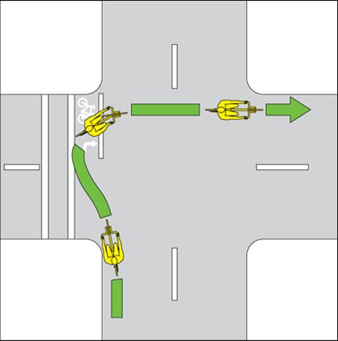
15—Revocation of Part 4 Division 5
Part 4 Division 5—delete Division 5
16—Substitution of heading to Part 6
Heading to Part 6—delete the heading and substitute:
Part 6—Traffic lights, traffic arrows and twin red lights
17—Variation of heading to Part 6 Division 1
(1) Heading to Part 6 Division 1, except the notes—delete the heading to Division 1, except the notes, and substitute:
Division 1—Obeying traffic lights and traffic arrows
(2) Heading to Part 6 Division 1, note 1—delete "installed with traffic lights that are"
18—Variation of rule 56—Stopping for a red traffic light or arrow
(1) Rule 56(1), example for subrule (1)(b), heading—delete "Stopping at a stop here on red signal sign" and substitute:
Stopping at a stop here on red signal sign on a road the driver is entering
(2) Rule 56—after subrule (2), including the notes and diagrams and note for diagrams, insert:
(3) If there is a bicycle storage area before any traffic lights referred to in subrule (1) or (2), a reference to the stop line in subrule (1)(a) or (2)(a):
(a) in the case of a driver of a motor vehicle, is a reference to the first stop line that the driver comes, or came, to in approaching the lights;
(b) in the case of a rider of a bicycle, is a reference to the stop line that is nearest to the intersection.
Note—
Bicycle storage area is defined in the dictionary.
19—Variation of rule 57—Stopping for a yellow traffic light or arrow
Rule 57—after subrule (3), including the notes, insert:
(4) If there is a bicycle storage area before any traffic lights referred to in subrule (1) or (2), a reference to the stop line in subrule (1)(a) or (2)(a):
(a) in the case of a driver of a motor vehicle, is a reference to the first stop line that the driver comes, or came, to in approaching the lights;
(b) in the case of a rider of a bicycle, is a reference to the stop line that is nearest to the intersection.
Note—
Bicycle storage area is defined in the dictionary.
20—Variation of rule 60—Proceeding through a red traffic arrow
(1) Rule 60—after "intersection", wherever occurring, insert:
or marked foot crossing
(2) Rule 60, note 1—delete the note and substitute:
Note 1—
Enter, intersection, marked foot crossing and red traffic arrow are defined in the dictionary.
21—Insertion of rule 60A
After rule 60 insert:
60A—Proceeding through a bicycle storage area before a red traffic light or arrow
(1) If there is a bicycle storage area before traffic lights that are showing a red traffic light, a driver of a motor vehicle must not allow any part of the vehicle to enter the bicycle storage area.
Offence provision.
Note—
Bicycle storage area, red traffic light and motor vehicle are defined in the dictionary.
(2) If there is a bicycle storage area before traffic arrows that are showing a red traffic arrow, and a driver of a motor vehicle is turning in the direction indicated by the arrow, the driver must not allow any part of the vehicle to enter the bicycle storage area.
Offence provision.
Note—
Red traffic arrow is defined in the dictionary.
22—Variation of heading to Part 6 Division 2
Heading to Part 6 Division 2, except the note—delete the heading to Division 2, except the note, and substitute:
Division 2—Giving way at traffic lights and traffic arrows
23—Variation of rule 62—Giving way when turning at an intersection with
traffic lights
Rule 62—before the examples (with the portion of rule 62 preceding the examples now to be designated as subrule (1)) insert:
(2) However, a driver who is turning at an intersection with traffic arrows showing a green traffic arrow need not give way to an oncoming vehicle if the driver is turning in the direction indicated by the green traffic arrow.
Note—
Green traffic arrow is defined in the dictionary.
24—Variation of rule 67—Stopping and giving way at a stop sign or stop line at an intersection without traffic lights
(1) Rule 67(2), including the note—delete subrule (2), including the note, and substitute:
(2) The driver must stop as near as practicable to, but before reaching:
(a) the stop line; or
(b) if there is no stop line—the intersection.
(2) Rule 67(3), note—delete the note and substitute:
Note—
Enter, give way line, oncoming vehicle, slip lane and U-turn are defined in the dictionary.
25—Variation of rule 68—Stopping and giving way at a stop sign or stop line at other places
(1) Rule 68(1)—delete "(except an intersection, children's crossing, level crossing, or a place with twin red lights)"
(2) Rule 68(1)—delete "rule" and substitute:
rule, unless the place is:
(a) an intersection; or
(b) a children’s crossing; or
(c) an area of a road that is not a children’s crossing only because it does not have:
(i) children crossing flags; or
(ii) children’s crossing signs and twin yellow lights; or
(d) a level crossing; or
(e) a place with twin red lights.
(3) Rule 68(2)—delete subrule (2) and substitute:
(2) The driver must stop as near as practicable to, but before reaching:
(a) the stop line; or
(b) if there is no stop line—the stop sign.
(4) Rule 68(3)—after "at or near the" insert:
stop line or
26—Variation of rule 73—Giving way at a T-intersection
(1) Rule 73(2)(a)—delete "road; and" and substitute:
road (except a vehicle making a U-turn on the continuing road at the T-intersection); and
(2) Rule 73(3)(a)—delete "road; and" and substitute:
road (except a vehicle making a U-turn on the continuing road at the T-intersection); and
(3) Rule 73(5)(a)—delete "right; and" and substitute:
right (except a vehicle making a U-turn from the terminating road at the T-intersection); and
27—Variation of rule 80—Stopping at a children's crossing
(1) Rule 80(2)—delete "must stop at" and substitute:
must stop as near as practicable to, but before reaching,
(2) Rule 80(3)—after "until" insert:
there is no pedestrian on or entering the crossing and
28—Variation of rule 81—Giving way at a pedestrian crossing
Rule 81(3), except the notes, diagram and examples—delete subrule (3), except the notes, diagram and examples and substitute:
(3) A pedestrian crossing is an area of a road:
(a) at a place with white stripes on the road surface that:
(i) run lengthwise along the road; and
(ii) are of approximately the same length; and
(iii) are approximately parallel to each other; and
(iv) are in a row that extends completely, or partly, across the road; and
(b) with or without either or both of the following:
(i) a pedestrian crossing sign;
(ii) alternating flashing twin yellow lights.
29—Substitution of rule 85
Rule 85—delete the rule and substitute:
85—Giving way on a painted island
A driver entering a turning lane from a painted island must give way to:
(a) any vehicle in the turning lane; or
(b) if the turning lane and painted island are nearest to the far left side of the road—any vehicle entering the turning lane from the marked lane, or line of traffic, immediately to the right of the turning lane; or
(c) if the turning lane and painted island are nearest to the dividing line or median strip on the road or the far right side of the road—any vehicle entering the turning lane from the marked lane, or line of traffic, immediately to the left of the turning lane.
Offence provision.
Note 1—
Line of traffic, marked lane, painted island and turning lane are defined in the dictionary.
Note 2—
Rules 138 and 139 (4) allow a driver to drive on a painted island in certain circumstances.
Note 3—
For this rule, give way means the driver must slow down and, if necessary, stop to avoid a collision—see the definition in the dictionary.
Examples—

Example 1 | Example 2
Driver entering a turning lane from a painted island giving way to a vehicle entering the turning lane from the marked lane immediately to the right of the turning lane.  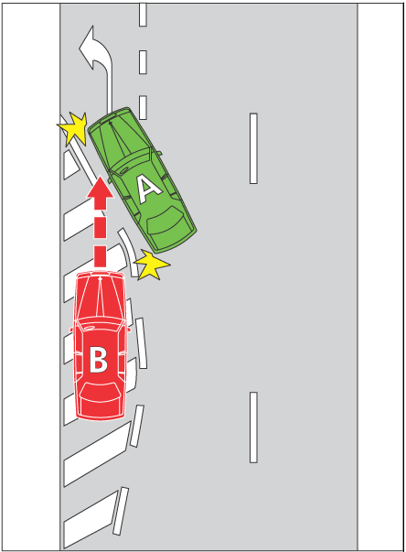 | Driver entering a turning lane from a painted island giving way to a vehicle entering the turning lane from the marked lane immediately to the left of the turning lane.  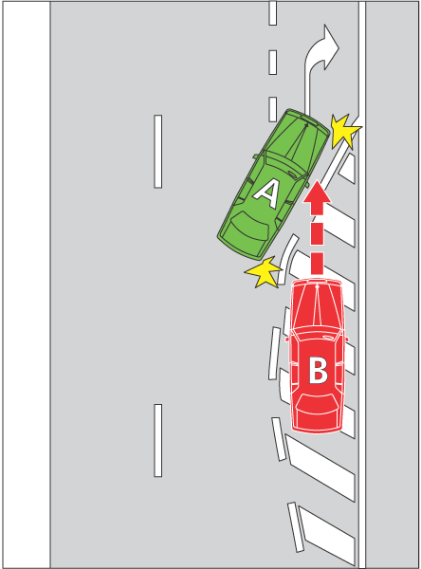
In the examples, vehicle B must give way to vehicle A.
30—Variation of rule 87—Giving way when moving from a side of a road or a median strip parking area
(1) Rule 87(1)—delete ", or from a shoulder of a road,"
(2) Rule 87(1), note 1—delete the note and substitute:
Note 1—
Line of traffic and marked lane are defined in the dictionary.
(3) Rule 87—after subrule (3), including the notes, insert:
(4) In this rule:
road does not include a road-related area, but includes any shoulder of the road.
Note—
Road-related area is defined in rule 13 and shoulder is defined in rule 12.
31—Substitution of heading to Part 8 Division 1
Heading to Part 8 Division 1, including the note—delete the heading to Division 1, including the note, and substitute:
Division 1—Traffic signs and road markings at intersections and other places
Note—
Intersection, road marking and traffic sign are defined in the dictionary.
32—Variation of rule 91—No left turn and no right turn signs
Rule 91(1), (2) and (3), except the diagrams and the note for diagrams—delete subrules (1), (2) and (3), except the diagrams and the note for diagrams and substitute:
(1) If there is a no left turn sign at an intersection, or another place on a road, a driver must not turn left at the intersection or place.
Offence provision.
(2) If there is a no right turn sign at an intersection, or another place on a road, a driver must not turn right or make a U-turn at the intersection or place.
Offence provision.
(3) However, a driver may make a U-turn at the intersection or place if there is a U-turn permitted sign at the intersection or place.
33—Variation of rule 92—Traffic lane arrows
Rule 92(2), including the note and the examples—delete subrule (2), including the note and the examples and substitute:
(2) However, this rule does not apply to a driver if:
(a) the arrows indicate a direction to the right (whether or not they also indicate another direction) at an intersection and the driver is making a U-turn at the intersection; or
(b) a traffic sign indicates that the driver may drive in a direction different to that indicated by the traffic lane arrows; or
(c) the driver is driving in the direction indicated by traffic lane arrows that apply to 1 or more marked lanes and there is an obstruction in each of those lanes; or
(d) the driver is turning at an intersection in accordance with rule 28 (2) or 32 (2).
Note 1—
Obstruction and U-turn are defined in the dictionary.
Note 2—
Rules 40 and 41 deal with making a U-turn at an intersection. If there are traffic lights at the intersection, the driver may make a U-turn only if there is a U-turn permitted sign at the intersection. If there are no traffic lights at the intersection, the driver may make a U-turn unless there is a no U-turn sign at the intersection.
Note 3—
Rule 28 (2) deals with vehicles 7.5 metres long or longer turning left at an intersection from within the marked lane next to the left lane as well as, or instead of, the left lane on a multi-lane road. Rule 32 (2) deals with vehicles 7.5 metres long or longer turning right at an intersection from within the marked lane next to the right lane as well as, or instead of, the right lane on a multi-lane road.
Examples—
Example 1
Traffic lane arrows on the surface of marked lanes
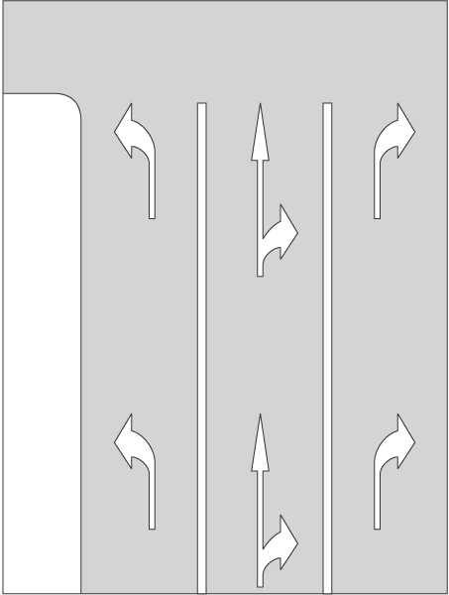
Example 2
Traffic lane arrows on a traffic sign
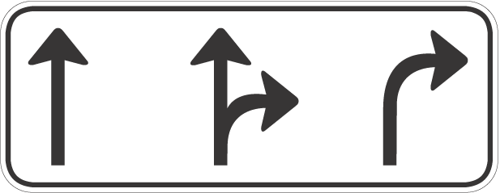
(3) The existence of a bicycle storage area in a marked lane does not alter a driver's obligation to comply with this rule.
Note—
Bicycle storage area is defined in the dictionary.
34—Variation of rule 98—One-way signs
Rule 98—after subrule (2), note 2 and before the diagrams insert:
(3) This rule does not apply to the rider of a motor bike that is a postal vehicle, the rider of a bicycle or the rider of an animal if the rider:
(a) is riding on a footpath, nature strip or shared path adjacent to the length of road; and
(b) is permitted to ride on the footpath, nature strip or shared path under the Australian Road Rules or another law of this jurisdiction.
Note—
Bicycle, footpath, motor bike, nature strip and postal vehicle are defined in the dictionary and shared path is defined in rule 242.
35—Variation of rule 99—Keep left and keep right signs
Rule 99—after subrule (2), before the diagrams, insert:
(3) This rule does not apply to the rider of a motor bike that is a postal vehicle, the rider of a bicycle or the rider of an animal if the rider:
(a) is riding on a footpath, nature strip or shared path; and
(b) is permitted to ride on the footpath, nature strip or shared path under the Australian Road Rules or another law of this jurisdiction.
Note—
Bicycle, footpath, motor bike, nature strip and postal vehicle are defined in the dictionary and shared path is defined in rule 242.
36—Insertion of rule 101A
Part 8, Division 2—after rule 101 insert:
101A—Safety ramp and arrester bed signs
(1) A driver must not drive on a safety ramp or arrester bed unless:
(a) it is necessary for the driver to do so in the interests of safety; or
(b) the driver is permitted to do so under another law of this jurisdiction.
Offence provision.
(2) In this rule:
arrester bed means an area to which an arrester bed sign applies.
safety ramp means an area to which a safety ramp sign applies.

Arrester bed sign   | Safety ramp sign  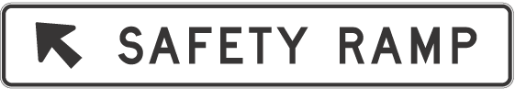
Note for diagrams—
There are a number of other permitted versions of each of these signs—see the diagrams in Schedule 3.
37—Variation of rule 104—No trucks signs
Rule 104(4), except the diagram—delete subrule (4), except the diagram, and substitute:
(4) This rule does not apply to a driver if the destination of the driver lies beyond a no trucks sign and:
(a) there is no other route by which the driver’s vehicle could reach that destination; or
(b) any other route by which the driver’s vehicle could reach that destination would require the vehicle to pass another no trucks sign.
38—Variation of rule 109—What is a roundabout
(1) Rule 109—delete "intersection with" and substitute:
intersection
(2) Rule 109(a)—delete "either" and substitute:
with either
(3) Rule 109(b)—delete paragraph (b) and substitute:
(b) with or without a roundabout sign at each entrance.
39—Variation of rule 115—Driving in a roundabout to the left of the central traffic island
Rule 115(1), except the note—delete subrule (1), except the note, and substitute:
(1) A driver driving in a roundabout must drive:
(a) to the left of the central traffic island in the roundabout; or
(b) if subrule (2) applies to the driver—on the edge of the central traffic island, to the left of the centre of the island; or
(c) if subrule (3) applies to the driver—over the central traffic island, to the left of the centre of the island.
Offence provision.
40—Variation of rule 121—Stopping and giving way at a stop sign at a level crossing
Rule 121(a)—delete paragraph (a) and substitute:
(a) stop as near as practicable to, but before reaching, the stop line or, if there is no stop line, as near as practicable to, but before reaching, the stop sign; and
41—Variation of rule 130—Keeping to the left on a multi-lane road
(1) Rule 130(2)—after paragraph (g) insert:
or
(h) the right lane is a special purpose lane in which the driver, under another provision of the Australian Road Rules, is permitted to drive; or
(i) there are only 2 marked lanes and the left lane is a slow vehicle turn out lane.
(2) Rule 130(2) note 1—delete the note and substitute:
Note 1—
Centre of the road, left traffic lane arrows, obstruction, overtake, right change of direction signal, special purpose lane, traffic and U-turn are defined in the dictionary.
(3) Rule 130(4)—after the definition of lane, including the notes, (but before the diagrams) insert:
slow vehicle turn out lane means a marked lane, or the part of a marked lane, to which a slow vehicle turn out lane sign applies.
Note—
A slow vehicle turn out lane is designed for slow-moving vehicles to move into to allow faster vehicles to pass in an adjacent marked lane.
(4) Rule 130, diagram of End keep left unless overtaking sign—delete the diagram and substitute:

End keep left unless overtaking sign  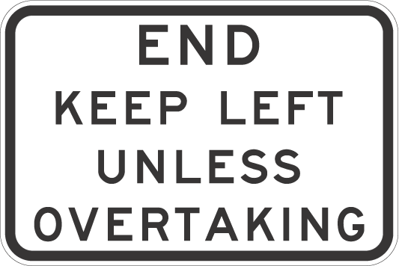 | Slow vehicle turn out lane sign  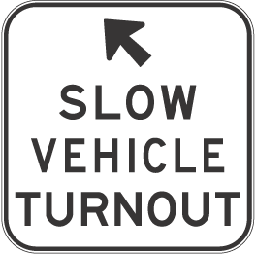
(5) Rule 130—after the diagrams insert:
Note for diagrams—
There is another permitted version of the End keep left unless overtaking sign—see the diagram in Schedule 3.
42—Variation of rule 131—Keeping to the left of oncoming vehicles
Rule 131—before the examples (with the portion of rule 131 preceding the examples now to be designated as subrule (1)) insert:
(2) This rule does not apply to the rider of a motor bike that is a postal vehicle, the rider of a bicycle or the rider of an animal if:
(a) the rider is riding on a footpath, nature strip or shared path; and
(b) the rider is permitted to ride on the footpath, nature strip or shared path under the Australian Road Rules or another law of this jurisdiction; and
(c) either:
(i) the oncoming vehicle is not on the footpath, nature strip or shared path; or
(ii) the oncoming vehicle is not permitted, under the Australian Road Rules or under another law of this jurisdiction, to be on the footpath, nature strip or shared path.
Note—
Bicycle, footpath, motor bike, nature strip and postal vehicle are defined in the dictionary and shared path is defined in rule 242.
43—Variation of rule 132—Keeping to the left of the centre of a road or the dividing line
(1) Rule 132—after subrule (2), including the note, insert:
(2A) A driver on a road with a single continuous dividing line, a single continuous dividing line to the left of a broken dividing line or 2 parallel continuous dividing lines must not drive across the dividing lines to perform a U-turn.
Offence provision.
(2) Rule 132—after subrule (3), note 2, (but before the diagram) insert:
(4) In this rule:
road does not include a footpath, nature strip, bicycle path, separated footpath or shared path.
Note—
Footpath and nature strip are defined in the dictionary, bicycle path and separated footpath are defined in rule 239 and shared path is defined in rule 242.
44—Variation of rule 134—Exceptions to keeping to the left of a dividing line
Rule 134, examples, examples 3, 4 and 5—delete examples 3, 4 and 5 and substitute:

Example 3 | Example 4
Driving to the right of the centre of the road not permitted—overtaking on a road with a single continuous dividing line only  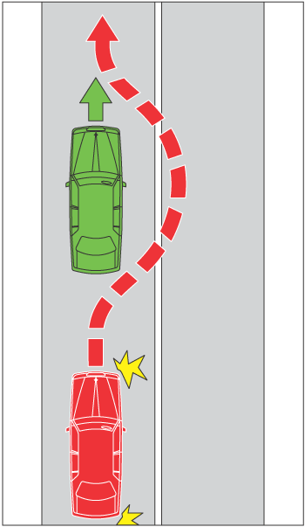 | Driving to the right of the centre of the road not permitted—overtaking on a road with a single continuous dividing line to the left of a broken dividing line  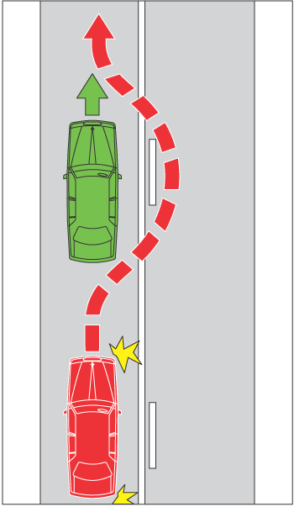

Example 5
Driving to the right of the centre of the road not permitted—overtaking on a road with 2 parallel continuous dividing lines
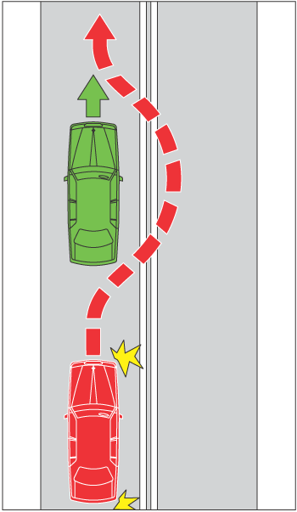
45—Variation of rule 138—Keeping off a painted island
(1) Rule 138(2), note 2—delete "island" and substitute:
island and rule 197 deals with stopping on painted islands
(2) Rule 138(2)—after note 2 insert:
Note 3—
Subrule (3) excludes certain painted islands from the application of paragraph (a).
(3) Rule 138—after subrule (2), including the notes, insert:
(3) Subrule (2)(a) does not apply in the case of a painted island:
(a) that separates a road that takes vehicles in one direction from another road that takes vehicles in the same direction at a place where the roads merge; or
(b) that separates one part of a road from other parts of the road to create a slip lane.
Note—
Slip lane is defined in the dictionary.
Examples—

Example 1  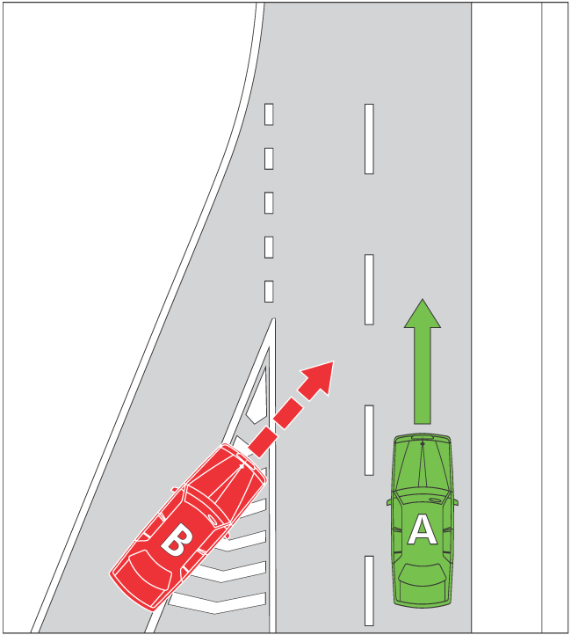 | Example 2  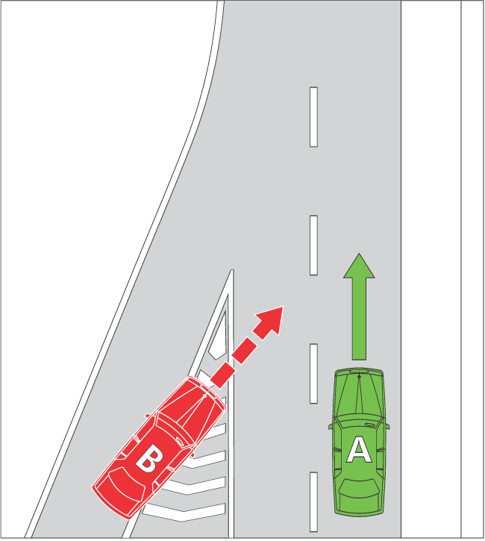
46—Variation of rule 141—No overtaking etc to the left of a vehicle
(1) Rule 141(1)(b)—delete "signal" and substitute:
signal and it is safe to overtake to the left of the vehicle
(2) Rule 141(1), note—delete the note and substitute:
Note—
Bicycle, centre of the road, marked lane, multi-lane road, overtake, right change of direction signal and U-turn are defined in the dictionary.
47—Variation of rule 146—Driving within a single marked lane or line of traffic
(1) Rule 146(1)(a)—delete ", a shoulder of the road or emergency stopping lane" and substitute:
or a shoulder of the road
(2) Rule 146(1), note 1—delete ", shoulder is defined in rule 12, and emergency stopping lane is defined in rule 95" and substitute:
and shoulder is defined in rule 12
(3) Rule 146(2)(b)—delete ", a shoulder of the road or an emergency stopping lane" and substitute:
or a shoulder of the road
48—Variation of rule 148—Giving way when moving from one marked lane or line of traffic to another marked lane or line of traffic
(1) Rule 148(1)—delete "on a multi-lane road"
(2) Rule 148(1), examples, example 1—delete example 1 and substitute:
Example 1
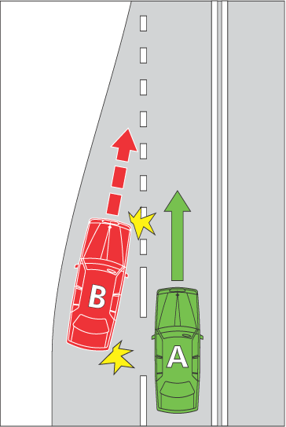
49—Insertion of rule 148A
After rule 148 insert:
148A—Giving way when moving within a single marked lane
If a driver diverges to the left or right within a marked lane, the driver must give way to any vehicle that is in the lane.
Offence provision.
Note—
Marked lane is defined in the dictionary.
50—Variation of rule 150—Driving on or across a continuous white edge line
Rule 150(1), including the notes—delete subrule (1), including the notes, and substitute:
(1) A driver must not drive on or over a continuous white edge line on a road unless subrule (1A) or (1B) applies to the driver.
Offence provision.
Note 1—
Edge line is defined in the dictionary.
Note 2—
A driver must not stop at the side of a road marked with a continuous yellow edge line—see rule 169.
(1A) A driver may drive on or over a continuous white edge line on a road if the driver is:
(a) overtaking a vehicle that is turning right, or making a U-turn from the centre of the road, and is giving a right change of direction signal; or
(b) driving a slow-moving vehicle, and it is necessary for the driver to drive on or over the edge line to allow the vehicle to be overtaken or passed by another vehicle; or
(c) driving a vehicle that is too wide, or too long, to drive on the road without driving on or over the edge line; or
(d) permitted to drive on or over the edge line under another law of this jurisdiction; or
(e) avoiding an obstruction.
Note—
Centre of the road, obstruction, overtake, right change of direction signal and U-turn are defined in the dictionary.
(1B) A driver may drive on or over a continuous white edge line on a road for up to 100 metres if the driver is:
(a) turning at an intersection; or
(b) entering or leaving the road; or
(c) entering a part of the road of one kind from a part of the road of another kind (for example, moving to or from a service road, a shoulder of the road or an emergency stopping lane); or
(d) stopping at the side of the road (including any shoulder of the road).
Note—
Intersection and service road are defined in the dictionary, emergency stopping lane is defined in rule 95, and shoulder is defined in rule 12.
51—Variation of rule 154—Bus lanes
Rule 154(2), except the diagrams and the note for diagrams—delete subrule (2), except the diagrams and the note for diagrams, and substitute:
(2) A bus lane is a marked lane, or the part of a marked lane:
(a) beginning at a bus lane sign (whether or not there is also a bus lane road marking) and ending at the nearest of the following:
(i) an end bus lane sign;
(ii) a traffic sign that indicates the beginning of another special purpose lane; or
(b) beginning at a bus lane road marking (if there is no bus lane sign) and ending at the next intersection.
Note—
Intersection, marked lane, special purpose lane and traffic sign are defined in the dictionary.
(3) In this rule:
bus lane road marking means a road marking consisting of:
(a) the letters ‘BL’; or
(b) the words ‘bus lane’; or
(c) the words ‘bus only’.
Note—
Road marking is defined in the dictionary.
52—Variation of rule 155—Tram lanes
(1) Rule 155(1)—delete "or public bus" and substitute:
, tram recovery vehicle or public bus
(2) Rule 155(1), note 1—delete note 1 and substitute:
Note 1—
Public bus, tram and tram recovery vehicle are defined in the dictionary.
(3) Rule 155(3), except the diagrams, note for diagrams and example—delete subrule (3), except the diagrams, note for diagrams and example, and substitute:
(3) A tram lane is a part of a road with tram tracks that:
(a) is between a tram lane sign and an end tram lane sign; and
(b) is marked along the left side of the tracks (when facing the direction of travel of a tram on the tracks) by a continuous yellow line parallel to the tracks.
Note—
Tram tracks is defined in the dictionary.
53—Insertion of rule 155A
After rule 155 insert:
155A—Tramways
(1) A driver (except the driver of a tram, tram recovery vehicle or public bus) must not drive in a tramway, unless the driver is permitted to drive in the tramway under subrule (2).
Offence provision.
Note 1—
Public bus, tram and tram recovery vehicle are defined in the dictionary.
Note 2—
The exceptions and defence provided in rule 158 do not apply to tramways.
(2) A driver may drive in a tramway if:
(a) it is necessary for the driver to drive in the tramway to avoid an obstruction; and
(b) when driving in the tramway, the driver does not move into the path of an approaching tram or public bus travelling in the tramway.
Note—
Obstruction is defined in the dictionary.
(3) A tramway is a part of a road with tram tracks that:
(a) is between a tramway sign and an end tramway sign; and
(b) is marked along the left side of the tracks (when facing the direction of travel of a tram on the tracks) by either:
(i) 2 continuous yellow lines parallel to the tracks; or
(ii) a structure (for example, a dividing strip, pedestrian refuge, traffic island, row of bollards or separation kerb), whether or not the structure is also being used to indicate a safety zone,
but does include any part of the road where vehicles are permitted to cross the tramway.
(4) For the purposes of subrule (3)(b)(i), a line is to be considered to be continuous despite any break in it that is designed to permit vehicles to cross the tramway.
Note—
Dividing strip, traffic island and tram tracks are defined in the dictionary and safety zone is defined in rule 162.

Tramway sign  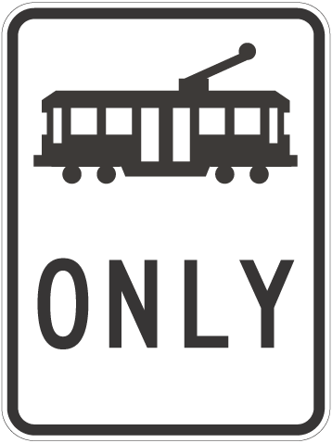 | End tramway sign  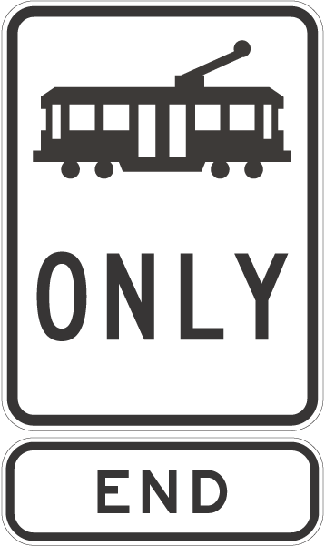

Examples—

Tramway with double yellow line  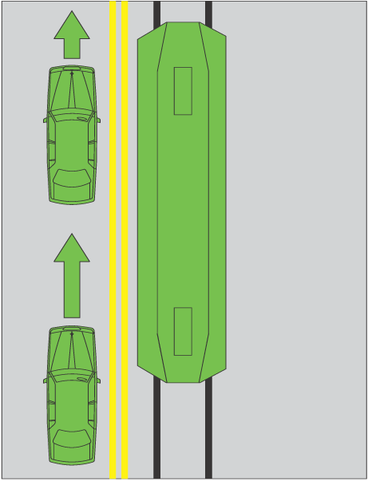 | Tramway with separation kerb  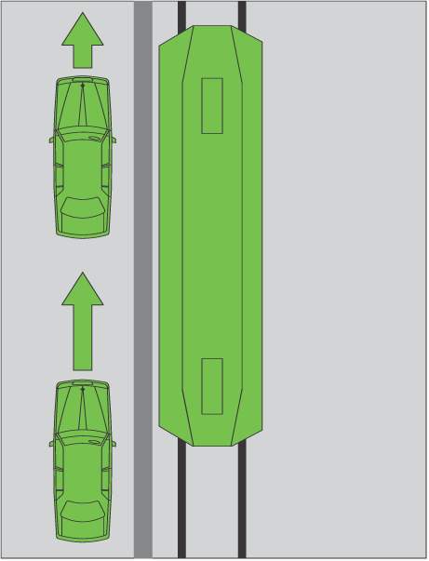
54—Variation of rule 168—No parking signs
Rule 168(3), except the diagrams and the notes for diagrams—delete subrule (3), except the diagrams and the notes for diagrams, and substitute:
(3) In this rule:
required time means:
(a) if information on or with the sign indicates a time—the indicated time; or
(b) if there is no indicated time—2 minutes; or
(c) if there is no indicated time, or the indicated time is less than
5 minutes, and rule 206 applies to the driver—5 minutes.
Note 1—
With is defined in the dictionary.
Note 2—
Rule 206 applies to a driver if the driver’s vehicle displays
a current parking permit for people with disabilities and the
driver complies with the conditions of use of the permit—
see rule 206 (1).
55—Variation of rule 171—Stopping on or near a children's crossing
Rule 171, examples, example 1, diagram except the heading—delete the diagram except the heading and substitute:
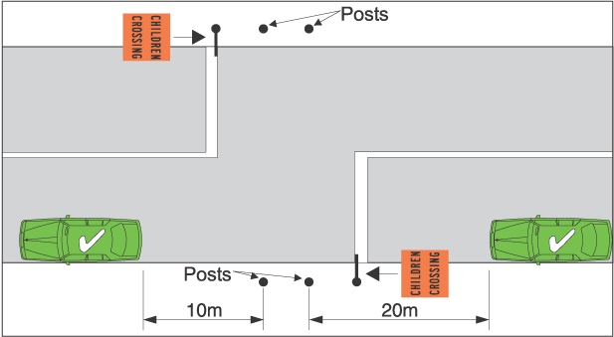
56—Variation of rule 176—Stopping on a clearway
Rule 176(4) and (5), except the diagrams and the note for diagrams—delete subrules (4) and (5), except the diagrams and the note for diagrams, and substitute:
(4) A clearway sign applies, for the days or times indicated on the sign, to a length of road beginning at the sign and ending at the nearest of the following:
(a) a clearway sign on the road that indicates different days or times;
(b) an end clearway sign on the road;
(c) the end of the road.
57—Variation of rule 187—Stopping in a bicycle lane, bus lane, tram lane, tramway, transit lane, truck lane or on tram tracks
Rule 187(3), including the notes—delete subrule (3), including the notes, and substitute:
(3) A driver (except the driver of a tram, a tram recovery vehicle or a public bus) must not stop in a tram lane, a tramway or on tram tracks.
Offence provision.
Note 1—
Bicycle lane is defined in rule 153, bus lane is defined in rule 154, tram lane is defined in rule 155, tramway is defined in rule 155A, transit lane is defined in rule 156, truck lane is defined in rule 157, and public bus, public minibus, taxi, tram and tram tracks are defined in the dictionary.
Note 2—
Rule 76 deals with drivers keeping clear of trams travelling in tram lanes or on tram tracks marked on each side by a yellow line.
Note 3—
Part 11, Division 6 deals with driving in bicycle lanes, bus lanes, tram lanes, tramways, transit lanes and truck lanes.
58—Variation of rule 196—Stopping at or near a tram stop
(1) Rule 196(1), except the notes—delete subrule (1), except the notes, and substitute:
(1) A driver (except the driver of a tram, a tram recovery vehicle or a public bus travelling along tram tracks) must not stop at a tram stop or on the road within 20 metres before a sign that indicates a tram stop, unless:
(a) the driver stops at a place on a length of road, or in an area, to which a parking control sign applies; and
(b) the driver is permitted to stop at that place under the Australian Road Rules.
Offence provision.
(2) Rule 196(1), note 1—delete note 1 and substitute:
Note 1—
Parking control sign, public bus, tram and travelling along tram tracks are defined in the dictionary.
59—Variation of rule 197—Stopping on a path, dividing strip, nature strip or painted island
(1) Rule 197—after subrule (1), including the notes, insert:
(1A) A driver must not stop on a painted island.
Offence provision.
Note 1—
Painted island is defined in the dictionary.
Note 2—
Rule 85 deals with the give way rules applying to a driver entering a turning lane from a painted island and rule 138 deals with keeping off painted islands.
(2) Rule 197(2)—delete "This rule" and substitute:
Subrule (1)
60—Variation of rule 205—Parking for longer than indicated
Rule 205—after subrule (1), including the note, insert:
(1A) If a permissive parking sign does not indicate a period and does not indicate that it applies at particular times, or at particular times on particular days, a driver may, at any time, park continuously on a length of road, or in an area, to which the sign applies, unless:
(a) another parking control sign applies to the length of road or area; and
(b) the driver is prohibited from parking on the length of road, or in the area, under the Australian Road Rules.
Note—
Parking control sign is defined in the dictionary.
61—Insertion of rule 205A
After rule 205 insert:
205A—Parking outside times indicated
If a permissive parking sign indicates that it applies at particular times, or at particular times on particular days, a driver may park on the length of road, or in an area, to which the sign applies at a time, or at a time on a day, when the sign does not apply, unless:
(a) another parking control sign applies to the length of road or area; and
(b) the driver is prohibited from parking on the length of road, or in the area, at that time, or at that time on that day, under the Australian Road Rules.
Note 1—
Parking control sign is defined in the dictionary.
Note 2—
Rules 318 (1) and (2) deal with the effect of information on or with a traffic control device (including a permissive parking sign) that limits the application of the device to particular times or days. Under rule 318 (3), if the information indicates that the device applies on a particular day, for example Friday, the sign does not have effect on a Friday that is a public holiday at the place where the device is located, unless otherwise stated.
62—Variation of rule 208—Parallel parking on a road (except in a median strip parking area)
Rule 208(6)—delete "any dividing line" and substitute:
the continuous dividing line
63—Insertion of rule 208A
After rule 208 insert:
208A—Parallel parking in a road-related area (except in a median strip parking area)
(1) A driver who parks in a road-related area (except in a median strip parking area) must position the driver’s vehicle to face:
(a) in the direction of travel of vehicles in the marked lane or line of traffic next to the part of the road-related area where the driver parks; or
(b) if there is no traffic next to that part of the road-related area—in the direction in which vehicles could lawfully travel in the road-related area; or
(c) if the road-related area is an area that divides a road—either:
(i) in the direction of travel of vehicles in the marked lane or line of traffic to the left of the driver; or
(ii) if there is no traffic to the left of the driver—in the direction in which vehicles could lawfully travel on that part of the road.
Offence provision.
Note—
Driver’s vehicle, line of traffic, marked lane and median strip parking area are defined in the dictionary and road-related area is defined in rule 13.
(2) Subrule (1) does not apply if:
(a) another law of this jurisdiction permits the driver to park in another manner in the road-related area; or
(b) signs or road markings indicate that angle parking is required in the road-related area.
64—Variation of rule 210—Angle parking
(1) Rule 210(2A), examples, example 2, heading—delete "Parking at 45° at the side of a one-way road" and substitute:
Parking at 45° at the right side of a one-way road
(2) Rule 210(4A), examples for subrule (4)—delete the examples and substitute:
Examples for subrule (4)—

Example 5  Parking "rear in" at 30° at the side of a road  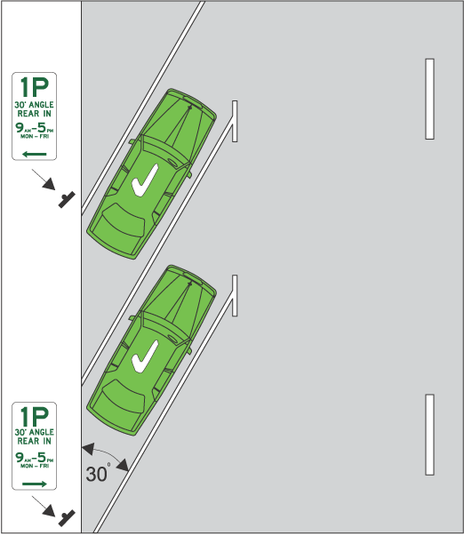 | Example 6  Parking "rear in" at 30° in a median strip parking area  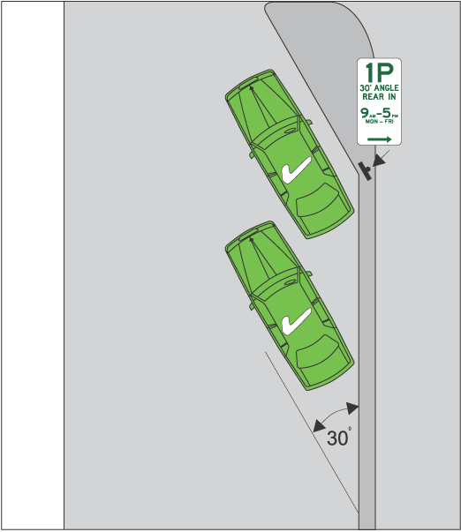
Example 7  Parking "rear in" at 45° at the side of a road  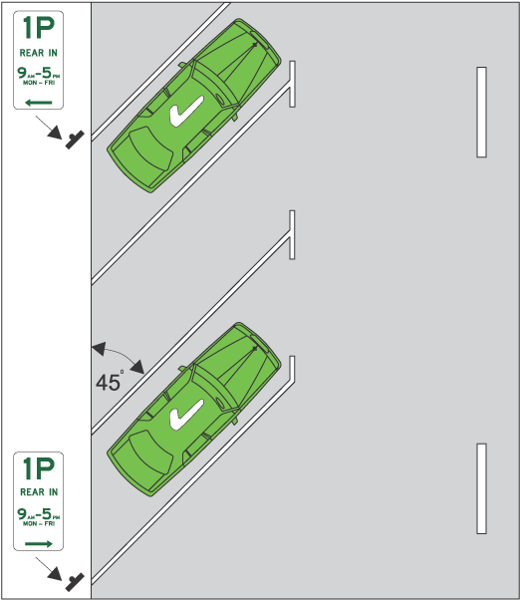 | Example 8  Parking "rear in" at 45° in a median strip parking area  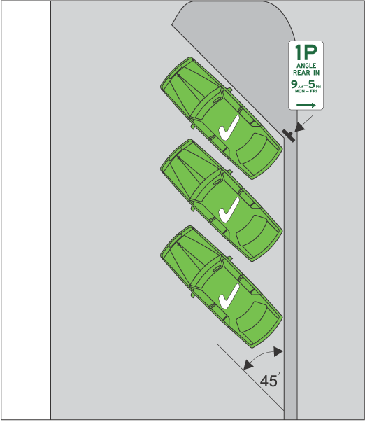

Example 9  Parking "rear in" at 60° at the side of a road  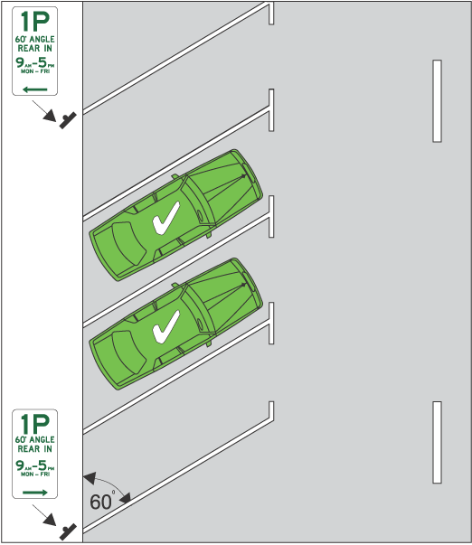 | Example 10  Parking "rear in" at 60° in a median strip parking area  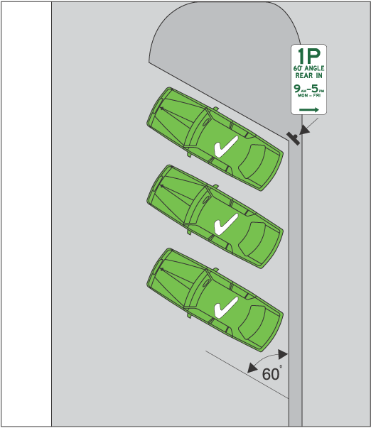
65—Variation of rule 211—Parking in parking bays
(1) Rule 211(1) and (2)—delete subrules (1) and (2), including the notes, and substitute:
(1) This rule applies to a driver who parks on a length of road, or in an area, that has parking bays (whether or not a park in bays only sign applies to the length of road or area).
Note—
Parking bay is defined in the dictionary.
Park in bays only sign
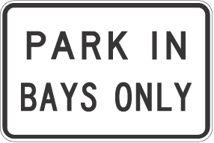
(2) The driver must position the driver’s vehicle completely within a single parking bay, unless the vehicle is too wide or long to fit completely within the bay.
Offence provision.
Note 1—
Driver’s vehicle is defined in the dictionary.
Note 2—
Vehicle includes a combination—see rule 15 (d).
(2) Rule 211(3), diagram, including the heading to the diagram—delete the diagram, including the heading to the diagram
66—Variation of rule 213—Making a motor vehicle secure
Rule 213(5)—delete subrule (5) and substitute:
(5) If the driver will be over 3 metres from the closest part of the vehicle and there is no-one left in the vehicle, the driver must:
(a) if the windows of the vehicle can be secured—secure the windows immediately before leaving the vehicle; and
(b) if the doors of the vehicle can be locked—lock the doors immediately after leaving the vehicle.
Offence provision.
Note—
Window is defined in the dictionary.
(6) For the purposes of subrule (5), a window is secure even if it is open by up to 2 centimetres.
67—Variation of rule 217—Using fog lights
(1) Rule 217(1)—delete "a rear fog light must not operate the fog light" and substitute:
front fog lights or rear fog lights must not operate the fog lights
(2) Rule 217(2)—delete subrule (2) and substitute:
(2) In this rule:
front fog light means a light (other than a headlight) fitted to the front of a vehicle to improve illumination of the road in fog, snowfall, heavy rain or dust clouds.
rear fog light means a light (other than a brake light, a tail light, a number plate light or a reversing light) fitted to the rear of a vehicle to make the vehicle more easily visible from the rear in fog, snowfall, heavy rain or dust clouds.
68—Variation of rule 221—Using hazard warning lights
(1) Rule 221(g)—after "anti-theft device" insert:
, or an alcohol interlock device,
(2) Rule 221—after its present contents (now to be designated as subrule (1)) insert:
(2) In this rule:
alcohol interlock device means a device in a vehicle that is designed to prevent the vehicle from being started or driven unless the device is supplied with a breath sample that contains either no alcohol, or less than a certain concentration of alcohol.
69—Variation of rule 224—Using horns and similar warning devices
(1) Rule 224(b)—after "anti-theft device" insert:
, or an alcohol interlock device,
(2) Rule 224, note 1—delete note 1 and substitute:
Note 1—
Driver’s vehicle is defined in the dictionary, road user is defined in rule 14 and alcohol interlock device is defined in rule 221.
70—Variation of rule 225—Using radar detectors and similar devices
(1) Rule 225(1)—after "if the vehicle" insert:
, or a trailer being towed by the vehicle,
(2) Rule 225(2), including the note—delete subrule (2), including the note, and substitute:
(2) A person who is travelling in or on a vehicle or trailer must not have in his or her possession a device for preventing the effective use of a speed measuring device, or a device for detecting the use of a speed measuring device, unless the person is exempt from this rule under another law of this jurisdiction.
Offence provision.
(3) Subrules (1) and (2) apply whether or not the device is operating or in working order.
Note—
Under the law of this jurisdiction, radar detectors and similar devices may be subject to confiscation.
71—Variation of rule 238—Pedestrians travelling along a road (except in or on a wheeled recreational device or toy)
Rule 238(2)—after paragraph (a) insert:
(ab) must, when moving forward, face approaching traffic that is moving in the direction opposite to that in which the pedestrian is travelling, unless it is impracticable to do so; and
72—Variation of heading to Part 14 Division 2
Heading to Part 14, Division 2—after note 2 insert:
Note 3—
Rules that apply to users of wheeled recreational devices also apply to users of motorised scooters—see the definitions of wheeled recreational device and motorised scooter in the dictionary.
73—Insertion of rule 239A
Part 14, Division 2—before rule 240 insert:
239A—No wheeled recreational devices or toys sign
A person on a road who is travelling in or on a wheeled recreational device or wheeled toy must not travel past a no wheeled recreational devices or toys sign.
Offence provision.

No wheeled recreational devices or toys sign
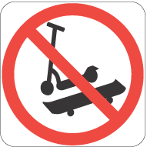 | 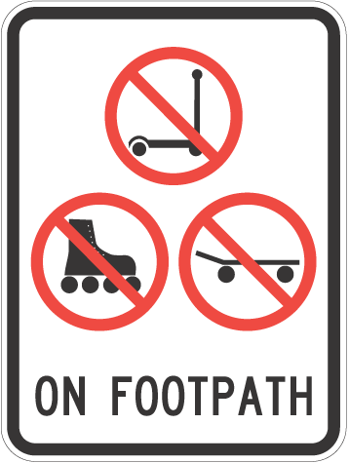
74—Variation of rule 240—Wheeled recreational devices and toys not to be used on certain roads
(1) Rule 240(1)(b)—delete "60" and substitute:
50
(2) Rule 240(2)(b)—delete paragraph (b) and substitute:
(b) on a road at night; or
(c) on a road at any other time if another law of this jurisdiction prohibits wheeled recreational devices from being on all roads, or that road, at that time.
(3) Rule 240(2), example for paragraph (b)—delete the example and substitute:
Note—
Night is defined in the dictionary.
(4) Rule 240—after subrule (3) insert:
(3A) Subrules (1) and (2) do not apply to a person who is crossing a road in or on a wheeled recreational device or wheeled toy, if the person:
(a) crosses the road by the shortest safe route; and
(b) does not stay on the road longer than necessary to cross the road safely; and
(c) is not prohibited, under another law of this jurisdiction, from crossing the road in or on the wheeled recreational device or wheeled toy.
(5) Rule 240(4)—delete "In subrule (1)" and substitute:
In subrules (1) and (2) (b)
75—Insertion of rules 244A to 244C
Part 14 Division 2—after rule 244 insert:
244A—Meanings of scooter and motorised scooter
(1) In these Rules:
scooter means a device that:
(a) has 2 or more wheels and a footboard supported by the wheels; and
(b) is steered by handlebars; and
(c) is designed to be used by a single person; and
(d) is propelled by any 1 or more of the following:
(i) gravity;
(ii) the user pushing 1 foot against the ground;
(iii) an electric motor or motors; and
(e) if it is fitted with an electric motor or motors, complies with the following requirements:
(i) its maker certifies (either by means of a plate attached to the motor or each motor, or by means of engraving on the motor or each motor) the ungoverned power output of the motor, or each motor;
(ii) the maximum power output of the motor, or the combined maximum power output of the motors, is not more than 200 watts;
(iii) when propelled only by the motor or motors, the scooter is not capable of going faster than 10 km/h on level ground.
motorised scooter means a scooter that is propelled by 1 or more electric motors and complies with the requirements in paragraph (e) of the definition of scooter.
(2) A reference in paragraph (d) or (e) of the definition of scooter, or in the definition of motorised scooter, in subrule (1), to a motor includes both a motor that is part of the relevant device and a motor that is attached to the device.
(3) In these Rules, a reference to a scooter includes a motorised scooter unless the contrary intention appears.
244B—Wearing of helmets by users of motorised scooters
A person who is travelling on a motorised scooter on a road or road-related area must wear an approved bicycle helmet securely fitted and fastened on his or her head, unless he or she is exempt from wearing a bicycle helmet under another law of this jurisdiction.
Offence provision.
Note—
Approved bicycle helmet and motorised scooter are defined in the dictionary.
244C—Motorised scooters not to be used
If another law of this jurisdiction prohibits the use of motorised scooters on a road or road-related area, a person must not travel on a motorised scooter on a road or road-related area.
Offence provision.
76—Variation of rule 246—Carrying people on a bicycle
Rule 246—after its present contents (now to be designated as subrule (1)) insert:
(2) A passenger on a bicycle that is moving, or is stationary but not parked, must sit in the seat designed for the passenger.
Offence provision.
(3) The rider of a bicycle must not ride with a passenger unless the passenger complies with subrule (2).
Offence provision.
77—Insertion of rules 247A and 247B
After rule 247 insert:
247A—Entering a bicycle storage area
(1) A rider of a bicycle approaching a bicycle storage area at an intersection that has traffic lights or traffic arrows showing a red traffic light or red arrow must not enter the bicycle storage area other than from a bicycle lane, unless the rider is not required to ride in the bicycle lane under the Australian Road Rules.
Offence provision.
Note—
Bicycle storage area is defined in the dictionary.
(2) Subrule (1) does not apply if:
(a) the bicycle storage area cannot, under another law of this jurisdiction, be entered from a bicycle lane; and
(b) the rider enters the area in accordance with another law of this jurisdiction.
247B—Giving way while entering or in a bicycle storage area
(1) A rider of a bicycle must when entering a bicycle storage area, give way to:
(a) any vehicle that is in the area; and
(b) if the area is before any green or yellow traffic lights, any motor vehicle that is entering or about to enter the area, unless the motor vehicle is turning in a direction that is subject to a red traffic arrow; and
(c) if the area forms part of a lane to which traffic arrows apply, any motor vehicle that is entering or about to enter the area at a time when those arrows are green or yellow.
Offence provision.
Note—
Bicycle storage area is defined in the dictionary.
(2) A rider of a bicycle that is in a bicycle storage area that extends across more than one lane of a multi-lane road must, if the area is before any green or yellow traffic lights, give way to a motor vehicle that is in any lane other than the lane that the bicycle is directly in front of, unless the motor vehicle is turning in a direction that is subject to a red traffic arrow.
Offence provision.
78—Variation of rule 256—Bicycle helmets
Rule 256(2) and (3)—delete subrules (2) and (3) and substitute:
(2) A passenger on a bicycle that is moving, or is stationary but not parked, must wear an approved bicycle helmet securely fitted and fastened on the passenger’s head, unless the passenger is:
(a) a paying passenger on a three or four-wheeled bicycle; or
(b) exempt from wearing a bicycle helmet under another law of this jurisdiction.
Offence provision.
(3) The rider of a bicycle must not ride with a passenger on the bicycle unless the passenger complies with subrule (2).
Offence provision.
79—Variation of rule 260—Stopping for a red bicycle crossing light
Rule 260(1), note—delete the note and substitute:
Note 1—
Bicycle crossing lights is defined in the dictionary.
Note 2—
Red bicycle crossing light includes a flashing red bicycle crossing light—see the definition in the dictionary.
80—Variation of rule 261—Stopping for a yellow bicycle crossing light
Rule 261(1), note—delete the note and substitute:
Note 1—
Bicycle crossing lights is defined in the dictionary.
Note 2—
Yellow bicycle crossing light includes a flashing yellow bicycle crossing light—see the definition in the dictionary.
81—Substitution of rule 262
Rule 262—delete the rule and substitute:
262—Proceeding when bicycle crossing lights change to yellow or red
(1) The rider of a bicycle who is crossing at an intersection, or another place on a road, with bicycle crossing lights and traffic lights must comply with this rule.
Offence provision.
Note—
Bicycle crossing lights, intersection and traffic lights are defined in the dictionary.
(2) If the bicycle crossing lights change from green to yellow, flashing yellow, red or flashing red while the rider is crossing the road, the rider must not stay on the road for longer than necessary to cross safely to the nearer (in the direction of travel of the rider) of the following:
(a) a dividing strip, safety zone, or traffic island, forming part of the area set aside or used by riders of bicycles to cross the road at the intersection or place (the safety area);
(b) the nearest side of the road.
Note—
Dividing strip and traffic island are defined in the dictionary, and safety zone is defined in rule 162.
(3) If, under subrule (2), the rider crosses to the safety area, the rider must remain in the safety area until the bicycle crossing lights change to green.
(4) However, if the rider cannot operate the bicycle crossing lights from the safety area, the rider may cross to the far side of the road when:
(a) the traffic lights change to green or flashing yellow, or there is no red traffic light showing; and
(b) it is safe to do so.
Note—
Red traffic light is defined in the dictionary.
(5) In this rule:
road does not include a road-related area, but includes any shoulder of the road.
Note—
Road-related area is defined in rule 13 and shoulder is defined in rule 12.
82—Variation of rule 271—Riding on motor bikes
(1) Rule 271(1)—delete "that is moving, or" and substitute:
that is moving (other than a rider who is walking beside and pushing a motor bike), or the rider of a motor bike that
(2) Rule 271—after subrule (5) insert:
(5A) The rider of a motor bike must not ride with a passenger who is under
8 years old unless the passenger is in a sidecar.
Offence provision.
(5B) A passenger must not ride in a sidecar of a motorbike unless the passenger is seated safely.
Offence provision.
(5C) The rider of a motor bike must not ride with a passenger in a sidecar unless the passenger complies with subrule (5B).
Offence provision.
83—Variation of heading to Part 17
(1) Heading to Part 17, except the notes—delete the heading, except the notes, and substitute:
Part 17—Additional rules for drivers of trams, tram recovery vehicles and public buses
(2) Heading to Part 17, note 1—after "trams," insert:
tram recovery vehicles,
(3) Heading to Part 17, note 2—delete "trams and public buses" and substitute:
trams, tram recovery vehicles and public buses
84—Variation of heading to Part 17 Division 1
Heading to Part 17, Division 1, note—delete the note and substitute:
Note—
Public bus, T lights, tram, tram recovery vehicle and travelling along tram tracks are defined in the dictionary.
85—Substitution of rule 273
Rule 273—delete the rule and substitute:
273—Division also applies to tram recovery vehicles and public buses travelling along tram tracks
(1) This Division applies to the driver of a tram recovery vehicle as if a reference in the Division to a tram included a reference to a tram recovery vehicle.
(2) This Division applies to the driver of a public bus travelling along tram tracks as if a reference in the Division to a tram included a reference to a public bus travelling along tram tracks.
86—Variation of rule 280—Application of Division
Rule 280(1), except the note—delete subrule (1), except the note, and substitute:
(1) This Division applies to the driver of a public bus who is driving in a bus lane.
87—Variation of rule 297—Driver to have proper control of a vehicle etc
(1) Rule 297—after subrule (1) insert:
(1A) A driver must not drive a vehicle if a person or an animal is in the
driver’s lap.
Offence provision.
(2) Rule 297—after subrule (2), including the note, insert:
(3) The rider of a motor bike must not ride with an animal on the petrol tank of the motor bike.
Offence provision.
Note—
Motor bike is defined in the dictionary.
(4) Subrule (3) does not apply to a person who rides with an animal on the petrol tank of a motor bike for a distance of not more than 500 metres on a road for the purposes of a farming activity that the person is carrying out.
88—Substitution of rule 301
Rule 301—delete the rule and substitute:
301—Leading an animal while driving a vehicle
(1) The driver of a motor vehicle must not lead an animal, including by tethering the animal to the motor vehicle, unless the driver is permitted to do so under another law of this jurisdiction.
Offence provision.
Note—
Motor vehicle is defined in the dictionary.
(2) A person who is a passenger in, or on any part of, a motor vehicle must not lead an animal while the motor vehicle is moving unless the passenger is permitted to do so under another law of this jurisdiction.
Offence provision.
(3) The rider of a bicycle must not lead an animal, including by tethering the animal to the bicycle, unless the rider is permitted to do so under another law of this jurisdiction.
Offence provision.
Note—
Bicycle is defined in the dictionary.
89—Variation of rule 309—Exemption for drivers of trams etc
(1) Rule 309—delete "tram, or" and substitute:
tram, the driver of a tram recovery vehicle engaged in accessing or recovering a disabled tram, or the driver of
(2) Rule 309, note—delete the note and substitute:
Note—
Public bus, tram, tram recovery vehicle and travelling along tram tracks are defined in the dictionary.
90—Variation of rule 313—Exemption for postal vehicles
Rule 313(2)—after the item relating to rule 288 (Driving on a path) insert:
• rule 289 (Driving on a nature strip)
91—Insertion of rule 323A
Part 20 Division 1—after rule 323 insert:
323A—Audible lines
(1) An audible line is a line on a road that is made up of a series of closely spaced raised pieces of material designed to create a continuous noise or vibration if driven on by a motor vehicle.
Note—
Motor vehicle is defined in the dictionary.
(2) A reference in the Australian Road Rules to a line is to be taken to include a reference to an audible line, unless otherwise expressly stated.
(3) For the purposes of the Australian Road Rules:
(a) an audible line is to be taken to be continuous even if there is no physical link between the pieces of material that make up the line;
(b) if there is no physical link between those pieces, the colour of the audible line is to be taken to be the visible colour of those pieces.
92—Variation of rule 334—How parking control signs apply to a length of road
Rule 334(2), except the examples—delete subrule (2), except the examples, and substitute:
(2) If a parking control sign applies to a length of road, the sign is at the side of the road, and there are no parking bays to which the sign applies, then, unless information on or with the sign indicates otherwise, the sign applies to:
(a) any shoulder of the road on that side of the road; and
(b) the part of the road on the length of road that extends from the far side of the road (excluding any road-related area) on that side of the road for:
(i) if the sign, or information on or with the sign, includes the words ‘angle parking’ or ‘angle’—6 metres; or
(ii) in any other case—3 metres.
Note—
Road-related area is defined in rule 13 and shoulder is defined in rule 12.
93—Variation of rule 335—Traffic control devices applying to an area
Rule 335(2), examples—after example 4 insert:
5 An end no parking area sign.
6 An end no stopping area sign.
7 An end parking area sign.
94—Variation of rule 340—Traffic control devices (except road markings and parking control signs)
Rule 340(2), example 2—delete example 2 and substitute:
2 If a driver is turning left using a slip lane at an intersection, a traffic light on the right side of the painted island or traffic island that separates the slip lane from other parts of the road does not apply to the driver.
95—Variation of rule 341—Road markings
Rule 341, note—delete the note and substitute:
Note 1—
Road marking is defined in the dictionary.
Note 2—
A person may, under another rule, be exempt from complying with particular road markings—see, for example, rules 134, 138, 139, 147 and 150.
96—Insertion of rule 352
Part 21—after rule 351 insert:
352—References to stopping as near as practicable to a place
A requirement in the Australian Road Rules for a driver to stop as near as practicable to a place is not complied with only because the driver stops behind a vehicle that has stopped at the place.
Example—
If a driver stops behind a vehicle that has stopped at a stop sign or stop line in accordance with rule 67, 68 or 121, the driver must, after the vehicle has proceeded, stop at the stop sign or stop line in accordance with the rule.
97—Variation of Schedule 2—Standard or commonly used traffic signs
(1) Schedule 2, item headed "End keep left unless overtaking sign"—delete the item and substitute:
End keep left unless overtaking sign
(rule 130)
(2) Schedule 2—after item headed "End no overtaking or passing sign" insert:

End no parking area sign  (rule 335)  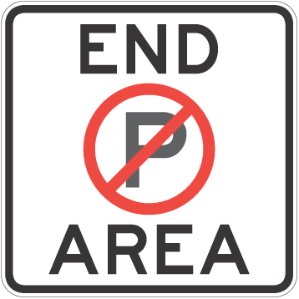 | End no stopping area sign  (rule 335)  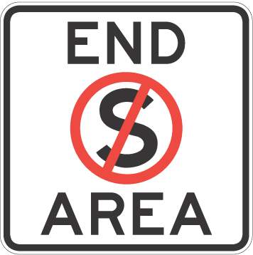
End parking area sign
(rule 335)
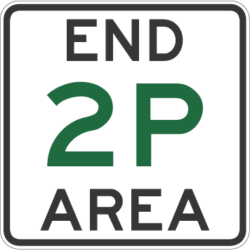
(3) Schedule 2—after item headed "One-way sign" insert:
One-way sign
(rule 98)
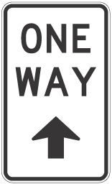
(4) Schedule 2—after item headed "Shared zone sign" insert:
Slow vehicle turn out lane sign
(rule 130)
98—Variation of Schedule 3—Other permitted traffic signs
(1) Schedule 3—after item headed "End freeway sign", last occurring, insert:
End keep left unless overtaking sign
(rule 130)
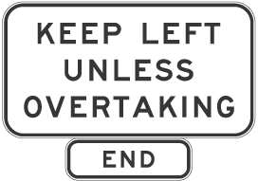
(2) Schedule 3—after item headed "End school zone sign", last occurring, insert:
End school zone sign
(rule 23)
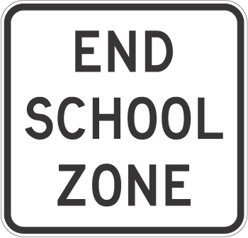
(3) Schedule 3—after item headed "End tram lane sign" insert:
End tramway sign
(rule 155A)
(4) Schedule 3—after item headed "Hand-held stop sign", last occurring, insert:
Hand-held stop sign
(rules 80, 101)

(5) Schedule 3—after item headed "No U-turn sign", last occurring, insert:

No wheeled recreational devices or toys sign  (rule 239A) | No wheeled recreational devices or toys sign  (rule 239A)
(6) Schedule 3, item headed "One-way sign", last occurring (in which the arrow on the sign is vertical),—delete the item
(7) Schedule 3—after item headed "School zone sign", last occurring, insert:

School zone sign  (rule 23)  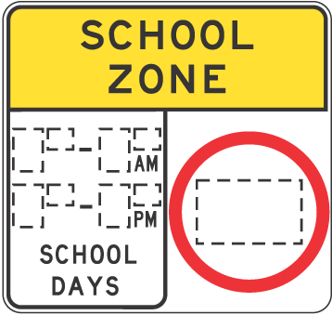 | School zone sign  (rule 23)  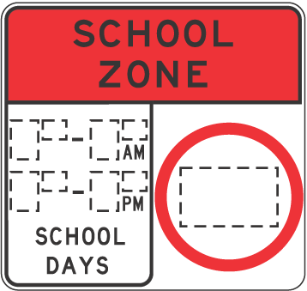

School zone sign  (rule 23)  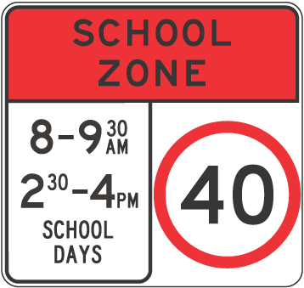 | School zone sign  (rule 23)  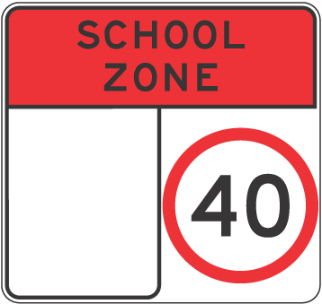
(8) Schedule 3—after item headed "Taxi zone sign", last occurring, insert:
Taxi zone sign
(rule 182)
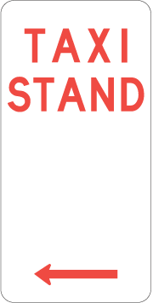
(9) Schedule 3—after item headed "Tram lane sign" insert:
Tramway sign
(rule 155A)
(10) Schedule 3—after item headed "Transit lane sign", last occurring, insert:

Truck arrester bed  (rule 101A)  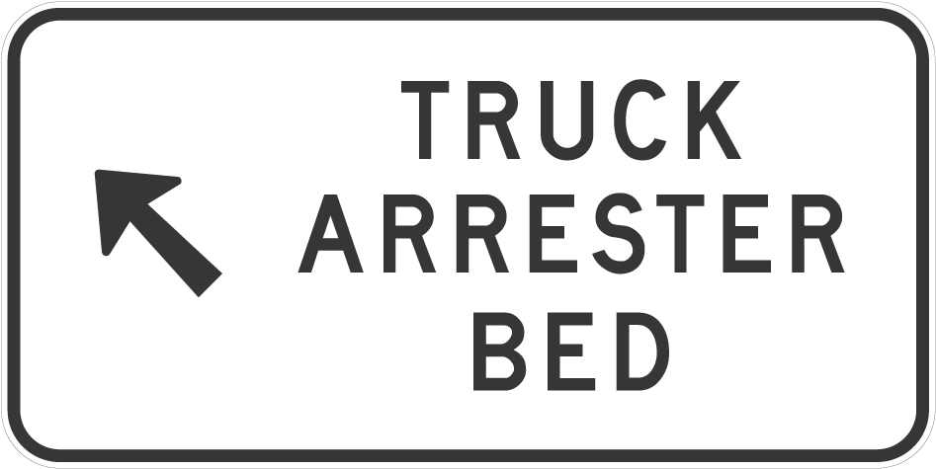 | Truck arrester bed  (rule 101A)  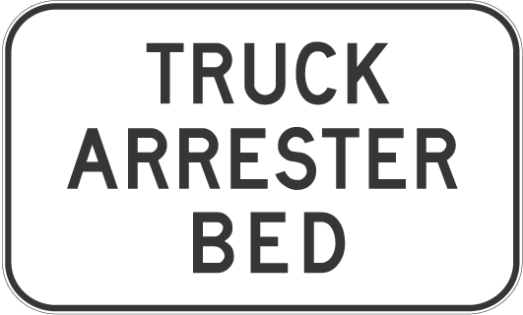
99—Variation of Dictionary
(1) Dictionary—after the definition of adjacent land, including the notes, insert:
alcohol interlock device see rule 221.
(2) Dictionary—after the definition of bicycle crossing lights, including the note, insert:
bicycle hook turn storage area means an area between an intersection and a marked foot crossing, or if there is no marked foot crossing, a stop line, before the intersection that has painted on it 1 or more bicycle symbols and 1 or more right traffic lane arrows, and includes any line that delineates the right side of the area, and any line that delineates the left side of the area that is not also a stop line or part of a marked foot crossing and excludes any bicycle storage area.
Note 1—
Intersection, bicycle symbol, right traffic lane arrows, motor vehicle and marked foot crossing are defined in this dictionary and hook turns are described in rules 34 and 35.
Note 2—
See example in rule 35.
(3) Dictionary—after the definition of bicycle path road marking insert:
bicycle storage area means:
(a) an area of a road before an intersection with traffic lights:
(i) that has painted on it 1 or more bicycle symbols; and
(ii) that is between 2 parallel stop lines, regardless of whether the lines are of equal length; and
(iii) that opens out from a bicycle lane;
but does not include any stop line; or
(b) if another law of this jurisdiction defines a bicycle storage area, that area as defined under that law.
Note—
Intersection, traffic lights, bicycle symbol and stop line are defined in this dictionary.
(4) Dictionary, definition of built-up area, excluding the note,—delete the definition, excluding the note, and substitute:
built-up area, in relation to a length of road, means an area in which either of the following is present for a distance of at least 500 metres or, if the length of road is shorter than 500 metres, for the whole road:
(a) buildings, not over 100 metres apart, on land next to the road;
(b) street lights not over 100 metres apart.
(5) Dictionary—after the definition of freeway insert:
front fog light see rule 217.
(6) Dictionary—after the definition of motor bike insert:
motorised scooter see rule 244A.
(7) Dictionary, definition of motor vehicle—delete the definition and substitute:
motor vehicle means a vehicle (other than a motorised scooter) that is built to be propelled by a motor that forms part of the vehicle.
(8) Dictionary, definition of painted island—delete the definition and substitute:
painted island means an area of a road:
(a) that has painted on it stripes or chevrons in white or another colour that contrasts with the colour of the road; and
(b) that is surrounded either:
(i) by a line or lines (whether broken or continuous); or
(ii) partly by a combination of a line or lines (whether broken or continuous) and partly by a kerb or by a structure on or next to the road.
(9) Dictionary—after the definition of school zone insert:
scooter see rule 244A.
(10) Dictionary, definition of stop line, (b)—delete paragraph (b) and substitute:
(b) is not part of a marked foot crossing, a keep clear marking or a bicycle storage area for hook turns.
(11) Dictionary, definition of traffic arrows—delete "installed with traffic lights that is"
(12) Dictionary—after the definition of tram lane insert:
tram recovery vehicle means a vehicle used by a tram operator to access and recover disabled trams for which the tram operator is responsible.
(13) Dictionary, definition of tram stop—delete the definition and substitute:
tram stop means a place on a road at which there is a sign indicating that trams will stop to enable people to get on or off.
(14) Dictionary—after the definition of tram tracks insert:
tramway see rule 155A.
(15) Dictionary—after the definition of turning lane, including the note, insert:
turn line means a road marking, at an intersection, consisting of a line (whether broken or continuous) that is designed to indicate how a turn is to be made at the intersection.
(16) Dictionary, definition of wheeled recreational device, (b)—after "motor-assisted device" insert:
other than a motorised scooter
(17) Dictionary, definition of wheeled toy—after "scooter" insert:
(other than a motorised scooter)
(18) Dictionary—after the definition of white traffic arrow insert:
window, in relation to a vehicle, includes any sunroof fitted to the vehicle.
Made by the Governor
with the advice and consent of the Executive Council
on 25 September 2008
No 261 of 2008
MRS07/005CS

HOUSING IMPROVEMENT ACT 1940
WHEREAS by notice published in the Government Gazette on the dates mentioned in the following table the South Australian Housing Trust did declare the houses described in the said table to be substandard for the purposes of Part 7 of the Housing Improvement Act 1940, the South Australian Housing Trust in the exercise of the powers conferred by the said Part, does hereby fix as the maximum rental per week which shall be payable subject to section 55 of the Residential Tenancies Act 1995, in respect of each house described in the following table the amount shown in the said table opposite the description of such house and this notice shall come into force on the date of this publication in the Gazette.
Address of House | Allotment, Section, etc. | Certificate of Title  Volume Folio | Date and page of Government Gazette in which notice declaring house to be substandard published | Maximum rental per week payable in respect of each house  $

37 Hamilton Road, Aldinga Beach |  | Allotment 237 in Deposited Plan 6381, Hundred of Willunga | 5728 | 664 |  | 31.7.08, page 3501 | 180.00
42 Ashton Road, Davoren Park |  | Allotment 951 in Deposited Plan 7712, Hundred of Munno Para | 5643 | 55 |  | 31.7.08, page 3501 | 157.00
16 East Street, Port Wakefield |  | Allotment 140 in Filed Plan 175460, Hundred of Inkerman | 5818 | 621 |  | 26.7.90, page 426 | 135.00
231 Railway Terrace, Tailem Bend |  | Allotment 368 in the area of Tailem Bend, Hundred of Seymour | 6009 | 469 |  | 11.2.88, page 359 | 165.00
Unit 1/18 Sando Avenue, Tranmere |  | Unit 1, Strata Plan 1616, Hundred of Adelaide | 5055 | 774 |  | 27.3.08, page 1102 | 120.00
11 Taylors Road, Waterloo Corner (also known as Lot 11, Stanley Road) |  | Allotment 11 in Deposited Plan 4843, Hundred of Munno Para | 5342 | 381 |  | 5.6.08, page 1844 | 179.00

Dated at Adelaide, 25 September 2008. D. Huxley, Director, Corporate and Board Services

HOUSING IMPROVEMENT ACT 1940
NOTICE is hereby given that the South Australian Housing Trust in the exercise of the powers conferred by the Housing Improvement Act 1940, does hereby declare the houses described in the table hereunder to be substandard for the purposes of Part 7 of the Housing Improvement Act 1940.
No. of House and Street | Locality | Allotment, Section, etc. | Certificate of Title  Volume Folio

41 Branson Avenue |  | Clearview | Allotment 7 in Deposited Plan 6076, Hundred of Yatala | 5659 | 99
7 Gayland Road |  | Elizabeth Downs | Allotment 166 in Deposited Plan 7075, Hundred of Munno Para | 5280 | 873
53 Nimitz Road |  | Elizabeth East | Allotment 140 in Deposited Plan 6415, Hundred of Munno Para | 5208 | 160
247 Hogarth Road |  | Elizabeth Grove | Allotment 23 in Filed Plan 18197, Hundred of Munno Para | 5120 | 474
23 Mofflin Road |  | Elizabeth Grove | Allotment 349 in Deposited Plan 6188, Hundred of Munno Para | 5263 | 562
3 Dally Road |  | Gilles Plains | Allotment 64 in Deposited Plan 7771, Hundred of Yatala | 5503 | 173
Unit 2/18 Fosters Road |  | Hillcrest | Unit 2, Strata Plan 10641, Hundred of Yatala | 5339 | 222
Unit 4/7, Liston Street |  | Parkside | Unit 4, Strata Plan 6627, Hundred of Adelaide | 5014 | 506
5 Strathcona Avenue |  | Panorama | Allotment 151 in Deposited Plan 3692, Hundred of Adelaide | 5281 | 161
9 Fifth Street |  | Port Pirie West | Allotment 60 in Deposited Plan 895, Hundred of Pirie | 5814 | 144
9 Gray Terrace |  | Rosewater | Allotment 16 in Deposited Plan 1560, Hundred of Port Adelaide | 5435 | 83
1 Nalara Avenue |  | Rostrevor | Allotment 134 in Deposited Plan 3603, Hundred of Adelaide | 5272 | 781
5 Twelfth Avenue |  | Woodville North | Allotment 61 in Deposited Plan 4177, Hundred of Yatala | 5789 | 918

Dated at Adelaide, 25 September 2008. D. Huxley, Director, Corporate and Board Services

HOUSING IMPROVEMENT ACT 1940
WHEREAS by notice published in the Government Gazette on the dates mentioned in the following table the South Australian Housing Trust did declare the houses described in the said table to be substandard for the purposes of Part 7 of the Housing Improvement Act 1940, and whereas the South Australian Housing Trust is satisfied that each of the houses described hereunder has ceased to be substandard, notice is hereby given that, in exercise of the powers conferred by the said Part, the South Australian Housing Trust does hereby revoke the said declaration in respect of each house.
Address of House | Allotment, Section, etc. | Certificate of Title  Volume Folio | Date and page of Government Gazette in which notice declaring house to be substandard published

Allotment 1, Warnertown Road, Port Pirie (also known as 205 Warnertown Road) |  | Allotment 1 of Portion of Section 834 in Filed Plan 2014, Hundred of Pirie | 5101 | 187 |  | 1.9.77, page 625

Dated at Adelaide, 25 September 2008. D. Huxley, Director, Corporate and Board Services

T. GOODES, Government Printer, South Australia

