No. 58 3611

THE SOUTH AUSTRALIAN

GOVERNMENT GAZETTE
www.governmentgazette.sa.gov.au

PUBLISHED BY AUTHORITY

ALL PUBLIC ACTS appearing in this GAZETTE are to be considered official, and obeyed as such

ADELAIDE, THURSDAY, 13 AUGUST 2009

CONTENTS

Page
Appointments, Resignations, Etc. 3612
Aquaculture Act 2001—Notice 3612
Corporations and District Councils—Notices 3667
Crown Lands Act 1929—Notice 3613
Development Act 1993—
Erratum 3614
Notice 3614
Development Regulations 2008—Notice 3614
Fisheries Management Act 2007—Notices 3615
Housing Improvement Act 1940—Notices 3617
Liquor Licensing Act 1997—Notices 3618
Mining Act 1971—Notices 3623
National Electricity Law—Notice 3624
Natural Resources Management Act 2004—Notices 3624

Page
National Parks and Wildlife (National Parks) Regulations
2001—Notices 3624
Petroleum Act 2000—Notices 3627
Pharmacy Practice Act 2007—Notice 3630
Public Trustee Office—Administration of Estates 3669

REGULATIONS
Passenger Transport Act 1994 (No. 217 of 2009) 3647
Animal Welfare Act 1985 (No. 218 of 2009) 3652
Development Act 1993 (No. 219 of 2009) 3664
Roads (Opening and Closing) Act 1991—Notice 3627
Road Traffic Act 1961—Notice 3646
South Australian Local Government Grants Commission
Act 1992—Notice 3646

GOVERNMENT GAZETTE NOTICES
ALL poundkeepers’ and private advertisements forwarded for publication in the South Australian Government Gazette must be PAID FOR PRIOR TO INSERTION; and all notices, from whatever source, should be legibly written on one side of the paper only and sent to Government Publishing SA so as to be received no later
than 4 p.m. on the Tuesday preceding the day of publication. Phone 8207 1045 or Fax 8207 1040. E-mail: governmentgazette@dpc.sa.gov.au. Send as attachments in Word format and please confirm your transmission with a faxed copy of your document, including the date the notice is to be published and to whom the notice will be charged. The Government Gazette is available online at: www.governmentgazette.sa.gov.au

Department of the Premier and Cabinet
Adelaide, 13 August 2009
HIS Excellency the Governor’s Deputy in Executive Council has been pleased to appoint the undermentioned to the Child Death and Serious Injury Review Committee, pursuant to the provisions of the Children’s Protection Act 1993:
Member: (from 13 August 2009 until 12 August 2011)
Angela Marie Davis
By command,
Tom Koutsantonis, for Premier
DFCCN/09/029

Department of the Premier and Cabinet
Adelaide, 13 August 2009
HIS Excellency the Governor’s Deputy in Executive Council has been pleased to appoint the undermentioned to the State Theatre Company of South Australia—Board of Governors, pursuant to the provisions of the State Theatre Company of South Australia Act 1972:
Governor: (from 13 August 2009 until 30 June 2010)
Loretta Anne Reynolds
By command,
Tom Koutsantonis, for Premier
ASACAB004/02

Department of the Premier and Cabinet
Adelaide, 13 August 2009
HIS Excellency the Governor’s Deputy in Executive Council has been pleased to appoint the undermentioned to the Pastoral Board, pursuant to the provisions of the Pastoral Land Management and Conservation Act 1989:
Deputy Member: (from 13 August 2009 until 4 July 2010)
Fraser James Vickery (Deputy to Iwanicki)
Helen Kay Lamont (Deputy to Bartsch)
By command,
Tom Koutsantonis, for Premier
WBCS09/0018

Department of the Premier and Cabinet
Adelaide, 13 August 2009
HIS Excellency the Governor’s Deputy in Executive Council has been pleased to appoint the undermentioned to the Legal Practitioners Disciplinary Tribunal, pursuant to the provisions of the Legal Practitioners Act 1981:
Member: (from 13 August 2009 until 12 August 2012)
Liesl Jane Chapman
Michael Greig Evans
By command,
Tom Koutsantonis, for Premier
AGO0067/07CS

Department of the Premier and Cabinet
Adelaide, 13 August 2009
HIS Excellency the Governor’s Deputy in Executive Council has been pleased to appoint the Honourable Jane Diane Lomax-Smith, MP, Minister for Education, Minister for Mental Health and Substance Abuse, Minister for Tourism and Minister for the City of Adelaide to be also Acting Minister for Health, Acting Minister for the Southern Suburbs and Acting Minister Assisting the Premier in the Arts for the period from 15 August 2009 to 21 August 2009 inclusive, during the absence of the Honourable John David Hill, MP.
By command,
Tom Koutsantonis, for Premier
HEAC-2009-00049

Department of the Premier and Cabinet
Adelaide, 13 August 2009
HIS Excellency the Governor’s Deputy in Executive Council has been pleased to appoint the Honourable Michael John Atkinson, MP, Attorney-General, Minister for Justice, Minister for Multicultural Affairs and Minister for Veterans’ Affairs to be also Acting Minister for Police, Acting Minister for Emergency Services and Acting Minister for Recreation, Sport and Racing for the period from 16 August 2009 to 28 August 2009 inclusive, during the absence of the Honourable Michael John Wright, MP.
By command,
Tom Koutsantonis, for Premier
MPOL09/009CS

Department of the Premier and Cabinet
Adelaide, 13 August 2009
HIS Excellency the Governor’s Deputy in Executive Council has been pleased to appoint the Honourable Michael John Atkinson, MP, Attorney-General, Minister for Justice, Minister for Multi-cultural Affairs and Minister for Veterans’ Affairs to be also Acting Minister for Families and Communities, Acting Minister for the Northern Suburbs, Acting Minister for Housing, Acting Minister for Ageing and Acting Minister for Disability for the period from 17 August 2009 to 30 August 2009 inclusive, during the absence of the Honourable Jennifer Mary Rankine, MP.
By command,
Tom Koutsantonis, for Premier
DFCCS/09/046

Department of the Premier and Cabinet
Adelaide, 13 August 2009
HIS Excellency the Governor’s Deputy in Executive Council has been pleased to appoint Melanie Joy D’ambrosio, Justin Yorke Granleese and Catherine Anne Witkowski as analysts for the purposes of the Controlled Substances Act 1984, from 17 August 2009, pursuant to section 51 of the Controlled Substances Act 1984.
By command,
Tom Koutsantonis, for Premier
AGO0189/09CS

AQUACULTURE ACT 2001
Grant of Aquaculture Lease
PURSUANT to the provisions of section 22 of the Aquaculture Act 2001, Paul Caica, Minister for Agriculture, Food and Fisheries, hereby gives notice of the grant of the following leases for the purposes of aquaculture in the waters of the state:
LA00162 | LA00095
LA00119 | LA00120
LA00130 | LA00246
LA00247 | LA00227
LA00228 | LA00201
LA00202 | LA00203
LA00204 | LA00205
LA00206 | LA00207
LA00208 | LA00209
LA00210 | LA00211
LA00212 | LA00213
LA00214 | LA00215
LA00216 | LA00217
LA00218 | LA00219
LA00220 | LA00221
LA00222 | LA00223
LA00221 | LA00225
LA00226 | LA00227
LA00228 | LA00229
LA00230 | LA00231
LA00232 | LA00233
LA00234 | LA00235
LA00236 | LA00237
LA00238 | LA00239
LA00174 | LA00175
LA00176 | LA00177
LA00178 | LA00179

Further details are available for all of the above leases granted on the PIRSA Aquaculture Public Register; which can be found at https://info.pir.sa.gov.au/aquapr/page/gui3/map.html.
Paul Caica, Minister for Agriculture, Food and Fisheries

CROWN LANDS ACT 1929: SECTION 5
TAKE NOTICE that pursuant to the Crown Lands Act 1929, I, JAY WEATHERILL, Minister for Environment and Conservation, Minister of the Crown to whom the administration of the Crown Lands Act 1929 is committed DO HEREBY:
1. Dedicate the Crown Land defined in The First Schedule as Reserves for Drainage Purposes and declare that such land shall be under the care, control and management of the Cobdogla Irrigation Trust Incorporated.
2. Dedicate the Crown Land defined in The Second Schedule as Reserves for Water Supply Purposes and declare that such land shall be under the care, control and management of the Cobdogla Irrigation Trust Incorporated.
The First Schedule
Allotment 6 in Deposited Plan 25952, Allotment 5 in Deposited Plan 27848, Allotments 4 and 6 in Deposited Plan 42312, Allotment 3 in Deposited Plan 43628, Allotments 108, 109 and 111 in Deposited Plan 72045, Allotments 101, 103, 105 and 106 in Deposited Plan 72046, Allotments 101, 103 and 104 in Deposited Plan 72047, Allotment 101 in Deposited Plan 73084, Allotment 101 in Deposited Plan 75990, Sections 761, 955, 978, 979, 981, 982, 986, 989, 990, 993, 995, 1000, 1006, 1007, 1011, 1013, 1014, 1015, 1016, 1020, 1033, 1036, 1041, 1046, 1051, 1056, 1066, 1068, 1086, 1087, 1090, 1091, 1092, 1093, 1094, 1095, 1097, 1098, 1099, 1100, 1101, 1102 and 1103, Hundred of Loveday, Cobdogla Irrigation Area, Loveday Division, County of Hamley and Allotments 203, 204 and 205 in Deposited Plan 62771, Allotment 100 in Deposited Plan 74105, Allotment 100 in Deposited Plan 75741, Sections 713, 730, 742, 756, 778 and 782, Cobdogla Irrigation Area, Nookamka Division and Sections 814, 816, 817, 818 and 821, Cobdogla Irrigation Area, Cobdogla Division and Section 103, Hundred of Katarapko, Cobdogla Irrigation Area, Weigall Division, County of Hamley, exclusive of all necessary roads, subject to an existing easement over portion of Allotment 100 marked B on Deposited Plan 75741 (Land Grant Volume 4402, Folio 711).
The Second Schedule
Allotments 100 and 102 in Deposited Plan 75533, Allotment 6 in Deposited Plan 27848, Allotment 2 in Deposited Plan 30831, Allotment 101 in Deposited Plan 72048, Sections 760, 863, 864, 865, 956, 991, 996, 998, 999, 1004, 1017, 1018, 1022, 1023, 1027, 1028, 1029, 1037, 1038, 1052, 1054, 1057, 1106, 1107, 1108, 1109 and 1110, Hundred of Loveday, Cobdogla Irrigation Area, Loveday Division, County of Hamley and Allotments 3 and 4 in Deposited Plan 23852, Allotments 5 and 6 in Deposited Plan 27336, Allotment 100 in Filed Plan 35543, Allotment 101 in Filed Plan 37018, Allotment 100 in Filed Plan 37436, Allotments 1 and 3 in Deposited Plan 44846, Allotment 11 in Deposited Plan 45408, Allotments 5 and 9 in Deposited Plan 45493, Allotment 161 in Deposited Plan 46615, Allotments 3 and 5 in Deposited Plan 47099, Allotments 11 and 12 in Deposited Plan 47533, Allotment 11 in Deposited Plan 48291, Allotments 100 and 102 in Deposited Plan 74299, Sections 695, 748, 749, 759, 765, 769,
770, 779, 780, 781, 785, 794, 849, 851 and 852, Cobdogla Irrigation Area, Nookamka Division and Sections 679, 680 and 811, Cobdogla Irrigation Area, Cobdogla Division, exclusive of all necessary roads, subject to:
1. An existing easement over Allotment 6 in Deposited Plan 27336 (RLG 8256659).
2. An existing easement over portion of Allotment 6 in Deposited Plan 27336 marked A on Filed Plan 36255 (Land Grant Volume 4402, Folio 711).
3. An existing easement over portion of Allotment 100 marked A on Filed Plan 35543 (RLG 8256659).
4. An existing easement over portion of Allotment 5 in Deposited Plan 27336 marked A on Filed Plan 36230 (RLG 8256659).
5. An existing easement over portion of Allotment 101 marked B on Filed Plan 37018 (RLG 8210215).
6. Existing easements over portion of Allotment 101 marked A on Filed Plan 37018 (RLG 8643237 and RLG 8769997).
7. An existing easement over portion of Allotment 100 marked E on Filed Plan 37436 (RLG 8210215).
8. Existing easements over portion of Allotment 100 marked D on Filed Plan 37436 (RLG 8769992 and RLG 8769994).
9. Existing easements over portions of Allotment 100 marked X and C on Filed Plan 37436 (RLG 8769993 and RLG 8769997 respectively).
10. An existing easement over Allotment 11 in Deposited Plan 45408 (RLG 8256659).
11. Existing easements over portions of Allotment 11 marked A and B on Deposited Plan 45408 (Land Grant Volume 5428, Folio 934 and Land Grant Volume 4402, Folio 710 respectively).
12. An existing easement over Allotment 9 in Deposited Plan 45493 (RLG 8769997).
13. An existing easement over Allotment 161 in Deposited Plan 46615 (RLG 8368473).
14. Existing easements over portions of Allotment 161 marked A and D on Deposited Plan 46615 (Land Grant Volume 4402, Folio 710 and Land Grant Volume 4402, Folio 711 respectively).
15. An existing easement over portion of Allotment 5 marked D on Deposited Plan 47099 (RLG 8256659).
16. An existing easement over portion of Allotment 3 marked B on Deposited Plan 47099 (Land Grant Volume 4402, Folio 710).
17. An existing easement over portion of Allotment 11 marked A on Deposited Plan 48291 (RLG 8256659).
18. Existing easements over portions of Allotment 11 marked B and C on Deposited Plan 48291 (Land Grant Volume 4402, Folio 710 and Land Grant Volume 4402, Folio 711 respectively).
19. An existing easement over Allotment 102 in Deposited Plan 74299 and portion of Allotment 100 marked A on Deposited Plan 74299 (RLG 8769997).
20. An existing easement over portion of Allotment 100 marked B on Deposited Plan 74299 (RLG 8769996).
21. An existing easement over portion of Allotment 102 marked D on Deposited Plan 74299 (RLG 8210217).
22. An existing easement over portions of Allotments 100 and 102 marked C on Deposited Plan 74299 (RLG 8210215).
23. An existing right of way over portion of Allotment 100 in Deposited Plan 75533 marked A on Filed Plan 50416 (RLG 11093129).
24. Existing rights of way over portions of Allotment 100 in Deposited Plan 75533 marked B and C on Filed Plan 50416 (RLG 11121080).
25. An existing easement over portion of Section 695, Cobdogla Irrigation Area, Nookamka Division marked A on Filed Plan 37241 (RLG 8196124).
26. An existing easement over Section 748, Cobdogla Irrigation Area, Nookamka Division (RLG 8256659).
27. An existing easement over portion of Section 748, Cobdogla Irrigation Area, Nookamka Division marked B on Filed Plan 49480 (Land Grant Volume 4402, Folio 711).
28. An existing right of way over portion of Section 748, Cobdogla Irrigation Area, Nookamka Division marked A on Filed Plan 49480 (RLG 10942033).
29. An existing easement over Section 765, Cobdogla Irrigation Area, Nookamka Division (RLG 8769997).
30. Existing easements over portions of Section 780, Cobdogla Irrigation Area, Nookamka Division marked C and B on Filed Plan 37621 (RLG 8769995 and RLG 8769997 respectively).
31. An existing easement over portion of Section 781, Cobdogla Irrigation Area, Nookamka Division marked A on Filed Plan 37581 (RLG 8769997).
32. An existing easement over portion of Section 849, Cobdogla Irrigation Area, Nookamka Division marked A on Filed Plan 36256 (Land Grant Volume 4402, Folio 711).
33. An existing easement over portion of Section 851, Cobdogla Irrigation Area, Nookamka Division marked A on Filed Plan 36256 (Land Grant Volume 4402, Folio 711).
34. An existing easement over portion of Section 852, Cobdogla Irrigation Area, Nookamka Division marked A on Filed Plan 36256 (Land Grant Volume 4402, Folio 711).
35. An existing easement over Section 794, Cobdogla Irrigation Area, Nookamka Division (RLG 8256659).
Dated 13 August 2009.
Jay Weatherill, Minister for Environment and Conservation
DEH 11/4106

DEVELOPMENT ACT 1993, SECTION 25 (17): CITY OF CHARLES STURT—BETTER DEVELOPMENT PLAN (BDP) AND GENERAL DEVELOPMENT PLAN AMEND-MENT
Preamble
1. The Development Plan amendment entitled ‘City of Charles Sturt—Better Development Plan (BDP) and General Development Plan Amendment’ (the Plan Amendment) has been finalised in accordance with the provisions of the Development Act 1993.
2. The Minister for Urban Development and Planning has decided to approve the Plan Amendment.
Notice
PURSUANT to section 25 of the Development Act 1993, I—
(a) approve the Plan Amendment; and
(b) fix the day on which this notice is published in the Gazette as the day on which the Plan Amendment will come into operation.
Dated 13 August 2009.
Paul Holloway, Minister for Urban Development and Planning

DEVELOPMENT ACT 1993, SECTION 25 (17): CITY OF PORT ADELAIDE ENFIELD—OUTDOOR ADVERTISE-MENTS DEVELOPMENT PLAN AMENDMENT
Preamble
1. The Development Plan amendment entitled ‘City of Port Adelaide Enfield—Outdoor Advertisements Development Plan Amendment’ (the Plan Amendment) has been finalised in accordance with the provisions of the Development Act 1993.
2. The Minister for Urban Development and Planning has decided to approve the Plan Amendment.
Notice
PURSUANT to section 25 of the Development Act 1993, I—
(a) approve the Plan Amendment; and
(b) fix the day on which this notice is published in the Gazette as the day on which the Plan Amendment will come into operation.
Dated 13 August 2009.
Paul Holloway, Minister for Urban Development and Planning

DEVELOPMENT ACT 1993
Erratum
City of Port Adelaide Enfield Development Plan
Amendment Notice
THE notice in the Government Gazette that appeared Thursday,
6 August 2009, on page 3477, for the approval of the ‘CITY
OF PORT ADELAIDE—INDUSTRY ZONES PART ONE DEVELOPMENT PLAN AMENDMENT’, should read, as follows:
‘DEVELOPMENT ACT 1993, SECTION 25 (17): CITY OF PORT ADELAIDE ENFIELD—INDUSTRY ZONES PART ONE DEVELOPMENT PLAN AMENDMENT
Preamble
1. The Development Plan amendment entitled ‘City of Port Adelaide Enfield—Industry Zones Part One Development Plan Amendment’ (the Plan Amendment) has been finalised in accordance with the provisions of the Development Act 1993.
2. The Minister for Urban Development and Planning has decided to approve the Plan Amendment.
Notice
PURSUANT to section 25 of the Development Act 1993, I—
(a) approve the Plan Amendment; and
(b) the Plan Amendment is operational as of 6 August 2009.’
Dated 13 August 2009.
Paul Holloway, Minister for Urban Development and Planning

DEVELOPMENT REGULATIONS 2008
Complying Development—Regulation 8A and Schedule 4
Areas Determined by the Minister for the Purposes of Clause 2B of Schedule 4—New Dwellings
Preamble
It is necessary to advise that pursuant to Schedule 4, Clause 2B (1) of the Development Regulations 2008, I, Paul Holloway, being the Minister administering the Development Act 1993, revoke existing determined areas within the Charles Sturt (City) Develop-ment Plan dated 4 September 2008 and determine additional areas within the Charles Sturt Council Development Plan as identified in this notice.
Notice
PURSUANT to Schedule 4, Clause 2B (1), of the Development Regulations 2008, I, Paul Holloway, being the Minister administering the Development Act 1993, have revoked all the determined areas as gazetted on the 18 June 2009, within the Charles Sturt (City) Development Plan dated 4 September 2008, that Schedule 4—Complying Development, Clause 2(B) currently applies to.
I have further determined the following areas within the Charles Sturt Council Development Plan (amended by the approved Charles Sturt Council Better Development Plan (BDP) and General Development Plan Amendment) where Schedule 4—Complying Development, Clause 2(B) will apply as follows:
1. Except where located on land shown in the Development Plan to be adjacent land to an Industrial Zone and/or within ANEF Contours, ANEI or Aircraft Noise affected areas, the area defined by the boundaries of the following Residential Zone policy areas:
(i) Inner Suburban Policy Area 15
(ii) Western Edge Policy Area 17
(iii) West Lakes General Policy Area 18
(iv) West Lakes Medium Density Policy Area 19
(v) Integrated Medium Density Policy Area 20
(vi) Woodville Medium Density Policy Area 21
(vii) Cheltenham Park Policy Area 22.
Dated 13 August 2009.
Paul Holloway, Minister for Urban Development and Planning

FISHERIES MANAGEMENT ACT 2007: SECTION 115
TAKE notice that pursuant to section 115 of the Fisheries Management Act 2007, Damien Wilksch, Block 35, Cadell, S.A. 5321 (the ‘exemption holder’), holder of River Fishery Licence No. R03, is exempt from section 53 (2) of the Fisheries Management Act 2007 and Regulation 7 (b) (i) and Clause 6 of Schedule 6 of the Fisheries Management (General) Regulations 2007, but only insofar as he may use the device described in Schedule 1 to take carp, bony bream and other non-native species in the areas specified in Schedule 2 for the purpose of trade or business (the ‘exempted activity’), subject to the conditions set out in Schedule 3, from 7 August 2009 until 30 June 2010, unless varied or revoked earlier.
Schedule 1
‘Carp net’—a gill net with a ply greater than 5, having a maximum length of 50 m and a minimum mesh size of 10 cm and a maximum mesh size not exceeding 18 cm.
Schedule 2
(1) Subject to paragraph (2), the licence holder may conduct fishing activities pursuant to this licence in all backwaters of the River Murray excluding the following areas during the corresponding period set out in the following table:
Area Excluded | Period of Closure
Lake Littra and outflow channel | Permanent—all year
Clover Lake | Permanent—all year
Coombool Swamp | Permanent—all year
Lake Limbra and outflow channel | Permanent—all year
Lake Woolpolool | Permanent—all year
Ral Ral Creek below Chaffey Pumping Station and entrance waters to Lake Merreti | Permanent—all year
Katarapko Creek and Eckert Creek, including The Splash | Permanent—all year
Bulyong Creek | Permanent—all year
Pilby Creek | Permanent—all year
Hancock Creek | Permanent—all year
Mundic Creek | Permanent—all year
Pike River | Permanent—all year
Punkah Creek | Permanent—all year
Slaney Creek | Permanent—all year
Loch Luna | Permanent—all year
Cobdogla Swamp | 1 August to 30 April (inclusive)
Loveday Swamp/Mussel lagoons | 1 August to 30 April (inclusive)
Lake Merreti | 1 August to 31 January (inclusive)
(2) The licence holder may conduct fishing operations within the closure areas and periods listed above if given written approval by the Director of Fisheries to undertake specified carp eradication work in a specified area for a specified period.
Schedule 3
1. The exemption holder must not use more than 30 carp nets at any one time in permitted backwaters of the River Murray.
2. The exemption holder must not have more than 30 carp nets in his possession at any time when he is deploying carp nets in the backwaters of the River Murray.
3. The exemption holder may only engage in the exempted activity when also fishing pursuant to River Fishery Licence No. R03, and may only use a boat to engage in the exempted activity if that boat is registered by endorsement on River Fishery Licence No. R03.
4. The exemption holder must not cause or permit a person to act as his agent when engaged in the exempted activity unless that person may lawfully act as an agent for the exemption holder in relation to River Fishery Licence No. R03.
5. All native fish (excluding bony bream and yabbies) taken in the course of the exempted activity must be immediately returned to the water.
6. Immediately prior to commencing the exempted activity, the exemption holder must contact the PIRSA Fisheries Compliance Unit on 1800 065 522 and provide the following details:
• the licence number and person(s) conducting the activity;
• the exact location(s) of the fishing activities;
• the number of carp nets being used;
• Exemption No. 9902266.
7. The exemption holder must ensure that the carp nets are checked and all fish removed at least once during each 24 hour period.
8. When the exemption holder moves the carp nets more than 3 km from the reported location of the nets under Condition 6, or removes the nets from the river completely, the exemption holder must again report to PIRSA Fisheries Compliance on 1800 065 522 and provide either details, as required under Condition 6 of this exemption notice, or report that fishing with carp nets has ceased.
9. While engaged in the exempted activity, the exemption holder must be in possession of a copy of this notice. Such notice must be produced to a PIRSA Fisheries Compliance Officer as requested.
10. The exemption holder must not contravene or fail to comply with the Fisheries Management Act 2007, or any regulations made under that Act, except where specifically exempted by this notice.
Dated 6 August 2009.
M. Smallridge, Director of Fisheries

FISHERIES MANAGEMENT ACT 2007: SECTION 79
TAKE note that the notice made under section 79 of the Fisheries Management Act 2007, published in the South Australian Govern-ment Gazette, dated 5 March 2009, referring to the West Coast Prawn Fishery, is hereby varied such that it will not be unlawful for a person fishing pursuant to a West Coast Prawn Fishery Licence to use prawn trawl nets in the waters specified in Schedule 1, under the conditions specified in Schedule 2, during the period specified in Schedule 3.
Schedule 1
The waters of the west coast prawn fishery adjacent to Venus Bay.
Schedule 2
1. Each licence holder must ensure that a representative sample of the catch (a ‘bucket count’) is taken for each trawl shot carried out during the fishing activity.
2. Each ‘bucket count’ sample must be accurately weighed to 7 kg where possible and the total number of prawns contained in the bucket must be recorded on the attached data sheet, marked ‘West Coast Prawn Fishery Bucket Count Data Sheet’.
3. The information recorded on the ‘WCPF Bucket Count Data Sheet’ must be returned to SARDI Aquatic Sciences within 15 days of the fishing activity being completed.
4. Fishing must cease if one or both of the following limits are reached:
(a) the average catch per vessel, per night (for all three vessels) drops below 300 kg for two consecutive nights;
(b) the average prawn ‘bucket count’ for all three vessels exceeds 240 prawns per bucket on any single fishing night.
5. The fleet must nominate a licence holder to provide a daily update by telephone or SMS message to the PIRSA Fisheries Manager, to report the total prawn catch per night and the average prawn ’bucket count’ information.
6. No fishing activity may be undertaken between 0700 hours and 1830 hours on any day during the period of this notice
Schedule 3
From 1830 hours on 14 August 2009 to 0700 hours on 28 August 2009.
Dated 11 August 2009.
S. Sloan, Program Leader, Fisheries Management

FISHERIES MANAGEMENT ACT 2007: SECTION 115
Erratum
IN Government Gazette No. 57 dated 6 August 2009, on page 3480, second notice appearing, due to a typographical error in the table ‘Area Excluded’ Pike Creek should be replaced with Pike River.
M. Smallridge, Director of Fisheries

FISHERIES MANAGEMENT ACT 2007: SECTION 115
TAKE notice that, pursuant to section 115 of the Fisheries Management Act 2007, Andrew Ferguson of Australian Bight Abalone, G.P.O. Box 1243, Adelaide, S.A. 5001 (the ‘exemption holder’) or a person acting as his agent are exempt from section 52 of the Fisheries Management Act 2007, but only insofar as they may collect beachcast algae and seagrass, for the purpose of trade or business (the ‘exempted activity’) in the areas specified in Schedule 1, subject to the conditions in Schedule 2, from 3 August 2009 until 31 August 2009, unless varied or revoked earlier.
Schedule 1
Intertidal area between Mean Low Water Springs and Mean High Water Springs and bounded by 486181mE 6285680mN (MGA zone 53) to the north and 485411mE 6279859mN (MGA zone 53) to the south.
Schedule 2
1. The exemption holder may take beachcast (unconnected and deposited on shore) algae and seagrass for the purpose of trade or business from the area listed in Schedule 1.
2. A maximum of 500 tonnes may be collected pursuant to this exemption.
3. The operation should be designed to prevent removal of sand.
4. Written permission from the Department of Transport, Energy and Infrastructure must be obtained before material may be collected from the area.
5. The exemption holder must notify PIRSA Fishwatch on 1800 065 522 on any day of operation, at least two hours prior to conducting the exempted activity and answer a series of questions about the exempted activity. The exemption holder will need to have a copy of the exemption at the time of making the call and be able to provide information about the area and time of the exempted activity, the vehicles and other related questions. Exemption No. 9902274.
6. A report on the area of beach cleared (square metres), volume of seagrass cleared (cubic metres) and the method and location of disposal must be supplied to the Director of Fisheries, G.P.O. Box 1625, Adelaide, S.A. 5001 no later than 15 working days after the expiry of this exemption.
7. While engaged in the exempted activity the exemption holder or his agent must carry or have about or near their person a copy of this notice. Such notice must be produced to a PIRSA Fisheries Officer upon request.
8. The exemption holder must not contravene or fail to comply with the Fisheries Management Act 2007, or any regulations made under that Act, except where specifically exempted by this notice.
Dated 5 August 2009.
M. Smallridge, Director of Fisheries

HOUSING IMPROVEMENT ACT 1940
WHEREAS by notice published in the Government Gazette on the dates mentioned in the following table, the South Australian Housing Trust Board delegate did declare the houses described in the following table to be substandard for the purposes of Part 7 of the Housing Improvement Act 1940, and whereas the South Australian Housing Trust is satisfied that each of the houses described hereunder has ceased to be substandard, notice is hereby given that, in exercise of the powers conferred by the said Part, the South Australian Housing Trust does hereby revoke the said declaration in respect of each house.
Address of House | Allotment, Section, etc. | Certificate of Title  Volume Folio | Date and page of Government Gazette in which notice declaring house to be substandard published

1 Drew Street, (also known as 78 Old Port Wakefield Road) Two Wells |  | Allotments 2, 3 and 4 in Deposited Plan 326, Hundred of Port Gawler | 5789 | 579 |  | 28.8.80, page 730
8A Honeysuckle Drive, Hope Valley (8A and 8B Honeysuckle Drive converted to one dwelling) |  | Allotment 5 in Deposited Plan 6284, Hundred of Yatala | 5286 | 456 |  | 26.2.09, page 751
8B Honeysuckle Drive, Hope Valley (8A and 8B Honeysuckle Drive converted to one dwelling) |  | Allotment 5 in Deposited Plan 6284, Hundred of Yatala | 5286 | 456 |  | 26.2.09, page 751

Dated at Adelaide, 13 August 2009. D. Huxley, Director, Corporate Services, Housing SA

HOUSING IMPROVEMENT ACT 1940
WHEREAS by notice published in the Government Gazette on the dates mentioned in the following table the South Australian Housing Trust Board delegate did declare the houses described in the said table to be substandard for the purposes of Part 7 of the Housing Improvement Act 1940, the South Australian Housing Trust in the exercise of the powers conferred by the said Part, does hereby fix as the maximum rental per week which shall be payable subject to section 55 of the Residential Tenancies Act 1995, in respect of each house described in the following table the amount shown in the said table opposite the description of such house and this notice shall come into force on the date of this publication in the Gazette.
Address of House | Allotment, Section, etc. | Certificate of Title  Volume Folio | Date and page of Government Gazette in which notice declaring house to be substandard published | Maximum rental per week payable in respect of each house  $

4 Eyre Highway, Wudinna |  | Section 162, Hundred of Pygery in the area named Wudinna | 5423 | 217 |  | 26.3.09, page 1125 | 140.00
33B (formerly known as 33) Second Street, Nuriootpa |  | Allotment 237 in Filed Plan 210213, Hundred of Nuriootpa | 5978 | 279 |  | 2.9.76, page 799 | 285.00
16 White Terrace, Fulham Gardens |  | Allotment 5 in Deposited Plan 8497, Hundred of Yatala | 5130 | 983 |  | 4.6.09, page 2331 | 290.00

Dated at Adelaide, 13 August 2009. D. Huxley, Director, Corporate Services, Housing SA

HOUSING IMPROVEMENT ACT 1940
NOTICE is hereby given that the South Australian Housing Trust Board delegate in the exercise of the powers conferred by the Housing Improvement Act 1940, does hereby declare the houses described in the table hereunder to be substandard for the purposes of Part 7 of the Housing Improvement Act 1940.
No. of House and Street | Locality | Allotment, Section, etc. | Certificate of Title  Volume Folio

Unit 3, 6 Bingham Street |  | Goolwa | Unit 3 in Strata Plan 3945, Hundred of Goolwa | 5046 | 196
12 O’Brien Street |  | Adelaide | Allotment 264 in Filed Plan 182726, Hundred of Adelaide | 5521 | 119
7 Queen Street |  | Kapunda | Allotment 508 in Filed Plan 211294, Hundred of Kapunda | 5594 | 621
32 Sellicks Beach Road |  | Selicks Beach | Allotment 135 in Deposited Plan 5715, Hundred of Willunga | 5397 | 538
21 Victoria Street |  | Peterborough | Allotment 1 in Filed Plan 147899, Hundred of Yongala | 5271 | 79

Dated at Adelaide, 13 August 2009. D. Huxley, Director, Corporate Services, Housing SA

LIQUOR LICENSING ACT 1997
Notice of Application
NOTICE is hereby given, pursuant to section 52 (2) (b) of the Liquor Licensing Act 1997, that Buffin Pty Ltd as trustee for the Buffalo Family Trust has applied to the Licensing Authority for the transfer of a Restaurant Licence in respect of premises situated at 465 Pulteney Street, Adelaide, S.A. 5000, known as Anytime Modern Chinese Restaurant and to be known as Café ‘Q’ Uisine.
The application has been set down for hearing on 8 September 2009 at 10 a.m.
Any person may object to the application by lodging a notice of objection in the prescribed form with the Liquor and Gambling Commissioner and serving a copy of the notice on the applicant at the applicant’s address, at least seven days before the hearing date (viz: 1 September 2009).
The applicant’s address for service is c/o Quality Training and Hospitality College, 451-453 Pulteney Street, Adelaide, S.A. 5000 (Attention: Richard Finlayson).
Plans in respect of the premises the subject of the application are open to public inspection without fee at the Office of the Liquor and Gambling Commissioner, 9th Floor, East Wing, 50 Grenfell Street, Adelaide, S.A. 5000. Phone 8226 8410, Fax:
8226 8512. Email: olgc@agd.sa.gov.au.
Dated 4 August 2009.
Applicant

LIQUOR LICENSING ACT 1997
Notice of Application
NOTICE is hereby given, pursuant to section 52 (2) (b) of the Liquor Licensing Act 1997, that BK Wines Pty Ltd as trustee for BK Wines Family Trust and Zed’s Family Trust has applied to the Licensing Authority for the removal of a Producer’s Licence in respect of premises currently situated at 18 Wattle Street, Lobethal, S.A. 5241 and to be situated at 23 Onkaparinga Valley Road, Charleston, S.A. 5244 and known as BK Wines.
The application has been set down for callover on 11 September 2009 at 9 a.m.
Conditions
The following licence conditions are sought:
• Designated sampling area as per plans lodged with this office.
Any person may object to the application by lodging a notice of objection in the prescribed form with the Liquor and Gambling Commissioner and serving a copy of the notice on the applicant at the applicant’s address, at least seven days before the callover date (viz: 4 September 2009).
The applicant’s address for service is c/o Zane Scott, 34 Stopford Road, Hove, S.A. 5048.
Plans in respect of the premises the subject of the application are open to public inspection without fee at the Office of the Liquor and Gambling Commissioner, 9th Floor, East Wing, 50 Grenfell Street, Adelaide, S.A. 5000. Phone 8226 8410, Fax:
8226 8512. Email: olgc@agd.sa.gov.au.
Dated 6 August 2009.
Applicant

LIQUOR LICENSING ACT 1997
Notice of Application
NOTICE is hereby given, pursuant to section 52 (2) (b) of the Liquor Licensing Act 1997, that Sandra Joy Schubert has applied to the Licensing Authority for a Direct Sales Licence in respect of premises situated at 3 Stonyrise Road, Ashton, S.A. 5137 and to be known as Billy Pye Vineyard.
The application has been set down for callover on 11 September 2009 at 9 a.m.
Any person may object to the application by lodging a notice of objection in the prescribed form with the Liquor and Gambling Commissioner and serving a copy of the notice on the applicant at the applicant’s address, at least seven days before the callover date (viz: 4 September 2009).
The applicant’s address for service is c/o Sandra Schubert, 3 Stonyrise Road, Ashton, S.A. 5137.
Plans in respect of the premises the subject of the application are open to public inspection without fee at the Office of the Liquor and Gambling Commissioner, 9th Floor, East Wing, 50 Grenfell Street, Adelaide, S.A. 5000. Phone 8226 8410, Fax:
8226 8512. Email: olgc@agd.sa.gov.au.
Dated 4 August 2009.
Applicant

LIQUOR LICENSING ACT 1997
Notice of Application
NOTICE is hereby given, pursuant to section 52 (2) (b) of the Liquor Licensing Act 1997, that Verdun Park Wines Pty Ltd has applied to the Licensing Authority for a Producer’s Licence in respect of premises situated at Lot 6, ‘Verdun Park’, Sandow Road, Verdun, S.A. 5245 and to be known as Verdun Park Wines.
The application has been set down for callover on 11 September 2009 at 9 a.m.
Any person may object to the application by lodging a notice of objection in the prescribed form with the Liquor and Gambling Commissioner and serving a copy of the notice on the applicant at the applicant’s address, at least seven days before the callover date (viz: 4 September 2009).
The applicant’s address for service is c/o Bob Voumard, P.O. Box 41, Verdun, S.A. 5245.
Plans in respect of the premises the subject of the application are open to public inspection without fee at the Office of the Liquor and Gambling Commissioner, 9th Floor, East Wing, 50 Grenfell Street, Adelaide, S.A. 5000. Phone 8226 8410, Fax:
8226 8512. Email: olgc@agd.sa.gov.au.
Dated 4 August 2009.
Applicant

LIQUOR LICENSING ACT 1997
Notice of Application
NOTICE is hereby given, pursuant to section 52 (2) (b) of the Liquor Licensing Act 1997, that Luong Quoc Huynh has applied to the Licensing Authority for a Restaurant Licence in respect of premises situated at Shop 5, 87-93 Grand Junction Road, Rosewater, S.A. 5013 and to be known as Thaun Kieu Delight.
The application has been set down for callover on 11 September 2009 at 9 a.m.
Any person may object to the application by lodging a notice of objection in the prescribed form with the Liquor and Gambling Commissioner and serving a copy of the notice on the applicant at the applicant’s address, at least seven days before the callover date (viz: 4 September 2009).
The applicant’s address for service is c/o Luong Quoc Huynh, 159 Shepherdson Road, Parafield Gardens, S.A. 5107.
Plans in respect of the premises the subject of the application are open to public inspection without fee at the Office of the Liquor and Gambling Commissioner, 9th Floor, East Wing, 50 Grenfell Street, Adelaide, S.A. 5000. Phone 8226 8410, Fax:
8226 8512. Email: olgc@agd.sa.gov.au.
Dated 4 August 2009.
Applicant

LIQUOR LICENSING ACT 1997
Notice of Application
NOTICE is hereby given, pursuant to section 52 (2) (b) of the Liquor Licensing Act 1997, that W. & W. International Pty Ltd, Unit 8, 5-7 Ween Road, Pooraka, S.A. 5095 has applied to the Licensing Authority for a Direct Sales Licence in respect of the business to be known as W. & W. International Pty Ltd.
The application has been set down for callover on 11 September 2009 at 9 a.m.
Any person may object to the application by lodging a notice of objection in the prescribed form with the Liquor and Gambling Commissioner and serving a copy of the notice on the applicant at the applicant’s address, at least seven days before the callover date (viz: 4 September 2009).
The applicant’s address for service is c/o Stella Cheng, Unit 8, 5-7 Ween Road, Pooraka, S.A. 5095.
Plans in respect of the premises the subject of the application are open to public inspection without fee at the Office of the Liquor and Gambling Commissioner, 9th Floor, East Wing, 50 Grenfell Street, Adelaide, S.A. 5000. Phone 8226 8410, Fax:
8226 8512. Email: olgc@agd.sa.gov.au.
Dated 5 August 2009.
Applicant

LIQUOR LICENSING ACT 1997
Notice of Application
NOTICE is hereby given, pursuant to section 52 (2) (b) of the Liquor Licensing Act 1997, that Darren John Meyers and Deborah Meyers as trustee for the D. J. and D. Meyers Family Trust, 6B, 3 Alexa Road, North Haven, S.A. 5018 have applied to the Licensing Authority for a Direct Sales Licence in respect of the business to be known as Wines of Willochra.
The application has been set down for callover on 11 September 2009 at 9 a.m.
Any person may object to the application by lodging a notice of objection in the prescribed form with the Liquor and Gambling Commissioner and serving a copy of the notice on the applicants at the applicants’ address, at least seven days before the callover date (viz: 4 September 2009).
The applicants’ address for service is c/o David Watts and Associates, 1 Cator Street, Glenside, S.A. 5065.
Plans in respect of the premises the subject of the application are open to public inspection without fee at the Office of the Liquor and Gambling Commissioner, 9th Floor, East Wing, 50 Grenfell Street, Adelaide, S.A. 5000. Phone 8226 8410, Fax:
8226 8512. Email: olgc@agd.sa.gov.au.
Dated 5 August 2009.
Applicants

LIQUOR LICENSING ACT 1997
Notice of Application
NOTICE is hereby given, pursuant to section 52 (2) (b) of the Liquor Licensing Act 1997, that Metro Adelaide Pty Ltd as trustee for Metro Adelaide Unit Trust has applied to the Licensing Authority for a variation to Extended Trading Authorisation in respect of premises situated at 46 Grote Street, Adelaide, S.A. 5000 and known as Metropolitan Hotel.
The application has been set down for callover on 11 September 2009 at 9 a.m.
Conditions
The following licence conditions are sought:
• Variation to Extended Trading Authorisation:
Good Friday: Midnight to 2 a.m.
Christmas Day: Midnight to 2 a.m.
Sundays preceding Public Holidays: 8 p.m. to 2 a.m. the following day.
Any person may object to the application by lodging a notice of objection in the prescribed form with the Liquor and Gambling Commissioner and serving a copy of the notice on the applicant at the applicant’s address, at least seven days before the callover date (viz: 4 September 2009).
The applicant’s address for service is c/o Metro Adelaide Pty Ltd, 46 Grote Street, Adelaide, S.A. 5000 (Attention: Damien Kelly).
Plans in respect of the premises the subject of the application are open to public inspection without fee at the Office of the Liquor and Gambling Commissioner, 9th Floor, East Wing, 50 Grenfell Street, Adelaide, S.A. 5000. Phone 8226 8410, Fax:
8226 8512. Email: olgc@agd.sa.gov.au.
Dated 6 August 2009.
Applicant

LIQUOR LICENSING ACT 1997
Notice of Application
NOTICE is hereby given, pursuant to section 52 (2) (b) of the Liquor Licensing Act 1997, that Marion Sub-Branch R.S.L. Inc. has applied to the Licensing Authority for variation to Entertain-ment Consent in respect of premises situated at 31-39 Norfolk Road, Marion, S.A. 5043 and known as RSL Marion Sub-Branch.
The application has been set down for callover on 11 September 2009 at 9 a.m.
Conditions
The following licence conditions are sought:
• Variation to the currently approved Entertainment Consent to include Areas 3, 4 and 5 as per plans lodged with this office.
Any person may object to the application by lodging a notice of objection in the prescribed form with the Liquor and Gambling Commissioner and serving a copy of the notice on the applicant at the applicant’s address, at least seven days before the callover date (viz: 4 September 2009).
The applicant’s address for service is c/o Carol King, 31-39 Norfolk Road, Marion, S.A. 5043.
Plans in respect of the premises the subject of the application are open to public inspection without fee at the Office of the Liquor and Gambling Commissioner, 9th Floor, East Wing, 50 Grenfell Street, Adelaide, S.A. 5000. Phone 8226 8410, Fax:
8226 8512. Email: olgc@agd.sa.gov.au.
Dated 6 August 2009.
Applicant

LIQUOR LICENSING ACT 1997
Notice of Application
NOTICE is hereby given, pursuant to section 52 (2) (b) of the Liquor Licensing Act 1997, that E Australia Consortium Pty Ltd has applied to the Licensing Authority for a Direct Sales Licence in respect of premises situated at Woodcroft Shopping Centre, Shop 37, Bains Road, Woodcroft, S.A. 5162 and to be known as E-Liquor Store.
The application has been set down for callover on 11 September 2009 at 9 a.m.
Any person may object to the application by lodging a notice of objection in the prescribed form with the Liquor and Gambling Commissioner and serving a copy of the notice on the applicant at the applicant’s address, at least seven days before the callover date (viz: 4 September 2009).
The applicant’s address for service is c/o Patsouris and Associates Lawyers, 82 Halifax Street, Adelaide, S.A. 5000 (Attention: Harry Patsouris).
Plans in respect of the premises the subject of the application are open to public inspection without fee at the Office of the Liquor and Gambling Commissioner, 9th Floor, East Wing, 50 Grenfell Street, Adelaide, S.A. 5000. Phone 8226 8410, Fax:
8226 8512. Email: olgc@agd.sa.gov.au.
Dated 6 August 2009.
Applicant

LIQUOR LICENSING ACT 1997
Notice of Application
NOTICE is hereby given, pursuant to section 52 (2) (b) of the Liquor Licensing Act 1997, that Anzano Social Club (Adelaide) Inc. has applied to the Licensing Authority for a variation to an Extended Trading Authorisation in respect of premises situated at 2B Chief Street, Brompton, S.A. 5007 and known as Anzano Social Club (Adelaide).
The application has been set down for callover on 11 September 2009 at 9 a.m.
Conditions
The following licence conditions are sought:
• Variation to an Extended Trading Authorisation:
Sunday: 8 a.m. to 11 a.m. and 8 p.m. to midnight;
Days preceding other Public Holidays: Midnight to 1 a.m. the following day;
Sundays preceding Public Holidays: 8 p.m. to 1 a.m. the following day.
Any person may object to the application by lodging a notice of objection in the prescribed form with the Liquor and Gambling Commissioner and serving a copy of the notice on the applicant at the applicant’s address, at least seven days before the callover date (viz: 4 September 2009).
The applicant’s address for service is c/o Anzano Social Club (Adelaide) Inc., 2B Chief Street, Brompton, S.A. 5007.
Plans in respect of the premises the subject of the application are open to public inspection without fee at the Office of the Liquor and Gambling Commissioner, 9th Floor, East Wing, 50 Grenfell Street, Adelaide, S.A. 5000. Phone 8226 8410, Fax:
8226 8512. Email: olgc@agd.sa.gov.au.
Dated 7 August 2009.
Applicant

LIQUOR LICENSING ACT 1997
Notice of Application
NOTICE is hereby given, pursuant to section 52 (2) (b) of the Liquor Licensing Act 1997, that Terra Rossa Wine Club Pty Ltd has applied to the Licensing Authority for a Special Circumstances Licence in respect of premises situated at 48 Church Street, Penola, S.A. 5277 and to be known as Terra Rossa Wine Club.
The application has been set down for callover on 11 September 2009 at 9 a.m.
Conditions
The following licence conditions are sought:
• For consumption of wine and wine products produced by the licensee and/or participating Limestone Coast Giz Producers (AWBC Geographical Indicator Zone) who do not have a separate cellar door outlet.
• For consumption on the licensed premises:
(a) at any time on any day with or ancillary to a meal provided by the licensee;
(b) at any time on any day to a person attending a function at which food is provided;
(c) to members of the public for tasting by way of free sample or by a reasonable charge between the hours of 10 a.m. and midnight.
• For consumption off the licensed premises:
(a) on any day between the hours of 10 a.m. and 9 p.m.
Any person may object to the application by lodging a notice of objection in the prescribed form with the Liquor and Gambling Commissioner and serving a copy of the notice on the applicant at the applicant’s address, at least seven days before the callover date (viz: 4 September 2009).
The applicant’s address for service is c/o Camatta Lempens, Level 1, 345 King William Street, Adelaide, S.A. 5000.
Plans in respect of the premises the subject of the application are open to public inspection without fee at the Office of the Liquor and Gambling Commissioner, 9th Floor, East Wing, 50 Grenfell Street, Adelaide, S.A. 5000. Phone 8226 8410, Fax:
8226 8512. Email: olgc@agd.sa.gov.au.
Dated 10 August 2009.
Applicant

LIQUOR LICENSING ACT 1997
Notice of Application
NOTICE is hereby given, pursuant to section 52 (2) (b) of the Liquor Licensing Act 1997, that Flagstaff Hill Golf Club Inc. has applied to the Licensing Authority for a variation to an Extended Trading Authorisation in respect of premises situated at Memford Way, Flagstaff Hill, S.A. 5159 and known as Flagstaff Hill Golf Club.
The application has been set down for callover on 11 September 2009 at 9 a.m.
Conditions
The following licence conditions are sought:
• Variation to the currently approved Extended Trading Authorisation:
From:
(Members Only)
Sunday: 8 p.m. to 10 p.m.
To:
Friday and Saturday: Midnight to 2 a.m. the following day.
Sunday: 8 a.m. to 11 a.m. and 8 p.m. to 10 p.m.
Sundays preceding Public Holidays: 8 p.m. to mid-night.
Any person may object to the application by lodging a notice of objection in the prescribed form with the Liquor and Gambling Commissioner and serving a copy of the notice on the applicant at the applicant’s address, at least seven days before the callover date (viz: 4 September 2009).
The applicant’s address for service is c/o Denise Henly, Memford Way, Flagstaff Hill, S.A. 5159.
Plans in respect of the premises the subject of the application are open to public inspection without fee at the Office of the Liquor and Gambling Commissioner, 9th Floor, East Wing, 50 Grenfell Street, Adelaide, S.A. 5000. Phone 8226 8410, Fax:
8226 8512. Email: olgc@agd.sa.gov.au.
Dated 10 August 2009.
Applicant

LIQUOR LICENSING ACT 1997
Notice of Application
NOTICE is hereby given, pursuant to section 52 (2) (b) of the Liquor Licensing Act 1997, that Prosbis Pty Ltd as trustee for the 182 Victoria Square Unit Trust has applied to the Licensing Authority for a Restaurant Licence with Section 34 (1) (c) and Extended Trading Area in respect of premises situated at 182 Victoria Square, Adelaide, S.A. 5000 and to be known as Bistro Cafe Espresso.
The application has been set down for callover on 11 September 2009 at 9 a.m.
Conditions
The following licence conditions are sought:
• Approval under Section 34 (1) (c) to sell liquor without meals for consumption on the licensed premises by persons:
(a) seated at a table; or
(b) attending a function at which food is provided.
• Extension of area to include the outdoor footpath Dining Area as per plans lodged with this office.
Any person may object to the application by lodging a notice of objection in the prescribed form with the Liquor and Gambling Commissioner and serving a copy of the notice on the applicant at the applicant’s address, at least seven days before the callover date (viz: 4 September 2009).
The applicant’s address for service is c/o Prosbis Pty Ltd, P.O. Box 2059, Hilton Plaza, S.A. 5033.
Plans in respect of the premises the subject of the application are open to public inspection without fee at the Office of the Liquor and Gambling Commissioner, 9th Floor, East Wing, 50 Grenfell Street, Adelaide, S.A. 5000. Phone 8226 8410, Fax:
8226 8512. Email: olgc@agd.sa.gov.au.
Dated 10 August 2009.
Applicant

LIQUOR LICENSING ACT 1997
Notice of Application
NOTICE is hereby given, pursuant to section 52 (2) (b) of the Liquor Licensing Act 1997, that THCM International Pty Ltd, 13 Briant Road, Magill, S.A. 5072 has applied to the Licensing Authority for a Direct Sales Licence in respect of the business to be known as THCM International Pty Ltd.
The application has been set down for callover on 11 September 2009 at 9 a.m.
Any person may object to the application by lodging a notice of objection in the prescribed form with the Liquor and Gambling Commissioner and serving a copy of the notice on the applicant at the applicant’s address, at least seven days before the callover date (viz: 4 September 2009).
The applicant’s address for service is c/o Stella Cheng, 13 Briant Road, Magill S.A. 5072.
Plans in respect of the premises the subject of the application are open to public inspection without fee at the Office of the Liquor and Gambling Commissioner, 9th Floor, East Wing, 50 Grenfell Street, Adelaide, S.A. 5000. Phone 8226 8410, Fax:
8226 8512. Email: olgc@agd.sa.gov.au.
Dated 5 August 2009.
Applicant

LIQUOR LICENSING ACT 1997
Notice of Application
NOTICE is hereby given, pursuant to section 52 (2) (b) of the Liquor Licensing Act 1997, that Hogs Glenelg Pty Ltd as trustee for the Hogs Glenelg Trust has applied to the Licensing Authority for the transfer of a Special Circumstances Licence in respect of premises situated at 1st Floor, 32-36 Jetty Road, Glenelg, S.A. 5045 and known as Hog’s Breath Cafe.
The application has been set down for hearing on 14 September 2009 at 9 a.m.
Any person may object to the application by lodging a notice of objection in the prescribed form with the Liquor and Gambling Commissioner and serving a copy of the notice on the applicant at the applicant’s address, at least seven days before the hearing date (viz: 7 September 2009).
The applicant’s address for service is c/o Ben Farmer, P.O. Box 10272, Adelaide, S.A. 5000.
Plans in respect of the premises the subject of the application are open to public inspection without fee at the Office of the Liquor and Gambling Commissioner, 9th Floor, East Wing, 50 Grenfell Street, Adelaide, S.A. 5000. Phone 8226 8410, Fax:
8226 8512. Email: olgc@agd.sa.gov.au.
Dated 4 August 2009.
Applicant

LIQUOR LICENSING ACT 1997
Notice of Application
NOTICE is hereby given, pursuant to section 52 (2) (b) of the Liquor Licensing Act 1997, that Debbi Maree Lloyd and Christine Wendy D’Onofrio have applied to the Licensing Authority for the transfer of a Hotel Licence in respect of premises situated at 1 Bruce Street, Eudunda, S.A. 5374 and known as Light Hotel.
The application has been set down for hearing on 14 September 2009 at 9.30 a.m.
Any person may object to the application by lodging a notice of objection in the prescribed form with the Liquor and Gambling Commissioner and serving a copy of the notice on the applicants at the applicants’ address, at least seven days before the hearing date (viz: 7 September 2009).
The applicants’ address for service is c/o Jeff Stevens and Associates, Level 1, 86 Pirie Street, Adelaide, S.A. 5000.
Plans in respect of the premises the subject of the application are open to public inspection without fee at the Office of the Liquor and Gambling Commissioner, 9th Floor, East Wing, 50 Grenfell Street, Adelaide, S.A. 5000. Phone 8226 8410, Fax:
8226 8512. Email: olgc@agd.sa.gov.au.
Dated 6 August 2009.
Applicants

LIQUOR LICENSING ACT 1997
Notice of Application
NOTICE is hereby given, pursuant to section 52 (2) (b) of the Liquor Licensing Act 1997, that Riad Rachid has applied to the Licensing Authority for the transfer of a Restaurant Licence in respect of premises situated at 225 Main Road, McLaren Vale, S.A. 5171 and known as the Tin Shed Cafe.
The application has been set down for hearing on 14 September 2009 at 10 a.m.
Any person may object to the application by lodging a notice of objection in the prescribed form with the Liquor and Gambling Commissioner and serving a copy of the notice on the applicant at the applicant’s address, at least seven days before the hearing date (viz: 7 September 2009).
The applicant’s address for service is c/o Jihan Rachid, 27 Davey Crescent, Seaview Downs, S.A. 5049.
Plans in respect of the premises the subject of the application are open to public inspection without fee at the Office of the Liquor and Gambling Commissioner, 9th Floor, East Wing, 50 Grenfell Street, Adelaide, S.A. 5000. Phone 8226 8410, Fax:
8226 8512. Email: olgc@agd.sa.gov.au.
Dated 7 August 2009.
Applicant

LIQUOR LICENSING ACT 1997
Notice of Application
NOTICE is hereby given, pursuant to section 52 (2) (b) of the Liquor Licensing Act 1997, that Grand Chancellor Hotel Pty Ltd has applied to the Licensing Authority for the transfer of a Hotel Licence in respect of premises situated at 65 Hindley Street, Adelaide, S.A. 5000, known as Holiday Inn Adelaide and to be known as Hotel Grand Chancellor Adelaide.
The application has been set down for hearing on 14 September 2009 at 10.30 a.m.
Any person may object to the application by lodging a notice of objection in the prescribed form with the Liquor and Gambling Commissioner and serving a copy of the notice on the applicant at the applicant’s address, at least seven days before the hearing date (viz: 7 September 2009).
The applicant’s address for service is c/o Fisher Jeffries Barristers and Solicitors, G.P.O. Box 544, Adelaide, S.A. 5001 (Attention: Stephen Lendrum).
Plans in respect of the premises the subject of the application are open to public inspection without fee at the Office of the Liquor and Gambling Commissioner, 9th Floor, East Wing, 50 Grenfell Street, Adelaide, S.A. 5000. Phone 8226 8410, Fax:
8226 8512. Email: olgc@agd.sa.gov.au.
Dated 7 August 2009.
Applicant

LIQUOR LICENSING ACT 1997
Notice of Application
NOTICE is hereby given, pursuant to section 52 (2) (b) of the Liquor Licensing Act 1997, that Noodle Kingdom (SA) Pty Ltd has applied to the Licensing Authority for the transfer of a Restaurant Licence in respect of premises situated at Shop 3, 31-39 Gouger Street, Adelaide, S.A. 5000 and known as Noodle Kingdom.
The application has been set down for hearing on 15 September 2009 at 9 a.m.
Any person may object to the application by lodging a notice of objection in the prescribed form with the Liquor and Gambling Commissioner and serving a copy of the notice on the applicant at the applicant’s address, at least seven days before the hearing date (viz: 8 September 2009).
The applicant’s address for service is c/o Yuen Sze, Shop 3G/31-39 Gouger Street, Adelaide, S.A. 5000.
Plans in respect of the premises the subject of the application are open to public inspection without fee at the Office of the Liquor and Gambling Commissioner, 9th Floor, East Wing, 50 Grenfell Street, Adelaide, S.A. 5000. Phone 8226 8410, Fax:
8226 8512. Email: olgc@agd.sa.gov.au.
Dated 10 August 2009.
Applicant

LIQUOR LICENSING ACT 1997
Notice of Application
NOTICE is hereby given, pursuant to section 52 (2) (b) of the Liquor Licensing Act 1997, that MacFor Pty Ltd has applied to the Licensing Authority for the transfer of a Special Circum-stances Licence in respect of premises situated at R3, Marina Pier Building, Holdfast Shores, Glenelg, S.A. 5045 and known as Fizz on the Beach.
The application has been set down for hearing on 15 September 2009 at 10 a.m.
Any person may object to the application by lodging a notice of objection in the prescribed form with the Liquor and Gambling Commissioner and serving a copy of the notice on the applicant at the applicant’s address, at least seven days before the hearing date (viz: 8 September 2009).
The applicant’s address for service is c/o Wallmans Lawyers, 173 Wakefield Street, Adelaide, S.A. 5000 (Attention: Ben Allen or Sam Ngai).
Plans in respect of the premises the subject of the application are open to public inspection without fee at the Office of the Liquor and Gambling Commissioner, 9th Floor, East Wing, 50 Grenfell Street, Adelaide, S.A. 5000. Phone 8226 8410, Fax:
8226 8512. Email: olgc@agd.sa.gov.au.
Dated 10 August 2009.
Applicant

LIQUOR LICENSING ACT 1997
Notice of Application
NOTICE is hereby given, pursuant to section 52 (2) (b) of the Liquor Licensing Act 1997, that Burp Again Pty Ltd has applied to the Licensing Authority for the transfer of a Restaurant Licence in respect of premises situated at 47B Morphett Street, Adelaide, S.A. 5000 known as Cafe 47 and to be known as Burp Again.
The application has been set down for hearing on 16 September 2009 at 9 a.m.
Any person may object to the application by lodging a notice of objection in the prescribed form with the Liquor and Gambling Commissioner and serving a copy of the notice on the applicant at the applicant’s address, at least seven days before the hearing date (viz: 9 September 2009).
The applicant’s address for service is c/o Paul Rowse, 47B Morphett Street, Adelaide, S.A. 5000.
Plans in respect of the premises the subject of the application are open to public inspection without fee at the Office of the Liquor and Gambling Commissioner, 9th Floor, East Wing, 50 Grenfell Street, Adelaide, S.A. 5000. Phone 8226 8410, Fax:
8226 8512. Email: olgc@agd.sa.gov.au.
Dated 10 August 2009.
Applicant

LIQUOR LICENSING ACT 1997
Notice of Application
NOTICE is hereby given, pursuant to section 52 (2) (b) of the Liquor Licensing Act 1997, that John Matthew Blum has applied to the Licensing Authority for the transfer of a Restaurant Licence in respect of premises situated at 95-97 Murray Street, Gawler, S.A. 5118 and known as Viva! on Victory.
The application has been set down for hearing on 16 September 2009 at 9.30 a.m.
Any person may object to the application by lodging a notice of objection in the prescribed form with the Liquor and Gambling Commissioner and serving a copy of the notice on the applicant at the applicant’s address, at least seven days before the hearing date (viz: 9 September 2009).
The applicant’s address for service is c/o John Blum, 42 Penrith Avenue, Gawler West, S.A. 5118.
Plans in respect of the premises the subject of the application are open to public inspection without fee at the Office of the Liquor and Gambling Commissioner, 9th Floor, East Wing, 50 Grenfell Street, Adelaide, S.A. 5000. Phone 8226 8410, Fax:
8226 8512. Email: olgc@agd.sa.gov.au.
Dated 10 August 2009.
Applicant

LIQUOR LICENSING ACT 1997
Notice of Application
NOTICE is hereby given, pursuant to section 52 (2) (b) of the Liquor Licensing Act 1997, that Glenena Pty Ltd has applied to the Licensing Authority for Alterations, Redefinition and variation to Extended Trading Authorisation in respect of premises situated at 100 McDougall Stuart Avenue, Whyalla Norrie, S.A. 5608 and known as Westland Hotel/Motel.
The application has been set down for callover on 11 September 2009 at 9 a.m.
Conditions
The following licence conditions are sought:
• Alterations to create a Verandah and Decking Area within Area 9 as per plans lodged with this office.
• Alterations and Redefinition to create an outdoor smoking area adjacent to area as per plans lodged with this office.
• Redefinition to include the function room outdoor Verandah Area as per plans lodged with this office.
• Variation to Extended Trading Authorisation to include the abovementioned new smoking/verandah areas for the following days and times:
Monday and Saturday: Midnight to 3 a.m. the following day.
Sunday: 8 a.m. to 11 a.m. and 8 p.m. to midnight.
Christmas Day: Midnight to 2 a.m.
New Year’s Eve: Midnight to 3 a.m. the following day.
Any person may object to the application by lodging a notice of objection in the prescribed form with the Liquor and Gambling Commissioner and serving a copy of the notice on the applicant at the applicant’s address, at least seven days before the callover date (viz: 4 September 2009).
The applicant’s address for service is c/o Darren Beare, P.O. Box 2165, Whyalla Norrie, S.A. 5608.
Plans in respect of the premises the subject of the application are open to public inspection without fee at the Office of the Liquor and Gambling Commissioner, 9th Floor, East Wing, 50 Grenfell Street, Adelaide, S.A. 5000. Phone 8226 8410, Fax:
8226 8512. Email: olgc@agd.sa.gov.au.
Dated 11 August 2009.
Applicant

MINING ACT 1971
NOTICE is hereby given in accordance with section 28 (5) of the Mining Act 1971, that the Minister for Mineral Resources Development proposes to grant an Exploration Licence over the undermentioned area:
Applicant: Southern Uranium Limited
Location: Mount Middleback area—Approximately 55 km south-west of Whyalla.
Pastoral Leases: Cooyerdoo, Shirrocoe
Term: 1 year
Area in km²: 26
Ref.: 2009/00083
Plan and co-ordinates can be found on the PIRSA website: http://www.pir.sa.gov.au/minerals/public_notices or by phoning Mineral Tenements on (08) 8463 3103.
J. Martin, Acting Mining Registrar

MINING ACT 1971
NOTICE is hereby given in accordance with section 28 (5) of the Mining Act 1971, that the Minister for Mineral Resources Development proposes to grant an Exploration Licence over the undermentioned area:
Applicant: AFMECO Mining & Exploration Pty Ltd
Location: Round Hill area—Approximately 110 km north-west of Olary.
Pastoral Leases: Glen Warwick, Curnamona
Term: 1 year
Area in km²: 254
Ref.: 2009/00089
Plan and co-ordinates can be found on the PIRSA website: http://www.pir.sa.gov.au/minerals/public_notices or by phoning Mineral Tenements on (08) 8463 3103.
J. Martin, Acting Mining Registrar

MINING ACT 1971
NOTICE is hereby given in accordance with section 28 (5) of the Mining Act 1971, that the Minister for Mineral Resources Development proposes to grant an Exploration Licence over the undermentioned area:
Applicant: Perilya Limited (51%), Minotaur Operations Pty Ltd (49%).
Location: Blinman area—Approximately 180 km north-norrth-east of Port Augusta.
Pastoral Leases: Puttapa, Moorillah, Warraweena, Narrina, Artimore, Wirrealpa, Angorichina, Moolooloo, North Moolooloo, Manners Well.
Term: 1 year
Area in km²: 527
Ref.: 2009/00159
Plan and co-ordinates can be found on the PIRSA website: http://www.pir.sa.gov.au/minerals/public_notices or by phoning Mineral Tenements on (08) 8463 3103.
J. Martin, Acting Mining Registrar

MINING ACT 1971
NOTICE is hereby given in accordance with section 28 (5) of the Mining Act 1971, that the Minister for Mineral Resources Development proposes to grant an Exploration Licence over the undermentioned area:
Applicant: Exco Operations (SA) Ltd (60%), Exco Resources (SA) Pty Ltd (40%).
Location: Bulloo Creek area—Approximately 25 km north-east of Olary.
Pastoral Leases: Bulloo Creek, Bindarrah
Term: 1 year
Area in km²: 96
Ref.: 2009/00231
Plan and co-ordinates can be found on the PIRSA website: http://www.pir.sa.gov.au/minerals/public_notices or by phoning Mineral Tenements on (08) 8463 3103.
J. Martin, Acting Mining Registrar

MINING ACT 1971
NOTICE is hereby given in accordance with section 28 (5) of the Mining Act 1971, that the Minister for Mineral Resources Development proposes to grant an Exploration Licence over the undermentioned area:
Applicant: Agricola Mining Pty Ltd
Location: Lake Hawdon area—Approximately 16 km east of Robe.
Term: 1 year
Area in km²: 36
Ref.: 2009/00232
Plan and co-ordinates can be found on the PIRSA website: http://www.pir.sa.gov.au/minerals/public_notices or by phoning Mineral Tenements on (08) 8463 3103.
J. Martin, Acting Mining Registrar

MINING ACT 1971
NOTICE is hereby given in accordance with section 28 (5) of the Mining Act 1971, that the Minister for Mineral Resources Development proposes to grant an Exploration Licence over the undermentioned area:
Applicant: PlatSearch NL
Location: Wynbring area—Approximately 100 km west of Tarcoola.
Pastoral Leases: Mount Christie, Mulgathing
Term: 1 year
Area in km²: 1 281
Ref.: 2009/00236
Plan and co-ordinates can be found on the PIRSA website: http://www.pir.sa.gov.au/minerals/public_notices or by phoning Mineral Tenements on (08) 8463 3103.
J. Martin, Acting Mining Registrar

MINING ACT 1971
NOTICE is hereby given in accordance with section 35A (1) of the Mining Act 1971, that an application for a mining lease over the undermentioned mineral claim has been received. Details of the proposal may be inspected at the Department of Primary Industries and Resources, Mineral Resources Group, Level 7, 101 Grenfell Street, Adelaide, S.A. 5000:
Applicant: Destiny Stone Australia Pty Ltd
Claim Number: 3954
Location: Allotment 34, Deposited Plan 62803, Hundred of Ridley—Approximately 14.5 km east of Cambrai.
Area: 143.55 hectares
Purpose: For the recovery of granite
Reference: T02725
A copy of the proposal has been provided to the Mid Murray Council.
Written submissions in relation to the granting of the mining lease are invited to be received at the Department of Primary Industries and Resources, Mineral Resources Group, Level 7, 101 Grenfell Street, Adelaide, S.A. 5000 or G.P.O. Box 1671, Adelaide, S.A. 5001, no later than 3 September 2009.
Copies of all submissions will be forwarded to the applicant and may be made available for public inspection unless confidentiality is requested.
J. Martin, Acting Mining Registrar

NATIONAL ELECTRICITY LAW
THE Australian Energy Market Commission (AEMC) gives notice under the National Electricity Law of the following matter.
Under sections 102 and 103, the making of the following Rules and related final determination:
• National Electricity Amendment (Congestion Information Resource) Rule 2009 No. 16. All provisions commence on 1 September 2009.
• National Electricity Amendment (Negative Inter-regional Settlements Residue Amounts) Rule 2009 No. 17. All provisions commence on 1 July 2010.
• National Electricity Amendment (Fully Co-optimised and Alternative Constraint Formulations) Rule 2009 No. 18. All provisions commence on 1 September 2009.
Further details on the above matter are available on the AEMC’s website www.aemc.gov.au. All documents in relation to the above matter are published on the AEMC’s website and are available for inspection at the offices of the AEMC.
John Tamblyn
Chairman
Australian Energy Market Commission
Level 5, 201 Elizabeth Street
Sydney, N.S.W. 2000
Telephone: (02) 8296 7800
Facsimile: (02) 8296 7899
13 August 2009.

NATIONAL PARKS AND WILDLIFE (NATIONAL PARKS) REGULATIONS 2001
Closure of Onkaparinga River National Park
PURSUANT to Regulations 8 (3) (a) and 8 (3) (d) of the National Parks and Wildlife (National Parks) Regulations 2001, I, Edward Gregory Leaman, Director of National Parks and Wildlife, close to the public, the whole of Onkaparinga River National Park from 6 p.m. on Monday, 19 October 2009 until 6 a.m. on Wednesday, 21 October 2009.
The purpose of the closure is to ensure the safety of the public during a pest control and monitoring program within the reserve during the period indicated.
Use of Firearms within the Reserve
Pursuant to Regulations 8 (4), 20 (1) and 41 of the National Parks and Wildlife (National Parks) Regulations 2001, I, Edward Gregory Leaman, Director of National Parks and Wildlife, grant permission to members of the Sporting Shooters Association of Australia Hunting & Conservation Branch (SA) Inc. in possession of both a current Hunting Permit and a firearm to enter and remain in Onkaparinga River National Park from 6 p.m. on Monday, 19 October 2009 until 6 a.m. on Wednesday, 21 October 2009 for the purpose of taking feral animals.
This permission is conditional upon the observance by each of those persons of the requirements of the National Parks and Wildlife Act 1972, National Parks and Wildlife (National Parks) Regulations 2001, and the National Parks and Wildlife (Hunting) Regulations 1996, including those requiring compliance with the Director’s requests, requirements and orders of a Warden.
Dated 11 August 2009.
E. G. Leaman, Director of National Parks and Wildlife

NATIONAL PARKS AND WILDLIFE (NATIONAL PARKS) REGULATIONS 2001
Closure of The Dutchmans Stern Conservation Park
PURSUANT to Regulations 8 (3) (a) and 8 (3) (d) of the National Parks and Wildlife (National Parks) Regulations 2001, I, Edward Gregory Leaman, Director of National Parks and Wildlife, close to the public, the whole of The Dutchmans Stern Conservation Park from 6 a.m. on Monday, 9 November 2009 until 6 p.m. on Friday, 13 November 2009.
The purpose of the closure is to ensure the safety of the public during a pest control and monitoring program within the reserve during the period indicated.
Use of Firearms within the Reserve
Pursuant to Regulations 8 (4), 20 (1) and 41 of the National Parks and Wildlife (National Parks) Regulations 2001, I, Edward Gregory Leaman, Director of National Parks and Wildlife, grant permission to members of the Sporting Shooters Association of Australia Hunting & Conservation Branch (SA) Inc. in possession of both a current Hunting Permit and a firearm to enter and remain in The Dutchmans Stern Conservation Park from 6 a.m. on Monday, 9 November 2009 until 6 p.m. on Friday, 13 November 2009 for the purpose of taking feral animals.
This permission is conditional upon the observance by each of those persons of the requirements of the National Parks and Wildlife Act 1972, National Parks and Wildlife (National Parks) Regulations 2001, and the National Parks and Wildlife (Hunting) Regulations 1996, including those requiring compliance with the Director’s requests, requirements and orders of a Warden.
Dated 10 August 2009.
E. G. Leaman, Director of National Parks and Wildlife

NATURAL RESOURCES MANAGEMENT ACT 2004
Declaration of Penalty in Relation to the Unauthorised
Taking of Water
I, JAY WEATHERILL, Minister for Environment and Conser-vation, to whom administration of the Natural Resources Management Act 2004 (the Act) is committed, hereby declare that pursuant to section 115 of the Act, the following penalties are payable in relation to the unauthorised or unlawful taking or use of water during the consumption period that corresponds to the financial year 1 July 2009 to 30 June 2010 inclusive:
1. Where a licensee takes water from a prescribed well in the Northern Adelaide Plains Prescribed Wells Area in excess of the water allocation endorsed on the water licence, or a person who takes water in excess of the amount authorised for use by a notice under section 132 of the Act:
(a) a rate of 37 cents per kilolitre for all water taken in excess of the water allocation endorsed on the licence, up to and including a quantity equal to 10% of the water allocation endorsed on the water licence; and
(b) a rate of $1.25 per kilolitre for all water taken in excess of the quantity of water referred to in paragraph (a).
2. Where, in the Barossa Prescribed Water Resources Area:
• water is taken by a licensee from a prescribed well or watercourse; or
• surface water is taken by a licensee,
in excess of the water allocation endorsed on the water licence, or a person who takes water in excess of the amount authorised for use by a notice under section 132 of the Act:
(a) a rate of $1.25 per kilolitre for all water taken in excess of the water allocation endorsed on the licence, up to and including a quantity equal to 10% of the water allocation endorsed on the licence; and
(b) a rate of $1.95 per kilolitre for all water taken in excess of the quantity of water referred to in paragraph (a).
3. Where a licensee takes water from the River Murray Prescribed Watercourse in excess of the water allocation endorsed on the water management authorisation, or exceeds their volumetric limit in relation to a water resource works approval or site use approval, or a person who takes water in excess of the amount authorised for use by a notice under section 132 of the Act:
(a) a rate of $1.15 per kilolitre for all water taken in excess of the water allocation endorsed on the water management authorisation or the amount authorised for use by a notice under section 132 of the Act, up to and including a quantity equal to 10% of the water allocation endorsed on the water management authorisation or amount authorised by the notice; and
(b) a rate of $2.30 cents per kilolitre for all water taken in excess of the quantity referred to in paragraph (a).
4. Where a licensee takes water from a prescribed well in the Angas Bremer Prescribed Wells Area in excess of the water allocation endorsed on the water licence, or a person who takes water in excess of the amount authorised for use by a notice under section 132 of the Act:
(a) a rate of 24 cents per kilolitre for all water taken in excess of the water allocation endorsed on the licence, up to and including a quantity equal to 10% of the water allocation endorsed on the licence; and
(b) a rate of 45 cents per kilolitre for all water taken in excess of the quantity of water referred to in paragraph (a).
5. Where a licensee takes water from a prescribed well in the Mallee Prescribed Wells Area in excess of the water allocation endorsed on the water licence or a person who takes water in excess of the amount authorised for use by a notice under section 132 of the Act:
(a) a rate of 21 cents per kilolitre for all water taken in excess of the water allocation endorsed on the licence or the amount authorised for use by a notice under section 132 of the Act, up to and including a quantity equal to 10% of the water allocation endorsed on the licence; and
(b) a rate of 37 cents per kilolitre for all water taken in excess of the quantity of water referred to in paragraph (a).
6. Where a licensee takes water from a prescribed well in the Peake, Roby and Sherlock Prescribed Wells Area in excess of the water allocation endorsed on the water licence or a person who takes water in excess of the amount authorised for use by a notice under section 132 of the Act:
(a) a rate of 21 cents per kilolitre for all water taken in excess of the water allocation endorsed on the licence or the amount authorised for use by a notice under section 132 of the Act, up to and including a quantity equal to 10% of the water allocation endorsed on the licence; and
(b) a rate of 37 cents per kilolitre for all water taken in excess of the quantity of water referred to in paragraph (a).
7. Where a licensee takes water from a prescribed well in the Southern Basins Prescribed Wells Area or the Musgrave Prescribed Wells Area in excess of the water allocation endorsed on the water licence, or a person who takes water in excess of the amount authorised for use by a notice under section 132 of the Act:
(a) a rate of 21 cents per kilolitre for all water taken in excess of the water allocation endorsed on the licence, up to and including a quantity equal to 10% of the water allocation endorsed on the licence; and
(b) a rate of $1.25 per kilolitre for all water taken in excess of the quantity of water referred to in paragraph (a).
8. Where a licensee takes water from a prescribed well in the McLaren Vale Prescribed Wells Area in excess of the water allocation endorsed on the water licence, or a person who takes water in excess of the amount authorised for use by a notice under section 132 of the Act:
(a) a rate of $3.75 per kilolitre for all water taken in excess of the water allocation endorsed on the licence, up to and including a quantity equal to 10% of the water allocation endorsed on the licence; and
(b) a rate of $12.40 per kilolitre for all water taken in excess of the quantity of water referred to in paragraph (a).
9. Where a licensee takes water from a prescribed well in the Lower Limestone Coast Prescribed Wells Area, or the Padthaway Prescribed Wells Area, or the Tatiara Prescribed Wells Area, or the Tintinara Coonalpyn Prescribed Wells Area, in excess of the water allocation endorsed on the water licence or a person who takes water in excess of the amount authorised for use by a notice under section 132 of the Act:
(a) a rate of 63 cents per kilolitre for all water taken in excess of the water allocation endorsed on the licence or the amount authorised for use by a notice under section 132 of the Act, up to and including a quantity equal to 10% of the water allocation endorsed on the licence; and
(b) a rate of $1.30 per kilolitre for all water taken in excess of the quantity of water referred to in paragraph (a).
10. Where water is taken from any prescribed water resource by a person who is not the holder of a water licence or who is not authorised under section 128 of the Act to take the water:
• a rate of $19.10 per kilolitre of water determined or assessed to have been taken in accordance with section 106 of the Act.
11. Where water is taken from any water resource in South Australia subject to a notice under section 132 of the Act, by a person who is not the holder of a water licence or who is not authorised under section 132 of the Act:
• a rate of $19.10 per kilolitre of water determined or assessed to have been taken in accordance with section 106 of the Act.
12. Where a licensee takes water from a prescribed well in the Far North Prescribed Wells Area in excess of the water allocation endorsed on the water licence or a person who takes water in excess of the amount authorised for use by a notice under section 132 of the Act:
(a) a rate of 21 cents per kilolitre for all water taken in excess of the water allocation endorsed on the licence or the amount authorised for use by a notice under section 132 of the Act, up to and including a quantity equal to 10% of the water allocation endorsed on the licence; and
(b) a rate of 37 cents per kilolitre for all water taken in excess of the quantity of water referred to in paragraph (a).
13. Where in the Clare Valley Prescribed Water Resources Area water is taken by a licensee from a prescribed well or watercourse, or surface water is taken by a licensee in excess of the water allocation endorsed on the water licence, or a person who takes water in excess of the amount authorised for use by a notice under section 132 of the Act:
(a) a rate of $1.25 per kilolitre for all water taken in excess of the water allocation endorsed on the licence, up to and including a quantity equal to 10% of the water allocation endorsed on the licence; and
(b) a rate of $1.95 per kilolitre for all water taken in excess of the quantity of water referred to in paragraph (a).
In this notice:
‘the Northern Adelaide Plains Prescribed Wells Area’ means the area declared to be the Northern Adelaide Plains Proclaimed Region by proclamation under section 41 of the Water Resources Act 1976 (see Gazette, 13 May 1976, page 2459), and as further proclaimed under section 125 of the Natural Resources Management Act 2004 (see Gazette, 22 July 2004, page 2600);
‘the River Murray Prescribed Watercourse’ means the watercourses and lakes declared to be the River Murray Proclaimed Watercourse by proclamation under section 25 of the Water Resources Act 1976 (see Gazette, 10 August 1978, page 467);
‘the Angas Bremer Prescribed Wells Area’ means the area declared to be the Angas Bremer Proclaimed Region by proclamation under section 41 of the Water Resources Act 1976 (see Gazette, 23 October 1980, page 1192);
‘the Mallee Prescribed Wells Area’ means the area declared to be the Mallee Prescribed Wells Area by proclamation under section 41 of the Water Resources Act 1997 (see Gazette, 28 July 1983, page 205 and varied on 9 January 1986, page 19) and as further proclaimed under section 125 of the Natural Resources Management Act 2004 (see Gazette, 27 October 2005, page 3833);
‘the Barossa Prescribed Water Resources Area’ means the area declared by proclamation under section 125 of the Natural Resources Management Act 2004 (see Gazette, 19 May 2005, page 1295);
‘the Southern Basins Prescribed Wells Area’ means the area declared to be the Southern Basins Proclaimed Region by proclamation under section 41 of the Water Resources Act 1976 (see Gazette, 12 March 1987, page 596);
‘the Musgrave Prescribed Wells Area’ means the area declared to be the Musgrave Proclaimed Region by proclamation under section 41 of the Water Resources Act 1976 (see Gazette, 12 March 1987, page 596);
‘the McLaren Vale Prescribed Wells Area’ means the area gazetted on 7 January 1999, page 13, under the provisions of the Water Resources Act 1997;
‘the Lower Limestone Coast Prescribed Wells Area’ means the area declared by proclamation under section 8 of the Water Resources Act 1997 (see Gazette, 2 December 2004, page 4462);
‘the Padthaway Prescribed Wells Area’ means the area declared to be the Padthaway Proclaimed Region by proclamation under section 41 of the Water Resources Act 1976 (see Gazette, 13 May 1976);
‘the Peake, Roby and Sherlock Prescribed Wells Area’ means the area declared by proclamation under section 125 of the Natural Resources Management Act 2004 (see Gazette, 27 October 2005, page 3836);
‘the Tatiara Prescribed Wells Area’ means the area declared to be the Tatiara Proclaimed Region by proclamation under section 41 of the Water Resources Act 1976 (see Gazette, 12 July 1984, page 134, as varied on 9 January 1986, page 64 and varied on 30 January 1986, page 206);
‘the Tintinara Coonalpyn Prescribed Wells Area’ means the area declared to be the Tintinara Coonalpyn Prescribed wells Area by proclamation under section 41 of the Water Resources Act 1997 (see Gazette, 2 November 1999, page 2933);
‘the Far North Prescribed Wells Area’ means the area declared by proclamation under section 125 of the Natural Resources Management Act 2004 (see Gazette, 27 March 2003, page 1249);
‘the Clare Valley Prescribed Water Resources Area’ means the area declared by proclamation under section 125 of the Natural Resources Management Act 2004 (see Gazette, 15 January 2009, page 281).
A reference in this notice to the water allocation endorsed on the water licence is a reference to a water (taking) or water (holding) allocation in respect of the water resource to which the reference relates.
Dated 8 August 2009.
Jay Weatherill, Minister for Environment and Conservation

NATURAL RESOURCES MANAGEMENT ACT 2004
Declaration of Animals and Plants
PURSUANT to section 174 of the Natural Resources Management Act 2004 (the Act), I, Jay Weatherill, Minister for Environment and Conservation, vary the notice published at pages 2018 to 2060 of the Government Gazette of 30 June 2005 (as varied) as follows:
Schedule 2 is amended by the replacement of Plants Class 11 with the following:
Plants | Provisions of Act that are  to apply | Category | Control Area
Class 11  cabomba  Cabomba caroliniana  common lantana  Lantana camara  hymenachne  Hymenachne amplexicaulis  miconia  Miconia spp.  mimosa  Mimosa pigra  pond apple  Annona glabra  prickly acacia  Acacia nilotica subsp. indica  rubber vine  Cryptostegia grandiflora  willows  Salix spp., excluding Salix babylonica, Salix calodendron and Salix reichardii  witchweeds  Striga spp., excluding Striga curviflora, Striga multiflora, Striga parviflora and Striga squamigera | 177 (1) (2) | 3 | The whole of the State.
Class 13  prickly acacia  Acacia nilotica subsp. indica | 177 (1) (2)  182 (1) (3) | 3 | The whole of the State.  The area of the South Australian Arid Lands Natural Resource Management region.

Dated 5 August 2009.
Jay Weatherill, Minister for Environment and Conservation

NATURAL RESOURCES MANAGEMENT ACT 2004
Notice of Authorisation to Take Water
PURSUANT to section 128 of the Natural Resources Management Act 2004 (‘the Act’), I, Jay Weatherill, Minister for Environment and Conservation, hereby authorise the taking of water from the River Murray Prescribed Watercourse for the purpose of:
• testing Pumping Station 1 of The Creeks Pipeline Scheme located at Jervois,
subject to the conditions specified in Schedule A.
Schedule A
1. All water taken pursuant to this authorisation must only be used for the purposes described above.
2. All water taken pursuant to this authorisation must be returned to the River Murray Prescribed Watercourse, where possible.
3. All water taken from and returned to the River Murray pursuant to this authorisation must be recorded through a flow recording meter installed in accordance with the approved meter specifications of the Department of Water, Land and Biodiversity Conservation.
4. This authorisation does not negate the responsibility to obtain any other necessary approvals.
This authorisation will commence on the date below and will remain in effect for until 31 October 2009, unless earlier varied or revoked.
Dated 8 August 2009.
Jay Weatherill, Minister for Environment and Conservation

PETROLEUM ACT 2000
Suspension of Geothermal Exploration Licences—GELs 191, 192, 193, 194, 195, 196, 197, 198, 199, 200, 201, 202, 203, 204,
205, 236, 237 and 238
PURSUANT to section 90 of the Petroleum Act 2000, notice is hereby given that the abovementioned Geothermal Exploration Licences have been suspended under the provisions of the Petroleum Act 2000, from and including 8 August 2009 until
7 August 2010, pursuant to delegated powers dated 28 March 2002, Gazetted 11 April 2002, page 1573.
The expiry date of the GELs 191-205 is now determined to be
1 October 2012.
The expiry date of the GELs 236-238 is now determined to be
1 October 2013.
Dated 6 August 2009.
B. A. Goldstein,
Director Petroleum and Geothermal
Minerals and Energy Resources
Primary Industries and Resources SA
Delegate of the Minister for Mineral
Resources Development

PETROLEUM ACT 2000
Section 25 (5) (b)
Variation of Petroleum Exploration Licence—PEL 102
NOTICE is hereby given that under the provisions of the Petroleum Act 2000, pursuant to delegated powers, the conditions of the abovementioned Exploration Licence have been varied as follows:
Condition 1 of the licence is omitted and the following substituted:
‘1. During the term of the licence, the licensee shall carry out or cause to be carried out exploratory operations on the area comprised in the licence in accordance with such work programs as are approved by the Minister from time to time. Years one to five exploratory operations are guaranteed and any subsequent licence year work program becomes guaran-teed upon entry into any such licence year. These exploratory operations shall include but not necessarily be limited to:

Year of Term of Licence |  | Minimum Work Requirements
One |  | • Acquire 150 km 2D seismic data; and  • Geological and geophysical studies.
Two |  | • Geological and geophysical studies.
Three |  | • Geological and geophysical studies.
Four |  | • Drill 1 well.
Five |  | • Acquire 38 km² 3D seismic data; and  • Drill 1 well.*
*Subject to compulsory relinquishment of an additional 25% of the original licence area to take effect upon the first renewal of PEL 102.
 | ’
The relinquishment of additional area as substitution for part of the work program satisfies the requirement to have regard to the original competitive tender process and the work programs proposed by other applicants for the licence.
Dated 7 August 2009.
B. A. Goldstein,
Director Petroleum and Geothermal
Minerals and Energy Resources
Primary Industries and Resources SA
Delegate of the Minister for Mineral
Resources Development

ROADS (OPENING AND CLOSING) ACT 1991:
SECTION 24
NOTICE OF CONFIRMATION OF ROAD
PROCESS ORDER
Public Road, Koorine
BY Road Process Order made on 16 February 2009, the Wattle Range Council ordered that:
1. Portion of the public road adjacent to the allotment comprising Pieces 2 and 3 in Deposited Plan 74641, more particularly delineated and lettered ‘A’ in Preliminary Plan No. 08/0038 be closed.
2. The whole of the land subject to closure be transferred to Bruce Teagle Nominees Pty Ltd in accordance with agreement for transfer dated 19 December 2008 entered into between the Wattle Range Council and Bruce Teagle Nominees Pty Ltd.
On 22 July 2009, that order was confirmed by the Minister for Infrastructure conditionally upon the deposit by the Registrar-General of Deposited Plan 80760 being the authority for the new boundaries.
Pursuant to section 24 (5) of the Roads (Opening and Closing) Act 1991, NOTICE of the order referred to above and its confirmation is hereby given.
Dated 13 August 2009.
P. M. Kentish, Surveyor-General

GOVERNMENT GAZETTE ADVERTISEMENT RATES

To apply from 1 July 2009

$  Agents, Ceasing to Act as 42.75  Associations:  Incorporation 21.70  Intention of Incorporation 53.50  Transfer of Properties 53.50  Attorney, Appointment of 42.75  Bailiff’s Sale 53.50  Cemetery Curator Appointed 31.75  Companies:  Alteration to Constitution 42.75  Capital, Increase or Decrease of 53.50  Ceasing to Carry on Business 31.75  Declaration of Dividend 31.75  Incorporation 42.75  Lost Share Certificates:  First Name 31.75  Each Subsequent Name 10.90  Meeting Final 35.75  Meeting Final Regarding Liquidator’s Report on  Conduct of Winding Up (equivalent to ‘Final  Meeting’)  First Name 42.75  Each Subsequent Name 10.90  Notices:  Call 53.50  Change of Name 21.70  Creditors 42.75  Creditors Compromise of Arrangement 42.75  Creditors (extraordinary resolution that ‘the Com-pany be wound up voluntarily and that a liquidator be appointed’) 53.50  Release of Liquidator⎯Application⎯Large Ad. 85.00  ⎯Release Granted 53.50  Receiver and Manager Appointed 49.50  Receiver and Manager Ceasing to Act 42.75  Restored Name 40.00  Petition to Supreme Court for Winding Up 74.50  Summons in Action 63.50  Order of Supreme Court for Winding Up Action 42.75  Register of Interests⎯Section 84 (1) Exempt 96.00  Removal of Office 21.70  Proof of Debts 42.75  Sales of Shares and Forfeiture 42.75  Estates:  Assigned 31.75  Deceased Persons⎯Notice to Creditors, etc. 53.50  Each Subsequent Name 10.90  Deceased Persons⎯Closed Estates 31.75  Each Subsequent Estate 1.40  Probate, Selling of 42.75  Public Trustee, each Estate 10.90 |  | $  Firms:  Ceasing to Carry on Business (each insertion) 28.50  Discontinuance Place of Business 28.50  Land⎯Real Property Act:  Intention to Sell, Notice of 53.50  Lost Certificate of Title Notices 53.50  Cancellation, Notice of (Strata Plan) 53.50  Mortgages:  Caveat Lodgement 21.70  Discharge of 22.70  Foreclosures 21.70  Transfer of 21.70  Sublet 10.90  Leases⎯Application for Transfer (2 insertions) each 10.90  Lost Treasury Receipts (3 insertions) each 31.75  Licensing 63.50  Municipal or District Councils:  Annual Financial Statement⎯Forms 1 and 2 598.00  Electricity Supply⎯Forms 19 and 20 425.00  Default in Payment of Rates:  First Name 85.00  Each Subsequent Name 10.90  Noxious Trade 31.75  Partnership, Dissolution of 31.75  Petitions (small) 21.70  Registered Building Societies (from Registrar-  General) 21.70  Register of Unclaimed Moneys⎯First Name 31.75  Each Subsequent Name 10.90  Registers of Members⎯Three pages and over:  Rate per page (in 8pt) 272.00  Rate per page (in 6pt) 359.00  Sale of Land by Public Auction 54.00  Advertisements 3.00  ¼ page advertisement 127.00  ½ page advertisement 254.00  Full page advertisement 498.00  Advertisements, other than those listed are charged at $3.00 per column line, tabular one-third extra.  Notices by Colleges, Universities, Corporations and District Councils to be charged at $3.00 per line.  Where the notice inserted varies significantly in length from that which is usually published a charge of $3.00 per column line will be applied in lieu of advertisement rates listed.  South Australian Government publications are sold on the condition that they will not be reproduced without prior permission from the Government Printer.
All the above prices include GST

GOVERNMENT GAZETTE NOTICES
ALL private advertisements forwarded for publication in the South Australian Government Gazette must be PAID FOR PRIOR TO INSERTION; and all notices, from whatever source, should be legibly written on one side of the paper only and sent to Government Publishing SA so as to be received no later than 4 p.m. Tuesday preceding the day of publication. Phone 8207 1045 or Fax 8207 1040. E-mail: governmentgazette@dpc.sa.gov.au. Send as attachments in Word format. Please include date the notice is to be published and to whom the notice will be charged. The Government Gazette is available online at: www.governmentgazette.sa.gov.au.

MISCELLANEOUS LEGISLATION AND GOVERNMENT PUBLICATIONS PRICES AS FROM 1 JULY 2009

Acts, Bills, Rules, Parliamentary Papers and Regulations
Pages | Main | Amends | Pages | Main | Amends

1-16 | 2.60 | 1.20 | 497-512 | 36.25 | 35.25
17-32 | 3.50 | 2.20 | 513-528 | 37.25 | 36.00
33-48 | 4.55 | 3.25 | 529-544 | 38.50 | 37.25
49-64 | 5.75 | 4.40 | 545-560 | 39.50 | 38.50
65-80 | 6.70 | 5.55 | 561-576 | 40.50 | 39.50
81-96 | 7.80 | 6.45 | 577-592 | 41.75 | 40.00
97-112 | 8.90 | 7.60 | 593-608 | 43.00 | 41.50
113-128 | 9.95 | 8.75 | 609-624 | 43.75 | 42.75
129-144 | 11.10 | 9.85 | 625-640 | 45.00 | 43.25
145-160 | 12.20 | 10.90 | 641-656 | 46.00 | 45.00
161-176 | 13.30 | 12.00 | 657-672 | 46.75 | 45.50
177-192 | 14.50 | 13.10 | 673-688 | 48.75 | 46.75
193-208 | 15.60 | 14.40 | 689-704 | 49.50 | 47.75
209-224 | 16.50 | 15.20 | 705-720 | 50.25 | 49.00
225-240 | 17.60 | 16.30 | 721-736 | 52.00 | 50.00
241-257 | 18.90 | 17.20 | 737-752 | 52.50 | 51.00
258-272 | 19.90 | 18.30 | 753-768 | 53.50 | 52.00
273-288 | 21.00 | 19.70 | 769-784 | 54.50 | 53.50
289-304 | 21.90 | 20.60 | 785-800 | 55.50 | 54.50
305-320 | 23.20 | 21.80 | 801-816 | 57.00 | 55.00
321-336 | 24.20 | 22.80 | 817-832 | 58.00 | 57.00
337-352 | 25.40 | 24.10 | 833-848 | 59.00 | 58.00
353-368 | 26.25 | 25.20 | 849-864 | 60.00 | 58.50
369-384 | 27.50 | 26.25 | 865-880 | 61.50 | 60.00
385-400 | 28.75 | 27.25 | 881-896 | 62.00 | 60.50
401-416 | 29.75 | 28.25 | 897-912 | 63.50 | 62.00
417-432 | 31.00 | 29.50 | 913-928 | 64.00 | 63.50
433-448 | 32.00 | 30.75 | 929-944 | 65.00 | 64.00
449-464 | 32.75 | 31.50 | 945-960 | 66.00 | 64.50
465-480 | 33.25 | 32.50 | 961-976 | 68.50 | 65.50
481-496 | 35.25 | 33.25 | 977-992 | 69.50 | 66.00

Legislation—Acts, Regulations, etc: $
Subscriptions:
Acts 223.00
All Bills as Laid 536.00
Rules and Regulations 536.00
Parliamentary Papers 536.00
Bound Acts 248.00
Index 124.00
Government Gazette
Copy 5.85
Subscription 296.00
Hansard
Copy 16.30
Subscription—per session (issued weekly) 465.00
Cloth bound—per volume 199.00
Subscription—per session (issued daily) 465.00
Legislation on Disk
Whole Database 3 443.00
Annual Subscription for fortnightly updates 1 058.00
Individual Act(s) including updates POA
Notice of Vacancies
Annual Subscription 164.00
Compendium
Subscriptions:
New Subscriptions 2 039.00
Updates 719.00
(All the above prices include GST)

All Legislation, Government Gazette, Hansard and Legislation on disk are available from:
Counter Sales Government Legislation⁺ Outlet
and Mail Orders: Service SA Customer Service Centre,
Ground Floor—EDS Centre, 108 North Terrace, Adelaide, S.A. 5000
Phone: 13 23 24 (local call cost), Fax: (08) 8204 1909
Postal: G.P.O. Box 1707, Adelaide, S.A. 5001

Online Shop: www.shop.service.sa.gov.au

Subscriptions and Government Publishing SA
Standing Orders: Box 9, Plaza Level, Riverside Centre, North Terrace, Adelaide, S.A. 5000
Phone: (08) 8207 1043, (08) 8207 0910, Fax: (08) 8207 1040

PHARMACY PRACTICE ACT 2007

Code of Pharmacist Professional Conduct

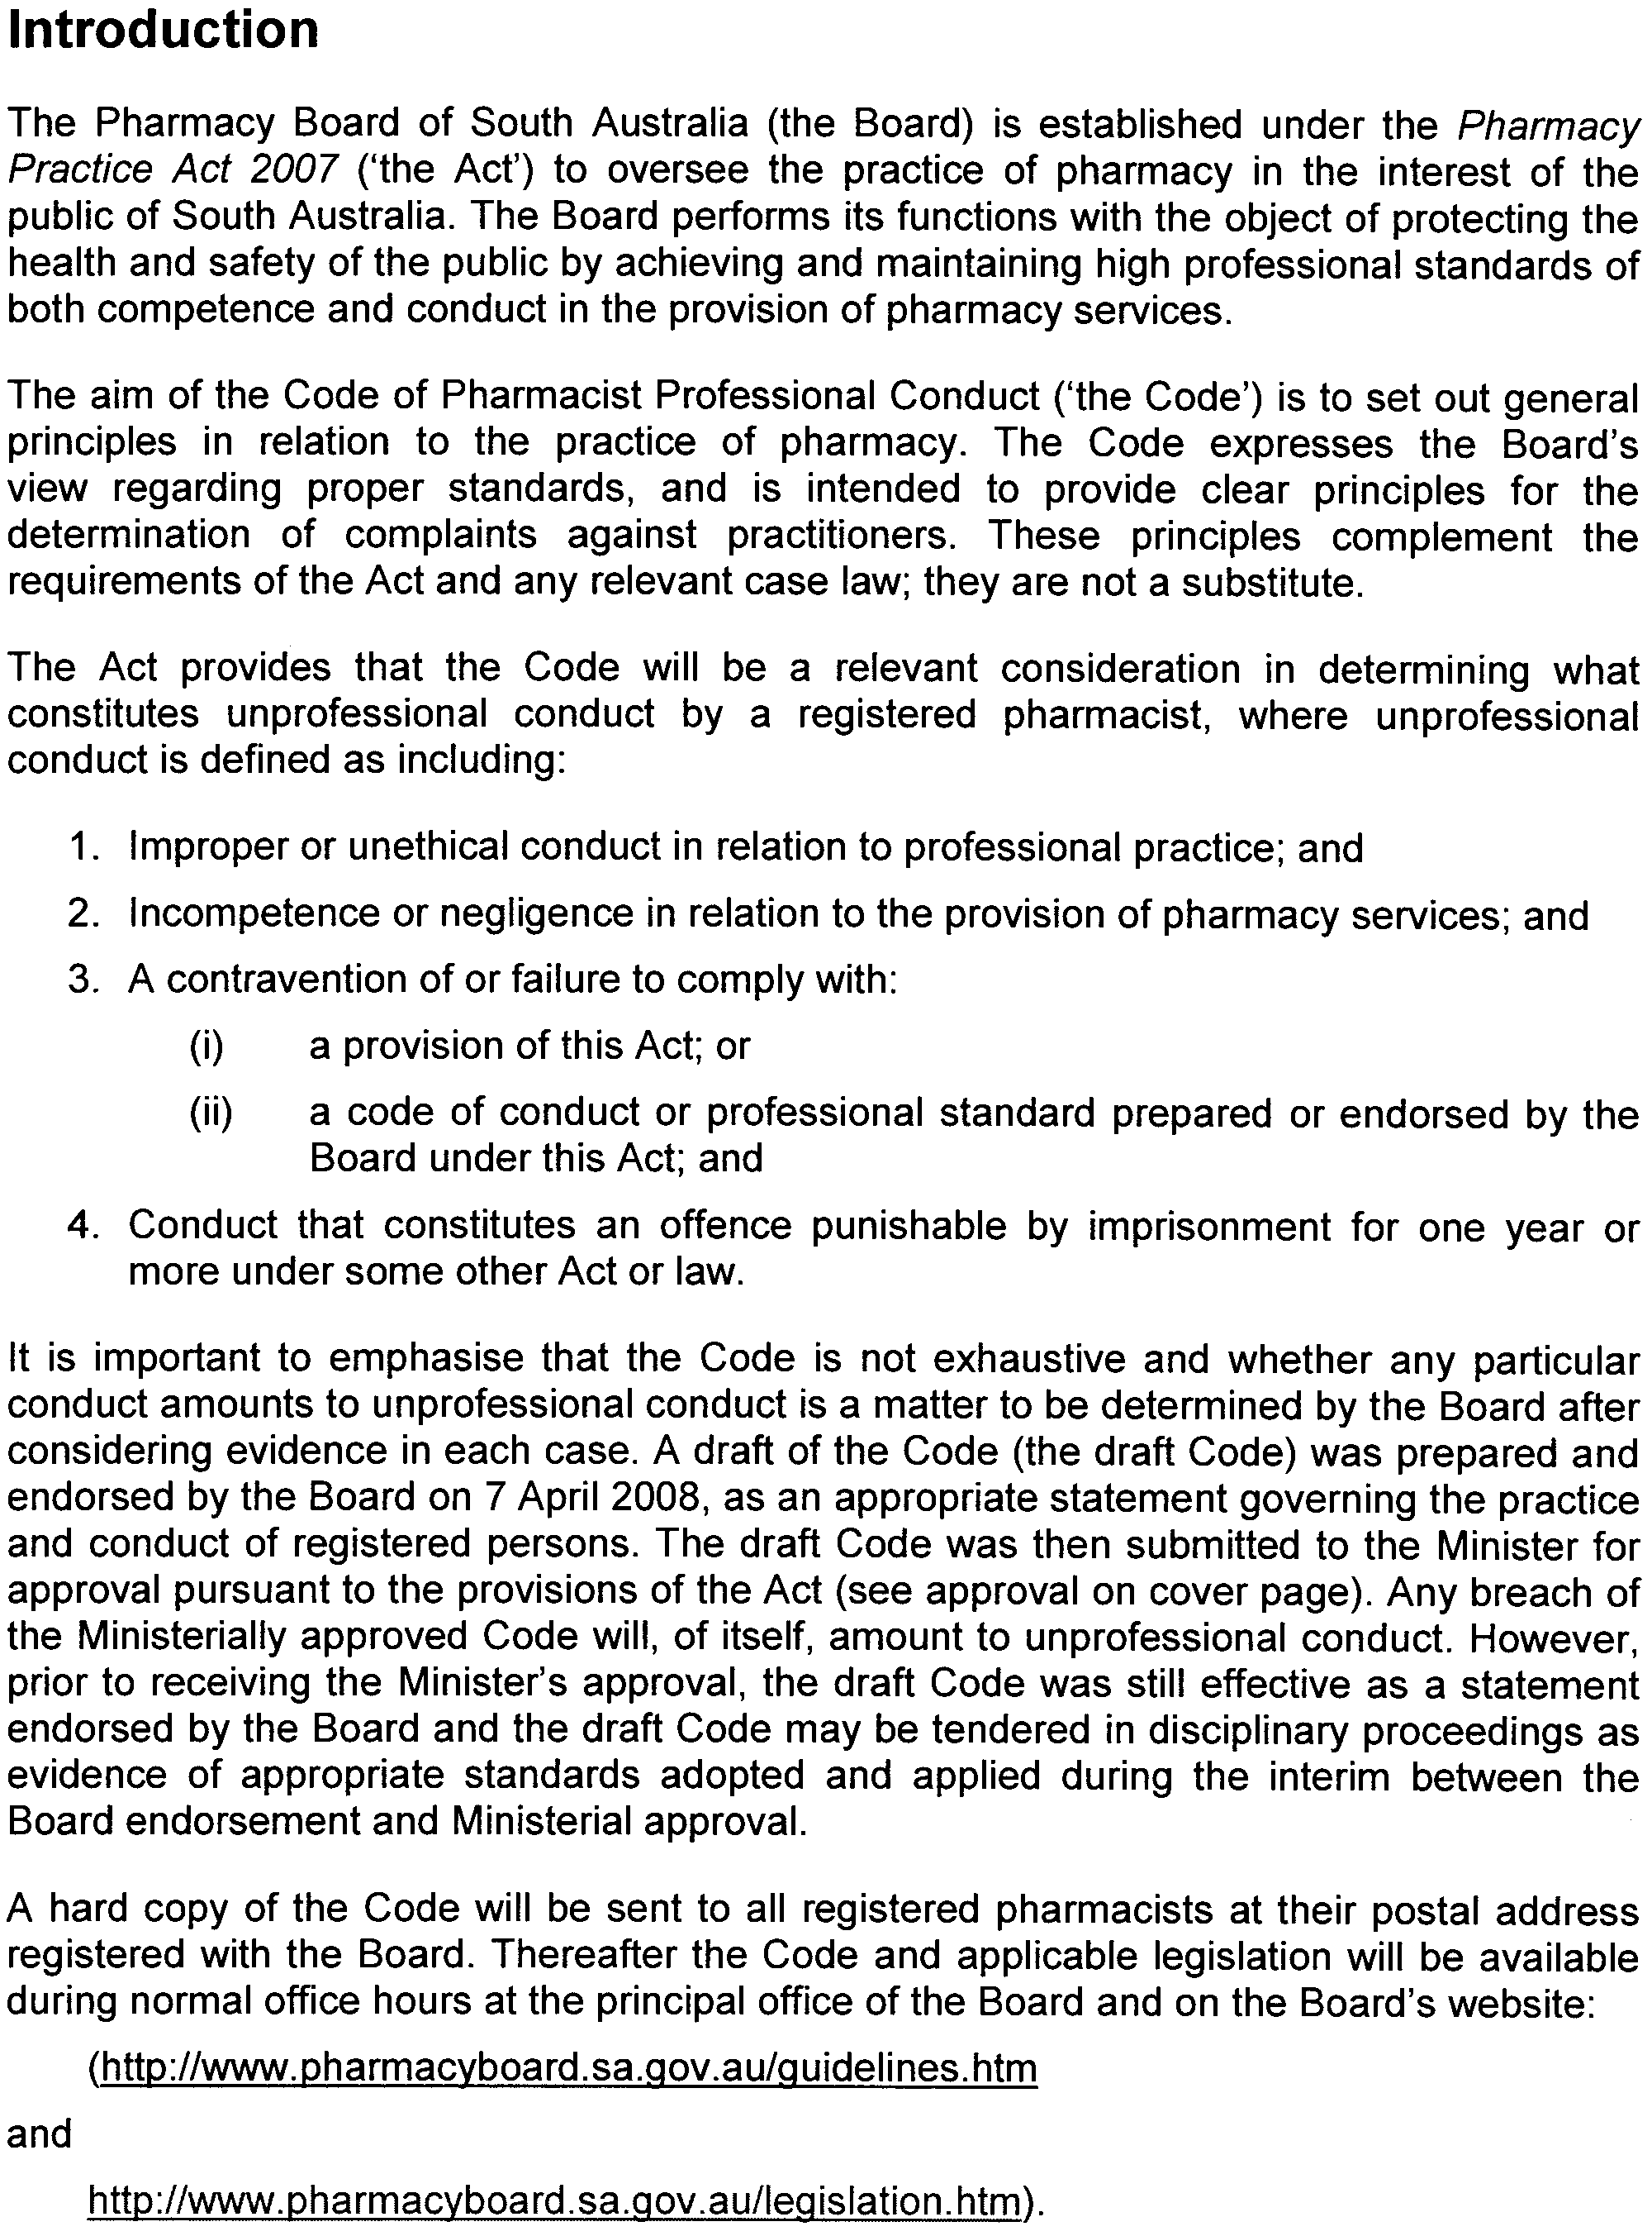

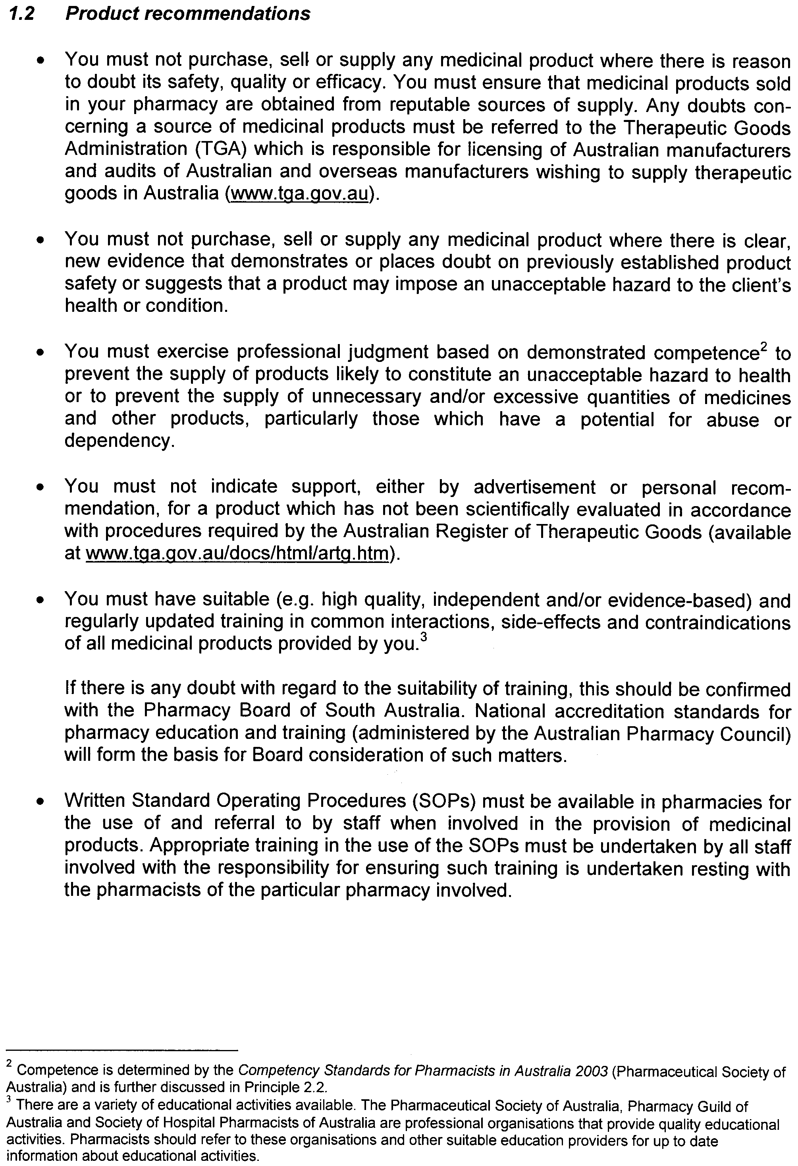

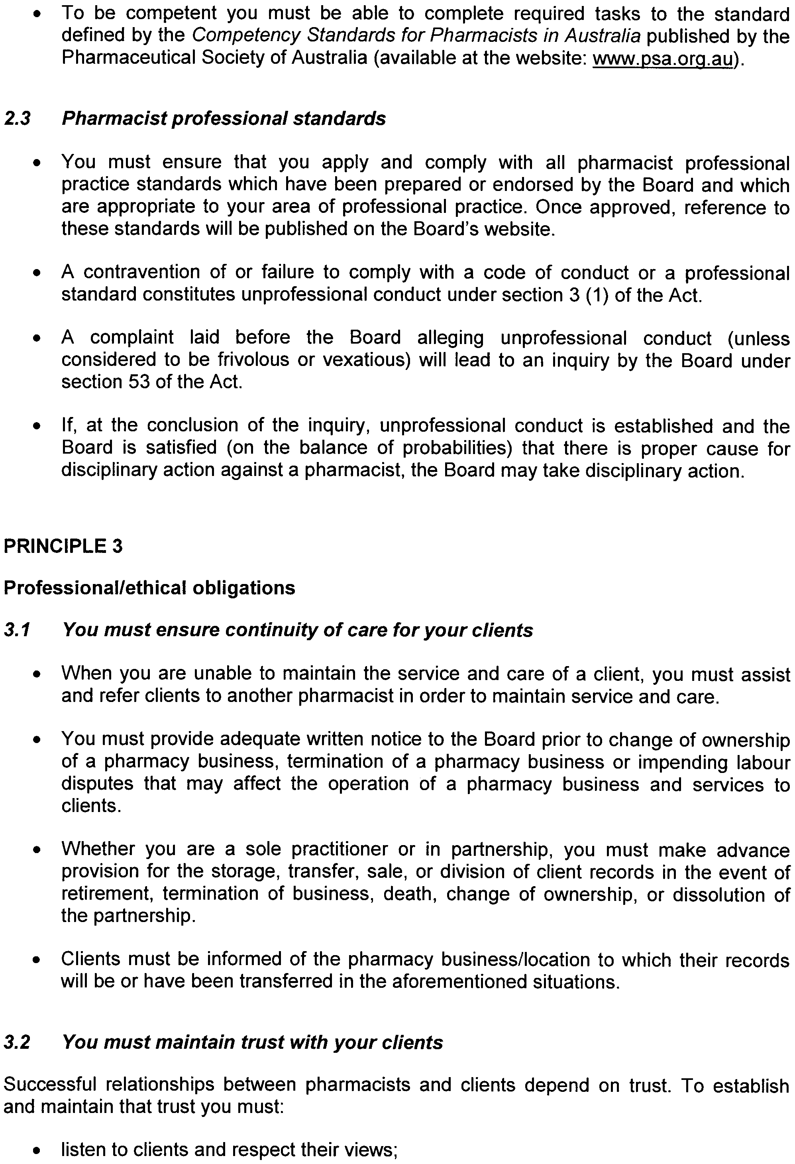

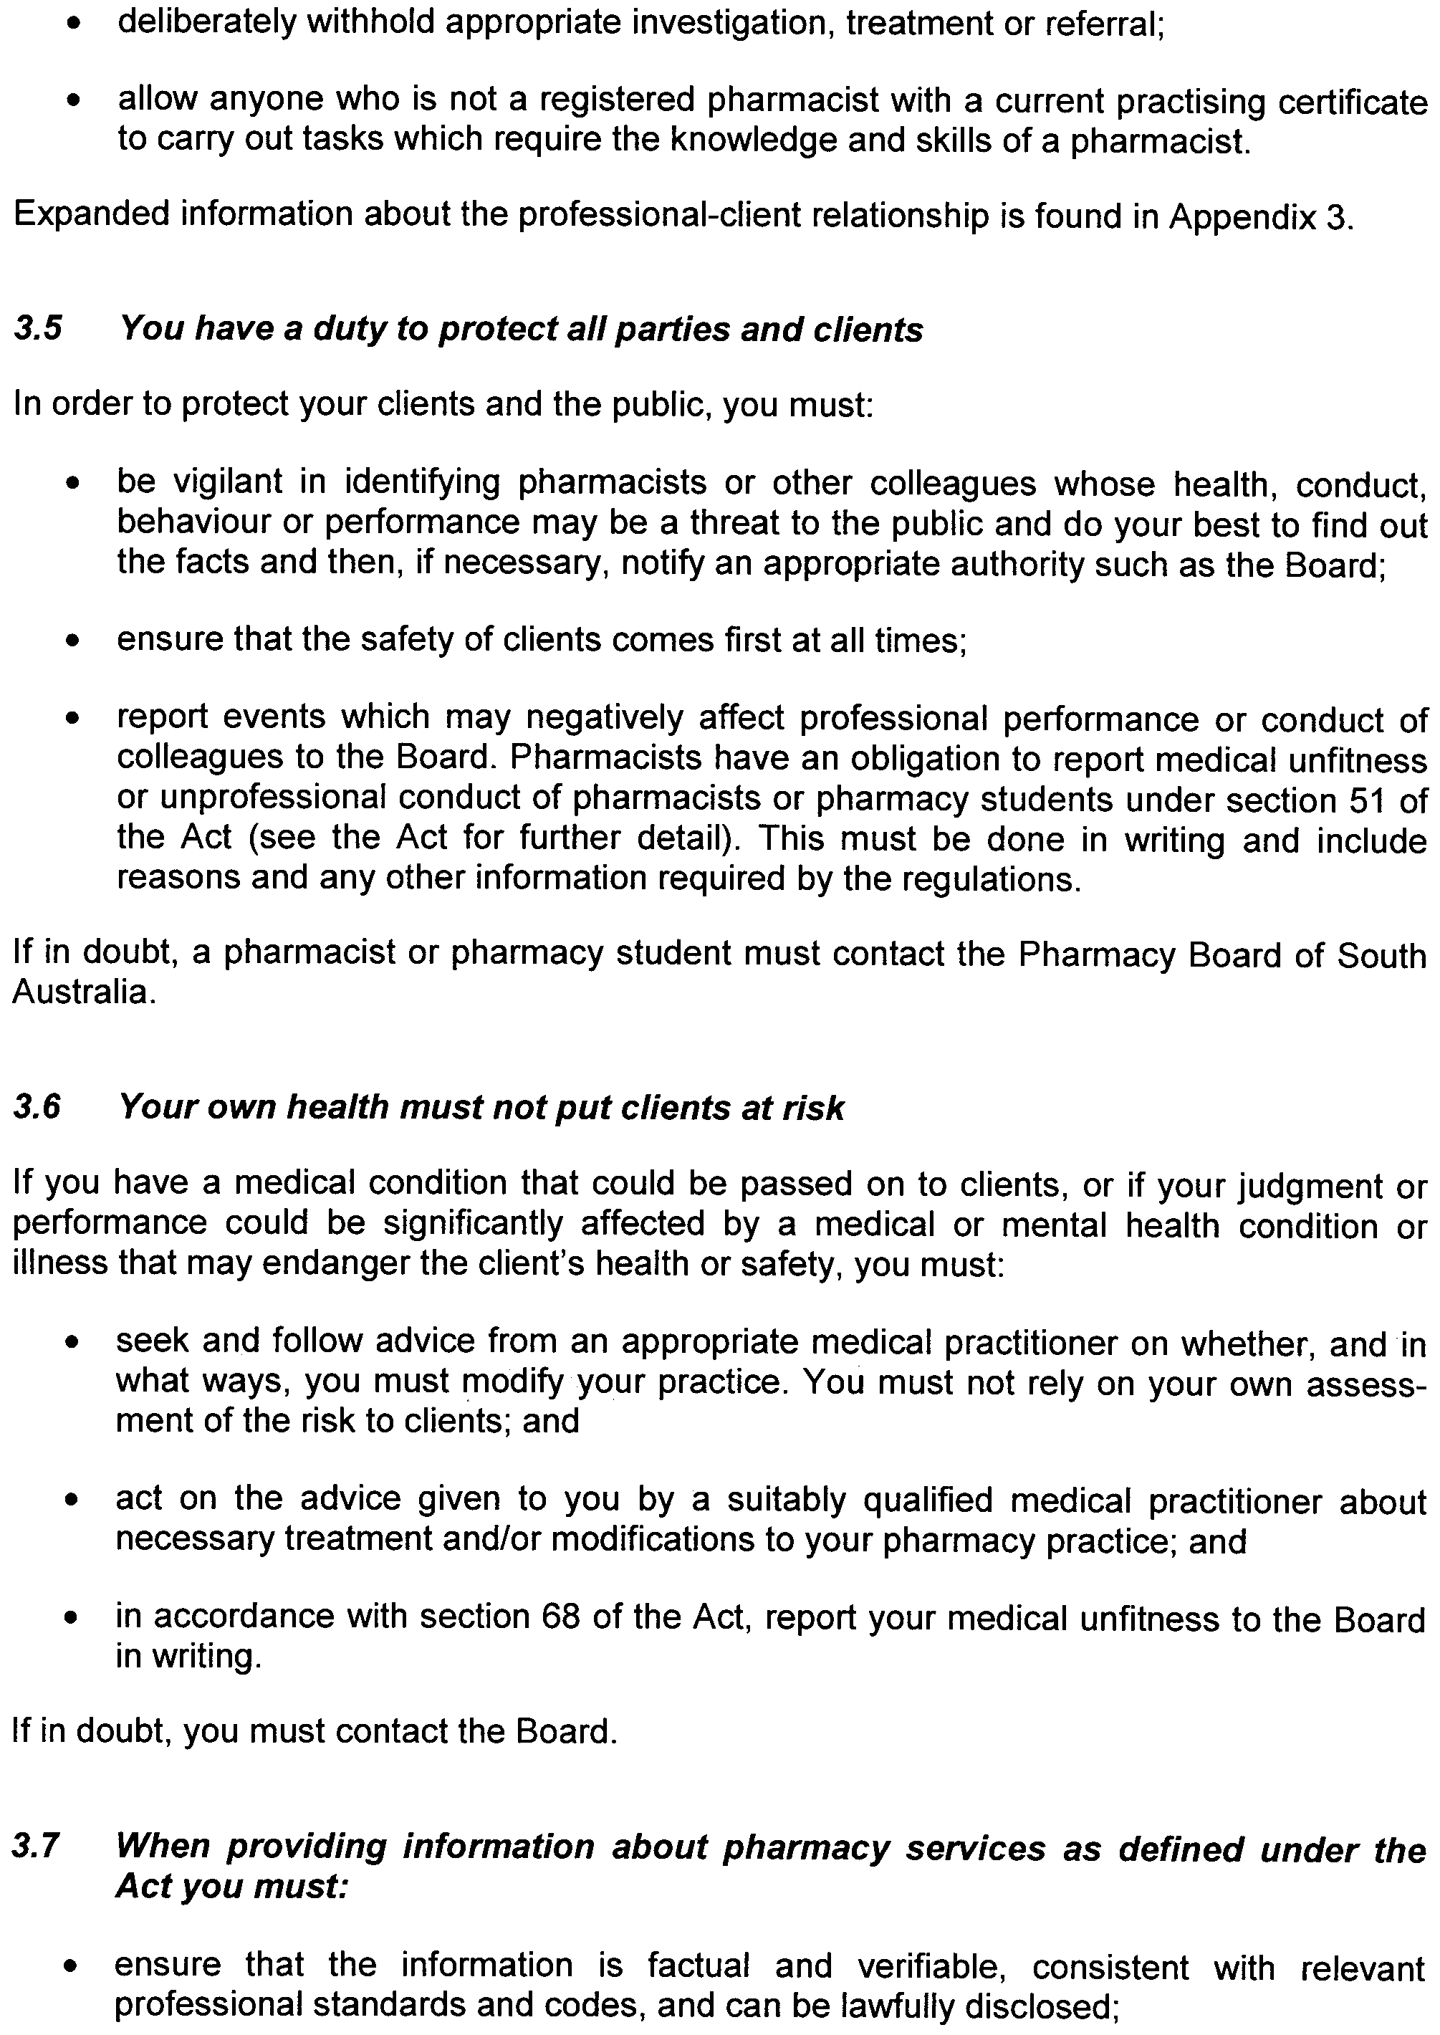


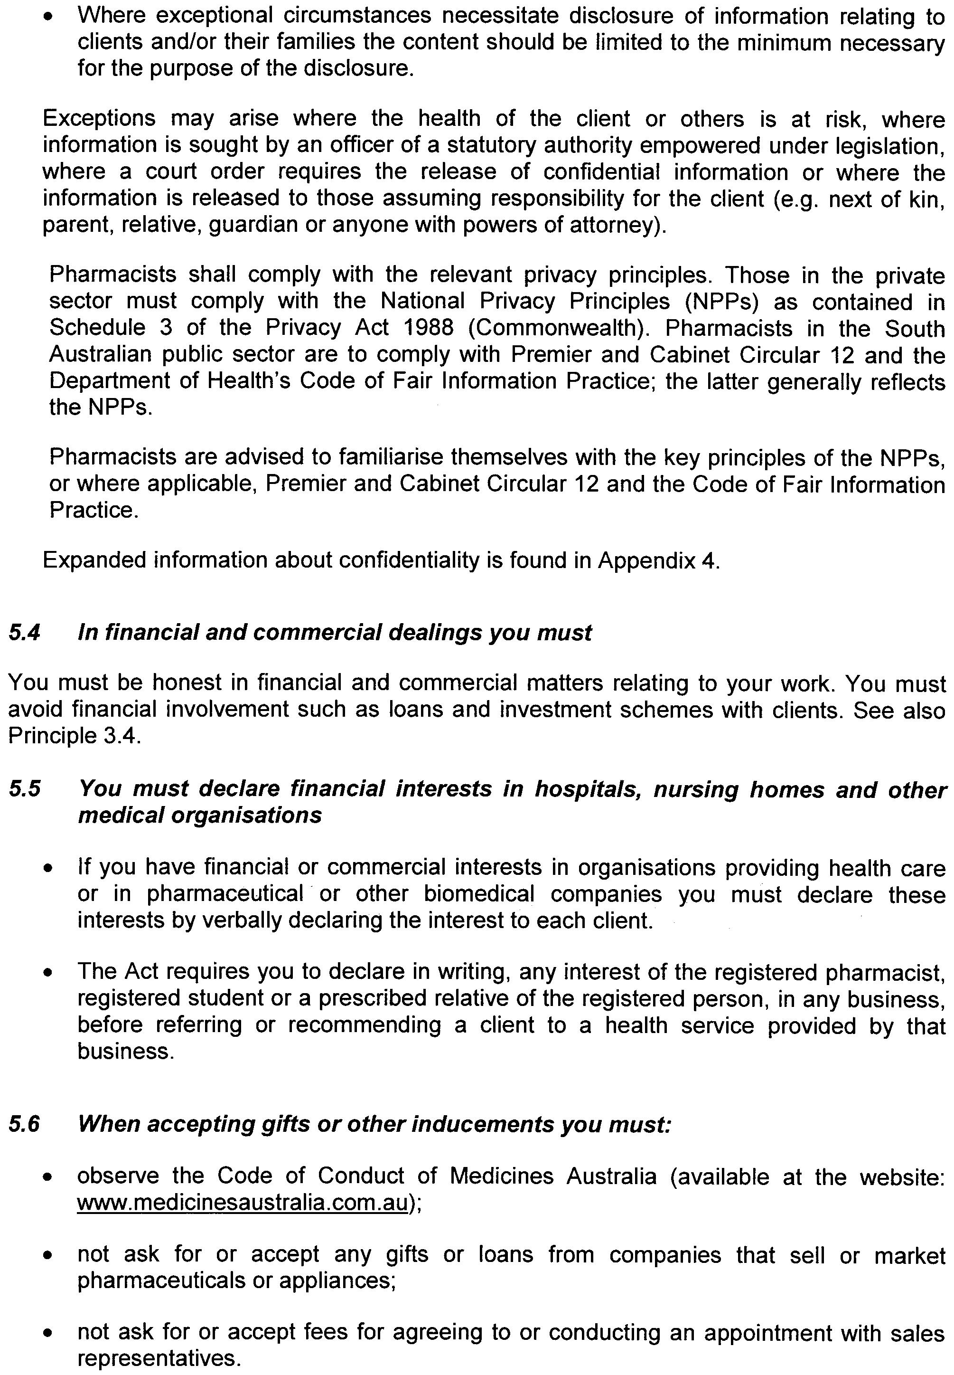
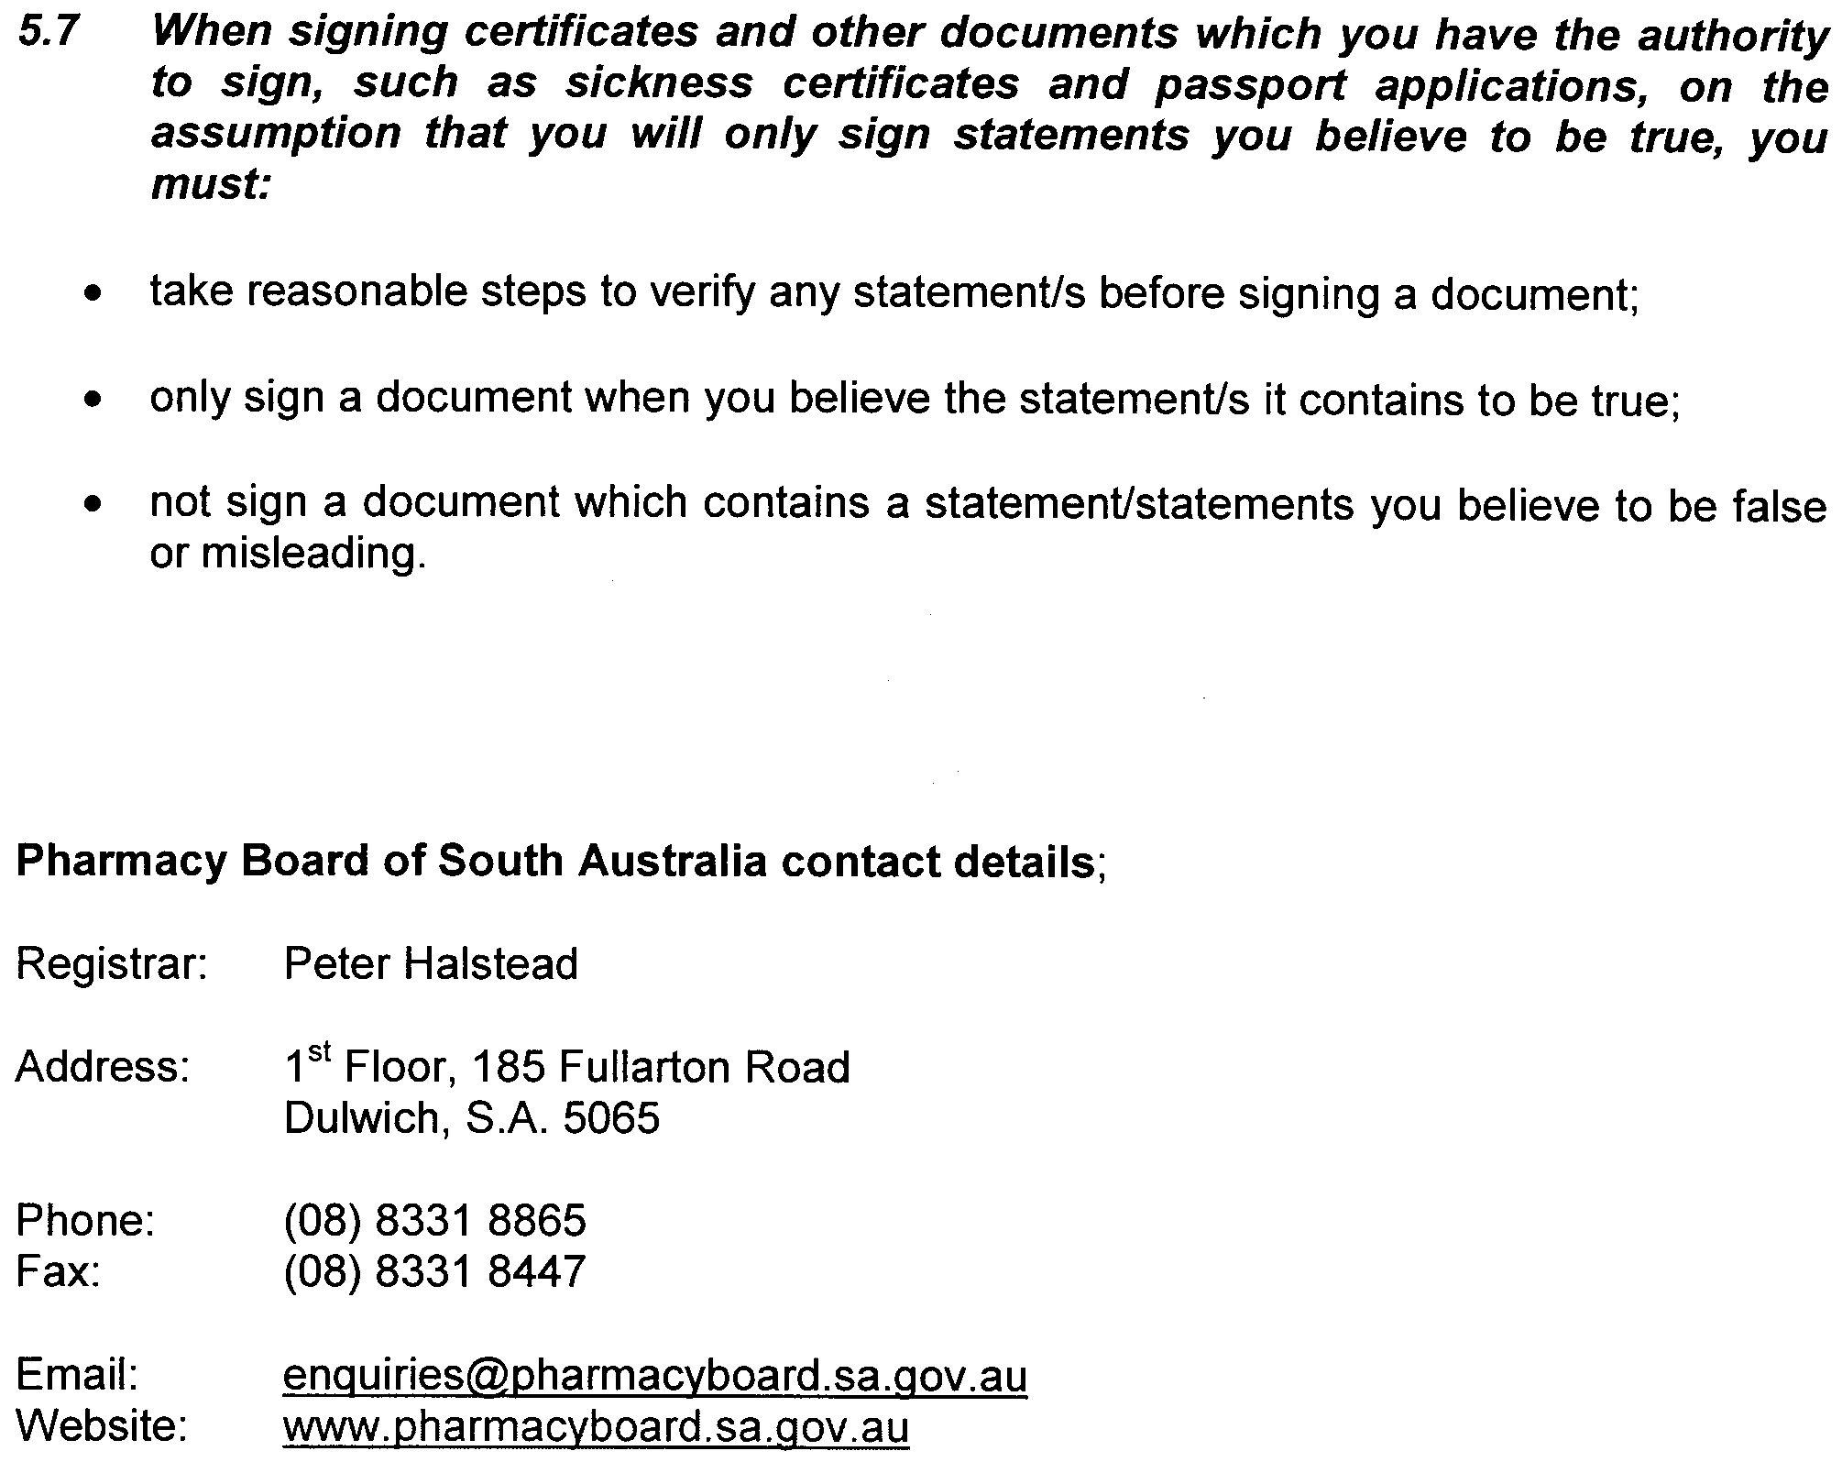

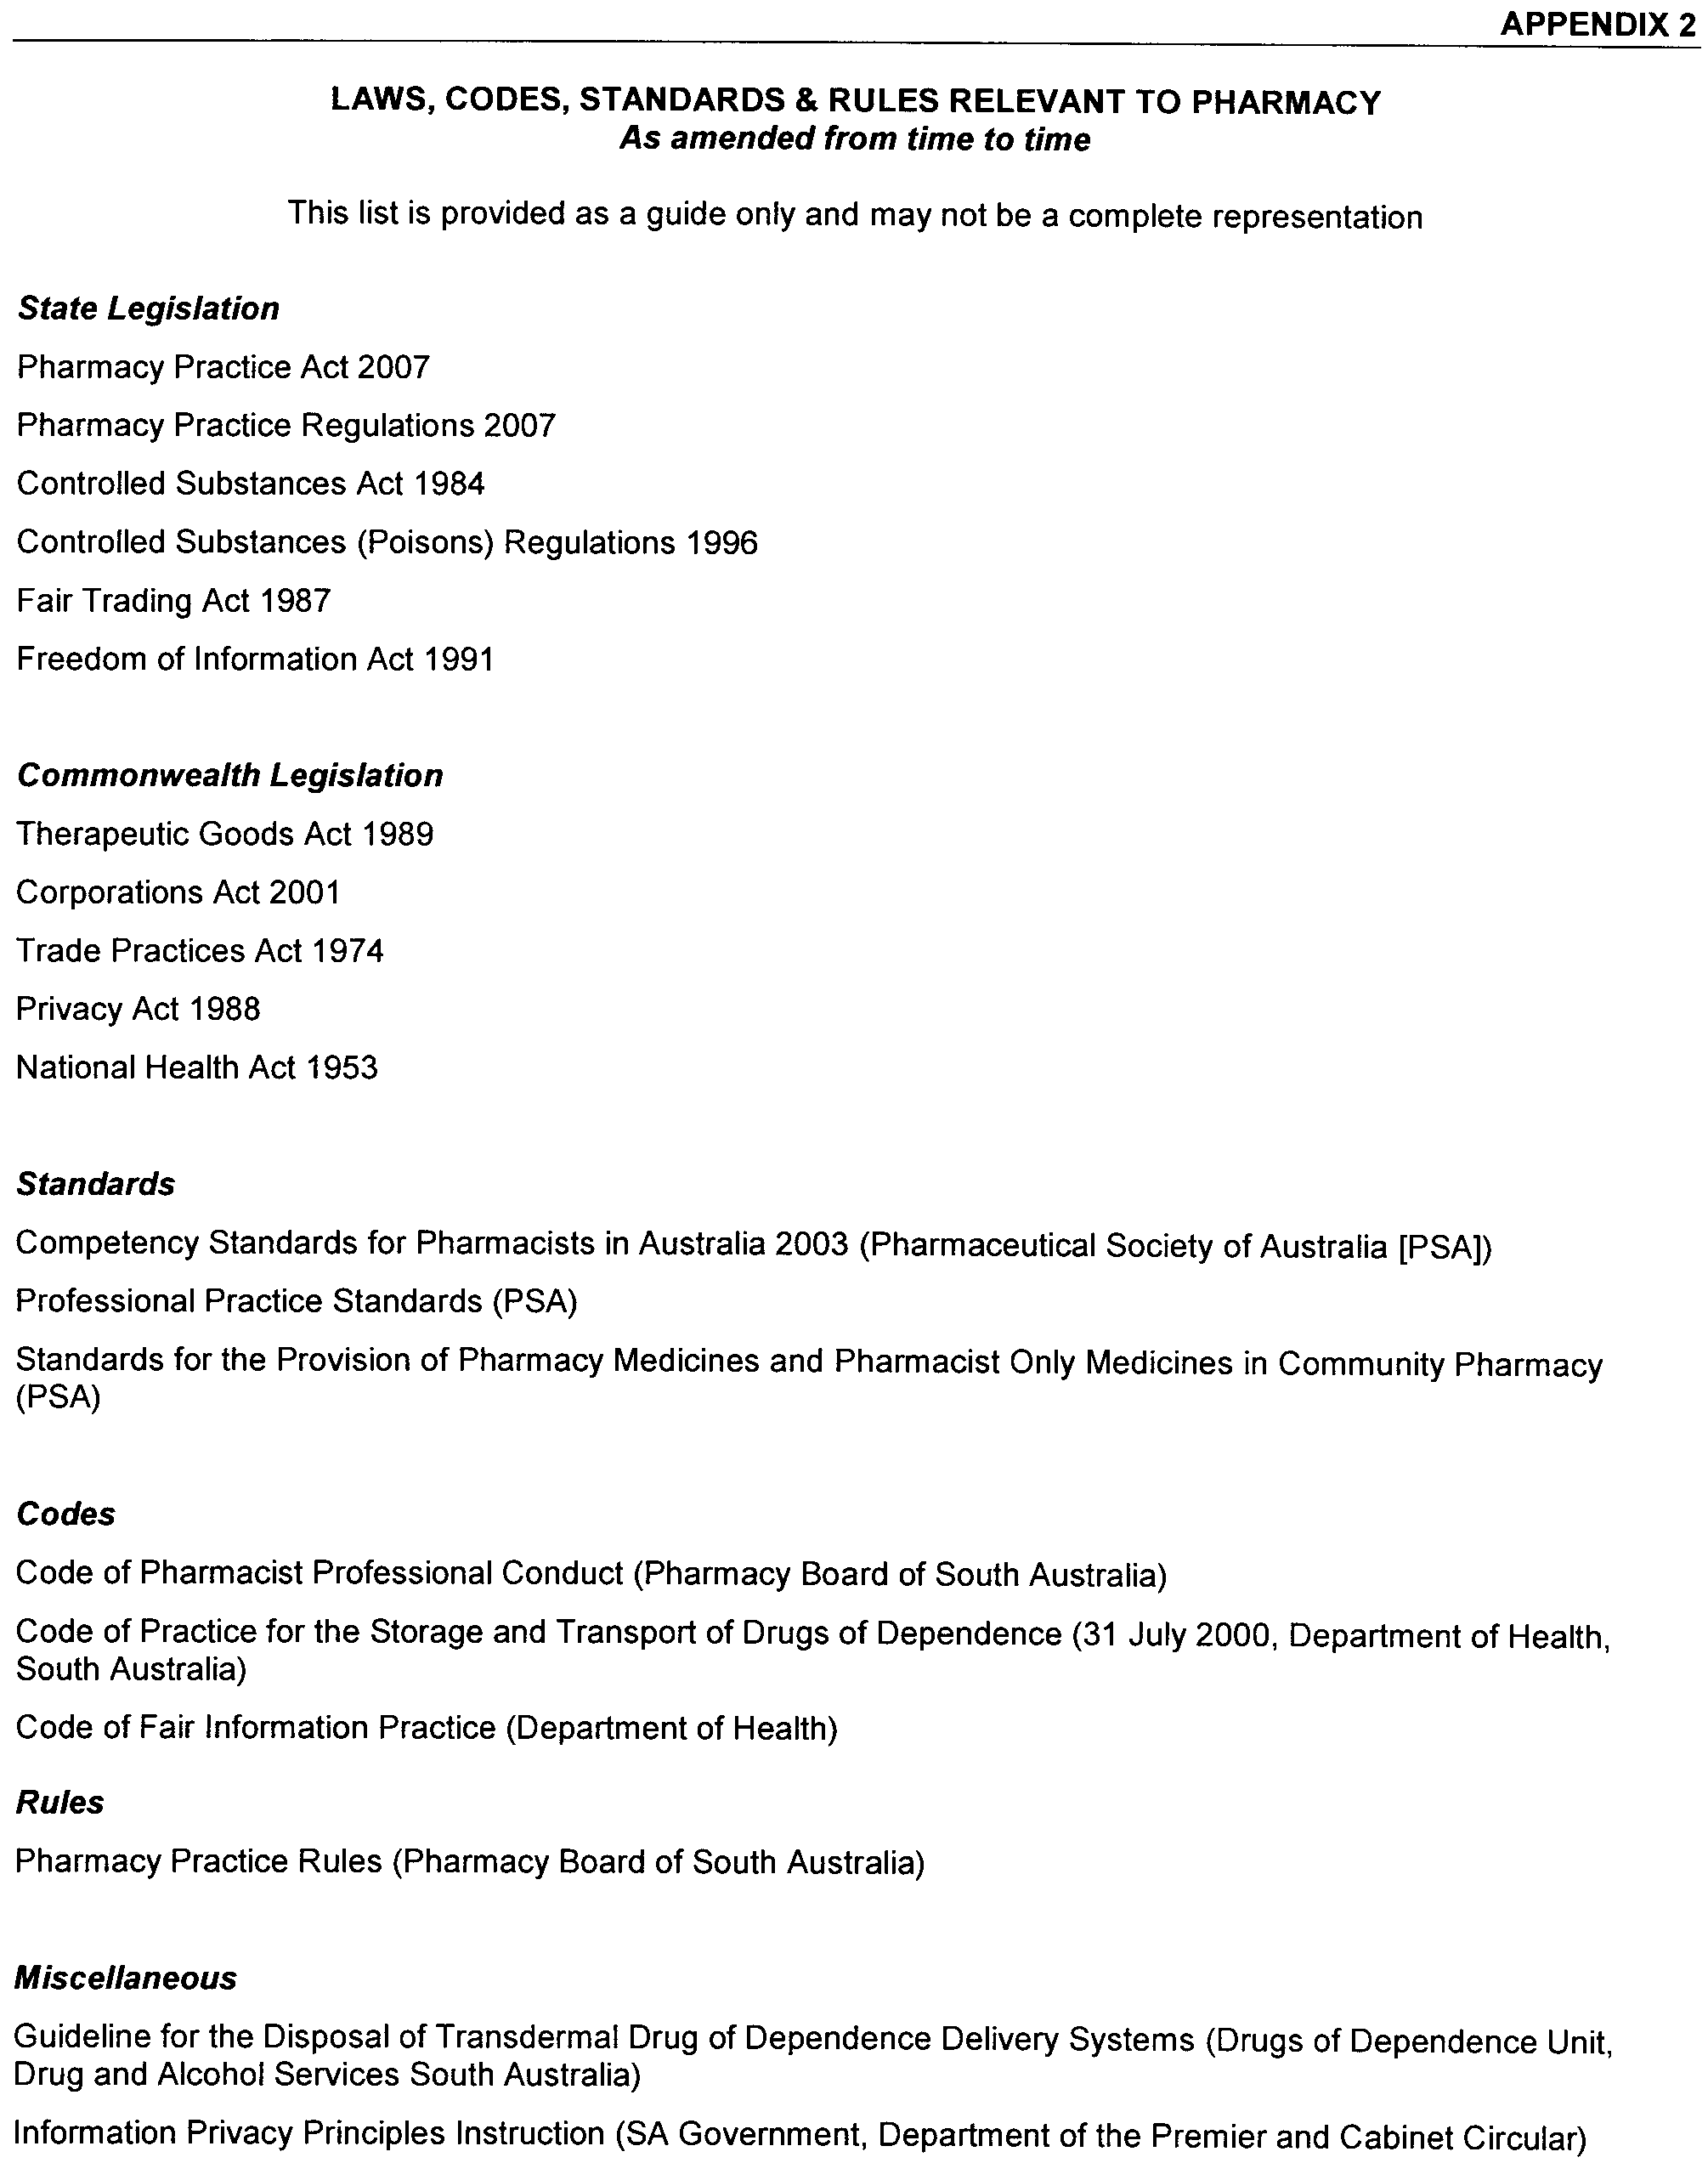
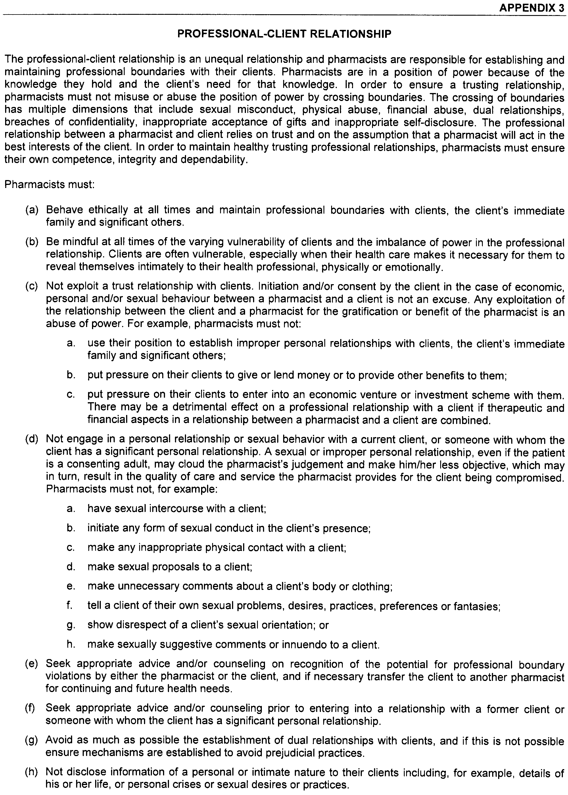
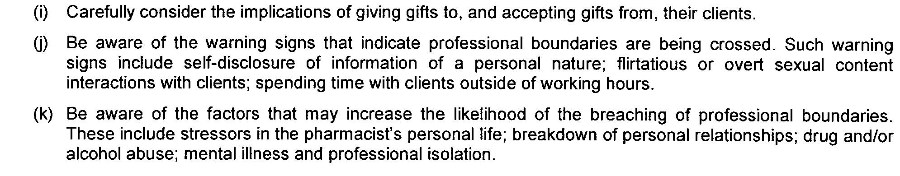

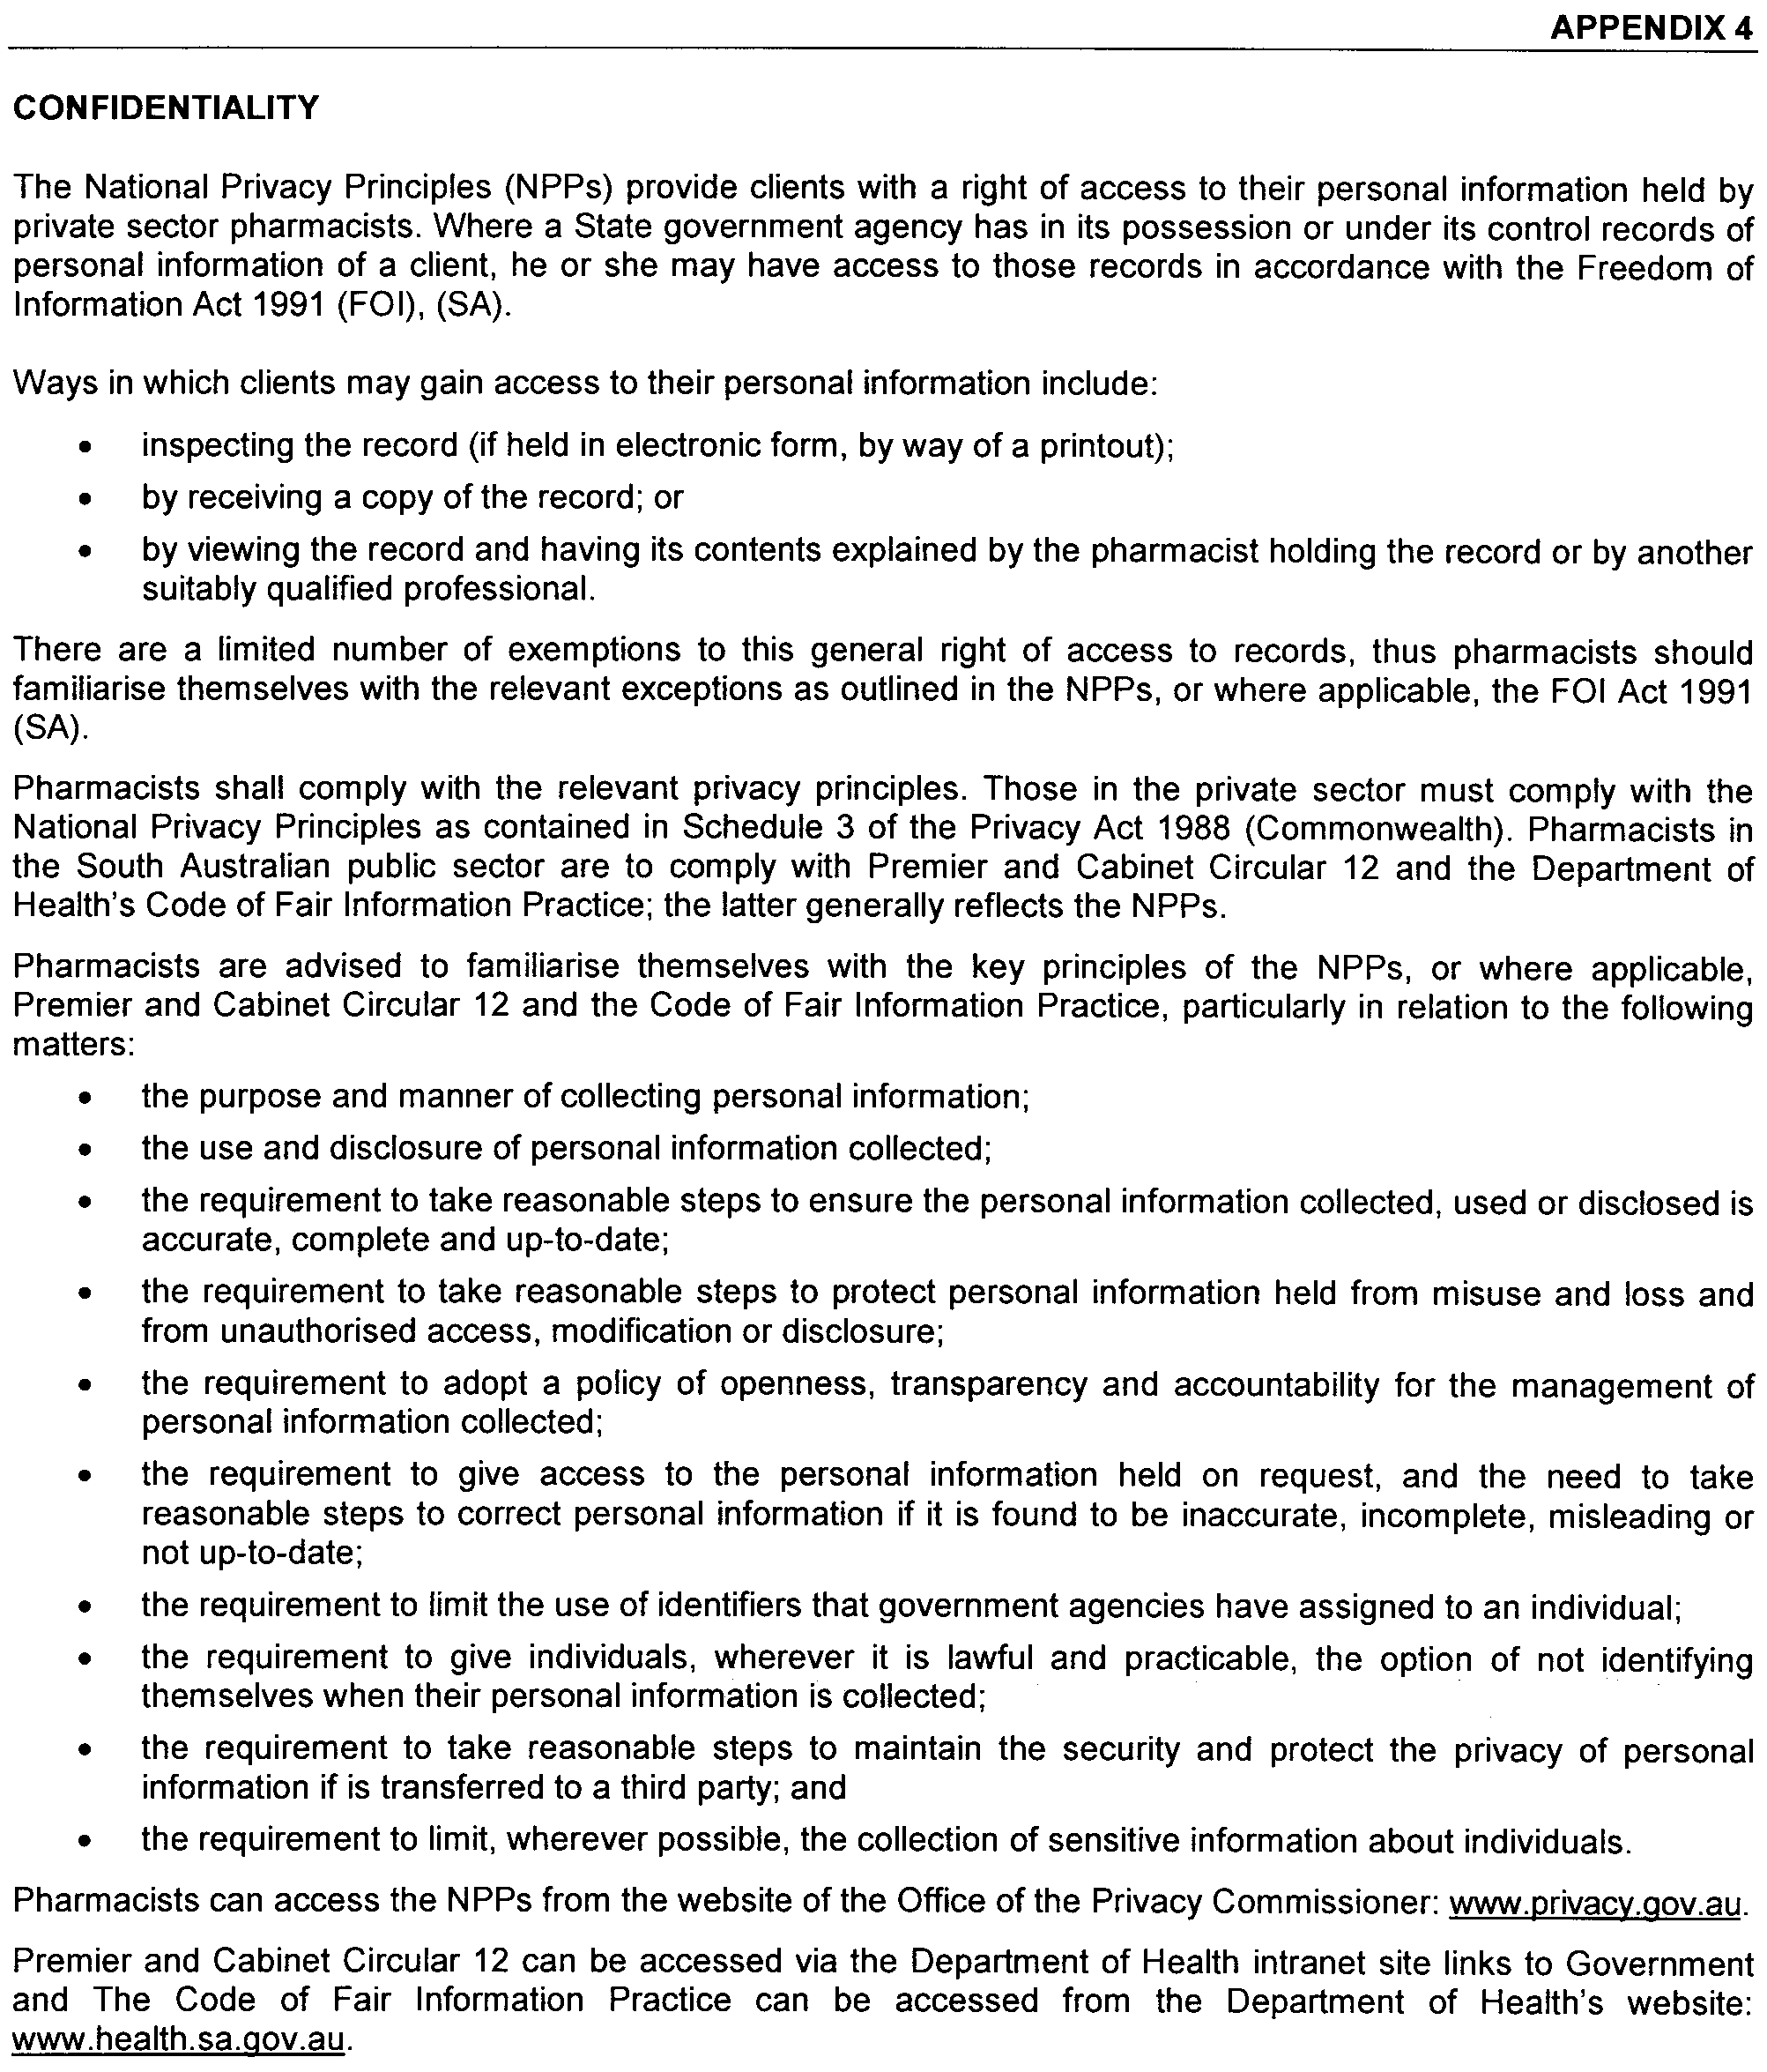

Dated 24 July 2009.
John Hill, Minister for Health

ROAD TRAFFIC ACT 1961
Authorised Officers to Conduct Breath Analysis
I, MALCOLM ARTHUR HYDE, Commissioner of Police, pursuant to section 47K (3) (a) of the Road Traffic Act 1961, do hereby certify that on 31 July 2009, the following Police Officers were authorised to conduct breath analysis:

PD  Number | Officer Name
72298 | Bell, Courtney Elizabeth
79036 | Bruce, Samuel Spencer
72248 | Everlyn, Callan Michael
72170 | Fin, Steven
79545 | Hempel, Nicholas Paul
72138 | Marsh, James Benjamin
49243 | McClure, Clinton Robert
40145 | McPherson, Anna Louise
72389 | Murphy, Craig Richard
79956 | Taubers, Sarah Jade
Dated 31 July 2009.
Malcolm Arthur Hyde, Commissioner of Police

SOUTH AUSTRALIAN LOCAL GOVERNMENT GRANTS COMMISSION ACT 1992
Payment of Grants
I, JAY WEATHERILL, Acting Minister for State/Local Government Relations, being the Minister responsible for the administration of the South Australian Local Government Grants Commission Act 1992 (the Act), hereby state pursuant to section 6 of the Act that:
(a) the total amount available for payment of grants pursuant to the Act for 2009-2010 is $132 361 238;
(b) the amount available for payment of general purpose financial assistance grants within the total amount for 2009-2010 is $99 706 437;
(c) the amount available for payment of identified local
road grants within the total amount for 2009-2010 is $32 654 801;
(d) an amount of $676 150 relating to the overpayment of grants for 2008-2009 (following adjustment for actual CPI and population, in accordance with Commonwealth legislation), will be deducted from the funds to be paid to Councils during 2009-2010, using the grant relativities applied in 2008-2009; and
(e) an amount of $32 814 503 relating to the payment of grants for 2009-2010 brought forward and paid in June 2009, will be deducted from the funds to be paid to Councils during 2009-2010.
Dated 7 August 2009.
Jay Weatherill, Acting Minister for State/ Local Government Relations

South Australia
Passenger Transport Variation Regulations 2009
under the Passenger Transport Act 1994

Contents
Part 1—Preliminary
1 Short title
2 Commencement
3 Variation provisions
Part 2—Variation of Passenger Transport Regulations 2009
4 Variation of regulation 3—Interpretation
5 Variation of regulation 57—Requirements relating to meters
6 Variation of regulation 61—Offences relating to meters
7 Variation of regulation 63—Operation of meter by taxi driver
8 Variation of regulation 71—Multiple-hirings
9 Variation of Schedule 3—Maximum fares (metropolitan taxis)

Part 1—Preliminary
1—Short title
These regulations may be cited as the Passenger Transport Variation Regulations 2009.
2—Commencement
These regulations will come into operation immediately after the Passenger Transport Regulations 2009 come into operation.
3—Variation provisions
In these regulations, a provision under a heading referring to the variation of specified regulations varies the regulations so specified.
Part 2—Variation of Passenger Transport Regulations 2009
4—Variation of regulation 3—Interpretation
(1) Regulation 3(1)—after the definition of motor cycle insert:
multiple-hiring in relation to a taxi—see regulation 71;
multi-seat hiring, in relation to a taxi that is approved to carry 5 or more passengers, means a single hiring (whether pre-arranged or not) of the taxi to carry 5 or more passengers;
(2) Regulation 3(5)—delete subregulation (5) and substitute:
(5) For the purposes of these regulations—
(a) a hiring of a taxi commences—
(i) subject to subparagraph (ii), in the case of a hiring by hail or a pre-arranged hiring—when the passenger is seated in the taxi and an instruction or direction is given to the driver by the hirer or passenger;
(ii) in the case of a pre-arranged hiring—from a time arranged with the hirer provided that, before that time, the taxi has arrived at the place arranged for pick up and the driver has there made personal contact with the hirer or passenger;
(b) a hiring of a taxi ends—
(i) in the case of a multi-seat hiring—
(A) if the last passenger remaining in the taxi discharges the taxi before arriving at the agreed destination—when the taxi is discharged; or
(B) when the taxi arrives at the agreed destination for the last passenger remaining in the taxi and there is no further service agreed between the driver and the last remaining passenger;
(ii) in any other case—
(A) if the passenger discharges the taxi before arriving at the agreed destination—when the taxi is discharged; or
(B) when the taxi arrives at the agreed destination and there is no further service agreed between the driver and the passenger.
5—Variation of regulation 57—Requirements relating to meters
Regulation 57(1)(c)—after "taxi" insert:
(and, if necessary, additional meter displays must be positioned in the taxi to enable this to occur)
6—Variation of regulation 61—Offences relating to meters
Regulation 61—after its current contents (now to be designated as subregulation (1)) insert:
(2) A relevant person for a taxi must ensure that a taxi-meter fitted to the taxi does not, when activated, apply a tariff for the hiring of the taxi other than a tariff that is allowed for such hiring of such taxi under Schedule 3.
Maximum penalty: $750.
Expiation fee: $105.
7—Variation of regulation 63—Operation of meter by taxi driver
Regulation 63(1)(b)—delete paragraph (b) and substitute:
(b) must only apply the tariff for the hiring that—
(i) is allowed for such hiring under Schedule 3; and
(ii) is displayed by the tariff indicator at the commencement of the hiring; and
8—Variation of regulation 71—Multiple-hirings
Regulation 71—delete "another" and substitute:
a separate
9—Variation of Schedule 3—Maximum fares (metropolitan taxis)
(1) Schedule 3, clause 1(1)(a)(i)—delete "$3.00" and substitute:
$3.20
(2) Schedule 3, clause 1(1)(a)(ii)—delete "$4.70" and substitute:
$4.90
(3) Schedule 3, clause 1(1)(a)—after subparagraph (ii) insert:

(iii) | on tariff 3 | $4.20
(iv) | on tariff 4 | $6.40
(4) Schedule 3, clause 1(1)(b)(i)—delete "66.93" and substitute:
63.67
(5) Schedule 3, clause 1(1)(b)(ii)—delete "61.06" and substitute:
58.09
(6) Schedule 3, clause 1(1)(b)—after subparagraph (ii) insert:

(iii) | on tariff 3—for every 48.98 metres or part | $0.10
(iv) | on tariff 4—for every 44.68 metres or part | $0.10
(7) Schedule 3, clause 1(1)(c)(i)—delete "10.68" and substitute:
10.16
(8) Schedule 3, clause 1(1)(c)(ii)—delete "10.68" and substitute:
10.16
(9) Schedule 3, clause 1(1)(c)—after subparagraph (ii) insert:

(iii) | on tariff 3—for each period of 7.82 seconds | $0.10
(iv) | on tariff 4—for each period of 7.82 seconds | $0.10

(10) Schedule 3, clause 1(2) and (3)—delete subclauses (2) and (3) and substitute:
(2) The following tariffs apply to the hiring of a metropolitan taxi:
(a) in the case of a multi-seat hiring—
(i) commenced between the hours of 7 pm on Monday to Thursday inclusive and 6 am on the following day, or between the hours of 7 pm on Friday and 6 am on the following Monday, or during a public holiday—tariff 4 applies;
(ii) commenced at any other time—tariff 3 applies;
(b) in any other case—
(i) commenced between the hours of 7 pm on Monday to Thursday inclusive and 6 am on the following day, or between the hours of 7 pm on Friday and 6 am on the following Monday, or during a public holiday—tariff 2 applies;
(ii) commenced at any other time—tariff 1 applies.
(11) Schedule 3, clause 2(1)—delete "must not exceed $0.97 per kilometre calculated on the forward and return journey plus waiting time at the rate of $0.10 for each period of 10.68 seconds." and substitute:
—
(a) in the case of a multi-seat hiring—must not exceed $1.34 per kilometre calculated on the forward and return journey plus waiting time at the rate of $0.10 for each period of 10.16 seconds;
(b) in any other case—must not exceed $1.03 per kilometre calculated on the forward and return journey plus waiting time at the rate of $0.10 for each period of 10.16 seconds.
(12) Schedule 3, clause 2(3)—delete "10.68" and substitute:
10.16
(13) Schedule 3, clause 4—delete clause 4 and substitute:
4—Multiple-hirings
If a metropolitan taxi is used for a multiple-hiring—
(a) the tariff to be applied must be tariff 1 or tariff 2 (as the case may be); and
(b) the fare for any of the hirers must not exceed 75% of the fare recorded on the taxi-meter on reaching that hirer's destination.
Note—
As required by section 10AA(2) of the Subordinate Legislation Act 1978, the Minister has certified that, in the Minister's opinion, it is necessary or appropriate that these regulations come into operation as set out in these regulations.
Made by the Governor’s Deputy
with the advice and consent of the Executive Council
on 13 August 2009
No 217 of 2009
MTR09/074

South Australia
Animal Welfare Variation Regulations 2009
under the Animal Welfare Act 1985

Contents
Part 1—Preliminary
1 Short title
2 Commencement
3 Variation provisions
Part 2—Variation of Animal Welfare Regulations 2000 to take effect immediately
4 Variation of Schedule 2—Codes of practice
Part 3—Variation of Animal Welfare Regulations 2000 to take effect on later dates
5 Substitution of regulation 5
5 Inspectors
5A Codes of practice
6 Variation of regulation 8—Use of certain other electrical devices
7 Revocation of heading to Part 3
8 Revocation of regulation 10
9 Substitution of heading to Part 3A
10 Substitution of heading to Part 3B
11 Variation of regulation 13N—Requirements relating to confining domestic fowls in cages
12 Substitution of Part 5
Part 5—Pigs
Division 1—Preliminary
21 Interpretation
22 Application of Part
23 Exemptions from Part
24 Keeping records
Division 2—General requirements
25 Day-to-day care of pigs
26 Medical and surgical procedures
Division 3—Keeping pigs in indoor housing
27 Application of Division
28 Pigs in individual housing—minimum space and welfare requirements
29 Pigs in group housing—minimum space and welfare requirements
30 Equipment in indoor housing
13 Variation of Schedule 2—Codes of practice

Part 1—Preliminary
1—Short title
These regulations may be cited as the Animal Welfare Variation Regulations 2009.
2—Commencement
(1) Parts 1 and 2 of these regulations come into operation on the day on which they are made.
(2) Subject to subregulations (3) and (4), Part 3 of these regulations will come into operation on 1 November 2009.
(3) Regulations 25(5) and 26(1) and (2) (to be inserted into the Animal Welfare Regulations 2000 by regulation 12 of these regulations) will come into operation on
1 March 2011.
(4) Regulation 29(1) (to be inserted into the Animal Welfare Regulations 2000 by regulation 12 of these regulations) will come into operation on 20 April 2012.
3—Variation provisions
In these regulations, a provision under a heading referring to the variation of specified regulations varies the regulations so specified.
Part 2—Variation of Animal Welfare Regulations 2000 to take effect immediately
4—Variation of Schedule 2—Codes of practice
(1) Schedule 2 other than item 17—delete "as amended from time to time" wherever occurring and substitute in each case:
as in force on 20 May 2009
(2) Schedule 2, item 17—delete "as amended from time to time" and substitute:
as in force on 19 April 2007
Part 3—Variation of Animal Welfare Regulations 2000 to take effect on later dates
5—Substitution of regulation 5
Regulation 5—delete the regulation and substitute:
5—Inspectors
(1) For the purposes of the definition of qualified person in section 28 of the Act, the following training is prescribed:
(a) a course of basic training for inspectors provided, from time to time, by the Minister;
(b) a course of training that would, in the opinion of the Minister, qualify a person to be appointed as a member of a police force of the Commonwealth or a State or Territory of the Commonwealth;
(c) a course of training approved by the Minister provided by—
(i) the Royal Society for the Prevention of Cruelty to Animals (South Australia) (RSPCA) or an organisation corresponding to the RSPCA in another State or a Territory of the Commonwealth; or
(ii) a public sector agency of the Commonwealth or a State or Territory of the Commonwealth.
(2) An inspector is authorised to give expiation notices for an alleged offence against the Act or these regulations.
5A—Codes of practice
(1) A person described in an entry in Schedule 2 must, in carrying out an activity described in that entry, ensure compliance with the code of practice and any modifications specified in the entry.
Maximum penalty: $2 500.
Expiation fee: $210.
(2) For the purposes of section 43 of the Act, each of the codes of practice specified in Schedule 2 is a prescribed code of practice.
6—Variation of regulation 8—Use of certain other electrical devices
(1) Regulation 8(2)(b)(i)—delete subparagraph (i) and substitute:
(i) the animal is a prescribed animal; and
(2) Regulation 8—after subregulation (2) insert:
(3) In this regulation—
prescribed animal means—
(a) an animal of the genus Bos or Bubalus; or
(b) an animal of the genus Sus (other than a pig that is being kept in the course of the business of a piggery).
7—Revocation of heading to Part 3
Heading to Part 3—delete the heading
8—Revocation of regulation 10
Regulation 10—delete the regulation
9—Substitution of heading to Part 3A
Heading to Part 3A—delete the heading and substitute:
Part 3—Rodeos
10—Substitution of heading to Part 3B
Heading to Part 3B—delete the heading and substitute:
Part 3A—Domestic fowls
11—Variation of regulation 13N—Requirements relating to confining domestic fowls in cages
Regulation 13N(5)—after "Subregulation (4)" insert:
and this subregulation
12—Substitution of Part 5
Part 5—delete the Part and substitute:
Part 5—Pigs
Division 1—Preliminary
21—Interpretation
(1) In this Part—
boar means an uncastrated male pig over 9 months of age;
creep area means an area for housing piglets adjacent to a farrowing crate in which the piglets of the sow are protected from crushing and overlying by the sow;
farrowing means giving birth to piglets;
farrowing crate means an enclosure for housing a sow for the purposes of farrowing—
(a) that closely corresponds to the sow's body size; and
(b) in which the sow is unable to turn around; and
(c) that has an adjacent creep area for any piglets of the sow;
farrowing pen means a pen for housing—
(a) a sow for the purposes of farrowing; and
(b) any piglets of the sow;
feeder means a trough, hopper or other equipment from which feed may be accessed by a pig;
gilt means a female pig (other than a sow) that has been selected for breeding;
herd health program, in relation to a pig, means a program, approved by the Minister, that identifies potential health and biosecurity risks to the pig and specifies action to prevent or minimise those risks;
pen means an enclosure for housing a pig or group of pigs in which the pig or pigs are able to turn around;
piglet, of a sow, includes any piglet that is dependent on the sow for milk;
sow means an adult female pig that has had 1 or more litters;
stall means an enclosure (other than a farrowing crate) for housing a single pig—
(a) that closely corresponds to the pig's body size; and
(b) in which the pig is unable to turn around;
suitably qualified—see subregulation (2);
waterer means a trough or other equipment from which drinking water may be accessed by a pig.
(2) For the purposes of this Part, a person is suitably qualified if the person—
(a) is a veterinary surgeon; or
(b) holds a tertiary qualification approved by the Minister in the field of veterinary science or agriculture; or
(c) holds a Certificate III in Agriculture (Pig Production) from a college within the meaning of the Technical and Further Education Act 1975; or
(d) holds a qualification that is, in the opinion of the Minister, equivalent to the qualification referred to in paragraph (c); or
(e) satisfies the Minister that he or she has, during a period of at least 12 months, been responsible for the care of pigs in a business that has, during that period of responsibility, complied with a quality assurance program approved by the Minister relating to pig husbandry.
22—Application of Part
This Part applies in relation to a pig kept in the course of the business of a piggery.
23—Exemptions from Part
(1) Subject to this regulation, the Minister may, by notice in writing—
(a) exempt a person, subject to such conditions as the Minister thinks fit and specifies in the notice, from specified provisions of this Part; or
(b) vary or revoke an exemption, or a condition of an exemption, under this regulation or impose a further condition.
(2) An exemption under this regulation operates for a period (not exceeding 12 months) specified in the notice.
(3) A person who contravenes a condition of an exemption is guilty of an offence.
Maximum penalty: $2 500.
Expiation fee: $210.
24—Keeping records
(1) A person who keeps a pig must ensure that—
(a) a written record is kept of—
(i) any inspection of the pig required under this Part (including any concerns regarding the pig's health or welfare detected by the inspection); and
(ii) any inspection of equipment required under this Part (including any equipment failure or malfunction detected by the inspection); and
(b) the record—
(i) is kept for 3 years from the day on which the record was made; and
(ii) is readily available for inspection at all reasonable times by an inspector.
Maximum penalty: $2 500.
Expiation fee: $210.
(2) For the purposes of subregulation (1), a record may be kept in electronic form.
Division 2—General requirements
25—Day-to-day care of pigs
(1) A person who keeps a pig must ensure that the pig is provided with—
(a) adequate food containing sufficient nutrients to ensure the pig's good health and vitality; and
(b) adequate water to meet the pig's physiological needs.
Maximum penalty: $2 500.
(2) A person who keeps a pig must ensure that, within 24 hours after birth, the pig has received colostrum or an appropriate substitute.
Maximum penalty: $2 500.
(3) A person who keeps a pig must ensure that the pig is inspected at least once a day to assess the pig's health and well-being.
Maximum penalty: $2 500.
Expiation fee: $210.
(4) A person who keeps a pig must ensure that—
(a) reasonable steps are taken to avoid a build up of faeces and urine in the pig's housing; and
(b) the pig is not tethered; and
(c) the pig is not exposed to any dog unless—
(i) the dog is under the effective control of a person; and
(ii) in the case of a dog that has a history of biting humans or animals—the dog is wearing a muzzle.
Maximum penalty: $2 500.
Expiation fee: $210.
(5) A person who keeps a pig must ensure that—
(a) each person responsible for the care of the pig is a suitably qualified person or a person acting under the supervision of a suitably qualified person; and
(b) a herd health program is in place in relation to the pig.
Maximum penalty: $2 500.
Note—
Subregulation (5) will come into operation on 1 March 2011.
26—Medical and surgical procedures
Note—
Subregulations (1) and (2) will come into operation on 1 March 2011.
(1) A person who keeps a pig must ensure that—
(a) any significant medical or surgical procedure is carried out in relation to the pig only by a suitably qualified person or by a person acting under the direct supervision of a suitably qualified person; and
(b) any simple medical or surgical procedure is carried out in relation to the pig only by a suitably qualified person or by a person acting under the supervision (whether or not direct supervision) of a suitably qualified person.
Maximum penalty: $2 500.
Expiation fee: $210.
(2) However, subregulation (1) does not apply in relation to the destruction of a pig if, due to urgent circumstances—
(a) the services of a suitably qualified person are not reasonably available; and
(b) destruction of the pig is necessary in order to prevent undue suffering by the pig.
(3) A person who keeps a pig must ensure that a vasectomy or surgical castration is not performed on a pig over 21 days of age unless the pig is anaesthetised.
Maximum penalty: $2 500.
Expiation fee: $210.
(4) In this regulation—
significant medical or surgical procedure, in relation to a pig, means—
(a) vasectomy or castration of the pig; or
(b) tusk trimming of the pig; or
(c) nose ringing of the pig; or
(d) destruction of the pig;
simple medical or surgical procedure, in relation to a pig, means—
(a) administration to the pig of a veterinary product (including a drug, vaccine or other substance) whether intravenously, orally, topically or by any other means; or
(b) diagnosis of pregnancy of the pig; or
(c) docking of the pig's tail; or
(d) clipping of the pig's needle teeth; or
(e) measurement of the pig's backfat; or
(f) application to the pig of identification marks, tags or chips.
(5) This regulation is in addition to and does not derogate from the operation of—
(a) the Agricultural and Veterinary Products (Control of Use) Act 2002 (for example, in relation to the treatment of an animal with a veterinary product within the meaning of that Act); or
(b) the Livestock Act 1997 (for example, in relation to the supply or use of a vaccine); or
(c) the Veterinary Practice Act 2003 (for example, in relation to the provision of veterinary treatment within the meaning of that Act).
Division 3—Keeping pigs in indoor housing
27—Application of Division
(1) This Division does not apply in relation to a pig that is generally allowed to range freely in a paddock or outdoor yard and uses an enclosure (such as an ark or hut) for shelter, feeding or drinking.
(2) A reference in this Division to a minimum area of floor space required for housing for a pig is a reference to the total floor space that is to be available to the pig in the housing and does not, unless otherwise specified, include any area occupied by fixtures or fittings.
28—Pigs in individual housing—minimum space and welfare requirements
(1) The minimum floor space requirements for pigs in individual housing set out in subregulation (2) apply to new housing, or a substantial alteration to existing housing—
(a) in respect of which an application for development approval is made under the Development Act 1993 after the commencement of this regulation; or
(b) in respect of which—
(i) no application for development approval has been made under the Development Act 1993; and
(ii) the building work begins after the commencement of this regulation.
(2) A person who keeps a pig in individual housing must ensure that—
(a) in the case of a sow kept in a stall—the floor space of the stall is not less than 0.6 metres wide and not less than 2.2 metres long; and
(b) in the case of a sow kept in a farrowing pen—the floor space of the pen (which may include space occupied by a farrowing crate and creep area) is not less than 5.6 square metres; and
(c) in the case of a sow kept in a farrowing crate with an adjacent creep area (whether or not within a farrowing pen)—
(i) the floor space of the farrowing crate and creep area, when aggregated, is not less than 3.2 square metres; and
(ii) the floor space of the farrowing crate (which may include space occupied by a rear anti-crush rail, appropriately placed) is not less than 0.5 metres wide (when measured to within 0.45 metres of the floor of the crate) and not less than 2 metres long; and
(d) in the case of a boar kept in a stall—the floor space of the stall is not less than 0.7 metres wide and not less than 2.4 metres long; and
(e) in the case of a boar kept in a pen—the floor space of the pen is not less than 6 square metres.
Maximum penalty: $2 500.
Expiation fee: $210.
(3) A person who keeps a pig in individual housing must ensure that—
(a) the pig is managed in such a way as to avoid harm to the pig (including aggressive or threatening behaviour) from a pig in a neighbouring area; and
(b) the pig is able to stand and lie down without being obstructed by fixtures or fittings; and
(c) if the pig is kept in a stall—
(i) the pig is able to stand without simultaneously touching—
(A) opposite ends of the stall; or
(B) opposite sides of the stall; and
(ii) the pig is able to lie down without its snout and hindquarters simultaneously touching opposite ends of the stall; and
(iii) the pig's back does not touch any bars along the top face of the stall when standing or when it has its head down while feeding or drinking; and
(d) in addition—
(i) in the case of a sow kept in a farrowing crate—
(A) during and after farrowing, the sow and her piglets are provided with sufficient space to minimise the risk of the piglets being crushed, trapped or otherwise injured; and
(B) when lactating, the sow is able to lie and extend her limbs freely and position herself so that both sides of her udder are accessible to her piglets; and
(C) the sow is not confined in the farrowing crate for more than 6 weeks during any 1 reproductive cycle unless she is required to foster piglets (in which case, she may be confined 1 additional time during which period she must receive such extra nutrition and supervision as may be necessary in order to maintain good health and vitality); and
(ii) in the case of a boar kept in a stall—the boar is released from the stall for mating or exercise at least twice a week.
Maximum penalty: $2 500.
Expiation fee: $210.
Note—
It is intended that, from 20 April 2017, it will be unlawful for a pregnant sow to be confined in a stall for more than 6 weeks during any 1 reproductive cycle unless she is convalescing or receiving other veterinary care.
29—Pigs in group housing—minimum space and welfare requirements
Note—
Subregulation (1) will come into operation on 20 April 2012.
(1) A person who keeps a pig in group housing must ensure that—
(a) for each sow kept in the housing—the floor space of the housing is not less than 1.4 square metres;
(b) for each gilt weighing more than 100 kilograms kept in the housing—the floor space is not less than 1 square metre;
(c) in any other case—the floor space of the housing is not less than the number of square metres calculated in accordance with the following formula:
where—
P is the average weight in kilograms of each pig kept in the housing.
Maximum penalty: $2 500.
Expiation fee: $210.
(2) A person who keeps a pig in group housing must ensure that the pig is managed in such a way as to avoid harm to the pig (including aggressive or threatening behaviour) from other pigs in the housing.
Maximum penalty: $2 500.
Expiation fee: $210.
30—Equipment in indoor housing
(1) A person who keeps a pig in indoor housing that is ventilated by an electronically controlled ventilation system must ensure—
(a) that—
(i) inspections of the ventilation system are carried out at least twice a day; or
(ii) the housing is fitted with an alarm system,
for the purpose of alerting a person responsible for the care of the pig to any failure or malfunction of the ventilation system; and
(b) that the housing is provided with a backup system or equipment that may be relied on to ventilate the housing in the event of such failure or malfunction in order to maintain the health and vitality of the pig.
Maximum penalty: $2 500.
Expiation fee: $210.
(2) A person who keeps a pig in indoor housing must ensure that the housing is equipped with—
(a) a feeder and waterer for the pig that—
(i) are kept in good working order; and
(ii) are designed and positioned so as not to pose a risk of injury to the pig; and
(b) backup equipment or a system that may be relied on to provide feed or water to the pig in the event of a failure or malfunction of a regular feeder or waterer.
Maximum penalty: $2 500.
Expiation fee: $210.
(3) A person who keeps a pig in indoor housing must ensure that each feeder, waterer and ventilation system in the housing and any equipment that is essential to the proper functioning of such a feeder, waterer or ventilation system is, unless otherwise specified in this regulation, inspected at least once a day.
Maximum penalty: $2 500.
Expiation fee: $210.
(4) A person who keeps a pig in indoor housing must ensure that electrical installations of mains voltage are properly earthed and inaccessible to the pig.
Maximum penalty: $2 500.
Expiation fee: $210.
13—Variation of Schedule 2—Codes of practice
Schedule 2, item 17—delete item 17
Note—
As required by section 10AA(2) of the Subordinate Legislation Act 1978, the Minister has certified that, in the Minister's opinion, it is necessary or appropriate that these regulations come into operation as set out in these regulations.
Made by the Governor’s Deputy
with the advice and consent of the Executive Council
on 13 August 2009
No 218 of 2009
EHCS09/0007

South Australia
Development (Charles Sturt Development Plan)
Variation Regulations 2009
under the Development Act 1993

Contents
Part 1—Preliminary
1 Short title
2 Commencement
3 Variation provisions
Part 2—Variation of Development Regulations 2008
4 Variation of Schedule 1A—Development that does not require development plan consent
5 Variation of Schedule 3—Acts and activities which are not development
6 Variation of Schedule 4—Complying development
7 Variation of Schedule 9—Public notice categories

Part 1—Preliminary
1—Short title
These regulations may be cited as the Development (Charles Sturt Development Plan) Variation Regulations 2009.
2—Commencement
These regulations come into operation on the day on which they are made.
3—Variation provisions
In these regulations, a provision under a heading referring to the variation of specified regulations varies the regulations so specified.
Part 2—Variation of Development Regulations 2008
4—Variation of Schedule 1A—Development that does not require development plan consent
Schedule 1A, clause 3—delete "Policy Area 4 or Policy Area 5" and substitute:
West Lakes General Policy Area 18 or West Lakes Medium Density Policy Area 19
5—Variation of Schedule 3—Acts and activities which are not development
(1) Schedule 3, clause 4(1)(a)—delete "Policy Area 4 or Policy Area 5" and substitute:
West Lakes General Policy Area 18 or West Lakes Medium Density Policy Area 19
(2) Schedule 3, clause 4(1)(f)(i)(A)—after "a Historic (Conservation) Policy Area," insert:
a Historic Conservation Area,
(3) Schedule 3, clause 4(1)(f)(i)(D)—delete "Policy Area 4 or Policy Area 5" and substitute:
West Lakes General Policy Area 18 or West Lakes Medium Density Policy Area 19
(4) Schedule 3, clause 4(1)(f)(ii)—delete "Residential Historic (Conservation) Zone" and substitute:
Residential Character Zone
(5) Schedule 3, clause 12(1)(b)(i)—delete "or a Historic (Conservation) Policy Area" and substitute:
, a Historic (Conservation) Policy Area or a Historic Conservation Area
6—Variation of Schedule 4—Complying development
Schedule 4, clause 1(1)(d)(i)(D)—delete "Policy Area 4 or Policy Area 5" and substitute:
West Lakes General Policy Area 18 or West Lakes Medium Density Policy Area 19
7—Variation of Schedule 9—Public notice categories
(1) Schedule 9, clause 6(1)(k)—delete "Recreation (West Beach) Zone as delineated in the relevant Development Plan" and substitute:
Recreation Zone in the Development Plan that relates to the area of the City of Charles Sturt
(2) Schedule 9, clause 15(b)—delete "or a Historic (Conservation) Policy Area" and substitute:
, a Historic (Conservation) Policy Area or a Historic Conservation Area
Note—
As required by section 10AA(2) of the Subordinate Legislation Act 1978, the Minister has certified that, in the Minister's opinion, it is necessary or appropriate that these regulations come into operation as set out in these regulations.
Made by the Governor’s Deputy
with the advice and consent of the Executive Council
on 13 August 2009
No 219 of 2009
MUDP09/015CS

FAXING COPY?
IF you fax copy to Government Publishing SA for inclusion in the Government Gazette, there is no need to send a Confirmation Copy to us as well.
This creates confusion and may well result in your notice being printed twice.
Please use the following fax number:
Fax transmission: (08) 8207 1040
Phone Inquiries: (08) 8207 1045
Please include a contact person, phone number and order number so that we can phone back with any queries we may have regarding the fax copy.
NOTE: Closing time for lodging new copy (fax, hard copy or email) is 4 p.m. on Tuesday preceding the day of publication.

Government Gazette notices can be E-mailed.
The address is:
governmentgazette@dpc.sa.gov.au
Documents should be sent as attachments in Word format.
When sending a document via E-mail, please confirm your transmission with a faxed copy of your document, including the date the notice is to be published.
Fax transmission: (08) 8207 1040
Enquiries: (08) 8207 1045
NOTE: Closing time for lodging new copy (fax, hard copy or email) is 4 p.m. on Tuesday preceding the day of publication.

CITY OF CAMPBELLTOWN
Development Assessment Panel Appointment
NOTICE is hereby given that at its meeting held on 4 August 2009, Council resolved to appoint Franco Boscaini to a position of membership on the Council Development Assessment Panel.
P. Di Iulio, Chief Executive Officer

CITY OF NORWOOD PAYNEHAM & ST PETERS
Development Assessment Panel
NOTICE is hereby given that pursuant to section 56A (5) of the Development Act 1993, the Council has appointed Gavin Lloyd-Jones to the City of Norwood Payneham & St Peters Development Assessment Panel.
Gavin Lloyd-Jones has also been appointed as Presiding Member of the Panel. The appointments are effective for the period 17 August 2009 to 31 October 2010.
Any written enquiries regarding this appointment should be directed to:
Mario Barone
Chief Executive Officer
City of Norwood Payneham & St Peters
P.O. Box 204
Kent Town, S.A. 5071.
All telephone enquiries should be directed to Mark Thompson, Manager, Development Assessment on 8366 4567.
M. Barone, Chief Executive Officer

PORT AUGUSTA CITY COUNCIL
Erratum
Declaration of Public Road
NOTICE is hereby given that pursuant to section 210 of the Local Government Act 1999, Council at its meeting held on 27 January 2009, resolved to declare the portion of Nestor Street, Stirling North, created within Deposited Plan 11 (between allotments 503 and 504 in Filed Plan 21299), being portion of the land in certificate of title 647/1, as a public road.
G. J. Perkin, City Manager

CITY OF TEA TREE GULLY
Exclusion from the Community Land Classification
NOTICE is hereby given, pursuant to section 193 (6) of the Local Government Act 1999, that the Council of the City of Tea Tree Gully at its meeting held on 10 March 2009, excluded from the Community Land Classification the following:
• Allotment 100 in Deposited Plan 80990, Lower North East Road, Highbury.
D. Rogowski, Chief Executive Officer

THE BAROSSA COUNCIL
Periodical Review of Elector Representation—
Public Consultation
NOTICE is hereby given that the Council has undertaken a review to determine whether alterations are required in respect to elector representation, including ward boundaries and the composition of Council.
As an outcome of this review Council proposes:
(a) that Council retain the office of Mayor (elected by the whole of the community) as its principal member;
(b) that the Council not be divided into wards; and
(c) that Council be comprised of 11 area Councillors.
Council has prepared a report which details the review process, public consultation undertaken and the proposal Council considers should be carried into effect. A copy of this report is available from the Council Offices, 43-51 Tanunda Road, Nuriootpa, S.A. 5355 and at Council’s website www.barossa.sa.gov.au or by contacting Ben Dornier on (08) 8563 8418.
Written submissions are invited from interested persons and should be directed to the attention of the Chief Executive Officer, fax (08) 8563 8461 or email bdornier@barossa.sa.gov.au. The closing date for written submissions has been extended to close of business on Friday, 4 September 2009.
Any person(s) making a written submission will be given the opportunity to appear before a meeting of Council to be heard in support of their submission.
D. Morcom, Chief Executive Officer

DISTRICT COUNCIL OF BARUNGA WEST
Roads (Opening and Closing) Act 1991
Road Closure—Kulpara
NOTICE is hereby given, pursuant to section 10 of the Roads (Opening and Closing) Act 1991, that the District Council of Barunga West proposes to make a Road Process Order to close portions of the unnamed Public Road between Rod Daniels Road, E Daniels Road and G Daniels Road and merge with the adjoining sections 148, 186 and 533, Hundred of Kulpara, as delineated and lettered ‘A’, ‘B’ and ‘C’ respectively on Preliminary Plan No. 09/0036.
A copy of the plan and a statement of persons affected are available for public inspection at the Council Office, Bay Street, Port Broughton, S.A. 5522 and the Adelaide office of the Surveyor-General, 101 Grenfell Street, Adelaide, during normal office hours.
Any application for easement or objection must set out the full name, address and details of the submission and must be fully supported by reasons.
The application for easement or objection must be made in writing to the Council, P.O. Box 3, Port Broughton, S.A. 5522 within 28 days of this notice and a copy must be forwarded to the Surveyor-General, G.P.O. Box 1354, Adelaide, S.A. 5001. Where a submission is made, the Council will give notification of a meeting at which the matter will be considered.
Dated 13 August 2009.
N. Hand, District Manager

DISTRICT COUNCIL OF CEDUNA
Periodical Review of Elector Representation
Final Recommendation
NOTICE is hereby given that the District Council of Ceduna, in accordance with the requirements of section 12 (4) of the Local Government Act 1999, has reviewed its composition and elector representation arrangements.
Certification
Pursuant to section 12 (13) (a) of the said Act, the Electoral Commissioner has certified that the review undertaken by Council satisfies the requirements of section 12 and may therefore now be put into effect as from the day of the first general election held after the expiration of five months from the publication of this notice.
The representation arrangements (unchanged) are as follows:
1. Retain the existing structure of no wards.
2. Retain the existing representation levels of:
2.1 A Mayor elected by electors.
2.2 Eight elected members elected from across the Council area.
T. Irvine, Chief Executive Officer

THE FLINDERS RANGES COUNCIL
Erratum
Adoption of Valuation and Declaration of Rates
IN Government Gazette No. 53 dated 23 July 2009, page 3410, first notice appearing under the heading ‘Declaration of Community Wastewater Management Systems Annual Service Charge’ a service charge of $240 should read as $260.
C. J. Davies, Chief Executive Officer

LIGHT REGIONAL COUNCIL
Adoption of Valuation and Declaration of Rates and Charges
NOTICE is hereby given that at its special meeting held on 29 July 2009, in relation to the financial year ending 30 June 2010, the Light Regional Council, in exercise of the powers contained within Chapters 8 and 10 of the Local Government Act 1999, made the following resolutions:
Adoption of Valuation
1. Pursuant to section 167 (2) (a) of the Local Government Act 1999, to adopt for rating purposes the most recent valuations of the Valuer-General of capital value in relation to all land within the area of the Council, such valuations to apply to that land from 1 July 2009 and specifies that the total of the values that are to apply within the area of the Council is $2 655 066 020 of which $2 611 952 580 is rateable.
Declaration of Differential General Rates
2. Pursuant to sections 153 (1) (b) and 156 (1) of the Local Government Act 1999, to declare the following differential general rates in respect of rateable land within its area based upon the capital value of rateable land, varying according to Land Use Category:
(1) on rateable land attributed Land Use Category 1 (Residential) or Land Use Category 9 (Other), a rate of 0.343 cents in the dollar of the capital value of such land;
(2) on rateable land attributed Land Use Category 2 (Commercial—Shop) or Land Use Category 3 (Commercial—Office), a rate of 0.60025 cents in the dollar of the capital value of such land;
(3) on rateable land attributed Land Use Category 4 (Commercial—Other), a rate of 0.686 cents in the dollar of the capital value of such land;
(4) on rateable land attributed Land Use Category 5 (Industry—Light), or Category 6 (Industry—Other), a rate of 0.94325 cents in the dollar of the capital value of such land;
(5) on rateable land attributed Land Use Category 7 (Primary Production), a rate of 0.2744 cents in the dollar of the capital value of such land;
(6) on rateable land attributed Land Use Category 8 (Vacant Land), a rate of 0.60025 cents in the dollar of the capital value of such land.
Imposition of a Minimum Rate
3. Pursuant to section 158 (1) (a) of the Local Government Act 1999, to declare that the minimum amount payable by way of general rates in respect of all rateable land within the Council area shall be $625.
Imposition of Domestic Refuse and Recycling Annual
Service Charge
4. Pursuant to section 155 of the Local Government Act 1999, to impose an annual service charge based on the nature of the service for refuse collection and recycling of $235 on each assessment in respect of all land to which the Council provides or makes available the 3-bin service and of $149 on each assessment in respect of all land to which the Council provides or makes available the 2-bin service.
Imposition of Community Wastewater Management System
Annual Service Charge
5. Pursuant to section 155 of the Local Government Act 1999, to impose the following annual service charges based on the nature of the service on each assessment in respect of all land to which the Council provides or makes available a Community Wastewater Management System:
$
Kapunda 368
Freeling 368
Freeling (Hanson Street North Subdivision) 348
Greenock 368
Roseworthy 368
Declaration of Separate Rate for Natural Resources
Management Board Levies
6. Pursuant to the powers contained in the Natural Resources Management Act 2004 and section 154 of the Local Govern-ment Act 1999 and in order to reimburse the Council for the amount contributed to the Adelaide and Mount Lofty Ranges Natural Resources Management Board, declare a separate rate of 0.009131 cents in the dollar of the capital value of land, in respect of all rateable land in the Council’s area and in the area of that Board.
B. Carr, Chief Executive Officer

DISTRICT COUNCIL OF LOWER EYRE PENINSULA
Development Act 1993
Winter Hill Rural Living Development Plan Amendment—
Draft for Public Consultation
NOTICE is hereby given that the District Council of Lower Eyre Peninsula has prepared a draft Winter Hill Rural Living Develop-ment Plan Amendment to amend the Lower Eyre Peninsula (DC) Development Plan.
The Development Plan Amendment seeks to re-zone two parcels of land on the western face of Winter Hill from Water Protection Zone to Rural Living Zone. The parcels of land in question are known as allotment 12 (certificate of title reference volume 5977, folio 869) and allotment 504 and part of allotment 500 (together previously forming allotment 201) having certificates of title volume 6037, folio 78 and volume 6035, folio 482, respectively.
The draft Development Plan Amendment is to be released for a four-week consultation period, starting from Thursday, 13 August 2009.
The relevant documents will be available for public inspection during normal office hours at the District Council of Lower Eyre Peninsula offices at Cummins and Port Lincoln and on-line at www.lowereyrepeninsula.sa.gov.au from Thursday, 13 August 2009 to Friday, 11 September 2009, inclusive.
A copy of the Development Plan Amendment can be purchased from the Council for $5.
Written submissions regarding the draft amendment will be accepted by the District Council of Lower Eyre Peninsula until 5 p.m. on 11 September 2009. The written submission should also clearly indicate whether you wish to speak at the public hearing on your submission. All submissions should be addressed to the Chief Executive Officer, District Council of Lower Eyre Peninsula, P.O. Box 41, Cummins, S.A. 5631.
Copies of all submissions received will be available for inspection by interested persons at the Cummins and Port Lincoln offices from 14 September 2009, until the date of the public hearing.
A public hearing will be held at 3 p.m. on Friday, 18 September 2009, in the Council Chambers, Railway Terrace, Cummins.
The public hearing may not be held if no submission indicates an interest in speaking at the public hearing.
Any queries can be directed to Leith Blacker, Development Manager on (08) 8676 2106 or leithb@dclep.sa.gov.au.
Dated 12 August 2009.
R. Pearson, Chief Executive Officer

DISTRICT COUNCIL OF LOXTON WAIKERIE
Exclusion from the Community Land Classification
NOTICE is hereby given pursuant to section 193 (6) of the Local Government Act 1999, the District Council of Loxton Waikerie at its meeting held on 17 July 2009, excluded from the Community Land Classification the following:
Allotment 194 in Filed Plan 178210 described in certificate of title volume 5820, folio 273, Drabsch Street, Loxton.
D. Schliebs, Acting Chief Executive Officer

DISTRICT COUNCIL OF STREAKY BAY
Public Consultation
Periodical Review of Elector Representation
NOTICE is hereby given that the Council has undertaken a review to determine whether alterations are required in respect to elector representation, including ward boundaries and the composition of Council.
As an outcome of this review Council proposes the following in respect to its future size, composition and ward structure (to come into effect as at the next Local Government election in November 2010):
• The principal member of Council continue to be a Chair-person, chosen by the elected members of Council from amongst their own number, and the office continue to bear the title of Mayor, pursuant to the provisions of Section 51 of the Act.
• The Council area continue to be divided into two wards with two wards each being represented by four ward councillors.
• The wards be identified as Flinders (Ward 1) and Eyre (Ward 2).
• The elected Council continue to comprise eight ward councillors.
• Not to introduce area councillors in addition to ward councillors.
Report
Council has prepared a report which details the review process, public consultation undertaken and the proposal Council considers should be carried into effect. A copy of this report is available from the Council Office, 29 Alfred Terrace, Streaky Bay and at Council’s website at www.streakybay.sa.gov.au or contacting Des Jennings, Chief Executive Officer on (08) 8626 1001.
Written Submissions
Written submissions are invited from interested persons and should be directed to Des Jennings, Chief Executive Officer, P.O. Box 179, Streaky Bay, S.A. 5680, fax (08) 8626 1196 or email jenningsdes@streakybay.sa.gov.au by close of business at 5 p.m. on Monday, 7 September 2009.
Any person(s) making a written submission will be given the opportunity to appear before a meeting of Council or Council committee to be heard in support of their submission.
D. Jennings, Chief Executive Officer

IN the matter of the estates of the undermentioned deceased persons:
Barrington, Edmund Murray, late of 24-34 Avenue Road, Glynde, retired electrical engineer, who died on 2 May 2009.
Cutting, Donald Herbert, late of Supple Road, Waterloo Corner, retired army officer, who died on 1 June 2009.
Dunbar, Henry Morton, late of 8 Cherry Street, Freeling, retired carpenter, who died on 23 June 2009.
Fisher, Irene Ethel, late of 20 Ward Street, Whyalla, of no occupation, who died on 11 April 2009.
Hadley, Teresa Gertrude, late of 333 Marion Road, North Plympton, retired public servant, who died on 10 April 2009.
Hamence, Colin Arthur, late of 157 Beulah Road, Norwood, retired salesman, who died on 19 June 2009.
Marshall, Lillian Mavis, late of 37 Winzor Street, Salisbury, of no occupation, who died on 23 August 2008.
McRae, Catherine, late of 150 Adams Road, Craigmore, of no occupation, who died on 11 June 2009.
Russell, Evelyn Esther, late of Grainger Road, Somerton park, retired nurse, who died on 23 June 2009.
Notice is hereby given pursuant to the Trustee Act 1936, as amended, the Inheritance (Family Provision) Act 1972, and the Family Relationships Act 1975, that all creditors, beneficiaries, and other persons having claims against the said estates are required to send, in writing, to the Public Trustee, 25 Franklin Street, Adelaide, S.A. 5000, full particulars and proof of such claims, on or before 11 September 2009, otherwise they will be excluded from the distribution of the said estate; and notice is also hereby given that all persons who are indebted to the said estates are required to pay the amount of their debts to the Public Trustee or proceedings will be taken for the recovery thereof; and all persons having any property belonging to the said estates are forthwith to deliver the same to the Public Trustee.
Dated 13 August 2009.
M. I. Bodycoat, Public Trustee

ATTENTION

CUSTOMERS requiring a proof of their notice for inclusion in the Government Gazette, please note that the onus is on you to inform Government Publishing SA of any subsequent corrections by 10 a.m. on Thursday, which is our publication deadline.

For any corrections to your notice please phone 8207 1045 or Fax 8207 1040 before 10 a.m. on Thursday.

If we do not receive any communication by 10 a.m. on Thursday (day of publication) we will presume the notice is correct and will print it as it is.

Remember—the onus is on you to inform us of any corrections necessary to your notice.

NOTE: Closing time for lodging new copy (electronically, fax or hard copy) is 4 p.m. on Tuesday preceding the day of publication. Phone 8207 1045—Fax 8207 1040.
Email: governmentgazette@dpc.sa.gov.au

Printed and published by authority every Thursday by T. GOODES, Government Printer, South Australia
Price: $5.60, plus postage; to subscribers, $284.00 per annum.
(The above prices are inclusive of GST)

