No. 59 3671

THE SOUTH AUSTRALIAN

GOVERNMENT GAZETTE
www.governmentgazette.sa.gov.au

PUBLISHED BY AUTHORITY

ALL PUBLIC ACTS appearing in this GAZETTE are to be considered official, and obeyed as such

ADELAIDE, THURSDAY, 20 AUGUST 2009

CONTENTS

Page
Appointments, Resignations, Etc. 3672
Aquaculture Act 2001—Notice 3672
Authorised Betting Operations Act 2000—Notice 3672
Compulsory Third Party Insurance—Notice 3674
Corporations and District Councils—Notices 3771
Crown Lands Act 1929—Notices 3673
Development Act 1993—Notices 3676
Gaming Machines Act 1992—Notice 3679
Geographical Names Act 1991—
Corrigendum 3679
Liquor Licensing Act 1997—Notices 3679
Mining Act 1971—Notices 3682
Motor Vehicles (Approval of Motor Bikes and Motor
Trikes) Notice 2009 3730
National Electricity Law—Notice 3684
National Parks and Wildlife (National Parks) Regulations
2001—Notice 3684

Page
National Parks and Wildlife Act 1972—Notice 3684
Occupational Therapy Practice Act 2005—Guidelines 3685
Petroleum Act 2000—Notice 3702
Proclamations 3739
Professional Standards Act 2004—Notice 3703
Public Trustee Office—Administration of Estates 3786

REGULATIONS
Family and Community Services Act 1972—
(No. 220 of 2009) 3755
Freedom of Information Act 1991 (No. 221 of 2009) 3768
Roads (Opening and Closing) Act 1991—Notices 3708
Sewerage Act 1929—Notice 3708
Water Mains and Sewers—Mains Laid, Replaced, Etc. 3708
Waterworks Act 1932—Notices 3711
Workers Rehabilitation and Compensation Act 1986—
Notice 3712

GOVERNMENT GAZETTE NOTICES
ALL poundkeepers’ and private advertisements forwarded for publication in the South Australian Government Gazette must be PAID FOR PRIOR TO INSERTION; and all notices, from whatever source, should be legibly written on one side of the paper only and sent to Government Publishing SA so as to be received no later
than 4 p.m. on the Tuesday preceding the day of publication. Phone 8207 1045 or Fax 8207 1040. E-mail: governmentgazette@dpc.sa.gov.au. Send as attachments in Word format and please confirm your transmission with a faxed copy of your document, including the date the notice is to be published and to whom the notice will be charged. The Government Gazette is available online at: www.governmentgazette.sa.gov.au

Department of the Premier and Cabinet
Adelaide, 20 August 2009
HIS Excellency the Governor in Executive Council has been pleased to appoint the undermentioned to the South Australian Metropolitan Fire Service Disciplinary Committee, pursuant to the provisions of the Fire and Emergency Services Act 2005:
Member: (from 1 November 2009 until 31 October 2011)
Graham Walter Dart
Member: (from 20 August 2009 until 19 August 2012)
Michael Lucas Vander-Jeugd
Brendan Thomas West
Presiding Member: (from 1 November 2009 until 31 October 2011)
Graham Walter Dart
By command,
Michael O’Brien, for Premier
MES2009/003

Department of the Premier and Cabinet
Adelaide, 20 August 2009
HIS Excellency the Governor in Executive Council has been pleased to appoint the undermentioned to the Teachers Registration Board, pursuant to the provisions of the Teachers Registration and Standards Act 2004:
Deputy Member: (from 20 August 2009 until 30 March 2011)
Christopher John Allen (Deputy to Kelly)
By command,
Michael O’Brien, for Premier
MEDU09/016CS

Department of the Premier and Cabinet
Adelaide, 20 August 2009
HIS Excellency the Governor in Executive Council has been pleased to appoint Karen Bartel as a Deputy President of the Industrial Relations Commission of South Australia for a term commencing on 25 August 2009, pursuant to the provisions of the Fair Work Act 1994.
By command,
Michael O’Brien, for Premier
MIR21-09CS

Department of the Premier and Cabinet
Adelaide, 20 August 2009
HIS Excellency the Governor in Executive Council has been pleased to appoint Michael John Doyle as an Industrial Relations Commissioner of the Industrial Relations Commission of South Australia for a term commencing on 25 August 2009, pursuant to the provisions of the Fair Work Act 1994.
By command,
Michael O’Brien, for Premier
MIR21-09CS

Department of the Premier and Cabinet
Adelaide, 20 August 2009
HIS Excellency the Governor in Executive Council has been pleased to appoint David Steel as an Industrial Relations Commissioner of the Industrial Relations Commission of South Australia for a term commencing on 8 September 2009, pursuant to the provisions of the Fair Work Act 1994.
By command,
Michael O’Brien, for Premier
MIR21-09CS

Department of the Premier and Cabinet
Adelaide, 20 August 2009
HIS Excellency the Governor in Executive Council has suspended from the office of Justice of the Peace, William Anthony Monks, from 20 August 2009 until further notice, pursuant to section 10 of the Justices of the Peace Act 2005.
By command,
Michael O’Brien, for Premier
JP09/040CS

Department of the Premier and Cabinet
Adelaide, 20 August 2009
THE Council recommends that His Excellency suspend from the office of Justice of the Peace, Rodney Lester Tyney, for a period commencing on 20 August 2009 until 31 July 2011, pursuant to section 10 of the Justices of the Peace Act 2005.
By command,
Michael O’Brien, for Premier
JP09/039CS

AQUACULTURE ACT 2001
Grant of Aquaculture Lease
PURSUANT to the provisions of section 22 of the Aquaculture Act 2001, Paul Caica, Minister for Agriculture, Food and Fisheries, hereby gives notice of the grant of the following leases for the purposes of aquaculture in the waters of the state:
LA00243 | LA00245
LA00244

Further details are available for all of the above leases granted on the PIRSA Aquaculture Public Register; which can be found at https://info.pir.sa.gov.au/aquapr/page/gui3/map.html.
Paul Caica, Minister for Agriculture, Food and Fisheries

AUTHORISED BETTING OPERATIONS ACT 2000
Section 4 (1) (b)
Notice of Approval of Contingencies
No. 3 of 2009
INDEPENDENT GAMBLING AUTHORITY, by this notice, approves contingencies relating to sporting or other events within Australia:
1. Citation
This notice may be cited as the Approved Contingencies (Innamincka Picnic Races—Galloping) Notice 2009.
2. Approval
(1) The contingencies listed in the table are approved in respect of fixed odds betting by licensed bookmakers.
(2) This approval is subject to the provisions of the Authorised Betting Operations Act 2000, the Book-makers Licensing Rules 2000, any other rules made under section 62 of the Act, and the conditions to which a licence or permit are subject.
(3) This approval of contingencies may be amended or revoked by further notice.
3. Definitions
In this Notice—
‘Event’—
(a) means a race on the flat for horses where each animal is ridden by a person;
(b) includes, in relation to an event mentioned in paragraph (a) for which there were more accepters than places, a division of that event offering the same prize as the event;
‘place’ means the contingency that a specified Entrant will place either first or second (or, if applicable, third or fourth) in a specified Event (including where different odds are offered by a bookmaker for first place vis-a-vis any of second or, if applicable, third or fourth place);
‘race’, with respect to horses, includes—
(a) a race conducted by a licensed racing club; and
(b) a race at a picnic race meeting or a gymkhana;
‘win’ means the contingency that a specified Entrant will place first in, or win, a specified Event.
Table
Picnic race meeting conducted by or on behalf of the Innamincka Sporting Club at the Innamincka racecourse on 29 August 2009 and such later date to which the meeting may be adjourned
No. | Description of Event | Prizes | Approved  Contingencies
1. | Open sprint over 800 metres for horses | First—$800  Second—$200  Third—$100 | Win, place or derivative
2. | Open sprint over 1 000 metres for horses | First—$800  Second—$200  Third—$100 | Win, place or derivative
3. | 800 metres race for horses which have been registered | First—$800  Second—$200  Third—$100 | Win, place or derivative
4. | Open race over 1 400 metres for horses | First—$3 000  and cup  Second—$500  Third—$300 | Win, place or derivative
5. | Open race over 1 000 metres for horses | First—$1 300  and bracelet  Second—$300  Third—$200 | Win, place or derivative
6. | Open race over 1 200 metres for horses | First—$800  Second—$200  Third—$100 | Win, place or derivative
7. | Consolation race over  800 metres for horses which have been registered—open to horses which have started, but not placed first, on the day | First—$700  Second—$200  Third—$100 | Win, place or derivative
Dated 17 August 2009.
R. C. J. Chappell, Secretary to the Independent Gambling Authority

CROWN LANDS ACT 1929: SECTION 5
TAKE NOTICE that pursuant to the Crown Lands Act 1929, I, JAY WEATHERILL, Minister for Environment and Conservation, Minister of the Crown to whom the administration of the Crown Lands Act 1929 is committed DO HEREBY dedicate the Crown Land defined in The Schedule as Reserves for Drainage and Water Supply Purposes and declare that such land shall be under the care, control and management of the Lyrup Village Settlement Trust Incorporated.
The Schedule
Allotments 100 and 102 in Deposited Plan 76766, Allotment 100 in Deposited Plan 73888, Sections 394, 395, 396, 397, 398, 399, 400, 401, 403, 404, 405, 407, 413, 414 and 578, Hundred of Paringa, County of Alfred, exclusive of all necessary roads, subject to:
1. An existing easement over portion of Allotment 100 marked B on Deposited Plan 73888 (RLG 9837540).
2. An existing easement over portion of Section 405, Hundred of Paringa marked E on Filed Plan 42717 (RLG 9447106).
Dated 20 August 2009.
Jay Weatherill, Minister for Environment and Conservation
DEH 11/4398

CROWN LANDS ACT 1929: SECTION 5
TAKE NOTICE that pursuant to the Crown Lands Act 1929, I, JAY WEATHERILL, Minister for Environment and Conservation, Minister of the Crown to whom the administration of the Crown Lands Act 1929 is committed DO HEREBY resume the land defined in The Schedule.
The Schedule
Plantation Reserve, Section 726, Hundred of Nuriootpa, County of Light, the proclamation of which was published in the Government Gazette of 16 November 1978 at page 1555, being the whole of the land comprised in Crown Record Volume 5755, Folio 150.
Dated 20 August 2009.
Jay Weatherill, Minister for Environment and Conservation
DEH 17/2656

DEVELOPMENT ACT 1993: SECTION 48
Notice by the Governor
Preamble
1. I have given a development authorisation pursuant to section 48 of the Development Act 1993, for the disposal of additional waste types (low level contaminated waste) at the existing Northward Fill (landfill) at Inkerman, by Transpacific Waste Management Pty Ltd, which authorisation is published in the Gazette of 20 August 2009.
2. I wish to delegate certain of my powers under section 48 to the Minister for Urban Development and Planning.
Delegation
PURSUANT to section 48 (8) of the Development Act 1993 and with the advice and consent of the Executive Council, I make the following delegations:
1. I delegate to the Minister for Urban Development and Planning:
(a) my power to assess and approve the conditions specified in the said development authorisation (provided the essential nature of the development is not changed);
(b) my power under section 48 (7a) to grant or permit any variation associated with the said development authorisation (provided the essential nature of the development is not changed);
(c) in relation to the said development authorisation, or any variation thereof—my power to vary or revoke conditions, or to attach new conditions, under section 48 (7) (provided the essential nature of the development is not changed);
(d) my power under section 48 (2) (a) to indicate that a development authorisation will not be granted, should there be any amendment to the Environmental Impact Statement to which section 47 (2) (b) has applied; and
(e) my power to grant the development authorisation required under section 48 (2) (b) (i) if there has been any amendment to the Environmental Impact Statement to which section 47 (2) (b) has applied.
Given under my hand at Adelaide, 20 August 2009.
Kevin Scarce, Governor

DEVELOPMENT ACT 1993: SECTION 48
Decision by the Governor
Preamble
1. On 4 August 1995 the Minister for Housing, Urban Development and Local Government Relations, being of the opinion that a proposed development of a waste management facility in the form of a solid waste landfill (Northward Fill Inkerman Landfill Depot) at Inkerman (‘the development’) was a development of major social, economic or environmental importance, directed the proponent to prepare an Environmental Impact Statement pursuant to section 46 of the Development Act 1993.
2. On 7 November 1995 an Environmental Impact Statement for the development was published in accordance with section 46 of the Development Act 1993. Subsequently, the Minister prepared an Assessment Report in accordance with section 46 of the Development Act 1993.
3. On 21 January 1999 the Governor gave notice in the Government Gazette that pursuant to section 48 of the Development Act 1993 a development authorisation was granted to the development subject to conditions specified in that notice.
4. The development was the subject of further applications to amend the development authorisation, and associated amendments to the Environmental Impact Statement were made under section 47 of the Development Act 1993.
5. Variations to the development authorisation were granted by the Development Assessment Commission as delegate of the Governor on 17 June 2004, 14 October 2004, 13 April 2006, 20 September 2007 and 8 June 2008.
6. On 19 September 2008 Transpacific Waste Management Pty Ltd, the company now having the benefit of the development authorisation, applied for an amendment to the development authorisation to allow the receipt of low level contaminated waste at the approved landfill and disposal of these wastes into cells that are separate from those currently used to dispose of solid wastes.
7. The proposal has been the subject of an Amended Environmental Impact Statement and an Amendment to the Assessment Report under the section 47 of the Development Act 1993, and is hereafter referred to as the ‘proposed amended Major Development’.
8. I am satisfied that an appropriate Amended Environmental Impact Statement and an Amended Assessment Report have been prepared in relation to the proposed amended Major Development, in accordance with section 47, Division 2 of Part 4 of the Development Act 1993, and have had regard, when considering the proposed amended Major Development, to all relevant matters under section 48 (5) of the Development Act 1993.
9. I have decided to grant a development authorisation to the proposed amended Major Development under section 48 (2) of the Development Act 1993.
10. For ease of reference, I have decided to revoke all conditions and substitute therefore the conditions contained herein. Conditions that pertain to the amendment are contained in conditions 1-5. Conditions that relate to the current operation of the landfill have been retained and are contained in conditions
6-22.
11. Contemporaneously with the issuing of this Notice, I intend pursuant to section 48 (8) of the Development Act to delegate to the Minister (a) the power to grant or permit any variation associated with that development application and associated document (provided the essential nature of the development is not changed); and (b) in relation to that development authorisation, or any variation – the power to revoke conditions, or to attach new conditions, under section 48 (7) of the Development Act 1993 (provided the essential nature of the development is not changed).
Decision
PURSUANT to section 48 of the Development Act 1993 and with the advice and consent of the Executive Council, and having due regard to the matters set out in section 48 (5) and all other relevant matters, I:
(a) grant a development authorisation in relation to the proposed amended Major Development under section
48 (2) subject to the Conditions set out in Part A below;
(b) specify all matters relating to this development authorisation as matters in respect of which conditions of this authorisation may be varied or revoked, or new conditions attached;
(c) specify for the purposes of section 48 (11) (b) the period of two years from the date of this development authorisation as the time within which substantial work must be commenced on site, failing which I may cancel this authorisation.
Part A: Conditions of Development Authorisation
General Conditions
1. Except where minor amendments may be required by other legislation, or by conditions imposed herein, the proposed Major Development shall be undertaken in strict accordance with the following documents:
• Transpacific Waste Management, Northward Fill—EIS Amendment to Accommodate Additional Waste Types (dated 19 September 2008). Prepared by QED Pty Ltd;
• proponent’s response to submissions—Letter from QED Pty Ltd (on behalf of Transpacific Waste Management Pty Ltd) to the Department of Planning & Local Government dated 1 April 2009 (Ref: 10786), but in the case of conflict with a specific condition below the specific condition shall apply.
2. Before any building work is undertaken on the site, the building work is to be certified by a private certifier, or by some person determined by the Minister for Urban Development and Planning, as complying with the provisions of the Building Rules (or the Building Rules as modified according to criteria prescribed by the Regulations).
Low Level Contaminated Waste/Treatment Plant Residues Cells
3. Prior to the construction of the Low Level Contaminated Waste/Treatment Plant Residues Cell (LLCW/TPRC), the Licensee shall submit to the Environment Protection Authority for assessment and approval a revised Landfill Environmental Management Plan (LEMP) incorporating the design, construction, technical specifications, environmental and post-closure manage-ment of the LLCW/TPRC.
4. The Licensee shall, no less than three months prior to construction of any LLCW/TPRC at the Premises:
(a) provide to the Environment Protection Authority a specification document that provides a detailed design for the relevant cell;
(b) not construct any cell unless written approval has been received from the Environment Protection Authority.
5. The Licensee shall prior to receiving, storing, treating or disposing of any waste within the LLCW/TPRC, provide to the Environment Protection Authority:
(a) an ‘As Constructed Report’ certifying compliance with the approved design for the lining system, including a Construction Quality Assurance (CQA) for the liner and the Level 1 Supervision Report; and
(b) not receive any LLCW/TPR without written approval from the Environment Protection Authority.
Groundwater
6. Monitoring shall be undertaken over two successive winter seasons to determine the maximum seasonal watertable level for that period starting prior to the landfill operations starting.
7. An internal leachate-level monitoring bore network within each stage of the landfill shall be established to allow early identification of any problem with the leachate collection system before excessive leachate heads develop.
8. Groundwater monitoring bores shall be established down gradient of the leachate collection ponds to the satisfaction of the Environment Protection Authority.
Leachate Management
9. The ‘As Constructed Report’ shall include a certification from a geotechnical consultant that the liner and drainage system has been constructed in accordance with the design principles together with in-situ testing to demonstrate that the required permeability has been achieved prior to operations commencing, except as varied by conditions 9a, 9b, 9c and 9d.
9a. The high density polyethylene (HDPE) membrane and geotextile portion of the liner shall extend a minimum of 5 m laterally from the sump (measured from the toe of the sump side slope to the outer edge of the lining system) and the underlying clay outside the sump area must have a minimum thickness of 1 m.
9b. The drainage slopes towards drainage lines and along drainage lines shall be a minimum of 2% and 1% respectively.
9c. Construction of the landfill liner and polylock system shall be undertaken and certified in accordance with Level 1 supervision and Construction Quality Assurance (CQA) procedures. A report documenting the results of the Level 1 supervision and construction quality control tests for the compacted clay liner, HDPE membrane and polylock system shall be prepared to the reasonable satisfaction of the Environment Protection Authority.
9d. Appropriate procedures and controls shall be implemented on site to address potential risks or damage which may compromise the integrity of the leachate extraction system, including from vehicle traffic, Ultraviolet Radiation, and any movements of the overland pipework including interim flexible pipework used while cells are operational.
9e. Contingency procedures shall be developed to address the potential for and response to any pipe rupture and leachate emission from the leachate pipes and extraction system.
9f. The LEMP shall be updated to incorporate conditions 9d. and 9e.
Landfill Gas
10. Landfill gas extraction wells shall be installed progressively as filling of the cell proceeds, to the satisfaction of the Environment Protection Authority.
11. All fire control measures proposed at the site shall be approved by the Country Fire Service prior to operations commencing.
Buffers and Landscaping
12. The maximum height of the landfill including rehabilitation shall be restricted to 27 m AHD (generally 7 m above the existing natural surface) to be consistent with the existing maximum topographic levels in the region.
13. All perimeter plantings shall be started as early as practicable after the date of this approval to achieve maximum amelioration of visual impacts.
14. Screening by suitable plantings where adequate natural screening is not provided, shall be provided for the perimeter fence, all built structures, stockpiles and internal roads (where practicable) using suitable species in accordance with the Vegetation Management and Revegetation Plan proposed as part of the Landfill Environmental Management Plan (LEMP).
Noise and Dust
15. The proponent shall comply with the provisions of the Environment Protection (Industrial Noise) Policy (1994, SA Government).
16a. The maximum hours of operation shall be 6 a.m. to 7.30 p.m. seven days per week and waste shall only be received between 6 a.m. and 7 p.m.
16b. The Applicant shall ensure that close proximity and low impact directional reverse beepers are installed and utilised on all mobile plant associated with waste disposal operations.
16c. Noise levels shall not exceed 40 dB(A) in accordance with EPA Fact Sheet 424/04 between the hours of 10 p.m. and 7 a.m.
Infrastructure
17. The proponent shall pay all reasonable costs of the detailed design and construction of any public roadworks made necessary by this development and to the satisfaction of Transport SA.
Building Rules
18. Work constituting building work under the Development Act 1993, shall be certified by the Wakefield Regional Council or a private certifier, as complying with the Building Rules. Copies of the relevant certification documentation shall be provided to the Minister for Urban Development and Planning, as outlined in Regulation 64 of the Development Act 1993. No building works shall commence until a favourable decision has been notified in writing to the applicant by the Governor or the Development Assessment Commission as delegate of the Governor.
Heritage
19. The party with the benefit of this approval shall ensure that operators and construction personnel are made aware of the requirements under the Aboriginal Heritage Act 1988 that any burial site skeletal material or significant artefact discovery is reported to the Division of State Aboriginal Affairs, Department for Environment and Heritage, and Aboriginal Affairs.
Wastes
20. No Listed Waste as prescribed in Schedule 1, Part B of the Environment Protection Act 1993, or contaminated soil and material or asbestos containing material, shall be permitted to be disposed of without further development authorisation except as varied by the conditions listed below.
21. The proponent may receive and dispose of wastes from different regions as follows:
(a) waste from the Adelaide Metropolitan Area that has gone through a Resource Recovery and Waste Transfer Facility; or
(b) waste from regional areas outside the Metropolitan area that:
− has been through a kerbside recycling service comprising at least 2 mobile garbage bins with a maximum 140 litre weekly waste collection and a minimum 240 litre fortnightly recycling collection; or
− has been through a mobile garbage bin kerbside recycling system that yields at least 4kg per household per week for recycling, excluding contamination; or
− has been processed through a resource recovery facility/transfer station for the purposes of removing recyclable material prior to being transported for disposal.
22. The proponent may receive and dispose of the following additional wastes:
(a) Shredded tyres with other approved waste for a period of 3 years after which the proponent must apply for additional development approval.
(b) Non-friable asbestos subject to handling and disposal procedures for non-friable asbestos, including the Environmental Management procedures as discussed in detail in Appendix F of the variation proposal.
(c) Quarantine waste subject to approval from AQIS to receive and dispose of quarantine waste. In addition, the proponent shall:
(i) receive quarantine waste that is accompanied by a completed Quarantine Waste Form developed by the Licensee;
(ii) dispose of quarantine waste immediately upon receipt;
(iii) ensure a minimum of 2 metres of cover is placed over the waste immediately after disposal;
(iv) dispose of waste in accordance with requirements of AQIS (including supervision, deep burial and tracking);
(v) maintain records that describe details for each load of quarantine waste received and disposed including the following items:
− location of disposal;
− date and time of receipt and disposal;
− volume of waste;
− type of waste;
− producer of the waste;
− transporter of the waste and driver name; and
− name of person supervising disposal of waste;
(vi) maintain procedures for the notification, handling, supervision, records management and disposal of quarantine waste and tracking systems to prevent the re-excavation of quarantine wastes.
(d) Foundry sands—the proponent shall:
(i) assess the Used Foundry Sand in accordance with EPA Guidelines for Used Foundry Sand (UFS)—classification and disposal (EPA 329/03—September 2003);
(ii) ensure that the Used Foundry Sands have been classified prior to disposal according to the maximum concentrations in mg/kg (dry weight), and the maximum leachate concentration in mg/L, of the contaminants listed in the above referenced Guideline;
(iii) ensure that only Used Foundry Sand classified and certified as Class 1 (or with lower contaminant levels) is received and disposed at the Premises.
(e) Low Level Contaminated Waste that meet the relevant Environment Protection Authority Low Level Con-taminated Waste Criteria.
Part B: Notes to Proponent
Building Rules
• The proponent must obtain a Building Rules assessment and certification for any building work from either the Wakefield Regional Council or a private certifier (at the proponent’s option) and forward to the Minister for Urban Development and Planning all relevant certification documents as outlined in Regulation 64 of the Development Regulations, 2008.
• Pursuant to Development Regulation 64, the proponent is especially advised that the Wakefield Regional Council or private certifier conducting a Building Rules assessment must:
– provide to the Minister for Urban Development and Planning a certification in the form set out in Schedule 12A of the Development Regulations 2008 in relation to the building works in question; and
– to the extent that may be relevant and appropriate:
(i) issue a Schedule of Essential Safety Provisions under Division 4 of Part 12; and
(ii) assign a classification of the building under these regulations; and
(iii) ensure that the appropriate levy has been paid under the Construction Industry Training Fund 1993.
• Regulation 64 of the Development Regulations 1993 provides further information about the type and quantity of all Building Rules certification documentation for Major Developments required for referral to the Minister for Urban Development and Planning. The Wakefield Regional Council or private certifier undertaking Building Rules assessments must ensure that the assessment and certification are consistent with this development authorisation (including its Conditions and Notes).
EPA Licensing and General Environmental Duty of Care
• The applicant is reminded of its general environmental duty, as required by section 25 of the Environment Protection Act 1993, to take all reasonable and practical measures to ensure that the activities on the whole site, including during both construction and operation, do not pollute the environment in a way which causes or may cause environmental harm.
• Environmental authorisation in the form of an amended licence may be required for the construction and/or operation of this development. The applicant is advised to contact the Environment Protection Authority before acting on this approval to ascertain licensing requirements.
• The Environment Protection Authority will require the proponent to review and amend where necessary the current Landfill Environmental Management Plan (LEMP) to satisfy the Authority’s licensing requirements. Such a plan will be required to include provisions for the review, from time to time, of waste treatment and disposal methods to facilitate implementation of continuous improvement programs. The LEMP will be required to incorporate specific plans in relation to groundwater, leachate and, surface water management. It will also be required to include provisions for implementation of corrective actions in the event of any failure of the leachate and groundwater management systems.
• Control over the types of waste to be received at the site will be exercised by the Environment Protection Authority. This will be done through conditions of environmental authorisation or requirements under a relevant Environment Protection Policy rather than through conditions of development authorisation.
• It is likely that as a condition of such a license the Environment Protection Authority will require the licensee to carry out specified environmental monitoring of air and water quality and to make reports of the results of such monitoring to it.
• A financial assurance in accordance with the provisions of section 51 of the Environment Protection Act 1993 will be required by the Environment Protection Authority as a condition of license.
Given under my hand at Adelaide, 20 August 2009.
Kevin Scarce, Governor

DEVELOPMENT ACT 1993, SECTION 25 (17): ADELAIDE HILLS COUNCIL—FLOOD MANAGEMENT DEVELOP-MENT PLAN AMENDMENT
Preamble
1. The Development Plan amendment entitled ‘Adelaide Hills Council—Flood Management Development Plan Amendment’ (the Plan Amendment) has been finalised in accordance with the provisions of the Development Act 1993.
2. The Minister for Urban Development and Planning has decided to approve the Plan Amendment.
Notice
PURSUANT to section 25 of the Development Act 1993, I—
(a) approve the Plan Amendment; and
(b) fix the day on which this notice is published in the Gazette as the day on which the Plan Amendment will come into operation.
Dated 20 August 2009.
Paul Holloway, Minister for Urban Development and Planning

GEOGRAPHICAL NAMES ACT 1991
Corrigendum
Notice of Declaration of Names of Places
IN the Government Gazette of 10 November 1994, the following should be noted:
• Page 1488, 1:50 000, Mapsheet 6432-2, ‘Mambray’, EMU HILL should have the grid reference 759927 6363582.
• Page 1489, 1:50 000, Mapsheet 6432-3, ‘Cultana’, MONUMENT HILL should have the grid reference 756640 6362492.
• Page 1489, 1:50 000, Mapsheet 6432-2, ‘Mambray’, STATION HILL should have the grid reference 760983 6364215.
Dated 13 August 2009.
P. M. Kentish, Surveyor-General, Department for Transport, Energy and Infrastructure
DTEI.22-413/07/0032

GAMING MACHINES ACT 1992
Notice of Application for Grant of Gaming Machine
Dealers Licence
NOTICE is hereby given, pursuant to section 29 of the Gaming Machines Act 1992, that Macmont Gaming Supplies Pty Ltd has applied to the Liquor Licensing Commissioner for the grant of a Gaming Machine Dealers Licence in respect of premises situated at 41-45 Holden Street, Hindmarsh, S.A. 5007 and known as Macmont Gaming Supplies Pty Ltd.
The application has been set down for hearing on 21 September 2009.
Any person may object to the application by lodging a notice of objection in the prescribed form with the Liquor Licensing Commissioner, and serving a copy of the notice on the applicant at the applicant’s address given above, at least seven days before the hearing date (viz: 14 September 2009).
The applicant’s address for service is c/o Macmont Gaming Supplies Pty Ltd, 2 Salisbury Street, Somerton Park, S.A. 5044.
Plans in respect of the premises the subject of the application are open to public inspection without fee at the Office of the Liquor Licensing Commissioner, 9th Floor, East Wing, G.R.E. Building, 50 Grenfell Street, Adelaide 5000.
Dated 14 August 2009.
Applicant

LIQUOR LICENSING ACT 1997
Notice of Application
NOTICE is hereby given, pursuant to section 52 (2) (b) of the Liquor Licensing Act 1997, that Chabaar Pty Ltd as trustee for Chabaar Thai Trust has applied to the Licensing Authority for the transfer of a Restaurant Licence in respect of premises situated at 230 The Parade, Norwood, S.A. 5067 and known as Amorino Cafe Ristorante and to be known as Chabaar Thai.
The application has been set down for hearing on 21 September 2009 at 10.30 a.m.
Any person may object to the application by lodging a notice of objection in the prescribed form with the Liquor and Gambling Commissioner and serving a copy of the notice on the applicant at the applicant’s address, at least seven days before the hearing date (viz: 14 September 2009).
The applicant’s address for service is c/o Tom Manolakis, P.O. Box 521, Salisbury, S.A. 5108.
Plans in respect of the premises the subject of the application are open to public inspection without fee at the Office of the Liquor and Gambling Commissioner, 9th Floor, East Wing, 50 Grenfell Street, Adelaide, S.A. 5000. Phone 8226 8410, Fax:
8226 8512. Email: olgc@agd.sa.gov.au.
Dated 14 August 2009.
Applicant

LIQUOR LICENSING ACT 1997
Notice of Application
NOTICE is hereby given, pursuant to section 52 (2) (b) of the Liquor Licensing Act 1997, that G. & S. Nour Pty Ltd as trustee for G. & S. Nour Family Trust has applied to the Licensing Authority for the transfer of a Restaurant Licence in respect of premises situated at 445-447 Torrens Road, Woodville Park, S.A. 5011 and known as Lindy Lodge Motel.
The application has been set down for hearing on 22 September 2009 at 11 a.m.
Any person may object to the application by lodging a notice of objection in the prescribed form with the Liquor and Gambling Commissioner and serving a copy of the notice on the applicant at the applicant’s address, at least seven days before the hearing date (viz: 15 September 2009).
The applicant’s address for service is c/o G. & S. Nour Pty Ltd, 3 Arthur Street, Pennington, S.A. 5013.
Plans in respect of the premises the subject of the application are open to public inspection without fee at the Office of the Liquor and Gambling Commissioner, 9th Floor, East Wing, 50 Grenfell Street, Adelaide, S.A. 5000. Phone 8226 8410, Fax:
8226 8512. Email: olgc@agd.sa.gov.au.
Dated 13 August 2009.
Applicant

LIQUOR LICENSING ACT 1997
Notice of Application
NOTICE is hereby given, pursuant to section 52 (2) (b) of the Liquor Licensing Act 1997, that KJDL Pty Ltd has applied to the Licensing Authority for the transfer of a Restaurant Licence in respect of premises situated at 342 Grange road, Kidman Park, S.A. 5025 and known as Moda Cuccina and to be known as La vita Café/Ristorante.
The application has been set down for hearing on 15 September 2009 at 10.30 a.m.
Any person may object to the application by lodging a notice of objection in the prescribed form with the Liquor and Gambling Commissioner and serving a copy of the notice on the applicant at the applicant’s address, at least seven days before the hearing date (viz: 8 September 2009).
The applicant’s address for service is c/o Adelaide Corporate Consultants & Commercial Services, P.O. Box 74, Henley Beach, S.A. 5022 (Attention: Peter D’Alfonso).
Plans in respect of the premises the subject of the application are open to public inspection without fee at the Office of the Liquor and Gambling Commissioner, 9th Floor, East Wing, 50 Grenfell Street, Adelaide, S.A. 5000. Phone 8226 8410, Fax:
8226 8512. Email: olgc@agd.sa.gov.au.
Dated 17 August 2009.
Applicant

LIQUOR LICENSING ACT 1997
Notice of Application
NOTICE is hereby given, pursuant to section 52 (2) (b) of the Liquor Licensing Act 1997, that Vincenzo Blefari, Maria Blefari and Saverio Blefari have applied to the Licensing Authority for a Producer’s Licence in respect of premises situated at Lot 50, Schoenthal Road, Lobethal, S.A. 5241 and to be known as V. and M. Blefari and Sons.
The application has been set down for callover on 18 September 2009 at 9 a.m.
Any person may object to the application by lodging a notice of objection in the prescribed form with the Liquor and Gambling Commissioner and serving a copy of the notice on the applicants at the applicants’ address, at least seven days before the callover date (viz: 11 September 2009).
The applicants’ address for service is c/o Savoerp Blefari. P.O. Box 173, Lobethal, S.A. 5241.
Plans in respect of the premises the subject of the application are open to public inspection without fee at the Office of the Liquor and Gambling Commissioner, 9th Floor, East Wing, 50 Grenfell Street, Adelaide, S.A. 5000. Phone 8226 8410, Fax:
8226 8512. Email: olgc@agd.sa.gov.au.
Dated 11 August 2009.
Applicants

LIQUOR LICENSING ACT 1997
Notice of Application
NOTICE is hereby given, pursuant to section 52 (2) (b) of the Liquor Licensing Act 1997, that Maxtrend Pty Ltd has applied to the Licensing Authority for an Entertainment Venue Licence with Section 35 (1) (c) and Extended Trading Authorisation in respect of premises situated at 100 Grote Street, Adelaide, S.A. 5000 and to be known as Heaven Plus Karaoke.
The application has been set down for callover on 18 September 2009 at 9 a.m.
Conditions
The following licence conditions are sought:
• Approval under Section 35 (1) (c) to sell liquor for con-sumption on the Licensed premises by persons:
(a) seated at a table; or
(b) attending a function at which food is provided.
• Extended Trading Authorisation:
Monday to Saturday: Midnight to 5 a.m. the following day;
Sunday: 8 p.m. to 5 a.m. the following day;
Good Friday: Midnight to 2 a.m.;
Christmas Day: Midnight to 2 a.m.;
Sunday Christmas Eve: 8 p.m. to 2 a.m. the following day;
New Year’s Eve: 2 a.m. the following day to 5 a.m. the following day;
Days preceding other Public Holidays: Midnight to 5 a.m. the following day;
Sundays preceding Public Holidays: 8 p.m. to 5 a.m. the following day.
Any person may object to the application by lodging a notice of objection in the prescribed form with the Liquor and Gambling Commissioner and serving a copy of the notice on the applicant at the applicant’s address, at least seven days before the callover date (viz: 11 September 2009).
The applicant’s address for service is c/o Liang Cao, 15 Darley Road, Paradise, S.A. 5075.
Plans in respect of the premises the subject of the application are open to public inspection without fee at the Office of the Liquor and Gambling Commissioner, 9th Floor, East Wing, 50 Grenfell Street, Adelaide, S.A. 5000. Phone 8226 8410, Fax:
8226 8512. Email: olgc@agd.sa.gov.au.
Dated 10 August 2009.
Applicant

LIQUOR LICENSING ACT 1997
Notice of Application
NOTICE is hereby given, pursuant to section 52 (2) (b) of the Liquor Licensing Act 1997, that The Gallery Bar (S.A.) Pty Ltd as trustee for The Gallery Bar Unit Trust has applied to the Licensing Authority for Alterations, Redefinition and variation to Extended Trading Authorisation, variation to Entertainment Consent, variation to Conditions and Extended Trading Area in respect of premises situated at 30 Waymouth Street, Adelaide, S.A. 5000 and known as The Gallery Bar.
The application has been set down for callover on 18 September 2009 at 9 a.m.
Conditions
The following licence conditions are sought:
• Alterations to the ground floor entrance to include bi-folding glass doors as per plans lodged with this office.
• Alterations to the ground floor to create a new bar at the rear of the premises in place of the current bar and to create a new stair case as per plans lodged with this office.
• Alterations to the first floor to create a new bar/service area as per plans lodged with this office.
• Alterations to the first floor to include a balcony with folding screen doors as per plans lodged with this office.
• Extension of trading area to include footpath area as per plans lodged with this office.
• Redefinition to include the rooftop of the premises with a bar/service area as per plans lodged with this office.
• Variation to the currently approved Extended Trading Authorisation to include the whole of the licensed premises including the new rooftop area in accordance with the currently approved Extended Trading Authorisation.
• Variation to the currently Approved Entertainment Consent to include the whole of the Licensed Premises including the new first floor balcony and the new rooftop area.
• Variation to the Licence Conditions to amend the currently approved Trading Hours:
From:
Monday to Tuesday: Midday to 9 p.m.;
Wednesday to Thursday: Midday to 3 a.m. the following day;
Friday to Saturday: Midday to 5 a.m. the following day;
Sunday: Midday to 1 a.m. the following day.
To:
Monday to Tuesday: 8 a.m. to midnight;
Wednesday to Thursday: 8 a.m. to 3 a.m. the following day;
Friday to Saturday: 8 a.m. to 5 a.m. the following day;
Sunday: 11 a.m. to 1 a.m. the following day.
Any person may object to the application by lodging a notice of objection in the prescribed form with the Liquor and Gambling Commissioner and serving a copy of the notice on the applicant at the applicant’s address, at least seven days before the callover date (viz: 11 September 2009).
The applicant’s address for service is c/o Richards Commercial Lawyers, G.P.O. Box 2835, Adelaide, S.A. 5001 (Attention: Tom Pledge).
Plans in respect of the premises the subject of the application are open to public inspection without fee at the Office of the Liquor and Gambling Commissioner, 9th Floor, East Wing, 50 Grenfell Street, Adelaide, S.A. 5000. Phone 8226 8410, Fax:
8226 8512. Email: olgc@agd.sa.gov.au.
Dated 11 August 2009.
Applicant

LIQUOR LICENSING ACT 1997
Notice of Application
NOTICE is hereby given, pursuant to section 52 (2) (b) of the Liquor Licensing Act 1997, that Ikonic Kitchen Pty Ltd as trustee for Ikonic Kitchen Unit Trust has applied to the Licensing Authority for a Restaurant Licence in respect of premises situated at 196 Henley Beach Road, Torrensville, S.A. 5031 and to be known as Ikonic Kitchen.
The application has been set down for callover on 18 September 2009 at 9 a.m.
Any person may object to the application by lodging a notice of objection in the prescribed form with the Liquor and Gambling Commissioner and serving a copy of the notice on the applicant at the applicant’s address, at least seven days before the callover date (viz: 11 September 2009).
The applicant’s address for service is c/o John Christopoulos, 196 Henley Beach Road, Torrensville, S.A. 5031.
Plans in respect of the premises the subject of the application are open to public inspection without fee at the Office of the Liquor and Gambling Commissioner, 9th Floor, East Wing, 50 Grenfell Street, Adelaide, S.A. 5000. Phone 8226 8410, Fax:
8226 8512. Email: olgc@agd.sa.gov.au.
Dated 11 August 2009.
Applicant

LIQUOR LICENSING ACT 1997
Notice of Application
NOTICE is hereby given, pursuant to section 52 (2) (b) of the Liquor Licensing Act 1997, that Emu Bay Lavender Pty Ltd has applied to the Licensing Authority for a Restaurant Licence with Entertainment Consent in respect of premises situated at Section 75, Emubay Road, Wisanger, Kingscote, K.I. 5223 and to be known as Emubay Lavender.
The application has been set down for callover on 18 September 2009 at 9 a.m.
Conditions
The following licence conditions are sought:
• Entertainment Consent is sought for the whole of the Licensed Premises for the following days and times:
Friday and Saturday: 6 p.m. to midnight.
Any person may object to the application by lodging a notice of objection in the prescribed form with the Liquor and Gambling Commissioner and serving a copy of the notice on the applicant at the applicant’s address, at least seven days before the callover date (viz: 11 September 2009).
The applicant’s address for service is c/o Tony Bell or Maria Patterson, P.O. Box 401, Kingscote, K.I. 5223.
Plans in respect of the premises the subject of the application are open to public inspection without fee at the Office of the Liquor and Gambling Commissioner, 9th Floor, East Wing, 50 Grenfell Street, Adelaide, S.A. 5000. Phone 8226 8410, Fax:
8226 8512. Email: olgc@agd.sa.gov.au.
Dated 12 August 2009.
Applicant

LIQUOR LICENSING ACT 1997
Notice of Application
NOTICE is hereby given, pursuant to section 52 (2) (b) of the Liquor Licensing Act 1997, that Swell Brewing Co. Pty Ltd has applied to the Licensing Authority for a Producer’s Licence in respect of premises situated at Lot 8, Section 96, Olivers Road, McLaren Vale, S.A. 5171 and to be known as Swell Brewing Co. Pty Ltd.
The application has been set down for callover on 18 September 2009 at 9 a.m.
Any person may object to the application by lodging a notice of objection in the prescribed form with the Liquor and Gambling Commissioner and serving a copy of the notice on the applicant at the applicant’s address, at least seven days before the callover date (viz: 11 September 2009).
The applicant’s address for service is c/o Swell brewing Co. Pty Ltd, P.O. Box 146, McLaren Vale, S.A. 5171.
Plans in respect of the premises the subject of the application are open to public inspection without fee at the Office of the Liquor and Gambling Commissioner, 9th Floor, East Wing, 50 Grenfell Street, Adelaide, S.A. 5000. Phone 8226 8410, Fax:
8226 8512. Email: olgc@agd.sa.gov.au.
Dated 12 August 2009.
Applicant

LIQUOR LICENSING ACT 1997
Notice of Application
NOTICE is hereby given, pursuant to section 52 (2) (b) of the Liquor Licensing Act 1997, that Marion Sports & Community Club Inc. has applied to the Licensing Authority for Alterations, variation to Extended Trading Authorisation and variation to Entertainment Consent in respect of premises situated at 262 Sturt Road, Marion, S.A. 5043 and known as Marion Sports & Community Club.
The application has been set down for callover on 18 September 2009 at 9 a.m.
Conditions
The following licence conditions are sought:
• Alterations to extend the licensed premises to create a new Function Room, Bar and Toilet facilities as per plans lodged with this office.
• Variation to the existing Extended Trading Authorisation to apply to the whole of the licensed premises including the abovementioned area for the following days and times:
Monday to Saturday: Midnight to 2 a.m. the following day;
Sunday: 8 a.m. to 11 a.m. and 8 p.m. to 2 a.m. the following day;
Good Friday: Midnight to 2 a.m.;
Christmas Day: Midnight to 2 a.m.
• Variation to the existing Entertainment Consent to apply to the whole of the licensed premises for the days and times listed above as per plans lodged with this office.
Any person may object to the application by lodging a notice of objection in the prescribed form with the Liquor and Gambling Commissioner and serving a copy of the notice on the applicant at the applicant’s address, at least seven days before the callover date (viz: 11 September 2009).
The applicant’s address for service is c/o Wallmans Lawyers, 173 Wakefield Street, Adelaide, S.A. 5000 (Attention: Ben Allen or Sam Ngai).
Plans in respect of the premises the subject of the application are open to public inspection without fee at the Office of the Liquor and Gambling Commissioner, 9th Floor, East Wing, 50 Grenfell Street, Adelaide, S.A. 5000. Phone 8226 8410, Fax:
8226 8512. Email: olgc@agd.sa.gov.au.
Dated 13 August 2009.
Applicant

LIQUOR LICENSING ACT 1997
Notice of Application
NOTICE is hereby given, pursuant to section 52 (2) (b) of the Liquor Licensing Act 1997, that Alice’s Kitchen Pty Ltd has applied to the Licensing Authority for a Restaurant Licence and Entertainment Consent in respect of premises situated at 46 Gawler Street, Mount Barker, S.A. 5251 and to be known as Alice’s Kitchen.
The application has been set down for callover on 18 September 2009 at 9 a.m.
Conditions
The following licence conditions are sought:
• Entertainment Consent:
Monday to Sunday: 12 noon to midnight.
Any person may object to the application by lodging a notice of objection in the prescribed form with the Liquor and Gambling Commissioner and serving a copy of the notice on the applicant at the applicant’s address, at least seven days before the callover date (viz: 11 September 2009).
The applicant’s address for service is c/o David Watts and Associates, 1 Cator Street, Glenside, S.A. 5065.
Plans in respect of the premises the subject of the application are open to public inspection without fee at the Office of the Liquor and Gambling Commissioner, 9th Floor, East Wing, 50 Grenfell Street, Adelaide, S.A. 5000. Phone 8226 8410, Fax:
8226 8512. Email: olgc@agd.sa.gov.au.
Dated 14 August 2009.
Applicant

LIQUOR LICENSING ACT 1997
Notice of Application
NOTICE is hereby given, pursuant to section 52 (2) (b) of the Liquor Licensing Act 1997, that Edbourne Pty Ltd has applied to the Licensing Authority for a variation to Entertainment Consent in respect of premises situated at 9-11 Hindley Street, Adelaide, S.A. 5000 and known as Hotti Restaurant.
The application has been set down for callover on 18 September 2009 at 9 a.m.
Conditions
The following licence conditions are sought:
• Variation to the existing Entertainment Consent for Area 1 to now be as follows:
Monday to Sunday: 8 a.m. to 3 a.m. the following day;
Maundy Thursday: 8 a.m. to 2 a.m. the following day;
Christmas Eve: 8 a.m. to 3 a.m. the following day;
Sunday Christmas Eve: 8 a.m. to 3 a.m. the following day;
New Year’s Eve: 8 a.m. to 6 a.m. the following day;
Days preceding other Public Holidays: 8 a.m. to 3 a.m. the following day;
Sundays preceding Public Holidays: 8 a.m. to 3 a.m. the following day.
Any person may object to the application by lodging a notice of objection in the prescribed form with the Liquor and Gambling Commissioner and serving a copy of the notice on the applicant at the applicant’s address, at least seven days before the callover date (viz: 11 September 2009).
The applicant’s address for service is c/o Donaldson Walsh Lawyers, G.P.O. Box 2873, Adelaide, S.A. 5001 (Attention: Jarrod Ryan).
Plans in respect of the premises the subject of the application are open to public inspection without fee at the Office of the Liquor and Gambling Commissioner, 9th Floor, East Wing, 50 Grenfell Street, Adelaide, S.A. 5000. Phone 8226 8410, Fax:
8226 8512. Email: olgc@agd.sa.gov.au.
Dated 14 August 2009.
Applicant

LIQUOR LICENSING ACT 1997
Notice of Application
NOTICE is hereby given, pursuant to section 52 (2) (b) of the Liquor Licensing Act 1997, that Orrkle Pty Ltd and Paul Cameron Hassett have applied to the Licensing Authority for the transfer of a Hotel Licence in respect of premises situated at Fourth Street, Appila, S.A. 5480 and known as Yarrowie Hotel.
The application has been set down for hearing on 21 September 2009 at 9.30 a.m.
Any person may object to the application by lodging a notice of objection in the prescribed form with the Liquor and Gambling Commissioner and serving a copy of the notice on the applicants at the applicants’ address, at least seven days before the hearing date (viz: 14 September 2009).
The applicants’ address for service is c/o Paul Hassett, P.O. Box 38, Appila, S.A. 5480.
Plans in respect of the premises the subject of the application are open to public inspection without fee at the Office of the Liquor and Gambling Commissioner, 9th Floor, East Wing, 50 Grenfell Street, Adelaide, S.A. 5000. Phone 8226 8410, Fax:
8226 8512. Email: olgc@agd.sa.gov.au.
Dated 11 August 2009.
Applicants

MINING ACT 1971
NOTICE is hereby given in accordance with section 28 (5) of the Mining Act 1971, that the Minister for Mineral Resources Development proposes to grant an Exploration Licence over the undermentioned area:
Applicant: Pontifex Holdings Pty Ltd
Location: Lipson Cove area—Approximately 60 km north-east of Port Lincoln.
Term: 1 year
Area in km²: 399
Ref.: 2009/00048
Plan and co-ordinates can be found on the PIRSA website: http://www.pir.sa.gov.au/minerals/public_notices or by phoning Mineral Tenements on (08) 8463 3103.
J. Martin, Acting Mining Registrar

MINING ACT 1971
NOTICE is hereby given in accordance with section 28 (5) of the Mining Act 1971, that the Minister for Mineral Resources Development proposes to grant an Exploration Licence over the undermentioned area:
Applicant: Lincoln Minerals Limited
Location: Uno area—Approximately 10 km west-south-west of Port Augusta.
Pastoral Leases: Uno, Siam
Term: 1 year
Area in km²: 26
Ref.: 2009/00084
Plan and co-ordinates can be found on the PIRSA website: http://www.pir.sa.gov.au/minerals/public_notices or by phoning Mineral Tenements on (08) 8463 3103.
J. Martin, Acting Mining Registrar

MINING ACT 1971
NOTICE is hereby given in accordance with section 28 (5) of the Mining Act 1971, that the Minister for Mineral Resources Development proposes to grant an Exploration Licence over the undermentioned area.
Applicant: Falcon Minerals Limited
Location: Mount Margaret area—Approximately 100 km south-east of Oodnadatta.
Pastoral Leases: The Peake, Anna Creek, Nilpinna
Term: 1 year
Area in km²: 497
Ref: 2009/00110
Plan and co-ordinates can be found on the PIRSA website: http://www.pir.sa.gov.au/minerals/public_notices or by phoning Mineral Tenements on (08) 8463 3103.
J. Martin, Acting Mining Registrar

MINING ACT 1971
NOTICE is hereby given in accordance with section 28 (5) of the Mining Act 1971, that the Minister for Mineral Resources Development proposes to grant an Exploration Licence over the undermentioned area:
Applicant: Phoenix Copper Limited
Location: Minlaton area—Approximately 100 km north-west of Adelaide.
Term: 1 Year
Area in km²: 258
Ref.: 2009/00155
Plan and co-ordinates can be found on the PIRSA website: http://www.pir.sa.gov.au/minerals/public_notices or by phoning Mineral Tenements on (08) 8463 3103.
J. Martin, Acting Mining Registrar

MINING ACT 1971
NOTICE is hereby given in accordance with section 28 (5) of the Mining Act 1971, that the Minister for Mineral Resources Development proposes to grant an Exploration Licence over the undermentioned area:
Applicant: Dominion Gold Operations Pty Ltd
Location: Jumbuck area—Approximately 140 km south-west of Coober Pedy.
Pastoral Leases: Pt Commonwealth Hill, Pt Woorong Downs, Mobella, Mount Christie.
Term: 1 year
Area in km²: 772
Ref.: 2009/00242
Plan and co-ordinates can be found on the PIRSA website: http://www.pir.sa.gov.au/minerals/public_notices or by phoning Mineral Tenements on (08) 8463 3103.
J. Martin, Acting Mining Registrar

MINING ACT 1971
NOTICE is hereby given in accordance with section 28 (5) of the Mining Act 1971, that the Minister for Mineral Resources Development proposes to grant an Exploration Licence over the undermentioned area:
Applicants: Dominion Gold Operations Pty Ltd (90%), Coombedown Resources Pty Ltd (10%).
Location: Sandstone area—Approximately 140 km north-west of Tarcoola.
Pastoral Leases: Pt Commonwealth Hill, Pt Woorong Downs
Term: 1 year
Area in km²: 194
Ref.: 2009/00243
Plan and co-ordinates can be found on the PIRSA website: http://www.pir.sa.gov.au/minerals/public_notices or by phoning Mineral Tenements on (08) 8463 3103.
J. Martin, Acting Mining Registrar

MINING ACT 1971
NOTICE is hereby given in accordance with section 28 (5) of the Mining Act 1971, that the Minister for Mineral Resources Development proposes to grant an Exploration Licence over the undermentioned area:
Applicant: BHP Billiton Nickel West Pty Ltd
Location: Andamooka Ranges Area—Approximately 110 km west of Leigh Creek.
Pastoral Leases: Andamooka, Andamooka Island
Term: 1 year
Area in km²: 762
Ref: 2009/00253
Plan and co-ordinates can be found on the PIRSA website: http://www.pir.sa.gov.au/minerals/public_notices or by phoning Mineral Tenements on (08) 8463 3103.
J. Martin, Acting Mining Registrar

MINING ACT 1971
NOTICE is hereby given in accordance with section 35A (1) of the Mining Act 1971, that an application for a mining lease over the undermentioned mineral claim has been received. Details of the proposal may be inspected at the Department of Primary Industries and Resources, Mineral Resources Group, Level 7, 101 Grenfell Street, Adelaide, S.A. 5000:
Applicant: Alawoona Dale Pty Ltd
Claim Number: 3483
Location: Allotment 4, DP 19840 Hundred of Hindmarsh—Approximately 20 km south-east of Millicent.
Area: 67.9 hectares
Purpose: For the recovery of dolomite/limestone.
Reference: T02448
A copy of the proposal has been provided to the Wattle Range Council.
Written submissions in relation to the granting of the mining lease are invited to be received at the Department of Primary Industries and Resources, Mineral Resources Group, Level 7, 101 Grenfell Street, Adelaide, S.A. 5000 or G.P.O. Box 1671, Adelaide, S.A. 5001 no later than 1 October 2009.
Copies of all submissions will be forwarded to the applicant and may be made available for public inspection unless confidentiality is requested.
J. Martin, Acting Mining Registrar

MINING ACT 1971
NOTICE is hereby given in accordance with section 35A (1) of the Mining Act 1971, that an application for a mining lease over the undermentioned mineral claim has been received. Details of the proposal may be inspected at the Department of Primary Industries and Resources, Mineral Resources Group, Level 7, 101 Grenfell Street, Adelaide, S.A. 5000:
Applicant: DG Pitt Pty Ltd
Claim Number: 4132
Location: Section 905, Hundred of Naracoorte—Approxi-mately 5 km north of Naracoorte.
Area: 9.8 hectares
Purpose: For the recovery of limestone
Reference: T02777
A copy of the proposal has been provided to the Naracoorte Lucindale Council.
Written submissions in relation to the granting of the mining lease are invited to be received at the Department of Primary Industries and Resources, Mineral Resources Group, Level 7, 101 Grenfell Street, Adelaide, S.A. 5000 or G.P.O. Box 1671, Adelaide, S.A. 5001 no later than 17 September 2009.
Copies of all submissions will be forwarded to the applicant and may be made available for public inspection unless confidentiality is requested.
J. Martin, Acting Mining Registrar

NATIONAL ELECTRICITY LAW
THE Australian Energy Market Commission (AEMC) gives notice under the National Electricity Law of the following matters.
Under section 99, the making of a draft determination and draft National Electricity Amendment (Confidentiality Provisions for Network Connections) Rule 2009 (Project Ref. ERC0089). In relation to the draft determination:
• requests for a pre-determination hearing must be received by 27 August 2009;
• submissions must be received by 2 October 2009; and
• requests for a hearing should be forwarded to submissions@aemc.gov.au and must cite the Project Ref. in its title.
Under section 95, the Reliability Panel has requested the Improved RERT Flexibility and Short-notice Reserve Contracts Rule proposal (Project Ref. ERC0094). The proposal seeks to provide a framework to allow the RERT to operate at shorter notice, and for contracted reserves to be used for system security purposes where practicable. The AEMC intends to expedite the Rule proposal under section 96 on the grounds that it considers the proposed Rule is urgent.
In relation to the proposal:
• written objections must be received by 3 September 2009;
• submissions must be received by 17 September 2009; and
• written objections may be forwarded to submissions@aemc.gov.au and must cite the Project Ref. in its title.
Submissions on each proposal can be lodged online via the AEMC’s website at www.aemc.gov.au. Submissions should be submitted in accordance with the AEMC’s Guidelines for making written submissions on Rule change proposals. The AEMC publishes all submissions on its website subject to a claim of confidentiality.
Objections on the above proposal can be forwarded to submissions@aemc.gov.au and must cite the Project Ref. in its title.
Before submitting your objection or submission, you must review the AEMC’s privacy collection statement on its website at www.aemc.gov.au. All documents in relation to the above matters are published on the AEMC’s website and are available for inspection at the offices of the AEMC.
John Tamblyn
Chairman
Australian Energy Market Commission
Level 5, 201 Elizabeth Street
Sydney, N.S.W. 2000
Telephone: (02) 8296 7800
Facsimile: (02) 8296 7899
20 August 2009.

NATIONAL PARKS AND WILDLIFE ACT 1972
Witjira National Park Management Plan
I, JAY WEATHERILL, Minister for Environment and Con-servation, hereby give notice under the provisions of section 38 of the National Parks and Wildlife Act 1972 that, on 26 May 2008, I adopted a plan of management for Witjira National Park.
Copies of the plan may be inspected at or obtained from the offices of the Department for Environment and Heritage at:
• DEH Information Line e-mail dehinformation@saugov.sa.gov.au,
telephone 8204 1910;
• http://www.environment.sa.gov.au/parks/management/plans.html
• Level 1, 100 Pirie Street, Adelaide, S.A. 5000 (G.P.O. Box 1047, Adelaide, S.A. 5001), telephone 8204 1910;
• Port Augusta Regional Office, 9 MacKay Street, Port Augusta (P.O. Box 78, Port Augusta, S.A. 5700), (08) 8648 5300.
Copies of this publication can be purchased at a cost of $10 per copy (plus $2 postage within South Australia) from the addresses above.
Jay Weatherill, Minister for Environment and Conservation

NATIONAL PARKS AND WILDLIFE (NATIONAL PARKS) REGULATIONS 2001
Temporary Closure of Moorook Game Reserve
PURSUANT to Regulations 8 (3) (a), 11 (1) and 14 of the National Parks and Wildlife (National Parks) Regulations 2001, I, Edward Gregory Leaman, Director of National Parks and Wildlife, close to the public, part of the Moorook Game Reserve from 6 a.m. on Monday, 31 August 2009 until 6 p.m. on Tuesday, 31 August 2010.
The closure applies to part of Wachtels Lagoon within the reserve. The area will be closed within the following co-ordinates:
442748E, 6210926N to 443079E, 6210458N, direct line between two co-ordinates;
443079E, 6210458N to 443268E, 6209307N, direct line between two co-ordinates;
443268E, 6209307N to 442454E, 6209208N, direct line between two co-ordinates;
442454E, 6209208N to 441737E, 6209450N, direct line between two co-ordinates;
441737E, 6209450N to 441377E, 6209958N, direct line between two co-ordinates;
441377E, 6209958N to 442748E, 6210926N, direct line between two co-ordinates.
Northings and Eastings are in Universal Transverse Mercator Projection, Zone 54S, Datum: Geocentric Datum of Australia 1994.
The closure is necessary for the proper management of the reserve.
Dated 11 August 2009.
E. G. Leaman, Director of National Parks and Wildlife








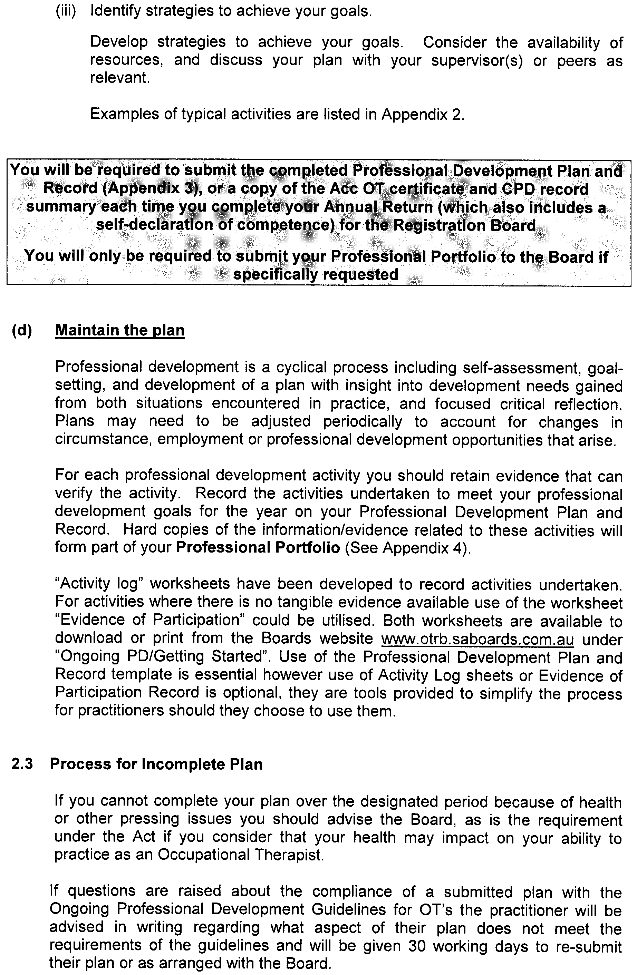
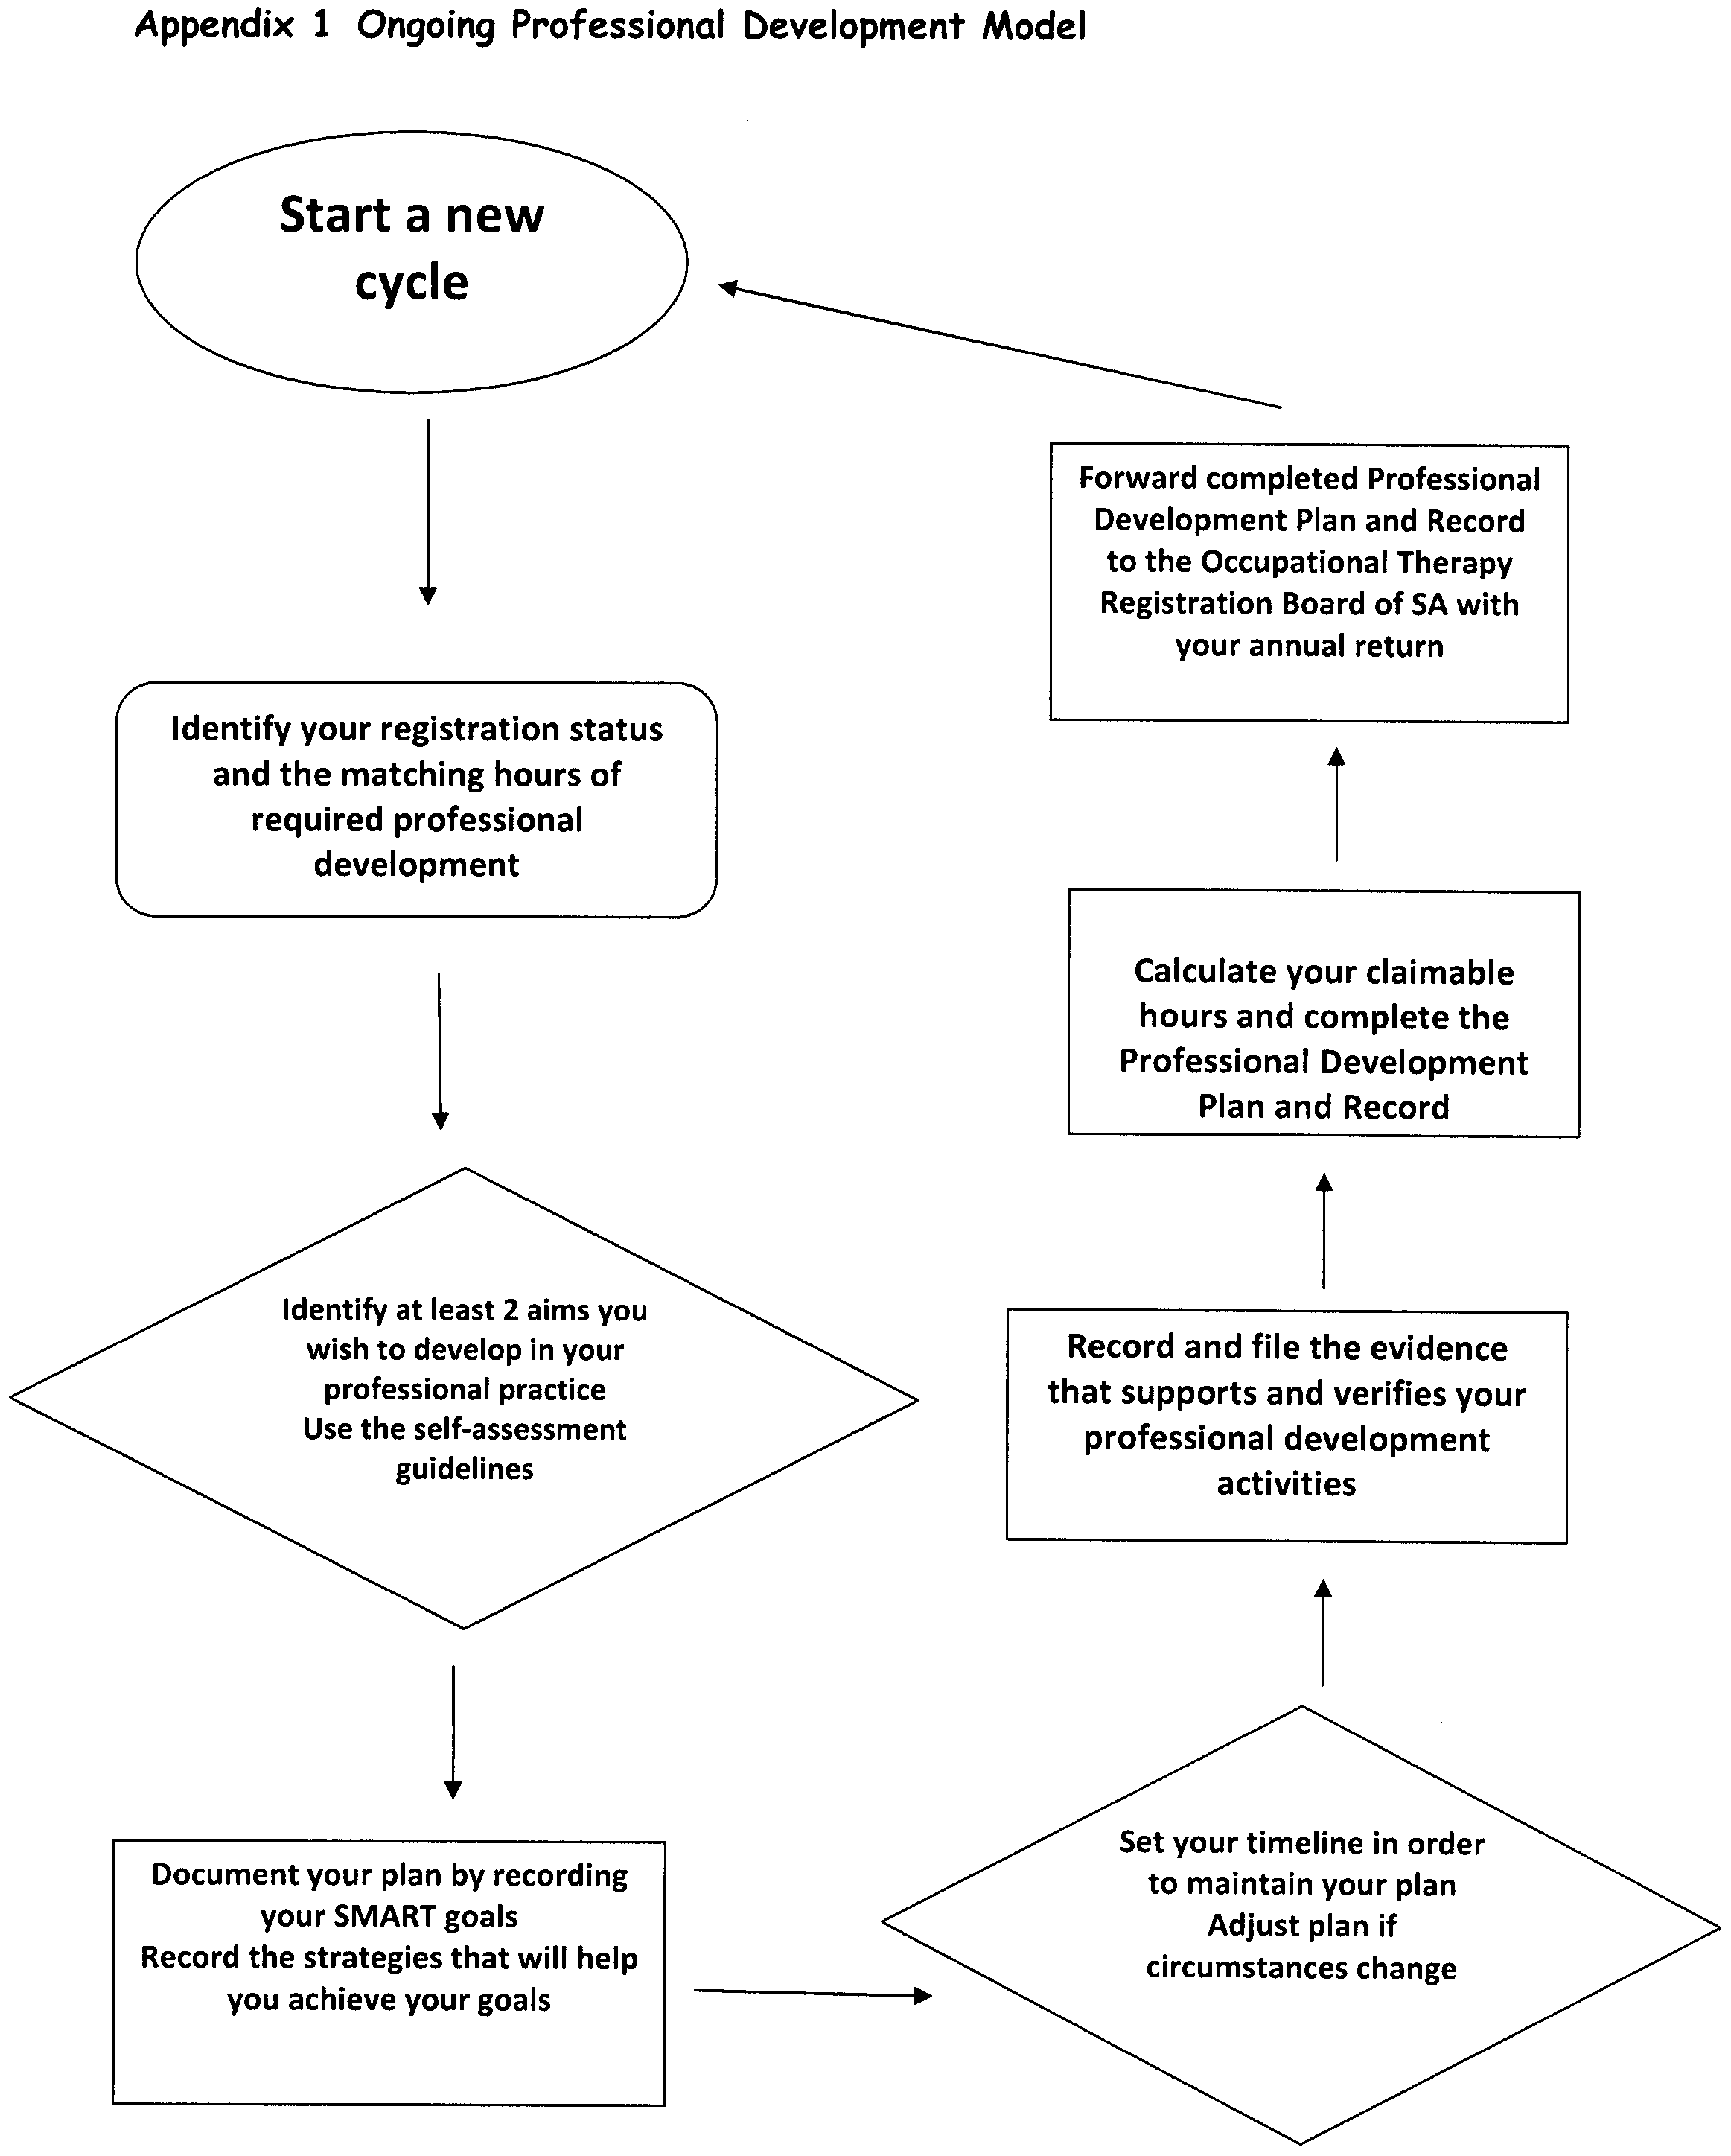



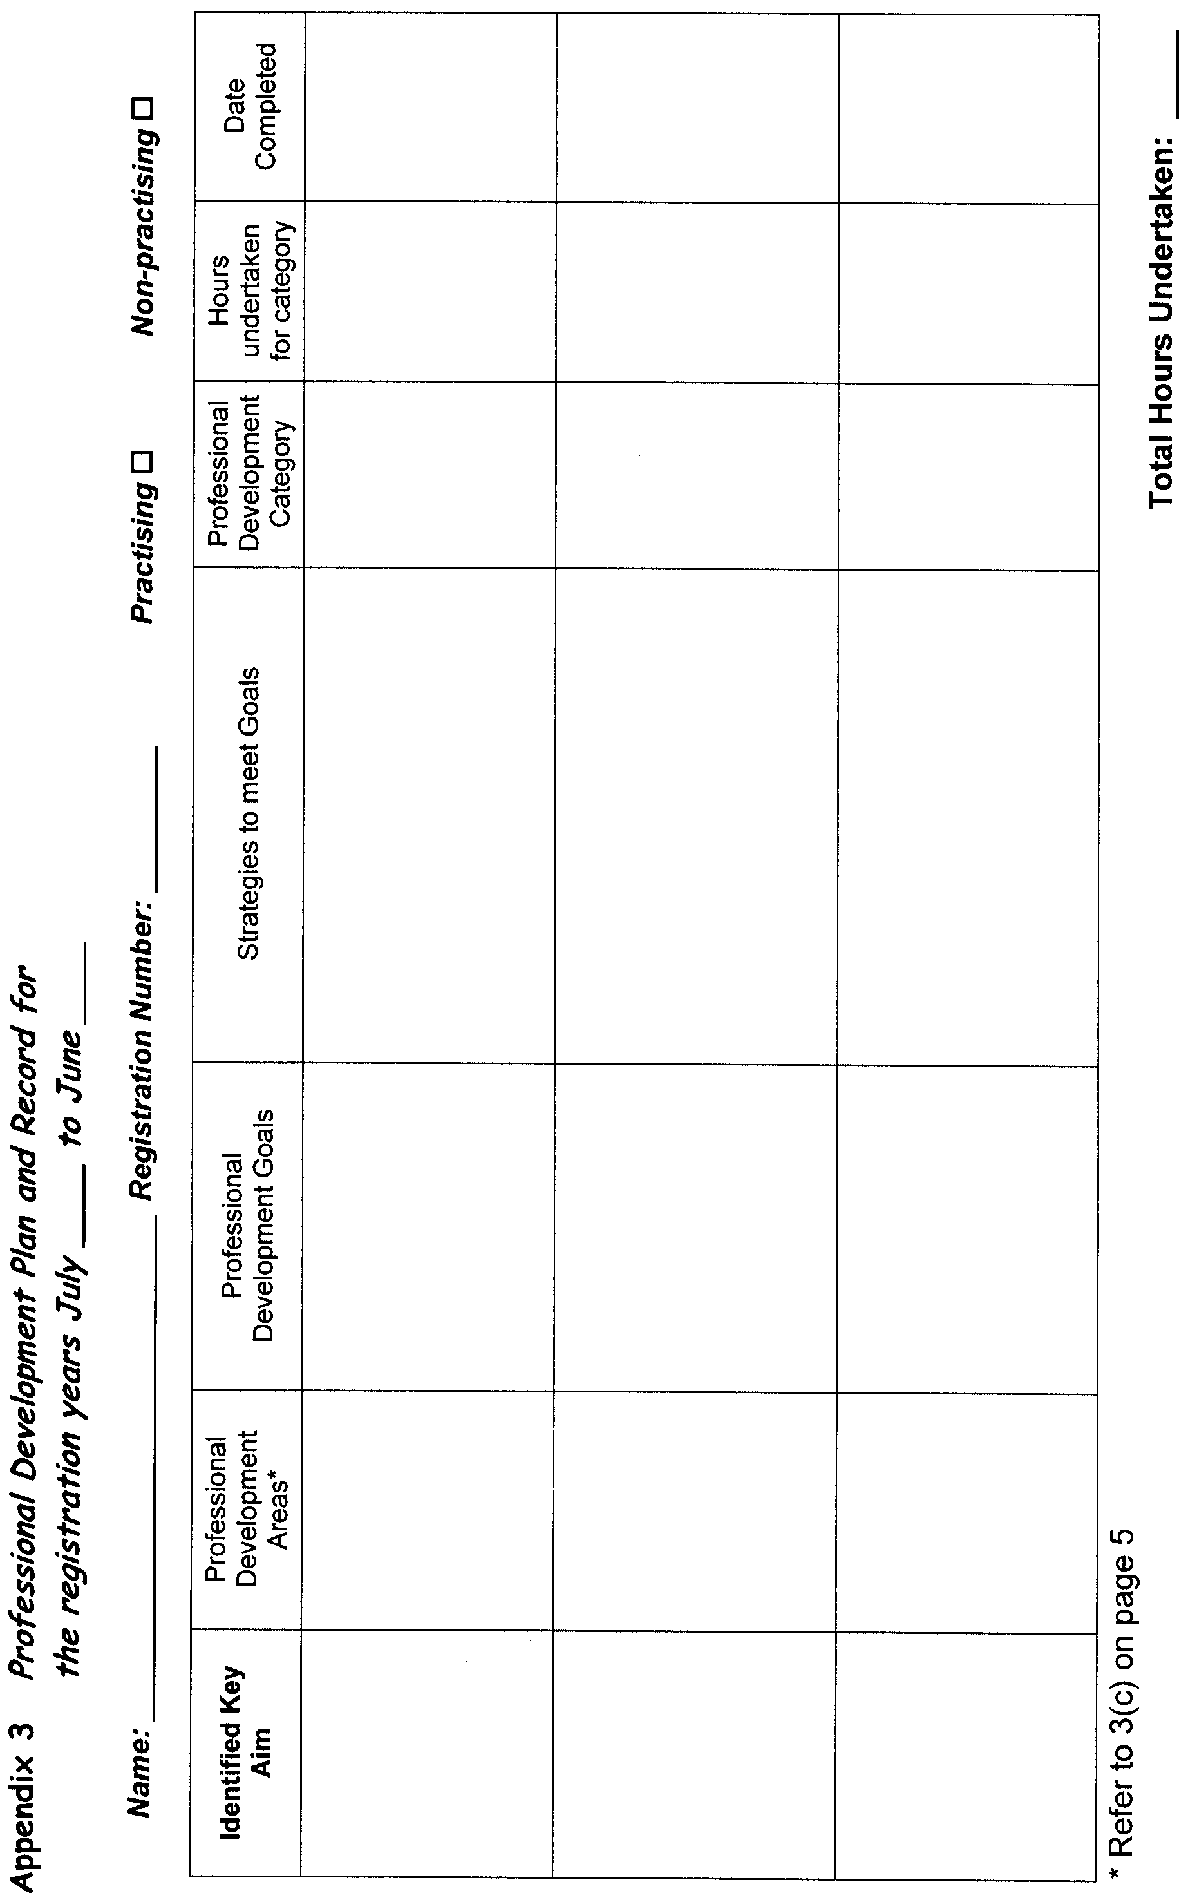
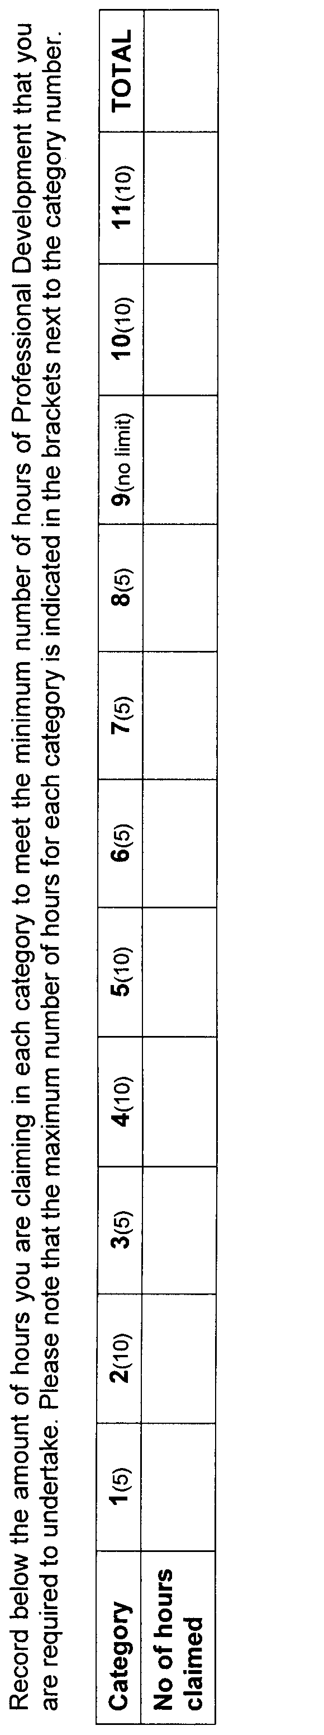



GOVERNMENT GAZETTE ADVERTISEMENT RATES

To apply from 1 July 2009

$  Agents, Ceasing to Act as 42.75  Associations:  Incorporation 21.70  Intention of Incorporation 53.50  Transfer of Properties 53.50  Attorney, Appointment of 42.75  Bailiff’s Sale 53.50  Cemetery Curator Appointed 31.75  Companies:  Alteration to Constitution 42.75  Capital, Increase or Decrease of 53.50  Ceasing to Carry on Business 31.75  Declaration of Dividend 31.75  Incorporation 42.75  Lost Share Certificates:  First Name 31.75  Each Subsequent Name 10.90  Meeting Final 35.75  Meeting Final Regarding Liquidator’s Report on  Conduct of Winding Up (equivalent to ‘Final  Meeting’)  First Name 42.75  Each Subsequent Name 10.90  Notices:  Call 53.50  Change of Name 21.70  Creditors 42.75  Creditors Compromise of Arrangement 42.75  Creditors (extraordinary resolution that ‘the Com-pany be wound up voluntarily and that a liquidator be appointed’) 53.50  Release of Liquidator⎯Application⎯Large Ad. 85.00  ⎯Release Granted 53.50  Receiver and Manager Appointed 49.50  Receiver and Manager Ceasing to Act 42.75  Restored Name 40.00  Petition to Supreme Court for Winding Up 74.50  Summons in Action 63.50  Order of Supreme Court for Winding Up Action 42.75  Register of Interests⎯Section 84 (1) Exempt 96.00  Removal of Office 21.70  Proof of Debts 42.75  Sales of Shares and Forfeiture 42.75  Estates:  Assigned 31.75  Deceased Persons⎯Notice to Creditors, etc. 53.50  Each Subsequent Name 10.90  Deceased Persons⎯Closed Estates 31.75  Each Subsequent Estate 1.40  Probate, Selling of 42.75  Public Trustee, each Estate 10.90 |  | $  Firms:  Ceasing to Carry on Business (each insertion) 28.50  Discontinuance Place of Business 28.50  Land⎯Real Property Act:  Intention to Sell, Notice of 53.50  Lost Certificate of Title Notices 53.50  Cancellation, Notice of (Strata Plan) 53.50  Mortgages:  Caveat Lodgement 21.70  Discharge of 22.70  Foreclosures 21.70  Transfer of 21.70  Sublet 10.90  Leases⎯Application for Transfer (2 insertions) each 10.90  Lost Treasury Receipts (3 insertions) each 31.75  Licensing 63.50  Municipal or District Councils:  Annual Financial Statement⎯Forms 1 and 2 598.00  Electricity Supply⎯Forms 19 and 20 425.00  Default in Payment of Rates:  First Name 85.00  Each Subsequent Name 10.90  Noxious Trade 31.75  Partnership, Dissolution of 31.75  Petitions (small) 21.70  Registered Building Societies (from Registrar-  General) 21.70  Register of Unclaimed Moneys⎯First Name 31.75  Each Subsequent Name 10.90  Registers of Members⎯Three pages and over:  Rate per page (in 8pt) 272.00  Rate per page (in 6pt) 359.00  Sale of Land by Public Auction 54.00  Advertisements 3.00  ¼ page advertisement 127.00  ½ page advertisement 254.00  Full page advertisement 498.00  Advertisements, other than those listed are charged at $3.00 per column line, tabular one-third extra.  Notices by Colleges, Universities, Corporations and District Councils to be charged at $3.00 per line.  Where the notice inserted varies significantly in length from that which is usually published a charge of $3.00 per column line will be applied in lieu of advertisement rates listed.  South Australian Government publications are sold on the condition that they will not be reproduced without prior permission from the Government Printer.
All the above prices include GST

GOVERNMENT GAZETTE NOTICES
ALL private advertisements forwarded for publication in the South Australian Government Gazette must be PAID FOR PRIOR TO INSERTION; and all notices, from whatever source, should be legibly written on one side of the paper only and sent to Government Publishing SA so as to be received no later than 4 p.m. Tuesday preceding the day of publication. Phone 8207 1045 or Fax 8207 1040. E-mail: governmentgazette@dpc.sa.gov.au. Send as attachments in Word format. Please include date the notice is to be published and to whom the notice will be charged. The Government Gazette is available online at: www.governmentgazette.sa.gov.au.

MISCELLANEOUS LEGISLATION AND GOVERNMENT PUBLICATIONS PRICES AS FROM 1 JULY 2009

Acts, Bills, Rules, Parliamentary Papers and Regulations
Pages | Main | Amends | Pages | Main | Amends

1-16 | 2.60 | 1.20 | 497-512 | 36.25 | 35.25
17-32 | 3.50 | 2.20 | 513-528 | 37.25 | 36.00
33-48 | 4.55 | 3.25 | 529-544 | 38.50 | 37.25
49-64 | 5.75 | 4.40 | 545-560 | 39.50 | 38.50
65-80 | 6.70 | 5.55 | 561-576 | 40.50 | 39.50
81-96 | 7.80 | 6.45 | 577-592 | 41.75 | 40.00
97-112 | 8.90 | 7.60 | 593-608 | 43.00 | 41.50
113-128 | 9.95 | 8.75 | 609-624 | 43.75 | 42.75
129-144 | 11.10 | 9.85 | 625-640 | 45.00 | 43.25
145-160 | 12.20 | 10.90 | 641-656 | 46.00 | 45.00
161-176 | 13.30 | 12.00 | 657-672 | 46.75 | 45.50
177-192 | 14.50 | 13.10 | 673-688 | 48.75 | 46.75
193-208 | 15.60 | 14.40 | 689-704 | 49.50 | 47.75
209-224 | 16.50 | 15.20 | 705-720 | 50.25 | 49.00
225-240 | 17.60 | 16.30 | 721-736 | 52.00 | 50.00
241-257 | 18.90 | 17.20 | 737-752 | 52.50 | 51.00
258-272 | 19.90 | 18.30 | 753-768 | 53.50 | 52.00
273-288 | 21.00 | 19.70 | 769-784 | 54.50 | 53.50
289-304 | 21.90 | 20.60 | 785-800 | 55.50 | 54.50
305-320 | 23.20 | 21.80 | 801-816 | 57.00 | 55.00
321-336 | 24.20 | 22.80 | 817-832 | 58.00 | 57.00
337-352 | 25.40 | 24.10 | 833-848 | 59.00 | 58.00
353-368 | 26.25 | 25.20 | 849-864 | 60.00 | 58.50
369-384 | 27.50 | 26.25 | 865-880 | 61.50 | 60.00
385-400 | 28.75 | 27.25 | 881-896 | 62.00 | 60.50
401-416 | 29.75 | 28.25 | 897-912 | 63.50 | 62.00
417-432 | 31.00 | 29.50 | 913-928 | 64.00 | 63.50
433-448 | 32.00 | 30.75 | 929-944 | 65.00 | 64.00
449-464 | 32.75 | 31.50 | 945-960 | 66.00 | 64.50
465-480 | 33.25 | 32.50 | 961-976 | 68.50 | 65.50
481-496 | 35.25 | 33.25 | 977-992 | 69.50 | 66.00

Legislation—Acts, Regulations, etc: $
Subscriptions:
Acts 223.00
All Bills as Laid 536.00
Rules and Regulations 536.00
Parliamentary Papers 536.00
Bound Acts 248.00
Index 124.00
Government Gazette
Copy 5.85
Subscription 296.00
Hansard
Copy 16.30
Subscription—per session (issued weekly) 465.00
Cloth bound—per volume 199.00
Subscription—per session (issued daily) 465.00
Legislation on Disk
Whole Database 3 443.00
Annual Subscription for fortnightly updates 1 058.00
Individual Act(s) including updates POA
Notice of Vacancies
Annual Subscription 164.00
Compendium
Subscriptions:
New Subscriptions 2 039.00
Updates 719.00
(All the above prices include GST)

All Legislation, Government Gazette, Hansard and Legislation on disk are available from:
Counter Sales Government Legislation⁺ Outlet
and Mail Orders: Service SA Customer Service Centre,
Ground Floor—EDS Centre, 108 North Terrace, Adelaide, S.A. 5000
Phone: 13 23 24 (local call cost), Fax: (08) 8204 1909
Postal: G.P.O. Box 1707, Adelaide, S.A. 5001

Online Shop: www.shop.service.sa.gov.au

Subscriptions and Government Publishing SA
Standing Orders: Box 9, Plaza Level, Riverside Centre, North Terrace, Adelaide, S.A. 5000
Phone: (08) 8207 1043, (08) 8207 0910, Fax: (08) 8207 1040

PETROLEUM ACT 2000
Amendment to Notice of Invitation of Applications for an Exploration Licence
I, BARRY ALAN GOLDSTEIN, Director Petroleum and Geothermal, Minerals and Energy Resources, Department of Primary Industries and Resources in the State of South Australia, pursuant to the provisions of the Petroleum Act 2000, and pursuant to delegated powers dated 28 March 2002, Gazetted 11 April 2002, page 1573 and in accordance with section 22 (1) of the Petroleum Act 2000, on behalf of the Minister for Mineral Resources Development (Minister) hereby amend the ‘Notice of Invitation of Applications for an Exploration Licence’ as published in the South Australian Government Gazette, page 628, dated 12 February 2009, by substituting the ‘CO2009-E minimum area available’, and the description of ‘Zone-E’ with the amended minimum area and description following:
CO 2009-E (minimum available area).
Area: 1 472 km² approximately.
CO2009 ZONE E (amended)
Description of Area
All that part of the State of South Australia, bounded as follows:
Commencing at a point being the intersection of latitude 27°52′00″S GDA94 and longitude 140°56′00″E GDA94, thence east to the eastern border of the State of South Australia, thence southerly along the border of the said State to latitude 28°47′00″S GDA94, west to longitude 140°55′00″E GDA94, south to latitude 28°50′00″S GDA94, west to longitude 140°52′00″E GDA94, south to latitude 28°53′00″S GDA94, west to longitude 140°28′00″E GDA94, south to latitude 28°57′00″S GDA94, west to longitude 140°19′30″E GDA94, south to latitude 29°00′00″S AGD66, west to longitude 140°10′00″E AGD66, north to latitude 28°40′00″S AGD66, west to longitude 139°50′00″E AGD66, north to latitude 28°22′35″S GDA94, east to longitude 139°52′00″E Clarke1858, south to latitude 28°23′00″S Clarke1858, east to longitude 139°53′00″E Clarke1858, south to latitude 28°24′00″S Clarke1858, east to longitude 139°55′00″E Clarke1858, south to latitude 28°25′00″S Clarke1858, east to longitude 140°02′00″E Clarke1858, north to latitude 28°24′00″S Clarke1858, east to longitude 140°04′00″E Clarke1858, north to latitude 28°21′00″S AGD66, east to longitude 140°04′50″E AGD66, north to latitude 28°20′50″S AGD66, east to longitude 140°06′10″E AGD66, north to latitude 28°20′40″S AGD66, east to longitude 140°08′30″E AGD66, north to latitude 28°20′20″S AGD66, east to longitude 140°08′40″E AGD66, north to latitude 28°19′40″S AGD66, east to longitude 140°10′20″E AGD66, south to latitude 28°20′00″S AGD66, east to longitude 140°10′30″E AGD66, south to latitude 28°20′10″S AGD66, east to longitude 140°11′00″E Clarke1858, north to latitude 28°16′00″S Clarke1858, east to longitude 140°12′00″E Clarke1858, north to latitude 28°14′00″S Clarke1858, east to longitude 140°16′00″E Clarke1858, north to latitude 28°12′00″S Clarke1858, east to longitude 140°17′00″E Clarke1858, north to latitude 28°11′00″S Clarke1858, east to longitude 140°19′00″E Clarke1858, north to latitude 28°10′00″S Clarke1858, east to longitude 140°20′00″E Clarke1858, north to latitude 28°09′00″S Clarke1858, east to longitude 140°24′00″E Clarke1858, north to latitude 28°07′00″S AGD66, east to longitude 140°25′40″E AGD66, north to latitude 28°03′00″S AGD66, east to longitude 140°30′00″E GDA94, north to latitude 28°00′00″S GDA94, east to longitude 140°34′00″E GDA94, south to latitude 28°01′00″S GDA94, east to longitude 140°34′20″E AGD66, north to latitude 27°56′10″S AGD66, east to longitude 140°36′40″E AGD66, north to latitude 27°54′50″S AGD66, east to longitude 140°50′00″E AGD66, north to latitude 27°53′00″S GDA94, east to longitude 140°56′00″E GDA94 and north to point of commencement.
Area: 9 044 km² approximately.
All other provisions of the ‘Notice of Invitation of Applications for an Exploration Licence’ as published in the South Australian Government Gazette, page 628, dated 12 February 2009 remain unchanged.
Dated 18 August 2009.
B. A. Goldstein,
Director Petroleum and Geothermal
Minerals and Energy Resources
Primary Industries and Resources SA
Delegate of the Minister for Mineral Resources Development

PROFESSIONAL STANDARDS ACT 2004

Engineers Australia South Australia Scheme

PURSUANT to section 14 (1) of the Professional Standards Act 2004, I authorise the publication in the Gazette of the Engineers Australia South Australia Scheme.

Pursuant to section 15 (1) (a) of the Professional Standards Act 2004, I specify 1 September 2009, as the date of commencement of the Engineers South Australia Scheme.

Dated 18 August 2009.

Michael Atkinson, Attorney-General


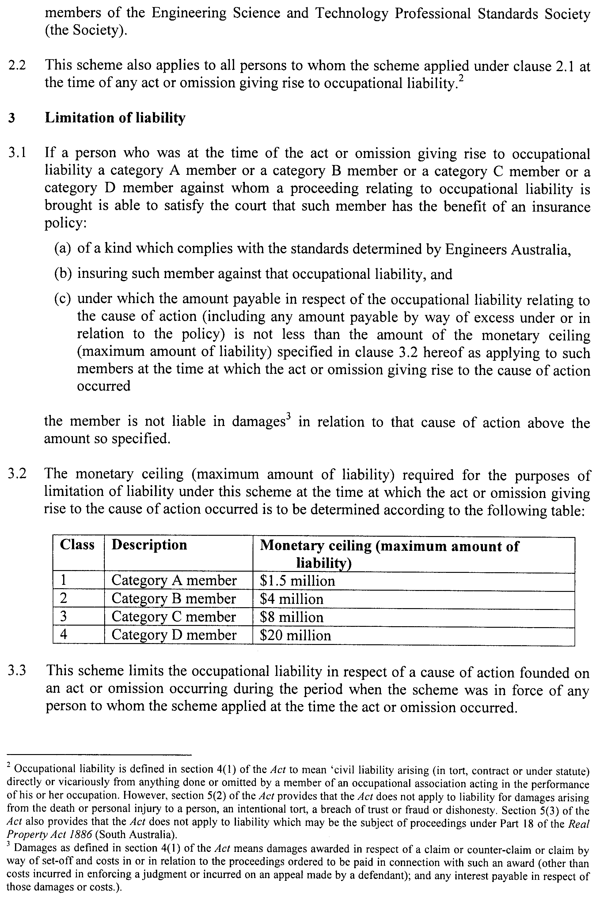
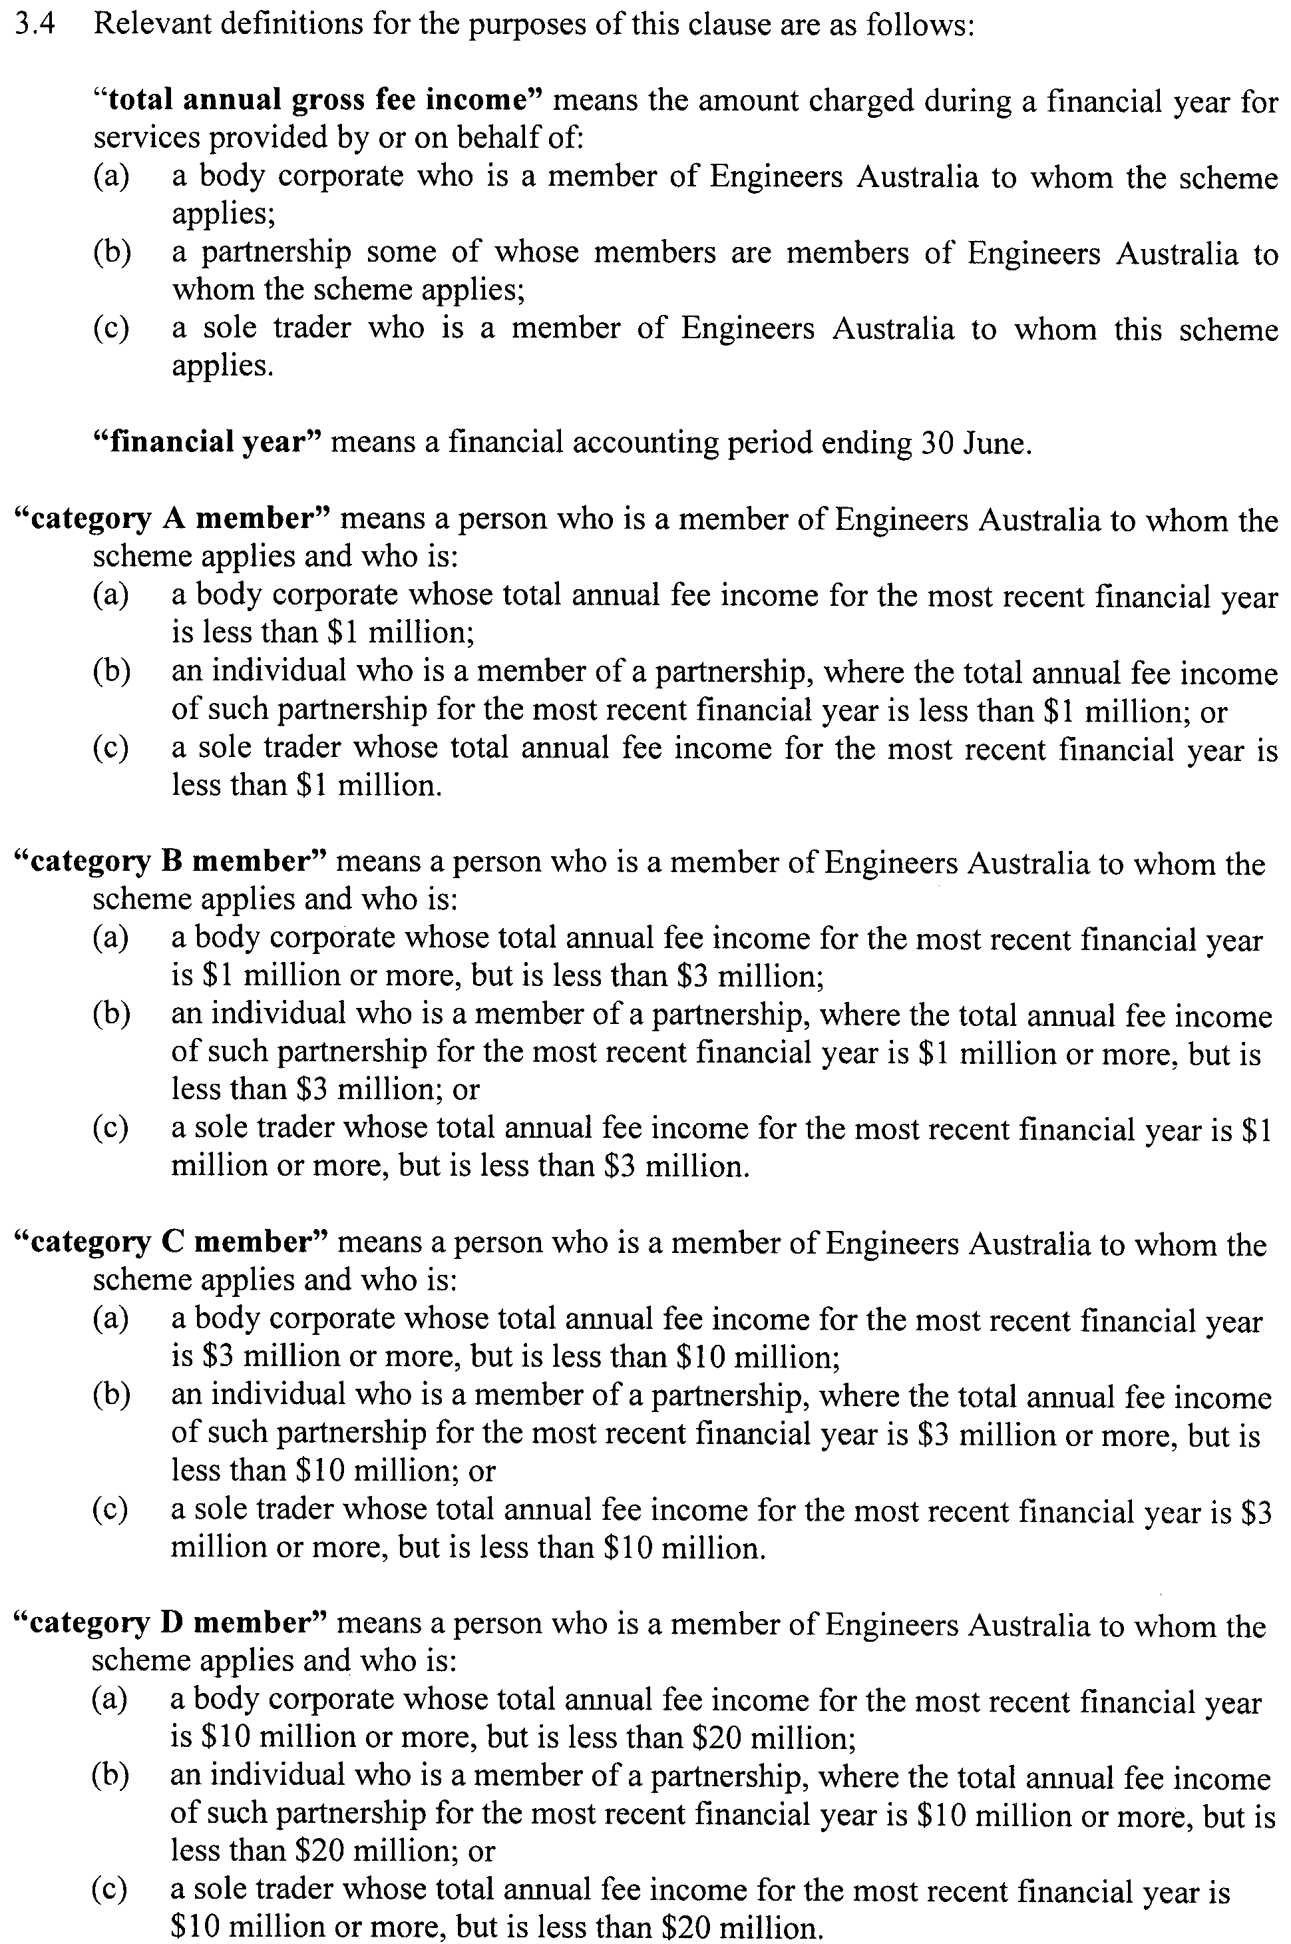
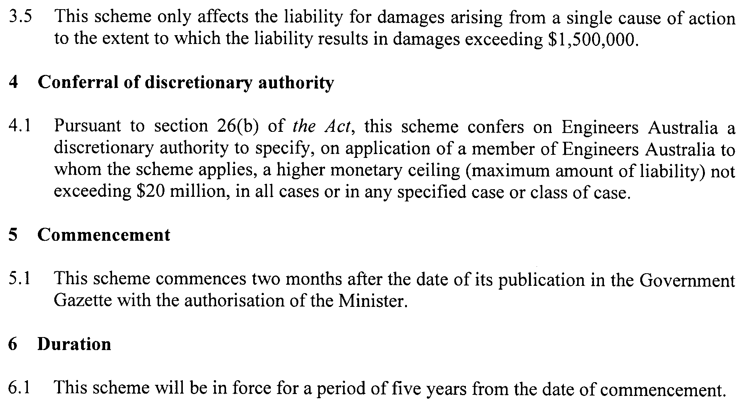

ROADS (OPENING AND CLOSING) ACT 1991:
SECTION 24
NOTICE OF CONFIRMATION OF ROAD
PROCESS ORDER
Road Closure
Texel Court, Salisbury South
BY Road Process Order made on 16 June 2009, the City of Salisbury ordered that:
1. Portion of the public road (Texel Court) situate adjoining the western boundaries of allotment 7 in Deposited Plan 19865, generally delineated and lettered ‘A’ in Preliminary Plan No. 08/0041 be closed.
2. The whole of the land subject to closure be transferred to Allan William Finnie and Suzanne Paulette Finnie in accordance with the agreement for transfer dated 16 June 2009 entered into between the City of Salisbury and A. W. and S. P. Finnie.
On 27 July 2009 that order was confirmed by the Minister for Infrastructure conditionally upon the deposit by the Registrar-General of Deposited Plan 81485 being the authority for the new boundaries.
Pursuant to section 24 (5) of the Roads (Opening and Closing) Act 1991, NOTICE of the order referred to above and its confirmation is hereby given.
Dated 20 August 2009.
P. M. Kentish, Surveyor-General

ROADS (OPENING AND CLOSING) ACT 1991:
SECTION 24
NOTICE OF CONFIRMATION OF ROAD
PROCESS ORDER
Road Opening and Closing,
Gillen Street and Gleeson Street, Clare
BY Road Process Order made on 16 June 2009, the Clare and Gilbert Valleys Council ordered that:
1. Portion of allotment 91 in Filed Plan 204224, more particularly delineated and numbered ‘1’ in Preliminary Plan No. 08/0048 be opened as road.
2. Portions of the unnamed public road and Gillen and Gleeson Streets situate adjoining allotment 91 in Filed Plan 204224, more particularly delineated and lettered ‘A’ in Preliminary Plan No. 08/0048 be closed.
3. The whole of the land subject to closure be transferred to Bryan Sylvester Edwards and Barbara Elaine Edwards in accordance with agreement for exchange dated 16 June 2009 entered into between the Clare and Gilbert Valleys Council and B. S. and B. E. Edwards.
On 13 August 2009 that order was confirmed by the Minister for Infrastructure conditionally upon the deposit by the Registrar-General of Deposited Plan 81544 being the authority for the new boundaries.
Pursuant to section 24 (5) of the Roads (Opening and Closing) Act 1991, NOTICE of the order referred to above and its confirmation is hereby given.
Dated 20 August 2009.
P. M. Kentish, Surveyor-General

ROADS (OPENING AND CLOSING) ACT 1991:
SECTION 24
NOTICE OF CONFIRMATION OF ROAD
PROCESS ORDER
Road Closure
Lincoln Highway, Tumby Bay
BY Road Process Order made on 16 May 2008, The District Council of Tumby Bay ordered that:
1. Portion of the public road (Lincoln Highway) situate north of Bratten Way and adjoining the western boundaries of section 323, Hundred of Hutchinson, allotment 1 in Deposited Plan
24401 and allotments 3, 4 and 5 in Deposited Plan 28663, more particularly delineated and lettered ‘B’, ‘C’, ‘D’ and ‘E’ in Preliminary Plan No. 04/0138 be closed.
2. The whole of the land subject to closure be transferred to Ausbulk Ltd in accordance with agreement for transfer dated
15 May 2008 entered into between The District Council of Tumby Bay and Ausbulk Ltd.
3. The following easements are granted over portions of the land subject to that closure:
Grant to the Distribution Lessor Corporation an easement for electricity supply purposes.
Grant to the South Australian Water Corporation an ease-ment for water supply purposes.
On 6 April 2009 that order was confirmed by the Minister for Infrastructure conditionally upon the deposit by the Registrar-General of Deposited Plan 78016 being the authority for the new boundaries.
Pursuant to section 24 (5) of the Roads (Opening and Closing) Act 1991, NOTICE of the order referred to above and its confirmation is hereby given.
Dated 20 August 2009.
P. M. Kentish, Surveyor-General

SEWERAGE ACT 1929
Addition of Land to Adelaide Drainage Area
PURSUANT to section 18 of the Sewerage Act 1929, the South Australian Water Corporation:
(a) adds to the Adelaide Drainage Area all the land contained in:
(i) Deposited Plan 80683 (except the portion of that land already in the Adelaide Drainage Area);
(ii) allotment 1004 in Deposited Plan 76859 (except the portion of that land already in the Adelaide Drainage Area); and
(b) declares that this notice will have effect from 1 July 2009.
Dated 17 August 2009.
Signed for and on behalf of the South Australian Water Corporation by a person duly authorised so to do:
A. Schirripa, Manager Billing and Collection
In the presence of:
N. Morales, Team Leader Billing
SAWATER 09/06016 D1418

WATER MAINS AND SEWERS

Office of the South Australian Water Corporation
Adelaide, 20 August 2009

WATER MAINS LAID

Notice is hereby given that the following main pipes or parts of main pipes have been laid down by the South Australian Water Corporation in or near the undermentioned water districts and are now available for a constant supply of water to adjacent land.

ADELAIDE WATER DISTRICT

CITY OF CHARLES STURT
Across Frogmore Road, Kidman Park. p22
Easements in lot 332 in LTRO DP 73488, Frogmore Road, Kidman Park. p22

CITY OF ONKAPARINGA
In and across Pinkgum Avenue, Aldinga Beach. p1
Halcyon Circuit, Aldinga Beach. p1
Whistlers Avenue, Aldinga Beach. p1
Bushtail Avenue, Aldinga Beach. p1
Halcyon Circuit, Aldinga Beach. p2
Whistlers Avenue, Aldinga Beach. p2
Across Commercial Road, Seaford Meadows. p5
Atlantis Avenue, Seaford Meadows. p5-7
Message Road, Seaford Meadows. p5
Easements in lot 3001 in LTRO DP 80700, Commercial Road, Seaford Meadows. p5
Maritime Road, Seaford Meadows. p6
Anchor Road, Seaford Meadows. p7
Flare Road, Seaford Meadows. p7
Tidal Street, Seaford Meadows. p6 and 7

CITY OF PORT ADELAIDE ENFIELD
In and across Agnes Street, Ottoway. p23
Pearce Street, Ottoway. p23
St Johns Street, Ottoway. p24
Eastern Parade, Ottoway. p24

CITY OF SALISBURY
Mossman Street, Mawson Lakes. p3
Victoria Parade, Mawson Lakes. p3
Mowbray Street, Mawson Lakes. p3
In and across Phillipson Circuit, Mawson Lakes. p4
Across and in Elder Drive, Mawson Lakes. p4
Templeton Street, Mawson Lakes. p4

CITY OF TEA TREE GULLY
Ashby Avenue, Highbury. p13

BAROSSA COUNTRY LANDS WATER DISTRICT

THE BAROSSA COUNCIL
Pimpala Road, Sandy Creek. This main is available on application only. p11
Kalbeeba Road, Concordia. p12

BEETALOO COUNTRY LANDS WATER DISTRICT

DISTRICT COUNCIL OF BARUNGA WEST
Across Casey Road, Port Broughton. p19
Easements in lot 100 in LTRO DP 74248, Casey Road, Port Broughton. p19

NORTHERN AREAS COUNCIL
In and across Bowmans Road, Gulnare and Yacka. p16
Hermitage Road, Yacka. p16

BLUE LAKE COUNTRY LANDS WATER DISTRICT

DISTRICT COUNCIL OF GRANT
Across Punt Road, O.B. Flat. p20

KANMANTOO WATER DISTRICT

DISTRICT COUNCIL OF MOUNT BARKER
Bartholomew Road, Kanmantoo. p10

MOUNT GAMBIER WATER DISTRICT

DISTRICT COUNCIL OF GRANT
Lakes Park Drive, O.B. Flat. p20
Lorikeet Street, O.B. Flat. p20

PORT PIRIE WATER DISTRICT

PORT PIRIE REGIONAL COUNCIL
Across and in Kipara Street, Port Pirie West. p14
Public road east of lot 50 in LTRO DP 1809, Port Pirie West. p14

STOCKWELL WATER DISTRICT

THE BAROSSA COUNCIL
Across Sturt Highway, Stockwell. p8
Easements in reserve (lot 201 in LTRO DP 71890), Sturt Highway, Stockwell. p8
Mickan Road, Stockwell. p8
Laucke Drive, Stockwell. p8 and 9

WATER MAINS ABANDONED

Notice is hereby given that the undermentioned water mains have been abandoned by the South Australian Water Corporation.

ADELAIDE WATER DISTRICT

CITY OF PORT ADELAIDE ENFIELD
In and across Agnes Street, Ottoway. p23
Pearce Street, Ottoway. p23
St Johns Street, Ottoway. p24
Eastern Parade, Ottoway. p24

CITY OF SALISBURY
Mossman Street, Mawson Lakes. p3
Victoria Parade, Mawson Lakes. p3

BEETALOO COUNTRY LANDS WATER DISTRICT

NORTHERN AREAS COUNCIL
Bowmans Road, Gulnare and Yacka. p16
Hermitage Road, Yacka. p16

PORT PIRIE WATER DISTRICT

PORT PIRIE REGIONAL COUNCIL
Across and in Kipara Street, Port Pirie West. p14

WATER MAINS LAID

Notice is hereby given that the undermentioned water mains have been laid down by the South Australian Water Corporation and are not available for a constant supply of water to adjacent land.

JERVOIS WATER DISTRICT

THE RURAL CITY OF MURRAY BRIDGE
Waterworks land (section 842, hundred of Brinkley), Rayson Street, Jervois. p15

TAILEM BEND WATER DISTRICT

COORONG DISTRICT COUNCIL
In and across South Terrace, Tailem Bend. p15
Across Princes Highway, Tailem Bend. p15
Easement in sections 663 and 664, hundred of Seymour, Princes Highway, Tailem Bend. p15

JERVOIS WATERWORKS

OUTSIDE JERVOIS WATER DISTRICT

THE RURAL CITY OF MURRAY BRIDGE
Easement in sections 1413 and 1244, hundred of Brinkley, Jervois Ferry Road, Jervois. p15
Jervois Ferry Road, Jervois. p15
Easement in sections 1332 and 219, hundred of Brinkley, Jervois Ferry Road, Jervois. p15
In and across Rayson Street, Jervois. p15
Easements in section 1299, hundred of Brinkley, Rayson Street, Jervois. p15

OUTSIDE TAILEM BEND WATER DISTRICT

COORONG DISTRICT COUNCIL
Across River Murray, Tailem Bend. p15

OUTSIDE WATER DISTRICTS

THE RURAL CITY OF MURRAY BRIDGE
Across River Murray, Jervois. p15

SEWERS LAID

Notice is hereby given that the following sewers have been laid down by the South Australian Water Corporation in the undermentioned drainage areas and are now available for house connections.

ADELAIDE DRAINAGE AREA

CITY OF BURNSIDE
Stanley Street, Erindale. FB 1185 p29

CITY OF CHARLES STURT
Easements in lot 332 in LTRO DP 73488, Frogmore Road, Kidman Park. FB 1186 p9-11

CITY OF HOLDFAST BAY
Easement in lot 9 in LTRO DP 2442 and lot 70 in LTRO DP 81234, Esplanade, Somerton Park. FB 1185 p25

CITY OF ONKAPARINGA
Martin Road, Morphett Vale. FB 1185 p20
Across Grundy Terrace, Christies Beach. FB 1185 p21
Easements in lots 11 and 12 in LTRO DP 76019, Grundy Terrace, Christies Beach. FB 1185 p21
Pancras Court, Morphett Vale. FB 1185 p28
In and across Maritime Road, Seaford Meadows. FB 1186 p14, 15 and 17
Easements in reserve (lot 804 in LTRO DP 79367), Atlantis Avenue, Seaford Meadows. FB 1186 p14, 15 and 17
Across and in Atlantis Avenue, Seaford Meadows. FB 1186 p14-17 and 19
Easement in reserve (lot 803 in LTRO DP 79367), Atlantis Avenue and reserve (lot 811 in LTRO DP 81291), Buoy Crescent, Seaford Meadows. FB 1186 p14, 15 and 17
In and across Message Road, Seaford Meadows. FB 1186 p14, 15 and 19
Sand Street, Seaford Meadows. FB 1186 p14, 15 and 19
Anchor Road, Seaford Meadows. FB 1186 p14, 15 and 19
Easements in lots 330 and 331 in LTRO DP 79367, Maritime Road, Seaford Meadows. FB 1186 p14, 15 and 18
In and across Tidal Street, Seaford Meadows. FB 1186 p14-16 and 18
Flare Road, Seaford Meadows. FB 1186 p14, 16 and 18

CITY OF PLAYFORD
Easement in lot 80 in LTRO DP 6184 and lot 200 in LTRO DP 80202, Fatchen Street, Elizabeth Grove. FB 1185 p22

CITY OF SALISBURY
In and across George Street, Green Fields and Mawson Lakes. FB 1186 p7 and 8
Easements in drainage reserve (lot 1 in LTRO DP 75831), George Street, Mawson Lakes. FB 1186 p7 and 8
Across Port Wakefield Road, Mawson Lakes. FB 1186 p7 and 8
Phillipson Circuit, Mawson Lakes. FB 1186 p12 and 13
Elder Drive, Mawson Lakes. FB 1186 p12 and 13

CITY OF TEA TREE GULLY
Ashby Avenue, Highbury. FB 1185 p30

ALDINGA DRAINAGE AREA

CITY OF ONKAPARINGA
In and across Esplanade, Aldinga Beach. FB 1185 p27
Ocean Street, Aldinga Beach. FB 1185 p27
Pinkgum Avenue, Aldinga Beach. FB 1186 p1-3
Easements in allotment piece 9703 in LTRO DP 79389, Rowley Road, Aldinga Beach. FB 1186 p4-6
Whistlers Avenue, Aldinga Beach. FB 1186 p4-6

MOUNT GAMBIER COUNTRY DRAINAGE AREA

CITY OF MOUNT GAMBIER
Across Victoria Terrace, Mount Gambier. FB 1175 p35
Easement in lot 4 in LTRO DP 64827, Victoria Terrace, Mount Gambier. FB 1175 p35

MURRAY BRIDGE COUNTRY DRAINAGE AREA

THE RURAL CITY OF MURRAY BRIDGE
Thomas Street, Murray Bridge. FB 1185 p24

SEWERS ABANDONED

Notice is hereby given that the undermentioned sewers have been abandoned by the South Australian Water Corporation.

ADELAIDE DRAINAGE AREA

ADELAIDE CITY COUNCIL
Private road (lot 101 in LTRO DP 79811), Coglin Street, Adelaide. FB 1185 p26
Easement in LTRO CP 25355 (formerly lot 100 in LTRO DP 79811), Coglin Street, Adelaide. FB 1185 p26

CITY OF SALISBURY
George Street, Green Fields—100 mm PVC pumping main. FB 1186 p7 and 8
Across and in Ryans Road, Green Fields—100 mm PVC pumping main. FB 1186 p7 and 8

SEWERS LAID

Notice is hereby given that the undermentioned sewer has been laid down by the South Australian Water Corporation and are not available for house connections.

OUTSIDE MURRAY BRIDGE COUNTRY DRAINAGE AREA

THE RURAL CITY OF MURRAY BRIDGE
Easements in lot 865 in LTRO FP 167680, lot 866 in LTRO FP 167681 and lot 4 in LTRO FP 101622, Roper Road, Murray Bridge. FB 1185 p23

A. Howe, Chief Executive Officer, South Australian Water Corporation

WATERWORKS ACT 1932
Addition of Land to Renmark Water District
PURSUANT to section 6 of the Waterworks Act 1932, the South Australian Water Corporation:
(a) adds to the Renmark Water District all the land contained in allotment 1 in Deposited Plan 72521; and
(b) declares that this notice will have effect from 1 July 2009.
Dated 17 August 2009.
Signed for and on behalf of the South Australian Water Corporation by a person duly authorised so to do:
A. Schirripa, Manager Billing and Collection
In the presence of:
N. Morales, Team Leader Billing
SAWATER 09/07493 W1415

WATERWORKS ACT 1932
Addition of Land to Barossa Country Lands Water District
PURSUANT to section 6 of the Waterworks Act 1932, the South Australian Water Corporation:
(a) adds to the Barossa Country Lands Water District all the land contained in:
(i) allotments 1 and 2 in Deposited Plan 44959;
(ii) that portion of Pimpala Road, Sandy Creek abutting allotments 1 and 2 in Deposited Plan 44959 (except the portion of that land already in the Barossa Country Lands Water District); and
(b) declares that this notice will have effect from 1 July 2009.
Dated 17 August 2009.
Signed for and on behalf of the South Australian Water Corporation by a person duly authorised so to do:
A. Schirripa, Manager Billing and Collection
In the presence of:
N. Morales, Team Leader Billing
SAWATER 09/06018 W1416

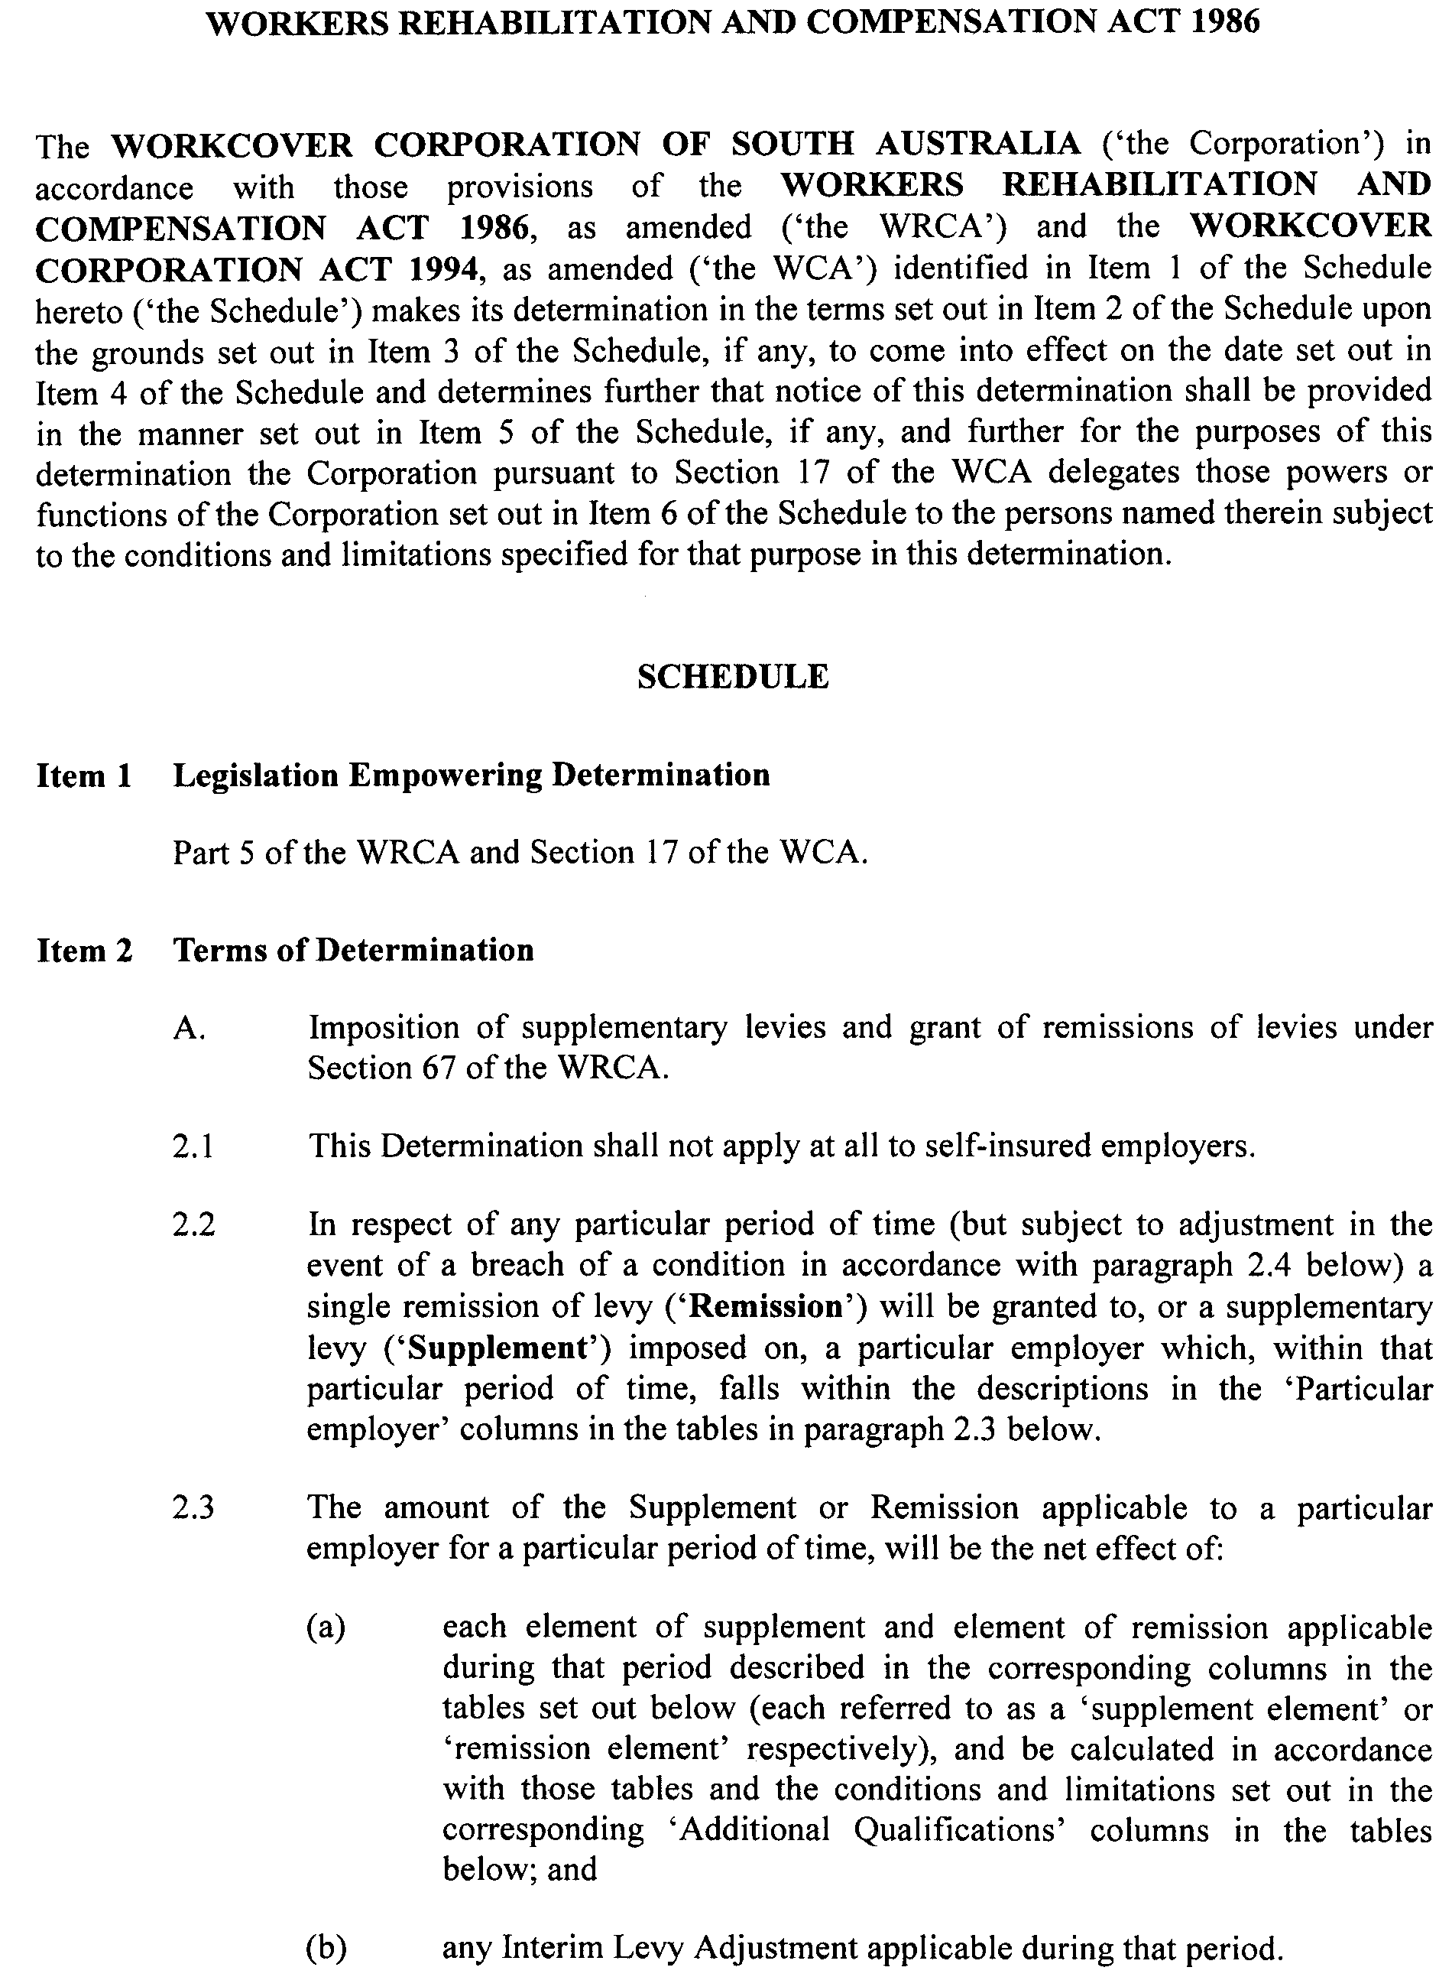

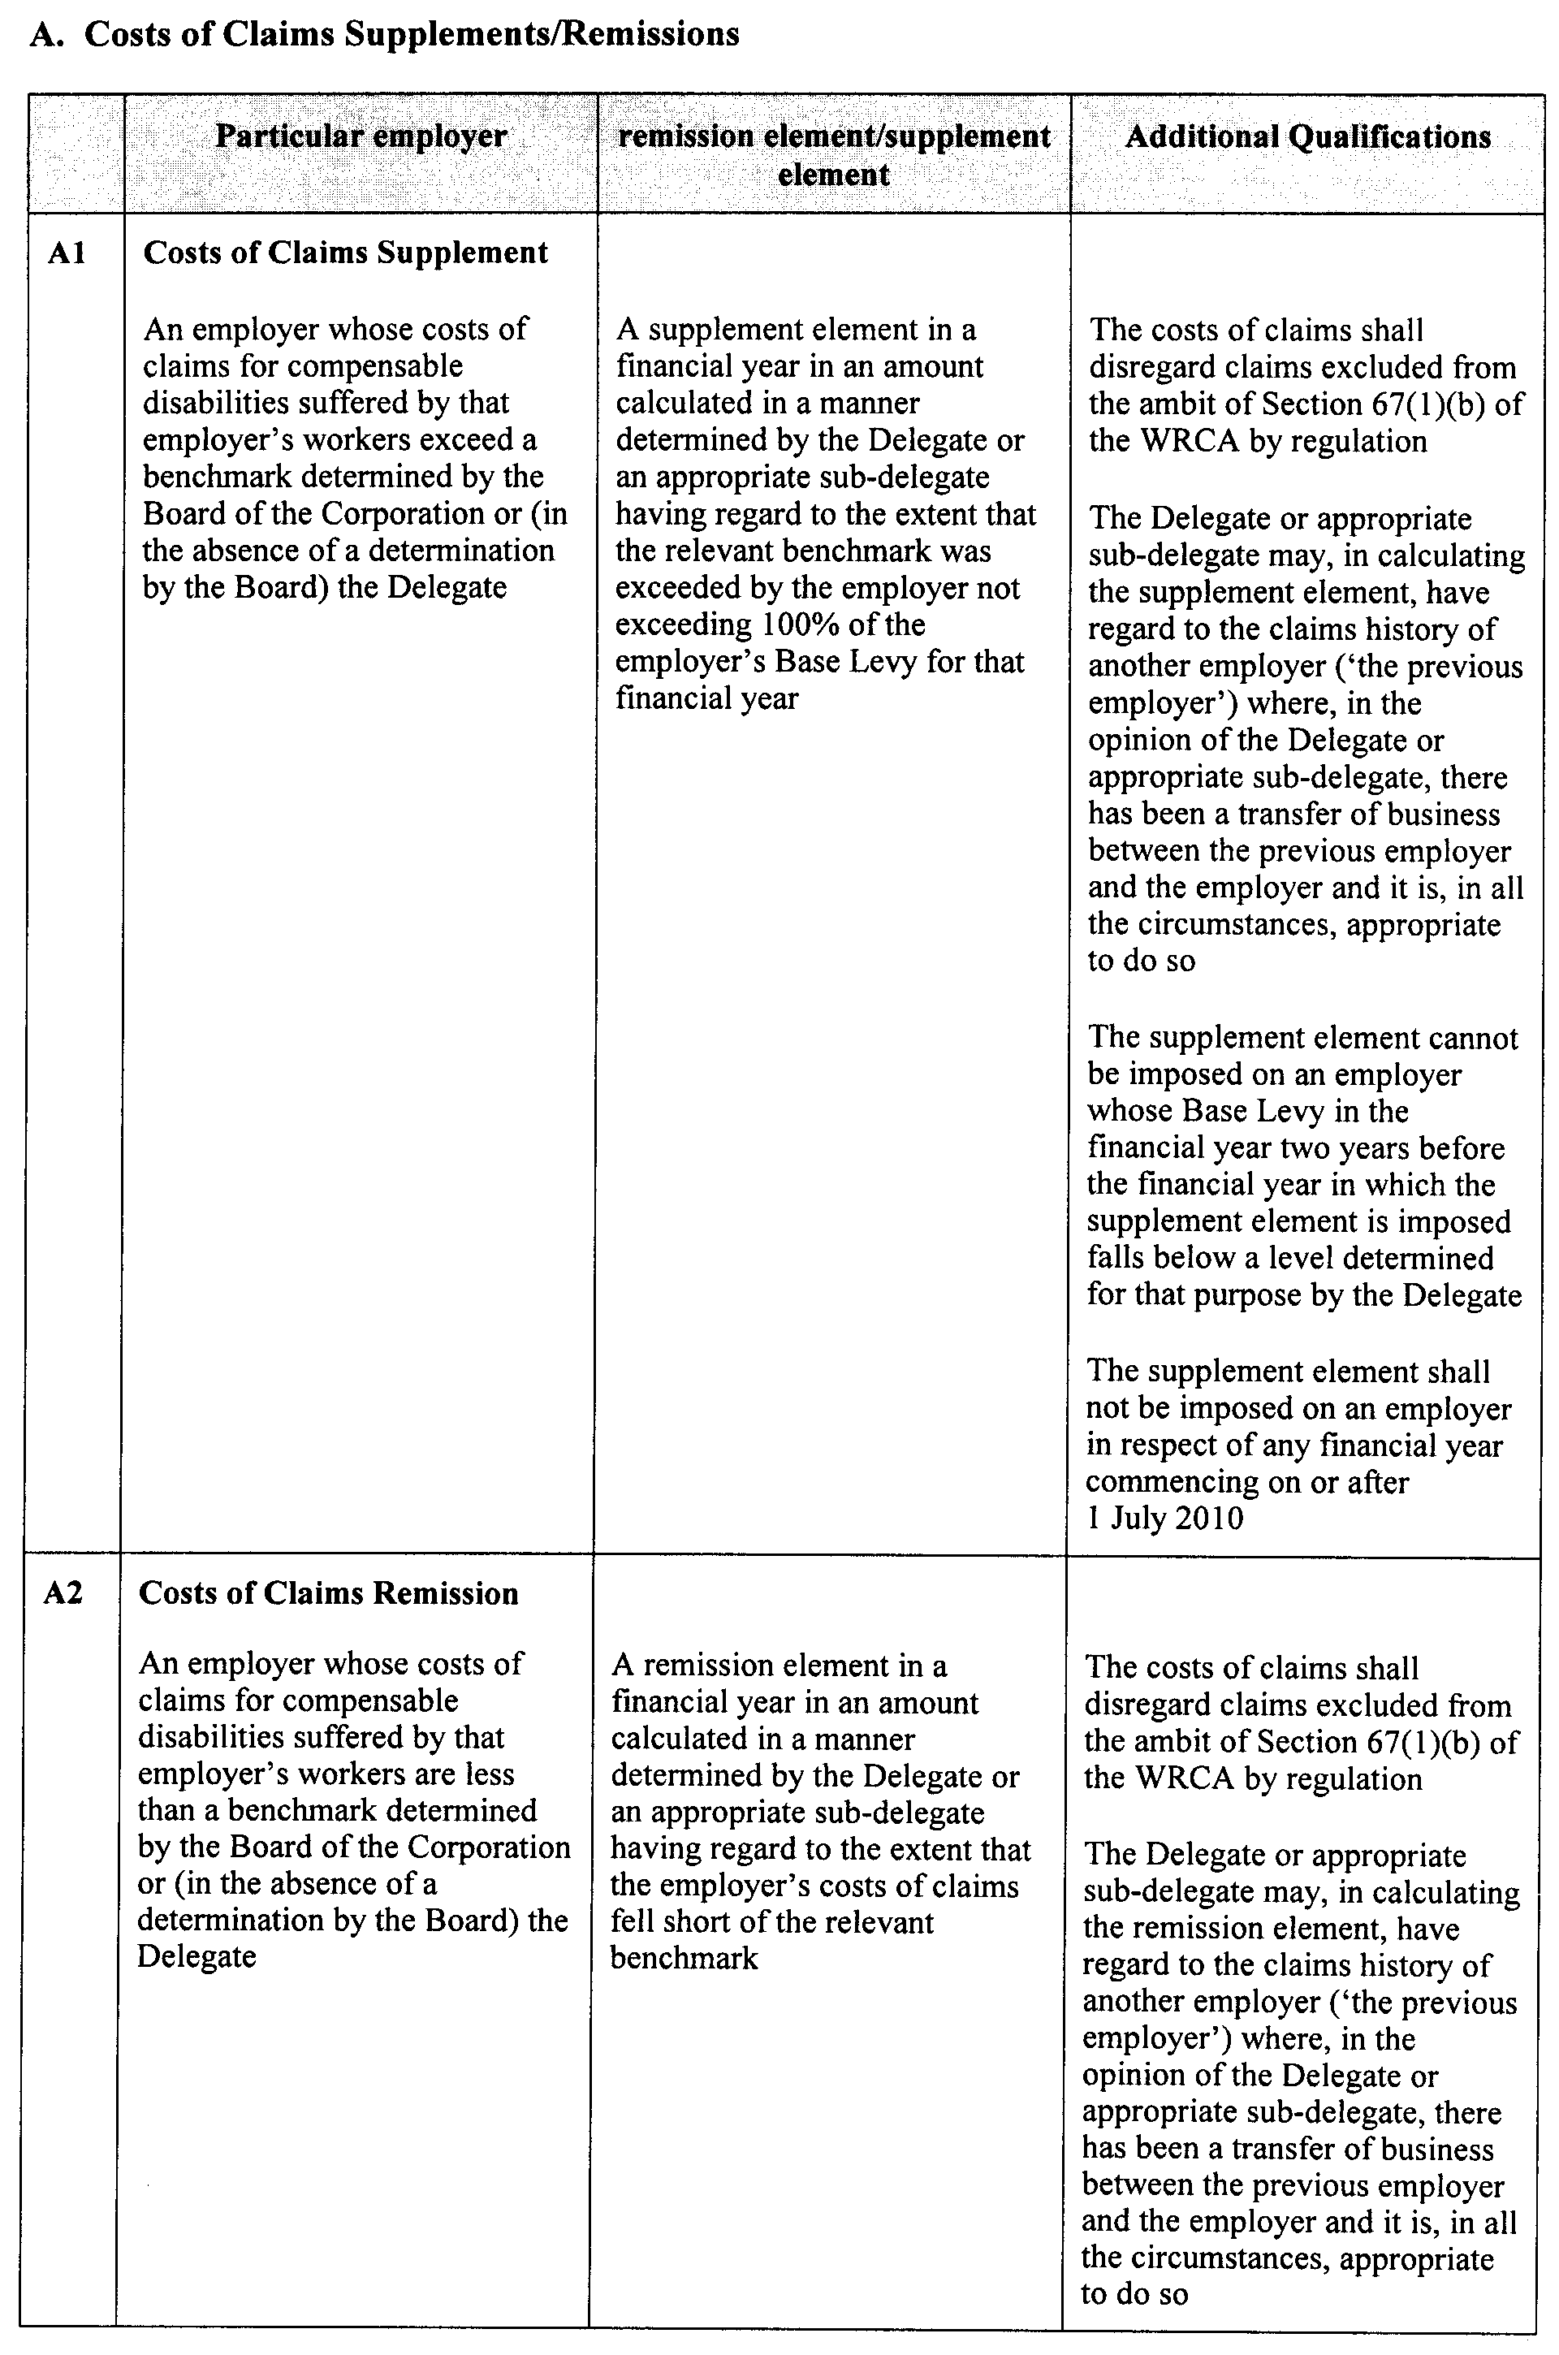
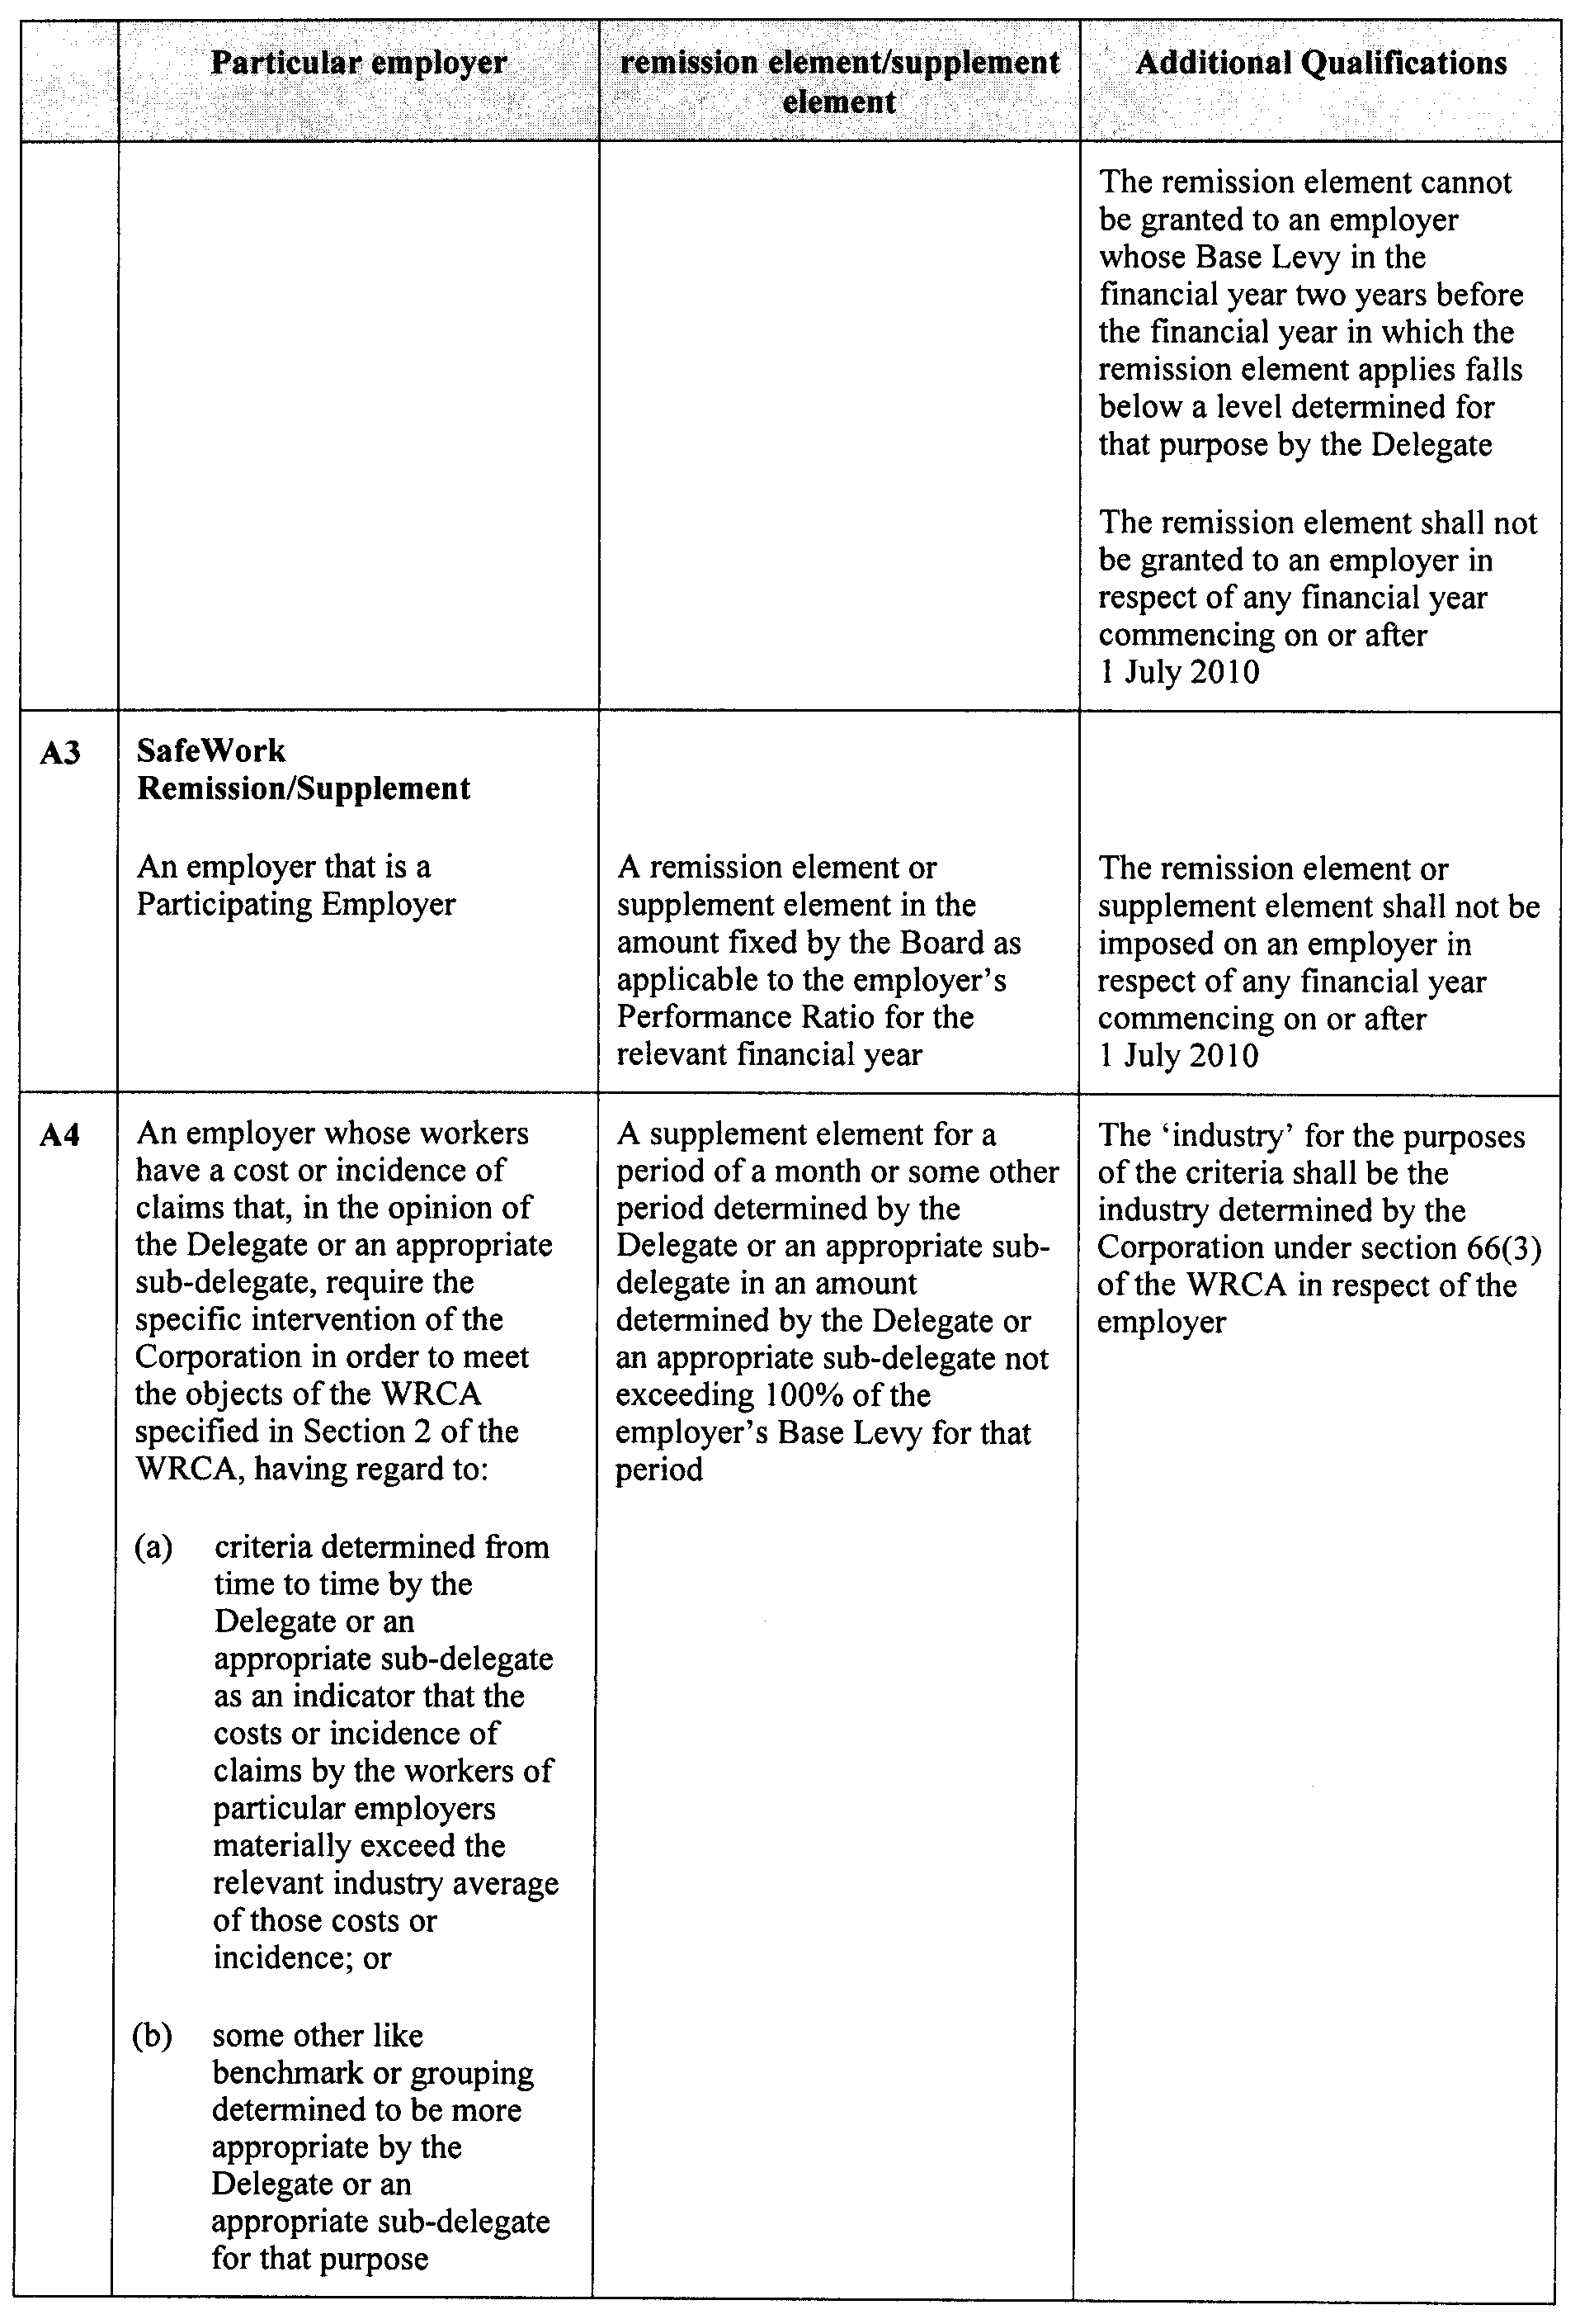

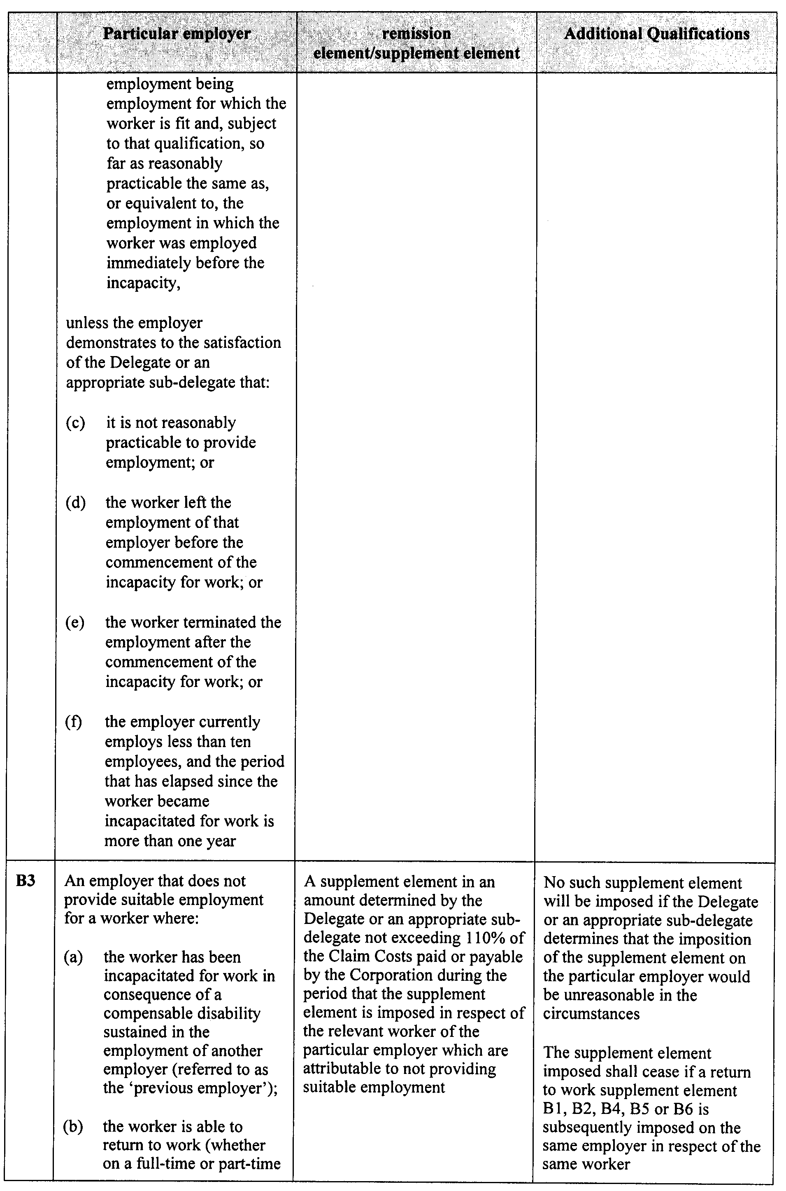

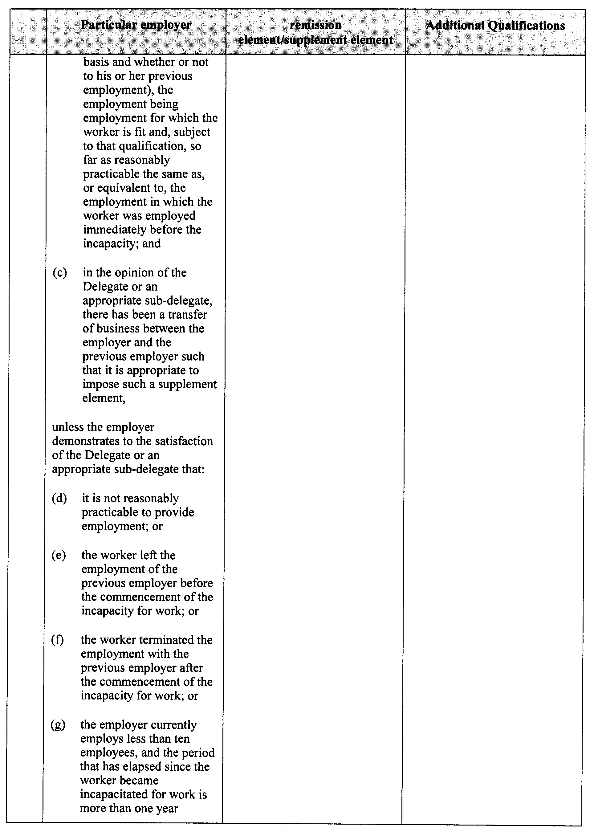
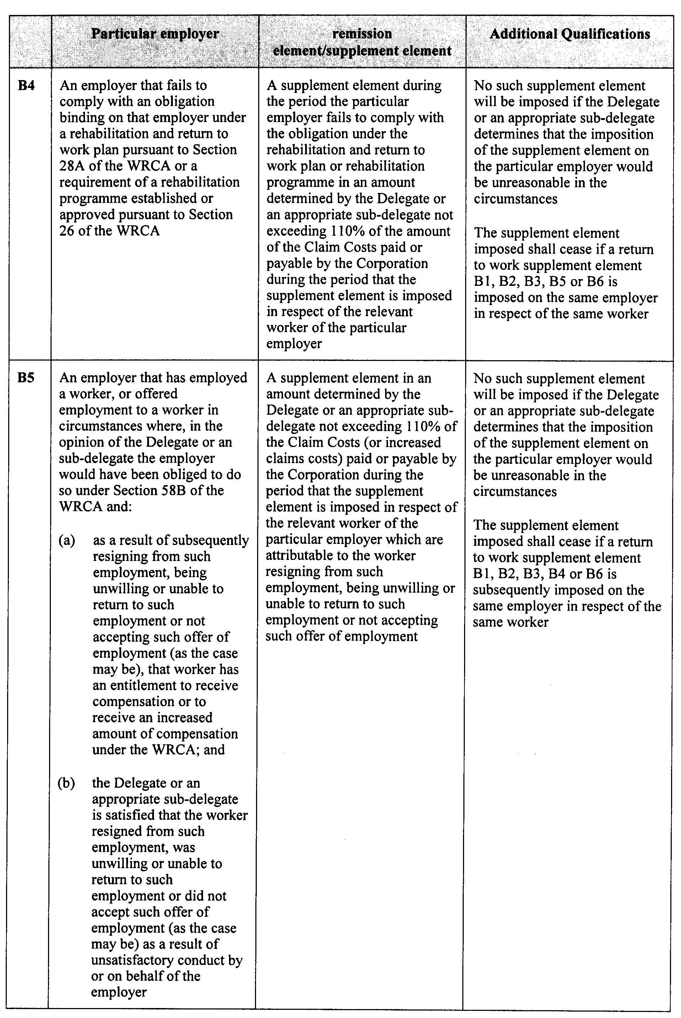
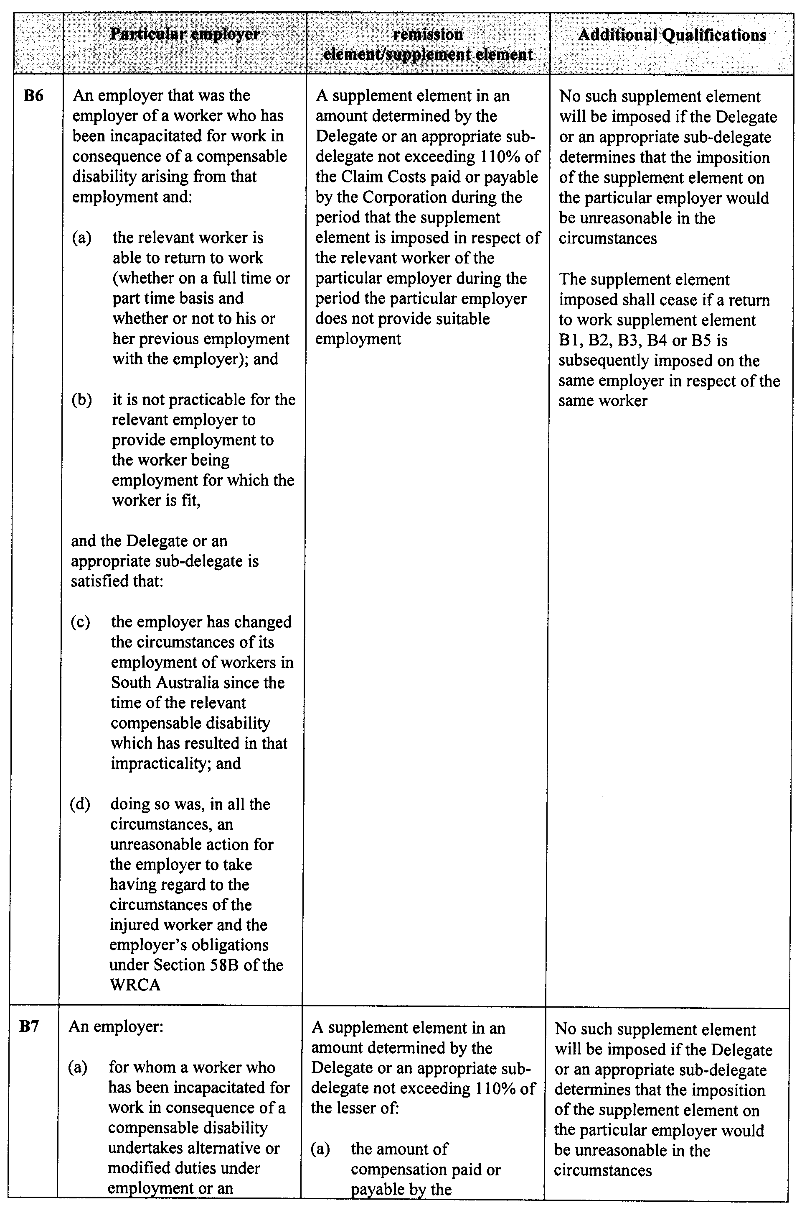
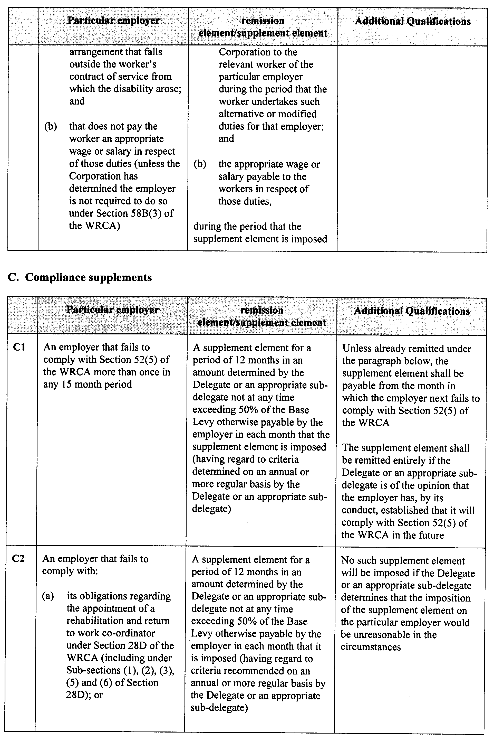
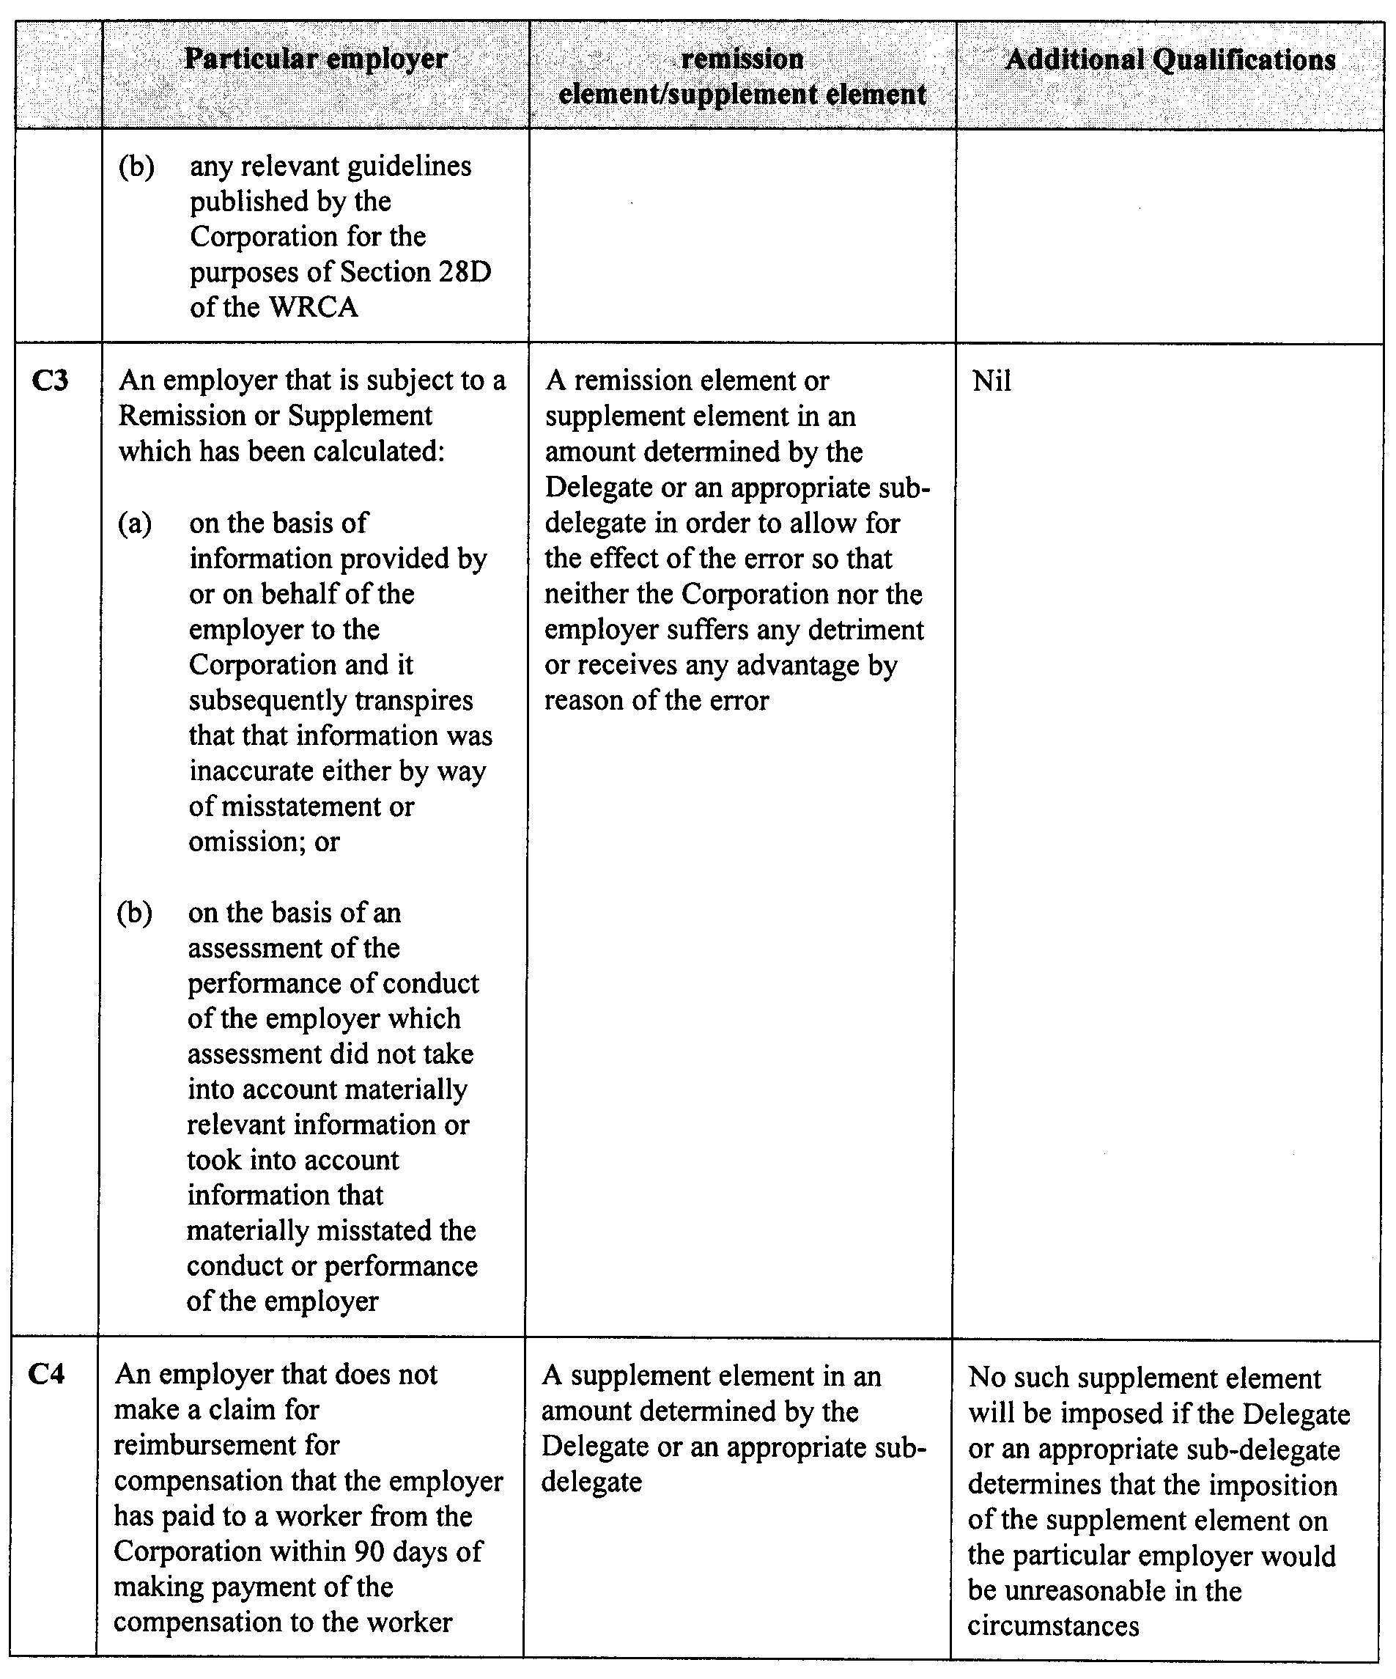
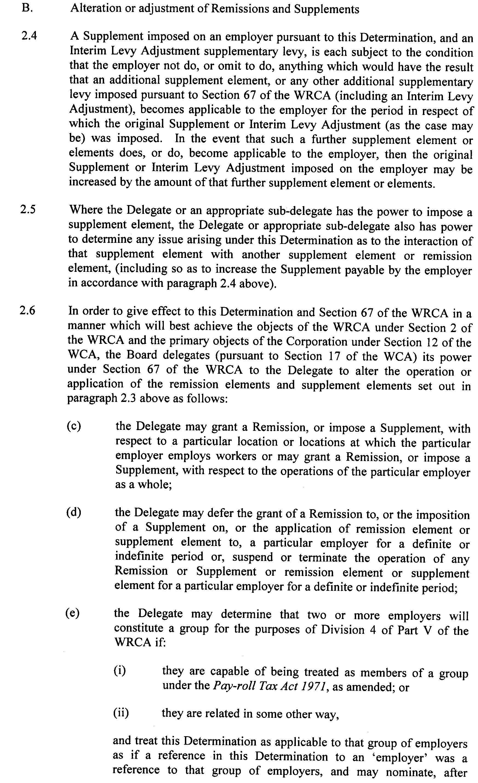
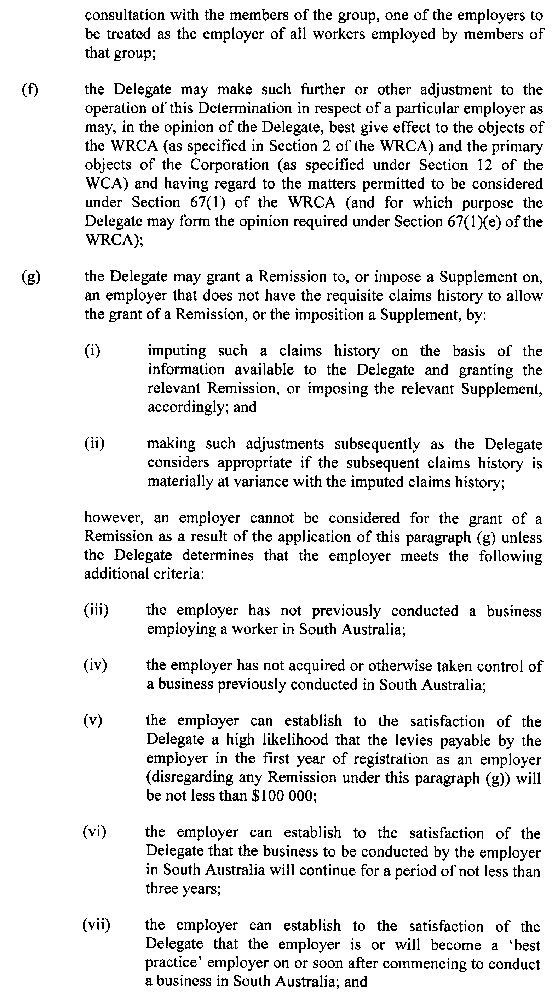

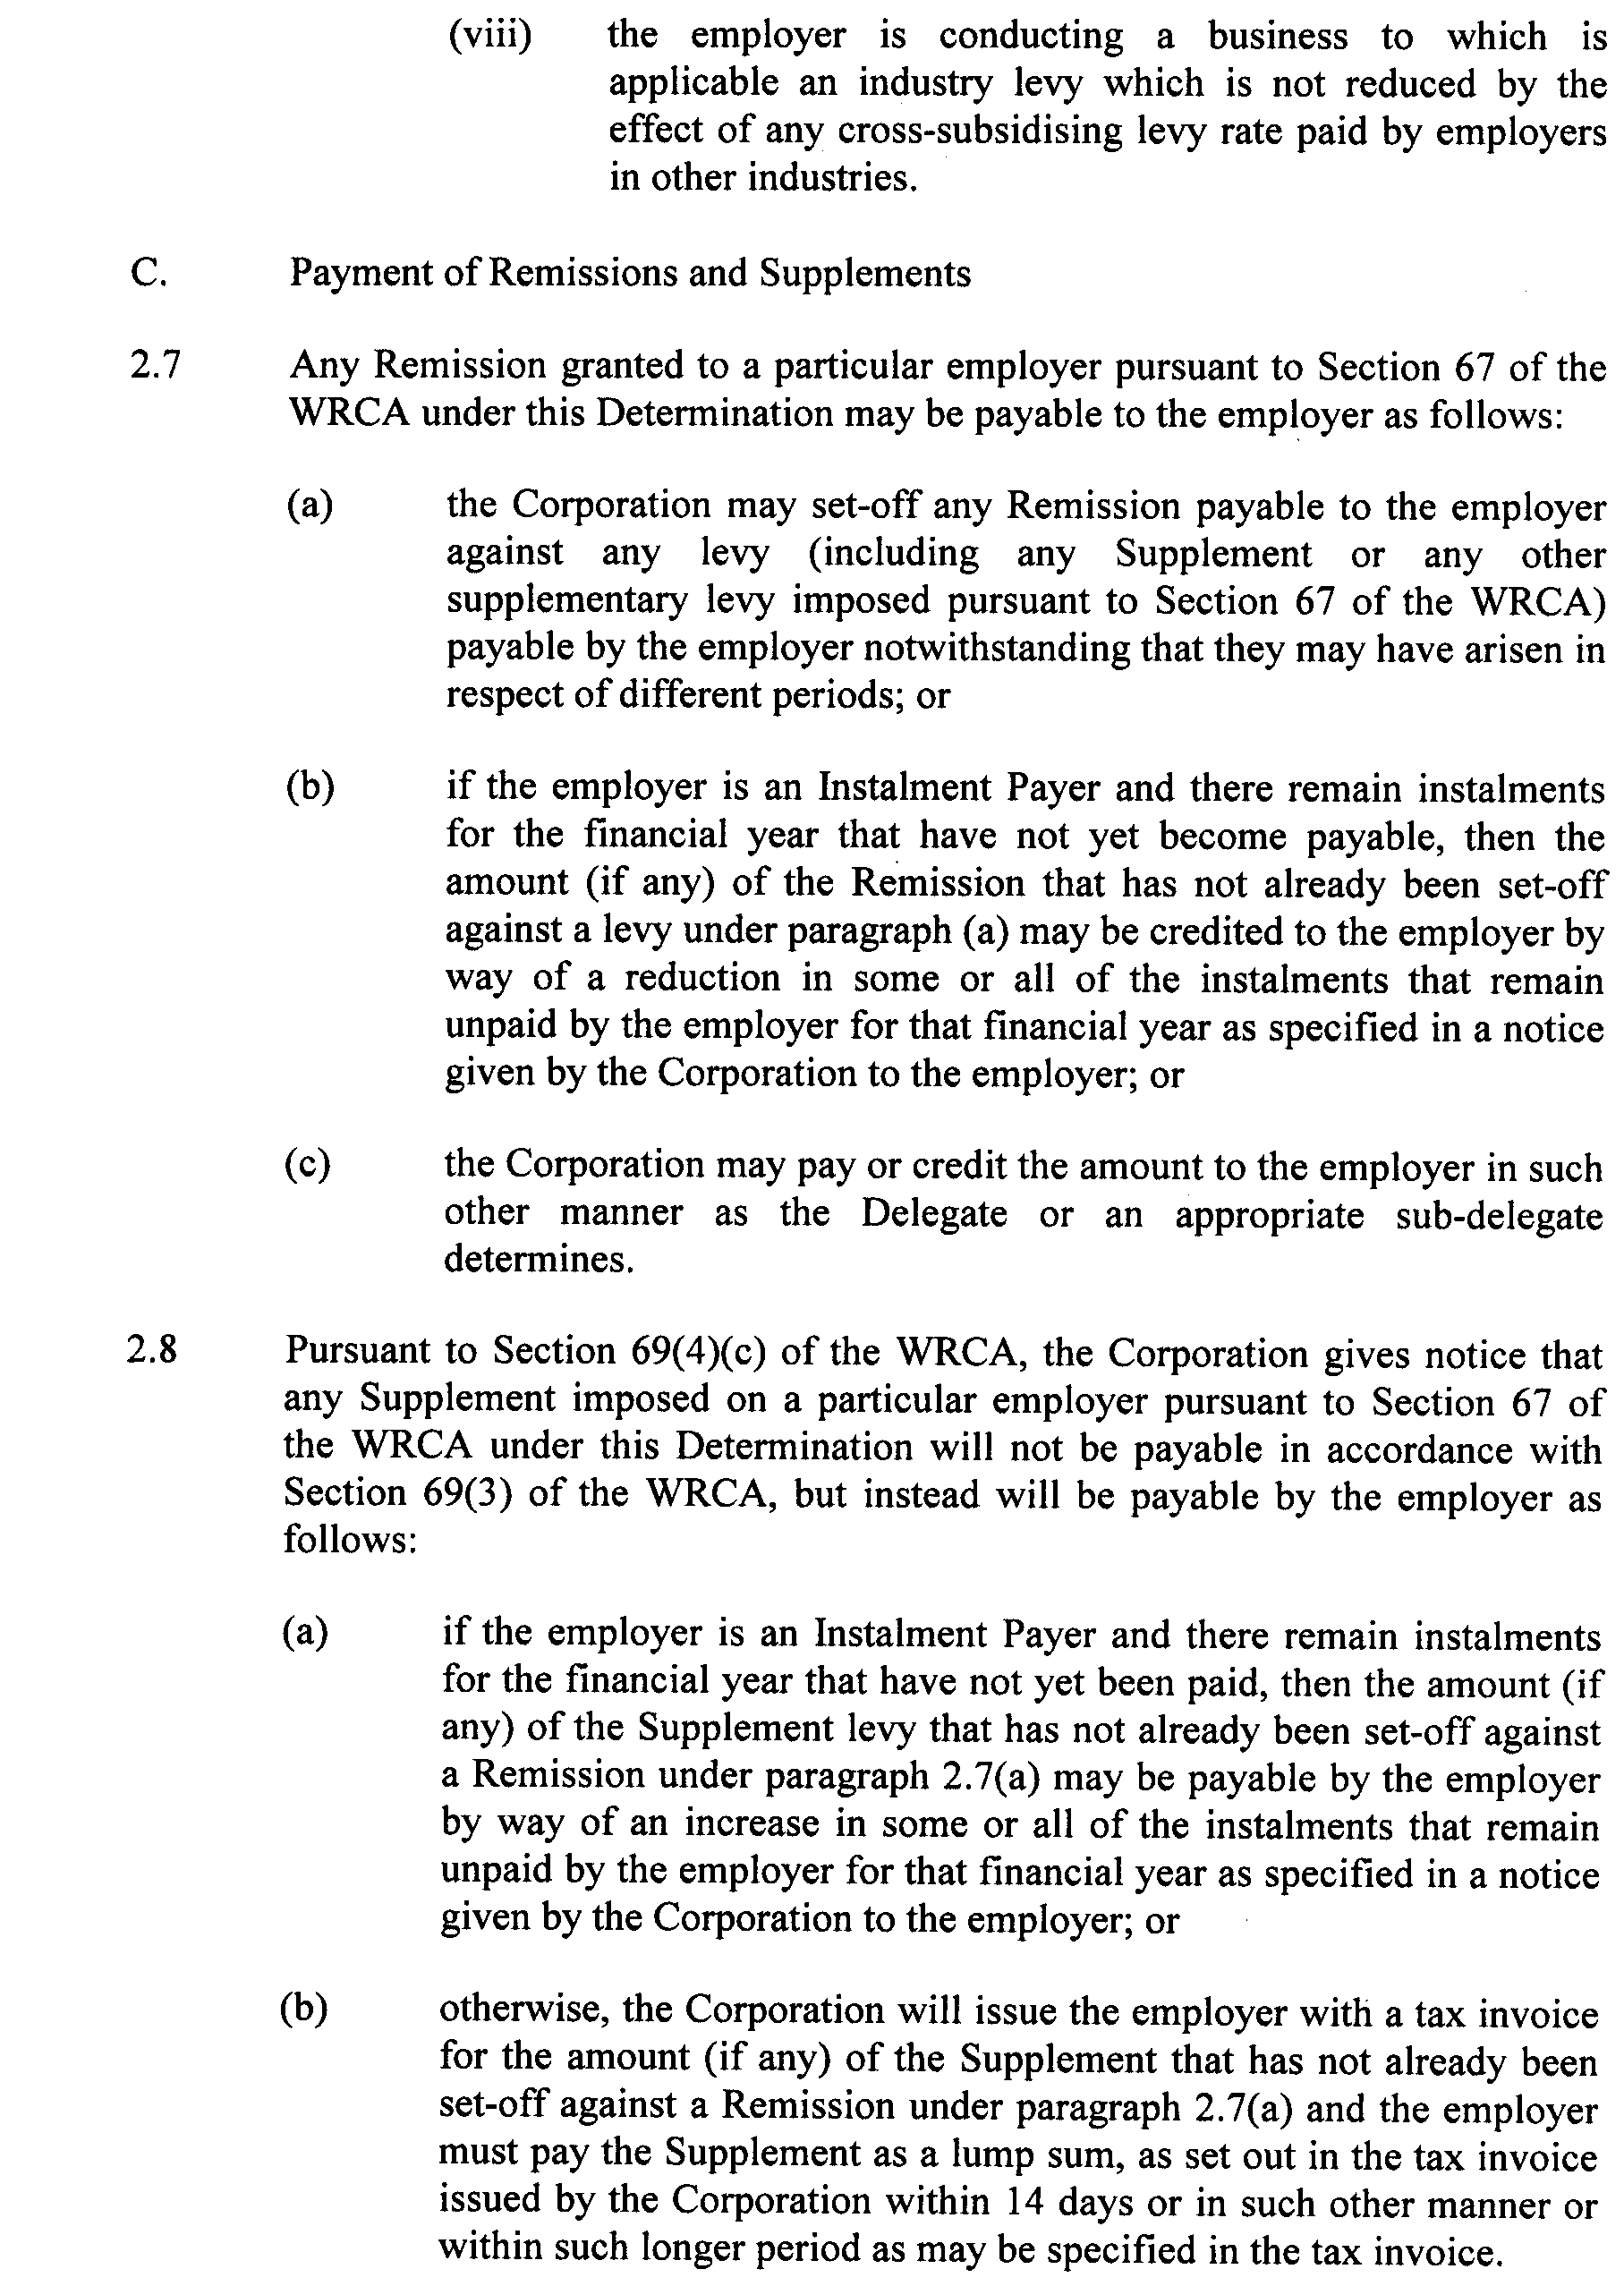
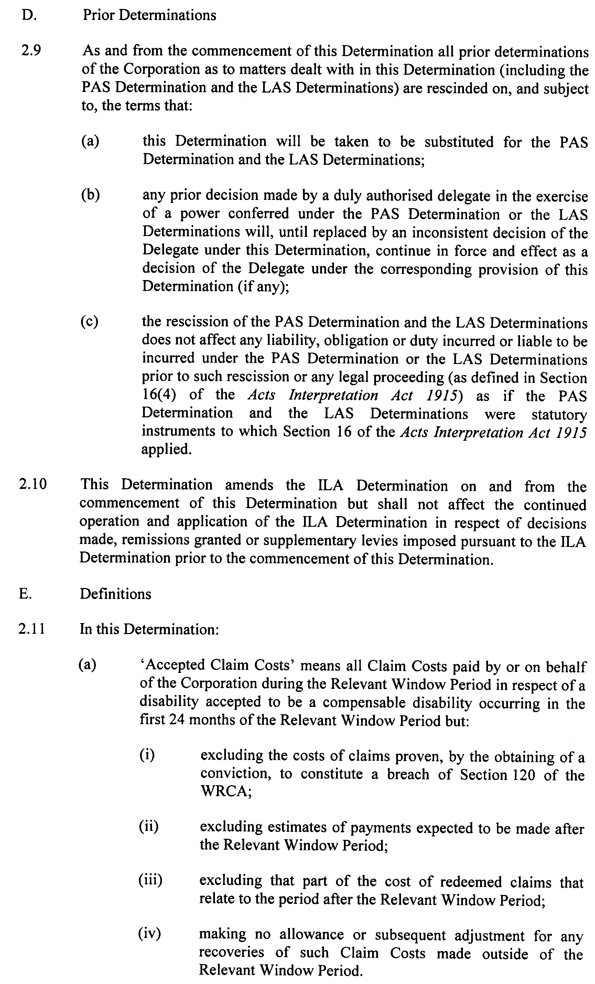
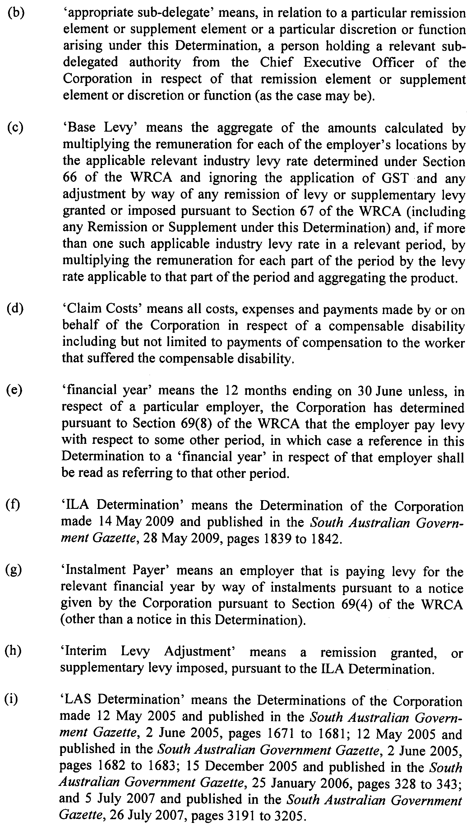

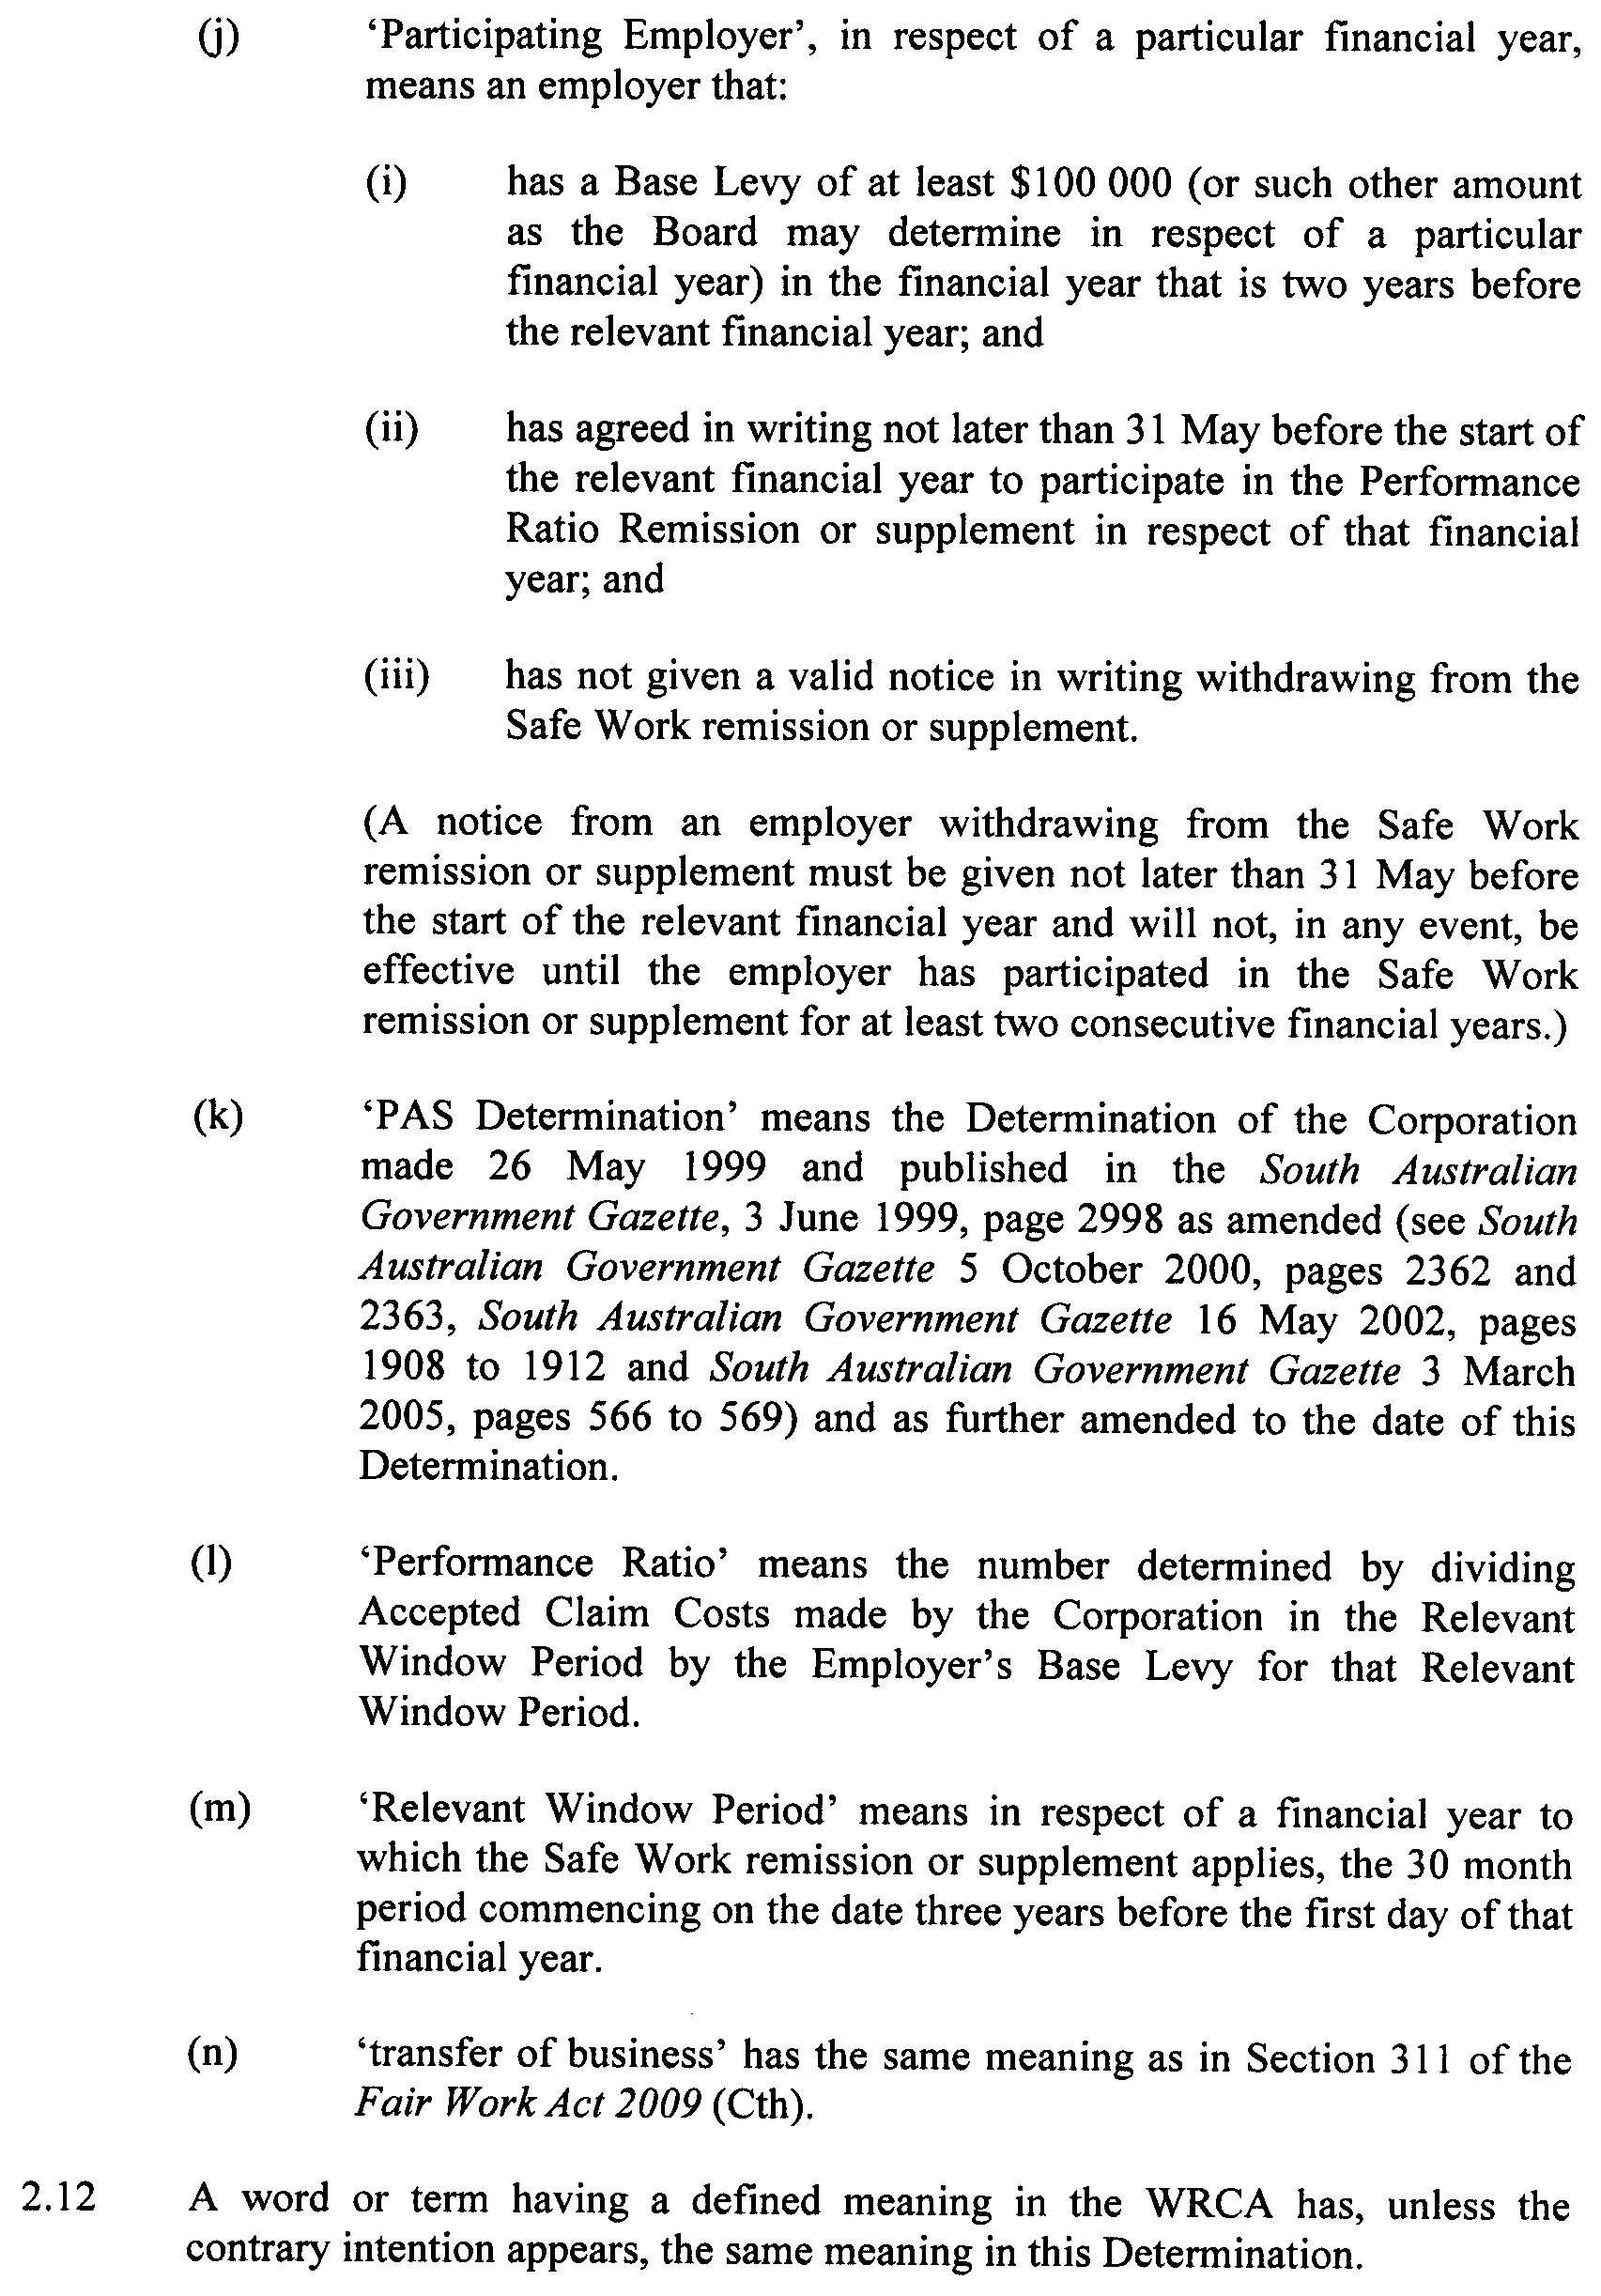

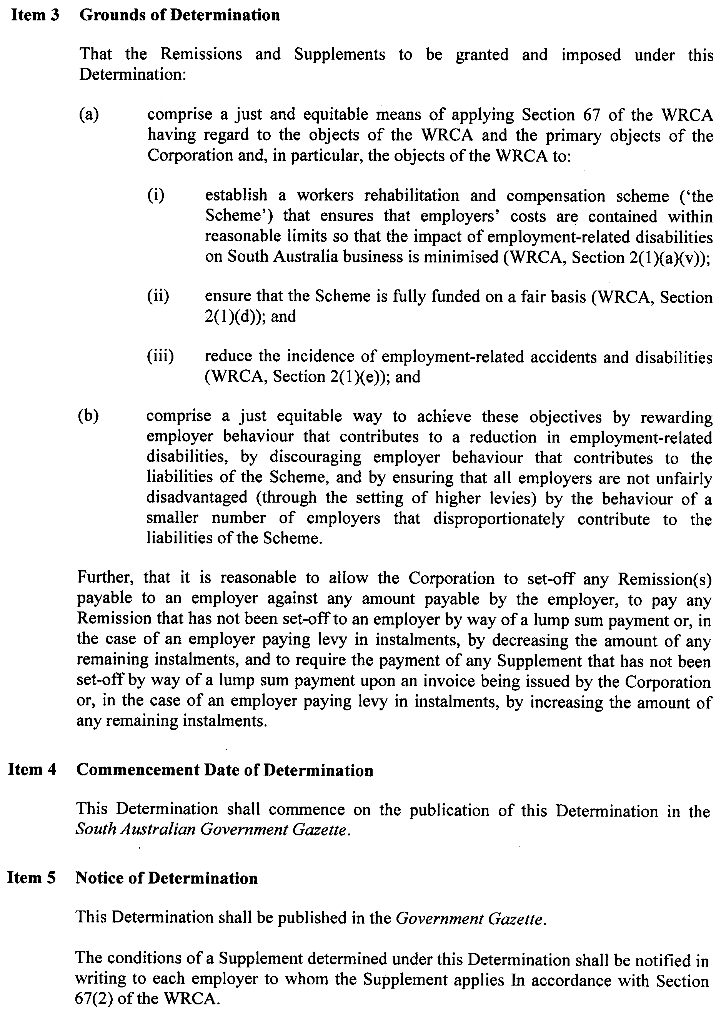

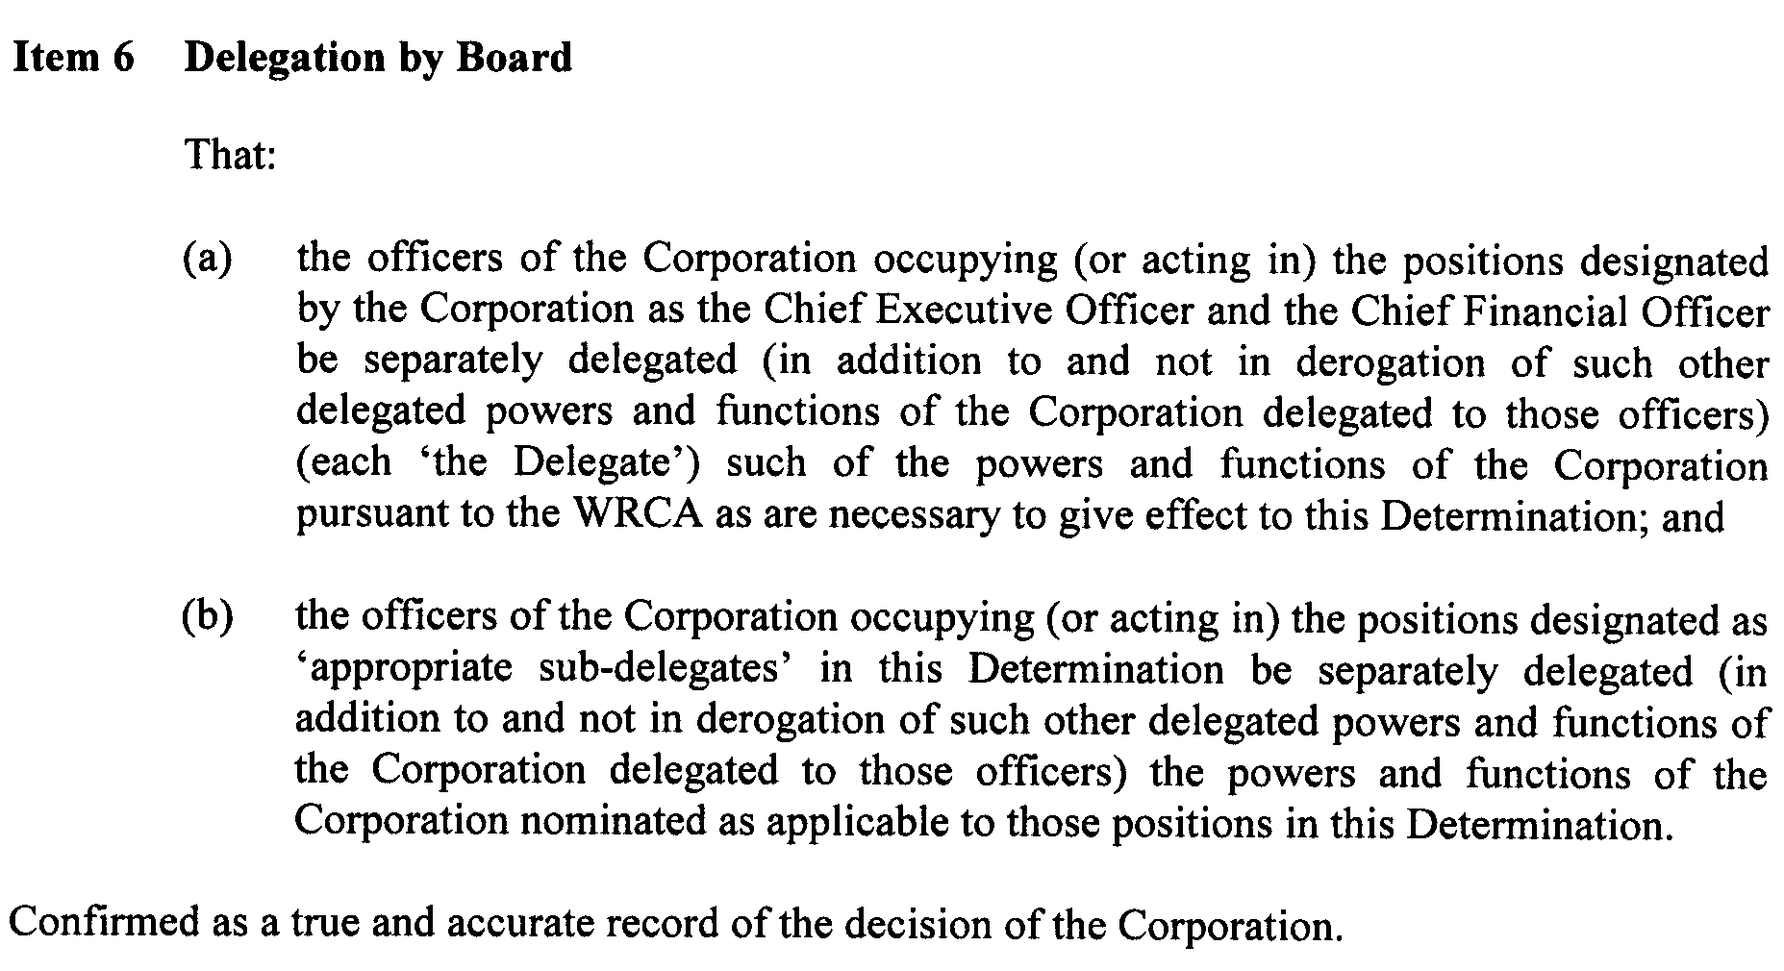
Dated 13 August 2009.
P. Bentley, Board Chair

South Australia
Motor Vehicles (Approval of Motor Bikes and Motor Trikes) Notice 2009
under the Motor Vehicles Act 1959
1—Short title
This notice may be cited as the Motor Vehicles (Approval of Motor Bikes and Motor Trikes) Notice 2009.
2—Commencement
This notice will come into operation on the date of publication in this Gazette.
3—Approved motor bikes and motor trikes
For the purposes of Schedules 2 and 3 of the Motor Vehicles Regulations 1996 and the transitional provisions of the Motor Vehicles Variation Regulations 2005 (No 233 of 2005), the motor bikes and motor trikes specified in Schedule 1 are approved.

Schedule 1—Approved motor bikes and motor trikes
1—Motor bikes and motor trikes with an engine capacity not exceeding 260 ml
All motor bikes and motor trikes with an engine capacity not exceeding 260 milliliters and a power to weight ratio not exceeding 150 kilowatts per tonne other than the following:
Suzuki RGV250
Kawasaki KR250 (KR-1 and KR1s models)
Honda NSR250
Yamaha TZR250
Aprilia RS250
2—Motor bikes and motor trikes with an engine capacity not less than 261 ml and not exceeding 660 ml
The motor bikes and motor trikes listed in the table below.

Make | Model
AJS | Model 18  Model 30
Aprilia | Moto 6.5  Pegaso 650  Pegaso 650 I.E.  Scarabeo 400  Scarabeo 500  Sportcity 300
Ariel | Huntmaster  Red Hunter 350  Red Hunter 500
Benelli | Velvet 400
Bultaco | Sherpa
BMW | F650  F650CS  F650GD  F650GS (Not including models manufactured after November 2007 with 800ml engine)  F650ST  G450X  R50  R60  R60/5  R60/6  R65  R69
BSA | B33  B50SS Gold Star  Empire Star  Gold Star M24  Gold Star post-war 350 singles  Golden Flash  Lightning  M20 500  M21 600  Spitfire MKIII  Thunderbolt
Cagiva | 410TE  610TE  610TE-E  Canyon 500  Canyon 600  River 600  W16 600
Cossack | 650
Derbi | 659/659 Cafe
Dneper | K650
Douglas | Post-war 350
Ducati | 400 SS Junior  600 Supersport  600 Superlight  DM450  DM500  M600 Monster  Monster 400  M620ie (24kw Lite)  SL 500 Pantah  SL 600 Pantah
Enfield | Bullet Deluxe  Bullet STD  Taurus
Gasgas | EC400  FSE400  SM400  Supermotard
Gilera | Nexus 500
Harley | SS350
Honda | 600V Transalp  Bros  CB350  CB350F  CB400  CB400F  CB400N  CB400T  CB500  CBX550F  CRF450  CRF450X  CX500  Deauville 650  FT500  NX650  Revere  RVF400  Silverwing  SL350  SWH300  VF400F  VT400  VT500  VT600C  XBR500  XL350  XL500  XL600  XL650 Transalp  XR350  XR350R  XR400R  XR500  XR600  XR600R  XR650L
Husaberg | FE(Enduro)4E8  FE(Enduro)5E8  FE(Enduro)7E8  FE400  FE450  FE501  FE550  FE600  FE650  FS450  FS650
Husqvarna | DBD34 Gold Star  SM 450ie  SM 510ie  SM610  TE310ie  TE 450ie  TE 510ie  TE610  WR300  350TE  400TE  410TE  430WR  510TE  610TE  610TE-E
Hyosung | Aquila GV650L  Comet GT650L  Comet GT650RL  Comet GT650SL
Jawa | 350
Kawasaki | EN450  ER500A  ER500C  ER6nl  EX400  EX500A  KL600  KL650A  KL650B  KL650C  KLE500A  KLE500B  KLR650  KLX300B  KLX400B  KLX450A  KLX650B  KLX650C  KZ400  KZ440  KZ500  KZ550  LTD440  NINJA 650RL  Z600A  Z650B  ZR550B  Z500
KTM | 350 EXC Special-R  625 SMC  660 SMC  EXC Series 300  EXC Series 360  EXC Series 380  EXC Series 400  EXC Series 510  EXC Series 525  GS Series 300  GS Series 400  GS Series 450  GS Series 500  GS Series 550  GS Series 600  LC4 Series 300  LC4 Series 400  LC4 Series 500  LC4 Series 540  LC4 Series 550  LC4 Series 600  LC4 Series 625  LC4 Series 650
Kymco | T70000 (500)  T70020 (500i)  T70020 (500Ri)
Matchless | 600  650  G80 Major
Montesa | Cota
Moto Morini | 350 Sport  500 Strada  500W
Moto Guzzi | V35  V50  V65
MuZ | Baghira 660  Scorpion Replica  Skorpion Sport  Skorpion Tour
MV Agusta | 350
Norton | Model 50  Dominator Model 88  Dominator Model 90  ES2
Oz Trike | Fun 500
Panther | 600  650
Piaggio | MP3 400  X9 500  XEVO 400ie  X8 400
Peugeot | Geopolis 400  Satelis 400  Satelis 500
Royal Enfield | 650  Bullet 500  Bullet 350  Diesel 324  Electra 500  Lightning 500
Rudge-Whitworth | 650
Sherco | S4 Enduro
Suzuki | AN400  AN400A  AN650  DR350  DR350S  DR500  DR600R  DR600S  DR650R  DR650RE  DR650RL  DR650RSL  DR650SE  DR-Z400  DR-Z400E  DR-Z400S  DR-Z400SM  GR650  GS450E  GS450S  GS450SX  GS500  GS500E  GS500F  GS500K  GS550  GSX400E  GSX400F  GSX650FU  LS650  RE5  SFV650U Gladius  SV650SU  XF650
SYM | Citycom 300
TM | 300 Enduro  450  530  TM300  TM400
Triumph | Bonneville 650  Speed Twin  T100 Tiger  T100R Daytona 500  Thunderbird 650  Trophy 500  Trophy 650  TRW25  Note: Only includes models manufactured up to and including 1983.
Ural | 650
Velocette | MAC 350  MSS 500  Venom
Vespa | GTS300
VOR | 400 Enduro  450 Enduro  500 Enduro  530 Enduro
Xingyue | XY400Y
Yamaha | RD350  RD350LC  RD400  SR500  SRX600  SZR660  TT350  TT600  TT600E  TT600R  TX650  WR400F  WR426F  WR450  WR450F  XJ550  XJ650  XJR400  XP500 – T Max  XS400  XS650  XT225  XT350  XT500  XT550  XT600  XT600Z  XT660R  XT660X  XTZ660  XV535  XVS650  XVS650A  XZ550  YP 400

Schedule 2—Revocation
The Motor Vehicles (Approval of Motor Bikes and Motor Trikes) Notice 2009 made on 25 June 2009 (Gazette No. 44, 25 June 2009, page 2990) is revoked.

Made by John Neville, Deputy Registrar of Motor Vehicles

14 August 2009

South Australia
Environment Protection (River Murray Water Protection Area) Proclamation 2009
under section 61A of the Environment Protection Act 1993
1—Short title
This proclamation may be cited as the Environment Protection (River Murray Water Protection Area) Proclamation 2009.
2—Commencement
This proclamation comes into operation on the day on which it is made.
3—Declaration of part of the State to be water protection area
The following part of the State is declared to be a water protection area:
The River Murray Floodplain Area delineated in the plan deposited in the General Registry Office No 440/2003.
Made by the Governor
on the recommendation of the Authority and with the advice and consent of the Executive Council
on 20 August 2009
EPCS09/0001

South Australia
Environment Protection (Water Protection Area) Variation Proclamation 2009
under section 61A of the Environment Protection Act 1993

Preamble
1 By proclamation made under section 42 of the Water Resources Act 1990 on 15 November 1990 (see Gazette 15.11.1990 p1491), the River Murray Water Protection Area and the South East Water Protection Area were declared.
2 The Water Resources Act 1990 was repealed by the Water Resources Act 1997.
3 Section 20 of the Statutes Amendment (Water Resources) Act 1997 provides that a proclamation declaring a part of the State to be a water protection area under Part 5 of the Water Resources Act 1990 that was in force immediately before the repeal of that Part is taken to have been made under section 61A of the Environment Protection Act 1993.
4 It is now intended that the proclamation be varied so that the reference to the River Murray Water Protection Area be deleted and the description of the South East Water Protection Area be varied and that the River Murray Water Protection Area be declared a water protection area by another proclamation made on this day under section 61A of the Environment Protection Act 1993.

Part 1—Preliminary
1—Short title
This proclamation may be cited as the Environment Protection (Water Protection Area) Variation 2009.
2—Commencement
This proclamation comes into operation on the day on which it is made.
Part 2—Variation of proclamation made under the Water Resources Act 1990 declaring River Murray Water Protection Area and South East Water Protection Area (Gazette 15.11.1990 p1491) and taken to have been made under section 61A of the Environment Protection Act 1993
3—Variation of proclamation
(1) Item relating to declaration of River Murray Water Protection Area—delete the item
(2) Item relating to declaration of South East Water Protection Area, description of Part of State within Water Protection Area—delete "as depicted in map 19 in the schedule" and substitute:
other than land within the River Murray Floodplain Area delineated in the plan deposited in the General Registry Office No 440/2003, forming part of the area depicted in map 19 in the schedule
(3) Schedule, map 16—delete the map
Made by the Governor
on the recommendation of the Authority and with the advice and consent of the Executive Council
on 20 August 2009
EPCS09/0001

South Australia
Highways (Road Closure—Tapleys Hill Road, Glenelg North) Proclamation 2009
under section 27AA of the Highways Act 1926
1—Short title
This proclamation may be cited as the Highways (Road Closure—Tapleys Hill Road, Glenelg North) Proclamation 2009.
2—Commencement
This proclamation comes into operation on the day on which it is made.
3—Road closure
The portion of public road delineated as allotment 500 in approved Plan No FP 52735 lodged in the Lands Titles Registration Office is closed.
Made by the Governor
on the recommendation of the Commissioner of Highways and with the advice and consent of the Executive Council
on 20 August 2009
MTR09/076

South Australia
National Parks and Wildlife (Cocata Conservation Park—Mining Rights) Proclamation 2009
under section 43 of the National Parks and Wildlife Act 1972

Preamble
1 The Crown land described in Schedule 1 is, by another proclamation made on this day, added to the Cocata Conservation Park under section 30(2) of the National Parks and Wildlife Act 1972.
2 It is intended that, by this proclamation, certain existing and future rights of entry, prospecting, exploration or mining be preserved in relation to that land.

1—Short title
This proclamation may be cited as the National Parks and Wildlife (Cocata Conservation Park—Mining Rights) Proclamation 2009.
2—Commencement
This proclamation comes into operation on the day on which it is made.
3—Interpretation
In this proclamation—
Environment Minister means the Minister for the time being administering the National Parks and Wildlife Act 1972;
Mining Minister means the Minister for the time being administering the Mining Act 1971.
4—Existing rights to continue
Subject to clause 6, existing rights of entry, prospecting, exploration or mining under the Mining Act 1971 may continue to be exercised in respect of the land described in Schedule 1.
5—New rights may be acquired
Rights of entry, prospecting, exploration or mining may, with the approval of the Mining Minister and the Environment Minister, be acquired pursuant to the Mining Act 1971 in respect of the land described in Schedule 1 and may, subject to clause 6, be exercised in respect of that land.
6—Conditions for exercise of rights
A person in whom rights of entry, prospecting, exploration or mining are vested pursuant to the Mining Act 1971 (whether those rights were acquired before or after the making of this proclamation) must not exercise those rights in respect of the land described in Schedule 1 unless the person complies with the following conditions:
(a) if work to be carried out in relation to the land in the exercise of those rights has not previously been authorised, the person must give at least 3 months notice of the proposed work to the Mining Minister and the Environment Minister and must supply each Minister with such information relating to the proposed work as the Minister may require;
(b) if directions are agreed between the Mining Minister and the Environment Minister and given to the person in writing in relation to—
(i) carrying out work in relation to the land in a manner that minimises damage to the land (including the land's vegetation and wildlife) and the environment generally; or
(ii) preserving objects, structures or sites of historical, scientific or cultural interest; or
(iii) rehabilitating the land (including the land's vegetation and wildlife) on completion of the work; or
(iv) (where the work is being carried out in the exercise of rights acquired after the making of this proclamation) prohibiting or restricting access to any specified area of the land that the Ministers believe would suffer significant detriment as a result of carrying out the work,
the person must comply with those directions in carrying out the work;
(c) if a plan of management is in operation under section 38 of the National Parks and Wildlife Act 1972 in respect of the land, the person must have regard to the provisions of the plan of management;
(d) in addition to complying with the other requirements of this proclamation, the person—
(i) must take such steps as are reasonably necessary to ensure that objects, structures and sites of historical, scientific or cultural interest and the land's vegetation and wildlife are not unduly affected by any work; and
(ii) must maintain all work areas in a clean and tidy condition; and
(iii) must, on the completion of any work, obliterate or remove all installations and structures (other than installations and structures designated by the Mining Minister and the Environment Minister as suitable for retention) used exclusively for the purposes of that work;
(e) if no direction has been given by the Mining Minister and the Environment Minister under paragraph (b)(iii), the person must rehabilitate the land (including its vegetation and wildlife) on completion of any work to the satisfaction of the Environment Minister.
7—Governor may give approvals, directions
If the Mining Minister and the Environment Minister cannot agree as to whether—
(a) approval should be granted or refused under clause 5; or
(b) a direction should be given under clause 6(b),
the Governor may, with the advice and consent of the Executive Council—
(c) grant or refuse the necessary approval under clause 5; or
(d) give a direction in writing under clause 6(b).
Schedule 1—Description of land
Allotment 50 of Deposited Plan 25893, Hundred of Pordia;
Allotment 52 of Deposited Plan 26395, Hundred of Cocata;
Allotment 55 of Deposited Plan 26400, Hundred of Cocata;
Section 15, Hundred of Cocata;
Section 36, Hundred of Kappakoola.
Made by the Governor
with the advice and consent of the Executive Council
on 20 August 2009
EHCS09/0015

South Australia
National Parks and Wildlife (Cocata Conservation Park) Proclamation 2009
under section 30(2) of the National Parks and Wildlife Act 1972
1—Short title
This proclamation may be cited as the National Parks and Wildlife (Cocata Conservation Park) Proclamation 2009.
2—Commencement
This proclamation comes into operation on the day on which it is made.
3—Alteration of boundaries of Cocata Conservation Park
The boundaries of the Cocata Conservation Park are altered by adding to the Park the following Crown land:
Allotment 50 of Deposited Plan 25893, Hundred of Pordia;
Allotment 52 of Deposited Plan 26395, Hundred of Cocata;
Allotment 55 of Deposited Plan 26400, Hundred of Cocata;
Section 15, Hundred of Cocata;
Section 36, Hundred of Kappakoola.
Made by the Governor
with the advice and consent of the Executive Council
on 20 August 2009
EHCS09/0015

South Australia
National Parks and Wildlife (Kulliparu Conservation Park—Mining Rights) Proclamation 2009
under section 43 of the National Parks and Wildlife Act 1972

Preamble
1 The Crown land described in Schedule 1 is, by another proclamation made on this day, added to the Kulliparu Conservation Park under section 30(2) of the National Parks and Wildlife Act 1972.
2 It is intended that, by this proclamation, certain existing and future rights of entry, prospecting, exploration or mining be preserved in relation to that land.

1—Short title
This proclamation may be cited as the National Parks and Wildlife (Kulliparu Conservation Park—Mining Rights) Proclamation 2009.
2—Commencement
This proclamation comes into operation on the day on which it is made.
3—Interpretation
In this proclamation—
Environment Minister means the Minister for the time being administering the National Parks and Wildlife Act 1972;
Mining Minister means the Minister for the time being administering the Mining Act 1971.
4—Existing rights to continue
Subject to clause 6, existing rights of entry, prospecting, exploration or mining under the Mining Act 1971 may continue to be exercised in respect of the land described in
Schedule 1.
5—New rights may be acquired
Rights of entry, prospecting, exploration or mining may, with the approval of the Mining Minister and the Environment Minister, be acquired pursuant to the Mining Act 1971 in respect of the land described in Schedule 1 and may, subject to clause 6, be exercised in respect of that land.
6—Conditions for exercise of rights
A person in whom rights of entry, prospecting, exploration or mining are vested pursuant to the Mining Act 1971 (whether those rights were acquired before or after the making of this proclamation) must not exercise those rights in respect of the land described in Schedule 1 unless the person complies with the following conditions:
(a) if work to be carried out in relation to the land in the exercise of those rights has not previously been authorised, the person must give at least 3 months notice of the proposed work to the Mining Minister and the Environment Minister and must supply each Minister with such information relating to the proposed work as the Minister may require;
(b) if directions are agreed between the Mining Minister and the Environment Minister and given to the person in writing in relation to—
(i) carrying out work in relation to the land in a manner that minimises damage to the land (including the land's vegetation and wildlife) and the environment generally; or
(ii) preserving objects, structures or sites of historical, scientific or cultural interest; or
(iii) rehabilitating the land (including the land's vegetation and wildlife) on completion of the work; or
(iv) (where the work is being carried out in the exercise of rights acquired after the making of this proclamation) prohibiting or restricting access to any specified area of the land that the Ministers believe would suffer significant detriment as a result of carrying out the work,
the person must comply with those directions in carrying out the work;
(c) if a plan of management is in operation under section 38 of the National Parks and Wildlife Act 1972 in respect of the land, the person must have regard to the provisions of the plan of management;
(d) in addition to complying with the other requirements of this proclamation, the person—
(i) must take such steps as are reasonably necessary to ensure that objects, structures and sites of historical, scientific or cultural interest and the land's vegetation and wildlife are not unduly affected by any work; and
(ii) must maintain all work areas in a clean and tidy condition; and
(iii) must, on the completion of any work, obliterate or remove all installations and structures (other than installations and structures designated by the Mining Minister and the Environment Minister as suitable for retention) used exclusively for the purposes of that work;
(e) if no direction has been given by the Mining Minister and the Environment Minister under paragraph (b)(iii), the person must rehabilitate the land (including its vegetation and wildlife) on completion of any work to the satisfaction of the Environment Minister.
7—Governor may give approvals, directions
If the Mining Minister and the Environment Minister cannot agree as to whether—
(a) approval should be granted or refused under clause 5; or
(b) a direction should be given under clause 6(b),
the Governor may, with the advice and consent of the Executive Council—
(c) grant or refuse the necessary approval under clause 5; or
(d) give a direction in writing under clause 6(b).
Schedule 1—Description of land
Allotment 100 of Deposited Plan 40476, Hundred of Addison;
Allotment 83 of Deposited Plan 36526, Hundred of Addison;
Sections 47 and 48, Hundred of Wright;
Sections 15, 23 and 24, Hundred of Addison;
Sections 7, 19, 20, 21, 24, 25, 27 and 28, Hundred of Wallis;
Allotment 100 of Deposited Plan 25212, Hundred of Wallis;
Section 19, Hundred of Moorkitabie;
Allotment 31 of Deposited Plan 36188, Hundred of Moorkitabie;
Allotment 10 of Deposited Plan 33666, Hundred of Witera;
Section 102, Out of Hundreds (Elliston).
Made by the Governor
with the advice and consent of the Executive Council
on 20 August 2009
EHCS09/0015

South Australia
National Parks and Wildlife (Kulliparu Conservation Park) Proclamation 2009
under section 30(2) of the National Parks and Wildlife Act 1972
1—Short title
This proclamation may be cited as the National Parks and Wildlife (Kulliparu Conservation Park) Proclamation 2009.
2—Commencement
This proclamation comes into operation on the day on which it is made.
3—Alteration of boundaries of Kulliparu Conservation Park
The boundaries of the Kulliparu Conservation Park are altered by adding to the Park the following Crown land:
Allotment 100 of Deposited Plan 40476, Hundred of Addison;
Allotment 83 of Deposited Plan 36526, Hundred of Addison;
Sections 47 and 48, Hundred of Wright;
Sections 15, 23 and 24, Hundred of Addison;
Sections 7, 19, 20, 21, 24, 25, 27 and 28, Hundred of Wallis;
Allotment 100 of Deposited Plan 25212, Hundred of Wallis;
Section 19, Hundred of Moorkitabie;
Allotment 31 of Deposited Plan 36188, Hundred of Moorkitabie;
Allotment 10 of Deposited Plan 33666, Hundred of Witera;
Section 102, Out of Hundreds (Elliston).
Made by the Governor
with the advice and consent of the Executive Council
on 20 August 2009
EHCS09/0015

South Australia
National Parks and Wildlife (Munyaroo Conservation Park—Mining Rights) Proclamation 2009
under section 43 of the National Parks and Wildlife Act 1972

Preamble
1 The Crown land described in Schedule 1, together with other land, is, by another proclamation made on this day, added to the Munyaroo Conservation Park under section 30(2) of the National Parks and Wildlife Act 1972.
2 It is intended that, by this proclamation, certain existing and future rights of entry, prospecting, exploration or mining be preserved in relation to that land.

1—Short title
This proclamation may be cited as the National Parks and Wildlife (Munyaroo Conservation Park—Mining Rights) Proclamation 2009.
2—Commencement
This proclamation comes into operation on the day on which it is made.
3—Interpretation
In this proclamation—
Environment Minister means the Minister for the time being administering the National Parks and Wildlife Act 1972;
Mining Minister means the Minister for the time being administering the Mining Act 1971.
4—Existing rights to continue
Subject to clause 6, existing rights of entry, prospecting, exploration or mining under the Mining Act 1971 may continue to be exercised in respect of the land described in Schedule 1.
5—New rights may be acquired
Rights of entry, prospecting, exploration or mining may, with the approval of the Mining Minister and the Environment Minister, be acquired pursuant to the Mining Act 1971 in respect of the land described in Schedule 1 and may, subject to clause 6, be exercised in respect of that land.
6—Conditions for exercise of rights
A person in whom rights of entry, prospecting, exploration or mining are vested pursuant to the Mining Act 1971 (whether those rights were acquired before or after the making of this proclamation) must not exercise those rights in respect of the land described in Schedule 1 unless the person complies with the following conditions:
(a) if work to be carried out in relation to the land in the exercise of those rights has not previously been authorised, the person must give at least 3 months notice of the proposed work to the Mining Minister and the Environment Minister and must supply each Minister with such information relating to the proposed work as the Minister may require;
(b) if directions are agreed between the Mining Minister and the Environment Minister and given to the person in writing in relation to—
(i) carrying out work in relation to the land in a manner that minimises damage to the land (including the land's vegetation and wildlife) and the environment generally; or
(ii) preserving objects, structures or sites of historical, scientific or cultural interest; or
(iii) rehabilitating the land (including the land's vegetation and wildlife) on completion of the work; or
(iv) (where the work is being carried out in the exercise of rights acquired after the making of this proclamation) prohibiting or restricting access to any specified area of the land that the Ministers believe would suffer significant detriment as a result of carrying out the work,
the person must comply with those directions in carrying out the work;
(c) if a plan of management is in operation under section 38 of the National Parks and Wildlife Act 1972 in respect of the land, the person must have regard to the provisions of the plan of management;
(d) in addition to complying with the other requirements of this proclamation, the person—
(i) must take such steps as are reasonably necessary to ensure that objects, structures and sites of historical, scientific or cultural interest and the land's vegetation and wildlife are not unduly affected by any work; and
(ii) must maintain all work areas in a clean and tidy condition; and
(iii) must, on the completion of any work, obliterate or remove all installations and structures (other than installations and structures designated by the Mining Minister and the Environment Minister as suitable for retention) used exclusively for the purposes of that work;
(e) if no direction has been given by the Mining Minister and the Environment Minister under paragraph (b)(iii), the person must rehabilitate the land (including its vegetation and wildlife) on completion of any work to the satisfaction of the Environment Minister.
7—Governor may give approvals, directions
If the Mining Minister and the Environment Minister cannot agree as to whether—
(a) approval should be granted or refused under clause 5; or
(b) a direction should be given under clause 6(b),
the Governor may, with the advice and consent of the Executive Council—
(c) grant or refuse the necessary approval under clause 5; or
(d) give a direction in writing under clause 6(b).
Schedule 1—Description of land
Sections 35 and 36, Hundred of Charleston;
Allotment 102 of Deposited Plan 38411, Hundreds of McGregor and Warren.
Made by the Governor
with the advice and consent of the Executive Council
on 20 August 2009
EHCS09/0015

South Australia
National Parks and Wildlife (Munyaroo Conservation Park) Proclamation 2009
under section 30(2) of the National Parks and Wildlife Act 1972
1—Short title
This proclamation may be cited as the National Parks and Wildlife (Munyaroo Conservation Park) Proclamation 2009.
2—Commencement
This proclamation comes into operation on the day on which it is made.
3—Alteration of boundaries of Munyaroo Conservation Park
The boundaries of the Munyaroo Conservation Park are altered by adding to the Park the following Crown land:
Sections 35 and 36, Hundred of Charleston;
Allotment 101 of Deposited Plan 38411, Hundred of McGregor;
Allotment 102 of Deposited Plan 38411, Hundreds of McGregor and Warren.
Made by the Governor
with the advice and consent of the Executive Council
on 20 August 2009
EHCS09/0015

South Australia
Family and Community Services Regulations 2009
under the Family and Community Services Act 1972

Contents
Part 1—Preliminary
1 Short title
2 Commencement
3 Interpretation
Part 2—Advisory committees
4 Conduct of business by advisory committee
Part 3—Training centres
5 Functions of Chief Executive Officer
6 Visitors
7 Prohibited treatment of residents
8 Use of force against residents
9 Detention rooms
10 Power to search residents
11 Power to search visitors
Part 4—Residential care facilities
12 Functions of Chief Executive Officer
13 Prohibited treatment of children in residential care facilities
14 Use of force against children in residential care facilities
Part 5—Miscellaneous
15 Application for licence to carry on business of foster care agency
16 Agreement for admission of child to licensed children's residential facility
Schedule 1—Agreement for admission of child to licensed children's residential facility
Schedule 2—Revocation of Family and Community Services Regulations 1996

Part 1—Preliminary
1—Short title
These regulations may be cited as the Family and Community Services Regulations 2009.
2—Commencement
These regulations will come into operation on 1 September 2009.
3—Interpretation
In these regulations, unless the contrary intention appears—
Act means the Family and Community Services Act 1972;
advisory committee means an advisory committee established by the Minister under section 11 of the Act;
detention room means a room in a training centre that is set aside for the detention of residents of the centre;
liquor means any beverage that, at 20 degrees Celsius, contains more than 1.15% alcohol by volume and includes any other substance that comprises, constitutes, contains or may be converted into that beverage;
resident, in relation to a training centre, means a youth detained in the centre;
residential care facility means a residential care facility established under section 36 of the Act.
Part 2—Advisory committees
4—Conduct of business by advisory committee
(1) The member appointed as the presiding member of an advisory committee will preside at meetings of the committee at which he or she is present.
(2) If the presiding member is absent from a meeting of the committee, the following provisions apply:
(a) if another member has been appointed as that member's deputy and is present at the meeting—the deputy will preside at the meeting;
(b) in any other case—a member chosen by the members present at the meeting will preside at the meeting.
(3) A quorum of an advisory committee consists of one-half of the total number of its members (ignoring any fraction resulting from the division) plus 1.
(4) A decision carried by a majority of the votes cast by members at a meeting is a decision of the committee.
(5) Each member present at a meeting of the committee has 1 vote on any question arising for decision and, if the votes are equal, the presiding member at the meeting may exercise a casting vote.
Part 3—Training centres
5—Functions of Chief Executive Officer
(1) The Chief Executive Officer has responsibility to ensure that proper standards of administration are observed in the management of a training centre established under the Act.
(2) The Chief Executive Officer must, for example, ensure that adequate arrangements are in place in a training centre—
(a) to maintain the physical, psychological and emotional well-being of the residents of the training centre; and
(b) to promote the social, cultural and educational development of the residents of the training centre resident; and
(c) to maintain discipline and order among the residents of the training centre resident; and
(d) to ensure, through the implementation of operational procedures, the proper security, control and management of the training centre.
6—Visitors
(1) A resident of a training centre is entitled to be visited by at least 1 person on at least 1 occasion each week.
(2) The manager of a training centre must encourage and facilitate visits to the residents in the centre by their relatives and friends.
(3) A visit by a legal practitioner for the purpose of rendering legal services to a resident of a training centre will not be held to be a visit for the purposes of subregulation (1).
(4) However, the manager of a training centre may, if of the opinion that special reasons exist for doing so, order that a particular person is barred from visiting a resident of the centre for any period the manager thinks fit, or until further order of the manager.
7—Prohibited treatment of residents
Subject to these regulations, a resident of a training centre must not be subjected to any of the following kinds of treatment:
(a) corporal punishment of any form (that is, any action that inflicts or is intended to inflict physical pain or discomfort);
(b) isolation (other than in a detention room) from other residents;
(c) psychological pressure or emotional abuse of any form intended to intimidate or humiliate;
(d) deprivation of medical attention, basic food or drink, clothing or any other essential item;
(e) deprivation of sleep;
(f) unjustified deprivation of contact with persons outside the centre;
(g) any other treatment that is cruel, inhuman or degrading.
8—Use of force against residents
(1) An employee in a training centre may only use such force against a resident of the centre as is reasonably necessary in any particular case—
(a) to prevent the resident from harming himself or herself or another person; or
(b) to prevent the resident from causing significant damage to property; or
(c) to ensure that the resident complies with a reasonable direction given by an employee of the centre; or
(d) to maintain order in the centre; or
(e) to preserve the security of the centre.
(2) If force is used against a resident of a training centre, each employee involved must ensure that a written report is provided to the manager of the centre containing the following particulars:
(a) the name of the resident;
(b) the name of each employee involved in or who witnessed the use of force;
(c) the date, time and location in the centre where the use of force took place;
(d) the nature of the force used and the purpose for which, or circumstances in which, the force was used.
(3) An account of an incident leading to the use of force against a resident must be—
(a) written, signed and dated by the resident; or
(b) if the resident cannot write—
(i) written on the instructions of the resident, and signed and dated, by a person nominated for the purpose by the resident; and
(ii) signed by the resident,
(and such account must be kept together with the record required to be kept under subregulation (2)).
(4) A resident may nominate any of the following persons for the purposes of subregulation (3)(b):
(a) the resident's case manager or case worker;
(b) a lawyer;
(c) a cultural advisor;
(d) any other adult person,
(but any such person nominated may not be an employee of the training centre nor have been present during the relevant incident that led to the use of force against the resident).
9—Detention rooms
(1) A resident of a training centre may only be detained in a detention room if an employee in the centre believes on reasonable grounds that—
(a) the resident is about to harm himself or herself or another person; or
(b) the resident is about to cause significant damage to property; or
(c) it is necessary to detain the resident in a detention room—
(i) to maintain order in the centre; or
(ii) to preserve the security of the centre.
(2) However, a resident of a training centre who is under the age of 12 years must not be detained in a detention room.
(3) The maximum length of time that a resident of a training centre may be detained in a detention room is as follows:
(a) in the case of a resident aged 12 to 14 years—24 hours;
(b) in the case of a resident aged 15 years or over—48 hours.
(4) A resident of a training centre who is detained in a detention room—
(a) must be closely supervised; and
(b) must be observed at intervals of not longer than 5 minutes.
(5) If a resident of a training centre is detained in a detention room, the manager of the centre must ensure that a record is made containing the following details:
(a) the name and age of the resident;
(b) the date and time the detention began;
(c) the date and time the detention ended;
(d) the reason for the detention;
(e) the name of the employee of the centre who ordered the detention;
(f) action taken (if any) in respect of the resident before the resident was so detained;
(g) the management plan established for the resident for the period during which the resident was detained in the detention room;
(h) any issues or concerns relating to the resident's medical condition.
(6) An account of an incident leading to the detention of a resident in a detention room must be—
(a) written, signed and dated by the resident; or
(b) if the resident cannot write—
(i) written on the instructions of the resident, and signed and dated, by a person nominated for the purpose by the resident; and
(ii) signed by the resident,
(and such account must be kept together with the record required to be kept under subregulation (5)).
(7) A resident may nominate any of the following persons for the purposes of subregulation (6)(b):
(a) the resident's case manager or case worker;
(b) a lawyer;
(c) a cultural advisor;
(d) any other adult person,
(but any such person nominated may not be an employee of the training centre nor have been present during the relevant incident that led to the resident being detained in the detention room).
10—Power to search residents
(1) The manager of a training centre may cause a resident of the centre or a resident's belongings to be searched in any of the following situations:
(a) when the resident is received into the centre or returns after an absence from the centre;
(b) if the resident has had a full contact visit with a visitor to the centre;
(c) if the manager has reasonable cause to suspect that the resident has in his or her possession in the centre any substance or item—
(i) that is prohibited in the centre; or
(ii) that may jeopardise the security of the centre.
(2) The following provisions apply to the search of a resident of a training centre:
(a) those present at any time during the search when the resident is naked (except a medical practitioner) must be of the same sex as the resident;
(b) at least 2 persons (apart from the resident) must be present at all times during the search when the resident is naked (with 1 of them conducting the search while the other observes);
(c) if a medical practitioner is required for the purposes of the search—the medical practitioner must be in addition to the 2 persons required under paragraph (b);
(d) for the purposes of the search—the resident may be required—
(i) to open his or her mouth; and
(ii) to strip; and
(iii) to adopt particular postures; and
(iv) to do anything else reasonably necessary for the purposes of the search,
and if the resident does not comply with such a requirement, reasonable force may be applied to secure compliance;
(e) force must not be applied to open the resident's mouth except by or under the supervision of a medical practitioner;
(f) nothing may be introduced into an orifice of the resident's body for the purposes of the search except by a medical practitioner;
(g) the search must be carried out expeditiously and undue humiliation of the resident must be avoided.
11—Power to search visitors
(1) This regulation does not apply to a person who is a resident of a training centre.
(2) The manager of a training centre may—
(a) cause any person who enters the centre to submit, subject to the person's consent, to a limited contact search, and to having his or her belongings searched, for the presence of prohibited items; or
(b) if there are reasonable grounds for suspecting that a person entering or in the centre is in possession of a prohibited item—cause the person and his or her possessions to be detained and searched; or
(c) if there are reasonable grounds for suspecting that a vehicle entering or in the centre is carrying a prohibited item—cause the vehicle to be detained and searched.
(3) If a person does not consent to a limited contact search, the manager of the training centre may cause the person to be refused entry to or removed from the centre, using only such force as is reasonably necessary for the purpose.
(4) Failure of a person to consent to a limited contact search does not of itself constitute grounds for suspecting that the person is in possession of a prohibited item.
(5) The following provisions apply to a limited contact search:
(a) the person cannot be required to remove any clothing or to open his or her mouth, and nothing may be introduced into an orifice of the person's body;
(b) any direct contact with the person's flesh that is necessary for the purpose of the search must be minimal and within the bounds of propriety;
(c) the person may be required to adopt certain postures or to do anything else reasonably necessary for the purposes of the search and, if the person does not comply with such a requirement, the manager may cause the person to be removed from the centre, using only such force as is reasonably necessary for the purpose;
(d) the search must be carried out expeditiously and undue humiliation of the person must be avoided.
(6) The following provisions apply to a search under subregulation (2)(b):
(a) the person may be required—
(i) to remove his or her outer clothing (including footwear and headwear) but no other clothing; and
(ii) to open his or her mouth (but force cannot be applied to open the person's mouth); and
(iii) to adopt certain postures; and
(iv) to submit to being frisked; and
(v) to do anything else reasonably necessary for the purposes of the search,
and, if the person does not comply with such a requirement, the manager may cause the person to be removed from the training centre, using only such force as is reasonably necessary for the purpose;
(b) nothing may be introduced into an orifice (including the mouth) of the person's body;
(c) at least 2 persons (apart from the person being searched) must be present at all times during the search;
(d) the search must be carried out expeditiously and undue humiliation of the person must be avoided.
(7) The following provisions apply to a search under subregulation (2)(c):
(a) the driver of the vehicle may be required to do anything reasonably necessary for the purposes of the search;
(b) if the driver does not comply with a requirement made under paragraph (a)—the manager may cause the driver and the vehicle to be refused entry to or removed from the training centre, using only such force as is reasonably necessary for the purpose.
(8) If a prohibited item is found as a result of a search under this regulation, or a person fails to comply with a requirement lawfully made for the purposes of a search under this regulation, the manager may cause the person or the driver of the vehicle (as the case may be) to be handed over into the custody of a police officer as soon as reasonably practicable and to be kept in detention until that happens.
(9) If the employee who carries out a search of a person under this section suspects on reasonable grounds that a prohibited item may be concealed on or in the person's body, the manager may cause the person to be handed over into the custody of a police officer as soon as reasonably practicable and to be kept in detention until that happens.
(10) On a person being detained under subregulation (8) or (9), the manager must immediately cause a police officer to be notified.
(11) Despite the preceding provisions of this regulation, if a person or vehicle may be detained under this regulation for the purposes of being searched, the manager may, instead, cause the person or vehicle to be refused entry to or removed from the training centre, using only such force as is reasonably necessary for the purpose.
(12) For the purposes of this regulation, if permission for the introduction of any of the following items into a training centre has not been given by the manager of the centre, the item will be a prohibited item:
(a) a substance that is—
(i) a prescription drug; or
(ii) a controlled drug; or
(iii) a controlled plant,
under the Controlled Substances Act 1984;
(b) a syringe or needle;
(c) a device capable of being used for the administration of a controlled drug by means of the drawing of smoke or fumes (resulting from the heating or burning of the drug or substance), including a device known as a bong;
(d) any—
(i) flammable, corrosive or toxic substance that is a dangerous substance under the Dangerous Substances Act 1979; or
(ii) liquor; or
(iii) paint; or
(iv) oil; or
(v) acid or alkali; or
(vi) glue; or
(vii) herbicide, fungicide or insecticide;
(e) a pressurised spray canister;
(f) an explosive, explosive device or incendiary device, or any substance or device that can be used in the manufacture of an explosive or incendiary device;
(g) any pistol, revolver, rifle, machine gun, shot gun or any other kind of gun or weapon;
(h) a device or instrument designed or commonly used, or that has been or is capable of being adapted or modified, for the purpose of—
(i) inflicting any kind of bodily injury or harm to a person; or
(ii) assisting a resident to escape from a training centre;
(i) a book, diagram, plan or other document, or audio or video recording, or any other material of any kind, that instructs, teaches or otherwise guides a person—
(i) how to make any item referred to in the preceding paragraphs; or
(ii) about a method of escaping from a training centre or causing an insurrection, riot or other disturbance at a training centre;
(j) a film classified RC, X 18+ or R 18+, or a computer game classified RC, under the Classification (Publications, Films and Computer Games) Act 1995;
(k) pornographic material;
(l) a camera or other device capable of capturing or recording images (whether digitally or on film or tape);
(m) a mobile telephone, mobile telephone accessory or other device that may be used to make or receive a telephone call;
(n) a 2-way radio (also known as a walkie talkie);
(o) any device that includes a modem or other device enabling it to transmit or receive data to or from a network of computers;
(p) any unauthorised data storage device;
An unauthorised data storage device means a data storage device that has not been specifically authorised by the manager, but does not include a data storage device of a kind referred to in a preceding paragraph or a data storage device containing only a film or computer game classified G under the Classification (Publications, Films and Computer Games) Act 1995.
(q) any tool;
(r) any wire, rope, cord or twine;
(s) any mirror, glass or ceramic item;
(t) jewellery;
(u) a backpack, handbag or any other bag;
(v) a pram, pusher or bassinette;
(w) an item or substance for grooming, cosmetic or toiletry purposes;
(x) any other item for personal use.
Part 4—Residential care facilities
12—Functions of Chief Executive Officer
(1) The Chief Executive Officer has responsibility to ensure that proper standards of administration are observed in the management of a residential care facility established under the Act.
(2) The Chief Executive Officer must, for example, ensure that adequate arrangements are in place in a residential care facility—
(a) to maintain the physical, psychological and emotional well-being of children placed in the facility; and
(b) to promote the social, cultural and educational development of children placed in the facility; and
(c) to maintain discipline and order in the facility; and
(d) to ensure, through the implementation of operational procedures, the proper control and management of the facility.
13—Prohibited treatment of children in residential care facilities
Subject to these regulations, a child placed in a residential care facility must not be subjected to any of the following kinds of treatment:
(a) corporal punishment of any form (that is, any action that inflicts or is intended to inflict physical pain or discomfort);
(b) isolation from other children in the facility by, for example, being kept apart from the normal routine of the facility in a locked room;
(c) psychological pressure or emotional abuse of any form intended to intimidate or humiliate;
(d) deprivation of medical attention, basic food or drink, clothing or any other essential item;
(e) deprivation of sleep;
(f) unjustified deprivation of contact with persons outside the facility;
(g) any other treatment that is cruel, inhuman or degrading.
14—Use of force against children in residential care facilities
(1) An employee in a residential care facility may only use such force against a child placed in the facility as is reasonably necessary in any particular case—
(a) to prevent the child from harming himself or herself or another person; or
(b) to prevent the child from causing significant damage to property; or
(c) as a last resort after other strategies have failed—to ensure that the child complies with a reasonable direction given by an employee of the facility; or
(d) to maintain order in the facility.
(2) If force is used against a child placed in a residential care facility, each employee involved must ensure that a written report is provided to the supervisor of the facility containing the following particulars:
(a) the name of the child;
(b) the name of each employee involved in or who witnessed the use of force;
(c) the date, time and location in the facility where the use of force took place;
(d) the nature of the force used and the purpose for which, or circumstances in which, the force was used;
(e) the follow-up action (if any) undertaken as a result of the use of force.
(3) An account of an incident leading to the use of force against a child placed in a residential care facility must be—
(a) written, signed and dated by the child; or
(b) if the child cannot write—
(i) written on the instructions of the child, and signed and dated, by a person nominated for the purpose by the child; and
(ii) signed by the child,
(and such account must be kept together with the record required to be kept under subregulation (2)).
(4) A child may nominate any of the following persons for the purposes of subregulation (3)(b):
(a) the child's case manager or case worker;
(b) a lawyer;
(c) a cultural advisor;
(d) any other adult person,
(but any such person nominated may not be an employee of the facility nor have been present during the relevant incident that led to the use of force against the child).
Part 5—Miscellaneous
15—Application for licence to carry on business of foster care agency
For the purposes of section 48(2) of the Act, an application for a licence to carry on the business of a foster care agency, or for renewal of a licence to carry on the business of a foster care agency must be made to the Chief Executive Officer on a form obtained from the Chief Executive Officer.
16—Agreement for admission of child to licensed children's residential facility
For the purposes of section 55(1)(a) of the Act, an agreement for a child to be placed in a children's residential facility must be in the form set out in Schedule 1.
Schedule 1—Agreement for admission of child to licensed children's residential facility
Family and Community Services Act 1972 (section 55(1)(a))
Part A—Agreement
1 Name of guardian(s) entering into agreement:
2 Address of guardian(s):
3 Name, age and sex of child or children to which agreement relates:
4 Name of children's residential facility:
*I/we the guardian(s) named above agree to entrust the children's residential facility named above with the care, custody and control of the *child/children named above for a period of months, commencing on the day of 20 subject to the conditions specified in Part B of this agreement.
I , the *licensee/person authorised by the licensee of the children's residential facility named above agree that the facility will be responsible for the care, custody and control of the *child/children named above for the period specified, subject to the conditions specified in Part B of this agreement.
* Delete where appropriate.
Part B—Conditions
This agreement is subject to the following conditions: (For example, conditions relating to payment by the guardian(s) in respect of the care of the child/children, visiting rights, absences from the facility, consent to medical and dental treatment, education, religious instruction or any other matter relating to the care, custody and control of the child/children including their rights to cultural identity and connection to their community. If the space provided is insufficient, attach a separate sheet.)
Dated this day of 20 .
Signed by the guardian(s):
In the presence of: (witness)
Signed by the licensee or person authorised by
the licensee of the children's residential facility:
In the presence of: (witness)
Schedule 2—Revocation of Family and Community Services Regulations 1996
The Family and Community Services Regulations 1996 are revoked.
Note—
As required by section 10AA(2) of the Subordinate Legislation Act 1978, the Minister has certified that, in the Minister's opinion, it is necessary or appropriate that these regulations come into operation as set out in these regulations.
Made by the Governor
with the advice and consent of the Executive Council
on 20 August 2009
No 220 of 2009
DFCCS/08/020

South Australia
Freedom of Information (Exempt Agency) Variation Regulations 2009
under the Freedom of Information Act 1991

Contents
Part 1—Preliminary
1 Short title
2 Commencement
3 Variation provisions
Part 2—Variation of Freedom of Information (Exempt Agency) Regulations 2008
4 Variation of regulation 3—Interpretation
5 Variation of regulation 4—Exempt agencies
6 Insertion of regulation 7
7 Exempt agencies in respect of certain information—investigation into City of Burnside

Part 1—Preliminary
1—Short title
These regulations may be cited as the Freedom of Information (Exempt Agency) Variation Regulations 2009.
2—Commencement
These regulations come into operation on the day on which they are made.
3—Variation provisions
In these regulations, a provision under a heading referring to the variation of specified regulations varies the regulations so specified.
Part 2—Variation of Freedom of Information (Exempt Agency) Regulations 2008
4—Variation of regulation 3—Interpretation
Regulation 3—after its present contents (now to be designated as subregulation (1)) insert:
(2) For the avoidance of doubt, where a provision of these regulations declares an agency to be an exempt agency in respect of a specified class of information, the agency is, from the commencement of the provision, so exempt regardless of whether the information was created or received by the agency before or after that commencement.
5—Variation of regulation 4—Exempt agencies
Regulation 4—after paragraph (e) insert:
(f) the investigator appointed pursuant to instrument of appointment dated 22 July 2009 under section 272 of the Local Government Act 1999 to carry out an investigation into the City of Burnside.
6—Insertion of regulation 7
After regulation 6 insert:
7—Exempt agencies in respect of certain information—investigation into City of Burnside
For the purposes of the definition of exempt agency in section 4(1) of the Act, the following agencies are declared to be exempt agencies in respect of information relating to the investigation into the City of Burnside carried out by the investigator referred to in regulation 4(f):
(a) any agency assisting in the investigation;
(b) the Department of Primary Industries and Resources;
(c) the Minister for State/Local Government Relations;
(d) the Department of Planning and Local Government.
Note—
As required by section 10AA(2) of the Subordinate Legislation Act 1978, the Minister has certified that, in the Minister's opinion, it is necessary or appropriate that these regulations come into operation as set out in these regulations.
Made by the Governor
with the advice and consent of the Executive Council
on 20 August 2009
No 221 of 2009
CLGRF2008/000335

FAXING COPY?
IF you fax copy to Government Publishing SA for inclusion in the Government Gazette, there is no need to send a Confirmation Copy to us as well.
This creates confusion and may well result in your notice being printed twice.
Please use the following fax number:
Fax transmission: (08) 8207 1040
Phone Inquiries: (08) 8207 1045
Please include a contact person, phone number and order number so that we can phone back with any queries we may have regarding the fax copy.
NOTE: Closing time for lodging new copy (fax, hard copy or email) is 4 p.m. on Tuesday preceding the day of publication.

Government Gazette notices can be E-mailed.
The address is:
governmentgazette@dpc.sa.gov.au
Documents should be sent as attachments in Word format.
When sending a document via E-mail, please confirm your transmission with a faxed copy of your document, including the date the notice is to be published.
Fax transmission: (08) 8207 1040
Enquiries: (08) 8207 1045
NOTE: Closing time for lodging new copy (fax, hard copy or email) is 4 p.m. on Tuesday preceding the day of publication.

CITY OF CHARLES STURT
Change of Road Names
NOTICE is hereby given that the Council of the City of Charles Sturt, at its meeting held on 10 August 2009, resolved pursuant to section 219 (1) of the Local Government Act 1999, that certain public roads, being Cambridge Street, Athol Park be changed to Gateshead Street, Athol Park and Blackwood Avenue, Athol Park be changed to Blackwood Court, Athol Park.
A plan which delineates the public roads which are subject to the change of road name, together with a copy of the Council’s resolution is available for inspection at the Council’s Civic Centre, 72 Woodville Road, Woodville, S.A. 5011, during the hours of 9 a.m. and 5 p.m. on week days.
M. Withers, Chief Executive Officer

CITY OF CHARLES STURT
Change of Road Name
NOTICE is hereby given that the Council of the City of Charles Sturt, at its meeting held on 10 August 2009, resolved pursuant to section 219 (1) of the Local Government Act 1999, that a certain public road, being a section of Merlin Road, Fulham Gardens, for houses numbered 7, 9, 11, 13 and 15 be changed from Merlin Road to Merlin Court, Fulham Gardens.
A plan which delineates the public road which is subject to the change of road name, together with a copy of the Council’s resolution is available for inspection at the Council’s Civic Centre, 72 Woodville Road, Woodville, S.A. 5011, during the hours of 9 a.m. and 5 p.m. on week days.
M. Withers, Chief Executive Officer

CITY OF MITCHAM
Exclusion of Land from Classification as Community Land
NOTICE is hereby given that, pursuant to section 193 (6) (a) and section 193 (4) of the Local Government Act 1999, the Council of the City of Mitcham at its meeting held on 22 July 2008, resolved that the following land be excluded from Classification as Community Land:
Allotment 9 in Deposited Plan 1329 being the whole of the land comprised in certificate of title volume 5268, folio 97; and
Allotment 2 in Filed Plan 147371 being the whole of the land comprised in certificate of title volume 5268, folio 98.
H. Dyer, Chief Executive Officer

CITY OF NORWOOD PAYNEHAM & ST PETERS
Review of Elector Representation
NOTICE is hereby given that pursuant to the provisions of section 12 (7) of the Local Government Act 1999, the City of Norwood Payneham & St Peters has undertaken a review to determine whether alterations are required in respect to its elector representation, including ward boundaries and the composition of the Council.
The Council currently comprises a Mayor and 15 Elected Members, with the City divided into seven Wards.
Following consultation regarding a number of possible options for the future composition of the Council, the Council has proposed to retain the current structure and composition of the Council as follows:
(1) The position of Mayor be retained;
(2) There continue to be Wards;
(3) There continue to be Ward Councillors and no Area Councillors;
(4) The number of Elected Members remain at 15 and the Mayor (making a total of 16 Elected Members); and
(5) The current Ward structure of 7 wards and the existing Ward names to remain.
Representation Review Report
The Council has prepared a Representation Review Report which details the Review process, public consultation undertaken and additional information regarding the proposal for the future structure and composition of the Council, (as shown above), which the Council considers could be carried into effect.
Copies of the Representation Review Report can be obtained from:
• The Norwood Town Hall, 175 The Parade, Norwood.
• The Council’s Libraries:
− Norwood, 110 The Parade, Norwood.
− Payneham, Turner Street, Felixstow.
− St Peters, 101 Payneham Road, St Peters.
• Council’s website at www.npsp.sa.gov.au
• By telephoning Lisa Mara on 8366 4549.
Written Submissions
Written submissions are invited from interested persons commencing on Wednesday, 19 August 2009. Please address all submissions to the Chief Executive Officer, P.O. Box 204, Kent Town, S.A. 5071.
All submissions must be received by the close of business on Friday, 11 September 2009.
Any person making a written submission will be given the opportunity to address the Council in relation to their submission, at the Council meeting to be held on Tuesday, 29 September 2009.
Further Information
Information regarding the Representation Review can be obtained by contacting Lisa Mara, Manager, Governance & Civic Affairs, on telephone 8366 4549 or via email:
lmara@npsp.sa.gov.au
M. Barone, Chief Executive Officer

CITY OF SALISBURY
Erratum
Declaration of Public Road
IN Government Gazette dated 16 July 2009 on page 3213, which reads ‘Council resolved to declare Allotment 100 in Deposited Plan 34411 being certificate of title volume 5078, folio 638, known as portion of Chellaston Avenue, Pooraka, as public road’ should read ‘Council resolved in accordance with section 208 of the Local Government Act 1999, to declare Allotment 100 in Deposited Plan 34411 being certificate of title volume 5078, folio 638, known as portion of Chellaston Avenue, Pooraka, as public road’.
S. Hains, City Manager

ADELAIDE HILLS COUNCIL
Roads (Opening and Closing) Act 1991
Road Closure—Mount Lofty Summit Road, Crafers
NOTICE is hereby given, pursuant to section 10 of the Roads (Opening and Closing) Act 1991, that the Adelaide Hills Council proposes to make a Road Process Order to close and merge portion of the public road (Mount Lofty Summit Road) with allotment 91 in Filed Plan 208029, allotment 1 in Filed Plan 125591 and allotments 10 (portion) and 11 in Deposited Plan 1012, situated adjoining the northern boundaries of said allotments, more particularly delineated and lettered ‘A’, ‘B’ and ‘C’ in Preliminary Plan No. 09/0064.
A copy of the plan and a statement of persons affected are available for public inspection at the offices of the Adelaide Hills Council, 63 Mount Barker Road, Stirling and 28 Main Street, Woodside and the office of the Surveyor-General, 101 Grenfell Street, Adelaide, during normal office hours.
Any application for easement or object must set out the full name, address and details of the submission and must be fully supported by reasons. The application for easement or objection must be made in writing to the Adelaide Hills Council, P.O. Box 44, Woodside, S.A. 5244, within 28 days of this notice and a copy must be forwarded to the Surveyor-General, G.P.O. Box 1354, Adelaide, S.A. 5001. Where a submission is made, the Council will give notification of a meeting at which the matter will be considered.
Dated 20 August 2009.
P. Peppin, Chief Executive Officer

ADELAIDE HILLS COUNCIL
Appointment of Public Officer
NOTICE is hereby given that Nick Day, Manager Customer Relations and Marketing, has been appointed as the Public Officer for the Council’s Development Assessment Panel, pursuant to section 56A (23) of the Development Act 1993. The functions of a public officer include ensuring the proper investigation of complaints about the conduct of a member of the Council’s Development Assessment Panel (but nothing in this section prevents a person making a complaint to the Ombudsman at any time under the Ombudsman Act 1972, or the public officer referring a complaint to another person or authority for investigation or determination).
Any complaints should be submitted in writing to the Public Officer:
Nick Day, Manager Customer Relations and Marketing
P.O. Box 44, Woodside, S.A. 5244
Telephone: (08) 8408 0403
Fax: (08) 8389 7440
E-mail: mail@ahc.sa.gov.au.
P. Peppin, Chief Executive Officer

DISTRICT COUNCIL OF THE COPPER COAST
By-law Made Under the Local Government Act 1999
By-law No. 1—Permits and Penalties
A by-law to create a permit system for Council by-laws, to fix maximum and continuing penalties for offences, and for the construction of Council by-laws.
Part 1—Preliminary
1. Title
This by-law may be cited as the Permits and Penalties By-law 2009 and is By-law No. 1 of the District Council of the Copper Coast.
2. Authorising Law
This by-law is made under section 246 of the Act and subsections 667 (1) 3.liv and 9.xvi of the Local Government Act 1934.
3. Purpose
The objects of this by-law are to provide for the good rule and Government of the Council area, and for the convenience, comfort and safety of its inhabitants by:
3.1 creating a permit system for Council by-laws;
3.2 providing for the enforcement of breaches of Council by-laws and fixing penalties; and
3.3 clarifying the construction of Council by-laws.
4. Commencement, Revocation and Expiry
4.1 The following by-laws previously made by the Council are revoked from the day on which this by-law comes into operation¹:
4.1.1 By-law No. 1—Permits and Penalties 2002.²
4.2 This by-law will expire on 1 January 2017.³
Note:
¹ Generally a by-law comes into operation four months after the day on which it is gazetted: Section 249 (5) of the Act.
² Section 253 of the Act provides that the revocation of a by-law by another by-law that contains substantially the same provisions, does not affect certain resolutions such as those applying a by-law to a part or parts of the Council area.
³ Pursuant to section 251 of the Act, a by-law will expire on 1 January following the seventh anniversary of the gazettal of the by-law.
5. Application
5.1 This by-law applies throughout the Council area.
6. Interpretation
In this by-law, unless the contrary intention appears:
6.1 Act means the Local Government Act 1999;
6.2 Council means District Council of the Copper Coast;
6.3 person includes a body corporate.
Note:
Section 14 of the Interpretation Act 1915, provides that an expression used in this by-law has, unless the
7. Construction of by-laws generally
7.1 Every by-law of the Council is subject to any Act of Parliament and Regulations made there under.
7.2 In any by-law of the Council, unless the contrary intention appears permission means permission of the Council, granted in writing prior to the act, event or activity to which it relates.
Part 2—Permits and Penalties
8. Permits
8.1 Where a by-law requires that permission be obtained any person seeking the grant of permission must submit a written application to the Council in the form (if any) and accompanied by the fee (if any) prescribed by the Council.
8.2 The Council may attach such conditions as it thinks fit to a grant of permission, and may vary or revoke such conditions or impose new conditions by notice in writing to the person granted permission.
8.3 A person granted permission must comply with every such condition.
8.4 The Council may suspend or revoke a grant of per-mission at any time by notice in writing to the person granted permission.
9. Offences and Penalties
9.1 A person who commits a breach of any by-law of the Council is guilty of an offence and is liable to a maximum penalty being the maximum penalty referred to in the Act that may be fixed by a by-law for any breach of a by-law.
9.2 A person who commits a breach of a by-law of the Council of a continuing nature is guilty of an offence and, in addition to any other penalty that may be imposed, is liable to a further penalty for every day on which the offence continues, such penalty being the maximum amount referred to in the Act that may be fixed by a by-law for a breach of a by-law of a continuing nature.
Note:
The maximum penalty for a breach of a by-law is currently $750, and the maximum penalty for every day in which a breach of a continuing nature continues is currently $50—see section 246 (3) (g) of the Act.
This by-law was duly made and passed at a meeting of the Council of the District Council of the Copper Coast held on
5 August 2009, by an absolute majority of the members for the time being constituting the Council, there being at least two-thirds of the members present.
P. Dinning, Chief Executive Officer

DISTRICT COUNCIL OF THE COPPER COAST
By-law Made Under the Local Government Act 1999
By-law No. 2—Local Government Land
A by-law to regulate the access to and use of Local Government Land (other than roads), and certain public places.
Part 1—Preliminary
1. Title
This by-law may be cited as the Local Government Land By-law 2009 and is By-law No. 2 of the District Council of the Copper Coast.
2. Authorising Law
This by-law is made under sections 238 and 246 of the Act and subsections 667 (1) 4.i and 9.xvi of the Local Government Act 1934.
3. Purpose
The objects of this by-law are to regulate the access to and use of Local Government Land (other than roads), and certain public places:
3.1 to prevent and mitigate nuisances;
3.2 to prevent damage to Local Government Land;
3.3 to protect the convenience, comfort and safety of members of the public;
3.4 to enhance the amenity of the Council area; and
3.5 for the good rule and government of the area.
4. Commencement, Revocation and Expiry
4.1 The following by-laws previously made by the Council are revoked from the day on which this by-law comes into operation¹:
4.1.1 By-law No. 3—Local Government Land 2002; and
4.1.2 By-law No. 2—Boat Ramps 2002.²
4.2 This by-law will expire on 1 January 2017.³
Note:
¹ Generally a by-law comes into operation four months after the day on which it is gazetted: Section 249 (5) of the Act.
² Section 253 of the Act provides that the revocation of a by-law by another by-law that contains substantially the same provisions, does not affect certain resolutions such as those applying a by-law to a part or parts of the Council area.
³ Pursuant to section 251 of the Act, a by-law will expire on 1 January following the seventh anniversary of the gazettal of the by-law.
5. Application
5.1 This by-law operates subject to the Council’s Permits and Penalties By-law 2009.
5.2 Subject to subclause 5.3, this by-law applies throughout the Council area.
5.3 Clauses 9.3, 9.24.3, 10.4 and 10.10.3 of this by-law only apply in such part or parts of the Council area as the Council may by resolution direct in accordance with section 246 (3) (e) of the Act.
6. Interpretation
In this by-law, unless the contrary intention appears:
6.1 Act means the Local Government Act 1999;
6.2 animal or animals includes birds and insects but does not include a dog;
6.3 annual ticket means a ticket purchased from the Council offices authorising the launch of a boat from a boat ramp, which is valid from the date of purchase until the following 30 June;
6.4 boat includes a raft, pontoon or personal watercraft or other similar device;
6.5 boat ramp means a facility constructed, maintained and operated by the Council for the launching of boat;
6.6 bridge includes a jetty;
6.7 camp includes setting up a camp, or causing a tent, caravan or motor home to remain on the land for the purpose of staying overnight, whether or not any person is in attendance or sleeps on the land;
6.8 children’s playground means an enclosed area in which there is equipment or other devices installed for the purpose of children’s play (or within 10 m of such devices if there is no enclosed area);
6.9 Council means District Council of the Copper Coast;
6.10 electoral matter has the same meaning as in the Electoral Act 1985, provided that such electoral matter is not capable of causing physical damage or injury to any person within its immediate vicinity;
6.11 effective control means a person exercising effective control of an animal either:
6.11.1 by means of a physical restraint; or
6.11.2 by command, the dog being in close proximity to the person and the person being able to see the dog at all times;
6.12 emergency worker has the same meaning as in the Road Traffic (Road Rules—Ancillary and Miscellaneous Provisions) Regulations 1999;
6.13 funeral ceremony means a ceremony only (i.e. a memorial service) and does not include a burial;
6.14 liquor has the same meaning as in the Liquor Licensing Act 1997;
6.15 Local Government Land means all land owned by the Council or under the Council’s care, control and management (except roads);
6.16 low water mark means the lowest meteorological tide;
6.17 offensive includes threatening, abusive, insulting or annoying behaviour and offend has a complimentary meaning;
6.18 officer means a Council Officer, Police Officer or any other authorised person;
6.19 open container means a container which:
(a) after the contents of the container have been sealed at the time of manufacturer:
(i) being a bottle, that has had its cap, cork or top removed (whether or not it has since been replaced);
(ii) being a can, that has been opened or punctured;
(iii) being a cask, that has had its tap placed in a position to allow it to be used;
(iv) being any other form of container, that has been opened, broken, punctured or manipulated in such a way as to allow access to its contents; or
(v) is a flask, glass, mug or other container able to contain liquid;
6.20 short term ticket means a ticket purchased from a vending machine located at a boat ramp, valid for one launch of any one boat from the boat ramp within 24 hours from the time of purchase;
6.21 ticket means either an annual ticket or a short term ticket;
6.22 tobacco product has the same meaning as in the Tobacco Products Regulation Act 1997;
6.23 vehicle has the same meaning as in the Road Traffic Act 1961;
6.24 waters includes a body of water, including a pond, lake, river, creek or wetlands under the care, control and management of the Council.
Note:
Section 14 of the Interpretation Act 1915 provides that an expression used in a by-law has, unless the contrary intention appears, the same meaning as in the Acts under which the by-law was made.
Part 2—Access to Local Government Land
7. Access
Note:
Pursuant to section 238 (7) of the Act, if a Council makes a by-law about access to or use of a particular piece of Local Government Land (under section 238), the Council must erect a sign in a prominent position on, or in the immediate vicinity of, the land to which the by-law applies.
The Council may:
7.1 close, or regulate or restrict access to, any part of Local Government Land to the public for specified times and days; and
7.2 fix charges or fees payable for entry onto any part of Local Government Land.
8. Closed Lands
A person must not without permission, enter or remain on any Local Government Land:
8.1 which has been closed, or access to the public regulated or restricted, in accordance with Clause 7.1;
8.2 where entry fees or charges are payable, without paying those fees or charges; or
8.3 where the land has been enclosed by fences and/or walls and gates that have been closed and locked.
Part 3—Use of Local Government Land
9. Activities Requiring Permission
Note:
Pursuant to section 238 (7) of the Act, if a Council makes a by-law about access to or use of a particular piece of Local Government Land (under section 238), the Council must erect a sign in a prominent position on, or in the immediate vicinity of, the land to which the by-law applies.
A person must not without the permission of the Council, do any of the following on Local Government Land.
9.1 Advertising
Subject to Clause 15.2, display, paint or erect any sign or hoarding for the purpose of commercial advertising or any other purpose.
9.2 Aircraft
Subject to the Civil Aviation Act 1988, land any aircraft on, or take off any aircraft from the land.
9.3 Alcohol
Consume, carry or be in possession or in charge of any liquor on Local Government Land comprising parks or reserves to which the Council has determined this paragraph applies.
9.4 Amplification
Use an amplifier or other mechanical or electrical device for the purpose of broadcasting sound, or magnifying sound, to an audience.
9.5 Animals
9.5.1 On Local Government Land other than the foreshore:
9.5.1.1 cause or allow an animal to stray onto, move over, graze or be left unattended on Local Government Land;
9.5.1.2 cause or allow an animal to enter, swim, bathe or remain in any waters located on Local Government Land; or
9.5.1.3 lead, herd or exercise an animal, except where the Council has set aside a track or other area for use by or in connection with an animal of that kind, and provided that the animal or animals are under effective control.
9.5.2 On Local Government Land comprising the fore-shore:
9.5.2.1 cause or allow a sheep, cow, goat or horse to enter, swim, bath or remain in any waters; or
9.5.2.2 lead, herd or exercise a sheep, cow, goat or horse.
9.6 Annoyance
Do anything likely to offend or unreasonably interfere with any other person:
9.6.1.1 using that land; or
9.6.1.2 occupying nearby premises,
by making a noise or creating a disturbance.
9.7 Attachments
Subject to Clause 15.2, attach anything to a tree, plant, equipment, fence, post, structure or fixture on Local Government Land.
9.8 Bees
Place a hive of bees on such land, or allow it to remain thereon.
9.9 Boats
Subject to the provisions of the Harbours and Navigation Act 1993:
9.9.1 launch or retrieve a boat to or from any waters where the Council has determined that this subclause applies;
9.9.2 launch or retrieve a boat other than from a boat ramp constructed for that purpose;
9.9.3 propel, float or otherwise use a boat on or in any waters;
9.9.4 hire out a boat or otherwise use a boat for commercial purposes; or
9.9.5 moor a boat on any waters or to a pontoon attached to Local Government Land.
9.10 Bridge Jumping
Jump or dive from a bridge on Local Government Land.
9.11 Buildings
Use a building, or structure on Local Government Land for a purpose other than its intended purpose.
9.12 Burials and Memorials
9.12.1 Bury, inter or spread the ashes of any human or animal remains.
9.12.2 Erect any memorial.
9.13 Camping and Tents
9.13.1 Erect a tent or other structure of calico, canvas, plastic or similar material as a place of habitation.
9.13.2 Camp or sleep overnight except where a person is in a caravan park on Local Government Land, the proprietor of which has been given permission to operate the caravan park on that land.
9.14 Canvassing
Convey any advertising, religious or other message to any bystander, passer-by or other.
9.15 Defacing Property
Deface, paint, spray, write, cut names, letters or make marks on any tree, rock, gate, fence, building, sign, bridge or property of the Council.
9.16 Distribution
Subject to Clause 15.2, place on a vehicle (without the consent of the owner of the vehicle), or give out or distribute any hand bill, book, notice, leaflet, or other printed matter to any bystander, passer-by or other person.
9.17 Donations
Ask for or receive or indicate that he or she desires a donation of money or any other thing.
9.18 Entertainment and Busking
9.18.1 Sing, busk or play a recording or use a musical instrument for the apparent purpose of either entertaining others or receiving money.
9.18.2 Conduct or hold a concert, festival, show, public gathering, circus, meeting, performance or any other similar activity.
9.19 Equipment
Use an item of equipment, facilities or property belonging to the Council if that person is of or over the age indicated by a sign or notice as the age limit for using such equipment, facility or property.
9.20 Fires
Subject to the Fire and Emergency Services Act 2005, light a fire except:
9.20.1 in a place provided by the Council for that purpose; or
9.20.2 in a portable barbeque, as long as the barbeque is used in an area that is clear of flammable material for a distance of at least 4 m.
9.21 Fireworks
Ignite or discharge any fireworks.
9.22 Flora and Fauna
Subject to the Native Vegetation Act 1991 and the National Parks and Wildlife Act 1972:
9.22.1 damage, pick, disturb, interfere with or remove any plant or flower thereon;
9.22.2 cause or allow an animal to stand or walk on any flower bed or garden plot;
9.22.3 deposit, dig, damage, disturb, interfere with or remove any soil, stone, wood, clay, gravel, pebbles, timber, bark or any part of the land;
9.22.4 take, interfere with, tease, harm or disturb any animal, bird or marine creature or the eggs or young of any animal, bird or marine creature;
9.22.5 pick, collect, take, interfere with or disturb any fruit, nuts, berries or native seeds;
9.22.6 disturb, interfere with or damage any burrow, nest or habitat of any animal or bird;
9.22.7 use, possess or have control of any device for the purpose of killing or capturing any animal, bird or marine creature; or
9.22.8 burn any timber or dead wood.
9.23 Foreshore
On Local Government Land comprising the foreshore:
9.23.1 drive or propel a vehicle onto or from the foreshore other than by a ramp or thoroughfare constructed or set aside by the Council for that purpose;
9.23.2 drive or propel a vehicle on the foreshore except on an area or road that is constructed or set aside for that purpose;
9.23.3 launch or retrieve a boat from the foreshore without using a boat ramp or thoroughfare constructed or set aside by the Council for that purpose;
9.23.4 allow a vehicle to remain stationary on a boat ramp longer than is necessary to launch or retrieve a boat; or
9.23.5 hire out a boat on or from the foreshore.
9.24 Games
9.24.1 Participate in, promote or organise any organised competition or sport, as distinct from organised social play.
9.24.2 Play or practice any game which involves kicking, hitting or throwing a ball or other object on Local Government Land which may cause or be likely to cause injury or discomfort to a person being on or in the vicinity of that lands or detract from or be likely to detract from another person’s lawful use and enjoy-ment of that land.
9.24.3 Play or practice the game of golf on Local Government Land to which the Council has resolved this subclause applies.
9.25 Litter
9.25.1 Throw, cast, place, deposit or leave any rubbish, dirt or refuse of any kind whatsoever except in a garbage container provided for that purpose.
9.25.2 Deposit any soil, clay, stone, gravel, green waste or other putrescible waste or any other matter.
9.26 Marine Life
Introduce any marine life to any waters located on Local Government Land.
9.27 Model Aircraft, Boats and Cars
Fly or operate a model aircraft, boat or model or remote control vehicle in a manner may cause or be likely to cause injury or discomfort to a person being on or in the vicinity of the land or detract from or be likely to detract from another person’s lawful use of and enjoyment of the land.
9.28 Overhanging Articles or Displaying Personal Items
Suspend or hang an article or object from a building, verandah, pergola, post or other structure on Local Government Land where it might present a nuisance or danger to a person using the land or be of an unsightly nature.
9.29 Playing Area
Use or occupy a playing area:
9.29.1 in such a manner as to damage or be likely to damage the surface of the playing area or infrastructure (above and under ground level);
9.29.2 in a manner contrary to the purpose for which the playing area was intended to be used or occupied; or
9.29.3 contrary to directions of the Council made by resolution and indicated on a sign displayed adjacent to the playing area.
9.30 Pontoons
Install or maintain a pontoon or jetty in any waters on Local Government Land.
9.31 Posting of Bills
Subject to Clause 15.2, post or allow or cause to be posted any bills, advertisements or other papers or items on a building or structure on Local Government Land or in a public place.
9.32 Preaching
Preach, harangue or solicit for religious purposes.
9.33 Ropes
Place a buoy, cable, chain, hawser, rope or net in or across any waters.
9.34 Swimming
Subject to the provisions of the Harbors and Navigation Act 1993, swim in, bathe or enter any waters except:
9.34.1 in an area which the Council has determined may be used for such purposes; and
9.34.2 in accordance with any conditions that the Council may have determined by resolution apply to such use.
9.35 Toilets
In any public convenience on Local Government Land:
9.35.1 urinate other than in a urinal or pan or defecate other than in a pan set apart for that purpose;
9.35.2 deposit anything in a pan, urinal or drain which is likely to cause a blockage;
9.35.3 use it for a purpose for which it was not designed or constructed;
9.35.4 enter a toilet that is set aside for use of the opposite sex except:
9.35.4.1 where a child under the age of eight years is accompanied by an adult parent or guardian of that sex;
9.35.4.2 to provide assistance to a disabled person; or
9.35.4.3 in the case of a genuine emergency.
9.36 Trading
Sell, buy, offer or display anything for sale.
9.37 Vehicles
9.37.1 Drive or propel a vehicle except on an area or road constructed and identified by the Council for that purpose, by means of signs, devices or fencing and the like.
9.37.2 Promote, organise or take part in a race, test or trial of any kind in which vehicles take part, except on an area properly constructed for that purpose.
9.37.3 Repair, wash, paint, panel beat or carry out other work to a vehicle, except for running repairs in the case of a breakdown.
9.38 Weddings, Functions and Special Events
9.38.1 Hold, conduct or participate in a marriage ceremony, funeral or special event.
9.38.2 Erect a marquee, stage or structure for the purpose of holding or conducting a wedding, funeral or special event.
9.38.3 Hold or conduct any filming where the filming is for a commercial purpose.
10. Prohibited Activities
A person must not do any of the following on Local Govern-ment Land.
10.1 Animals
10.1.1 Cause or allow any animal to enter, swim, bathe or remain in any waters to the inconvenience, annoyance or danger of any other person bathing or swimming.
10.1.2 Cause or allow an animal to damage a flower-bed, garden plot, tree, lawn or like thing or place.
10.1.3 Lead, herd or exercise a horse in such manner as to cause a nuisance or endanger the safety of a person.
10.2 Boat Ramps
10.2.1 Use a boat ramp without having first purchased an annual ticket or short term ticket.
10.3 Equipment
Use any item of equipment, facilities or property belonging to the Council other than in the manner and for the purpose for which it was designed, constructed or intended to be used or in such manner as is likely to damage or destroy it.
10.4 Fishing
10.4.1 Fish in any waters to which the Council has determined this subclause applies.
10.4.2 Fish from a bridge or other structure to which the Council has determined this subclause applies.
10.5 Glass
Willfully break any glass, china or other brittle material.
10.6 Interference with Land
Interfere with, alter or damage the land (including a building, structure or fixture located on the land) including:
10.6.1 altering the construction or arrangement of the land to permit or facilitate access from an adjacent property;
10.6.2 erecting or installing a structure in, on, across, under or over the land;
10.6.3 changing or interfering with the construction, arrangement or materials of the land;
10.6.4 planting a tree of other vegetation on the land, interfering with the vegetation on the land or removing vegetation from the land; or
10.6.5 otherwise use the land in a manner contrary to the purpose for which the land was designed to be used.
10.7 Interference with Permitted Use
Interrupt, disrupt or interfere with any other person’s use of Local Government Land which is permitted or for which permission has been granted.
10.8 Nuisance
Behave in such a manner as to cause discomfort, inconvenience, annoyance or offence to any other person.
10.9 Playing games
Play or practice a game:
10.9.1 which is likely to cause damage to the lands or anything in it;
10.9.2 in any area where a sign indicates that the game is prohibited.
10.10 Smoking
Smoke, hold or otherwise have control over an ignited tobacco product:
10.10.1 in any building;
10.10.2 in any children’s playground; or
10.10.3 on any land to which the Council has deter-mined this subclause applies.
10.11 Throwing objects
Throw, roll, project or discharge a stone substance or other missile, excluding sport and recreational equipment designed to be used in that way.
10.12 Solicitation
Tout or solicit customers for the parking of vehicles or for any other purpose whatsoever.
10.13 Waste
10.13.1 Deposit or leave thereon:
10.13.1.1 anything obnoxious or offensive;
10.13.1.2 any offal, dead animal, dung or filth; or
10.13.1.3 any mineral, mineral waste, indus-trial waste or bi-products.
10.13.2 Foul or pollute any waters situated thereon.
10.13.3 Deposit any rubbish other than in receptacles provided by the Council for that purpose.
10.13.4 Deposit in a receptacle any rubbish emanating from domestic or trade purposes, unless desig-nated by a sign or signs.
Part 4—Enforcement
11. Directions
11.1 A person on Local Government Land must comply with a reasonable direction from an authorised person relating to:
11.1.1 that person’s use of the land;
11.1.2 that person’s conduct and behaviour on the land;
11.1.3 that person’s safety on the land; or
11.1.4 the safety and enjoyment of other persons on the land.
11.2 A person who, in the opinion of an authorised person, is likely to commit or has committed, a breach of this by-law must immediately comply with a direction of an authorised person to leave that part of Local Government Land.
12. Orders
If a person fails to comply with an order of an authorised person made pursuant to section 262 of the Act in respect of a breach of this by-law, the Council may recover its costs of any action taken under section 262 (3) of the Act from the person to whom the order was directed.
Note:
Section 262 (1) of the Act states:
(1) If a person (the offender) engages in conduct that is a contraven-tion of this Act or a by-law under this Act, an authorised person may order the offender:
(a) if the conduct is still continuing—to stop the conduct; and
(b) whether or not the conduct is still continuing—to take specified action to remedy the contravention.
Subsections (2) and (3) of section 262 also provide that it is an offence to fail to comply with an order and that if a person does not comply, the authorised person may take action reasonably required to have the order carried out. For example, an authorised person may order a person to:
• cease smoking on Local Government Land;
• remove an object or structure encroaching on Local Government Land;
• dismantle and remove a structure erected on Local Government Land without permission.
13. Removal of Animals and Objects
An authorised person may remove an animal or object that is on Local Government Land in breach of a by-law if no person is in charge of, or apparently in charge of, the animal or object.
14. Enforcement Relating to Boat Ramps
14.1 For the purposes of Clause 10.2, the following apply:
14.1.1 an Officer may require any person who is using or who has used, a boat ramp to produce a ticket.
14.1.2 if a ticket cannot be produced, an Officer may issue an account to the person who is using or who has used a boat ramp.
Part 5—Miscellaneous
15. Exemptions
15.1 The restrictions in this by-law do not apply to a Police Officer, Emergency worker, Council Officer or employee acting in the course and within the scope of that persons normal duties, or to a contractor while performing work for the Council and while acting under the supervision of a Council Officer.
15.2 The restrictions in Clauses 9.1, 9.7, 9.16 and 9.31 of this by-law do not apply to electoral matter authorised by a candidate and which is:
15.2.1 related to a Commonwealth or State election and occurs during the period commencing on the issue of the writ or writs for the election and ending at the close of polls on polling day;
15.2.2 related to an election under the Act or the Local Government (Elections) Act 1999 and occurs during the period commencing four weeks immediately before the date that has been set (either by or under either Act) for polling day and ending at the close of voting on polling day; or
15.2.3 related to, and occurs during the course of and for the purpose of a referendum.
This by-law was duly made and passed at a meeting of the Council of the District Council of the Copper Coast held on
5 August 2009, by an absolute majority of the members for the time being constituting the Council, there being at least two-thirds of the members present.
P. Dinning, Chief Executive Officer

DISTRICT COUNCIL OF THE COPPER COAST
By-law Made Under the Local Government Act 1999
By-law No. 3—Roads
A by-law to regulate certain activities on roads in the Council area.
Part 1—Preliminary
1. Title
This by-law may be cited as the Roads By-law 2009 and is By-law No. 3 of the District Council of the Copper Coast.
2. Authorising Law
This by-law is made under sections 239 and 246 of the Act, Regulation 13 (1) (c) of the Local Government (Implementation) Regulations 1999, and subsections 667 (1), 4.i, 5.vii, 7.ii and 9.xvi of the Local Government Act 1934.
3. Purpose
The objects of this by-law are to manage and regulate the use of roads in the Council area:
3.1 to protect the convenience, comfort and safety of road users and members of the public;
3.2 to prevent damage to buildings and structures on roads;
3.3 to prevent nuisances occurring on roads; and
3.4 for the good rule and government of the Council area.
4. Commencement, Revocation and Expiry
4.1 The following by-laws previously made by the Council are revoked from the day on which this by-law comes into operation¹:
4.1.1 By-law No. 4—Roads 2002.²
4.2 This by-law will expire on 1 January 2017.³
Note:
¹ Generally a by-law comes into operation four months after the day on which it is gazetted: Section 249 (5) of the Act.
² Section 253 of the Act provides that the revocation of a by-law by another by-law that contains substantially the same provisions, does not affect certain resolutions such as those applying a by-law to a part or parts of the Council area.
³ Pursuant to section 251 of the Act, a by-law will expire on 1 January following the seventh anniversary of the gazettal of the by-law.
5. Application
5.1 This by-law operates subject to the Council’s Permits and Penalties By-law 2009.
5.2 This by-law applies throughout the Council area.
6. Interpretation
In this by-law, unless the contrary intention appears:
6.1 Act means the Local Government Act 1999;
6.2 animal includes birds, insects and poultry but does not include a dog or a cat;
6.3 camp includes setting up a camp, or causing a tent, caravan or motorhome to remain on the land for the purpose of staying overnight, whether or not any person is in attendance or sleeps on the land;
6.4 Council means District Council of the Copper Coast;
6.5 effective control means a person exercising effective control of an animal either:
6.5.1 by means of a physical restraint;
6.5.2 by command, the animal being in close proximity to the person, and the person being able to see the animal at all times;
6.6 electoral matter has the same meaning as in the Electoral Act 1995, provided that such electoral matter is not capable of causing physical damage or injury to a person within its immediate vicinity;
6.7 emergency vehicle has the same meaning as in the Australian Road Rules;
6.8 emergency worker has the same meaning as in the Road Traffic (Road Rules—Ancillary and Miscellaneous Provisions) Regulations 1999;
6.9 vehicle has the same meaning as in the Road Traffic Act 1961.
Note:
Section 14 of the Interpretation Act 1915, provides that an expression used in this by-law has, unless the contrary intention appears, the same meaning as in the Acts under which the by-law was made.
Part 2—Use of Roads
7. Activities Requiring Permission
A person must not do any of the following activities on a road without the permission of the Council:
7.1 Amplification
Use an amplifier or other device whether mechanical or electrical for the purpose of amplifying sound to broad-cast announcements or advertisements.
7.2 Animals
7.2.1 Cause or allow an animal to stray onto, move over, or graze on a road except where the Council has set aside a track or other area for use by or in connection with an animal of that kind and then only if under the effective control of a person.
7.2.2 Lead, drive or exercise an animal in such a manner as to cause a nuisance or endanger the safety of a person.
7.3 Donations
Ask for or receive or indicate a desire for a donation of money or any other thing, or otherwise solicit for religious or charitable purposes.
7.4 Obstructions
Erect, install or place or cause to be erected, installed or placed any structure, object or material of any kind so as to obstruct a road or footway, water-channel, or water-course in a road.
7.5 Posting of Bills
Subject to Clause 11.2, post or allow or cause to be posted any bills, advertisements, or other papers or items on a building or structure on a road.
7.6 Preaching
Preach, harangue or solicit for religious purposes.
7.7 Public Exhibitions and Displays
7.7.1 Sing, busk, play a recording or use a music instrument, or perform similar activities.
7.7.2 Conduct or hold a concert, festival, show, circus, performance or a similar activity.
7.7.3 Erect a stage or structure for the purpose of conducting or holding a concert, festival, show, circus, performance or a similar activity.
7.7.4 Cause any public exhibitions or displays.
7.8 Tents and Camping
7.8.1 Erect a tent or other structure of calico, canvas, or plastic or other similar material as a place of habitation.
7.8.2 Camp or sleep overnight.
7.9 Vehicles
Repair, wash, paint, panel beat or perform other work of a similar nature to a vehicle, except for running repairs in the case of a vehicle breakdown.
Note:
Movable signs on roads are regulated by sections 226 and 227 of the Act and the Council’s Moveable Signs By-law (if any).
Part 3—Enforcement
8. Directions
A person who, in the opinion of an authorised person is committing or has committed a breach of this by-law, must immediately comply with a direction of an authorised person to leave that part of the road.
9. Orders
If a person does not comply with an order of an authorised person made pursuant to section 262 of the Act in respect of a breach of this by-law, the Council may recover its costs of any action taken under section 262 (3) of the Act from the person to whom the order was directed.
Note:
Section 262 (1) of the Act states:
(1) If a person (the offender) engages in conduct that is a contraven-tion of this Act or a by-law under this Act, an authorised person may order the offender:
(a) if the conduct is still continuing—to stop the conduct; and
(b) whether or not the conduct is still continuing—to take specified action to remedy the contravention.
Subsections (2) and (3) of section 262 also provide that it is an offence to fail to comply with an order and that if a person does not comply, the authorised person may take action reasonably required to have the order carried out. For example, an authorised person may order a person to:
• cease busking on a road;
• remove an object or structure blocking a footpath;
• remove bills posted on a structure on a road;
• dismantle and remove a tent from a road.
10. Removal of animals and objects
An authorised person may remove an animal or object that is on a road in breach of a by-law if no person is in charge, or apparently in charge, of the animal or object.
Part 4—Miscellaneous
11. Exemptions
11.1 The restrictions in this by-law to not apply to a Police Officer, Council Officer or employee acting in the course and within the scope of that person’s normal duties, or to a contractor while performing work for the Council and while acting under the supervision of a Council Officer, or an Emergency worker when driving an emergency vehicle for the purpose of responding to an emergency.
11.2 The restrictions in Clause 7.5 of this by-law do not apply to activities regulated by those Clauses provided that the activity is:
11.2.1 related to a Commonwealth or State election and occurs during the period commencing on the issue of the writ or writs for the election and ending at the close of polls on polling day; or
11.2.2 related to an election under the Act or the Local Government (Elections) Act 1999 and occurs during the period commencing four weeks immediately before the date that has been set (either by or under either Act) for polling day and ending at the close of voting on polling day; or
11.2.3 related to, and occurs during the course of and for the purpose of a referendum.
This by-law was duly made and passed at a meeting of the Council of the District Council of the Copper Coast held on
5 August 2009, by an absolute majority of the members for the time being constituting the Council, there being at least two-thirds of the members present.
P. Dinning, Chief Executive Officer

DISTRICT COUNCIL OF THE COPPER COAST
By-law Made Under the Local Government Act 1999
By-law No. 4—Moveable Signs
A by-law to set standards for moveable signs on roads and to provide conditions for the placement of such signs.
Part 1—Preliminary
1. Title
This by-law may be cited as the Moveable Signs By-law 2009 and is By-law No. 4 of the District Council of the Copper Coast.
2. Authorising Law
This by-law is made under sections 239 and 246 of the Act, and subsections 667 (1), 4.i and 9.xvi of the Local Government Act 1934.
3. Purpose
The object of this by-law is to set standards for movable signs on roads:
3.1 to protect the comfort and safety of road users and members of the public;
3.2 to enhance the amenity of roads and surrounding parts of the Council area;
3.3 to prevent nuisances occurring on roads;
3.4 to prevent unreasonable interference with the use of a road; and
3.5 for the good rule and government of the Council area.
4. Commencement, Revocation and Expiry
4.1 The following by-laws previously made by the Council are revoked from the day on which this by-law comes into operation¹:
4.1.1 By-law No. 5—Moveable Signs 2002.²
4.2 This by-law will expire on 1 January 2017.³
Note:
¹ Generally a by-law comes into operation four months after the day on which it is gazetted: Section 249 (5) of the Act.
² Section 253 of the Act provides that the revocation of a by-law by another by-law that contains substantially the same provisions, does not affect certain resolutions such as those applying a by-law to a part or parts of the Council area.
³ Pursuant to section 251 of the Act, a by-law will expire on 1 January following the seventh anniversary of the gazettal of the by-law.
5. Application
5.1 This by-law operates subject to the Council’s Permits and Penalties By-law 2009.
5.2 This by-law applies throughout the Council area.
6. Interpretation
In this by-law, unless the contrary intention appears:
6.1 Act means the Local Government Act 1999;
6.2 business premises means premises from which a business is being conducted;
6.3 Council means District Council of the Copper Coast;
6.4 footpath area means:
6.4.1 that part of a road between the property boundary of the road and the edge of the carriageway on the same side as that boundary;
6.4.2 a footway, lane or other place made or con-structed for the use of pedestrians and not for the use of vehicle;
6.5 vehicle has the same meaning as in the Road Traffic Act 1961.
Note:
Section 14 of the Interpretation Act 1915, provides that an expression used in this by-law has, unless the contrary intention appears, the same meaning as in the Acts under which the by-law was made.
Part 2—Moveable Signs
7. Construction and Design
A moveable sign placed on a footpath area must:
7.1 be of kind known as a ‘A’ Frame or Sandwich Board sign, an ‘inverted ‘T’ sign, or a flat sign or, with the permission of the Council, a sign of some other kind;
7.2 be designed, constructed and maintained in good quality and condition;
7.3 be of strong construction and sufficiently stable or securely fixed so as to keep its position in adverse weather conditions;
7.4 have no sharp or jagged edges or corners;
7.5 not be unsightly or offensive in appearance or content;
7.6 not move when in a position or contain an animated display;
7.7 be constructed of timber, metal, plastic or plastic coated cardboard, or a mixture of such materials;
7.8 not exceed 900 mm in height, 600 mm in width and 600 mm in depth;
7.9 in the case of an ‘A’ Frame or Sandwich Board sign:
7.9.1 be hinged or joined at the top;
7.9.2 be of such construction that its sides are securely fixed or locked in position when erected; and
7.9.3 not have a base are in excess of 0.6 m²;
7.10 in the case of an ‘inverted ‘T’ sign, not contain struts or members that run between the display area and the base of the sign.
8. Placement
A moveable sign must not be:
8.1 placed on any part of a road apart from the footpath area;
8.2 placed on a footpath that is less than 2.2 m wide;
8.3 placed closer than 2 m from another structure, fixed object, tree, bush or plant;
8.4 placed within 1 m of an entrance to any business premises;
8.5 placed on the sealed part of a footpath area unless the sealed part is wide enough to contain the sign and still leave a clean thoroughfare of at least 1.2 m;
8.6 placed so as to interfere with the reasonable movement of persons or vehicles using the footpath or road in the vicinity of where the moveable sign is placed;
8.7 placed closer than 1.5 m to the kerb (or, if there is no kerb, to the edge of the carriageway of a road or the shoulder of the road, which ever is the greater;
8.8 placed on a landscaped area, other than landscaping that comprises only lawn;
8.9 placed within 10 m of an intersection of two or more roads;
8.10 placed on a footpath area with a minimum height clearance from a structure above it of less then 2 m;
8.11 placed on a designated parking area or within 1 m of an entrance to premises;
8.12 tied, fixed or attached to, or placed closer than 2 m to any other structure, object or thing (including another moveable sign);
8.13 displayed during the hours of darkness unless it is clearly lit; or
8.14 placed in such a position or in such circumstances that the safety of a user of the footpath area or road is at risk.
9. Appearance
A moveable sign placed on the footpath area of a road must, in the opinion of an authorised person:
9.1 be painted or otherwise detailed at a competent and professional manner;
9.2 be attractive, legible and simply worded to convey a precise message;
9.3 be of such design and contain such colours which are compatible with the architectural design of the premises adjacent to the sign, and which relate well to the town scope and overall amenity of the locality in which it is situated;
9.4 contain combinations of colour and typographical styles which blend in with and reinforce the heritage qualities of the locality and the buildings where it is situated;
9.5 not have balloons, flags, streamers or other things attached to it; and
9.6 not rotate or contain flashing parts.
10. Banners
A person must not erect or display a banner on a building or structure on a road without the Council’s permission.
Note:
A person must not erect or display a banner on a public road for a business purpose without a permit from the Council issued under section 222 of the Local Government Act 1999.
11. Restrictions
11.1 The owner or operator of a business must not cause or allow more than one moveable sign for each business premises to be displayed on the footpath area of a road at any time.
11.2 A person must not cause or allow a moveable sign to be placed on a footpath area unless:
11.2.1 it only displays material which advertises a business being conducted on premises adjacent to the moveable sign or the goods and services available from that business; and
11.2.2 the business premises to which it relates is open to the public.
11.3 If in the opinion of the Council a footpath area is unsafe for a moveable sign to be displayed the Council may prohibit or restrict the display of a moveable sign on such conditions as the Council thinks fit.
12. Exemptions
12.1 Except for Clauses 7.3, 7.4, 8.1, 8.6 and 8.14, the requirements of this by-law do not apply to a moveable sign which:
12.1.1 advertises a garage sale taking place from residential premises;
12.1.2 is a directional sign to an event run by a community organisation or charitable body.
12.2 Except for Clauses 7.3, 7.4, 8.1, 8.6 and 8.14, the requirements of this by-law do not apply to a flat sign which only contains a newspaper headline and the name of a newspaper or magazine.
12.3 A requirement of this by-law will not apply where the Council has granted permission for the moveable sign to be displayed contrary to that requirement.
Note:
This by-law does not apply to moveable signs placed and maintained on a road in accordance with section 226 (3) of the Act, which includes any sign:
• placed there pursuant to an authorisation under another Act;
• designed to direct people to the open inspection of any land or building that is available for purchase or lease;
• related to a State or Commonwealth election and is displayed during the period commencing on the issue of the writ of writs for the election and ending at the close of polls on polling day;
• related to an election held under this Act or the Local Government (Elections) Act 1999 and is displayed during the period commen-cing four weeks immediately before the date that has been set (either by or under either Act) for polling day and ending at the close of voting on polling day; or
• the sign is of a prescribed class.
Part 3—Enforcement
13. Removal of Movable Signs
13.1 A person must immediately comply with the order of an authorised person to remove a moveable sign made pursuant to section 227 (1) of the Act.
13.2 The owner of or other person entitled to recover a move-able sign removed by an authorised person pursuant to section 227 (2) of the Act, may be required to pay to the Council any reasonable costs incurred by the Council in removing, storing, and disposing of the moveable sign before being entitled to recover the moveable sign.
13.3 The owner, or other person responsible for a moveable sign must remove or relocate the movable sign at the request of an authorised person:
13.3.1 if, in the opinion of an authorised person, and not withstanding compliance with this by-law, there is any hazard or obstruction or there is likely to be a hazard or obstruction arising out of the location of the moveable sign; or
13.3.2 for the purpose of special events, parades, roadwork’s or in any other circumstances which, in the opinion of the authorised person, require relocation or removal of the moveable sign to protect public safety or to protect or enhance the amenity of a particular locality.
This by-law was duly made and passed at a meeting of the Council of the District Council of the Copper Coast held on
5 August 2009, by an absolute majority of the members for the time being constituting the Council, there being at least two-thirds of the members present.
P. Dinning, Chief Executive Officer

DISTRICT COUNCIL OF THE COPPER COAST
By-law Made Under the Dog and Cat Management Act 1995 and the Local Government Act 1999
By-law No. 5—Dogs
A by-law to limit the number of dogs kept on premises and for the management and control of dogs in the Council area.
Part 1—Preliminary
1. Title
This by-law may be cited as the Dog By-law 2009 and is By-law No. 5 of the District Council of the Copper Coast.
2. Authorising Law
This by-law is made under section 90 (5) of the Dog and Cat Management Act 1995, sections 238 and 246 of the Act, and subsection 667 (1), 9.xvi of the Local Government Act 1934.
3. Purpose
The objects of this by-law are to control and manage dogs in the Council area:
3.1 to reduce the incidence of environmental nuisance caused by dogs;
3.2 to promote responsible dog ownership;
3.3 to protect the convenience, comfort and safety of members of the public; and
3.4 for the good rule and Government of the Council area.
4. Commencement, Revocation and Expiry
4.1 This by-law will expire on 1 January 2017.¹
Note:
¹ Pursuant to section 251 of the Act, a by-law will expire on 1 January following the seventh anniversary of the gazettal of the by-law.
5. Application
5.1 This by-law operates subject to the Council’s Permits and Penalties By-law 2009.
5.2 Clauses 9.1.1 and 10.1.2, of this by-law only apply in such part or parts of the Council area as the Council may by resolution direct in accordance with section 246 (3) (e) of the Act.
6. Interpretation
In this by-law, unless the contrary intention appears:
6.1 Act means the Local Government Act 1999;
6.2 approved kennel establishment means a building, struc-ture or area approved by a relevant authority, pursuant to the Development Act 1993, for the keeping of dogs on a temporary or permanent basis;
6.3 children’s playground means an enclosed area in which there is equipment or other installed devices for the purpose of children’s play (or within 3 m of such devices if there is no enclosed area);
6.4 Council means District Council of the Copper Coast;
6.5 detached dwelling, row dwelling and semi-detached dwelling have the same meanings as in the Development Act 1993;
6.6 dog has the same meaning as in the Dog and Cat Management Act 1995, except that the dog must be three months of age or older or, have lost its juvenile teeth;
6.7 Dog Management Officer and Cat Management Officer is a person appointed by Council as such, pursuant to the Dog and Cat Management Act 1995;
6.8 effective control means a person exercising effective control of a dog either:
6.8.1 by means of a physical restraint; or
6.8.2 by command, the dog being in close proximity to the person and the person being able to see the dog at all times;
6.9 keep includes the provision of food or shelter;
6.10 premises includes land whether used or occupied for domestic or non-domestic purposes except an approved kennel establishment;
6.11 small dwelling means a self-contained residence that is:
6.11.1 a residential flat building;
6.11.2 contained in a separate strata unit;
6.11.3 on an allotment less than 400-600 m² in area; or
6.11.4 without a secure yard of at lease 100 m² in area;
6.12 working dog means a dog used principally for droving or tending livestock.
Note:
Section 14 of the Interpretation Act 1915, provides that an expression used in this by-law has, unless the contrary intention appears, the same meaning as in the Acts under which the by-laws was made.
Part 2—Limits on Dog Numbers
7. Limits on Dog Numbers in Private Premises
7.1 Subject to Clauses 7.2 and 7.4, a person must not, with-out the Council’s permission keep:
7.1.1 in a township, more than one dog in a small dwelling;
7.1.2 in a township, more than two dogs in premises other than a small dwelling;
7.1.3 outside of a township, more than three dogs (other than working dogs).
7.2 Subclause 7.1 does not apply to:
7.2.1 approved kennel establishments operating in accordance with all required approvals and consents; or
7.2.2 premises from which a business involving dogs operates provided that the business is registered in accordance with the Dog and Cat Management Act 1995.
7.3 The Council may require that premises which are the subject of an application for permission to keep additional dogs, must be inspected by a dog management officer for the purpose of assessing the suitability of the premises for housing dogs.
7.4 No dog is to be kept on any premises where in the opinion of a Dog Management Officer, there is no secure or appropriate area where a dog may be effectively confined.
Part 3—Dog Controls
8. Dog Exercise Areas
8.1 Subject to Clauses 9 and 10 of this by-law, a person may enter a park in the Council area for the purpose of exercising a dog under his or her effective control.
8.2 A person entering a dog exercise area designated by the Council must ensure that any dog under that person’s control, charge or authority is under effective control at all times.
9. Dog on Leash Areas
9.1 A person must not, without the Council’s permission, allow a dog under that persons control, charge or authority (except an accredited guide dog, hearing dog or disability dog) to be or remain:
9.1.1 on Local Government Land or public place to which the Council has resolved that this subclause applies; and
9.1.2 on any park or reserve during times when organised sport is being played,
unless the dog is secured by a strong leash not exceeding 2 m in length which is either tethered securely to a fixed object capable of securing the dog or held by a person capable of controlling the dog and preventing it from being a nuisance or a danger to other persons.
10. Dog Prohibited Areas
10.1 A person must not allow a dog under that person’s control, charge or authority (except an accredited guide dog, hearing dog or disability dog) to enter or remain:
10.1.1 on any children’s playground on Local Govern-ment Land;
10.1.2 on any other Local Government Land or public place to which the Council has determined that this subclause applies.
11. Dog Faeces
No person is to allow a dog under that person’s control, charge or authority to be in a public place or on Local Government Land unless that person has in their possession a bag or other suitable container for the collection and lawful disposal of any faeces that the dog may deposit (for the purpose of complying with their obligation under section 45A (6) of the Dog and Cat Management Act 1995).
Part 4—Enforcement
12. Orders
12.1 If a person engages in conduct that is a contravention of this by-law, an authorised person or dog management officer may order that person:
12.1.1 if the conduct is still continuing—to stop the conduct; and
12.1.2 whether or no the conduct is still continuing—to take specified action to remedy the con-travention.
12.2 A person must comply with an order under this Clause.
12.3 If a person does not comply with an order, the authorised person or Dog Management Officer may take action reasonably required to have the order carried out, and the Council may recover its costs of any action so taken from the person to whom the order was directed.
12.4 However, an authorised person or dog management officer may not use force against a person under this section.
Note:
For example, an authorised person may order a person to:
• cease keeping more than the permitted number of dogs on that person’s premises; or
• remove a dog from a dog prohibited area.
This by-law was duly made and passed at a meeting of the Council of the District Council of the Copper Coast held on
5 August 2009, by an absolute majority of the members for the time being constituting the Council, there being at least two-thirds of the members present.
P. Dinning, Chief Executive Officer

DISTRICT COUNCIL OF THE COPPER COAST
By-law Made Under the Dog and Cat Management Act 1995 and the Local Government Act 1999
By-law No. 6—Cats
A by-law to limit the number of cats kept on premises and for the management and control of cats in the Council area.
Part 1—Preliminary
1. Title
This by-law may be cited as the Cats By-law 2009 and is By-law No. 6 of the District Council of the Copper Coast.
2. Authorising Law
This by-law is made under subsection 90 (5) of the Dog and Cat Management Act 1995, section 246 of the Act and subsection
667 (1), 4.i and 9.xvi of the Local Government Act 1934.
3. Purpose
The objects of this by-law are to control and manage cats in the Council area:
3.1 to promote responsible cat ownership;
3.2 to reduce the incidence of the public and environmental nuisance caused by cats;
3.3 to protect the comfort and safety of members of the public; and
3.4 for the good rule and government of the Council area.
4. Commencement, Revocation and Expiry
4.1 This by-law will expire on 1 January 2017.¹
Note:
¹ Pursuant to section 251 of the Act, a by-law will expire on 1 January following the seventh anniversary of the gazettal of the by-law.
5. Application
5.1 This by-law operates subject to the Council’s Permits and Penalties By-law 2009.
5.2 This by-law applies throughout the Council area.
6. Interpretation
In this by-law, unless the contrary intention appears:
6.1 Act means the Local Government Act 1999;
6.2 approved cattery means a building, structure or area approved by a relevant authority, pursuant to the Development Act 1993, for the keeping of cats on a temporary or permanent basis;
6.3 Council means District Council of the Copper Coast;
6.4 identified cat means a cat identified in the manner set
out in Regulation 9 of the Dog and Cat Management Regulations 1995;
6.5 keep includes the provision of food or shelter;
6.6 nuisance means:
6.6.1 unreasonably interfering with the peace, comfort or convenience of a person;
6.6.2 injurious to a person’s real or personal property; or
6.6.3 obnoxious, offensive or hazardous to health;
6.7 premises includes land whether used or occupied for domestic or non-domestic purposes except an approved cattery.
Note:
Section 14 of the Interpretation Act 1915, provides that an expression used in this by-law has, unless the contrary intention appears, the same meaning as in the Acts under which the by-law is made.
Part 2—Limits on Cat Numbers
7. Limits on Cat Numbers
7.1 Subject to Clause 7.2, a person must not, without the Council’s permission keep in any premises:
7.1.1 more than two cats; or
7.1.2 a cat of or over the age of three months, or which has lost its juvenile canine teeth, unless the cat is an identified cat.
7.2 Clause 7.1 does not apply to approved catteries operating in accordance with all required approvals and consents.
8. Cats Not to be a Nuisance
8.1 An owner or occupier of premises is guilty of an offence if a cat or cats kept or allowed to remain on the premises causes a nuisance by reason of:
8.1.1 noise or odour created by the cat or cats;
8.1.2 wandering from the land; or
8.1.3 the aggressive nature of the cat or cats.
Part 4—Enforcement
9. Orders
9.1 If a person engages in conduct that is a contravention of this by-law, an authorised person or cat management officer may order that person:
9.1.1 if the conduct is still continuing—to stop the conduct; and
9.1.2 whether or not the conduct is still continuing—to take specified action to remedy the contravention.
9.2 A person must comply with an order under this Clause.
9.3 If a person does not comply with an order, the authorised person or Cat Management Officer may take action reasonably required to have the order carried out, and the Council may recover its costs of any action so taken from the person to whom the order was directed.
9.4 However, an authorised person or Cat Management Officer may not use force against a person under this section.
Note:
For example, an authorised person may order a person to:
• cease keeping more than the permitted number of cats on that person’s premises; or
• take the necessary steps to mitigate a nuisance caused by howling cats.
This by-law was duly made and passed at a meeting of the Council of the District Council of the Copper Coast held on
5 August 2009, by an absolute majority of the members for the time being constituting the Council, there being at least two-thirds of the members present.
P. Dinning, Chief Executive Officer

DISTRICT COUNCIL OF KAROONDA EAST MURRAY
Periodical Review of Elector Representation
NOTICE is hereby given that Council, in accordance with the requirements of section 12 (4) of the Local Government Act 1999, has reviewed its composition and elector representation arrange-ments.
Pursuant to section 12 (13) (a) of the said Act, the Electoral Commissioner has certified that the review undertaken by Council satisfies the requirements of section 12 and may therefore now put into effect as from the day of the first general election held at the expiration of five months from the publication of this notice.
The revised representation arrangements are as follows:
• The principal member of Council being the Mayor continue to be elected by the Community at large.
• The abolition of wards resulting in no wards for the area.
• Reduction in the composition of Council from Mayor and eight councillors to Mayor and six councillors.
• The six area councillors to all be elected by the community at large.
P. Smithson, Chief Executive Officer

DISTRICT COUNCIL OF KIMBA
Temporary Road Closure
NOTICE is hereby given that Council at its ordinary meeting held on Wednesday, 12 August 2009, resolved that pursuant to section 359 of the Local Government Act 1934, as amended, that traffic be excluded from the southern lane of Schaefer Avenue between Cross Street and South Terrace (including parts of the intersections of South and Park Terrace and Cross Street) between 10 a.m. and 3 p.m. on Sunday, 30 August 2009, for the purpose of the Kimba Area School conducting training for the Pedal Prix.
D. A. Cearns, Chief Executive Officer

KINGSTON DISTRICT COUNCIL
Mayoral Poll
Results of Poll to determine if the Composition
of Council will be Altered
Count Summary:
Formal Ballot Papers: 1 332
Informal Ballot Papers: 9
Poll Question:
Are you in favour of changing the status of the principal member of Council from Chairperson to Mayor?
Results:
Yes 800
No 532
Changes to Council’s composition will take effect at the next periodical election, being November 2010.
K. Mousley, Returning Officer

DISTRICT COUNCIL OF MOUNT REMARKABLE
Adoption of Valuation and Declaration of Rates
NOTICE is hereby given that the District Council of Mount Remarkable at a special meeting held on 11 August 2009, adopted for rating purposes for the financial year ending 30 June 2010, pursuant to section 167 (2) (a) of the Local Government Act 1999, the Valuer-General’s most recent valuations of land available to the Council, being the site valuations of land totalling $297 360 670 and specified that 11 August 2009, shall be the day as and from when the Valuer-General’s valuation shall become the valuation of the Council.
Declaration of Rates
In order to raise the amount of $1 801 233 that is required to be raised in rates, the Council declared:
1. Differential general rates pursuant to section 156 (1) (c) of the Local Government Act 1999 as follows:
(a) in respect of land situated outside of townships as follows:
(i) 0.367 cents in the dollar on rateable land of Category 1 use;
(ii) 4.500 cents in the dollar on rateable land of Categories 2 and 3 uses;
(iii) 6.900 cents in the dollar on rateable land of Category 4 use;
(iv) 7.585 cents in the dollar on rateable land of Categories 5 and 6 uses;
(v) 0.3558 cents in the dollar on rateable land of Categories 7 and 8 uses; and
(vi) 10.1 cents in the dollar on rateable land of Category 9 use;
(b) in respect of land situated within townships as follows:
(i) in the township of Appila:
• 2.60 cents in the dollar on rateable land of Categories 1, 7 and 8 uses;
• 4.00 cents in the dollar on rateable land of Categories 2, 3, 4, 5 and 6 uses; and
• 5.00 cents in the dollar on rateable land of Category 9 use;
(ii) in the township of Booleroo Centre:
• 1.60 cents in the dollar on rateable land of Categories 1, 7 and 8 uses;
• 2.50 cents in the dollar on rateable land of Categories 2 and 3 uses;
• 3.00 cents in the dollar on rateable land of Category 4 use;
• 3.76 cents in the dollar on rateable land of Categories 5 and 6 uses; and
• 4.00 cents in the dollar on rateable land of Category 9 use;
(iii) in the townships of Bruce, Hammond, Moockra and Willowie:
• 0.60 cents in the dollar on rateable land of Category 1 use;
• 4.50 cents in the dollar on rateable land of Categories 2 and 3 uses;
• 6.90 cents in the dollar on rateable land of Category 4 use;
• 7.585 cents in the dollar on rateable land of Categories 5 and 6 uses;
• 0.60 cents in the dollar on rateable land of Categories 7 and 8 uses; and
• 13.00 cents in the dollar on rateable land of Category 9 use;
(iv) in the township of Melrose:
• 0.619 cents in the dollar on rateable land of Categories 1, 7 and 8 uses;
• 1.20 cents in the dollar on rateable land of Categories 2 and 3 uses;
• 2.50 cents in the dollar on rateable land of Categories 4, 5 and 6 uses; and
• 3.10 cents in the dollar on rateable land of Category 9 use;
(v) in the township of Murray Town:
• 2.57 cents in the dollar on rateable land of Categories 1, 5, 6, 7 and 8 uses;
• 5.900 cents in the dollar on rateable land of Categories 2, 3 and 4 uses; and
• 5.71 cents in the dollar on rateable land of Category 9 use;
(vi) in the township of Port Flinders—0.470 cents in the dollar on all rateable land;
(vii) in the township of Port Germein:
• 0.47 cents in the dollar on rateable land of Categories 1, 7 and 8 uses;
• 0.831 cents in the dollar on rateable land of Categories 2 and 3 uses;
• 0.97 cents in the dollar on rateable land of Categories 4, 5 and 6 uses; and
• 1.70 cents in the dollar on rateable land of Category 9 use;
(viii) in the township of Wirrabara:
• 2.15 cents in the dollar on rateable land of Categories 1, 7 and 8 uses;
• 2.90 cents in the dollar on rateable land of Categories 2 and 3 uses;
• 3.04 cents in the dollar on rateable land of Category 4 use;
• 5.00 cents in the dollar on rateable land of Categories 5 and 6 uses; and
• 4.65 cents in the dollar on rateable land of Category 9 use;
(ix) in the township of Wilmington:
• 1.15 cents in the dollar on rateable land of Categories 1, 7 and 8 uses;
• 1.70 cents in the dollar on rateable land of Categories 2 and 3 uses;
• 4.80 cents in the dollar on rateable land of Categories 4, 5 and 6 uses; and
• 4.00 cents in the dollar on rateable land of Category 9 use.
2. A fixed charge component of the general rate of $235 be imposed upon each assessment in accordance with section 152 (1) (c) of the Local Government Act 1999.
Separate Rates
Natural Resources Management Levy
Pursuant to the provisions of section 95 of the Natural Resources Management Act 2004 and section 154 of the Local Government Act 1999, Council declared a separate rate of 0.1378 cents in the dollar on the site value of all rateable land in the area of the Council to raise the amount of $73 423 payable to the Northern and Yorke Natural Resources Management Board.
Pursuant to the provisions of section 95 of the Natural Resources Management Act 2004 and section 158 of the Local Government Act 1999, that Council fixes a minimum amount payable by way of this separate rate of $35.15.
Hall Separate Rate
That for a period of one year (of a total of five years), Council declared a separate rate pursuant to section 154 of the Local Government Act 1999, for the purpose of maintaining the structural stability and improving the building maintenance program of District Halls within the townships of Appila, Booleroo Centre, Bruce, Hammond, Melrose, Murray Town, Port Germein, Willowie, Wilmington and Wirrabara.
A fixed charge of $13.25 was declared for this purpose on all rateable land in the area of the Council with the following parts of the Council area being excluded:
• the township of Port Flinders;
• that part of the Hundred of Winninowie, north of the Microwave Tower Road and west of the eastern boundaries of sections 227, 60, 70, 133, 231, 52, 46, 214, 131, 41 and 44; and
• that part of the Hundred of Woolundunga, east of the western boundary of sections 264, 267, 23, 928, 24, 281, 611, 295, 294, 241 and 355.
Annual Service Charges
1. Pursuant to section 155 of the Local Government Act 1999, and in accordance with the CWMS Property Units Code as provided at Regulation 9A of the Local Government (General) Regulations 1999, declared an annual service charge for the collection, treatment and disposal of wastewater in respect of all assessments within the townships of Wilmington, Melrose and Booleroo Centre to which Council makes available a Community Wastewater Management Scheme and for each of the seven
assessments of land associated with the Port Germein mini Community Wastewater Management Scheme. The Service Charges shall be:
Wilmington:
$308 per unit on each assessment of land;
Melrose:
$316 per unit on each assessment of land;
Booleroo Centre:
$348 per unit on each assessment of land;
Port Germein:
$400 per unit on each of the seven assessments of land.
2. Pursuant to section 155 of the Local Government Act 1999, Council declares an annual service charge of $109.20 for the collection and disposal of waste in a mobile garbage bin, on:
(a) all occupied properties in the defined townships of Appila, Booleroo Centre, Hammond, Melrose, Murray Town, Port Germein, Port Flinders, Willowie, Wilming-ton and Wirrabara; and
(b) all land outside of the townships abutting the defined collection route on which a habitable dwelling exists.
3. Pursuant to section 155 of the Local Government Act 1999, Council declares an annual service charge of $169.80 per annum on each assessment of land within the township of Port Flinders to which Council makes available the Port Flinders Water Supply and Council declares a service charge of $1.88 per kilolitre for each kilolitre of water supplied, and that these service charges also apply to non-rateable land to which the service is made available.
Payment of Rates
Pursuant to section 181 (2) (a) of the Local Government Act 1999, Council declared that all rates will be payable in four equal or approximately equal instalments and that the due date for
those instalments will be 24 September 2009, 10 December 2009,
11 March 2010 and 10 June 2010.
S. R. Cheriton, Chief Executive Officer

NARACOORTE AND LUCINDALE COUNCIL
Roads (Opening and Closing) Act 1991
Atkinsons Road, Wild Dog Valley
NOTICE is hereby given, pursuant to section 10 of the Roads (Opening and Closing) Act 1991, that the Naracoorte and Lucindale Council proposes to make a Road Process Order to:
(1) open as road portions of section 300, Hundred of Hynam, more particularly delineated and numbered ‘1’ and ‘3’ in Preliminary Plan No. 09/0059;
(2) open as road portion of allotment 1 in Filed Plan 12225, more particularly delineated and numbered ‘2’ in Preliminary Plan No. 09/0059;
(3) close and merge portion of the Public Road situated adjoining section 300 and allotment 1 in Filed Plan 12225, more particularly delineated and lettered ‘A’, ‘B’ and ‘C’ in Preliminary Plan No. 09/0059, in exchange for land taken for new road more particularly delineated and numbered ‘1’, ‘2’ and ‘3’ as described above.
A copy of the plan and a statement of persons affected are available for public inspection at the office of the Council, DeGaris Place, Naracoorte and the Adelaide office of the Surveyor-General during normal office hours.
Any application for easement or objection must set out the full name, address and details of the submission and must be fully supported by reasons. The application for easement or objection must be made in writing to the Council, P.O. Box 555, Naracoorte, S.A. 5271, within 28 days of this notice and a copy must be forwarded to the Surveyor-General, G.P.O. Box 1354, Adelaide, S.A. 5001.
Where a submission is made, the Council will give notification of a meeting at which the matter will be considered.
Dated 20 August 2009.
A. Evans, Chief Executive Officer

DISTRICT COUNCIL OF YANKALILLA
Periodical Review
NOTICE is hereby given that the District Council of Yankalilla has reviewed its composition and elector representation arrange-ments in accordance with the provisions of section 12 (4) of the Local Government Act 1999.
Pursuant to section 12 (13) (a) of the said Act, the Electoral Commissioner has certified that the review undertaken by Council satisfies the requirements of section 12 of the Local Government Act 1999 and may therefore be put into effect as from the day of the first general election held after the expiration of five months from the publication of this notice.
The revised representation arrangements are as follows:
The District Council of Yankalilla will comprise of nine Ward Councillors (no area Councillors) and the Chairman will be the principal member of Council.
The council area will be divided into two wards as defined on the following schedules with Light Ward being represented by five Councillors and Field Ward being represented by four Councillors.
The First Schedule
Light Ward comprising portions of the Hundreds of Yankalilla and Myponga, County of Hindmarsh, more particularly delineated on the plan published herewith.

LIGHT WARD

The Second Schedule
Field Ward comprising portions of the Hundreds of Yankalilla, Waitpinga, Myponga and Encounter Bay, County of Hindmarsh, more particularly delineated on the plan published herewith.
FIELD WARD
Dated 20 August 2009.
R. Sweetman, Chief Executive Officer

PORT PIRIE REGIONAL COUNCIL
Results of Supplementary Election for two Area Councillors
Conducted on Monday, 10 August 2009
Formal Ballot Papers: 3 745
Informal Ballot Papers: 43
Quota: 1 249
Candidates | First  Preference  Votes | Result after Distribution  of Preferences
Wagner, Catherine Mary | 143
Arnold, Peter James | 1 611 | Elected 1
Mills, Stephen | 270
Bone, Ellei | 698
Basley, Mike | 700 | Elected 2
Stephens, Marcus M. | 323
K. Mousley, Returning Officer

WATTLE RANGE COUNCIL
Erratum
Declaration of Public Road—
Wattle Range Road, Hundred of Riddoch
IN Government Gazette dated 6 August 2009, page 3608, the following was omitted after ‘to be a pubic road’:
‘subject to the preservation of the existing easement to the ETSA Corporation.’
F. N. Brennan, Chief Executive Officer

IN the matter of the estates of the undermentioned deceased persons:
Dohnt, Hazel Doreen, late of Kennedy Court, Largs Bay, of no occupation, who died on 1 July 2009.
Field, Iris Kathleen, late of 9 Brenchley Grove, Kingswood, widow, who died on 13 May 2009.
Hellyer, Ethel Murat, late of 324 Military Road, Semaphore Park, of no occupation, who died on 4 February 2009.
Marsh, Beryl Alice May, late of 10 Wigley Street, Largs Bay, of no occupation, who died on 9 June 2009.
McTier, Mona, late of 61 Silkes Road, Paradise, widow, who died on 23 May 2009.
Stals, Anatolijs, late of 21 Pamela Avenue, Campbelltown, of no occupation, who died on 1 February 2009.
Talbot, Esther Caroline Priscilla, late of 1 Daly Street, Kurralta Park, home duties, who died on 11 February 2007.
Notice is hereby given pursuant to the Trustee Act 1936, as amended, the Inheritance (Family Provision) Act 1972, and the Family Relationships Act 1975, that all creditors, beneficiaries, and other persons having claims against the said estates are required to send, in writing, to the Public Trustee, 25 Franklin Street, Adelaide, S.A. 5000, full particulars and proof of such claims, on or before 18 September 2009, otherwise they will be excluded from the distribution of the said estate; and notice is also hereby given that all persons who are indebted to the said estates are required to pay the amount of their debts to the Public Trustee or proceedings will be taken for the recovery thereof; and all persons having any property belonging to the said estates are forthwith to deliver the same to the Public Trustee.
Dated 20 August 2009.
M. I. Bodycoat, Public Trustee

ATTENTION

CUSTOMERS requiring a proof of their notice for inclusion in the Government Gazette, please note that the onus is on you to inform Government Publishing SA of any subsequent corrections by 10 a.m. on Thursday, which is our publication deadline.

For any corrections to your notice please phone 8207 1045 or Fax 8207 1040 before 10 a.m. on Thursday.

If we do not receive any communication by 10 a.m. on Thursday (day of publication) we will presume the notice is correct and will print it as it is.

Remember—the onus is on you to inform us of any corrections necessary to your notice.

NOTE: Closing time for lodging new copy (electronically, fax or hard copy) is 4 p.m. on Tuesday preceding the day of publication. Phone 8207 1045—Fax 8207 1040.
Email: governmentgazette@dpc.sa.gov.au

Printed and published by authority every Thursday by T. GOODES, Government Printer, South Australia
Price: $5.60, plus postage; to subscribers, $284.00 per annum.
(The above prices are inclusive of GST)

