No. 60 3789

THE SOUTH AUSTRALIAN

GOVERNMENT GAZETTE
www.governmentgazette.sa.gov.au

PUBLISHED BY AUTHORITY

ALL PUBLIC ACTS appearing in this GAZETTE are to be considered official, and obeyed as such

ADELAIDE, THURSDAY, 27 AUGUST 2009

CONTENTS

Page
Associations Incorporation Act 1985—Notice. 3790
Brands Act 1933—1st Quarter 2009 3791
Controlled Substances Act 1984—Notice 3808
Corporations and District Councils—Notices 3857
Crown Lands Act 1929—Notices 3790
Development Act 1993—Notices 3808
Equal Opportunity Tribunal—Notice 3813
Fisheries Management Act 2007—Notice 3813
Genetically Modified Crops Management Act 2004—
Notice 3815
Geographical Names Act 1991—Notice 3814
Housing Improvement Act 1940—
Erratum 3818
Notices 3818
Land Acquisition Act 1969—Notice 3814
Liquor Licensing Act 1997—Notices 3819

Page
Mining Act 1971—Notices 3822
Motor Vehicles Act 1959—Notice 3823
National Electricity Law—Notice 3849
National Parks and Wildlife Act 1972—Notice 3814
Natural Resources Management Act 2004—Notice 3849
Petroleum Act 2000—Notices 3849
Public Trustee Office—Administration of Estates 3859
Real Property Act 1886—Notice 3850
Retail and Commercial Leases Act 1995—Notice 3850
Roads (Opening and Closing) Act 1991—Notice 3851
Road Traffic Act 1961—Notice 3851
Training and Skills Development Act 2008—Notice 3852
Wilderness Protection Regulations 2006—Notice 3855
WorkCover Corporation Act 1994—Notice 3853
Workers Rehabilitation and Compensation Act 1986—
Notice 3853

GOVERNMENT GAZETTE NOTICES
ALL poundkeepers’ and private advertisements forwarded for publication in the South Australian Government Gazette must be PAID FOR PRIOR TO INSERTION; and all notices, from whatever source, should be legibly written on one side of the paper only and sent to Government Publishing SA so as to be received no later
than 4 p.m. on the Tuesday preceding the day of publication. Phone 8207 1045 or Fax 8207 1040. E-mail: governmentgazette@dpc.sa.gov.au. Send as attachments in Word format and please confirm your transmission with a faxed copy of your document, including the date the notice is to be published and to whom the notice will be charged. The Government Gazette is available online at: www.governmentgazette.sa.gov.au

ASSOCIATIONS INCORPORATION ACT 1985
Deregistration of Associations
NOTICE is hereby given that the Corporate Affairs Commission approves the applications for deregistration received from the associations named below, pursuant to section 43A of the Associations Incorporation Act 1985. Deregistration takes effect on the date of publication of this notice:
Advance Strathalbyn Association Incorporated
Aussie Roos Netball Club Incorporated
Australian Confederation of Paediatric & Child Health
Nurses—SA Branch Incorporated
Brenda Park/Scotts Creek Wetlands Rehabilitation Group
Incorporated
Bushido Martial Arts Association Incorporated
Centre for Groundwater Studies Incorporated
Indigemedia Incorporated
Inner Wheel Club of Thebarton Hindmarsh Incorporated
Lions Club of Bridgewater Incorporated
Parents of Adoptees Group S.A. Incorporated
South Australian Local Government Consulting Incorporated
Talunga Villages Incorporated
The Adelaide Boys Choir Incorporated
The Family Therapy Association of South Australia
Incorporated
The Probus Club of Elizabeth Para Incorporated
The Returned Services League and Lions Clubs of Mallala
Incorporated
The Rotary Club of St Marys, South Australia Incorporated.
Given at Adelaide, 24 August 2009.
B. I. Colquist, A Delegate of the Corporate Affairs Commission

CROWN LANDS ACT 1929: SECTION 5
TAKE NOTICE that pursuant to the Crown Lands Act 1929, I, JAY WEATHERILL, Minister for Environment and Conservation, Minister of the Crown to whom the administration of the Crown Lands Act 1929 is committed DO HEREBY dedicate the Crown Land defined in The Schedule as Public Road.
The Schedule
Allotments 51 and 52 in Deposited Plan 71124, Hundred of Coombe, County of Cardwell, being within The Coorong district.
Dated 27 August 2009.
Jay Weatherill, Minister for Environment and Conservation
DEH 09/3004

CROWN LANDS ACT 1929: SECTION 5
TAKE NOTICE that pursuant to the Crown Lands Act 1929, I, JAY WEATHERILL, Minister for Environment and Conservation, Minister of the Crown to whom the administration of the Crown Lands Act 1929 is committed DO HEREBY resume the land defined in The Schedule.
The Schedule
1. Kulliparu Conservation Reserve, Allotment 100 in Deposited Plan 25212, Hundred of Wallis, Allotment 10 in Deposited Plan 33666, Hundred of Witera, Allotment 31 in Deposited Plan 36188, Hundred of Moorkitabie, Section 102, Out of Hundreds (Elliston), Sections 15, 23 and 24, Hundred of Addison, Section 19, Hundred of Moorkitabie and Sections 7, 19, 20, 21, 24, 25, 27 and 28, Hundred of Wallis, County of Robinson, the notice of which was published in the Government Gazette of 11 November 1993 at pages 2438, 2439 and 2440, The Twentieth Schedule, being the whole of the land comprised in Crown Record Volume 5775 Folio 148.
2. Reserve for Conservation Purposes (Kulliparu Conservation Reserve), Sections 47 and 48, Hundred of Wright, County of Robinson, the notice of which was published in the Government Gazette of 21 April 1994 at page 1037, being the whole of the land comprised in Crown Record Volume 5772 Folio 459.
3. Reserve for Conservation Purposes (Kulliparu Conservation Reserve), Allotment 83 in Deposited Plan 36526 and Allotment 100 in Deposited Plan 40476, Hundred of Addison, County of Robinson, the notice of which was published in the Government Gazette of 15 February 1996 at page 1119, being the whole of the land comprised in Crown Record Volume 5327 Folio 681 and Crown Record Volume 5329 Folio 457 (respectively).
Dated 27 August 2009.
Jay Weatherill, Minister for Environment and Conservation
DENR 08/0860

CROWN LANDS ACT 1929: SECTION 5
TAKE NOTICE that pursuant to the Crown Lands Act 1929, I, JAY WEATHERILL, Minister for Environment and Conservation, Minister of the Crown to whom the administration of the Crown Lands Act 1929 is committed DO HEREBY resume the land defined in The Schedule.
The Schedule
Munyaroo Conservation Reserve, Sections 35 and 36, Hundred of Charleston and Allotments 101 and 102 in Deposited Plan 38411, Hundreds of McGregor and Warren, County of Jervois, the notice of which was published in the Government Gazette of 11 November 1993 at pages 2438, 2439 and 2440, The Twenty First Schedule, and amended by notice published in the Government Gazette of 5 May 1994 at pages 1173 and 1174, being the whole of the land comprised in Crown Record Volume 5773 Folio 870.
Dated 27 August 2009.
Jay Weatherill, Minister for Environment and Conservation
DENR 08/0861

CROWN LANDS ACT 1929: SECTION 5
TAKE NOTICE that pursuant to the Crown Lands Act 1929, I, JAY WEATHERILL, Minister for Environment and Conservation, Minister of the Crown to whom the administration of the Crown Lands Act 1929 is committed DO HEREBY resume the land defined in The Schedule.
The Schedule
Cocata Conservation Reserve, Allotment 50 in Deposited Plan 25893, Hundred of Pordia, Allotment 52 in Deposited Plan 26395, Allotment 55 in Deposited Plan 26400 and Section 15, Hundred of Cocata and Section 36, Hundred of Kappakoola, County of LeHunte, the notice of which was published in the Government Gazette of 11 November 1993 at pages 2438, 2439 and 2440, The Fifteenth Schedule, being the whole of the land comprised in Crown Record Volume 6006 Folio 943.
Dated 27 August 2009.
Jay Weatherill, Minister for Environment and Conservation
DENR 08/0862



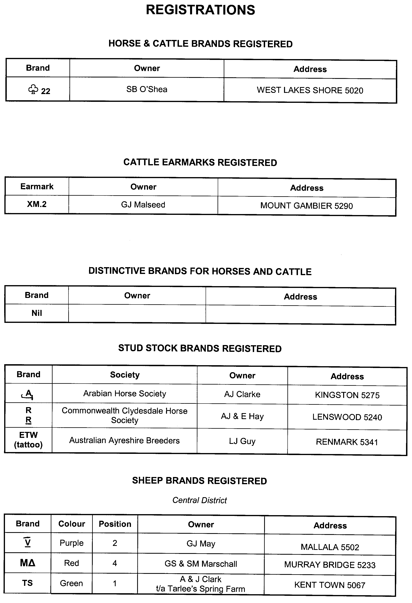
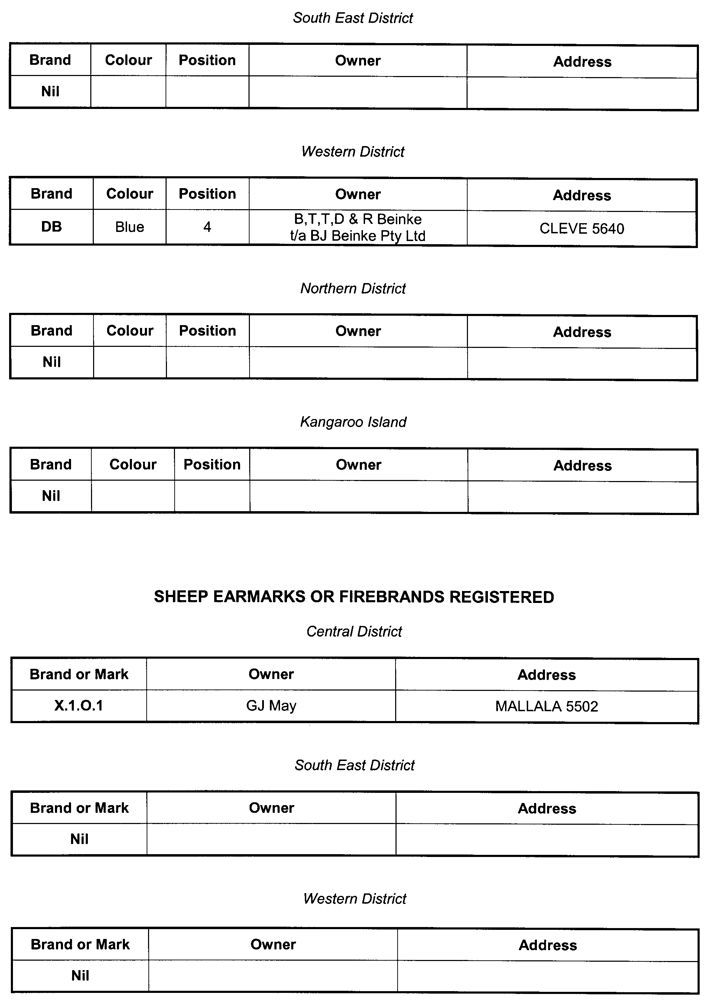

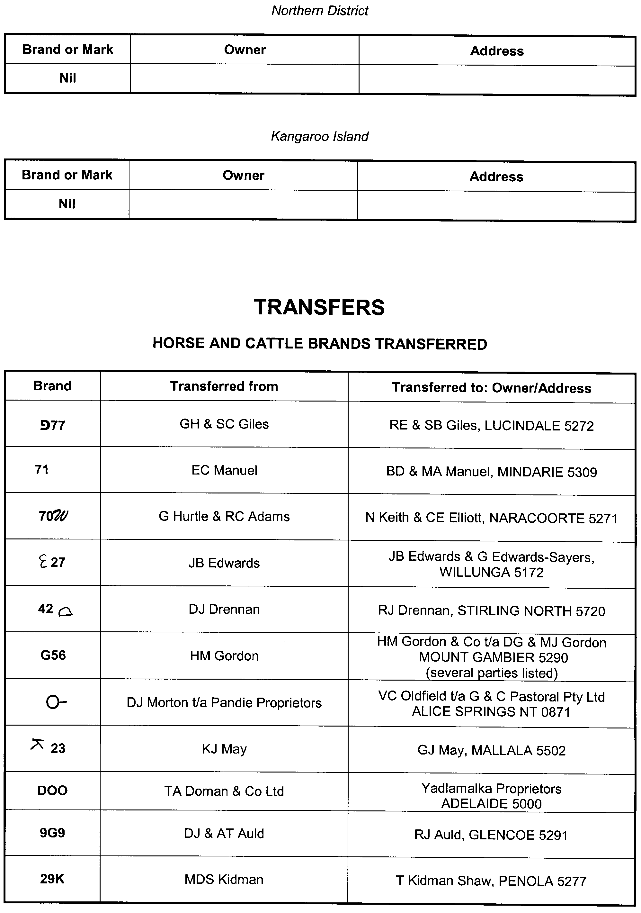

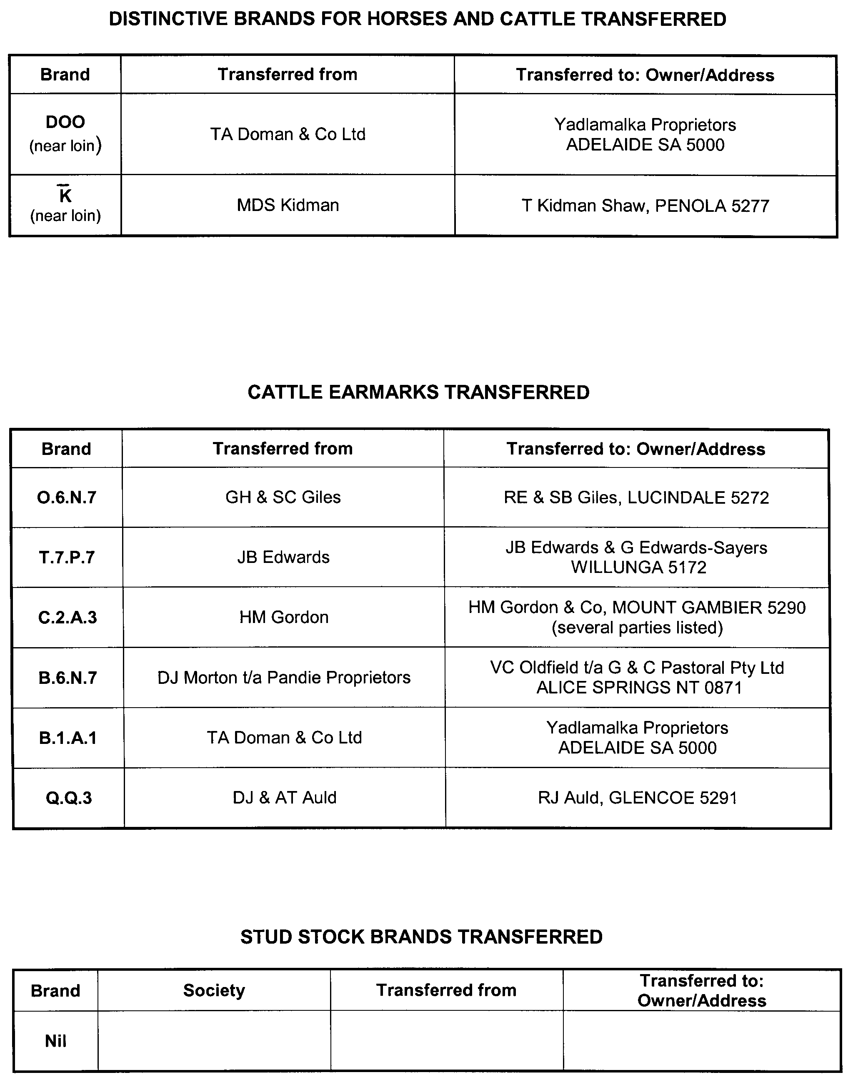
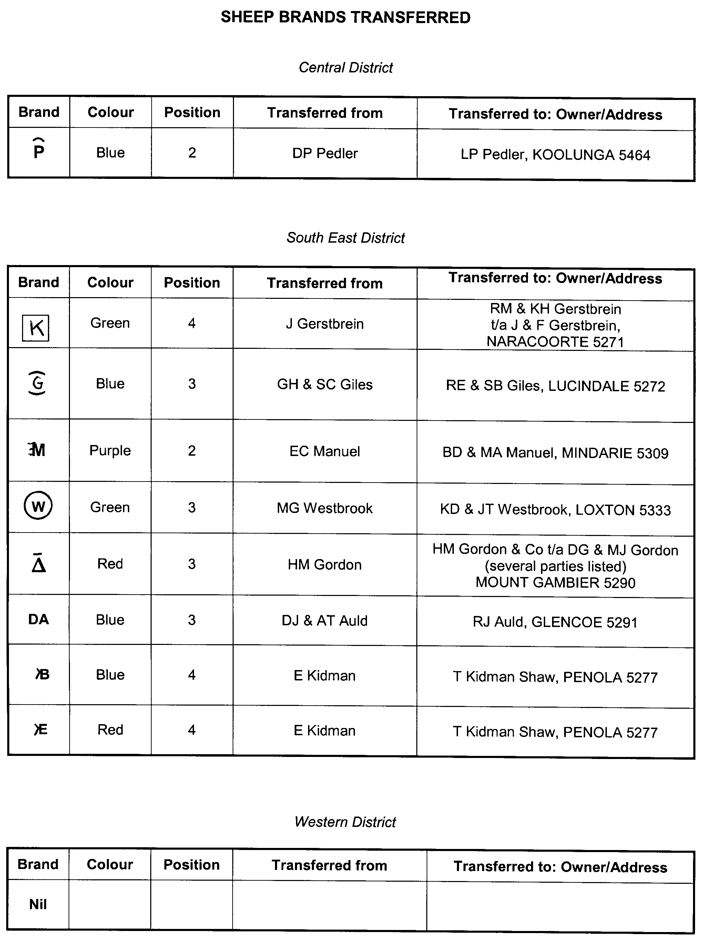

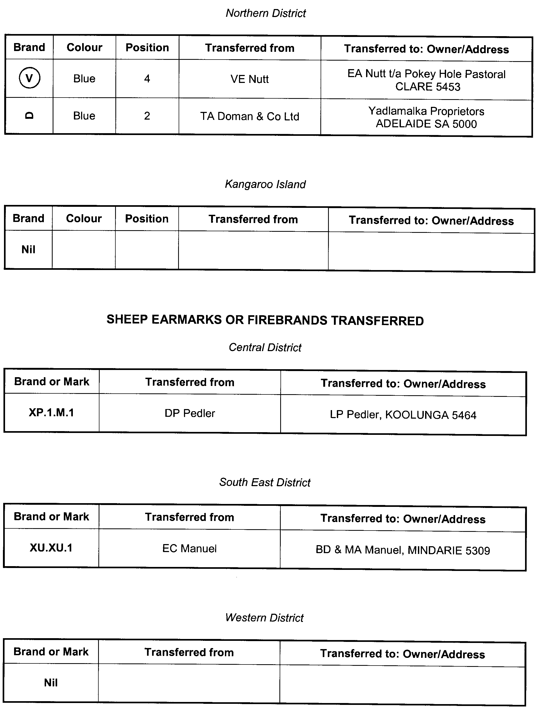

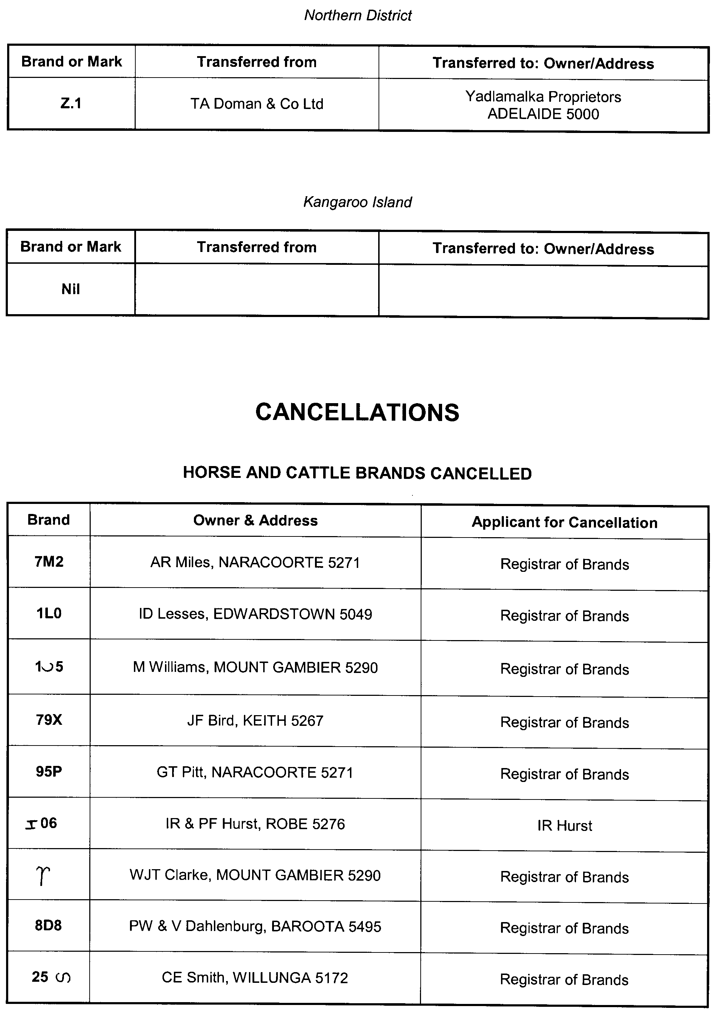

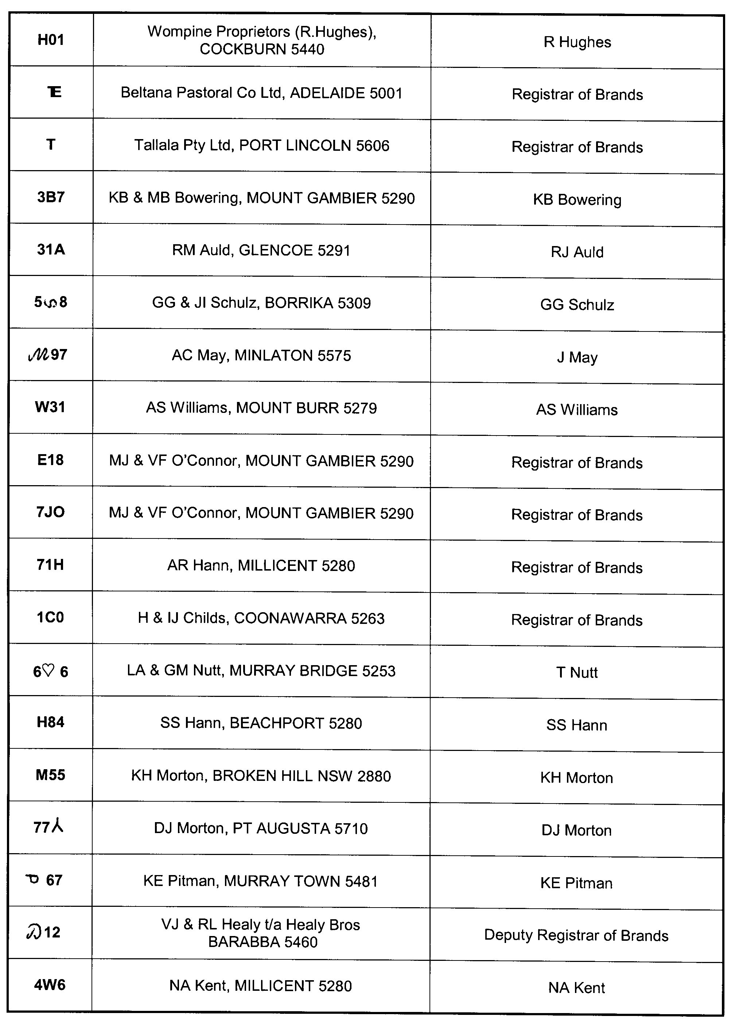
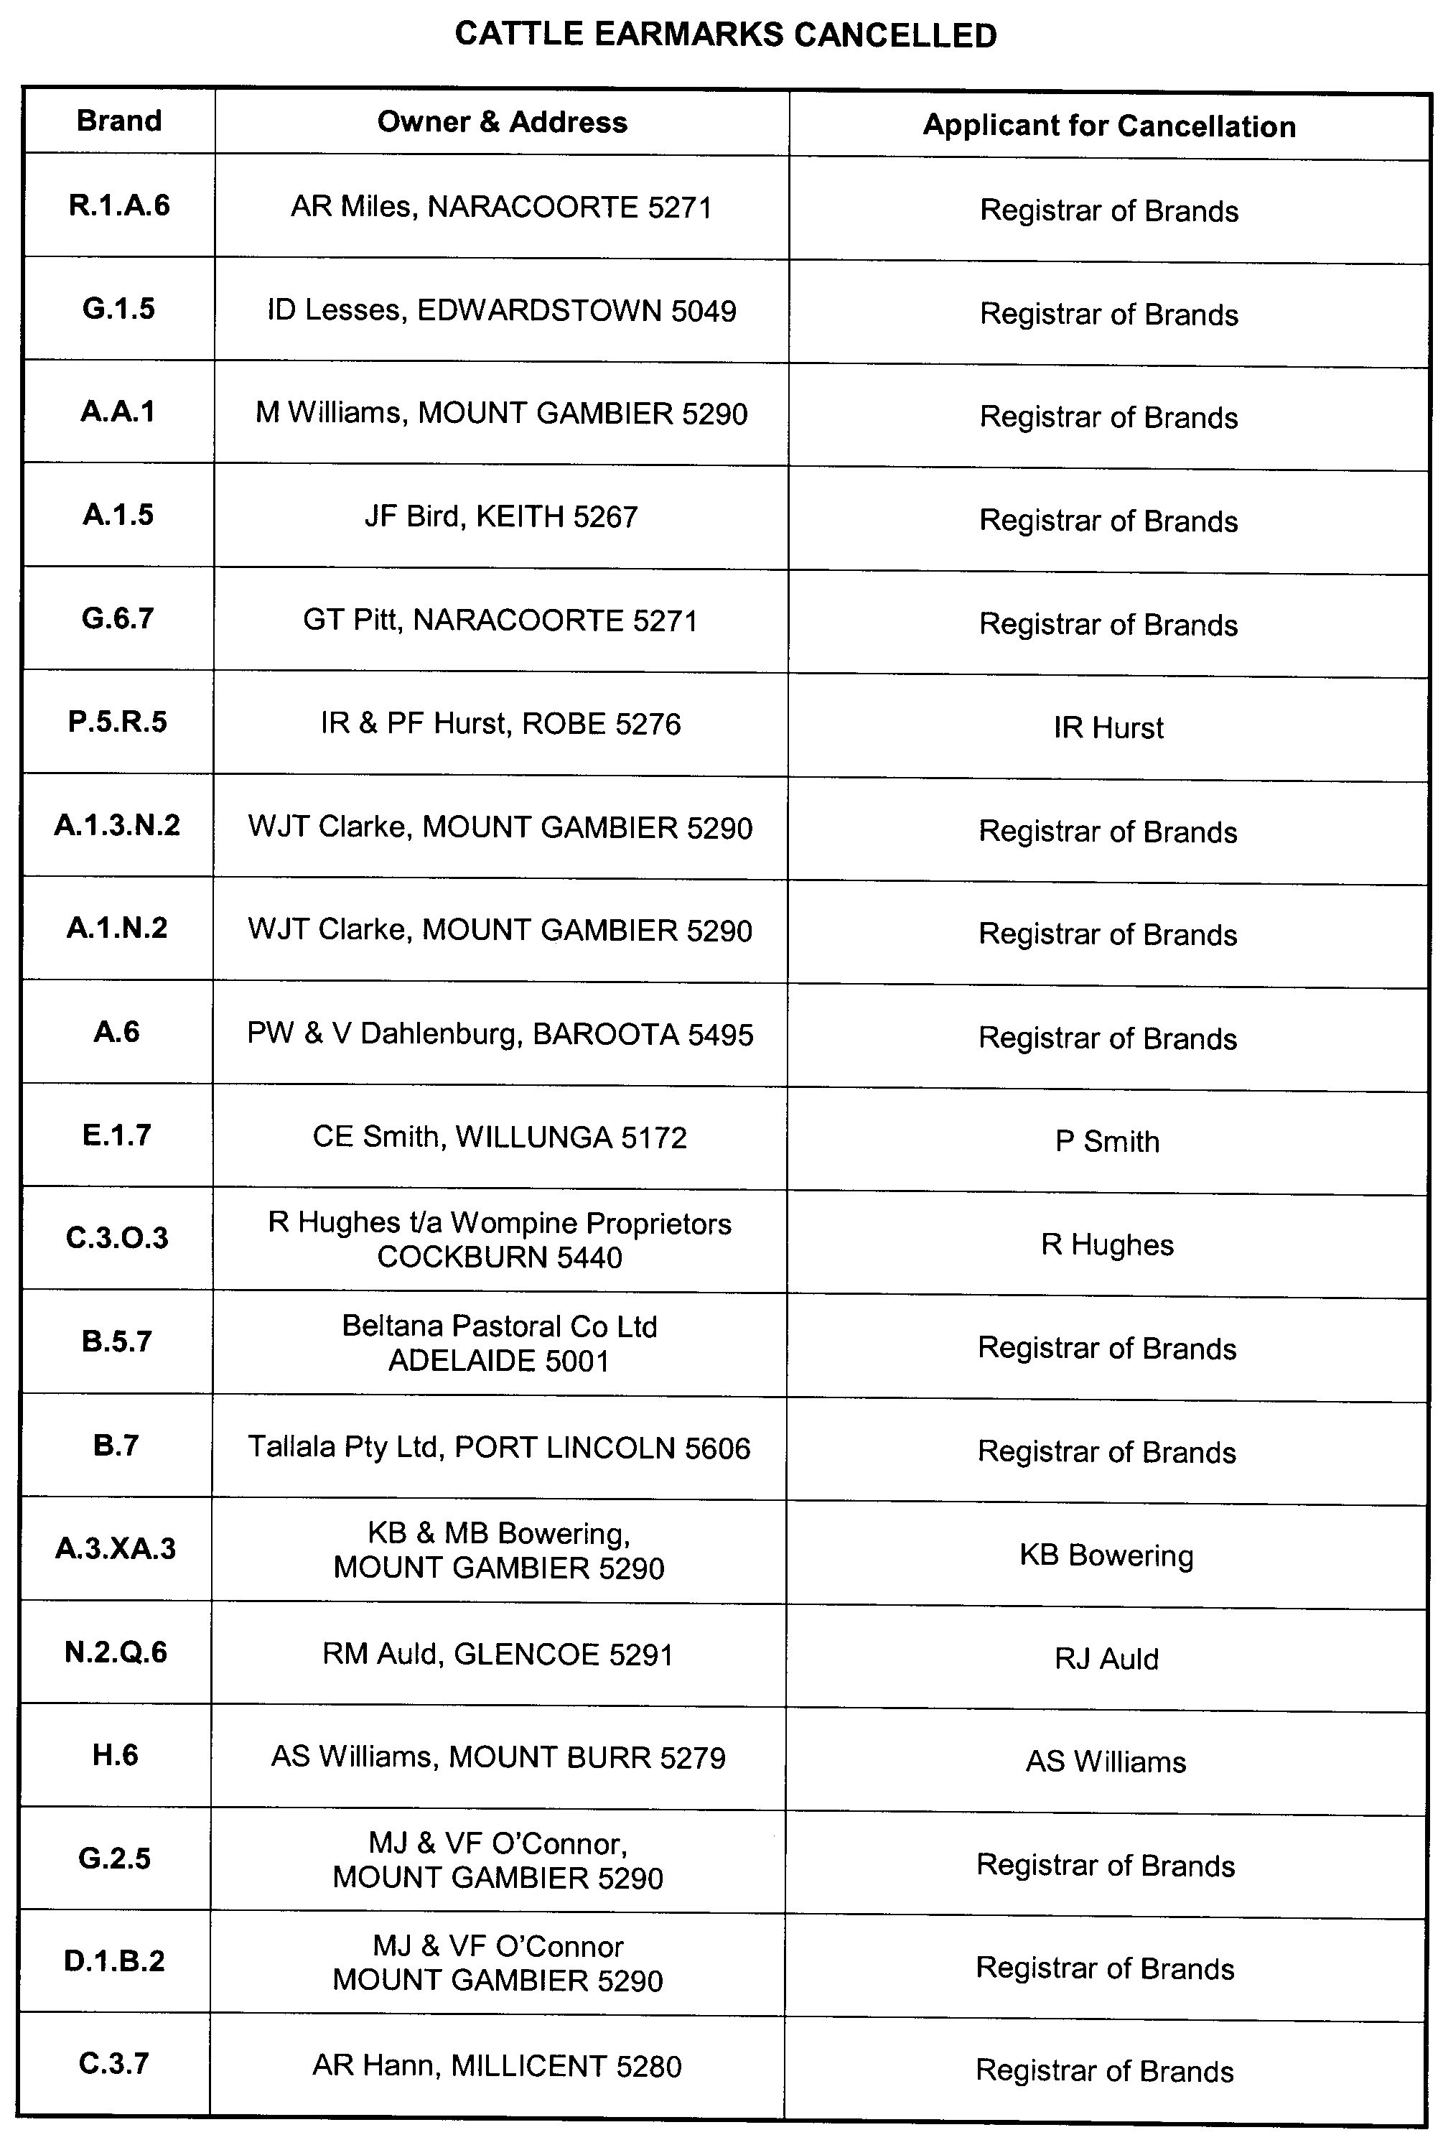
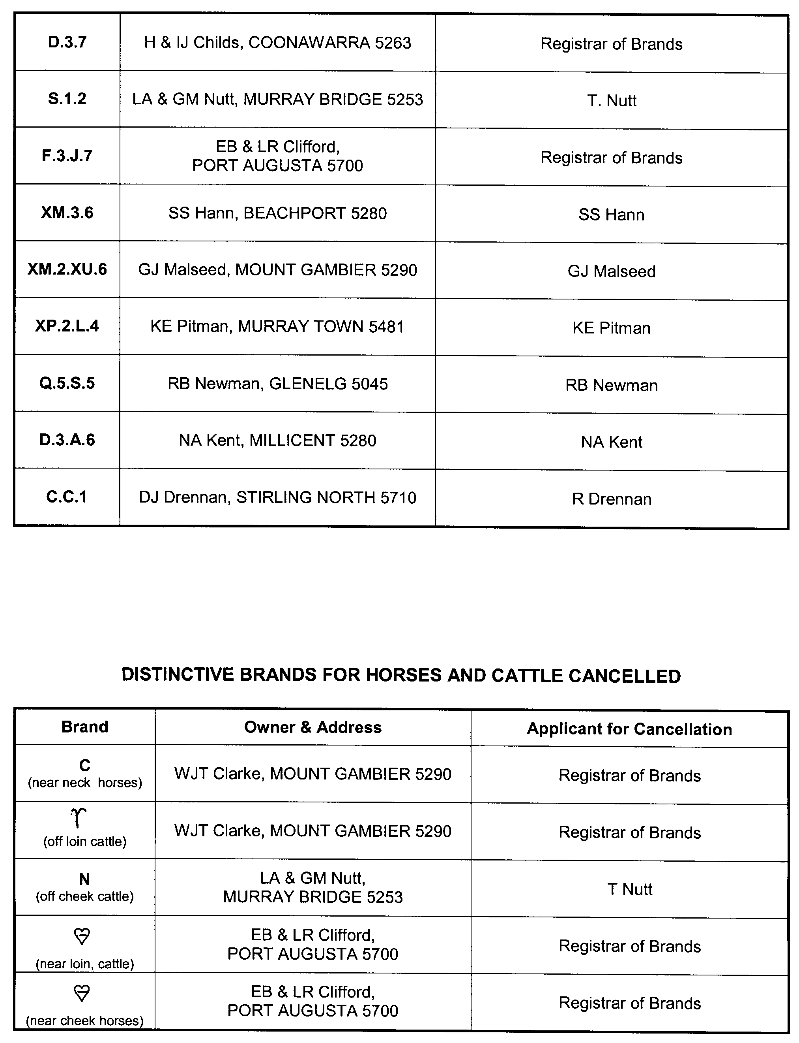

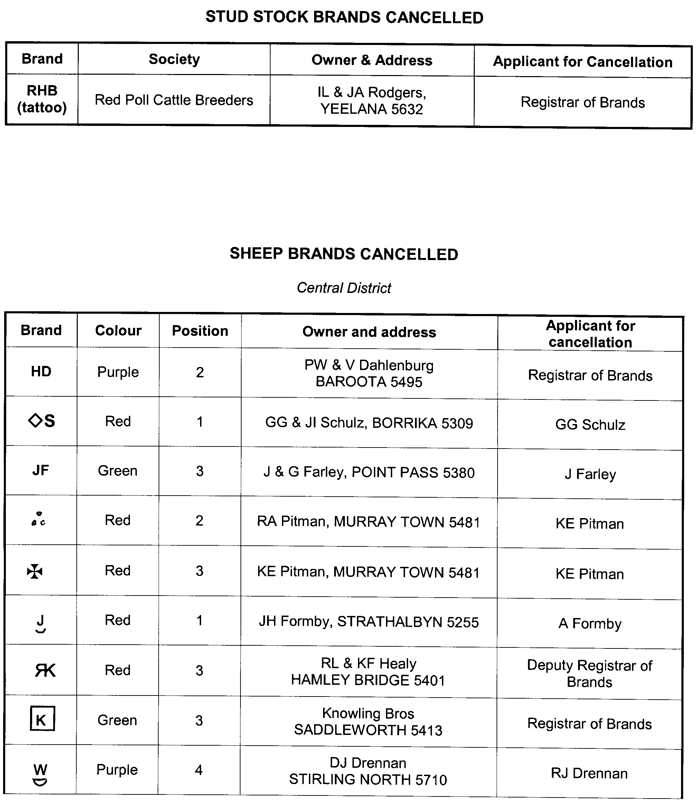

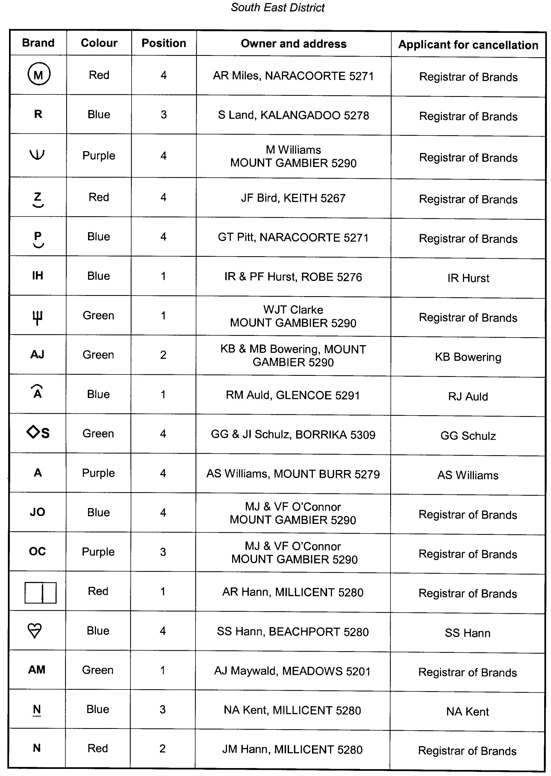

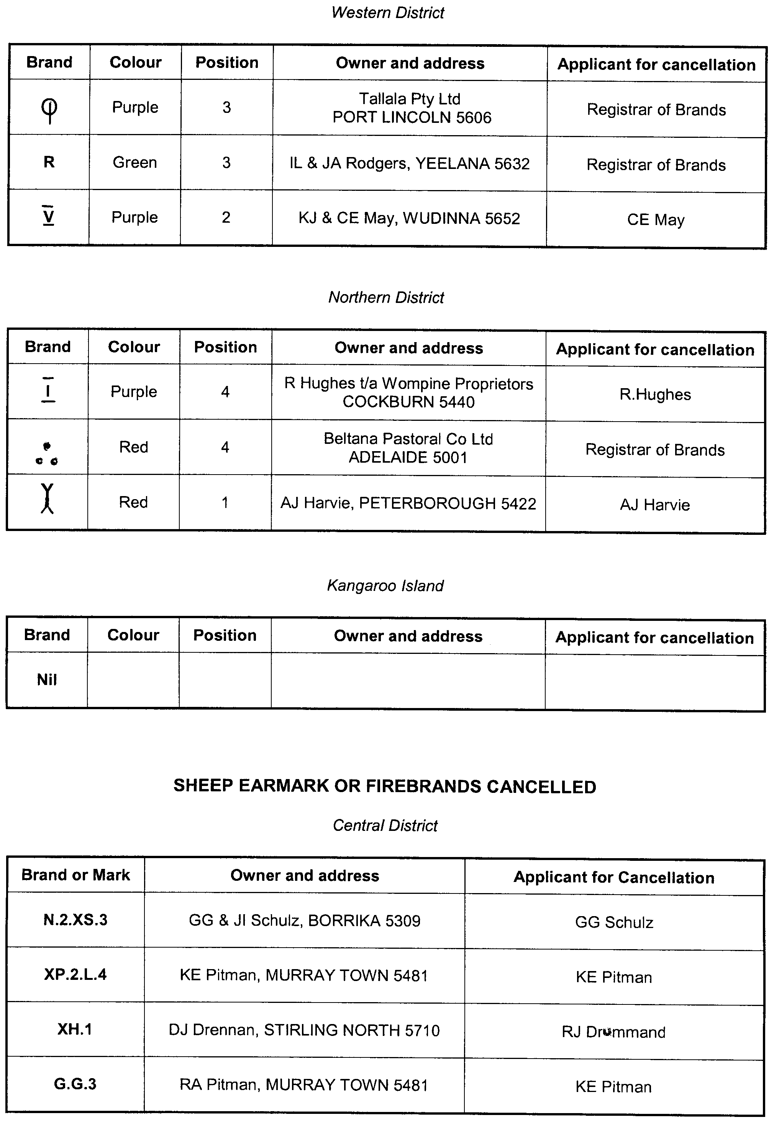

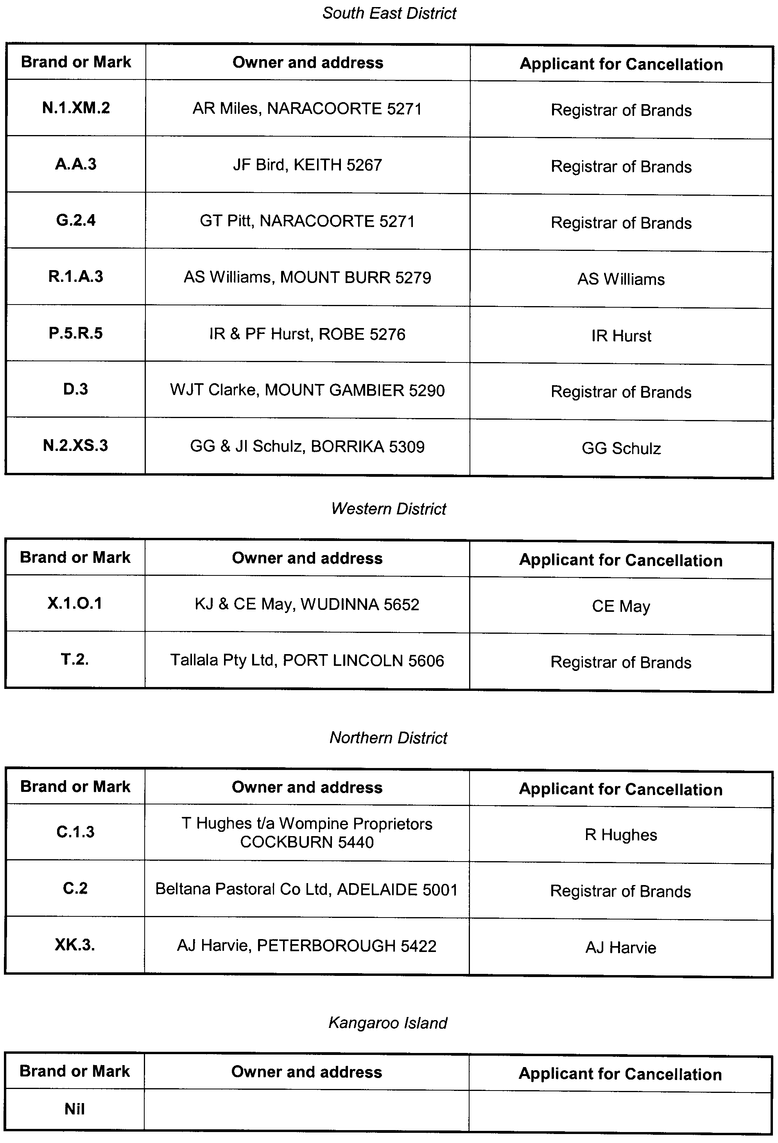

GOVERNMENT GAZETTE ADVERTISEMENT RATES

To apply from 1 July 2009

$  Agents, Ceasing to Act as 42.75  Associations:  Incorporation 21.70  Intention of Incorporation 53.50  Transfer of Properties 53.50  Attorney, Appointment of 42.75  Bailiff’s Sale 53.50  Cemetery Curator Appointed 31.75  Companies:  Alteration to Constitution 42.75  Capital, Increase or Decrease of 53.50  Ceasing to Carry on Business 31.75  Declaration of Dividend 31.75  Incorporation 42.75  Lost Share Certificates:  First Name 31.75  Each Subsequent Name 10.90  Meeting Final 35.75  Meeting Final Regarding Liquidator’s Report on  Conduct of Winding Up (equivalent to ‘Final  Meeting’)  First Name 42.75  Each Subsequent Name 10.90  Notices:  Call 53.50  Change of Name 21.70  Creditors 42.75  Creditors Compromise of Arrangement 42.75  Creditors (extraordinary resolution that ‘the Com-pany be wound up voluntarily and that a liquidator be appointed’) 53.50  Release of Liquidator⎯Application⎯Large Ad. 85.00  ⎯Release Granted 53.50  Receiver and Manager Appointed 49.50  Receiver and Manager Ceasing to Act 42.75  Restored Name 40.00  Petition to Supreme Court for Winding Up 74.50  Summons in Action 63.50  Order of Supreme Court for Winding Up Action 42.75  Register of Interests⎯Section 84 (1) Exempt 96.00  Removal of Office 21.70  Proof of Debts 42.75  Sales of Shares and Forfeiture 42.75  Estates:  Assigned 31.75  Deceased Persons⎯Notice to Creditors, etc. 53.50  Each Subsequent Name 10.90  Deceased Persons⎯Closed Estates 31.75  Each Subsequent Estate 1.40  Probate, Selling of 42.75  Public Trustee, each Estate 10.90 |  | $  Firms:  Ceasing to Carry on Business (each insertion) 28.50  Discontinuance Place of Business 28.50  Land⎯Real Property Act:  Intention to Sell, Notice of 53.50  Lost Certificate of Title Notices 53.50  Cancellation, Notice of (Strata Plan) 53.50  Mortgages:  Caveat Lodgement 21.70  Discharge of 22.70  Foreclosures 21.70  Transfer of 21.70  Sublet 10.90  Leases⎯Application for Transfer (2 insertions) each 10.90  Lost Treasury Receipts (3 insertions) each 31.75  Licensing 63.50  Municipal or District Councils:  Annual Financial Statement⎯Forms 1 and 2 598.00  Electricity Supply⎯Forms 19 and 20 425.00  Default in Payment of Rates:  First Name 85.00  Each Subsequent Name 10.90  Noxious Trade 31.75  Partnership, Dissolution of 31.75  Petitions (small) 21.70  Registered Building Societies (from Registrar-  General) 21.70  Register of Unclaimed Moneys⎯First Name 31.75  Each Subsequent Name 10.90  Registers of Members⎯Three pages and over:  Rate per page (in 8pt) 272.00  Rate per page (in 6pt) 359.00  Sale of Land by Public Auction 54.00  Advertisements 3.00  ¼ page advertisement 127.00  ½ page advertisement 254.00  Full page advertisement 498.00  Advertisements, other than those listed are charged at $3.00 per column line, tabular one-third extra.  Notices by Colleges, Universities, Corporations and District Councils to be charged at $3.00 per line.  Where the notice inserted varies significantly in length from that which is usually published a charge of $3.00 per column line will be applied in lieu of advertisement rates listed.  South Australian Government publications are sold on the condition that they will not be reproduced without prior permission from the Government Printer.
All the above prices include GST

GOVERNMENT GAZETTE NOTICES
ALL private advertisements forwarded for publication in the South Australian Government Gazette must be PAID FOR PRIOR TO INSERTION; and all notices, from whatever source, should be legibly written on one side of the paper only and sent to Government Publishing SA so as to be received no later than 4 p.m. Tuesday preceding the day of publication. Phone 8207 1045 or Fax 8207 1040. E-mail: governmentgazette@dpc.sa.gov.au. Send as attachments in Word format. Please include date the notice is to be published and to whom the notice will be charged. The Government Gazette is available online at: www.governmentgazette.sa.gov.au.

MISCELLANEOUS LEGISLATION AND GOVERNMENT PUBLICATIONS PRICES AS FROM 1 JULY 2009

Acts, Bills, Rules, Parliamentary Papers and Regulations
Pages | Main | Amends | Pages | Main | Amends

1-16 | 2.60 | 1.20 | 497-512 | 36.25 | 35.25
17-32 | 3.50 | 2.20 | 513-528 | 37.25 | 36.00
33-48 | 4.55 | 3.25 | 529-544 | 38.50 | 37.25
49-64 | 5.75 | 4.40 | 545-560 | 39.50 | 38.50
65-80 | 6.70 | 5.55 | 561-576 | 40.50 | 39.50
81-96 | 7.80 | 6.45 | 577-592 | 41.75 | 40.00
97-112 | 8.90 | 7.60 | 593-608 | 43.00 | 41.50
113-128 | 9.95 | 8.75 | 609-624 | 43.75 | 42.75
129-144 | 11.10 | 9.85 | 625-640 | 45.00 | 43.25
145-160 | 12.20 | 10.90 | 641-656 | 46.00 | 45.00
161-176 | 13.30 | 12.00 | 657-672 | 46.75 | 45.50
177-192 | 14.50 | 13.10 | 673-688 | 48.75 | 46.75
193-208 | 15.60 | 14.40 | 689-704 | 49.50 | 47.75
209-224 | 16.50 | 15.20 | 705-720 | 50.25 | 49.00
225-240 | 17.60 | 16.30 | 721-736 | 52.00 | 50.00
241-257 | 18.90 | 17.20 | 737-752 | 52.50 | 51.00
258-272 | 19.90 | 18.30 | 753-768 | 53.50 | 52.00
273-288 | 21.00 | 19.70 | 769-784 | 54.50 | 53.50
289-304 | 21.90 | 20.60 | 785-800 | 55.50 | 54.50
305-320 | 23.20 | 21.80 | 801-816 | 57.00 | 55.00
321-336 | 24.20 | 22.80 | 817-832 | 58.00 | 57.00
337-352 | 25.40 | 24.10 | 833-848 | 59.00 | 58.00
353-368 | 26.25 | 25.20 | 849-864 | 60.00 | 58.50
369-384 | 27.50 | 26.25 | 865-880 | 61.50 | 60.00
385-400 | 28.75 | 27.25 | 881-896 | 62.00 | 60.50
401-416 | 29.75 | 28.25 | 897-912 | 63.50 | 62.00
417-432 | 31.00 | 29.50 | 913-928 | 64.00 | 63.50
433-448 | 32.00 | 30.75 | 929-944 | 65.00 | 64.00
449-464 | 32.75 | 31.50 | 945-960 | 66.00 | 64.50
465-480 | 33.25 | 32.50 | 961-976 | 68.50 | 65.50
481-496 | 35.25 | 33.25 | 977-992 | 69.50 | 66.00

Legislation—Acts, Regulations, etc: $
Subscriptions:
Acts 223.00
All Bills as Laid 536.00
Rules and Regulations 536.00
Parliamentary Papers 536.00
Bound Acts 248.00
Index 124.00
Government Gazette
Copy 5.85
Subscription 296.00
Hansard
Copy 16.30
Subscription—per session (issued weekly) 465.00
Cloth bound—per volume 199.00
Subscription—per session (issued daily) 465.00
Legislation on Disk
Whole Database 3 443.00
Annual Subscription for fortnightly updates 1 058.00
Individual Act(s) including updates POA
Notice of Vacancies
Annual Subscription 164.00
Compendium
Subscriptions:
New Subscriptions 2 039.00
Updates 719.00
(All the above prices include GST)

All Legislation, Government Gazette, Hansard and Legislation on disk are available from:
Counter Sales Government Legislation⁺ Outlet
and Mail Orders: Service SA Customer Service Centre,
Ground Floor—EDS Centre, 108 North Terrace, Adelaide, S.A. 5000
Phone: 13 23 24 (local call cost), Fax: (08) 8204 1909
Postal: G.P.O. Box 1707, Adelaide, S.A. 5001

Online Shop: www.shop.service.sa.gov.au

Subscriptions and Government Publishing SA
Standing Orders: Box 9, Plaza Level, Riverside Centre, North Terrace, Adelaide, S.A. 5000
Phone: (08) 8207 1043, (08) 8207 0910, Fax: (08) 8207 1040

CONTROLLED SUBSTANCES ACT 1984
Prohibition of Administering Prescription Drugs
TAKE notice that on 17 August 2009, I, Keith Evans, Executive Director, Drug and Alcohol Services South Australia, having formed the opinion that Dr Brian Reading Moore has prescribed, supplied and administered a prescription drug in an irresponsible manner, exercised the authority delegated by the Minister for Mental Health and Substance Abuse under section 62A of the Controlled Substances Act 1984 and made the following order under section 57 (1) (c) of the Act:
Dr Brian Reading Moore,
is prohibited from supplying, prescribing, administering using or having possession of the following substances or class of substances:
• a drug of dependence as declared by Regulation 7A of the Controlled Substances (Poisons) Regulations 1996, pursuant to section 12 (3) of the Controlled Substances Act 1984, namely any poison listed in Schedule 8 of the Standard for the Uniform Scheduling of Drugs and Poisons as published and amended by the National Drugs and Poisons Schedule Committee under the Commonwealth’s Therapeutic Goods Act 1989, and
• prescription drugs that contain codeine or dextro-propoxyphene.
This Order does not apply to any of the above drugs or class of drugs lawfully supplied or prescribed for the treatment of Dr Brian Reading Moore by a dentist or medical practitioner or by a veterinary surgeon for administration to an animal in his care.
This order took effect when it was served on Dr Brian Reading Moore on 19 August 2009.
K. Evans, Delegate for the Minister for Mental Health and Substance Abuse

DEVELOPMENT ACT 1993: SECTION 48
Notice by the Governor
Preamble
1. I have given a development authorisation pursuant to section 48 of the Development Act 1993 for the establishment of a Multiple Waste Treatment Facility (for treating high level contaminated waste) at the existing Northern Balefill (landfill) near Dublin, by Integrated Waste Services Pty Ltd, which authorisation is published in the Gazette of 27 August 2009.
2. I wish to delegate certain of my powers under section 48 to the Minister for Urban Development and Planning.
Delegation
PURSUANT to section 48 (8) of the Development Act 1993 and with the advice and consent of the Executive Council I make the following delegations:
I delegate to the Minister for Urban Development and Planning:
(a) my power to assess and approve the reserved matters specified in the said provisional development authorisation (provided the essential nature of the development is not changed);
(b) my power under section 48 (7a) to grant or permit any variation associated with the said provisional develop-ment authorisation (provided the essential nature of the development is not changed);
(c) in relation to the said provisional development authorisation, or any variation thereof- my power to vary or revoke conditions, or to attach new conditions, under section 48 (7) (provided the essential nature of the development is not changed);
(d) if all reserved matters specified in the said provisional development authorisation have been approved, my power to grant the development authorisation required under section 48 (2) (b) (i) (provided there has been no alteration to the Environmental Impact Statement to which section 47 (2) (b) has applied);
(e) my power under section 48 (2) (a) to indicate that a development authorisation will not be granted, should there be any amendment to the Environmental Impact Statement to which section 47 (2) (b) has applied; and
(f) my power to grant the development authorisation required under section 48 (2) (b) (i) if there has been any amendment to the Environmental Impact Statement to which section 47 (2) (b) has applied.
Given under my hand at Adelaide, 27 August 2009.
Kevin Scarce, Governor

DEVELOPMENT ACT 1993: SECTION 48
Decision by the Governor
Preamble
1. On 19 October 1994 the Minister for Housing, Urban Development and Local Government Relations, being of the opinion that a proposed development of a waste management facility in the form of a solid waste landfill (Northern Balefill) near Dublin (‘the development’) was a development of major social, economic or environmental importance, directed the proponent to prepare an Environmental Impact Statement pursuant to section 46 of the Development Act 1993.
2. On 22 April 1996 an Environmental Impact Statement for the development was published in accordance with section 46 of the Development Act 1993. Subsequently, the Minister prepared an Assessment Report in accordance with section 46 of the Development Act 1993.
3. On 29 January 1998 the Governor gave notice in the Government Gazette that pursuant to section 48 of the Development Act 1993 a development authorisation was granted to the development subject to conditions specified in that notice.
4. Following an application by the beneficiary of the development authorisation for a variation to the authorisation to allow the receipt and disposal of low level contaminated waste, the development was the subject of an Amended Environmental Impact Statement and an Amendment to the Assessment Report under section 47 of the Development Act 1993 (‘the amended development’).
5. On 8 September 2005 the Governor gave notice in the Government Gazette that provisional development consent, reserving specific matters for further assessment, was granted for the amended development subject to conditions specified in that notice.
6. On 30 June 2008 Integrated Waste Services Pty Ltd, the company now having the benefit of the development authorisation applied for a second amendment to the development authorisation proposing the establishment of a Multiple Waste Treatment Facility for the treatment and disposal of high level contaminated waste at the existing landfill.
7. The proposal has been the subject of an Amended Environmental Impact Statement and an Amended Assessment Report under the section 47 of the Development Act 1993, and is hereafter referred to as the ‘proposed amended Major Develop-ment’.
8. I am satisfied that an appropriate Amended Environmental Impact Statement and an Amendment to the Assessment Report have been prepared in relation to the proposed amended Major Development, in accordance with section 47, Division 2 of Part 4 of the Development Act 1993, and have had regard, when considering the proposed amended Major Development, to all relevant matters under section 48 (5) of the Development Act 1993.
9. I have decided to grant provisional development authorisation to the proposed Major Development under section 48 (6) of the Development Act 1993, whilst reserving the decision on specified matters until further assessment of the proposed development.
10. For ease of reference, I have decided to revoke all conditions previously imposed on the provisional development authorisation and to substitute therefore the reserved matters and conditions contained herein. Conditions that pertain to the second amendment are contained in conditions 1-25. Conditions that relate to the current operation of the landfill have been retained and are reimposed in conditions 26-51.
11. Contemporaneously with the issuing of this Notice, I intend pursuant to section 48(8) of the Development Act to delegate to the Minister (a) the power to assess and make a decision on matters specified as reserved and to grant a final development authorisation for the purposes of section 48 (2) (b) (i) of the Act; (b) the power pursuant to section 48B to grant or permit any variation associated with that development application and associated document (provided the essential nature of the development is not changed); and (c) in relation to that development authorisation, or any variation—the power to revoke conditions, or to attach new conditions, under section 48 (7) of the Development Act 1993 (provided the essential nature of the development is not changed).
Decision
PURSUANT to section 48 of the Development Act 1993 and with the advice and consent of the Executive Council, and having due regard to the matters set out in section 48 (5) and all other relevant matters, I:
(a) grant a provisional development authorisation in relation to the proposed amended Major Development under section 48 (6) subject to the conditions set out in Part B below;
(b) pursuant to section 48 (6) reserve my decision on the reserved matters specified in Part A below;
(c) specify all matters relating to this provisional development authorisation as matters in respect of which conditions of this authorisation may be varied or revoked, or new conditions attached;
(d) specify for the purposes of section 48 (11) (b) the period of two years from the date of this provisional development authorisation as the time within which substantial work must be commenced on site, failing which I may cancel this authorisation.
Part A: Reserved Matters
The following are the matters reserved for further assessment:
(a) compliance with the Building Rules in relation to all aspects of the proposed Major Development;
(b) final plans, cross-sections and elevations for the Multiple Waste Treatment Facility building;
(c) an Environmental Management Plan for the operation of Stage 1 of the Multiple Waste Treatment Facility.
Part B: Conditions of Provisional Development Authorisation
General Conditions
1. The development authorisation granted hereunder is provisional only, does not operate as a final development authorisation, and does not therefore authorise implementation of the proposed amended Major Development. Only an authorisation granted under section 48 (2) (b) (i) can operate to authorise implementation of the proposed amended Major Development, which authorisation will only be granted after the reserved matters have been assessed and approved.
2. Except where minor amendments may be required by other legislation, or by conditions imposed herein, the proposed Major Development shall be undertaken in strict accordance with the following documents:
• Development application dated 30 June 2008;
• Environmental Impact Statement Amendment, Integrated Waste Services Northern Balefill Dublin Multiple Waste Treatment Facility EIS Amendment prepared by Golder Associates, dated 24 November 2008, but in the case of conflict with a specific condition below the specific condition shall apply;
• proponent’s response to submissions, letter from Connor Holmes to the Department of Planning and Local Govern-ment dated 3 April 2009, but in the case of conflict with a specific condition below the specific condition shall apply;
• correspondence from Connor Holmes to the Department of Planning & Local Government containing additional information on the proposal dated 27 May 2009, but in the case of conflict with a specific condition below the specific condition shall apply.
3. Before any building work is undertaken on the site, the building work is to be certified by a private certifier, or by some person determined by the Minister for Urban Development and Planning, as complying with the provisions of the Building Rules (or the Building Rules as modified according to criteria prescribed by the Regulations).
Multiple Waste Treatment Facility (MWTF)
4. The design of the MWTF shall be amended to include coloured metal cladding on all sides of the building, so as to enclose the whole of the facility.
5. Designs for the effluent treatment and disposal system shall be prepared to the reasonable satisfaction of the District Council of Mallala.
6. An automated wind monitoring station shall be established next to Stage 1 of the MWTF, prior to the commencement of operation of Stage 1.
7. Upon the completion of Stage 1 construction, the interim storage of High Level Contaminated Waste shall not exceed 3 500m³ of materials, until Stage 2 construction is complete.
8. Construction of Stage 2 shall commence immediately upon the completion of construction of Stage 1.
9. Stage 2 shall be completed within 12 months of the commencement of construction.
10. Treatment of waste material shall not occur until the construction of the entire MWTF has been completed, to the reasonable satisfaction of the EPA.
11. High Level Contaminated Waste is not required to be baled or shredded.
12. The unloading and storage of High Level Contaminated Waste for Stage 1 shall be undertaken in accordance with an Environment Protection Authority approved Environmental Management Plan for Stage 1.
13. The unloading of High Level Contaminated Waste shall only occur during conditions where the wind speed measured on-site is less than or equal to 15 knots/hr.
14. High Level Contaminated Waste materials shall be wetted down during unloading.
15. High Level Contaminated Waste materials shall be covered with an impervious cover (such as High Density Polyethylene plastic) immediately after unloading, in order to prevent air emissions and rainfall infiltration.
16. The impervious cover shall be securely held down.
17. A truck wash with water sprays shall be installed for the removal of residues from vehicles transporting High Level Contaminated Waste to the site. All transport vehicles shall not leave the site unless they have gone through the truck wash.
18. All unloading and storage activities for Stage 1 shall be supervised and inspected by a suitably qualified and experienced environmental consultant, to the reasonable satisfaction of the Environment Protection Authority, to ensure activities are undertaken in accordance with the Environmental Management Plan for Stage 1. Stored materials shall be inspected quarterly to ensure they are covered in a secure manner.
19. Treatment of the stored materials shall only commence once the completed MTWF is approved by the Environment Protection Authority to commence operation.
20. Bioremediation and stabilisation are the only treatment processes that shall be used in the MWTF.
21. Pre-remediation trials shall be conducted on all contaminated materials, prior to delivery to the MWTF, to determine if treatment methods approved by the Environment Protection Authority would be successful. Trial results shall be submitted to the Environment Protection Authority for assessment, prior to delivery of contaminated materials to the MWTF.
22. Post-remediation testing on treated materials shall be undertaken to assess its suitability to be disposed of or reused. Testing results shall be submitted to the Environment Protection Authority for assessment, prior to disposal or reuse.
23. Future treatment options shall undergo pre-trial assessment, to the reasonable satisfaction of the Environment Protection Authority, before they can be adopted.
24. An Environmental Management Plan (EMP) for activities associated with the MWTF, prepared to the reasonable satisfaction of the Environment Protection Authority, must be in place prior to the receival, storage and treatment of contaminated materials in Stage 2.
Solid Waste Balefill
25. The work shall be carried out as shown on the plans (Figures 3.1 to 3.9) in the Development Application Report dated 28 November 1997, included with the Development Application dated 2 December 1997, except as varied by these conditions.
26. Subject to conditions 25, 26 and 27, all waste received for disposal at the facility shall be shredded and baled.
27. Unbaled green waste or unbaled construction or demolition waste of appropriate particle sizes may by placed and compacted in any voids unavoidably occurring between bales and the inclined surface of the cells in which those bales are placed to the reasonable satisfaction of the Environment Protection Authority and in accordance with any applicable requirements of a relevant environmental authorisation.
28. Waste materials received for disposal at the facility need not be shredded before baling where shredding of those materials is not required for the purpose of producing bales of a density and structural integrity that satisfy the applicable requirements of any relevant environmental authorisation.
29. Non-friable asbestos waste shall not be shredded or baled but shall be disposed of in accordance with the applicable requirements of any relevant environmental authorisation.
30. All perimeter plantings shall be started as early as practicable after the date of this authorisation to achieve maximum amelioration of visual impacts.
31. Screening by suitable plantings where adequate natural screening is not provided, shall be provided for the perimeter fence, all built structures, stockpiles and internal roads (where practicable) using suitable species in accordance with the Vegetation Management and Revegetation Plan proposed as part of the Landfill Environmental Management Plan (LEMP).
32. All firebreaks and external drainage channels shall be located on the inner edge of the vegetation screen and existing stands of native vegetation. In the event that drainage channels are required to be located close to the site boundary, their redesign to form low-lying wetland/saltmarsh communities as part of the vegetation screen shall be undertaken and implemented to the satisfaction of the Environment Protection Authority.
33. A leachate monitoring bore shall be installed within each cell to assist with leachate management, particularly if leachate circulation is incorporated in the Landfill Environmental Management Plan (LEMP).
34. The proponent shall pay all reasonable costs of the detailed design and construction of any public roadworks made necessary by this development. Such works may include the opening and associated left turn deceleration lane from Port Wakefield Road, and the upgrading of the entrance to balefill junction to the satisfaction of the Commissioner of Highways.
35. The proponent shall seal (two coat spray seal) the internal site access road for a minimum of 520 m from the nearest residence.
36. The applicant shall prepare a Vegetation Management and Revegetation Plan (which may be included in the LEMP) to the reasonable satisfaction of the Development Assessment Commission and must implement that Plan once it has been approved by the Development Assessment Commission.
Low Level Contaminated Soil and Liquid Treatment Plant Residues
37. Low level contaminated soil (LLCS) and liquid treatment plant residues (LLTR) are not required to be baled or shredded.
38. The work shall be carried in accordance with the following documents and plans:
• EIS Amendment, Receipt of Low Level Contaminated Soil and Liquid Waste Treatment Plant Residues at the IWS Northern Balefill, dated July 2003;
• Response Document on the EIS Amendment for the Receipt of Low Level Contaminated Soil and Liquid Waste Treatment Plant Residues (Revised), dated 30 April 2004;
• Supplementary Information EIS Amendment Receipt of Low Level Contaminated Soil and Liquid Waste Treatment Plant Residues at the IWS Northern Balefill, dated 26 November 2004;
• Landfill Environmental Management Plan, dated 2001 or as varied by any applicable requirements of a licence from the Environment Protection Authority;
• Drawings:
− 3307DO1, 4/11/2004—cell 31 design plan;
− 3307DO2, Drawn 25/8/2004 and checked 18/2/2005—Section A, liner and sump design;
− 3307DO3, 10/8/2004—liner design sections and details;
− 3307DO4, 14/10/2004—cell 31 interim capping design;
− 3307DO5, 13/8/2004—landfill staging plan;
− 3307DO6, 13/8/2004—final surface water control;
− 3307DO8, Drawn 27/8/2004 and checked 26/11/2004—interim surface water control;
− 3307DO9 P1, Drawn 4/11/2004 and checked 26/11/2004—cell design plan line 2;
− 3307DO10, Drawn 29/8/2004 and checked 26/11/2004—sections D and E, swale drain design.
39. Distance to groundwater requirements shall be as follows:
− based on groundwater level monitoring results and interpolated highest groundwater levels for Cell 31, including a 0.1 metre buffer; the base of the sump shall be at 9.1 m AHD;
− not withstanding the above requirement, a minimum separation distance of 2 m between the underside of the lowest portion of the lining system (including the sump area) and the underlying groundwater shall be maintained at all times.
40. Leachate collection and extraction system requirements shall be as follows:
− leachate removal shall implement a system which accommodates the installation of the pumps at the leachate riser access point;
− following cell completion and until the entire cell base is covered with a minimum of 1.5 metres of waste, a pump with a flow capacity of a minimum of 40 litres per second shall be installed;
− after it can be demonstrated that leachate production has declined to less than 1 litre per second, this pump can be replaced by a pump of lesser flow capacity;
− a back-up pump with the relevant capacity shall be readily available on site at all time.
41. Leachate treatment requirements shall be as follows:
− Leachate may be managed and treated by means of:
• direct extraction into an on-site leachate evaporation pond which shall meet the minimum design specification as follows:
• composite lining system comprising a 1 metre low permeability clay liner with k < 1x 10-9m/s compacted to 95% Maximum Dry Density by standard compaction, and a moisture content between 0% and +4% wet of Optimum Moisture Content, overlaid by a 2mm high density polyethylene (HDPE) liner (welded);
• minimum of 600 mm freeboard;
• modelling with HELP or LANDSIM shall consider a 1 in 25, 24h duration storm event;
• a minimum separation distance of 2 metres between the underside of the lowest portion of the lining system and the underlying groundwater shall be maintained at all times.
• direct extraction into an onsite tank vehicle suitable for the transport of leachate into an onsite leachate evaporation pond;
• direct extraction into a licensed vehicle and transported to an off-site Environment Protection Authority licensed Waste Water Treatment Plant;
• direct extraction into a suitably designed, temporary on-site storage tank prior to off-site disposal by an Environment Protection Authority licensed vehicle at an Environment Protection Authority licensed Waste Water Treatment Plant or prior to on-site transport to an onsite leachate evaporation pond.
42. Leachate management requirements shall be as follows:
− the head of leachate on the liner shall not exceed 300 mm (excluding the sump) at all times. To facilitate this, the trigger level for leachate extraction out of the leachate sump shall be set at 290 mm;
− in addition to automatic leachate data readings, a manual monitoring probe shall be installed and calibrated to allow for direct readings of the vertical elevation of leachate in the riser pipe and conversion to the maximum leachate head on top of the liner;
− leachate levels shall be read manually daily and recorded in the onsite operations logbook or as specified otherwise in the Environment Protection Authority licence.
43. Distance between LLCS/LTPR cells and Balefill cells (reference drawing 3307D03, 18/8/2004) shall be as follows:
− the distance between LLCS/LTPR cells and Balefill cells shall be at a minimum of 5 metres, measured between the toe of the LLCS cell structure (that is where the outer surface of the cap of the completed LLCS/LTPR cell joins the outer surface of the underlying clay liner for the same cell) and the cap of the nearest balefill cell (that is where the outer surface of the cap of a completed balefill cell joins the outer surface of the underlying clay liner).
44. Level 1 Supervision requirements shall be as follows:
− the construction of the clay liner of the cell shall be carried out under Level 1 Supervision in accordance with AS 3798-1996, Appendix B;
− the construction of the HDPE liner shall be carried out under the full time supervision of a suitably qualified geotechnical consultant with experience in the construction and supervision of the construction of HDPE lining systems, quality control procedures and testing.
45. ‘As Constructed Report’ requirements shall be as follows:
− an ‘As Constructed Report’ certifying compliance with the approved design for the lining system, including a Construction Quality Assurance Report (CQA) for the HDPE liner and the Level 1 Supervision Report, shall be submitted to the Environment Protection Authority for acceptance prior to the commencement of the receipt and disposal of waste in each cell. No waste shall be received and disposed of prior to written acceptance of the ‘As Constructed Report’ by the Environment Protection Authority.
46. Coverage of waste requirements shall be as follows:
− all waste shall be covered as soon as reasonable practicable after the receipt of waste and placement in the cell or at close of business on each business day with at least 150 mm of cover material (waste fill or intermediate landfill cover with the restriction to a maximum particle size of 100 mm);
− if a load of particularly odorous material is received at the LLCS/LTPR cell, it shall be covered immediately with a minimum of 150 mm cover material;
− during periods when the LLCS/LTPR cell is not operating, routine monitoring for odorous gases shall be carried out as part of the site monitoring program and may trigger the application of additional cover material;
− alternative cover materials may be used after the proponent:
• has demonstrated to the Environment Protection Authority that the proposed material and placement method result in an equivalent or better performance compared to the approved material; and
• has received written approval from the EPA prior to the use of alternative materials and placement methods.
47. Groundwater management requirements shall be as follows:
– an additional groundwater well shall be installed west of cell 30 and the first round of groundwater sampling and testing shall be completed at least 2 weeks prior to commencement of construction of cell 31;
– groundwater level monitoring shall commence at least 2 weeks before commencement of construction of cell 31; groundwater levels shall be taken weekly and reported to the Environment Protection Authority monthly (datasheet and graph) or as specified otherwise in the EPA authorisation;
– four monitoring rounds at three monthly intervals in the first 12 months of operation shall be carried out to establish additional background analyte levels around cell 31;
– six monthly monitoring rounds shall be undertaken following the completion of the initial 12 months of groundwater monitoring or as specified otherwise in the Environment Protection Authority licence;
– prior to the commencement of construction of any other cell for the receipt of LLCS/LTPR, the groundwater management and monitoring program shall be reviewed and submitted for Environment Protection Authority approval.
48. Surface Water Management requirements shall be as follows:
− a stormwater management plan shall be developed and submitted for Environment Protection Authority’s approval addressing all issues related to the staged construction of LLCS/LTPR cells on site prior to commencement of construction of cell 31;
− the stormwater management plan shall provide surface water control and management measures for:
• surface water or stormwater runoff that does not interact with the waste material or other operational areas of the site and is considered to be uncontaminated;
• surface water that comes into contact with waste materials or is collected from landfill areas or other operational areas and is considered to be contaminated;
• surface runoff from the final landfill cap which has to be controlled;
• diversion of surface water run-off from perimeter areas away from the operating cell.
49. Landfill Environmental Management Plan (LEMP) requirements shall be as follows:
– the new section of the LEMP (‘Section 17’) shall be completed and incorporated in the revised LEMP document;
– the complete revised LEMP document shall be finalised and submitted to the Environment Protection Authority for approval prior to the receipt and disposal of LLCS/LTPR on the premises.
50. A wheel wash with water sprays shall be installed ensure removal of residues from the wheels and underside of the vehicles transporting low level contaminated soil and liquid treatment plant residues to the site.
Part C: Notes to Proponent
Building Rules
• The proponent shall obtain a Building Rules assessment and certification for any building work from either the Wakefield Regional Council or a private certifier (at the proponent’s option) and forward to the Minister for Urban Development and Planning all relevant certification documents as outlined in Regulation 64 of the Development Regulations 2008.
• Pursuant to Development Regulation 64, the proponent is especially advised that the District Council of Mallala or private certifier conducting a Building Rules assessment must:
− provide to the Minister for Urban Development and Planning a certification in the form set out in Schedule 12A of the Development Regulations 2008 in relation to the building works in question; and
– to the extent that may be relevant and appropriate:
(i) issue a Schedule of Essential Safety Provisions under Division 4 of Part 12;
(ii) assign a classification of the building under these regulations; and
(iii) ensure that the appropriate levy has been paid under the Construction Industry Training Fund 1993.
• Regulation 64 of the Development Regulations 2008 provides further information about the type and quantity of all Building Rules certification documentation for Major Developments required for referral to the Minister for Urban Development and Planning. The District Council of Mallala or private certifier undertaking Building Rules assessments must ensure that the assessment and certification are consistent with this provisional development authorisation (including its Conditions and Notes).
Environmental Management Plan for the Multiple Waste Treatment Facility (MWTF)
• An Environmental Management Plan (EMP) covering the operation requirements for the MTWF shall be prepared in consultation with the Environment Protection Authority.
• The EMP shall include an air quality monitoring programme to ensure air emissions from the MWTF do not contain contaminants at levels that may be harmful to nearby residents and land uses.
• The EMP shall include protocols for testing/trialling the suitability and effectiveness of treatment methods for batches of contaminated materials that could potentially be treated at the MWTF, prior to the receival of such material.
• The EMP shall include contingencies for dealing with contaminated materials that cannot meet disposal criteria after treatment.
• The EMP shall include a detailed risk assessment protocol for all contaminated waste types to be treated.
• The EMP shall include a Fire Risk Management Plan.
• The EMP shall include a Hazardous Substances Management Plan.
• The EMP shall include an Occupational Health, Safety and Welfare Plan prepared in consultation with the Department of Health.
• The EMP shall include a financial assurance strategy.
• The EMP shall be amended if new treatment options, that have been approved by the Environment Protection Authority, are adopted in the future.
• The current Landfill Environmental Management Plan (LEMP) shall be amended, to the reasonable satisfaction of the Environment Protection Authority, to address the management of soil erosion and stormwater and the upgrading of existing screens and/or mounds or the establishment of new vegetated screens and/or mounds associated with the MWTF.
• The amendment of the LEMP and the upgrading of the site infrastructure, including but not limited to vegetated screens and/or mounds, shall be undertaken prior to commencement of the MWTF operations.
EPA Licensing and General Environmental Duty of Care
• The applicant is reminded of its general environmental duty, as required by section 25 of the Environment Protection Act 1993, to take all reasonable and practical measures to ensure that the activities on the whole site, including during both construction and operation, do not pollute the environment in a way which causes or may cause environmental harm.
• Environmental authorisation in the form of an amended licence will be required for the construction and/or operation of this development. The applicant is advised to contact the Environment Protection Authority before acting on this approval to ascertain licensing requirements.
• It is likely that as a condition of such a licence the Environment Protection Authority will require the licensee to carry out specified environmental monitoring of air and water quality and to make reports of the results of such monitoring to it.
General Landfill Operations
• To provide additional screening and wildlife habitat the following options could be investigated by the proponent, council, community and local landowners:
− revegetation of the road reserve along Prime Beach Road, in conjunction with the District Council of Mallala and the community;
− revegetation of the road reserve along Port Wakefield Road, in conjunction with the Department of Transport and Urban Planning (Transport SA) to further reduce views from the eastern direction;
− plantings on private property along fence lines adjoining the site, in conjunction with landowners and the community.
• All sedimentation basins, evaporation ponds, and surface water drainage channels should be suitably located, designed and managed to ensure native vegetation (especially low-lying saltmarsh communities) is not adversely affected by construction activities or groundwater mounding and, if possible, the ecological value enhanced.
• A comprehensive Pest Plant and Animal Management Plan must be implemented prior to landfill operations commencing, to ensure the site is free of as many pest species as possible from the onset and adequate monitoring and follow-up control should occur, as discussed in the Assessment Report.
• Whilst not totally within the control of the proponent, monitoring and control programs to reduce the risk of disease transmission between activities in the area may ideally be prepared by adopting a district approach, in co-ordination with the Adelaide Plains Animal and Plant Control Board, Department of Primary Industries and Resources and landowners.
• To minimise and control any onsite soil erosion (particularly of stockpiled material), a Soil Erosion and Drainage Management Plan (SEDMP) as described in the Environment Protection Agency’s ‘Stormwater Pollution Prevention Codes of Practice’, must be prepared and approved as part of the LEMP, before the site becomes operational.
• As part of the LEMP, a Surface Water Management Plan must be prepared by the proponent to the satisfaction of the EPA prior to receipt of any waste. The plan should address the collection and management of all onsite surface water (including any contaminated run-off originating from roadways, carparks and hardstands, the vehicle workshop or wheel washing facility) and management of all surface water flows entering the site from land external to the site, in particular to ensure their final discharge does not impact adversely on any downstream wetlands.
• A monitoring program must be established to record levels of coastal flooding in the western section of the site and, if results indicate a significant risk, a review process be undertaken (ideally through any relevant local community consultative committee) to determine whether to proceed with Stage 9.
• If blasting is required to remove any of the Ripon Calcrete, explosion vibration characteristics and monitoring require-ments must be determined in consultation with the Environment Protection Authority and District Council of Mallala, prior to commencement.
• The Environment Protection Agency must be provided with all additional data concerning the site geology as it becomes available, as this could necessitate minor changes to landfill design or method of operation and the installation of additional groundwater monitoring bores.
• To enable detailed design of the proposed groundwater protection system, to determine the minimum depth at which the landfill cells should be based and to enable detailed design of the surface water management system; further investi-gation of groundwater levels and behaviour on the site must be undertaken prior to finalisation of the detailed design of the landfill and preparation of management plans.
• As part of the LEMP, a detailed Groundwater and Leachate Management Plan must be prepared by the proponent to the satisfaction of the Environment Protection Authority, prior to receipt of any waste. The Plan must demonstrate how the method of hydraulic containment proposed can be practically achieved. Further hydrogeological investigations must be carried out prior to the commencement of any landfill construction in order to fully define the dewatering and groundwater disposal requirements and to provide details of how the cells can be dewatered and constructed for full hydraulic containment of leachate. In particular, monitoring of watertable levels must commence immediately after the granting of the development authorisation in order that the magnitude of seasonal fluctuations can be fully established prior to construction of the landfill. The Plan may provide for staging of leachate and groundwater management works which may be required as a result of the staging of waste disposal activities upon the site, and should include contingency measures to be implemented in the event of any failure of the leachate management system.
• A more sustainable after-use for the site that will encourage the regeneration and rehabilitation of natural communities must be considered during future post closure planning.
• If appropriate with the desired end use to be determined in more detail at a later stage, the entire landform may be planted with appropriate types of native vegetation cover.
• Determination of interim and post closure land uses of the site, proposed to be undertaken in association with any relevant local community consultative committee, must be undertaken as required by the Environment Protection Authority as part of the LEMP.
Given under my hand at Adelaide, 27 August 2009.
Kevin Scarce, Governor

DEVELOPMENT ACT 1993, SECTION 25 (17): CITY OF ONKAPARINGA—LOCAL HERITAGE (ONKA-PARINGA) DEVELOPMENT PLAN AMENDMENT
Preamble
1. The Development Plan amendment entitled ‘City of Onkaparinga—Local Heritage (Onkaparinga) Development Plan Amendment’ (the Plan Amendment) has been finalised in accordance with the provisions of the Development Act 1993.
2. The Minister for Urban Development and Planning has decided to approve the Plan Amendment.
Notice
PURSUANT to section 25 of the Development Act 1993, I—
(a) approve the Plan Amendment; and
(b) fix the day on which this notice is published in the Gazette as the day on which the Plan Amendment will come into operation.
Dated 27 August 2009.
Paul Holloway Minister for Urban Development and Planning

DEVELOPMENT ACT 1993, SECTION 29 (2) (b) (i): AMEND-MENT TO THE PORT ADELAIDE ENFIELD (CITY) DEVELOPMENT PLAN
Preamble
It is necessary to amend the Port Adelaide Enfield (City) Development Plan (the Plan) dated 11 June 2009 and as amended by the Industry Zones Part One Development Plan Amendment approved on 6 August 2009 and by the Outdoor Advertisements Development Plan Amendment approved on 13 August 2009.
Notice
PURSUANT to section 29 (2) (b) (i) of the Development Act 1993, I, Paul Holloway, being the Minister administering the Act, amend the Port Adelaide Enfield (City) Development Plan dated 11 June 2009 as follows, remove the entire Council Wide section ‘Outdoor Advertising’ as inserted into the Plan by the Industry Zones Part One Development Plan Amendment approved on the 6 August 2009, namely:
‘Outdoor Advertising
103 Advertising displays associated with industrial development should comprise free standing signs.
104 On land having up to and including 50 metres frontage to a public road, advertising displays should comprise a single free standing sign that does not have a total height in excess of 6 metres and a total face area in excess of 6 square metres.
105 On land having more than 50 metres frontage to a public road, advertising displays may comprise:
(a) a single free-standing sign that may exceed both the maximum height of 6 metres by 1 metre and the maximum face area of 6 square metres by 1 square metre for every additional 10 metres of frontage or part thereof to a maximum height of 10 metres and a maximum face area of 10 square metres; or alternatively
(b) up to two free standing signs each of which do not have a total height in excess of 6 metres and a total face area in excess of 6 square metres.
106 Third party advertisements (i.e. advertisements related to messages or products that are not directly associated with the activity lawfully occurring on the land on which the advertisement is to be displayed) should not be erected.’
Dated 27 August 2009.
Paul Holloway, Minister for Urban Development and Planning

EQUAL OPPORTUNITY TRIBUNAL
No. 207 of 2009
Notice of Exemption
Before Deputy Presiding Officer Cole and
Members Bachmann and Jasinski
I HEREBY certify that on 18 August 2009, the Equal Opportunity Tribunal of South Australia, on the application of Pembroke School Inc. made the following orders for exemption:
1. Pembroke School Inc. is exempted from the operation of section 37 of the Equal Opportunity Act 1984, to permit it to favour girls or boys in respect of applications for enrolment at all year levels from its Early Learning Centre to Year 7, inclusive, for the purpose of obtaining gender balance in each year.
2. This exemption will be in force for three years from the date of its gazettal.
Dated 20 August 2009.
Bjorn De Jager for I. Phillips, Registrar, Equal Opportunity Tribunal

FISHERIES MANAGEMENT ACT 2007: SECTION 115
TAKE notice that pursuant to section 115 of the Fisheries Management Act 2007, Dr Peter Gill of Blue Whale Study Inc., 25 Priestly Road, Tyrendarra, Vic. 3285 (the ‘exemption holder’) or a person acting as his agent, is exempt from section 71 of the Fisheries Management Act 2007, but only insofar as they may engage in the activities specified in Schedule 1 (the ‘exempted activity’), subject to the conditions set out in Schedule 2, from 21 August 2009 until 30 June 2010, unless varied or revoked earlier.
Schedule 1
The taking of biopsies and attachment of satellite and suction-cup dive-logger tags to blue whales (Balaenoptera musculus) in South Australian waters and collection of krill using hand nets, excluding aquatic reserves and the waters of the Adelaide Dolphin Sanctuary.
Schedule 2
1. The specimens collected by the exemption holder are for scientific and research purposes only and must not be sold.
2. Any specimens not returned to the water must be lodged with the South Australian Museum as voucher specimens.
3. Before collecting any specimens pursuant to this notice, the exemption holder or a person acting as an agent must contact the PIRSA Fisheries Compliance Unit on 1800 065 522 and answer a series of questions about the exempted activity. The exemption holder will need to have a copy of the exemption at the time of making the call and be able to provide information about the area and time of the exempted activity, the vehicles and/or boats involved, the number of agents undertaking the exempted activity and other related questions. Exemption No. 9902272.
4. The exemption holder and his agents must comply with any permits, requirements and directions from the South Australian Department for Environment and Heritage and the Australian Government Department of the Environment, Water, Heritage and the Arts.
5. While engaged in the exempted activity, the exemption holder or agent must be in possession of a copy of this notice. Such notice must be produced to a PIRSA Fisheries Compliance Officer if requested.
6. The exemption holders must not contravene or fail to comply with the Fisheries Management Act 2007 or any regulations made under that Act, except where specifically exempted by this notice.
Dated 19 August 2009.
M. Smallridge, Director of Fisheries

GEOGRAPHICAL NAMES ACT 1991
Notice to Assign names to Places
NOTICE is hereby given pursuant to the provisions of the above Act, that I, PETER MACLAREN KENTISH, Surveyor-General and Delegate appointed by Patrick Conlon, Minister for Infrastructure, Minister of the Crown to whom the administration of the Geographical Names Act 1991 is committed DO HEREBY assign locality names for addressing purposes as indicated on the plan below:
(1) That area marked (A) be known as the locality of TORRENS ISLAND.
(2) That area marked (B) be known as the locality of GARDEN ISLAND.
The Plan
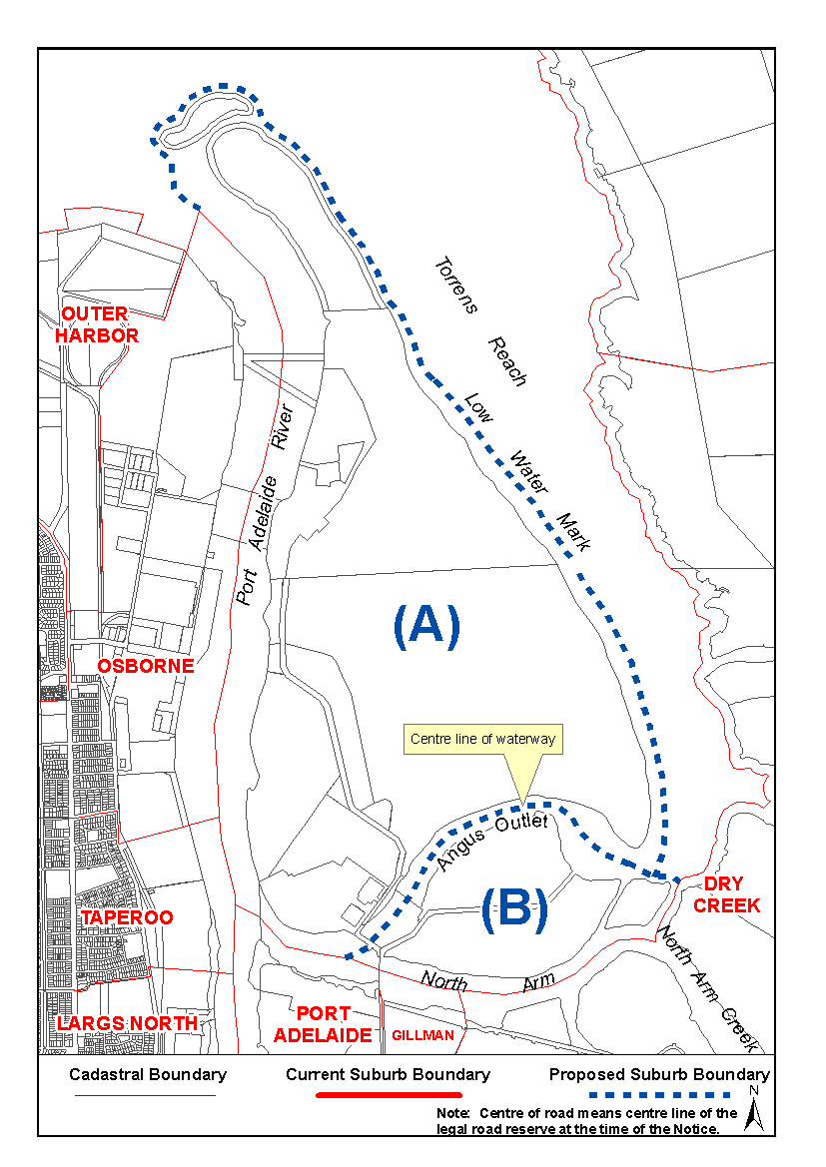
Dated 20 August 2009.
P. M. Kentish, Surveyor-General, Department for Transport, Energy and Infrastructure
DTEI.22-413/08/0023

LAND ACQUISITION ACT 1969
(Section 16)
Notice of Acquisition
THE COMMISSIONER OF HIGHWAYS (the ‘Authority’), 33 Warwick Street, Walkerville, S.A. 5081, acquires the following interests in the following land:
Definition of Land Acquired
Comprising an unencumbered estate in fee simple in those pieces of land situated at Pieces 10 and 11, Brown Road and Port Wakefield Road, Waterloo Corner, being portions of the allotment comprising Pieces 10 and 11 in Deposited Plan 41904, comprised in certificate of title volume 5792, folio 642 and being portions of Piece 11 in Deposited Plan 41904 and being the whole of the allotment comprising pieces marked 187* and 188* in the Plan numbered D76820 that has been lodged in the Lands Titles Office.
This notice is given under section 16 of the Land Acquisition Act 1969.
Compensation
A person who has or had an interest in the land that is divested or diminished by the acquisition or the enjoyment of which is adversely affected by the acquisition who does not receive an offer of compensation from the Authority may apply to the Authority for compensation.
Inquiries
Inquiries should be directed to:
Chris Southam,
P.O. Box 1,
Walkerville, S.A. 5081
Telephone: (08) 8402 1730
Dated 25 August 2009.
The Common Seal of the Commissioner of Highways was hereto affixed by authority of the Commissioner in the presence of:
D. Thomas, Manager, Property Planning and Management Services, Department for Transport, Energy and Infrastructure
DTEI 2007/14789/02

NATIONAL PARKS AND WILDLIFE ACT 1972
Mainland Conservation Parks of Yorke Peninsula
Management Plan
I, JAY WEATHERILL, Minister for Environment and Con-servation, hereby give notice under the provisions of section 38 of the National Parks and Wildlife Act 1972 that, on 24 June 2009, I adopted a plan of management for Mainland Conservation Parks of Yorke Peninsula.
Copies of the plan may be inspected at or obtained from the offices of the Department for Environment and Heritage at:
• DEH Information Line (e-mail:
dehinformation@saugov.sa.gov.au), telephone 8204 1910;
• http://www.environment.sa.gov.au/parks/management/plans.html;
• Level 1, 100 Pirie Street, Adelaide, S.A. 5000 (G.P.O. Box 1047, Adelaide, S.A. 5001), telephone 8204 1910;
• DEH Yorke District Office (Innes National Park, Stenhouse Bay, S.A. 5575), telephone 8854 3200.
Copies of this publication can be purchased at a cost of $10 per copy (plus $2 postage within South Australia) from the addresses above.
Jay Weatherill, Minister for Environment and Conservation


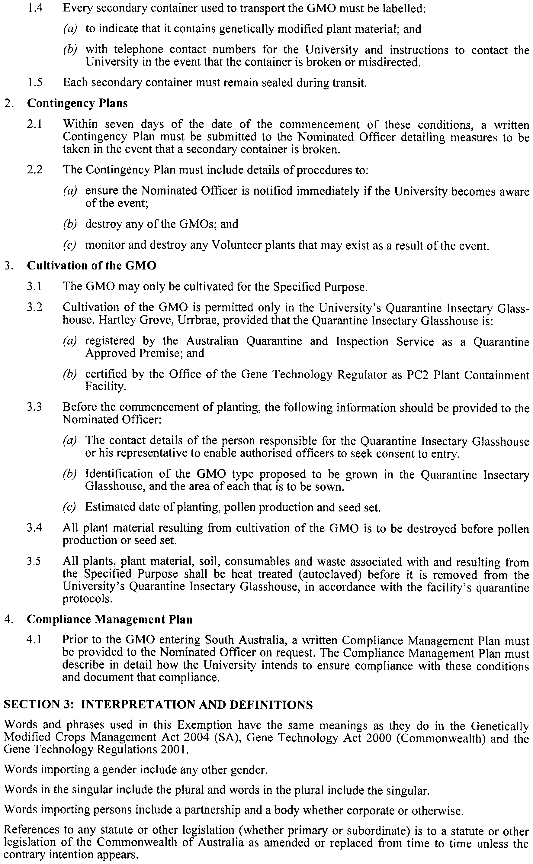
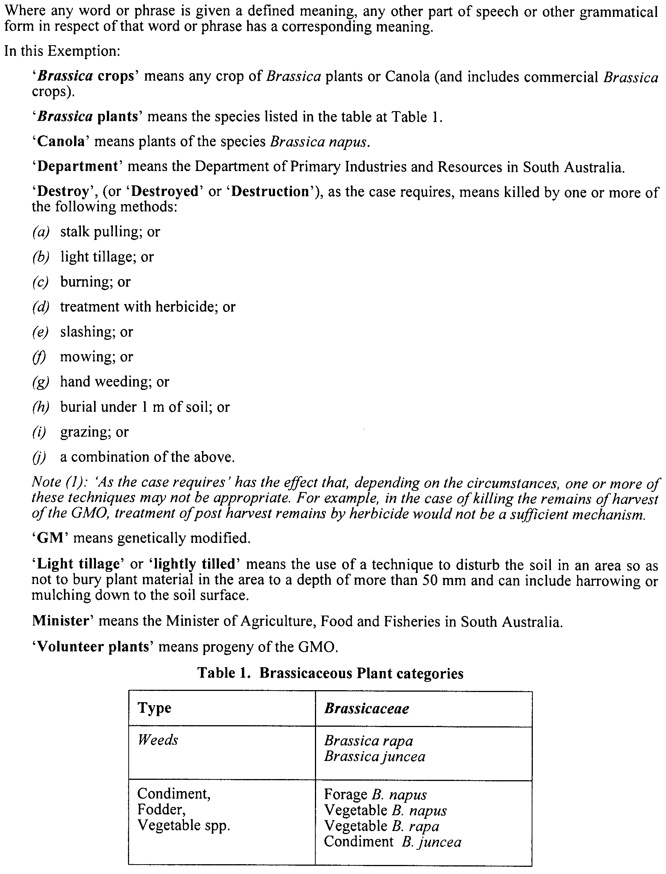

Paul Caica, Minister for Agriculture, Food and Fisheries

HOUSING IMPROVEMENT ACT 1940
Erratum
IN Government Gazette No. 58 dated 13 August 2009, on page 3617, second notice, first entry below was printed in error and should be replaced with the following:
Address of House | Allotment, Section, etc. | Certificate of Title  Volume Folio | Date and page of Government Gazette in which notice declaring house to be substandard published | Maximum rental per week payable in respect of each house  $

4 Eyre Highway, Wudinna |  | Section 162, Hundred of Pygery in the area named Wudinna | 5423 | 217 |  | 26.3.09, page 1125 | 100.00

Dated at Adelaide, 27 August 2009. D. Huxley, Director, Corporate Services, Housing SA

HOUSING IMPROVEMENT ACT 1940
NOTICE is hereby given that the South Australian Housing Trust Board delegate in the exercise of the powers conferred by the Housing Improvement Act 1940, does hereby declare the houses described in the table hereunder to be substandard for the purposes of Part 7 of the Housing Improvement Act 1940.
No. of House and Street | Locality | Allotment, Section, etc. | Certificate of Title  Volume Folio

Unit 2, 12 Phillips Street |  | Kensington | Allotment 7 in Deposited Plan 1002, Hundred of Adelaide | 5721 | 953

Dated at Adelaide, 27 March 2009. D. Huxley, Director, Corporate Services, Housing SA

HOUSING IMPROVEMENT ACT 1940
WHEREAS by notice published in the Government Gazette on the dates mentioned in the following table the South Australian Housing Trust Board delegate did declare the houses described in the said table to be substandard for the purposes of Part 7 of the Housing Improvement Act 1940, the South Australian Housing Trust in the exercise of the powers conferred by the said Part, does hereby fix as the maximum rental per week which shall be payable subject to section 55 of the Residential Tenancies Act 1995, in respect of each house described in the following table the amount shown in the said table opposite the description of such house and this notice shall come into force on the date of this publication in the Gazette.
Address of House | Allotment, Section, etc. | Certificate of Title  Volume Folio | Date and page of Government Gazette in which notice declaring house to be substandard published | Maximum rental per week payable in respect of each house  $

31 Adelaide Road, Pinnaroo |  | Allotment 44 in Deposited Plan 3032, Hundred of Pinnaroo | 5302 | 275 |  | 27.7.06, page 2380 | 126.00
Flat 2, 22 Crocker Street, Bordertown |  | Allotment 502 in Filed Plan 204838, Hundred of Tatiara | 5777 | 208 |  | 30.5.96, page 2605 | 160.00
9 (also known as 9-11) Falconer Street, Port Pirie West |  | Allotment 115 in Deposited Plan 403, Hundred of Pirie | 5279 | 204 |  | 17.7.08, page 3361 | 118.00
Unit 8, 12-16 Pibroch Avenue, Windsor Gardens |  | Unit 8, Strata Plan 1841, Hundred of Yatala | 5057 | 778 |  | 27.7.00, page 309 | 180.00

Dated at Adelaide, 27 August 2009. D. Huxley, Director, Corporate Services, Housing SA

HOUSING IMPROVEMENT ACT 1940
WHEREAS by notice published in the Government Gazette on the dates mentioned in the following table, the South Australian Housing Trust Board delegate did declare the houses described in the following table to be substandard for the purposes of Part 7 of the Housing Improvement Act 1940, and whereas the South Australian Housing Trust is satisfied that each of the houses described hereunder has ceased to be substandard, notice is hereby given that, in exercise of the powers conferred by the said Part, the South Australian Housing Trust does hereby revoke the said declaration in respect of each house.
Address of House | Allotment, Section, etc. | Certificate of Title  Volume Folio | Date and page of Government Gazette in which notice declaring house to be substandard published

11 Copley Street, Broadview |  | Allotment 77 in Deposited Plan 4308, Hundred of Yatala | 5284 | 957 |  | 7.1.99, page 7
24 Gould Road, Elizabeth Park |  | Allotment 703 in Deposited Plan 7005, Hundred of Munno Para | 5168 | 185 |  | 22.5.08, page 1690
241 Lyons Road, Dernancourt |  | Allotment 167 in Deposited Plan 5615, Hundred of Yatala | 5984 | 602 |  | 4.6.09, page 2331
A detached timber framed house at McFarlane Road, Barmera |  | Section 19 in the Cobdogla Irrigation area of Hamley | 6031  6031 | 328  329 |  | 10.9.87, page 810
Lot 12, Pratt Road, Wasleys (also known as Sellick and Lot 12, Jane Terrace |  | Allotment 12 in Deposited Plan 12940, Hundred of Mudla Wirra | 5158 | 406 |  | 30.7.09, page 3420
21 Race Course Road, Balaklava |  | Allotment 10 in Filed Plan 12452, Hundred of Balaklava | 5488 | 947 |  | 28.2.08, page 722

Dated at Adelaide, 27 August 2009. D. Huxley, Director, Corporate Services, Housing SA

LIQUOR LICENSING ACT 1997 AND GAMING MACHINES ACT 1992
Notice of Application
NOTICE is hereby given, pursuant to section 52 of the Liquor Licensing Act 1997 and section 29 of the Gaming Machines Act 1992, that Michael Scott McMahon and Sarah Alison McMahon as trustees for the McMahon Family Trust have applied to the Licensing Authority for the transfer of a Hotel and Gaming Machine Licence in respect of premises situated at 31 Venables Street, Macclesfield, S.A. 5153 and known as Macclesfield Hotel.
The applications have been set down for hearing on 30 September 2009 at 10 a.m.
Any person may object to the application by lodging a notice of objection in the prescribed form with the Liquor and Gambling Commissioner and serving a copy of the notice on the applicants at the applicants’ address, at least seven days before the hearing date (viz: 23 September 2009).
The applicants’ address for service is c/o Clelands Lawyers, 208 Carrington Street, Adelaide, S.A. 5000 (Attention: Leon McEvoy).
Plans in respect of the premises the subject of the application are open to public inspection without fee at the Office of the Liquor and Gambling Commissioner, 9th Floor, East Wing, 50 Grenfell Street, Adelaide, S.A. 5000. Phone 8226 8410, Fax:
8226 8512. Email: olgc@agd.sa.gov.au.
Dated 24 August 2009.
Applicants

LIQUOR LICENSING ACT 1997
Notice of Application
NOTICE is hereby given, pursuant to section 52 (2) (b) of the Liquor Licensing Act 1997, that Simon Alexander Greenleaf has applied to the Licensing Authority for the transfer of a Special Circumstances Licence in respect of premises situated at Building 35/4 Adelaide Road, Lobethal, S.A. 5240 and known as Adelaide Hills Wine Cellar.
The application has been set down for hearing on 29 September 2009 at 11.30 a.m.
Any person may object to the application by lodging a notice of objection in the prescribed form with the Liquor and Gambling Commissioner and serving a copy of the notice on the applicant at the applicant’s address, at least seven days before the hearing date (viz: 22 September 2009).
The applicant’s address for service is c/o Simon Greenleaf, 45 Marion Place, Prospect, S.A. 5082.
Plans in respect of the premises the subject of the application are open to public inspection without fee at the Office of the Liquor and Gambling Commissioner, 9th Floor, East Wing, 50 Grenfell Street, Adelaide, S.A. 5000. Phone 8226 8410, Fax:
8226 8512. Email: olgc@agd.sa.gov.au.
Dated 24 August 2009.
Applicant

LIQUOR LICENSING ACT 1997
Notice of Application
NOTICE is hereby given, pursuant to section 52 (2) (b) of the Liquor Licensing Act 1997, that Surflex Pty Ltd has applied to the Licensing Authority for the transfer of a Residential Licence in respect of premises situated at Kennedy Avenue, Mount Gambier East, S.A. 5290 and known as Top of the Town Rest.Blue Lake Motel.
The application has been set down for hearing on 30 September 2009 at 9.30 a.m.
Any person may object to the application by lodging a notice of objection in the prescribed form with the Liquor and Gambling Commissioner and serving a copy of the notice on the applicant at the applicant’s address, at least seven days before the hearing date (viz: 23 September 2009).
The applicant’s address for service is c/o Jeff Stevens and Associates, Level 1, 86 Pirie Street, Adelaide, S.A. 5000 (Attention: Jeff Stevens).
Plans in respect of the premises the subject of the application are open to public inspection without fee at the Office of the Liquor and Gambling Commissioner, 9th Floor, East Wing, 50 Grenfell Street, Adelaide, S.A. 5000. Phone 8226 8410, Fax:
8226 8512. Email: olgc@agd.sa.gov.au.
Dated 24 August 2009.
Applicant

LIQUOR LICENSING ACT 1997
Notice of Application
NOTICE is hereby given, pursuant to section 52 (2) (b) of the Liquor Licensing Act 1997, that Smokers Club Pty Ltd has applied to the Licensing Authority for a variation to an Extended Trading Authorisation and variation to Conditions in respect of premises situated at 163 Waymouth Street, Adelaide, S.A. 5000 and known as Garage Bar & Dining.
The application has been set down for callover on 18 September 2009 at 9 a.m.
Conditions
The following licence conditions are sought:
• Variation to an Extended Trading Authorisation to permit trading in Areas 1, 2 and 4 as depicted on the current approved plan from midnight to 5 a.m. on Thursday and Sunday nights (presently 4 a.m.).
• Variation to Conditions to remove Conditions 2, 3, 4 and 6 from the licence:
(2) There shall be no loudspeakers placed on or in any fascia of the premises or in any outdoor area.
(3) No loudspeaker shall be placed closer than 4 m from any entrance to or exit from the premises and at all times any such loudspeaker is to be directed away from the entrance to or exit from the premises and into the premises proper.
(4) All external doors and windows are to be closed when live entertainment (including DJ’s and Juke-boxes) is being provided.
(6) Area 4 is only to be used under the licence when the game of petanque is being played in that area and any other activity in Area 4 must only be ancillary to playing the game of petanque.
Any person may object to the application by lodging a notice of objection in the prescribed form with the Liquor and Gambling Commissioner and serving a copy of the notice on the applicant at the applicant’s address, at least seven days before the callover date (viz: 11 September 2009).
The applicant’s address for service is c/o Wallmans Lawyers, G.P.O. Box 1018, Adelaide, S.A. 5001 (Attention: Peter Hoban or Ben Allen).
Plans in respect of the premises the subject of the application are open to public inspection without fee at the Office of the Liquor and Gambling Commissioner, 9th Floor, East Wing, 50 Grenfell Street, Adelaide, S.A. 5000. Phone 8226 8410, Fax:
8226 8512. Email: olgc@agd.sa.gov.au.
Dated 18 August 2009.
Applicant

LIQUOR LICENSING ACT 1997
Notice of Application
NOTICE is hereby given, pursuant to section 52 (2) (b) of the Liquor Licensing Act 1997, that Pichai Ngoensawang has applied to the Licensing Authority for Alterations, variation to an Extended Trading Authorisation and variation to an Entertainment Consent in respect of premises situated at 54 Henley Beach Road, Mile End, S.A. 5031 and known as Tongue Thai’d Cafe.
The application has been set down for hearing on 22 September 2009 at 10 a.m.
Conditions
The following licence conditions are sought:
• Alterations to remove internal wall in Area 3 as per plans lodged with this office.
• Alterations to extend into the tenancy adjacent Area 3 as per plans lodged with this office.
• Variation to an Extended Trading Authorisation to include the adjacent tenancy as per plans lodged with this office and in relation to Section 34 (1) (c) for the following days and times:
Monday to Sunday: Midnight to 1 a.m. the following day;
Good Friday: Midnight to 1 a.m.;
Christmas Day: Midnight to 1 a.m.;
Sunday Christmas Eve: 8 p.m. to 1 a.m. the following day;
Days preceding other Public Holidays: Midnight to 1 a.m. the following day;
Sundays preceding Public Holidays: 8 p.m. to 1 a.m. the following day.
• Variation to Entertainment Consent which currently applies to Areas 1 and 3 to 5 and to now include the above-mentioned adjacent tenancy as per plans lodged with this office.
Any person may object to the application by lodging a notice of objection in the prescribed form with the Liquor and Gambling Commissioner and serving a copy of the notice on the applicant at the applicant’s address, at least seven days before the hearing date (viz: 15 September 2009).
The applicant’s address for service is c/o Mathew Ngoen-sawang, 50-54 Henley Beach Road, Mile End, S.A. 5031.
Plans in respect of the premises the subject of the application are open to public inspection without fee at the Office of the Liquor and Gambling Commissioner, 9th Floor, East Wing, 50 Grenfell Street, Adelaide, S.A. 5000. Phone 8226 8410, Fax:
8226 8512. Email: olgc@agd.sa.gov.au.
Dated 18 August 2009.
Applicant

LIQUOR LICENSING ACT 1997
Notice of Application
NOTICE is hereby given, pursuant to section 52 (2) (b) of the Liquor Licensing Act 1997, that Red Earth Farms (Riverland) Pty Ltd has applied to the Licensing Authority for a Producer’s Licence in respect of premises situated at Section 662, Hundred of Waikerie, Cadell Road, Waikerie, S.A. 5330 and known as Pfeiler Farms.
The application has been set down for hearing on 23 September 2009 at 10 a.m.
Any person may object to the application by lodging a notice of objection in the prescribed form with the Liquor and Gambling Commissioner and serving a copy of the notice on the applicant at the applicant’s address, at least seven days before the hearing date (viz: 16 September 2009).
The applicant’s address for service is c/o Kym Pfeiler, PMB 10, Waikerie, S.A. 5330.
Plans in respect of the premises the subject of the application are open to public inspection without fee at the Office of the Liquor and Gambling Commissioner, 9th Floor, East Wing, 50 Grenfell Street, Adelaide, S.A. 5000. Phone 8226 8410, Fax:
8226 8512. Email: olgc@agd.sa.gov.au.
Dated 18 August 2009.
Applicant

LIQUOR LICENSING ACT 1997
Notice of Application
NOTICE is hereby given, pursuant to section 52 (2) (b) of the Liquor Licensing Act 1997, that Modbury Bowling Club Inc. has applied to the Licensing Authority for a variation to an Extended Trading Authorisation in respect of premises situated at Jack High Lane, Ridgehaven, S.A. 5097 and known as Modbury Bowling Club.
The application has been set down for hearing on 23 September 2009 at 11 a.m.
Conditions
The following licence conditions are sought:
• Variation to Extended Trading Authorisation:
Sunday: 8 a.m. to 11 a.m. and 8 p.m. to midnight.
Any person may object to the application by lodging a notice of objection in the prescribed form with the Liquor and Gambling Commissioner and serving a copy of the notice on the applicant at the applicant’s address, at least seven days before the hearing date (viz: 16 September 2009).
The applicant’s address for service is c/o J. Morris, P.O. Box 507, Modbury, S.A. 5092.
Plans in respect of the premises the subject of the application are open to public inspection without fee at the Office of the Liquor and Gambling Commissioner, 9th Floor, East Wing, 50 Grenfell Street, Adelaide, S.A. 5000. Phone 8226 8410, Fax:
8226 8512. Email: olgc@agd.sa.gov.au.
Dated 18 August 2009.
Applicant

LIQUOR LICENSING ACT 1997
Notice of Application
NOTICE is hereby given, pursuant to section 52 (2) (b) of the Liquor Licensing Act 1997, that Serious Fun (S.A.) Pty Ltd as trustee for the Hart Family Wines Trust has applied to the Licensing Authority for a Producer’s Licence in respect of premises situated at Lot 176, Light Pass Road, Vine Vale, S.A. 5352 and to be known as Hart of the Barossa.
The application has been set down for hearing on 28 September 2009 at 9.30 a.m.
Any person may object to the application by lodging a notice of objection in the prescribed form with the Liquor and Gambling Commissioner and serving a copy of the notice on the applicant at the applicant’s address, at least seven days before the hearing date (viz: 21 September 2009).
The applicant’s address for service is c/o Aventus Legal, P.O. Box 3670, Norwood, S.A. 5067 (Attention: Brent Marks).
Plans in respect of the premises the subject of the application are open to public inspection without fee at the Office of the Liquor and Gambling Commissioner, 9th Floor, East Wing, 50 Grenfell Street, Adelaide, S.A. 5000. Phone 8226 8410, Fax:
8226 8512. Email: olgc@agd.sa.gov.au.
Dated 19 August 2009.
Applicant

LIQUOR LICENSING ACT 1997
Notice of Application
NOTICE is hereby given, pursuant to section 52 (2) (b) of the Liquor Licensing Act 1997, that Heartland Wines Pty Ltd has applied to the Licensing Authority for the removal of a Producer’s Licence in respect of premises situated at 229 Greenhill Road, Dulwich, S.A. 5065 and to be situated at Unit 12, 15 Fullarton Road, Kent Town, S.A. 5067 and known as Heartland Wines.
The application has been set down for hearing on 29 September 2009 at 10 a.m.
Any person may object to the application by lodging a notice of objection in the prescribed form with the Liquor and Gambling Commissioner and serving a copy of the notice on the applicant at the applicant’s address, at least seven days before the hearing date (viz: 22 September 2009).
The applicant’s address for service is c/o Clelands Lawyers, 208 Carrington Street, Adelaide, S.A. 5000 (Attention: Leon McEvoy).
Plans in respect of the premises the subject of the application are open to public inspection without fee at the Office of the Liquor and Gambling Commissioner, 9th Floor, East Wing, 50 Grenfell Street, Adelaide, S.A. 5000. Phone 8226 8410, Fax:
8226 8512. Email: olgc@agd.sa.gov.au.
Dated 21 August 2009.
Applicant

LIQUOR LICENSING ACT 1997
Notice of Application
NOTICE is hereby given, pursuant to section 52 (2) (b) of the Liquor Licensing Act 1997, that Decant Wines Pty Ltd has applied to the Licensing Authority for the removal of a Wholesale Liquor Merchant’s Licence in respect of premises currently situated at 229 Greenhill Road, Dulwich, S.A. 5065 and to be situated at Unit 12, 15 Fullarton Road, Kent Town, S.A. 5067 and known as Decant Wines.
The application has been set down for hearing on 29 September 2009 at 10.30 a.m.
Any person may object to the application by lodging a notice of objection in the prescribed form with the Liquor and Gambling Commissioner and serving a copy of the notice on the applicant at the applicant’s address, at least seven days before the hearing date (viz: 22 September 2009).
The applicant’s address for service is c/o Clelands Lawyers, 208 Carrington Street, Adelaide, S.A. 5000 (Attention: Leon McEvoy).
Plans in respect of the premises the subject of the application are open to public inspection without fee at the Office of the Liquor and Gambling Commissioner, 9th Floor, East Wing, 50 Grenfell Street, Adelaide, S.A. 5000. Phone 8226 8410, Fax:
8226 8512. Email: olgc@agd.sa.gov.au.
Dated 21 August 2009.
Applicant

LIQUOR LICENSING ACT 1997
Notice of Application
NOTICE is hereby given, pursuant to section 52 (2) (b) of the Liquor Licensing Act 1997, that Penley Estate Pty Ltd as trustee for Japhsan Unit Trust, 19 The Parade, Norwood, S.A. 5067, has applied to the Licensing Authority for a Direct Sales Licence in respect of the business to be known as Penley Estate.
The application has been set down for hearing on 29 September 2009 at 9.30 a.m.
Any person may object to the application by lodging a notice of objection in the prescribed form with the Liquor and Gambling Commissioner and serving a copy of the notice on the applicant at the applicant’s address, at least seven days before the hearing date (viz: 22 September 2009).
The applicant’s address for service is c/o Susan C. Chenery Barrister and Solicitor, 19 The Parade, Norwood, S.A. 5067 (Attention: Susan Chenery).
Plans in respect of the premises the subject of the application are open to public inspection without fee at the Office of the Liquor and Gambling Commissioner, 9th Floor, East Wing, 50 Grenfell Street, Adelaide, S.A. 5000. Phone 8226 8410, Fax:
8226 8512. Email: olgc@agd.sa.gov.au.
Dated 21 August 2009.
Applicant

LIQUOR LICENSING ACT 1997
Notice of Application
NOTICE is hereby given, pursuant to section 52 (2) (b) of the Liquor Licensing Act 1997, that Paul Edward Strand, Jo-Anne Strand, Aimee Margaret Strand, Chloe Nancy Strand and Kourtney-Lee Strand have applied to the Licensing Authority for the transfer of a Residential Licence in respect of premises situated at Edith Street, Edithburgh, S.A. 5583 and known as Edithburgh House.
The application has been set down for hearing on 29 September 2009 at 11 a.m.
Any person may object to the application by lodging a notice of objection in the prescribed form with the Liquor and Gambling Commissioner and serving a copy of the notice on the applicants at the applicants’ address, at least seven days before the hearing date (viz: 22 August 2009).
The applicants’ address for service is c/o Paul Strand, P.O. Box 187, Edithburgh, S.A. 5583.
Plans in respect of the premises the subject of the application are open to public inspection without fee at the Office of the Liquor and Gambling Commissioner, 9th Floor, East Wing, 50 Grenfell Street, Adelaide, S.A. 5000. Phone 8226 8410, Fax:
8226 8512. Email: olgc@agd.sa.gov.au.
Dated 21 August 2009.
Applicants

MINING ACT 1971
NOTICE is hereby given in accordance with section 28 (5) of the Mining Act 1971, that the Minister for Mineral Resources Development proposes to grant an Exploration Licence over the undermentioned area:
Applicant: Tasman Resources Ltd
Location: Andamooka North area—Approximately 140 km north-west of Leigh Creek.
Pastoral Leases: Andamooka, Stuarts Creek, Billa Kalina, Roxby Downs, Mulgaria.
Term: 1 year
Area in km²: 1 295
Ref.: 2009/00053
Plan and co-ordinates can be found on the PIRSA website: http://www.pir.sa.gov.au/minerals/public_notices or by phoning Mineral Tenements on (08) 8463 3103.
J. Martin, Acting Mining Registrar

MINING ACT 1971
NOTICE is hereby given in accordance with section 28 (5) of the Mining Act 1971, that the Minister for Mineral Resources Development proposes to grant an Exploration Licence over the undermentioned area:
Applicant: Bonanza Gold Pty Ltd
Location: Mount Painter area—Approximately 100 km north-east of Leigh Creek.
Pastoral Lease: Arkaroola
Term: 1 year
Area in km²: 89
Ref.: 2009/00218
Plan and co-ordinates can be found on the PIRSA website: http://www.pir.sa.gov.au/minerals/public_notices or by phoning Mineral Tenements on (08) 8463 3103.
J. Martin, Acting Mining Registrar

MINING ACT 1971
NOTICE is hereby given in accordance with section 28 (5) of the Mining Act 1971, that the Minister for Mineral Resources Development proposes to grant an Exploration Licence over the undermentioned area:
Applicant: Australian Zircon NL
Location: Murtho area—Approximately 10 km east of Renmark.
Term: 1 year
Area in km²: 365
Ref.: 2009/00081
Plan and co-ordinates can be found on the PIRSA website: http://www.pir.sa.gov.au/minerals/public_notices or by phoning Mineral Tenements on (08) 8463 3103.
J. Martin, Acting Mining Registrar

MINING ACT 1971
NOTICE is hereby given in accordance with section 28 (5) of the Mining Act 1971, that the Minister for Mineral Resources Development proposes to grant an Exploration Licence over the undermentioned area:
Applicant: Southern Uranium Ltd
Location: Yalanda East area—Approximately 80 km south-west of Whyalla.
Pastoral Lease: Cooyerdoo
Term: 1 year
Area in km²: 144
Ref.: 2009/00144
Plan and co-ordinates can be found on the PIRSA website: http://www.pir.sa.gov.au/minerals/public_notices or by phoning Mineral Tenements on (08) 8463 3103.
J. Martin, Acting Mining Registrar

MINING ACT 1971
NOTICE is hereby given in accordance with section 28 (5) of the Mining Act, 1971, that the Minister for Mineral Resources Development proposes to grant an Exploration Licence over the undermentioned area:
Applicant: OZ Minerals Prominent Hill Operations Pty Ltd
Location: Mount Hawker area—Approximately 140 km south-east of Coober Pedy.
Pastoral Leases: Anna Creek, Millers Creek
Term: 1 year
Area in km²: 446
Ref.: 2009/00224
Plan and co-ordinates can be found on the PIRSA website: http://www.pir.sa.gov.au/minerals/public_notices or by phoning Mineral Tenements on (08) 8463 3103.
J. Martin, Acting Mining Registrar



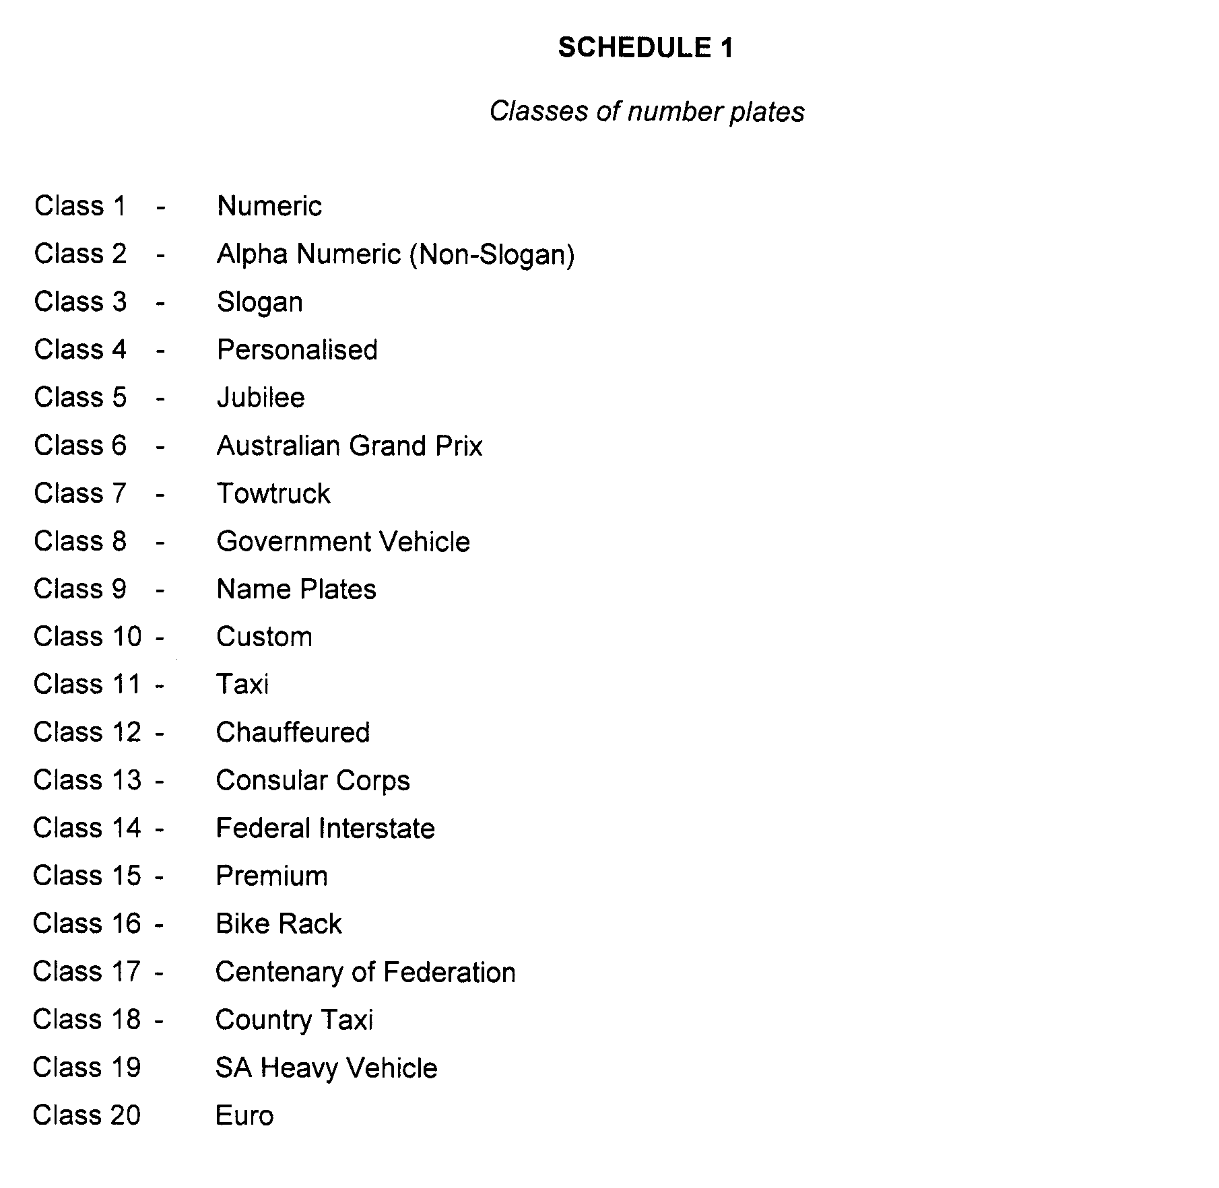

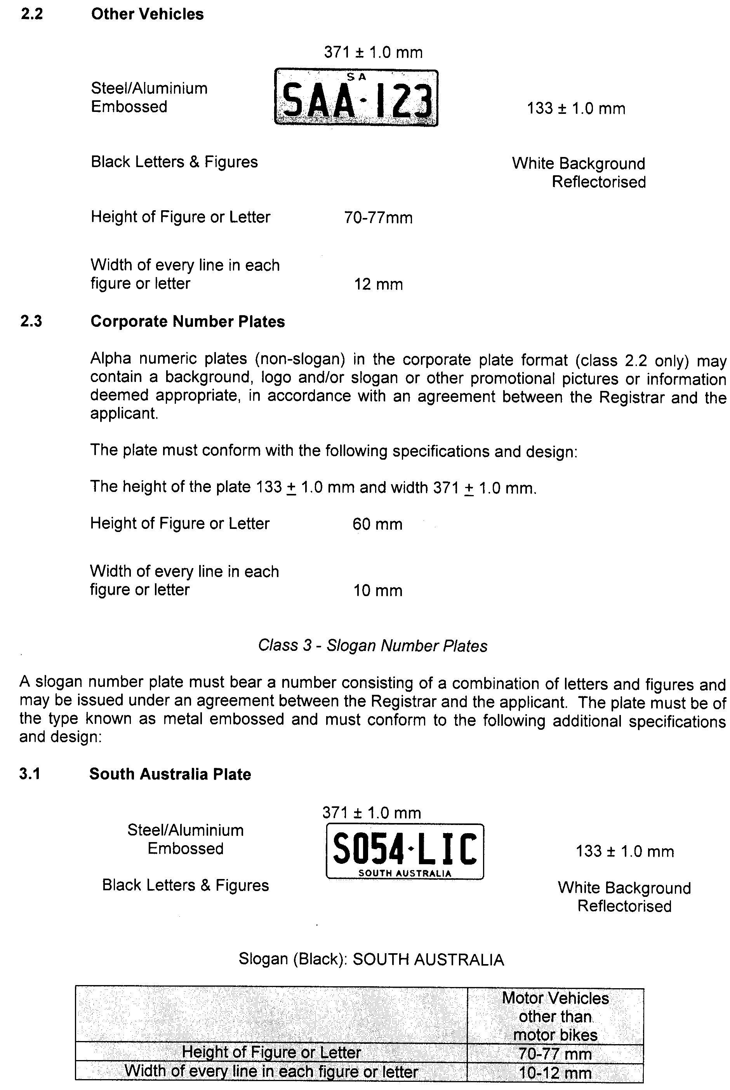
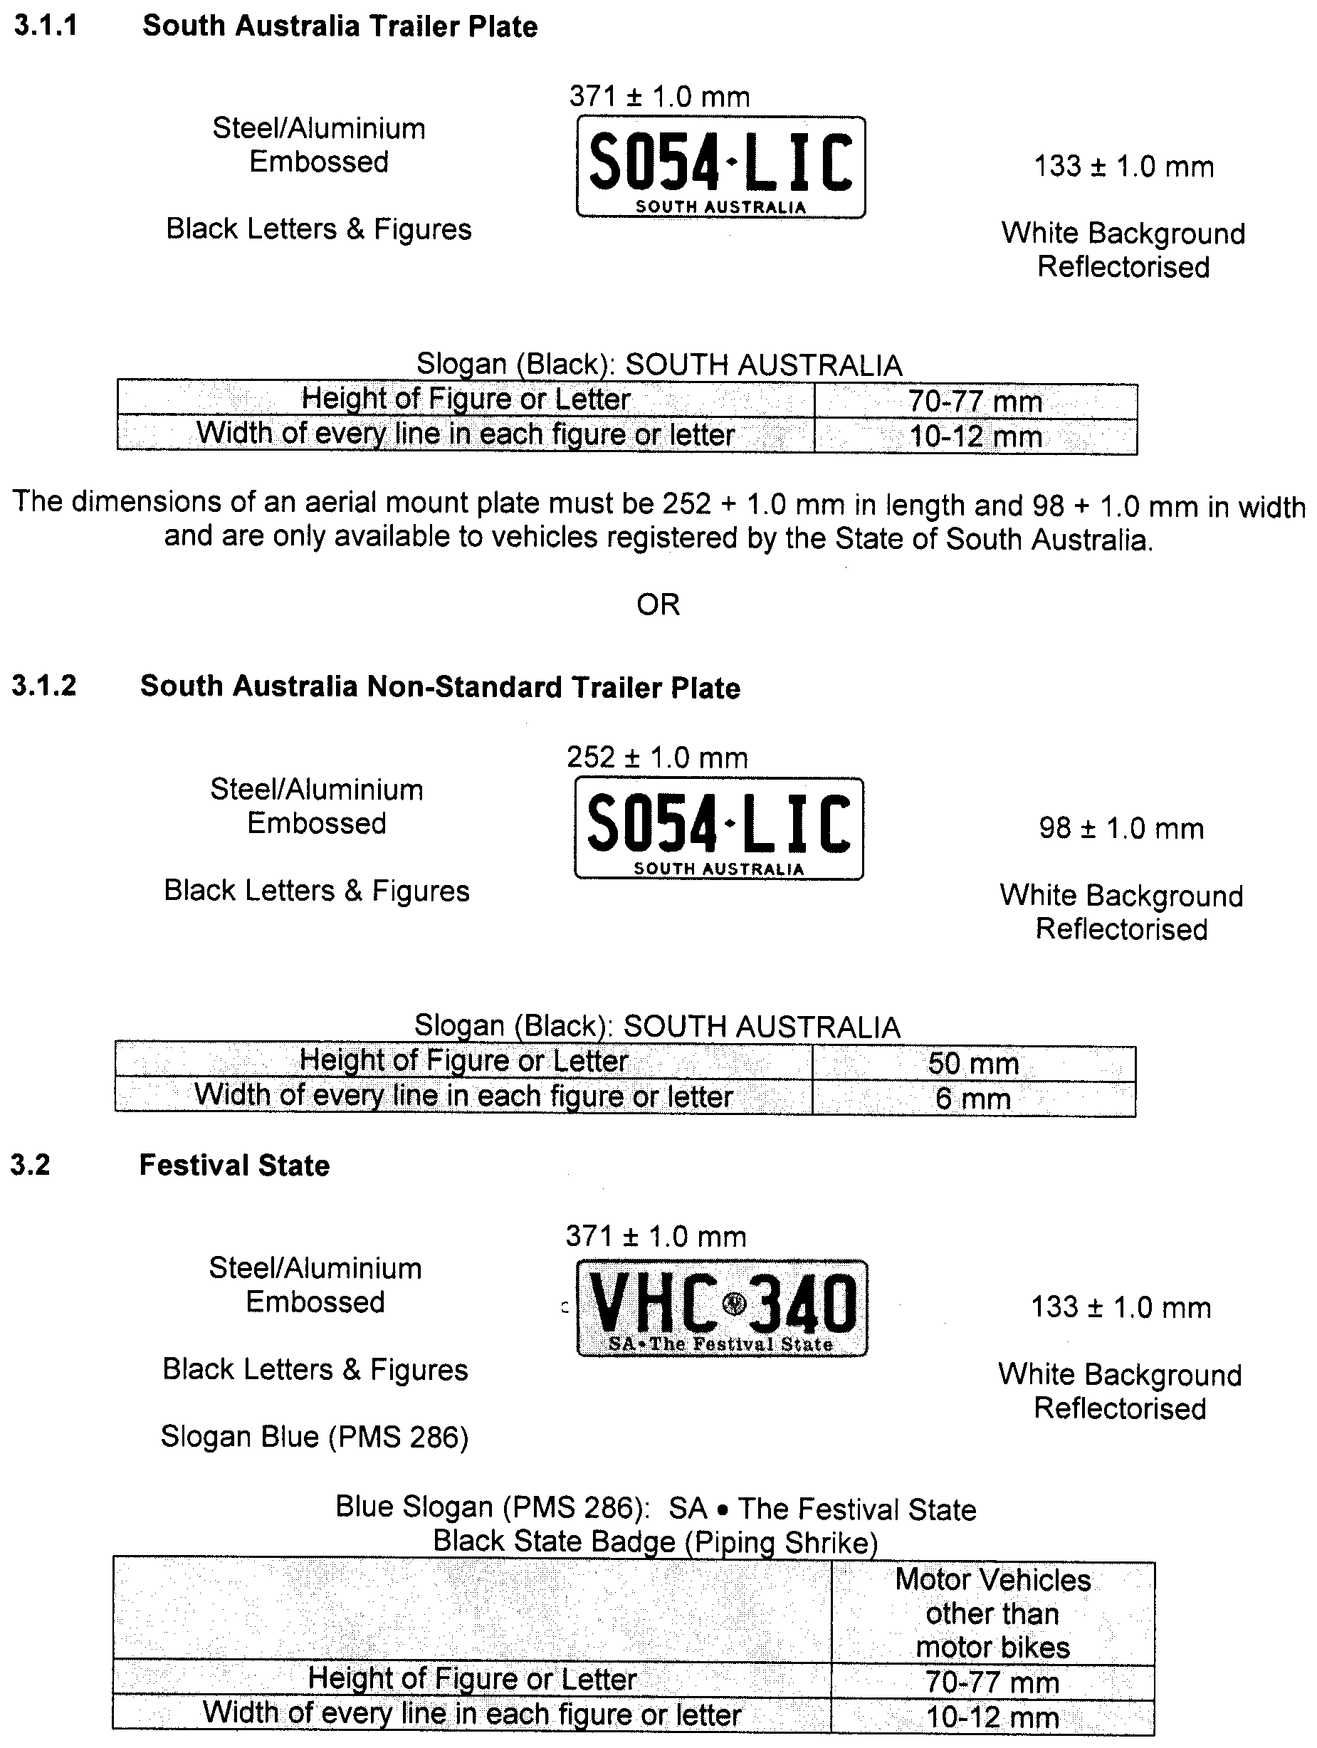

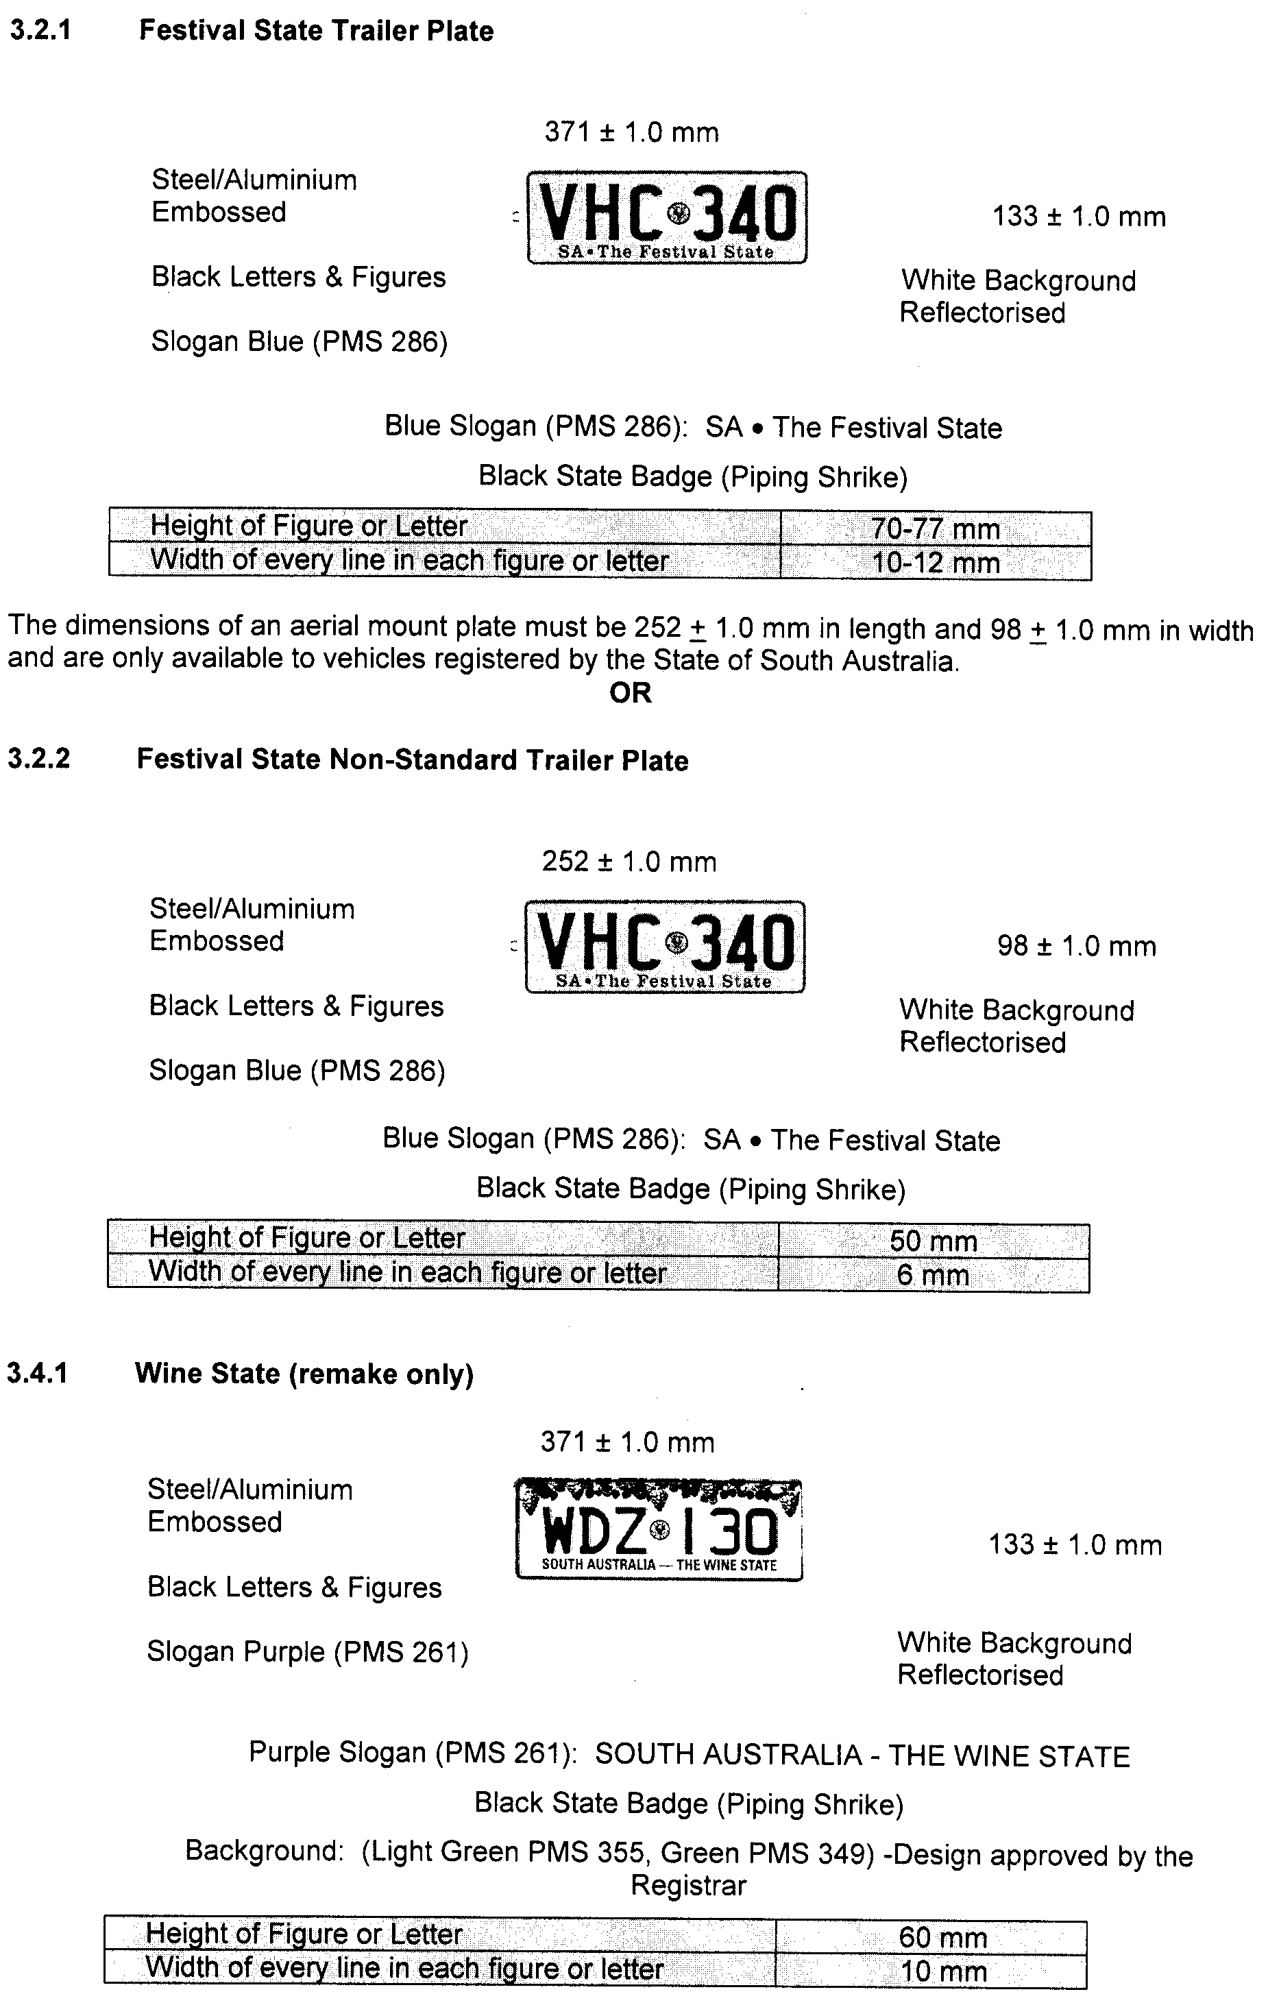
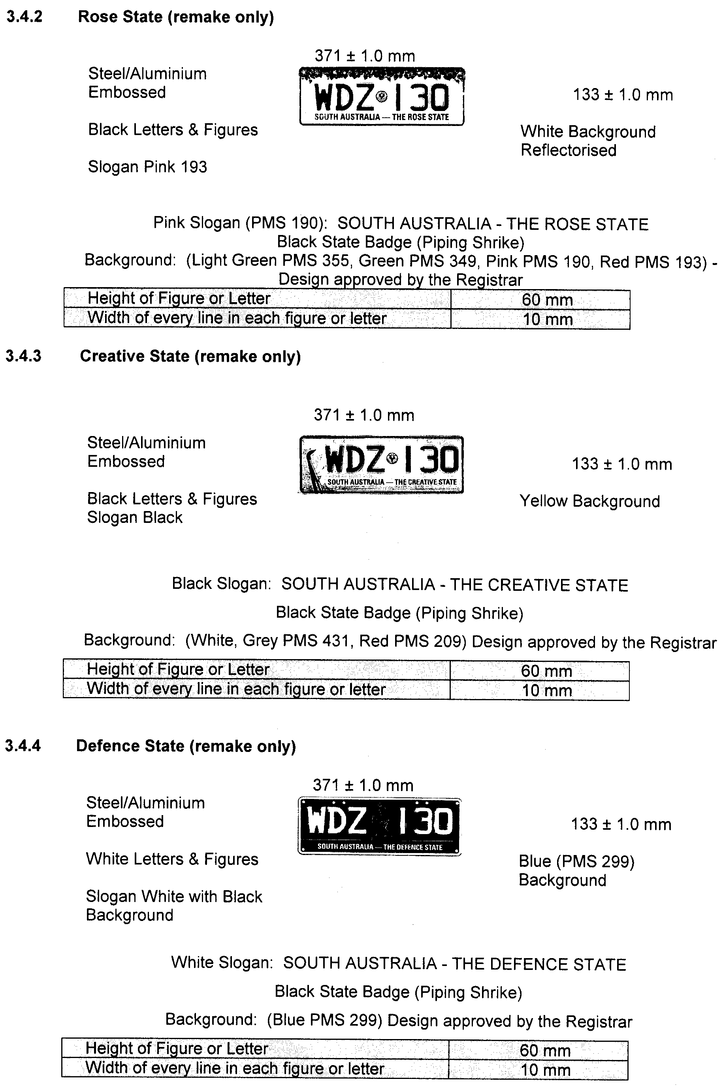
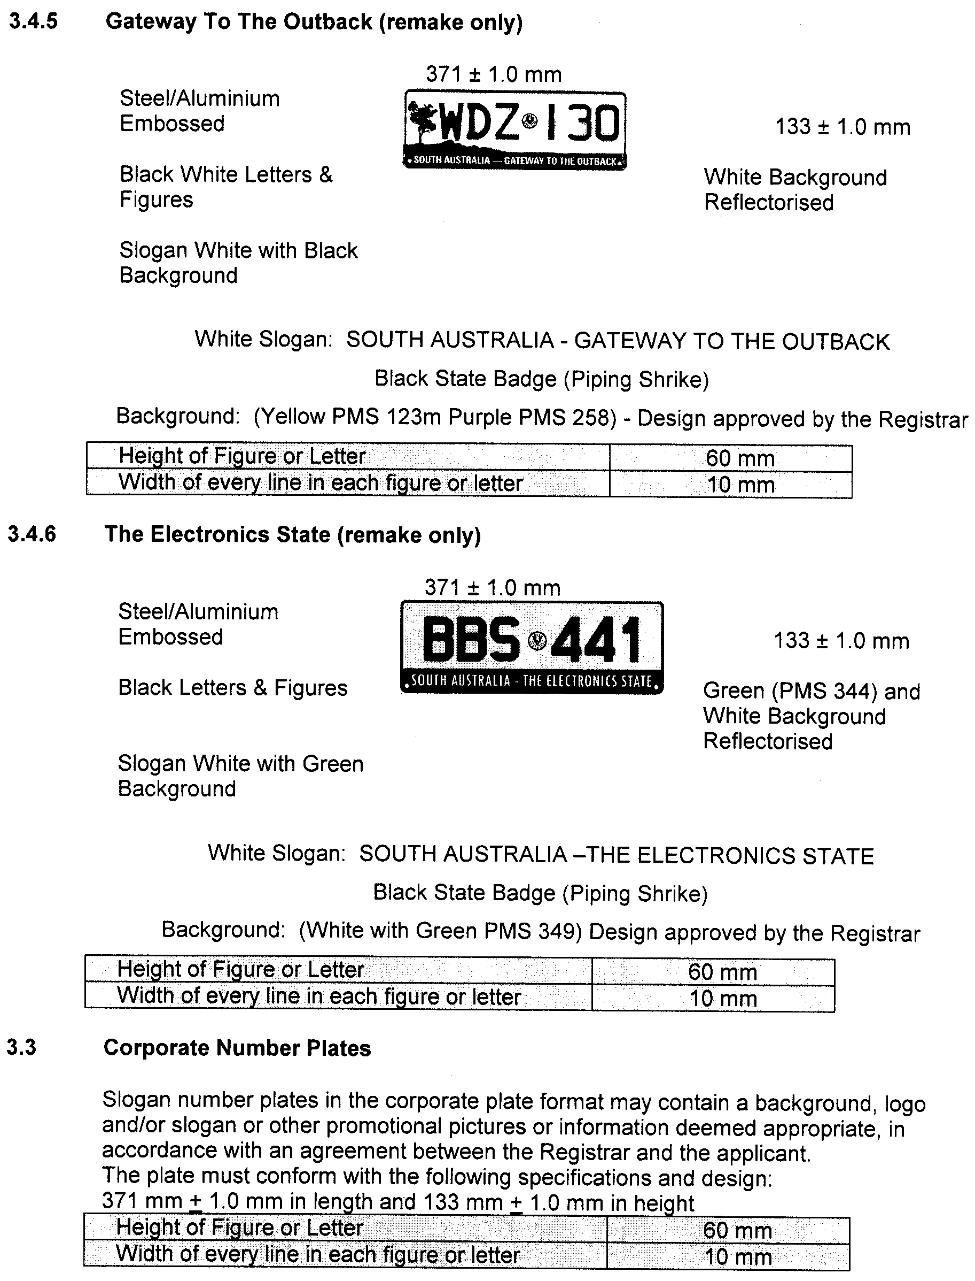




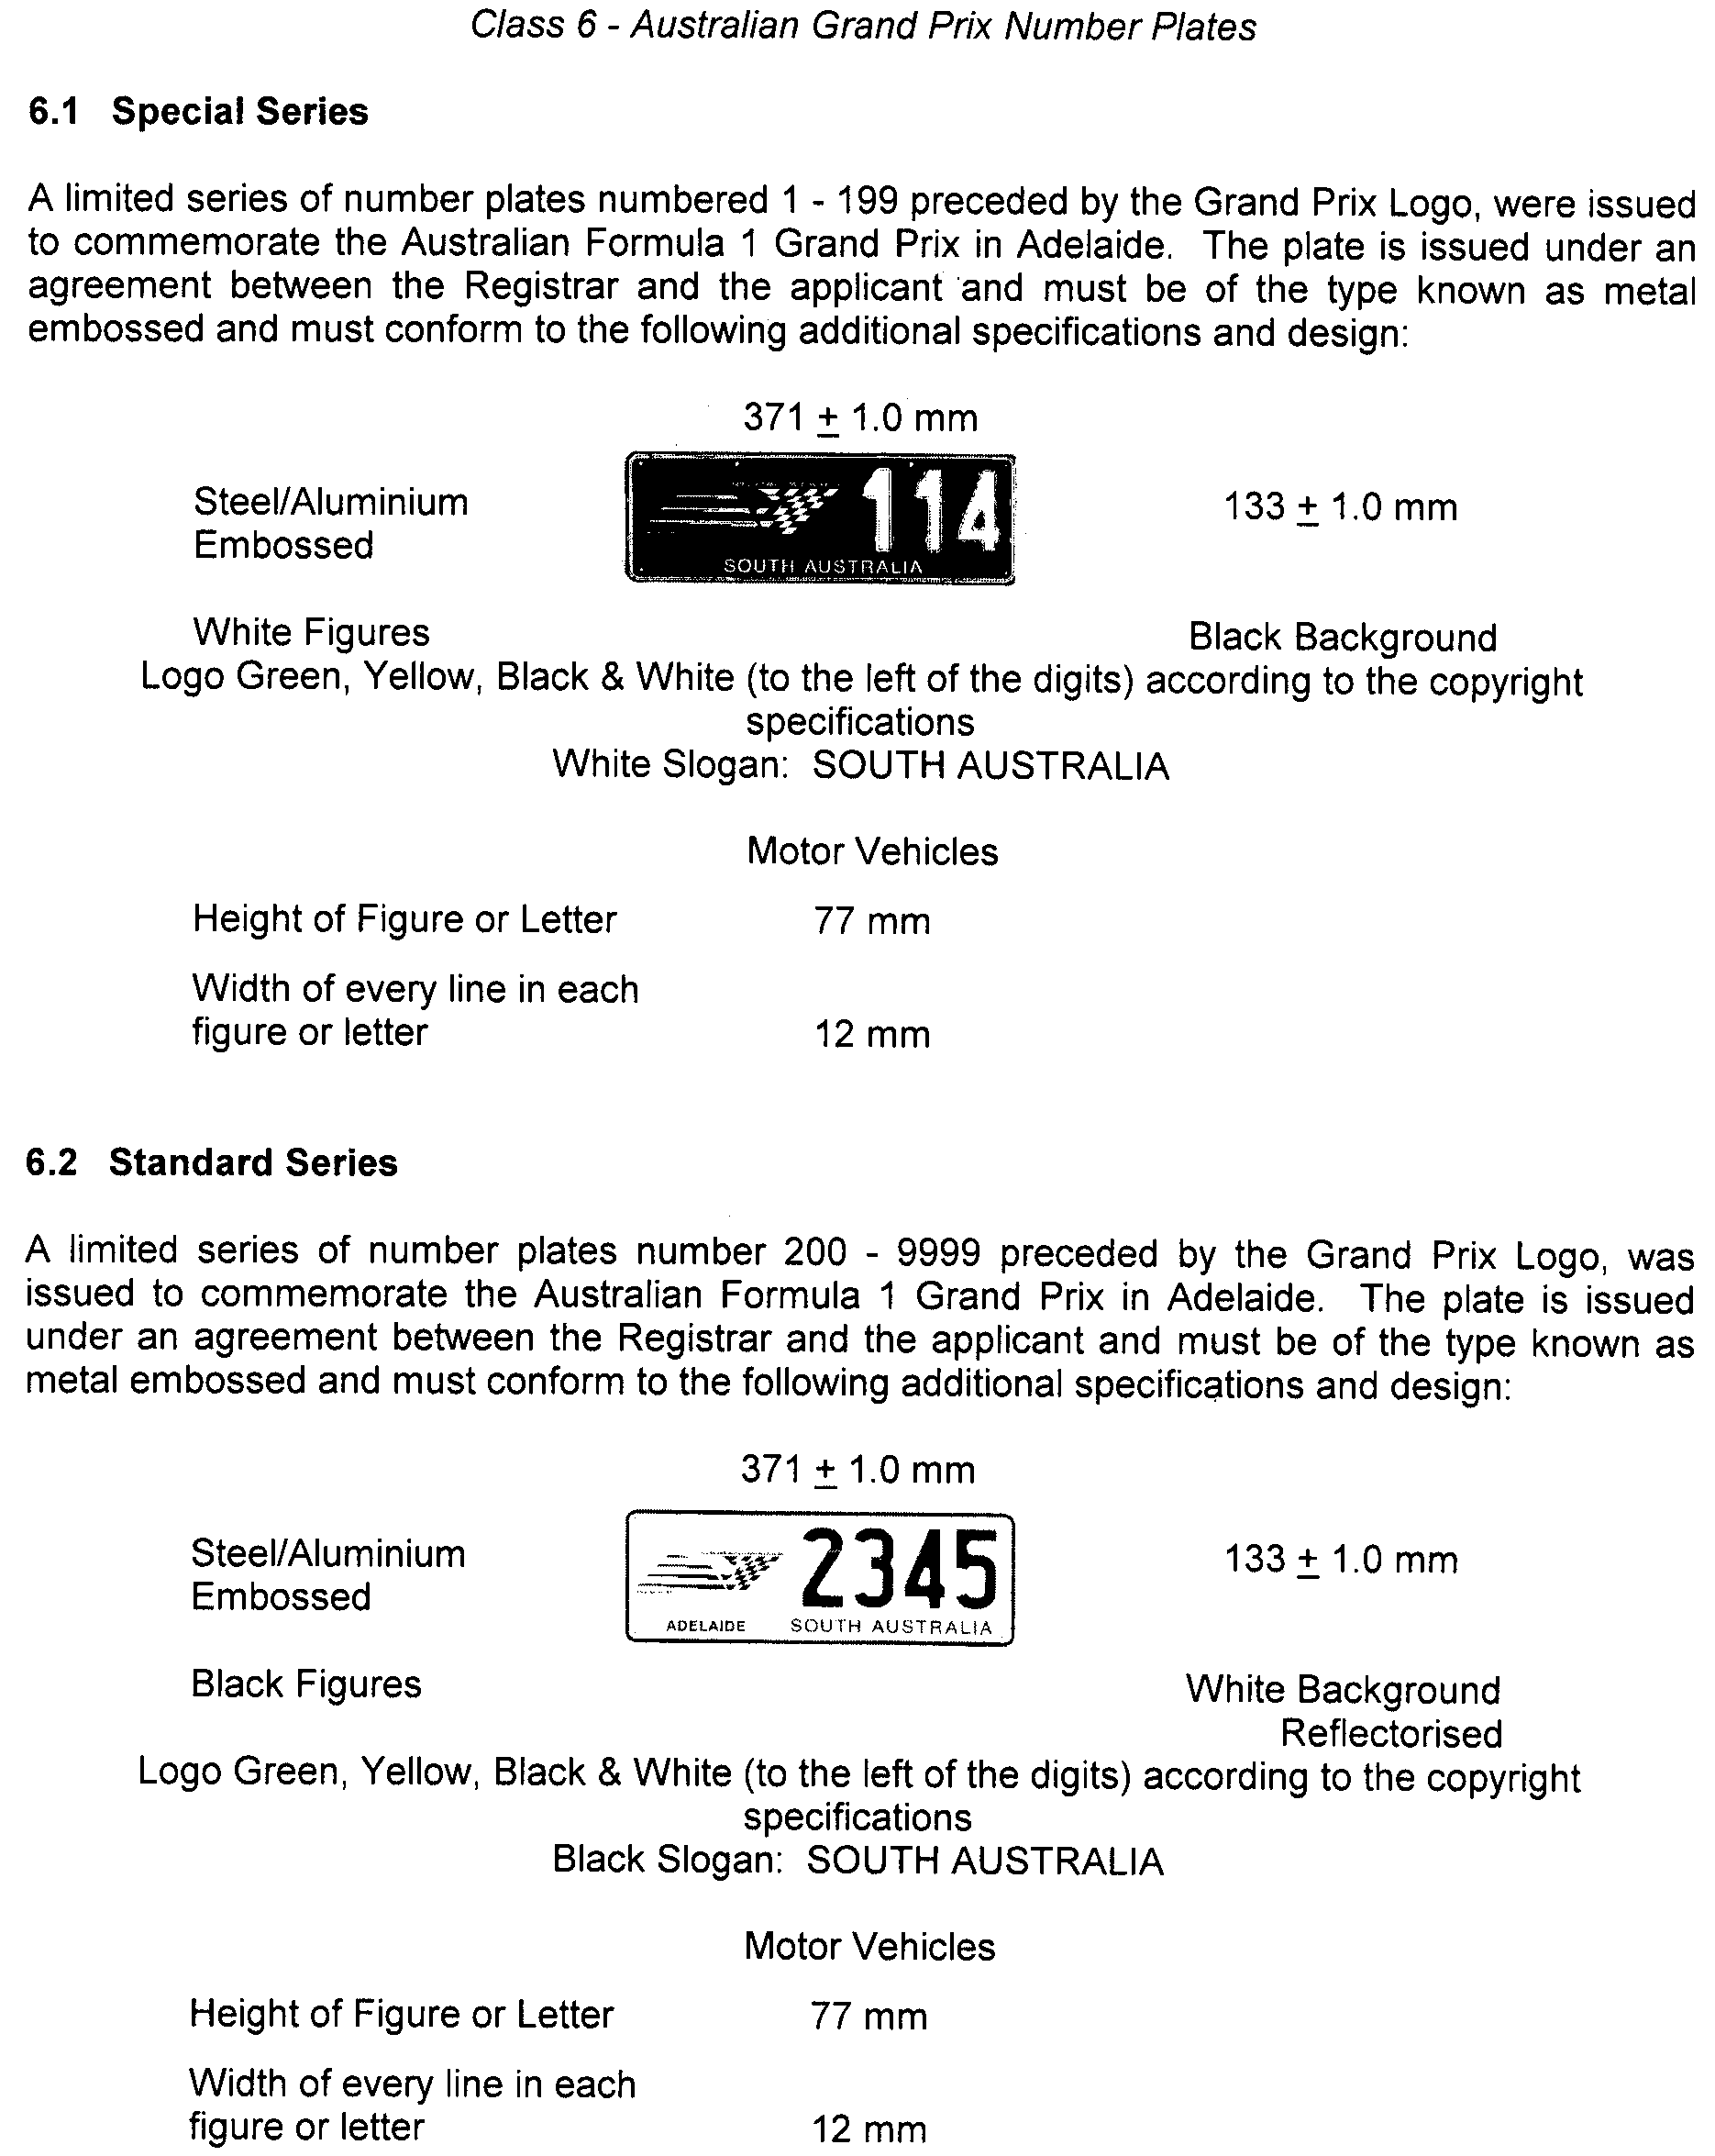




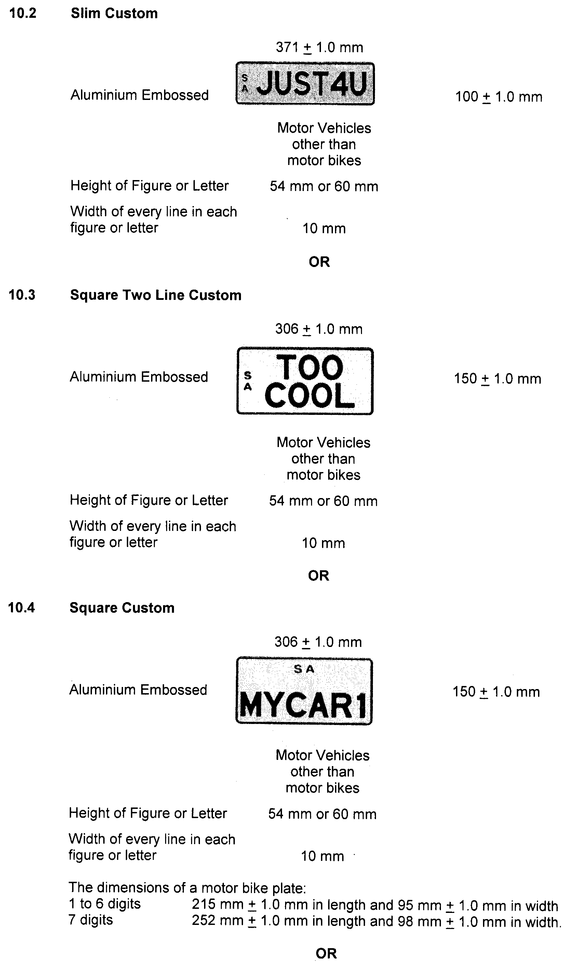


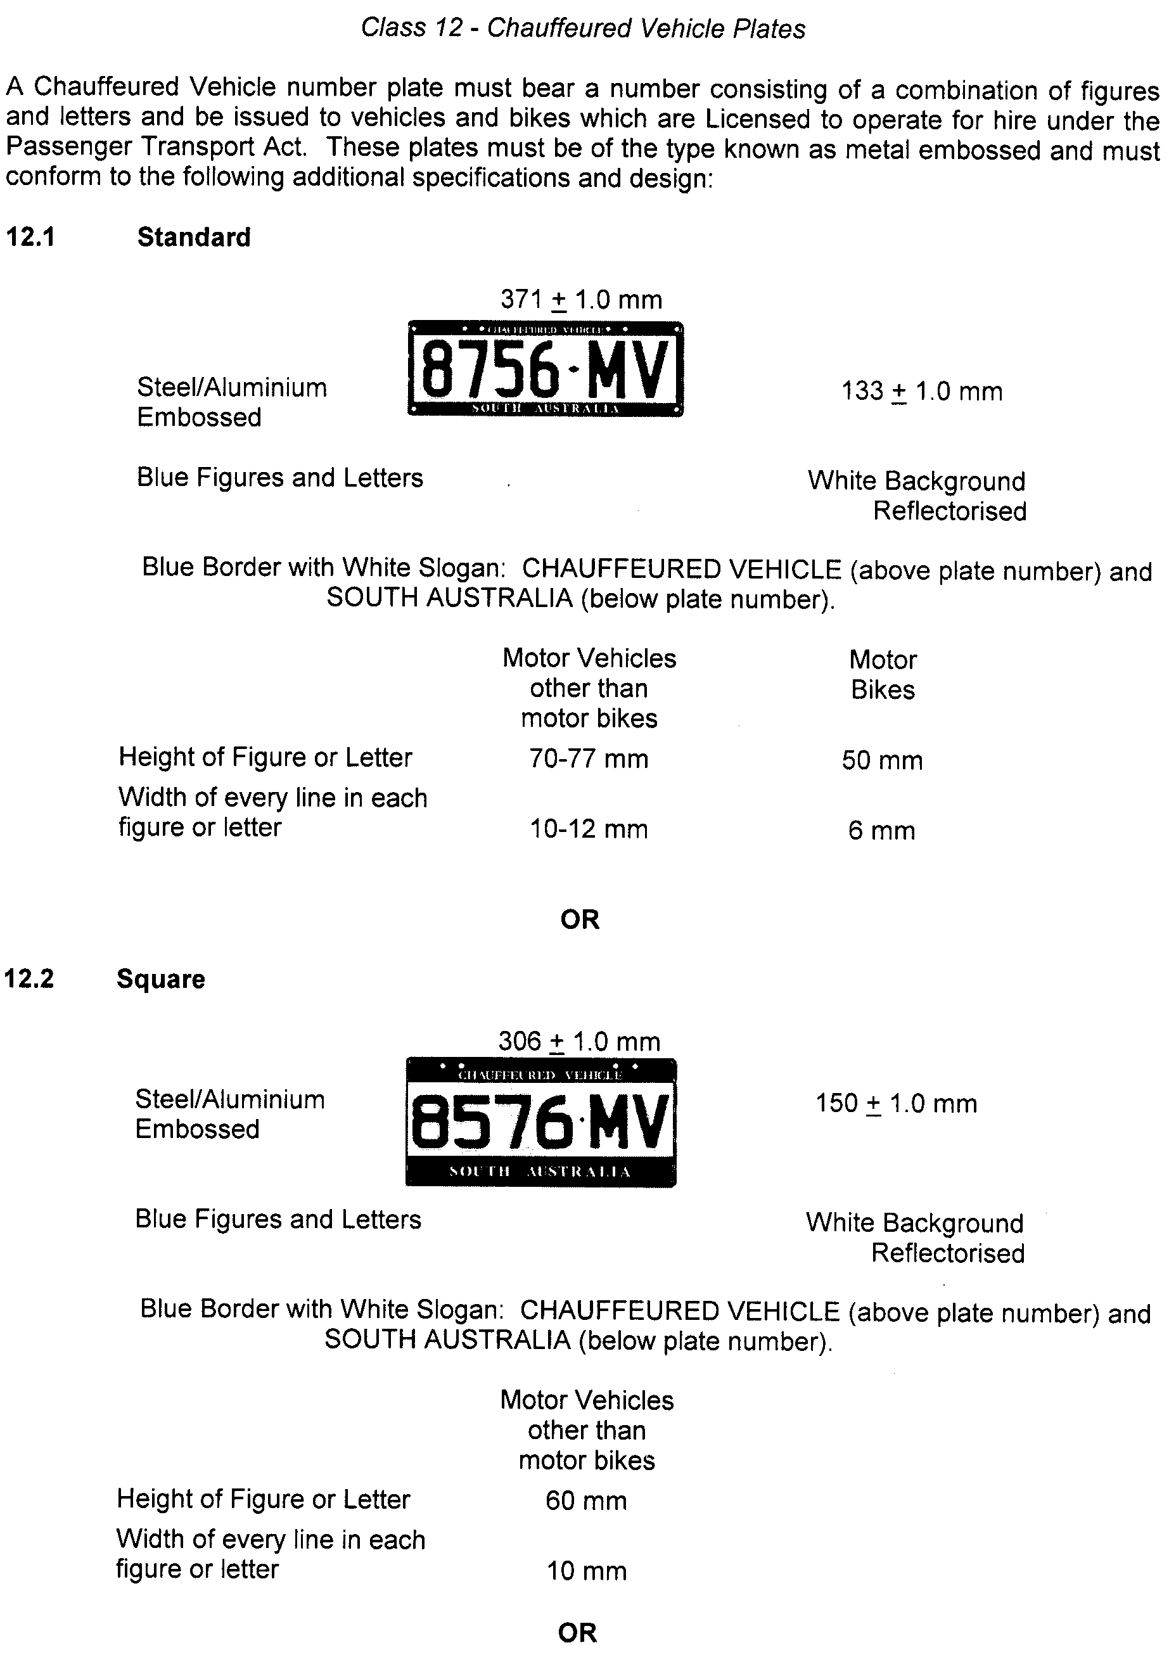




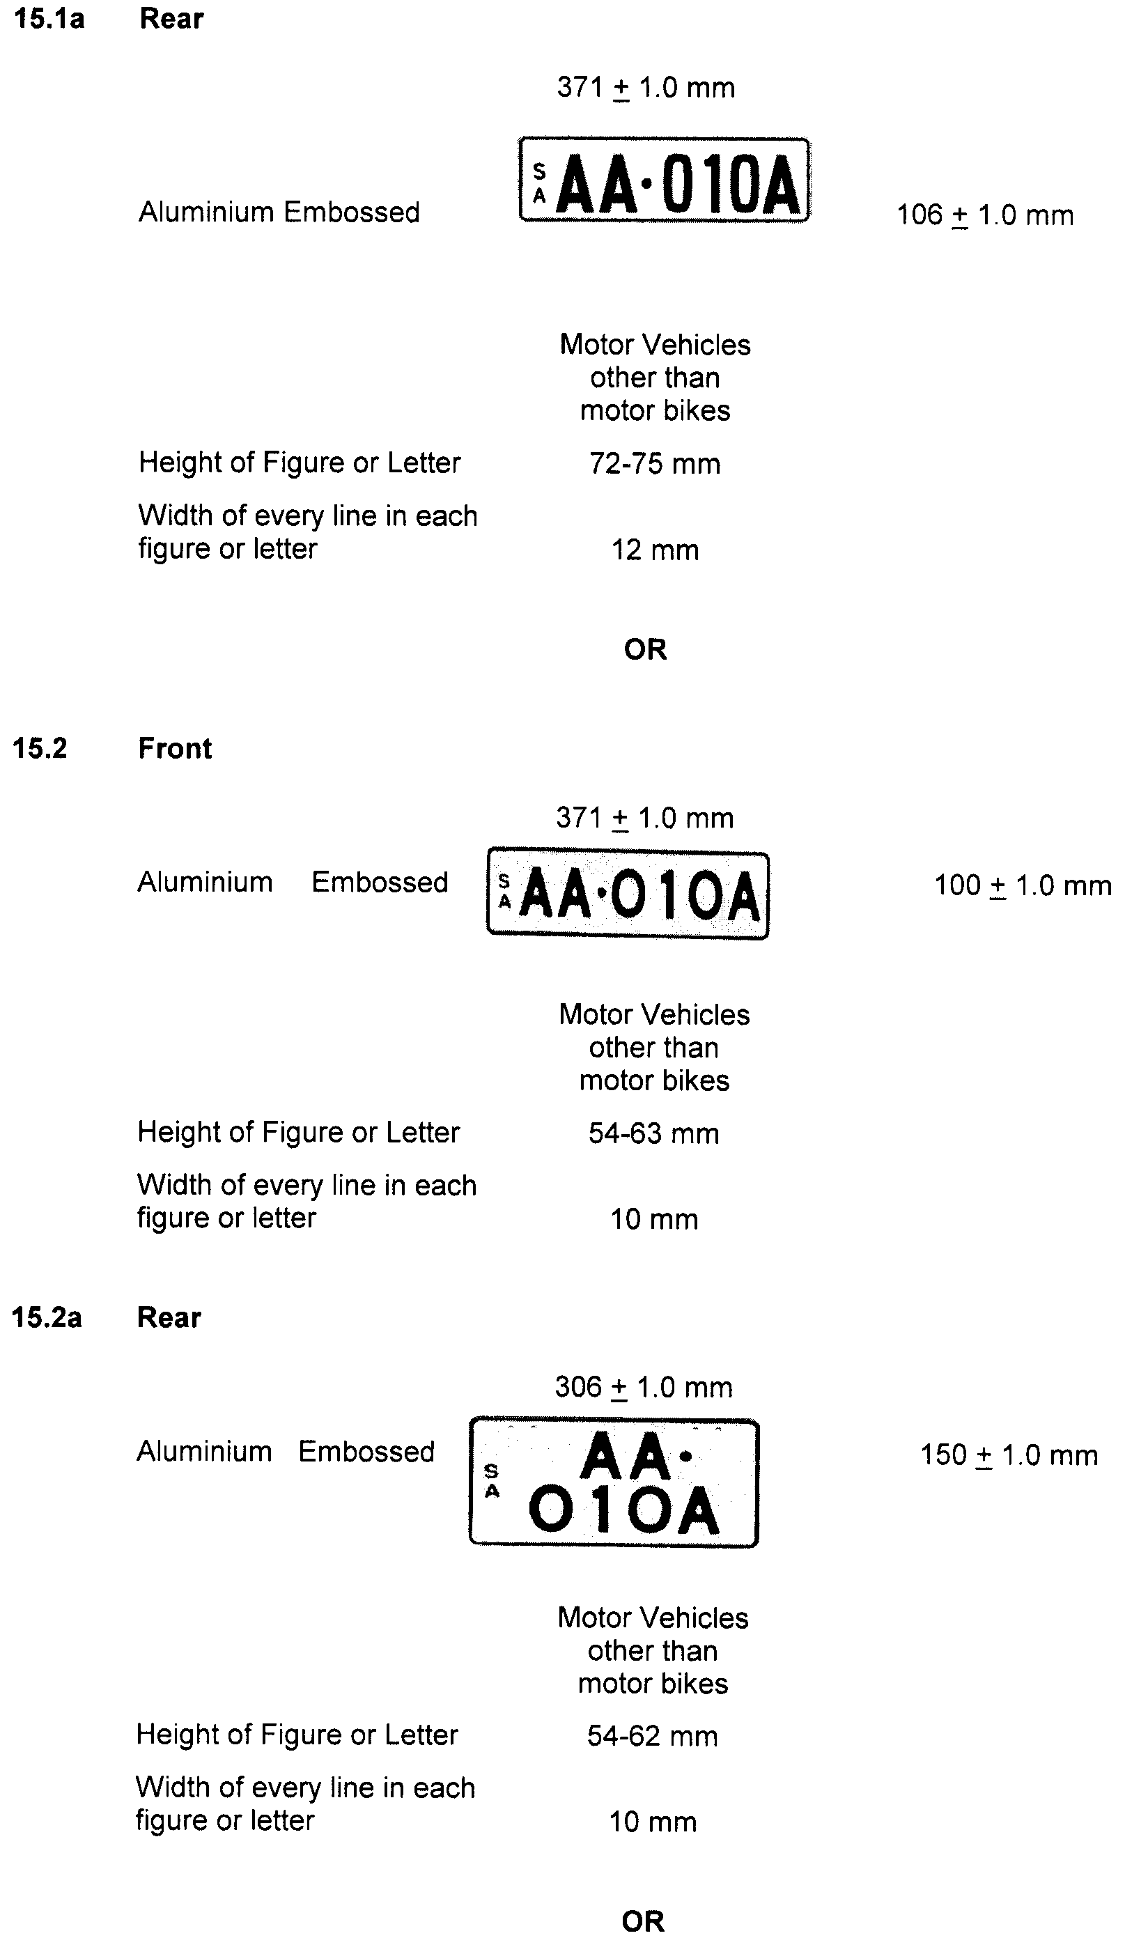
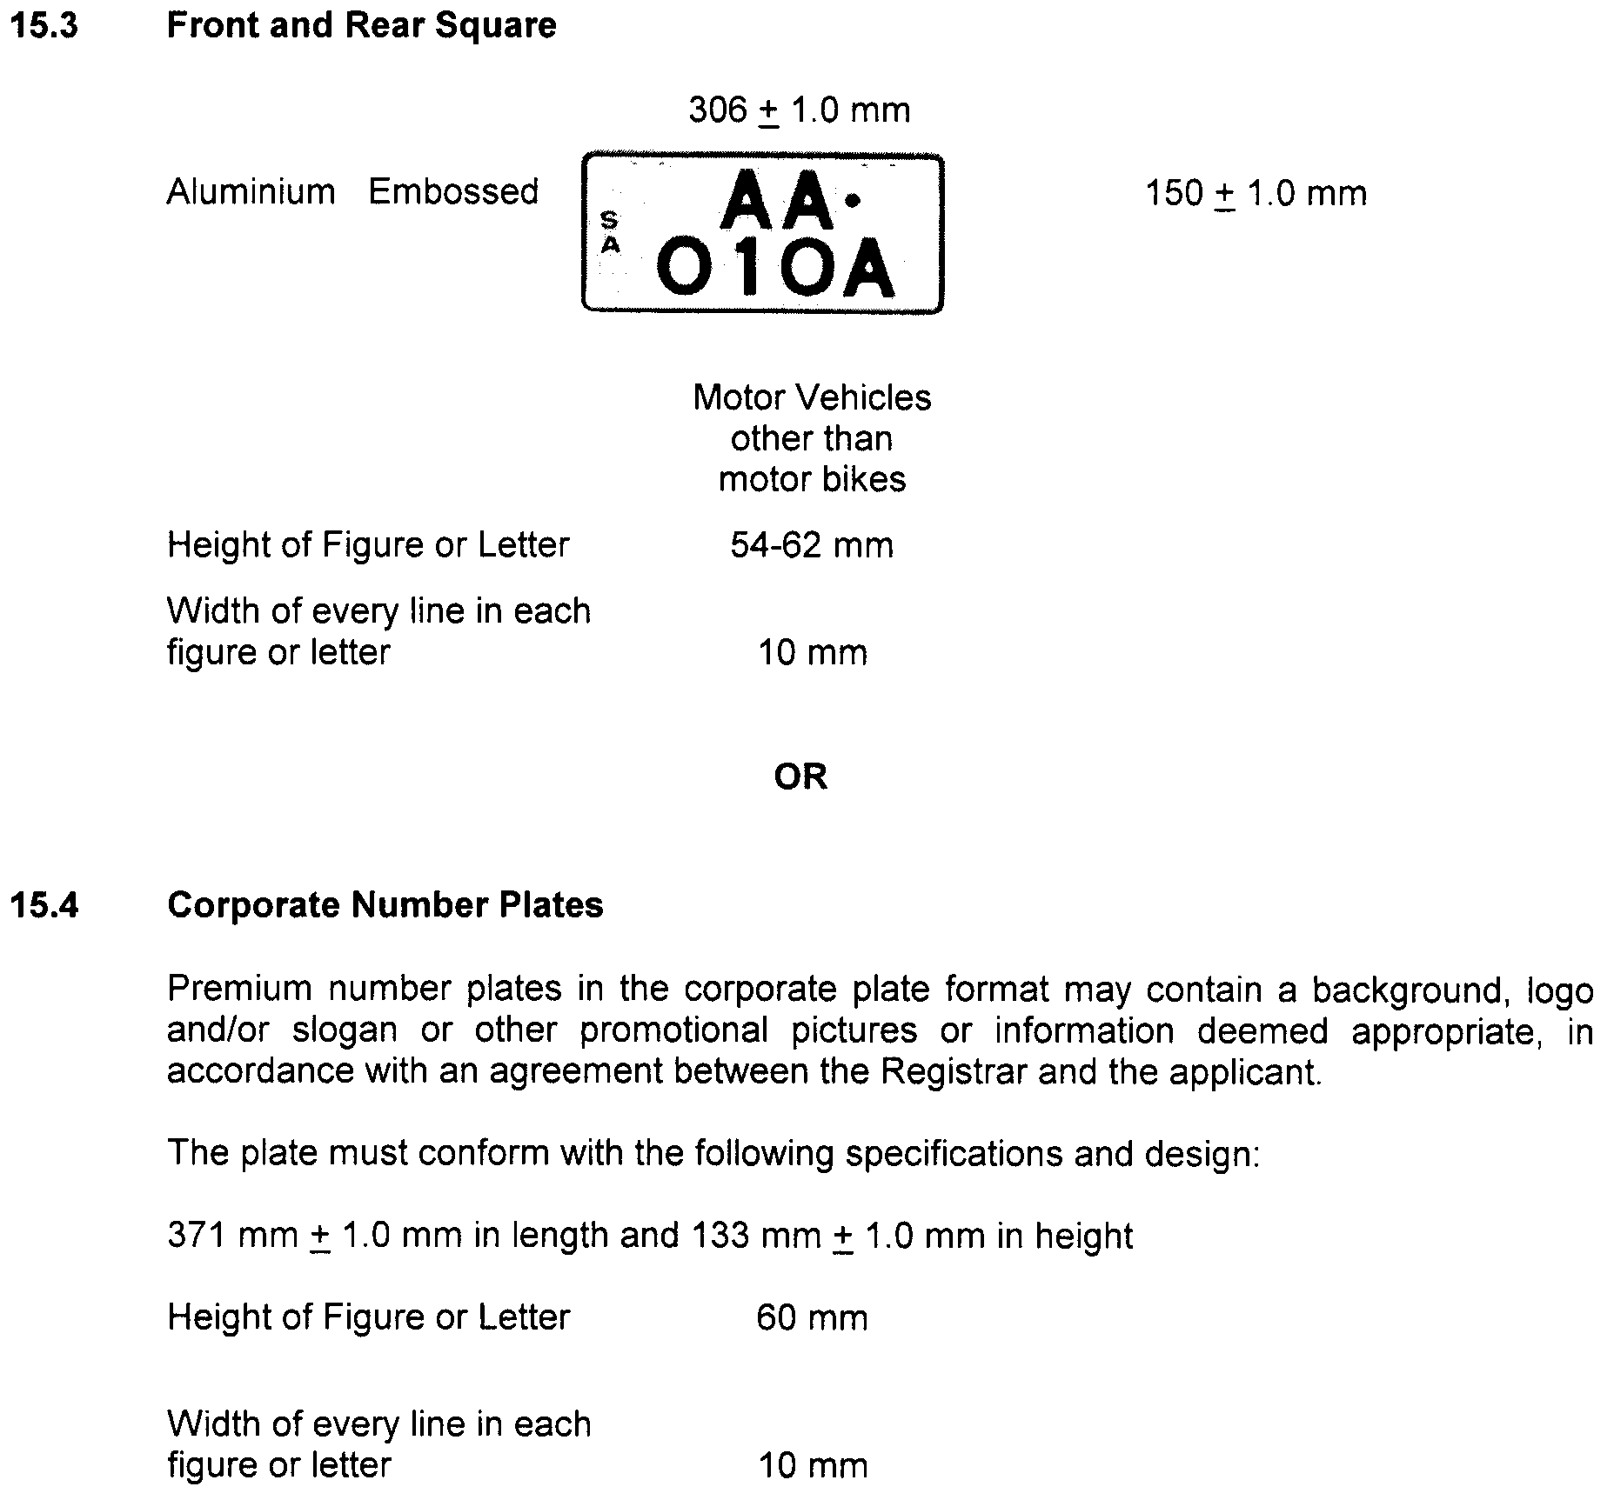







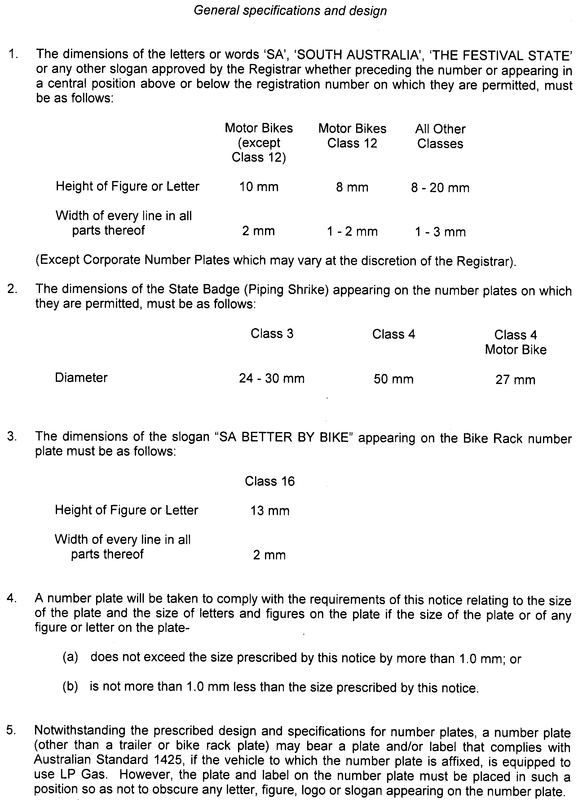

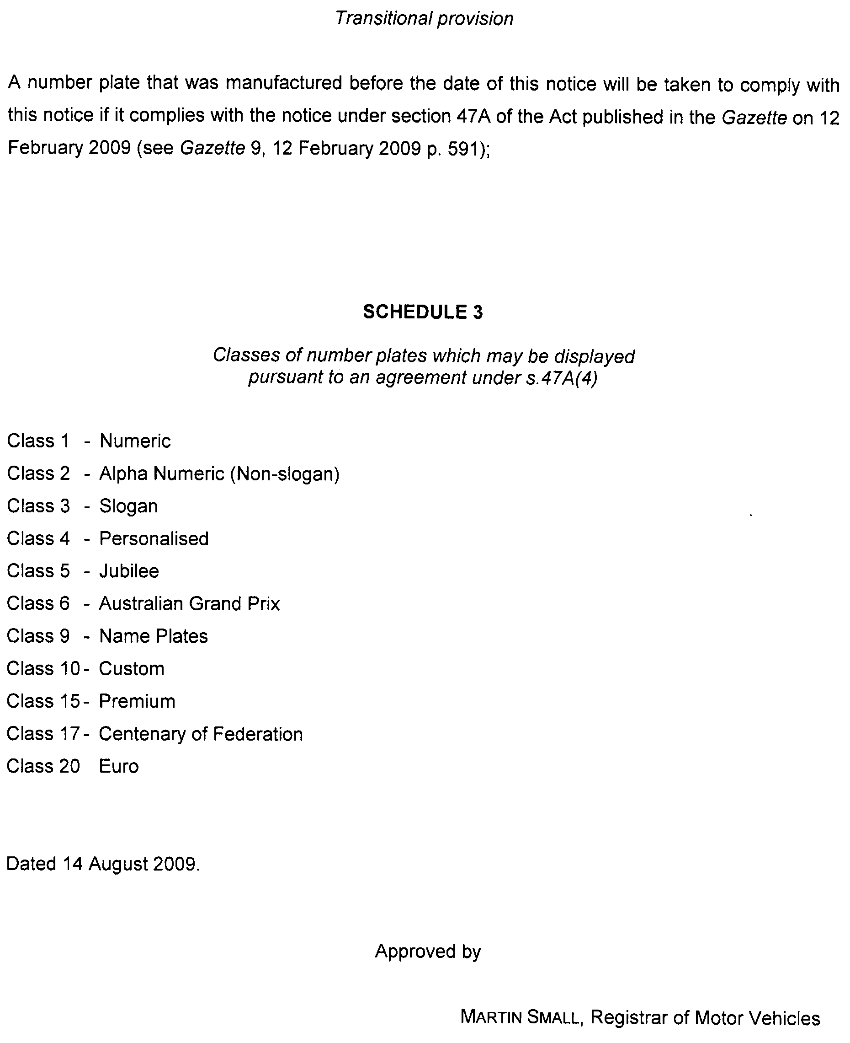
NATIONAL ELECTRICITY LAW
THE Australian Energy Market Commission (AEMC) gives notice under the National Electricity Law of the following matter.
Under section 95, AEMO has requested the Provision of Metering Data Services and Clarification of Existing Metrology Requirements Rule proposal (Project Ref. ERC0092). The proposal seeks to change and clarify some regulatory arrangements for the provision of metering data services. Submissions must be received by 16 October 2009.
Submissions on this proposal can be lodged online via the AEMC’s website at www.aemc.gov.au. Before submitting your submission, you must review the AEMC’s privacy collection statement on its website.
Submissions should be submitted in accordance with the AEMC’s Guidelines for making written submissions on Rule change proposals. The AEMC publishes all submissions on its website subject to a claim of confidentiality.
All documents in relation to the above matter are published on the AEMC’s website and are available for inspection at the offices of the AEMC.
John Tamblyn
Chairman
Australian Energy Market Commission
Level 5, 201 Elizabeth Street
Sydney, N.S.W. 2000
Telephone: (02) 8296 7800
Facsimile: (02) 8296 7899
27 August 2009.

NATURAL RESOURCES MANAGEMENT ACT 2004
Revocation of Notice of Prohibition
PURSUANT to section 132 (9) of the Natural Resources Management Act 2004, I, Jay Weatherill, Minister for Environment and Conservation in the State of South Australia and Minister to whom the administration of the Natural Resources Management Act 2004, is committed, revoke the Notice of Prohibition on the Taking of Water from the Clare Valley Prescribed Water Resources Area dated 24 December 2008 and published in the Government Gazette (pages 281-282) of 15 January 2009.
Dated 18 August 2009.
Jay Weatherill, Minister for Environment and Conservation

PETROLEUM ACT 2000
Application for Variation of Pipeline Licence—PL 18
PURSUANT to section 65 (6) of the Petroleum Act 2000 (the Act) and Delegated powers, notice is hereby given that Epic Energy Queensland Pty Ltd has applied for a variation to Pipeline Licence PL 18.
Description of Application
A steel pipeline for the conveyance of natural gas being a loop line with pipes of a nominal diameter 400-500 mm (herein
called the ‘Loop Line’) over a route of approximately 92 km commencing at the South Australia/Queensland border and pro-ceeding to the following delivery transfer points:
(a) the insulation gasket immediately upstream of the isolation valve located at the hot tap connection to the Moomba to Adelaide Pipeline (Pipeline Licence 1); and
(b) the insulation gasket immediately upstream of the isolation valve located at the hot tap connection to the Moomba to Sydney Pipeline (Pipeline Licence 7).
The Loop Line is located approximately 8 m south of the Mainline and utilises the existing mainline valve and Moomba Metering and Pressure Regulation Station.
Dated 25 August 2009.
B. A. Goldstein,
Director Petroleum and Geothermal
Minerals and Energy Resources
Primary Industries and Resources SA
Delegate of the Minister for Mineral
Resources Development

PETROLEUM ACT 2000
Suspension of Geothermal Exploration Licences
GELs 128, 129, 161, 162 and 163
PURSUANT to section 90 of the Petroleum Act 2000, notice is hereby given that the abovementioned Geothermal Exploration Licences have been suspended under the provisions of the Petroleum Act 2000, from and including 1 August 2009 until 31 December 2009, pursuant to delegated powers.
The expiry date of GELs 128, 129, 161, 162 and 163 is now determined to be 2 February 2010.
Dated 25 August 2009.
B. A. Goldstein,
Director Petroleum and Geothermal
Minerals and Energy Resources
Primary Industries and Resources SA
Delegate of the Minister for Mineral
Resources Development

PETROLEUM ACT 2000
Section 25 (5) (b)
Variation of Petroleum Exploration Licence—PEL 115
NOTICE is hereby given that under the provisions of the Petroleum Act 2000, pursuant to delegated powers, the conditions of the abovementioned Exploration Licence have been varied as follows:
Condition 1 of the licence is omitted and the following substituted:
‘1. During the term of the licence, the licensee shall carry out or cause to be carried out exploratory operations on the area comprised in the licence in accordance with such work programs as are approved by the Minister from time to time. Years one to five exploratory operations are guaranteed. These exploratory operations shall include but not necessarily be limited to:

Year of Term of Licence |  | Minimum Work Requirements
One |  | • Seismic reprocessing; and  • Geological and geophysical studies.
Two |  | • 2 wells.
Three |  | • 4 wells.
Four |  | • 1 well.
Five |  | • Geological and geophysical studies.
 | ’
The variation results in the removal of 2 wells from the year five work program.
Dated 18 August 2009.
B. A. Goldstein,
Director Petroleum and Geothermal
Minerals and Energy Resources
Primary Industries and Resources SA
Delegate of the Minister for Mineral
Resources Development

REAL PROPERTY ACT NOTICE
WHEREAS the persons named at the foot hereof have each respectively for himself made application to have the land set forth and described before his name at the foot hereof brought under the operation of the Real Property Act: Notice is hereby given that unless caveat be lodged with the Registrar-General by some person having estate or interest in the said lands on or before the expiration of the period herein below for each case specified, the said several pieces of land will be brought under the operation of the said Act as by law directed. Diagrams delineating these parcels of land may be inspected at the Lands Titles Registration Office, Adelaide, and in the offices of the several corporations or district councils in which the lands are situated.

The Schedule
No. of  Applica-  tion | Description of Property |  | Name |  | Residence | Date up to and  inclusive of which  caveat may be  lodged

31120 | Portion of Allotment 232 of Section 355, Hundred of Yatala in the area named Brompton |  | David Jeffrey Harris and Helen Louise Harris |  | 83 East Street, Brompton, S.A. 5007 | 27 October 2009

Dated 27 August 2009, at the Lands Titles Registration Office, Adelaide. J. Zaccaria, Deputy Registrar-General

RETAIL AND COMMERCIAL LEASES ACT 1995
Exemptions
PURSUANT to section 77 (1) (a) of the Retail and Commercial Leases Act 1995 (SA) I, Jay Weatherill, Acting Minister for Consumer Affairs for the State of South Australia:
EXEMPT the lease between the Minister for Economic Development and Team Avcon Incorporated in relation to the operation of the Tomorrow Studio at Unit 6, 193 Wakefield Street, Adelaide, being that portion of the land comprised in certificate of title volume 5024, folio 104, marked on the plan annexed to the lease together with certain rights of use described in the lease from all of the provisions of the Retail and Commercial Leases Act 1995.
EXEMPT the lease between the Minister for Economic Development and Paul Malyschko—trading as Blink Software in relation to the operation of the Tomorrow Studio at Unit 6, 193 Wakefield Street, Adelaide, being that portion of the land comprised in certificate of title volume 5024, folio 104, marked on the plan annexed to the lease together with certain rights of use described in the lease from all of the provisions of the Retail and Commercial Leases Act 1995.
EXEMPT the lease between the Minister for Economic Development and Holly Owen—trading as Champagne for Ladies in relation to the operation of the Tomorrow Studio at Unit 6, 193 Wakefield Street, Adelaide, being that portion of the land comprised in certificate of title volume 5024, folio 104, marked on the plan annexed to the lease together with certain rights of use described in the lease from all of the provisions of the Retail and Commercial Leases Act 1995.
EXEMPT the lease between the Minister for Economic Development and Dan Monceaux—trading as Danimations in relation to the operation of the Tomorrow Studio at Unit 6, 193 Wakefield Street, Adelaide, being that portion of the land comprised in certificate of title volume 5024, folio 104, marked on the plan annexed to the lease together with certain rights of use described in the lease from all of the provisions of the Retail and Commercial Leases Act 1995.
EXEMPT the lease between the Minister for Economic Development and Digital Lamb Pty Ltd in relation to the operation of the Tomorrow Studio at Unit 6, 193 Wakefield Street, Adelaide, being that portion of the land comprised in certificate of title volume 5024, folio 104, marked on the plan annexed to the lease together with certain rights of use described in the lease from all of the provisions of the Retail and Commercial Leases Act 1995.
EXEMPT the lease between the Minister for Economic Development and Ryan Adams—trading as Dream Labs in relation to the operation of the Tomorrow Studio at Unit 6, 193 Wakefield Street, Adelaide, being that portion of the land comprised in certificate of title volume 5024, folio 104, marked on the plan annexed to the lease together with certain rights of use described in the lease from all of the provisions of the Retail and Commercial Leases Act 1995.
EXEMPT the lease between the Minister for Economic Development and Dean Cormick—trading as Extra Artists in relation to the operation of the Tomorrow Studio at Unit 6, 193 Wakefield Street, Adelaide, being that portion of the land comprised in certificate of title volume 5024, folio 104, marked on the plan annexed to the lease together with certain rights of use described in the lease from all of the provisions of the Retail and Commercial Leases Act 1995.
EXEMPT the lease between the Minister for Economic Development and Farrell Media Pty Ltd—trading as Eastside Digital in relation to the operation of the Tomorrow Studio at Unit 6, 193 Wakefield Street, Adelaide, being that portion of the land comprised in certificate of title volume 5024, folio 104, marked on the plan annexed to the lease together with certain rights of use described in the lease from all of the provisions of the Retail and Commercial Leases Act 1995.
EXEMPT the lease between the Minister for Economic Development and Ray Jalil—trading as figASIA in relation to the operation of the Tomorrow Studio at Unit 6, 193 Wakefield Street, Adelaide, being that portion of the land comprised in certificate of title volume 5024, folio 104, marked on the plan annexed to the lease together with certain rights of use described in the lease from all of the provisions of the Retail and Commercial Leases Act 1995.
EXEMPT the lease between the Minister for Economic Development and Ben Kilsby—trading as Holopoint Development Studios in relation to the operation of the Tomorrow Studio at Unit 6, 193 Wakefield Street, Adelaide, being that portion of the land comprised in certificate of title volume 5024, folio 104, marked on the plan annexed to the lease together with certain rights of use described in the lease from all of the provisions of the Retail and Commercial Leases Act 1995.
EXEMPT the lease between the Minister for Economic Development and Kyle Leffers—trading as I Love Biscuits in relation to the operation of the Tomorrow Studio at Unit 6, 193 Wakefield Street, Adelaide, being that portion of the land comprised in certificate of title volume 5024, folio 104, marked on the plan annexed to the lease together with certain rights of use described in the lease from all of the provisions of the Retail and Commercial Leases Act 1995.
EXEMPT the lease between the Minister for Economic Development and Intilligent Software Development Pty Ltd in relation to the operation of the Tomorrow Studio at Unit 6, 193 Wakefield Street, Adelaide, being that portion of the land comprised in certificate of title volume 5024, folio 104, marked on the plan annexed to the lease together with certain rights of use described in the lease from all of the provisions of the Retail and Commercial Leases Act 1995.

EXEMPT the lease between the Minister for Economic Development and Proactive Technology Group Pty Ltd in relation to the operation of the Tomorrow Studio at Unit 6, 193 Wakefield Street, Adelaide, being that portion of the land comprised in certificate of title volume 5024, folio 104, marked on the plan annexed to the lease together with certain rights of use described in the lease from all of the provisions of the Retail and Commercial Leases Act 1995.
EXEMPT the lease between the Minister for Economic Development and Stretch Creative Pty Ltd in relation to the operation of the Tomorrow Studio at Unit 6, 193 Wakefield Street, Adelaide, being that portion of the land comprised in certificate of title volume 5024, folio 104, marked on the plan annexed to the lease together with certain rights of use described in the lease from all of the provisions of the Retail and Commercial Leases Act 1995.
Dated 23 August 2009.
Jay Weatherill, Acting Minister for Consumer Affairs

ROADS (OPENING AND CLOSING) ACT 1991:
SECTION 24
NOTICE OF CONFIRMATION OF ROAD
PROCESS ORDER
Road Closure, Glenroy
BY Road Process Order made on 2 June 2009, the Wattle Range Council ordered that:
1. Portion of the unnamed public road situate west of Magarey Lane and adjoining the southern boundaries of sections 229 and 231, Hundred of Comaum, more particularly delineated and lettered ‘A’ and ‘B’ in Preliminary Plan No. 32/0601 be closed.
2. The whole of the land subject to closure be transferred to Trevor Stanley Reschke in accordance with agreement for transfer dated 25 November 2008, entered into between the Wattle Range Council and T. S. Reschke.
On 27 July 2009 that order was confirmed by the Minister for Infrastructure conditionally upon the deposit by the Registrar-General of Deposited Plan 81397, being the authority for the new boundaries.
Pursuant to section 24 (5) of the Roads (Opening and Closing) Act 1991, NOTICE of the order referred to above and its confirmation is hereby given.
Dated 27 August 2009.
P. M. Kentish, Surveyor-General

ROAD TRAFFIC ACT 1961
Authorised Officers to Conduct Breath Analysis
I, MALCOLM ARTHUR HYDE, Commissioner of Police, pursuant to section 47K (3) (a) of the Road Traffic Act 1961, do hereby certify that on 13 August 2009, the following Police Officers were authorised to conduct breath analysis:

PD  Number | Officer Name
78634 | Crabb, Lisa Marie
72518 | Firth, Robin Michael
72049 | Hyde, Andrew
72740 | Jones, Julie
72137 | Manson, Joel Ryan
35172 | McKenzie, David Paul
79295 | Morris, Ryan Andrew
79240 | O’Connell, Jacquelynn
Dated 13 August 2009.
Malcolm Arthur Hyde, Commissioner of Police

TRAINING AND SKILLS DEVELOPMENT ACT 2008

Part 4 – Apprenticeships/Traineeships

Pursuant to the provision of the Training and Skills Development Act 2008, the Training and Skills Commission (TaSC) gives notice that determines the following
Trades or Declared Vocations in addition to the gazette notices of:

- 25 September 2008 | - 23 October 2008 | - 13 November 2008 | - 4 December 2008
- 18 December 2008 | - 29 January 2009 | - 12 February 2009 | - 5 March 2009
- 12 March 2009 | - 26 March 2009 | - 30 April 2009 | - 18 June 2009
- 25 June 2009

Trades or Declared Vocations and Required Qualifications and Training
Contract Conditions for the
MEA07 Aeroskills Training Package

Errata
Government Gazette issue number 75 of 18 December 2008 page 5629 omitted the following qualification and training contract arrangements:

*Trade/ #Declared Vocation | Code | Title | Term of Training Contract | Probationary  Period
* Aircraft Maintenance  Engineer or  Technician (Avionics) | MEA40607 | Certificate IV in Aeroskills (Avionics) | 48 months | 3 months

WORKCOVER CORPORATION ACT 1994
WORKERS REHABILITATION AND COMPENSATION ACT 1986
Determination of Board of WorkCover Corporation of South Australia
THE Board of the WorkCover Corporation of South Australia determines as follows, pursuant to section 17 of the WorkCover Corporation Act 1994, section 72 of the Workers Rehabilitation and Compensation Act 1986 and all other enabling powers:
1. Citation and Date of Commencement
(1) This determination may be cited as the WorkCover Levy Review Determination 2002.
(2) This determination takes effect on 13 August 2009.
2. Continuation of WorkCover Levy Review Panel
The WorkCover Levy Review Panel (‘the Panel’) established by the Board’s determination of 29 June 2000 (see South Australian Government Gazette, 29 June 2000, page 3472) is hereby continued.
3. Function and powers under section 72 of Workers Rehabilitation and Compensation Act 1986
The function of the Panel shall be to perform the functions of the Board under section 72 of the Workers Rehabilitation and Compensation Act 1986 (‘the Act’) as delegate of the Board under that section in reviewing decisions of the Corporation pursuant to subsections 66 (4), 66 (5), 66 (6), 67 (1), 67 (2), 67 (3), 67 (4), 69 (4) (b), 70 (1), 70 (2), 70 (3), 70 (4), 71 (1), 71 (2) of the Act and (subject to the succeeding clauses of this determination) the powers of the Board under section 72 of the Act (other than the power to review a decision of the Corporation on a matter of law going to the validity of that decision) are delegated to the Panel for that purpose.
4. Constitution of Panel
(1) Subject to Clause 4 (2B), the Panel shall sit comprising four members appointed by the Board consisting of:
(a) a President, who shall be a legal practitioner (wherever in Australia admitted), and who shall decide any questions of law;
(b) a member with expertise in the interests of registered employers;
(c) a member with expertise in the interests of workers; and
(d) a member with expertise in the interests of the Corporation.
(2) Where the anticipated unavailability of appointed members or the anticipated volume of work necessitates, deputy members may be appointed by the Board.
(2A) A Deputy President or other Deputy Member has the powers and duties of the position held by the person for whom he or she deputes.
(2B) Where the Panel is reviewing a decision of the Corporation pursuant to section 67 (1) of the Act to impose a Balancing Payment (as defined in the Levy Adjustment Scheme determined by the Corporation or its delegate from time to time) on an employer, the President sitting alone may, after hearing from the parties to the review on the matter, appoint a person with appropriate technical expertise (e.g., an actuary) as a temporary member of the Panel for the purposes of reviewing that decision. Such temporary member would sit on the Panel in substitution for the member ordinarily sitting pursuant to Clause 4 (1) (d) of this Determination.
(3) The President may sit alone:
(a) to give directions;
(b) to determine procedural matters;
(c) for the promotion of conciliation;
(d) to seek evidence; or
(e) to dispose of an application on a matter of law involving no disputes of fact and no exercise of discretion,
but (subject to this clause) the Panel shall otherwise sit as a Panel of four.
(4) A decision of a majority of members of the Panel, other than a decision as to a matter of law, shall be the decision of the Panel, but a member not agreeing with a decision of the majority may give reasons for not agreeing.
(4A) In the event of the Panel being equally divided in opinion as to the decision to be made, the Panel’s decision shall be in accordance with the opinion of the President or Deputy President.
(4B) A quorum of the Panel shall be three members, provided that members representing each interest referred to in subclause (1) or (where applicable) deputies thereof have been offered, in the opinion of the President, a reasonable opportunity to sit.
(5) If a member of the Panel becomes unavailable after the commencement of a hearing, the application must be heard again by the Panel properly constituted or (with the concurrence of the parties) adjourned until the absent member becomes available again, unless the decision of the remaining members is unanimous.
(6) However, no hearing may commence or continue without the President or a Deputy President.
5. Indemnity of Members
Any liability attaching to a member of the Panel (including a temporary member appointed pursuant to Clause 4 (2B)) for an act or omission by the member, or by the Panel, in good faith and in the exercise or purported exercise of a power or function, or in the discharge or purported exercise of a duty, of the member or the Panel is assumed by the Corporation.
6. Tenure of Members
(1) Members (other than the President) shall be appointed for a term of two years, except in the event of a casual vacancy, where a member may be appointed for two years or for the balance of the term of the former member at the option of the Board.
(1A) The President of the Panel shall be appointed for a term of five years.
(2) A deputy of a member shall be appointed for a term specified by the Board in the instrument of appointment, not exceeding the balance of the term of the member for whom the deputy is to depute.
(3) A member of the Panel whose term has expired may, if a new appointment has not been made, continue to sit as a member of the Panel until a new appointment is made.
(4) A former member of the Panel may sit as a member of the Panel for the purpose of completing the hearing and determination of part-heard proceedings.
7. Conciliation as Condition Precedent to jurisdiction
(1) Upon receipt of any application lodged under section 72 (1) of the Act, the registry of the Panel will forward a copy to the operating unit of the Corporation responsible for the disputed decision. The operating unit of the Corporation responsible for the disputed decision, the General Counsel of the Corporation or Senior Lawyer of the Corporation will reconsider the decision (disregarding any question of whether the application is out of time) and must inform the Panel and the applicant within 14 days of the result of the reconsideration (and its attitude to any question of an extension of time).
(1A) Where the operating unit of the Corporation responsible for the disputed decision, or the General Counsel of the Corporation, or granting an extension of time that exceeds seven days, the registry must invite the employer to indicate whether it has any objections to the proposed extension of time and the reasons for any objection. If there is any such objection, the registry must refer the question to the President of the Panel to determine.
(2) If—
(a) the Corporation, on reconsideration of a disputed decision, confirms the decision; or
(b) the Corporation, on reconsideration of a disputed decision, varies the decision and the applicant expresses dissatisfaction with the variation,
the registry of the Panel must provide the applicant 30 days to notify the registry to refer the dispute for conciliation by a conciliator who will use his or her best endeavours to bring the applicant and the operating unit of the Corporation that is responsible for the disputed decision, or the General Counsel of the Corporation, or Senior Lawyer of the Corporation to an agreed resolution of the matters referred to in the application, and the Panel may not hear and determine any application unless it is satisfied that conciliation has been attempted and failed or it is satisfied that such attempts have no realistic prospects of success.
(3) If, during the hearing of any matter, it appears to the Panel that there is a realistic prospect of a negotiated outcome being achieved, it may refer the matter back for further conciliation or the Panel may make such other attempts to promote conciliation as it thinks appropriate.
(4) In this clause, ‘conciliation’ includes:
(a) counselling;
(b) mediation;
(c) neutral evaluation;
(d) case appraisal;
(e) conciliation; and
(f) any combination of the above,
and the format of conciliation in any particular case shall be at the discretion of the conciliator in consultation with the parties, with the proviso that any confidential information provided during conciliation may be withheld from the Panel if the provider of that information requests.
8. Principles of Operation of Panel
(1) The Panel shall be bound by and is hereby directed to follow the principles of natural justice.
(2) Subject to subclause (1), the Panel:
(a) shall act according to equity, good conscience and the substantial merits of the case, without regard to technicalities and legal forms;
(b) is not bound by the rules of evidence, but may inform itself by such means and such material as it thinks fit; and
(c) shall act as expeditiously as the circumstances of a particular case permit.
(3) The Panel must ascertain whether the parties to any proceedings desire to be heard by way of oral evidence or submissions and must in that event give at least 14 days notice of the date, time and place of hearing, but if both parties to particular proceedings wish to have the application determined on the documents the Panel need not hold a hearing but must give the parties at least 14 days notice to make final written submissions before proceeding to make a determination.
(4) If only one party to proceedings desires to present oral evidence or submissions, the Panel must give the other party at least 14 days notice of the hearing and inform that party that there is a danger that at the hearing the Panel may hear things from the first party that the other party will be unable to respond to if it does not attend.
(5) A party may appear in person or (if a body corporate) by any proper officer or may be represented by counsel or by any duly appointed and authorised agent.
(6) A party engaging representation must do so at its own cost.
9. Powers of President of Panel
The President of the Panel, or a Deputy President acting in that office may, while so acting, exercise the powers of, and is hereby appointed as, an authorised officer under the Act. For the purposes of this clause, operating units of the Corporation and its agents are directed to comply with any requirements of the President or Deputy President as though they were subject to section 110 of the Act.
10. Reservation of Board’s Discretion to Decide
The Panel is required to determine all applications that fail to resolve through reconsideration or at conciliation, unless the Corporation, within 14 days of receipt of any application advises the Board that the particular dispute is of unusual significance and the Board, prior to the hearing of the application by the Panel, serves notice on the Panel and the applicant that the Panel is to make a recommendation only and refer the matter to the Board
11. Revocation
The determination of the Board published in the South Australian Government Gazette on 17 January 2008, is revoked from the commencement of this determination.
12. Transitional
Where an application for review lodged before 1 July 2002 is part-heard at that date, the hearing will be completed by the Panel as constituted before that date. The amendment to this Determination made by the Board on 13 August 2009 will operate immediately.
Dated 13 August 2009.
P. Bentley, Board Chairperson, WorkCover Corporation

WILDERNESS PROTECTION REGULATIONS 2006
Closure of Cape Torrens Wilderness Protection Area and
Western River Wilderness Protection Area
PURSUANT to Regulations 6 (2) (c) of the Wilderness Protection Regulations 2006, I, Edward Gregory Leaman, Director of National Parks and Wildlife, close to the public the whole of Cape Torrens Wilderness Protection Area and the whole of Western River Wilderness Protection Area from 6 p.m. on Sunday,
11 October 2009 until 6 a.m. on Saturday, 24 October 2009.
The purpose of the closure is to ensure the safety of the public during an animal control and monitoring program within the reserves during the period indicated.
Use of Firearms within the Reserve
Pursuant to Regulations 6 (4), 16 (1) and 34 of the Wilderness Protection Regulations 2006, I, Edward Gregory Leaman, Director of National Parks and Wildlife, grant permission to staff employed by the Kangaroo Island Natural Resources Management Board, in possession of both a current Hunting Permit and a firearm, to enter and remain in the whole of Cape Torrens Wilderness Protection Area and the whole of Western River Wilderness Protection Area from 6 p.m. on Sunday, 11 October 2009 until 6 a.m. on Saturday, 24 October 2009 for the purpose of taking feral animals.
This permission is conditional upon the observance by each of those persons of the requirements of the Wilderness Protection Act 1992, Wilderness Protection Regulations 2006 and the National Parks and Wildlife (Hunting) Regulations 1996, including those requiring compliance with the Director’s requests, requirements and orders of a Warden.
Dated 20 August 2009.
E. G. Leaman, Director of National Parks and Wildlife

FAXING COPY?
IF you fax copy to Government Publishing SA for inclusion in the Government Gazette, there is no need to send a Confirmation Copy to us as well.
This creates confusion and may well result in your notice being printed twice.
Please use the following fax number:
Fax transmission: (08) 8207 1040
Phone Inquiries: (08) 8207 1045
Please include a contact person, phone number and order number so that we can phone back with any queries we may have regarding the fax copy.
NOTE: Closing time for lodging new copy (fax, hard copy or email) is 4 p.m. on Tuesday preceding the day of publication.

Government Gazette notices can be E-mailed.
The address is:
governmentgazette@dpc.sa.gov.au
Documents should be sent as attachments in Word format.
When sending a document via E-mail, please confirm your transmission with a faxed copy of your document, including the date the notice is to be published.
Fax transmission: (08) 8207 1040
Enquiries: (08) 8207 1045
NOTE: Closing time for lodging new copy (fax, hard copy or email) is 4 p.m. on Tuesday preceding the day of publication.

CITY OF PLAYFORD
Roads (Opening and Closing) Act 1991
Road Closure—Bibaringa
NOTICE is herby given, pursuant to section 10 of the Roads (Opening and Closing) Act 1991, that the City of Playford proposes to make a Road Process Order to close portion of Eagles Nest Drive and merge with adjoining Allotment 7 in Deposited Plan 14594, as delineated and lettered ‘A’ on Preliminary Plan No. 09/0019.
A copy of the plan and a statement of persons affected are available for public inspection at Playford Operations Centre, 12 Bishopstone Road, Davoren Park, S.A. 5113 and the Adelaide Office of the Surveyor-General, 101 Grenfell Street, Adelaide, during normal office hours.
Any application for easement or objection must set out the full name, address and details of the submission and must be fully supported by reasons.
The application for easement or objection must be made in writing to the Council, 12 Bishopstone Road, Davoren Park, S.A. 5113 within 28 days of this notice and a copy must be forwarded to the Surveyor-General, G.P.O. Box 1354, Adelaide, S.A. 5001. Where a submission is made, the Council will give notification of a meeting at which the matter will be considered.
Dated 27 August 2009.
T. Jackson, Chief Executive Officer

DISTRICT COUNCIL OF BARUNGA WEST
Roads (Opening and Closing) Act 1991
Road Closures—Melton
NOTICE is herby given, pursuant to section 10 of the Roads (Opening and Closing) Act 1991, that the District Council of Barunga West proposes to make Road Process Orders to close:
1. The whole of the un-named public road between Kulpara Road and Railway Terrace and merge with the adjoining allotments 300, 301, 302 and 303 in Filed Plan 216519 and allotment 383 in Filed Plan 190135, as delineated and lettered ‘A’, ‘B’ and ‘C’ on Preliminary Plan No. 09/0038, and
2. Portion of the un-named public road west of Daniels Road adjoining the southern boundary of allotment 92 in Filed Plan 204100 and merge with the adjoining piece of allotment 95 in Filed Plan 178388, as delineated and lettered ‘A’ on Preliminary Plan No. 09/0039.
Copy of the plans and statements of persons affected are available for public inspection at the Council Office, Bay Street, Port Broughton, S.A. 5522 and the Adelaide Office of the Surveyor-General during normal office hours.
Any application for easement or objection must set out the full name, address and details of the submission and must be fully supported by reasons.
The application for easement or objection must be made in writing to the Council, P.O. Box 3, Port Broughton, S.A. 5522 within 28 days of this notice and a copy must be forwarded to the Surveyor-General, G.P.O. Box 1354, Adelaide, S.A. 5001. Where a submission is made, the Council will give notification of a meeting at which the matter will be considered.
Dated 27 August 2009.
N. Hand, District Manager

THE COORONG DISTRICT COUNCIL
Adoption of Valuation and Declaration of Rates
NOTICE is hereby given that at a meeting of the Council held on Thursday, 13 August 2009 and for the year ending 30 June 2010, it was resolved:
Adoption of Valuation
To adopt, for rating purposes, the capital values made by the Valuer-General totalling $1 328 389 700 of which $1 293 974 679 is in respect to rateable land, and that 13 August shall be the day as and from which such valuations shall become the valuations of the Council.
Declaration of Differential General Rates
To declare the following differential rates based upon the use of all rateable land within its area:
(a) 0.2900 cents in the dollar of the Capital Value of rateable land of Categories 1 and 9 uses (residential and ‘other’ categories).
(b) 0.2900 cents in the dollar of the Capital Value of rateable land of Categories 2, 3, 4, 5 and 6 uses (commercial/industrial categories).
(c) 0.2465 cents in the dollar of the Capital Value of rateable land of Category 7 use (primary production category).
(d) 0.3335 cents in the dollar of the Capital Value of rateable land of Category 8 use (vacant land category).
Declaration of Fixed Charge
To set a fixed charge of $295 that shall be payable by way of rates in respect of all rateable land.
Declaration of Separate Rate—SA Murray Darling
Natural Resources Management Levy
Pursuant to the Natural Resources Management Act 2004 and section 154 of the Local Government Act 1999 and in order to reimburse the Council the amount contributed to the SA Murray Darling Basin Natural Resource Management Board, the Coorong District Council declares a separate rate of 0.006373 cents in the dollar based on the capital value of rateable land in the area and the catchment area of the SA Murray Darling Basin Natural Resources Management Board.
Declaration of Separate Rate—South East Natural Resources Management Levy
Pursuant to the Natural Resources Management Act 2004 and section 154 of the Local Government Act 1999 and in order to reimburse the Council the amount contributed to the South East Natural Resources Management Board, the Coorong District Council declares a separate rate of $37.30 in respect of each rateable property in the area and the catchment area of the South East Natural Resources Management Board.
Declaration of Service Charges—Community Wastewater Management Schemes
To declare the following annual service charges for the Meningie, Tailem Bend, Tintinara and Wellington East Community Wastewater Management Schemes:
(a) $178.50 per unit for occupied land; and
(b) $35.70 per unit for vacant land.
Declaration of Service Charges—Water Supply Systems
To declare the following service charges for the supply of water:
(a) To which the Council makes available a water supply service in the area of Wellington East:
Minimum rate: $187.10
Water rates : 0.93 cents/kl for water usage in excess of 125 kl/annum.
(b) To which the Council makes available a water supply service in the area of Peake:
Minimum rate: $136.30
Water rates : 0.93 cents/kl for water usage in excess of 125 kl/annum.
Payment of Rates
That rates will fall due and in four equal or approximately equal instalments on the following dates:
30 September 2009
15 December 2009
15 March 2010
15 June 2010
T. F. Drew, Chief Executive Officer

DISTRICT COUNCIL OF THE COPPER COAST
Public Consultation
Periodical Review of Elector Representation
NOTICE is hereby given that the Council has undertaken a review to determine whether alterations are required in respect to elector representation, including ward boundaries and the composition of Council.
In response to submissions received in respect to the proposal previously presented for public consideration and comment, Council (at a special meeting convened on 19 August 2009) resolved to amend its proposal as follows:
• Retain the Mayor as the principal member of Council, to be elected by the community at council-wide elections.
• The Council area not be divided into wards (i.e. abolish wards).
• The elected council comprise ten area councillors, to be elected by the community at council-wide elections.
Report
Council has prepared a revised report which details the review process, public consultation undertaken and the proposal Council considers should be carried into effect. A copy of this report is available from the Council Offices, 51 Taylor Street, Kadina and at Council’s website at: www.coppercoast.sa.gov.au or by con-tacting Greg O’Connor on (08) 8821 1600.
Written Submissions
Written submissions are invited from interested persons and should be directed to Greg O’Connor, fax (08) 8821 2736 or email info@coppercoast.sa.gov.au by close of business on Friday, 18 September 2009.
Any person(s) making a written submission will be given the opportunity to appear before a meeting of Council or Council committee to be heard in support of their submission.
P. Dinning, Chief Executive Officer

DISTRICT COUNCIL OF ELLISTON
Public Consultation
Periodical Review of Elector Representation
NOTICE is hereby given that the Council has undertaken a review to determine whether alterations are required in respect to elector representation, including ward boundaries and the composition of Council.
As an outcome of this review Council proposes:
(1) That Council retain the office of Chairperson, to be chosen by the elected members of Council.
(2) That the council area not be divided into wards.
(3) That the elected Council comprise eight area councillors.
(4) That a report be prepared pursuant to the provisions of section 12 (8a) of the Local Government Act 1999 and that the required three week public consultation process be initiated.
Report
Council has prepared a report which details the review process, public consultation undertaken and the proposal Council considers should be carried into effect. A copy of this report is available from the Council Offices, Beach Terrace, Elliston S.A. 5670 and at Council’s website at www.elliston.sa.gov.au or contacting the Council Office on 8687 9177.
Written Submissions
Written submissions are invited from interested persons and should be directed to The Chief Executive Officer, P.O. Box 46, Elliston, S.A. 5670, fax 8687 9176 or email dce@elliston.sa.gov.au by close of business on Thursday, 18 September 2009.
Any person(s) making a written submission will be given the opportunity to appear before a meeting of Council to be heard in support of their submission.
R. Gregor, Chief Executive Officer

THE FLINDERS RANGES COUNCIL
Temporary Road Closure
NOTICE is hereby given that pursuant to section 33 of the Road Traffic Act 1961, that:
Wirreanda Terrace, between Arkaba Street and Chace View Terrace and Chace View Terrace from Wirreanda Terrace to Rawnsley Street, Hawker, between the hours of 6 a.m. and 8.30 a.m. on Tuesday, 25 August 2009, be closed to all vehicles, excluding ‘Variety Bash’ vehicles, Council and emergency vehicles, for the purposes of a Variety Bash Breakfast.
C. J. Davies, Chief Executive Officer

THE FLINDERS RANGES COUNCIL
Public Road Declaration
NOTICE is hereby given that in accordance with section 208 of the Local Government Act 1999, The Flinders Ranges Council at its meeting held on 11 August 2009, declared those portions shown as Private Road in Deposited Plan 1501, being the whole of the land contained within certificate of title register book volume 568, folio 140, as public roads.
C. J. Davies, Chief Executive Officer

LIGHT REGIONAL COUNCIL
Temporary Road Closure
NOTICE is hereby given that Hill Street Kapunda, from Main Street to the eastern alignment of Blyth Street, will be closed from 8 a.m. Saturday, 12 September 2009 through to 5 p.m. on Sunday, 13 September 2009, due to the holding of the Annual Kapunda Celtic Festival. For enquiries and further details, contact Light Regional Council on (08) 8525 3200.
B. Carr, Chief Executive Officer

DISTRICT COUNCIL OF MALLALA
Public Consultation
Periodical Review of Elector Representation
NOTICE is hereby given that the Council has undertaken a review to determine whether alterations are required in respect to elector representation, including ward boundaries and the composition of Council.
As an outcome of this review Council proposes to adopt retention of the existing wards structure.
Report
Council has prepared a report which details the review process, public consultation undertaken and the proposal Council considers should be carried into effect. A copy of this report is available from the Council Offices, 2A Wasleys Road, Mallala and at Council’s website at www.mallala.sa.gov.au.
Written Submissions
Written submissions are invited from interested persons and should be directed to Peter Buchmann by close of business on
18 September 2009.
Any person(s) making a written submission will be given the opportunity to appear before a meeting of Council on Monday,
21 September 2009, to be heard in support of their submission.
C. Mansueto, Chief Executive Officer

MID MURRAY COUNCIL
Extension of Public Consultation Deadline
Periodical Review of Elector Representation
NOTICE is hereby given that the Council has undertaken a review to determine whether alterations are required in respect to elector representation, including ward boundaries and the composition of Council.
As an outcome of this review Council proposes to:
• Retain the Mayor as the principal member of Council, to be elected by the community at Council-wide elections.
• Retain 11 ward councillors.
• Divide the Council area into five wards, with two wards each being represented by three ward councillors, two wards each being represented by two ward councillors each and the remaining ward being represented by one ward councillor.
• The wards be identified as Randell (Ward 1), River South (Ward 2), Sturt (Ward 3), River North (Ward 4) and Reedy Creek (Ward 5).
• Not introduce area councillors in addition to ward councillors.
Report
Council has prepared a report which details the review process, public consultation undertaken and the proposal Council considers should be carried into effect. A copy of this report is available from the Council Offices, 49 Adelaide Road, Mannum, S.A. 5238, Main Street, Cambrai, S.A. 5353 and corner Fourth and Eighth Streets, Morgan, S.A. 5320, at the Council’s website at:
www.mid-murray.sa.gov.au or contacting Robin Bourne on 8569 0100.
Written Submissions
Written submissions are invited from interested persons and should be directed to the Chief Executive Officer, Mid Murray Council, P.O. Box 28, Mannum, S.A. 5238, fax: 8569 1931 or email postbox@mid-murray.sa.gov.au and will now be received by the close of business on Friday, 4 September 2009.
Any person(s) making a written submission will be given the opportunity to appear before a meeting of Council or Council committee to be heard in support of their submission.
D. H. Gollan, Chief Executive Officer

IN the matter of the estates of the undermentioned deceased persons:
Aries, Ronald Shane, late of 9 Beach Road, St Kilda, retired labourer, who died on 6 June 2009.
Blackwell, Dianne Rebecca, late of 181-193 Days Road, Regency Park, of no occupation, who died on 12 June 2009.
Carter, Gretchen Muriel, late of 2 Jelley Street, Woodville, retired nurse, who died on 15 June 2009.
Cockburn, Ronald, late of 50 Kesters Road, Para Hills West, retired pattern maker, who died on 11 June 2009.
Dienelt, Gilbert, late of 580 Brighton Road, South Brighton, retired insurance agent, who died on 29 May 2009.
Docherty, Daphne Shirley, late of 1 Cumnock Street, James-town, of no occupation, who died on 30 June 2009.
Fellenberg, Francis Charles, late of 8 Mine Street, Kadina, retired tally clerk, who died on 19 June 2009.
O’Brien, Dorothy Beatrice, late of 98 Military Road, Semaphore South, of no occupation, who died on 6 March 2009.
Pearce, Ellen Agnes, late of 50 Kesters Road, Para Hills West, of no occupation, who died on 19 April 2009.
Robertson, Elsa Joan, late of 3 Moselle Avenue, Glengowrie, home duties, who died on 16 May 2009.
Szuek, Otto, late of 75-79 Hilltop Drive, Oakden, retired pharmacy assistant, who died on 30 March 2009.
Notice is hereby given pursuant to the Trustee Act 1936, as amended, the Inheritance (Family Provision) Act 1972, and the Family Relationships Act 1975, that all creditors, beneficiaries, and other persons having claims against the said estates are required to send, in writing, to the Public Trustee, 25 Franklin Street, Adelaide, S.A. 5000, full particulars and proof of such claims, on or before 25 September 2009, otherwise they will be excluded from the distribution of the said estate; and notice is also hereby given that all persons who are indebted to the said estates are required to pay the amount of their debts to the Public Trustee or proceedings will be taken for the recovery thereof; and all persons having any property belonging to the said estates are forthwith to deliver the same to the Public Trustee.
Dated 27 August 2009.
M. I. Bodycoat, Public Trustee

ATTENTION

CUSTOMERS requiring a proof of their notice for inclusion in the Government Gazette, please note that the onus is on you to inform Government Publishing SA of any subsequent corrections by 10 a.m. on Thursday, which is our publication deadline.

For any corrections to your notice please phone 8207 1045 or Fax 8207 1040 before 10 a.m. on Thursday.

If we do not receive any communication by 10 a.m. on Thursday (day of publication) we will presume the notice is correct and will print it as it is.

Remember—the onus is on you to inform us of any corrections necessary to your notice.

NOTE: Closing time for lodging new copy (electronically, fax or hard copy) is 4 p.m. on Tuesday preceding the day of publication. Phone 8207 1045—Fax 8207 1040.
Email: governmentgazette@dpc.sa.gov.au

Printed and published by authority every Thursday by T. GOODES, Government Printer, South Australia
Price: $5.60, plus postage; to subscribers, $284.00 per annum.
(The above prices are inclusive of GST)

