SUPPLEMENTARY GAZETTE



THE SOUTH AUSTRALIAN

GOVERNMENT GAZETTE
www.governmentgazette.sa.gov.au

PUBLISHED BY AUTHORITY

ALL PUBLIC ACTS appearing in this GAZETTE are to be considered official, and obeyed as such

ADELAIDE, TUESDAY, 1 DECEMBER 2009

DEVELOPMENT REGULATIONS 2008
Complying Development—Regulation 8A and Schedule 4
Identification of Areas Determined by the Minister for the Purposes of Clause 2B of Schedule 4—New Dwellings
Preamble
For the purposes of section 35 of the Development Act 1993, the development of new dwellings that are located within areas determined by the Minister and that meet the requirements of Clause 2B of Schedule 4 of the Development Regulations 2008, will be complying development.
The Minister has determined that Clause 2B of Schedule 4 of the Development Regulations 2008, will apply to the areas identified in this notice for the period of time specified in this notice.
Notice
PURSUANT to Schedule 4, Clause 2B (1), of the Development Regulations 2008, I, Paul Holloway, being the Minister administering the Development Act 1993, have determined that between 1 December 2009 and 13 December 2009 (inclusive of those dates)
Schedule 4—Complying Development, Clause 2 (B) of the Development Regulations 2008, will apply in relation to the areas identified in ‘Attachment A’.
Dated 1 December 2009.
Paul Holloway, Minister for Urban Development and Planning

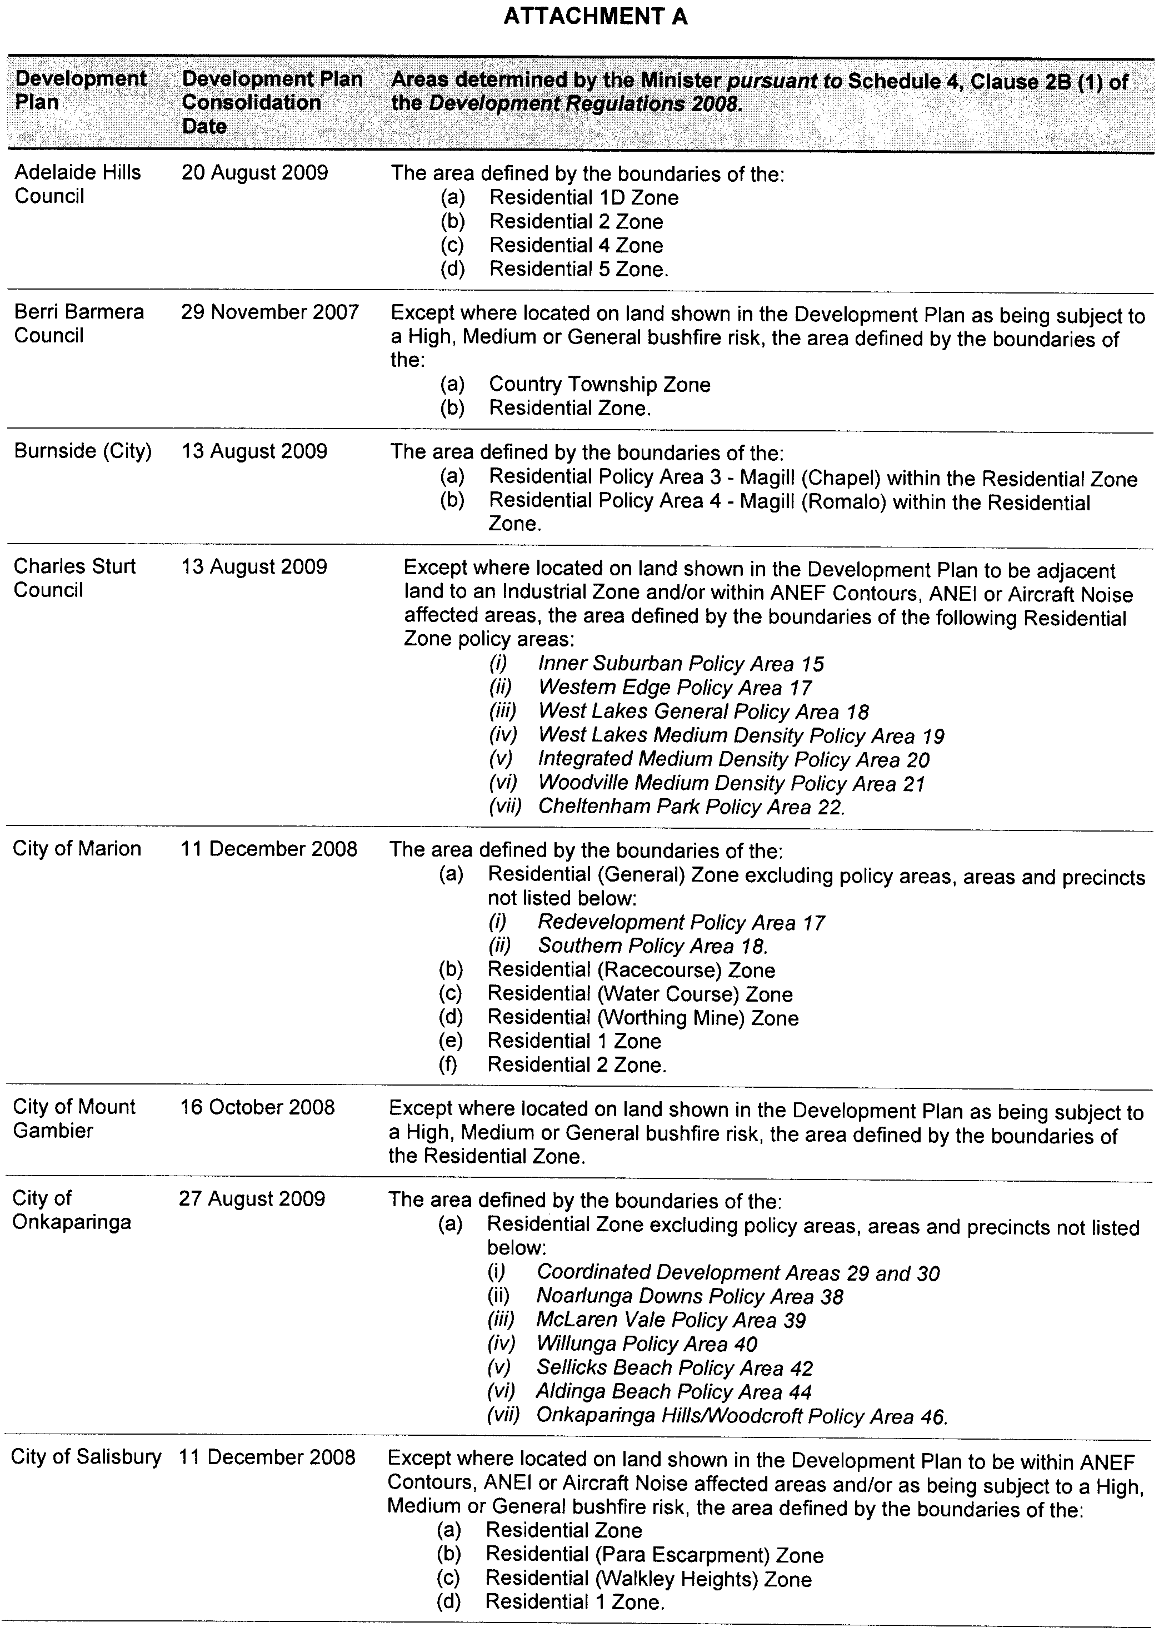
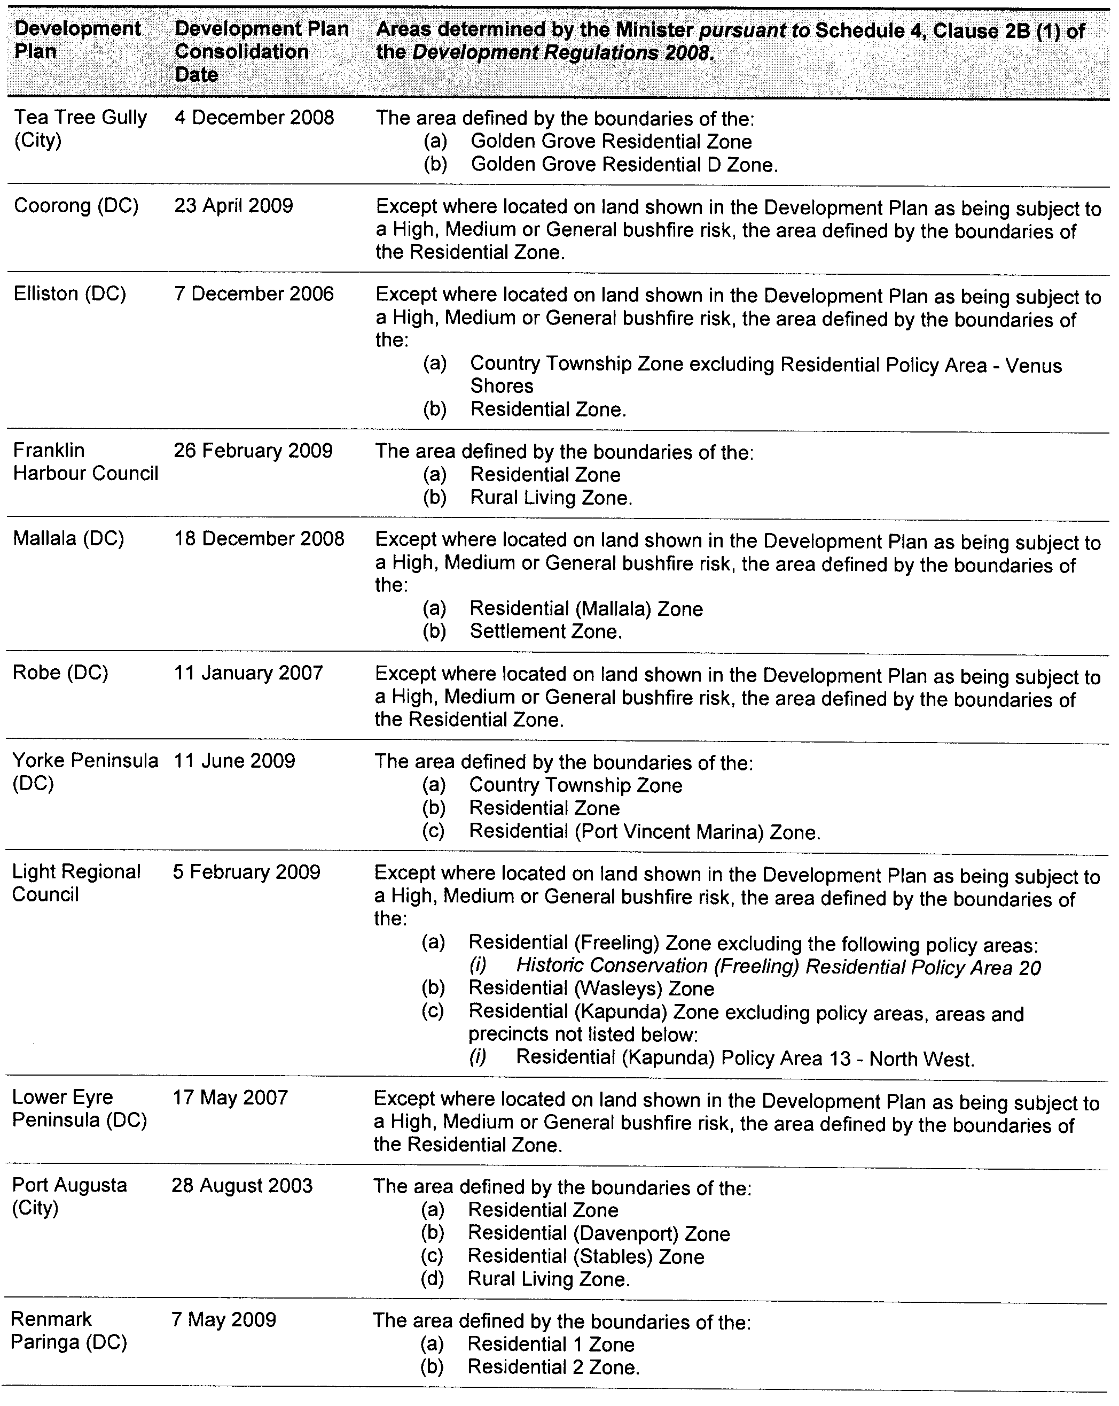
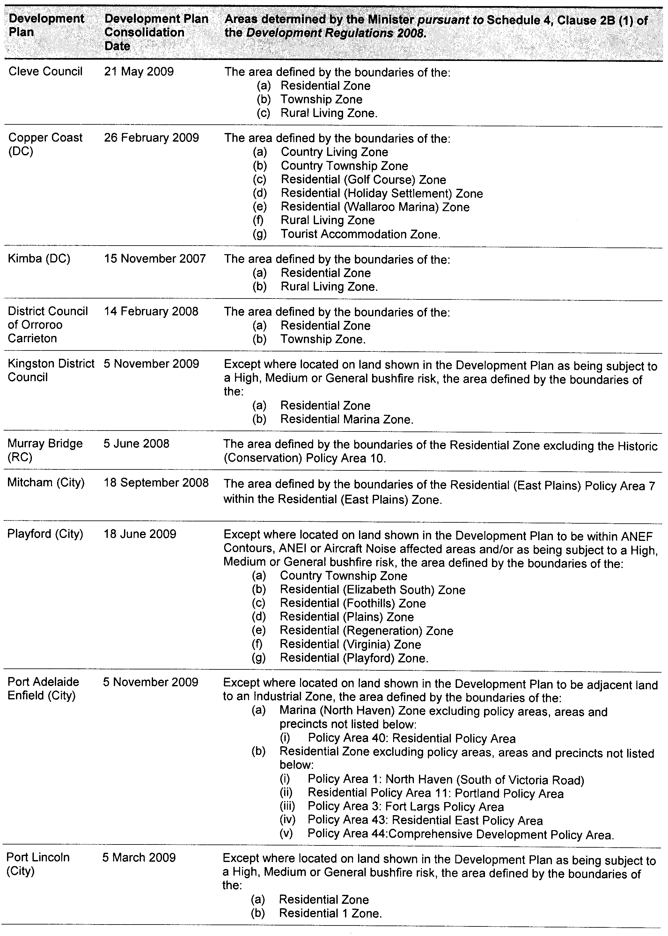
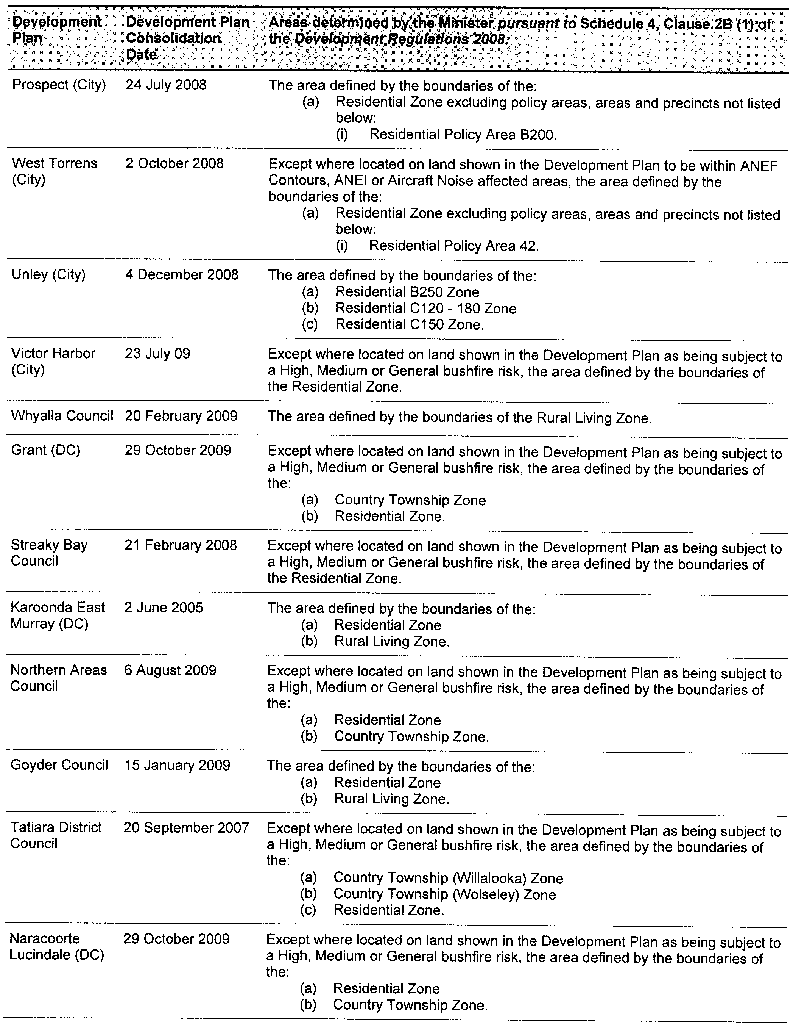
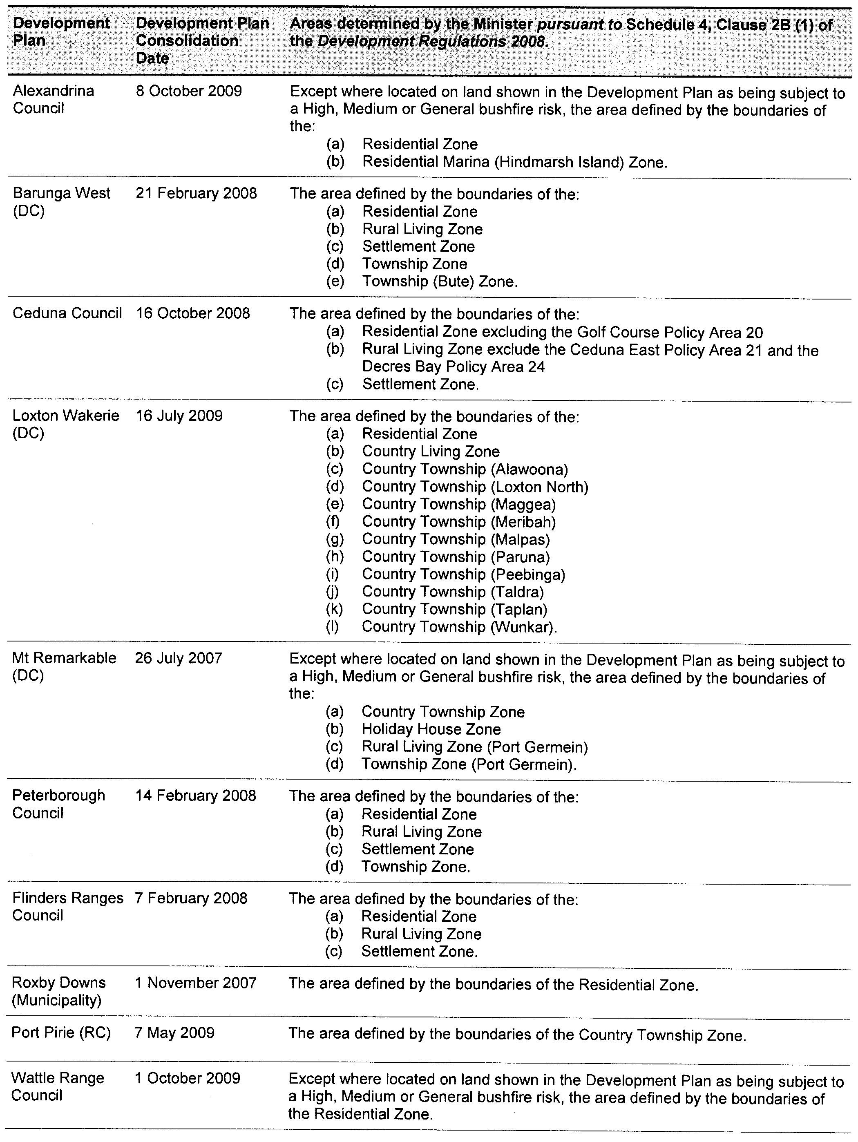

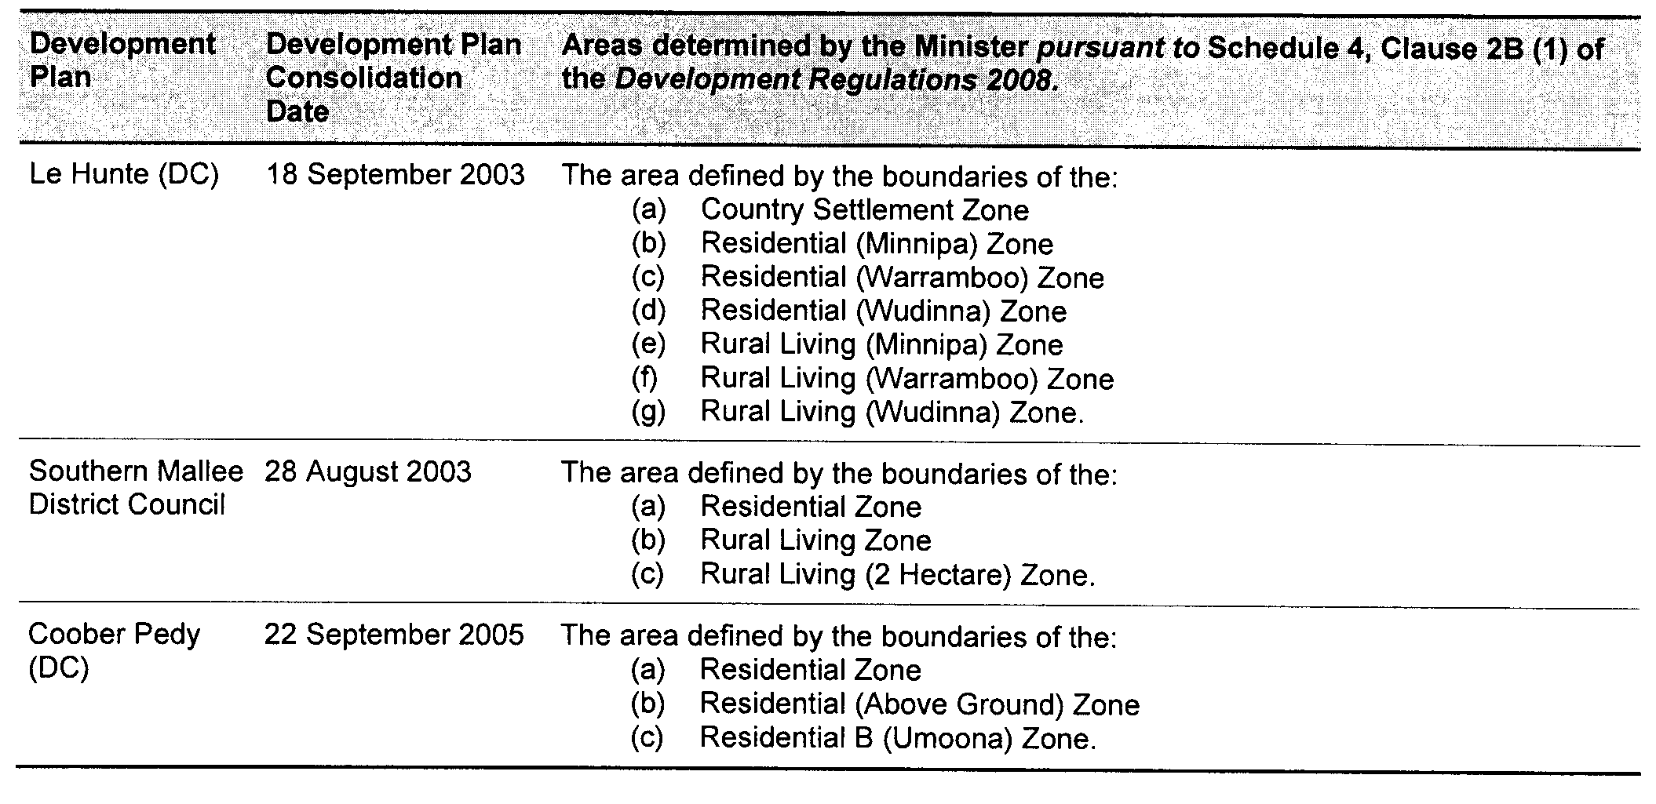

B. MORRIS, Government Printer, South Australia

