No. 92 6021



THE SOUTH AUSTRALIAN

GOVERNMENT GAZETTE
www.governmentgazette.sa.gov.au

PUBLISHED BY AUTHORITY

ALL PUBLIC ACTS appearing in this GAZETTE are to be considered official, and obeyed as such

ADELAIDE, THURSDAY, 10 DECEMBER 2009

CONTENTS

Page
Acts Assented To 6022
Appointments, Resignations, Etc. 6022
Aquaculture Act 2001—Notice 6025
Architects Act 1939—Notice 6025
Corporations and District Councils—Notices 6261
Crown Lands Act 1929—Notices 6026
Dental Board of South Australia—Code of Practice 6083
Development Act 1993—Notices 6026
Electoral Act 1985—Notices 6027
Emergency Management Act 2004—Notice 6027
Environment Protection Act 1993—Notice 6076
Housing Improvement Act 1940—Erratum 6126
Legislative Council—Resolution 6025
Liquor Licensing Act 1997—Notices 6127
Mining Act 1971—Notices 6128
National Electricity Law—Notice 6128
National Parks and Wildlife Act 1972—Notice 6128
National Parks and Wildlife (National Parks)
Regulations 2001—Notices 6129
Natural Resources Management Act 2004—Notices 6130
Proclamations 6167
Public Trustee Office—Administration of Estates 6288
REGULATIONS
Development Act 1993 (No. 278 of 2009) 6174
Liquor Licensing Act 1997—
(No. 279 of 2009) 6185
(No. 280 of 2009) 6187

Page
REGULATIONS—continued
Liquor Licensing Act 1997—continued
(No. 281 of 2009) 6189
(No. 282 of 2009) 6191
Development Act 1993 (No. 283 of 2009) 6193
Road Traffic Act 1961—
(No. 284 of 2009) 6195
(No. 285 of 2009) 6197
Liquor Licensing Act 1997—
(No. 286 of 2009) 6202
(No. 287 of 2009) 6204
Motor Vehicles Act 1959 (No. 288 of 2009) 6207
Road Traffic Act 1961 (No. 289 of 2009) 6209
Harbors and Navigation Act 1993—
(No. 290 of 2009) 6213
(No. 291 of 2009) 6223
Liquor Licensing Act 1997—
(No. 292 of 2009) 6227
(No. 293 of 2009) 6229
(No. 294 of 2009) 6231
Natural Resources Management Act 2004—
(No. 295 of 2009) 6233
Highways Act 1926 (No. 296 of 2009) 6249
Remuneration Tribunal—Determination 6132
Roads (Opening and Closing) Act 1991—Notices 6163
Road Traffic Act 1961—Notice 6162
Water Mains and Sewers—Main Laid, Replaced, Etc 6164

GOVERNMENT GAZETTE NOTICES
ALL poundkeepers’ and private advertisements forwarded for publication in the South Australian Government Gazette must be PAID FOR PRIOR TO INSERTION; and all notices, from whatever source, should be legibly written on one side of the paper only and sent to Government Publishing SA so as to be received no later
than 4 p.m. on the Tuesday preceding the day of publication. Phone 8207 1045 or Fax 8207 1040. E-mail: governmentgazette@dpc.sa.gov.au. Send as attachments in Word format and please confirm your transmission with a faxed copy of your document, including the date the notice is to be published and to whom the notice will be charged. The Government Gazette is available online at: www.governmentgazette.sa.gov.au

Department of the Premier and Cabinet
Adelaide, 10 December 2009
HIS Excellency the Governor directs it to be notified for general information that he has in the name and on behalf of Her Majesty The Queen, this day assented to the undermentioned Acts passed by the Legislative Council and House of Assembly in Parliament assembled, viz.:
No. 65 of 2009—Children’s Protection (Implementation of Report Recommendations) Amendment Act 2009. An Act to amend the Children’s Protection Act 1993; and to make related amendments to the Health and Community Services Complaints Act 2004.
No. 66 of 2009—Statutes Amendment (Council Allowances) Act 2009. An Act to amend the Local Government Act 1999 and the City of Adelaide Act 1998.
No. 67 of 2009—Classification (Publications, Films and Computer Games) (R 18+ Films) Amendment Act 2009. An Act to amend the Classification (Publications, Films and Computer Games) Act 1995.
No. 68 of 2009—Development (Control of External Painting) Amendment Act 2009. An Act to amend the Development Act 1993.
No. 69 of 2009—Magistrates Court (Special Justices) Amendment Act 2009. An Act to amend the Magistrates Court Act 1991.
No. 70 of 2009—Upper South East Dryland Salinity and Flood Management (Extension of Project) Amendment Act 2009. An Act to amend the Upper South East Dryland Salinity and Flood Management Act 2002.
No. 71 of 2009—Motor Vehicles (Miscellaneous No 2) Amendment Act 2009. An Act to amend the Motor Vehicles Act 1959; and to make a related amendment to the Road Traffic Act 1961.
No. 72 of 2009—Spent Convictions Act 2009. An Act to limit the effect a person’s conviction for certain offences if the person completes a period of crime-free behaviour; and for other purposes.
No. 73 of 2009—Bail (Arson) Amendment Act 2009. An Act to amend the Bail Act 1985.
No. 74 of 2009—Criminal Law (Clamping, Impounding and Forfeiture of Vehicles) (Miscellaneous) Amendment Act 2009. An Act to amend the Criminal Law (Clamping, Impounding and Forfeiture of Vehicles) Act 2007; and to make a related amendment to the Summary Offences Act 1953.
No. 75 of 2009—Outback Communities (Administration and Management) Act 2009. An Act to establish the Outback Communities Authority and to facilitate the administration and management of outback communities; to repeal the Outback Areas Community Development Trust Act 1978; and for other purposes.
No. 76 of 2009—Valuation of Land (Miscellaneous) Amendment Act 2009. An Act to amend the Valuation of Land Act 1971.
No. 77 of 2009—Building and Construction Industry Security of Payment Act 2009. An Act to provide for payments for construction work carried out, and related goods and service supplied, under construction contracts; to make related amendments to the Building Work Contractors Act 1995 and the Commercial Arbitration and Industrial Referral Agreements Act 1986; and for other purposes.
No. 78 of 2009—Statutes Amendment (Children’s Protection) Act 2009. An Act to amend the Children’s Protection Act 1993, the Criminal Law (Sentencing) Act 1988 and the Summary Procedure Act 1921.
No. 79 of 2009—Statutes Amendment (Victims of Crime) Act 2009. An Act to amend the Criminal Law (Sentencing) Act 1988; the Criminal Law Consolidation Act 1935; the Defamation Act 2005; the Freedom of Information Act 1991; and the Victims of Crime Act 2001.
No. 80 of 2009—River Torrens Linear Park (Linear Parks) Amendment Act 2009. An Act to amend the River Torrens Linear Park Act 2006.
No. 81 of 2009—Local Government (Accountability Framework) Amendment Act 2009. An Act to amend the Local Government Act 1999.
No. 82 of 2009—Statutes Amendment and Repeal (Trade Measurement) Act 2009. An Act to amend the Natural Resources Management Act 2004 and to repeal the Trade Measurement Act 1993 and the Trade Measurement Administration Act 1993.
No. 83 of 2009—Anangu Pitjantjatjara Yankunytjatjara Land Rights (Mintabie) Amendment Act 2009. An Act to amend the Anangu Pitjantjatjara Yankunytjatjara Land Rights Act 1981 and to make related amendments to the Opal Mining Act 1995 and to by-laws under the Anangu Pitjantjatjara Yankunytjatjara Land Rights Act 1981.
No. 84 of 2009—Statutes Amendment (Public Sector Consequential Amendments) Act 2009. An Act to amend various Acts consequent on the enactment of the Public Sector Act 2009 and the Public Sector Management (Consequential) Amendment Act 2009.
No. 85 of 2009—Intervention Orders (Prevention of Abuse) Act 2009. An Act to provide for intervention orders and associated problem gambling and tenancy orders in cases of domestic and non-domestic abuse; to make related amendments to the Bail Act 1985, the Criminal Law Consolidation Act 1935, the Criminal Law (Sentencing) Act 1988, the Cross-border Justice Act 2009, the District Court Act 1991, the Evidence Act 1929, the Firearms Act 1977, the Magistrates Court Act 1991, the Problem Gambling Family Protection Orders Act 2004, the Summary Procedure Act 1921, the Supreme Court Act 1935 and the Youth Court Act 1993; to repeal the Domestic Violence Act 1994; and for other purposes.
No. 86 of 2009—Commonwealth Powers (De Facto Relationships) Act 2009. An Act to refer certain financial matters relating to the breakdown of certain relationships to the Parliament of the Commonwealth for the purposes of section 51 (xxxvii) of the Constitution of the Commonwealth.
By command,
Tom Koutsantonis, for Premier
DPC06/0875

Department of the Premier and Cabinet
Adelaide, 10 December 2009
HIS Excellency the Governor in Executive Council has been pleased to appoint the undermentioned to the South Australian Murray-Darling Basin Natural Resources Management Board, pursuant to the provisions of the Natural Resources Management Act 2004:
Member: (from 14 April 2010 until 13 April 2013)
Emily Claire Jenke
Colin Charles Milburn
By command,
Tom Koutsantonis, for Premier
MRMCS09/112

Department of the Premier and Cabinet
Adelaide, 10 December 2009
HIS Excellency the Governor in Executive Council has been pleased to appoint the undermentioned to the RESI Corporation Board, pursuant to the provisions of the Electricity Corporations Act 1994:
Director: (from 1 January 2010 until 31 December 2010)
Andrew George Anastasiades
By command,
Tom Koutsantonis, for Premier
T&F09/079CS

Department of the Premier and Cabinet
Adelaide, 10 December 2009
HIS Excellency the Governor in Executive Council has been pleased to appoint the undermentioned to the South Australian Asset Management Corporation Board, pursuant to the provisions of the State Bank of South Australia Act 1983:
Director: (from 1 January 2010 until 31 December 2010)
Andrew George Anastasiades
By command,
Tom Koutsantonis, for Premier
T&F09/080CS

Department of the Premier and Cabinet
Adelaide, 10 December 2009
HIS Excellency the Governor in Executive Council has been pleased to appoint the undermentioned to the South Australian Psychological Board, pursuant to the provisions of the Psychological Practices Act 1973:
Member: (from 1 January 2010 until 31 December 2012)
Meredith Gwendoline Dickson
Peter Nicholas Gilchrist
Anthony Harold Winefield
Angela Marie Davis
Anne Frances Gannoni
Marie Jose O’Neill
Radomir Stratil
Chair: (from 1 January 2010 until 31 December 2012)
Meredith Gwendoline Dickson
By command,
Tom Koutsantonis, for Premier
HEAC-2009-00019

Department of the Premier and Cabinet
Adelaide, 10 December 2009
HIS Excellency the Governor in Executive Council has been pleased to appoint the undermentioned to the Veterinary Surgeons Board of South Australia, pursuant to the provisions of the Veterinary Practice Act 2003:
Member: (from 1 January 2010 until 31 December 2012)
James Andrew Smith
Deputy Member: (from 1 January 2010 until 31 December 2012)
Jane Eleanor McNicholl (Deputy to Smith)
By command,
Tom Koutsantonis, for Premier
MAFF09/028CS

Department of the Premier and Cabinet
Adelaide, 10 December 2009
HIS Excellency the Governor in Executive Council has been pleased to appoint the undermentioned to the Independent Gambling Authority, pursuant to the provisions of the Independent Gambling Authority Act 1995:
Member: (from 1 October 2010 until 30 September 2013)
Alan Peter Moss
Presiding Member: (from 1 October 2010 until 30 September 2013)
Alan Peter Moss
By command,
Tom Koutsantonis, for Premier
MGA09/011SC

Department of the Premier and Cabinet
Adelaide, 10 December 2009
HIS Excellency the Governor in Executive Council has been pleased to appoint the undermentioned to the Parole Board of South Australia, pursuant to the provisions of the Correctional Services Act 1982:
Deputy Member: (from 10 December 2009 until 9 December 2012)
Robin Macleish Durant (Deputy to Dodd)
By command,
Tom Koutsantonis, for Premier
MCS09/024SC

Department of the Premier and Cabinet
Adelaide, 10 December 2009
HIS Excellency the Governor in Executive Council has been pleased to appoint the undermentioned to the Board of the Botanic Gardens and State Herbarium, pursuant to the provisions of the Botanic Gardens and State Herbarium Act 1978:
Member: (from 10 December 2009 until 30 June 2013)
David John Wissler Knox
By command,
Tom Koutsantonis, for Premier
EHCS09/0038

Department of the Premier and Cabinet
Adelaide, 10 December 2009
HIS Excellency the Governor in Executive Council has been pleased to appoint the undermentioned to the Natural Resources Management Council, pursuant to the provisions of the Natural Resources Management Act 2004:
Member: (from 30 April 2010 until 29 April 2013)
Roger Barrington Wickes
Wendy Anne Bell
Presiding Member: (from 30 April 2010 until 29 April 2011)
Sharon Ruth Starick
By command,
Tom Koutsantonis, for Premier
WBCS09/0033

Department of the Premier and Cabinet
Adelaide, 10 December 2009
HIS Excellency the Governor in Executive Council has been pleased to appoint Acting Ministers as set out below:
Honourable Paul Holloway, MLC, Minister for Mineral Resources Development, Minister for Urban Development and Planning and Minister for Small Business to be also Acting Premier, Acting Minister for Economic Development, Acting Minister for Social Inclusion and Acting Minister for Sustainability and Climate Change for the period from 29 December 2009 to 4 January 2010 inclusive, during the absence of the Honourable Michael David Rann, MP.
Honourable Paul Holloway, MLC, Minister for Mineral Resources Development, Minister for Urban Development and Planning and Minister for Small Business to be also Acting Minister for the Arts on 4 January 2010, during the absence of the Honourable Michael David Rann, MP.
Honourable Paul Holloway, MLC, Minister for Mineral Resources Development, Minister for Urban Development and Planning and Minister for Small Business to be also Acting Deputy Premier, Acting Treasurer, Acting Minister for Industry and Trade and Acting Minister for Federal/State Relations for the period from 23 December 2009 to 28 December 2009 inclusive, during the absence of the Honourable Kevin Owen Foley, MP.
Honourable Paul Holloway, MLC, Minister for Mineral Resources Development, Minister for Urban Development and Planning and Minister for Small Business to be also Acting Minister for Transport, Acting Minister for Infrastructure and Acting Minister for Energy for the period from 4 January 2010 to 17 January 2010 inclusive, during the absence of the Honourable Patrick Frederick Conlon, MP.
Honourable Patrick Frederick Conlon, MP, Minister for Transport, Minister for Infrastructure and Minister for Energy to be also Acting Deputy Premier, Acting Treasurer, Acting Minister for Industry and Trade and Acting Minister for Federal/State Relations for the period from 29 December 2009 to 3 January 2010 inclusive, during the absence of the Honourable Kevin Owen Foley, MP.
Honourable Patrick Frederick Conlon, MP, Minister for Transport, Minister for Infrastructure and Minister for Energy to be also Acting Minister for Mineral Resources Development, Acting Minister for Urban Development and Planning and Acting Minister for Small Business for the period from 18 January 2010 to 31 January 2010 inclusive, during the absence of the Honourable Paul Holloway, MLC.
Honourable Michael John Atkinson, MP, Attorney-General, Minister for Justice, Minister for Multicultural Affairs and Minister for Veterans’ Affairs to be also Acting Deputy Premier, Acting Treasurer, Acting Minister for Industry and Trade and Acting Minister for Federal/State Relations for the period from 4 January 2009 to 8 January 2010 inclusive, during the absence of the Honourable Kevin Owen Foley, MP.
Honourable John David Hill, MP, Minister for Health, Minister for the Southern Suburbs and Minister Assisting the Premier in the Arts to be also Acting Minister for the Arts for the period from 29 December 2009 to 3 January 2010 inclusive, during the absence of the Honourable Michael David Rann, MP.
Honourable John David Hill, MP, Minister for Health, Minister for the Southern Suburbs and Minister Assisting the Premier in the Arts to be also Acting Minister for Education, Acting Minister for Mental Health and Substance Abuse, Acting Minister for Tourism and Acting Minister for the City of Adelaide for the period from 18 December 2009 to 24 December 2009 and for the period from 30 December 2009 to 3 January 2010 inclusive, during the absence of the Honourable Jane Diane Lomax-Smith, MP.
Honourable John David Hill, MP, Minister for Health, Minister for the Southern Suburbs and Minister Assisting the Premier in the Arts to be also Acting Minister for Environment and Conservation for the period from 22 December 2009 to 28 December 2009 inclusive, during the absence of the Honourable Jay Wilson Weatherill, MP.
Honourable Jane Diane Lomax-Smith, MP, Minister for Education, Minister for Mental Health and Substance Abuse, Minister for Tourism and Minister for the City of Adelaide to be also Acting Minister for Health, Acting Minister for the Southern Suburbs and Acting Minister Assisting the Premier in the Arts for the period from 4 January 2010 to 15 January 2010 inclusive, during the absence of the Honourable John David Hill, MP.
Honourable Jay Wilson Weatherill, MP, Minister for Environment and Conservation, Minister for Early Childhood Development, Minister for Aboriginal Affairs and Reconciliation and Minister Assisting the Premier in Cabinet Business and Public Sector Management to be also Acting Minister for Agriculture, Food and Fisheries, Acting Minister for Industrial Relations, Acting Minister for Forests and Acting Minister for Regional Development for the period from 18 January 2010 to 31 January 2010 inclusive, during the absence of the Honourable Paul Caica, MP.
Honourable Gail Elizabeth Gago, MLC, Minister for State/Local Government Relations, Minister for the Status of Women, Minister for Consumer Affairs, Minister for Government Enterprises and Minister Assisting the Minister for
Transport, Infrastructure and Energy to be also Acting Minister for Environment and Conservation for the period from 15 December 2009 to 21 December 2009 inclusive, during the absence of the Honourable Jay Wilson Weatherill, MP.
Honourable Paul Caica, MP, Minister for Agriculture, Food and Fisheries, Minister for Industrial Relations, Minister for Forests and Minister for Regional Development to be also Acting Minister for Police, Acting Minister for Emergency Services and Acting Minister for Recreation, Sport and Racing for the period from 2 January 2010 to 10 January 2010 inclusive, during the absence of the Honourable Michael John Wright, MP.
Honourable Paul Caica, MP, Minister for Agriculture, Food and Fisheries, Minister for Industrial Relations, Minister for Forests and Minister for Regional Development to be also Acting Minister for Early Childhood Development, Acting Minister for Aboriginal Affairs and Reconciliation and Acting Minister Assisting the Premier in Cabinet Business and Public Sector Management for the period from 15 December 2009 to 28 December 2009 inclusive, during the absence of the Honourable Jay Wilson Weatherill, MP.
By command,
Tom Koutsantonis, for Premier
DPC08/037CS

Department of the Premier and Cabinet
Adelaide, 10 December 2009
HIS Excellency the Governor in Executive Council has been pleased to appoint the Honourable Kevin Owen Foley, MP, Deputy Premier, Treasurer, Minister for Industry and Trade and Minister for Federal/State Relations to be also Acting Premier, Acting Minister for Economic Development, Acting Minister for Social Inclusion and Acting Minister for Sustainability and Climate Change for the period from 12 December 2009 to 21 December 2009 inclusive, during the absence of the Honourable Michael David Rann, MP.
By command,
Tom Koutsantonis, for Premier
DPC030/96Pt4CS

Department of the Premier and Cabinet
Adelaide, 10 December 2009
HIS Excellency the Governor in Executive Council has been pleased to appoint the Honourable John David Hill, MP, Minister for Health, Minister for the Southern Suburbs and Minister Assisting the Premier in the Arts to be also Acting Minister for the Arts for the period from 12 December 2009 to 21 December 2009 inclusive, during the absence of the Honourable Michael David Rann, MP.
By command,
Tom Koutsantonis, for Premier
DPC030/96Pt4CS

Department of the Premier and Cabinet
Adelaide, 10 December 2009
HIS Excellency the Governor in Executive Council has been pleased to appoint Rodney George Hook as the Rail Commissioner for a term of five years commencing on 10 December 2009 and expiring on 9 December 2014, pursuant to section 5 of the Rail Commissioner Act 2009.
By command,
Tom Koutsantonis, for Premier
MTR09/105

Department of the Premier and Cabinet
Adelaide, 10 December 2009
HIS Excellency the Governor in Executive Council has been pleased to appoint Manuel Delgado as a Deputy Rail Commissioner for a term of five years commencing on 10 December 2009 and expiring on 9 December 2014, pursuant to Section 5 of the Rail Commissioner Act 2009.
By command,
Tom Koutsantonis, for Premier
MTR09/105

Department of the Premier and Cabinet
Adelaide, 10 December 2009
HIS Excellency the Governor in Executive Council has been pleased to appoint Samuel Luke Clarke as an officer of the Crown for the purpose of providing the range of custodial services for Prisoner Movement and In-Court Management services, in accordance with the South Australian Prisoner Movement and In-Court Management contract, without pay or other industrial entitlement, staff of G4S Custodial Services Pty Ltd, pursuant to Section 68 of the Constitution Act 1934.
By command,
Tom Koutsantonis, for Premier
MCS09/022SC

Legislative Council Office, 2 December 2009
FORWARDED to the Honourable the Premier the following Resolution, passed by the Legislative Council on 2 December 2009:
That the Regulations under the Firearms Act 1977, con-cerning Prescribed Firearms, made on 1 October 2009 and laid on the table of this Council on 13 October 2009, be disallowed.
J. M. Davis, Clerk

ARCHITECTS ACT 1939
By-laws
THE ARCHITECTS BOARD OF SOUTH AUSTRALIA, by virtue of the Architects Act 1939 and all other powers, hereby makes the following by-laws:
By-laws under the Architects Act 1939
1. The by-laws made the Architects Board of South Australia, pursuant to the Architects Act 1939 on 31 March 1977 and published in the Government Gazette on the same day at pages 999 to 1005 inclusive, as varied are herinafter referred to as ‘the principal by-laws’.
2. By-law 14 of the principal by laws is varied as follows:
(1) by deleting the words ‘The registration fee for natural persons shall be one hundred and thirty-five dollars and for companies three hundred and ninety dollars’ and substituting the words “The registration fee for natural persons shall be one hundred and thirty-five dollars and for companies three hundred and ninety-five dollars’.
3. By-law 15 of the principal by-laws is varied as follows:
(1) by deleting the words ‘three hundred and five dollars’ and substituting the words ‘three hundred and ten dollars’; and
(2) by deleting the words ‘four hundred and forty five dollars for companies with up to two directors, and ‘five hundred dollars’ for companies with more than two directors and substituting the words ‘four hundred and fifty dollars’ for companies with up to two directors and ‘five hundred and five dollars’ for companies with more than two directors’.
The above by-laws were duly made and passed by the Architects Board of South Australia at a meeting of the board held on 14 October 2009.
These by-laws are to come into operation on 1 January 2010.
A. L. S. Davies, Chairman
J. E. Bailey, Registrar
Confirmed in Executive Council, on 10 December 2009.
Kevin John Scarce, Governor
Pursuant to section 10 AA (2) of the Subordinate Legislation Act 1978, I, certify that, in my opinion, it is necessary or appropriate that these by-laws these by-laws come into operation on 1 January 2010.
Endorsed,
Paul Holloway, Minister for Urban Development and Planning

AQUACULTURE ACT 2001
Grant of Aquaculture Lease
PURSUANT to the provisions of section 22 of the Aquaculture Act 2001, Paul Caica, Minister for Agriculture, Food and Fisheries, hereby gives notice of the grant of the following leases for the purposes of aquaculture in the waters of the state:
LA00162 | LA00095
LA00119 | LA00120
LA00130 | LA00246
LA00247 | LA00227
LA00228 | LA00201
LA00202 | LA00203
LA00204 | LA00205
LA00206 | LA00207
LA00208 | LA00209
LA00210 | LA00211
LA00212 | LA00213
LA00214 | LA00215
LA00216 | LA00217
LA00218 | LA00219
LA00220 | LA00221
LA00222 | LA00223
LA00221 | LA00225
LA00226 | LA00227
LA00228 | LA00229
LA00230 | LA00231
LA00232 | LA00233
LA00234 | LA00235
LA00236 | LA00237
LA00238 | LA00239
LA00174 | LA00175
LA00176 | LA00177
LA00178 | LA00179
Further details are available for all of the above leases granted on the PIRSA Aquaculture Public Register, which can be found at:
https://info.pir.sa.gov.au/aquapr/page/gui3/map.html.
Paul Caica, Minister for Agriculture, Food and Fisheries

CROWN LANDS ACT 1929: SECTION 5
TAKE NOTICE that pursuant to the Crown Lands Act 1929, I, JAY WEATHERILL, Minister for Environment and Conservation, Minister of the Crown to whom the administration of the Crown Lands Act 1929 is committed DO HEREBY dedicate the Crown Land defined in The Schedule as Public Road.
The Schedule
Allotments 13 and 14 in Deposited Plan 82243, Out of Hundreds (Renmark), being within the district of Berri and Bar-mera.
Dated 10 December 2009.
Jay Weatherill, Minister for Environment and Conservation
DEH 11/3180

CROWN LANDS ACT 1929: SECTION 5
TAKE NOTICE that pursuant to the Crown Lands Act 1929, I, JAY WEATHERILL, Minister for Environment and Conservation, Minister of the Crown to whom the administration of the Crown Lands Act 1929 is committed DO HEREBY:
1. Dedicate the Crown Land defined in The First Schedule as Reserves for Cemetery Purposes and declare that such land shall be under the care, control and management of The District Council of Mount Remarkable.
2. Dedicate the Crown Land defined in The Second Schedule as a Reserve for Conservation Purposes and declare that such land shall be under the care, control and management of The District Council of Mount Remarkable.
3. Vary the proclamation as described in The Third Schedule by declaring that portion of the Town of Port Germein Cemetery as defined in The Third Schedule shall be under the care, control and management of The District Council of Mount Remarkable.
4. Vary the proclamation as described in The Fourth Schedule by declaring that portion of the Public Cemetery of the Hundred of Appila as defined in The Fourth Schedule shall be under the care, control and management of The District Council of Mount Remarkable.
The First Schedule
Section 504, Hundred of Wongyarra and Section 510, Hundred of Telowie, County of Frome, exclusive of all necessary roads.
The Second Schedule
Section 505, Hundred of Wongyarra, County of Frome, exclusive of all necessary roads.
The Third Schedule
Portion of the Town of Port Germein Cemetery, Section 511, Hundred of Telowie, the proclamation of which together with other land was published in the Government Gazette of 5 December 1878 at page 1639.
The Fourth Schedule
Portion of the Public Cemetery of the Hundred of Appila, Section 641, Hundred of Appila, the proclamation of which together with other land was published in the Government Gazette of 15 November 1877 at page 1273.
Dated 10 December 2009.
Jay Weatherill, Minister for Environment and Conservation
DEH 13/1212

DEVELOPMENT ACT 1993
Adoption of Minister’s Code:
Undertaking Development in Bushfire Protection Areas—
February 2009 (as amended December 2009)
Preamble
Regulation 106 of the Development Regulations 2008 prescribes the Minister for Urban Development and Planning for the purposes of section 23 (5) of the Development Act 1993. This section provides that a Development Plan may adopt, wholly or partially and with or without modification a code prepared or published by the Minister for Urban Development and Planning under Regulation 106.
The Minister for Urban Development and Planning has prepared the ‘Minister’s Code—Undertaking Development in Bushfire Protection Areas February 2009 (as amended December 2009)’. Relevant Development Plans will require that an application for a development plan consent or a land division consent in relation to development in a bushfire protection area must be assessed taking into account the mandatory requirements of the Minister’s Code.
Notice
PURSUANT to regulation 106 of the Development Regulations 2008, notice is given of the adoption of the Minister’s Code—Undertaking Development in Bushfire Protection Areas—February 2009 (amended December 2009) as published by the Minister for Urban Development and Planning.
The adoption of the Minister’s Code—Undertaking develop-ment in Bushfire Protection Areas—February 2009 (amended December 2009) will take effect for the purposes of the Development Regulations 2008 from the date of this notice.
Dated 8 December 2009.
Paul Holloway, Minister for Urban Development and Planning

DEVELOPMENT ACT 1993, SECTION 25 (17): CITY OF ONKAPARINGA—GENERAL AMENDMENTS (PART 2) DEVELOPMENT PLAN AMENDMENT
Preamble
1. The Development Plan amendment entitled ‘City of Onkaparinga—General Amendments (Part 2) Development Plan Amendment’ (the Plan Amendment) has been finalised in accordance with the provisions of the Development Act 1993.
2. The Minister for Urban Development and Planning has decided to approve the Plan Amendment.
Notice
PURSUANT to section 25 of the Development Act 1993, I—
(a) approve the Plan Amendment; and
(b) fix the day on which this notice is published in the Gazette as the day on which the Plan Amendment will come into operation.
Dated 10 December 2009.
Paul Holloway, Minister for Urban Development and Planning

DEVELOPMENT ACT 1993, SECTION 25 (17): CITY OF MOUNT GAMBIER—PENOLA ROAD DISTRICT CENTRE ZONE DEVELOPMENT PLAN AMENDMENT
Preamble
1. The Development Plan amendment entitled ‘City of Mount Gambier—Penola Road District Centre Zone Development Plan Amendment’ (the Plan Amendment) has been finalised in accordance with the provisions of the Development Act 1993.
2. The Minister for Urban Development and Planning has decided to approve the Plan Amendment.
Notice
PURSUANT to section 25 of the Development Act 1993, I—
(a) approve the Plan Amendment; and
(b) fix the day on which this notice is published in the Gazette as the day on which the Plan Amendment will come into operation.
Dated 10 December 2009.
Paul Holloway, Minister for Urban Development and Planning

DEVELOPMENT ACT 1993, SECTION 28 (1): DECLARA-TION OF INTERIM OPERATION OF BUSHFIRES (MIS-CELLANEOUS AMENDMENTS) DEVELOPMENT PLAN AMENDMENT
Notice by the Minister
PURSUANT to section 28 (1) of the Development Act 1993, I, the Hon. Paul Holloway, Minister for Urban Development and Planning, am of the opinion that it is necessary in the interest of the orderly and proper development of the areas affected by the Bushfires (Miscellaneous Amendments) Development Plan Amendment that the Development Plan Amendment should come into operation without delay. I declare that the Development Plan Amendment will come into operation on an interim basis on the day in which this notice is published.
Dated 8 December 2009.
Paul Holloway, Minister for Urban Development and Planning

DEVELOPMENT ACT 1993: BUSHFIRES (MISCELLANEOUS AMENDMENTS) DEVELOPMENT PLAN AMENDMENT
Prepared by the Minister
Draft for Public Consultation
NOTICE is hereby given that the Minister for Urban Development and Planning, pursuant to sections 24 and 26 of the Development Act 1993, has prepared a draft Bushfires (Miscellaneous Amendments) Development Plan Amendment (DPA) to amend the following Development Plans:
Adelaide Hills Council | Naracoorte Lucindale (DC)
Alexandrina Council | Northern Areas Council
Berri Barmera Council | Onkaparinga (City)
Burnside (City) | Playford (City)
Campbelltown (City) | Port Lincoln (City)
Clare & Gilbert Valleys Council | Port Pirie (RC)
Elliston (DC) | Renmark Paringa (DC)
Gawler (CT) | Robe (DC)
Grant (DC) | Salisbury (City)
Kangaroo Island Council | Streaky Bay (DC)
Kingston District Council | Tatiara (DC)
Light Regional Council | Tea Tree Gully (City)
Lower Eyre Peninsula (DC) | The Barossa Council
Mallala (DC) | Tumby Bay Council
Mid Murray Council | Victor Harbor (City)
Mitcham (City) | Wakefield Regional Council
Mount Barker (DC) | Wattle Range Council
Mount Gambier (City) | Yankalilla (DC)
Mount Remarkable (DC) | Yorke Peninsula (DC)
Murray Bridge (RC) | Land not within a Council Area (Coastal Waters)
The draft DPA proposes to establish a more obvious link between Development Plan policy and the Minister’s Code: Undertaking development in Bushfire Protection Areas, which has been updated to reflect changes made to the Development Regulations 2008 and building policy. A copy of the Code can be found at: www.planning.sa.gov.au/go/bushfiresdpa.
The draft DPA will be on public consultation from Thursday, 10 December 2009 to Wednesday, 17 February 2010.
Copies of the draft DPA are available during normal office hours at the Department of Planning and Local Government, Level 5, 136 North Terrace, Adelaide and at the Council Offices of the affected council areas (see above).
The DPA can also be viewed on the Internet at:
www.planning.sa.gov.au/go/bushfiresdpa.
Written submissions regarding the draft DPA should be submitted no later than 5 p.m. on Wednesday, 17 February 2010. Submissions should be addressed to:
The Presiding Member, Development Policy Advisory Committee,
Bushfires (Miscellaneous Amendments) DPA,
c/o Department of Planning and Local Government,
Post: G.P.O. Box 1815, Adelaide, S.A. 5001; or
Email: dpac@sa.gov.au.
Your submission should clearly indicate whether you wish to be heard at the public meeting and at which meeting venue you wish to attend.
Copies of all public submissions will be available for inspection by interested persons at the Department of Planning and Local Government, Level 5, 136 North Terrace, from 18 February 2010 until the conclusion of the public meetings, and will also be available for viewing on the Department of Planning and Local Government website.
The public meetings, at which interested persons may appear to be heard in relation to the draft DPA and the submissions, are scheduled as follows:
Clare  Time Date: 7 p.m., Tuesday,  16 March 2010.  Venue: Clare Town Hall Function Room, 229 Main  North Road, Clare, S.A. 5453. | Mount Gambier  Time Date: 7 p.m., Tuesday,  23 March 2010.  Venue: Quality Inn Inter-national Motel (Pavilion Room), Millicent Road, Mount Gambier, S.A. 5290.
Port Lincoln  Time Date: 7 p.m., Tuesday,  30 March 2010.  Venue: Port Lincoln Hotel (Ballroom), 1 Lincoln Highway, Port Lincoln, S.A. 5606. | Adelaide  Time Date: 7 p.m., Tuesday,  6 April 2010.  Venue: Mercure Hotel (James Alexander Room), 125 North Terrace, Adelaide, S.A. 5000.
The public meeting may not be held if no submissions are received or if no-one requests to be heard at a meeting venue. Please check the Department of Planning and Local Government’s website before the scheduled date of the meeting to find out whether it is being held.
If you would like more information about the draft DPA, please contact David Gibson by telephone 8463 5558 or via email at David.Gibson2@sa.gov.au.
Dated 10 December 2009.
Secretary, Development Policy Advisory Committee

EMERGENCY MANAGEMENT ACT 2004
State Emergency Relief Fund
Appointments
I HEREBY appoint the following persons to the State Emergency Relief Fund Committee as ongoing members for a term of three years, pursuant to the Emergency Management Act 2004. The appointments will commence on the date that the notice of appointment is published in the South Australian Government Gazette:
• Barry Joseph Grear AO
• Veronica Margaret Faggotter
• Raina Nella Nechvoglod
• Sherree Goldsworthy
• Helen Kay Lamont
Dated 8 December 2009.
J. Rankine, Minister for Families and Communities

ELECTORAL ACT 1985: PART 3, DIVISION 2
Remote Subdivisions
PURSUANT to section 15 of the Electoral Act 1985, I, Kay Marie Mousley, Electoral Commissioner, hereby revoke the declaration contained on page 3809 of the South Australia Government Gazette dated 27 October 2005 and declare the following subdivisions to be remote subdivisions:
Chaffey-Barker
Flinders-Grey
Giles-Grey
Goyder-Grey
Hammond-Barker
MacKillop-Barker
Stuart-Grey
Dated 10 December 2009.
K. Mousley, Electoral Commissioner
ECSA 138/09

ELECTORAL ACT 1985: SECTION 15
TAKE notice that pursuant to section 15 of the Electoral Act 1985, I, Kay Marie Mousley, the Electoral Commissioner, divide the House of Assembly electoral districts, named in the Schedule, that were defined in the Electoral Districts Boundaries Commission Order of 29 March 2007 and that become effective at the next general elections.
The division of the district boundaries into 87 subdivisions are named, delineated and described in the separate sketch plans contained in the Schedule.
The Schedule
Adelaide Light
Ashford Little Para
Bragg MacKillop
Bright Mawson
Chaffey Mitchell
Cheltenham Morialta
Colton Morphett
Croydon Mount Gambier
Davenport Napier
Elder Newland
Enfield Norwood
Finniss Playford
Fisher Port Adelaide
Flinders Ramsay
Florey Reynell
Frome Schubert
Giles Stuart
Goyder Taylor
Hammond Torrens
Hartley Unley
Heysen Waite
Kaurna West Torrens
Kavel Wright
Lee

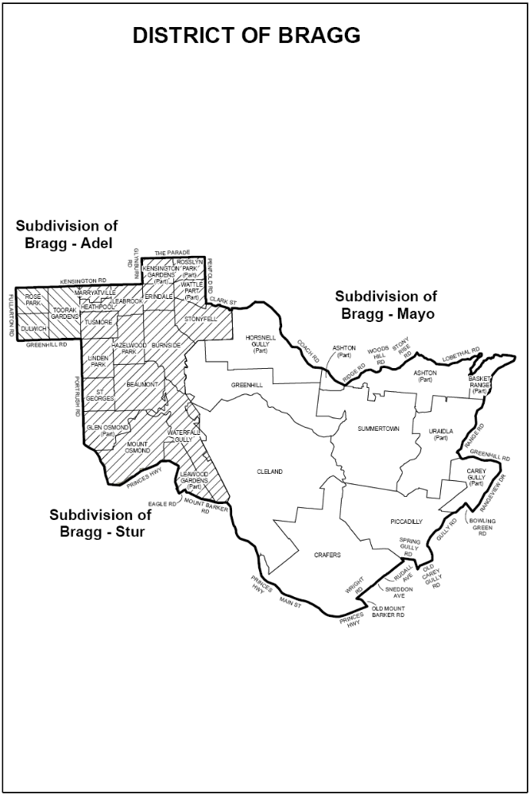
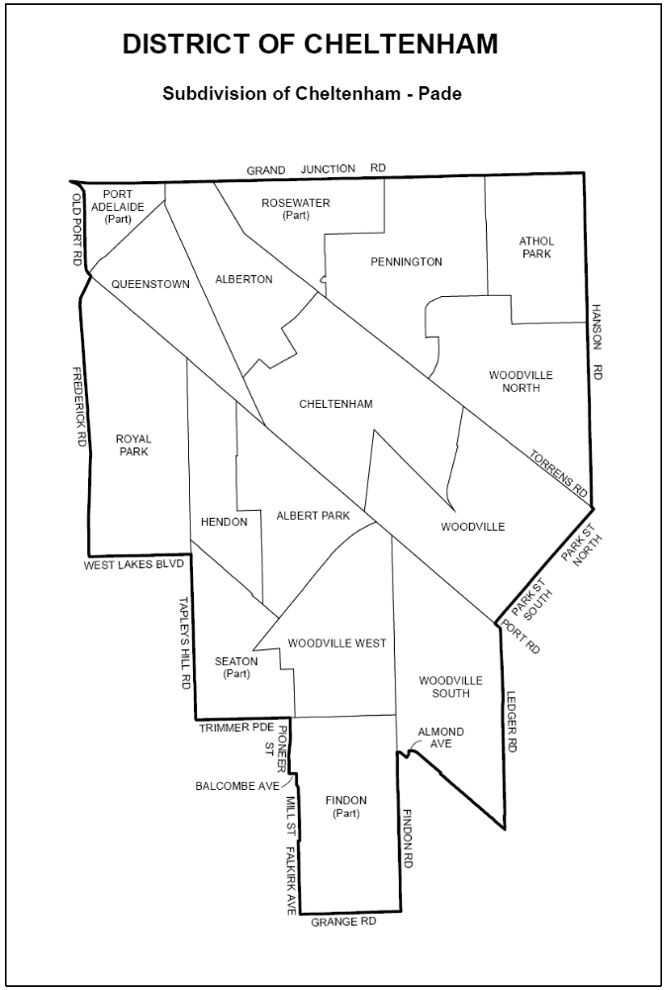
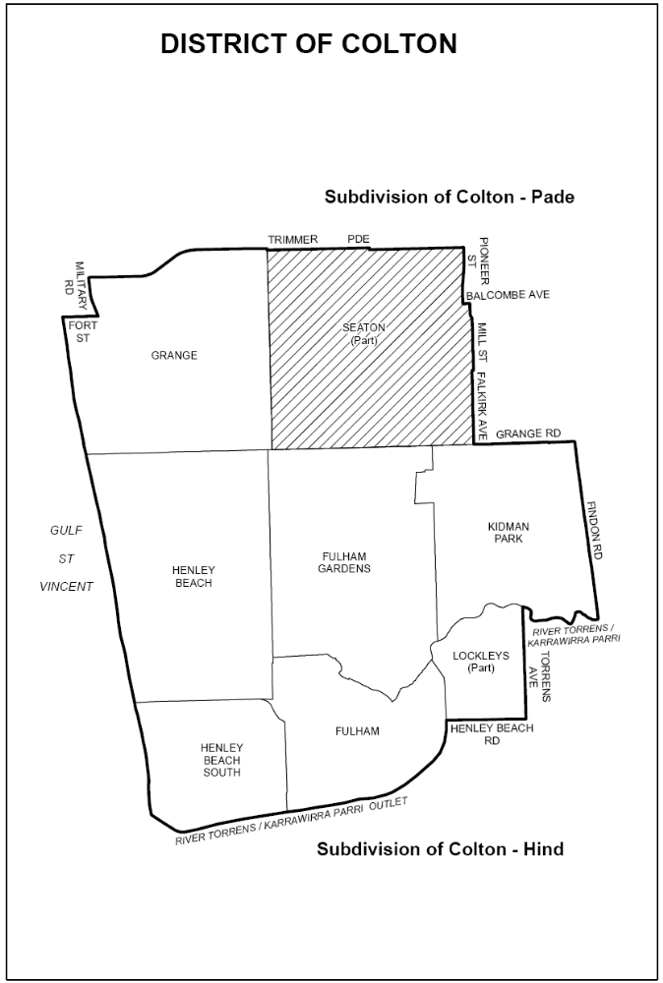
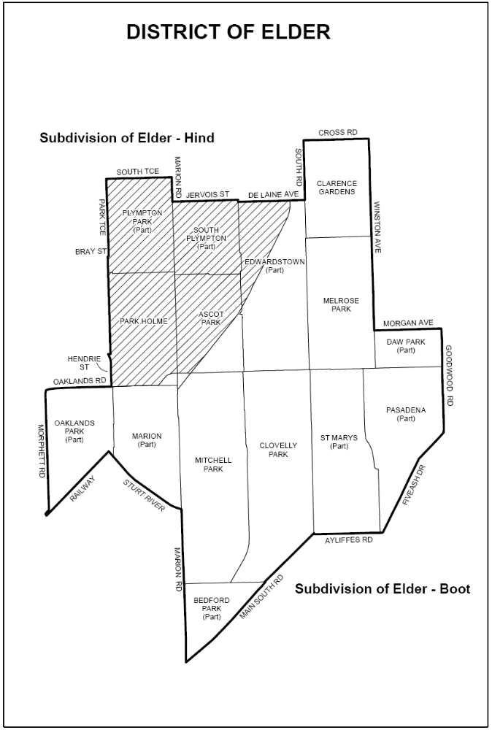
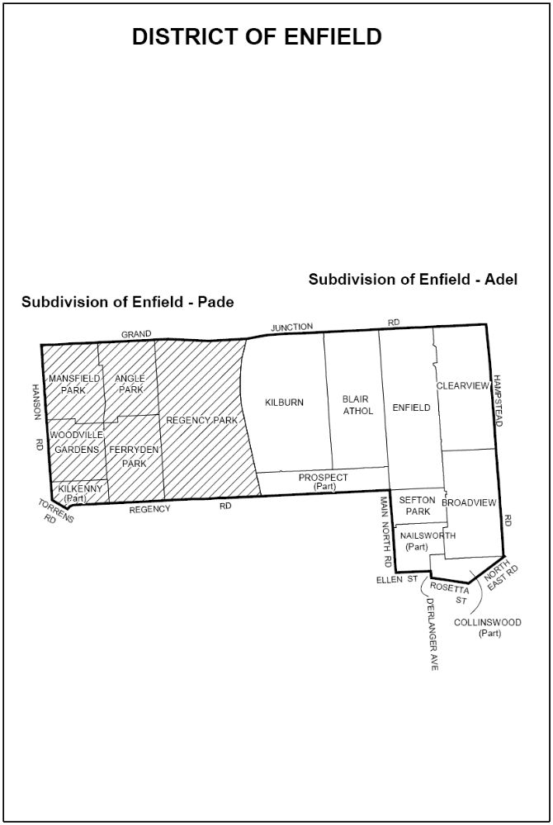
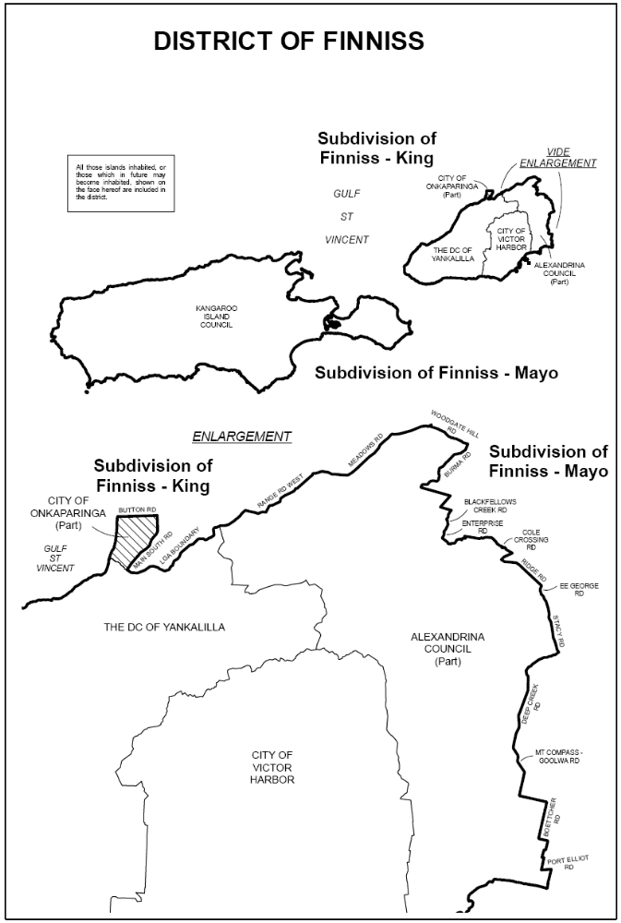
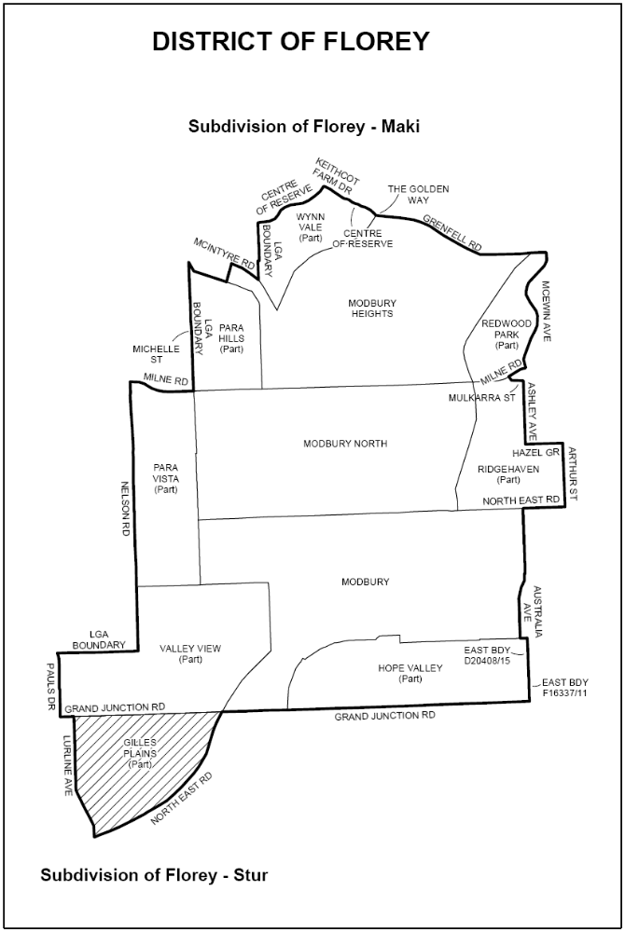
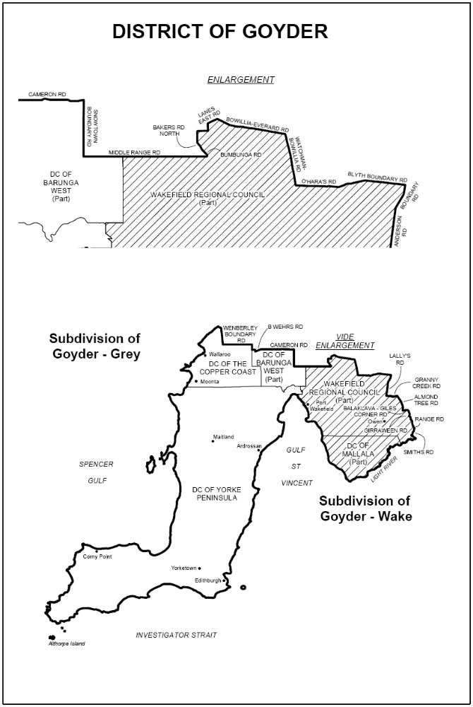
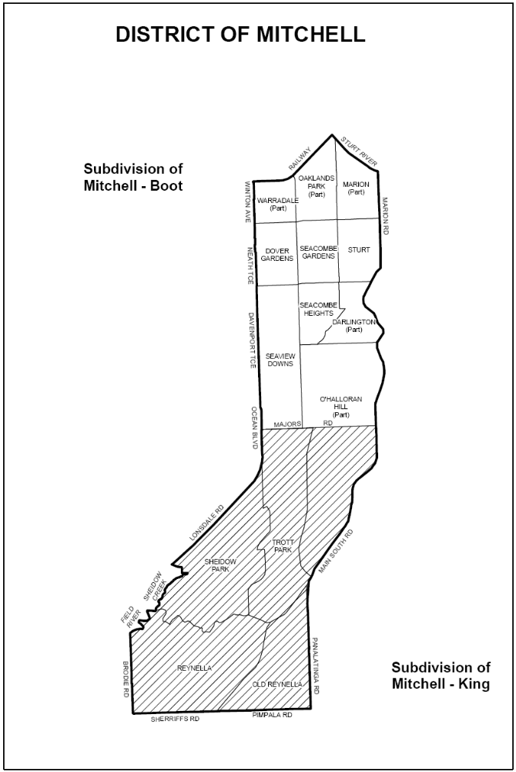
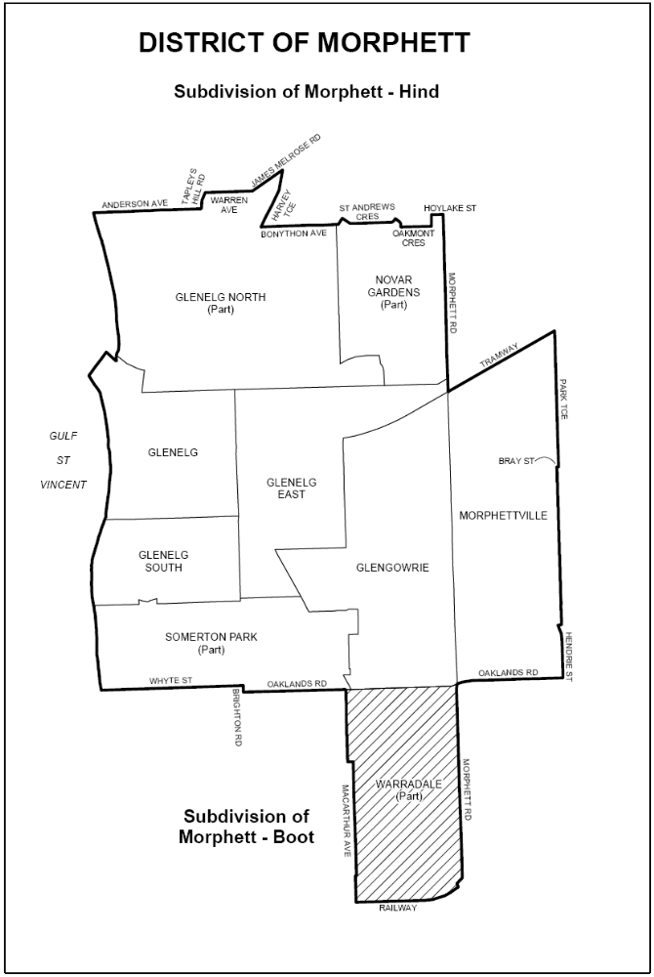
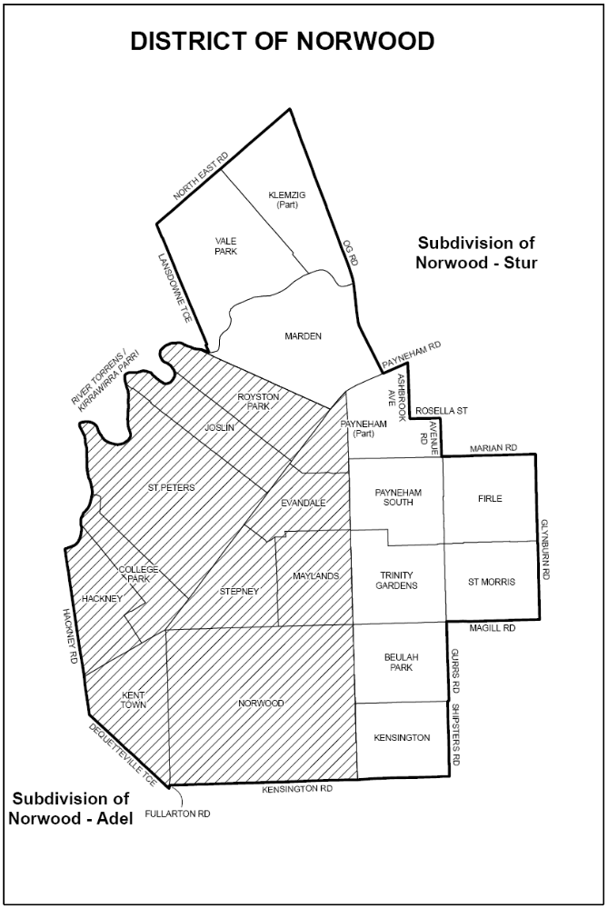
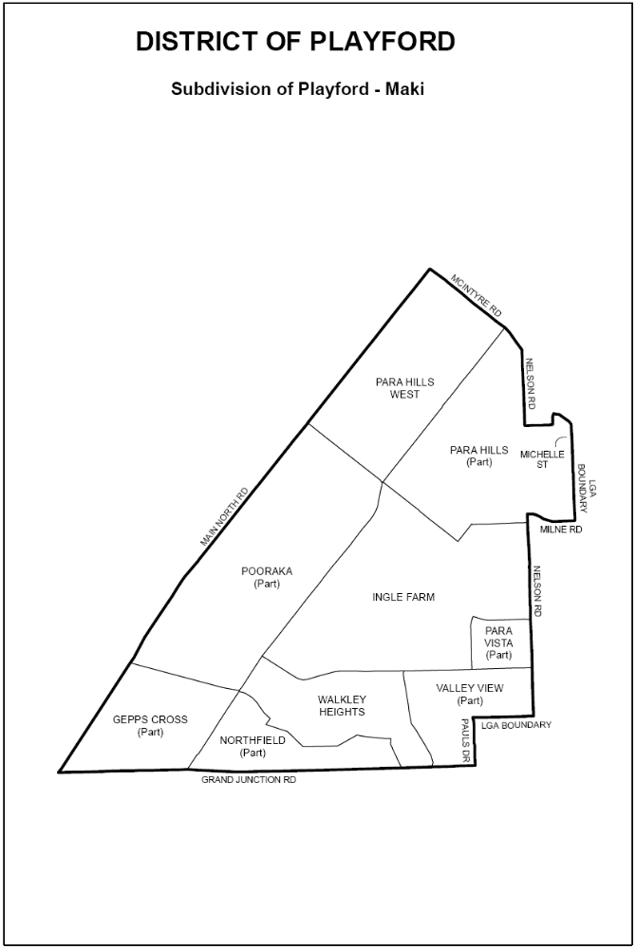
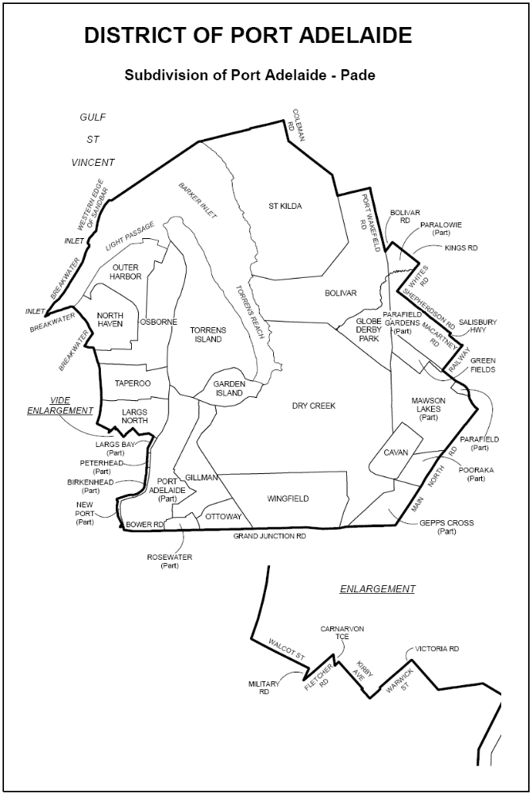
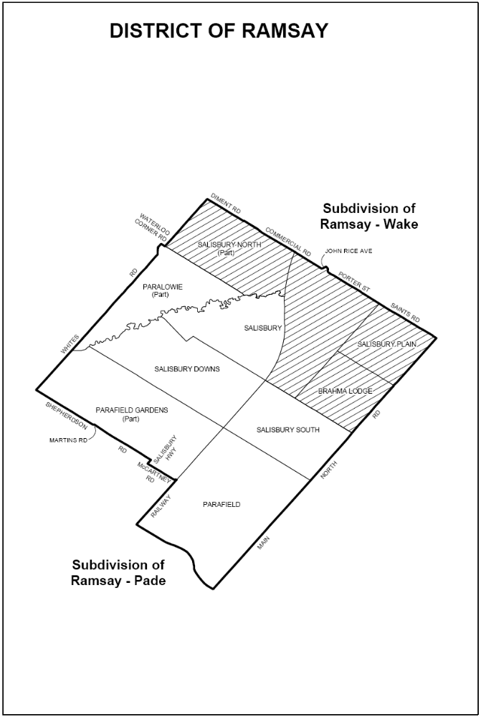
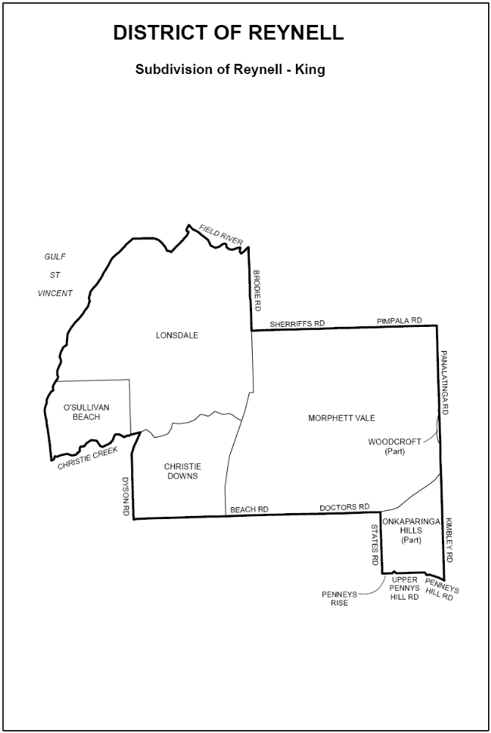
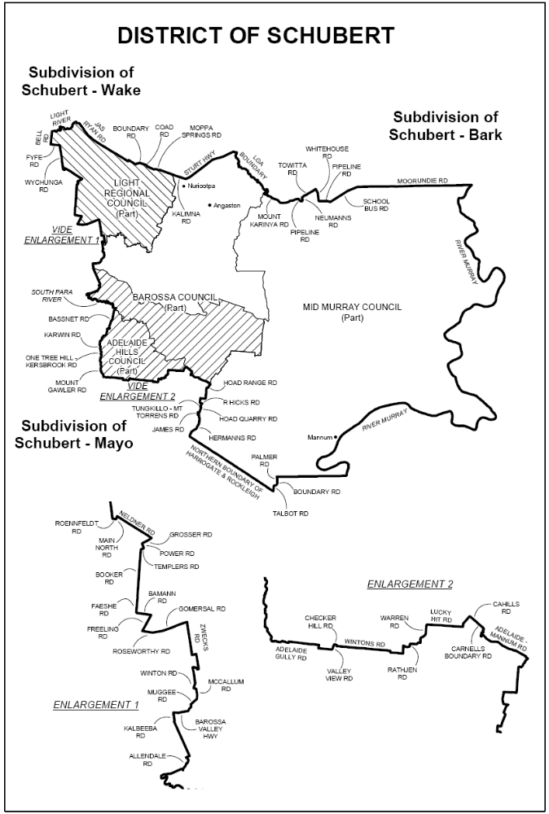
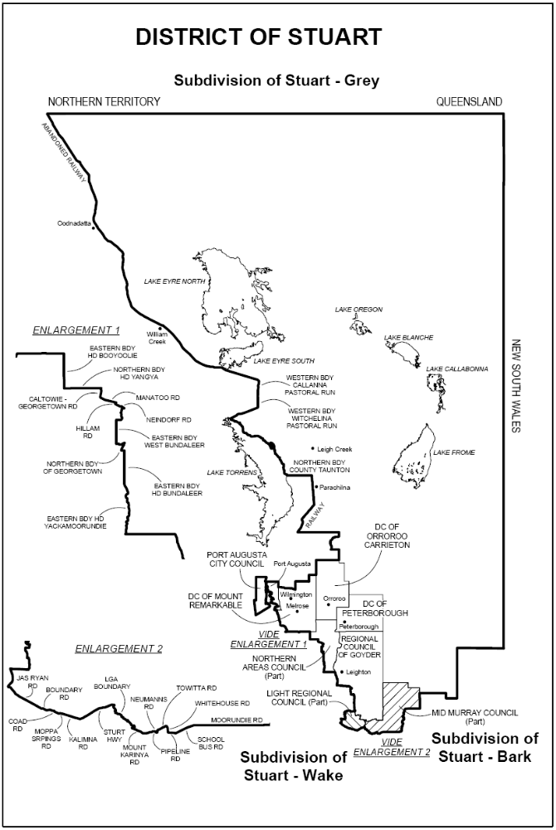
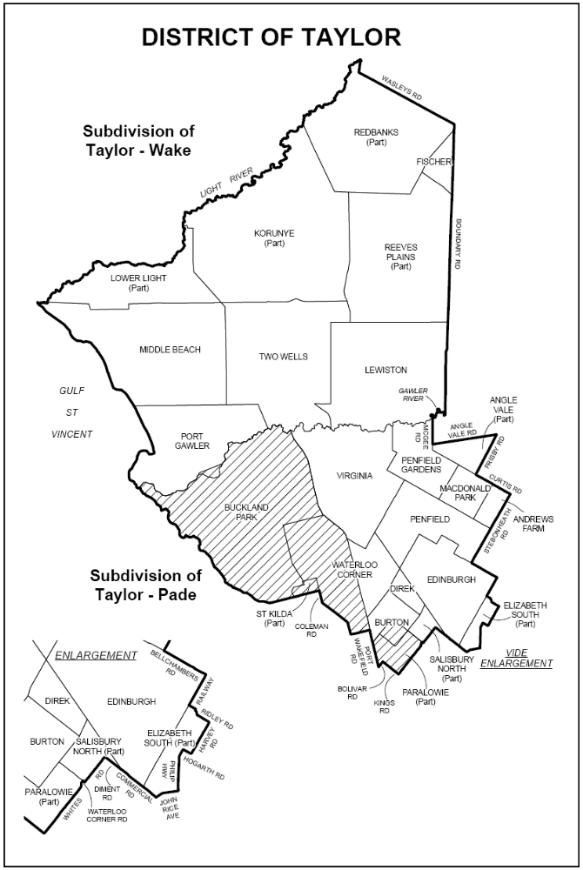
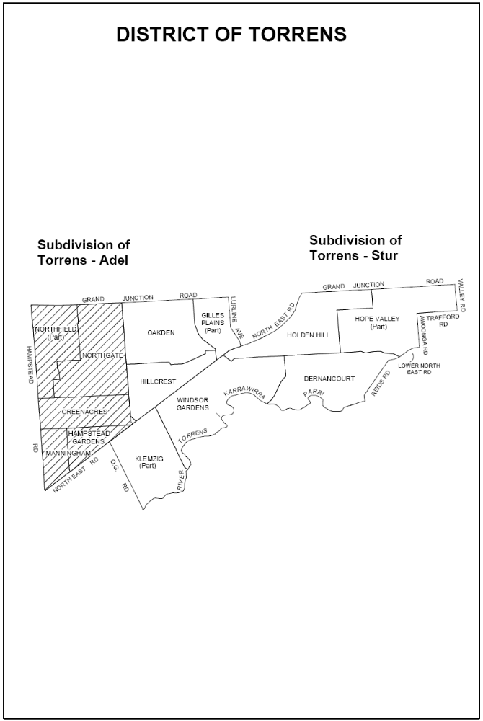
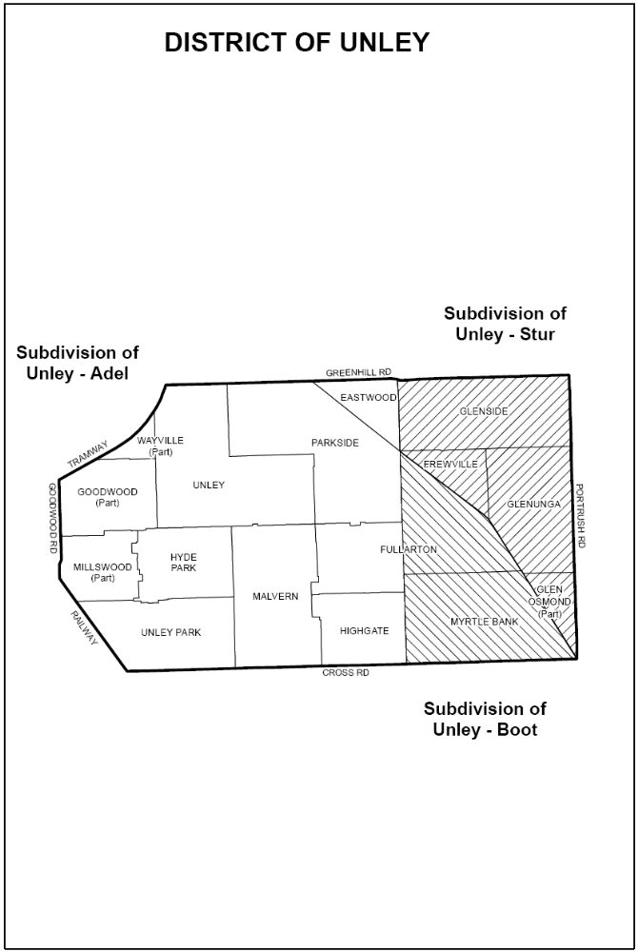
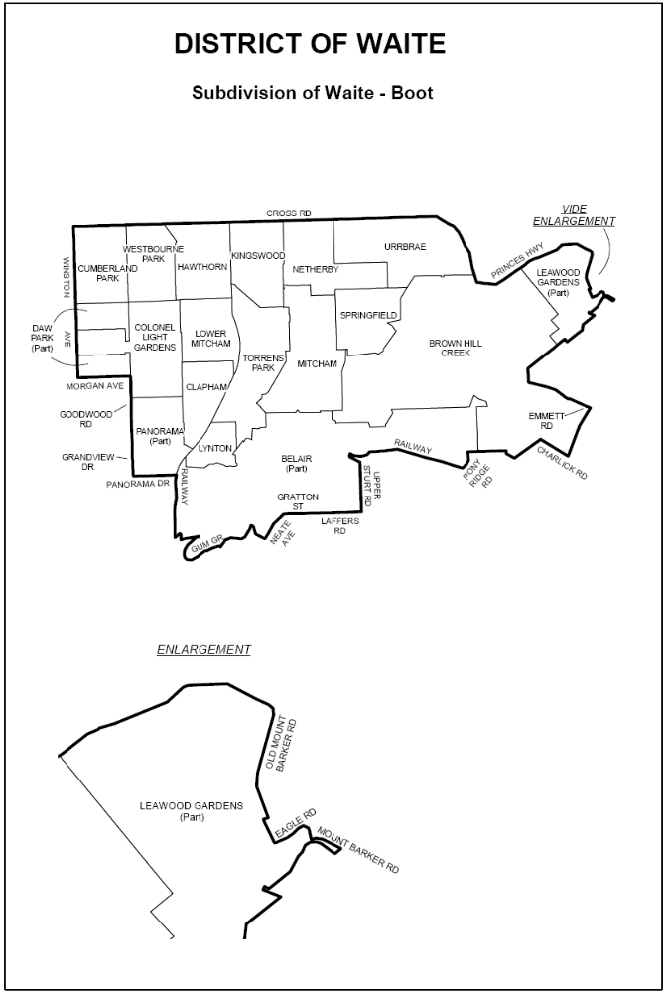
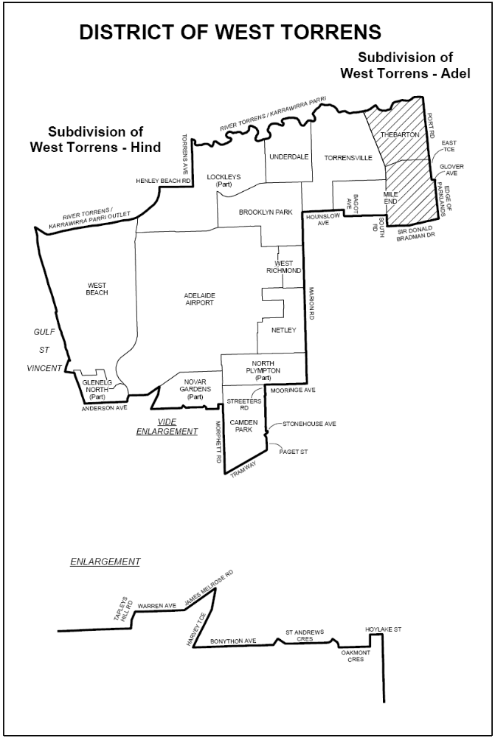
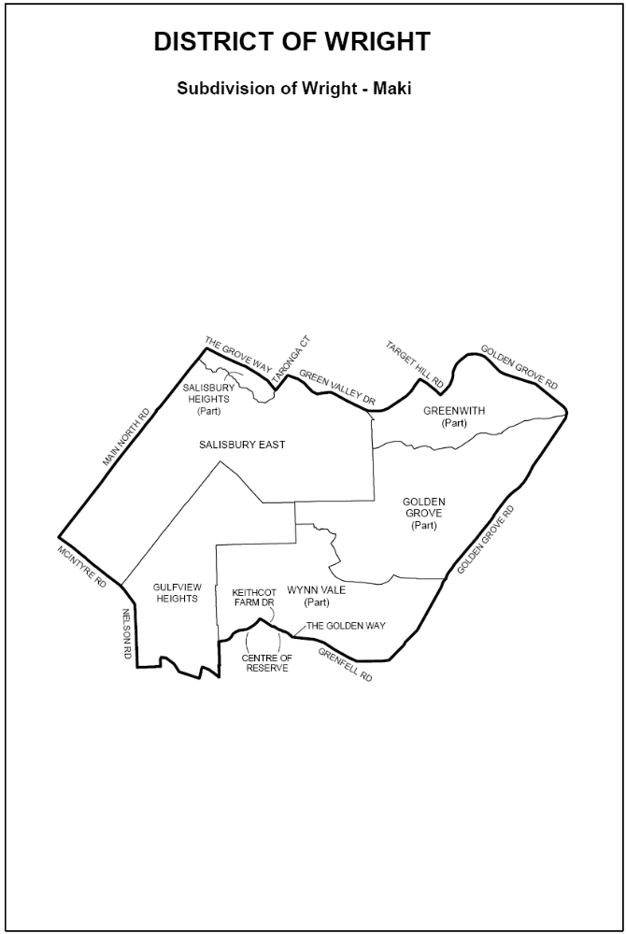
Dated 10 December 2009.
K. Mousley, Electoral Commissioner
ECSA 138/09

ENVIRONMENT PROTECTION ACT 1993
Approval of Category B Containers
I, ANDREA KAYE WOODS, Team Leader, Container Deposit Legislation and Delegate of the Environment Protection Authority (‘the Authority’), pursuant to section 68 of the Environment Protection Act 1993 (SA) (‘the Act’) hereby:
Approval of Category B Containers
Approve as Category B Containers, subject to the conditions in subclauses (1), (2), (3) and (4) below, each of the classes of containers identified by reference to the following matters described in the first 4 columns of Schedule 1 of this Notice which are sold in South Australia:
(a) the product which each class of containers shall contain;
(b) the size of the containers;
(c) the type of containers; and
(d) the name of the holders of these approvals.
(1) That containers of the class to which the approval relates must bear the refund marking specified by the Authority for containers of that class.
(2) The holder of the approval must have in place an effective and appropriate waste management arrangement in relation to containers of that class. For the purpose of this approval notice the company named in Column 5 of Schedule 1 of this Notice is the nominated super collector.
(3) In the case of an approval in relation to Category B containers that the waste management arrangement must require the holder of the approval to provide specified super collectors with a declaration in the form determined by the Authority in relation to each sale of such containers by the holder of the approval as soon as practicable after the sale.
(4) The holder of these approvals must ensure that if a sticker bearing the refund marking has been approved and is applied to the container, then the sticker must not be placed on any portion of the opening mechanism or in any other place that would require complete or partial removal of the sticker before the contents may be consumed.
Schedule 1

Column 1 | Column 2 |  | Column 3 |  | Column 4 |  | Column 5
Product Name | Container  Size (mL) |  | Container Type |  | Approval Holder |  | Collection  Arrangements
Ayam Natural Coconut Water with Pulp | 320 | Can—Steel |  | A. Clouet (Australia) Pty Ltd |  | Statewide Recycling
Lobethal Bierhaus Chocolate Oatmeal Stout | 330 | Glass |  | Adelaide Hills Craft Brewing Pty Ltd trading as Lobethal Bierhaus |  | Marine Stores Ltd
7 Cherry Up Antioxidant | 355 | Can—Aluminium |  | Charming Waters |  | Statewide Recycling
A&W Cream Soda | 355 | Can—Aluminium |  | Charming Waters |  | Statewide Recycling
Big Red Vanilla Float | 355 | Can—Aluminium |  | Charming Waters |  | Statewide Recycling
Blue Sky Organic Black Cherry Cherish | 355 | Can—Aluminium |  | Charming Waters |  | Statewide Recycling
Blue Sky Organic Ginger Ale | 355 | Can—Aluminium |  | Charming Waters |  | Statewide Recycling
Blue Sky Organic Lemon Lime | 355 | Can—Aluminium |  | Charming Waters |  | Statewide Recycling
Blue Sky Organic New Century Cola | 355 | Can—Aluminium |  | Charming Waters |  | Statewide Recycling
Blue Sky Organic Orange Divine | 355 | Can—Aluminium |  | Charming Waters |  | Statewide Recycling
Blue Sky Organic Root Beer Encore | 355 | Can—Aluminium |  | Charming Waters |  | Statewide Recycling
Dr Pepper Cherry | 355 | Can—Aluminium |  | Charming Waters |  | Statewide Recycling
Dr Pepper Cherry Vanilla | 355 | Can—Aluminium |  | Charming Waters |  | Statewide Recycling
Tango Apple | 330 | Can—Aluminium |  | Charming Waters |  | Statewide Recycling
Tango Cherry | 330 | Can—Aluminium |  | Charming Waters |  | Statewide Recycling
Tango Orange | 330 | Can—Aluminium |  | Charming Waters |  | Statewide Recycling
Vimto Fizzy | 330 | Can—Aluminium |  | Charming Waters |  | Statewide Recycling
Welchs Sparkling Grape Soda | 355 | Can—Aluminium |  | Charming Waters |  | Statewide Recycling
Welchs Sparkling Strawberry Soda | 355 | Can—Aluminium |  | Charming Waters |  | Statewide Recycling
Dai Viet Super 4.9% | 330 | Glass |  | Do Bottle Shop |  | Statewide Recycling
Maisels Weisse Alcohol Free 0.5% | 500 | Glass |  | Empire Liquor |  | Statewide Recycling
Hellena Lemonade | 1 250 | PET |  | Euro Dell Imports Pty Ltd |  | Marine Stores Ltd
Hortex Aronii Juice | 1 000 | LPB—Aseptic |  | Euro Dell Imports Pty Ltd |  | Marine Stores Ltd
Hortex Beetroot Apple Juice | 1 000 | LPB—Aseptic |  | Euro Dell Imports Pty Ltd |  | Marine Stores Ltd
Hortex Blackcurrant Juice | 1 000 | LPB—Aseptic |  | Euro Dell Imports Pty Ltd |  | Marine Stores Ltd
Hortex Grape Juice | 1 000 | LPB—Aseptic |  | Euro Dell Imports Pty Ltd |  | Marine Stores Ltd
Hortex Multifruit Juice | 1 000 | LPB—Aseptic |  | Euro Dell Imports Pty Ltd |  | Marine Stores Ltd
Hortex Multivitamina Juice | 1 000 | LPB—Aseptic |  | Euro Dell Imports Pty Ltd |  | Marine Stores Ltd
Hortex Red Grapefruit Juice | 1 000 | LPB—Aseptic |  | Euro Dell Imports Pty Ltd |  | Marine Stores Ltd
Hortex Sour Cherry Juice | 1 000 | LPB—Aseptic |  | Euro Dell Imports Pty Ltd |  | Marine Stores Ltd
Kubus Carrot Apple Banana Juice | 1000 | Glass |  | Euro Dell Imports Pty Ltd |  | Marine Stores Ltd
Kubus Carrot Apple Banana Juice | 330 | Glass |  | Euro Dell Imports Pty Ltd |  | Marine Stores Ltd
Kubus Carrot Apple Orange Juice | 1 000 | Glass |  | Euro Dell Imports Pty Ltd |  | Marine Stores Ltd
Kubus Carrot Apple Orange Juice | 330 | Glass |  | Euro Dell Imports Pty Ltd |  | Marine Stores Ltd
Kubus Carrot Apple Peach Juice | 1 000 | Glass |  | Euro Dell Imports Pty Ltd |  | Marine Stores Ltd
Kubus Carrot Apple Peach Juice | 330 | Glass |  | Euro Dell Imports Pty Ltd |  | Marine Stores Ltd
Kubus Carrot Apple Peach Juice | 330 | Glass |  | Euro Dell Imports Pty Ltd |  | Marine Stores Ltd
Kubus Carrot Apple Raspberry Juice | 1 000 | Glass |  | Euro Dell Imports Pty Ltd |  | Marine Stores Ltd
Kubus Carrot Apple Raspberry Juice | 330 | Glass |  | Euro Dell Imports Pty Ltd |  | Marine Stores Ltd
Kubus Carrot Apple Strawberry Juice | 1 000 | Glass |  | Euro Dell Imports Pty Ltd |  | Marine Stores Ltd
Kubus Carrot Apple Strawberry Juice | 330 | Glass |  | Euro Dell Imports Pty Ltd |  | Marine Stores Ltd
Kubus Kiwi Banana Juice | 1 000 | Glass |  | Euro Dell Imports Pty Ltd |  | Marine Stores Ltd
Muszynianksi Water | 1 500 | PET |  | Euro Dell Imports Pty Ltd |  | Marine Stores Ltd
Zywiec Lemon Mineral Water | 1 500 | PET |  | Euro Dell Imports Pty Ltd |  | Marine Stores Ltd
Zywiec Water | 1 500 | PET |  | Euro Dell Imports Pty Ltd |  | Marine Stores Ltd
Zywiec Water | 500 | PET |  | Euro Dell Imports Pty Ltd |  | Marine Stores Ltd
Cascade Stout Smooth and Rich | 375 | Glass |  | Fosters Australia |  | Marine Stores Ltd
Pure Blonde Naked | 375 | Can—Aluminium |  | Fosters Australia |  | Marine Stores Ltd
Maiden Ale | 650 | Glass |  | Fresh Cellars trading as Brewboys |  | Marine Stores Ltd
Fanta Strawberry | 330 | Can—Aluminium |  | Funworks |  | Flagcan Distributors
Mountain Dew Code Red | 330 | Can—Aluminium |  | Funworks |  | Flagcan Distributors
Mountain Dew Voltage | 330 | Can—Aluminium |  | Funworks |  | Flagcan Distributors
Pepsi Wild Cherry | 330 | Can—Aluminium |  | Funworks |  | Flagcan Distributors
Nekta Liquid Kiwi Fruit | 1 250 | Glass |  | Holmac Sales Pty Ltd |  | Marine Stores Ltd
Froopers Apple & Blackcurrant Fruit Drink | 200 | HDPE |  | Intertrading Australia Pty Ltd |  | Statewide Recycling
Froopers Apple & Blackcurrant Fruit Drink | 250 | HDPE |  | Intertrading Australia Pty Ltd |  | Statewide Recycling
Froopers Apple Fruit Drink | 250 | HDPE |  | Intertrading Australia Pty Ltd |  | Statewide Recycling
Froopers Apple Fruit Drink | 200 | HDPE |  | Intertrading Australia Pty Ltd |  | Statewide Recycling
Froopers Apple Raspberry Flavoured Fruit Dink | 200 | HDPE |  | Intertrading Australia Pty Ltd |  | Statewide Recycling
Froopers Looney Tunes Orange Fruit Drink | 200 | HDPE |  | Intertrading Australia Pty Ltd |  | Statewide Recycling
Froopers Looney Tunes Tropical Fruit Drink | 200 | HDPE |  | Intertrading Australia Pty Ltd |  | Statewide Recycling
Froopers Orange Fruit Drink | 200 | HDPE |  | Intertrading Australia Pty Ltd |  | Statewide Recycling
Froopers Peach & Strawberry Flavoured Fruit Drink | 200 | HDPE |  | Intertrading Australia Pty Ltd |  | Statewide Recycling
Froopers Tropical Fruit Drink | 200 | HDPE |  | Intertrading Australia Pty Ltd |  | Statewide Recycling
Aleve Blood Orange | 330 | Glass |  | L Z Enterprises Pty Ltd |  | Statewide Recycling
Aleve Dragonfruit Lime | 330 | Glass |  | L Z Enterprises Pty Ltd |  | Statewide Recycling
Aleve Passionfruit | 330 | Glass |  | L Z Enterprises Pty Ltd |  | Statewide Recycling
Aleve Pink Grapefruit | 330 | Glass |  | L Z Enterprises Pty Ltd |  | Statewide Recycling
Aleve Raspberry Cranberry | 330 | Glass |  | L Z Enterprises Pty Ltd |  | Statewide Recycling
Amuse Blueberry Water | 380 | PET |  | L Z Enterprises Pty Ltd |  | Statewide Recycling
Amuse Fruit Delight Water | 380 | PET |  | L Z Enterprises Pty Ltd |  | Statewide Recycling
Amuse Raspberry Water | 380 | PET |  | L Z Enterprises Pty Ltd |  | Statewide Recycling
Barbie Peach Strawberry Flavoured Fruit Drink | 250 | PET |  | L Z Enterprises Pty Ltd |  | Statewide Recycling
Barbie Raspberry Flavoured Fruit Drink | 250 | PET |  | L Z Enterprises Pty Ltd |  | Statewide Recycling
Barbie Tropical Flavoured Fruit Drink | 250 | PET |  | L Z Enterprises Pty Ltd |  | Statewide Recycling
Ben 10 Lime Flavoured Fruit Drink | 250 | PET |  | L Z Enterprises Pty Ltd |  | Statewide Recycling
Ben 10 Orange Flavoured Fruit Drink | 250 | PET |  | L Z Enterprises Pty Ltd |  | Statewide Recycling
Ben 10 Raspberry Flavoured Fruit Drink | 250 | PET |  | L Z Enterprises Pty Ltd |  | Statewide Recycling
Bob The Builder Apple Blackcurrant Flavoured Fruit Drink | 250 | PET |  | L Z Enterprises Pty Ltd |  | Statewide Recycling
Diego Raspberry Flavoured Fruit Drink | 250 | PET |  | L Z Enterprises Pty Ltd |  | Statewide Recycling
Dora Apple Blackcurrant Flavoured Fruit Drink | 250 | PET |  | L Z Enterprises Pty Ltd |  | Statewide Recycling
Dora Peach Strawberry Flavoured Fruit Drink | 250 | PET |  | L Z Enterprises Pty Ltd |  | Statewide Recycling
Dora Tropical Flavoured Fruit Drink | 250 | PET |  | L Z Enterprises Pty Ltd |  | Statewide Recycling
Hulk Wild Berry Flavoured Fruit Drink | 300 | PET |  | L Z Enterprises Pty Ltd |  | Statewide Recycling
Spiderman Apple Blackcurrant Flavoured Fruit Drink | 300 | PET |  | L Z Enterprises Pty Ltd |  | Statewide Recycling
Strawberry Shortcake Apple Strawberry Flavoured Fruit Drink | 250 | PET |  | L Z Enterprises Pty Ltd |  | Statewide Recycling
Strawberry Shortcake Peach Flavoured Fruit Drink | 250 | PET |  | L Z Enterprises Pty Ltd |  | Statewide Recycling
Thomas The Tank Apple Flavoured Fruit Drink | 250 | PET |  | L Z Enterprises Pty Ltd |  | Statewide Recycling
Transformers Lime Flavoured Fruit Drink | 300 | PET |  | L Z Enterprises Pty Ltd |  | Statewide Recycling
Transformers Orange Flavoured Fruit Drink | 300 | PET |  | L Z Enterprises Pty Ltd |  | Statewide Recycling
Transformers Raspberry Flavoured Fruit Drink | 300 | PET |  | L Z Enterprises Pty Ltd |  | Statewide Recycling
Wolverine Apple Blackcurrant Flavoured Fruit Drink | 300 | PET |  | L Z Enterprises Pty Ltd |  | Statewide Recycling
Budweiser | 355 | Can—Aluminium |  | Lion Nathan Australia Limited |  | Marine Stores Ltd
Budweiser | 355 | Glass |  | Lion Nathan Australia Limited |  | Marine Stores Ltd
Mangrove Mountain Springs Organic | 350 | PET |  | Mangrove Mountain Springs Pty Ltd |  | Marine Stores Ltd
Mangrove Mountain Springs Organic Pure Natural Spring Water | 600 | PET |  | Mangrove Mountain Springs Pty Ltd |  | Marine Stores Ltd
Mangrove Mountain Springs Pure Natrual Spring Water | 1 500 | PET |  | Mangrove Mountain Springs Pty Ltd |  | Marine Stores Ltd
Mangrove Mountain Springs Pure Natural Spring Water | 3 000 | PET |  | Mangrove Mountain Springs Pty Ltd |  | Marine Stores Ltd
Horleys Pro Fit Chocolate Flavoured Dairy Drink | 250 | LPB—Aseptic |  | Naturalac Nutrition Ltd trading as Horleys |  | Statewide Recycling
Horleys Pro Fit Strawberry Flavoured Dairy Drink | 250 | LPB—Aseptic |  | Naturalac Nutrition Ltd trading as Horleys |  | Statewide Recycling
Horleys Pro Fit Vanilla Flavoured Dairy Drink | 250 | LPB—Aseptic |  | Naturalac Nutrition Ltd trading as Horleys |  | Statewide Recycling
Horleys Protein Hit Double Chocolate | 375 | LPB—Aseptic |  | Naturalac Nutrition Ltd trading as Horleys |  | Statewide Recycling
Horleys Sculpt Chocolate Flavour | 250 | LPB—Aseptic |  | Naturalac Nutrition Ltd trading as Horleys |  | Statewide Recycling
Horleys Sculpt Vanilla Flavour | 250 | LPB—Aseptic |  | Naturalac Nutrition Ltd trading as Horleys |  | Statewide Recycling
Zywiec Beer | 500 | Can—Aluminium |  | Negro International Pty Ltd |  | Marine Stores Ltd
Hawaiian Noni Fruit Drink | 1 000 | HDPE |  | Neways International Australia Pty Ltd |  | Statewide Recycling
7Up Cherry | 330 | Can—Aluminium |  | Nonnel Pty Ltd trading as Lollipops Wholesale |  | Flagcan Distributors
Abbot Ginger Beer | 330 | Can—Aluminium |  | Nonnel Pty Ltd trading as Lollipops Wholesale |  | Flagcan Distributors
American Cream Soda | 330 | Can—Aluminium |  | Nonnel Pty Ltd trading as Lollipops Wholesale |  | Flagcan Distributors
Ben Shaw Dandelion & Burdock | 330 | Can—Aluminium |  | Nonnel Pty Ltd trading as Lollipops Wholesale |  | Flagcan Distributors
Cherry Coke | 330 | Can—Aluminium |  | Nonnel Pty Ltd trading as Lollipops Wholesale |  | Flagcan Distributors
D & G Old Jamaica Ginger Beer | 330 | Can—Aluminium |  | Nonnel Pty Ltd trading as Lollipops Wholesale |  | Flagcan Distributors
Dandelion & Burdock | 330 | Can—Aluminium |  | Nonnel Pty Ltd trading as Lollipops Wholesale |  | Flagcan Distributors
Dr Pepper | 330 | Can—Aluminium |  | Nonnel Pty Ltd trading as Lollipops Wholesale |  | Flagcan Distributors
IRN Bru | 330 | Can—Aluminium |  | Nonnel Pty Ltd trading as Lollipops Wholesale |  | Flagcan Distributors
Tango Cherry | 330 | Can—Aluminium |  | Nonnel Pty Ltd trading as Lollipops Wholesale |  | Flagcan Distributors
Tango Orange | 330 | Can—Aluminium |  | Nonnel Pty Ltd trading as Lollipops Wholesale |  | Flagcan Distributors
Tizer | 330 | Can—Aluminium |  | Nonnel Pty Ltd trading as Lollipops Wholesale |  | Flagcan Distributors
Vimto Sparkling | 330 | Can—Aluminium |  | Nonnel Pty Ltd trading as Lollipops Wholesale |  | Flagcan Distributors
Whole Kids Organic Juice Fresh Apple & Blackcurrant | 250 | LPB—Aseptic |  | Nourish Foods Pty Ltd |  | Statewide Recycling
Whole Kids Organic Juice Fresh Apple & Pear | 250 | LPB—Aseptic |  | Nourish Foods Pty Ltd |  | Statewide Recycling
Cherry Coke | 355 | Can—Aluminium |  | Nutcracker Sweet |  | Statewide Recycling
Dr Pepper | 355 | Can—Aluminium |  | Nutcracker Sweet |  | Statewide Recycling
Grape Fanta | 355 | Can—Aluminium |  | Nutcracker Sweet |  | Statewide Recycling
Smart Juice Tropical Fruit & Veg | 400 | PET |  | P & N Beverages Australia Pty Ltd |  | Flagcan Distributors
Tru Blu Brewers Choice Ginger Beer | 1 250 | PET |  | P & N Beverages Australia Pty Ltd |  | Flagcan Distributors
Tru Blu Ceda Creaming Soda | 2 250 | PET |  | P & N Beverages Australia Pty Ltd |  | Flagcan Distributors
Tru Blu Ceda Creaming Soda | 1 250 | PET |  | P & N Beverages Australia Pty Ltd |  | Flagcan Distributors
Tru Blu Ceda Creaming Soda | 2 000 | PET |  | P & N Beverages Australia Pty Ltd |  | Flagcan Distributors
Tru Blu Club Dry Ginger Ale | 1 250 | PET |  | P & N Beverages Australia Pty Ltd |  | Flagcan Distributors
Tru Blu Club Lemon Lime Bitters | 1 250 | PET |  | P & N Beverages Australia Pty Ltd |  | Flagcan Distributors
Tru Blu Club Soda Water | 1 250 | PET |  | P & N Beverages Australia Pty Ltd |  | Flagcan Distributors
Tru Blu Club Tonic Water | 1 250 | PET |  | P & N Beverages Australia Pty Ltd |  | Flagcan Distributors
Tru Blu Crush Lime | 1 250 | PET |  | P & N Beverages Australia Pty Ltd |  | Flagcan Distributors
Tru Blu Crush Orange | 2 250 | PET |  | P & N Beverages Australia Pty Ltd |  | Flagcan Distributors
Tru Blu Crush Orange | 2 000 | PET |  | P & N Beverages Australia Pty Ltd |  | Flagcan Distributors
Tru Blu Crush Orange | 1 250 | PET |  | P & N Beverages Australia Pty Ltd |  | Flagcan Distributors
Tru Blu Crush Passion | 2 250 | PET |  | P & N Beverages Australia Pty Ltd |  | Flagcan Distributors
Tru Blu Crush Passion | 1 250 | PET |  | P & N Beverages Australia Pty Ltd |  | Flagcan Distributors
Tru Blu Crush Pine | 2 250 | PET |  | P & N Beverages Australia Pty Ltd |  | Flagcan Distributors
Tru Blu Crush Pine | 1 250 | PET |  | P & N Beverages Australia Pty Ltd |  | Flagcan Distributors
Tru Blu Crush Pine | 2 000 | PET |  | P & N Beverages Australia Pty Ltd |  | Flagcan Distributors
Tru Blu Diet Crush Orange | 1 250 | PET |  | P & N Beverages Australia Pty Ltd |  | Flagcan Distributors
Tru Blu Diet Crush Passion | 1 250 | PET |  | P & N Beverages Australia Pty Ltd |  | Flagcan Distributors
Tru Blu Diet Pub Squash Lemon Soda Squash | 1 250 | PET |  | P & N Beverages Australia Pty Ltd |  | Flagcan Distributors
Tru Blu H2O | 600 | PET |  | P & N Beverages Australia Pty Ltd |  | Flagcan Distributors
Tru Blu Lido Lemonade | 2 250 | PET |  | P & N Beverages Australia Pty Ltd |  | Flagcan Distributors
Tru Blu Lido Lemonade | 1 250 | PET |  | P & N Beverages Australia Pty Ltd |  | Flagcan Distributors
Tru Blu Lido Lemonade | 2 000 | PET |  | P & N Beverages Australia Pty Ltd |  | Flagcan Distributors
Tru Blu McSars Double Sars Sarsaparilla | 2 000 | PET |  | P & N Beverages Australia Pty Ltd |  | Flagcan Distributors
Tru Blu The Original Pub Squash Lemon Soda Squash | 2 250 | PET |  | P & N Beverages Australia Pty Ltd |  | Flagcan Distributors
Tru Blu The Original Pub Squash Lemon Soda Squash | 1 250 | PET |  | P & N Beverages Australia Pty Ltd |  | Flagcan Distributors
Arundel Sussex Gold | 500 | Glass |  | Palais Imports |  | Marine Stores Ltd
Belvoir Old Dalby | 500 | Glass |  | Palais Imports |  | Marine Stores Ltd
Camerons Monkey Stout | 500 | Glass |  | Palais Imports |  | Marine Stores Ltd
Camerons Strongarm | 500 | Glass |  | Palais Imports |  | Marine Stores Ltd
Coach House Blueberry | 500 | Glass |  | Palais Imports |  | Marine Stores Ltd
Cotleigh Barn Owl | 500 | Glass |  | Palais Imports |  | Marine Stores Ltd
Cotleigh Golden Seahawk | 500 | Glass |  | Palais Imports |  | Marine Stores Ltd
Crouch Vale Amarillo | 500 | Glass |  | Palais Imports |  | Marine Stores Ltd
Cwmbran Full Malty | 500 | Glass |  | Palais Imports |  | Marine Stores Ltd
Dark Star Espresso Stout | 500 | Glass |  | Palais Imports |  | Marine Stores Ltd
Dorset Chesil | 500 | Glass |  | Palais Imports |  | Marine Stores Ltd
Dorset Jurassic | 500 | Glass |  | Palais Imports |  | Marine Stores Ltd
Felinfoel Double Dragon | 500 | Glass |  | Palais Imports |  | Marine Stores Ltd
Goffs Black Knight Ale | 500 | Glass |  | Palais Imports |  | Marine Stores Ltd
Goffs Jouster Ale | 500 | Glass |  | Palais Imports |  | Marine Stores Ltd
Grainstore Rutland Panther | 500 | Glass |  | Palais Imports |  | Marine Stores Ltd
Grainstore Ten Fifty | 500 | Glass |  | Palais Imports |  | Marine Stores Ltd
Pottons Shambles | 500 | Glass |  | Palais Imports |  | Marine Stores Ltd
Pottons Village Bike | 500 | Glass |  | Palais Imports |  | Marine Stores Ltd
RCH Firebox Bitter | 500 | Glass |  | Palais Imports |  | Marine Stores Ltd
RCH Old Slug | 500 | Glass |  | Palais Imports |  | Marine Stores Ltd
Whittingtons Cats Whiskers | 500 | Glass |  | Palais Imports |  | Marine Stores Ltd
Woods Hopping Mad | 500 | Glass |  | Palais Imports |  | Marine Stores Ltd
Woods Shropshire Lad | 500 | Glass |  | Palais Imports |  | Marine Stores Ltd
Fever Tree Premium Lemon Tonic | 200 | Glass |  | Rio Coffee Pty Ltd |  | Statewide Recycling
Fever Tree Spring Soda Water | 200 | Glass |  | Rio Coffee Pty Ltd |  | Statewide Recycling
Zuegg Skipper 100% Apple | 200 | Glass |  | Rio Coffee Pty Ltd |  | Statewide Recycling
Zuegg Skipper 100% Brasil | 200 | Glass |  | Rio Coffee Pty Ltd |  | Statewide Recycling
Zuegg Skipper 100% Grapefruit | 200 | Glass |  | Rio Coffee Pty Ltd |  | Statewide Recycling
Zuegg Skipper 100% Orange | 200 | Glass |  | Rio Coffee Pty Ltd |  | Statewide Recycling
Zuegg Skipper 100% Pineapple | 200 | Glass |  | Rio Coffee Pty Ltd |  | Statewide Recycling
Zuegg Skipper ACE | 200 | Glass |  | Rio Coffee Pty Ltd |  | Statewide Recycling
Zuegg Skipper Apricot | 200 | Glass |  | Rio Coffee Pty Ltd |  | Statewide Recycling
Zuegg Skipper Blood Orange | 200 | Glass |  | Rio Coffee Pty Ltd |  | Statewide Recycling
Zuegg Skipper Kiwi and Apple | 200 | Glass |  | Rio Coffee Pty Ltd |  | Statewide Recycling
Zuegg Skipper Peach | 200 | Glass |  | Rio Coffee Pty Ltd |  | Statewide Recycling
Zuegg Skipper Pear | 200 | Glass |  | Rio Coffee Pty Ltd |  | Statewide Recycling
Magners Irish Cider | 568 | Glass |  | Suntory (Aust) Pty Ltd |  | Statewide Recycling
Magners Pear | 568 | Glass |  | Suntory (Aust) Pty Ltd |  | Statewide Recycling
Midori & Lemonade | 300 | Can—Aluminium |  | Suntory (Aust) Pty Ltd |  | Statewide Recycling
Aquaessence Alkaline Spring Water Anti Oxidant Infused | 350 | Guala Pack |  | Water for Life Pty Ltd |  | Statewide Recycling
Aquaessence Alkaline Spring Water Anti Oxidant Infused | 600 | Guala Pack |  | Water for Life Pty Ltd |  | Statewide Recycling

GOVERNMENT GAZETTE ADVERTISEMENT RATES

To apply from 1 July 2009

$  Agents, Ceasing to Act as 42.75  Associations:  Incorporation 21.70  Intention of Incorporation 53.50  Transfer of Properties 53.50  Attorney, Appointment of 42.75  Bailiff’s Sale 53.50  Cemetery Curator Appointed 31.75  Companies:  Alteration to Constitution 42.75  Capital, Increase or Decrease of 53.50  Ceasing to Carry on Business 31.75  Declaration of Dividend 31.75  Incorporation 42.75  Lost Share Certificates:  First Name 31.75  Each Subsequent Name 10.90  Meeting Final 35.75  Meeting Final Regarding Liquidator’s Report on  Conduct of Winding Up (equivalent to ‘Final  Meeting’)  First Name 42.75  Each Subsequent Name 10.90  Notices:  Call 53.50  Change of Name 21.70  Creditors 42.75  Creditors Compromise of Arrangement 42.75  Creditors (extraordinary resolution that ‘the Com-pany be wound up voluntarily and that a liquidator be appointed’) 53.50  Release of Liquidator⎯Application⎯Large Ad. 85.00  ⎯Release Granted 53.50  Receiver and Manager Appointed 49.50  Receiver and Manager Ceasing to Act 42.75  Restored Name 40.00  Petition to Supreme Court for Winding Up 74.50  Summons in Action 63.50  Order of Supreme Court for Winding Up Action 42.75  Register of Interests⎯Section 84 (1) Exempt 96.00  Removal of Office 21.70  Proof of Debts 42.75  Sales of Shares and Forfeiture 42.75  Estates:  Assigned 31.75  Deceased Persons⎯Notice to Creditors, etc. 53.50  Each Subsequent Name 10.90  Deceased Persons⎯Closed Estates 31.75  Each Subsequent Estate 1.40  Probate, Selling of 42.75  Public Trustee, each Estate 10.90 |  | $  Firms:  Ceasing to Carry on Business (each insertion) 28.50  Discontinuance Place of Business 28.50  Land⎯Real Property Act:  Intention to Sell, Notice of 53.50  Lost Certificate of Title Notices 53.50  Cancellation, Notice of (Strata Plan) 53.50  Mortgages:  Caveat Lodgement 21.70  Discharge of 22.70  Foreclosures 21.70  Transfer of 21.70  Sublet 10.90  Leases⎯Application for Transfer (2 insertions) each 10.90  Lost Treasury Receipts (3 insertions) each 31.75  Licensing 63.50  Municipal or District Councils:  Annual Financial Statement⎯Forms 1 and 2 598.00  Electricity Supply⎯Forms 19 and 20 425.00  Default in Payment of Rates:  First Name 85.00  Each Subsequent Name 10.90  Noxious Trade 31.75  Partnership, Dissolution of 31.75  Petitions (small) 21.70  Registered Building Societies (from Registrar-  General) 21.70  Register of Unclaimed Moneys⎯First Name 31.75  Each Subsequent Name 10.90  Registers of Members⎯Three pages and over:  Rate per page (in 8pt) 272.00  Rate per page (in 6pt) 359.00  Sale of Land by Public Auction 54.00  Advertisements 3.00  ¼ page advertisement 127.00  ½ page advertisement 254.00  Full page advertisement 498.00  Advertisements, other than those listed are charged at $3.00 per column line, tabular one-third extra.  Notices by Colleges, Universities, Corporations and District Councils to be charged at $3.00 per line.  Where the notice inserted varies significantly in length from that which is usually published a charge of $3.00 per column line will be applied in lieu of advertisement rates listed.  South Australian Government publications are sold on the condition that they will not be reproduced without prior permission from the Government Printer.
All the above prices include GST

GOVERNMENT GAZETTE NOTICES
ALL private advertisements forwarded for publication in the South Australian Government Gazette must be PAID FOR PRIOR TO INSERTION; and all notices, from whatever source, should be legibly written on one side of the paper only and sent to Government Publishing SA so as to be received no later than 4 p.m. Tuesday preceding the day of publication. Phone 8207 1045 or Fax 8207 1040. E-mail: governmentgazette@dpc.sa.gov.au. Send as attachments in Word format. Please include date the notice is to be published and to whom the notice will be charged. The Government Gazette is available online at: www.governmentgazette.sa.gov.au.

MISCELLANEOUS LEGISLATION AND GOVERNMENT PUBLICATIONS PRICES AS FROM 1 JULY 2009

Acts, Bills, Rules, Parliamentary Papers and Regulations
Pages | Main | Amends | Pages | Main | Amends

1-16 | 2.60 | 1.20 | 497-512 | 36.25 | 35.25
17-32 | 3.50 | 2.20 | 513-528 | 37.25 | 36.00
33-48 | 4.55 | 3.25 | 529-544 | 38.50 | 37.25
49-64 | 5.75 | 4.40 | 545-560 | 39.50 | 38.50
65-80 | 6.70 | 5.55 | 561-576 | 40.50 | 39.50
81-96 | 7.80 | 6.45 | 577-592 | 41.75 | 40.00
97-112 | 8.90 | 7.60 | 593-608 | 43.00 | 41.50
113-128 | 9.95 | 8.75 | 609-624 | 43.75 | 42.75
129-144 | 11.10 | 9.85 | 625-640 | 45.00 | 43.25
145-160 | 12.20 | 10.90 | 641-656 | 46.00 | 45.00
161-176 | 13.30 | 12.00 | 657-672 | 46.75 | 45.50
177-192 | 14.50 | 13.10 | 673-688 | 48.75 | 46.75
193-208 | 15.60 | 14.40 | 689-704 | 49.50 | 47.75
209-224 | 16.50 | 15.20 | 705-720 | 50.25 | 49.00
225-240 | 17.60 | 16.30 | 721-736 | 52.00 | 50.00
241-257 | 18.90 | 17.20 | 737-752 | 52.50 | 51.00
258-272 | 19.90 | 18.30 | 753-768 | 53.50 | 52.00
273-288 | 21.00 | 19.70 | 769-784 | 54.50 | 53.50
289-304 | 21.90 | 20.60 | 785-800 | 55.50 | 54.50
305-320 | 23.20 | 21.80 | 801-816 | 57.00 | 55.00
321-336 | 24.20 | 22.80 | 817-832 | 58.00 | 57.00
337-352 | 25.40 | 24.10 | 833-848 | 59.00 | 58.00
353-368 | 26.25 | 25.20 | 849-864 | 60.00 | 58.50
369-384 | 27.50 | 26.25 | 865-880 | 61.50 | 60.00
385-400 | 28.75 | 27.25 | 881-896 | 62.00 | 60.50
401-416 | 29.75 | 28.25 | 897-912 | 63.50 | 62.00
417-432 | 31.00 | 29.50 | 913-928 | 64.00 | 63.50
433-448 | 32.00 | 30.75 | 929-944 | 65.00 | 64.00
449-464 | 32.75 | 31.50 | 945-960 | 66.00 | 64.50
465-480 | 33.25 | 32.50 | 961-976 | 68.50 | 65.50
481-496 | 35.25 | 33.25 | 977-992 | 69.50 | 66.00

Legislation—Acts, Regulations, etc: $
Subscriptions:
Acts 223.00
All Bills as Laid 536.00
Rules and Regulations 536.00
Parliamentary Papers 536.00
Bound Acts 248.00
Index 124.00
Government Gazette
Copy 5.85
Subscription 296.00
Hansard
Copy 16.30
Subscription—per session (issued weekly) 465.00
Cloth bound—per volume 199.00
Subscription—per session (issued daily) 465.00
Legislation on Disk
Whole Database 3 443.00
Annual Subscription for fortnightly updates 1 058.00
Individual Act(s) including updates POA
Notice of Vacancies
Annual Subscription 164.00
Compendium
Subscriptions:
New Subscriptions 2 039.00
Updates 719.00
(All the above prices include GST)

All Legislation, Government Gazette, Hansard and Legislation on disk are available from:
Counter Sales Government Legislation⁺ Outlet
and Mail Orders: Service SA Customer Service Centre,
Ground Floor—EDS Centre, 108 North Terrace, Adelaide, S.A. 5000
Phone: 13 23 24 (local call cost), Fax: (08) 8204 1909
Postal: G.P.O. Box 1707, Adelaide, S.A. 5001

Online Shop: www.shop.service.sa.gov.au

Subscriptions and Government Publishing SA
Standing Orders: Box 9, Plaza Level, Riverside Centre, North Terrace, Adelaide, S.A. 5000
Phone: (08) 8207 1043, (08) 8207 0910, Fax: (08) 8207 1040

Christmas/New Year Holiday Publishing Information

Last Gazette for 2009 will be Wednesday, 23 December 2009.

Closing date for notices for publication will be
4 p.m. Monday, 21 December 2009.

First Gazette for 2010 will be Thursday, 7 January 2010.

Closing date for notices for publication will be
4 p.m. Tuesday, 5 January 2010.

(There will NOT be a Gazette in the period between these two dates.)

It would be appreciated if Government Gazette notices for publication be addressed to:

Email address for Government Gazette notices:

governmentgazette@dpc.sa.gov.au

When sending a document via Email please confirm your transmission with a faxed copy, including the date the notice is to be published.

Facsimile transmission of notices:
(08) 8207 1040
Attention: Government Gazette Section

Inquiries telephone: 8207 1045

AusDoc subscribers:

Government Publishing SA
DX 56508

Postal address:

Government Publishing SA
Box 9
Plaza Level
Riverside Centre
North Terrace, Adelaide, S.A. 5000



Advertising


Code of Practice

Issue date: November 2009
Last Updated:
Next review date:
Approved by the Minister for Health: 10 November 2009





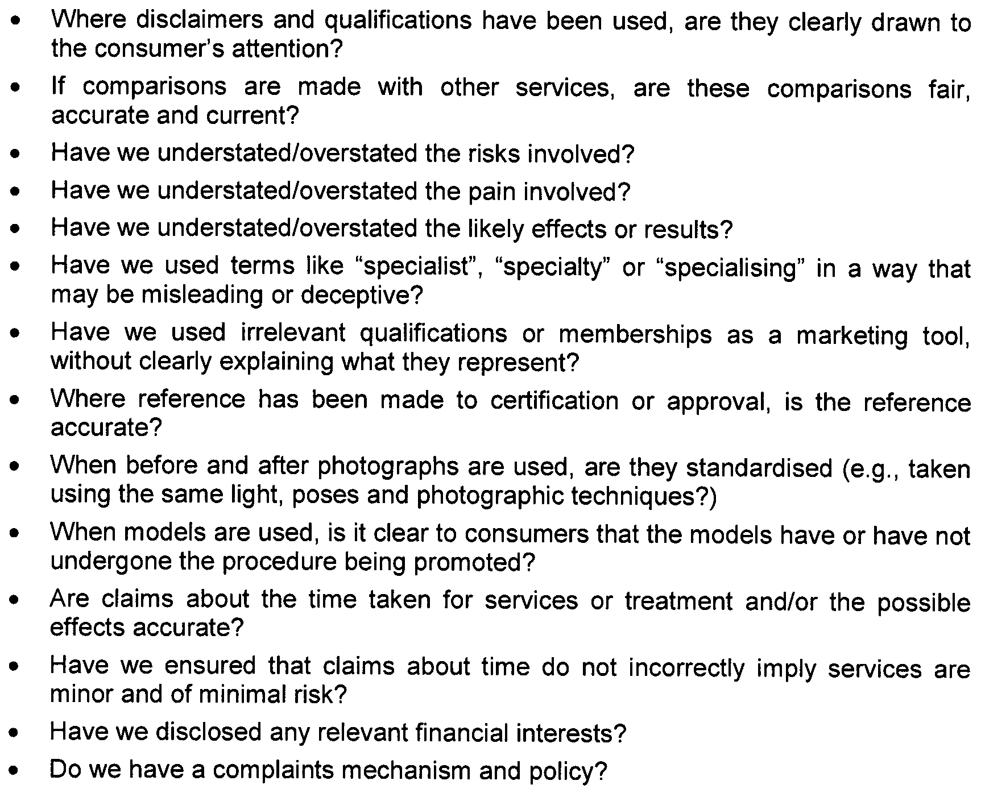
After Hours Service

Code of Practice

Issue Date: November 2009
Last Updated:
Next Review Date:
Approved by the Minister for Health: 10 November 2009

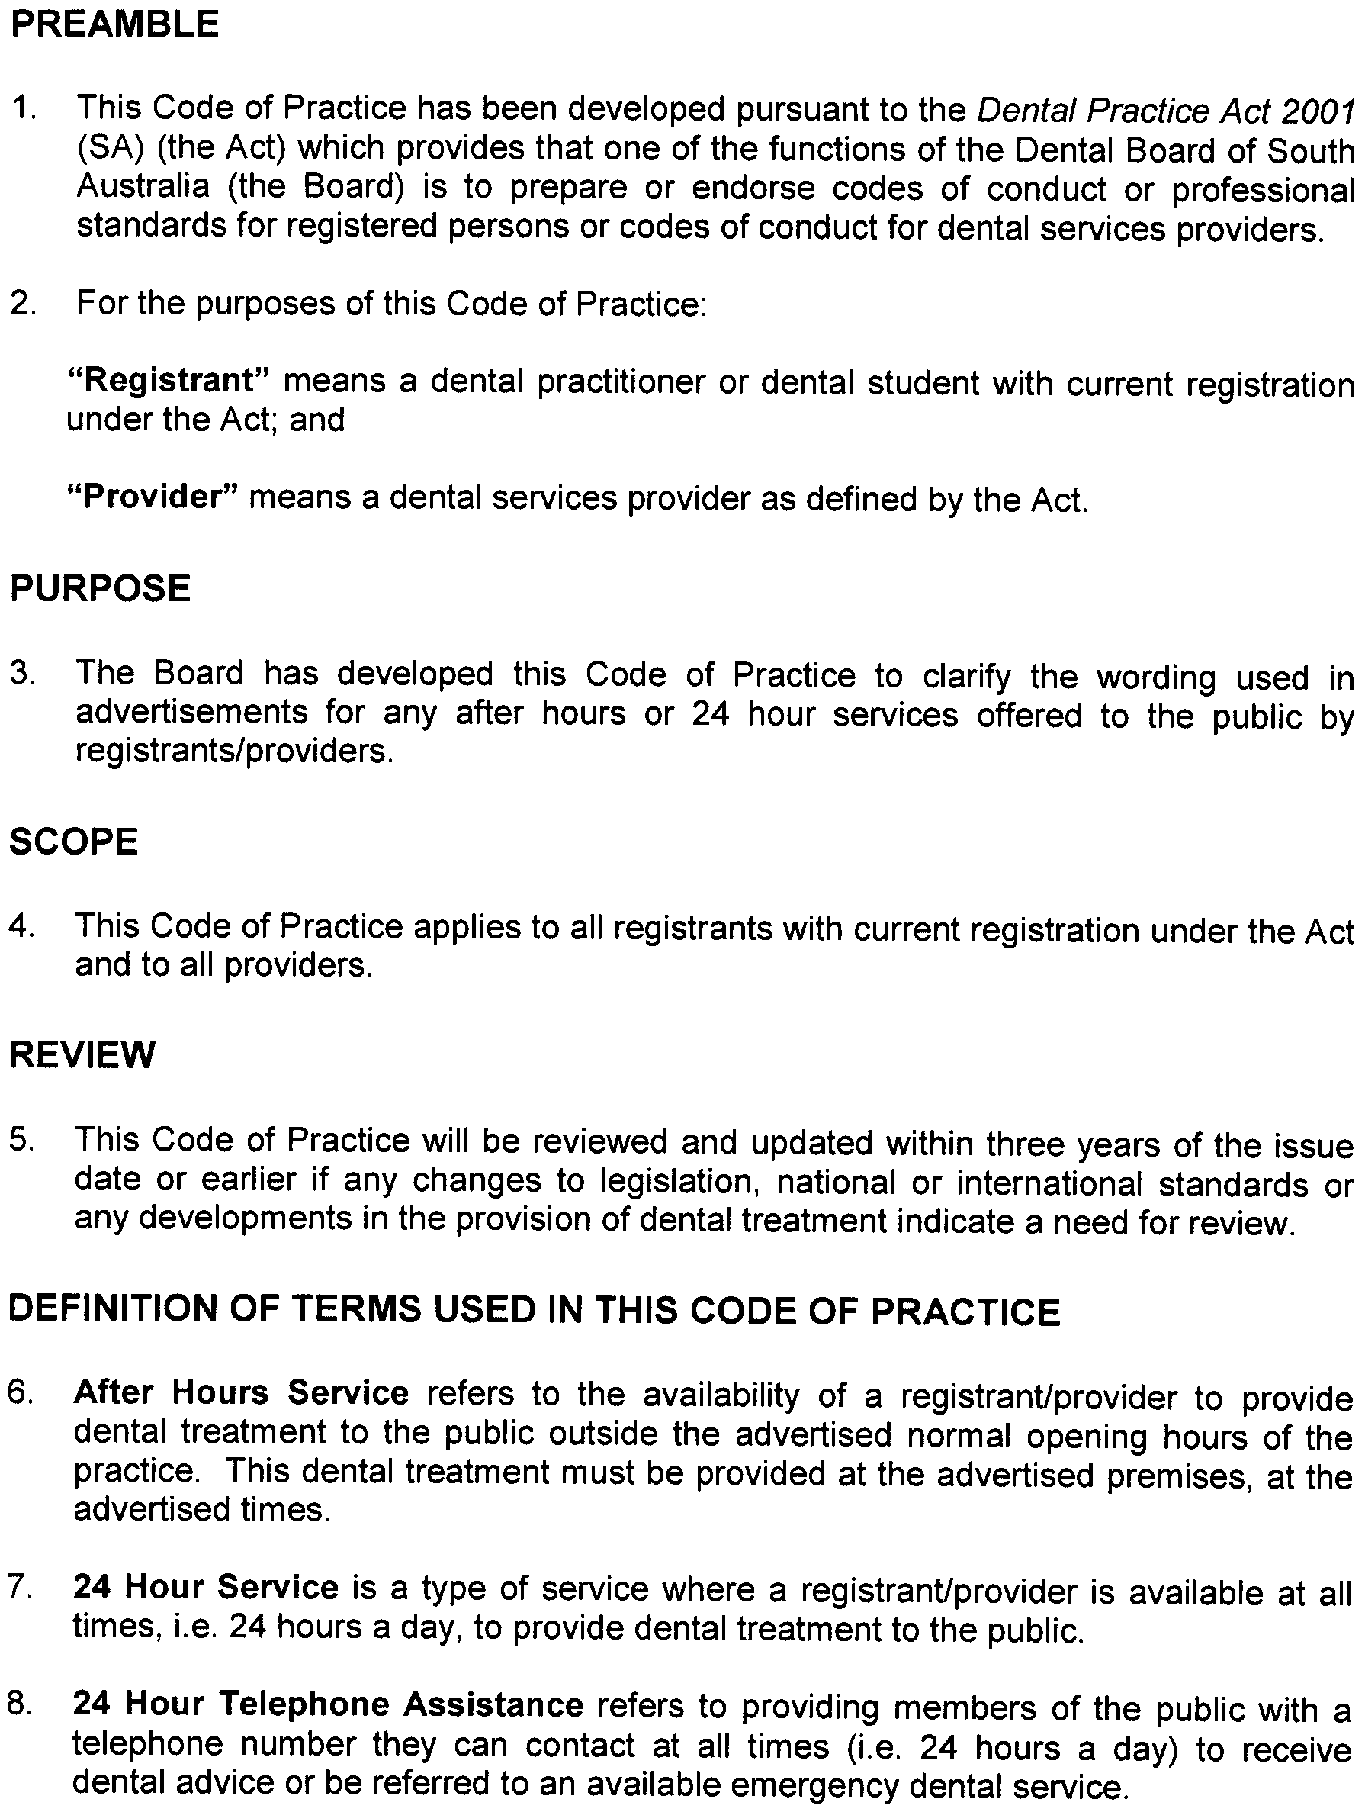
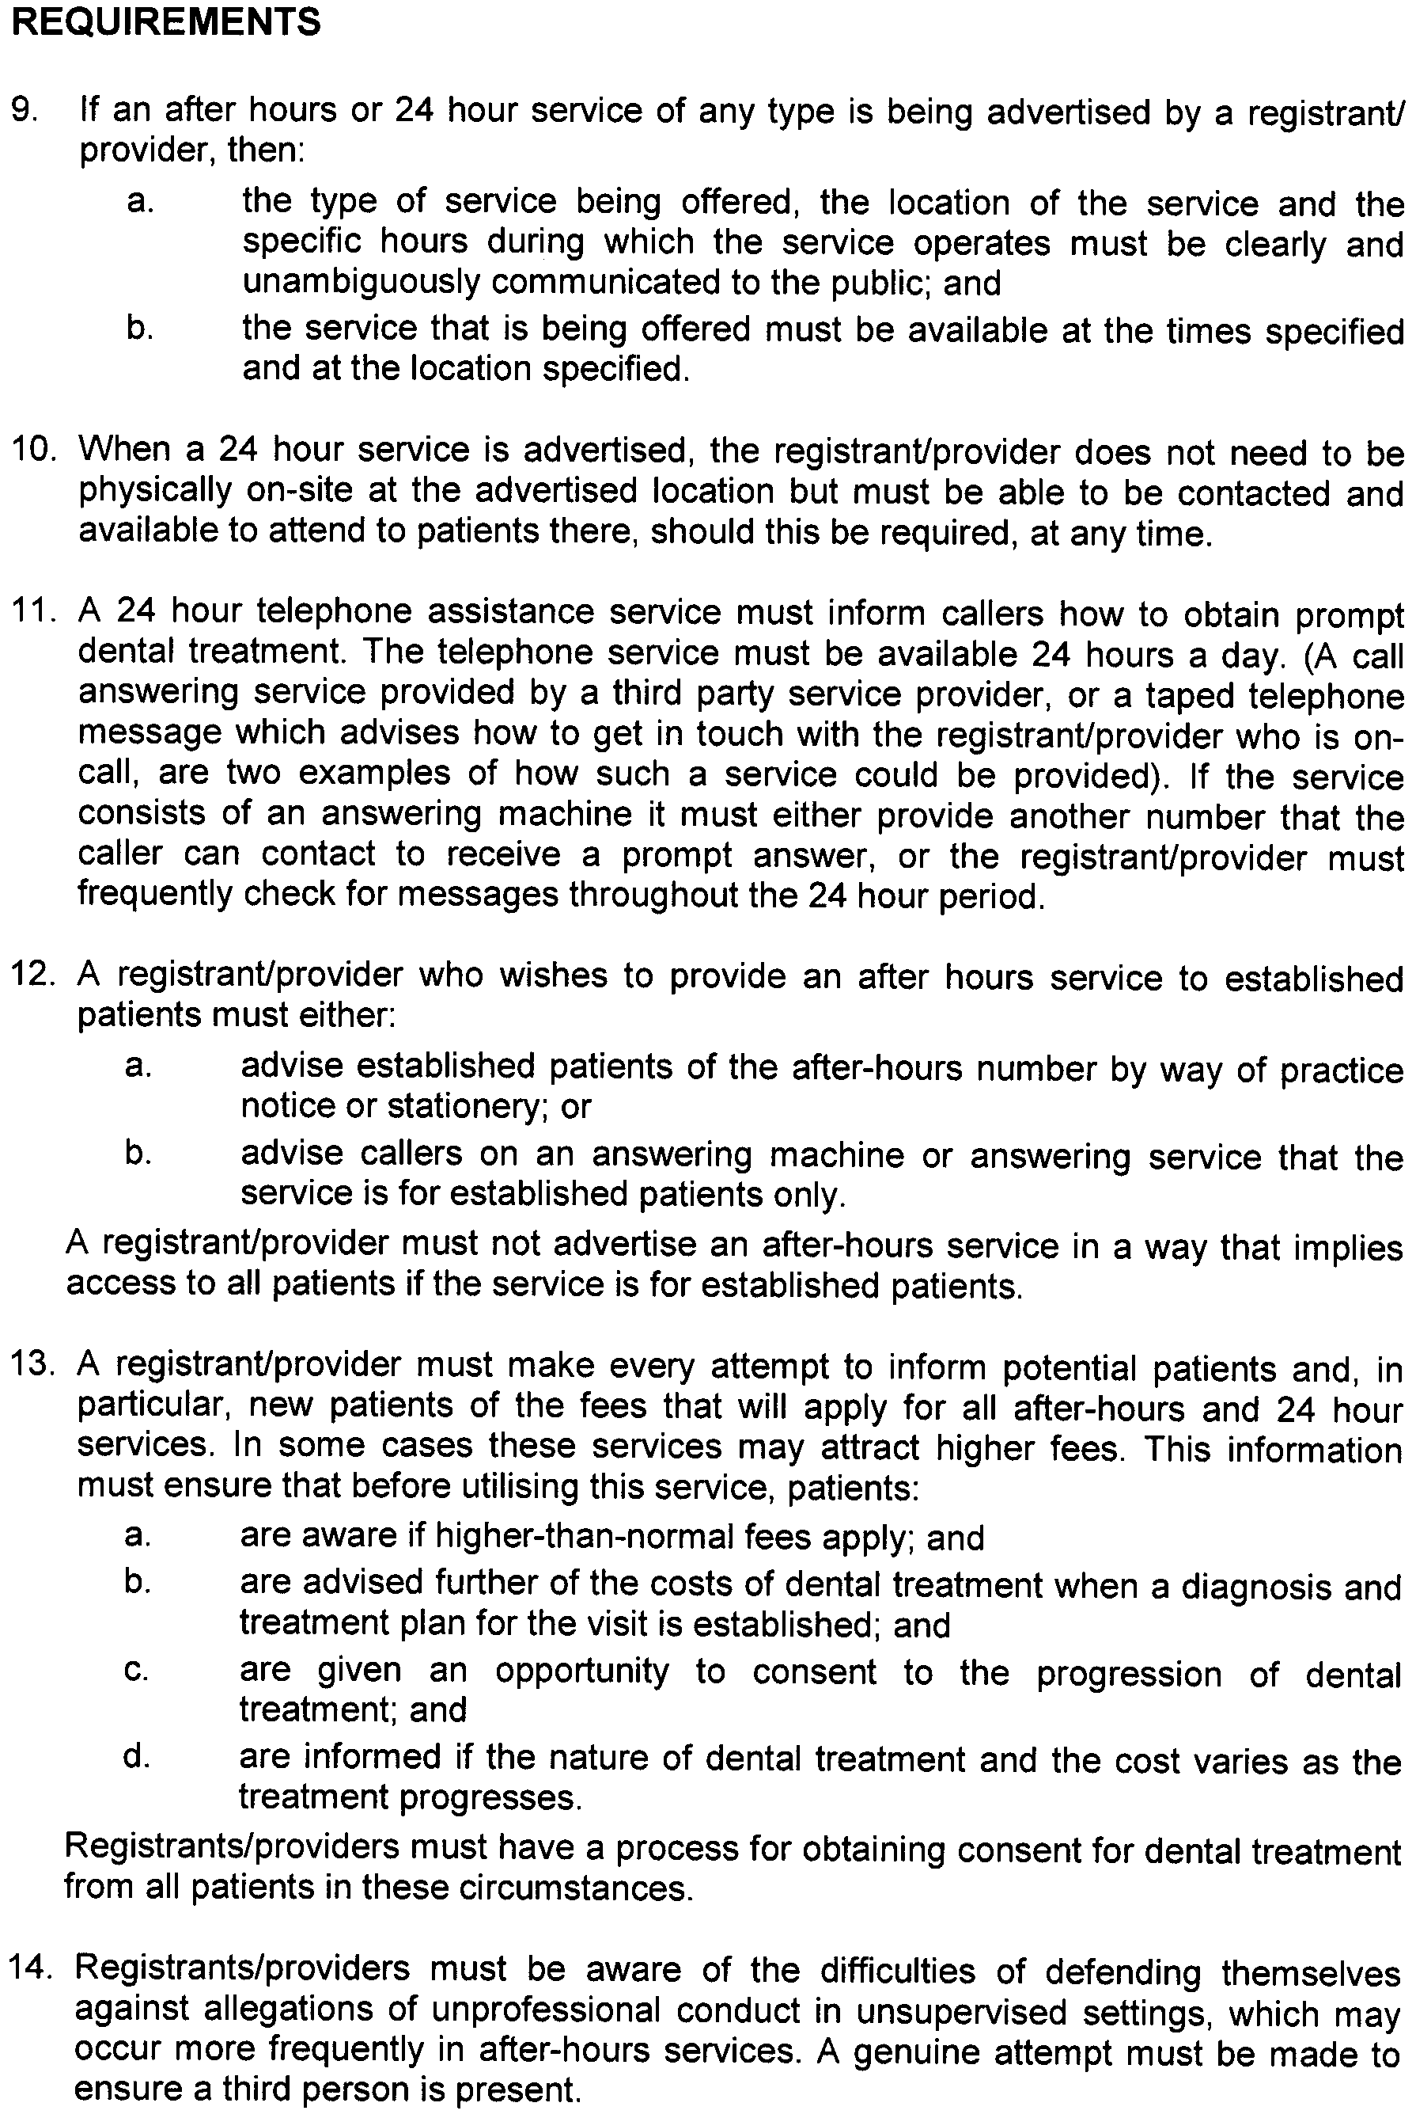
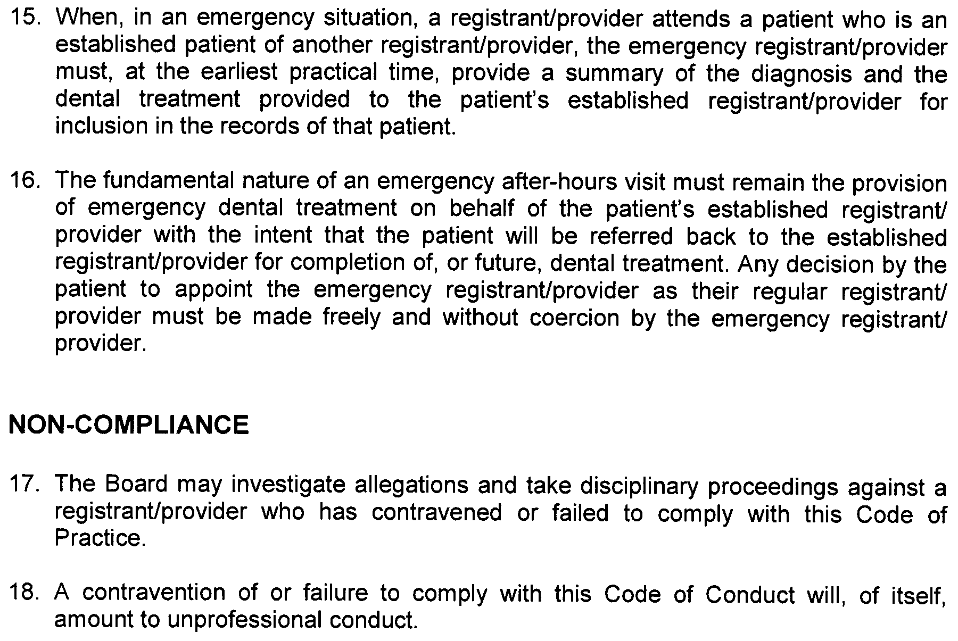
Dental Appliance Therapy
for the Treatment of Sleep Disorders

Code of Practice

Issue Date: November 2009
Last Updated:
Next Review Date:
Approved by the Minister for Health: 10 November 2009

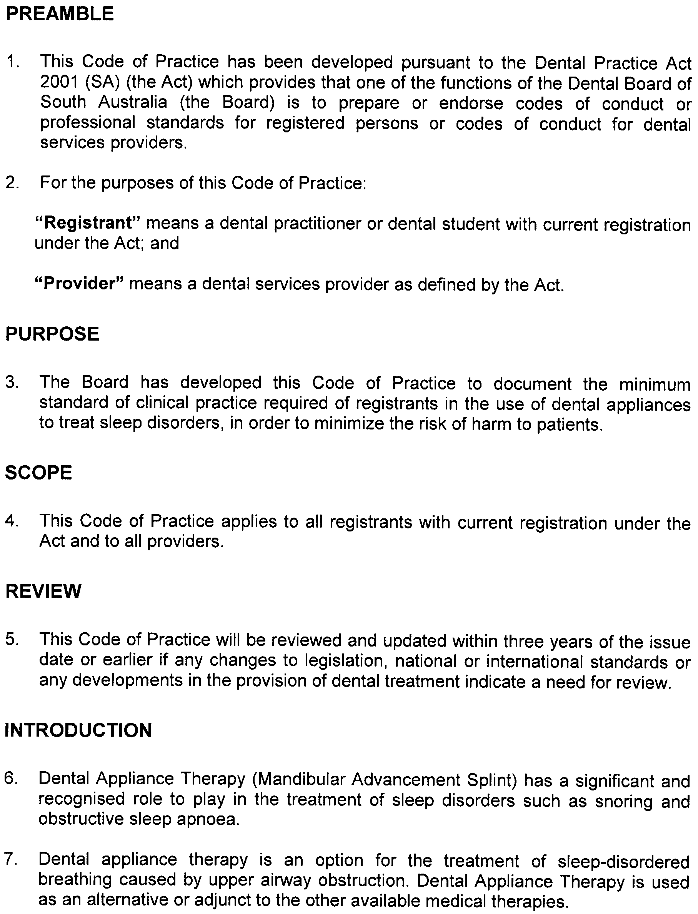
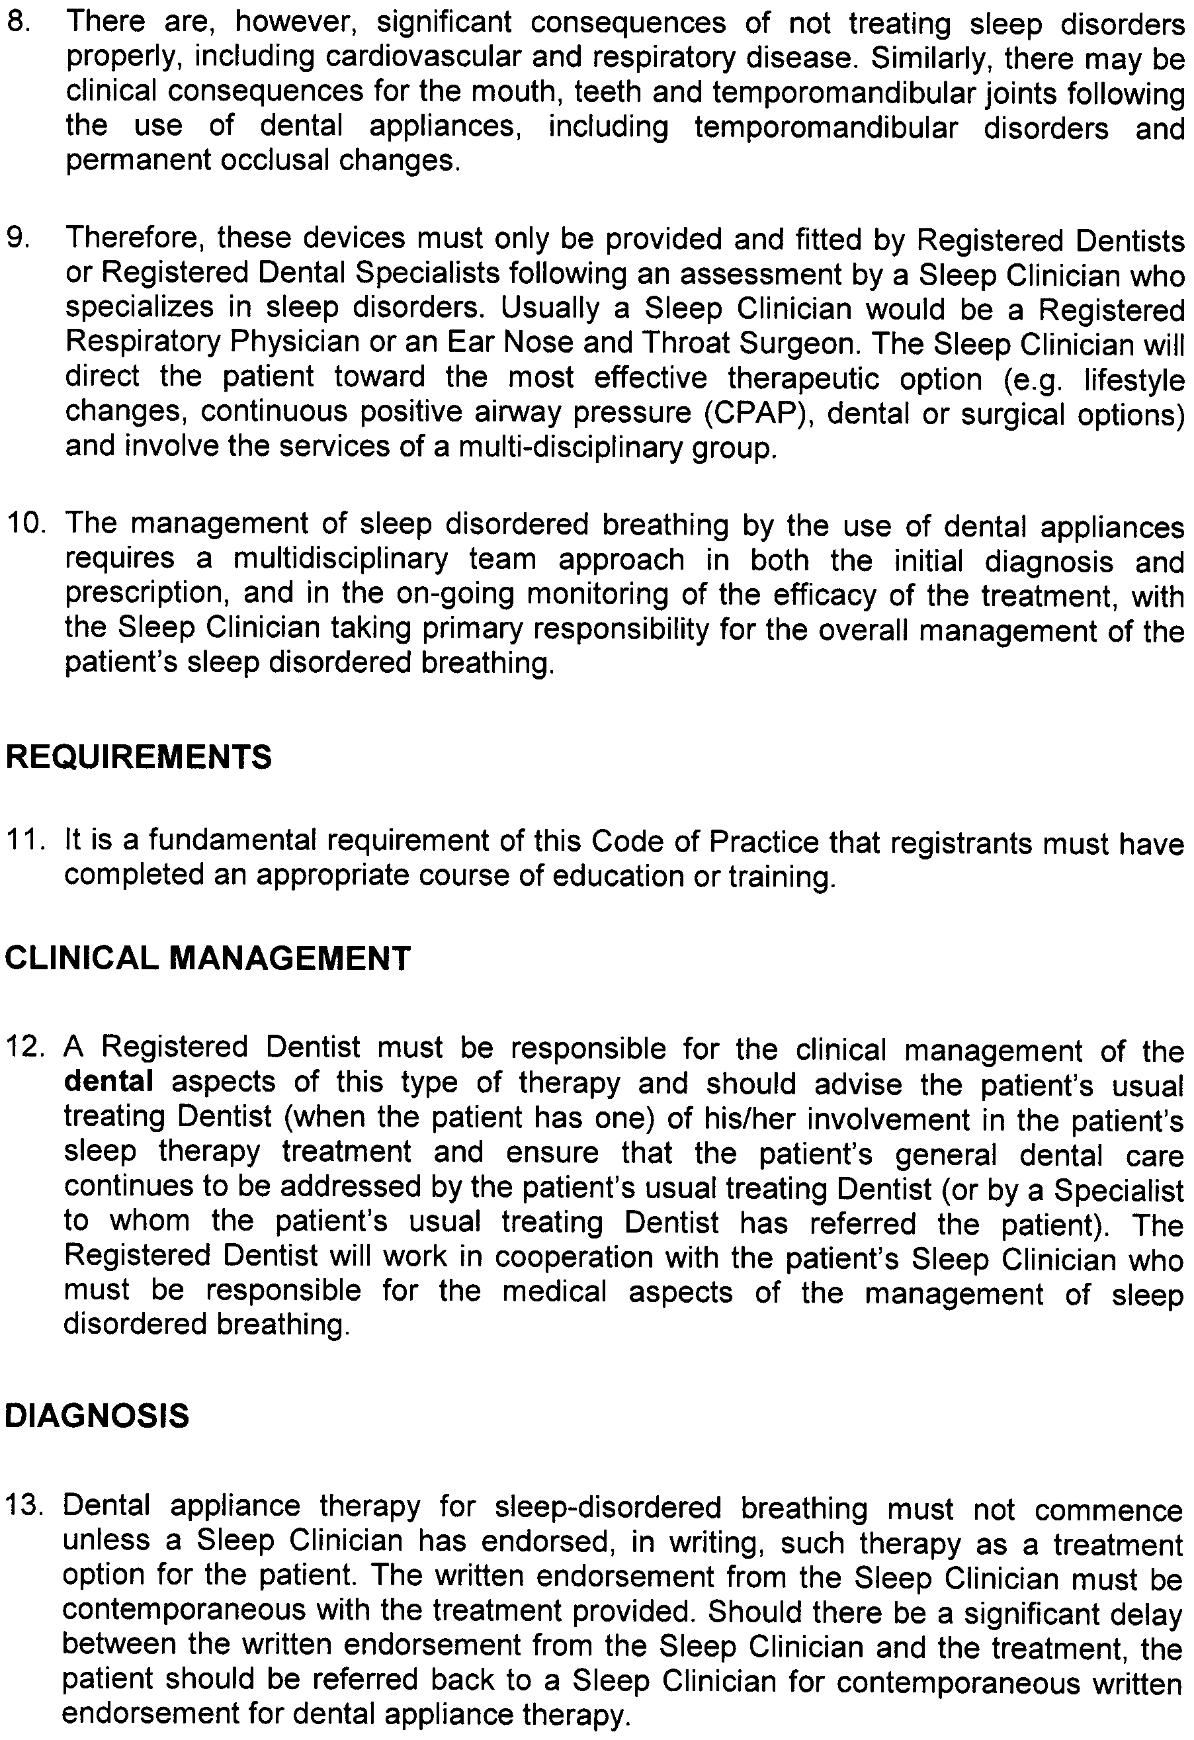
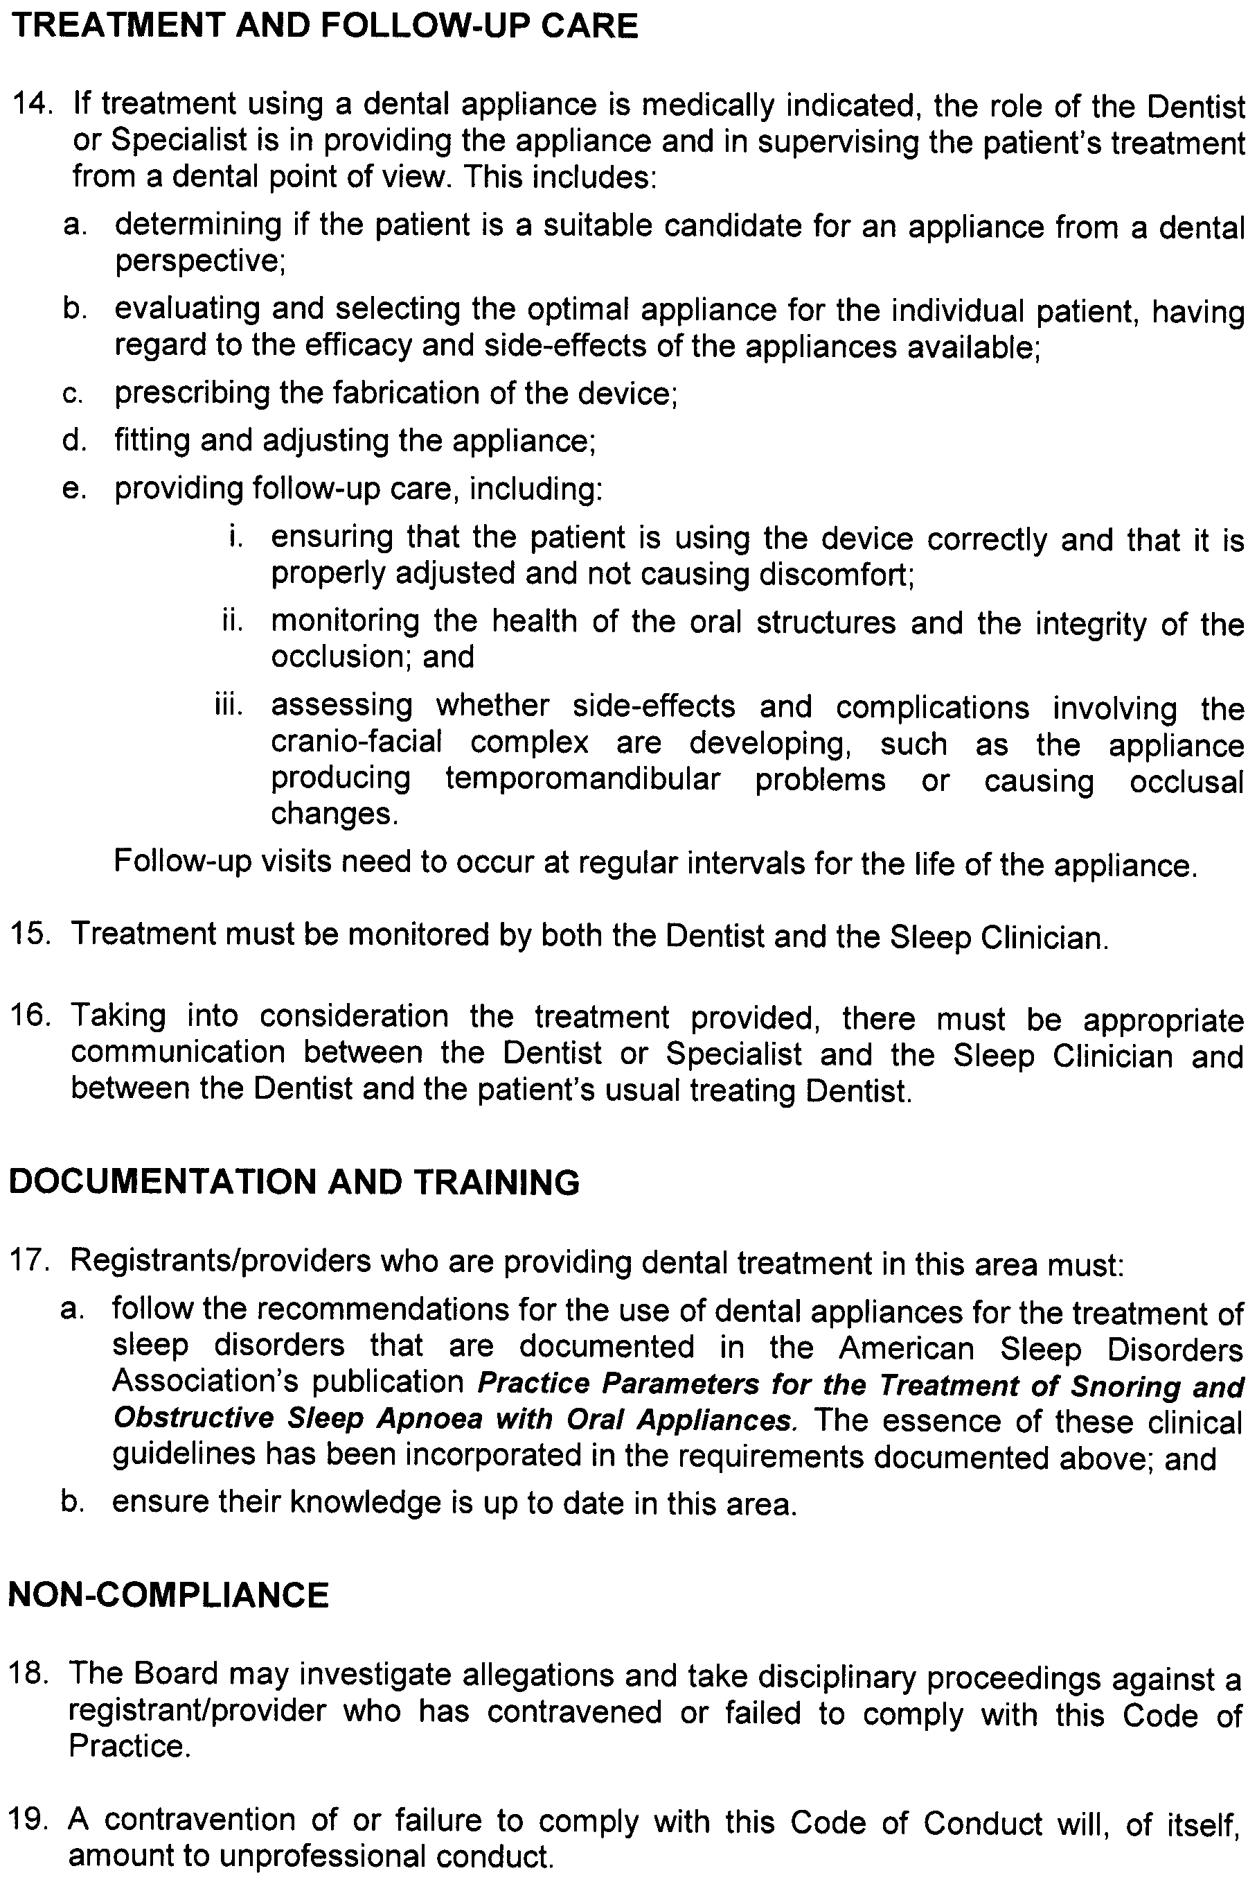
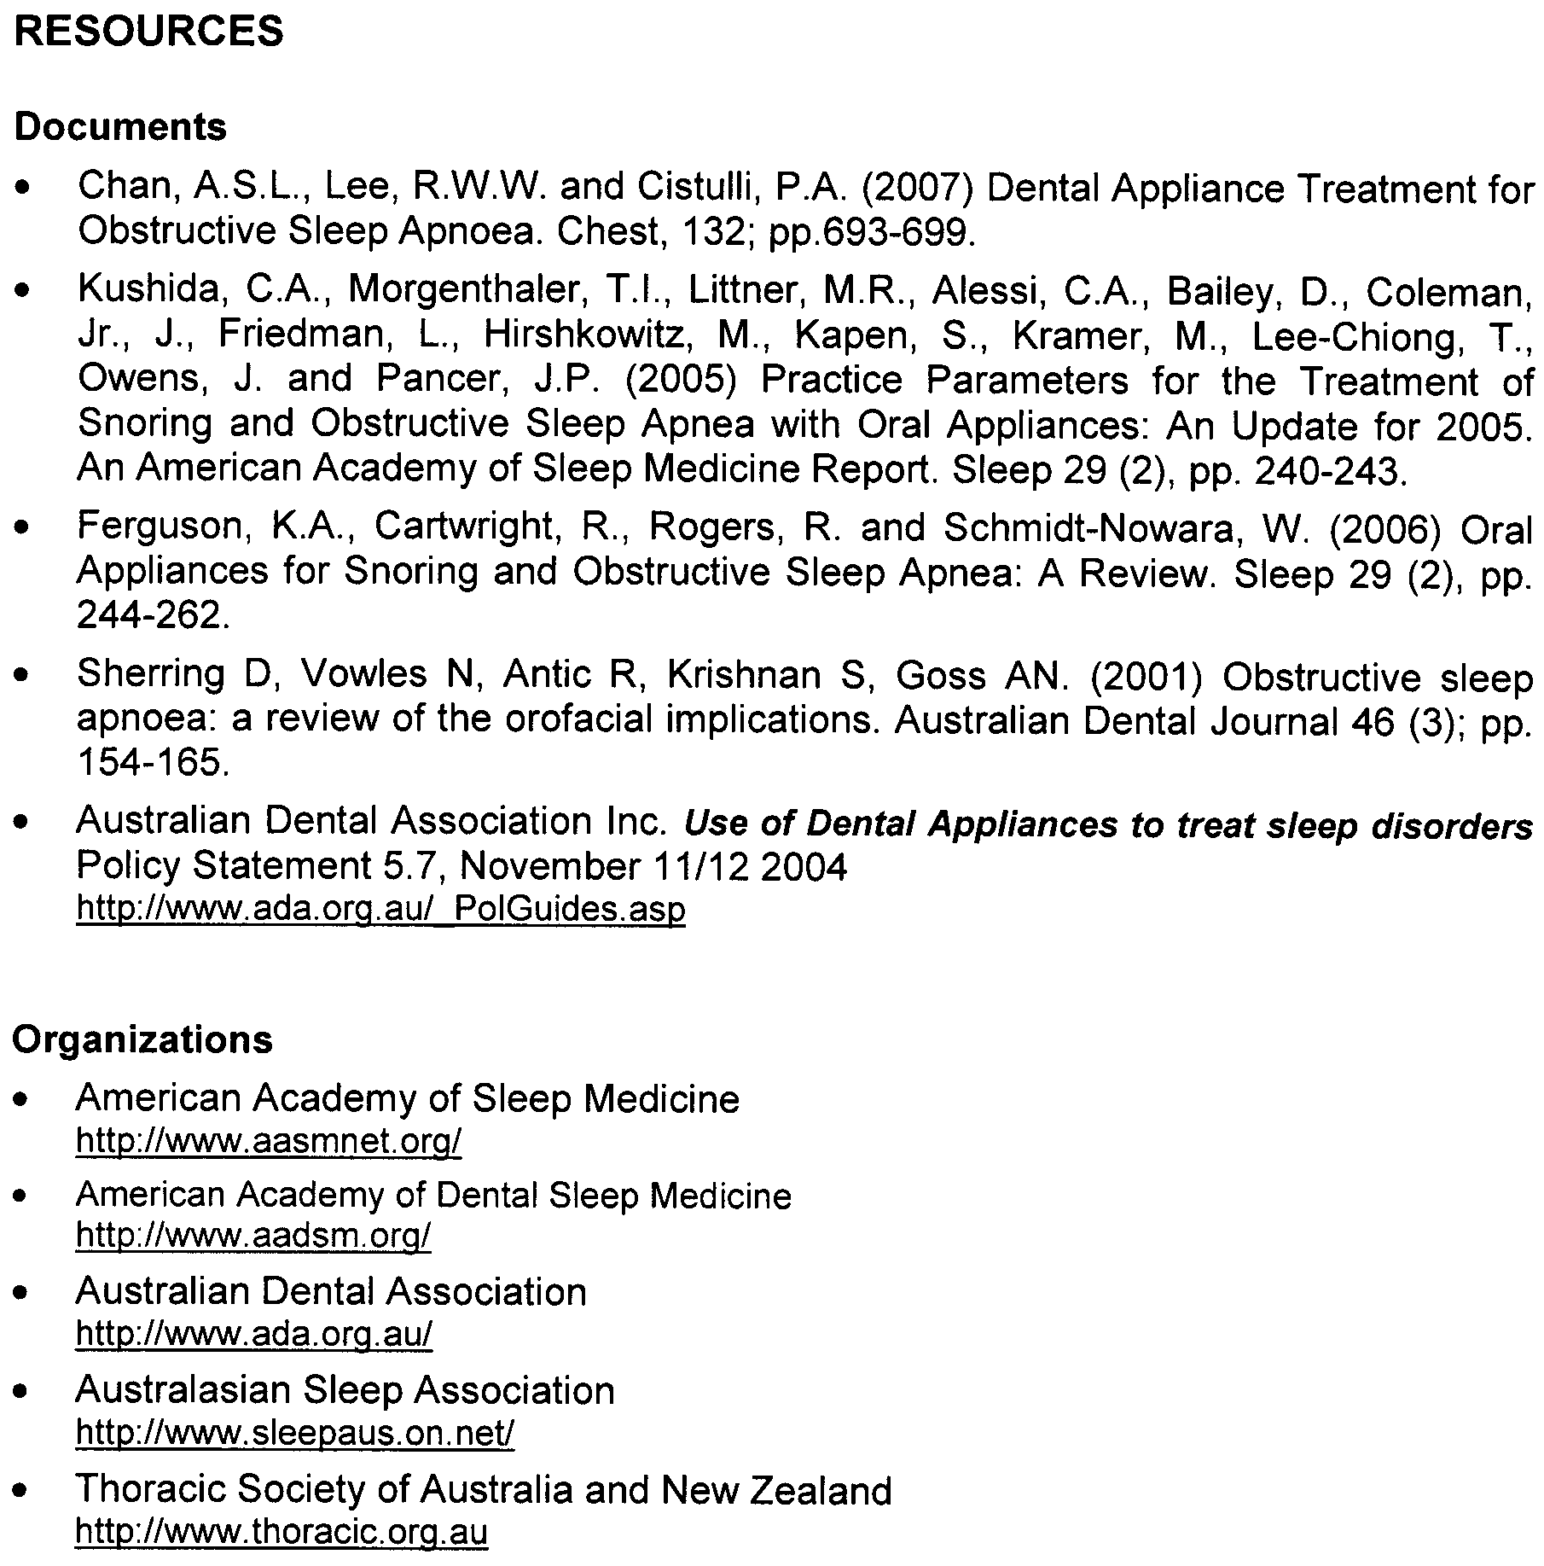
Dental Records
Code of Practice

Issue Date: November 2009
Last Updated:
Next Review Date:
Approved by the Minister for Health: 10 November 2009
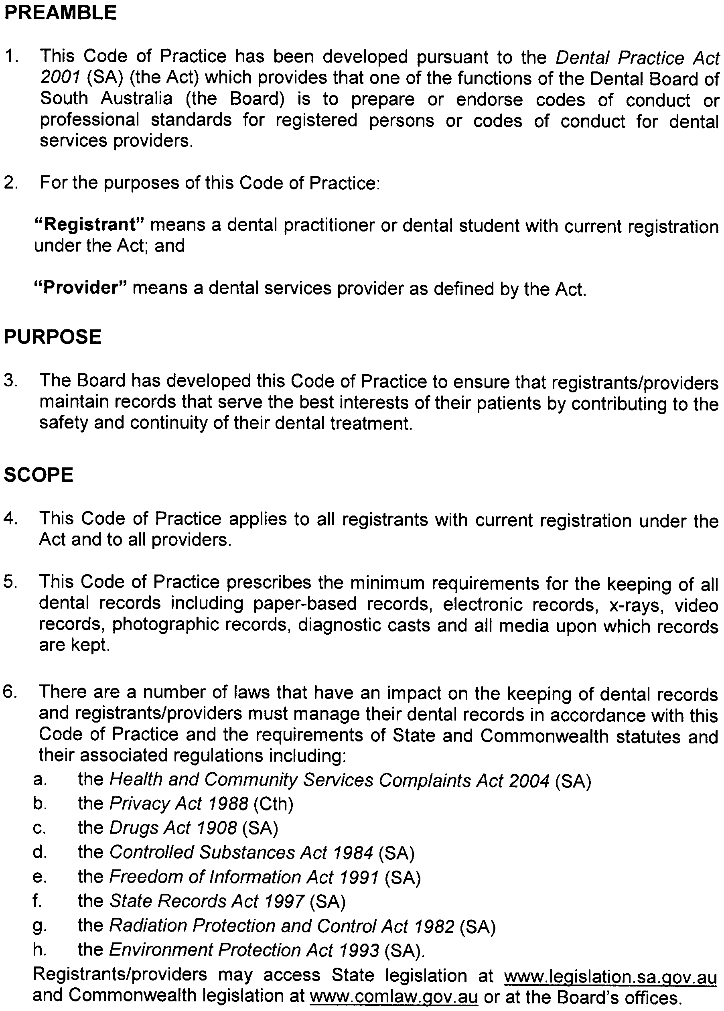
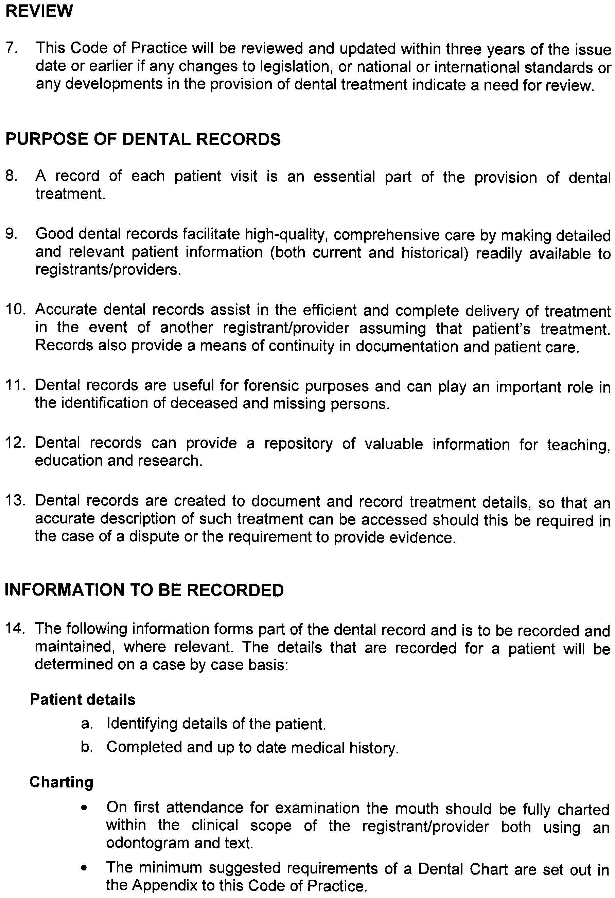
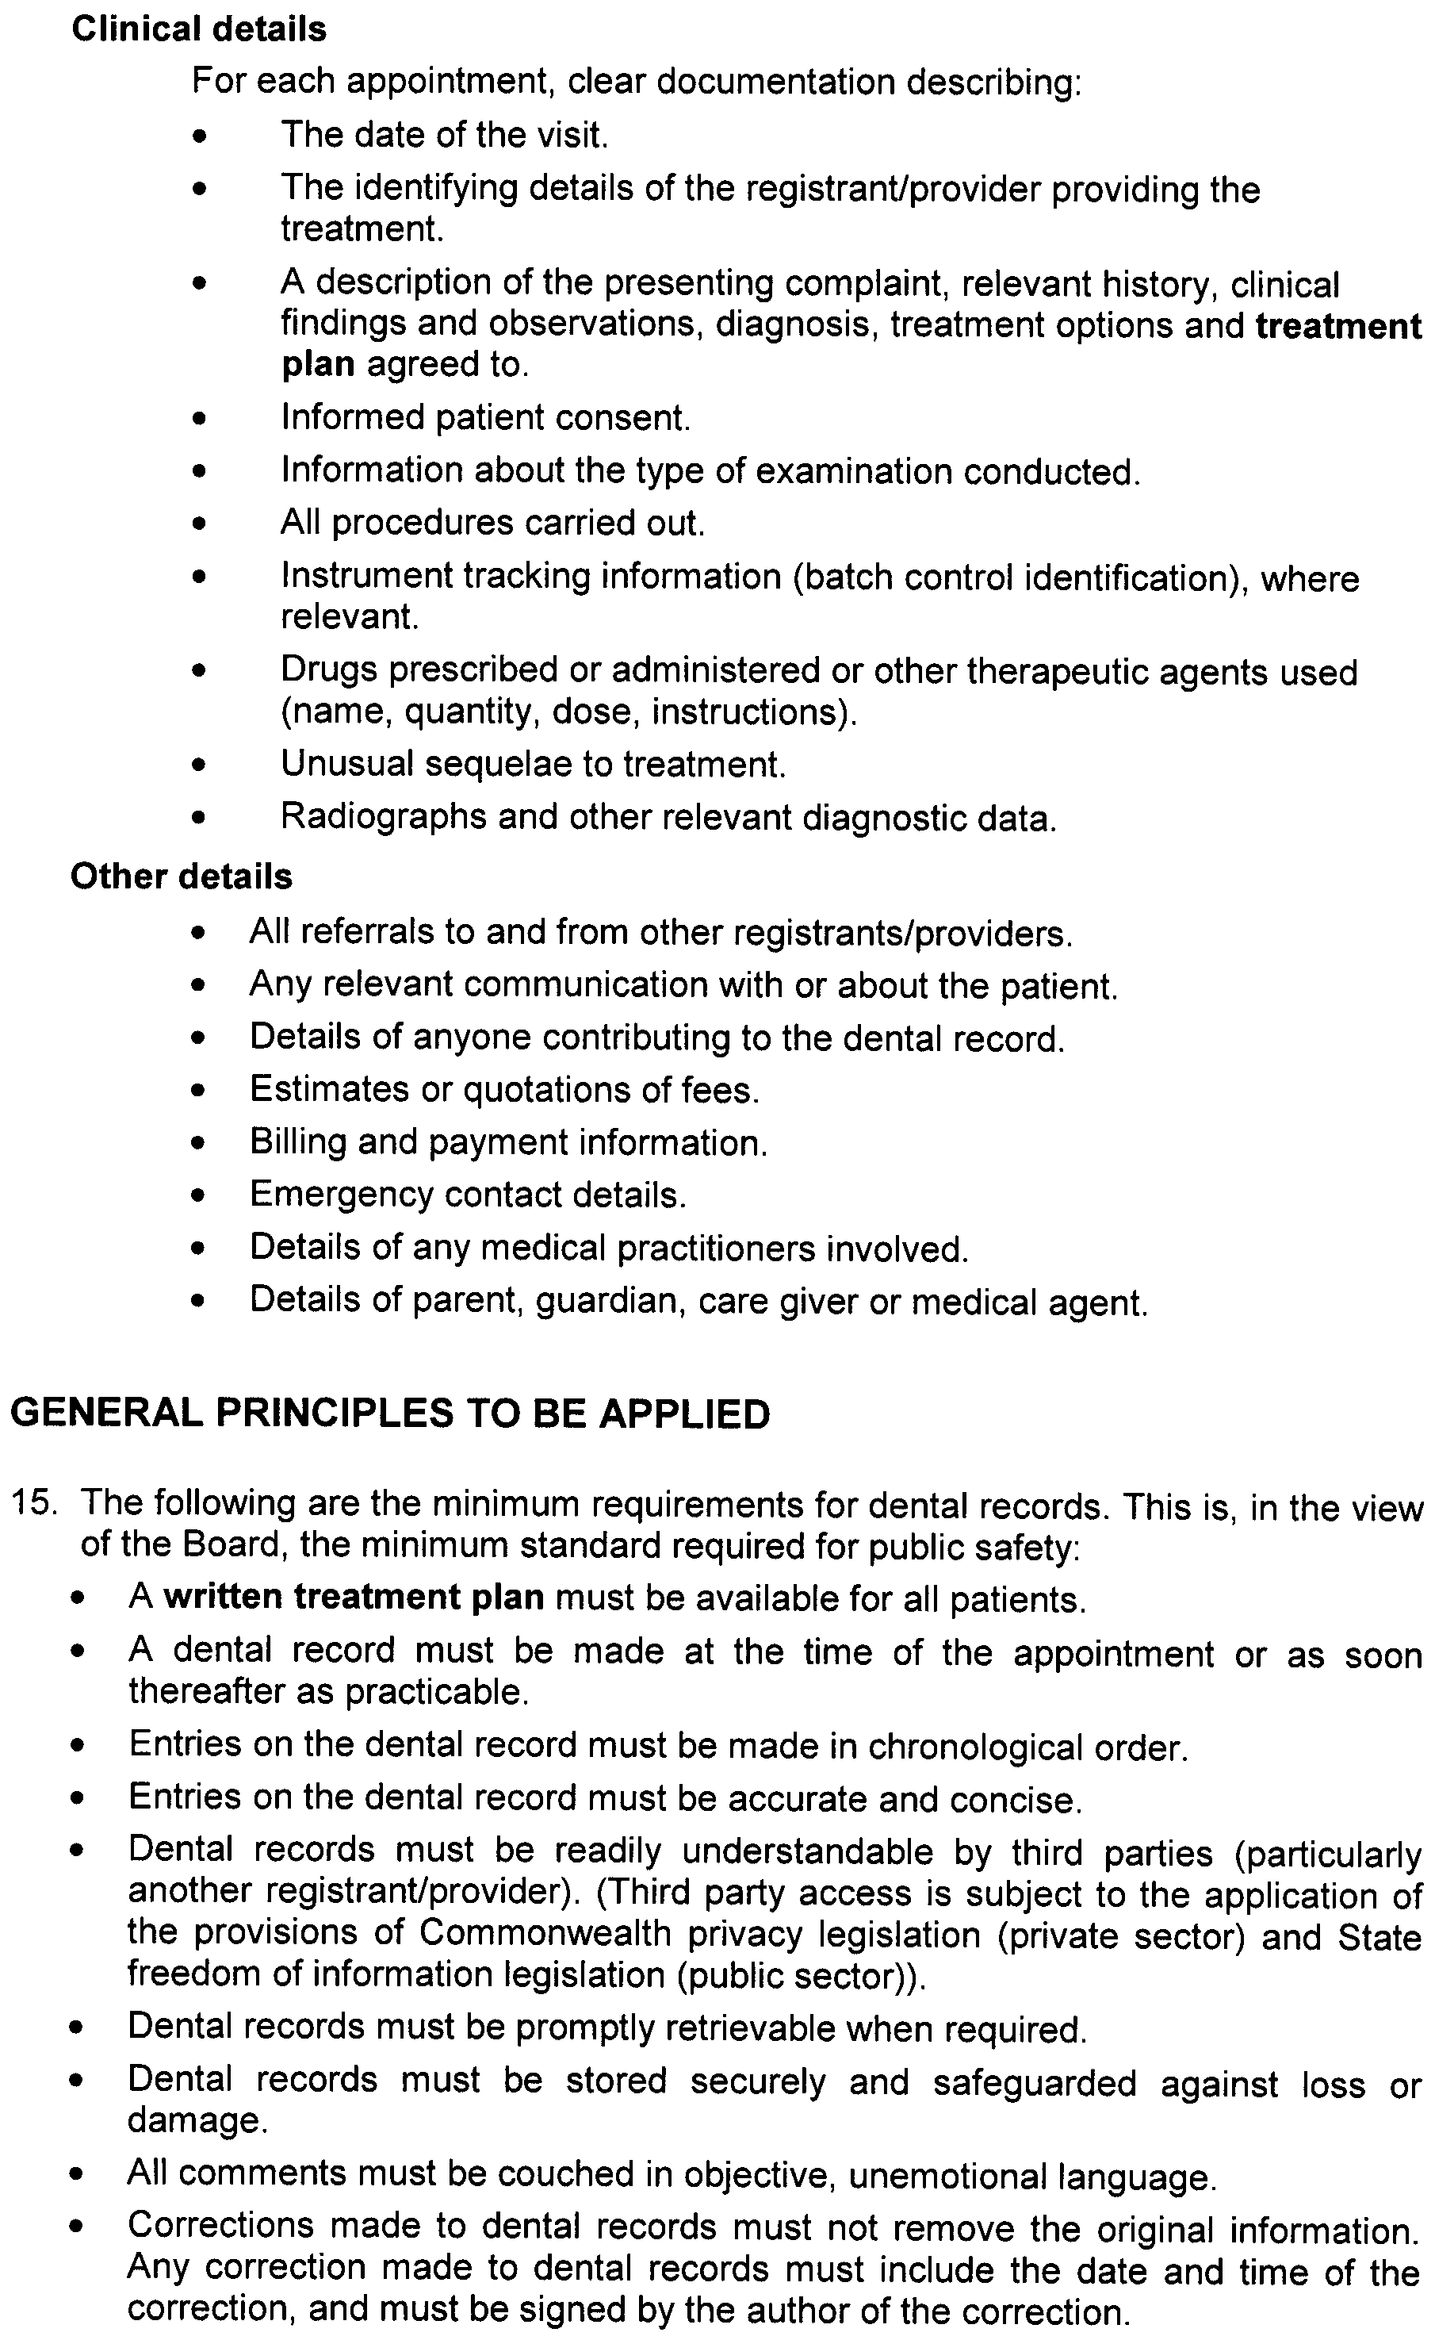
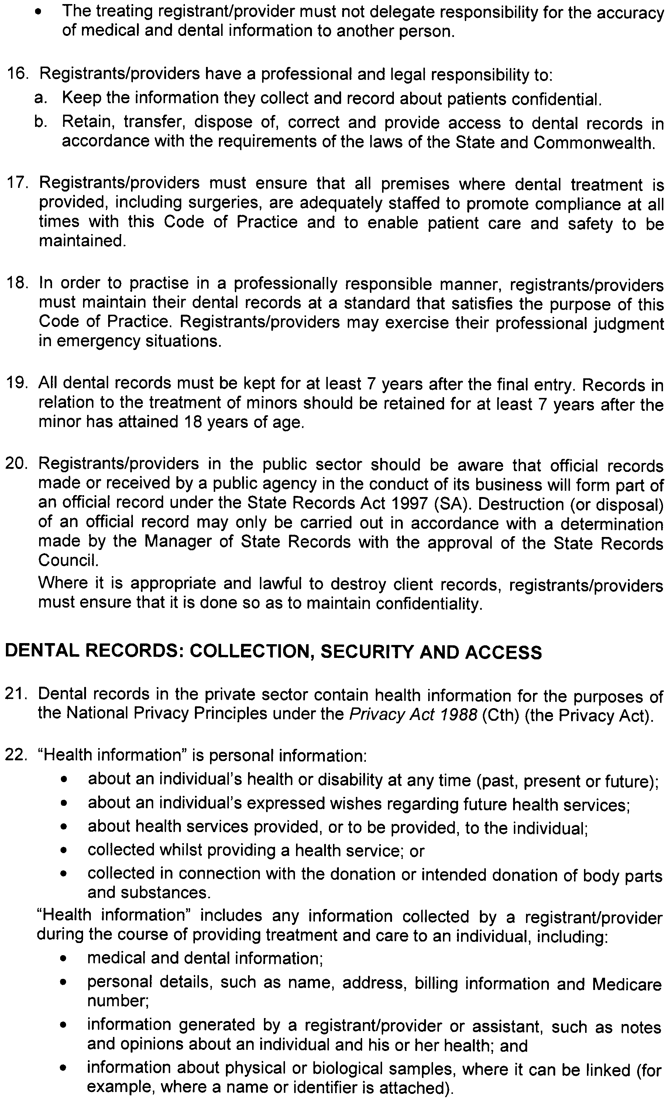
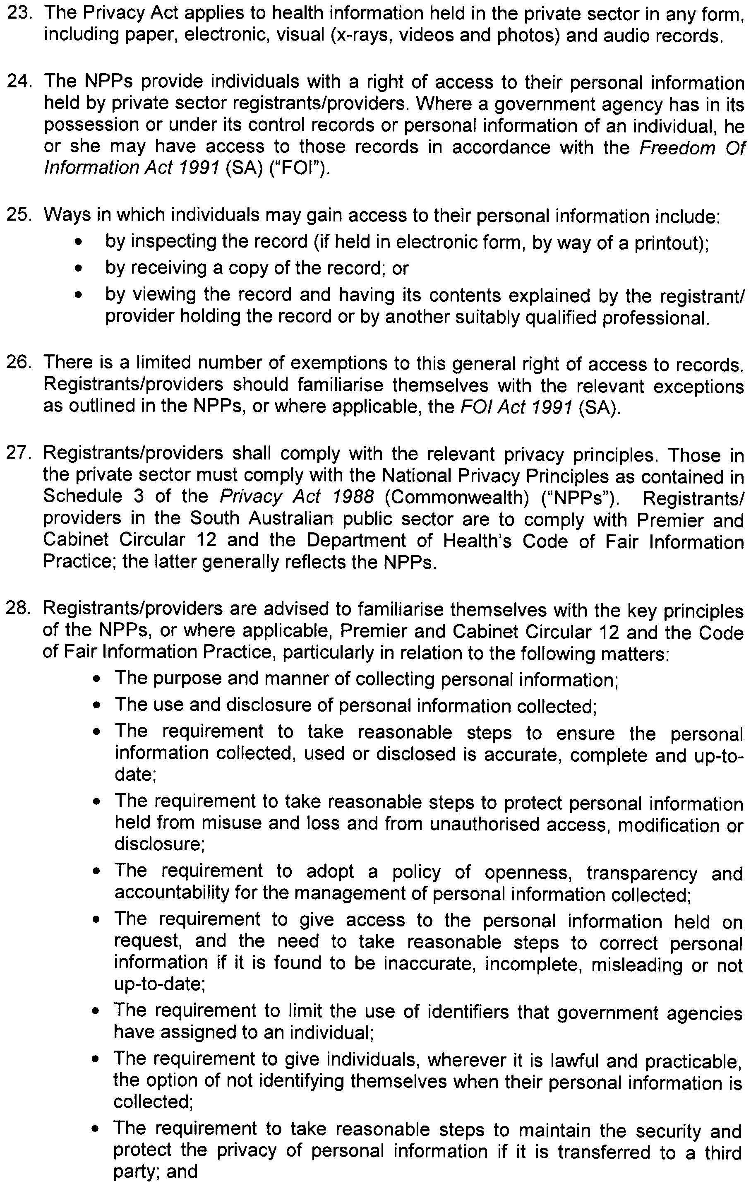
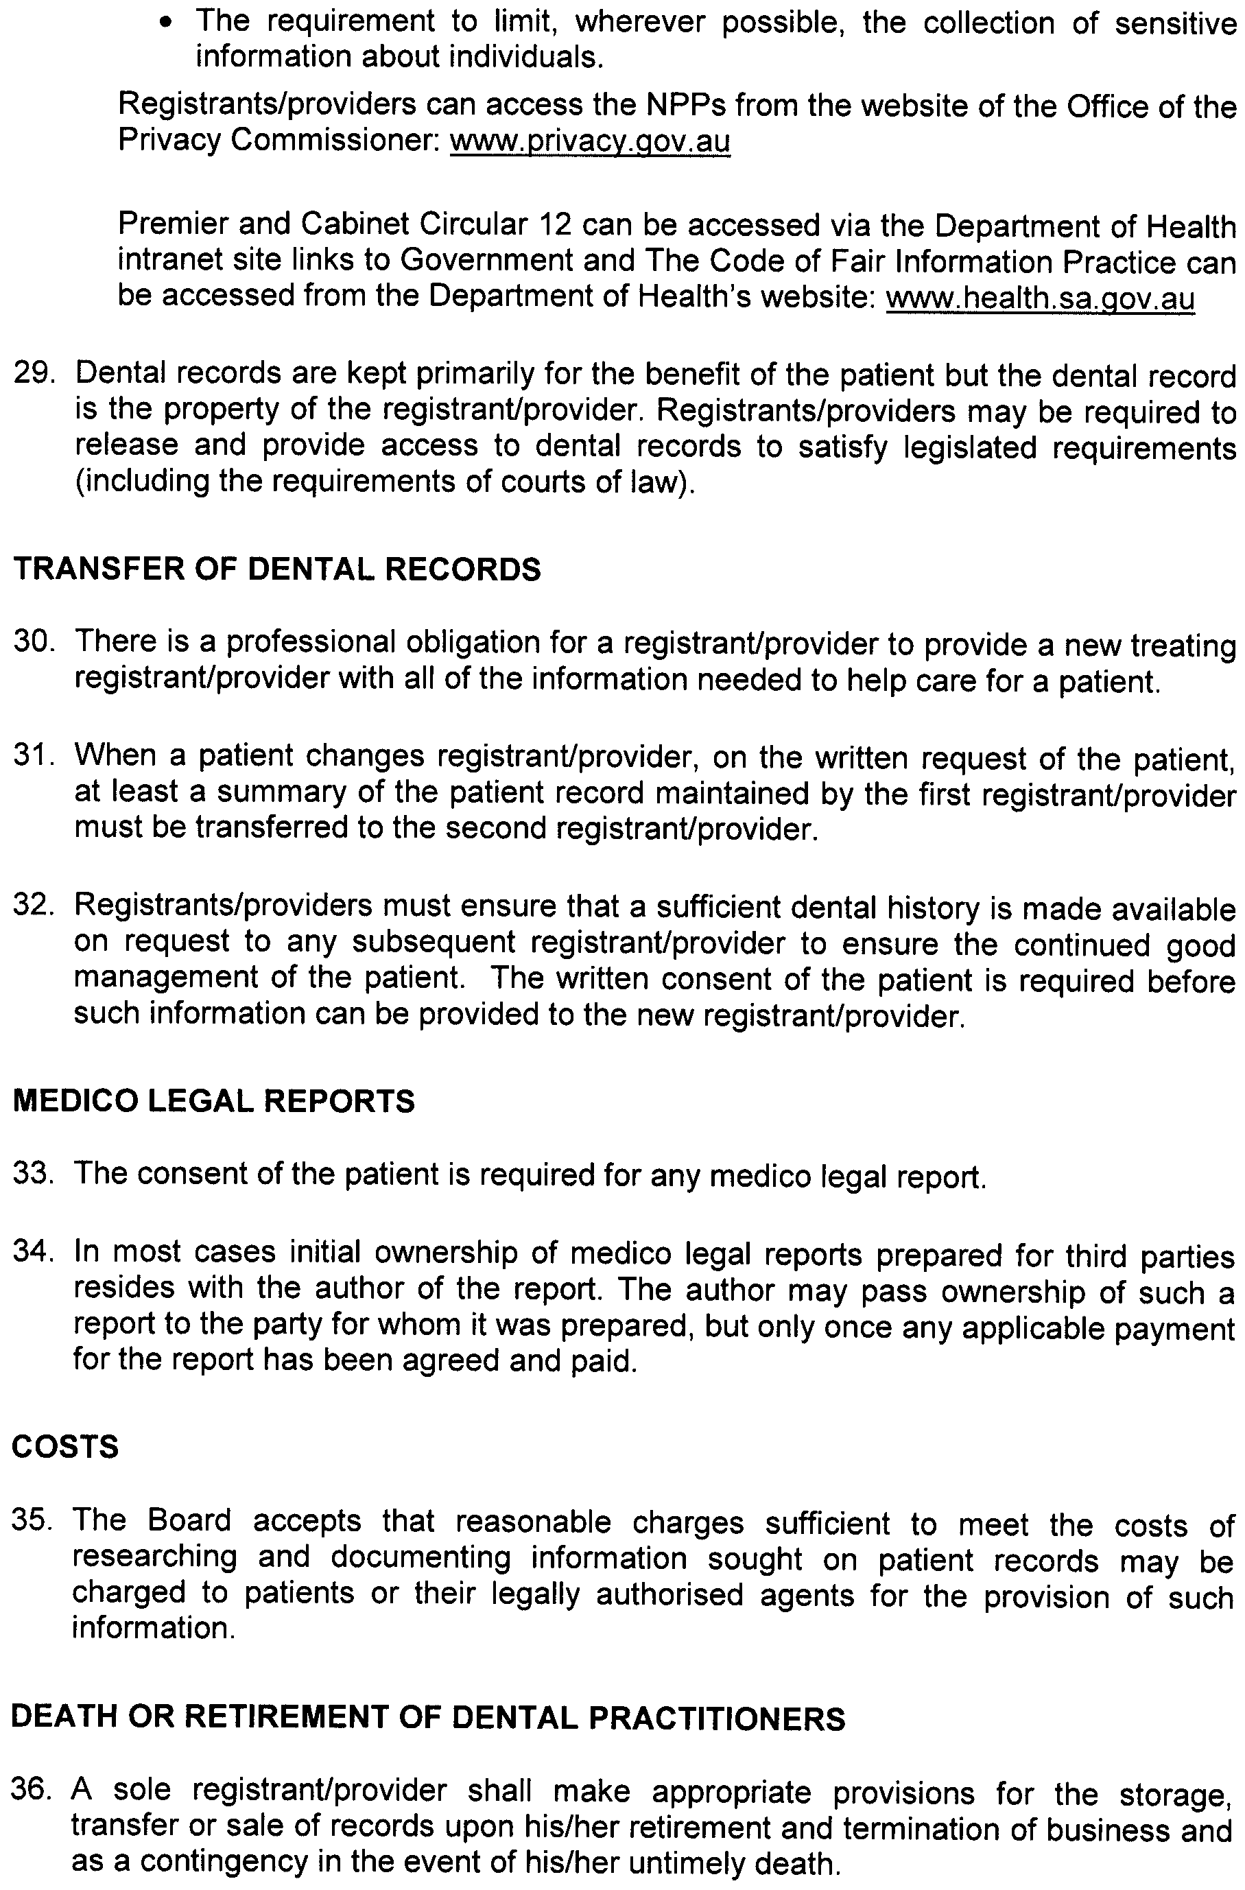

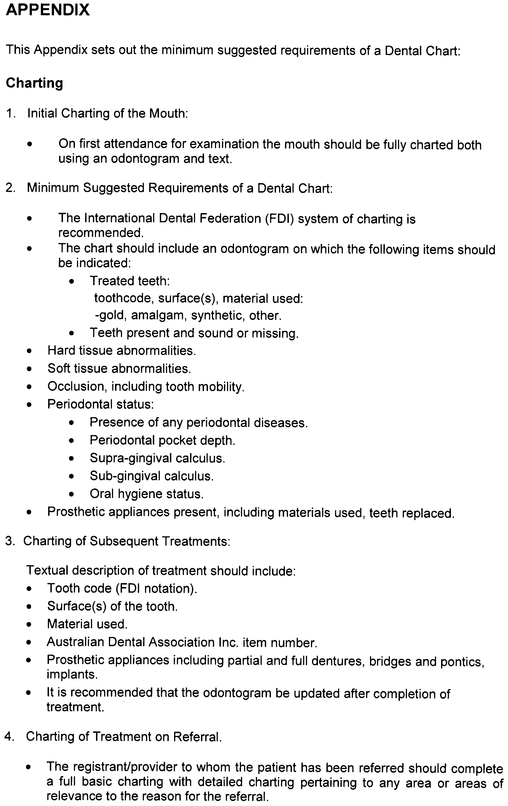
General Practitioner Dentists in Specialist Practices

Code of Practice

Issue Date: November 2009
Last Updated:
Next Review Date:
Approved by the Minister for Health: 10 November 2009

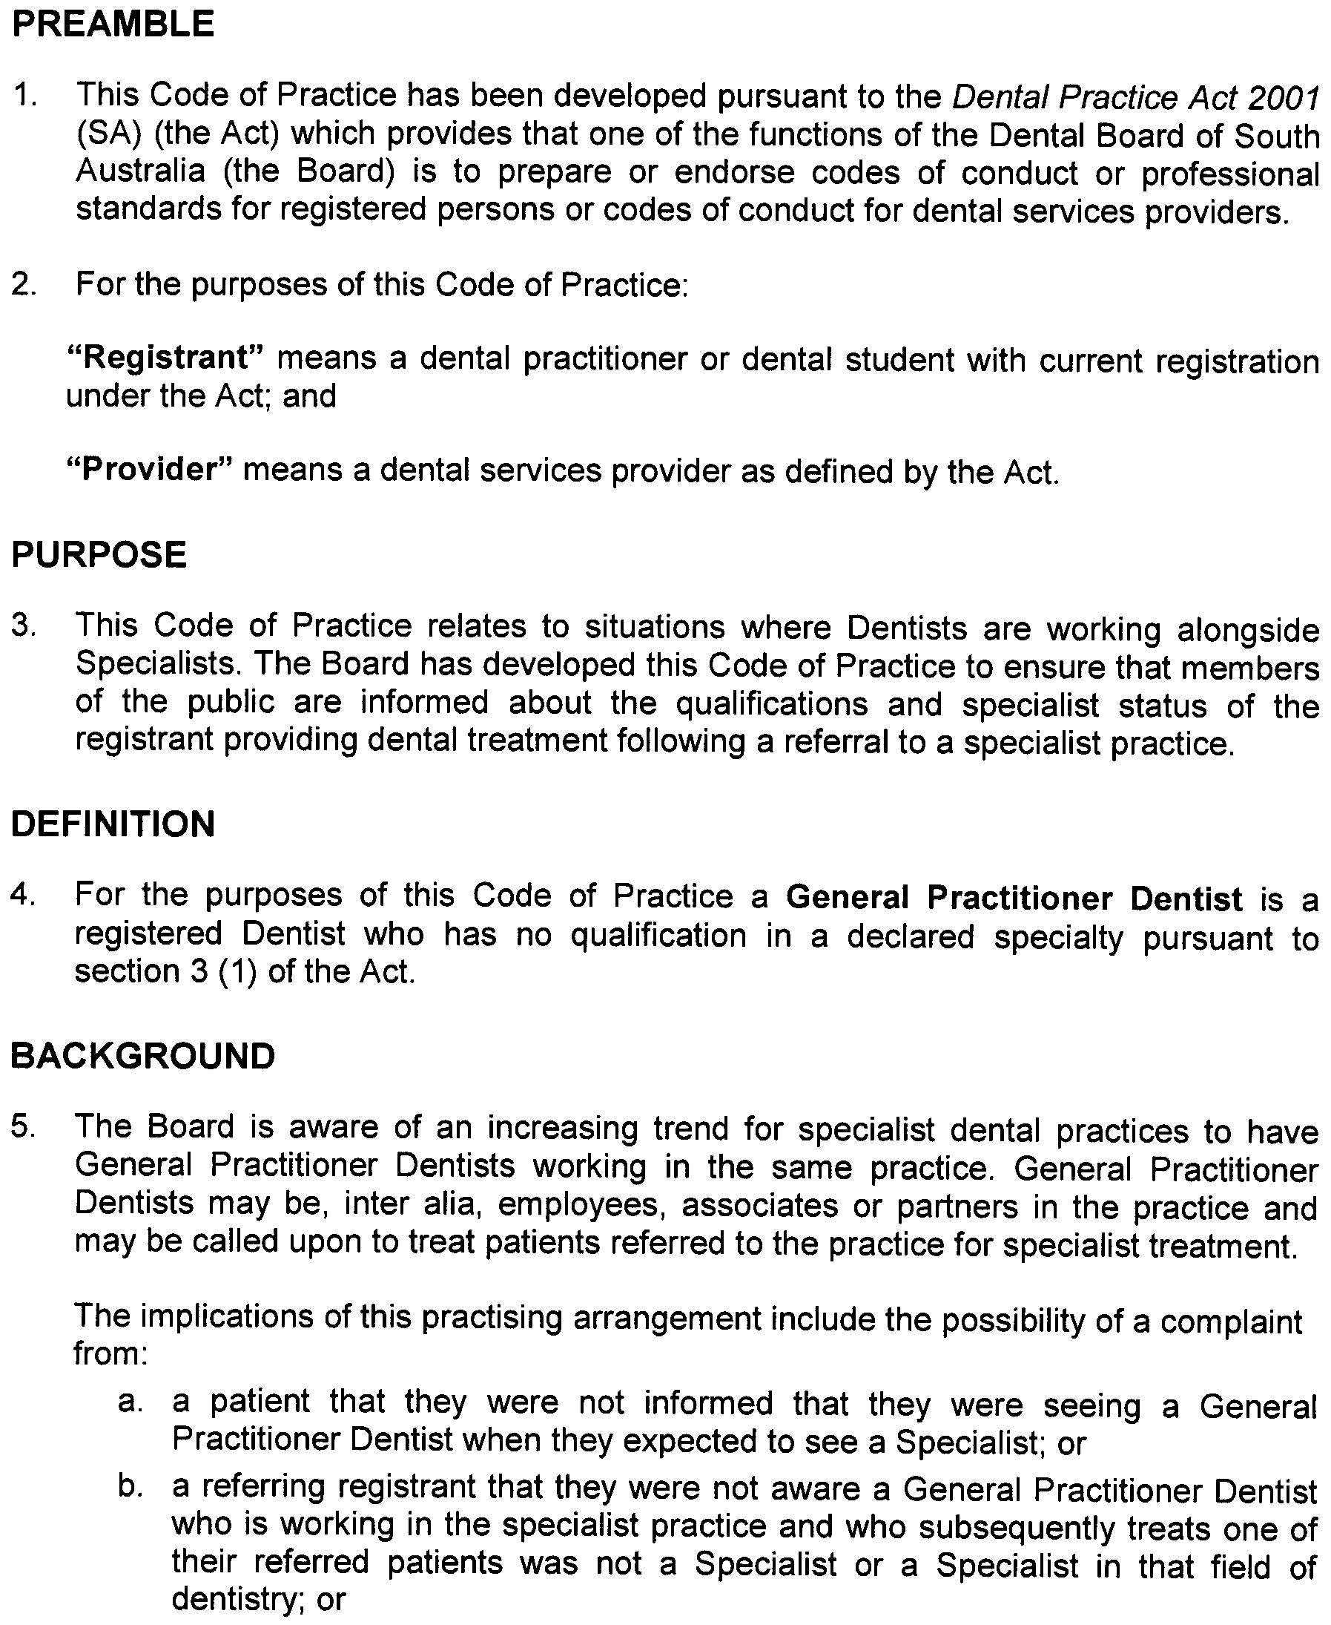

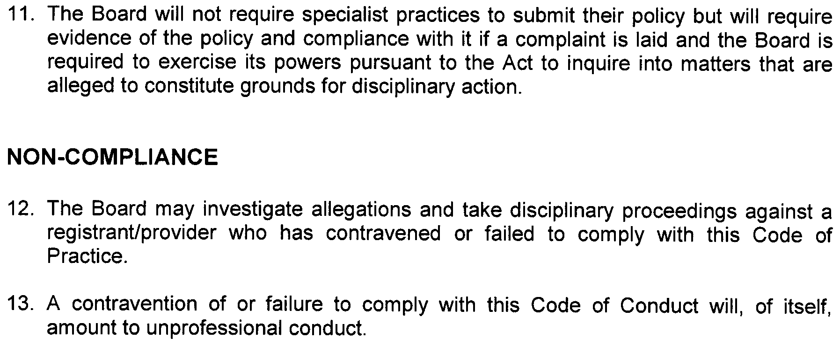
Infection Control

Code of Practice

Issue Date: November 2009
Last Updated:
Next Review Date:
Approved by the Minister for Health: 10 November 2009

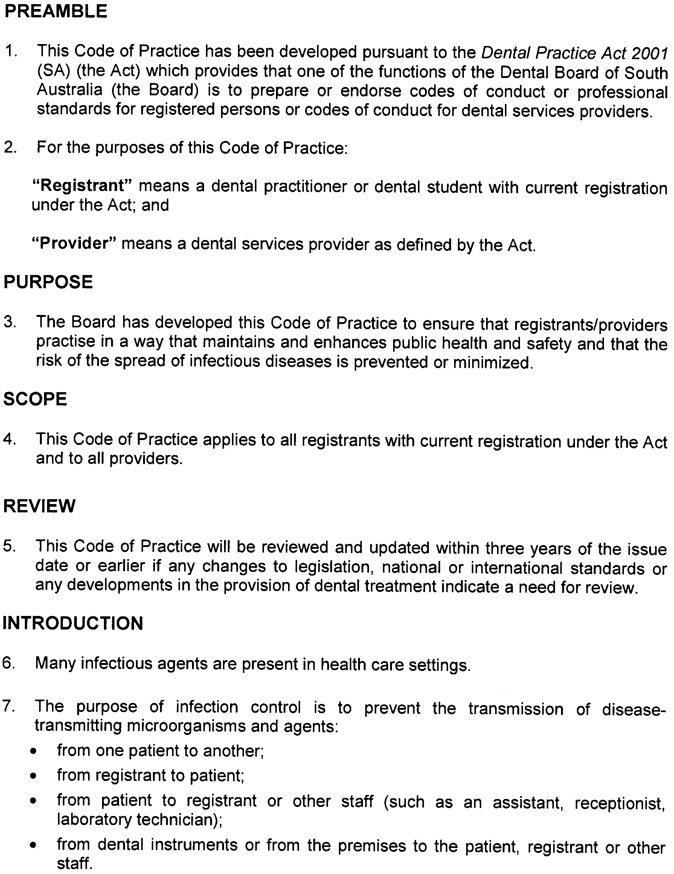
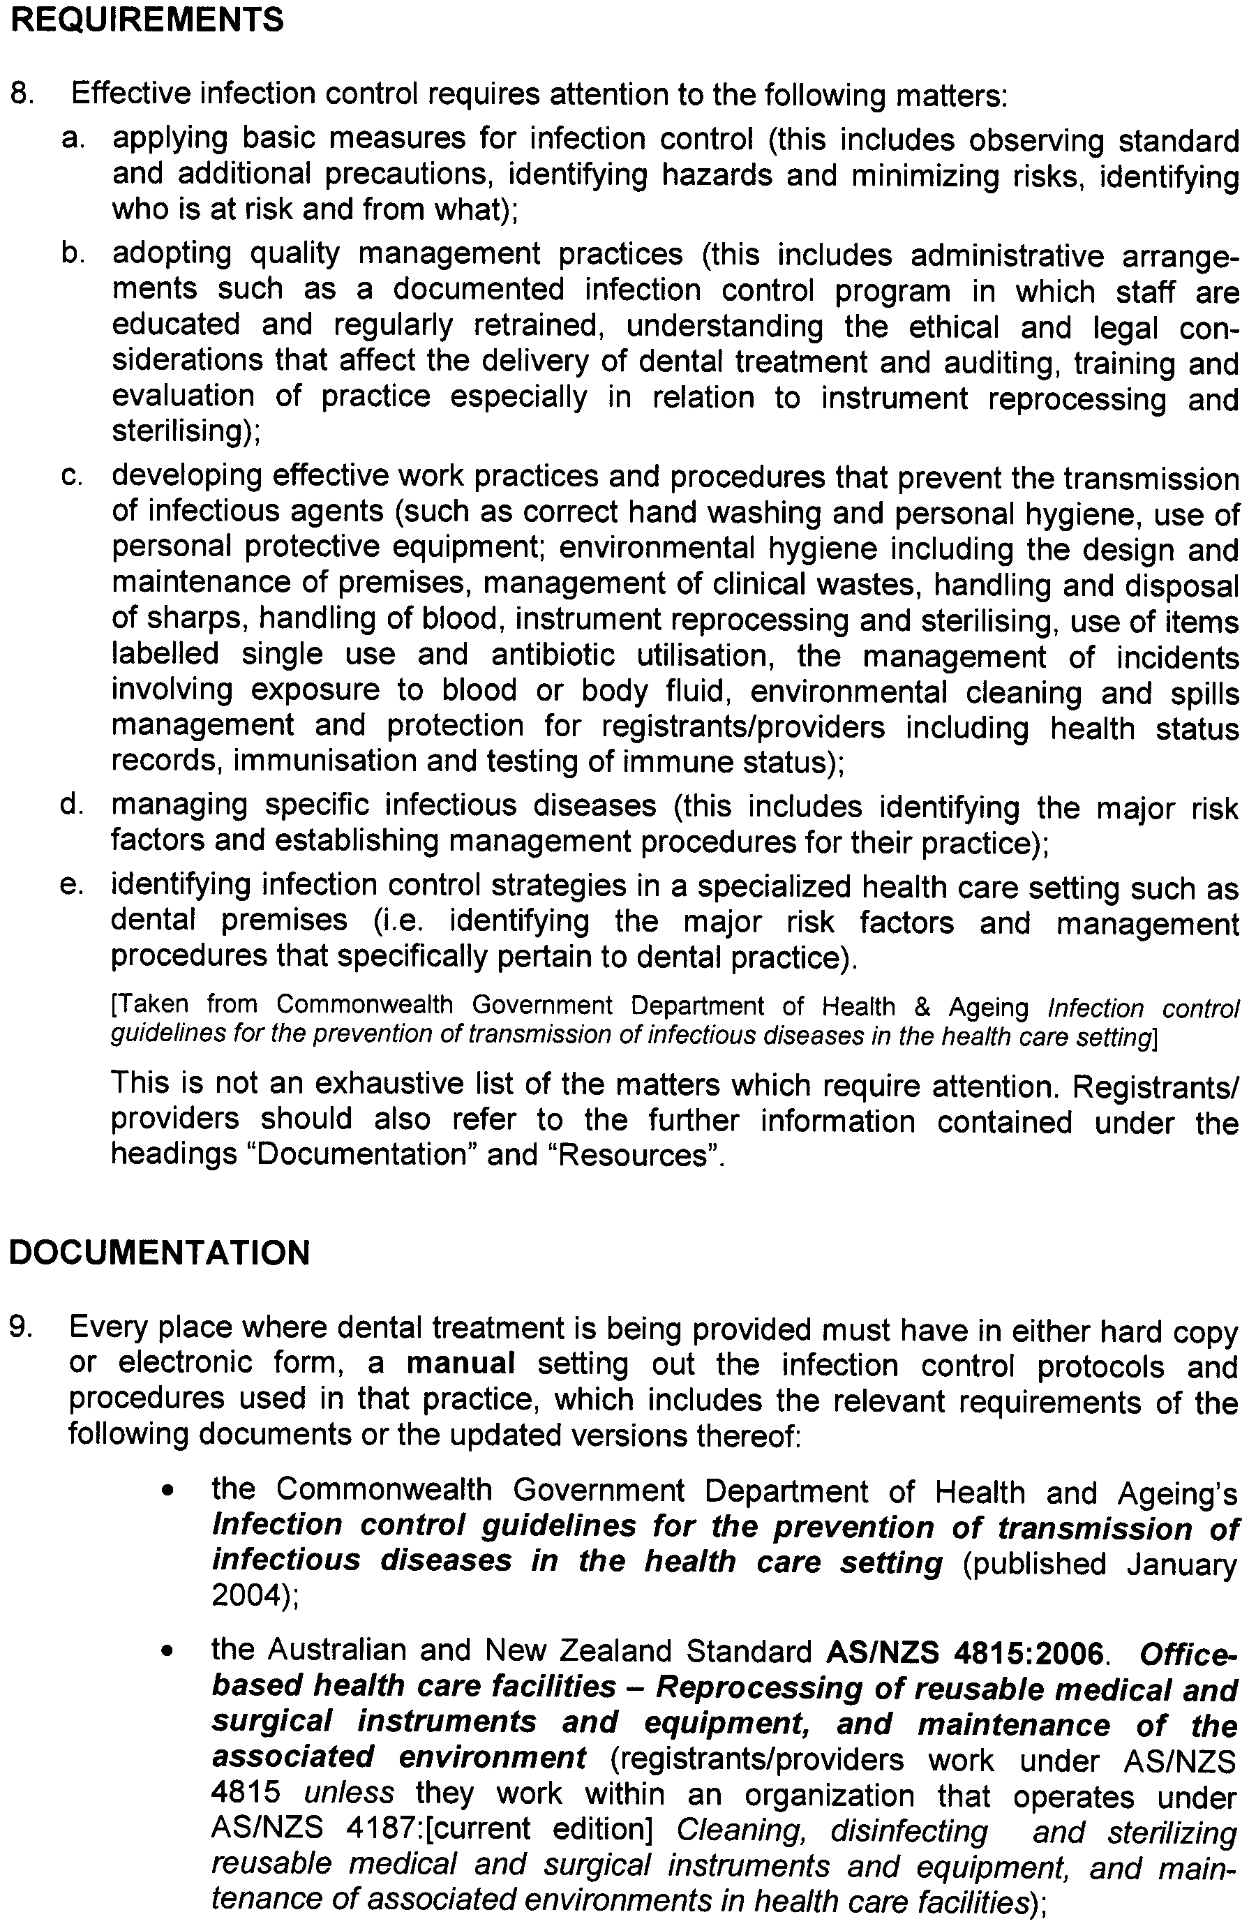
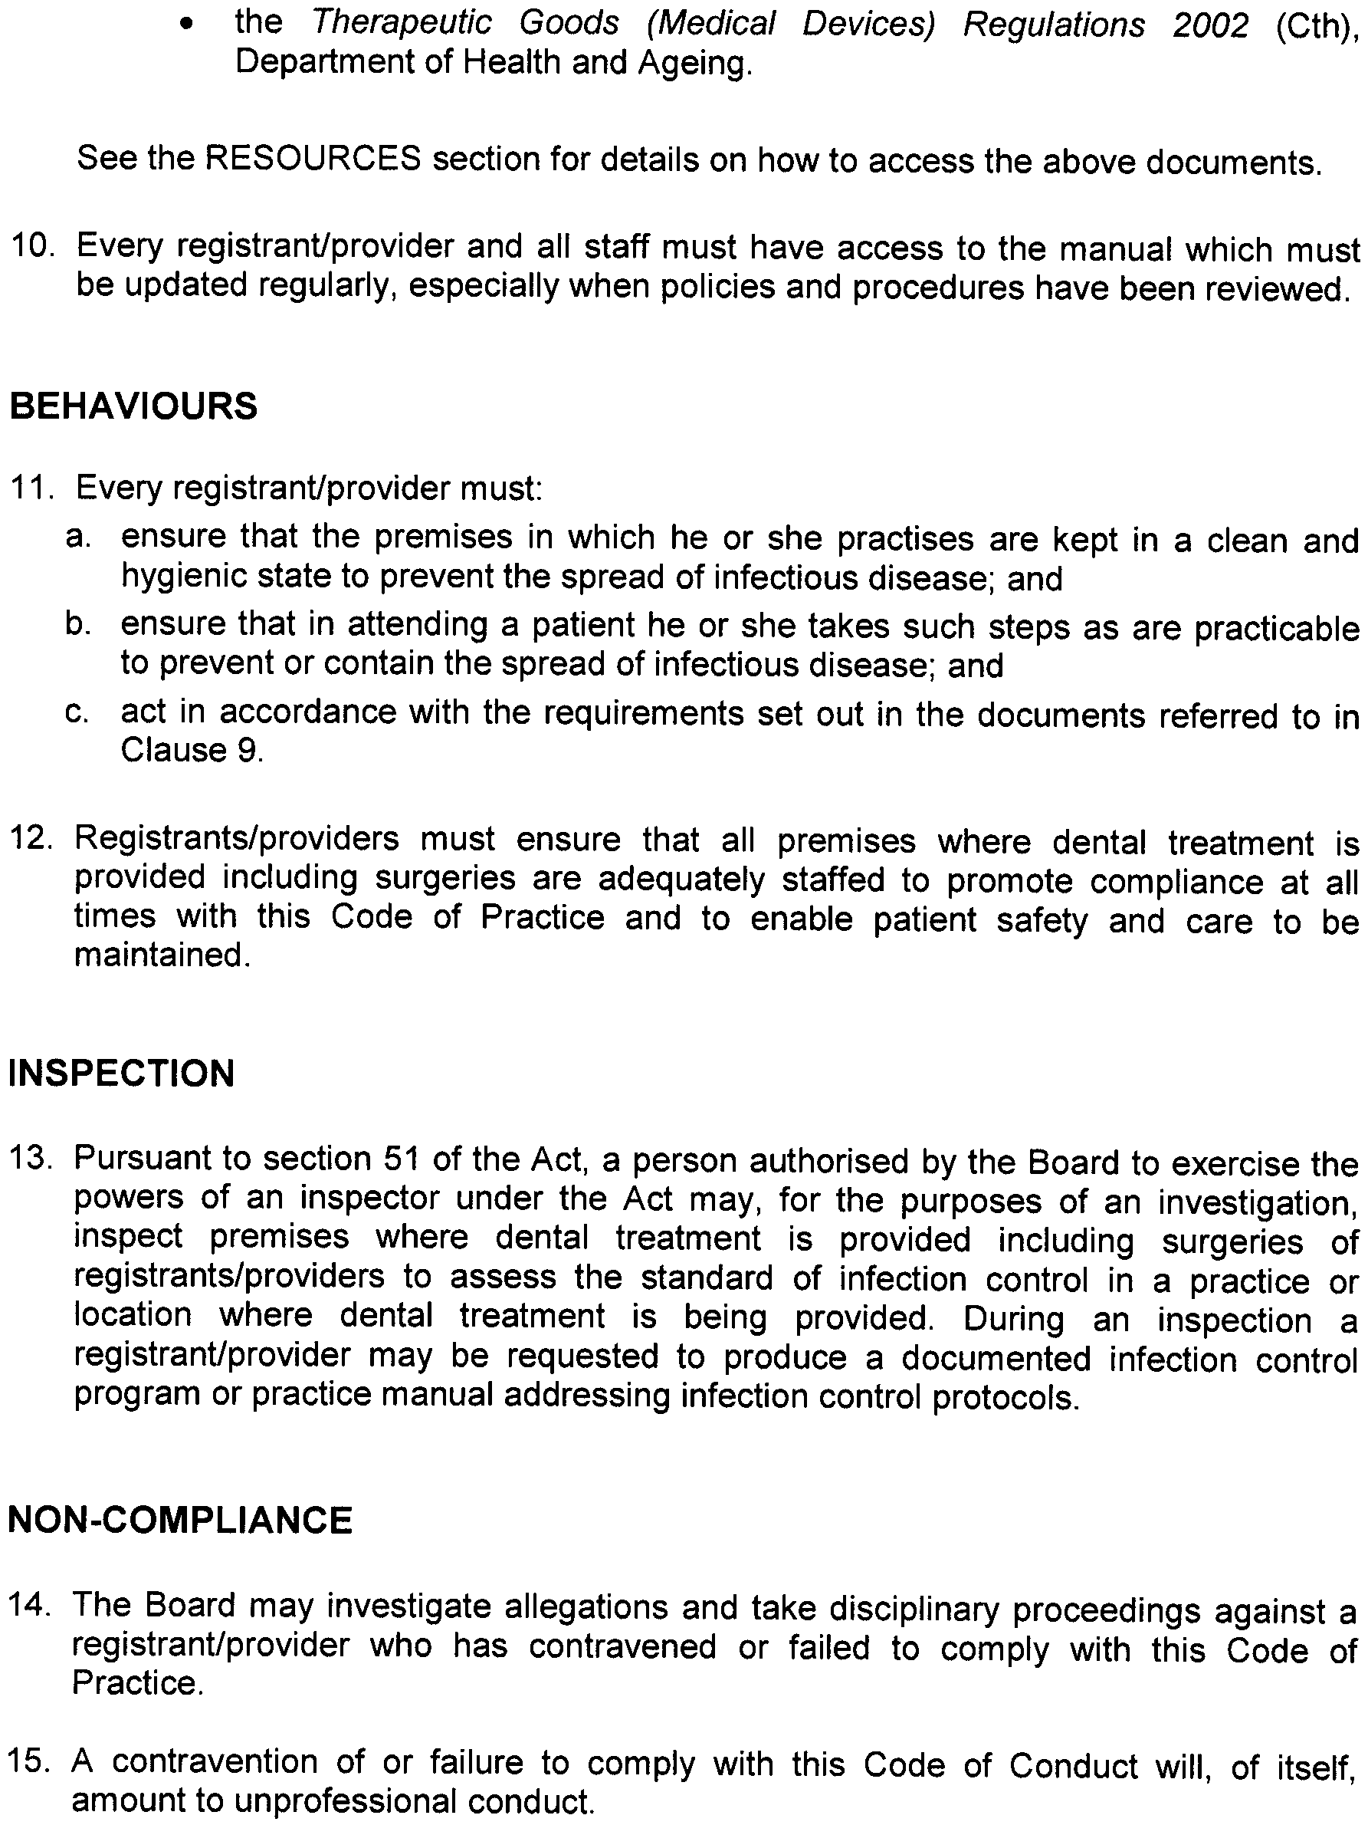

Informed Consent

Code of Practice

Issue date: November 2009
Last Updated:
Next review date:
Approved by the Minister for Health: 10 November 2009

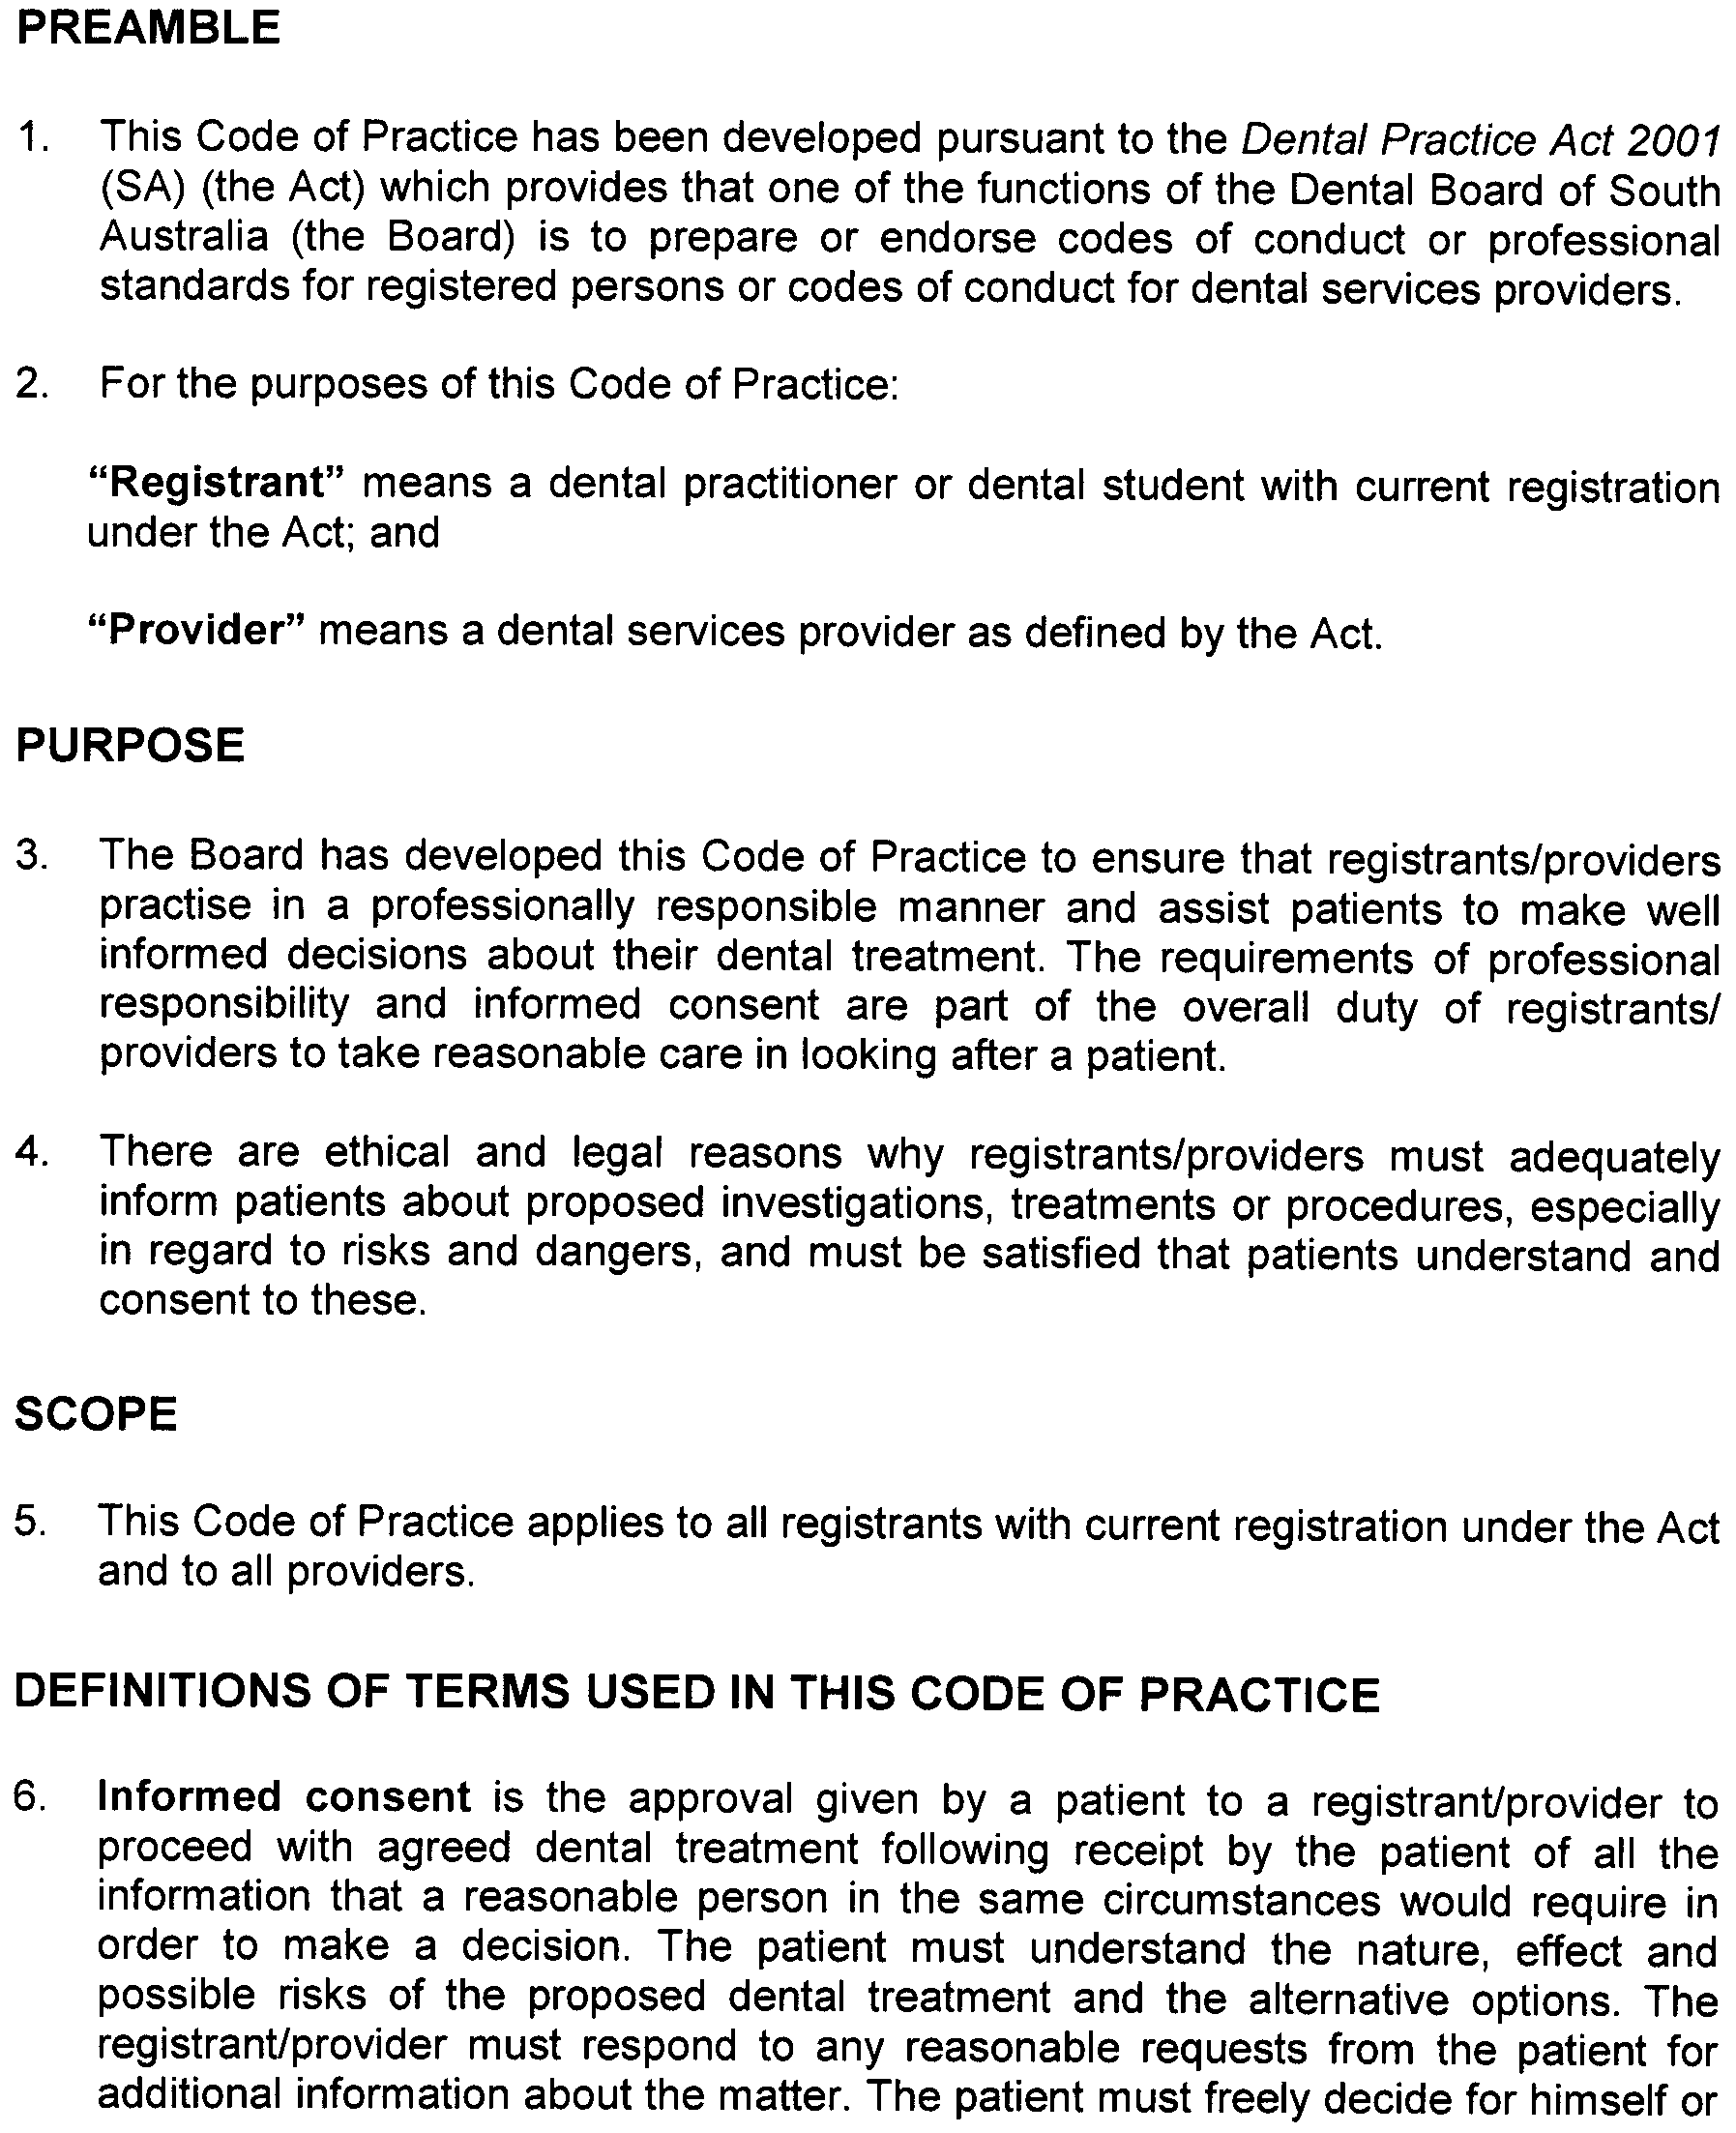
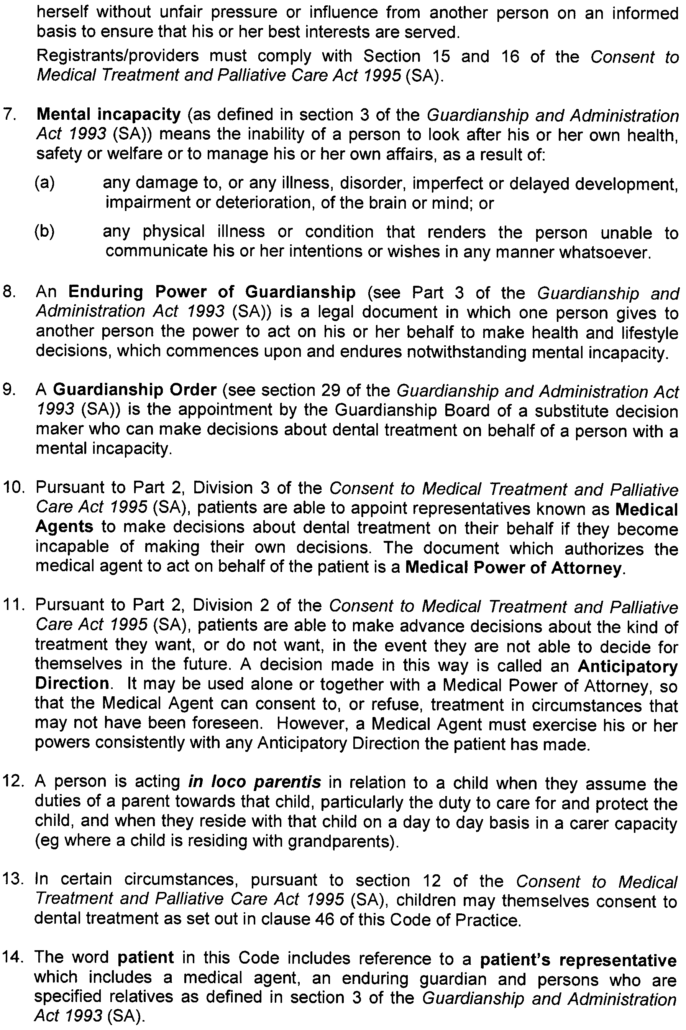
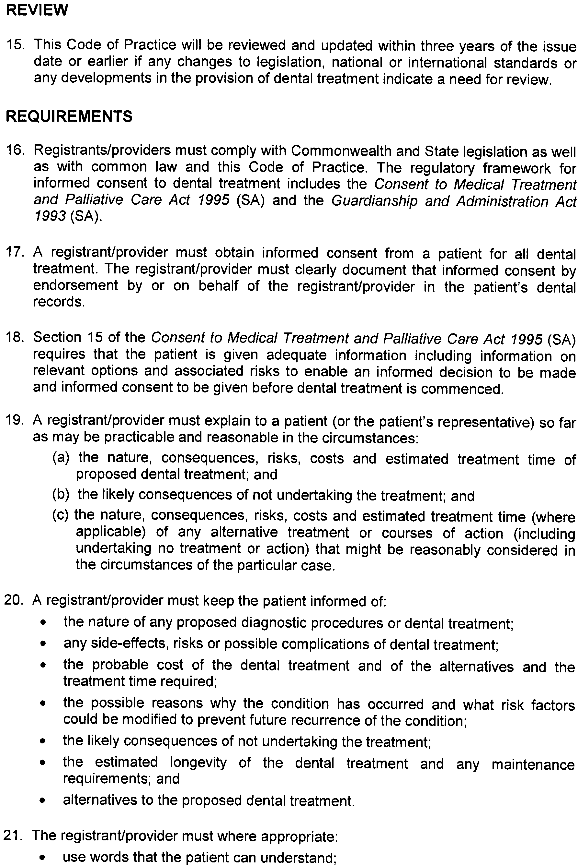
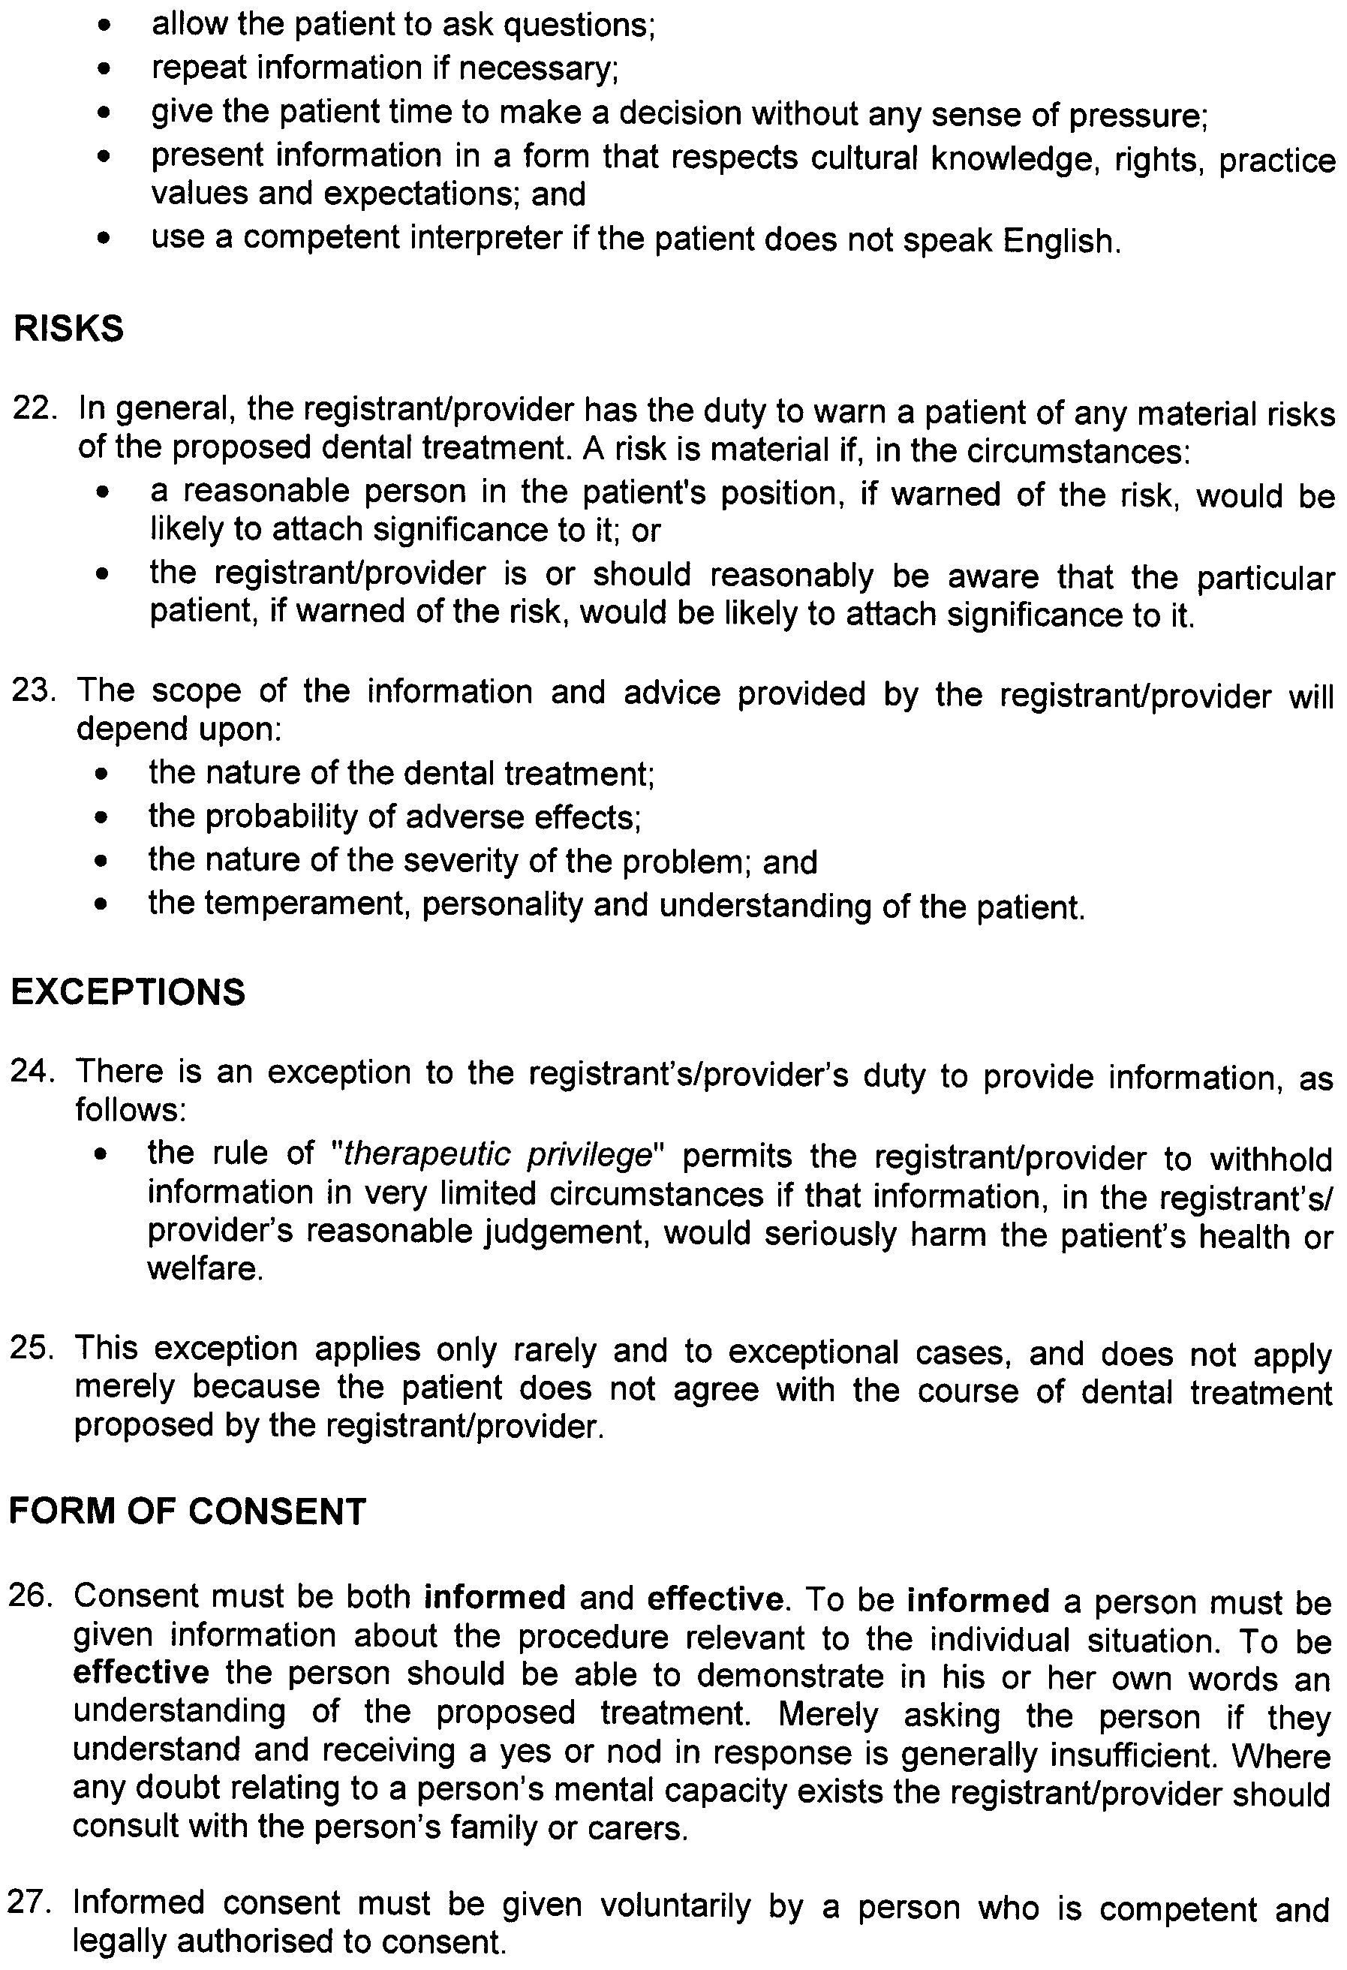
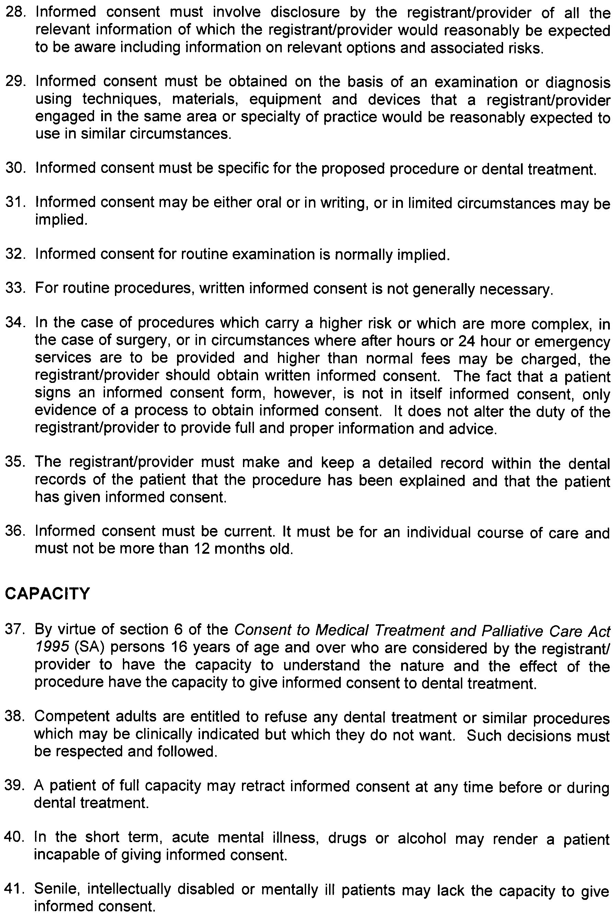
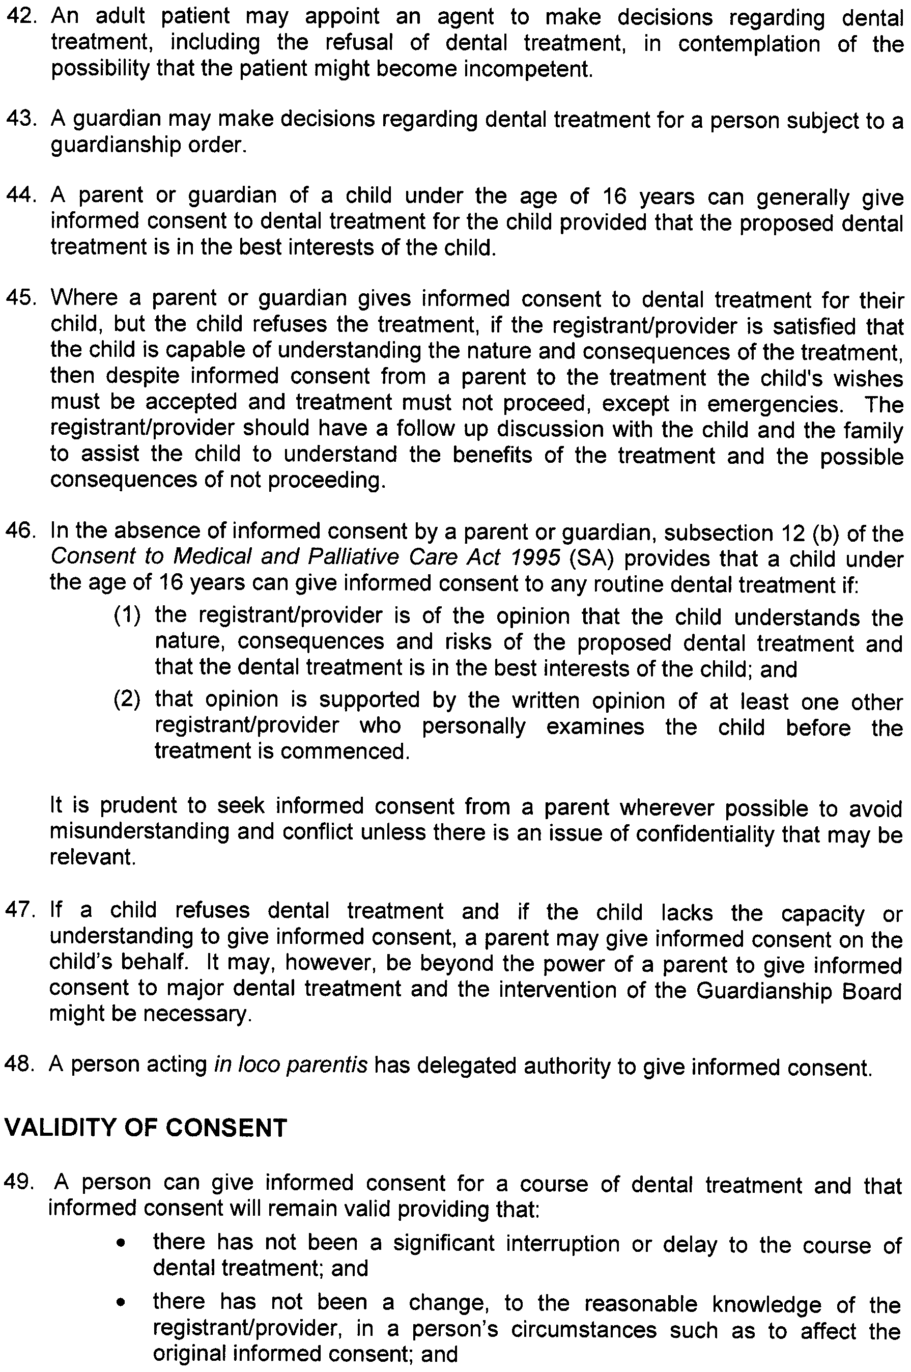
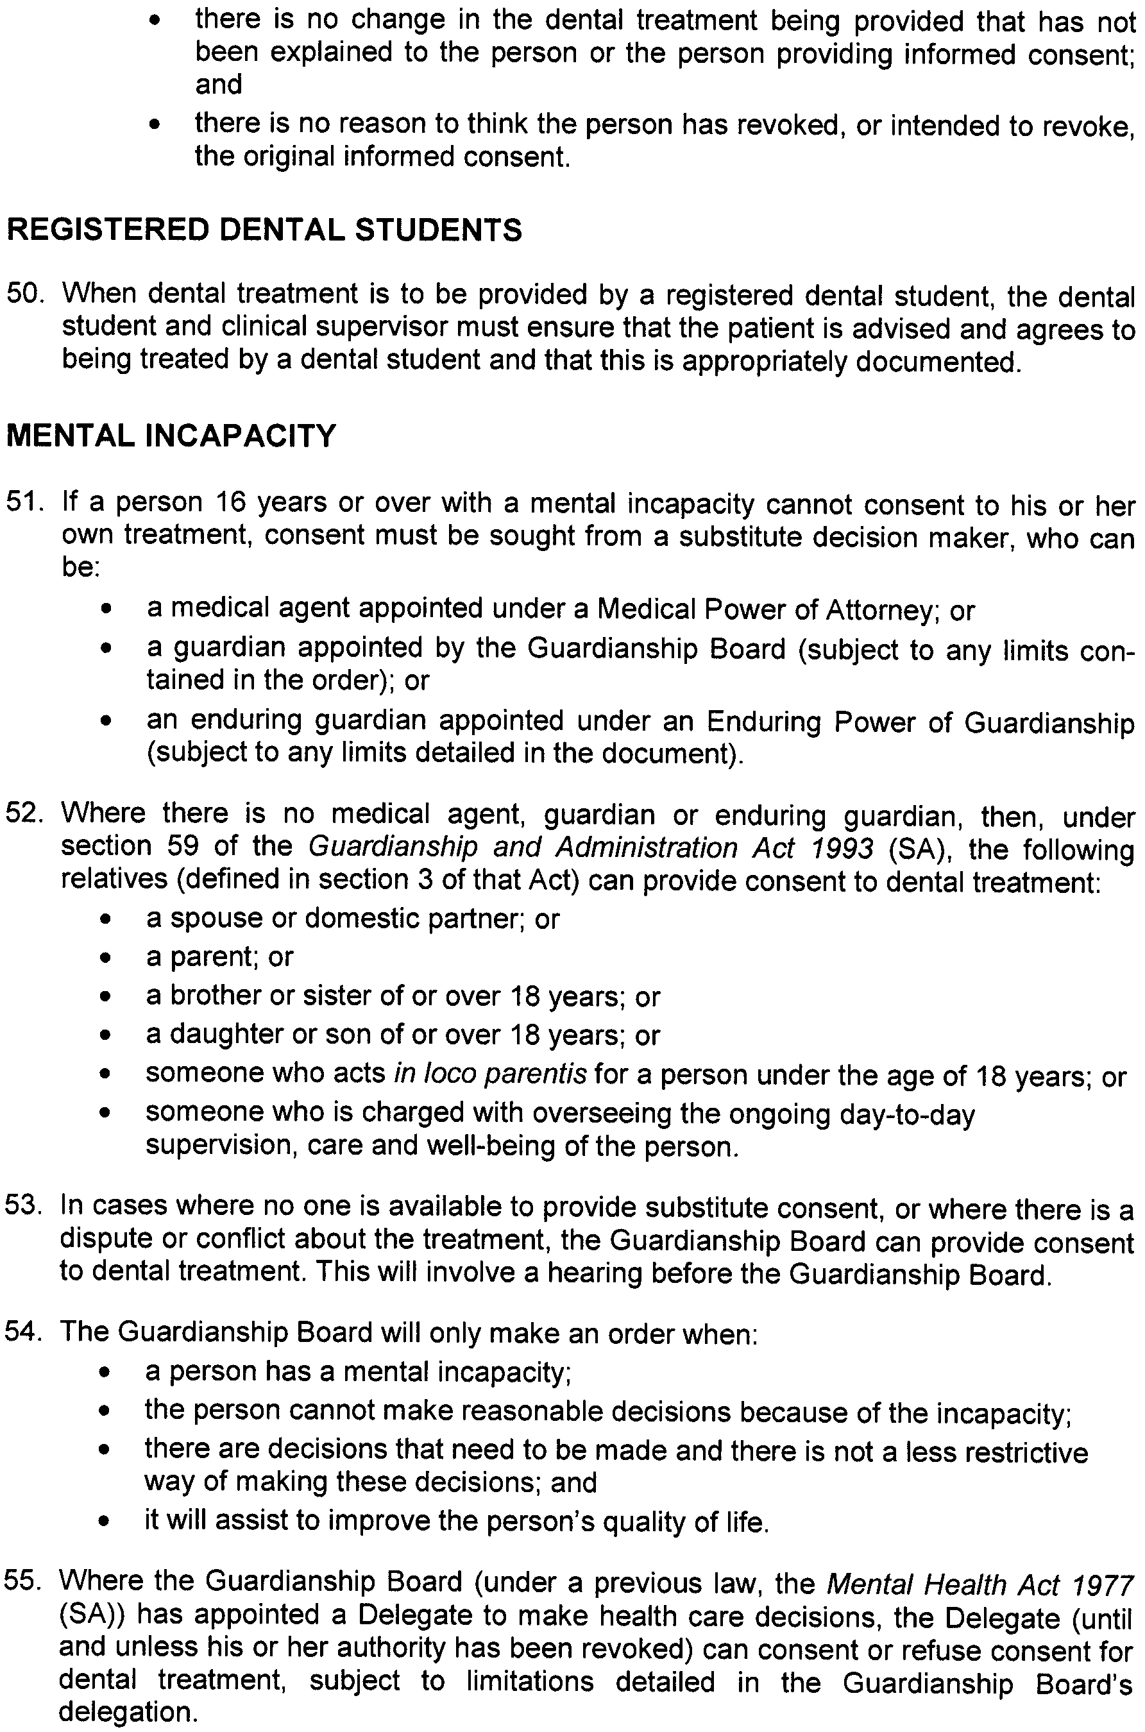
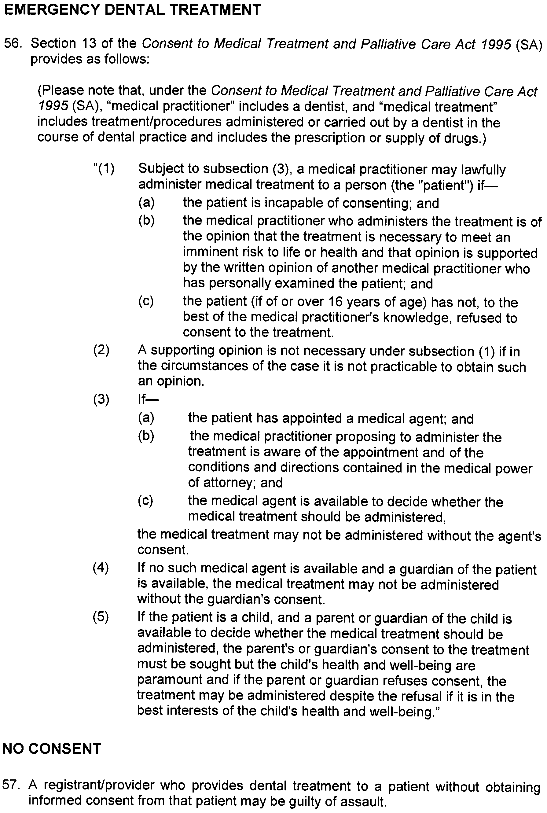
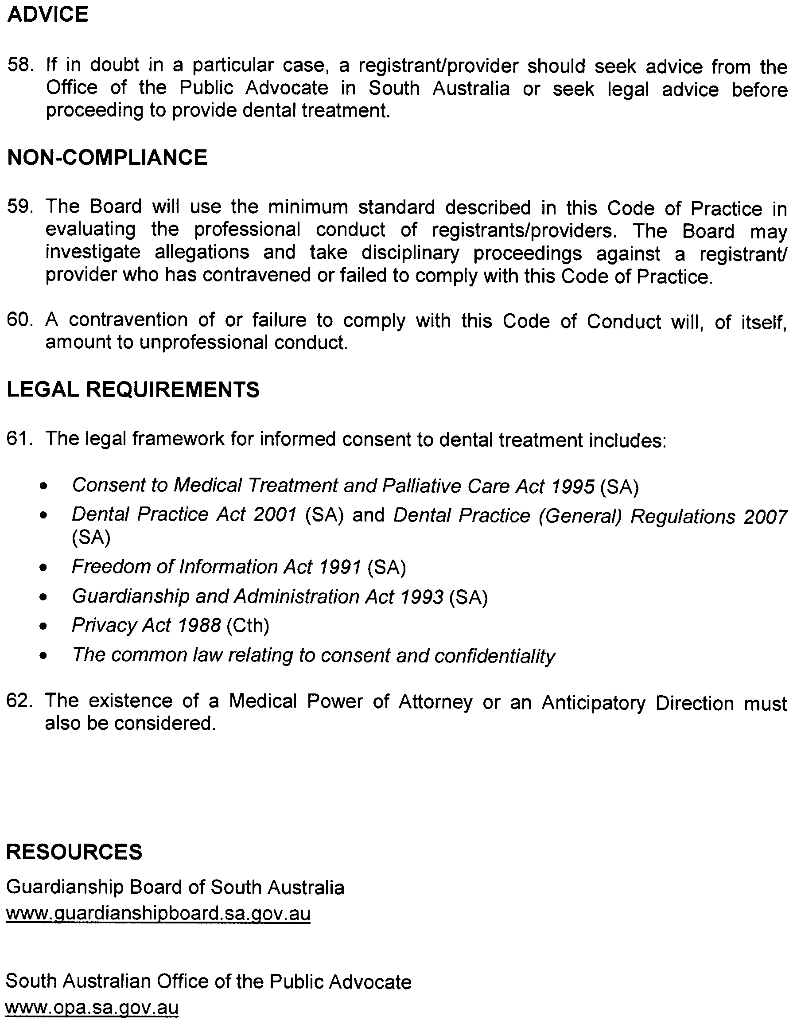
Professional Boundaries

Code of Practice

Issue Date: November 2009
Last Updated:
Next Review Date:
Approved by the Minister for Health: 10 November 2009


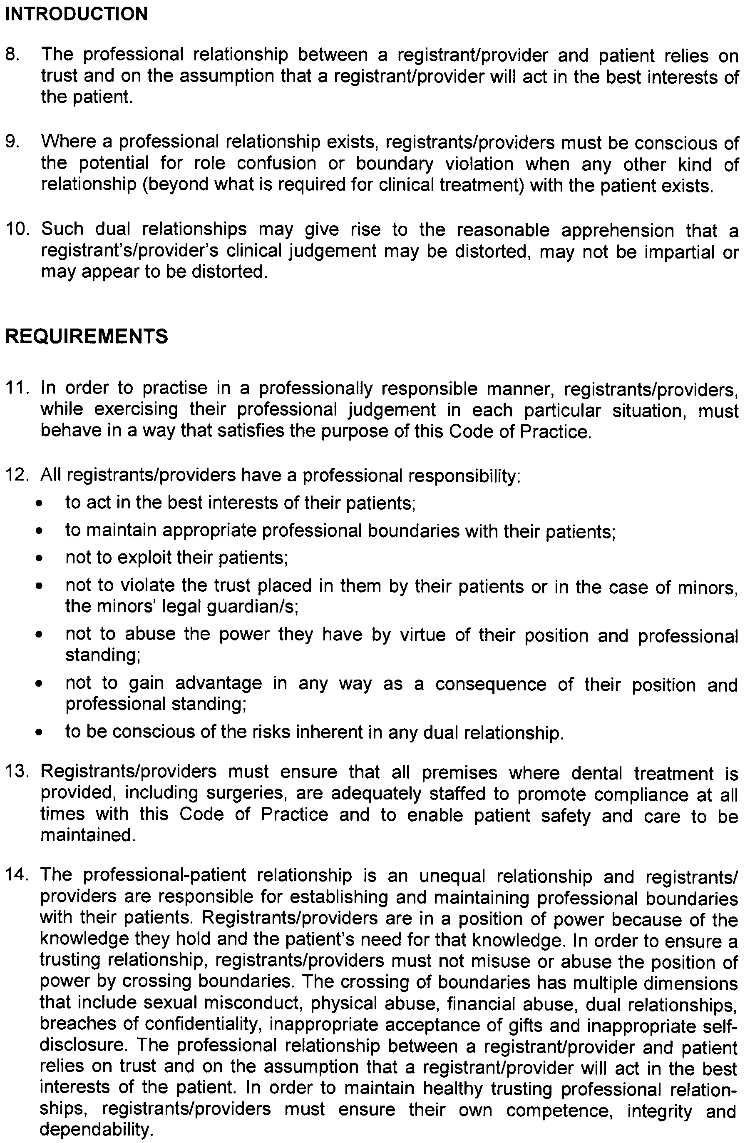
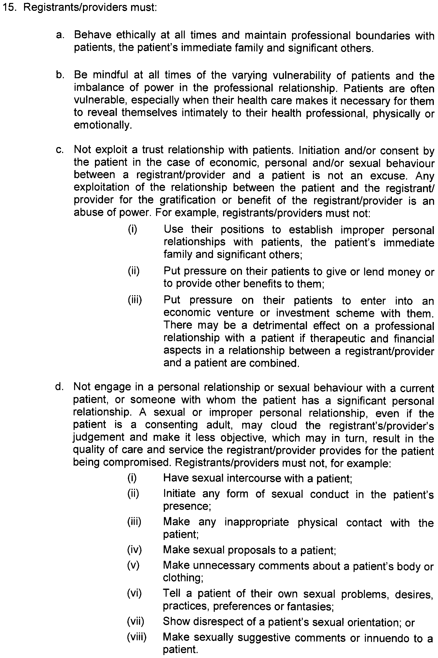
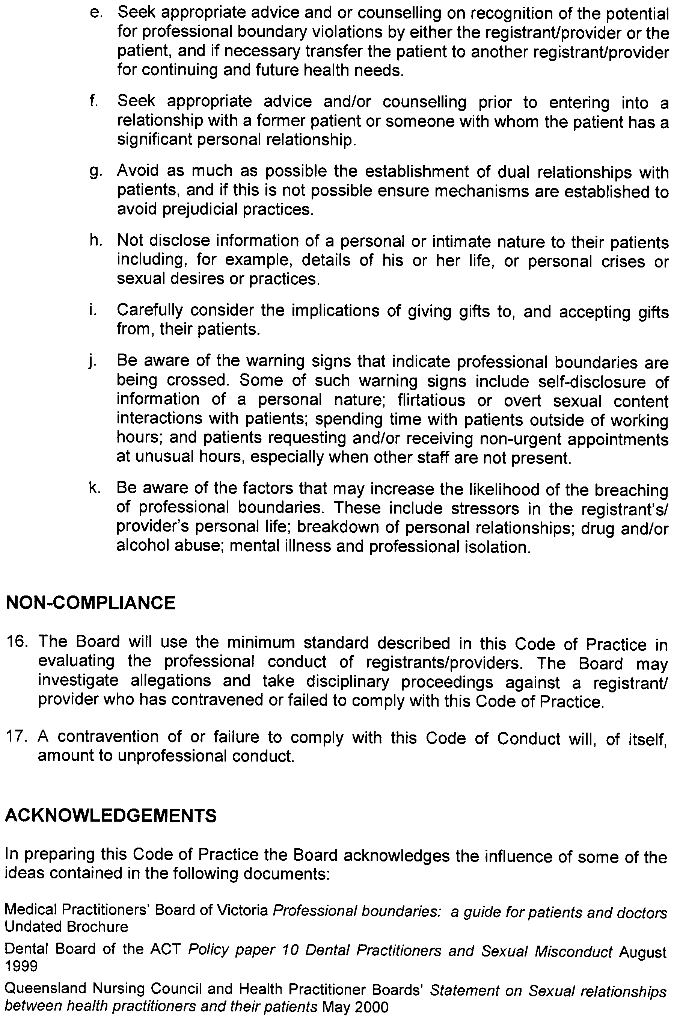
Use of Soft Tissue Cosmetic Injections

Code of Practice

Issue Date: November 2009
Last Updated:
Next Review Date:
Approved by the Minister for Health: 10 November 2009

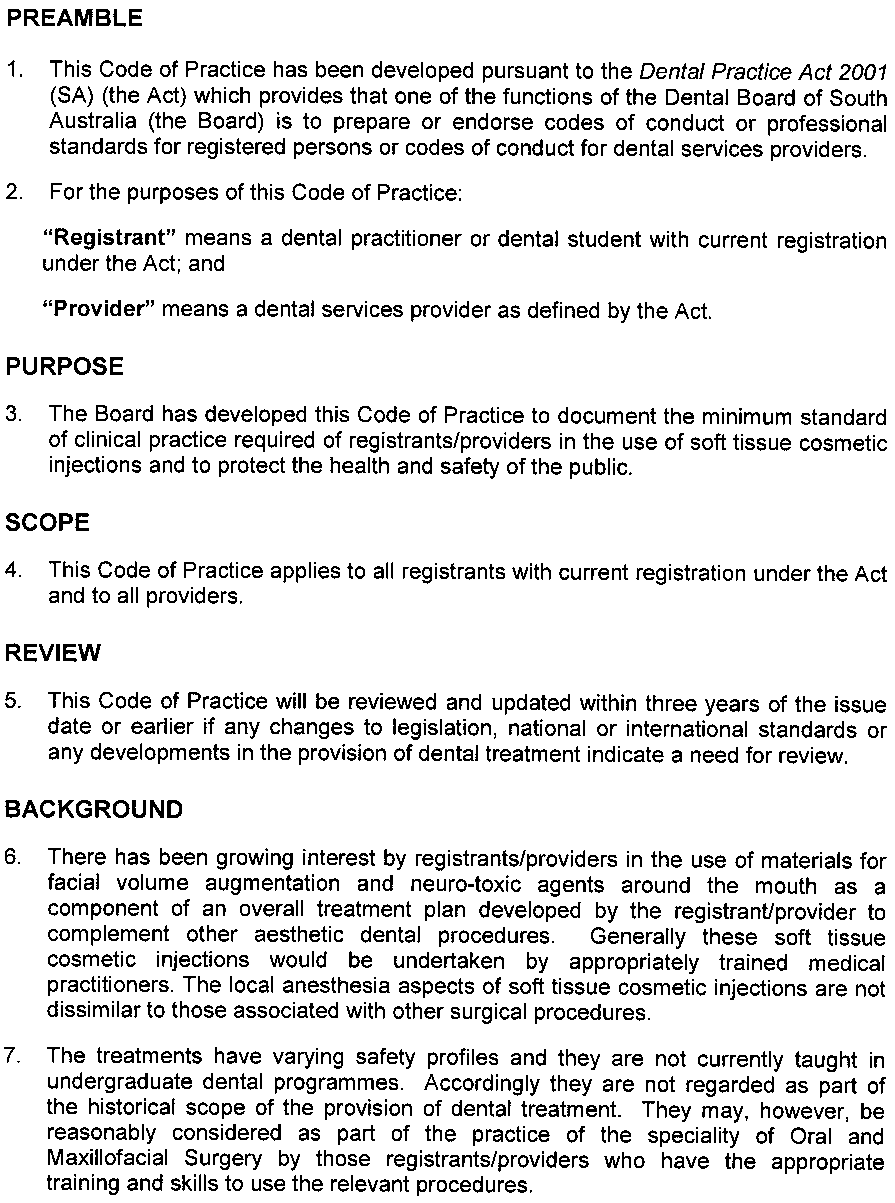

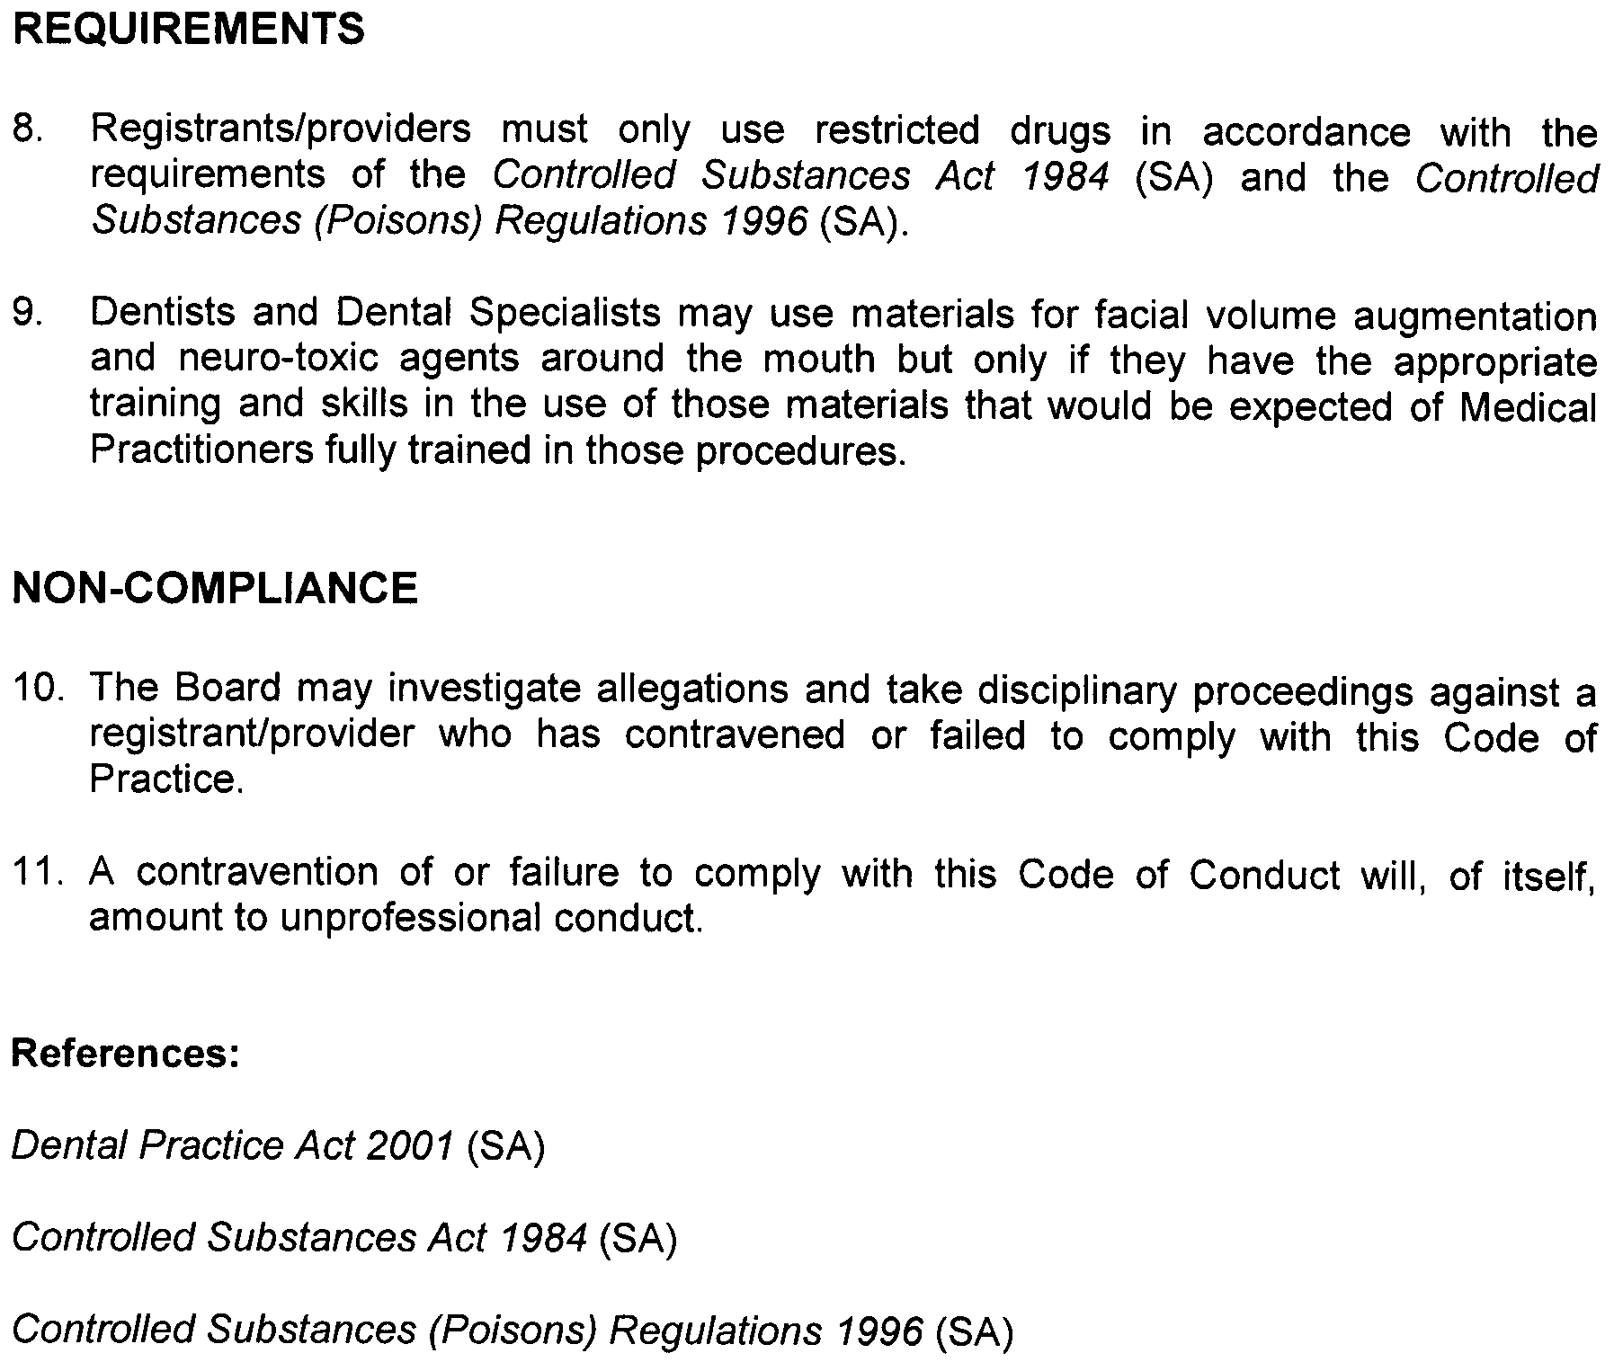

HOUSING IMPROVEMENT ACT 1940
Erratum
IN Government Gazette No. 81 dated 19 November 2009, on page 5199, fifth entry below was printed in error and should be replaced with the following:
No. of House and Street | Locality | Allotment, Section, etc. | Certificate of Title  Volume Folio

48 Railway Terrace East |  | Snowtown | Allotment 153 in Town of Snowtown, Hundred of Barunga | 5241 | 86

Dated at Adelaide, 19 November 2009. D. Huxley, Director, Corporate Services, Housing SA

LIQUOR LICENSING ACT 1997
Notice of Application
NOTICE is hereby given, pursuant to section 52 (2) (b) of the Liquor Licensing Act 1997, that The Grove Tennis Club Inc. has applied to the Licensing Authority for a Limited Club Licence with Entertainment Consent in respect of premises situated at corner of Mark and Oldham Roads, Elizabeth Vale, S.A. 5112 and to be known as The Grove Tennis Club Inc.
The application has been set down for hearing on 21 December 2009 at 3 p.m.
Conditions
The following licence conditions are sought:
• Entertainment Consent is sought for the area shown as Area 1 on the plan as per plans lodged with this office.
Any person may object to the application by lodging a notice of objection in the prescribed form with the Liquor and Gambling Commissioner and serving a copy of the notice on the applicant at the applicant’s address, at least three days before the hearing date (viz: 18 December 2009).
The applicant’s address for service is c/o Reg Driver, 90 Collingbourne Drive, Elizabeth Vale, S.A. 5112.
Plans in respect of the premises the subject of the application are open to public inspection without fee at the Office of the Liquor and Gambling Commissioner, 9th Floor, East Wing, 50 Grenfell Street, Adelaide, S.A. 5000. Phone 8226 8410, Fax:
8226 8512. Email: olgc@agd.sa.gov.au.
Dated 8 December 2009.
Applicant

LIQUOR LICENSING ACT 1997
Notice of Application
NOTICE is hereby given, pursuant to section 52 (2) (b) of the Liquor Licensing Act 1997, that Shanker Sabapathy has applied to the Licensing Authority for the transfer of a Restaurant Licence and Redefinition in respect of premises situated at 89 Prospect Road, Prospect, S.A. 5082, known as Studio 89 Cafe + Venue and to be known as Shanker’s.
The application has been set down for hearing on 4 January 2010 at 9 a.m.
Conditions
The following licence conditions are sought:
• Redefinition to include the room adjacent to Area 4 as per plans lodged with this office.
Any person may object to the application by lodging a notice of objection in the prescribed form with the Liquor and Gambling Commissioner and serving a copy of the notice on the applicant at the applicant’s address, at least four days before the hearing date (viz: 31 December 2009).
The applicant’s address for service is c/o Shanker Sabapathy, 89 Prospect road, Prospect, S.A. 5082.
Plans in respect of the premises the subject of the application are open to public inspection without fee at the Office of the Liquor and Gambling Commissioner, 9th Floor, East Wing, 50 Grenfell Street, Adelaide, S.A. 5000. Phone 8226 8410, Fax:
8226 8512. Email: olgc@agd.sa.gov.au.
Dated 1 December 2009.
Applicant

LIQUOR LICENSING ACT 1997
Notice of Application
NOTICE is hereby given, pursuant to section 52 (2) (b) of the Liquor Licensing Act 1997, that McLaren Vale Studio Winery Pty Ltd, 90 Chalk Hill Road, McLaren Vale, S.A. 5171 has applied to the Licensing Authority for a Direct Sales Licence in respect of the business to be known as Redheads Studio.
The application has been set down for hearing on 4 January 2010 at 10.30 a.m.
Any person may object to the application by lodging a notice of objection in the prescribed form with the Liquor and Gambling Commissioner and serving a copy of the notice on the applicant at the applicant’s address, at least four days before the hearing date (viz: 31 December 2009).
The applicant’s address for service is c/o Piper Alderman, Geoff Forbes, G.P.O. Box 65, Adelaide, S.A. 5001.
Plans in respect of the premises the subject of the application are open to public inspection without fee at the Office of the Liquor and Gambling Commissioner, 9th Floor, East Wing, 50 Grenfell Street, Adelaide, S.A. 5000. Phone 8226 8410, Fax:
8226 8512. Email: olgc@agd.sa.gov.au.
Dated 4 December 2009.
Applicant

LIQUOR LICENSING ACT 1997
Notice of Application
NOTICE is hereby given, pursuant to section 52 (2) (b) of the Liquor Licensing Act 1997, that Toni Tannous Kanaan and Rema Kanaan have applied to the Licensing Authority for the transfer of a Restaurant Licence in respect of premises situated at 164 King William Road, Hyde Park, S.A. 5061, known as Zoes Restaurant and Takeaway and to be known as Zoe’s Restaurant.
The application has been set down for hearing on 13 January 2010 at 9.30 a.m.
Any person may object to the application by lodging a notice of objection in the prescribed form with the Liquor and Gambling Commissioner and serving a copy of the notice on the applicants at the applicants’ address, at least seven days before the hearing date (viz: 6 January 2010).
The applicants’ address for service is c/o Rema Kanaan, 164 King William Road, Hyde Park, S.A. 5061.
Plans in respect of the premises the subject of the application are open to public inspection without fee at the Office of the Liquor and Gambling Commissioner, 9th Floor, East Wing, 50 Grenfell Street, Adelaide, S.A. 5000. Phone 8226 8410, Fax:
8226 8512. Email: olgc@agd.sa.gov.au.
Dated 2 December 2009.
Applicants

LIQUOR LICENSING ACT 1997
Notice of Application
NOTICE is hereby given, pursuant to section 52 (2) (b) of the Liquor Licensing Act 1997, that Anthony Andrew Barich and Pamela Dawn Barich have applied to the Licensing Authority for a Producer’s Licence in respect of premises situated at 73 Freundt Road, New Residence, S.A. 5333 and to be known as A. A. & P. D. Barich.
The application has been set down for hearing on 14 January 2010 at 9.30 a.m.
Any person may object to the application by lodging a notice of objection in the prescribed form with the Liquor and Gambling Commissioner and serving a copy of the notice on the applicants at the applicants’ address, at least seven days before the hearing date (viz: 7 January 2010).
The applicants’ address for service is c/o Pamela Barich, P.O. Box 259, Loxton, S.A. 5333.
Plans in respect of the premises the subject of the application are open to public inspection without fee at the Office of the Liquor and Gambling Commissioner, 9th Floor, East Wing, 50 Grenfell Street, Adelaide, S.A. 5000. Phone 8226 8410, Fax:
8226 8512. Email: olgc@agd.sa.gov.au.
Dated 3 December 2009.
Applicants

LIQUOR LICENSING ACT 1997
Notice of Application
NOTICE is hereby given, pursuant to section 52 (2) (b) of the Liquor Licensing Act 1997, that Cantarella Bros. Pty Ltd has applied to the Licensing Authority for the removal of a Wholesale Liquor Merchant’s Licence in respect of premises situated at 46 First Street, Brompton, S.A. 5007 and to be situated at 184 Cormack Road, Wingfield, S.A. 5013 and known as Cantarella Bros.
The application has been set down for hearing on 18 January 2010 at 9.30 a.m.
Any person may object to the application by lodging a notice of objection in the prescribed form with the Liquor and Gambling Commissioner and serving a copy of the notice on the applicant at the applicant’s address, at least seven days before the hearing date (viz: 11 January 2010).
The applicant’s address for service is c/o Wallmans Lawyers, 173 Wakefield Street, Adelaide, S.A. 5000 (Attention: Peter Hoban or Ben Allen).
Plans in respect of the premises the subject of the application are open to public inspection without fee at the Office of the Liquor and Gambling Commissioner, 9th Floor, East Wing, 50 Grenfell Street, Adelaide, S.A. 5000. Phone 8226 8410, Fax:
8226 8512. Email: olgc@agd.sa.gov.au.
Dated 4 December 2009.
Applicant

MINING ACT 1971
NOTICE is hereby given in accordance with section 28 (5) of the Mining Act 1971, that the Minister for Mineral Resources Development proposes to grant an Exploration Licence over the undermentioned area:
Applicant: Southern Iron Pty Ltd
Location: Windy Valley area—Approximately 50 km south of Coober Pedy.
Pastoral Leases: Ingomar, Mount Penrhyn, Lake Wirrida
Term: 1 year
Area in km²: 426
Ref.: 2009/00142
Plan and co-ordinates can be found on the PIRSA website: http://www.pir.sa.gov.au/minerals/public_notices or by phoning Mineral Tenements on (08) 8463 3103.
J. Martin, Acting Mining Registrar

MINING ACT 1971
NOTICE is hereby given in accordance with section 28 (5) of the Mining Act 1971, that the Minister for Mineral Resources Development proposes to grant an Exploration Licence over the undermentioned area:
Applicant: Lock Uranium Pty Ltd
Location: Polda Trough area—Approximately 70 km south-west of Kimba.
Term: 1 year
Area in km²: 640
Ref.: 2009/00246
Plan and co-ordinates can be found on the PIRSA website: http://www.pir.sa.gov.au/minerals/public_notices or by phoning Mineral Tenements on (08) 8463 3103.
J. Martin, Acting Mining Registrar

NATIONAL ELECTRICITY LAW
THE Australian Energy Market Commission (AEMC) gives notice under the National Electricity Law of the following matters.
Under section 107, the period of time for the making of the draft determination on the Provision of Metering Data Services and Clarification of Existing Metrology Requirements Rule proposal has been extended to 1 April 2010.
Under section 99, the making of a draft determination and draft National Electricity Amendment (Early Implementation of Market Impact Parameters) Rule 2009 (Project Ref. ERC0093). In relation to the draft determination:
• requests for a pre-determination hearing must be received by 17 December 2009;
• submissions must be received by 29 January 2010; and
• requests for a hearing should be forwarded to submissions@aemc.gov.au and must cite the Project Ref. in its title.
Submissions on this proposal can be lodged online via the AEMC’s website at www.aemc.gov.au. Before submitting your submission, you must review the AEMC’s privacy collection statement on its website. Submissions should be submitted in accordance with the AEMC’s Guidelines for making written submissions on Rule change proposals. The AEMC publishes all submissions on its website subject to a claim of confidentiality.
All documents in relation to the above matters are published on the AEMC’s website and are available for inspection at the offices of the AEMC.
John Tamblyn
Chairman
Australian Energy Market Commission
Level 5, 201 Elizabeth Street
Sydney, N.S.W. 2000
Telephone: (02) 8296 7800
Facsimile: (02) 8296 7899
10 December 2009.

NATIONAL PARKS AND WILDLIFE ACT 1972
Appointment of Wardens
PURSUANT to section 20 of the National Parks and Wildlife Act 1972, I, Edward Gregory Leaman, Director of National Parks and Wildlife, authorised delegate, hereby appoint each of the persons listed in Schedule 1 below as Wardens for the whole of the State of South Australia, for the period commencing on 1 January 2010 and ending on 31 December 2010.
Dated 7 December 2009.
E. G. Leaman, Director of National Parks and Wildlife

Schedule 1

Card  No. | Name of Warden
431 | Agius, Gavin
263 | Ah Chee, Dean Lennie
481 | Ahlin Sarah
183 | Alexander, Peter James
131 | Allen, Ross James
407 | Amey, Donald Leigh
269 | Anderson, Kenneth Paul
79 | Anderson, Malcolm John
358 | Anderson, Ross David
266 | Armenio, Melanie Marie
352 | Armstrong, David Mark
276 | Arnold, Christine Radegunde
299 | Axford, Geoffrey Bruce
408 | Bastian, Nathaniel James
446 | Beaton, Nicola Jane
223 | Beinke, Stuart
409 | Bell, Catherine Louise
365 | Bourne, Steven
478 | Bravington, Elijah
387 | Bredl, Rose-Marie
479 | Brougham, Neil
182 | Brown, Stephen Hugh
331 | Buck, Alison Janette
411 | Causebrook, Andrew Moulton
448 | Clarke, Alexander Abel Saxton
361 | Clarke, Simon
007 | Clayton, Stephen
430 | Cliff, Wendy Anne
152 | Collins, James Timothy
403 | Coulthard, Shara
412 | Cox, Tamahina
349 | Crack, Rebecca Jane
305 | Crawford, Darren Robert
200 | Crocker, James Scott
80 | Dahl, Erik Svern
215 | Dalzell, Brett Graham
413 | Davis, Deborah Ann
142 | De Groot, Richard
323 | De Smit, Eric Edward
396 | Dickson, Catherine
449 | Dinan, Nicholas Liam John
332 | Doyle, Daniel Dominic
238 | Dridan, Hannah Gosse
278 | Drogemuller, Glen
429 | Ellis, Janine
164 | Ellis, Robert James
134 | Falkenberg, Ian Douglas
450 | Ferschl, Donna Yvonne
480 | Francis, Dennis
146 | Fraser, Timothy Scott
218 | Freak, Michael James
124 | Fuhlbohm, Timothy Wayne
261 | Gable, Grant Morrison
133 | Gerschwitz, Ronald Thomas
447 | Gibbs, Verity Anne
92 | Giebel, Gerhard Wilhelm Otto
90 | Gilbert, Steven John
424 | Gitsham, John
452 | Gow, Keenan Timothy
383 | Haegi, Laurence
385 | Hall, Timothy Alan
55 | Halstead, Christopher Kenneth
453 | Hansford, Andrew Douglas
56 | Harper, Michael John
454 | Hartman, Timothy James
428 | Havelberg, Christopher
380 | Heard, David
415 | Hicks, Stuart Darren
455 | Hlava, Cassandra
3 | Hollow, Philip Rodney
445 | Holmes, Justin
477 | Iwao, Seiji
191 | Jackway, Glenn Richard
345 | Jennings, Scott Adrian
456 | Jensen, Donna Maree
473 | Jones, Sarah-Jane
328 | Kalinowska, Ewilina
293 | Kelly, Deborah Kaye
436 | Klopp, Nalini
344 | Koerner, Dylan Charles
457 | Koolmatrie, Joseph
128 | Kraehenbuehl, Janine Ann
458 | Kumar, Saras Suresh
384 | Laver, Robert
270 | Leggett, Tamara Jane
373 | Liddle, Leanne Maree
405 | Magor, Tony Brett
84 | Maguire, Anthony
272 | McIntosh, Thomas William
459 | McLean, Anne
356 | Morcom, Robyn Joanne
138 | Mount, Donald Gerard
129 | Naismith, Trevor Leonard
460 | Nester, Samantha Lee Anne
367 | Nicholls, Sonya
187 | Nixon, Craig Leslie
395 | Nussio, Donna Marie
281 | Oster, Simon Mark
324 | Paterson, Caroline Jane
433 | Patrick, Andrew
398 | Penhall, Michael
440 | Pitman, Jennifer
376 | Pobke, Katrina
442 | Robb, Adrian Joseph
222 | Robins, Brian Andrew
181 | Saers, Ronald Henry
406 | Sanderson, Samual John
461 | Savage, Russell Edward
434 | Schmidt, Carol
81 | Scholz, Volker Helmet
475 | Schriever, Barry
443 | Schutz, John Erwin
462 | Sims, Philip Jonathan
355 | Sleep, Robert George
382 | Smith, Aaron
381 | Snowball, Derek
37 | Stelmann, Joachim Gerry
216 | Strachan, Phillip James
441 | Stratman, Bronwyn
439 | Sutcliffe, Mark
374 | Swales, Jasmine
208 | Tanner, Ian Craig
283 | Taylor, Stephen Martin
463 | Thompson, Christopher Mark
167 | Tilley, Joseph William
464 | Tomlinson, James Andrew
378 | Trebilcock, Michael
196 | Troath, Robert Bryn Lewis
421 | Underwood, Geoffrey Haydn
274 | Unsworth, Paul Graham
422 | Uppill, Kym Nicholas
325 | Villiers, Kerri Anne
474 | Walsh, Patrick
306 | Watkins, Peter James
364 | Welsby, Keith Antony
199 | Wigg, Michael John
425 | Wilkins, David Sydney
399 | Wilkins, Peter James
466 | Williams, Justin Christopher
444 | Williams, Michael Joseph
423 | Wilson, Darren Lee
327 | Woods, Jonathan David
377 | Wright, Jacqueline
158 | Zepf, Albert Gerard
294 | Zidarich, Anthony David

NATIONAL PARKS AND WILDLIFE (NATIONAL PARKS) REGULATIONS 2001
Closure of Gawler Ranges National Park
PURSUANT to Regulations 8 (3) (a) and 8 (3) (d) of the National Parks and Wildlife (National Parks) Regulations 2001, I, Edward Gregory Leaman, Director of National Parks and Wildlife, close to the public, the whole of Gawler Ranges National Park from 6 a.m. on Saturday, 6 February 2010 until 6 p.m. on Saturday, 13 February 2010.
The purpose of the closure is to ensure the safety of the public during a pest control and monitoring program within the reserve during the period indicated.
Use of Firearms within the Reserve
Pursuant to Regulations 8 (4), 20 (1) and 41 of the National Parks and Wildlife (National Parks) Regulations 2001, I, Edward Gregory Leaman, Director of National Parks and Wildlife, grant permission to members of the Sporting Shooters Association of Australia Hunting & Conservation Branch (SA) Inc. in possession of both a current Hunting Permit and a firearm to enter and remain in Gawler Ranges National Park from 6 a.m. on Saturday, 6 February 2010 until 6 p.m. on Saturday, 13 February 2010 for the purpose of taking feral animals.
This permission is conditional upon the observance by each of those persons of the requirements of the National Parks and Wildlife Act 1972, National Parks and Wildlife (National Parks) Regulations 2001 and the National Parks and Wildlife (Hunting) Regulations 1996, including those requiring compliance with the Director’s requests, requirements and orders of a Warden.
Dated 7 December 2009.
E. G. Leaman, Director of National Parks and Wildlife

NATIONAL PARKS AND WILDLIFE (NATIONAL PARKS) REGULATIONS 2001
Closure of Onkaparinga River National Park
PURSUANT to Regulations 8 (3) (a) and 8 (3) (d) of the National Parks and Wildlife (National Parks) Regulations 2001, I, Edward Gregory Leaman, Director of National Parks and Wildlife, close to the public, the whole of Onkaparinga River National Park from
6 p.m. on Tuesday, 30 March 2010 until 6 a.m. on Thursday, 1 April 2010.
The purpose of the closure is to ensure the safety of the public during a pest control and monitoring program within the reserve during the period indicated.
Use of Firearms within the Reserve
Pursuant to Regulations 8 (4), 20 (1) and 41 of the National Parks and Wildlife (National Parks) Regulations 2001, I, Edward Gregory Leaman, Director of National Parks and Wildlife, grant permission to members of the Sporting Shooters Association of Australia Hunting & Conservation Branch (SA) Inc. in possession of both a current Hunting Permit and a firearm to enter and remain in Onkaparinga River National Park from 6 p.m. on Tuesday, 30 March 2010 until 6 a.m. on Thursday, 1 April 2010 for the purpose of taking feral animals.
This permission is conditional upon the observance by each of those persons of the requirements of the National Parks and Wildlife Act 1972, National Parks and Wildlife (National Parks) Regulations 2001 and the National Parks and Wildlife (Hunting) Regulations 1996, including those requiring compliance with the Director’s requests, requirements and orders of a Warden.
Dated 2 December 2009.
E. G. Leaman, Director of National Parks and Wildlife

NATURAL RESOURCES MANAGEMENT ACT 2004
Variation of Areas within the Adelaide and Mount Lofty Ranges Natural Resources Management Region
PURSUANT to section 45 (2) (a) of the Natural Resources Management Act 2004, the Adelaide and Mount Lofty Ranges Natural Resources Management Board hereby varies the notice Establishment of Areas within the Adelaide and Mount Lofty Ranges Natural Resources Management Region published in the Government Gazette on 22 May 2008, page 1708, by replacing General Registry Office Plan No. GRO—18/2008 with General Registry Office Plan No. GRO—48/2009.
Dated 7 December 2009.
Y. Sneddon, Presiding Member, Adelaide and Mount Lofty Ranges Natural Resources Management Board

NATURAL RESOURCES MANAGEMENT ACT 2004
Variation of Areas within the South Australian Arid Lands Natural Resources Management Region
PURSUANT to section 45 (2) (a) of the Natural Resources Management Act 2004, the South Australian Arid Lands Natural Resources Management Board hereby varies the notice Establishment of Areas Within the South Australian Arid Lands Natural Resources Management Region published in the Government Gazette on 29 June 2006, page 2082, by replacing the General Registry Office Plan No. 72/06 with General Registry Office Plan No. 47/2009:
Dated 3 December 2009.
C. Reed, Presiding Member, South Australian Arid Lands Natural Resources Management Board

NATURAL RESOURCES MANAGEMENT ACT 2004
Establishment of Area within the South Australian Arid Lands Natural Resources Management Region
PURSUANT to section 45 of the Natural Resources Management Act 2004, the South Australian Arid Lands Natural Resources Management Board hereby designates one additional area within its region as an area within which an NRM group will operate. This NRM group area is defined and designated as follows by General Registry Office Plan No. 47/2009:
South Australian Arid Lands—North East Pastoral
Dated 3 December 2009.
C. Reed, Presiding Member, South Australian Arid Lands Natural Resources Management Board

NATURAL RESOURCES MANAGEMENT ACT 2004
Establishment of NRM Group within the South Australian Arid Lands Natural Resources Management Region
PURSUANT to section 46 of the Natural Resources Management Act 2004, the South Australian Arid Lands Natural Resources Management Board establishes the following NRM group:
Area | NRM Group Name
South Australian Arid Lands—North East Pastoral | North East Pastoral
Dated 3 December 2009.
C. Reed, Presiding Member, South Australian Arid Lands Natural Resources Management Board

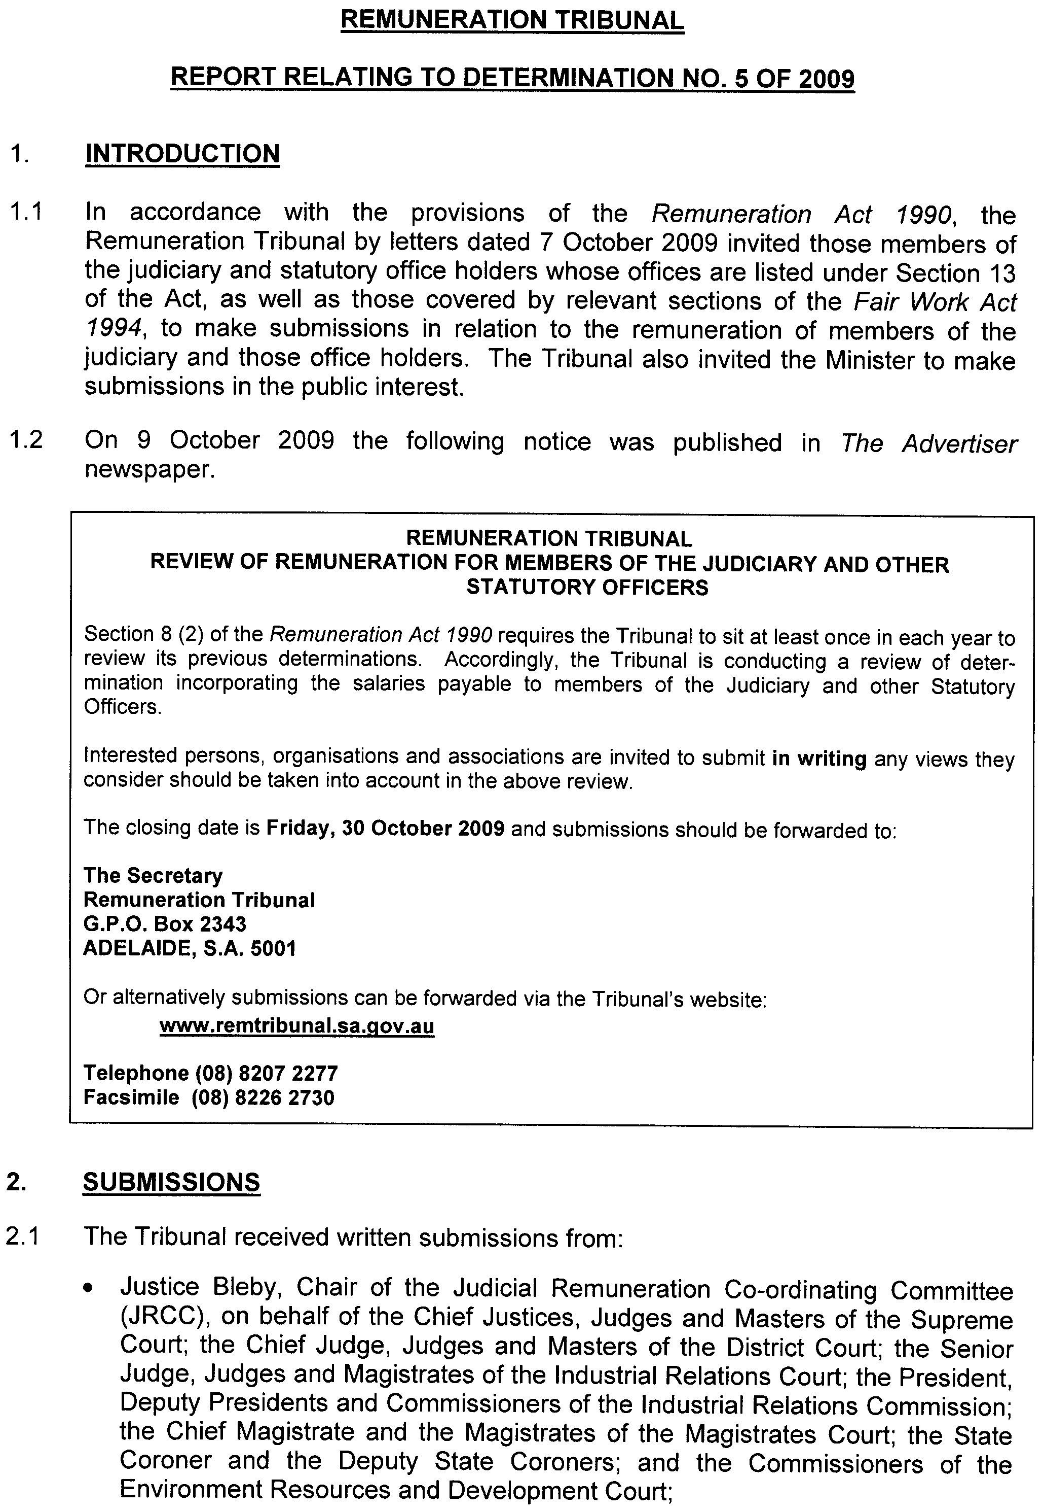
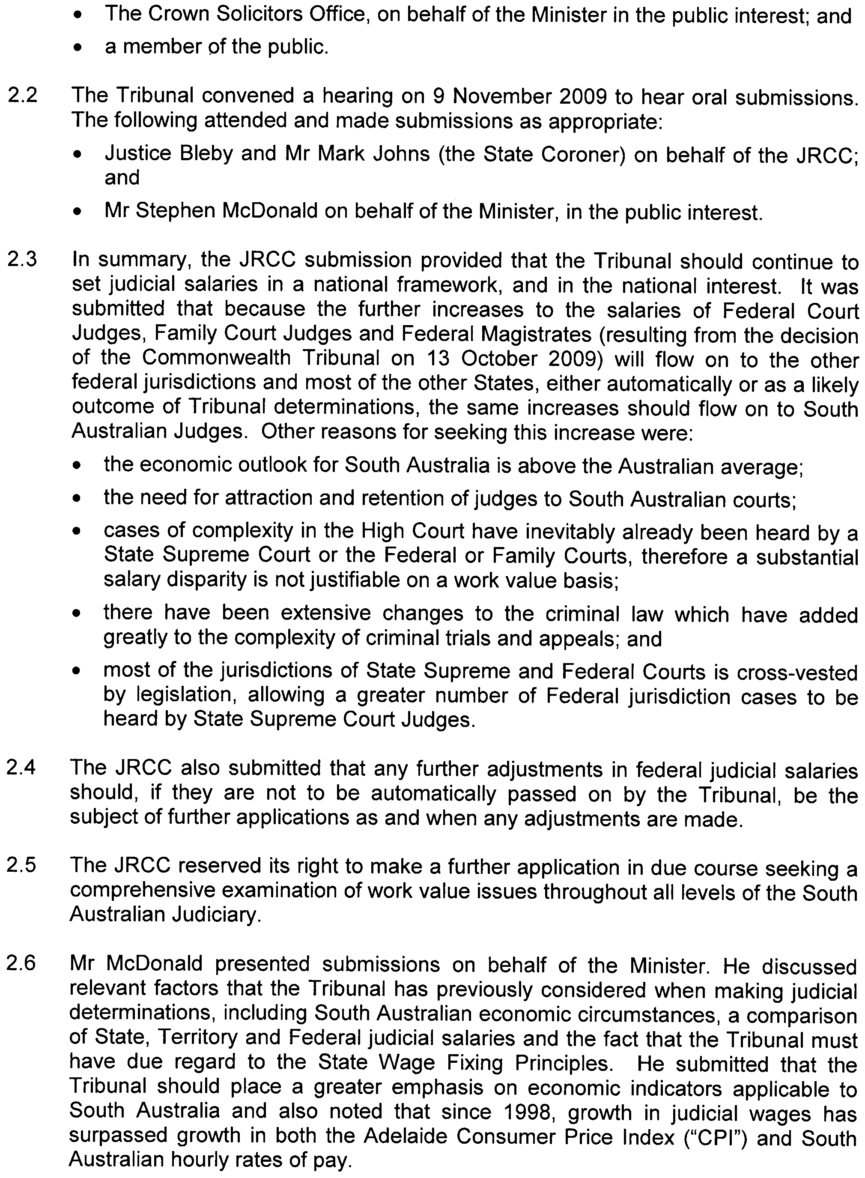
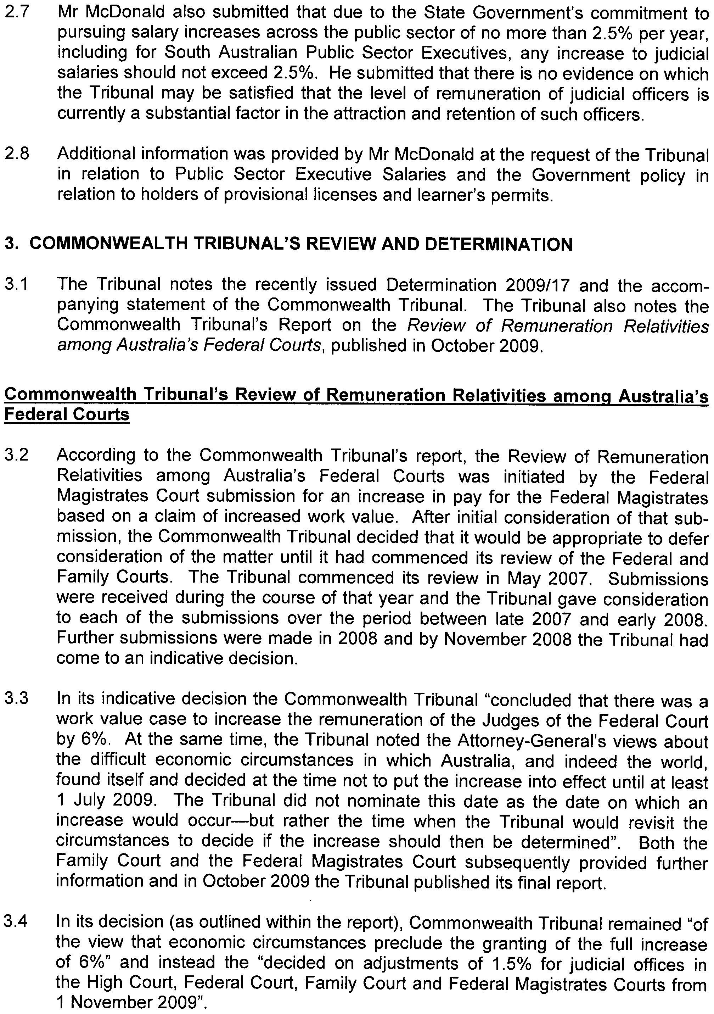
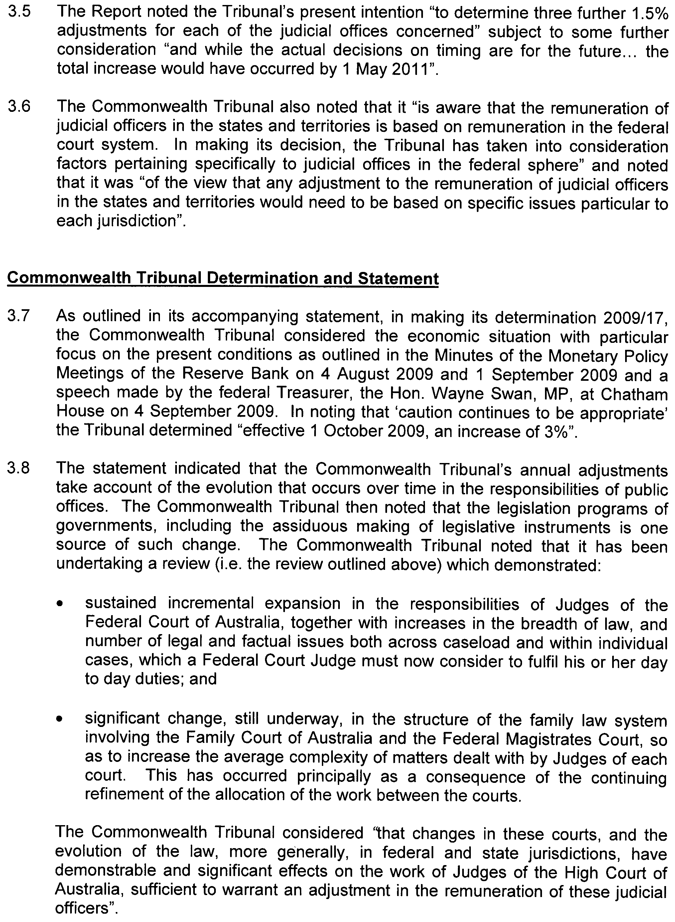
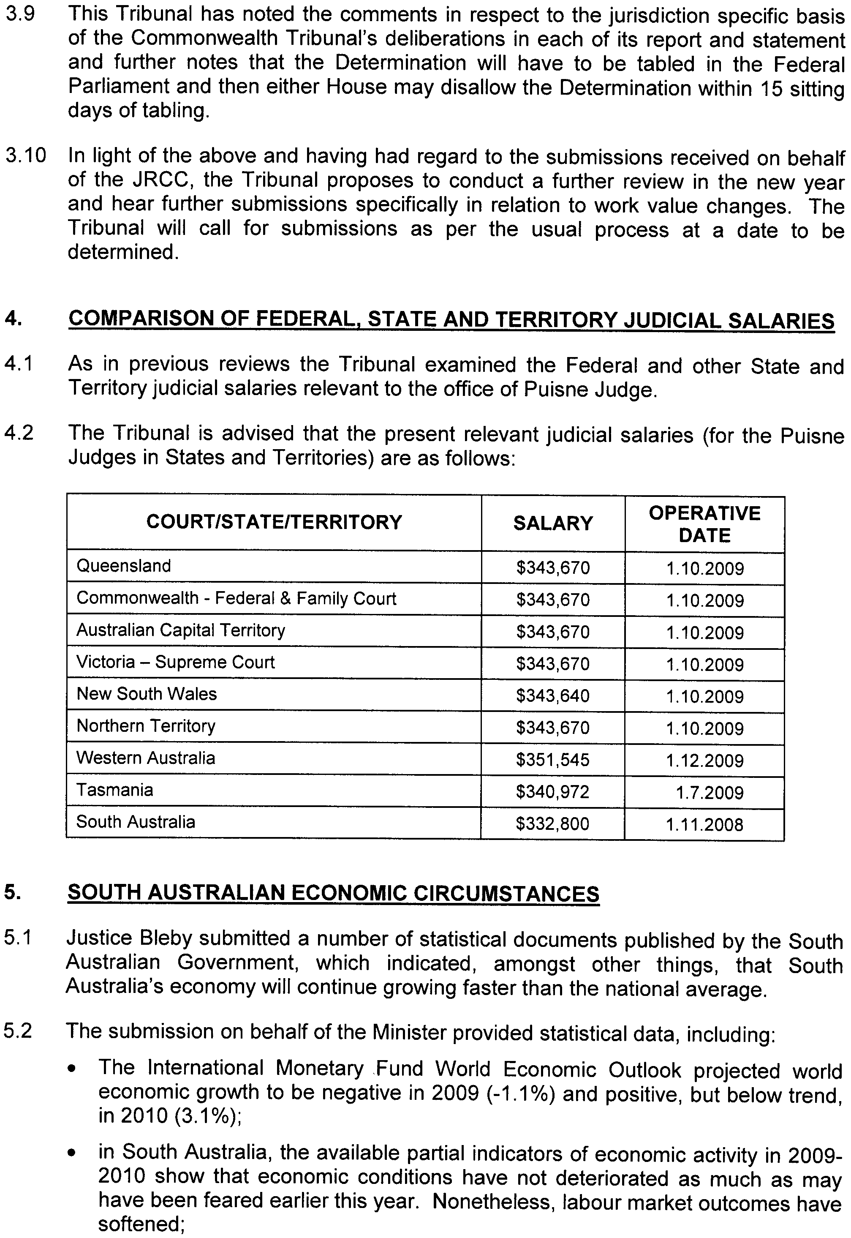
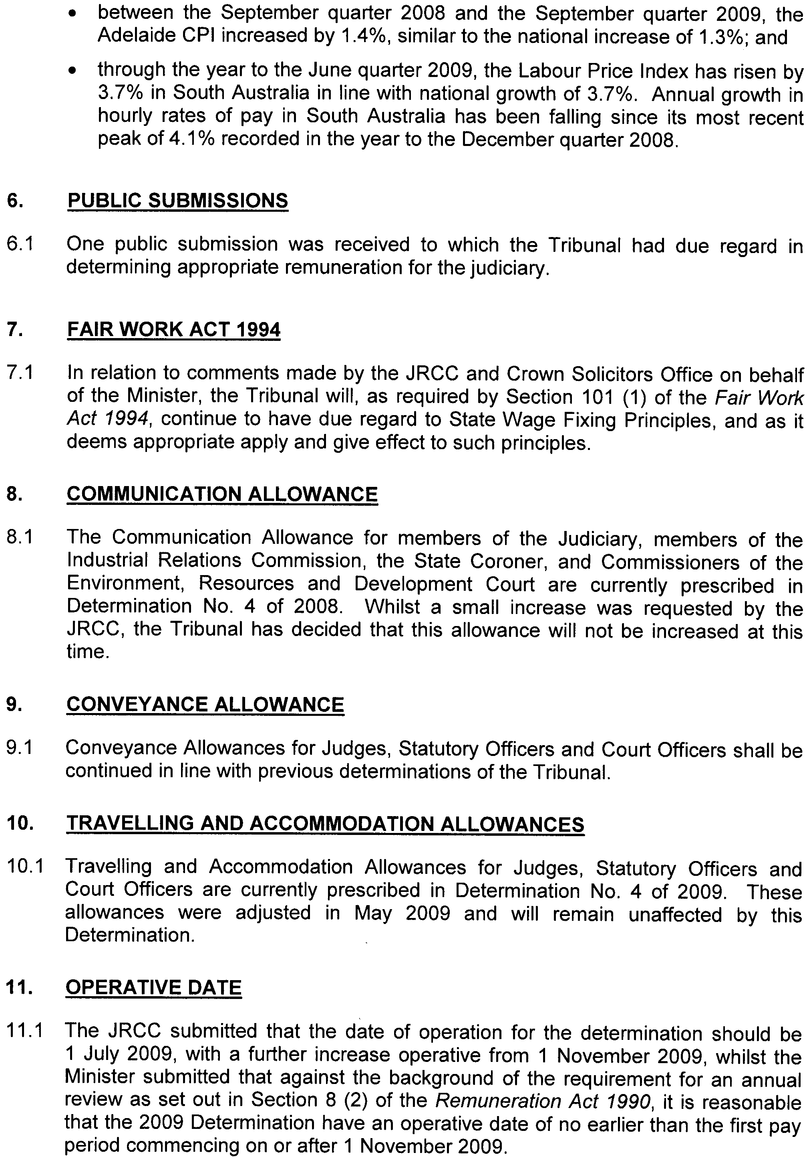

December 2009.

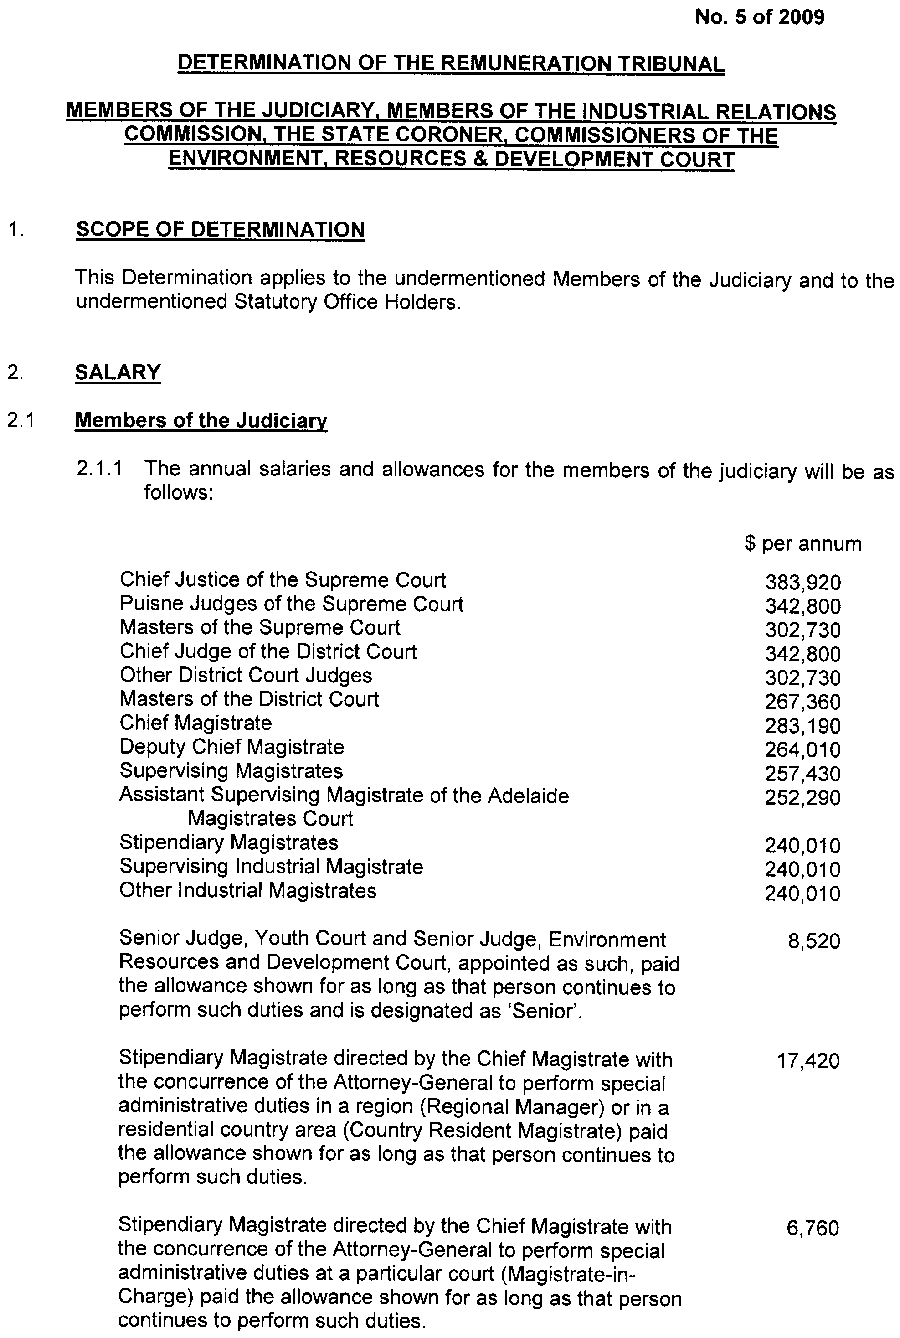
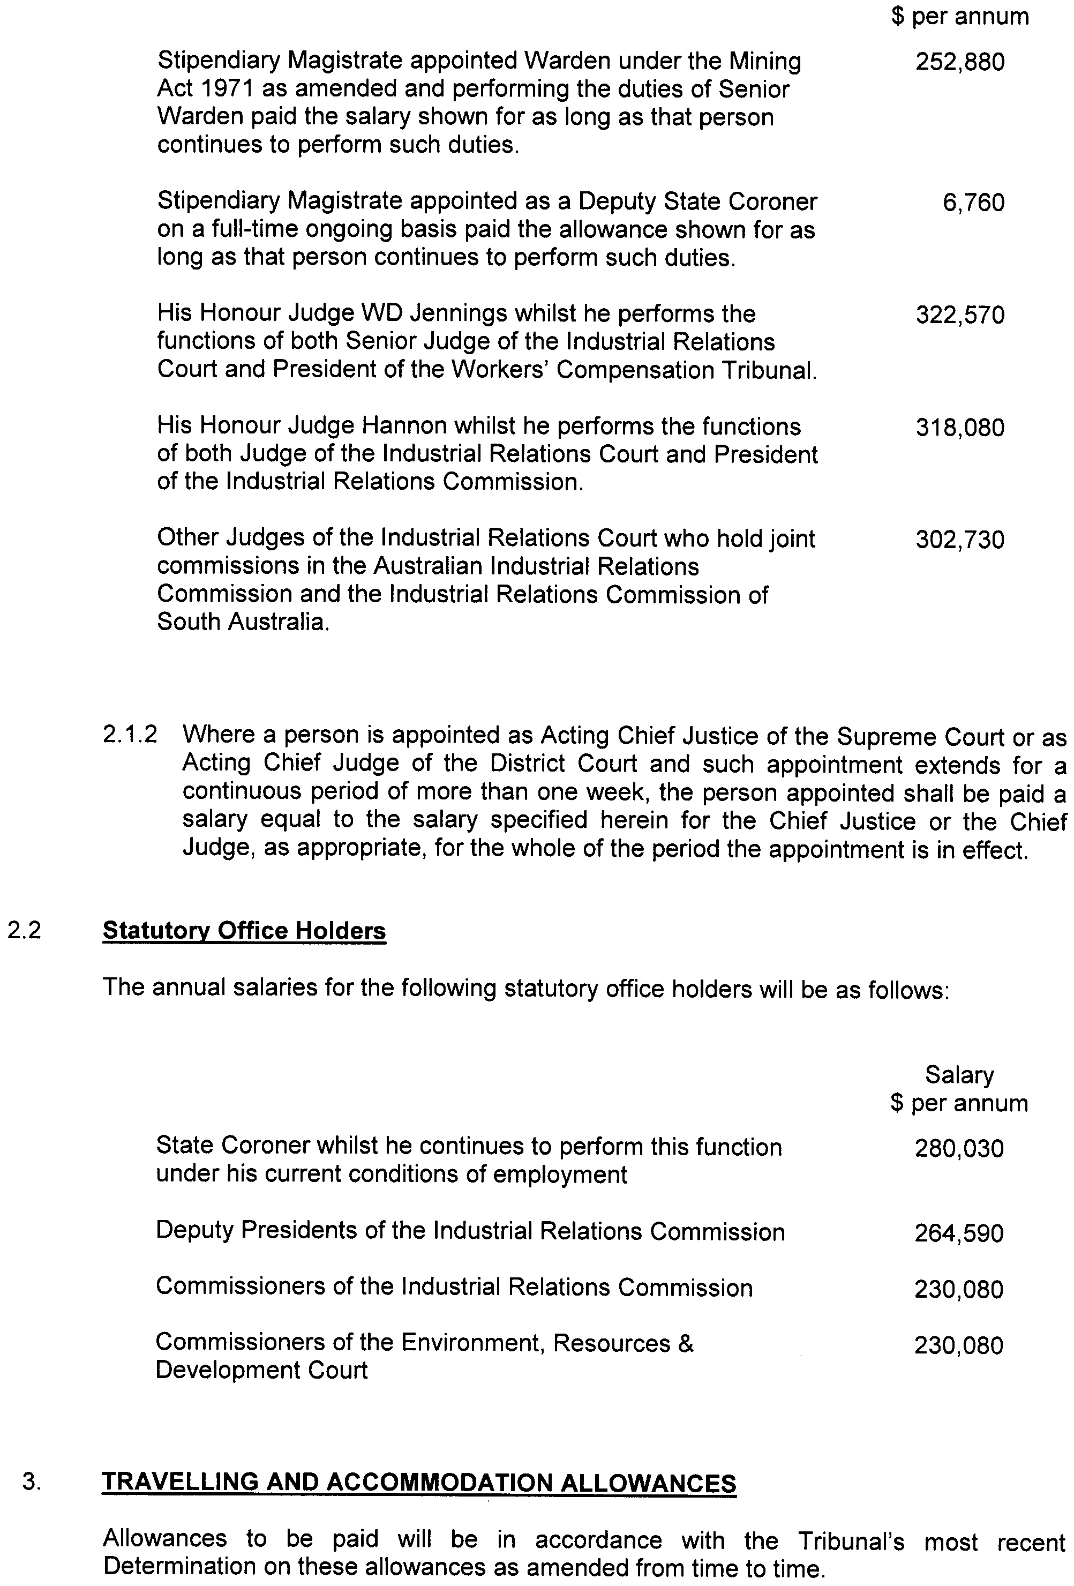


December 2009.
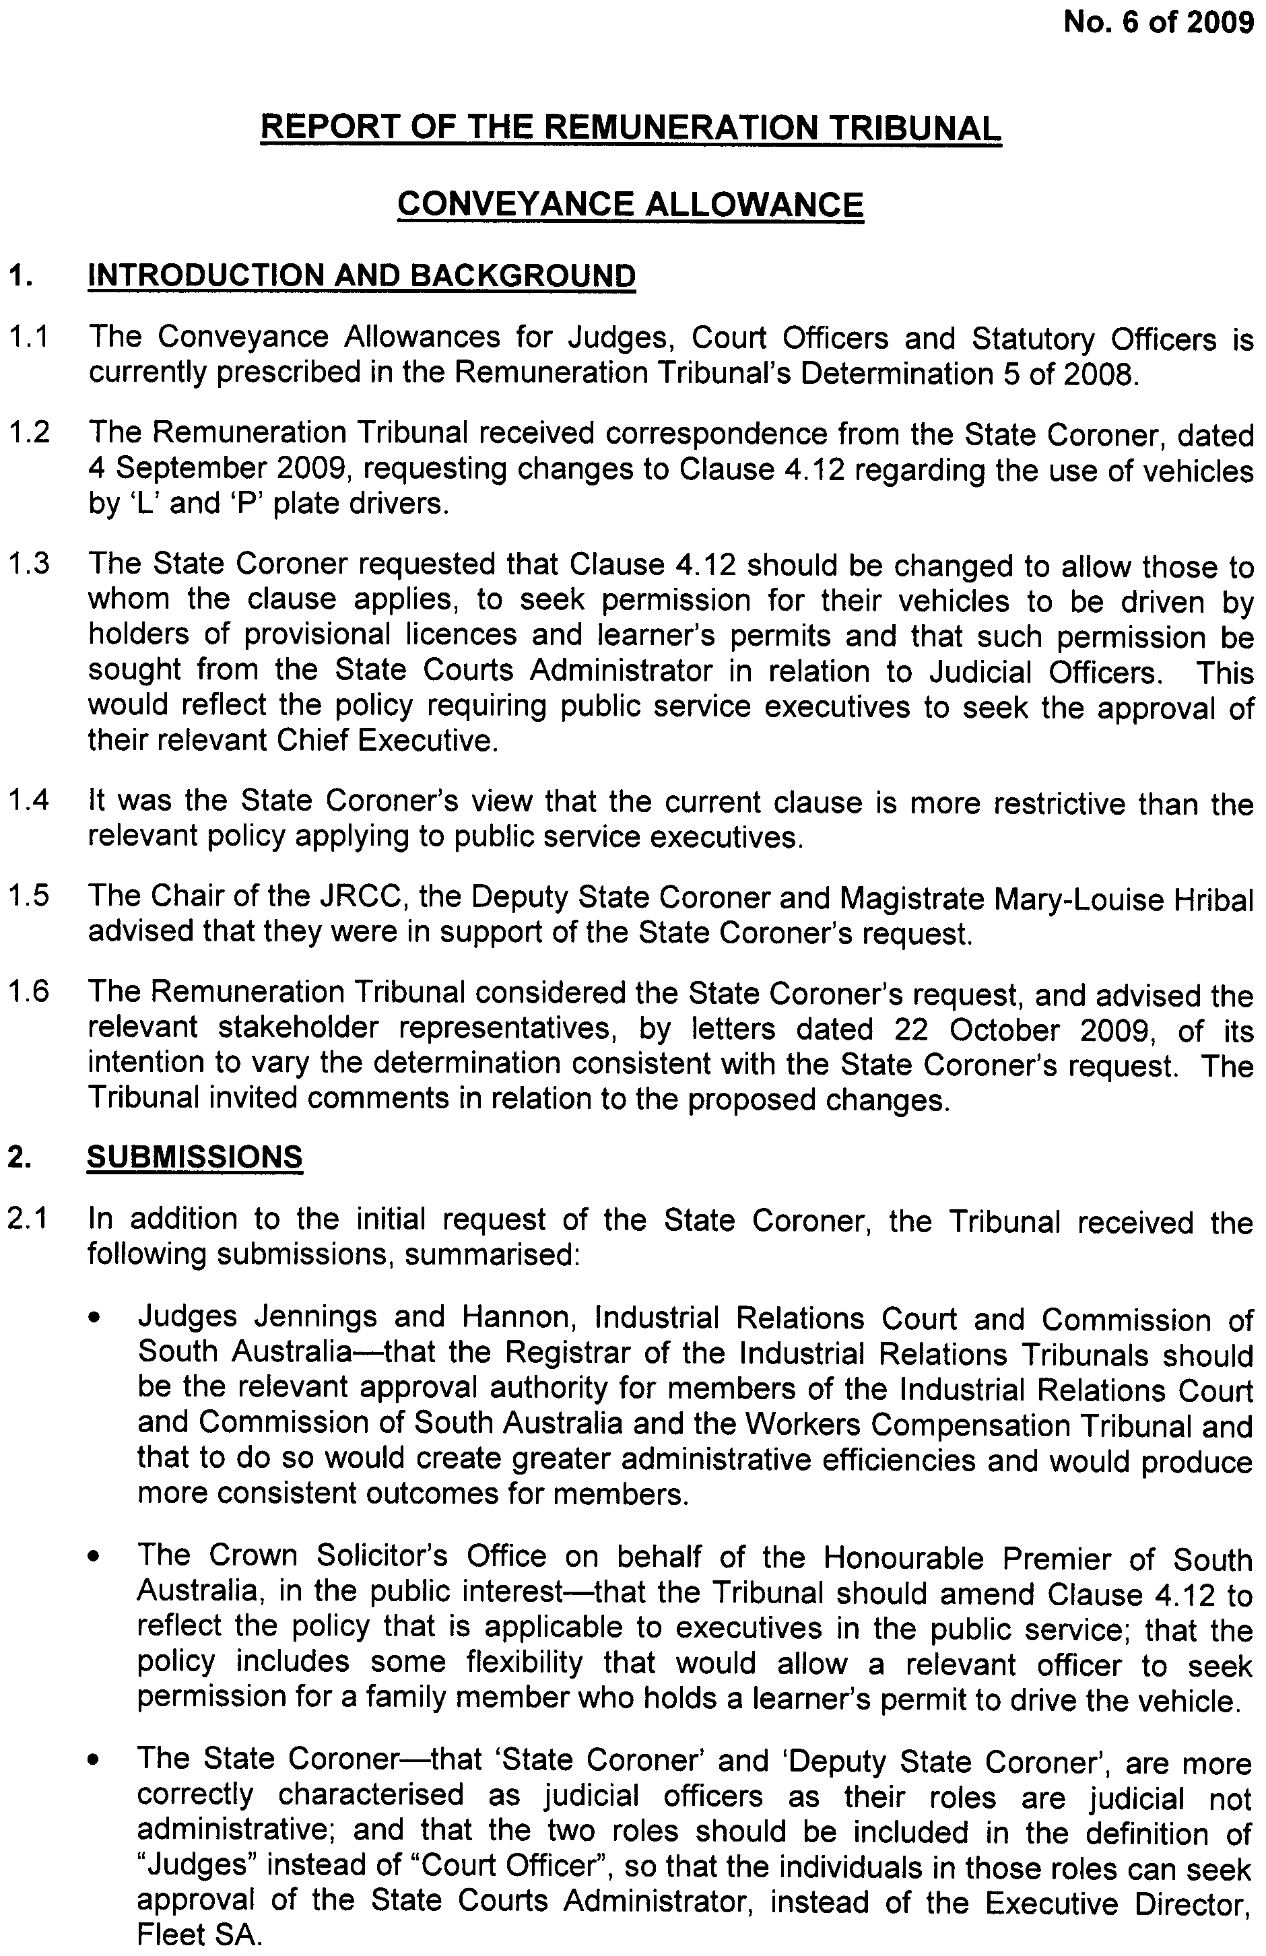


December 2009.

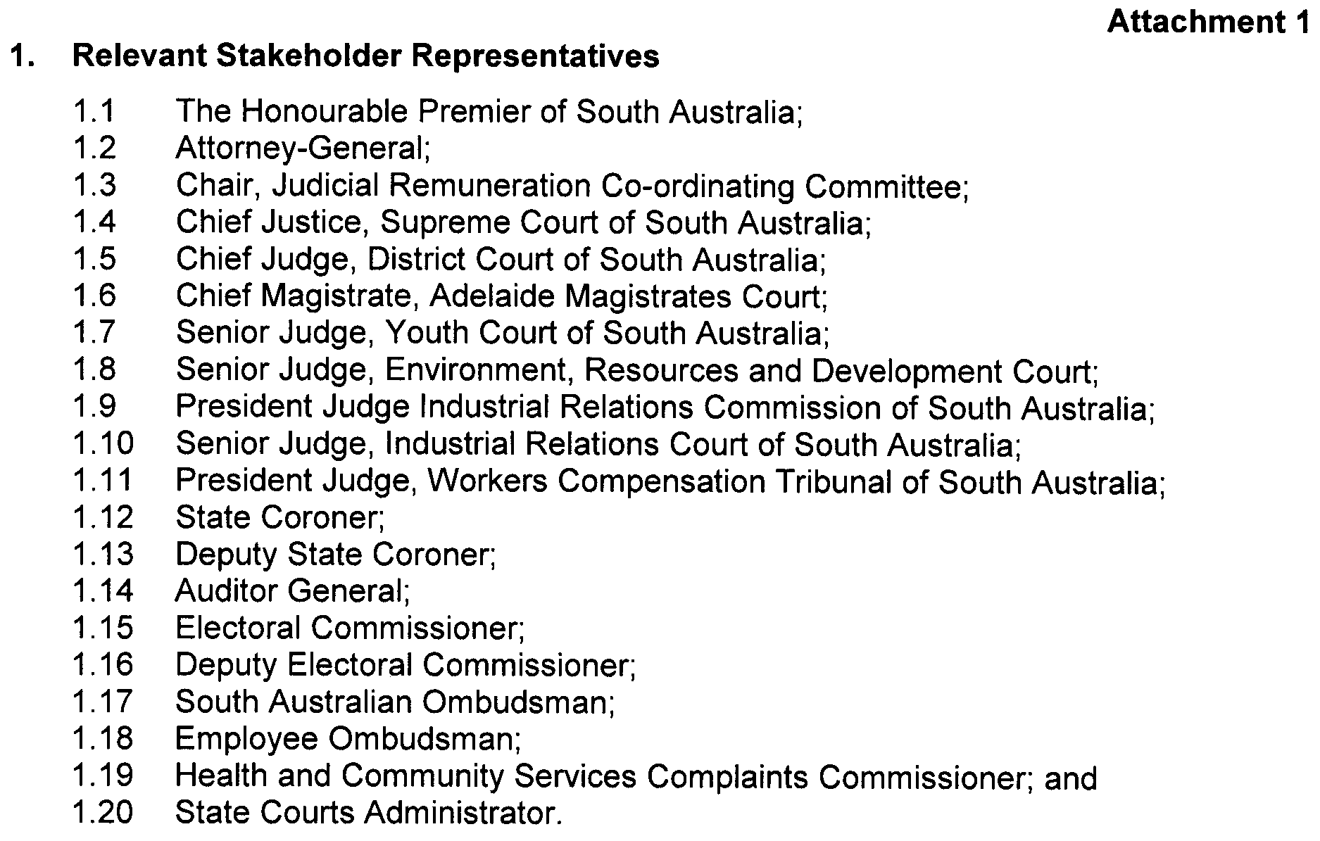
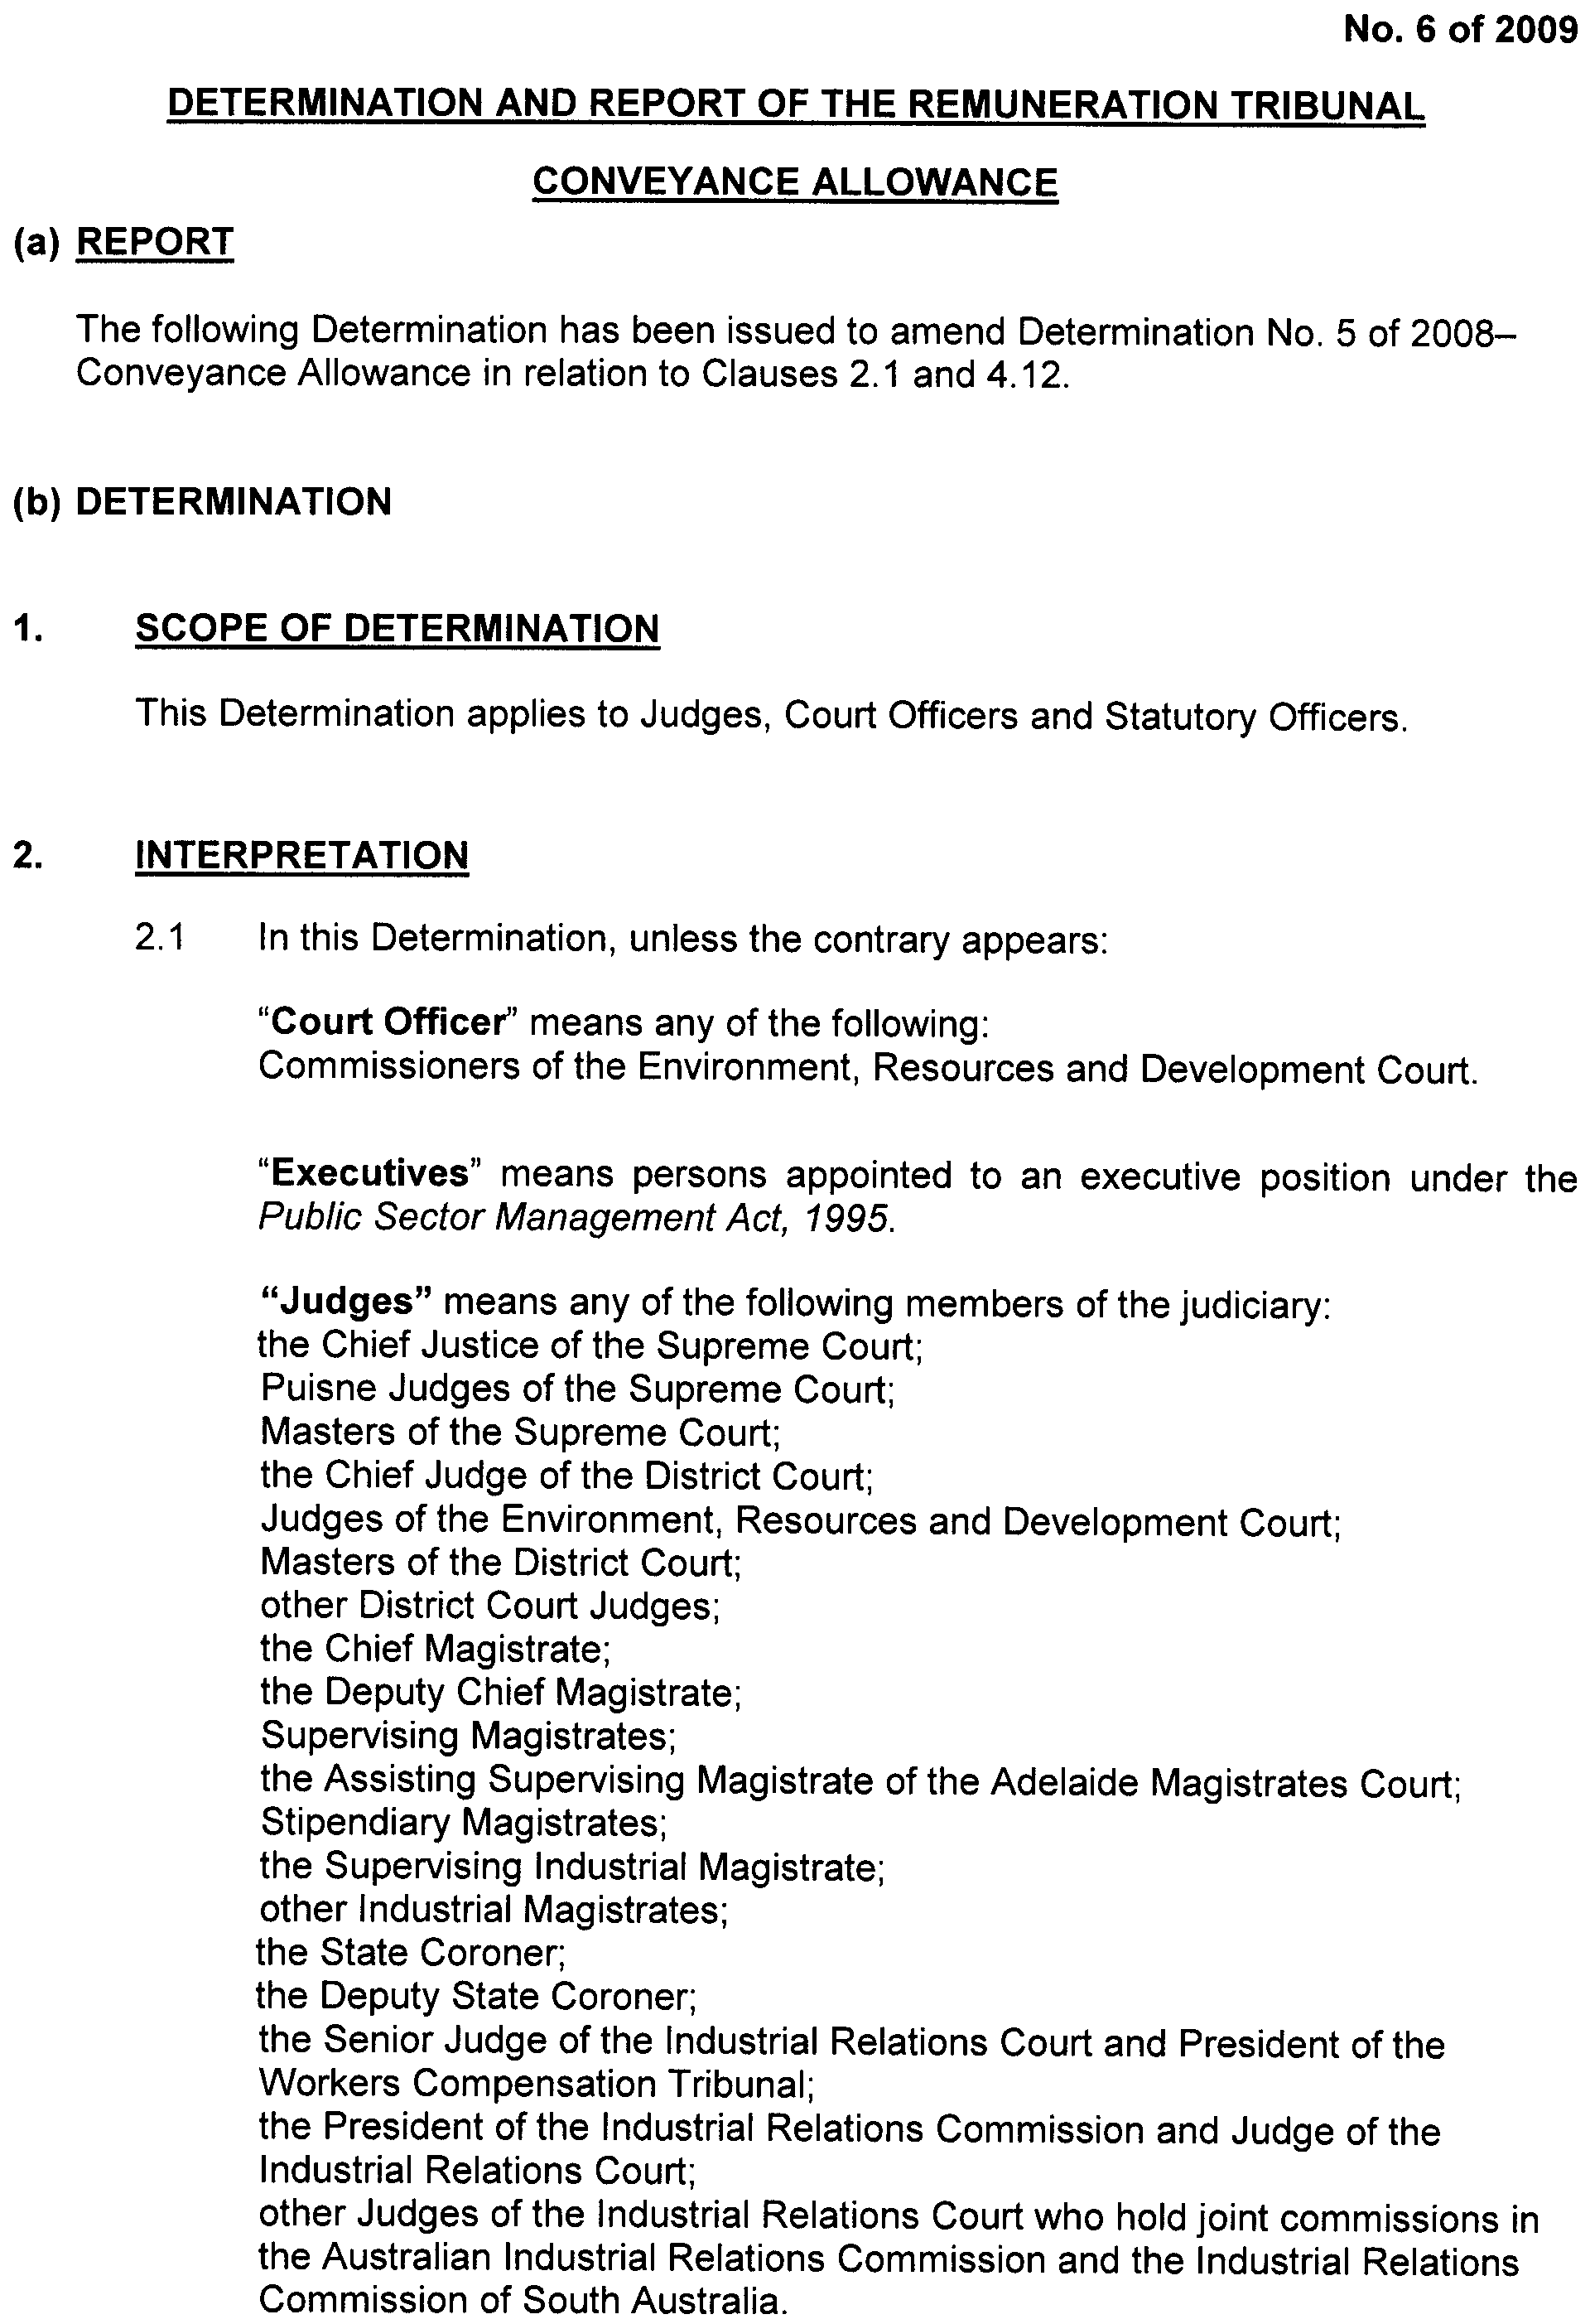
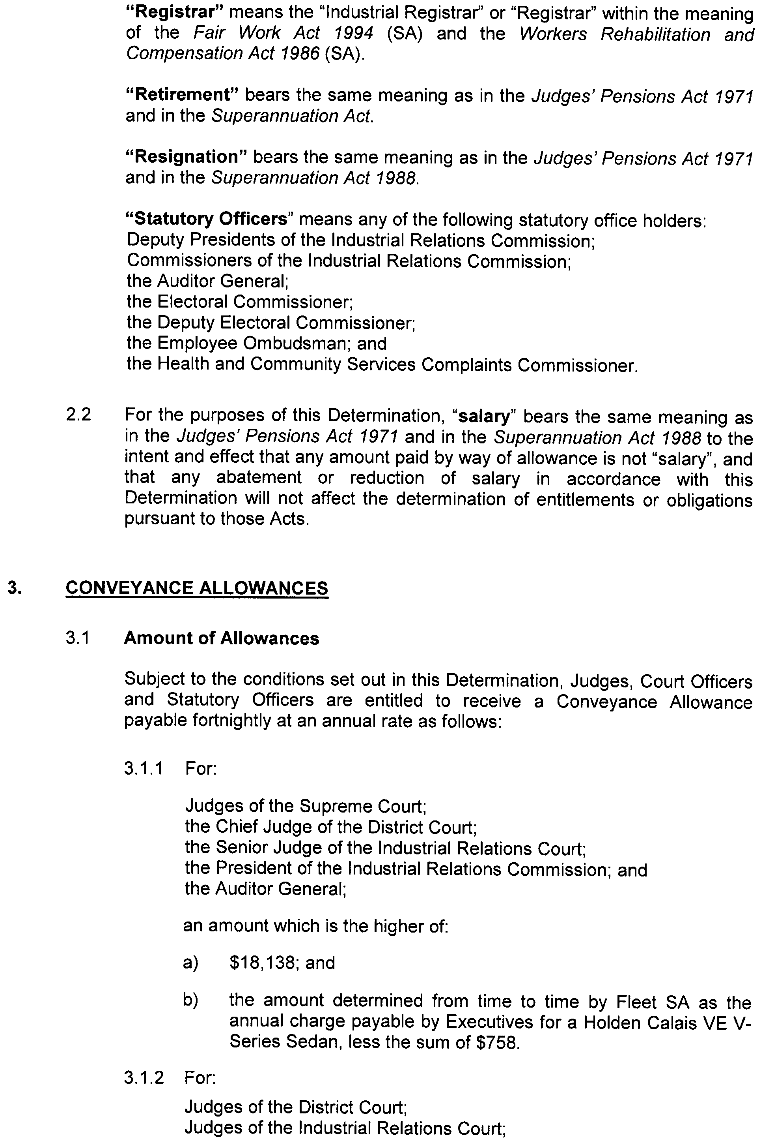
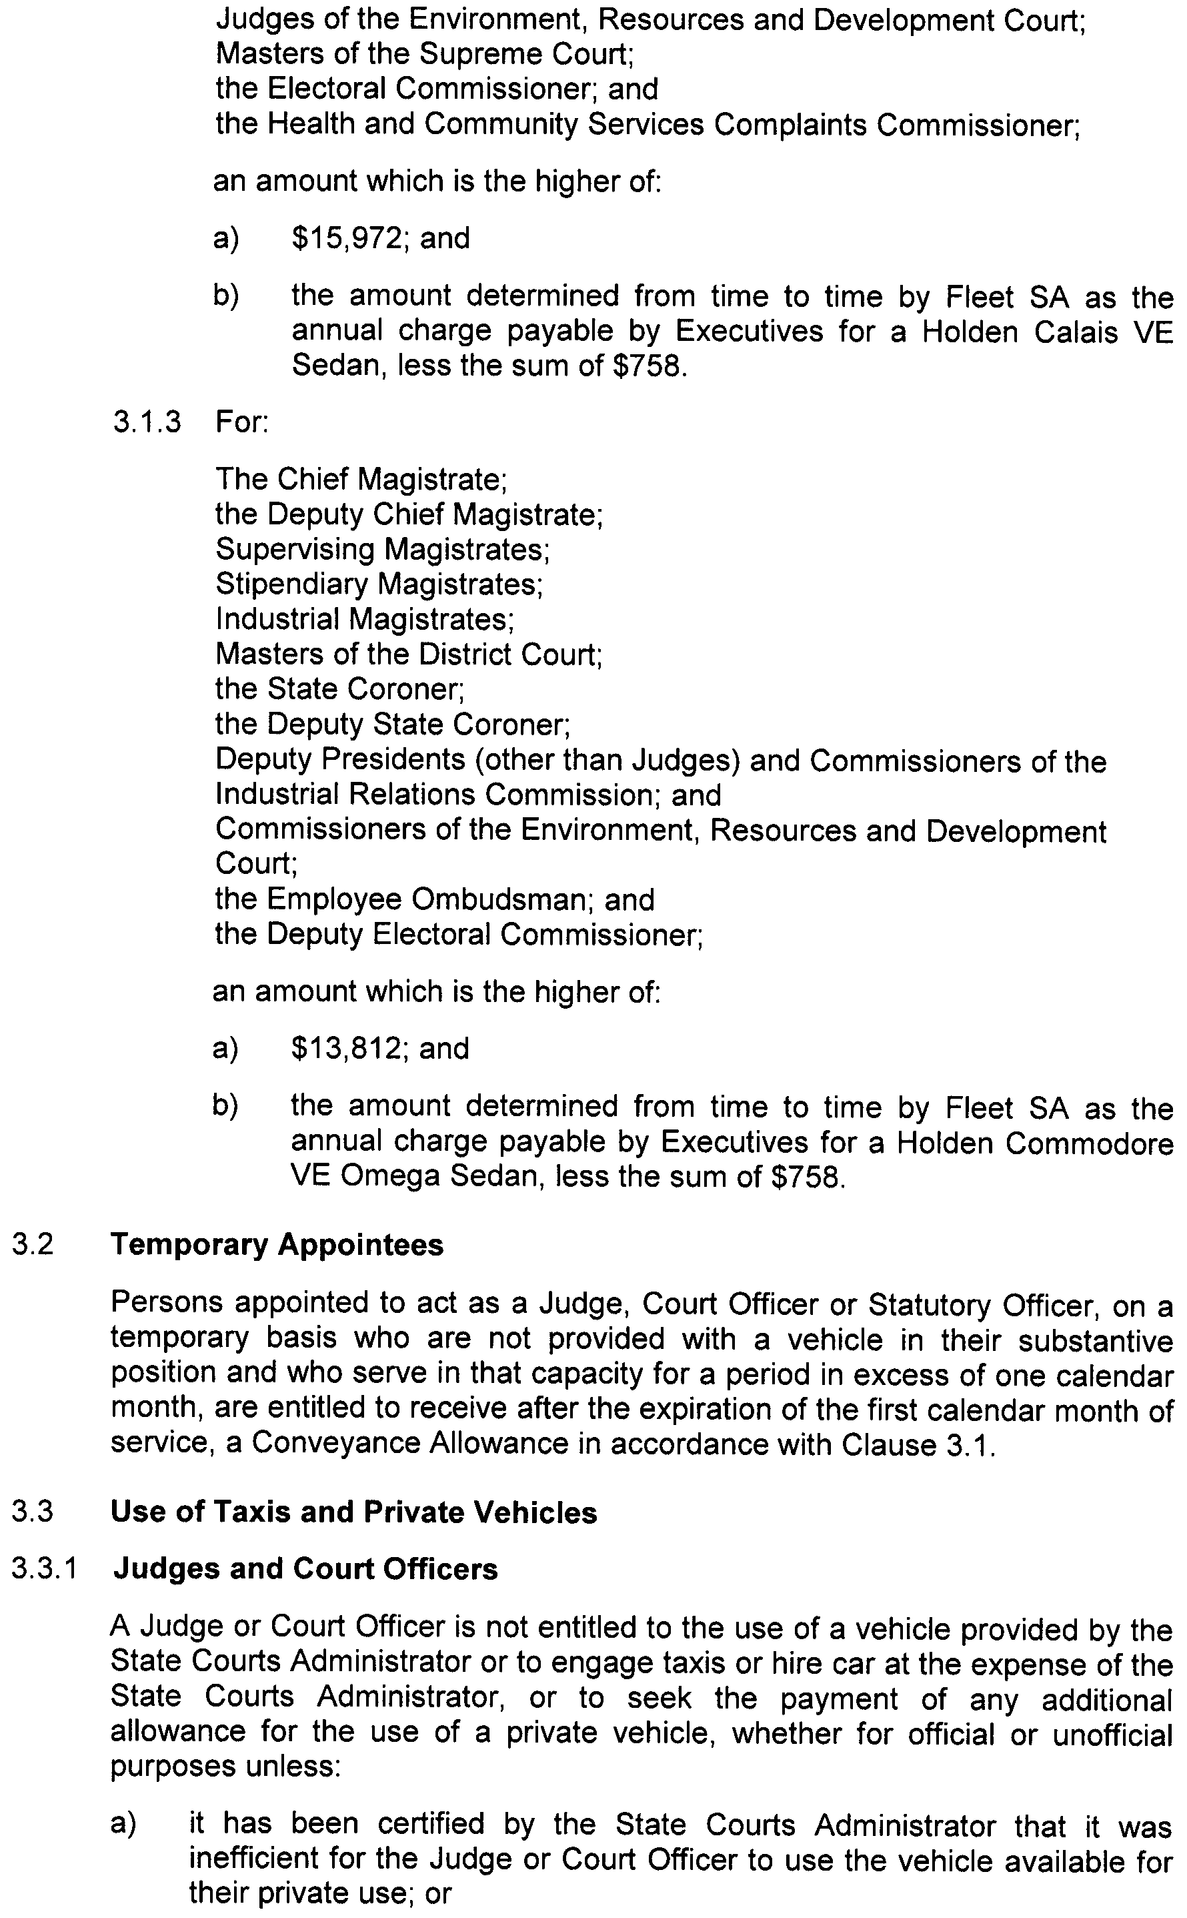
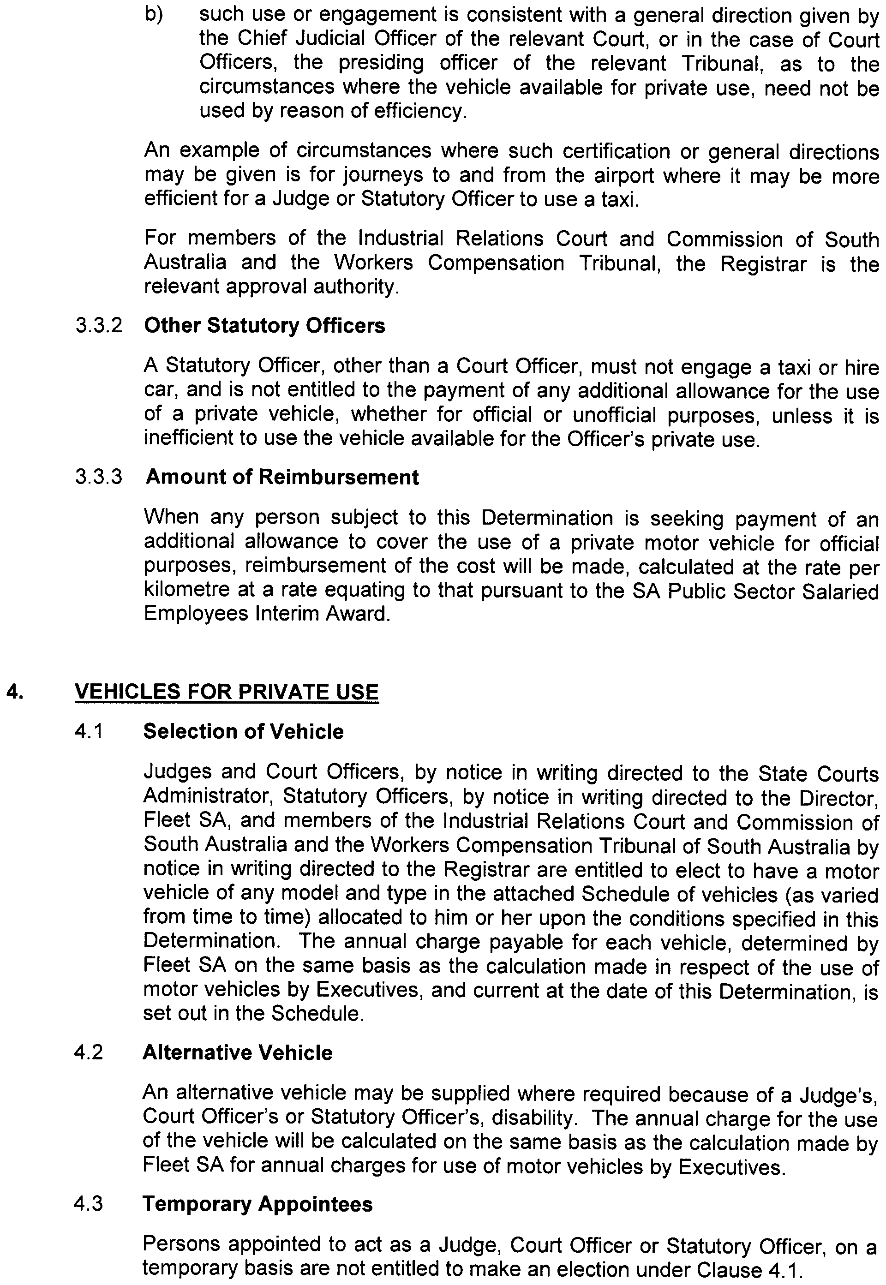
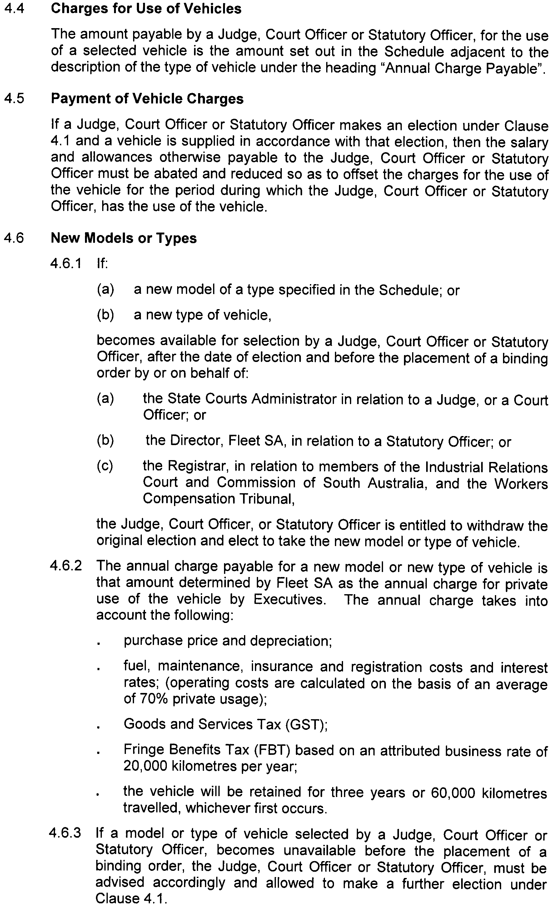
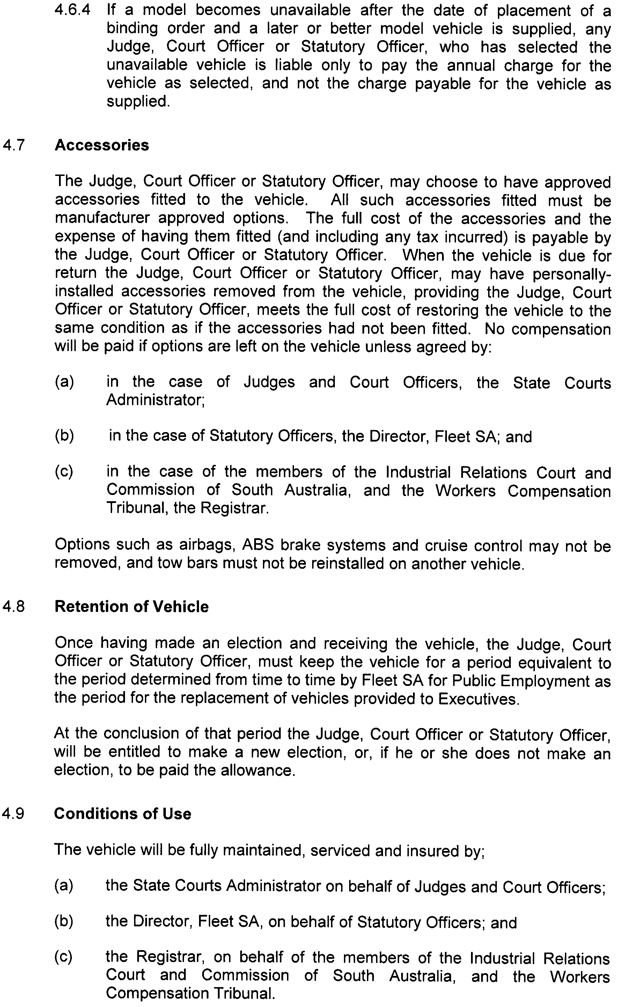
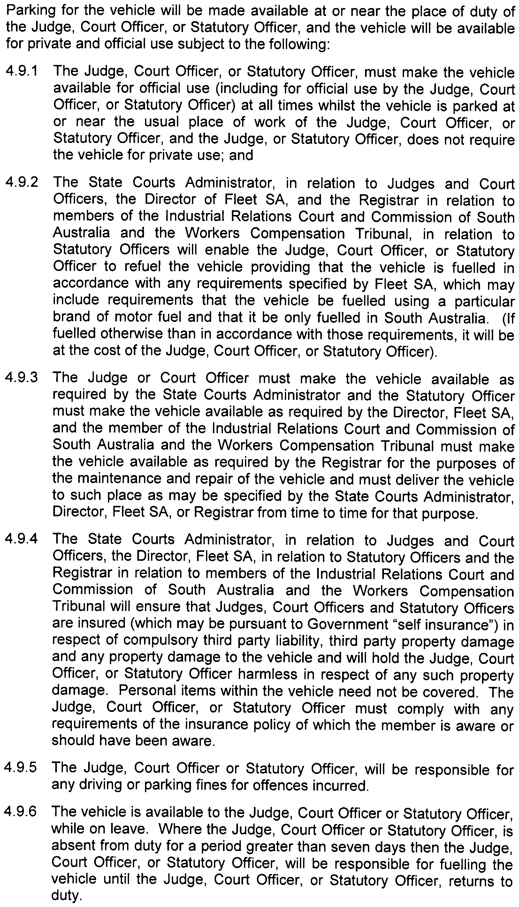
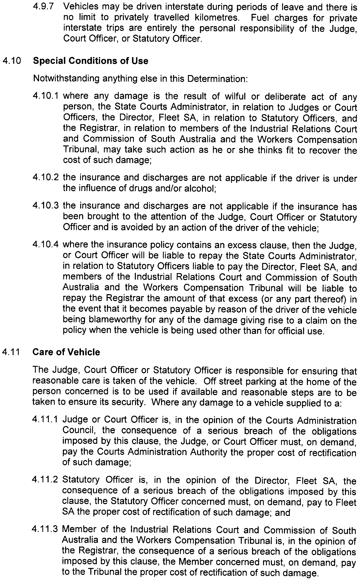
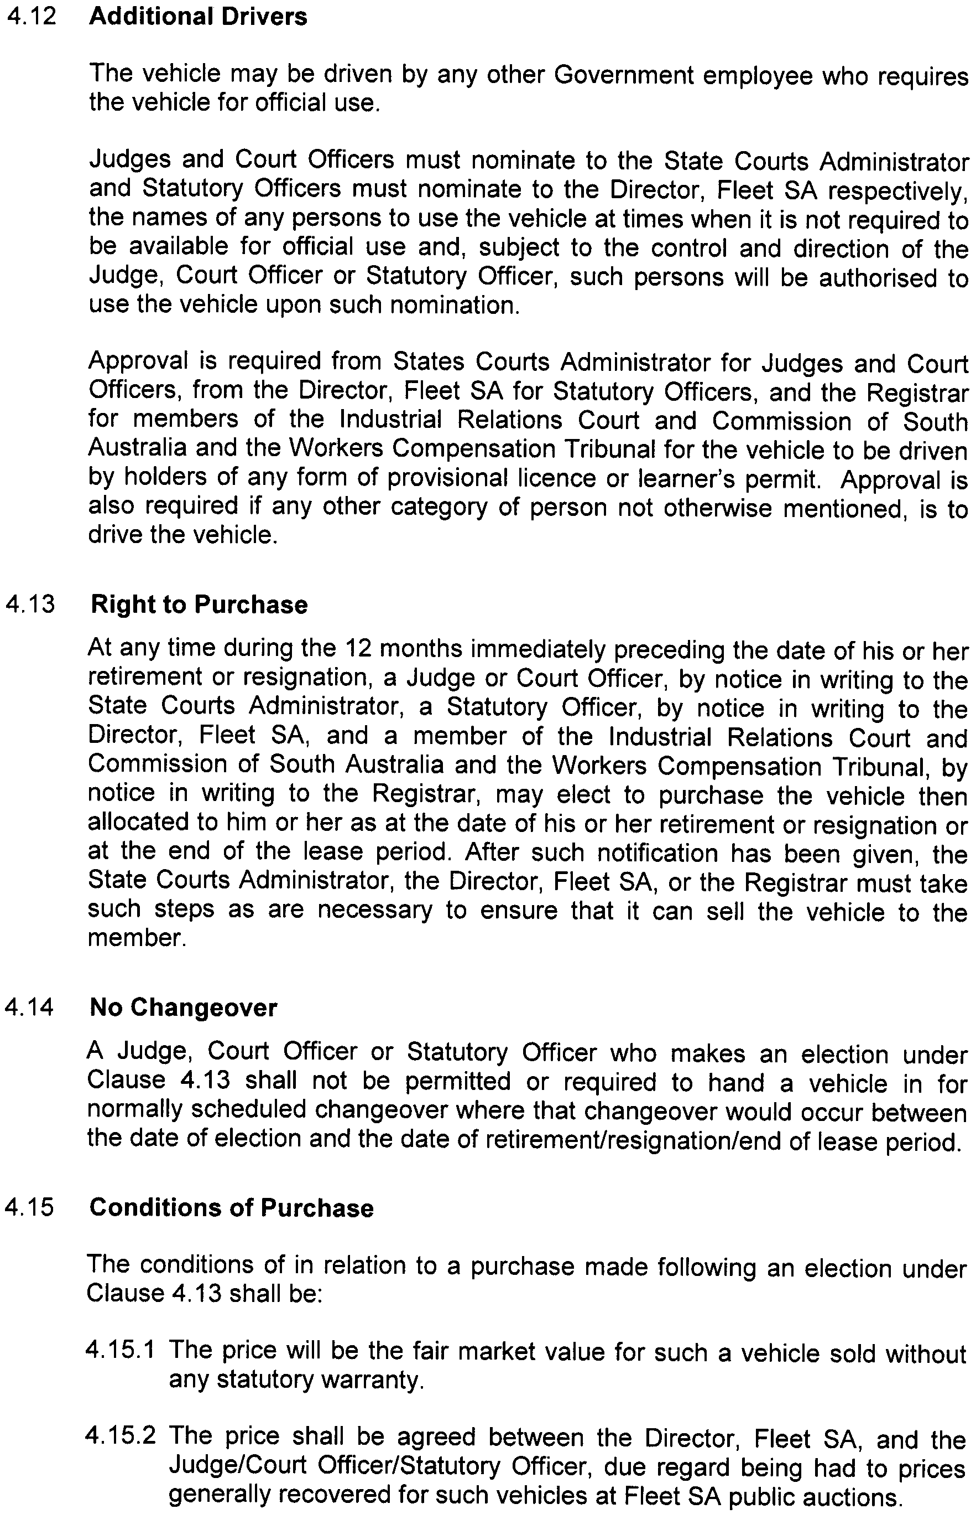

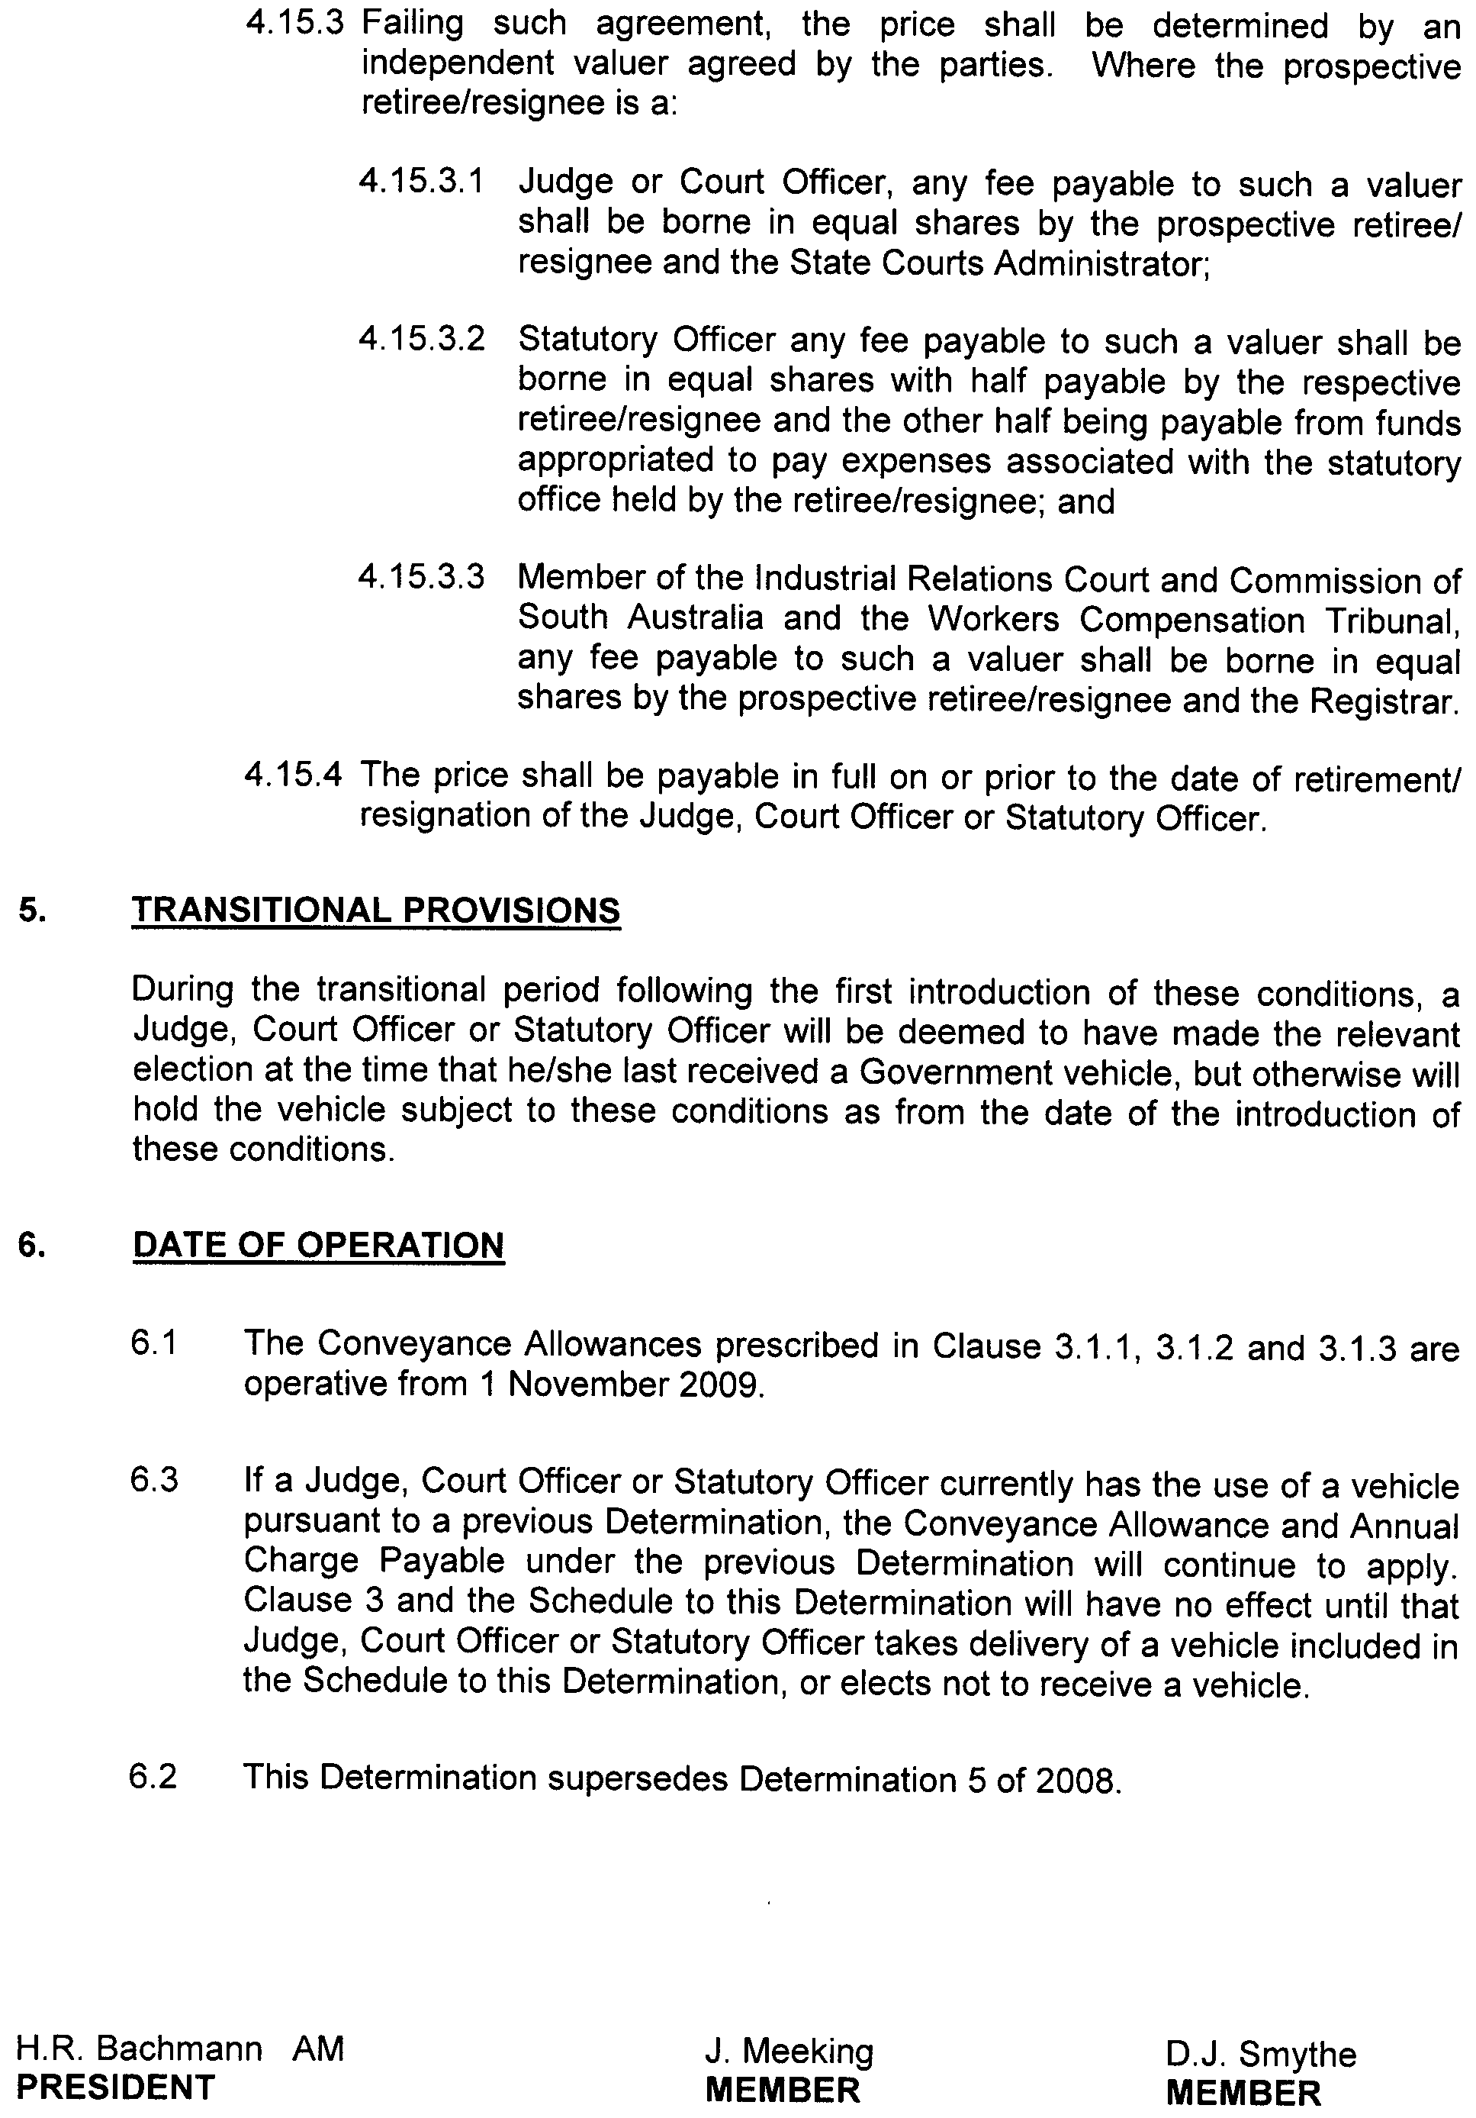
December 2009.
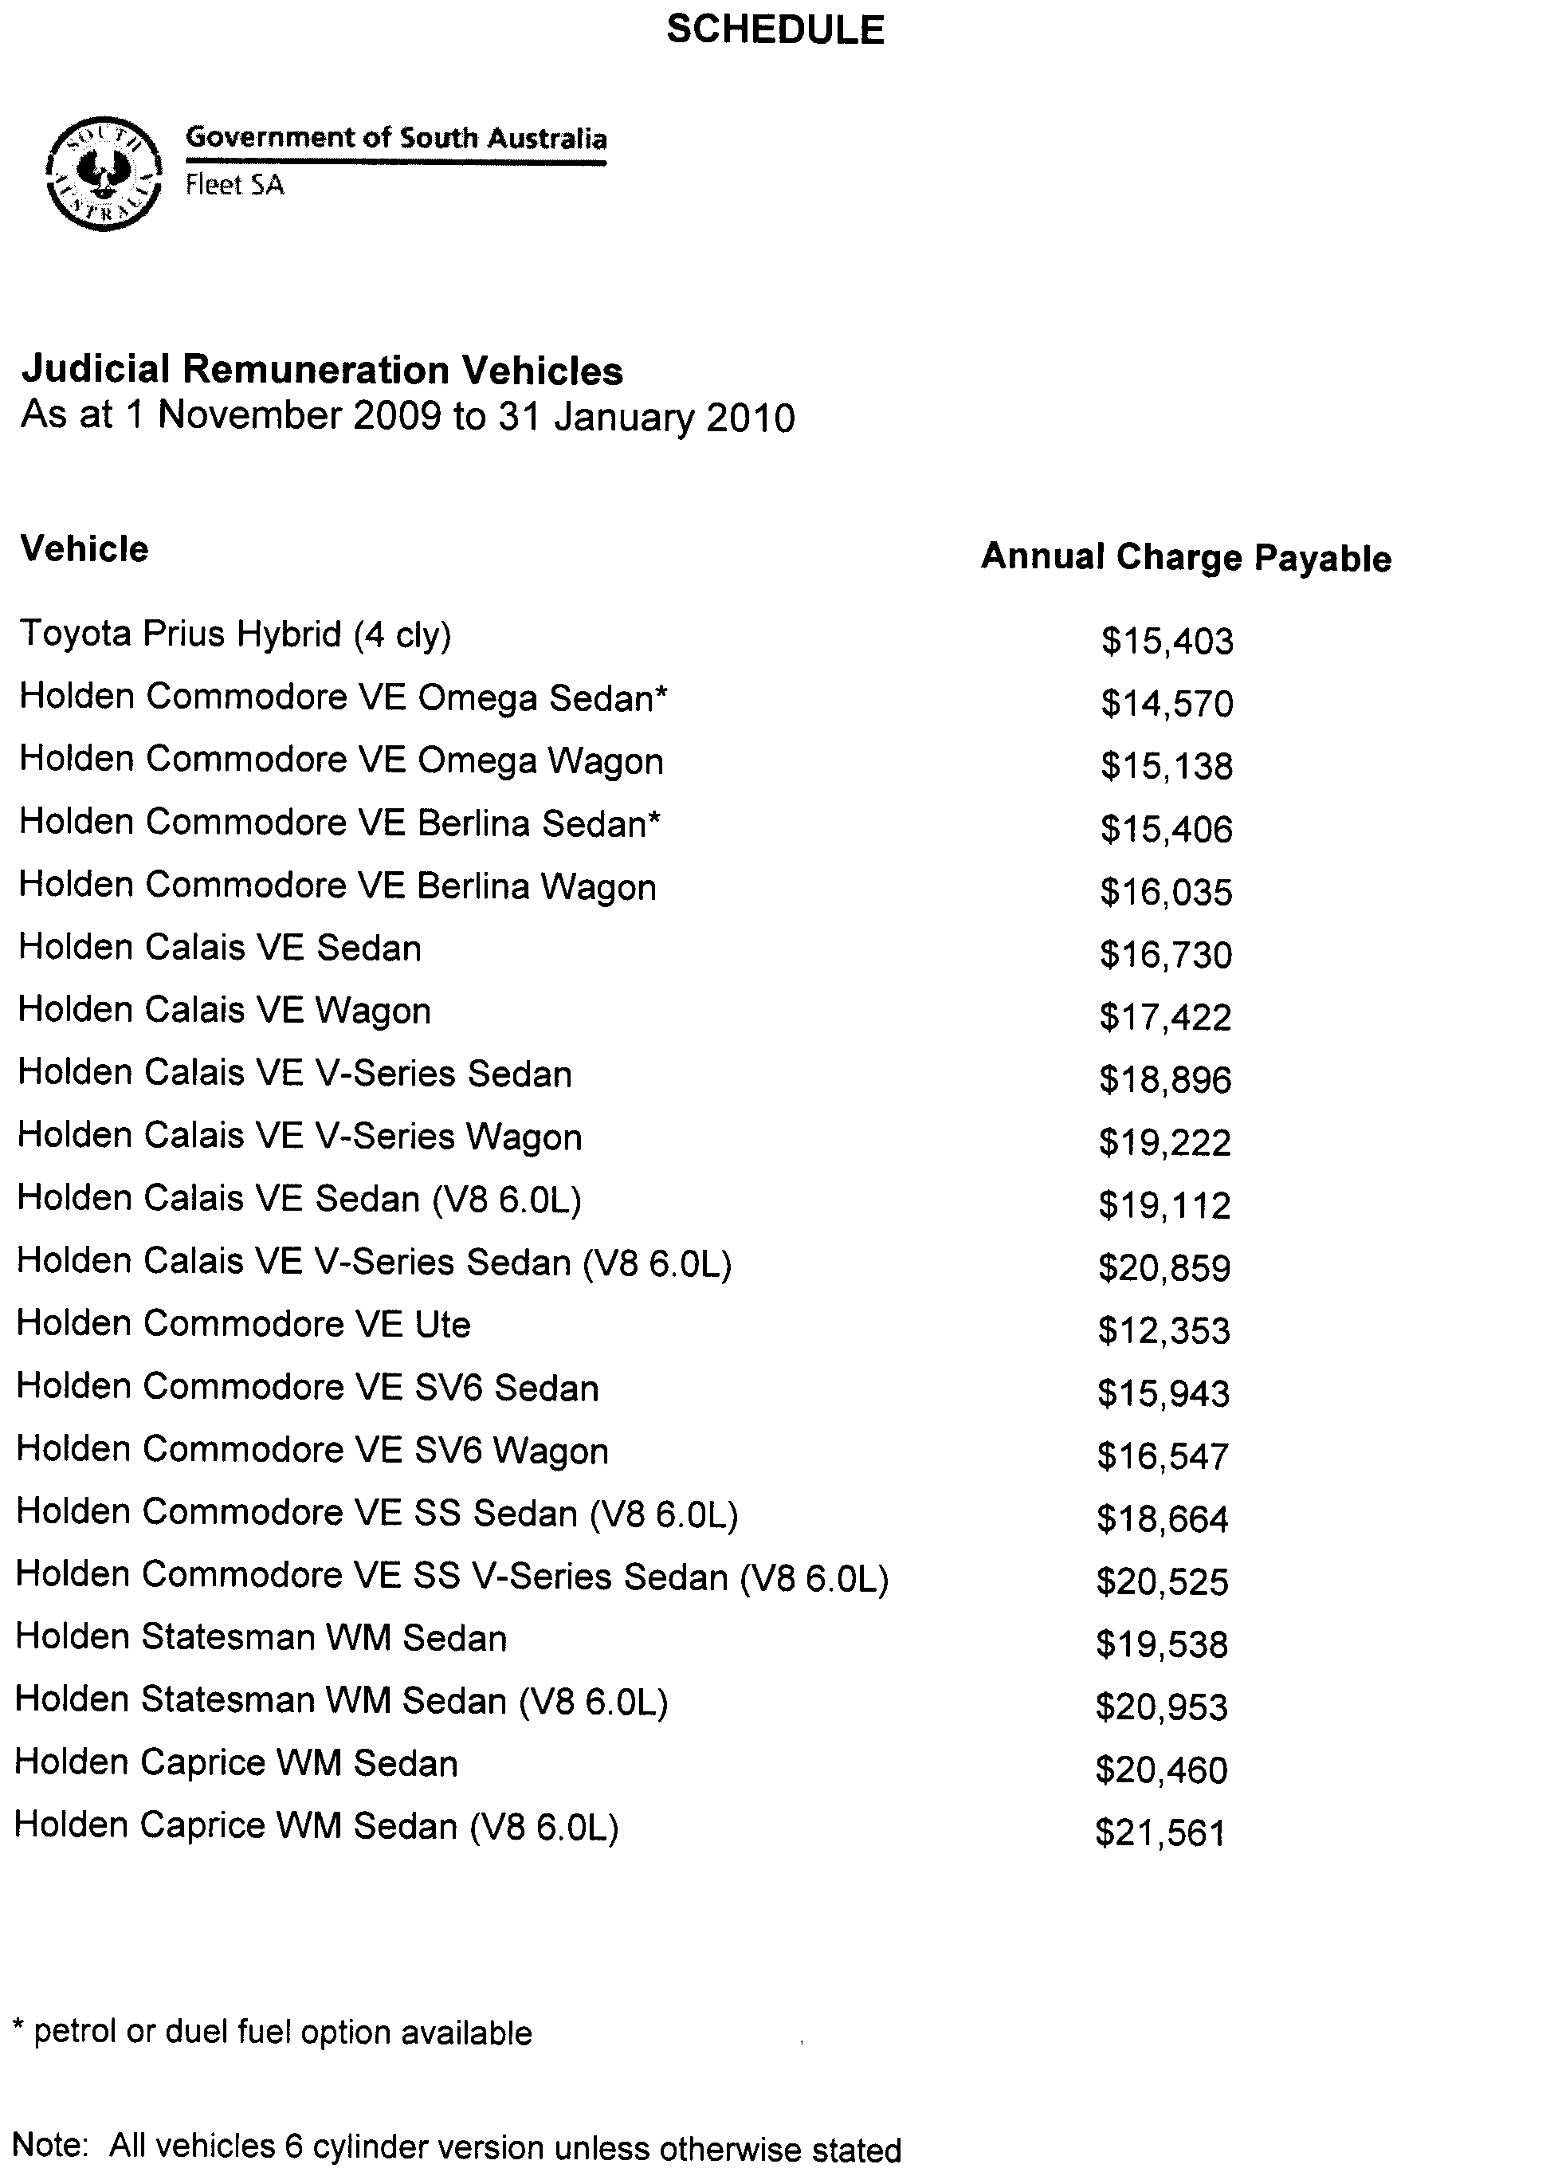


December 2009.

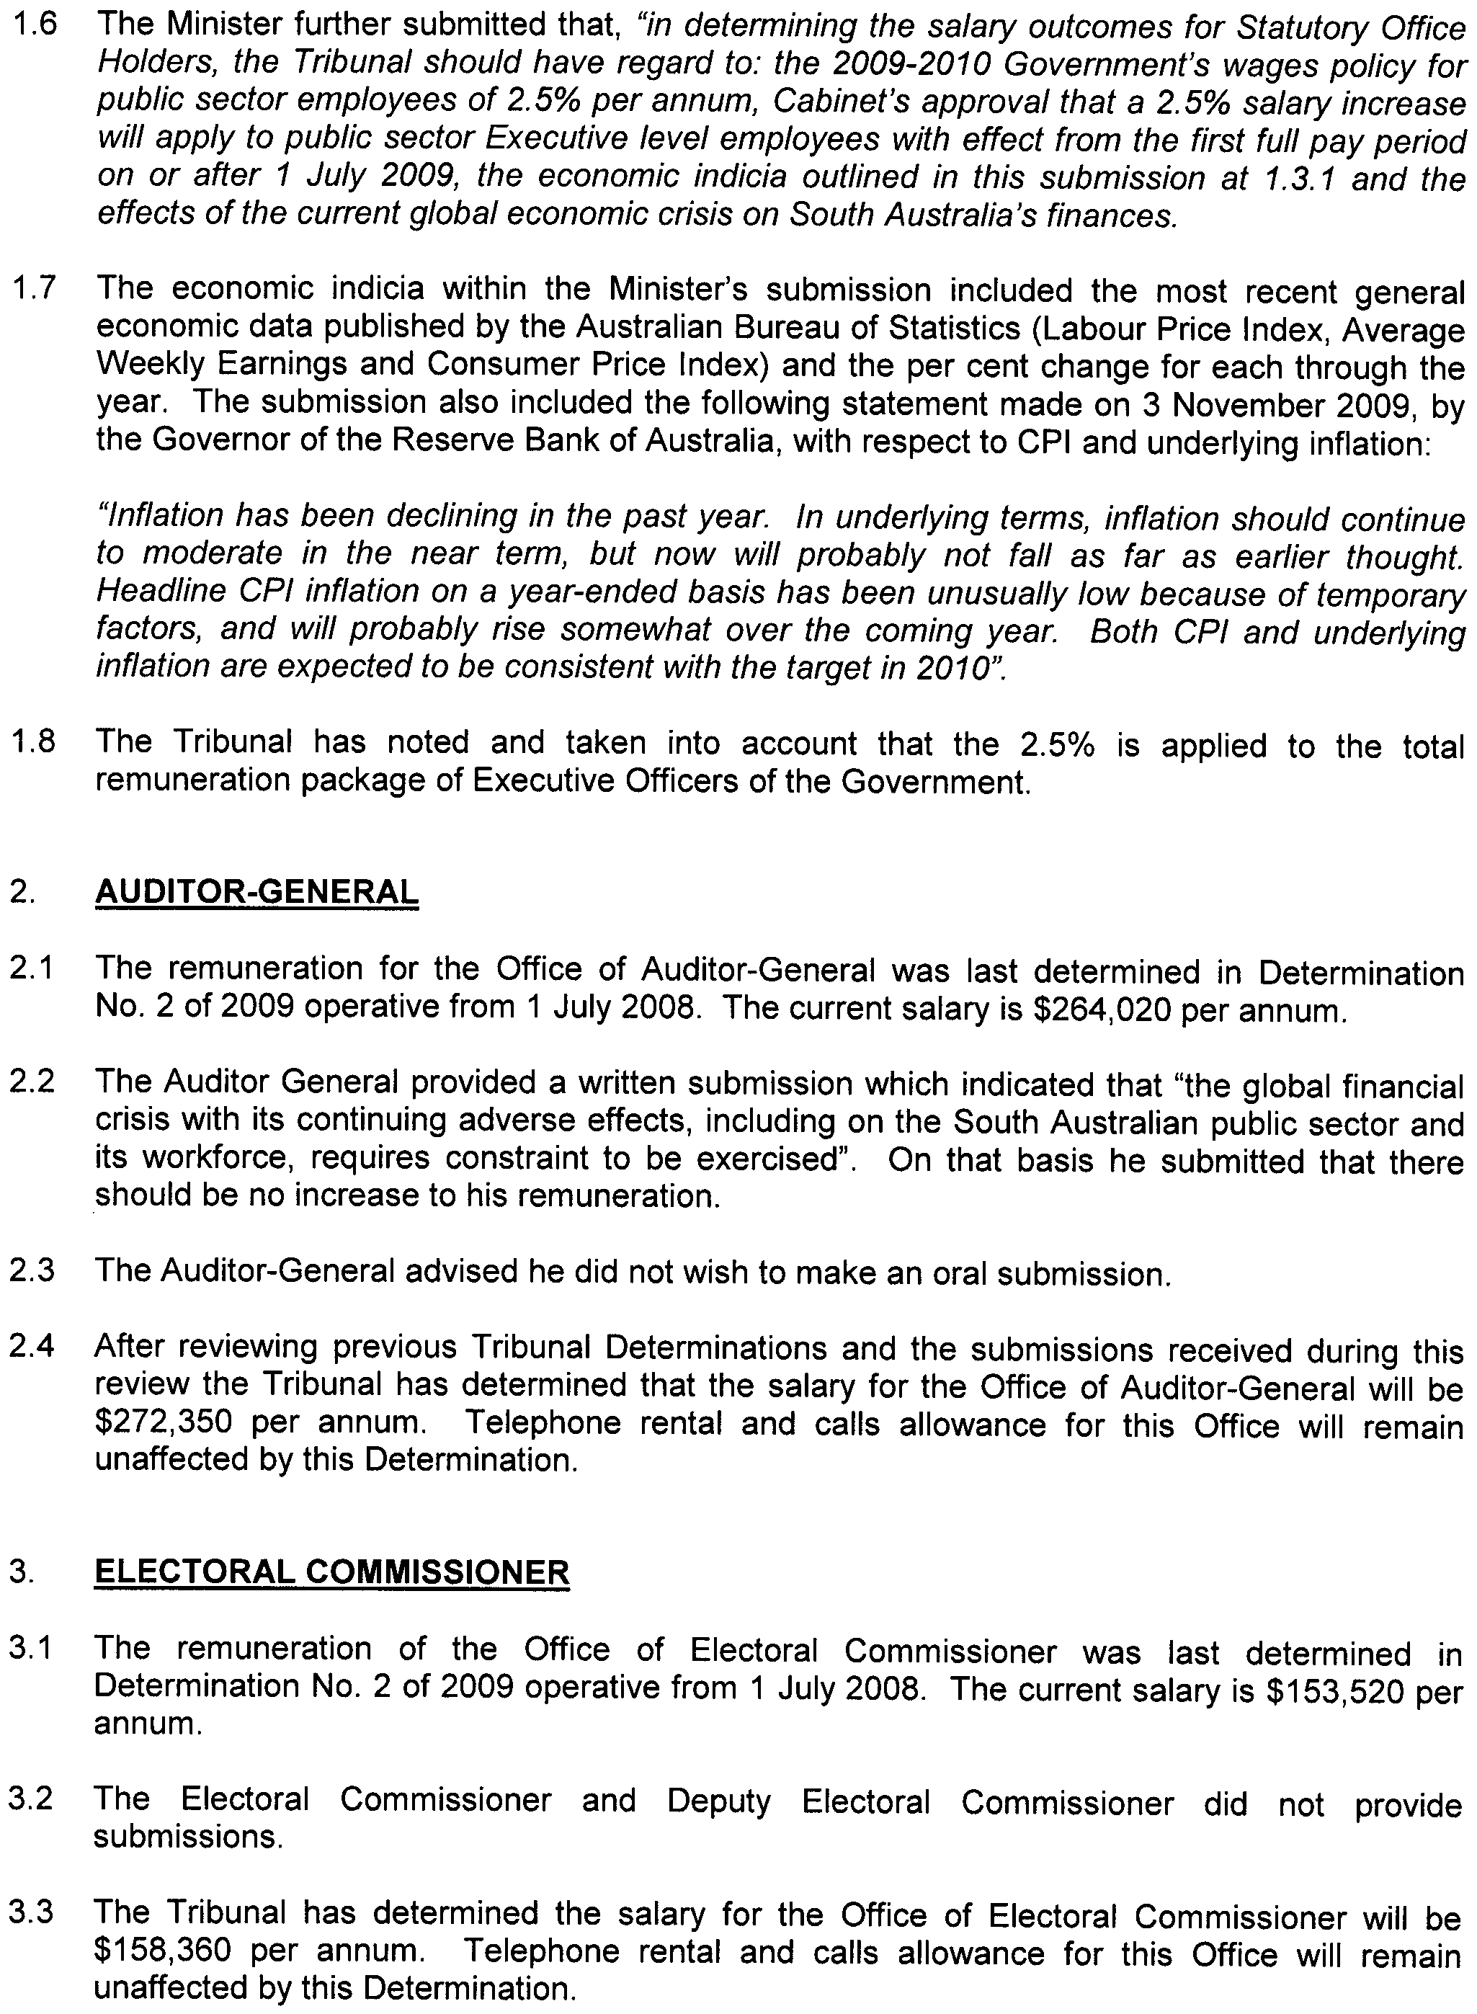

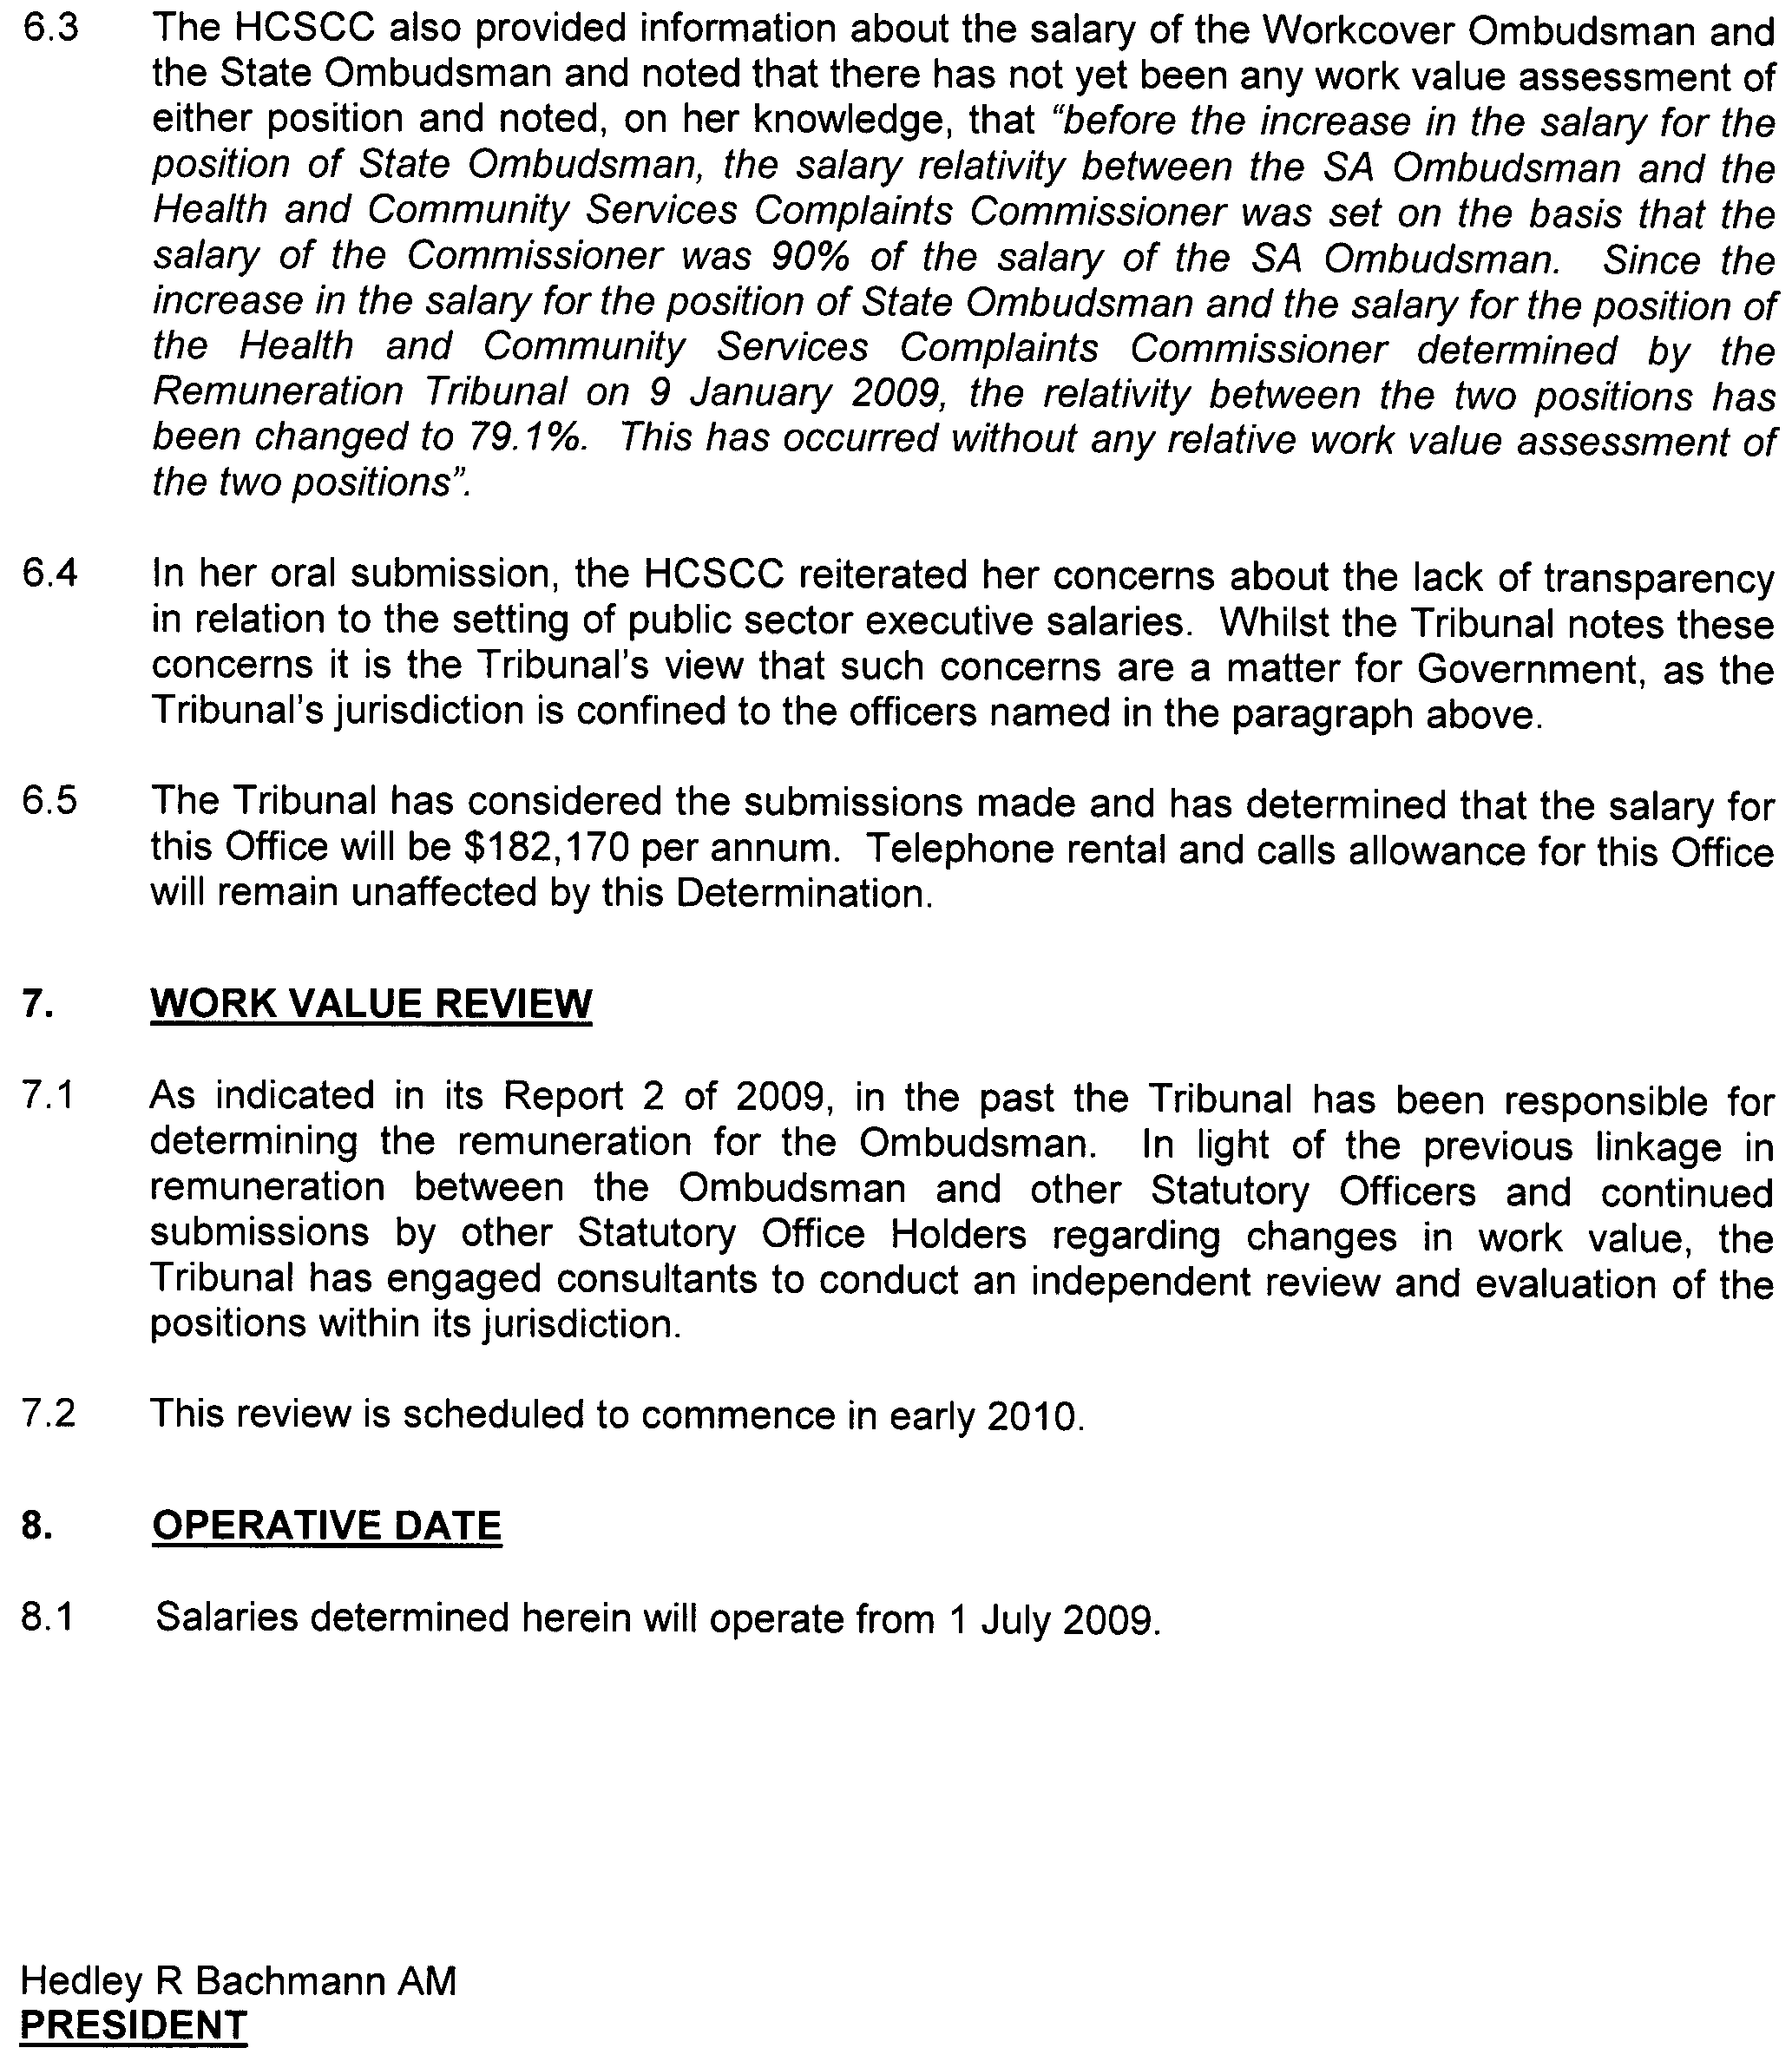
December 2009.

ROAD TRAFFIC ACT 1961

SUPPLEMENTARY NOTICE OF APPROVAL & EXEMPTION
Pursuant to Sections 161A and 163AA of the Road Traffic Act 1961

OPERATION OF ROAD TRAIN VEHICLES IN SOUTH AUSTRALIA

1. REVOCATION OF PREVIOUS NOTICE
1.1 I hereby revoke the Supplementary Notice of Approval and Exemption titled ‘Operation of Road Train Vehicles in South Australia’ published in the South Australian Government Gazette, dated 3 December 2009.

2. APPROVAL
2.1 In accordance with the powers delegated to me by the Minister for Transport under section 163AA of the Road Traffic Act 1961 and regulation 155 of the Road Traffic (Vehicle Standards) Rules 1999, I hereby vary the conditions of the Notice of Approval and Exemption titled ‘Operation of Road Train Vehicles in South Australia’ (the ‘Primary Notice’) dated 2 June 2008 and published in the South Australian Government Gazette, as detailed below.

3. APPLICATION OF SUPPLEMENTARY NOTICE
3.1 This Supplementary Notice must be read in conjunction with the Primary Notice and applies to approved vehicles operating under the Primary Notice and engaged in the transport of product for Iluka Resources Limited.

4. ROUTES AVAILABLE TO APPROVED VEHICLES
4.1 An approved vehicle may operate under the conditions of the Primary Notice on:
4.1.1 the Ooldea–Colona Station Road, from the Iluka Mine Access Road to the Ooldea–Colona Station Road/ Eyre Highway junction: and
4.1.2 Davison Street, Thevenard, between Railway Terrace and Bergmann Drive.
4.2 Notwithstanding the requirements of Clause 39.1 of the Code of Practice for Road Trains, an approved vehicle travelling under this Notice may operate at Higher Mass Limits on the routes identified in 4.1 of this Notice.
4.3 An approved vehicle is prohibited from making the following turning movements:
4.3.1 Left turn from Davison Street into Thevenard Road.
4.3.2 Left turn from Davison Street into Railway Terrace.
4.3.3 Right turn from Davison Street into Railway Terrace.
4.3.4 Left turn from Railway Terrace into Davison Street.

5. CONDITIONS AND LIMITATIONS APPLYING TO THIS SUPPLEMENTARY NOTICE
5.1 The driver of an approved vehicle must:
5.1.1 continue to comply with all conditions and requirements of the Primary Notice; and
5.1.2 carry at all times a legible, current and complete copy of:
(i) this Supplementary Notice;
(ii) the Primary Notice;
(iii) the ‘Code of Practice for Road Trains’ dated April 2008;
(iv) all current approved Road Train and Converter Dolly route network map(s) (as appropriate) specific to the entire route being travelled/operated on during the particular journey undertaken with the exception of the routes identified in 4.1 of this Notice, including more specific detailed maps of routes and townships where available; and
(v) A current driver medical certificate where you are required to undergo and pass a medical examination.
5.1.3 produce any or all of the documents indicated in 5.1.2 above when requested by a DTEI Authorised Officer appointed under the Road Traffic Act 1961 or a Police Officer.

6. DEFINITIONS
In this Notice:
6.1 ‘Primary Notice’ means the Notice of Approval and Exemption titled ‘Operation of Road Train Vehicles in South Australia’, dated 2 June 2008;
6.2 ‘Supplementary Notice’ means this Supplementary Notice;
6.3 ‘Code of Practice’ means the Code of Practice for Road Trains, dated April 2008 as issued by the Department for Transport, Energy and Infrastructure; and
6.4 ‘Approved vehicle’ means a vehicle combination consisting of a prime mover towing two trailers, where a converter dolly supporting a semi trailer is counted as a single trailer (double road train).

7. COMMENCEMENT OF THIS NOTICE
7.1 This Supplementary Notice is valid from 12.01 a.m. on 11 December 2009 until 12.01 a.m. on 28 February 2010.

8. AUTHORISATION

Brian Hemming
Director, Transport Safety Regulation
For and on behalf of
Executive Director, Safety and Regulation Division
Department for Transport, Energy and Infrastructure

ROADS (OPENING AND CLOSING) ACT 1991:
SECTION 24
NOTICE OF CONFIRMATION OF ROAD
PROCESS ORDER
Road Closure
Thompson Street, Waikerie
BY Road Process Order made on 7 October 2009, the District Council of Loxton Waikerie ordered that:
1. Portion of Thompson Street situate south of Coombe Terrace and between allotments 78 and 423, Town of Waikerie, more particularly delineated and lettered ‘A’ in Preliminary Plan No. 06/0078 be closed.
2. Issue a Certificate of Title to the District Council of Loxton Waikerie for the whole of the land subject to closure which land is being retained by the Council for public purposes.
3. The following easement is granted over portion of the land subject to that closure.
Grant to the South Australian Water Corporation an easement for water supply purposes.
On 1 December 2009 that order was confirmed by the Minister for Infrastructure conditionally upon the deposit by the Registrar-General of Deposited Plan 82662 being the authority for the new boundaries.
Pursuant to section 24 (5) of the Roads (Opening and Closing) Act 1991, NOTICE of the order referred to above and its confirmation is hereby given.
Dated 10 December 2009.
P. M. Kentish, Surveyor-General

ROADS (OPENING AND CLOSING) ACT 1991:
SECTION 24
NOTICE OF CONFIRMATION OF ROAD
PROCESS ORDER
Road Closure
Sawmill Gully Road, Mylor
BY Road Process Order made on 28 September 2009, The District Council of Mount Barker ordered that:
1. Portion of Sawmill Gully Road being a three metre square strip situate adjoining section 427, Hundred of Kuitpo, more particularly delineated and lettered ‘A’ in Preliminary Plan No. 09/0051 be closed.
2. The whole of the land subject to closure be transferred to Georgene Reilly O’Rourke in accordance with agreement for transfer dated 28 September 2009 entered into between The District Council of Mount Barker and G. R. O’Rourke.
On 1 December 2009 that order was confirmed by the Minister for Infrastructure conditionally upon the deposit by the Registrar-General of Deposited Plan 82495 being the authority for the new boundaries.
Pursuant to section 24 (5) of the Roads (Opening and Closing) Act 1991, NOTICE of the order referred to above and its confirmation is hereby given.
Dated 10 December 2009.
P. M. Kentish, Surveyor-General

WATER MAINS AND SEWERS

Office of the South Australian Water Corporation
Adelaide, 10 December 2009

WATER MAINS LAID

Notice is hereby given that the following main pipes or parts of main pipes have been laid down by the South Australian Water Corporation in or near the undermentioned water districts and are now available for a constant supply of water to adjacent land.

ADELAIDE WATER DISTRICT

ADELAIDE CITY COUNCIL
Across Flinders Street, Adelaide. p2
Public road east of lot 11 in LTRO DP 70131, Flinders Street, Adelaide. p2

CITY OF ONKAPARINGA
Across Rowley Road, Aldinga Beach. p6
In and across Emerald Boulevard, Aldinga Beach. p6
Sapphire Way, Aldinga Beach. p6
Azure Place, Aldinga Beach. p6
In and across Indigo Court, Aldinga Beach. p7
Cobalt Place, Aldinga Beach. p7

CITY OF PLAYFORD
Across Chellaston Road, Munno Para West. p13
In and across Kalyvas Drive, Munno Para West. p13
Rosaria Court, Munno Para West. p13
Timothy Street, Munno Para West. p13
Fradd Court, Angle Vale. p15

CITY OF SALISBURY
Mowbray Street, Mawson Lakes. p11
Wentworth Street, Mawson Lakes. p11
Chianti Lane, Mawson Lakes. p11
Easement in lot 2017 in LTRO DP 80726, Victoria Parade, Mawson Lakes. p11

ARNO BAY WATER DISTRICT

DISTRICT COUNCIL OF CLEVE
High Street, Arno Bay. p3

BEETALOO COUNTRY LANDS WATER DISTRICT

PORT PIRIE REGIONAL COUNCIL
Across Scenic Drive, Nelshaby. p33

BLUE LAKE COUNTRY LANDS WATER DISTRICT

DISTRICT COUNCIL OF GRANT
Wireless Road, Suttontown. p34

CLAYTON BAY WATER DISTRICT

ALEXANDRINA COUNCIL
In and across Alexandrina Drive, Clayton Bay. p16-19
Grandview Drive, Clayton Bay. p16
Island View Drive, Clayton Bay. p16
Gilbert Street, Clayton Bay. p19 and 24
Pearce Road, Clayton Bay. p19 and 24
In and across Clayton Street, Clayton Bay. p19-22
In and across Warburton Street, Clayton Bay. p22
Finniss Street, Clayton Bay. p22 and 21
Across Gorge Street, Clayton Bay. p21
Lowther Street, Clayton Bay. p23
Chandos Street, Clayton Bay. p22 and 23
Rankine Street, Clayton Bay. p22

EUDUNDA WATER DISTRICT

REGIONAL COUNCIL OF GOYDER
Ward Street, Eudunda. p25
South Terrace, Eudunda. p25

HAWKER WATER DISTRICT

THE FLINDERS RANGES COUNCIL
Wirreanda Terrace, Hawker. p31
In and across Elder Terrace, Hawker. p31 and 32

LYNDOCH WATER DISTRICT

THE BAROSSA COUNCIL
In and across Gilbert Street, Lyndoch. p8
Jollytown Road, Lyndoch. p8 and 9
In and across Carol Street, Lyndoch. p9
Stella Court, Lyndoch. p9
In and across Gilbert Street, Lyndoch. p10

MOONTA WATER DISTIRCT

DISTRICT COUNCIL OF THE COPPER COAST
Symons Street, Moonta Bay. p27

MOUNT GAMBIER WATER DISTRICT

CITY OF MOUNT GAMBIER
Woodlands Drive, Mount Gambier. p12
O’Leary Road, Mount Gambier. p34
Wireless Road, Mount Gambier and Suttontown. p34

MUNDALLIO COUNTRY LANDS WATER DISTRICT

PORT AUGUSTA CITY COUNCIL
Across public road (known as Zerna Road), Port Augusta. p28
Public road north of allotment piece 202 in LTRO DP 80205, Port Augusta. p28
Across and in public road (known as Abattoirs Road), Port Augusta. p28

PORT LINCOLN WATER DISTRICT

CITY OF PORT LINCOLN
Tennant Street, Port Lincoln. p4

ROBE WATER DISTRICT

DISTRICT COUNCIL OF ROBE
In and across Alexander Tolmer Way, Robe. p14
New Road (lot 53 in LTRO DP 79246), Robe. p14
New Road (lot 51 in LTRO DP 79246), Robe. p14
Easement in lot 54 in LTRO DP 79246, Alexander Tolmer Way, Robe. p14

WARREN COUNTRY LANDS WATER DISTRICT

LIGHT REGIONAL COUNCIL
Nitschke Road, Marananga. p26

WHYALLA WATER DISTRICT

THE CORPORATION OF THE CITY OF WHYALLA
Across McRitchie Crescent, Whyalla Stuart. p5
Foote Place, Whyalla Stuart. p5

WATER MAINS ABANDONED

Notice is hereby given that the undermentioned water mains have been abandoned by the South Australian Water Corporation.

BEETALOO COUNTRY LANDS WATER DISTRICT

PORT PIRIE REGIONAL COUNCIL
Across Scenic Drive, Nelshaby. p33
Easements in lot 20 in LTRO DP 35859, Scenic Drive, Nelshaby. p33

BLUE LAKE COUNTRY LANDS WATER DISTRICT

DISTRICT COUNCIL OF GRANT
Wireless Road, Suttontown. p34

BORDERTOWN WATER DISTRICT

TATIARA DISTRICT COUNCIL
Cannawigara Road, Bordertown. p30

CLAYTON BAY WATER DISTRICT

ALEXANDRINA COUNCIL
Island View Drive, Clayton Bay. p16

EUDUNDA WATER DISTRICT

REGIONAL COUNCIL OF GOYDER
Ward Street, Eudunda. p25
South Terrace, Eudunda. p25

HAWKER WATER DISTRICT

THE FLINDERS RANGES COUNCIL
Wirreanda Terrace, Hawker. p31
Elder Terrace, Hawker. p31 and 32

KINGSTON ON MURRAY WATERWORKS

MOOROOK COUNTRY LANDS WATER DISTRICT

DISTRICT COUNCIL OF LOXTON WAIKERIE
Morgan Street, Kingston on Murray. p35
Across River Terrace, Kingston on Murray. p35
Easement in section 107, hundred of Moorook, River Terrace, Kingston on Murray. p35

LYNDOCH WATER DISTRICT

THE BAROSSA COUNCIL
Gilbert Street, Lyndoch. p8
In and across Gilbert Street, Lyndoch. p10

MOUNT GAMBIER WATER DISTRICT

CITY OF MOUNT GAMBIER
O’Leary Road, Mount Gambier. p34
Wireless Road, Mount Gambier and Suttontown. p34

MUNDALLIO COUNTRY LANDS WATER DISTRICT

PORT AUGUSTA CITY COUNCIL
Public road (known as Zerna Road), Port Augusta. p28

PORT LINCOLN WATER DISTRICT

CITY OF PORT LINCOLN
Tennant Street, Port Lincoln. p4

BARMERA WATERWORKS

OUTSIDE BARMERA WATER DISTRICT

THE BERRI BARMERA COUNCIL
Across MacGillivray Street, Barmera. p29
Easements in lot 759, MacGillivray Street, Barmera. p29

WATER MAINS LAID

Notice is hereby given that the undermentioned water mains have been laid down by the South Australian Water Corporation and are not available for a constant supply of water to adjacent land.

BARMERA WATERWORKS

OUTSIDE BARMERA WATER DISTRICT

THE BERRI BARMERA COUNCIL
Across and in MacGillivray Street, Barmera. p29
Easement in lot 759, MacGillivray Street, Barmera. p29

ADDENDUM

Addendum to notice in “Government Gazette” of 23 May 1991

“WATER MAINS LAID”

“Notice is hereby given that the following main pipes or parts of main pipes have been laid down by the Minister of Water Resources in or near the undermentioned water districts and are now available for a constant supply of water to adjacent land.”

“ADELAIDE WATER DISTRICT”

“DISTRICT OF WILLUNGA” (now City of Onkaparinga)
“Bowering Road (now Bowering Hill Road), Port Willunga. p60”
To this notice add “This main is not available for constant rateable supply to LTRO CP 21109.” p1

SEWERS LAID

Notice is hereby given that the following sewers have been laid down by the South Australian Water Corporation in the undermentioned drainage areas and are now available for house connections.

ADELAIDE DRAINAGE AREA

CITY OF MARION
William Street, Glengowrie. FB 1187 p45

CITY OF MITCHAM
Easements in lot 265 in LTRO DP 4793, Highland Drive and lot 101 in LTRO DP 82029, Argyll Walk, Bellevue Heights. FB 1187 p42
Across Egmont Terrace, Hawthorn. FB 1187 p46
Garwood Street, Hawthorn. FB 1187 p46
Across Cross Road, Kings Park and Westbourne Park. FB 1079 p51
Across and in Llanfair Terrace, Westbourne Park. FB 1079 p51
Llanfair Terrace, Westbourne Park. FB 1079 p52
Across Marlborough Road, Westbourne Park and Hawthorn. FB 1079 p52
Across Sussex Terrace, Hawthorn. FB 1079 p52
Egmont Terrace, Hawthorn. FB 1079 p52

CITY OF ONKAPARINGA
Playford Drive, Morphett Vale. FB 1187 p43
Easements in lot 2 in LTRO DP 68317, Lennard Drive and lot 1 in LTRO DP 68317, Esplanade, Moana. FB 1187 p47

CITY OF PORT ADELAIDE ENFIELD
Waverley Street, Largs Bay. FB 1187 p41

CITY OF SALISBURY
Easements in lot 3002 in LTRO DP 80726, Salisbury Highway and reserve (lot 805 in LTRO DP 70436), Mossman Street, Mawson Lakes. FB 1157 p20, 22 and 24
In and across Mossman Street, Mawson Lakes. FB 1157 p20, 22 and 24
Logan Street, Mawson Lakes. FB 1157 p20, 22 and 24
Mossman Street, Mawson Lakes. FB 1157 p25 and 26
Jackson Street, Mawson Lakes. FB 1157 p25 and 26
Easement in lot 2017 in LTRO DP 80726, Jackson Street, Mawson Lakes. FB 1157 p25 and 26
Mowbray Street, Mawson Lakes. FB 1166 p18-20
Easement in lot 2017 in LTRO DP 80726, Mowbray Street, Mawson Lakes. FB 1166 p18-20
St. Clair Avenue, Mawson Lakes. FB 1166 p18-20

CITY OF UNLEY
Easements in allotment piece 500 in LTRO DP 57944, allotment piece 701 in LTRO DP 53413 and allotment pieces 603 and 604 in LTRO DP 54175, Millswood Crescent, Millswood. FB 1079 p51
Across and in Millswood Crescent, Millswood. FB 1079 p51
Across Ormonde Avenue, Millswood. FB 1079 p51
Across Ellesmere Terrace, Millswood. FB 1079 p51
In and across Goodwood Road, Millswood and Kings Park. FB 1079 p51
Ningana Avenue, Kings Park. FB 1079 p51
Across and in Valmai Avenue, Kings Park. FB 1079 p51
Jellicoe Avenue, Kings Park. FB 1079 p51
Across Cross Road, Kings Park. FB 1079 p51

ALDINGA DRAINAGE AREA

CITY OF ONKAPARINGA
Maurice Street, Aldinga Beach. FB 1187 p49
Across and in Fraser Street, Aldinga Beach. FB 1187 p49

MANNUM COUNTRY DRAINAGE AREA

MID MURRAY COUNCIL
In and across North Terrace, Port Mannum. FB 1188 p43

MOUNT GAMBIER COUNTRY DRAINAGE AREA

DISTRICT COUNCIL OF GRANT
Easements in lot 3 in LTRO DP 68580, O’Leary Road, Suttontown. FB 1163 p15
In and across Pick Avenue, OB Flat. FB 1175 p31-33
Easements in lot 204 and 203 in LTRO DP 74063, Punt Road and lot 202 in LTRO DP 74063, Lorikeet Street, OB Flat. FB 1175 p31-33

CITY OF MOUNT GAMBIER
Across and in Pick Avenue, Mount Gambier and OB Flat. FB 1175 p31-33
Across Wehl Street, Mount Gambier. FB 1187 p44

PORT LINCOLN COUNTRY DRAINAGE AREA

CITY OF PORT LINCOLN
Tennant Street, Port Lincoln. FB 1187 p50

SEWERS ABANDONED

Notice is hereby given that the undermentioned sewers have been abandoned by the South Australian Water Corporation.

ADEALIDE DRAINAGE AREA

CITY OF PORT ADELAIDE ENFIELD
Waverley Street, Largs Bay. FB 1187 p41

CITY OF MITCHAM
Across Cross Road, Kings Park and Westbourne Park. FB 1079 p51
Across and in Llanfair Terrace, Westbourne Park. FB 1079 p51
Llanfair Terrace, Westbourne Park. FB 1079 p52
Across Marlborough Road, Westbourne Park and Hawthorn. FB 1079 p52
Across Sussex Terrace, Hawthorn. FB 1079 p52
Egmont Terrace, Hawthorn. FB 1079 p52

CITY OF UNLEY
Easements in allotment piece 500 in LTRO DP 57944, allotment piece 701 in LTRO DP 53413 and allotment pieces 603 and 604 in LTRO DP 54175, Millswood Crescent, Millswood. FB 1079 p51
Across and in Millswood Crescent, Millswood. FB 1079 p51
Across Ormonde Avenue, Millswood. FB 1079 p51
Across Ellesmere Terrace, Millswood. FB 1079 p51
In and across Goodwood Road, Millswood and Kings Park. FB 1079 p51
Ningana Avenue, Kings Park. FB 1079 p51
Across and in Valmai Avenue, Kings Park. FB 1079 p51
Jellicoe Avenue, Kings Park. FB 1079 p51
Across Cross Road, Kings Park. FB 1079 p51

SEWERS LAID

Notice is hereby given that the undermentioned sewers have been laid down by the South Australian Water Corporation and are not available for house connections.

ADELAIDE DRAINAGE AREA

ADELAIDE CITY COUNCIL
Across West Terrace, Adelaide. FB 1187 p48

CITY OF SALISBURY
Sewerage land (lot 800 in LTRO DP 70138), Elder Drive. Mawson Lakes. FB 1157 p20, 21 and 23
Easements in reserve (lot 901 in LTRO DP 70138), Elder Drive, drainage reserve (lot 844 in LTRO DP 70048) and lot 3006 in LTRO DP 77735, Salisbury Highway, Mawson Lakes. FB 1157 p20, 21 and 23
Across Elder Smith Road, Mawson Lakes. FB 1157 p20, 21 and 23
Easements in reserve (lot 3001 in LTRO DP 80726), Victoria Parade and lot 3002 in LTRO DP 80726, Salisbury Highway, Mawson Lakes. FB 1157 p20-22 and 24
Logan Street, Mawson Lakes. FB 1166 p18-20
Across Mowbray Street, Mawson Lakes. FB 1166 p18-20
Easement in lot 2017 in LTRO DP 80726, Jackson Street, Mawson Lakes. FB 1166 p18-20
St. Clair Avenue, Mawson Lakes. FB 1166 p18-20

A. Howe, Chief Executive Officer, South Australian Water Corporation

South Australia
Correctional Services (Miscellaneous) Amendment Act (Commencement) Proclamation 2009
1—Short title
This proclamation may be cited as the Correctional Services (Miscellaneous) Amendment Act (Commencement) Proclamation 2009.
2—Commencement of Act
The Correctional Services (Miscellaneous) Amendment Act 2009 (No 63 of 2009) will come into operation on 1 January 2010.
Made by the Governor
with the advice and consent of the Executive Council
on 10 December 2009
MCS09/023SC

South Australia
Local Government (Elections) (Miscellaneous) Amendment Act (Commencement) Proclamation 2009
1—Short title
This proclamation may be cited as the Local Government (Elections) (Miscellaneous) Amendment Act (Commencement) Proclamation 2009.
2—Commencement of Act
The Local Government (Elections) (Miscellaneous) Amendment Act 2009 (No 50 of 2009) will come into operation on 21 December 2009.
Made by the Governor
with the advice and consent of the Executive Council
on 10 December 2009
09MLG0009CS

South Australia
National Electricity (South Australia) (Smart Meters) Amendment Act (Commencement) Proclamation 2009
1—Short title
This proclamation may be cited as the National Electricity (South Australia) (Smart Meters) Amendment Act (Commencement) Proclamation 2009.
2—Commencement of Act
The National Electricity (South Australia) (Smart Meters) Amendment Act 2009 (No 54 of 2009) will come into operation on 1 January 2010.
Made by the Governor
with the advice and consent of the Executive Council
on 10 December 2009
MEN09/019

South Australia
National Gas (South Australia) (Short Term Trading Market) Amendment Act (Commencement) Proclamation 2009
1—Short title
This proclamation may be cited as the National Gas (South Australia) (Short Term Trading Market) Amendment Act (Commencement) Proclamation 2009.
2—Commencement of Act
The National Gas (South Australia) (Short Term Trading Market) Amendment Act 2009 (No 46 of 2009) will come into operation on 1 January 2010.
Made by the Governor
with the advice and consent of the Executive Council
on 10 December 2009
MEN09/019

South Australia
Statutes Amendment (Electricity and Gas—Information Management and Retailer of Last Resort) Act (Commencement) Proclamation 2009
1—Short title
This proclamation may be cited as the Statutes Amendment (Electricity and Gas—Information Management and Retailer of Last Resort) Act (Commencement) Proclamation 2009.
2—Commencement of section
Section 5 of the Statutes Amendment (Electricity and Gas—Information Management and Retailer of Last Resort) Act 2009 (No 45 of 2009) will come into operation on 1 July 2010.
Made by the Governor
with the advice and consent of the Executive Council
on 10 December 2009
MEN09/019

South Australia
Statutes Amendment (Transport Portfolio—Alcohol and Drugs) Act (Commencement) Proclamation 2009
1—Short title
This proclamation may be cited as the Statutes Amendment (Transport Portfolio—Alcohol and Drugs) Act (Commencement) Proclamation 2009.
2—Commencement of suspended provisions
The remaining provisions (other than section 36) of the Statutes Amendment (Transport Portfolio—Alcohol and Drugs) Act 2009 (No 8 of 2009) will come into operation on 1 February 2010.
Made by the Governor
with the advice and consent of the Executive Council
on 10 December 2009
MRS09/010CS

South Australia
Electrical Products (Part 2 Declarations) Variation Proclamation 2009
under section 5 of the Electrical Products Act 2000
Part 1—Preliminary
1—Short title
This proclamation may be cited as the Electrical Products (Part 2 Declarations) Variation Proclamation 2009.
2—Commencement
This proclamation comes into operation on the day on which it is made.
3—Variation provisions
In this proclamation, a provision under a heading referring to the variation of a specified proclamation varies the proclamation so specified.
Part 2—Variation of Electrical Products (Part 2 Declarations) Proclamation 2004
4—Variation of clause 3—Interpretation
(1) Clause 3, definition of Australian Standard—after "published" insert:
or approved
(2) Clause 3—after its present contents (now to be designated as subclause (1)) insert:
(2) A version of an Australian Standard that has the same number as an interim Australian Standard will be taken to be a later version of the same standard.
5—Variation of Schedule 2—Energy performance registration
Schedule 2, after clause 10 insert:

10AA | Self-ballasted compact fluorescent lamp, being an electrical device that—  (a) is unable to be dismantled without being permanently damaged; and  (b) is provided with a lamp cap; and  (c) incorporates a light source and any additional elements necessary for starting and stable operation of the light source,  commonly referred to as a CFLi (compact fluorescent lamp with integral ballast)—see section 3.13 AS 4847.1(Int). | AS/NZS 4847.2(Int)2
Made by the Governor
with the advice and consent of the Executive Council
on 10 December 2009
MEN09/017

South Australia
National Parks and Wildlife (Pike River Conservation Park) Proclamation 2009
under section 30(2) of the National Parks and Wildlife Act 1972

Preamble
1 The following land forms part of the Pike River Conservation Park:
Allotment 10 of Deposited Plan 72034, Hundred of Paringa, County of Alfred.
2 It is intended that, by this proclamation, the land be excluded from the Park.
3 A resolution requesting the making of this proclamation has been passed by both the House of Assembly and the Legislative Council.

1—Short title
This proclamation may be cited as the National Parks and Wildlife (Pike River Conservation Park) Proclamation 2009.
2—Commencement
This proclamation comes into operation on the day on which it is made.
3—Alteration of boundaries of Pike River Conservation Park
The boundaries of the Pike River Conservation Park are altered by excluding from the Park the land defined in clause 1 of the preamble to this proclamation.
Made by the Governor
pursuant to a resolution of both Houses of Parliament and with the advice and consent of the Executive Council
on 10 December 2009
EHCS09/0003

South Australia
National Parks and Wildlife (Pike River Conservation Park) Proclamation 2009
under section 30(2) of the National Parks and Wildlife Act 1972
1—Short title
This proclamation may be cited as the National Parks and Wildlife (Pike River Conservation Park) Proclamation 2009.
2—Commencement
This proclamation comes into operation on the day on which it is made.
3—Alteration of boundaries of Pike River Conservation Park
The boundaries of the Pike River Conservation Park are altered by adding to the Park the following Crown land:
Section 84, Hundred of Paringa, County of Alfred.
Made by the Governor
with the advice and consent of the Executive Council
on 10 December 2009
EHCS09/0003

South Australia
Development (Regional Development Assessment Panels) Variation Regulations 2009
under section 34 of the Development Act 1993

Contents
Part 1—Preliminary
1 Short title
2 Commencement
3 Variation provisions
Part 2—Variation of Development Regulations 2008
4 Insertion of Schedules 28, 29 and 30
Schedule 28—Eastern Eyre Peninsula Regional Development Assessment Panel
1 Interpretation
2 Constitution of panel
3 Number of members
4 Criteria for membership and appointment procedures
5 Term of office
6 Conditions of appointment
7 Appointment of deputy presiding member
8 Procedures of panel
9 Administration of panel
10 Other matters
Schedule 29—Flinders Regional Development Assessment Panel
1 Interpretation
2 Constitution of panel
3 Number of members
4 Criteria for membership and appointment procedures
5 Term of office
6 Conditions of appointment
7 Appointment of deputy presiding member
8 Procedures of panel
9 Administration of panel
10 Other matters
Schedule 30—Riverland Regional Development Assessment Panel
1 Interpretation
2 Constitution of panel
3 Number of members
4 Criteria for membership and appointment procedures
5 Term of office
6 Conditions of appointment
7 Appointment of deputy presiding member
8 Procedures of panel
9 Administration of panel
10 Other matters

Part 1—Preliminary
1—Short title
These regulations may be cited as the Development (Regional Development Assessment Panels) Variation Regulations 2009.
2—Commencement
These regulations will come into operation on 1 January 2010.
3—Variation provisions
In these regulations, a provision under a heading referring to the variation of specified regulations varies the regulations so specified.
Part 2—Variation of Development Regulations 2008
4—Insertion of Schedules 28, 29 and 30
After Schedule 27 insert:
Schedule 28—Eastern Eyre Peninsula Regional Development Assessment Panel
1—Interpretation
In this Schedule—
relevant councils means—
(a) The District Council of Cleve; and
(b) The District Council of Franklin Harbour; and
(c) The District Council of Kimba.
2—Constitution of panel
(1) The Eastern Eyre Peninsula Regional Development Assessment Panel (the panel) is constituted in relation to the areas of the relevant councils.
(2) The panel may act as a delegate of a relevant council in the manner contemplated by section 34(23)(c) of the Act.
3—Number of members
The panel consists of 7 members.
4—Criteria for membership and appointment procedures
(1) The following provisions will apply in relation to the constitution and membership of the panel:
(a) the presiding member will be appointed by the Minister from a list of at least 2 nominees submitted to the Minister by the relevant councils taking into account the following requirements:
(i) the presiding member must not be a member or officer of any of the relevant councils;
(ii) the presiding member must be a fit and proper person to be a member of a development assessment panel;
(iii) the presiding member must be a person who is determined by the Minister to have a reasonable knowledge of the operation and requirements of the Act, and appropriate qualifications or experience in a field that is relevant to the activities of the panel;
(b) if—
(i) less than 2 nominees are submitted to the Minister; or
(ii) neither or none (as the case may be) of the nominees submitted to the Minister meets the requirements set out in paragraph (a),
the Minister may, having regard to the requirements set out in paragraph (a), appoint a presiding member considered suitable for the position by the Minister;
(c) the remaining members of the panel will be appointed taking into account the following requirements:
(i) each of the relevant councils will appoint 2 members;
(ii) a member appointed by a relevant council may be either a person who is not a member or officer of any of the relevant councils or a person who is either—
(A) a member of the relevant council; or
(B) an officer of the relevant council (although any such officer may only be a member of the panel if the relevant council has taken steps to ensure that the officer is not directly involved in the assessment of applications under the Act (other than as a member of the panel), or in the preparation of any council report to the panel on the assessment of particular applications);
(iii) with respect to the members of the panel who are not members or officers of the relevant councils—
(A) each must be a fit and proper person to be a member of a regional development assessment panel; and
(B) each must be a person who is determined by the relevant council making the appointment to have a reasonable knowledge of the operation and requirements of the Act, and appropriate qualifications or experience in a field that is relevant to the activities of the panel; and
(C) the qualifications and experience of these members, when considered in conjunction with the qualifications and experience of the presiding member, must provide a reasonable balance across the fields that are relevant to the activities of the panel;
(d) the Minister and the relevant councils—
(i) must, insofar as is reasonably practicable, ensure that at least 1 member of the panel is a woman and at least 1 member is a man; and
(ii) should, insofar as is reasonably practicable, ensure that the panel consists of equal numbers of men and women.
(2) The other procedures to be followed with respect to the appointment of members will be determined by the Minister and the relevant councils.
(3) The Minister and the relevant councils must, within 14 days after a person is appointed as a member of the panel, give notice of the appointment by publishing in a newspaper circulating in the area of the relevant councils the—
(a) full name of the person; and
(b) the term of the appointment.
5—Term of office
(1) The term of office of a member will be for a period, not exceeding 2 years, determined by the relevant councils (and, at the expiration of a term of appointment, a member is eligible for reappointment).
(2) A member of the panel whose term of office expires may nevertheless continue to act as a member, for a period of up to 6 months, until he or she is reappointed or a successor is appointed (as the case may be).
6—Conditions of appointment
Subject to this Schedule, the conditions of appointment of the members of the panel will be determined by the relevant councils.
7—Appointment of deputy presiding member
The members of the panel will appoint the deputy presiding member of the panel.
8—Procedures of panel
(1) A quorum at a meeting of the panel is a number ascertained by dividing the total number of members of the panel for the time being in office by 2, ignoring any fraction resulting from the division, and adding 1.
(2) Each member of the panel present at a meeting of the panel is entitled to 1 vote on any matter arising for decision and, if the votes are equal, the member presiding at the meeting is entitled to a second or casting vote.
(3) Subject to this Schedule, the procedures to be observed in relation to the conduct of the business of the panel will be determined by the panel.
9—Administration of panel
Any—
(a) staffing and other support issues associated with the creation or operations of the panel; and
(b) special accounting or financial issues that may arise in relation to the panel,
will be provided for by the relevant councils.
10—Other matters
The relevant councils must, at the request of the Minister, provide information to the Minister—
(a) about the constitution of the panel under the Act and this Schedule; or
(b) about the powers and functions delegated to the panel under section 34(23) of the Act.
Schedule 29—Flinders Regional Development Assessment Panel
1—Interpretation
In this Schedule—
relevant councils means—
(a) The Flinders Ranges Council; and
(b) The District Council of Mount Remarkable; and
(c) District Council of Orroroo/Carrieton; and
(d) District Council of Peterborough.
2—Constitution of panel
(1) The Flinders Regional Development Assessment Panel (the panel) is constituted in relation to the areas of the relevant councils.
(2) The panel may act as a delegate of a relevant council in the manner contemplated by section 34(23)(c) of the Act.
3—Number of members
The panel consists of 5 members.
4—Criteria for membership and appointment procedures
(1) The following provisions will apply in relation to the constitution and membership of the panel:
(a) the presiding member will be appointed by the Minister from a list of at least 2 nominees submitted to the Minister by the relevant councils taking into account the following requirements:
(i) the presiding member must not be a member or officer of any of the relevant councils;
(ii) the presiding member must be a fit and proper person to be a member of a development assessment panel;
(iii) the presiding member must be a person who is determined by the Minister to have a reasonable knowledge of the operation and requirements of the Act, and appropriate qualifications or experience in a field that is relevant to the activities of the panel;
(b) if—
(i) less than 2 nominees are submitted to the Minister; or
(ii) neither or none (as the case may be) of the nominees submitted to the Minister meets the requirements set out in paragraph (a),
the Minister may, having regard to the requirements set out in paragraph (a), appoint a presiding member considered suitable for the position by the Minister;
(c) the remaining members of the panel will be appointed taking into account the following requirements:
(i) each of the relevant councils will appoint 1 member;
(ii) a member appointed by a relevant council may be a person who is either—
(A) a member of the relevant council; or
(B) an officer of the relevant council (although any such officer may only be a member of the panel if the relevant council has taken steps to ensure that the officer is not directly involved in the assessment of applications under the Act (other than as a member of the panel), or in the preparation of any council report to the panel on the assessment of particular applications);
(d) the Minister and the relevant councils—
(i) must, insofar as is reasonably practicable, ensure that at least 1 member of the panel is a woman and at least 1 member is a man; and
(ii) should, insofar as is reasonably practicable, ensure that the panel consists of equal numbers of men and women.
(2) The other procedures to be followed with respect to the appointment of members will be determined by the relevant councils.
(3) The Minister and the relevant councils must, within 14 days after a person is appointed as a member of the panel, give notice of the appointment by publishing in a newspaper circulating in the area of the relevant councils the—
(a) full name of the person; and
(b) the term of the appointment.
5—Term of office
(1) The term of office of a member will be for a period, not exceeding 2 years, determined by the relevant councils (and, at the expiration of a term of appointment, a member is eligible for reappointment).
(2) A member of the panel whose term of office expires may nevertheless continue to act as a member, for a period of up to 6 months, until he or she is reappointed or a successor is appointed (as the case may be).
6—Conditions of appointment
Subject to this Schedule, the conditions of appointment of the members of the panel will be determined by the relevant councils.
7—Appointment of deputy presiding member
The members of the panel will appoint the deputy presiding member of the panel.
8—Procedures of panel
(1) A quorum at a meeting of the panel is a number ascertained by dividing the total number of members of the panel for the time being in office by 2, ignoring any fraction resulting from the division, and adding 1.
(2) Each member of the panel present at a meeting of the panel is entitled to 1 vote on any matter arising for decision and, if the votes are equal, the member presiding at the meeting is entitled to a second or casting vote.
(3) Subject to this Schedule, the procedures to be observed in relation to the conduct of the business of the panel will be determined by the panel.
9—Administration of panel
Any—
(a) staffing and other support issues associated with the creation or operations of the panel; and
(b) special accounting or financial issues that may arise in relation to the panel,
will be provided for by the relevant councils.
10—Other matters
The relevant councils must, at the request of the Minister, provide information to the Minister—
(a) about the constitution of the panel under the Act and this Schedule; or
(b) about the powers and functions delegated to the panel under section 34(23) of the Act.
Schedule 30—Riverland Regional Development Assessment Panel
1—Interpretation
In this Schedule—
relevant councils means—
(a) The Berri Barmera Council; and
(b) District Council of Loxton Waikerie; and
(c) Renmark Paringa Council.
2—Constitution of panel
(1) The Riverland Regional Development Assessment Panel (the panel) is constituted in relation to the areas of the relevant councils.
(2) The panel may act as a delegate of a relevant council in the manner contemplated by section 34(23)(c) of the Act.
3—Number of members
The panel consists of 7 members.
4—Criteria for membership and appointment procedures
(1) The following provisions will apply in relation to the constitution and membership of the panel:
(a) the presiding member will be appointed by the Minister from a list of at least 2 nominees submitted to the Minister by the relevant councils taking into account the following requirements:
(i) the presiding member must not be a member or officer of any of the relevant councils;
(ii) the presiding member must be a fit and proper person to be a member of a development assessment panel;
(iii) the presiding member must be a person who is determined by the Minister to have a reasonable knowledge of the operation and requirements of the Act, and appropriate qualifications or experience in a field that is relevant to the activities of the panel;
(b) if—
(i) less than 2 nominees are submitted to the Minister; or
(ii) neither or none (as the case may be) of the nominees submitted to the Minister meets the requirements set out in paragraph (a),
the Minister may, having regard to the requirements set out in paragraph (a), appoint a presiding member considered suitable for the position by the Minister;
(c) the remaining members of the panel will be appointed taking into account the following requirements:
(i) each of the relevant councils will appoint 2 members;
(ii) a member appointed by a relevant council may be either a person who is not a member or officer of any of the relevant councils or a person who is either—
(A) a member of the relevant council; or
(B) an officer of the relevant council (although any such officer may only be a member of the panel if the relevant council has taken steps to ensure that the officer is not directly involved in the assessment of applications under the Act (other than as a member of the panel), or in the preparation of any council report to the panel on the assessment of particular applications);
(iii) with respect to the members of the panel who are not members or officers of the relevant councils—
(A) each must be a fit and proper person to be a member of a regional development assessment panel; and
(B) each must be a person who is determined by the relevant council making the appointment to have a reasonable knowledge of the operation and requirements of the Act, and appropriate qualifications or experience in a field that is relevant to the activities of the panel; and
(C) the qualifications and experience of these members, when considered in conjunction with the qualifications and experience of the presiding member, must provide a reasonable balance across the fields that are relevant to the activities of the panel;
(d) the Minister and the relevant councils—
(i) must, insofar as is reasonably practicable, ensure that at least 1 member of the panel is a woman and at least 1 member is a man; and
(ii) should, insofar as is reasonably practicable, ensure that the panel consists of equal numbers of men and women.
(2) The other procedures to be followed with respect to the appointment of members will be determined by the relevant councils.
(3) The Minister and the relevant councils must, within 14 days after a person is appointed as a member of the panel, give notice of the appointment by publishing in a newspaper circulating in the area of the relevant councils the—
(a) full name of the person; and
(b) the term of the appointment.
5—Term of office
(1) The term of office of a member will be for a period, not exceeding 2 years, determined by the relevant councils (and, at the expiration of a term of appointment, a member is eligible for reappointment).
(2) A member of the panel whose term of office expires may nevertheless continue to act as a member, for a period of up to 6 months, until he or she is reappointed or a successor is appointed (as the case may be).
6—Conditions of appointment
Subject to this Schedule, the conditions of appointment of the members of the panel will be determined by the relevant councils.
7—Appointment of deputy presiding member
The members of the panel will appoint the deputy presiding member of the panel.
8—Procedures of panel
(1) A quorum at a meeting of the panel is a number ascertained by dividing the total number of members of the panel for the time being in office by 2, ignoring any fraction resulting from the division, and adding 1.
(2) Each member of the panel present at a meeting of the panel is entitled to 1 vote on any matter arising for decision and, if the votes are equal, the member presiding at the meeting is entitled to a second or casting vote.
(3) Subject to this Schedule, the procedures to be observed in relation to the conduct of the business of the panel will be determined by the panel.
9—Administration of panel
Any—
(a) staffing and other support issues associated with the creation or operations of the panel; and
(b) special accounting or financial issues that may arise in relation to the panel,
will be provided for by the relevant councils.
10—Other matters
The relevant councils must, at the request of the Minister, provide information to the Minister—
(a) about the constitution of the panel under the Act and this Schedule; or
(b) about the powers and functions delegated to the panel under section 34(23) of the Act.
Note—
As required by section 10AA(2) of the Subordinate Legislation Act 1978, the Minister has certified that, in the Minister's opinion, it is necessary or appropriate that these regulations come into operation as set out in these regulations.
Made by the Governor
following compliance by the Minister with section 34(20) of the Act and with the advice and consent of the Executive Council
on 10 December 2009
No 278 of 2009

South Australia
Liquor Licensing (Dry Areas—Short Term) Variation Regulations 2009
under the Liquor Licensing Act 1997

Contents
Part 1—Preliminary
1 Short title
2 Commencement
3 Variation provisions
Part 2—Variation of Liquor Licensing (Dry Areas—Short Term) Regulations 1997
4 Variation of Schedule 1—Short term dry areas

Part 1—Preliminary
1—Short title
These regulations may be cited as the Liquor Licensing (Dry Areas—Short Term) Variation Regulations 2009.
2—Commencement
These regulations come into operation on the day on which they are made.
3—Variation provisions
In these regulations, a provision under a heading referring to the variation of specified regulations varies the regulations so specified.
Part 2—Variation of Liquor Licensing (Dry Areas—Short Term) Regulations 1997
4—Variation of Schedule 1—Short term dry areas
Schedule 1—after the item headed "Adelaide—Area 2 (Elder Park)" insert:

Adelaide—Area 3 (Rymill Park and Rundle Park)
(there is no plan for this area)
The area in the City of Adelaide bounded on the north by Botanic Road, on the east by Dequetteville Terrace, on the south by Bartels Road and on the west by East Terrace. The area includes the whole of Rundle Road between East Terrace and Dequetteville Terrace. | 5 pm on 31 December 2009 to 7 am on 2 January 2010. | The consumption of liquor is prohibited and the possession of liquor is prohibited.
Note—
As required by section 10AA(2) of the Subordinate Legislation Act 1978, the Minister has certified that, in the Minister's opinion, it is necessary or appropriate that these regulations come into operation as set out in these regulations.
Made by the Governor
with the advice and consent of the Executive Council
on 10 December 2009
No 279 of 2009
09MCA0047CS

South Australia
Liquor Licensing (Dry Areas—Short Term) Variation Regulations 2009
under the Liquor Licensing Act 1997

Contents
Part 1—Preliminary
1 Short title
2 Commencement
3 Variation provisions
Part 2—Variation of Liquor Licensing (Dry Areas—Short Term) Regulations 1997
4 Variation of Schedule 1—Short term dry areas

Part 1—Preliminary
1—Short title
These regulations may be cited as the Liquor Licensing (Dry Areas—Short Term) Variation Regulations 2009.
2—Commencement
These regulations come into operation on the day on which they are made.
3—Variation provisions
In these regulations, a provision under a heading referring to the variation of specified regulations varies the regulations so specified.
Part 2—Variation of Liquor Licensing (Dry Areas—Short Term) Regulations 1997
4—Variation of Schedule 1—Short term dry areas
Schedule 1, item headed "Adelaide—Area 2 (Elder Park)", column headed "Period"—delete "6 p.m. on 31 December 2008 to 6 a.m. on 1 January 2009." and substitute:
6 pm on 31 December 2009 to 6 am on 1 January 2010.
Note—
As required by section 10AA(2) of the Subordinate Legislation Act 1978, the Minister has certified that, in the Minister's opinion, it is necessary or appropriate that these regulations come into operation as set out in these regulations.
Made by the Governor
with the advice and consent of the Executive Council
on 10 December 2009
No 280 of 2009
09MCA0045CS

South Australia
Liquor Licensing (Dry Areas—Short Term) Variation Regulations 2009
under the Liquor Licensing Act 1997

Contents
Part 1—Preliminary
1 Short title
2 Commencement
3 Variation provisions
Part 2—Variation of Liquor Licensing (Dry Areas—Short Term) Regulations 1997
4 Variation of Schedule 1—Short term dry areas

Part 1—Preliminary
1—Short title
These regulations may be cited as the Liquor Licensing (Dry Areas—Short Term) Variation Regulations 2009.
2—Commencement
These regulations come into operation on the day on which they are made.
3—Variation provisions
In these regulations, a provision under a heading referring to the variation of specified regulations varies the regulations so specified.
Part 2—Variation of Liquor Licensing (Dry Areas—Short Term) Regulations 1997
4—Variation of Schedule 1—Short term dry areas
Schedule 1, item headed "Morgan—Area 1", column headed "Period"—delete "4 p.m. on 31 December 2008 to 9 a.m. on 1 January 2009." and substitute:
4 pm on 31 December 2009 to 9 am on 1 January 2010.
Note—
As required by section 10AA(2) of the Subordinate Legislation Act 1978, the Minister has certified that, in the Minister's opinion, it is necessary or appropriate that these regulations come into operation as set out in these regulations.
Made by the Governor
with the advice and consent of the Executive Council
on 10 December 2009
No 281 of 2009
09MCA0048CS

South Australia
Liquor Licensing (Dry Areas—Short Term) Variation Regulations 2009
under the Liquor Licensing Act 1997

Contents
Part 1—Preliminary
1 Short title
2 Commencement
3 Variation provisions
Part 2—Variation of Liquor Licensing (Dry Areas—Short Term) Regulations 1997
4 Variation of Schedule 1—Short term dry areas

Part 1—Preliminary
1—Short title
These regulations may be cited as the Liquor Licensing (Dry Areas—Short Term) Variation Regulations 2009.
2—Commencement
These regulations come into operation on the day on which they are made.
3—Variation provisions
In these regulations, a provision under a heading referring to the variation of specified regulations varies the regulations so specified.
Part 2—Variation of Liquor Licensing (Dry Areas—Short Term) Regulations 1997
4—Variation of Schedule 1—Short term dry areas
Schedule 1, item headed "Adelaide—Area 1 (Bonython Park)", column headed "Period"—delete "4 p.m. on 9 January 2009 to 1 a.m. on 11 January 2009." and substitute:
4 pm on 8 January 2010 to 1 am on 10 January 2010.
Note—
As required by section 10AA(2) of the Subordinate Legislation Act 1978, the Minister has certified that, in the Minister's opinion, it is necessary or appropriate that these regulations come into operation as set out in these regulations.
Made by the Governor
with the advice and consent of the Executive Council
on 10 December 2009
No 282 of 2009
09MCA0046CS

South Australia
Development (Adoption of Codes and Standards) Variation Regulations 2009
under the Development Act 1993

Contents
Part 1—Preliminary
1 Short title
2 Commencement
3 Variation provisions
Part 2—Variation of Development Regulations 2008
4 Variation of regulation 106—Adoption of codes and standards
5 Revocation of regulation 106A

Part 1—Preliminary
1—Short title
These regulations may be cited as the Development (Adoption of Codes and Standards) Variation Regulations 2009.
2—Commencement
These regulations come into operation on the day on which they are made.
3—Variation provisions
In these regulations, a provision under a heading referring to the variation of specified regulations varies the regulations so specified.
Part 2—Variation of Development Regulations 2008
4—Variation of regulation 106—Adoption of codes and standards
(1) Regulation 106(1)—delete subregulation (1) and substitute:
(1) For the purposes of section 23(5) of the Act, the following bodies are prescribed:
(a) the Minister;
(b) Standards Australia.
(2) Regulation 106(2)(e)—delete paragraph (e) and substitute:
(e) Standards Australia;
5—Revocation of regulation 106A
Regulation 106A—delete the regulation
Note—
As required by section 10AA(2) of the Subordinate Legislation Act 1978, the Minister has certified that, in the Minister's opinion, it is necessary or appropriate that these regulations come into operation as set out in these regulations.
Made by the Governor
with the advice and consent of the Executive Council
on 10 December 2009
No 283 of 2009
MUDP09/017CS

South Australia
Road Traffic (Miscellaneous) Variation Regulations 2009
under the Road Traffic Act 1961

Contents
Part 1—Preliminary
1 Short title
2 Commencement
3 Variation provisions
Part 2—Variation of Road Traffic (Miscellaneous) Regulations 1999
4 Revocation of regulation 28
5 Variation of Schedule 9—Expiation fees

Part 1—Preliminary
1—Short title
These regulations may be cited as the Road Traffic (Miscellaneous) Variation Regulations 2009.
2—Commencement
These regulations will come into operation on 1 January 2010.
3—Variation provisions
In these regulations, a provision under a heading referring to the variation of specified regulations varies the regulations so specified.
Part 2—Variation of Road Traffic (Miscellaneous) Regulations 1999
4—Revocation of regulation 28
Regulation 28—delete the regulation
5—Variation of Schedule 9—Expiation fees
Schedule 9, Part 5, item relating to regulation 44(1), sub-item relating to regulation 28—delete the sub-item
Note—
As required by section 10AA(2) of the Subordinate Legislation Act 1978, the Minister has certified that, in the Minister's opinion, it is necessary or appropriate that these regulations come into operation as set out in these regulations.
Made by the Governor
with the advice and consent of the Executive Council
on 10 December 2009
No 284 of 2009
MRS09/008CS

South Australia
Road Traffic (Vehicle Standards) Variation Rules 2009
under the Road Traffic Act 1961

Contents
Part 1—Preliminary
1 Short title
2 Commencement
3 Variation provisions
Part 2—Variation of Road Traffic (Vehicle Standards) Rules 1999
4 Substitution of rule 12
12 Non-application of Vehicle Standards to ADR-compliant matters
5 Variation of heading to Part 3
6 Variation of rule 24—Adopted standards
7 Variation of rule 41—Electrical wiring, components, connections and installations
8 Variation of rule 43—Windscreens and windows
9 Variation of rule 44—Window tinting
10 Variation of rule 53—Retreads
11 Variation of rule 62—Specifications for warning signs
12 Variation of rule 117—Specifications for warning signs
13 Variation of rule 128—Performance of braking systems
14 Insertion of rule 148A
148A Measurement of stationary noise levels
15 Revocation of rule 153
16 Variation of heading to Part 11
17 Substitution of rule 154
154 LPG-powered vehicles
154A Vehicles powered by natural gas
18 Insertion of rule 177
177 References to Australian Standards and Australian/New Zealand Standards
19 Variation of Dictionary

Part 1—Preliminary
1—Short title
These rules may be cited as the Road Traffic (Vehicle Standards) Variation Rules 2009.
2—Commencement
These rules will come into operation on 1 January 2010.
3—Variation provisions
In these rules, a provision under a heading referring to the variation of specified rules varies the rules so specified.
Part 2—Variation of Road Traffic (Vehicle Standards) Rules 1999
4—Substitution of rule 12
Rule 12—delete the rule and substitute:
12—Non-application of Vehicle Standards to ADR-compliant matters
(1) A requirement of Parts 5 to 13 of the Vehicle Standards does not apply to a vehicle if the requirement is inconsistent with a requirement of a second or third edition ADR that the vehicle complies with (regardless of whether or not the vehicle is required to comply with the ADR requirement).
(2) Subrule (1) does not apply if the vehicle is not of the same class or type as the vehicles to which the ADR requirement applies.
Example—
As the second and third edition ADRs do not apply to a truck built in 1968, the truck must comply with rule 129 (motor vehicle braking system requirements). If the owner of such a truck modified the brakes so that they did comply with the second edition ADRs, any requirement in rule 129 in relation to the truck's brakes that was inconsistent with the second edition ADRs would no longer apply to the truck.
However, if the modified brakes only comply with a rule of the second edition ADRs that only applies to passenger cars, then rule 129 does apply, as subrule (1) of rule 12 would not apply as a result of subrule (2), because a truck is not a passenger car.
5—Variation of heading to Part 3
Heading to Part 3, Note 2—insert at the end of the note:
Rule 34(6) (horns, alarms etc) of the Vehicle Standards modifies the effect of the corresponding ADR requirement.
6—Variation of rule 24—Adopted standards
Rule 24, Example—delete "Australian Standard AS 1906 Retro-reflective" and substitute:
Australian/New Zealand Standard AS/NZS 1906.1:1993 Retroreflective
7—Variation of rule 41—Electrical wiring, components, connections and installations
Rule 41(2)—delete "Connections" and substitute:
Connectors
8—Variation of rule 43—Windscreens and windows
Rule 43(2), definition of approved material, 5th and 6th dot points—delete "Road Vehicle Safety Glass" wherever occurring and substitute in each case:
Specification for Road Vehicle Safety Glass
9—Variation of rule 44—Window tinting
Rule 44(6)—delete subrule (6) and substitute:
(6) Glazing in a side window forward of the rear of the driver's seat may be coated to achieve a luminous transmittance of not less than 35%.
10—Variation of rule 53—Retreads
(1) Rule 53(1)(a)—delete "or Australian Standard AS 1973-1985 Retreaded Pneumatic Passenger and Light Truck Tyre" and substitute:
or Australian Standard AS 1973-1985 Retreaded Pneumatic Passenger Car and Light Truck Tyres
(2) Rule 53(1)(c)—delete "Australian Standard AS 1973-1985 Retreaded Pneumatic Passenger and Light Truck Tyre" and substitute:
Australian Standard AS 1973-1985 Retreaded Pneumatic Passenger Car and Light Truck Tyres
11—Variation of rule 62—Specifications for warning signs
(1) Rule 62(3)—delete "1744" and substitute:
1744-1975
(2) Rule 62(7)—delete "Australian Standard AS 1906 Retro-reflective" and substitute:
Australian/New Zealand Standard AS/NZS 1906.1:1993 Retroreflective
12—Variation of rule 117—Specifications for warning signs
Rule 117(3)(c)—delete "Australian Standard AS 1906 Retro-reflective" and substitute:
Australian/New Zealand Standard AS/NZS 1906.1:1993 Retroreflective
13—Variation of rule 128—Performance of braking systems
Rule 128(8)—delete subrule (8) and substitute:
(8) The parking brake of a vehicle or combination must be able to hold the vehicle or combination stationary on a 12% gradient:
(a) when the vehicle or combination is on a dry, smooth road surface, free from loose material; and
(b) whether or not the vehicle or combination is loaded.
14—Insertion of rule 148A
Part 10, Division 3—before rule 149 insert:
148A—Measurement of stationary noise levels
(1) For this Division, the stationary noise level of a motor vehicle is to be measured in accordance with the procedure set out for the kind of vehicle in the National Stationary Exhaust Noise Test Procedures for In-Service Motor Vehicles—September 2006 (ISBN: 1 921168 50 1) published by the Commission.
(2) In this rule:
Commission means the National Transport Commission established by the National Transport Commission Act 2003 of the Commonwealth.
Note—
The National Stationary Exhaust Noise Test Procedures for In-Service Motor Vehicles—September 2006 is available on the Commission's website at www.ntc.gov.au.
15—Revocation of rule 153
Rule 153—delete the rule
16—Variation of heading to Part 11
Heading to Part 11, Note—delete the note and substitute:
Note—
This Part sets out requirements to ensure that LPG (Liquid Petroleum Gas) and NG (Natural Gas) fuel systems are safely installed in motor vehicles. In the case of vehicles with an LPG system installed, there is an additional requirement to ensure that they can be identified as LPG-powered vehicles.
17—Substitution of rule 154
Rule 154—delete the rule and substitute:
154—LPG-powered vehicles
(1) An LPG system installed in a motor vehicle, and the vehicle, must comply with all relevant requirements set out in the version of Australian/New Zealand Standard AS/NZS 1425 current at the time of installation of the system in the vehicle.
(2) A motor vehicle that has an LPG system installed must have fixed conspicuously to its front and rear number plates the labels required by the version of Australian/New Zealand Standard AS/NZS 1425 current at the time of installation of the system in the vehicle.
(3) If a motor vehicle had an LPG system installed before Australian Standard AS 1425-1973 was published, the vehicle must have fixed conspicuously to its front and rear number plates a label:
(a) that is made of durable material; and
(b) that is at least 25 millimetres wide and 25 millimetres high; and
(c) that is of a reflective red that conforms with either Australian Standard AS 1743-1975 or Australian Standard AS 1906.1-1976; and
(d) that states "LPGAS" or "LPG", or similar words or acronyms that have the same meaning, in capital letters at least 6 millimetres high.
154A—Vehicles powered by natural gas
A natural gas system installed in a motor vehicle, and the vehicle, must comply with all relevant requirements set out in the version of Australian/New Zealand Standard AS/NZS 2739 current at the time of installation of the system in the vehicle.
Examples—
Forms of natural gas include CNG (Compressed Natural Gas) and LNG (Liquid Natural Gas).
18—Insertion of rule 177
After rule 176, including the note, insert:
177—References to Australian Standards and Australian/New Zealand Standards
For the Vehicle Standards, each version of—
(a) an Australian Standard (or AS) of a specified number; and
(b) an Australian/New Zealand Standard (or AS/NZS) of the same number,
will be taken to be a version of the same standard.
19—Variation of Dictionary
(1) Dictionary, definition of 50 millimetre kingpin—delete "Articulated Vehicles Kingpins" and substitute:
Articulated Vehicles—Kingpins
(2) Dictionary, definition of 90 millimetre kingpin—delete "Articulated Vehicles Kingpins" and substitute:
Articulated Vehicles—Kingpins
(3) Dictionary, definition of Australian Standard or Australian/New Zealand Standard—delete the definition and substitute:
AS or Australian Standard or AS/NZS or Australian/New Zealand Standard means a standard published by or under the authority of Standards Australia (alone or jointly with others).
Note—
As required by section 10AA(2) of the Subordinate Legislation Act 1978, the Minister has certified that, in the Minister's opinion, it is necessary or appropriate that these rules come into operation as set out in these rules.
Made by the Governor
with the advice and consent of the Executive Council
on 10 December 2009
No 285 of 2009
MRS09/008CS

South Australia
Liquor Licensing (Dry Areas—Short Term) Variation Regulations 2009
under the Liquor Licensing Act 1997

Contents
Part 1—Preliminary
1 Short title
2 Commencement
3 Variation provisions
Part 2—Variation of Liquor Licensing (Dry Areas—Short Term) Regulations 1997
4 Variation of Schedule 1—Short term dry areas

Part 1—Preliminary
1—Short title
These regulations may be cited as the Liquor Licensing (Dry Areas—Short Term) Variation Regulations 2009.
2—Commencement
These regulations come into operation on the day on which they are made.
3—Variation provisions
In these regulations, a provision under a heading referring to the variation of specified regulations varies the regulations so specified.
Part 2—Variation of Liquor Licensing (Dry Areas—Short Term) Regulations 1997
4—Variation of Schedule 1—Short term dry areas
Schedule 1, item headed "Glenelg—Area 1", column headed "Period"—delete "9 p.m. on 31 December 2008 to 6 a.m. on 1 January 2009." and substitute:
9 pm on 31 December 2009 to 6 am on 1 January 2010.
Note—
As required by section 10AA(2) of the Subordinate Legislation Act 1978, the Minister has certified that, in the Minister's opinion, it is necessary or appropriate that these regulations come into operation as set out in these regulations.
Made by the Governor
with the advice and consent of the Executive Council
on 10 December 2009
No 286 of 2009
09MCA0050CS

South Australia
Liquor Licensing (Dry Areas—Long Term) Variation Regulations 2009
under the Liquor Licensing Act 1997

Contents
Part 1—Preliminary
1 Short title
2 Commencement
3 Variation provisions
Part 2—Variation of Liquor Licensing (Dry Areas—Long Term) Regulations 1997
4 Variation of Schedule 1—Long term dry areas

Part 1—Preliminary
1—Short title
These regulations may be cited as the Liquor Licensing (Dry Areas—Long Term) Variation Regulations 2009.
2—Commencement
These regulations come into operation on the day on which they are made.
3—Variation provisions
In these regulations, a provision under a heading referring to the variation of specified regulations varies the regulations so specified.
Part 2—Variation of Liquor Licensing (Dry Areas—Long Term) Regulations 1997
4—Variation of Schedule 1—Long term dry areas
Schedule 1—after the item headed "Coober Pedy—Area 1" insert:

Edithburgh—Area 1
(there is no plan for this area)
The area in and adjacent to Edithburgh bounded as follows: commencing at the point at which the prolongation in a straight line of the northern boundary of Beach Road intersects the low water mark on the western side of Gulf St Vincent, then generally south-easterly, southerly and south-westerly along the low water mark (including around the outer boundary of any groyne, breakwater, jetty, boat ramp or other structure extending out to sea so as to include in the area the whole of that structure and any area beneath it) to the point at which the low water mark is intersected by the prolongation in a straight line of the southern boundary of Whiting Drive, then north-westerly and westerly along that prolongation and boundary of Whiting Drive to the point at which it is intersected by the prolongation in a straight line of the western boundary of Tuna Avenue, then northerly along that prolongation and boundary of Tuna Avenue to the southern boundary of Panfry Terrace, then westerly along that boundary of Panfry Terrace and the prolongation in a straight line of that boundary to the point at which it intersects the prolongation in a straight line of the western boundary of Park Terrace, then northerly along that prolongation and boundary of Park Terrace to the point at which it intersects the prolongation in a straight line of the northern boundary of Beach Road, then easterly along that prolongation and boundary of Beach Road and the prolongation in a straight line of that boundary to the point of commencement. | From 10 p.m. on each day until 8 a.m. on the following day, until 8 a.m. on 22 October 2010. | The consumption and possession of liquor are prohibited.
Note—
As required by section 10AA(2) of the Subordinate Legislation Act 1978, the Minister has certified that, in the Minister's opinion, it is necessary or appropriate that these regulations come into operation as set out in these regulations.
Made by the Governor
with the advice and consent of the Executive Council
on 10 December 2009
No 287 of 2009
09MCA0036CS

South Australia
Motor Vehicles Variation Regulations 2009
under the Motor Vehicles Act 1959

Contents
Part 1—Preliminary
1 Short title
2 Commencement
3 Variation provisions
Part 2—Variation of Motor Vehicles Regulations 1996
4 Insertion of regulation 34AA
34AA Circumstances in which licence not subject to mandatory alcohol interlock scheme conditions
5 Variation of regulation 34C—Fees payable by holders of licence subject to alcohol interlock scheme conditions

Part 1—Preliminary
1—Short title
These regulations may be cited as the Motor Vehicles Variation Regulations 2009.
2—Commencement
These regulations will come into operation on 1 February 2010.
3—Variation provisions
In these regulations, a provision under a heading referring to the variation of specified regulations varies the regulations so specified.
Part 2—Variation of Motor Vehicles Regulations 1996
4—Insertion of regulation 34AA
Part 3 Division 1A— before regulation 34A insert:
34AA—Circumstances in which licence not subject to mandatory alcohol interlock scheme conditions
For the purposes of section 81E(4) of the Act, the prescribed circumstances are that—
(a) the applicant for a licence is unable to operate an alcohol interlock by reason of some physical or medical condition of the applicant; and
(b) it is not reasonably practicable for an alcohol interlock to be modified so as to enable the applicant to operate the device.
5—Variation of regulation 34C—Fees payable by holders of licence subject to alcohol interlock scheme conditions
(1) Regulation 34C(2)—after "subject to the" insert:
mandatory alcohol interlock scheme conditions or the
(2) Regulation 34C(4), definition of prescribed period—after "subject to the" insert:
mandatory alcohol interlock scheme conditions or the
Note—
As required by section 10AA(2) of the Subordinate Legislation Act 1978, the Minister has certified that, in the Minister's opinion, it is necessary or appropriate that these regulations come into operation as set out in these regulations.
Made by the Governor
with the advice and consent of the Executive Council
on 10 December 2009
No 288 of 2009
MRS07/007CS

South Australia
Road Traffic (Miscellaneous) Variation Regulations 2009
under the Road Traffic Act 1961

Contents
Part 1—Preliminary
1 Short title
2 Commencement
3 Variation provisions
Part 2—Variation of Road Traffic (Miscellaneous) Regulations 1999
4 Variation of regulation 4—Interpretation
5 Variation of regulation 8C—Oral advice on refusal or failure to comply with drug screening test, oral fluid analysis or blood test direction
6 Variation of regulation 9—Oral advice and written notice on recording of positive breath analysis reading
7 Variation of regulation 10—Request for approved blood test kit
8 Variation of regulation 11—Procedures for voluntary blood test
9 Substitution of regulation 13A
13A Recurrent offenders—prescribed day
10 Substitution of Schedule 3
Schedule 3—Form of certificate

Part 1—Preliminary
1—Short title
These regulations may be cited as the Road Traffic (Miscellaneous) Variation Regulations 2009.
2—Commencement
These regulations will come into operation on 1 February 2010.
3—Variation provisions
In these regulations, a provision under a heading referring to the variation of specified regulations varies the regulations so specified.
Part 2—Variation of Road Traffic (Miscellaneous) Regulations 1999
4—Variation of regulation 4—Interpretation
Regulation 4(1)—after the definition of ADR insert:
approved courier means a person approved by the Commissioner of Police as a courier for the purposes of Schedule 1 of the Act;
5—Variation of regulation 8C—Oral advice on refusal or failure to comply with drug screening test, oral fluid analysis or blood test direction
Regulation 8C—delete "or blood test" and substitute:
and blood test
6—Variation of regulation 9—Oral advice and written notice on recording of positive breath analysis reading
Regulation 9—delete "(Evidence etc)" wherever occurring and substitute in each case:
(Evidence)
7—Variation of regulation 10—Request for approved blood test kit
Regulation 10(1)—delete "(Evidence etc)" and substitute:
(Evidence)
8—Variation of regulation 11—Procedures for voluntary blood test
(1) Regulation 11—delete "(Evidence etc)" and substitute:
(Evidence)
(2) Regulation 11(a)—delete "(Evidence etc)" and substitute:
(Evidence)
(3) Regulation 11(j)—delete paragraph (j) and substitute:
(j) a copy of the signed certificate must be delivered by the medical practitioner together with the other sealed container containing part of the blood sample to a police officer or an approved courier;
(ja) a police officer to whom a copy of the signed certificate and the other sealed container is delivered under paragraph (j) must deliver the copy and container to Forensic Science SA or to an approved courier;
(jb) an approved courier to whom a copy of the signed certificate and the other sealed container is delivered under this regulation must deliver the copy and container to Forensic Science SA;
(4) Regulation 11(l)—delete "State Forensic Science" and substitute:
Forensic Science SA
(5) Regulation 11(m)(i)—delete "State Forensic Science" and substitute:
Forensic Science SA
9—Substitution of regulation 13A
Regulation 13A—delete the regulation and substitute:
13A—Recurrent offenders—prescribed day
For the purposes of section 47J of the Act, the prescribed day is 1 February 2010.
10—Substitution of Schedule 3
Schedule 3—delete the Schedule and substitute:
Schedule 3—Form of certificate
(Section 47K(1a) and regulation 11)
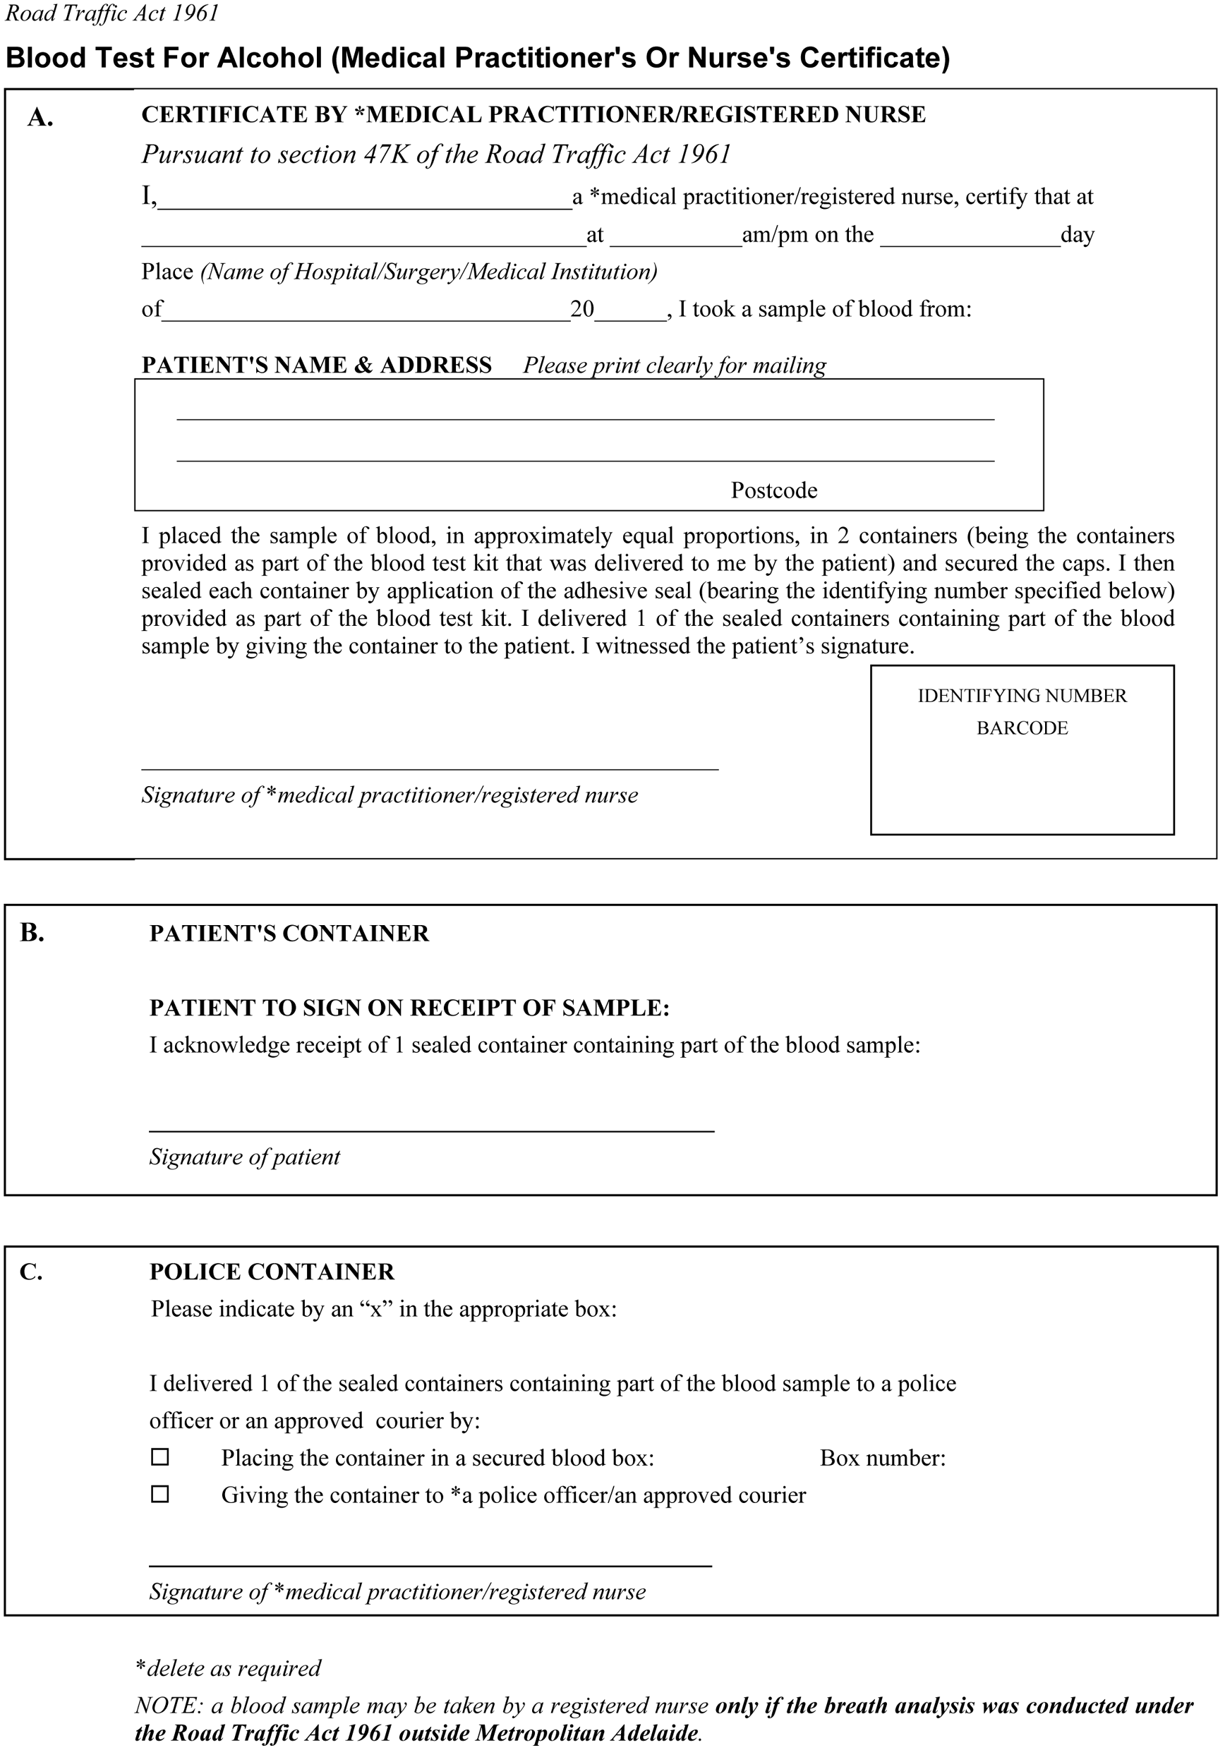
Note—
This form may be combined with a form required for the purposes of section 73(2) of the Harbors and Navigation Act 1993 and Schedule 2 clause 15(2) of the Rail Safety Act 2007 and regulations under those Acts.
Note—
As required by section 10AA(2) of the Subordinate Legislation Act 1978, the Minister has certified that, in the Minister's opinion, it is necessary or appropriate that these regulations come into operation as set out in these regulations.
Made by the Governor
with the advice and consent of the Executive Council
on 10 December 2009
No 289 of 2009
MRS07/007CS & MRS08/004CS

South Australia
Harbors and Navigation (Alcohol and Drug Testing) Regulations 2009
under the Harbors and Navigation Act 1993

Contents
1 Short title
2 Commencement
3 Interpretation
4 Prescribed class of offences
5 Conduct of breath analysis
6 Oral advice on refusal or failure to comply with alcotest or breath analysis direction
7 Oral advice on refusal or failure to comply with drug screening test, oral fluid analysis or blood test direction
8 Oral advice and written notice on recording of positive breath analysis reading
9 Procedures for voluntary blood test
10 Request for approved blood test kit
11 Prescribed period for keeping blood samples and oral fluid samples
12 Information to be included on analyst's certificate
Schedule 1—Prescribed oral advice and written notice
1 Oral advice on refusal or failure to comply with alcotest or breath analysis direction—section 71(9)(b) of Act
2 Oral advice on refusal or failure to comply with drug screening test, oral fluid analysis or blood test direction—section 72(11)(b) of Act
3 Oral advice on recording of positive breath analysis reading—section 73(6)(a) of Act
4 Written notice on recording of positive breath analysis reading—section 73(6)(a) of Act
Schedule 2—Form of certificate
Schedule 3—Form of request
Schedule 4—Revocation of Harbors and Navigation (Breath Analysis and Blood Test) Regulations 1997

1—Short title
These regulations may be cited as the Harbors and Navigation (Alcohol and Drug Testing) Regulations 2009.
2—Commencement
These regulations will come into operation on 1 February 2010.
3—Interpretation
In these regulations—
Act means the Harbors and Navigation Act 1993;
approved courier means a person approved by the Commissioner of Police under the Road Traffic Act 1961 as a courier for the purposes of Schedule 1 of that Act.
4—Prescribed class of offences
For the purposes of paragraph (a) of the definition of prescribed circumstances in section 4(1) of the Act, each of the following is an offence of a prescribed class:
(a) an offence against section 69, 69A, 70 or 85 of the Act;
(b) an offence against regulation 11(1), 167, 168, 171, 173, 179, 180, 181 or 198 of the Harbors and Navigation Regulations 2009;
(c) an offence against—
(i) section 84 of the Act; or
(ii) regulation 165(2) or 166(2) of the Harbors and Navigation Regulations 2009,
committed by a master or an operator of a vessel.
5—Conduct of breath analysis
(1) Pursuant to section 71(7) of the Act, if a person submits to a breath analysis, the breath analysis must be conducted in the following manner:
(a) the person must provide 2 separate samples of breath for analysis;
(b) each sample must be provided in accordance with the directions of the operator of the breath analysing instrument and must consist of not less than 1 litre of breath;
(c) there must be an interval of not less than 2 minutes and not more than 10 minutes between the provision of the samples.
(2) Despite subregulation (1)—
(a) if, on analysing a sample of breath, the breath analysing instrument indicates an error in the analysis of the sample—
(i) that sample, or, if that sample was the second sample provided, both samples, must be disregarded; and
(ii) the person may be required to provide 2 further samples of breath for analysis using a different instrument (and such samples must be provided in accordance with subregulation (1)(b) and (c)); or
(b) if, on analysing a sample of breath, the breath analysing instrument indicates the presence of alcohol in the mouth of the person—
(i) that sample, or, if that sample was the second sample provided, both samples, must be disregarded; and
(ii) the person may be required to provide 2 further samples of breath for analysis (and such samples must be provided in accordance with subregulation (1)(b) and (c)); or
(c) if, on analysing 2 samples of breath, the breath analysing instrument indicates that the reading obtained on analysis of the second sample was more than 15% higher or lower than the reading obtained on analysis of the first sample—
(i) those samples must be disregarded; and
(ii) the person may be required to provide 2 further samples of breath for analysis (and such samples must be provided in accordance with subregulation (1)(b) and (c)); or
(d) if, for any reason, a second sample of breath is not provided within 10 minutes of the provision of the first sample—
(i) the first sample is to be disregarded; and
(ii) the person may be required to provide 2 further samples of breath for analysis (and such samples must be provided in accordance with subregulation (1)(b) and (c)).
(3) If a person submits to a breath analysis, the result of the breath analysis will, for the purposes of Part 10 Division 4 of the Act and for the purposes of any other Act, be taken to be the reading produced by the breath analysing instrument, on analysis of the samples of breath provided by the person in accordance with this regulation, that indicates the lower concentration of alcohol in the person's breath (not taking into account any samples that, in accordance with this regulation, are to be disregarded).
6—Oral advice on refusal or failure to comply with alcotest or breath analysis direction
For the purposes of section 71(9)(b) of the Act, the prescribed oral advice is set out in Schedule 1 clause 1.
7—Oral advice on refusal or failure to comply with drug screening test, oral fluid analysis or blood test direction
For the purposes of section 72(11)(b) of the Act, the prescribed oral advice is set out in Schedule 1 clause 2.
8—Oral advice and written notice on recording of positive breath analysis reading
(1) For the purposes of section 73(6)(a) of the Act, the prescribed oral advice is set out in Schedule 1 clause 3.
(2) For the purposes of section 73(6)(a) of the Act, the prescribed written notice is set out in Schedule 1 clause 4.
9—Procedures for voluntary blood test
For the purposes of section 73(2)(a) of the Act, a sample of a person's blood must be taken and dealt with as follows:
(a) the person must cause the sample to be taken by a medical practitioner of the person's choice and must deliver the blood test kit supplied to the person under section 73(6)(b) of the Act to the medical practitioner for use for that purpose;
(b) the medical practitioner by whom the sample of the person's blood is taken must place the sample, in approximately equal proportions, in 2 containers (being the containers provided as part of the blood test kit);
(c) each container must contain a sufficient quantity of blood to enable an accurate evaluation to be made of any concentration of alcohol present in the blood and the sample of blood taken by the medical practitioner must be such as to furnish 2 such quantities of blood;
(d) the medical practitioner must seal each container by application of the adhesive seal (bearing an identifying number) provided as part of the blood test kit;
(e) it is the duty of the medical practitioner to take such measures as are reasonably practicable in the circumstances to ensure that the blood is not adulterated and does not deteriorate so as to prevent a proper assessment of the concentration of alcohol present in the blood of the person from whom the sample was taken;
(f) the medical practitioner must then complete a certificate in the form set out in Schedule 2 by inserting the particulars required by the form;
(g) the certificate must be signed by the medical practitioner certifying as to the matters set out in the form;
(h) the certificate must also bear the signature of the person from whom the blood sample was taken, attested to by the signature of the medical practitioner;
(i) the original of the signed certificate must then be delivered to the person from whom the blood sample was taken together with 1 of the sealed containers containing part of the blood sample;
(j) a copy of the signed certificate must be delivered by the medical practitioner together with the other sealed container containing part of the blood sample to a police officer or an approved courier;
(k) a police officer to whom a copy of the signed certificate and the other sealed container is delivered under paragraph (j) must deliver the copy and container to Forensic Science SA or to an approved courier;
(l) an approved courier to whom a copy of the signed certificate and the other sealed container is delivered under this regulation must deliver the copy and container to Forensic Science SA;
(m) the blood sample container and copy of the certificate referred to in paragraph (j) must not be delivered into the possession of the person from whom the sample was taken;
(n) on receipt of the blood sample container and certificate at Forensic Science SA, the blood in the container must be analysed as soon as reasonably practicable by or under the supervision of an analyst to determine the concentration of alcohol present in the blood expressed in grams in 100ml of blood;
(o) the analyst must then complete and sign a certificate certifying as to the following matters:
(i) the date of receipt at Forensic Science SA of the blood sample container and the certificate accompanying the blood sample container;
(ii) the identifying number appearing on the adhesive seal used to seal the blood sample container;
(iii) the name and professional qualifications of the analyst;
(iv) the concentration of alcohol found to be present in the blood expressed in grams in 100ml of blood;
(v) any factors relating to the blood sample or the analysis that might, in the opinion of the analyst, adversely affect the accuracy or validity of the analysis;
(vi) any other information relating to the blood sample or analysis or both that the analyst thinks fit to include;
(p) the analyst's certificate must be sent by post to the person from whom the blood sample was taken at the address shown as the person's address on the certificate accompanying the blood sample container;
(q) a copy of the analyst's certificate must be sent to or retained on behalf of the Minister;
(r) a copy of the analyst's certificate must also be sent to the Commissioner of Police;
(s) the person from whom the blood sample was taken may cause the sample of blood as contained in the blood sample container delivered to that person to be analysed to determine the concentration of alcohol present in the blood.
10—Request for approved blood test kit
(1) For the purposes of section 73(6)(b) of the Act, a request for an approved blood test kit must be made in accordance with the following:
(a) the request must be made either orally or in writing to the person operating the breath analysing instrument (the operator);
(b) on such a request having been made by the person, the operator or any other authorised person present at the scene must complete a written request form in the form set out in Schedule 3 by inserting the particulars required by the form;
(c) the person making the request must then sign the request form in the presence of the operator or other authorised person and the person's signature must be attested to by the signature of the operator or other authorised person;
(d) the original of the signed request form may be retained by the person making the request;
(e) a copy of the signed request form must be delivered to the operator or other authorised person.
(2) The copy of the request form delivered to the operator or other authorised person must be delivered to the Minister or retained on the Minister's behalf for 12 months from the day on which the request form was signed by the person making the request.
11—Prescribed period for keeping blood samples and oral fluid samples
For the purposes of clauses 2(e)(ii) and 7(e)(ii) of Schedule 1A of the Act, the period prescribed for which a container containing a sample of a person's blood or oral fluid (as the case may be) must be kept available for collection by or on behalf of that person is 12 months from the day on which the sample was taken from the person.
12—Information to be included on analyst's certificate
For the purposes of clause 7(f)(iv) of Schedule 1A of the Act, the required information in relation to any prescribed drug found to be present in the sample is information identifying the drug or drugs.
Schedule 1—Prescribed oral advice and written notice
[regulations 6 to 8]
1—Oral advice on refusal or failure to comply with alcotest or breath analysis direction—section 71(9)(b) of Act
It is a criminal offence to refuse or fail to provide a breath sample without good cause and you could be fined as a consequence.
It is a defence if you have some physical or medical condition that prevents you from providing a breath sample, but only if you ask for a sample of your blood to be taken instead or can show that your condition also prevents the taking of blood.
If you want a blood sample taken because of your condition, you should ask for that and the authorised person will help you to have the sample taken at Government expense.
2—Oral advice on refusal or failure to comply with drug screening test, oral fluid analysis or blood test direction—section 72(11)(b) of Act
It is a criminal offence to refuse or fail to provide a sample of oral fluid or blood without good cause and you could be fined as a consequence.
It is a defence if you have some physical or medical condition that prevents you from providing a sample of oral fluid or blood [whichever is applicable], but only if you ask for a sample of your blood or oral fluid [whichever is applicable] to be taken instead.
If you want a sample of blood or oral fluid [whichever is applicable] taken because of your condition, you should ask for that and the authorised person will help you to have the sample taken at Government expense.
3—Oral advice on recording of positive breath analysis reading—section 73(6)(a) of Act
The breathalyser reading just taken shows that you had a prohibited level of alcohol in your blood.
Therefore, it appears that you have committed an offence against section 70(2) of the Harbors and Navigation Act 1993.
In any court proceedings for that offence, or for an offence against section 70(1) of the Harbors and Navigation Act 1993, it will be presumed that the breathalyser accurately indicated your blood alcohol level at the time of the reading and for the preceding 2 hours. However, the Harbors and Navigation Act 1993 allows for contrary evidence based on the results of a blood test.
If you want to have such a blood test you will have to make your own arrangements and follow certain procedures, using a special blood test kit. This blood test kit will be supplied to you on your signing a written request.
If you obtain a blood test kit and want to have your blood tested, you should take the kit promptly to a hospital or medical practitioner in order to have a sample of your blood taken.
You must not consume any more alcohol before having a sample of your blood taken and must not open the blood test kit before delivering it to a medical practitioner.
Under the blood test procedure, the sample of blood is divided and sealed in 2 containers. You will have to sign a form that will be given to you by the medical practitioner.
1 of the sealed containers will be given to you and you may make your own arrangements to have the blood in that container analysed.
In any event, the blood in the other container will be analysed by Forensic Science SA and you will be given written notice of the results of the analysis.
Further information as to these matters is contained in the written notice which will be delivered to you shortly.
4—Written notice on recording of positive breath analysis reading—section 73(6)(a) of Act
Operation of Harbors and Navigation Act 1993 in relation to results of breath analysis
1—Offence
A person commits an offence against section 70(2) of the Harbors and Navigation Act 1993 if the person—
(a) operates a vessel; or
(b) is a member of the crew of a vessel who is (or ought to be) engaged in duties affecting the safe navigation, operation or use of the vessel,
while there is present in his or her blood the prescribed concentration of alcohol (as defined in section 4 of the Act).
2—Breath analysis
Your breath has just been analysed by means of a breath analysing instrument which indicated that the prescribed concentration of alcohol was present in your blood.
Accordingly, it appears that you have committed the offence described above.
3—Legal effect of breath analysis result
In proceedings for the offence described above or an offence against section 70(1) of the Harbors and Navigation Act 1993, the result of the breath analysis will be presumed to accurately record the concentration of alcohol in your blood at the time of the analysis and throughout the preceding 2 hours (section 73(1), (3)).
In any proceedings against you for such an offence, you will be able to challenge the accuracy of the breath analysis reading—
(a) if you have a sample of your blood taken and analysed as described below; AND
(b) if the result of analysis of the blood sample shows that the breath analysing instrument gave an exaggerated reading of the concentration of alcohol present in your blood (section 73(2)).
Procedures for optional blood test
1 You may have a sample of your blood taken and analysed if you wish.
2 For that purpose, you must request the breath analysis operator to supply you with an approved blood test kit (you must sign a written request form for the kit and should retain a copy of the signed request form).
3 You should then proceed promptly to a hospital or a medical practitioner of your choice and request that a sample of your blood be taken (using the blood test kit).
4 Do not consume any further alcohol before the sample is taken.
5 Do not open the blood test kit.
6 The medical practitioner taking the sample of your blood will divide it and place it into 2 containers and seal the containers. 1 container will be delivered to you—do not break the seal on this container.
7 Sign the form presented to you by the medical practitioner—the original of the form will be given to you which you should retain.
8 You may, if you wish, have the blood sample (in the container delivered to you) analysed at a laboratory to determine the concentration of alcohol present in the blood.
9 The other blood sample container will, in any event, be sent to Forensic Science SA where the blood will be analysed. The results of this analysis will be sent to you at your address (as indicated on the form presented to you by the medical practitioner who took the blood sample).
Schedule 2—Form of certificate
[Section 73(2) and regulation 9]

Note—
This form may be combined with a form required for the purposes of section 47K(1a) of the Road Traffic Act 1961 and Schedule 2 clause 15(2) of the Rail Safety Act 2007 and regulations under those Acts.
Schedule 3—Form of request
[Section 73(6)(b) and regulation 10]
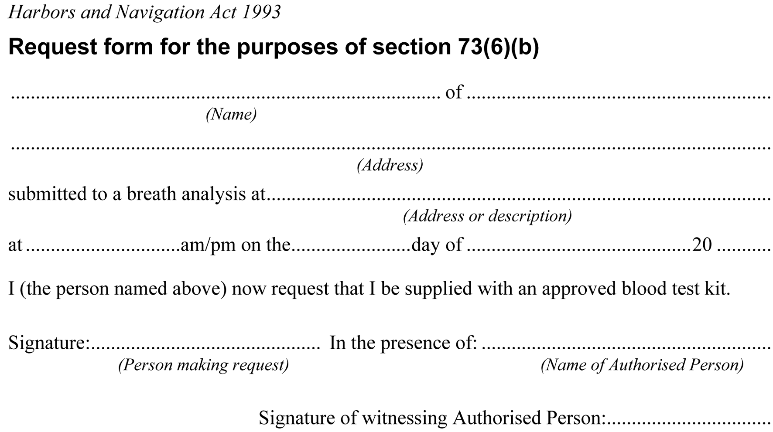
Schedule 4—Revocation of Harbors and Navigation (Breath Analysis and Blood Test) Regulations 1997
The Harbors and Navigation (Breath Analysis and Blood Test) Regulations 1997 are revoked.
Note—
As required by section 10AA(2) of the Subordinate Legislation Act 1978, the Minister has certified that, in the Minister's opinion, it is necessary or appropriate that these regulations come into operation as set out in these regulations.
Made by the Governor
with the advice and consent of the Executive Council
on 10 December 2009
No 290 of 2009
MRS08/004CS

South Australia
Harbors and Navigation (Miscellaneous) Variation Regulations 2009
under the Harbors and Navigation Act 1993

Contents
Part 1—Preliminary
1 Short title
2 Commencement
3 Variation provisions
Part 2—Variation of Harbors and Navigation Regulations 2009
4 Variation of regulation 12—Special rule in relation to sailing on Port Adelaide River
5 Variation of regulation 189—Port River Expressway Bridges
6 Variation of Schedule 5—Restricted areas

Part 1—Preliminary
1—Short title
These regulations may be cited as the Harbors and Navigation (Miscellaneous) Variation Regulations 2009.
2—Commencement
These regulations will come into operation on the day on which they are made.
3—Variation provisions
In these regulations, a provision under a heading referring to the variation of specified regulations varies the regulations so specified.
Part 2—Variation of Harbors and Navigation Regulations 2009
4—Variation of regulation 12—Special rule in relation to sailing on Port Adelaide River
(1) Regulation 12(1)—delete subregulation (1) and substitute:
(1) A person must not, without the approval of the CEO, operate a vessel under sail power alone in the waters of the Port Adelaide River—
(a) west of the Birkenhead Bridge; or
(b) in No 1 Dock.
Maximum penalty: $1 250.
Expiation fee: $160.
(2) Regulation 12—after subregulation (3) insert:
(4) In this regulation—
No 1 Dock means the waters of the Port Adelaide River east of a line being the prolongation generally south of the western boundary of Piece 118 of Deposited Plan 79638.
Note—
The following map is provided for convenience of reference only.
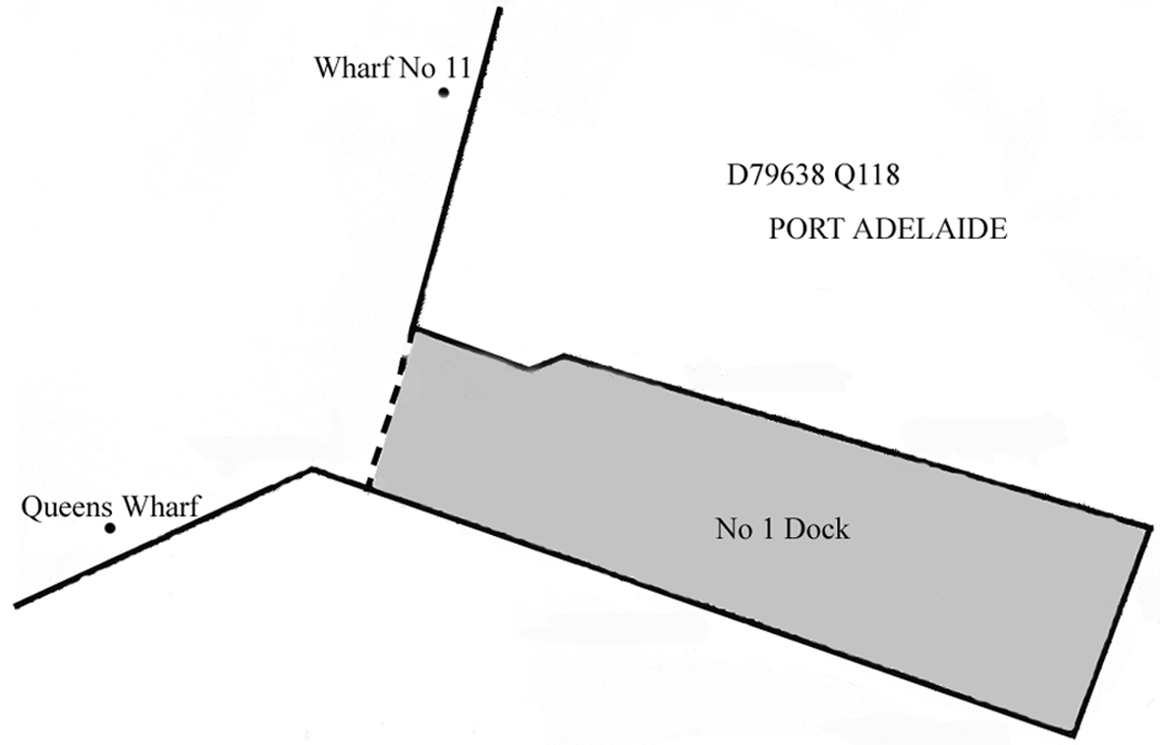
5—Variation of regulation 189—Port River Expressway Bridges
(1) Regulation 189(6)(f)—delete paragraph (f) and substitute:
(f) subject to any direction of the person operating the bridge to the contrary, he or she must ensure that the vessel, when being navigated under the bridge—
(i) in the case of a sailing vessel, operated under sail power alone, that does not require the bridge to be opened to navigate under the bridge—is not operated within the navigation pass; or
(ii) in any other case—is only operated within the navigation pass;
(2) Regulation 189(6)—after paragraph (k) insert:
(l) in the case of a sailing vessel, operated under sail power alone, that does not require the bridge to be opened to navigate under the bridge—he or she must not stop the vessel within 10 metres of the bridge.
(3) Regulation 189—after subregulation (7) insert:
(7a) Paragraphs (a), (i) and (j) of subregulation (6) do not apply to the master or operator of a sailing vessel, operated under sail power alone, that does not require the bridge to be opened to navigate under the bridge.
6—Variation of Schedule 5—Restricted areas
(1) Schedule 5 Part 1 clause 1, item relating to Murray Bridge—after Area 2 insert:
Area 3: the portion of the River Murray at Murray Bridge on the south-west side of Long Island bounded as follows:
• on the south-east by a straight line from a point 40 m (along the bank of the river) generally north-west of the southern alignment of Allotment 4 in Filed Plan 101622, Hundred of Mobilong, and extending north-east to the south-west bank of Long Island;
• on the south-west by the south-west bank of the river;
• on the north-west by a straight line from the north-west alignment of Allotment 867 in Filed Plan 167682, Hundred of Mobilong, and extending north-east to the south-west bank of Long Island;
• on the north-east by the south-west bank of Long Island.
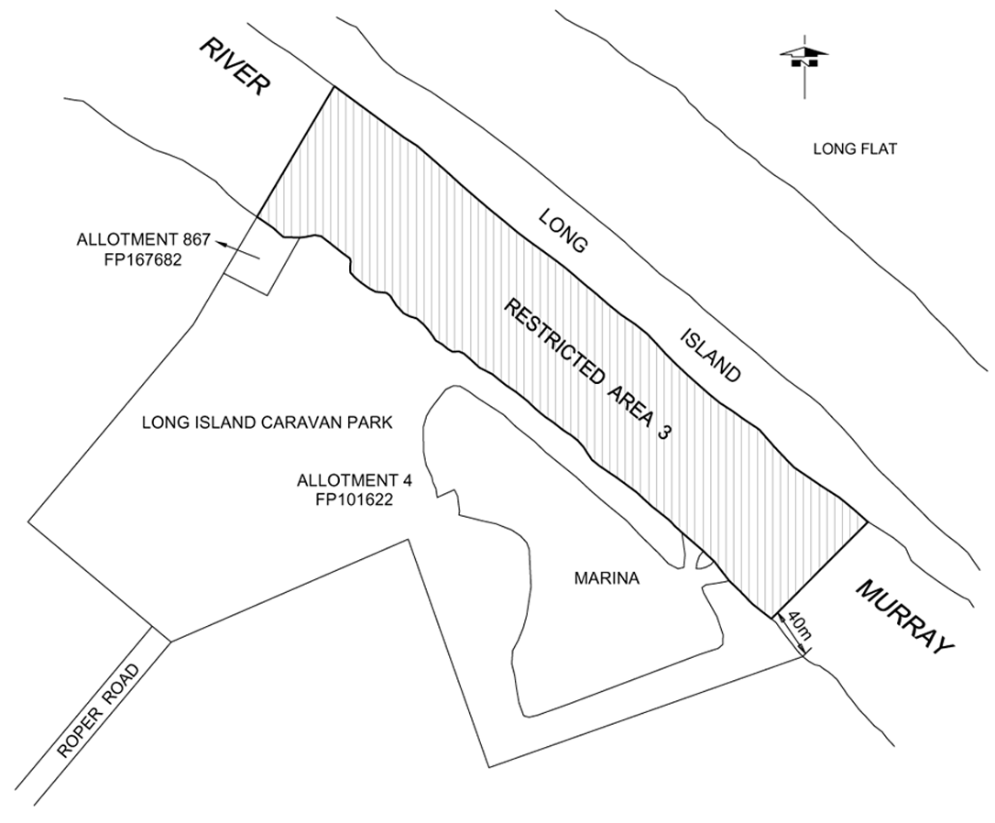
(2) Schedule 5 Part 3 clause 3—after the item relating to Murray Bridge Area 2 insert:

Murray Bridge Area 3 | Controls 2 and 5
Note—
As required by section 10AA(2) of the Subordinate Legislation Act 1978, the Minister has certified that, in the Minister's opinion, it is necessary or appropriate that these regulations come into operation as set out in these regulations.
Made by the Governor
with the advice and consent of the Executive Council
on 10 December 2009
No 291 of 2009
MTR09/087

South Australia
Liquor Licensing (Dry Areas—Short Term) Variation Regulations 2009
under the Liquor Licensing Act 1997

Contents
Part 1—Preliminary
1 Short title
2 Commencement
3 Variation provisions
Part 2—Variation of Liquor Licensing (Dry Areas—Short Term) Regulations 1997
4 Variation of Schedule 1—Short term dry areas

Part 1—Preliminary
1—Short title
These regulations may be cited as the Liquor Licensing (Dry Areas—Short Term) Variation Regulations 2009.
2—Commencement
These regulations come into operation on the day on which they are made.
3—Variation provisions
In these regulations, a provision under a heading referring to the variation of specified regulations varies the regulations so specified.
Part 2—Variation of Liquor Licensing (Dry Areas—Short Term) Regulations 1997
4—Variation of Schedule 1—Short term dry areas
(1) Schedule 1, item headed "Wallaroo—Area 1", column headed "Period"—delete "12 noon on 31 December 2008 to 7 a.m. on 1 January 2009." and substitute:
12 noon on 31 December 2009 to 7 am on 1 January 2010.
(2) Schedule 1, item headed "Wallaroo—Area 2", column headed "Period"—delete "12 noon on 31 December 2008 to 7 a.m. on 1 January 2009." and substitute:
12 noon on 31 December 2009 to 7 am on 1 January 2010.
Note—
As required by section 10AA(2) of the Subordinate Legislation Act 1978, the Minister has certified that, in the Minister's opinion, it is necessary or appropriate that these regulations come into operation as set out in these regulations.
Made by the Governor
with the advice and consent of the Executive Council
on 10 December 2009
No 292 of 2009
09MCA0049CS

South Australia
Liquor Licensing (Dry Areas—Short Term) Variation Regulations 2009
under the Liquor Licensing Act 1997

Contents
Part 1—Preliminary
1 Short title
2 Commencement
3 Variation provisions
Part 2—Variation of Liquor Licensing (Dry Areas—Short Term) Regulations 1997
4 Variation of Schedule 1—Short term dry areas

Part 1—Preliminary
1—Short title
These regulations may be cited as the Liquor Licensing (Dry Areas—Short Term) Variation Regulations 2009.
2—Commencement
These regulations come into operation on the day on which they are made.
3—Variation provisions
In these regulations, a provision under a heading referring to the variation of specified regulations varies the regulations so specified.
Part 2—Variation of Liquor Licensing (Dry Areas—Short Term) Regulations 1997
4—Variation of Schedule 1—Short term dry areas
(1) Schedule 1, item headed "Robe—Area 1", column headed "Period"—delete "1 p.m. on 31 December 2008 to 12.01 a.m. on 2 January 2009." and substitute:
1 pm on 31 December 2009 to 12.01 am on 2 January 2010.
(2) Schedule 1, item headed "Robe—Area 2", column headed "Period"—delete "1 p.m. on 31 December 2008 to 12.01 a.m. on 2 January 2009." and substitute:
1 pm on 31 December 2009 to 12.01 am on 2 January 2010.
(3) Schedule 1, item headed "Robe—Area 3", column headed "Period"—delete "1 p.m. on 31 December 2008 to 12.01 a.m. on 2 January 2009." and substitute:
1 pm on 31 December 2009 to 12.01 am on 2 January 2010.
(4) Schedule 1, item headed "Robe—Area 4", column headed "Period"—delete "1 p.m. on 31 December 2008 to 12.01 a.m. on 2 January 2009." and substitute:
1 pm on 31 December 2009 to 12.01 am on 2 January 2010.
(5) Schedule 1, item headed "Robe—Area 5", column headed "Period"—delete "1 p.m. on 31 December 2008 to 12.01 a.m. on 2 January 2009." and substitute:
1 pm on 31 December 2009 to 12.01 am on 2 January 2010.
Note—
As required by section 10AA(2) of the Subordinate Legislation Act 1978, the Minister has certified that, in the Minister's opinion, it is necessary or appropriate that these regulations come into operation as set out in these regulations.
Made by the Governor
with the advice and consent of the Executive Council
on 10 December 2009
No 293 of 2009
09MCA0052CS

South Australia
Liquor Licensing (Dry Areas—Short Term) Variation Regulations 2009
under the Liquor Licensing Act 1997

Contents
Part 1—Preliminary
1 Short title
2 Commencement
3 Variation provisions
Part 2—Variation of Liquor Licensing (Dry Areas—Short Term) Regulations 1997
4 Variation of Schedule 1—Short term dry areas

Part 1—Preliminary
1—Short title
These regulations may be cited as the Liquor Licensing (Dry Areas—Short Term) Variation Regulations 2009.
2—Commencement
These regulations come into operation on the day on which they are made.
3—Variation provisions
In these regulations, a provision under a heading referring to the variation of specified regulations varies the regulations so specified.
Part 2—Variation of Liquor Licensing (Dry Areas—Short Term) Regulations 1997
4—Variation of Schedule 1—Short term dry areas
Schedule 1, item headed "Beachport—Area 1", column headed "Period"—delete "12 noon on 31 December 2008 to 12 noon on 2 January 2009." and substitute:
12 noon on 31 December 2009 to 12 noon on 2 January 2010.
Note—
As required by section 10AA(2) of the Subordinate Legislation Act 1978, the Minister has certified that, in the Minister's opinion, it is necessary or appropriate that these regulations come into operation as set out in these regulations.
Made by the Governor
with the advice and consent of the Executive Council
on 10 December 2009
No 294 of 2009
09MCA0053CS

South Australia
Natural Resources Management (Marne Saunders Prescribed Water Resources Area—Reduction of Water Access Entitlements) Regulations 2009
under the Natural Resources Management Act 2004

Contents
Preamble
1 Short title
2 Commencement
3 Interpretation
4 Average adjusted winter runoff
5 Maximum theoretical enterprise requirement
6 Reasonable requirements
7 Consumptive use limit
8 Water taken from multiple resources or multiple diversion structures etc
9 Scheme for reduction of water access entitlements for existing users
Schedule 1—Estimated water requirements—intensive farming
Schedule 2—Irrigated crop water requirements
Schedule 3—Table of values
Schedule 4—Main watercourse and tributary management sub-zones
Part 1—Main watercourse management sub-zones
Part 2—Tributary management sub-zones

Preamble
1 The Marne River and Saunders Creek Area was declared to be a surface water prescribed area, all watercourses in the Marne River and Saunders Creek Area were declared to be prescribed watercourses and existing and future wells in the Marne River and Saunders Creek Area were declared to be prescribed wells by the Water Resources (Marne River and Saunders Creek—Prescribed Water Resources) Regulations 2003.
Note—
Those regulations came into operation on 20 March 2003—see Gazette 20.03.2003 p1111.
2 Those regulations were revoked by the Water Resources (Marne Saunders Prescribed Water Resources Area) Regulations 2005 (the 2005 regulations), which declared—
(a) an area to be the Marne Saunders Prescribed Water Resources Area; and
(b) all watercourses situated in the Marne Saunders Prescribed Water Resources Area to be prescribed watercourses; and
(c) all wells situated in the Marne Saunders Prescribed Water Resources Area and wells drilled in that area after the commencement of those regulations to be prescribed wells; and
(d) the Marne Saunders Prescribed Water Resources Area to be a surface water prescribed area.
Note—
Those regulations came into operation on 7 April 2005—see Gazette 7.04.2005 p834.
3 Pursuant to Schedule 4 clause 54(2) of the Act, the 2005 regulations continue in force and effect as if they were regulations made under section 125 of the Act.
4 Pursuant to the 2005 regulations, the prescribed period in relation to the Marne Saunders Prescribed Water Resources Area ended on 20 March 2006.
5 The prescribed period having ended, the Minister is of the opinion that the aggregate of water access entitlements assigned to existing users under section 164N(1) and (2) of the Act exceeds the capacity of the resource.
6 It is now appropriate to make regulations setting out a scheme for the reduction of water access entitlements of existing users in the Marne Saunders Prescribed Water Resources Area.

1—Short title
These regulations may be cited as the Natural Resources Management (Marne Saunders Prescribed Water Resources Area—Reduction of Water Access Entitlements) Regulations 2009.
2—Commencement
These regulations come into operation on the day on which they are made.
3—Interpretation
(1) In these regulations—
Act means the Natural Resources Management Act 2004;
average adjusted winter runoff—see regulation 4;
category A zone, in relation to underground water, means the following underground water management zones and sub-zone as set out in the plans lodged as Deposits No 49 of 2008 and 28 of 2009 in the General Registry Office:
(a) Unconfined Zone 1;
(b) Confined Zone A;
(c) Confined sub-zone C2;
consumptive use limit—see regulation 7;
dam includes a reservoir or lake;
Department means the administrative unit of the Public Service that is designated from time to time by the Minister by notice in the Gazette as being the Department for the purposes of these regulations;
diversion structure means a structure or object that collects, diverts or extracts water flowing in a watercourse, or surface water flowing over land;
establishment period, applying to particular land within the Marne Saunders Prescribed Water Resources Area, means the establishment period for the area in which the land is situated under the Water Resources (Marne Saunders Prescribed Water Resources Area) Regulations 2005;
existing user means—
(a) an existing user under section 164N of the Act; and
(b) an existing user under section 36 of the repealed Act;
flow path, in relation to water, means the path or direction over land which the water flow naturally takes or would take;
licensable dam means a dam used for a purpose other than stock watering or domestic purposes—
(a) that had been lawfully constructed on the relevant land as at the end of the establishment period applying to the land; or
(b) that had not been constructed on the relevant land as at the end of the establishment period applying to the land but in respect of which the existing user had committed significant financial or other resources during that period;
main watercourse management sub-zone means a main watercourse management sub-zone specified in Schedule 4 Part 1;
management sub-zone, in relation to an existing user, means the main watercourse management sub-zone or tributary management sub-zone (as set out in the plan lodged as Deposit No 1 of 2009 in the General Registry Office) of the management zone of the Marne Saunders Prescribed Water Resources Area in which the relevant land, or the relevant part of the relevant land, is located;
management zone, in relation to an existing user, means a management zone (as set out in the plans lodged as Deposits No 47, 49 and 51 of 2008 in the General Registry Office) of Marne Saunders Prescribed Water Resources Area;
Marne Saunders Prescribed Water Resources Area has the same meaning as in the Water Resources (Marne Saunders Prescribed Water Resources Area) Regulations 2005;
maximum theoretical enterprise requirement or MTER, in relation to an existing user, means the MTER for the user determined in accordance with regulation 5;
non-licensable dam means a dam used, or to be used, for stock watering or domestic purposes and that had been lawfully constructed on the relevant land as at the end of the establishment period applying to the land;
reasonable requirements of an existing user—see regulation 6;
repealed Act means the Water Resources Act 1997 (as in force immediately before the commencement of Schedule 4 of the Act);
tributary management sub-zone means a tributary management sub-zone specified in Schedule 4 Part 2;
watercourse water means water in a watercourse.
(2) For the purposes of these regulations, a reference to a particular climate band will be taken to be a reference to the climate band of that number, as set out in the map lodged as Deposit No 29 of 2009 in the General Registry Office.
(3) For the purposes of these regulations, the area of catchment areas is to be measured in square kilometres.
(4) For the purposes of these regulations, a management sub-zone will be taken to be upstream of a main watercourse diversion structure if—
(a) in the case of a main watercourse management sub-zone—the whole of the management sub-zone lies upstream of the main watercourse diversion structure;
(b) in the case of a tributary watercourse management sub-zone—the primary point of inflow from the tributary management sub-zone to the main watercourse management sub-zone is upstream of that main watercourse diversion structure.
(5) For the purposes of these regulations, diversion structures will be taken to be hydrologically continuous if they are connected by the same flow path or watercourse.
(6) Nothing in these regulations authorises an existing user to take more water under a water access entitlement than an amount equal to the user's reasonable requirements.
4—Average adjusted winter runoff
(1) The average adjusted winter runoff (measured in megalitres) at a particular diversion structure that takes water from a tributary management sub-zone is to be determined by multiplying the average adjusted winter runoff depth applicable at the diversion structure (as determined by the Minister) by the catchment area upstream of the diversion structure.
(2) The average adjusted winter runoff (measured in megalitres) at a particular diversion structure that takes water from a main watercourse management sub-zone (the main watercourse diversion structure) is to be determined by aggregating the average adjusted winter runoff volume for each tributary management sub-zone upstream of the diversion structure.
(3) In this regulation—
average adjusted winter runoff volume, for a tributary management sub-zone, is the volume specified in column 2 of the table in Schedule 3 in relation to the tributary management sub-zone.
5—Maximum theoretical enterprise requirement
(1) For the purposes of these regulations, the maximum theoretical enterprise requirement for an existing user is to be determined as follows:
(a) if the existing user is an intensive farmer—the estimated water requirement of the user, calculated—
(i) in relation to an animal or animals of a kind referred to in the table in Schedule 1—
(A) by multiplying the number of a particular kind of animal referred to in column 1 of the table farmed by the user by the estimated water requirement in column 2 of the table relating to the relevant animal; and
(B) aggregating the amounts referred to in subsubparagraph (A) for each kind of animal intensively farmed by the user;
(ii) in the case of an intensive farmer of yabbies (Cherax destructor)—by applying the following formula in relation to the pond used to farm the yabbies (or, if the user has more than 1 such pond, by applying the formula to each such pond and aggregating the results):
where—
L means length in metres of the pond
W means width in metres of the pond
D means depth in metres of the pond
ER means the evaporation rate of 1.95 metres per year;
(iii) if the intensive farming involves a washdown for dairy cattle—
(A) in the case of farming involving less than 150 animals—3 224 kilolitres per year; or
(B) in the case of farming involving not less than 150 animals but less than 350 animals—4 049 kilolitres per year; or
(C) in the case of farming involving not less than 350 animals—5 566 kilolitres per year;
(iv) if the intensive farming involves a washdown for dogs—4.9 kilolitres per m² of the washdown;
(b) if the existing user is an irrigated crop farmer—
(i) to the extent that the relevant crop is in climate band 1—the irrigated crop water requirement of the user, calculated by multiplying the number of hectares of the crop in climate band 1 by the irrigated crop water requirement in column 2 of the table in Schedule 2 relating to the relevant crop;
(ii) to the extent that the relevant crop is in climate band 2—the irrigated crop water requirement of the user, calculated by multiplying the number of hectares of the crop in climate band 2 by the irrigated crop water requirement in column 3 of the table in Schedule 2 relating to the relevant crop;
(iii) to the extent that the relevant crop is in climate band 3—the irrigated crop water requirement of the user, calculated by multiplying the number of hectares of the crop in climate band 3 by the irrigated crop water requirement in column 4 of the table in Schedule 2 relating to the relevant crop;
(iv) to the extent that the relevant crop is in climate band 4—the irrigated crop water requirement of the user, calculated by multiplying the number of hectares of the crop in climate band 4 by the irrigated crop water requirement in column 5 of the table in Schedule 2 relating to the relevant crop;
(v) to the extent that the relevant crop is in climate band 5—the irrigated crop water requirement of the user, calculated by multiplying the number of hectares of the crop in climate band 5 by the irrigated crop water requirement in column 6 of the table in Schedule 2 relating to the relevant crop;
(c) if the existing user is an industrial user—the industrial water requirements applicable to the user specified in 1 or more of the following subparagraphs:
(i) in the case of olive pickling and bottling (including washdown)—300 kilolitres per year;
(ii) in the case of a winery processing more than 700 but less than 900 tonnes of grapes per year—2 500 kilolitres per year;
(iii) in the case of a winery processing less than 200 tonnes of grapes per year—300 kilolitres per year;
(iv) in the case of a winery with 2.5 hectares of surrounding gardens—14 550 kilolitres per year;
(v) in the case of a winery nursery and surrounding trees—500 kilolitres per year;
(vi) in the case of washdown for winery plant and equipment—250 kilolitres per year;
(vii) in the case of a quarry (sawing equipment and washdown)—4 000 kilolitres per year;
(viii) in the case of a quarry (diamond wire saw)—200 kilolitres per year;
(ix) in the case of a restaurant with 14 accommodation units—700 kilolitres per year;
(d) if more than 1 of the above paragraphs or subparagraphs applies in relation to the existing user—the aggregate of all applicable requirements.
(2) For the purposes of this regulation, a reference to a particular number of animals, or to the size of a particular crop, yabbie pond or washdown for dogs, will be taken to be a reference to the maximum number of animals, or size of the crop, pond or washdown, farmed or used by the existing user during the establishment period applying to the relevant land.
6—Reasonable requirements
For the purposes of these regulations, the reasonable requirements of an existing user, or a class of existing users, will be taken to be an amount of water equal to the MTER for the existing user (if any).
7—Consumptive use limit
(1) For the purposes of these regulations, the consumptive use limit for a tributary management sub-zone will be taken to be the amount set out in column 3 of the table in Schedule 3 relating to the relevant tributary management sub-zone.
(2) For the purposes of these regulations, the consumptive use limit at a diversion structure in a main watercourse management sub-zone will be taken to be an amount equal to the aggregate of the consumptive use limits for each tributary management sub-zone upstream of the diversion structure.
(3) For the purposes of these regulations, an existing user's share of the consumptive use limit, in relation to a tributary management sub-zone, will be taken to be the proportion of the available consumptive use limit for the tributary management sub-zone that represents the proportion of the existing user's reasonable requirements as compared to the total reasonable requirements of all existing users within the management sub-zone.
(4) For the purposes of these regulations, an existing user's share of the consumptive use limit, at a diversion structure in a main watercourse management sub-zone, will be taken to be the proportion of the available consumptive use limit at the diversion structure that represents the proportion of the existing user's reasonable requirements as compared to the total reasonable requirements of all existing users—
(a) in that part of the main watercourse management sub-zone that is upstream of the diversion structure; plus
(b) in all other management sub-zones upstream of the diversion structure.
(5) For the purposes of this regulation, the available consumptive use limit for a tributary management sub-zone will be taken to be the consumptive use limit for the tributary management sub-zone less an amount equal to 30% of the capacity of all non-licensable dams for the management sub-zone (as at the end of the establishment period applying to the management sub-zone).
(6) For the purposes of this regulation, the available consumptive use limit at a diversion structure in a main watercourse management sub-zone will be taken to be the consumptive use limit at the diversion structure less an amount equal to 30% of the capacity of—
(a) all non-licensable dams in that part of the main watercourse management sub-zone that is upstream of the diversion structure; plus
(b) all non-licensable dams in all other management sub-zones upstream of the diversion structure.
8—Water taken from multiple resources or multiple diversion structures etc
(1) If an existing user has water access entitlements under section 164N of the Act in respect of more than 1 water resource, the Minister may, in reducing a water access entitlement or entitlements—
(a) reduce the amount of water that may be taken under a particular water access entitlement, or the aggregate amount of water that may be taken under all such water access entitlements; or
(b) make an order specifying the amount of water that may be taken from a particular water resource; or
(c) make an order specifying a proportion or ratio in which water may be taken from each water resource.
(2) If an existing user has water access entitlements under section 164N of the Act in respect of multiple diversion structures—
(a) all of which are in the same management sub-zone; and
(b) that are hydrologically continuous; and
(c) in relation to which the flow path stays within the same property,
the Minister may, in reducing a water access entitlement or entitlements—
(d) reduce the total amount of water that may be taken at 1 or more of the diversion structures; or
(e) make an order specifying—
(i) the amount of water that may be taken at a particular diversion structure; or
(ii) the aggregate amount of water that may be taken at all such diversion structures; or
(f) make an order specifying a proportion or ratio in which water may be taken at each of the diversion structures.
(3) If an existing user has water access entitlements under section 164N of the Act in respect of multiple wells in the same water resource, the Minister may, in reducing a water access entitlement or entitlements—
(a) reduce the total amount of water that may be taken from the wells; or
(b) make an order specifying—
(i) the amount of water that may be taken from a particular well; or
(ii) the aggregate amount of water that may be taken from the wells.
(4) A person who contravenes an order under this regulation is guilty of an offence.
Maximum penalty:
(a) in the case of a body corporate—$10 000;
(b) in the case of a natural person—$5 000.
Expiation fee: $315.
9—Scheme for reduction of water access entitlements for existing users
(1) Subject to this regulation, for the purposes of section 164N(3)(b) of the Act, a water access entitlement assigned to an existing user in the Marne Saunders Prescribed Water Resources Area under section 164N of the Act, or under section 36 of the repealed Act, may be reduced in accordance with the following provisions:
(a) in the case of a water access entitlement of an existing user in respect of surface water (other than surface water comprised of roof runoff)—the Minister may reduce the water access entitlement such that the amount of surface water that may be taken at a particular diversion structure under the water access entitlement is reduced to the lesser of—
(i) the existing user's share of the consumptive use limit for the user's management sub-zone, determined in accordance with regulation 7; or
(ii) the amount of water comprising—
(A) in the case of a diversion structure that is a licensable dam—the capacity of the dam; or
(B) 100% of the average adjusted winter runoff upstream of the diversion structure less—
• the amount of evaporation from each licensable and non-licensable dam in the catchment area upstream of the diversion structure; and
• the consumptive use in the catchment area upstream of the diversion structure,
whichever is the lesser; or
(iii) the MTER for the existing user (if any);
(b) in the case of a water access entitlement of an existing user in respect of surface water comprised of roof runoff—the Minister may reduce the water access entitlement such that the amount of roof runoff that may be taken under the water access entitlement is reduced to an amount equal to 85% of the rainfall falling on the relevant roof area at any particular time;
(c) in the case of a water access entitlement of an existing user in respect of watercourse water—the Minister may reduce the water access entitlement such that the amount of watercourse water that may be taken at a particular diversion structure under the water access entitlement is reduced to the lesser of—
(i) the existing user's share of the consumptive use limit for the user's management sub-zone, calculated in accordance with regulation 7; or
(ii) the amount of water comprising 100% of the average adjusted winter runoff at the diversion structure less—
(A) the amount of evaporation from each licensable and non-licensable dam in the catchment area upstream of the diversion structure; and
(B) the consumptive use in the catchment area upstream of the diversion structure; or
(iii) the MTER for the existing user (if any);
(d) in the case of a water access entitlement of an existing user in respect of underground water taking the water from a category A zone—the Minister may reduce the water access entitlement such that the amount of underground water that may be taken at a particular well under the water access entitlement is reduced to the reasonable requirements of the existing user, less a percentage determined by the Minister for the purposes of this paragraph.
(2) Despite subregulation (1), if the reduction of a water access entitlement of an existing user at a diversion structure in accordance with that subregulation would result in the amount of water allocated, or to be allocated, at the diversion structure being less than 50% of the MTER for the existing user, then the Minister may instead reduce the water access entitlement such that the amount of water allocated, or to be allocated, in relation to the water access entitlement at the diversion structure is reduced to the lesser of—
(a) 50% of the MTER for the existing user; or
(b) if the water access entitlement relates to a licensable dam—the capacity of the dam.
(3) For the purposes of this regulation, the amount of evaporation from a dam will be taken to be an amount of water equal to the lesser of—
(a) 30% of the dam's capacity; or
(b) the capacity of the dam less any existing user allocation to be taken from the dam.
(4) For the purposes of paragraphs (a)(ii) and (c)(ii) of subregulation (1), the consumptive use in a catchment area will be taken to be an amount of water equal to—
(a) the allocations for all existing users to be made from the surface water or watercourse water (as the case requires), excluding any allocations of surface water comprised of roof runoff; plus
(b) 30% of the capacity of all non-licensable dams in the catchment area.
Schedule 1—Estimated water requirements—intensive farming

Kind of animal | Estimated water requirement for animal
Dairy cattle | 55 kL/animal/year
Chicken (meat) | 0.13 kL/bird/year
Chicken (eggs) | 0.18 kL/bird/year
Pigs (sow breeding unit) | 91 kL/sow breeding unit/year*
Sheep (feedlot) | 1.46 kL/animal/year
Dogs (kennel) | 5.5 kL/animal/year
Horses | 18 kL/animal/year
Rabbits | 4.13 kL/animal/year
* The estimated water requirement in relation to sow breeding units is calculated at a ratio of 1:10 sows to growers/weaners/finishers.
Schedule 2—Irrigated crop water requirements

Crop | Band 1* | Band 2* | Band 3* | Band 4* | Band 5*
Reference crop | 8.63 | 9.55 | 9.78 | 10.18 | 10.70
Acacia | 4.86 | 5.38 | 5.52 | 5.83 | 6.72
Almond nursery | 8.63 | 9.55 | 9.78 | 10.18 | 10.70
Apricot | 6.30 | 7.05 | 7.19 | n/a | n/a
Beetroot | n/a | n/a | n/a | 3.31 | 3.38
Bush tomato | 4.86 | 5.38 | 5.52 | 5.83 | 6.72
Cereal hay | n/a | n/a | n/a | 0.39 | 0.70
Citrus | 4.82 | 5.40 | 5.54 | n/a | n/a
Eucalyptus | 5.83 | 6.49 | 6.65 | 7.04 | 7.51
Fruit tree (not otherwise listed) | 6.30 | 7.05 | 7.19 | n/a | n/a
Garden | 5.82 | 6.45 | 6.60 | 6.97 | 7.43
Geraldton wax | 4.86 | 5.38 | 5.52 | 5.83 | 6.72
Lucerne hay | 7.99 | 8.75 | 8.91 | 9.31 | 9.76
Lucerne graze | 5.83 | 6.49 | 6.65 | 7.04 | 7.51
Muntrie berries | 4.86 | 5.38 | 5.52 | 5.83 | 6.72
Native produce (not otherwise listed) | 4.86 | 5.38 | 5.52 | 5.83 | 6.72
Native trees | 5.83 | 6.49 | 6.65 | 7.04 | 7.51
Nursery | 8.63 | 9.55 | 9.78 | 10.18 | 10.70
Olive (oil) | 4.77 | 5.27 | 5.41 | 5.67 | 6.04
Olive (fresh) | 5.29 | 5.89 | 6.03 | 6.35 | 6.80
Pasture | 5.83 | 6.49 | 6.65 | 7.04 | 7.51
Pasture starter | 0.94 | 1.02 | 1.01 | 1.01 | 1.01
Pecan | 6.30 | 7.05 | 7.19 | n/a | n/a
Pumpkin | 4.75 | 5.07 | 5.12 | 5.16 | 5.25
Quandong | 4.86 | 5.38 | 5.52 | 5.83 | 6.72
Recreational crop | 5.82 | 6.45 | 6.60 | 6.97 | 7.43
Semibaccarta | 4.86 | 5.38 | 5.52 | 5.83 | 6.72
Sorghum | 5.91 | 6.39 | 6.46 | 6.55 | 6.68
Stonefruit (not otherwise listed) | 6.30 | 7.05 | 7.19 | n/a | n/a
Tomato | n/a | n/a | n/a | 11.15 | 11.67
Turf (buffalo, couch, kikuyu) | n/a | n/a | n/a | 8.23 | 8.70
Turf (fescue) | n/a | n/a | n/a | 9.54 | 10.03
Vegetables (not otherwise listed) | 4.75 | 5.07 | 5.12 | 5.16 | 5.25
Watermelon | n/a | n/a | n/a | 5.54 | 5.59
Wine grape (red) | 1.87 | 2.15 | 2.22 | 2.36 | 2.53
Wine grape (white) | 1.94 | 2.23 | 2.31 | 2.45 | 2.61
Woodlot | 5.83 | 6.49 | 6.65 | 7.04 | 7.51
* all measurements are megalitres per hectare per year.
Schedule 3—Table of values

Management sub-zone | Average adjusted winter runoff volume for management sub-zone (megalitres) | Consumptive use limit for management sub-zone (megalitres)
M1-01 | 1783 | 535
M1-02 | 957 | 287
M1-03 | 557 | 167
M1-04 | 163 | 49
M1-05 | 900 | 270
M1-06 | 103 | 31
M1-07 | 353 | 106
M1-08 | 120 | 36
M1-09 | 497 | 149
M1-10 | 363 | 109
M1-11 | 87 | 26
M2-01 | 270 | 81
M2-02 | 183 | 55
M2-03 | 457 | 137
M2-04 | 527 | 158
M2-05 | 93 | 28
M2-06 | 90 | 27
M2-07 | 80 | 24
M2-08 | 73 | 22
M2-09 | 30 | 9
M2-10 | 127 | 38
M2-11 | 63 | 19
M2-12 | 47 | 14
M2-13 | 37 | 11
M2-14 | 30 | 9
M2-15 | 20 | 6
M3 | 80 | 24
M4 | 70 | 21
M5 | 123 | 37
M6 | n/a | the amount determined by the Minister
M7 | n/a | the amount determined by the Minister
M8 | n/a | the amount determined by the Minister
S1-01 | 257 | 77
S1-02 | 43 | 13
S1-03 | 43 | 13
S1-04 | 13 | 4
S1-05 | 40 | 12
S1-06 | 13 | 4
S2-01 | 127 | 38
S2-02 | 63 | 19
S2-03 | 43 | 13
S2-04 | 30 | 9
S2-05 | 30 | 9
S2-06 | 17 | 5
S2-07 | 53 | 16
S2-08 | 33 | 10
S2-09 | 23 | 7
S2-10 | 17 | 5
S2-11 | 37 | 11
S3 | 123 | 37
S4 | 80 | 24
S5 | 37 | 11
S6 | 27 | 8
S7 | n/a | the amount determined by the Minister
S8 | n/a | the amount determined by the Minister
Schedule 4—Main watercourse and tributary management sub-zones
Part 1—Main watercourse management sub-zones

Management sub-zone | Management zone
M6 | Upper Marne
M7 | Lower Marne
M8 | Upper Marne
S7 | Upper Saunders
S8 | Lower Saunders
Part 2—Tributary management sub-zones

Management sub-zone | Management zone
M1-01 to M1-11 (inclusive) | Upper Marne
M2-01 to M2-15 (inclusive) | Upper Marne
M3 | Upper Marne
M4, M5 | Lower Marne
S1-01 to S1-06 (inclusive) | Upper Saunders
S2-01 to S2-11 (inclusive) | Upper Saunders
S3 to S6 (inclusive) | Lower Saunders
Note—
As required by section 10AA(2) of the Subordinate Legislation Act 1978, the Minister has certified that, in the Minister's opinion, it is necessary or appropriate that these regulations come into operation as set out in these regulations.
Made by the Governor
with the advice and consent of the Executive Council
on 10 December 2009
No 295 of 2009
WBCS09/0027

South Australia
Highways (Port River Expressway Project) Variation Regulations 2009
under the Highways Act 1926

Contents
Part 1—Preliminary
1 Short title
2 Commencement
3 Variation provisions
Part 2—Variation of Highways (Port River Expressway Project) Regulations 2004
4 Variation of regulation 4—Port River Expressway Project
5 Variation of Schedule 1—Principal features of Port River Expressway Project
6 Substitution of Schedule 2
Schedule 2—Land to which Port River Expressway Project applies

Part 1—Preliminary
1—Short title
These regulations may be cited as the Highways (Port River Expressway Project) Variation Regulations 2009.
2—Commencement
These regulations come into operation on the day on which they are made.
3—Variation provisions
In these regulations, a provision under a heading referring to the variation of specified regulations varies the regulations so specified.
Part 2—Variation of Highways (Port River Expressway Project) Regulations 2004
4—Variation of regulation 4—Port River Expressway Project
Regulation 4(2)—delete "the bold black line shown in the plans (Figures 2 to 5) set out" and substitute:
the bold black line connecting the coordinate points shown in Figures 2 to 5
5—Variation of Schedule 1—Principal features of Port River Expressway Project
Schedule 1, Part 4, Figure 1—delete Figure 1 and substitute:
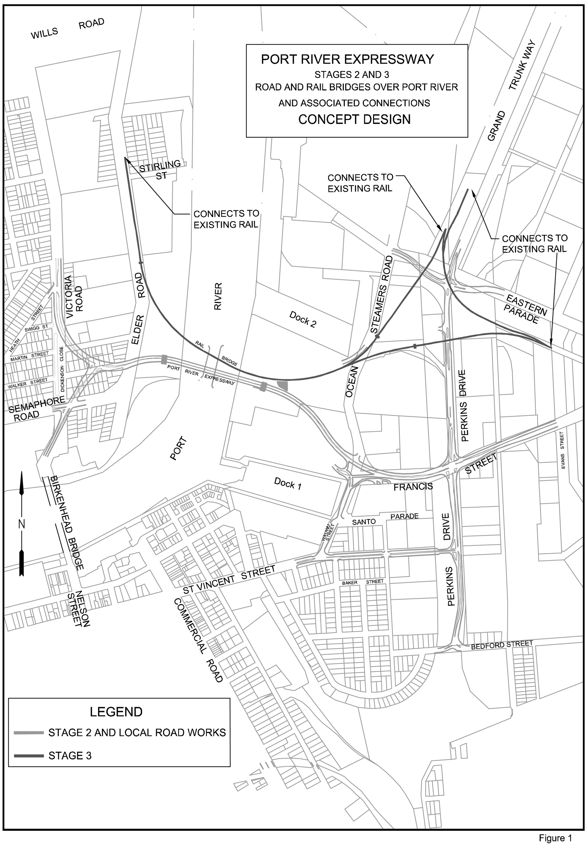
6—Substitution of Schedule 2
Schedule 2—delete the Schedule and substitute:
Schedule 2—Land to which Port River Expressway Project applies
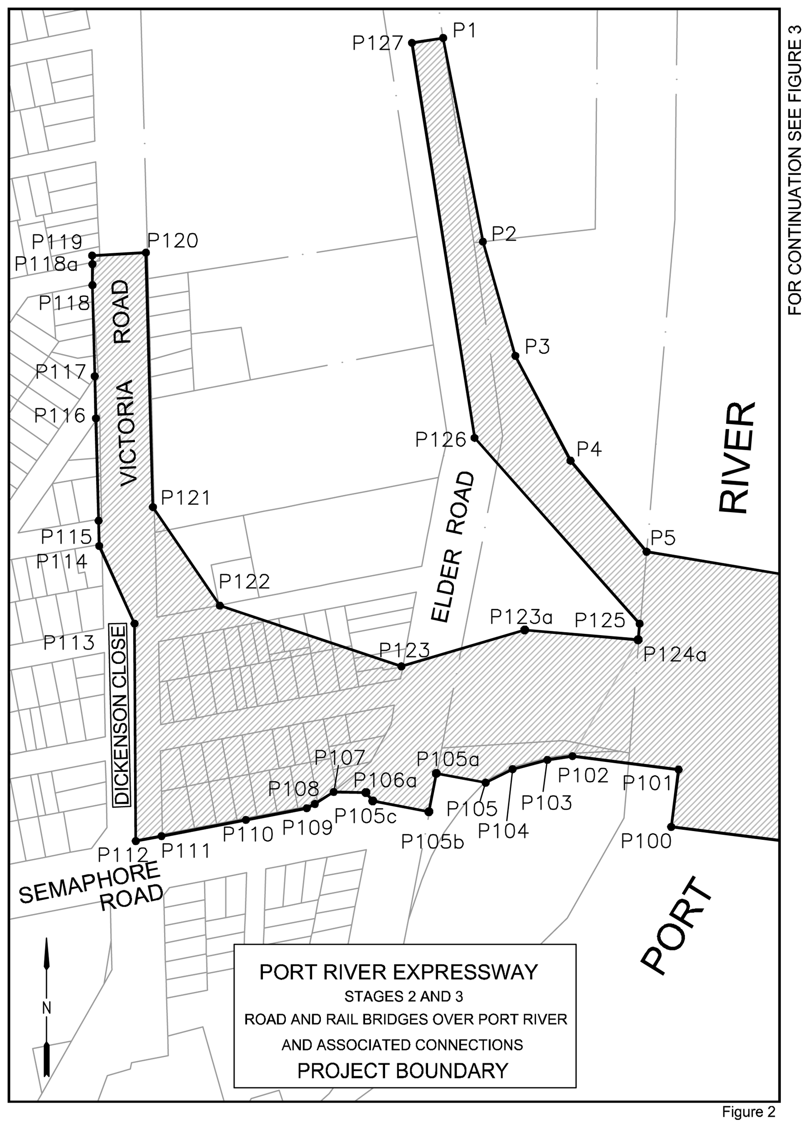
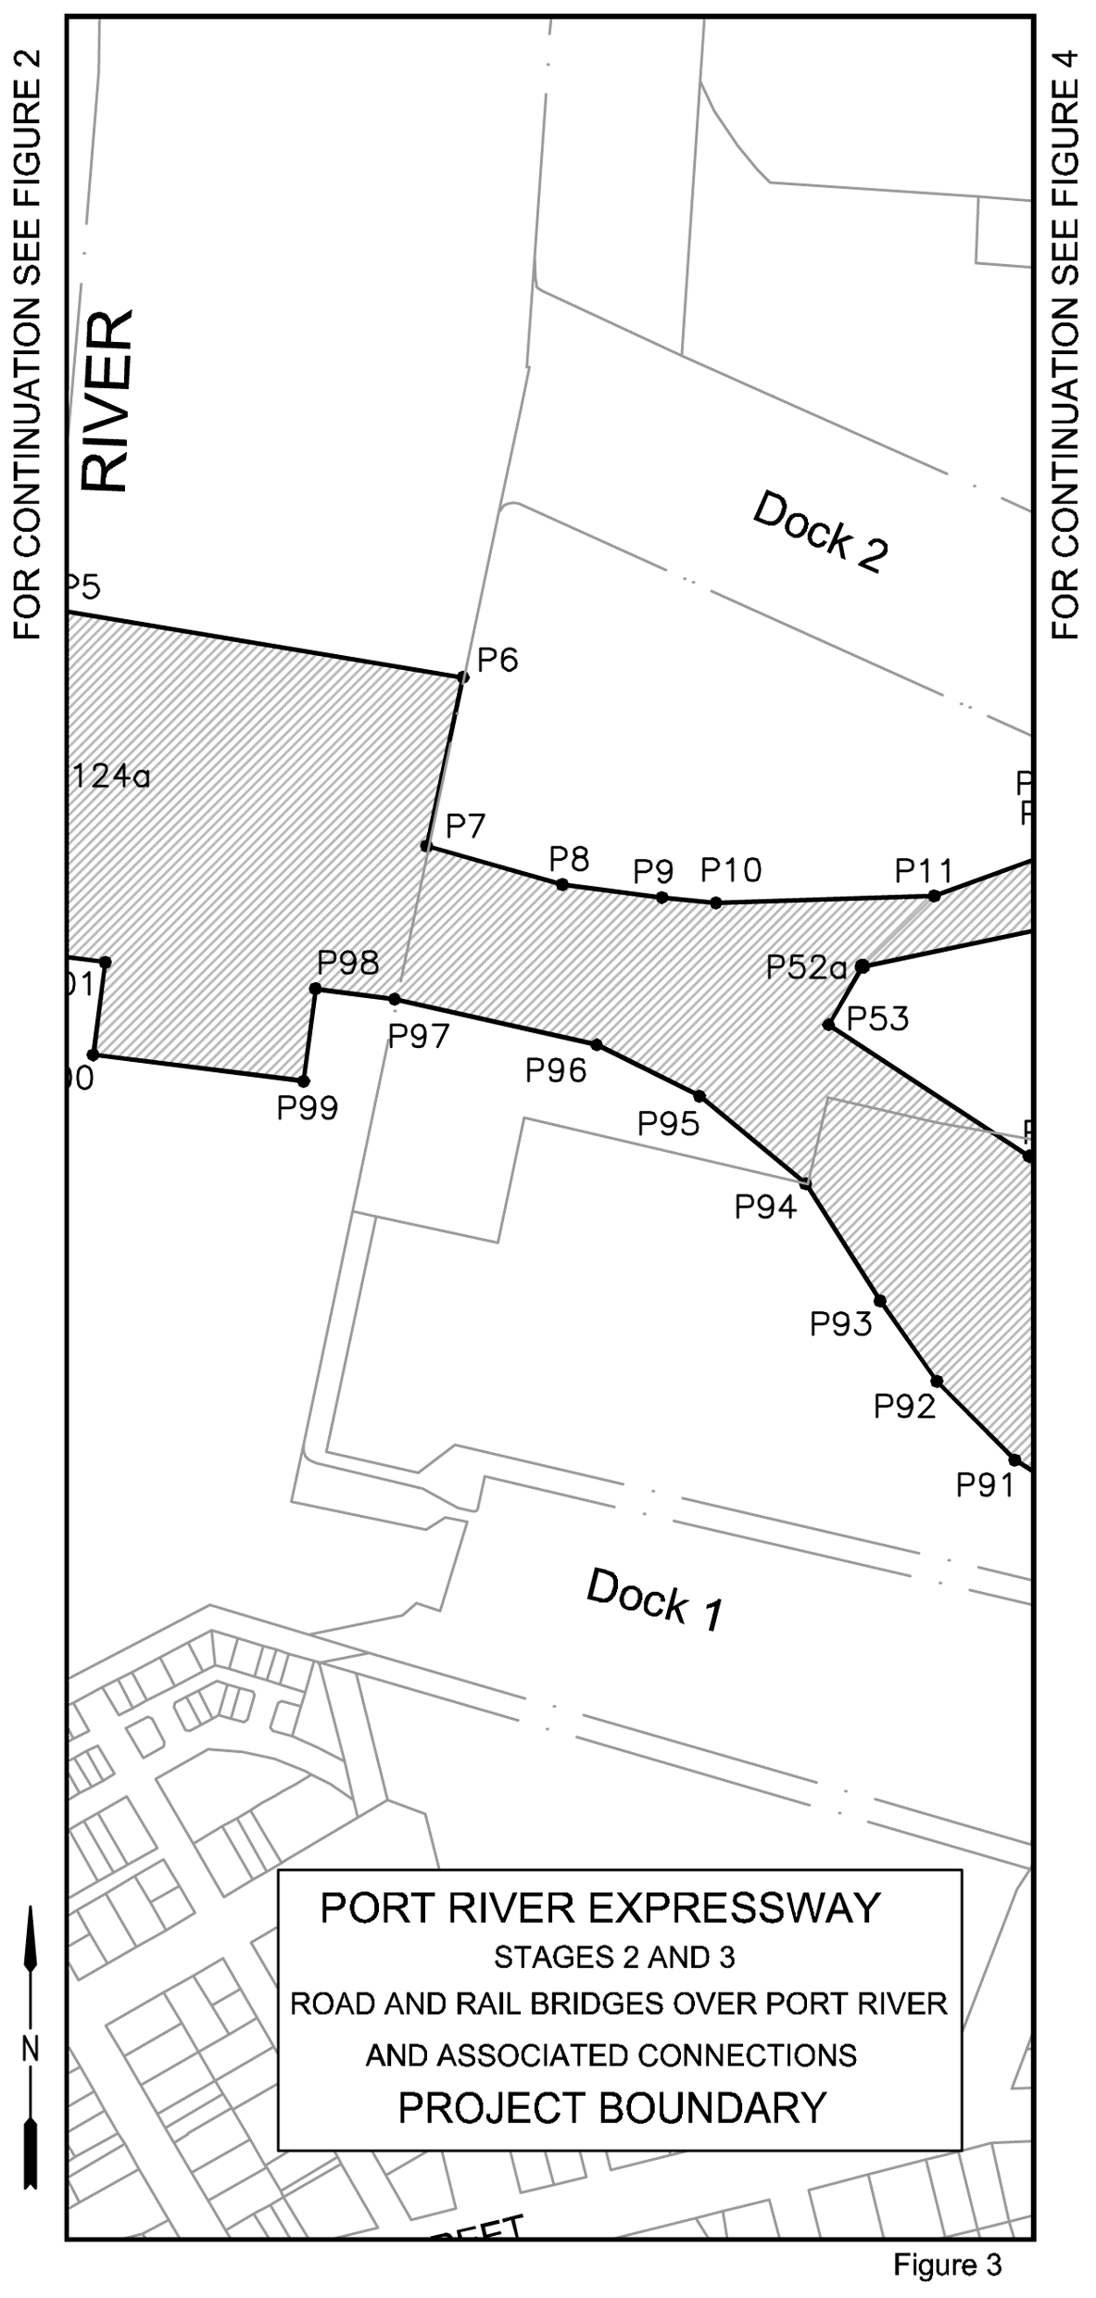
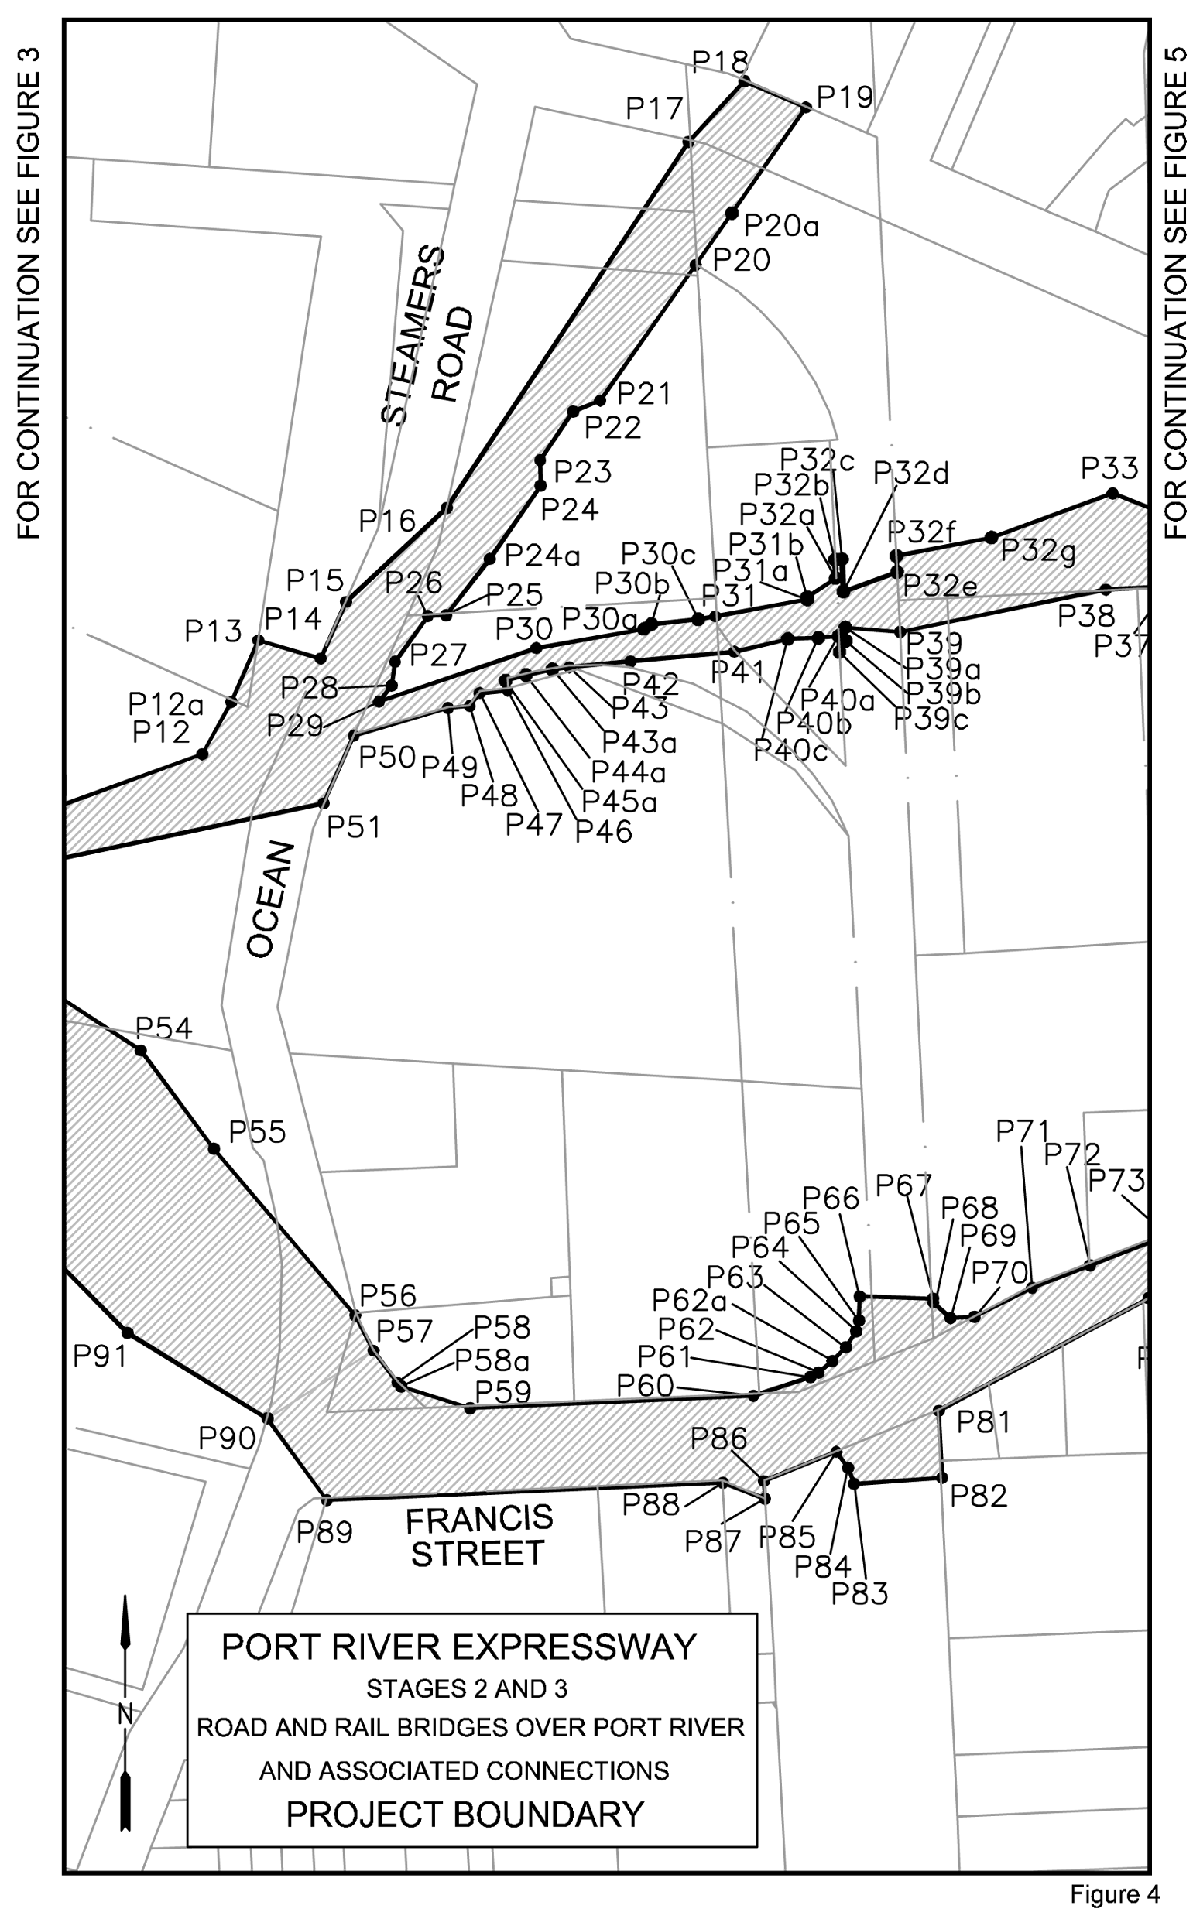
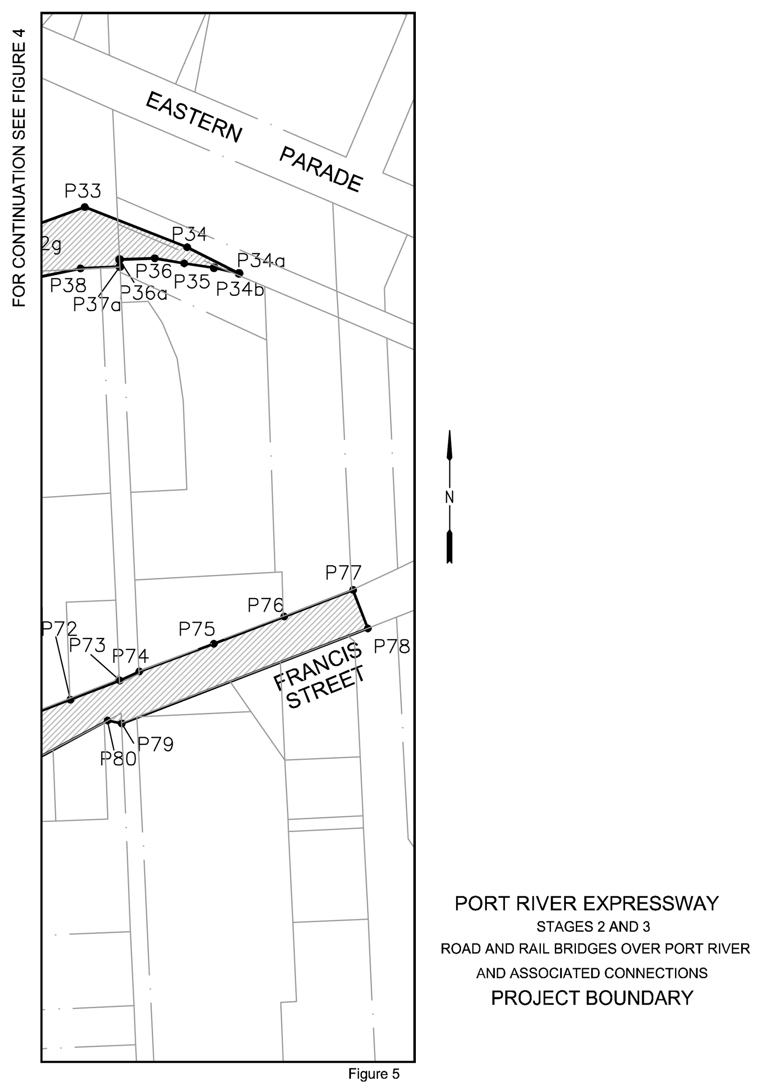

Explanation of Coordinates shown in Figures 2 to 5—
1 The Coordinate Origin is Permanent Survey Mark S317 (E=50000 N=100000, local in metres) that is located on the southern corner of Victoria Road and Heath Street, Cadastral No 6628/18085.
2 The Point Nos and Coordinates shown in Figures 2 to 5 are defined in the table below.

Point No | Coordinates
1 | E=50255.093742 | N=100280.466961
2 | E=50284.469641 | N=100130.194413
3 | E=50308.355774 | N=100046.041002
4 | E=50349.065143 | N=99968.665976
5 | E=50405.081495 | N=99901.536880
6 | E=50591.558382 | N=99870.563362
7 | E=50575.031897 | N=99793.754809
8 | E=50636.806950 | N=99776.249925
9 | E=50682.112751 | N=99770.354818
10 | E=50706.695341 | N=99767.847600
11 | E=50805.950983 | N=99770.947036
12 | E=50879.305329 | N=99797.742481
12a | E=50893.476599 | N=99823.324470
13 | E=50906.761873 | N=99853.588072
14 | E=50937.245930 | N=99844.646885
15 | E=50949.674738 | N=99872.425437
16 | E=50999.032592 | N=99918.567716
17 | E=51117.341000 | N=100098.102000
18 | E=51144.684453 | N=100127.767420
19 | E=51174.756242 | N=100114.961019
20 | E=51120.715208 | N=100037.653696
20a | E=51138.574510 | N=100063.092203
21 | E=51074.096859 | N=99971.201679
22 | E=51060.777584 | N=99965.688945
23 | E=51044.668530 | N=99941.887035
24 | E=51044.960323 | N=99929.441355
24a | E=51019.918389 | N=99893.460816
25 | E=50998.634035 | N=99865.924412
26 | E=50989.622495 | N=99865.421832
27 | E=50973.645105 | N=99843.014211
28 | E=50971.921662 | N=99831.365568
29 | E=50965.790717 | N=99823.433724
30 | E=51042.790068 | N=99849.718465
30a | E=51095.525607 | N=99859.116393
30b | E=51099.103000 | N=99861.432000
30c | E=51122.121000 | N=99863.856000
31 | E=51130.373864 | N=99865.326608
31a | E=51175.523619 | N=99873.593837
31b | E=51175.406374 | N=99874.678969
32a | E=51189.409371 | N=99884.051193
32b | E=51188.960979 | N=99893.120115
32c | E=51192.356831 | N=99893.288015
32d | E=51193.121670 | N=99877.429132
32e | E=51219.346967 | N=99887.028116
32f | E=51219.058860 | N=99894.918496
32g | E=51265.602917 | N=99903.958719
33 | E=51324.902946 | N=99925.663716
34 | E=51403.634946 | N=99894.762502
34a | E=51443.495229 | N=99874.652234
34b | E=51424.341836 | N=99878.964592
35 | E=51401.366088 | N=99882.333263
36 | E=51378.768997 | N=99886.294186
36a | E=51351.681675 | N=99885.286143
37a | E=51351.937792 | N=99879.853471
38 | E=51321.614368 | N=99878.424100
39 | E=51220.902188 | N=99857.658860
39a | E=51193.970143 | N=99859.836123
39b | E=51194.286113 | N=99853.284510
39c | E=51191.206466 | N=99847.788532
40a | E=51190.782724 | N=99855.745861
40b | E=51180.900094 | N=99854.780246
40c | E=51165.869146 | N=99854.200626
41 | E=51139.704534 | N=99847.938893
42 | E=51088.890361 | N=99843.203021
43 | E=51058.833914 | N=99840.401765
43a | E=51050.588000 | N=99839.264000
44a | E=51037.747000 | N=99836.538000
45a | E=51027.742000 | N=99833.818000
46 | E=51028.671306 | N=99828.996545
47 | E=51015.067034 | N=99827.691523
48 | E=51010.193934 | N=99821.313397
49 | E=50999.519720 | N=99820.336380
50 | E=50953.400793 | N=99806.734121
51 | E=50938.615572 | N=99773.609429
52a | E=50773.337141 | N=99738.789166
53 | E=50757.998103 | N=99712.226760
54 | E=50849.142305 | N=99652.374575
55 | E=50884.919267 | N=99604.164579
56 | E=50954.120727 | N=99522.472431
57 | E=50963.028900 | N=99505.147082
58 | E=50974.694129 | N=99489.500765
58a | E=50976.687312 | N=99487.584362
59 | E=51010.397158 | N=99476.945829
60 | E=51149.168951 | N=99483.022273
61 | E=51177.007041 | N=99492.135074
62 | E=51180.970307 | N=99494.338663
62a | E=51187.781321 | N=99500.046779
63 | E=51194.315627 | N=99506.736892
64 | E=51199.396039 | N=99514.588272
65 | E=51200.721378 | N=99519.896103
66 | E=51201.065492 | N=99531.719106
67 | E=51237.078321 | N=99530.670934
68 | E=51237.176600 | N=99528.693743
69 | E=51245.562117 | N=99521.098855
70 | E=51257.291903 | N=99521.679221
71 | E=51285.481363 | N=99536.020608
72 | E=51313.845934 | N=99546.952818
73 | E=51351.844699 | N=99561.601101
74 | E=51366.774000 | N=99568.574236
75 | E=51424.153155 | N=99589.901647
76 | E=51478.239243 | N=99610.814050
77 | E=51531.119308 | N=99631.260444
78 | E=51542.565292 | N=99601.668100
79 | E=51353.396721 | N=99528.501438
80 | E=51342.424502 | N=99530.894489
81 | E=51239.827430 | N=99475.658410
82 | E=51241.451221 | N=99442.692053
83 | E=51198.367998 | N=99439.807980
84 | E=51195.461736 | N=99447.604692
85 | E=51189.660398 | N=99455.450445
86 | E=51154.231000 | N=99441.179000
87 | E=51154.722716 | N=99432.503573
88 | E=51134.131307 | N=99440.295735
89 | E=50940.235423 | N=99431.763619
90 | E=50911.240890 | N=99471.848756
91 | E=50842.640167 | N=99513.855106
92 | E=50807.269772 | N=99549.723035
93 | E=50781.385794 | N=99586.323419
94 | E=50747.546625 | N=99639.809839
95 | E=50699.115982 | N=99679.766673
96 | E=50652.420970 | N=99703.058309
97 | E=50560.379470 | N=99724.043421
98 | E=50524.461385 | N=99728.605017
99 | E=50518.981926 | N=99686.550157
100 | E=50423.232321 | N=99698.569624
101 | E=50428.729818 | N=99740.762927
102 | E=50350.482672 | N=99750.700314
103 | E=50331.953638 | N=99747.979616
104 | E=50306.313417 | N=99741.089647
105 | E=50286.463231 | N=99731.159635
105a | E=50250.093827 | N=99737.981471
105b | E=50244.648063 | N=99709.691187
105c | E=50203.268323 | N=99717.659668
106a | E=50198.213674 | N=99723.884252
107 | E=50174.442340 | N=99724.244950
108 | E=50159.107204 | N=99715.475928
109 | E=50154.599147 | N=99712.302923
110 | E=50108.239083 | N=99703.682556
111 | E=50046.075900 | N=99691.714142
112 | E=50028.602764 | N=99688.100827
113 | E=50027.638188 | N=99848.500883
114 | E=50001.664598 | N=99905.791924
115 | E=49999.674656 | N=99924.335069
116 | E=49997.679888 | N=99999.913661
117 | E=49998.357984 | N=100030.972905
118 | E=49996.586191 | N=100098.089430
118a | E=49995.142243 | N=100113.646551
119 | E=49996.386261 | N=100119.996601
120 | E=50036.074576 | N=100122.082486
121 | E=50041.160134 | N=99934.466838
122 | E=50090.587366 | N=99861.733627
123 | E=50224.384159 | N=99816.926959
123a | E=50315.247147 | N=99843.774857
124a | E=50398.932920 | N=99836.554069
125 | E=50399.928215 | N=99848.448341
126 | E=50278.294332 | N=99985.504017
127 | E=50232.149457 | N=100276.925848
Note—
As required by section 10AA(2) of the Subordinate Legislation Act 1978, the Minister has certified that, in the Minister's opinion, it is necessary or appropriate that these regulations come into operation as set out in these regulations.
Made by the Governor
with the advice and consent of the Executive Council
on 10 December 2009
No 296 of 2009
MTR09/091

FAXING COPY?
IF you fax copy to Government Publishing SA for inclusion in the Government Gazette, there is no need to send a Confirmation Copy to us as well.
This creates confusion and may well result in your notice being printed twice.
Please use the following fax number:
Fax transmission: (08) 8207 1040
Phone Inquiries: (08) 8207 1045
Please include a contact person, phone number and order number so that we can phone back with any queries we may have regarding the fax copy.
NOTE: Closing time for lodging new copy (fax, hard copy or email) is 4 p.m. on Tuesday preceding the day of publication.

Government Gazette notices can be E-mailed.
The address is:
governmentgazette@dpc.sa.gov.au
Documents should be sent as attachments in Word format.
When sending a document via E-mail, please confirm your transmission with a faxed copy of your document, including the date the notice is to be published.
Fax transmission: (08) 8207 1040
Enquiries: (08) 8207 1045
NOTE: Closing time for lodging new copy (fax, hard copy or email) is 4 p.m. on Tuesday preceding the day of publication.

CITY OF HOLDFAST BAY
Local Government Act 1999
Adoption of Community Land Management Plans
NOTICE is hereby given that following relevant consultation pursuant to section 197 of the Local Government Act 1999, the City of Holdfast Bay at its meeting held on 24 November 2009, resolved to adopt Community Land Management Plans for Council’s Business Facilities. These facilities include the following properties:
• Elizabeth Street car park;
• Partridge Street car park;
• Milton/Cowper Street car park;
• 5 to 9 Partridge Street; and
• Brighton Caravan Park.
J. P. Lynch, Chief Executive Officer

CITY OF NORWOOD PAYNEHAM AND ST PETERS
Development Act 1993
Residential Development (City Wide Policy) Development Plan Amendment Public Consultation
NOTICE is hereby given that the City of Norwood Payneham and St Peters has, pursuant to sections 24 and 25 of the Development Act 1993, prepared a draft Development Plan Amendment to amend the Norwood, Payneham and St Peters (City) Development Plan.
The Development Plan Amendment proposes to amend the Development Plan by:
• replacing the existing City Wide ‘Residential Development’ section with a new set of Objectives and Principles of Development Control which address all common aspects of a residential development (including character and amenity, land division, design and appearance, street and boundary setbacks, private open space, garages and carports, car parking and access);
• introducing specific provisions that provide guidance for hammerhead and battleaxe development, dependent and supported accommodation, housing for seniors, buildings on sloping sites and home-based business;
• introducing policies encouraging environmentally sustainable development;
• introducing four new City-Wide sections into the Develop-ment Plan to address:
– interface between residential land uses or zones and other land uses or zones;
– landscaping, fences and walls;
– hazards, including flooding and site contamination; and
– energy efficiency.
Copies of the draft Development Plan Amendment will
be available for public inspection and hard copies can be obtained free of charge during normal office hours at the Council’s Main Customer Service Centre at the Norwood Town Hall, 175
The Parade, Norwood and on the Council website at: www.npsp.sa.gov.au. Copies will also be able to be obtained or viewed at:
• St Peters Customer Service Centre, 101 Payneham Road,
St Peters.
• Payneham Customer Service Centre, 2 Turner Street, Felixstow.
• Norwood Library, 110 The Parade, Norwood.
The draft Development Plan Amendment will be on display from Monday, 14 December 2009 until Friday, 5 March 2010, during which time written submissions are invited.
Written submissions should be submitted no later than 5.00pm on Friday, 5 March 2010 and should be addressed to the Chief Executive Officer, City of Norwood Payneham and St Peters, P.O. Box 204, Kent Town, S.A. 5071. The written submissions should clearly indicate whether you wish to be heard at the Public Meeting in support of your submission.
Copies of all submissions will be available for inspection at the Norwood Town Hall Customer Service Centre, 175 The Parade, Norwood from Monday, 8 March 2010 until the conclusion of the Public Meeting.
A Public Meeting will be held at 7 p.m. on Wednesday, 17 March 2010 in the Don Pyatt Hall, 175 The Parade, Norwood to hear from interested persons in relation to the draft DPA and the submissions. If the Council does not receive any written submission requesting to be heard, the Public Meeting will not be held.
Any enquiries should be directed to Keke Michalos, Senior Urban Planner, Policy and Strategy, on 8366 4509.
Dated 30 November 2009.
M. Barone, Chief Executive Officer

CITY OF SALISBURY
Assumption of Care, Control and Management of Land
NOTICE is hereby given that at its meeting held on 23 November 2009, the City of Salisbury with the consent of the Minister for Recreation, Sport and Racing resolved to assume the care, control and management of the land described as Allotment 65 in Filed Plan 113660 comprised in certificate of title volume 5827, folio 672 and known as the Salisbury Recreation Precinct Happy Home Reserve, Salisbury North, pursuant to and in accordance with section 192 (1) of the Local Government Act 1999.
S. Hains, City Manager

[Republished]
IN Government Gazette dated 3 December 2009 on page 6002, due to a typographical error, is to be republished.
CITY OF WEST TORRENS
Final Recommendation
Periodical Review of Elector Representation
NOTICE is hereby given that the City of West Torrens, in accordance with the requirements under section 12(4) of the Local Government Act 1999 (the ‘Act’), has reviewed its composition and elector representation arrangements.
Certification
Pursuant to section 12 (13) (a) of the Act, the Electoral Commission has certified that the review undertaken by Council satisfies the requirements of section 12 and may therefore now be put into effect as from the day of the first general election held after the publication of this notice.
The revised representation arrangements (unchanged) are as follows:
• Retain the existing position title of Mayor.
• Retain the existing number of Elected Members (14 plus a Mayor).
• Retain the existing ward structure (7).
W. J. Ross, Chief Executive Officer (Acting)
[*]

CITY OF SALISBURY
Review of Elector Representation
NOTICE is hereby given that the City of Salisbury has completed a review of its elector representation arrangements, including its composition and ward structure, in accordance with the requirements of section 12 (4) of the Local Government Act 1999 (the Act).
Pursuant to section 12 (13) (a) of the Act, the Electoral Commissioner has certified that the review undertaken by Council satisfies the requirements of section 12 of the Act. As such, the following structure will be put into effect as from the day of the first general election held after the publication of this notice:
• The elected Council will comprise the Mayor (elected ‘at large’ by the community) and 16 ward councillors.
• The City will be divided into eight wards, as defined in Schedules 1 to 8 inclusive, with each ward to be represented by two councillors.
• The wards be identified as Central (ward 1), East (ward 2), South (ward 3), Hills (ward 4), Para (ward 5), North (ward 6), Levels (ward 7) and West (ward 8).
Schedule 1
Central Ward: Comprising all of the land contained within the suburbs of Brahma Lodge, Elizabeth Vale, Salisbury, Salisbury Park, Salisbury Plain and Salisbury South, being the land more particularly delineated on the plan published herewith.
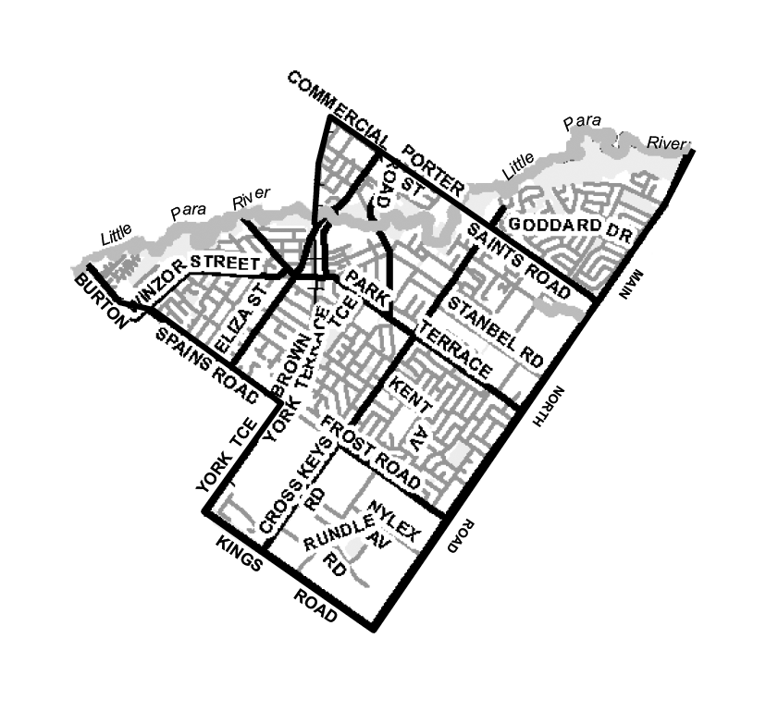
Schedule 2
East Ward: Comprising all of the land contained within the suburbs of Gulfview Heights (north of Wynn Vale Drive), Salisbury East and Salisbury Heights, being the land more particularly delineated on the plan published herewith.
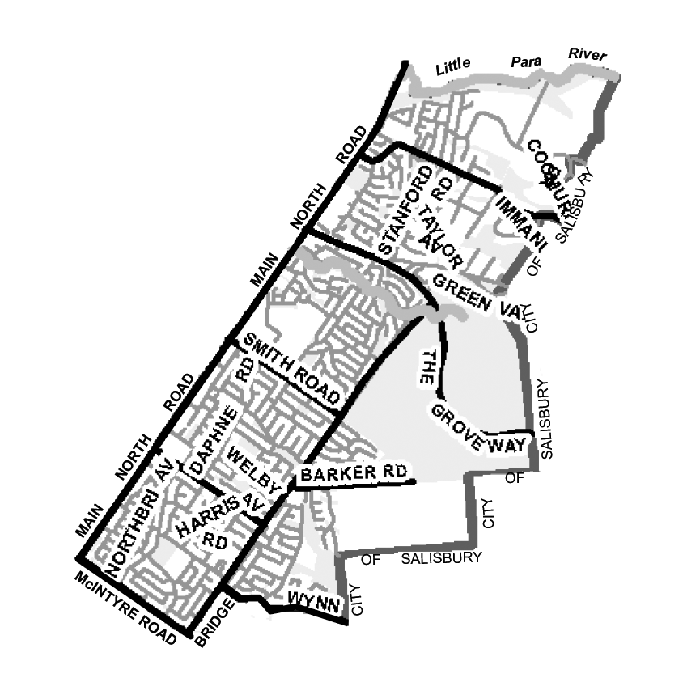
Schedule 3
South Ward: Comprising all the land contained within the suburbs of Ingle Farm (except the land north of Montague Road and west of Aragon Road/Sloan Road), Para Vista, Valley View and Walkley Heights, being the land more particularly delineated on the plan published herewith.
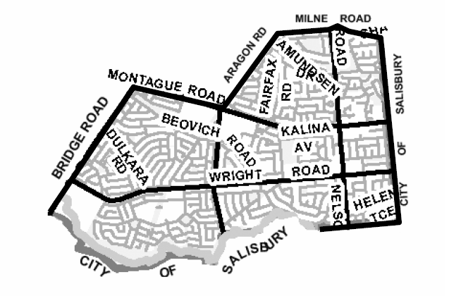

Schedule 4
Hills Ward: Comprising all the land contained within the suburbs of Gulfview Heights (south of Wynn Vale Drive), Para Hills, Para Hills West, Pooraka (north of Montague Road) and Ingle Farm (north of Montague Road and west of Aragon Road/Sloan Road), being the land more particularly delineated on the plan published herewith.
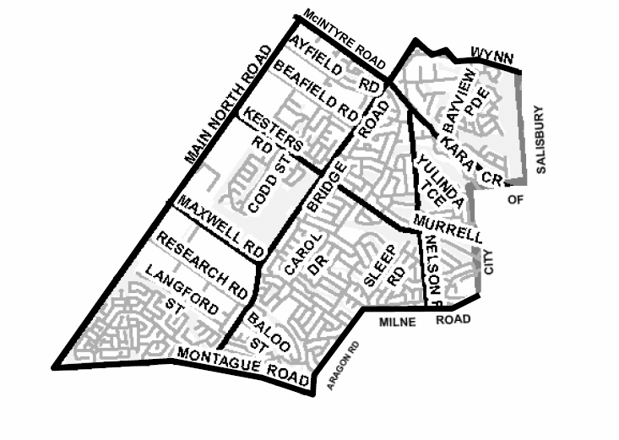
Schedule 5
Para Ward: Comprising all the land contained within the suburbs of Parafield Gardens (east of Whites Road and West of Salisbury Highway), Paralowie (east of Whites Road) and Salisbury Downs, being the land more particularly delineated on the plan published herewith.

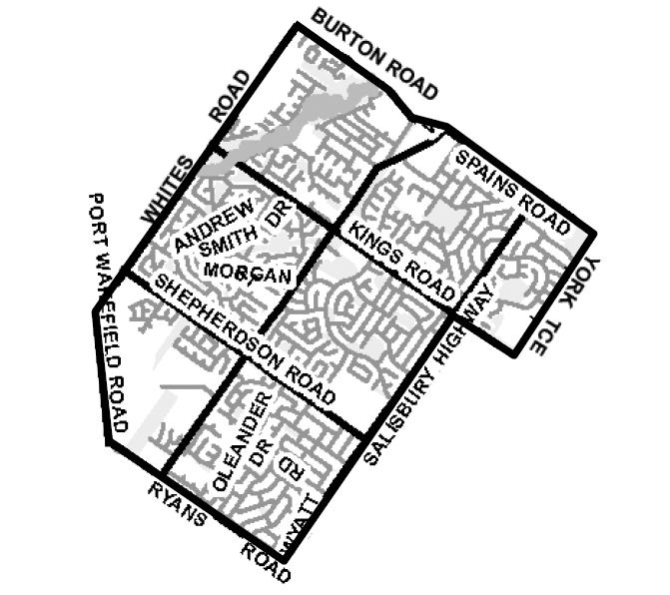
Schedule 6
North Ward: Comprising all the land contained within the suburbs of Direk, Edinburgh, Paralowie (North of Burton Road) and Salisbury North, being the land more particularly delineated on the plan published herewith.
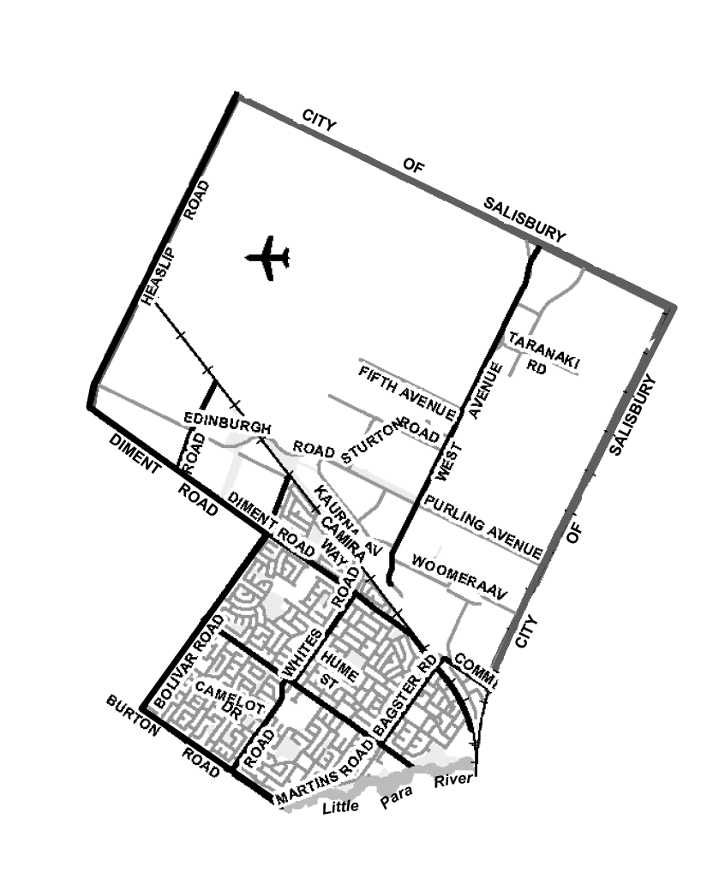
Schedule 7
Levels Ward: Comprising all the land contained within the suburbs of Cavan, Dry Creek (east of Salisbury Highway), Mawson Lakes (east of Salisbury Highway), Parafield, Parafield Gardens (east of Salisbury Highway) and Pooraka (south of Montague Road), being the land more particularly delineated on the plan published herewith.
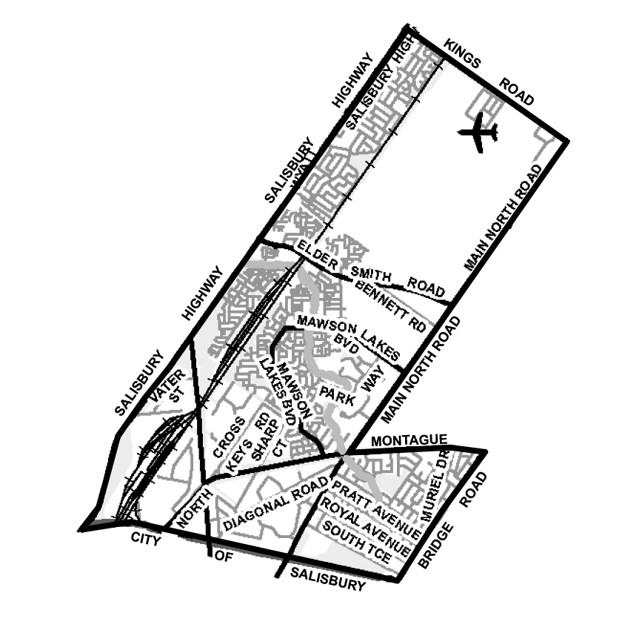
Schedule 8
West Ward: Comprising all the land contained within the suburbs of Bolivar, Burton, Dry Creek (West of Salisbury Highway), Globe Derby Park, Greenfields, Mawson Lakes (West of Salisbury Highway), Parafield Gardens (West of Whites Road), Paralowie (West of Whites Road), St Kilda and Waterloo Corner, being the land more particularly delineated on the plan published herewith.

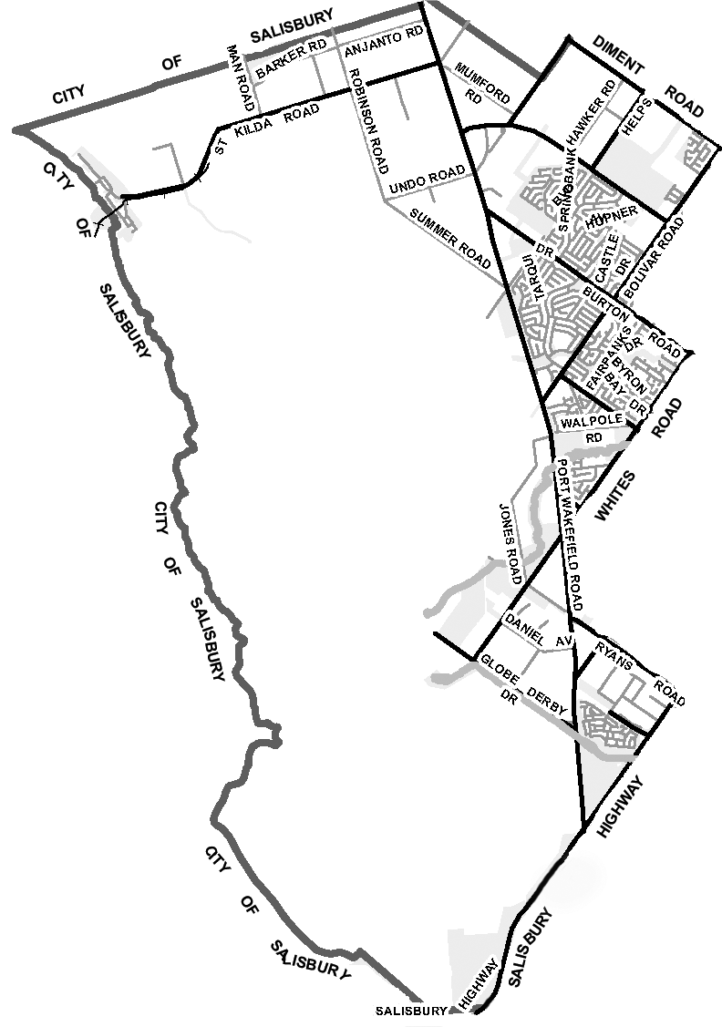
S. Hains, City Manager

ADELAIDE HILLS COUNCIL
Periodical Review of Elector Representation
NOTICE is hereby given that the Adelaide Hills Council, in accordance with the requirements of section 12 (4) of the Local Government Act 1999, has reviewed its composition and elector representation arrangements.
Pursuant to section 12 (13) (a) of the said Act, the Electoral Commissioner has certified that the review undertaken by Council satisfies the requirements of section 12 and may therefore now be put into effect as from the day of the first general election held after the publication of this notice.
The revised representation arrangements are as follows:
The elected composition will remain a total of 13 elected members comprised of:
• The position of Mayor as principal member of the Council elected at large.
• 12 ward Councillors elected from five wards.
The existing ward structure, which divides the Council area into 5 wards, is to be retained with boundary adjustments as defined in Schedules 1 to 5 inclusive. The wards will continue to be entitled as follows and the ward elected composition will be:
Manoah, Marble Hill and Torrens Valley Wards are each represented by two councillors and Mount Lofty and Onkaparinga Valley wards are each represented by three councillors.
First Schedule
Manoah Ward: Comprising the whole of the suburbs within the area of the municipality of Adelaide Hills Council of Bradbury, Crafers West, Dorset Vale, Heathfield, Ironbank, Longwood, Mylor, Scott Creek, Upper Sturt and the portions of Aldgate and Stirling being the land more particularly delineated on the plan published herewith.

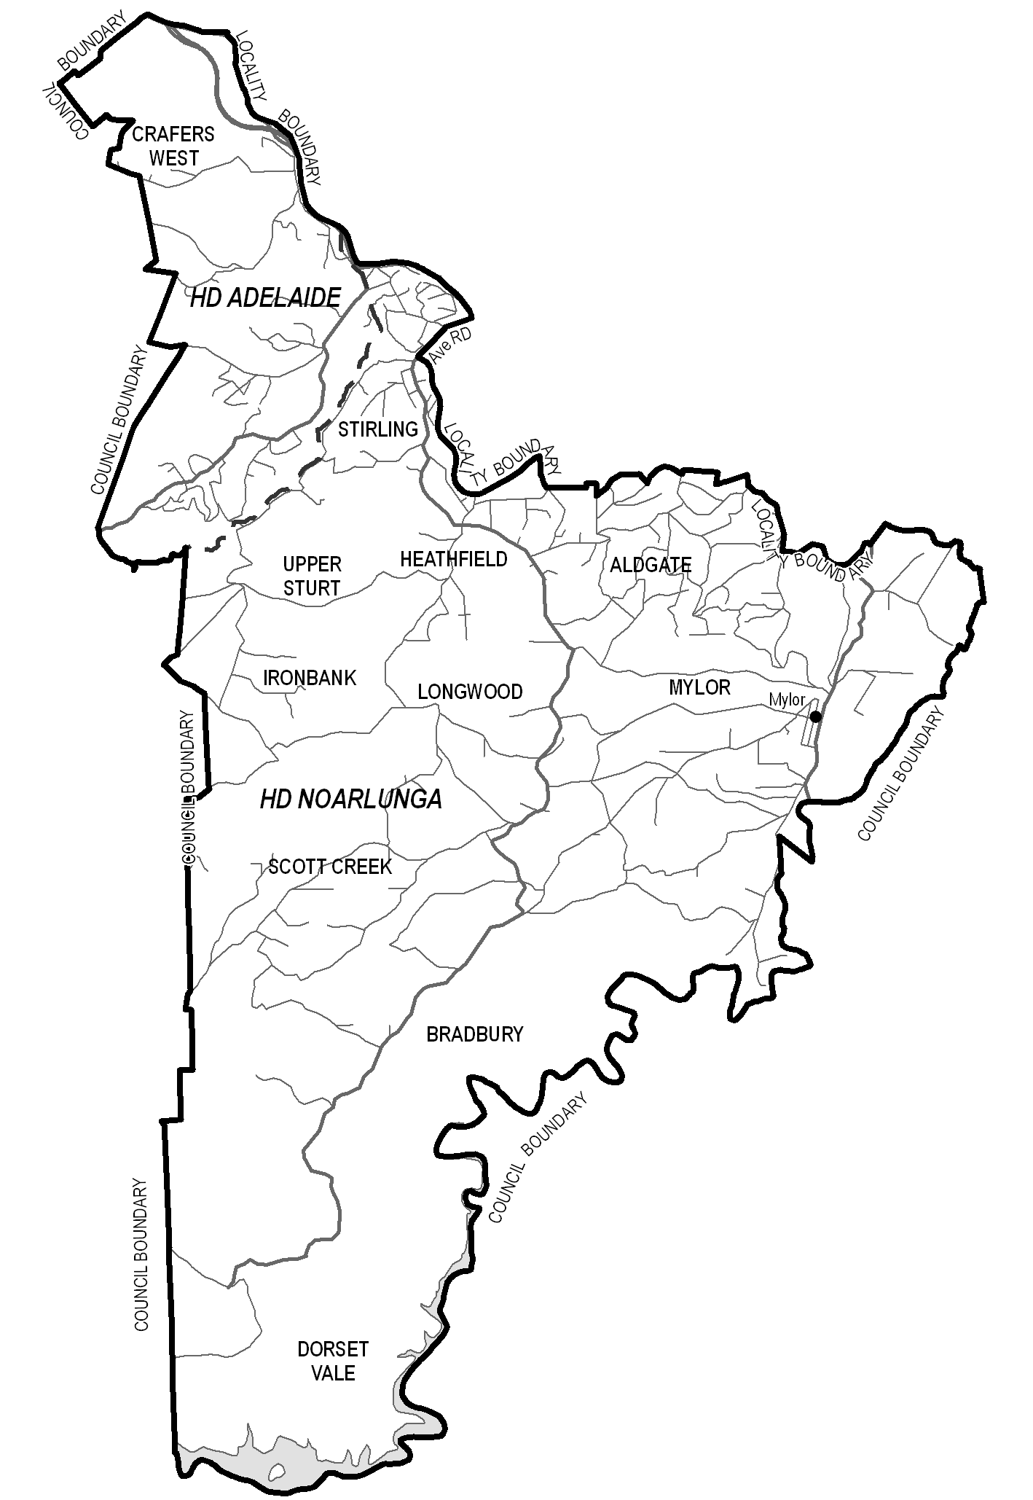
Second Schedule
Mount Lofty: Comprising the whole of the suburbs within the area of the municipality of Adelaide Hills Council of Crafers, Bridgwater, Cleland and Mount George and the portions of Hundreds of Adelaide, Aldgate and Stirling being the land more particularly delineated on the plan published herewith.

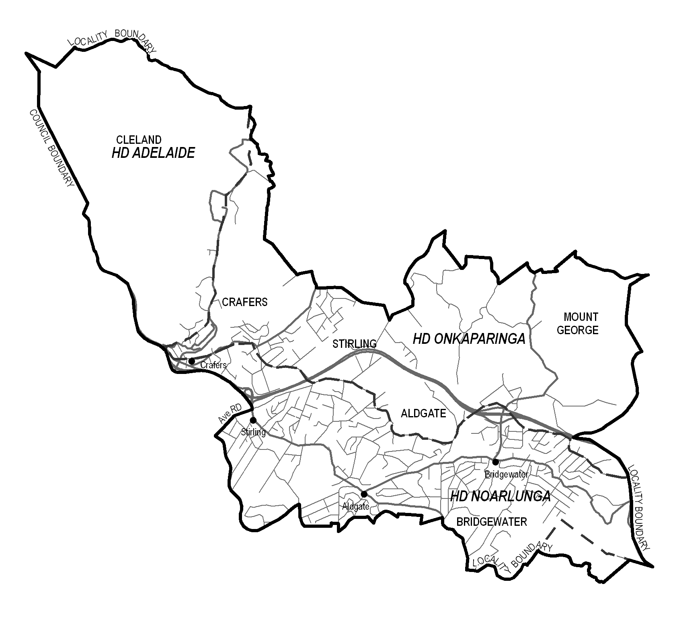
Third Schedule
Marble Hill: Comprising the whole of the suburbs within the area of the municipality of Adelaide Hills Council of Ashton, Basket Range, Carey Gully, Castambul, Cherryville, Greenhill, Horsnell Gully, Marble Hill, Montacute, Norton Summit, Piccadilly, Rostrevor, Summertown, Teringie, Uraidla, Woodforde and the portions of Hundreds of Adelaide and Onkaparinga, being the land more particularly delineated on the plan published herewith.

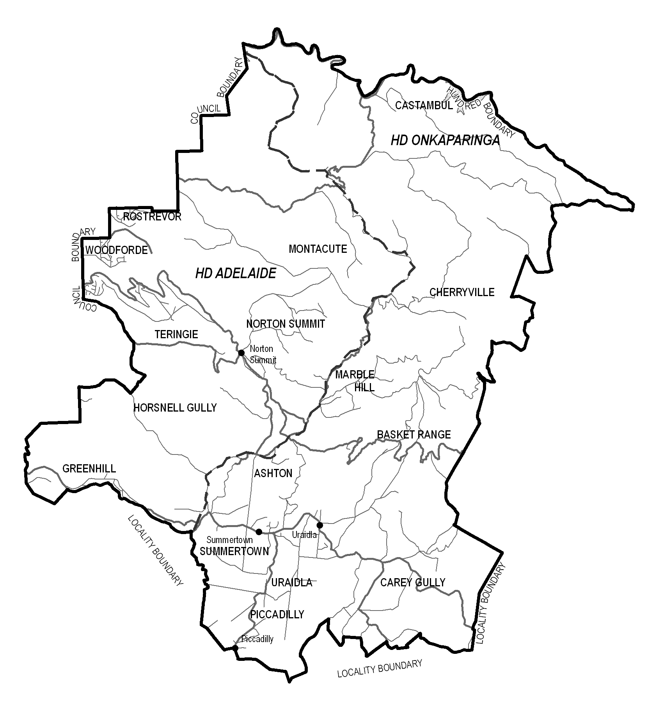

Fourth Schedule
Torrens Valley: Comprising the whole of the suburbs within the area of the municipality of Adelaide Hills Council of Birdwood, Chain of Ponds, Cromer, Cudlee Creek, Forreston, Gumeracha, Houghton, Humbug Scrub, Inglewood, Kersbrook, Lower Hermitage, Millbrook, Mount Pleasant, Paracombe, Upper Hermitage and the portion of Mount Torrens being the land more particularly delineated on the plan published herewith.

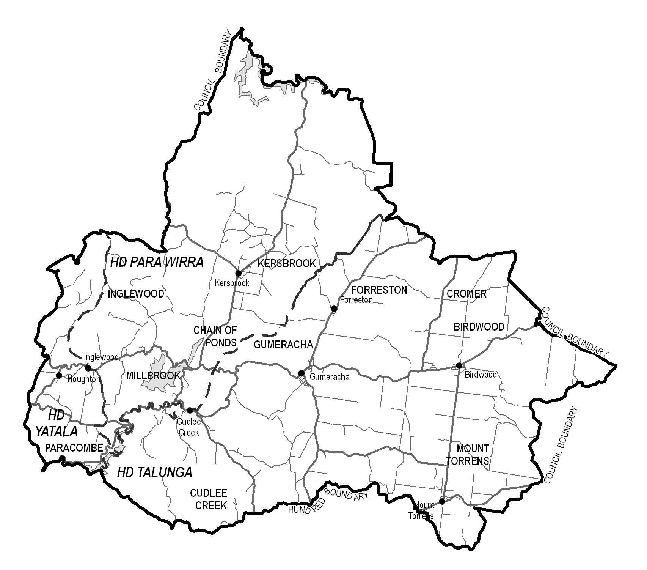
Fifth Schedule
Onkaparinga Valley: Comprising the whole of the suburbs within the area of the municipality of Adelaide Hills Council of Balhannah, Charleston, Inverbrackie, Lenswood, Lobethal, Oakbank, Verdun, Woodside and the portions of Mount Torrens and Forest Range being the land more particularly delineated on the plan published herewith.

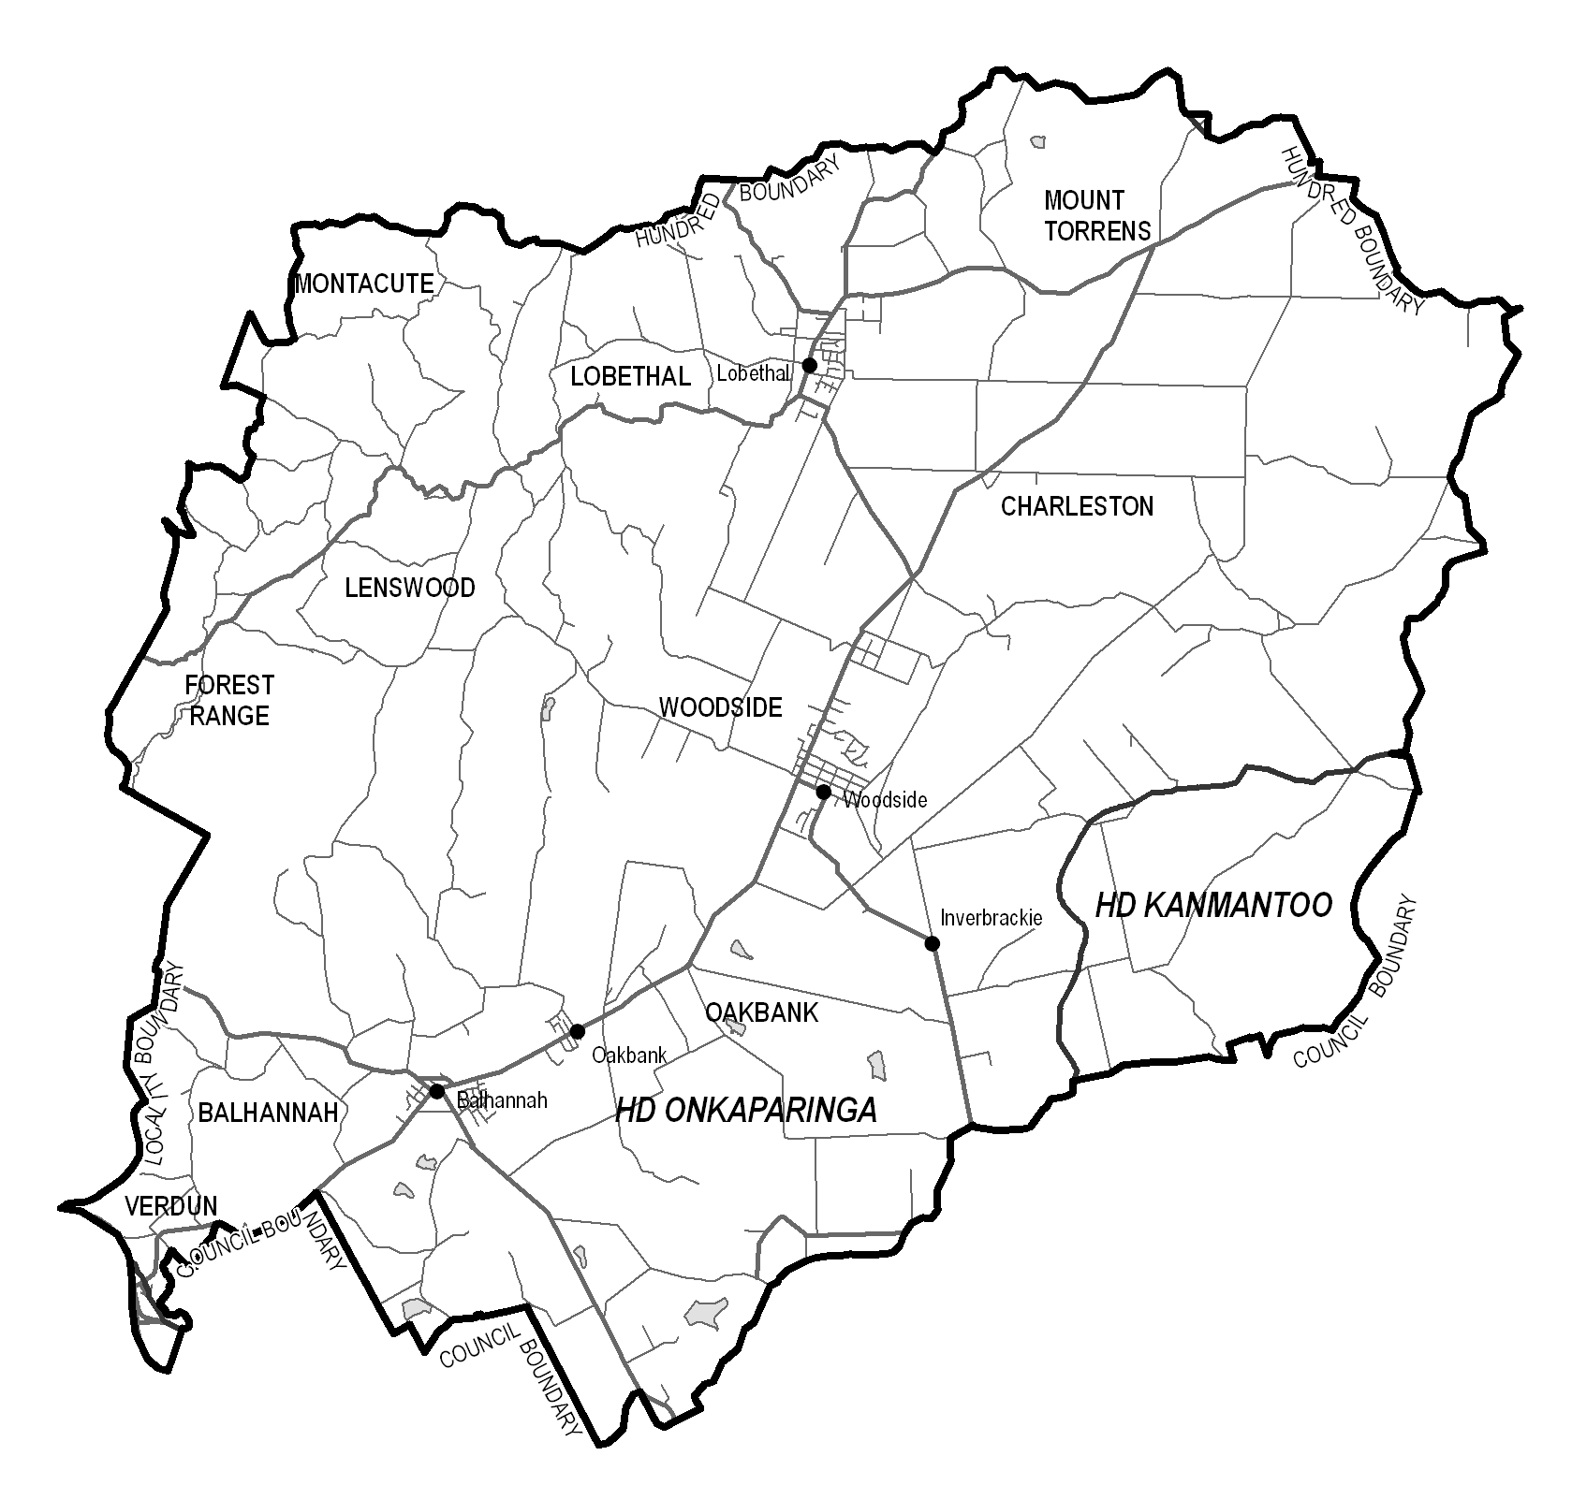
P. Peppin, Chief Executive Officer

ALEXANDRINA COUNCIL
Assignment of Road Names
NOTICE is hereby given, pursuant to section 219 (1) of the Local Government Act 1999, that the Alexandrina Council has assigned the following road names:
Meeting held on 19 May 2008:
• For the un-named road east off Stevens Road to Sterling Downs Road, Currency Creek, be named Taverner Road.
Meeting held on 17 December 2007:
• That the southern end of Cole Crossing Road, Nangkita, from the southern boundary of section 441 to the southern boundary of section 243, Hundred of Nangkita, be named Griggs Road.
Meeting held on 18 September 2006:
• For the un-named road reserve west off the road junction of Merrilli Place and Hutton Street, Port Elliot be named Knights Beach Walk.
Meeting held on 7 August 2006:
• For the partial re-naming of the southern entrance of Lockett Road, off Myrtle Grove Road, Currency Creek adjacent to part section 2002, Hundred of Nangkita, be named Shaw Road.
Meeting held on 7 May 2007:
• For the un-named road reserve east off Pullen Road, Hindmarsh Island, from the western boundary of section 103, Hundred of Nangkita, east to the un-made road reserve adjacent to PCS2004/05 Randell Road, be named Sheoak Lane.
J. Coombe, Chief Executive

CLARE AND GILBERT VALLEYS COUNCIL
Review of Elector Representation
NOTICE is hereby given that the Clare and Gilbert Valleys Council has completed a review of its elector representation arrangements, including its composition and ward structure, in accordance with the requirements of section 12 (4) of the Local Government Act 1999 (the Act).
Pursuant to section 12 (13) (a) of the Act, the Electoral Commissioner has certified that the review undertaken by Council satisfies the requirements of section 12 of the Act. As such, the following structure will be put into effect as from the day of the first general election held after the expiration of five months from the publication of this notice:
• The council area will not be divided into wards.
• The elected Council will comprise the Mayor and nine area councillors who represent the Council area as a whole.
R. D. Blight, Chief Executive Officer

DISTRICT COUNCIL OF THE COPPER COAST
Review of Elector Representation
NOTICE is hereby given that the District Council of the Copper Coast has completed a review of its elector representation arrangements, including its composition and ward structure, in accordance with the requirements of section 12 (4) of the Local Government Act 1999 (the Act).
Pursuant to section 12 (13) (a) of the Act, the Electoral Commissioner has certified that the review undertaken by Council satisfies the requirements of section 12 of the Act. As such, the following structure will be put into effect as from the day of the first general election held after the publication of this notice.
• The Council area will not be divided into wards.
• The elected Council will comprise the Mayor (elected by the whole community) and 10 area councillors who represent the Council area as a whole.
P. Dinning, Chief Executive Officer

DISTRICT COUNCIL OF MALLALA
Rename Roads
NOTICE is hereby given that, in accordance with section 219 of the Local Government Act 1999, the Council, at its meeting held on Monday, 19 October 2009, resolved to rename the following road names:
The roadway currently named Masters Road adjacent section 92, H140800 to section 629 H140800, Hundred of Port Gawler, be renamed Verner Road;
Notice is hereby given that, in accordance with section 219 of the Local Government Act 1999, the Council, at its meeting held on Monday, 16 November 2009, resolved to rename the following road names:
The roadway currently named Port Lorne Road adjacent section 378, H140400 to section 376 H140400, Hundred of Dublin, be renamed Lorne Road.
Alteration to Load Limit
Notice is hereby given that the Council, at its meeting held on Monday, 16 November 2009, resolved that in accordance with the provisions of section 32 of the Road Traffic Act 1961, a load limit of 5 tonnes, service vehicles excepted, be applied to Lois Lane, Mallala, effective 7 December 2009.
C. Mansueto, Chief Executive Officer

DISTRICT COUNCIL OF MALLALA
Review of Elector Representation
NOTICE is herby given that the District Council of Mallala has completed a review of its composition and elector representation arrangements in accordance with the provisions of section 12 (4) of the Local Government Act 1999.
Pursuant to section(13) (a) of the said Act, the Electoral Commissioner has certified that the review undertaken by Council satisfies the requirements of section 12 of the Local Government Act 1999 and may therefore be put into effect as from the day of the first general election held after the expiration of five months from the publication of this notice.
The result of the review sees the composition and elector representation for the Council area unchanged and that the arrangements will remain as:
The principal member of Council continue to be a Chairperson, chosen by the elected members of Council from amongst their own number and the office continue to bear the title of Mayor, pursuant to the provisions of section 51 of the Act.
The District Council of Mallala area continue to be divided into four wards, as per the existing ward structure, with two wards each being represented by two ward councillors, one ward being represented by three ward councillors and one to be represented by four ward councillors.
The elected Council continue to comprise 11 ward councillors.
The wards shall be identified as Dublin (Ward 1); Mallala (Ward 2) Two Wells (Ward 3) and Lewiston (Ward 4).
Dated 4 December 2009.
C. Mansueto, Chief Executive Officer

MID MURRAY COUNCIL
Review of Elector Representation
NOTICE is hereby given that the Mid Murray Council has completed a review of its elector representation arrangements, including its composition and ward structure, in accordance with the requirements of section 12 (4) of the Local Government Act 1999 (the Act).
Pursuant to section 12 (13) (a) of the Act, the Electoral Commissioner has certified that the review undertaken by Council satisfies the requirements of section 12 of the Act. As such, the following structure will be put into effect as from the day of the first general election held after the publication of this notice:
• The elected Council will comprise the Mayor (elected ‘at large’ by the community) 11 ward councillors.
• The council area continue to be divided into five wards under an amended ward structure, with two wards (i.e. Randell and River North wards) each being represented by three ward councillors, a further two wards (i.e. River South and Sturt wards) each being represented by two ward councillors, and the remaining ward (i.e. Reedy Creek ward) being represented by one ward councillor.
• The wards be identified as Randell (Ward 1), River South (Ward 2), Sturt (Ward 3) River North (Ward 4) and Reedy Creek (Ward 5).
• The alterations to the boundaries of the existing wards are defined in Schedules 1 to 3 that follow.

The First Schedule
Sturt Ward and Reedy Creek Ward: Alter and adjust the boundaries of the Sturt Ward and Reedy Creek Ward of the Mid Murray Council by severing from the said Reedy Creek Ward that portion of the Hundred of Jutland, more particularly delineated on the plan published herewith and marked (A) and annexing the same to the said Sturt Ward.

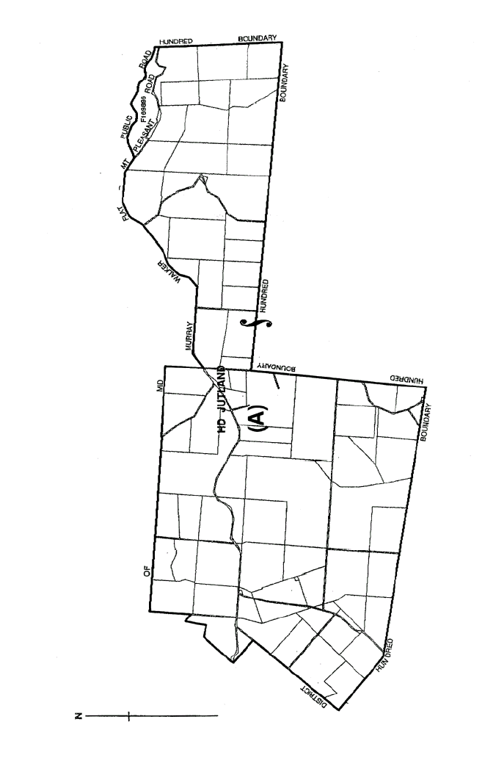

The Second Schedule
River North Ward and River South Ward: Alter and adjust the boundaries of the River North Ward and River South Ward of the Mid Murray Council by severing from the said River North Ward that portion of the Hundred of Nildottie and Hundred of Fisher, more particularly delineated on the plan published herewith and marked (B) and annexing the same to the said River South Ward.

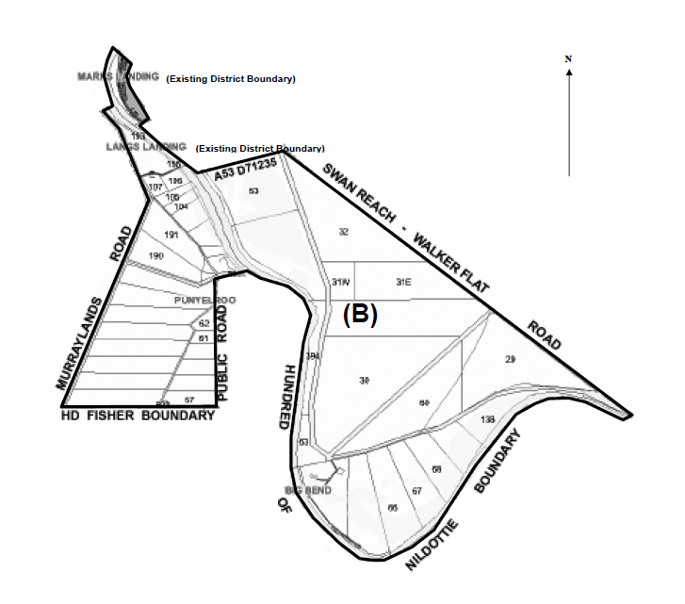

The Third Schedule
Randell Ward and River South Ward: Alter and adjust the boundaries of the Randell Ward and River South Ward of the Mid Murray Council by severing from the said Randell Ward that portion of the Hundred of Younghusband, more particularly delineated on the plan published herewith and marked (C) and annexing the same to the said River South Ward.

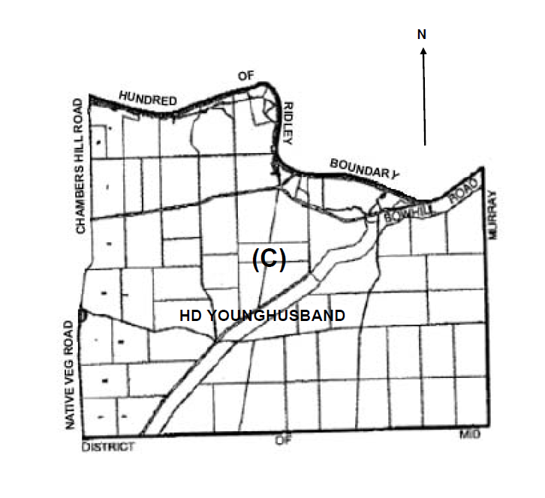
D. Gollan, Chief Executive Officer

DISTRICT COUNCIL OF MOUNT REMARKABLE
Periodical Review of Elector Representation—
Final Recommendation
NOTICE is hereby given that the District Council of Mount Remarkable, in accordance with the requirements of section 12 (4) of the Local Government Act 1999, has reviewed its composition and elector representation arrangements.
Certification
Pursuant to section 12 (13) (a) of the said Act, the Electoral Commissioner has certified that the review undertaken by Council satisfies the requirements of section 12 and may therefore now be put into effect as from the day of the first general election held after the publication of this notice.
The revised representation arrangements are as follows:
The District Council of Mount Remarkable will comprise of Chairperson (titled Mayor) and 7 ward Councillors elected from four wards.
The existing ward structure, which divides the Council area into 4 wards, is to be retained with boundary adjustments. The wards will continue to be entitled as follows and the ward elected composition will be:
Councillors—Coastal, Ranges and Plains ward represented by two Councillors and Forest Ward represented by 1 Councillor.
First Schedule
Coastal Ward: Comprising the Hundreds of Baroota and Telowie and portions of the Hundreds of Woolundunga and Winninowie and more particularly delineated in the plan published herewith.

Second Schedule
Ranges Ward: Comprising the Hundreds of Willochra and Gregory and portions of the Hundreds of Woolundunga, Winninowie and Wongyarra and more particularly delineated in the plan published herewith.

Third Schedule
Plains Ward: Comprising the Hundreds of Moockra, Coonatto, Pinda, Willowie and Booleroo and portions of the Hundreds of Appila and Wongyarra and more particularly delineated in the plan published herewith.

Fourth Schedule
Forest Ward: Comprising the Hundreds of Howe, and Darling and portions of the Hundreds of Appila and Wongyarra and more particularly delineated in the plan published herewith.

S. R. Cheriton, Chief Executive Officer

DISTRICT COUNCIL OF ORROROO CARRIETON
Review of Elector Representation
NOTICE is hereby given that the District Council of Orroroo Carrieton, in accordance with the requirements of section 12 (4) of the Local Government Act 1999, has reviewed its composition and elector representation arrangements.
Certification
Pursuant to section 12 (13) (a) of the said Act, the Electoral Commissioner has certified that the review undertaken by Council satisfies the requirements of section 12 and may therefore now be put into effect as from the day of the first general election held after the publication of this notice.
The revised representation arrangements are as follows:
The elected Council will comprise the Chairperson and seven area councillors who represent the Council area as a whole.
I. Wilson, Chief Executive Officer

DISTRICT COUNCIL OF STREAKY BAY
Review of Elector Representation
NOTICE is hereby given that the District Council of Streaky Bay has completed a review of its elector representation arrangements, including its composition and ward structure, in accordance with the requirements of section 12 (4) of the Local Government Act 1999 (the Act).
Pursuant to section 12 (13) (a) of the Act, the Electoral Commissioner has certified that the review undertaken by Council satisfies the requirements of section 12 of the Act. As such, the following structure will be put into effect as from the day of the first general election held after the publication of this notice.
• The principal member of Council continue to be a Chairperson, chosen by the elected members of Council from amongst their own number, and the office continue to bear the title of ‘Mayor’.
• The elected Council continue to comprise eight ward councillors, including the ‘Mayor’.
• The council area continue to be divided into two wards, as per the current ward structure, with each ward being represented by four ward councillors.
• The wards continue to be identified as Flinders (Ward 1) and Eyre (Ward 2).
D. Jennings, Chief Executive Officer

DISTRICT COUNCIL OF TUMBY BAY
Temporary Road Closure—Tumbay Bay Township
NOTICE is hereby given that Council has declared that the activities associated with the Annual Christmas Celebrations is an event to which section 33 of the Road Traffic Act 1961 applies and hereby makes an order declaring:
That portion of West Terrace commencing from South Terrace in a northerly direction until it meets North Terrace, the full length of North Terrace, Spencer Street commencing from North Terrace in a southerly direction until it meets Mortlock Street, Mortlock Street between Spencer Street and Tumby Terrace, Tumby Terrace commencing from Mortlock Street in a northerly direction until it meets North Terrace, Esplanade commencing from North Terrace in a northerly direction until it meets Wibberley Street, Wibberley Street commencing from Esplanade in a westerly direction until it meets West Terrace, West Terrace commencing from Wibberley Street in a southerly direction until it meets Lipson Road, Lipson Road commencing from West Terrace in a south-easterly direction until it meets North Terrace, Tumby Bay, are roads on which the event is to be held and that the roads will be closed to traffic on Thursday, 24 December 2009, for the holding of the Street Parade and Celebrations between 6 p.m. to 10 p.m.
E. A. Roberts, District Clerk

DISTRICT COUNCIL OF TUMBY BAY
Roads (Opening and Closing) Act 1991
Road Opening—Harvey Drive, Tumby Bay
NOTICE is hereby given, pursuant to section 10 of the Roads (Opening and Closing) Act 1991, that the District Council of Tumby Bay proposes to make a Road Process Order to open as road portion of Alllotment 2006 in Deposited Plan 66876, more particularly delineated and numbered ‘1’ on Preliminary Plan No. 09/0058, forming an extension of Harvey Drive.
A copy of the plan and a statement of persons affected are available for public inspection at the office of the Council at Mortlock Street, Tumby Bay and the Adelaide Office of the Surveyor-General, 101 Grenfell Street, Adelaide, during normal office hours.
Any objection or application for an easement must set out the full name and address of the person making the objection or application and must be fully supported by reasons.
The application for easement or objection must be made in writing to the Council, P.O. Box 61, Tumby Bay, S.A. 5605 within 28 days of this notice and a copy must be forwarded to the Surveyor-General, G.P.O. Box 1354, Adelaide, S.A. 5001. Where a submission is made, the Council will give notification of a meeting at which the matter will be considered.
Dated 2 November 2009.
E. A. Roberts, District Clerk

WAKEFIELD REGIONAL COUNCIL
Periodical Review of Elector Representation
NOTICE is hereby given that the Wakefield Regional Council, in accordance with the requirements of section 12 (4) of the Local Government Act 1999, has reviewed its composition and elector representation arrangements.
Pursuant to section 12 (13) (a) of the said Act, the Electoral Commissioner has certified that the review undertaken by council satisfies the requirements of section 12 and may therefore now be put into effect as from the day of the first general election held after the publication of this notice.
The revised representation arrangements are as follows:
• The Council of Wakefield Regional Council will comprise of Mayor as the principle member and 10 ward Councillors.
• The Council area will be divided into four wards, as defined in the following Schedules:
First Schedule
Northern Ward:
Comprising the Hundreds of Barunga, Cameron, Boucaut, Hart, Everard and Blyth, more particularly delineated in the plan published herewith.
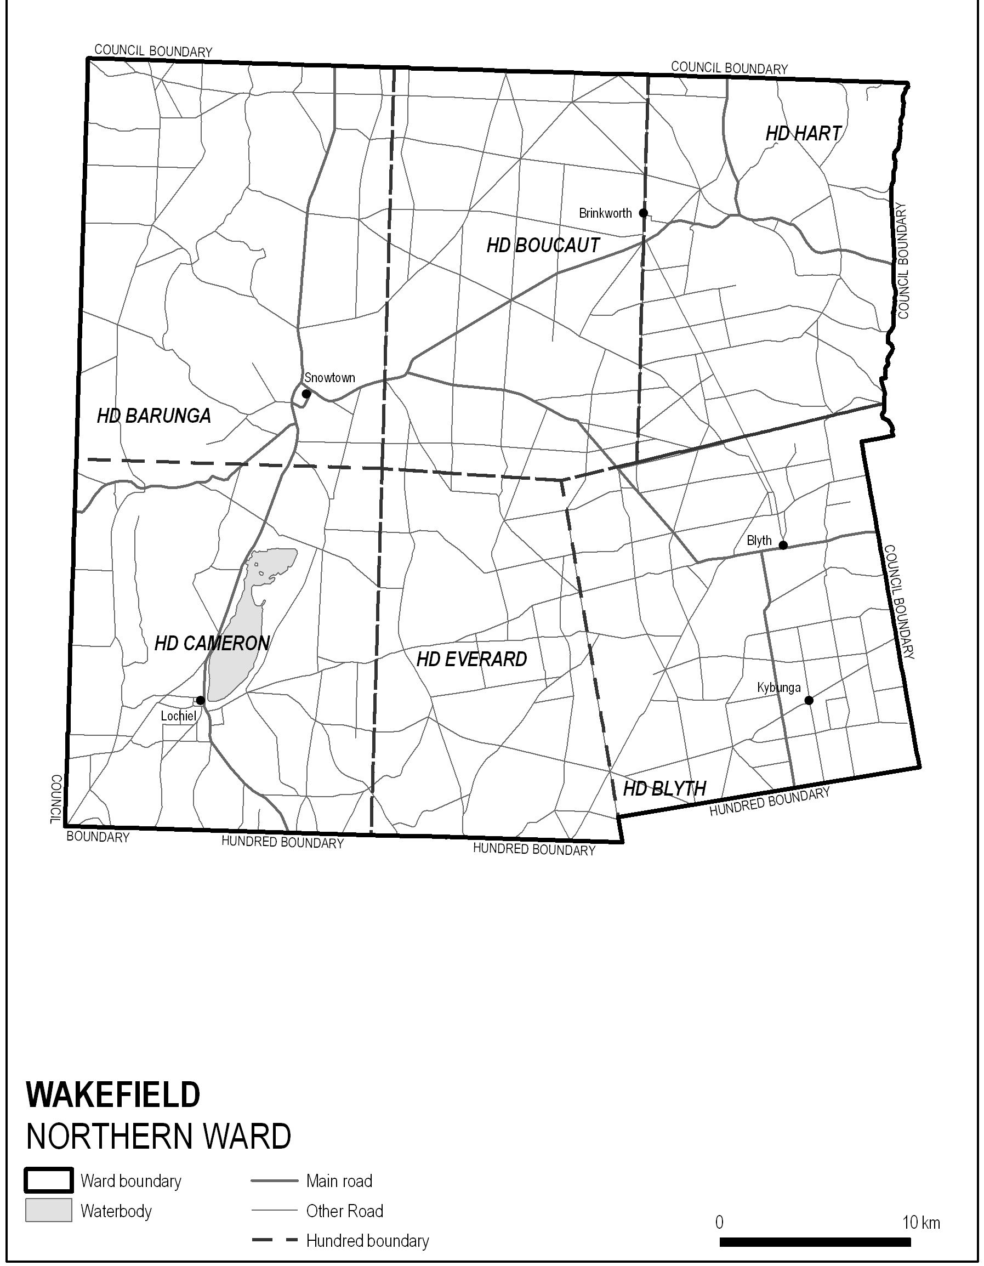
Second Schedule
Western Ward:
Comprising the Hundreds of Goyder, Stow, Inkerman and portion of Hundreds of Balaklava and Clinton and more particularly delineated in the plan published herewith.
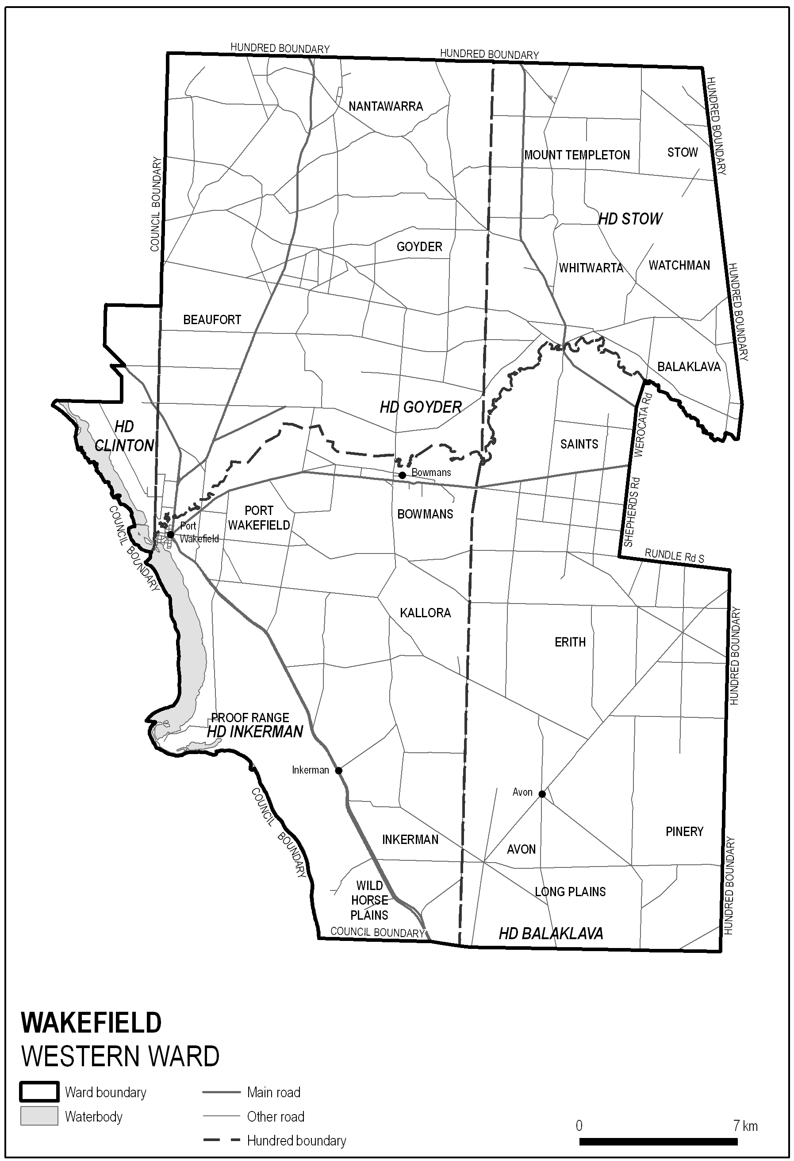
Third Schedule
Central Ward:
Comprising the Hundred of Hall and portion of the Hundred of Balaklava, Dalkey and Upper Wakefield and more particularly delineated in the plan published herewith.

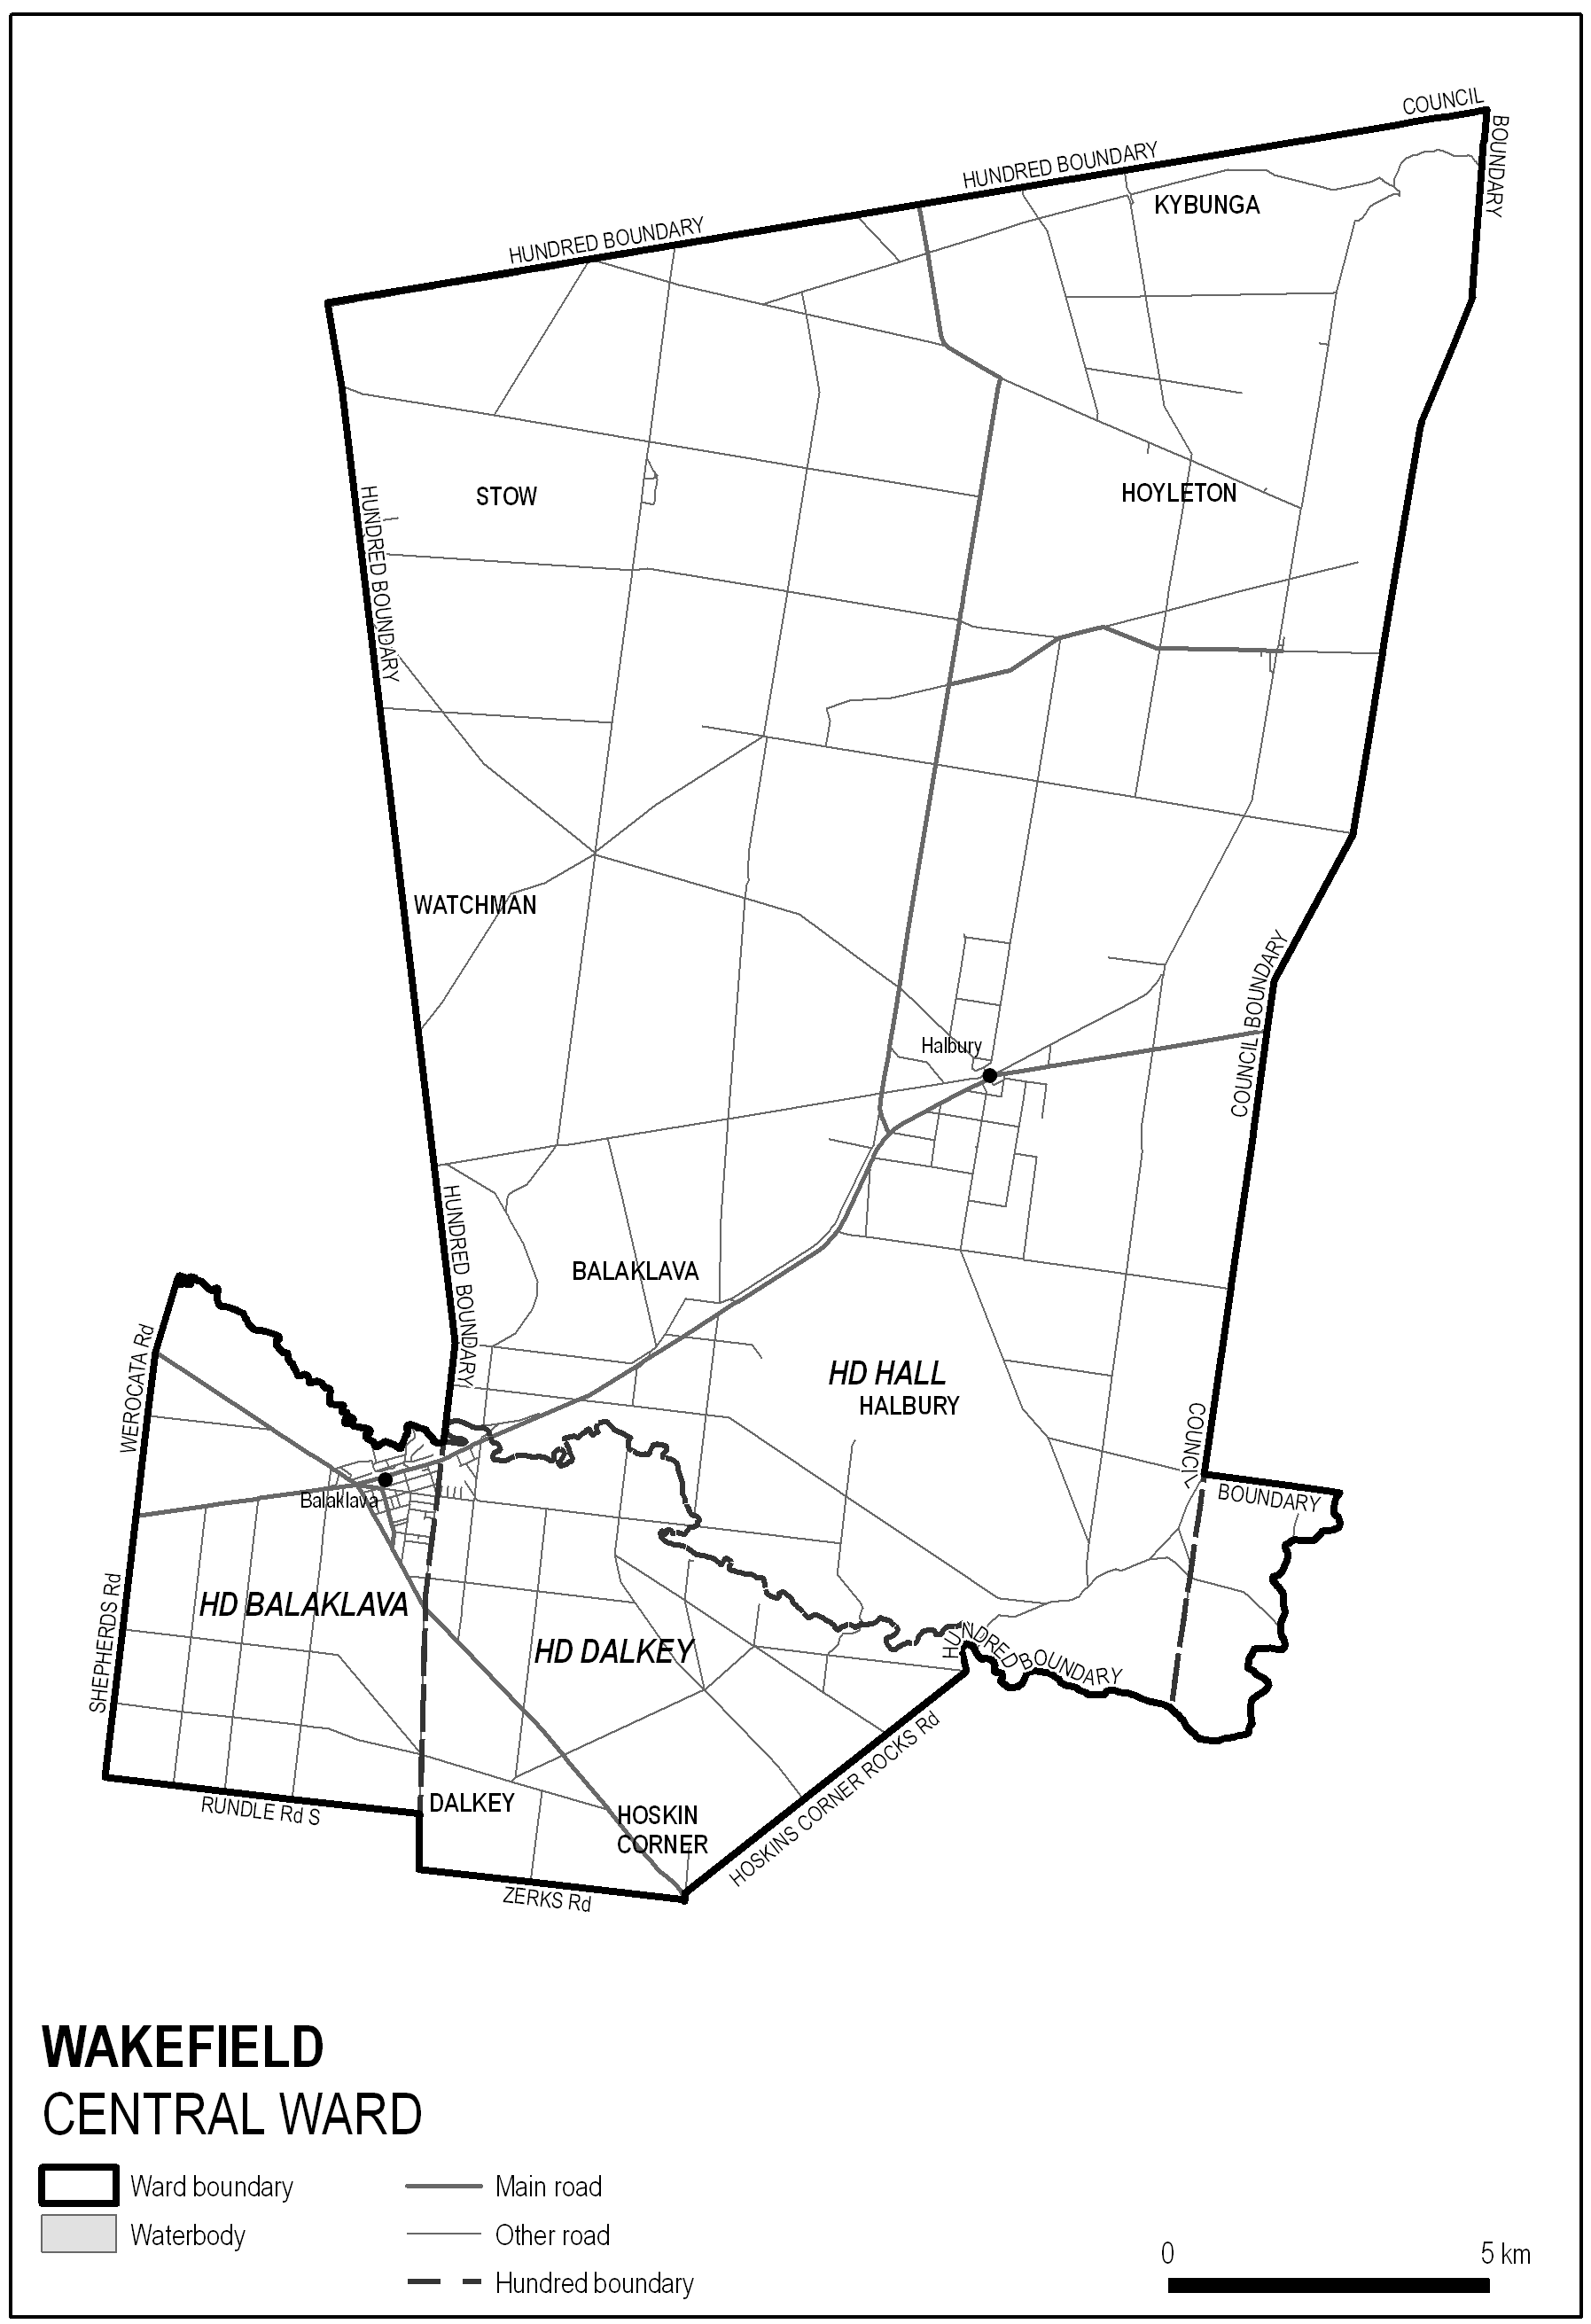
Fourth Schedule
Southern Ward:
Comprising portion of the Hundred of Alma and portion of the Hundred of Dalkey and more particularly delineated in the plan published herewith.

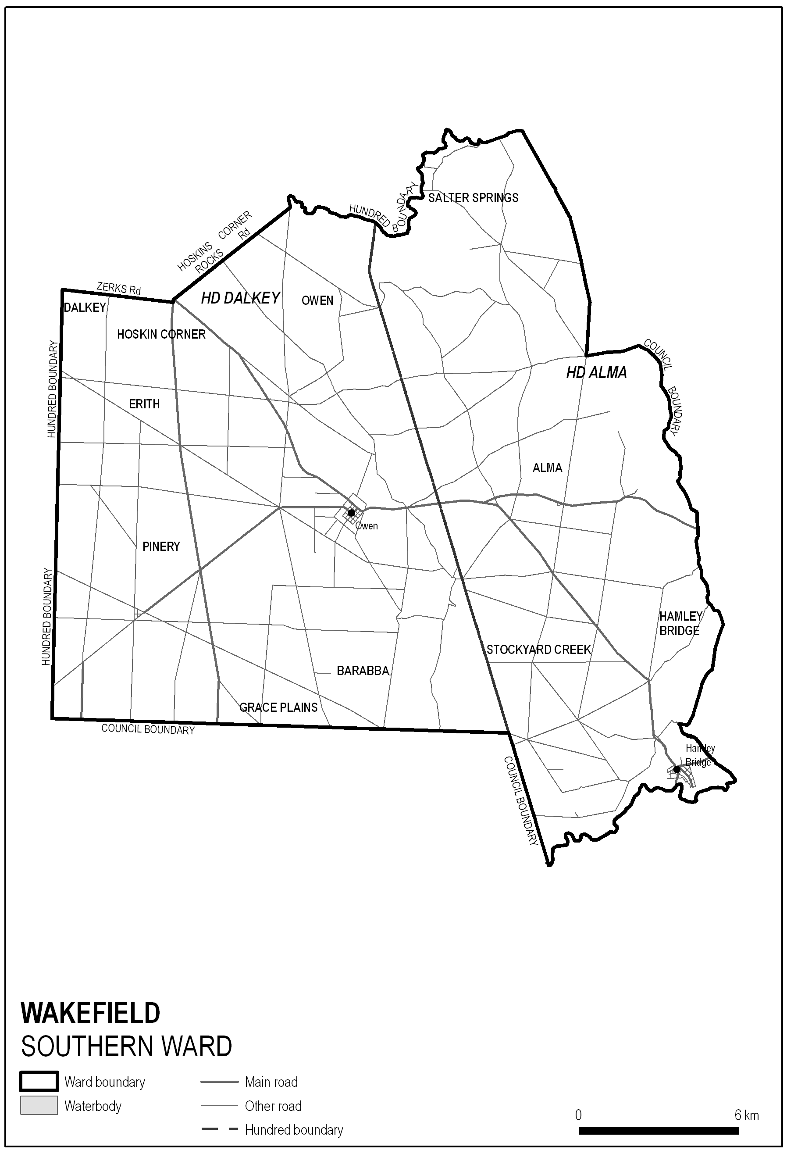
P. Barry, Chief Executive Officer

DISTRICT COUNCIL OF YANKALILLA
By-law Made Under the Local Government Act 1999
By-Law No. 1 of 2009—Penalties
A by-law to create a permit system for Council by-laws, to fix maximum and continuing penalties for offences, and for the construction of Council by-laws.
Part 1—Preliminary
1. Title
This by-law may be cited as the Permits and Penalties By-law 2009 and is By-law No. 1 of the District Council of Yankalilla.
2. Authorising Law
This by-law is made under section 246 of the Act and sections 667 (1) 3.liv and 9.xvi of the Local Government Act 1934.
3. Purpose
The objects of this by-law are to provide for the good rule and government of the Council area, and for the convenience, comfort and safety of its inhabitants by:
3.1 creating a permit system for Council by-laws;
3.2 providing for the enforcement of breaches of Council by-laws and fixing penalties; and
3.3 clarifying the construction of Council by-laws.
4. Commencement, Revocation and Expiry
4.1 The following by-laws previously made by the Council are revoked from the day on which this by-law comes into operation¹:
4.1.1 By-law No. 1 of 2002—Permits and Penalties.²
4.2 This by-law will expire on 1 January 2017.³
Note:
¹ Generally a by-law comes into operation four months after the day on which it is gazetted: section 249 (5) of the Act.
² Section 253 of the Act provides that the revocation of a by-law by another by-law that contains substantially the same provisions, does not affect certain resolutions such as those applying a by-law to a part or parts of the Council area.
³ Pursuant to section 251 of the Act, a by-law will expire on 1 January following the seventh anniversary of the gazettal of the by-law.
5. Application
5.1 This by-law applies throughout the Council area.
6. Interpretation
In this by-law, unless the contrary intention appears:
6.1 Act means the Local Government Act 1999;
6.2 Council means District Council of Yankalilla;
6.3 person includes a body corporate.
Note:
Section 14 of the Interpretation Act 1915, provides that an expression used in this by-law has, unless the contrary intention appears, the same meaning as in the Act.
7. Construction of By-laws Generally
7.1 Every by-law of the Council is subject to any Act of Parliament and Regulations made thereunder.
7.2 In any by-law of the Council, unless the contrary intention appears permission means permission of the Council, granted in writing prior to the act, event or activity to which it relates.
Part 2—Permits and Penalties
8. Permits
8.1 Where a by-law requires that permission be obtained any person seeking the grant of permission must submit a written application to the Council in the form (if any) and accompanied by the fee (if any) prescribed by the Council.
8.2 The Council may attach such conditions as it thinks fit to a grant of permission, and may vary or revoke such conditions or impose new conditions by notice in writing to the person granted permission.
8.3 A person granted permission must comply with every such condition.
8.4 The Council may suspend or revoke a grant of permission at any time by notice in writing to the person granted permission.
9. Offences and Penalties
9.1 A person who commits a breach of any by-law of the Council is guilty of an offence and is liable to a maximum penalty being the maximum penalty referred to in the Act that may be fixed by a by-law for any breach of a by-law.
9.2 A person who commits a breach of a by-law of the Council of a continuing nature is guilty of an offence and, in addition to any other penalty that may be imposed, is liable to a further penalty for every day on which the offence continues, such penalty being the maximum amount referred to in the Act that may be fixed by a by-law for a breach of a by-law of a continuing nature.
Note:
The maximum penalty for a breach of a by-law is currently $750 and the maximum penalty for every day in which a breach of a continuing nature continues is currently $50—see section 246 (3) (g) of the Act.
This by-law was duly made and passed at a meeting of the District Council of Yankalilla held on 17 September 2009, by an absolute majority of the members for the time being constituting the Council, there being at least two-thirds of the members present.
R. D. Sweetman, Chief Executive

DISTRICT COUNCIL OF YANKALILLA
By-law Made Under the Local Government Act 1999
By-Law No. 2 of 2009—Local Government Land
A by-law to regulate the access to and use of Local Government Land (other than roads), and certain public places.
Part 1—Preliminary
1. Title
This by-law may be cited as the Local Government Land By-law 2009 and is By-law No. 2 of the District Council of Yankalilla.
2. Authorising Law
This by-law is made under sections 238 and 246 of the Act and sections 667 (1) 4.i and 9.xvi of the Local Government Act 1934.
3. Purpose
The objects of this by-law are to regulate the access to and use of Local Government Land (other than roads), and certain public places:
3.1 to prevent and mitigate nuisances;
3.2 to prevent damage to Local Government Land;
3.3 to protect the convenience, comfort and safety of members of the public;
3.4 to enhance the amenity of the Council area; and
3.5 for the good rule and government of the area.
4. Commencement, Revocation and Expiry
4.1 The following by-laws previously made by the Council are revoked from the day on which this by-law comes into operation¹:
4.1.1 By-law No. 4 of 2002—Local Government Land.²
4.2 This by-law will expire on 1 January 2017.³
Note:
¹ Generally a by-law comes into operation four months after the day on which it is gazetted: section 249 (5) of the Act.
² Section 253 of the Act provides that the revocation of a by-law by another by-law that contains substantially the same provisions, does not affect certain resolutions such as those applying a by-law to a part or parts of the Council area.
³ Pursuant to section 251 of the Act, a by-law will expire on 1 January following the seventh anniversary of the gazettal of the by-law.
5. Application
5.1 This by-law operates subject to the Council’s Permits and Penalties By-law 2009.
5.2 Subject to Clauses 5.3 and 5.4, this by-law applies throughout the Council area.
5.3 Clauses 9.3, 9.9.1, 9.24.3, 10.4 and 10.10.3 of this by-law only apply in such part or parts of the Council area as the Council may, by resolution direct in accordance with section 246 (3) (e) of the Act.
5.4 Clause 9.9.2 of this by-law only applies throughout the Council area except in such part or parts of the Council area as the Council may by resolution direct in accordance with section 246 (3) (e) of the Act.
6. Interpretation
In this by-law, unless the contrary intention appears:
6.1 Act means the Local Government Act 1999;
6.2 animal or animals includes birds and insects but does not include a dog;
6.3 boat includes a raft, pontoon or personal watercraft or other similar device;
6.4 camp includes setting up a camp, or causing a tent, caravan or motor home to remain on the land for the purpose of staying overnight, whether or not any person is in attendance or sleeps on the land;
6.5 children’s playground means an enclosed area in which there is equipment or other devices installed for the purpose of children’s play (or within 3 m of such devices if there is no enclosed area);
6.6 Controlled area means the area of the foreshore at Normanville Beach commencing at a point 100 m south of the jetty and extending to a point 100 m north of the Yankalilla River;
6.7 Council means District Council of Yankalilla;
6.8 electoral matter has the same meaning as in the Electoral Act 1985, provided that such electoral matter is not capable of causing physical damage or injury to any person within its immediate vicinity;
6.9 effective control means a person exercising effective control of an animal either:
6.9.1 by means of a physical restraint; or
6.9.2 by command, the animal being in close proximity to the person and the person being able to see the animal at all times;
6.10 emergency worker has the same meaning as in the Road Traffic (Road Rules—Ancillary and Miscellaneous Provisions) Regulations 1999;
6.11 funeral ceremony means a ceremony only (i.e. a memorial service) and does not include a burial;
6.12 liquor has the same meaning as in the Liquor Licensing Act 1997;
6.13 Local Government Land means all land owned by the Council or under the Council’s care, control and management (except roads);
6.14 low water mark means the lowest meteorological tide;
6.15 offensive includes threatening, abusive, insulting or annoying behaviour and offend has a complementary meaning;
6.16 open container means a container which:
(a) after the contents of the container have been sealed at the time of manufacture:
(i) being a bottle, it has had its cap, cork or top removed (whether or not it has since been replaced);
(ii) being a can, it has been opened or punctured;
(iii) being a cask, it has had its tap placed in a position to allow it to be used;
(iv) being any other form of container, it has been opened, broken, punctured or manipulated in such a way as to allow access to its contents; or
(v) is a flask, glass, mug or other container able to contain liquid;
6.17 tobacco product has the same meaning as in the Tobacco Products Regulation Act 1997;
6.18 vehicle has the same meaning as in the Road Traffic Act 1961;
6.19 waters includes a body of water, including a pond, lake, river, creek or wetlands under the care, control and management of the Council.
Note:
Section 14 of the Interpretation Act 1915, provides that an expression used in a by-law has, unless the contrary intention appears, the same meaning as in the Acts under which the by-law was made.
Part 2—Access to Local Government Land
7. Access
Note:
Pursuant to section 238 (7) of the Act, if a Council makes a by-law about access to or use of a particular piece of Local Government Land (under section 238), the Council must erect a sign in a prominent position on, or in the immediate vicinity of, the land to which the by-law applies.
The Council may:
7.1 close, or regulate or restrict access to, any part of Local Government Land to the public for specified times and days; and
7.2 fix charges or fees payable for entry onto any part of Local Government Land.
8. Closed Lands
A person must not without permission, enter or remain on any Local Government Land:
8.1 which has been closed, or in respect of which access by the public is regulated or restricted in accordance with Clause 7.1;
8.2 where entry fees or charges are payable, without paying those fees or charges; or
8.3 where the land has been enclosed by fences and/or walls and gates that have been closed and locked.
Part 3—Use of Local Government Land
9. Activities Requiring Permission
Note:
Pursuant to section 238 (7) of the Act, if a Council makes a by-law about access to or use of a particular piece of Local Government Land (under section 238), the Council must erect a sign in a prominent position on, or in the immediate vicinity of, the land to which the by-law applies.
A person must not without the permission of the Council, do any of the following on Local Government Land.
9.1 Advertising
Subject to Clause 14.2, display, paint or erect any sign or hoarding for the purpose of commercial advertising or any other purpose.
9.2 Aircraft
Subject to the Civil Aviation Act 1988, land any aircraft on, or take off any aircraft from the land.
9.3 Alcohol
Consume, carry or be in possession or in charge of any liquor on Local Government Land comprising parks or reserves to which the Council has determined this paragraph applies.
9.4 Amplification
Use an amplifier or other mechanical or electrical device for the purpose of broadcasting sound, or magnifying sound, to an audience.
9.5 Animals
9.5.1 On Local Government Land other than the foreshore:
(a) cause or allow an animal to stray onto, move over, graze or be left unattended on Local Government Land;
(b) cause or allow an animal to enter, swim, bathe or remain in any waters located on Local Government Land; or
(c) lead, herd or exercise an animal, except where the Council has set aside a track or other area for use by or in connection with an animal of that kind, and provided that the animal or animals are under effective control.
9.5.2 On Local Government Land comprising the foreshore:
(a) cause or allow a sheep, cow, goat or horse to enter, swim, bathe or remain in any waters; or
(b) lead, herd or exercise a sheep, cow or goat.
9.6 Annoyance
Do anything likely to offend or unreasonably interfere with any other person:
(a) using that land; or
(b) occupying nearby premises,
by making a noise or creating a disturbance.
9.7 Attachments
Subject to Clause 14.2, attach anything to a tree, plant, equipment, fence, post, structure or fixture on Local Government Land.
9.8 Bees
Place a hive of bees on such land, or allow it to remain thereon.
9.9 Boats
Subject to the provisions of the Harbors and Navigation Act 1993:
9.9.1 launch or retrieve a boat to or from any waters where the Council has determined that this subclause applies;
9.9.2 launch or retrieve a boat other than from a boat ramp constructed for that purpose;
9.9.3 propel, float or otherwise use a boat on or in any waters;
9.9.4 hire out a boat or otherwise use a boat for commercial purposes; or
9.9.5 moor a boat on any waters or to a pontoon attached to Local Government Land.
9.10 Bridge Jumping
Jump or dive from a bridge on Local Government Land.
9.11 Buildings
Use a building, or structure on Local Government Land for a purpose other than its intended purpose.
9.12 Burials and Memorials
9.12.1 Bury, inter or spread the ashes of any human or animal remains.
9.12.2 Erect any memorial.
9.13 Camping and Tents
9.13.1 Erect a tent or other structure of calico, canvas, plastic or similar material as a place of habitation.
9.13.2 Camp or sleep overnight except where a person is in a caravan park on Local Government Land, the proprietor of which has been given permission to operate the caravan park on that land.
9.14 Canvassing
Convey any advertising, religious or other message to any by-stander, passer-by or other.
9.15 Defacing Property
Deface, paint, spray, write, cut names, letters or make marks on any tree, rock, gate, fence, building, sign, bridge or property of the Council.
9.16 Distribution
Subject to Clause 14.2, place on a vehicle (without the consent of the owner of the vehicle), or give out or distribute any hand bill, book, notice, leaflet, or other printed matter to any by-stander, passer-by or other person.
9.17 Donations
Ask for or receive or indicate that he or she desires a donation of money or any other thing.
9.18 Entertainment and Busking
9.18.1 Sing, busk or play a recording or use a musical instrument for the apparent purpose of either entertaining others or receiving money.
9.18.2 Conduct or hold a concert, festival, show, public gathering, circus, meeting, performance or any other similar activity.
9.19 Equipment
Use an item of equipment, facilities or property belonging to the Council if that person is of or over the age indicated by a sign or notice as the age limit for using such equipment, facility or property.
9.20 Fires
Subject to the Fire and Emergency Services Act 2005, light a fire except:
9.20.1 in a place provided by the Council for that purpose; or
9.20.2 in a portable barbeque, as long as the barbeque is used in an area that is clear of flammable material for a distance of at least 4 m.
9.21 Fireworks
Ignite or discharge any fireworks.
9.22 Flora and Fauna
Subject to the Native Vegetation Act 1991 and the National Parks and Wildlife Act 1972:
9.22.1 damage, pick, disturb, interfere with or remove any plant or flower thereon;
9.22.2 cause or allow an animal to stand or walk on any flower bed or garden plot;
9.22.3 deposit, dig, damage, disturb, interfere with or remove any soil, stone, wood, clay, gravel, pebbles, timber, bark or any part of the land;
9.22.4 take, interfere with, tease, harm or disturb any animal, bird or marine creature or the eggs or young of any animal, bird or marine creature;
9.22.5 pick, collect, take, interfere with or disturb any fruit, nuts, berries or native seeds;
9.22.6 disturb, interfere with or damage any burrow, nest or habitat of any animal or bird;
9.22.7 use, possess or have control of any device for the purpose of killing or capturing any animal, bird or marine creature; or
9.22.8 burn any timber or dead wood.
9.23 Foreshore
On Local Government Land comprising the foreshore:
9.23.1 drive or propel a vehicle onto or from the foreshore except to launch or retrieve a boat so long as the vehicle accesses the foreshore by a ramp or thoroughfare constructed or set aside by the Council for that purpose;
9.23.2 drive or propel a vehicle on the foreshore except to launch or retrieve a boat so long as the vehicle is driven or propelled on an area or road that is constructed or set aside by the Council for that purpose;
9.23.3 launch or retrieve a boat from the foreshore without using a boat ramp or thoroughfare constructed or set aside by the Council for that purpose;
9.23.4 allow a vehicle to remain stationary on a boat ramp longer than is necessary to launch or retrieve a boat; or
9.23.5 hire out a boat on or from the foreshore.
9.24 Games
9.24.1 Participate in, promote or organise any organised competition or sport, as distinct from organised social play.
9.24.2 Play or practise any game which involves kicking, hitting or throwing a ball or other object on Local Government Land which may cause or be likely to cause injury or discomfort to a person being on or in the vicinity of that land or detract from or be likely to detract from another person’s lawful use and enjoyment of that land.
9.24.3 Play or practise the game of golf on Local Government Land to which the Council has resolved this subclause applies.
9.25 Litter
9.25.1 Throw, cast, place, deposit or leave any rubbish, dirt or refuse of any kind whatsoever except in a garbage container provided for that purpose.
9.25.2 Deposit any soil, clay, stone, gravel, green waste or other putrescible waste or any other matter.
9.26 Marine Life
Introduce any marine life to any waters located on Local Government Land.
9.27 Model Aircraft, Boats and Cars
Fly or operate a model aircraft, boat or model or remote control vehicle in a manner which may cause or be likely to cause injury or discomfort to a person being on or in the vicinity of the land or detract from or be likely to detract from another person’s lawful use of and enjoyment of the land.
9.28 Overhanging Articles or Displaying Personal Items
Suspend or hang an article or object from a building, verandah, pergola, post or other structure on Local Government Land where it might present a nuisance or danger to a person using the land or be of an unsightly nature.
9.29 Playing Area
Use or occupy a playing area:
9.29.1 in such a manner as to damage or be likely to damage the surface of the playing area or infrastructure (above and under ground level);
9.29.2 in a manner contrary to the purpose for which the playing area was intended to be used or occupied; or
9.29.3 contrary to directions of the Council made by resolution and indicated on a sign displayed adjacent to the playing area.
9.30 Pontoons
Install or maintain a pontoon or jetty in any waters.
9.31 Posting of Bills
Subject to Clause 14.2, post or allow or cause to be posted any bills, advertisements or other papers or items on a building or structure on Local Government Land or in a public place.
9.32 Preaching
Preach, harangue or solicit for religious purposes.
9.33 Ropes
Place a buoy, cable, chain, hawser, rope or net in or across any waters.
9.34 Swimming
Subject to the provisions of the Harbors and Navigation Act 1993, swim in, bathe or enter any waters except:
9.34.1 in an area which the Council has determined may be used for such purposes; and
9.34.2 in accordance with any conditions that the Council may have determined by resolution apply to such use.
9.35 Toilets
In any public convenience on Local Government Land:
9.35.1 urinate other than in a urinal or pan or defecate other than in a pan set apart for that purpose;
9.35.2 deposit anything in a pan, urinal or drain which is likely to cause a blockage;
9.35.3 use it for a purpose for which it was not designed or constructed;
9.35.4 enter a toilet that is set aside for use of the opposite sex except:
(a) where a child under the age of eight years is accompanied by an adult parent or guardian of that sex; or
(b) to provide assistance to a disabled person; or
(c) in the case of a genuine emergency.
9.36 Trading
Sell, buy, offer or display anything for sale.
9.37 Vehicles
9.37.1 Drive or propel a vehicle except on an area or road constructed and identified by the Council for that purpose, by means of signs, devices or fencing and the like.
9.37.2 Promote, organise or take part in a race, test or trial of any kind in which vehicles take part, except on an area properly constructed for that purpose.
9.37.3 Repair, wash, paint, panel beat or carry out other work to a vehicle, except for running repairs in the case of a breakdown.
9.38 Weddings, Functions and Special Events
9.38.1 Hold, conduct or participate in a marriage ceremony, funeral or special event.
9.38.2 Erect a marquee, stage or structure for the purpose of holding or conducting a wedding, funeral or special event.
9.38.3 Hold or conduct any filming where the filming is for a commercial purpose.
10. Prohibited Activities
A person must not do any of the following on Local Government Land.
10.1 Animals
10.1.1 Cause or allow any animal to enter, swim, bathe or remain in any waters to the inconvenience, annoyance or danger of any other person bathing or swimming.
10.1.2 Cause or allow an animal to damage a flowerbed, garden plot, tree, lawn or like thing or place.
10.1.3 Lead, herd or exercise a horse in such manner as to cause a nuisance or endanger the safety of a person.
10.1.4 Except for in a ‘controlled area’, ride, lead or exercise a horse on Local Government Land comprising the foreshore.
10.1.5 Cause or allow any horse to be let loose or left unattended within a controlled area.
10.2 Coastal Areas
Subject to the Coastal Protection Act 1972 and the Native Vegetation Act 1991:
10.2.1 destabalise sand on a sand dune;
10.2.2 ride a sand board or any other object on a sand dune;
10.2.3 destroy, remove or interfere with dead or live vegetation within a sand dune, coastal slope or cliff;
10.2.4 introduce flora or fauna or dump any material on a sand dune;
10.2.5 carry out any activity that may damage or threaten the integrity of a sand dune, coastal slope or cliff.
10.3 Equipment
Use any item of equipment, facilities or property belonging to the Council other than in the manner and for the purpose for which it was designed, constructed or intended to be used or in such manner as is likely to damage or destroy it.
10.4 Fishing
10.4.1 Fish in any waters to which the Council has determined this subclause applies.
10.4.2 Fish from a bridge or other structure to which the Council has determined this subclause applies.
10.5 Glass
Willfully break any glass, china or other brittle material.
10.6 Interference with Land
Interfere with, alter or damage the land (including a building, structure or fixture located on the land) including:
10.6.1 altering the construction or arrangement of the land to permit or facilitate access from an adjacent property;
10.6.2 erecting or installing a structure in, on, across, under or over the land;
10.6.3 changing or interfering with the construction, arrangement or materials of the land;
10.6.4 planting a tree or other vegetation on the land, interfering with the vegetation on the land or removing vegetation from the land; or
10.6.5 otherwise use the land in a manner contrary to the purpose for which the land was designed to be used.
10.7 Interference with Permitted Use
Interrupt, disrupt or interfere with any other person’s use of Local Government Land which is permitted or for which permission has been granted.
10.8 Nuisance
Behave in such a manner as to cause discomfort, inconvenience, annoyance or offence to any other person.
10.9 Playing Games
Play or practise a game:
10.9.1 which is likely to cause damage to the land or anything on it;
10.9.2 in any area where a sign indicates that the game is prohibited.
10.10 Smoking
Smoke, hold or otherwise have control over an ignited tobacco product:
10.10.1 in any building;
10.10.2 in any children’s playground; or
10.10.3 on any land to which the Council has determined this subclause applies.
10.11 Throwing Objects
Throw, roll, project or discharge a stone, substance or other missile, excluding sport and recreational equipment designed to be used in that way.
10.12 Solicitation
Tout or solicit customers for the parking of vehicles or for any other purpose whatsoever.
10.13 Waste
10.13.1 Deposit or leave thereon:
(a) anything obnoxious or offensive;
(b) any offal, dead animal, dung or filth; or
(c) any mineral, mineral waste, industrial waste or by-products.
10.13.2 Foul or pollute any waters situated thereon.
10.13.3 Deposit any rubbish other than in receptacles provided by the Council for that purpose.
10.13.4 Deposit in a receptacle any rubbish emanating from domestic or trade purposes, unless des-ignated by a sign or signs.
Part 4—Enforcement
11. Directions
11.1 A person on Local Government Land must comply with a reasonable direction from an authorised person relating to:
11.1.1 that person’s use of the land;
11.1.2 that person’s conduct and behaviour on the land;
11.1.3 that person’s safety on the land; or
11.1.4 the safety and enjoyment of other persons on the land.
11.2 A person who, in the opinion of an authorised person, is likely to commit or has committed, a breach of this by-law must immediately comply with a direction of an authorised person to leave that part of Local Government Land.
12. Orders
If a person fails to comply with an order of an authorised person made pursuant to section 262 of the Act in respect of a breach of this by-law, the Council may recover its costs of any action taken under section 262 (3) of the Act from the person to whom the order was directed.
Note:
Section 262 (1) of the Act states:
(1) If a person (the offender) engages in conduct that is a contravention of this Act or a by-law under this Act, an authorised person may order the offender:
(a) if the conduct is still continuing—to stop the conduct; and
(b) whether or not the conduct is still continuing—to take specified action to remedy the contravention.
Subsections (2) and (3) of section 262 also provide that it is an offence to fail to comply with an order and that if a person does not comply, the authorised person may take action reasonably required to have the order carried out. For example, an authorised person may order a person to:
• cease smoking on Local Government Land;
• remove an object or structure encroaching on Local Government Land;
• dismantle and remove a structure erected on Local Government Land without permission.
13. Removal of Animals and Objects
An authorised person may remove an animal or object that is on Local Government Land in breach of a by-law if no person is in charge of, or apparently in charge of, the animal or object.
Part 5—Miscellaneous
14. Exemptions
14.1 The restrictions in this by-law do not apply to a Police Officer, emergency worker, Council Officer or employee acting in the course and within the scope of that person’s normal duties, or to a contractor while performing work for the Council and while acting under the supervision of a Council Officer.
14.2 The restrictions in Clauses 9.1, 9.7, 9.16 and 9.31 of this by-law do not apply to electoral matter authorised by a candidate and which is:
14.2.1 related to a Commonwealth or State election and occurs during the period commencing on the issue of the writ or writs for the election and ending at the close of polls on polling day;
14.2.2 related to an election under the Act or the Local Government (Elections) Act 1999 and occurs during the period commencing four weeks immediately before the date that has been set (either by or under either Act) for polling day and ending at the close of voting on polling day; or
14.2.3 related to, and occurs during the course of and for the purpose of a referendum.
This by-law was duly made and passed at a meeting of the District Council of Yankalilla held on 17 September 2009, by an absolute majority of the members for the time being constituting the Council, there being at least two-thirds of the members present.
R. D. Sweetman, Chief Executive

DISTRICT COUNCIL OF YANKALILLA
By-law Made Under the Local Government Act 1999
By-Law No. 3 of 2009—Roads
A by-law to regulate certain activities on roads in the Council area.
Part 1—Preliminary
1. Title
This by-law may be cited as the Roads By-law 2009 and is By-law No. 3 of the District Council of Yankalilla.
2. Authorising Law
This by-law is made under sections 239 and 246 of the Act, Regulation 13 (1) (c) of the Local Government (Implementation) Regulations 1999 and sections 667 (1), 4.i, 5.vii, 7.ii and 9.xvi of the Local Government Act 1934.
3. Purpose
The objects of this by-law are to manage and regulate the prescribed uses of roads in the Council area:
3.1 to protect the convenience, comfort and safety of road users and members of the public;
3.2 to prevent damage to buildings and structures on roads;
3.3 to prevent certain nuisances occurring on roads; and
3.4 for the good rule and government of the Council area.
4. Commencement, Revocation and Expiry
4.1 The following by-laws previously made by the Council are revoked from the day on which this by-law comes into operation¹:
4.1.1 By-law No. 3—Roads.²
4.2 This by-law will expire on 1 January 2017.³
Note:
¹ Generally a by-law comes into operation four months after the day on which it is gazetted: section 249 (5) of the Act.
² Section 253 of the Act provides that the revocation of a by-law by another by-law that contains substantially the same provisions, does not affect certain resolutions such as those applying a by-law to a part or parts of the Council area.
³ Pursuant to section 251 of the Act, a by-law will expire on 1 January following the seventh anniversary of the gazettal of the by-law.
5. Application
5.1 This by-law operates subject to the Council’s Permits and Penalties By-law 2009.
5.2 This by-law applies throughout the Council area.
6. Interpretation
In this by-law, unless the contrary intention appears:
6.1 Act means the Local Government Act 1999;
6.2 animal includes birds, insects and poultry but does not include a dog or a cat;
6.3 camp includes setting up a camp, or causing a tent, caravan or motor home to remain on the land for the purpose of staying overnight, whether or not any person is in attendance or sleeps on the land;
6.4 Council means District Council of Yankalilla;
6.5 effective control means a person exercising effective control of an animal either:
6.5.1 by means of a physical restraint;
6.5.2 by command, the animal being in close proximity to the person, and the person being able to see the animal at all times;
6.6 electoral matter has the same meaning as in the Electoral Act 1995, provided that such electoral matter is not capable of causing physical damage or injury to a person within its immediate vicinity;
6.7 emergency worker has the same meaning as in the Road Traffic (Road Rules—Ancillary and Miscellaneous Pro-visions) Regulations 1999;
6.8 vehicle has the same meaning as in the Road Traffic Act 1961.
Note:
Section 14 of the Interpretation Act 1915, provides that an expression used in this by-law has, unless the contrary intention appears, the same meaning as in the Acts under which the by-law was made.
Part 2—Use of Roads
7. Activities Requiring Permission
A person must not do any of the following activities on a road without the permission of the Council:
7.1 Amplification
Use an amplifier or other device whether mechanical or electrical for the purpose of broadcasting announcements or advertisements.
7.2 Animals
7.2.1 Cause or allow an animal to stray onto, move over, or graze on a road except where the Council has set aside a track or other area for use by or in connection with an animal of that kind, and provided the animal or animals are under effective control.
7.2.2 Lead, herd or exercise an animal in such a manner as to cause a nuisance or endanger the safety of a person.
7.3 Camping and Tents
7.3.1 Erect a tent or other structure of calico, canvas, plastic or other similar material as a place of habitation.
7.3.2 Camp or sleep overnight.
7.4 Donations
Ask for or receive or indicate a desire for a donation of money or any other thing, or otherwise solicit for religious or charitable purposes.
7.5 Obstructions
Erect, install or place or cause to be erected, installed or placed any structure, object or material of any kind so as to obstruct a road or footway, water-channel, or watercourse in a road.
7.6 Posting of Bills
Subject to Clause 11.2, post or allow or cause to be posted any bills, advertisements, or other papers or items on a building or structure on a road.
7.7 Preaching
Preach, harangue or solicit for religious purposes.
7.8 Public Exhibitions and Displays
7.8.1 Sing, busk, play a recording or use a music instrument, or perform similar activities.
7.8.2 Conduct or hold a concert, festival, show, circus, performance or a similar activity.
7.8.3 Erect a stage or structure for the purpose of conducting or holding a concert, festival, show, circus, performance or a similar activity.
7.8.4 Cause any public exhibitions or displays.
7.9 Vehicles
Repair, wash, paint, panel beat or perform other work of a similar nature to a vehicle, except for running repairs in the case of a vehicle breakdown.
Note:
Moveable signs on roads are regulated by sections 226 and 227 of the Act and the Council’s Moveable Signs By-law (if any).
Part 3—Enforcement
8. Directions
A person who, in the opinion of an authorised person is committing or has committed a breach of this by-law, must immediately comply with a direction of an authorised person to leave that part of the road.
9. Orders
If a person does not comply with an order of an authorised person made pursuant to section 262 of the Act in respect of a breach of this by-law, the Council may recover its costs of any action taken under section 262 (3) of the Act from the person to whom the order was directed.
Note:
Section 262 (1) of the Act states:
(1) If a person (the offender) engages in conduct that is a contravention of this Act or a by-law under this Act, an authorised person may order the offender:
(a) if the conduct is still continuing—to stop the conduct; and
(b) whether or not the conduct is still continuing—to take specified action to remedy the contravention.
Subsections (2) and (3) of section 262 also provide that it is an offence to fail to comply with an order and that if a person does not comply, the authorised person may take action reasonably required to have the order carried out. For example, an authorised person may order a person to:
• cease busking on a road;
• remove an object or structure blocking a footpath;
• remove bills posted on a structure on a road;
• dismantle and remove a tent from a road.
10. Removal of Animals and Objects
An authorised person may remove an animal or object that is on a road in breach of a by-law if no person is in charge, or apparently in charge, of the animal or object.
Part 4—Miscellaneous
11. Exemptions
11.1 The restrictions in this by-law do not apply to a
Police Officer, emergency worker, Council Officer or employee acting in the course and within the scope of that person’s normal duties, or to a contractor while performing work for the Council and while acting under the supervision of a Council Officer.
11.2 The restrictions in Clause 7.5 of this by-law do not apply to electoral matter authorised by a candidate and which is:
11.2.1 related to a Commonwealth or State election and occurs during the period commencing on the issue of the writ or writs for the election and ending at the close of polls on polling day;
11.2.2 related to an election under the Act or the Local Government (Elections) Act 1999 and occurs during the period commencing four weeks immediately before the date that has been set (either by or under either Act) for polling day and ending at the close of voting on polling day; or
11.2.3 related to, and occurs during the course of and for the purpose of a referendum.
This by-law was duly made and passed at a meeting of the District Council of Yankalilla held on 17 September 2009, by an absolute majority of the members for the time being constituting the Council, there being at least two-thirds of the members present.
R. D. Sweetman, Chief Executive

DISTRICT COUNCIL OF YANKALILLA
By-law Made Under the Local Government Act 1999
By-law No. 4 of 2009—Moveable Signs
A by-law to set standards for moveable signs on roads and to provide conditions for the placement of such signs.
Part 1—Preliminary
1. Title
This by-law may be cited as the Moveable Signs By-law 2009 and is By-law No. 4 of the District Council of Yankalilla.
2. Authorising Law
This by-law is made under sections 239 and 246 of the Act and sections 667 (1), 4.i and 9.xvi of the Local Government Act 1934.
3. Purpose
The object of this by-law is to set standards for moveable signs on roads:
3.1 to protect the comfort and safety of road users and members of the public;
3.2 to enhance the amenity of roads and surrounding parts of the Council area;
3.3 to prevent nuisances occurring on roads;
3.4 to prevent unreasonable interference with the use of a road; and
3.5 for the good rule and government of the Council area.
4. Commencement, Revocation and Expiry
4.1 The following by-laws previously made by the Council are revoked from the day on which this by-law comes into operation¹:
4.1.1 By-law No. 2 of 2002—Moveable Signs.²
4.2 This by-law will expire on 1 January 2017.³
Note:
¹ Generally a by-law comes into operation four months after the day on which it is gazetted: section 249 (5) of the Act.
² Section 253 of the Act provides that the revocation of a by-law by another by-law that contains substantially the same provisions, does not affect certain resolutions such as those applying a by-law to a part or parts of the Council area.
³ Pursuant to section 251 of the Act, a by-law will expire on 1 January following the seventh anniversary of the gazetted of the by-law.
5. Application
5.1 This by-law operates subject to the Council’s Permits and Penalties By-law 2009.
5.2 This by-law applies throughout the Council area.
6. Interpretation
In this by-law, unless the contrary intention appears:
6.1 Act means the Local Government Act 1999;
6.2 business premises means premises from which a business is being conducted;
6.3 Council means District Council of Yankalilla;
6.4 footpath area means:
6.4.1 that part of a road between the property boundary of the road and the edge of the carriageway on the same side as that boundary;
6.4.2 a footway, lane or other place made or con-structed for the use of pedestrians and not for the use of vehicles;
6.5 vehicle has the same meaning as in the Road Traffic Act 1961.
Note:
Section 14 of the Interpretation Act 1915, provides that an expression used in this by-law has, unless the contrary intention appears, the same meaning as in the Acts under which the by-law was made.
Part 2—Moveable Signs
7. Construction and Design
A moveable sign placed on a footpath area must:
7.1 be of kind known as an ‘A’ Frame or Sandwich Board sign, an inverted ‘T’ sign, or a flat sign or, with the permission of the Council, a sign of some other kind;
7.2 be designed, constructed and maintained in good quality and condition;
7.3 be of strong construction and sufficiently stable or securely fixed so as to keep its position in adverse weather conditions;
7.4 have no sharp or jagged edges or corners;
7.5 not be unsightly or offensive in appearance or content;
7.6 be constructed of timber, metal, plastic or plastic coated cardboard, or a mixture of such materials;
7.7 not exceed 1 200 mm in height, 800 mm in width and 800 mm in depth;
7.8 in the case of an ‘A’ Frame or Sandwich Board sign:
7.8.1 be hinged or joined at the top;
7.8.2 be of such construction that its sides are securely fixed or locked in position when erected; and
7.8.3 not have a base area in excess of 0.6 m²;
7.9 in the case of an inverted ‘T’ sign, not contain struts or members that run between the display area and the base of the sign.
8. Placement
A moveable sign must not be:
8.1 placed on any part of a road apart from the footpath area;
8.2 placed on a footpath that is less than 2.5 m wide;
8.3 placed closer than 2 m from another structure, fixed object, tree, bush or plant;
8.4 placed within 1 m of an entrance to any business premises;
8.5 placed on the sealed part of a footpath, if there is an unsealed part on which the sign can be placed in accordance with this by-law;
8.6 placed so as to interfere with the reasonable movement of persons or vehicles using the footpath or road in the vicinity of where the moveable sign is placed;
8.7 placed closer than 400 mm to the kerb (or, if there is no kerb, to the edge of the carriageway of a road or the shoulder of the road, whichever is the greater);
8.8 placed on a landscaped area, other than landscaping that comprises only lawn;
8.9 placed within 2 m of an intersection of two or more roads;
8.10 placed on a designated parking area or within 1 m of an entrance to premises;
8.11 tied, fixed or attached to, or placed closer than 2 m to any other structure, object or thing (including another moveable sign);
8.12 displayed during the hours of darkness unless it is clearly lit; or
8.13 placed in such a position or in such circumstances that the safety of a user of the footpath area or road is at risk.
9. Appearance
A moveable sign placed on the footpath area of a road must, in the opinion of an authorised person:
9.1 be painted or otherwise detailed in a competent and professional manner;
9.2 be attractive, legible and simply worded to convey a precise message;
9.3 be of such design and contain such colours which are compatible with the architectural design of the premises adjacent to the sign, and which relate well to the town scope and overall amenity of the locality in which it is situated;
9.4 contain combinations of colour and typographical styles which blend in with and reinforce the heritage qualities of the locality and the buildings where it is situated;
9.5 not have balloons, flags, streamers or other things attached to it; and
9.6 not rotate or contain flashing parts.
10. Banners
A person must not erect or display a banner on a building or structure on a road without the Council’s permission.
Note:
A person must not erect or display a banner on a public road for a business purpose without a permit from the Council issued under section 222 of the Local Government Act 1999.
11. Restrictions
11.1 The owner or operator of a business must not cause or allow more than one moveable sign for each business premises to be displayed on the footpath area of a road at any time.
11.2 A person must not without the Council’s permission on Local Government Land (including roads) display a moveable sign on or attached to or leaning against a vehicle that is parked primarily for the purpose for advertising (including for sale) a product or business to which the sign relates.
11.3 A person must not cause or allow a moveable sign to be placed on a footpath area unless:
11.3.1 it only displays material which advertises a business being conducted on premises adjacent to the moveable sign or the goods and services available from that business; and
11.3.2 the business premises to which it relates is open to the public.
11.4 If in the opinion of the Council a footpath area is unsafe for a moveable sign to be displayed the Council may prohibit or restrict the display of a moveable sign on such conditions as the Council thinks fit.
12. Exemptions
12.1 Except for Clauses 7.3, 7.4, 8.1, 8.6 and 8.13, the requirements of this by-law do not apply to a moveable sign which:
12.1.1 advertises a garage sale taking place from residential premises;
12.1.2 is a directional sign to an event run by a community organisation or charitable body.
12.2 Except for Clauses 7.3, 7.4, 8.1 and 8.13, the require-ments of this by-law do not apply to a flat sign which only contains a newspaper headline and the name of a newspaper or magazine.
12.3 A requirement of this by-law will not apply where the Council has granted permission for the moveable sign to be displayed contrary to that requirement.
Note:
This by-law does not apply to moveable signs placed and maintained on a road in accordance with section 226 (3) of the Act, which includes any sign:
• placed there pursuant to an authorisation under another Act;
• designed to direct people to the open inspection of any land or building that is available for purchase or lease;
• related to a State or Commonwealth election and is displayed during the period commencing on the issue of the writ or writs for the election and ending at the close of polls on polling day;
• related to an election held under this Act or the Local Government (Elections) Act 1999 and is displayed during the period com-mencing four weeks immediately before the date that has been set (either by or under either Act) for polling day and ending at the close of voting on polling day; or
• the sign is of a prescribed class.
Part 3—Enforcement
13. Removal of Moveable Signs
13.1 A person must immediately comply with the order of an authorised person to remove a moveable sign made pursuant to section 227 (1) of the Act.
13.2 The owner of or other person entitled to recover a moveable sign removed by an authorised person pursuant to section 227 (2) of the Act, may be required to pay to the Council any reasonable costs incurred by the Council in removing, storing, and/or disposing of the moveable sign before being entitled to recover the moveable sign.
13.3 The owner, or other person responsible for a moveable sign must remove or relocate the moveable sign at the request of an authorised person:
13.3.1 if, in the opinion of an authorised person, and not withstanding compliance with this by-law, there is any hazard or obstruction or there is likely to be a hazard or obstruction arising out of the location of the moveable sign; or
13.3.2 for the purpose of special events, parades, roadworks or in any other circumstances which, in the opinion of the authorised person, require relocation or removal of the moveable sign to protect public safety or to protect or enhance the amenity of a particular locality.
This by-law was duly made and passed at a meeting of the District Council of Yankalilla held on 17 September 2009, by an absolute majority of the members for the time being constituting the Council, there being at least two-thirds of the members present.
R. D. Sweetman, Chief Executive

DISTRICT COUNCIL OF YANKALILLA
By-law Made Under the Dog and Cat Management Act 1995 and the Local Government Act 1999
By-law No. 5 of 2009—Dogs
A by-law to limit the number of dogs kept on premises and for the management and control of dogs in the Council area.
Part 1—Preliminary
1. Title
This by-law may be cited as the Dog By-law 2009 and is By-law No. 5 of the District Council of Yankalilla.
2. Authorising Law
This by-law is made under section 90 (5) of the Dog and Cat Management Act 1995, sections 238 and 246 of the Act and sections 667 (1), 9.xvi of the Local Government Act 1934.
3. Purpose
The objects of this by-law are to control and manage dogs in the Council area:
3.1 to reduce the incidence of environmental nuisance caused by dogs;
3.2 to promote responsible dog ownership;
3.3 to protect the convenience, comfort and safety of members of the public; and
3.4 for the good rule and government of the Council area.
4. Commencement, Revocation and Expiry
4.1 The following by-laws previously made by the Council are revoked from the day on which this by-law comes into operation¹:
4.1.1 By-law No. 5 of 2002—Dogs and Cats.²
4.2 This by-law will expire on 1 January 2017.³
Note:
¹ Generally a by-law comes into operation four months after the day on which it is gazetted: section 249 (5) of the Act.
² Section 253 of the Act provides that the revocation of a by-law by another by-law that contains substantially the same provisions, does not affect certain resolutions such as those applying a by-law to a part or parts of the Council area.
³ Pursuant to section 251 of the Act, a by-law will expire on 1 January following the seventh anniversary of the gazettal of the by-law.
5. Application
5.1 This by-law operates subject to the Council’s Permits and Penalties By-law 2009.
5.2 Subject to Clause 5.3, this by-law applies throughout the Council area.
5.3 Clauses 9.1.1 and 10.1.2 of this by-law only apply
in such part or parts of the Council area as the Council may, by resolution direct in accordance with section 246 (3) (e) of the Act.
6. Interpretation
In this by-law, unless the contrary intention appears:
6.1 Act means the Local Government Act 1999;
6.2 approved kennel establishment means a building, structure or area approved by a relevant authority, pursuant to the Development Act 1993, for the keeping of dogs on a temporary or permanent basis;
6.3 children’s playground means an enclosed area in which there is equipment or other installed devices for the purpose of children’s play (or within 3 m of such devices if there is no enclosed area);
6.4 Council means District Council of Yankalilla;
6.5 detached dwelling, row dwelling and semi-detached dwelling have the same meanings as in the Development Act 1993;
6.6 dog (except in Clause 7.1) has the same meaning as in the Dog and Cat Management Act 1995;
6.7 effective control means a person exercising effective control of a dog either:
6.7.1 by means of a physical restraint; or
6.7.2 by command, the dog being in close proximity to the person and the person being able to see the dog at all times.
6.8 keep includes the provision of food or shelter;
6.9 premises includes land, whether used or occupied for domestic or non-domestic purposes, except an approved kennel establishment.
6.10 small dwelling means a self-contained residence that is:
6.10.1 a residential flat building;
6.10.2 contained in a separate strata unit;
6.10.3 on an allotment less than 350 m² in area; or
6.10.4 without a secure yard of at least 100 m² in area.
6.11 working dog means a dog used principally for droving or tending livestock.
Note:
Section 14 of the Interpretation Act 1915, provides that an expression used in this by-law has, unless the contrary intention appears, the same meaning as in the Acts under which the by-laws was made.
Part 2—Limits on Dog Numbers
7. Limits on Dog Numbers in Private Premises
7.1 Subject to Clauses 7.2 and 7.4, a person must not, without the Council’s permission keep:
7.1.1 in a township, more than one dog in a small dwelling;
7.1.2 in a township, more than two dogs in premises other than a small dwelling;
7.1.3 outside of a township, more than three dogs (other than working dogs).
7.2 For the purposes of Clause 7.1, ‘dog’ means a dog that is three months of age or, a dog that has lost its juvenile teeth.
7.3 Clause 7.1 does not apply to:
7.3.1 approved kennel establishments operating in accordance with all required approvals and consents; or
7.3.2 any business involving dogs providing that the business is registered in accordance with the Dog and Cat Management Act 1995.
7.4 The Council may require that premises which are the subject of an application for permission to keep additional dogs, must be inspected by an authorised person for the purpose of assessing the suitability of the premises for keeping the dogs.
7.5 No dog is to be kept on any premises where, in the opinion of an authorised person, there is no secure or appropriate area where a dog may be effectively confined.
Part 3—Dog Controls
8. Dog Exercise Areas
8.1 Subject to Clauses 9 and 10 of this by-law, a person may enter a park in the Council area for the purpose of exercising a dog under his or her effective control.
8.2 A person on Local Government Land or in a public place must ensure that any dog under that person’s control, charge or authority is under effective control at all times.
9. Dog on Leash Areas
9.1 A person must not, without the Council’s permission, allow a dog under that person’s control, charge or authority (except an accredited guide dog, hearing dog or disability dog) to be or remain:
9.1.1 on Local Government Land or public place to which the Council has determined that this subclause applies; and
9.1.2 on any park or reserve during times when organised sport is being played,
unless the dog is secured by a strong leash not exceeding 2 m in length which is either tethered securely to a fixed object capable of securing the dog or held by a person capable of controlling the dog and preventing it from being a nuisance or a danger to other persons.
10. Dog Prohibited Areas
10.1 A person must not allow a dog under that person’s control, charge or authority (except an accredited guide dog, hearing dog or disability dog) to enter or remain:
10.1.1 on any children’s playground on Local Govern-ment Land;
10.1.2 on any other Local Government Land or public place to which the Council has determined that this subclause applies.
11. Dog Faeces
No person is to allow a dog under that person’s control, charge or authority to be in a public place or on Local Government Land unless that person has in their possession a bag or other suitable container for the collection and lawful disposal of any faeces that the dog may deposit (for the purpose of complying with their obligation under section 45A (6) of the Dog and Cat Management Act 1995).
Part 4—Enforcement
12. Orders
12.1 If a person engages in conduct that is in contravention of this by-law, an authorised person or dog management officer may order that person:
12.1.1 if the conduct is still continuing—to stop the conduct; and
12.1.2 whether or not the conduct is still continuing—to take specified action to remedy the contravention.
12.2 A person must comply with an order under this clause.
12.3 If a person does not comply with an order, the authorised person may take action reasonably required to have the order carried out and, the Council may recover its costs of any action so taken from the person to whom the order was directed.
12.4 However, an authorised person may not use force against a person under this section.
Note:
For example, an authorised person may order a person to:
• cease keeping more than the permitted number of dogs on that person’s premises; or
• remove a dog from a dog prohibited area.
This by-law was duly made and passed at a meeting of the District Council of Yankalilla held on 19 November 2009, by an absolute majority of the members for the time being constituting the Council, there being at least two-thirds of the members present.
R. D. Sweetman, Chief Executive

DISTRICT COUNCIL OF YANKALILLA
By-law Made Under the Local Government Act 1999
By-law No. 6 of 2009—Nuisances Caused by Building Sites
TO prevent and suppress certain kinds of nuisances caused by rubbish escaping from land on which building work is being undertaken.
Part 1—Preliminary
1. Title
This by-law may be cited as the Nuisances Caused by Building Sites By-law 2009 and is By-law No. 6 of the District Council of Yankalilla.
2. Authorising Law
This by-law is made under section 667 (1) 4.i of the Local Government Act 1934.
3. Purpose
The objects of this by-law are to:
3.1 prevent and suppress nuisances;
3.2 protect the convenience, comfort and safety of members of the public;
3.3 enhance the amenity of the Council area.
4. Expiration
4.1 This by-law will expire on 1 January 2017.¹
Note:
¹ Pursuant to section 251 of the Act, a by-law will expire on 1 January following the seventh anniversary of the gazetted by-law.
5. Application
5.1 This by-law applies throughout the Council area.
6. Interpretation
In this by-law, unless the contrary intention appears:
6.1 authorised person has the same meaning as in the Local Government Act 1999;
6.2 building work has the same meaning as in the Development Act 1993.
Note:
Section 14 of the Interpretation Act 1915, provides that an expression used in a by-law has, unless the contrary intention appears, the same meaning as in the Act.
Part 2—Prevention and Removal of Discharge
7. No Unauthorised Discharge
7.1 The person in charge of building work on land must ensure that all paper, plastic or other building materials (not including soil, sand or stones) on the land associated with the building work do not blow from the land in a wind.

7.2 Section 7.1 does not extend to the prevention of materials blowing from land in a wind of such velocity and nature that similar materials from other properties in the area generally are blown from those properties, provided that reasonable steps have been taken to secure the materials on the land.
8. Removal of Discharge
8.1 If paper, plastic or other building materials (not including soil, sand or stones) blows from the land, the person in charge of the building work must remove all such materials from any nearby land at the request in writing of an authorised person.
8.2 If the person in charge of building work on land fails to comply with section 8.1 then the Council may undertake the work itself and recover the cost of doing so from that person.
This by-law was duly made and passed at a meeting of the District Council of Yankalilla held on 17 September 2009, by an absolute majority of the members for the time being constituting the Council, there being at least two-thirds of the members present.
R. D. Sweetman, Chief Executive Officer

IN the matter of the estates of the undermentioned deceased persons:
Cubak, Eva, late of 37 Arthur Street, Plympton Park, home duties, who died on 12 September 2009.
Galvin, Stephen James, late of 13 Fitzroy Terrace, Fitzroy, retired farm hand, who died on 18 September 2009.
Horne, Mary Agnes, late of 58 Chief Street, Brompton, home duties, who died on 26 September 2009.
Jellett, Jean Jessie Dorothy, late of 29 Chasewater Street, Lower Mitcham, retired secretary, who died on 29 August 2009.
Johns, Alison Joyce, late of 342 Marion Road, North Plympton, home duties, who died on 13 October 2009.
McLean, Norman James, late of 59 Grand Junction Road, Rosewater, retired general hand, who died on 23 July 2009.
Palmer, Aileen May, late of 30 Sussex Terrace, Westbourne Park, of no occupation, who died on 19 April 2009.
Pritchard, Leslie Garfield, late of 51 Eighth Avenue, St Peters, retired labourer, who died on 28 July 2009.
Reynolds, Thelma May, late of 98 Military Road, Semaphore South, of no occupation, who died on 25 October 2009.
Richardson, Leslie, late of 36 Sunshine Avenue, Warradale, retired industrial inspector, who died on 11 February 2009.
Riekstins, Teodors Voldmars, late of 580 Brighton Road, South Brighton, retired television technician, who died on 17 October 2009.
Stacey, Margaret Therese, late of 2A Talbot Street, Hilton, retired demonstrator, who died on 29 August 2009.
Notice is hereby given pursuant to the Trustee Act 1936, as amended, the Inheritance (Family Provision) Act 1972, and the Family Relationships Act 1975, that all creditors, beneficiaries, and other persons having claims against the said estates are required to send, in writing, to the Public Trustee, 25 Franklin Street, Adelaide, S.A. 5000, full particulars and proof of such claims, on or before 15 January 2010, otherwise they will be excluded from the distribution of the said estate; and notice is also hereby given that all persons who are indebted to the said estates are required to pay the amount of their debts to the Public Trustee or proceedings will be taken for the recovery thereof; and all persons having any property belonging to the said estates are forthwith to deliver the same to the Public Trustee.
Dated 10 December 2009.
M. I. Bodycoat, Public Trustee

ATTENTION

CUSTOMERS requiring a proof of their notice for inclusion in the Government Gazette, please note that the onus is on you to inform Government Publishing SA of any subsequent corrections by 10 a.m. on Thursday, which is our publication deadline.

For any corrections to your notice please phone 8207 1045 or Fax 8207 1040 before 10 a.m. on Thursday.

If we do not receive any communication by 10 a.m. on Thursday (day of publication) we will presume the notice is correct and will print it as it is.

Remember—the onus is on you to inform us of any corrections necessary to your notice.

NOTE: Closing time for lodging new copy (electronically, fax or hard copy) is 4 p.m. on Tuesday preceding the day of publication. Phone 8207 1045—Fax 8207 1040.
Email: governmentgazette@dpc.sa.gov.au

Printed and published by authority every Thursday by B. MORRIS, Government Printer, South Australia
Price: $5.60, plus postage; to subscribers, $284.00 per annum.
(The above prices are inclusive of GST)

