No. 8 503

THE SOUTH AUSTRALIAN

GOVERNMENT GAZETTE
www.governmentgazette.sa.gov.au

PUBLISHED BY AUTHORITY

ALL PUBLIC ACTS appearing in this GAZETTE are to be considered official, and obeyed as such

ADELAIDE, THURSDAY, 5 FEBRUARY 2009

CONTENTS

Page
Appointments, Resignations, Etc. 504
Classification (Publications, Films and Computer
Games) Act 1995—Notices 505
Corporations and District Councils—Notices 559
Crown Lands Act 1929—Notices 505
Development Act 1993—Notice 506
Electoral Act 1985—Notice 506
Fisheries Management Act 2007—Notices 508
Geographical Names Act 1991—Notice 510
Liquor Licensing Act 1997—Notices 510
National Electricity Law—Notice 512
Petroleum Act 2000—Notices 513
Private Advertisement 571

Page
Proclamations 534
Public Trustee Office—Administration of Estates 571
REGULATIONS
Liquor Licensing Act 1997—
(No. 9 of 2009) 545
(No. 10 of 2009) 549
WorkCover Corporation Act 1994 (No. 11 of 2009) 551
Associations Incorporation Act 1985 (No. 12 of 2009) 555
Roads (Opening and Closing) Act 1991—Notice 512
Transport, Department of—Notice to Mariners 512
Treasury—Quarterly Statements 515
Unclaimed Moneys Act 1891—Notices 572
Water Mains and Sewers—Main Laid, Replaced, Etc 532

GOVERNMENT GAZETTE NOTICES
ALL poundkeepers’ and private advertisements forwarded for publication in the South Australian Government Gazette must be PAID FOR PRIOR TO INSERTION; and all notices, from whatever source, should be legibly written on one side of the paper only and sent to Government Publishing SA so as to be received no later
than 4 p.m. on the Tuesday preceding the day of publication. Phone 8207 1045 or Fax 8207 1040. E-mail: governmentgazette@dpc.sa.gov.au. Send as attachments in Word format and please confirm your transmission with a faxed copy of your document, including the date the notice is to be published and to whom the notice will be charged. The Government Gazette is available online at: www.governmentgazette.sa.gov.au

Department of the Premier and Cabinet
Adelaide, 5 February 2009
HIS Excellency the Governor in Executive Council has been pleased to appoint the undermentioned to the South Australian Citrus Industry Development Board, pursuant to the provisions of the Citrus Industry Act 2005:
Member: (from 5 February 2009 until 4 February 2012)
Peter Anderson Walker
Graham James McInness
Linda Hausler
Betty Lyniece Lloyd
Richard William Fewster
Helen Aggeletos
Scott Philip Searles
Presiding Member: (from 5 February 2009 until 4 February 2012)
Peter Anderson Walker
By command,
Gail Gago, for Premier
MAFF08/029CS

Department of the Premier and Cabinet
Adelaide, 5 February 2009
HIS Excellency the Governor in Executive Council has been pleased to appoint the undermentioned to the Optometry Board of South Australia, pursuant to the provisions of the Optometry Practice Act 2007:
Member: (from 5 February 2009 until 21 October 2010)
Rachel Anne Cooper
By command,
Gail Gago, for Premier
HEACS/08/323

Department of the Premier and Cabinet
Adelaide, 5 February 2009
HIS Excellency the Governor in Executive Council has been pleased to appoint the undermentioned to the Safework SA Advisory Committee, pursuant to the provisions of the Occupational Health, Safety and Welfare Act 1986:
Member: (from 9 February 2009 until 8 February 2012)
David Frith
Maurice John Howard
Belinda Jane Grant
Margaret Heylen
Janet Giles
Martin O’Malley
Jill Cavanough
Member: (from 10 February 2009 until 8 February 2012)
Donald Blairs
By command,
Gail Gago, for Premier
MIR04/09CS

Department of the Premier and Cabinet
Adelaide, 5 February 2009
HIS Excellency the Governor in Executive Council has been pleased to appoint Conciliation Officers of the Workers Compensation Tribunal listed, pursuant to section 81 of the Workers Rehabilitation and Compensation Act 1986:
Start Date Expiry Date
Clare Frances Byrt 22/03/2009 21/03/2014
Margaret Winifred Sexton 23/02/2009 22/02/2014
Tony Corrighan 09/02/2009 08/02/2014
By command,
Gail Gago, for Premier
MIR03/08CS

Department of the Premier and Cabinet
Adelaide, 5 February 2009
HIS Excellency the Governor in Executive Council has been pleased to appoint as an officer of the Crown, Michelle Ann Hutchesson, for the purpose of providing the range of custodial services for Prisoner Movement and In-Court Management Services and for the management and operation of the Mount Gambier Prison, in accordance with the South Australian Prisoner Movement and In-Court Management contract and the contract for the management and operation of the Mount Gambier Prison, without pay or other industrial entitlement, the staff member of GSL Custodial Services Pty Ltd, pursuant to section 68 of the Constitution Act 1934.
By command,
Gail Gago, for Premier
MCS08/027SC

Department of the Premier and Cabinet
Adelaide, 5 February 2009
HIS Excellency the Governor in Executive Council has been pleased to appoint Michael Timothy McRae as a Special Justice of the Peace for South Australia for a term commencing on
5 February 2009 and expiring on 23 September 2010, pursuant to section 7 of the Justices of the Peace Act 2005.
By command,
Gail Gago, for Premier
JP09/002CS

Department of the Premier and Cabinet
Adelaide, 5 February 2009
HIS Excellency the Governor in Executive Council has been pleased to appoint the people listed as Justices of the Peace for South Australia for a period of 10 years commencing from
5 February 2009 and expiring on 4 February 2019, pursuant to section 4 of the Justices of the Peace Act 2005:
John Cooper
Walter Frank
Colin Edward Grantham
Lynn Marie Hand
Sharon Hondow
Cindy Josepha Matsen
Shanna Marie Pedler
Belinda Lee Perks
Kathryn Riley
Vicki-Anne Stanford
Christopher Andrew Sumner
Catherine Joyce Theophilus
Karyn Verona-Butson
By command,
Gail Gago, for Premier
JP08/041CS

CLASSIFICATION (PUBLICATIONS, FILMS AND COMPUTER GAMES) ACT 1995
Classification of Publication
TAKE notice that the South Australian Classification Council has considered the publication described in the schedule hereto and has classified it pursuant to section 16 of the Classification (Publications, Films and Computer Games) Act 1995, as follows:
Title | Media | Publisher | Classification
Just 18 Magazine, Volume 10, Issue 9 | Publication | Galaxy Publications Ltd | Refused Classification
W. Chapman, Registrar, South Australian Classification Council

CLASSIFICATION (PUBLICATIONS, FILMS AND COMPUTER GAMES) ACT 1995
Classification of Publication
TAKE notice that the South Australian Classification Council has considered the publication described in the schedule hereto and has classified it pursuant to section 19A of the Classification (Publications, Films and Computer Games) Act 1995, as follows:
Title | Media | Publisher | Classification
Just 18 Magazine | Publication | Galaxy Publications Ltd | Refused Classification  Serial Classification—24 months
W. Chapman, Registrar, South Australian Classification Council

CROWN LANDS ACT 1929: SECTION 5
TAKE NOTICE that pursuant to the Crown Lands Act 1929, I, JAY WEATHERILL, Minister for Environment and Conservation, Minister of the Crown to whom the administration of the Crown Lands Act 1929 is committed DO HEREBY dedicate the Crown Land defined in The Schedule as Public Road.
The Schedule
Allotments 93, 94 and 95 in Deposited Plan 23550, Out of Hundreds (Murloocoppie) and Allotment 50 in Deposited Plan 23551, Out of Hundreds (Billakalina), being within Out of Districts.
Dated 5 February 2009.
Jay Weatherill, Minister for Environment and Conservation
DEH 14/0427

CROWN LANDS ACT 1929: SECTION 5
TAKE NOTICE that pursuant to the Crown Lands Act 1929, I, JAY WEATHERILL, Minister for Environment and Conservation, Minister of the Crown to whom the administration of the Crown Lands Act 1929 is committed DO HEREBY:
1. Dedicate the Crown Land defined in The First Schedule as a Reserve for Drainage Purposes and declare that such land shall be under the care, control and management of the Moorook Irrigation Trust Incorporated.
2. Dedicate the Crown Land defined in The Second Schedule as Reserves for Water Supply Purposes and declare that such land shall be under the care, control and management of the Moorook Irrigation Trust Incorporated.
The First Schedule
Section 306, Hundred of Moorook, County of Albert, exclusive of all necessary roads, being the whole of the land comprised in Crown Record Volume 5746, Folio 568.
The Second Schedule
Sections 629, 631, 636, 640, 644, 645, Allotment 3 in Deposited Plan 39952 and Allotments 100 and 101 in Deposited Plan 62334, Hundred of Moorook, County of Albert, exclusive of all necessary roads, being the whole of the land comprised in Crown Record Volume 5764, Folio 262, Crown Record Volume 5764, Folio 264, Crown Record Volume 5443, Folio 169, Crown Record Volume 5443, Folio 167, Crown Record Volume 5440, Folio 711, Crown Record Volume 5440, Folio 710, Crown Record Volume 5931, Folio 566 and Crown Record Volume 5968, Folio 617 (respectively) subject to:
1. An easement over the whole of Section 636 and portion of Allotment 3 in Deposited Plan 39952 marked B on Filed Plan 49907 to the South Australian Water Corporation (RLG 10917149).
2. An easement over the whole of Section 636 and portion of Allotment 3 in Deposited Plan 39952 marked C on Filed Plan 49907 to the South Australian Water Corporation (RLG 10917150).
3. An easement over the whole of Sections 631, 640, 644 and 645 and portions of Allotment 3 marked B on Deposited Plan 39952 to the Moorook Irrigation Trust Incorporated (RLG 10917151).
4. An easement over the whole of Section 636 and portion of Allotment 3 marked C on Deposited Plan 39952 to the Moorook Irrigation Trust Incorporated (RLG 10917152).
5. An existing right of way over portion of Allotment 3 in Deposited Plan 39952 marked A on Filed Plan 46034 (RLG 10071026).
Dated 5 February 2009.
Jay Weatherill, Minister for Environment and Conservation
DEH 11/4325

ELECTORAL ACT 1985
Results of House of Assembly By-election for the District of Frome held on 17 January 2009
A WRIT for the election of a member of the House of Assembly District of Frome was issued on Friday, 28 November 2008. Polling took place on Saturday, 17 January 2009 and the Writ was returned Tuesday, 3 February 2009.
Results of the election are as follows:
District: Frome
Elected Candidate: Brock, Geoff
Result: Independent
Swing-to-lose %: 1.8%
Pursuant to section 96 (11) of the Electoral Act 1985, the following are the votes attributed to the two unexcluded candidates in the by-election for the District of Frome:
Final Votes after Distribution of Preferences of
Excluded Candidates

Candidate Number Percentage Affiliation

Brock, Geoff 9 987 51.7% IND
Boylan, Terry 9 322 48.3% LIB

IND Independent, LIB Liberal Party
K. Mousley, Electoral Commissioner
SEO 278/2008

DEVELOPMENT ACT 1993, SECTION 48: DECISION BY THE DEVELOPMENT ASSESSMENT COMMISSION AS DELEGATE OF THE GOVERNOR
Preamble
1. On 25 January 2006 the Minister for Urban Development and Planning gave notice in the Government Gazette that he was of the opinion that it was appropriate for the proper assessment of development of major environmental, social or economic importance that section 46 of the Development Act 1993, applied to any development of a kind listed in Schedule 1 of that notice in the parts of the State listed in Schedule 2 of that notice.
2. A proposal from Bradken Resources Pty Ltd (hereafter ‘the proponent’) to upgrade and expand an existing foundry located on Cromwell Road in Kilburn was the subject of a development application lodged in March 2006.
3. In accordance with the declaration referred to in paragraph 1 of the preamble of this Notice, the application has been under consideration under Division 2 of Part 4 of the Development Act 1993. The proposal has been the subject of a Public Environmental Report and an Assessment Report under sections 46 and 46C of the Development Act 1993, and is hereafter referred to as the ‘proposed Major Development’.
4. On 13 December 2007, the Governor granted a provisional development authorisation subject to conditions and reserved matters.
5. Application was made to the Development Assessment Commission as delegate of the Governor, for a decision regarding a variation for the proposed development. The proponent sought to make several variations to the current development approval for the Bradken Foundry—Upgrade and Expansion project, primarily related to changes in construction timing, internal spaces, height and width reduction of some sheds and several technical details. Approval was granted on 20 October 2008.
6. The proponent has now sought to satisfy the reserved matters relating to the Construction Environmental Management Plan and Environmental Management and Monitoring Plan as required in Decision (b) (iii) by the Governor. The Development Assessment Commission is satisfied that the amended development does not require the preparation of a further or amended Environmental Impact Statement, and that the amended proposal does not change the essential nature of the development.
Decision
PURSUANT to section 48 of the Development Act 1993 and with the advice and consent of the Executive Council, and having due regard to the matters set out in section 48 (5) and all other relevant matters, I:
(a) grant a provisional development authorisation in relation to the proposed major development, subject to the conditions and notes to the proponent below;
(b) pursuant to section 48 (6) and Regulation 64 (1) reserve my decision on the following matters:
(i) compliance with the Building Rules in relation to all aspects of the proposed major development (refer
to Notes to the applicant below for further information);
(ii) additional information shall be provided to the Environment Protection Authority prior to the commencement of any demolition or construction related to this Provisional Development Authori-sation, to demonstrate that the proposed method of stormwater disposal via an infiltration basin on soils will not adversely impact on underlying soils and groundwater. In the event that this is not able to be demonstrated, the proponent will be required to install a lining system to the pond that is acceptable to the Environment Protection Authority and discharge excess stormwater to the North Arm East Channel;
(c) specify all matters relating to this provisional develop-ment authorisation as matters in respect of which conditions of this authorisation may be varied or revoked, or new conditions attached; and
(d) specify for the purposes of section 48 (11) (b) the period of two years from the date hereof as the time within which substantial work must be commenced on site, failing which I may cancel this authorisation.
Conditions of Approval
1. Except where minor amendments may be required by other legislation, or by conditions imposed herein, the proposed major development shall be undertaken in strict accordance with:
(a) The following documents:
• Development application dated March 2006 (except to the extent that it may be varied by a subsequent document in this paragraph).
• Public Environmental Report, Proposed Upgrading and Expansion of an Existing Foundry, 80 Cromwell Road, Kilburn, prepared by Bradken Resources Pty Ltd, dated February 2007 (except to the extent that it may be varied by a subsequent document in this paragraph).
• Response Document, prepared by Bradken Resources Pty Ltd for the Proposed Expansion and Upgrading of an Existing Foundry, 80 Cromwell Road, Kilburn, dated June 2007.
• Assessment Report prepared by the Minister for Urban Development and Planning, dated November 2007.
• Amendment to major development approval applica-tion letter dated 26 June 2008, File: F2618.
• Amendment to major development approval application letter dated 19 September 2008, Ref. No.: KG-SW-00-19092008.
• ‘Construction Environmental Management Plan (Revision 2)’ and ‘Environmental Management and Monitoring Plan (Revision 7)’ as have been prepared by the proponent to the reasonable satisfaction of the Environment Protection Authority, as contained in the letter EPA 05/11365 and EPA Authorisation 13845.
2. The proponent shall submit further information and application(s) in relation to the matters that have been reserved.
3. Construction and overall operational noise shall not exceed:
(a) 58dB(A) between the hours of 7 a.m. and 10 p.m. when measured and adjusted at the nearest existing residential dwelling in accordance with the current environment protection noise policy; and
(b) 50dB(A) between the hours of 10 p.m. and 7 a.m. when measured and adjusted at the nearest existing residential dwelling in accordance with the current environment protection noise policy.
4. All reasonable and practicable measures shall be employed so that work practices achieve a short term maximum noise level of 60dB(A) when measured and adjusted at the nearest existing residential dwelling in accordance with the current environment protection noise policy.
5. The proponent shall submit a post construction noise compliance assessment report (to the reasonable satisfaction of the Environment Protection Authority) prepared by an acoustic engineer* to verify that the above noise criteria are achieved. This must be submitted to the Environment Protection Authority within three months of completion of the development.
(* an acoustic engineer is defined as someone who is eligible for membership of both the Australian Institute of Engineers and the Australian Acoustical Society).
6. The noise reduction measures specified in the following sections of the Bradken Public Environmental Report, February 2007, shall be implemented as per the specifications below:
(a) Volume 1, Section 5.4.2.1, pp. 51-53;
(b) Volume 2, Appendix Q, Section 3.1 ‘Assumptions’ of the ‘Preliminary Noise Model—Foundry Upgrade, Bradken, December 2006’; and
(c) the car park fence specified in page 3 of Sonus report S2048C2, 20 October 2006.
7. Construction shall be carried out in accordance with the following specifications:
• The Environment Protection Authority information sheet Construction Noise (http://www.environment.sa.gov.au/epa/
pdfs/info_construction.pdf); and
• Volume 2, Appendix M, ‘Construction Environmental Management Plan’, October 2006.
8. Noisy construction activities shall be limited to the following times:
• Monday to Saturday: 7 a.m. to 7 p.m.
• Sunday and Public Holidays: If Sunday or Public Holiday work is essential, noise should be kept to a minimum. In these cases work shall not start before 9 a.m. and shall be finished by 7 p.m.
9. All on-site operations shall comply with Work Instruction BK3-E-005 Environmental Noise Control:
• scheduling of particularly noisy machines after 9 a.m. e.g. Jackhammers, Rock Breakers, Piling equipment;
• locating equipment so that impact on neighbouring premises is minimised;
• between work periods, shut down or throttle to a minimum, machines such as backhoes, cranes, bobcats, loaders and generators;
• all equipment to be properly maintained, with special attention to mufflers and other noise control devices. Equipment failing to meet acceptable noise levels shall not be used; and
• preparation of a Traffic Management Plan in conjunction with contractors, suppliers and the Local Government to minimise traffic impacts.
The above construction noise requirements shall be put into any tender contract conditions.
10. An Energy audit shall be undertaken and submitted to the Sustainability and Climate Change Division of the Department of Premier and Cabinet within 12 months of commencement of operation of the new plant, to assess:
(a) electricity consumption per tonne melted by the Electric Arc Furnace to confirm the performance claimed by the manufacturer; and
(b) total emissions per tonne of dressed casting.
11. Upon commissioning of the Electric Arc Furnace and plant equipment, appropriate testing shall be carried out to verify the data used to predict the ground level concentrations in the Public Environmental Report.
12. Scrap steel stored on-site shall be located within the designated scrap steel storage area within the Furnace Building.
13. The cutting of scrap steel shall only be carried out within an area whereby any generated fume or particulate is extracted to pollution control equipment.
14. Particulate monitoring (PM10) shall be undertaken to record the particulate levels at the site boundary pre and post expansion and during the construction phase.
15. The proponent shall demonstrate that the proposed ventilation system prevents the escape of fugitive material under all operating conditions.
16. The Furnace Building (incorporating the Electric Arc Furnace, mould pouring and mould cooling operations) shall be managed and extracted to an extent whereby the building remains under negative pressure to limit the generation of fugitive emissions.
17. Mould pouring and cooling shall occur within the Furnace Building whereby fumes, odours and particulates from cooling moulds are extracted to pollution control equipment.
18. Used foundry sand shall be stored within a designated bunker or within an enclosure.
19. Where material is stored within a bunker, the material shall remain below the height of the storage bunker walls.
20. The materials stored in bunkers shall be suitably conditioned by moisture or by some other means to prevent the generation of fugitive emissions during handling.
21. Landscaping of the site shall commence prior to demolition and construction activities and when established, must be maintained in good health and condition at all times. Plants must be replaced when dead or become seriously diseased within the first growing season after death or becoming seriously distressed. Plants used shall be mature and quick growing to ensure screening is achieved in a timely manner.
22. Inert clay soil shall be used to cap the screening mounds.
23. All external lights shall be directed and shielded in such a way as to prevent undue glare from the site and any lighting that is not in use for operational or security reasons shall be switched off.
24. The applicant shall ensure that stormwater not complying with the Environment Protection (Water Quality) Policy 2003, criteria is not discharged from the site without prior effective treatment.
25. The following building finishes shall be used:
• the walls section to an elevation of up to 3 m from ground surface to be finished in colorbond ‘shale grey’;
• the wall sections above 3 m and up to the roof to be finished in colorbond ‘surf mist’; and
• detailed elements such as doors, canopies, downpipes etc., to be finished in colorbond ‘deep ocean’.
26. One secure bicycle park shall be established per 10 full-time employees.
Notes to Proponent
1. All matters relating to this provisional development authorisation are matters in respect of which conditions of this authorisation may be varied or revoked, or new conditions attached.
2. A decision on building rules will only be made after a Building Rules assessment and certification has been undertaken and issued by a Private Certifier or the City of Port Adelaide Enfield, in accordance with the provisions of the Development Act 1993 and after the Minister for Urban Development and Planning receives a copy of all relevant certification documentation, as outlined in Regulation 64 of the Development Regulations 1993.
3. Pursuant to Development Regulation 64, the applicant is advised that the City of Port Adelaide Enfield or private certifier conducting a Building Rules assessment must:
(a) provide to the Minister a certification in the form set out in Schedule 12A of the Development Regulations 1993, in relation to the building works in question; and
(b) to the extent that may be relevant and appropriate:
(i) issue a Schedule of Essential Safety Provisions under Division 4 of Part 12;
(ii) assign a classification of the buildings under these regulations;
(iii) ensure that the appropriate levy has been paid under the Construction Industry Training Fund 1993.
Regulation 64 of the Development Regulations 1993, provides further information about the type and quantity of all Building Rules certification documentation for Major Developments required for referral to the Minister for Urban Development and Planning.
4. The City of Port Adelaide Enfield or private certifier undertaking the Building Rules assessment must ensure that the assessment and certification are consistent with this provisional development authorisation (including Conditions or Notes that apply in relation to this provisional development authorisation).
5. An application to vary the Major Development or any of its components may be submitted. Whether a new Public Environ-mental Report and Assessment Report need to be prepared will depend on the nature of the variation and the lapse of time since the preparation of the Public Environmental Report.
6. The applicant is reminded of its general environmental duty, as required by section 25 of the Environment Protection Act 1993, to take all reasonable and practical measures to ensure that the activities on the whole site, including during construction, do not pollute the environment in a way which causes or may cause environmental harm.
7. An environmental authorisation exists for the foundry operation at this development site. The applicant is required to contact the Environment Protection Authority before acting on this development authorisation to ascertain the need for any additional or amended licensing requirements. Additional conditions may be attached to any amended licence granted by the Environment Protection Authority.
8. Any information sheets, guidelines documents, codes of practice, technical bulletins etc. that are referenced in this response have been provided to the planning authority or may be accessed on the following website:
http://www.environment.sa.gov.au/epa/pub.html.
9. The ‘Construction Environmental Management Plan’ and ‘Environmental Management and Monitoring Plan’ should be prepared taking into consideration relevant Environment Protection policies and guideline documents, including, the Environment Protection (Air Quality) Policy 1994, the Environ-ment Protection (Water Quality) Policy 2003, the Occupational Health and Safety Regulations, Environment Protection Authority Guidelines on Odour Assessment, using odour source modelling 2003, Environment Protection Authority Handbook for Pollution Avoidance on Commercial and Residential Building Sites 2004 and the Environment Protection Authority Stormwater Pollution Prevention Code of Practice for the Building and Construction Industry. The EPA is to be notified of any significant changes to the ‘Construction Environmental Management Plan’ and ‘Environ-mental Management and Monitoring Plan’.
10. Residents that are likely to be impacted by construction activities should be pre-warned of any planned construction activity which is likely to be particularly noisy. Notification should be in writing and not less than seven days in advance of the planned activity.
11. The Minister has a specific power to require testing, monitoring and auditing under section 48C of the Development Act 1993.
12. For the purposes of section 48 (11) (b) the period of two years from the last decision, 30 October 2008, as the time within which substantial work must be commenced on-site, failing which the Governor may cancel this authorisation.
Given under my hand at Adelaide, 5 February 2009.
T. Byrt, Presiding Member, Development Assessment Commission
MUDP07/029CS

FISHERIES MANAGEMENT ACT 2007: SECTION 115
TAKE notice that, pursuant to section 115 of the Fisheries Management Act 2007, all persons undertaking fishing activity are exempt from clauses 61 and 114 of Schedule 6 of the Fisheries Management (General) Regulations 2007, but only insofar as a person may engage in the activity described in Schedule 1, subject to the conditions in Schedule 2, for the period commencing on
30 January 2009 until 31 December 2009.
Schedule 1
The taking of yellowtail kingfish in the waters of Spencer Gulf that have a minimum length of 45 cm and a maximum length of 60 cm.
Schedule 2
1. The maximum number of yellowtail kingfish that may be taken pursuant to this notice by a person on any one day is 10, unless that person is fishing pursuant to a Commercial Fishery Licence granted under section 51 of the Fisheries Management Act 2007.
2. The maximum number of yellowtail kingfish that may be taken pursuant to this notice from a boat on any one day is 30, unless the boat is registered and endorsed on a Commercial Fishery Licence granted under section 51 of the Fisheries Manage-ment Act 2007.
3. The exemption holders must not contravene or fail to comply with the Fisheries Management Act 2007, or any regulations made under that Act, except where specifically exempted by this notice.
Dated 29 January 2009.
W. Zacharin, Director of Fisheries

FISHERIES MANAGEMENT ACT 2007: SECTION 115
TAKE notice that pursuant to section 115 of the Fisheries Management Act 2007 (‘the Act’), Derek Hamer of SARDI Aquatic Sciences (the ‘exemption holder’) is exempt from sections 52 and 53 of the Fisheries Management Act 2007 and clause 18 of Schedule 6 of the Fisheries Management (General) Regulations 2007, but only insofar as the exemption holder, or a person acting as his agent, may take southern rock lobster (Jasus edwardsii) using rock lobster pots and using rock lobster pots that do not have escape gaps (the ‘exempted activity’), subject to the conditions in Schedule 1, during the period 29 January 2009 until 31 March 2009, unless varied or revoked earlier.
Schedule 1
1. Registered masters fishing pursuant to the following Northern Zone Rock Lobster Fishery Licences may undertake the exempted activity on behalf of the exemption holder and under his direction—N011 and N091.
2. An agent of the exemption holder may have a maximum one rock lobster pot in addition to the maximum number of rock lobster pots endorsed on the licence.
3. During the exempted activity, a maximum of two rock lobster pots may be used without escape gaps or have the escape gaps closed.
4. The agents must provide any information required by the exemption holder and complete the ‘Sea Lion Exclusion Device (SLED/Spike) Industry Trial—Voluntary Catch Sampling Log’, supplied by the exemption holder, in accordance with the directions of the South Australian Research and Development Institute—Aquatic Sciences.
5. While engaged in the exempted activity, the exemption holder must have in his possession a copy of this notice and produce a copy of this notice if requested by a PIRSA Fisheries Compliance Officer.
6. The exemption holder must not contravene or fail to comply with the Fisheries Management Act 2007, or any regulation made under that Act, except where specifically exempted by this notice.
Dated 29 January 2009.
W. Zacharin, Director of Fisheries

FISHERIES MANAGEMENT ACT 2007: SECTION 115
TAKE notice that pursuant to section 115 of the Fisheries Management Act 2007, Neil D. Schmucker (the ‘exemption holder’), the holder of Marine Scalefish Fishery Licence No. M012, is exempted from section 70 of the Fisheries Management Act 2007, but only insofar as the exemption holder may collect sea mullet (Mugil cephalus) using a haul net for exploratory fishing purposes (the ‘exempted activity’), subject to the conditions specified in Schedule 1, from 14 February 2009 until 30 June 2009, in the five regions specified in Schedule 2, unless this notice is varied or revoked earlier.
Schedule 1
1. The exemption holder may only take sea mullet (Mugil cephalus) pursuant to this exemption, all other species must be returned to the water immediately.
2. The exemption holder may not undertake any other fishing activities whilst undertaking the exempted activity.
3. The exempted activity may only be undertaken using a boat registered on Marine Scalefish Fishery Licence No. M012.
4. Only a haul net with minimum mesh size of 7.62 cm may be used pursuant to this exemption.
5. The exempted activity may only be undertaken in depths of 3 m or less.
6. The exempted activity can only be undertaken between 0600 hours and 2000 hours on any given day.
7. A maximum of 9.5 tonnes of sea mullet (Mugil cephalus) may be taken pursuant to this exemption.
8. All fish must be accurately weighed and consigned to the registered fish processor The Fish Factory Pty Ltd, Fish Processor Registration No. FP0018, within 12 hours of being landed.
9. Within 24 hours of consigning the catch to a registered fish processor, the exemption holder must provide PIRSA Fisheries with copies of receipts indicating the total landed weight. These are to be faxed to PIRSA Fisheries on 8226 0434 (Policy) and 8449 1646 (Compliance).
10. Information about fish collected pursuant to this exemption must be recorded in the Marine Scalefish Daily Fishing Log sheets that are completed in accordance with the Fisheries Management (Marine Scalefish Fisheries) Regulations 2006. This information may be recorded on the same log sheet as information supplied for normal fishing activities for that day. Each log sheet is to be provided to SARDI in accordance with the regulations.
11. The exemption holder must notify PIRSA Fisheries on 1800 065 522 at least four hours prior to conducting the exempted activity and answer a series of questions about the exempted activity. The exemption holder will need to have a copy of the exemption notice at the time of making the call, and be able to provide information about the area and time of the exempted activity, the vessels and vehicles involved and other related questions. Exemption No. 9902204.
12. The exemption holder must allow a PIRSA Fisheries Compliance Officer or another nominated person to be present on board the boat during the exempted activity if requested by PIRSA Fisheries.
13. While engaged in the exempted activity, the exemption holder must have in his possession a copy of this notice and produce a copy of this notice if requested by a PIRSA Fisheries Compliance Officer.
14. The exemption holder must not contravene or fail to comply with the Fisheries Management Act 2007, or any regulation made under that Act, except where specifically exempted by this notice.
Schedule 2
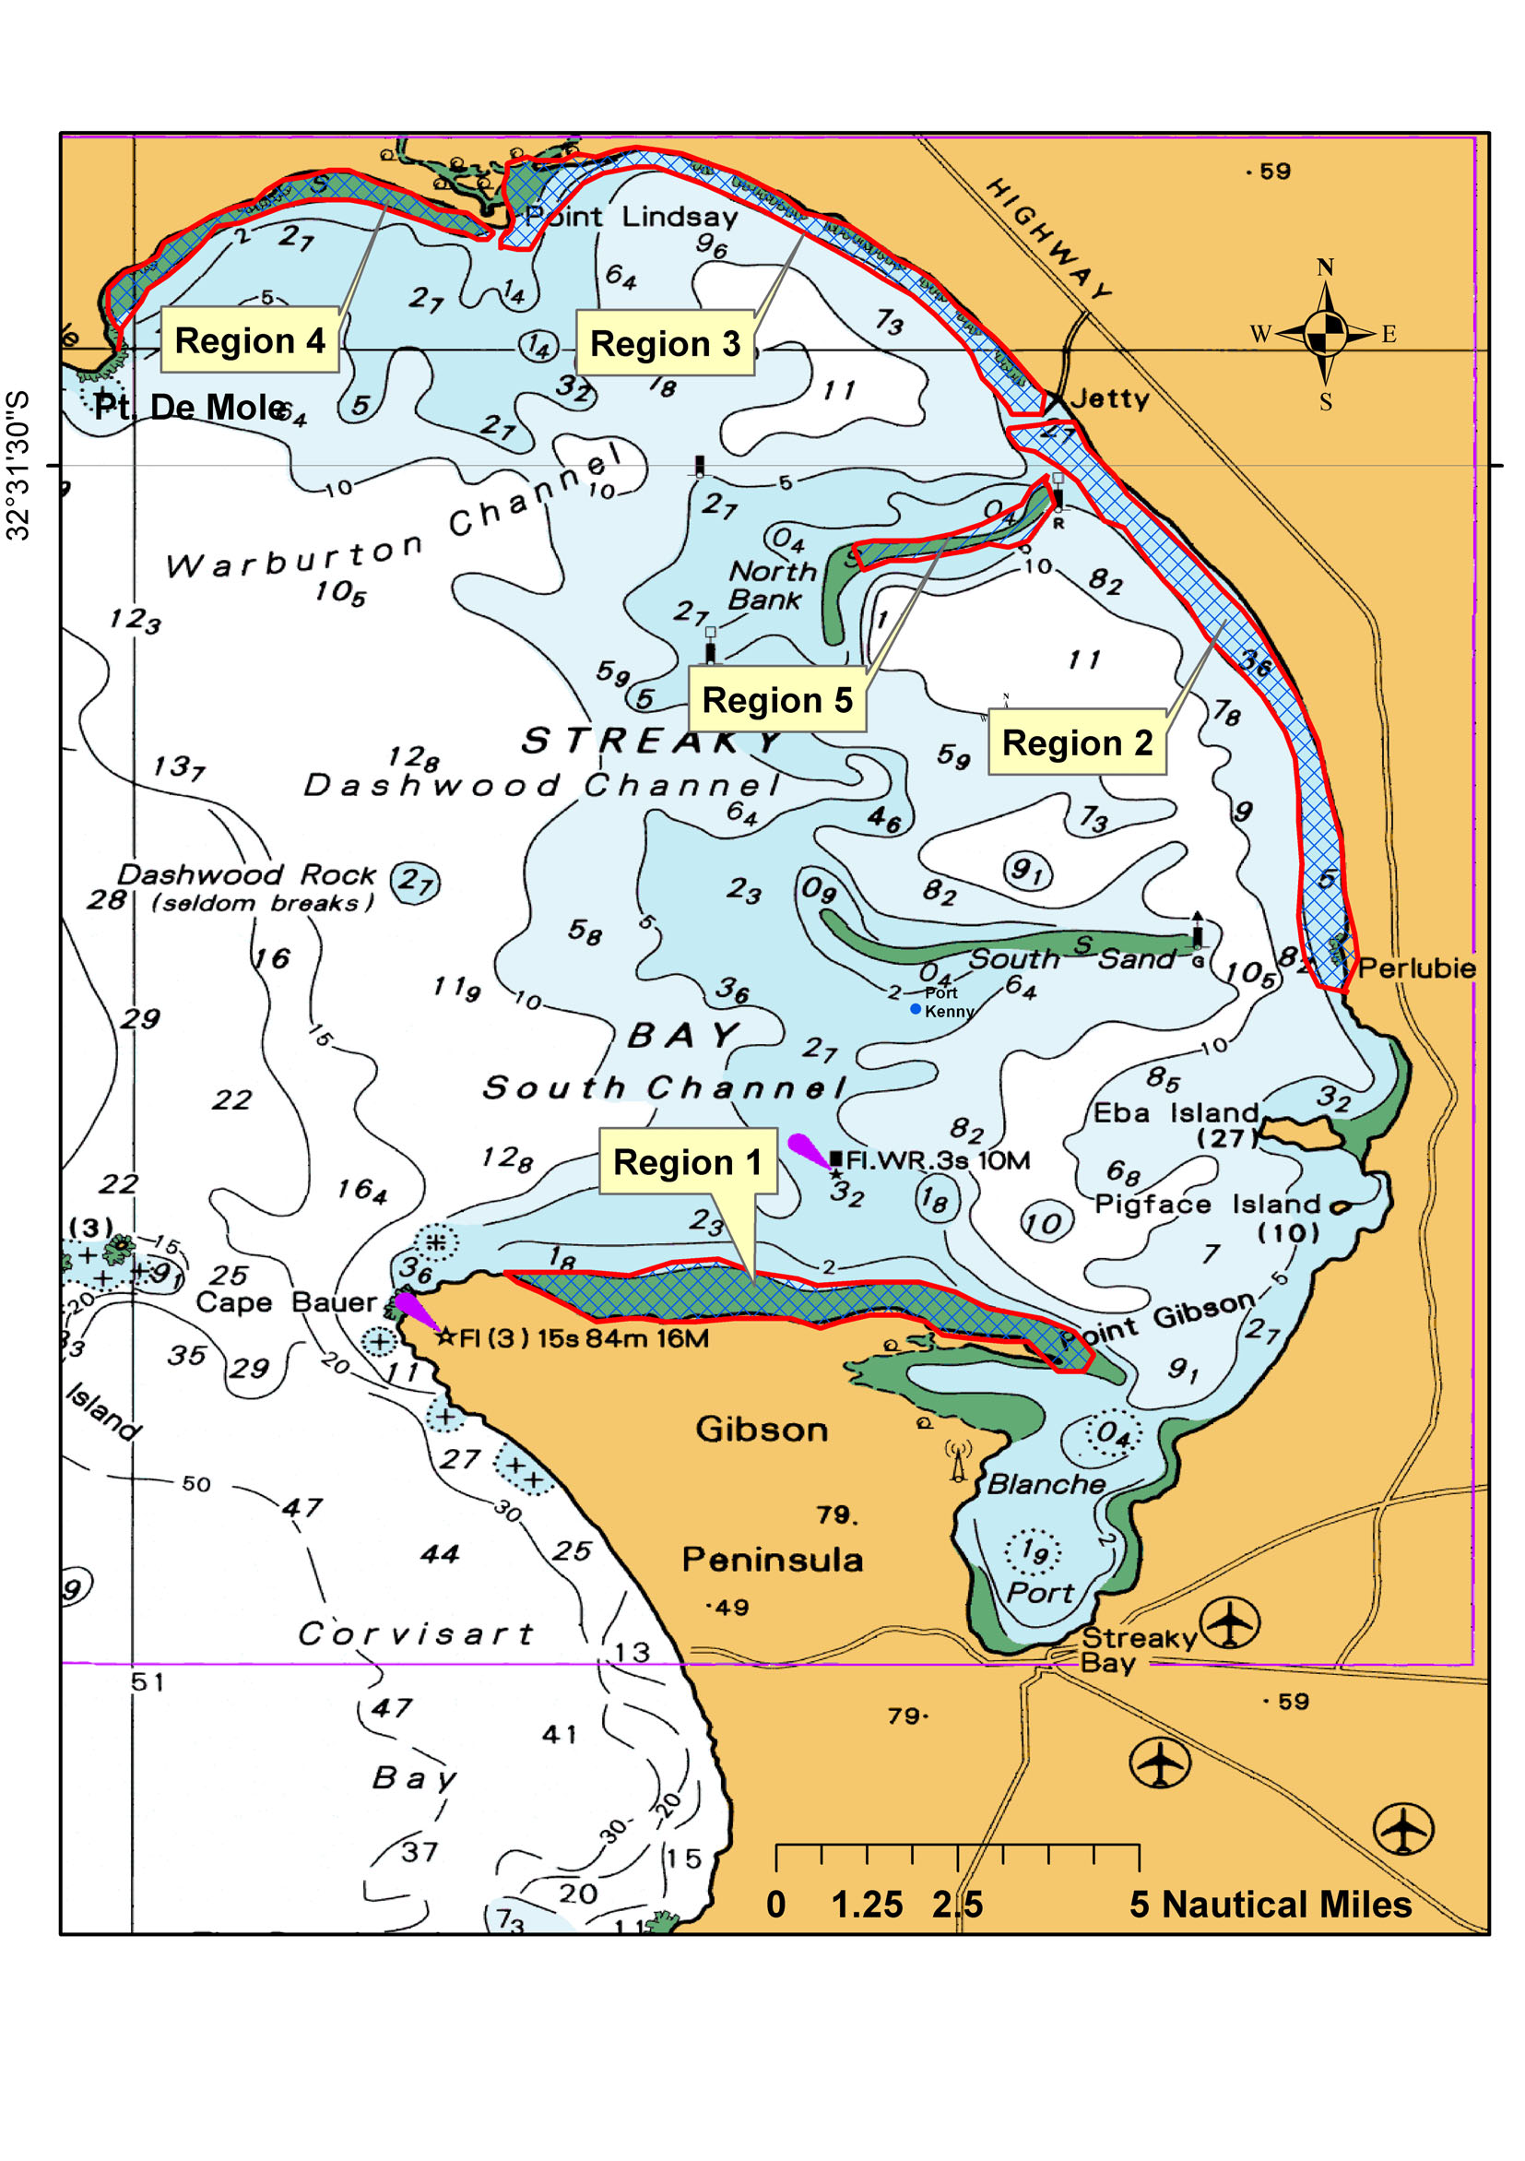
Dated 1 February 2009.
W. Zacharin, Director of Fisheries

FISHERIES MANAGEMENT ACT 2007: SECTION 115
TAKE notice that pursuant to section 115 of the Fisheries Management Act 2007, Darren Hicks of the Australian Water Quality Centre, Private Mail Bag 3, Salisbury, S.A. 5108 (the ‘exemption holder’) or a person acting as his authorised agent, is exempt from sections 70 and 78 of the Fisheries Management Act 2007, but only insofar as he may collect, retain and relocate fish from the waters described in Schedule 1 (the ‘exempted activity’), using gear listed in Schedule 2, subject to the conditions set out in Schedule 3, from 4 February 2009 until 30 June 2009, unless varied or revoked earlier.
Schedule 1
The River Torrens water catchment in the area known as the Breakout Creek Wetlands.
Schedule 2
• 3 Fyke nets with 10 m span, maximum 1 m diameter entrance and minimum mesh size of 6 mm.
• 1 seine net with a maximum length of 10 m and minimum mesh size of 12 mm.
• 1 seine net with a maximum length of 25 m and minimum mesh size of 15 mm.
• 1 seine net with a maximum length of 3.5 m and minimum mesh size of 10 mm.
• 5 bait traps with a maximum opening of 5 cm.
• 1 dip net per person.
Schedule 3
1. The fish collected by the exemption holder may be relocated within the waters described in Schedule 1, or held in situ tem-porary captive maintenance within the waters described in Schedule 1 only, and must not be sold.
2. All native fish taken pursuant to the exempted activity must be returned alive to the water as soon as possible except those fish held in temporary captive maintenance.
3. All non-native species must not be returned to the water and must be disposed of.
4. The authorised agents are Scott Howell, Rachel Clancy, Paul McEvoy, Susan Grey or Sonia Barter to undertake the exempted activity on his behalf as his agent.
5. Within 14 days of the collection of fish pursuant to this notice, the exemption holder must provide a report in writing to the Director of Fisheries (Attention: Mark Ayliffe, G.P.O. Box 1625, Adelaide, S.A. 5001), giving the following details:
• the date and time of collection;
• the name and number of each species taken, including any mortalities resulting from collecting;
• details of any organisms released; and
• details of any organisms held in situ and the temporary captive maintenance locations.
6. The exemption holder must notify PIRSA Fisheries Compliance on 1800 065 522 at least two hours prior to conducting the exempted activity and answer a series of questions about the exempted activity. The exemption holder will need to have a copy of the exemption at the time of making the call, and be able to provide information about the area and time of the exempted activity, the vehicles and boats involved, the number of agents undertaking the exempted activity and other related questions. Exemption No. 9902207.
7. While engaged in the exempted activity, the exemption holder must be in possession of a copy of this notice. Such notice must be produced to a PIRSA Fisheries Compliance Officer if requested.
8. The exemption holder must not contravene or fail to comply with the Fisheries Management Act 2007, or any regulations made under that Act, except where specifically exempted by this notice.
Dated 2 February 2009.
W. Zacharin, Director of Fisheries

GEOGRAPHICAL NAMES ACT 1991
Notice to Alter Boundaries of Places
NOTICE is hereby given pursuant to section 11B (5) of the Geographical Names Act 1991, that I, PETER MACLAREN KENTISH, Surveyor-General and Delegate appointed by Patrick Conlon, Minister for Infrastructure, Minister of the Crown to whom the administration of the Geographical Names Act 1991 is committed DO HEREBY alter the following boundaries as listed in the schedule below:
The Schedule
Description | File Reference | Date of  Approval
Move the rural locality boundary of Hay Valley to the southern boundary of Lot 93 in Deposited Plan 64153 so that the whole of the Lot is within Hay Valley. | DTEI 22-413/09/0003 | 21.1.09
The altered boundary can be viewed on the Land Services Property Location Browser (PLB) website at:
www.landservices.sa.gov.au/1Online_Services/20PLB/0default.asp
or by contacting the Geographical Name Unit, DTEI on (08) 8204 8539.
P. M. Kentish, Surveyor-General

LIQUOR LICENSING ACT 1997
Notice of Application
NOTICE is hereby given, pursuant to section 52 (2) (b) of the Liquor Licensing Act 1997, that Mars Cav Pty Ltd as trustee for Mars Cav Unit Trust has applied to the Licensing Authority for the transfer of a Restaurant Licence in respect of premises situated at Shops 9 and 10, 184 Frederick Road, Grange, S.A. 5022, known as Cafe Emilios and to be known as Amici Pizza Café.
The application has been set down for hearing on 5 March 2009 at 9.30 a.m.
Any person may object to the application by lodging a notice of objection in the prescribed form with the Liquor and Gambling Commissioner and serving a copy of the notice on the applicant at the applicant’s address, at least seven days before the hearing date (viz: 26 February 2009).
The applicant’s address for service is c/o Mario Cavuoto,
Shop 9 and 10, 184 Frederick Road, Grange, S.A. 5022.
Plans in respect of the premises the subject of the application are open to public inspection without fee at the Office of the Liquor and Gambling Commissioner, 9th Floor, East Wing, 50 Grenfell Street, Adelaide, S.A. 5000. Phone 8226 8410, Fax:
8226 8512. Email: olgc@agd.sa.gov.au.
Dated 28 January 2009.
Applicant

LIQUOR LICENSING ACT 1997
Notice of Application
NOTICE is hereby given, pursuant to section 52 (2) (b) of the Liquor Licensing Act 1997, that Fodder Coonawarra Pty Ltd has applied to the Licensing Authority for the transfer of a Restaurant Licence in respect of premises situated at Memorial Drive, Coonawarra, S.A. 5263, known as Redfingers and to be known as Fodder Coonawarra.
The application has been set down for hearing on 5 March 2009 at 9 a.m.
Any person may object to the application by lodging a notice of objection in the prescribed form with the Liquor and Gambling Commissioner and serving a copy of the notice on the applicant at the applicant’s address, at least seven days before the hearing date (viz: 26 February 2009).
The applicant’s address for service is c/o David Watts and Associates, 1 Cator Street, Glenside, S.A. 5065.
Plans in respect of the premises the subject of the application are open to public inspection without fee at the Office of the Liquor and Gambling Commissioner, 9th Floor, East Wing, 50 Grenfell Street, Adelaide, S.A. 5000. Phone 8226 8410, Fax:
8226 8512. Email: olgc@agd.sa.gov.au.
Dated 28 January 2009.
Applicant

LIQUOR LICENSING ACT 1997
Notice of Application
NOTICE is hereby given, pursuant to section 52 (2) (b) of the Liquor Licensing Act 1997, that A. & L. Royal Investments Pty Ltd as trustee for A. T. & L. J. Royal Family Trust has applied to the Licensing Authority for a Wholesale Liquor Merchant’s Licence in respect of premises situated at 160 May Terrace, Ottoway, S.A. 5013 and to be known as Armstrong Wines.
The application has been set down for callover on 6 March 2009 at 9 a.m.
Any person may object to the application by lodging a notice of objection in the prescribed form with the Liquor and Gambling Commissioner and serving a copy of the notice on the applicant at the applicant’s address, at least seven days before the callover date (viz: 27 February 2009).
The applicant’s address for service is c/o Lynch Meyer Lawyers, 190 Flinders Street, Adelaide, S.A. 5001.
Plans in respect of the premises the subject of the application are open to public inspection without fee at the Office of the Liquor and Gambling Commissioner, 9th Floor, East Wing, 50 Grenfell Street, Adelaide, S.A. 5000. Phone 8226 8410, Fax:
8226 8512. Email: olgc@agd.sa.gov.au.
Dated 28 January 2009.
Applicant

LIQUOR LICENSING ACT 1997
Notice of Application
NOTICE is hereby given, pursuant to section 52 (2) (b) of the Liquor Licensing Act 1997, that S.A. National Football League Inc. has applied to the Licensing Authority for Alterations, Redefinition, variation to an Extended Trading Authorisation and variation to Entertainment Consent in respect of premises situated at Turner Drive, West Lakes, S.A. 5021 and known as AAMI Stadium.
The application has been set down for callover on 6 March 2009 at 9 a.m.
Conditions
The following licence conditions are sought:
• Redefinition to include the area currently known as the Adelaide Football Club Training and Rehab. Building to be known as The Crows Shed as per plans lodged with this office.
• Approval is sought for internal and external alterations to Level 2 and Level 3 of the abovementioned building as per plans lodged with this office.
• Variation to current Extended Trading Authorisation and Entertainment Consent to include the abovementioned areas as per plans lodged with this office.
Any person may object to the application by lodging a notice of objection in the prescribed form with the Liquor and Gambling Commissioner and serving a copy of the notice on the applicant at the applicant’s address, at least seven days before the callover date (viz: 27 February 2009).
The applicant’s address for service is c/o John Lyons, P.O. Box 1, West Lakes, S.A. 5021.
Plans in respect of the premises the subject of the application are open to public inspection without fee at the Office of the Liquor and Gambling Commissioner, 9th Floor, East Wing, 50 Grenfell Street, Adelaide, S.A. 5000. Phone 8226 8410, Fax:
8226 8512. Email: olgc@agd.sa.gov.au.
Dated 29 January 2009.
Applicant

LIQUOR LICENSING ACT 1997
Notice of Application
NOTICE is hereby given, pursuant to section 52 (2) (b) of the Liquor Licensing Act 1997, that Outback Jacks Bar & Grill Pty Ltd has applied to the Licensing Authority for a Restaurant Licence with Section 34 (1) (c) authorisation and an Extended Trading Authorisation in respect of premises situated at Shop 11, Marina Pier, Glenelg, S.A. 5045 and to be known as Outback Jacks Bar & Grill Glenelg.
The application has been set down for callover on 6 March 2009 at 9 a.m.
Conditions
The following licence conditions are sought:
• Approval under Section 34 (1) (c) to sell liquor for con-sumption on the licensed premises by persons:
(a) seated at a table; or
(b) attending a function at which food is provided.
• Extended Trading Authorisation is sought on Sundays from 8 p.m. until midnight.
Any person may object to the application by lodging a notice of objection in the prescribed form with the Liquor and Gambling Commissioner and serving a copy of the notice on the applicant at the applicant’s address, at least seven days before the callover date (viz: 27 February 2009).
The applicant’s address for service is c/o Camatta Lempens, Level 1, 345 King William Street, Adelaide, S.A. 5000 (Attention: Robert Lempens).
Plans in respect of the premises the subject of the application are open to public inspection without fee at the Office of the Liquor and Gambling Commissioner, 9th Floor, East Wing, 50 Grenfell Street, Adelaide, S.A. 5000. Phone 8226 8410, Fax:
8226 8512. Email: olgc@agd.sa.gov.au.
Dated 30 January 2009.
Applicant

LIQUOR LICENSING ACT 1997
Notice of Application
NOTICE is hereby given, pursuant to section 52 (2) (b) of the Liquor Licensing Act 1997, that Emilio Mazzone and Jennifer Ellen Mazzone have applied to the Licensing Authority for a Restaurant Licence in respect of premises situated at 38 Herbert Street, Laura, S.A. 5480 and known as De’ Cafe Laura.
The application has been set down for callover on 6 March 2009 at 9 a.m.
Any person may object to the application by lodging a notice of objection in the prescribed form with the Liquor and Gambling Commissioner and serving a copy of the notice on the applicants at the applicants’ address, at least seven days before the callover date (viz: 27 February 2009).
The applicants’ address for service is c/o Jennifer Mazzone, 38 Herbert Street, Laura, S.A. 5480.
Plans in respect of the premises the subject of the application are open to public inspection without fee at the Office of the Liquor and Gambling Commissioner, 9th Floor, East Wing, 50 Grenfell Street, Adelaide, S.A. 5000. Phone 8226 8410, Fax:
8226 8512. Email: olgc@agd.sa.gov.au.
Dated 2 February 2009.
Applicants

LIQUOR LICENSING ACT 1997
Notice of Application
NOTICE is hereby given, pursuant to section 52 (2) (b) of the Liquor Licensing Act 1997, that OSB Liquor Investments Pty Ltd has applied to the Licensing Authority for the transfer of a Retail Liquor Merchant’s Licence in respect of premises situated at 105 Galloway Road, O’Sullivan Beach, S.A. 5166 and known as O’Sullivan Beach Liquor Store.
The application has been set down for hearing on 10 March 2009 at 9 a.m.
Any person may object to the application by lodging a notice of objection in the prescribed form with the Liquor and Gambling Commissioner and serving a copy of the notice on the applicant at the applicant’s address, at least seven days before the hearing date (viz: 3 March 2009).
The applicant’s address for service is c/o Duncan Basheer Hannon, Barristers and Solicitors, G.P.O. Box 2, Adelaide, S.A. 5001 (Attention: Max Basheer or David Tillett).
Plans in respect of the premises the subject of the application are open to public inspection without fee at the Office of the Liquor and Gambling Commissioner, 9th Floor, East Wing, 50 Grenfell Street, Adelaide, S.A. 5000. Phone 8226 8410, Fax:
8226 8512. Email: olgc@agd.sa.gov.au.
Dated 29 January 2009.
Applicant

LIQUOR LICENSING ACT 1997
Notice of Application
NOTICE is hereby given, pursuant to section 52 (2) (b) of the Liquor Licensing Act 1997, that Curious Food Pty Ltd has applied to the Licensing Authority for the transfer of a Restaurant Licence in respect of premises situated at Shop 11, 329-331 Henley Beach Road, Brooklyn Park, S.A. 5032 and known as Nizam’s Indian Curry Bar.
The application has been set down for hearing on 10 March 2009 at 10 a.m.
Any person may object to the application by lodging a notice of objection in the prescribed form with the Liquor and Gambling Commissioner and serving a copy of the notice on the applicant at the applicant’s address, at least seven days before the hearing date (viz: 3 March 2009).
The applicant’s address for service is c/o Tingting Wang,
Shop 11, 329 Henley Beach Road, Brooklyn Park, S.A. 5032.
Plans in respect of the premises the subject of the application are open to public inspection without fee at the Office of the Liquor and Gambling Commissioner, 9th Floor, East Wing, 50 Grenfell Street, Adelaide, S.A. 5000. Phone 8226 8410, Fax:
8226 8512. Email: olgc@agd.sa.gov.au.
Dated 2 February 2009.
Applicant

NATIONAL ELECTRICITY LAW
THE Australian Energy Market Commission (AEMC) gives notice under the National Electricity Law of the following matter.
Under section 101, the AEMC will hold a public hearing on its draft determination on the Futures Offset Arrangements Rule change proposal.
• Venue: AEMC office, Level 5, 201 Elizabeth Street, Sydney.
• Date: 12 February 2009.
• Time: 10 a.m. to 12 noon.
Further details on the above matters are available on the AEMC’s website www.aemc.gov.au. All documents in relation to the above matters are published on the AEMC’s website and are available for inspection at the offices of the AEMC.
John Tamblyn
Chairman
Australian Energy Market Commission
Level 5, 201 Elizabeth Street
Sydney, N.S.W. 2000
Telephone: (02) 8296 7800
Facsimile: (02) 8296 7899
5 February 2009.

ROADS (OPENING AND CLOSING) ACT 1991:
SECTION 24
NOTICE OF CONFIRMATION OF ROAD
PROCESS ORDER
Road Closure
Esmeralda Street, Mannum
BY Road Process Order made on 13 October 2008, the Mid Murray Council ordered that:
1. Portion of Esmeralda Street adjoining allotment 1 in Filed Plan 119664, more particularly delineated and lettered ‘A’ in Preliminary Plan No. 08/0037 be closed.
2. The whole of the land subject to closure be transferred to Peter William Ingram and Veronica Anne Jones-Ingram in accordance with agreement for transfer dated 23 September 2008 entered into between the Mid Murray Council and P. W. Ingram and V. A. Jones-Ingram.
On 18 December 2008 that order was confirmed by the Minister for Infrastructure conditionally upon the deposit by the Registrar-General of Deposited Plan 79659 being the authority for the new boundaries.
Pursuant to section 24 (5) of the Roads (Opening and Closing) Act 1991, NOTICE of the order referred to above and its confirmation is hereby given.
Dated 5 February 2009.
P. M. Kentish, Surveyor-General

NOTICE TO MARINERS
No. 2 of 2009
South Australia—Gulf St Vincent—O’Sullivan Beach
Boat Haven—Dredging Operations
MARINERS are advised that maintenance dredging utilising the cutter suction dredge Marcon is scheduled to commence on
16 February 2009, for a period of eight weeks:
• Dredging operations will be continuous around the clock—24 hours.
• Dredge will maintain a listening watch on VHF channel 14.
• Dredge spoils will be pumped through a trailing pipeline anchored to the seabed where it crosses the entrance channel. The floating pipeline will be marked with buoys wherever required.
• Dredge will display the appropriate International Collision Regulations lights and shapes.
• Entrance to the boat haven will remain open for the currency of the project and mariners should navigate with extreme caution in the vicinity of the dredge and its trailing pipeline.
Charts affected: Aus 125 and 780.
Adelaide, 28 January 2009.
Patrick Conlon, Minister for Transport
DTEI 2009/00683

PETROLEUM ACT 2000
Grant of Petroleum Retention Licences—PRLs 17 and 18 and Renewal of PEL 103
Grant of Petroleum Retention Licences—PRLs 17 and 18
PURSUANT to section 92 (1) of the Petroleum Act 2000, notice is hereby given that the undermentioned Petroleum Retention Licences have been granted under the provisions of the Petroleum Act 2000, pursuant to delegated powers dated 28 March 2002, Gazetted 11 April 2002, page 1573:
No. of  Licence | Licensee | Locality | Expiry
PRL 17 | Innamincka Petroleum Limited | Cooper Basin of South Australia | 27 January 2014
PRL 18 | Innamincka Petroleum Limited | Cooper Basin of South Australia | 27 January 2014
Description of Area—PRL 17
All that part of the State of South Australia, bounded as follows:
Commencing at a point being the intersection of latitude 27°17′10″S GDA94 and longitude 140°47′50″E GDA94, thence east to longitude 140°49′40″E GDA94, south to latitude 27°17′40″S GDA94, west to longitude 140°49′30″E GDA94, south to latitude 27°18′30″S GDA94, west to longitude 140°49′10″E GDA94, south to latitude 27°19′50″S GDA94, east to longitude 140°50′10″E GDA94, north to latitude 27°19′20″S GDA94, east to longitude 140°51′50″E GDA94, south to latitude 27°20′10″S GDA94, west to longitude 140°51′40″E GDA94, south to latitude 27°20′50″S GDA94, east to longitude 140°52′40″E GDA94, north to latitude 27°20′30″S GDA94, east to longitude 140°53′40″E GDA94, north to latitude 27°20′10″S GDA94, east to longitude 140°54′10″E GDA94, north to latitude 27°19′50″S GDA94, east to longitude 140°54′50″E GDA94, north to latitude 27°19′30″S GDA94, east to longitude 140°55′40″E GDA94, north to latitude 27°19′10″S GDA94, east to longitude 140°56′20″E GDA94, north to latitude 27°18′50″S GDA94, east to longitude 140°57′00″E GDA94, north to latitude 27°18′30″S GDA94, east to longitude 140°57′30″E GDA94, north to latitude 27°18′10″S GDA94, east to longitude 140°58′50″E GDA94, south to latitude 27°18′30″S GDA94, west to longitude 140°58′20″E GDA94, south to latitude 27°18′40″S GDA94, west to longitude 140°58′00″E GDA94, south to latitude 27°18′50″S GDA94, west to longitude 140°57′40″E GDA94, south to latitude 27°19′00″S GDA94, west to longitude 140°57′20″E GDA94, south to latitude 27°19′10″S GDA94, west to longitude 140°56′50″E GDA94, south to latitude 27°19′30″S GDA94, west to longitude 140°56′30″E GDA94, south to latitude 27°20′00″S GDA94, west to longitude 140°56′10″E GDA94, south to latitude 27°20′30″S GDA94, west to longitude 140°55′50″E GDA94, south to latitude 27°21′00″S GDA94, west to longitude 140°55′30″E GDA94, south to latitude 27°21′20″S GDA94, west to longitude 140°54′50″E GDA94, south to latitude 27°21′50″S GDA94, west to longitude 140°50′40″E GDA94, north to latitude 27°21′40″S GDA94, east to longitude 140°51′00″E GDA94, north to latitude 27°20′30″S GDA94, west to longitude 140°49′10″E GDA94, south to latitude 27°21′30″S GDA94, west to longitude 140°48′40″E GDA94, south to latitude 27°21′50″S GDA94, west to longitude 140°47′40″E GDA94, north to latitude 27°21′40″S GDA94, west to longitude 140°46′20″E GDA94, north to latitude 27°21′10″S GDA94, east to longitude 140°46′30″E GDA94, north to latitude 27°20′40″S GDA94, east to longitude 140°46′50″E GDA94, north to latitude 27°20′10″S GDA94, east to longitude 140°47′10″E GDA94, north to latitude 27°19′50″S GDA94, east to longitude 140°47′30″E GDA94, north to latitude 27°19′30″S GDA94, east to longitude 140°47′40″E GDA94, north to latitude 27°19′10″S GDA94, east to longitude 140°47′50″E GDA94 and north to the point of commencement.
Area: 63 km² approximately.
Description of Area—PRL 18
All that part of the State of South Australia, bounded as follows:
Commencing at a point being the intersection of latitude 27°21′50″S GDA94 and longitude 140°48′00″E GDA94, thence east to longitude 140°48′40″E GDA94, south to latitude 27°22′10″S GDA94, west to longitude 140°48′20″E GDA94, south to latitude 27°22′40″S GDA94, west to longitude 140°48′00″E GDA94, south to latitude 27°23′10″S GDA94, west to longitude 140°47′40″E GDA94, south to latitude 27°23′40″S GDA94, west to longitude 140°47′20″E GDA94, south to latitude 27°24′20″S GDA94, east to longitude 140°48′50″E GDA94, north to latitude 27°23′50″S GDA94, east to longitude 140°49′10″E GDA94, north to latitude 27°23′30″S GDA94, east to longitude 140°49′30″E GDA94, north to latitude 27°23′10″S GDA94, east to longitude 140°50′00″E GDA94, north to latitude 27°22′50″S GDA94, east to longitude 140°50′20″E GDA94, north to latitude 27°22′10″S GDA94, east to longitude 140°50′40″E GDA94, north to latitude 27°21′50″S GDA94, east to longitude 140°54′20″E GDA94, south to latitude 27°22′20″S GDA94, west to longitude 140°54′10″E GDA94, south to latitude 27°23′00″S GDA94, west to longitude 140°53′50″E GDA94, south to latitude 27°23′20″S GDA94, west to longitude 140°53′30″E GDA94, south to latitude 27°23′50″S GDA94, west to longitude 140°53′10″E GDA94, south to latitude 27°24′10″S GDA94, west to longitude 140°52′40″E GDA94, south to latitude 27°24′40″S GDA94, west to longitude 140°52′20″E GDA94, south to latitude 27°25′00″S GDA94, west to longitude 140°52′00″E GDA94, south to latitude 27°25′30″S GDA94, west to longitude 140°51′40″E GDA94, south to latitude 27°25′50″S GDA94, west to longitude 140°51′20″E GDA94, south to latitude 27°26′10″S GDA94, west to longitude 140°51′00″E GDA94, south to latitude 27°26′40″S GDA94, west to longitude 140°50′30″E GDA94, south to latitude 27°27′10″S GDA94, west to longitude 140°50′10″E GDA94, south to latitude 27°27′40″S GDA94, west to longitude 140°49′40″E GDA94, south to latitude 27°28′10″S GDA94, west to longitude 140°49′10″E GDA94, south to latitude 27°28′30″S GDA94, west to longitude 140°48′30″E GDA94, north to latitude 27°27′50″S GDA94, east to longitude 140°48′50″E GDA94, north to latitude 27°27′30″S GDA94, east to longitude 140°49′10″E GDA94, north to latitude 27°27′10″S GDA94, east to longitude 140°49′30″E GDA94, north to latitude 27°26′50″S GDA94, east to longitude 140°49′50″E GDA94, north to latitude 27°26′30″S GDA94, east to longitude 140°50′10″E GDA94, north to latitude 27°25′00″S GDA94, west to longitude 140°48′10″E GDA94, south to latitude 27°25′10″S GDA94, west to longitude 140°47′20″E GDA94, south to latitude 27°25′50″S GDA94, west to longitude 140°46′50″E GDA94, south to latitude 27°26′50″S GDA94, west to longitude 140°46′10″E GDA94, south to latitude 27°27′00″S GDA94, west to longitude 140°45′30″E GDA94, north to latitude 27°26′40″S GDA94, east to longitude 140°45′50″E GDA94, north to latitude 27°26′20″S GDA94, east to longitude 140°46′00″E GDA94, north to latitude 27°25′30″S GDA94, east to longitude 140°46′20″E GDA94, north to latitude 27°25′10″S GDA94, east to longitude 140°46′30″E GDA94, north to latitude 27°24′40″S GDA94, east to longitude 140°46′40″E GDA94, north to latitude 27°24′10″S GDA94, east to longitude 140°46′50″E GDA94, north to latitude 27°23′50″S GDA94, east to longitude 140°47′10″E GDA94, north to latitude 27°23′20″S GDA94, east to longitude 140°47′30″E GDA94, north to latitude 27°23′00″S GDA94, east to longitude 140°47′40″E GDA94, north to latitude 27°22′30″S GDA94, east to longitude 140°48′00″E GDA94 and north to point of commencement.
Area: 65 km² approximately.
Renewal of Petroleum Exploration Licence—PEL 103
Notice is hereby given that the abovementioned licence has been renewed under the provisions of the Petroleum Act 2000, pursuant to delegated powers dated 28 March 2002, Gazetted 11 April 2002, page 1573:

No. of Licence | Licensee | Locality | Date of Expiry | Area in km²
PEL 103 | Innamincka Petroleum Limited | Cooper Basin of South Australia | 28 July 2013 | 232
All that part of the State of South Australia, bounded as follows:
Area 1
Commencing at a point being the intersection of latitude 27°21′10″S GDA94 and longitude 140°59′00″E GDA94, thence east to the eastern border of the State of South Australia, thence southerly along the border of the said State to latitude 27°30′00″S GDA94, west to longitude 140°59′30″E GDA94, south to latitude 27°30′20″S GDA94, west to longitude 140°59′10″E GDA94, south to latitude 27°30′40″S AGD66, west to longitude 140°54′30″E AGD66, south to latitude 27°31′40″S AGD66, west to longitude 140°52′40″E AGD66, south to latitude 27°32′00″S GDA94, west to longitude 140°49′40″E GDA94, north to latitude 27°30′20″S GDA94, west to longitude 140°49′20″E GDA94, north to latitude 27°30′00″S GDA94, west to longitude 140°47′10″E GDA94, north to latitude 27°29′10″S GDA94, east to longitude 140°47′30″E GDA94, north to latitude 27°29′00″S GDA94, east to longitude 140°48′30″E GDA94, north to latitude 27°28′30″S GDA94, east to longitude 140°49′10″E GDA94, north to latitude 27°28′10″S GDA94, east to longitude 140°49′40″E GDA94, north to latitude 27°27′40″S GDA94, east to longitude 140°50′10″E GDA94, north to latitude 27°27′10″S GDA94, east to longitude 140°51′10″E GDA94, south to latitude 27°28′30″S GDA94, east to longitude 140°51′30″E GDA94, north to latitude 27°28′00″S GDA94, east to longitude 140°51′50″E GDA94, north to latitude 27°27′30″S GDA94, east to longitude 140°52′10″E GDA94, north to latitude 27°27′00″S GDA94, east to longitude 140°52′30″E GDA94, north to latitude 27°26′30″S GDA94, east to longitude 140°52′50″E GDA94, north to latitude 27°26′00″S GDA94, east to longitude 140°53′10″E GDA94, north to latitude 27°25′30″S GDA94, east to longitude 140°53′30″E GDA94, north to latitude 27°25′00″S GDA94, east to longitude 140°53′50″E GDA94, north to latitude 27°24′30″S GDA94, east to longitude 140°54′10″E GDA94, north to latitude 27°24′00″S GDA94, east to longitude 140°54′40″E GDA94, north to latitude 27°23′40″S GDA94, east to longitude 140°55′10″E GDA94, north to latitude 27°23′10″S GDA94, east to longitude 140°55′40″E GDA94, north to latitude 27°22′10″S GDA94, east to longitude 140°56′20″E GDA94, north to latitude 27°22′00″S GDA94, east to longitude 140°57′00″E GDA94, north to latitude 27°21′50″S GDA94, east to longitude 140°57′40″E GDA94, north to latitude 27°21′30″S GDA94, east to longitude 140°58′20″E GDA94, north to latitude 27°21′20″S GDA94, east to longitude 140°59′00″E GDA94 and north to the point of commencement.
Area 2
Commencing at a point being the intersection of latitude 27°15′30″S GDA94 and longitude 140°57′00″E GDA94, thence east to longitude 140°58′40″E GDA94, south to latitude 27°16′10″S GDA94, west to longitude 140°57′00″E GDA94 and north to the point of commencement.
Area: 232 km² approximately.
Dated 28 January 2009.
M. Malavazos, Acting Director Petroleum and Geothermal
Minerals and Energy Resources
Primary Industries and Resources SA
Delegate of the Minister for Mineral Resources Development

PETROLEUM ACT 2000
Grant of Associated Facilities Licences—AFLs 149 and 150
(Adjunct to Petroleum Exploration Licence PEL 104)
NOTICE is hereby given that the undermentioned Associated Facilities Licence has been granted under the provisions of the Petroleum Act 2000, pursuant to delegated powers dated 28 March 2002, Gazetted 11 April 2002, page 1573.
No. of  Licence | Licensee | Locality | Area  in km² | Reference
AFL 149 | Victoria Oil Exploration (1977) Pty Ltd  Permian Oil Pty Ltd  Springfield Oil and Gas Pty Ltd  Impress (Cooper Basin) Pty Ltd | Cooper Basin | 2.57 | 27/02/555
AFL 150 |  | Cooper Basin | 4.94 | 27/02/555
Description of Area—AFL 149
All that part of the State of South Australia, bounded as follows:
Commencing at a point being the intersection of latitude 27°29′52″S GDA94 and longitude 139°29′49″E GDA94, thence east to longitude 139°30′00″E AGD66, south to latitude 27°33′08″S GDA94, west to longitude 139°29′49″E GDA94 and north to the point of commencement.
Area: 2.57 km² approximately.
Description of Area—AFL 150
All that part of the State of South Australia, bounded as follows:
Commencing at a point being the intersection of latitude 27°35′00″S AGD66 and longitude 139°31′14″E GDA94, thence east to longitude 139°35′00″E AGD66, south to latitude 27°35′20″S GDA94, west to longitude 139°31′14″E GDA94 and north to the point of commencement.
Area: 4.94 km² approximately.
Dated 3 February 2009.
B. A. Goldstein, Director Petroleum and Geothermal
Minerals and Energy Resources
Primary Industries and Resources SA
Delegate of the Minister for Mineral Resources Development

Treasurer’s Quarterly Statement

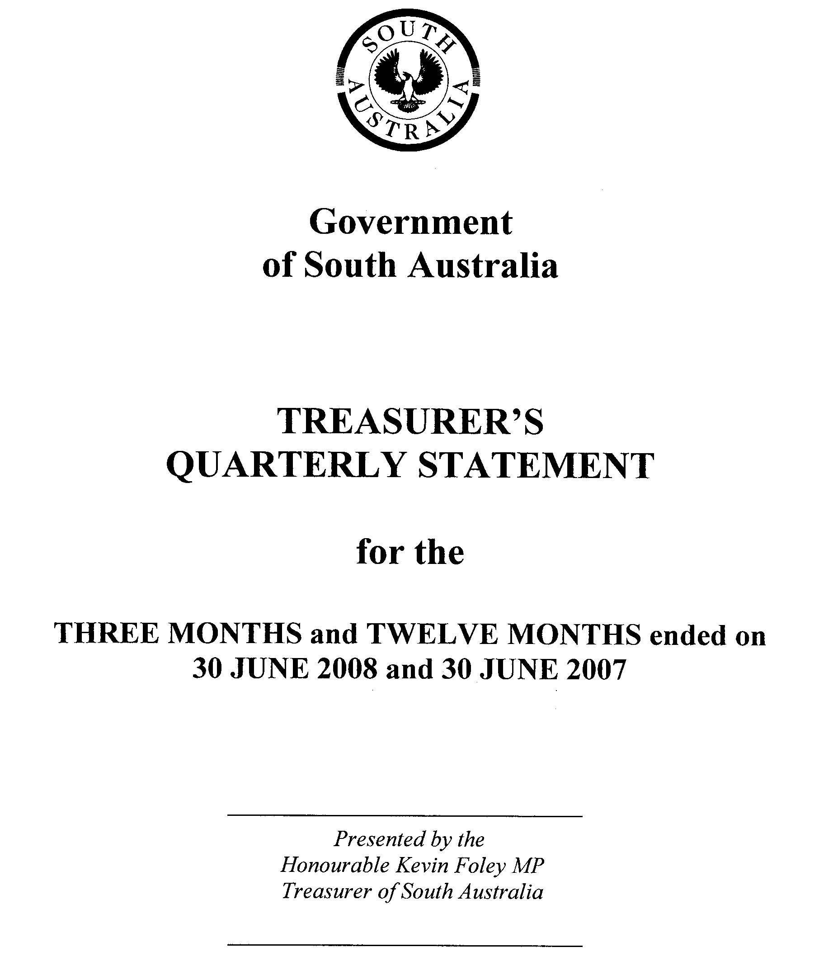
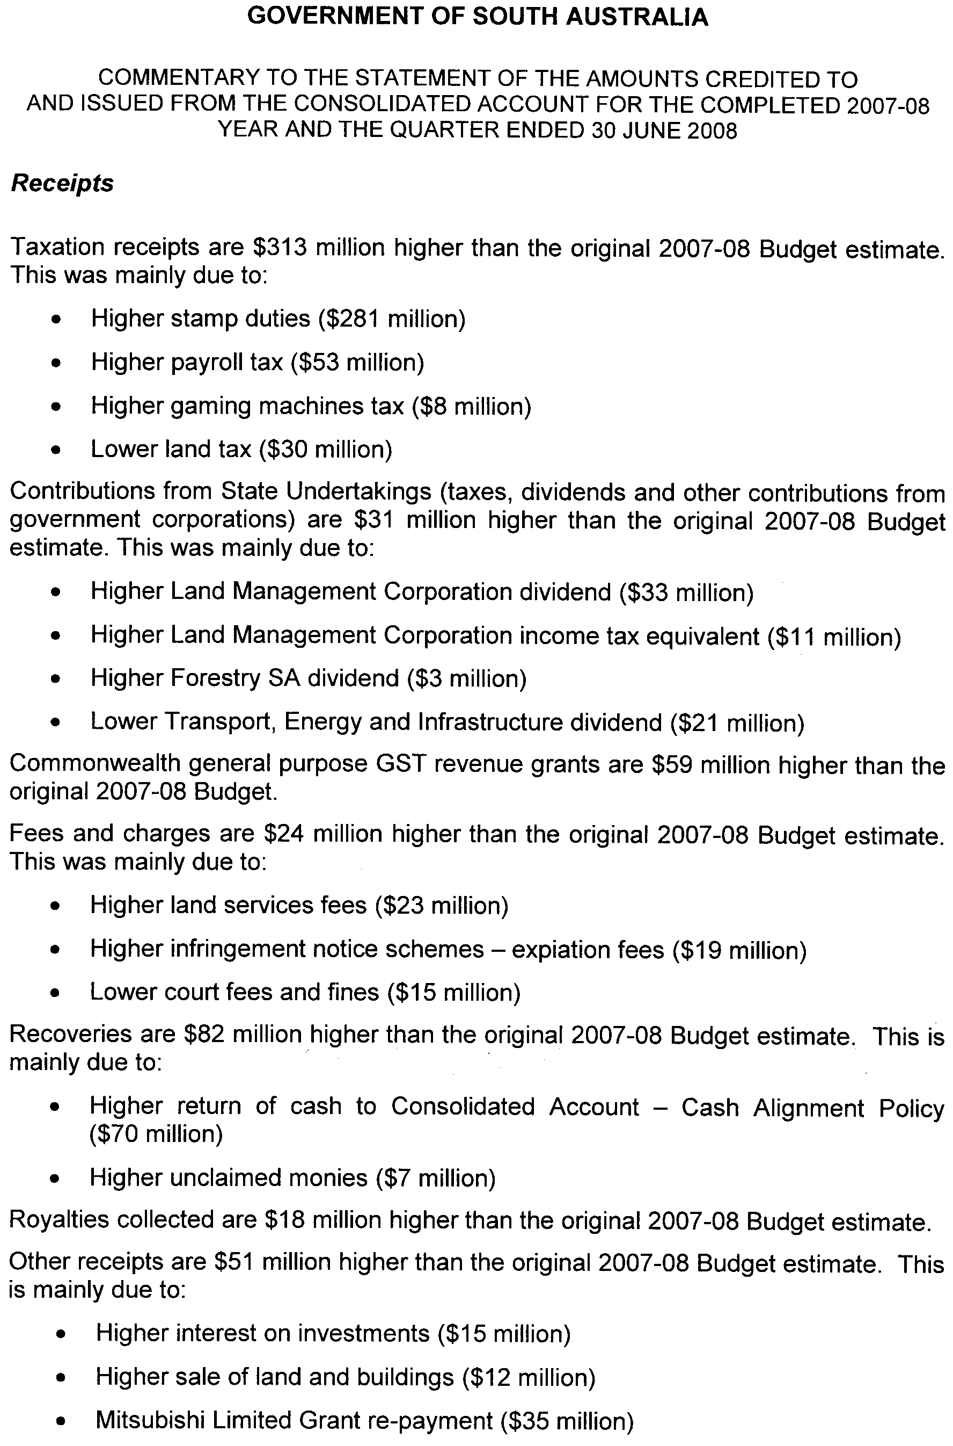
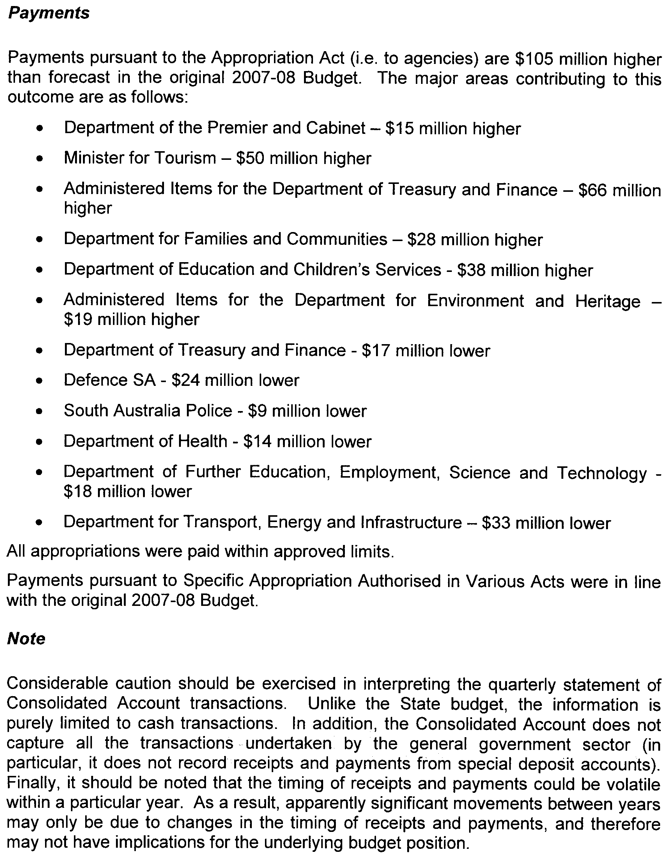
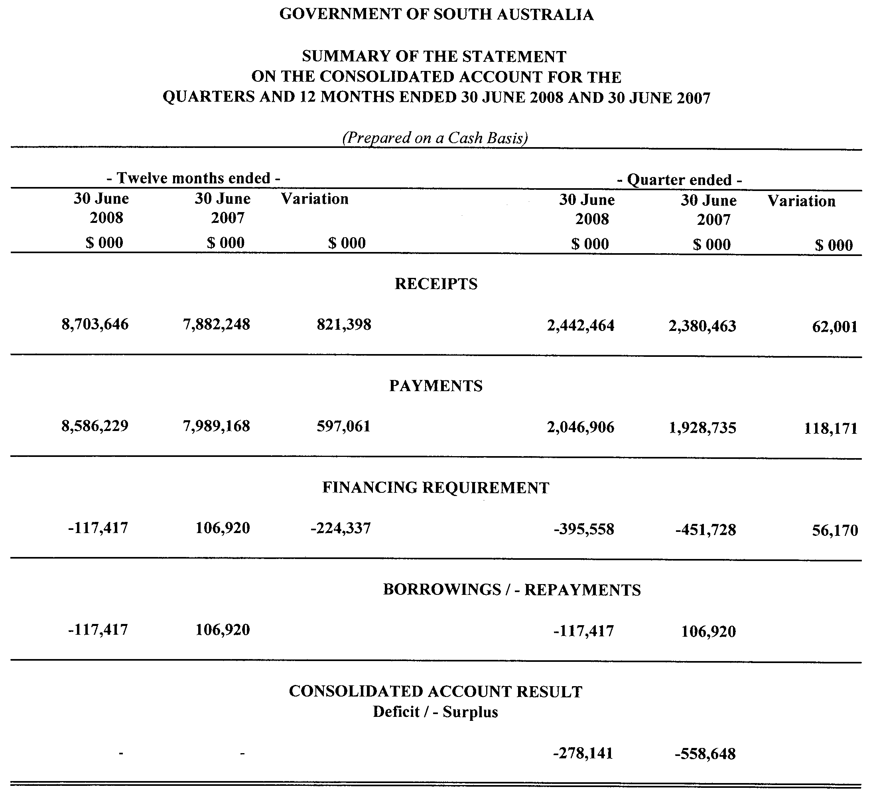
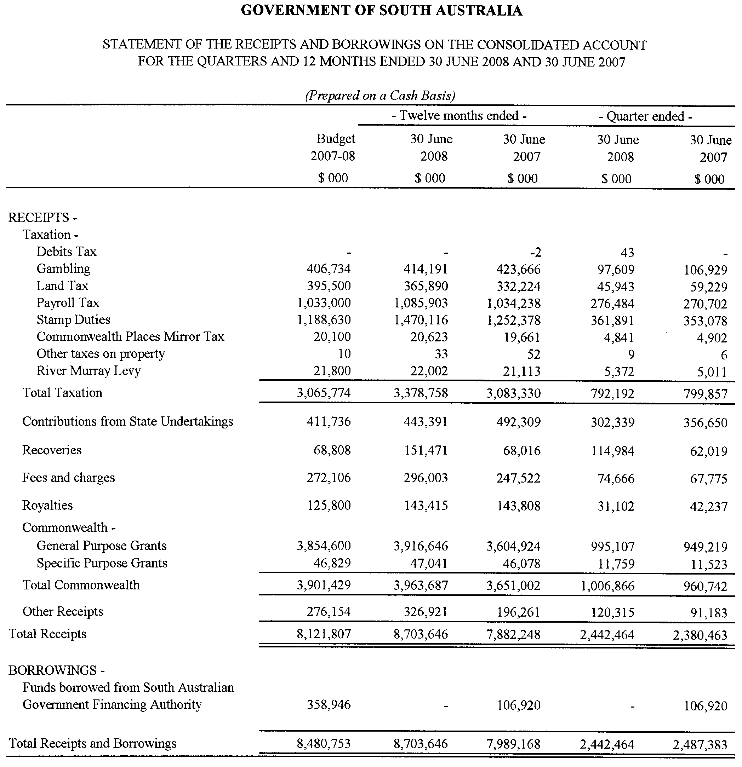
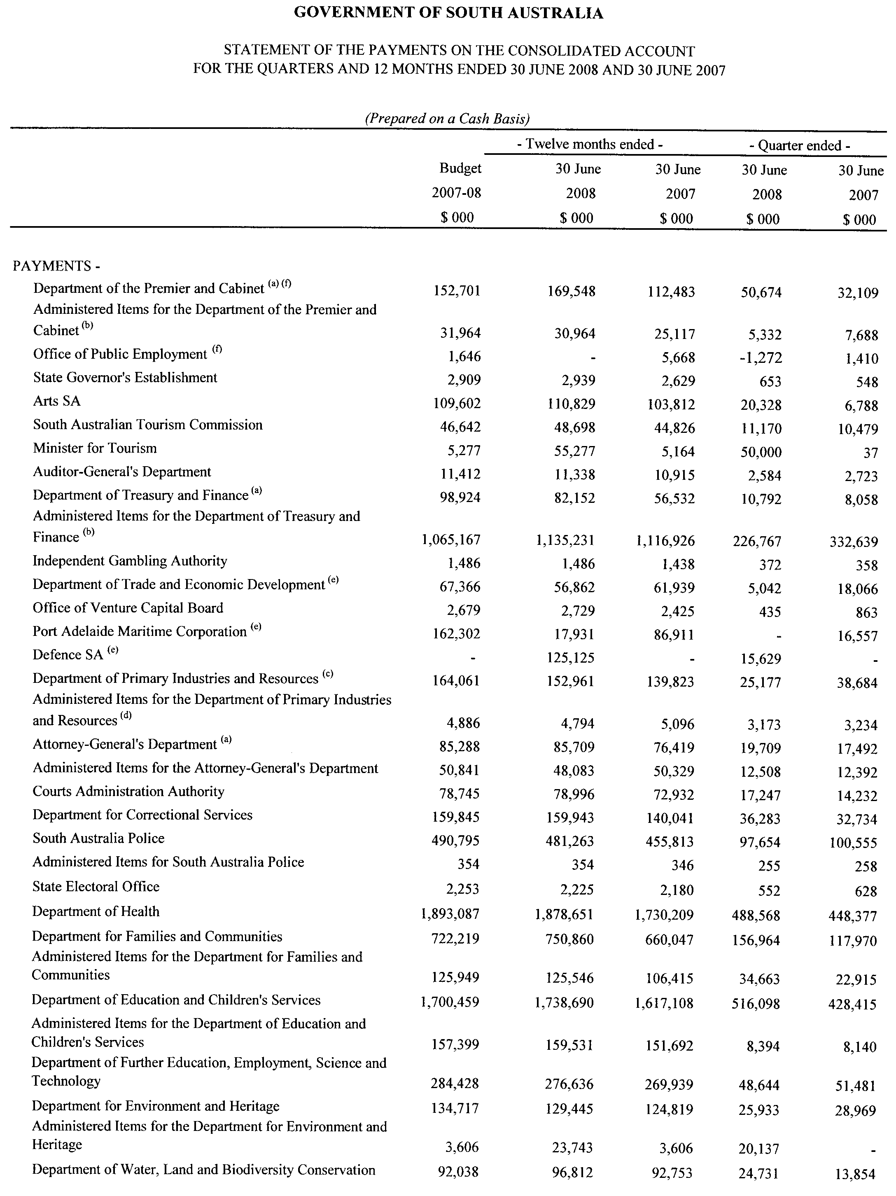
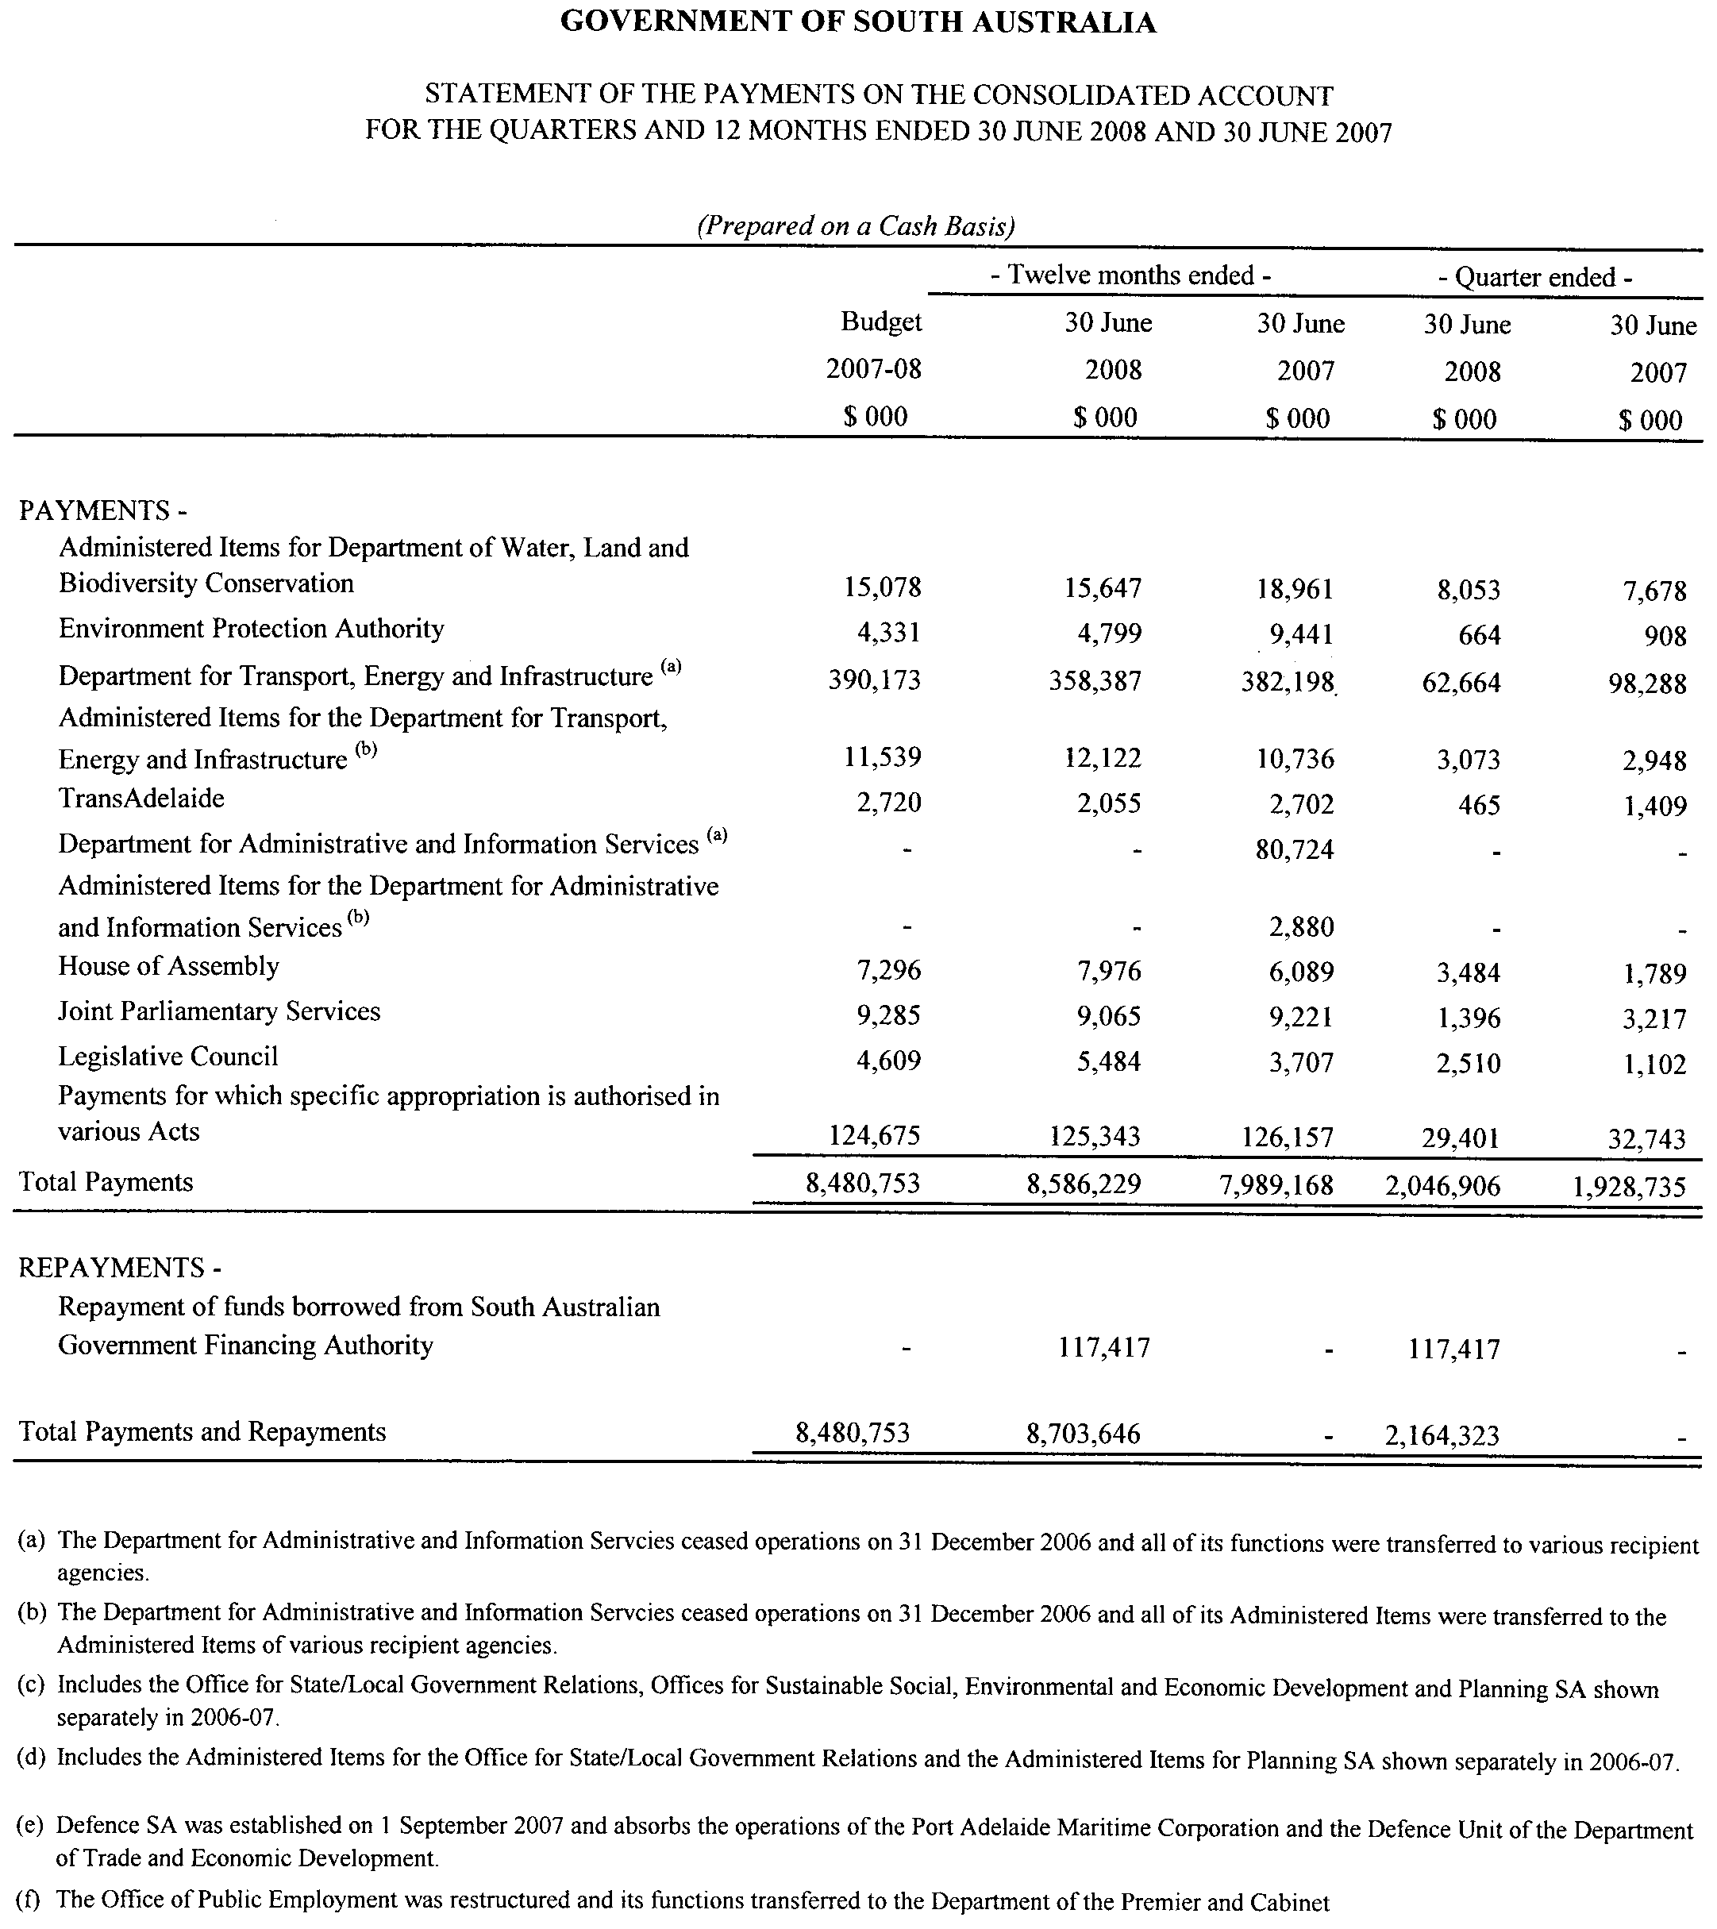

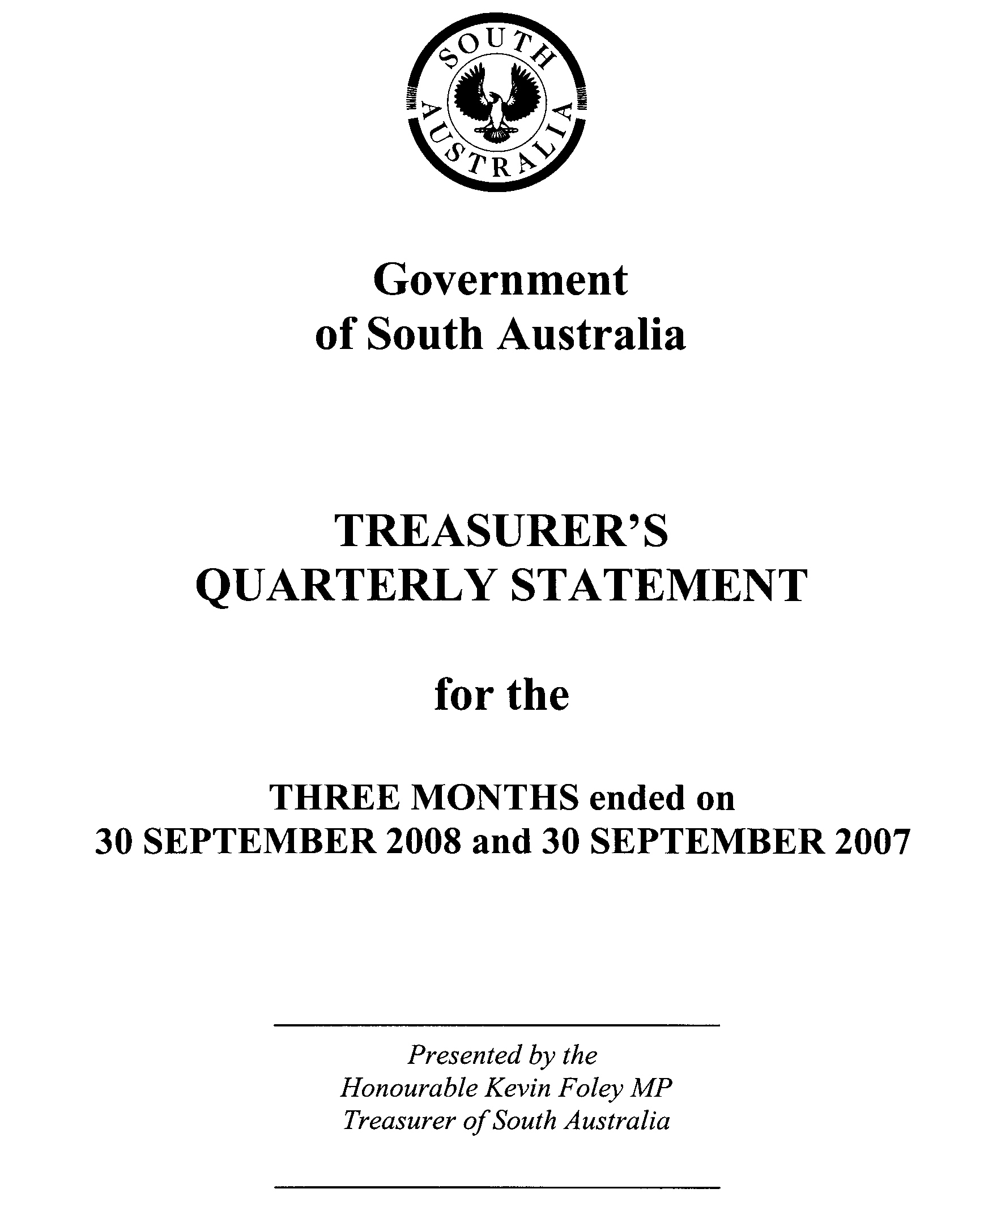
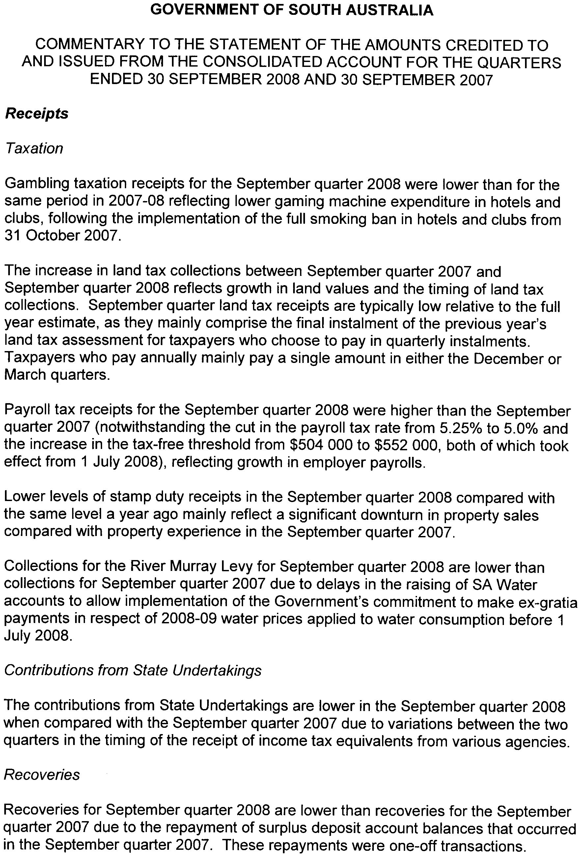
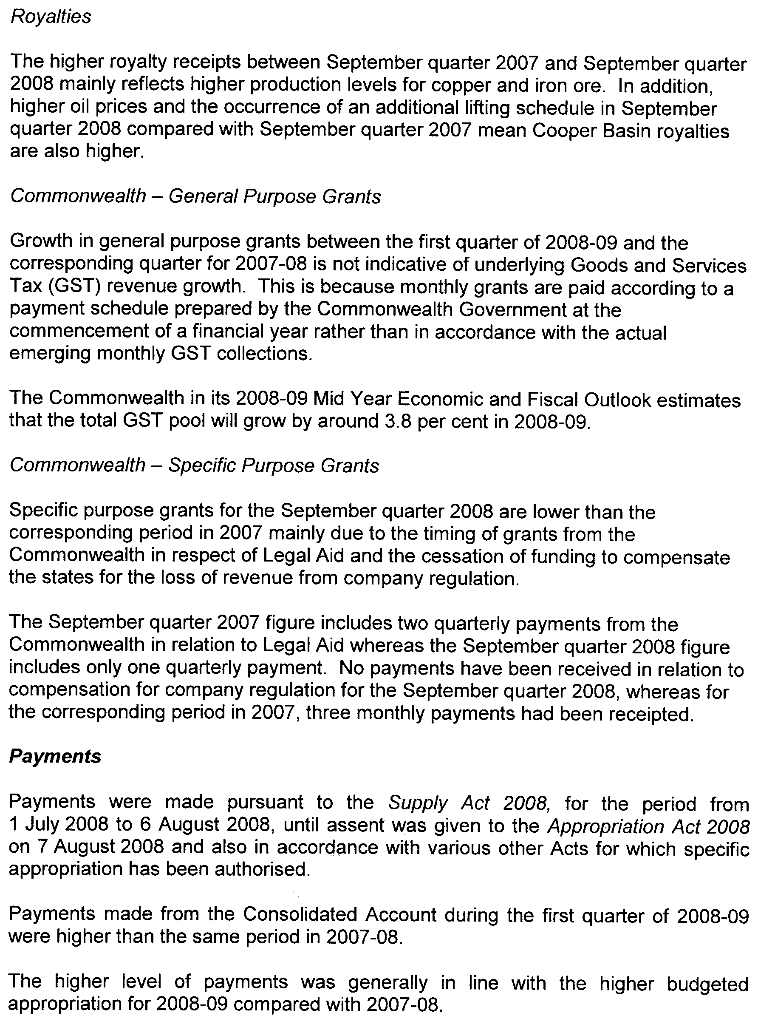
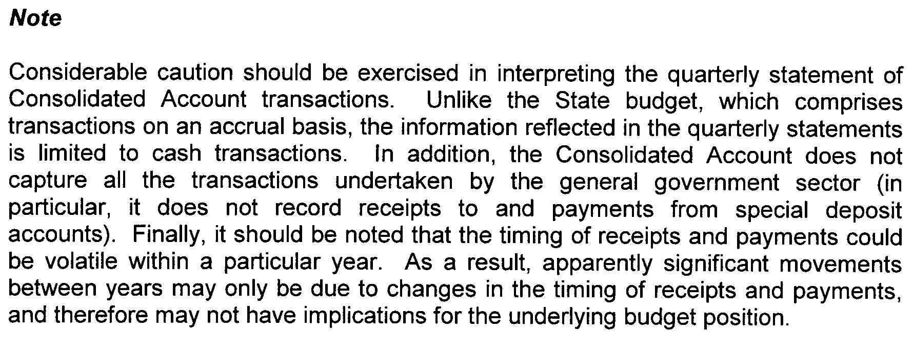
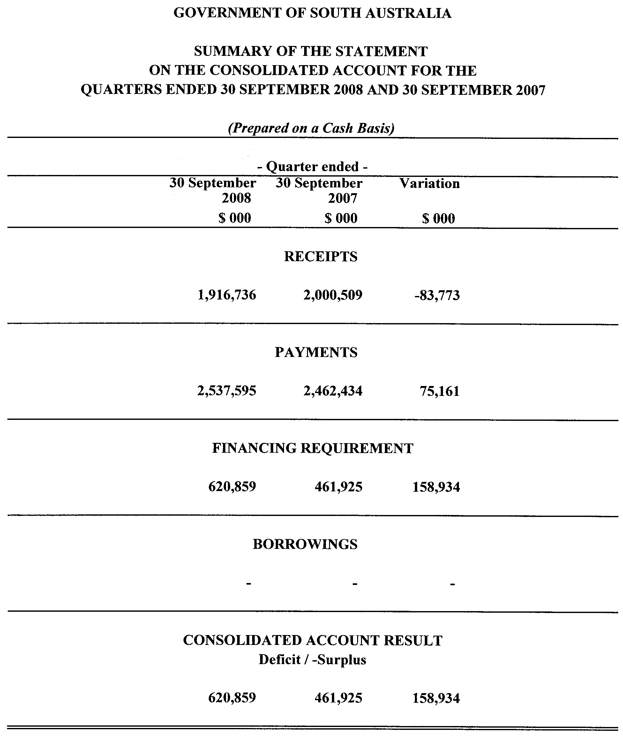
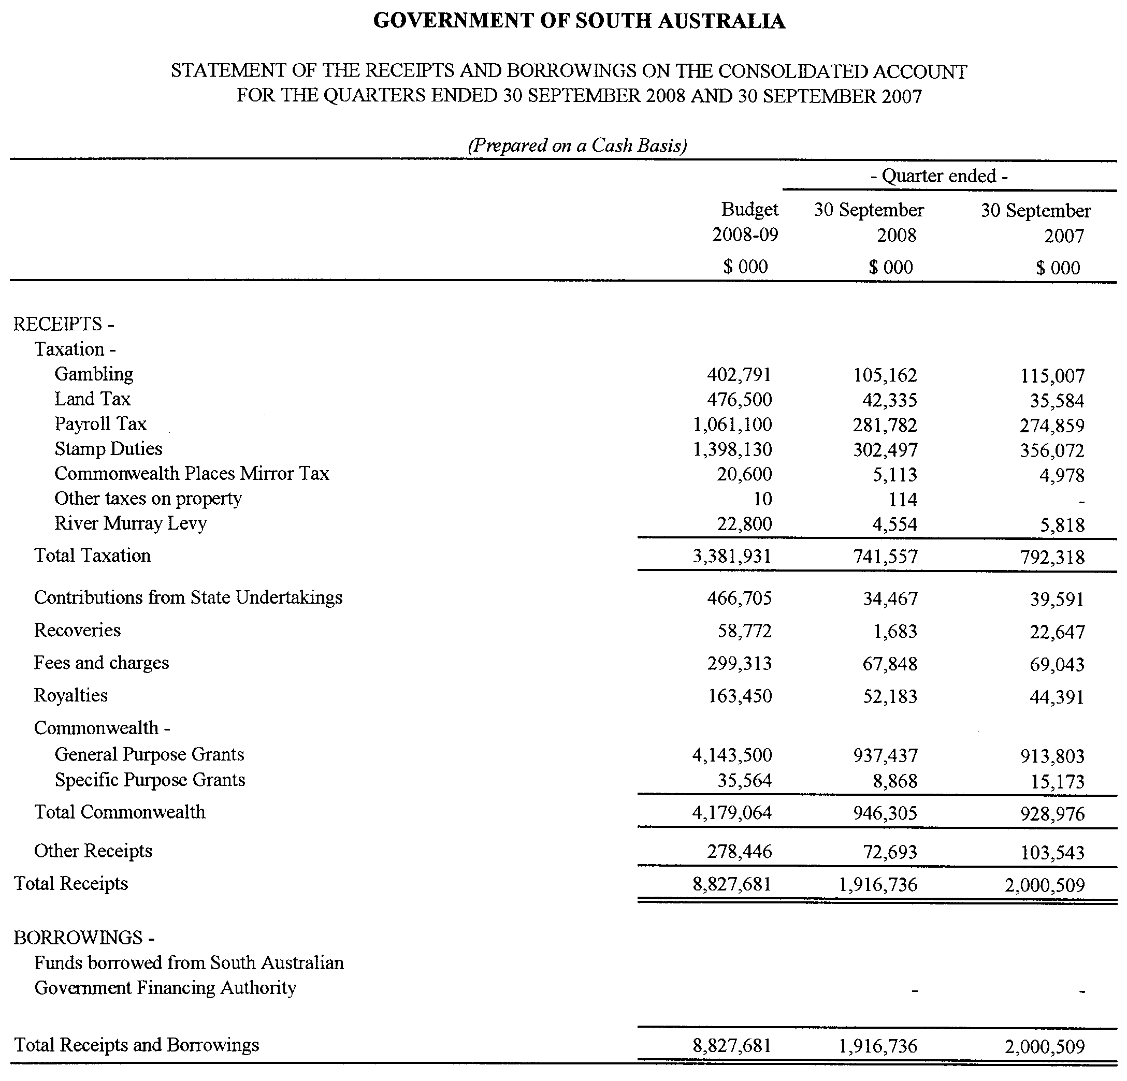
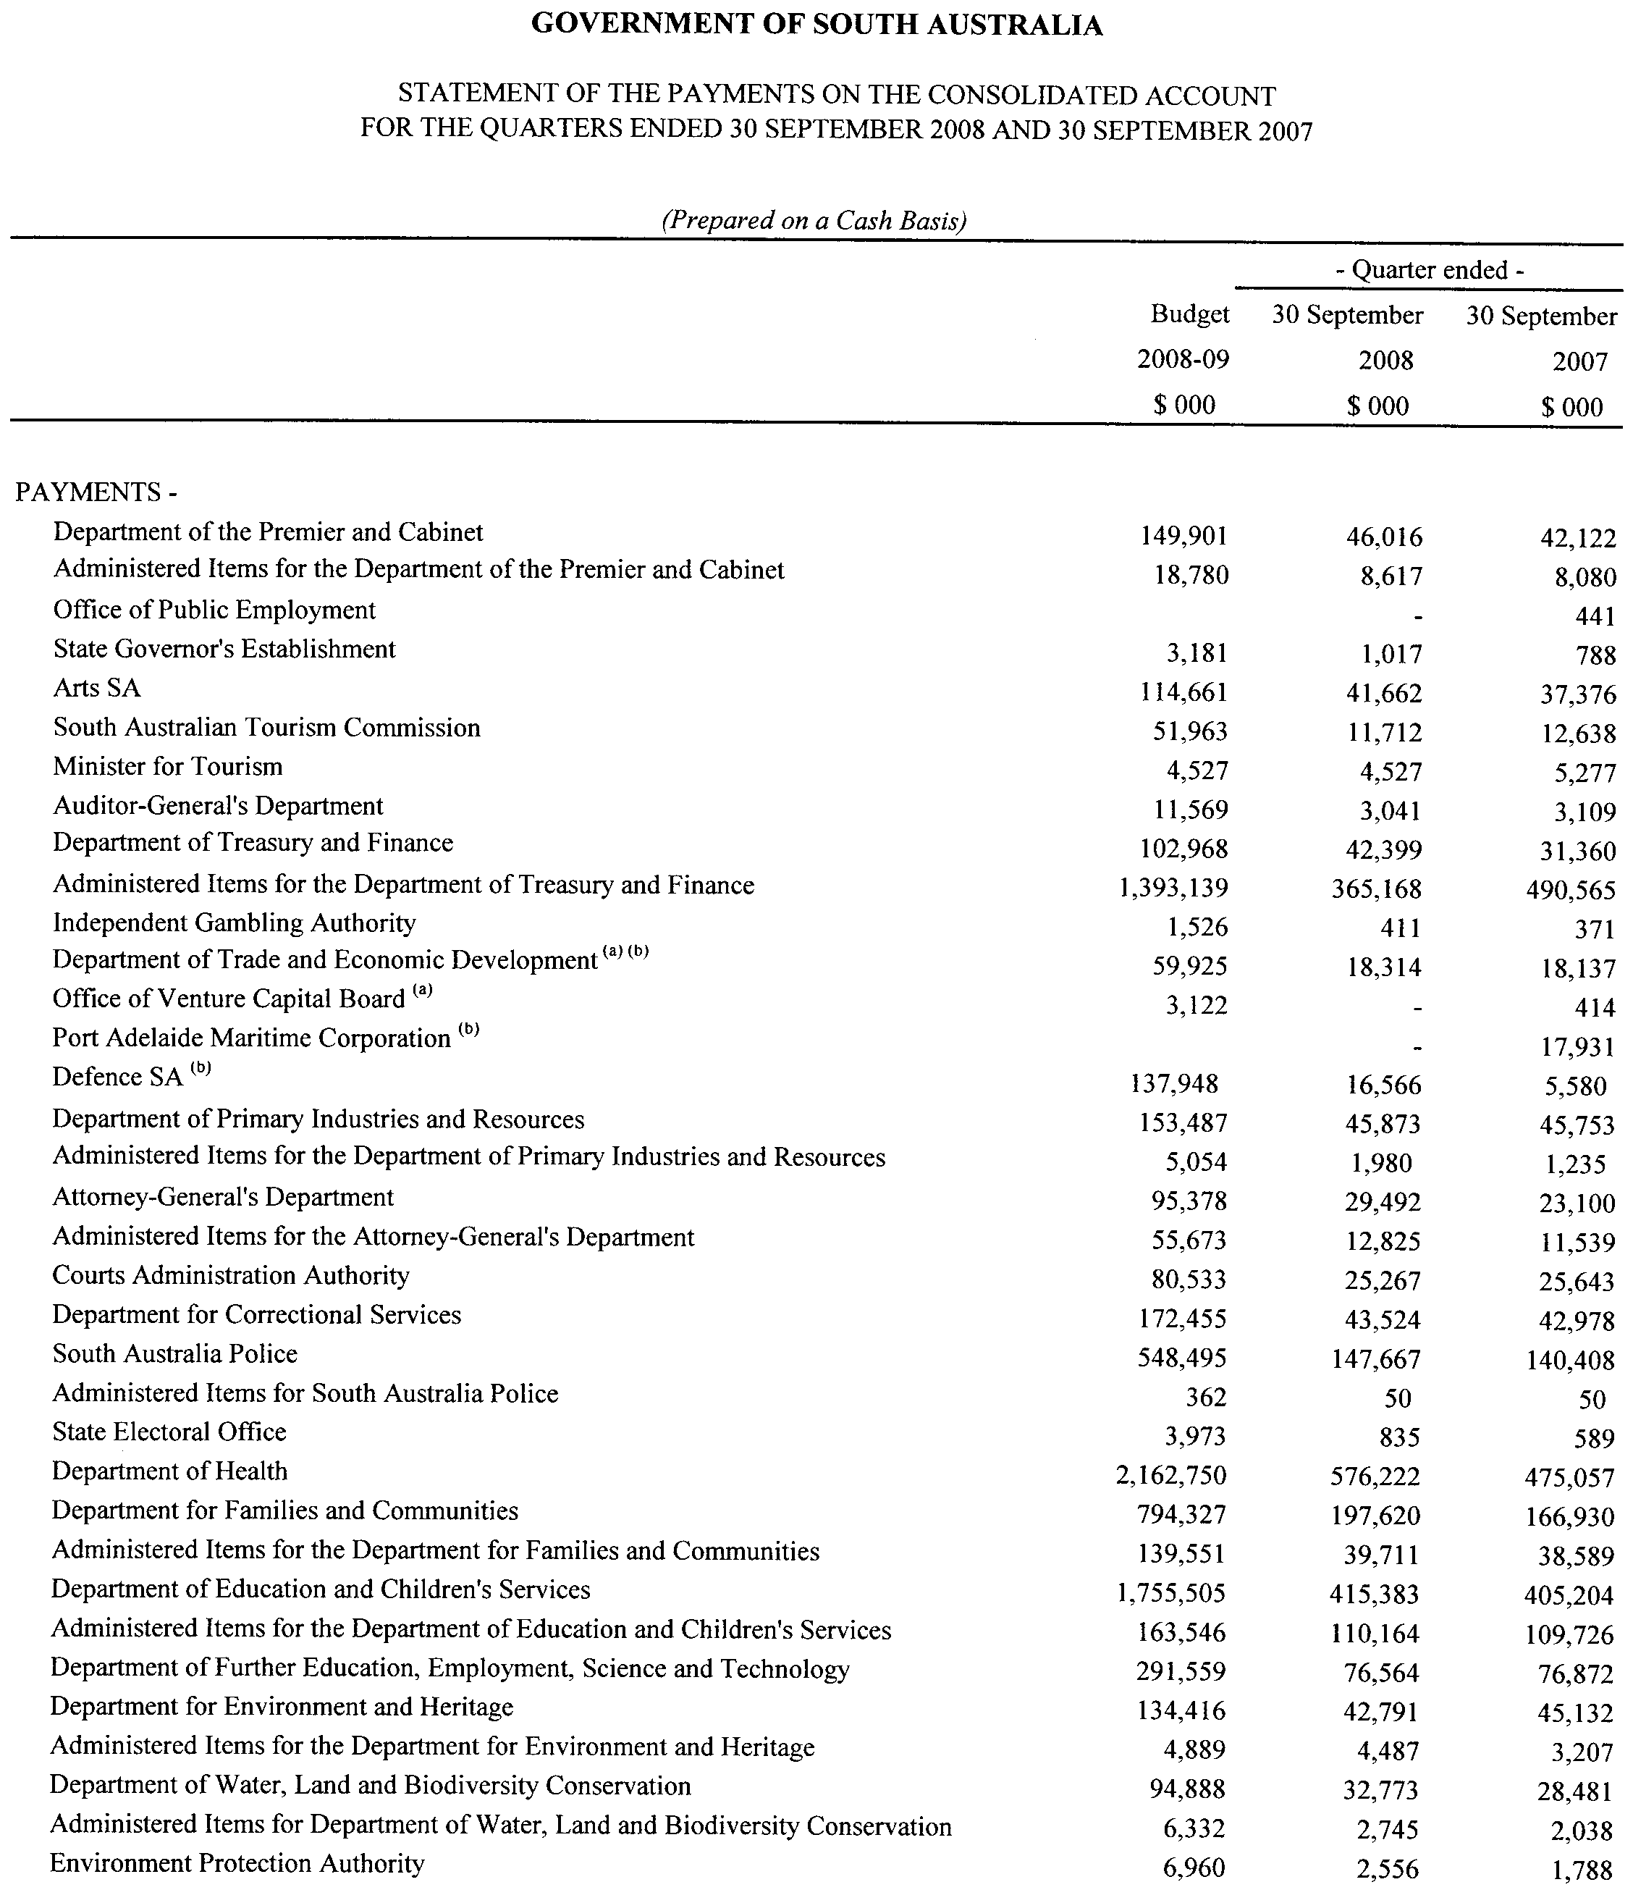
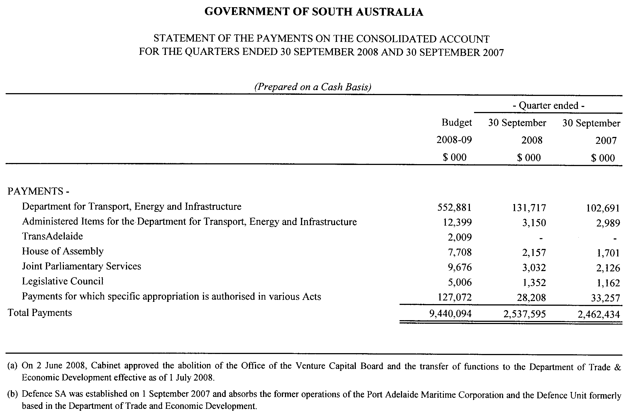

GOVERNMENT GAZETTE ADVERTISEMENT RATES

To apply from 1 July 2008

$  Agents, Ceasing to Act as 41.00  Associations:  Incorporation 20.80  Intention of Incorporation 51.50  Transfer of Properties 51.50  Attorney, Appointment of 41.00  Bailiff’s Sale 51.50  Cemetery Curator Appointed 30.50  Companies:  Alteration to Constitution 41.00  Capital, Increase or Decrease of 51.50  Ceasing to Carry on Business 30.50  Declaration of Dividend 30.50  Incorporation 41.00  Lost Share Certificates:  First Name 30.50  Each Subsequent Name 10.50  Meeting Final 34.25  Meeting Final Regarding Liquidator’s Report on  Conduct of Winding Up (equivalent to ‘Final  Meeting’)  First Name 41.00  Each Subsequent Name 10.50  Notices:  Call 51.50  Change of Name 20.80  Creditors 41.00  Creditors Compromise of Arrangement 41.00  Creditors (extraordinary resolution that ‘the Com-pany be wound up voluntarily and that a liquidator be appointed’) 51.50  Release of Liquidator⎯Application⎯Large Ad. 81.50  ⎯Release Granted 51.50  Receiver and Manager Appointed 47.50  Receiver and Manager Ceasing to Act 41.00  Restored Name 38.50  Petition to Supreme Court for Winding Up 71.50  Summons in Action 61.00  Order of Supreme Court for Winding Up Action 41.00  Register of Interests⎯Section 84 (1) Exempt 92.00  Removal of Office 20.80  Proof of Debts 41.00  Sales of Shares and Forfeiture 41.00  Estates:  Assigned 30.50  Deceased Persons⎯Notice to Creditors, etc. 51.50  Each Subsequent Name 10.50  Deceased Persons⎯Closed Estates 30.50  Each Subsequent Estate 1.35  Probate, Selling of 41.00  Public Trustee, each Estate 10.50 |  | $  Firms:  Ceasing to Carry on Business (each insertion) 27.25  Discontinuance Place of Business 27.25  Land⎯Real Property Act:  Intention to Sell, Notice of 51.50  Lost Certificate of Title Notices 51.50  Cancellation, Notice of (Strata Plan) 51.50  Mortgages:  Caveat Lodgement 20.80  Discharge of 21.80  Foreclosures 20.80  Transfer of 20.80  Sublet 10.50  Leases⎯Application for Transfer (2 insertions) each 10.50  Lost Treasury Receipts (3 insertions) each 30.50  Licensing 61.00  Municipal or District Councils:  Annual Financial Statement⎯Forms 1 and 2 574.00  Electricity Supply⎯Forms 19 and 20 408.00  Default in Payment of Rates:  First Name 81.50  Each Subsequent Name 10.50  Noxious Trade 30.50  Partnership, Dissolution of 30.50  Petitions (small) 20.80  Registered Building Societies (from Registrar-  General) 20.80  Register of Unclaimed Moneys⎯First Name 30.50  Each Subsequent Name 10.50  Registers of Members⎯Three pages and over:  Rate per page (in 8pt) 261.00  Rate per page (in 6pt) 345.00  Sale of Land by Public Auction 52.00  Advertisements 2.90  ¼ page advertisement 122.00  ½ page advertisement 244.00  Full page advertisement 478.00  Advertisements, other than those listed are charged at $2.90 per column line, tabular one-third extra.  Notices by Colleges, Universities, Corporations and District Councils to be charged at $2.90 per line.  Where the notice inserted varies significantly in length from that which is usually published a charge of $2.90 per column line will be applied in lieu of advertisement rates listed.  South Australian Government publications are sold on the condition that they will not be reproduced without prior permission from the Government Printer.
All the above prices include GST

GOVERNMENT GAZETTE NOTICES
ALL private advertisements forwarded for publication in the South Australian Government Gazette must be PAID FOR PRIOR TO INSERTION; and all notices, from whatever source, should be legibly written on one side of the paper only and sent to Government Publishing SA so as to be received no later than 4 p.m. Tuesday preceding the day of publication. Phone 8207 1045 or Fax 8207 1040. E-mail: governmentgazette@dpc.sa.gov.au. Send as attachments in Word format. Please include date the notice is to be published and to whom the notice will be charged. The Government Gazette is available online at: www.governmentgazette.sa.gov.au.

MISCELLANEOUS LEGISLATION AND GOVERNMENT PUBLICATIONS PRICES AS FROM 1 JULY 2008

Acts, Bills, Rules, Parliamentary Papers and Regulations
Pages | Main | Amends | Pages | Main | Amends

1-16 | 2.50 | 1.15 | 497-512 | 34.75 | 33.75
17-32 | 3.35 | 2.10 | 513-528 | 35.75 | 34.50
33-48 | 4.35 | 3.10 | 529-544 | 37.00 | 35.75
49-64 | 5.50 | 4.20 | 545-560 | 38.00 | 37.00
65-80 | 6.45 | 5.35 | 561-576 | 38.75 | 38.00
81-96 | 7.50 | 6.20 | 577-592 | 40.00 | 38.50
97-112 | 8.55 | 7.30 | 593-608 | 41.25 | 39.75
113-128 | 9.55 | 8.40 | 609-624 | 42.00 | 41.00
129-144 | 10.70 | 9.45 | 625-640 | 43.25 | 41.50
145-160 | 11.70 | 10.50 | 641-656 | 44.25 | 43.25
161-176 | 12.80 | 11.50 | 657-672 | 44.75 | 43.75
177-192 | 13.90 | 12.60 | 673-688 | 46.75 | 44.75
193-208 | 15.00 | 13.80 | 689-704 | 47.50 | 45.70
209-224 | 15.80 | 14.60 | 705-720 | 48.25 | 47.00
225-240 | 16.90 | 15.60 | 721-736 | 50.00 | 48.00
241-257 | 18.10 | 16.50 | 737-752 | 50.50 | 49.00
258-272 | 19.10 | 17.60 | 753-768 | 51.50 | 50.00
273-288 | 20.20 | 18.90 | 769-784 | 52.50 | 51.50
289-304 | 21.00 | 19.80 | 785-800 | 53.50 | 52.50
305-320 | 22.30 | 20.90 | 801-816 | 54.50 | 53.00
321-336 | 23.20 | 21.90 | 817-832 | 55.50 | 54.50
337-352 | 24.40 | 23.10 | 833-848 | 56.50 | 55.50
353-368 | 25.25 | 24.20 | 849-864 | 57.50 | 56.00
369-384 | 26.50 | 25.25 | 865-880 | 59.00 | 57.50
385-400 | 27.50 | 26.25 | 881-896 | 59.50 | 58.00
401-416 | 28.50 | 27.00 | 897-912 | 61.00 | 59.50
417-432 | 29.75 | 28.25 | 913-928 | 61.50 | 61.00
433-448 | 30.75 | 29.50 | 929-944 | 62.50 | 61.50
449-464 | 31.50 | 30.25 | 945-960 | 63.50 | 62.00
465-480 | 32.00 | 31.25 | 961-976 | 65.50 | 63.00
481-496 | 33.75 | 32.00 | 977-992 | 66.50 | 63.50

Legislation—Acts, Regulations, etc: $
Subscriptions:
Acts 214.00
All Bills as Laid 514.00
Rules and Regulations 514.00
Parliamentary Papers 514.00
Bound Acts 238.00
Index 119.00
Government Gazette
Copy 5.60
Subscription 284.00
Hansard
Copy 15.60
Subscription—per session (issued weekly) 446.00
Cloth bound—per volume 191.00
Subscription—per session (issued daily) 446.00
Legislation on Disk
Whole Database 3 304.00
Annual Subscription for fortnightly updates 1 015.00
Individual Act(s) including updates POA
Compendium
Subscriptions:
Subscriptions 1 957.00
Updates 690.00
(All the above prices include GST)

All Legislation, Government Gazette, Hansard and Legislation on disk are available from:
Counter Sales Government Legislation⁺ Outlet
and Mail Orders: Service SA Customer Service Centre,
Ground Floor—EDS Centre, 108 North Terrace, Adelaide, S.A. 5000
Phone: 13 23 24 (local call cost), Fax: (08) 8204 1909
Postal: G.P.O. Box 1707, Adelaide, S.A. 5001

Online Shop: www.shop.service.sa.gov.au

Subscriptions and Government Publishing SA
Standing Orders: Box 9, Plaza Level, Riverside Centre, North Terrace, Adelaide, S.A. 5000
Phone: (08) 8207 1043, (08) 8207 0910, Fax: (08) 8207 1040

WATER MAINS AND SEWERS

Office of the South Australian Water Corporation
Adelaide, 5 February 2009

WATER MAINS LAID

Notice is hereby given that the following main pipes or parts of main pipes have been laid down by the South Australian Water Corporation in or near the undermentioned water districts and are now available for a constant supply of water to adjacent land.

ADELAIDE WATER DISTRICT

ADELAIDE CITY COUNCIL
Easement in section 6021, hundred of Adelaide, Adelaide. p15

CITY OF HOLDFAST BAY
Highland Avenue, Glenelg North. p1

CITY OF MARION
Thirza Avenue, Clovelly Park. p18

CITY OF PLAYFORD
Ridley Road, Elizabeth Grove. p19
Fairfield Road, Elizabeth Grove. p19 and 20
Gunther Street, Elizabeth Grove. p20

CITY OF PORT ADELAIDE ENFIELD
In and across Ocean Steamers Road, Port Adelaide. p23 and 24
Easements in lots 23 and 27 in LTRO DP 77625, Ocean Steamers Road, Port Adelaide. p23 and 24

CITY OF TEA TREE GULLY
Heysen Avenue, Hope Valley. p21

GOOLWA WATER DISTRICT

ALEXANDRINA COUNCIL
Knight Street, Goolwa Beach. p2
Golding Street, Goolwa Beach. p4

KAPUNDA WATER DISTRICT

LIGHT REGIONAL COUNCIL
Coghill Street, Kapunda. p3

PORT AUGUSTA WATER DISTRICT

PORT AUGUSTA CITY COUNCIL
Edwards Street, Stirling North. p5

WARREN COUNTRY LANDS WATER DISTRICT

CLARE AND GILBERT VALLEYS COUNCIL
Across and in Range Road, Alma. p27

WHYALLA WATER DISTRICT

THE CORPORATION OF THE CITY OF WHYALLA
Across and in Lacey Street, Whyalla Playford. p25 and 26
Hursthouse Street, Whyalla Playford. p25
Ayliffe Street, Whyalla Playford. p26

WATER MAINS ABANDONED

Notice is hereby given that the undermentioned water mains have been abandoned by the South Australian Water Corporation.

ADELAIDE WATER DISTRICT

CITY OF MARION
Thirza Avenue, Clovelly Park. p18

CITY OF PLAYFORD
Elizabeth Way, Elizabeth. p13
Ridley Road, Elizabeth Grove. p19
Fairfield Road, Elizabeth Grove. p19 and 20
Gunther Street, Elizabeth Grove. p20

CITY OF PORT ADELAIDE ENFIELD
Ocean Steamers Road, Port Adelaide. p23

CITY OF TEA TREE GULLY
Heysen Avenue, Hope Valley. p21

WARREN COUNTRY LANDS WATER DISTRICT

CLARE AND GILBERT VALLEYS COUNCIL
Waterworks land (lot 6 in LTRO FP 470), Range Road, Alma. p29
Alma-Tarlee Road, Alma. p27 and 31

WAKEFIELD REGIONAL COUNCIL
Alma-Tarlee Road, Alma. p31-35
Across and in Alma South Road, Alma. p35 and 36
Waterworks land (lot 255 in LTRO FP 175575), Alma-Tarlee Road, Alma. p35 and 36

WHYALLA WATER DISTRICT

THE CORPORATION OF THE CITY OF WHYALLA
In and across Lacey Street, Whyalla Playford. p25 and 26
Hursthouse Street, Whyalla Playford. p25
Ayliffe Street, Whyalla Playford. p26

WATER MAINS LAID

Notice is hereby given that the undermentioned water mains have been laid down by the South Australian Water Corporation and are not available for a constant supply of water to adjacent land.

WARREN COUNTRY LANDS WATER DISTRICT

CLARE AND GILBERT VALLEYS COUNCIL
Waterworks land (lot 6 in LTRO FP 470), Range Road, Alma. p27-29

OUTSIDE WATER DISTRICTS

CLARE AND GILBERT VALLEYS COUNCIL
Waterworks land (lot 2 in LTRO DP 65297), Copper Ore Road, Stanley. p16 and 17
Across Copper Ore Road, Stanley. p16

ADDENDA

Addenda to notices in “Government Gazette” of 10 July 2008

“WATER MAINS LAID”

“Notice is hereby given that the following main pipes or parts of main pipes have been laid down by the South Australian Water Corporation in or near the undermentioned water districts and are now available for a constant supply of water to adjacent land.”

“BURDETT COUNTRY LANDS WATER DISTRICT”

“MID MURRAY COUNCIL”

“In and across Loddon Road, Murray Bridge East. p63-66”

“Mitchell Avenue, Avoca Dell. p66”

“MURRAY BRIDGE WATER DISTRICT”

“MID MURRAY COUNCIL”

“Loddon Road, Murray Bridge East and Avoca Dell. p66-68”

“Mitchell Avenue, Avoca Dell. p66”

To each of these notices add “This main is available on application only.” p6-10

SEWERS LAID

Notice is hereby given that the following sewers have been laid down by the South Australian Water Corporation in the undermentioned drainage areas and are now available for house connections.

ADELAIDE DRAINAGE AREA

CITY OF MARION
Wilkins Street, Glengowrie. FB 1180 p16

CITY OF ONKAPARINGA
Wilson Street, Christies Beach. FB 1180 p17
Easement in lot 116 in LTRO DP 10785, Alabama Road, Happy Valley. FB 1180 p18
Alabama Road, Happy Valley. FB 1180 p18
Easements in lots 152 and 153 in LTRO DP 77689, Alabama Road, and lots 154-157, Dixie Court, Happy Valley. FB 1180 p18

CITY OF PORT ADELAIDE ENFIELD
Robert Street, Blair Athol. FB 1180 p19
Eddy Street, Enfield and Clearview. FB 1180 p20

SEWERS ABANDONED

Notice is hereby given that the undermentioned sewer has been abandoned by the South Australian Water Corporation.

Easement in lot 116 in LTRO DP 10785, Alabama Road, Happy Valley. FB 1180 p18

SEWERS LAID

Notice is hereby given that the undermentioned sewers have been laid down by the South Australian Water Corporation and are not available for house connections.

MURRAY BRIDGE COUNTRY DRAINAGE AREA

THE RURAL CITY OF MURRAY BRIDGE
Ridge Road, Murray Bridge—100 mm PVC pumping main. FB 1181 p30
Robin Street, Murray Bridge—100 mm PVC pumping main. FB 1181 p30

CORRECTION

Correction to notice in “Government Gazette” of 16 October 2008.

“SEWERS LAID”

“Notice is hereby given that the following sewers have been laid down by the South Australian Water Corporation in the undermentioned drainage areas and are now available for house connections.”

“ADELAIDE DRAINAGE AREA”

“CITY OF TEA TREE GULLY”
“Easement in reserve (lot 916 in LTRO DP 55138), the Promenade, Highbury. FB 1176 p21 and 22”
For “reserve (lot 916 in LTRO DP 55138)” read “lot 4 in LTRO DP 76438”

DELETIONS

Deletion of notices in “Government Gazette” of 16 October 2008.

“SEWERS LAID”

“Notice is hereby given that the following sewers have been laid down by the South Australian Water Corporation in the undermentioned drainage areas and are now available for house connections.”

“ADELAIDE DRAINAGE AREA”

“CITY OF TEA TREE GULLY”
“The Promenade, Highbury. FB 1176 p21 and 22”

“SEWERS ABANDONED”

“Notice is hereby given that the undermentioned sewer/s has/have been abandoned by the South Australian Water Corporation.”

“ADELAIDE DRAINAGE AREA”

“CITY OF TEA TREE GULLY”
“Easement in reserves (lot 916 in LTRO DP 55138 and lot 915 in LTRO DP 54599), The Promenade, Highbury. FB 1176 p21”
“Across The Promenade, Highbury. FB 1176 p21”

Delete these notices.

Deletion of notices in “Government Gazette” of 21 May 1987

“SEWERS LAID”

“MURRAY BRIDGE COUNTRY DRAINAGE AREA

“DISTRICT OF MURRAY BRIDGE”
“Sewerage land (lot 178), Ridge Road, Murray Bridge—8.0 m of 100 mm PVC rising main from pumping station in sewerage land (lot 178) running north-easterly to Ridge Road.”
“Ridge Road, Murray Bridge—167.2 m of 100 mm PVC rising main from 100 mm rising main in sewerage land (lot 178) running north-westerly to Robin Street.”
Robin Street, Murray Bridge—203 m of 100 mm PVC rising main from 100 mm rising main Ridge Road running south-westerly to 150 mm sewer, connecting mains.”

Delete these notices.

A. Howe, Chief Executive Officer, South Australian Water Corporation.

South Australia
Summary Offences (Indecent Filming) Amendment Act (Commencement) Proclamation 2009
1—Short title
This proclamation may be cited as the Summary Offences (Indecent Filming) Amendment Act (Commencement) Proclamation 2009.
2—Commencement of Act
The Summary Offences (Indecent Filming) Amendment Act 2008 (No 42 of 2008) will come into operation on 8 February 2009.
Made by the Governor
with the advice and consent of the Executive Council
on 5 February 2009
AGO0128/06CS

South Australia
Constitution (Legislative Council Casual Vacancy) Proclamation 2009
under section 13 of the Constitution Act 1934

Preamble
1 A seat of a member of the Legislative Council has become vacant by virtue of the resignation of the Honourable Sandra Myrtho Kanck, MLC.
2 A person must be chosen to occupy the vacant seat by an assembly of the members of both Houses of Parliament.
3 It is necessary to make provision in relation to the constitution and proceedings of that assembly.

1—Short title
This proclamation may be cited as the Constitution (Legislative Council Casual Vacancy) Proclamation 2009.
2—Commencement
This proclamation comes into operation on the day on which it is made.
3—Provisions relating to the assembly of members
The following provisions apply in relation to the constitution and proceedings of an assembly of the members of both Houses of Parliament to choose a person to occupy the vacant seat in the Legislative Council caused by the resignation of the Honourable Sandra Myrtho Kanck, MLC:
(a) the assembly will meet at 10:30 am on Tuesday, 17 February 2009 at the Legislative Council Chamber;
(b) the Honourable Robert Kenneth Sneath, MLC, is appointed to preside over the assembly;
(c) Janice Maxine Davis is appointed to be clerk of the assembly;
(d) the following rules are to be observed at the assembly and applied as the method by which the decision of the assembly will be evidenced:
(i) the presiding officer will take the chair;
(ii) the clerk of the assembly will read this proclamation;
(iii) the presiding officer will invite nominations for the vacant seat from the members of the assembly;
(iv) nominations will first be made without debate;
(v) a nomination will not be accepted by the presiding officer unless—
(A) the nomination is seconded; and
(B) the person nominated is a person who can lawfully be chosen by the assembly to occupy the vacancy;
(vi) when it appears that no further nominations are to be made, the members making the nominations, the members seconding the nominations and any other members of the assembly may speak if they desire;
(vii) when members have concluded their remarks, a ballot will be taken if necessary;
(viii) the presiding officer will announce to the assembly the name of the person chosen to occupy the vacant seat;
(ix) the President of the Legislative Council must be informed in writing of the decision of the assembly and notice of the decision must be published in the Gazette.
Made by the Governor
with the advice and consent of the Executive Council
on 5 February 2009
DPC07/029CS

South Australia
Crown Lands (Resumption of Dedicated Land) Proclamation 2009
under section 5AA(1)(c) of the Crown Lands Act 1929

Preamble
1 The following land is dedicated as a reserve for school purposes, not intended for ecclesiastical or denominational purposes (Gazette 7.2.1918 p232):
Section 30, Hundred of Nuriootpa, being the whole of the land comprised in Certificate of Title Register Book Volume 5987 Folio 164.
2 The registered proprietor of the land has consented to the resumption of the land.

1—Short title
This proclamation may be cited as the Crown Lands (Resumption of Dedicated Land) Proclamation 2009.
2—Commencement
This proclamation comes into operation on the day on which it is made.
3—Resumption of dedicated land
The land defined in clause 1 of the preamble is resumed.
Made by the Governor
with the advice and consent of the Executive Council
on 5 February 2009
EHCS09/0001

South Australia
Planning (Revocation of Open Space Preservation) Proclamation 2009
under section 62 of the Planning Act 1982
Part 1—Preliminary
1—Short title
This proclamation may be cited as the Planning (Revocation of Open Space Preservation) Proclamation 2009.
2—Commencement
This proclamation comes into operation on the day on which it is made.
3—Revocation of prohibition
(1) The prohibition imposed in relation to the prescribed land by a proclamation that has force and effect under section 62 of the Planning Act 1982 (as continued under section 21 of the Statutes Repeal and Amendment (Development) Act 1993) is revoked.
(2) In subclause (1)—
prescribed land means Allotment 5 in Filed Plan 131990, being land in Certificate of Title Register Book Volume 5286 Folio 997.
Made by the Governor
with the advice and consent of the Executive Council
on 5 February 2009
MUDP09/001CS

South Australia
Public Sector Management (Shared Services SA (11)) Proclamation 2009
under section 7 of the Public Sector Management Act 1995
1—Short title
This proclamation may be cited as the Public Sector Management (Shared Services SA (11)) Proclamation 2009.
2—Commencement
This proclamation will come into operation on 9 February 2009.
3—Incorporation of employees into Department of Treasury and Finance (for Shared Services SA)
(1) The public sector employees employed to perform functions in connection with the operations or activities of the Children, Youth and Women's Health Service Incorporated referred to in Schedule 1 are incorporated into the Department of Treasury and Finance.
(2) The public sector employees employed to perform functions in connection with the operations or activities of the SA Ambulance Service Inc referred to in Schedule 2 are incorporated into the Department of Treasury and Finance.
(3) The public sector employees employed to perform functions in connection with the operations or activities of the Southern Adelaide Health Service Incorporated referred to in Schedule 3 are incorporated into the Department of Treasury and Finance.
(4) For the purposes of determining entitlements with respect to recreation leave, sick leave and long service leave of those employees referred to in Schedule 1—
(a) the service of the employees in their previous employment in connection with the Children, Youth and Women's Health Service Incorporated will be taken to have been service under the Public Sector Management Act 1995; and
(b) the employees will be taken to have continuity of employment without termination of the employees' service.
(5) For the purposes of determining entitlements with respect to recreation leave, sick leave and long service leave of those employees referred to in Schedule 2—
(a) the service of the employees in their previous employment in connection with the SA Ambulance Service Inc will be taken to have been service under the Public Sector Management Act 1995; and
(b) the employees will be taken to have continuity of employment without termination of the employees' service.
(6) For the purposes of determining entitlements with respect to recreation leave, sick leave and long service leave of those employees referred to in Schedule 3—
(a) the service of the employees in their previous employment in connection with the Southern Adelaide Health Service Incorporated will be taken to have been service under the Public Sector Management Act 1995; and
(b) the employees will be taken to have continuity of employment without termination of the employees' service.
(7) If an employee incorporated into the Department of Treasury and Finance under this clause was, immediately before incorporation, employed under a contract on a temporary or casual basis, or for a fixed term, the employee will be taken to be appointed to the Department subject to a contract entered into between the employee and the Chief Executive of the Department under section 34 or 40 of the Public Sector Management Act 1995 (as the case may require) on the same conditions and, if applicable, for the balance of the term of the contract in existence immediately before incorporation.
Schedule 1—Employees employed in connection with Children, Youth and Women's Health Service Incorporated being incorporated into Department of Treasury and Finance
Jillian Anderson
Mafe Barcelona-Mossman
Grant Broad
Michael Caluya
Christine Farmer
Philip Hewett
Colleen Johnson
Zbigniew Krawczyk
Joan Lambert
Anthea Leaney
Colin Pannell
Maria Patsias
Cathryn Phillips
David Short
Robert Stott
Kerri Wright
Schedule 2—Employees employed in connection with SA Ambulance Service Inc being incorporated into Department of Treasury and Finance
Linda Cosgrove
Robert Falco
Sharon Hewitt
Wendy Lawrence
Thuy Mai
Pamela Perrie
Lyn Rainsford
Debbie Roberts
Drew Taylor
Cathie Tranent
Sue Wauchope
Schedule 3—Employees employed in connection with Southern Adelaide Health Service Incorporated being incorporated into Department of Treasury and Finance
Malcolm Brenton
Lisa Brown
Quentin Cathcart
Helen Casey
Kay Clay
Tracy Edgar
Jacqueline Fell
Elizabeth Finlayson
Michelle Fisher
Lynne Goodall
Kathy Hall
Christine Hodge
Betsy Holden
James Ivens
Darren Kay
Margaret Kelly
Jordan Ley
Derek Logan
Justin Marsden
Marie Martin
Laurent Mehuys
Peter Metaxas
Chrisoula Panagakis
Brooke Rogan
Jennifer Rush
Christina Russell
David Sharrad
Peter Shillabeer
Dimitra Siapantas
Terry Sutton
Stephen Thiele
Jo-Ann Underwood
Sandra Wagener
Made by the Governor
with the advice and consent of the Executive Council
on 5 February 2009
T&F08/075CS

South Australia
Tobacco Products Regulation (Exemption) Proclamation 2009
under section 71 of the Tobacco Products Regulation Act 1997
1—Short title
This proclamation may be cited as the Tobacco Products Regulation (Exemption) Proclamation 2009.
2—Interpretation
In this proclamation—
Act means the Tobacco Products Regulation Act 1997;
prescribed production means the stage production of Three Dog Night produced by Auspicious Arts Project Inc and performed during the period ending 30 April 2009.
3—Application of proclamation
This proclamation applies to the following persons:
(a) a person employed by, or in relation to, the prescribed production;
(b) an occupier of the Adelaide Festival Centre;
(c) an employer with responsibility for a workplace consisting of the Adelaide Festival Centre in relation to the prescribed production.
4—Exemption from section 46 of the Act
(1) A person to whom this proclamation applies is exempt from the operation of section 46 of the Act in relation to smoking occurring in the course of a performance, or rehearsal, of the prescribed production.
(2) An exemption under this clause is subject to the following conditions:
(a) smoking may only occur on a stage on which the prescribed production is being performed or rehearsed, or in a rehearsal room used in relation to the prescribed production;
(b) the area in which smoking may occur under the exemption must be well ventilated;
(c) a person may only smoke a tobacco product of a kind contemplated by paragraph (g) of the definition of tobacco product in section 4 of the Act.
(3) If a person contravenes or fails to comply with a condition of an exemption specified in subclause (2), the exemption does not, while the contravention or non-compliance continues, operate in that person's favour.
Made by the Governor
with the advice and consent of the Executive Council
on 5 February 2009
HEAC-2009-00001

South Australia
Youth Court (Designation and Classification of Special Justice) Proclamation 2009
under section 9 of the Youth Court Act 1993
1—Short title
This proclamation may be cited as the Youth Court (Designation and Classification of Special Justice) Proclamation 2009.
2—Commencement
This proclamation comes into operation on the day on which it is made.
3—Designation and classification of special justice
The special justice named in Schedule 1 is—
(a) designated as a special justice of the Youth Court of South Australia; and
(b) classified as a member of the Court's ancillary judiciary; and
(c) declared to be a member of the Court's ancillary judiciary until 23 September 2010.
Schedule 1—Special Justice of the Court
Michael Timothy McRae
Made by the Governor
with the advice and consent of the Executive Council
on 5 February 2009
JPS09/002CS

South Australia
Liquor Licensing (Dry Areas—Long Term) Variation Regulations 2009
under the Liquor Licensing Act 1997

Contents
Part 1—Preliminary
1 Short title
2 Commencement
3 Variation provisions
Part 2—Variation of Liquor Licensing (Dry Areas—Long Term) Regulations 1997
4 Variation of Schedule 1—Long term dry areas
5 Variation of Schedule 2—Plans of long term dry areas
Schedule 1—Plan to be inserted

Part 1—Preliminary
1—Short title
These regulations may be cited as the Liquor Licensing (Dry Areas—Long Term) Variation Regulations 2009.
2—Commencement
These regulations come into operation on the day on which they are made.
3—Variation provisions
In these regulations, a provision under a heading referring to the variation of specified regulations varies the regulations so specified.
Part 2—Variation of Liquor Licensing (Dry Areas—Long Term) Regulations 1997
4—Variation of Schedule 1—Long term dry areas
Schedule 1—after item headed "Stirling North—Area 1" insert:

Strathalbyn—Area 1
(see Schedule 2: Strathalbyn—Plan No 1)
The area in Strathalbyn bounded as follows: commencing at the point at which the south-eastern boundary of North Parade meets the north-eastern boundary of West Terrace, then south-easterly along that boundary of West Terrace to the north-western boundary of Adams Street, then north-easterly along that boundary of Adams Street and the prolongation in a straight line of that boundary to the north-eastern boundary of Edinburgh Road, then north-westerly along that boundary of Edinburgh Road to the end of the road, then in a straight line by the shortest route to the point at which the south-eastern boundary of South Terrace meets the south-western boundary of Parker Avenue, then along the continuation of that straight line across South Terrace to the north-western boundary of South Terrace, then north-easterly along the north-western boundary of South Terrace to the south-western boundary of East Terrace, then north-westerly along the south-western boundary of East Terrace to the south-eastern boundary of North Parade, then south-westerly along the south-eastern boundary of North Parade to the point of commencement. | From 9 p.m. on each day to 6 a.m. on the following day, until 6 a.m. on 12 February 2010, provided that where, for the purposes of an event of historic, cultural, traditional or community significance, Alexandrina Council authorises the consumption and possession of liquor in the area (or a defined part of the area) for a specified period during the event, the prohibition does not apply in the area (or defined part of the area) during that specified period. | The consumption and possession of liquor are prohibited.
5—Variation of Schedule 2—Plans of long term dry areas
Schedule 2—after the plan headed "Stirling North—Plan No 1" insert the plan headed "Strathalbyn—Plan No 1" in Schedule 1 of these regulations
Schedule 1—Plan to be inserted
Strathalbyn—Plan No 1
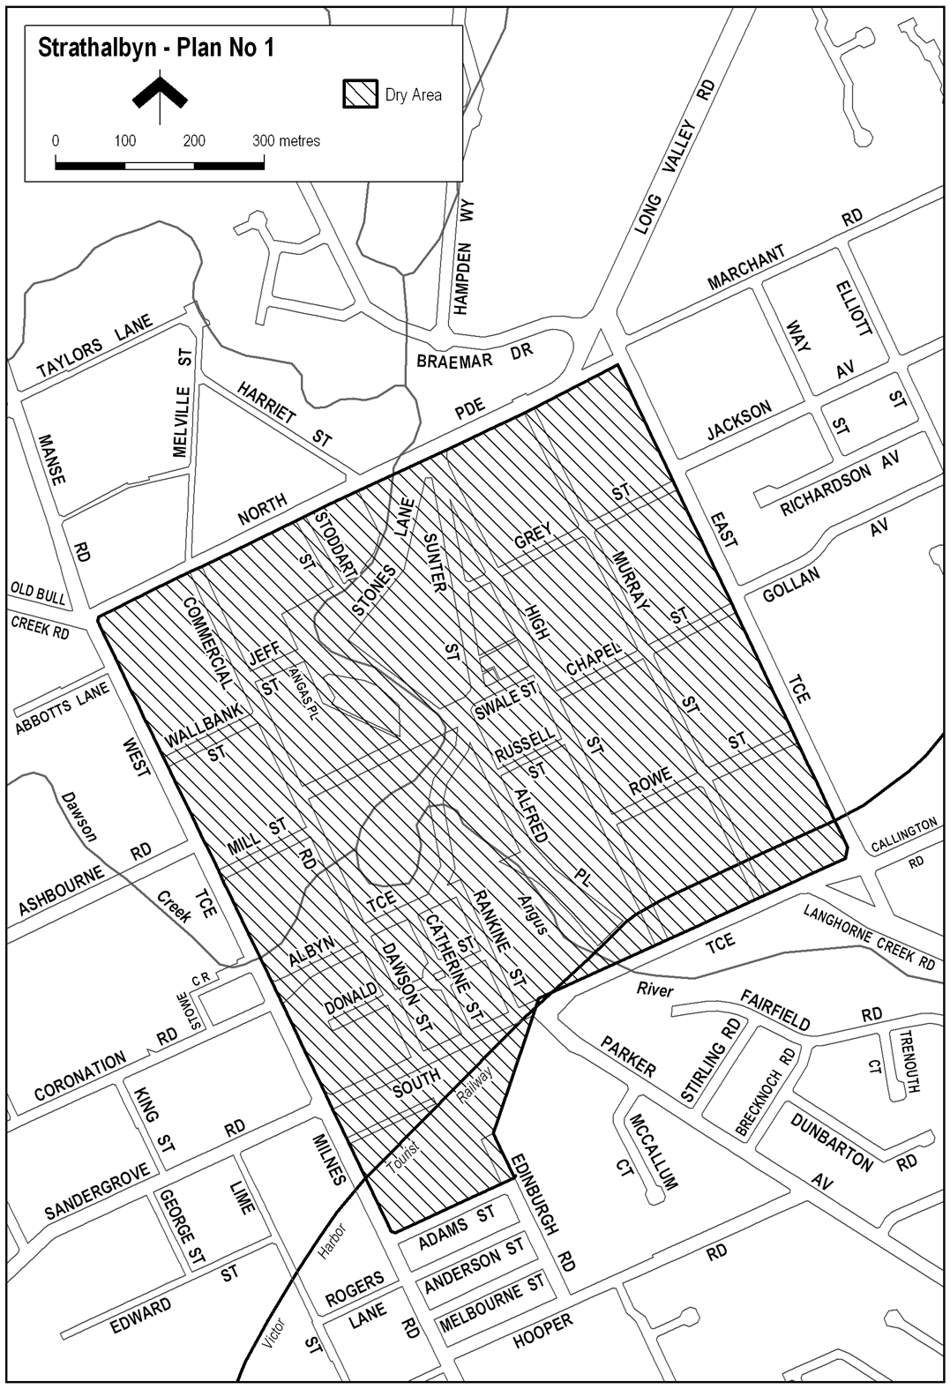
Note—
As required by section 10AA(2) of the Subordinate Legislation Act 1978, the Minister has certified that, in the Minister's opinion, it is necessary or appropriate that these regulations come into operation as set out in these regulations.
Made by the Governor
with the advice and consent of the Executive Council
on 5 February 2009
No 9 of 2009
90MCA0001CS

South Australia
Liquor Licensing (Dry Areas—Long Term) Variation Regulations 2009
under the Liquor Licensing Act 1997

Contents
Part 1—Preliminary
1 Short title
2 Commencement
3 Variation provisions
Part 2—Variation of Liquor Licensing (Dry Areas—Long Term) Regulations 1997
4 Variation of Schedule 1—Long term dry areas

Part 1—Preliminary
1—Short title
These regulations may be cited as the Liquor Licensing (Dry Areas—Long Term) Variation Regulations 2009.
2—Commencement
These regulations come into operation on the day on which they are made.
3—Variation provisions
In these regulations, a provision under a heading referring to the variation of specified regulations varies the regulations so specified.
Part 2—Variation of Liquor Licensing (Dry Areas—Long Term) Regulations 1997
4—Variation of Schedule 1—Long term dry areas
(1) Schedule 1, item headed "Naracoorte—Area 1", column headed "Period"—delete "2009" and substitute:
2011
(2) Schedule 1, item headed "Naracoorte—Area 2", column headed "Period"—delete "2009" and substitute:
2011
Note—
As required by section 10AA(2) of the Subordinate Legislation Act 1978, the Minister has certified that, in the Minister's opinion, it is necessary or appropriate that these regulations come into operation as set out in these regulations.
Made by the Governor
with the advice and consent of the Executive Council
on 5 February 2009
No 10 of 2009
90MCA0003CS
South Australia
WorkCover Corporation (Claims Management—Contractual Arrangements) Variation Regulations 2009
under the WorkCover Corporation Act 1994

Contents
Part 1—Preliminary
1 Short title
2 Commencement
3 Variation provisions
Part 2—Variation of WorkCover Corporation (Claims Management—Contractual Arrangements) Regulations 2005
4 Variation of regulation 3—Interpretation
5 Insertion of regulation 6
6 Authorisation of alliance contracts

Part 1—Preliminary
1—Short title
These regulations may be cited as the WorkCover Corporation (Claims Management—Contractual Arrangements) Variation Regulations 2009.
2—Commencement
These regulations will come into operation on the day immediately following the day on which the time for disallowance of these regulations passes (see section 14(4a)(a) of the WorkCover Corporation Act 1994).
3—Variation provisions
In these regulations, a provision under a heading referring to the variation of specified regulations varies the regulations so specified.
Part 2—Variation of WorkCover Corporation (Claims Management—Contractual Arrangements) Regulations 2005
4—Variation of regulation 3—Interpretation
Regulation 3—after the definition of Agent's services insert:
alliance contract means a contract authorised under regulation 6(1);
alliance contract claims means claims under the Workers Rehabilitation and Compensation Act 1986 determined to be within the scope of an alliance contract in accordance with criteria determined by the steering committee overseeing the alliance under the contract.
5—Insertion of regulation 6
After regulation 5 insert:
6—Authorisation of alliance contracts
(1) For the purposes of section 14(4)(d) of the WorkCover Corporation Act 1994, a contract entered into by the Corporation with a private sector body (the Agent) that involves the conferral of powers referred to in section 14(3) of that Act (other than the power to collect levies) and includes (but is not necessarily limited to) the following terms, or terms that have the effect of providing for the following, is, subject to subregulation (2), an authorised contract:
(a) a contractual term of not more than 5 years;
(b) terms establishing an alliance between the Corporation and the Agent for the management and determination of alliance contract claims under which the Agent is generally responsible for day to day administrative matters;
(c) for the purposes of the alliance, terms—
(i) setting out governing principles; and
(ii) requiring a steering committee established under section 16 of the WorkCover Corporation Act 1994 comprised of representatives of the Corporation and the Agent to oversee the alliance and setting out the committee's functions and procedures; and
(iii) setting out a dispute resolution procedure in the event that the representatives on the steering committee are unable to reach a unanimous decision on a matter; and
(iv) facilitating the day to day management and determination of alliance contract claims in a coordinated manner;
(d) the Agent may exercise such of the Corporation's statutory functions, powers and discretions as may be necessary for the performance of its functions under the contract;
(e) for the purpose of providing the Agent's services, the Agent is to be a delegate of the Corporation under section 17 of the WorkCover Corporation Act 1994, subject to specified conditions and limitations (if any);
(f) the Corporation's liability to pay compensation under the Workers Rehabilitation and Compensation Act 1986 is not underwritten by the Agent;
(g) the Agent is not entitled to receive or invest levies paid by employers under the Workers Rehabilitation and Compensation Act 1986;
(h) a fee is to be paid by the Corporation to the Agent in consideration of provision by the Agent of the Agent's services, and such fee may be adjusted from time to time (subject to a specified cap) having regard to—
(i) the quality of the services; and
(ii) the resources required for the performance of the services; and
(iii) outcomes relevant to returning injured workers to work; and
(iv) outcomes relevant to the overall costs and liabilities of the workers rehabilitation and compensation scheme determined on an actuarial basis; and
(v) if the contract relates to implementation of the Workers Rehabilitation and Compensation (Scheme Review) Amendment Act 2008—outcomes relevant to that implementation; and
(vi) other factors considered relevant by the Corporation;
(i) the Corporation may at any time, for such reason or reasons as may be specified in the contract, step in and take over from the Agent the management or determination of a specific claim or claims of a particular class or classes;
(j) in the event of a breach of the terms of the contract by the Agent, the Corporation may—
(i) terminate the contract; or
(ii) exercise such other remedies or sanctions as may be appropriate in the circumstances;
(k) the Corporation may, having regard to the performance by the Agent of its services, or on any other basis agreed between the parties, terminate the Agent's services, or a part of those services;
(l) the Agent must not, without the approval of the Corporation (which may be withheld at the discretion of the Corporation), assign the contract (or the performance of any part of the contract) or make use of subcontractors;
(m) the Agent, or a person employed by the Agent, must act in accordance with section 112 of the Workers Rehabilitation and Compensation Act 1986, as it applies to the Corporation;
(n) the Agent must, in carrying out the Agent's services, use information technology systems complementary to and compatible with those used by the Corporation;
(o) the Agent must implement an employee training and accreditation system approved by the Corporation;
(p) the Agent is not to provide services under the contract until the Corporation has issued a certificate (a certificate of readiness) certifying that the Agent is ready to provide those services.
(2) An alliance contract must also—
(a) regulate the use of external service providers by the Agent; and
(b) include the following:
(i) a method for monitoring and evaluating the quality of the Agent's services under the alliance contract;
(ii) a code of conduct (consistent with section 2 of the Workers Rehabilitation and Compensation Act 1986 and section 12 of the WorkCover Corporation Act 1994) to be observed by the Agent in respect of the performance of its obligations and functions under the alliance contract.
(3) An alliance contract may also include terms, or terms that have the effect of providing for the matters, that may be the subject of an authorised contract under regulation 4 in relation to claims other than alliance contract claims (and, consequently, if a contract authorised under regulation 4 is amended to include terms, or terms that have the effect of providing for the matters, that may be the subject of an alliance contract, the contract continues as an authorised contract).
(4) A contract assigned in accordance with subregulation (1)(l) continues as an authorised contract.
Note—
As required by section 10AA(2) of the Subordinate Legislation Act 1978, the Minister has certified that, in the Minister's opinion, it is necessary or appropriate that these regulations come into operation as set out in these regulations.
Made by the Governor
with the advice and consent of the Executive Council
on 5 February 2009
No 11 of 2009
MIR25/08CS

South Australia
Associations Incorporation Variation Regulations 2009
under the Associations Incorporation Act 1985

Contents
Part 1—Preliminary
1 Short title
2 Commencement
3 Variation provisions
Part 2—Variation of Associations Incorporation Regulations 2008
4 Substitution of Schedule 2
Schedule 2—Fees

Part 1—Preliminary
1—Short title
These regulations may be cited as the Associations Incorporation Variation
Regulations 2009.
2—Commencement
These regulations come into operation on the day on which they are made.
3—Variation provisions
In these regulations, a provision under a heading referring to the variation of specified regulations varies the regulations so specified.
Part 2—Variation of Associations Incorporation Regulations 2008
4—Substitution of Schedule 2
Schedule 2—delete the Schedule and substitute:
Schedule 2—Fees

1 | For inspection under section 6(2) of the Act of documents lodged by or in relation to an association | $20.70
2 | For the supply of an uncertified copy, or the supply of a copy of an extract from, a document held by the Commission in relation to an association (in addition to the fee payable under clause 1)—
 | (a) for 1 page | $4.50
 | (b) for each additional page or part of a page | $1.15
3 | For the supply of a certified copy of, or the supply of a certified copy of an extract from, a document held by the Commission in relation to an association (in addition to the fee payable under clause 1)—
 | (a) for 1 page | $20.70
 | (b) for each additional page or part of a page | $1.15
4 | On lodging an application to the Commission (not being an application for which a fee is specified elsewhere in the Schedule) to exercise any of the powers conferred on the Commission by the Act, or by those provisions of the Corporations Act 2001 of the Commonwealth applied by the Act to an association | $51.00
5 | On lodging an application to the Minister to exercise any powers conferred on the Minister by the Act | $51.00
6 | On lodging an application for incorporation under section 19 of the Act | $150.00
7 | On lodging an application for amalgamation under section 22 of the Act | $150.00
8 | On lodging an application to register an alteration to rules under section 24 of the Act (including an application to alter the name of an association) | $51.00
9 | For the approval of the Commission of an auditor under section 35(2)(b) of the Act | $71.00
10 | On lodging a periodic return under section 36 of the Act | $71.00
11 | On submitting to the Commission for examination a draft explanatory statement prior to its registration under the provisions of the Corporations Act 2001 of the Commonwealth applied under section 40A of the Act | $150.00
12 | On lodging an application for the approval of the Commission for extension of period under section 41C(4)(a) of the Act | $53.00
13 | For consent of the Commission under section 43(1a) of the Act to distribute surplus assets of an association on winding up among members of the association | $71.00
14 | On lodging an application to deregister an association under section 43A(1) of the Act | $105.00
15 | On making a request of the Commission under section 43A(5) of the Act (in addition to the fee payable under clause 14) | $71.00
16 | On lodging an application to the Commission to exercise the powers conferred by section 44A or 46 of the Act | $71.00
17 | For an act done by the Commission—
 | (a) representing a defunct association or its liquidator under section 44A of the Act | $71.00
 | (b) under section 46 of the Act | $71.00
18 | On lodging an application to the Commission to exercise the power conferred by section 53 of the Act | $71.00
19 | On lodging an application to reserve a name under section 53A(1) of the Act | $105.00
20 | On the late lodgment of a document (in addition to any lodgment fee provided by any other clause for the lodging of that document)—
 | (a) if lodged within 1 month after the prescribed time | $27.75
 | (b) if lodged more than 1 month but within 3 months after the prescribed time | $57.00
 | (c) if lodged more than 3 months after the prescribed time | $121.00
21 | For the production by the Commission, pursuant to a subpoena, of a document held by it in relation to an association— | $39.00
 | (a) for the first 2 pages or part of 2 pages | $20.70
 | (b) for each additional 2 pages or part of 2 pages | $1.15
22 | For any act that the Commission is required or authorised to do on the request of a person and for which a fee is not prescribed by any other clause | $28.00
Note—
As required by section 10AA(2) of the Subordinate Legislation Act 1978, the Minister has certified that, in the Minister's opinion, it is necessary or appropriate that these regulations come into operation as set out in these regulations.
Made by the Governor
with the advice and consent of the Executive Council
on 5 February 2009
No 12 of 2009
OCBACS08-00001

FAXING COPY?
IF you fax copy to Government Publishing SA for inclusion in the Government Gazette, there is no need to send a Confirmation Copy to us as well.
This creates confusion and may well result in your notice being printed twice.
Please use the following fax number:
Fax transmission: (08) 8207 1040
Phone Inquiries: (08) 8207 1045
Please include a contact person, phone number and order number so that we can phone back with any queries we may have regarding the fax copy.
NOTE: Closing time for lodging new copy (fax, hard copy or email) is 4 p.m. on Tuesday preceding the day of publication.

Government Gazette notices can be E-mailed.
The address is:
governmentgazette@dpc.sa.gov.au
Documents should be sent as attachments in Word format.
When sending a document via E-mail, please confirm your transmission with a faxed copy of your document, including the date the notice is to be published.
Fax transmission: (08) 8207 1040
Enquiries: (08) 8207 1045
NOTE: Closing time for lodging new copy (fax, hard copy or email) is 4 p.m. on Tuesday preceding the day of publication.

CITY OF ONKAPARINGA
Change of Road Names
NOTICE is hereby given that the Council of the City of Onkaparinga at its meeting held on 20 January 2009, resolved pursuant to section 219 (1) of the Local Government Act 1999, that the names of certain roads be changed as follows:
• The portion of Barytes Road south of Quarry Road and the portion of Budgens Road east of Victor Harbor Road to Seaview Road.
• The portion of Sherriffs Road west of Dyson Road to Sherriffs Road West.
A plan that delineates the roads which are subject to the change of street names, together with a copy of Council’s resolution are both available for inspection at Council’s Principal Office, Ramsay Place, Noarlunga Centre, during normal business hours.
J. S. Tate, Chief Executive Officer

CITY OF PORT ADELAIDE ENFIELD
Roads (Opening and Closing) Act 1991
Road Closure—Right of Way, Greenacres
NOTICE is hereby given, pursuant to section 10 of the Roads (Opening and Closing) Act 1991, that the City of Port Adelaide Enfield proposes to make a Road Process Order to close a Right of Way between Redward Avenue and Wingate Street and merge with adjoining allotments 20, 21, 41 and 42 in Deposited Plan 4945 as delineated and lettered ‘A’, ‘B’, ‘C’ and ‘D’ on Preliminary Plan No. 09/0002.
A copy of the plan and a statement of persons affected are available for public inspection at the Civic Centre, 163 St Vincent Street, Port Adelaide, S.A. 5015, the Council offices situated in the Enfield, Greenacres and Parks Libraries and the Adelaide office of the Surveyor-General during normal office hours.
Any application for easement or objection must set out the full name, address and details of the submission and must be fully supported by reasons.
The application for easement or objection must be made in writing to the Council, P.O. Box 110, Port Adelaide, S.A. 5015 within 28 days of this notice and a copy must be forwarded to the Surveyor-General, G.P.O. Box 1354, Adelaide, S.A. 5001. Where a submission is made, the Council will give notification of a meeting at which the matter will be considered.
Dated 5 February 2009.
H. J. Wierda, City Manager

CITY OF PORT ADELAIDE ENFIELD
Public Consultation
Periodical Review of Elector Representation
NOTICE is hereby given that pursuant to the provisions of section 12 (7) of the Local Government Act 1999, the Council is to carry out a review to determine whether the community would benefit from an alteration to its composition and ward structure.
Representation Options Paper
A Representation Options Paper that examines the various options available in relation to the composition and structure of the Council is now available for public consultation from:
The Principal Office of the Council, 163 St Vincent Street, Port Adelaide, S.A. 5015;
Council website www.portenf.sa.gov.au;
Semaphore Library, 14 Semaphore Road, Semaphore, S.A. 5019;
Port Adelaide Library, 2-4 Church Street, Port Adelaide, S.A. 5015;
The Parks Library, 2-46 Cowan Street, Angle Park, S.A. 5010;
Enfield Library, 1 Kensington Crescent, Enfield, S.A. 5085;
Greenacres Library, 2 Fosters Road, Greenacres, S.A. 5086.
Written Submissions
Interested persons are invited to make written submissions during the public consultation period from Monday, 9 February 2009 to Monday, 23 March 2009.
Written submissions must be received by 5 p.m. on Monday,
23 March 2009 addressed to:
Elector Representation Review,
The Chief Executive Officer,
City of Port Adelaide Enfield,
P.O. Box 110,
Port Adelaide, S.A. 5015.
Or faxed to: (08) 8405 6666.
Or emailed to: electedrepreview@portenf.sa.gov.au or go to the website and follow the links.
Public information sessions on the review will be held in the following locations:
Wednesday, 18 February 2009, 3 p.m. to 4.30 p.m., Town Hall, Port Adelaide.
Wednesday, 18 February 2009, 6.30 p.m. to 8 p.m., Town Hall, Port Adelaide.
Thursday, 19 February 2009, 3 p.m. to 4.30 p.m., Enfield Community Centre.
Thursday, 19 February 2009, 6.30 p.m. to 8 p.m., Enfield Community Centre.
Dated 5 February 2009.
H. J. Wierda, City Manager

CITY OF PROSPECT
Review of Elector Representation
NOTICE is hereby given that the City of Prospect is undertaking a review to determine whether a change of arrangements, in respect to elector representation, will result in the electors of the area being more adequately and fairly represented.
Pursuant to the provisions of section 12 (7) of the Local Government Act 1999, Council has prepared a ‘Representation Options Paper’ that examines the advantages and disadvantages of the various options available in regards to the composition and structure of Council and the division of the Council area into wards.
Copies of the ‘Representation Options Paper’ are available for inspection at Council’s Offices, 128 Prospect Road, Prospect and 1 Thomas Street, Nailsworth and on Council’s website:
www.prospect.sa.gov.au.
Interested persons are invited to make a written submission to the Chief Executive Officer, P.O. Box 171, Prospect, S.A. 5082, by close of business on Friday, 27 March 2009.
Information regarding the representation review can be obtained by contacting Justin Commons on telephone 8269 5355.
M. Goldstone, Chief Executive Officer

CITY OF PROSPECT
Close of Nominations
Supplementary Election for Councillor in Highbury Ward—
Nominations Received
AT the close of nominations at 12 noon on Thursday, 29 January 2009, the following people were accepted as candidates and are listed in the order in which they will appear on the ballot paper:
Councillor for Highbury Ward—(1 vacancy):
De Palma, John
Lee, Monica
Barnett, Kristina
Postal Voting
The election will be conducted by post. Ballot papers and pre-paid envelopes for each voting entitlement will be posted between Tuesday, 10 February 2009 and Monday, 16 February 2009, to every person, body corporate and group listed on the voters roll at roll close on Thursday, 18 December 2008. Voting is voluntary.
A person who has not received voting material by Monday, 16 February 2009 and believes they are entitled to vote should contact the Deputy Returning Officer on 8401 4318.
Completed voting material must be returned to reach the Returning Officer no later than 12 noon on Monday, 2 March 2009.
A ballot box will be provided at the Council Office, 128 Prospect Road, Prospect, for electors wishing to hand deliver their completed voting material during office hours.
Vote Counting Location
The scrutiny and counting of votes will take place at the Reception Room, Civic Centre, 128 Prospect Road, Prospect, as soon as practicable after 12 noon on Monday, 2 March 2009. A provisional declaration will be made at the conclusion of the election count.
Campaign Donations Return
All candidates must forward a Campaign Donations Return to the Council Chief Executive Officer within six weeks after the conclusion of the election.
K. Mousley, Returning Officer

ALEXANDRINA COUNCIL
Alexandrina Council’s Consultation Process for the Electoral Review Options Paper
NOTICE is hereby given that Alexandrina Council has prepared an Options Paper to review its electoral representation in accordance with the requirements of the Local Government Act 1999. A summary of the options paper will be available for comment over the next six weeks inviting written submissions and comments to the options paper closing on Monday, 9 March 2009.
A full Options Paper discussion draft is available from the offices of Alexandrina Council in Goolwa and Strathalbyn and is also available on Alexandrina Council’s website at:
www.alexandrina.sa.gov.au
and the libraries of Alexandrina Council in Strathalbyn, Milang, Port Elliot, Mount Compass and Goolwa.
Key issues to focus your comments on are the matters raised in the Paper, such as retaining the existing ward structures, single/ multi Council Member wards, the number of Council Members and relevant ward names.
Any other possible models may also be suggested and it will be most helpful if clear explanations or evidence for particular view points are included in the submission.
All comments and submissions will be considered by Council and a position paper will be published and be the subject of further consultation with an opportunity for comments and submissions from the community over a period of three weeks.
All submissions will have the opportunity for representation before Council to consolidate those comments and submissions after which Council will make its final report to the State Electoral Commissioner recommending an electoral representation appro-priate to our community.
All comments and submissions should be directed to the Chief Executive of Alexandrina Council, P.O. Box 21, Goolwa, S.A. 5214 or by email: alex@alexandrina.sa.gov.au or by fax on
8555 3603 by close of business on Friday, 20 March 2009.
J. L. Coombe, Chief Executive

DISTRICT COUNCIL OF THE COPPER COAST
Close of Nominations
Supplementary Election for Councillor in Wallaroo Ward—Nominations Received
AT the close of nominations at 12 noon on Thursday, 29 January 2009, the following people were accepted as candidates and are listed in the order in which they will appear on the ballot paper:
Councillor for Wallaroo Ward—(1 vacancy):
Gross, John
Woodforde, David Lindsay
Postal Voting
The election will be conducted by post. Ballot papers and pre-paid envelopes for each voting entitlement will be posted between Tuesday, 10 February 2009 and Monday, 16 February 2009 to every person, body corporate and group listed on the voters roll at roll close on Thursday, 18 December 2008. Voting is voluntary.
A person who has not received voting material by Monday, 16 February 2009 and believes they are entitled to vote should contact the Deputy Returning Officer on 8821 1600.
Completed voting material must be returned to reach the Deputy Returning Officer no later than 12 noon on Monday, 2 March 2009.
A ballot box will be provided at the Council Office, 51 Taylor Street, Kadina, for electors wishing to hand deliver their completed voting material during office hours.
Vote Counting Location
The scrutiny and counting of votes will take place at the Council Office, 51 Taylor Street, Kadina, as soon as practicable after
12 noon on Monday, 2 March 2009. A provisional declaration will be made at the conclusion of the election count.
Campaign Donations Return
All candidates must forward a Campaign Donations Return to the Council Chief Executive Officer within six weeks after the conclusion of the election.
K. Mousley, Returning Officer

THE FLINDERS RANGES COUNCIL
By-law Made Under the Local Government Act 1999
By-law No. 4—Waste Management
FOR the prevention and suppression of nuisances by regulating and controlling the removal of domestic, recyclable and green organic waste from premises and by regulating the management of Council property.
1. Definitions
In this by-law:
1.1 ‘Green Organics’ means any clean organic matter consisting of lawn clippings, plants, vegetables, leaves, prunings, horse manure or other materials for which permission has been given by the Council but no item larger than 15 cm in diameter;
1.2 ‘Green Organics Container’ means a container for the reception of Green Organics;
1.3 ‘Hard Waste’ means any internal and external household items such as fridges, television sets, mattresses, but excludes any Household Waste;
1.4 ‘Household Waste’ means any kind of domestic and kitchen waste generated from residences, but excludes liquids, metals (other than food containers), building materials, stones, bricks, soil, lead acid batteries and any dangerous or toxic waste;
1.5 ‘Household Waste Container’ means a container for the reception of Household Waste;
1.6 ‘Recyclables’ means newspapers, magazines, clean paper and cardboard, clean plastic containers of a type specified by the Council, clean tins and cans, clean glass and clean milk and juice containers and other materials for which permission has been given by the Council;
1.7 ‘Recyclables Container’ means a container for the recep-tion of Recyclables;
1.8 ‘Road’ has the same meaning as in the Local Govern-ment Act 1999.
2. Provide Containers
2.1 Every occupier of domestic premises must keep on his or her premises a Household Waste Container and a Recyclables Container in accordance with this by-law.
2.2 An occupier of domestic premises may, where a Green Organics collection service is offered by the Council, keep on his or her premises a container for Green Organics in accordance with this by-law.
3. Management of Waste Collection Services
An occupier of premises must:
3.1 Household Waste
3.1.1 ensure that the Household Waste Container kept on his or her premises is approved by the Council; and
3.1.2 ensure that the Household Waste Container only contains Household Waste; and
3.2 Recyclables
3.2.1 ensure that the Recyclables Container kept on his or her premises is approved by the Council; and
3.2.2 ensure that the Recyclables Container only con-tains Recyclables; and
3.3 Green Organics
3.3.1 ensure that any Green Organics Container kept on his or her premises is approved by the Council; and
3.3.2 ensure that the Green Organics Container only contains Green Organics; and
3.4 Keep Container Clean
cause each container to be kept in a clean and sanitary condition, maintained in good order and repair and kept watertight at all times; and
3.5 Sealing of Container
cause each container to be continuously and securely covered or sealed except when waste is being deposited in or removed from the container; and
3.6 Damage
ensure that each container is maintained so that it is not damaged or worn to the extent that:
3.6.1 it is not robust or watertight;
3.6.2 it is unable to be moved on its wheels (if any) efficiently;
3.6.3 the lid does not seal on the container when closed;
3.6.4 its efficiency or use is otherwise impaired; and
3.7 Collection Services
3.7.1 facilitate the collection and removal of Household Waste, Recyclables and Green Organics from his or her premises on the day of or the night before (and not before these times) the scheduled collection day;
3.7.2 ensure that prior to the day and time appointed by the Council for the collection of a Household Waste, Recyclables or Green Organics from the premises, the container containing that kind of waste is placed out for collection:
3.7.2.1 on the street in front of and on the same side as the premises, abutting the edge
of (but not on) the carriageway and positioned so that the side of the con-tainer on which the hinges of the lid are situated faces the premises; or
3.7.2.2 in another position as approved or directed by the Council; and
3.7.2.3 not under the overhanging branches of street trees; and
3.7.3 remove the container from that position on the same day after the collection has taken place.
4. Interference with Garbage/Hard Rubbish
A person must not remove, disburse or interfere with any Household Waste, Recyclables, Green Organics or Hard Waste (including bottles, newspapers, cans, containers or packaging) that has been placed on a Road or any other place for collection by the Council, its agents or contractors.
This foregoing by-law was duly made and passed at a meeting of the Flinders Ranges Council held on 20 January 2009, by an absolute majority of the members for the time being constituting the Council, there being at least two-thirds of the members present.
L. Connors, Chief Executive Officer

DISTRICT COUNCIL OF LOXTON WAIKERIE
Public Consultation—Periodical Review of Elector
Representation 2009
NOTICE is hereby given that pursuant to the provisions of section 12 of the Local Government Act 1999, the Council is to carry out a review to determine whether the community would benefit from an alteration to the composition and structure of the Council.
Representation Options Paper
A Representation Options Paper has been prepared in accor-dance with section 12 (7) of the Act and examines the various options available to the Council in relation to the composition and structure of the Council. Copies of the Paper will be available from Monday, 9 February 2009, for public consultation at:
Loxton Office: 29 East Terrace, Loxton.
Waikerie Office: Strangman Road, Waikerie.
Council website: www.loxtonwaikerie.sa.gov.au.
Written Submissions
Interested persons are invited to make written submissions during the six week public consultation period which commences on Monday, 9 February 2009.
Written submissions must be received by 5 p.m. on Monday,
23 March 2009 and addressed to:
Elector Representation Review,
Acting Chief Executive Officer,
District Council of Loxton Waikerie,
P.O. Box 409, Loxton, S.A. 5333.
Fax: 8584 6622.
Email: council@loxtonwaikerie.sa.gov.au.
Public Information Sessions
Details of public information sessions will be advertised separately.
Further Enquiries
For further information on the Representation Review please contact the Acting Chief Executive Officer, Peter Sellar, telephone 8584 8000 or email council@loxtonwaikerie.sa.gov.au.
P. Ackland, Chief Executive Officer

NARACOORTE LUCINDALE COUNCIL
Development Act 1993
Naracoorte Railway Yards Development Plan Amendment, (DPA)
By the Naracoorte Lucindale Council—
Draft for Public Consultation
NOTICE is hereby given that the Naracoorte Lucindale Council has, pursuant to section 25 of the Development Act 1993, prepared a draft DPA to amend the Naracoorte Lucindale Council Development Plan.
The draft DPA proposes to amend the Naracoorte Lucindale Council Development Plan by reviewing the current zoning of the land within the Naracoorte Railway Yards.
In its current state, and under the current Industrial zoning, the land does not offer the highest potential for development given its strategic location close to the centre of town and on one of the main road entries to the Town Centre.
The investigations conducted to inform the DPA have identified the need to rezone the subject land from Industry to a number of zones including: Town Centre (Naracoorte), Public Purpose and Infrastructure to facilitate the strategic and appropriate development of the land with regard to the existing site conditions and land uses on the land and more generally within the locality.
The draft DPA will be on public consultation from Thursday,
5 February 2009 to Thursday, 10 April 2009.
Copies (both hard copy and electronic) of the draft DPA are available during normal office hours at the office of the Naracoorte Lucindale Council, Degaris Place, Naracoorte or can be downloaded from the Council website:
www.naracoortelucindale.sa.gov.au.
Written submissions regarding the draft DPA should be submitted not later than 5 p.m. on Friday, 10 April 2009. All submissions should be addressed to the Director of Planning and Environmental Services, Naracoorte Lucindale Council, P.O.
Box 555, Naracoorte, S.A. 5271, and should clearly indicate whether you wish to be heard in support of your submission. If you wish to lodge your submission electronically, could you please email the electronic submission to council@nlc.sa.gov.au.
Copies of all submissions will be available for inspection by interested persons at the Council Offices from Monday, 13 April 2009 until the public hearing.
A public hearing will be held on Wednesday, 22 April 2009 at 6.30 p.m. in the Council Chambers, Degaris Place, Naracoorte. The public hearing will not be held if no submissions are received or if no submission has a request to be heard.
Dated 5 February 2009.
A. Evans, Chief Executive Officer

PORT PIRIE REGIONAL COUNCIL
By-law Made Under the Local Government Act 1999
By-law No. 1—Permits and Penalties
TO provide for a permit system, to fix maximum and continuing penalties for breach of Council by-laws, to clarify the construction of such by-laws and to repeal certain by-laws.
1. Repeal of By-laws
All by-laws previously made or adopted by the Council prior to the date this by-law is made, are hereby repealed from the day on which this by-law comes into operation.
2. Definition
In this by-law ‘person’ includes a natural person, a body corporate, an incorporated association and an un-incorporated association.
3. Permits
3.1 In any by-law of the Council, unless the contrary intention is clearly indicated, the word ‘permission’ means the permission of the Council, or such other person as the Council may by resolution authorise for that purpose, granted in writing prior to the act, event or activity to which it relates.
3.2 Where a by-law requires that permission be obtained any person seeking the grant of permission must submit a written application to the Council in the form (if any) and accompanied by the fee (if any) prescribed by the Council.
3.3 The Council, or such other person as the Council may by resolution authorise for that purpose, may attach such conditions (including time limits, renewal and transfer requirements as it thinks fit) to a grant of permission, and may vary or revoke such conditions or impose new conditions by notice in writing to the person granted permission.
3.4 Any person granted permission shall comply with every such condition.
3.5 The Council, or such other person as the Council may by resolution authorise for that purpose, may suspend or revoke a grant of permission at any time by notice in writing to the person granted permission.
4. Offences and Penalties
4.1 Any person who commits a breach of any by-law of the Council shall be guilty of an offence and shall be liable to a maximum penalty being the maximum penalty referred to in the Local Government Act 1999, that may be fixed by by-law for any breach of a by-law.
4.2 Any person who commits a breach of any by-law of the Council of a continuing nature shall be guilty of an offence and, in addition to any other penalty that may be imposed, shall be liable to a further penalty for every day on which the offence or breach of the by-law continues, such penalty being the maximum amount referred to in the Local Government Act 1999, that may be fixed by by-law for a breach of any by-law of a continuing nature.
5. Construction
5.1 Every by-law of the Council shall be subject to any Act of Parliament and Regulations made thereunder.
5.2 In any by-law of the Council, ‘the Council’ means the Port Pirie Regional Council.
This foregoing by-law was duly made and passed at a meeting of the Port Pirie Regional Council held on 28 January 2009, by an absolute majority of the members for the time being constituting the Council, there being at least two-thirds of the members present.
A. Johnson, Chief Executive Officer

PORT PIRIE REGIONAL COUNCIL
By-law Made Under the Local Government Act 1999
By-law No. 2—Moveable Signs
TO protect visual amenity and public safety on roads by setting standards for moveable signs on roads and providing conditions for the design, construction and placement of such signs in a manner which recognises the advertising needs of businesses to maximise economic viability.
1. Definitions
In this by-law:
1.1 ‘Authorised Person’ has the same meaning as in the Local Government Act 1999.
1.2 ‘Banner’ means a strip of cloth hung up or carried on a pole, fence or other structure.
1.3 ‘Boundary’ means that line between private property and the Road or Road Related Area.
1.4 ‘Business Premises’ means the premises from which a business, trade or calling is conducted.
1.5 ‘Footpath Area’ means that part of the Road between the boundary of the Road and the edge of the carriageway of the Road on the same side as that boundary.
1.6 ‘Local Government Land’ means land owned by the Council or under the Council’s care, control and management.
1.7 ‘Moveable Sign’ has the same meaning as in the Local Government Act 1999.
1.8 ‘Road’ has the same meaning as in the Local Government Act 1999.
1.9 ‘Road Related Area’ has the same meaning as in the Road Traffic Act 1961 and the Australian Road Rules.
1.10 ‘Vehicle’ has the same meaning as in the Road Traffic Act 1961 and the Australian Road Rules.
2. Design and Construction
A Moveable Sign displayed on a Road must:
2.1 be of a kind known as an ‘A’ frame or Sandwich Board sign, an inverted ‘T’ sign or a flat sign, or, with the permission of the Council, a sign of some other kind;
2.2 be well designed, constructed and maintained in good quality and condition so as not to present a hazard to any member of the public;
2.3 be of strong construction so as to be stable when in position and be able to keep its position in adverse weather conditions;
2.4 not contain sharp or jagged edges or corners;
2.5 not be unsightly or offensive in appearance or content;
2.6 not contain flashing parts or rotate;
2.7 be constructed of timber, cloth, metal, plastic or plastic coated cardboard, or a mixture of such materials;
2.8 not have balloons, flags, streamers or other material attached to it;
2.9 not exceed 900 mm in perpendicular height, or have a base with any side exceeding 600 mm in length;
2.10 not have a display area exceeding 1 m² in total or if the sign is two sided, 1 m² on each side; and
2.11 in the case of an ‘A’ Frame or Sandwich Board sign:
2.11.1 be hinged or joined at the top; and
2.11.2 be of such construction that its sides shall be securely fixed or locked in position when erected; and
2.12 in the case of an inverted ‘T’ sign, contain no struts or supports that run between the display area and the base of the sign.
3. Appearance
A Moveable Sign on a Road must, in the opinion of an Authorised Person:
3.1 be painted or otherwise detailed in a competent and professional manner;
3.2 be aesthetically appealing, legible and simply worded to convey a precise message;
3.3 be of such design and contain such colours as are compatible with the architectural design of the premises adjacent to the Moveable Sign, and which relate well to the townscape and overall amenity of the locality in which it is situated; and
3.4 contain combinations of colour and typographical styles which blend in with and reinforce the heritage qualities of the locality and the buildings where it is situated.
4. Placement
A Moveable Sign must:
4.1 only be positioned on the Footpath Area of a Road;
4.2 be adjacent to the Business Premises to which it relates;
4.3 be placed no closer than 400 mm from the edge of the carriageway of a Road;
4.4 in the case of a flat sign, must be in line with and against the property boundary of the Road;
4.5 not be placed on a Footpath Area less than 2 m from any structure, fixed object, tree, bush or plant (including another Moveable Sign);
4.6 not be fixed, tied, chained to or leant against any other structure, fixed object, tree, bush or plant (including another Moveable Sign);
4.7 not be placed on the sealed part of any Footpath Area, unless the sealed part is wide enough to contain the sign and still leave a clear thoroughfare for pedestrians of a width of at least 1.2 m;
4.8 not be placed within 1 m of the corner of a Road;
4.9 not be placed on a landscaped area;
4.10 be placed on a designated parking area or within 1 m of an entrance to or exit from premises;
4.11 not be placed within 6 m of an intersection;
4.12 not unreasonably restrict the use of the Footpath Area or endanger the safety of members of the public;
4.13 not be placed on a Footpath Area that is less than 2 m wide;
4.14 not be placed on a Footpath Area with a minimum height clearance, of a structure above it of less than 2 m;
4.15 not be placed so as to interfere with the reasonable movement of persons using the Footpath Area in the vicinity of or adjacent to where the Moveable Sign is positioned;
4.16 in the case of a flat sign, the message of which only contains newspaper headlines and the name of the newspaper, be placed resting against the Business Premises to which the Moveable Sign relates; and
4.17 not be placed so as to obstruct or impede a vehicle door when opened, provided that the vehicle is parked lawfully on the carriageway.
5. Restrictions
5.1 A Moveable Sign must:
5.1.1 only display material which advertises a business being conducted on premises which is im-mediately adjacent to the Moveable Sign, or the products available from that business;
5.1.2 be limited to one Moveable Sign per business;
5.1.3 only be displayed when the business to which the Moveable Sign relates is open;
5.1.4 be securely fixed in position such that it cannot be blown over or swept away in adverse weather conditions;
5.1.5 not be in such a position or in such circumstances that the safety of any person or user of the Road is at risk;
5.1.6 not be displayed during the hours of darkness unless it is in a clearly lit area and clearly visible; and
5.1.7 not be displayed on a median strip, traffic island or on the carriageway of a Road.
5.2 If in the opinion of the Council a Footpath Area or other area forming the boundary of any Road is unsafe for any Moveable Sign to be displayed or placed the Council may by resolution prohibit or restrict the display or placement of a Moveable Sign or the times a Moveable Sign may be displayed or placed in that area.
6. Banners
A banner must:
6.1 only be displayed on a Road, Footpath Area or Road Related Area;
6.2 be securely fixed to a pole, fence or other structure so that it does not hang loose or flap;
6.3 not, without the Council’s permission, be attached to any building, structure, fence, vegetation or other item owned by the Council on a Road, or other improvement owned by the Council to a Road;
6.4 only advertise an event to which the public are invited;
6.5 not be displayed more than one month before and two days after the event it advertises;
6.6 must not be displayed for a continuous period of more than one month and two days in any 12 month period; and
6.7 must not exceed 3 m² in size.
7. Signs on Local Government Land
A person must not, without the Council’s permission display or cause to be displayed a Moveable Sign on any Local Government Land or resting on or attached to a Vehicle on any Local Government Land except a Moveable Sign:
7.1 attached to a licensed taxi;
7.2 on or attached to a Vehicle belonging to any Council and which has been placed on or attached to the Vehicle with the consent of the Council to which the Vehicle belongs;
7.3 on or attached to a Bus greater than 6 m in length;
7.4 on or attached to a Vehicle which only has a sign or signs painted on or glued to it the main purpose of which is to identify it as belonging to a business; or
7.5 comprising a sunscreen on a Vehicle, where any message or trade name or mark on the sunscreen does not advertise a business being carried on in the vicinity of the place the Vehicle is parked, or the products available from that business.
8. Exemptions
8.1 Subparagraphs 5.1.1 and 5.1.2 of this by-law do not apply to a Moveable Sign which is displayed and used:
8.1.1 to advertise a garage sale taking place from residential premises provided that no more than four Moveable Signs per residential premises may be displayed at any one time in relation to a garage sale taking place at that residential premises; or
8.1.2 as a directional sign to a short term (less than three days) event run by a community/charitable body or an unincorporated association.
8.2 Subparagraphs 5.1.1, 5.1.2 and 5.1.3 of this by-law do not apply to a flat sign the message of which only contains a newspaper or magazine headlines and the name of the newspaper or magazine.
8.3 A requirement of this by-law will not apply where the Council has granted permission for the Moveable Sign to be displayed contrary to the requirement.
8.4 This by-law will not apply to a Moveable Sign which is:
8.4.1 placed on a Road pursuant to an authorisation under the Local Government Act 1999 or another Act;
8.4.2 designed to direct people to the open inspection of any land or building that is available for purchase or lease;
8.4.3 related to a State or Commonwealth election and is displayed during the period commencing on the issue of writ or writs for the election and ending at the close of polls on polling day; or
8.4.4 related to an election held under the Local Government Act 1999 or the Local Government (Elections) Act 1999 and is displayed during the period commencing four weeks immediately before the date that has been set (either by or under either Act) for polling day and ending at the close of voting on polling day.
9. Removal of Unauthorised Moveable Signs
9.1 If:
9.1.1 the design or construction of a Moveable Sign that has been placed on a Road does not comply with a requirement of this by-law;
9.1.2 the positioning of a Moveable Sign does not comply with a requirement of this by-law;
9.1.3 any other relevant requirement of this by-law is not complied with; or
9.1.4 the sign unreasonably:
9.1.4.1 restricts the use of the Road; or
9.1.4.2 endangers the safety of members of the public,
an Authorised Person may order the owner of the sign to remove the sign from the Road.
9.2 A person must comply with an order of an Authorised Person made pursuant to paragraph 9.1 of this by-law.
9.3 If the Authorised Person cannot find the owner, or the owner fails to comply immediately with the order, the Authorised Person may remove the Moveable Sign.
9.4 If a Moveable sign that is removed pursuant to clause 9.3 of this by-law, is not claimed within 30 days of such removal, the Authorised Person may sell, destroy or otherwise dispose of the Moveable Sign as the Authorised Person thinks fit.
9.5 The owner or other person entitled to recover a Moveable Sign removed pursuant to paragraph 9.3 of this by-law must pay to the Council any reasonable costs incurred by the Council in removing, storing and attempting to dispose of the Moveable Sign before being entitled to recover the Moveable Sign.
10. Removal of Authorised Moveable Signs
10.1 The owner of, or other person responsible for, a Moveable Sign must remove or relocate the Moveable Sign at the request of an Authorised Person if, in the reasonable opinion of that Authorised Person, and notwithstanding compliance with this by-law, there is any hazard or obstruction or there is likely to be a hazard or obstruction arising out of the location of the Moveable Sign.
10.2 The owner of or other person responsible for a Moveable Sign must remove or relocate the Moveable Sign at the request of an Authorised Person for the purpose of special events, parades, Road works or in any other circumstances which, in the reasonable opinion of the officer, requires relocation or removal of the Moveable Sign to protect public safety or to protect or enhance the amenity of a particular locality.
The foregoing by-law was duly made and passed at a meeting of the Port Pirie Regional Council held on 28 January 2009, by an absolute majority of the members for the time being constituting the Council, there being at least two-thirds of the members present.
A. Johnson, Chief Executive Officer

PORT PIRIE REGIONAL COUNCIL
By-law Made Under the Local Government Act 1999
By-law No. 3—Local Government Land
FOR the management of access to and use of land owned by the Council or under the care, control and management of the Council (other than roads).
1. Definition
In this by-law:
1.1 ‘Authorised Person’ has the same meaning as in the Local Government Act 1999.
1.2 ‘Camp’ includes setting up a camp, or allowing a caravan or tent to remain on the land whether or not any person is in attendance or sleeps on the land.
1.3 ‘Children’s Playground’ means any enclosed area in a recreation area in which there is equipment or other installed devices for the purpose of children’s play (or within 3 m of such devices if there is no enclosed area).
1.4 ‘Foreshore’ means the area between the low water mark on the seashore and the nearest boundary of:
1.4.1 a Road;
1.4.2 a section;
1.4.3 a public reserve; or
1.4.4 land comprised in a land grant, Crown Land or Crown Licence.
1.5 ‘Local Government Land’ means all land owned by or under the care, control and management of the Council except Roads.
1.6 ‘Low water mark’ means the lowest meteorological tide.
1.7 ‘Open Container’ means a container which:
1.7.1 after the contents of the container have been sealed at the time of manufacture:
1.7.1.1 being a bottle, has had its cap, cork or top removed (whether or not it has since been replaced);
1.7.1.2 being a can, it has been opened or punctured;
1.7.1.3 being a cask, it has had its tap placed in a position to allow it to be used; or
1.7.1.4 being any other form of container, it has been opened, broken, punctured or manipulated in such a way as to allow access to its contents; or
1.7.2 is a flask, glass, mug or other container able to contain liquid.
1.8 ‘Park’ has the same meaning as in the Local Government Act 1999.
1.9 ‘Public Place’ means a place (including a place on private land) to which the public has access but does not include any part of a community parcel divided by a plan of community division under the Community Titles Act 1996.
1.10 ‘Reserve’ has the same meaning as in the Local Govern-ment Act 1999.
1.11 ‘Road’ has the same meaning as in the Local Govern-ment Act 1999.
1.12 ‘Recreation Area’ means and includes parklands, plantations, ornamental grounds, reserves, land or other property owned by or held in trust for or under the care, control and management of the Council for recreation purposes, or any part thereof.
1.13 ‘Sand dune’ and ‘coastal slope or cliff’ means the sand dunes, coastal slopes, cliffs and other geomorphological coastal forms under the care, control and management of the Council.
1.14 ‘Vehicle’ has the same meaning as in the Road Traffic Act 1961 and the Australian Road Rules.
1.15 ‘Waters’ includes any body of water including a pond, lake, river, creek or wetlands under the care, control and management of the Council.
2. Activities requiring permission
A person must not without the permission of the Council under-take any of the following activities on any Local Government Land:
2.1 Access to Water
2.1.1 Subject to the provisions of the Harbors and Navigation Act 1993, enter any Waters, swim or water ski or use a boat or other object or device or otherwise engage in any aquatic activity in or on any Waters except:
2.1.1.1 in an area which the Council has by resolution determined may be used for such purpose;
2.1.1.2 in an area where a nearby sign states that such activity is allowed; and
2.1.1.3 in accordance with any conditions that the Council may have determined by resolution apply to such use and stated on a nearby sign; or
2.1.1.4 the Spencer Gulf.
2.2 Advertising
Display or erect any sign or hoarding for the purpose of commercial advertising or any other purpose.
2.3 Alcohol
Consume, carry, possess or be in charge of any alcoholic beverage on Local Government Land being a Park or Reserve to which this subparagraph applies during such times as the Council may determine by resolution.
2.4 Amplification
Use an amplifier or other device, whether mechanical or electrical for the purpose of amplifying sound.
2.5 Animals
2.5.1 Other than the Foreshore:
2.5.1.1 lead, drive or exercise any sheep, cow, goat or horse except on Local Govern-ment Land where the Council has set aside a track or other area for the use by or in connection with an animal of that kind;
2.5.1.2 cause or allow any sheep, cow, goat or horse to stray onto, move over, graze or be left unattended on any Local Govern-ment Land;
2.5.1.3 cause or allow any sheep, cow, goat or horse to enter, swim, bathe or remain in any Waters located on Local Govern-ment Land to which this subparagraph applies.
2.5.2 Comprising the Foreshore:
2.5.2.1 cause or allow any sheep, cow, goat or horse to enter, swim, bathe or remain in the sea or any other Waters;
2.5.2.2 lead, drive or exercise any sheep, cow, goat or horse.
2.6 Attachments
2.6.1 Attach anything to a tree, plant, structure or fixture on Local Government Land except for any electoral matter posted on a tree, plant, structure or fixture by or with the authority of a candidate which is related to a Commonwealth or State election and is attached during the period com-mencing on the issue of the writ or writs for the election and ending at close of polls on polling day or is related to an election held under the Local Government Act 1999 or the Local Govern-ment (Elections) Act 1999 and is attached during the period commencing four weeks immediately before the date that has been set (either by or under either Act) for polling day and ending at
the close of voting on polling day or is posted during the course of and for the purposes of a Referendum.
2.7 Aquatic Life
Take, interfere with, introduce or disturb any aquatic life in any Waters located on Local Government Land, to which this subparagraph applies.
2.8 Bees
Place any hive of bees on such land, or allow it to remain thereon.
2.9 Boats
2.9.1 Use or launch a boat or other object on or in any Waters except:
2.9.1.1 Waters that the Council has set aside for that purpose; or
2.9.1.2 in an area where a nearby sign states
that such activity is allowed and, in accordance with any conditions stated in the sign.
2.9.2 Launch or retrieve a boat to or from any Waters other than from a boat ramp constructed for that purpose.
2.9.3 Hire out a boat, raft, pontoon or watercraft or similar device or otherwise use such device for commercial purposes on or from any Waters.
2.10 Busking and Entertaining
2.10.1 Sing, busk or play any recording or use any musical instrument for the apparent purpose of either entertaining others or receiving money such as to cause a public nuisance.
2.10.2 Conduct or hold any concert, festival, show, public gathering, circus, meeting, performance or other similar activity such as to cause a public nuisance.
2.11 Camping and Tents
2.11.1 Erect any tent or other structure of calico, canvas, plastic or similar material as a place of habitation.
2.11.2 Camp or sleep overnight, except where a person is in a caravan park on Local Government Land, the proprietor of which has been given permission to operate the caravan park on the land.
2.12 Canvassing
2.12.1 Convey any advertising, religious or other message to any bystander, passer-by or other person except for any message or material that is related to a Commonwealth or State election and is conveyed during the period commencing on the issue of the writ or writs for the election and ending at the close of polls on polling day or is related to an election under the Local Government Act 1999 or the Local Government (Elections) Act 1999 and is conveyed during the period commencing four weeks immed-iately before the date that has been set (either by or under either Act) for polling day and ending at the close of voting on polling day or that is related to and conveyed during the course of and for the purpose of a Referendum.
2.13 Cemeteries
2.13.1 Comprising a cemetery:
2.13.1.1 bury or inter any human or animal remains; or
2.13.1.2 erect any memorial.
2.14 Closed lands
2.14.1 Enter or remain on any part of Local Govern-ment Land:
2.14.1.1 at any time during which the Council has declared that part to be closed to the public, and which is indicated by a sign to that effect on or adjacent to the land;
2.14.1.2 where the land is enclosed with fences and/or walls and gates, that have been closed and locked; or
2.14.1.3 where admission charges are payable for a person to enter that part, without paying those charges.
2.15 Donations
Ask for, receive or indicate that he or she desires a donation of money or any other valuable item or thing or otherwise solicit for charitable purposes.
2.16 Encroachment
Erect or place any fencing, posts or other structures or any other items or substances such as to encroach onto the land.
2.17 Fires
2.17.1 Subject to the Fire and Emergency Services Act 2005, light any fire except:
2.17.1.1 in a place provided by the Council for that purpose; or
2.17.1.2 in a portable barbeque, as long as the barbeque is used in an area that is clear of flammable material for a distance of at least 4 m.
2.18 Fireworks
Ignite, explode or use any fireworks.
2.19 Flora and Fauna
2.19.1 Subject to the Native Vegetation Act 1991 and the National Parks and Wildlife Act 1972:
2.19.1.1 damage, pick, disturb, interfere with or remove any plant or flower thereon;
2.19.1.2 lead or drive any animal or stand or walk on any flower bed or garden plot;
2.19.1.3 deposit, dig, damage, disturb, interfere with or remove any soil, sand, stone, wood, clay, gravel, pebbles, timber, bark or any part of the land;
2.19.1.4 take, interfere with, tease, harm or disturb any animal, bird or marine creature or the eggs or young of any animal, bird or marine creature;
2.19.1.5 pick, collect, take, interfere with or disturb any fruit, nuts, berries or native seeds;
2.19.1.6 disturb, interfere with or damage any burrow, nest or habitat of any animal or bird;
2.19.1.7 use, possess or have control of any device for the purpose of killing or capturing any animal, bird or marine creature.
2.20 Foreshore
2.20.1 Subject to the provisions of the Road Traffic Act 1961:
2.20.1.1 drive or propel a Vehicle onto or from the Foreshore other than by a ramp or thoroughfare constructed or provided by the Council for that purpose;
2.20.1.2 launch or retrieve a boat other than from a boat ramp constructed for that purpose;
2.20.1.3 hire out a boat on or from any part of the Foreshore;
2.20.1.4 lead or drive any horse, cattle, sheep or other like animal on the Foreshore except where the Council has set aside a track or other area for use by or in connection with an animal of that kind.
2.21 Games
2.21.1 Participate in, promote or organise any game, recreation or amusement which involves the use of a ball, missile or other object which by the use thereof may cause or be likely to cause injury or discomfort to any person being on or in the vicinity of that land or detract from or be likely to detract from another person’s lawful use and enjoyment of that land.
2.21.2 Promote, organise or take part in any organised competition or sport as distinct from organised social play.
2.21.3 Play or practice the game of golf.
2.22 Handbills on Cars
Place or put on any Vehicle on Local Government Land any handbill, advertisement, notice or other printed matter except for any electoral matter posted on a building or structure by or with the authority of a candidate which is related to a Commonwealth or State election and is posted during the period commencing on the issue of the writ or writs for the election and ending at the close of polls on polling day or is related to an election held under the Local Government Act 1999 or the Local Government (Elections) Act 1999 and is posted during the period commencing four weeks immediately before the date that has been set (either by or under either Act) for polling day and ending at the close of voting on polling day or is posted during the course of and for the purpose of a Referendum.
2.23 Model Aircraft
Fly or operate a model aircraft or power model boat such as to cause a nuisance.
2.24 Mooring
2.24.1 Moor any boat, house boat, raft or other water craft on or to Local Government Land or in any area that the Council has not set aside for the mooring of any boat, raft or other water craft.
2.24.2 Obstruct any boat, raft or other water craft or any mooring place, or any access to any boat, raft, object (either floating or sunk) whether that access is by water or by land.
2.25 Overhanging Articles or Displaying Personal Items
Suspend or hang any article or object from any building, verandah, pergola, post or other structure on Local Government Land where it might present a nuisance or danger to any person using the land or be of an unsightly nature.
2.26 Playing Area
2.26.1 Use or occupy any playing area:
2.26.1.1 in any manner contrary to the purpose for which the playing area was intended to be used or occupied;
2.26.1.2 contrary to directions of the Council made by resolution and indicated on a sign displayed adjacent to the playing area.
2.27 Posting of Bills etc.
2.27.1 Post any bills, advertisements or other papers or items on a building or structure on Local Government Land or Public Place except for any electoral matter posted on a building or structure by or with the authority of a candidate which:
2.27.1.1 is related to a Commonwealth or State election and is posted during the period commencing on the issue of the writ or writs for the election and ending at the close of polls on polling day;
2.27.1.2 is related to an election held under the Local Government Act 1999 or the Local Government (Elections) Act 1999 and is posted during the period commencing four weeks immediately before the date that has been set (either by or under either Act) for polling day and ending at the close of voting on polling day; or
2.27.1.3 is posted during the course of and for the purpose of a Referendum.
2.28 Preaching
Preach or harangue or otherwise solicit for religious purposes.
2.29 Rubbish and Rubbish Dumps
2.29.1 Interfere with, remove or take away any rubbish that has been discarded at any rubbish dump on Local Government Land.
2.29.2 Remove, disperse or interfere with any rubbish (including bottles, newspapers, cans, containers or packaging) that has been discarded in a Council rubbish bin on Local Government Land.
2.30 Smoking
Smoke tobacco or any other substance in any building or part thereof on Local Government Land.
2.31 Toilets
2.31.1 In any public convenience:
2.31.1.1 urinate other than in a urinal or pan or defecate other than in a pan set apart for that purpose;
2.31.1.2 smoke tobacco or any other substance;
2.31.1.3 deposit anything in a pan, urinal or drain which is likely to cause a blockage;
2.31.1.4 use it for a purpose for which it was not designed or constructed;
2.31.1.5 enter any toilet that is set aside for use by the opposite sex except in the case of:
(a) a child under the age of five years who is accompanied by an adult person of that opposite sex; or
(b) providing assistance to a disabled person.
2.32 Trading
Sell, buy, offer or display anything for sale.
2.33 Weddings, Funerals or Special Events
Conduct or participate in a marriage ceremony, funeral or special event.
2.34 Working on vehicles
Perform the work of repairing, washing, painting, panel beating or other work of any nature on or to any Vehicle, except for running repairs in the case of Vehicle breakdown.
3. Prohibited activities
A person must not undertake any of the following activities on any Local Government Land:
3.1 Animals
3.1.1 Cause or allow any animal to enter, swim, bathe or remain in any Waters to the inconvenience, annoyance or danger of any other person bathing or swimming.
3.1.2 Cause or allow any animal to damage any flower bed, garden, pot, tree, lawn or other item located thereon.
3.1.3 Lead, drive or exercise any horse or other animal in such manner as to endanger the safety of any other person.
3.2 Annoyances
3.2.1 Annoy, commit any nuisance or unreasonably interfere with any other person’s use of Local Government Land by making a noise or by creating a disturbance that has not been authorised by the Council.
3.2.2 Spit, urinate or defecate other than in toilets provided on any Local Government Land.
3.3 Damaging Property
Damage or remove a building, structure or fixture located on the land.
3.4 Defacing Land
Deface, paint, write, make marks on or fix bills or advertisements to any tree, rock, gate, fence, building, sign or other property except for any bills or advertise-ment posted on a building or structure that is related to a Commonwealth or State election and is conveyed during the period commencing on the issue of the writ or writs for the election and ending at the close of polls on polling day or is related to an election under the Local Government Act 1999 or the Local Government (Elections) Act 1999 and is conveyed during the period commencing four weeks immediately before the date that has been set (either by or under either Act) for polling day and ending at the close of voting on polling day or that is related to and conveyed during the course of and for the purpose of a Referendum.
3.5 Glass
Wilfully break any glass, china or other brittle material.
3.6 Interfere with Land
3.6.1 Interfere with the land such as levelling, flattening sand hills, planting grass, lawn or other vegeta-tion, paving the land or otherwise using the land in a manner contrary to the purpose for which the land was designated to be used; or
3.6.2 Destroy, damage or deface any article, structure, building or thing fixed to the land.
3.7 Interference with Permitted Use
Interrupt, disrupt or interfere with any other person’s use of Local Government Land which is permitted or for which permission has been granted.
3.8 Obstruction
3.8.1 Obstruct:
3.8.1.1 any path in or on any Local Government Land;
3.8.1.2 any door, entrance, stairway or aisle in any building in or on any Local Govern-ment Land; or
3.8.1.3 any gate or entrance to, in or on Local Government Land.
3.9 Sand Dunes
3.9.1 Use a sand board or other item to slide down a sand dune, coastal slope or cliff.
3.9.2 Destabilise sand on a sand dune, coastal slope or cliff so as to cause it to unnecessarily mass waste down slope.
3.9.3 Destroy, remove or cause interference to live or dead vegetation within a sand dune, coastal slope or coastal cliff.
3.9.4 Light or cause to be lit or permit to remain alight any fire within a sand dune or on a coastal slope or coastal cliff.
3.9.5 Introduce non-indigenous flora and fauna or dump any material in the sand dunes or down coastal slopes or coastal cliffs.
3.9.6 Carry out other activity which may threaten the integrity of sand dunes, coastal slopes and cliffs in the area.
3.10 Throwing Objects
Throw, roll, discharge or project a stone, substance or other missile, so as to be a danger to any person or animal.
3.11 Use of equipment
3.11.1 Use any item of equipment or property belonging to the Council:
3.11.1.1 other than in the manner and for the purpose for which it was designed, constructed or intended to be used or in such manner as is likely to damage or destroy it;
3.11.1.2 where any nearby sign states the con-ditions of use, except in accordance with such conditions.
3.12 Waste
3.12.1 Deposit or leave:
3.12.1.1 anything obnoxious or offensive;
3.12.1.2 any offal, dead animal, dung or filth; or
3.12.1.3 any mineral, mineral waste, industrial waste or bi-products.
3.12.2 Foul or pollute any waters situated thereon.
3.12.3 Deposit any rubbish other than in receptacles provided by the Council for that purpose.
3.12.4 Deposit in any receptacle any rubbish emana-ting from domestic or trade purposes, unless designated by a sign or signs.
4. Directions
A person must comply with any reasonable direction or request from an Authorised Person of the Council relating to:
4.1 that person’s use of the land;
4.2 that person’s conduct and behaviour on the land;
4.3 that person’s safety on the land; or
4.4 the safety and enjoyment of the land by other persons.
5. Removal of Encroachment or Interference
Any person who encroaches onto or interferes with Local Government Land contrary to this by-law must at the request in writing of an Authorised Person, cease the encroachment or interference and remove the source of the encroachment or interference and reinstate the land to the same standard as the state of the land prior to the encroachment or interference.
6. Council May do Work
If a person fails to remove an encroachment or interference on Local Government Land in accordance with a request of an Authorised Person pursuant to Clause 5 of this by-law, then the Council may:
6.1 undertake the work itself; and
6.2 recover the cost of doing so from that person.
7. Removal of Animals, Persons and Objects
7.1 If any animal, person or object is found on any part of Local Government Land in breach of a by-law:
7.1.1 any person in charge of the animal, person or object shall forthwith remove it from that part of the land on the request of an Authorised Person; and
7.1.2 an Authorised Person may remove the animal or object from the land if the person in charge of it fails to comply with the request or if no person is in charge of it.
8. Exemptions
The restrictions in this by-law do not apply to any Police Officer, Council Officer or Council employee acting in the course and within the scope of that person’s normal duties, or to a contractor while performing work for the Council and while acting under the supervision of a Council Officer, or to the driver of an emergency vehicle when driving an emergency vehicle as defined in the Road Traffic (Road Rules—Ancillary and Miscellaneous Provisions) Regulations and the Australian Road Rules 1999.
9. Application
9.1 Any of subparagraphs 2.1.1.1, 2.3, 2.5.1.3, 2.7 and 2.9.1.1 of this by-law shall apply only in such portion or portions of the area as the Council may by resolution direct from time to time in accordance with section 246 (3) (e) of the Local Government Act 1999.
The foregoing by-law was duly made and passed at a meeting of the Port Pirie Regional Council held on 28 January 2009, by an absolute majority of the members for the time being constituting the Council, there being at least two-thirds of the members present.
A. Johnson, Chief Executive Officer

PORT PIRIE REGIONAL COUNCIL
By-law Made Under the Local Government Act 1999
By-law No. 4—Roads
FOR the management of the use of roads in Council’s area.
1. Definition
In this by-law:
1.1 ‘Authorised Person’ has the same meaning as in the Local Government Act 1999.
1.2 ‘Road’ has the same meaning as in the Local Govern-ment Act 1999.
2. Activities requiring permission
A person must not, without the permission of the Council, undertake any of the following activities on any Road:
2.1 Advertising
Display any sign other than a moveable sign which is displayed on a Road in accordance with the Council’s Moveable Signs By-law.
2.2 Amplification
Use an amplifier or other device whether mechanical or electrical for the purpose of amplifying sound to broadcast announcements or advertisements.
2.3 Animals
2.3.1 Lead or drive any horse, cattle, sheep or other like animal except on a Road where the Council has set aside a track or other area for the use by or in connection with an animal of that kind.
2.3.2 Cause or allow any animal to stray onto, move over, graze or be left unattended on any Road.
2.3.3 Lead, drive or exercise any horse or other animal in such a manner as to endanger the safety of any person.
2.3.4 Stand, draw up or allow to remain stationary any horse, cattle, sheep and other like animal whether attached to a vehicle or not.
2.4 Donations
Ask for or receive or indicate that he or she desires a donation of money or any other thing or otherwise solicit for charitable purposes.
2.5 Public Exhibitions and Displays
2.5.1 Sing, busk or play any recording or use any musical instrument.
2.5.2 Conduct or hold any concert, festival, show, public gathering, circus, meeting, performance or any other similar activity.
2.5.3 Cause any other public exhibitions or displays.
2.6 Obstruction of a Road
Erect, install or place or cause to be erected, installed or placed any structure, item or material of any kind so as to obstruct the Road or any footway, water channel or water course in a Road.
2.7 Posting of Bills
2.7.1 Post or allow or cause to be posted any bills, advertisements or other papers or items on a building or structure on a Road except for any electoral matter posted on a building or structure by or with the authority of a candidate which:
2.7.1.1 is related to a Commonwealth or State election and is posted during the period commencing on the issue of the writ or writs for the election and ending at the close of polls on polling day;
2.7.1.2 is related to an election held under the Local Government Act 1999 or the Local Government (Elections) Act 1999 and is posted during the period commencing four weeks immediately before the date that has been set (either by or under either Act) for polling day and ending at the close of voting on polling day; or
2.7.1.3 is posted during the course of and for the purpose of a Referendum.
2.8 Preaching
Preach, harangue or otherwise solicit for religious purposes.
2.9 Tents and Camping
2.9.1 Erect any tent or other structure of calico, canvas, plastic or similar material as a place of habitation.
2.9.2 Camp or sleep overnight.
2.10 Working on vehicles
Perform the work of repairing, washing, painting, panel beating or other work of any nature on or to any vehicle, except for running repairs in the case of vehicle breakdown.
3. Exemptions
The restrictions in this by-law do not apply to any Police Officer, Council Officer or Council employee acting in the course and within the scope of that person’s normal duties, or to a contractor while performing work for the Council and while acting under the supervision of a Council Officer, or to the driver of an emergency vehicle when driving an emergency vehicle as defined in the Road Traffic (Road Rules—Ancillary and Miscellaneous Provisions) Regulations 1999 and the Australian Road Rules 1999.
4. Directions
A person must comply with any reasonable direction or request from an Authorised Person of the Council relating to:
4.1 that person’s use of the Road;
4.2 that person’s conduct and behaviour on the Road;
4.3 that person’s safety on the Road; or
4.4 the safety and enjoyment of the Road by other persons.
5. Removal of Animals, Persons and Objects
5.1 If any animal, person or object is found on any part of a Road in breach of a by-law:
5.1.1 any person in charge of the animal, person or object shall forthwith remove it from that part of the Road on the request of an Authorised Person; and
5.1.2 an Authorised Person may remove the animal or object from the road if the person in charge of it fails to comply with the request or if no person is in charge of it.
6. Application
Paragraph 2.3.1 of this by-law shall apply only in such portion or portions of the Council’s area as the Council may by resolution direct from time to time in accordance with section 246 (3) (e) of the Local Government Act 1999.
The foregoing by-law was duly made and passed at a meeting of the Port Pirie Regional Council held on 28 January 2009, by an absolute majority of the members for the time being constituting the Council, there being at least two-thirds of the members present.
A. Johnson, Chief Executive Officer

PORT PIRIE REGIONAL COUNCIL
By-law Made Under the Local Government Act 1999 and the Dog and Cat Management Act 1995
By-law No. 5—Dogs
TO limit the number of dogs that can be kept on premises and to provide for the control and management of dogs in the Council’s area.
1. Definitions
In this by-law:
1.1 ‘Approved Kennel Establishment’ means a building, structure, premises or area approved by the relevant authority pursuant to the Development Act 1993, for the keeping of dogs on a temporary or permanent basis.
1.2 ‘Disability Dog’ has the same meaning as in the Dog and Cat Management Act 1995.
1.3 ‘Guide Dog’ has the same meaning as in the Dog and Cat Management Act 1995.
1.4 ‘Hearing Dog’ has the same meaning as in the Dog and Cat Management Act 1995.
1.5 ‘Local Government Land’ means land owned by the Council or under the Council’s care, control and management.
1.6 ‘Premises’ includes land and a part of any premises or land whether used or occupied for domestic or non-domestic purposes except an Approved Kennel Establishment.
1.7 ‘Small Dwelling’ means a flat, a service flat, home unit, or a suite of rooms which is wholly occupied, or designed or intended or adapted to be occupied, as a separate dwelling, but does not include a detached, semi-detached or row dwelling house.
2. Limit on dog numbers
2.1 A person must not, without the Council’s permission keep on any Premises more than:
2.1.1 in a Small Dwelling, one dog;
2.1.2 in a Premises other than a Small Dwelling, two dogs.
3. Kennel establishments
3.1 The limit set out in paragraph 2.1 of this by-law does not apply:
3.1.1 to an Approved Kennel Establishment provided:
3.1.1.1 it is operating in accordance with all required approvals and consents; and
3.1.1.2 any business involving the dogs is registered in accordance with the Dog and Cat Management Act 1995; or
3.1.2 if the Council has exempted any Premises from compliance with paragraph 2.1 of this by-law by the granting of an exemption.
4. Dog free areas
A person must not without the Council’s permission on Local Government Land to which this paragraph applies, cause, suffer or permit any dog under that persons control, charge or authority (except a Disability Dog, Guide Dog or Hearing Dog), to be under that person’s control, charge or authority or remain in that place.
5. Dogs on leashes
A person must not without the Council’s permission on Local Government Land to which this paragraph applies, cause, suffer or permit any dog under that person’s control, charge or authority, to be or remain in that place unless such dog is restrained by a strong chain, cord or leash not exceeding 2 m in length and either tethered securely to a fixed object or held by a person capable of controlling the dog and preventing it from being a nuisance or danger to other persons.
6. Dog exercise areas
6.1 A person must not enter any part of Local Government Land to exercise a dog under that person’s control except on Local Government Land to which this paragraph applies.
6.2 Where a person enters upon any such part of Local Government Land for the purpose of exercising a dog under that person’s control, that person must ensure that the dog or dogs remain under effective control either by means of a physical restraint or by command, the dog being in close proximity to the person and the person being able to see the dog at all times while on that land.
7. Application of paragraphs
Paragraphs 4, 5 and 6 of this by-law shall apply only in such portion or portions of the area as the Council may by resolution direct (in accordance with section 246 of the Local Government Act 1999).
The foregoing by-law was duly made and passed at a meeting of the Port Pirie Regional Council held on 28 January 2009, by an absolute majority of the members for the time being constituting the Council, there being at least two-thirds of the members present.
A. Johnson, Chief Executive Officer

DISTRICT COUNCIL OF STREAKY BAY
Development Act 1993
Perlubie Landing Estate Development Plan Amendment
Public Consultation
NOTICE is hereby given that the District Council of Streaky Bay, pursuant to sections 24 and 25 of the Development Act 1993, has prepared a Development Plan Amendment Report (DPA) to amend its Development Plan(s).
The DPA applies to the Perlubie Landing Estate and a parcel of adjoining land adjacent to the Flinders Highway. The DPA rezones a parcel of land from Primary Industry Zone to Settlement Zone to enable an expansion of the Perlubie Landing Estate. The DPA also includes minor procedural changes to the complying, non-complying and public notice categories of the Settlement Zone.
The DPA report will be on public consultation from Thursday,
5 February until Thursday, 9 April 2009.
Copies of the DPA report are available during normal office hours at the District Council of Streaky Bay Offices, 29 Alfred Terrace, Streaky Bay and can also be viewed on Council’s website at www.streakybay.sa.gov.au.
Written submissions regarding the DPA should be submitted no later than 5 p.m. on Thursday, 9 April 2009. All submissions should be addressed to the Chief Executive Officer, District Council of Streaky Bay, P.O. Box 179, Streaky Bay, S.A. 5680 and should clearly indicate whether you wish to be heard in support of your submission at the public hearing. If you wish to lodge your submission electronically, please email it to dcstreaky@streakbay.sa.gov.au.
Copies of all submissions will be available for inspection at the Streaky Bay Council Office from 9 a.m. on Friday, 10 April 2009, until the conclusion of the public hearing.
A public meeting will be held on Thursday, 16 April 2009, commencing at 5 p.m. in the District Council of Streaky Bay Council Chambers, 29 Alfred Terrace, Streaky Bay, at which time interested persons may be heard in relation to the DPA and the submissions. The public hearing will not be held if no submissions are received or if no submission makes a request to be heard.
Dated 5 February 2009.
D. Jennings, Chief Executive Officer

IN the matter of the estates of the undermentioned deceased persons:
Beinke, Ralph Westley Nicholas, late of 15 Leadenhall Street, Port Adelaide, retired administrative officer, who died on 19 October 2008.
Collins, Ronald Alfred, late of 23 Catalina Road, Elizabeth East, retired bread carter, who died on 2 November 2008.
Davies, Barbara Isabel, late of 1 Wilton Street, Davoren Park, widow, who died on 19 November 2008.
Easton, Derek Francis, late of 93 Williamson Road, Para Hills, retired photographer, who died on 15 December 2008.
Galle, Reginald Victor, late of 5 Turnbull Road, Enfield, retired school teacher, who died on 12 September 2008.
Green, Lorraine Grace, late of 77 Sydenham Road, Norwood, of no occupation, who died on 15 July 2008.
Hazeldine, Frederick William, late of 22 William Street, Victor Harbor, retired systems engineer, who died on 3 November 2008.
Manuel, Iris Mary, late of 8 Russell Street, Kadina, home duties, who died on 27 June 2008.
McArthur, John, late of Moore Road, Strathalbyn, retired marine engineer, who died on 15 September 2008.
Rees, Ruth Dawn, late of 46 Commercial Street, Burra, of no occupation, who died on 29 November 2008.
Sanders, Thelma Blanche, late of 160 Walkerville Terrace, Walkerville, of no occupation, who died on 28 October 2008.
Satchell, Peter John, late of 4 Ashton Road, Davoren Park, retired project officer, who died on 13 December 2008.
Schenk, Louisa Paterson, late of 11 De Laine Avenue, Edwardstown, widow, who died on 20 November 2008.
Slattery, Anne, late of 17-19 Victoria Road, Clare, retired purchasing officer, who died on 6 December 2008.
Notice is hereby given pursuant to the Trustee Act 1936, as amended, the Inheritance (Family Provision) Act 1972, and the Family Relationships Act 1975, that all creditors, beneficiaries, and other persons having claims against the said estates are required to send, in writing, to the Public Trustee, 25 Franklin Street, Adelaide, S.A. 5000, full particulars and proof of such claims, on or before 6 March 2009, otherwise they will be excluded from the distribution of the said estate; and notice is also hereby given that all persons who are indebted to the said estates are required to pay the amount of their debts to the Public Trustee or proceedings will be taken for the recovery thereof; and all persons having any property belonging to the said estates are forthwith to deliver the same to the Public Trustee.
Dated 5 February 2009.
M. I. Bodycoat, Public Trustee

SOUTH AUSTRALIA—In the Supreme Court. No. 154 of 2009. In the matter of Banksia Productions Pty Ltd (ACN 008 215 745) and in the matter of the Corporations Act 2001.
Notice of Application of Winding up Order
A proceeding for the winding up of Banksia Productions Pty Ltd was commenced by the plaintiff, Channel 9 South Australia Pty Limited (ACN 007 577 880), on 28 January 2009 and will be heard by Judge Withers at the Supreme Court of South Australia,
1 Gouger Street, Adelaide at 2.15 p.m. on Tuesday, 3 March 2009. Copies of documents filed may be obtained from the plaintiff’s address for service. The plaintiff’s address for service is c/o O’Loughlins Lawyers, Level 2, 99 Frome Street, Adelaide, S.A. 5000.
Any person intending to appear at the hearing must file a notice of appearance in accordance with the prescribed form, together with the affidavit on which the person intends to rely, and serve a copy of the notice and any affidavit on the plaintiff at the plaintiff's address for service at least three days before the date fixed for the hearing.
Dated 5 February 2009.
A. L. McIntyre, Solicitor for the Plaintiff

UNCLAIMED MONEYS ACT 1891
Register of Unclaimed Moneys Held by Santos Ltd (ABN 80 007 550 923)—Preference Dividend 1

Name of Owner | Total Amount  Due to  Owner  A$ | Description of  Unclaimed Moneys | Date Amount  Became  Payable
PERPETUAL TRUSTEES CONS LTD  <LARKE FAMILY SUPER FUND A/C>  MERRILLS  C/- PERPETUAL P/FOLIO SERVICES  G.P.O. BOX 5106  SYDNEY N.S.W. 2001 | 1 053.00 | PREFERENCE DIV 1 | 2.4.02
PERPETUAL TRUSTEES CONS LTD  <WATERS FAMILY SUPER FUND A/C>  MERRILLS  C/- PERPETUAL P/FOLIO SERVICES  G.P.O. BOX 5106  SYDNEY N.S.W. 2001 | 421.20 | PREFERENCE DIV 1 | 2.4.02

UNCLAIMED MONEYS ACT 1891
Register of Unclaimed Moneys Held by Santos Ltd (ABN 80 007 550 923)—Preference Dividend 2

Name of Owner | Total Amount  Due to  Owner  A$ | Description of  Unclaimed Moneys | Date Amount  Became  Payable
MACMILLAN, Elizabeth Ann  P.O. BOX 1614  KINGSCLIFF N.S.W. 2487 | 329.40 | PREFERENCE DIV 2 | 30.9.02

UNCLAIMED MONEYS ACT 1891
Register of Unclaimed Moneys Held by Santos Ltd (ABN 80 007 550 923)—Buy-Back 1

Name of Owner | Total Amount  Due to  Owner  A$ | Description of  Unclaimed Moneys | Date Amount  Became  Payable
AEBERSOLD, Dorothy L.  710 VANGUARD  AUSTIN  TEXAS 78734 U.S.A. | 12.34 | BUY-BACK | 10.12.01
AERTS, Franciscus Johannes &  AERTS, Johanna P &  AERTS, Christianus  ARAPUNI ROAD RDI  PUTARURU 2371  NEW ZEALAND | 24.68 | BUY-BACK | 10.12.01
ALEX TULLOCH PTY LTD  P.O. BOX 536  MUSWELLBROOK N.S.W. 2333 | 7 558.25 | BUY-BACK | 10.12.01
COLLINS, Joan Isobel  12 NESBIT COURT  FRANKSTON VIC. 7344 | 265.31 | BUY-BACK | 10.12.01
TODD, Janice Christine  37 McDOWELL CRESCENT  AUCKLAND 1310  NEW ZEALAND | 24.68 | BUY-BACK | 10.12.01
WINDSHEIMER, Thomas L.  7600 RED ROBIN  HOUSTON  TEXAS 77075 U.S.A. | 18.51 | BUY-BACK | 10.12.01

ATTENTION

CUSTOMERS requiring a proof of their notice for inclusion in the Government Gazette, please note that the onus is on you to inform Government Publishing SA of any subsequent corrections by 10 a.m. on Thursday, which is our publication deadline.

For any corrections to your notice please phone 8207 1045 or Fax 8207 1040 before 10 a.m. on Thursday.

If we do not receive any communication by 10 a.m. on Thursday (day of publication) we will presume the notice is correct and will print it as it is.

Remember—the onus is on you to inform us of any corrections necessary to your notice.

NOTE: Closing time for lodging new copy (electronically, fax or hard copy) is 4 p.m. on Tuesday preceding the day of publication. Phone 8207 1045—Fax 8207 1040.
Email: governmentgazette@dpc.sa.gov.au

Printed and published by authority every Thursday by T. GOODES, Government Printer, South Australia
Price: $5.60, plus postage; to subscribers, $284.00 per annum.
(The above prices are inclusive of GST)

