No. 6 331

THE SOUTH AUSTRALIAN

GOVERNMENT GAZETTE
www.governmentgazette.sa.gov.au

PUBLISHED BY AUTHORITY

ALL PUBLIC ACTS appearing in this GAZETTE are to be considered official, and obeyed as such

ADELAIDE, THURSDAY, 22 JANUARY 2009

CONTENTS

Page
Appointments, Resignations, Etc. 332
Corporations and District Councils—Notices 411
Crown Lands Act 1929—Government Land Sale 332
Dangerous Substances Act 1979—Notice 333
Education Regulations 1997—Notice 333
Explosives Act 1936—Notice 333
Fair Work Act 1994—Notice 333
Fire and Emergency Services Act 2005—Notice 333
Land Acquisition Act 1969—Notices 333
Land Agents Act 1994—Notice 339
Liquor Licensing Act 1997—Notices 336
Local Government Act 1999—Notice 350
Mining Act 1971—Notices 362
National Electricity Law—Notice 362
Natural Resources Management Act 2004—Notice 362

Page
Occupational Health, Safety and Welfare Act 1986—
Notice 363
Petroleum Act 2000—Notices 363
Petroleum Products Regulation Act 1995—Notice 363
Port Augusta Circuit Court—Notice 366
Public Trustee Office—Administration of Estates 412

REGULATIONS
Liquor Licensing Act 1997 (No. 2 of 2009) 374
Passenger Transport Act 1994 (No. 3 of 2009) 396
Roads (Opening and Closing) Act 1991—Notices 368
Trade Standards Act 1979—Notice 368
Unclaimed Moneys Act 1891—Notices 413
Water Mains and Sewers—Main Laid, Replaced, Etc 369
Waterworks Act 1932—Notice 373

GOVERNMENT GAZETTE NOTICES
ALL poundkeepers’ and private advertisements forwarded for publication in the South Australian Government Gazette must be PAID FOR PRIOR TO INSERTION; and all notices, from whatever source, should be legibly written on one side of the paper only and sent to Government Publishing SA so as to be received no later
than 4 p.m. on the Tuesday preceding the day of publication. Phone 8207 1045 or Fax 8207 1040. E-mail: governmentgazette@dpc.sa.gov.au. Send as attachments in Word format and please confirm your transmission with a faxed copy of your document, including the date the notice is to be published and to whom the notice will be charged. The Government Gazette is available online at: www.governmentgazette.sa.gov.au

Department of the Premier and Cabinet
Adelaide, 22 January 2009
HIS Excellency the Governor in Executive Council has revoked the appointment of Vincent Damien Thomas as a Deputy Member to Allan David Dooley and Panayoula Parha as a Deputy Member to Jennifer Stehn of the Non-Government Schools Registration Board, pursuant to the provisions of the Education Act 1972 and section 36 of the Acts Interpretation Act 1915.
By command,
Gail Gago, for Premier
MEDU09/001CS

Department of the Premier and Cabinet
Adelaide, 22 January 2009
HIS Excellency the Governor in Executive Council has been pleased to appoint the undermentioned to the Non-Government Schools Registration Board, pursuant to the provisions of the Education Act 1972:
Member: (from 22 January 2009 until 30 June 2009)
Elizabeth Jane Swift
Mark Stewart Williams
Deputy Member: (from 22 January 2009 until 30 June 2009)
Panayoula Parha (Deputy to Williams)
Vincent Damien Thomas (Deputy to Swift)
By command,
Gail Gago, for Premier
MEDU09/001CS

Department of the Premier and Cabinet
Adelaide, 22 January 2009
HIS Excellency the Governor in Executive Council has been pleased to appoint the undermentioned to the Dental Board of South Australia, pursuant to the provisions of the Dental Practice Act 2001:
Member: (from 22 January 2009 until 22 June 2011)
Inaam Aboukhizam
By command,
Gail Gago, for Premier
HEACS/07/188

Department of the Premier and Cabinet
Adelaide, 22 January 2009
HIS Excellency the Governor in Executive Council has been pleased to appoint Hieu Van Le as Governor’s Deputy of South Australia for the period from 7 p.m. on Wednesday, 28 January 2009 until 11 a.m. on Saturday, 31 January 2009.
By command,
Gail Gago, for Premier

Department of the Premier and Cabinet
Adelaide, 22 January 2009
HIS Excellency the Governor in Executive Council has been pleased to appoint the people listed as Justices of the Peace for South Australia for a period of 10 years commencing from 22 January 2009 and expiring on 21 January 2019, pursuant to section 4 of the Justices of the Peace Act 2005:
Elizabeth Winifred Calvert
Elizabeth Anne Cooper
Kamran Ghanbari
Bruno Grenci
Debbie Anne Guenther
Marlene Natasha Haese
Phillip Noel Jones
Susan Jane McFarlane
Tracy Elizabeth Montesi
Sabina Malsook Ness-Chang
Thi Thao Nguyen Nguyen
Jeffrey Gordon Nickolls
Jillian Dawn Nickolls
Neville Albert Star
Richard Neil Wickstein
By command,
Gail Gago, for Premier
JP08/058CS

Department of the Premier and Cabinet
Adelaide, 22 January 2009
HIS Excellency the Governor in Executive Council has suspended from the office of Justice of the Peace, Tom Anastasios Frossinakis, from 22 January 2009 until 25 December 2010, pursuant to section 10 of the Justices of the Peace Act 2005.
By command,
Gail Gago, for Premier
JP08/070CS

GOVERNMENT LAND SALE
Under the Crown Lands Act 1929
Section 228
Department for Environment and Heritage
Adelaide, 22 January 2009
NOTICE is hereby given that the undermentioned Crown Land will be offered for sale by public auction on the property on Saturday, 24 January 2009, at 11 a.m.
Conditions of Sale
Subject to a reserve price, the section shall be sold at the highest bid.
If any dispute arises at the fall of the hammer, the section may be put again at the discretion of the auctioneer.
The section will not be sold to any person under the age of 18 years and no such person shall be entitled to obtain a Land Grant.
All biddings must be made in an audible voice, and the name of the purchaser as declared by the highest bidder will be announced by the auctioneer and immediately entered by him, and such entry shall be taken as conclusive evidence that the allotment has been bought by the person whose name has been so announced and entered, and the Land Grant shall issue accordingly.
No advance of less than one dollar will be taken as a bid by the auctioneer.
If at the conclusion of the sale the deposit is not paid, the allotment may at once be re-offered.
Time shall be deemed to be of the essence of the contract.
The sale is also subject to all Acts and Regulations now in force relating to the sale of Crown Lands.
The purchaser shall pay to the Department of Environment and Heritage the full purchase money or a deposit of at least 20 per centum thereof at the time of the sale and the balance, if any, within one calendar month or on a date to be mutually agreed upon.
The purchasers shall also pay within one calendar month of the date of the sale the sum of $340.20 (Registration fee includes GST) for the preparation and registration of a Land Grant.
J. Weatherill, Minister for Environment and Conservation

The Schedule
SECTION 557
HUNDRED OF WATERHOUSE
A. Holmes, Chief Executive Officer
DL 2703/85

DANGEROUS SUBSTANCES ACT 1979
Appointment
I, CARMEL ZOLLO, Acting Minister for Industrial Relations in and for the State of South Australia, hereby appoint the following person as an Authorised Officer for the purposes of the Dangerous Substances Act 1979, pursuant to section 7 (1) of the Dangerous Substances Act 1979:
Gavin John Lehmann
Dated 19 January 2009.
Carmel Zollo, Acting Minister for Industrial Relations

EDUCATION REGULATIONS 1997
Section 55B (1) (a)
Guidelines concerning full-time participation in an approved learning program and the nature of the activities which constitute participation in an approved learning program
1.1 Minimum number of hours which constitute full-time partici-pation in an approved learning program delivered by a school, TAFE or other Registered Training Provider:

Approved Learning Program | Minimum Full-Time Hours
Year 11/SACE Stage 1 | 600 hours per school year
Year 12/SACE Stage 2 | 500 hours per school year
TAFE and private Registered Training Provider | 450 hours per academic year

1.2 Without limitation, the minimum hours of participation in an approved learning program delivered through a school, TAFE or other Registered Training Provider undertaken can include:
• face-to-face learning (attendance at school/Registered Training Provider for instruction);
• self-directed learning (connected to the curriculum of
the approved learning program in which the child is participating;
• work/work experience as it relates to the course (structured workplace learning on-the-job training opportunities);
• electronic interface/study (e.g. Open Access College/ TAFE/Private Registered Training Provider online course, with learning and online support); and
• completion of assignments and other assessable tasks (as
a part of the curriculum requirements of the approved learning program).
Dated 15 January 2009.
Jane Lomax-Smith, Minister for Education

EXPLOSIVES ACT 1936
Appointments
I, CARMEL ZOLLO, Acting Minister for Industrial Relations in and for the State of South Australia, hereby appoint each of the following persons as an Authorised Officer for the purposes of the Explosives Act 1936, pursuant to section 9 (1) of the Explosives Act 1936:
Carl Jeremy Jonathon Asker
Wayne Andrew Dodd
Dated 19 January 2009.
Carmel Zollo, Acting Minister for Industrial Relations

FAIR WORK ACT 1994
Appointments
I, CARMEL ZOLLO, Acting Minister for Industrial Relations in and for the State of South Australia, hereby appoint each of the following persons to be an Inspector for the purposes of the Fair Work Act 1994, pursuant to section 64 (1) (b) of the Fair Work Act 1994:
George William Henry Canning
Samuel Ronald Cutts
Gavin John Lehmann
Ekaterina Martch
Sonia Teresa Spandrio
Dated 19 January 2009.
Carmel Zollo, Acting Minister for Industrial Relations

FIRE AND EMERGENCY SERVICES ACT 2005
Section 79 (3) (b)
Fires During the Fire Danger Season
I, EUAN ARTHUR FERGUSON, AFSM, the Chief Officer of the South Australian Country Fire Service hereby vary the restriction on lighting and maintaining of fires to allow the use of gas-fired BBQ’s during the period from midnight on 23 January 2009 until midnight on 24 January 2009, within the part of the State named Willunga Oval, bounded by Aldinga Road, Railway Terrace and Main Road, Willunga.
Dated 22 January 2009.
Euan Ferguson, Chief Officer, SA Country Fire Service

LAND ACQUISITION ACT 1969
(Section 16)
Notice of Acquisition
THE COMMISSIONER OF HIGHWAYS (the ‘Authority’), 33 Warwick Street, Walkerville, S.A. 5081, acquires the following interests in the following land:
Definition of Land Acquired
Comprising an estate in fee simple in that piece of land situated at Section 3048, Penfield Road, Penfield, being portion of section 3048 in the Hundred of Munno Para comprised in certificate of title volume 5887, folio 177 and being the whole of the land numbered 80 on the plan numbered Deposited Plan 76450 that has been lodged at the Lands Titles Office, subject to the easement created in T2996752 and the easement provided for by section 9 of the Natural Gas Authority Act 1967.
This notice is given under section 16 of the Land Acquisition Act 1969.
Compensation
A person who has or had an interest in the land that is divested or diminished by the acquisition or the enjoyment of which is adversely affected by the acquisition who does not receive an offer of compensation from the Authority may apply to the Authority for compensation.
Inquiries
Inquiries should be directed to:
Tim Tuppin,
P.O. Box 1,
Walkerville, S.A. 5081
Telephone: (08) 8343 2760
Dated 21 January 2009.
The Common Seal of the Commissioner of Highways was hereto affixed by direction of the Commissioner of Highways in the presence of:
A. Hartley, Acting Manager, Property Planning and Management Services, Department for Transport, Energy and Infrastructure
DTEI 2007/05436/01

LAND ACQUISITION ACT 1969
(Section 16)
Notice of Acquisition
THE COMMISSIONER OF HIGHWAYS (the ‘Authority’), 33 Warwick Street, Walkerville, S.A. 5081, acquires the following interests in the following land:
Definition of Land Acquired
Comprising an unencumbered estate in fee simple in that piece of land situated at Allotment 76, Port Wakefield Road, Waterloo Corner, being the whole of Allotment 76 in Filed Plan 114537, comprised in certificate of title volume 5840, folio 11.
This notice is given under section 16 of the Land Acquisition Act 1969.
Compensation
A person who has or had an interest in the land that is divested or diminished by the acquisition or the enjoyment of which is adversely affected by the acquisition who does not receive an offer of compensation from the Authority may apply to the Authority for compensation.
Inquiries
Inquiries should be directed to:
Chris Southam,
P.O. Box 1,
Walkerville, S.A. 5081
Telephone: (08) 8402 1730
Dated 21 January 2009.
The Common Seal of the Commissioner of Highways was hereto affixed by direction of the Commissioner of Highways in the presence of:
A. Hartley, Acting Manager, Property Planning and Management Services, Department for Transport, Energy and Infrastructure
DTEI 2007/12869/01

LAND ACQUISITION ACT 1969
(Section 16)
Notice of Acquisition
THE COMMISSIONER OF HIGHWAYS (the ‘Authority’), 33 Warwick Street, Walkerville, S.A. 5081, acquires the following interests in the following land:
Definition of Land Acquired
Comprising an unencumbered estate in fee simple in that piece of land situated at Allotment 51, Port Wakefield Road, Waterloo Corner, being the whole of Allotment 51 in Deposited Plan 24862, comprised in certificate of title volume 5092, folio 216.
This notice is given under section 16 of the Land Acquisition Act 1969.
Compensation
A person who has or had an interest in the land that is divested or diminished by the acquisition or the enjoyment of which is adversely affected by the acquisition who does not receive an offer of compensation from the Authority may apply to the Authority for compensation.
Inquiries
Inquiries should be directed to:
Chris Southam,
P.O. Box 1,
Walkerville, S.A. 5081
Telephone: (08) 8402 1730
Dated 21 January 2009.
The Common Seal of the Commissioner of Highways was hereto affixed by direction of the Commissioner of Highways in the presence of:
A. Hartley, Acting Manager, Property Planning and Management Services, Department for Transport, Energy and Infrastructure
DTEI 2007/12868/01

LAND ACQUISITION ACT 1969
(Section 16)
Notice of Acquisition
THE COMMISSIONER OF HIGHWAYS (the ‘Authority’), 33 Warwick Street, Walkerville, S.A. 5081, acquires the following interests in the following land:
Definition of Land Acquired
Comprising an unencumbered estate in fee simple in that piece of land situated at Lot 12, Port Wakefield Road, Waterloo Corner, being the whole of Allotment 12 in Deposited Plan 41904, being the whole of the land comprised in certificate of title volume 5279, folio 917.
This notice is given under section 16 of the Land Acquisition Act 1969.
Compensation
A person who has or had an interest in the land that is divested or diminished by the acquisition or the enjoyment of which is adversely affected by the acquisition who does not receive an offer of compensation from the Authority may apply to the Authority for compensation.
Inquiries
Inquiries should be directed to:
Chris Southam,
P.O. Box 1,
Walkerville, S.A. 5081
Telephone: (08) 8402 1730
Dated 21 January 2009.
The Common Seal of the Commissioner of Highways was hereto affixed by direction of the Commissioner of Highways in the presence of:
A. Hartley, Acting Manager, Property Planning and Management Services, Department for Transport, Energy and Infrastructure
DTEI 2007/14787/01

LAND ACQUISITION ACT 1969
(Section 16)
Notice of Acquisition
THE COMMISSIONER OF HIGHWAYS (the ‘Authority’), 33 Warwick Street, Walkerville, S.A. 5081, acquires the following interests in the following land:
Definition of Land Acquired
Comprising an unencumbered estate in fee simple in that piece of land situated at Lot 52, Port Wakefield Road, Waterloo Corner, being the whole of Allotment 52 in Deposited Plan 24862, comprised in certificate of title volume 5179, folio 308.
This notice is given under section 16 of the Land Acquisition Act 1969.
Compensation
A person who has or had an interest in the land that is divested or diminished by the acquisition or the enjoyment of which is adversely affected by the acquisition who does not receive an offer of compensation from the Authority may apply to the Authority for compensation.
Inquiries
Inquiries should be directed to:
Chris Southam,
P.O. Box 1,
Walkerville, S.A. 5081
Telephone: (08) 8402 1730
Dated 21 January 2009.
The Common Seal of the Commissioner of Highways was hereto affixed by direction of the Commissioner of Highways in the presence of:
A. Hartley, Acting Manager, Property Planning and Management Services, Department for Transport, Energy and Infrastructure
DTEI 2007/12867/01

LAND ACQUISITION ACT 1969
(Section 16)
Notice of Acquisition
THE COMMISSIONER OF HIGHWAYS (the ‘Authority’), 33 Warwick Street, Walkerville, S.A. 5081, acquires the following interests in the following land:
Definition of Land Acquired
Comprising an unencumbered estate in fee simple in that piece of land situated at Allotment 95, Port Wakefield Road, Waterloo Corner, being the whole of Allotment 95 in Filed Plan 114556, comprised in certificate of title volume 5805, folio 450.
This notice is given under section 16 of the Land Acquisition Act 1969.
Compensation
A person who has or had an interest in the land that is divested or diminished by the acquisition or the enjoyment of which is adversely affected by the acquisition who does not receive an offer of compensation from the Authority may apply to the Authority for compensation.
Inquiries
Inquiries should be directed to:
Chris Southam,
P.O. Box 1,
Walkerville, S.A. 5081
Telephone: (08) 8402 1730
Dated 21 January 2009.
The Common Seal of the Commissioner of Highways was hereto affixed by direction of the Commissioner of Highways in the presence of:
A. Hartley, Acting Manager, Property Planning and Management Services, Department for Transport, Energy and Infrastructure
DTEI 2007/12866/01

LAND ACQUISITION ACT 1969
(Section 16)
Notice of Acquisition
THE COMMISSIONER OF HIGHWAYS (the ‘Authority’), 33 Warwick Street, Walkerville, S.A. 5081, acquires the following interests in the following land:
Definition of Land Acquired
Comprising an unencumbered estate in fee simple in that piece of land situated at Allotment 94, Port Wakefield Road, Waterloo Corner, being the whole of Allotment 94 in Filed Plan 114555, comprised in certificate of title volume 5824, folio 490.
This notice is given under section 16 of the Land Acquisition Act 1969.
Compensation
A person who has or had an interest in the land that is divested or diminished by the acquisition or the enjoyment of which is adversely affected by the acquisition who does not receive an offer of compensation from the Authority may apply to the Authority for compensation.
Inquiries
Inquiries should be directed to:
Chris Southam,
P.O. Box 1,
Walkerville, S.A. 5081
Telephone: (08) 8402 1730
Dated 21 January 2009.
The Common Seal of the Commissioner of Highways was hereto affixed by direction of the Commissioner of Highways in the presence of:
A. Hartley, Acting Manager, Property Planning and Management Services, Department for Transport, Energy and Infrastructure
DTEI 2007/12865/01

LAND ACQUISITION ACT 1969
(Section 16)
Notice of Acquisition
THE COMMISSIONER OF HIGHWAYS (the ‘Authority’), 33 Warwick Street, Walkerville, S.A. 5081, acquires the following interests in the following land:
Definition of Land Acquired
Comprising an unencumbered estate in fee simple in that piece of land situated at Allotment 3, Port Wakefield Road, Waterloo Corner, being the whole of Allotment 3 in Filed Plan 114564, comprised in certificate of title volume 5296, folio 289.
This notice is given under section 16 of the Land Acquisition Act 1969.
Compensation
A person who has or had an interest in the land that is divested or diminished by the acquisition or the enjoyment of which is adversely affected by the acquisition who does not receive an offer of compensation from the Authority may apply to the Authority for compensation.
Inquiries
Inquiries should be directed to:
Chris Southam,
P.O. Box 1,
Walkerville, S.A. 5081
Telephone: (08) 8402 1730
Dated 21 January 2009.
The Common Seal of the Commissioner of Highways was hereto affixed by direction of the Commissioner of Highways in the presence of:
A. Hartley, Acting Manager, Property Planning and Management Services, Department for Transport, Energy and Infrastructure
DTEI 2007/12864/01

LAND ACQUISITION ACT 1969
(Section 16)
Notice of Acquisition
THE COMMISSIONER OF HIGHWAYS (the ‘Authority’), 33 Warwick Street, Walkerville, S.A. 5081, acquires the following interests in the following land:
Definition of Land Acquired
Firstly: Comprising the unencumbered estate in fee simple in that piece of land situated at Pieces 10 and 11, Brown and Port Wakefield Roads, Waterloo Corner, being portion of the allotment comprising Pieces 10 and 11 in Deposited Plan 41904, comprised in certificate of title volume 5792, folio 642 and being portion of Piece 11 in Deposited Plan 41904 and being the whole of the land marked ‘D’ and ‘E’ on Plan numbered D76820 that has been lodged in the Lands Titles Office.
Secondly: Comprising the right to a free and unrestricted Right of Way appurtenant to certificate of title volume 5792, folio 642, over the land marked ‘C’ in certificate of title volume 5792, folio 642 and comprised in certificate of title volume 5279, folio 917.
This notice is given under section 16 of the Land Acquisition Act 1969.
Compensation
A person who has or had an interest in the land that is divested or diminished by the acquisition or the enjoyment of which is adversely affected by the acquisition who does not receive an offer of compensation from the Authority may apply to the Authority for compensation.
Inquiries
Inquiries should be directed to:
Chris Southam,
P.O. Box 1,
Walkerville, S.A. 5081
Telephone: (08) 8402 1730
Dated 21 January 2009.
The Common Seal of the Commissioner of Highways was hereto affixed by direction of the Commissioner of Highways in the presence of:
A. Hartley, Acting Manager, Property Planning and Management Services, Department for Transport, Energy and Infrastructure
DTEI 2007/14789/01

LIQUOR LICENSING ACT 1997
Notice of Application
NOTICE is hereby given, pursuant to section 52 (2) (b) of the Liquor Licensing Act 1997, that Erna Contractors Pty Ltd has applied to the Licensing Authority for a Restaurant Licence in respect of premises situated at 1 Irvine Street, Jamestown, S.A. 5491 and to be known as Belalie Creek Restaurant.
The application has been set down for callover on 20 February 2009 at 9 a.m.
Any person may object to the application by lodging a notice of objection in the prescribed form with the Liquor and Gambling Commissioner and serving a copy of the notice on the applicant at the applicant’s address, at least seven days before the callover date (viz: 13 February 2009).
The applicant’s address for service is c/o Erna Contractors Pty Ltd, 18A Kilmanock Terrace, Jamestown, S.A. 5491.
Plans in respect of the premises the subject of the application are open to public inspection without fee at the Office of the Liquor and Gambling Commissioner, 9th Floor, East Wing, 50 Grenfell Street, Adelaide, S.A. 5000. Phone 8226 8410, Fax:
8226 8512. Email: olgc@agd.sa.gov.au.
Dated 13 January 2009.
Applicant

LIQUOR LICENSING ACT 1997
Notice of Application
NOTICE is hereby given, pursuant to section 52 (2) (b) of the Liquor Licensing Act 1997, that C. and L. Pacella Pty Ltd as trustee for the Cesare Pacella Family Trust has applied to the Licensing Authority for a Producer’s Licence in respect of premises situated at Lot 3, Kelly Road, Cudlee Creek, S.A. 5232 and to be known as Cesare’s Vines.
The application has been set down for callover on 20 February 2009 at 9 a.m.
Any person may object to the application by lodging a notice of objection in the prescribed form with the Liquor and Gambling Commissioner and serving a copy of the notice on the applicant at the applicant’s address, at least seven days before the callover date (viz: 13 February 2009).
The applicant’s address for service is c/o Donato Pacella, P.O. Box 932, Lobethal, S.A. 5241.
Plans in respect of the premises the subject of the application are open to public inspection without fee at the Office of the Liquor and Gambling Commissioner, 9th Floor, East Wing, 50
Grenfell Street, Adelaide, S.A. 5000. Phone 8226 8410, Fax:
8226 8512. Email: olgc@agd.sa.gov.au.
Dated 14 January 2009.
Applicant

LIQUOR LICENSING ACT 1997
Notice of Application
NOTICE is hereby given, pursuant to section 52 (2) (b) of the Liquor Licensing Act 1997, that Gomersal Wines Pty Ltd has applied to the Licensing Authority for a Special Circumstances Licence in respect of premises situated at 137 Lyndoch Road, Gomersal, S.A. 5352 and to be known as Gomersal Wines.
The application has been set down for hearing on 16 February 2009 at 10 a.m.
Conditions
The following new licence conditions are sought:
• To sell or supply liquor:
For consumption on the licensed premises:
Sunday to Thursday: 10 a.m. to midnight;
Friday and Saturday: 10 a.m. to 1.30 a.m. the follow-ing day.
(a) to a diner with or ancillary to a meal provided by the licensee in a designated Dining Room to a person seated at a table;
(b) to members of the public attending the premises for the purpose of:
(i) a pre-booked function;
(ii) a festival, exhibition, show or other special event held at the licensed premises by a genuine club or association;
(iii) a food or wine festival or event held
in conjunction with other licensees of licensed premises in the Barossa Valley;
(iv) attending a wedding, birthday party or other special social function or event at which those persons attend by invitation of the organiser.
For consumption off the licensed premises:
At any time liquor produced by the licensee and to supply liquor by the way of sample, such as sales and tastings to be conducted in the area marked ‘Wine Tasting/Sales’ as per plans lodged with this office.
• Entertainment Consent is sought as per plans lodged with this office, music to cease by 1 a.m., Friday and Saturday and by midnight, Sunday to Thursday.
• Other agreed Conditions:
(a) Music levels will not exceed those outlined in the EPA’s Guidelines.
(b) Patrons will not be permitted to consume alcohol in the car parking areas.
(c) The Function Centre shall be limited to no more than 220 patrons on site at any one time.
Any person may object to the application by lodging a notice of objection in the prescribed form with the Liquor and Gambling Commissioner and serving a copy of the notice on the applicant at the applicant’s address, at least seven days before the hearing date (viz: 9 February 2009).
The applicant’s address for service is c/o Clelands Solicitors, 208 Carrington Street, Adelaide, S.A. 5000 (Attention: Leon McEvoy).
Plans in respect of the premises the subject of the application are open to public inspection without fee at the Office of the Liquor and Gambling Commissioner, 9th Floor, East Wing, 50 Grenfell Street, Adelaide, S.A. 5000. Phone 8226 8410, Fax:
8226 8512. Email: olgc@agd.sa.gov.au.
Dated 14 January 2009.
Applicant

LIQUOR LICENSING ACT 1997
Notice of Application
NOTICE is hereby given, pursuant to section 52 (2) (b) of the Liquor Licensing Act 1997, that J & M Innes Pty Ltd as trustee for the Innes Operations Trust of V & A Lane, Coonawarra, S.A. 5263 has applied to the Licensing Authority for a Direct Sales Licence in respect of the Business to be known as J & M Innes.
The application has been set down for callover on 20 February 2009 at 9 a.m.
Any person may object to the application by lodging a notice of objection in the prescribed form with the Liquor and Gambling Commissioner and serving a copy of the notice on the applicant at the applicant’s address, at least seven days before the callover date (viz: 13 February 2009).
The applicant’s address for service is c/o David Watts and Associates, 1 Cator Street, Glenside, S.A. 5065.
Plans in respect of the premises the subject of the application are open to public inspection without fee at the Office of the Liquor and Gambling Commissioner, 9th Floor, East Wing, 50 Grenfell Street, Adelaide, S.A. 5000. Phone 8226 8410, Fax:
8226 8512. Email: olgc@agd.sa.gov.au.
Dated 14 January 2009.
Applicant

LIQUOR LICENSING ACT 1997
Notice of Application
NOTICE is hereby given, pursuant to section 52 (2) (b) of the Liquor Licensing Act 1997, that Detlef Friedrichs, P.O. Box 1112, Stirling, S.A. 5152 has applied to the Licensing Authority for a Direct Sales Licence in respect of the business to be known as Detlef Friedrichs.
The application has been set down for callover on 20 February 2009 at 9 a.m.
Any person may object to the application by lodging a notice of objection in the prescribed form with the Liquor and Gambling Commissioner and serving a copy of the notice on the applicant at the applicant’s address, at least seven days before the callover date (viz: 13 February 2009).
The applicant’s address for service is c/o David Watts and Associates, 1 Cator Street, Glenside, S.A. 5065.
Plans in respect of the premises the subject of the application are open to public inspection without fee at the Office of the Liquor and Gambling Commissioner, 9th Floor, East Wing, 50 Grenfell Street, Adelaide, S.A. 5000. Phone 8226 8410, Fax:
8226 8512. Email: olgc@agd.sa.gov.au.
Dated 14 January 2009.
Applicant

LIQUOR LICENSING ACT 1997
Notice of Application
NOTICE is hereby given, pursuant to section 52 (2) (b) of the Liquor Licensing Act 1997, that Chinbiya Pty Ltd has applied to the Licensing Authority for Alterations, Redefinition and variation to an Extended Trading Authorisation in respect of premises situated at Old Coach Road, Aldinga, S.A. 5173 and known as Aldinga Hotel.
The application has been set down for callover on 20 February 2009 at 9 a.m.
Conditions
The following licence conditions are sought:
• Alterations and Redefinition to construct an Outdoor Decking Area as per plans lodged with this office.
• Variation to an Extended Trading Authorisation to include the abovementioned area.
Any person may object to the application by lodging a notice of objection in the prescribed form with the Liquor and Gambling Commissioner and serving a copy of the notice on the applicant at the applicant’s address, at least seven days before the callover date (viz: 13 February 2009).
The applicant’s address for service is c/o Chinbiya Pty Ltd, Old Coach Road, Aldinga, S.A. 5173.
Plans in respect of the premises the subject of the application are open to public inspection without fee at the Office of the Liquor and Gambling Commissioner, 9th Floor, East Wing, 50 Grenfell Street, Adelaide, S.A. 5000. Phone 8226 8410, Fax:
8226 8512. Email: olgc@agd.sa.gov.au.
Dated 16 January 2009.
Applicant

LIQUOR LICENSING ACT 1997
Notice of Application
NOTICE is hereby given, pursuant to section 52 (2) (b) of the Liquor Licensing Act 1997, that Kathmandu Palace Pty Ltd has applied to the Licensing Authority for the transfer of a Restaurant Licence in respect of premises situated at 214 Hutt Street, Adelaide, S.A. 5000 and known as Aahara and to be known as Kathmandu Restaurant.
The application has been set down for hearing on 23 February 2009 at 10 a.m.
Any person may object to the application by lodging a notice of objection in the prescribed form with the Liquor and Gambling Commissioner and serving a copy of the notice on the applicant at the applicant’s address, at least seven days before the hearing date (viz: 16 February 2009).
The applicant’s address for service is c/o Kathmandu Palace Pty Ltd, 214 Hutt Street, Adelaide, S.A. 5000.
Plans in respect of the premises the subject of the application are open to public inspection without fee at the Office of the Liquor and Gambling Commissioner, 9th Floor, East Wing, 50 Grenfell Street, Adelaide, S.A. 5000. Phone 8226 8410, Fax:
8226 8512. Email: olgc@agd.sa.gov.au.
Dated 13 January 2009.
Applicant

LIQUOR LICENSING ACT 1997
Notice of Application
NOTICE is hereby given, pursuant to section 52 (2) (b) of the Liquor Licensing Act 1997, that Hui Feng Pty Ltd as trustee for Hui Feng Trading Trust has applied to the Licensing Authority for the transfer of a Residential Licence in respect of premises situated at 493 Portrush Road, Glenunga, S.A. 5064 and known as Adelaide Granada Motor Inn.
The application has been set down for hearing on 23 February 2009 at 11 a.m.
Any person may object to the application by lodging a notice of objection in the prescribed form with the Liquor and Gambling Commissioner and serving a copy of the notice on the applicant at the applicant’s address, at least seven days before the hearing date (viz: 16 February 2009).
The applicant’s address for service is c/o Winters, P.O. Box 7070, Hutt Street, Adelaide, S.A. 5000.
Plans in respect of the premises the subject of the application are open to public inspection without fee at the Office of the Liquor and Gambling Commissioner, 9th Floor, East Wing, 50 Grenfell Street, Adelaide, S.A. 5000. Phone 8226 8410, Fax:
8226 8512. Email: olgc@agd.sa.gov.au.
Dated 14 January 2009.
Applicant

LIQUOR LICENSING ACT 1997
Notice of Application
NOTICE is hereby given, pursuant to section 52 (2) (b) of the Liquor Licensing Act 1997, that Paul Christopher Jinman has applied to the Licensing Authority for the transfer of a Residential Licence in respect of premises situated at 17 Fourth Avenue, Naracoorte, S.A. 5271 and known as Belvedere Motel and Restaurant.
The application has been set down for hearing on 23 February 2009 at 9.30 a.m.
Any person may object to the application by lodging a notice of objection in the prescribed form with the Liquor and Gambling Commissioner and serving a copy of the notice on the applicant at the applicant’s address, at least seven days before the hearing date (viz: 16 February 2009).
The applicant’s address for service is c/o Wallmans Lawyers, 173 Wakefield Street, Adelaide, S.A. 5000 (Attention: Peter Hoban or Ben Allen).
Plans in respect of the premises the subject of the application are open to public inspection without fee at the Office of the Liquor and Gambling Commissioner, 9th Floor, East Wing, 50 Grenfell Street, Adelaide, S.A. 5000. Phone 8226 8410, Fax:
8226 8512. Email: olgc@agd.sa.gov.au.
Dated 19 January 2009.
Applicant

LIQUOR LICENSING ACT 1997
Notice of Application
NOTICE is hereby given, pursuant to section 52 (2) (b) of the Liquor Licensing Act 1997, that Yung International Pty Ltd as trustee for Mo Chai Yung Family Trust, Yung Family Trust and Piu Choi have applied to the Licensing Authority for the transfer of a Restaurant Licence in respect of premises situated at Shops 2 and 3, 242-252 Hutt Street, Adelaide, S.A. 5000 and known as Dragon Court Restaurant and to be known as Golden Dragon Palace Restaurant.
The application has been set down for callover on 24 February 2009 at 10 a.m.
Any person may object to the application by lodging a notice of objection in the prescribed form with the Liquor and Gambling Commissioner and serving a copy of the notice on the applicants at the applicants’ address, at least seven days before the callover date (viz: 17 February 2009).
The applicants’ address for service is c/o Mo Yiu Yung, 11 Reynolds Avenue, Brooklyn Park, S.A. 5032.
Plans in respect of the premises the subject of the application are open to public inspection without fee at the Office of the Liquor and Gambling Commissioner, 9th Floor, East Wing, 50 Grenfell Street, Adelaide, S.A. 5000. Phone 8226 8410, Fax:
8226 8512. Email: olgc@agd.sa.gov.au.
Dated 16 January 2009.
Applicants

LIQUOR LICENSING ACT 1997
Notice of Application
NOTICE is hereby given, pursuant to section 52 (2) (b) of the Liquor Licensing Act 1997, that The Big Fortune Pty Ltd as trustee for The Big Four Unit Trust has applied to the Licensing Authority for the transfer of a Restaurant Licence in respect of premises situated at 68-69 Moonta Street, Market Plaza, Adelaide, S.A. 5000 and known as T-Chow Chinese Restaurant.
The application has been set down for hearing on 25 February 2009 at 10 a.m.
Any person may object to the application by lodging a notice of objection in the prescribed form with the Liquor and Gambling Commissioner and serving a copy of the notice on the applicant at the applicant’s address, at least seven days before the hearing date (viz: 18 February 2009).
The applicant’s address for service is c/o Judy Koh Solicitor, 23A Payneham Road, College Park, S.A. 5069.
Plans in respect of the premises the subject of the application are open to public inspection without fee at the Office of the Liquor and Gambling Commissioner, 9th Floor, East Wing, 50 Grenfell Street, Adelaide, S.A. 5000. Phone 8226 8410, Fax:
8226 8512. Email: olgc@agd.sa.gov.au.
Dated 16 January 2009.
Applicant

LAND AGENTS ACT 1994
Office of Consumer and Business Affairs
Commissioner Approval of Qualifications for Land Agents, Sales Representatives and Auctioneers
January 2009
I, MAL HEMMERLING, Commissioner for Consumer Affairs, do hereby approve the qualifications set out in the following attached Schedules pursuant to sections 8 (1) (a) (ii), 8A (a) (ii) and 8C (b) (ii) of the Land Agents Act 1994. The following Schedules replace the approved Schedules 1, 2 and 3 that were Gazetted on 14 August 2008 (pages 3609 to 3611) and 23 October 2008 (pages 4901 to 4905):
• Schedule 1—Land Agent
• Schedule 2—Sales Representative
• Schedule 3—Auctioneer
Dated 19 January 2009.
Mal Hemmerling, Commissioner for Consumer Affairs,
Office of Consumer and Business Affairs

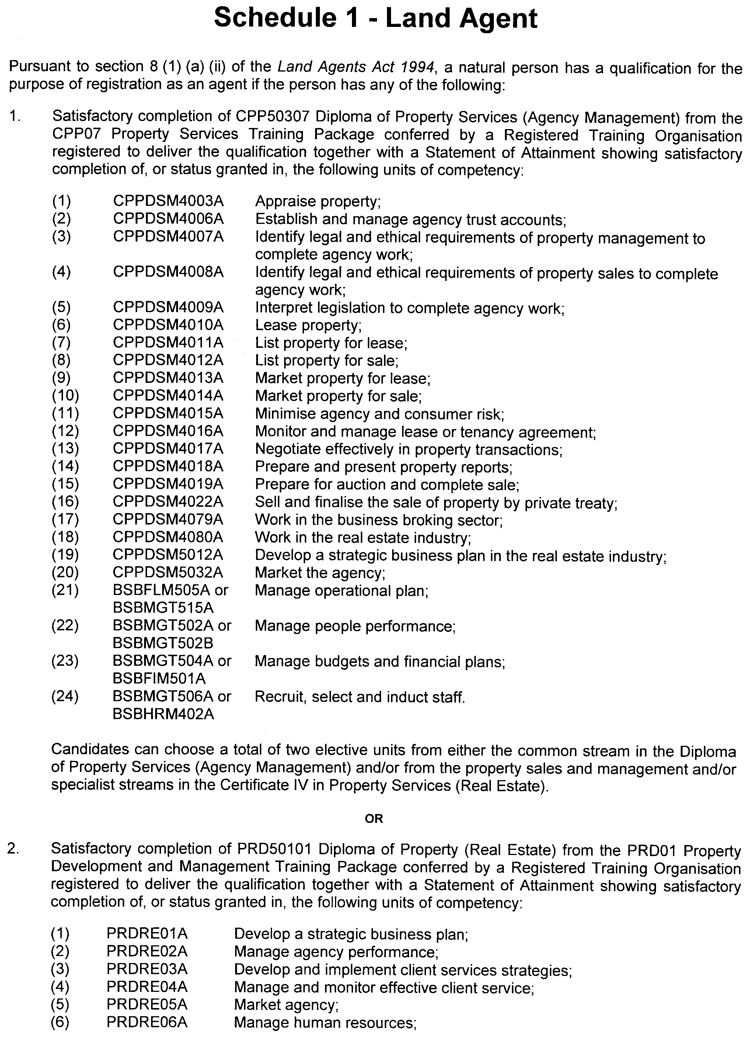

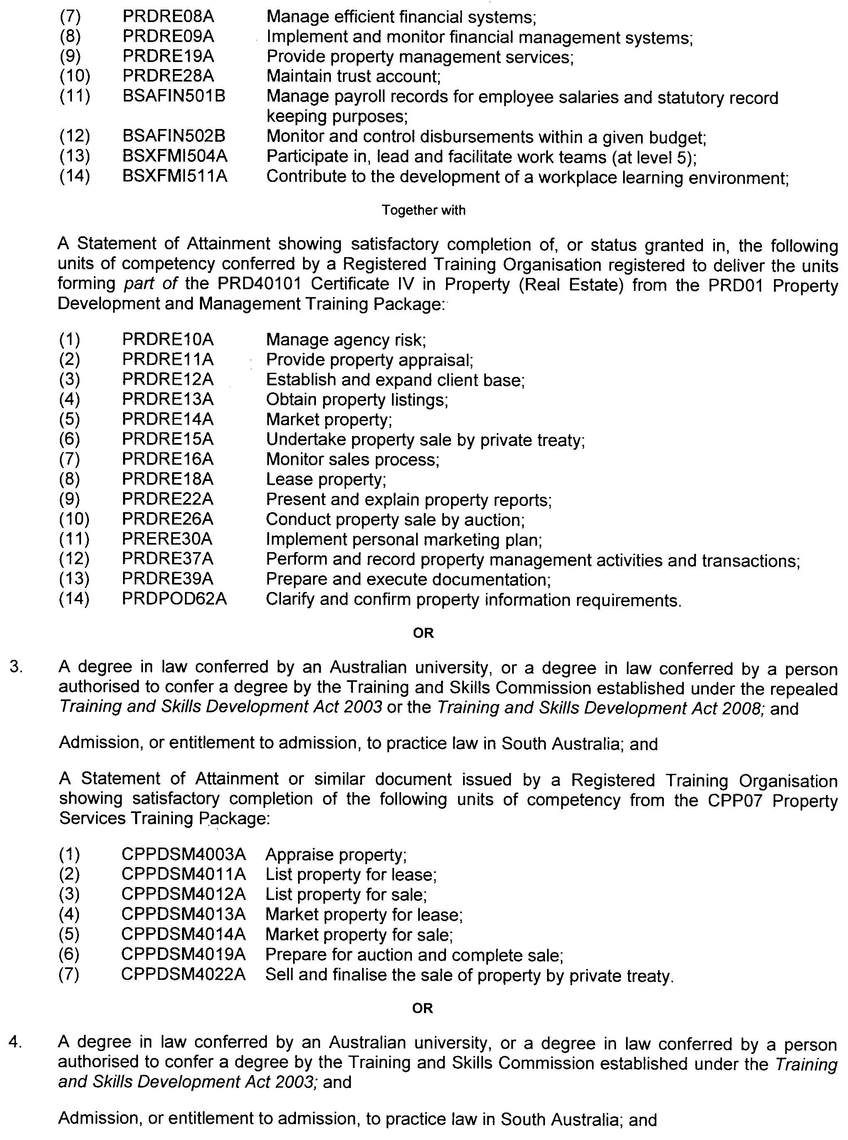

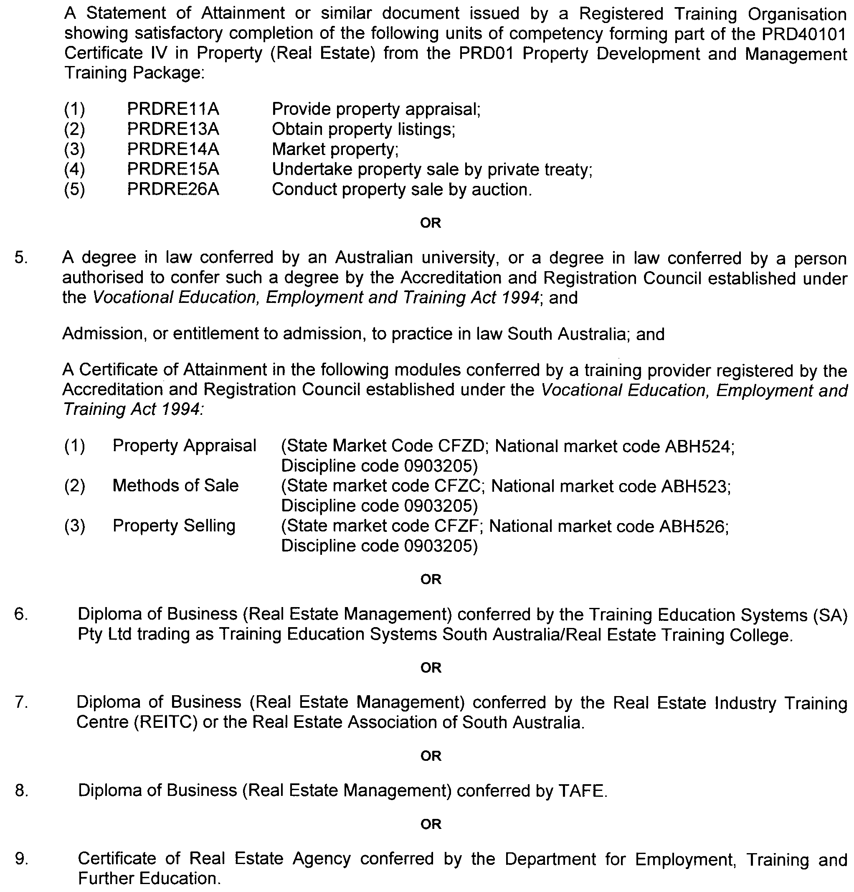

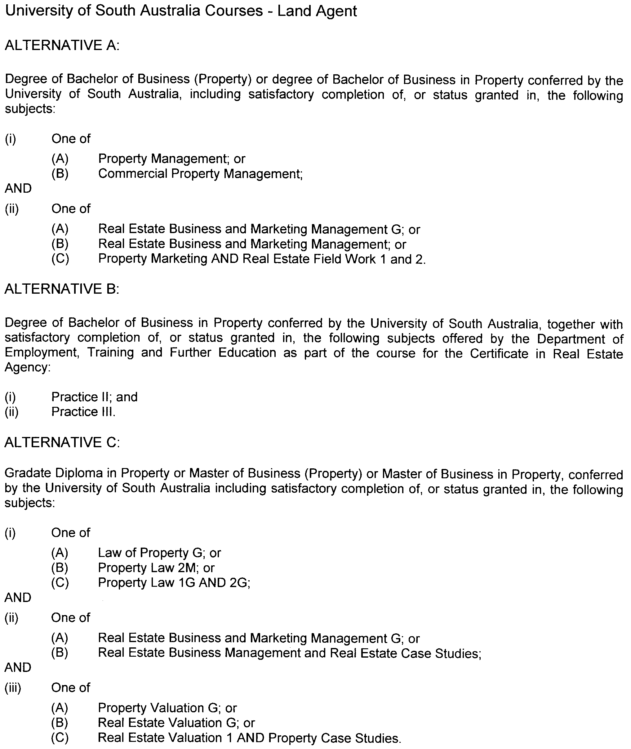

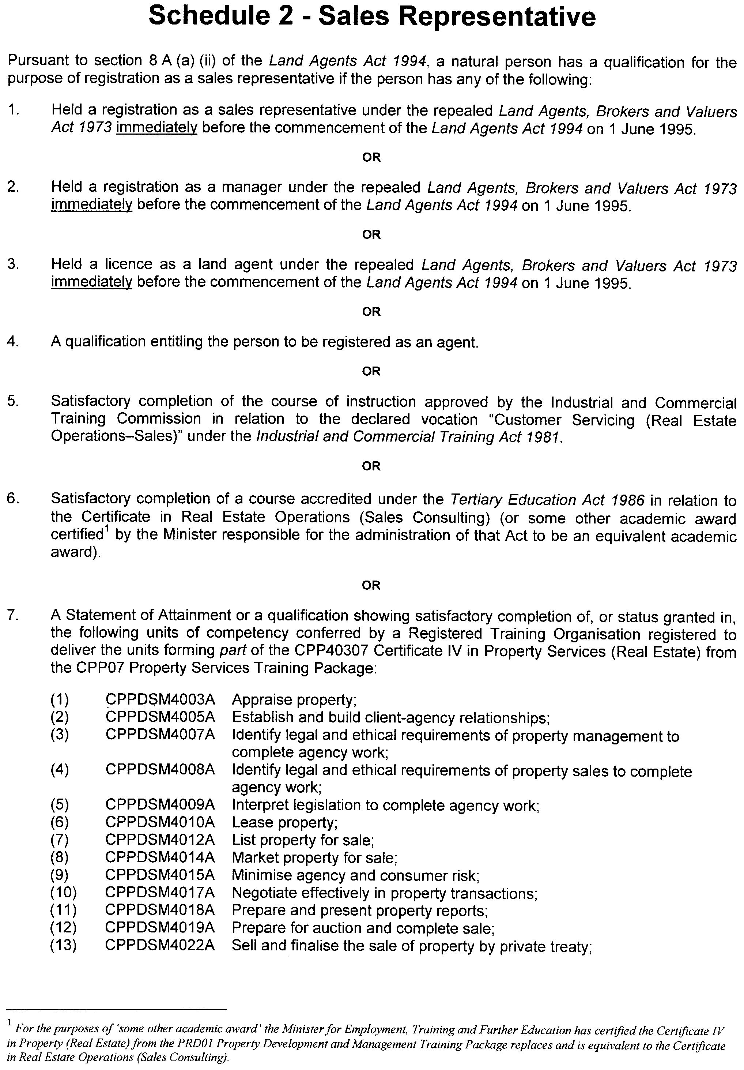

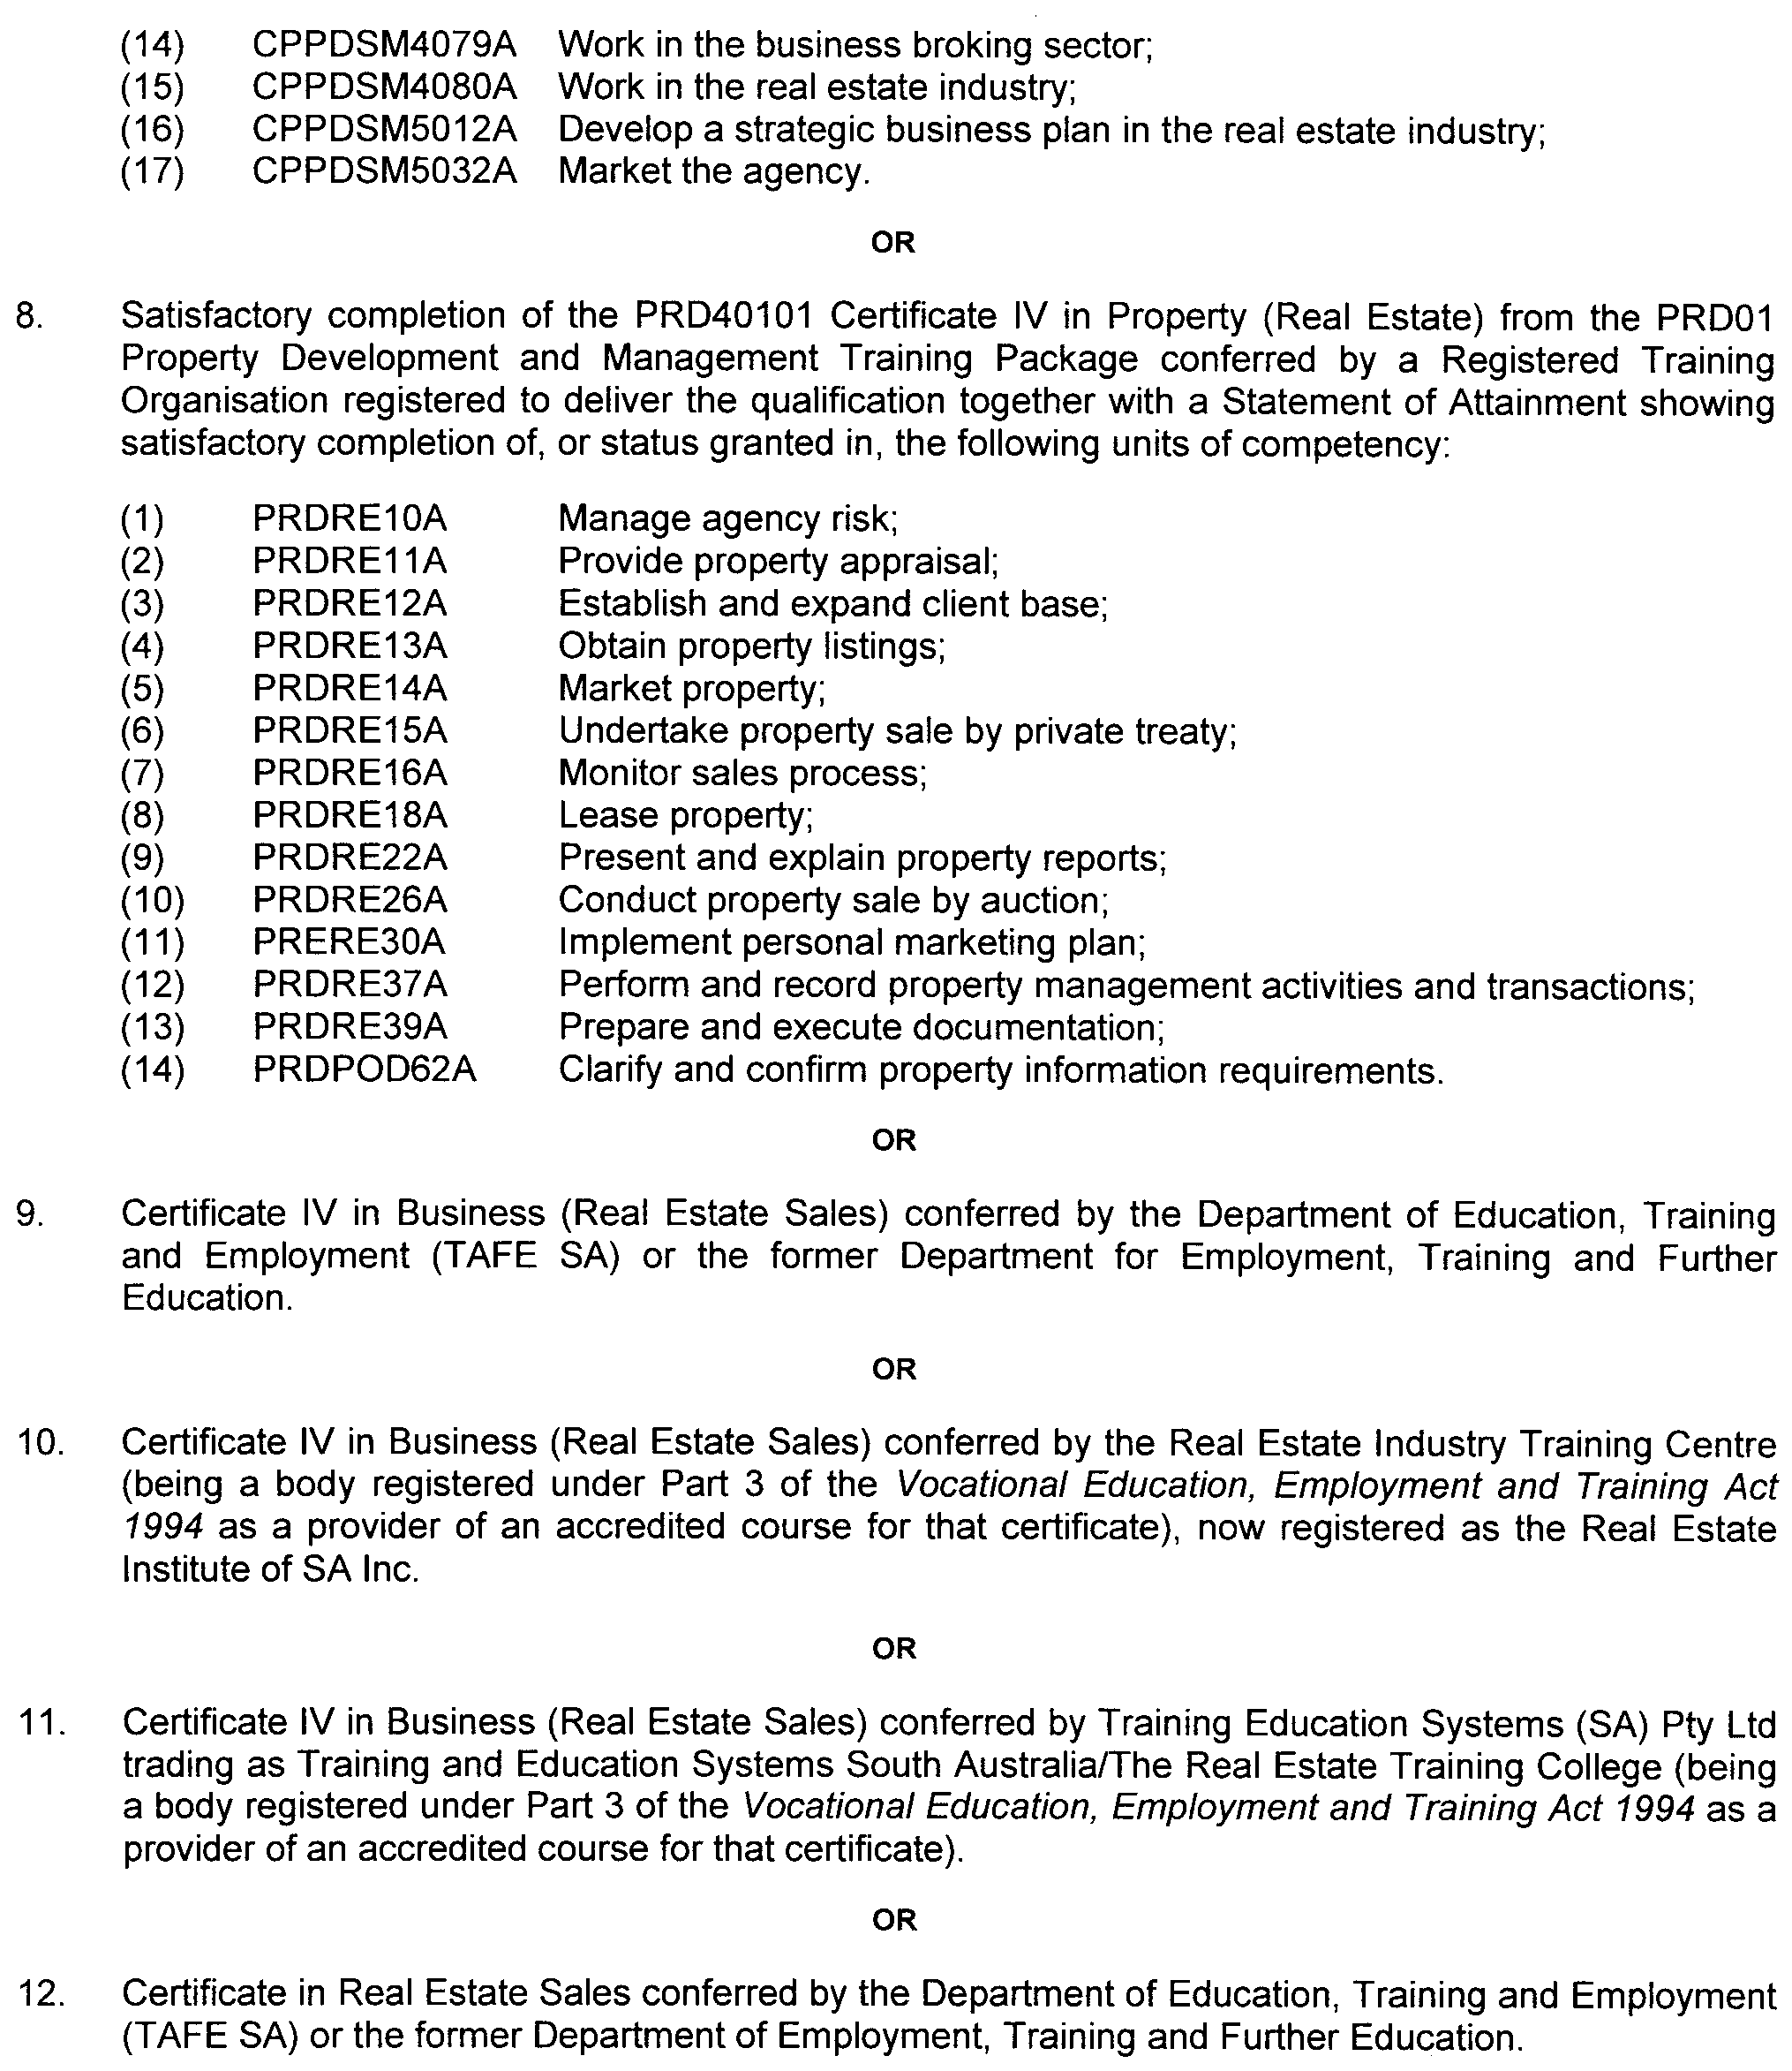

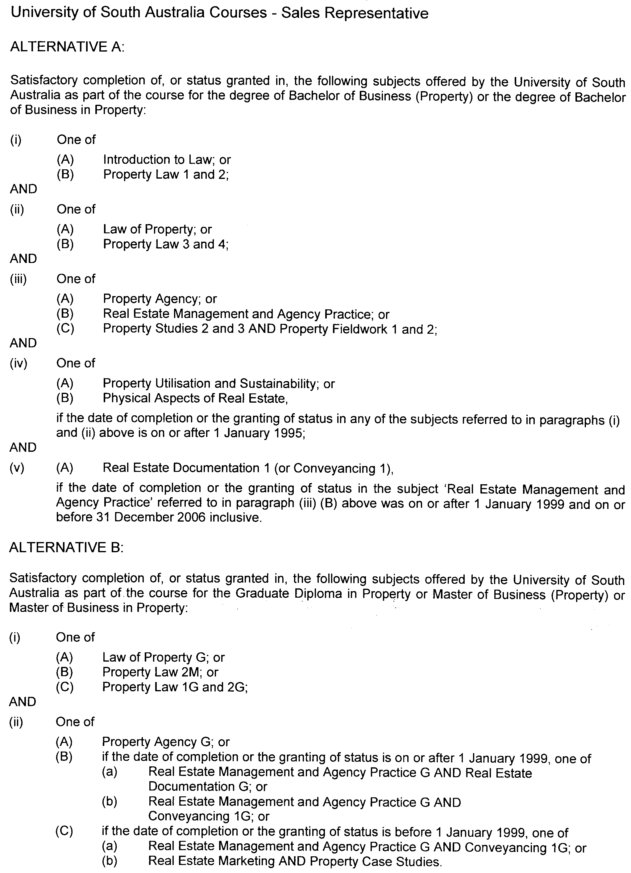

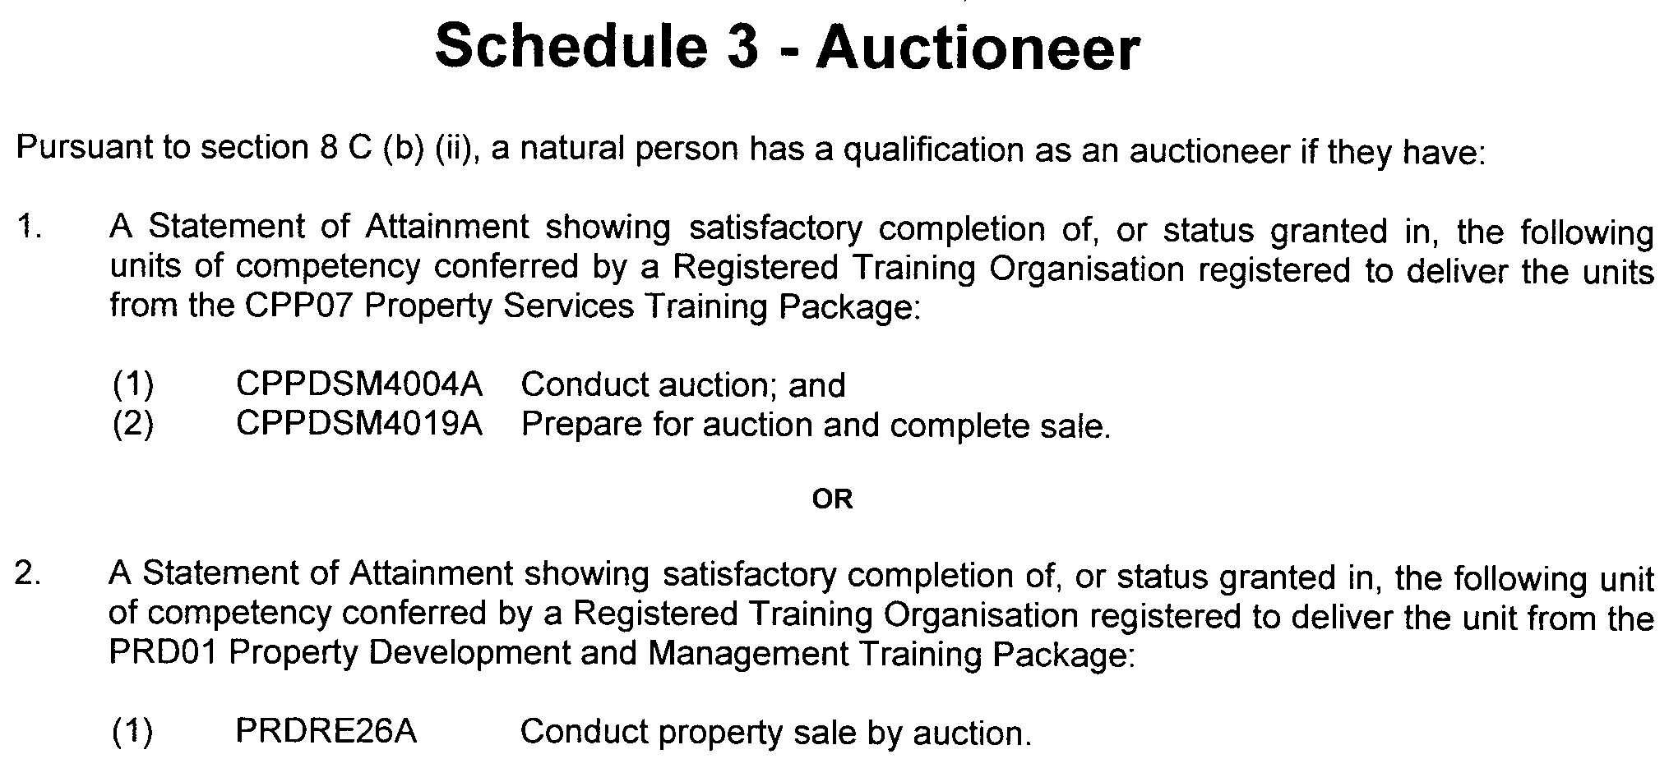

GOVERNMENT GAZETTE ADVERTISEMENT RATES

To apply from 1 July 2008

$  Agents, Ceasing to Act as 41.00  Associations:  Incorporation 20.80  Intention of Incorporation 51.50  Transfer of Properties 51.50  Attorney, Appointment of 41.00  Bailiff’s Sale 51.50  Cemetery Curator Appointed 30.50  Companies:  Alteration to Constitution 41.00  Capital, Increase or Decrease of 51.50  Ceasing to Carry on Business 30.50  Declaration of Dividend 30.50  Incorporation 41.00  Lost Share Certificates:  First Name 30.50  Each Subsequent Name 10.50  Meeting Final 34.25  Meeting Final Regarding Liquidator’s Report on  Conduct of Winding Up (equivalent to ‘Final  Meeting’)  First Name 41.00  Each Subsequent Name 10.50  Notices:  Call 51.50  Change of Name 20.80  Creditors 41.00  Creditors Compromise of Arrangement 41.00  Creditors (extraordinary resolution that ‘the Com-pany be wound up voluntarily and that a liquidator be appointed’) 51.50  Release of Liquidator⎯Application⎯Large Ad. 81.50  ⎯Release Granted 51.50  Receiver and Manager Appointed 47.50  Receiver and Manager Ceasing to Act 41.00  Restored Name 38.50  Petition to Supreme Court for Winding Up 71.50  Summons in Action 61.00  Order of Supreme Court for Winding Up Action 41.00  Register of Interests⎯Section 84 (1) Exempt 92.00  Removal of Office 20.80  Proof of Debts 41.00  Sales of Shares and Forfeiture 41.00  Estates:  Assigned 30.50  Deceased Persons⎯Notice to Creditors, etc. 51.50  Each Subsequent Name 10.50  Deceased Persons⎯Closed Estates 30.50  Each Subsequent Estate 1.35  Probate, Selling of 41.00  Public Trustee, each Estate 10.50 |  | $  Firms:  Ceasing to Carry on Business (each insertion) 27.25  Discontinuance Place of Business 27.25  Land⎯Real Property Act:  Intention to Sell, Notice of 51.50  Lost Certificate of Title Notices 51.50  Cancellation, Notice of (Strata Plan) 51.50  Mortgages:  Caveat Lodgement 20.80  Discharge of 21.80  Foreclosures 20.80  Transfer of 20.80  Sublet 10.50  Leases⎯Application for Transfer (2 insertions) each 10.50  Lost Treasury Receipts (3 insertions) each 30.50  Licensing 61.00  Municipal or District Councils:  Annual Financial Statement⎯Forms 1 and 2 574.00  Electricity Supply⎯Forms 19 and 20 408.00  Default in Payment of Rates:  First Name 81.50  Each Subsequent Name 10.50  Noxious Trade 30.50  Partnership, Dissolution of 30.50  Petitions (small) 20.80  Registered Building Societies (from Registrar-  General) 20.80  Register of Unclaimed Moneys⎯First Name 30.50  Each Subsequent Name 10.50  Registers of Members⎯Three pages and over:  Rate per page (in 8pt) 261.00  Rate per page (in 6pt) 345.00  Sale of Land by Public Auction 52.00  Advertisements 2.90  ¼ page advertisement 122.00  ½ page advertisement 244.00  Full page advertisement 478.00  Advertisements, other than those listed are charged at $2.90 per column line, tabular one-third extra.  Notices by Colleges, Universities, Corporations and District Councils to be charged at $2.90 per line.  Where the notice inserted varies significantly in length from that which is usually published a charge of $2.90 per column line will be applied in lieu of advertisement rates listed.  South Australian Government publications are sold on the condition that they will not be reproduced without prior permission from the Government Printer.
All the above prices include GST

GOVERNMENT GAZETTE NOTICES
ALL private advertisements forwarded for publication in the South Australian Government Gazette must be PAID FOR PRIOR TO INSERTION; and all notices, from whatever source, should be legibly written on one side of the paper only and sent to Government Publishing SA so as to be received no later than 4 p.m. Tuesday preceding the day of publication. Phone 8207 1045 or Fax 8207 1040. E-mail: governmentgazette@dpc.sa.gov.au. Send as attachments in Word format. Please include date the notice is to be published and to whom the notice will be charged. The Government Gazette is available online at: www.governmentgazette.sa.gov.au.

MISCELLANEOUS LEGISLATION AND GOVERNMENT PUBLICATIONS PRICES AS FROM 1 JULY 2008

Acts, Bills, Rules, Parliamentary Papers and Regulations
Pages | Main | Amends | Pages | Main | Amends

1-16 | 2.50 | 1.15 | 497-512 | 34.75 | 33.75
17-32 | 3.35 | 2.10 | 513-528 | 35.75 | 34.50
33-48 | 4.35 | 3.10 | 529-544 | 37.00 | 35.75
49-64 | 5.50 | 4.20 | 545-560 | 38.00 | 37.00
65-80 | 6.45 | 5.35 | 561-576 | 38.75 | 38.00
81-96 | 7.50 | 6.20 | 577-592 | 40.00 | 38.50
97-112 | 8.55 | 7.30 | 593-608 | 41.25 | 39.75
113-128 | 9.55 | 8.40 | 609-624 | 42.00 | 41.00
129-144 | 10.70 | 9.45 | 625-640 | 43.25 | 41.50
145-160 | 11.70 | 10.50 | 641-656 | 44.25 | 43.25
161-176 | 12.80 | 11.50 | 657-672 | 44.75 | 43.75
177-192 | 13.90 | 12.60 | 673-688 | 46.75 | 44.75
193-208 | 15.00 | 13.80 | 689-704 | 47.50 | 45.70
209-224 | 15.80 | 14.60 | 705-720 | 48.25 | 47.00
225-240 | 16.90 | 15.60 | 721-736 | 50.00 | 48.00
241-257 | 18.10 | 16.50 | 737-752 | 50.50 | 49.00
258-272 | 19.10 | 17.60 | 753-768 | 51.50 | 50.00
273-288 | 20.20 | 18.90 | 769-784 | 52.50 | 51.50
289-304 | 21.00 | 19.80 | 785-800 | 53.50 | 52.50
305-320 | 22.30 | 20.90 | 801-816 | 54.50 | 53.00
321-336 | 23.20 | 21.90 | 817-832 | 55.50 | 54.50
337-352 | 24.40 | 23.10 | 833-848 | 56.50 | 55.50
353-368 | 25.25 | 24.20 | 849-864 | 57.50 | 56.00
369-384 | 26.50 | 25.25 | 865-880 | 59.00 | 57.50
385-400 | 27.50 | 26.25 | 881-896 | 59.50 | 58.00
401-416 | 28.50 | 27.00 | 897-912 | 61.00 | 59.50
417-432 | 29.75 | 28.25 | 913-928 | 61.50 | 61.00
433-448 | 30.75 | 29.50 | 929-944 | 62.50 | 61.50
449-464 | 31.50 | 30.25 | 945-960 | 63.50 | 62.00
465-480 | 32.00 | 31.25 | 961-976 | 65.50 | 63.00
481-496 | 33.75 | 32.00 | 977-992 | 66.50 | 63.50

Legislation—Acts, Regulations, etc: $
Subscriptions:
Acts 214.00
All Bills as Laid 514.00
Rules and Regulations 514.00
Parliamentary Papers 514.00
Bound Acts 238.00
Index 119.00
Government Gazette
Copy 5.60
Subscription 284.00
Hansard
Copy 15.60
Subscription—per session (issued weekly) 446.00
Cloth bound—per volume 191.00
Subscription—per session (issued daily) 446.00
Legislation on Disk
Whole Database 3 304.00
Annual Subscription for fortnightly updates 1 015.00
Individual Act(s) including updates POA
Compendium
Subscriptions:
Subscriptions 1 957.00
Updates 690.00
(All the above prices include GST)

All Legislation, Government Gazette, Hansard and Legislation on disk are available from:
Counter Sales Government Legislation⁺ Outlet
and Mail Orders: Service SA Customer Service Centre,
Ground Floor—EDS Centre, 108 North Terrace, Adelaide, S.A. 5000
Phone: 13 23 24 (local call cost), Fax: (08) 8204 1909
Postal: G.P.O. Box 1707, Adelaide, S.A. 5001

Online Shop: www.shop.service.sa.gov.au

Subscriptions and Government Publishing SA
Standing Orders: Box 9, Plaza Level, Riverside Centre, North Terrace, Adelaide, S.A. 5000
Phone: (08) 8207 1043, (08) 8207 0910, Fax: (08) 8207 1040

LOCAL GOVERNMENT ACT 1999
Central Local Government Region of South Australia
Charter—November 2008
1. INTRODUCTION
1.1 Name
The name of the subsidiary is the Central Local Government Region of South Australia (referred to as ‘the Central Region’ in this Charter).
1.2 Establishment
The Central Region was established in 1998 under section 200 of the Local Government Act 1934 as a controlling authority.
The Central Region continues in existence as a regional subsidiary of the Councils listed below under Part 2 of Schedule 2 of the Local Government Act 1999 (‘the Act’) by virtue of the provisions of
section 25 of the Local Government (Implementation) Act 1999.
The establishing Councils, as they are currently named, are as follows:
1.2.1 The Barossa Council;
1.2.2 District Council of Barunga West;
1.2.3 Clare and Gilbert Valleys Council;
1.2.4 District Council of the Copper Coast;
1.2.5 The Flinders Ranges Council;
1.2.6 Regional Council of Goyder;
1.2.7 Light Regional Council;
1.2.8 District Council of Mallala;
1.2.9 District Council of Mount Remarkable;
1.2.10 Northern Areas Council;
1.2.11 District Council of Orroroo/Carrieton;
1.2.12 District Council of Peterborough;
1.2.13 Port Pirie Regional Council;
1.2.14 Wakefield Regional Council; and
1.2.15 District Council of Yorke Peninsula,
(referred to as ‘the Constituent Councils’ in this Charter).
1.3 Local Government Act 1999
This Charter must be read in conjunction with Schedule 2 to the Act. The Central Region shall conduct its affairs in accordance with Schedule 2 to the Act except as modified by this Charter as permitted by Schedule 2.
1.4 Objects and Purpose for which the Central Region is Established
The Central Region is established to:
1.4.1 undertake co-ordinating, advocacy and representational roles on behalf of its Constituent Councils at a regional level;
1.4.2 facilitate and co-ordinate activities of local government at a regional level related to com-munity and economic development with the object of achieving improvement for the benefit of the communities of its Constituent Councils;
1.4.3 develop, encourage, promote, foster and maintain consultation and co-operation and to strengthen the representation and status of local government when dealing with other govern-ments, private enterprise and the community;
1.4.4 develop further co-operation between its Constituent Councils for the benefit of the com-munities of the region;
1.4.5 develop and manage policies which guide the conduct of programs and projects in the region with the objective of securing the best outcomes for the communities of the region;
1.4.6 undertake projects and activities that benefit the region and its communities; and
1.4.7 associate, collaborate and work in conjunction with other regional local government bodies for the advancement of matters of common interest.
1.5 Powers and Functions of the Central Region
The powers, functions and duties of the Central Region, to be exercised in the performance of the Central Region’s objects and purposes, comprise:
1.5.1 becoming a member of or co-operating or contracting with any other association or organisation;
1.5.2 entering into contracts or arrangements with any Government agency or authority;
1.5.3 appointing, employing, remunerating, removing or suspending officers, managers, employees and agents;
1.5.4 entering into contracts with any person for the acquisition of goods and services;
1.5.5 entering into contracts with any person for the supply of goods and services;
1.5.6 raising revenue through subscriptions and levies from Constituent Councils (and Affiliates), by arrangements with sponsor organisations, by arrangement or contract with any other person and by any other means not inconsistent with the objects of the Central Region;
1.5.7 printing and publishing any newspapers, periodicals, books, leaflets, or other like writing;
1.5.8 appointing persons or committees to oversight the management of the Central Region, to steer projects or to pursue geographic or functional interests of Constituent Councils or specific groups of Constituent Councils;
1.5.9 delegating to persons or committees and changing or revoking such delegations;
1.5.10 inviting any elected member, officer or employee of a Constituent Council or any other person to be a member of any duly appointed committee;
1.5.11 acquiring, holding, dealing with and disposing of any real or personal property;
1.5.12 opening and operating bank accounts;
1.5.13 accumulating surplus funds for investment purposes;
1.5.14 investing any of the funds of the Central Region in any investment authorised by the Trustee Act 1936 or with the Local Government Finance Authority of South Australia provided that:
(a) in exercising this power of investment the Central Region must exercise the care, diligence and skill that a prudent person of business would exercise in managing the affairs of other persons; and
(b) the Central Region must avoid investments that are speculative or hazardous in nature;
1.5.15 borrowing money;
1.5.16 giving security for the discharge of liabilities; and
1.5.17 doing all other things that are incidental or conducive to the attainment of the objects, the furtherance of the interests and the exercise of the powers of the Central Region.
1.6 Property
1.6.1 All property held by the Central Region is held by it on behalf of the Constituent Councils.
1.6.2 No person may sell, encumber or otherwise deal with any property of the Central Region without the approval of the Central Region.
1.7 Delegation by the Central Region
The Central Region may by resolution delegate to the Executive Officer of the Central Region any of its powers, functions and duties under this Charter but may not delegate:
1.7.1 the power to impose charges;
1.7.2 the power to borrow money or obtain any other form of financial accommodation;
1.7.3 the power to approve expenditure of money on the works, services or operations of the Central Region not set out or included in a budget approved by the Central Region or where required by this Charter approved by the Constituent Councils;
1.7.4 the power to approve the reimbursement of expenses or payment of allowances to members of the Board of Management;
1.7.5 the power to adopt financial estimates and reports.
A delegation is revocable at will and does not prevent the Board from acting in a matter.
1.8 National Competition Policy
The Central Region does not undertake any commercial activities which constitute a significant business activity of the Central Region and to which the principles of competitive neutrality must be applied.
2. BOARD OF MANAGEMENT
The Central Region is a body corporate and is governed by a Board of Management (referred to as ‘the Board’ in this Charter) which shall have the responsibility to manage all activities of the Central Region ensuring that the Central Region acts in accordance with this Charter.
2.1 Membership of the Board
2.1.1 The Board shall consist of 15 members appointed pursuant to this Clause 2.1.
2.1.2 Each Constituent Council may appoint one elected member to be a Board Member and may at any time revoke the appointment and appoint another elected member as that Council’s delegate.
2.1.3 A Board Member shall, subject to this Charter, be appointed for a term not exceeding four years, as specified in the instrument of appointment and at the expiration of the term of office, will be eligible for re-appointment.
2.1.4 Each Constituent Council may appoint a person to be a Deputy Board Member to act in place of that Council’s Board Member if the Board Member is not present at a meeting of the Board.
2.1.5 In the absence of the Board Member, a Deputy Board Member has all the rights and responsibilities of the Board Member.
2.1.6 A Board Member and a deputy Board Member must be elected members of the Constituent Council which appoints him or her.
2.1.7 Each Constituent Council must give notice in writing to the Central Region of the elected members appointed as Board Members and Deputy Board Members and of any revocation.
2.1.8 In the event that a Board Member or a Deputy Board member appointed pursuant to this Clause is unable to attend a meeting, another elected member or officer of the relevant Council present at the meeting may, upon application, be accepted by the meeting as the proxy for the purposes of that meeting.
2.1.9 Each Board Member shall be entitled to exercise one vote on any matter arising for decision.
2.1.10 A Constituent Council or an Affiliate may invite any of its elected members or staff to attend meetings of the Board and those so invited may be heard but only a Board Member may exercise a vote.
2.1.11 The appointment of a Board Member shall terminate:
(a) upon the death of the Board Member;
(b) upon notification of the Board Member’s resignation by the Council to the Executive Officer;
(c) if the Board Member ceases to be an elected member of the Council which appointed the Board Member;
(d) if the Board Member’s appointment is revoked by the Council which appointed the Board Member; or
(e) if the Board Member resigns his/her position as Board member.
(See Clause 20, Part 2, Schedule 2 of the Act for the grounds which give rise to a vacancy)
2.1.12 The Board may by a two-thirds majority vote of the Board Members present (excluding the Board Member subject to this Clause 2.1.12) make a recommendation to the relevant Constituent Council seeking the Council’s approval to terminate the appointment of a Board Member in the event of:
(a) any behaviour of the Board Member which in the opinion of the Board amounts to impropriety;
(b) serious neglect of duty in attending to the responsibilities of a Board Member;
(c) breach of fiduciary duty to the Board or the Council(s);
(d) breach of the duty of confidentiality to the Board and the Council(s);
(e) breach of the conflict of interest rules of the Board; or
(f) any other behaviour which may discredit the Board.
2.2 Functions of the Board
2.2.1 The formulation of strategic plans and strategies aimed at improving the activities of the Central Region.
2.2.2 To provide input and policy direction to the Central Region.
2.2.3 Monitoring, overseeing and evaluating the performance of the Executive Officer of the Central Region.
2.2.4 Ensuring that ethical behaviour and integrity is followed in all activities undertaken by the Central Region.
2.2.5 Subject to subclause 2.6.15 ensuring that the activities of the Central Region are undertaken in an open and transparent manner.
2.2.6 Assisting in the development of Business Plans.
2.2.7 Exercising the care, diligence and skill that a prudent person of business would exercise in managing the affairs of other persons.
2.3 Propriety of Members of the Board
2.3.1 The principles regarding conflict of interest prescribed in the Act apply to all Board Members in the same manner as if they were elected members of a Council.
2.3.2 The Board Members are not required to comply with Division 2, Chapter 5 (Register of Interests) of the Local Government Act 1999.
2.3.3 The Board Members will at all times act in accordance with their duties of confidence and confidentiality and individual fiduciary duties including honesty and the exercise of reason-able care and diligence with respect to the performance and discharge of official functions and duties as required by Part 4, Division 1, Chapter 5 of the Act and Clause 23 of Part 2 of Schedule 2 to the Local Government Act 1999.
2.4 Chair of the Board
2.4.1 A Chair and two Deputy Chairs shall be elected at the Annual General Meeting by and from the Board Members appointed by the Constituent Councils.
2.4.2 Subject to legislation and any provision in this Charter to the contrary, the Chair and Deputy Chairs shall hold office from the Annual General Meeting at which they are elected until the next Annual General Meeting.
2.4.3 Nominations from Constituent Councils for the positions of Chair and Deputy Chairs must be in writing and must reach the Executive Officer no later than one week prior to the date of the Annual General Meeting.
2.4.4 If the Chair should cease to be a Board Member, either one of the Deputy Chairs may act as Chair until the election of a new Chair.
2.5 Powers of the Chair and Deputy Chair
2.5.1 The Chair shall preside at all meetings of the Board and, in the event of the Chair being absent from a meeting, one of the Deputy Chairs chosen by those present shall preside and in the event of the Chair and both Deputy Chairs being absent from a meeting, the Board Members present shall appoint a member from amongst them, who shall preside for that meeting or until the Chair or a Deputy Chair is present.
2.5.2 The Chair shall exercise a deliberative vote.
2.5.3 The Chair and the Deputy Chairs individually or collectively shall have such other powers as may be decided by a general meeting.
2.6 Meetings of the Board
2.6.1 The Board may determine procedures, in addition to but not inconsistent with those specified in this Charter, to apply at or in relation to its meetings.
2.6.2 Ordinary meeting of the Board must take place at such times and places as may be fixed by the Board or the Executive Officer of the Central Region from time to time.
2.6.3 For the purposes of this subclause, the contemporary linking together by telephone, audio-visual or other instantaneous means (‘telecommunications meeting’) of a number of the Board Members provided that at least a quorum is present, is deemed to constitute a meeting of the Board. Each of the Board Members taking part in the telecommunications meeting, must at all times during the telecommunications meeting be able to hear and be heard by each of the other Board Members present. At the commencement of the meeting, each Board Member must announce his/her presence to all other Board Members taking part in the meeting. A Board Member must not leave a telecommunications meeting by disconnecting his/her telephone, audio-visual or other communication equipment, unless that Board Member has previously notified the Chair of the meeting.
2.6.4 Notice of ordinary meetings of the Board (including the Annual General Meeting) must be given by the Executive Officer to each Board Member and Chief Executive Officer of the Constituent Councils at least four weeks prior to the holding of the meeting.
2.6.5 Notice of an ordinary meeting for the purpose of making a recommendation to wind up the Central Region will be sent to Board Members and the Chief Executive Officers of the Constituent Councils at least eight weeks before the date of the meeting.
2.6.6 Any three Board Members may by delivering a written request to the Executive Officer of the Central Region require a special meeting of the Board to be held. On receipt of the request the Executive Officer shall send a notice of the special meeting to all Board Members and Chief Executive Officers of the Constituent Councils at least three days prior to the commencement of the special meeting. Such notice shall specify the date, time and place of the special meeting and be signed by the Executive Officer, and contain, or be accompanied by, the agenda for the meeting.
2.6.7 The request to the Executive Officer requiring a special meeting to be held must be accompanied by the agenda for the meeting and any written reports intended to be considered at the meeting (and if an agenda is not provided the request is of no effect).
2.6.8 The Chair may convene urgent general meetings of the Board at the Chair’s discretion.
2.6.9 The Chair shall convene other meetings of the Board as a general meeting may direct.
2.6.10 Quorum
(a) The prescribed number of Board Members will constitute a quorum at a meeting and no business will be transacted at a meeting unless a quorum is present.
(b) The prescribed number of Board Members means a number ascertained by dividing the total number of Board Members for the time being in office or, for a meeting other than a general meeting, the number of Board Members appointed by the Central Region to attend that meeting, by two ignoring any fraction resulting from the division and adding one.
(c) In the matter of an ordinary meeting for the purpose of recommending the winding up of the Central Region, a quorum will be constituted by the attendance of Board Members of a majority of Constituent Councils.
2.6.11 Voting
(a) Every Board Member, including the Chair, shall have a deliberative vote. The Chair shall not in the event of an equality of votes have a casting vote.
(b) Questions arising for decision at ordinary meetings of the Board will be decided by a simple majority of votes on the basis of one vote per Board Member present at the meeting.
(c) In the event of a tied vote, the question is lost.
(d) A recommendation to Constituent Council’s to wind up the Central Region requires the votes of the Board Members of a majority of the Constituent Councils.
(e) Subject to conflicts of interest, each Board Member validly present at a meeting must vote on a question arising for decision at the meeting. Failure by any Board Member to vote other than in conflict of interest situations will be deemed to be a negative vote in relation to the question for decision.
2.6.12 A majority of the Board Members present at a meeting of the Board may adjourn the meeting from time to time and from place to place.
2.6.13 Subject to Clause 2.6.15 meetings of the Board must be conducted in a place open to the public.
2.6.14 All Board Members must keep confidential all documents and any information provided to them on a confidential basis for their consideration prior to a meeting of the Board.
2.6.15 The Board may order that the public be excluded from attendance at any meeting in order to enable the Board to consider in confidence:
(a) legal or other professional advice;
(b) complaints against an officer or employee of the Central Region;
(c) proposals for the appointment, suspension, demotion, disciplining or dismissal of an officer or employee of the Central Region;
(d) proposals relating to the remuneration or conditions of service of an officer or employee of the Central Region;
(e) tenders for the supply of goods or the carrying out of works;
(f) matters that the Board considers to be of a commercial and/or confidential nature;
(g) proposals relating to the acquisition or disposal of land;
(h) information relating to the health or financial position of any person;
(i) information given to the Central Region on the understanding that it would be treated as confidential; and
(j) matters relating to actual or possible litigation involving the Central Region or an officer or employee of the Central Region;
(k) this Clause 2.6.15 does not apply to:
(i) a Board Member; or
(ii) any other person permitted by the Board to remain in the room.
2.6.16 Where an order is made under Clause 2.6.15, a note must be made in the minutes of the making of the order and of the grounds on which it was made.
2.6.17 The Executive Officer must cause minutes to be kept of the proceedings at every meeting of the Board.
2.6.18 Where the Executive Officer is excluded from attendance at a meeting of the Board pursuant to Clause 2.6.15, the person presiding at the meeting shall cause the minutes to be kept.
2.6.19 Subject to Clause 2.6.21 a person is entitled to inspect, without payment of a fee:
(a) minutes of a Board Meeting;
(b) reports to the Board received at a meeting of the Board;
(c) recommendations presented to the Board in writing and adopted by resolution of the Board.
2.6.20 Subject to Clause 2.6.21, a person is entitled, on payment of a fee fixed by the Board, to obtain a copy of any documents available for inspection under Clause 2.6.19.
2.6.21 Clauses 2.6.19 and 2.6.20 do not apply in relation to a document or part of a document if:
(a) the document or part of the document relates to a matter of a kind referred to in Clause 2.6.15; and
(b) the Board orders that the document or part of the document be kept confidential (provided that in so ordering the Board must specify the duration of the order or the circumstances in which it will cease to apply or a period after which it must be reviewed).
2.6.22 Subject to this Charter and to any direction of the Constituent Councils the Board may determine its own procedures which must be fair and contribute to free and open decision making.
2.7 Annual General Meeting
2.7.1 The Annual General Meeting will:
(a) be held not later than 30 October in each calendar year;
(b) receive the Central Region’s Annual Report which may incorporate reports from com-mittees and any representatives reports from other organisations;
(c) receive the audited financial statement for the preceding financial year;
(d) acknowledge the appointment of Board Members;
(e) elect the Chair and two Deputy Chairs;
(f) appoint representatives to other organisations;
(g) adopt an annual program and a budget detailing the estimated revenues and costs for the financial year and give such instructions and authority in relation thereto to the Chair, Deputy Chairs, Executive Officer or other persons individually or together as may be considered appropriate; and
(h) consider any other business requiring consideration by the Board Members in general meeting.
3. EXECUTIVE OFFICER
3.1 The Board shall appoint an Executive Officer of the Central Region to manage the business of the Board on terms agreed between the Executive Officer and the Board.
3.2 The Executive Officer is responsible to the Central Region for the execution of decisions taken by the Central Region and for the efficient and effective management of the affairs of the Central Region.
3.3 The terms and conditions of the engagement and remuneration of the Executive Officer shall be determined by the Annual General Meeting as part of the annual program and budget.
3.4 The Executive Officer shall cause records to be kept of all activities and financial affairs of the Central Region in accordance with this Charter, in addition to other duties provided for by this Charter and those specified in the terms and conditions of appointment.
3.5 The Board shall delegate responsibility for the day to day management of the Central Region to the Executive Officer, who will ensure that sound business and human resource management practices are applied in the efficient and effective management of the operations of the Central Region.
3.6 The functions of the Executive Officer shall be specified in the terms and conditions of appointment and shall include but are not limited to:
3.6.1 attending at all meetings of the Board unless excluded by resolution of the Board;
3.6.2 ensuring that the decisions of the Board are implemented in a timely and efficient manner;
3.6.3 providing information to assist the Board to assess the Central Region’s performance against its Strategic and Business Plans;
3.6.4 appointing, managing, suspending and dismissing employees of the Central Region;
3.6.5 determining the conditions of employment of employees of the Central Region, within budgetary constraints set by the Board;
3.6.6 providing advice and reports to the Board on the exercise and performance of its powers and functions under this Charter or any Act;
3.6.7 ensuring that the Central Region is at all times complying with Schedule 2 of the Local Government Act 1999;
3.6.8 co-ordinating and initiating proposals for consideration of the Board including but not limited to continuing improvement of the operations of the Central Region;
3.6.9 ensuring that the assets and resources of the Central Region are properly managed and maintained;
3.6.10 ensuring that records required under the Act or any other legislation are properly kept and maintained;
3.6.11 ensuring that the Central Region’s annual report is distributed to the Constituent Councils in time to be incorporated in their annual reports;
3.6.12 exercising, performing or discharging other powers, functions or duties conferred on the Executive Officer by or under the Act or any other Act, and performing other functions lawfully directed by the Board; and
3.6.13 achieving financial outcomes in accordance with adopted plans and budgets of the Central Region.
3.7 The Executive Officer may delegate or sub-delegate to:
(a) a committee;
(b) an employee of the subsidiary;
(c) an employee of a Constituent Council; or
(d) a person for the time being occupying a particular office or position,
any power or function vested in the Executive Officer. Such delegation or sub-delegation may be subject to any conditions or limitations as determined by the Executive Officer.
3.8 Where a power or function is delegated to an employee, or a person occupying a particular office or position, that employee or person is responsible to the Executive Officer for the efficient and effective exercise or performance of that power or function.
3.9 A written record of all delegations and sub-delegations must be kept by the Executive Officer at all times.
4. MANAGEMENT
4.1 Financial Management
4.1.1 The Central Region shall keep proper books of accounts in accordance with the requirements of the Local Government (Financial Management) Regulations 1999.
4.1.2 The Central Region’s books of account must be available for inspection by any Board Member or authorised representative of any Constituent Council at any reasonable time on request.
4.1.3 The Central Region must establish and maintain a bank account with such banking facilities and at a bank to be determined by the Board.
4.1.4 All cheques must be signed by a person authorised by resolution of the Board.
4.1.5 Any payments made by Electronic Funds Transfer must be made in accordance with procedures approved by the Auditor.
4.1.6 The Executive Officer must act prudently in the handling of all financial transactions for the Central Region and must provide quarterly financial and corporate reports to the Board and if requested, the Constituent Councils.
4.2 Levies
4.2.1 The Central Region may levy Constituent Councils or Affiliates or any of them for a specified purpose or purposes.
4.2.2 A levy must be imposed by a ordinary general meeting of the Board.
4.2.3 The Executive Officer must give notice of the levy to all affected Councils.
4.2.4 A levy will not be binding on Constituent Councils or Affiliates until the expiration of one calendar month from the date of the notice.
4.2.5 A Constituent Council or Affiliate which objects in writing to the imposition of the levy within one month of the date of the notice shall be exempt from payment of the levy until its objection is considered at a general meeting of the Board.
4.2.6 A general meeting must, after consideration of the objection of a Constituent Council or an Affiliate to a levy, confirm or vary the levy on that Council or exempt that Council from payment of the levy.
4.2.7 The Chair may convene an urgent general meeting to consider an objection to a levy.
4.3 Audit
4.3.1 The Board shall appoint an auditor in accordance with the Local Government (Financial Management) Regulations 1999.
4.3.2 The Auditor shall hold office until the appointment is rescinded by resolution of the Board of Management.
4.3.3 The Auditor will have the same powers and responsibilities as set out in the Local Govern-ment Act 1999 in relation to a Council.
4.3.4 The audit of Financial Statements of the Central Region, together with the accompanying report from the Auditor, shall be submitted to both the Board and the Constituent Councils.
4.3.5 The books of account and financial statements shall be audited at least once per year.
4.3.6 The Central Region shall establish an audit committee in accordance with the Local Govern-ment (Financial Management) Regulations 1999.
4.4 Business Plan
The Central Region shall:
4.4.1 prepare a three year Business Plan linking the core activities of the Central Region to strategic, operational and organisational requirements with supporting financial projections setting out the estimates of revenue and expenditure as necessary for the period;
4.4.2 review the Business Plan annually; and
4.4.3 consult with the Constituent Councils prior to adopting or amending the Business Plan.
(See Clause 24, Part 2, Schedule 2 to the Act for the contents of the Business Plan)
4.5 Annual Program and Budget
4.5.1 A proposed annual program and budget detailing the estimated revenues and costs for the financial year shall be submitted to the Annual General Meeting.
4.5.2 The proposed annual program and the budget may be altered at the Annual General Meeting and shall be adopted subject to such alterations as the Annual General Meeting agrees upon.
4.5.3 The proposed annual program and the budget must be referred to Constituent Councils not later than the date of dispatch of the notice of the Annual General Meeting.
4.5.4 In accordance with the Local Government (Financial Management) Regulations 1999, the annual program and budget:
(a) must be provided to the Chief Executive Officer of all Constituent Councils within five business days after its adoption;
(b) must be adopted after 31 May; and
(c) must be reconsidered at least three times in the relevant financial year, at intervals of not less than three months between 30 September and 31 May in the relevant financial year.
4.5.5 A Constituent Council may comment on the annual program and the budget in writing to the Executive Officer at least three business days before the Annual General Meeting or through its delegate at the Annual General Meeting.
(See Clause 25, Part 2, Schedule 2 to the Act for the contents of the budget)
4.6 Reporting
4.6.1 The Central Region must submit to the Constituent Councils, at least once in each operating year, a report on the work and operations of the Central Region detailing achievement of the aims and objectives of its Business Plan and incorporating the audited Financial Statements of the Central Region and any other information or report as required by the Constituent Councils.
4.6.2 The Board shall present a balance sheet and full financial report to the Constituent Councils at the end of each operating year.
4.6.3 The operating year for the Central Region shall be the 1 July to 30 June in each year.
4.6.4 Following adoption by the Board of Management, the Central Region Annual Report for the preceding year will be provided to the Constituent Councils no later than 15 September.
5. MISCELLANEOUS
5.1 New Members
5.1.1 Subject to the provisions of the Act, this Charter may be amended by the unanimous agreement of the Constituent Councils to provide for the admission of a new Constituent Council or Councils, with or without conditions of membership.
5.1.2 A Council may apply for Affiliate status provided that it is a full member of another Regional organisation or, the Central Region is satisfied that there is good reason for the Council not to be a full member of a Region. An Affiliate may be heard but shall not be entitled to vote at meetings of the Central Region and shall, subject to legislative requirements, have such other rights and obligations as the Central Region may decide.
5.2 Subscription
5.2.1 Every Constituent Council shall be liable to contribute monies to the Central Region each financial year.
5.2.2 The amount of each Constituent Council’s subscription will be decided at the Annual General Meeting and will be due and payable within one month of a written request from the Executive Officer for payment.
5.2.3 If the Constituent Council status is granted to a Council after the first day of July in any year, the subscription payable by that Council for that year will be calculated on the basis of the number of months remaining in that year.
5.2.4 The subscription payable by an Affiliate shall be decided at the time Affiliate status is granted and may be varied by the Annual General Meeting.
5.3 Standing Orders
5.3.1 The Central Region may pass, alter or rescind standing orders or rules for the due management and regulation of the Central Region.
5.3.2 Standing orders or rules made pursuant to this Clause shall be entered in a book which will be kept for the information of Board Members and may be printed or circulated at the discretion of the Central Region.
5.3.3 Standing orders made, altered or rescinded since the previous Annual General Meeting shall be confirmed, varied or disallowed at a general meeting.
5.4 Disqualification
5.4.1 Subject to any legislative requirements, a Council which fails to pay its subscription or any other monies due to the Central Region within six months from the date upon which the subscription or other monies become due and payable shall cease to be a Constituent Council or, as the case may be, an Affiliate.
5.4.2 The Executive Officer will give notice in writing to the Council that its status as a Constituent Council or, as the case may be, an Affiliate, has been terminated.
5.5 Withdrawal
5.5.1 Subject to any legislative requirements, a Constituent Council or an Affiliate may resign from the Central Region at any time by giving three months notice in writing of such resignation to the Executive Officer provided that its subscription of the current year and other monies outstanding prior to the date of its giving notice of resignation have been paid to the Central Region.
5.5.2 The withdrawal of any Constituent Council does not extinguish the liability of that Constituent Council to contribute to any loss or liability incurred by the Central Region at any time before or after such withdrawal in respect of any act or omission by the Central Region prior to such withdrawal.
5.6 Insurance and Superannuation Requirements
5.6.1 The Central Region shall register with the Local Government Mutual Liability Scheme and comply with the rules of that Scheme.
5.6.2 The Central Region shall advise the Local Government Risk Management Services of its insurance requirements relating to Local Government Special Risks including buildings, structures, vehicles and equipment under the management, care and control of the Central Region.
5.6.3 If the Central Region employs any person it shall register with the Local Government Superan-nuation Scheme and the Local Government Workers Compensation Scheme and comply with the rules of those Schemes.
5.7 Winding Up
5.7.1 The Central Region may be wound up by unanimous resolution of the Constituent Councils and with the consent of the Minister.
5.7.2 In the event of a winding up, any surplus assets after payment of all expenses shall be returned to Constituent Councils in proportion to the subscription paid in the financial year prior to the passing of the resolution wind up.
5.7.3 If there are insufficient funds to pay all expenses due by the Central Region on winding up, a levy shall be imposed on all Constituent Councils in proportion to the subscription paid in the financial year prior to the passing of the resolution to wind up.
5.7.4 In the event of a winding up, an affiliate shall not be entitled to participate in a distribution of surplus assets and shall not be liable to pay a levy if there are insufficient funds to pay all expenses.
5.8 Direction by Constituent Councils
5.8.1 The establishment of the Central Region does not derogate from the power of the Constituent Councils to jointly act in any manner prudent to the sound management and operation of the Central Region, provided that the Constituent Councils have first agreed by unanimous resolution of each constituent Council as to the action to be taken.
5.8.2 For the purpose of subclause 5.8.1, any direction given by the Constituent Councils must be given in writing to the Executive Officer of the Central Region.
5.9 Alteration and Review of Charter
5.9.1 This Charter will be reviewed by the Constituent Councils acting in concurrence at least once in every three years.
5.9.2 This Charter may be amended by a resolution passed by a simple majority of the Constituent Councils.
5.9.3 Notice of a proposed alteration must be given by the Executive Officer to all Constituent Councils prior to the general meeting at which the alteration is proposed.
5.9.4 The Executive Officer must ensure that the amended Charter is published in the South Australian Government Gazette and a copy of the amended Charter provided to the Minister.
5.9.5 Before the Constituent Councils vote on a proposal to alter this Charter they must take into account any recommendation of the Board.
5.10 Disputes Between Constituent Councils
5.10.1 The Constituent Councils agree to work together in good faith to resolve any matter requiring their direction or resolution.
5.10.2 Where the Constituent Councils are unable to resolve a matter within 21 days of the matter being presented to them, the matter will be referred for arbitration by the President (or his/her nominee) of the Institute of Arbitration.
5.10.3 Notwithstanding subclause 5.10.2 the Constituent Councils agree to be bound by the decision of the Arbitrator (except in relation to any decision relating to the acquisition or disposal of any real property) and will endeavour to work together in good faith in the implementation of that decision.
5.10.4 The costs of arbitration shall be borne equally by the Constituent Councils.
5.11 Committees
5.11.1 The Board may establish a committee of Board Members and/or other persons for the purpose of:
(a) enquiring into and reporting to the Board on any matter within the Central Region’s functions and powers and as detailed in the terms of reference given by the Board to the Committee; or
(b) exercising, performing or discharging delegated powers, functions or duties.
5.11.2 A member of a committee established under this Clause holds office at the pleasure of the Board.
5.11.3 The Board may establish advisory committees consisting of or including persons who are not Board Members for enquiring into and reporting to the Board on any matter within the Central Region’s functions and powers and as detailed in the terms of reference which must be given by the Board to the advisory committee.
5.11.4 A member of an advisory committee established under this clause holds office at the pleasure of the Board.
5.11.5 The Chair of the Board is an ex-officio a member of any committee or advisory committee established by the Board.
5.12 The Central Local Government Region Executive Committee
5.12.1 The Board shall establish a committee to be known as ‘The Central Local Government Region Executive Committee’.
5.12.2 Members of The Central Local Government Region Executive Committee shall consist of:
(a) the Chair and the two Deputy Chairs elected pursuant to Clause 2.4.1; and
(b) two other Board Members elected at the AGM on the basis of nominations made at the AGM after the election of the Chair and Deputy Chairs.
5.12.3 The Central Local Government Region Executive Committee’s functions are to supervise the activities undertaken by the Central Region, to give guidance to the Executive Officer and to make recommendations to the Board.
5.13 Common Seal
5.13.1 The Central Region shall have a common seal upon which its corporate name shall appear in legible characters.
5.13.2 The common seal shall not be used without the express authorisation of a resolution of the Central Region and every use of the common seal shall be recorded in the minute book of the Central Region.
5.13.3 The affixing of the common seal shall be witnessed by the Chair or a Deputy Chair and the Executive Officer or such other person as the Central Region may appoint for the purpose.
5.13.4 The common seal shall be kept in the custody of the Executive Officer or such other person as the Central Region may from time to time decide.
5.14 Circumstances Not Provided For
5.14.1 If any circumstance arises about which this Charter is silent, incapable of taking effect or being implemented according to its strict provisions, the Chair may decide the action to be taken to ensure achievement of the objects of the Central Region and its effective administrator.
5.14.2 The Chair shall report any such decision at the next general meeting.

MINING ACT 1971
NOTICE is hereby given in accordance with section 28 (5) of the Mining Act 1971, that the Minister for Mineral Resources Development proposes to grant an Exploration Licence over the undermentioned area:
Applicant: Pirie Resources Pty Ltd
Location: Worlds End area⎯Approximately 10 km south-east of Burra.
Term: 1 year
Area in km²: 593
Ref.: 2008/00222
Plan and co-ordinates can be found on the PIRSA website: http://www.pir.sa.gov.au/minerals/public_notices or by phoning Mineral Tenements on (08) 8463 3103.
H. Thomas, Mining Registrar

MINING ACT 1971
NOTICE is hereby given in accordance with section 28 (5) of the Mining Act 1971, that the Minister for Mineral Resources Development proposes to grant an Exploration Licence over the undermentioned area:
Applicant: Flinders Mines Ltd
Location: Billa Kalina area⎯Approximately 170 km south-east of Coober Pedy.
Pastoral Lease: Millers Creek, Billa Kalina
Term: 1 year
Area in km²: 1 435
Ref.: 2008/00475
Plan and co-ordinates can be found on the PIRSA website: http://www.pir.sa.gov.au/minerals/public_notices or by phoning Mineral Tenements on (08) 8463 3103.
H. Thomas, Mining Registrar

MINING ACT 1971
NOTICE is hereby given in accordance with section 28 (5) of the Mining Act 1971, that the Minister for Mineral Resources Development proposes to grant an Exploration Licence over the undermentioned area:
Applicant: Southern Iron Pty Ltd
Location: Hawks Nest area⎯Approximately 120 km north of Kingoonya.
Pastoral Lease: McDouall Peak, Bulgunnia, Mount Eba.
Term: 2 years
Area in km²: 398
Ref.: 2008/00476
Plan and co-ordinates can be found on the PIRSA website: http://www.pir.sa.gov.au/minerals/public_notices or by phoning Mineral Tenements on (08) 8463 3103.
H. Thomas, Mining Registrar

NATIONAL ELECTRICITY LAW
THE Australian Energy Market Commission (AEMC) gives notice under the National Electricity Law of the following matters.
Under section 107A, the period of time for the making of the final determination on the proposed National Electricity Amend-ment (Confidentiality Arrangements in Respect of Information Required for Power System Studies) Rule 2009 (Project No. ERC0062) has been extended to 19 February 2009. The AEMC requires further submissions on transitional arrangements for the information that NEMMCO currently holds and uses for power system modelling. Submissions must be received by 6 February 2009.
Under section 99, the making of a draft determination for the rule change proposal relating to Futures Offset Arrangements (Project No. ERC0056). In relation to the draft determination:
• requests for a pre-determination hearing must be received by 30 January 2009; and
• submissions must be received by 6 March 2009.
All submissions and requests for a hearing should be forwarded to submissions@aemc.gov.au and must cite the Project No. in its title.
Submissions should be submitted in accordance with the AEMC’s Guidelines for making written submissions on Rule change proposals. The AEMC publishes all submissions on its website subject to a claim of confidentiality.
Under section 95, the AEMC Reliability Panel has requested the making of the proposed National Electricity Amendment (NEM Reliability Settings: VoLL, CPT and Future Reliability Review) Rule 2009. The proposal seeks to revise the Value of Lost Load and the Cumulative Price Threshold, and introduce a new process for reviewing reliability standards and settings. The AEMC has decided to fast track this Rule change request under section 96A of the NEL.
Further details on the above matters are available on the AEMC’s website www.aemc.gov.au. All documents in relation to the above matters are published on the AEMC’s website and are available for inspection at the offices of the AEMC.
John Tamblyn
Chairman
Australian Energy Market Commission
Level 5, 201 Elizabeth Street
Sydney, N.S.W. 2000
Telephone: (02) 8296 7800
Facsimile: (02) 8296 7899
22 January 2009.

NATURAL RESOURCES MANAGEMENT ACT 2004
Notice of Variation to the Notice of Restriction on the Taking of Water from the River Murray Prescribed Watercourse
PURSUANT to section 132 (9) of the Natural Resources Manage-ment Act 2004 (‘the Act’) and pursuant to the delegation of power in section 132 of the Act made to me by the Minister for Environ-ment and Conservation (under section 9 (1) of the Administrative Arrangements Act 1994 and by the notice pub-lished in the Government Gazette of 15 September 2005, page 3307), I, Karlene Maywald, Minister for the River Murray do hereby vary the Notice of Restriction on the Taking of Water from the River Murray Prescribed Watercourse published in the Government Gazette of 19 June 2008, pages 2360 and 2361 (‘the Notice’) and varied in the Government Gazette of 21 August 2008, pages 3730 and 3731, and varied in the Government Gazette of 18 September 2008, pages 4440 and 4441, and varied in the Government Gazette of 23 October 2008, pages 4919 and 4920, as follows:
1. Clause 1 (a) of Schedule 2 of the Notice is replaced with the following:
(a) If a person holds a water licence endorsed with a water (taking) allocation to take water from the River Murray Prescribed Watercourse for purposes other than domestic, stock, intensive farming, industrial or industrial-dairy purposes, as defined in the Act and the Water Allocation Plan for the River Murray Prescribed Watercourse adopted on 1 July 2002 (as amended on 12 January 2004), that person is entitled to take a quantity of water equivalent to 18% of the water (taking) allocation endorsed on the water licence, subject to the provisions of paragraphs 2-9 inclusive of this Schedule.
2. Clause 1 (d) of Schedule 2 of the Notice is replaced with the following:
(d) If, during the period of this Notice, a person receives approval under the Act to permanently convert a water (holding) allocation to a water (taking) allocation, that person is entitled to take a quantity of water equivalent to 18% of the resultant water (taking) allocation.
3. Clause 1 (e) of Schedule 2 of the Notice is replaced with the following:
(e) If, during the period of this Notice, a person receives approval under the Act to convert, for 2008-2009 only, a water (holding) allocation (that has been transferred to the licence from another South Australian water licence holder and the allocation transferred is iden-
tified on the prescribed transfer application form as an ‘entitlement transfer’ (as defined on the prescribed application form) to a water (taking) allocation, that person is entitled to take a quantity of water equivalent to 18% of the resultant water (taking) allocation.
4. Clause 2 of Schedule 2 of the Notice is replaced with the following:
2. Where a South Australian water licence holder permanently or temporarily transfers a water (taking) allocation during the term of this Notice to another South Australian water licence holder (the transferee), and the allocation transferred is identified on the prescribed application form as an ‘entitlement transfer’ (as defined on the prescribed application form), the transferee is entitled to take a quantity of water equivalent to 18% of the water (taking) allocation transferred.
Dated 20 January 2009.
K. Maywald, Minister for the River Murray

OCCUPATIONAL HEALTH, SAFETY AND WELFARE
ACT 1986
Appointments
I, CARMEL ZOLLO, Acting Minister for Industrial Relations in and for the State of South Australia, hereby authorise under the Occupational Health, Safety and Welfare Act 1986, the following public service employees to exercise the powers of an Inspector, pursuant to the Occupational Health, Safety and Welfare Act 1986:
George William Henry Canning
Samuel Ronald Cutts
Gavin John Lehmann
Ekaterina Martch
Sonia Teresa Spandrio
Dated 19 January 2009.
Carmel Zollo, Acting Minister for Industrial Relations

PETROLEUM PRODUCTS REGULATION ACT 1995
Appointment
I, CARMEL ZOLLO, Acting Minister for Industrial Relations in and for the State of South Australia, hereby appoint the following person as an Authorised Officer for the purposes of the Petroleum Products Regulation Act 1995, in accordance with my delegated authority under section 49 of the Petroleum Products Regulation Act 1995:
Gavin John Lehmann
Dated 19 January 2009.
Carmel Zollo, Acting Minister for Industrial Relations

PETROLEUM ACT 2000
Grant of Associated Facilities Licence—AFL 148
(Adjunct to Geothermal Exploration Licence—GEL 278)
NOTICE is hereby given that the abovementioned Associated Facilities Licence has been granted to Torrens Energy Limited under the provisions of the Petroleum Act 2000, pursuant to delegated powers dated 28 March 2002, Gazetted 11 April 2002, page 1573.
Description of Area
All that part of the State of South Australia, bounded as follows:
Commencing at a point being the intersection of latitude 31°07′30″S GDA94 and longitude 138°27′20″E GDA94, thence east to longitude 138°29′00″E GDA94, south to latitude 31°08′00″S GDA94, west to longitude 138°27′20″E GDA94 and north to the point of commencement.
Area: 2.45 km² approximately.
Dated 15 January 2009.
M. Malavazos,
Acting Director Petroleum and Geothermal
Minerals and Energy Resources
Primary Industries and Resources SA
Delegate of the Minister for Mineral
Resources Development

PETROLEUM ACT 2000
Grant of Geothermal Retention Licences—GRLs 20, 21, 22, 23 and 24
PURSUANT to section 92 (1) of the Petroleum Act 2000, notice is hereby given that the undermentioned Geothermal Retention Licences have been granted under the provisions of the Petroleum Act 2000, pursuant to delegated powers dated 28 March 2002, Gazetted 11 April 2002, page 1573.
No. of  Licence | Licensee | Locality | Date of Expiry
GRL 20 | Geodynamics Limited | Cooper Basin of South Australia | 18 January 2014
GRL 21 | Geodynamics Limited | Cooper Basin of South Australia | 18 January 2014
GRL 22 | Geodynamics Limited | Cooper Basin of South Australia | 18 January 2014
GRL 23 | Geodynamics Limited | Cooper Basin of South Australia | 18 January 2014
GRL 24 | Geodynamics Limited | Cooper Basin of South Australia | 18 January 2014

Description of Area—GRL 20
All that part of the State of South Australia, bounded as follows:
Commencing at a point being the intersection of latitude 28°02′00″S GDA94 and longitude 140°09′00″E GDA94, thence east to longitude 140°14′35″E GDA94, south to latitude 28°07′05″S GDA94, west to longitude 140°08′00″E GDA94, north to latitude 28°03′00″S GDA94, east to longitude 140°09′00″E GDA94 and north to the point of commencement.
Area: 98.2 km² approximately.
Description of Area—GRL 21
All that part of the State of South Australia, bounded as follows:
Commencing at a point being the intersection of latitude 28°07′05″S GDA94 and longitude 140°08′00″E GDA94, thence east to longitude 140°14′35″E GDA94, south to latitude 28°13′00″S GDA94, west to longitude 140°11′00″E GDA94, north to latitude 28°12′00″S GDA94, west to longitude 140°10′00″E GDA94, north to latitude 28°11′00″S GDA94, west to longitude 140°09′00″E GDA94, north to latitude 28°10′00″S GDA94, west to longitude 140°08′00″E GDA94 and north to the point of commencement.
Area: 99.6 km² approximately.
Description of Area—GRL 22
All that part of the State of South Australia, bounded as follows:
Commencing at a point being the intersection of latitude 28°02′00″S GDA94 and longitude 140°14′35″E GDA94, thence east to longitude 140°17′35″E GDA94, south to latitude 28°13′00″S GDA94, west to longitude 140°14′35″E GDA94 and north to the point of commencement.
Area: 99.7 km² approximately.
Description of Area—GRL 23
All that part of the State of South Australia, bounded as follows:
Commencing at a point being the intersection of latitude 28°02′00″S GDA94 and longitude 140°17′35″E GDA94, thence east to longitude 140°20′00″E GDA94, south to latitude 28°03′00″S GDA94, east to longitude 140°23′00″E GDA94, south to latitude 28°04′00″S GDA94, east to longitude 140°24′00″E GDA94, south to latitude 28°07′55″S GDA94, west to longitude 140°17′35″E GDA94 and north to the point of commencement.
Area: 99.7 km² approximately.
Description of Area—GRL 24
All that part of the State of South Australia, bounded as follows:
Commencing at a point being the intersection of latitude 28°07′55″S GDA94 and longitude 140°17′35″E GDA94, thence east to longitude 140°24′00″E GDA94, south to latitude 28°13′00″S GDA94, west to longitude 140°17′35″E GDA94 and north to the point of commencement.
Area: 98.5 km² approximately.
Dated 19 January 2009.
M. Malavazos, Acting Director Petroleum and Geothermal
Minerals and Energy Resources
Primary Industries and Resources SA
Delegate of the Minister for Mineral Resources Development

PETROLEUM ACT 2000
Grant of Petroleum Retention Licence—PRL 16
PURSUANT to section 92 (1) of the Petroleum Act 2000, notice is hereby given that the undermentioned Petroleum Retention Licence has been granted under the provisions of the Petroleum Act 2000, pursuant to delegated powers dated 28 March 2002, Gazetted 11 April 2002, page 1573.
No. of  Licence | Licensees | Locality | Expiry
PRL 16 | Stuart Petroleum Limited  Beach Oil and Gas Pty Limited | Cooper Basin of South Australia | 13 January 2014

Description of Area
All that part of the State of South Australia, bounded as follows:
Commencing at a point being the intersection of latitude 28°38′15″S GDA94 and longitude 140°06′00″E GDA94, thence east to longitude 140°07′05″E GDA94, south to latitude 28°38′50″S GDA94, west to longitude 140°07′00″E GDA94, south to latitude 28°39′05″S GDA94, west to longitude 140°06′55″E GDA94, south to latitude 28°39′10″S GDA94, west to longitude 140°06′50″E GDA94, south to latitude 28°39′15″S GDA94, west to longitude 140°06′45″E GDA94, south to latitude 28°39′20″S GDA94, west to longitude 140°06′10″E GDA94, north to latitude 28°39′15″S GDA94, west to longitude 140°06′05″E GDA94, north to latitude 28°38′40″S GDA94, west to longitude 140°06′00″E GDA94 and north to the point of commencement.
Area: 3.09 km² approximately.
Dated 14 January 2009.
M. Malavazos,
Acting Director Petroleum and Geothermal
Minerals and Energy Resources
Primary Industries and Resources SA
Delegate of the Minister for Mineral Resources Development

THE DISTRICT COURT OF SOUTH AUSTRALIA
PORT AUGUSTA CIRCUIT COURT
Sheriff’s Office, Adelaide, 27 January 2009
IN pursuance of a precept from the District Court of South Australia to me directed, I do hereby give notice that the said court will sit as a Court of Oyer and Terminer and General Gaol Delivery at the Courthouse at Port Augusta on the day and time undermentioned and all parties bound to prosecute and give evidence and all jurors summoned and all others having business at the said Court are required to attend the sittings thereof and the order of such business will be unless a Judge otherwise orders as follows:
Tuesday, 27 January 2009 at 10 a.m. on the first day of the sittings the only business taken will be the arraignment of prisoners in gaol and the passing of sentences on prisoners in gaol committed for sentence; the surrender of prisoners on bail committed for sentence; the surrender of persons in response to ex officio informations or of persons on bail and committed for trial who have signified their intentions to plead guilty and the passing of sentences.
Juries will be summoned for Wednesday, 28 January 2009 and persons will be tried on this and subsequent days of the sittings.
Prisoners in HM Gaol and on bail for sentence and for trial at the sittings of the Port Augusta Courthouse, commencing Tuesday, 27 January 2009.
Batt, Roland Alister |  | Aggravated serious criminal trespass in a place of residence; aggravated threatening to cause harm; aggravated assault causing harm; false imprisonment | On bail
Batt, Roland Alistair |  | Commit an assault that causes harm—basic offence | On bail
Batt, Roland Alister |  | Fail to comply—domestic; foreign violence restraining order | On bail
Abinett, Paul Ernest |  | Trespass in residence—commit assault—basic offence | On bail
Aitchison, Rebecca |  | Possessing a controlled substance for sale | On bail
Allwood, Robert Ian |  | Theft | On bail
Apirana, Kuru Edward |  | Indecently assault a person—aggravated offence | In gaol
Austin, Jason Aaron |  | Possess object with intent to cause serious harm | In gaol
Berg, Steven Patrick |  | Manufacture a controlled drug | On bail
Boston, Simon Karl |  | Unlawful sexual intercourse | On bail
Boston, Simon Karl |  | Unlawful sexual intercourse | On bail
Boyce, Nathan Lisle Robert |  | Possessing a controlled drug for supply | In gaol
Burgoyne, Jason Byron |  | Serious criminal trespass—residence occupied—aggravated; commit assault aggravated other by use of offensive weapon; commit theft using force | On bail
Burkenhagen, Tahnee Niklees |  | Arson | On bail
Carbine, Lionel William |  | Rape (3) | On bail
Coulthard, Andrew Rex |  | Aggravated threatening life | In gaol
Cox, Matthew Troy |  | Carry offensive weapon; aggravated threatening to cause harm (4); damage property not by marking graffiti; damage type unknown; aggravated assault | On bail
Day, Bernard Anthony |  | Rape | On bail
Dempsey, Allan James |  | Unlawful sexual intercourse (2) | On bail
Dennis, Geoffrey Maxwell |  | Possess controlled drug for sale; possess prescription drug | On bail
Denton, Daryl William |  | Rape (2) | On bail
Doolan, Derek |  | Rape (2) | In gaol
Evans-Peel, Lance |  | Aggravated serious criminal trespass—residence occupied; commit theft using force | In gaol
Fentiman, Luke John |  | Aggravated unlawful sexual intercourse | On bail
Foster, Caleb |  | Endanger life—basic offence (2); drive dangerously to cause police pursuit—aggravated offence (2); dishonestly take property without owners consent (3); damage property not by marking graffiti; damage | In gaol
Edwards, Helen Jane |  | Endanger life—basic offence (2); drive dangerously to cause police pursuit—aggravated offence (2); dishonestly take property without owners consent (3); damage property not by marking graffiti; damage | In gaol
Boyce, Nathan Lisle Robert |  | Endanger life—basic offence (2); drive dangerously to cause police pursuit—aggravated offence (2); dishonestly take property without owners consent (3); damage property no by marking graffiti; damage | In gaol
Gibbs, Adrian Hugh |  | Traffic in commercial quantity of controlled drug (2) | On bail
Dunstall, Reanna Lee |  | Traffic in commercial quantity of controlled drug (3) | On bail
Haines, Lola Olive |  | Serious criminal trespass—residence occupied—aggravated; commit assault aggravated other by use of offensive weapon; intentionally cause harm—aggravated offence—other | On bail
Hallion, Sally |  | Aggravated serious criminal trespass in a place of residence; assault | On bail
H. |  | Unlawful sexual intercourse; aggravated indecent assault (2) | On bail
Hawes, Jake Mitchell |  | Cause serious harm to another—aggravated offence—other | On bail
Hayes, Paul John |  | Manufacture a controlled drug | In gaol
Jenkins, Adam John |  | Rape; aggravated threatening harm (2) | On bail
Jordan, Danny |  | Attempted arson; aggravated creating risk of bodily harm (2) | On bail
Kay, Erina Glenette |  | Serious criminal trespass—residence occupied—aggravated; commit assault—basic offence; damage property not by markin graffiti; damage type unknown; dishonestly take property without owners consent | On bail
K. |  | Indecent assault; unlawful sexual intercourse (3) | On bail
Kelly, Neil Edward |  | Serious criminal trespass—non-residential—aggravated offence; dishonestly take property without owners consent | In gaol
Kilpatrick, Dillon Brian |  | Prevent person from attending as witness; fail to comply with bail agreement; failure to comply with bail | On bail
Kluske, Andrew Mark |  | Intentionally cause harm—basic offence | On bail
Koko, Kenneth Thomas |  | Cause harm (aggravated) against own child or spouse | In gaol
Kovacevic, Adrian Tomislav |  | Unlawful sexual intercourse with a person under 12; incite an indecent act by a child (aggravated offence) | On bail
Kugena, Harley Corey |  | Robbery | In gaol
Leis, Sonny Robert |  | Unlawful sexual intercourse with person under 17 years (3); indecently assault a person—basic offence | On bail
Lewis, James David |  | Indecent assault (11); unlawful sexual intercourse (2) | On bail
Lines, Stephen Robert |  | Commit an assault that causes harm—basic offence; serious criminal trespass—residence occupied—aggravated | On bail
Lynch, Terry John |  | Unlawful sexual intercourse | On bail
Markham, Kylie Louise |  | Hinder police; resist police; aggravated assault without weapon against a police officer | On bail
Martin Smith, Sumara Kate |  | Unauthorised person drive motor vehicle on road; drive under disqualification; unlawfully causing harm with intent to cause harm; creating risk of bodily harm; leaving an accident | On bail
Mattsson, Warren Avery |  | Unlawful sexual intercourse (2) | On bail
McLean, Robert Bruce |  | Cause serious harm to another—aggravated offence—other threaten to kill or endanger life—aggravated offence | On bail
McNamara, Shannon Wayne |  | Aggravated serious criminal trespass; serious criminal trespass in a place of residence (2); theft (2); aggravated causing serious harm | In gaol
Mitchell, Gary Francis |  | Unlawful sexual intercourse (3); indecent assault | On bail
Moat, Shilton Leigh |  | Commit theft using force | On bail
Newchurch, Steven Michael |  | Commit theft using force | In gaol
Moore, Matthew Philip |  | Aggravated serious criminal trespass in a place of residence (9); assault; theft (12); unlawfully on premises | On bail
Newchurch, Steven Michael J. |  | Commit theft using force (3); commit assault—basic offence | In gaol
Newell, Gary Nicholas |  | Recklessly cause serious harm—aggravated offence—other | On bail
Ogg, Glenn Alexander |  | Intentionally cause harm—aggravated offence—other; drive or use motor vehicle without consent | On bail
Papoulis, Dion George |  | Prevent person from giving evidence | On bail
Pepper, Michael John |  | Unlawful sexual intercourse with person under 17 years | On bail
Peters, Vernon |  | Fail to comply with bail agreement; false imprisonment; cause harm against own child or spouse (2); damage property not by marking graffiti; damage type unknown | In gaol
Powell, Adam Troy |  | Rape | On bail
Priestly, Frederick John |  | Indecently assault a person—basic offence (2) | On bail
Queama, Clayton Gary |  | Misuse motor vehicle—drive on park or garden to cause damage; endanger life—basic offence; fail to comply with bail agreement | On bail
Reid, Benjamin |  | Serious criminal trespass—non-residential—aggravated offence; dishonestly take property without owners consent | On bail
Reid, Alexander Richard |  | Serious criminal trespass—non-residential—aggravated offence; dishonestly take property without owners consent | On bail
Roberts, Mark Andrew |  | Unlawful sexual intercourse | On bail
Roberts, Timothy James |  | Inciting an indecent act by a child; indecent assault | On bail
Robinett, Frederick John |  | Threaten to kill or endanger life—aggravated offence | On bail
Roderick, Reginald Cecil |  | Commit theft using force | In gaol
Rogers, Christopher Max |  | Aggravated threatening life | On bail
Schilling, Noel Richard |  | Unlawful sexual intercourse; indecent assault (3) | On bail
Schlaefer, Marlene Edith |  | Unlawful wounding; assault occasioning actual bodily harm | On bail
S. |  | Indecent assault (5); unlawful sexual intercourse (10) | On bail
S. |  | Unlawful sexual intercourse (2); indecent assault (3) | On bail
Sherry, David Darcy |  | Unlawful sexual intercourse with a person under 12; unlawful sexual intercourse (3) | On bail
Stretton, Michael John |  | Serious criminal trespass—residence occupied—aggravated; intentionally cause harm—aggravated offence—other | On bail
Stubberfield, Gavin John |  | Unlawfully causing harm with intent to cause harm | On bail
Sumner, Adrian John |  | Aggravated serious criminal trespass in a place of residence; aggravated assault (2) | On bail
Taylor, Vincent Lloyd |  | Aggravated unlawfully causing serious harm with intent | On bail
Tidbury, Simon James |  | Unlawful sexual intercourse (2) | On bail
Tjami, Johnaton |  | Serious criminal trespass in a non-residential building; damaging property | On bail
Ward, Paul Anthony |  | Taking part in the sale of methylamphetamine; taking part in the sale of a controlled substance; trafficking in methylamphetamine (3) | On bail
Weetra, Jason Ross |  | Threaten to kill or endanger life—basic offence | On bail
Whiteman, Brian John |  | Taking part in the production of a prohibited substance; unlawful interference with an electricity meter; stealing electricity | On bail
Wilson, Derek Leslie John |  | Indecent assault—major indictable | On bail
Wilton, Aaron Ivan |  | Threaten to endanger life—aggravated offence | On bail
Prisoners on bail must surrender at 10 a.m. of the day appointed for their respective trials. If they do not appear when called upon their recognizances and those of their bail will be estreated and a bench warrant will be issued forthwith.
By order of the Court,
M. A. Stokes, Sheriff

ROADS (OPENING AND CLOSING) ACT 1991:
SECTION 24
NOTICE OF CONFIRMATION OF ROAD
PROCESS ORDER
Road Closure—Portion of Public Road and Weatherald Terrace,
Port Noarlunga South
BY Road Process Order made on 4 September 2008, the City of Onkaparinga ordered that:
1. Portion of the un-named public road and portion of Weatherald Terrace situate adjacent to the intersection of Commercial Road and section 817, Hundred of Willunga, more particularly lettered ‘A’ and ‘B’ in Preliminary Plan No. 08/0042 be closed.
2. The whole of the land subject to closure be transferred to the South Australian Water Corporation for use for emergency generators purposes.
On 17 December 2008 that order was confirmed by the Minister for Infrastructure conditionally upon the deposit by the Registrar-General of Deposited Plan 79001 being the authority for the new boundaries.
Pursuant to section 24 (5) of the Roads (Opening and Closing) Act 1991, NOTICE of the order referred to above and its confirmation is hereby given.
Dated 22 January 2009.
P. M. Kentish, Surveyor-General

ROADS (OPENING AND CLOSING) ACT 1991:
SECTION 24
NOTICE OF CONFIRMATION OF ROAD
PROCESS ORDER
Road Closure
Mannum Road, Murray Bridge
BY Road Process Order made on 17 September 2008, the Rural City of Murray Bridge ordered that:
1. Portion of Mannum Road between Allotment 670 in Filed Plan 167485 and Allotment 1 in Deposited Plan 40450, more particularly delineated and lettered ‘A’ in Preliminary Plan No. 08/0039 be closed.
2. Transfer the whole of the land subject to closure to Specialised Imports Pty Ltd in accordance with the agreement for transfer dated 4 April 2008 entered into between the Rural City of Murray Bridge and Specialised Imports Pty Ltd.
3. The following easements are granted over the whole/
portions of the land subject to that closure:
Grant to South Australian Water Corporation an easement for water supply purposes (whole).
Grant to Distribution Lessor Corporation an easement for overhead electricity supply purposes (portion).
Grant to Distribution Lessor Corporation an easement for underground electricity supply purposes (portion).
On 17 November 2008 that order was confirmed by the Minister for Infrastructure conditionally upon the deposit by the Registrar-General of Deposited Plan 79025 being the authority for the new boundaries.
Pursuant to section 24 (5) of the Roads (Opening and Closing) Act 1991, NOTICE of the order referred to above and its confirmation is hereby given.
Dated 22 January 2009.
P. M. Kentish, Surveyor-General

TRADE STANDARDS ACT 1979
Declaration of Dangerous Goods
I, GAIL GAGO, Minister for Consumer Affairs, pursuant to section 25 (1) (a) of the Trade Standards Act 1979, declare that
the goods specified in Schedule 1 are dangerous goods. Further, pursuant to sections 25 (2) (a) and 25 (2) (b) of the Trade Standards Act 1979, I am satisfied that this declaration is
necessary in order to avert risk of injury or impairment of health, and that it is not appropriate in the circumstances to deal with the matter by the prescription of safety standards.
A person must not, in the course of a trade or business, manufacture or supply goods listed and described in Schedule 1, unless the goods comply with the requirements listed and des-cribed in Schedules 2 and 3 annexed hereto. This notice will take effect on 27 January 2009 and will remain in effect until varied or revoked.
Dated 16 January 2009.
Gail Gago, Minister for Consumer Affairs

Schedule 1
Definitions
‘corded internal window covering’ means any interior drapery, hardware or window covering product (for example, a curtain, shade, blind or traverse rod or track) that incor-porates any of the following in its operation (other than solely as a tie-back for the covering):
(a) a ‘looped bead chain’ (being a series of small beads, equally spaced on a cord or connected by metal shafts, which is curved or doubled, or the ends of which are joined by a device, so as to form a closed loop);
(b) a ‘looped cord’ (being a form of rope, strap or string which is curved or doubled, or the ends of which are joined by a device, so as to form a closed loop);
(c) any other type of flexible looped device.
‘ANSI A100’ means the American National Standard entitled American National Standard for safety of corded window covering products and numbered ANSI/WCMA A100.1-1996, as approved by the American National Standards Institute on 27 November 1996.
‘AS/NZS ISO 8124’ means the Australian/New Zealand Standard entitled AS/NZS ISO 8124.1:2002, Safety of Toys, Part 1: Safety aspects related to mechanical and physical properties (ISO 8124-1:2000, MOD), published on 16 May 2002.

Schedule 2
Safety requirements
(1) The safety requirements for a corded internal window covering is that:
(a) it must be designed so that any exposed looped cord, looped bead chain or other flexible looped device does not extend to within 1 600 mm above the base of the covering when the covering is in its lowered position; and
(b) it must carry the label and tags required by Schedule 3; and
(c) it must be accompanied by written information that:
(i) explains how to install the covering; and
(ii) explains how to install any safety device the covering has and how the device is designed to function; and
(iii) repeats the warning referred to in Schedule 3 (1) (b).
(2) Subclause (1) (a) does not apply in relation to an exposed looped cord, looped bead chain or other flexible looped device:
(a) that is incapable of forming a loop with a circumference of greater than 300 mm (for example, because the covering includes an effective means by which the exposed looped cord, looped bead chain or other flexible looped device can be secured or retracted); or
(b) that has a cord release device:
(i) that passes the release test for such devices set out in Appendix A of ANSI A100; and
(ii) that, in the case of a device that is intended to entirely detach from the covering when it releases its loop, does not, when tested in accordance with clause 5.2 (Small parts test) of AS/NZS ISO 8124, fit entirely into the small parts cylinder referred to in that clause (whatever the device’s orientation); or
(c) that has a tension device that complies with the require-ments of clause 6.5.4 of ANSI A100.
(3) Subclause 1 (c) does not apply to a corded internal window covering that is custom made for installation by a person in the business of installing internal window coverings.

Schedule 3
Label and tags
(1) The required label and tags referred to in Schedule 2 (1) (b) are as follows:
(a) a warning label that complies with the requirements of clause 5.1.1 of ANSI A100, or that complies with those requirements (including that for a pictogram) except that it substitutes the words of warning in that clause with the following:
WARNING Looped cords, looped bead chains or other flexible looped devices may cause a strangulation hazard for children under five years.
KEEP CORDS AND CHAINS OUT OF REACH OF CHILDREN.
(b) a warning tag that complies with the requirements of clause 5.1.2 of ANSI A100, but which refers to ‘cots’ instead of ‘cribs’;
(c) if the covering includes any safety device, an operational tag that explains how the device is designed to function.
(2) A tag used for the purposes of subclause (1) (b) or (c) must be attached to an internal window covering separately from the warning label referred to in subclause (1) (a).
(3) The same tag may be used for the purposes of both subclause (1) (b) and (c) if:
(a) the warning (including pictogram) contained on the tag in compliance with subclause (1) (b) and any explanation contained on the tag in compliance with subclause (1) (c) are kept distinct from each other; and
(b) the warning and any such explanation are clear and legible.

WATER MAINS AND SEWERS

Office of the South Australian Water Corporation
Adelaide, 22 January 2009

WATER MAINS LAID

Notice is hereby given that the following main pipes or parts of main pipes have been laid down by the South Australian Water Corporation in or near the undermentioned water districts and are now available for a constant supply of water to adjacent land.

ADELAIDE WATER DISTRICT

CAMPBELLTOWN CITY COUNCIL
Easement in lots 14, 12 and 15 in LTRO DP 15744, James Street, Campbelltown. p42
James Street, Campbelltown. p42
Brookway Drive, Campbelltown. p42
In and across Lochiel Parkway, Campbelltown. p42-44
Easement in lot 1018 in LTRO DP 78534, Lochiel Parkway, Campbelltown. p42
Treloar Court, Campbelltown. p42 and 43
In and across Riverbank Circuit, Campbelltown. p43
Mundy Mews, Campbelltown. p43
Hobbs Drive, Campbelltown. p43
Across and in Hill Street, Campbelltown. p44

CITY OF ONKAPARINGA
Bristlecone Street, Flagstaff Hill. p45
Across and in Torrey Road, Flagstaff Hill. p45
Easements in lot 742 in LTRO DP 79086, Flagstaff Road, Flagstaff Hill. p45
Scotch Avenue, Flagstaff Hill. p45
Kakadu Drive, Morphett Vale. p46
Aramis Mews, Noarlunga Downs. p49
Easements in lots 814 (Oriana Drive) and 815 (Pacific Princess Parade), in LTRO CP 22821, Sellicks Beach. p50
Easements in lot 813 (Star Princess Court) in LTRO CP 22821, Sellicks Beach. p51
Easements in lots 815 ( Pacific Princess Parade) and 816 (Silver Cloud Grove) in LTRO CP 22821, Sellicks Beach. p51

CITY OF PLAYFORD
Chellaston Road, Munno Para West. p48
Tasos Drive, Munno Para West. p48
In and across Graeber Road, Smithfield. p62
Arcadia Drive, Smithfield. p62
Overlander Way, Smithfield. p62
In and across Admiralty Circuit, Smithfield. p62
Easements in lot 128 in LTRO DP 78557, Graeber Road, Smithfield. p62

CITY OF SALISBURY
Janine Drive, Burton. p63
Vanessa Drive, Burton. p63
Castle Drive, Burton. p63
Easements in lot 108 in LTRO DP 79223, Bolivar Road, Burton. p63 and 64
Across Bolivar Road, Burton. p64

CITY OF TEA TREE GULLY
The Parade, Holden Hill. p53
Pantowora Drive, Hope Valley. p65
Easements in lot 77 in LTRO DP 71832, Grand Junction Road, Hope Valley. p65

HAWKER WATER DISTRICT

THE FLINDERS RANGES COUNCIL
In and across Wirreanda Terrace, Hawker. p56
Cradock Road, Hawker. p57-59
In and across Rawnsley Street, Hawker. p57 and 60
Wilpena Road, Hawker. p59
Wonoka Terrace, Hawker. p59
Chace View Terrace, Hawker. p60

MOUNT GAMBIER WATER DISTRICT

CITY OF MOUNT GAMBIER
Across Commercial Street West, Mount Gambier. p47
McDonnell Drive, Mount Gambier. p47

TUMBY BAY WATER DISTRICT

DISTRICT COUNCIL OF TUMBY BAY
Across Wandana Place, Tumby Bay. p52
Moonta Court, Tumby Bay. p52

TWO WELLS WATER DISTRICT

DISTRICT COUNCIL OF MALLALA
Old Port Wakefield Road, Two Wells. p54

WATER MAINS ABANDONED

Notice is hereby given that the undermentioned water mains have been abandoned by the South Australian Water Corporation.

ADELAIDE WATER DISTRICT

ADELAIDE CITY COUNCIL
Mellor Street, Adelaide. p55
Easement in lot 100 in LTRO DP 75675, Franklin Street, Adelaide. p55

CAMPBELLTOWN CITY COUNCIL
Easement in lot 1018 in LTRO DP 78534, Lochiel Parkway, Campbelltown. p42
Lochiel Parkway, Campbelltown. p42
Easement in lot 1017 in LTRO DP 78534, Lochiel Parkway, Campbelltown. p42
Across Treloar Court, Campbelltown. p42
Easement in lots 11-8 in LTRO DP 73212, Treloar Court, Campbelltown. p43

CITY OF PLAYFORD
Iberia Way, Smithfield. p61
Graeber Road, Smithfield. p61 and 62

CLAYTON BAY WATER DISTRICT

ALEXANDRINA COUNCIL
Island View Drive, Clayton Bay. p41
Shoreline Drive, Clayton Bay. p41

HAWKER WATER DISTRICT

THE FLINDERS RANGES COUNCIL
Wirreanda Terrace, Hawker. p56
Arkaba Street, Hawker. p56
Cradock Road, Hawker. p57-59
Rawnsley Street, Hawker. p57 and 60
Wilpena Road, Hawker. p59
Wonoka Terrace, Hawker. p59

WATER MAINS LAID

Notice is hereby given that the undermentioned water mains have been laid down by the South Australian Water Corporation and are not available for a constant supply of water to adjacent land.

CLAYTON BAY WATER DISTRICT

ALEXANDRINA COUNCIL
Public road east of lot 201 in LTRO DP 72971, Clayton Bay. This main is available on application only—not available for constant rateable supply. p36 and 37
In and across Alexandrina Drive, Clayton Bay. This main is available on application only—not available for constant rateable supply. p38 and 39
In and across Island View Drive, Clayton Bay. This main is available on application only—not available for constant rateable supply. p39 and 40
In and across Shoreline Drive, Clayton Bay. This main is available on application only—not available for constant rateable supply. p41

MILANG WATER DISTRICT

ALEXANDRINA COUNCIL
Across and in Weeroona Drive, Milang. This main is available on application only—not available for constant rateable supply. p1 and 2
Landseer Road, Milang. This main is available on application only—not available for constant rateable supply. p2 and 3

STRATHALBYN COUNTRY LANDS WATER DISTRICT

ALEXANDRINA COUNCIL
Across and in Nine Mile Road, Milang. This main is available on application only—not available for constant rateable supply. p1
Landseer Road, Milang. This main is available on application only—not available for constant rateable supply. p3-5
Blackwell Road, Milang. This main is available on application only—not available for constant rateable supply. p5-13

OUTSIDE WATER DISTRICTS

ALEXANDRINA COUNCIL
Blackwell Road, Milang. This main is available on application only—not available for constant rateable supply. p13-17
Public road west of allotment pieces 6 and 7 in LTRO FP 142000, Milang and Clayton Bay. This main is available on application only—not available for constant rateable supply. p17-22
Public road north of section 110, hundred of Alexandrina, Clayton Bay. This main is available on application only—not available for constant rateable supply. p22-24
Public road east of section 109 and through section 112, hundred of Alexandrina, Clayton Bay. This main is available on application only—not available for constant rateable supply. p24-28
In and across Point Sturt Road, Clayton Bay. This main is available on application only—not available for constant rateable supply. p28-30
Public road through sections 115 and 116, hundred of Alexandrina, and east of lot 100 in LTRO DP 21377, Clayton Bay. This main is available on application only—not available for constant rateable supply. p30-36
Public road west of lot 14 in LTRO DP 68800, Clayton Bay. This main is available on application only—not available for constant rateable supply. p36

STREAKY BAY COUNTRY LANDS WATER DISTRICT

DISTRICT COUNCIL OF STREAKY BAY
Waterworks land (section 310, hundred of Ripon), Streaky Bay. p71
Public road north of sections 28-19 and 300, hundred of Ripon, Streaky Bay. p72-75
Easement in lot 13 in LTRO DP 20250, Streaky Bay. p75
Easements in lot 7 in LTRO DP 20250, lot 33 in LTRO DP 46223, lots 103-101 in LTRO DP 74763, lot 31 in LTRO DP 46223, lot 43 in LTRO DP 46936, Flats Road, and lot 42 in LTRO DP 46936, Mudge Road, Streaky Bay. p76 and 77
Across and in Mudge Road, Streaky Bay. p77-80
Andersons Road, Streaky Bay. p80-89
Across and in Cape Bauer Road, Streaky Bay. p89 and 90

CORRECTION

Correction to notice in “Government Gazette” of 5 November 1970.

“WATER MAINS REPLACED”

“OUTSIDE WATER DISTRICTS”

“DISTRICT OF TATIARA”
“Government road south of sections 199, 7, 5, 3 and 1, hundred of Wirrega and south of sections 127, F/14, F/12 and 892, hundred
of Tatiara—31 078 ft of 15 in. A.C. main from No. 1 pumping station south of section 199 running generally easterly and south easterly to boundary of Bordertown water district; replacing 7 ft of 6in. main and 31 139 ft of 8 in. main.”
The 15 in. (375 mm) main is now available for constant rateable supply between chainages 24 332 ft (7416.4 m) and 26 288 ft (8012.6 m).

DELETIONS

Deletion of notices in “Government Gazette” of 19 November 1936.

“WATER MAINS LAID”
“Office of the Commissioner of Waterworks, Adelaide, 19 November 1936.”
“NOTICE is hereby given that main pipes have been laid down by the Commissioner of Waterworks in the undermentioned streets, &c., and that he is prepared to distribute constant supply of water therefrom to the lands and premises situate in such streets:-”

“STREAKY BAY COUNTRY LANDS WATER DISTRICT”

“DISTRICT OF STREAKY BAY”
“Government road north-east of sections 286, 192, 191 and 36, and north of sections 35 to 19, and 300, Mount Maria Tank Reserve, easements through sections 3D and 3E, and Government road west of sections 3E, 152, 157 and 166, hundred of Ripon—42 964 ft of 4 in. main, continuation of 4 in. main running north-westerly, and northerly from boundary of Tod River Water District.
Government road west of section 166, hundred of Ripon—3 134 ft of 3 in. main, continuation from 4 in. main, running northerly to Government road north of section 165.
Government road north of sections 165 and 164, hundred of Ripon—4 733 ft of 3 in. main, from 3 in. main, Government road west of section 166, running westerly.”
Delete these notices.

Deletion of notice in “Government Gazette” of 18 September 2003.

“WATER MAINS LAID”

“Notice is hereby given that the following main pipes or parts of main pipes have been laid down by the South Australian Water Corporation in or near the undermentioned water districts and are now available for a constant supply of water to adjacent land.”

“STREAKY BAY COUNTRY LANDS WATER DISTRICT”

“DISTRICT COUNCIL OF STREAKY BAY”
“Andersons Road, Streaky Bay. p16”
Delete this notice.

SEWERS LAID

Notice is hereby given that the following sewers have been laid down by the South Australian Water Corporation in the undermentioned drainage areas and are now available for house connections.

ADELAIDE DRAINAGE AREA

CAMPBELLTOWN CITY COUNCIL
Across and in Hobbs Drive, Campbelltown. FB 1181 p1-5
In and across Lochiel Parkway, Campbelltown. FB 1181 p1-5
Easements in reserve (lot 90 in LTRO DP 73212), Lochiel Parkway, Campbelltown. FB 1181 p1, 2 and 4
Mundy Mews, Campbelltown. FB 1181 p1, 2 and 4
In and across Riverbank Circuit, Campbelltown. FB 1181 p1-5
Lapthorne Lane, Campbelltown. FB 1181 p1, 3 and 5
Treloar Court, Campbelltown. FB 1181 p1, 3 and 5

CITY OF ONKAPARINGA
Easements in reserves (lot 741 in LTRO DP 79086, Lacebark Court and lot 737 in LTRO DP 79086, Torrey Road), Flagstaff Hill. FB 1181 p6-9 and 11
Across and in Torrey Road, Flagstaff Hill. FB 1181 p6-11
Easement in lot 81 in LTRO DP 79086, Torrey Road, Flagstaff Hill. FB 1181 p6, 7 and 11
Easements in reserve (lot 742 in LTRO DP 79086), Scotch Avenue, Flagstaff Hill. FB 1181 p6, 8 and 10
In and across Scotch Avenue, Flagstaff Hill. FB 1181 p6, 8, 10 and 11
Bristlecone Street, Flagstaff Hill. FB 1181 p6, 8 and 10
Across Pimpala Road, Morphett Vale. FB 1181 p14 and 15
Easement in reserve (lot 200 in LTRO DP 71853), Kakadu Drive, Morphett Vale. FB 1181 p14 and 15
Across and in Kakadu Drive, Morphett Vale. FB 1181 p14 and 15
River Road, Noarlunga Downs. FB 1181 p19-21
In and across Aramis Mews, Noarlunga Downs. FB 1181 p19-21
Easements in lots 696, 694 and 693 in LTRO DP 78916, Aramis Mews, Noarlunga Downs. FB 1181 p19-21

CITY OF PLAYFORD
In and across Chellaston Road, Munno Para West. FB 1181
p16-18
Tasos Drive, Munno Para West. FB 1181 p16-18
Arcadia Drive, Smithfield. FB 1181 p22-24
Graeber Road, Smithfield. FB 1181 p22-24
Overlander Way, Smithfield. FB 1181 p22-24
In and across Admiralty Circuit, Smithfield. FB 1181 p22-24
Easement in lot 128 in LTRO DP 78557, Graeber Road, Smithfield. FB 1181 p22-24

CITY OF PORT ADELAIDE ENFIELD
Lynton Avenue, Gilles Plains. FB 1181 p12 and 13
Glenroy Avenue, Gilles Plains. FB 1181 p12 and 13

CITY OF SALISBURY
Janine Drive, Burton. FB 1178 p55, 56 and 58
Vanessa Drive, Burton. FB 1178 p55, 56 and 59
Castle Drive, Burton. FB 1178 p55 and 57-59
Easements in lot 108 in LTRO DP 79223, Bolivar Road, Burton. FB 1178 p55 and 57-59
West Avenue, Edinburgh. FB 1181 p25-27

CITY OF TEE TREE GULLY
Across Grand Junction Road, Hope Valley. FB 1178 p60
Easements in lot 77 in LTRO DP 71832, Grand Junction Road, Hope Valley. FB 1178 p60

ALDINGA DRAINAGE AREA

CITY OF ONKAPARINGA
Quinliven Road, Port Willunga. FB 1180 p6
Bowering Hill Road, Port Willunga. FB 1180 p6

ANGASTON COUNTRY DRAINAGE AREA

THE BAROSSA COUNCIL
Across Ninnes Grove, Angaston. FB 1180 p9 and 10
Easement in lot 11 in LTRO DP 46287, Schilling Street, Angaston. FB 1180 p9 and 10

MOUNT GAMBIER COUNTRY DRAINAGE AREA

CITY OF MOUNT GAMBIER
Across Commercial Street West, Mount Gambier. FB 1163 p57 and 58
McDonnell Drive, Mount Gambier. FB 1163 p57 and 58

PORT LINCOLN COUNTRY DRAINAGE AREA

CITY OF PORT LINCOLN
Across Ikaros Street, Port Lincoln. FB 1180 p5
Easement in lot 3 in LTRO DP 9237, Ikaros Street, Port Lincoln. FB 1180 p5

STIRLING COUNTRY DRAINAGE AREA

ADELAIDE HILLS COUNCIL
Lot 62 in LTRO DP 1797, Mount Barker Road, Bridgewater—40 mm PE80 pressure sewer system main. This main is available on application only. FB 1180 p11
Lot 64 in LTRO DP 1797, Mount Barker Road, Bridgewater—40 mm PE80 pressure sewer system main. This main is available on application only. FB 1180 p12
Lot 15 in LTRO FP 8131, Wattle Tree Road, Bridgewater—40 mm PE80 pressure sewer system main. This main is available on application only. FB 1180 p13
Lot 11 in LTRO FP 8131, Wattle Tree Road, Bridgewater—40 mm PE80 pressure sewer system main. This main is available on application only. FB 1180 p14
Lot 72 in LTRO DP 1797, Wattle Tree Road, Bridgewater—40 mm PE80 pressure sewer system main. This main is available on application only. FB 1180 p15

VICTOR HARBOR COUNTRY DRAINAGE AREA

CITY OF VICTOR HARBOR
In and across The Crescent, McCracken. FB 1180 p4
Easements in lot 507 in LTRO DP 78020, The Crescent and lots 504 and 502 in LTRO DP 78020, The Drive, McCracken. FB 1180 p4

SEWERS ABANDONED

Notice is hereby given that the undermentioned sewers have been abandoned by the South Australian Water Corporation.

ADELAIDE DRAINAGE AREA

ADELAIDE CITY COUNCIL
Mellor Street, Adelaide. FB 1180 p3
Easement in lot 100 in LTRO DP 75675, Franklin Street, Adelaide. FB 1180 p3

CITY OF SALISBURY
Castle Drive, Burton. FB 1178 p55 and 57

SEWERS LAID

Notice is hereby given that the undermentioned sewer has been laid down by the South Australian Water Corporation and is not available for house connections.

ADELAIDE DRAINAGE AREA

CITY OF SALISBURY
West Avenue, Edinburgh—150 mm PVC pumping main. FB 1181 p25-29

A. Howe, Chief Executive Officer, South Australian Water Corporation

WATERWORKS ACT 1932
Instrument of Authority to give Expiation Notices and to make Enquiries under Regulation 46 of the Waterworks Regulations 1996
PURSUANT to a delegation by the former Minister for Infrastructure (now the Minister for Water Security) dated 4 May 1997, the South Australian Water Corporation authorises the persons named in the Schedule to give expiation notices under the Waterworks Act 1932.
Pursuant to Regulation 46 of the Waterworks Regulations 1996, the South Australian Water Corporation also authorises the persons named in the Schedule to undertake the duties covered by Regulation 46.
This instrument revokes all previous authorities in regard to the giving of expiation notices and undertaking the duties covered by Regulation 46 under the Waterworks Act 1932.
Schedule
Adkins, Stephen Charles | Ellis, Neil Jeffery | Neeson, James Michael
Allan, Vivian Jumbo | Ettridge, Brian James | Neumeister, Herbert Franz Georg
Amos, Robert John | Evans, Roger Francis | Nikolajevic, Jovan
Baker, David Michael | Faulkner, Martin Paul | Palmer, Paul Leslie
Baldock, Cameron Keith | Fitzpatrick, Lee Kent | Pavy, Peter
Ball, Geoffrey Alan | Flynn, Shona Linda | Penny, Amy Dawn-Marie
Bampton, Stephen William | Ford, Mark Robert | Perotti, Fulvio
Barratt, Wesley John | Fountain, Tony Walter | Perriam, Christopher Ian
Battle, Jamie Leonard | Frick, Neville Kenneth | Perry, Roger Neil
Beard, Robert Malcolm Roland | Friel, Karen Dorothy | Persinos, John
Bell, Bryce Rodney | Froud, Mark Ainsley | Phillips, Peter Warren
Bell, Stephen Roy | Galama, James Alexander | Pickett, John William
Bennetts, Wayne Victor | Gill, Roger Colin | Pratt, Ingrid
Binney, Sharon Monica | Green, Matthew James | Radecki, Steven Anthony
Bishop, Lynton Andrew John | Hadfield, John Joseph | Raneberg, Rebecca Jayne
Boakes, Mark Matthew | Hall, John Allan | Rann, Anthony John
Bollenhagen, Julianne Anne | Hall, Natasha Jane | Richards, Douglas Thomas
Boothey, Rodney Deane | Hamden, Lynda Rae | Richardson, Gavin Lindsay
Bottrell, David James | Hannan, David James | Riddell, Amanda Jane
Bowman, Kelvin Daryl | Hannant, Lisa | Rishworth, James Philip
Bozsoki, Laszlo | Hartwell, Luke John | Roberts, Keith John
Breslauer, Robert Lewis | Harvey, Neil Roy | Rose, Steven John
Brooks, Clara | Hawken, Graham Robert | Rucioch, Paul Michael
Brooks, Mark David | Hendry, Andrew Clive | Ruszkiewicz, Anna Malgorzata,
Bruniges, Keith Edward | Heneker, Graham Clifton | Samuel, Peter Ronald
Bryowsky, Steven Ronald | Hoffrichter, Kym | Sandlant, Timothy James
Budgen, Paula Jane | Hogan, Susan Margaret | Santostefano, Robert
Butcher, Brian Charles | Hogben, Noel John | Sargent, Ford Stanley
Butler, Peter John | Hollitt, Wayne Ronald | Saunders, Steven Sydney
Caddy, Joel Robert | Hucks, Anthony Walter | Seal, Benjamin Andrew
Calabria, Amy Ellen | Huffa, Lewis John | Sharman, Steven James
Calio, Gaetano Anthony | Hughes, Robert Edward | Shiel, William Vincent
Campbell, Mark Charles | Hutchins, David George | Shuttleworth, Peter James
Carmen, David Ian | Irvine, Patrick John | Simpson, Jamie Patrick
Causby, Jason Bruce | Jenner, Brenton Jared | Skelton, Mark Adam
Celentano, Carmelina Lucia | Jones, Darryl Lee | Skipworth, Neville Brian
Centofanti, Alfonso | Katschner, Suzanna Slavica | Smart, Ian Robert
Chapman, Mark Raymond | Knevitt, Kimberley Sasha | Smith, Antony James
Cheesman, Alexandra Marie | Knowles, Robert John | Spence, Andrew William
Cherini, Andrew | Kobelt, Trevor John | Stark, Julie-Anne Thomson
Claridge, Kevin Trevor | Kohn, Raymond Bruce | Sterzl, Paul Gregory
Clark, Jeffrey Don | Kraft, Scott Michael | Szyndler, George
Cornelius, Paul Herbert | Kruger, Timothy Regan | Szyndler, Stanley
Cousins, Jason Andrew | Lambert, Philip Graham | Tapscott, Sallyann
Cragen, Peter Charles | Langman, David John | Telford, Terence John
Crawford, Warwick Graham | Lehmann, Derek Allan | Thornton, Marcus John
Curtis, Gary Frank | Mann, Richard Anthony | Tilly, David Maynard
Dal Santo, Dino | Marschall, Mark Matthew | Trout, Noel David
Daly, David Gerard | Martin, Nicholas Geoffrey | Uern, Shannon Glenn
Dearman, Herbert Bruce | Matheson, Donald Ian | Van Rooyen Jakobus
Dellaverde, Paolo | Maxwell, Leah | Veldhoen, Ben Peter
Dennehy, Dianne | McLean, Neil John | Walden, Jeffrey Charles
Di Mella, Antoinette | McMahon, Richard John | Walker, John Frederick
Dimitriadis, Evangelos | McPharlin, Andrew Ferguson | Warner, Scott
Dislers, Maris Eriks | Meakin, John Francis | Whelan, Shane Lee
Donnellan, Leo Francis | Melito, Cesare | Wilkinson, Brian
Douglass, Timothy James | Michelmore, Keith Edward | Williams, Barry John
Dowling, Robin David | Mikuzis, Jon Vytantas | Williams, Richard Mark
Eakins, James David | Minagall, Matthew John | Williamson, Brian Lewis
Edwards, Darryl Gene | Minagall, Shannon Lee | Wolter, Trevor John
Eerden, Lambertus Hendricus | Murray, Brian John
Dated 20 January 2009.
Signed for and on behalf of the South Australian Water Corporation by a person duly authorised so to do:
A. D. Howe, Chief Executive
In the presence of:
A. Westley, Acting Head of Regulation and Governance
SAW 97/02783 Pt 4
SAW 05/00306

South Australia
Liquor Licensing (Dry Areas—Long Term) Variation Regulations 2009
under the Liquor Licensing Act 1997

Contents
Part 1—Preliminary
1 Short title
2 Commencement
3 Variation provisions
Part 2—Variation of Liquor Licensing (Dry Areas—Long Term) Regulations 1997
4 Variation of Schedule 1—Long term dry areas
5 Variation of Schedule 2—Plans of long term dry areas
Schedule 1—Plans to be inserted

Part 1—Preliminary
1—Short title
These regulations may be cited as the Liquor Licensing (Dry Areas—Long Term) Variation Regulations 2009.
2—Commencement
These regulations come into operation on the day on which they are made.
3—Variation provisions
In these regulations, a provision under a heading referring to the variation of specified regulations varies the regulations so specified.
Part 2—Variation of Liquor Licensing (Dry Areas—Long Term) Regulations 1997
4—Variation of Schedule 1—Long term dry areas
(1) Schedule 1—after item headed "Adelaide—Area 1" insert:

Angaston—Area 1
(see Schedule 2: Angaston—Plan No 1)
The area in Angaston bounded as follows: commencing at the point at which the northern boundary of Dean Street intersects the western boundary of Schilling Street, then north-westerly along the western boundary of Schilling Street and the prolongation in a straight line of that boundary to the northern boundary of Murray Street, then south-westerly along that northern boundary of Murray Street to the eastern boundary of Middle Street, then north-westerly along that boundary of Middle Street and the prolongation in a straight line of that boundary to the northern boundary of Newcastle Street, then south-westerly along that boundary of Newcastle Street to the southern boundary of Lot 708 DP 1573, then generally south-westerly and north-westerly along the southern boundary of Lot 708 and of the adjoining allotments (Lot 103 DP 23247, Lot 102 DP 23247, Piece 53 DP 45842 and Lot 54 DP 45843) to the eastern boundary of Penrice Road, then north-westerly along that boundary of Penrice Road to the point at which it intersects the prolongation in a straight line of the northern boundary of Lot 753 DP 1573, then generally south-westerly along that prolongation and boundary of Lot 753 to the point at which it meets the north-eastern boundary of Lot 269 FP 172530, then north-westerly and south-westerly along the north-eastern and north-western boundaries of Lot 269 and the prolongation in a straight line (across Murray Street) of the north-western boundary of that Lot to the southern boundary of Murray Street, then south-easterly along that boundary of Murray Street to the south-eastern boundary of Piece 91 of FP 170445 (the north-western boundary of South Terrace), then south-westerly along that boundary of Piece 91 and the prolongation in a straight line of that boundary to the southern boundary of Fife Street, then south-easterly along that southern boundary of Fife Street to the western boundary of Washington Street, then south-westerly along that boundary of Washington Street to the southern boundary of Lindsay Street, then in a straight line by the shortest route to the point at which the southern boundary of Holmes Street meets the eastern boundary of Lot 11 FP 14788, then south-easterly along that southern boundary of Holmes Street to the western boundary of French Street, then north-easterly along that boundary of French Street to the western boundary of Sturt Street, then north-westerly along that boundary of Sturt Street to the point at which it intersects the prolongation in a straight line of the northern boundary of Dean Street, then easterly and north-easterly along that prolongation and boundary of Dean Street to the point of commencement. | From 10 p.m. on each day to 8 a.m. on the following day, until 8 a.m. on 22 January 2010. | The consumption and possession of liquor are prohibited.

Angaston—Area 2
(see Schedule 2: Angaston—Plan No 2)
The area in Angaston (generally known as Angas Recreation Park) bounded as follows: commencing at the point at which the western boundary of Park Road meets the south-eastern boundary of Washington Street, then south easterly along that western boundary of Park Road to the point at which the northern boundary of Lot 29 DP 2861 meets the eastern boundary of Lot 137 FP 173228, then south-easterly along that eastern boundary of Lot 137 to the northern boundary of Lot 51 DP 5086, then south-westerly and south-easterly along the northern and western boundaries of Lot 51 to the northern boundary of Gramp Avenue, then generally south-westerly along that boundary of Gramp Avenue to the eastern boundary of Radford Road, then north-westerly along that boundary of Radford Road to the south-eastern boundary of Washington Street, then north-easterly along that boundary of Washington Street to the point of commencement. | From 10 p.m. on each day to 8 a.m. on the following day, until 8 a.m. on 22 January 2010. | The consumption and possession of liquor are prohibited.
(2) Schedule 1—after item headed "Loxton—Area 3" insert:

Lyndoch—Area 1
(see Schedule 2: Lyndoch—Plan No 1)
The area in Lyndoch bounded as follows: commencing at the point at which the prolongation in a straight line of the north-western boundary of Lot 304 DP 23019 meets the north-eastern boundary of Barossa Valley Way, then south-easterly along that boundary of Barossa Valley Way to the north-western boundary of Lot 102 DP 45594, then north-easterly and south-easterly along the north-western and north-eastern boundaries of Lot 102 to the north-western boundary of Lot 91 FP 173100, then north-easterly, south-easterly and south-westerly along the north-western, north-eastern and south-eastern boundaries of Lot 91 to the south-western boundary of Lot 91, then in a straight line by the shortest route (across Barossa Valley Way) to the point at which the north-western boundary of Lot 11 FP 100287 meets the eastern boundary of that Lot, then southerly along the eastern boundary of Lot 11 and the eastern boundaries of the adjoining lots to the south-eastern boundary of Lot 7 FP 100286, then south-westerly along that south-eastern boundary of Lot 7 and the prolongation in a straight line of that boundary to the north-eastern boundary of the railway reserve (Piece 2 DP 58768), then generally north-westerly along that boundary of the railway reserve to the south-eastern boundary of Gilbert Street, then in a straight line by the shortest route across Gilbert Street to the point at which the north-eastern boundary of the railway reserve on the northern side of Gilbert Street meets the north-western boundary of Gilbert Street, then generally north-westerly along the north-eastern boundary of the railway reserve to the north-western boundary of Lot 304 DP 23019, then north-easterly along the north-western boundary of Lot 304 and the prolongation in a straight line of that boundary to the point of commencement. | From 10 p.m. on each day to 8 a.m. on the following day, until 8 a.m. on 22 January 2010. | The consumption and possession of liquor are prohibited.
(3) Schedule 1—after item headed "Mount Gambier—Area 5" insert:

Mount Pleasant—Area 1
(see Schedule 2: Mount Pleasant—Plan No 1)
The area in Mount Pleasant bounded as follows: commencing at the point at which the south-eastern boundary of Melrose Street meets the south-western boundary of Pentloes Road, then south-easterly along the south-western boundary of Pentloes Road to the north-western boundary of Showground Road, then south-westerly along the north-western boundary of Showground Road to the north-eastern boundary of Saleyard Road, then in a straight line by the shortest route to the point at which the north-western boundary of William Street meets the north-western boundary of Herriot Road, then south-westerly along the north-western boundary of William Street and the north-western boundary of Isaac Street to the point at which that boundary of Isaac Street meets the south-western boundary of Lot 58 FP 217853, then north-westerly along that south-western boundary of Lot 58 to the south-eastern boundary of Melrose Street, then south-westerly along that boundary of Melrose Street to the point at which it intersects the prolongation in a straight line of the eastern boundary of Lot 92 FP 170566, then northerly along that prolongation and boundary of Lot 92 to the point at which that boundary of Lot 92 meets the boundary of Lot 93 FP 170566, then generally north-easterly, south-westerly, north-easterly, north-westerly and north-easterly along the boundary of Lot 93 to the north-western boundary of Lot 94 FP 170566, then north-easterly along that boundary of Lot 94 to the north-western boundary of Lot 96 FP 170566, then north-easterly and south-easterly along that boundary of Lot 96 to the point at which it meets the north-eastern boundary of Lot 1 DP 23269, then south-easterly along that boundary of Lot 1 to the point at which it meets the north-western boundary of Lot 32 FP 24077, then north-easterly along that boundary of Lot 32 and the north-western boundaries of the adjoining lots to the south-western boundary of Lot 7 DP 54667, then north-westerly along that boundary of Lot 7 to the point at which it meets the south-eastern boundary of Lot 182 DP 76537, then generally easterly along that boundary of Lot 182 to the point at which it meets the south-western boundary of Talunga Park Road, then in a straight line by the shortest route across Talunga Park Road to the north-eastern boundary of the Road, then north-westerly along that boundary of the Road to the point at which it meets the north-western boundary of Lot 643 FP 169582, then generally north-easterly, south-easterly, north-easterly and south-easterly along the boundary of Lot 643 to the point at which it meets the north-western boundary of Lot 637 FP 169576, then in a straight line by the shortest route to the south-western boundary of Lot 4 DP 15632, then generally northerly, north-easterly and south-easterly along the boundary of Lot 4 to the point at which it meets the north-western boundary of Melrose Street, then north-easterly along that boundary of Melrose Street to the point at which it meets the south-western boundary of Section 81 Hundred of Talunga, then north-westerly, north-easterly and south-easterly around the south-western, north-western and north-eastern boundaries of the Section back to the north-western boundary of Melrose Street, then in a straight line by the shortest route across Melrose Street to the south-eastern boundary of the Street, then south-westerly along that boundary of the Street to the point of commencement. The area does not include the CFS building complex and carpark on Lots 92 and 93 FP 170566. | From 10 p.m. on each day to 8 a.m. on the following day, until 8 a.m. on 22 January 2010. | The consumption and possession of liquor are prohibited.
(4) Schedule 1—after item headed "North Adelaide—Area 1" insert:

Nuriootpa—Area 1
(see Schedule 2: Nuriootpa—Plan No 1)
The area in Nuriootpa bounded as follows: commencing at the point at which the northern boundary of Railway Terrace meets the eastern boundary of Tanunda Road, then in a straight line by the shortest route across Tanunda Road to the south-eastern corner of Lot 2 FP 2257, then north-westerly along the southern boundary of Lot 2 FP 2257 and the southern boundary of Lot 14 DP 26721 to the south-eastern boundary of Lot 26 DP 63967, then generally north-easterly along the south-eastern and eastern boundaries of Lot 26 to the point at which the eastern boundary of Lot 26 meets the eastern boundary of Barossa Street, then generally north-easterly along the eastern boundary of Barossa Street to the southern boundary of Gawler Street, then in a straight line by the shortest route across Gawler Street to the northern boundary of that Street, then south-easterly along the northern boundary of Gawler Street to the eastern boundary of Second Street, then north-easterly along the eastern boundary of Second Street and of Krieg Street (and the prolongation in a straight line of the eastern boundary of Krieg Street) to the northern boundary of Oswald Street, then south-easterly along the northern boundary of Oswald Street (and the prolongation in a straight line of that boundary) to the eastern boundary of Murray Street, then north-easterly along the eastern boundary of Murray Street to the point at which it meets the northern boundary of Lot 478 FP 172739, then south-easterly along the northern boundary of Lot 478 to the western boundary of Lot 130 DP 43207, then north-easterly and south-easterly along the western and northern boundaries of Lot 130 to the northern boundary of Lot 514 FP 172775, then south-easterly along the northern boundary of Lot 514 and the northern boundary of Section 667 Hundred of Moorooroo to the eastern boundary of Section 667, then south-westerly along the eastern boundary of Section 667 to the point at which it meets the northern boundary of Penrice Road, then north-westerly along the northern boundary of Penrice Road to the point at which it is intersected by the prolongation in a straight line of the western boundary of Lot 1 DP 7218, then in a straight line by the shortest route to the point at which the north-eastern boundary of Lot 51 DP 36626 meets the eastern boundary of that Lot, then south-westerly along the eastern boundary of Lot 51 to the point at which it meets the northern boundary of Lot 449 FP 172710, then north-westerly and south-westerly along the northern and western boundaries of Lot 449 to the northern boundary of Lot 62 FP 35775, then generally north-westerly, south-westerly and southerly along the northern and western boundaries of Lot 62 to the point at which the western boundary of Lot 62 meets the northern boundary of New Road, then south-easterly along the northern boundary of New Road and the prolongation in a straight line of that boundary to the point at which it intersects the prolongation in a straight line of the eastern boundary of William Street, then south-westerly along that prolongation and boundary of William Street to the northern boundary of Railway Terrace, then generally north-westerly along that boundary of Railway Terrace to the point of commencement. | From 10 p.m. on each day to 8 a.m. on the following day, until 8 a.m. on 22 January 2010. | The consumption and possession of liquor are prohibited.
(5) Schedule 1—after item headed "Stirling North—Area 1" insert:

Tanunda—Area 1
(see Schedule 2: Tanunda—Plan No 1)
The area in Tanunda bounded as follows: commencing at the point at which the northern boundary of College Street meets the western boundary of Murray Street, then north-easterly along the western boundary of Murray Street to the southern boundary of Lot 731 FP 172182 (the northern boundary of Bridge Street), then north-westerly, north-easterly and south-easterly along the southern, western and northern boundaries of Lot 731 back to the western boundary of Murray Street, then south-westerly along that boundary of Murray Street to the point at which it meets the northern boundary of Bridge Street, then in a straight line by the shortest route across Murray Street to the point at which the eastern boundary of Murray Street meets the northern boundary of Hobbs Street, then generally south-easterly along the northern boundary of Hobbs Street and the prolongation in a straight line of that boundary to the north-western boundary of the railway reserve, then generally south-westerly along that boundary of the railway reserve to the northern boundary of Basedow Road, then in a straight line by the shortest route across Basedow Road to the point at which the southern boundary of Basedow Road meets the western boundary of the railway reserve, then generally southerly and south-easterly along the western boundary of the railway reserve to the point at which that boundary meets the southern boundary of Lot 74 DP 58229, then in a straight line by the shortest route to the northern boundary of the eastern end of Fiedler Street, then generally south-westerly and north-westerly along the northern boundary of Fiedler Street and the prolongation in a straight line of that boundary to the western boundary of Murray Street, then north-easterly along the western boundary of Murray Street to the northern boundary of Theodor Street, then north-westerly along the northern boundary of Theodor Street and the prolongation in a straight line of that boundary to the western boundary of Maria Street, then generally north-easterly along the western boundary of Maria Street (including around the southern, western and northern boundaries of Goat Square, so as to include the whole of the Square within the area) and the prolongation in a straight line of that boundary to the northern boundary of Elizabeth Street, then north-westerly along that boundary of Elizabeth Street to the eastern boundary of Langmeil Road, then north-easterly along that boundary of Langmeil Road to the point at which it meets the southern boundary of Lot 670 FP 172121, then south-easterly along that boundary of Lot 670 and the southern boundary of Lot 672 FP 172123 to the point at which that boundary of Lot 672 meets the western boundary of Bilyara Road, then in a straight line by the shortest route across Bilyara Road to the point at which the eastern boundary of Bilyara Road meets the northern boundary of College Street, then south-easterly along the northern boundary of College Street to the point of commencement. | From 10 p.m. on each day to 8 a.m. on the following day, until 8 a.m. on 22 January 2010. | The consumption and possession of liquor are prohibited.
(6) Schedule 1—after item headed "West Beach—Area 1" insert:

Williamstown—Area 1
(see Schedule 2: Williamstown—Plan No 1)
The area in Williamstown bounded as follows: commencing at the point at which the prolongation in a straight line of the south-eastern boundary of Victoria Terrace intersects the western boundary of George Street, then generally north-easterly along that boundary of George Street to the western boundary of Queen Street, then north-westerly along that boundary of Queen Street to the point at which it is intersected by the prolongation in a straight line of the western boundary of Margaret Street, then north-easterly along that prolongation and boundary of Margaret Street to the point at which the western boundary of Margaret Street is intersected by the prolongation in a straight line of the northern boundary of Lot 7 FP 100253, then south-easterly along that prolongation and boundary of Lot 7 to the western boundary of Lot 101 DP 65093, then north-easterly, south-easterly and south-westerly along the western, northern and eastern boundaries of Lot 101 and south-westerly along the eastern boundaries of Lot 60 DP 64657 and Lot 151 DP 26382 to the southern boundary of Lot 151, then westerly along the southern boundary of Lot 151 and the southern boundary of Lot 23 FP 100258 to the point at which the southern boundary of Lot 23 is intersected by the prolongation in a straight line of the eastern boundary of Lot 22 FP 100258, then generally south-easterly along that prolongation and boundary of Lot 22 and the eastern boundaries of the adjoining allotments (Lots 54-59 DP 37) to the point at which the eastern boundary of Lot 59 DP 37 meets the northern boundary of Mount Crawford Road, then in a straight line by the shortest route across Mount Crawford Road to the point at which the north-western boundary of Lot 90 DP 65276 meets the southern boundary of Mount Crawford Road, then south-westerly along that boundary of Lot 90 to the south-eastern boundary of Lot 91 DP 65276, then south-westerly along the south-eastern boundary of Lot 91 and the south-eastern boundaries of Lots 92 and 86 DP 65276 to the point at which the south-eastern boundary of Lot 86 meets the south-western boundary of Lot 33 DP 65276, then in a straight line by the shortest route across Lot 86 to the south-eastern boundary of Lot 85 DP 65276, then south-westerly and westerly along the south-eastern and southern boundaries of Lot 85 to the point at which the southern boundary of Lot 85 meets the south-eastern boundary of Victoria Terrace, then south-westerly along that boundary of Victoria Terrace and the prolongation in a straight line of that boundary to the point of commencement. | From 10 p.m. on each day to 8 a.m. on the following day, until 8 a.m. on 22 January 2010. | The consumption and possession of liquor are prohibited.

Williamstown—Area 2
(see Schedule 2: Williamstown—Plan No 2)
The area adjacent to Williamstown, generally known as Queen Victoria Jubilee Park, being Lot 1 FP 100290. | From 10 p.m. on each day to 8 a.m. on the following day, until 8 a.m. on 22 January 2010. | The consumption and possession of liquor are prohibited.
5—Variation of Schedule 2—Plans of long term dry areas
(1) Schedule 2—after the plan headed "Adelaide—Plan No 1" insert the plans headed "Angaston—Plan No 1" and "Angaston—Plan No 2" in Schedule 1 of these regulations
(2) Schedule 2—after the plan headed "Loxton—Plan No 1" insert the plan headed "Lyndoch—Plan No 1" in Schedule 1 of these regulations
(3) Schedule 2—after the plan headed "Mount Gambier—Plan No 4" insert the plan headed "Mount Pleasant—Plan No 1" in Schedule 1 of these regulations
(4) Schedule 2—after the plan headed "North Adelaide—Plan No 1" insert the plan headed "Nuriootpa—Plan No 1" in Schedule 1 of these regulations
(5) Schedule 2—after the plan headed "Stirling North—Plan No 1" insert the plan headed "Tanunda—Plan No 1" in Schedule 1 of these regulations
(6) Schedule 2—after the plan headed "West Beach—Plan No 1" insert the plans headed "Williamstown—Plan No 1" and "Williamstown—Plan No 2" in Schedule 1 of these regulations
Schedule 1—Plans to be inserted
Angaston—Plan No 1
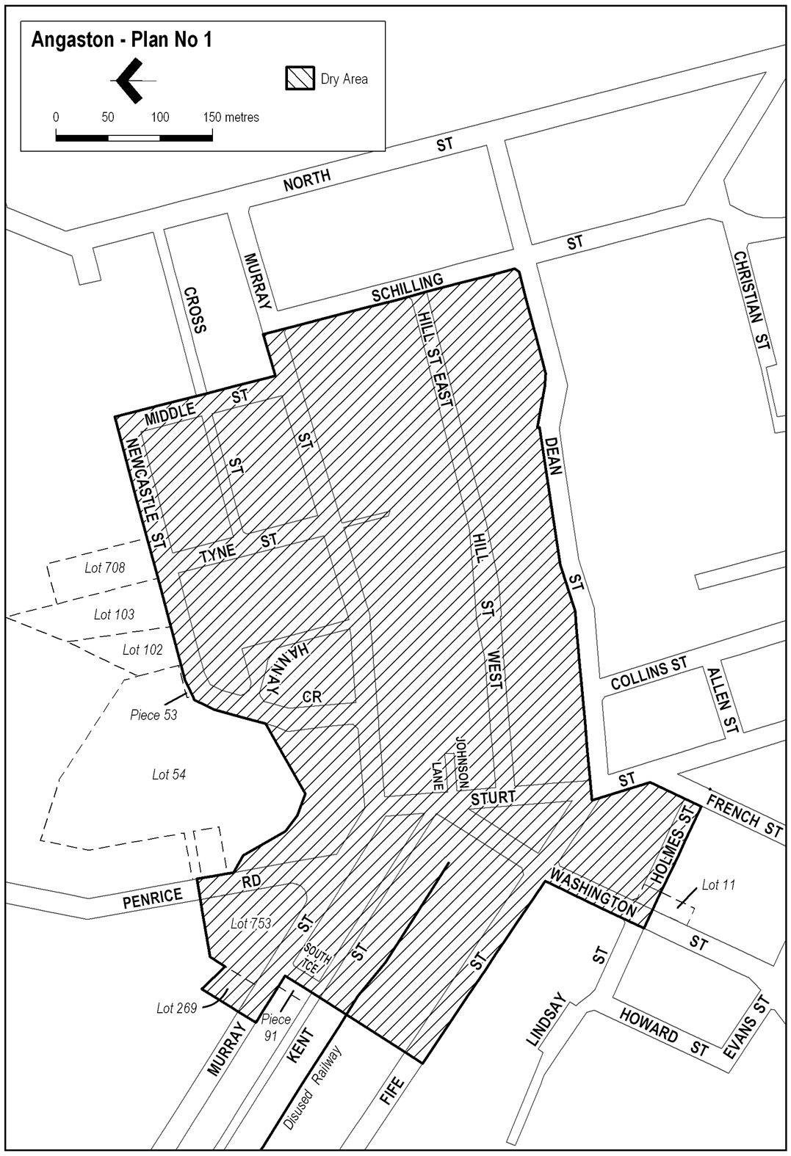
Angaston—Plan No 2
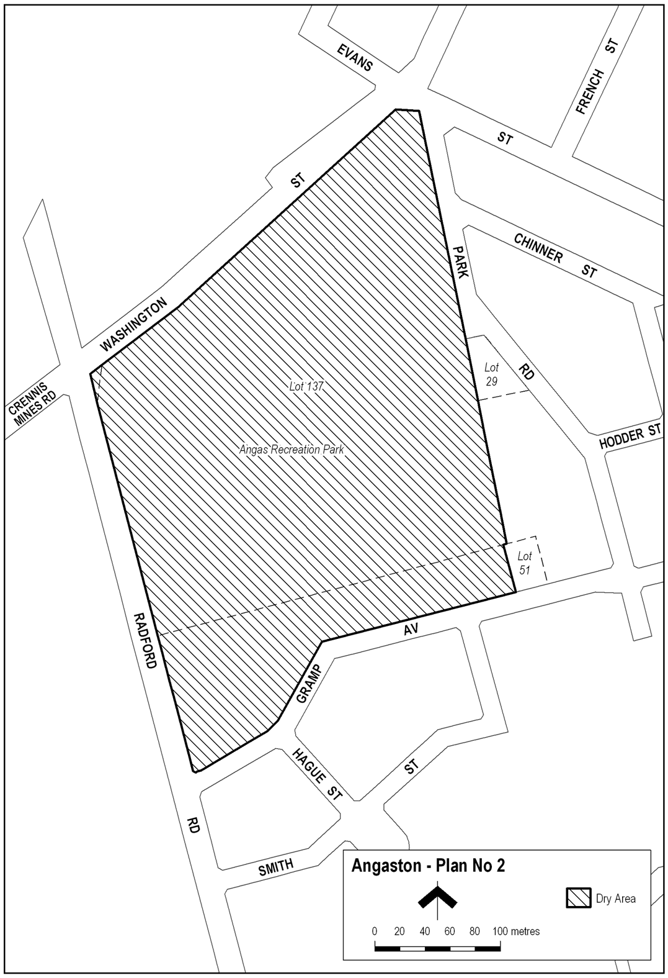
Lyndoch—Plan No 1
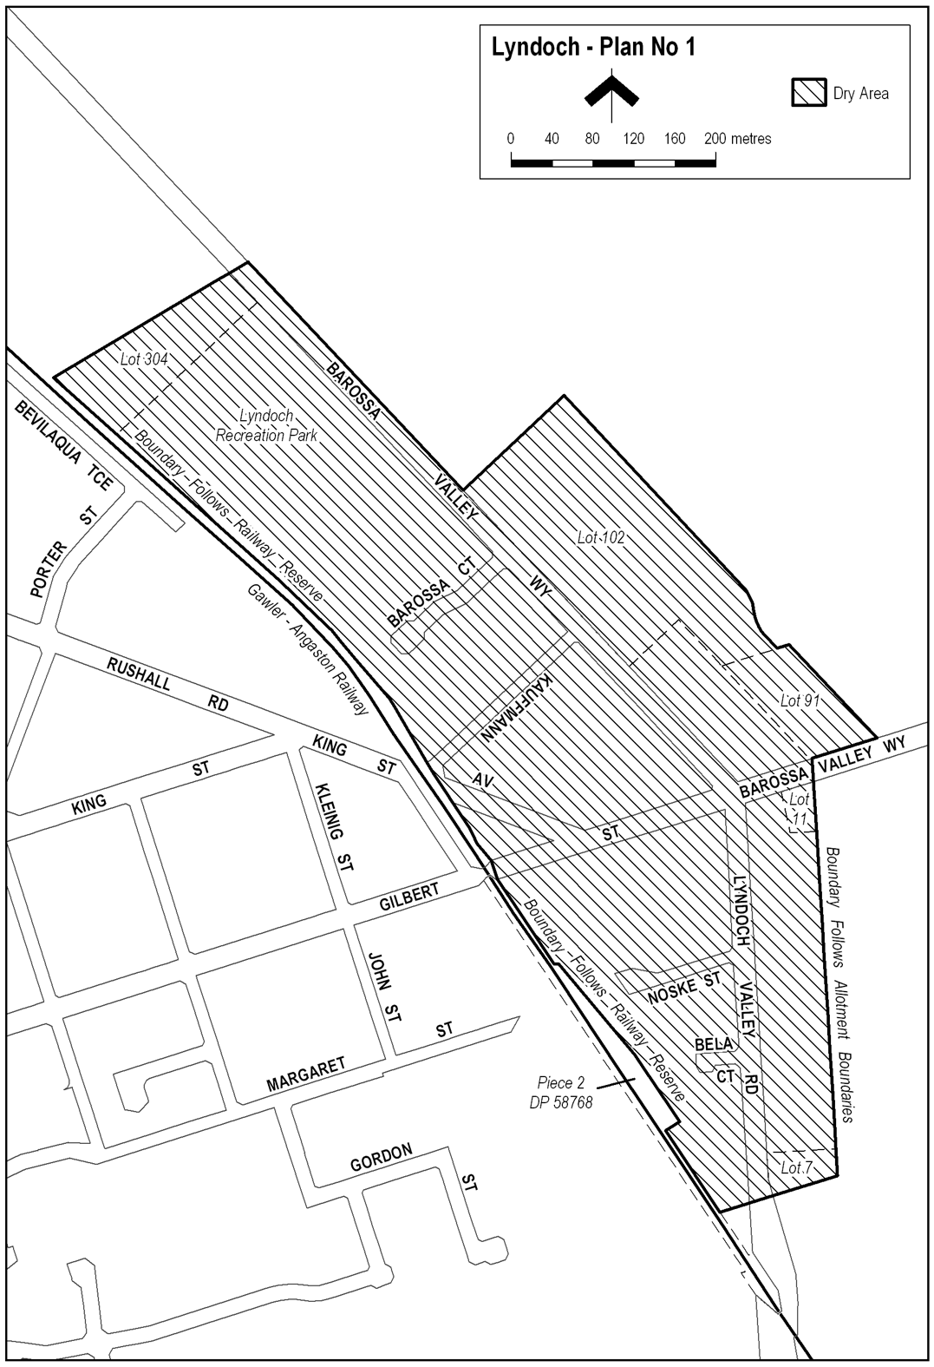
Mount Pleasant—Plan No 1
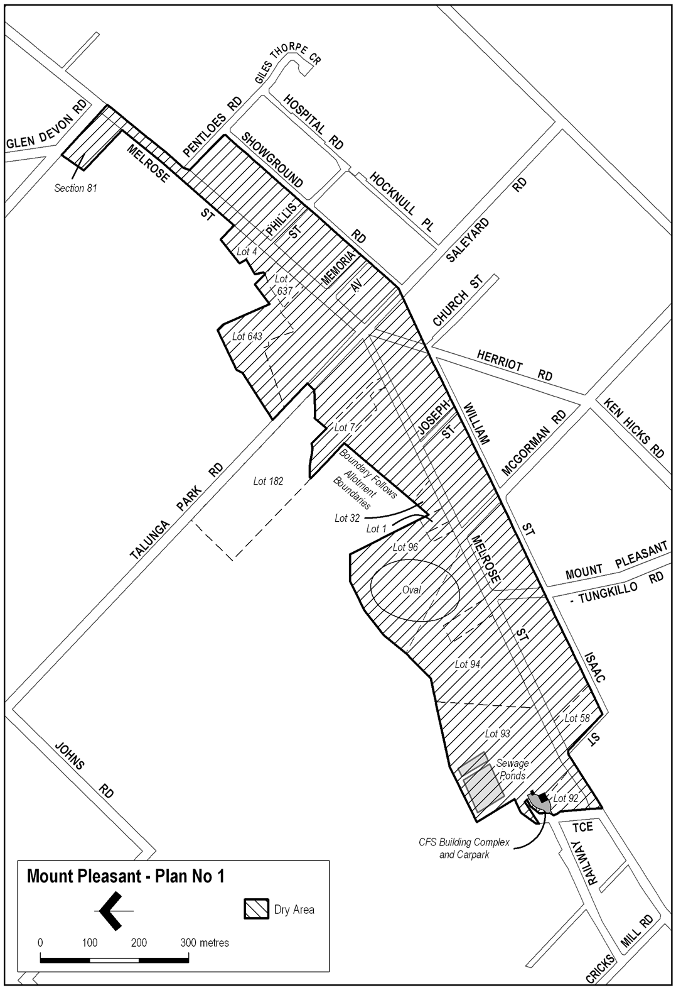
Nuriootpa—Plan No 1
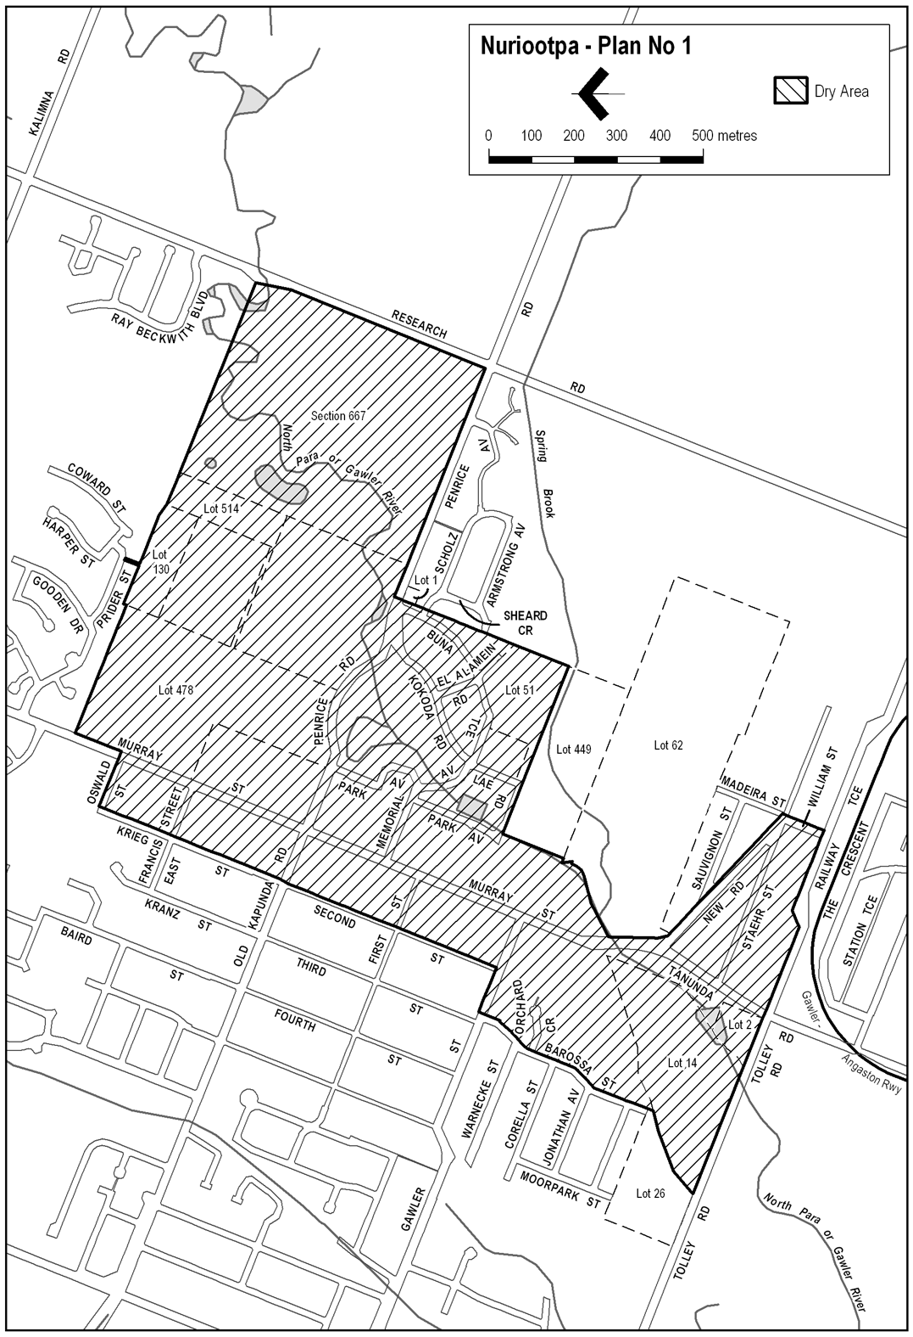
Tanunda—Plan No 1
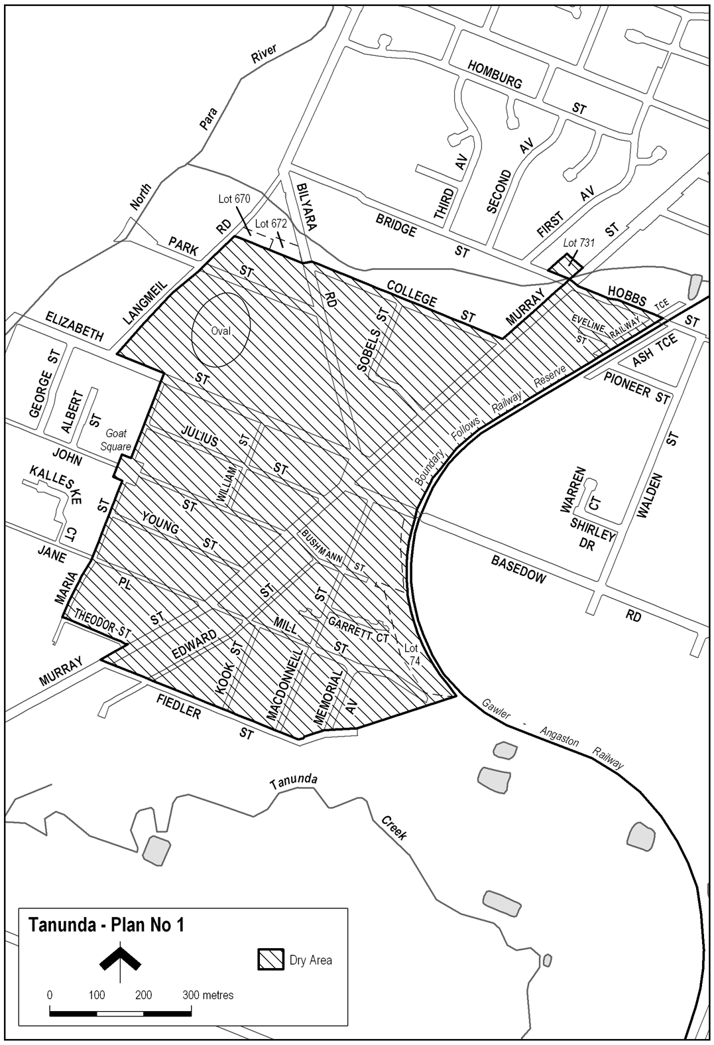
Williamstown—Plan No 1
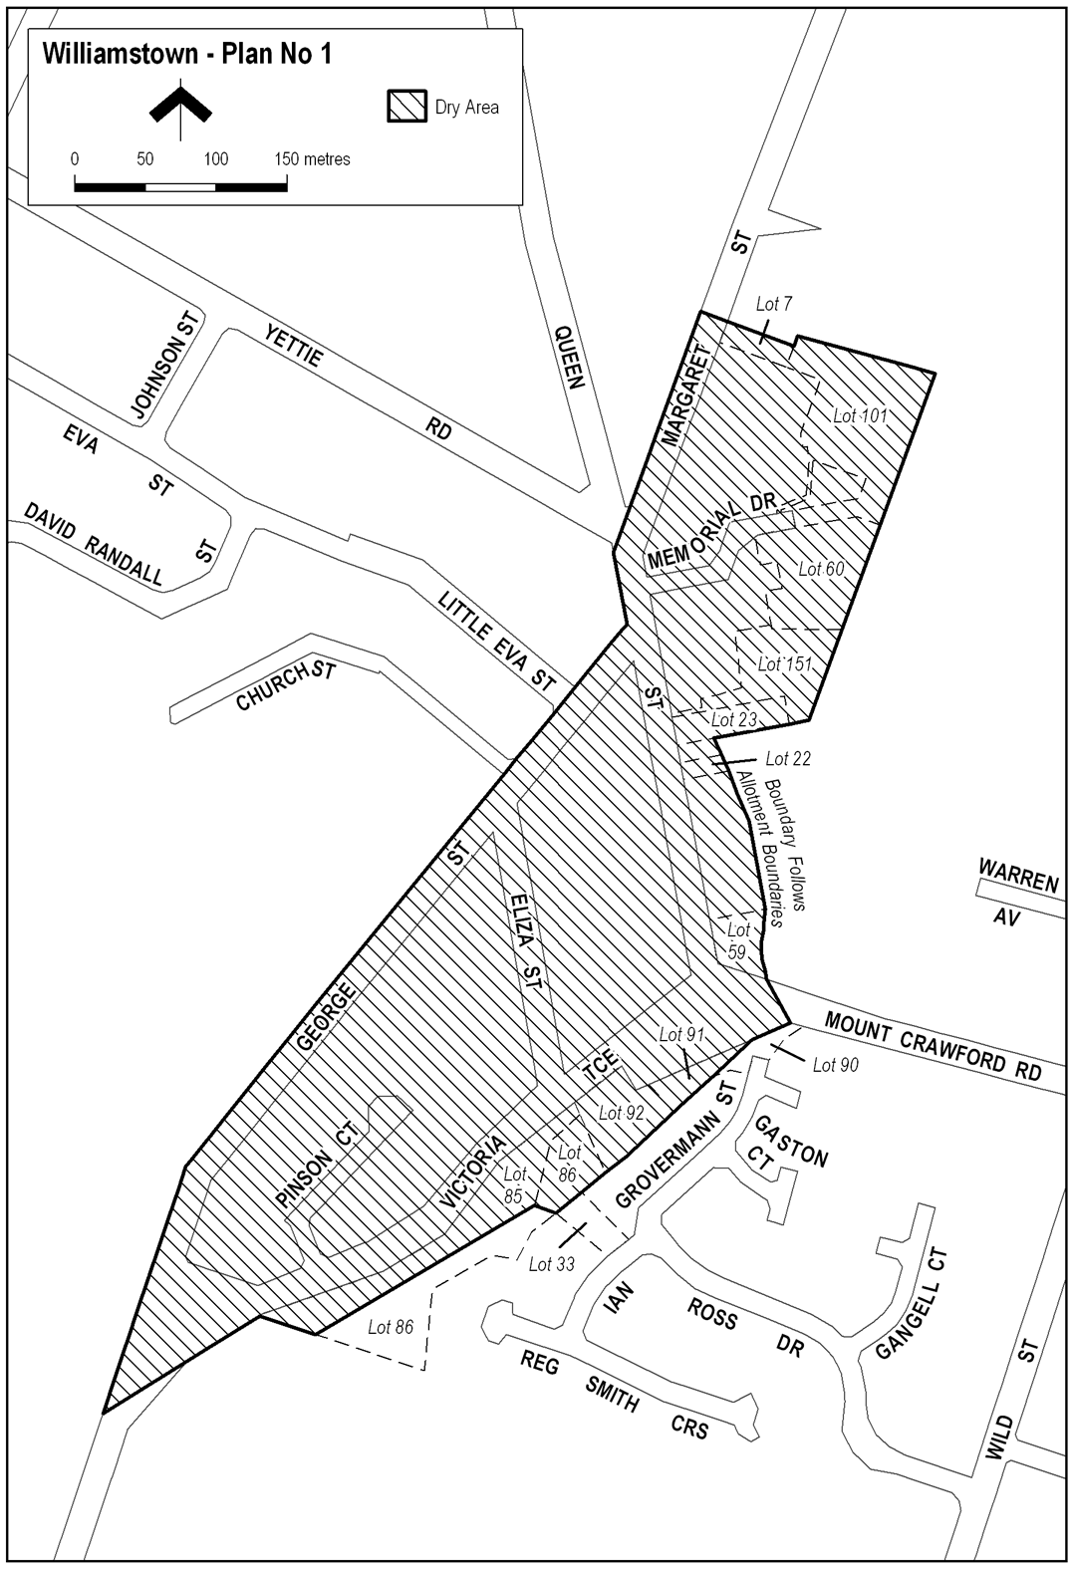
Williamstown—Plan No 2
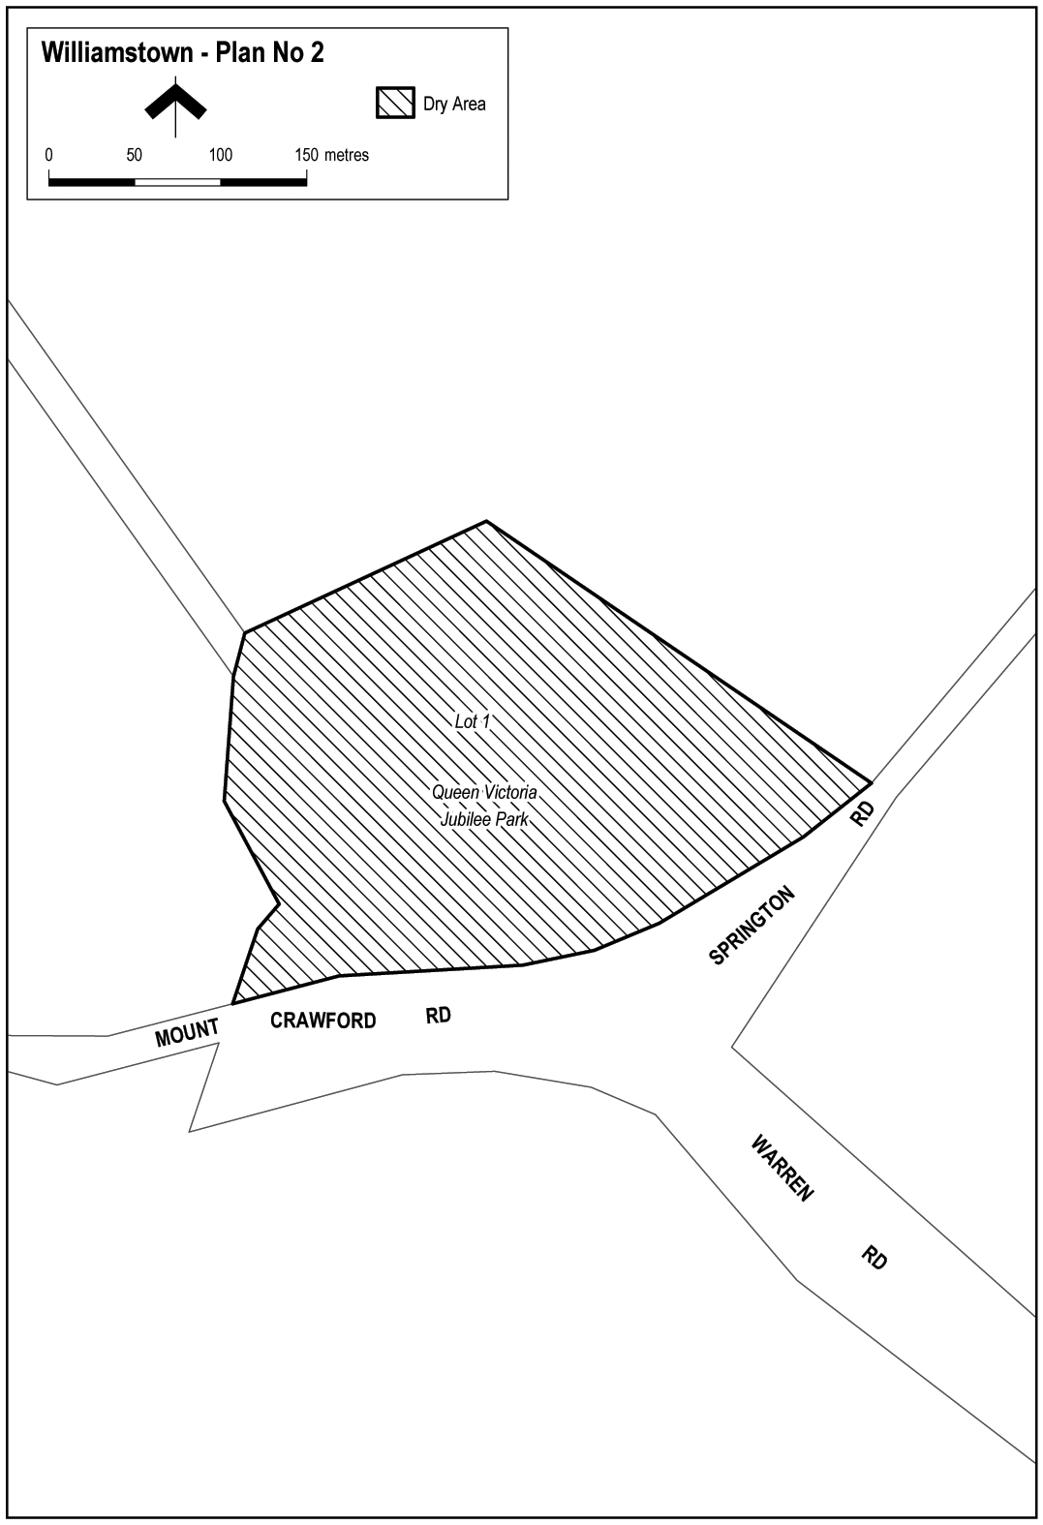
Note—
As required by section 10AA(2) of the Subordinate Legislation Act 1978, the Minister has certified that, in the Minister's opinion, it is necessary or appropriate that these regulations come into operation as set out in these regulations.
Made by the Governor
with the advice and consent of the Executive Council
on 22 January 2009
No 2 of 2009
09MCA0002CS

South Australia
Passenger Transport (General) Variation Regulations 2009
under the Passenger Transport Act 1994

Contents
Part 1—Preliminary
1 Short title
2 Commencement
3 Variation provisions
Part 2—Variation of Passenger Transport (General) Regulations 1994
4 Variation of regulation 3—Interpretation
5 Variation of regulation 7—Conditions
6 Variation of regulation 9—Drivers—Eligibility
7 Variation of regulation 11—Conditions
8 Variation of regulation 12—Centralised booking services—eligibility
9 Substitution of regulation 26
26 Exceptions to sections 45 and 52 of Act
10 Substitution of regulations 42 and 43
42 Display of taxi signs by metropolitan taxis
43 Display of taxi signs by country taxis
43A Requirement for taxi sign to indicate when taxi not available for hire
43B Return of taxi signs
43C Unauthorised use of signs
11 Variation of regulation 44—Removal of signs
12 Variation of regulation 45—Loss or theft of signs
13 Variation of regulation 46—Company signs
14 Variation of regulation 46A
15 Revocation of regulation 46B
16 Insertion of regulation 47AA
47AA Requirement for country taxi to have meter
17 Variation of regulation 47—Requirements relating to meters
18 Variation of regulation 48—Action required when meter defective
19 Variation of regulation 49—Compulsory inspection of meters
20 Variation of regulation 50—Substitution of wheels or alteration of drive train
21 Variation of regulation 54—Fares
22 Variation of regulation 55—Display of information
23 Variation of regulation 56—Stands
24 Variation of regulation 57—Duty to accept or continue hiring
25 Variation of regulation 59—Right to terminate or vary hiring
26 Variation of regulation 61C—Requirement to have approved security camera system fitted and operating
27 Variation of regulation 61K—Compulsory inspection of systems
28 Variation of regulation 72—Age of vehicles
29 Variation of regulation 74—Inspections
30 Variation of regulation 80—Surrender of registration plates
31 Revocation of regulation 91A
32 Variation of Schedule 2—Maximum fares chargeable by metropolitan taxis
33 Variation of Schedule 4—Fees
34 Variation of Schedule 9—Code of practice: taxi-drivers

Part 1—Preliminary
1—Short title
These regulations may be cited as the Passenger Transport (General) Variation Regulations 2009.
2—Commencement
These regulations will come into operation on 28 February 2009.
3—Variation provisions
In these regulations, a provision under a heading referring to the variation of specified regulations varies the regulations so specified.
Part 2—Variation of Passenger Transport (General) Regulations 1994
4—Variation of regulation 3—Interpretation
(1) Regulation 3(1)—after the definition of appropriate driver's licence insert:
approved country taxi service plan means a country taxi service plan approved by the Minister under regulation 7(1)(le);
(2) Regulation 3(1), definition of Australian Design Rules—delete "under the Road Traffic Regulations 1996" and substitute:
in the Road Traffic (Miscellaneous) Regulations 1999
(3) Regulation 3(1), definitions of compliance plate and council—delete the definitions and substitute:
compliance plate means a plate authorised to be placed on a motor vehicle, or taken to have been placed on a motor vehicle, under the Motor Vehicle Standards Act 1989 of the Commonwealth;
council means a council within the meaning of the Local Government Act 1999;
country taxi means a vehicle used for the purposes of a country taxi service;
Country Taxi Accreditation means the class of accreditation under section 27 of the Act of that name established pursuant to section 32(3) of the Act;
country taxi service means a passenger transport service operated outside Metropolitan Adelaide under a Country Taxi Accreditation;
country taxi service area means the area defined in the approved country taxi service plan for a country taxi service as the area within which the service may be provided;
(4) Regulation 3(1), definition of legal fare—delete the definition and substitute:
legal fare—
(a) in relation to the hiring of a country taxi or a journey by a country taxi—means a fare for the particular hiring or journey not exceeding the rate determined by the Minister;
(b) in relation to the hiring of a metropolitan taxi or a journey by a metropolitan taxi—means a fare for the particular hiring or journey determined in accordance with these regulations;
(5) Regulation 3(1)—after the definition of log out of insert:
metropolitan taxi means a vehicle for which a taxi licence is held or required to be held;
(6) Regulation 3(1), definition of public directory—delete the definition and substitute:
public directory includes a journal, brochure or other publication (whether in written or electronic form) that lists or advertises passenger transport services;
(7) Regulation 3(1)—after the definition of registration plate insert:
relevant person for a taxi means—
(a) in the case of a vehicle in respect of which a taxi licence is in force—the holder of the licence; or
(b) in the case of a vehicle used for the purposes of a country taxi service—the operator of the service;
(8) Regulation 3(1), definition of taxi—delete the definition and substitute:
taxi means a country taxi or a metropolitan taxi;
5—Variation of regulation 7—Conditions
(1) Regulation 7(1)(k)—after "taxi service" first occurring insert:
other than a country taxi service
(2) Regulation 7(1)(ka)—after "taxi-service" insert:
other than a country taxi service
(3) Regulation 7(1)(l)(iv)—delete "generally available throughout Metropolitan Adelaide"
(4) Regulation 7(1)—after paragraph (ld) insert:
(le) in the case of a Country Taxi Accreditation—
(i) that a vehicle used for the purposes of the service must be—
(A) a vehicle that is capable of seating at least 4 average-sized adults comfortably plus the driver; or
(B) a vehicle determined by the Minister (either specifically or according to a class of vehicle) as being appropriate for the purposes of a country taxi service; and
(ii) that the accredited person—
(A) must have in place a country taxi service plan for the country taxi service that complies with requirements determined by the Minister and is approved by the Minister before the commencement of the service; and
(B) must operate the service in accordance with the approved country taxi service plan for the service,
(and the country taxi service plan may be altered from time to time with the approval of the Minister);
6—Variation of regulation 9—Drivers—Eligibility
Regulation 9—after its present contents (now to be designated as subregulation (1)) insert:
(2) A person who applies for an accreditation under Part 4 Division 2 of the Act to enable the person to drive a country taxi must, if required by the Minister, satisfy the Minister that he or she has sufficient knowledge of streets and places in the country taxi service area in which the taxi is to be used for the purposes of a country taxi service to work effectively as the driver of a country taxi under the accreditation.
7—Variation of regulation 11—Conditions
Regulation 11(1)(g)(iii)—delete subparagraph (iii) and substitute:
(iii) except for—
(A) a vehicle used for the purposes of a service operated under a Small Passenger Vehicle (Special Purpose) Accreditation; or
(B) a vehicle drawn by an animal,
that the accredited person will not park or stand a vehicle on a public street, road or place unless a sign approved by the Minister that clearly indicates that the vehicle is not for hire is displayed on or near the vehicle in a manner determined by the Minister for the purposes of this regulation;
8—Variation of regulation 12—Centralised booking services—eligibility
Regulation 12(2)(a)—delete "is in a part of Metropolitan Adelaide" and substitute:
is in an area
9—Substitution of regulation 26
Regulation 26—delete the regulation and substitute:
26—Exceptions to sections 45 and 52 of Act
(1) Section 45(1)(a) of the Act does not apply in relation to the operation of a country taxi service by means of a vehicle that displays the word "TAXI" or that word in combination with the word "COUNTRY".
(2) Section 45(1)(b) of the Act does not apply in relation to a vehicle plying for hire or standing at a designated taxi-stand within the country taxi service area in which the vehicle may be used for the purposes of a country taxi service.
(3) Under section 45(1)(c) of the Act, a person who does not hold a taxi licence for a vehicle may cause or permit the vehicle to ply for hire in a public street, road or place if—
(a) the vehicle is being used for the purposes of a country taxi service; and
(b) the street, road or place is within the country taxi service area in which the vehicle may be used for the purposes of a country taxi service.
(4) Under section 45(1)(c) of the Act, a person who does not hold a taxi licence for a vehicle may cause or permit the vehicle to ply for hire in a public street, road or place if—
(a) the person holds an accreditation under Part 4 of the Act; and
(b) the vehicle is being used for the purposes of a service operated under the accreditation; and
(c) the vehicle is plying for hire—
(i) between midnight on the Monday preceding the commencement of a declared period within the meaning of the South Australian Motor Sport Act 1984 and midnight on the Thursday following the end of that declared period; or
(ii) between 10.00 pm on 31 December of any year and
10.00 am on 1 January of the following year.
(5) Under section 45(1)(d) of the Act, a person who does not hold a taxi licence for a vehicle fitted with a taxi-meter may operate a country taxi service by means of the vehicle.
(6) Under section 45(1)(d) of the Act, a person who does not hold a taxi licence for a vehicle fitted with a taxi-meter may operate a passenger transport service by means of the vehicle if—
(a) the vehicle was fitted with the meter before 1 August 1994; and
(b) the person used the vehicle for the purpose of the passenger transport service immediately before 1 August 1994; and
(c) the person holds an accreditation under Part 4 of the Act; and
(d) the following notice is displayed on or near the meter in a manner allowing it to be easily seen by any person sitting in the vehicle:
NOTICE TO ALL PASSENGERS
The rates shown on this meter have not been set under the Passenger Transport Act 1994.
The operator of this vehicle must inform passengers as to the rates set on this meter before the journey begins.
(7) Section 52(1) of the Act does not apply to—
(a) the operator of—
(i) a centralised booking service for taxis; or
(ii) a booking service for taxis operating outside Metropolitan Adelaide; or
(b) the operator of a country taxi service; or
(c) an employee or agent of a person referred to in paragraph (a)
or (b).
10—Substitution of regulations 42 and 43
Regulations 42 and 43—delete the regulations and substitute:
42—Display of taxi signs by metropolitan taxis
(1) For the purposes of section 45(4)(a) of the Act, a vehicle displays the word "TAXI" if—
(a) a taxi sign of a type approved by the Minister is fitted to the taxi in a manner approved by the Minister; and
(b) the taxi sign is in proper working order.
(2) Section 45(4)(a) of the Act does not apply—
(a) in the case of a vehicle being used under a pre-arranged hiring for the conveyance of a bridal party or the conveyance of a person in a funeral procession; or
(b) in the case of a vehicle being used while fitted with a damaged or faulty taxi sign if—
(i) the driver of the vehicle is not aware that the sign is damaged or faulty, or is completing a journey that commenced before he or she had become aware that the sign was damaged or faulty; or
(ii) the vehicle is being driven for a purpose connected with the repair or replacement of the taxi sign, or the driver has been authorised by the holder of the taxi licence for the taxi to drive the taxi for such a purpose.
43—Display of taxi signs by country taxis
(1) A vehicle must not be driven for the purposes of a country taxi service in a public street, road or place unless—
(a) a taxi sign of a type approved by the Minister is fitted to the vehicle in a manner approved by the Minister; and
(b) the taxi sign is in proper working order.
(2) Subregulation (1) does not apply while a vehicle is being used under a pre-arranged hiring for the conveyance of a bridal party or the conveyance of a person in a funeral procession.
(3) If a vehicle is driven in contravention of subregulation (1), the operator of the country taxi service is guilty of an offence.
Maximum penalty: $4 000.
(4) It is a defence to a charge of an offence against subregulation (3) for the defendant to prove—
(a) that the taxi sign fitted to the taxi at the time of the alleged offence was damaged or faulty; and
(b) that the driver—
(i) was not aware that the sign was damaged or faulty, or was completing a journey that commenced before the driver became aware that the sign was damaged or faulty; or
(ii) was driving the taxi for a purpose connected with the repair or replacement of the sign, or had been authorised by the defendant to drive the taxi for such a purpose.
43A—Requirement for taxi sign to indicate when taxi not available for hire
(1) A person other than an accredited taxi driver must not drive a taxi in a public street, road or place unless the taxi sign fitted to the taxi indicates in a manner approved by the Minister that the taxi is not available for hire.
Maximum penalty: $750.
Expiation fee: $105.
(2) An accredited taxi driver must not drive a taxi in a public street, road or place while the taxi is not available for hire unless the taxi sign fitted to the taxi indicates in a manner approved by the Minister that the taxi is not for hire.
Maximum penalty: $750.
Expiation fee: $105.
(3) Subregulation (2) does not apply to a taxi being used under a pre-arranged hiring for the conveyance of a bridal party or the conveyance of a person in a funeral procession.
(4) It is a defence to a charge of an offence against subregulation (1) or (2) for the defendant to prove—
(a) that the taxi sign fitted to the taxi at the time of the alleged offence was damaged or faulty; and
(b) that the defendant—
(i) was not aware that the sign was damaged or faulty, or was completing a journey that commenced before he or she became aware that the sign was damaged or faulty; or
(ii) was driving the taxi for a purpose connected with the repair or replacement of the sign.
43B—Return of taxi signs
A person to whom a taxi sign has been issued, or who has possession or custody of a taxi sign or a vehicle to which such a sign is fitted must, on request by an authorised officer for the return of the sign, immediately deliver the sign to the authorised officer or the Minister.
Maximum penalty: $750.
Expiation fee: $105.
43C—Unauthorised use of signs
(1) A person must not, in a public street, road or place in Metropolitan Adelaide or a country taxi service area, drive a vehicle to which there is fitted a taxi sign, or a sign the same as or closely resembling a taxi sign, unless the sign is fitted to the vehicle with the authority of the Minister.
Maximum penalty: $750.
Expiation fee: $105.
(2) Subregulation (1) does not apply to—
(a) a vehicle for which a taxi licence is held; or
(b) a vehicle used for the purposes of a country taxi service.
11—Variation of regulation 44—Removal of signs
(1) Regulation 44—after its present contents insert:
Maximum penalty: $750.
Expiation fee: $105.
(2) Regulation 44—after its present contents as varied by subregulation (1) (now to be designated as subregulation (1)) insert:
(2) If a person ceases to hold a Country Taxi Accreditation, the person must ensure that any taxi sign on a vehicle that was used for the purposes of a country taxi service operated under that accreditation is immediately removed from the vehicle.
Maximum penalty: $750.
Expiation fee: $105.
12—Variation of regulation 45—Loss or theft of signs
(1) Regulation 45(1), definition of relevant person—after paragraph (a) insert:
(ab) if the sign has been issued to, or leased by, the operator of a country taxi service—the operator of the service;
(2) Regulation 45(2)—after its present contents insert:
Maximum penalty: $750.
Expiation fee: $105.
(3) Regulation 45(3)—after its present contents insert:
Maximum penalty: $750.
Expiation fee: $105.
13—Variation of regulation 46—Company signs
(1) Regulation 46(1)—delete "A taxi must not be driven" and substitute:
A person must not drive a metropolitan taxi
(2) Regulation 46(1)—after its present contents as varied by subregulation (1) insert:
Maximum penalty: $750.
Expiation fee: $105.
14—Variation of regulation 46A
Regulation 46A(2)—delete subregulation (2) and substitute:
(2) A person must not drive a taxi in a public street, road or place if an advertisement on the outside of the taxi—
(a) is displayed other than in accordance with subregulation (1)(a); or
(b) does not comply with subregulation (1)(b).
Maximum penalty: $750.
Expiation fee: $105.
(3) Subregulation (2) does not apply in relation to an advertisement displayed on a taxi with the approval of the Minister.
15—Revocation of regulation 46B
Regulation 46B—delete the regulation
16—Insertion of regulation 47AA
Before regulation 47 insert:
47AA—Requirement for country taxi to have meter
A person must not use a vehicle for the purposes of a country taxi service unless the vehicle is fitted with a meter that complies with these regulations.
Maximum penalty: $4 000.
17—Variation of regulation 47—Requirements relating to meters
(1) Regulation 47(1)—after "Act" insert:
and regulation 47AA
(2) Regulation 47(1)(d)—delete paragraph (d) and substitute:
(d) a taxi-meter must be so adjusted that, when the taxi is hired and the meter is activated, the meter will register flagfall and fares not exceeding—
(i) in the case of a metropolitan taxi—the rates prescribed by Schedule 2; or
(ii) in the case of a country taxi—the rates determined by the Minister;
18—Variation of regulation 48—Action required when meter defective
Regulation 48—delete "holder of the licence" and substitute:
relevant person for the taxi
19—Variation of regulation 49—Compulsory inspection of meters
(1) Regulation 49(1)—delete "holder of a taxi licence" and substitute:
relevant person for a taxi
(2) Regulation 49(2)—after "taxi" first occurring insert:
for which a taxi licence is held
(3) Regulation 49—after subregulation (2) insert:
(3) If an authorised officer finds that a vehicle used for the purposes of a country taxi service is not fitted with a taxi-meter as required by these regulations, or is fitted with a meter that does not comply with these regulations, the authorised officer may give the operator of the service written notice that the vehicle must not be used for the purposes of the service until it is fitted with a taxi-meter that complies with these regulations.
20—Variation of regulation 50—Substitution of wheels or alteration of drive train
Regulation 50—delete "the holder of the relevant taxi licence" and substitute:
the relevant person for the taxi
21—Variation of regulation 54—Fares
Regulation 54(1)—delete subregulation (1) and substitute:
(1) The relevant person for a taxi must ensure that no more than the legal fare is demanded or recovered for the hiring of the taxi.
22—Variation of regulation 55—Display of information
Regulation 55—delete "The holder of a taxi licence" and substitute:
The relevant person for a taxi
23—Variation of regulation 56—Stands
Regulation 56(1)—delete subregulation (1) and substitute:
(1) The Minister must maintain at an office of the department open to the public during normal office hours a register of all areas designated by the Minister as taxi-stands and the times at which those taxi-stands may be used.
24—Variation of regulation 57—Duty to accept or continue hiring
(1) Regulation 57(1)—delete "to any place within Metropolitan Adelaide" and substitute:
to—
(a) in the case of a metropolitan taxi—any place within Metropolitan Adelaide; or
(b) in the case of a country taxi—any place within the country taxi service area in which the taxi may be used for the purposes of a country taxi service.
(2) Regulation 57(2)—delete "licensed to carry" and substitute:
authorised to carry
(3) Regulation 57(7)—delete subregulation (7) and substitute:
(7) For the purposes of this regulation—
(a) a taxi will be taken to be available for hire if it is in a public street, road or place, in charge of a driver and the taxi sign fitted to the taxi indicates in a manner approved by the Minister that the taxi is available for hire;
(b) the number of persons a taxi is authorised to carry is—
(i) in the case of a metropolitan taxi—the number of persons that the taxi is licensed to carry;
(ii) in any other case—
(A) a number shown on the certificate of inspection under section 54 of the Act or Part 4A of the Road Traffic Act 1961; or
(B) a number determined by the Minister in relation to the relevant vehicle.
25—Variation of regulation 59—Right to terminate or vary hiring
Regulation 59(2)—delete subregulation (2) and substitute:
(2) The driver of a taxi must not, without reasonable excuse, fail to comply with a request by the hirer of the taxi to the driver to carry him or her to a place not originally specified by the hirer if the place is—
(a) in the case of a metropolitan taxi—within Metropolitan
Adelaide; or
(b) in the case of a country taxi—within the country taxi service area in which the taxi may be used for the purposes of a country taxi service.
26—Variation of regulation 61C—Requirement to have approved security camera system fitted and operating
Regulation 61C(1)—delete subregulation (1) and substitute:
(1) A taxi must not be used for the purposes of a taxi service other than a country taxi service unless the taxi is fitted with an approved security camera system.
(1a) A taxi must not be used for the purposes of a country taxi service if it is fitted with a security camera system that is not an approved security camera system.
(1b) If—
(a) a taxi is used in contravention of subregulation (1) or (1a); or
(b) an approved security camera system fitted to a taxi—
(i) was not installed by an accredited supplier; or
(ii) is not in good working order,
the operator of the taxi service is guilty of an offence.
Maximum penalty: $2 500.
Expiation fee: $210.
27—Variation of regulation 61K—Compulsory inspection of systems
(1) Regulation 61K(1)—delete "holder of a taxi licence" and substitute:
relevant person for a taxi
(2) Regulation 61K(2)—before "taxi" insert:
metropolitan
(3) Regulation 61K—after subregulation (2) insert:
(3) If an authorised officer finds that a vehicle used for the purposes of a country taxi service is fitted with a security camera system that does not comply with requirements determined by the Minister for the purposes of this Division, the authorised officer may suspend the accreditation for the service until an authorised officer is satisfied that the security camera system has been removed from the vehicle.
28—Variation of regulation 72—Age of vehicles
Regulation 72(1)—delete subregulation (1) and substitute:
(1) A person must not use a vehicle for the purposes of a passenger transport service if the vehicle is—
(a) in the case of—
(i) a metropolitan taxi; or
(ii) a vehicle being used for the purposes of a service operated under—
(A) a Small Passenger Vehicle (Metropolitan) Accreditation; or
(B) a Small Passenger Vehicle (Special Purpose) Accreditation,
(other than a motor cycle or an off-road vehicle that is being used wholly or predominantly for travel outside Metropolitan Adelaide),
more than 6 years and 6 months old; or
(b) in the case of—
(i) a country taxi; or
(ii) a vehicle being used for the purposes of a service operated under—
(A) a Small Passenger Vehicle (Traditional) Accreditation; or
(B) a Small Passenger Vehicle (Non-Metropolitan) Accreditation; or
(iii) a motor cycle; or
(iv) an off-road vehicle that is being used wholly or predominantly for travel outside Metropolitan Adelaide,
more than 15 years old; or
(c) in any other case—more than 25 years old.
29—Variation of regulation 74—Inspections
(1) Regulation 74(1)(a)—before "taxi" first occurring insert:
metropolitan
(2) Regulation 74(1)—after paragraph (a) insert:
(ab) for a country taxi—a period of 12 months, calculated from the last day of the month in which the vehicle was last inspected under section 54 of the Act;
30—Variation of regulation 80—Surrender of registration plates
Regulation 80(b)(ii)—before "taxi" first occurring insert:
metropolitan
31—Revocation of regulation 91A
Regulation 91A—delete the regulation
32—Variation of Schedule 2—Maximum fares chargeable by metropolitan taxis
(1) Schedule 2, clause 1(1)—after "journey" wherever occurring insert:
by metropolitan taxi
(2) Schedule 2, clause 2(1)—after "journey" first occurring insert:
by metropolitan taxi
(3) Schedule 2, clause 2A—after "journey" insert:
by metropolitan taxi
(4) Schedule 2, clause 3—before "taxi" insert:
metropolitan
(5) Schedule 2, clause 4(a)—before "taxi" insert:
metropolitan
(6) Schedule 2, clause 4(b)—before "taxi" insert:
metropolitan
(7) Schedule 2, clause 4(c)—before "taxi" insert:
metropolitan
33—Variation of Schedule 4—Fees
(1) Schedule 4, clause 1(a)(ii)—delete "or a Small Passenger Vehicle (Non-Metropolitan) Accreditation" and substitute:
, a Small Passenger Vehicle (Non-Metropolitan) Accreditation or a Country Taxi Accreditation
(2) Schedule 4, clause 2(a)(ii)—delete "or a Small Passenger Vehicle (Non-Metropolitan) Accreditation" and substitute:
, a Small Passenger Vehicle (Non-Metropolitan) Accreditation or a Country Taxi Accreditation
(3) Schedule 4, clause 4(a)(ii)—delete "or a Small Passenger Vehicle (Non-Metropolitan) Accreditation" and substitute:
, a Small Passenger Vehicle (Non-Metropolitan) Accreditation or a Country Taxi Accreditation
(4) Schedule 4, clause 6(a)(ii)—delete "or a Small Passenger Vehicle (Non-Metropolitan) Accreditation" and substitute:
, a Small Passenger Vehicle (Non-Metropolitan) Accreditation or a Country Taxi Accreditation
34—Variation of Schedule 9—Code of practice: taxi-drivers
(1) Schedule 1, item 5—delete "the" and substitute:
any relevant
(2) Schedule 1, item 7—delete "within Metropolitan Adelaide"
(3) Schedule 1, item 16—delete "the" first occurring and substitute:
any relevant
Note—
As required by section 10AA(2) of the Subordinate Legislation Act 1978, the Minister has certified that, in the Minister's opinion, it is necessary or appropriate that these regulations come into operation as set out in these regulations.
Made by the Governor
with the advice and consent of the Executive Council
on 22 January 2009
No 3 of 2009
MTR08/041

FAXING COPY?
IF you fax copy to Government Publishing SA for inclusion in the Government Gazette, there is no need to send a Confirmation Copy to us as well.
This creates confusion and may well result in your notice being printed twice.
Please use the following fax number:
Fax transmission: (08) 8207 1040
Phone Inquiries: (08) 8207 1045
Please include a contact person, phone number and order number so that we can phone back with any queries we may have regarding the fax copy.
NOTE: Closing time for lodging new copy (fax, hard copy or email) is 4 p.m. on Tuesday preceding the day of publication.

Government Gazette notices can be E-mailed.
The address is:
governmentgazette@dpc.sa.gov.au
Documents should be sent as attachments in Word format.
When sending a document via E-mail, please confirm your transmission with a faxed copy of your document, including the date the notice is to be published.
Fax transmission: (08) 8207 1040
Enquiries: (08) 8207 1045
NOTE: Closing time for lodging new copy (fax, hard copy or email) is 4 p.m. on Tuesday preceding the day of publication.

CITY OF HOLDFAST BAY
Representation Review
NOTICE is hereby given that the City of Holdfast Bay, pursuant to section 12 (7) of the Local Government Act 1999, is conducting a review to determine whether alterations are required in respect to elector representation, including ward boundaries and the composition of the Council.
Holdfast Bay is currently divided into four wards, each represented by three Councillors. The Mayor is elected from across the whole City. The Representation Review explores whether this structure still meets the needs of electors. An Options Paper has been prepared which canvasses different models including fewer Councillors, as well as possible changes to ward boundaries.
This paper is available, free of charge, from the Council’s Customer Service Centres in Glenelg and Brighton and can be downloaded from Council’s website at www.holdfast.sa.gov.au.
Written comments, addressed to the Chief Executive Officer, City of Holdfast Bay, P.O. Box 19, Brighton, S.A. 5048, need to be received by Wednesday, 4 March 2009. All comments will be considered by Council at its meeting held on Tuesday, 24 March 2009.
R. T. Donaldson, Chief Executive Officer

CITY OF MOUNT GAMBIER
Review of Elector Representation
NOTICE is hereby given that the City of Mount Gambier is under-taking a review to determine whether a change of arrangements in respect to elector representation will result in the electors of the area being more adequately and fairly represented.
Pursuant to the provisions of section 12 (7) of the Local Government Act 1999, Council has prepared a representation options paper that examines the advantages and disadvantages of the various options available in regards to the composition and structure of Council, and the division of the Council area into wards.
Copies of the representation options paper are available free of charge at the Council Office, 10 Watson Terrace, Mount Gambier, the Mount Gambier Public Library and Council’s website: www.mountgambier.sa.gov.au.
Interested persons are invited to make a written submission to the Chief Executive Officer, P.O. Box 56, Mount Gambier, S.A. 5290, by close of business on Friday, 6 March 2009.
Information regarding the representation review can be obtained by contacting the undersigned at Council.
Dated 22 January 2009.
G. Muller, Chief Executive Officer

CITY OF NORWOOD, PAYENHAM & ST PETERS
Roads (Opening and Closing) Act 1991
Lower Portrush Road, Marden
NOTICE is hereby given pursuant to section 10 of the Act, that the City of Norwood, Payneham & St Peters proposes to make a Road Process Order to close, sell and transfer to Azzuri Club Ltd a portion of Lower Portrush Road adjoining allotment 51 in Deposited Plan 38114 shown marked ‘A’ on Preliminary Plan No. 08/0121.
A copy of the plan and statement of persons affected are available for public inspection at the Council’s Office, 175 The Parade, Norwood and the office of the Surveyor-General, 101 Grenfell Street, Adelaide, during normal office hours.
Any application for easement or objections must be made in writing within 28 days from the date of the last notice to the Council, P.O. Box 204, Kent Town, S.A. 5071 and the Surveyor-General, G.P.O. Box 1354, Adelaide, S.A. 5001, setting out
full details. Where a submission is made, Council will give notification of a meeting to deal with the matter.
Dated 22 January 2009.
M. Barone, Chief Executive Officer

CITY OF SALISBURY
Roads (Opening and Closing) Act 1991
Road Closing Portion of St Kilda Road, St Kilda
NOTICE is hereby given pursuant to section 10 of the said Act, that Council proposes to make a Road Process Order to close and sell to D. P. and F. M. Calabria, an irregularly-shaped portion of St Kilda Road adjoining Allotment 49, St Kilda and Allotment 501 in Deposited Plan 68610, shown as ‘A’ and ‘B’ (respectively) on Preliminary Plan No. 09/0003.
A copy of the plan and statement of persons affected are available for public inspection at Council’s Office, 12 James Street, Salisbury and the office of the Surveyor-General, 101 Grenfell Street, Adelaide, during normal office hours.
Any application for easement or representation must be made in writing within 28 days from Thursday, 22 January 2008, to the Council, P.O. Box 8, Salisbury, S.A. 5108 and the Surveyor-General, G.P.O. Box 1354, Adelaide, S.A. 5001, setting out full details.
Where a submission is made, Council will give notification of a meeting to deal with the matter.
S. Haines, City Manager

ALEXANDRINA COUNCIL
Alexandrina Council’s Consultation Process for the Electoral Review Options Paper
NOTICE is hereby given that Alexandrina Council has prepared an Options Paper to review its electoral representation in accordance with the requirements of the Local Government Act 1999. A summary of the options paper will be available for comment over the next six weeks inviting written submissions and comments to the options paper closing on Monday, 9 March 2009.
A full Options Paper discussion draft is available from
the offices of Alexandrina Council in Goolwa and Strathalbyn
and is also available on Alexandrina Council’s website at www.alexandrina.sa.gov.au and the libraries of Alexandrina Council in Strathalbyn, Milang, Port Elliot, Mount Compass and Goolwa.
Key issues to focus your comments on are the matters raised in the Paper, such as retaining the existing ward structures, single/ multi Council Member wards, the number of Council Members and relevant ward names.
Any other possible models may also be suggested and it will be most helpful if clear explanations or evidence for particular view points are included in the submission.
All comments and submissions will be considered by Council and a position paper will be published and be the subject of further consultation with an opportunity for comments and submissions from the community over a period of three weeks.
All submissions will have the opportunity for representation before Council to consolidate those comments and submissions after which Council will make its final report to the State Electoral Commissioner recommending an electoral representation appro-priate to our community.
All comments and submissions should be directed to the Chief Executive of Alexandrina Council, P.O. Box 21, Goolwa, S.A. 5214 or by email alex@alexandrina.sa.gov.au, or by fax on
8555 3603 by close of business on Monday, 9 March 2009.
J. L. Coombe, Chief Executive

DISTRICT COUNCIL OF GRANT
Development Act 1993
District Council of Grant Development Plan—Calula Low Density Residential Development Plan Amendment—
Draft for Public Consultation
NOTICE is hereby given that the District Council of Grant has prepared a draft Development Plan Amendment (DPA) to amend its Development Plan.
The DPA rezones the existing Country Living Zone on O’Leary Road and Wireless Road West to a Residential Zone (Low Density Policy Area) in accordance with the Greater Mount Gambier Master Plan.
The DPA report will be on public consultation from Thursday, 22 January 2009 until Monday, 23 March 2009.
Copies of the DPA will be available for public inspection during normal office hours at the Council Offices, 324 Commercial Street West, Mount Gambier and will be available on Council’s website at www.dcgrant.sa.gov.au.
Written submissions regarding the DPA should be submitted no later than 5 p.m. on Monday, 23 March 2009. All submissions should be addressed to the Chief Executive Officer, District Council of Grant, P.O. Box 724, Mount Gambier, S.A. 5290 and should clearly indicate whether or not you wish to be heard in support of your submission at the public meeting.
Copies of all written submissions received will be available for inspection by interested persons at Council’s offices from Tuesday, 24 March 2009 until the public meeting.
A public meeting will be held at the District Council of Grant, Council Chambers on Wednesday, 8 April 2009, commencing at 5.30 p.m. The public meeting will not be held if no submissions are received or if no submission makes a request to be heard.
Dated 22 January 2009.
R. Peate, Chief Executive Officer

DISTRICT COUNCIL OF KIMBA
Change of Street/Road Names
NOTICE is hereby given that Council at its meeting held on 14 January 2009, and in accordance with section 219 of the Local Government Act 1999, agreed to change the street/road names as listed below:

Old Name | New Name | Adjacent to Sections
Nielsen Road | Wally’s Road | 11, 12, 13, 14, Hundred of Pinkawillinie
Cant Road | Inglis Road | 19, 20, 21, 22, Hundred of Moseley
Cant Road | McDonald Road | 43, 44, 45 and 46, Hundred of Cootra and 43, 44, 45, Hundred of Caralue
Rifle Range Road | Venning Road | 228, 229, 230, 231, 46, Hundred of Solomon
Martin Terrace | Ellis Drive | 117, 187, 194, Hundred of Solomon (Schaefer Avenue to Cant Road)
Kimba Terrace | Francis Road | 100, Hundred of Solomon and 42, 49, Hundred of Kelly

D. A. Cearns, Chief Executive Officer

DISTRICT COUNCIL OF YORKE PENINSULA
Road Closure—Intersection Hardwicke Bay Road and
Kangaroo Flat Road
NOTICE is hereby given pursuant to section 10 of the Roads (Opening and Closing) Act 1991, that the District Council of Yorke Peninsula proposes to make a Road Process Order to close and sell to Colin Dodd, the triangular-shaped piece of unmade road (situated at the intersection of Hardwicke Bay Road and Kangaroo Flat Road) and adjoining Allotment 2 in Filed Plan 14872 more particularly delineated as ‘A’ on Preliminary Plan No. 09/0001.
A copy of the plan and statement of persons affected are available for public inspection at all four Council offices located at Maitland, Minlaton, Yorketown and Warooka and also on the website at www.yorke.sa.gov.au and the office of the Surveyor-General, 101 Grenfell Street, Adelaide, S.A. 5000, during office hours.
Any applications for easements or objections must be made in writing to both Ricki Bruhn, Chief Executive Officer, District Council of Yorke Peninsula, P.O. Box 88, Minlaton, S.A. 5575 and the Surveyor-General, G.P.O. Box 1354, Adelaide, S.A. 5001, outlining the full details.
Following receipt of submissions, Council will give notification of a meeting to address this matter.
Applications close at 5 p.m. on Wednesday, 11 February 2009.
This is the first and only publication of this notice.
R. K. Bruhn, Chief Executive Officer

IN the matter of the estates of the undermentioned deceased persons:
Courtney, Doreen Rita, late of 30 Sussex Terrace, Westbourne Park, of no occupation, who died on 16 November 2008.
Gainsborough, Thomas Berisor, late of Burns Street, Waikerie, retired motor mechanic, who died on 29 March 2008.
Gruber, George, late of 13 West Street, Semaphore Park, retired security watchman, who died on 21 November 2008.
Payne, Jean Marion, late of 26 River Road, Port Noarlunga, of no occupation, who died on 18 November 2008.
Ragacs, Ildi Anna, late of 6 Wellington Street, Kensington, home duties, who died on 22 October 2008.
Serra, Guiseppe, late of Jelly Crescent, Coober Pedy, retired miner, who died on 5 November 2008.
Standish, Florence May, late of Blamey Road, Elizabeth East, of no occupation, who died on 28 November 2008.
West, Francis Carlton, late of 30 Sussex Terrace, Westbourne Park, retired floor manager, who died on 20 October 2008.
Notice is hereby given pursuant to the Trustee Act 1936, as amended, the Inheritance (Family Provision) Act 1972, and the Family Relationships Act 1975, that all creditors, beneficiaries, and other persons having claims against the said estates are required to send, in writing, to the Public Trustee, 25 Franklin Street, Adelaide, S.A. 5000, full particulars and proof of such claims, on or before 20 February 2009, otherwise they will be excluded from the distribution of the said estate; and notice is also hereby given that all persons who are indebted to the said estates are required to pay the amount of their debts to the Public Trustee or proceedings will be taken for the recovery thereof; and all persons having any property belonging to the said estates are forthwith to deliver the same to the Public Trustee.
Dated 22 January 2009.
M. I. Bodycoat, Public Trustee

UNCLAIMED MONEYS ACT 1891
Register of Unclaimed Moneys over $10 held by Argo Investments Limited as at January 2009

Name of Owner on Books | Total Amount  Due to  Owner  $ | Description of  Unclaimed Moneys | Date of  Last Claim
John Fletcher Aitchison Esq | 52.11 | Dividend on shares | March 2001
 | 36.78 | Dividend on shares | June 2001
 | 15.33 | Dividend on shares | September 2001
 | 49.04 | Dividend on shares | March 2002
 | 55.18 | Dividend on shares | September 2002
Simon Graham Arkell | 61.71 | Dividend on shares | March 2001
 | 43.56 | Dividend on shares | June 2001
 | 18.15 | Dividend on shares | September 2001
 | 58.08 | Dividend on shares | March 2002
 | 65.34 | Dividend on shares | September 2002
Douglas Alexander Baddams | 10.80 | Dividend on shares | March 2001
Fiona Jane Baker | 16.20 | Dividend on shares | September 2001
Kirsty Valerie Ballinger | 10.00 | Dividend on shares | September 2002
Rachel Jean Ballinger | 18.02 | Dividend on shares | March 2001
 | 12.72 | Dividend on shares | June 2001
 | 16.96 | Dividend on shares | March 2002
 | 19.08 | Dividend on shares | September 2002
Rebecca May Ballinger | 10.00 | Dividend on shares | September 2002
Letitia Bath | 14.96 | Dividend on shares | March 2001
Henry James Beal | 23.63 | Dividend on shares | March 2001
 | 16.68 | Dividend on shares | June 2001
 | 22.24 | Dividend on shares | March 2002
 | 25.02 | Dividend on shares | September 2002
Benjamin Bird | 11.98 | Dividend on shares | September 2002
Patricia Mary Blesing | 23.63 | Dividend on shares | March 2001
 | 16.68 | Dividend on shares | June 2001
 | 22.24 | Dividend on shares | March 2002
 | 25.02 | Dividend on shares | September 2002
Greta Carmel Bradley | 42.42 | Dividend on shares | March 2001
 | 29.94 | Dividend on shares | June 2001
 | 12.48 | Dividend on shares | September 2001
 | 39.92 | Dividend on shares | March 2002
 | 44.92 | Dividend on shares | September 2002
Patrick Brennan | 23.10 | Dividend on shares | June 2001
 | 30.80 | Dividend on shares | March 2002
 | 34.66 | Dividend on shares | September 2002
Daniel James Brine | 33.49 | Dividend on shares | March 2001
 | 23.64 | Dividend on shares | June 2001
 | 31.52 | Dividend on shares | March 2002
 | 35.46 | Dividend on shares | September 2002
Charles Gilbert Brock Esq | 14.03 | Dividend on shares | March 2001
 | 13.20 | Dividend on shares | March 2002
 | 14.86 | Dividend on shares | September 2002
Anthony Bevan Robinson-Brown | 19.08 | Dividend on shares | September 2002
Janet Elizabeth Burdon | 699.47 | Dividend on shares | March 2001
 | 493.74 | Dividend on shares | June 2001
 | 205.73 | Dividend on shares | September 2001
 | 658.32 | Dividend on shares | March 2002
 | 740.62 | Dividend on shares | September 2002
Donald Arthur Clamp | 12.92 | Dividend on shares | March 2001
 | 12.16 | Dividend on shares | March 2002
 | 13.68 | Dividend on shares | September 2002
Michelle Kathleen Clissold | 18.70 | Dividend on shares | March 2001
 | 13.20 | Dividend on shares | June 2001
 | 17.60 | Dividend on shares | March 2002
 | 19.80 | Dividend on shares | September 2002
Coastal Nominees Limited <A/C N I> | 36.30 | Dividend on shares | March 2001
 | 25.62 | Dividend on shares | June 2001
 | 10.68 | Dividend on shares | September 2001
 | 34.16 | Dividend on shares | March 2002
 | 38.44 | Dividend on shares | September 2002
Ellen Vera Collin | 139.57 | Dividend on shares | March 2001
 | 98.52 | Dividend on shares | June 2001
 | 41.05 | Dividend on shares | September 2001
 | 131.36 | Dividend on shares | March 2002
 | 147.78 | Dividend on shares | September 2002
John Charles N. Corbin (deceased) | 12.35 | Dividend on shares | May 1994
 | 11.40 | Dividend on shares | November 1994
 | 12.35 | Dividend on shares | May 1995
 | 13.59 | Dividend on shares | November 1995
 | 13.59 | Dividend on shares | May 1996
 | 14.95 | Dividend on shares | November 1996
 | 14.95 | Dividend on shares | May 1997
 | 14.95 | Dividend on shares | October 1997
 | 14.95 | Dividend on shares | May 1998
 | 14.95 | Dividend on shares | November 1998
 | 16.10 | Dividend on shares | May 1999
 | 18.40 | Dividend on shares | November 1999
 | 16.10 | Dividend on shares | May 2000
 | 20.70 | Dividend on shares | October 2000
 | 19.55 | Dividend on shares | March 2001
 | 13.80 | Dividend on shares | June 2001
 | 18.40 | Dividend on shares | March 2002
 | 20.70 | Dividend on shares | September 2002
Nathan Christopher Crudden | 72.25 | Dividend on shares | March 2001
 | 51.00 | Dividend on shares | June 2001
 | 21.25 | Dividend on shares | September 2001
 | 68.00 | Dividend on shares | March 2002
 | 76.50 | Dividend on shares | September 2002
Jennifer Dabinett | 84.00 | Dividend on shares | June 2001
Jan Dickson | 12.92 | Dividend on shares | March 2001
 | 12.16 | Dividend on shares | March 2002
 | 13.68 | Dividend on shares | September 2002
Tony Dobson | 14.96 | Dividend on shares | March 2001
 | 10.56 | Dividend on shares | June 2001
 | 14.08 | Dividend on shares | March 2002
 | 15.84 | Dividend on shares | September 2002
John Ronald Doulton | 356.15 | Dividend on shares | March 2001
 | 251.40 | Dividend on shares | June 2001
 | 104.75 | Dividend on shares | September 2001
 | 335.20 | Dividend on shares | March 2002
 | 377.10 | Dividend on shares | September 2002
Margaret Rosalind Dwyer | 536.40 | Dividend on shares | March 2002
ESP Nominees Pty Ltd <Tacey A/C> | 428.70 | Dividend on shares | June 2001
Arthur William Etherington | 38.17 | Dividend on shares | March 2001
 | 26.94 | Dividend on shares | June 2001
 | 11.23 | Dividend on shares | September 2001
 | 35.92 | Dividend on shares | March 2002
 | 40.42 | Dividend on shares | September 2002
Financial Options Group Pty Ltd | 10.64 | Dividend on shares | March 2002
 | 11.98 | Dividend on shares | September 2002
David Antony Fletcher Esq | 97.30 | Dividend on shares | September 2001
 | 350.28 | Dividend on shares | September 2002
Colin Andrew Gray | 12.75 | Dividend on shares | March 2001
 | 12.00 | Dividend on shares | March 2002
 | 13.50 | Dividend on shares | September 2002
Isabel Jane Greenwood | 10.97 | Dividend on shares | March 2001
 | 10.32 | Dividend on shares | March 2002
 | 11.62 | Dividend on shares | September 2002
Benjamin John Hall | 12.00 | Dividend on shares | March 2002
 | 14.86 | Dividend on shares | September 2002
Jane Elinor Hall | 17.68 | Dividend on shares | March 2001
 | 12.48 | Dividend on shares | June 2001
 | 16.64 | Dividend on shares | March 2002
 | 18.72 | Dividend on shares | September 2002
Jennifer Anne Hall | 90.30 | Dividend on shares | September 2001
Stanley G. Hammond-Seaman | 587.27 | Dividend on shares | March 2001
 | 414.54 | Dividend on shares | June 2001
 | 172.73 | Dividend on shares | September 2001
 | 552.72 | Dividend on shares | March 2002
 | 621.82 | Dividend on shares | September 2002
Stanley Gilbert Hammond-Seaman | 588.29 | Dividend on shares | March 2001
 | 415.26 | Dividend on shares | June 2001
 | 173.03 | Dividend on shares | September 2001
 | 553.68 | Dividend on shares | March 2002
 | 622.90 | Dividend on shares | September 2002
David Charles Harkin | 179.86 | Dividend on shares | March 2001
 | 126.96 | Dividend on shares | June 2001
 | 52.90 | Dividend on shares | September 2001
 | 169.28 | Dividend on shares | March 2002
 | 190.44 | Dividend on shares | September 2002
Amanda Lee Henson | 45.00 | Dividend on shares | September 2002
Damien Sean Hickey | 12.60 | Dividend on shares | September 2002
Margaret Hilli | 131.76 | Dividend on shares | September 2002
Margaret Allison Hilli | 318.24 | Dividend on shares | September 2002
Stephanie Dione Hodge | 56.10 | Dividend on shares | March 2001
 | 39.60 | Dividend on shares | June 2001
 | 16.50 | Dividend on shares | September 2001
 | 52.80 | Dividend on shares | March 2002
 | 59.40 | Dividend on shares | September 2002
John Thomas Hogan Jnr | 512.48 | Dividend on shares | March 2002
 | 576.54 | Dividend on shares | September 2002
G. M. Hopkin and M. Beamish | 25.50 | Dividend on shares | March 2001
 | 18.00 | Dividend on shares | June 2001
 | 24.00 | Dividend on shares | March 2002
 | 27.00 | Dividend on shares | September 2002
Cheylie Rose Howett | 14.32 | Dividend on shares | September 2002
Michael Dene Howett | 14.32 | Dividend on shares | September 2002
Geoffrey William Hughes Esq | 57.72 | Dividend on shares | March 2001
 | 40.74 | Dividend on shares | June 2001
 | 16.98 | Dividend on shares | September 2001
 | 54.32 | Dividend on shares | March 2002
 | 61.12 | Dividend on shares | September 2002
Louise Marjorie Hurd | 41.14 | Dividend on shares | March 2001
 | 29.04 | Dividend on shares | June 2001
 | 12.10 | Dividend on shares | September 2001
 | 38.72 | Dividend on shares | March 2002
 | 43.56 | Dividend on shares | September 2002
Suzanne Shalom Huston | 16.75 | Dividend on shares | March 2001
 | 11.82 | Dividend on shares | June 2001
 | 15.76 | Dividend on shares | March 2002
 | 17.74 | Dividend on shares | September 2002
Gordon Thomas Hutchison | 22.61 | Dividend on shares | March 2001
 | 15.96 | Dividend on shares | June 2001
 | 21.28 | Dividend on shares | March 2002
 | 23.94 | Dividend on shares | September 2002
Dianne Garner Jack and Alan Michael Jack <Super Fund A/C> | 151.66 | Dividend on shares | September 2002
Somone Kylie Johns | 25.50 | Dividend on shares | March 2001
 | 18.00 | Dividend on shares | June 2001
 | 24.00 | Dividend on shares | March 2002
 | 27.00 | Dividend on shares | September 2002
Kylie Jones | 49.56 | Dividend on shares | March 2001
 | 34.98 | Dividend on shares | June 2001
 | 14.58 | Dividend on shares | September 2001
 | 46.64 | Dividend on shares | March 2002
 | 52.48 | Dividend on shares | September 2002
Zoe Louise Jordan and Robert Adam Jordan | 61.86 | Dividend on shares | September 2001
 | 11.98 | Dividend on shares | September 2002
Andrew Rodney Keane | 35.46 | Dividend on shares | September 2002
Joseph Alexander Kelly | 48.00 | Dividend on shares | March 2002
Catriona Mary Kirke | 17.29 | Dividend on shares | May 1996
Kate Georgina Lavis | 127.50 | Dividend on shares | March 2001
 | 90.00 | Dividend on shares | June 2001
 | 37.50 | Dividend on shares | September 2001
 | 120.00 | Dividend on shares | March 2002
 | 135.00 | Dividend on shares | September 2002
Glen Lazarus | 179.78 | Dividend on shares | March 2001
 | 126.90 | Dividend on shares | June 2001
Christian Lehmann | 12.80 | Dividend on shares | March 2002
Lucinda Anne Livesey | 12.16 | Dividend on shares | September 2002
Michelle Lock | 12.40 | Dividend on shares | March 2002
 | 13.96 | Dividend on shares | September 2002
Margaret Ann G. Lowe | 910.78 | Dividend on shares | March 2001
 | 642.90 | Dividend on shares | June 2001
 | 267.88 | Dividend on shares | September 2001
 | 857.20 | Dividend on shares | March 2002
 | 964.36 | Dividend on shares | September 2002
Mathew John Lowry | 76.93 | Dividend on shares | October 2000
Thomas Richard Harman Luce Esq | 22.19 | Dividend on shares | March 2001
 | 15.66 | Dividend on shares | June 2001
 | 20.88 | Dividend on shares | March 2002
 | 23.50 | Dividend on shares | September 2002
Evonne Lorraine Luckett (deceased) | 201.90 | Dividend on shares | June 2001
Sean Gavan MacSwiney | 820.08 | Dividend on shares | March 2001
 | 578.88 | Dividend on shares | June 2001
 | 241.20 | Dividend on shares | September 2001
 | 771.84 | Dividend on shares | March 2002
 | 868.32 | Dividend on shares | September 2002
Simon Manchee and Deborah Manchee <Partnership A/C> | 70.00 | Dividend on shares | March 2002
William John Mappin and Finlay Simon Mappin | 116.00 | Dividend on shares | March 2002
 | 27.00 | Dividend on shares | September 2002
Michaela Martin | 10.50 | Dividend on shares | May 2000
Roderick Cyril Martin <Amy Martin A/C> | 14.18 | Dividend on shares | March 2002
Malcolm Allan Mattschoss and Marjoria Ellen Mattschoss | 115.77 | Dividend on shares | March 2001
 | 81.72 | Dividend on shares | June 2001
 | 34.05 | Dividend on shares | September 2001
 | 108.96 | Dividend on shares | March 2002
 | 122.58 | Dividend on shares | September 2002
Samuel James McClure | 12.00 | Dividend on shares | March 2002
 | 13.50 | Dividend on shares | September 2002
Lewis John Oliver McGill | 92.06 | Dividend on shares | March 2001
 | 64.98 | Dividend on shares | June 2001
 | 27.08 | Dividend on shares | September 2001
 | 86.64 | Dividend on shares | March 2002
 | 97.48 | Dividend on shares | September 2002
Margaret Anne McGowan | 13.69 | Dividend on shares | March 2001
 | 12.88 | Dividend on shares | March 2002
 | 14.50 | Dividend on shares | September 2002
Christopher Alan McPherson | 14.52 | Dividend on shares | June 2001
Hamish McTaggart | 36.00 | Dividend on shares | September 2002
Simone McVicker | 40.80 | Dividend on shares | March 2002
 | 45.90 | Dividend on shares | September 2002
Rebecca Jane Messenger | 63.00 | Dividend on shares | September 2002
Annette Maree Millar | 37.44 | Dividend on shares | September 2002
Allen Robert Miller | 10.29 | Dividend on shares | March 2001
Jane Elizabeth Morris | 52.02 | Dividend on shares | March 2001
 | 36.72 | Dividend on shares | June 2001
 | 15.30 | Dividend on shares | September 2001
 | 48.96 | Dividend on shares | March 2002
 | 55.08 | Dividend on shares | September 2002
Catherine Mary Mosher (deceased) | 180.00 | Dividend on shares | March 2002
Andrew Muccio and Aphrodite Muccio <Lucas A/C> | 10.36 | Dividend on shares | September 2002
Charles David Munn | 10.86 | Dividend on shares | May 1996
 | 10.86 | Dividend on shares | May 1997
 | 10.86 | Dividend on shares | October 1997
 | 10.86 | Dividend on shares | May 1998
 | 10.86 | Dividend on shares | November 1998
 | 11.69 | Dividend on shares | May 1999
 | 15.03 | Dividend on shares | October 2000
 | 10.02 | Dividend on shares | June 2001
 | 13.36 | Dividend on shares | March 2002
 | 15.04 | Dividend on shares | September 2002
Robert Maxwell Neale | 42.33 | Dividend on shares | March 2001
 | 29.88 | Dividend on shares | June 2001
 | 12.45 | Dividend on shares | September 2001
 | 39.84 | Dividend on shares | March 2002
 | 44.82 | Dividend on shares | September 2002
Hamish Oliver | 41.14 | Dividend on shares | March 2001
 | 29.04 | Dividend on shares | June 2001
 | 12.10 | Dividend on shares | September 2001
 | 38.72 | Dividend on shares | March 2002
 | 43.56 | Dividend on shares | September 2002
Eliza Margaret O’Sullivan | 70.38 | Dividend on shares | September 2001
Rosemary N. Parsons | 38.98 | Dividend on shares | September 2002
Prudence Noel Pennefather | 122.15 | Dividend on shares | March 2001
 | 86.22 | Dividend on shares | June 2001
 | 35.93 | Dividend on shares | September 2001
 | 114.96 | Dividend on shares | March 2002
 | 129.34 | Dividend on shares | September 2002
Jane Vansittart Phillips | 96.99 | Dividend on shares | March 2001
 | 68.46 | Dividend on shares | June 2001
 | 28.53 | Dividend on shares | September 2001
 | 91.28 | Dividend on shares | March 2002
 | 102.70 | Dividend on shares | September 2002
Souridej Phomsouvanh | 16.00 | Dividend on shares | March 2002
 | 18.00 | Dividend on shares | September 2002
Kate Louise Portus | 217.80 | Dividend on shares | June 2001
Beau Jennifer Puglisi | 106.48 | Dividend on shares | March 2002
Maya Yasmin Puglisi | 85.20 | Dividend on shares | March 2002
Dr Margaret Joan Bronte Pulsford | 508.40 | Dividend on shares | March 2002
Matthew Thomas Quinn | 11.31 | Dividend on shares | March 2001
 | 10.64 | Dividend on shares | March 2002
 | 11.98 | Dividend on shares | September 2002
Melissa Jane Ralph | 33.90 | Dividend on shares | June 2001
Paul John Rennie | 60.86 | Dividend on shares | March 2001
 | 42.96 | Dividend on shares | June 2001
 | 17.90 | Dividend on shares | September 2001
 | 57.28 | Dividend on shares | March 2002
 | 64.44 | Dividend on shares | September 2002
Ferenc Revesz | 462.40 | Dividend on shares | March 2001
 | 326.40 | Dividend on shares | June 2001
 | 136.00 | Dividend on shares | September 2001
 | 435.20 | Dividend on shares | March 2002
 | 489.60 | Dividend on shares | September 2002
Elizabeth Rimmington | 47.52 | Dividend on shares | March 2001
 | 33.54 | Dividend on shares | June 2001
 | 13.98 | Dividend on shares | September 2001
 | 44.72 | Dividend on shares | March 2002
 | 50.32 | Dividend on shares | September 2002
Donna Marie Rivers <Jess Martin Rivers A/C> | 12.75 | Dividend on shares | March 2001
David John Rodgers | 52.45 | Dividend on shares | March 2001
 | 37.02 | Dividend on shares | June 2001
 | 15.43 | Dividend on shares | September 2001
 | 49.36 | Dividend on shares | March 2002
 | 55.54 | Dividend on shares | September 2002
Anthony Rossi and Lilian Rossi | 123.42 | Dividend on shares | March 2001
 | 87.12 | Dividend on shares | June 2001
 | 36.30 | Dividend on shares | September 2001
 | 116.16 | Dividend on shares | March 2002
 | 130.68 | Dividend on shares | September 2002
Anna Hellain Russell | 25.25 | Dividend on shares | March 2001
 | 17.82 | Dividend on shares | June 2001
 | 23.76 | Dividend on shares | March 2002
 | 26.74 | Dividend on shares | September 2002
David Ian Satchell | 86.22 | Dividend on shares | October 2000
Charles Denis Scanlan and Sir David Wilson | 2 017.47 | Dividend on shares | November 1998
Charles Denis Scanlan and David John Way | 931.14 | Dividend on shares | October 2000
Peter Willems Schumann | 305.05 | Dividend on shares | November 1998
John Marshall Scott Jnr | 10.12 | Dividend on shares | March 2001
 | 10.72 | Dividend on shares | September 2002
Veronica Seaborne | 43.95 | Dividend on shares | March 2001
Andrew Joseph Sheldon | 11.60 | Dividend on shares | March 2002
 | 13.06 | Dividend on shares | September 2002
Frances Hester Simmons | 21.00 | Dividend on shares | March 2001
Geoffrey Randolph A. Simpson | 10.20 | Dividend on shares | March 2001
 | 10.80 | Dividend on shares | September 2002
Mark Allen Simpson | 38.25 | Dividend on shares | March 2001
Brian George Sinfield Esq | 14.03 | Dividend on shares | March 2001
 | 13.20 | Dividend on shares | March 2002
 | 14.86 | Dividend on shares | September 2002
Renae Audrey Smart | 63.75 | Dividend on shares | September 2001
Benjamin James Smithson | 25.74 | Dividend on shares | September 2002
Smittco Nominees Limited | 12.23 | Dividend on shares | March 2002
Gary Stevens and Jillian Kaye Stevens | 16.75 | Dividend on shares | March 2001
 | 11.82 | Dividend on shares | June 2001
 | 15.76 | Dividend on shares | March 2002
 | 17.74 | Dividend on shares | September 2002
Shirley Estelle Stirling | 13.09 | Dividend on shares | March 2001
 | 12.32 | Dividend on shares | March 2002
 | 13.86 | Dividend on shares | September 2002
Jane Sullivan <Sean Michael Sullivan A/C> | 22.50 | Dividend on shares | September 2002
Jillian Depledge Sykes | 312.93 | Dividend on shares | October 2000
 | 278.16 | Dividend on shares | March 2002
 | 312.94 | Dividend on shares | September 2002
Judy Christine Tapfield | 36.25 | Dividend on shares | September 2001
Frederick Richard Thiele | 27.03 | Dividend on shares | March 2001
 | 19.08 | Dividend on shares | June 2001
 | 25.44 | Dividend on shares | March 2002
 | 28.62 | Dividend on shares | September 2002
Alison Louise Thomas | 241.74 | Dividend on shares | March 2001
 | 170.64 | Dividend on shares | June 2001
 | 71.10 | Dividend on shares | September 2001
 | 227.52 | Dividend on shares | March 2002
 | 255.96 | Dividend on shares | September 2002
Wendy Patricia Thomas | 12.45 | Dividend on shares | September 2001
Melissa Kate Thompson | 15.00 | Dividend on shares | September 2001
Kathleen Ruth Tolland | 26.10 | Dividend on shares | March 2001
 | 18.42 | Dividend on shares | June 2001
 | 24.56 | Dividend on shares | March 2002
 | 27.64 | Dividend on shares | September 2002
Bruno Tonon and Frank Tonon <Tonon Super Fund A/C> | 102.00 | Dividend on shares | March 2001
 | 96.00 | Dividend on shares | March 2002
Lachlan Hayward Trenthan | 25.50 | Dividend on shares | March 2001
 | 18.00 | Dividend on shares | June 2001
 | 24.00 | Dividend on shares | March 2002
 | 27.00 | Dividend on shares | September 2002
Elwin Arthur Tribe and Mary Pamela Anne Tribe | 20.57 | Dividend on shares | March 2001
 | 14.52 | Dividend on shares | June 2001
 | 19.36 | Dividend on shares | March 2002
 | 21.78 | Dividend on shares | September 2002
Kate Elizabeth Turner | 471.50 | Dividend on shares | March 2001
 | 332.82 | Dividend on shares | June 2001
 | 138.68 | Dividend on shares | September 2001
 | 443.76 | Dividend on shares | March 2002
 | 499.24 | Dividend on shares | September 2002
Mary Gwyneth Viveash | 65.11 | Dividend on shares | March 2001
 | 45.96 | Dividend on shares | June 2001
 | 19.15 | Dividend on shares | September 2001
 | 61.28 | Dividend on shares | March 2002
 | 68.94 | Dividend on shares | September 2001
Charles Brian Wakefield Esq | 33.49 | Dividend on shares | March 2001
 | 23.64 | Dividend on shares | June 2001
 | 31.52 | Dividend on shares | March 2002
 | 35.46 | Dividend on shares | September 2002
Joanna Katherine Ward | 12.00 | Dividend on shares | June 2001
Rosemary Jean Warr | 67.92 | Dividend on shares | March 2001
 | 47.94 | Dividend on shares | June 2001
 | 19.98 | Dividend on shares | September 2001
 | 63.92 | Dividend on shares | March 2002
 | 71.92 | Dividend on shares | September 2002
Gregory Paul Watts | 29.16 | Dividend on shares | March 2001
Nigel Richard Weston | 10.29 | Dividend on shares | March 2001
 | 10.90 | Dividend on shares | September 2002
Wildex Pty Ltd | 42.08 | Dividend on shares | March 2001
 | 29.70 | Dividend on shares | June 2001
 | 12.38 | Dividend on shares | September 2001
 | 39.60 | Dividend on shares | March 2002
 | 44.56 | Dividend on shares | September 2002
Barbara Williams | 11.22 | Dividend on shares | March 2001
 | 10.56 | Dividend on shares | March 2002
 | 11.88 | Dividend on shares | September 2002
Eleanor Patricia Williams | 39.61 | Dividend on shares | March 2001
 | 27.96 | Dividend on shares | June 2001
 | 11.65 | Dividend on shares | September 2001
 | 37.28 | Dividend on shares | March 2002
 | 41.94 | Dividend on shares | September 2002
Andrew McClelland Wilson | 17.50 | Dividend on shares | September 2001
Douglas Wilson | 29.16 | Dividend on shares | March 2001
 | 20.58 | Dividend on shares | June 2001
 | 27.44 | Dividend on shares | March 2002
 | 30.88 | Dividend on shares | September 2002
Jessica Meredith Wilson | 18.00 | Dividend on shares | June 2001
Rosemary Susan Winser and Richard Ross-Smith  <Eliza Rose Ross-Smith A/C> | 20.80 | Dividend on shares | March 2002
 | 23.40 | Dividend on shares | September 2002
Li Kam Yung Wong | 187.00 | Dividend on shares | March 2001
 | 132.00 | Dividend on shares | June 2001
 | 55.00 | Dividend on shares | September 2001
 | 176.00 | Dividend on shares | March 2002
 | 198.00 | Dividend on shares | September 2002

UNCLAIMED MONEYS ACT 1891
Register of Unclaimed Moneys Held by Constellation Australia Limited (formerly Hardy Wine Company Limited)
(ABN 86 008 273 907) over $10 as at January 2009

Name |  | Address | Total Amount  Due  $ | Date Payable
Ashcroft, Daniel Christopher |  | 38 Noongale Court, Ngunnawal, A.C.T. 2913 | 36.30 | April 2002
Ashcroft, Daniel Christopher |  | 38 Noongale Court, Ngunnawal, A.C.T. 2913 | 33.00 | October 2002
Ashcroft, Eric Robert |  | 191A Omokoroa Beach Road, Tauranga, N.Z. | 79.75 | April 2002
Ashcroft, Eric Robert |  | 191A Omokoroa Beach Road, Tauranga, N.Z. | 72.50 | October 2002
Bailey, Ray |  | 51A Aveland Avenue, Trinity Gardens, S.A. 5068 | 71.50 | April 2002
Bailey, Ray |  | 51A Aveland Avenue, Trinity Gardens, S.A. 5068 | 65.00 | October 2002
Baimbridge, Colin John |  | 7 Kieandu Court, Ferntree Gully, Vic. 3156 | 54.45 | April 2002
Baimbridge, Colin John |  | 7 Kieandu Court, Ferntree Gully, Vic. 3156 | 49.50 | October 2002
Birtwhistle, Paul |  | 20/70 Devonshire Street, Surrey Hills, N.S.W. 2010 | 100.00 | October 2002
Brazil, Benjamin |  | 708/12 Macleay Street, Potts Point, N.S.W. 2011 | 286.00 | April 2002
Bredemeyer, Robert |  | Address unknown | 65.12 | April 2002
Brooker, Michelle Louise |  | 9 Mitchell Street, Bairnsdale, Vic. 3875 | 11.00 | April 2002
Burrows, Philip (Burrows Family A/C) |  | 4 Curren Court, Sheidow Park, S.A. 5158 | 27.50 | April 2002
Burrows, Philip (Burrows Family A/C) |  | 4 Curren Court, Sheidow Park, S.A. 5158 | 25.00 | October 2002
E*Trade Australia Securities |  | Reply Paid 16, P.O. Box R1346, Royal Exchange, N.S.W. 1225 | 39.71 | April 2002
Edwards, Martyn John |  | 13 Palmerston Road, Unley, S.A. 5061 | 22.00 | October 2002
Gordon, Karina Marie |  | Unit 1015, 1 Seargeants Lane, St Leonards, N.S.W. 2065 | 22.00 | October 2002
Gormley, James Francis |  | 75 Nudgee Street, Rylstone, N.S.W. 2849 | 121.00 | April 2002
Hall, Wendy and Christopher |  | 104 Frederick Street, Welland, S.A. 5007 | 110.00 | April 2002
Hall, Wendy and Christopher |  | 104 Frederick Street, Welland, S.A. 5007 | 100.00 | October 2002
Hellen, Allistair |  | 77 Kedron Brook Road, Wilston, Qld 4051 | 30.00 | October 2002
Hellen, Clohe |  | 77 Kedron Brook Road, Wilston, Qld 4051 | 30.00 | October 2002
Hodson, Peter Hamlett and Anne |  | RD2, Drury, N.Z. | 72.60 | October 2002
Hughes & Cossar Ltd |  | Address unknown | 327.25 | April 2002
Kibble, Adam |  | Address unknown | 60.00 | October 2002
Kleimeyer, Jane |  | 18 Lorne Road, Pahran East, Vic. 3181 | 40.00 | October 2002
Kleinig, Ben |  | 6 Boomerang Street, Haberfield, N.S.W. 2045 | 42.35 | April 2002
Kleinig, Ben |  | 6 Boomerang Street, Haberfield, N.S.W. 2045 | 38.50 | October 2002
Lacey, Brenda |  | 12 Wilkins Grove, Swan Hill, Vic. 3585 | 390.00 | October 2002
Lally, Philip Andrew |  | P.O. Box 99, Clare, S.A. 5453 | 60.00 | October 2002
Lampley, Leslie Dean |  | C/o Oz Base, P.O. Box 414, Carnegie, Vic. 3163 | 19.00 | October 2002
Leith, Peter James (c/o Computer-share Registry Services Pty Ltd) |  | G.P.O. Box 1903, Adelaide, S.A. 5001 | 18.26 | April 2002
Leith, Peter James (c/o Computer-share Registry Services Pty Ltd) |  | G.P.O. Box 1903, Adelaide, S.A. 5001 | 16.60 | October 2002
Liebergreen, Christian and Yvette |  | 14 Evergreen Circle, Wentworth Falls, N.S.W. 2782 | 203.83 | April 2002
Liebergreen, Christian and Yvette |  | 14 Evergreen Circle, Wentworth Falls, N.S.W. 2782 | 185.30 | October 2002
MacMillan, Elizabeth Ann |  | P.O. Box 1614, Kingscliff, N.S.W. 2487 | 583.30 | October 2002
MCG Fund Nominees Pty Ltd |  | Address unknown | 159.50 | April 2002
Menzies, Joanne |  | T. J. Porker & Ass., P.O. Box 199, Kyneton, Vic. 3444 | 55.00 | October 2002
Menzies, Stuart |  | Unit 10, 89 Bent Street, Neutral Bay, N.S.W. 2089 | 78.00 | October 2002
Moore, Sir Mark Andrew |  | Address unknown | 20.00 | October 2002
Opto Systems Pty Ltd (Kymantas Super Fund A/C) |  | 27 William Street, Newtown, Vic. 3220 | 25.00 | October 2002
Parkinson, David |  | P.O. Box 2151, Port Moresby, NCD Papua New Guinea | 73.26 | April 2002
Parkinson, David |  | P.O. Box 2151, Port Moresby, NCD Papua New Guinea | 66.60 | October 2002
Pease, Robert |  | Unit 2, 8A Wilson Street, Ferntree Gully, Vic. 3156 | 16.50 | April 2002
Pease, Robert |  | Unit 2, 8A Wilson Street, Ferntree Gully, Vic. 3156 | 15.00 | October 2002
Phillips, Sabine and Judith Knott (Management Link S/F A/C) |  | P.O. Box 3024, Prahran East, Vic. 3181 | 43.56 | April 2002
Rae, Campbell McLachlan |  | P.O. Box 1039, Echuca, Vic. 3564 | 96.80 | October 2002
Read Media Services Pty Ltd |  | Level 2, 66 King Street, Sydney, N.S.W 2000 | 152.35 | April 2002
Read Media Services Pty Ltd |  | Level 2, 66 King Street, Sydney, N.S.W 2000 | 138.50 | October 2002
Richardson, Dr Adrian Nicholas and Dr Tersa Ruth Waldin |  | 12F/1 Jian Guo Men wai Dajie, Beijing 10002 China | 19.80 | April 2002
Richardson, Dr Adrian Nicholas and Dr Tersa Ruth Waldin |  | 12F/1 Jian Guo Men wai Dajie, Beijing 10002 China | 18.00 | October 2002
Richmond, Nicholas John |  | 26 Bernard Street, Claremont, W.A. 6010 | 32.00 | October 2002
Rubira Investments Pty Ltd |  | C/o Reardon & Ass, 15 Cobden Street, North Melbourne, Vic. 3051 | 176.00 | April 2002
Rubira Investments Pty Ltd |  | C/o Reardon & Ass, 15 Cobden Street, North Melbourne, Vic. 3051 | 160.00 | October 2002
Rungie, Dr Campbell Maxton |  | Unit 10, 214 Payneham Road, Evandale, S.A. 5089 | 22.00 | October 2002
Scott, Paul William |  | Unit 41, 76 Great Western Highway, Parramatta, N.S.W. 2150 | 33.80 | October 2002
Sell, Robert John |  | Address unknown | 100.00 | October 2002
Simonds, Shelly Anne |  | 17 Glover Street, Lyneham, A.C.T. 2602 | 55.00 | April 2002
Simonds, Shelly Anne |  | 17 Glover Street, Lyneham, A.C.T. 2602 | 50.00 | October 2002
Steward, June Frances |  | Address unknown | 550.00 | April 2002
Virgona, Shaun Keith |  | 4 Rendcomb Street, Kilsyth, Vic. 3137 | 100.00 | October 2002
Vodanovich, James Lees |  | Address unknown | 13.20 | April 2002
Wati, Chendra |  | 161 Princes Highway, Corrimal, N.S.W. 2518 | 50.00 | October 2002
Wheare, Janelle Ann |  | 17 Abbotsford Street, Abbotsford, Vic. 3067 | 20.00 | October 2002
Whelan, Richard John |  | 9 Olde Coach Road, Urrbrae, S.A. 5064 | 25.30 | October 2002
Whitty, Dr Michael Rohan |  | P.O. Box 875, Lane Cove, N.S.W. 2066 | 55.00 | April 2002
Whitty, Dr Michael Rohan |  | P.O. Box 875, Lane Cove, N.S.W. 2066 | 50.00 | October 2002
Winan Investments Pty Ltd |  | Level 12, 55 Clarence Street, Sydney, N.S.W. 2000 | 363.00 | April 2002
Winan Investments Pty Ltd |  | Level 12, 55 Clarence Street, Sydney, N.S.W. 2000 | 330.00 | October 2002
Winemakers Choice Pty Ltd (Marlow Super Fund A/C) |  | 20 Cumbee Lane, Burraneer Bay, Caringhbah, N.S.W. 2229 | 30.25 | April 2002
Wong, Yoon-Shim |  | 9+ Brittania Place, Bligh Park, N.S.W. 2756 | 55.00 | April 2002
Zaccara, Linda Teresa |  | 6/94 Gover Street, North Adelaide, S.A. 5006 | 47.20 | October 2002
 |  | Total | $6 803.94

UNCLAIMED MONEYS ACT 1891
Register of Unclaimed Moneys held by Elders Limited

Name of Owner on Books and  Last Known Address |  | Total  Amount  Due to Owner  $ |  |  | Cheque No. |  | Date When  First Due
Kennerley David, c/o Elders Limited, 69 Liverpool Street, Port Lincoln, S.A. 5606 |  |  | 11.50 |  |  | 65035 |  | 9.8.01
Greening Marc, c/o Elders Limited HR Department, G.P.O. Box 551, Adelaide, S.A. 5001 |  |  | 12.95 |  |  | 68664 |  | 21.8.01
Tavener Stirling, c/o Elders Limited, G.P.O. Box 551, Adelaide, S.A. 5001 |  |  | 21.11 |  |  | 33302 |  | 28.5.01
Aust Citrus Growers Federation, 10th Floor, 118 King William Street, Adelaide, S.A. 5000 |  |  | 24.75 |  |  | 973209 |  | 5.1.01
Unknown Vendor, Strathalbyn Market |  |  | 28.84 |  |  | — |  | 5.4.01
Makit Hardware, P.O. Box 216, Katherine, N.T. 0851 |  |  | 29.94 |  |  | 308 |  | 5.3.01
South East Photographics, 36 Commercial Street East, Mount Gambier, S.A. 5290 |  |  | 35.50 |  |  | 33132 |  | 25.5.01
Riverland Express, P.O. Box 26, Park Holme, S.A. 5043 |  |  | 38.50 |  |  | 34592 |  | 29.5.01
Asurco Contracting Pty Ltd, P.O. Box 2031, Port Adelaide, S.A. 5015 |  |  | 55.00 |  |  | 59166 |  | 26.7.01
Unknown Vendor, Strathalbyn Market |  |  | 64.62 |  |  | — |  | 4.1.01
Riverland Field Days Inc., P.O. Box 1933, Renmark, S.A. 5341 |  |  | 84.00 |  |  | 86509 |  | 2.10.01
BHP Reinforcing Products, 519 Cross Keys Road, Cavan, S.A. 5094 |  |  | 109.18 |  |  | 36264 |  | 2.6.01
Seed Distributors, 6 Roseberg Road, Wingfield, S.A. 5013 |  |  | 123.75 |  |  | 53575 |  | 11.1.01
Bridgestone Tyre, Murray Bridge, 125 Adelaide Road, Murray Bridge, S.A. 5253 |  |  | 170.00 |  |  | 4154 |  | 15.3.01
Potter, R. G., P.O. Box 1107, Mount Gambier, S.A. 5290 |  |  | 176.00 |  |  | 998334 |  | 1.3.01
Mouldens Solicitors, P.O. Box 8120, Station Arcade, Adelaide, S.A. 5000 |  |  | 220.00 |  |  | 548238 |  | 19.11.01
Union Steel, P.O. Box 1275, Palmerston, N.T. 0831 |  |  | 295.42 |  |  | 70671 |  | 24.8.01
Atkins Carlyle, P.O. Box 3473, Winnellie, N.T. 0821 |  |  | 304.65 |  |  | 61619 |  | 31.7.01
Unimin Australia Limited |  |  | 343.20 |  |  | 65461 |  | 10.8.01
Badge a Minit, 2 Chapel Street, Norwood, S.A. 5067 |  |  | 419.51 |  |  | 984835 |  | 3.1.01
5CS, P.O. Box 481, Port Pirie, S.A. 5540 |  |  | 440.00 |  |  | 96674 |  | 25.10.01
Department of Primary Industrial, P.O. Box 411, Loxton, S.A. 5333 |  |  | 450.00 |  |  | 22741 |  | 1.5.01
City Discount Tyres Nailsworth, 159 Main North Road, Nailsworth, S.A. 5083 |  |  | 477.00 |  |  | 67388 |  | 16.8.01
T. M. Rowan & Co., Box 708, Port Lincoln, S.A. 5606 |  |  | 880.00 |  |  | 547864 |  | 19.11.01
Potter, R. G., P.O. Box 1107, Mount Gambier, S.A. 5290 |  |  | 1 105.50 |  |  | 999377 |  | 2.3.01
Rum Jungle Export Depot, P.O. Box 173, Batchelor, N.T. 0845 |  |  | 1 387.01 |  |  | 37283 |  | 4.6.01
Cuddy, J. and V., 20/175 Stephens Road, Alice Springs, N.T. 0870 |  |  | 123.84 |  |  | 676025 |  | 22.3.01
Rosina Mary James, 34 Thornber Street, Unley Park, S.A. 5061 |  |  | 330.00 |  |  | — |  | —
Unknown |  |  | 87.40 |  |  | — |  | —
Rosina Mary James, 34 Thornber Street, Unley Park, S.A. 5061 |  |  | 330.00 |  |  | — |  | —
Unknown |  |  | 87.40 |  |  | — |  | —
Graham Thomas Varley, 88 Baker Street, Glengowrie, S.A. 5044 |  |  | 13.30 |  |  | 754940 |  | 27.8.02
Theodor R. Schultz, 42 Torrens Street West, Hilton, Adelaide, S.A. 5033 |  |  | 16.00 |  |  | 754788 |  | 27.8.02
Startrack Express, Locked Bag 2, St Marys, N.T. 1790 |  |  | 19.73 |  |  | 624219 |  | 6.6.02
Garden Grove Supplies, P.O. Box 292, Golden Grove, S.A. 5125 |  |  | 23.76 |  |  | 598972 |  | 2.4.02
Kerryl E. McCarthy, 2 Jackson Terrace, Enfield, S.A. 5085 |  |  | 28.00 |  |  | 753214 |  | 27.8.02
Clarks Foodland, Barmera, Bice Street, Berri, S.A. 5343 |  |  | 28.68 |  |  | 191841 |  | 5.7.02
G. H. Warren, 42 Dunure Terrace, Jamestown, S.A. 5491 |  |  | 29.55 |  |  | 688866 |  | 26.11.02
Katherine Mitre 10, P.O. Box 530, Katherine, N.T. 0851 |  |  | 37.95 |  |  | 710073 |  | 27.12.02
National 1 Limited, P.O. Box 1946, Katherine, N.T. 0851 |  |  | 42.07 |  |  | 626818 |  | 26.7.02
Loxton Computing, 39 East Terrace, Loxton, S.A. 5333 |  |  | 42.35 |  |  | 638819 |  | 23.8.02
T. J. Watson and B. A. Watson, 41 Matthew Flinders Drive, Victor Harbor, S.A. 5211 |  |  | 43.20 |  |  | 754808 |  | 27.8.02
D. R. and H. M. Hurrell, RSD, Yankalilla, S.A. 5203 |  |  | 49.50 |  |  | 713248 |  | 30.12.02
Office of Consumer and Business Affairs, G.P.O. Box 1407, Adelaide, S.A. 5001 |  |  | 58.00 |  |  | 679893 |  | 12.11.02
Premier Proline, P.O. Box 33, Kilburn North, S.A. 5084 |  |  | 58.74 |  |  | 700424 |  | 11.12.02
Bell Judy, 7 Radford Drive, Port Pirie, S.A. 5540 |  |  | 60.00 |  |  | 682373 |  | 15.11.02
Schultz, G. A., 47 Cooper Street, Berri, S.A. 5343 |  |  | 60.00 |  |  | 694478 |  | 2.12.02
Pamela V. Phillips, 18 Dartmore Close, Naracoorte, S.A. 5271 |  |  | 64.00 |  |  | 756189 |  | 27.8.02
Singleton (Traders) Pty Ltd, P.O. Box 59, Kilkenny, S.A. 5009 |  |  | 67.98 |  |  | 571444 |  | 22.1.02
Donald Allan Flett and Dorothy Jean Flett, PB, Penola, S.A. 5277 |  |  | 68.70 |  |  | 752556 |  | 27.8.02
Alfred John Peacock and Betty Dawn Peacock, Glencoe West, S.A. 5291 |  |  | 74.10 |  |  | 755258 |  | 27.8.02
Ruby Hilda Dawn Anderson, P.O. Box 234, Millicent, S.A. 5280 |  |  | 104.20 |  |  | 752168 |  | 27.8.02
Philmac Pty Ltd, P.O. Box 204, Plympton, S.A. 5038 |  |  | 121.69 |  |  | 338287 |  | 15.1.02
S. Bradford, c/o L. Considine, Box 34, Tantanoola, S.A. 5280 |  |  | 122.75 |  |  | 780059 |  | 24.7.02
S. Bradford, c/o L. Considine, Box 34, Tantanoola, S.A. 5280 |  |  | 122.75 |  |  | 780058 |  | 24.7.02
DN’s News Agency, 1 McCoy Street, Waikerie, SA. 5330 |  |  | 128.28 |  |  | 617920 |  | 27.5.02
B. P. E. (deceased) and E. N. M. E. (deceased), c/o Wallace Degaris & Co., P.O. Box 7, Millicent, S.A. 5280. |  |  | 133.80 |  |  | 756541 |  | 27.8.02
E. J. Maclean and M. I. Anderson, 67 Blue Hills Road, O’Halloran Hill, S.A. 5158 |  |  | 146.60 |  |  | 753165 |  | 27.8.02
Goodyear Auto Service Loxton, 32 Bookpurnong Terrace, Loxton, S.A. 5333 |  |  | 160.00 |  |  | 639595 |  | 26.8.02
G. R. and M. J. Morrow, 2 Belt Road, Millicent, S.A. 5280 |  |  | 171.90 |  |  | 756302 |  | 27.8.02
Novotel Adelaide on Hindley, P.O. Box 8144, Hindley Street, Adelaide, S.A. 5001 |  |  | 175.00 |  |  | 669758 |  | 29.10.02
Top End Rural Supplies, P.O. Box 1746, Katherine, N.T. 0851 |  |  | 198.43 |  |  | 663568 |  | 15.10.02
E. L. Sanders, c/o, P.O. Box 378, Echunga, S.A. 5153 |  |  | 203.93 |  |  | 690737 |  | 27.11.02
Gaynor Ciavatta, P.O. Box 261, Mount Gambier. S.A. 5290 |  |  | 261.35 |  |  | 781190 |  | 16.8.02
C. A. Sutherland and S. J. Sutherland, P.O. Box 887, Millicent, S.A. 5280 |  |  | 274.40 |  |  | 755343 |  | 27.8.02
Mavis Jean Skeer, P.O. Box 646, Millicent, S.A. 5280 |  |  | 324.80 |  |  | 754407 |  | 27.8.02
Trevor Raymond Skeer, P.O. Box 646, Millicent, S.A. 5280 |  |  | 336.50 |  |  | 754812 |  | 27.8.02
Atkins Carlyle, P.O. Box 3473, Winnellie, N.T. 0821 |  |  | 336.91 |  |  | 590824 |  | 11.3.02
Koala Hats Pty Ltd, P.O. Box 182, Liverpool BC NSW, N.T. 1871 |  |  | 352.00 |  |  | 574512 |  | 30.1.02
Croplands Equipment Pty Ltd, P.O. Box 2441, Dry Creek, S.A. 5094 |  |  | 399.52 |  |  | 705881 |  | 20.12.02
Footersville, P.O. Box 125, Woodville, S.A. 5011 |  |  | 434.50 |  |  | 598872 |  | 2.4.02
Osborne Signs, 3 Reginald Street, Port Pirie, S.A. 5540 |  |  | 440.00 |  |  | 637102 |  | 20.8.02
AMP Society |  |  | 466.67 |  |  | 778989 |  | 2.7.02
Jarrett Industries Pty Ltd, 15 Coongie Avenue, Edwardstown, S.A. 5039 |  |  | 472.68 |  |  | 657836 |  | 1.10.02
Austrahose (SA) Pty Ltd, P.O. Box 4114, Seaton, S.A. 5023 |  |  | 496.42 |  |  | 633668 |  | 12.8.02
AMP Society |  |  | 562.50 |  |  | 785015 |  | 3.9.02
N. K. Oldfield, Mungerannie Station, Channel Mail, Port Augusta, S.A. 5700 |  |  | 669.63 |  |  | 698149 |  | 6.12.02
Transport SA, P.O. Box 480, Kadina, S.A. 5554 |  |  | 768.00 |  |  | 181069 |  | 14.6.02
Hildabuilt Pty Ltd, 34 Elder Terrace, Hawker, S.A. 5434 |  |  | 1 047.20 |  |  | 576759 |  | 5.2.02
Commins Hendriks |  |  | 1 150.61 |  |  | 780638 |  | 6.8.02
Rocca Farms Pty Ltd, c/o Elders Limited, Katherine, N.T. 0850 |  |  | 1 610.00 |  |  | 786617 |  | 1.10.02
Coloma Transport, Caloma, S.A. 5501 |  |  | 2 676.23 |  |  | 707342 |  | 23.12.02
D. H., G. H. and P. J. Warren, 47 Accacia Avenue, Campbelltown, S.A. 5074 |  |  | 2 765.34 |  |  | 686220 |  | 22.11.02
D. H., G. H. and P. J. Warren, 47 Acacia Avenue, Campbelltown, S.A. 5074 |  |  | 2 950.71 |  |  | 699559 |  | 10.12.02
Jarrett Industries Pty Ltd, 15 Coongie Avenue, Edwardstown, S.A. 5039 |  |  | 3 960.00 |  |  | 673392 |  | 2002
A. and S. Winter, 9 Bexley Court, Vista, S.A. 5091 |  |  | 118.73 |  |  | 590729 |  | 8.3.02
Basham, C. and G., 4/3 Reus Court, Alice Springs, N.T. 0870 |  |  | 186.69 |  |  | 769812 |  | 30.04.02
Rosina Mary James, 34 Thornber Street, Unley Park, S.A. 5061 |  |  | 330.00 |  |  | — |  | 2002
Unknown |  |  | 87.40 |  |  | — |  | 2002
 |  |  | $34 420.30

ATTENTION

CUSTOMERS requiring a proof of their notice for inclusion in the Government Gazette, please note that the onus is on you to inform Government Publishing SA of any subsequent corrections by 10 a.m. on Thursday, which is our publication deadline.

For any corrections to your notice please phone 8207 1045 or Fax 8207 1040 before 10 a.m. on Thursday.

If we do not receive any communication by 10 a.m. on Thursday (day of publication) we will presume the notice is correct and will print it as it is.

Remember—the onus is on you to inform us of any corrections necessary to your notice.

NOTE: Closing time for lodging new copy (electronically, fax or hard copy) is 4 p.m. on Tuesday preceding the day of publication. Phone 8207 1045—Fax 8207 1040.
Email: governmentgazette@dpc.sa.gov.au

Printed and published by authority every Thursday by T. GOODES, Government Printer, South Australia
Price: $5.60, plus postage; to subscribers, $284.00 per annum.
(The above prices are inclusive of GST)

