SUPPLEMENTARY GAZETTE



THE SOUTH AUSTRALIAN

GOVERNMENT GAZETTE
www.governmentgazette.sa.gov.au

PUBLISHED BY AUTHORITY

ALL PUBLIC ACTS appearing in this GAZETTE are to be considered official, and obeyed as such

ADELAIDE, FRIDAY, 3 JULY 2009

ELECTRICITY ACT 1996
Standing and Default Contract Prices for Small Customers
Notice under the Electricity Standing Contract Price Determination and the Electricity Act 1996 of AGL South Australia Pty Ltd (AGL SA) ABN 49 091 105 092 Standing and Default Contract Prices for Small Customers
IN accordance with the requirements of the Electricity Standing Contract Price Determination made by the Essential Services Commission of South Australia (‘ESCOSA’) under the Essential Services Commission Act 2002 on 30 November 2007, notice is hereby given by AGL SA of its standing and default contract prices for customers who are consuming less than 160MWh per annum of electricity (‘small customers’). The standing contract prices are set out below in this notice and will apply from 22 July 2009. AGL SA’s price list, which contains a detailed make up of the standing and default contract prices, can be accessed on the AGL SA website (www.agl.com.au) or in the Government Gazette.
Pursuant to section 36AB of the Electricity Act 1996, notice is hereby given by AGL SA of its default contract prices for small customers who are purchasing electricity under AGL SA’s default contract terms and conditions. AGL SA has determined that its default contract prices will be the same as the standing contract prices set out in this notice. The default contract prices will apply from 22 July 2009.
Justification Statement—Default Contract Prices
The default contract prices set out in this notice are in-line with AGL SA’s standing contract prices as fixed by the above Price Determination of 30 November 2007, and include an allowance for the costs associated with the Residential Energy Efficiency Scheme in accordance with ESCOSA’s recent decision.
Please Note this Gazette supersedes the South Australian Supplementary Gazette No. 46 published on Tuesday, 30 June 2009.
For further information please call AGL on 131 245.
Paul McWilliams
Director
AGL South Australia Pty Limited

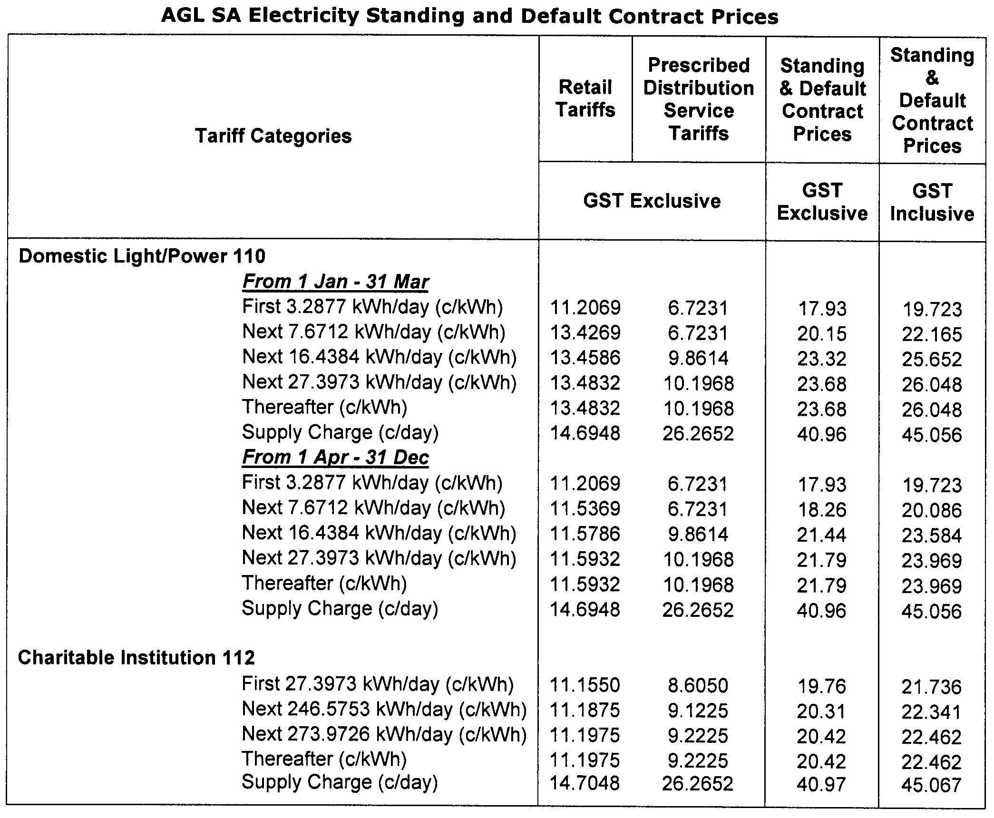
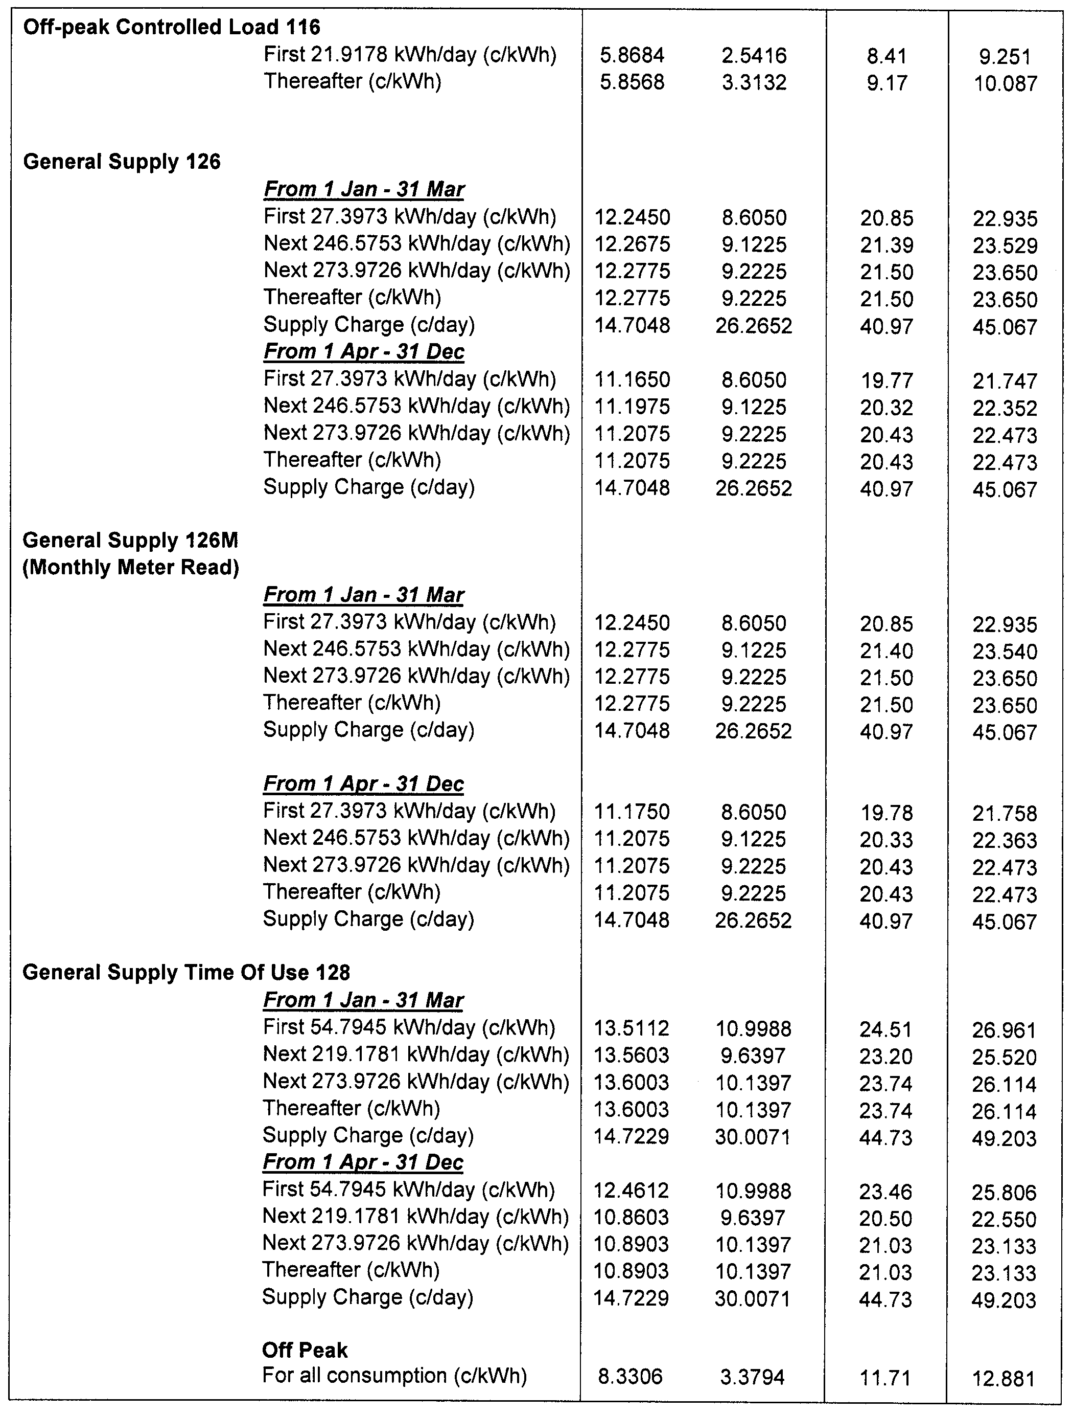
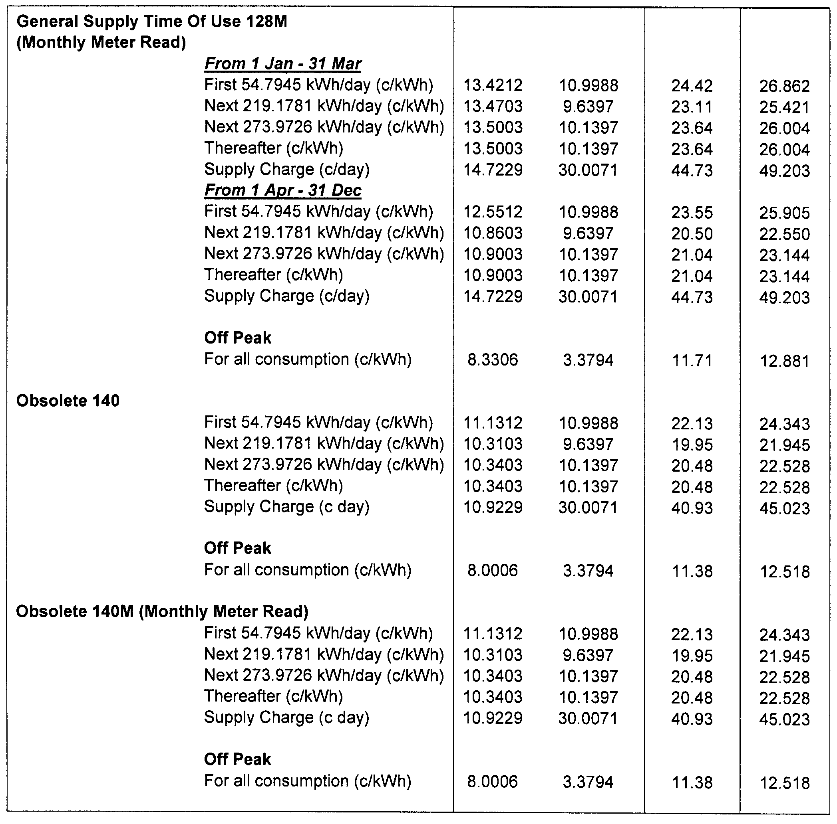
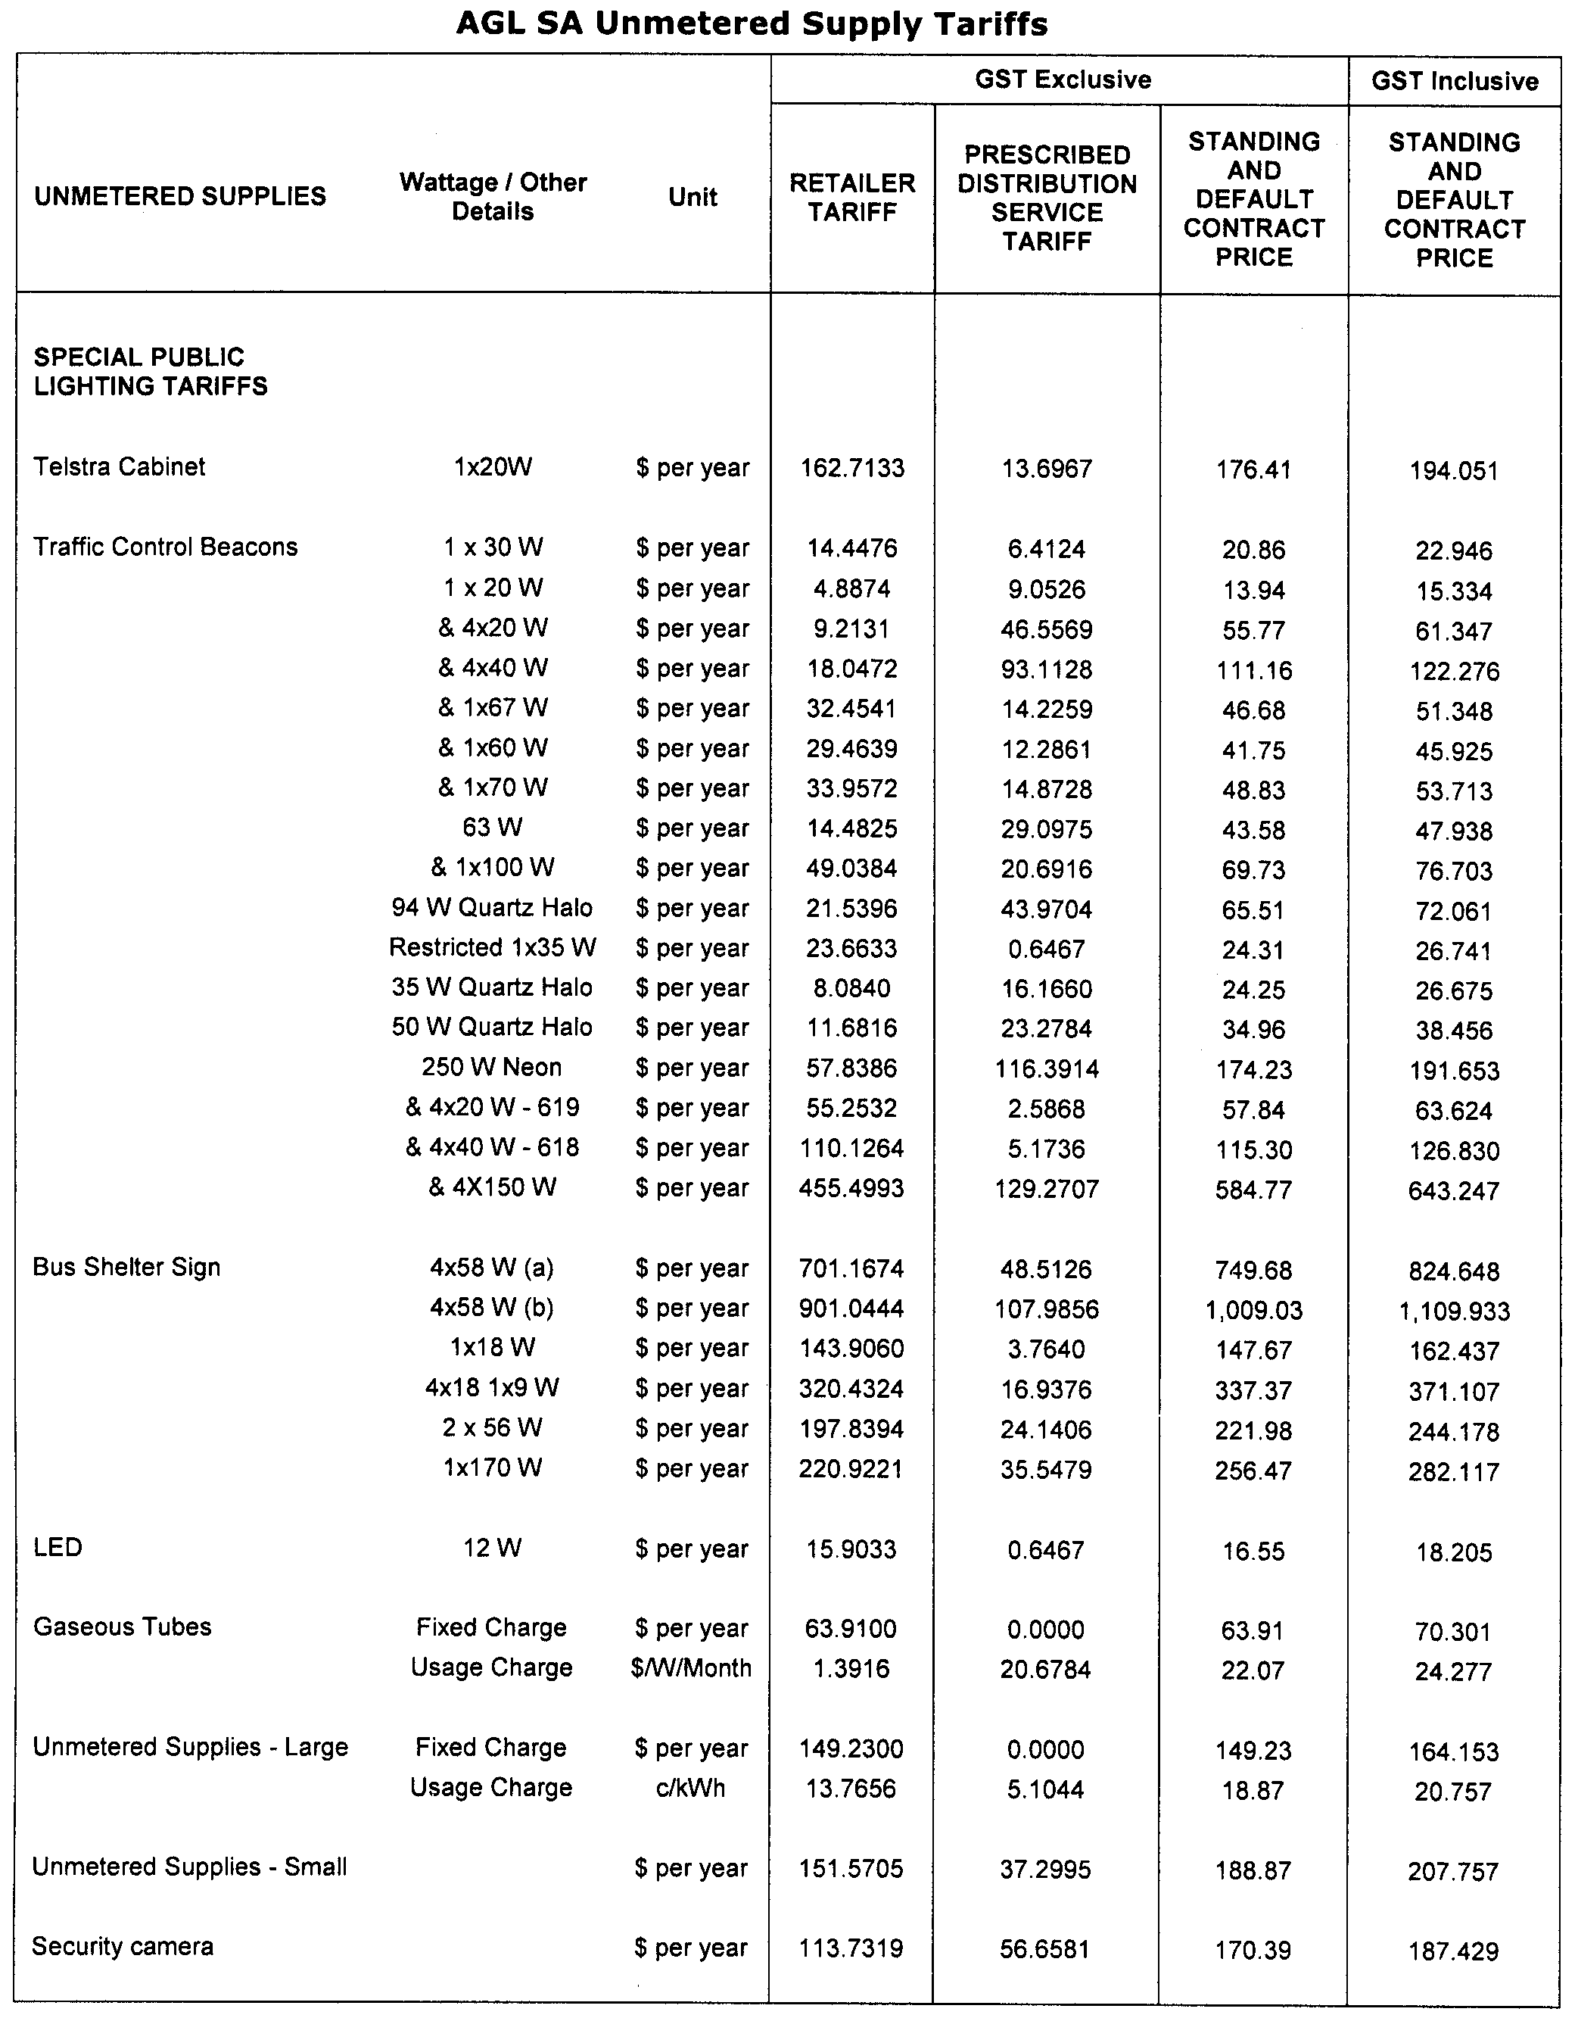
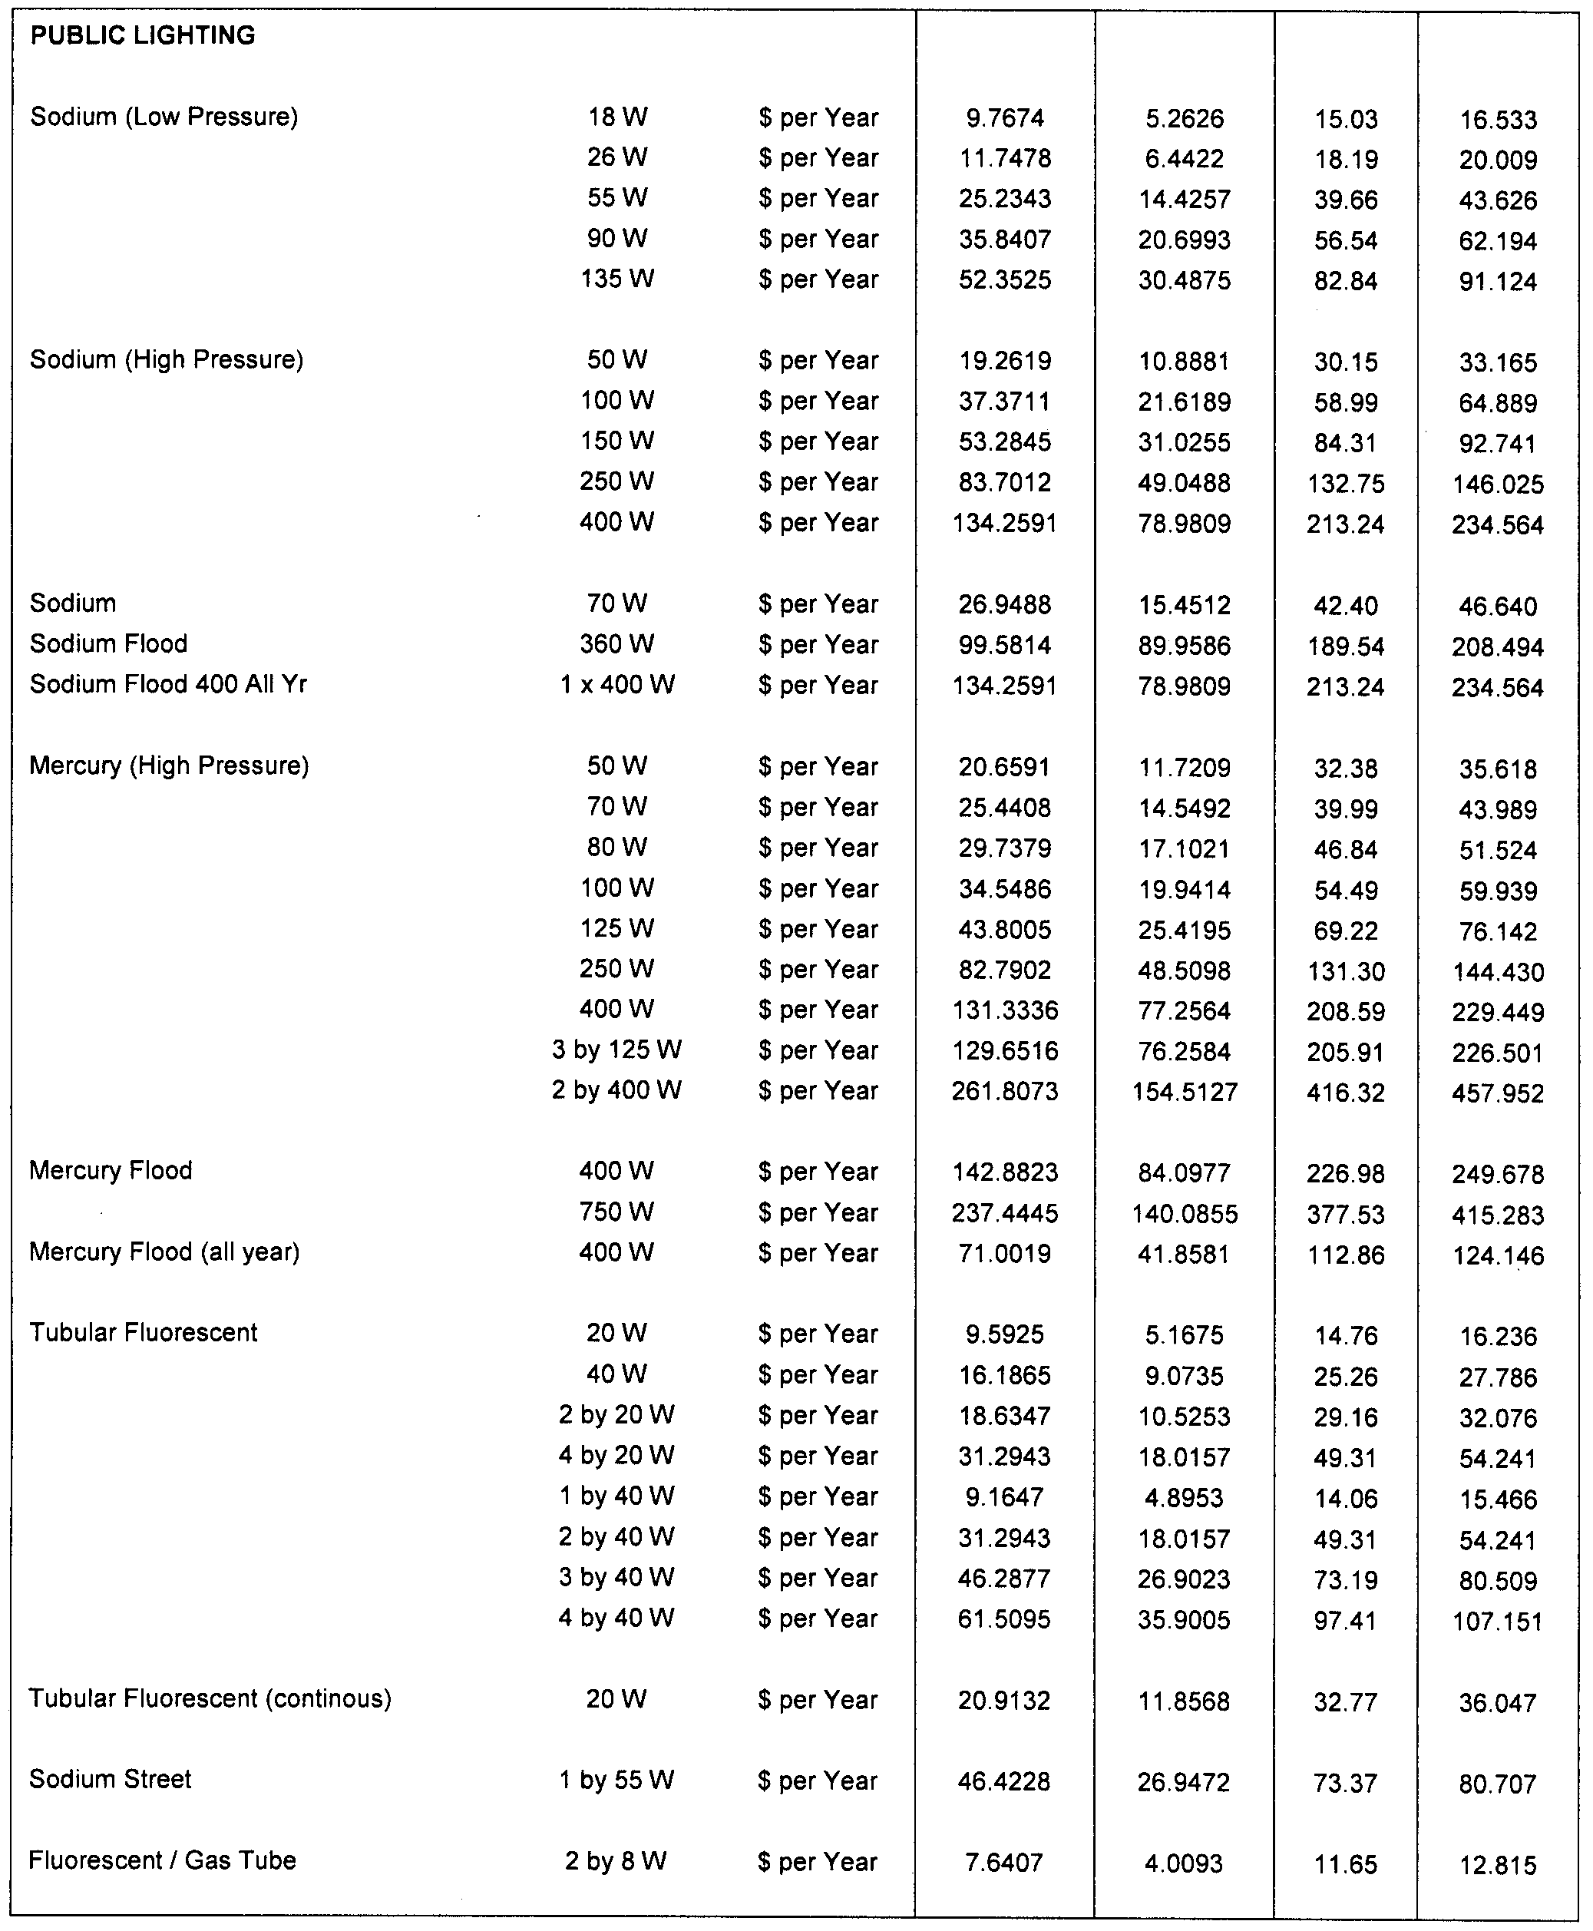
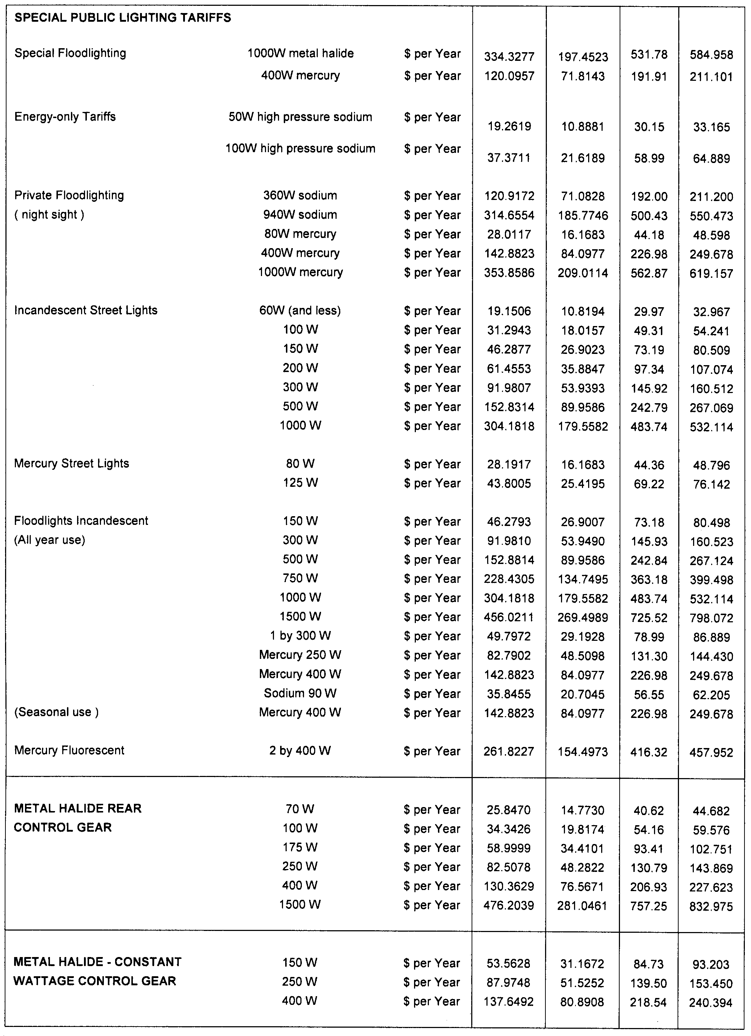
Explanatory Notes:
1. Standing and default contract price categories will only apply to small customers (that is, those customers who consume less than 160MWh of electricity per annum) who are purchasing electricity under AGL SA’s standing or default contract terms and conditions. Standing and default contract prices apply in accordance with the following principles:
(a) ‘Daily Consumption’ is the total electricity consumption for the period to which the customer’s bill relates, divided by the number of days in that period.
(b) Domestic Light/Power 110:
• applicable to all residential consumption (excluding Off-Peak Controlled Load Tariff 116) in premises used wholly or principally as private residences.
(c) Charitable Institutions 112:
• available to charitable institutions that have been endorsed by the Australian Taxation Office as an income tax exempt Charitable Entity under Subdivision 50-B of the Income Tax Assessment Act 1997.
(d) Controlled Load 116:
• for electricity used in permanently installed storage water heaters with a rated delivery of not less than 125 litres, storage space heaters and other approved thermal storage applications; the hours of application are fixed from time to time by AGL SA with control by time switch or other means. This price does not apply to electricity used outside those hours;
• customers who were taking supply under this tariff, or who had applied to do so, as at 30 June 2003, are subject to the conditions which were applicable at that date;
• this price is only available in conjunction with tariffs 110, 112, 126, 126M, 128, 128M, 140 or 140M.
(e) General Supply 126:
• available only to non-residential customers.
(f) General Supply 126M (Monthly Meter Reading):
• available only to non-residential customers;
• applies to customers whose meters are scheduled to be read monthly, and who are billed monthly;
• a monthly meter reading fee applies to this tariff in addition to the above prices.
(g) General Supply Time of Use 128:
• available only to non-residential customers with appropriate metering;
• includes customers previously on tariffs 120 + 121 and 130 + 131 who were taking supply under those tariffs, or who had applied to do so, as at 30 June 1997. Those customers are subject to the conditions which were applicable to those tariffs at that date, in addition to the current conditions.
(h) General Supply Time of Use 128M (Monthly Meter Reading):
• available only to non-residential customers with appropriate metering;
• includes customers previously on tariffs 120 + 121 and 130 + 131 who were taking supply under those tariffs, or who had applied to do so, as at 30 June 1997. Those customers are subject to the conditions which were applicable to those tariffs at that date, in addition to the current conditions;
• applies to customers whose meters are scheduled to be read monthly, and who are billed monthly;
• a monthly meter reading fee applies to this tariff in addition to the above prices.
(i) Obsolete Tariff 140 (formerly Farm Tariff 140):
• applies only to small customers that were taking supply under Obsolete Tariff 140, or who had applied to do so, as at 30 June 1997. Conditions applicable at that date apply, in addition to the current conditions.
(j) Obsolete Tariff 140M (Monthly Meter Reading):
• applies only to small customers that were taking supply under Obsolete Tariff 140, or who had applied to do so, as at 30 June 1997. Conditions applicable at that date apply, in addition to the current conditions;
• applies to customers whose meters are scheduled to be read monthly, and who are billed monthly;
• a monthly meter reading fee applies to this tariff in addition to the above prices.
2. Peak period is 0700 hours to 2100 hours from Monday to Friday (Central Standard Time) for all tariffs other than tariff 110 except where the network meters do not recognise specific tariff days. In these situations peak period is 0700 hours to 2100 hours (Central Standard Time) each day for tariffs other than tariff 110.
3. Off peak period is all times other than peak period.
4. Where prices change during a billing cycle the bill for that billing cycle will be calculated on a pro-rata basis using:
(a) the old price up to and including the date of change; and
(b) the new price from the date of change to the end of the billing cycle.

T. GOODES, Government Printer, South Australia

