No. 51 3163

THE SOUTH AUSTRALIAN

GOVERNMENT GAZETTE
www.governmentgazette.sa.gov.au

PUBLISHED BY AUTHORITY

ALL PUBLIC ACTS appearing in this GAZETTE are to be considered official, and obeyed as such

ADELAIDE, THURSDAY, 16 JULY 2009

CONTENTS

Page
Appointments, Resignations, Etc. 3164
Associations Incorporation Act 1985—Notice 3181
Brands Act 1933—4th Quarter 2008 3165
Corporations and District Councils—Notices 3212
Crown Lands Act 1929—Notices 3181
Development Act 1993—Notice 3181
Geographical Names Act 1991—Notices 3181
Harbors and Navigation Act 1993—Notice 3182
Housing Improvement Act 1940—Notices 3183
Liquor Licensing Act 1997—Notices 3185
Mining Act 1971—Notices 3188
National Parks and Wildlife (National Parks) Regulations
2001—Notice 3189
Petroleum Act 2000—Notices 3189

Page
Proclamation 3200
Public Trustee Office—Administration of Estates 3224

REGULATIONS
Natural Resources Management Act 2004
(No. 202 of 2009) 3201
Road Traffic Act 1961—
(No. 203 of 2009) 3203
(No. 204 of 2009) 3206
Motor Vehicles Act 1959 (No. 205 of 2009) 3208
Public Trustee Act 1995 (No. 206 of 2009) 3209
Roads (Opening and Closing) Act 1991—Notices 3189
Transport, Department of—Notices to Mariners 3190
Treasury—Quarterly Statement 3191

GOVERNMENT GAZETTE NOTICES
ALL poundkeepers’ and private advertisements forwarded for publication in the South Australian Government Gazette must be PAID FOR PRIOR TO INSERTION; and all notices, from whatever source, should be legibly written on one side of the paper only and sent to Government Publishing SA so as to be received no later
than 4 p.m. on the Tuesday preceding the day of publication. Phone 8207 1045 or Fax 8207 1040. E-mail: governmentgazette@dpc.sa.gov.au. Send as attachments in Word format and please confirm your transmission with a faxed copy of your document, including the date the notice is to be published and to whom the notice will be charged. The Government Gazette is available online at: www.governmentgazette.sa.gov.au

Department of the Premier and Cabinet
Adelaide, 16 July 2009
HIS Excellency the Governor in Executive Council has been pleased to appoint the undermentioned to the Carrick Hill Trust, pursuant to the provisions of the Carrick Hill Trust Act 1985:
Member: (from 16 July 2009 until 15 July 2012)
Brendan Leonard Grigg
By command,
Paul Caica, for Premier
ASA005-02

Department of the Premier and Cabinet
Adelaide, 16 July 2009
HIS Excellency the Governor in Executive Council has been pleased to appoint the undermentioned to the Legal Practitioners Conduct Board, pursuant to the provisions of the Legal Practitioners Act 1981:
Member: (from 16 July 2009 until 15 July 2012)
Joan-Therese Michele Fox
Stewart Ronald Leggett
By command,
Paul Caica, for Premier
AGO0068/03CS

Department of the Premier and Cabinet
Adelaide, 16 July 2009
HIS Excellency the Governor in Executive Council has been pleased to appoint the undermentioned to the Legal Services Commission, pursuant to the provisions of the Legal Services Commission Act 1977:
Member: (from 16 July 2009 until 15 July 2012)
Andrew English
By command,
Paul Caica, for Premier
AGO0249/02CS

Department of the Premier and Cabinet
Adelaide, 16 July 2009
HIS Excellency the Governor in Executive Council has been pleased to appoint Hieu Van Le as Governor’s Deputy of South Australia for the period from 8 a.m. on Saturday, 25 July 2009 until 10 a.m. on Saturday, 15 August 2009.
By command,
Paul Caica, for Premier

Department of the Premier and Cabinet
Adelaide, 16 July 2009
HIS Excellency the Governor in Executive Council has been pleased to appoint the Honourable John David Hill, MP, Minister for Health, Minister for the Southern Suburbs and Minister Assisting the Premier in the Arts to be also Acting Minister for Education, Acting Minister for Mental Health and Substance Abuse, Acting Minister for Tourism and Acting Minister for the City of Adelaide for the period from 20 July 2009 to 22 July 2009 inclusive, during the absence of the Honourable Jane Diane Lomax-Smith, MP.
By command,
Paul Caica, for Premier
DPC05/025CS

Department of the Premier and Cabinet
Adelaide, 16 July 2009
HIS Excellency the Governor in Executive Council has been pleased to appoint the Honourable Michael John Atkinson, MP, Attorney-General, Minister for Justice, Minister for Multicultural Affairs and Minister for Veterans’ Affairs to be also Acting Minister for Correctional Services, Acting Minister for Gambling, Acting Minister for Youth and Acting Minister for Volunteers for the period from 25 July 2009 to 8 August 2009 inclusive, during the absence of the Honourable Tom Koutsantonis, MP.
By command,
Paul Caica, for Premier
MCS09/010 SC

Department of the Premier and Cabinet
Adelaide, 16 July 2009
HIS Excellency the Governor in Executive Council has been pleased to appoint the people listed as Justices of the Peace for South Australia for a period of ten years commencing from 16 July 2009 and expiring on 15 July 2019, pursuant to section 4 of the Justices of the Peace Act 2005:
Ian Kenneth Adamson
Jon Bennett Alton
Bartolomeo Baldi
Mary Bassani
Joseph Anthony Bayer
Terri-Lee Boyd
Cheryle Ann Bradford
Wendy Kay Brown
Ian Gordon Buckley
Heather Janet Cleland
David Kingsley Cozens
Ian William Dales
Iva Gonda Denton
Barbara Eva Drewniak
Keryn Joy Eden
James Daniel Christian Ehmann
Willem Daniel De Witt Fourie
Geoffrey Lennard Gower
Timothy John Grant-Allan
Nicholas Grgurinovich
Richard Louis Haase
Elaine Mary Hall
Susan Elizabeth Harrison
George William MacKenzie Hobbs
Jana Isemonger
Julie-Anne Rose Jacobs
Mark Anthony Johnstone
Michael William Joy
Scott Stephen Keeley
Karen Louise Memmler
Malcolm Kingsley Mills
Peter Francis Morel
Steven Reginald Nye
David James O’Dwyer
Norman John O’Flaherty
Ivan Peter Oulianoff
Linda Jane Panaszek
Graham Pearce
Davina Cherie Quirke
Hussain Razaiat
Pamela Ann Robertson
Scott Michael Robertson
June Anne Rose
Mark Randall Skanes
Natalie Jennifer Sneath
Linda Jean Summers
Margaret Maria Tobar
Daniel Shane Earl Tumminello
Peter Robert Watson
Philip Douglas Watson
By command,
Paul Caica, for Premier
JP/09/037CS

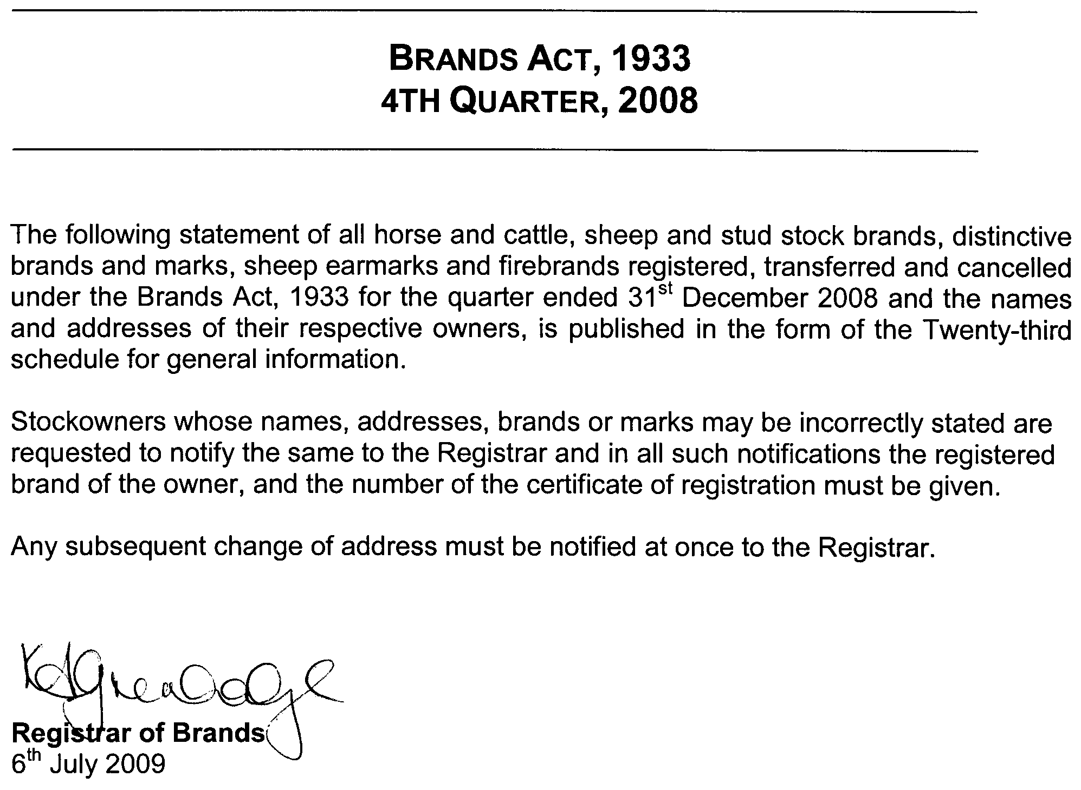
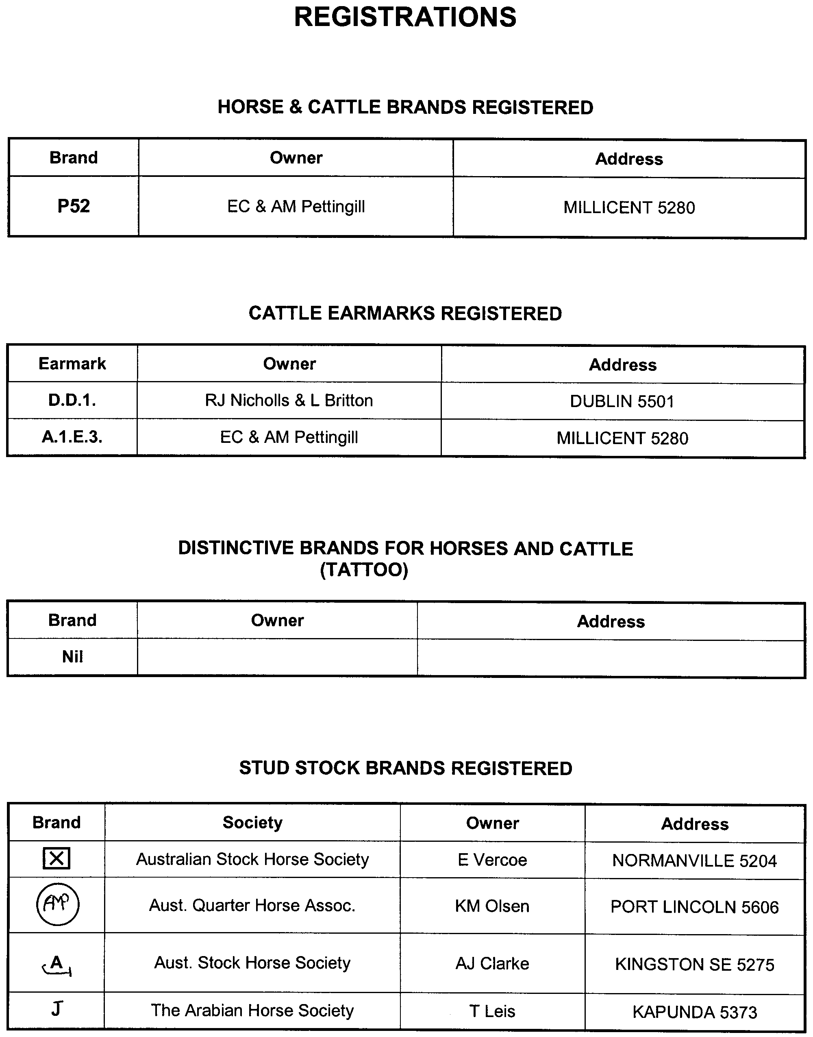
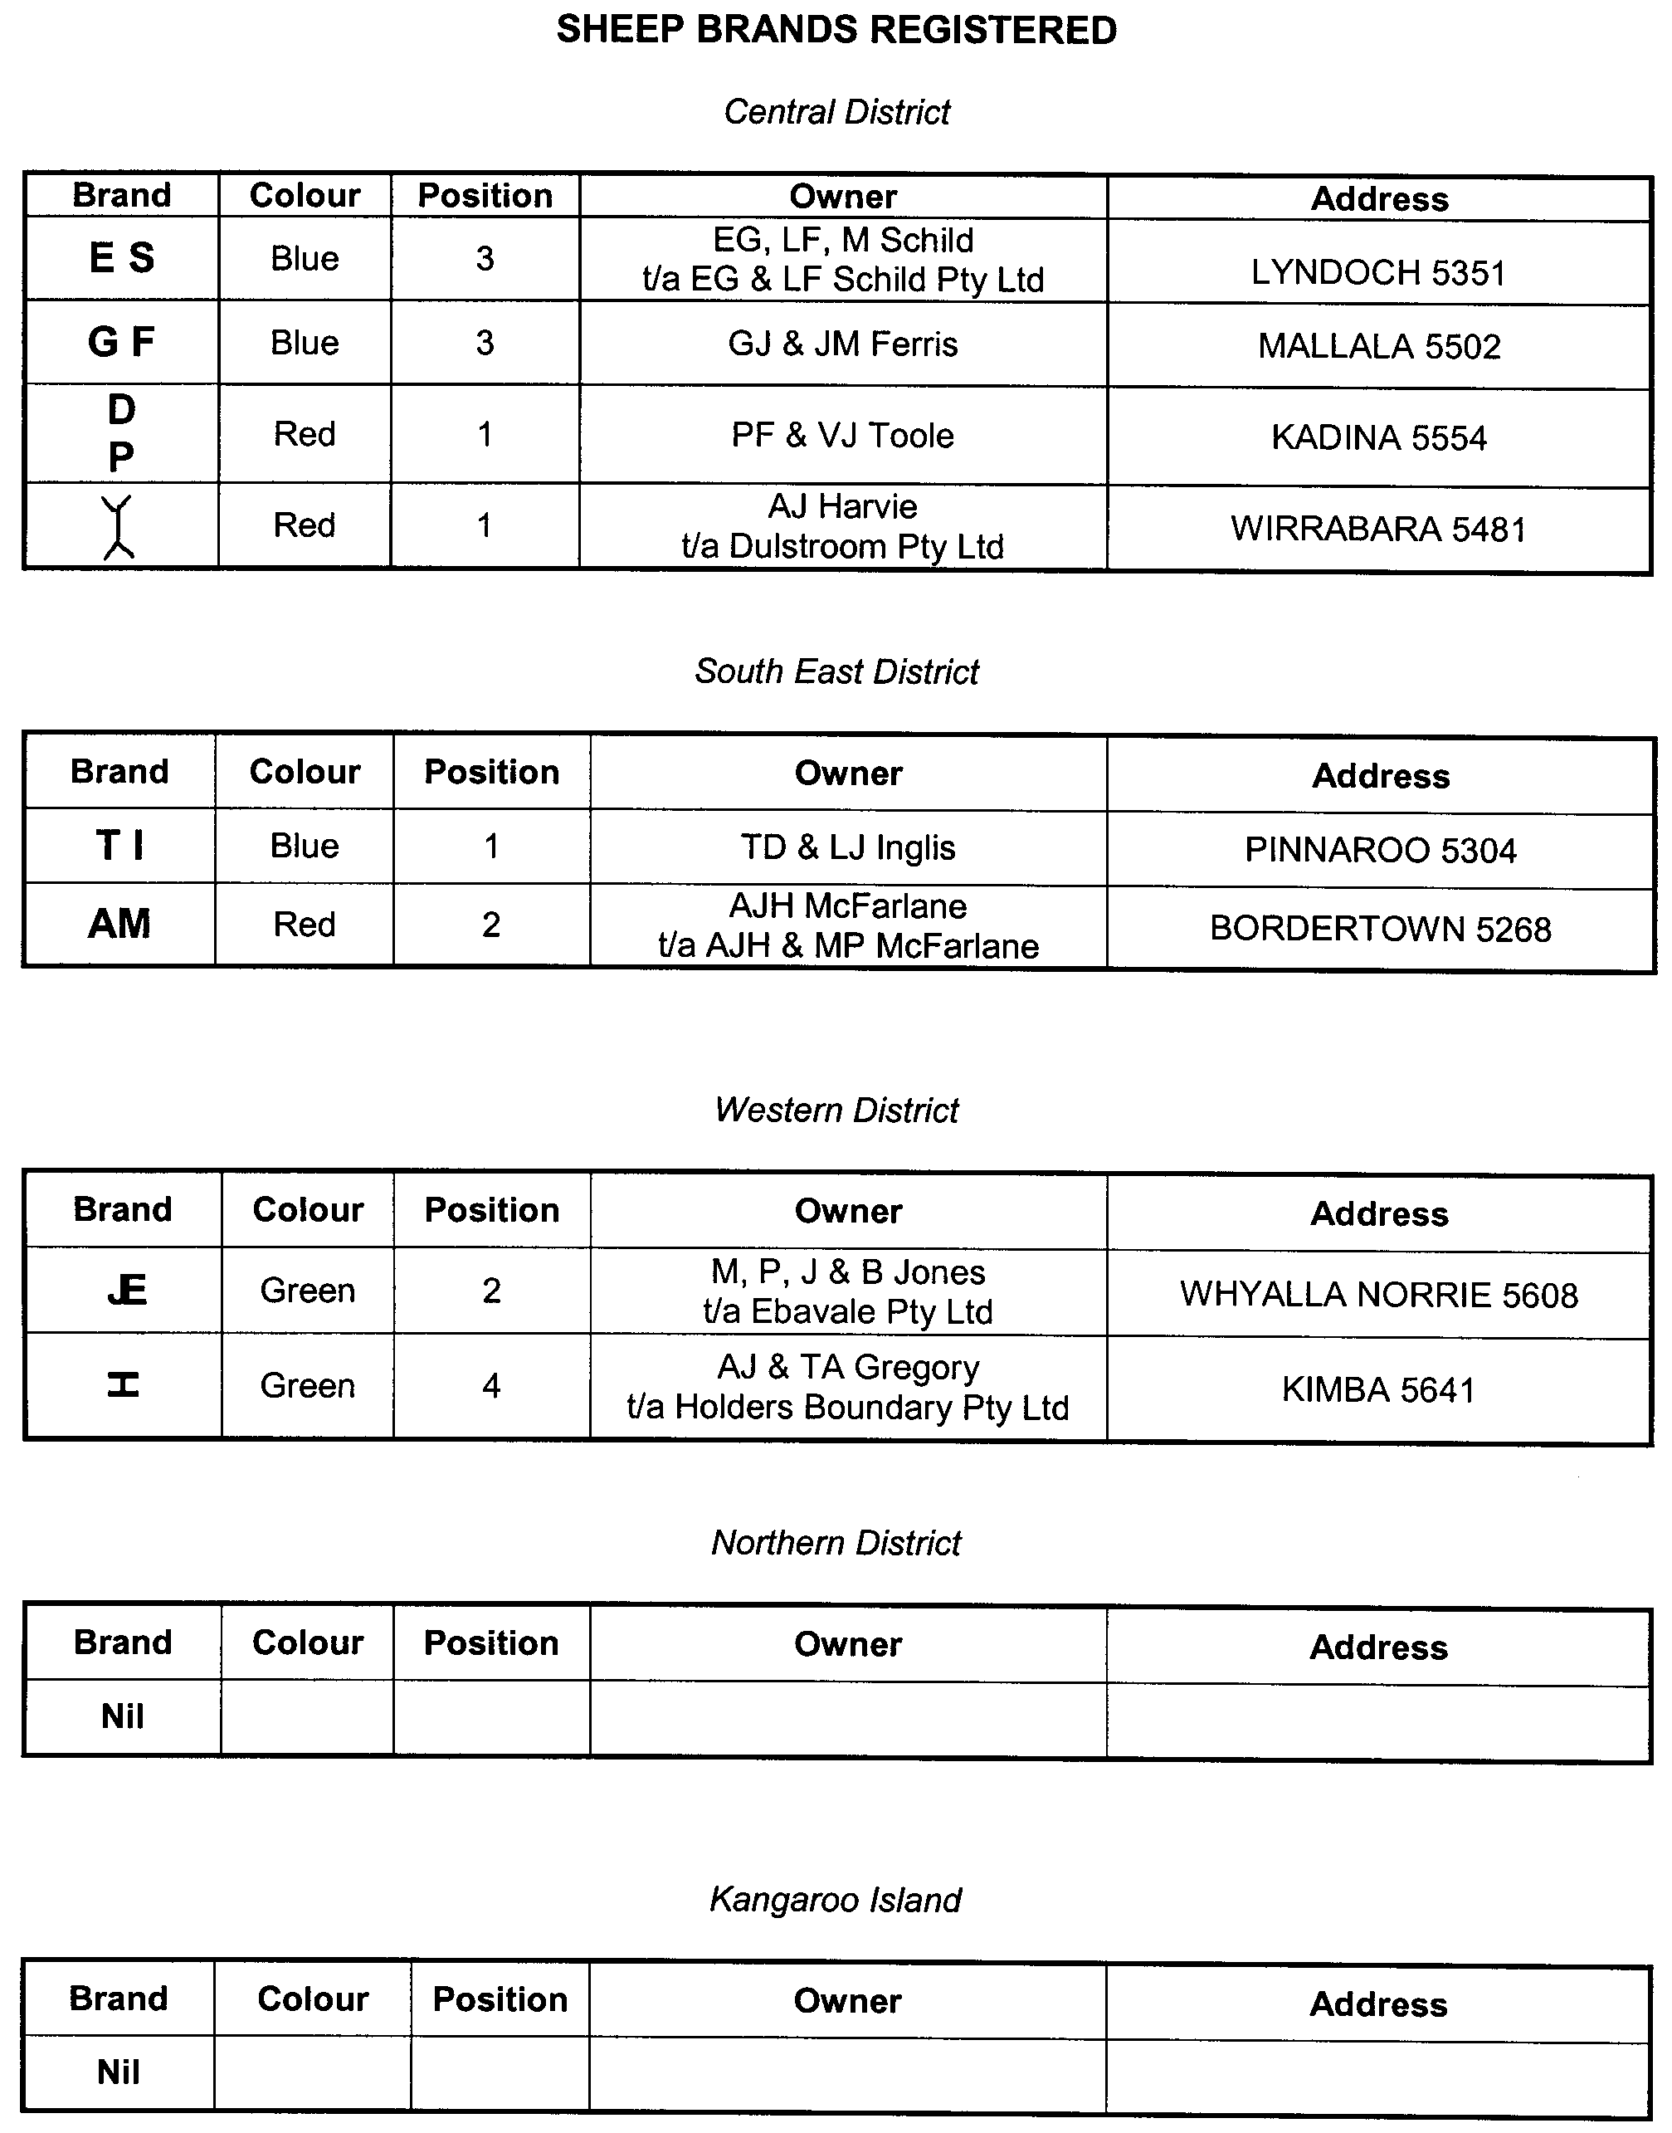
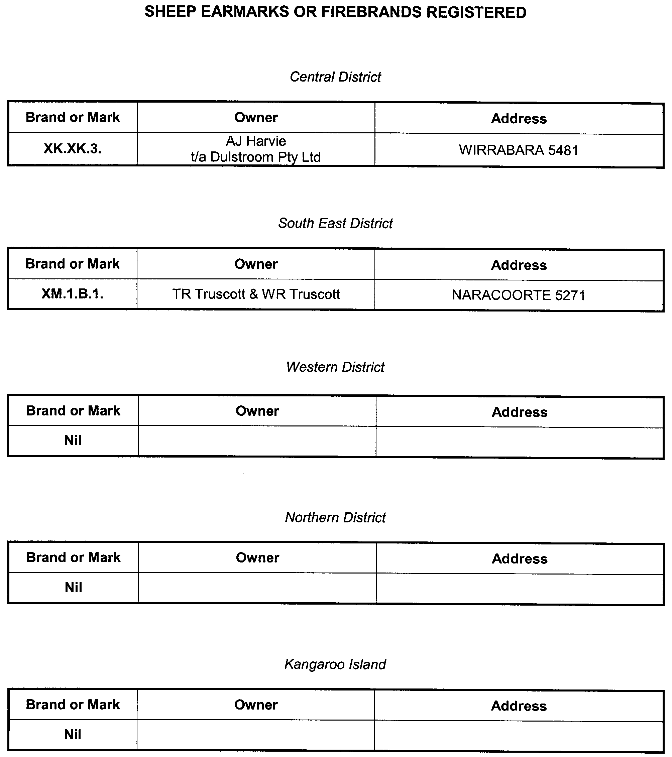
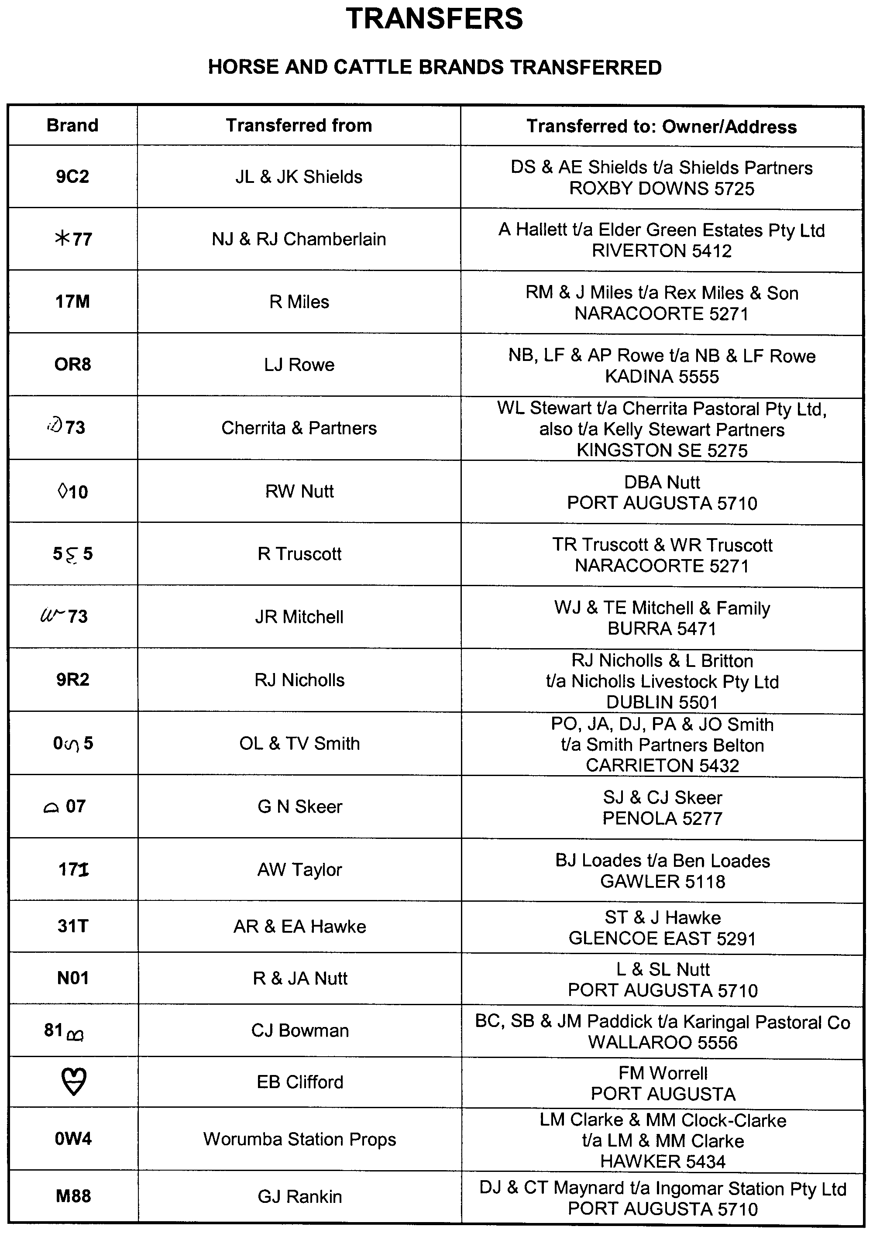
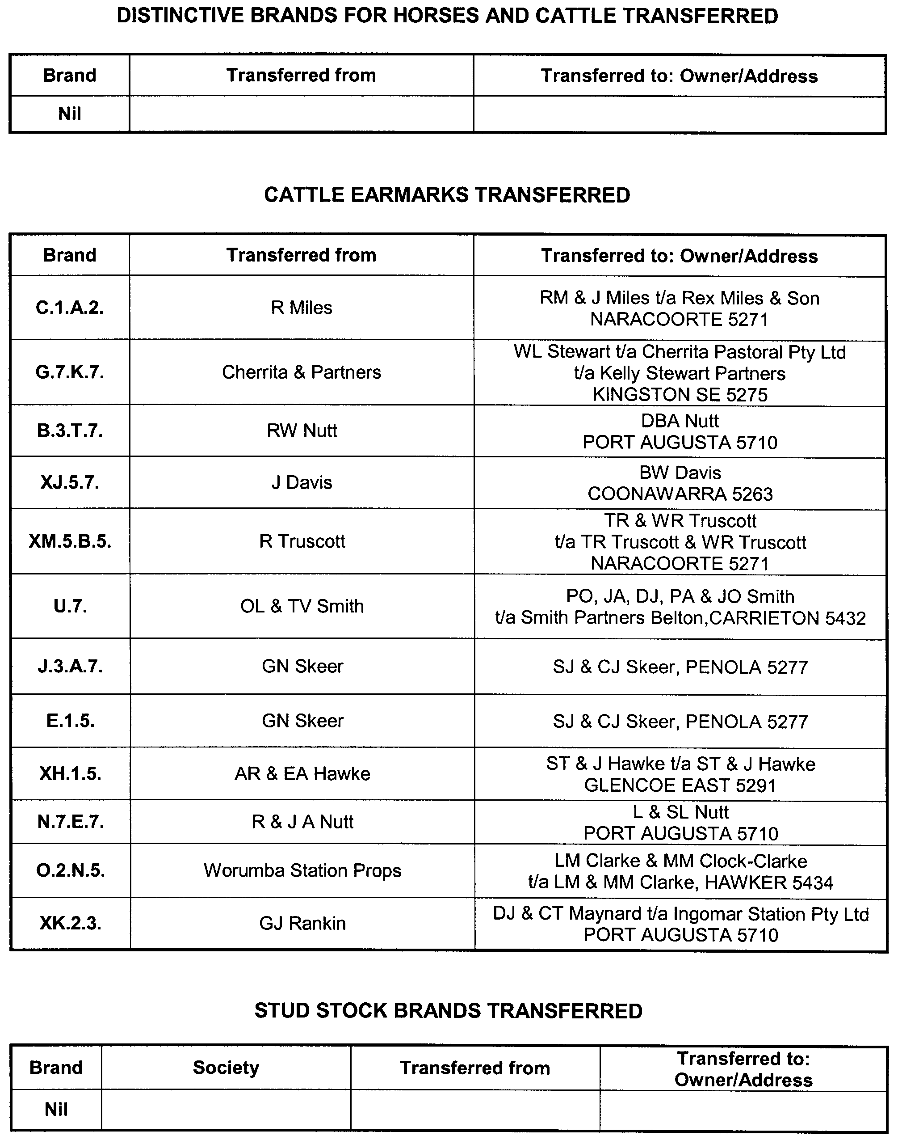
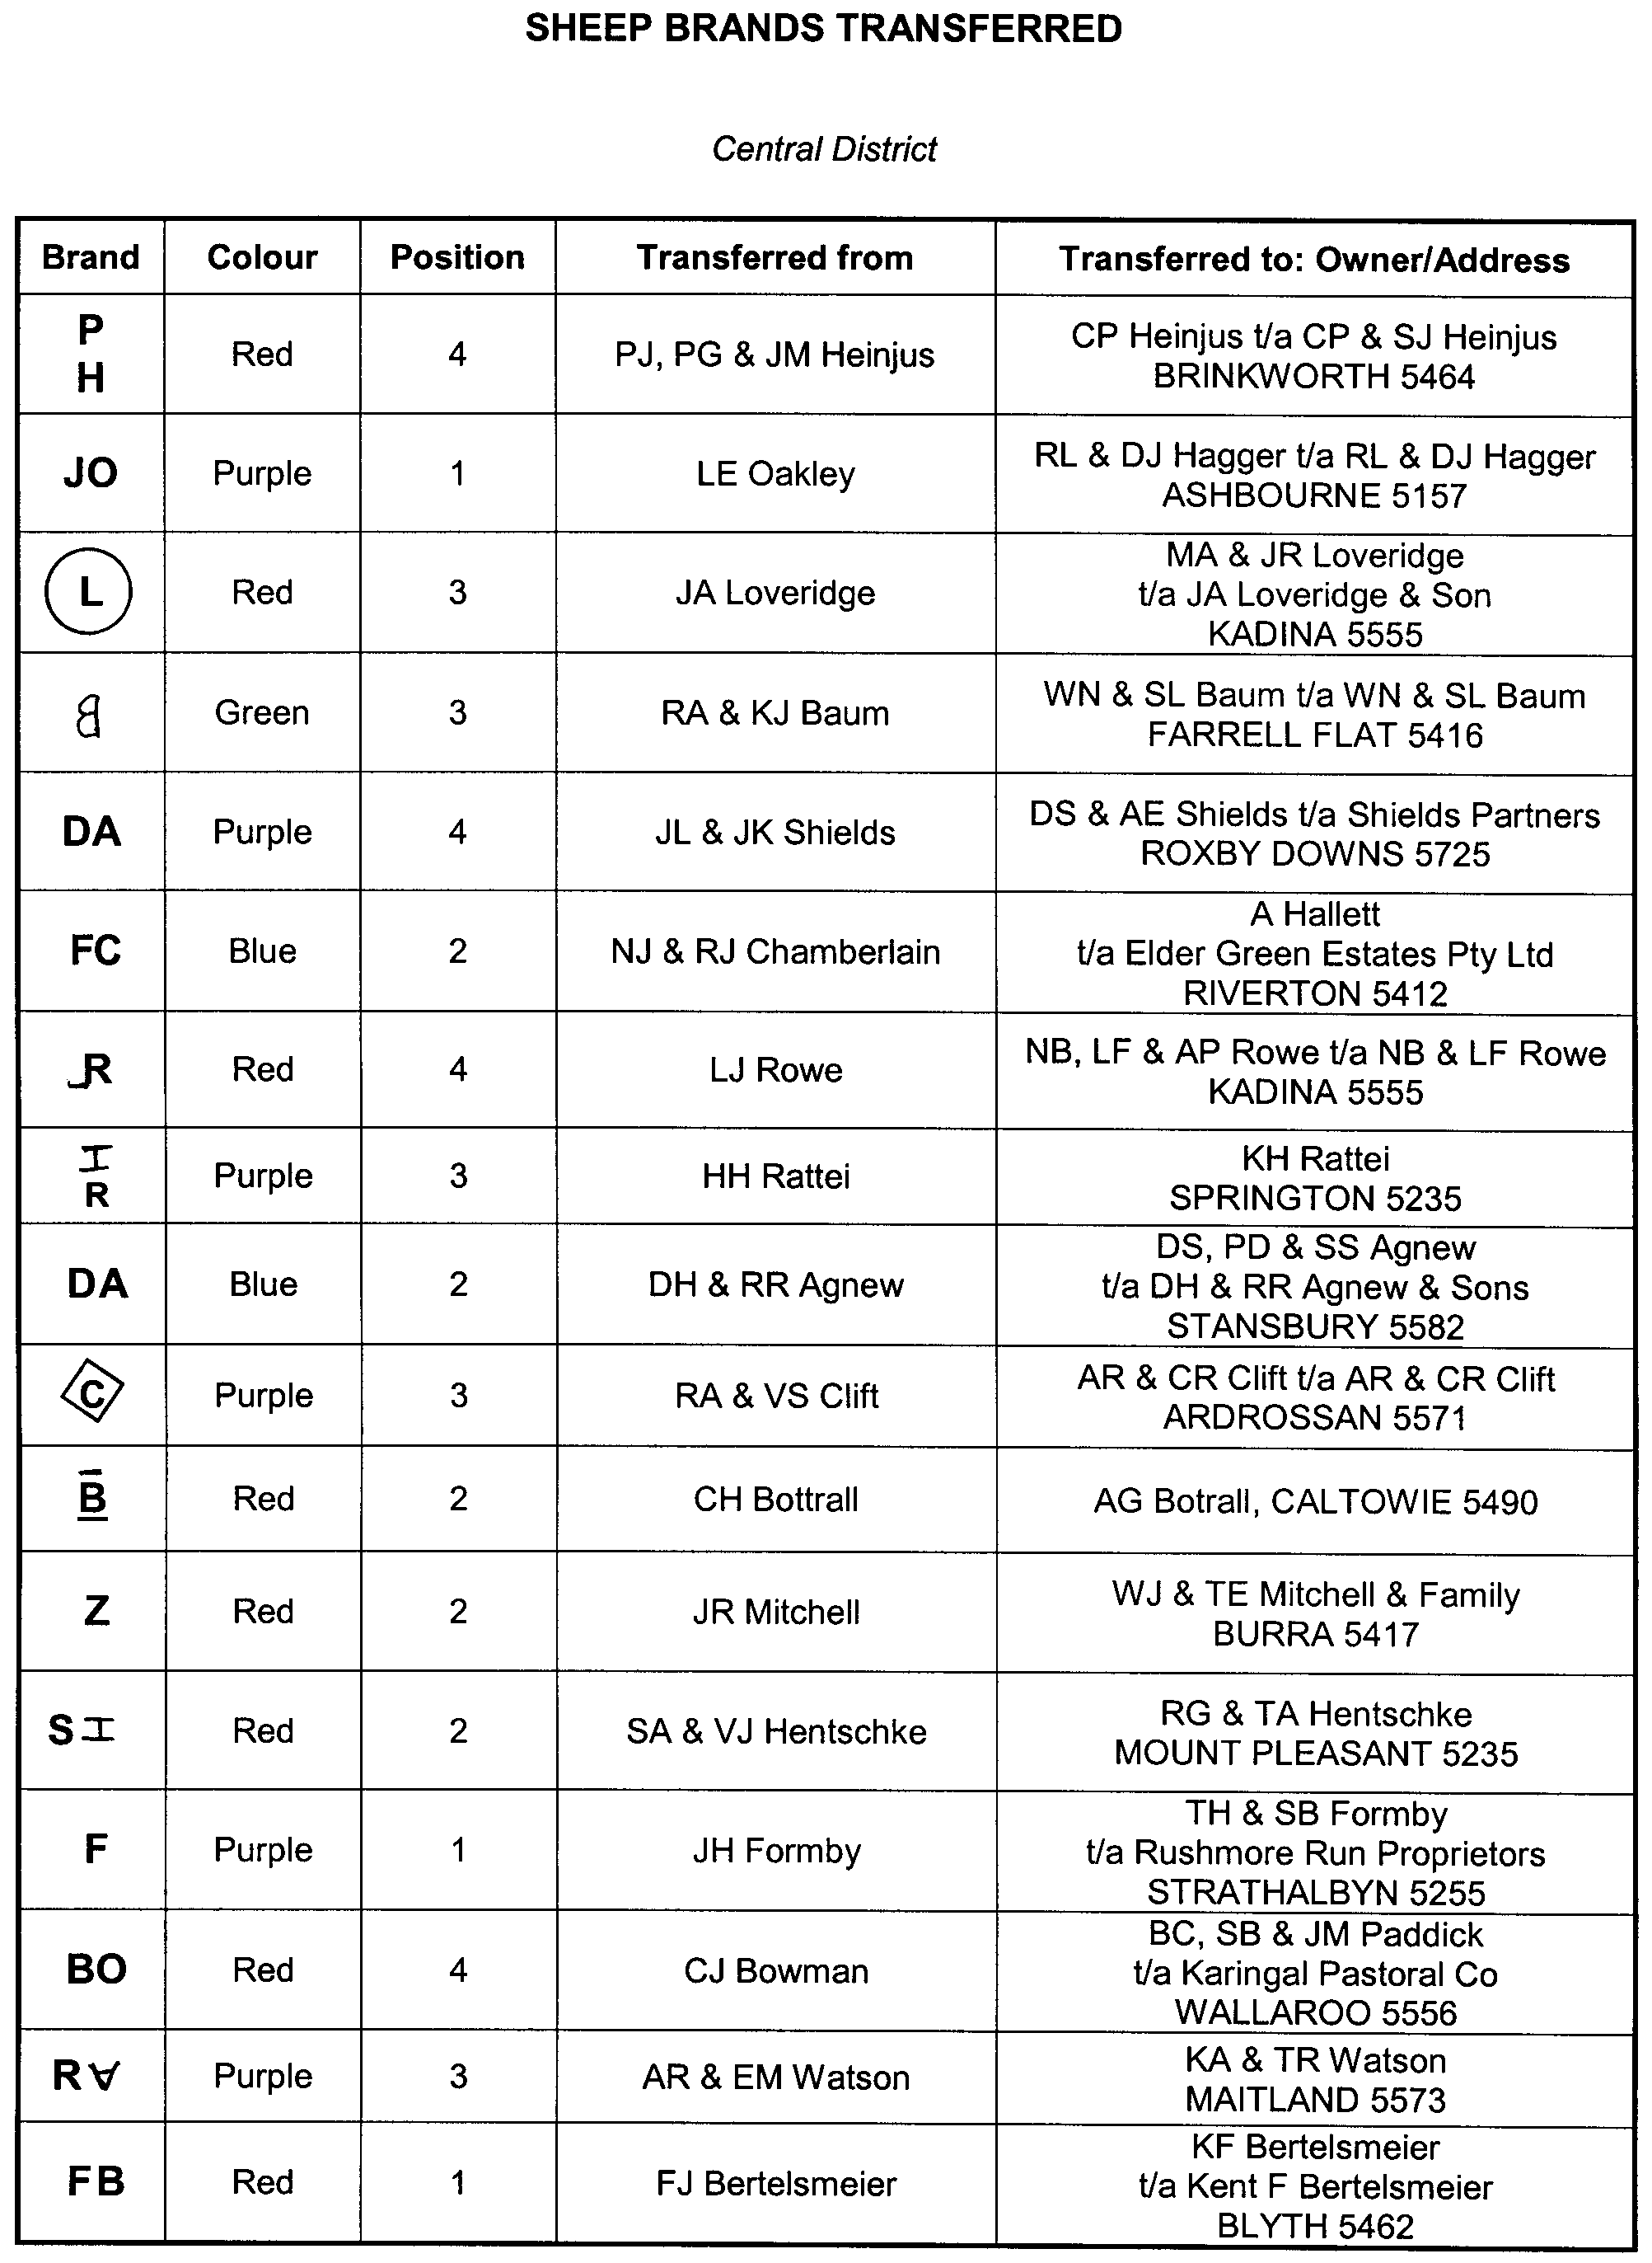
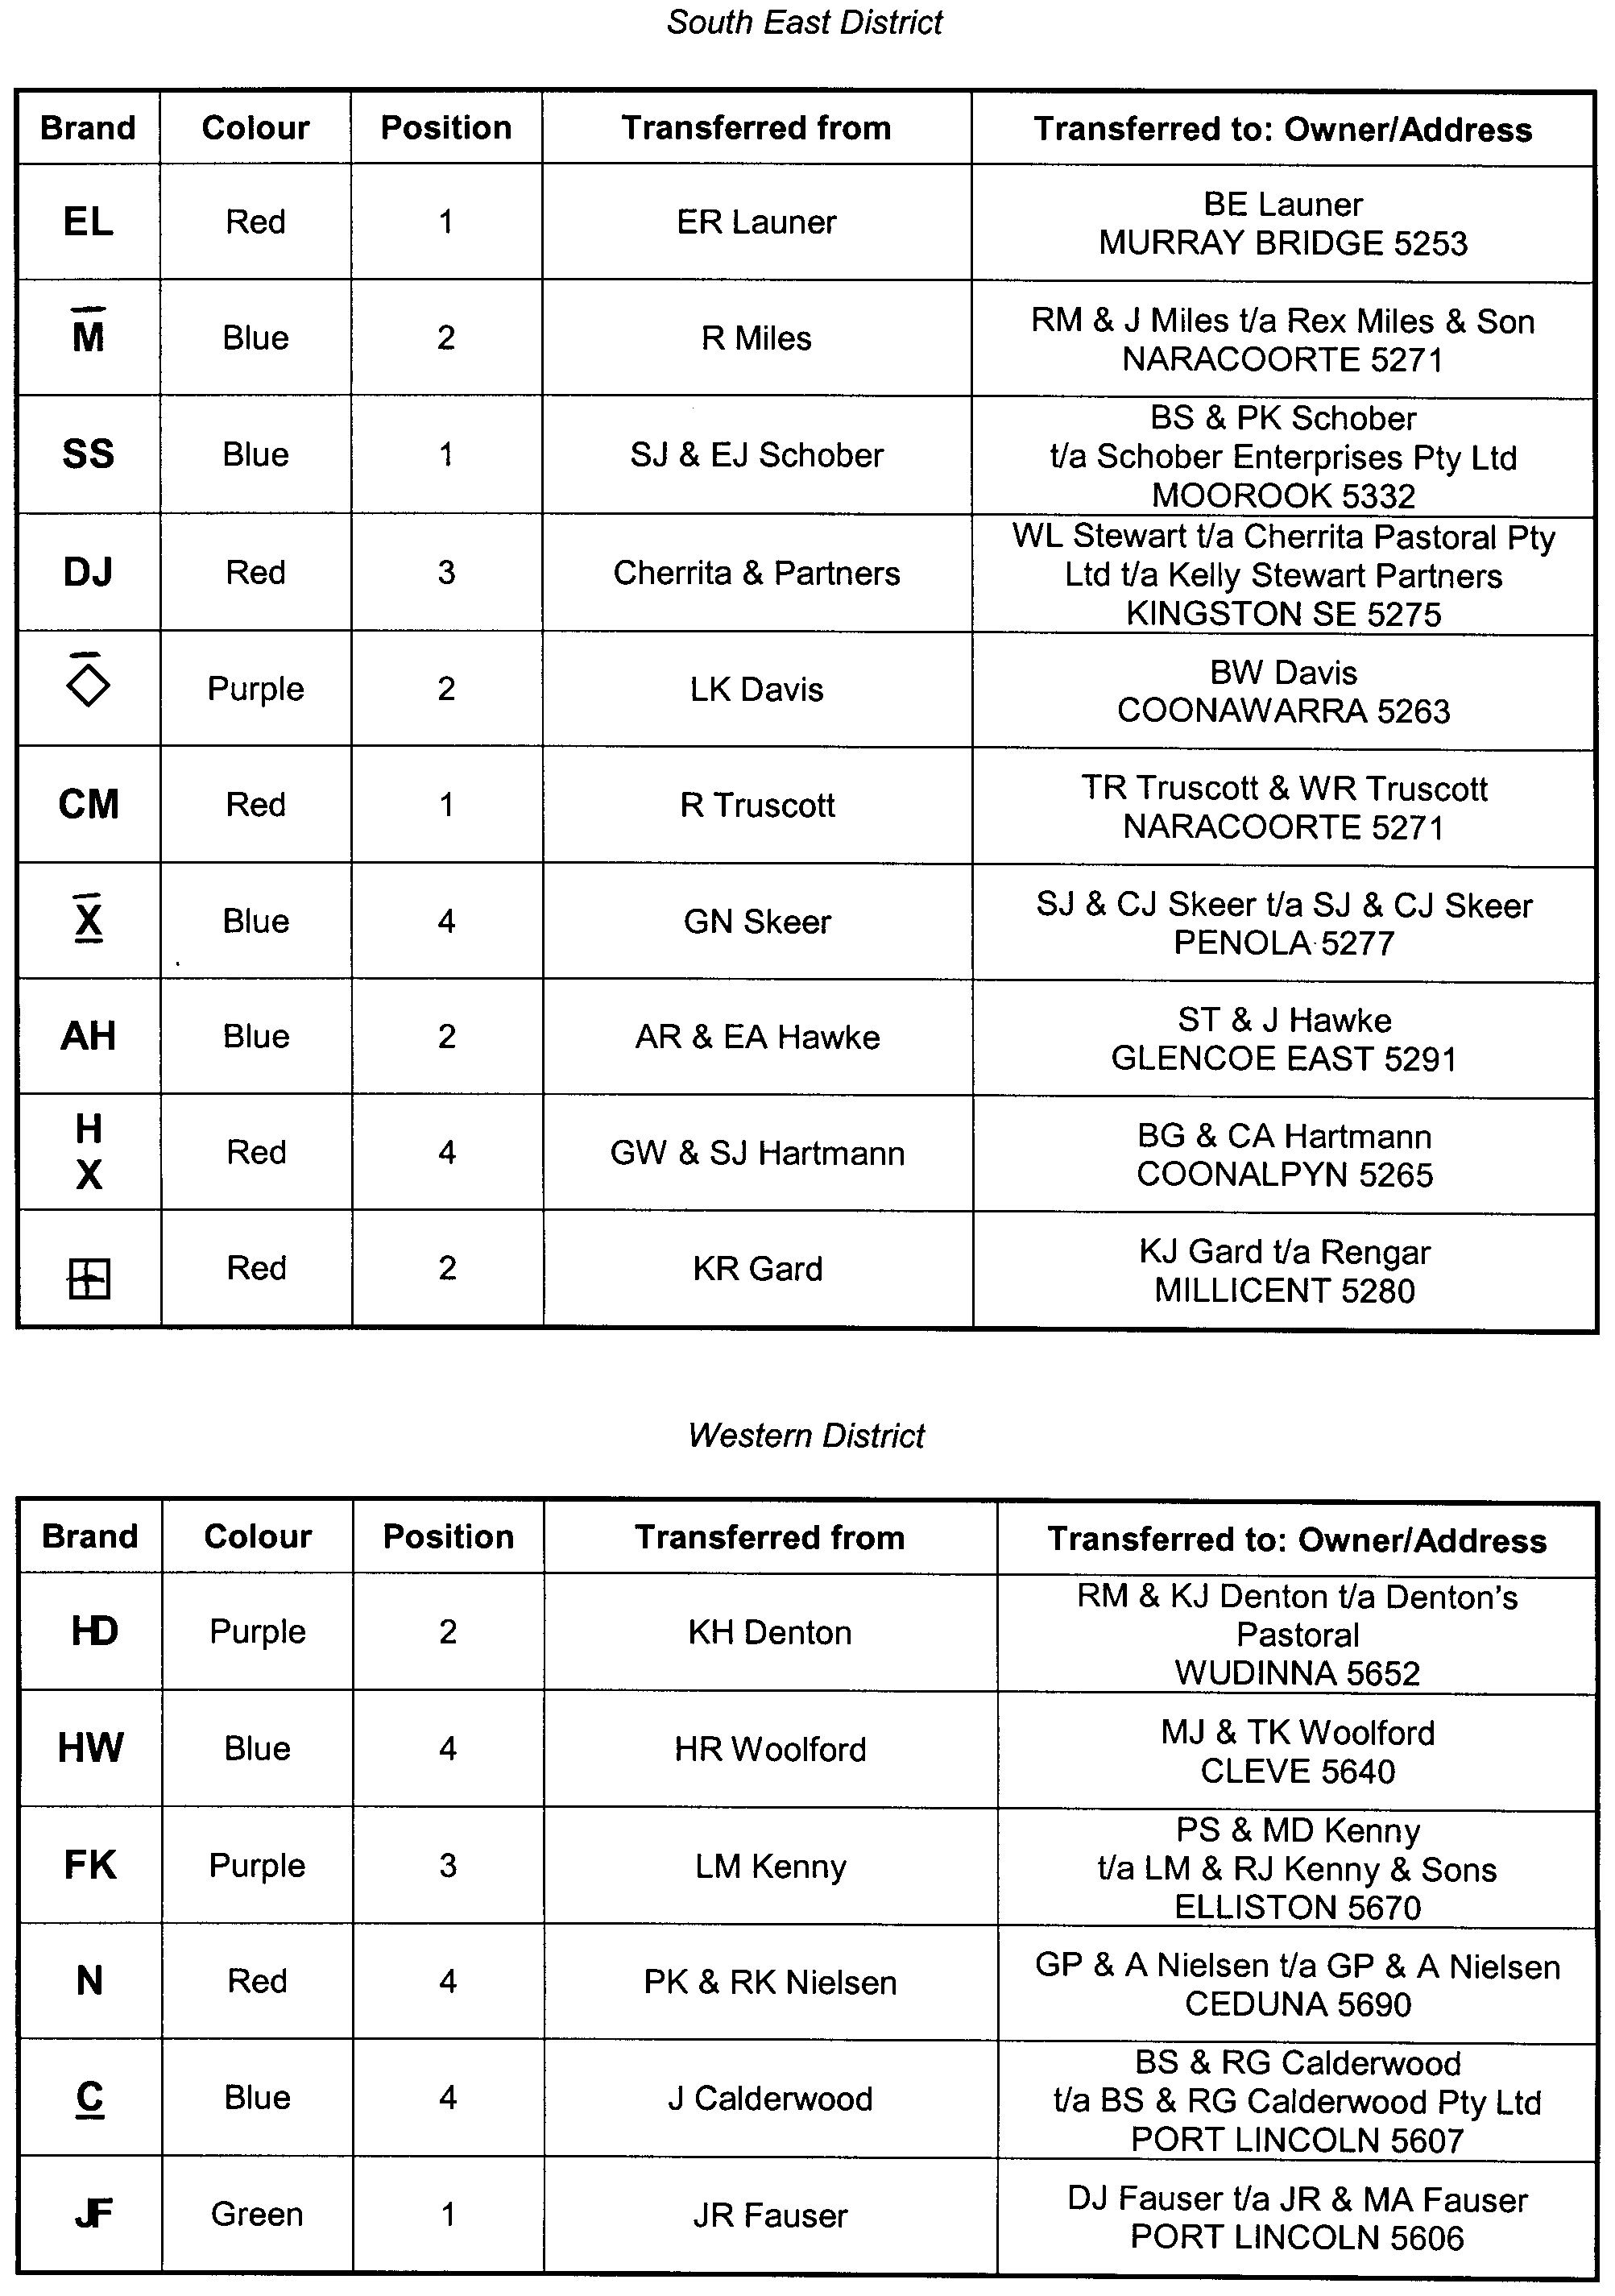
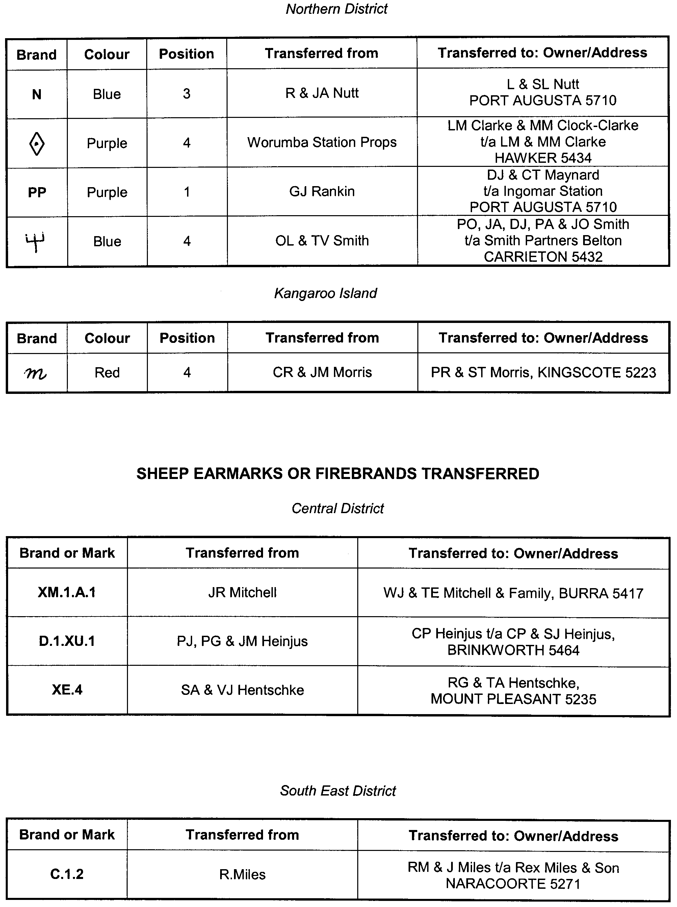
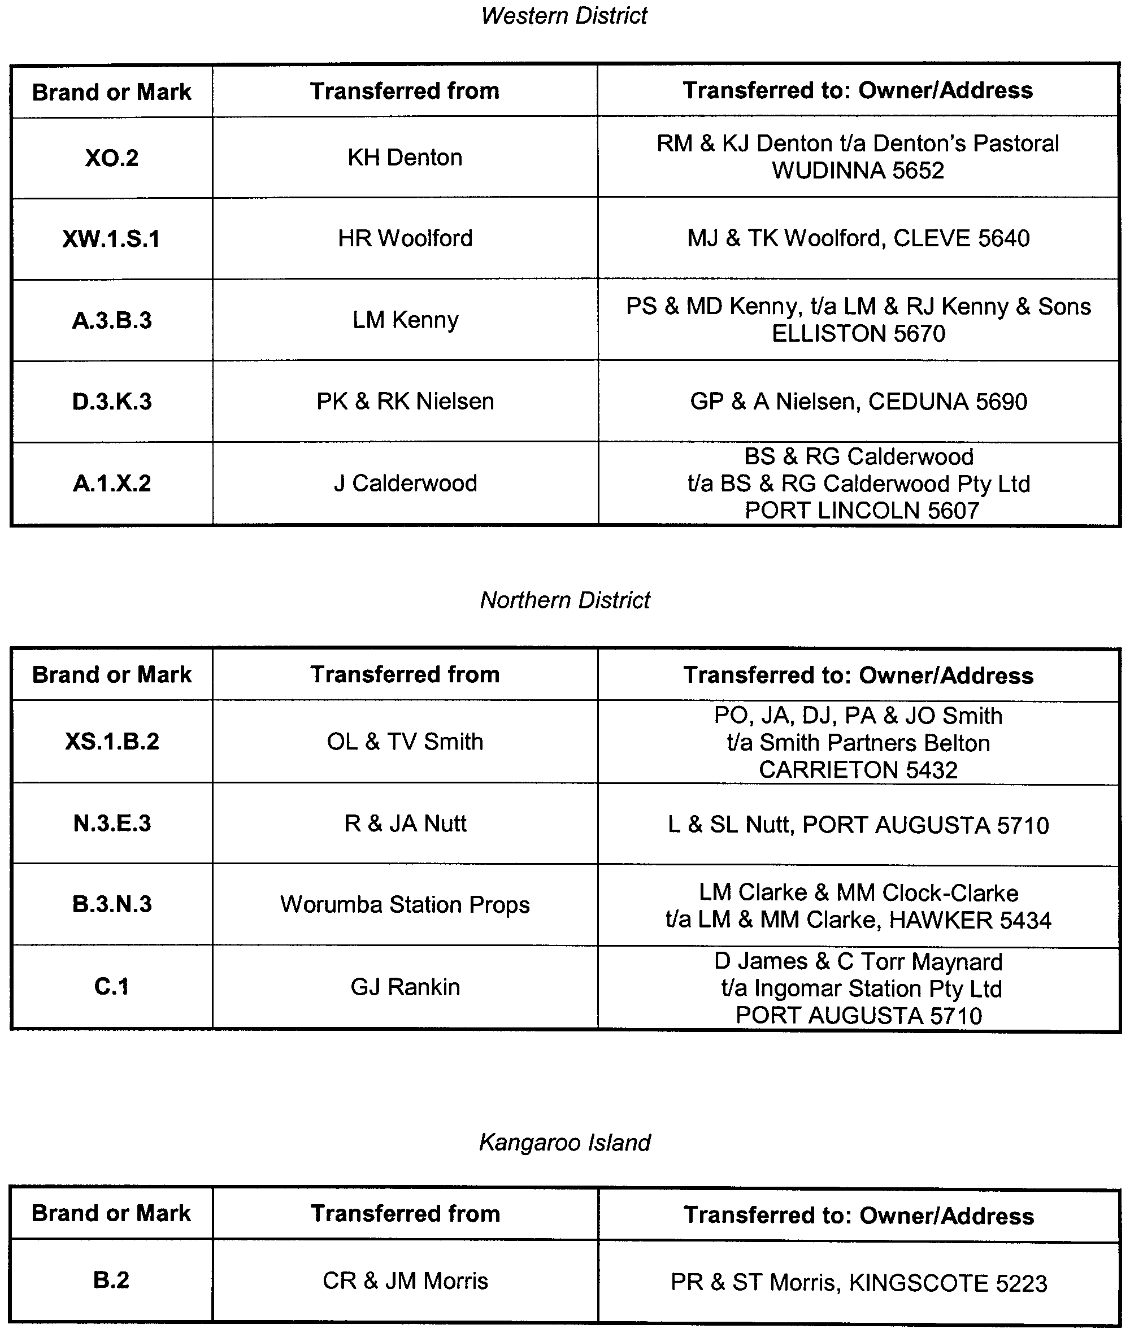
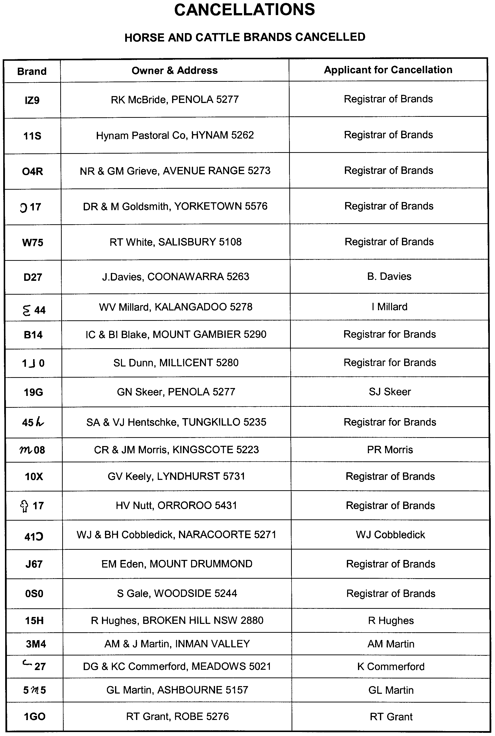
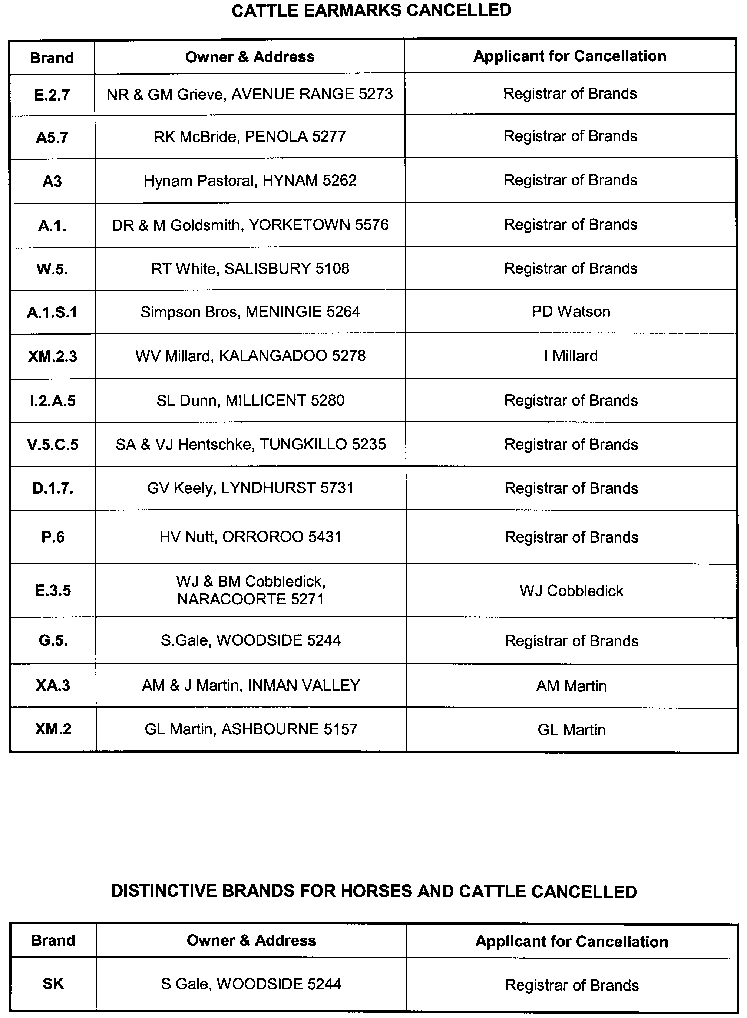
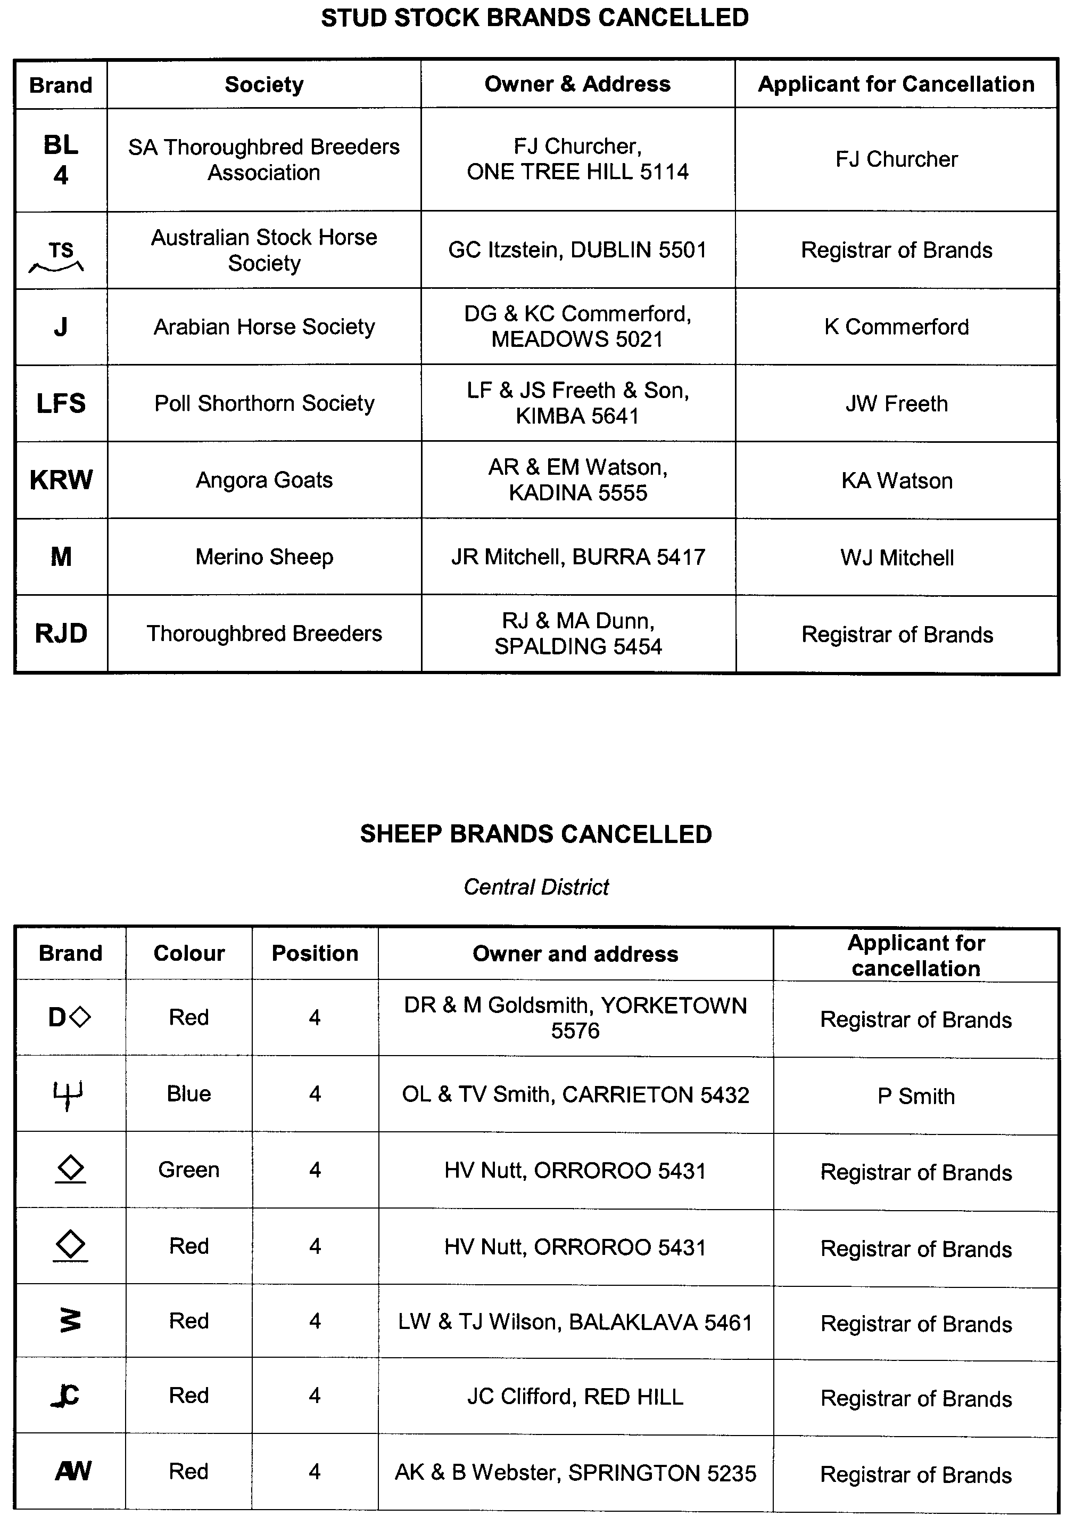
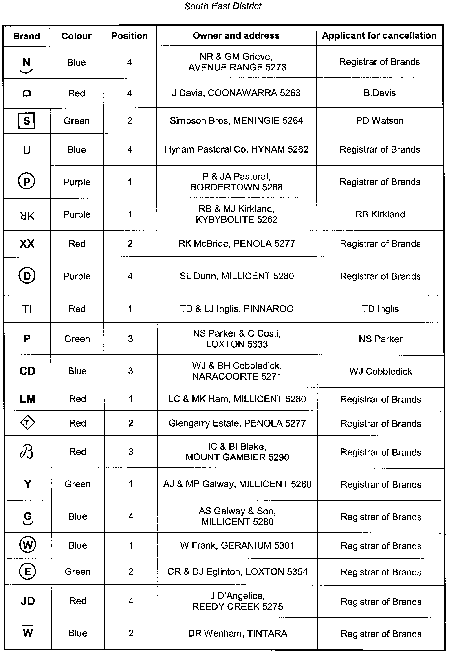
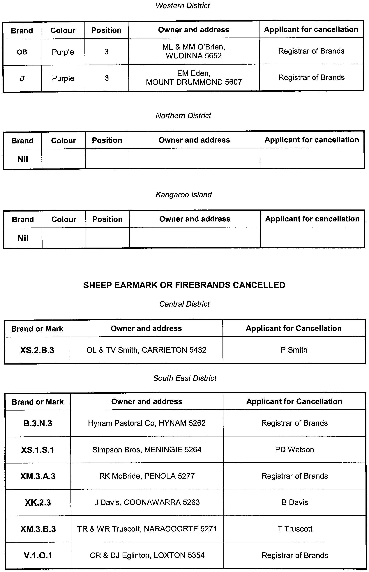

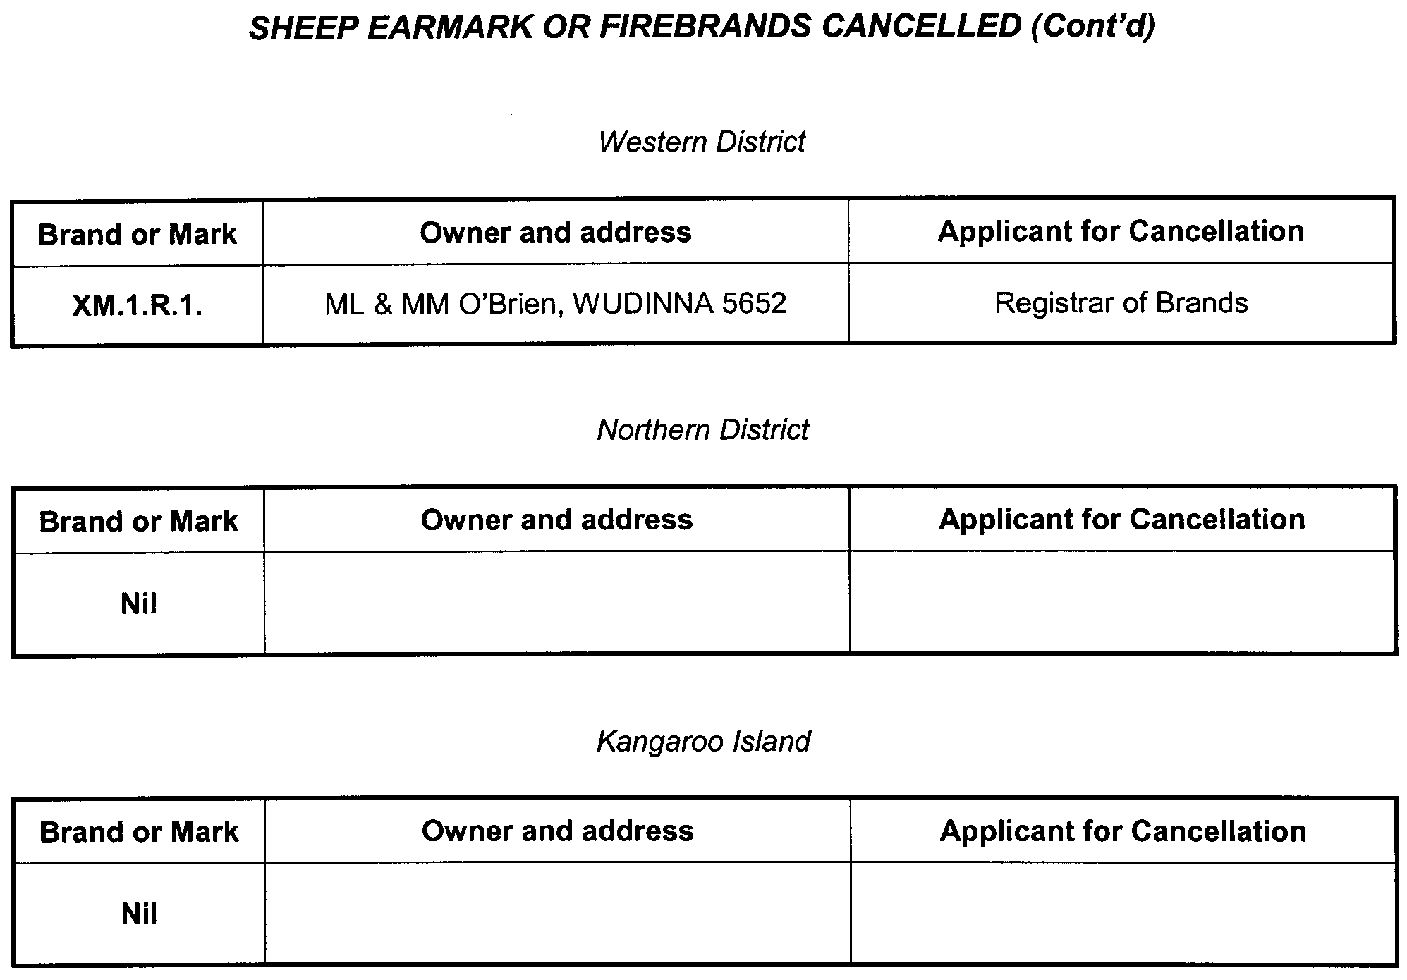

ASSOCIATIONS INCORPORATION ACT 1985
Order Pursuant to Section 42 (2)
Dissolution of Association
WHEREAS the Corporate Affairs Commission (‘the Commission’), pursuant to section 42 (1) of the Associations Incorporation Act 1985 (‘the Act’) is of the opinion that the undertaking or operations of Australasian Sleep Association Incorporated (‘the Association’) being an incorporated association under the Act are being carried on, or would more appropriately be carried on by a company limited by guarantee incorporated under the Corporations Act 2001 (Commonwealth) and whereas the Commission was on 8 July 2009, requested by the Association to transfer its undertaking to Australasian Sleep Association (ACN 138 032 014), the Commission pursuant to section 42 (2) of the Act does hereby order that on 16 July 2009, the Association will be dissolved, the property of the Association becomes the property of Australasian Sleep Association Incorporated and the rights and liabilities of the Association become the rights and liabilities of Australasian Sleep Association.
Given under the seal of the Commission at Adelaide, 14 July 2009.
B. I. Colquist, a Delegate of the Corporate Affairs Commission

CROWN LANDS ACT 1929: SECTION 5
TAKE NOTICE that pursuant to the Crown Lands Act 1929, I, JAY WEATHERILL, Minister for Environment and Conservation, Minister of the Crown to whom the administration of the Crown Lands Act 1929 is committed DO HEREBY:
1. Resume the land defined in The First Schedule.
2. Dedicate the Crown Land defined in The Second Schedule as a Reserve for Memorial Recreation Purposes and declare that such land shall be under the care, control and management of the District Council of Lower Eyre Peninsula.
The First Schedule
Memorial Recreation Reserve, Section 119, Hundred of Shannon, the proclamation of which was published in the Govern-ment Gazette of 2 August 1951 at page 218, being the whole of the land comprised in Crown Record Volume 5755, Folio 12.
The Second Schedule
Allotment 75 in Deposited Plan 81076, Hundred of Shannon, County of Musgrave, exclusive of all necessary roads.
Dated 16 July 2009.
Jay Weatherill, Minister for Environment and Conservation
DENR 08/0894

CROWN LANDS ACT 1929: SECTION 5
TAKE NOTICE that pursuant to the Crown Lands Act 1929, I, JAY WEATHERILL, Minister for Environment and Conservation, Minister of the Crown to whom the administration of the Crown Lands Act 1929 is committed DO HEREBY:
1. Resume the land defined in The First Schedule.
2. Dedicate the Crown Land defined in The Second Schedule as a Reserve for Community Centre Purposes and declare that such land shall be under the care, control and management of The Corporation of the City of Port Augusta.
The First Schedule
Community Centre Reserve, Section 1101, Hundred of Davenport, County of Frome, the proclamation of which was published in the Government Gazette of 13 January 1972 at page 52, The Second Schedule, being the whole of the land comprised in Crown Record Volume 5693, Folio 752.
The Second Schedule
Allotment 100 in Deposited Plan 80753, Hundred of Davenport, County of Frome, exclusive of all necessary roads.
Dated 16 July 2009.
Jay Weatherill, Minister for Environment and Conservation
DEH 13/0995

DEVELOPMENT ACT 1993, SECTION 25 (17): DISTRICT COUNCIL OF LOXTON WAIKERIE—TOWN CENTRE AND BULKY GOODS DEVELOPMENT PLAN AMEND-MENT
Preamble
1. The Development Plan Amendment entitled ‘District Council of Loxton Waikerie—Town Centre and Bulky Goods Develop-ment Plan Amendment’ (the Plan Amendment) has been finalised in accordance with the provisions of the Development Act 1993.
2. The Minister for Urban Development and Planning has decided to approve the Plan Amendment.
Notice
PURSUANT to section 25 of the Development Act 1993, I—
(a) approve the Plan Amendment; and
(b) fix the day on which this notice is published in the Gazette as the day on which the Plan Amendment will come into operation.
Dated 16 July 2009.
Paul Holloway, Minister for Urban Development and Planning

GEOGRAPHICAL NAMES ACT 1991
For Public Consultation
Notice of Intention to Alter the Boundary of a Place
NOTICE is hereby given pursuant to the provisions of the above Act, that the Minister for Infrastructure seeks public comment on a proposal to exclude from SEATON and include into GRANGE the area marked (A) as shown on the plan below.
The Plan
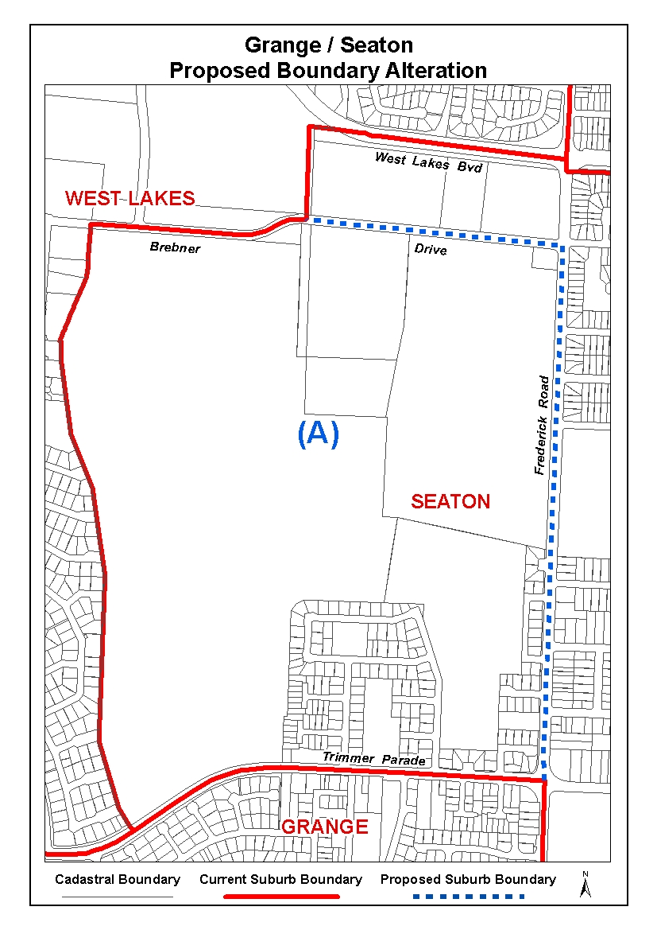
Submissions in writing regarding this proposal may be lodged with the Surveyor-General, G.P.O. Box 1354, Adelaide, S.A. 5001, within one month of the publication of this notice.
Dated 2 July 2009.
P. M. Kentish, Surveyor-General, Department for Transport Energy and Infrastructure
DTEI.22-413/09/0014

GEOGRAPHICAL NAMES ACT 1991
Notice to Assign a Name to a Place
NOTICE is hereby given pursuant to the provisions of the above Act that I, PETER MACLAREN KENTISH, Surveyor-General and Delegate appointed by Patrick Conlon, Minister for Infrastructure, Minister of the Crown to whom the administration of the Geographical Names Act 1991, is committed, DO HEREBY assign the name HANNAFORD CREEK to that feature located in the vicinity on the 1:50 000 Onkaparinga Mapsheet (6628-2) commencing at latitude –34°48′47″ and longitude 138°56′33″ and ending at latitude –34°43′19″ and longitude 138°59′2″.
Dated 13 July 2009.
P. M. Kentish, Surveyor-General, Department for Transport, Energy and Infrastructure
DTEI.22-413/09/0005

HARBORS AND NAVIGATION ACT 1993
Determination of the State Crewing Committee
THE following determination was made on 30 April 2009, by the State Crewing Committee, pursuant to part 6, section 45 of the Harbors and Navigation Act 1993.
Patrick Conlon, Minister for Transport
V20629

Amendment
HARBORS AND NAVIGATION ACT 1993
Determination of the State Crewing Committee in respect of the
M.V. ‘Shimano Explorer’
THE following determination is made by the State Crewing Committee, pursuant to part 6, section 45 of the Harbors and Navigation Act 1993, in respect of the Shimano Explorer while operating within 30 nautical miles from the South Australian coastline for voyages not exceeding 12 hours in duration:
Minimum Complement
Master and General Purpose Person (GP).
Minimum Qualifications of Crew
Master—Master Class 5 Certificate of Competency.
GP—An able bodied person not less than 16 years of age with not less than three months experience and has successfully completed an approved course in Elements of Shipboard Safety or Occupational Health and Safety at Sea.
The Master or GP to hold a Marine Engine Driver Grade 3 Certificate of Competency.
Capt. W. Ferrao, Presiding Member, State Crewing Committee

HOUSING IMPROVEMENT ACT 1940
WHEREAS by notice published in the Government Gazette on the dates mentioned in the following table the South Australian Housing Trust Board delegate did declare the houses described in the said table to be substandard for the purposes of Part 7 of the Housing Improvement Act 1940, the South Australian Housing Trust in the exercise of the powers conferred by the said Part, does hereby fix as the maximum rental per week which shall be payable subject to section 55 of the Residential Tenancies Act 1995, in respect of each house described in the following table the amount shown in the said table opposite the description of such house and this notice shall come into force on the date of this publication in the Gazette.
Address of House | Allotment, Section, etc. | Certificate of Title  Volume Folio | Date and page of Government Gazette in which notice declaring house to be substandard published | Maximum rental per week payable in respect of each house  $

19 Albert Street, Windsor Gardens |  | Allotment 30 in Filed Plan 128464, Hundred of Yatala | 5806 | 343 |  | 20.11.08, page 5120 | 135.00
42 Amanda Street, Port Pirie West |  | Allotment 136 in Filed Plan 189078, Hundred of Pirie | 5481 | 806 |  | 21.5.09, page 1756 | 78.00
88 Ashley Street, Torrensville |  | Allotment 37 in Deposited Plan 2674, Hundred of Adelaide | 5086 | 950 |  | 16.1.75, page 224 | 270.00
40 Coglin Street, Brompton |  | Allotments 11 and 12 in Deposited Plan 795, Hundred of Yatala | 5392 | 431 |  | 23.3.67, page 520 | 260.00
42 Coglin Street, Brompton |  | Allotments 13 and 14 in Deposited Plan 795, Hundred of Yatala | 5539 | 456 |  | 4.5.67, page 1527 | 390.00
14 Cross Keys Road, Brahma Lodge |  | Allotment 17 in Deposited Plan 7713, Hundred of Yatala | 5351 | 188 |  | 23.4.09, page 1464 | 228.00
19 Gilbert Street, Lyndoch |  | Allotment 8 in Deposited Plan 102, Hundred of Barossa | 5529 | 287 |  | 11.10.79, page 971 | 142.00
21 Gilbert Street, Lyndoch |  | Allotment 8 in Deposited Plan 102, Hundred of Barossa | 5529 | 287 |  | 11.10.79, page 971 | 142.00
91 Gordon Street, Naracoorte |  | Allotment 50 in Deposited Plan 3345, Hundred of Naracoorte | 5455 | 579 |  | 9.4.09, page 1331 | 138.00
Ground Floor, Flat 2, 136 Gover Street, North Adelaide |  | Allotment 412 in Filed Plan 183684, Hundred of Yatala | 5676 | 780 |  | 15.3.73, page 975 | 95.00
Upper Floor, Flat 4, 134 Gover Street, North Adelaide |  | Allotment 412 in Filed Plan 183684, Hundred of Yatala | 5676 | 780 |  | 15.3.73, page 975 | 95.00
Upper Floor, Flat 5, 136 Gover Street, North Adelaide |  | Allotment 412 in Filed Plan 183684, Hundred of Yatala | 5676 | 780 |  | 15.3.73, page 975 | 95.00
11 John Street, Burnside |  | Allotment 23 in Deposited Plan 638, Hundred of Adelaide | 5475 | 640 |  | 23.4.09, page 1464 | 262.00
Lot 201, Main North Road, Watervale |  | Allotment 201 in Filed Plan 9380, Hundred of Upper Wakefield | 5494 | 86 |  | 26.2.09, page 751 | 166.00
52 Revell Street, Port Pirie West |  | Allotment 2 in Deposited Plan 1498, Hundred of Pirie | 5733 | 257 |  | 9.4.09, page 1331 | 112.00
5 Rickaby Street, Croydon Park |  | Allotment 74 in Filed Plan 117956, Hundred of Yatala | 5541 | 201 |  | 9.4.09, page 1331 | 20.00
15 Symonds Street, Risdon Park, (also known as Port Pirie) |  | Allotment 39 in Filed Plan 38901, Hundred of Pirie | 5670 | 984 |  | 9.4.09, page 1331 | 140.00
234 Smith Street, Naracoorte |  | Allotment 4 in Deposited Plan 4130, Hundred of Naracoorte | 5714 | 474 |  | 26.2.09, page 751 | 138.00
386 Tapleys Hill Road, Seaton |  | Allotment 102 in Deposited Plan 36556, Hundred of Yatala | 5120 | 546 |  | 22.11.07, page 4266 | 77.00

Dated at Adelaide, 16 July 2009. D. Huxley, Director, Corporate Services, Housing SA

HOUSING IMPROVEMENT ACT 1940
WHEREAS by notice published in the Government Gazette on the dates mentioned in the following table, the South Australian Housing Trust Board delegate did declare the houses described in the following table to be substandard for the purposes of Part 7 of the Housing Improvement Act 1940, and whereas the South Australian Housing Trust is satisfied that each of the houses described hereunder has ceased to be substandard, notice is hereby given that, in exercise of the powers conferred by the said Part, the South Australian Housing Trust does hereby revoke the said declaration in respect of each house.
Address of House | Allotment, Section, etc. | Certificate of Title  Volume Folio | Date and page of Government Gazette in which notice declaring house to be substandard published

40 Arthur Street, Naracoorte |  | Allotment 196 in Filed Plan 199090, Hundred of Naracoorte | 5677 | 389 |  | 29.7.93, page 715
57 Avro Avenue, Albert Park |  | Allotment 132 in Deposited Plan 3590, Hundred of Yatala | 5693 | 127 |  | 9.4.09, page 1331
4 Beare Street, Clare |  | Allotment 66 in Deposited Plan 242, Hundred of Clare | 5287 | 310 |  | 9.10.08, page 4766
29 Blyth Terrace, Moonta |  | Allotment 10, Township of Moonta, County of Daly | 5822 | 66 |  | 29.6.95, page 3061
5 Kadina Road, Wallaroo |  | Allotment 368 in Filed Plan 190120, Hundred of Wallaroo | 5662 | 84 |  | 29.10.92, page 1439
3 Lee Terrace, Rosewater |  | Allotment 303 in Filed Plan 210279, Hundred of Port Adelaide | 5613 | 821 |  | 26.11.98, page 1638
31 Lyndoch Valley Road, Lyndoch |  | Allotment 6 in Deposited Plan 1818, Hundred of Barossa | 5362 | 405 |  | 25.6.81, page 2006
(Rear of) 847 Main North Road, Pooraka |  | Allotment 89 in Filed Plan 113098, Hundred of Port Adelaide | 5718 | 650 |  | 23.10.08, page 4899
Lot 1 (front Unit), 46 Mannum Road, Murray Bridge |  | Allotment 1 in Deposited Plan 25127, Hundred of Mobilong | 5434 | 344 |  | 26.2.09, page 751
Lot 6, Military Road, Nairne (CFS No. 102263A) (Brukunga) |  | Allotment 6 in Deposited Plan 60021, Hundred of Kanmantoo | 5926 | 503 |  | 26.10.95, page 1186
53 North Terrace, Port Elliot |  | Allotment 1 in Deposited Plan 63566, Hundred of Goolwa | 5911 | 744 |  | 2.3.06, page 766
75 Packer Street, Terowie |  | Allotment 75 in Deposited Plan 699, Hundred of Terowie | 5947 | 969 |  | 7.7.94, page 21
31 Ryan Avenue, Athelstone |  | Allotment 74 in Deposited Plan 6776, Hundred of Adelaide | 5455 | 759 |  | 31.1.08, page 330
4 Scarborough Street, Somerton Park |  | Allotment 107 in Filed Plan 8748, Hundred of Noarlunga | 5179 | 102 |  | 13.9.07, page 3676
128 South Terrace, Pooraka |  | Allotment 90 in Filed Plan 112999, Hundred of Yatala | 5687 | 673 |  | 24.4.08, page 1422
3 Taylor Street, Brompton |  | Allotment 22 in Filed Plan 119440, Hundred of Yatala | 5851 | 692 |  | 18.5.67, page 1600
Unit 1, 16 Vista Avenue, Valley View |  | Allotment 49 in Deposited Plan 6503, Hundred of Yatala | 5630 | 23 |  | 24.5.07, page 2143
15 Walton Street, Peterhead |  | Allotment 31 in Deposited Plan 1440, Hundred of Port Adelaide | 5691 | 602 |  | 2.3.06, page 766
Shack Dwelling at 64 Wood Terrace, Whyalla |  | Allotment 586, Township Plan 560501, Hundred of Randell | 5483 | 200 |  | 21.1.71, page 253

Dated at Adelaide, 16 July 2009. D. Huxley, Director, Corporate Services, Housing SA

HOUSING IMPROVEMENT ACT 1940
NOTICE is hereby given that the South Australian Housing Trust Board delegate in the exercise of the powers conferred by the Housing Improvement Act 1940, does hereby declare the houses described in the table hereunder to be substandard for the purposes of Part 7 of the Housing Improvement Act 1940.
No. of House and Street | Locality | Allotment, Section, etc. | Certificate of Title  Volume Folio

45 Mill Street |  | Findon | Allotment 101 in Deposited Plan 22749, Hundred of Yatala | 5438 | 929
51 Oxford Street |  | Hillcrest | Allotment 208 in Deposited Plan 5463, Hundred of Yatala | 5598 | 510
48 Wilkins Street |  | Solomontown (also known as Port Pirie) | Allotment 272 in Filed Plan 184354, Hundred of Pirie | 5564 | 229

Dated at Adelaide, 16 July 2009. D. Huxley, Director, Corporate Services, Housing SA

LIQUOR LICENSING ACT 1997
Notice of Application
NOTICE is hereby given, pursuant to section 52 (2) (b) of the Liquor Licensing Act 1997, that JS & MR Entertainment Pty Ltd has applied to the Licensing Authority for the transfer of a Hotel Licence, Alterations, extension of Trading Area, variation to an Extended Trading Authorisation and variation to Entertainment Consent in respect of premises situated at 27 Eighteenth Street, Gawler, S.A. 5118 and known as Terminus Hotel Gawler.
The application has been set down for callover on 7 August 2009 at 9 a.m.
Conditions
The following licence conditions are sought:
• Minor internal alterations as per plans lodged with this office.
• Extension of Trading Area to include footpath adjacent to Areas 1 and 2 as per plans lodged with this office.
• Variation to an Extended Trading Authorisation to include the areas listed as Areas 4, 5 and 6 on the plans lodged with this office for the following hours:
Monday to Wednesday: Midnight to 12.30 a.m. the following day;
Thursday: Midnight to 2 a.m. the following day;
Friday and Saturday: Midnight to 3 a.m. the following day;
Sunday: 8 a.m. to 11 a.m. and 8 p.m. to midnight.
• Variation to the existing Extended Trading Authorisation for the areas currently approved with an Extended Trading Authorisation and to include the areas listed as Areas 4, 5 and 6 on the plans lodged with this office for the following hours:
Good Friday: Midnight to 2 a.m.;
Christmas Day: Midnight to 2 a.m.;
Sunday Christmas Eve: 8 p.m. to 2 a.m. the following day;
Days preceding other Public Holidays: Midnight to 2 a.m. the following day;
Sundays preceding Public Holidays: 8 p.m. to 2 a.m. the following day.
• Variation to Entertainment Consent to include Areas 1 and 2 for the abovementioned hours.
• Variation to Entertainment Consent to include the area listed as Area 4 on the plans lodged with this office for the following hours:
Saturday and Sunday: Midday to 9 p.m.;
Public Holidays: Midday to 9 p.m.
Any person may object to the application by lodging a notice of objection in the prescribed form with the Liquor and Gambling Commissioner and serving a copy of the notice on the applicant at the applicant’s address, at least seven days before the callover date (viz: 31 July 2009).
The applicant’s address for service is c/o Foreman Legal, 69 Mount Barker Road, Stirling, S.A. 5152.
Plans in respect of the premises the subject of the application are open to public inspection without fee at the Office of the Liquor and Gambling Commissioner, 9th Floor, East Wing, 50 Grenfell Street, Adelaide, S.A. 5000. Phone 8226 8410, Fax:
8226 8512. Email: olgc@agd.sa.gov.au.
Dated 8 July 2009.
Applicant

LIQUOR LICENSING ACT 1997
Notice of Application
NOTICE is hereby given, pursuant to section 52 (2) (b) of the Liquor Licensing Act 1997, that Seven Stars Hotel (SA) Pty Ltd as trustee for Seven Starts Hotel Unit Trust has applied to the Licensing Authority for Alterations and Redefinition in respect of premises situated at 187 Angas Street, Adelaide, S.A. 5000 and known as Seven Stars Hotel.
The application has been set down for callover on 7 August 2009 at 9 a.m.
Any person may object to the application by lodging a notice of objection in the prescribed form with the Liquor and Gambling Commissioner and serving a copy of the notice on the applicant at the applicant’s address, at least seven days before the callover date (viz: 31 July 2009).
The applicant’s address for service is c/o John Waltham, 187 Angas Street, Adelaide, S.A. 5000.
Plans in respect of the premises the subject of the application are open to public inspection without fee at the Office of the Liquor and Gambling Commissioner, 9th Floor, East Wing, 50 Grenfell Street, Adelaide, S.A. 5000. Phone 8226 8410, Fax:
8226 8512. Email: olgc@agd.sa.gov.au.
Dated 2 July 2009.
Applicant

LIQUOR LICENSING ACT 1997
Notice of Application
NOTICE is hereby given, pursuant to section 52 (2) (b) of the Liquor Licensing Act 1997, that Brand New Vintage Limited has applied to the Licensing Authority for a Redefinition and transfer of a Wholesale Liquor Merchant’s Licence in respect of premises situated at 102-104 Main Road, Hahndorf, S.A. 5245, known as Nepenthe Wines and to be known as Brand New Vintage Limited.
The application has been set down for hearing on 11 August 2009 at 9 a.m.
Conditions
The following licence conditions are sought:
• Redefinition to move the current licence to a different building on the premises as per plans lodged.
Any person may object to the application by lodging a notice of objection in the prescribed form with the Liquor and Gambling Commissioner and serving a copy of the notice on the applicant at the applicant’s address, at least seven days before the hearing date (viz: 31 July 2009).
The applicant’s address for service is c/o Finlaysons Solicitors, 81 Flinders Street, Adelaide, S.A. 5000 (Attention: Andrew Williams).
Plans in respect of the premises the subject of the application are open to public inspection without fee at the Office of the Liquor and Gambling Commissioner, 9th Floor, East Wing, 50 Grenfell Street, Adelaide, S.A. 5000. Phone 8226 8410, Fax:
8226 8512. Email: olgc@agd.sa.gov.au.
Dated 8 July 2009.
Applicant

LIQUOR LICENSING ACT 1997
Notice of Application
NOTICE is hereby given, pursuant to section 52 (2) (b) of the Liquor Licensing Act 1997, that Brand New Vintage Limited has applied to the Licensing Authority for a Redefinition and transfer of a Producer’s Licence in respect of premises situated at 102 Main Road, Hahndorf, S.A. 5245, known as Nepenthe Wines and to be known as Brand New Vintage Limited.
The application has been set down for hearing on 11 August 2009 at 9.30 a.m.
Conditions
The following licence conditions are sought:
• Redefinition of the licensed area to be reduced to area as per plans lodged.
Any person may object to the application by lodging a notice of objection in the prescribed form with the Liquor and Gambling Commissioner and serving a copy of the notice on the applicant at the applicant’s address, at least seven days before the hearing date (viz: 4 August 2009).
The applicant’s address for service is c/o Finlaysons Solicitors, 81 Flinders Street, Adelaide, S.A. 5000 (Attention: Andrew Williams).
Plans in respect of the premises the subject of the application are open to public inspection without fee at the Office of the Liquor and Gambling Commissioner, 9th Floor, East Wing, 50 Grenfell Street, Adelaide, S.A. 5000. Phone 8226 8410, Fax:
8226 8512. Email: olgc@agd.sa.gov.au.
Dated 8 July 2009.
Applicant

LIQUOR LICENSING ACT 1997
Notice of Application
NOTICE is hereby given, pursuant to section 52 (2) (b) of the Liquor Licensing Act 1997, that Anja Pty Ltd as trustee for Andrew Tolley Family Trust has applied to the Licensing Authority for a Producer’s Licence in respect of premises situated at 15 Shergis Avenue, Vale Park, S.A. 5081 and to be known as Anja Pty Ltd.
The application has been set down for callover on 14 August 2009 at 9 a.m.
Any person may object to the application by lodging a notice of objection in the prescribed form with the Liquor and Gambling Commissioner and serving a copy of the notice on the applicant at the applicant’s address, at least seven days before the callover date (viz: 7 August 2009).
The applicant’s address for service is c/o Andrew Tolley, 15 Shergis Avenue, Vale Park, S.A. 5081.
Plans in respect of the premises the subject of the application are open to public inspection without fee at the Office of the Liquor and Gambling Commissioner, 9th Floor, East Wing, 50 Grenfell Street, Adelaide, S.A. 5000. Phone 8226 8410, Fax:
8226 8512. Email: olgc@agd.sa.gov.au.
Dated 8 July 2009.
Applicant

LIQUOR LICENSING ACT 1997
Notice of Application
NOTICE is hereby given, pursuant to section 52 (2) (b) of the Liquor Licensing Act 1997, that Resource Management Services Pty Ltd has applied to the Licensing Authority for the removal of a Direct Sales Licence in respect of premises situated at Suite 210/95 Currie Street, Adelaide, S.A. 5000 and to be situated at Suite 4/39 Onkaparinga Valley Road, Woodside, S.A. 5244 and known as James L. Williams Wines.
The application has been set down for callover on 14 August 2009 at 9 a.m.
Any person may object to the application by lodging a notice of objection in the prescribed form with the Liquor and Gambling Commissioner and serving a copy of the notice on the applicant at the applicant’s address, at least seven days before the callover date (viz: 7 August 2009).
The applicant’s address for service is c/o James Williams, P.O. Box 794, Neutral Bay, N.S.W. 2089.
Plans in respect of the premises the subject of the application are open to public inspection without fee at the Office of the Liquor and Gambling Commissioner, 9th Floor, East Wing, 50 Grenfell Street, Adelaide, S.A. 5000. Phone 8226 8410, Fax:
8226 8512. Email: olgc@agd.sa.gov.au.
Dated 9 July 2009.
Applicant

LIQUOR LICENSING ACT 1997
Notice of Application
NOTICE is hereby given, pursuant to section 52 (2) (b) of the Liquor Licensing Act 1997, that Olaf Peter Hansen has applied to the Licensing Authority for a Restaurant Licence with Section 34 (1) (c) Authorisation and an Extended Trading Authorisation in respect of premises situated at Beach Road, Goolwa, S.A. 5214 and to be known as Bombora @ Goolwa Beach.
The application has been set down for callover on 14 August 2009 at 9 a.m.
Conditions
The following licence conditions are sought:
• Approval under Section 34 (1) (c) to sell liquor without meals for consumption on the licensed premises by persons:
(a) seated at a table; or
(b) attending a function at which food is provided.
• Extended Trading Authorisation is sought for the following days and times in relation to the abovementioned condition:
Sunday: 8 a.m. to 11 a.m. and 8 p.m. to midnight;
Sunday Christmas Eve: 8 p.m. to midnight.
Any person may object to the application by lodging a notice of objection in the prescribed form with the Liquor and Gambling Commissioner and serving a copy of the notice on the applicant at the applicant’s address, at least seven days before the callover date (viz: 7 August 2009).
The applicant’s address for service is c/o Jeanette Rosadoni, P.O. Box 2, Blackwood, S.A. 5051.
Plans in respect of the premises the subject of the application are open to public inspection without fee at the Office of the Liquor and Gambling Commissioner, 9th Floor, East Wing, 50 Grenfell Street, Adelaide, S.A. 5000. Phone 8226 8410, Fax:
8226 8512. Email: olgc@agd.sa.gov.au.
Dated 13 July 2009.
Applicant

LIQUOR LICENSING ACT 1997
Notice of Application
NOTICE is hereby given, pursuant to section 52 (2) (b) of the Liquor Licensing Act 1997, that Clarity Wines Pty Ltd has applied to the Licensing Authority for a Producer’s Licence in respect of premises situated at Lot 53, Adelaide-Mannum Road, Gumeracha, S.A. 5233 and to be known as Clarity Wines Pty Ltd.
The application has been set down for callover on 14 August 2009 at 9 a.m.
Any person may object to the application by lodging a notice of objection in the prescribed form with the Liquor and Gambling Commissioner and serving a copy of the notice on the applicant at the applicant’s address, at least seven days before the callover date (viz: 7 August 2009).
The applicant’s address for service is c/o Cheryl Pagell, P.O. Box 3055, North Adelaide, S.A. 5006.
Plans in respect of the premises the subject of the application are open to public inspection without fee at the Office of the Liquor and Gambling Commissioner, 9th Floor, East Wing, 50 Grenfell Street, Adelaide, S.A. 5000. Phone 8226 8410, Fax:
8226 8512. Email: olgc@agd.sa.gov.au.
Dated 8 July 2009.
Applicant

LIQUOR LICENSING ACT 1997
Notice of Application
NOTICE is hereby given, pursuant to section 52 (2) (b) of the Liquor Licensing Act 1997, that Nam Chan Cho as trustee for Cho & Kim Trust has applied to the Licensing Authority for a Special Circumstances Licence in respect of premises situated at 38 Currie Street, Adelaide, S.A. 5000 and to be known as KBS Convenience Store.
The application has been set down for callover on 14 August 2009 at 9 a.m.
Conditions
The following licence conditions are sought:
• To sell only imported Korean Alcohol for consumption off the licensed premises:
Monday to Saturday: 6 a.m. to 8 p.m.
Any person may object to the application by lodging a notice of objection in the prescribed form with the Liquor and Gambling Commissioner and serving a copy of the notice on the applicant at the applicant’s address, at least seven days before the callover date (viz: 7 August 2009).
The applicant’s address for service is c/o Jennifer Jeon, P.O. Box 3137, Rundle Mall, S.A. 5000.
Plans in respect of the premises the subject of the application are open to public inspection without fee at the Office of the Liquor and Gambling Commissioner, 9th Floor, East Wing, 50 Grenfell Street, Adelaide, S.A. 5000. Phone 8226 8410, Fax:
8226 8512. Email: olgc@agd.sa.gov.au.
Dated 9 July 2009.
Applicant

LIQUOR LICENSING ACT 1997
Notice of Application
NOTICE is hereby given, pursuant to section 52 (2) (b) of the Liquor Licensing Act 1997, that Viti Vini Consulting Pty Ltd has applied to the Licensing Authority for the removal of a Producer’s Licence in respect of premises situated at Lot 7, Campbell Road, Penwortham, S.A. 5453 and to be situated at Lot 17, Craig Hill Road, Clare, S.A. 5453 and known as Lawson Wines.
The application has been set down for callover on 14 August 2009 at 9 a.m.
Any person may object to the application by lodging a notice of objection in the prescribed form with the Liquor and Gambling Commissioner and serving a copy of the notice on the applicant at the applicant’s address, at least seven days before the callover date (viz: 7 August 2009).
The applicant’s address for service is c/o Matthew Lawson, P.O. Box 8991, Clare, S.A. 5453.
Plans in respect of the premises the subject of the application are open to public inspection without fee at the Office of the Liquor and Gambling Commissioner, 9th Floor, East Wing, 50 Grenfell Street, Adelaide, S.A. 5000. Phone 8226 8410, Fax:
8226 8512. Email: olgc@agd.sa.gov.au.
Dated 9 July 2009.
Applicant

LIQUOR LICENSING ACT 1997
Notice of Application
NOTICE is hereby given, pursuant to section 52 (2) (b) of the Liquor Licensing Act 1997, that The Barn Palais Pty Ltd has applied to the Licensing Authority for a Redefinition in respect of premises situated at Nelson Road, O.B. Flat, via Mount Gambier, S.A. 5290 and known as Barn Motel.
The application has been set down for callover on 14 August 2009 at 9 a.m.
Conditions
The following licence conditions are sought:
• Redefinition of licensed area to include 18 new Motel Units and laundry/store room as per plans lodged with this office.
Any person may object to the application by lodging a notice of objection in the prescribed form with the Liquor and Gambling Commissioner and serving a copy of the notice on the applicant at the applicant’s address, at least seven days before the callover date (viz: 7 August 2009).
The applicant’s address for service is c/o Kent Comley, P.O. Box 947, Mount Gambier, S.A. 5290.
Plans in respect of the premises the subject of the application are open to public inspection without fee at the Office of the Liquor and Gambling Commissioner, 9th Floor, East Wing, 50 Grenfell Street, Adelaide, S.A. 5000. Phone 8226 8410, Fax:
8226 8512. Email: olgc@agd.sa.gov.au.
Dated 9 July 2009.
Applicant

LIQUOR LICENSING ACT 1997
Notice of Application
NOTICE is hereby given, pursuant to section 52 (2) (b) of the Liquor Licensing Act 1997, that Mount Lofty Ranges Vineyard Pty Ltd has applied to the Licensing Authority for the transfer of a Producer’s Licence in respect of premises situated at Part 71-72 Harris Road, Lenswood, S.A. 5240 and known as Mount Lofty Ranges Vineyard.
The application has been set down for hearing on 17 August 2009 at 9.30 a.m.
Any person may object to the application by lodging a notice of objection in the prescribed form with the Liquor and Gambling Commissioner and serving a copy of the notice on the applicant at the applicant’s address, at least seven days before the hearing date (viz: 10 August 2009).
The applicant’s address for service is c/o Garry Sweeney, Part 71-72 Harris Road, Lenswood, S.A. 5240.
Plans in respect of the premises the subject of the application are open to public inspection without fee at the Office of the Liquor and Gambling Commissioner, 9th Floor, East Wing, 50 Grenfell Street, Adelaide, S.A. 5000. Phone 8226 8410, Fax:
8226 8512. Email: olgc@agd.sa.gov.au.
Dated 10 July 2009.
Applicant

LIQUOR LICENSING ACT 1997
Notice of Application
NOTICE is hereby given, pursuant to section 52 (2) (b) of the Liquor Licensing Act 1997, that Blanco Catering Pty Ltd has applied to the Licensing Authority for the transfer of a Restaurant Licence in respect of premises situated at Adelaide Botanic Gardens, North Terrace, Adelaide, S.A. 5000 and known as Cafe Fibonacci and the transfer of a Special Circumstances Licence in respect of premises situated at North Terrace, Adelaide, S.A. 5000 and known as Botanic Gardens Restaurant.
The application has been set down for hearing on 17 August 2009 at 9.30 a.m.
Any person may object to the application by lodging a notice of objection in the prescribed form with the Liquor and Gambling Commissioner and serving a copy of the notice on the applicant at the applicant’s address, at least seven days before the hearing date (viz: 7 August 2009).
The applicant’s address for service is c/o Steven Blanco, 37 Amherst Avenue, Trinity Gardens, S.A. 5068.
Plans in respect of the premises the subject of the application are open to public inspection without fee at the Office of the Liquor and Gambling Commissioner, 9th Floor, East Wing, 50 Grenfell Street, Adelaide, S.A. 5000. Phone 8226 8410, Fax:
8226 8512. Email: olgc@agd.sa.gov.au.
Dated 10 July 2009.
Applicant

LIQUOR LICENSING ACT 1997
Notice of Application
NOTICE is hereby given, pursuant to section 52 (2) (b) of the Liquor Licensing Act 1997, that La Spiaggia Pty Ltd has applied to the Licensing Authority for the transfer of a Residential Licence and Redefinition in respect of premises situated at 207 The Esplanade, Henley Beach, S.A. 5022 and known as Regal Academy of Tourism and Hospitality and to be known as Del Monte La Spiaggia Hotel.
The application has been set down for hearing on 17 August 2009 at 9 a.m.
Conditions
The following licence conditions are sought:
• Redefinition to remove apartments from the licensed area as per plans lodged with this office.
Any person may object to the application by lodging a notice of objection in the prescribed form with the Liquor and Gambling Commissioner and serving a copy of the notice on the applicant at the applicant’s address, at least seven days before the hearing date (viz: 10 August 2009).
The applicant’s address for service is c/o Vera Ubaldi, 209 The Esplanade, Henley Beach, S.A. 5022.
Plans in respect of the premises the subject of the application are open to public inspection without fee at the Office of the Liquor and Gambling Commissioner, 9th Floor, East Wing, 50 Grenfell Street, Adelaide, S.A. 5000. Phone 8226 8410, Fax:
8226 8512. Email: olgc@agd.sa.gov.au.
Dated 10 July 2009.
Applicant

LIQUOR LICENSING ACT 1997
Notice of Application
NOTICE is hereby given, pursuant to section 52 (2) (b) of the Liquor Licensing Act 1997, that Buffin Pty Ltd has applied to the Licensing Authority for the transfer of a Restaurant Licence in respect of premises situated at Adelphi Terrace, Glenelg North, S.A. 5045 and known as Buffalo Family Restaurant.
The application has been set down for hearing on 17 August 2009 at 10.30 a.m.
Any person may object to the application by lodging a notice of objection in the prescribed form with the Liquor and Gambling Commissioner and serving a copy of the notice on the applicant at the applicant’s address, at least seven days before the hearing date (viz: 10 August 2009).
The applicant’s address for service is c/o Richard Finlayson, 1/465 Pulteney Street, Adelaide, S.A. 5000.
Plans in respect of the premises the subject of the application are open to public inspection without fee at the Office of the Liquor and Gambling Commissioner, 9th Floor, East Wing, 50 Grenfell Street, Adelaide, S.A. 5000. Phone 8226 8410, Fax:
8226 8512. Email: olgc@agd.sa.gov.au.
Dated 10 July 2009.
Applicant

MINING ACT 1971
NOTICE is hereby given in accordance with section 28 (5) of the Mining Act 1971, that the Minister for Mineral Resources Development proposes to grant an Exploration Licence over the undermentioned area:
Applicant: Flinders Mines Limited
Location: Lobethal area—Approximately 20 km east of Adelaide.
Term: 1 year
Area in km²: 333
Ref.: 2009/00111
Plan and co-ordinates can be found on the PIRSA website: http://www.pir.sa.gov.au/minerals/public notices or by phoning Mineral Tenements on (08) 8463 3103.
J. Martin, Acting Mining Registrar

MINING ACT 1971
NOTICE is hereby given in accordance with section 28 (5) of the Mining Act 1971, that the Minister for Mineral Resources Development proposes to grant an Exploration Licence over the undermentioned area:
Applicant: Iluka Resources Limited
Location: Pidinga area—Approximately 120 km north-west of Ceduna.
Pastoral Lease: Chundaria
Term: 2 years
Area in km²: 2 462
Ref.: 2009/00175
Plan and co-ordinates can be found on the PIRSA website: http://www.pir.sa.gov.au/minerals/public notices or by phoning Mineral Tenements on (08) 8463 3103.
J. Martin, Acting Mining Registrar

MINING ACT 1971
NOTICE is hereby given in accordance with section 35A (1) of the Mining Act 1971, that applications for mining leases over the undermentioned mineral claims have been received. Details of the proposal may be inspected at the Department of Primary Industries and Resources, Mineral Resources Group, Level 7, 101 Grenfell Street, Adelaide, S.A. 5000:
Applicant: Linke Contracting Pty Ltd
Claim Numbers: 4021, 4022 and 4023
Locations: Application 1 (MC 4021 and 4022) within Piece 93, FP 210062 and Piece 95, FP210063, Hundred of Paisley. Application 2 (MC 4023) within Piece 94, FP 210062 and Piece 96, FP 210063, Hundred of Paisley.
Approximately 8 km east of Blanchetown.
Area: MC’s 4021 and 4022 totalling 472.2 hectares.
MC 4023 200.3 hectares.
Purpose: For the recovery of gypsum and limestone.
Reference: T02732
A copy of the proposal has been provided to the District Council of Loxton Waikerie.
Written submissions in relation to the granting of the mining leases are invited to be received at the Department of Primary Industries and Resources, Mineral Resources Group, Level 7, 101 Grenfell Street, Adelaide, S.A. 5000 or G.P.O. Box 1671, Adelaide, S.A. 5001 no later than 13 August 2009.
Copies of all submissions will be forwarded to the applicant and may be made available for public inspection unless confidentiality is requested.
J. Martin, Acting Mining Registrar

NATIONAL PARKS AND WILDLIFE (NATIONAL PARKS) REGULATIONS 2001
Closure of Vulkathunha-Gammon Ranges National Park
PURSUANT to Regulations 8 (3) (a) and 8 (3) (d) of the National Parks and Wildlife (National Parks) Regulations 2001, I, Leanne Burch, Acting Director of National Parks and Wildlife, an authorised delegate of the Co-management Board, close to the public, the whole of Vulkathunha-Gammon Ranges National Park from 6 a.m. on Sunday, 23 August 2009 until 6 p.m. on Friday, 28 August 2009.
The purpose of the closure is to ensure the safety of the public during a pest control and monitoring program within the reserve during the period indicated.
Use of Firearms within the Reserve
Pursuant to Regulations 8 (4), 20 (1) and 41 of the National Parks and Wildlife (National Parks) Regulations 2001, I, Leanne Burch, Acting Director of National Parks and Wildlife, an authorised delegate of the Co-management Board, grant permission to members of the Sporting Shooters Association of Australia Hunting and Conservation Branch (SA) Inc. in possession of both a current Hunting Permit and a firearm to enter and remain in the Vulkathunha-Gammon Ranges National Park from 6 a.m. on Sunday, 23 August 2009 until 6 p.m. on Friday, 28 August 2009, for the purpose of taking feral animals.
This permission is conditional upon the observance by each of those persons of the requirements of the National Parks and Wildlife Act 1972, National Parks and Wildlife (National Parks) Regulations 2001 and the National Parks and Wildlife (Hunting) Regulations 1996, including those requiring compliance with the Director’s requests, requirements and orders of a Warden.
Dated 10 July 2009.
L. Burch, Acting Director of National Parks and Wildlife

PETROLEUM ACT 2000
Suspension of Petroleum Exploration Licence—PEL 124
PURSUANT to section 90 of the Petroleum Act 2000, notice is hereby given that PEL 124 has been suspended under the provisions of the Petroleum Act 2000, from and including 10 June 2009 until 9 June 2010, pursuant to delegated powers dated 28 March 2002, Gazetted 11 April 2002, page 1573.
The expiry date of PEL 124 is now determined to be 1 October 2012.
Dated 9 July 2009.
B. A. Goldstein,
Director Petroleum and Geothermal
Minerals and Energy Resources
Primary Industries and Resources SA
Delegate of the Minister for Mineral
Resources Development

PETROLEUM ACT 2000
Suspension of Geothermal Exploration Licences—
GELs 337, 338 and 339
PURSUANT to section 90 of the Petroleum Act 2000, notice is hereby given that the abovementioned Geothermal Exploration Licences have been suspended under the provisions of the Petroleum Act 2000, from and including 1 June 2009 until 31 May 2010, pursuant to delegated powers dated 28 March 2002, Gazetted 11 April 2002, page 1573.
The expiry date of GELs 337, 338 and 339 is now determined to be 31 August 2014.
Dated 8 July 2009.
B. A. Goldstein,
Director Petroleum and Geothermal
Minerals and Energy Resources
Primary Industries and Resources SA
Delegate of the Minister for Mineral
Resources Development

ROADS (OPENING AND CLOSING) ACT 1991:
SECTION 24
NOTICE OF CONFIRMATION OF ROAD
PROCESS ORDER
Road Opening
Agricultural Bureau Drive, Millicent
BY Road Process Order made on 6 April 2009, the Wattle Range Council ordered that:
Portion of allotment 2 in Deposited Plan 33234 adjoining the intersection of Mount Burr Road and Agricultural Bureau Drive, more particularly delineated and numbered ‘10’ in Preliminary Plan No. 08/0088 be opened as road.
On 3 July 2009 that order was confirmed by the Minister for Infrastructure conditionally upon the deposit by the Registrar-General of Deposited Plan 80981 being the authority for the new boundaries.
Pursuant to section 24 (5) of the Roads (Opening and Closing) Act 1991, NOTICE of the order referred to above and its confirmation is hereby given.
Dated 16 July 2009.
P. M. Kentish, Surveyor-General

ROADS (OPENING AND CLOSING) ACT 1991:
SECTION 24
NOTICE OF CONFIRMATION OF ROAD
PROCESS ORDER
Road Opening and Closing
Woods Hill and Tregarthen Roads, Ashton
BY Road Process Order made on 24 March 2009, the Adelaide Hills Council ordered that:
1. Portions of allotment 1 in Filed Plan 12063, more particularly delineated and numbered ‘1’ and ‘2’ on Preliminary Plan No. 08/0015 be opened as road, forming a re-alignment of the Tregarthen Road.
2. Portions of Woods Hill and Tregarthen Roads situate adjoining the northern and eastern boundaries of allotment 1 in Filed Plan 12063, more particularly delineated and lettered ‘A’ and ‘B’ (respectively) on Preliminary Plan No. 08/0015 be closed.
3. The whole of land subject to closure be transferred to Ashton Hills Pty Ltd in accordance with agreement for exchange dated 20 October 2008, entered into between the Adelaide Hills Council and Ashton Hills Pty Ltd.
On 3 July 2009 that order was confirmed by the Minister for Infrastructure conditionally upon the deposit by the Registrar-General of Deposited Plan 80740 being the authority for the new boundaries.
Pursuant to section 24 (5) of the Roads (Opening and Closing) Act 1991, NOTICE of the order referred to above and its confirmation is hereby given.
Dated 16 July 2009.
P. M. Kentish, Surveyor-General

ROADS (OPENING AND CLOSING) ACT 1991:
SECTION 24
NOTICE OF CONFIRMATION OF ROAD
PROCESS ORDER
Road Closure, Southend
BY Road Process Order made on 11 May 2009, the Wattle Range Council ordered that:
1. Portion of the unnamed public road situate adjoining Baker Street and allotment 61, Town of Southend, more particularly delineated and lettered ‘A’ in Preliminary Plan No. 09/0004 be closed.
2. The whole of the land subject to closure be transferred to James Michael Thompson and Katie Helen Thompson in accordance with agreement for transfer dated 20 March 2009, entered into between the Wattle Range Council and J. M. and K. H. Thompson.
On 10 July 2009 that order was confirmed by the Minister for Infrastructure conditionally upon the deposit by the Registrar-General of Deposited Plan 81277 being the authority for the new boundaries.
Pursuant to section 24 (5) of the Roads (Opening and Closing) Act 1991, NOTICE of the order referred to above and its confirmation is hereby given.
Dated 16 July 2009.
P. M. Kentish, Surveyor-General

NOTICE TO MARINERS
No. 34 of 2009
South Australia—Coffin Bay—Port Douglas—Channel Marker Not Operating
MARINERS, please note that No. 10 channel marker (Fl W.R 1.5 secs) in position latitude 34°36.586′S, longitude 135°24.084′E is currently not operating. Weather permitting the light will be repaired shortly.
Mariners are further advised to exercise extreme caution when navigating in the area.
Charts affected: Aus 121 and 342.
Publication affected: Admiralty Pilot Volume 1 (Second Edition 2008), page 353.
Adelaide, 2 July 2009.
Patrick Conlon, Minister for Transport
DTEI 2009/00683

NOTICE TO MARINERS
No. 35 of 2009
South Australia—Port Bonython—Channel Marker
Not Operating
MARINERS please note that No. 7 Starboard hand channel marker, Fl. (G) 3 secs in position latitude 33°02.214′S, longitude 137°45.982′E is currently not operating. Weather permitting the light will be repaired shortly.
Mariners are advised to exercise extreme caution when navigating in the area.
Charts affected: Aus. 136.
Publication affected: Australia Pilot Volume 1 (Second Edition 2008), page 378.
Adelaide, 14 July 2009.
Patrick Conlon, Minister for Transport
DTEI: 2009/00683

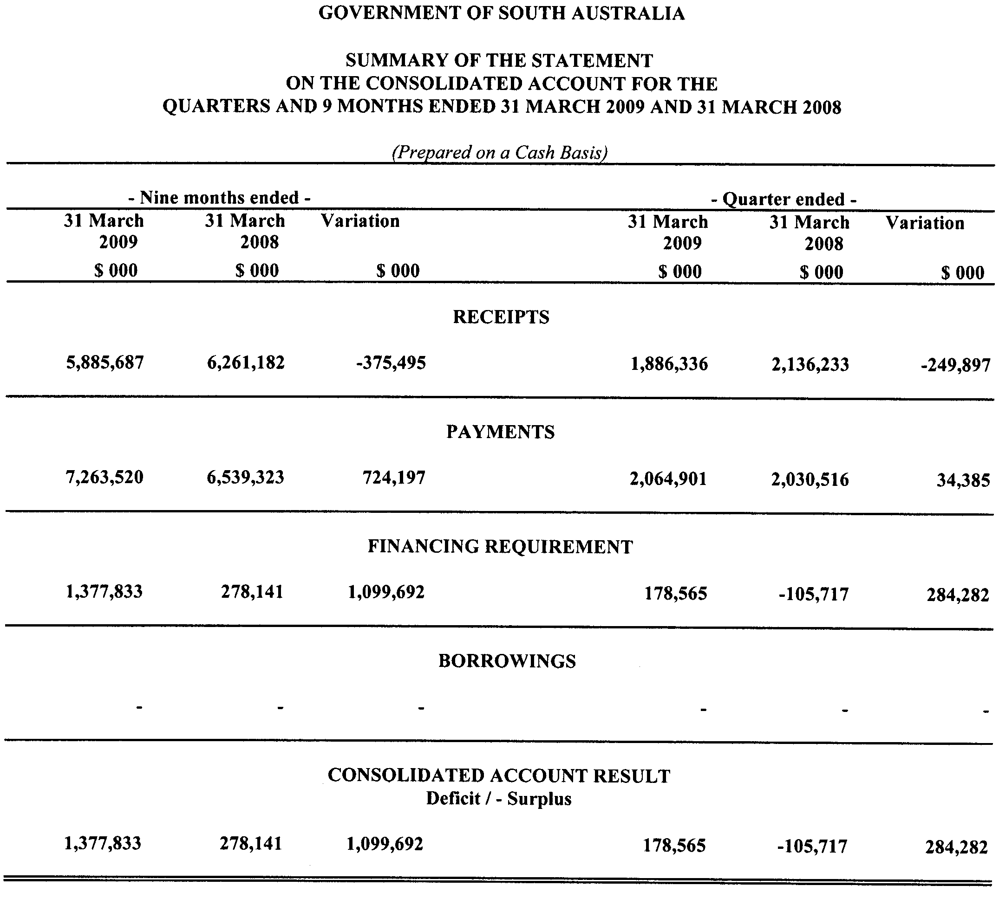
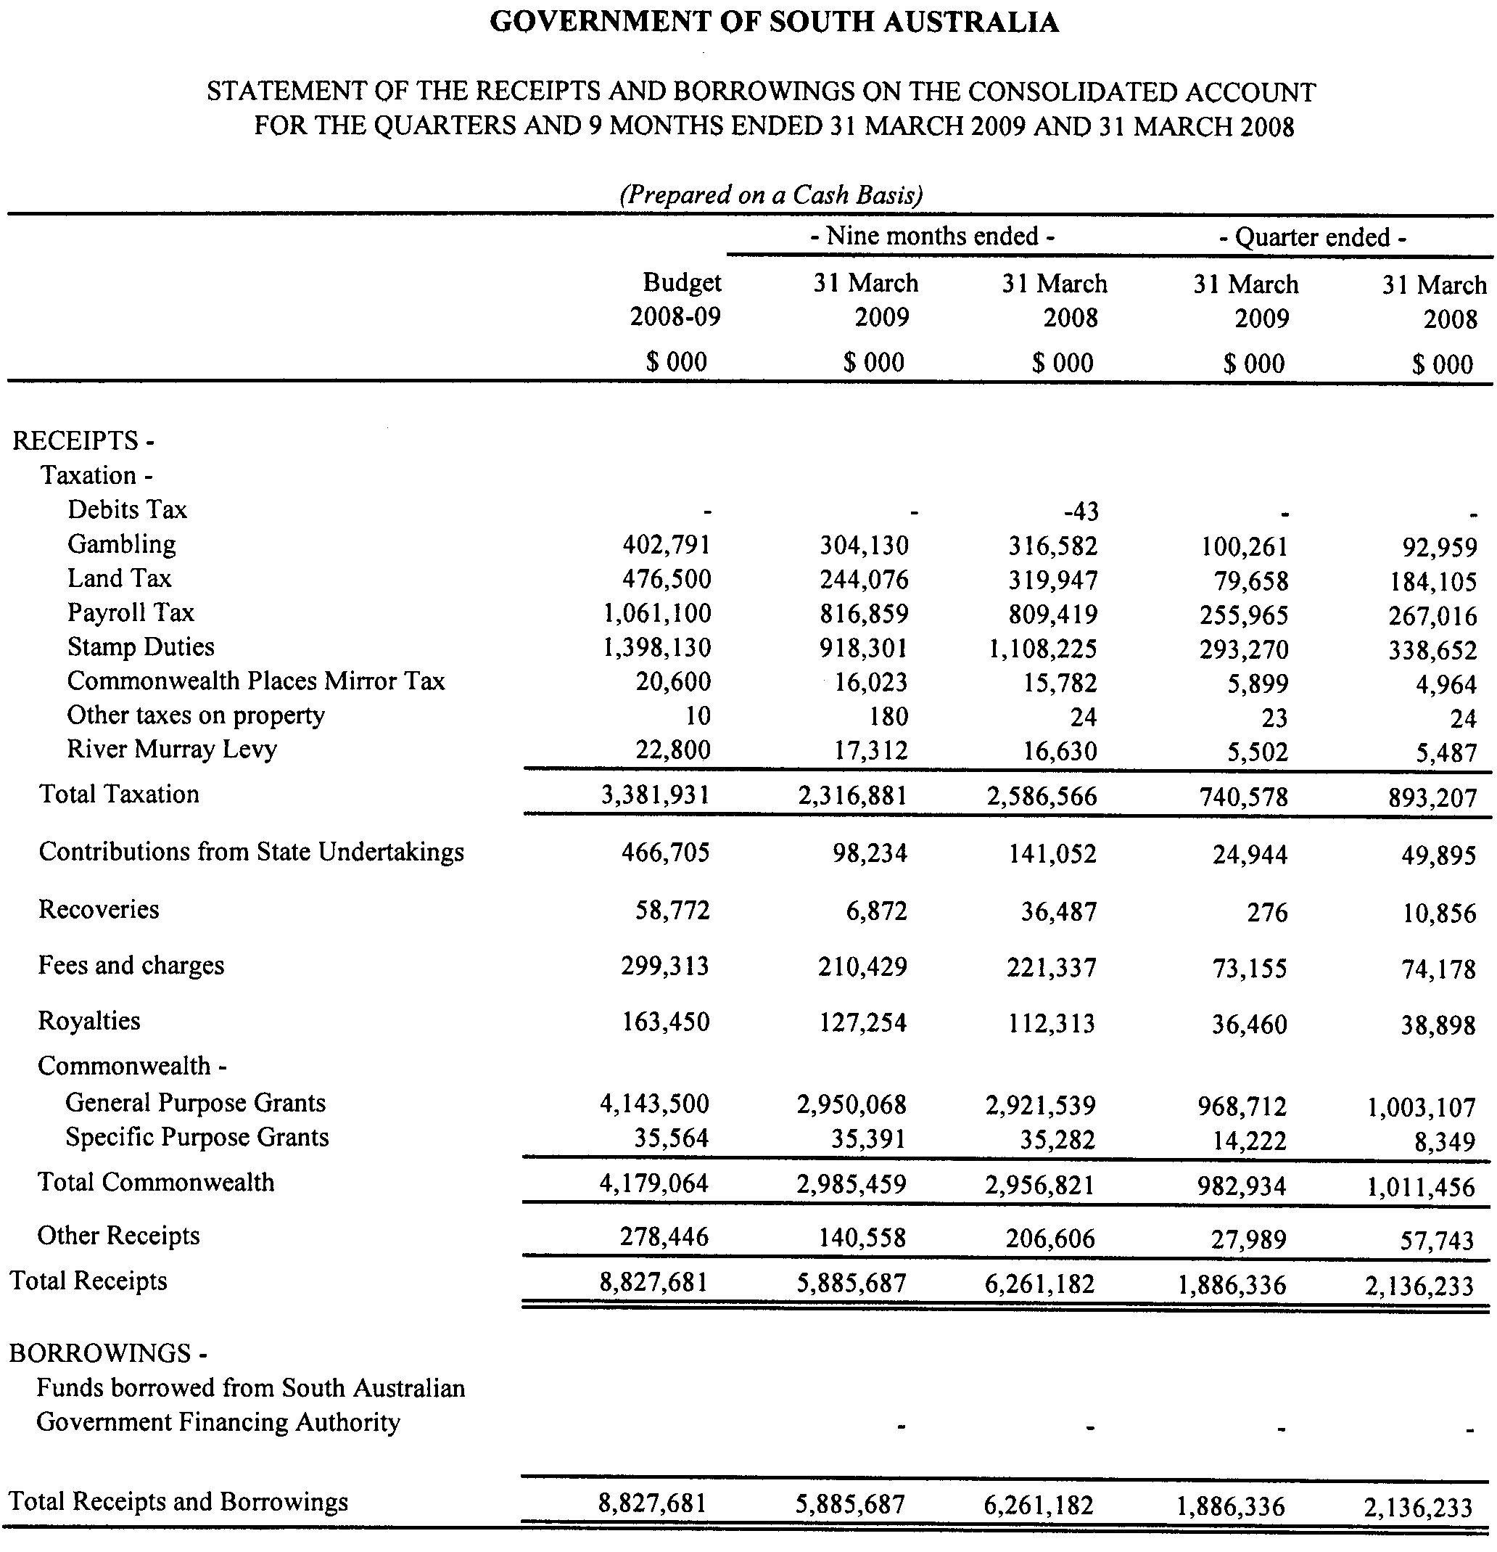
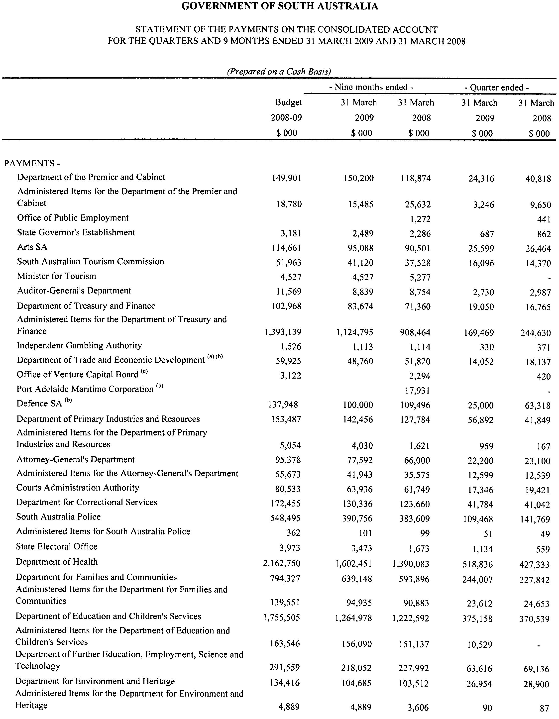
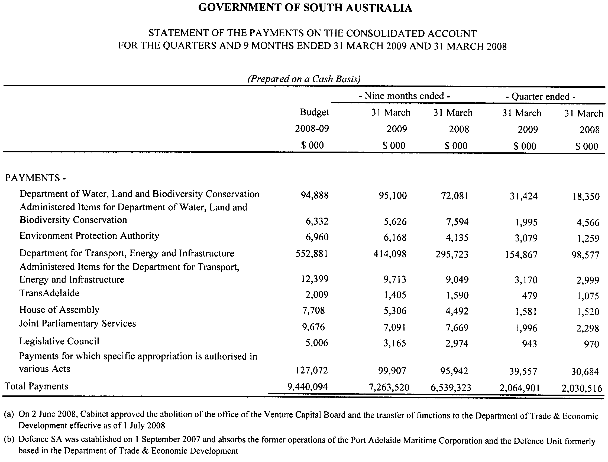

GOVERNMENT GAZETTE ADVERTISEMENT RATES

To apply from 1 July 2009

$  Agents, Ceasing to Act as 42.75  Associations:  Incorporation 21.70  Intention of Incorporation 53.50  Transfer of Properties 53.50  Attorney, Appointment of 42.75  Bailiff’s Sale 53.50  Cemetery Curator Appointed 31.75  Companies:  Alteration to Constitution 42.75  Capital, Increase or Decrease of 53.50  Ceasing to Carry on Business 31.75  Declaration of Dividend 31.75  Incorporation 42.75  Lost Share Certificates:  First Name 31.75  Each Subsequent Name 10.90  Meeting Final 35.75  Meeting Final Regarding Liquidator’s Report on  Conduct of Winding Up (equivalent to ‘Final  Meeting’)  First Name 42.75  Each Subsequent Name 10.90  Notices:  Call 53.50  Change of Name 21.70  Creditors 42.75  Creditors Compromise of Arrangement 42.75  Creditors (extraordinary resolution that ‘the Com-pany be wound up voluntarily and that a liquidator be appointed’) 53.50  Release of Liquidator⎯Application⎯Large Ad. 85.00  ⎯Release Granted 53.50  Receiver and Manager Appointed 49.50  Receiver and Manager Ceasing to Act 42.75  Restored Name 40.00  Petition to Supreme Court for Winding Up 74.50  Summons in Action 63.50  Order of Supreme Court for Winding Up Action 42.75  Register of Interests⎯Section 84 (1) Exempt 96.00  Removal of Office 21.70  Proof of Debts 42.75  Sales of Shares and Forfeiture 42.75  Estates:  Assigned 31.75  Deceased Persons⎯Notice to Creditors, etc. 53.50  Each Subsequent Name 10.90  Deceased Persons⎯Closed Estates 31.75  Each Subsequent Estate 1.40  Probate, Selling of 42.75  Public Trustee, each Estate 10.90 |  | $  Firms:  Ceasing to Carry on Business (each insertion) 28.50  Discontinuance Place of Business 28.50  Land⎯Real Property Act:  Intention to Sell, Notice of 53.50  Lost Certificate of Title Notices 53.50  Cancellation, Notice of (Strata Plan) 53.50  Mortgages:  Caveat Lodgement 21.70  Discharge of 22.70  Foreclosures 21.70  Transfer of 21.70  Sublet 10.90  Leases⎯Application for Transfer (2 insertions) each 10.90  Lost Treasury Receipts (3 insertions) each 31.75  Licensing 63.50  Municipal or District Councils:  Annual Financial Statement⎯Forms 1 and 2 598.00  Electricity Supply⎯Forms 19 and 20 425.00  Default in Payment of Rates:  First Name 85.00  Each Subsequent Name 10.90  Noxious Trade 31.75  Partnership, Dissolution of 31.75  Petitions (small) 21.70  Registered Building Societies (from Registrar-  General) 21.70  Register of Unclaimed Moneys⎯First Name 31.75  Each Subsequent Name 10.90  Registers of Members⎯Three pages and over:  Rate per page (in 8pt) 272.00  Rate per page (in 6pt) 359.00  Sale of Land by Public Auction 54.00  Advertisements 3.00  ¼ page advertisement 127.00  ½ page advertisement 254.00  Full page advertisement 498.00  Advertisements, other than those listed are charged at $3.00 per column line, tabular one-third extra.  Notices by Colleges, Universities, Corporations and District Councils to be charged at $3.00 per line.  Where the notice inserted varies significantly in length from that which is usually published a charge of $3.00 per column line will be applied in lieu of advertisement rates listed.  South Australian Government publications are sold on the condition that they will not be reproduced without prior permission from the Government Printer.
All the above prices include GST

GOVERNMENT GAZETTE NOTICES
ALL private advertisements forwarded for publication in the South Australian Government Gazette must be PAID FOR PRIOR TO INSERTION; and all notices, from whatever source, should be legibly written on one side of the paper only and sent to Government Publishing SA so as to be received no later than 4 p.m. Tuesday preceding the day of publication. Phone 8207 1045 or Fax 8207 1040. E-mail: governmentgazette@dpc.sa.gov.au. Send as attachments in Word format. Please include date the notice is to be published and to whom the notice will be charged. The Government Gazette is available online at: www.governmentgazette.sa.gov.au.

MISCELLANEOUS LEGISLATION AND GOVERNMENT PUBLICATIONS PRICES AS FROM 1 JULY 2009

Acts, Bills, Rules, Parliamentary Papers and Regulations
Pages | Main | Amends | Pages | Main | Amends

1-16 | 2.60 | 1.20 | 497-512 | 36.25 | 35.25
17-32 | 3.50 | 2.20 | 513-528 | 37.25 | 36.00
33-48 | 4.55 | 3.25 | 529-544 | 38.50 | 37.25
49-64 | 5.75 | 4.40 | 545-560 | 39.50 | 38.50
65-80 | 6.70 | 5.55 | 561-576 | 40.50 | 39.50
81-96 | 7.80 | 6.45 | 577-592 | 41.75 | 40.00
97-112 | 8.90 | 7.60 | 593-608 | 43.00 | 41.50
113-128 | 9.95 | 8.75 | 609-624 | 43.75 | 42.75
129-144 | 11.10 | 9.85 | 625-640 | 45.00 | 43.25
145-160 | 12.20 | 10.90 | 641-656 | 46.00 | 45.00
161-176 | 13.30 | 12.00 | 657-672 | 46.75 | 45.50
177-192 | 14.50 | 13.10 | 673-688 | 48.75 | 46.75
193-208 | 15.60 | 14.40 | 689-704 | 49.50 | 47.75
209-224 | 16.50 | 15.20 | 705-720 | 50.25 | 49.00
225-240 | 17.60 | 16.30 | 721-736 | 52.00 | 50.00
241-257 | 18.90 | 17.20 | 737-752 | 52.50 | 51.00
258-272 | 19.90 | 18.30 | 753-768 | 53.50 | 52.00
273-288 | 21.00 | 19.70 | 769-784 | 54.50 | 53.50
289-304 | 21.90 | 20.60 | 785-800 | 55.50 | 54.50
305-320 | 23.20 | 21.80 | 801-816 | 57.00 | 55.00
321-336 | 24.20 | 22.80 | 817-832 | 58.00 | 57.00
337-352 | 25.40 | 24.10 | 833-848 | 59.00 | 58.00
353-368 | 26.25 | 25.20 | 849-864 | 60.00 | 58.50
369-384 | 27.50 | 26.25 | 865-880 | 61.50 | 60.00
385-400 | 28.75 | 27.25 | 881-896 | 62.00 | 60.50
401-416 | 29.75 | 28.25 | 897-912 | 63.50 | 62.00
417-432 | 31.00 | 29.50 | 913-928 | 64.00 | 63.50
433-448 | 32.00 | 30.75 | 929-944 | 65.00 | 64.00
449-464 | 32.75 | 31.50 | 945-960 | 66.00 | 64.50
465-480 | 33.25 | 32.50 | 961-976 | 68.50 | 65.50
481-496 | 35.25 | 33.25 | 977-992 | 69.50 | 66.00

Legislation—Acts, Regulations, etc: $
Subscriptions:
Acts 223.00
All Bills as Laid 536.00
Rules and Regulations 536.00
Parliamentary Papers 536.00
Bound Acts 248.00
Index 124.00
Government Gazette
Copy 5.85
Subscription 296.00
Hansard
Copy 16.30
Subscription—per session (issued weekly) 465.00
Cloth bound—per volume 199.00
Subscription—per session (issued daily) 465.00
Legislation on Disk
Whole Database 3 443.00
Annual Subscription for fortnightly updates 1 058.00
Individual Act(s) including updates POA
Notice of Vacancies
Annual Subscription 164.00
Compendium
Subscriptions:
New Subscriptions 2 039.00
Updates 719.00
(All the above prices include GST)

All Legislation, Government Gazette, Hansard and Legislation on disk are available from:
Counter Sales Government Legislation⁺ Outlet
and Mail Orders: Service SA Customer Service Centre,
Ground Floor—EDS Centre, 108 North Terrace, Adelaide, S.A. 5000
Phone: 13 23 24 (local call cost), Fax: (08) 8204 1909
Postal: G.P.O. Box 1707, Adelaide, S.A. 5001

Online Shop: www.shop.service.sa.gov.au

Subscriptions and Government Publishing SA
Standing Orders: Box 9, Plaza Level, Riverside Centre, North Terrace, Adelaide, S.A. 5000
Phone: (08) 8207 1043, (08) 8207 0910, Fax: (08) 8207 1040

South Australia
National Parks and Wildlife (Murray River National
Park) Proclamation 2009
under section 28(2) of the National Parks and Wildlife Act 1972
1—Short title
This proclamation may be cited as the National Parks and Wildlife (Murray River
National Park) Proclamation 2009.
2—Commencement
This proclamation comes into operation on the day on which it is made.
3—Alteration of boundaries of Murray River National Park
The boundaries of the Murray River National Park are altered by adding to the Park
the following Crown land:
Section 445, Hundred of Paringa;
Allotment 100 of Deposited Plan 78113, Hundred of Paringa;
Allotment comprising Pieces 19, 20, 21 and 22 of Deposited Plan 76346, Hundred
of Paringa.
Made by the Governor
with the advice and consent of the Executive Council
on 16 July 2009
EHCS09/0014

South Australia
Natural Resources Management (General) (Water Allocation Plans—Transitional Provisions) Variation Regulations 2009
under the Natural Resources Management Act 2004

Contents
Part 1—Preliminary
1 Short title
2 Commencement
3 Variation provisions
Part 2—Variation of Natural Resources Management (General)
Regulations 2005
4 Variation of regulation 47—Transitional provisions—Water licences and plans—2007 Amendments

Part 1—Preliminary
1—Short title
These regulations may be cited as the Natural Resources Management (General)
(Water Allocation Plans—Transitional Provisions) Variation Regulations 2009.
2—Commencement
These regulations come into operation on the day on which they are made.
3—Variation provisions
In these regulations, a provision under a heading referring to the variation of specified regulations varies the regulations so specified.
Part 2—Variation of Natural Resources Management (General) Regulations 2005
4—Variation of regulation 47—Transitional provisions—Water licences and plans—2007 Amendments
Regulation 47—after subregulation (6) insert:
(6a) Pending steps being taken to take into account the operation of Part 3 of the 2007 Amendment Act—
(a) a water allocation plan in existence immediately before the commencement of this subregulation may continue to operate despite section 76(4)(ab) and (b) of the Act; and
(b) a proposed water allocation plan, or a proposed amendment of a water allocation plan, the subject of a concept statement prepared by a regional NRM board and made available to the public under section 78(8) of the Act before the commencement of this subregulation may be considered under the Act, and may be adopted by the Minister under the Act, without complying with section 76(4)(ab) and (b) of the Act.
(6b) An entitlement created by Schedule 4 clause 54(5) of the Act continues under section 164N of the Act (as enacted by the 2007 Amendment Act).
Note—
As required by section 10AA(2) of the Subordinate Legislation Act 1978, the Minister has certified that, in the Minister's opinion, it is necessary or appropriate that these regulations come into operation as set out in these regulations.
Made by the Governor
with the advice and consent of the Executive Council
on 16 July 2009
No 202 of 2009

South Australia
Road Traffic (Road Rules—Ancillary and Miscellaneous Provisions) Variation Regulations 2009
under the Road Traffic Act 1961

Contents
Part 1—Preliminary
1 Short title
2 Commencement
3 Variation provisions
Part 2—Variation of Road Traffic (Road Rules—Ancillary and Miscellaneous Provisions) Regulations 1999
4 Insertion of regulation 33
33 Prohibition of use of mobile phone by holder of learner's permit, P1 licence etc

Part 1—Preliminary
1—Short title
These regulations may be cited as the Road Traffic (Road Rules—Ancillary and Miscellaneous Provisions) Variation Regulations 2009.
2—Commencement
These regulations will come into operation on 31 August 2009.
3—Variation provisions
In these regulations, a provision under a heading referring to the variation of specified regulations varies the regulations so specified.
Part 2—Variation of Road Traffic (Road Rules—Ancillary and Miscellaneous Provisions) Regulations 1999
4—Insertion of regulation 33
After regulation 32 insert:
33—Prohibition of use of mobile phone by holder of learner's permit, P1 licence etc
(1) Despite anything in rule 300 (Use of mobile phones), a driver of a vehicle (except an emergency vehicle or police vehicle) who is a learner or P1 driver must not use a mobile phone while the vehicle is moving or is stationary but not parked.
Maximum penalty: $2 500.
(2) In this regulation—
corresponding permit or licence means—
(a) a learner licence, provisional licence or probationary licence issued under the Road Transport (Driver Licensing) Act 1999 of the Australian Capital Territory; or
(b) a learner licence or provisional licence issued under the Road Transport (Driver Licensing) Act 1998 of New South Wales; or
(c) a learner licence or licence that is provisional issued under the Motor Vehicles Act of the Northern Territory; or
(d) a learner licence, provisional licence or probationary licence issued under the Transport Operations (Road Use Management) Act 1995 of Queensland; or
(e) a learner licence or provisional licence issued under the Vehicle and Traffic Act 1999 of Tasmania; or
(f) a learner permit or probationary driver licence issued under the Road Safety Act 1986 of Victoria; or
(g) a learner's permit or provisional licence issued under the Road Traffic Act 1974 of Western Australia;
learner or P1 driver, in relation to a vehicle, means a driver—
(a) who is the holder of a learner's permit or P1 licence within the meaning of the Motor Vehicles Act 1959 that authorises him or her to drive a vehicle of that class on a road; or
(b) who—
(i) is the holder of a corresponding permit or licence issued under a law of another State or a Territory of the Commonwealth that authorises him or her to drive a vehicle of that class on a road; and
(ii) is prohibited by the law of that State or Territory from driving a vehicle of that class on a road in that State or Territory without displaying an "L" plate or a red "P" plate (as the case may be) on the vehicle;
"L" plate means a plate or sign displaying the letter "L" in black lettering on a yellow background;
mobile phone has the same meaning as in rule 300;
red "P" plate means a plate or sign displaying the letter "P" in red lettering on a white background or in white lettering on a red background;
use has the same meaning as in rule 300.
Note—
As required by section 10AA(2) of the Subordinate Legislation Act 1978, the Minister has certified that, in the Minister's opinion, it is necessary or appropriate that these regulations come into operation as set out in these regulations.
Made by the Governor
with the advice and consent of the Executive Council
on 16 July 2009
No 203 of 2009
MRS09/001CS

South Australia
Road Traffic (Miscellaneous) Variation Regulations 2009
under the Road Traffic Act 1961

Contents
Part 1—Preliminary
1 Short title
2 Commencement
3 Variation provisions
Part 2—Variation of Road Traffic (Miscellaneous) Regulations 1999
4 Variation of regulation 8—Offences included in prescribed circumstances
5 Variation of Schedule 9—Expiation fees

Part 1—Preliminary
1—Short title
These regulations may be cited as the Road Traffic (Miscellaneous) Variation Regulations 2009.
2—Commencement
These regulations will come into operation on 31 August 2009.
3—Variation provisions
In these regulations, a provision under a heading referring to the variation of specified regulations varies the regulations so specified.
Part 2—Variation of Road Traffic (Miscellaneous) Regulations 1999
4—Variation of regulation 8—Offences included in prescribed circumstances
Regulation 8(e)—delete "or 26A" and substitute:
, 26A or 33(1)
5—Variation of Schedule 9—Expiation fees
Schedule 9, Part 6—after the last item insert:

33(1) | Learner or P1 driver using mobile phone while driving vehicle | $218
Note—
As required by section 10AA(2) of the Subordinate Legislation Act 1978, the Minister has certified that, in the Minister's opinion, it is necessary or appropriate that these regulations come into operation as set out in these regulations.
Made by the Governor
with the advice and consent of the Executive Council
on 16 July 2009
No 204 of 2009
MRS09/001CS

South Australia
Motor Vehicles Variation Regulations 2009
under the Motor Vehicles Act 1959

Contents
Part 1—Preliminary
1 Short title
2 Commencement
3 Variation provisions
Part 2—Variation of Motor Vehicles Regulations 1996
4 Variation of Schedule 7—Demerit points

Part 1—Preliminary
1—Short title
These regulations may be cited as the Motor Vehicles Variation Regulations 2009.
2—Commencement
These regulations will come into operation on 31 August 2009.
3—Variation provisions
In these regulations, a provision under a heading referring to the variation of specified regulations varies the regulations so specified.
Part 2—Variation of Motor Vehicles Regulations 1996
4—Variation of Schedule 7—Demerit points
Schedule 7, Part 2, Division 3—after the last item insert:

33(1) | Learner or P1 driver using mobile phone while driving vehicle | 3
Note—
As required by section 10AA(2) of the Subordinate Legislation Act 1978, the Minister has certified that, in the Minister's opinion, it is necessary or appropriate that these regulations come into operation as set out in these regulations.
Made by the Governor
with the advice and consent of the Executive Council
on 16 July 2009
No 205 of 2009
MRS09/001CS
South Australia
Public Trustee Variation Regulations 2009
under the Public Trustee Act 1995

Contents
Part 1—Preliminary
1 Short title
2 Commencement
3 Variation provisions
Part 2—Variation of Public Trustee Regulations 1995
4 Variation of Schedule 2—Commission and fees

Part 1—Preliminary
1—Short title
These regulations may be cited as the Public Trustee Variation Regulations 2009.
2—Commencement
These regulations come into operation on the day on which they are made.
3—Variation provisions
In these regulations, a provision under a heading referring to the variation of specified regulations varies the regulations so specified.
Part 2—Variation of Public Trustee Regulations 1995
4—Variation of Schedule 2—Commission and fees
Schedule 2, clause 1(1), table—delete the table and substitute:

Capital amount or value of estate | Maximum rate of commission
does not exceed $200 000 | 4%
exceeds $200 000 but does not exceed $400 000 | 3%
exceeds $400 000 but does not exceed $600 000 | 2%
exceeds $600 000 | 1%
Note—
As required by section 10AA(2) of the Subordinate Legislation Act 1978, the Minister has certified that, in the Minister's opinion, it is necessary or appropriate that these regulations come into operation as set out in these regulations.
Made by the Governor
with the advice and consent of the Executive Council
on 16 July 2009
No 206 of 2009
AGO01157/09CS

FAXING COPY?
IF you fax copy to Government Publishing SA for inclusion in the Government Gazette, there is no need to send a Confirmation Copy to us as well.
This creates confusion and may well result in your notice being printed twice.
Please use the following fax number:
Fax transmission: (08) 8207 1040
Phone Inquiries: (08) 8207 1045
Please include a contact person, phone number and order number so that we can phone back with any queries we may have regarding the fax copy.
NOTE: Closing time for lodging new copy (fax, hard copy or email) is 4 p.m. on Tuesday preceding the day of publication.

Government Gazette notices can be E-mailed.
The address is:
governmentgazette@dpc.sa.gov.au
Documents should be sent as attachments in Word format.
When sending a document via E-mail, please confirm your transmission with a faxed copy of your document, including the date the notice is to be published.
Fax transmission: (08) 8207 1040
Enquiries: (08) 8207 1045
NOTE: Closing time for lodging new copy (fax, hard copy or email) is 4 p.m. on Tuesday preceding the day of publication.

CITY OF MOUNT GAMBIER
Development Act 1993
Centres, Shopping and Local Centres Zone Development Plan Amendment (DPA) by the City of Mount Gambier—
Draft for Public Consultation
NOTICE is hereby given that the City of Mount Gambier has, pursuant to section 25 of the Development Act 1993, prepared a draft Centres, Shopping and Local Centres Zone DPA to amend the City of Mount Gambier Development Plan.
The draft DPA proposes to amend the City of Mount Gambier Development Plan by providing a review of the City’s Centres, Shopping and Commercial Zones, with the intention to re-zone appropriate land for retail purposes.
Currently, a lack of suitably sized vacant or developable allotments within the existing City Centre Zone, along with increased pressure on Council to identify areas where both large scale retail development and smaller scale commercial pursuits can occur, constrains the growth of retail development within the Council area.
The investigations have identified a need to re-zone suitable land within proximity of the City Centre Zone for retail purposes, along with providing additional land for commercial and mixed use activities. As a result, this DPA proposes to re-zone relevant land from Residential to Mixed Use and Commercial, Commercial to City Centre and Local Shopping to Local Centre, in order to establish appropriate areas to accommodate the demand for retail and commercial activity.
The draft DPA will be on public consultation from Thursday, 16 July 2009 to Friday, 11 September 2009.
Copies (both hard copy and electronic) of the draft DPA are available during normal office hours at the offices of the City
of Mount Gambier, or can be viewed on the internet at www.mountgambier.sa.gov.au.
• Civic Centre, 10 Watson Terrace, Mount Gambier.
Written submissions regarding the draft DPA should be submitted not later than 5 p.m. on Friday, 11 September 2009. All submissions should be addressed to the Chief Executive Officer, City of Mount Gambier, P.O. Box 56, Mount Gambier, S.A. 5290, marked attention to: Tracy Tzioutziouklaris, Strategic Project Officer and should clearly indicate whether you wish to be heard in support of your submission at the public meeting. If you wish to lodge your submission electronically, could you please email the electronic submission to city@mountgambier.sa.gov.au.
G. Muller, Chief Executive Officer

CITY OF PORT ADELAIDE ENFIELD
Adoption of Valuations and Declaration of Rates
NOTICE is hereby given that at its meeting held on 7 July 2009, the Council:
1. Adopted the capital valuations that are to apply in its area for rating purposes for the 2009-2010 financial year, totalling $21 628 845 965.
2. Declared differential general rates on rateable land within its area as follows:
• Residential—A differential general rate of $0.00253 in the dollar on the value of the land subject to the rate.
• Commercial (Shop)—A differential general rate of $0.00505 in the dollar on the value of the land subject to the rate.
• Commercial (Office)—A differential general rate of $0.00505 in the dollar on the value of the land subject to the rate.
• Commercial (Other)—A differential general rate of $0.00505 in the dollar on the value of the land subject to the rate.
• Industry (Light)—A differential general rate of $0.00505 in the dollar on the value of the land subject to the rate.
• Industry (Other)—A differential general rate of $0.00505 in the dollar on the value of the land subject to the rate.
• Primary Production—A differential general rate of $0.00505 in the dollar on the value of the land subject to the rate.
• Vacant Land—A differential general rate of $0.00505 in the dollar on the value of the land subject to the rate.
• Other—A differential general rate of $0.00505 in the dollar on the value of the land subject to the rate.
3. Fixed a minimum amount payable by way of rates, pursuant to section 158 of the Local Government Act 1999, in respect of the 2009-2010 financial year, in respect of rateable land within all parts of its area of $660, excluding the following areas defined in the Port Adelaide Enfield (City) Development Plan, consolidated 11 June 2009:
• The area defined as Industry (Port) Zone maps PAdE/3, 4, 8, 9, 12 and 13.
• The Business Policy Area of the Marina (North Haven) Zone, map PAdE/43.
• The Boat Haven and Coast Policy Area of the Marina (North Haven) Zone map PAdE/43.
4. Declared a separate rate in respect to the 2009-2010 financial year of $0.0000660 in the dollar on the value of rateable land in the area of the Adelaide and Mount Lofty Ranges Natural Resources Management Board.
5. Declared a separate rate in respect to the 2009-2010 financial year of $0.00143 in the dollar on the value of rateable land for each allotment contained within Deposited Plan No. 42580 comprising the New Haven Village at North Haven.
6. Declared that all rates declared or payable in respect of or during the 2009-2010 financial year will fall due (unless otherwise agreed with the Principal Ratepayer) in four equal or approximately equal instalments payable on 2 September 2009, 2 December 2009, 3 March 2010 and 2 June 2010,
with reference to categories of uses being the categories of uses as differentiating factors referred to in the Local Government (General) Regulations 1999.
H. J. Wierda, City Manager

PORT AUGUSTA CITY COUNCIL
Adoption of Valuation and Declaration of Rates
NOTICE is hereby given that the Corporation of the City of Port Augusta at a Special Meeting held on 2 July 2009, resolved for the 2009-2010 financial year as follows:
Adoption of Valuation
Adopt the valuations of the Valuer-General of site values for all rateable property in the area of the Council which amounts in total to a value of $729 770 060, and specifies 2 July 2009 as the day upon which such valuations shall become the valuations of the Council.
Declaration of Rates
1. Declares differential general rates according to the locality and the use of the land based upon the site value of the land on all rateable land within the area of the Council for the year ending 30 June 2010 as follows:
(a) In that area of the City zoned in the Development Plan as Residential, Highway Services, Residential Stables, Neighbourhood Centre, Urban Coastal, District Centre, Local Centre, Industry, Airport, Recreation:
(i) 1.53 cents in the dollar on rateable land with land use Categories 1, 8 and 9;
(ii) 2.9 cents in the dollar on all rateable land with land use Categories 2, 3, 4, 5 and 6; and
(iii) 0.437 cents in the dollar for all rateable land with a land use Category 7.
(b) In that area of the City zoned in the Development Plan as Public Purposes, Defence, Conservation, Rural Living, Coastal Conservation, Primary Industry:
(i) 1.02 cents in the dollar on rateable land with land use Categories 1 and 9.
(ii) 2.9 cents in the dollar on all rateable land with land use Categories 2, 3, 4, 5 and 6.
(iii) 0.437 cents in the dollar for all rateable land within a land use Category 7.
(iv) 0.511 cents in the dollar on all rateable land with a land use Category 8.
(c) In the area of the City zoned in the Development Plan as Coastal Holiday Settlement:
(i) 0.4401 cents in the dollar on all rateable land with land use Categories 1, 2, 3, 4, 5 and 6.
(ii) 0.437 cents in the dollar on all rateable land with a land use Category 7.
(iii) 0.511 cents in the dollar on all rateable land with a land use Category 8.
(iv) 1.02 cents in the dollar on all rateable land with a land use Category 9.
(d) In all other areas not specifically referred to in sub-paragraphs (a), (b) and (c) above, 2.24 cents in the dollar on all other rateable land irrespective of its land use Category.
2. Council fixes a minimum amount payable by way of rates of $895 in respect of all rateable land in its area except rateable land with land use Categories 7 or 8 located in the Development Plan Zones of Public Purposes, Defence, Conservation, Coastal Conservation, Coastal Holiday Settlement, Primary Industry and Rural Living.
3. Council declares an annual service charge of $297 per unit for all vacant and occupied properties to which the effluent drainage disposal services is made available within the City of Port Augusta for the 2009-2010 financial year in the Willsden, Augusta Park, Hospital Road, Zanuckville, Conwaytown, Transcontinental Estate and Stirling North Effluent Disposal Schemes.
4. Council declares an annual service charge of $165 for the purpose of a kerbside waste collection and recycling service for all occupied properties within the City of Port Augusta to which the service is made available in 2009-2010 financial year.
5. In order to reimburse the Council for amounts contributed to the Northern and Yorke Natural Resources Management Board totalling $209 981, the Council declares a separate rate based on a fixed charge of $33 on all rateable properties within the area of the Council.
G. J. Perkin, City Manager

CITY OF SALISBURY
Declaration of Public Road
NOTICE is hereby given that at its meeting on 15 December 2008, Council resolved to declare Allotment 100 in Deposited Plan 34411 being certificate of title volume 5078, folio 638, known as portion of Chellaston Avenue, Pooraka, as public road. Should you have any queries, please do not hesitate to contact James Brennan on (08) 8406 8216.
S. Hains, City Manager

CITY OF UNLEY
Adoption of Valuations
NOTICE is hereby given that the Corporation of the City of Unley in accordance with section 167 (2) (a) of the Local Government Act 1999 at a meeting held on 22 June 2009, adopted for the year ending 30 June 2010, the Government assessment of capital value being $10 459 433 280 as detailed in the valuation roll prepared by the Valuer-General in relation to the areas of the Corporation of the City of Unley and hereby specifies 1 July 2009 as the day as and from which such valuation shall become and be the valuations of the Council.
Declaration of Rates
Notice is hereby given that at a meeting held on Monday, 22 June 2008, the Corporation of the City of Unley in accordance with section 156 (1) (a) of the Local Government Act 1999 declared differential general rates, based upon the capital value of the land subject to the rate, for the year ending 30 June 2010 as follows:
(a) In respect to rateable land which is categorised by land use Category 1 (Residential) in Regulation 10 of the Local Government (General) Regulations 1999 as a prescribed permissible differentiating factor, a differential general rate of 0.2370 cents in the dollar.
(b) In respect to rateable land which is categorised by land use Category 2 (Commercial—Shop), Category 5 (Industry—Light), Category 6 (Industry—Other), Category 7 (Primary Production), Category 8 (Vacant Land) and Category 9 (Other) in Regulation 10 of the Local Government (General) Regulations 1999 as prescribed permissible differentiating factors, a differential general rate of 0.429 cents in the dollar.
(c) In respect to rateable land which is categorised by land use Category 3 (Commercial—Office) and Category 4 (Commercial—Other) in Regulation 10 of the Local Government (General) Regulations 1999 as prescribed permissible differentiating factors, a differential general rate of 0.5620 cents in the dollar.
Pursuant to section 158 of the Local Government Act 1999 the council fixed a minimum amount that shall be payable by way of rates on all rateable land within the whole of the Municipality for the year ending 30 June 2010 at $568.
Pursuant to section 154 to the Local Government Act 1999 and in respect to all rateable land within the City of Unley, a separate rate of 0.00689 cents in the dollar was declared as the Natural Resources Management Levy in accordance with the requirements of the Natural Resources Management Act 2004.
Pursuant to section 154 of the Local Government Act 1999 for the year ending 30 June 2010 the following differential Separate Rates are declared on all rateable land based upon capital value of the land, subject to the rate as follows:
• In order to raise the amount of $64 000 to carry out the project of promoting and enhancing business viability, profitability, trade and commerce in that part of the Council’s area comprising rateable land with an Unley Road address, a differential separate rate of 0.0261 cents in the dollar in respect of land uses: Category 2 (Com-
mercial—Shop), Category 3 (Commercial—Office) and Category 4 (Commercial—Other).
• In order to raise the amount of $40 000 to carry out the project of promoting and enhancing business viability, profitability, trade and commerce in that part of the Council’s area comprising rateable land with a Goodwood Road address and situated between Mitchell Street/Arundel Avenue to the south and Leader Street/Parsons Street to the North, a differential separate rate of 0.1110 cents in the dollar in respect of land uses: Category 2 (Commercial—Shop), Category 3 (Commercial—Office) and Category 4 (Commercial—Other).
• In order to raise the amount of $110 000 to carry out the project of promoting and enhancing business viability, profitability, trade and commerce in that part of the Council’s area comprising rateable land with a King William Road address and situated between Greenhill Road and Commercial Road (eastern side), a differential separate rate of 0.1770 cents in the dollar in respect of land uses: Category 2 (Commercial—Shop).
• In order to raise the amount of $15 000 to carry out the project of promoting and enhancing business viability, profitability, trade and commerce in that part of the Council’s area comprising rateable land along the western side of Glen Osmond Road and situated between Greenhill Road and Katherine Street, a differential separate rate of 0.0700 cents in the dollar in respect of land uses:
Category 2 (Commercial—Shop).
Ray Pincombe, Chief Executive Officer

CITY OF WEST TORRENS
Adoption of Valuations and Declaration of Rates
NOTICE is hereby given that the Council in exercise of the powers contained in Chapters 8, 9 and 10 of the Local Govern-ment Act 1999 and the Natural Resources Management Act 2004:
Adoption of Valuations
1. At a meeting held on 7 July 2009, Council adopted for rating purposes, for the year ending 30 June 2010, the capital valuations of the Valuer-General of all property within the area, totalling $12 135 068 660.
Declaration of Rates
2. At a meeting held on 7 July 2009:
(1) Declared differential general rates in the dollar based on capital values as follows:
(a) 0.242863 cents in the dollar on rateable land of Category 1 use;
(b) 0.510490 cents in the dollar on rateable land of Categories 2, 3, 4, 5, 6, 7, 8 and 9 use.
(2) Declared a minimum amount payable by way of general rates on rateable land in its area of $613.40.
(3) Declared a separate rate on rateable land within the area of 0.007155 cents in the dollar based on capital values, as a contribution to the Adelaide and Mount Lofty Ranges Natural Resources Management Board.
T. Buss, Chief Executive Officer

CITY OF WEST TORRENS
Declaration as a Public Road—Notice of Intention
NOTICE is hereby given that pursuant to section 210 of the Local Government Act 1999, that the City of West Torrens proposes to declare the following land to be a public road:
Allotment 28 within Deposited Plan 1234 in the area named Thebarton, Hundred of Adelaide, certificate of title volume 434, folio 195.
Anyone with a registered interest in the above land is invited to make a written submission to:
John Voigt,
Manager, Properties and Infrastructure,
City of West Torrens,
165 Sir Donald Bradman Drive,
Hilton, S.A. 5033.
Closing date for submissions is Thursday, 13 August 2009.
T. Buss, Chief Executive Officer

CITY OF WHYALLA
Declaration of Rates
NOTICE is hereby given that having adopted the official valuation of the land (for rating purposes) in Council’s area to the amount of $835 468 280 at its meeting of 18 May 2009 and given that at its meeting held on 6 July 2009, Council considered and adopted the Annual Business Plan and Budget in accordance with the requirements contained in section 123 of the Local Government Act 1999:
Notice is hereby given that, pursuant to section 152 (1) (c) and section 153 of the Local Government Act 1999, the Corporation of the City of Whyalla hereby declares that differential general rates based on the site value of all rateable property within its area apply for the year ending 30 June 2010, and:
1. The differential general rate shall vary according to the locality of the land in various zones defined in the City’s Development Plan, established pursuant to the Development Act 1993, and the use of the land, pursuant to section 156 of the Local Government Act 1999 and Regulation 10 (2) of the Local Government (General) Regulations 1999 and the rate applies as follows:
(A) Locality and Use as Differentiating Factors:
(i) In respect of all rateable land situated in Commercial, District Centre, Local Centre, Town Centre and recreation zones, and so recorded in the assessment records of the Council, a differential general rate of 1.752 cents in the dollar on the assessed site value of the land, but excluding any land categorised as Residential in the said Regulations and for which the general differential rate is declared in paragraph (B) hereunder.
(ii) In respect of all rateable land situated in the Light Industry Zones, and so recorded in the assessment records of the Council, a differential general rate of 1.752 cents in the dollar on the assessed site value of the land, but excluding any land categorised as Residential in the said Regulations and for which the general differential rate is declared in paragraph (B) hereunder.
(iii) In respect of all rateable property situated in Residential, Residential Character and Community Zones and so recorded in the assessment records of the Council, a differential general rate of 0.713 cents in the dollar on the assessed site value of the land, but excluding any land categorised as Com-
mercial (Shop), Commercial (Office), Commercial (Other), Industry (Light) and Industry (Other) in the said Regulations, and for which the general differential rate is declared in paragraph (B) hereunder.
(iv) In respect of all rateable property situated in Rural Living Zones and so recorded in the assessment records of the Council, a differential general rate of 0.488 cents in the dollar on the assessed site value of the land, but excluding any land categorised as Commercial (Shop), Commercial (Office), Com-
mercial (Other), Industry (Light) and Industry (Other) in the said Regulations and for which the general differential rate is declared in paragraph (B) hereunder.
(v) In respect of all rateable property situated in Industry (Port) and Coastal Conservation Zones and so recorded in the assessment records of the Council, a differential general rate of 10.653 cents in the dollar on the assessed site value of the land, but excluding any land categorised as Residential in the said Regulations and for which the general differential rate is declared in paragraph (B) hereunder.
(vi) In respect of all rateable properties situated in Coastal Settlement and Settlement Zones and so recorded in the assessment records of the Council, a differential general rate of 0.145 cents in the dollar on the assessed site value of the land, but excluding any land categorised as Commercial (Shop), Com-
mercial (Office), Commercial (Other), Industry (Light) and Industry (Other) in the said Regulations and for which the general differential rate is declared in paragraph (B) hereunder.
(vii) In respect of all rateable properties situated in Primary Production Zones and so recorded in the assessment records of the Council, a differential general rate of 0.012 cents in the dollar on the assessed site value of the land, but excluding any land categorised as Commercial (Shop), Commer-
cial (Office), Commercial (Other), Industry (Light) and Industry (Other) in the said Regulations and for which the general differential rate is declared in paragraph (B) hereunder.
(viii) In respect of all rateable properties situated in the Regional Centre Zones and so recorded in the assessment records of the Council, a differential general rate of 2.062 cents in the dollar on the assessed site value of the land, but excluding any land categorised as Residential in the said Regulations and for which the general differential rate is declared in paragraph (B) hereunder.
(B) Land Use as a Differentiating Factor in accordance with, as follows:
(i) Residential—a differential general rate of 0.713 cents in the dollar on the assessed site value of each such property.
(ii) Commercial (Shop)—a differential general rate of 1.752 cents in the dollar on the assessed site value of each such property.
(iii) Commercial (Office)—a differential general rate of 1.752 cents in the dollar on the assessed site value of each such property.
(iv) Commercial (Other)—a differential general rate of 1.752 cents in the dollar on the assessed site value of each such property.
(v) Industry (Light)—a differential general rate of 1.752 cents in the dollar on the assessed site value of each such property.
(vi) Industry (Other)—a differential general rate of 1.752 cents in the dollar on the assessed site value of each such property.
(vii) Primary Production—a differential general rate of 0.012 cents in the dollar on the assessed site value of each such property.
(viii) Vacant Land—a differential general rate of 1.752 cents in the dollar on the assessed site value of each such property.
(ix) Other (any other land use not referred to in a previous category)—a differential general rate of 3.360 cents in the dollar on the assessed site value of each such property.
2. The fixed charge shall be in the sum of $297.
Declaration of a Service Rate
3. The Corporation of the City of Whyalla further declares a service rate of $158 on rateable land within its area for the provision of the service of collection, treatment or disposal of waste where such a service is provided pursuant to section 155 of the Local Government Act 1999.
Amount to be Raised
An amount of $11 893 065 be declared as the amount which the Council intends to raise by general rates, the fixed charge and the service rate, which amount is calculated as follows:
• General rates—$7 041 665.
• Fixed charge—$3 210 570.
• Service rate—$1 640 830.
Declaration of a Separate Rate—Main Street Rate
4. The Corporation of the City of Whyalla further declares, pursuant to section 154 of the Local Government Act 1999, a separate rate of 0.76 cents in the dollar based on the value of the land subject to the rate, situated in the area delineated in the Plan attached as Annexure ‘C’ to the Report under reference.
The purpose of the separate rate is to provide funds to be applied towards development of the City Plaza and surrounding district, promotional activities throughout the year, beautifying the City Plaza area for the benefit of Whyalla and servicing loan repayments.
Declaration of a Separate Rate—Natural Resources
Management Levy
5. The Corporation of the City of Whyalla further declares pursuant to section 95 of the Natural Resources Management Act 2004 and section 154 of the Local Government Act 1999, a separate rate based on a fixed charge of $45 on all rateable property within its area for the purpose of the Natural Resources Management Levy.
The Natural Resources Management (NRM) Levy is collected on behalf of the Eyre Peninsula Natural Resources Management Board. The levy funds various Natural Resources Management projects undertaken by the Regional Natural Resources Management Board.
Rates shall be Payable
6. All rates shall be payable in four instalments in the 2009-2010 financial year within 30 days of the date of the rate notice or on 4 September 2009 for the first instalment,
4 December 2009 for the second instalment, 5 March 2010 for the third instalment and 4 June 2010 for the fourth instalment, whichever is the earlier date, pursuant to section 181 of the Local Government Act 1999.
The Council may agree with the principal ratepayer that rates will be payable in such instalments falling due on such days as the Council sees fit and in that event, the ratepayers rates will be payable accordingly, pursuant to sub-section 181 (5) of that Act.
P. Cameron, Chief Executive Officer

CITY OF WHYALLA
Public Consultation
Periodical Review of Elector Representation
NOTICE is hereby given that the Council has undertaken a review to determine whether alterations are required in respect to elector representation, including ward boundaries and the composition of Council.
As an outcome of this review Council proposes to reduce the number of elected members to nine.
Report
Council has prepared a report which details the review process, public consultation undertaken and the proposal Council considers should be carried into effect. A copy of this report is available from the Council Offices, Darling Terrace, Whyalla and at Council’s website at whyalla.sa.gov.au or contacting Carmel Westbrook, Manager Governance and Organisation Development on telephone (08) 8640 3444.
Written Submissions
Written submissions are invited from interested persons and should be directed to the Chief Executive Officer, fax (08) 8645 0155 or email council@whyalla.sa.gov.au by close of business on Monday, 10 August 2009.
Any person(s) making a written submission will be given the opportunity to appear before a meeting of Council or Council committee to be heard in support of their submission.
P. Cameron, Chief Executive Officer

TOWN OF GAWLER
Adoption of Valuation
NOTICE is hereby given that the Town of Gawler, at its meeting held on Tuesday, 30 June 2009 and for the fiscal year ending 30 June 2010, adopted, for rating purposes, the most recent valuations of the Valuer-General available to Council, of the capital value rateable land within the area of the Council totaling $2 785 733 900.
Declaration of Rates
1. Declared the following differential general rates in respect of all rateable land in the Council’s area on the basis of the use of land:
(a) Residential—0.3777 cents in the dollar.
(b) Commercial (Shop)—0.3972 cents in the dollar.
(c) Commercial (Office)—0.3972 cents in the dollar.
(d) Commercial (Other)—0.3972 cents in the dollar.
(e) Industry (Light)—0.3777 cents in the dollar.
(f) Industry (Other)—0.3777 cents in the dollar.
(g) Primary Production—0.3777 cents in the dollar.
(h) Vacant Land—0.4532 cents in the dollar.
(i) Other—0.3777 cents in the dollar.
2. Fixed a minimum amount payable by way of rates of $674 in respect of rateable land in the Council area.
3. Imposed an annual waste management service charge of $150 for the prescribed service of waste management on each separate assessment, of occupied land to which the service is provided.
4. Declared a separate differential rate be declared for business development and marketing in respect of all rateable land within the hatched area A defined in map on page 24 of the Annual Business Plan, figure 1 of the Agenda for land uses—Category 2 (Commercial—Shop), Category 3 (Commercial—Office), Cate-
gory 4 (Commercial—Other), Category 5 (Industry—Light), Category 6 (Industry—Other), 0.06634 cents in the dollar.
5. Declared a separate differential rate be declared for business development in respect of all rateable land within the Gawler township excluding the hatched area A as defined in the map on page 24 of the Annual Business Plan on land uses—Category 2 (Commercial—Shop), Category 3 (Commercial—Office), Cate-
gory 4 (Commercial—Other), Category 5 (Industry—Light), Category 6 (Industry—Other), 0.03913 cents in the dollar.
6. Declared a separate rate be declared for the provision of additional car parking in respect of all rateable land within the hatched area A defined in map on page 24 of the Annual Business Plan, figure 1 of the Agenda for land uses—Category 2 (Com-
mercial—Shop), Category 3 (Commercial—Office), Category 4 (Commercial—Other), Category 5 (Industry—Light), Category 6 (Industry—Other), 0.259 cents in the dollar.
Natural Resources Management Levy
In order to reimburse to the Council the amount of $225 145 contributed to the Adelaide and Mount Lofty Ranges Natural Resources Management Board, a separate rate of 0.008450 cents in the dollar based upon the capital value of rateable land, is declared on all rateable land in the Council’s area, within the Adelaide and Mount Lofty Ranges Natural Resources Management Board area for the year ending 30 June 2010.
Rebate to Cap Rate Increase
Pursuant to section 166 (1) (l) (ii) of the Local Government Act 1999, the Council will grant a rebate on application, to rateable land of Category 1 (Residential) use, to cap any increase in the general rates levied to 15% of that paid in the previous year, where that increase is as a result of significant valuation movements but not as a result of:
• Significant capital improvements on the property.
• The basis for rating or rebates has changed from the previous year.
• New building work and/or development activity.
• Changes in land use, wholly or partially.
• Changes in zoning.
• The ownership of the rateable property has changed from the previous year.
• The property is no longer the principal place of residence.
• A correction to a previously undervalued property by the Valuer-General.
• The property is owned by a company or incorporated body.
Payment
Determined that all rates and services charges will be payable in four equal or approximately equal instalments, falling due on
11 September 2009, 4 December 2009, 5 March 2010 and 4 June 2010.
S. Kerrigan, Chief Executive Officer

ADELAIDE HILLS COUNCIL
Adoption of Valuation and Declaration of Rates for 2009-2010
NOTICE is hereby given that at the meeting held on 7 July 2009, the Council in exercise of the powers contained in Chapter 10 of the Local Government Act 1999, passed the following resolutions:
Determination of Valuation—2009-2010
The most recent valuations of the State Valuation Office of the capital value of land within the Council’s area, be adopted for rating purposes, $7 804 847 420.
Declaration of Rates
The following rates were declared by the Council to apply to all rateable land within the Council area:
(a) On rateable land assigned Categories 1, 7, 8 and 9 (Residential, Primary Production, Vacant and Other), a rate of 0.2492 cents in the dollar of the capital value of such land; and
(b) On rateable land assigned Categories 2, 3, 4, 5 and 6 (Commercial and Industrial), a rate of 0.2865 cents in the dollar of the capital value of such land.
Declaration of General Rates—Annual Fixed Charge
Pursuant to section 152 (1) (c) (ii) of the Local Government Act 1999 and in accordance with the provisions of section 152 of the Act, the Council declared a fixed charge of $285 in respect of all rateable land in the Council area for the financial year ending 30 June 2010.
Declaration of a Separate Rate—Natural Resources
Management Levy
In accordance with section 95 of the Natural Resources Management Act 2004 and section 154 of the Local Govern-ment Act 1999, in order to reimburse the Council the amount contributed to Regional NRM Boards, the Council declared the following separate rates based upon the capital value of rateable land for the financial year ending 30 June 2010:
(a) 0.010262 cents in the dollar on all rateable land in the Council’s area and in the area of the Adelaide and Mount Lofty Natural Resources Management Board;
(b) 0.006234 cents in the dollar on all rateable land in the Council’s area and in the area of the SA Murray-Darling Basin Natural Resources Management Board.
Service Charges
Pursuant to section 155 of the Local Government Act 1999, for the financial year ending 30 June 2010, the Council imposed the following annual service charges based on the nature of the service and the level of usage of the service:
(a) In respect of all land to which the Council provides or makes available the prescribed service known as the Woodside Community Wastewater Management Systems an annual service charge of $560 in respect of land which is occupied and an annual service charge of $385 in respect of land which is vacant.
(b) In respect of all land to which the Council provides or makes available the prescribed service known as the Woodside Extension Community Wastewater Manage-ment Systems an annual service charge of $560 in respect of land which is occupied and an annual service charge of $385 in respect of land which is vacant.
(c) In respect of all land to which the Council provides or makes available the prescribed service known as the Birdwood and Mount Torrens Township Community Wastewater Management Systems an annual service charge of $560 in respect of land which is occupied and an annual service charge of $385 in respect of land which is vacant.
(d) In respect of all land to which the Council provides or makes available the prescribed service known as the Kersbrook Township Community Wastewater Manage-ment Systems an annual service charge of $560 in respect of land which is occupied and an annual service charge of $385 in respect of land which is vacant.
(e) In respect of all land to which the Council provides
or makes available the prescribed service known as
the Charleston Township Community Wastewater Management Systems an annual service charge of $560 in respect of land which is occupied and an annual service charge of $385 in respect of land which is vacant.
(f) In respect of all land to which the Council provides or makes available the prescribed service known as the Verdun Township Community Wastewater Manage-ment Systems an annual service charge of $560 in respect of land which is occupied and an annual service charge of $385 in respect of land which is vacant.
(g) In respect of all land to which the Council provides or makes available the prescribed service known as the Mount Lofty Ward Community Wastewater Manage-ment Systems an annual service charge of $560 in respect of land which is occupied and an annual service charge of $385 in respect of land which is vacant.
Declaration of a Separate Rate—Stirling Business
(a) Pursuant to section 154 of the Local Government Act 1999, for the financial year ending 30 June 2010, in order to raise the amount of $45 000 to carry out the activity of promoting and enhancing business viability, profitability, trade and commerce in that part of the Council’s area comprising rateable land, within the precinct known as the District Centre (Stirling) Zone and the businesses fronting both sides of Mount Barker Road east of the District Centre (Stirling) Zone to Pine Street, excluding land attributed a land use Category 1 (Residential) and Government owned land, the Council declares a separate rate (to be known as the Stirling Business Separate Rate) of 0.079165 cents in the dollar based on the capital value of all rateable land within that part of the Council’s area.
(b) In exercise of the powers contained in section 166 (1) (b) of the Local Government Act 1999 and being of the opinion that it is desirable to do so for the purpose of assisting or supporting a business in its area, the Council hereby grants a rebate of the Stirling Business Separate Rate to principal ratepayers in respect of rateable land which is subject to the Stirling Business Separate Rate upon written application to the Council, where the amount payable in respect of the Stirling Business Separate Rate exceeds $1 500.
(c) In exercise of the power contained in section 44 of the Local Government Act 1999, the Council hereby delegates 7 July 2009 to the Chief Executive Office of the Council the power to receive a written application for a rebate of the Stirling Business Separate Rate from a principal ratepayer and to grant a rebate in respect of the Stirling Business Separate Rate in accordance with part (b) of this resolution.
Payment of Rates
That pursuant to the provisions of section 181 of the Local Government Act 1999, the abovementioned rates including charges which have been imposed for the financial year ending 30 June 2010, are payable by four equal (or approximately equal) quarterly instalments (unless otherwise agreed with
the principal ratepayer), falling due during the months of September, December, March and June.
P. Peppin, Chief Executive Officer

ALEXANDRINA COUNCIL
Adoption of Valuations and Declaration of Rates
NOTICE is hereby given that the Alexandrina Council, at its meeting held on 6 July 2009, for the financial year ending 30 June 2010, in exercise of the powers contained in Chapters 8 and 10 of the Local Government Act 1999, resolved as follows:
Adoption of Valuations
Pursuant to section 167 (2) of the Act, adopted for rating purposes for the year ending 30 June 2010, the Valuer-General’s valuation of the capital value in relation to land within the
area of the Council and declared that the total valuation that
is to apply within the area is $5 662 405 680 of which $5 527 333 829 is the valuation of rateable land.
Declaration of Rates
That pursuant to sections 153 (1) (b), (3), (4) and 156 (1) (a) of the Act, declared the following differential general rates on rateable land within the Council area, based on the capital value of the land and by reference to land use as categorised within Regulation 10 of the Local Government (General) Regulations 1999:
• In respect of rateable land which is categorised by land use Category 1 (Residential), Category 2 (Commercial—Shops), Category 3 (Commercial—Office), Category 4 (Commercial—Other), Category 5 (Industrial—Light), Category 6 (Industrial—Other), Category 8 (Vacant Land) and Category 9 (Other), a differential general rate of 0.3685 cents in the dollar.
• In respect of rateable land which is categorised by land use Category 7 (Primary Production), a differential general rate of 0.3169 cents in the dollar.
• Determine that the maximum increase in the general rate to be charged on rateable land within its area that constitutes the principal place of residence of a principal ratepayer shall be 9%:
• provided, however, that the maximum increase shall not apply where:
(a) the property has been acquired by the ratepayer or has become their principal place of residence after 1 July 2007 (residential qualification period);
(b) the increase in general rate payable is due in whole or in part to an increase in valuation of the land in the assessment because of improvements (including maturing vines) made to it valued in excess of $20 000; and
(c) the increase in general rate payable is due in whole or in part to an increase in valuation of the property attributable to a change in the zoning of the land under the Development Act.
Minimum Rate
Pursuant to section 158 (1) (a) of the Act, a minimum amount payable by way of rates of $600 be fixed for rateable land within the Council’s area.
Declaration of Separate Rates—Natural Resources
Management Levy Valuations
In exercise of the powers contained in section 95 of the Natural Resources Management Act 2004 and section 154 of the Local Government Act 1999 and in order to reimburse to Council, the amount contributed to:
• The Adelaide and Mount Lofty Natural Resources Management Board, being $58 138 a separate rate of 0.0044 cents in the dollar, based on rateable land in the Council’s area within the area of the Board, the capital value of which comprises $1 289 063 000.
• The South Australian Murray-Darling Basin Natural Resources Management Board, being $252 171 a separate rate of 0.0059 cents in the dollar, based on rateable land in the Council’s area within the area of
the Board, the capital value of which comprises $4 238 245 000.
Rate Rebates
Pursuant to section 44 of the Local Government Act 1999, delegates its power to the Chief Executive Officer or his nominee to determine applications and to grant a discretionary rebate of rates in accordance with section 166 of the Local Government Act 1999.
Pursuant to Chapter 10, Division 5 of the Local Government Act 1999, adopt the Rate Rebate Policy as presented.
Service Charges
Pursuant to section 155 of the Act, the Alexandrina Council declare the following service charges for all properties serviced by these schemes for the year ending 30 June 2010 as follows:
(1) Common Effluent Service Charges:
(a) Strathalbyn:
occupied unit—$359
vacant unit—$269
(b) Goolwa:
occupied unit—$381
vacant unit—$286
(c) Port Elliot:
occupied unit—$381
vacant unit—$284
(d) Port Elliot (Waterport):
occupied unit—$386
vacant unit—$289
(e) Elliot Gardens:
occupied unit—$143
(f) Milang:
occupied unit—$395
half occupied—$185
vacant unit—$296
(g) Mount Compass:
occupied unit—$369
vacant unit—$277
(2) Water Schemes:
(a) Finniss Water Scheme:
(i) An access charge of $160 for properties connected to the Scheme with an additional charge of $160 per kilolitre for consumption.
Payment of Rates
That pursuant to section 181 (1) of the Local Government Act 1999, Council declares that all rates for the year ending 30 June 2010 are payable by quarterly instalments on the fourth day of the month of September 2009, December 2009, March 2010 and June 2010.
J. Coombe, Chief Executive Officer

THE BAROSSA COUNCIL
Roads (Opening and Closing) Act 1991
Road Closure—Mount Pleasant
NOTICE is hereby given, pursuant to section 10 of the Roads (Opening and Closing) Act 1991, that The Barossa Council proposes to make a Road Process Order to close and merge with Piece 111 in Filed Plan 170573 and section 243, Hundred of Talunga the whole of the un-named public road between Piece 111 in Filed Plan 170573 and section 243 and adjoining Allotment 609 in Filed Plan 169548, more particularly delineated and lettered ‘A’ on Preliminary Plan No. 09/0047.
A copy of the plan and a statement of persons affected are available for public inspection at the office of the Council, 43-51 Tanunda Road, Nuriootpa and the Adelaide Office of the Surveyor-General, 101 Grenfell Street, Adelaide, during normal office hours.
Any objection or application for an easement must set out the full name and address of the person making the objection or application and must be fully supported by reasons.
The application for easement or objection must be made in writing to the Council, P.O. Box 867, Nuriootpa, S.A. 5355 within 28 days of this notice and a copy must be forwarded to the Surveyor-General, G.P.O. Box 1354, Adelaide, S.A. 5001. Where a submission is made, the Council will give notification of a meeting at which the matter will be considered.
Dated 8 July 2009.
D. Morcom, Chief Executive Officer

THE BAROSSA COUNCIL
Adoption of Valuation and Declaration of Rates and Charges
Adoption of Valuation
1. Notice is hereby given that at its meeting held on 30 June 2009 and in relation to the 2009-2010 Financial Year, Council, in accordance with section 167 (2) (a) of the Local Government Act 1999, adopts for rating purposes the Valuer-General’s valuations of capital value in relation to the area of the Council, which specifies that the total of the values that are to apply within the area is $3 981 729 100 of which $3 879 131 169 is rateable.
Declaration of Differential General Rates
2. That Council, pursuant to sections 152 (1) (c) (i), 153 (1) (b) and 156 (1) (a) of the Local Government Act 1999, declares the following differential general rates on rateable land within its area, for the year ending 30 June 2010, based upon the capital value of the land which rates vary by reference to land use categories as per Regulation 10 of the Local Government (General) Regulations 1999:
(1) on rateable land of Category 1 use (Residential), a rate of 0.2587 cents in the dollar of the capital value of such land;
(2) on rateable land of Category 2 use (Commercial—Shop), Category 3 use (Commercial—Office) and Category 4 use (Commercial—Other), a rate of 0.4101 cents in the dollar of the capital value of such land;
(3) on rateable land of Category 5 use (Industry—Light), a rate of 0.4357 cents in the dollar of the capital value of such land;
(4) on rateable land of Category 6 use (Industry—Other), a rate of 1.2213 cents in the dollar of the capital value of such land;
(5) on rateable land of Category 7 use (Primary Production), a rate of 0.2765 cents in the dollar of the capital value of such land;
(6) on rateable land of Category 8 use (Vacant Land), a rate of 0.4713 cents in the dollar of the capital value of such land; and
(7) on rateable land of Category 9 use (Other), a rate of 0.4271 cents in the dollar of the capital value of such land.
Fixed Charge
3. That Council, pursuant to section 152 (1) (c) (ii) of the Local Government Act 1999, declare a fixed charge of $225 on each separately valued piece of rateable land within the Council area for the year ending 30 June 2010.
Waste Collection Service Rate
4. That Council, pursuant to section 155 of the Local Govern-ment Act 1999 and in order to provide the service of waste collection in those parts of the Council’s area described in (3) below, declare the following service charges by reference to the nature and/or level of usage of the service, for the year ending 30 June 2010:
(1) Non-recyclable Waste Collection:
(a) An annual service charge of $99.30 (70.93 cents per litre capacity) for 140 L collection receptacles).
(b) An annual service charge of $135.40 (56.42 cents per litre capacity) for 240 L collection receptacles:
except in instances where, subject to written application to and approved by the Council, residential households with six or more permanent residents may receive a 240 L receptacle at the same service rate cost of a 140 L receptacle.
(2) Recyclable Waste Collection:
An annual service charge of $47.75 (19.90 cents per litre capacity) for 240 L collection receptacles).
(3) Parts of the Area:
(a) the townships of Angaston, Lyndoch, Moculta, Mount Pleasant, Nuriootpa, Stockwell, Tanunda and Williamstown;
(b) the policy areas of Eden Valley and Springton;
(c) land in the Council’s area between Altona Road and Barossa Valley Way known as ‘Altona’; and
(d) any other part of the Council area not otherwise described in this section to which the Council makes available (as at this date) a waste collection service.
Community Wastewater Management Systems (CWMS) Rate and Service Charge
5. That Council, pursuant to section 155 of the Local Govern-ment Act 1999, declare a service rate and service charge in the following areas to which Council makes available a Community Wastewater Management System (CWMS):
(1) Stockwell—Residential and Vacant Land Properties:
(a) an annual service charge of $285 (including a capital repayment contribution of $160) and a service rate of 0.0645 cents in the dollar of the capital value of land on assessments of occupied residential rateable land;
(b) an annual service charge of $160 on assessments of occupied non-rateable land; and
(c) an annual service charge of $240 on each assess-ment of vacant rateable and non-rateable land.
(2) Stockwell—Non-Residential and Non-Vacant Land Properties:
A service rate of 0.111 cents in the dollar of the capital value of occupied non-residential rateable land.
(3) Lyndoch, Mount Pleasant, Nuriootpa, Penrice, Tanunda and Williamstown—Residential and Vacant Land Properties:
(a) an annual service charge of $125 and a service rate of 0.0645 cents in the dollar of the capital value of assessments of occupied residential rateable land; and
(b) an annual service charge of $100 on each assess-ment of vacant rateable and non-rateable land.
(4) Lyndoch, Mount Pleasant, Nuriootpa, Penrice, Tanunda and Williamstown—Non-Residential and Non-Vacant Land Properties:
A service rate of 0.111 cents in the dollar of the capital value of occupied non-residential rateable land.
(5) Springton—Residential and Vacant Land Properties:
(a) an annual service charge of $520 (including a capital repayment contribution of $245) on assessments of occupied residential rateable land;
(b) an annual service charge of $245 on assessments of occupied non-rateable land; and
(c) an annual service charge of $55 on each assessment of vacant rateable and non-rateable land.
(6) Springton—Non-Residential and Non-Vacant Land Properties:
(a) a service rate of 0.111 cents in the dollar of the capital value of occupied non-residential rateable land; and
(b) an annual service charge of $160 on assessments of occupied non-rateable land.
Separate Rate for the Aquatic and Fitness Centre
6. (1) That Council, pursuant to sections 154 and 156 (1) (a) of the Local Government Act 1999, for the purpose of raising $872 000 to meet loan repayments for the funding of the activity which is the proposed Aquatic and Fitness Centre declares the following differential separate rates for year 1 of 6 years within the part of the area comprising all rateable land within its area except that land with a land use of ‘vacant’ for the year ending 30 June 2010, based upon the capital value of the land which rates vary by reference to land use categories as per Regulation 10 of the Local Government Act (General) Regulations 1999:
(a) on rateable land of Category 1 use (Residential), a rate of 0.02181 cents in the dollar of the capital value of such land;
(b) on rateable land of Category 2 use (Commercial—Shop), Category 3 use (Commercial—Office) and Category 4 use (Commercial—Other), a rate of 0.03819 cents in the dollar of the capital value of such land;
(c) on rateable land of Category 5 use (Industry—Light), a rate of 0.03819 cents in the dollar of the capital value of such land;
(d) on rateable land of Category 6 use (Industry—Other), a rate of 0.07925 cents in the dollar of the capital value of such land;
(e) on rateable land of Category 7 use (Primary Production), a rate of 0.00885 cents in the dollar of the capital value of such land; and
(f) on rateable land of Category 9 use (Other), a rate of 0.03819 cents in the dollar of the capital value of such land.
(2) Further, that Council pursuant to section 166 (1) (l) of the Local Government Act 1999, grants a rebate of 50% on the separate rate to the principal ratepayer of rateable land within the land use Category 1 (Residential), Category 7 (Primary Production)
and Category 9 (Other) where the principal ratepayer is eligible for a State Government concession on their Council rates.
Natural Resources Management Levies
7. That Council in exercise of the powers contained in section 154 of the Local Government Act 1999:
(1) and in order to reimburse the Council for the amount contributed to the Adelaide and Mount Lofty Ranges Natural Resources Management Board, a levy in the nature of a separate rate be imposed comprising of 0.0085 cents in the dollar of the capital value of land, on all rateable land in the Council’s area in the area of that Board in accordance with section 95 of the Natural Resources Management Act 2004; and
(2) in order to reimburse the Council for the amount contributed to the SA Murray-Darling Basin Natural Resources Management Board, a levy in the nature of a separate rate be imposed comprising of 0.0061 cents in the dollar of the capital value of land, on all rateable land in the Council’s area in the area of that Board in accordance with section 95 of the Natural Resources Management Act 2004.
Payment of Rates
8. (1) Pursuant to section 181 (1) of the Local Government Act 1999, all rates and charges will be payable in four quarterly instalments due on 15 September 2009, 15 December 2009, 16 March 2010 and 15 June 2010, provided that in cases where the initial account requiring payment of rates is not sent at least 30 days prior to these dates, or an amended account is required to be sent, authority to fix the date by which rates must be paid in respect of those assessments affected is hereby delegated pursuant to section 44 of the Act, to the Chief Executive Officer.
(2) Pursuant to section 44 of the Local Government Act 1999, the Chief Executive Officer be delegated power under section 181 (4) (b) of the Act to enter into agreements with ratepayers relating to the payment of rates in any case where the Chief Executive Officer thinks it necessary or desirable to do so.
(3) Pursuant to section 181 (11) of the Local Government Act 1999, all rates and charges paid in full on or before 15 September 2009 (first instalment date) will attract a discount of 2% (net of Council rebates if applicable).
Rebate of General Rates
9. That Council pursuant to section 166 (1) (b) of the Local Government Act 1999, grants a rebate of 20% on the general rate to the principal ratepayer of rateable land within the land use Category 6 (Industry—Other), for all land with the following State Valuation Office land use codes: 3110-3113 and 3121 (food manufacturing); 3200-3240 (textiles); 3311 (sawmills); 3410-3420 (paper and paper products, printing and publishing); 3560 (plastic products); 3720 (non-ferrous metal basic industries); 3810-3819 (fabricated metal products except machinery and equipment); 3824 (special industrial machinery and equipment); 3909 (other manufacturing industries); 6540-6550 (motor vehicle trans-portation); 8230 (dimension stone); 8240 (crushed stone); 8250-8259 (sand and gravel); 8260 (clay) and 8290 (non-metals).
Residential Rates Cap
10. That Council, pursuant to section 153 (3) and (4) of the Local Government Act 1999, has determined to fix a maximum increase in general rates levied upon a property which constitutes the principal place of residence of a principal ratepayer at:
(a) 7.5% over and above the general rates levied for the 2008-2009 financial year (for residential ratepayers who are eligible for a State Government concession on their Council rates); or
(b) 15% over and above the general rates levied for the 2008-2009 financial year (all other residential rate-payers), provided that:
(i) the property has been the principal place of residence of the principal ratepayer since at least
1 July 2008; and
(ii) the property has not been subject to improvements with a value of more than $20 000 since 1 July 2008.
D. Morcom, Chief Executive Officer

DISTRICT COUNCIL OF BARUNGA WEST
Roads (Opening and Closing) Act 1991
Road Closure—G Meirs Road, Paskeville
NOTICE is hereby given, pursuant to section 10 of the Roads (Opening and Closing) Act 1991, that the District Council of Barunga West proposes to make a Road Process Order to close the whole of G Meirs Road situated west of Pontifex Road and between Sections 357 and 358, Hundred of Kulpara and merge with said Section 357, more particularly delineated and lettered ‘A’ on Preliminary Plan No. 09/0049.
A copy of the plan and a statement of persons affected are available for public inspection at the Council Office, Bay Street, Port Broughton, S.A. 5522 and the Adelaide office of the Surveyor-General during normal office hours.
Any application for easement or objection must set out the full name, address and details of the submission and must be fully supported by reasons.
The application for easement or objection must be made in writing to the Council, P.O. Box 3, Port Broughton, S.A. 5522 within 28 days of this notice and a copy must be forwarded to the Surveyor-General, G.P.O. Box 1354, Adelaide, S.A. 5001. Where a submission is made, the Council will give notification of a meeting at which the matter will be considered.
Dated 21 July 2009.
N. Hand, District Manager

DISTRICT COUNCIL OF BARUNGA WEST
Roads (Opening and Closing) Act 1991
Road Closure—Paskeville
NOTICE is hereby given, pursuant to section 10 of the Roads (Opening and Closing) Act 1991, that the District Council of Barunga West proposes to make a Road Process Order to close the whole of the un-named public road adjoining the southern boundary of Section 515, Hundred of Kulpara and merge with the adjoining Section G, Hundred of Kulpara, more particularly delineated and lettered ‘A’ on Preliminary Plan No. 09/0050.
A copy of the plan and a statement of persons affected are available for public inspection at the Council Office, Bay Street, Port Broughton, S.A. 5522 and the Adelaide office of the Surveyor-General, 101 Grenfell Street, Adelaide, during normal office hours.
Any application for easement or objection must set out the full name, address and details of the submission and must be fully supported by reasons.
The application for easement or objection must be made in writing to the Council, P.O. Box 3, Port Broughton, S.A. 5522 within 28 days of this notice and a copy must be forwarded to the Surveyor-General, G.P.O. Box 1354, Adelaide, S.A. 5001. Where a submission is made, the Council will give notification of a meeting at which the matter will be considered.
Dated 21 July 2009.
N. Hand, District Manager

DISTRICT COUNCIL OF THE COPPER COAST
Renaming of Roads
NOTICE is hereby given that the District Council of the Copper Coast passed a resolution on 7 May 2008, pursuant to section 219 of the Local Government Act 1999, to rename Farell Court to Farell Road and Jessica Court to Jessica Street both within North Shores Development, Wallaroo.
P. Dinning, Chief Executive Officer

DISTRICT COUNCIL OF THE COPPER COAST
Adoption of Valuations and Declaration of Rates
NOTICE is hereby given that the District Council of the Copper Coast, at its meeting of Council, held on Wednesday, 1 July 2009, resolved as follows:
Adoption of Valuations
Pursuant to section 167 (2) (a) of the Local Government Act 1999 (‘the Act’), the most recent valuations of the Valuer-General available to the Council, of the capital value of land within the Council’s area, is adopted for rating purposes for the financial year ending 30 June 2010.
Adoption of Rates
1. That having taken into account the general principles of rating in section 150 of the Act and the requirements of section 153 (2) of the Act, and pursuant to section 152 (1) (c) of the Act, Council declares that the general rate in respect of rateable land within the area of the Council for the financial year ending 30 June 2010, will be a rate that consists of two components:
(i) one being the value of the rateable land; and
(ii) the other being the fixed charge applicable to the rateable land.
2. Pursuant to sections 153 (1) (b) and 156 (1) (a) of the Act the Council declares the following differential general rates varying according to the use of the land for the financial year ending 30 June 2010:
2.1 for all rateable land within the area of the Council which has been attributed land use Category 1 (Residential), a rate of 0.1954 cents in the dollar;
2.2 for all rateable land within the area of the Council which has been attributed land use Category 2 (Commercial—Shop), Category 3 (Commercial—Office) or Category 4 (Commercial—Other), a rate of 0.3811 cents in the dollar;
2.3 for all rateable land within the area of the Council which has been attributed land use Category 5 (Industry—Light) or Category 6 (Industry—Other), a rate of 0.3915 cents in the dollar;
2.4 for all rateable land within the area of the Council which has been attributed land use Category 7 (Primary Production), a rate of 0.1620 cents in the dollar;
2.5 for all rateable land within the area of the Council which has been attributed land use Category 8 (Vacant Land), a rate of 0.3185 cents in the dollar; and
2.6 for all rateable land within the area of the Council which has been attributed land use Category 9 (Other) (being any other land use not referred to in a previous category including marina berths), a rate of 0.1954 cents in the dollar.
3. Pursuant to section 152 (1) (c) (ii) of the Act, and in accordance with the provisions of section 152 of the Act, the Council declares an amount of $265 as a fixed charge in respect of each separate piece of rateable land in the area of the Council for the financial year ending 30 June 2010.
Adoption of Community Wastewater Management Scheme
Annual Service Charges
Pursuant to section 155 of the Act and Regulation 9A (3) (b) of the Local Government (General) Regulations 1999, the Council declares an annual service charge based on the nature of the service and the level of usage of the service in respect of all land to which the Council provides or makes available the prescribed service known as the Community Wastewater Management Scheme of $355 per property unit for the financial year ending 30 June 2010.
Adoption of Natural Resources Management Levy
Pursuant to section 95 of the Natural Resources Management Act 2004 and section 154 of the Act, Council declares a separate rate of 0.0136 cents in the dollar based on the capital value of all rateable land within the Council area and the area of the Northern and Yorke Natural Resources Management Board in order to reimburse the Council the amount of $368 305 payable to the Northern and Yorke Natural Resources Management Board for the financial year ending 30 June 2010.
Payment of Rates
Pursuant to section 181 of the Act all rates and charges declared by Council for the financial year ending 30 June 2010, will fall due in four equal or approximately equal instalments payable on or before the first day in each of the months of September 2009, December 2009, March 2010 and June 2010, failing which the said rates shall be regarded as being in arrears and subject to the imposition of fines and interest, as prescribed.
P. Dinning, Chief Executive Officer

DISTRICT COUNCIL OF GRANT
Declaration of Public Road
NOTICE is hereby given that, at a Council meeting held on Monday, 18 May 2009, pursuant to section 208 of the Local Government Act 1999, Council declared the following to be public roads, and pursuant to section 219 formally adopted the following road names:
1. Land marked as Public Road in the Plan of division of allotments 11, 12 and 15 in FP40185, Hundred of Blanche, and hereby assigns the following names to portion of the roads indicated thereon:
‘Lorikeet Street’—between Lots 1 and 35; and
‘Lakes Park Drive’—from the south-eastern corner of Lot 35, to the south-west corner of Lot 12, and including road along the northern boundary of Lot 11, adjacent to Stages 1, 3 and 4 as shown on the approved plan of division.
2. Land marked as Public Road in the plan of division DP77987, and hereby assigns the name ‘Compton Rise Crescent’.
R. J. Peate, Chief Executive Officer

DISTRICT COUNCIL OF GRANT
Adoption of Valuations and Declaration of Rates
NOTICE is hereby given that at its meeting held on 13 July 2009, Council in exercise of the powers contained in Part 1 of Chapter 10 of the Local Government Act 1999, for the financial year ending 30 June 2010:
1. Pursuant to section 167 (2) (a) of the Local Government Act 1999, adopted for rating purposes capital valuations of land within the Council’s area made by the Valuer-General, totalling $2 273 952 600 comprising $2 209 351 527 in respect of rateable land and $64 601 073 in respect of non-rateable land before alteration.
2. Pursuant to section 153 (1) (a) of the Local Government Act 1999, declared a general rate on all rateable land within the Council’s area of 0.2336 cents in the dollar based on the capital value of rateable land.
3. Pursuant to section 158 (1) (a) of the Local Government Act 1999, fixed a minimum amount of $435 payable by way of general rates on rateable land within the Council’s area.
4. Pursuant to section 155 of the Local Government Act 1999, imposed an annual service charge based on the nature of the service of $189 for the prescribed service of collection and disposal (including recycling) of waste (Mobile Garbage Bins) on all land to which it provides or makes available the service as follows:
(a) in the townships of Port MacDonnell, Racecourse Bay, Donovans, Caveton, Carpenter Rocks, Blackfellows Caves, Nene Valley, Kongorong, Allendale East and the Pelican Point/Carpenter Rocks Shacks area;
(b) in the following streets and roads at Moorak: Kilsby Road, Orchard Road, Florence Street, Berkefeld Road, Johnston Road, Thompson Court, Northumberland Avenue and Bay Road (from the boundary of the City of Mount Gambier to Tarrant Road);
(c) in the following streets and roads at Yahl: Brim Brim Road, Church Street, Yahl Road (from Square Mile Road to Yahl Hall Road), Yahl Hall Road (from Brim Brim Road to Yahl Road), Lange Road (from Yahl Road to the eastern boundary of property A5325,
Lot 1, FP9406);
(d) in the following streets and roads at Tarpeena: bounded by McEnroe Road (from Riddoch Highway to Bailey Road), Bailey Road (from McEnroe Road to Clezy Road), Clezy Road (from Bailey Road to Quarry Road), Quarry Road (from Clezy Road to Medhurst Road), Medhurst Road (from Quarry Road to Riddoch Highway), Riddoch Highway (from Medhurst Road to Albinia Terrace West), Albinia Terrace West (from Riddoch Highway to Marion Terrace), Marion Terrace (from Albinia Terrace West to Boully Road) and Boully Road (from Marion Terrace to Riddoch Highway);
(e) in the following streets and roads at Worrolong: bounded by Hawkins Road (from Worrolong Road to Buchanan Road), Buchanan Road (from Hawkins Road to Triangle Road), Triangle Road (from Buchanan Road to Worrolong Road), Worrolong Road (from Triangle Road to Hawkins Road), including Williams Road, Kavanagh Road, Cutting Court, Billing Road, McMahon Road, Leggett Road and O’Neil Road (from Triangle Road to Worrolong Road);
(f) in the following streets and roads at Cafpirco Road area including Cafpirco Road (from Princes Highway to Burnda Road), Burnda Road (from Mitchell Road to Railway line), Bells Lane, Allie Drive, John Fallas Drive, Bill James Court and Mulwala Road (from Cafpirco Road to the southern boundary of Lot 11 in division of Lots 22 and 23, DP1755); and
(g) in the following streets and roads at Attamarra including Eldridge Drive, Albatross Terrace, Eagle Court, Fairway Court, Stableford Court, Ambrose Court and Turnbull Drive.
5. Pursuant to section 155 of the Local Government Act 1999, imposed an annual service charge based on the nature of the service on any land to which the Council provides or makes available the Community Wastewater Management Systems being prescribed services for the collection, treatment and disposal of waste as follows:
(a) $133 per annum on all vacant land and $353 per annum on all occupied land in that part of the township of Port MacDonnell served by the Community Waste-water Management System;
(b) $123 per annum on all vacant land and $194 per annum on all occupied land in that part of the township of Tarpeena served by the Community Wastewater Management System;
(c) $1 395 per annum on all occupied land in that part of the Pelican Point area from sections 690 to 700, sections 702 to 726, Hundred of Kongorong, Lot 8, (DP5111) Newton Road and Lot 651, Newton Road, served by the Community Wastewater Management System;
(d) $348 per annum on all vacant land and $404 per annum on all occupied land in that part of the township of Allendale East served by the Community Waste-water Management System.
6. Pursuant to section 95 of the Natural Resources Manage-ment Act 2004 and section 152 of the Local Government Act 1999, in order to reimburse the Council for amounts contributed to the South East Natural Resources Management Board, declared a separate rate (Regional Natural Resources Manage-ment Levy) of $36.63 on all rateable land within the region of the Board and within the Council area, based on a fixed charge of the same amount on all rateable land.
7. Pursuant to section 181 (1) of the Local Government Act 1999, declared that all rates shall be payable in four equal or approximately equal instalments with the first instalment payable on or before 4 September 2009, the second instalment payable on or before 4 December 2009, the third instalment payable on or before 5 March 2010 and the fourth instalment payable on or before 4 June 2010.
Dated 13 July 2009.
R. J. Peate, Chief Executive Officer

KANGAROO ISLAND COUNCIL
Adoption of Valuation and Declaration of Rates 2009-2010
NOTICE is hereby given that the Kangaroo Island Council at its meeting on 26 June 2009 for the financial year ending 30 June 2010:
1. Adopted for rating purposes the Valuer-General’s valuations of capital values applicable to land within the Council area totalling $1 606 735 360.
2. Declared differential general rates based upon the use of the land as follows:
(1) Residential—0.0020 cents in the dollar;
(2) Commercial (Shop)—0.0027 cents in the dollar;
(3) Commercial (Office)—0.0027 cents in the dollar;
(4) Commercial (Other)—0.0027 cents in the dollar;
(5) Industry (Light)—0.0027 cents in the dollar;
(6) Industry (Other)—0.0027 cents in the dollar;
(7) Primary Production—0.0016 cents in the dollar;
(8) Vacant Land—0.0031 cents in the dollar; and
(9) Other—0.0027 cents in the dollar.
3. Imposed a fixed charge of $290 in respect of each separate piece of rateable land in the Council area.
4. Declared a separate rate of a fixed amount of $25.70 per assessment on all rateable land in the Council area to recover the amount of $116 850 payable to the Kangaroo Island Natural Resources Management Board.
5. Imposed annual service charges as follows:
(1) in respect of land serviced by the Council’s waste management (collection and recycling service), $190 for vacant land and $290 for occupied land;
(2) in respect of land serviced by the Community Waste Water Management System $510 for vacant land and $510 for occupied land within the following township schemes: Kingscote and Brownlow, Parndana, Parndana East, American River and Penneshaw.
C. Noon, Chief Executive Officer

DISTRICT COUNCIL OF LOWER EYRE PENINSULA
Allocation of Road Names
NOTICE is hereby given that the District Council of Lower Eyre Peninsula at a meeting held on 19 June 2009, issued a resolution pursuant to section 219 (1) of the Local Government Act 1999, to allocate the following:
‘That the common property access running adjacent to the southern boundaries of Allotments 2-6 in CP24475 and ending at the western boundaries of Allotments 8 and 9 in CP24475 be named Ingrid Close.’
R. Pearson, Chief Executive Officer

DISTRICT COUNCIL OF MALLALA
Adoption of Valuation
NOTICE is hereby given that the Council at its meeting held on
6 July 2009, resolved in accordance with section 167 (2) (a) of the Local Government Act 1999, adopts for rating purposes the most recent valuations of the Valuer-General available to the Council of the capital value of land within the Council’s area, totalling $1 279 599 500.
Declaration of Rates
Notice is hereby given that the Council at its meeting held on
6 July 2009, resolved pursuant to section 153 of the Local Govern-ment Act 1999 and in respect of the financial year ending 30 June 2010, in order to raise the amount of $5 221 815 from rate income:
1. Differential general rates pursuant to section 156 (1) (b) of the Act be declared on all rateable land as follows:
(1) 0.529 cents in the dollar in the Centre Zones in Mallala and Two Wells, in the Industrial Zone in Two Wells;
(2) 0.430 cents in the dollar in the Residential and Recreational Zones in Mallala and Two Wells and Country Town Zones;
(3) 0.409 cents in the dollar in the Rural Living (1), the Rural Living (2) and the Rural Living (Animal Husbandry) Zones;
(4) 0.459 cents in the dollar in the Coastal Township and Settlements Zones;
(5) 0.425 cents in the dollar in the Horticulture Zone;
(6) 0.364 cents in the dollar in the Future Urban Mallala and Two Wells, Commercial (Bulk Handling), Special Use (Mallala Racecourse), Industry (Mallala Race-course), Regional Open Space System (Conservation), Regional Open Space System (Watercourse), Coastal and General Farming Zones.
2. A minimum amount payable by way of the general rates of $600 be fixed in respect of all rateable land within the Council’s area in accordance with section 158 (1) (a) of the Local Govern-ment Act 1999.
Annual Service Charges
Pursuant to section 155 of the Local Government Act 1999, the Council having regard to the level of useage of the service imposes the following service charges payable in respect to rate-able and non-rateable land where a septic tank effluent disposal connection point is provided as follows:
Middle Beach $
Large Tank 325
Small Tank 350
Vacant Land 300
and an additional service charge component payable by those ratepayers who have chosen to fund their STED Scheme installation costs from loan funds raised by Council to finance the establishment of the Middle Beach STED scheme of $575.08.
Separate Rate—Dublin Water Supply
Pursuant to the provisions of section 154 (1) of the Local Government Act 1999, Council has declared a fixed charge of $541.46 in order to recover the amount paid for the installation of the Dublin Water Supply on rateable properties along Harris Road.
Natural Resources Management Levy
Pursuant to the provisions of section 95 of the Natural Resources Management Act 2004 and section 154 of the Local Government Act 1999, the District Council of Mallala declares a separate rate of 0.009398 cents in the dollar on rateable land within its area for the financial year ending 30 June 2010, for the purpose of raising the amount of $118 598 payable to the Adelaide and Mount Lofty Ranges Natural Resources Management Board in accordance with the requirements of the Natural Resources Management Act 2004.
J. Tillack, Acting Chief Executive Officer

PORT PIRIE REGIONAL COUNCIL
Close of Nominations
Supplementary Election for Area Councillor—
Nominations Received
AT the close of nominations at 12 noon on Thursday, 9 July 2009 the following people were accepted as candidates and are listed in the order in which they will appear on the ballot paper.
Area Councillors—two vacancies
Wagner, Catherine Mary
Arnold, Peter James
Mills, Stephen
Bone, Ellei
Basley, Mike
Stephens, Marcus M.
Postal Voting
The election will be conducted by post. Ballot papers and pre-paid envelopes for each voting entitlement will be posted between Tuesday, 21 July 2009 and Monday, 27 July 2009 to every person, body corporate and group listed on the voters roll at roll close on Friday, 29 May 2009. Voting is voluntary.
A person who has not received voting material by Wednesday,
5 August 2009 and believes they are entitled to vote should contact the Deputy Returning Officer on (08) 7424 7415.
Completed voting material must be returned to reach the Deputy Returning Officer no later than 12 noon on Monday, 10 August 2009.
A ballot box will be provided at the Council Office, 115 Ellen Street, Port Pirie, for electors wishing to hand deliver their completed voting material during office hours.
Vote Counting Location
The scrutiny and counting of votes will take place at Port Pirie Regional Council Office, 115 Ellen Street, Port Pirie, as soon as practicable after 12 noon on Monday, 10 August 2009. A provisional declaration will be made at the conclusion of the election count.
Campaign Donations Return
All candidates must forward a Campaign Donations Return to the Council Chief Executive Officer within six weeks after the conclusion of the election.
K. Mousley, Returning Officer

TATIARA DISTRICT COUNCIL
Adoption of Valuations and Declaration of Rates
NOTICE is hereby given that the Tatiara District Council at its meeting held on 7 July 2009, resolved the following:
Adoption of 2009-2010 Annual Business Plan
That Council, having considered all submissions received in accordance with section 123 (6) of the Local Government Act 1999, adopts the annual business plan for the financial year ended 30 June 2010, pursuant to and in accordance with section 123 of the Local Government Act 1999 and Regulation 5A of the Local Government (Financial Management) Regulations 1999.
Adoption of 2009-2010 Budget
That Council adopts the budget for the financial year ending 30 June 2010, having considered the budget in conjunction with the Council’s Annual Business Plan and determined it to be consistent with that plan, with a budgeted cash surplus of $30 407 and an operating surplus of $531 307 comprising the following documents, pursuant to and in accordance with section 123 of the Local Government Act 1999 and Regulation 5B of the Local Government (Financial Management) Regulations 1999:
• Budgeted Income Statement.
• Budgeted Cash Flow Statement.
• Budgeted Balance Sheet.
• Budgeted Changes in Equity Statement.
• Budgeted Uniform Presentation of Finances.
• Financial Indicators Statement.
Adoption of Valuations
That pursuant to section 167 (2) (a) of the Local Government Act 1999, Council adopt for rating purposes for the financial year ending 30 June 2010, the most recent valuations of the Valuer-General available to Council of the Capital Values applicable to land within the area of the Council, totalling $1 703 450 100 and that the valuations have application for rating purposes from 1 July 2009.
Declaration of Rates
That having taken into account the general principles of rating contained in section 150 of the Local Government Act 1999 and the requirements of section 153 (2) of the Local Government Act 1999, pursuant to section 153 (1) (b) and section 156 (1) (b) of the Local Government Act 1999 Council declares the following differential general rates for the financial year ending 30 June 2010, on rateable land within its area, varying according to the locality of the land:
• 0.5779 cents in the dollar in respect of rateable land within the townships of Bordertown, Keith, Mundulla, Padthaway and Wolseley;
• 0.3846 cents in the dollar in respect of rateable land in the area outside the townships of Bordertown, Keith, Mundulla, Padthaway and Wolseley.
Declaration of Minimum Rate
That pursuant to section 158 (1) (a) of the Local Government Act 1999, the Council hereby fixes in respect of the financial year ending 30 June 2010, a minimum amount of $350 that shall be payable by way of general rates on rateable land in the Council’s area.
Declaration of Separate Rate—Natural Resources
Management Levy
That pursuant to section 95 of the Natural Resources Manage-ment Act 2004 and section 154 of the Local Government Act 1999, in order to reimburse to the Council the amount contributed to the South East Natural Resources Management Board, in the financial year ending 30 June 2010, the Council declares a separate rate based on a fixed charge of the same amount on all rateable land in the area of the Council and in the area of the Board of $37.44.
Declaration of Separate Rate—Keith Hospital Levy
That pursuant to section 154 of the Local Government Act 1999, Council declares a separate rate based on a fixed charge of $24 for the financial year ending 30 June 2010 on all rateable properties in the West Ward for the purpose of funding the development of the Keith & District Hospital Inc. for medical practitioner facilities, being called a ‘Health Hub’.
Rebate Arrangements
That pursuant to section 166 (1) (1) (ii) of the Local Govern-ment Act 1999, for the purpose of providing relief against what would otherwise amount to a substantial change in rates payable by a ratepayer due to a rapid change in valuations, a rebate of rates for the year ending 30 June 2010, will be granted to the Principal Ratepayer in respect of an assessment where the amount of any increase in general rates in respect of that assessment between the amount of the general rates imposed for the financial year ending 30 June 2009 and the amount of the general rates payable for the financial year ending 30 June 2010 is greater than 15%, provided however that the rebate will not apply where:
(1) The property has been acquired by the principal rate-payer after 30 June 2007;
(2) the increase in the general rates payable is due in whole or in part to an increase in the valuation of the property attributable to improvements made to it valued in excess of $10 000;
(3) the increase in the general rates payable is due in whole or in part to an increase in the valuation of the property attributable to a change in the zoning of the land under the Development Act 1993; or
(4) the general rates payable in respect of an assessment for the financial year ending 30 June 2010, is equal to or less than the minimum rate payable as set out in paragraph 3.1.6 above; and
(5) pursuant to section 166 (3a) of the Local Government Act 1999 the principal ratepayer in respect of an assessment has received a rebate in respect of that assessment pursuant to section 166 (1) (l) (ii) of the Local Government Act 1999 for the preceding three years.
The amount of the rebate shall be the difference between the amount of the general rates in monetary terms imposed for the financial year ending 30 June 2010 and the amount of general rates in monetary terms payable (prior to deducting any pensioner concession or other concessions) for the financial year ending 30 June 2009, plus 15% of those rates.
The rebate will be automatically calculated by Council and recorded on the 2009-2010 rate notice.
Payment of Rates
That pursuant to section 181 (2) of the Local Government Act 1999, the Council declares that the rates and charges payable in respect of the financial year ending 30 June 2010, are payable in four equal or approximately equal instalments due on:
1 September 2009;
1 December 2009;
1 March 2010; and
1 June 2010.
Community Wastewater Management Schemes (STEDS)
That pursuant to section 155 of the Local Government Act 1999, in respect of the financial year ending 30 June 2010, Council declares an annual service charge, based on the nature of service and varying according to whether the land is vacant or occupied, on all land within its area to which Council provides or makes available the prescribed service of Community Wastewater Management Schemes (CWMS) of:
• $190 in respect of each piece of vacant land serviced by the Bordertown CWMS;
• $280 in respect of each piece of occupied land serviced by the Bordertown CWMS;
• $190 in respect of each piece of vacant land serviced by the Keith CWMS;
• $280 in respect of each piece of occupied land serviced by the Keith CWMS;
• $190 in respect of each piece of vacant land serviced by the Mundulla CWMS;
• $280 in respect of each piece of occupied land serviced by the Mundulla CWMS;
• $190 in respect of each piece of vacant land serviced by the Wolseley CWMS; and
• $280 in respect of each piece of occupied land serviced by the Wolseley CWMS.
Two-Bin Refuse Collection System Service Charge
That pursuant to section 155 of the Local Government Act 1999, in respect of the financial year ending 30 June 2010, Council declares an annual service charge based on the nature of service, in respect of all land within its area, to which it provides or makes available the prescribed service known as the Bin Refuse Collection system of $150.
R. J. Harkness, Chief Executive Officer

WAKEFIELD REGIONAL COUNCIL
Development Act 1993
Rural Living
Development Plan Amendment by Wakefield Regional Council—
Draft for Public Consultation
NOTICE is hereby given that Wakefield Regional Council has, pursuant to section 25 of the Development Act 1993, prepared a draft Rural Living DPA to amend the Wakefield Regional Council Development Plan.
The draft DPA proposes to amend the Wakefield Regional Council Development Plan to provide for rural living zones at:
• Balaklava, as an extension to the existing Horse Keeping Policy area to the west of the racecourse;
• to the south of Halbury;
• to the south and south-west of Owen; and
• to the north of Blyth.
These are in addition to the existing rural living zone at Port Wakefield.
In addition to the above, the DPA provides for township expansion to the north and east of Blyth, and introduces a Concept Plan to provide for the logical extension and linking of roads and infrastructure at Blyth.
A minor zone anomaly at Blyth is also corrected with rail land being removed from the Township zone and added to the Light Industry zone.
Land division policies are introduced for each of the above areas to ensure that development reflects the intended use of the land for rural living purposes.
The draft DPA will be on public consultation from Thursday, 16 July 2009 to Friday, 11 September 2009.
Copies (both hard copy and electronic) of the draft DPA are available during normal office hours at the offices of the Wakefield Regional Council, Scotland Place, Balaklava, or can be viewed on the internet at www.wakefieldrc.sa.gov.au.
Written submissions regarding the draft DPA should be submitted not later than 5 p.m. on Friday, 11 September 2009.
All submissions should be addressed to the Chief Executive Officer, Wakefield Regional Council, P.O. Box 167, Balaklava, S.A. 5461, marked to the attention of Elca McCarthy, Environmental Services Manager, and should clearly indicate whether you wish to be heard in support of your submission at the public meeting.
Submissions may be lodged electronically to:
admin@wakefieldrc.sa.gov.au.
The public meeting will be held, if required, at 3.30 p.m. on Wednesday, 23 September 2009 at the Council Office, Scotland Place, Balaklava.
P. Barry, Chief Executive Officer

IN the matter of the estates of the undermentioned deceased persons:
Anderson, James Albert, late of 4 Voules Street, Taperoo, retired foreman, who died on 24 May 2009.
Arney, Ralph Lawrence, late of 580 Brighton Road, South Brighton, retired lecturer, who died on 12 May 2009.
Brown, Nova Alicia, late of 437 Salisbury Highway, Parafield Gardens, of no occupation, who died on 26 February 2009.
Campbell, Myrtle Annie, late of 150 Adams Road, Craigmore, of no occupation, who died on 15 January 2009.
Clarke, Vida Kathleen, late of 2-16 Cardigan Street, Angle Park, home duties, who died on 8 April 2009.
Cook, Elizabeth Theresa, late of 4 Harrow Avenue, Magill, of no occupation, who died on 23 April 2009.
Ellis, Colin James, late of 14-22 King William Road, Wayville, retired commonwealth public servant, who died on 11 March 2009.
Gohl, Doras Jean, late of 1215 Grand Junction Road, Hope Valley, of no occupation, who died on 17 April 2009.
Huntley, Beryl Lillian Mae, late of 7-8 Oakmont Court, Salisbury East, of no occupation, who died on 20 May 2009.
Hutton, Mary Isabel, late of 56 High Street, Grange, widow, who died on 1 June 2009.
Johnson, Marcia Jane, late of 8 Cambridge Street, Wynn Vale, home duties, who died on 12 April 2009.
Lock, Phyllis Sophia, late of 68 Sherriffs Road, Morphett Vale, home dutes, who died on 17 November 2008.
McPherson, Thomas William, late of 56 High Street, Grange, retired electrician, who died on 8 May 2009.
Newbound, Leslie Thomas, late of 14 Phillips Street, Port Wakefield, retired shearer, who died on 2 June 2009.
Pfitzner, Joyce Dorothy, late of 160 Walkerville Terrace, Walkerville, of no occupation, who died on 22 December 2008.
Notice is hereby given pursuant to the Trustee Act 1936, as amended, the Inheritance (Family Provision) Act 1972, and the Family Relationships Act 1975, that all creditors, beneficiaries, and other persons having claims against the said estates are required to send, in writing, to the Public Trustee, 25 Franklin Street, Adelaide, S.A. 5000, full particulars and proof of such claims, on or before 14 August 2009, otherwise they will be excluded from the distribution of the said estate; and notice is also hereby given that all persons who are indebted to the said estates are required to pay the amount of their debts to the Public Trustee or proceedings will be taken for the recovery thereof; and all persons having any property belonging to the said estates are forthwith to deliver the same to the Public Trustee.
Dated 16 July 2009.
M. I. Bodycoat, Public Trustee

ATTENTION

CUSTOMERS requiring a proof of their notice for inclusion in the Government Gazette, please note that the onus is on you to inform Government Publishing SA of any subsequent corrections by 10 a.m. on Thursday, which is our publication deadline.

For any corrections to your notice please phone 8207 1045 or Fax 8207 1040 before 10 a.m. on Thursday.

If we do not receive any communication by 10 a.m. on Thursday (day of publication) we will presume the notice is correct and will print it as it is.

Remember—the onus is on you to inform us of any corrections necessary to your notice.

NOTE: Closing time for lodging new copy (electronically, fax or hard copy) is 4 p.m. on Tuesday preceding the day of publication. Phone 8207 1045—Fax 8207 1040.
Email: governmentgazette@dpc.sa.gov.au

Printed and published by authority every Thursday by T. GOODES, Government Printer, South Australia
Price: $5.60, plus postage; to subscribers, $284.00 per annum.
(The above prices are inclusive of GST)

