No. 18 975

THE SOUTH AUSTRALIAN

GOVERNMENT GAZETTE
www.governmentgazette.sa.gov.au

PUBLISHED BY AUTHORITY

ALL PUBLIC ACTS appearing in this GAZETTE are to be considered official, and obeyed as such

ADELAIDE, THURSDAY, 12 MARCH 2009

CONTENTS

Page
Acts Assented To 976
Appointments, Resignations, Etc. 976
Building Work Contractors Act 1995—Notice 977
Corporations and District Councils—Notices 1005
Development Act 1993—Notices 978
Fisheries Management Act 2007—Notices 982
Housing Improvement Act 1940—Notices 983
Land Acquisition Act 1969—Notice 986
Liquor Licensing Act 1997—Notices 986
Mining Act 1971—Notices 988
National Electricity Law—Notice 989
Proclamations 992
Proof of Sunrise and Sunset Act 1923—Almanac 990
Public Trustee Office—Administration of Estates 1005
Rail Safety Act 2007—Notice 989

REGULATION
South Australian Country Arts Trust Act 1992
(No. 22 of 2009) 1003
Roads (Opening and Closing) Act 1991—Notices 989
Training and Skills Development Act 2008—Notice 991
Transport, Department of—Notice to Mariners 982

GOVERNMENT GAZETTE NOTICES
ALL poundkeepers’ and private advertisements forwarded for publication in the South Australian Government Gazette must be PAID FOR PRIOR TO INSERTION; and all notices, from whatever source, should be legibly written on one side of the paper only and sent to Government Publishing SA so as to be received no later
than 4 p.m. on the Tuesday preceding the day of publication. Phone 8207 1045 or Fax 8207 1040. E-mail: governmentgazette@dpc.sa.gov.au. Send as attachments in Word format and please confirm your transmission with a faxed copy of your document, including the date the notice is to be published and to whom the notice will be charged. The Government Gazette is available online at: www.governmentgazette.sa.gov.au

Department of the Premier and Cabinet
Adelaide, 12 March 2009
HIS Excellency the Governor’s Deputy directs it to be notified for general information that he has in the name and on behalf of Her Majesty The Queen, this day assented to the undermentioned Acts passed by the Legislative Council and House of Assembly in Parliament assembled, viz.:
No. 8 of 2009—Statutes Amendment (Transport Portfolio—Alcohol and Drugs) Act 2009. An Act to amend the Harbors and Navigation Act 1993; the Motor Vehicles Act 1959; the Rail Safety Act 2007 and the Road Traffic Act 1961.
No. 9 of 2009—Mount Gambier Hospital Hydrotherapy Pool Fund Act 2009. An Act to allow for donations for a hydrotherapy pool at Mount Gambier Hospital to be returned to donors or applied for another purpose.
By command,
Michael O’Brien, for Premier
DPC06/0875

Department of the Premier and Cabinet
Adelaide, 12 March 2009
HIS Excellency the Governor’s Deputy in Executive Council has been pleased to appoint the undermentioned to the Electricity Supply Industry Planning Council, pursuant to the provisions of the Electricity Act 1996:
Director: (from 12 March 2009 until 11 March 2010)
John Eastham
Lewis William Owens
Jane Elizabeth Yuile
Chair: (from 12 March 2009 until 11 March 2010)
John Eastham
By command,
Michael O’Brien, for Premier
MEN08/012

Department of the Premier and Cabinet
Adelaide, 12 March 2009
HIS Excellency the Governor’s Deputy in Executive Council has been pleased to appoint Paul Joseph Case to the position of Chief Executive, Olympic Dam Taskforce for a term of three years commencing on 12 March 2009 and expiring on 11 March 2012, pursuant to section 68 of the Constitution Act 1934.
By command,
Michael O’Brien, for Premier
DPC 025/03CS

Department of the Premier and Cabinet
Adelaide, 12 March 2009
HIS Excellency the Governor’s Deputy in Executive Council has been pleased to appoint the persons listed, to the list of legally qualified medical practitioners for the purpose of constituting Medical Panels for a period of three years commencing 12 March 2009, pursuant to section 98 (2) of the Workers Rehabilitation and Compensation Act 1986:

Given  Name | Middle  Name | Surname | Specialty
Richard |  | Heah | General Practitioner
Colin | George | Mills | Occupational Physician
Ingrid |  | Wangel | General Practitioner
Stephanie |  | Partridge | General Practitioner
Andrew |  | Sutherland | Orthopaedic Surgeon
Arduino | Aleksander | Mangoni | General Practitioner
Geoffrey | James | Graham | Occupational Physician
John | Putnam | Bastian | Rehabilitation Physician
David | Bates | Bowman | Gastroenterologist
Graham | Russell | Norton | Neurologist
John | Christopher | Meegan | Occupational Physician
Jeganath |  | Krishnan | Orthopaedic Surgeon
John | Alexander | Cross | Occupational Physician
Donald |  | Reid | Gastroenterologist
Peter |  | Jezukaitis | Occupational Physician
Edward |  | Mah | Orthopaedic Surgeon
David |  | Fitzgerald | General Practitioner
Reece | Ian | Jennings | General Practitioner
Nicholas | Gerasimos | Vlachoulis | General Practitioner
David | Alan | Cherry | Pain Medicine Specialist
Jonathan |  | Sporne | General Practitioner
Christopher | John | Branson | Psychiatrist
Anthony | Chee Keong | Thoo | Occupational Physician
Celia | Mary | Cooper | General Medicine Specialist
Orso | Lorenzo | Osti | Orthopaedic Surgeon
Graham | Robert | Sinclair | Urologist
Andris | Peteris | Darzins | General Practitioner
Malcolm | Douglas | Smith | Rheumatologist
Penelope | Anne | Briscoe | Pain Medicine Specialist
Brian | Patrick | Brophy | Neurosurgeon
Mark |  | Holmes | General Medicine Specialist
Thomas | Craig | Paterson | Psychiatrist
Julian | David | Mcneil | Rheumatologist
Thomas | Alexander | Frayne | ENT Surgeon
Paul | Laszlo | Pers | General Practitioner
Kevin |  | Angel | Orthopaedic Surgeon
Timothy |  | Burrough | General Practitioner
Robin |  | Chase | Occupational Physician
Edward |  | Marzec | ENT Surgeon
Gary | Kenneth | Clothier | Rehabilitation Physician
Michael |  | Clarke | Psychiatrist
Antonio |  | Cocchiaro | General Practitioner
Peter |  | Reilly | Neurosurgeon
Christopher | Arthur | Wagner | General Practitioner
Ivan |  | Simmons | Dermatologist
Thomas |  | Stevenson | Orthopaedic Surgeon
Ian | Winston | Hocking | Obstetrician/ Gynaecologist
John |  | Sangster | Cardiologist
Peter | Lazarus | Anastassiadis | Rehabilitation Physician
Oswald | Marino | Petrucco | Obstetrician/ Gynaecologist
Erik | Theodore | Eriksen | General Surgeon
Damian | John | Newberry | General Practitioner
Ernst | Michael | Shanahan | Rheumatologist
Neisha | Kym | Wratten | Obstetrician/ Gynaecologist
Cherrie | Ann | Galletly | Psychiatrist
David | John | Ash | Psychiatrist
Anastasios | Tom | Savvoulidis | Orthopaedic Surgeon
David |  | Marshall | Orthopaedic Surgeon
Brian | Stuart | Mckenny | Psychiatrist
John |  | Tomich | ENT Surgeon
Gordon |  | Morrison | Orthopaedic Surgeon
Maria |  | Crotty | Rehabilitation Physician
John | Byrne | Murchland | Ophthalmologist
Robert | Neville | Atkinson | Orthopaedic Surgeon
Stephen |  | Leow | General Practitioner
Gary |  | Champion | Rheumatologist
Chris |  | Koulos | General Practitioner
Pasquale |  | Cocchiaro | General Practitioner
James | David | Hundertmark | Psychiatrist
Catherine | Margaret | Reid | Dermatologist
Lindon |  | Wing | General Medicine Specialist
John |  | Wilson | Occupational Physician
Christopher | Brian | Kelly | Occupational Physician
Warren |  | Weightman | Dermatologist
Noel |  | Grieve | Dermatologist
Martin | Kevin | Robinson | Neurologist
Janina |  | Gipslis | Psychiatrist
Alexander | Cowell | Mcfarlane | Psychiatrist
Nicholas | Lawrence | Ford | Psychiatrist
Jonathan |  | Cook | General Practitioner
Gustaw | Jozef | Czechowicz | General Practitioner
Paul |  | Reynolds | Thoracic Medicine Specialist
Richard | Bruce | Burnet | Endocrinologist
Cindy | Joyce | Molloy | Neurosurgeon
Bruce | Frederick | Rounsefell | Pain Medicine Specialist

By command,
Michael O’Brien, for Premier
MIR05/09CS

Department of the Premier and Cabinet
Adelaide, 12 March 2009
HIS Excellency the Governor’s Deputy in Executive Council has been pleased to appoint Lynette Joy Parnell as Presiding Officer of the Promotion and Grievance Appeals Tribunal for a term commencing from 12 March 2009 and expiring on 11 March 2010, pursuant to Schedule 3 of the Public Sector Management Act 1995.
By command,
Michael O’Brien, for Premier
DPC038/03CS

Department of the Premier and Cabinet
Adelaide, 12 March 2009
HIS Excellency the Governor’s Deputy in Executive Council has been pleased to appoint the people listed as Justices of the Peace for South Australia for a period of 10 years commencing from
12 March 2009 and expiring on 11 March 2019, pursuant to section 4 of the Justices of the Peace Act 2005:
Julie Bavington
Christine Ann Boden
Glenford Ronald Brewty
Alan John Bruce
Janice Rae Cook
Margaret Julian Pitt Crowley
Leanne Faye Dunchue
Kelvin Giles Farnham
Heather Jane Hartley
Deborah Anne McPherson
Anh-Tuan Ngo
Albert Leslie Oates
Amanda Lee Steff
Deborah Kay Sykes
Tracy Lee Wilson
By command,
Michael O’Brien, for Premier
JP08/065CS

BUILDING WORK CONTRACTORS ACT 1995
Exemption
TAKE notice that, pursuant to section 45 of the Building Work Contractors Act 1995, I, Mal Hemmerling, Commissioner for Consumer Affairs, do hereby exempt the licensee named in Schedule 1 from the application of Division 3 of Part 5 of the above Act in relation to domestic building work described in Schedule 2 and subject to the conditions specified in Schedule 3.
Schedule 1
Haralambos Amanatidis, BLD 110589.
Schedule 2
Construction of a single-storey addition to existing dwelling including bathroom, laundry, toilet and family room on land situated at 31 George Street, Clarence Park, S.A. 5034 (certificate of title volume 5436, folio 999, allotment 1 in Deposited Plan 23633 in the area named Clarence Park, Hundred of Adelaide).
Schedule 3
1. This exemption is limited to domestic building work personally performed by the licensee for the construction of a single-storey addition to existing dwelling including bathroom, laundry, toilet and family room on land situated at 31 George Street, Clarence Park, S.A. 5034 (certificate of title volume 5436, folio 999, allotment 1 in Deposited Plan 23633 in the area named Clarence Park, Hundred of Adelaide).
2. This exemption does not apply to any domestic building work the licensee sub-contracts to another building work contractor, for which that contractor is required by law to hold building indemnity insurance.
3. That the licensee does not transfer his interest in the land prior to five years from the date of completion of the building work the subject of this exemption, without the prior authorisation of the Commissioner for Consumer Affairs. Before giving such authorisation, the Commissioner for Consumer Affairs may require the licensee to take any reasonable steps to protect the future purchaser(s) of the property, including but not limited to:
• providing evidence that an adequate policy of building indemnity insurance is in force to cover the balance of the five-year period from the date of completion of the building work the subject of this exemption;
• providing evidence of an independent expert inspection of the building work the subject of this exemption;
• making an independent expert report available to pros-pective purchasers of the property; and
• giving prospective purchasers of the property notice of the absence of a policy of building indemnity insurance.
Dated 3 March 2009.
M. Hemmerling, Commissioner for Consumer Affairs, Office of Consumer and Business Affairs, Delegate of the Minister for Consumer Affairs
Ref.: 610/09-00016

DEVELOPMENT ACT 1993: SECTION 48
Notice by the Governor’s Deputy
Preamble
1. I have given a development authorisation pursuant to section 48 (2) (b) (i) of the Development Act 1993 for a seawater desal-ination plant at Port Stanvac Lonsdale, which authorisation is published contemporaneously herewith (hereafter ‘the develop-ment authorisation’).
2. I wish to delegate certain of my powers under section 48 of the said Act to the Minister for Urban Development and Planning (hereinafter ‘the Minister’).
Delegation
I delegate to the Minister as follows:
(a) my power under section 48 (7a) to vary the development authorisation on application of the person having the benefit of the development authorisation;
(b) in relation to the development authorisation, or any variation thereof—my power to vary, revoke, or attach new, conditions under section 48 (7);
(c) my powers under section 48 (2) (a) and (b), to grant (with or without conditions) a development authorisation or to refuse a development authorisation in respect of any amended proposal.
Given under my hand at Adelaide, 12 March 2009.
Hieu Van Le, Governor’s Deputy

DEVELOPMENT ACT 1993: SECTION 48
Decision by the Governor’s Deputy
Preamble
1. On 26 February 2009, a provisional development authori-sation was granted under section 48 (6) of the Development Act 1993, which authorisation appears at pages 714ff of the Govern-ment Gazette of 26 February 2009, and which deals with a certain proposed Major Development, being a proposed desalination plant at Port Stanvac, Lonsdale (the “proposed Major Development”).
2. It was intended on that date to grant a final authorisation under section 48 (2) (b) (i) without any reserved matters.
3. I now issue that final authorisation under section 48 (2)
(b) (i).
4. Contemporaneously with the issuing of this Notice, I intend pursuant to section 48 (8) of the Development Act to delegate to the Minister certain of my powers under section 48.
Decision
PURSUANT to section 48 of the Development Act 1993 and with the advice and consent of the Executive Council, and having due regard to the matters set out in section 48 (5) and all other relevant matters, I:
(a) grant a development authorisation in relation to the proposed Major Development under section 48 (2) (b) (i) subject to the conditions set out in Part A below;
(b) specify under section 48 (7) (b) (i) all matters relating to this development authorisation as matters in respect of which conditions of this authorisation may be varied or revoked, or new conditions attached;
(c) specify for the purposes of section 48 (11) (b) the period of two years from the date of this development authorisation as the time within which substantial work must be commenced on site, failing which I may cancel this authorisation.
Part A: Conditions of Development Authorisation
General Conditions
1. Except where minor amendments may be required by other legislation, or by conditions imposed herein, the proposed Major Development shall be undertaken in strict accordance with the following documents:
• Development application dated 23 June 2008.
• Environmental Impact Statement (Volumes 1 and 2), Proposed Adelaide Desalination Plant EIS dated November 2008.
• The Environmental Objectives and Performance Criteria prescribed in Table 3.1 EIS or as modified in the conditions below, but in the case of conflict with a specific condition below the specific condition will apply.
• The detailed stormwater and runoff measures proposed in Tables 8.9 and 8.10 of the EIS or as modified in the conditions below but in the case of conflict with a specific condition below the specific condition will apply.
• Response to Submissions, Proposed Adelaide Desalination Plant by SA Water Corporation dated 22 January 2009, but in the case of conflict with a specific condition below the specific condition shall apply.
• Correspondence from SA Water to DPLG dated 4 February 2009, containing additional information including a Statement from the Independent Technical Review Panel and additional hydrodynamic and ecotoxicology modelling results.
2. Before any building work, the building work is to be certified by a private certifier, or by some person determined by the Minister, as complying with the provisions of the Building Rules (or the Building Rules as modified according to criteria prescribed by the Regulations).
Construction Phase
3. All works and site activities shall be undertaken in accordance with an approved Construction Environmental Management and Monitoring Plan prepared to the satisfaction of the EPA prior to commencement construction activities. The CEMMP must include measures that at a minimum address:
• Groundwater management and monitoring, including disposal of groundwater if dewatering is required during construction.
• Site contamination management issues, including measures for the assessment, management, remediation or removal of any contaminated material, including soil and/or ground-water.
• A Soil Erosion and Drainage Management Plan on the construction site, including:
• minimising areas disturbed;
• location of stockpiles to protect drainage lines;
• installation of erosion control measures;
• maintenance of erosion control devices and sediment control measures;
• progressive rehabilitation and stabilisation (including revegetation) of disturbed areas;
• minimising entry/exit points to the site;
• stabilisation of entry/exit points and the installation of devices (truck grates) to minimise the amount of soil and sand deposited on roads.
• A Noise and Vibration Management Plan, including:
• controlling noise at source;
• scheduling noisy activities between 7 a.m. and 10 p.m. and in accordance with the general environmental duty as described in section 25 of the Environment Protection Act 1993;
• equipment maintenance and use of mufflers and silencers;
• use of noise barriers;
• management of underwater noise to minimise adverse impact on marine fauna.
• A Construction Air Quality Management Plan, including:
• minimising the area and extend of earthworks required and ensure disturbed areas are protected and revegetated in a timely manner;
• specific measures to manage dust and limit emissions, including covered construction vehicles to prevent any loss of load;
• management of any odours from any organic and other sources.
• A Waste Management and Minimisation Plan, that provides:
• mixed construction and demolition wastes to be stored in an undercover area or within skip bins with removable lids capable of preventing the infiltration and ponding of stormwater within the waste body and removed to appropriately licensed waste depot;
• descriptions of on-site storage waste facilities;
• waste loading and off-loading areas;
• routes taken by waste disposal vehicles;
• locations for off site waste disposal;
• steps taken to minimise waste generation and maximise reuse and recycling; and
• waste oil is to be stored in a bunded enclosure preventing the infiltration of stormwater into that bund in accordance with EPA Guideline Bunding and Spill Management June 2007;
• identification of ‘no go’ zones for construction, including a 10 m buffer along the coastal cliff;
• signage should be installed at the O’Sullivans Beach boat ramp showing the exclusion zone for the desalination plant operations;
• entry/exit points to the site should be minimised, stabilised and devices installed (i.e. truck gates) to minimise the amount of soil and sand leaving the site.
4. Access to and egress from the site (including internal movements within the site) shall be undertaken in accordance with an approved Traffic Management Plan prepared to the satisfaction of DTEI prior to commencing construction works. The Traffic Management Plan must identify:
(a) the preferred access route;
(b) outline measures to manage and mitigate traffic impacts to the local community and businesses during construction;
(c) the internal access route and on-site parking arrange-ments for at least 550 vehicles.
5. All upgrading works required to improve transport infrastructure shall be designed and constructed to the satisfaction of DTEI and in consultation with the Onkaparinga Council (as appropriate) with all costs (including the design, construction and project management) being the responsibility of the proponent.
6. The Onkaparinga and Marion Councils shall be given seven days notice, before the commencement of works, and shall be provided with the name and contact details of a person responsible for co-ordinating site works by this approval.
Operational Phase
7. The operation of the plant shall be undertaken in accordance with an approved Operational Environmental Management and Monitoring Plan (OEMMP) prepared to the satisfaction of the EPA prior to operation of the plant commencing. The OEMMP must include measures that at a minimum address:
• Ongoing management of environmental controls to protect stormwater quality, including:
• diversion of clean water away from potentially con-taminated water;
• excavation of sediment from detention basins as required;
• regular inspection of bunded areas to assess the integrity of bunds;
• assessment of pollutant concentrations prior to reuse or off-site discharge from detention facilities;
• regular inspection and maintenance of drainage channels.
• The reuse or recycle water including rainwater harvesting and stormwater recycling.
• The minimise and validation of underwater noise levels during the operational phase.
• The minimise of noise generation from the plant, equip-ment, machinery and vehicles on site.
• Commitment to solid waste management strategies, with a preference given to implementation of the waste hierarchy (in order of preference): avoid, reduce, reuse, recycle, recover, treat, dispose.
• Ongoing protection of groundwater.
• Emergency response and contingency procedures for dealing with spillages of chemicals and contaminants to the terrestrial and/or marine environment.
• Potential dust and odour generation.
• Measures that ensure marine sediments and debris that collect and accumulate along the fine screens in the pumping station should be stored in skip bins with removable lids or in an undercover area capable of preventing the infiltration and ponding of stormwater within the waste body. Marine sediments and debris should be stored for a maximum period of 72 hours prior to removal to an appropriately EPA licensed compost facility or waste depot to reduce potential impacts associated with odour generation and the attraction of vermin.
8. A report should be prepared by an experienced and suitably qualified environmental consultant for approval by the EPA, in relation to any potential site contamination, prior to the operational phase of the plant commencing.
Design of Intake and Outfall Infrastructure
Intake Structure
9. The proponent shall design, construct and operate the intake infrastructure in accordance with design parameters provided in the Environmental Objectives and Performance Criteria (or as modified by the EPA through licensing requirements) including the following parameters:
(a) location of the intake structure must be within the mid benthic zone (envelope/zone shown on Figures 3.4 and 3.5 of the EIS);
(b) intake structure to be located at a sufficient distance from the subtidal reef area to minimise the risk of entrainment or entrapment of reef species;
(c) seawater intake velocity at the entry to the intake structure should not exceed 0.15 m/s under any operating condition;
(d) seawater intake to incorporate screen/grill to restrict ingress of marine biota with a maximum clear grill spacing of 75 millimetres (as installed); and
(e) any chlorination (or approved biocide) dosing system from the intake structure must ensure that there is no backflow of chemical dosing into the marine environment.
In addition to the above performance criteria, the proponent shall design the intake infrastructure as follows (or as modified by the EPA through licensing requirements):
(f) installation of the full tunnel option (and not the hybrid tunnel option) for the intake and outfall infrastructure.
Outfall Structure
10. The proponent shall design, construct and operate the outfall infrastructure in accordance with design parameters provided in the Environmental Objectives and Performance Criteria (or as modified by the EPA through licensing require-ments) including the following parameters:
(a) location of the outfall structure must be positioned within the envelope zone shown on Figures 3.4 and 3.5 of the EIS and far enough from the intake to avoid any short circuiting;
(b) the outfall system must terminate with diffusers designed to promote rapid dispersion of the saline concentrate into the surrounding seawater;
(c) the outfall must achieve the required initial dilution of 50:1 at the seabed, under all current scenarios for the full range of operating conditions/flows;
(d) the design of the outfall system should include con-sideration of the use of bypass flows or other measures to ensure the achievement of the target dilution require-ments, particularly under low discharge flows;
(e) the outfall diffuser shall be capable of:
• being extended; and
• being modified to reduce the number of diffuser outlets and/or to adjust dispersion rates from each diffuser outlet; and
(f) the saline concentrate discharge must not contain Cleaning in Place (CIP) chemicals or any other preservation chemicals, unless permitted by the EPA through licensing requirements.
Built Form
11. The proponent shall design, build and operate the built form structures in accordance with design parameters provided in the Environmental Objectives and Performance Criteria. In addition the proponent shall:
(a) Prepare a detailed Landscaping Plan, using locally indigenous species for approval by the Minister, prior to operation of the plant. The landscaping plan should indicate the mature height and density of species used to screen buildings and establish vegetated buffers using locally indigenous species along the perimeters of the ADP site, including a:
• a 200 m vegetated buffer along the northern boundary (along the City of Marion boundary) using locally indigenous species approved in the landscaping plan;
• a 20 m vegetated buffer along the eastern boundary using locally indigenous species approved in the landscaping plan;
• a 50 m densely vegetated buffer along the coastal cliff (western boundary) in accordance with the approved landscaping plan;
• a development 10 m ‘exclusion area’ (‘no go’ area) along the coastal cliff.
The Landscaping Plan should be negotiated with Onkaparinga Council prior to submission to the Minister for approval:
(b) All landscaping shall be maintained in good health and condition at all times. A plant shall be replaced if or when it dies or becomes seriously diseased within the first growing season after the plant dies or becomes seriously diseased.
(c) All lighting required on site must use low profile lighting.
Part B: Notes to Proponent
EPA Licensing and General Environmental Duty of Care
• The applicant is reminded of its general environmental duty, as required by section 25 of the Environment Protection Act 1993, to take all reasonable and practical measures to ensure that the activities on the whole site, including during both construction and operation, do not pollute the environment in a way which causes or may cause environmental harm.
• Environmental authorisation in the form of a licence may be required for the construction and/or operation of this development. The applicant is advised to contact the Environment Protection Authority before acting on this approval to ascertain licensing requirements.
• The following activities in relation to the components of the development hereby approved and/or requiring future approval will require licences under the Environment Protection Act 1993:
• Earthworks Drainage: the conduct of earthworks operations in the course of which more than 100 kilolitres of waste water containing suspended solids in a concentration exceeding 25 milligrams per litre is discharged directly or indirectly to marine waters or inland waters.
• Dredging: removing solid matter from the bed or any marine waters by any digging or suction apparatus, but excluding works carried out for the establishment of a visual aid to navigation and any lawful fishing or recreational activity. SA Water already holds a five year dredging licence under the Environment Protection Act 1993 initiated in 2008 as part of the pilot desalination plant. A dredging licence will be required from the EPA prior to commencing any dredging activities associated with the full scale plant. To approve such a licence the EPA will require the preparation of a Dredge Management Plan which incorporates but is not limited to:
• sediment turbidity control including a monitoring plan and turbidity trigger that when exceeded will cease work;
• management of spoil from dredging works, including any spoil to be disposed of in accordance with the national Ocean Disposal Guidelines for Dredged Material;
• timing of any dredging to avoid dodge tides and recruitment periods for key reef species (July to December) where feasible;
• address contingency, spill management and emergency responses associated with potential spillage of chemicals and contaminants to the marine environment; and
• address solid waste management strategies.
If the EPA’s preferred option is disposal of any dredge spoil to land, the proponent must consider suitable sites.
If dredged soil is deposited to land with large volumes of waste water (especially with cutter suction method of dredging needing to be placed in settlement ponds and returned to marine waters, it is likely that a licence under the Environment Protection Act 1993 for the activity of Earthworks Drainage will be required.
All excess fill material generated during the excavation taken off site for reuse or disposal to an EPA licensed waste depot will require appropriate classification prior to removal from the site. Any reuse of material (on or off site) should include an assessment of the potential adverse impacts associated with the fill material.
Fill material that exceeds EPA waste fill classification criteria will require approval and sign off by an appropriately qualified environmental consultant indicating that the material is suitable for that purpose. Alternatively, if there is no beneficial reuse option for the fill material it will require disposal at an appropriately licensed waste depot:
• Discharge to Marine or Inland Waters when the volume of discharge exceeds 50 kilolitres per day.
• It is likely that as a condition of such licences the Environment Protection Authority will require the licensee to carry out specified environmental monitoring of water quality and to make reports of the results of such monitoring to it. For the purposes of the Discharge Licence the EPA will require, at a minimum, for the operator to monitor and report on:
• discharge water quality, including whole effluent ecotoxicity testing;
• diffuser performance validation;
• process monitoring to confirm that performance is within the acceptable range as originally designed;
• water quality and ecological impacts on the marine environment (including the use of reference sites); and
• identify management responses to exceedences of
the trigger values/criteria used in association with monitoring programs.
• All works associated with the rehabilitation and remediation of the site are required by law to be undertaken in accordance with:
• section 25 (1) of the Environment Protection Act 1993 which requires that a person must not undertake any activity, which pollutes, or may pollute without taking all reasonable and practical measures to prevent or minimise harm to the environment);
• the Environment Protection (Water Quality) Policy 2003; and
• other relevant Environment Protection Policies made under Part 5 of the Environment Protection Act 1993.
Building Rules
• The proponent must obtain a Building Rules assessment and certification from either the Onkaparinga Council or a private certifier (at the proponent’s option) and forward to the Minister for Urban Development and Planning all relevant certification documents as outlined in Regulation 64 of the Development Regulations, 2008.
• Pursuant to Development Regulation 64, the proponent is especially advised that the Onkaparinga Council or private certifier conducting a Building Rules assessment must:
• provide to the Minister for Urban Development and Planning a certification in the form set out in Schedule 12A of the Development Regulations 2008 in relation to the building works in question; and
• to the extent that may be relevant and appropriate:
(i) issue a Schedule of Essential Safety Provisions under Division 4 of Part 12; and
(ii) assign a classification of the building under these regulations; and
(iii) ensure that the appropriate levy has been paid under the Construction Industry Training Fund 1993.
• Regulation 64 of the Development Regulations 1993 provides further information about the type and quantity of all Building Rules certification documentation for Major Developments required for referral to the Minister for Urban Development and Planning. The Onkaparinga Council or private certifier undertaking Building Rules assessments must ensure that the assessment and certifi-cation are consistent with this provisional development authorisation (including its Conditions and Notes).
Construction Environmental Management and Monitoring Plan
• Construction activities undertaken in accordance with the approved CEMMP must comply with the Environment Protection Authority’s:
• Stormwater Pollution Prevention Code of Practice for the Building and Construction Industry (1999); and
• Environment Protection (Water Quality) Policy 2003.
Operational Environmental Management and Monitoring Plan
• It is likely that license conditions imposed by the EPA will require the proponent to appoint an independent acoustic consultant (other than the company that prepared the acoustic report) to monitor noise levels at two localities at least; at one noise sensitive receiver adjacent to the boundary of the nearest residential zone to the north of the site, and the nearest noise sensitive receiver to the west from the site. The noise monitoring should be executed in accordance with Environmental Protection (Noise) Policy 2007 procedures where all of the noise sources associated with the desalination plant are in operating mode. The results of the monitoring should be submitted to the EPA no later than two months from the date of the plant commissioning.
• All marine ecological monitoring needs to be conducted as a beyond Before After Control Impact (BACI) design and the hypothesis of the monitoring needs to be explicitly detailed before the monitoring is undertaken. This monitoring needs to be undertaken using multiple control sites in order to allow for seasonal differences at Port Stanvac not being confused with impacts from the desalination plant.
• Marine construction activities must not impact upon existing shipping lanes and works will be undertaken in accordance with the Harbours and Navigation Act 1993.
• There is a need to keep large vessels clear of the area as the vessels may have a deep enough draft to hit the intake pipes at 13 m below the surface. This has already been addressed for the pilot plant by establishing an exclusion zone around the infrastructure in the water with temporary navigation markers. A new exclusion zone will need to be established for the full scale plant when the design is finalised taking into account the shipping channels and the Harbours and Navigation Act 1993. Furthermore, notices to mariners will have to be issued highlighting the new exclusion zone and statutory navigation markers will need to be installed, wherever necessary. Signage should be installed on shore (near boat ramp) showing a plan of ‘exclusion zone’ including plant infrastructure in the water and other important information to mariners.
• A detailed plan of infrastructure drawn to scale should be submitted to DTEI to enable the details to be inserted on navigational charts.
Traffic Management Plan
• The Traffic Management Plan shall include details for Restricted Access Vehicle (RAV) routes. Should RAV’s access the site (i.e. B-doubles, over-dimensional vehicles) it will be necessary for the route to be assessed and approvals obtained from DTEI for these vehicles to utilise the surrounding road network.
• The following additional analysis shall be undertaken in consultation with DTEI prior to the completion of the Traffic Management Plan and commencement of construction:
• Modelling of the Sheriffs/Lonsdale Road signalised intersection assuming that a link road between Sheriffs Road and Meyer Road is provided and will be utilised by construction traffic. The modelling (SIRDA analysis) is to be done utilising the most up to date SCATS report and phasing operation.
• Modelling of the Lonsdale/Meyer Road junction as a fully signalised T junction rather than a partially signalised junction, assuming that the link road is not provided. The analysis must look at both a single (i.e. existing situation) and dual right turn lanes on the Meyer Road approach to Lonsdale Road.
• The analysis shall include a cost comparison between upgrading the Meyer/Lonsdale Road junction to signals, or the creation of a suitable roadway to link the proposed site to Sheriffs Road. The analysis for upgrading Lonsdale/Meyer Road to signals should consider the additional accidents likely to occur as a result of the signals, operating costs and the ongoing maintenance/operational costs.
Engineering construction plans for roads, drainage, footpaths and intersections
• These plans shall be finalised in accordance with the requirements of the DTEI and the Onkaparinga Council prior to its submission to the Minister for approval.
Land Management Plan
• This plan shall be approved by the Environment Protection Authority, the Department of Water, Land and Biodiversity Conservation (including consideration by the Onkaparinga Council) prior to its submission to the Minister for approval.
Pest and Weed Management Plan
• This plan should address both weeds and feral animals and shall considered by the Onkaparinga Council and approved by the Minister.
Sustainability Management Plan
• This plan shall be approved by the Environment Protection Authority, and the Department of Premier and Cabinet (Sustainability and Climate Change Office) prior to its submission to the Development Assessment Commission for approval.
Cultural Heritage Management Plan
• This plan shall be approved by the Department of Premier and Cabinet (AARD Division) prior to its submission to the Minister for approval.
• The proponent is reminded of its obligations under the Aboriginal Heritage Act 1988 whereby any ‘clearance’ work, which may require permission to disturb damage or destroy Aboriginal Sites, must be undertaken with the full authorisation of the Minister for Aboriginal Affairs and Reconciliation, according to section 23 of the Aboriginal Heritage Act 1988.
• The proponent, and all agents, employees and contractors, such as construction crews, should be conversant with the provisions of the Aboriginal Heritage Act 1988, particularly the requirement to immediately contact the Department of Premier and Cabinet (Aboriginal Affairs and Reconciliation) in the event that archaeological items (especially skeletal material) are uncovered during earthmoving.
Emergency Response Management Plan
• The proponent shall ensure satisfactory chemical spill and fire-fighting facilities and contingency plans in the form of an, determined in consultation with responsible officers within the Department for Transport, Energy and Infra-structure and the Metropolitan Fire Service (MFS) or the Country Fire Service (CFS) (as applicable), are in place prior to commencement of operation of the ADP.
General Advice
• Should the proponent wish to vary the Major Development or any of the components of the Major Development, an application may be submitted, provided that the develop-ment application variation remains within the ambit of the Environmental Impact Statement and Assessment Report referred to in this development authorisation. If an application for variation involves substantial changes to the proposal, it will be processed pursuant to section 47 (2) (b) of the Development Act 1993.
Given under my hand at Adelaide, 12 March 2009.
Hieu Van Le, Governor’s Deputy

FISHERIES MANAGEMENT ACT 2007: SECTION 115
TAKE notice that pursuant to section 115 of the Fisheries Management Act 2007 (‘the Act’), Derek Hamer of SARDI Aquatic Sciences (the ‘exemption holder’) is exempt from sections 52 and 53 of the Fisheries Management Act 2007 and Clause 18 of Schedule 6 of the Fisheries Management (General) Regulations 2007, but only insofar as the exemption holder, or a person acting as his agent, may take southern rock lobster (Jasus edwardsii) using rock lobster pots and using rock lobster pots that do not have escape gaps (the ‘exempted activity’), subject to the conditions in Schedule 1, during the period 4 March 2009 until 31 May 2009, unless varied or revoked earlier.
Schedule 1
1. Registered masters fishing pursuant to the following Northern Zone Rock Lobster Fishery Licences may undertake the exempted activity on behalf of the exemption holder and under his direction—N011, N024, N025, N027, N031, N035, N038, N044, N056, N070, N072, N075, N091, N096 and N101.
2. An agent of the exemption holder may have a maximum one rock lobster pot in addition to the maximum number of rock lobster pots endorsed on the licence.
3. During the exempted activity, a maximum of two rock lobster pots may be used without escape gaps or have the escape gaps closed.
4. The agents must provide any information required by the exemption holder and complete the ‘Sea Lion Exclusion Device (SLED/Spike) Industry Trial—Voluntary Catch Sampling Log’, supplied by the exemption holder, in accordance with the directions of the South Australian Research and Development Institute—Aquatic Sciences.
5. While engaged in the exempted activity, the exemption holder must have in his possession a copy of this notice and produce a copy of this notice if requested by a PIRSA Fisheries Compliance Officer.
6. The exemption holder must not contravene or fail to comply with the Fisheries Management Act 2007, or any regulation made under that Act, except where specifically exempted by this notice.
Dated 4 March 2009.
K. Crosthwaite, General Manger, Fisheries Policy and Program

FISHERIES MANAGEMENT ACT 2007: SECTION 115
Revocation Notice
TAKE note that the notice made under section 115 of the Fisheries Management Act 2007 and published in the South Australian Government Gazette on page number 508, dated 5 February 2009, being the third notice on that page, referring to Derek Hamer using rock lobster pots with escape gaps, is hereby revoked.
Dated 4 March 2009.
K. Crosthwaite, General Manger, Fisheries Policy and Program

FISHERIES MANAGEMENT ACT 2007: SECTION 115
Revocation Notice
TAKE note that the notice made under section 115 of the Fisheries Management Act 2007 and published in the South Australian Government Gazette on page number 429, dated 29 January 2009, being the first notice on that page, referring to Derek Hamer using rock lobster pots with escape gaps, is hereby revoked.
Dated 4 March 2009.
K. Crosthwaite, General Manger, Fisheries Policy and Program

NOTICE TO MARINERS
No. 13 of 2009
South Australia—Gulf St Vincent—Port Stanvac—Scientific Equipment Deployed
SA WATER will be deploying some scientific equipment in position latitude 35°05′32.55″S, longitude 138°27′56.97″E, for a period of approximately 12 months.
The equipment is marked with a special yellow marker buoy, St Andrew’s Cross topmark and a yellow light flashing every
3 seconds.
Mariners are advised to exercise caution when navigating in the area.
Charts affected: Aus 125 and 781.
Adelaide, 6 March 2009.
Patrick Conlon, Minister for Transport
DTEI 2009/00683

HOUSING IMPROVEMENT ACT 1940
NOTICE is hereby given that the South Australian Housing Trust in the exercise of the powers conferred by the Housing Improvement Act 1940, does hereby declare the houses described in the table hereunder to be substandard for the purposes of Part 7 of the Housing Improvement Act 1940.
No. of House and Street | Locality | Allotment, Section, etc. | Certificate of Title  Volume Folio

13 Shannon Street |  | Elizabeth East | Allotment 17 in Deposited Plan 46975, Hundred of Munno Para | 5413 | 573

Dated at Adelaide, 12 March 2009. D. Huxley, General Manager, Corporate Services, Housing SA

HOUSING IMPROVEMENT ACT 1940
WHEREAS by notice published in the Government Gazette on the dates mentioned in the following table the South Australian Housing Trust did declare the houses described in the said table to be substandard for the purposes of Part 7 of the Housing Improvement Act 1940, the South Australian Housing Trust in the exercise of the powers conferred by the said Part, does hereby fix as the maximum rental per week which shall be payable subject to section 55 of the Residential Tenancies Act 1995, in respect of each house described in the following table the amount shown in the said table opposite the description of such house and this notice shall come into force on the date of this publication in the Gazette.
Address of House | Allotment, Section, etc. | Certificate of Title  Volume Folio | Date and page of Government Gazette in which notice declaring house to be substandard published | Maximum rental per week payable in respect of each house  $

14 Tenth Street, Port Pirie West |  | Allotment 286 in Deposited Plan 622, Hundred of Pirie | 5159 | 509 |  | 29.1.09, page 430 | 105.00
41 Railway Terrace, Balaklava |  | Allotment 35 in Deposited Plan 266, Hundred of Balaklava | 5466 | 596 |  | 29.1.09, page 430 | 64.00
4 Beare Street, Clare |  | Allotment 66 in Deposited Plan 242, Hundred of Clare | 5287 | 310 |  | 9.10.08, page 4766 | 100.00
80 Main Street, Peterborough |  | Allotment 771 in Filed Plan 185663, Hundred of Yongala | 5442 | 240 |  | 29.1.09, page 430 | 116.00

Dated at Adelaide, 12 March 2009. D. Huxley, General Manager, Corporate Services, Housing SA

HOUSING IMPROVEMENT ACT 1940
WHEREAS by notice published in the Government Gazette on the dates mentioned in the following table, the South Australian Housing Trust did declare the houses described in the following table to be substandard for the purposes of Part 7 of the Housing Improvement Act 1940, and whereas the South Australian Housing Trust is satisfied that each of the houses described hereunder has ceased to be substandard, notice is hereby given that, in exercise of the powers conferred by the said Part, the South Australian Housing Trust does hereby revoke the said declaration in respect of each house.
Address of House | Allotment, Section, etc. | Certificate of Title  Volume Folio | Date and page of Government Gazette in which notice declaring house to be substandard published

Unit 4, 12 Centre Street, Largs Bay |  | Allotment 68 in Deposited Plan 3186, Hundred of Port Adelaide | 5192 | 521 |  | 17.7.08, page 3361
12 Charlotte Street, Smithfield |  | Allotment 741 in Deposited Plan 67100, Hundred of Munno Para | 5938 | 977 |  | 20.12.07, page 4895
Section 53368, Cudlee Creek Road (also known as Lot 4, Berry Hill Road), Lobethal |  | Allotment 4 in Deposited Plan 60166, Hundred of Adelaide Hills | 5883 | 475 |  | 27.7.06, page 2380
24 Pulsford Road, Prospect |  | Allotment 74 in Filed Plan 109639, Hundred of Yatala | 5367 | 917 |  | 30.1.92, page 283
21 Stephen Crescent, Christie Downs |  | Allotment 92 in Deposited Plan 10163, Hundred of Noarlunga | 5349 | 483 |  | 11.9.08, page 4259
4 Winchester Avenue, Colonel Light Gardens |  | Allotment 574 of subdivision of portion of section 257 | 5581 | 287 |  | 29.10.92, page 1438

Dated at Adelaide, 12 March 2009. D. Huxley, General Manager, Corporate Services, Housing SA

GOVERNMENT GAZETTE ADVERTISEMENT RATES

To apply from 1 July 2008

$  Agents, Ceasing to Act as 41.00  Associations:  Incorporation 20.80  Intention of Incorporation 51.50  Transfer of Properties 51.50  Attorney, Appointment of 41.00  Bailiff’s Sale 51.50  Cemetery Curator Appointed 30.50  Companies:  Alteration to Constitution 41.00  Capital, Increase or Decrease of 51.50  Ceasing to Carry on Business 30.50  Declaration of Dividend 30.50  Incorporation 41.00  Lost Share Certificates:  First Name 30.50  Each Subsequent Name 10.50  Meeting Final 34.25  Meeting Final Regarding Liquidator’s Report on  Conduct of Winding Up (equivalent to ‘Final  Meeting’)  First Name 41.00  Each Subsequent Name 10.50  Notices:  Call 51.50  Change of Name 20.80  Creditors 41.00  Creditors Compromise of Arrangement 41.00  Creditors (extraordinary resolution that ‘the Com-pany be wound up voluntarily and that a liquidator be appointed’) 51.50  Release of Liquidator⎯Application⎯Large Ad. 81.50  ⎯Release Granted 51.50  Receiver and Manager Appointed 47.50  Receiver and Manager Ceasing to Act 41.00  Restored Name 38.50  Petition to Supreme Court for Winding Up 71.50  Summons in Action 61.00  Order of Supreme Court for Winding Up Action 41.00  Register of Interests⎯Section 84 (1) Exempt 92.00  Removal of Office 20.80  Proof of Debts 41.00  Sales of Shares and Forfeiture 41.00  Estates:  Assigned 30.50  Deceased Persons⎯Notice to Creditors, etc. 51.50  Each Subsequent Name 10.50  Deceased Persons⎯Closed Estates 30.50  Each Subsequent Estate 1.35  Probate, Selling of 41.00  Public Trustee, each Estate 10.50 |  | $  Firms:  Ceasing to Carry on Business (each insertion) 27.25  Discontinuance Place of Business 27.25  Land⎯Real Property Act:  Intention to Sell, Notice of 51.50  Lost Certificate of Title Notices 51.50  Cancellation, Notice of (Strata Plan) 51.50  Mortgages:  Caveat Lodgement 20.80  Discharge of 21.80  Foreclosures 20.80  Transfer of 20.80  Sublet 10.50  Leases⎯Application for Transfer (2 insertions) each 10.50  Lost Treasury Receipts (3 insertions) each 30.50  Licensing 61.00  Municipal or District Councils:  Annual Financial Statement⎯Forms 1 and 2 574.00  Electricity Supply⎯Forms 19 and 20 408.00  Default in Payment of Rates:  First Name 81.50  Each Subsequent Name 10.50  Noxious Trade 30.50  Partnership, Dissolution of 30.50  Petitions (small) 20.80  Registered Building Societies (from Registrar-  General) 20.80  Register of Unclaimed Moneys⎯First Name 30.50  Each Subsequent Name 10.50  Registers of Members⎯Three pages and over:  Rate per page (in 8pt) 261.00  Rate per page (in 6pt) 345.00  Sale of Land by Public Auction 52.00  Advertisements 2.90  ¼ page advertisement 122.00  ½ page advertisement 244.00  Full page advertisement 478.00  Advertisements, other than those listed are charged at $2.90 per column line, tabular one-third extra.  Notices by Colleges, Universities, Corporations and District Councils to be charged at $2.90 per line.  Where the notice inserted varies significantly in length from that which is usually published a charge of $2.90 per column line will be applied in lieu of advertisement rates listed.  South Australian Government publications are sold on the condition that they will not be reproduced without prior permission from the Government Printer.
All the above prices include GST

GOVERNMENT GAZETTE NOTICES
ALL private advertisements forwarded for publication in the South Australian Government Gazette must be PAID FOR PRIOR TO INSERTION; and all notices, from whatever source, should be legibly written on one side of the paper only and sent to Government Publishing SA so as to be received no later than 4 p.m. Tuesday preceding the day of publication. Phone 8207 1045 or Fax 8207 1040. E-mail: governmentgazette@dpc.sa.gov.au. Send as attachments in Word format. Please include date the notice is to be published and to whom the notice will be charged. The Government Gazette is available online at: www.governmentgazette.sa.gov.au.

MISCELLANEOUS LEGISLATION AND GOVERNMENT PUBLICATIONS PRICES AS FROM 1 JULY 2008

Acts, Bills, Rules, Parliamentary Papers and Regulations
Pages | Main | Amends | Pages | Main | Amends

1-16 | 2.50 | 1.15 | 497-512 | 34.75 | 33.75
17-32 | 3.35 | 2.10 | 513-528 | 35.75 | 34.50
33-48 | 4.35 | 3.10 | 529-544 | 37.00 | 35.75
49-64 | 5.50 | 4.20 | 545-560 | 38.00 | 37.00
65-80 | 6.45 | 5.35 | 561-576 | 38.75 | 38.00
81-96 | 7.50 | 6.20 | 577-592 | 40.00 | 38.50
97-112 | 8.55 | 7.30 | 593-608 | 41.25 | 39.75
113-128 | 9.55 | 8.40 | 609-624 | 42.00 | 41.00
129-144 | 10.70 | 9.45 | 625-640 | 43.25 | 41.50
145-160 | 11.70 | 10.50 | 641-656 | 44.25 | 43.25
161-176 | 12.80 | 11.50 | 657-672 | 44.75 | 43.75
177-192 | 13.90 | 12.60 | 673-688 | 46.75 | 44.75
193-208 | 15.00 | 13.80 | 689-704 | 47.50 | 45.70
209-224 | 15.80 | 14.60 | 705-720 | 48.25 | 47.00
225-240 | 16.90 | 15.60 | 721-736 | 50.00 | 48.00
241-257 | 18.10 | 16.50 | 737-752 | 50.50 | 49.00
258-272 | 19.10 | 17.60 | 753-768 | 51.50 | 50.00
273-288 | 20.20 | 18.90 | 769-784 | 52.50 | 51.50
289-304 | 21.00 | 19.80 | 785-800 | 53.50 | 52.50
305-320 | 22.30 | 20.90 | 801-816 | 54.50 | 53.00
321-336 | 23.20 | 21.90 | 817-832 | 55.50 | 54.50
337-352 | 24.40 | 23.10 | 833-848 | 56.50 | 55.50
353-368 | 25.25 | 24.20 | 849-864 | 57.50 | 56.00
369-384 | 26.50 | 25.25 | 865-880 | 59.00 | 57.50
385-400 | 27.50 | 26.25 | 881-896 | 59.50 | 58.00
401-416 | 28.50 | 27.00 | 897-912 | 61.00 | 59.50
417-432 | 29.75 | 28.25 | 913-928 | 61.50 | 61.00
433-448 | 30.75 | 29.50 | 929-944 | 62.50 | 61.50
449-464 | 31.50 | 30.25 | 945-960 | 63.50 | 62.00
465-480 | 32.00 | 31.25 | 961-976 | 65.50 | 63.00
481-496 | 33.75 | 32.00 | 977-992 | 66.50 | 63.50

Legislation—Acts, Regulations, etc: $
Subscriptions:
Acts 214.00
All Bills as Laid 514.00
Rules and Regulations 514.00
Parliamentary Papers 514.00
Bound Acts 238.00
Index 119.00
Government Gazette
Copy 5.60
Subscription 284.00
Hansard
Copy 15.60
Subscription—per session (issued weekly) 446.00
Cloth bound—per volume 191.00
Subscription—per session (issued daily) 446.00
Legislation on Disk
Whole Database 3 304.00
Annual Subscription for fortnightly updates 1 015.00
Individual Act(s) including updates POA
Compendium
Subscriptions:
Subscriptions 1 957.00
Updates 690.00
(All the above prices include GST)

All Legislation, Government Gazette, Hansard and Legislation on disk are available from:
Counter Sales Government Legislation⁺ Outlet
and Mail Orders: Service SA Customer Service Centre,
Ground Floor—EDS Centre, 108 North Terrace, Adelaide, S.A. 5000
Phone: 13 23 24 (local call cost), Fax: (08) 8204 1909
Postal: G.P.O. Box 1707, Adelaide, S.A. 5001

Online Shop: www.shop.service.sa.gov.au

Subscriptions and Government Publishing SA
Standing Orders: Box 9, Plaza Level, Riverside Centre, North Terrace, Adelaide, S.A. 5000
Phone: (08) 8207 1043, (08) 8207 0910, Fax: (08) 8207 1040

LAND ACQUISITION ACT 1969
(Section 16)
Notice of Acquisition
THE COMMISSIONER OF HIGHWAYS (the ‘Authority’), 33 Warwick Street, Walkerville, S.A. 5081, acquires the following interests in the following land:
Definition of Land Acquired
Comprising an unencumbered estate in fee simple in that piece of land situated at Lot 205, Sturt Highway, Shea-Oak Log, being portion of Allotment 205 in Deposited Plan 43368 comprised in certificate of title volume 5474, folio 412 and being the whole of the land numbered 545 on the approved plan numbered D76723 and that has been lodged at the Land Titles Office.
This notice is given under section 16 of the Land Acquisition Act 1969.
Compensation
A person who has or had an interest in the land that is divested or diminished by the acquisition or the enjoyment of which is adversely affected by the acquisition who does not receive an offer of compensation from the Authority may apply to the Authority for compensation.
Inquiries
Inquiries should be directed to:
Hanna Samuels,
P.O. Box 1,
Walkerville, S.A. 5081
Telephone: (08) 8402 1805
Dated 10 March 2009.
The Common Seal of the Commissioner of Highways was hereto affixed by direction of the Commissioner of Highways in the presence of:
D. Thomas, Manager, Property Planning and Management Services, Department for Transport, Energy and Infrastructure
2007/12069/01

LIQUOR LICENSING ACT 1997
Notice of Application
NOTICE is hereby given, pursuant to section 52 (2) (b) of the Liquor Licensing Act 1997, that Wui King Tam has applied to the Licensing Authority for the transfer of a Restaurant Licence in respect of premises situated at 524 Goodwood Road, Daw Park, S.A. 5041 and known as Muntin Restaurant.
The application has been set down for hearing on 7 April 2009 at 9 a.m.
Any person may object to the application by lodging a notice of objection in the prescribed form with the Liquor and Gambling Commissioner and serving a copy of the notice on the applicant at the applicant’s address, at least seven days before the hearing date (viz: 31 March 2009).
The applicant’s address for service is c/o Gordon Cheng Barristers and Solicitors, 1st Floor, Pulteney Centre, 186 Pulteney Street, Adelaide, S.A. 5000 (Attention: Gordon Cheng).
Plans in respect of the premises the subject of the application are open to public inspection without fee at the Office of the Liquor and Gambling Commissioner, 9th Floor, East Wing, 50 Grenfell Street, Adelaide, S.A. 5000. Phone 8226 8410, Fax:
8226 8512. Email: olgc@agd.sa.gov.au.
Dated 3 March 2009.
Applicant

LIQUOR LICENSING ACT 1997
Notice of Application
NOTICE is hereby given, pursuant to section 52 (2) (b) of the Liquor Licensing Act 1997, that Marcia Eileen Gregory has applied to the Licensing Authority for the transfer of a Retail Liquor Merchant’s Licence in respect of premises situated at Memorial Drive, Coonawarra, S.A. 5263 and known as Coonawarra Store.
The application has been set down for hearing on 7 April 2009 at 9.30 a.m.
Any person may object to the application by lodging a notice of objection in the prescribed form with the Liquor and Gambling Commissioner and serving a copy of the notice on the applicant at the applicant’s address, at least seven days before the hearing date (viz: 31 March 2009).
The applicant’s address for service is c/o Westley Digiorgio Solicitors, P.O. Box 1265, Naracoorte, S.A. 5271 (Attention: Peter Wesley).
Plans in respect of the premises the subject of the application are open to public inspection without fee at the Office of the Liquor and Gambling Commissioner, 9th Floor, East Wing, 50 Grenfell Street, Adelaide, S.A. 5000. Phone 8226 8410, Fax:
8226 8512. Email: olgc@agd.sa.gov.au.
Dated 3 March 2009.
Applicant

LIQUOR LICENSING ACT 1997
Notice of Application
NOTICE is hereby given, pursuant to section 52 (2) (b) of the Liquor Licensing Act 1997, that Azure on West Terrace Pty Ltd as trustee for Azure Operations Trust has applied to the Licensing Authority for variation to Conditions in respect of premises situated at 1 North Terrace, Adelaide, S.A. 5000 and known as Newmarket Hotel.
The application has been set down for callover on 9 April 2009 at 9 a.m.
Conditions
The following licence conditions are sought:
• Variation to Condition 7:
From:
Area 10 shall only be used on Wednesdays and Saturdays between 10 p.m. and 6 a.m. the following day and shall be used solely as a bona fide walkway and then only for patrons between other areas of the licensed premises.
To:
Area 10 shall only be used between midday and 6 a.m. the following day on each day the licensed premises is trading and shall be used only as a:
• Bona fide walkway for patrons accessing other areas of the licensed premises; or
• Smoke Court for use by patrons of the licensed premises.
Any person may object to the application by lodging a notice of objection in the prescribed form with the Liquor and Gambling Commissioner and serving a copy of the notice on the applicant at the applicant’s address, at least seven days before the callover date (viz: 2 April 2009).
The applicant’s address for service is c/o DMAW Lawyers, Level 3, 80 King William Street, Adelaide, S.A. 5000 (Attention: Craig Vozzo or Adrian Battiston).
Plans in respect of the premises the subject of the application are open to public inspection without fee at the Office of the Liquor and Gambling Commissioner, 9th Floor, East Wing, 50 Grenfell Street, Adelaide, S.A. 5000. Phone 8226 8410, Fax:
8226 8512. Email: olgc@agd.sa.gov.au.
Dated 5 March 2009.
Applicant

LIQUOR LICENSING ACT 1997
Notice of Application
NOTICE is hereby given, pursuant to section 52 (2) (b) of the Liquor Licensing Act 1997, that Peter James Freckleton has applied to the Licensing Authority for a Producer’s Licence in respect of premises situated at Pavy Road, Joanna via Naracoorte, S.A. 5271 and to be known as Karrawirra Wines.
The application has been set down for callover on 9 April 2009 at 9 a.m.
Any person may object to the application by lodging a notice of objection in the prescribed form with the Liquor and Gambling Commissioner and serving a copy of the notice on the applicant at the applicant’s address, at least seven days before the callover date (viz: 2 April 2009).
The applicant’s address for service is c/o Westley Digiorgio Solicitors, P.O. Box 1265, Naracoorte, S.A. 5271 (Attention: Peter Westley).
Plans in respect of the premises the subject of the application are open to public inspection without fee at the Office of the Liquor and Gambling Commissioner, 9th Floor, East Wing, 50 Grenfell Street, Adelaide, S.A. 5000. Phone 8226 8410, Fax:
8226 8512. Email: olgc@agd.sa.gov.au.
Dated 4 March 2009.
Applicant

LIQUOR LICENSING ACT 1997
Notice of Application
NOTICE is hereby given, pursuant to section 52 (2) (b) of the Liquor Licensing Act 1997, that Anna Kyriacou and Nicholas Kyriacou have applied to the Licensing Authority for a Restaurant Licence in respect of premises situated at 27 Bailey Road, Two Wells, S.A. 5501 and to be known as Verdale Cafe.
The application has been set down for callover on 9 April 2009 at 9 a.m.
Any person may object to the application by lodging a notice of objection in the prescribed form with the Liquor and Gambling Commissioner and serving a copy of the notice on the applicants at the applicants’ address, at least seven days before the callover date (viz: 2 April 2009).
The applicants’ address for service is c/o Anna Kyriacou, 368 Sir Donald Bradman Drive, Booklyn Park, S.A. 5032.
Plans in respect of the premises the subject of the application are open to public inspection without fee at the Office of the Liquor and Gambling Commissioner, 9th Floor, East Wing, 50 Grenfell Street, Adelaide, S.A. 5000. Phone 8226 8410, Fax:
8226 8512. Email: olgc@agd.sa.gov.au.
Dated 4 March 2009.
Applicants

LIQUOR LICENSING ACT 1997
Notice of Application
NOTICE is hereby given, pursuant to section 52 (2) (b) of the Liquor Licensing Act 1997, that SA Volleyball Association Inc. has applied to the Licensing Authority for a variation to Conditions in respect of premises situated at 213 Pirie Street, Adelaide, S.A. 5000 and known as Mutual Community City Beach.
The application has been set down for callover on 9 April 2009 at 9 a.m.
Conditions
The following licence conditions are sought:
Variation to Conditions:
From:
Monday to Friday: 6 p.m. to 10.30 p.m.
Saturday: 2 p.m. to midnight.
Sunday: 2 p.m. to 8 p.m.
To:
Monday to Thursday: 12 noon to 10.30 p.m.
Friday and Saturday: 12 noon to midnight.
Sunday: 12 noon to 10.30 p.m.
Any person may object to the application by lodging a notice of objection in the prescribed form with the Liquor and Gambling Commissioner and serving a copy of the notice on the applicant at the applicant’s address, at least seven days before the callover date (viz: 2 April 2009).
The applicant’s address for service is c/o SA Volleyball Association Inc., P.O. Box 145, Marden, S.A. 5070.
Plans in respect of the premises the subject of the application are open to public inspection without fee at the Office of the Liquor and Gambling Commissioner, 9th Floor, East Wing, 50 Grenfell Street, Adelaide, S.A. 5000. Phone 8226 8410, Fax:
8226 8512. Email: olgc@agd.sa.gov.au.
Dated 6 March 2009.
Applicant

LIQUOR LICENSING ACT 1997
Notice of Application
NOTICE is hereby given, pursuant to section 52 (2) (b) of the Liquor Licensing Act 1997, that Appila Tennis Club Inc. has applied to the Licensing Authority for a Limited Club Licence in respect of premises situated at Stacey Park, Third Street, Appila, S.A. 5480 and to be known as Appila Tennis Club Inc.
The application has been set down for callover on 9 April 2009 at 9 a.m.
Any person may object to the application by lodging a notice of objection in the prescribed form with the Liquor and Gambling Commissioner and serving a copy of the notice on the applicant at the applicant’s address, at least seven days before the callover date (viz: 2 April 2009).
The applicant’s address for service is c/o Dymphna Catford, P.O. Box 3, Appila, S.A. 5480.
Plans in respect of the premises the subject of the application are open to public inspection without fee at the Office of the Liquor and Gambling Commissioner, 9th Floor, East Wing, 50 Grenfell Street, Adelaide, S.A. 5000. Phone 8226 8410, Fax:
8226 8512. Email: olgc@agd.sa.gov.au.
Dated 5 March 2009.
Applicant

LIQUOR LICENSING ACT 1997
Notice of Application
NOTICE is hereby given, pursuant to section 52 (2) (b) of the Liquor Licensing Act 1997, that Woolworths Limited has applied to the Licensing Authority for the removal of a Retail Liquor Merchant’s Licence in respect of premises currently situated at 31 North East Road, Collinswood, S.A. 5081, to be situated at Shop 19A, Walkerville Shopping Centre, corner Walkerville Terrace and Victoria Terrace, Walkerville, S.A. 5081, currently known as BWS—Beer Wines Spirits and to be known as Woolworths Liquor.
The application has been set down for callover on 9 April 2009 at 9 a.m.
Any person may object to the application by lodging a notice of objection in the prescribed form with the Liquor and Gambling Commissioner and serving a copy of the notice on the applicant at the applicant’s address, at least seven days before the callover date (viz: 2 April 2009).
The applicant’s address for service is c/o Clelands Lawyers, G.P.O. Box 627, Adelaide, S.A. 5001 (Attention: Rinaldo D’Aloia).
Plans in respect of the premises the subject of the application are open to public inspection without fee at the Office of the Liquor and Gambling Commissioner, 9th Floor, East Wing, 50 Grenfell Street, Adelaide, S.A. 5000. Phone 8226 8410, Fax:
8226 8512. Email: olgc@agd.sa.gov.au.
Dated 6 March 2009.
Applicant

LIQUOR LICENSING ACT 1997
Notice of Application
NOTICE is hereby given, pursuant to section 52 (2) (b) of the Liquor Licensing Act 1997, that Lindsey Cove Pty Ltd and Sandmar Nominees Pty Ltd have applied to the Licensing Authority for Alterations, Redefinition and variation to an Extended Trading Authorisation in respect of premises situated at 39 Carlisle Street, Ethelton, S.A. 5015 and known as Carlisle Tavern.
The application has been set down for callover on 9 April 2009 at 9 a.m.
Conditions
The following licence conditions are sought:
• Alterations and Redefinition to include a new Outdoor Area adjacent to Area 3 as per plans lodged with this office.
• Variation to an Extended Trading Authorisation to include the abovementioned area as per plans lodged with this office.
Any person may object to the application by lodging a notice of objection in the prescribed form with the Liquor and Gambling Commissioner and serving a copy of the notice on the applicants at the applicants’ address, at least seven days before the callover date (viz: 8 April 2009).
The applicants’ address for service is c/o Graham Hobbs, 540 Port Road, Allenby Gardens, S.A. 5009.
Plans in respect of the premises the subject of the application are open to public inspection without fee at the Office of the Liquor and Gambling Commissioner, 9th Floor, East Wing, 50 Grenfell Street, Adelaide, S.A. 5000. Phone 8226 8410, Fax:
8226 8512. Email: olgc@agd.sa.gov.au.
Dated 6 March 2009.
Applicants

MINING ACT 1971
NOTICE is hereby given in accordance with section 28 (5) of the Mining Act 1971, that the Minister for Mineral Resources Development proposes to grant an Exploration Licence over the undermentioned area:
Applicant: Marmota Energy Limited
Location: Lake Callabonna area—Approximately 170 km and 210 km north-east of Olary.
Pastoral Lease: Quinyambie Station
Term: 1 year
Area in km²: 644
Ref.: 2008/00339
Plan and co-ordinates can be found on the PIRSA website: http://www.pir.sa.gov.au/minerals/public_notices or by phoning Mineral Tenements on (08) 8463 3103.
H. Thomas, Mining Registrar

MINING ACT 1971
NOTICE is hereby given in accordance with section 28 (5) of the Mining Act 1971, that the Minister for Mineral Resources Development proposes to grant an Exploration Licence over the undermentioned area:
Applicant: Marmota Energy Limited
Location: Lake Frome area—Approximately 170 km south-east of Leigh Creek.
Pastoral Lease: Lakeside Station
Term: 1 year
Area in km²: 232
Ref.: 2008/00343
Plan and co-ordinates can be found on the PIRSA website: http://www.pir.sa.gov.au/minerals/public_notices or by phoning Mineral Tenements on (08) 8463 3103.
H. Thomas, Mining Registrar

MINING ACT 1971
NOTICE is hereby given in accordance with section 28 (5) of the Mining Act 1971, that the Minister for Mineral Resources Development proposes to grant an Exploration Licence over the undermentioned area:
Applicant: Marmota Energy Limited
Location: Lake Callabonna 2 area—Approximately 180 km north-east of Leigh Creek.
Pastoral Leases: Lakeside, Woolatchi and Moolawatana Stations.
Term: 1 year
Area in km²: 217
Ref.: 2008/00344
Plan and co-ordinates can be found on the PIRSA website: http://www.pir.sa.gov.au/minerals/public_notices or by phoning Mineral Tenements on (08) 8463 3103.
H. Thomas, Mining Registrar

MINING ACT 1971
NOTICE is hereby given in accordance with section 28 (5) of the Mining Act 1971, that the Minister for Mineral Resources Development proposes to grant an Exploration Licence over the undermentioned area:
Applicant: Marmota Energy Limited
Location: Lake Callabonna South area—Approximately 175 km north-east of Leigh Creek.
Pastoral Leases: Moolawatana and Lakeside Stations
Term: 1 year
Area in km²: 21
Ref.: 2008/00348
Plan and co-ordinates can be found on the PIRSA website: http://www.pir.sa.gov.au/minerals/public_notices or by phoning Mineral Tenements on (08) 8463 3103.
H. Thomas, Mining Registrar

MINING ACT 1971
NOTICE is hereby given in accordance with section 28 (5) of the Mining Act 1971, that the Minister for Mineral Resources Development proposes to grant an Exploration Licence over the undermentioned area:
Applicant: Marmota Energy Limited
Location: Lake Frome area—Approximately 170 km east of Leigh Creek.
Pastoral Lease: Lakeside Station
Term: 1 year
Area in km²: 665
Ref.: 2008/00360
Plan and co-ordinates can be found on the PIRSA website: http://www.pir.sa.gov.au/minerals/public_notices or by phoning Mineral Tenements on (08) 8463 3103.
H. Thomas, Mining Registrar

NATIONAL ELECTRICITY LAW
THE Australian Energy Market Commission (AEMC) gives notice under the National Electricity Law of the following matter.
Under section 99, the making of a draft determination on the Contingency Administered Price Cap Following a Physical Trigger Event Rule proposal (Project No. ERC0075). In relation to the draft determination:
• requests for a pre-determination hearing must be received by 20 March 2009; and
• submissions must be received by 24 April 2009.
Submissions and requests for a hearing can be forwarded to submissions@aemc.gov.au and must cite the Project No. in the title.
Submissions should be submitted in accordance with the AEMC’s Guidelines for making written submissions on Rule change proposals. The AEMC publishes all submissions on its website subject to a claim of confidentiality.
Further details on the above matter are available on the AEMC’s website www.aemc.gov.au. All documents in relation to the above matter are published on the AEMC’s website and are available for inspection at the offices of the AEMC.
John Tamblyn
Chairman
Australian Energy Market Commission
Level 5, 201 Elizabeth Street
Sydney, N.S.W. 2000
Telephone: (02) 8296 7800
Facsimile: (02) 8296 7899
12 March 2009.

RAIL SAFETY ACT 2007
Notice of Exemption
TAKE notice that pursuant to section 7 of the Rail Safety Act 2007 (the Act) I, Patrick Frederick Conlon, Minister for Transport in the State of South Australia, do hereby confer an exemption on the Rail Commissioner (as appointed under section 68 of the Constitution Act 1934) from Part 4, Division 2 of the Act for the Rail Commissioner’s actions as a rail transport operator to carry out or cause or permit to be carried out the:
(a) construction of a railway, railway tracks and associated track structures; and
(b) management, commissioning, maintenance, repair, modification, installation, operation or decommissioning of rail infrastructure.
This exemption does not apply to the operation or movement of rolling stock for any purposes, including (a) and (b) above.
This exemption is subject to the following conditions:
(1) Notwithstanding this exemption, the provisions of section 58 of the Act, relating to safety management systems, shall apply to the Rail Commissioner as if the Rail Commissioner is required to be accredited for the railway operations described in (a) and (b) above.
(2) Notwithstanding this exemption, the Rail Commissioner shall comply with the provisions of Regulation 9 of the Rail Safety (General) Regulations 2008, relating to the prescribed conditions of, or restrictions on, accreditation.
(3) The Rail Commissioner shall comply with the provisions of the Act, including any provision applicable to an accredited party, other than the provisions contained in Part 4, Division 2 of the Act.
(4) The Rail Commissioner shall provide to the Rail Safety Regulator a safety management plan, as defined in the Act, for each rail infrastructure project that is being undertaken by the Rail Commissioner at least 28 days prior to railway operations commencing for the relevant project.
(5) The Rail Commissioner cannot transfer or assign the exemption conferred by this Notice.
Take further notice that, pursuant to section 7 of the Act, this exemption is revoked after 12 months from the date of this Notice and that I may, at anytime by further notice in the Gazette, vary or revoke this exemption or a condition of this exemption.
Dated 23 February 2009.
Patrick Conlon, Minister for Transport

ROADS (OPENING AND CLOSING) ACT 1991:
SECTION 24
NOTICE OF CONFIRMATION OF ROAD
PROCESS ORDER
Road Closure—Kulpara
BY Road Process Order made on 11 November 2008, the District Council of Barunga West ordered that:
1. The whole of the un-named public road situate west of Yarroo Road and between sections 197, 435 and 436, Hundred of Kulpara, more particularly delineated and lettered ‘A’ in Preliminary Plan No. 08/0081 be closed.
2. The whole of the land subject to closure be transferred to Peter Laurence Ewen and Rita Christina Ewen in accordance with agreement for transfer dated 11 November 2008 entered into between the District Council of Barunga West and P. L. and R. C. Ewen.
On 26 February 2009 that order was confirmed by the Minister for Infrastructure conditionally upon the deposit by the Registrar-General of Deposited Plan 79867 being the authority for the new boundaries.
Pursuant to section 24 (5) of the Roads (Opening and Closing) Act 1991, NOTICE of the order referred to above and its confirmation is hereby given.
Dated 12 March 2009.
P. M. Kentish, Surveyor-General

ROADS (OPENING AND CLOSING) ACT 1991:
SECTION 24
NOTICE OF CONFIRMATION OF ROAD
PROCESS ORDER
Road Opening
Cypress Street, Norwood
BY Road Process Order made on 9 February 2009, The Corporation of the City of Norwood Payneham & St Peters ordered that:
Portion of closed road A in Road Plan 8376 situate at the western end of Cypress Street, more particularly delineated and numbered ‘1’ in Preliminary Plan No. 08/0117 be opened as road.
On 3 March 2009 that order was confirmed by the Minister for Infrastructure conditionally upon the deposit by the Registrar-General of Deposited Plan 80386 being the authority for the new boundaries.
Pursuant to section 24 (5) of the Roads (Opening and Closing) Act 1991, NOTICE of the order referred to above and its confirmation is hereby given.
Dated 12 March 2009.
P. M. Kentish, Surveyor-General

PROOF OF SUNRISE AND SUNSET ACT 1923—ALMANAC FOR APRIL, MAY AND JUNE 2009
PURSUANT to the requirements of the Proof of Sunrise and Sunset Act 1923, I, Jim Hallion, Commissioner of Highways, at the direction of the Honourable the Minister for Transport and Urban Planning, publish in the Schedule hereto an almanac setting out the times of sunrise and sunset on every day for the three calendar months of April, May and June 2009.
Dated at Adelaide, 4 March 2009.

J. Hallion, Commissioner of Highways
97/03263

The Schedule
Times of sunrise and sunset during the months of April, May and June 2009 for Adelaide: latitude 34°56′S, longitude 138°36′E, GMT + 9.50 hours (Daylight saving GMT + 10.50).
Month | April |  | May |  | June
Date | Sunrise  hr min | Sunset  hr min | Sunrise  hr min | Sunset  hr min | Sunrise  hr min | Sunset  hr min

1  2  3  4  *5  6  7  8  9  10  11  12  13  14  15  16  17  18  19  20  21  22  23  24  25  26  27  28  29  30  31 | 07 28  07 29  07 30  07 30  06 31  06 32  06 33  06 34  06 34  06 35  06 36  06 37  06 38  06 38  06 39  06 40  06 41  06 42  06 42  06 43  06 44  06 45  06 45  06 46  06 47  06 48  06 49  06 49  06 50  06 51 | 19 11  19 09  19 08  19 07  18 05  18 04  18 03  18 01  18 00  17 59  17 57  17 56  17 55  17 53  17 52  17 51  17 50  17 48  17 47  17 46  17 45  17 44  17 42  17 41  17 40  17 39  17 38  17 37  17 36  17 35 | 06 52  06 53  06 53  06 54  06 55  06 56  06 57  06 57  06 58  06 59  07 00  07 00  07 01  07 02  07 03  07 04  07 04  07 05  07 06  07 06  07 07  07 08  07 09  07 09  07 10  07 11  07 11  07 12  07 13  07 13  07 14 | 17 34  17 33  17 32  17 31  17 30  17 29  17 28  17 27  17 26  17 25  17 24  17 23  17 23  17 22  17 21  17 20  17 20  17 19  17 18  17.18  17 17  17 17  17 16  17 15  17 15  17 14  17 14  17 14  17 13  17 13  17.12 | 07 15  07 15  07 16  07 16  07 17  07 17  07 18  07 18  07 19  07 19  07 20  07 20  07 21  07 21  07 21  07 22  07 22  07 22  07 23  07 23  07 23  07 23  07 24  07 24  07 24  07 24  07 24  07 24  07 24  07 24 | 17 12  17 12  17 12  17 11  17 11  17 11  17 11  17 11  17 11  17 11  17 11  17 10  17 10  17 11  17 11  17 11  17 11  17 11  17 11  17 11  17 11  17 12  17 12  17 12  17 12  17 13  17 13  17 13  17 14  17 14

*Note: Daylight saving time is subject to change.
Sunrise and Sunset times calculated on 17 November 2008.

TRAINING AND SKILLS DEVELOPMENT ACT 2008

Part 4 – Apprenticeships/Traineeships

Pursuant to the provision of the Training and Skills Development Act 2008, the Training and
Skills Commission (TaSC) gives notice that determines the following
Trades or Declared Vocations in addition to the gazettals of:

- 25 September 2008 | - 23 October 2008 | - 13 November 2008 | - 4 December 2008
- 18 December 2008 | - 29 January 2009 | - 12 February 2009

which set out the Trades and Declared Vocations and the terms and conditions applicable to the Trades and Declared Vocations.

Trades or Declared Vocations required qualifications and
Training Contract conditions
for the Australian Meat Industry Training Package (MTM07)

*Trade/  #Declared Vocation | Code | Title | Nominal Term of Contract of Training | Probationary Period
# Meat Processor (Boning Operations) | MTM30107 | Certificate III in Meat Processing (Boning Room) | 24 months | 2 months
# Meat Slicer | MTM30207 | Certificate III in Meat Processing (Food Services) | 24 months | 2 months
# Meat Inspector | MTM30307 | Certificate III in Meat Processing (Meat Safety) | 24 months | 2 months
# Rendering Plant Operator | MTM30407 | Certificate III in Meat Processing (Rendering) | 24 months | 2 months
# Slaughter Floor Operator | MTM30507 | Certificate III in Meat Processing (Slaughtering) | 24 months | 2 months
# Quality Assurance Monitor/Officer | MTM30607 | Certificate III in Meat Processing (General) | 24 months | 2 months

Bold denotes new declared vocation

South Australia
South Australian Country Arts Trust (Constitution of Trust) Amendment Act (Commencement) Proclamation 2009
under the South Australian Country Arts Trust Act 1992
1—Short title
This proclamation may be cited as the South Australian Country Arts Trust (Constitution of Trust) Amendment Act (Commencement) Proclamation 2009.
2—Commencement of Act
The South Australian Country Arts (Constitution of Trust) Amendment Act 2009 (No 3 of 2009) will come into operation on 1 April 2009.
Made by the Governor’s Deputy
with the advice and consent of the Executive Council
on 12 March 2009
ASACAB005/08
South Australia
Public Sector Management (Abolition of Department for Administrative and Information Services) Proclamation 2009
under section 7 of the Public Sector Management Act 1995
1—Short title
This proclamation may be cited as the Public Sector Management (Abolition of Department for Administrative and Information Services) Proclamation 2009.
2—Commencement
This proclamation comes into operation on the day on which it is made.
3—Abolition of DAIS
The Department for Administrative and Information Services is abolished.
Made by the Governor’s Deputy
with the advice and consent of the Executive Council
on 12 March 2009
DPC025/03CS
South Australia
Public Sector Management (Exclusion from Public Service) Proclamation 2009
under clause 1(2) of Schedule 1 of the Public Sector Management Act 1995
1—Short title
This proclamation may be cited as the Public Sector Management (Exclusion from Public Service) Proclamation 2009.
2—Commencement
This proclamation comes into operation on the day on which it is made.
3—Exclusion from Public Service
Paul Joseph Case (Chief Executive, Olympic Dam Taskforce) is excluded from the Public Service.
Made by the Governor’s Deputy
with the advice and consent of the Executive Council
on 12 March 2009
DPC025/03CS
South Australia
South Australian Country Arts Trust (Proclaimed Regions) Proclamation 2009
under section 3(3) of the South Australian Country Arts Trust Act 1992
1—Short title
This proclamation may be cited as the South Australian Country Arts Trust (Proclaimed Regions) Proclamation 2009.
2—Commencement
This proclamation comes into operation on the day on which the South Australian Country Arts Trust (Constitution of Trust) Amendment Act 2009 comes into operation.
3—Proclaimed regions
The areas defined in Schedule 1 are declared to be regions for the purposes of the South Australian Country Arts Trust Act 1992.
Schedule 1—Proclaimed regions (definitions)
Fleurieu and Kangaroo Island/Adelaide Hills
The Fleurieu and Kangaroo Island/Adelaide Hills region consists of the areas of the following councils:
Adelaide Hills Council
Alexandrina Council
Kangaroo Island Council
The District Council of Mount Barker
City of Victor Harbor
The District Council of Yankalilla.
Limestone Coast
The Limestone Coast region consists of the areas of the following councils:
District Council of Grant
Kingston District Council
City of Mount Gambier
Naracoorte Lucindale Council
The District Council of Robe
The District Council of Tatiara
Wattle Range Council.

Barossa, Yorke/Mid North
The Barossa, Yorke/Mid North region consists of the areas of the following councils:
The Barossa Council
District Council of Barunga West
Clare and Gilbert Valleys Council
District Council of the Copper Coast
Light Regional Council
The District Council of Mallala
The District Council of Mount Remarkable
Northern Areas Council
District Council of Orroroo/Carrieton
District Council of Peterborough
Port Pirie Regional Council
Regional Council of Goyder
Wakefield Regional Council
District Council of Yorke Peninsula.
Murray and Mallee
The Murray and Mallee region consists of—
(a) the areas of the following councils:
The Berri Barmera Council
The Coorong District Council
The District Council of Karoonda East Murray
District Council of Loxton Waikerie
Mid Murray Council
Renmark Paringa Council
Rural City of Murray Bridge
Southern Mallee District Council; and
(b) that part of the State outside the areas of councils, bounded on the south by the northern boundaries of the areas of the Mid Murray Council, The Berri Barmera Council, the District Council of Loxton Waikerie and the Renmark Paringa Council, bounded on the east by the border of South Australia with New South Wales, bounded on the north by the southern boundary of the South Australian Arid Lands Natural Resources Management Region (as defined and designated by General Registry Office Plan No. GP27/2008), and bounded on the west by the eastern boundary of the area of the Regional Council of Goyder.

Eyre and Western/Far North
The Eyre and Western/Far North region consists of—
(a) the areas of the following councils:
The District Council of Ceduna
The District Council of Cleve
District Council of Coober Pedy
The District Council of Elliston
The District Council of Franklin Harbour
The District Council of Kimba
District Council of Lower Eyre Peninsula
The Flinders Ranges Council
The Corporation of the City of Port Augusta
City of Port Lincoln
Municipal Council of Roxby Downs
The District Council of Streaky Bay
The District Council of Tumby Bay
The Corporation of the City of Whyalla
Wudinna District Council; and
(b) that part of the State that is outside the areas of councils and outside the areas of the Barossa, Yorke/Mid North, Fleurieu and Kangaroo Island/Adelaide Hills, Limestone Coast and Murray and Mallee regions.
Schedule 2—Proclaimed regions (maps)
Note—
The maps included in this Schedule are provided for convenience of reference only.
Barossa, Yorke and Mid North
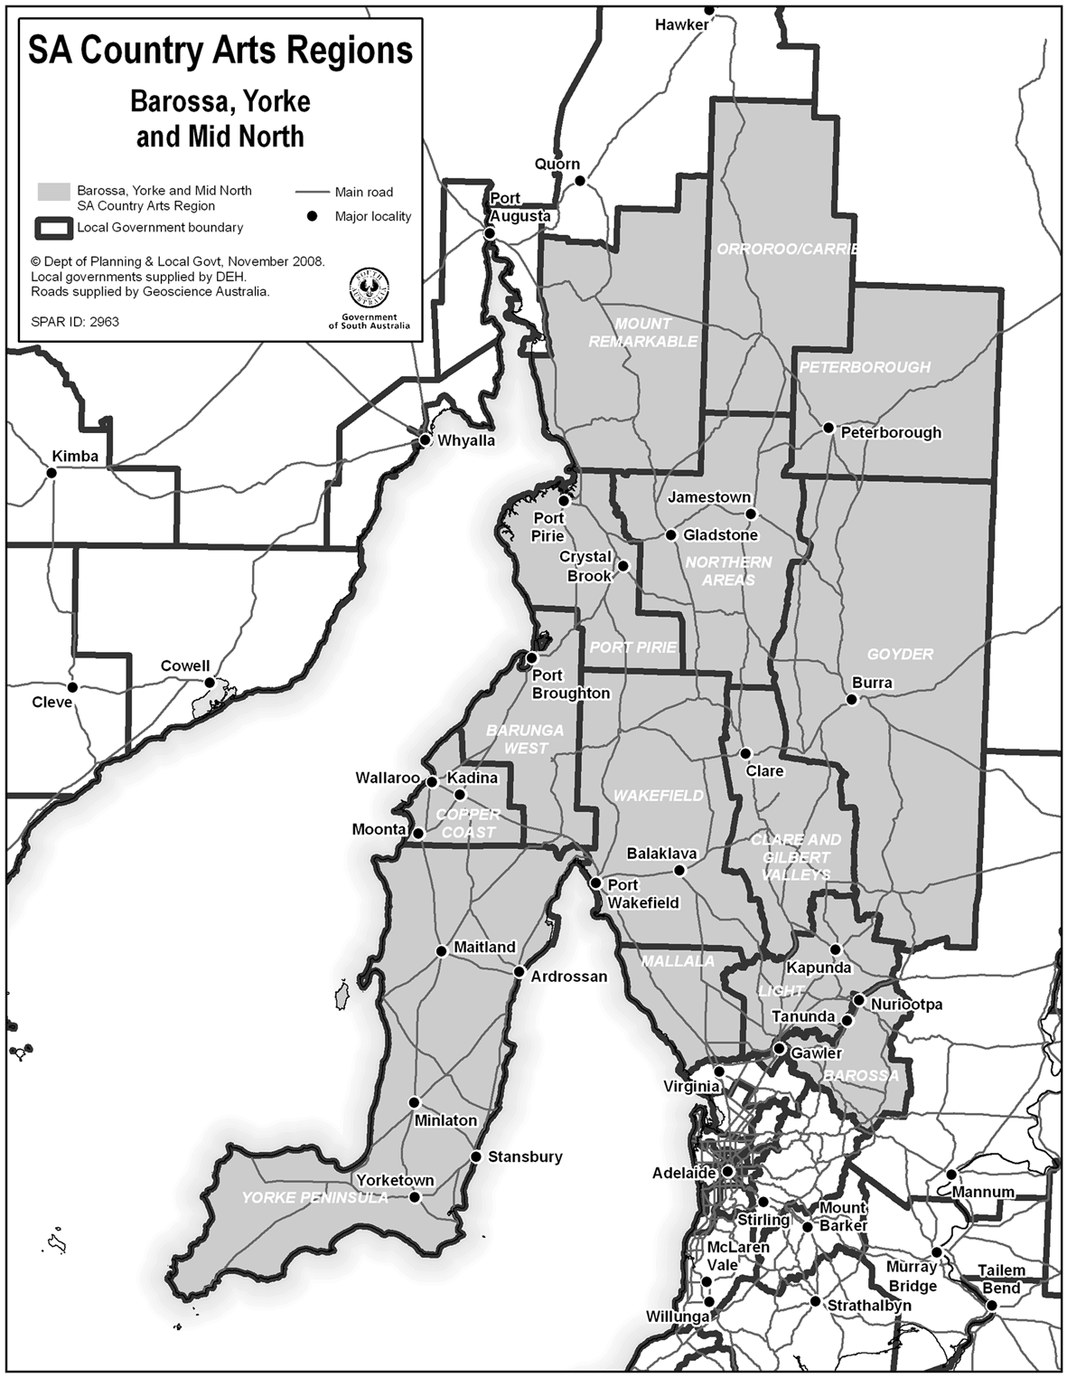
Eyre and Western/Far North
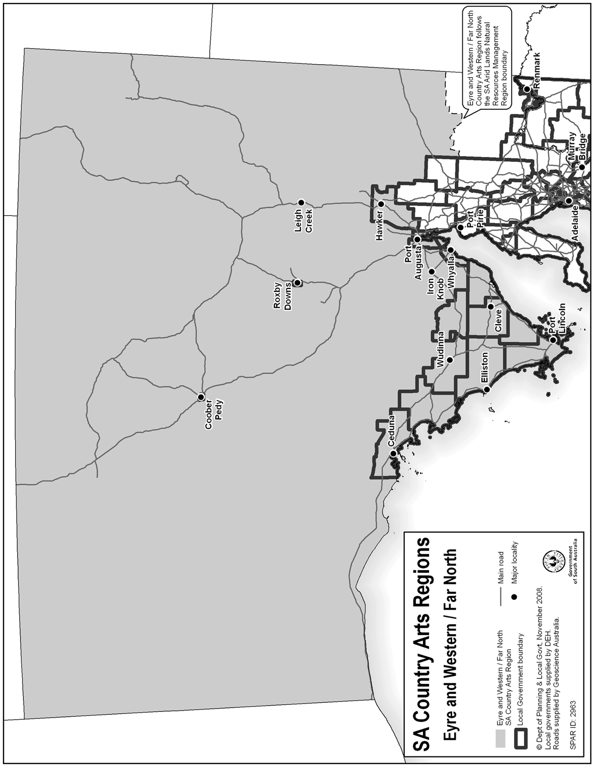
Fleurieu and Kangaroo Island/Adelaide Hills
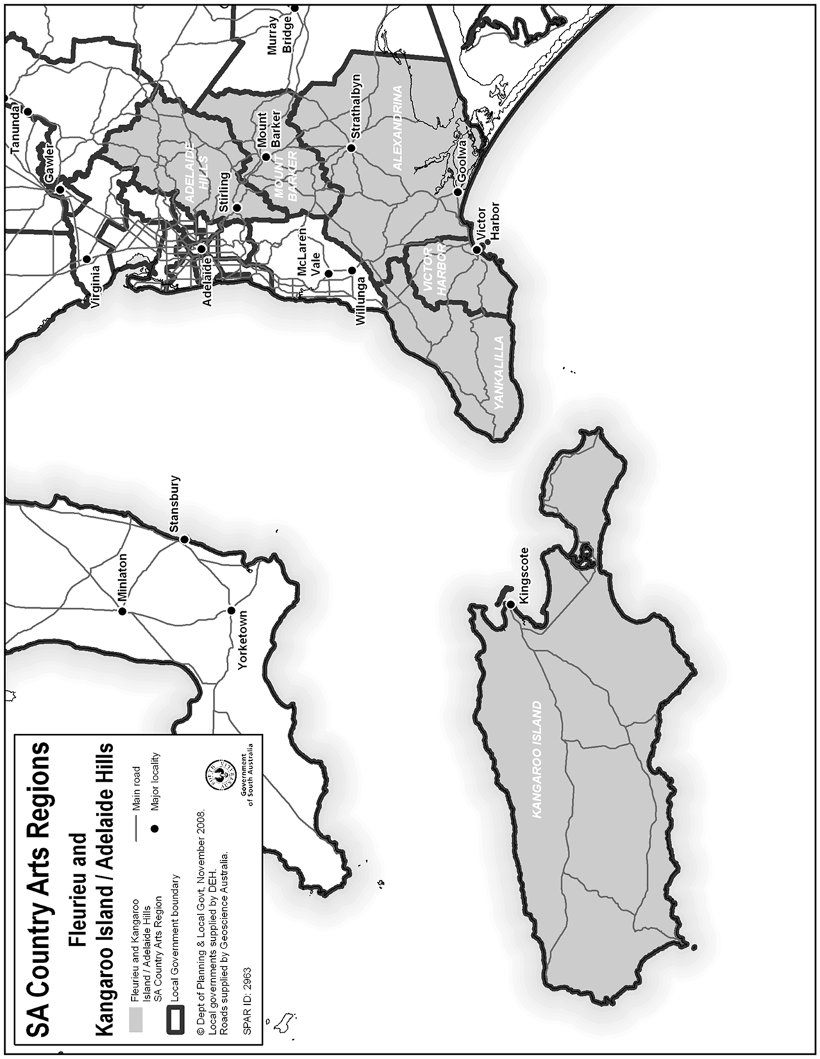
Limestone Coast
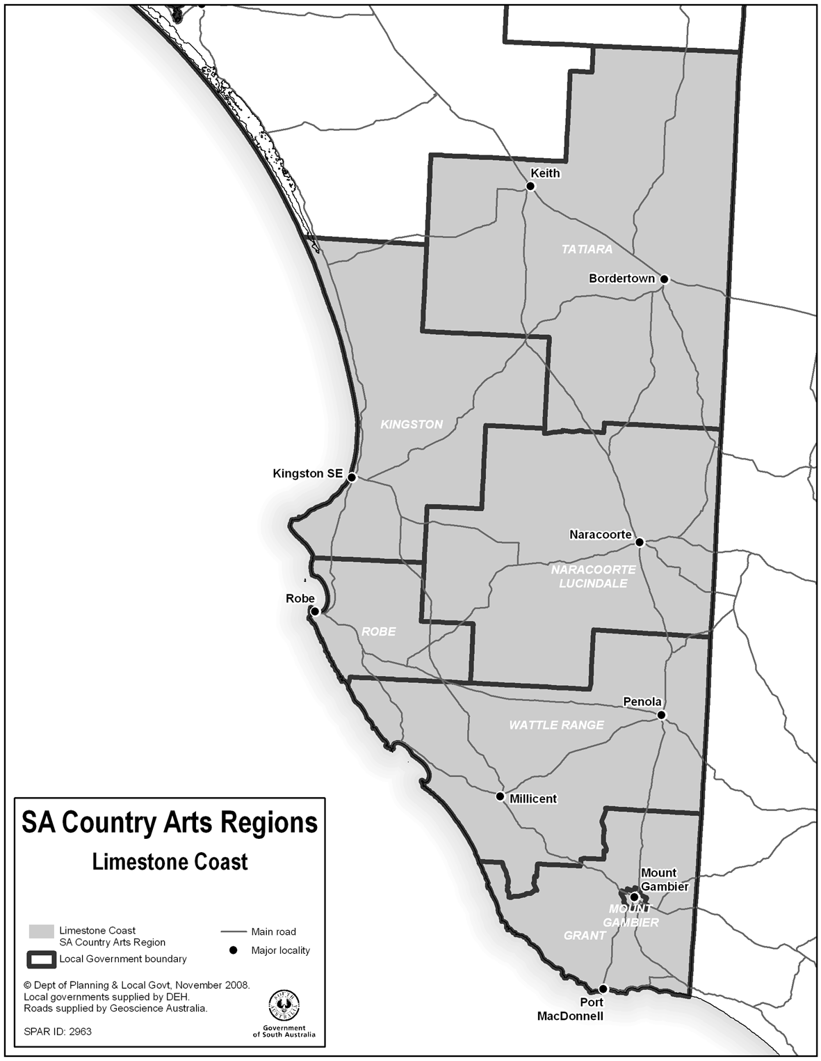
Murray and Mallee
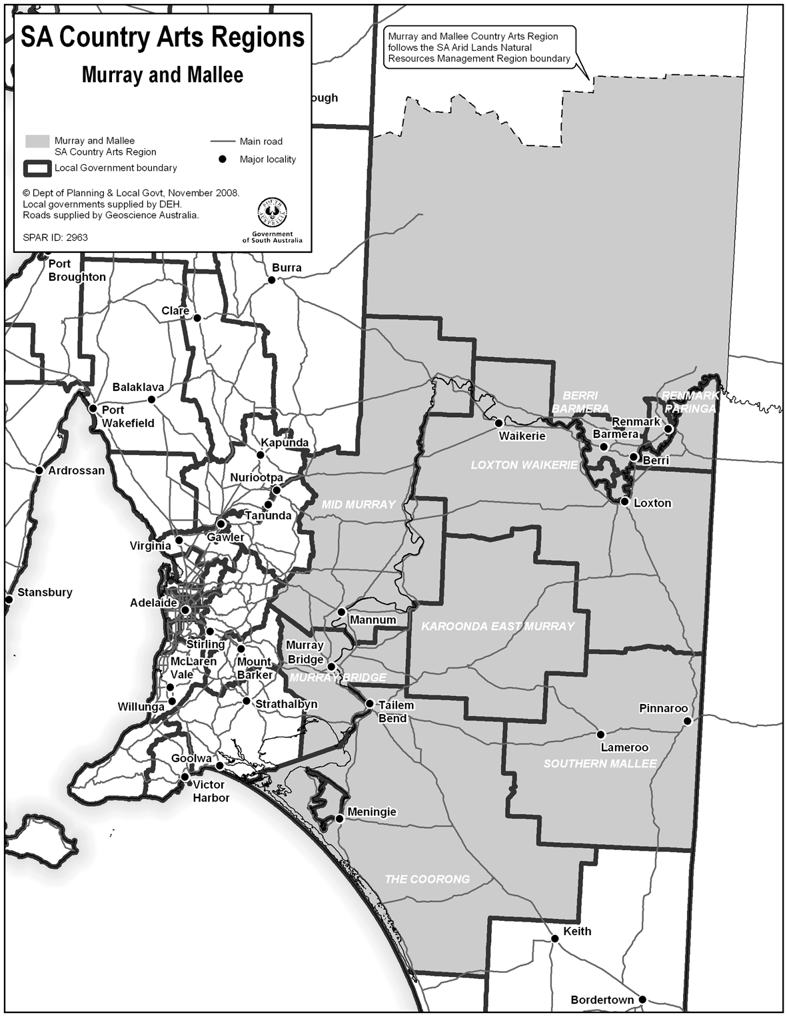
Made by the Governor’s Deputy
with the advice and consent of the Executive Council
on 12 March 2009
ASACAB005/08
South Australia
South Australian Country Arts Trust Revocation Regulations 2009
under the South Australian Country Arts Trust Act 1992

Contents
Part 1—Preliminary
1 Short title
2 Commencement
Part 2—Revocation of South Australian Country Arts Trust Regulations 2004
3 Revocation of regulations

Part 1—Preliminary
1—Short title
These regulations may be cited as the South Australian Country Arts Trust Revocation Regulations 2009.
2—Commencement
These regulations will come into operation on the day on which the South Australian Country Arts Trust (Constitution of Trust) Amendment Act 2009 comes into operation.
Part 2—Revocation of South Australian Country Arts Trust Regulations 2004
3—Revocation of regulations
The South Australian Country Arts Trust Regulations 2004 are revoked.
Note—
As required by section 10AA(2) of the Subordinate Legislation Act 1978, the Minister has certified that, in the Minister's opinion, it is necessary or appropriate that these regulations come into operation as set out in these regulations.
Made by the Governor’s Deputy
with the advice and consent of the Executive Council
on 12 March 2009
No 22 of 2009
ASACAB005/008

FAXING COPY?
IF you fax copy to Government Publishing SA for inclusion in the Government Gazette, there is no need to send a Confirmation Copy to us as well.
This creates confusion and may well result in your notice being printed twice.
Please use the following fax number:
Fax transmission: (08) 8207 1040
Phone Inquiries: (08) 8207 1045
Please include a contact person, phone number and order number so that we can phone back with any queries we may have regarding the fax copy.
NOTE: Closing time for lodging new copy (fax, hard copy or email) is 4 p.m. on Tuesday preceding the day of publication.

Government Gazette notices can be E-mailed.
The address is:
governmentgazette@dpc.sa.gov.au
Documents should be sent as attachments in Word format.
When sending a document via E-mail, please confirm your transmission with a faxed copy of your document, including the date the notice is to be published.
Fax transmission: (08) 8207 1040
Enquiries: (08) 8207 1045
NOTE: Closing time for lodging new copy (fax, hard copy or email) is 4 p.m. on Tuesday preceding the day of publication.

CITY OF PROSPECT
Election Results
Supplementary Election for Councillor in Highbury Ward
Conducted on Monday, 2 March 2009
Formal Ballot Papers: 771
Informal Ballot Papers: 0
Quota: 386
Candidates | First  Preference  Votes | Result after Distribution  of Preferences
De Palma, John | 222
Lee, Monica | 350 | Elected
Barnett, Kristina | 199
K. Mousley, Returning Officer

ALEXANDRINA COUNCIL
Erratum
Alexandrina Council’s Consultation Process for the Electoral Review Options Paper
NOTICE is hereby given that in reference to the advertisement placed in the South Australian Government Gazette on 5 February 2009 (page 560). In paragraph one, the closing date should read Friday, 20 March 2009 (not Monday, 9 March 2009 as published).
We apologise for any inconvenience caused in relation to this error.
J. Coombe, Chief Executive

DISTRICT COUNCIL OF THE COPPER COAST
Election Results
Supplementary Election for Councillor in Wallaroo Ward
Conducted on Monday, 2 March 2009
Formal Ballot Papers: 1 705
Informal Ballot Papers: 3
Quota: 853
Candidates | First  Preference  Votes | Result after Distribution  of Preferences
Gross, John | 854 | Elected
Woodforde, David Lindsay | 851
K. Mousley, Returning Officer

DISTRICT COUNCIL OF THE COPPER COAST
Roads (Opening and Closing) Act 1991
Road Closing—Portions Young and Beaton Streets, Wallaroo
NOTICE is hereby given, pursuant to section 10 of the Roads (Opening and Closing) Act 1991, that the District Council of the Copper Coast proposes to make a Road Process Order to close the whole of Young Street between Bagot and Elizabeth Streets and portion of Beaton Street between Allotment 154, Town of Wallaroo and Allotment 861 in Filed Plan 189803, shown more particularly delineated and lettered ‘A’, ‘B’ and ‘C’ on Preliminary Plan No. 09/0011.
Closed roads ‘A’ and ‘B’ to be transferred to The Catholic Diocese of Port Pirie Inc. and close road ‘C’ to be transferred to the Catholic Church Endowment Society Inc.
A copy of the plan and a statement of persons affected are available for public inspection at the offices of the District Council of the Copper Coast, 51 Taylor Street, Kadina and the Adelaide office of the Surveyor-General during normal office hours.
Any application for easement or objection must set out the full name, address and details of the submission and must be fully supported by reasons. The application for easement or objection must be made in writing to the District Council of the Copper Coast, 51 Taylor Street, Kadina, S.A. 5554 within 28 days of this notice and a copy must be forwarded to the Surveyor-General, G.P.O. Box 1354, Adelaide, S.A. 5001. Where a submission is made, the Council will give notification of a meeting at which the matter will be considered.
Dated 3 March 2009.
P. Dinning, Chief Executive Officer

IN the matter of the estates of the undermentioned deceased persons:
Abrahamson, Kuno, late of 88-94 Robert Street, West Croydon, of no occupation, who died on 15 December 2008.
Atkinson, John James, late of 63-69 Hall Street, Semaphore, retired storeman, who died on 8 March 1997.
Auld, John Bernard, late of 10 Kemp Street, Woodville, retired sheet metal worker, who died on 21 December 2008.
Barwick, Elizabeth Magdelena Georgina, late of 2 The Strand, Mawson Lakes, of no occupation, who died on 7 January 2009.
Bragg, Norman, late of 46 Lorraine Avenue, Para Vista, retired process worker, who died on 18 November 2008.
Caddy, Irene Florence, late of 9 Winchester Street, St Peters, of no occupation, who died on 5 January 2008.
Edkins, Cathleen Elizabeth, late of Ruwoldt Road, Yahl, retired artist, who died on 2 September 2008.
Filipsons, Karlis, late of 50 Gulfview Road, Christies Beach, retired supervisor, who died on 2 September 2008.
Giblin, Frederick Alfred, late of 10 Baxter Road, Seaford, retired train examiner, who died on 16 December 2008.
Gray, Thelma Jean, late of 52 Esplanade, Semaphore, retired manager, who died on 25 December 2008.
Harrison, Alfred, late of Bartlett Parade, Port Augusta, retired stockman, who died on 5 August 2008.
Knuckey, Zona, late of 580 Lower North East Road, Campbell-town, of no occupation, who died on 30 December 2008.
Lynch, Michael Albert Gilbert, late of 94 McKenzie Road, Elizabeth Downs, retired leading hand, who died on 12 October 2008.
Mahar, John, late of 172 Port Road, Hindmarsh, of no occupation, who died on 10 June 2008.
Mildren, Phylis Eileen, late of 81-93 Regency Road, Croydon Park, of no occupation, who died on 30 January 2009.
Renshaw, Bridgid Agnes, late of 9 Spencer Street, Parafield Gardens, home duties, who died on 3 June 2008.
Sainato, Concetta Anna Maria, late of 13 Fitzroy Terrace, Fitzroy, of no occupation, who died on 4 November 2008.
Smith, Brenda Margery, late of Grainger Road, Somerton Park, of no occupation, who died on 10 January 2009.
Smith, Kenneth Denny, formerly of Kangaroo Island, Seaman, date of death unknown.
Wallman, Margaret Jeanne, late of 60 States Road, Morphett Vale, of no occupation, who died on 26 December 2008.
Watson, Eva Mavis Salome, late of 437 Salisbury Highway, Parafield Gardens, home duties, who died on 25 December 2008.
Notice is hereby given pursuant to the Trustee Act 1936, as amended, the Inheritance (Family Provision) Act 1972, and the Family Relationships Act 1975, that all creditors, beneficiaries, and other persons having claims against the said estates are required to send, in writing, to the Public Trustee, 25 Franklin Street, Adelaide, S.A. 5000, full particulars and proof of such claims, on or before 10 April 2009, otherwise they will be excluded from the distribution of the said estate; and notice is also hereby given that all persons who are indebted to the said estates are required to pay the amount of their debts to the Public Trustee or proceedings will be taken for the recovery thereof; and all persons having any property belonging to the said estates are forthwith to deliver the same to the Public Trustee.
Dated 12 March 2009.
M. I. Bodycoat, Public Trustee

ATTENTION

CUSTOMERS requiring a proof of their notice for inclusion in the Government Gazette, please note that the onus is on you to inform Government Publishing SA of any subsequent corrections by 10 a.m. on Thursday, which is our publication deadline.

For any corrections to your notice please phone 8207 1045 or Fax 8207 1040 before 10 a.m. on Thursday.

If we do not receive any communication by 10 a.m. on Thursday (day of publication) we will presume the notice is correct and will print it as it is.

Remember—the onus is on you to inform us of any corrections necessary to your notice.

NOTE: Closing time for lodging new copy (electronically, fax or hard copy) is 4 p.m. on Tuesday preceding the day of publication. Phone 8207 1045—Fax 8207 1040.
Email: governmentgazette@dpc.sa.gov.au

Printed and published by authority every Thursday by T. GOODES, Government Printer, South Australia
Price: $5.60, plus postage; to subscribers, $284.00 per annum.
(The above prices are inclusive of GST)

