No. 79 5141

THE SOUTH AUSTRALIAN

GOVERNMENT GAZETTE
www.governmentgazette.sa.gov.au

PUBLISHED BY AUTHORITY

ALL PUBLIC ACTS appearing in this GAZETTE are to be considered official, and obeyed as such

ADELAIDE, THURSDAY, 12 NOVEMBER 2009

CONTENTS

Page
Appointments, Resignations, Etc. 5142
Corporations and District Councils—Notices 5178
Fisheries Management Act 2007—Notices 5142
Geographical Names Act 1991—
Notice 5144
Corrigendum 5144
Liquor Licensing Act 1997—Notices 5144
Medical Board of South Australia—Notices 5154
Mining Act 1971—Notices 5169
National Electricity Law—Notice 5169
Partnership Act 1891-1975—Notice 5187
Petroleum and Geothermal Energy Act 2000—Notices 5170
Proclamations 5174
Public Trustee Office—Administration of Estates 5186
Roads (Opening and Closing) Act 1991—Notices 5170
Road Traffic Act 1961—Notice 5170
Trade Standards Act 1979—Notice 5171
Water Mains and Sewers—Mains Laid, Replaced, Etc 5171
Wilderness Protection Act 1992—Erratum 5171

GOVERNMENT GAZETTE NOTICES
ALL poundkeepers’ and private advertisements forwarded for publication in the South Australian Government Gazette must be PAID FOR PRIOR TO INSERTION; and all notices, from whatever source, should be legibly written on one side of the paper only and sent to Government Publishing SA so as to be received no later
than 4 p.m. on the Tuesday preceding the day of publication. Phone 8207 1045 or Fax 8207 1040. E-mail: governmentgazette@dpc.sa.gov.au. Send as attachments in Word format and please confirm your transmission with a faxed copy of your document, including the date the notice is to be published and to whom the notice will be charged. The Government Gazette is available online at: www.governmentgazette.sa.gov.au

Department of the Premier and Cabinet
Adelaide, 12 November 2009
HIS Excellency the Governor in Executive Council has been pleased to appoint the undermentioned to the State Procurement Board, pursuant to the provisions of the State Procurement Act 2004:
Member: (from 12 November 2009 until 11 November 2011)
Christopher John Oerman
By command,
Michael O’Brien, for Premier
T&F09/071CS

Department of the Premier and Cabinet
Adelaide, 12 November 2009
HIS Excellency the Governor in Executive Council has been pleased to appoint the undermentioned to the Medical Board of South Australia, pursuant to the provisions of the Medical Practice Act 2004:
Member: (from 12 November 2009 until 11 November 2012)
Anne Louise Tonkin
Lesley Claire Palk
Deputy Member: (from 12 November 2009 until 11 November 2012)
Katherine Margaret Sullivan (Deputy to Palk)
By command,
Michael O’Brien, for Premier
HEAC-2009-00010

Department of the Premier and Cabinet
Adelaide, 12 November 2009
HIS Excellency the Governor in Executive Council has been pleased to appoint the undermentioned to the Legal Services Commission, pursuant to the provisions of the Legal Services Commission Act 1977:
Member: (from 20 November 2009 until 19 November 2012)
Michael Carlisle Howard Burgess
By command,
Michael O’Brien, for Premier
AGO0249/02CS

Department of the Premier and Cabinet
Adelaide, 12 November 2009
HIS Excellency the Governor in Executive Council has been pleased to appoint the undermentioned to the Equal Opportunity Tribunal, pursuant to the provisions of the Equal Opportunity Act 1984:
Deputy Presiding Officer: (from 12 November 2009 until 11 November 2012)
Susanne Denise Cole
David William Smith
Rauf Soulio
Kevin Gordon Nicholson
Paul Rice
By command,
Michael O’Brien, for Premier
AGO0266/02CS

Department of the Premier and Cabinet
Adelaide, 12 November 2009
HIS Excellency the Governor in Executive Council has been pleased to appoint the undermentioned to the South Australian Classification Council, pursuant to the provisions of the Classifi-cation (Publications, Films and Computer Games) Act 1995:
Member: (from 12 November 2009 until 11 November 2012)
Julie Joy Redman
Barbara Edith Biggins
Michael John Dean Dawson
Anthony Patrick Durkin
George Spiridon Karzis
Chair: (from 12 November 2009 until 11 November 2012)
Julie Joy Redman
By command,
Michael O’Brien, for Premier
AGO0096/02CS

Department of the Premier and Cabinet
Adelaide, 12 November 2009
HIS Excellency the Governor in Executive Council has been pleased to appoint the undermentioned to the Adelaide Festival Corporation Board, pursuant to the provisions of the Adelaide Festival Corporation Act 1998:
Member: (from 12 November 2009 until 12 November 2010)
Joseph Cullen
By command,
Michael O’Brien, for Premier
ASACAB001/02

FISHERIES MANAGEMENT ACT 2007: SECTION 115
TAKE notice that pursuant to section 115 of the Fisheries Management Act 2007, Scott Slater of Department of Environment and Heritage, SE Region, 11 Helen Street, Mount Gambier, S.A. 5290, (the ‘exemption holder’) or a person acting as his agent, is exempt from the provision of sections 70, 71, 72 and 78 (2) of the Fisheries Management Act 2007 but only insofar as he may engage in the collection of Yarra Pygmy Perch (Nannoperca obscura) and Dwarf Galaxias (Galaxiella pusilla) in inland waters of the Limestone Coast of South Australia (the ‘exempted activity’), using the gear specified in Schedule 1 and release those fish into the waters described in Schedule 2, subject to the conditions set out in Schedule 3, from 6 November 2009 until 31 December 2009, unless varied or revoked earlier.
Schedule 1
• 2 seine nets (maximum length 25 m, minimum mesh size 6 mm).
• 40 fish traps (maximum dimension 1 m, maximum entrance size 10 cm).
• 1 dip net per person.
• 10 fyke nets (maximum width 10 m, minimum mesh size 3 mm).
• 2 dive torches.
Schedule 2
Closed or artificial freshwater ponds, dams, wetlands and tanks located within the Limestone Coast.
Schedule 3
1. The specimens collected by the exemption holders are for stocking of those waters described in Schedule 2 for the purpose of establishing backup populations of fish where local extinction or depletion is possible and must not be sold.
2. All fish collected and retained pursuant to the exempted activity must be deposited into a site described in Schedule 2 that has an agreement between the land holder and the Department for Environment and Heritage for the maintenance of the fish released into the stocking site.
3. All non-native fish collected must be destroyed and disposed of appropriately.
4. Fish collected and retained from one location must be kept separate from fish collected and retained from any other location.
5. No fish can be moved from their released site and relocated without the written approval of the Director of Fisheries.
6. Before conducting the exempted activity, the exemption holder must contact the PIRSA Fisheries Compliance Unit on 1800 065 522 and answer a series of questions about the exempted activity. You will need to have a copy of your exemption with you at the time of making the call and be able to provide information about the area and time of the exempted activity, the vehicles and/or boats involved, the number of agents undertaking the exempted activity and other related issues. Exemption No. 9902285.
7. The exemption holder must provide a report in writing detailing the outcomes of the collection of fish pursuant to this notice to the Director of Fisheries, (G.P.O. Box 1625, Adelaide, S.A. 5001) within 14 days of any collection, giving the following details:
• the date and time of collection;
• location of collection site;
• the description of all species collected;
• the number of each species collected; and
• the number of each species retained for ex-situ maintenance.
8. The exemption holder must provide a report in writing detailing the outcomes of the release of fish, pursuant to this notice, to the Director of Fisheries, (G.P.O. Box 1625, Adelaide, S.A. 5001) within 14 days of any release, giving the following details:
• the date and time of release;
• location of release site;
• the description of the species released;
• the number of each species released into the site; and
• location of site that the species were collected from.
9. While engaged in the exempted activity, the exemption holder must be in possession of a copy of this notice. Such notice must be produced to a PIRSA Fisheries Compliance Officer if requested.
10. The exemption holder must not contravene or fail to comply with the Fisheries Management Act 2007, or any regulations made under that Act, except where specifically exempted by this notice.
Dated 4 November 2009.
M. Smallridge, Director of Fisheries

FISHERIES MANAGEMENT ACT 2007: SECTION 115
TAKE notice that pursuant to section 115 of the Fisheries Management Act 2007, Bill Round, Hallett Cove R-12 School, Gledsdale Road, Hallett Cove, S.A. 5158 (the ‘exemption holder’), or a person acting as his agent, is exempt from section 78 (2) of the Fisheries Management Act 2007 and Clauses 72 and 118 of Schedule 6 of the Fisheries Management (General) Regulations 2007, but only insofar as the exemption holder shall not be guilty of an offence when engaging in the taking, possessing and subsequent release of aquatic organisms (excluding species protected, pursuant to section 71 of the Fisheries Management Act 2007) using the gear specified in Schedule 1 for education purposes at the Hallett Cove R-12 School (the ‘exempted activity’), from the waters specified in Schedule 2, subject to the conditions specified in Schedule 3, from 1 January 2010 until 31 December 2010, unless varied or revoked earlier.
Schedule 1
• Soft mesh hand nets
Schedule 2
South Australian marine coastal waters and intertidal ‘rocky’ reef areas (excluding aquatic reserves and marine parks).
Schedule 3
1. All organisms taken by the exemption holder are for display purposes only and must not be sold.
2. An employee of the Hallett Cove R-12 School must be present at all times whilst conducting the exempted activity.
3. The exempted activity must be undertaken in a manner that ensures minimal disturbance of the reef.
4. No more than five of any species may be taken or possessed at any one time except those species listed below:
• Rock lobster—maximum 1.
• Blennies/Gobies—maximum 10 each.
• Shrimp species—maximum 50 combined.
5. All organisms released pursuant to this notice must be released as near as practicable to the point of capture.
6. Within 14 days of the collection of organisms, pursuant to this notice, the exemption holder must provide a report in writing to the Director of Fisheries, (G.P.O. Box 1625, Adelaide, S.A. 5001), giving the following details:
• the date and time of collection;
• the name and number of each species taken, including any mortalities resulting from collecting; and
• details of any organisms released.
7. The exemption holder must notify PIRSA Fisheries Compliance Unit on 1800 065 522 at least two hours prior to conducting the exempted activity and answer a series of questions about the exempted activity. The exemption holder will need to have a copy of the exemption at the time of making the call and be able to provide information about the area and time of the exempted activity, the vehicles and boats involved, the number of agents undertaking the exempted activity and other related questions. Exemption No. 9902295.
8. While engaged in the exempted activity, the exemption holder must have in their possession a copy of this notice and produce such notice if required by a PIRSA Fisheries Compliance Officer.
9. The exemption holder shall not contravene or fail to comply with the Fisheries Management Act 2007, or any regulations made under that Act, except where specifically exempted by the notice.
Dated 4 November 2009.
M. Smallridge, Director of Fisheries

FISHERIES MANAGEMENT ACT 2007: SECTION 115
TAKE notice that pursuant to section 115 of the Fisheries Management Act 2007, the holder of a Northern Zone Rock Lobster Fishery Licence issued pursuant to the Fisheries Management (Rock Lobster Fisheries) Regulations 2006 (the ‘exemption holders’) are exempted from the provisions of Regulation 5 of the Fisheries Management (Vessel Monitoring Scheme) Regulations 2007, but only insofar as an exemption holder shall not be guilty of an offence when using a registered boat that is endorsed on the licence to undertake fishing activity for the sole purpose of fishing for species other than southern rock lobster (Jasus edwardsii) and giant crabs (Pseudocarinus gigas) without having a fitted and operational vessel monitoring system (the ‘exempted activity’), subject to the conditions specified in Schedule 1, from 6 November 2009 until 31 May 2010, unless this notice is varied or revoked earlier.
Schedule 1
1. The exemption holder may only conduct the exempted activity from a boat that is registered and endorsed on their Northern Zone Rock Lobster Fishery Licence and that is less than 6 m in length.
2. The exemption holder must ensure that only a master registered on their Northern Zone Rock Lobster Fishery Licence undertakes the exempted activity.
3. The exemption holder must notify PIRSA Fisheries by calling 1800 065 522 prior to engaging in the exempted activity and providing the following information:
• the name of the licence holder making the call;
• the fishery licence number of the licence on which the registered boat is endorsed;
• the name of the boat and the commercial boat registration number;
• the time and date the exempted activity will commence; and
• the time and date the exempted activity will cease.
4. An exemption holder must ensure that no rock lobster pots are on board the registered boat at any time during the exempted activity.
5. An exemption holder must not take or have on board the registered boat any rock lobster during the exempted activity.
6. An exemption holder must not contravene or fail to comply with the Fisheries Management Act 2007, or any other regulations made under that Act, except where specifically exempted by this notice.
Dated 5 November 2009.
M. Smallridge, Director of Fisheries

GEOGRAPHICAL NAMES ACT 1991
Corrigendum
Notice of Declaration of Names of Places
IN the Government Gazette of 11 December 1986, page 1859, first notice appearing under the list of declared names for Mapsheet 1:50 000 6634-4 ‘Wilpena’, the name BIMBORRINA HILL should be BIMBORNINA HILL.
Dated 9 November 2009.
P. M. Kentish, Surveyor-General, Department for Transport, Energy and Infrastructure
DTEI.22-413/07/0032

GEOGRAPHICAL NAMES ACT 1991
Notice to Rescind a Name of a Feature
NOTICE is hereby given pursuant to the provisions of the above Act that I, PETER MACLAREN KENTISH, Surveyor-General and Delegate appointed by Patrick Conlon, Minister for Infrastructure, Minister of the Crown to whom the administration of the Geographical Names Act 1991, is committed, DO HEREBY rescind the name MOUNT SIMMS WELL for that feature located on the 1:50 000 Mapsheet Holowilena (6634-2) at latitude -31°57′45″ and longitude 138°46′2″. This name should not have been declared as a geographical name.
Dated 4 November 2009.
P. M. Kentish, Surveyor-General, Department for Transport, Energy and Infrastructure
DTEI.22-413/07/0032

LIQUOR LICENSING ACT 1997 AND GAMING MACHINES ACT 1992
Notice of Application
NOTICE is hereby given, pursuant to section 52 of the Liquor Licensing Act 1997 and section 29 of the Gaming Machines Act 1992, that Australian Leisure and Hospitality Group Limited has applied to the Licensing Authority for the transfer of a Hotel and Gaming Machine Licence in respect of premises situated at 33 Main North Road, Willaston, S.A. 5118 and known as Willaston Hotel.
The application has been set down for hearing on 21 December 2009 at 10.30 a.m.
Any person may object to the application by lodging a notice of objection in the prescribed form with the Liquor and Gambling Commissioner and serving a copy of the notice on the applicant at the applicant’s address, at least seven days before the hearing date (viz: 14 December 2009).
The applicant’s address for service is c/o DMAW Lawyers, Level 3, 80 King William Street, Adelaide, S.A. 5000 (Attention: Craig Vozzo).
Plans in respect of the premises the subject of the application are open to public inspection without fee at the Office of the Liquor and Gambling Commissioner, 9th Floor, East Wing, 50 Grenfell Street, Adelaide, S.A. 5000. Phone 8226 8410, Fax:
8226 8512. Email: olgc@agd.sa.gov.au.
Dated 9 November 2009.
Applicant

LIQUOR LICENSING ACT 1997
Notice of Application
NOTICE is hereby given, pursuant to section 52 (2) (b) of the Liquor Licensing Act 1997, that Peter John Hancock and Kerry Lyn Hancock have applied to the Licensing Authority for a Special Circumstances Licence with an Extended Trading Authorisation and Entertainment Consent in respect of premises situated at Holdfast Shores Marina, Glenelg, S.A. 5045 and to be known as Holdfast Bay Charters.
The application has been set down for hearing on 22 December 2009 at 9 a.m.
Conditions
The following licence conditions are sought:
• Under section 40 of the Liquor Licensing Act 1997, the licence authorises the sale, supply and consumption of liquor to and by a bona fide passenger to whom the licensee or its agents have issued a ticket for a bona fide cruise or function for the following hours of operation which include an Extended Trading Authorisation:
On any Day (except New Year’s Eve when trading is permitted from 8 a.m. to 1 a.m. the following day): 8 a.m. to 10 p.m.
• Entertainment Consent shall be limited to when the vessel is in open water only and not within the waters of the Patawalonga or the Holdfast Shores Marina Basin.
• The vessel is not permitted to enter or depart from Holdfast Shores Marina outside of the hours of 8 a.m. and 10 p.m. Monday to Sunday, except for New Year’s Eve where the vessel will return to the Holdfast Shores Marina by 1 a.m. and the passengers shall disembark within 30 minutes of mooring in the marina. Return may be delayed when a gale warning is issued unexpectedly.
• The loading and unloading of passengers shall be limited to the Holdfast Shores Charter Wharf. No passengers are to be set down within the waters of the Patawalonga frontage.
• The consumption of alcohol on the vessel is to be limited to when the vessel is in open waters only and not within the waters of the Patawalonga or the Holdfast Shores Marina Basin.
• The licensee shall insure that the passenger embark onto and disembark from the vessel in a quiet and orderly fashion so as not to disturb nearby residents.
• The licence is for a trial period of 12 months.
Any person may object to the application by lodging a notice of objection in the prescribed form with the Liquor and Gambling Commissioner and serving a copy of the notice on the applicants at the applicants’ address, at least seven days before the hearing date (viz: 15 December 2009).
The applicants’ address for service is c/o Peter Hancock, 7 Wilkinson Avenue, Somerton Park, S.A. 5044.
Plans in respect of the premises the subject of the application are open to public inspection without fee at the Office of the Liquor and Gambling Commissioner, 9th Floor, East Wing, 50 Grenfell Street, Adelaide, S.A. 5000. Phone 8226 8410, Fax:
8226 8512. Email: olgc@agd.sa.gov.au.
Dated 10 November 2009.
Applicants

LIQUOR LICENSING ACT 1997
Notice of Application
NOTICE is hereby given, pursuant to section 52 (2) (b) of the Liquor Licensing Act 1997, that Mattim Holdings Pty Ltd has applied to the Licensing Authority for a Retail Liquor Merchant’s Licence in respect of premises situated at Shops 1, 2 and 3, Brighton Shopping Centre, Brighton Road, Brighton, S.A. 5048 and known as Brighton Celebrations.
The application has been set down for hearing on 15 December 2009 at 11.30 a.m.
Any person may object to the application by lodging a notice of objection in the prescribed form with the Liquor and Gambling Commissioner and serving a copy of the notice on the applicant at the applicant’s address, at least seven days before the hearing date (viz: 8 December 2009).
The applicant’s address for service is c/o Rinaldo D’Aloia, Clelands Lawyers, 208 Carrington Street, Adelaide, S.A. 5000.
Plans in respect of the premises the subject of the application are open to public inspection without fee at the Office of the Liquor and Gambling Commissioner, 9th Floor, East Wing, 50 Grenfell Street, Adelaide, S.A. 5000. Phone 8226 8410, Fax:
8226 8512. Email: olgc@agd.sa.gov.au.
Dated 9 November 2009.
Applicant

LIQUOR LICENSING ACT 1997
Notice of Application
NOTICE is hereby given, pursuant to section 52 (2) (b) of the Liquor Licensing Act 1997, that Sung Won Pty Ltd as trustee for Jang & Back Trust has applied to the Licensing Authority for the transfer of a Special Circumstances Licence in respect of premises situated at 482A Payneham Road, Glynde, S.A. 5070 and known as Lucky Korean Store.
The application has been set down for hearing on 3 December 2009 at 11.30 a.m.
Any person may object to the application by lodging a notice of objection in the prescribed form with the Liquor and Gambling Commissioner and serving a copy of the notice on the applicant at the applicant’s address, at least one day before the hearing date (viz: 2 December 2009).
The applicant’s address for service is c/o Martin Lee, Suite 412, 33 Pirie Street, Adelaide, S.A. 5000.
Plans in respect of the premises the subject of the application are open to public inspection without fee at the Office of the Liquor and Gambling Commissioner, 9th Floor, East Wing, 50 Grenfell Street, Adelaide, S.A. 5000. Phone 8226 8410, Fax:
8226 8512. Email: olgc@agd.sa.gov.au.
Dated 9 November 2009.
Applicant

LIQUOR LICENSING ACT 1997
Notice of Application
NOTICE is hereby given, pursuant to section 52 (2) (b) of the Liquor Licensing Act 1997, that Leslie Michael Wright and Heather Frances Foster have applied to the Licensing Authority for the transfer of a Special Circumstances Licence in respect of premises situated at Railway Terrace, Beachport, S.A. 5280, known as Bompa’s of Beachport and to be known as Bompa’s.
The application has been set down for hearing on 15 December 2009 at 9.30 a.m.
Any person may object to the application by lodging a notice of objection in the prescribed form with the Liquor and Gambling Commissioner and serving a copy of the notice on the applicants at the applicants’ address, at least seven days before the hearing date (viz: 8 December 2009).
The applicants’ address for service is c/o Tindal Gask Bentley, Level 2, 12 Pirie Street, Adelaide, S.A. 5000 (Attention: Giles Kahl).
Plans in respect of the premises the subject of the application are open to public inspection without fee at the Office of the Liquor and Gambling Commissioner, 9th Floor, East Wing, 50 Grenfell Street, Adelaide, S.A. 5000. Phone 8226 8410, Fax:
8226 8512. Email: olgc@agd.sa.gov.au.
Dated 6 November 2009.
Applicants

LIQUOR LICENSING ACT 1997
Notice of Application
NOTICE is hereby given, pursuant to section 52 (2) (b) of the Liquor Licensing Act 1997, that S & M Family Pty Ltd as trustee for S & M Family Trust has applied to the Licensing Authority for the transfer of a Restaurant Licence in respect of premises situated at 111 Murray Street, Gawler, S.A. 5118 and known as La Dolce Vita.
The application has been set down for hearing on 14 December 2009 at 10.30 a.m.
Any person may object to the application by lodging a notice of objection in the prescribed form with the Liquor and Gambling Commissioner and serving a copy of the notice on the applicant at the applicant’s address, at least seven days before the hearing date (viz: 7 December 2009).
The applicant’s address for service is c/o Tony Spencely, P.O. Box 161, Willaston, S.A. 5118.
Plans in respect of the premises the subject of the application are open to public inspection without fee at the Office of the Liquor and Gambling Commissioner, 9th Floor, East Wing, 50 Grenfell Street, Adelaide, S.A. 5000. Phone 8226 8410, Fax:
8226 8512. Email: olgc@agd.sa.gov.au.
Dated 9 November 2009.
Applicant

LIQUOR LICENSING ACT 1997
Notice of Application
NOTICE is hereby given, pursuant to section 52 (2) (b) of the Liquor Licensing Act 1997, that Leslie Michael Wright has applied to the Licensing Authority for the transfer of a Residential Licence in respect of premises situated at 115 Penola Road, Mount Gambier, S.A. 5290 and known as Motel Mount Gambier.
The application has been set down for hearing on 15 December 2009 at 10 a.m.
Any person may object to the application by lodging a notice of objection in the prescribed form with the Liquor and Gambling Commissioner and serving a copy of the notice on the applicant at the applicant’s address, at least seven days before the hearing date (viz: 8 December 2009).
The applicant’s address for service is c/o Giles Kahl, Level 2, 12 Pirie Street, Adelaide, S.A. 5000.
Plans in respect of the premises the subject of the application are open to public inspection without fee at the Office of the Liquor and Gambling Commissioner, 9th Floor, East Wing, 50 Grenfell Street, Adelaide, S.A. 5000. Phone 8226 8410, Fax:
8226 8512. Email: olgc@agd.sa.gov.au.
Dated 8 November 2009.
Applicant

LIQUOR LICENSING ACT 1997
Notice of Application
NOTICE is hereby given, pursuant to section 52 (2) (b) of the Liquor Licensing Act 1997, that Caos Pty Ltd has applied to the Licensing Authority for the transfer of a Hotel and Gaming Machine Licence, variation to an Extended Trading Authorisation and Extended Trading Area in respect of premises situated at 13 North Parade, Port Adelaide, S.A. 5015 and known as British Hotel.
The application has been set down for hearing on 14 December 2009 at 11 a.m.
Conditions
The following licence conditions are sought:
• Extension of Trading Area to include the outdoor footpath area as per plans lodged with this office.
• Variation to Extended Trading Authorisation to include the abovementioned outdoor footpath area as per plans lodged with this office and for the following days and times:
Thursday: Midnight to 2 a.m. the following day;
Friday to Saturday: Midnight to 4 a.m. the following day;
Sunday: 8 a.m. to 11 a.m. and 8 p.m. to midnight.
• Variation to Extended Trading Authorisation for the areas currently approved with Extended Trading Authorisation and for the abovementioned outdoor footpath area for the following days and times:
Good Friday: Midnight to 2 a.m.;
Christmas Day: Midnight to 2 a.m.
Any person may object to the application by lodging a notice of objection in the prescribed form with the Liquor and Gambling Commissioner and serving a copy of the notice on the applicant at the applicant’s address, at least seven days before the hearing date (viz: 7 December 2009.).
The applicant’s address for service is c/o Donaldson Walsh Lawyers, G.P.O. Box 2873, Adelaide, S.A. 5001 (Attention: Jarrod Ryan).
Plans in respect of the premises the subject of the application are open to public inspection without fee at the Office of the Liquor and Gambling Commissioner, 9th Floor, East Wing, 50 Grenfell Street, Adelaide, S.A. 5000. Phone 8226 8410, Fax:
8226 8512. Email: olgc@agd.sa.gov.au.
Dated 9 November 2009.
Applicant

LIQUOR LICENSING ACT 1997
Notice of Application
NOTICE is hereby given, pursuant to section 52 (2) (b) of the Liquor Licensing Act 1997, that Bel Holdings SA Pty Ltd has applied to the Licensing Authority for a Producer’s Licence and a Wholesale Liquor Merchant’s Licence in respect of premises situated at Allotment 62 in Deposited Plan 72415, Chino Street, Renmark West, S.A. 5341 and known as Bel Holdings SA Pty Ltd.
The application has been set down for hearing on 17 December 2009 at 9.30 a.m.
Any person may object to the application by lodging a notice of objection in the prescribed form with the Liquor and Gambling Commissioner and serving a copy of the notice on the applicant at the applicant’s address, at least seven days before the hearing date (viz: 10 December 2009.).
The applicant’s address for service is c/o Stuart Andrew Solicitors, 11 Ahern Street, Berri, S.A. 5343 (Attention: Dimitria Dale).
Plans in respect of the premises the subject of the application are open to public inspection without fee at the Office of the Liquor and Gambling Commissioner, 9th Floor, East Wing, 50 Grenfell Street, Adelaide, S.A. 5000. Phone 8226 8410, Fax:
8226 8512. Email: olgc@agd.sa.gov.au.
Dated 8 November 2009.
Applicant

LIQUOR LICENSING ACT 1997
Notice of Application
NOTICE is hereby given, pursuant to section 52 (2) (b) of the Liquor Licensing Act 1997, that Two Hands Wines Pty Ltd has applied to the Licensing Authority for the removal of a Wholesale Liquor Merchant’s Licence in respect of premises situated at Branson Vineyard, corner of Seppeltsfield Road and Sturt Highway, Greenock Creek, S.A. 5360 and to be situated at
2 Wellington Square, North Adelaide, S.A. 5006 and known as Two Hands Wines.
The application has been set down for hearing on 17 December 2009 at 11.30 a.m.
Any person may object to the application by lodging a notice of objection in the prescribed form with the Liquor and Gambling Commissioner and serving a copy of the notice on the applicant at the applicant’s address, at least seven days before the hearing date (viz: 10 December 2009.).
The applicant’s address for service is c/o James Bayer, P.O. Box 1013, North Adelaide, S.A. 5006.
Plans in respect of the premises the subject of the application are open to public inspection without fee at the Office of the Liquor and Gambling Commissioner, 9th Floor, East Wing, 50 Grenfell Street, Adelaide, S.A. 5000. Phone 8226 8410, Fax:
8226 8512. Email: olgc@agd.sa.gov.au.
Dated 8 November 2009.
Applicant

LIQUOR LICENSING ACT 1997
Notice of Application
NOTICE is hereby given, pursuant to section 52 (2) (b) of the Liquor Licensing Act 1997, that Keane & Tomlinson Pty Ltd has applied to the Licensing Authority for the transfer of a Restaurant Licensing in respect of premises situated at 21 Victoria Street, Robe, S.A. 5276 and known as Sails at Robe.
The application has been set down for hearing on 21 December 2009 at 10 a.m.
Any person may object to the application by lodging a notice of objection in the prescribed form with the Liquor and Gambling Commissioner and serving a copy of the notice on the applicant at the applicant’s address, at least seven days before the hearing date (viz: 14 December 2009.).
The applicant’s address for service is c/o Westley Digiogorgo, P.O. Box 1265, Naracoorte, S.A. 5271 (Attention: Peter Westley).
Plans in respect of the premises the subject of the application are open to public inspection without fee at the Office of the Liquor and Gambling Commissioner, 9th Floor, East Wing, 50 Grenfell Street, Adelaide, S.A. 5000. Phone 8226 8410, Fax:
8226 8512. Email: olgc@agd.sa.gov.au.
Dated 8 November 2009.
Applicant

LIQUOR LICENSING ACT 1997
Notice of Application
NOTICE is hereby given, pursuant to section 52 (2) (b) of the Liquor Licensing Act 1997, that Cellar6 Pty Ltd has applied to the Licensing Authority for a Direct Sales Licence in respect of premises situated at 56 Mitcham Avenue, Lower Mitcham, S.A. 5062 and to be known as Cellar6.
The application has been set down for hearing on 17 December 2009 at 11.30 a.m.
Any person may object to the application by lodging a notice of objection in the prescribed form with the Liquor and Gambling Commissioner and serving a copy of the notice on the applicant at the applicant’s address, at least seven days before the hearing date (viz: 10 December 2009).
The applicant’s address for service is c/o Stephen Tamblyn, 56 Mitcham Avenue, Lower Mitcham, S.A. 5062.
Plans in respect of the premises the subject of the application are open to public inspection without fee at the Office of the Liquor and Gambling Commissioner, 9th Floor, East Wing, 50 Grenfell Street, Adelaide, S.A. 5000. Phone 8226 8410, Fax:
8226 8512. Email: olgc@agd.sa.gov.au.
Dated 8 November 2009.
Applicant

LIQUOR LICENSING ACT 1997
Notice of Application
NOTICE is hereby given, pursuant to section 52 (2) (b) of the Liquor Licensing Act 1997, that Normans Wine Company Pty Ltd has applied to the Licensing Authority for a Producer’s Licence in respect of premises situated at 10 William Gilbert Avenue, Cockatoo Valley, S.A. 5351 and known as Normans Wine Company Pty Ltd.
The application has been set down for hearing on 3 December 2009 at 11 a.m.
Any person may object to the application by lodging a notice of objection in the prescribed form with the Liquor and Gambling Commissioner and serving a copy of the notice on the applicant at the applicant’s address, on or before 2 December 2009).
The applicant’s address for service is c/o Damien Lister, P.O. Box 787, Williamstown, S.A. 5351.
Plans in respect of the premises the subject of the application are open to public inspection without fee at the Office of the Liquor and Gambling Commissioner, 9th Floor, East Wing, 50 Grenfell Street, Adelaide, S.A. 5000. Phone 8226 8410, Fax:
8226 8512. Email: olgc@agd.sa.gov.au.
Dated 8 November 2009.
Applicant

LIQUOR LICENSING ACT 1997
Notice of Application
NOTICE is hereby given, pursuant to section 52 (2) (b) of the Liquor Licensing Act 1997, that Dalu John Vettiyadan, Dious Bastin Tharakan and Gopinath Thangappan have applied to the Licensing Authority for a Restaurant Licence in respect of premises situated at 1/52 Magill Road, Magill, S.A. 5072 and to be known as Mango Grove.
The application has been set down for hearing on 21 December 2009 at 11.30 a.m.
Any person may object to the application by lodging a notice of objection in the prescribed form with the Liquor and Gambling Commissioner and serving a copy of the notice on the applicants at the applicants’ address, at least seven days before the hearing date (viz: 14 December 2009).
The applicants’ address for service is c/o Dious Tharakan, 26 John Renwick Place, Modbury Heights, S.A. 5092.
Plans in respect of the premises the subject of the application are open to public inspection without fee at the Office of the Liquor and Gambling Commissioner, 9th Floor, East Wing, 50 Grenfell Street, Adelaide, S.A. 5000. Phone 8226 8410, Fax:
8226 8512. Email: olgc@agd.sa.gov.au.
Dated 8 November 2009.
Applicants

LIQUOR LICENSING ACT 1997
Notice of Application
NOTICE is hereby given, pursuant to section 52 (2) (b) of the Liquor Licensing Act 1997, that Fassina Investments Pty Ltd has applied to the Licensing Authority for the removal of a Retail Liquor Merchant’s Licence in respect of premises situated at Shop 107, Centro Shopping Centre, Hanson Road, Kilkenny, S.A. 5009 and to be situated at Unit 5/10-14 Regency Road, Kilkenny, S.A. 5009 and known as Fassina Liquor Merchants.
The application has been set down for hearing on 14 December 2009 at 11.30 a.m.
Any person may object to the application by lodging a notice of objection in the prescribed form with the Liquor and Gambling Commissioner and serving a copy of the notice on the applicant at the applicant’s address, at least seven days before the hearing date (viz: 7 December 2009).
The applicant’s address for service is c/o Wallmans Lawyers, G.P.O. Box 1018, Adelaide, S.A. 5001 (Attention: Peter Hoban or Ben Allen).
Plans in respect of the premises the subject of the application are open to public inspection without fee at the Office of the Liquor and Gambling Commissioner, 9th Floor, East Wing, 50 Grenfell Street, Adelaide, S.A. 5000. Phone 8226 8410, Fax:
8226 8512. Email: olgc@agd.sa.gov.au.
Dated 9 November 2009.
Applicant

LIQUOR LICENSING ACT 1997
Notice of Application
NOTICE is hereby given, pursuant to section 52 (2) (b) of the Liquor Licensing Act 1997, that RJ & GS Kennedy Pty Ltd as trustee for Kennedy Family Trust has applied to the Licensing Authority for the transfer of a Hotel Licence in respect of premises situated at 60 Main Street, Nairne, S.A. 5252 and known as Millers Arms Hotel.
The application has been set down for hearing on 16 December 2009 at 11 a.m.
Any person may object to the application by lodging a notice of objection in the prescribed form with the Liquor and Gambling Commissioner and serving a copy of the notice on the applicant at the applicant’s address, at least seven days before the hearing date (viz: 9 December 2009).
The applicant’s address for service is c/o Foreman Legal, 69 Mount Barker Road, Stirling, S.A. 5152 (Attention: Philip Foreman).
Plans in respect of the premises the subject of the application are open to public inspection without fee at the Office of the Liquor and Gambling Commissioner, 9th Floor, East Wing, 50 Grenfell Street, Adelaide, S.A. 5000. Phone 8226 8410, Fax:
8226 8512. Email: olgc@agd.sa.gov.au.
Dated 8 November 2009.
Applicant

LIQUOR LICENSING ACT 1997
Notice of Application
NOTICE is hereby given, pursuant to section 52 (2) (b) of the Liquor Licensing Act 1997, that Starog Nominees Pty Ltd as trustee for Starog Eden Valley Trust has applied to the Licensing Authority for the transfer of a Hotel and Gaming Machine Licence, Alterations and Redefinition in respect of premises situated at 11 Main Road, Eden Valley, S.A. 5235 and known as Eden Valley Hotel.
The application has been set down for hearing on 16 December 2009 at 11.30 a.m.
Conditions
The following licence conditions are sought:
• Redefinition to extending the Beer Garden to the rear of the premises as per plans lodged with this office.
• Extension of Trading Area to include the footbath adjacent to Area 3 as per plans lodged with this office.
Any person may object to the application by lodging a notice of objection in the prescribed form with the Liquor and Gambling Commissioner and serving a copy of the notice on the applicant at the applicant’s address, at least seven days before the hearing date (viz: 9 December 2009).
The applicant’s address for service is c/o Foreman Legal, 69 Mount Barker Road, Stirling, S.A. 5152 (Attention: Philip Foreman).
Plans in respect of the premises the subject of the application are open to public inspection without fee at the Office of the Liquor and Gambling Commissioner, 9th Floor, East Wing, 50 Grenfell Street, Adelaide, S.A. 5000. Phone 8226 8410, Fax:
8226 8512. Email: olgc@agd.sa.gov.au.
Dated 8 November 2009.
Applicant

LIQUOR LICENSING ACT 1997
Notice of Application
NOTICE is hereby given, pursuant to section 52 (2) (b) of the Liquor Licensing Act 1997, that Gouger Street Hotel Pty Ltd as trustee for Jackson Ryan Family Trust, SD Johnston Family Trust and AJ Turner Family Trust has applied to the Licensing Authority for the transfer of a Hotel Licence in respect of premises situated at corner of Mellor and Waymouth Streets, Adelaide, S.A. 5000 and known as Garage Bar & Dining.
The application has been set down for hearing on 17 December 2009 at 10.30 a.m.
Any person may object to the application by lodging a notice of objection in the prescribed form with the Liquor and Gambling Commissioner and serving a copy of the notice on the applicant at the applicant’s address, at least seven days before the hearing date (viz: 10 December 2009).
The applicant’s address for service is c/o Graeme Hodge, 121 Greenhill Road, Glenside, S.A. 5061.
Plans in respect of the premises the subject of the application are open to public inspection without fee at the Office of the Liquor and Gambling Commissioner, 9th Floor, East Wing, 50 Grenfell Street, Adelaide, S.A. 5000. Phone 8226 8410, Fax:
8226 8512. Email: olgc@agd.sa.gov.au.
Dated 8 November 2009.
Applicant

LIQUOR LICENSING ACT 1997
Notice of Application
NOTICE is hereby given, pursuant to section 52 (2) (b) of the Liquor Licensing Act 1997, that The Director’s Cellar Pty Ltd has applied to the Licensing Authority for a Producer’s Licence in respect of premises situated at 8 Barretts Road, Torrens Park, S.A. 5062 and known as Claremont Wines.
The application has been set down for hearing on 16 December 2009 at 10.30 a.m.
Any person may object to the application by lodging a notice of objection in the prescribed form with the Liquor and Gambling Commissioner and serving a copy of the notice on the applicant at the applicant’s address, at least seven days before the hearing date (viz: 9 December 2009).
The applicant’s address for service is c/o Les Sampson, 8 Barretts Road, Torrrens Park, S.A. 5062.
Plans in respect of the premises the subject of the application are open to public inspection without fee at the Office of the Liquor and Gambling Commissioner, 9th Floor, East Wing, 50 Grenfell Street, Adelaide, S.A. 5000. Phone 8226 8410, Fax:
8226 8512. Email: olgc@agd.sa.gov.au.
Dated 8 November 2009.
Applicant

LIQUOR LICENSING ACT 1997
Notice of Application
NOTICE is hereby given, pursuant to section 52 (2) (b) of the Liquor Licensing Act 1997, that Glenelg District Cricket Club Inc. has applied to the Licensing Authority for a variation to Extended Trading Authorisation in respect of premises situated at Glenelg Oval, Brighton Road, Glenelg, S.A. 5045 and known as Glenelg District Cricket Club.
The application has been set down for hearing on 16 December 2009 at 9.30 a.m.
Conditions
The following licence conditions are sought:
• Variation to Extended Trading Authorisation to include the following:
From 1 October to 31 March.
Friday to Saturday: Midnight to 1 a.m. the following day.
Any person may object to the application by lodging a notice of objection in the prescribed form with the Liquor and Gambling Commissioner and serving a copy of the notice on the applicant at the applicant’s address, at least seven days before the hearing date (viz: 9 December 2009.).
The applicant’s address for service is c/o Bob Snewin, Glenelg Oval, Brighton Road, Glenelg, S.A. 5045.
Plans in respect of the premises the subject of the application are open to public inspection without fee at the Office of the Liquor and Gambling Commissioner, 9th Floor, East Wing, 50 Grenfell Street, Adelaide, S.A. 5000. Phone 8226 8410, Fax:
8226 8512. Email: olgc@agd.sa.gov.au.
Dated 8 November 2009.
Applicant

LIQUOR LICENSING ACT 1997
Notice of Application
NOTICE is hereby given, pursuant to section 52 (2) (b) of the Liquor Licensing Act 1997, that Lambrook Wines Pty Ltd as trustee for the Lampit Family Trust, 7B Spark Terrace, Rostrevor, S.A. 5073 has applied to the Licensing Authority for a Direct Sales Licence in respect of business to be known as Lambrook Wines.
The application has been set down for hearing on 15 December 2009 at 10.30 a.m.
Any person may object to the application by lodging a notice of objection in the prescribed form with the Liquor and Gambling Commissioner and serving a copy of the notice on the applicant at the applicant’s address, at least seven days before the hearing date (viz: 8 December 2009.).
The applicant’s address for service is c/o Andersons Solicitors, G.P.O. Box 468, Adelaide, S.A. 5001 (Attention: Greg Welden).
Plans in respect of the premises the subject of the application are open to public inspection without fee at the Office of the Liquor and Gambling Commissioner, 9th Floor, East Wing, 50 Grenfell Street, Adelaide, S.A. 5000. Phone 8226 8410, Fax:
8226 8512. Email: olgc@agd.sa.gov.au.
Dated 8 November 2009.
Applicant

LIQUOR LICENSING ACT 1997
Notice of Application
NOTICE is hereby given, pursuant to section 52 (2) (b) of the Liquor Licensing Act 1997, that Port Augusta City Council has applied to the Licensing Authority for a variation to Conditions in respect of premises situated at 52 Commercial Road, Port Augusta, S.A. 5700 and known as Port Augusta Cultural Centre—Yarta Purtli.
The application has been set down for hearing on 15 December 2009 at 11 a.m.
Conditions
The following licence conditions are sought:
• Variation to Conditions to vary the following licence Condition:
From:
All liquor to be provided in plastic cups in Area 4.
To:
All liquor is to be provided in plastic cups or in a can, with the can to be opened at time of sale in Area 4.
Any person may object to the application by lodging a notice of objection in the prescribed form with the Liquor and Gambling Commissioner and serving a copy of the notice on the applicant at the applicant’s address, at least seven days before the hearing date (viz: 8 December 2009.).
The applicant’s address for service is c/o Tina Dunemann, P.O. Box 398, Port Augusta, S.A. 5700.
Plans in respect of the premises the subject of the application are open to public inspection without fee at the Office of the Liquor and Gambling Commissioner, 9th Floor, East Wing, 50 Grenfell Street, Adelaide, S.A. 5000. Phone 8226 8410, Fax:
8226 8512. Email: olgc@agd.sa.gov.au.
Dated 8 November 2009.
Applicant

LIQUOR LICENSING ACT 1997
Notice of Application
NOTICE is hereby given, pursuant to section 52 (2) (b) of the Liquor Licensing Act 1997, that Sotless P & F Pty Ltd has applied to the Licensing Authority for the transfer of a Special Circum-stances Licence in respect of premises situated at Moomba, Tirrawarra, Toolachee, Dullinga, S.A. 5270 and known as Santos.
The application has been set down for hearing on 15 December 2009 at 10 a.m.
Any person may object to the application by lodging a notice of objection in the prescribed form with the Liquor and Gambling Commissioner and serving a copy of the notice on the applicant at the applicant’s address, at least seven days before the hearing date (viz: 8 December 2009).
The applicant’s address for service is c/o Murray Keen, Level 3/350 Queen Street, Melbourne, Vic. 3000.
Plans in respect of the premises the subject of the application are open to public inspection without fee at the Office of the Liquor and Gambling Commissioner, 9th Floor, East Wing, 50 Grenfell Street, Adelaide, S.A. 5000. Phone 8226 8410, Fax:
8226 8512. Email: olgc@agd.sa.gov.au.
Dated 8 November 2009.
Applicant

LIQUOR LICENSING ACT 1997
Notice of Application
NOTICE is hereby given, pursuant to section 52 (2) (b) of the Liquor Licensing Act 1997, that Rendelsham Cricket Club Incorporated has applied to the Licensing Authority for a Limited Club Licence in respect of premises situated at Parklands 452, Rendelsham, S.A. 5280 and to be known as Rendelsham Cricket Club.
The application has been set down for hearing on 15 December 2009 at 9 a.m.
Any person may object to the application by lodging a notice of objection in the prescribed form with the Liquor and Gambling Commissioner and serving a copy of the notice on the applicant at the applicant’s address, at least seven days before the hearing date (viz: 8 December 2009).
The applicant’s address for service is c/o Graeme Smith, P.O. Box 85, Rendelsham, S.A. 5280.
Plans in respect of the premises the subject of the application are open to public inspection without fee at the Office of the Liquor and Gambling Commissioner, 9th Floor, East Wing, 50 Grenfell Street, Adelaide, S.A. 5000. Phone 8226 8410, Fax:
8226 8512. Email: olgc@agd.sa.gov.au.
Dated 6 November 2009.
Applicant

LIQUOR LICENSING ACT 1997
Notice of Application
NOTICE is hereby given, pursuant to section 52 (2) (b) of the Liquor Licensing Act 1997, that Flying Geese Pty Ltd has applied to the Licensing Authority for the transfer and removal of a Producer’s Licence in respect of premises situated at Lot 20, Little Road, Willunga, S.A. 5172 and to be situated at 180 Barton Terrace West, North Adelaide, S.A. 5006 and known as Cape Barren Wines.
The application has been set down for hearing on 14 December 2009 at 11 a.m.
Any person may object to the application by lodging a notice of objection in the prescribed form with the Liquor and Gambling Commissioner and serving a copy of the notice on the applicant at the applicant’s address, at least seven days before the hearing date (viz: 7 December 2009).
The applicant’s address for service is c/o Wallmans Lawyers, G.P.O. Box 1018, Adelaide, S.A. 5001 (Attention: Peter Hoban or Ben Allen).
Plans in respect of the premises the subject of the application are open to public inspection without fee at the Office of the Liquor and Gambling Commissioner, 9th Floor, East Wing, 50 Grenfell Street, Adelaide, S.A. 5000. Phone 8226 8410, Fax:
8226 8512. Email: olgc@agd.sa.gov.au.
Dated 6 November 2009.
Applicant

LIQUOR LICENSING ACT 1997
Notice of Application
NOTICE is hereby given, pursuant to section 52 (2) (b) of the Liquor Licensing Act 1997, that Masa and Associates Pty Ltd has applied to the Licensing Authority for a Restaurant Licence in respect of premises situated at Shop 4-5, King William Street, Adelaide, S.A. 5000 and to be known as Sushi Train Grenfell Station.
The application has been set down for hearing on 3 December 2009 at 10.30 a.m.
Any person may object to the application by lodging a notice of objection in the prescribed form with the Liquor and Gambling Commissioner and serving a copy of the notice on the applicant at the applicant’s address, at least two days before the hearing date (viz: 1 December 2009).
The applicant’s address for service is c/o Tomokazu Hori, Shop 4-5, 82 King William Street, Adelaide, S.A. 5000.
Plans in respect of the premises the subject of the application are open to public inspection without fee at the Office of the Liquor and Gambling Commissioner, 9th Floor, East Wing, 50 Grenfell Street, Adelaide, S.A. 5000. Phone 8226 8410, Fax:
8226 8512. Email: olgc@agd.sa.gov.au.
Dated 4 November 2009.
Applicant

LIQUOR LICENSING ACT 1997
Notice of Application
NOTICE is hereby given, pursuant to section 52 (2) (b) of the Liquor Licensing Act 1997, that Venue Church Business Pty Ltd as trustee for Church Venue Business Unit Trust has applied to the Licensing Authority for a variation to Conditions in respect of premises situated at 9 Synagogue Place, Adelaide, S.A. 5000 and known as Apple Nightclub.
The application has been set down for hearing on 1 December 2009 at 11.30 a.m.
Conditions
The following licence conditions are sought:
• Variation to licence Conditions to vary the hours of operation to trade from 4 p.m. on each day (currently 6 p.m. on each day).
Any person may object to the application by lodging a notice of objection in the prescribed form with the Liquor and Gambling Commissioner and serving a copy of the notice on the applicant at the applicant’s address, at least seven days before the hearing date (viz: 3 November 2009).
The applicant’s address for service is c/o DMAW Lawyers, Level 3, 80 King William Street, Adelaide, S.A. 5000 (Attention: Craig Vozzo).
Plans in respect of the premises the subject of the application are open to public inspection without fee at the Office of the Liquor and Gambling Commissioner, 9th Floor, East Wing, 50 Grenfell Street, Adelaide, S.A. 5000. Phone 8226 8410, Fax:
8226 8512. Email: olgc@agd.sa.gov.au.
Dated 5 November 2009.
Applicant

LIQUOR LICENSING ACT 1997
Notice of Application
NOTICE is hereby given, pursuant to section 52 (2) (b) of the Liquor Licensing Act 1997, that Vietnam Veterans Motorcycle Australia (SA Chapter) including Veterans Motorcycle Club Australia Inc. has applied to the Licensing Authority for the removal of a Limited Club Licence in respect of premises situated at 7B Adelaide Terrace, St Marys, S.A. 5042 and to be situated at 3/23 Donegal Road, Lonsdale, S.A. 5160 and known as Vietnam Veterans Motorcycle Club (SA) Inc.
The application has been set down for hearing on 8 December 2009 at 9 a.m.
Any person may object to the application by lodging a notice of objection in the prescribed form with the Liquor and Gambling Commissioner and serving a copy of the notice on the applicant at the applicant’s address, at least seven days before the hearing date (viz: 1 December 2009).
The applicant’s address for service is c/o Doug Merritt, P.O. Box 266, Fulham Gardens, S.A. 5024.
Plans in respect of the premises the subject of the application are open to public inspection without fee at the Office of the Liquor and Gambling Commissioner, 9th Floor, East Wing, 50 Grenfell Street, Adelaide, S.A. 5000. Phone 8226 8410, Fax:
8226 8512. Email: olgc@agd.sa.gov.au.
Dated 5 November 2009.
Applicant

LIQUOR LICENSING ACT 1997
Notice of Application
NOTICE is hereby given, pursuant to section 52 (2) (b) of the Liquor Licensing Act 1997, that Jacqueline Anne Craig has applied to the Licensing Authority for the transfer of a Special Circumstances Licence in respect of premises situated at Lot 250, Main Road and 27 Chalk Hill Road, McLaren Vale, S.A. 5171 and known as Awganix.
The application has been set down for hearing on 8 December 2009 at 11 a.m.
Any person may object to the application by lodging a notice of objection in the prescribed form with the Liquor and Gambling Commissioner and serving a copy of the notice on the applicant at the applicant’s address, at least seven days before the hearing date (viz: 1 December 2009).
The applicant’s address for service is c/o Jacqueline Craig, P.O. Box 733, McLaren Vale, S.A. 5171.
Plans in respect of the premises the subject of the application are open to public inspection without fee at the Office of the Liquor and Gambling Commissioner, 9th Floor, East Wing, 50 Grenfell Street, Adelaide, S.A. 5000. Phone 8226 8410, Fax:
8226 8512. Email: olgc@agd.sa.gov.au.
Dated 4 November 2009.
Applicant

LIQUOR LICENSING ACT 1997
Notice of Application
NOTICE is hereby given, pursuant to section 52 (2) (b) of the Liquor Licensing Act 1997, that Daman Enterprises Pty Ltd as trustee for the Parmar Family Trust has applied to the Licensing Authority for the transfer of a Restaurant Licence in respect of premises situated at 70 Woodville Road, Woodville, S.A. 5011 and known as Royal India.
The application has been set down for hearing on 8 December 2009 at 10.30 a.m.
Any person may object to the application by lodging a notice of objection in the prescribed form with the Liquor and Gambling Commissioner and serving a copy of the notice on the applicant at the applicant’s address, at least seven days before the hearing date (viz: 1 December 2009.).
The applicant’s address for service is c/o Mailo Camara,
Level 6, 117 King William Street, Adelaide, S.A. 5000.
Plans in respect of the premises the subject of the application are open to public inspection without fee at the Office of the Liquor and Gambling Commissioner, 9th Floor, East Wing, 50 Grenfell Street, Adelaide, S.A. 5000. Phone 8226 8410, Fax:
8226 8512. Email: olgc@agd.sa.gov.au.
Dated 4 November 2009.
Applicant

LIQUOR LICENSING ACT 1997
Notice of Application
NOTICE is hereby given, pursuant to section 52 (2) (b) of the Liquor Licensing Act 1997, that Jonathan Deluao and Carmen Deluao have applied to the Licensing Authority for a Restaurant Licence with Entertainment Consent in respect of premises situated at 94 Essington Lewis Avenue, Whyalla, S.A. 5600 and to be known as Kafe Laguna.
The application has been set down for hearing on 9 December 2009 at 9.30 a.m.
Conditions
The following licence conditions are sought:
• Entertainment Consent is sought for all internal areas only as per plans lodged with this office for the following days and times:
Tuesday to Saturday: 6 p.m. to 11 p.m.;
Christmas Eve: 6 p.m. to midnight;
Sunday Christmas Eve: 7 p.m. to midnight;
New Year’s Eve: 7 p.m. to midnight;
Days preceding other Public Holidays: 6 p.m. to 11 p.m.;
Sundays preceding other Public Holidays: 6 p.m. to 11 p.m.
Any person may object to the application by lodging a notice of objection in the prescribed form with the Liquor and Gambling Commissioner and serving a copy of the notice on the applicants at the applicants’ address, at least seven days before the hearing date (viz: 2 December 2009).
The applicants’ address for service is c/o Jonathan Deluao, 23 Trevan Street, Whyalla Norrie, S.A. 5600.
Plans in respect of the premises the subject of the application are open to public inspection without fee at the Office of the Liquor and Gambling Commissioner, 9th Floor, East Wing, 50 Grenfell Street, Adelaide, S.A. 5000. Phone 8226 8410, Fax:
8226 8512. Email: olgc@agd.sa.gov.au.
Dated 4 November 2009.
Applicants

LIQUOR LICENSING ACT 1997
Notice of Application
NOTICE is hereby given, pursuant to section 52 (2) (b) of the Liquor Licensing Act 1997, that L K Vineyard Management Pty Ltd has applied to the Licensing Authority for the transfer of a Restaurant Licence in respect of premises situated at 12 Main North Road, Clare, S.A. 5453 and known as Citadel Casual Dining.
The application has been set down for hearing on 8 December 2009 at 10 a.m.
Any person may object to the application by lodging a notice of objection in the prescribed form with the Liquor and Gambling Commissioner and serving a copy of the notice on the applicant at the applicant’s address, at least seven days before the hearing date (viz: 1 December 2009.).
The applicant’s address for service is c/o Jeff Stevens & Associates, Level 1, 86 Pirie Street, Adelaide, S.A. 5000.
Plans in respect of the premises the subject of the application are open to public inspection without fee at the Office of the Liquor and Gambling Commissioner, 9th Floor, East Wing, 50 Grenfell Street, Adelaide, S.A. 5000. Phone 8226 8410, Fax:
8226 8512. Email: olgc@agd.sa.gov.au.
Dated 4 November 2009.
Applicant

LIQUOR LICENSING ACT 1997
Notice of Application
NOTICE is hereby given, pursuant to section 52 (2) (b) of the Liquor Licensing Act 1997, that Hannah Rantanen has applied to the Licensing Authority for the transfer of a Producer’s Licence in respect of premises situated at Sawmill Road, Sevenhill, S.A. 5453 and known as Stringy Brae.
The application has been set down for hearing on 8 December 2009 at 9.30 a.m.
Any person may object to the application by lodging a notice of objection in the prescribed form with the Liquor and Gambling Commissioner and serving a copy of the notice on the applicant at the applicant’s address, at least seven days before the hearing date (viz: 1 December 2009).
The applicant’s address for service is c/o Hannah Rantanen, P.O. Box 35, Sevenhill, S.A. 5453.
Plans in respect of the premises the subject of the application are open to public inspection without fee at the Office of the Liquor and Gambling Commissioner, 9th Floor, East Wing, 50 Grenfell Street, Adelaide, S.A. 5000. Phone 8226 8410, Fax:
8226 8512. Email: olgc@agd.sa.gov.au.
Dated 4 November 2009.
Applicant

LIQUOR LICENSING ACT 1997
Notice of Application
NOTICE is hereby given, pursuant to section 52 (2) (b) of the Liquor Licensing Act 1997, that Marie Anne Linke has applied to the Licensing Authority for a Special Circumstances Licence in respect of premises situated at 47 Murray Street, Tanunda, S.A. 5352 and to be known as Collective Barossa.
The application has been set down for hearing on 7 December 2009 at 9.30 a.m.
Conditions
The following licence conditions are sought:
• For consumption on the licensed premises:
– To sell and supply wine which is profuced by ‘The Collective’ namely: Gumpara Wines, Kurtz Family Vineyards, Smallfry Wines and Karra Yerta Wines to a patron by way of sample and with ancillary to food provided by the licensee for the following hours of operation:
Monday to Sunday: 11 a.m. to 5.30 p.m.
• For consumption off the licensed premises:
– To sell wine which is produced by ‘The Collective’ namely: Gumpara Wines, Kurtz Family vineyards, Smallfry Wines and Karra Yerta Wines for the following hours of operation:
Monday to Sunday: 11 a.m. to 5.30 p.m.
Any person may object to the application by lodging a notice of objection in the prescribed form with the Liquor and Gambling Commissioner and serving a copy of the notice on the applicant at the applicant’s address, at least seven days before the hearing date (viz: 30 November 2009).
The applicant’s address for service is c/o Marie Linke, P.O. Box 707, Tanunda, S.A. 5352.
Plans in respect of the premises the subject of the application are open to public inspection without fee at the Office of the Liquor and Gambling Commissioner, 9th Floor, East Wing, 50 Grenfell Street, Adelaide, S.A. 5000. Phone 8226 8410, Fax:
8226 8512. Email: olgc@agd.sa.gov.au.
Dated 3 November 2009.
Applicant

LIQUOR LICENSING ACT 1997
Notice of Application
NOTICE is hereby given, pursuant to section 52 (2) (b) of the Liquor Licensing Act 1997, that Thuan Kieu Delight Pty Ltd has applied to the Licensing Authority for a Restaurant Licence in respect of premises situated at Shop 5, 87/93 Grand Junction Road, Rosewater, S.A. 5013 and to be known as Thuan Kieu Delight.
The application has been set down for hearing on 10 December 2009 at 10 a.m.
Any person may object to the application by lodging a notice of objection in the prescribed form with the Liquor and Gambling Commissioner and serving a copy of the notice on the applicant at the applicant’s address, at least seven days before the hearing date (viz: 3 December 2009).
The applicant’s address for service is c/o Luong Quoc Huynh, Shop 5/87-93 Grand Junction Road, Rosewater, S.A. 5013.
Plans in respect of the premises the subject of the application are open to public inspection without fee at the Office of the Liquor and Gambling Commissioner, 9th Floor, East Wing, 50 Grenfell Street, Adelaide, S.A. 5000. Phone 8226 8410, Fax:
8226 8512. Email: olgc@agd.sa.gov.au.
Dated 3 November 2009.
Applicant

GOVERNMENT GAZETTE ADVERTISEMENT RATES

To apply from 1 July 2009

$  Agents, Ceasing to Act as 42.75  Associations:  Incorporation 21.70  Intention of Incorporation 53.50  Transfer of Properties 53.50  Attorney, Appointment of 42.75  Bailiff’s Sale 53.50  Cemetery Curator Appointed 31.75  Companies:  Alteration to Constitution 42.75  Capital, Increase or Decrease of 53.50  Ceasing to Carry on Business 31.75  Declaration of Dividend 31.75  Incorporation 42.75  Lost Share Certificates:  First Name 31.75  Each Subsequent Name 10.90  Meeting Final 35.75  Meeting Final Regarding Liquidator’s Report on  Conduct of Winding Up (equivalent to ‘Final  Meeting’)  First Name 42.75  Each Subsequent Name 10.90  Notices:  Call 53.50  Change of Name 21.70  Creditors 42.75  Creditors Compromise of Arrangement 42.75  Creditors (extraordinary resolution that ‘the Com-pany be wound up voluntarily and that a liquidator be appointed’) 53.50  Release of Liquidator⎯Application⎯Large Ad. 85.00  ⎯Release Granted 53.50  Receiver and Manager Appointed 49.50  Receiver and Manager Ceasing to Act 42.75  Restored Name 40.00  Petition to Supreme Court for Winding Up 74.50  Summons in Action 63.50  Order of Supreme Court for Winding Up Action 42.75  Register of Interests⎯Section 84 (1) Exempt 96.00  Removal of Office 21.70  Proof of Debts 42.75  Sales of Shares and Forfeiture 42.75  Estates:  Assigned 31.75  Deceased Persons⎯Notice to Creditors, etc. 53.50  Each Subsequent Name 10.90  Deceased Persons⎯Closed Estates 31.75  Each Subsequent Estate 1.40  Probate, Selling of 42.75  Public Trustee, each Estate 10.90 |  | $  Firms:  Ceasing to Carry on Business (each insertion) 28.50  Discontinuance Place of Business 28.50  Land⎯Real Property Act:  Intention to Sell, Notice of 53.50  Lost Certificate of Title Notices 53.50  Cancellation, Notice of (Strata Plan) 53.50  Mortgages:  Caveat Lodgement 21.70  Discharge of 22.70  Foreclosures 21.70  Transfer of 21.70  Sublet 10.90  Leases⎯Application for Transfer (2 insertions) each 10.90  Lost Treasury Receipts (3 insertions) each 31.75  Licensing 63.50  Municipal or District Councils:  Annual Financial Statement⎯Forms 1 and 2 598.00  Electricity Supply⎯Forms 19 and 20 425.00  Default in Payment of Rates:  First Name 85.00  Each Subsequent Name 10.90  Noxious Trade 31.75  Partnership, Dissolution of 31.75  Petitions (small) 21.70  Registered Building Societies (from Registrar-  General) 21.70  Register of Unclaimed Moneys⎯First Name 31.75  Each Subsequent Name 10.90  Registers of Members⎯Three pages and over:  Rate per page (in 8pt) 272.00  Rate per page (in 6pt) 359.00  Sale of Land by Public Auction 54.00  Advertisements 3.00  ¼ page advertisement 127.00  ½ page advertisement 254.00  Full page advertisement 498.00  Advertisements, other than those listed are charged at $3.00 per column line, tabular one-third extra.  Notices by Colleges, Universities, Corporations and District Councils to be charged at $3.00 per line.  Where the notice inserted varies significantly in length from that which is usually published a charge of $3.00 per column line will be applied in lieu of advertisement rates listed.  South Australian Government publications are sold on the condition that they will not be reproduced without prior permission from the Government Printer.
All the above prices include GST

GOVERNMENT GAZETTE NOTICES
ALL private advertisements forwarded for publication in the South Australian Government Gazette must be PAID FOR PRIOR TO INSERTION; and all notices, from whatever source, should be legibly written on one side of the paper only and sent to Government Publishing SA so as to be received no later than 4 p.m. Tuesday preceding the day of publication. Phone 8207 1045 or Fax 8207 1040. E-mail: governmentgazette@dpc.sa.gov.au. Send as attachments in Word format. Please include date the notice is to be published and to whom the notice will be charged. The Government Gazette is available online at: www.governmentgazette.sa.gov.au.

MISCELLANEOUS LEGISLATION AND GOVERNMENT PUBLICATIONS PRICES AS FROM 1 JULY 2009

Acts, Bills, Rules, Parliamentary Papers and Regulations
Pages | Main | Amends | Pages | Main | Amends

1-16 | 2.60 | 1.20 | 497-512 | 36.25 | 35.25
17-32 | 3.50 | 2.20 | 513-528 | 37.25 | 36.00
33-48 | 4.55 | 3.25 | 529-544 | 38.50 | 37.25
49-64 | 5.75 | 4.40 | 545-560 | 39.50 | 38.50
65-80 | 6.70 | 5.55 | 561-576 | 40.50 | 39.50
81-96 | 7.80 | 6.45 | 577-592 | 41.75 | 40.00
97-112 | 8.90 | 7.60 | 593-608 | 43.00 | 41.50
113-128 | 9.95 | 8.75 | 609-624 | 43.75 | 42.75
129-144 | 11.10 | 9.85 | 625-640 | 45.00 | 43.25
145-160 | 12.20 | 10.90 | 641-656 | 46.00 | 45.00
161-176 | 13.30 | 12.00 | 657-672 | 46.75 | 45.50
177-192 | 14.50 | 13.10 | 673-688 | 48.75 | 46.75
193-208 | 15.60 | 14.40 | 689-704 | 49.50 | 47.75
209-224 | 16.50 | 15.20 | 705-720 | 50.25 | 49.00
225-240 | 17.60 | 16.30 | 721-736 | 52.00 | 50.00
241-257 | 18.90 | 17.20 | 737-752 | 52.50 | 51.00
258-272 | 19.90 | 18.30 | 753-768 | 53.50 | 52.00
273-288 | 21.00 | 19.70 | 769-784 | 54.50 | 53.50
289-304 | 21.90 | 20.60 | 785-800 | 55.50 | 54.50
305-320 | 23.20 | 21.80 | 801-816 | 57.00 | 55.00
321-336 | 24.20 | 22.80 | 817-832 | 58.00 | 57.00
337-352 | 25.40 | 24.10 | 833-848 | 59.00 | 58.00
353-368 | 26.25 | 25.20 | 849-864 | 60.00 | 58.50
369-384 | 27.50 | 26.25 | 865-880 | 61.50 | 60.00
385-400 | 28.75 | 27.25 | 881-896 | 62.00 | 60.50
401-416 | 29.75 | 28.25 | 897-912 | 63.50 | 62.00
417-432 | 31.00 | 29.50 | 913-928 | 64.00 | 63.50
433-448 | 32.00 | 30.75 | 929-944 | 65.00 | 64.00
449-464 | 32.75 | 31.50 | 945-960 | 66.00 | 64.50
465-480 | 33.25 | 32.50 | 961-976 | 68.50 | 65.50
481-496 | 35.25 | 33.25 | 977-992 | 69.50 | 66.00

Legislation—Acts, Regulations, etc: $
Subscriptions:
Acts 223.00
All Bills as Laid 536.00
Rules and Regulations 536.00
Parliamentary Papers 536.00
Bound Acts 248.00
Index 124.00
Government Gazette
Copy 5.85
Subscription 296.00
Hansard
Copy 16.30
Subscription—per session (issued weekly) 465.00
Cloth bound—per volume 199.00
Subscription—per session (issued daily) 465.00
Legislation on Disk
Whole Database 3 443.00
Annual Subscription for fortnightly updates 1 058.00
Individual Act(s) including updates POA
Notice of Vacancies
Annual Subscription 164.00
Compendium
Subscriptions:
New Subscriptions 2 039.00
Updates 719.00
(All the above prices include GST)

All Legislation, Government Gazette, Hansard and Legislation on disk are available from:
Counter Sales Government Legislation⁺ Outlet
and Mail Orders: Service SA Customer Service Centre,
Ground Floor—EDS Centre, 108 North Terrace, Adelaide, S.A. 5000
Phone: 13 23 24 (local call cost), Fax: (08) 8204 1909
Postal: G.P.O. Box 1707, Adelaide, S.A. 5001

Online Shop: www.shop.service.sa.gov.au

Subscriptions and Government Publishing SA
Standing Orders: Box 9, Plaza Level, Riverside Centre, North Terrace, Adelaide, S.A. 5000
Phone: (08) 8207 1043, (08) 8207 0910, Fax: (08) 8207 1040


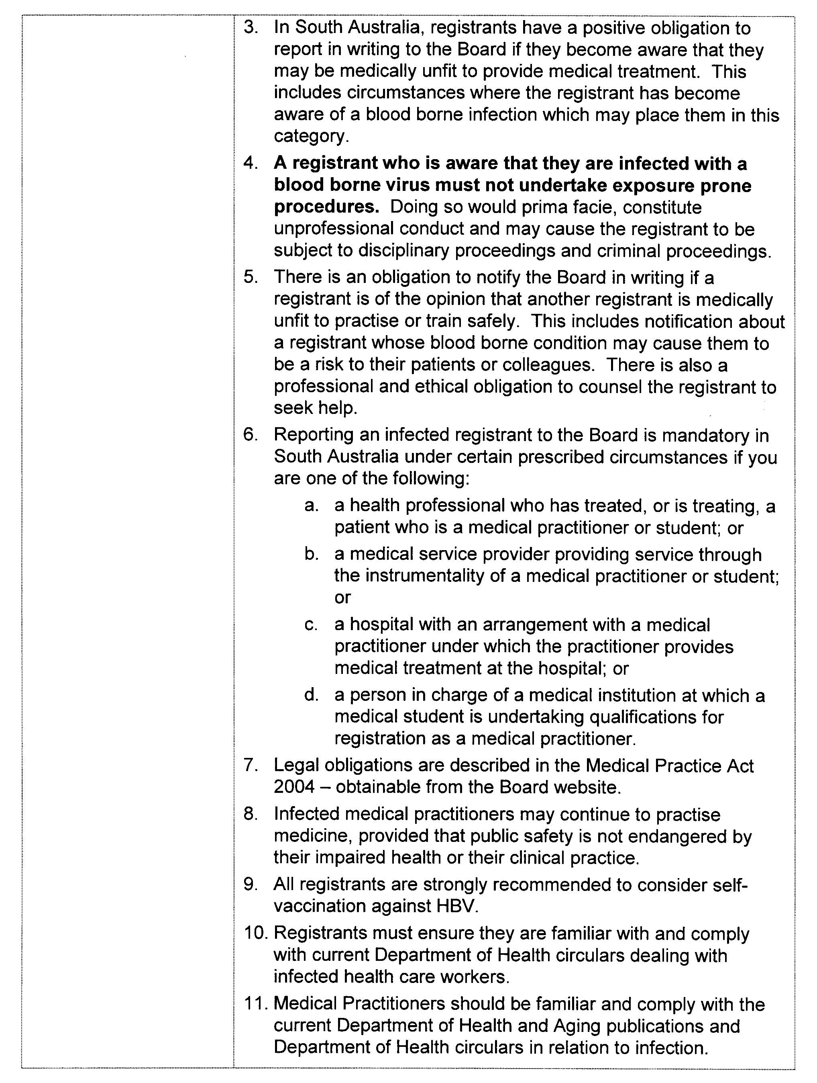
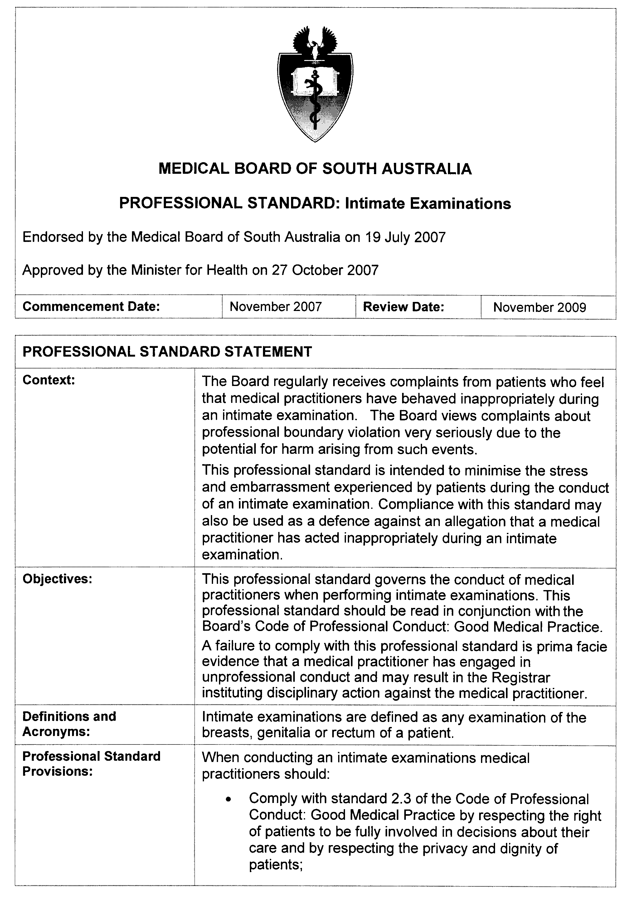
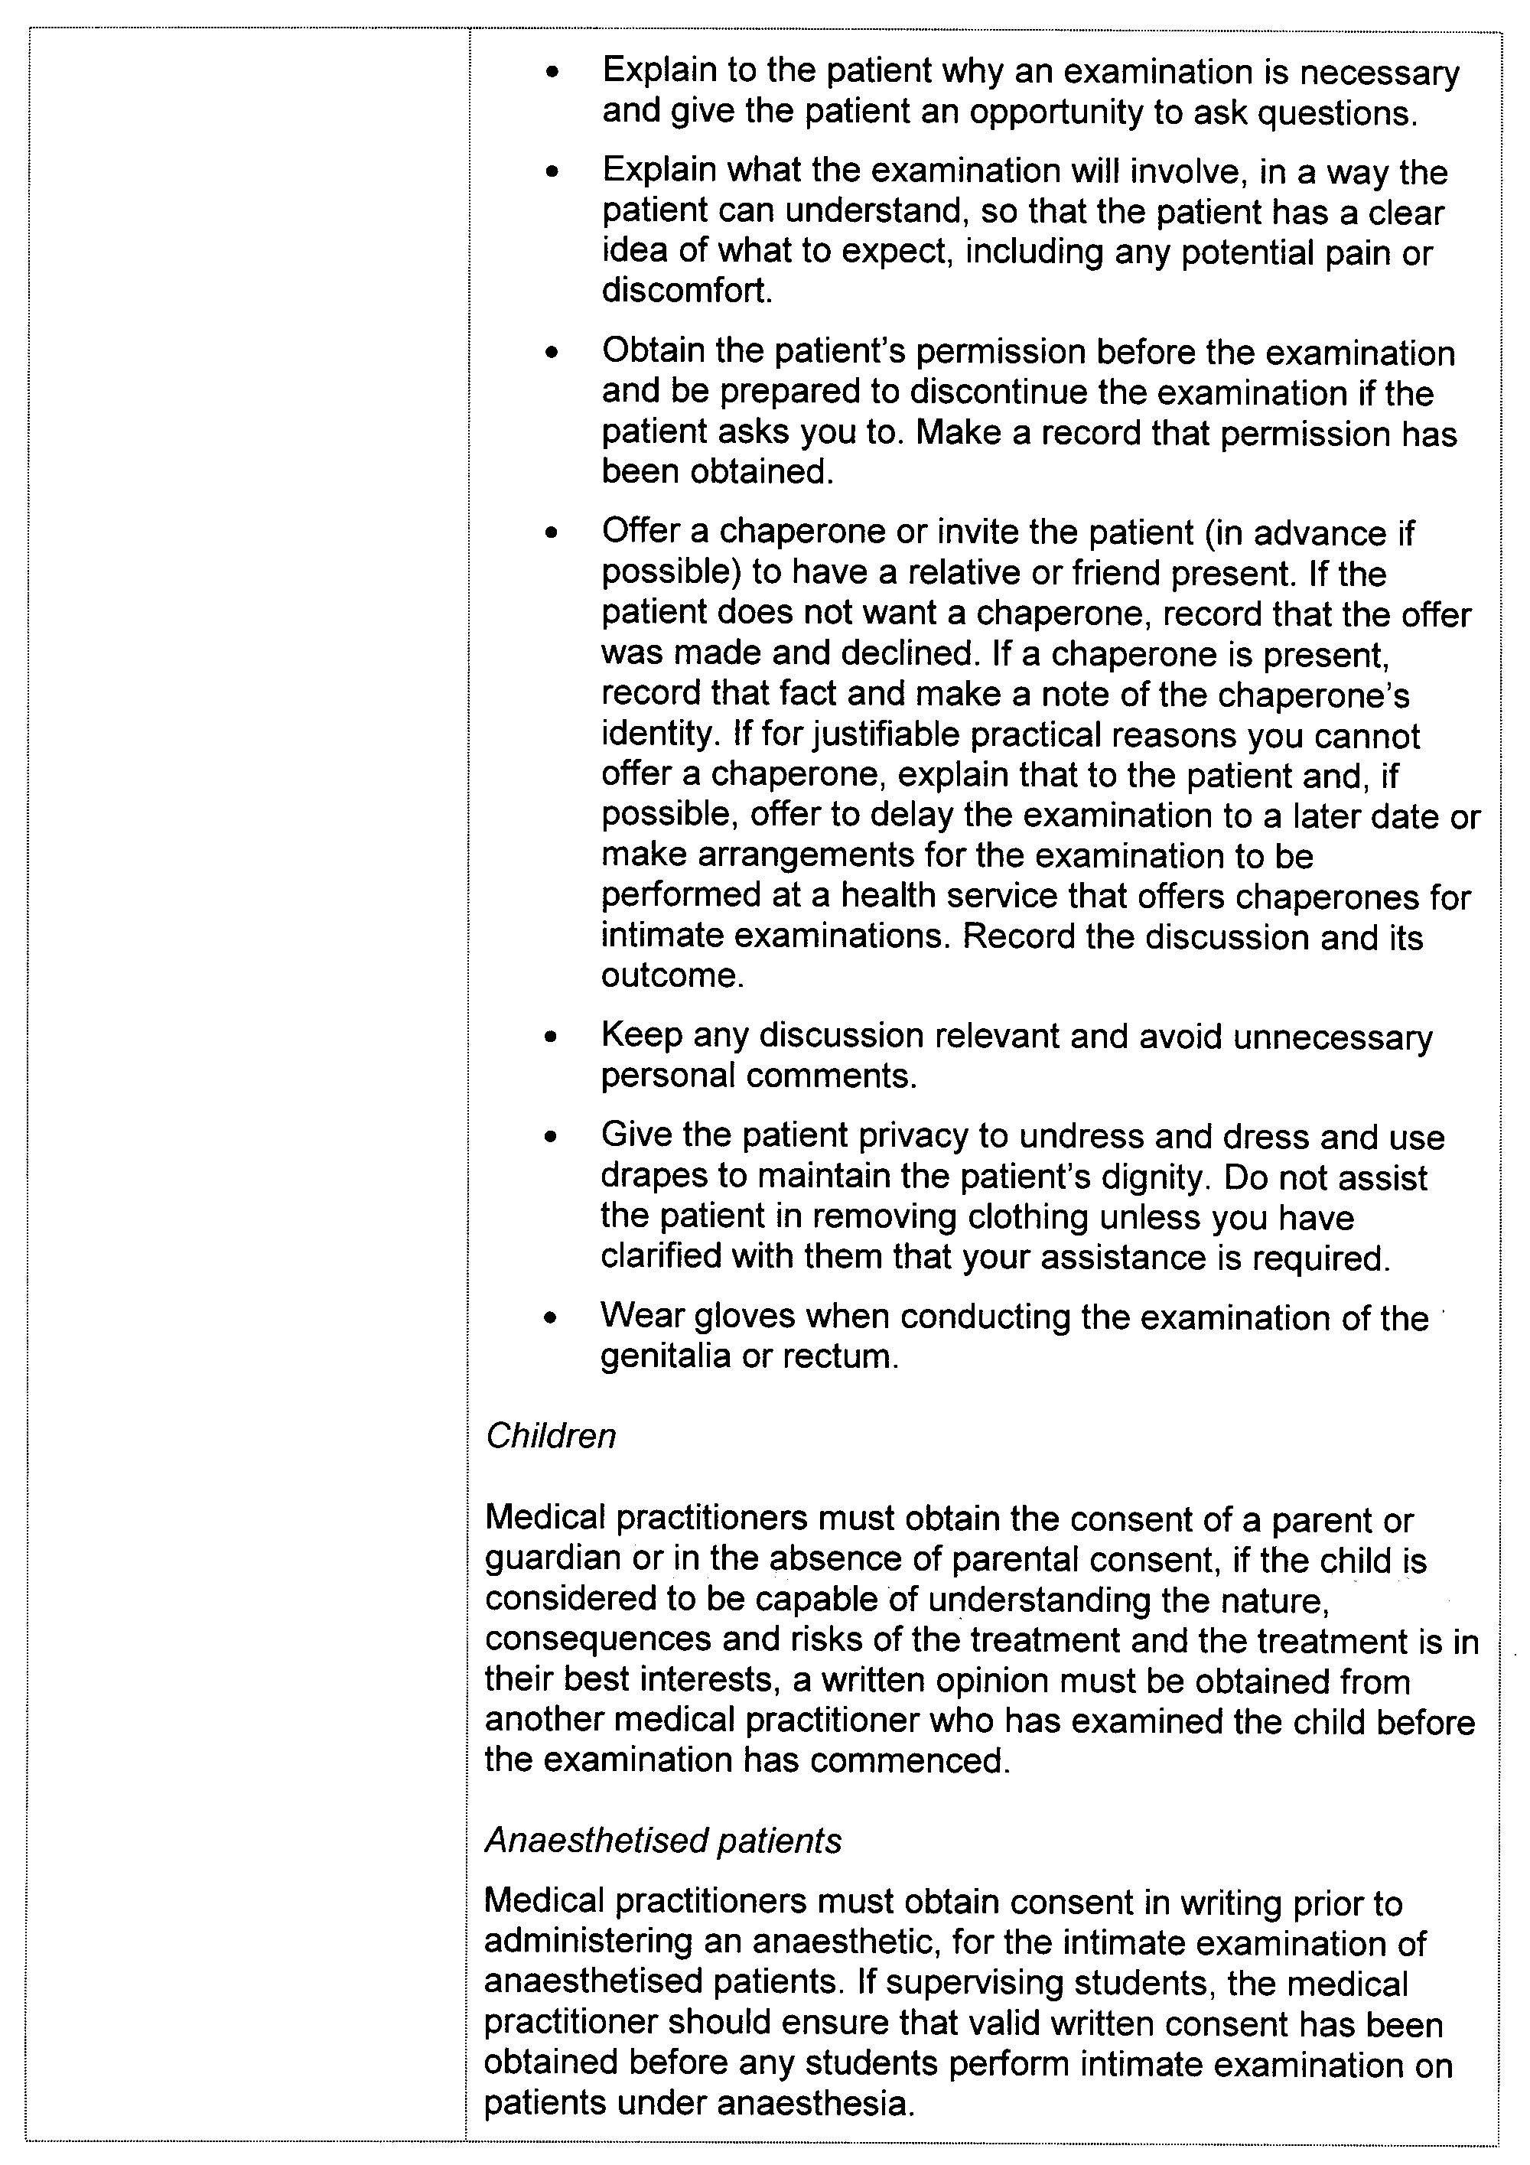

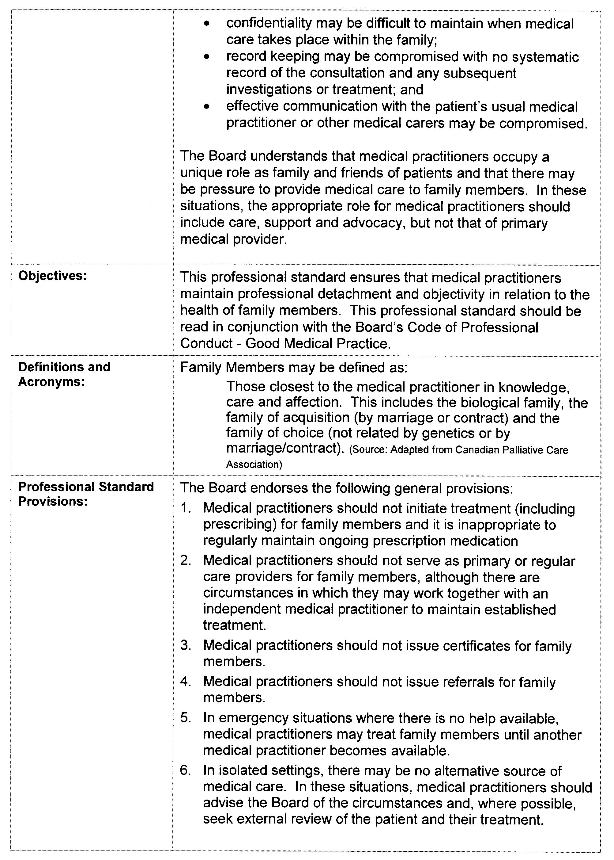
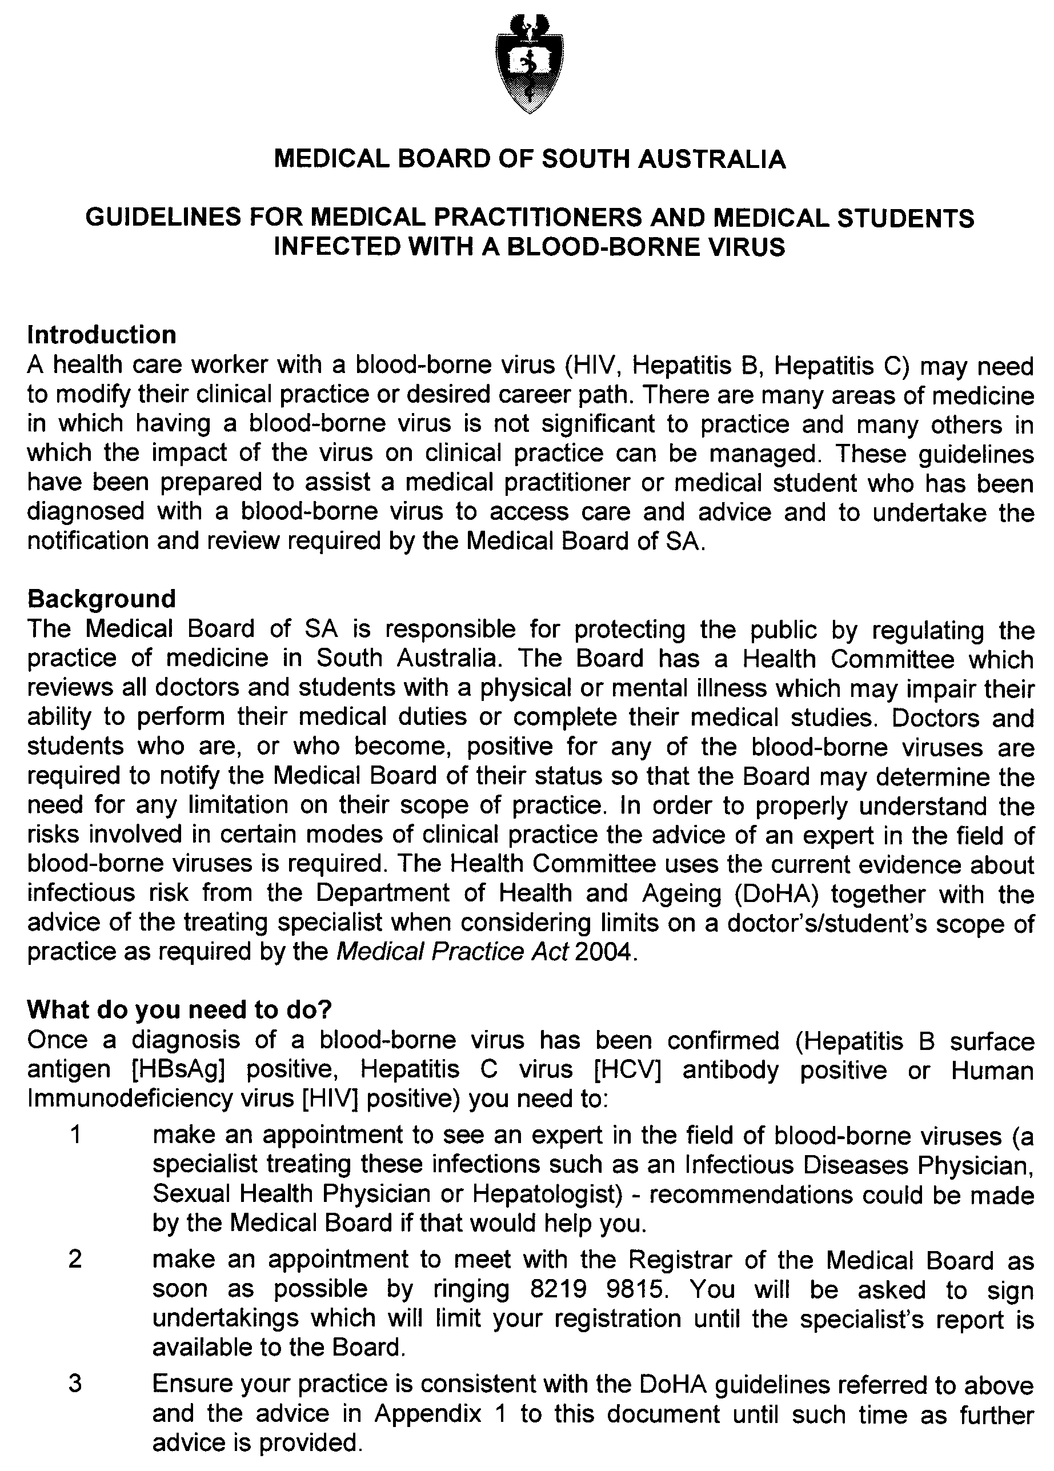
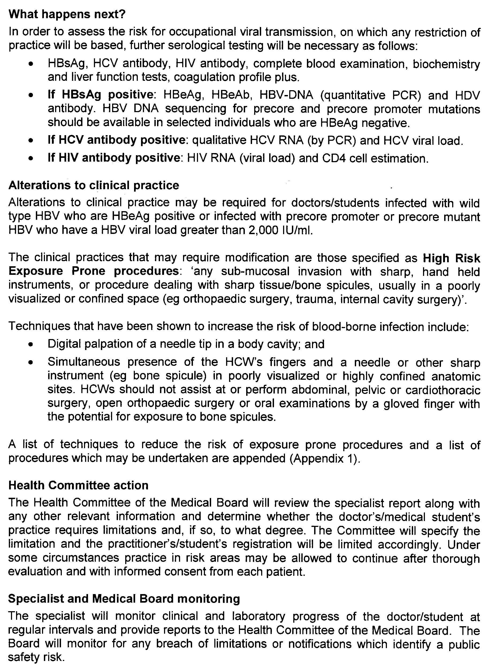
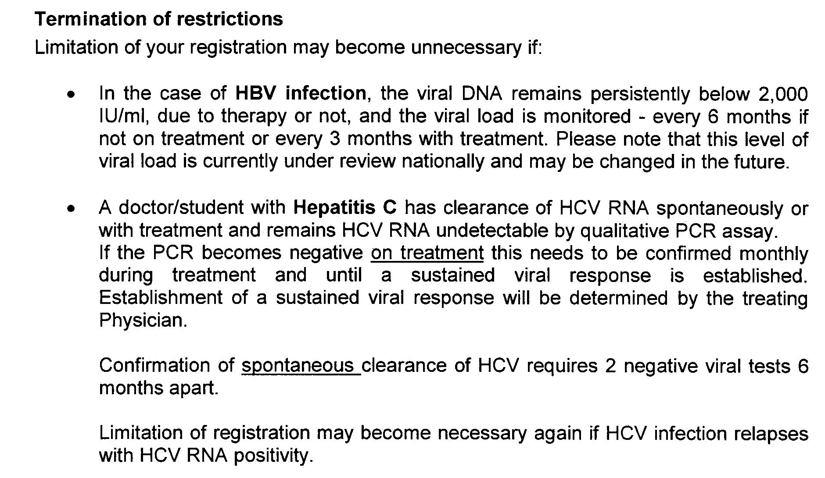
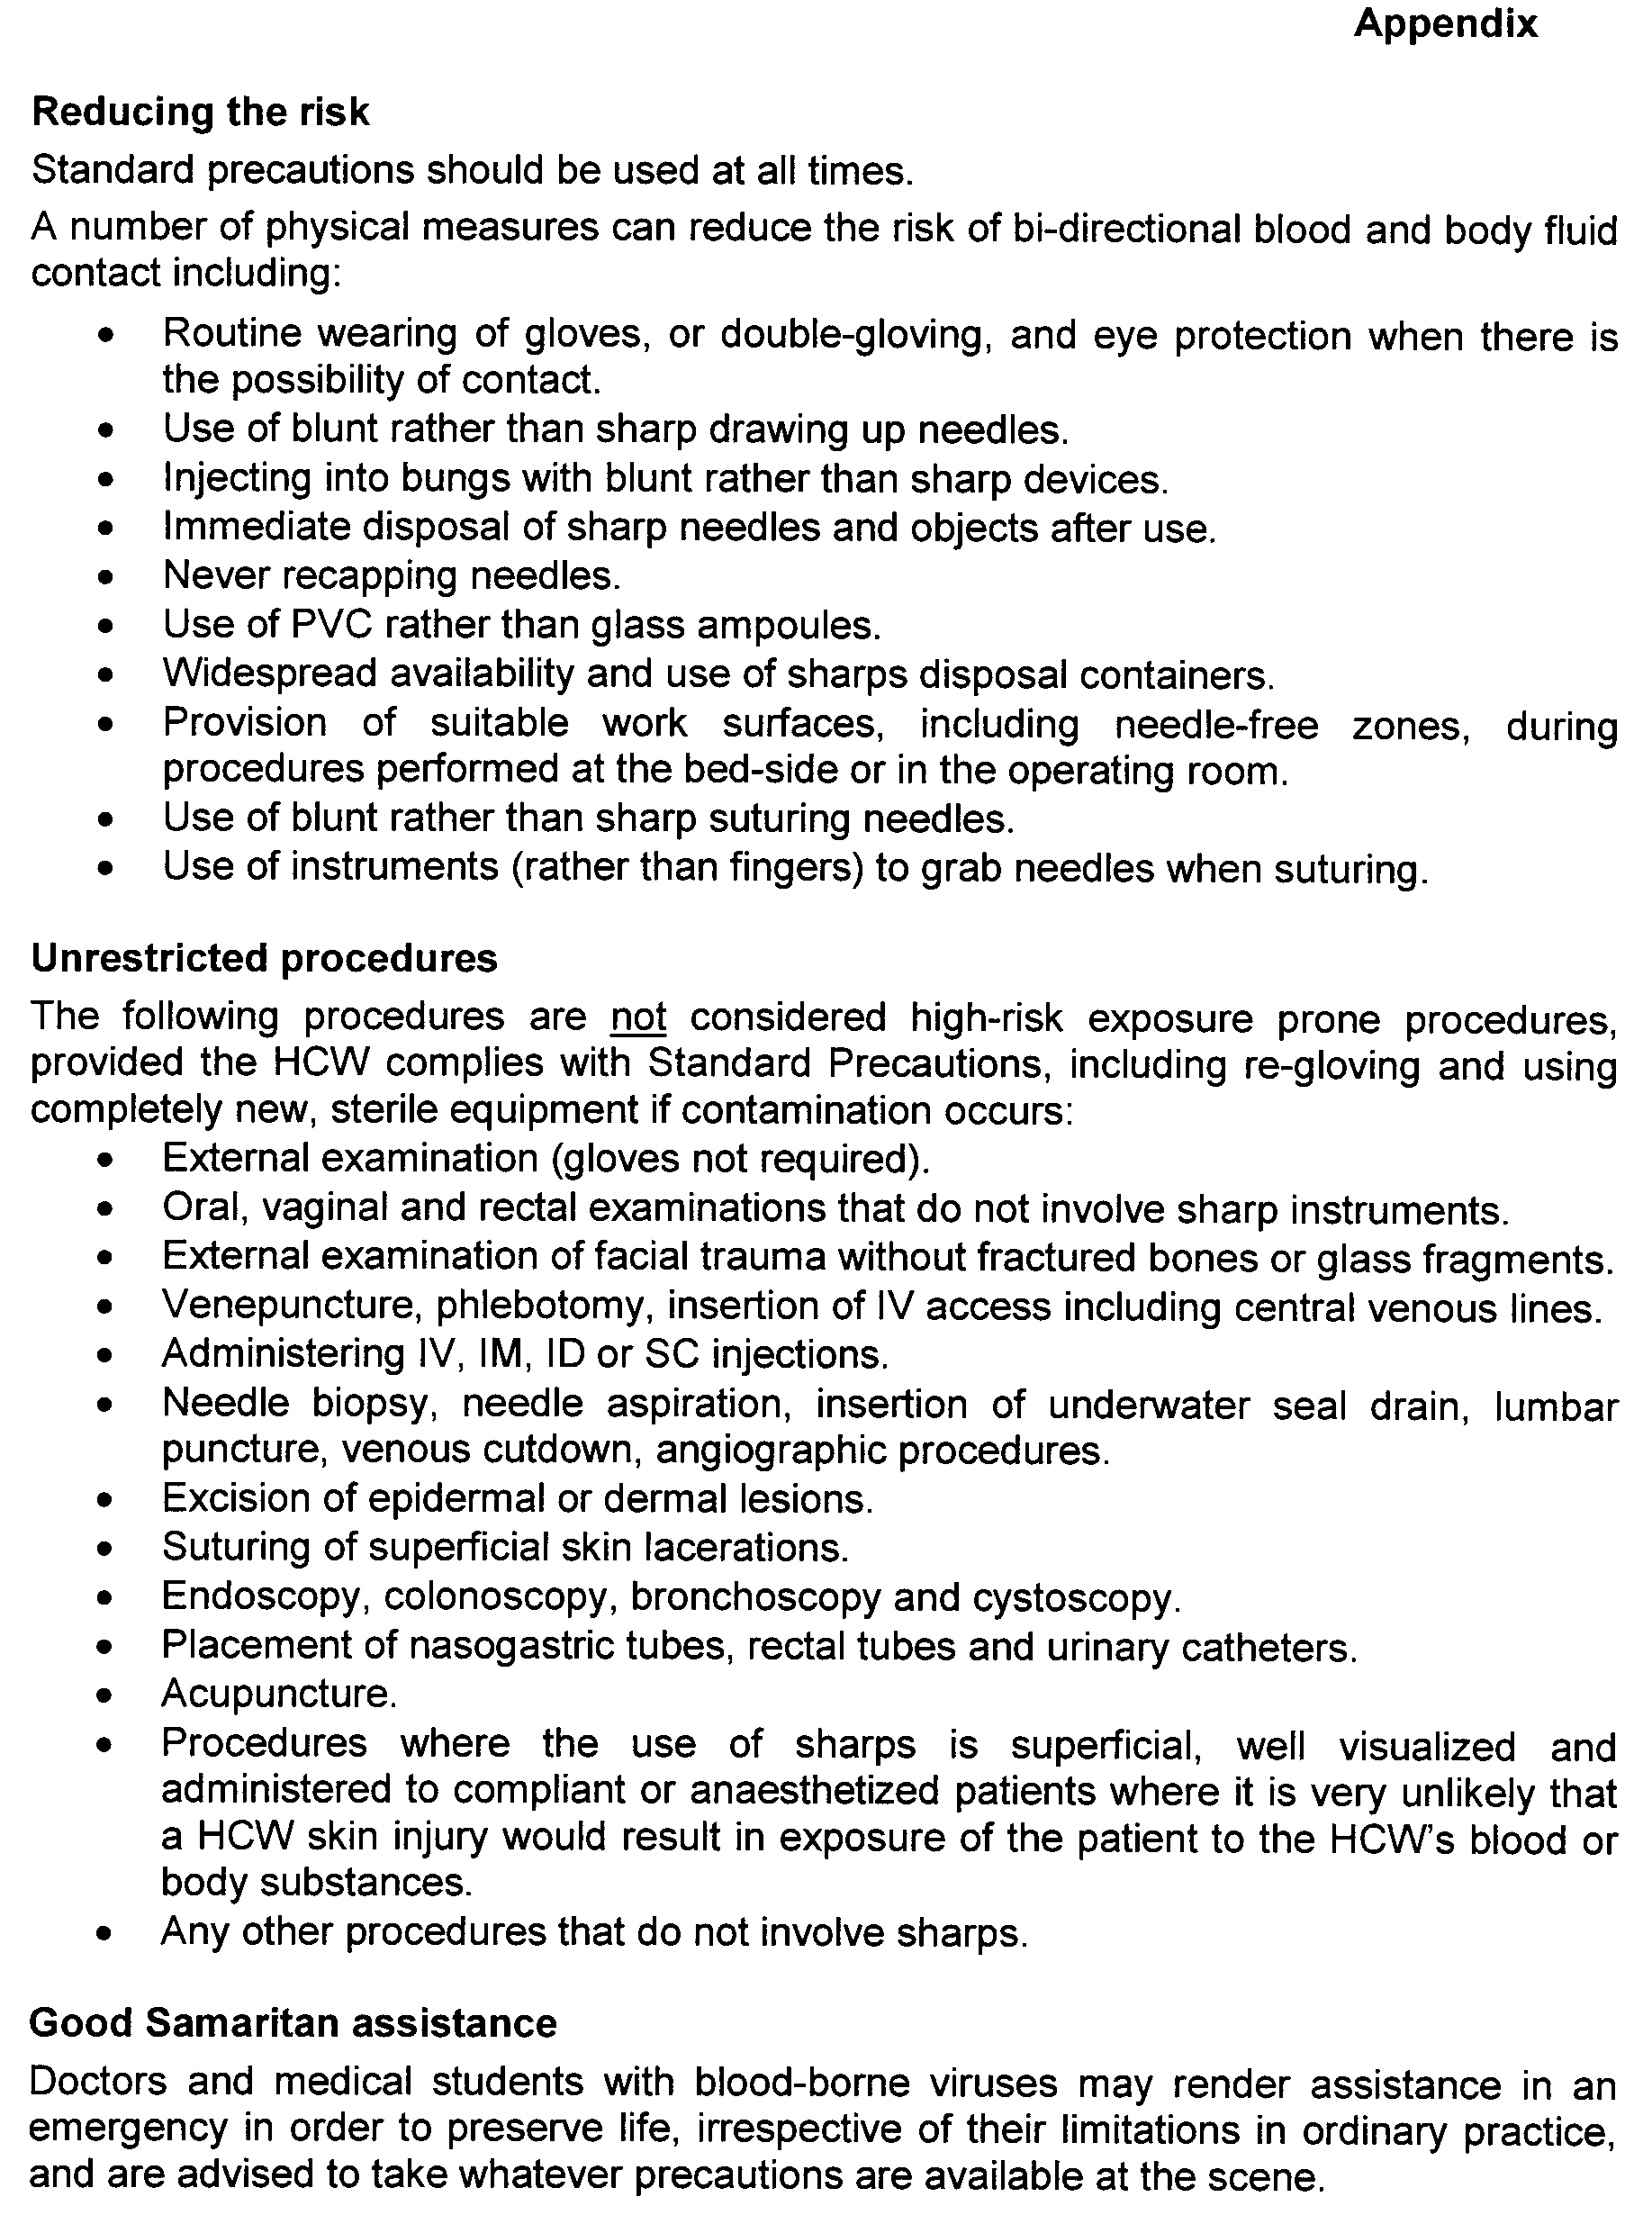



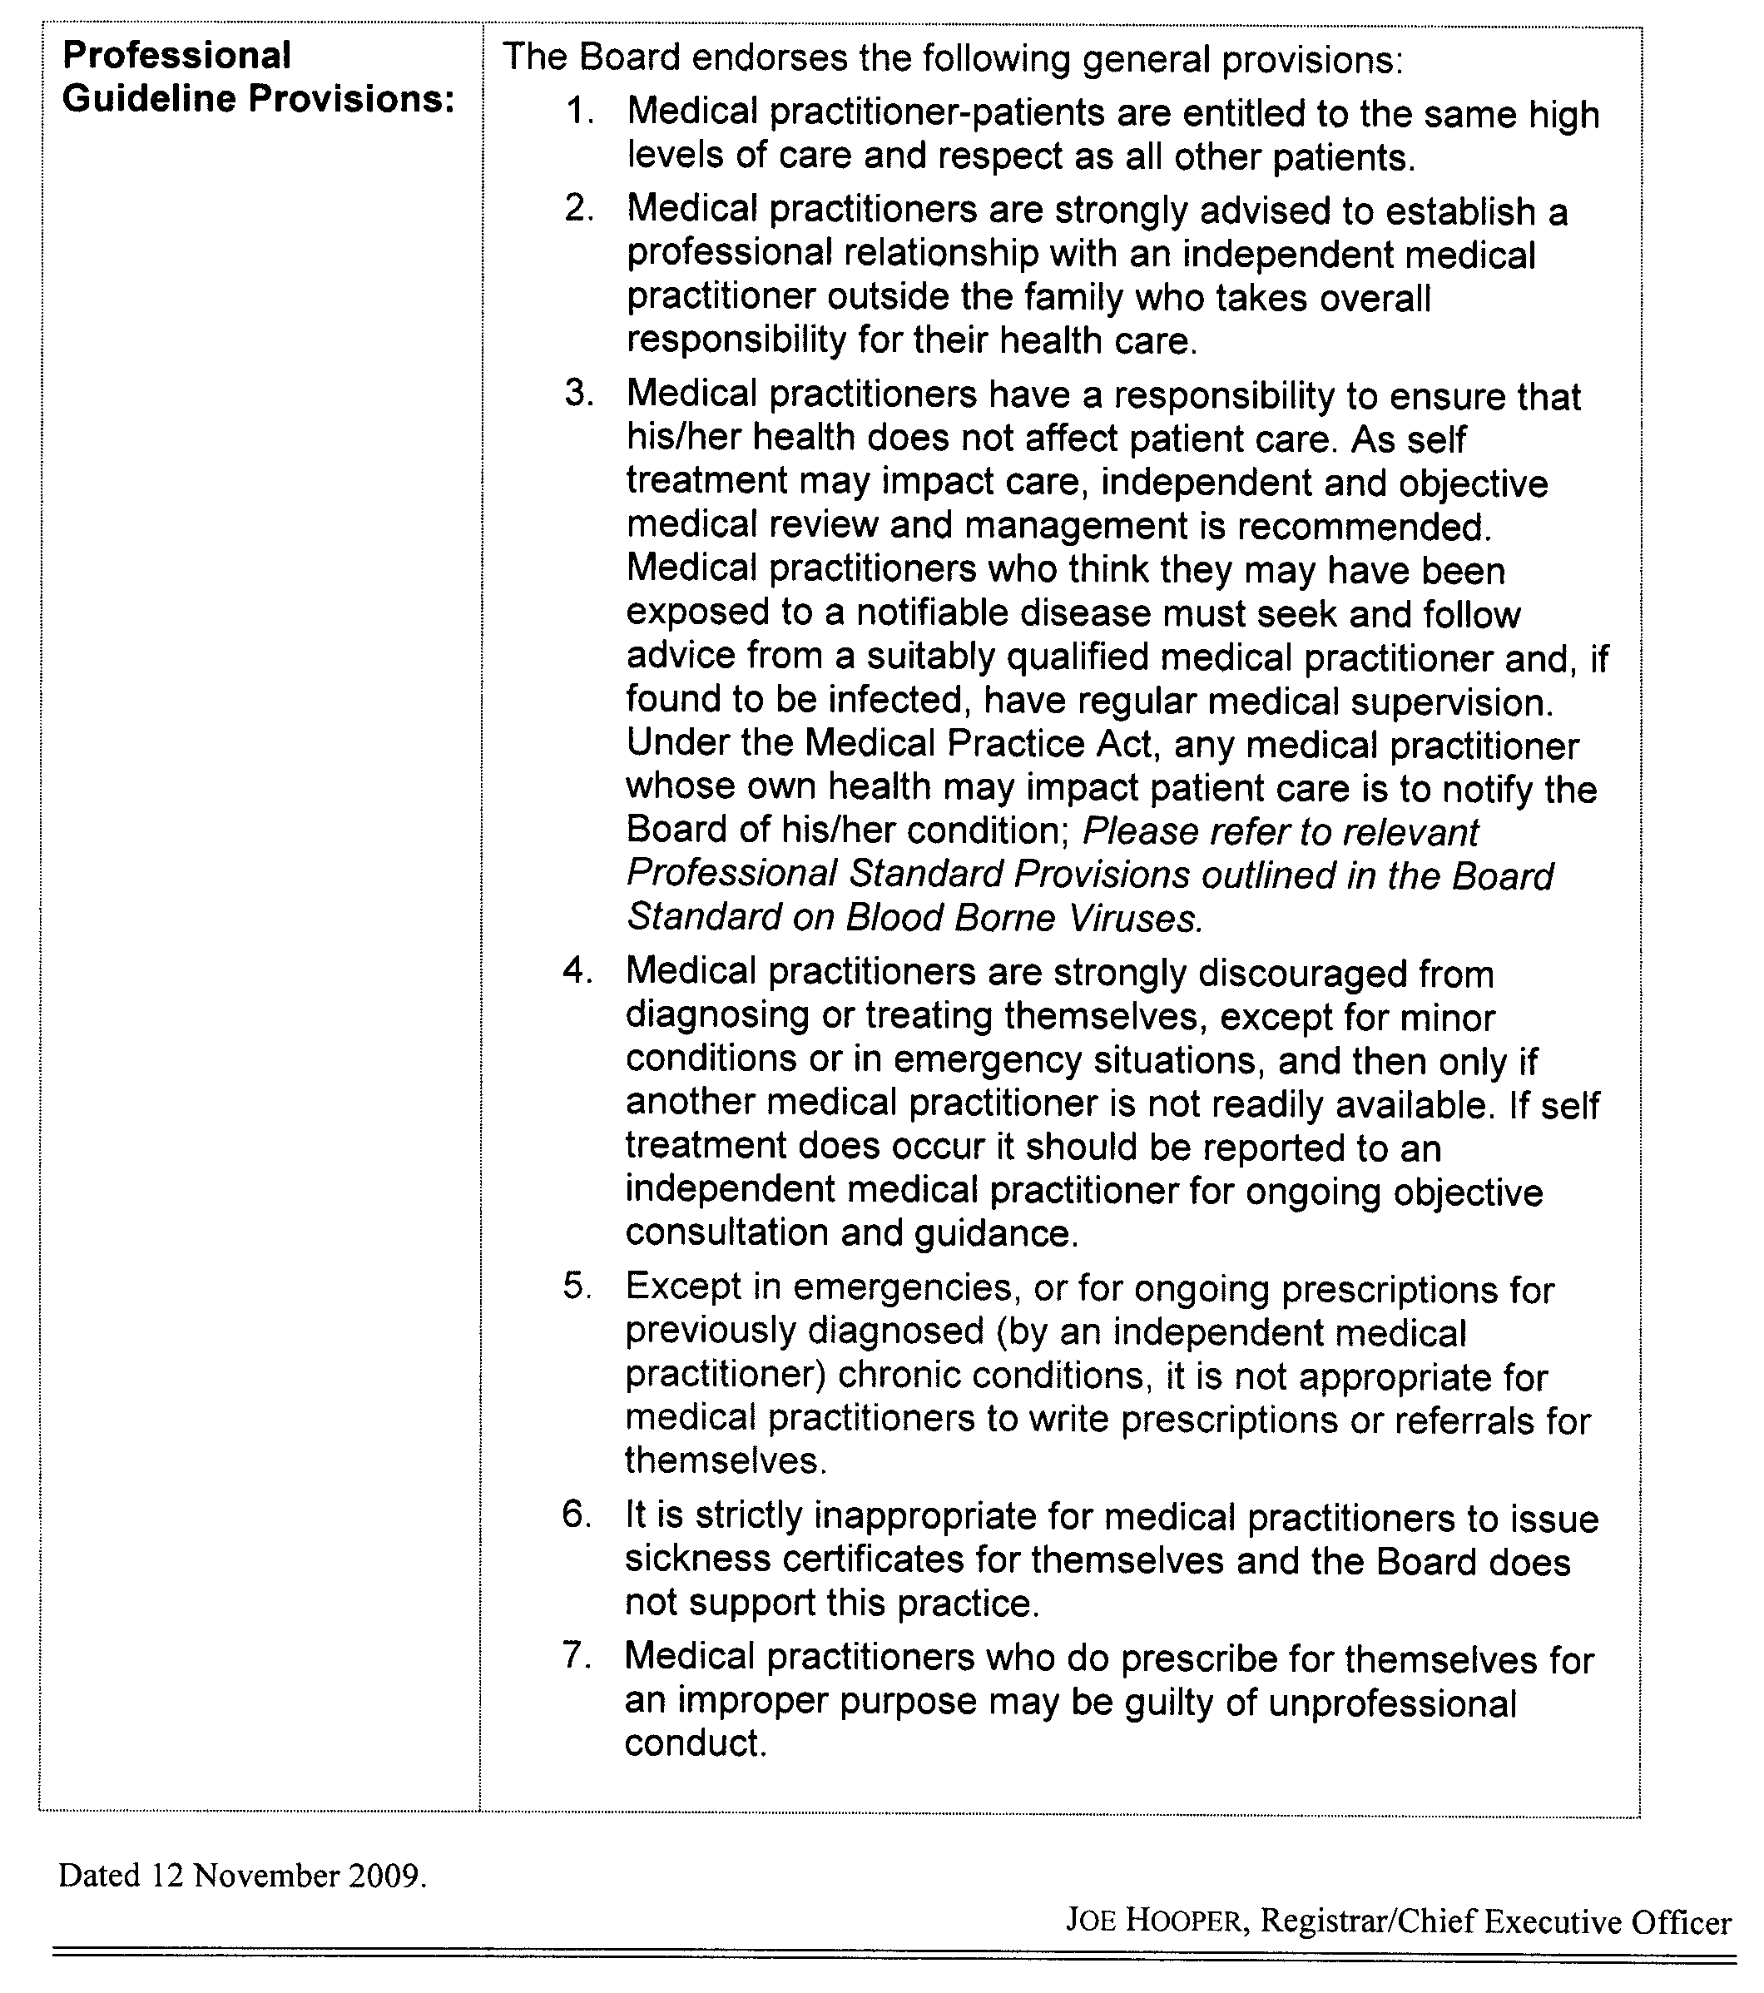
Dated 12 November 2009.
Joe Hooper, Registrar/Chief Executive Officer

Christmas/New Year Holiday Publishing Information

Last Gazette for 2009 will be Wednesday, 23 December 2009.

Closing date for notices for publication will be
4 p.m. Monday, 21 December 2009.

First Gazette for 2010 will be Thursday, 7 January 2010.

Closing date for notices for publication will be
4 p.m. Tuesday, 5 January 2010.

(There will NOT be a Gazette in the period between these two dates.)

It would be appreciated if Government Gazette notices for publication be addressed to:

Email address for Government Gazette notices:

governmentgazette@dpc.sa.gov.au

When sending a document via Email please confirm your transmission with a faxed copy, including the date the notice is to be published.

Facsimile transmission of notices:
(08) 8207 1040
Attention: Government Gazette Section

Inquiries telephone: 8207 1045

AusDoc subscribers:

Government Publishing SA
DX 56508

Postal address:

Government Publishing SA
Box 9
Plaza Level
Riverside Centre
North Terrace, Adelaide, S.A. 5000

MINING ACT 1971
NOTICE is hereby given in accordance with section 28 (5) of the Mining Act 1971, that the Minister for Mineral Resources Development proposes to grant an Exploration Licence over the undermentioned area:
Applicant: Pontifex Holdings Pty Ltd
Location: Verran area—Approximately 40 km south-west of Cowell.
Term: 1 year
Area in km²: 812
Ref.: 2009/00118
Plan and co-ordinates can be found on the PIRSA website: http://www.pir.sa.gov.au/minerals/public_notices or by phoning Mineral Tenements on (08) 8463 3103.
S. Watson, Mining Registrar

MINING ACT 1971
NOTICE is hereby given in accordance with section 28 (5) of the Mining Act 1971, that the Minister for Mineral Resources Development proposes to grant an Exploration Licence over the undermentioned area:
Applicant: Lynch Mining Pty Ltd
Location: Mount Hope area—Approximately 80 km north-west of Port Lincoln.
Term: 1 year
Area in km²: 235
Ref.: 2009/00335
Plan and co-ordinates can be found on the PIRSA website: http://www.pir.sa.gov.au/minerals/public_notices or by phoning Mineral Tenements on (08) 8463 3103.
S. Watson, Mining Registrar

MINING ACT 1971
NOTICE is hereby given in accordance with section 28 (5) of the Mining Act 1971, that the Minister for Mineral Resources Development proposes to grant an Exploration Licence over the undermentioned area:
Applicant: Havilah Resources NL
Location: Billeroo West area—Approximately 100 km north of Olary.
Pastoral Leases: Frome Downs, Quinyambie, Billeroo West, Benagerie.
Term: 1 year
Area in km²: 176
Ref.: 2009/00337
Plan and co-ordinates can be found on the PIRSA website: http://www.pir.sa.gov.au/minerals/public_notices or by phoning Mineral Tenements on (08) 8463 3103.
S. Watson, Mining Registrar

MINING ACT 1971
Invitation to Submit Exploration Licence Applications
NOTICE is hereby given that the Minister for Mineral Resources Development will be considering Exploration Licence applications over the undermentioned areas. Applications will be received for a period of four weeks from 12 November 2009, up to and including the closing date of 11 December 2009.
Each application must quote the reference number for the area, and must incorporate the whole of the area (as specified below):
Area 1
Ref.: T02770
Location: Pallatu area—Approximately 390 km west-north-west of Marla.
Area: 12 km²
Area 2
Ref.: T02771
Location: East Deering Hills area—Approximately 370 km west-north-west of Marla.
Area: 37 km²
Area 3
Ref.: T02772
Location: Hanging Knoll area—Approximately 340 km west-north-west of Marla.
Area: 34 km²
Area 4
Ref.: T02773
Location: Mount Caroline area—Approximately 310 km west-north-west of Marla.
Area: 46 km²
Applications may be submitted to PIRSA in the following formats:
• SARIG www.pir.sa.gov.au/minerals/sarig; or
• in person at Level 7, 101 Grenfell Street, Adelaide, S.A. 5000, using the application for Mineral Exploration Licence (Form 29); or
• Facsimile using Form 29 to (08) 8463 3101; or
• Emailing Form 29 to pirsa.tenements@sa.gov.au.
Plans and co-ordinates can be found on the PIRSA Sarig website: www.pir.sa.gov.au/minerals/sarig or by phoning Mineral Tenements on (08) 8463 3103.
S. Watson, Mining Registrar

NATIONAL ELECTRICITY LAW
THE Australian Energy Market Commission (AEMC) gives notice under the National Electricity Law of the following matters.
Under sections 102 and 103, the making of the National Electricity Amendment (Confidentiality Provisions for Network Connections) Rule 2009 No. 20 and related final determination. All provisions commence on 12 November 2009.
Under section 95, AEMO has requested the Transparency of Operating Data Rule proposal (Project Ref. ERC0096). The proposal seeks to change the publication timing requirements for National Electricity Market operating data. Submissions must be received by 14 December 2009.
Submissions on this proposal can be lodged online via the AEMC’s website at www.aemc.gov.au. Before submitting your submission, you must review the AEMC’s privacy collection statement on its website.
Submissions should be submitted in accordance with the AEMC’s Guidelines for making written submissions on Rule change proposals. The AEMC publishes all submissions on its website subject to a claim of confidentiality.
All documents in relation to the above matters are published on the AEMC’s website and are available for inspection at the offices of the AEMC.
John Tamblyn
Chairman
Australian Energy Market Commission
Level 5, 201 Elizabeth Street
Sydney, N.S.W. 2000
Telephone: (02) 8296 7800
Facsimile: (02) 8296 7899
12 November 2009.

PETROLEUM AND GEOTHERMAL ENERGY ACT 2000
Statement of Environmental Objectives for
Existing Regulated Activities
PURSUANT to section 104 (1) of the Petroleum and Geothermal Energy Act 2000 (the Act) I, Michael Malavazos, Acting Director, Petroleum and Geothermal, Minerals and Energy Resources Division, Department of Primary Industries and Resources SA, Delegate of the Minister for Mineral Resources Development, pursuant to Delegation dated 28 March 2002, Gazetted 11 April 2002, do hereby publish the following document as having been approved as a statement of environmental objectives under the Act:
Document:
1. Statement of Environmental Objectives: Pipeline Licence Nos 3 and 4, October 2009.
This document is available for public inspection on the Environmental Register section of the Petroleum and Geothermal Group’s website (www.pir.sa.gov.au/petrol/envreg) or at the Public Office determined, pursuant to section 107 (1) of the Act to be at:
Office of Minerals and Energy Resources
Customer Services
Level 7, 101 Grenfell Street
Adelaide, S.A. 5000
Dated 5 November 2009.
M. Malavazos,
Acting Director Petroleum and Geothermal
Delegate of the Minister for Mineral
Resources Development

PETROLEUM AND GEOTHERMAL ENERGY ACT 2000
Application for Grant of Associated Activities Licence—AAL 154
PURSUANT to section 65 (6) of the Petroleum and Geothermal Energy Act 2000 (the Act) and Delegation dated 1 October 2009, notice is hereby given that an application for the grant of an Associated Activities Licence over the area described below has been received from Beach Petroleum Limited and Cooper Energy Limited.
Description of Application Area
A 50 m buffer around line segments defined by the following pairs of co-ordinates (MGA Zone 54, GDA94), adjacent to Petroleum Exploration Licence PEL 92 in the State of South Australia:
From To
352393mE, 6898679mN 355958mE, 6898658mN
351409mE, 6901258mN 352231mE, 6901247mN
Area: 0.437 km² approximately.
Dated 10 November 2009.
C. D. Cockshell,
Acting Director Petroleum and Geothermal
Minerals and Energy Resources
Primary Industries and Resources SA
Delegate of the Minister for Mineral
Resources Development

ROADS (OPENING AND CLOSING) ACT 1991:
SECTION 34
ORDER BY THE MINISTER TO CLOSE ROAD
Public Road, Glenside
BY an Order made on 23 July 2009 under sections 6 and 34 of the Roads (Opening and Closing) Act 1991, the Minister for Infrastructure ordered that the whole of the unnamed public road situate adjoining Fullarton Road and between pieces 737 and 738 in Deposited Plan 55725 be closed.
Vest in the Crown the whole of the land subject to closure.
The following easements are granted over the road closed by this order:
Grant an easement with a full free and unrestricted right and liberty for the Grantee and its agents servants workmen and contractors with plant and equipment with or without vehicles from time to time and at all times hereafter to enter and remain upon and to break the surface of dig open up and repair and to construct and maintain a pedestrian and cycle pathway to be held appurtenant to the Minister for Mental Health and Substance Abuse.
Grant a free and unrestricted right and liberty from time to time and at all times hereafter for the Grantee and its servants agents contractors lessees licensees invitees (including but not limited to the general public at large) visitors and other persons authorised by the Grantee and other persons claiming through the Grantee in common with the Grantor to pass and repass on foot and by non motorised cycle (and with the exception of motorised vehicles other than motorised vehicles used by persons for genuine medical (including aged and disabled mobility) purposes) to be held appurtenant to the Minister for Mental Health and Substance Abuse.
On 31 August 2009 that order was confirmed by the Minister for Infrastructure conditionally upon the deposit by the Registrar-General of Deposited Plan 81124 being the authority for the new boundaries.
Notice of the Order is hereby published in accordance with section 34 (7) of the said Act.
Dated 12 November 2009.
P. M. Kentish, Surveyor-General
DTEI 08/0087

ROADS (OPENING AND CLOSING) ACT 1991:
SECTION 24
NOTICE OF CONFIRMATION OF ROAD
PROCESS ORDER
Road Closure
Mottled Cove Road, Port Neill
BY Road Process Order made on 29 September 2009, The District Council of Tumby Bay ordered that:
1. Portion of the public road (southern end of Mottled Cove Road) situate adjoining section 172, Hundred of Dixson, more particularly delineated and lettered ‘A’ in Preliminary Plan No. 07/0065 be closed.
2. The whole of the land subject to closure be transferred to Murray Fredrick Mason in accordance with agreement for transfer dated 10 December 2007 entered into between The District Council of Tumby Bay and M. F. Mason.
On 22 October 2009 that order was confirmed by the Minister for Infrastructure conditionally upon the deposit by the Registrar-General of Deposited Plan 82102 being the authority for the new boundaries.
Pursuant to section 24 (5) of the Roads (Opening and Closing) Act 1991, NOTICE of the order referred to above and its confirmation is hereby given.
Dated 12 November 2009.
P. M. Kentish, Surveyor-General

ROAD TRAFFIC ACT 1961
Authorised Officers to Conduct Breath Analysis
I, MALCOLM ARTHUR HYDE, Commissioner of Police, pursuant to section 47K (3) (a) of the Road Traffic Act 1961, do hereby certify that on 3 November 2009, the following police officers were authorised to conduct breath analysis:

PD  Number | Officer Name
81764 | Brown, Garreth Quentin
73517 | Dunleavy, George Bernard
77910 | Hall, Marie Astrid
72611 | Henderson, David Craig
79894 | McNamara, Julie Anne
73364 | McNicol, Bryony Jeanne
72091 | Oats, Craig Roger
41131 | O’Donnell, Melanie
72642 | Prior, Lenae Chantelle
72300 | Rowbottom, Teegan Kate
39833 | Vasey, Jason Corey
73248 | Whiting, Katie Louise
Dated 3 November 2009.
Malcolm Arthur Hyde, Commissioner of Police

TRADE STANDARDS ACT 1979
Discretionary Exemption
TAKE notice that I, Gail Gago, Minister for Consumer Affairs in the State of South Australia, do hereby exempt the goods named in Schedule 1 below from the Declaration of Dangerous Goods previously made and described in Schedule 2 below, pursuant to Part 7, section 36 (1) (b) and (c) of the Trade Standards Act 1979.
Schedule 1
Expanding novelty toy known as ‘Hatching Eggs Komodo Dragon’, Item No. AEGG03KD. The ‘Hatching Eggs Komodo Dragon’ toys are characterised by clear packaging containing the toy inside a dissolvable egg.
Schedule 2
The goods described in Schedule 1 above are exempt from the requirements of the Declaration of Dangerous Goods signed by the Minister for Consumer Affairs on 9 August 1990 and published in the Government Gazette of 30 August 1990.
Dated 26 October 2009.
Gail Gago, Minister for Consumer Affairs

WILDERNESS PROTECTION ACT 1992
Erratum
Proposal to Proclaim the Nutys Archipelago and the Investigator Group of Islands Wilderness Protection Areas
NOTICE published in the Government Gazette on Thursday, 5 November 209 on page 5091, under the heading ‘WILDERNESS PROTECTION ACT 1992—Proposal to Proclaim . . .’ should have declared the gazettal date as 30 October 2009 not 30 November 2009.
Dated 12 November 2009.
Jay Weatherill, Minister for Environment and Conservation

WATER MAINS AND SEWERS

Office of the South Australian Water Corporation
Adelaide, 12 November 2009

WATER MAINS LAID

Notice is hereby given that the following main pipes or parts of main pipes have been laid down by the South Australian Water Corporation in or near the undermentioned water districts and are now available for a constant supply of water to adjacent land.

ADELAIDE WATER DISTRICT

ADELAIDE CITY COUNCIL
Easements in section 6021, hundred of Adelaide, Greenhill Road, Adelaide. p10 and 11
Across Sir Lewis Cohen Avenue, Adelaide. p10

CAMPBELLTOWN CITY COUNCIL
Michele Road, Paradise. p42
Ottavio Court, Paradise. p42

CITY OF MARION
Bowaka Street, Park Holme. p54
CITY OF PLAYFORD
In and across Mayfair Drive, Andrews Farm. p14
Easement in lot 6000 in LTRO DP 81697, Oxford Drive, Andrews Farm. p14
Bright Court, Andrews Farm. p14
Concord Way, Andrews Farm. p14
Across and in Discovery Way, Andrews Farm. p14
Easement in lot 5001 in LTRO DP 81696, Discovery Way, Andrews Farm. p14
Oxford Drive, Andrews Farm. p15
Easement in lot 6000 in LTRO DP 81697, Oxford Drive, Andrews Farm. p15
In and across East Parkway, Andrews Farm. p16
Chambri Lane, Andrews Farm. p16
Hume Street, Andrews Farm. p16
In and across Ontario Crescent, Andrews Farm. p16 and 17
Willandra Close, Andrews Farm. p16
In and across Alexandrina Crescent, Andrews Farm. p16
Lonsdale Crescent, Andrews Farm. p17
St. Clair Avenue, Andrews Farm. p17
In and across Andrews Road, MacDonald Park and Andrews Farm. p18 and 19
In and across West Parkway, Andrews Farm. p18 and 21
Easements in lot 1005 in LTRO DP 80683, Andrews Road, Andrews Farm. p21 and 20
Semillon Crescent, Andrews Farm. p18
Easements in lot 1006 in LTRO DP 80683, Andrews Road, Andrews Farm. p18 and 21
Chateau Avenue, Andrews Farm. p18 and 19
Langhorne Street, Andrews Farm. p18
Eden Lane, Andrews Farm. p19
In and across Esperance Drive, Andrews Farm. p21
In and across Coonawarra Avenue, Andrews Farm. p20
Oregon Avenue, Andrews Farm. p20
Rothbury Street, Andrews Farm. p19
Heaslip Road, Direk. p24-26
Across Sullivan Road, Elizabeth Park. p30
North Way, Elizabeth Park. p30
Across Bowman Street, Elizabeth Park. p30

CITY OF PORT ADELAIDE ENFIELD
Maloja Street, Osborne. p3
Sir Keith Smith Drive, North Haven. p38 and 39
Across and in Mersey Road, Osborne. p40 and 41
Annie Watt Circuit, Osborne. p40 and 41
Nelcebee Street, Osborne. p41

CITY OF SALISBURY
Walpole Road, Paralowie. p6
Julian Court, Paralowie. p6
Melvina Road, Paralowie. p6
Heaslip Road, Direk. p26
Edinburgh Road, Direk. p26
In and across Mirage Road, Direk. p26 and 27
Easements in lot 1000 in LTRO DP 80770, Mirage Road, Direk. p27 and 29
In and across Caribou Drive, Direk. p27 and 28
Orion Road, Direk. p28 and 29
Across Princess Street, Paralowie. p43
Amelia Court, Paralowie. p43

CITY OF TEA TREE GULLY
In and across Captain Robertson Avenue, Golden Grove. p31
In and across Tuscan Road, Golden Grove. p31 and 32
In and across Hallett Road, Golden Grove. p32
Clinker Circuit, Golden Grove. p32

BEETALOO COUNTRY LANDS WATER DISTRICT

DISTRICT COUNCIL OF THE COPPER COAST
Ramsey Street, Jerusalem. p33 and 34
Dangerfield Street, Jerusalem. p34
Across and in Archer Road, Port Hughes. p48
In and across Retallick Road, Moonta and Kooroona. p49 and 50

CALLINGTON WATER DISTRICT

DISTRICT COUNCIL OF MOUNT BARKER
Hannam Street, Callington. p53

GOOLWA WATER DISTRICT

ALEXANDRINA COUNCIL
Golding Street, Goolwa Beach. p7

KANMANTOO WATER DISTRICT

DISTRICT COUNCIL OF MOUNT BARKER
Young Road, Kanmantoo. p8

KANMANTOO COUNTRY LANDS WATER DISTRICT

DISTRICT COUNCIL OF MOUNT BARKER
Back Callington Road, Callington. p2

MOONTA WATER DISTRICT

DISTRICT COUNCIL OF THE COPPER COAST
Chapman Road, Moonta Bay. p9
Easements in allotment piece 42 in LTRO DP 31023, Moonta-Maitland Road, Moonta. p50 and 51
Across and in Moonta-Maitland Road, Moonta. p51

MUNDALLIO COUNTRY LANDS WATER DISTRICT

PORT AUGUSTA CITY COUNCIL
Kelly Court, Stirling North. p52
Ruby Court, Stirling North. p52

PORT AUGUSTA WATER DISTRICT

PORT AUGUSTA CITY COUNCIL
In and across Maule Avenue, Stirling North. p52

PORT HUGHES WATER DISTRICT

DISTRICT COUNCIL OF THE COPPER COAST
In and across South Terrace, Port Hughes. p44
Easements in lots 318 and 319, South Terrace, Port Hughes. p44
Easements in lot 3043 in LTRO DP 81800, South Terrace, Port Hughes. p44
In and across St Andrews Drive, Port Hughes. p45-48
Birdie Street, Port Hughes. p45
Eagle Street, Port Hughes. p45
Matchplay Court, Port Hughes. p46
Callaway Court, Port Hughes. p46
Stroke Court, Port Hughes. p47
Stableford Court, Port Hughes. p48

TOD RIVER COUNTRY LANDS WATER DISTRICT

DISTRICT COUNCIL OF LOWER EYRE PENINSULA
Howard Avenue, Boston. p1

TWO WELLS WATER DISTRICT

DISTRICT COUNCIL OF MALLALA
Cannizzaro Road, Lewiston. p35-37

WALLAROO WATER DISTRICT

DISTRICT COUNCIL OF THE COPPER COAST
Millsteed Street, Wallaroo. p4

WALLAROO MINES WATER DISTRICT

DISTRICT COUNCIL OF THE COPPER COAST
Champion Street, Jerusalem. p33
Ramsey Street, Jerusalem. p33
Lukeman Street, Jerusalem. p33

WATER MAINS ABANDONED

Notice is hereby given that the undermentioned water mains have been abandoned by the South Australian Water Corporation.

ADELAIDE WATER DISTRICT

ADELAIDE CITY COUNCIL
Easements in section 6021, hundred of Adelaide, Greenhill Road, Adelaide. p10 and 11
Across Sir Lewis Cohen Avenue, Adelaide. p10

CITY OF PLAYFORD
Mayfair Drive, Andrews Farm. p14
Alexandrina Crescent, Andrews Farm. p16

CITY OF SALISBURY
Melvina Road, Paralowie. p6

BEETALOO COUNTRY LANDS WATER DISTRICT

DISTRICT COUNCIL OF THE COPPER COAST
Retallick Road, Moonta. p49

MOONTA WATER DISTRICT

DISTRICT COUNCIL OF THE COPPER COAST
Chapman Road, Moonta Bay. p9
Across Moonta-Maitland Road, Moonta. p51

PORT HUGHES WATER DISTRICT

DISTRICT COUNCIL OF THE COPPER COAST
South Terrace, Port Hughes. p44

WALLAROO MINES WATER DISTRICT

DISTRICT COUNCIL OF THE COPPER COAST
Champion Street, Jerusalem. p33

WATER MAINS LAID

Notice is hereby given that the undermentioned water mains have been laid down by the South Australian Water Corporation and are not available for a constant supply of water to adjacent land.

BERRI WATERWORKS

OUTSIDE BERRI WATER DISTRICT

THE BERRI BARMERA COUNCIL
In and across Phillips Road, Berri. p22 and 23
Easements in lot 10 in LTRO DP 82211, Phillips Road, Berri. p23

SEWERS LAID

Notice is hereby given that the following sewers have been laid down by the South Australian Water Corporation in the undermentioned drainage area and are now available for house connections.

ADELAIDE DRAINAGE AREA

CAMPBELLTOWN CITY COUNCIL
Wattle Street, Campbelltown. FB 1187 p29

CITY OF CHARLES STURT
Kirra Avenue, West Lakes Shore. FB 1187 p31
Across Nambour Crescent, West Lakes Shore. FB 1187 p31
Varram Way, West Lakes Shore. FB 1187 p32
Kiama Avenue, West Lakes Shore. FB 1187 p32

CITY OF MARION
Bowaka Street, Park Holme. FB 1187 p33

CITY OF PLAYFORD
Discovery Way, Andrews Farm. FB 1186 p56-58
Easement in lot 5001 in LTRO DP 81696, Discovery Way, Andrews Farm. FB 1186 p56-58
In and across Mayfair Drive, Andrews Farm. FB 1186 p56-58
Easement in lot 6000 in LTRO DP 81697, Oxford Drive, Andrews Farm. FB 1186 p56-59
Bright Court, Andrews Farm. FB 1186 p56-58
Concord Way, Andrews Farm. FB 1186 p56-58
Oxford Drive, Andrews Farm. FB 1186 p59
Across East Parkway, Andrews Farm. FB 1188 p1, 2, 4 and 5
Easement in reserve (lot 975) in LTRO DP 80758, East Parkway, Andrews Farm. FB 1188 p1, 2 and 4
Willandra Close, Andrews Farm. FB 1188 p1, 2 and 4
In and across Ontario Crescent, Andrews Farm. FB 1188 p1-4
Across and in Lonsdale Crescent, Andrews Farm. FB 1188 p1, 3, 4 and 5
Across and in St. Clair Avenue, Andrews Farm. FB 1188 p1, 3 and 5
Easements in lot 1052 in LTRO DP 80758, Mendota Avenue, Andrews Farm. FB 1188 p1 and 3-5
In and across Alexandrina Crescent, Andrews Farm. FB 1188 p1, 2, 4 and 5
Hume Street, Andrews Farm. FB 1188 p1, 2, 4 and 5
Chambri Lane, Andrews Farm. FB 1188 p1, 2 and 5
Easement in lot 1051 in LTRO DP 80758, East Parkway. FB 1188 p1, 2 and 5
Alexandrina Crescent, Andrews Farm. FB 1187 p34
Across and in Mendota Avenue, Andrews Farm. FB 1187 p34
Easement in lot 1052 in LTRO DP 80758, Mendota Avenue, Andrews Farm. FB 1187 p34

CITY OF PORT ADELAIDE ENFIELD
Across Malwa Street, Osborne. FB 1187 p24
Maloja Street, Osborne. FB 1187 p24
Stewart Street, Glanville. FB 1187 p30
Across Exmouth Road, Glanville and Exeter. FB 1187 p30

CITY OF WEST TORRENS
River Road, Torrensville. FB 1187 p28

SEWERS ABANDONED

Notice is hereby given that the undermentioned sewers have been abandoned by the South Australian Water Corporation.

ADELAIDE DRAINAGE AREA

CITY OF CHARLES STURT
Kirra Avenue, West Lakes Shore. FB 1187 p31
Across Nambour Crescent, West Lakes Shore. FB 1187 p31
Varram Way, West Lakes Shore. FB 1187 p32
Kiama Avenue, West Lakes Shore. FB 1187 p32

CITY OF PORT ADELAIDE ENFIELD
Stewart Street, Glanville. FB 1187 p30
Across Exmouth Road, Glanville and Exeter. FB 1187 p30

CITY OF WEST TORRENS
River Road, Torrensville. FB 1187 p28

MOUNT GAMBIER COUNTRY DRAINAGE AREA

CITY OF MOUNT GAMBIER
Easement in lot 34 in LTRO DP 64865, Bellevale Court, Mount Gambier. FB 1187 p25

SEWERS LAID

Notice is hereby given that the undermentioned sewer has been laid down by the South Australian Water Corporation and is not available for house connections.

PORT PIRIE COUNTRY DRAINAGE AREA

PORT PIRIE REGIONAL COUNCIL
Sewerage land (section 1174, hundred of Pirie), Gertrude Street, Port Pirie. FB 1187 p26

A. Howe, Chief Executive Officer, South Australian Water Corporation

South Australia
Crown Lands (Land Freed from Trust) Proclamation 2009
under section 5AA(1)(d) of the Crown Lands Act 1929

Preamble
1 The following land is held in trust as a public cemetery:
Section 504, Hundred of Wongyarra, being the whole of the land comprised in Certificate of Title Register Book Volume 5852 Folio 728.
2 No registered proprietor of the land is able or willing to have the care, control and management of the land.

1—Short title
This proclamation may be cited as the Crown Lands (Land Freed from Trust) Proclamation 2009.
2—Commencement
This proclamation comes into operation on the day on which it is made.
3—Land freed from trust
The land defined in the preamble to this proclamation is freed from the trust referred to in the preamble.
4—Cancellation of grant of land
The grant of the land defined in the preamble to this proclamation is cancelled.
Made by the Governor
with the advice and consent of the Executive Council
on 12 November 2009
EHCS09/0022

South Australia
Crown Lands (Resumption of Dedicated Land) Proclamation 2009
under section 5AA(1)(c) of the Crown Lands Act 1929

Preamble
1 The following land is dedicated for public use as a site for the interment of the dead (Town of Port Germein Cemetery) (Gazette 5.12.1878 p1639):
Section 510, Hundred of Telowie, being the whole of the land comprised in Certificate of Title Register Book Volume 5837 Folio 506.
2 No registered proprietor of the land is able or willing to have the care, control and management of the land.

1—Short title
This proclamation may be cited as the Crown Lands (Resumption of Dedicated Land) Proclamation 2009.
2—Commencement
This proclamation comes into operation on the day on which it is made.
3—Resumption of dedicated land
The land defined in the preamble to this proclamation is resumed.
4—Cancellation of grant of land
The grant of the land defined in the preamble to this proclamation is cancelled.
Made by the Governor
with the advice and consent of the Executive Council
on 12 November 2009
EHCS09/0022

South Australia
Mining (Variation of Private Mine) Proclamation 2009
under section 73N of the Mining Act 1971

Preamble
1 The following area was declared to be a private mine by proclamation on 15 April 1976 (Gazette 15.4.1976 p1978):
That portion of allotment 42 and those portions of allotment 44, section 402, hundred of Noarlunga, county of Adelaide being portion of the land contained in certificate of title register book volume 1583 folio 47.
2 The Warden's Court has declared (on 4 August 2009 in Action No 192 of 2009) that proper grounds exist for varying the declaration referred to in clause 1 by excising the following land from the area of the private mine:
(a) the portion of the private mine within Certificate of Title Register Book Volume 5835 Folio 493; and
(b) the portion of the private mine within Certificate of Title Register Book Volume 5835 Folio 491.

1—Short title
This proclamation may be cited as the Mining (Variation of Private Mine) Proclamation 2009.
2—Commencement
This proclamation comes into operation on the day on which it is made.
3—Variation of private mine
The declaration referred to in clause 1 of the preamble is varied by excising from the area of the private mine the portions of the private mine described in clause 2 of the preamble.
Made by the Governor
on the basis of the declaration of the Warden's Court referred to in clause 2 of the preamble and with the advice and consent of the Executive Council
on 12 November 2009
AGO0047/02CS

FAXING COPY?
IF you fax copy to Government Publishing SA for inclusion in the Government Gazette, there is no need to send a Confirmation Copy to us as well.
This creates confusion and may well result in your notice being printed twice.
Please use the following fax number:
Fax transmission: (08) 8207 1040
Phone Inquiries: (08) 8207 1045
Please include a contact person, phone number and order number so that we can phone back with any queries we may have regarding the fax copy.
NOTE: Closing time for lodging new copy (fax, hard copy or email) is 4 p.m. on Tuesday preceding the day of publication.

Government Gazette notices can be E-mailed.
The address is:
governmentgazette@dpc.sa.gov.au
Documents should be sent as attachments in Word format.
When sending a document via E-mail, please confirm your transmission with a faxed copy of your document, including the date the notice is to be published.
Fax transmission: (08) 8207 1040
Enquiries: (08) 8207 1045
NOTE: Closing time for lodging new copy (fax, hard copy or email) is 4 p.m. on Tuesday preceding the day of publication.

CITY OF NORWOOD PAYNEHAM & ST PETERS
Review of Elector Representation
NOTICE is hereby given that pursuant to the provisions of section 12 (7) of the Local Government Act 1999, the City of Norwood Payneham & St Peters has undertaken a review to determine whether alterations are required in respect to its elector represen-tation, including ward boundaries and the composition of the Council.
The Council currently comprises a Mayor and 15 Elected Members, with the City divided into seven wards.
Following consideration of the feedback received regarding the initial Review Report dated August 2009, the Council has proposed to amend the structure and composition of the Council as follows:
(1) The position of Mayor be retained.
(2) There continue to be Ward Councillors and no Area Councillors.
(3) The number of elected members be reduced to 13 elected members and the Mayor (making a total of 14 elected members).
(4) There continue to be wards, with a total of six wards.
Representation Review Final Report—A Report to the Electoral Commissioner October 2009
The Council has now prepared its Final Report which is to be forwarded to the Electoral Commission SA for certification. The Final Report details the Review process, public consultation undertaken and additional information regarding the proposal for the future structure and composition of the Council (as shown above), which the Council considers should be carried into effect.
Copies of the Representation Review Final Report—A Report to the Electoral Commissioner October 2009 can be obtained from:
• The Norwood Town Hall, 175 The Parade, Norwood.
• The Council’s Libraries:
Norwood, 110 The Parade, Norwood;
Payneham, Turner Street, Felixstow;
St Peters, 101 Payneham Road, St Peters.
• Council’s website at www.npsp.sa.gov.au.
• By telephoning Lisa Mara on 8366 4549.
Written Submissions
Written submissions are invited from interested persons com-mencing on Wednesday, 11 November 2009. Please address all submissions to the Chief Executive Officer, P.O. Box 204, Kent Town, S.A. 5071.
All submissions must be received by 12 noon on Friday, 4 December 2009.
Any person making a written submission is invited to address the Council in relation to their submission, at the Council meeting to be held on Monday, 7 December 2009.
If you would like to address the Council in respect to your submission please confirm this in your submission and/or advise Lisa Mara, Manager, Governance and Civic Affairs, on telephone 8366 4549 or via email: lmara@npsp.sa.gov.au.
Further Information regarding the Representation Review can be obtained by contacting Lisa Mara as per the details shown above.
M. Barone, Chief Executive Officer

CITY OF ONKAPARINGA
Final Recommendation
Periodical Review of Elector Representation
NOTICE is hereby given that the City of Onkaparinga, in accordance with the requirements of section 12 (4) of the Local Government Act 1999, has reviewed its composition and elector representation arrangements.
Certification
Pursuant to section 12 (13) (a) of the said Act, the Electoral Commissioner has certified that the review undertaken by Council satisfies the requirements of section 12 and may therefore now be put into effect as from the day of the first general election held after the publication of this notice.
The revised representation arrangements are as follows:
• Council will continue to have wards. There will be five wards with their boundaries and ward names as shown in the ward boundary descriptions and maps provided in this notice;
• the Council structure will not include area councillors;
• the total number of councillors will be 20 and there will be four councillors in each ward;
• the existing ward names of Knox, Pimpala, Thalassa, Mid south Coast and Wine Coast will continue to be used;
• the principal member will be a mayor elected by the voters as opposed to being appointed from within the councillors (chairperson).
Details of each of the wards and their boundaries are as follows:
Knox Ward
Commencing at the north-west corner of the Lonsdale suburb boundary and heading east along the City of Onkaparinga boundary until it meets the Happy Valley suburb boundary, south until the Reynella East boundary, east along the Reynella East suburb boundary until Panalatinga Road, south along Panalatinga Road to Reynell Road, west along Reynell Road, south-west along Old South Road, south-west along Main South Road, south-east along States Road, continuing south along States Road, west along Doctors Road and continuing west along Beach Road, north along Dyson Road, west along Gulfview Road to the coast, then following the coastline until the north-west corner of the Lonsdale suburb boundary.

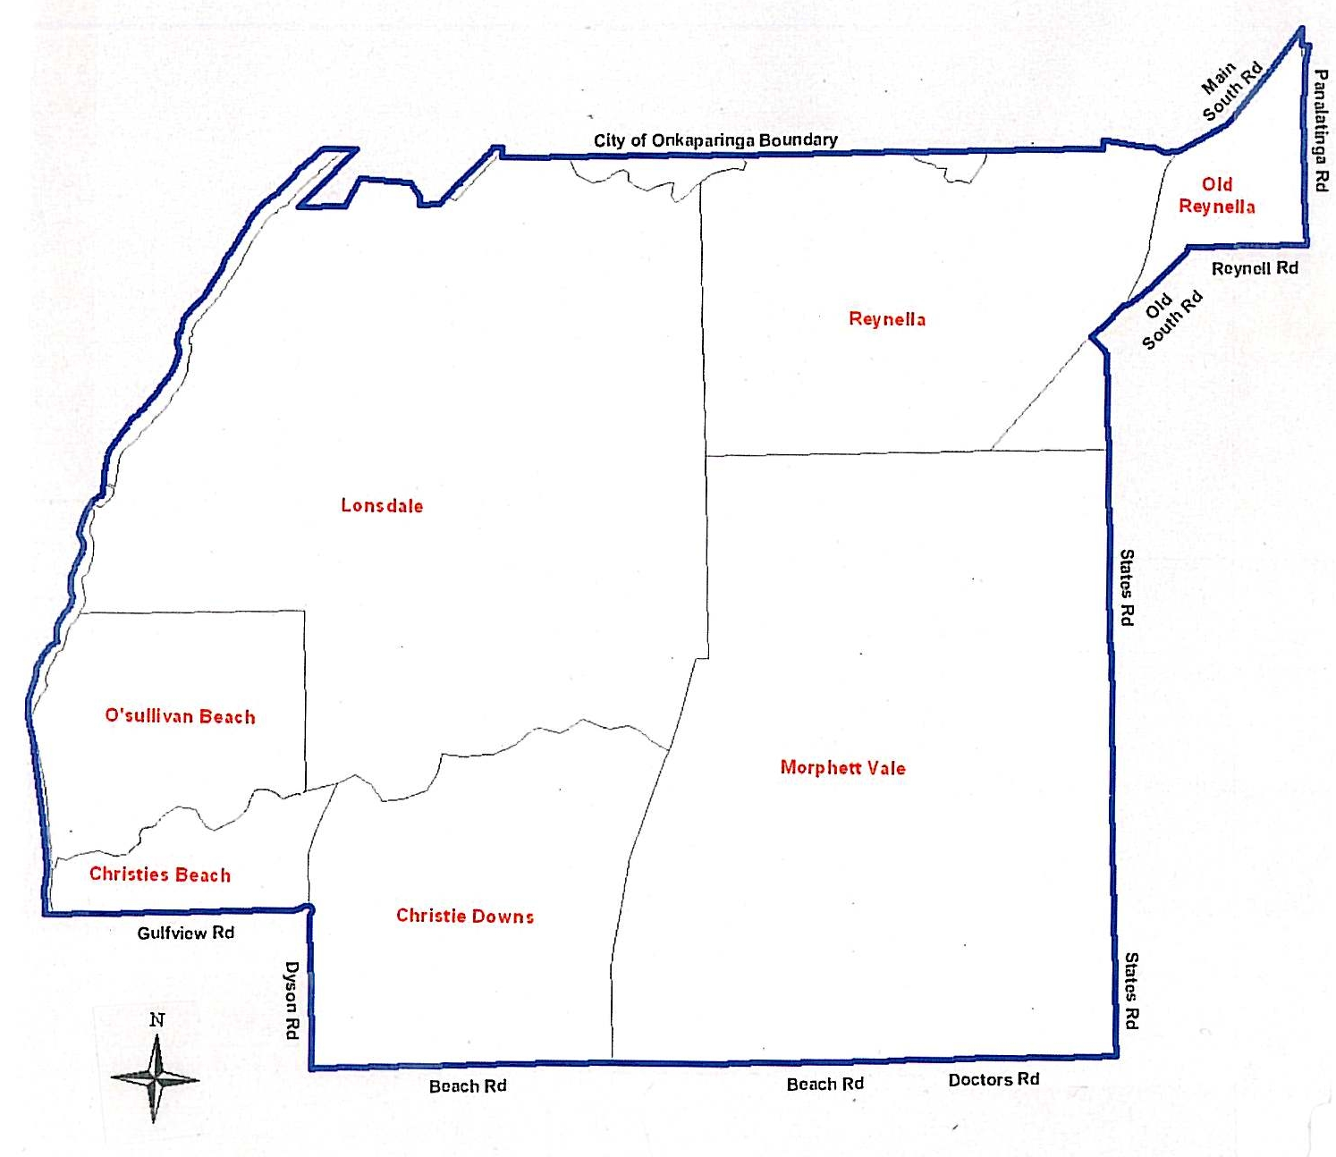
Pimpala Ward
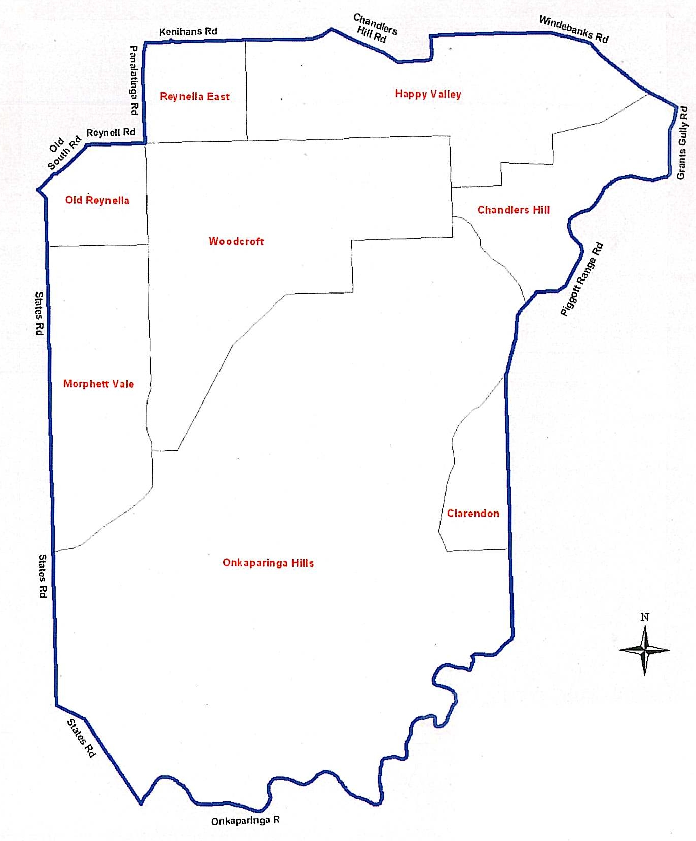
Commencing at the north-west corner of the Reynella East suburb boundary, then east along Braes Close, east along Kenihans Road, south-east along Chandlers Hill Road, north along Happy Valley Drive, east along Windebanks Road, south-east along Windebanks Road to Chandlers Hill Road, south-east along Chandlers Hill Road, south-west along Grants Gully Road, south along Grants Gully Road to Piggott Range Road, west following Piggott Range Road until the intersection of Lovick Road, due south until the Onkaparinga River and then following the Onkaparinga River in a south-westerly direction, north-west along States Road, north along States Road until it intersects with Main South Road, north-east along Main South Road, north-east along Old South Road, east along Reynell Road, north along Panalatinga Road until the north-west corner of the Reynella East suburb boundary.

Thalassa Ward
Commencing at the north-west corner of the City of Onkaparinga boundary, following the Sturt River (City of Onkaparinga boundary) in an easterly direction until the boundary’s north-east corner, south along the City of Onkaparinga boundary to Wickham Hill Road, north-west along Wickham Hill Road, north-west following Toops Hill Road, south-west along McLaren Flat Road, west following Clayton Road, north along the Kangarilla suburb boundary, north-east along Moritz Road, north-west along Schuller Road, south-west along Chapel Hill Road, north-west along Clarendon suburb boundary until it meets the Onkaparinga River, due north until the intersection of Piggott Range Road and Lovick Road, north-east following Piggott Range Road, north along Grants Gully Road, north-west along Chandlers Hill Road, continuing north-west following Windebanks Road, south along Happy Valley Drive, north-west along Chandlers Hill Road, south-west following Kenihans Road, west along Braes Close and following the Happy Valley suburb boundary to its south-west corner, north-east along the City of Onkaparinga boundary until it meets the Sturt River.

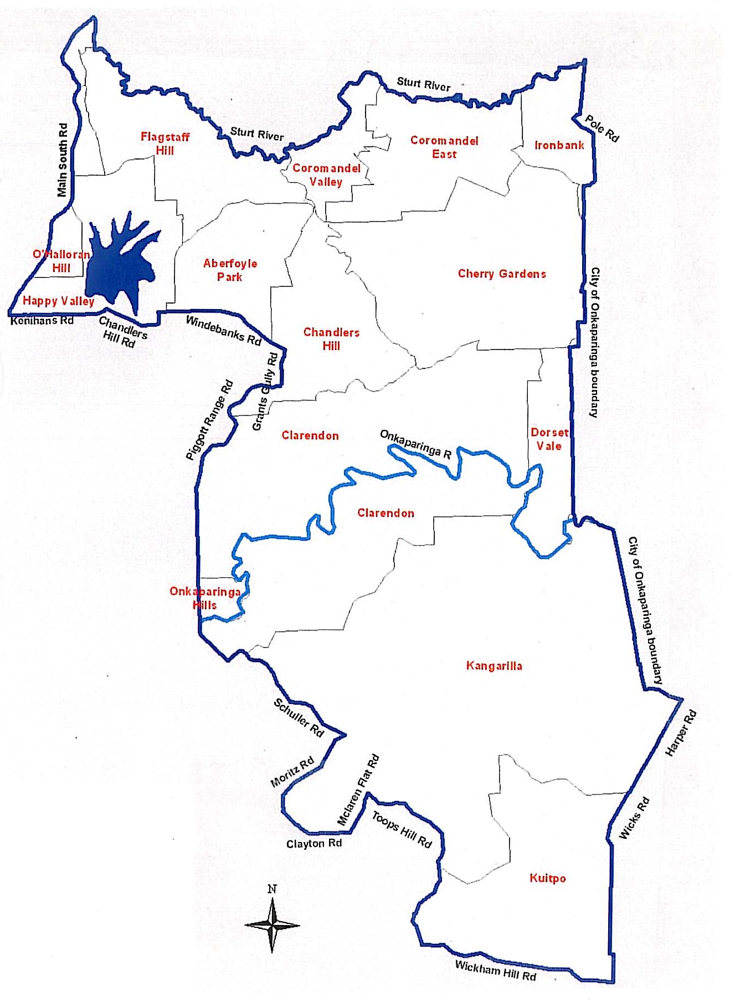
Mid South Coast Ward
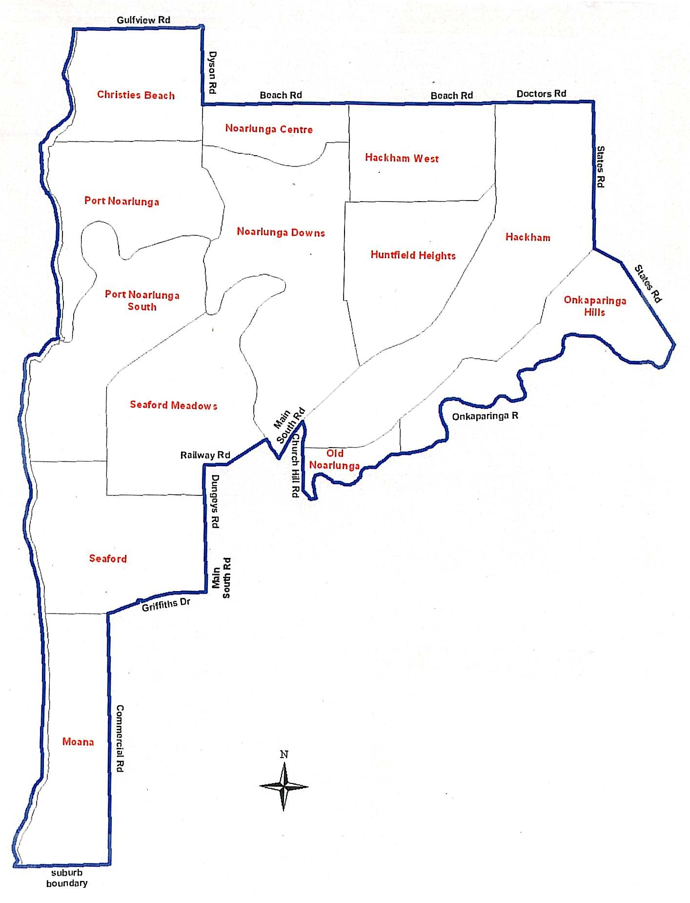
Commencing at the coast, east along Gulfview Road, south along Dyson Road, east along Beach Road, continuing east along Doctors Road, south following States Road, due south-east until the intersection of the Onkaparinga Hills suburb boundary and the Onkaparinga River, south-west along the Onkaparinga River, west to Patapinda Road, north-west along Patapinda Road, north along Church Hill Road to Main South Road, south-west along Main South Road until the Onkaparinga River, north-west along the Onkaparinga River for 270 m, south-west to Railway Road, due west to Sauerbiers Road, south along Eric Road, south along Main South Road, west along Griffiths Drive, south along Commercial Road until the south-east corner of the Moana suburb boundary, west along the Moana suburb boundary until it reaches the coast, north along the coast until Gulfview Road.

Wine Coast Ward
Commencing where the coast meets the north-west corner of the Maslins Beach suburb boundary, east along the Maslin Beach Suburb boundary, north along Commercial Road, north-east along Griffiths Drive, north along Main South Road, north along Eric Road until the intersection of Sauerbiers Road and Railway Road, east along Railway Road, due north-east until intersecting the Onkaparinga River, south-east along the Onkaparinga River until it intersects with Main South Road, north-east along Main South Road, south along Church Hill Road, south-east along Patapinda Road, east to the Onkaparinga River, following the Onkaparinga River north-east until the Blewitt Springs suburb boundary’s most northern point (where it meets the Onkaparinga Hills and Clarendon suburb boundaries), south-east following the Blewitt Spring suburb boundary, north-east along Chapel Hill Road, south-east along Schuller Road, south-west along Moritz Road, south-east along Clayton Road, north-east along McLaren Flat Road, south-east following Toops Hill Road to Wickham Hill Road, south to Range Road, south-west following Range Road, continuing south-west along the City of Onkaparinga boundary until it reaches the coastline, following the coastline north until it reaches the Moana suburb boundary.

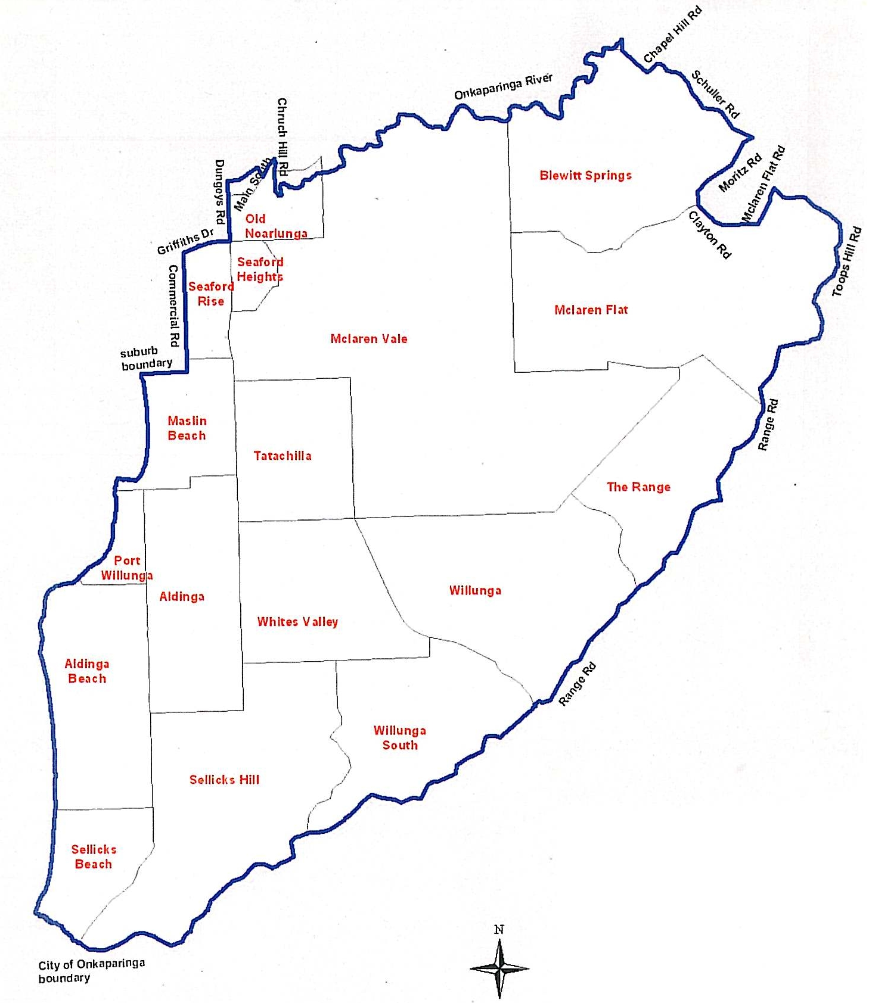
Dated 13 October 2009.
J. Tate, Chief Executive Officer

CITY OF PLAYFORD
Development Act 1993
Better Development Plan General Development
Plan Amendment—Public Consultation
NOTICE is hereby given that the City of Playford, pursuant to sections 24 and 25 of the Development Act 1993, has prepared a Development Plan Amendment Report (DPA) to amend its Development Plan.
The Amendment will change the Development Plan by replacing the entire contents of the current Development Plan and including new Development Plan text in the revised Better Development Plan format and structure promoted by the State Government.
The DPA report will be on public consultation from Thursday, 12 November 2009 until Friday, 29 January 2010.
Copies of the DPA report are available during normal office hours at Customer Service at the Playford Civic Centre 10 Playford Boulevard Elizabeth. Alternatively the DPA report can be viewed on the Internet at www.playford.sa.gov.au (then ‘click’ on ‘current community consultation’) or during normal opening hours at the following locations:
• The Playford Library at the Civic Centre (at the above address)*.
• Customer service and Playford Library, Shop 51, Munno Para Shopping City*.
* Library opening times are available on:
www.playford.sa.gov.au (click on library service).
Written submissions regarding the DPA should be submitted no later than 5 p.m. on 29 January 2010. All submissions should be addressed to the Chief Executive Officer, City of Playford,
12 Bishopstone Road, Davoren Park and marked ‘Better Development Plan DPA’ and should clearly indicate whether you wish to be heard in support of your submission at the public hearing. If you wish to lodge your submission electronically, please email it to playford@playford.sa.gov.au.
Copies of all submissions will be available for inspection at the Civic Centre, 10 Playford Boulevard, Elizabeth, from 1 February 2010 until the conclusion of the public hearing.
A public hearing will be held on Tuesday, 16 February 2010 at 7 p.m. at the Civic Centre, 10 Playford Boulevard, Elizabeth, at which time interested persons may be heard in relation to the DPA and the submissions. The public hearing will not be held if no submissions are received or if no submission makes a request to be heard.
If you would like further information about the DPA, contact Paul Johnson on telephone 8256 0332 or by e-mail:
phjohnson@playford.sa.gov.au.
Dated 12 November 2009.
T. Jackson, Chief Executive Officer

CITY OF PLAYFORD
Roads (Opening and Closing) Act 1991
Road Closure—Burdon Street, Elizabeth Park
NOTICE is hereby given pursuant to section 10 of the Act, that the Council proposes to make a Road Process Order to close, sell and transfer to the South Australian Housing Trust the portion of Burdon Street adjoining allotments 594 to 597, 606 to 608 in Deposited Plan 6711, allotment 6 in Deposited Plan 42127, allotments 9 and 10 in Deposited Plan 53147, allotment 51 in Deposited Plan 44649 and allotment 1 in Deposited Plan 62102, more particularly delineated ‘A’ on Preliminary Plan No. 09/0034. The portion of road to be closed is to be merged with the adjoining land (allotment 607 in Deposited Plan 6711) as part of a redevelopment of the adjoining land and a new road will be created to provide access to the properties affected by the road closure.
A copy of the plan and statement of persons affected are available for public inspection at the Playford Operations Centre, 12 Bishopstone Road, Davoren Park and the office of the Surveyor-General, 101 Grenfell Street, Adelaide, during normal office hours.
Any application for easement or objections must set out the full name, address and details of the submission and must be fully supported by reasons.
The application for easement or objections must be made in writing within 28 days of the last notice (18 November 2009) to the Council, 12 Bishopstone Road, Davoren Park, S.A. 5113 and the Surveyor-General, G.P.O. Box 1354, Adelaide, S.A. 5001, setting out full details. Where a submission is made, Council will give notification of a meeting at which the matter will be considered.
Dated 11 November 2009.
T. Jackson, Chief Executive Officer

CITY OF PLAYFORD
Roads (Opening and Closing) Act 1991
Road Closure—Walkway between Bowman Street/Burdon
Street, Elizabeth Park
NOTICE is hereby given pursuant to section 10 of the Act, that the Council proposes to make a Road Process Order to close, sell and transfer to the South Australian Housing Trust the whole of the walkway between Bowman Street and Burdon Street, more particularly delineated ‘A’ on Preliminary Plan No. 09/0033. The walkway to be closed is to be merged with the adjoining land (allotment 617 in Deposited Plan 6711).
A copy of the plan and statement of persons affected are available for public inspection at the Playford Operations Centre, 12 Bishopstone Road, Davoren Park and the office of the Surveyor-General, 101 Grenfell Street, Adelaide, during normal office hours.
Any application for easement or objections must set out the full name, address and details of the submission and must be fully supported by reasons.
The application for easement or objections must be made in writing within 28 days of the last notice (18 November 2009) to the Council, 12 Bishopstone Road, Davoren Park, S.A. 5113 and the Surveyor-General, G.P.O. Box 1354, Adelaide, S.A. 5001, setting out full details. Where a submission is made, Council will give notification of a meeting at which the matter will be considered.
Dated 11 November 2009.
T. Jackson, Chief Executive Officer

CITY OF PLAYFORD
Amendment to Community Land Management Plan
NOTICE is hereby given that pursuant to Section 198 (4) of the Local Government Act 1999, Council has resolved to amend Community Land Management Plan 10.1 Walkway Reserve, to allow car parking on portion of Bubner Street Reserve, Elizabeth South.
T. Jackson, Chief Executive Officer

PORT AUGUSTA CITY COUNCIL
Roads (Opening and Closing) Act 1991
Road Closure—Stirling North
NOTICE is hereby given, pursuant to section 10 of the Roads (Opening and Closing) Act 1991, that The Corporation of the City of Port Augusta proposes to make a Road Process Order to close the whole of the un-named Public Road north of Quorn Road and between pieces 1, 2, 3 and 4 in Filed Plan 101503 and Allotment 94 and piece 93 in Filed Plan 206961, more particularly delineated ‘A’, ‘B’ and ‘C’ in Preliminary Plan No. 09/0072.
Close road to be merged: ‘A’ with pieces 1 and 2, ‘B’ with pieces 3 and 4 and ‘C’ to Vest in the Crown for addition to crown lease volume 1600, folio 51 held by Pichi Richi Railway Preservation Society Inc.
A copy of the plan and a statement of persons affected are available for public inspection at the office of the Council, 4 Mackay Street, Port Augusta and the Adelaide office of the Surveyor-General during normal office hours.
Any application for easement or objection must set out the full name, address and details of the submission and must be fully supported by reasons.
The application for easement or objection must be made in writing to the Council, P.O. Box 1704, Port Augusta, S.A. 5700 within 28 days of this notice and a copy must be forwarded to the Surveyor-General, G.P.O. Box 1354, Adelaide, S.A. 5001. Where a submission is made, the Council will give notification of a meeting at which the matter will be considered.
Dated 6 October 2009.
G. Perkin, Chief Executive Officer

PORT AUGUSTA CITY COUNCIL
Review of Elector Representation
NOTICE is hereby given that the Port Augusta City Council has completed a review of its elector representation arrangements, including its composition and ward structure, in accordance with the requirements of section 12 (4) of the Local Government Act 1999 (the Act).
Pursuant to section 12 (13) (a) of the Act, the Electoral Commissioner has certified that the review undertaken by Council satisfies the requirements of section 12 of the Act. As such, the following structure will be put into effect as from the day of the first general election held after the expiration of five months from the publication of this notice:
• The Council area will not be divided into wards.
• The elected Council will comprise the Mayor and nine area councillors who represent the Council area as a whole.
G. Perkin, City Manager

CITY OF PORT LINCOLN
Review of Elector Representation
NOTICE is hereby given that the City of Port Lincoln has completed a review of its elector representation arrangements, including its composition and ward structure, in accordance with the requirements of section 12 (4) of the Local Government Act 1999 (the Act).
Pursuant to section 12 (13) (a) of the Act, the Electoral Commissioner has certified that the review undertaken by Council satisfies the requirements of section 12 of the Act. As such, the following structure will be put into effect as from the day of the first general election held after the expiration of five months from the publication of this notice.
• The council area will not be divided into wards.
• The elected Council will comprise the Mayor and 10 area councillors who represent the Council area as a whole.
G. Dodd, Chief Executive Officer

TOWN OF GAWLER
Community Land Management Plans
NOTICE is hereby given that in accordance with sections 197 and 198 of the Local Government Act 1999, Council at a meeting held on 27 October 2009:
(1) Adopted Community Land Management Plan—Undeveloped Reserves.
(2) Adopted Community Land Management Plan—Reserve.
S. Kerrigan, Chief Executive Officer

DISTRICT COUNCIL OF BARUNGA WEST
Roads (Opening and Closing) Act 1991
Road Closures—Melton and Paskeville, Hundred of Kulpara
NOTICE is herby given, pursuant to section 10 of the Roads (Opening and Closing) Act 1991, that the District Council of Barunga West proposes to make Road Process Order to close:
1. The whole of the unnamed public roads situate south of Paskeville-Kulpara Road and adjoining allotment 399 in Filed Plan 190151, allotment 389 in Filed Plan 190141 and allotment 391 in Filed Plan 190143, section 379, the southern and eastern
boundary of section 141 and the southern and western boundary of section 142, more particularly delineated and lettered ‘A’, ‘B’, ‘C’, ‘D’, ‘E’ and ‘F’ on Preliminary Plan No. 09/0052.
Closed Roads to be merged: ‘A’ with section 141, ‘B’ with section 140, ‘C’ with section 139, ‘D’ with section 142 and ‘E’ and ‘F’ with allotments 389 and 399 and section 379.
2. The whole of unnamed public road situate west of Rod Daniels Road and merge with the adjoining section 146, more particularly delineated and lettered ‘A’ on Preliminary Plan No. 09/0073.
3. The whole of the unnamed public road situate adjacent to Pridhams-Paskeville Road and merge with the adjoining section 433, more particularly delineated and lettered ‘A’ on Preliminary Plan No. 09/0063.
4. Portions of the unnamed public roads and G Hill Road situate adjoining Piece 1 in Deposited Plan 40550, sections 421, 422, 423 and 424, Allotment 3 in Deposited Plan 35709 and sections 404, 403 and 402, more particularly delineated and lettered ‘A’, ‘B’, ‘C’, ‘D’, ‘E’, ‘F’ and ‘G’ on Preliminary Plan No. 09/0068.
Closed Roads to be merged: ‘A’ with Piece 1, ‘B’ with sections 432 and 424, ‘C’ with sections 421 and 422, ‘D’ with allotment 3, ‘E’ with section 404, ‘F’ with section 403 and ‘G’ with section 402.
A copy of the plans and statements of persons affected are available for public inspection at the Council Office, Bay Street, Port Broughton, S.A. 5522 and the Adelaide Office of the Surveyor-General during normal office hours.
Any application for easement or objection must set out the full name, address and details of the submission and must be fully supported by reasons.
The application for easement or objection must be made in writing to the Council, P.O. Box 3, Port Broughton, S.A. 5522 within 28 days of this notice and a copy must be forwarded to the Surveyor-General, G.P.O. Box 1354, Adelaide, S.A. 5001. Where a submission is made, the Council will give notification of a meeting at which the matter will be considered.
Dated 10 November 2009.
N. Hand, District Manager

DISTRICT COUNCIL OF BARUNGA WEST
Final Recommendation
Periodical Review of Elector Representation
NOTICE is hereby given that the District Council of Barunga West in accordance with the requirements of section 12 (4) of the Local Government Act 1999, has reviewed its composition and elector representation arrangements.
Certification
Pursuant to section 12 (13) (a) of the said Act, the Electoral Commissioner has certified that the review undertaken by Council satisfies the requirement of section 12 and may therefore now be put into effect as from the day of the first general election held after the expiration of five months from the publication of this notice.
The representation arrangements (unchanged) are as follows:
1. Retain the existing structure of no wards.
2. Retain the existing representation levels of:
2.1 A Mayor elected by Council members.
2.2 Nine elected members (including the Mayor) from across the Council area.
N. Hand, District Manager

BERRI BARMERA COUNCIL
Review of Elector Representation
NOTICE is hereby given that the Berri Barmera Council has completed a review of its elector representation arrangements, including its composition and ward structure, in accordance with the requirements of section 12 (4) of the Local Government Act 1999 (the Act).
Pursuant to section 12 (13) (a) of the Act, the Electoral Com-missioner has certified that the review undertaken by Council satisfies the requirements of section 12 of the Act. As such, the following structure will be put into effect as from the day of the first general election held after the expiration of five months from the publication of this notice.
• The council area will not be divided into wards.
• The elected Council will comprise the Mayor and eight area councillors who represent the Council area as a whole.
D. Beaton, Chief Executive Officer

DISTRICT COUNCIL OF GRANT
Roads (Opening and Closing) Act 1991
Road Closure—Ellis Street, Carpenter Rocks
NOTICE is hereby given, pursuant to section 10 of the Act, that the Council proposes to make a Road Process Order to close, sell and transfer to the adjoining owner the public road (Ellis Street) north of Carpenter Rocks Road, adjoining Allotment 1 in Deposited Plan 4378, Hundred of Kongorong, more particularly marked ‘A’ on Preliminary Plan No. 09/0076.
A copy of the plan and a statement of persons affected are available for public inspection at the office of the District Council of Grant, situated at 324 Commercial Street West, Mount Gambier and the office of the Surveyor-General, 101 Grenfell Street, Adelaide, during normal office hours.
Any application for easement or objections must be made in writing within 28 days of this notice, to the Council, P.O. Box 724, Mount Gambier, S.A. 5290 and the Surveyor-General, G.P.O. Box 1354, Adelaide, S.A. 5001, setting out full details. Where a submission is made, Council will give notification of a meeting to deal with the matter.
Dated 19 November 2009.
R. Peate, Chief Executive Officer

DISTRICT COUNCIL OF LOXTON WAIKERIE
Roads (Opening and Closing) Act 1991
Road Opening and Closing, Mantung
NOTICE is hereby given pursuant to section 10 of the Act, that the Council proposes to make a Road Process Order to open as road portion of section 30, Hundred of Mantung, forming a re-alignment of Evans Road and more particularly delineated and numbered ‘1’ on Preliminary Plan No. 09/0077 and to close and exchange with J. N. and C. H. Evans a portion of Evans Road rendered superfluous more particularly delineated and lettered ‘A’ on Preliminary Plan No. 09/0077 in exchange for land taken for new road.
A copy of the plan and statement of persons affected are available for public inspection at Council’s Office, East Terrace, Loxton and the office of the Surveyor-General, 101 Grenfell Street, Adelaide, during normal office hours.
Any objections or representations must be made in writing within 28 days from this notice to the Council, P.O. Box 409, Loxton, S.A. 5333 and the Surveyor-General, G.P.O. Box 1354, Adelaide, S.A. 5001, setting out full details. Where a submission is made, the Council will give notification of a meeting at which the matter will be considered.
Dated 19 November 2009.
P. Sellar, Chief Executive Officer

DISTRICT COUNCIL OF PETERBOROUGH
Supplementary Election—Close of Nominations
AT the close of nominations at 12 noon on Thursday, 5 November 2009 the following people were accepted as candidates and are listed in the order in which they will appear on the ballot paper:
Nominations Received
Area Councillor—(2 vacancies)
Woodman, Christopher Kym
Hardbottle, Frank
Beveridge, Bridget Margaret
Postal Voting
The election will be conducted by post. Ballot papers and pre-paid envelopes for each voting entitlement will be posted between Tuesday, 17 November 2009 and Monday, 23 November 2009 to every person, body corporate and group listed on the voters roll at roll close on Wednesday, 30 September 2009. Voting is voluntary.
A person who has not received voting material by Monday, 23 November 2009 and believes they are entitled to vote should contact the Deputy Returning Officer on (08) 7424 7418.
Completed voting material must be returned to reach the Returning Officer no later than 12 noon on Monday, 7 December 2009.
A ballot box will be provided at the Council Office, 108 Main Street, Peterborough for electors wishing to hand deliver their completed voting material during office hours.
Vote Counting Location
The scrutiny and counting of votes will take place at the Town Hall Meeting Room, 108 Main Street, Peterborough as soon as practicable after 12 noon on Monday, 7 December 2009. A provisional declaration will be made at the conclusion of the election count.
Campaign Donations Return
All candidates must forward a Campaign Donations Return to the Council Chief Executive Officer within six weeks after the conclusion of the election.
K. Mousley, Returning Officer

DISTRICT COUNCIL OF PETERBOROUGH
Temporary Appointment
NOTICE is hereby given that Peter McGuinness has been appointed Acting Chief Executive Officer from 7 December 2009 until 31 December 2009, both days inclusive, with all delegations being transferred.
T. D. Barnes, Chief Executive Officer

IN the matter of the estates of the undermentioned deceased persons:
Arnold, Charles Thomas, late of 31 Railway Avenue, Bridgewater, retired storeman, who died on 6 September 2009.
Bond Maxwell Edward, late of Shackleton Avenue, Ingle Farm, retired car builder, who died on 19 August 2009.
Bonython, Timothy Dean, late of 8 Martens Avenue, Fullarton, of no occupation, who died on 14 March 2005.
Clarke, John Colin, late of 20 Norseman Avenue, Westbourne Park, retired farmer, who died on 29 August 2009.
Cowell, Frances Annie, late of 35 Coppin Street, Semaphore, home duties, who died on 22 July 2009.
Evens, Clement Alfred, late of 78-96 Dumfries Avenue, Northgate, of no occupation, who died on 17 June 2009.
Farrow, Ruby Joyce, late of 14 Frew Street, Fullarton, of no occupation, who died on 10 August 2009.
Gayton, Frederick, late of 7 Beldale Street, Sunnybank Hills, Queensland, retired Technical Officer, who died on 8 August 2009.
Gohl, Alan Eric, late of 1217 Grand Junction Road, Hope Valley, retired quality control officer, who died on 16 September 2009.
Gray, Harold Donald, late of 61-63 Oxford Terrace, Port Lincoln, retired accountant, who died on 8 July 2009.
Jaensch, Lorna Eunice, late of 13 Stokes Road, Karoonda, retired farmer, who died on 2 March 2009.
Leipold, Gerda, late of 67 Porter Street, Salisbury, of no occupation who died on 1 September 2009.
McCrohan, Jack Clarence, late of 54 Cashel Street, St Marys, retired accountant, who died on 24 April 2009.
Milne, Violet Margaret, late of 98 Newton Road, Campbelltown, widow, who died on 28 August 2009.
Richardson, Kenneth Brian, late of 139 Edward Street, Melrose Park, retired hotel manager, who died on 19 August 2009.
Simpson, Ronald Edward, late of 7 Martindale Avenue, Toorak Gardens, retired sales representative, who died on 13 September 2009.

Singh, Alan, late of Hawdon Street, Barmera, labourer, who died on 15 July 2009.
Symonds, Lancelot, late of 35 Glenburnie Terrace, Plympton, retired credit officer, who died on 13 September 2009.
Thompson, Wayne Russell, late of 226 Fullarton Road, Glenside, of no occupation, who died on 20 June 2008.
von Berg, Irene Ann, late of 7 Victoria Street, Goodwood, of no occupation, who died on 16 August 2009.
Ward, Donald James, late of 22 Harrow Terrace, Kingswood, retired draftsman, who died on 11 September 2009.
Webster, Ronald, late of 7-12 Majors Road, North Moonta, retired curator, who died on 10 January 2009.
Zolotenki, Zbigniew, late of 47 Golfers Avenue, Seaton, retired french polisher, who died on 20 August 2009.
Notice is hereby given pursuant to the Trustee Act 1936, as amended, the Inheritance (Family Provision) Act 1972, and the Family Relationships Act 1975, that all creditors, beneficiaries, and other persons having claims against the said estates are required to send, in writing, to the Public Trustee, 25 Franklin Street, Adelaide, S.A. 5000, full particulars and proof of such claims, on or before 11 December 2009, otherwise they will be excluded from the distribution of the said estate; and notice is also hereby given that all persons who are indebted to the said estates are required to pay the amount of their debts to the Public Trustee or proceedings will be taken for the recovery thereof; and all persons having any property belonging to the said estates are forthwith to deliver the same to the Public Trustee.
Dated 12 November 2009.
M. I. Bodycoat, Public Trustee

PARTNERSHIP ACT 1891-1975
Notice of Discontinuance of Partnership
TAKE notice that as from 6 October 2009 the partnership of Darcy Neil Mobbs, Unit 4/100 Hewittson Road, Elizabeth West, S.A. 5113 and Scott Jason Mackinlay, Unit 4/100 Hewittson Road, Elizabeth West, S.A. 5113 who traded as S & D Wardrobe Solutions, A.B.N. 65 955 149 039, was dissolved.
Darcy Neil Mobbs has retired from the partnership.
Scott Jason Mackinlay will continue to operate the business under the name of S & D Wardrobe Solutions (A.B.N. 46 025 494 916), and shall be responsible for all the debts and liabilities thereof.
D. N. Mobbs
S. J. Mackinlay

ATTENTION

CUSTOMERS requiring a proof of their notice for inclusion in the Government Gazette, please note that the onus is on you to inform Government Publishing SA of any subsequent corrections by 10 a.m. on Thursday, which is our publication deadline.

For any corrections to your notice please phone 8207 1045 or Fax 8207 1040 before 10 a.m. on Thursday.

If we do not receive any communication by 10 a.m. on Thursday (day of publication) we will presume the notice is correct and will print it as it is.

Remember—the onus is on you to inform us of any corrections necessary to your notice.

NOTE: Closing time for lodging new copy (electronically, fax or hard copy) is 4 p.m. on Tuesday preceding the day of publication. Phone 8207 1045—Fax 8207 1040.
Email: governmentgazette@dpc.sa.gov.au

Printed and published by authority every Thursday by B. MORRIS, Government Printer, South Australia
Price: $5.60, plus postage; to subscribers, $284.00 per annum.
(The above prices are inclusive of GST)

