SUPPLEMENTARY GAZETTE



THE SOUTH AUSTRALIAN

GOVERNMENT GAZETTE
www.governmentgazette.sa.gov.au

PUBLISHED BY AUTHORITY

ALL PUBLIC ACTS appearing in this GAZETTE are to be considered official, and obeyed as such

ADELAIDE, FRIDAY, 27 NOVEMBER 2009

CONTENTS
Page
Administrative Arrangements Act 1994—Notice 5934
Development Regulations 2008—Notice 5934

ADMINISTRATIVE ARRANGEMENTS ACT 1994
Delegation of Function of Power
PURSUANT to section 9 (1) of the Administrative Arrangements Act 1994, I, Paul Holloway, Minister for Urban Development and Planning, delegate all of my functions and powers under Clause 2B of Schedule 4 to the Development Regulations 2008, to the Minister for Employment, Training and Further Education but only insofar as the exercise of those functions and powers relate to the City of Burnside.
Dated 25 November 2009.
Paul Holloway, Minister for Urban Development and Planning

DEVELOPMENT REGULATIONS 2008
Complying Development—Regulation 8A and Schedule 4
Areas Revoked and New Areas Determined by the Minister for the Purposes of Schedule 4—
Complying Development, Clause 2B—New Dwellings
Preamble
For the purposes of section 35 of the Development Act 1993, the development of new dwellings that are located within areas determined by the Minister and that meet the requirements of Clause 2B of Schedule 4 of the Development Regulations will be complying development.
The Minister has decided to extend the areas within which the new dwelling complying development provisions apply and to produce Residential Code Maps showing the areas to which Clause 2B of Schedule 4 applies.
In order to give effect to this determination the Minister has decided to revoke the previous determination and to include all areas of the City of Burnside to which Part 2B, Schedule 4 now applies within the new determination.
Notice
PURSUANT to Schedule 4, Part 2B (1) of the Development Regulations 2008 (‘the Regulations’) and pursuant to the delegation of functions and powers in Schedule 4, Part 2B (1) of the Development Regulations 2008, made to me by the Minister for Urban Development and Planning (under section 9 (1) of the Administrative Arrangements Act 1994, by the notice published in the Government Gazette of 27 November 2009), I, Michael O’Brien, Minister for Employment, Training and Further Education have revoked those areas within the City of Burnside listed within the Government Gazette as published on 18 June 2009 on pages 2819 and 2820.
Further, I have determined that from 14 December 2009, Clause 2B of Schedule 4 will apply in relation to the shaded areas on the Residential Code Maps attached to this Notice marked ‘Attachment A’.
Dated 26 November 2009.
Michael O’Brien, Minister for Employment, Training and Further Education

Attachment A
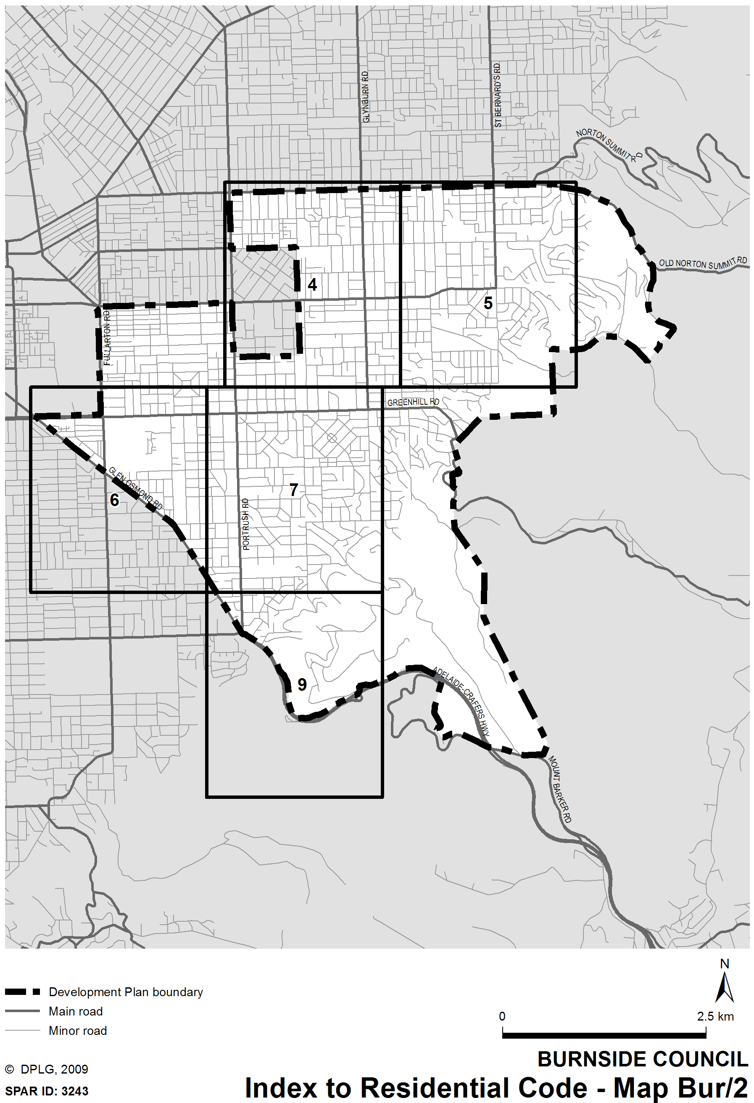
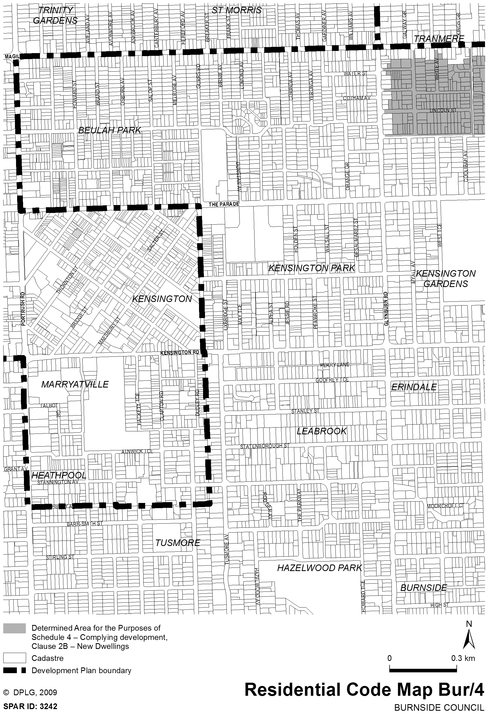
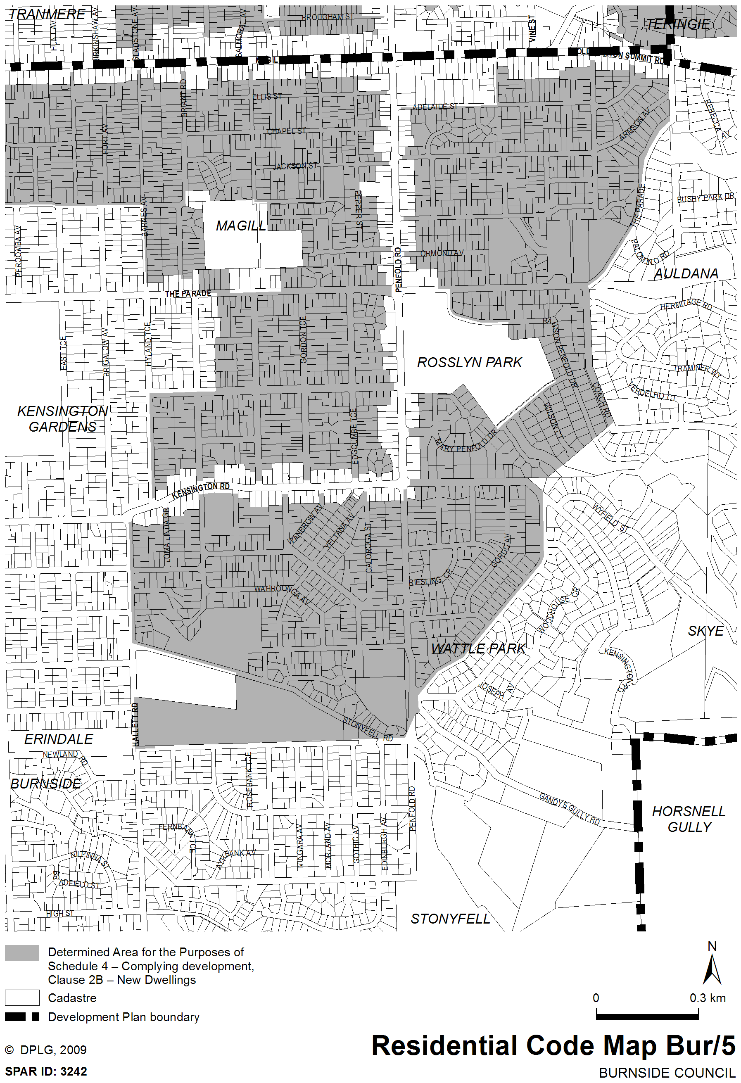
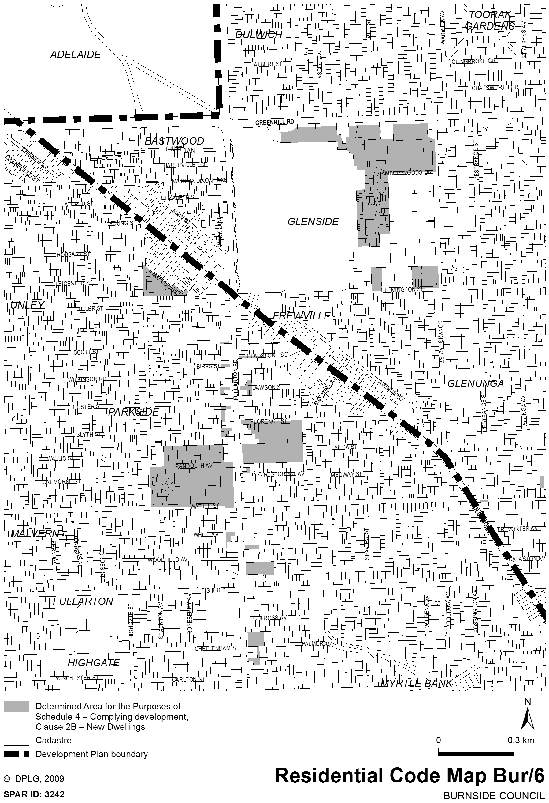
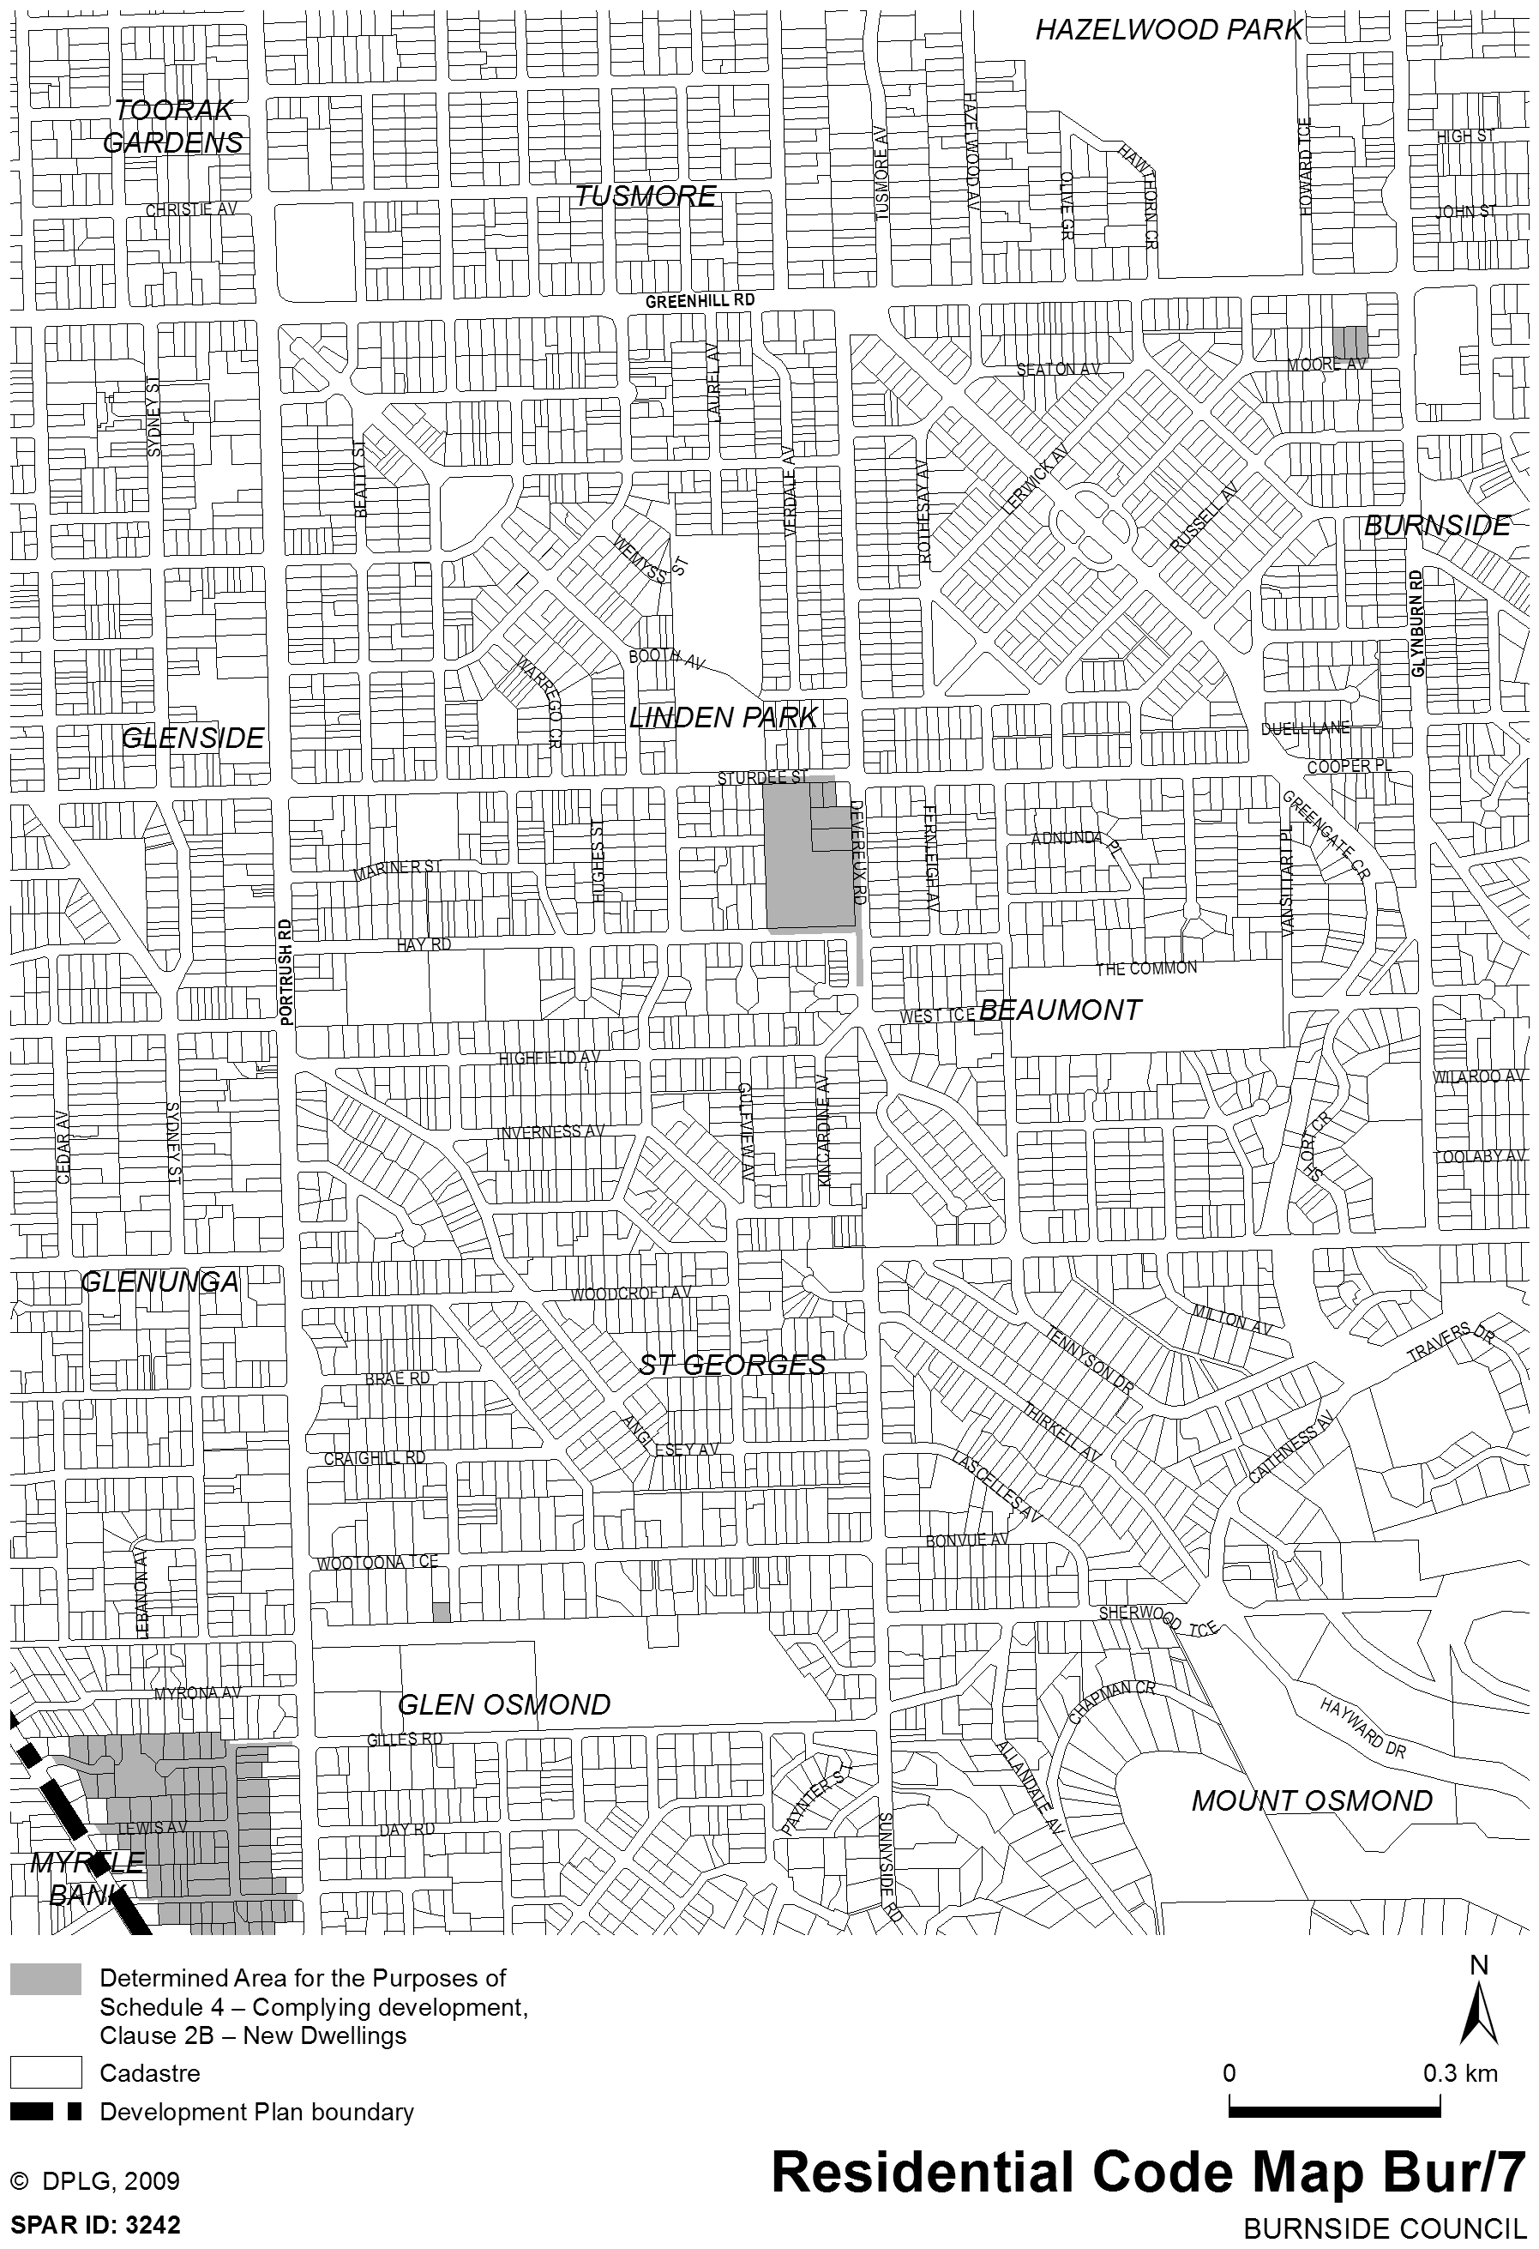
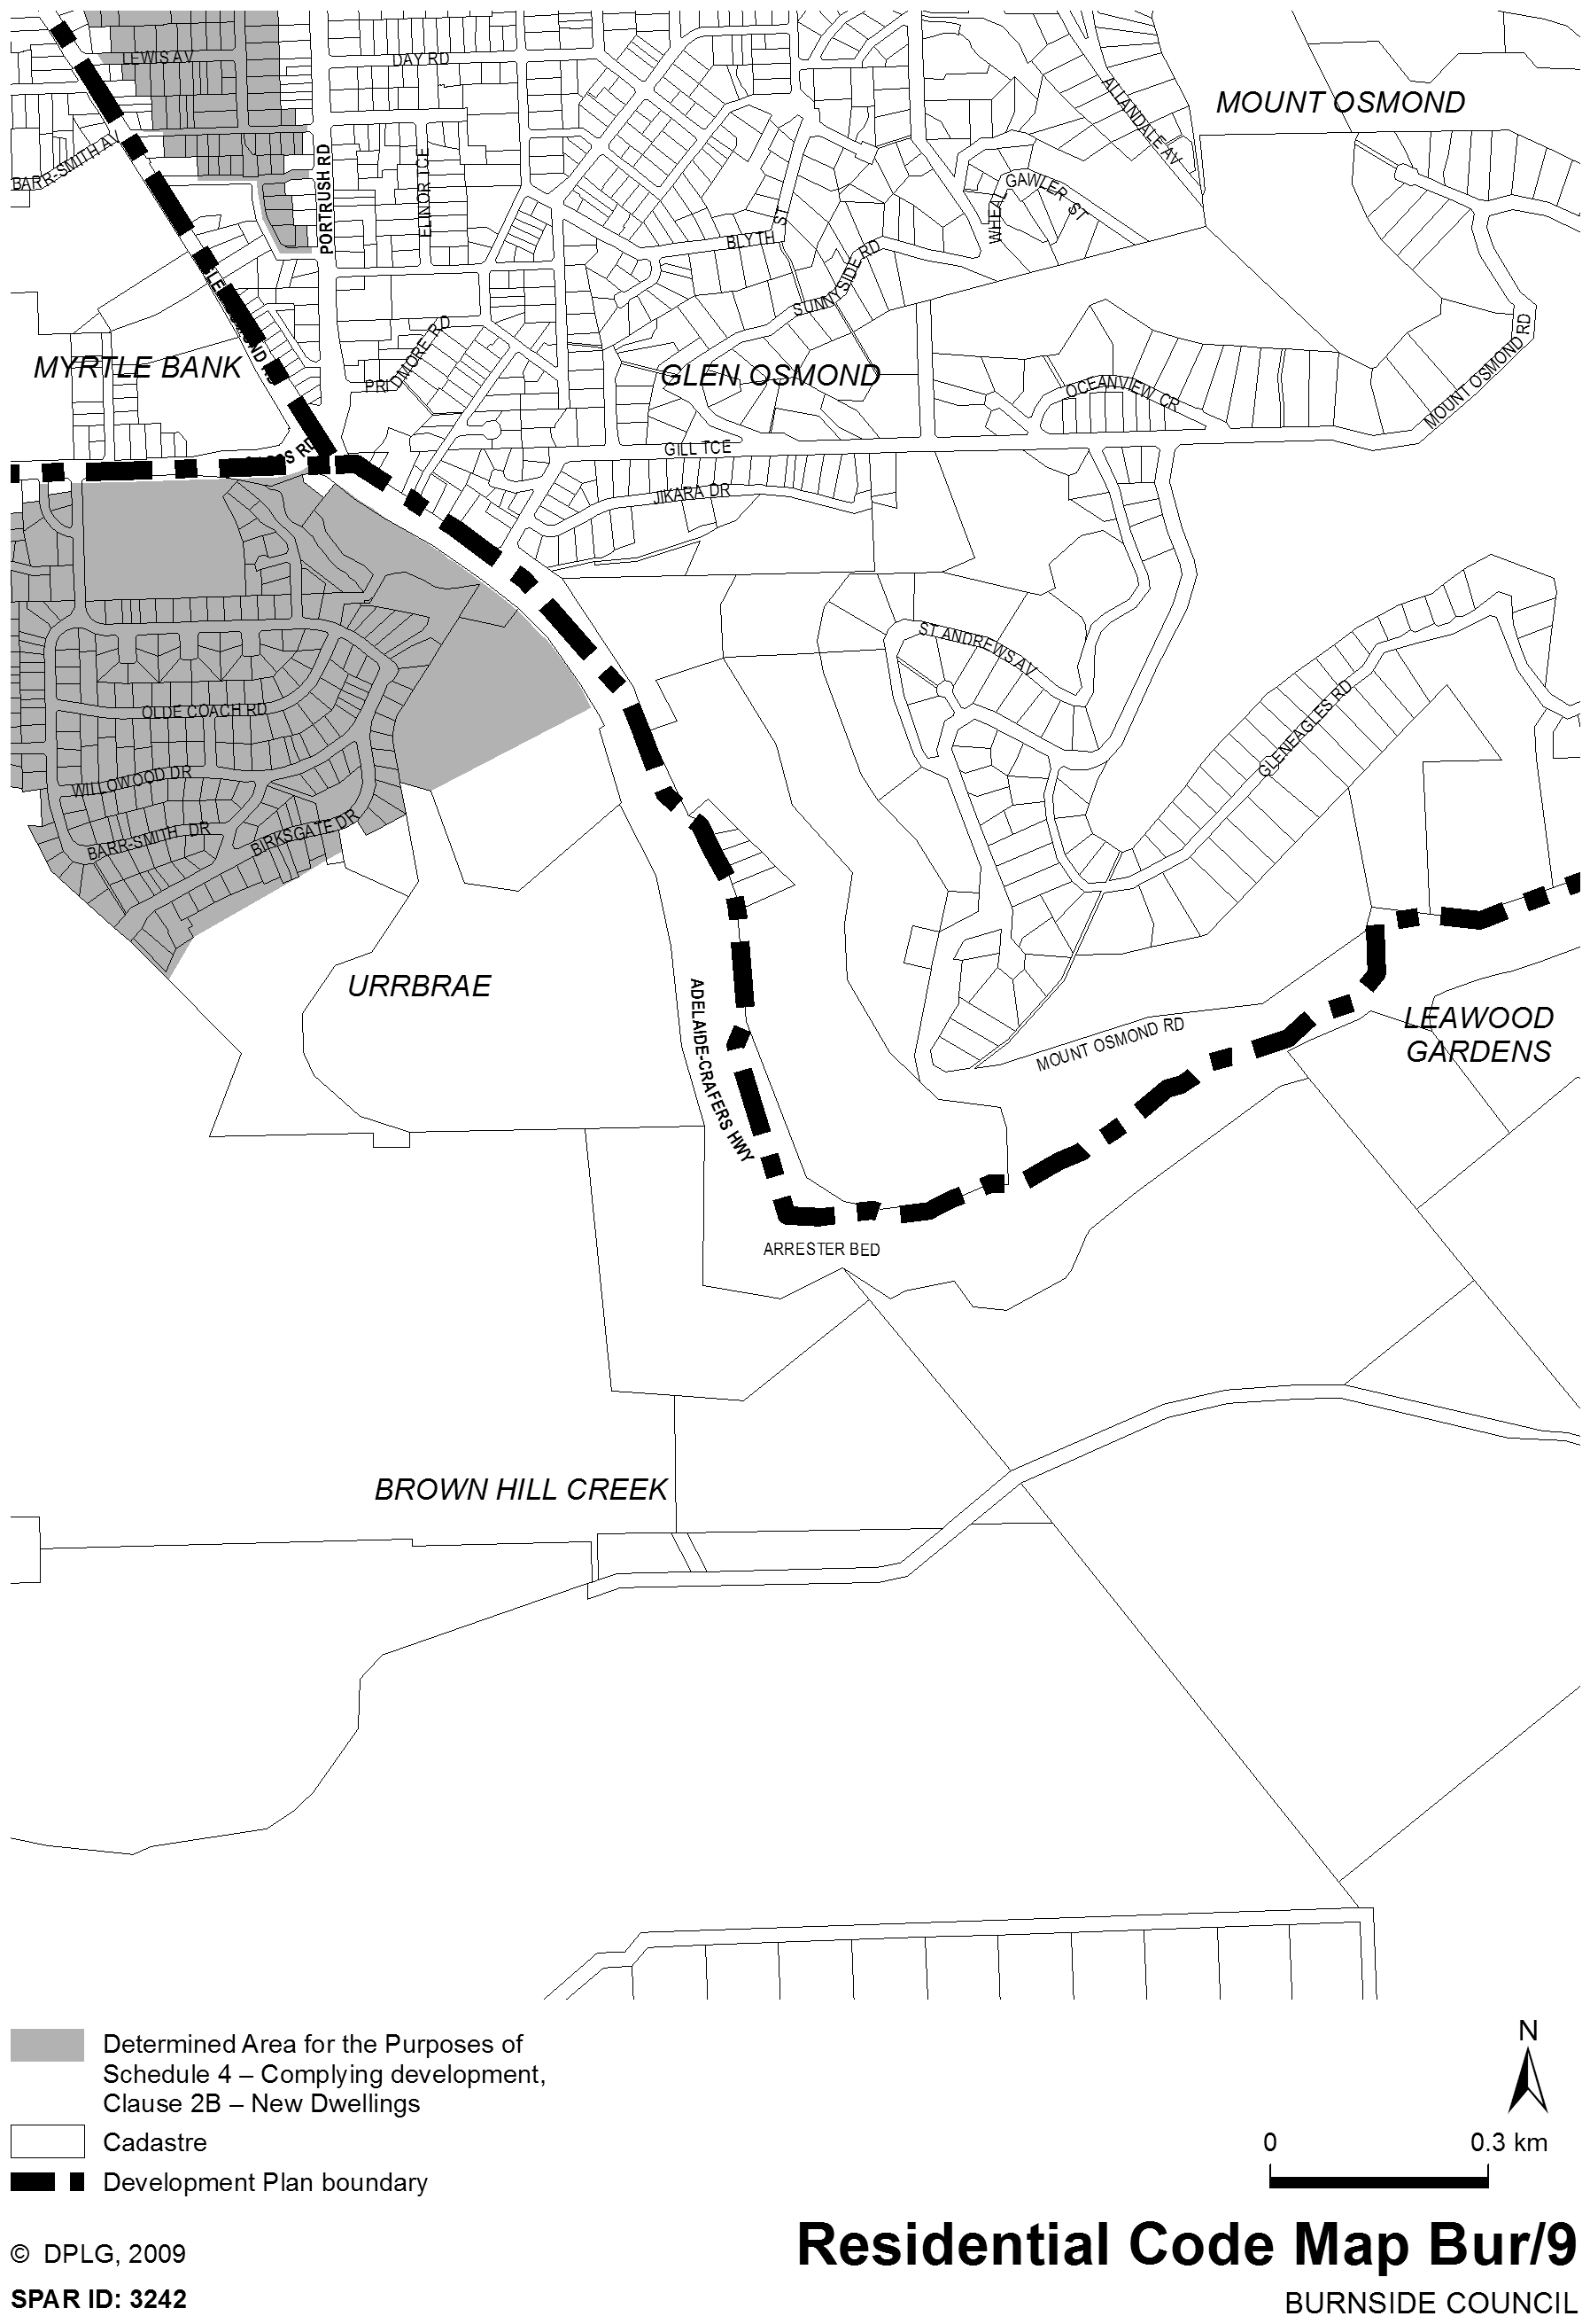

B. MORRIS, Government Printer, South Australia

