No. 68 4649

THE SOUTH AUSTRALIAN

GOVERNMENT GAZETTE
www.governmentgazette.sa.gov.au

PUBLISHED BY AUTHORITY

ALL PUBLIC ACTS appearing in this GAZETTE are to be considered official, and obeyed as such

ADELAIDE, THURSDAY, 24 SEPTEMBER 2009

CONTENTS

Page
Appointments, Resignations, Etc. 4650
Corporations and District Councils—Notices 4729
Development Act 1993—Notices 4650
Electoral Act 1985—Notice 4650
Electricity (General) Regulations 1997—Notice 4651
Gas Regulations 1997—Notice 4651
Health Care Act 2008—Notices 4652
Housing Improvement Act 1940—
Erratum 4696
Notices 4695
Land Acquisition Act 1969—Notice 4696
Liquor Licensing Act 1997—Notices 4696
Mining Act 1971—Notices 4698
National Parks and Wildlife (National Parks) Regulations
2001—Notice 4699
Natural Resources Management Act 2004—Notices 4700
Oaths Act 1936—Notice 4700

Page
Petroleum Act 2000—Notice 4703
Proclamations 4715
Public Trustee Office—Administration of Estates 4736

REGULATIONS
Motor Vehicles Act 1959 (No. 238 of 2009) 4718
Liquor Licensing Act 1997—
(No. 239 of 2009) 4721
(No. 240 of 2009) 4723
Primary Industry Funding Schemes Act 1998—
(No. 241 of 2009) 4725
Roads (Opening and Closing) Act 1991—Notices 4701

RULES OF COURT
District Court Civil Rules 2006 4709
Training and Skills Development Act 2008—Notices 4712
Transport—Notices to Mariners 4714

GOVERNMENT GAZETTE NOTICES
ALL poundkeepers’ and private advertisements forwarded for publication in the South Australian Government Gazette must be PAID FOR PRIOR TO INSERTION; and all notices, from whatever source, should be legibly written on one side of the paper only and sent to Government Publishing SA so as to be received no later
than 4 p.m. on the Tuesday preceding the day of publication. Phone 8207 1045 or Fax 8207 1040. E-mail: governmentgazette@dpc.sa.gov.au. Send as attachments in Word format and please confirm your transmission with a faxed copy of your document, including the date the notice is to be published and to whom the notice will be charged. The Government Gazette is available online at: www.governmentgazette.sa.gov.au

Department of the Premier and Cabinet
Adelaide, 24 September 2009
HER Excellency the Governor in Executive Council has been pleased to appoint the undermentioned to the South Australian Museum Board, pursuant to the provisions of the South Australian Museum Act 1976:
Member: (from 24 September 2009 until 23 September 2012)
Natasha Jessica Stott Despoja
By command,
Michael O’Brien, for Premier
ASACAB003/02

Department of the Premier and Cabinet
Adelaide, 24 September 2009
HER Excellency the Governor in Executive Council has been pleased to appoint the undermentioned to the Wilderness Advisory Committee, pursuant to the provisions of the Wilderness Protection Act 1992:
Member: (from 24 September 2009 until 31 December 2009)
Susan Barker
Member: (from 24 September 2009 until 23 September 2012)
Charles Eric Maynard Bills
Robert George Lesslie
Molly Ann Whalen
Presiding Member: (from 24 September 2009 until 23 September 2012)
Charles Eric Maynard Bills
By command,
Michael O’Brien, for Premier
EHCS09/0025

Department of the Premier and Cabinet
Adelaide, 24 September 2009
HIS Excellency the Governor in Executive Council has been pleased to appoint Hieu Van Le as Governor’s Deputy of South Australia for the period from 10.30 a.m. on Wednesday, 30 September 2009 until 11.30 a.m. on Saturday, 3 October 2009.
By command,
Michael O’Brien, for Premier

Department of the Premier and Cabinet
Adelaide, 24 September 2009
HIS Excellency the Governor in Executive Council has been pleased to appoint the Honourable Jay Wilson Weatherill, MP, Minister for Environment and Conservation, Minister for Early Childhood Development, Minister for Aboriginal Affairs and Reconciliation and Minister Assisting the Premier in Cabinet Business and Public Sector Management to be also Acting Minister for the River Murray and Acting Minister for Water Security for the period from 25 September 2009 to 30 September 2009 inclusive, during the absence of the Honourable Karlene Ann Maywald, MP.
By command,
Michael O’Brien, for Premier
MRMCS09/090

Department of the Premier and Cabinet
Adelaide, 24 September 2009
HIS Excellency the Governor in Executive Council has been pleased to appoint the Honourable Patrick Frederick Conlon, MP, Minister for Transport, Minister for Infrastructure and Minister for Energy to be also Acting Minister for the River Murray and Acting Minister for Water Security for the period from 1 October 2009 to 11 October 2009 inclusive, during the absence of the Honourable Karlene Ann Maywald, MP.
By command,
Michael O’Brien, for Premier
MRMCS09/090

DEVELOPMENT ACT 1993, SECTION 28 (5): DECLARA-TION OF CESSATION OF INTERIM OPERATION OF THE CITY OF PORT LINCOLN—BUILDING HEIGHT AND DESIGN PLAN AMENDMENT REPORT
Preamble
On 21 August 2008, the Minister, under section 28 (1), declared the City of Port Lincoln—Building Height and Design Plan Amendment Report as an amendment to come into interim operation without delay on that day. The Port Lincoln (City) Development Plan, consolidated on 21 August 2008, incorporated the provisions of the ‘Building Height and Design Plan Amend-ment Report’.
The City of Port Lincoln—Building Height and Design Plan Amendment Report has not been authorised by the Minister under section 27 (1) within the required 12 months period.
Notice
PURSUANT to section 28 (4) (c) of the Development Act 1993, the City of Port Lincoln—Building Height and Design Plan Amendment Report ceases to operate under the Interim Operation Order proclaimed by the Minister on 21 August 2008.
Dated 9 September 2009.
Paul Holloway, Minister for Urban Development and Planning

DEVELOPMENT ACT 1993, SECTION 25 (17): WATTLE RANGE COUNCIL—PENOLA HERITAGE DEVELOP-MENT PLAN AMENDMENT
Preamble
1. The Development Plan amendment entitled ‘Wattle Range Council—Penola Heritage Development Plan Amendment’ (the Plan Amendment) has been finalised in accordance with the provisions of the Development Act 1993.
2. The Minister for Urban Development and Planning has decided to approve the Plan Amendment.
Notice
PURSUANT to section 25 of the Development Act 1993, I—
(a) approve the Plan Amendment; and
(b) fix the day on which this notice is published in the Gazette as the day on which the Plan Amendment will come into operation.
Dated 24 September 2009.
Paul Holloway, Minister for Urban Development and Planning

ELECTORAL ACT 1985
Part 6—Registration of Political Parties
NOTICE is hereby given that the following application for registration as a registered political party under the provisions of Part 6 of the Electoral Act 1985, has been received:
Name of Party: Democratic Labor Party of Australia
Abbreviation: DLP
Name of Applicant: David McCabe
Any elector who believes that the party should not be registered:
• because the party does not have as a purpose, the promotion of the election to the State Parliament of its endorsed candidate(s); or
• because the application does not fulfil the technical requirements specified in the Act; or
• because the party’s name is likely to be confused with
that of another registered party, parliamentary party or prominent public body,
can formally object in writing to the Electoral Commissioner by close of business on 26 October 2009. Objections must contain the postal address and signature of the objector.
Dated 24 September 2009.
K. Mousley, Electoral Commissioner, Level 6, 60 Light Square, Adelaide, S.A. 5000
ECSA 175/09

ELECTRICITY (GENERAL) REGULATIONS 1997
AND
GAS REGULATIONS 1997
Residential Energy Efficiency Scheme—
Variation to Ministerial Determination of Energy Efficiency Activities
NOTICE is hereby given that:
1. On 30 October 2008, pursuant to Regulation 7AN (1) of the Electricity (General) Regulations 1997 and 8DK (1) of the Gas Regulations 1997, by notice in the South Australian Government Gazette the Minister for Energy determined specified activities to be energy efficiency activities for the purposes of the Residential Energy Efficiency Scheme established under Part 2AA of those regulations (South Australian Government Gazette, 30 October 2008, page 4971).
2. Pursuant to its powers under Regulation 7AN (6) of the Electricity (General) Regulations 1997 and Regulation 8DK (6) of the Gas Regulations 1997, the Commission varies Clause 6 of the item ‘Lighting’ contained within that Ministerial determination as follows:
Replace the table set out in Clause 6 of the item ‘Lighting’ as Gazetted on 30 October 2008, with the following new table:

Class | Incumbent Lamp |  |  | Replacement Lamp
Class | Incandescent  (tungsten incandescent) | Halogen  (tungsten halogen meeting AS 4934.2) | Flux  (lumens)  (Typical claimed) | CFL
Class | Wattage | Wattage (approx.) | Flux  (lumens)  (Typical claimed) | Wattage | Initial Luminous Flux  (lumens)
1 | 40 | 28 | 410 | 18 - 12 | 1 400 – 7001
2 | 60 | 42 | 700 | 12 - 15 | 1 700 – 1 000
3 | 75 | 52 | 915 | 15 - 20 | 1 880 – 1 200
4 | 100 | 70 | 1 350 | 20 - 25 | 1 200 – 1 600

3. The Commission’s variation has effect from 24 September 2009.
4. Queries in relation to the Residential Energy Efficiency Scheme may be directed to the Essential Services Commission, 8th Floor, 50 Pirie Street, Adelaide. Telephone (08) 8463 4444 or Freecall 1800 633 592 (mobiles and SA only).
Execution:
The seal of the Essential Services Commission was affixed with due Authority by the Chairperson of the Essential Services Commission.
Dated 24 September 2009.
Patrick Walsh, Chairperson, Essential Services Commission

HEALTH CARE ACT 2008
Fees and Charges
I, JOHN HILL, Minister for Health, hereby give notice pursuant to section 44 of the Health Care Act 2008, of the fees in the list attached to apply to a Medicare patient who is not a compensable patient.
These charges will operate from 17 September 2009 to 30 June 2010.
Dated 8 September 2009.
John Hill, Minister for Health

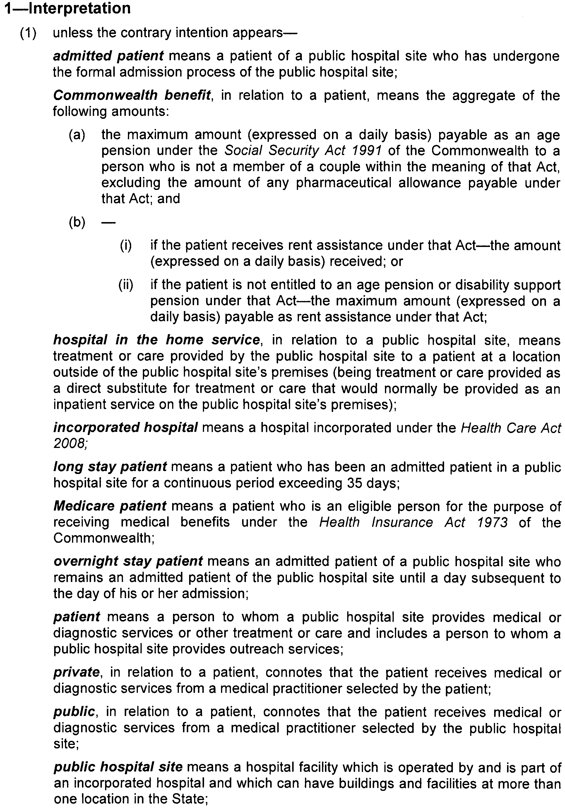
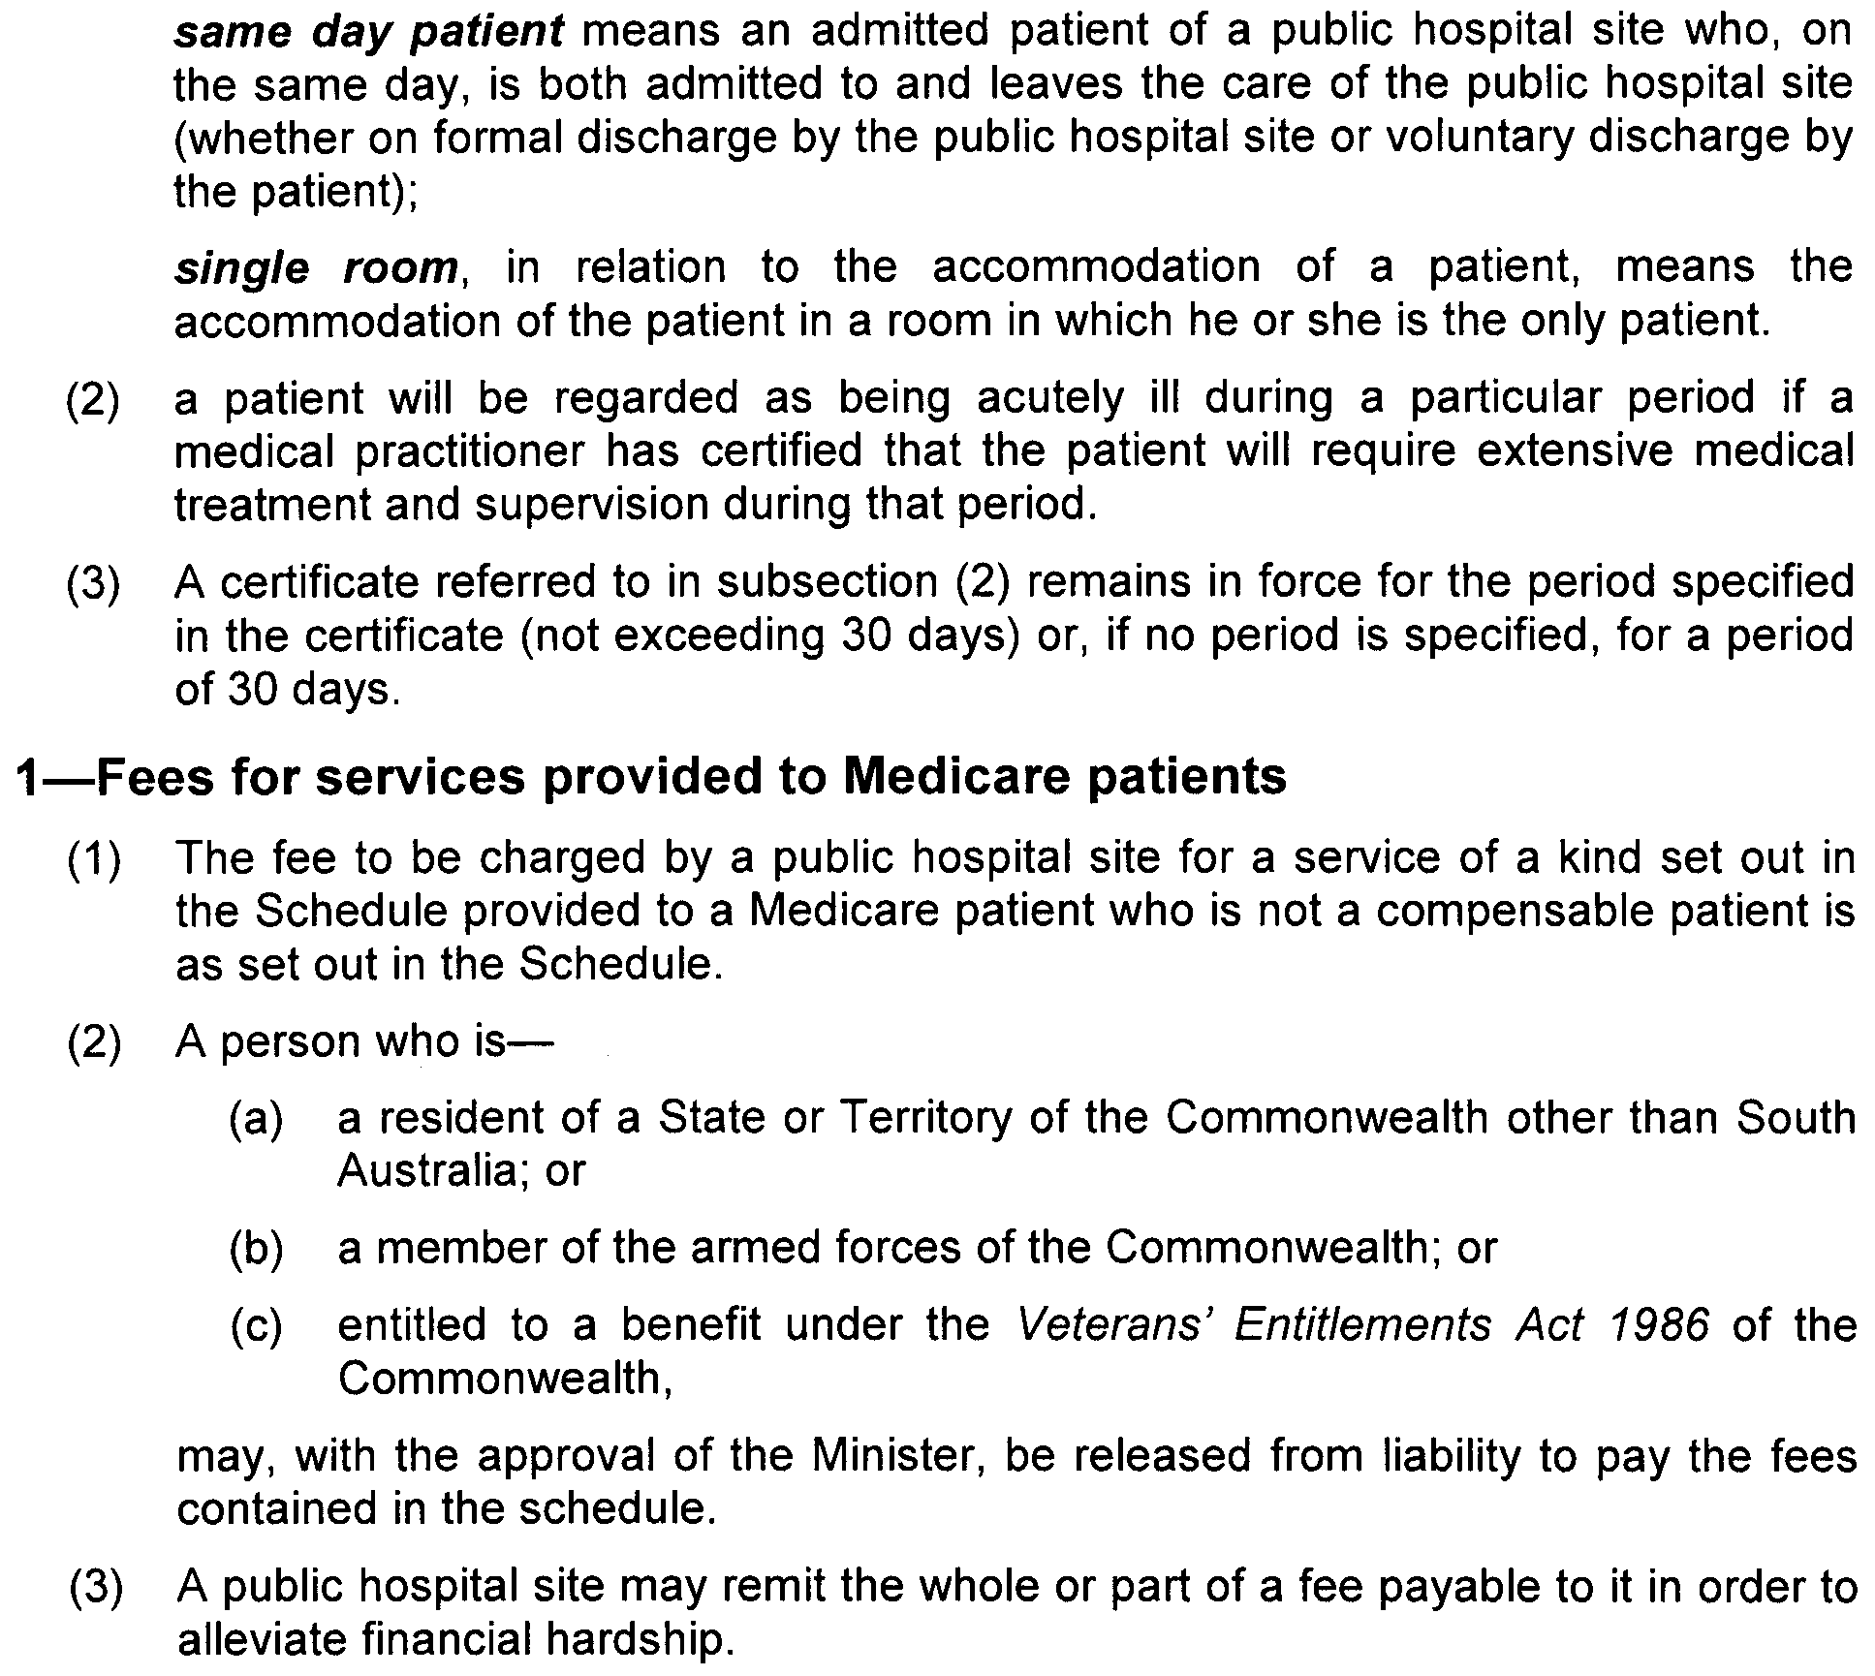
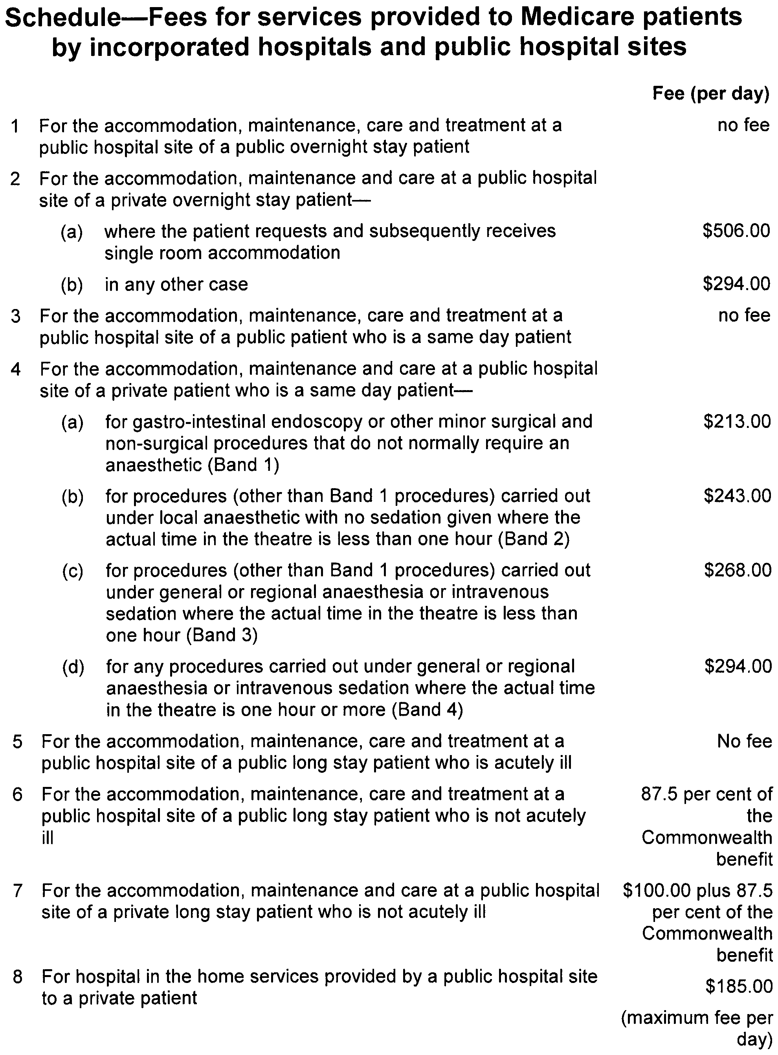

HEALTH CARE ACT 2008
Fees and Charges
I, JOHN HILL, Minister for Health, hereby give notice pursuant to section 44 of the Health Care Act 2008, of the fees in the list attached to apply to a compensable patient.
These charges will operate from 17 September 2009 to 30 June 2010.
Dated 8 September 2009.
John Hill, Minister for Health

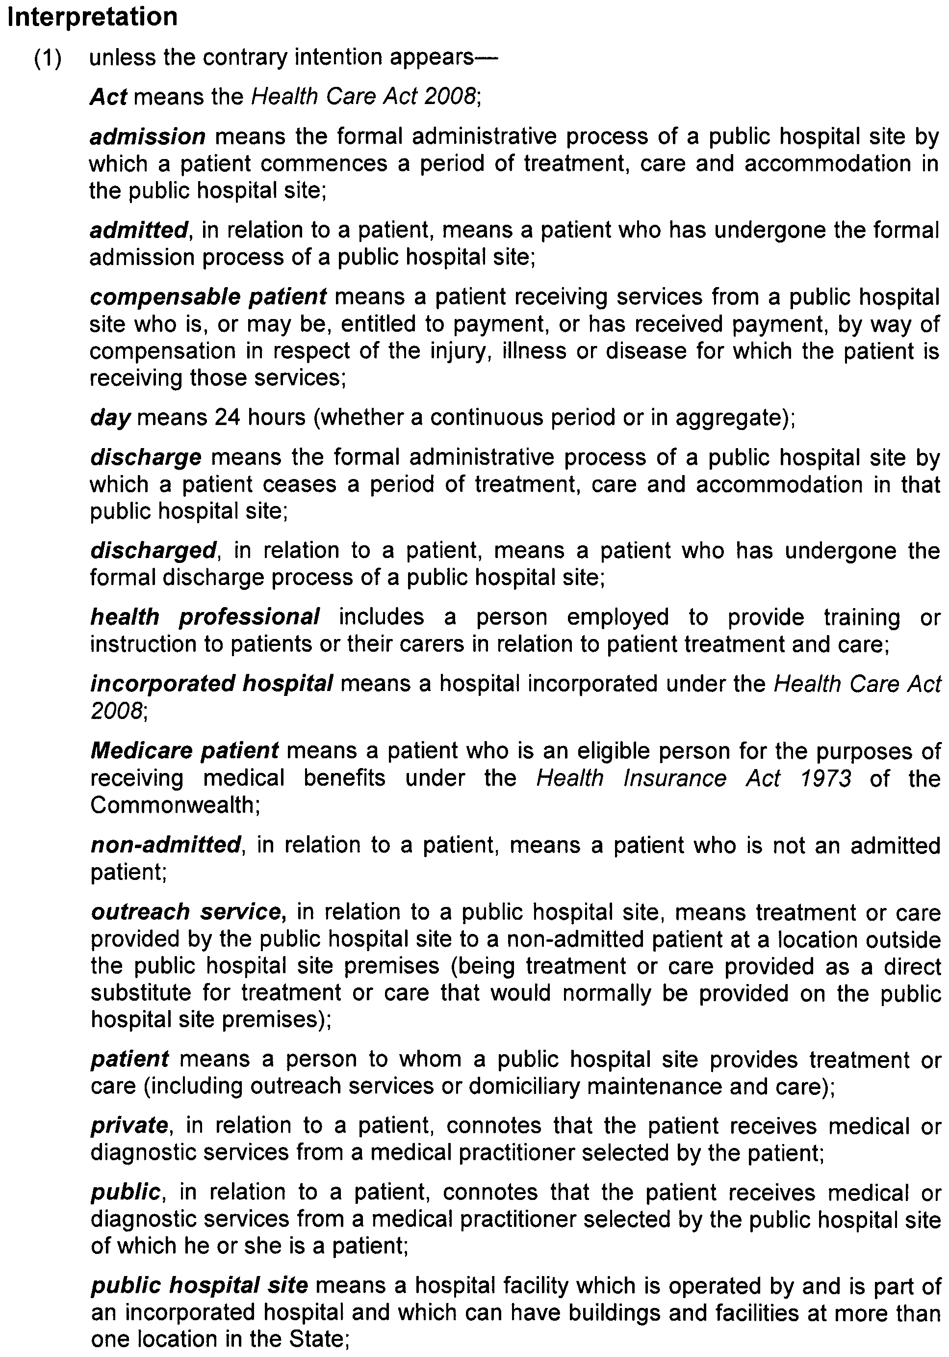
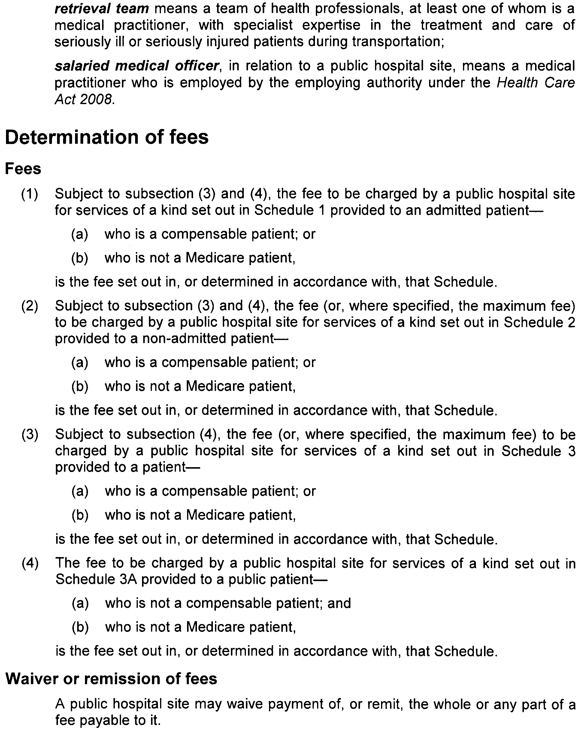
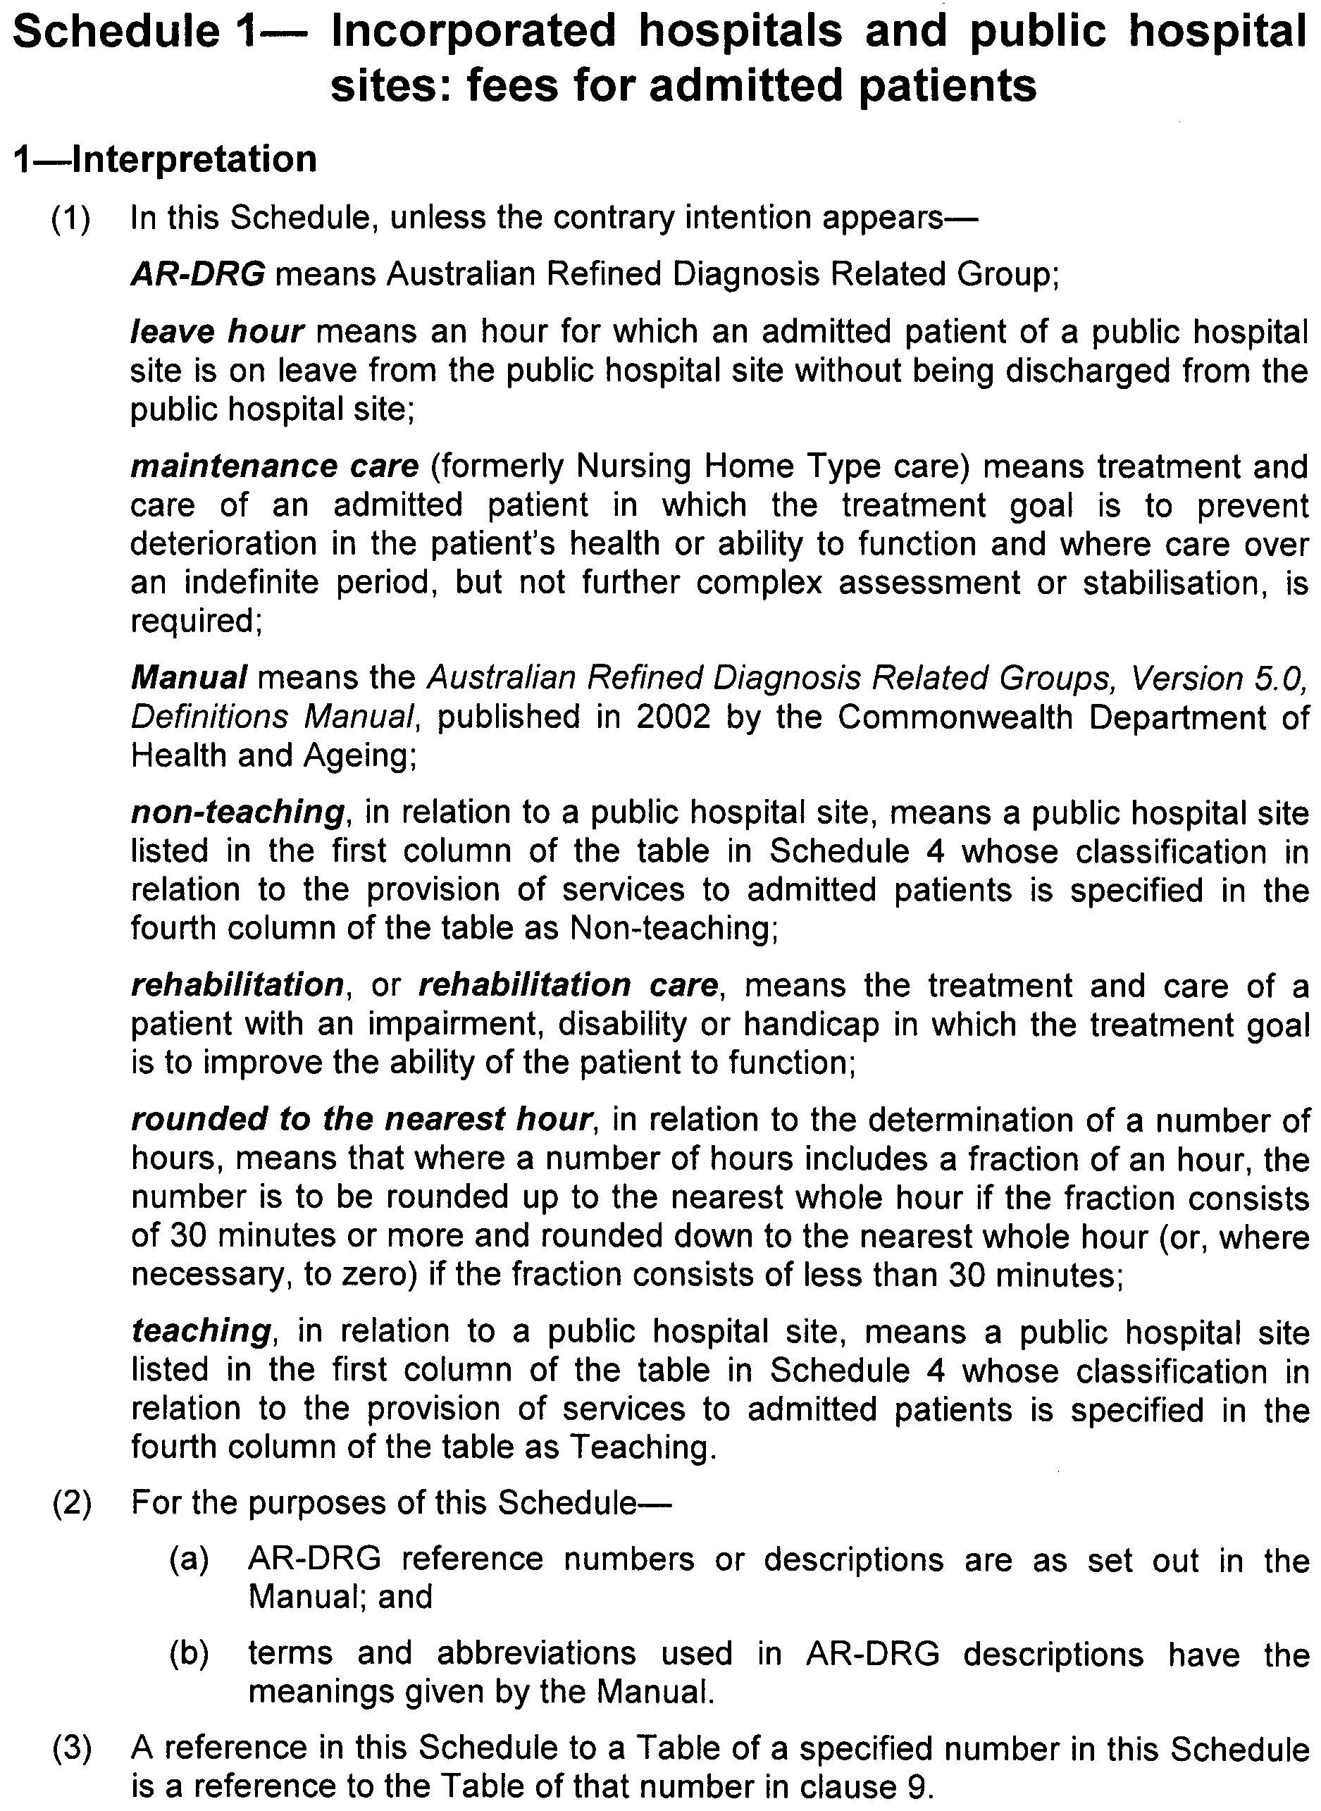
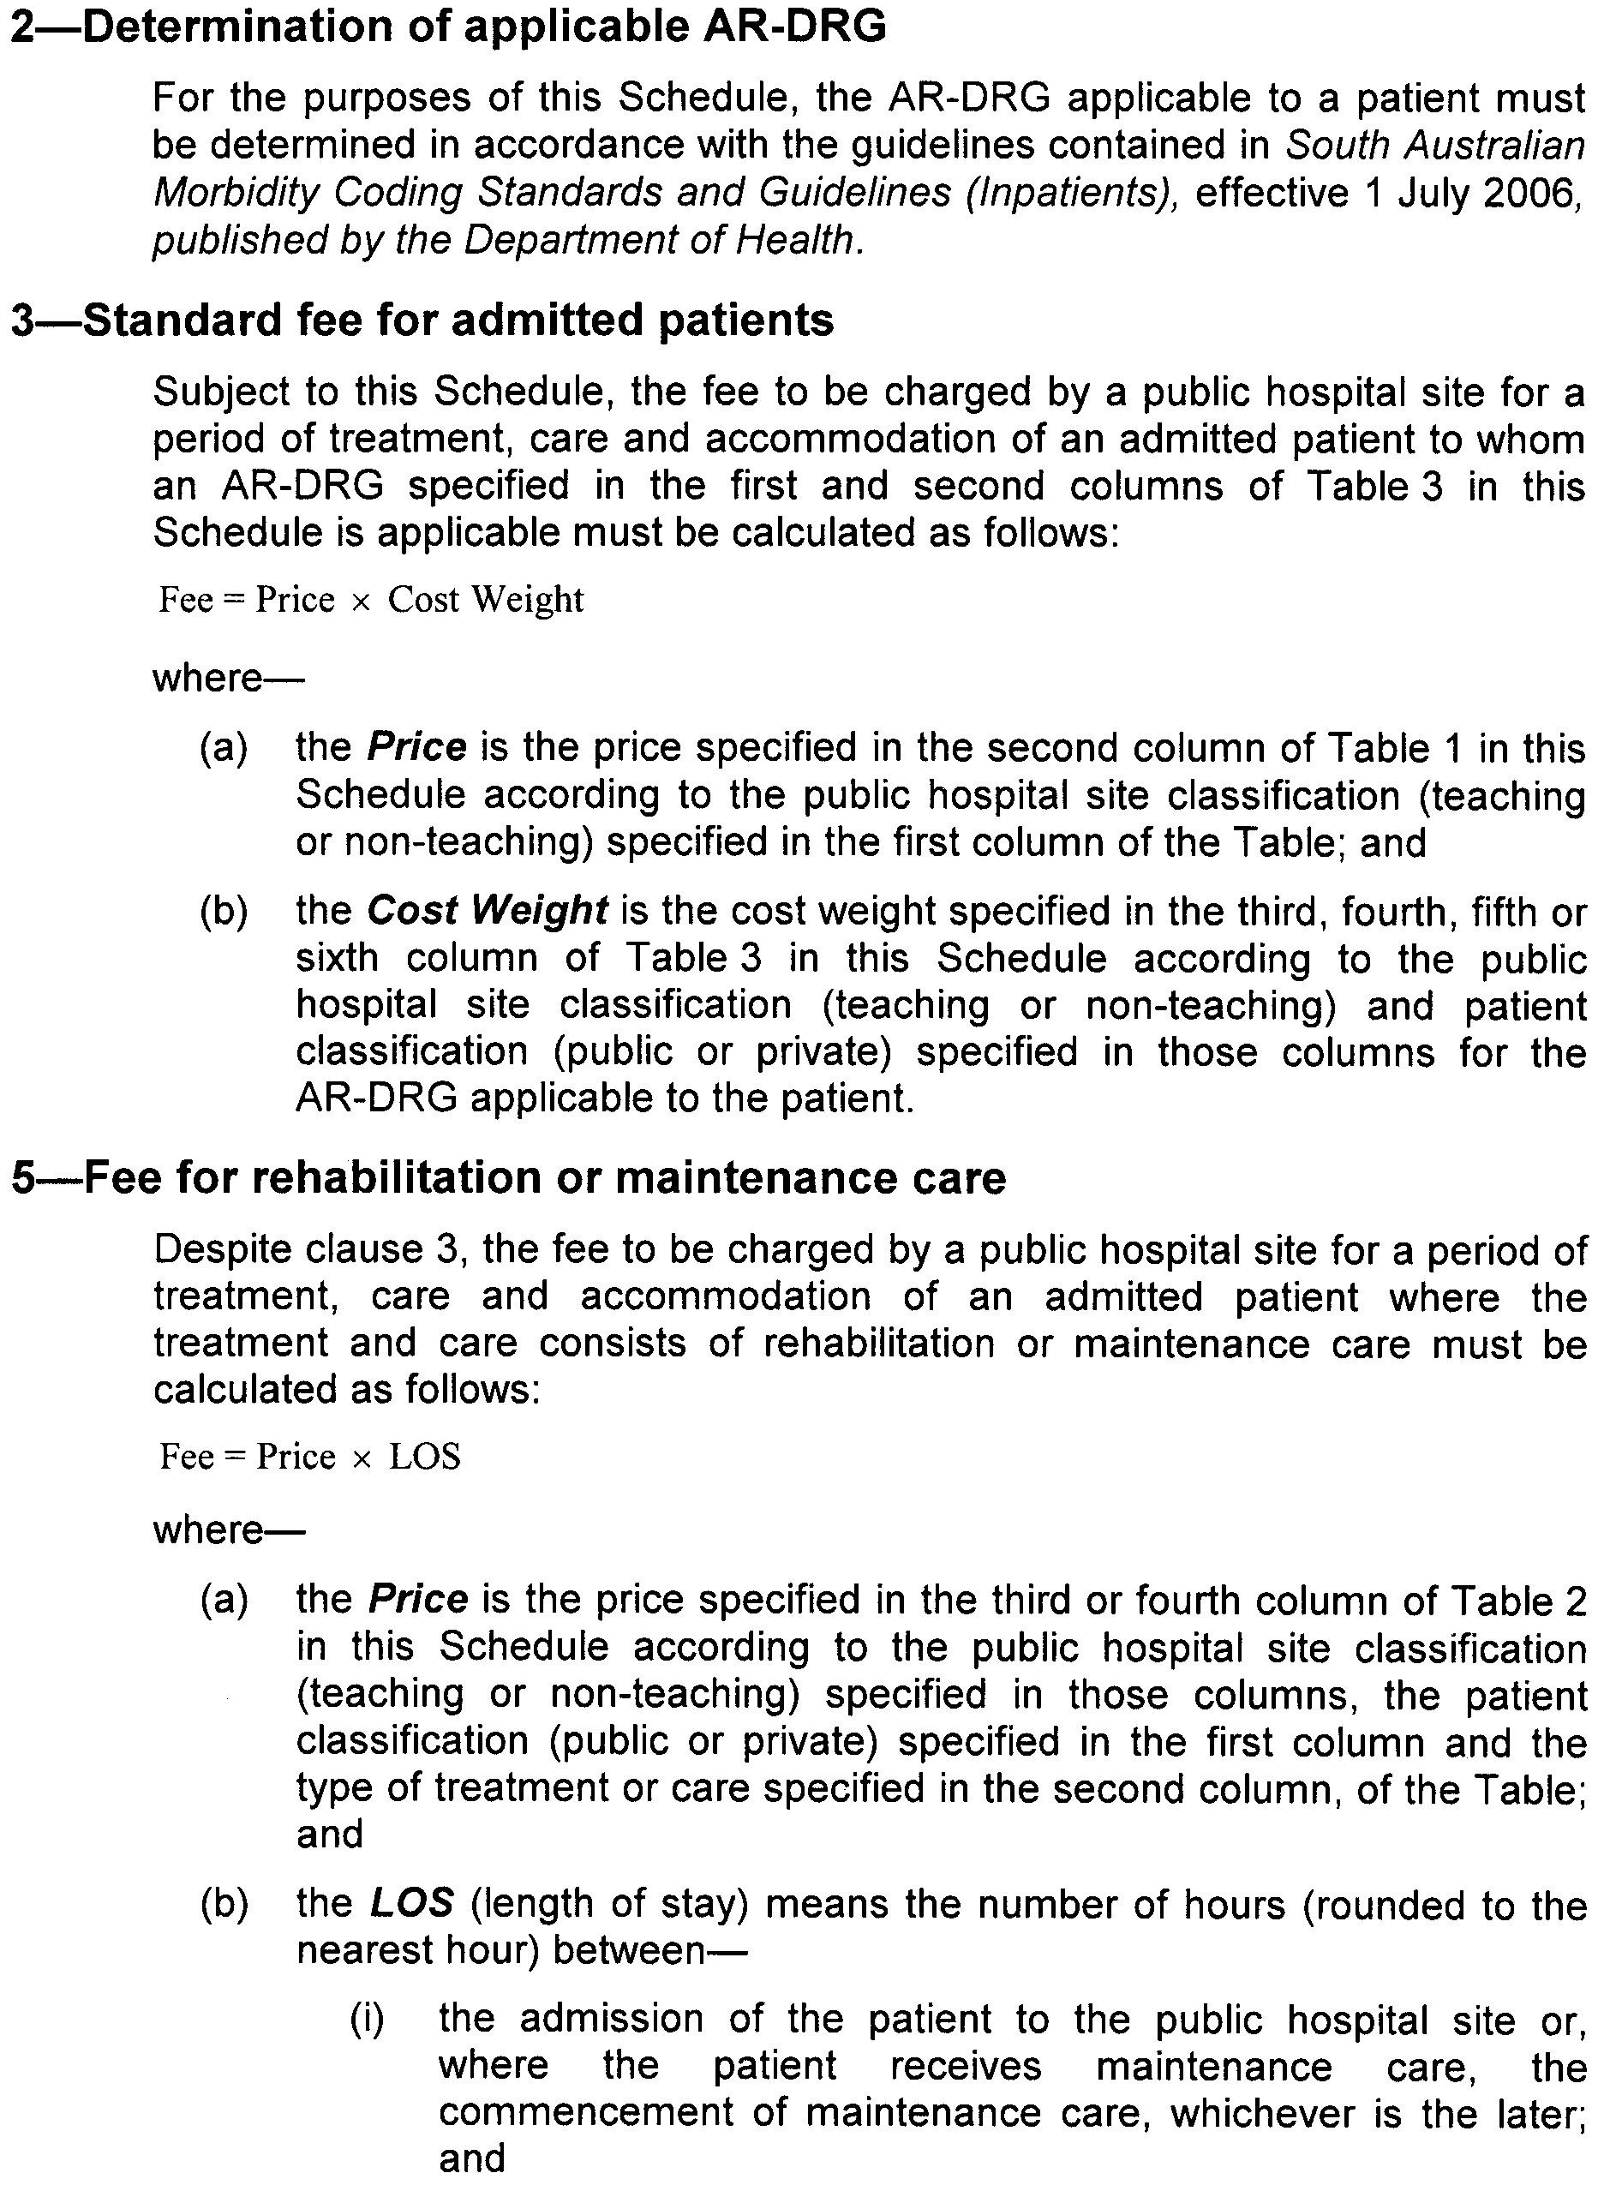
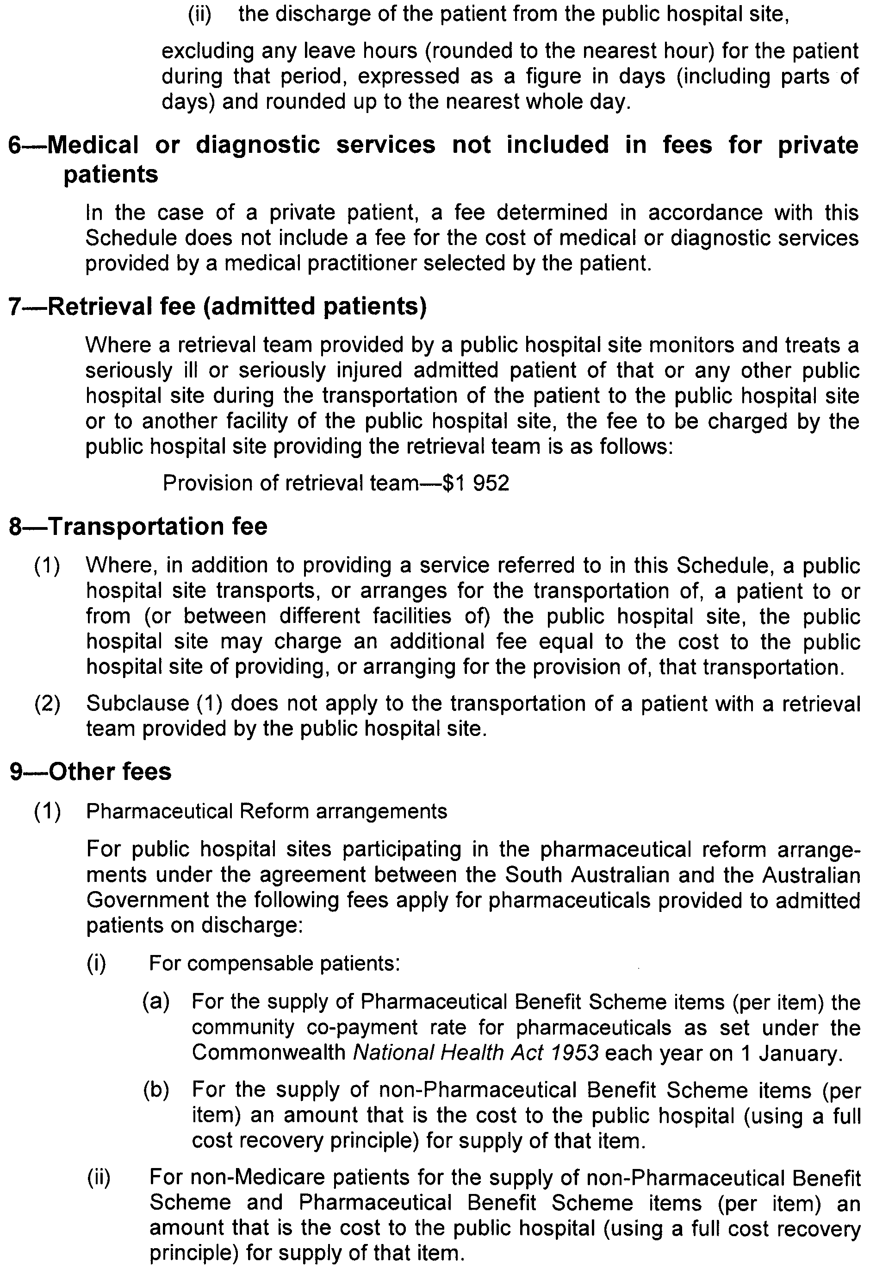
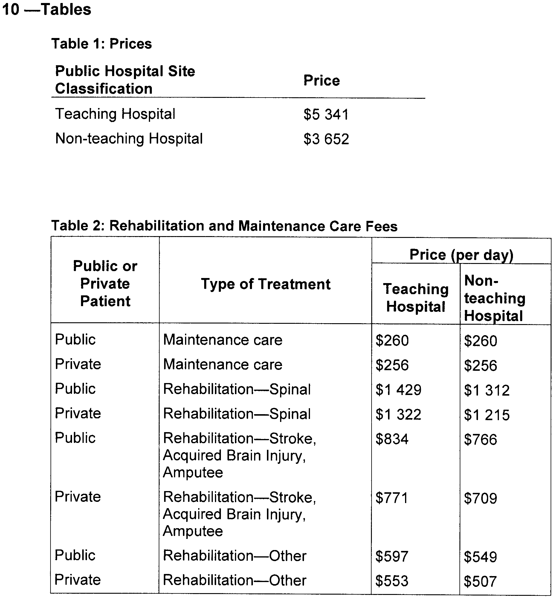
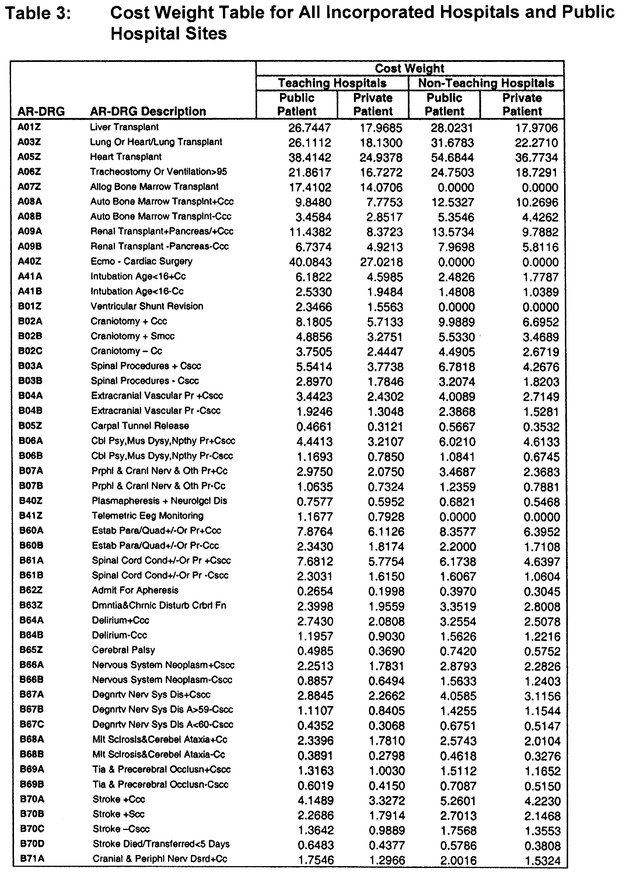
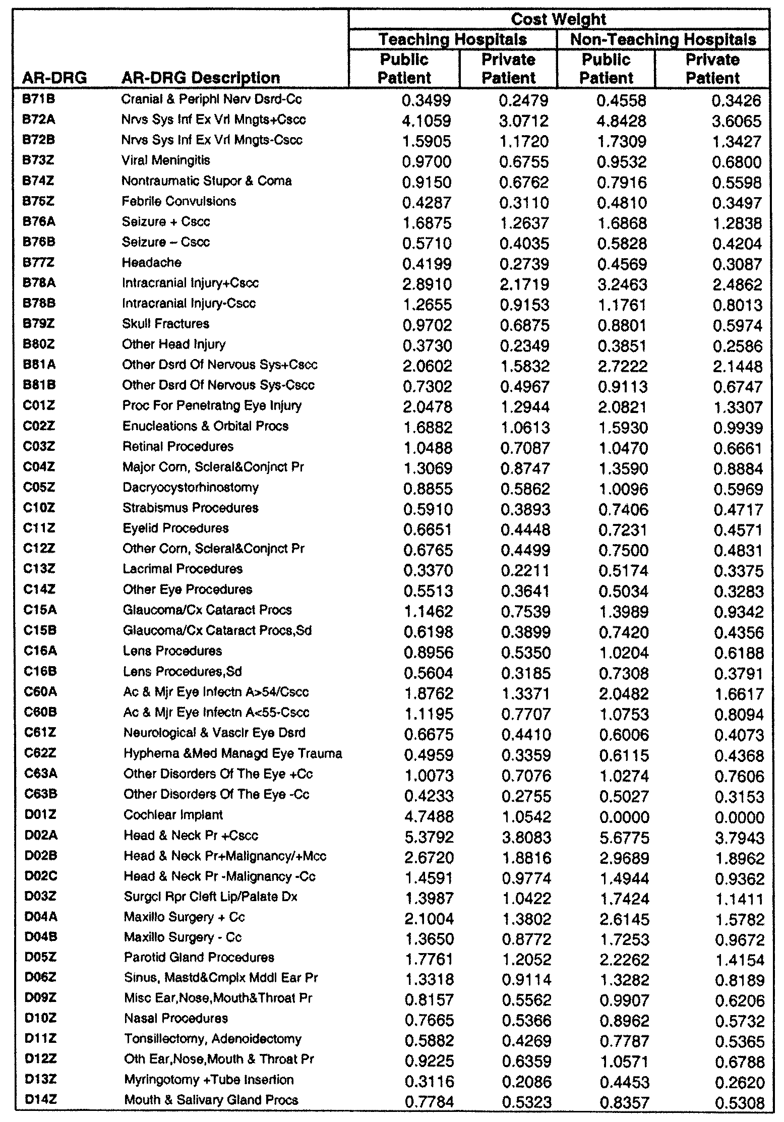
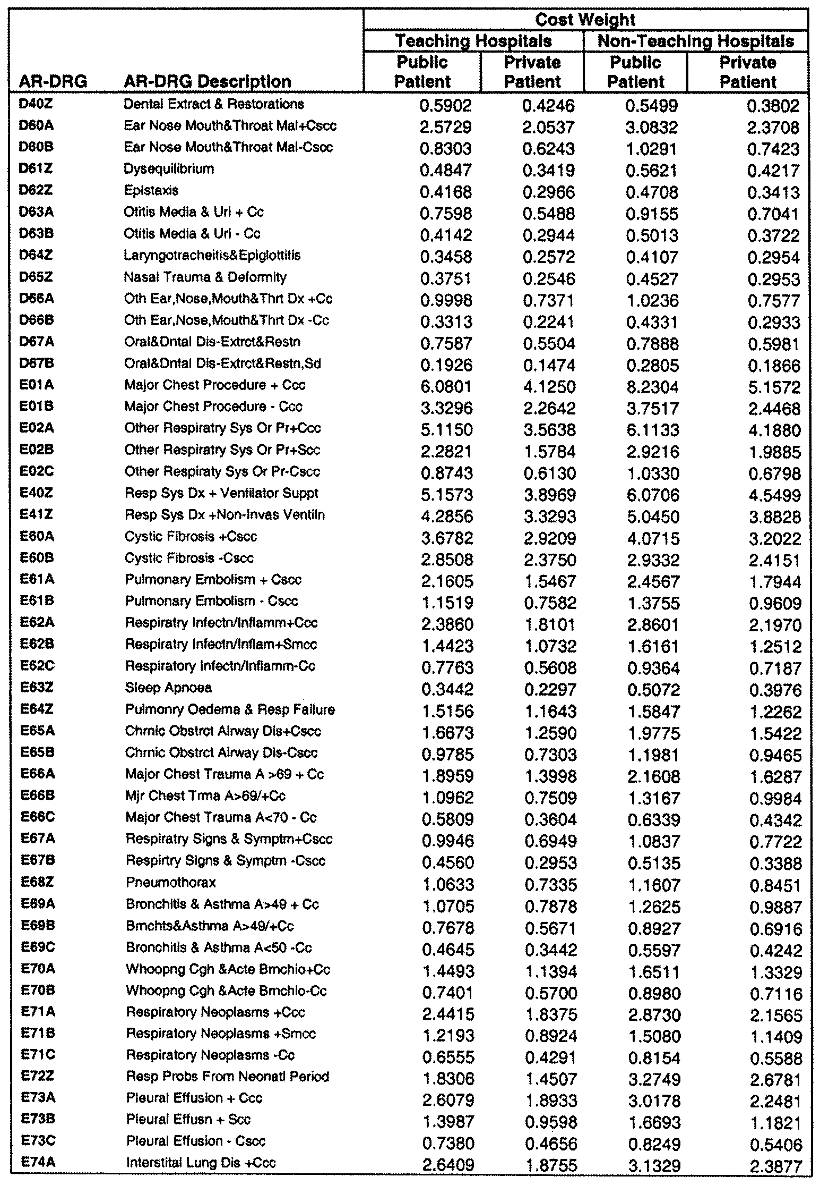
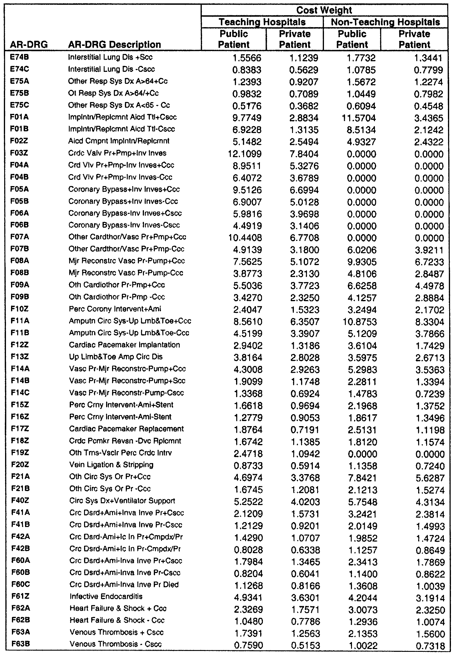
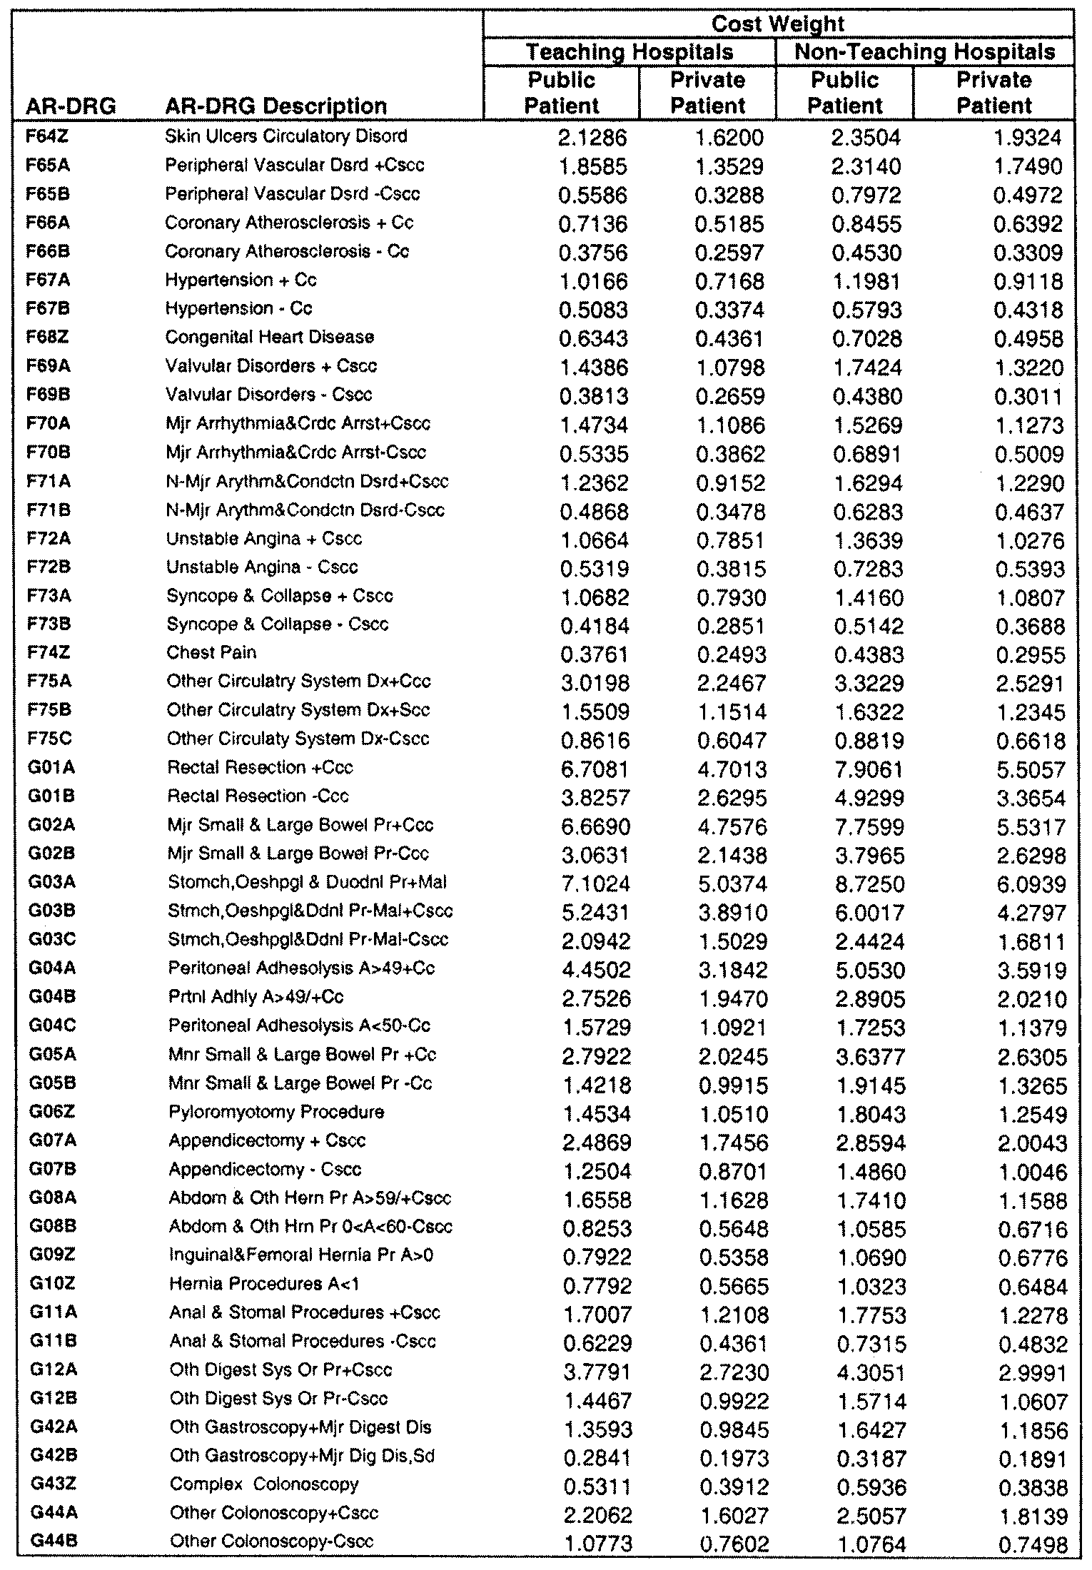
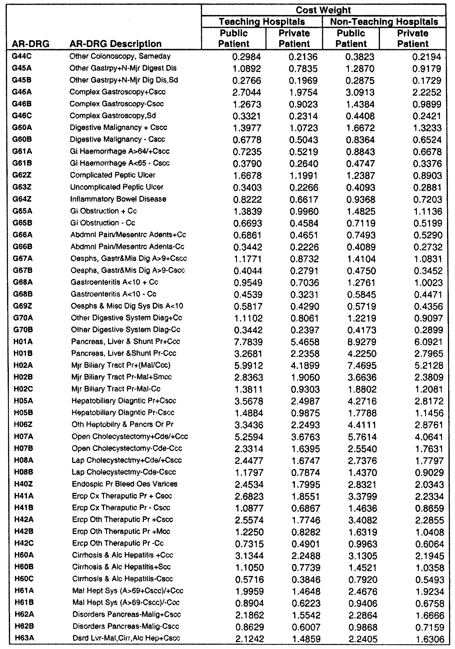
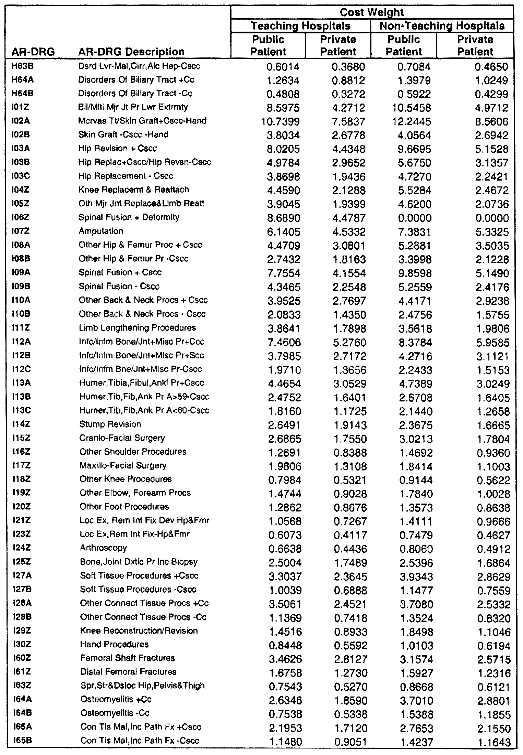
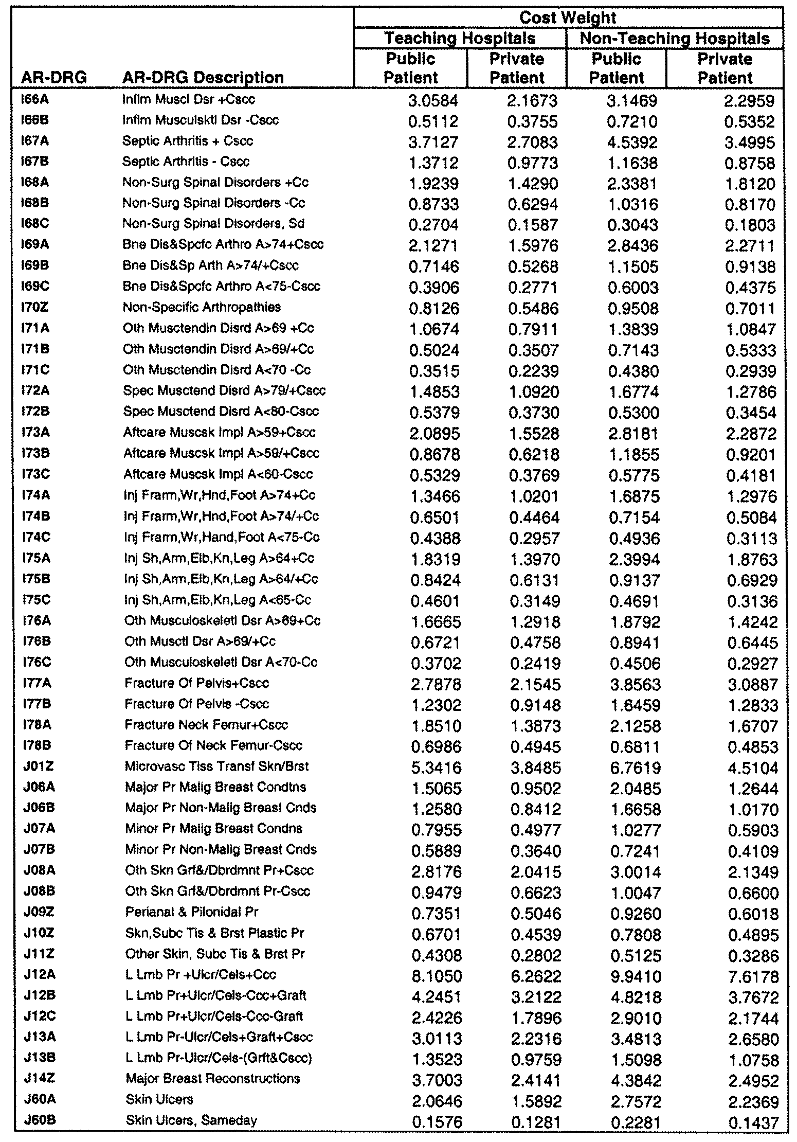
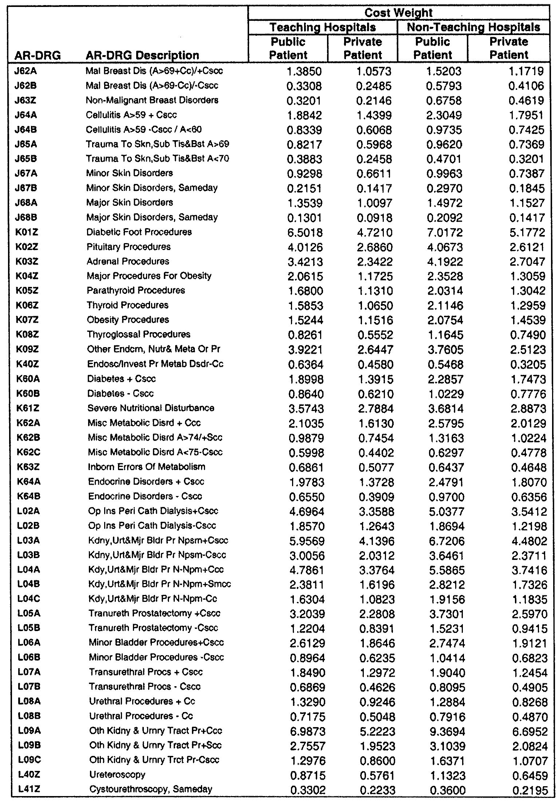
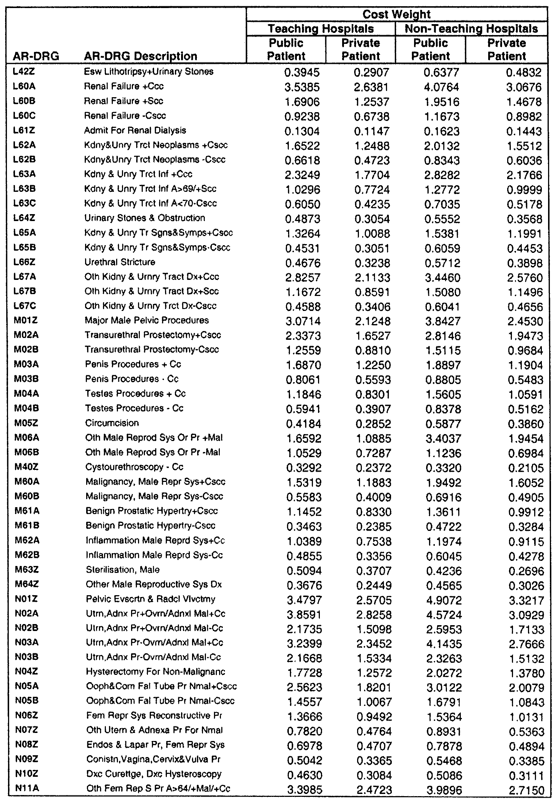
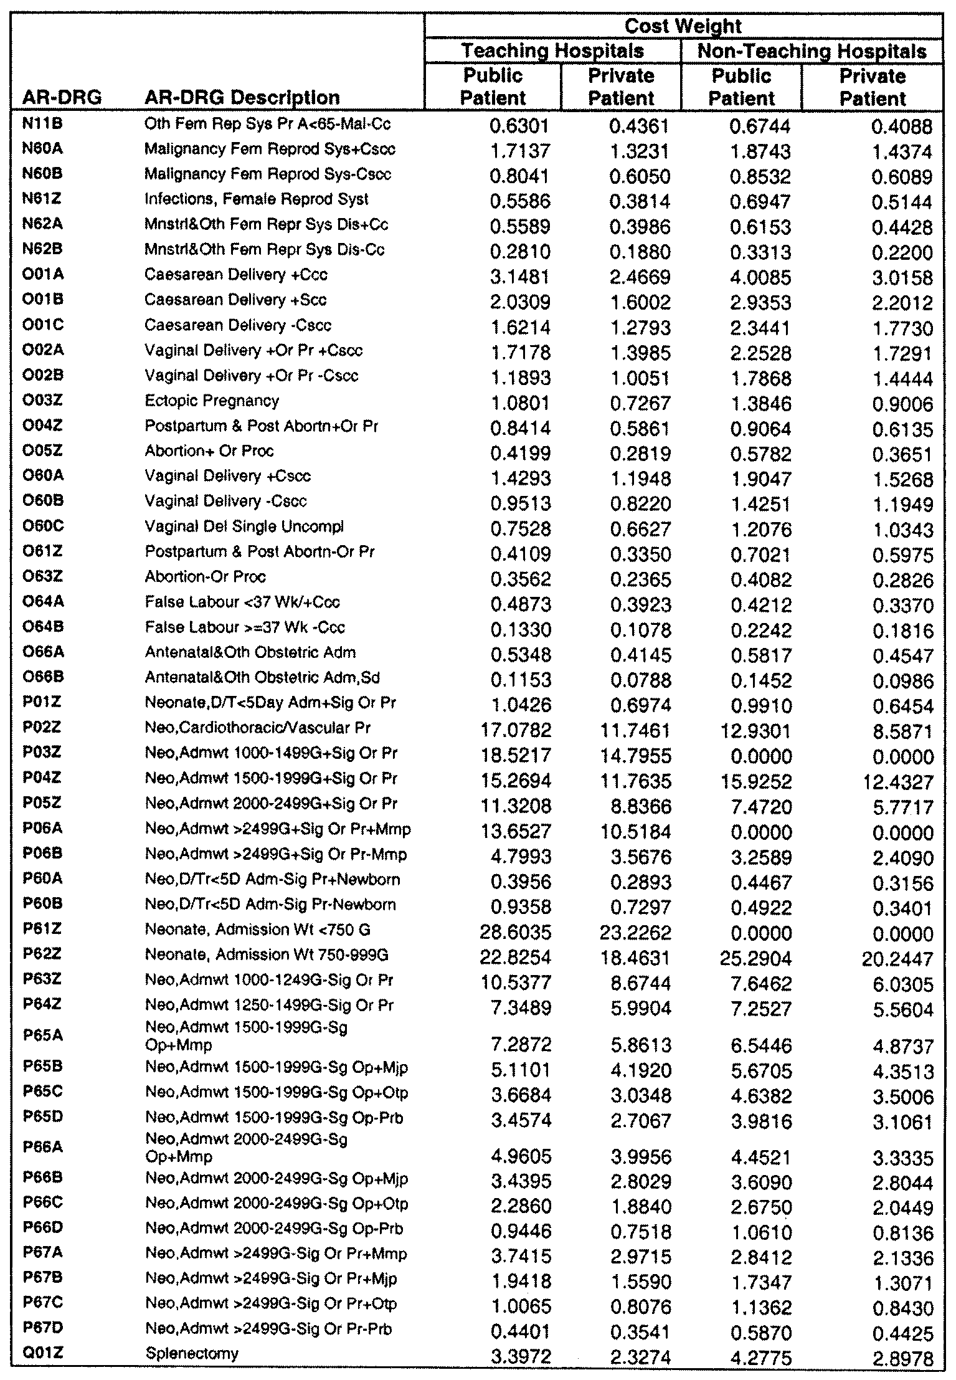
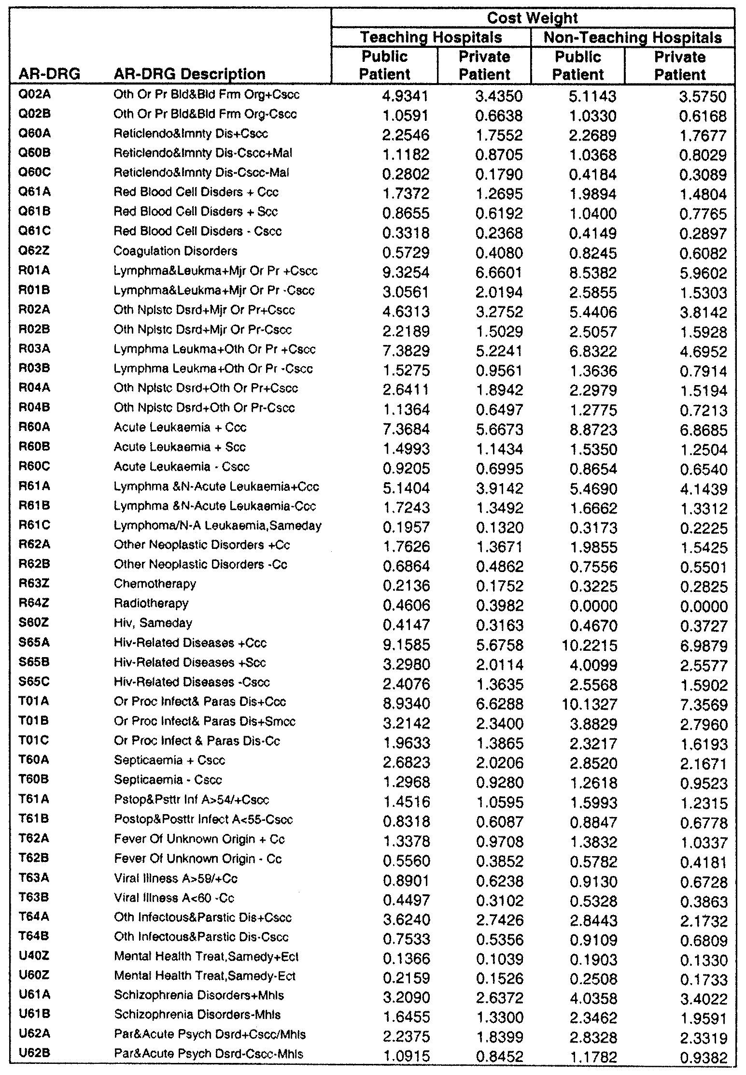
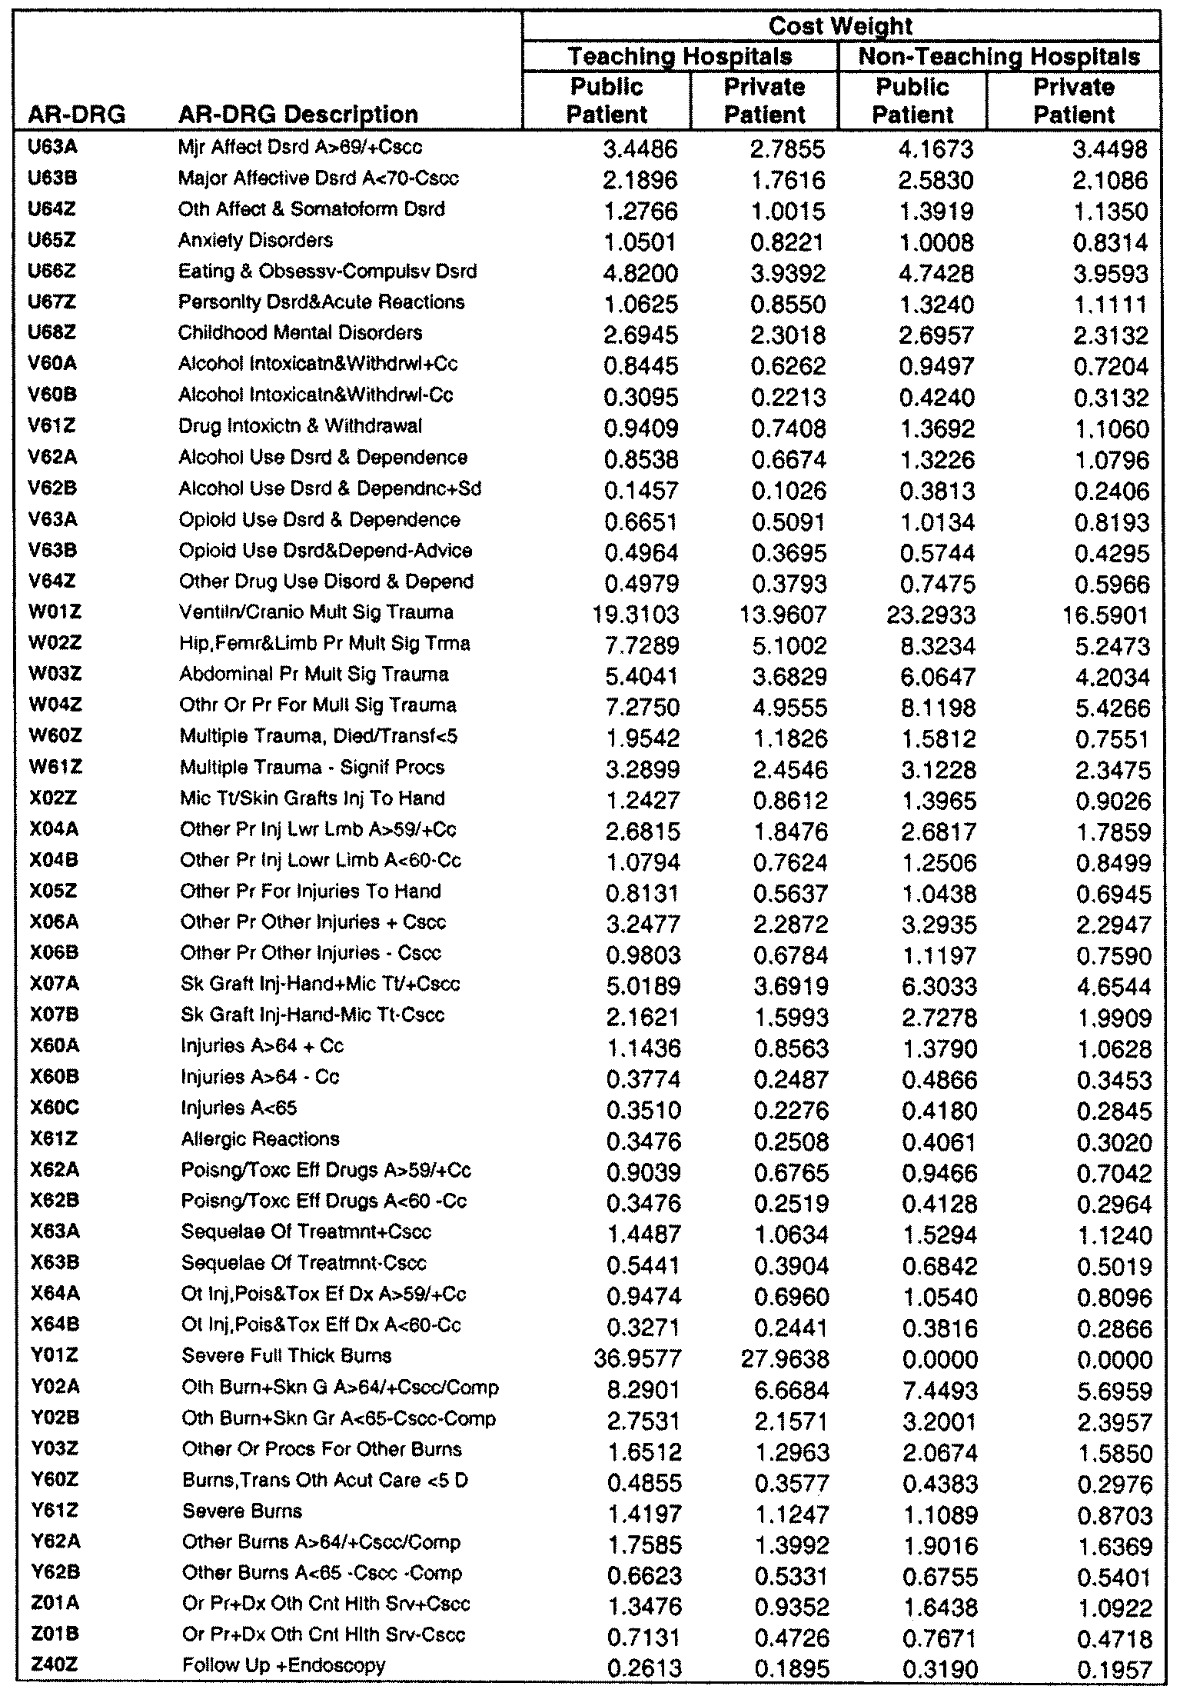
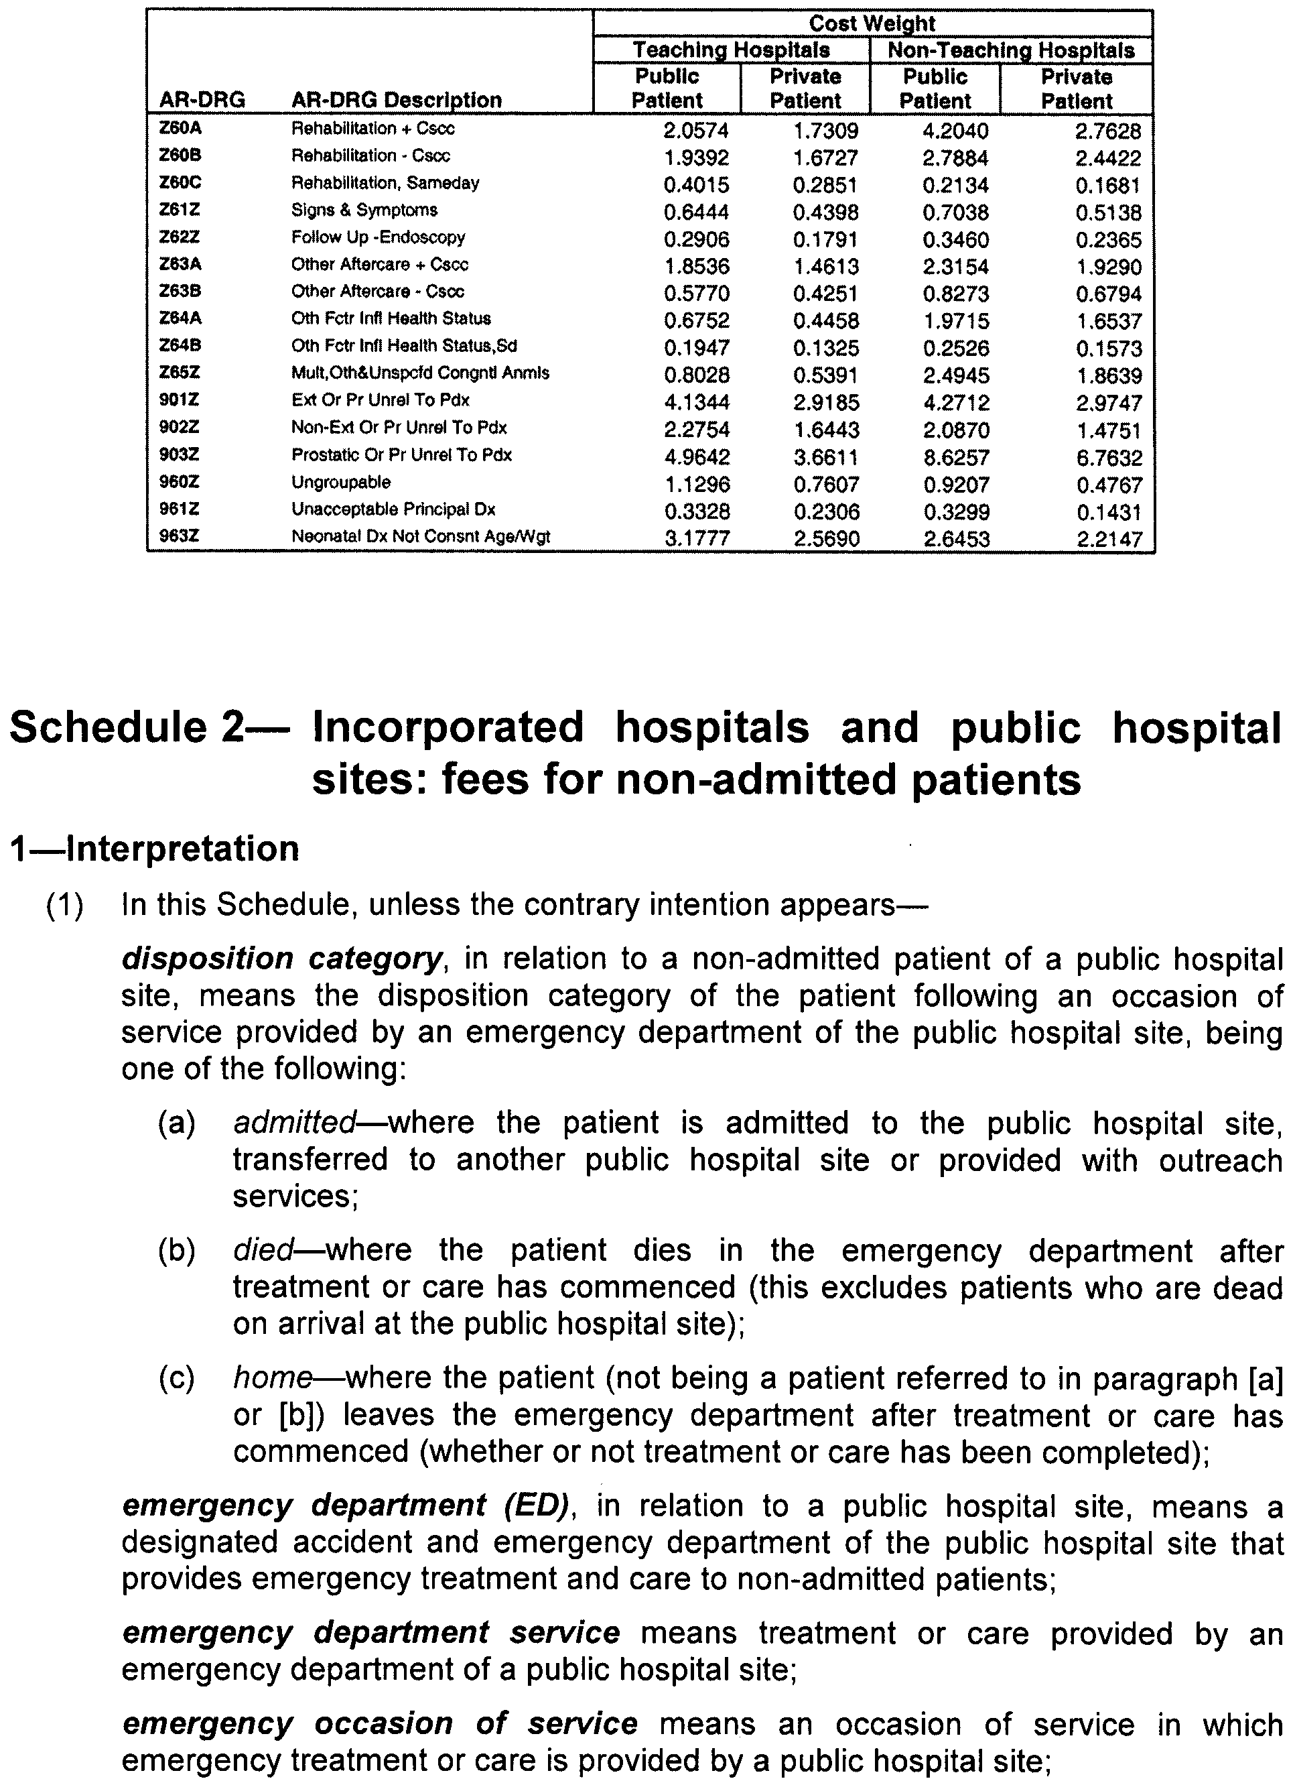
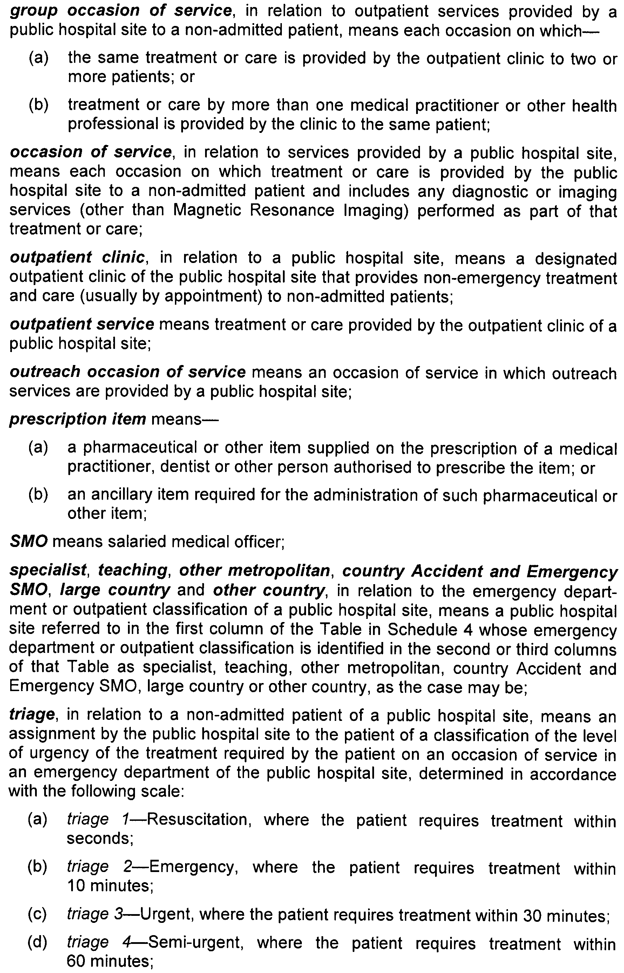
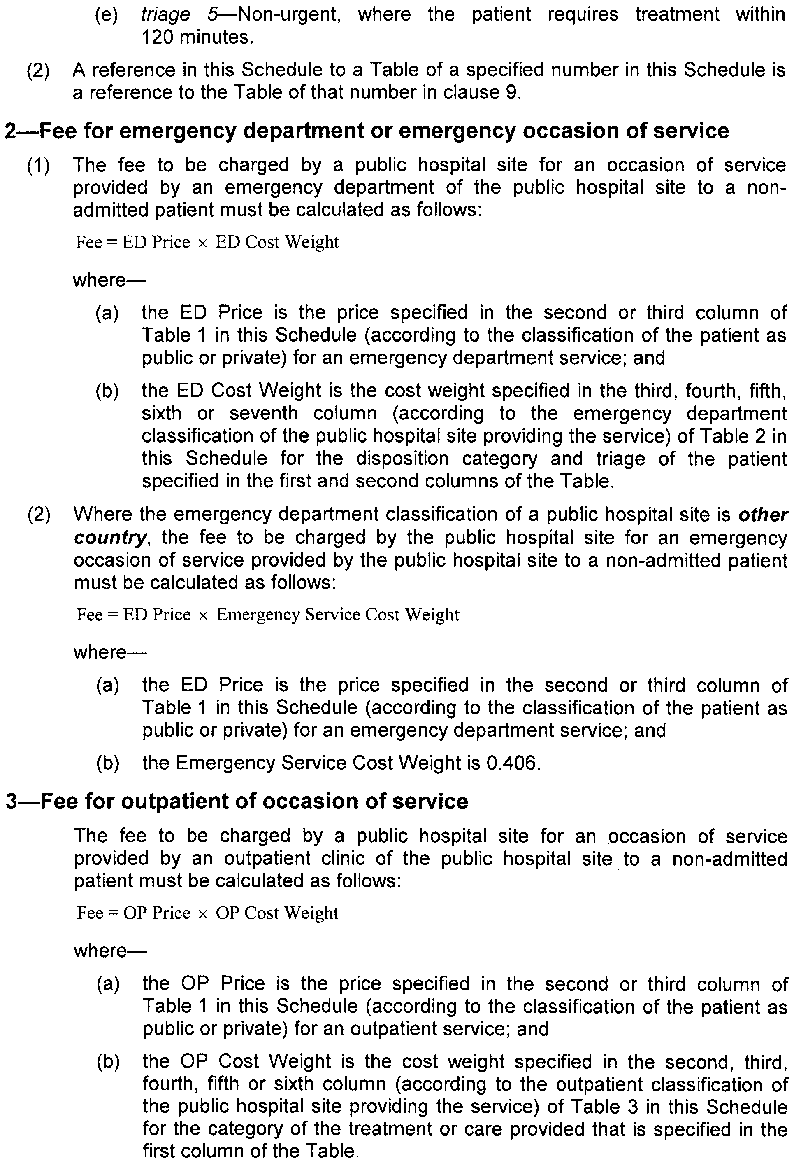

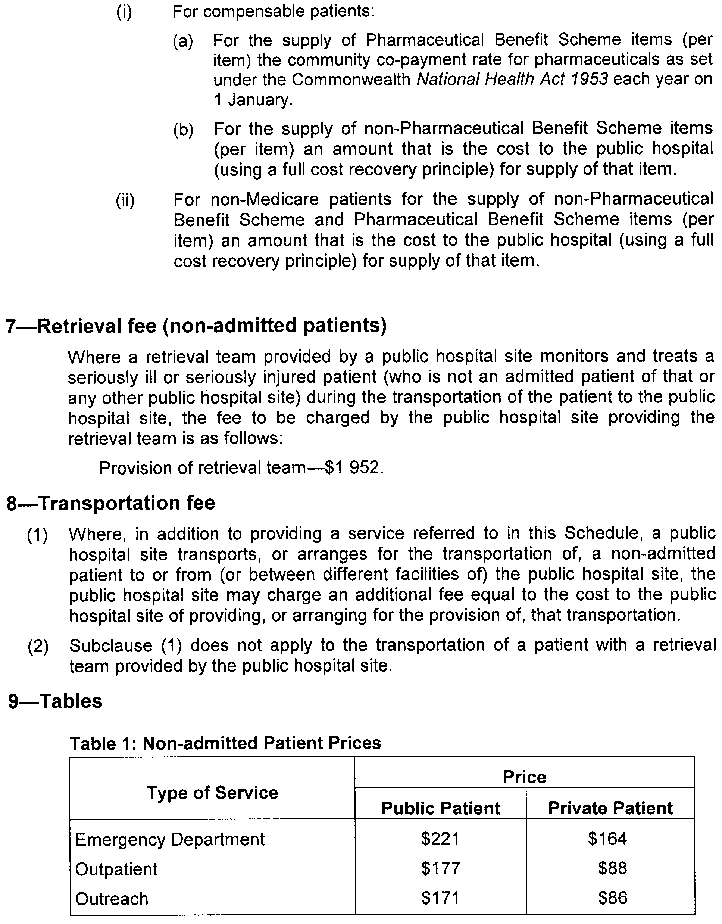
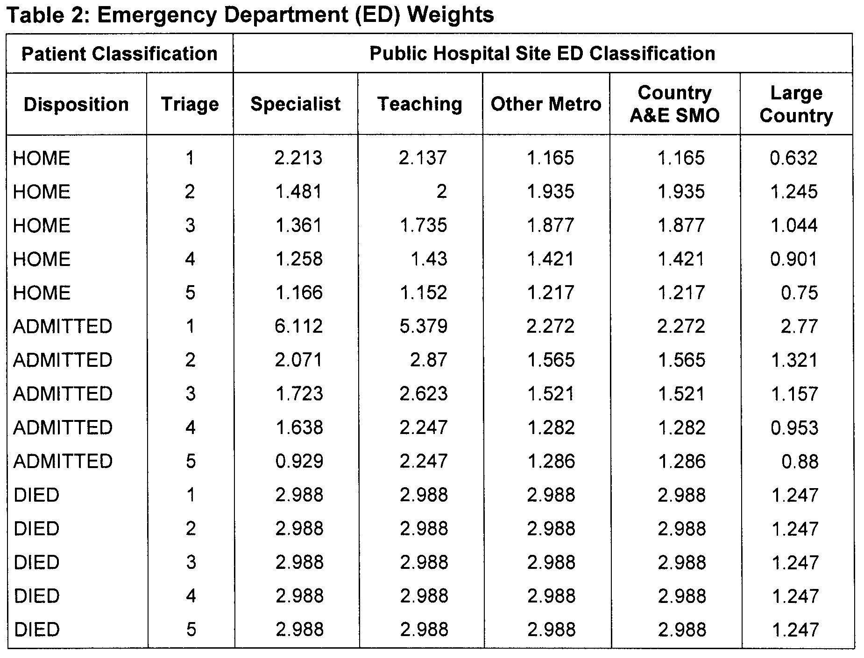
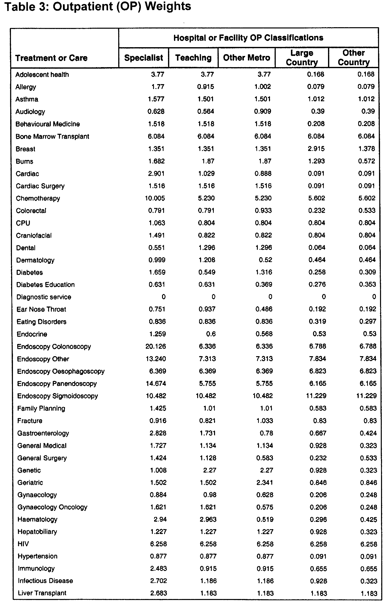
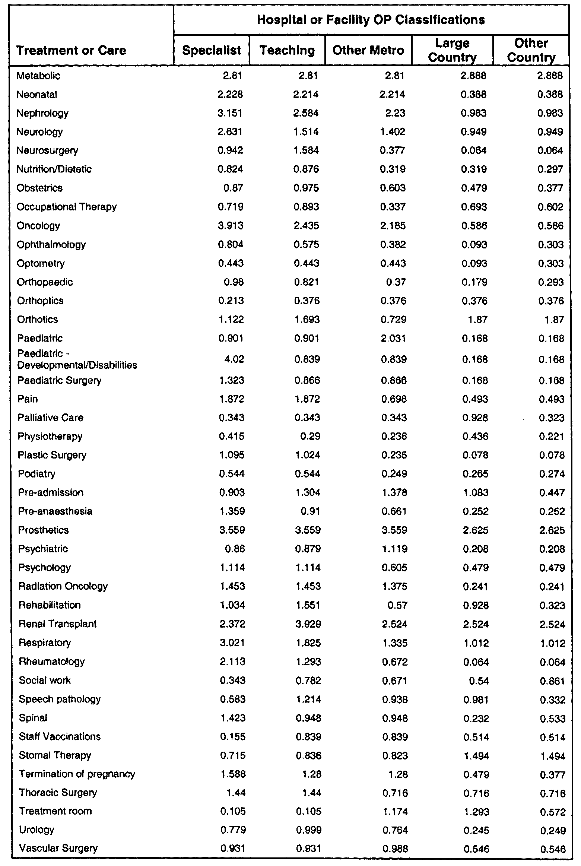
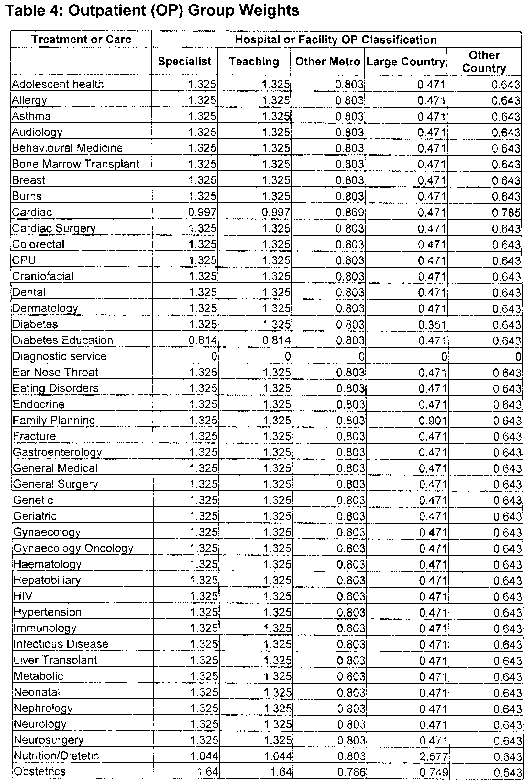
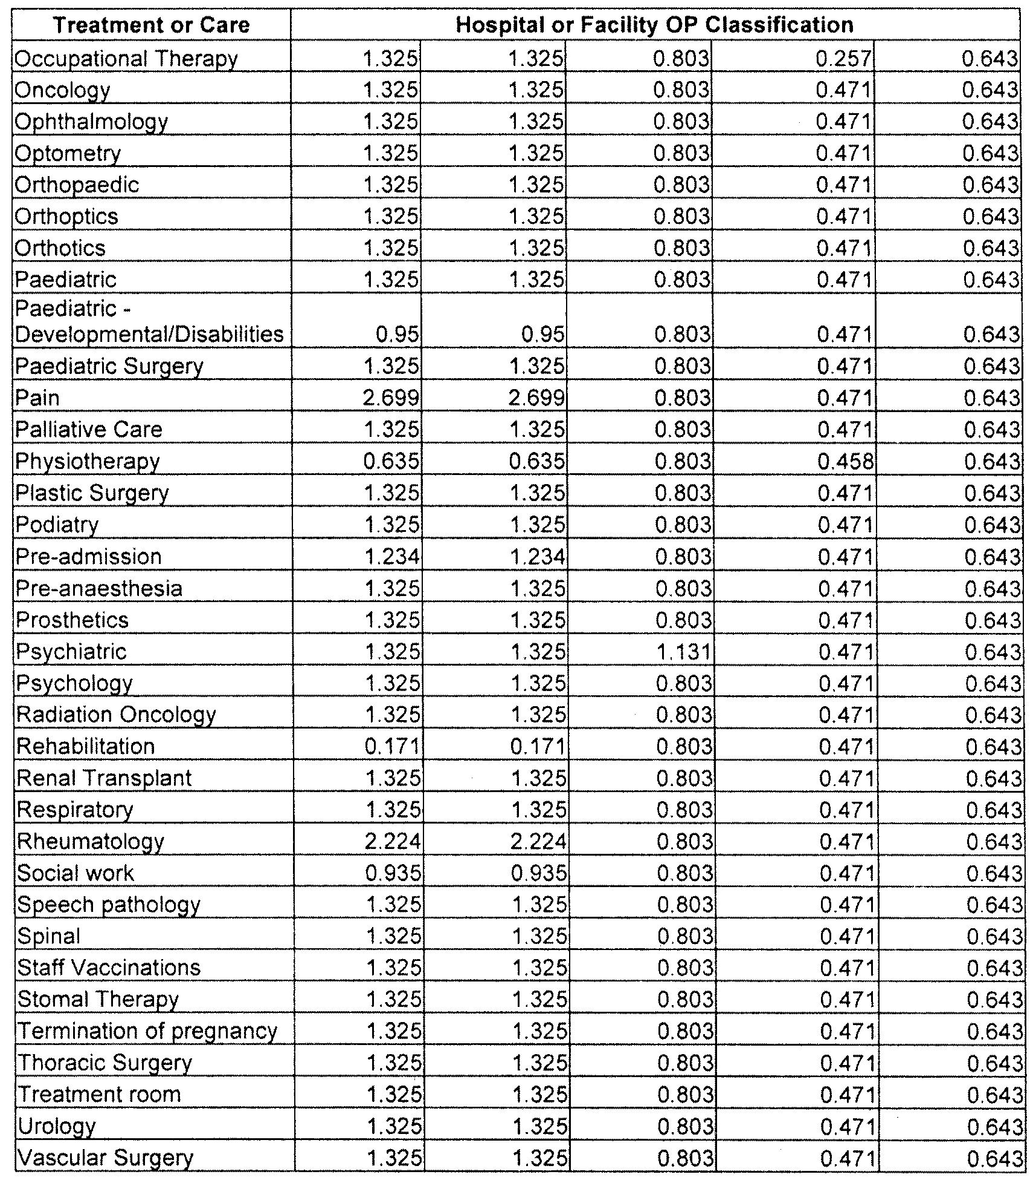
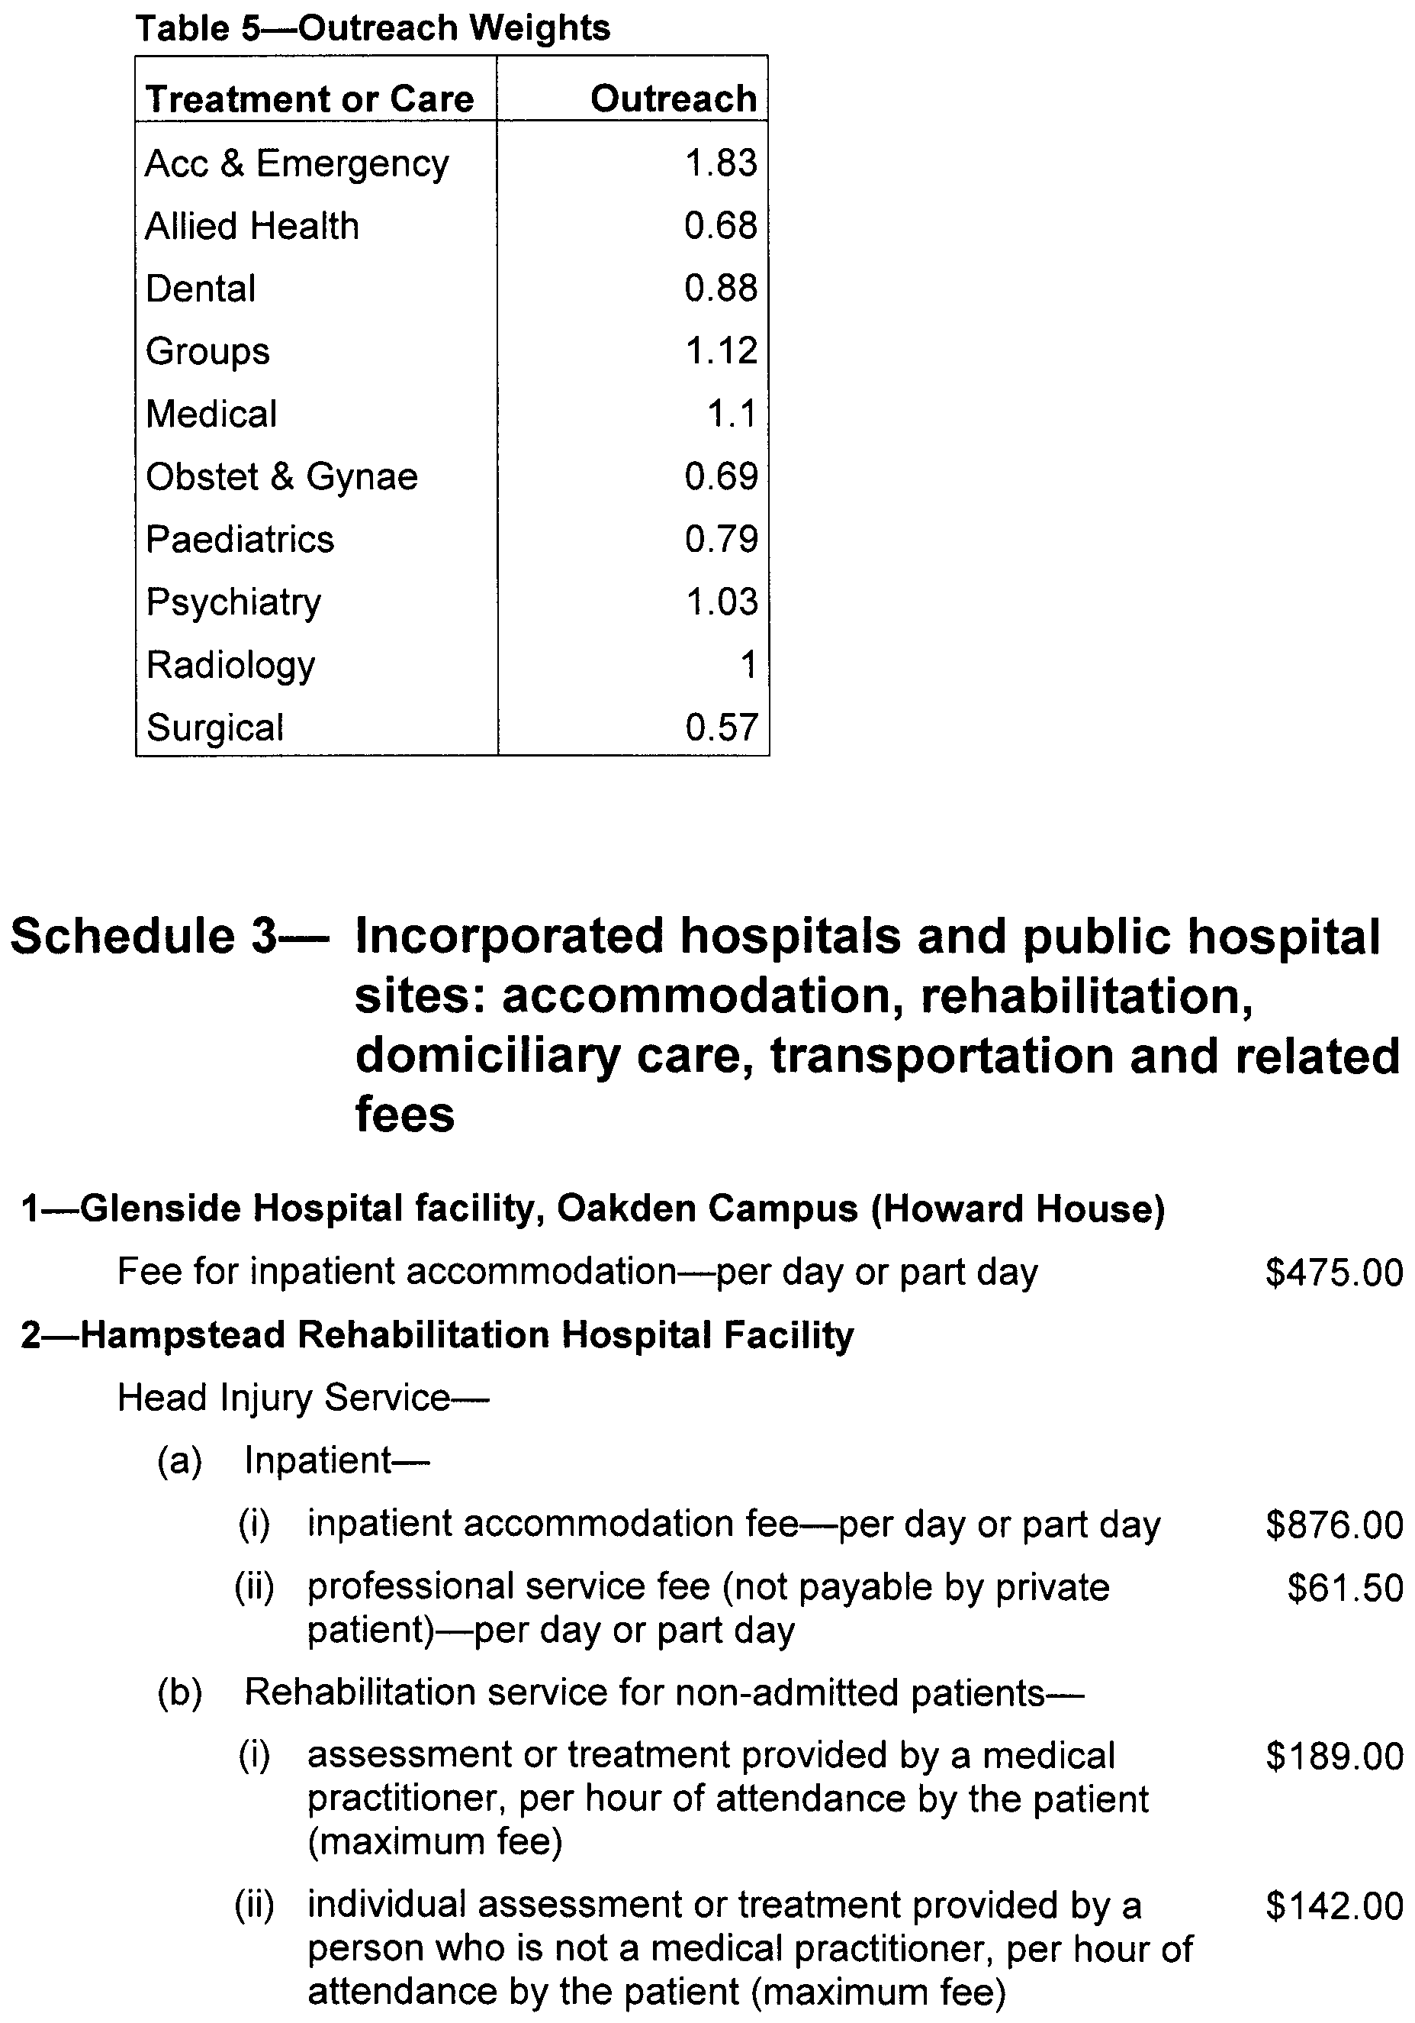
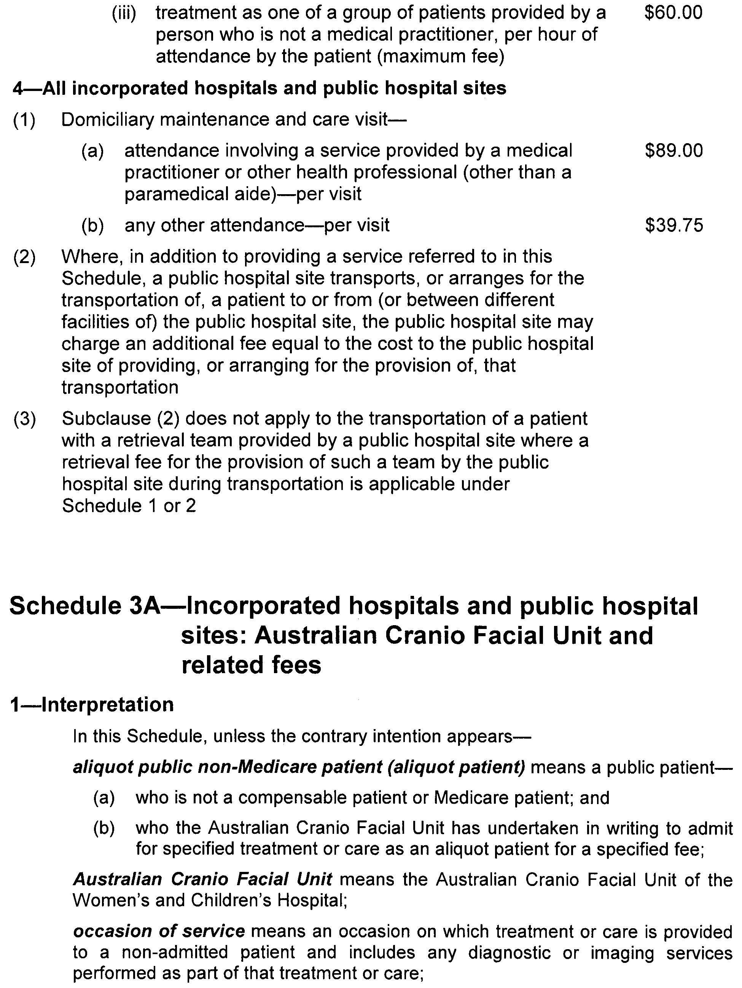
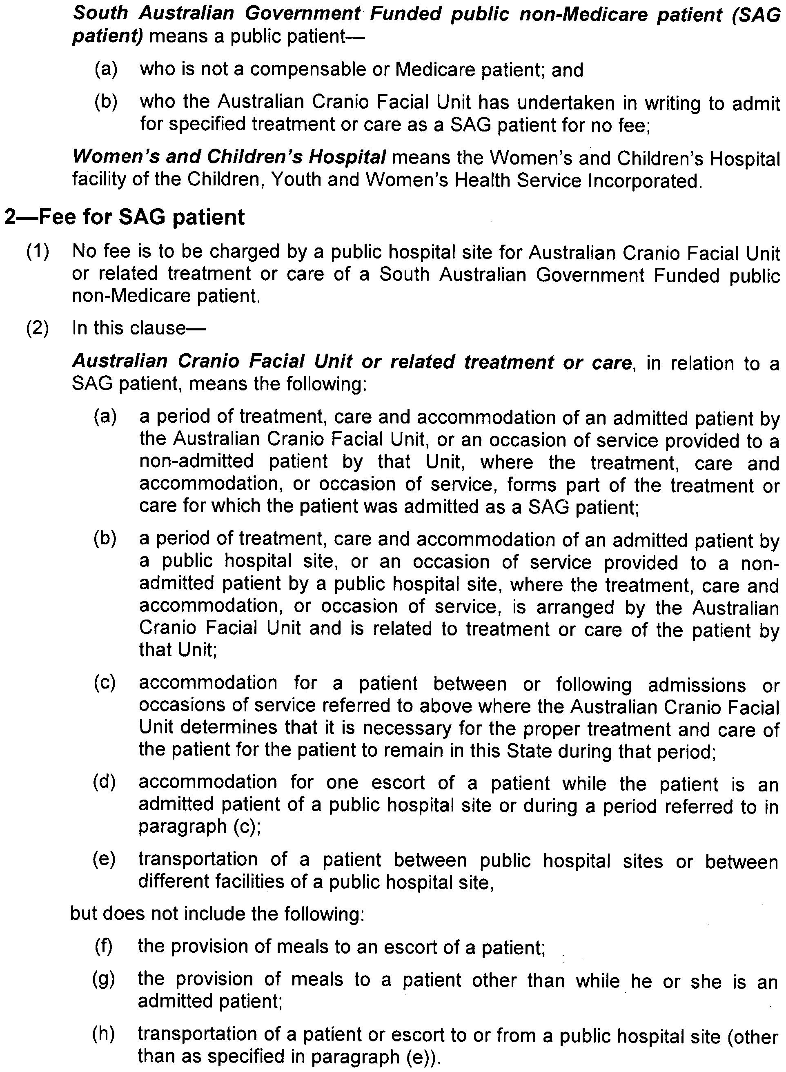
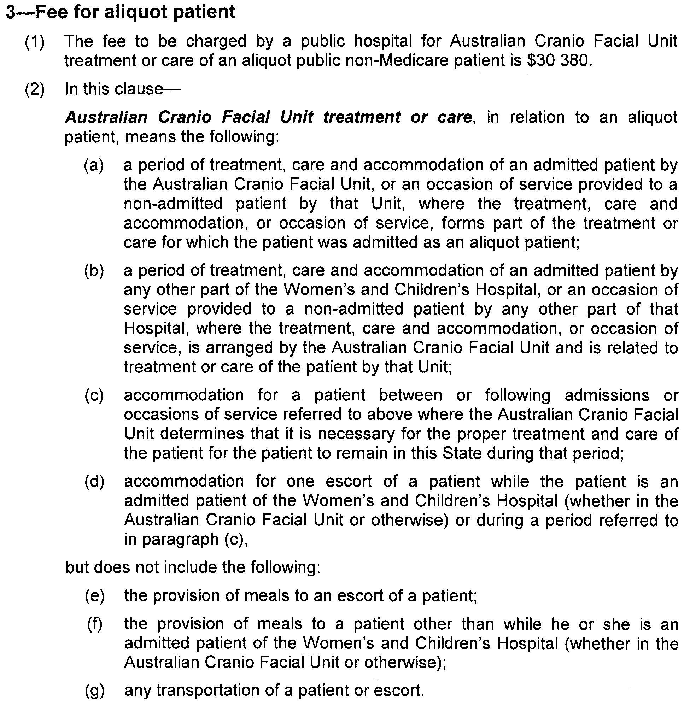
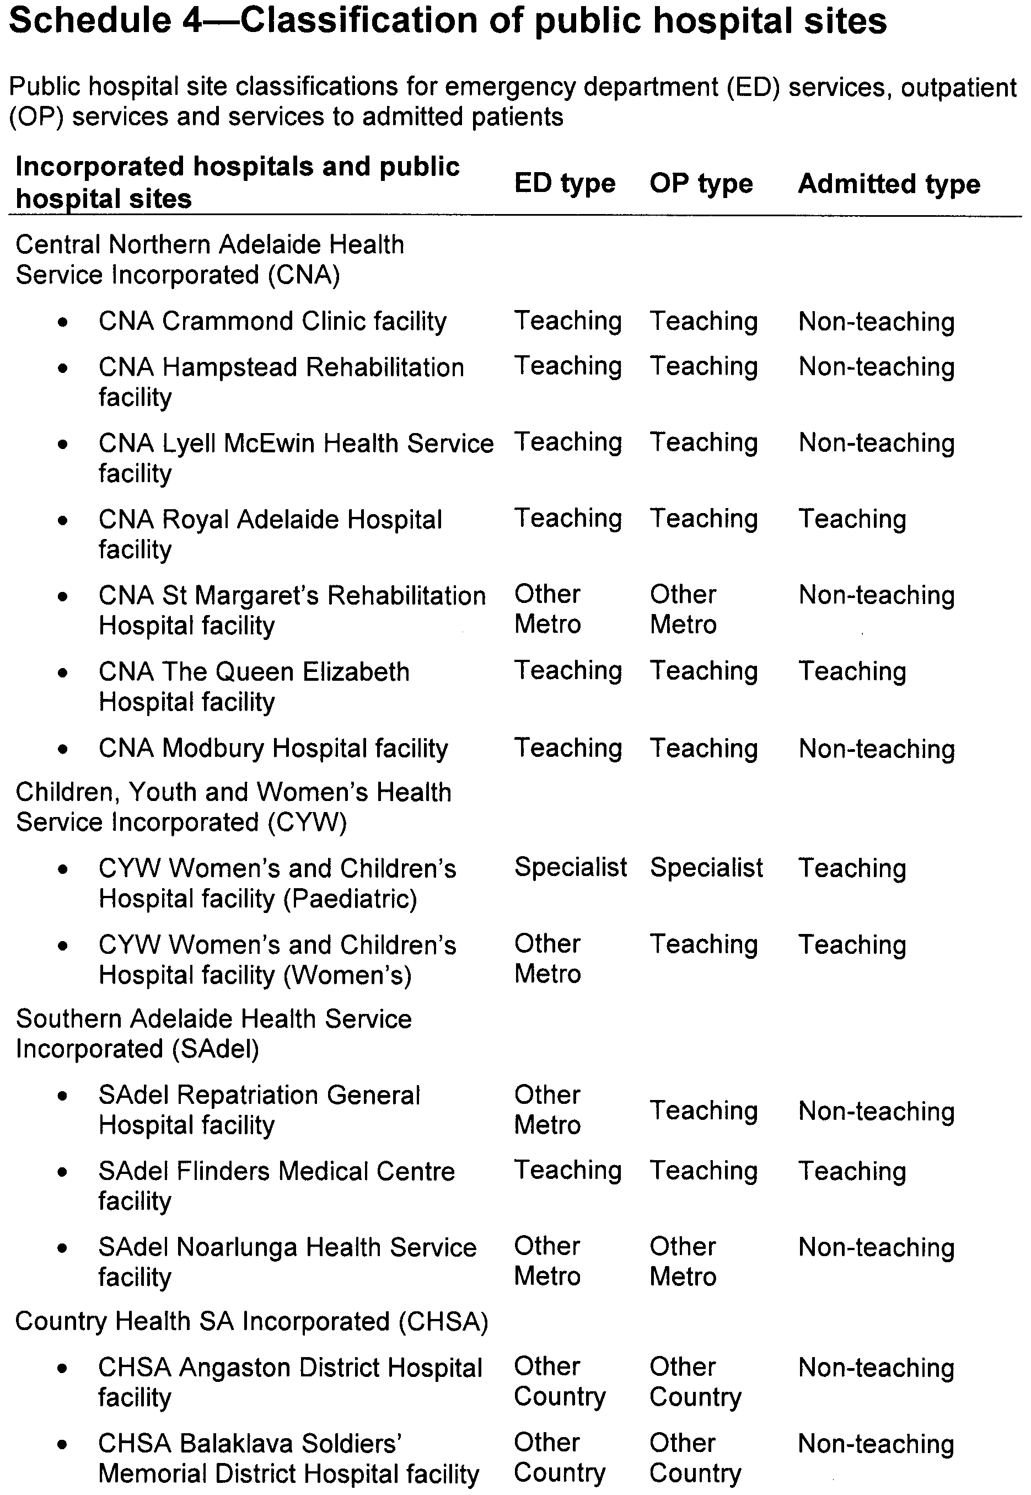
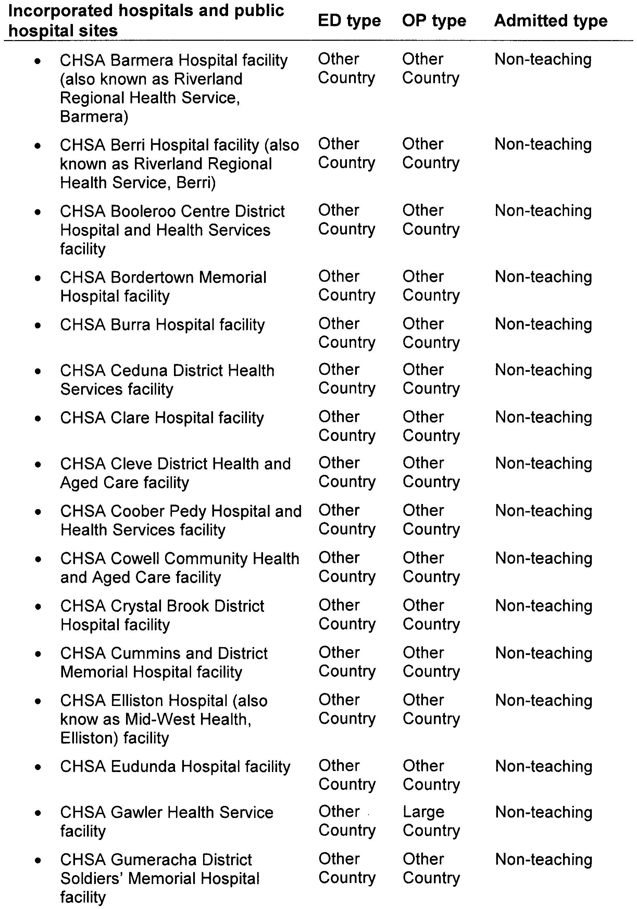
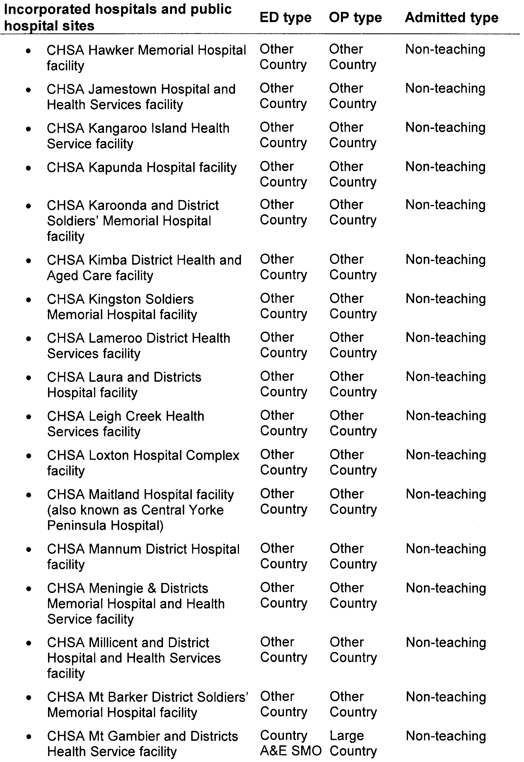
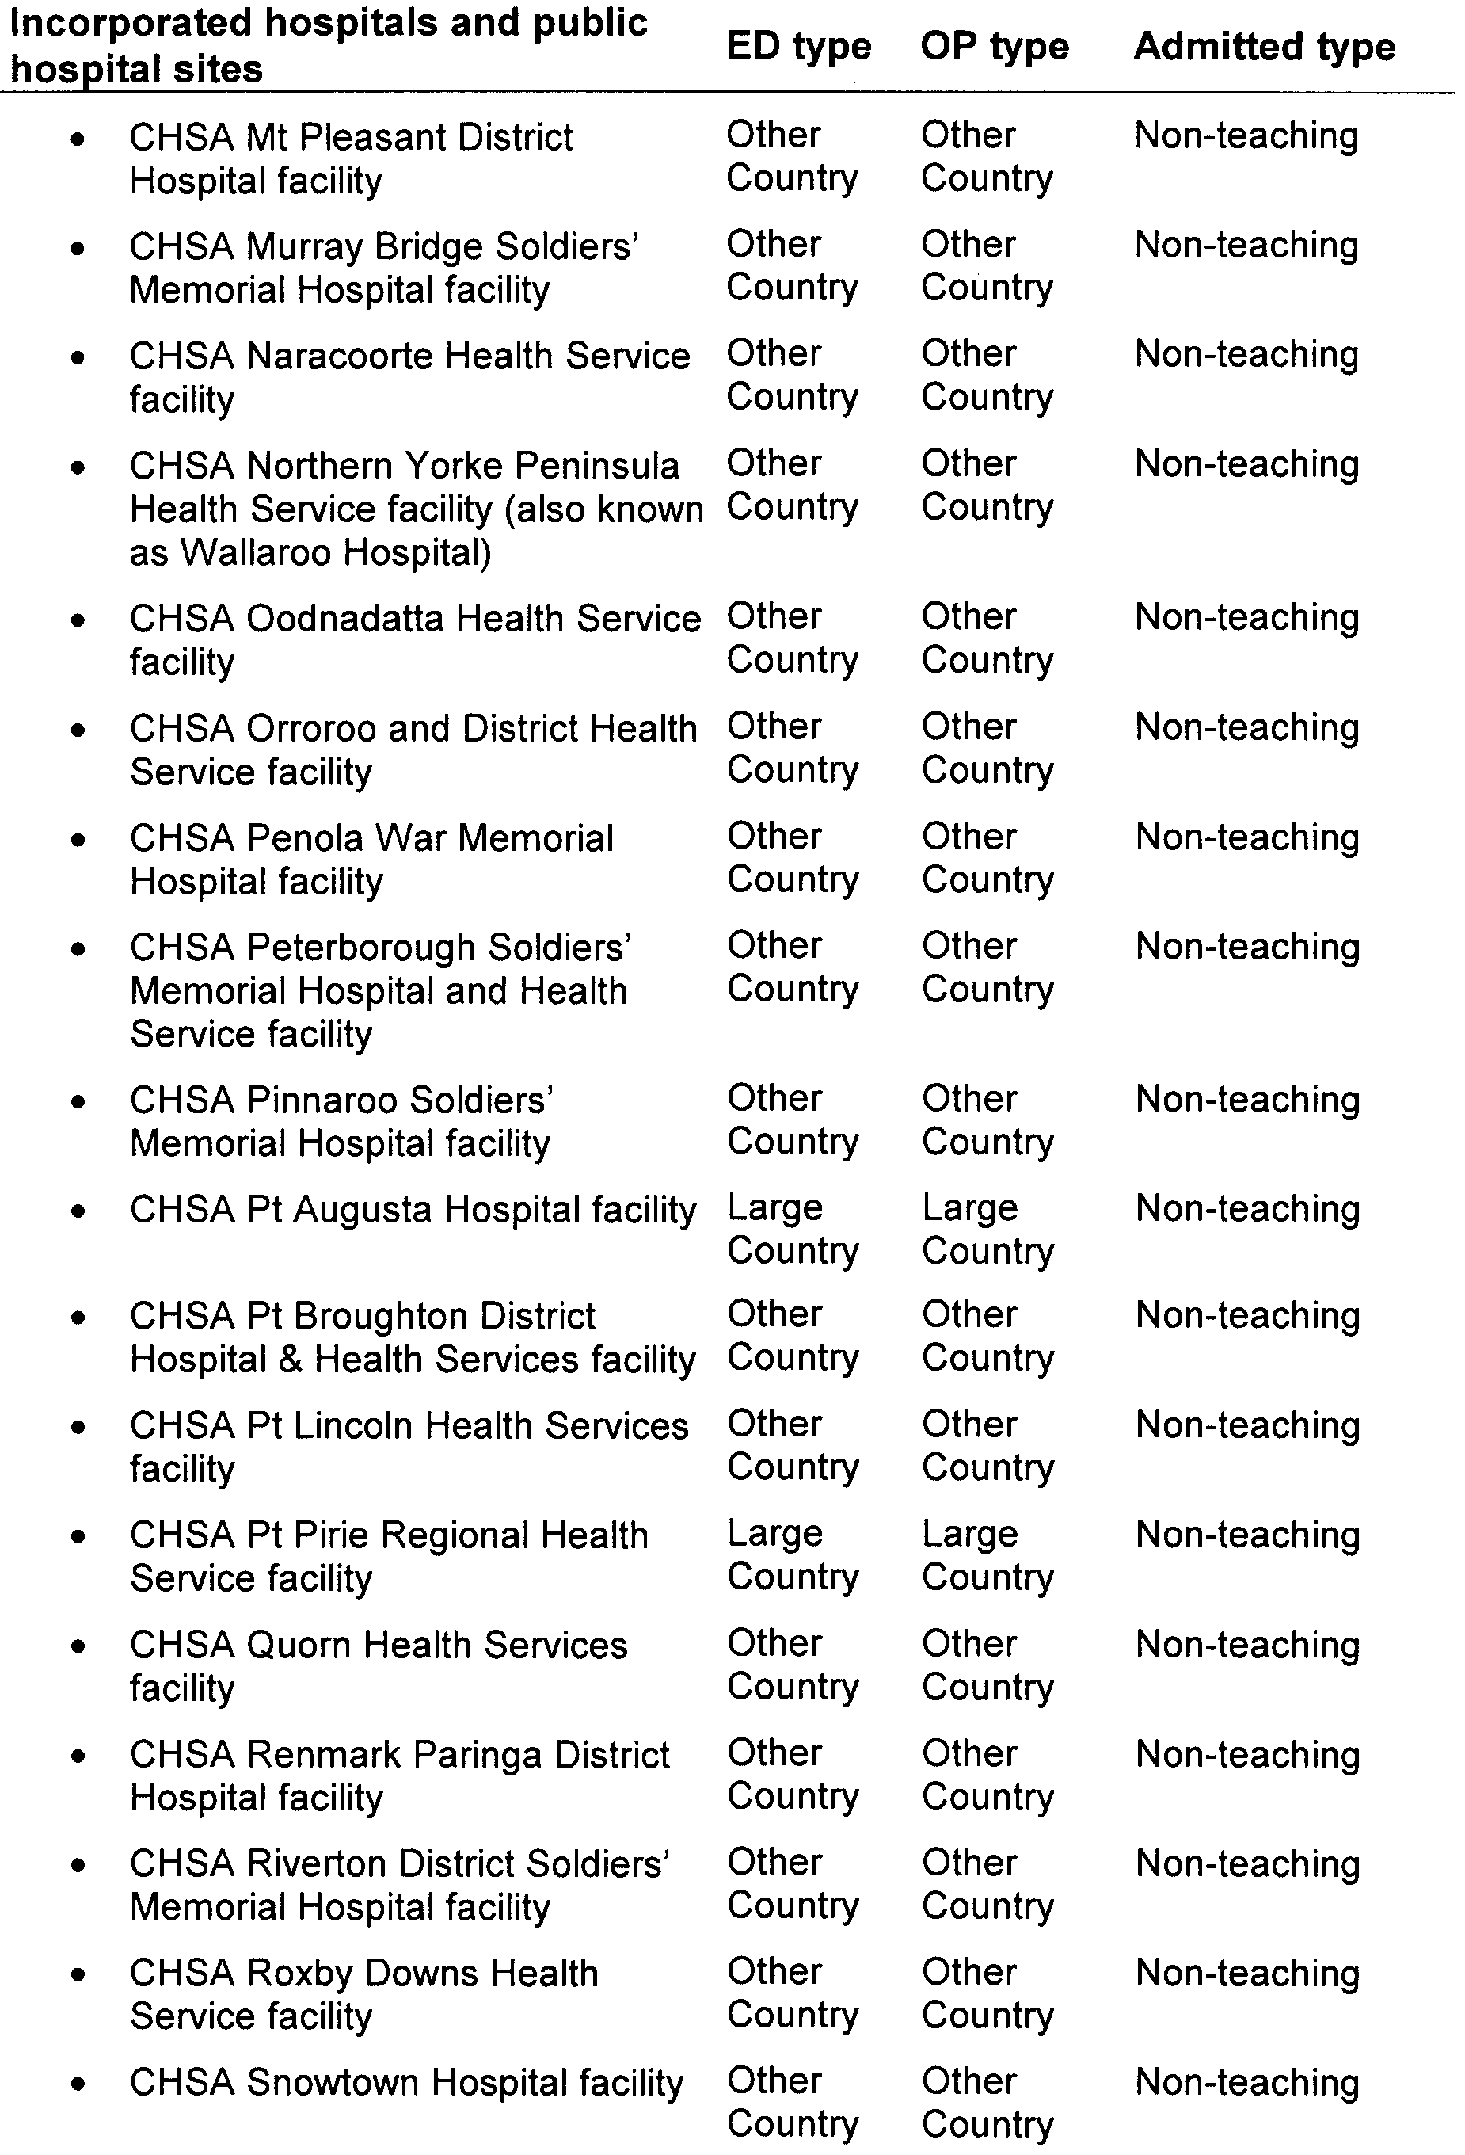

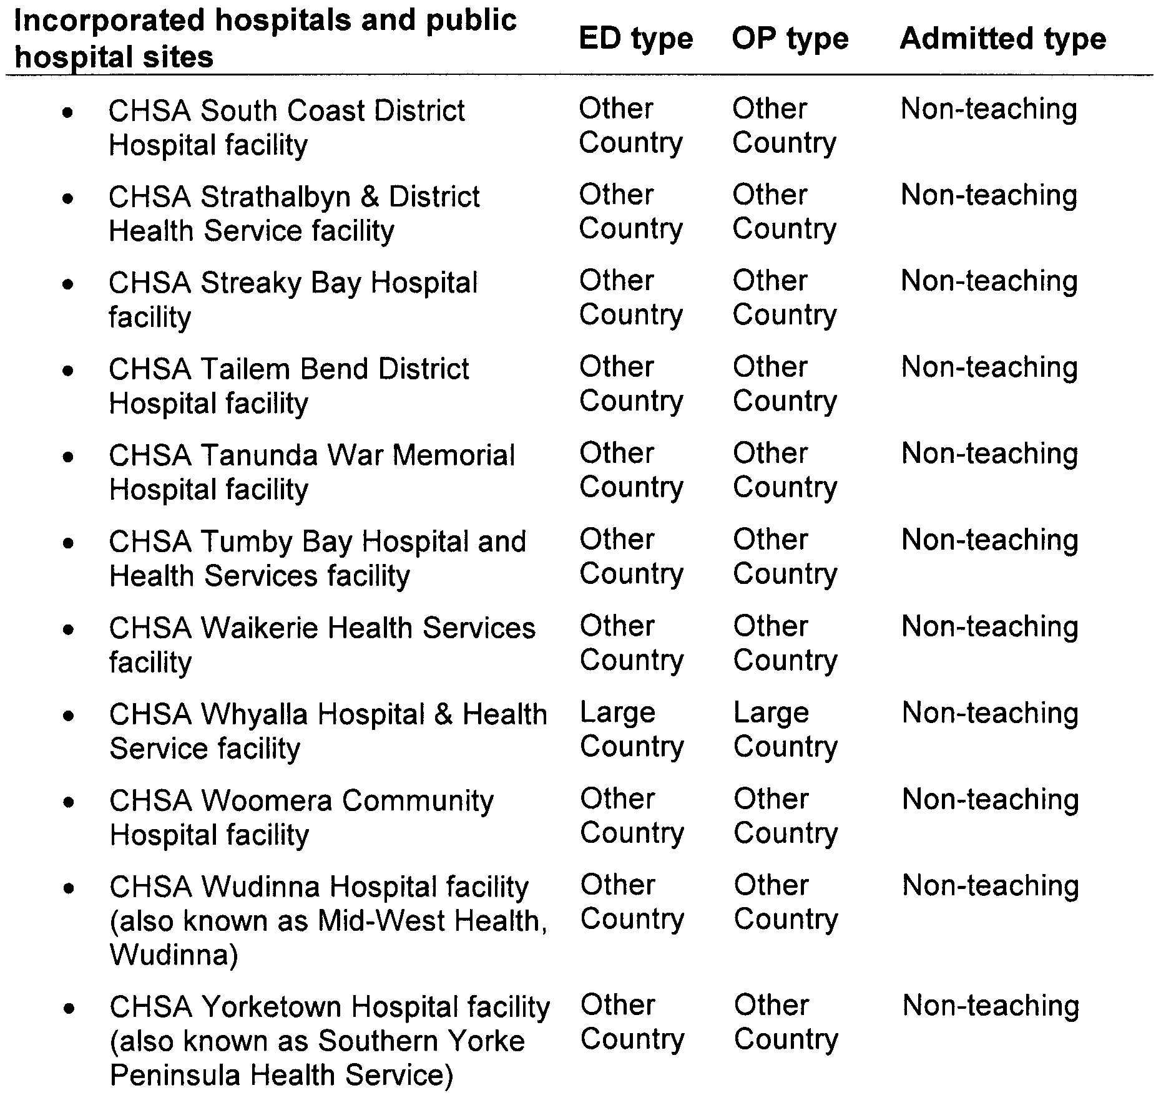

HOUSING IMPROVEMENT ACT 1940
WHEREAS by notice published in the Government Gazette on the dates mentioned in the following table, the South Australian Housing Trust Board delegate did declare the houses described in the following table to be substandard for the purposes of Part 7 of the Housing Improvement Act 1940, and whereas the South Australian Housing Trust is satisfied that each of the houses described hereunder has ceased to be substandard, notice is hereby given that, in exercise of the powers conferred by the said Part, the South Australian Housing Trust does hereby revoke the said declaration in respect of each house.
Address of House | Allotment, Section, etc. | Certificate of Title  Volume Folio | Date and page of Government Gazette in which notice declaring house to be substandard published

Lot 1, By-pass Road, Waikerie |  | Allotment 1 in Deposited Plan 22948, Hundred of Waikerie | 5337 | 516 |  | 26.4.01, page 1664
203 Commercial Road, Seaford (also known as Port Noarlunga South) |  | Allotment 3 in Deposited Plan 7884, Hundred of Willunga | 5583 | 228 |  | 1.3.01, page 805
10 Harrow Road, College Park |  | Allotment 74 in Filed Plan 136425, Hundred of Adelaide | 5790 | 430 |  | 22.2.07, page 555
7 Hartley Street, Port Augusta West |  | Allotment 91 in Filed Plan 163799, Hundred of Copley | 5325 | 634 |  | 26.8.93, page 989
30 Maude Street, Port Pirie West |  | Allotment 95 in Filed Plan 209606, Hundred of Pirie | 5574 | 134 |  | 25.11.93, page 2605
413 Montague Road, Modbury |  | Allotment 219 in Deposited Plan 7530, Hundred of Yatala | 5077 | 305 |  | 29.1.09, page 430
71 Palm Avenue, Royal Park |  | Allotment 358 in Deposited Plan 1040, Hundred of Yatala | 5609 | 470 |  | 24.11.83, page 1519
Unit 23, 4 Para Road, Evanston |  | Unit 23 in Strata Plan 12931, Hundred of Munno Para | 5186 | 934 |  | 26.2.09, page 751
7 Waytown Street, Elizabeth Park |  | Allotment 184 in Deposited Plan 9017, Hundred of Munno Para | 5393 | 22 |  | 30.7.09, page 3420

Dated at Adelaide, 24 September 2009. D. Huxley, Director, Corporate Services, Housing SA

HOUSING IMPROVEMENT ACT 1940
WHEREAS by notice published in the Government Gazette on the dates mentioned in the following table the South Australian Housing Trust Board delegate did declare the houses described in the said table to be substandard for the purposes of Part 7 of the Housing Improvement Act 1940, the South Australian Housing Trust in the exercise of the powers conferred by the said Part, does hereby fix as the maximum rental per week which shall be payable subject to section 55 of the Residential Tenancies Act 1995, in respect of each house described in the following table the amount shown in the said table opposite the description of such house and this notice shall come into force on the date of this publication in the Gazette.
Address of House | Allotment, Section, etc. | Certificate of Title  Volume Folio | Date and page of Government Gazette in which notice declaring house to be substandard published | Maximum rental per week payable in respect of each house  $

5 Birks Street, Parkside |  | Allotment 3 in Filed Plan 7972, Hundred of Adelaide | 5798 | 358 |  | 25.9.97, page 886 | 265.00
18 Bond Road, Port Broughton |  | Allotment 18 in Deposited Plan 2065, Hundred of Mundoora | 5082 | 743 |  | 18.6.09, page 2830 | 160.00
21 Esmond Road, Port Pirie South |  | Allotment 852 in Filed Plan 209228, Hundred of Pirie | 5779 | 847 |  | 30.7.09, page 3420 | 204.00
8 First Street, Orroroo |  | Allotment 3 in Filed Plan 105506, Hundred of Walloway | 5160 | 881 |  | 25.7.96, page 182 | 91.00
48 King Street, Clare |  | Allotment 700 in Deposited Plan 65247, Hundred of Clare | 5923 | 851 |  | 29.7.93, page 715 | 198.00
9 Stirrup Street, Saddleworth |  | Allotment 481 in Filed Plan 168610  Allotment 482 in Filed Plan 168611 | 5584  5584 | 967  968 |  | 30.10.03, page 3902 | 172.00

Dated at Adelaide, 24 September 2009. D. Huxley, Director, Corporate Services, Housing SA

HOUSING IMPROVEMENT ACT 1940
NOTICE is hereby given that the South Australian Housing Trust Board delegate in the exercise of the powers conferred by the Housing Improvement Act 1940, does hereby declare the houses described in the table hereunder to be substandard for the purposes of Part 7 of the Housing Improvement Act 1940.
No. of House and Street | Locality | Allotment, Section, etc. | Certificate of Title  Volume Folio

31 Blanford Street |  | West Croydon | Allotment 33 in Deposited Plan 1615, Hundred of Yatala | 5721 | 659
4 Hewitt Road |  | Elizabeth South | Allotment 4 in Deposited Plan 51759, Hundred of Munno Para | 5655 | 557
82 Montacute Road |  | Hectorville | Allotments 15 and 16 in Deposited Plan 1463, Hundred of Adelaide | 5878 | 457
470 Smith Street |  | Moonta Mines | Section 2069, Hundred of Wallaroo in the area named Moonta Mines | 5508 | 924
Lot 9, Vale Road |  | Highland Valley | Allotment 9 in Filed Plan 122, Hundred of Strathalbyn | 5499 | 352

Dated at Adelaide, 24 September 2009. D. Huxley, Director, Corporate Services, Housing SA

HOUSING IMPROVEMENT ACT 1940
Erratum
IN Government Gazette No. 65 dated 10 September 2009, on page 4392, fifth entry below was revoked incorrectly due to a change of address and the status of Rent Revision now remains.
Address of House | Allotment, Section, etc. | Certificate of Title  Volume Folio | Date and page of Government Gazette in which notice declaring house to be substandard published

60 Kadina Road, North Yelta |  | Section 2262, Hundred of Wallaroo | 5432 | 561 |  | 13.7.89, page 87

Dated at Adelaide, 24 September 2009. D. Huxley, Director, Corporate Services, Housing SA

LAND ACQUISITION ACT 1969
(Section 16)
Notice of Acquisition
THE COMMISSIONER OF HIGHWAYS (the ‘Authority’), 33 Warwick Street, Walkerville, S.A. 5081, acquires the following interests in the following land:
Definition of Land Acquired
Comprising the fee simple in that piece of land situated at
Lot 3, Heaslip Road, Penfield, being the portion of Allotment 3 in Filed Plan 11187, comprised in certificate of title volume 5488, folio 640, being the parcel comprising the whole of the land numbered 265* and the whole of the land numbered 266* on an unapproved plan numbered D81810 that has been lodged in the Lands Titles Office subject to the existing easement created in T 3907120.
This notice is given under section 16 of the Land Acquisition Act 1969.
Compensation
A person who has or had an interest in the land that is divested or diminished by the acquisition or the enjoyment of which is adversely affected by the acquisition who does not receive an offer of compensation from the Authority may apply to the Authority for compensation.
Inquiries
Inquiries should be directed to:
Jim Tuppin,
P.O. Box 1,
Walkerville, S.A. 5081
Telephone: (08) 8343 2760
Dated 15 September 2009.
The Common Seal of the Commissioner of Highways was hereto affixed by authority of the Commissioner in the presence of:
D. Thomas, Manager, Property Planning and Management Services, Department for Transport, Energy and Infrastructure
DTEI 2008/04905/01

LIQUOR LICENSING ACT 1997 AND GAMING MACHINES ACT 1992
Notice of Application
NOTICE is hereby given, pursuant to section 52 of the Liquor Licensing Act 1997 and section 29 of the Gaming Machines Act 1992, that Piyhac Pty Ltd as trustee for Piyhac Unit Trust has applied to the Licensing Authority for the transfer of a Hotel and Gaming Machine Licence in respect of premises situated at Gorge Road, Cudlee Creek, S.A. 5232 and known as Cudlee Creek Restaurant & Tavern.
The applications have been set down for hearing on 28 October 2009 at 9.30 a.m.
Any person may object to the application by lodging a notice of objection in the prescribed form with the Liquor and Gambling Commissioner and serving a copy of the notice on the applicant at the applicant’s address, at least seven days before the hearing date (viz: 21 October 2009).
The applicant’s address for service is c/o Caderyn McEwan, Kelly & Co. Lawyers, Level 21, 91 King William Street, Adelaide, S.A. 5000.
Plans in respect of the premises the subject of the application are open to public inspection without fee at the Office of the Liquor and Gambling Commissioner, 9th Floor, East Wing, 50 Grenfell Street, Adelaide, S.A. 5000. Phone 8226 8410, Fax:
8226 8512. Email: olgc@agd.sa.gov.au.
Dated 18 September 2009.
Applicant

LIQUOR LICENSING ACT 1997 AND GAMING MACHINES ACT 1992
Notice of Application
NOTICE is hereby given, pursuant to section 52 of the Liquor Licensing Act 1997 and section 29 of the Gaming Machines Act 1992, that Hendrie Pretoria Pty Ltd as trustee for Hendrie Pretoria Family Trust and Gilmorgan Pty Ltd as trustee for Woodforde Family Trust have applied to the Licencing Authority for a Hotel and Gaming Machine Licence in respect of premises situated at 50 Randell Street, Mannum, S.A. 5238 and known as Pretoria Hotel.
The applications have been set down for hearing on 28 October 2009 at 10 a.m.
Any person may object to the application by lodging a notice of objection in the prescribed form with the Liquor and Gambling Commissioner and serving a copy of the notice on the applicants at the applicants’ address, at least seven days before the hearing date (viz: 21 October 2009).
The applicants’ address for service is c/o Piper Alderman, 167 Flinders Street, Adelaide, S.A. 5000 (Attention: Geoff Forbes or Jonathan Dodd).
Plans in respect of the premises the subject of the application are open to public inspection without fee at the Office of the Liquor and Gambling Commissioner, 9th Floor, East Wing, 50 Grenfell Street, Adelaide, S.A. 5000. Phone 8226 8410, Fax:
8226 8512. Email: olgc@agd.sa.gov.au.
Dated 21 September 2009.
Applicants

LIQUOR LICENSING ACT 1997
Notice of Application
NOTICE is hereby given, pursuant to section 52 (2) (b) of the Liquor Licensing Act 1997, that Langmeil Pty Ltd has applied to the Licensing Authority for Alterations, Redefinition and Entertainment Consent in respect of premises situated at Para Road, Tanunda, S.A. 5352 and known as Langmeil Winery.
The application has been set down for hearing on 20 October 2009 at 10.30 a.m.
Conditions
The following licence conditions are sought:
• Alterations and Redefinition to create a ‘Finished Goods Warehouse’ with designated dining area as per plans lodged with this office.
• Alterations and Redefinition to create a ‘Shelter’ with designated sampling area as per plans lodged with this office.
• Redefinition of Area 4 to extend and create an outdoor area with designated dining and sampling area as per plans lodged with this office.
• Entertainment Consent to apply to Areas 2, 4 and 6 as per plans lodged with this office and for the following days and times:
Monday to Saturday: Midday to midnight;
Sunday: 11.30 a.m. to midnight;
New Year’s Eve: Midday to 2 a.m. the following day;
Days preceding other Public Holidays: Midday to midnight;
Sundays preceding other Public Holidays: 11.30 a.m. to midnight.
Any person may object to the application by lodging a notice of objection in the prescribed form with the Liquor and Gambling Commissioner and serving a copy of the notice on the applicant at the applicant’s address, at least seven days before the hearing date (viz: 13 October 2009).
The applicant’s address for service is c/o Christopher Bitter, P.O. Box 551, Tanunda, S.A. 5352.
Plans in respect of the premises the subject of the application are open to public inspection without fee at the Office of the Liquor and Gambling Commissioner, 9th Floor, East Wing, 50 Grenfell Street, Adelaide, S.A. 5000. Phone 8226 8410, Fax:
8226 8512. Email: olgc@agd.sa.gov.au.
Dated 17 September 2009.
Applicant

LIQUOR LICENSING ACT 1997
Notice of Application
NOTICE is hereby given, pursuant to section 52 (2) (b) of the Liquor Licensing Act 1997, that Giocondo Mario Musolino and Judith Musolino have applied to the Licensing Authority for a Restaurant Licence with Section 34 (1) (c), Extended Trading Authorisation and Entertainment Consent in respect of premises situated at 101/1-2 Wirra Drive, Newport Quays, Glanville, S.A. 5015 and to be known as Portobello Food Kitchen Bar.
The application has been set down for hearing on 22 October 2009 at 10.30 a.m.
Conditions
The following licence conditions are sought:
• Approval is sought under Section 34 (1) (c) to sell liquor without meals for consumption on the licensed premises by persons:
(a) seated at a table; or
(b) attending a function at which food is provided.
• Extended Trading Authorisation is sought for the following days and times in relation to the abovementioned condition:
Sunday: 8 a.m. to 11 a.m. and 8 p.m. to midnight.
• Entertainment Consent is sought for the dining room as per plans lodged with this office and for the following days and times:
Monday to Sunday: Midday to 11 p.m.;
Maundy Thursday: Midday to 11 p.m.;
Christmas Eve: Midday to 11 p.m.;
Sunday Christmas Eve: Midday to midnight;
New Year’s Eve: Midday to midnight;
Days preceding other Public Holidays: Midday to 11 p.m.;
Sundays preceding other Pulic Holidays: Midday to midnight.
Any person may object to the application by lodging a notice of objection in the prescribed form with the Liquor and Gambling Commissioner and serving a copy of the notice on the applicants at the applicants’ address, at least seven days before the hearing date (viz: 15 October 2009).
The applicants’ address for service is c/o Gio Musolino, 114 Semaphore Road, Semaphore, S.A. 5019.
Plans in respect of the premises the subject of the application are open to public inspection without fee at the Office of the Liquor and Gambling Commissioner, 9th Floor, East Wing, 50 Grenfell Street, Adelaide, S.A. 5000. Phone 8226 8410, Fax:
8226 8512. Email: olgc@agd.sa.gov.au.
Dated 16 September 2009.
Applicants

LIQUOR LICENSING ACT 1997
Notice of Application
NOTICE is hereby given, pursuant to section 52 (2) (b) of the Liquor Licensing Act 1997, that Deepak Uppal and Manoj Kumar Yadav have applied to the Licensing Authority for a Restaurant Licence in respect of premises situated at 290 Port Road, Hindmarsh, S.A. 5007 and to be known as Taste of Bollywood.
The application has been set down for hearing on 26 October 2009 at 10.30 a.m.
Any person may object to the application by lodging a notice of objection in the prescribed form with the Liquor and Gambling Commissioner and serving a copy of the notice on the applicants at the applicants’ address, at least seven days before the hearing date (viz: 19 October 2009).
The applicants’ address for service is c/o Deepak Uppal, 290 Port Road, Hindmarsh, S.A. 5007.
Plans in respect of the premises the subject of the application are open to public inspection without fee at the Office of the Liquor and Gambling Commissioner, 9th Floor, East Wing, 50 Grenfell Street, Adelaide, S.A. 5000. Phone 8226 8410, Fax:
8226 8512. Email: olgc@agd.sa.gov.au.
Dated 17 September 2009.
Applicants

LIQUOR LICENSING ACT 1997
Notice of Application
NOTICE is hereby given, pursuant to section 52 (2) (b) of the Liquor Licensing Act 1997, that Hayden Maxwell Vawser has applied to the Licensing Authority for the transfer of a Hotel Licence in respect of premises situated at Arthur Street, Booleroo Centre, S.A. 5482 and known as Booleroo Centre Hotel.
The application has been set down for hearing on 26 October 2009 at 11 a.m.
Any person may object to the application by lodging a notice of objection in the prescribed form with the Liquor and Gambling Commissioner and serving a copy of the notice on the applicant at the applicant’s address, at least seven days before the hearing date (viz: 19 October 2009).
The applicant’s address for service is c/o Jeff Stevens & Associates, Level 1, 86 Pirie Street, Adelaide, S.A. 5000.
Plans in respect of the premises the subject of the application are open to public inspection without fee at the Office of the Liquor and Gambling Commissioner, 9th Floor, East Wing, 50 Grenfell Street, Adelaide, S.A. 5000. Phone 8226 8410, Fax:
8226 8512. Email: olgc@agd.sa.gov.au.
Dated 17 September 2009.
Applicant

LIQUOR LICENSING ACT 1997
Notice of Application
NOTICE is hereby given, pursuant to section 52 (2) (b) of the Liquor Licensing Act 1997, that Woodvale Clare Pty Ltd as trustee for Woodvale Property Trust has applied to the Licensing Authority for a Producer’s Licence in respect of premises situated at Lot 72, Hughes Park Road, Penwortham, S.A. 5453 and to be known as Woodvale Clare Pty Ltd.
The application has been set down for hearing on 28 October 2009 at 10.30 a.m.
Any person may object to the application by lodging a notice of objection in the prescribed form with the Liquor and Gambling Commissioner and serving a copy of the notice on the applicant at the applicant’s address, at least seven days before the hearing date (viz: 21 October 2009).
The applicant’s address for service is c/o Jenkins Anderson Allard, P.O. Box 118, Auburn, S.A. 5451 (Attention: Greg Anderson).
Plans in respect of the premises the subject of the application are open to public inspection without fee at the Office of the Liquor and Gambling Commissioner, 9th Floor, East Wing, 50 Grenfell Street, Adelaide, S.A. 5000. Phone 8226 8410, Fax:
8226 8512. Email: olgc@agd.sa.gov.au.
Dated 21 September 2009.
Applicant

LIQUOR LICENSING ACT 1997
Notice of Application
NOTICE is hereby given, pursuant to section 52 (2) (b) of the Liquor Licensing Act 1997, that Garage Corporation Pty Ltd, 16 Mundulla Avenue, Woodcroft, S.A. 5162 has applied to the Licensing Authority for a Direct Sales Licence in respect of the business to be known as Garage Gourmet.
The application has been set down for hearing on 28 October 2009 at 11 a.m.
Any person may object to the application by lodging a notice of objection in the prescribed form with the Liquor and Gambling Commissioner and serving a copy of the notice on the applicant at the applicant’s address, at least seven days before the hearing date (viz: 21 October 2009).
The applicant’s address for service is c/o Finlaysons, G.P.O. Box 1244, Adelaide, S.A. 5001 (Attention: Andrew Williams).
Plans in respect of the premises the subject of the application are open to public inspection without fee at the Office of the Liquor and Gambling Commissioner, 9th Floor, East Wing, 50 Grenfell Street, Adelaide, S.A. 5000. Phone 8226 8410, Fax:
8226 8512. Email: olgc@agd.sa.gov.au.
Dated 21 September 2009.
Applicant

LIQUOR LICENSING ACT 1997
Notice of Application
NOTICE is hereby given, pursuant to section 52 (2) (b) of the Liquor Licensing Act 1997, that Penna Lane Vintners Pty Ltd has applied to the Licensing Authority for the transfer of a Producer’s Licence in respect of premises situated at Penna Lane, Pen-wortham, S.A. 5452 and known as Penna Lane Wines.
The application has been set down for hearing on 29 October 2009 at 10.30 a.m.
Any person may object to the application by lodging a notice of objection in the prescribed form with the Liquor and Gambling Commissioner and serving a copy of the notice on the applicant at the applicant’s address, at least seven days before the hearing date (viz: 22 October 2009).
The applicant’s address for service is c/o Bill Moody, 7th Floor, 185 Victoria Square, Adelaide, S.A. 5000.
Plans in respect of the premises the subject of the application are open to public inspection without fee at the Office of the Liquor and Gambling Commissioner, 9th Floor, East Wing, 50 Grenfell Street, Adelaide, S.A. 5000. Phone 8226 8410, Fax:
8226 8512. Email: olgc@agd.sa.gov.au.
Dated 21 September 2009.
Applicant

MINING ACT 1971
NOTICE is hereby given in accordance with section 28 (5) of the Mining Act 1971, that the Minister for Mineral Resources Development proposes to grant an Exploration Licence over the undermentioned area:
Applicant: Saltbush Flat Mine Nominees Pty Ltd
Location: Nackara area—Approximately 35 km north-east of Peterborough.
Term: 1 year
Area in km²: 98
Ref.: 2009/00076
Plan and co-ordinates can be found on the PIRSA website: http://www.pir.sa.gov.au/minerals/public_notices or by phoning Mineral Tenements on (08) 8463 3103.
J. Martin, Acting Mining Registrar

MINING ACT 1971
NOTICE is hereby given in accordance with section 28 (5) of the Mining Act 1971, that the Minister for Mineral Resources Development proposes to grant an Exploration Licence over the undermentioned area:
Applicant: Saltbush Flat Mine Nominees Pty Ltd
Location: Witchitie area—Approximately 100 km north-east of Port Augusta.
Pastoral Leases: Witchitie, Minburra, Wilcowie and Holo-wilena South.
Term: 1 year
Area in km²: 32
Ref.: 2009/00113
Plan and co-ordinates can be found on the PIRSA website: http://www.pir.sa.gov.au/minerals/public_notices or by phoning Mineral Tenements on (08) 8463 3103.
J. Martin, Acting Mining Registrar

MINING ACT 1971
NOTICE is hereby given in accordance with section 28 (5) of the Mining Act 1971, that the Minister for Mineral Resources Development proposes to grant an Exploration Licence over the undermentioned area:
Applicant: Dominion Gold Operations Pty Ltd
Location: Lake Labyrinth area—Approximately 25 km north-north-west of Kingoonya.
Pastoral Leases: Wilgena and Bon Bon
Term: 1 year
Area in km²: 248
Ref.: 2009/00219
Plan and co-ordinates can be found on the PIRSA website: http://www.pir.sa.gov.au/minerals/public_notices or by phoning Mineral Tenements on (08) 8463 3103.
J. Martin, Acting Mining Registrar

MINING ACT 1971
NOTICE is hereby given in accordance with section 28 (5) of the Mining Act 1971, that the Minister for Mineral Resources Development proposes to grant an Exploration Licence over the undermentioned area:
Applicant: Iluka Resources Limited
Location: Jellabinna area—Approximately 80 km north-west of Ceduna.
Term: 2 years
Area in km²: 1 511
Ref.: 2009/00283
Plan and co-ordinates can be found on the PIRSA website: http://www.pir.sa.gov.au/minerals/public_notices or by phoning Mineral Tenements on (08) 8463 3103.
J. Martin, Acting Mining Registrar

MINING ACT 1971
NOTICE is hereby given in accordance with section 35A (1) of the Mining Act 1971, that an application for a mining lease over the undermentioned mineral claim has been received. Details of the proposal may be inspected at the Department of Primary Industries and Resources, Mineral Resources Group, Level 7, 101 Grenfell Street, Adelaide, S.A. 5000:
Applicant: Grocke Loam Sand & Metal Supplies Pty Ltd
Claim Number: 4110
Location: Allotment 186 in Deposited Plan 15836, Hundred of Nuriootpa—Approximately 4 km north-west of Lyndoch adjacent to the North Para River.
Area: 1.82 hectares
Purpose: For the recovery of extractive minerals (sand)
Reference: T02742
A copy of the proposal has been provided to the Light Regional Council.
Written submissions in relation to the granting of the mining lease are invited to be received at the Department of Primary Industries and Resources, Mineral Resources Group, Level 7, 101 Grenfell Street, Adelaide, S.A. 5000 or G.P.O. Box 1671, Adelaide, S.A. 5001, no later than 16 October 2009.
Copies of all submissions will be forwarded to the applicant and may be made available for public inspection unless confidentiality is requested.
J. Martin, Acting Mining Registrar

NATIONAL PARKS AND WILDLIFE (NATIONAL PARKS) REGULATIONS 2001
Closure of Granite Island Recreation Park
PURSUANT to Regulations 8 (3) (a) and 8 (3) (d) of the National Parks and Wildlife (National Parks) Regulations 2001, I, Edward Gregory Leaman, Director of National Parks and Wildlife, close to the public, the whole of Granite Island Recreation Park from:
10.30 p.m. on Friday, 20 November 2009 until 5.30 a.m. on Saturday, 21 November 2009;
10.30 p.m. on Saturday, 21 November 2009 until 5.30 a.m. on Sunday, 22 November 2009;
10.30 p.m. on Sunday, 22 November 2009 until 5.30 a.m. on Monday, 23 November 2009;
10.30 p.m. on Monday, 23 November 2009 until 5.30 a.m. on Tuesday, 24 November 2009; and
10.30 p.m. on Tuesday, 24 November 2009 until 5.30 a.m. on Wednesday, 25 November 2009.
The purpose of the closure is for the proper management of the reserve and in the interest of public safety.
Permission to Enter and Remain in the Reserve
Pursuant to Regulations 8 (4) and 41 of the National Parks and Wildlife (National Parks) Regulations 2001, I, Edward Gregory Leaman, Director of National Parks and Wildlife, grant permission to persons undertaking bona fide recreational and commercial fishing activities to enter Granite Island Recreation Park between the causeway and the screw-pile jetty for the purpose of accessing the screw-pile jetty for these fishing activities, during the above-mentioned closure periods.
Pursuant to Regulations 8 (4) and 41 of the National Parks and Wildlife (National Parks) Regulations 2001, I, Edward Gregory Leaman, Director of National Parks and Wildlife, grant permission to the lessee of the Granite Island Development Zone, its agents and employees to enter and remain in Granite Island Recreation Park during the abovementioned closure periods for the purposes of undertaking activities associated with the said lease.
These permissions are conditional upon the observance by each of those persons, of the requirements of the National Parks and Wildlife Act 1972 and the National Parks and Wildlife (National Parks) Regulations 2001, including those requiring compliance with the Director’s requests, requirements and orders of a Warden.
Dated 21 September 2009.
E. G. Leaman, Director of National Parks and Wildlife

NATURAL RESOURCES MANAGEMENT ACT 2004
Notice of Authorisation to Take Water in the McLaren Vale Prescribed Wells Area
PURSUANT to section 128 of the Natural Resources Manage-ment Act 2004, I, Jay Weatherill, Minister for Environment and Conservation, hereby authorise the taking of water from wells within the area of the McLaren Vale Prescribed Wells Area prescribed under the Water Resources (McLaren Vale Prescribed Wells Area) Regulations 1990, as set out within Schedule A below for the purposes set out in Schedule B, and subject to the conditions specified in Schedule C. This authorisation will commence on the date below and will remain in effect for a period of five years unless earlier varied or revoked.
Schedule A
Area
1. The Hundred of Willunga.
Schedule B
Purpose
2. For the extraction of treated reclaimed water from the Tertiary aquifer (Port Willunga Formation) injected into the Tertiary aquifer (Port Willunga Formation) under Environment Protection Authority Licence No. 22904, dated 26 August 2009.
Schedule C
Conditions
3. Only 400 megalitres (or a lesser amount) per annum shall be taken from the Tertiary aquifer (Port Willunga Formation).
4. Extraction of treated reclaimed water from the Tertiary aquifer (Port Willunga Formation) may only occur from the date of this authorisation until 31 August 2014.
5. The water user must not take water except through a meter, fitted to the satisfaction of the Minister.
6. The water user must immediately report any fault or sus-pected fault with the meter or meters.
7. The user must not cause, suffer or permit any interference with a meter used for the purposes of measuring the quantity of water used under this Notice or any interference with pipes or fittings that may affect the accuracy of a meter, without the Minister’s authority.
8. The water user must not adjust or alter the meter without the Minister’s authority.
9. The water user must not permit sand, soil or any other material to be deposited on or around a meter.
10. The water user must not permit deposits of sand, soil or any other material to build up around a meter.
11. The water user must keep vegetation cleared away from the meter.
12. The water user must not damage or destroy the meter.
Dated 18 September 2009.
Jay Weatherill, Minister for Environment and Conservation

NATURAL RESOURCES MANAGEMENT ACT 2004
Revocation of Notice of Authorisation to Take Water in the McLaren Vale Prescribed Wells Area
PURSUANT to section 128 (5) of the Natural Resources Manage-ment Act 2004, I, Jay Weatherill, Minister for Environment and Conservation in the State of South Australia and Minister to whom the administration of the Natural Resources Management Act 2004, is committed, revoke the Notice of Authorisation to Take Water in the McLaren Vale Prescribed Wells Area dated 19 May 2009 and published in the Government Gazette (page 1762) of 21 May 2009.
Dated 18 September 2009.
Jay Weatherill, Minister for Environment and Conservation

OATHS ACT 1936
Notice of Termination of Appointment of Proclaimed Member of
the Police Force to take Declarations and Attest the
Execution of Instruments
PURSUANT to subsection (3) of section 33 of the Oaths Act 1936, I give notice that I have terminated the appointment of these proclaimed members of the police force to take declarations and attest the execution of instruments under that section:
Tony Ager, appointed on 14 April 2005;
Kylie Jane Baker, appointed on 14 April 2005;
Andrew Donaldson Barkell, appointed on 15 November 2001;
John Charles Beaumont, appointed on 22 May 2003;
Paul Andrew Bennett, appointed on 28 September 2006;
Steven Carmel Bonnici, appointed on 15 November 2001;
David Andrew Boorman, appointed on 13 March 2008;
Brendan James Bowes, appointed on 28 September 2006;
Matthew John Boyley, appointed on 27 May 2004;
Michael Andrew Brown, appointed on 18 January 2007;
Ian Gordon Buckley, appointed on 22 May 2003;
Colin Arthur Burner, appointed on 22 May 2003;
Desmond John Busch, appointed on 22 May 2003;
Jeremy Chad Terrence Canham, appointed on 18 January 2007;
Stephen Mark Charles, appointed on 27 May 2004;
David Anthony Clark, appointed on 15 November 2001;
Walter James Clarke, appointed on 22 May 2003;
Philip Thomas Cochrane, appointed on 15 November 2001;
Peter Colin Codrington, appointed on 22 May 2003;
Ian Johnstone Colbey, appointed on 22 May 2003;
Michelle Cornwaithe, appointed on 13 March 2008;
Dennis Stephen Cox, appointed on 27 May 2004;
Andrew James Darlington, appointed on 18 January 2007;
Russell Ian Dart, appointed on 14 April 2005;
Robert Mills Delaine, appointed on 21 December 2000;
Alan Robert Dennett, appointed on 22 May 2003;
Simon Lyle Dewar, appointed on 18 January 2007;
Peter John Dietman, appointed on 27 May 2004;
Ian Norman Dix, appointed on 15 November 2001;
James Douglas Edgecombe, appointed on 27 May 2004;
Denis George Edmonds, appointed on 30 September 1982;
Jeffrey Kenneth Elliott, appointed on 15 November 2001;
Katherine Ellison, appointed on 27 May 2004;
Sean Michael Everett, appointed on 15 November 2001;
Murray Glen Farrelly, appointed on 15 November 2001;
Kelly Faye Fletcher, appointed on 22 May 2003;
George Thomas Fox, appointed on 22 May 2003;
Thaddeus Galkowski, appointed on 21 December 2000;
Gavin John Gerschwitz, appointed on 22 May 2003;
Orlando Gollop, appointed on 14 April 2005;
Kenneth Leslie Graetz, appointed on 22 May 2003;
Nicole Antoinette Grollo, appointed on 13 March 2008;
James Heapy, appointed on 22 May 2003;
Bret Tate Heath, appointed on 22 May 2003;
Trevor John Hentschke, appointed on 4 January 1996;
Peter John Hibbard, appointed on 22 May 2003;
Celeste Kylie Hill, appointed on 28 September 2006;
Richard Graham Hobbs, appointed on 22 May 2003;
Brenton Herbert Irrgang, appointed on 14 April 2005;
Nicole Louise John, appointed on 13 March 2008;
Robin James Kelly, appointed on 13 March 2008;
William James Kelsey, appointed on 14 April 2005;
Frank James Latimer, appointed on 22 May 2003;
Oliver Joseph Thomas Laurence, appointed on 30 April 2009;
Clayton Alan Le Clercq, appointed on 22 May 2003;
James Laurence Leane, appointed on 22 May 2003;
Brett Geoffrey Liebich, appointed on 22 May 2003;
Michael David Lloyd, appointed on 27 May 2004;
Peter Hendrik Loch, appointed on 15 November 2001;
Ian Robert Lockwood, appointed on 22 May 2003;
Graham John Lough, appointed on 29 August 1990;
David John Marchant, appointed on 13 March 2008;
John Scott Marshall, appointed on 14 April 2005;
James Girdham McDonald, appointed on 27 May 2004;
Mark Andrew McKinna, appointed on 13 March 2008;
David John McRostie, appointed on 14 April 2005;
Rebecca Adella Milne, appointed on 28 September 2006;
Lawrence Howard Moore, appointed on 15 November 2001;
Jeanne Heather Motteram, appointed on 22 May 2003;
Pieter Willem Mur, appointed on 21 December 2000;
Lorey Faith Neale, appointed on 28 September 2006;
Glenn Andrew Nitschke, appointed on 18 January 2007;
Francis Christian Pagh, appointed on 20 July 2000;
Richard Roy Perryman, appointed on 15 November 2001;
Robert James Poppy, appointed on 14 April 2005;
Ferdinand Georg Prosser, appointed on 22 May 2003;
Gregory Paul Ranger, appointed on 15 November 2001;
Simon Wayne Riddle, appointed on 27 May 2004;
Jaqueline Toni Roads, appointed on 28 September 2006;
Allan Malcolm Rodda, appointed on 22 May 2003;
Robert Paul Rosser, appointed on 21 December 2000;
Barry Ross Schell, appointed on 14 April 2005;
Dennis Geoffrey Schilling, appointed on 11 March 1999;
Kenneth Joseph Sharp, appointed on 15 November 2001;
Daniel Shean, appointed on 22 May 2003;
Vincent Paul Sheehy, appointed on 27 May 2004;
Paul Francis Simionato, appointed on 14 April 2005;
John Andrew Simper, appointed on 27 May 2004;
Gary Thomas Simpson, appointed on 15 November 2001;
Michael David Smith, appointed on 13 March 2008;
Andrew James Strachan, appointed on 28 September 2006;
Michael Lothar Thunig, appointed on 22 May 2003;
Gary David Trezise, appointed on 15 November 2001;
David Versegi, appointed on 18 January 2007;
Arthur Robin Walls, appointed on 15 November 2001;
Phillip James Warrick, appointed on 11 October 1988;
Peter Robert Willing, appointed on 29 August 1996; and
Peter Brian Woite, appointed on 18 September 1977.
Dated 13 September 2009.
Michael Atkinson, Attorney-General
09/001

ROADS (OPENING AND CLOSING) ACT 1991:
SECTION 24
NOTICE OF CONFIRMATION OF ROAD
PROCESS ORDER
Road Opening and Closing
Yattalunga
BY Road Process Order made on 11 February 2009, the City of Playford ordered that:
1. Portion of piece 3 in Deposited Plan 61398, more particularly delineated and numbered ‘10’ in Preliminary Plan No. 08/0059 be opened as road forming a re-alignment of the eastern end of the road thereat.
2. Portion of the un-named public road situate dividing pieces 1 and 3 in Deposited Plan 61398 rendered superfluous by the road opening and adjoining the intersection with Glenburnie Road, more particularly delineated and lettered ‘B’ in Preliminary Plan No. 08/0059 be closed.
3. The whole of the land subject to closure be transferred to Peter John Ween and Jan Mahala Ween in accordance with agreement for exchange dated 8 August 2008 entered into between the City of Playford and P. J. and J. M. Ween.
4. The following easement be granted over portion of the land subject to that closure:
Grant to Distribution Lessor Corporation an easement for underground and overhead electricity supply purposes.
On 31 August 2009 that order was confirmed by the Minister for Infrastructure conditionally upon the deposit by the Registrar-General of Deposited Plan 81077 being the authority for the new boundaries.
Pursuant to section 24 (5) of the Roads (Opening and Closing) Act 1991, NOTICE of the order referred to above and its confirmation is hereby given.
Dated 24 September 2009.
P. M. Kentish, Surveyor-General

ROADS (OPENING AND CLOSING) ACT 1991:
SECTION 24
NOTICE OF CONFIRMATION OF ROAD
PROCESS ORDER
Road Closure
Watson Terrace, Mount Gambier
BY Road Process Order made on 30 June 2009, the City of Mount Gambier ordered that:
1. Portion of Watson Terrace situate east of Bay Road and adjoining allotment 6 in Filed Plan 105220 more particularly delineated and lettered ‘A’ in Preliminary Plan No. 08/0014 be closed.
2. Issue a Certificate of Title to the City of Mount Gambier for the whole of the land subject to closure which land is being retained by Council to merge with the adjoining Council-owned land.
3. The following easement be granted over portion of the land subject to that closure:
Grant to the South Australian Water Corporation an ease-ment for sewerage purposes.
On 31 August 2009 that order was confirmed by the Minister for Infrastructure conditionally upon the deposit by the Registrar-General of Deposited Plan 81700 being the authority for the new boundaries.
Pursuant to section 24 (5) of the Roads (Opening and Closing) Act 1991, NOTICE of the order referred to above and its confirmation is hereby given.
Dated 24 September 2009.
P. M. Kentish, Surveyor-General

ROADS (OPENING AND CLOSING) ACT 1991:
SECTION 24
NOTICE OF CONFIRMATION OF ROAD
PROCESS ORDER
Road Closure
Ladywood Road, Modbury North
BY Road Process Order made on 22 June 2009, the City of Tea Tree Gully ordered that:
1. Portion of Ladywood Road situate adjoining north of Montague Road and adjoining allotment 46 in Filed Plan 132048 and allotment 47 in Filed Plan 132049, more particularly delineated and lettered ‘A’ and ‘B’ in Preliminary Plan No. 08/0026 be closed.
2. Issue two Certificates of Title to the City of Tea Tree Gully for the whole of the land subject to closure which land is being retained by Council to merge with the adjoining Council-owned lands.
3. The following easement be granted over portion of the land subject to that closure:
Grant to the South Australian Water Corporation an ease-ment for sewerage purposes.
On 19 August 2009 that order was confirmed by the Minister for Infrastructure conditionally upon the deposit by the Registrar-General of Deposited Plan 81574 being the authority for the new boundaries.

Pursuant to section 24 (5) of the Roads (Opening and Closing) Act 1991, NOTICE of the order referred to above and its confirmation is hereby given.
Dated 24 September 2009.
P. M. Kentish, Surveyor-General

ROADS (OPENING AND CLOSING) ACT 1991:
SECTION 24
NOTICE OF CONFIRMATION OF ROAD
PROCESS ORDER
Road Opening and Closing
Cromer Road, Birdwood
BY Road Process Order made on 5 May 2009, the Adelaide Hills Council ordered that:
1. A triangularly-shaped portion of allotment 88 in Filed Plan 155203, more particularly delineated and numbered ‘1’ in Preliminary Plan No. 08/0109 be opened as road, forming a widening of Cromer Road.
2. Portion of Cromer Road situate adjoining the eastern boundary of allotment 88 in Filed Plan 155203, more particularly delineated and lettered ‘A’ in Preliminary Plan No. 08/0109 be closed.
3. The whole of land subject to closure be transferred to Leeanne Vicki Pfeiffer and David John Pfeiffer in accordance with agreement for exchange dated 24 November 2008 entered into between the Adelaide Hills Council and L. V. and D. J. Pfeiffer.
On 11 August 2009 that order was confirmed by the Minister for Infrastructure conditionally upon the deposit by the Registrar-General of Deposited Plan 81290 being the authority for the new boundaries.
Pursuant to section 24 (5) of the Roads (Opening and Closing) Act 1991, NOTICE of the order referred to above and its confirmation is hereby given.
Dated 24 September 2009.
P. M. Kentish, Surveyor-General

ROADS (OPENING AND CLOSING) ACT 1991:
SECTION 24
NOTICE OF CONFIRMATION OF ROAD
PROCESS ORDER
Road Closure, Yorketown
BY Road Process Order made on 14 April 2009, the District Council of Yorke Peninsula ordered that:
1. The triangularly-shaped portion of the public road situated at the intersection of Kangaroo Flat Road and Hardwicke Bay Road and adjoining the north-western boundary of Allotment 2 in Filed Plan 14872, Hundred of Dalrymple, more particularly delineated and lettered ‘A’ in Preliminary Plan 09/0001 be closed.
2. The whole of the land subject to closure be transferred to Colin Ross Dodd in accordance with agreement for transfer dated 24 January 2009 entered into between the District Council of Yorke Peninsula and C. R. Dodd.
On 3 July 2009 that order was confirmed by the Minister for Infrastructure conditionally upon the deposit by the Registrar-General of Deposited Plan 81363 being the authority for the new boundaries.
Pursuant to section 24 (5) of the Roads (Opening and Closing) Act 1991, NOTICE of the order referred to above and its confirmation is hereby given.
Dated 24 September 2009.
P. M. Kentish, Surveyor-General

PETROLEUM ACT 2000
Amendment to Notice of Invitation of Applications for an Exploration Licence
I, BARRY ALAN GOLDSTEIN, Director Petroleum and Geothermal, Minerals and Energy Resources, Department of Primary Industries and Resources in the State of South Australia, pursuant to the provisions of the Petroleum Act 2000 and pursuant to delegated powers dated 28 March 2002, Gazetted 11 April 2002, page 1573 and in accordance with section 22 (1) of the Petroleum Act 2000, on behalf of the Minister for Mineral Resources Development (Minister) hereby amend the ‘Amendment to Notice of Invitation of Applications for an Exploration Licence’ as published in the South Australian Government Gazette, pages 4472-4488, dated 17 September 2009, by substituting the description of the area designated as ‘CO 2009-E’ with the amended description of the CO 2009-E area following:
CO 2009-E
All that part of the State of South Australia, bounded as follows:
Area 1
Commencing at a point being the intersection of latitude 28°32′15″S GDA94 and longitude 140°00′55″E GDA94, thence east to longitude 140°06′45″E GDA94, south to latitude 28°32′30″S GDA94, east to longitude 140°07′20″E GDA94, south to latitude 28°32′55″S GDA94, east to longitude 140°07′50″E GDA94, south to latitude 28°34′00″S GDA94, west to longitude 140°07′40″E GDA94, south to latitude 28°34′10″S GDA94, west to longitude 140°07′15″E GDA94, south to latitude 28°34′20″S GDA94, west to longitude 140°06′45″E GDA94, south to latitude 28°34′35″S GDA94, west to longitude 140°06′20″E GDA94, south to latitude 28°34′45″S GDA94, west to longitude 140°06′00″E GDA94, south to latitude 28°34′55″S GDA94, west to longitude 140°05′45″E GDA94, south to latitude 28°35′10″S GDA94, west to longitude 140°05′25″E GDA94, south to latitude 28°35′25″S GDA94, west to longitude 140°05′00″E GDA94, south to latitude 28°35′40″S GDA94, west to longitude 140°04′45″E GDA94, south to latitude 28°35′50″S GDA94, west to longitude 140°04′15″E GDA94, south to latitude 28°36′25″S GDA94, west to longitude 140°03′40″E GDA94, south to latitude 28°36′40″S GDA94, west to longitude 139°59′00″E GDA94, south to latitude 28°40′00″S AGD66, west to longitude 139°50′00″E AGD66, north to latitude 28°36′40″S GDA94, east to longitude 139°50′50″E GDA94, north to latitude 28°36′35″S GDA94, east to longitude 139°51′35″E GDA94, north to latitude 28°36′30″S GDA94, east to longitude 139°52′50″E GDA94, north to latitude 28°36′25″S GDA94, east to longitude 139°53′05″E GDA94, north to latitude 28°36′15″S GDA94, east to longitude 139°53′30″E GDA94, north to latitude 28°36′05″S GDA94, east to longitude 139°53′45″E GDA94, north to latitude 28°35′55″S GDA94, east to longitude 139°54′00″E GDA94, north to latitude 28°35′45″S GDA94, east to longitude 139°54′25″E GDA94, north to latitude 28°35′35″S GDA94, east to longitude 139°54′45″E GDA94, north to latitude 28°35′25″S GDA94, east to longitude 139°55′00″E GDA94, north to latitude 28°35′15″S GDA94, east to longitude 139°55′20″E GDA94, north to latitude 28°35′05″S GDA94, east to longitude 139°55′45″E GDA94, north to latitude 28°34′55″S GDA94, east to longitude 139°56′00″E GDA94, north to latitude 28°34′45″S GDA94, east to longitude 139°56′10″E GDA94, north to latitude 28°34′40″S GDA94, east to longitude 139°56′20″E GDA94, north to latitude 28°34′35″S GDA94, east to longitude 139°56′30″E GDA94, north to latitude 28°34′30″S GDA94, east to longitude 139°56′40″E GDA94, north to latitude 28°34′20″S GDA94, east to longitude 139°56′55″E GDA94, north to latitude 28°34′15″S GDA94, east to longitude 139°57′15″E GDA94, north to latitude 28°34′05″S GDA94, east to longitude 139°57′30″E GDA94, north to latitude 28°33′55″S GDA94, east to longitude 139°57′45″E GDA94, north to latitude 28°33′50″S GDA94, east to longitude 139°58′00″E GDA94, north to latitude 28°33′40″S GDA94, east to longitude 139°58′25″E GDA94, north to latitude 28°33′30″S GDA94, east to longitude 139°58′40″E GDA94, north to latitude 28°33′20″S GDA94, east to longitude 139°59′05″E GDA94, north to latitude 28°33′10″S GDA94, east to longitude 140°00′05″E GDA94, north to latitude 28°33′00″S GDA94, east to longitude 140°00′15″E GDA94, north to latitude 28°32′50″S GDA94, east to longitude 140°00′25″E GDA94, north to latitude 28°32′40″S GDA94, east to longitude 140°00′35″E GDA94, north to latitude 28°32′30″S GDA94, east to longitude 140°00′45″E GDA94, north to latitude 28°32′20″S GDA94, east to longitude 140°00′55″E GDA94 and north to the point of commencement.
Area 2
Commencing at a point being the intersection of latitude 28°18′50″S GDA94 and longitude 140°34′50″E GDA94, thence east to longitude 140°35′00″E AGD66, south to latitude 28°19′00″S AGD66, east to longitude 140°39′55″E GDA94, south to latitude 28°19′30″S GDA94, west to longitude 140°39′00″E GDA94, south to latitude 28°20′00″S GDA94, west to longitude 140°38′40″E GDA94, south to latitude 28°21′00″S GDA94, east to longitude 140°39′00″E GDA94, south to latitude 28°21′35″S GDA94, west to longitude 140°37′00″E GDA94, south to latitude 28°22′25″S GDA94, east to longitude 140°38′00″E GDA94, south to latitude 28°23′00″S GDA94, west to longitude 140°36′30″E GDA94, south to latitude 28°24′00″S GDA94, east to longitude 140°40′00″E GDA94, south to latitude 28°25′00″S GDA94, west to longitude 140°39′00″E GDA94, south to latitude 28°26′00″S GDA94, west to longitude 140°36′00″E GDA94, south to latitude 28°27′30″S GDA94, east to longitude 140°38′00″E GDA94, south to latitude 28°28′00″S GDA94, east to longitude 140°40′30″E GDA94, south to latitude 28°29′55″S GDA94, east to longitude 140°41′00″E AGD66, north to latitude 28°29′15″S AGD66, east to longitude 140°42′40″E AGD66, south to latitude 28°29′20″S AGD66, west to longitude 140°42′10″E AGD66, south to latitude 28°29′30″S AGD66, west to longitude 140°41′40″E AGD66, south to latitude 28°30′40″S AGD66, east to longitude 140°42′35″E AGD66, south to latitude 28°31′05″S AGD66, west to longitude 140°42′35″E GDA94, south to latitude 28°31′40″S GDA94, west to longitude 140°40′00″E AGD66, north to latitude 28°30′00″S AGD66, west to longitude 140°35′00″E AGD66, south to latitude 28°40′00″S AGD66, west to longitude 140°24′30″E GDA94, north to latitude 28°38′30″S GDA94, west to longitude 140°22′10″E GDA94, south to latitude 28°38′50″S GDA94, west to longitude 140°21′10″E GDA94, north to latitude 28°38′30″S GDA94, west to longitude 140°20′30″E GDA94, north to latitude 28°38′00″S GDA94, east to longitude 140°22′20″E GDA94, north to latitude 28°37′40″S GDA94, east to longitude 140°22′50″E GDA94, north to latitude 28°37′10″S GDA94, east to longitude 140°23′20″E GDA94, north to latitude 28°34′20″S GDA94, east to longitude 140°23′50″E GDA94, north to latitude 28°34′00″S GDA94, east to longitude 140°24′30″E GDA94, north to latitude 28°33′40″S GDA94, east to longitude 140°24′50″E GDA94, north to latitude 28°33′20″S GDA94, east to longitude 140°25′10″E GDA94, north to latitude 28°32′50″S GDA94, east to longitude 140°25′30″E GDA94, north to latitude 28°32′30″S GDA94, east to longitude 140°25′50″E GDA94, north to latitude 28°32′10″S GDA94, east to longitude 140°26′10″E GDA94, north to latitude 28°31′50″S GDA94, east to longitude 140°26′40″E GDA94, north to latitude 28°31′20″S GDA94, east to longitude 140°27′10″E GDA94, north to latitude 28°31′00″S GDA94, east to longitude 140°28′00″E GDA94, north to latitude 28°30′40″S GDA94, east to longitude 140°28′50″E GDA94, north to latitude 28°30′20″S GDA94, east to longitude 140°29′10″E GDA94, south to latitude 28°30′40″S GDA94, east to longitude 140°29′30″E GDA94, south to latitude 28°31′00″S GDA94, east to longitude 140°30′10″E GDA94, north to latitude 28°30′30″S GDA94, east to longitude 140°30′30″E GDA94, north to latitude 28°30′10″S GDA94, east to longitude 140°30′50″E GDA94, north to latitude 28°29′50″S GDA94, east to longitude 140°31′20″E GDA94, north to latitude 28°29′30″S GDA94, east to longitude 140°31′40″E GDA94, north to latitude 28°29′10″S GDA94, east to longitude 140°32′10″E GDA94, north to latitude 28°28′40″S GDA94, east to longitude 140°32′40″E GDA94, north to latitude 28°28′20″S GDA94, east to longitude 140°33′00″E GDA94, north to latitude 28°28′00″S GDA94, east to longitude 140°33′20″E GDA94, north to latitude 28°27′40″S GDA94, west to longitude 140°33′00″E GDA94, north to latitude 28°27′20″S GDA94, west to longitude 140°32′40″E GDA94, north to latitude 28°26′10″S GDA94, west to longitude 140°32′20″E GDA94, north to latitude 28°25′20″S GDA94, west to longitude 140°32′00″E GDA94, north to latitude 28°25′00″S GDA94, west to longitude 140°31′40″E GDA94, north to latitude 28°24′20″S GDA94, east to longitude 140°32′00″E GDA94, north to latitude 28°24′00″S GDA94, east to longitude 140°32′20″E GDA94, south to latitude 28°24′20″S GDA94, east to longitude 140°33′00″E GDA94, north to latitude 28°24′00″S GDA94, east to longitude 140°33′20″E GDA94, north to latitude 28°23′40″S GDA94, east to longitude 140°34′00″E GDA94, north to latitude 28°23′20″S GDA94, east to longitude 140°34′30″E GDA94, north to latitude 28°23′00″S GDA94, east to longitude 140°34′50″E GDA94, north to latitude 28°22′30″S GDA94, west to longitude 140°34′20″E GDA94, north to latitude 28°22′10″S GDA94, west to longitude 140°34′00″E GDA94, north to latitude 28°21′50″S GDA94, west to longitude 140°33′40″E GDA94, north to latitude 28°21′30″S GDA94, west to longitude 140°33′20″E GDA94, north to latitude 28°21′10″S GDA94, east to longitude 140°33′40″E GDA94, north to latitude 28°20′50″S GDA94, east to longitude 140°34′00″E GDA94, north to latitude 28°20′20″S GDA94, west to longitude 140°33′40″E GDA94, north to latitude 28°19′50″S GDA94, east to longitude 140°34′10″E GDA94, north to latitude 28°19′20″S GDA94, east to longitude 140°34′50″E GDA94 and north to the point of commencement.
Area 3
Commencing at a point being the intersection of latitude 28°10′00″S AGD66 and longitude 140°28′00″E Clarke1858, thence east to longitude 140°29′00″E AGD66, south to latitude 28°12′30″S AGD66, east to longitude 140°31′00″E AGD66, south to latitude 28°14′00″S AGD66, east to longitude 140°35′00″E AGD66, south to latitude 28°14′40″S AGD66, west to longitude 140°34′10″E AGD66, south to latitude 28°15′00″S AGD66, west to longitude 140°33′30″E AGD66, south to latitude 28°15′20″S AGD66, west to longitude 140°33′20″E AGD66, south to latitude 28°15′40″S AGD66, west to longitude 140°33′00″E AGD66, south to latitude 28°16′00″S AGD66, west to longitude 140°32′30″E AGD66, south to latitude 28°16′30″S AGD66, west to longitude 140°32′10″E AGD66, south to latitude 28°16′40″S AGD66, west to longitude 140°31′50″E AGD66, south to latitude 28°16′50″S AGD66, west to longitude 140°31′20″E AGD66, south to latitude 28°17′00″S AGD66, west to longitude 140°31′00″E AGD66, south to latitude 28°17′10″S AGD66, west to longitude 140°30′50″E AGD66, south to latitude 28°17′20″S AGD66, west to longitude 140°30′30″E AGD66, south to latitude 28°17′30″S AGD66, west to longitude 140°30′10″E AGD66, south to latitude 28°17′40″S AGD66, west to longitude 140°30′00″E AGD66, south to latitude 28°19′30″S AGD66, west to longitude 140°29′50″E AGD66, north to latitude 28°19′10″S AGD66, west to longitude 140°28′20″E AGD66, south to latitude 28°19′30″S AGD66, west to longitude 140°28′10″E AGD66, south to latitude 28°19′55″S AGD66, west to longitude 140°28′00″E AGD66, south to latitude 28°20′05″S AGD66, west to longitude 140°27′50″E AGD66, south to latitude 28°20′10″S AGD66, west to longitude 140°26′40″E AGD66, south to latitude 28°21′40″S AGD66, east to longitude 140°28′30″E AGD66, north to latitude 28°20′50″S AGD66, east to longitude 140°28′50″E AGD66, north to latitude 28°20′40″S AGD66, east to longitude 140°29′05″E AGD66, north to latitude 28°20′35″S AGD66, east to longitude 140°29′10″E GDA94, south to latitude 28°21′50″S GDA94, west to longitude 140°28′30″E GDA94, south to latitude 28°22′40″S GDA94, west to longitude 140°27′10″E AGD66, south to latitude 28°22′45″S AGD66, west to longitude 140°27′00″E AGD66, north to latitude 28°22′30″S AGD66, west to longitude 140°26′40″E AGD66, north to latitude 28°22′10″S AGD66, west to longitude 140°26′30″E AGD66, north to latitude 28°22′05″S AGD66, west to longitude 140°25′00″E AGD66, south to latitude 28°23′50″S AGD66, west to longitude 140°24′20″E GDA94, south to latitude 28°24′10″S GDA94, west to longitude 140°23′20″E GDA94, south to latitude 28°24′30″S GDA94, west to longitude 140°22′40″E GDA94, south to latitude 28°24′50″S GDA94, west to longitude 140°21′40″E GDA94, south to latitude 28°25′10″S GDA94, west to longitude 140°20′20″E GDA94, south to latitude 28°25′30″S GDA94, west to longitude 140°19′50″E GDA94, south to latitude 28°26′20″S GDA94, west to longitude 140°19′20″E GDA94, south to latitude 28°26′40″S GDA94, west to longitude 140°18′50″E GDA94, south to latitude 28°27′00″S GDA94, west to longitude 140°18′20″E GDA94, south to latitude 28°27′20″S GDA94, west to longitude 140°17′30″E GDA94, south to latitude 28°27′50″S GDA94, west to longitude 140°15′50″E GDA94, south to latitude 28°28′20″S GDA94, west to longitude 140°15′20″E GDA94, south to latitude 28°29′00″S GDA94, west to longitude 140°15′00″E AGD66, south to latitude 28°29′20″S GDA94, west to longitude 140°12′45″E AGD66, south to latitude 28°29′25″S AGD66, west to longitude 140°12′20″E AGD66, south to latitude 28°29′35″S AGD66, west to longitude 140°12′10″E AGD66, south to latitude 28°29′45″S AGD66, west to longitude 140°09′40″E AGD66, north to latitude 28°28′30″S AGD66, west to longitude 140°08′00″E AGD66, south to latitude 28°28′45″S AGD66, west to longitude 140°07′30″E AGD66, south to latitude 28°29′00″S AGD66, west to longitude 140°07′20″E AGD66, south to latitude 28°29′10″S GDA94, west to longitude 140°03′30″E GDA94, north to latitude 28°29′00″S AGD66, east to longitude 140°04′20″E AGD66, north to latitude 28°28′50″S AGD66, east to longitude 140°04′30″E AGD66, north to latitude 28°28′40″S AGD66, east to longitude 140°04′40″E AGD66, north to latitude 28°28′30″S AGD66, east to longitude 140°04′45″E AGD66, north to latitude 28°28′20″S AGD66, east to longitude 140°04′50″E AGD66, north to latitude 28°28′00″S AGD66, west to longitude 140°04′30″E AGD66, north to latitude 28°27′55″S AGD66, west to longitude 140°04′00″E AGD66, south to latitude 28°28′00″S AGD66, west to longitude 140°03′50″E AGD66, south to latitude 28°28′05″S AGD66, west to longitude 140°03′40″E AGD66, south to latitude 28°28′15″S AGD66, west to longitude 140°03′30″E AGD66, south to latitude 28°28′30″S AGD66, west to longitude 140°03′20″E AGD66, south to latitude 28°28′45″S GDA94, west to longitude 139°59′45″E GDA94, north to latitude 28°27′25″S AGD66, west to longitude 139°59′20″E GDA94, north to latitude 28°27′10″S GDA94, west to longitude 139°59′10″E GDA94, north to latitude 28°26′00″S GDA94, west to longitude 139°58′55″E GDA94, north to latitude 28°25′35″S GDA94, west to longitude 139°58′40″E GDA94, north to latitude 28°25′30″S GDA94, west to longitude 139°58′15″E AGD66, north to latitude 28°25′00″S Clarke1858, east to longitude 139°59′20″E AGD66, south to latitude 28°25′50″S AGD66, east to longitude 139°59′30″E AGD66, south to latitude 28°26′10″S AGD66, east to longitude 139°59′40″E AGD66, south to latitude 28°26′30″S AGD66, east to longitude 139°59′50″E AGD66, south to latitude 28°26′50″S AGD66, east to longitude 139°59′55″E AGD66, south to latitude 28°27′05″S AGD66, east to longitude 140°00′10″E AGD66, south to latitude 28°27′10″S AGD66, east to longitude 140°00′20″E AGD66, south to latitude 28°27′15″S AGD66, east to longitude 140°00′40″E AGD66, north to latitude 28°27′10″S AGD66, east to longitude 140°00′45″E AGD66, north to latitude 28°27′00″S AGD66, east to longitude 140°00′50″E AGD66, north to latitude 28°26′50″S AGD66, east to longitude 140°01′20″E AGD66, north to latitude 28°26′40″S AGD66, east to longitude 140°01′30″E AGD66, north to latitude 28°26′30″S AGD66, east to longitude 140°01′40″E AGD66, north to latitude 28°26′25″S AGD66, east to longitude 140°01′50″E AGD66, north to latitude 28°26′20″S AGD66, east to longitude 140°01′55″E AGD66, north to latitude 28°26′15″S AGD66, east to longitude 140°02′00″E AGD66, north to latitude 28°25′50″S AGD66, west to longitude 140°01′20″E AGD66, north to latitude 28°25′30″S AGD66, west to longitude 140°01′10″E AGD66, north to latitude 28°25′20″S AGD66, west to longitude 140°01′00″E AGD66, north to latitude 28°25′10″S AGD66, west to longitude 140°00′50″E AGD66, north to latitude 28°25′00″S Clarke1858, east to longitude 140°02′00″E Clarke1858, north to latitude 28°24′00″S Clarke1858, east to longitude 140°02′30″E AGD66, south to latitude 28°24′30″S AGD66, east to longitude 140°02′40″E AGD66, south to latitude 28°24′40″S AGD66, east to longitude 140°03′40″E AGD66, north to latitude 28°24′30″S AGD66, east to longitude 140°03′50″E AGD66, north to latitude 28°23′54″S GDA94, east to longitude 140°04′00″E Clarke1858, north to latitude 28°23′10″S AGD66, east to longitude 140°04′20″E AGD66, north to latitude 28°22′40″S AGD66, east to longitude 140°05′00″E AGD66, south to latitude 28°23′00″S GDA94, west to longitude 140°05′00″E GDA94, south to latitude 28°23′05″S GDA94, west to longitude 140°04′55″E GDA94, south to latitude 28°23′20″S GDA94, west to longitude 140°04′50″E GDA94, south to latitude 28°23′25″S GDA94, west to longitude 140°04′40″E AGD66, south to latitude 28°23′50″S AGD66, east to longitude 140°04′50″E AGD66, south to latitude 28°24′00″S GDA94, east to longitude 140°05′00″E GDA94, south to latitude 28°24′15″S GDA94, east to longitude 140°05′05″E GDA94, south to latitude 28°24′25″S GDA94, east to longitude 140°05′30″E AGD66, north to latitude 28°24′25″S AGD66, east to longitude 140°05′35″E AGD66, north to latitude 28°24′20″S AGD66, east to longitude 140°05′45″E GDA94, north to latitude 28°23′50″S GDA94, east to longitude 140°05′50″E GDA94, north to latitude 28°23′35″S GDA94, west to longitude 140°05′45″E GDA94, north to latitude 28°23′25″S AGD66, east to longitude 140°05′50″E AGD66, north to latitude 28°23′15″S AGD66, east to longitude 140°05′55″E AGD66, north to latitude 28°23′10″S AGD66, east to longitude 140°06′00″E AGD66, north to latitude 28°22′50″S AGD66, west to longitude 140°05′35″E GDA94, north to latitude 28°22′40″S AGD66, east to longitude 140°05′50″E AGD66, north to latitude 28°21′50″S AGD66, east to longitude 140°06′00″E AGD66, south to latitude 28°22′00″S AGD66, east to longitude 140°06′10″E AGD66, south to latitude 28°22′10″S AGD66, east to longitude 140°07′20″E AGD66, north to latitude 28°20′40″S AGD66, east to longitude 140°08′30″E AGD66, south to latitude 28°22′25″S GDA94, east to longitude 140°09′00″E GDA94, north to latitude 28°22′20″S GDA94, east to longitude 140°09′35″E GDA94, north to latitude 28°22′10″S GDA94, east to longitude 140°10′05″E GDA94, north to latitude 28°21′50″S GDA94, east to longitude 140°10′30″E GDA94, north to latitude 28°21′20″S GDA94, east to longitude 140°10′50″E AGD66, north to latitude 28°20′10″S AGD66, east to longitude 140°11′00″E Clarke1858, north to latitude 28°19′00″S Clarke1858, east to longitude 140°13′40″E GDA94, south to latitude 28°19′05″S GDA94, west to longitude 140°13′25″E GDA94, south to latitude 28°19′55″S GDA94, east to longitude 140°14′05″E GDA94, north to latitude 28°19′50″S GDA94, east to longitude 140°14′20″E GDA94, north to latitude 28°19′45″S GDA94, east to longitude 140°14′40″E GDA94, north to latitude 28°19′35″S GDA94, east to longitude 140°15′00″E GDA94, north to latitude 28°19′15″S GDA94, east to longitude 140°15′10″E GDA94, north to latitude 28°19′00″S Clarke1858, east to longitude 140°17′00″E Clarke1858, north to latitude 28°18′00″S Clarke1858, east to longitude 140°19′00″E Clarke1858, north to latitude 28°16′00″S Clarke1858, east to longitude 140°21′00″E Clarke1858, north to latitude 28°15′00″S Clarke1858, east to longitude 140°28′00″E Clarke1858 and north to the point of commencement.
But excluding the areas bounded as follows:
Commencing at a point being the intersection of latitude 28°18′05″S GDA94 and longitude 140°21′30″E GDA94, thence east to longitude 140°22′00″E GDA94, south to latitude 28°18′25″S GDA94, west to longitude 140°21′45″E GDA94, south to latitude 28°18′40″S GDA94, west to longitude 140°21′30″E GDA94, south to latitude 28°19′35″S GDA94, west to longitude 140°21′10″E GDA94, south to latitude 28°19′40″S GDA94, west to longitude 140°20′15″E GDA94, south to latitude 28°19′45″S GDA94, west to longitude 140°20′10″E GDA94, south to latitude 28°19′55″S GDA94, west to longitude 140°19′55″E GDA94, south to latitude 28°20′00″S GDA94, west to longitude 140°19′30″E GDA94, north to latitude 28°19′15″S GDA94, east to longitude 140°19′55″E GDA94, north to latitude 28°19′10″S GDA94, east to longitude 140°20′00″E GDA94, north to latitude 28°18′55″S GDA94, east to longitude 140°20′05″E GDA94, north to latitude 28°18′50″S GDA94, east to longitude 140°20′10″E GDA94, north to latitude 28°18′30″S GDA94, east to longitude 140°21′20″E GDA94, north to latitude 28°18′20″S GDA94, east to longitude 140°21′30″E GDA94 and north to the point of commencement.
And
Commencing at a point being the intersection of latitude 28°22′50″S AGD66 and longitude 140°16′40″E GDA94, thence east to longitude 140°17′05″E GDA94, south to latitude 28°23′00″S AGD66, east to longitude 140°17′30″E AGD66, south to latitude 28°23′10″S GDA94, west to longitude 140°17′20″E GDA94, south to latitude 28°23′40″S AGD66, west to longitude 140°16′30″E AGD66, north to latitude 28°23′10″S AGD66, east to longitude 140°16′40″E GDA94 and north to the point of commencement.
Area 4
Commencing at a point being the intersection of latitude 27°57′00″S AGD66 and longitude 140°56′40″E AGD66, thence east to the eastern border of theState of South Australia, thence southerly along the border of the said Stateto latitude 28°02′10″S AGD66, west to longitude 140°59′10″E AGD66, north to latitude 28°00′00″S AGD66, west to longitude 140°58′05″E GDA94, south to latitude 28°00′40″S GDA94, west to longitude 140°57′50″E GDA94, south to latitude 28°01′00″S GDA94, west to longitude 140°57′20″E GDA94, south to latitude 28°01′50″S GDA94, west to longitude 140°56′35″E GDA94, north to latitude 27°59′55″S GDA94, west to longitude 140°55′25″E GDA94, south to latitude 28°00′20″S GDA94, west to longitude 140°55′00″E GDA94, south to latitude 28°00′40″S GDA94, west to longitude 140°54′05″E GDA94, south to latitude 28°00′55″S GDA94, west to longitude 140°53′30″E AGD66, south to latitude 28°01′25″S AGD66, west to longitude 140°53′10″E GDA94, south to latitude 28°02′10″S GDA94, west to longitude 140°52′30″E GDA94, south to latitude 28°02′20″S GDA94, west to longitude 140°51′35″E GDA94, south to latitude 28°03′00″S Clarke1858, west to longitude 140°51′00″E Clarke1858, south to latitude 28°04′00″S Clarke1858, west to longitude 140°50′00″E Clarke1858, south to latitude 28°10′00″S Clarke1858, east to longitude 140°51′00″E Clarke1858, south to latitude 28°11′00″S Clarke1858, east to longitude 140°55′00″E Clarke1858, north to latitude 28°09′00″S Clarke1858, east to the eastern border of the Stateof South Australia, thence southerly along the border of the said State tolatitude 28°15′30″S GDA94, west to longitude 140°59′45″E GDA94, north to latitude 28°14′20″S GDA94, west to longitude 140°59′30″E AGD66, north to latitude 28°13′30″S AGD66, west to longitude 140°59′10″E AGD66, north to latitude 28°13′10″S AGD66, west to longitude 140°59′00″E GDA94, north to latitude 28°12′20″S GDA94, west to longitude 140°58′10″E GDA94, north to latitude 28°12′10″S GDA94, west to longitude 140°57′35″E GDA94, north to latitude 28°12′00″S GDA94, west to longitude 140°57′10″E GDA94, south to latitude 28°12′40″S GDA94, east to longitude 140°57′10″E AGD66, south to latitude 28°14′20″S AGD66, west to longitude 140°56′50″E AGD66, north to latitude 28°14′10″S AGD66, west to longitude 140°56′20″E AGD66, north to latitude 28°13′40″S AGD66, west to longitude 140°56′10″E AGD66, north to latitude 28°13′30″S AGD66, west to longitude 140°56′00″E AGD66, north to latitude 28°13′20″S AGD66, west to longitude 140°55′50″E AGD66, north to latitude 28°12′00″S AGD66, west to longitude 140°54′10″E AGD66, north to latitude 28°11′30″S AGD66, west to longitude 140°52′30″E AGD66, south to latitude 28°12′50″S AGD66, east to longitude 140°53′40″E AGD66, south to latitude 28°13′40″S AGD66, east to longitude 140°54′00″E AGD66, south to latitude 28°14′00″S AGD66, east to longitude 140°55′30″E AGD66, south to latitude 28°14′10″S AGD66, east to longitude 140°55′40″E AGD66, south to latitude 28°14′25″S AGD66, east to longitude 140°56′10″E GDA94, south to latitude 28°15′00″S AGD66, east to longitude 140°56′10″E AGD66, south to latitude 28°15′20″S AGD66, east to longitude 140°56′20″E AGD66, south to latitude 28°15′30″S AGD66, east to longitude 140°57′00″E AGD66, north to latitude 28°15′20″S AGD66, east to longitude 140°57′10″E AGD66, north to latitude 28°15′10″S AGD66, east to longitude 140°57′40″E GDA94, south to latitude 28°15′15″S GDA94, east to longitude 140°57′45″E GDA94, south to latitude 28°15′25″S GDA94, east to longitude 140°57′50″E GDA94, south to latitude 28°16′05″S GDA94, east to longitude 140°58′05″E GDA94, south to latitude 28°16′40″S GDA94, east to longitude 140°58′15″E GDA94, south to latitude 28°17′35″S GDA94, east to longitude 140°58′25″E GDA94, south to latitude 28°17′40″S GDA94, east to longitude 140°59′40″E GDA94, north to latitude 28°17′35″S GDA94, east to the eastern border of the Stateof South Australia, thence southerly along the border of the said State tolatitude 28°22′00″S Clarke1858, east to longitude 140°59′00″E Clarke1858, north to latitude 28°21′00″S Clarke1858, west to longitude 140°58′30″E AGD66, north to latitude 28°19′20″S AGD66, west to longitude 140°58′20″E AGD66, north to latitude 28°18′20″S AGD66, west to longitude 140°56′35″E AGD66, south to latitude 28°21′00″S Clarke1858, west to longitude 140°56′25″E AGD66, north to latitude 28°20′50″S AGD66, west to longitude 140°55′25″E AGD66, south to latitude 28°21′50″S AGD66, east to longitude 140°55′35″E AGD66, south to latitude 28°22′00″S AGD66, east to longitude 140°56′00″E Clarke1858, south to latitude 28°25′00″S Clarke1858, east to longitude 140°57′00″E Clarke1858, south to latitude 28°26′00″S Clarke1858, east to longitude 140°59′30″E AGD66, south to latitude 28°26′10″S AGD66, east to longitude 140°59′40″E AGD66, south to latitude 28°26′15″S AGD66, east to the eastern border of the Stateof South Australia, thence southerly along the border of the said State tolatitude 28°34′00″S GDA94, east to longitude 140°58′00″E GDA94, south to latitude 28°35′00″S AGD66, west to longitude 140°55′00″E GDA94, north to latitude 28°32′00″S GDA94, west to longitude 140°53′00″E GDA94, south to latitude 28°34′30″S GDA94, west to longitude 140°52′00″E GDA94, south to latitude 28°35′00″S AGD66, west to longitude 140°40′00″E AGD66, north to latitude 28°32′55″S GDA94, east to longitude 140°42′00″E GDA94, south to latitude 28°33′55″S GDA94, east to longitude 140°42′35″E GDA94, south to latitude 28°33′57″S GDA94, east to longitude 140°44′10″E GDA94, north to latitude 28°33′50″S GDA94, east to longitude 140°47′00″E GDA94, north to latitude 28°32′30″S GDA94, east to longitude 140°49′00″E GDA94, south to latitude 28°32′45″S GDA94, east to longitude 140°49′40″E GDA94, north to latitude 28°32′00″S GDA94, west to longitude 140°49′30″E GDA94, north to latitude 28°30′45″S GDA94, west to longitude 140°47′35″E GDA94, north to latitude 28°30′20″S GDA94, west to longitude 140°46′00″E GDA94, south to latitude 28°31′00″S GDA94, west to longitude 140°44′45″E AGD66, north to latitude 28°28′20″S AGD66, west to longitude 140°44′00″E GDA94, north to latitude 28°28′00″S GDA94, west to longitude 140°43′00″E GDA94, north to latitude 28°26′00″S GDA94, west to longitude 140°42′30″E GDA94, north to latitude 28°25′30″S AGD66, east to longitude 140°44′20″E AGD66, north to latitude 28°25′00″S Clarke1858, east to longitude 140°45′00″E Clarke1858, south to latitude 28°30′00″S Clarke1858, east to longitude 140°50′00″E Clarke1858, north to latitude 28°29′00″S Clarke1858, east to longitude 140°51′00″E Clarke1858, north to latitude 28°26′00″S Clarke1858, east to longitude 140°52′00″E Clarke1858, north to latitude 28°20′00″S Clarke1858, west to longitude 140°50′00″E Clarke1858, north to latitude 28°19′00″S Clarke1858, west to longitude 140°46′10″E AGD66, north to latitude 28°18′10″S AGD66, west to longitude 140°44′50″E AGD66, north to latitude 28°16′30″S AGD66, east to longitude 140°45′50″E GDA94, south to latitude 28°16′55″S GDA94, east to longitude 140°46′15″E GDA94, south to latitude 28°17′15″S GDA94, east to longitude 140°46′35″E GDA94, south to latitude 28°18′20″S GDA94, east to longitude 140°47′30″E GDA94, north to latitude 28°17′15″S GDA94, west to longitude 140°47′10″E GDA94, north to latitude 28°16′30″S AGD66, east to longitude 140°49′05″E GDA94, south to latitude 28°17′05″S GDA94, east to longitude 140°49′40″E GDA94, south to latitude 28°17′15″S GDA94, east to longitude 140°50′10″E AGD66, north to latitude 28°16′30″S AGD66, east to longitude 140°50′40″E AGD66, south to latitude 28°17′20″S AGD66, east to longitude 140°51′30″E AGD66, north to latitude 28°17′10″S AGD66, east to longitude 140°51′40″E AGD66, south to latitude 28°18′40″S AGD66, east to longitude 140°52′00″E AGD66, north to latitude 28°18′30″S AGD66, east to longitude 140°52′40″E AGD66, south to latitude 28°19′00″S GDA94, east to longitude 140°53′15″E GDA94, north to latitude 28°15′45″S GDA94, west to longitude 140°52′30″E GDA94, north to latitude 28°15′15″S GDA94, west to longitude 140°52′10″E GDA94, north to latitude 28°15′00″S GDA94, west to longitude 140°51′00″E AGD66, north to latitude 28°14′10″S AGD66, east to longitude 140°51′10″E AGD66, south to latitude 28°14′20″S AGD66, east to longitude 140°51′20″E AGD66, south to latitude 28°14′30″S AGD66, east to longitude 140°52′00″E AGD66, north to latitude 28°14′20″S AGD66, east to longitude 140°52′20″E AGD66, north to latitude 28°13′50″S AGD66, east to longitude 140°52′30″E AGD66, north to latitude 28°13′10″S AGD66, west to longitude 140°52′20″E AGD66, north to latitude 28°12′50″S AGD66, west to longitude 140°51′30″E AGD66, south to latitude 28°13′00″S AGD66, west to longitude 140°51′00″E AGD66, north to latitude 28°11′30″S AGD66, west to longitude 140°42′30″E AGD66, north to latitude 28°11′20″S AGD66, west to longitude 140°41′40″E AGD66, south to latitude 28°11′30″S AGD66, west to longitude 140°41′10″E AGD66, south to latitude 28°11′40″S AGD66, west to longitude 140°40′40″E AGD66, south to latitude 28°11′50″S AGD66, west to longitude 140°40′30″E AGD66, south to latitude 28°12′00″S AGD66, west to longitude 140°40′20″E AGD66, south to latitude 28°12′10″S AGD66, west to longitude 140°40′10″E AGD66, south to latitude 28°12′20″S AGD66, west to longitude 140°40′00″E Clarke1858, north to latitude 28°09′00″S Clarke1858, east to longitude 140°41′00″E Clarke1858, north to latitude 28°08′00″S Clarke1858, east to longitude 140°42′00″E Clarke1858, north to latitude 28°05′00″S Clarke1858, east to longitude 140°43′00″E Clarke1858, north to latitude 28°04′40″S GDA94, east to longitude 140°43′25″E GDA94, north to latitude 28°04′30″S GDA94, east to longitude 140°43′40″E GDA94, north to latitude 28°04′10″S GDA94, east to longitude 140°44′15″E GDA94, south to latitude 28°04′20″S GDA94, east to longitude 140°45′15″E GDA94, north to latitude 28°04′00″S GDA94, east to longitude 140°45′45″E GDA94, north to latitude 28°03′30″S AGD66, east to longitude 140°45′50″E AGD66, north to latitude 28°03′20″S AGD66, east to longitude 140°46′30″E AGD66, north to latitude 28°03′10″S AGD66, east to longitude 140°46′40″E AGD66, north to latitude 28°02′40″S AGD66, west to longitude 140°46′20″E AGD66, south to latitude 28°02′50″S AGD66, west to longitude 140°46′00″E GDA94, north to latitude 28°01′40″S GDA94, east to longitude 140°46′20″E AGD66, south to latitude 28°01′50″S AGD66, east to longitude 140°46′50″E AGD66, south to latitude 28°02′00″S AGD66, east to longitude 140°47′10″E AGD66, south to latitude 28°02′10″S AGD66, east to longitude 140°47′50″E AGD66, north to latitude 28°01′40″S AGD66, west to longitude 140°47′40″E AGD66, north to latitude 28°01′20″S AGD66, west to longitude 140°47′30″E AGD66, north to latitude 28°01′10″S GDA94, east to longitude 140°49′40″E GDA94, north to latitude 28°00′20″S AGD66, east to longitude 140°53′20″E AGD66, north to latitude 27°58′30″S AGD66, east to longitude 140°56′40″E AGD66 and north to the point of commencement.
But excluding the areas bounded as follows:
Commencing at a point being the intersection of latitude 28°04′20″S GDA94 and longitude 140°46′20″E AGD66, thence east to longitude 140°46′30″E GDA94, south to latitude 28°05′30″S GDA94, east to longitude 140°47′00″E GDA94, south to latitude 28°05′50″S GDA94, east to longitude 140°48′30″E GDA94, south to latitude 28°06′30″S GDA94, west to longitude 140°48′00″E GDA94, south to latitude 28°06′45″S GDA94, west to longitude 140°44′00″E GDA94, north to latitude 28°06′25″S GDA94, west to longitude 140°43′30″E GDA94, north to latitude 28°05′15″S GDA94, east to longitude 140°44′00″E GDA94, north to latitude 28°05′00″S GDA94, east to longitude 140°44′15″E GDA94, north to latitude 28°04′40″S AGD66, east to longitude 140°45′10″E AGD66, south to latitude 28°04′50″S AGD66, east to longitude 140°46′00″E AGD66, north to latitude 28°04′40″S AGD66, east to longitude 140°46′10″E AGD66, north to latitude 28°04′30″S AGD66, east to longitude 140°46′20″E AGD66 and north to the point of commencement.
And
Commencing at a point being the intersection of latitude 28°16′15″S AGD66 and longitude 140°56′35″E AGD66, thence east to longitude 140°57′00″E AGD66, south to latitude 28°16′20″S AGD66, east to longitude 140°57′05″E AGD66, south to latitude 28°16′25″S AGD66, east to longitude 140°57′10″E AGD66, south to latitude 28°16′35″S AGD66, east to longitude 140°57′15″E AGD66, south to latitude 28°17′10″S AGD66, west to longitude 140°56′40″E AGD66, north to latitude 28°17′00″S AGD66, west to longitude 140°56′35″E AGD66, north to latitude 28°16′50″S AGD66, west to longitude 140°56′30″E AGD66, north to latitude 28°16′25″S AGD66, east to longitude 140°56′35″E AGD66 and north to the point of commencement.
And
Commencing at a point being the intersection of latitude 28°24′00″S AGD66 and longitude 140°53′00″E AGD66, thence east to longitude 140°55′30″E AGD66, south to latitude 28°25′00″S AGD66, east to longitude 140°55′52″E AGD66, south to latitude 28°26′00″S AGD66, east to longitude 140°56′30″E AGD66, south to latitude 28°27′00″S AGD66, east to longitude 140°56′45″E AGD66, south to latitude 28°27′30″S AGD66, east to longitude 140°57′30″E AGD66, south to latitude 28°31′00″S AGD66, west to longitude 140°53′00″E AGD66 and north to the point of commencement.
And
Commencing at a point being the intersection of latitude 28°32′00″S GDA94 and longitude 140°56′00″E GDA94, thence east to longitude 140°58′00″E GDA94, south to latitude 28°33′00″S GDA94, west to longitude 140°56′00″E GDA94 and north to the point of commencement.
Area 5
Commencing at a point being the intersection of latitude 27°54′50″S AGD66 and longitude 140°36′40″E AGD66, thence east to longitude 140°40′20″E GDA94, south to latitude 27°56′00″S GDA94, west to longitude 140°39′00″E GDA94, south to latitude 27°58′20″S GDA94, west to longitude 140°38′15″E GDA94, south to latitude 28°00′50″S GDA94, west to longitude 140°36′20″E GDA94, south to latitude 28°03′05″S GDA94, west to longitude 140°34′25″E GDA94, south to latitude 28°03′55″S GDA94, west to longitude 140°33′15″E GDA94, south to latitude 28°04′00″S GDA94, west to longitude 140°31′05″E GDA94, north to latitude
28°03′55″S GDA94, west to longitude 140°30′00″E GDA94, north to latitude 28°00′00″S GDA94, east to longitude 140°34′00″E GDA94, south to latitude 28°01′00″S GDA94, east to longitude 140°34′20″E AGD66, north to latitude 27°56′10″S AGD66, east to longitude 140°36′40″E AGD66 and north to the point of commencement.
Area 6
Commencing at a point being the intersection of latitude 28°00′20″S AGD66 and longitude 140°40′00″E AGD66, thence east to longitude 140°44′00″E GDA94, south to latitude 28°02′00″S GDA94, west to longitude 140°43′00″E Clarke1858, north to latitude 28°02′00″S Clarke1858, west to longitude 140°40′00″E AGD66 and north to the point of commencement.
Area 7
Commencing at a point being the intersection of latitude 28°16′30″S AGD66 and longitude 140°40′00″E Clarke1858, thence east to longitude 140°43′50″E AGD66, south to latitude 28°18′10″S AGD66, east to longitude 140°44′05″E GDA94, south to latitude 28°19′00″S Clarke1858, west to longitude 140°44′00″E Clarke1858, south to latitude 28°21′50″S AGD66, west to longitude 140°43′30″E AGD66, north to latitude 28°20′50″S AGD66, west to longitude 140°43′20″E AGD66, north to latitude 28°20′00″S AGD66, west to longitude 140°43′10″E AGD66, north to latitude 28°18′50″S AGD66, west to longitude 140°42′10″E AGD66, south to latitude 28°19′40″S AGD66, east to longitude 140°42′30″E AGD66, south to latitude 28°20′50″S AGD66, west to longitude 140°42′00″E AGD66, south to latitude 28°21′20″S AGD66, west to longitude 140°41′50″E AGD66, south to latitude 28°21′40″S AGD66, west to longitude 140°41′40″E AGD66, south to latitude 28°22′30″S AGD66, east to longitude 140°42′00″E AGD66, south to latitude 28°23′00″S AGD66, west to longitude 140°41′40″E AGD66, south to latitude 28°24′00″S AGD66, east to longitude 140°42′00″E AGD66, south to latitude 28°24′00″S GDA94, west to longitude 140°41′00″E GDA94, north to latitude 28°23′00″S GDA94, west to longitude 140°40′15″E GDA94, north to latitude 28°21′00″S GDA94, west to longitude 140°40′00″E GDA94, north to latitude 28°20′00″S GDA94, east to longitude 140°41′00″E GDA94, north to latitude 28°19′00″S GDA94, west to longitude 140°40′30″E GDA94, north to latitude 28°18′30″S AGD66, east to longitude 140°40′30″E AGD66, north to latitude 28°18′10″S AGD66, east to longitude 140°40′40″E AGD66, north to latitude 28°18′00″S AGD66, east to longitude 140°41′10″E AGD66, north to latitude 28°17′50″S AGD66, east to longitude 140°41′20″E AGD66, north to latitude 28°17′00″S AGD66, west to longitude 140°40′00″E Clarke1858 and north to the point of commencement.
Area 8
Commencing at a point being the intersection of latitude 28°17′40″S AGD66 and longitude 140°31′55″E AGD66, thence east to longitude 140°32′05″E AGD66, south to latitude 28°17′50″S AGD66, east to longitude 140°32′20″E AGD66, south to latitude 28°18′00″S AGD66, east to longitude 140°32′30″E AGD66, south to latitude 28°18′10″S AGD66, west to longitude 140°32′25″E AGD66, north to latitude 28°18′05″S AGD66, west to longitude 140°32′15″E AGD66, north to latitude 28°18′00″S AGD66, west to longitude 140°32′00″E AGD66, north to latitude 28°17′55″S AGD66, west to longitude 140°31′50″E AGD66, north to latitude 28°17′45″S AGD66, east to longitude 140°31′55″E AGD66 and north to the point of commencement.
Area 9
Commencing at a point being the intersection of latitude 28°17′50″S AGD66 and longitude 140°32′45″E AGD66, thence east to longitude 140°32′50″E AGD66, south to latitude 28°17′55″S AGD66, east to longitude 140°33′00″E AGD66, south to latitude 28°18′00″S AGD66, east to longitude 140°33′02″E AGD66, south to latitude 28°18′10″S AGD66, west to longitude 140°33′00″E AGD66, south to latitude 28°18′15″S AGD66, west to longitude 140°32′50″E AGD66, north to latitude 28°18′00″S AGD66, west to longitude 140°32′45″E AGD66 and north to the point of commencement.
Area 10
Commencing at a point being the intersection of latitude 28°20′50″S AGD66 and longitude 140°04′50″E AGD66, thence east to longitude 140°05′50″E AGD66, south to latitude 28°21′50″S AGD66, west to longitude 140°05′12″E GDA94, north to latitude 28°21′40″S GDA94, west to longitude 140°05′07″E GDA94, north to latitude 28°21′35″S GDA94, west to longitude 140°04′57″E GDA94, south to latitude 28°21′40″S GDA94, west to longitude 140°04′52″E GDA94, south to latitude 28°21′50″S AGD66, west to longitude 140°04′30″E GDA94, north to latitude 28°21′35″S GDA94, west to longitude 140°04′25″E GDA94, north to latitude 28°21′30″S GDA94, west to longitude 140°04′20″E GDA94, north to latitude 28°21′25″S GDA94, west to longitude 140°04′15″E GDA94, north to latitude 28°21′20″S GDA94, west to longitude 140°04′05″E GDA94, north to latitude 28°21′15″S GDA94, west to longitude 140°04′00″E Clarke1858, north to latitude 28°21′00″S AGD66, east to longitude 140°04′50″E AGD66 and north to the point of commencement.
Area 11
Commencing at a point being the intersection of latitude 28°21′55″S AGD66 and longitude 140°31′40″E AGD66, thence east to longitude 140°32′05″E AGD66, south to latitude 28°22′15″S AGD66, west to longitude 140°32′00″E AGD66, south to latitude 28°22′20″S AGD66, west to longitude 140°31′45″E AGD66, south to latitude 28°22′25″S AGD66, west to longitude 140°31′40″E AGD66, south to latitude 28°22′35″S AGD66, west to longitude 140°31′30″E AGD66, south to latitude 28°23′00″S AGD66, west to longitude 140°31′25″E AGD66, south to latitude 28°23′10″S AGD66, west to longitude 140°31′15″E AGD66, south to latitude 28°23′25″S AGD66, west to longitude 140°30′50″E AGD66, north to latitude 28°23′05″S AGD66, east to longitude 140°30′55″E AGD66, north to latitude 28°22′45″S AGD66, east to longitude 140°31′00″E AGD66, north to latitude 28°22′40″S AGD66, east to longitude 140°31′05″E AGD66, north to latitude 28°22′35″S AGD66, east to longitude 140°31′10″E AGD66, north to latitude 28°22′25″S AGD66, east to longitude 140°31′25″E AGD66, north to latitude 28°22′15″S AGD66, east to longitude 140°31′30″E AGD66, north to latitude 28°22′10″S AGD66, east to longitude 140°31′35″E AGD66, north to latitude 28°22′00″S AGD66, east to longitude 140°31′40″E AGD66 and north to the point of commencement.
Area 12
Commencing at a point being the intersection of latitude 28°25′00″S Clarke1858 and longitude 139°56′30″E GDA94, thence east to longitude 139°57′00″E AGD66, south to latitude 28°25′35″S AGD66, east to longitude 139°57′35″E AGD66, south to latitude 28°26′00″S AGD66, west to longitude 139°57′25″E AGD66, south to latitude 28°26′45″S AGD66, west to longitude 139°57′20″E AGD66, south to latitude 28°27′30″S GDA94, east to longitude 139°57′40″E GDA94, south to latitude 28°27′50″S AGD66, east to longitude 139°58′20″E AGD66, south to latitude 28°28′10″S AGD66, west to longitude 139°58′00″E AGD66, south to latitude 28°28′15″S AGD66, west to longitude 139°57′50″E AGD66, south to latitude 28°28′20″S AGD66, west to longitude 139°57′40″E AGD66, south to latitude 28°28′30″S AGD66, east to longitude 139°57′45″E GDA94, south to latitude 28°29′30″S AGD66, west to longitude 139°57′40″E AGD66, south to latitude 28°30′15″S GDA94, west to longitude 139°56′30″E GDA94 and north to the point of commencement.
Area 13
Commencing at a point being the intersection of latitude 28°27′10″S AGD66 and longitude 140°30′20″E AGD66, thence east to longitude 140°31′05″E AGD66, south to latitude 28°28′00″S Clarke1858, west to longitude 140°31′00″E Clarke1858, south to latitude 28°28′40″S AGD66, west to longitude 140°30′40″E GDA94, north to latitude 28°28′20″S AGD66, west to longitude 140°30′20″E AGD66 and north to the point of commencement.
Area 14
Commencing at a point being the intersection of latitude 28°28′00″S AGD66 and longitude 140°26′35″E AGD66, thence east to longitude 140°26′50″E AGD66, south to latitude 28°28′05″S GDA94, west to longitude 140°26′45″E GDA94, south to latitude 28°28′10″S GDA94, west to longitude 140°26′35″E AGD66 and north to the point of commencement.
Area 15
Commencing at a point being the intersection of latitude 28°29′05″S AGD66 and longitude 139°59′30″E AGD66, thence east to longitude 140°00′05″E AGD66, south to latitude 28°29′15″S AGD66, west to longitude 140°00′00″E AGD66, south to latitude 28°29′20″S AGD66, west to longitude 139°59′55″E AGD66, south to latitude 28°29′25″S AGD66, west to longitude 139°59′45″E AGD66, south to latitude 28°29′35″S AGD66, west to longitude 139°59′40″E AGD66, south to latitude 28°29′40″S AGD66, west to longitude 139°59′30″E AGD66, north to latitude 28°29′20″S AGD66, west to longitude 139°58′40″E AGD66, north to latitude 28°29′08″S AGD66, east to longitude 139°59′00″E AGD66, south to latitude 28°29′15″S AGD66, east to longitude 139°59′30″E AGD66 and north to the point of commencement.
Area 16
Commencing at a point being the intersection of latitude 28°29′50″S AGD66 and longitude 140°07′25″E GDA94, thence east to longitude 140°07′55″E AGD66, south to latitude 28°29′5250″S AGD66, east to longitude 140°08′00″E AGD66, south to latitude 28°29′55″S AGD66, east to longitude 140°08′05″E AGD66, south to latitude 28°29′57″S AGD66, east to longitude 140°08′15″E AGD66, south to latitude 28°30′00″S AGD66, east to longitude 140°08′28″E AGD66, south to latitude 28°30′02″S AGD66, east to longitude 140°08′33″E AGD66, south to latitude 28°30′05″S AGD66, east to longitude 140°08′35″E AGD66, south to latitude 28°30′10″S AGD66, east to longitude 140°08′45″E AGD66, north to latitude 28°30′05″S AGD66, east to longitude 140°08′50″E AGD66, south to latitude 28°30′25″S AGD66, west to longitude 140°08′40″E AGD66, south to latitude 28°30′30″S AGD66, west to longitude 140°08′20″E AGD66, north to latitude 28°30′25″S GDA94, west to longitude 140°07′25″E GDA94 and north to the point of commencement.
Area 17
Commencing at a point being the intersection of latitude 28°30′30″S AGD66 and longitude 140°25′30″E AGD66, thence east to longitude 140°26′00″E AGD66, south to latitude 28°31′10″S AGD66, west to longitude 140°25′50″E AGD66, south to latitude 28°31′20″S AGD66, west to longitude 140°25′30″E AGD66 and north to the point of commencement.
Area 18
Commencing at a point being the intersection of latitude 28°33′30″S AGD66 and longitude 140°20′30″E AGD66, thence east to longitude 140°20′50″E AGD66, south to latitude 28°33′40″S AGD66, east to longitude 140°21′30″E AGD66, south to latitude 28°34′00″S Clarke1858, east to longitude 140°22′00″E AGD66, north to latitude 28°33′50″S AGD66, east to longitude 140°22′10″E AGD66, south to latitude 28°34′05″S AGD66, west to longitude 140°21′30″E AGD66, south to latitude 28°34′10″S AGD66, west to longitude 140°21′20″E AGD66, south to latitude 28°34′20″S AGD66, west to longitude 140°20′30″E AGD66 and north to the point of commencement.
Area 19
Commencing at a point being the intersection of latitude 28°34′40″S GDA94 and longitude 140°11′50″E GDA94, thence east to longitude 140°12′05″E GDA94, south to latitude 28°35′50″S GDA94, east to longitude 140°15′00″E AGD66, south to latitude 28°40′00″S AGD66, west to longitude 140°10′20″E GDA94, north to latitude 28°37′45″S GDA94, west to longitude 140°08′35″E GDA94, north to latitude 28°36′25″S GDA94, east to longitude 140°09′15″E GDA94, north to latitude 28°35′50″S GDA94, east to longitude 140°09′25″E GDA94, north to latitude 28°35′45″S GDA94, east to longitude 140°09′35″E GDA94, north to latitude 28°35′40″S GDA94, east to longitude 140°09′40″E GDA94, north to latitude 28°35′35″S GDA94, east to longitude 140°09′50″E GDA94, north to latitude 28°35′30″S GDA94, east to longitude 140°10′05″E GDA94, north to latitude 28°35′25″S GDA94, east to longitude 140°10′25″E GDA94, north to latitude 28°35′20″S GDA94, east to longitude 140°10′35″E GDA94, north to latitude 28°35′15″S GDA94, east to longitude 140°10′45″E GDA94, north to latitude 28°35′10″S GDA94, east to longitude 140°11′00″E GDA94, north to latitude 28°35′05″S GDA94, east to longitude 140°11′10″E GDA94, north to latitude 28°35′00″S GDA94, east to longitude 140°11′20″E GDA94, north to latitude 28°34′55″S GDA94, east to longitude 140°11′25″E GDA94, north to latitude 28°34′50″S GDA94, east to longitude 140°11′35″E GDA94, north to latitude 28°34′45″S GDA94, east to longitude 140°11′50″E GDA94 and north to the point of commencement.
Area 20
Commencing at a point being the intersection of latitude 28°39′00″S AGD66 and longitude 140°15′40″E AGD66, thence east to longitude 140°16′40″E AGD66, south to latitude 28°39′10″S AGD66, east to longitude 140°18′20″E AGD66, south to latitude 28°40′00″S AGD66, west to longitude 140°17′50″E AGD66, south to latitude 28°40′50″S AGD66, west to longitude 140°17′40″E AGD66, south to latitude 28°41′30″S AGD66, west to longitude 140°17′10″E AGD66, south to latitude 28°42′10″S AGD66, west to longitude 140°16′10″E AGD66, north to latitude 28°41′30″S AGD66, west to longitude 140°15′40″E AGD66, south to latitude 28°41′50″S AGD66, west to longitude 140°15′00″E Clarke1858, north to latitude 28°40′40″S AGD66, east to longitude 140°15′30″E AGD66, north to latitude 28°40′30″S AGD66, east to longitude 140°15′40″E AGD66 and north to the point of commencement.
Area: 2 625.6 km² approximately.
All other provisions of the ‘Amendment to Notice of Invitation of Applications for an Exploration Licence’ as published in the South Australian Government Gazette, pages 4472-4488, dated 17 September 2009, remain unchanged.
Dated 22 August 2009.
B. A. Goldstein,
Director Petroleum and Geothermal
Minerals and Energy Resources
Primary Industries and Resources SA
Delegate of the Minister for Mineral Resources Development

RULES OF COURT
District Court Civil Rules 2006
(Amendment No. 11)
BY virtue and in pursuance of section 51 of the District Court Act 1991 and all other enabling powers, we, Terence Anthony Worthington, Chief Judge, Dean Ernest Clayton, and Kevin Gordon Nicholson, Judges of the District Court of South Australia, make the following Rules of Court.
1. These Rules may be cited as the ‘District Court Civil Rules 2006 (Amendment No. 11)’.
2. The District Court Civil Rules 2006 as amended by these Rules may be cited as the District Court Civil Rules 2006.
3. This amendment will commence on 1 October 2009, or upon its gazettal, which-ever is the later.
4. The District Court Civil Rules 2006 are amended as set out below.
5. Rule 264 is amended by:
5.1 adding immediately after the date ‘1 October 2008’ appearing in subrule (3B), the words ‘until and including 30 September 2009’;
5.2 adding a new subrule (3C) as follows:
‘(3C) For the work done on and after 1 October 2009:
(a) the costs specified in Schedule 1 (excluding Items 4 (a) and 16 (a) (i)) are to be increased by 9.7% which increase is inclusive of the increases granted by subrules (3A) and (3B);
(b) the costs specified in Items 4 (a) and 16 (a) (i) in Schedule 1 are to be increased by 3.4%.’
Dated 15 September 2009.
T. A. Worthington, Chief Judge
P. A. J. Herriman, Judge
K. G. Nicholson, Judge

GOVERNMENT GAZETTE ADVERTISEMENT RATES

To apply from 1 July 2009

$  Agents, Ceasing to Act as 42.75  Associations:  Incorporation 21.70  Intention of Incorporation 53.50  Transfer of Properties 53.50  Attorney, Appointment of 42.75  Bailiff’s Sale 53.50  Cemetery Curator Appointed 31.75  Companies:  Alteration to Constitution 42.75  Capital, Increase or Decrease of 53.50  Ceasing to Carry on Business 31.75  Declaration of Dividend 31.75  Incorporation 42.75  Lost Share Certificates:  First Name 31.75  Each Subsequent Name 10.90  Meeting Final 35.75  Meeting Final Regarding Liquidator’s Report on  Conduct of Winding Up (equivalent to ‘Final  Meeting’)  First Name 42.75  Each Subsequent Name 10.90  Notices:  Call 53.50  Change of Name 21.70  Creditors 42.75  Creditors Compromise of Arrangement 42.75  Creditors (extraordinary resolution that ‘the Com-pany be wound up voluntarily and that a liquidator be appointed’) 53.50  Release of Liquidator⎯Application⎯Large Ad. 85.00  ⎯Release Granted 53.50  Receiver and Manager Appointed 49.50  Receiver and Manager Ceasing to Act 42.75  Restored Name 40.00  Petition to Supreme Court for Winding Up 74.50  Summons in Action 63.50  Order of Supreme Court for Winding Up Action 42.75  Register of Interests⎯Section 84 (1) Exempt 96.00  Removal of Office 21.70  Proof of Debts 42.75  Sales of Shares and Forfeiture 42.75  Estates:  Assigned 31.75  Deceased Persons⎯Notice to Creditors, etc. 53.50  Each Subsequent Name 10.90  Deceased Persons⎯Closed Estates 31.75  Each Subsequent Estate 1.40  Probate, Selling of 42.75  Public Trustee, each Estate 10.90 |  | $  Firms:  Ceasing to Carry on Business (each insertion) 28.50  Discontinuance Place of Business 28.50  Land⎯Real Property Act:  Intention to Sell, Notice of 53.50  Lost Certificate of Title Notices 53.50  Cancellation, Notice of (Strata Plan) 53.50  Mortgages:  Caveat Lodgement 21.70  Discharge of 22.70  Foreclosures 21.70  Transfer of 21.70  Sublet 10.90  Leases⎯Application for Transfer (2 insertions) each 10.90  Lost Treasury Receipts (3 insertions) each 31.75  Licensing 63.50  Municipal or District Councils:  Annual Financial Statement⎯Forms 1 and 2 598.00  Electricity Supply⎯Forms 19 and 20 425.00  Default in Payment of Rates:  First Name 85.00  Each Subsequent Name 10.90  Noxious Trade 31.75  Partnership, Dissolution of 31.75  Petitions (small) 21.70  Registered Building Societies (from Registrar-  General) 21.70  Register of Unclaimed Moneys⎯First Name 31.75  Each Subsequent Name 10.90  Registers of Members⎯Three pages and over:  Rate per page (in 8pt) 272.00  Rate per page (in 6pt) 359.00  Sale of Land by Public Auction 54.00  Advertisements 3.00  ¼ page advertisement 127.00  ½ page advertisement 254.00  Full page advertisement 498.00  Advertisements, other than those listed are charged at $3.00 per column line, tabular one-third extra.  Notices by Colleges, Universities, Corporations and District Councils to be charged at $3.00 per line.  Where the notice inserted varies significantly in length from that which is usually published a charge of $3.00 per column line will be applied in lieu of advertisement rates listed.  South Australian Government publications are sold on the condition that they will not be reproduced without prior permission from the Government Printer.
All the above prices include GST

GOVERNMENT GAZETTE NOTICES
ALL private advertisements forwarded for publication in the South Australian Government Gazette must be PAID FOR PRIOR TO INSERTION; and all notices, from whatever source, should be legibly written on one side of the paper only and sent to Government Publishing SA so as to be received no later than 4 p.m. Tuesday preceding the day of publication. Phone 8207 1045 or Fax 8207 1040. E-mail: governmentgazette@dpc.sa.gov.au. Send as attachments in Word format. Please include date the notice is to be published and to whom the notice will be charged. The Government Gazette is available online at: www.governmentgazette.sa.gov.au.

MISCELLANEOUS LEGISLATION AND GOVERNMENT PUBLICATIONS PRICES AS FROM 1 JULY 2009

Acts, Bills, Rules, Parliamentary Papers and Regulations
Pages | Main | Amends | Pages | Main | Amends

1-16 | 2.60 | 1.20 | 497-512 | 36.25 | 35.25
17-32 | 3.50 | 2.20 | 513-528 | 37.25 | 36.00
33-48 | 4.55 | 3.25 | 529-544 | 38.50 | 37.25
49-64 | 5.75 | 4.40 | 545-560 | 39.50 | 38.50
65-80 | 6.70 | 5.55 | 561-576 | 40.50 | 39.50
81-96 | 7.80 | 6.45 | 577-592 | 41.75 | 40.00
97-112 | 8.90 | 7.60 | 593-608 | 43.00 | 41.50
113-128 | 9.95 | 8.75 | 609-624 | 43.75 | 42.75
129-144 | 11.10 | 9.85 | 625-640 | 45.00 | 43.25
145-160 | 12.20 | 10.90 | 641-656 | 46.00 | 45.00
161-176 | 13.30 | 12.00 | 657-672 | 46.75 | 45.50
177-192 | 14.50 | 13.10 | 673-688 | 48.75 | 46.75
193-208 | 15.60 | 14.40 | 689-704 | 49.50 | 47.75
209-224 | 16.50 | 15.20 | 705-720 | 50.25 | 49.00
225-240 | 17.60 | 16.30 | 721-736 | 52.00 | 50.00
241-257 | 18.90 | 17.20 | 737-752 | 52.50 | 51.00
258-272 | 19.90 | 18.30 | 753-768 | 53.50 | 52.00
273-288 | 21.00 | 19.70 | 769-784 | 54.50 | 53.50
289-304 | 21.90 | 20.60 | 785-800 | 55.50 | 54.50
305-320 | 23.20 | 21.80 | 801-816 | 57.00 | 55.00
321-336 | 24.20 | 22.80 | 817-832 | 58.00 | 57.00
337-352 | 25.40 | 24.10 | 833-848 | 59.00 | 58.00
353-368 | 26.25 | 25.20 | 849-864 | 60.00 | 58.50
369-384 | 27.50 | 26.25 | 865-880 | 61.50 | 60.00
385-400 | 28.75 | 27.25 | 881-896 | 62.00 | 60.50
401-416 | 29.75 | 28.25 | 897-912 | 63.50 | 62.00
417-432 | 31.00 | 29.50 | 913-928 | 64.00 | 63.50
433-448 | 32.00 | 30.75 | 929-944 | 65.00 | 64.00
449-464 | 32.75 | 31.50 | 945-960 | 66.00 | 64.50
465-480 | 33.25 | 32.50 | 961-976 | 68.50 | 65.50
481-496 | 35.25 | 33.25 | 977-992 | 69.50 | 66.00

Legislation—Acts, Regulations, etc: $
Subscriptions:
Acts 223.00
All Bills as Laid 536.00
Rules and Regulations 536.00
Parliamentary Papers 536.00
Bound Acts 248.00
Index 124.00
Government Gazette
Copy 5.85
Subscription 296.00
Hansard
Copy 16.30
Subscription—per session (issued weekly) 465.00
Cloth bound—per volume 199.00
Subscription—per session (issued daily) 465.00
Legislation on Disk
Whole Database 3 443.00
Annual Subscription for fortnightly updates 1 058.00
Individual Act(s) including updates POA
Notice of Vacancies
Annual Subscription 164.00
Compendium
Subscriptions:
New Subscriptions 2 039.00
Updates 719.00
(All the above prices include GST)

All Legislation, Government Gazette, Hansard and Legislation on disk are available from:
Counter Sales Government Legislation⁺ Outlet
and Mail Orders: Service SA Customer Service Centre,
Ground Floor—EDS Centre, 108 North Terrace, Adelaide, S.A. 5000
Phone: 13 23 24 (local call cost), Fax: (08) 8204 1909
Postal: G.P.O. Box 1707, Adelaide, S.A. 5001

Online Shop: www.shop.service.sa.gov.au

Subscriptions and Government Publishing SA
Standing Orders: Box 9, Plaza Level, Riverside Centre, North Terrace, Adelaide, S.A. 5000
Phone: (08) 8207 1043, (08) 8207 0910, Fax: (08) 8207 1040

TRAINING AND SKILLS DEVELOPMENT ACT 2008

Part 4 – Apprenticeships/Traineeships

Pursuant to the provision of the Training and Skills Development Act 2008, the Training and Skills Commission (TaSC) gives notice that determines the following
Trades or Declared Vocations in addition to the gazette notices of:

- 25 September 2008 | - 23 October 2008 | - 13 November 2008 | - 4 December 2008
- 18 December 2008 | - 29 January 2009 | - 12 February 2009 | - 5 March 2009
- 12 March 2009 | - 26 March 2009 | - 30 April 2009 | - 25 June 2009
- 27 August 2009 | - 17 September 2009

Trades or Declared Vocations, required Qualifications, and Training Contract
Conditions for the
AVI08 Aviation Training Package

*Trade/#Declared Vocation | National  Code | Qualification | Term of  Contract | Probationary  Period
#Cargo Services Operator | AVI30208 | Certificate III in Aviation (Flight Operations) | 24 months | 2 months
#Senior Cabin Crew
#Senior Flight Crew
#Aerodrome Operations Assistant | AVI30408 | Certificate III in Aviation (Ground Operations and Service) | 24 months | 2 months
#Aircraft Refueller
#Airport Reporting Officer
#Export Airfreight Operator
#Senior Check-in and Passenger Service Officer
#Supervisor – Baggage Handling
#Commercial Aeroplane Pilot | AVI40108 | Certificate IV in Aviation (Commercial Pilot Aeroplane Licence) | 24 months | 2 months

Bold denotes new declared vocations

TRAINING AND SKILLS DEVELOPMENT ACT 2008

Part 4 – Apprenticeships/Traineeships

Pursuant to the provision of the Training and Skills Development Act 2008, the Training and Skills Commission (TaSC) gives notice that determines the following
Trades or Declared Vocations in addition to the Gazette notices of:

- 25 September 2008 | - 23 October 2008 | - 13 November 2008 | - 4 December 2008
- 18 December 2008 | - 29 January 2009 | - 12 February 2009 | - 5 March 2009
- 12 March 2009 | - 26 March 2009 | - 30 April 2009 | - 18 June 2009
- 25 June 2009 | - 27 August 2009

Trades or Declared Vocations and Required Qualifications and Training Contract
Conditions for the

Water Industry Training Package (NWP07)

*Trade/#Declared Vocation | National  Code | Qualification | Term of  Contract | Probationary  Period
#Water Technician Specialist | NWP70107 | Vocational Graduate Certificate in Water Industry Leadership | 24 Months | 2 months

NOTICE TO MARINERS
No. 44 of 2009
South Australia—Warning—Access past River Murray Mouth
BOAT operators are advised that restrictions on access through the Murray Mouth Dredging Exclusion Zone will be lifted during daylight hours from 8 a.m. on Saturday, 3 October 2009, until further notice. Sunrise and sunset times are advised on the website (http://www.transport.sa.gov.au/quicklinks/sunrise_sunset.asp) and in the media.
Mariners are advised to exercise extreme caution, as there are possibilities of varying water depths, strong tidal currents, waves, shifting sandbars and shallow water. Existing channels may shift or close in the course of a single day making return passage impossible. Dangerous conditions may prevail.
Dredging of the Murray Mouth area has been undertaken to protect the Coorong ecosystem and not to facilitate navigation. The dredge has been moved to one side of the dredge area for this period and must be avoided. Dredging may have caused parts of the area to have different depths and may have created steeply shelved sections.
Mariners are advised that anchoring is prohibited in the area and will be strictly enforced. Non compliance will result in a prosecution, in accordance with Harbors and Navigation Act 1993 and Regulations. A speed limit of four knots and restrictions
on boating activities, apply in accordance with the Harbors Regulations 1994.
Mariners are further advised that vessels are not permitted to enter the buoyed zone and that a penalty for entering the buoyed zone will be enforced.
Navigation through the locks at Tauwitchere and Goolwa is still closed until further notice due to low water levels in Lake Alexandrina.
Adelaide, 11 September 2009.
Patrick Conlon, Minister for Transport
DTEI 2009/00683

NOTICE TO MARINERS
No. 45 of 2009
South Australia—River Murray—Morgan and Tailem Bend—Environmental Monitoring Equipment Deployed
SA WATER will be deploying two environmental monitoring buoys on the River Murray near Morgan and Tailem Bend.
The Morgan buoy will be approximately 2 km up-stream of Morgan adjacent to the SA Water pumping station and existing DWLBC monitoring pontoon at position latitude 34°01′20.0″S, longitude 139°41′17.1″E.
The Tailem Bend buoy will be approximately 3 km down-stream of the Tailem Bend ferry adjacent to an existing DWLBC monitoring pontoon at position latitude 35°16′53.0″S, longitude 139°27′10.4″E.
Each monitoring buoy consists of a yellow 1.25 m diameter buoy marked with a St Andrews Cross topmark and lit by a flashing yellow light every three seconds.
Mariners are advised to exercise caution when navigating in the area.
Adelaide, 11 September 2009.
Patrick Conlon, Minister for Transport
DTEI 2009/00683

NOTICE TO MARINERS
No. 46 of 2009
South Australia Port Broughton Channel—Replacement of Navigation Markers
MARINERS are advised that major works are scheduled to commence this week in the Port Broughton channel associated with replacement of 40 navigation markers.
The work will be carried out in four stages with no more that
10 beacons in each stage commencing from the boat ramp and moving progressively to the outer entrance beacon. Work is expected to be completed by February 2010.
The beacons removed will be temporarily replaced with red (port) and green (starboard) buoys and marked with the numbers corresponding to the beacon removed. The buoys will also be fitted with retro reflective tapes. As the entrance beacon is the only lit beacon in the channel, a yellow flashing light every three seconds will be installed temporarily on the old entrance beacon whilst the new entrance beacon is installed. This will enable mariners to navigate safely within the channel whilst works are in progress.
The proposed work plan is as follows:
Stage 1—Beacon Nos 73 to 55: Approximate dates September/October 2009.
Stage 2—Beacon Nos 53 to 37: Approximate dates October/November 2009.
Stage 3—Beacon Nos 35 to 21: Approximate dates November/December 2009.
Stage 4—Beacon Nos 21 to 1: Approximate dates December/January 2010.
The Contractors vessels will exhibit the required lights and day shapes to comply with the International Regulations for preventing collisions at sea.
Mariners are further advised to exercise extreme caution when navigating in the area.
Charts affected: Aus 778.
Publication affected: Australia Pilot, Volume 1 (Second Edition, 2008) page 375.
Adelaide, 15 September 2009.
Patrick Conlon, Minister for Transport
DTEI 2009/00683

NOTICE TO MARINERS
No. 47 of 2009
South Australia—Entrance to North Haven Marina—Amendment to Breakwater Lights
MARINERS are advised of the following amendments:
Breakwater light north in position latitude 34°47.68′S, longitude 138°28.95′E, flashing (red) every two seconds, range five miles.
Breakwater light south in position latitude 34°47.74′S, longitude 138°28.91′E, flashing (green) every two seconds, range five miles.
Charts affected: Aus 137.
List of Lights: Volume K—Nos 2056.6 and 2056.4.
Adelaide, 15 September 2009.
Patrick Conlon, Minister for Transport
DTEI 2009/00683

South Australia
Crown Lands (Resumption of Dedicated Land) Proclamation 2009
under section 5AA(1)(c) of the Crown Lands Act 1929

Preamble
1 The following land is dedicated as a Community Purposes Reserve (Gazette 13.5.1999 p2503):
Allotment 51 of Deposited Plan 50403, Hundred of Blanche, County of Grey, being the whole of the land comprised in Certificate of Title Register Book Volume 5698 Folio 328.
2 The registered proprietor of the land has consented to the resumption of the land.

1—Short title
This proclamation may be cited as the Crown Lands (Resumption of Dedicated Land) Proclamation 2009.
2—Commencement
This proclamation comes into operation on the day on which it is made.
3—Resumption of dedicated land
The land defined in clause 1 of the preamble is resumed.
Made by the Governor
with the advice and consent of the Executive Council
on 24 September 2009
EHCS09/0024

South Australia
Local Government (Boundary Adjustment—City of Burnside and City of Mitcham) Proclamation 2009
under sections 9 and 11 of the Local Government Act 1999
1—Short title
This proclamation may be cited as the Local Government (Boundary Adjustment—City of Burnside and City of Mitcham) Proclamation 2009.
2—Commencement
This proclamation comes into operation on the day on which it is made.
3—Boundary adjustment
The boundaries of the areas of the City of Burnside and the City of Mitcham are altered in the manner indicated in the map in Schedule 1 so that the land at Lot 77 Eagle Road, Leawood Gardens is wholly within the area of the City of Burnside (and consequential amendments are made to the boundaries of any relevant wards).
Schedule 1—Plan of boundary adjustment
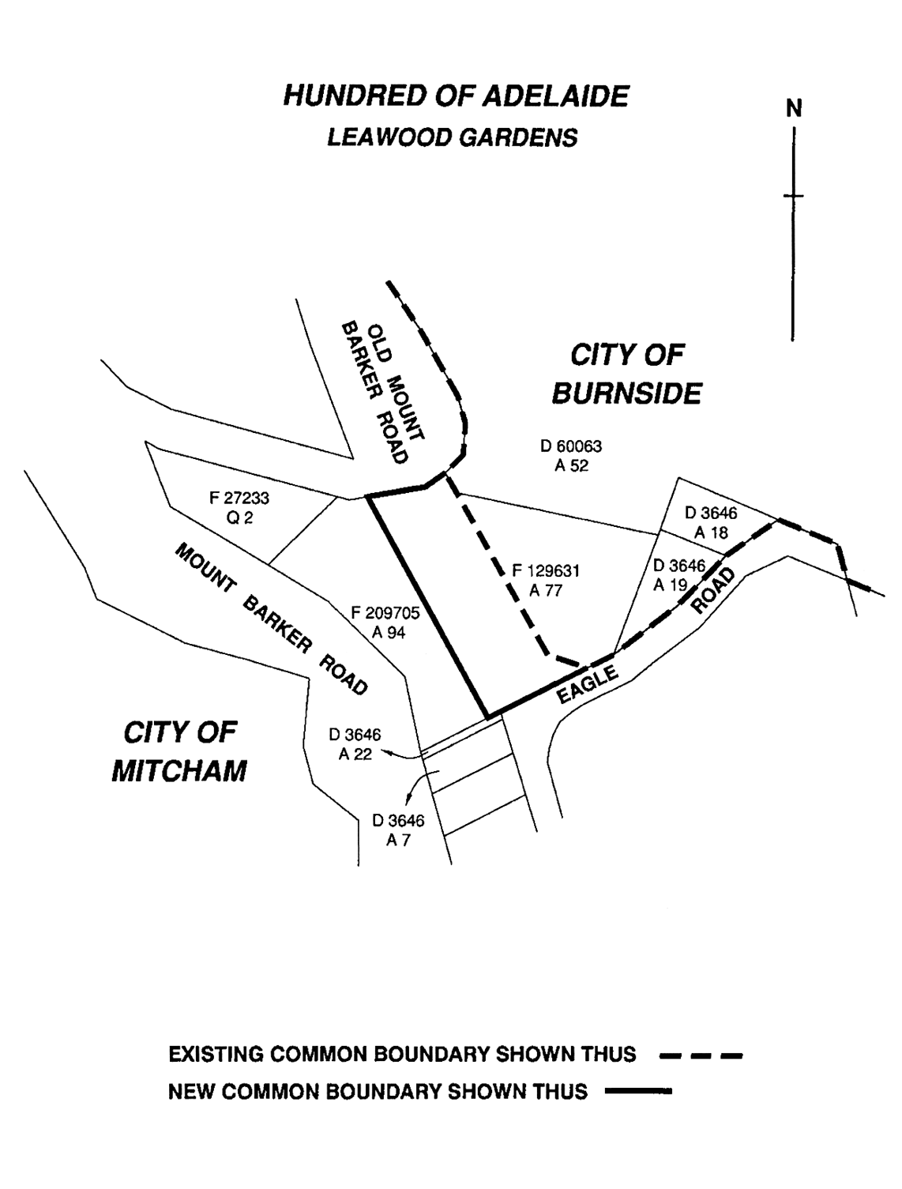
Made by the Governor
on the recommendation of the Boundary Adjustment Facilitation Panel and with the advice and consent of the Executive Council
on 24 September 2009
09MLG0013CS

South Australia
Motor Vehicles Variation Regulations 2009
under the Motor Vehicles Act 1959

Contents
Part 1—Preliminary
1 Short title
2 Commencement
3 Variation provisions
Part 2—Variation of Motor Vehicles Regulations 1996
4 Variation of regulation 25—Exemptions from duty to hold licence, learner's permit or particular class of licence

Part 1—Preliminary
1—Short title
These regulations may be cited as the Motor Vehicles Variation Regulations 2009.
2—Commencement
These regulations come into operation on the day on which they are made.
3—Variation provisions
In these regulations, a provision under a heading referring to the variation of specified regulations varies the regulations so specified.
Part 2—Variation of Motor Vehicles Regulations 1996
4—Variation of regulation 25—Exemptions from duty to hold licence, learner's permit or particular class of licence
Regulation 25—after subregulation (6) insert:
(7) A person may drive a motor home on roads in this State without holding a driver's licence under the Act if—
(a) the person holds a foreign licence, written in English or accompanied by an English translation, authorising the person to drive a motor vehicle with a GVM not exceeding 3.5 tonnes; or
(b) the person holds—
(i) a foreign licence authorising the person to drive a motor vehicle with a GVM not exceeding 3.5 tonnes; and
(ii) an international driving permit.
(8) However, subregulation (7) does not apply if—
(a) the person is disqualified from holding or obtaining an interstate licence in any State or Territory of the Commonwealth; or
(b) the person is disqualified from holding or obtaining a foreign licence in any country; or
(c) the person has resided in this State for a continuous period of more than 3 months and is a permanent resident or citizen of Australia; or
(d) the person's foreign licence only authorises the person to drive a motor bike, motor trike, moped, motorised wheelchair or other vehicle that is not a motor car; or
(e) a notice under subregulation (9) is in force in relation to the person.
(9) If the Registrar is of the opinion that—
(a) a person to whom subregulation (7) applies is not suitable to drive a motor home in this State; or
(b) the ability of a person to whom subregulation (7) applies to drive a motor home safely is impaired due to a permanent or long term injury or illness,
the Registrar may give the person notice in writing—
(c) prohibiting the person from driving a motor home on roads in this State without holding a driver's licence issued under the Act while the notice is in force; and
(d) stating the reasons for the giving of the notice; and
(e) specifying any action that may be taken by the person to regain the benefit of subregulation (7).
(10) The Registrar may revoke a notice under subregulation (9) by further notice to the person.
(11) A person must, while driving a motor home on roads in this State under subregulation (7)—
(a) carry his or her—
(i) foreign licence (together with any accompanying English translation of the licence); and
(ii) international driving permit (if any); and
(b) produce those documents if requested to do so by a police officer or authorised officer.
Maximum penalty: $1 250.
(12) If a person drives a motor home in this State under subregulation (7), the person's foreign licence will—
(a) for the purposes of section 74 of the Act and any law prescribed for the purposes of section 97A(4)(a) of the Act, be taken to be a licence under the Act; and
(b) for the purposes of a contract or policy of insurance relating to the vehicle, be taken to be a licence under the Act.
(13) In this regulation—
(a) international driving permit, interstate licence and permanent resident have the same respective meanings as in section 97A of the Act;
(b) motor home means a motor vehicle with a GVM not exceeding 4.5 tonnes that is designed and constructed for the primary purpose of providing a temporary dwelling for persons using the vehicle for recreational travel.
Note—
As required by section 10AA(2) of the Subordinate Legislation Act 1978, the Minister has certified that, in the Minister's opinion, it is necessary or appropriate that these regulations come into operation as set out in these regulations.
Made by the Governor
with the advice and consent of the Executive Council
on 24 September 2009
No 238 of 2009
MRS09/002CS

South Australia
Liquor Licensing (Dry Areas—Short Term) Variation Regulations 2009
under the Liquor Licensing Act 1997

Contents
Part 1—Preliminary
1 Short title
2 Commencement
3 Variation provisions
Part 2—Variation of Liquor Licensing (Dry Areas—Short Term) Regulations 1997
4 Variation of Schedule 1—Short term dry areas

Part 1—Preliminary
1—Short title
These regulations may be cited as the Liquor Licensing (Dry Areas—Short Term) Variation Regulations 2009.
2—Commencement
These regulations come into operation on the day on which they are made.
3—Variation provisions
In these regulations, a provision under a heading referring to the variation of specified regulations varies the regulations so specified.
Part 2—Variation of Liquor Licensing (Dry Areas—Short Term) Regulations 1997
4—Variation of Schedule 1—Short term dry areas
Schedule 1, item headed "Semaphore—Area 1", column headed "Period", (a), (b)—delete paragraphs (a) and (b) and substitute:
(a) 12 noon on 31 December 2009 to 12 noon on 1 January 2010;
(b) 12 noon on 26 January 2010 to 12 noon on 27 January 2010.
Note—
As required by section 10AA(2) of the Subordinate Legislation Act 1978, the Minister has certified that, in the Minister's opinion, it is necessary or appropriate that these regulations come into operation as set out in these regulations.
Made by the Governor
with the advice and consent of the Executive Council
on 24 September 2009
No 239 of 2009
09MCA0035CS

South Australia
Liquor Licensing (Dry Areas—Short Term) Variation Regulations 2009
under the Liquor Licensing Act 1997

Contents
Part 1—Preliminary
1 Short title
2 Commencement
3 Variation provisions
Part 2—Variation of Liquor Licensing (Dry Areas—Short Term) Regulations 1997
4 Variation of Schedule 1—Short term dry areas

Part 1—Preliminary
1—Short title
These regulations may be cited as the Liquor Licensing (Dry Areas—Short Term) Variation Regulations 2009.
2—Commencement
These regulations come into operation on the day on which they are made.
3—Variation provisions
In these regulations, a provision under a heading referring to the variation of specified regulations varies the regulations so specified.
Part 2—Variation of Liquor Licensing (Dry Areas—Short Term) Regulations 1997
4—Variation of Schedule 1—Short term dry areas
(1) Schedule 1, item headed "Victor Harbor—Area 1", column headed "Period"—delete "From 3 p.m. on 31 December 2008 to 8 a.m. on 1 January 2009." and substitute:
From 3 pm on 31 December 2009 to 8 am on 1 January 2010.
(2) Schedule 1, item headed "Victor Harbor—Area 2", column headed "Period"—delete "From 8 a.m. on 21 November 2008 to 10 p.m. on 29 November 2008." and substitute:
From 8 am on 20 November 2009 to 10 pm on 28 November 2009.
(3) Schedule 1, item headed "Victor Harbor—Area 3", column headed "Period", (a), (b)—delete paragraphs (a) and (b) and substitute:
(a) From 8 am on 20 November 2009 to 10 pm on 28 November 2009;
(b) From 3 pm on 31 December 2009 to 8 am on 1 January 2010.
Note—
As required by section 10AA(2) of the Subordinate Legislation Act 1978, the Minister has certified that, in the Minister's opinion, it is necessary or appropriate that these regulations come into operation as set out in these regulations.
Made by the Governor
with the advice and consent of the Executive Council
on 24 September 2009
No 240 of 2009
09MCA0034CS

South Australia
Primary Industry Funding Schemes (Citrus Growers Fund) Variation Regulations 2009
under the Primary Industry Funding Schemes Act 1998

Contents
Part 1—Preliminary
1 Short title
2 Commencement
3 Variation provisions
Part 2—Variation of Primary Industry Funding Schemes (Citrus Growers Fund) Regulations 2005
4 Variation of regulation 5—Contributions to Fund
5 Insertion of Schedule 1
Schedule 1—Transitional provisions for 2009 variation
1 Interpretation
2 Refund of prescribed contributions
3 Deduction of prescribed contributions
4 Application of Fund
5 No default after refund or non-payment of prescribed proportion

Part 1—Preliminary
1—Short title
These regulations may be cited as the Primary Industry Funding Schemes (Citrus Growers Fund) Variation Regulations 2009.
2—Commencement
These regulations will come into operation on 1 October 2009.
3—Variation provisions
In these regulations, a provision under a heading referring to the variation of specified regulations varies the regulations so specified.
Part 2—Variation of Primary Industry Funding Schemes (Citrus Growers Fund) Regulations 2005
4—Variation of regulation 5—Contributions to Fund
Regulation 5(1)(a)—delete "$1.15" and substitute:
65 cents
5—Insertion of Schedule 1
After regulation 8 insert:
Schedule 1—Transitional provisions for 2009 variation
1—Interpretation
In this Schedule—
prescribed period means 1 November 2008 to 30 September 2009;
prescribed proportion means 50/115.
2—Refund of prescribed contributions
(1) A refund of the prescribed proportion of contributions paid by or on behalf of a citrus grower in respect of citrus fruit sold during the prescribed period may be claimed by the citrus grower by giving notice in writing to the Minister on or before 31 December 2009.
(2) A person claiming a refund under subclause (1) must supply the Minister with—
(a) evidence acceptable to the Minister of the contributions made by the claimant in respect of which the claim for refund is made; and
(b) if the Minister so requires, verification of that evidence in the form of a statutory declaration.
(3) If the person satisfies the Minister that the person is entitled to a refund, the Minister must refund to the person the prescribed proportion of the contributions paid by the person in respect of citrus fruit sold during the prescribed period.
3—Deduction of prescribed contributions
If the prescribed proportion of contributions paid by or on behalf of a citrus grower in respect of citrus fruit sold during the prescribed period is refunded to the grower under this Schedule, any further claim under regulation 5 for a refund of contributions paid by or on behalf the grower in respect of citrus fruit sold during that period is limited to the remaining proportion of the contributions.
4—Application of Fund
The Fund may be applied by the Minister for repayment of contributions under this Schedule.
5—No default after refund or non-payment of prescribed proportion
For the purposes of regulation 7(2), a person is not to be taken to be in default only by virtue of the fact that—
(a) the person has failed to pay an amount not exceeding the prescribed proportion of contributions liable to be paid under regulation 5 in respect of citrus fruit sold during the prescribed period; or
(b) the person has been refunded the prescribed proportion of contributions under this Schedule.
Note—
As required by section 10AA(2) of the Subordinate Legislation Act 1978, the Minister has certified that, in the Minister's opinion, it is necessary or appropriate that these regulations come into operation as set out in these regulations.
Made by the Governor
with the advice and consent of the Executive Council
on 24 September 2009
No 241 of 2009
MAFF09/020CS

FAXING COPY?
IF you fax copy to Government Publishing SA for inclusion in the Government Gazette, there is no need to send a Confirmation Copy to us as well.
This creates confusion and may well result in your notice being printed twice.
Please use the following fax number:
Fax transmission: (08) 8207 1040
Phone Inquiries: (08) 8207 1045
Please include a contact person, phone number and order number so that we can phone back with any queries we may have regarding the fax copy.
NOTE: Closing time for lodging new copy (fax, hard copy or email) is 4 p.m. on Tuesday preceding the day of publication.

Government Gazette notices can be E-mailed.
The address is:
governmentgazette@dpc.sa.gov.au
Documents should be sent as attachments in Word format.
When sending a document via E-mail, please confirm your transmission with a faxed copy of your document, including the date the notice is to be published.
Fax transmission: (08) 8207 1040
Enquiries: (08) 8207 1045
NOTE: Closing time for lodging new copy (fax, hard copy or email) is 4 p.m. on Tuesday preceding the day of publication.

CAMPBELLTOWN CITY COUNCIL
Revocation of Community Land Classification
NOTICE is hereby given that Council at its meeting held on 15 September 2009, resolved to revoke the Community Land Classification for the Magill Institute, 609-611 Magill Road, Magill, described in Allotment 1 in Filed Plan 5655, certificate of title volume 5464, folio 617 and Allotment 72 in Filed Plan 133823, certificate of title volume 5900, folio 309, having complied with all requirements in relation to section 194 of the Local Government Act 1999.
Dated 16 September 2009.
P. Di Iulio, Chief Executive Officer

CITY OF HOLDFAST BAY
Change of Road Name
NOTICE is hereby given that the Council of the City of Holdfast Bay at its meeting held on 11 August 2009 and the Council of the City of Marion at its meeting held on 25 August 2009, resolved pursuant to section 219 (1) of the Local Government Act 1999, that a certain public road, being a section of Vinall Street, Brighton and Dover Gardens, for houses numbered 1A, 1B, 1C, 2B and 2C, be changed from Vinall Street to Vinall Street West, Brighton and for house numbered 2A be changed from Vinall Street to Vinall Street West, Dover Gardens.
A plan which delineates the public road which is subject to the change of road name, together with a copy of the Council’s resolution is available for inspection at the City of Holdfast Bay Civic Centre, 24 Jetty Road, Brighton, S.A. 5048, during the hours of 8.30 a.m. and 5 p.m. on weekdays or City of Marion Civic Centre, 245 Sturt Road, Sturt, during the hours of 8.30 a.m. and 5 p.m. on weekdays.
J. Lynch, Chief Executive Officer

CITY OF MARION
Change of Road Name
NOTICE is hereby given that the Council of the City of Marion at its meeting held on 25 August 2009 and the Council of the City of Holdfast Bay at its meeting held on 11 August 2009, resolved pursuant to section 219 (1) of the Local Government Act 1999, that a certain public road, being a section of Vinall Street, Brighton and Dover Gardens, for houses numbered 1A, 1B, 1C, 2B and 2C, be changed from Vinall Street to Vinall Street West, Brighton and for house numbered 2A be changed from Vinall Street to Vinall Street West, Dover Gardens.
A plan which delineates the public road which is subject to the change of road name, together with a copy of the Council’s resolution is available for inspection at the City of Marion Civic Centre, 245 Sturt Road, Sturt, during the hours of 8.30 a.m. and 5 p.m. on weekdays or the City of Holdfast Bay Civic Centre, 24 Jetty Road, Brighton, S.A. 5048, during the hours of 8.30 a.m. and 5 p.m. on weekdays.
M. Searle, Chief Executive Officer

DISTRICT COUNCIL OF ROBE
Roads (Opening and Closing) Act 1991
Road Closure—Park Terrace, Robe
NOTICE is hereby given, pursuant to section 10 of the Roads (Opening and Closing) Act 1991, that the District Council of Robe proposes to make a Road Process Order to close and sell by Public Auction or Tender the portion of the public road (Park Terrace) situated adjoining Allotment 113, in Filed Plan 205459 and Allotments 51 and 52 in Deposited Plan 3786, as more particularly delineated and lettered ‘A’ and ‘B’ on Preliminary Plan No. 09/0061.
A copy of the plan and a statement of persons affected are available for public inspection at the office of the Council at Royal Circus, Robe and the Adelaide office of the Surveyor-General during normal office hours.
Any application for easement or objection must set out the full name, address and details of the submission and must be fully supported by reasons.
The application for easement or objection must be made in writing to the Council, P.O. Box 1, Robe, S.A. 5276, within 28 days of this notice and a copy must be forwarded to the Surveyor-General, G.P.O. Box 1354, Adelaide, S.A. 5001.
Where a submission is made, the Council will give notification of a meeting at which the matter will be considered.
Dated 24 September 2009.
B. Hender, Chief Executive Officer

TATIARA DISTRICT COUNCIL
By-law Made Under the Local Government Act 1999
By-law No. 1 of 2009
A by-law to create a permit system for Council by-laws, to fix maximum and continuing penalties for offences and for the construction of Council by-laws.
Part 1—Preliminary
1. Title
This by-law may be cited as the Permits and Penalties By-law 2009 and is By-law No. 1 of the Tatiara District Council.
2. Authorising Law
This by-law is made under section 246 of the Act and subsections 667 (1) 3.liv and 9.xvi of the Local Government Act 1934, as amended.
3. Purpose
The objects of this by-law are to provide for the good rule and government of the Council area, and for the convenience, comfort and safety of its inhabitants by:
3.1 creating a permit system for Council by-laws;
3.2 providing for the enforcement of breaches of Council by-laws and fixing penalties; and
3.3 clarifying the construction of Council by-laws.
4. Commencement, Revocation and Expiry
4.1 The following by-laws previously made by the Council are revoked from the day on which this by-law comes into operation:
4.1.1 By-law No. 1—Permits and Penalties.
4.2 This by-law will expire on 1 January 2017.
5. Application
5.1 This by-law applies throughout the Council area.
6. Interpretation
In this by-law, unless the contrary intention appears:
6.1 Act means the Local Government Act 1999;
6.2 Council means Tatiara District Council;
6.3 person includes a body corporate.
7. Construction of By-laws Generally
7.1 Every by-law of the Council is subject to any Act of Parliament and Regulations made thereunder.
7.2 In any by-law of the Council, unless the contrary intention appears permission means permission of the Council, granted in writing prior to the act, event or activity to which it relates.
Part 2—Permits and Penalties
8. Permits
8.1 Where a by-law requires that permission be obtained any person seeking the grant of permission must submit a written application to the Council in the form (if any) and accompanied by the fee (if any) prescribed by the Council.
8.2 The Council may attach such conditions as it thinks fit to a grant of permission and may vary or revoke such conditions or impose new conditions by notice in writing to the person granted permission.
8.3 A person granted permission must comply with every such condition.
8.4 The Council may suspend or revoke a grant of permission at any time by notice in writing to the person granted permission.
9. Offences and Penalties
9.1 A person who commits a breach of any by-law of the Council is guilty of an offence and is liable to a maximum penalty being the maximum penalty referred to in the Act that may be fixed by a by-law for any breach of a by-law.
9.2 A person who commits a breach of a by-law of the Council of a continuing nature is guilty of an offence and in addition to any other penalty that may be imposed, is liable to a further penalty for every day on which the offence continues, such penalty being the maximum amount referred to in the Act that may be fixed by a by-law for a breach of a by-law of a continuing nature.
This by-law was duly made and passed at a meeting of the Tatiara District Council held on 8 September 2009, by an absolute majority of the members for the time being constituting the Council, there being at least two-thirds of the members present.
R. J. Harkness, Chief Executive Officer

TATIARA DISTRICT COUNCIL
By-law Made Under the Local Government Act 1999
By-law No. 2 of 2009
A by-law to set standards for moveable signs on roads and to provide conditions for the placement of such signs.
Part 1—Preliminary
1. Title
This by-law may be cited as the Moveable Signs By-law 2009 and is By-law No. 2 of the Tatiara District Council.
2. Authorising Law
This by-law is made under sections 239 and 246 of the Act and subsections 667 (1), 4.i and 9.xvi of the Local Government Act 1934, as amended.
3. Purpose
The object of this by-law is to set standards for movable signs on roads:
3.1 to protect the comfort and safety of road users and members of the public;
3.2 to enhance the amenity of roads and surrounding parts of the Council area;
3.3 to prevent nuisances occurring on roads;
3.4 to prevent unreasonable interference with the use of a road; and
3.5 for the good rule and government of the Council area.
4. Commencement, Revocation and Expiry
4.1 The following by-laws previously made by the Council are revoked from the day on which this by-law comes into operation:
4.1.1 By-Law No. 2—Moveable Signs.
4.2 This by-law will expire on 1 January 2017.
5. Application
5.1 This by-law operates subject to the Council’s Permits and Penalties By-law 2009.
5.2 This by-law applies throughout the Council area.
6. Interpretation
In this by-law, unless the contrary intention appears:
6.1 Act means the Local Government Act 1999;
6.2 business premises means premises from which a business is being conducted;
6.3 Council means Tatiara District Council;
6.4 footpath area means:
6.4.1 that part of a road between the property boundary of the road and the edge of the carriageway on the same side as that boundary;
6.4.2 a footway, lane or other place made or constructed for the use of pedestrians and not for the use of a vehicle;
6.5 vehicle has the same meaning as in the Road Traffic Act 1961.
Part 2—Moveable Signs
7. Construction and Design
A moveable sign placed on a footpath area must:
7.1 be of a kind known as an ‘A’ Frame or Sandwich Board sign, an ‘inverted T’ sign, or a flat sign or, with the permission of the Council, a sign of some other kind;
7.2 be designed, constructed and maintained in good quality and condition;
7.3 be of strong construction and sufficiently stable or securely fixed so as to keep its position in adverse weather conditions;
7.4 have no sharp or jagged edges or corners;
7.5 not be unsightly or offensive in appearance or content;
7.6 be constructed of timber, metal, plastic or plastic coated cardboard, or a mixture of such materials;
7.7 not exceed 1 000 mm in height, 600 mm in width and 600 mm in depth;
7.8 in the case of an ‘A’ Frame or Sandwich Board sign:
7.8.1 be hinged or joined at the top;
7.8.2 be of such construction that its sides are securely fixed or locked in position when erected; and
7.8.3 not have a base area in excess of 0.6 m²;
7.9 in the case of an ‘inverted T’ sign, not contain struts or members that run between the display area and the base of the sign.
8. Placement
A moveable sign must not be:
8.1 placed on any part of a road apart from the footpath area;
8.2 placed on a footpath that is less than 2.5 m wide;
8.3 placed closer than 2 m from another structure, fixed object, tree, bush or plant;
8.4 placed within 1 m of an entrance to any business premises;
8.5 placed on the sealed part of a footpath, if there is an unsealed part on which the sign can be placed in accordance with this by-law;
8.6 placed so as to interfere with the reasonable movement of persons or vehicles using the footpath or road in the vicinity of where the moveable sign is placed;
8.7 placed closer than 0.6 m to the kerb (or, if there is no kerb) to the edge of the carriageway of a road or the shoulder of the road, which ever is the greater;
8.8 placed on a landscaped area, other than landscaping that comprises only lawn;
8.9 placed within 10 m of an intersection of two or more roads;
8.10 placed on a footpath area with a minimum height clearance from a structure above it of less then 2 m;
8.11 placed on a designated parking area or within 1 m of an entrance to premises;
8.12 tied, fixed or attached to, or placed closer than 2 m to any other structure, object or thing (including another move-able sign);
8.13 displayed during the hours of darkness;
8.14 placed in such a position or in such circumstances that the safety of a user of the footpath area or road is at risk.
9. Appearance
A moveable sign placed on the footpath area of a road must, in the opinion of an authorised person:
9.1 be painted or otherwise detailed at a competent and professional manner;
9.2 be attractive, legible and simply worded to convey a precise message;
9.3 not have balloons, flags, streamers or other things attached to it; and
9.4 not rotate or contain flashing parts.
10. Banners
A person must not erect or display a banner on a building or structure on a road without the Council’s permission.
11. Restrictions
11.1 The owner or operator of a business must not cause or allow more than one moveable sign for each business premises to be displayed on the footpath area of a road at any time.
11.2 A person must not without the Council’s permission on Local Government land (including roads) display a moveable sign on or attached to or leaning against a vehicle that is parked primarily for the purpose for advertising (including for sale) a product or business to which the sign relates.
11.3 A person must not cause or allow a moveable sign to be placed on a footpath area unless:
11.3.1 it only displays material which advertises a business being conducted on premises adjacent to the moveable sign or the goods and services available from that business; and
11.3.2 the business premises to which it relates is open to the public.
11.4 If in the opinion of the Council a footpath area is unsafe for a moveable sign to be displayed the Council may prohibit or restrict the display of a moveable sign on such conditions as the Council thinks fit.
12. Exemptions
12.1 Subclauses 9.1, 9.2, 11.1 and 11.2 of this by-law do not apply to a moveable sign which:
12.1.1 advertises a garage sale taking place from residential premises;
12.1.2 is a directional sign to an event run by a community organisation or charitable body.
12.2 A requirement of this by-law will not apply where the Council has granted permission for the moveable sign to be displayed contrary to that requirement.
Note:
This by-law does not apply to moveable signs placed and maintained on a road in accordance with section 226 (3) of the Act, which includes any sign:
• placed there pursuant to an authorisation under another Act;
• designed to direct people to the open inspection of any land or building that is available for purchase or lease;
• related to a State or Commonwealth election and is displayed during the period commencing on the issue of the writ of writs for the election and ending at the close of polls on polling day;
• related to an election held under this Act or the Local Government (Elections) Act 1999 and is displayed during the period commencing four weeks immediately before the date that has been set (either by or under either Act) for polling day and ending at the close of voting on polling day; or
• the sign is of a prescribed class.
Part 3—Enforcement
13. Removal of Moveable Signs
13.1 A person must immediately comply with the order of an authorised person to remove a moveable sign made pursuant to section 227 (1) of the Act.
13.2 The owner of or other person entitled to recover a moveable sign removed by an authorised person pursuant to section 227 (2) of the Act, may be required to pay to the Council any reasonable costs incurred by the Council in removing, storing and disposing of the moveable sign before being entitled to recover the moveable sign.
13.3 The owner, or other person responsible for a moveable sign must remove or relocate the movable sign at the request of an authorised person:
13.3.1 if, in the opinion of an authorised person and not withstanding compliance with this by-law, there is any hazard or obstruction or there is likely to be a hazard or obstruction arising out of the location of the moveable sign; or
13.3.2 for the purpose of special events, parades, roadworks or in any other circumstances which, in the opinion of the authorised person, require relocation or removal of the moveable sign to protect public safety or to protect or enhance the amenity of a particular locality.
This by-law was duly made and passed at a meeting of the Tatiara District Council held on 8 September 2009, by an absolute majority of the members for the time being constituting the Council, there being at least two-thirds of the members present.
R. J. Harkness, Chief Executive Officer

TATIARA DISTRICT COUNCIL
By-law Made Under the Local Government Act 1999
By-law No. 3 of 2009
A by-law to regulate certain activities on roads in the Council area.

1. Title
This by-law may be cited as the Roads By-law 2009 and is By-law No. 3 of the Tatiara District Council.
2. Authorising Law
This by-law is made under sections 239 and 246 of the Act, Regulation 13 (1) (c) of the Local Government (Implementation) Regulations 1999 and subsections 667 (1), 4.i, 5.vii, 7.ii and 9.xv1 of the Local Government Act 1934, as amended.
3. Purpose
The objects of this by-law are to manage and regulate the use of roads in the Council area:
3.1 to protect the comfort and safety of road users and members of the public;
3.2 to prevent damage to buildings and structures on roads;
3.3 to prevent nuisances occurring on roads; and
3.4 for the good rule and government of the Council area.
4. Commencement, Revocation and Expiry
4.1 The following by-laws previously made by the Council are revoked from the day on which this by-law comes into operation:
4.1.1 By-law No. 3—Roads.
4.2 This by-law will expire on 1 January 2017.
5. Application
5.1 This by-law operates subject to the Council’s Permits and Penalties By-law 2009.
5.2 This by-law applies throughout the Council area.
6. Interpretation
In this by-law, unless the contrary intention appears:
6.1 Act means the Local Government Act 1999;
6.2 animal includes birds, insects and poultry but does not include a dog or a cat;
6.3 camp includes setting up a camp, or causing a tent, caravan or motor home to remain on the land for the purpose of staying overnight, whether or not any person is in attendance or sleeps on the land;
6.4 Council means Tatiara District Council;
6.5 effective control means a person exercising effective control of an animal either:
6.5.1 by means of a physical restraint;
6.5.2 by command, the animal being in close proximity to the person and the person being able to see the animal at all times;
6.6 electoral matter has the same meaning as in the Electoral Act 1985, provided that such electoral matter is not capable of causing physical damage or injury to a person within its immediate vicinity;
6.7 emergency vehicle has the same meaning as in the Australian Road Rules;
6.8 vehicle has the same meaning as in the Road Traffic Act 1961.
Part 2—Use of Roads
7. Activities Requiring Permission
A person must not do any of the following activities on a road without the permission of the Council:
7.1 Amplification
Use an amplifier or other device whether mechanical or electrical for the purpose of amplifying sound to broadcast announcements or advertisements.
7.2 Animals
7.2.1 Cause or allow an animal to stray onto, or graze on a road except where the Council has set aside a track or other area for use by or in connection with an animal of that kind and provided the animal or animals are under effective control.
7.2.2 Lead, herd or exercise an animal in such a manner as to cause a nuisance or endanger the safety of a person.
7.3. Donations
Ask for or receive or indicate a desire for a donation of money or any other thing, or otherwise solicit for religious or charitable purposes.
7.4 Obstructions
Erect, install or place or cause to be erected, installed or placed any structure, object or material of any kind so as to obstruct a road or footway, water-channel, or water-course in a road.
7.5 Posting of bills
Subject to Clause 11.2, post or allow or cause to be posted any bills, advertisements, or other papers or items on a building or structure on a road.
7.6 Preaching
Preach, harangue or solicit for religious purposes.
7.7 Public exhibitions and displays
7.7.1 Sing, busk, play a recording or use a music instrument or perform similar activities.
7.7.2 Conduct or hold a concert, festival, show, circus, performance or a similar activity.
7.7.3 Erect a stage or structure for the purpose of conducting or holding a concert, festival, show, circus, performance or a similar activity.
7.7.4 Cause any public exhibitions or displays.
7.8 Tents and camping
7.8.1 Erect a tent or other structure of calico, canvas or plastic or other similar material as a place of habitation.
7.8.2 Camp or sleep overnight.
7.9 Vehicles
Repair, wash, paint, panel beat or perform other work of a similar nature to a vehicle, except for running repairs in the case of a vehicle breakdown.
Part 3—Enforcement
8. Directions
A person who, in the opinion of an authorised person is committing or has committed a breach of this by-law, must immediately comply with a direction of an authorised person to leave that part of the road.
9. Orders
If a person does not comply with an order of an authorised person made pursuant to section 262 of the Act in respect of a breach of this by-law, the Council may recover its costs of any action taken under section 262 (3) of the Act from the person to whom the order was directed.
10. Removal of Animals and Objects
An authorised person may remove an animal or object that is on a road in breach of a by-law if no person is in charge, or apparently in charge, of the animal or object.
Part 4—Miscellaneous
11. Exemptions
11.1. The restrictions in this by-law do not apply to a Police Officer, emergency worker, Council Officer or employee acting in the course and within the scope of that person’s normal duties, or to a contractor while performing work for the Council and while acting under the supervision of a Council Officer.
11.2. The restrictions in Clause 7.5 of this by-law do not apply to activities regulated by those clauses provided that the activity is:
11.2.1 related to a Commonwealth or State election and occurs during the period commencing on the issue of the writ or writs for the election and ending at the close of polls on polling day;
11.2.2 related to an election under the Act or the Local Government (Elections) Act 1999 and occurs during the period commencing four weeks immediately before the date that has been set (either by or under either Act) for polling day and ending at the close of voting on polling day; or
11.2.3 related to, and occurs during the course of and for the purpose of a referendum.
This by-law was duly made and passed at a meeting of the Tatiara District Council held on 8 September 2009, by an absolute majority of the members for the time being constituting the Council, there being at least two-thirds of the members present.
R. J. Harkness, Chief Executive Officer

TATIARA DISTRICT COUNCIL
By-law Made Under the Local Government Act 1999
By-law No. 4 of 2009
A by-law to regulate the access to and use of Local Government land (other than roads), and certain public places.
Part 1—Preliminary
1. Title
This by-law may be cited as the Local Government Land By-law 2009 and is By-law No. 4 of the Tatiara District Council.
2. Authorising Law
This by-law is made under sections 238 and 246 of the Act and subsections 667 (1) 4.i and 9.xvi of the Local Government Act 1934, as amended.
3. Purpose
The objects of this by-law are to regulate the access to and use of Local Government land (other than roads), and certain pubic places:
3.1 to prevent and mitigate nuisances;
3.2 to prevent damage to Local Government land;
3.3 to protect the convenience, comfort and safety of members of the public;
3.4 to enhance the amenity of the Council area; and
3.5 for the good rule and government of the area.
4. Commencement, Revocation and Expiry
4.1 The following by-laws previously made by the Council are revoked from the day on which this by-law comes into operation:
4.1.1 By-law No. 4—Local Government Land.
4.2 This by-law will expire on 1 January 2017.
5. Application
5.1 This by-law operates subject to the Council’s Permits and Penalties By-law 2009.
5.2 Subject to subclause 5.3, this by-law applies throughout the Council area.
5.3 Clauses 9.3, 9.22.3, 10.3 and 10.9 of this by-law only apply to such part or parts of the Council area as the Council may, by resolution direct in accordance with section 246 (3) (e) of the Act.
6. Interpretation
In this by-law, unless the contrary intention appears:
6.1 Act means the Local Government Act 1999;
6.2 animal or animals includes birds and insects but does not include a dog;
6.3 boat includes a raft, pontoon or personal watercraft or other similar device;
6.4 camp includes setting up a camp, or causing a tent, caravan or motor home to remain on the land for the purpose of staying overnight, whether or not any person is in attendance or sleeps on the land;
6.5 children’s playground means an enclosed area in which there is equipment or other devices installed for the purpose of children’s play (or within 3 m of such devices if there is no enclosed area);
6.6 Council means Tatiara District Council;
6.7 electoral matter has the same meaning as in the Electoral Act 1985, provided that such electoral matter is not capable of causing physical damage or injury to any person within its immediate vicinity;
6.8 emergency vehicle has the same meaning as in the Australian Road Rules;
6.9 emergency worker has the same meaning as in the Road Traffic (Road Rules—Ancillary and Miscellaneous Provisions) Regulations 1999;
6.10 funeral ceremony means a ceremony only (i.e. a memorial service) and does not include a burial;
6.11 liquor has the same meaning as in the Liquor Licensing Act 1997;
6.12 Local Government Land means all land owned by the Council or under the Council’s care, control and management (except roads);
6.13 low water mark means the lowest meteorological tide;
6.14 offensive includes threatening, abusive, insulting or annoying behaviour and offend has a complimentary meaning;
6.15 open container means a container which:
(a) after the contents of the container have been sealed at the time of manufacture:
(i) being a bottle, it has had its cap, cork or top removed (whether or not it has since been replaced);
(ii) being a can, it has been opened or punctured;
(iii) being a cask, it has had its tap placed in a position to allow it to be used;
(iv) being any other form of container, it has been opened, broken, punctured or manipulated in such a way as to allow access to its contents; or
(v) is a flask, glass, mug or other container able to contain liquid;
6.16 tobacco product has the same meaning as in the Tobacco Products Regulation Act 1997;
6.17 vehicle has the same meaning as in the Road Traffic Act 1961;
6.18 waters includes a body of water, including a pond, lake, river, creek or wetlands under the care, control and management of the Council.
Part 2—Access to Local Government Land
7. Access
The Council may:
7.1 close, or regulate or restrict access to, any part of Local Government land to the public for specified times and days; and
7.2 fix charges or fees payable for entry onto any part of Local Government land.
8. Closed Lands
A person must not without permission, enter or remain on any Local Government land:
8.1 which has been closed, or access to the public regulated or restricted, in accordance with Clause 7.1;
8.2 where entry fees or charges are payable, without paying those fees or charges; or
8.3 where the land has been enclosed by fences and/or walls and gates that have been closed and locked.
Part 3—Use of Local Government Land
9. Activities Requiring Permission
A person must not without the permission of the Council, do any of the following on Local Government land:
9.1 Advertising
Display, paint or erect any sign or hoarding for the purpose of commercial advertising or any other purpose.
9.2 Aircraft
Subject to the Civil Aviation Act 1988, land any aircraft on, or take off any aircraft from the land.
9.3 Alcohol
Consume, carry or be in possession or in charge of any liquor on Local Government land comprising parks or reserves to which the Council has determined this paragraph applies.
9.4 Amplification
Use an amplifier or other mechanical or electrical device for the purpose of amplifying sound.
9.5 Animals
9.5.1 On Local Government land:
9.5.1.1 cause or allow an animal to stray onto, move over, graze or be left unattended on Local Government land;
9.5.1.2 cause or allow an animal to enter, swim, bathe or remain in any waters located on Local Government land;
9.5.1.3 lead, herd or exercise an animal, except where the Council has set aside a track or other area for use by or in connection with an animal of that kind, and provided that the animal or animals are under effective control.
9.6 Annoyance
Do anything likely to offend or unreasonably interfere with any other person:
9.6.1 using that land; or
9.6.2 occupying nearby premises,
by making a noise or creating a disturbance.
9.7 Attachments
Attach anything to a tree, plant, equipment, fence, post, structure or fixture on Local Government land.
9.8 Bees
Place a hive of bees on such land, or allow it to remain thereon.
9.9 Bridge Jumping
Jump or dive from a bridge on Local Government land.
9.10 Buildings
Use a building, or structure on Local Government land for a purpose other than its intended purpose.
9.11 Burials and Memorials
9.11.1 Bury, inter or spread the ashes of any human or animal remains.
9.11.2 Erect any memorial.
9.12 Camping and Tents
9.12.1 Erect a tent or other structure of calico, canvas, plastic or similar material as a place of habitation.
9.12.2 Camp or sleep overnight except where a person is in a caravan park on Local Government land, the proprietor of which has been given permission to operate the caravan park on that land.
9.13 Canvassing
Subject to Clause 14.2 convey any advertising, religious or other message to any bystander, passer-by or other.
9.14 Defacing Property
Deface, paint, spray, write, cut names, letters or make marks on any tree, rock, gate, fence, building, sign, bridge or property of the Council.
9.15 Distribution
Subject to Clause 14.2, place on a vehicle (without the consent of the owner of the vehicle), or give out or distribute any hand bill, book, notice, leaflet or other printed matter to any bystander, passer-by or other person.
9.16 Donations
Ask for or receive or indicate that he or she desires a donation of money or any other thing.
9.17 Entertainment and Busking
9.17.1 Sing, busk or play a recording or use a musical instrument for the apparent purpose of either entertaining others or receiving money.
9.17.2 Conduct or hold a concert, festival, show, public gathering, circus, meeting, performance or any other similar activity.
9.18 Equipment
Use an item of equipment, facilities or property belonging to the Council if that person is of or over the age indicated by a sign or notice as the age limit for using such equipment, facility or property.
9.19 Fires
Subject to the Fire and Emergency Services Act 2005, light a fire except:
9.19.1 in a place provided by the Council for that purpose;
9.19.2 in a portable barbeque, as long as the barbeque is used in an area that is clear of flammable material for a distance of at least 4 m.
9.20 Fireworks
Ignite or discharge any fireworks.
9.21 Flora and Fauna
Subject to the Native Vegetation Act 1991 and the National Parks and Wildlife Act 1972:
9.21.1 damage, pick, disturb, interfere with or remove any plant or flower thereon;
9.21.2 lead or drive any animal or stand or walk on any flower bed or garden plot;
9.21.3 deposit, dig, damage, disturb, interfere with or remove any soil, stone, wood, clay, gravel, pebbles, timber, bark or any part of the land;
9.21.4 take, interfere with, tease, harm or disturb any animal, bird or marine creature or the eggs or young of any animal, bird or marine creature;
9.21.5 pick, collect, take, interfere with or disturb any fruit, nuts, berries or native seeds;
9.21.6 disturb, interfere with or damage any burrow, nest or habitat of any animal or bird;
9.21.7 use, possess or have control of any device for the purpose of killing or capturing any animal, bird or marine creature;
9.21.8 burn any timber or dead wood.
9.22 Games
9.22.1 Participate in, promote or organise any organised competition or sport, as distinct from organised social play.
9.22.2 Play or practice any game which involves kicking, hitting or throwing a ball or other object on Local Government land which may cause or be likely to cause injury or discomfort to a person being on or in the vicinity of that lands or detract from or be likely to detract from another person’s lawful use and enjoy-ment of that land.
9.22.3 Play or practice the game of golf on Local Government land to which the Council has resolved this subclause applies.
9.23 Litter
9.23.1 Throw, cast, place, deposit or leave any rubbish, dirt or refuse of any kind whatsoever except in a garbage container provided for that purpose.
9.23.2 Deposit any soil, clay, stone, gravel, green waste or other putrescible waste or any other matter.
9.24 Marine Life
Introduce any marine life to any waters located on Local Government land.
9.25 Model Aircraft, Boats and Cars
Fly or operate a model aircraft, boat or model or remote control vehicle in a manner may cause or be likely to cause injury or discomfort to a person being on or in the vicinity of the land or detract from or be likely to detract from another person’s lawful use of and enjoyment of the land.
9.26 Overhanging Articles or Displaying Personal Items
Suspend or hang an article or object from a building, verandah, pergola, post or other structure on Local Government land where it might present a nuisance or danger to a person using the land or be of an unsightly nature.
9.27 Playing Area
Use or occupy a playing area:
9.27.1 in such a manner as to damage or be likely to damage the surface of the playing area or infrastructure (above and under ground level);
9.27.2 in a manner contrary to the purpose for which the playing area was intended to be used or occupied;
9.27.3 contrary to directions of the Council made by resolution and indicated on a sign displayed adjacent to the playing area.
9.28 Pontoons
Install or maintain a pontoon or jetty in any waters.
9.29 Posting of Bills
Post or allow or cause to be posted any bills, advertise-ments or other papers or items on a building or structure on Local Government land or in a public place.
9.30 Preaching
Preach, harangue or solicit for religious purposes.
9.31 Ropes
Place a buoy, cable, chain, hawser, rope or net in or across any waters.
9.32 Swimming
Subject to the provisions of the Harbors and Navigation Act 1993, swim in, bathe or enter any waters except:
9.32.1 in an area which the Council has determined may be used for such purposes; and
9.32.2 in accordance with any conditions that the Council may have determined by resolution apply to such use.
9.33 Toilets
In any public convenience on Local Government land:
9.33.1 urinate other than in a urinal or pan or defecate other than in a pan set apart for that purpose;
9.33.2 deposit anything in a pan, urinal or drain which is likely to cause a blockage;
9.33.3 use it for a purpose for which it was not designed or constructed;
9.33.4 enter a toilet that is set aside for use of the opposite sex except:
9.33.4.1 where a child under the age of eight years is accompanied by an adult parent or guardian of that sex;
9.33.4.2 to provide assistance to a disabled person; or
9.33.4.3 in the case of a genuine emergency.
9.34 Trading
Sell, buy, offer or display anything for sale.
9.35 Vehicles
9.35.1 Drive or propel a vehicle except on an area constructed and identified by the Council for that purpose, by means of signs, devices or fencing and the like.
9.35.2 Promote, organise or take part in a race, test or trial of any kind in which vehicles take part, except on an area properly constructed for that purpose.
9.35.3 Repair, wash, paint, panel beat or carry out other work to a vehicle, except for running repairs in the case of a breakdown.
9.36 Weddings, Functions and Special Events
9.36.1 Hold, conduct or participate in a marriage ceremony, funeral or special event.
9.36.2 Erect a marquee, stage or structure for the purpose of holding or conducting a wedding, funeral or special event.
9.36.3 Hold or conduct any filming where the filming is for a commercial purpose.
10. Prohibited Activities
A person must not do any of the following on Local Govern-ment land:
10.1 Animals
10.1.1 Cause or allow any animal to enter, swim, bathe or remain in any waters to the inconvenience, annoyance or danger of any other person bathing or swimming.
10.1.2 Cause or allow an animal to damage a flower-bed, garden, pot, tree, lawn or other item located thereon.
10.1.3 Lead, drive or exercise a horse in such manner as to endanger the safety of any other person.
10.2 Equipment
Use any item of equipment, facilities or property belonging to the Council other than in the manner and for the purpose for which it was designed, constructed or intended to be used or in such manner as is likely to damage or destroy it.
10.3 Fishing
10.3.1 Fish in any waters to which the Council has determined this subclause applies.
10.3.2 Fish from a bridge or other structure to which the Council has determined this subclause applies.
10.4 Glass
Willfully break any glass, china or other brittle material.
10.5 Interference with Land
Interfere with, alter or damage the land (including a building, structure or fixture located on the land) including:
10.5.1 altering the construction or arrangement of the land to permit or facilitate access from an adjacent property;
10.5.2 erecting or installing a structure in, on, across, under or over the land;
10.5.3 changing or interfering with the construction, arrangement or materials of the land;
10.5.4 planting a tree of other vegetation on the land, interfering with the vegetation on the land or removing vegetation from the land; or
10.5.5 otherwise use the land in a manner contrary to the purpose for which the land was designed to be used.
10.6 Interference with Permitted Use
Interrupt, disrupt or interfere with any other person’s use of Local Government land which is permitted or for which permission has been granted.
10.7 Nuisance
Behave in such a manner as to cause discomfort, inconvenience, annoyance or offence to any other person.
10.8 Playing Games
Play or practice a game:
10.8.1 which is likely to cause damage to the lands or anything in it;
10.8.2 in any area where a sign indicates that the game is prohibited.
10.9 Smoking
Smoke, hold or otherwise have control over an ignited tobacco product:
10.9.1 in any building;
10.9.2 in any children’s playground;
10.9.3 on any land to which the Council has deter-mined this subclause applies.
10.10 Throwing Objects
Throw, roll, project or discharge a stone, substance or other missile, excluding sport and recreational equipment designed to be used in that way.
10.11 Solicitation
Tout or solicit customers for the parking of vehicles or for any other purpose whatsoever.
10.12 Waste
10.12.1 Deposit or leave thereon:
10.12.1.1 anything obnoxious or offensive;
10.12.1.2 any offal, dead animal, dung or filth; or
10.12.1.3 any mineral, mineral waste, indus-trial waste or bi-products.
10.12.2 Foul or pollute any waters situated thereon.
10.12.3 Deposit any rubbish other than in receptacles provided by the Council for that purpose.
10.12.4 Deposit in a receptacle any rubbish emanating from domestic or trade purposes, unless desig-nated by a sign or signs.
Part 4—Enforcement
11. Directions
11.1 A person on Local Government land must comply with a reasonable direction from an authorised person relating to:
11.1.1 that person’s use of the land;
11.1.2 that person’s conduct and behaviour on the land;
11.1.3 that person’s safety on the land; or
11.1.4 the safety and enjoyment of other persons on the land.
11.2 A person who, in the opinion of an authorised person, is likely to commit or has committed, a breach of this by-law must immediately comply with a direction of an authorised person to leave that part of Local Government land.
12. Orders
If a person fails to comply with an order of an authorised person made pursuant to section 262 of the Act in respect of a breach of this by-law, the Council may recover its costs of any action taken under section 262 (3) of the Act from the person to whom the order was directed.
13. Removal of Animals and Objects
An authorised person may remove an animal or object that is on Local Government land in breach of a by-law if no person is in charge of, or apparently in charge of, the animal or object.
Part 5—Miscellaneous
14. Exemptions
14.1 The restrictions in this by-law do not apply to a Police Officer, emergency worker, Council Officer or employee acting in the course and within the scope of that person’s normal duties, or to a contractor while performing work for the Council and while acting under the supervision of a Council Officer.
14.2 The restrictions in Clauses 9.1, 9.7, 9.13, 9.15 and 9.29 of this by-law do not apply to electoral matter which is:
14.2.1 related to a Commonwealth or State election and occurs during the period commencing on the issue of the writ or writs for the election and ending at the close of polls on polling day;
14.2.2 related to an election under the Act or the Local Government (Elections) Act 1999 and occurs during the period commencing four weeks immediately before the date that has been set (either by or under either Act) for polling day and ending at the close of voting on polling day; or
14.2.3 related to and occurs during the course of and for the purpose of a referendum.
This by-law was duly made and passed at a meeting of the Tatiara District Council held on 8 September 2009, by an absolute majority of the members for the time being constituting the Council, there being at least two-thirds of the members present.
R. J. Harkness, Chief Executive Officer

WAKEFIELD REGIONAL COUNCIL
Exclusion of Land from Classification as Community Land
NOTICE is hereby given that Council, at its ordinary meeting held on 24 June 2009, resolved pursuant to section 193 (4) of the Local Government Act 1999, to exclude the proposed drainage ease-ments in favour of the Council as described in Deposited Plan 81052, Hundred of Barunga, being certain sections of railway land in Snowtown township, from Classification as Community Land.
P. Barry, Chief Executive Officer

IN the matter of the estates of the undermentioned deceased persons:
Battersby, Raymond Simeon, late of 23 Hurlstone Street, Peterborough, retired manager, who died on 19 June 2009.
Beatty, Ilma Ivy, late of 1 Steele Street, Campbelltown, of no occupation, who died on 22 July 2009.
Brooks, Frederick George, late of 61 Silkes Road, Paradise, retired technical officer, who died on 8 June 2009.
Campbell, Graham, late of Grainger Road, Somerton Park, retired explosive technician, who died on 20 July 2009.
Elliott, Dorothy Ann, late of 25 Newton Street, Whyalla, of no occupation, who died on 2 November 2008.
Hartley, Terence, late of 43A Flinders Avenue, Whyalla Stuart, of no occupation, who died on 11 December 2008.
Herde, Jean Elizabeth, late of 50 Darebin Street, Mile End, widow, who died on 11 July 2009.
Jeffery, Jeffery Alfred, late of 3 Grant Avenue, Gilles Plains, retired estimator, who died on 29 May 2009.
King, Jean Marion, late of 6 Ellis Street, Enfield, of no occupation, who died on 27 June 2009.
Liddell, David John James, late of 740 Torrens Road, Rosewater, retired builders labourer, who died on 23 July 2009.
Matzeit, Hans, late of 6 Ellis Street, Enfield, retired toolmaker, who died on 31 May 2009.
McMaster, Valma Gertrude, late of 25 Diosma Drive, Morphett Vale, home duties, who died on 25 June 2009.
Payne, Zetta Gluyas, late of 110 Strathfield Terrace, Largs North, of no occupation, who died on 15 July 2009.
Rovis, Bernadette Therese, late of 82 Cross Keys Road, Brahma Lodge, home duties, who died on 8 January 2008.
Schubert, Joan Leona, late of 5 Lurther Road, Loxton, home duties, who died on 26 April 2009.
Thiele, Victor Charles, late of 78-96 Dumfries Avenue, North-gate, of no occupation, who died on 27 April 2009.
Wilkey, David Wayne, late of 123 David Terrace, Woodville Park, labourer, who died on 6 May 2008.
Notice is hereby given pursuant to the Trustee Act 1936, as amended, the Inheritance (Family Provision) Act 1972, and the Family Relationships Act 1975, that all creditors, beneficiaries, and other persons having claims against the said estates are required to send, in writing, to the Public Trustee, 25 Franklin Street, Adelaide, S.A. 5000, full particulars and proof of such claims, on or before 23 October 2009, otherwise they will be excluded from the distribution of the said estate; and notice is also hereby given that all persons who are indebted to the said estates are required to pay the amount of their debts to the Public Trustee or proceedings will be taken for the recovery thereof; and all persons having any property belonging to the said estates are forthwith to deliver the same to the Public Trustee.
Dated 24 September 2009.
M. I. Bodycoat, Public Trustee

ATTENTION

CUSTOMERS requiring a proof of their notice for inclusion in the Government Gazette, please note that the onus is on you to inform Government Publishing SA of any subsequent corrections by 10 a.m. on Thursday, which is our publication deadline.

For any corrections to your notice please phone 8207 1045 or Fax 8207 1040 before 10 a.m. on Thursday.

If we do not receive any communication by 10 a.m. on Thursday (day of publication) we will presume the notice is correct and will print it as it is.

Remember—the onus is on you to inform us of any corrections necessary to your notice.

NOTE: Closing time for lodging new copy (electronically, fax or hard copy) is 4 p.m. on Tuesday preceding the day of publication. Phone 8207 1045—Fax 8207 1040.
Email: governmentgazette@dpc.sa.gov.au

Printed and published by authority every Thursday by T. GOODES, Government Printer, South Australia
Price: $5.60, plus postage; to subscribers, $284.00 per annum.
(The above prices are inclusive of GST)

