No. 21 1159

THE SOUTH AUSTRALIAN

GOVERNMENT GAZETTE
www.governmentgazette.sa.gov.au

PUBLISHED BY AUTHORITY

ALL PUBLIC ACTS appearing in this GAZETTE are to be considered official, and obeyed as such

ADELAIDE, THURSDAY, 1 APRIL 2010

CONTENTS

Page
Aquaculture Act 2001—Notice 1171
Brands Act 1933—2nd Quarter 2009 1160
Corporations and District Councils—Notices 1203
Development Act 1993—Notice 1171
Dog Fence Act 1946—Notice 1174
Environment Protection Act 1993—Notices 1175
Geographical Names Act 1991—Corrigendum 1180
Housing Improvement Act 1940—Notices 1179
Hydroponics Industry Control Act 2009—Notices 1180
Liquor Licensing Act 1997—Notices 1181
Mining Act 1971—Notices 1184
National Electricity Law—Notice 1185
Pastoral Land Management and Conservation Act 1989—
Notices 1190
Petroleum and Geothermal Energy Act 2000—Notices 1188
Public Trustee Office—Administration of Estates 1204
Real Property Act 1886—Notice 1194
Remuneration Tribunal, Determination of—Notice 1190
Roads (Opening and Closing) Act 1991—Notice 1191
Shop Trading Hours Act 1977—Notice 1191
Transport, Department of—Notice to Mariners 1191
Water Mains and Sewers—Mains Laid, Replaced, Etc 1191
Waterworks Act 1932—
Erratum 1194
Notices 1195

GOVERNMENT GAZETTE NOTICES
ALL poundkeepers’ and private advertisements forwarded for publication in the South Australian Government Gazette must be PAID FOR PRIOR TO INSERTION; and all notices, from whatever source, should be legibly written on one side of the paper only and sent to Government Publishing SA so as to be received no later
than 4 p.m. on the Tuesday preceding the day of publication. Phone 8207 1045 or Fax 8207 1040. E-mail: governmentgazette@dpc.sa.gov.au. Send as attachments in Word format and please confirm your transmission with a faxed copy of your document, including the date the notice is to be published and to whom the notice will be charged. The Government Gazette is available online at: www.governmentgazette.sa.gov.au

Brands Act 1933
2nd Quarter, 2009

The following statement of all horse and cattle, sheep and stud stock brands, distinctive brands and marks, sheep earmarks and firebrands registered, transferred and cancelled under the Brands Act 1933 for the quarter ended 30th June 2009 and the names and addresses of their respective owners, is published in the form of the Twenty-third schedule for general information.

Stockowners whose names, addresses, brands or marks may be incorrectly stated are requested to notify the same to the Registrar and in all such notifications the registered brand of the owner and the number of the certificate of registration must be given.

Any subsequent change of address must be notified at once to the Registrar.


Register of Brands
22nd March 2010.

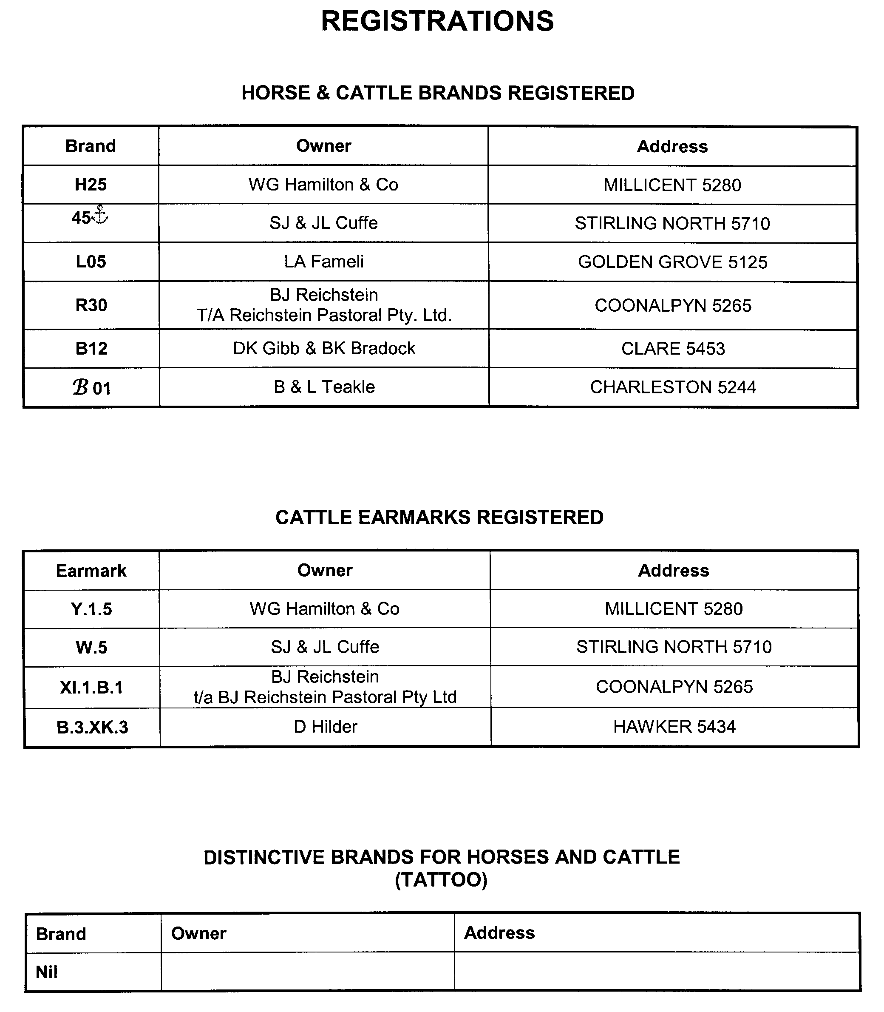
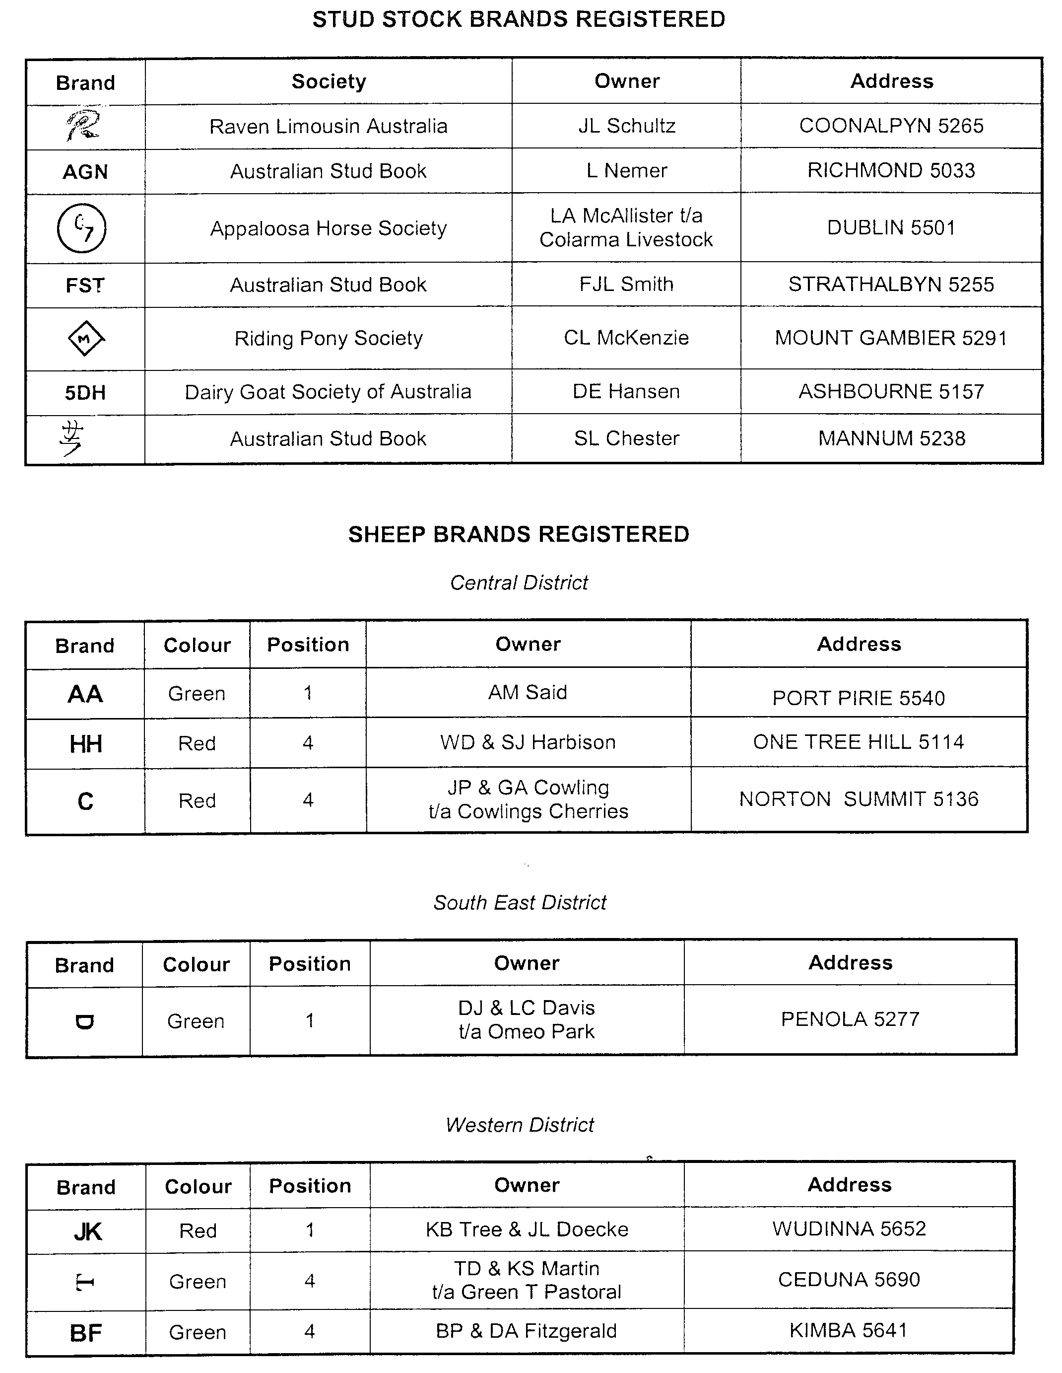
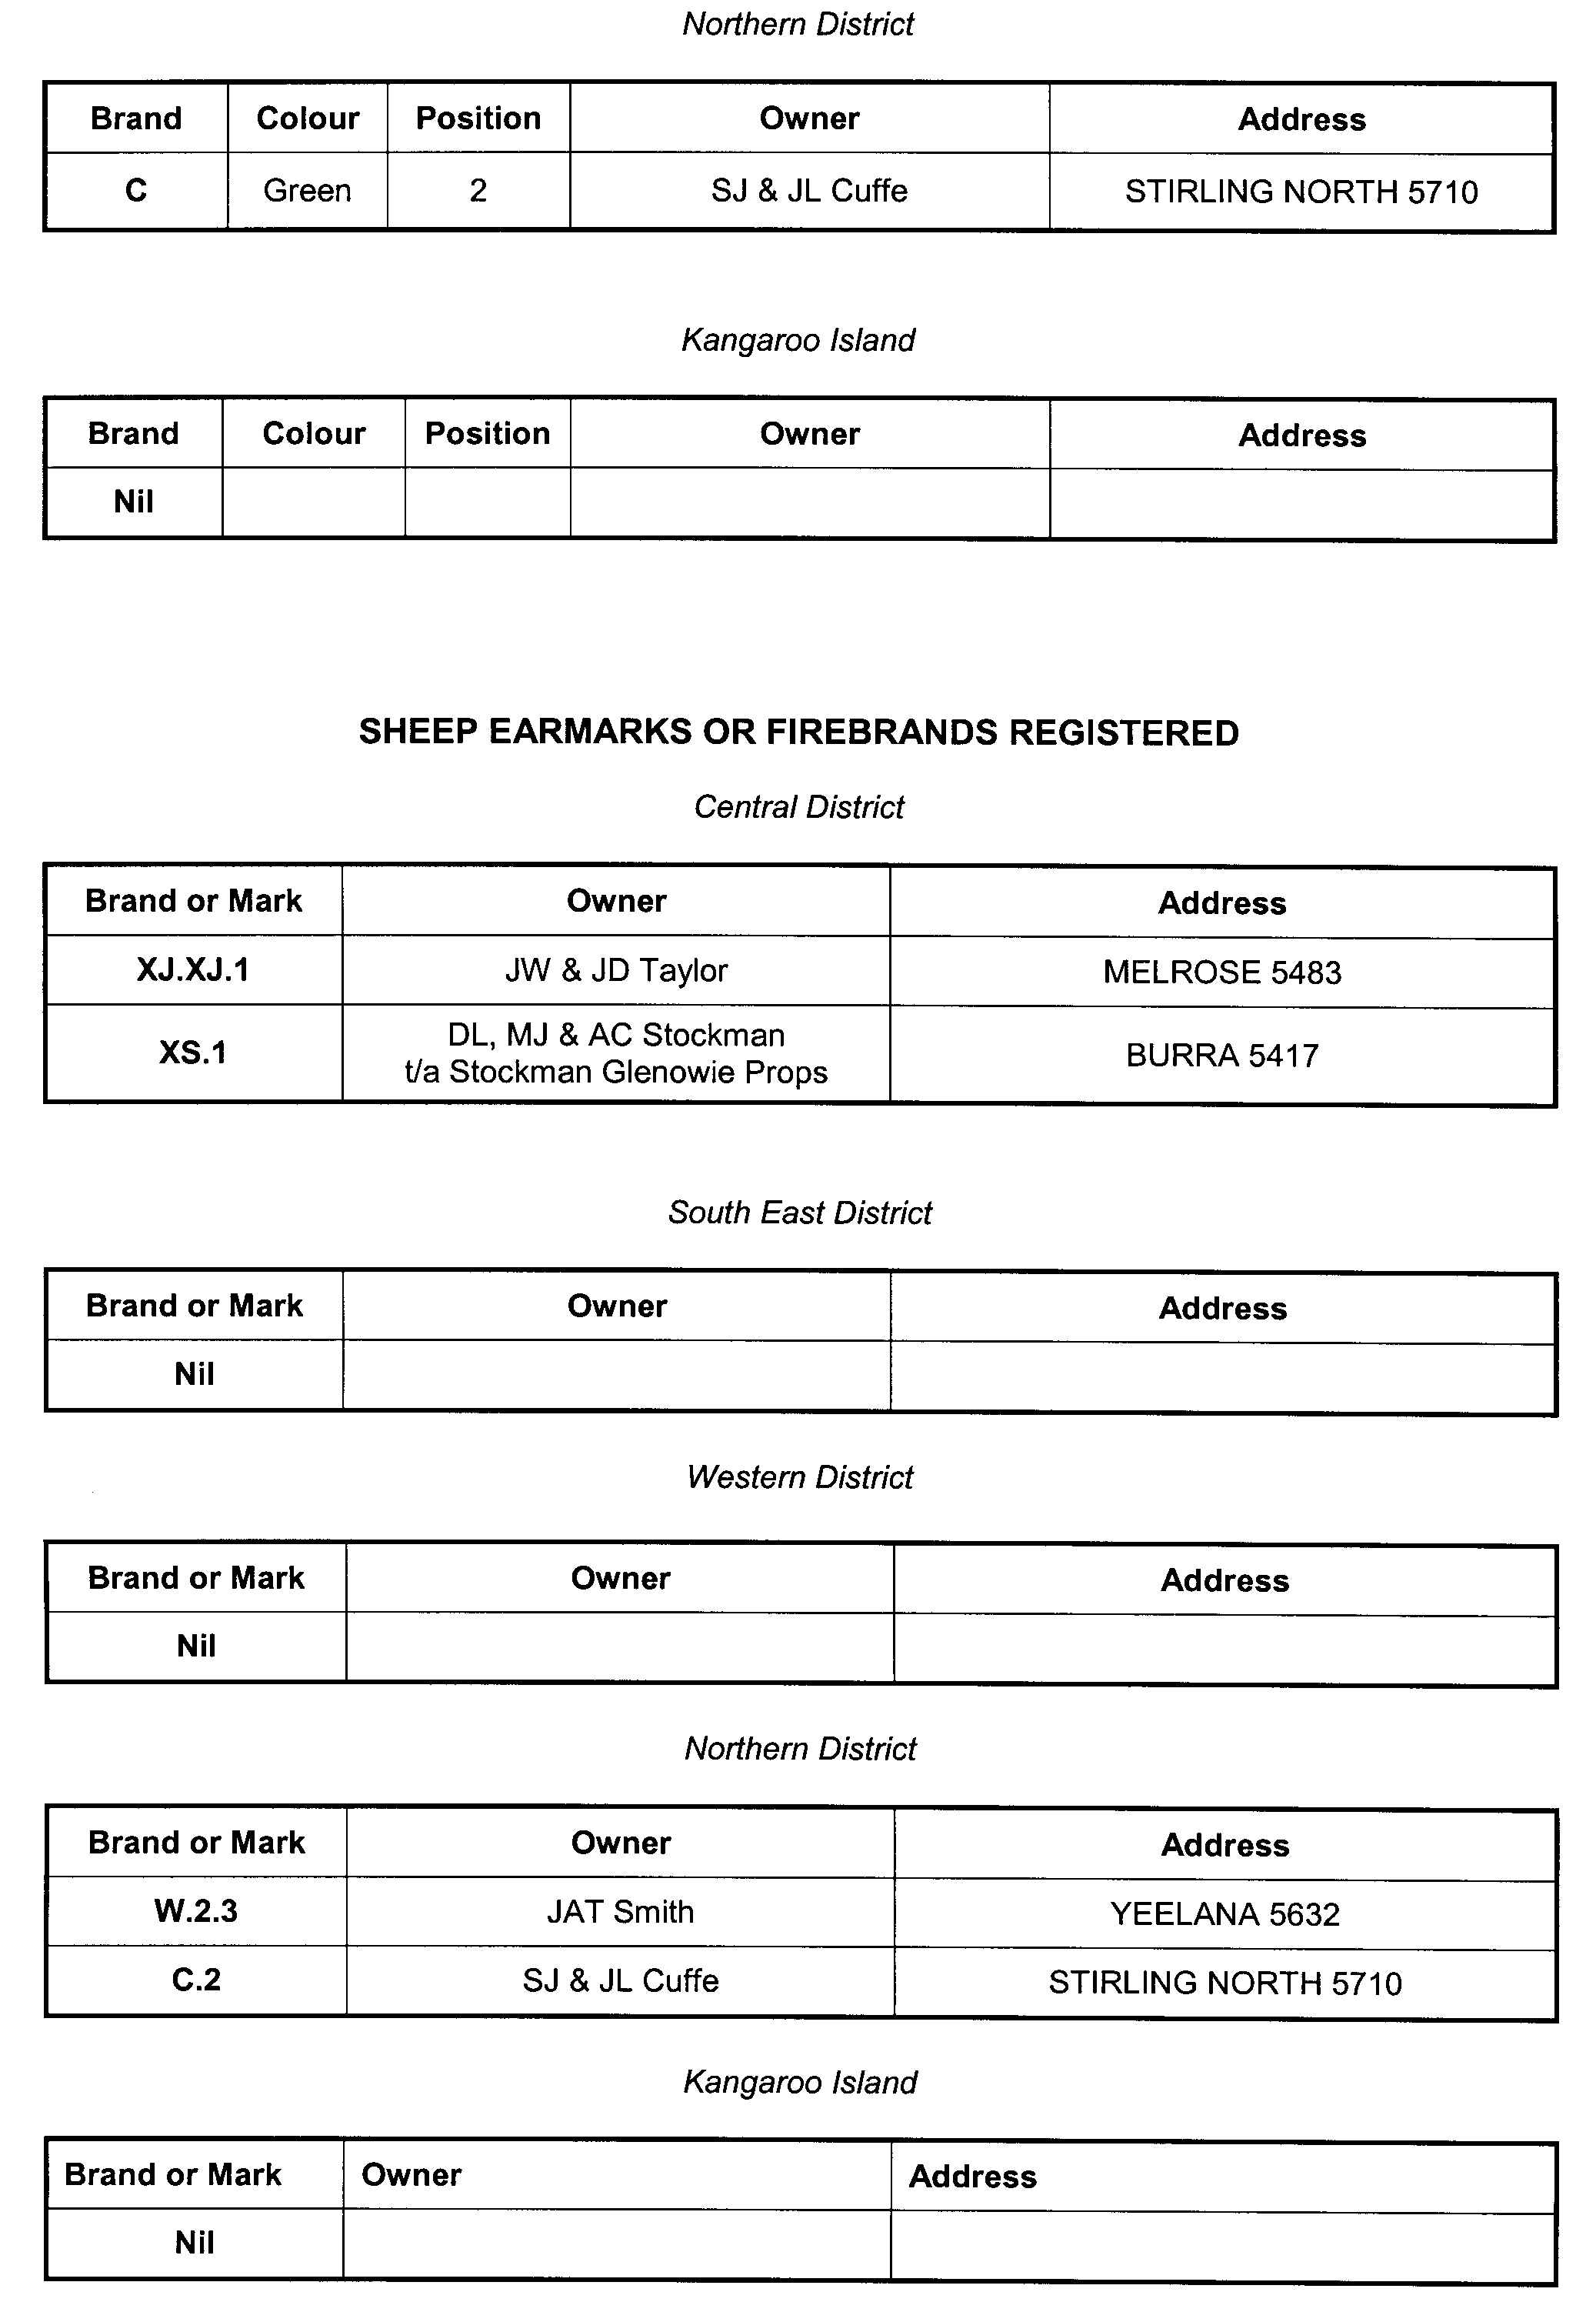
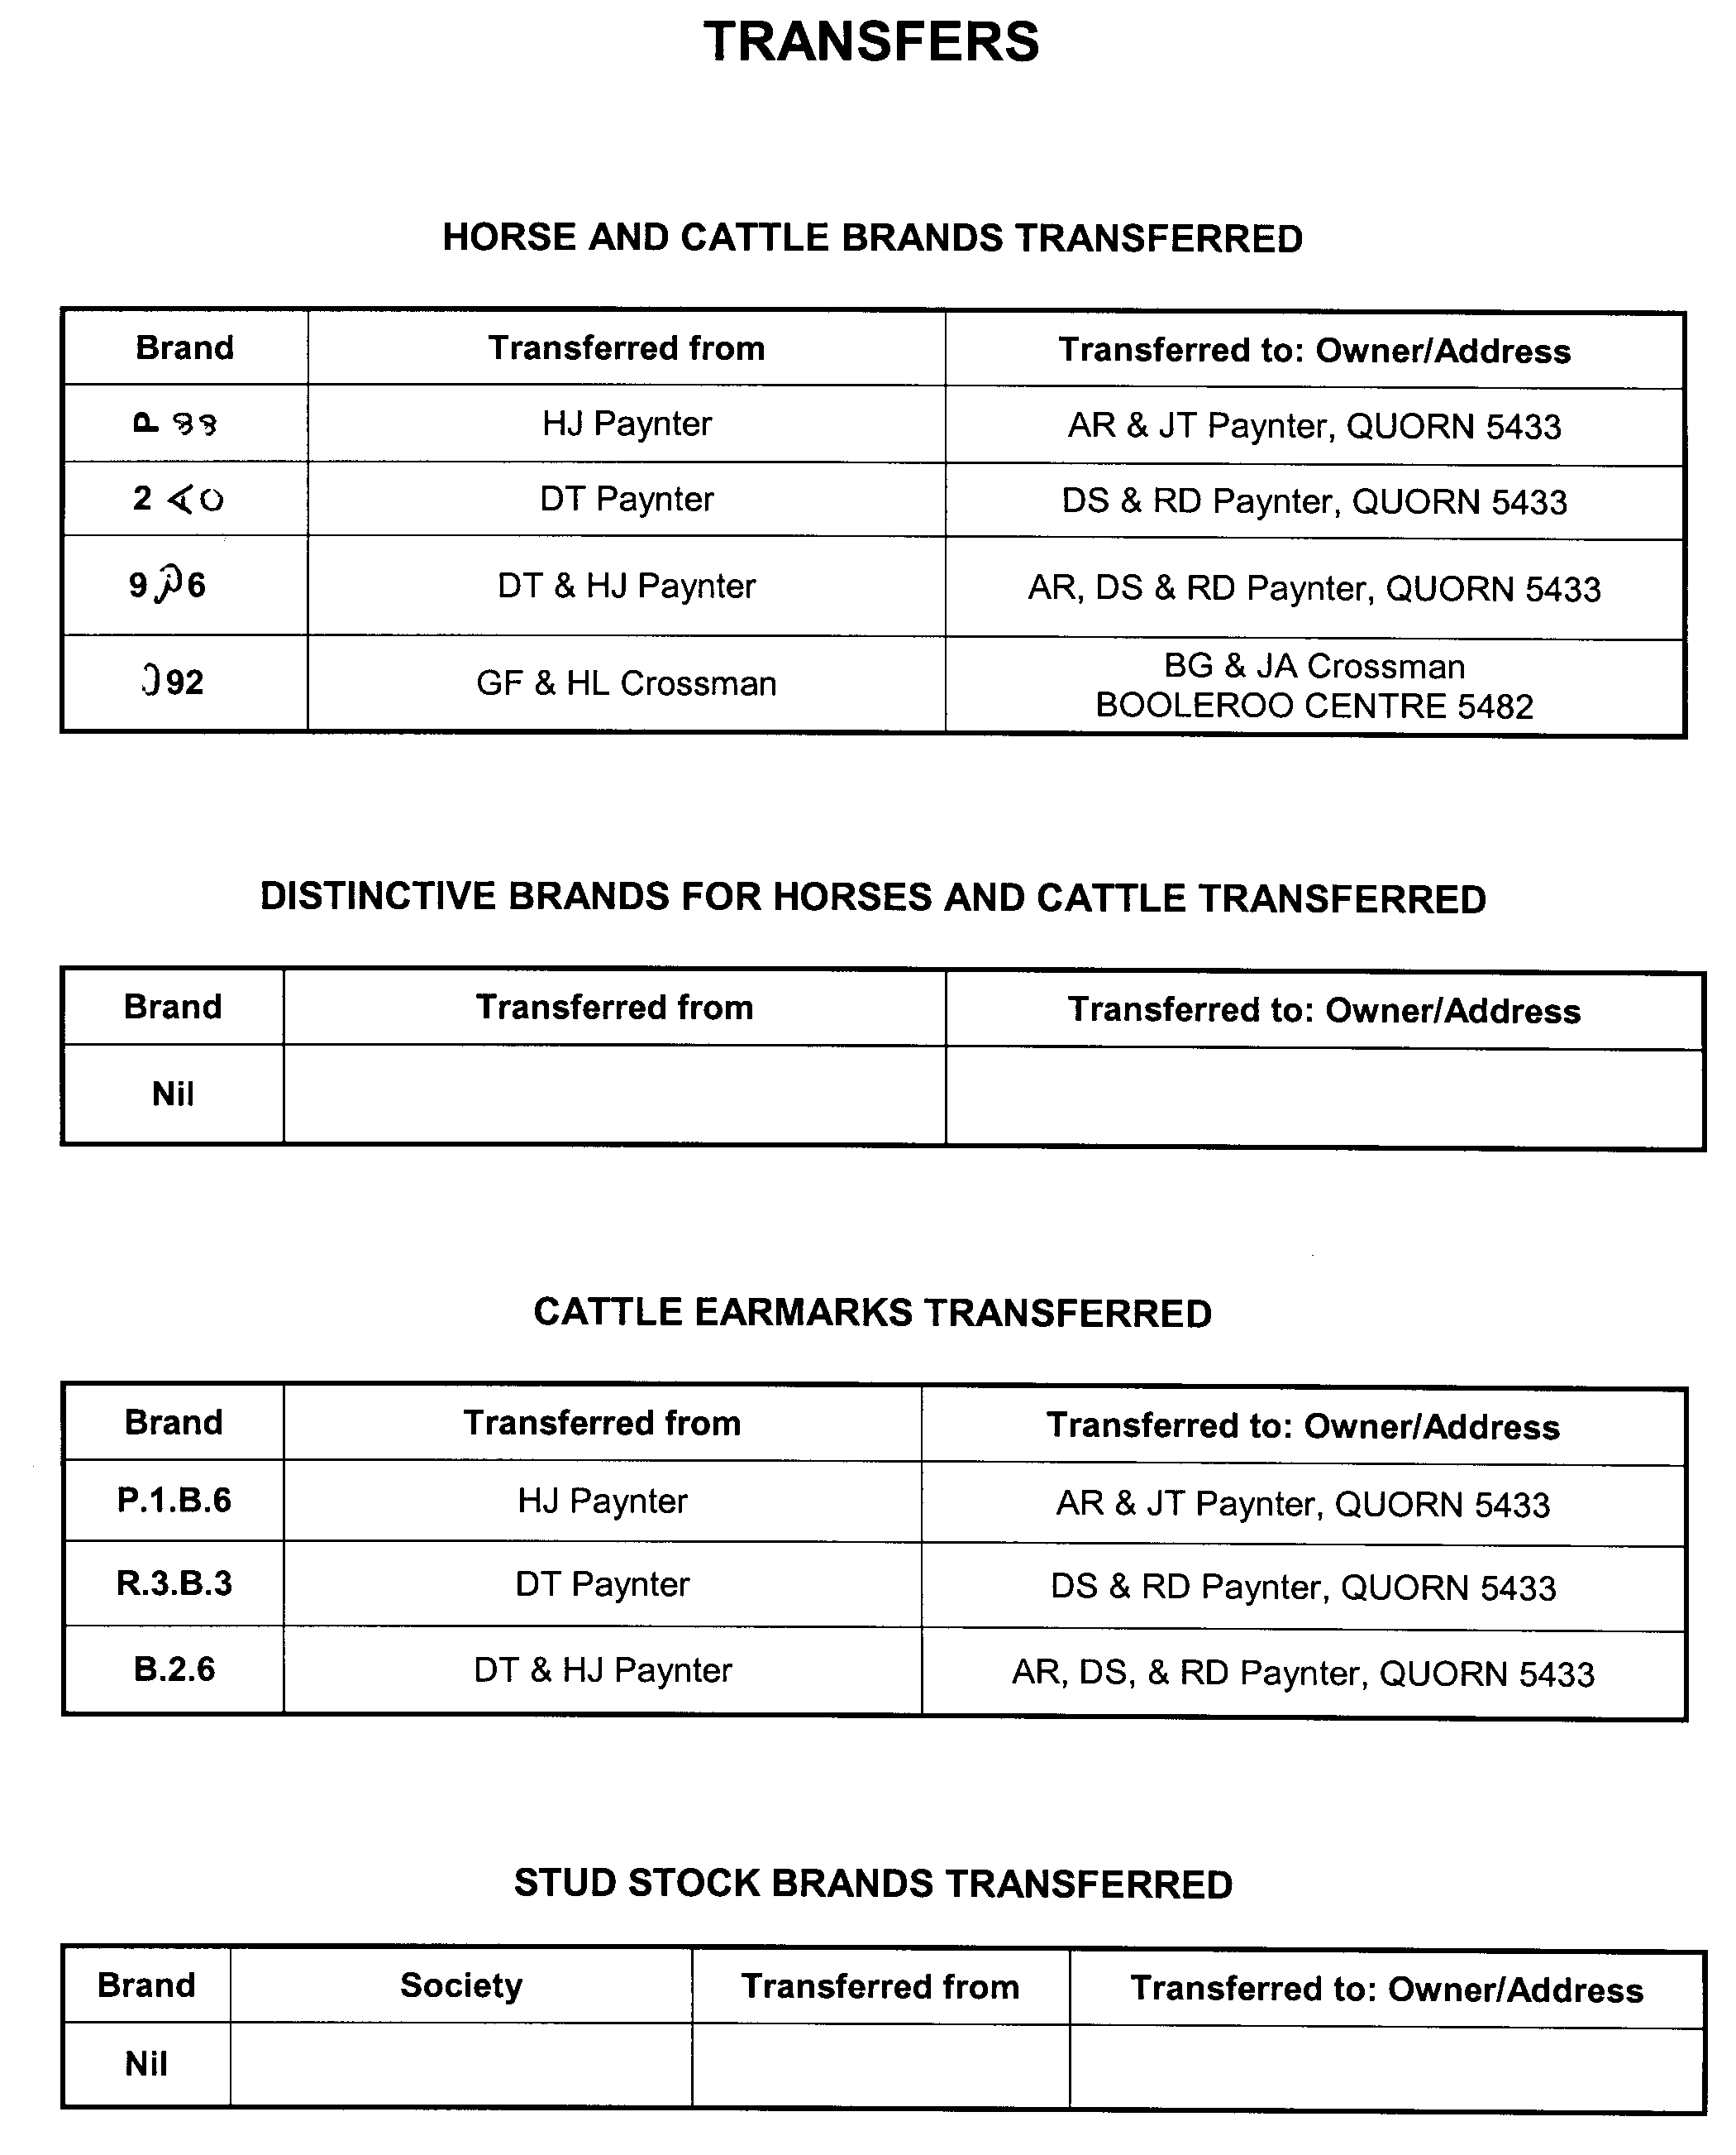
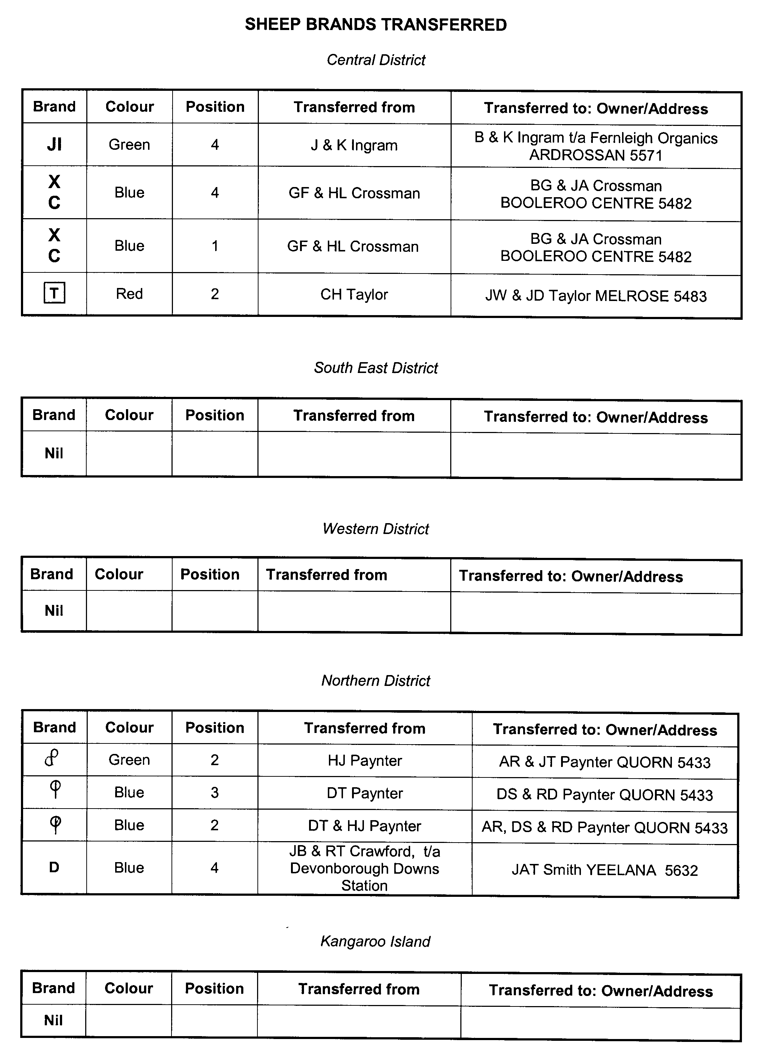
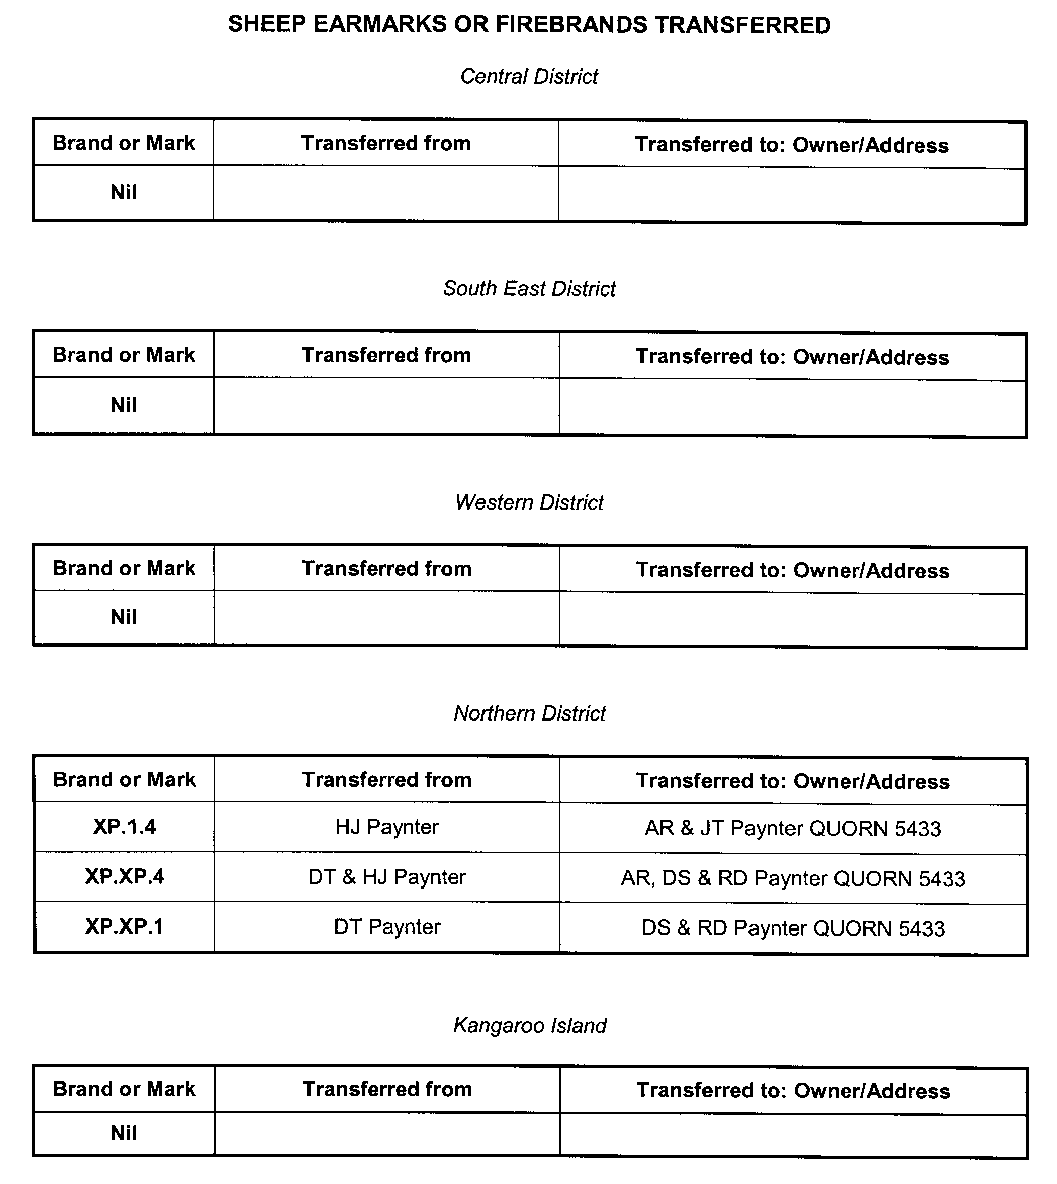
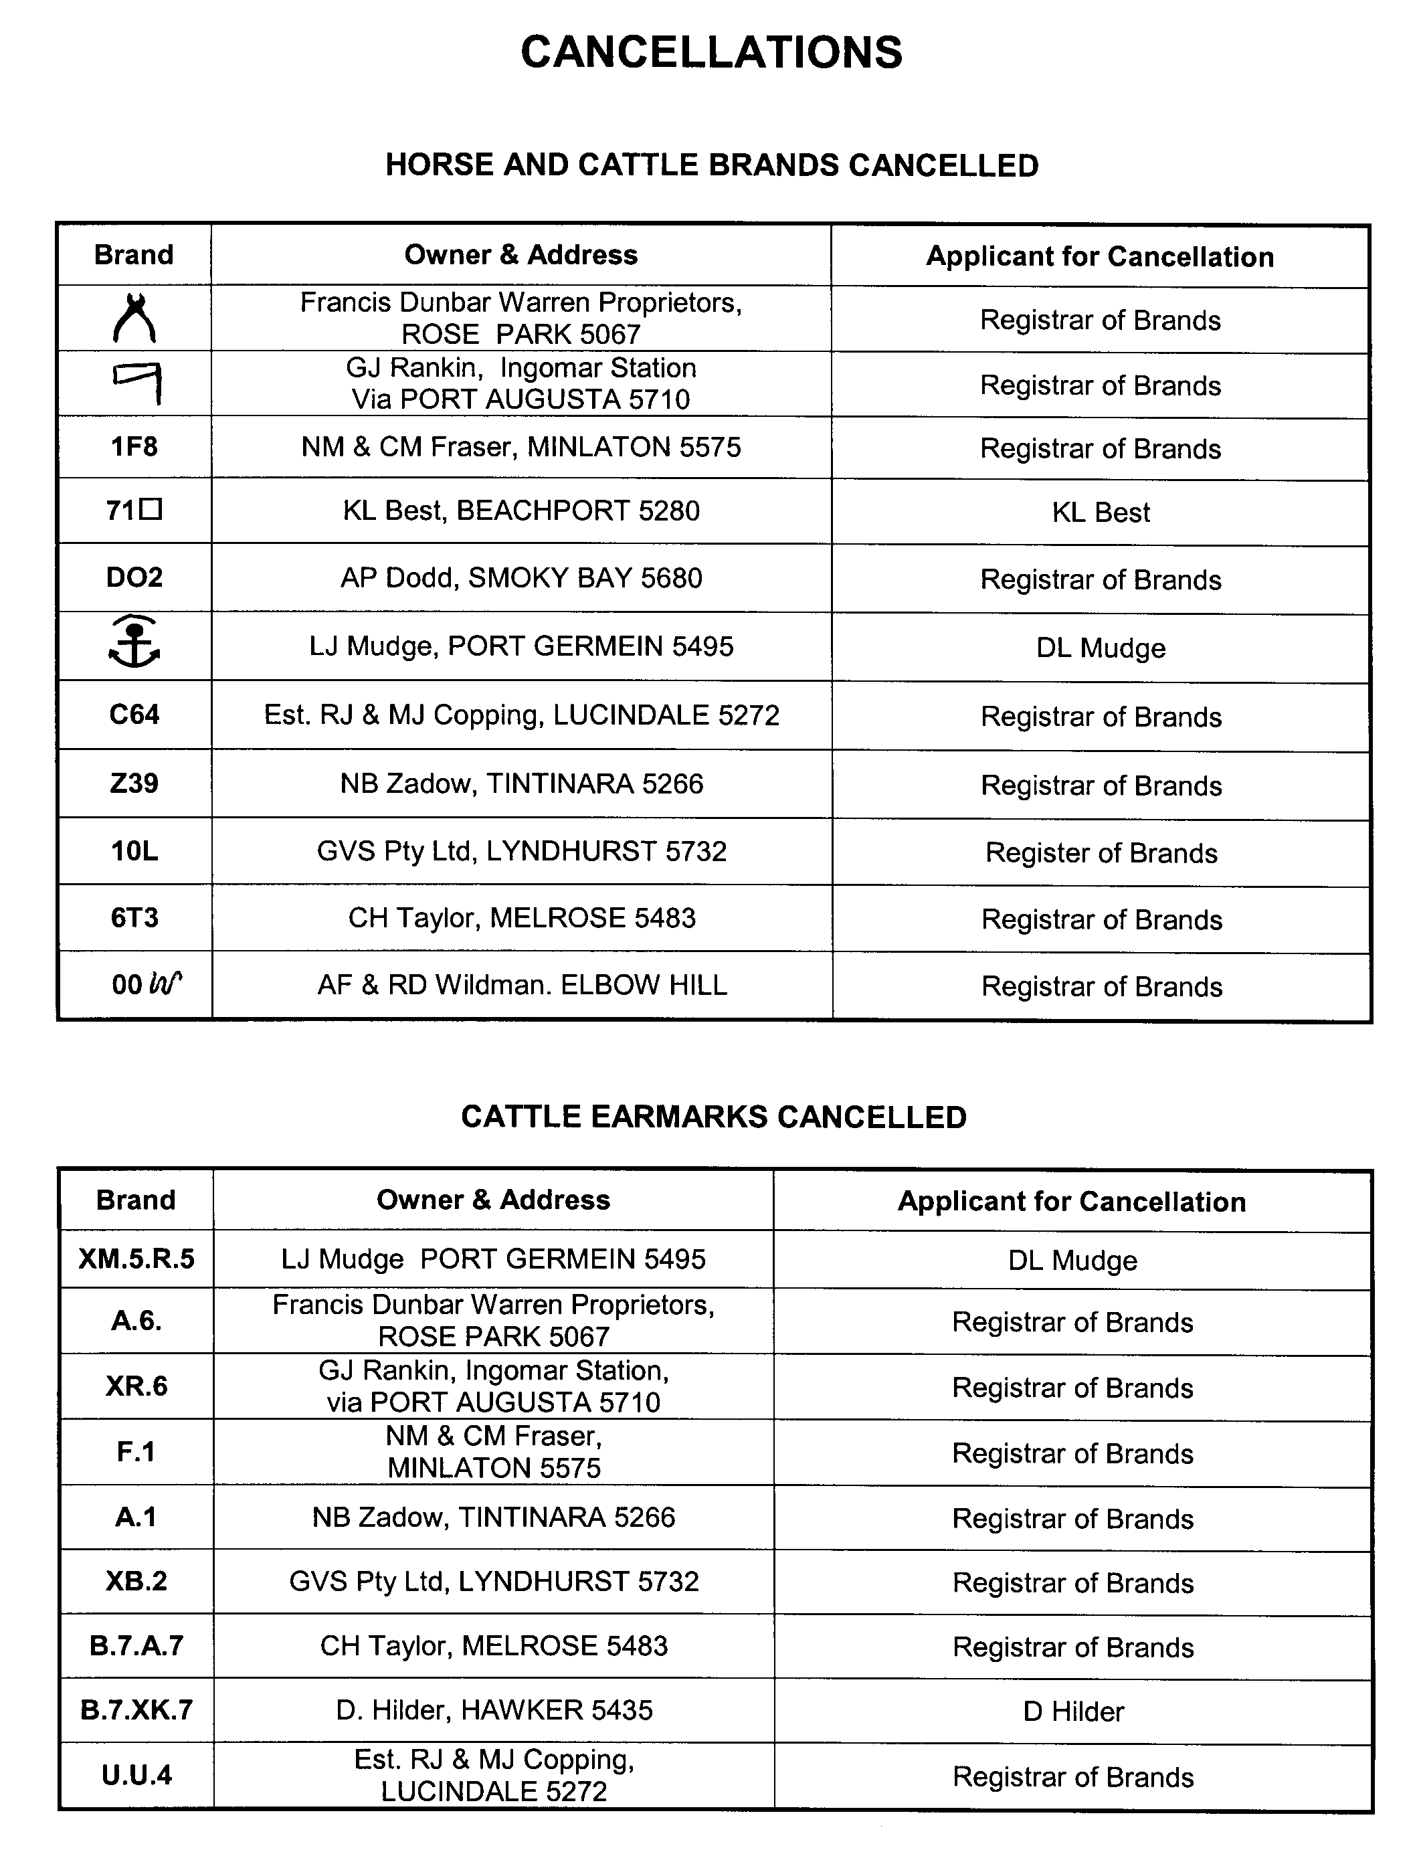
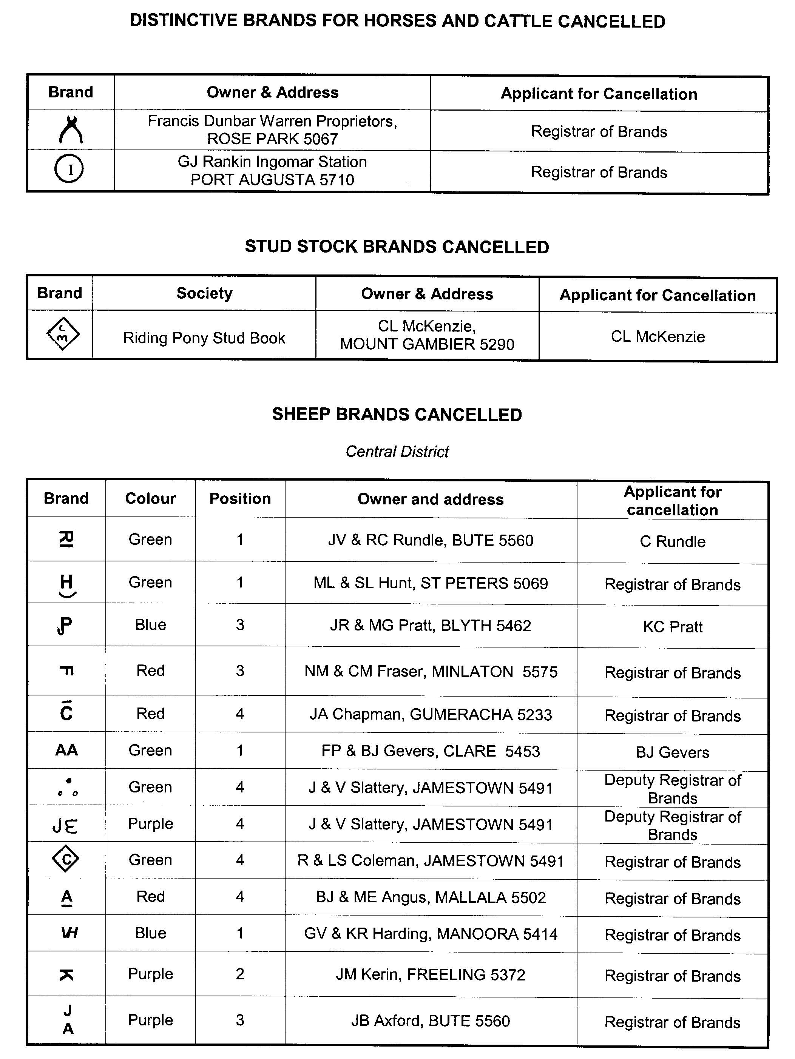
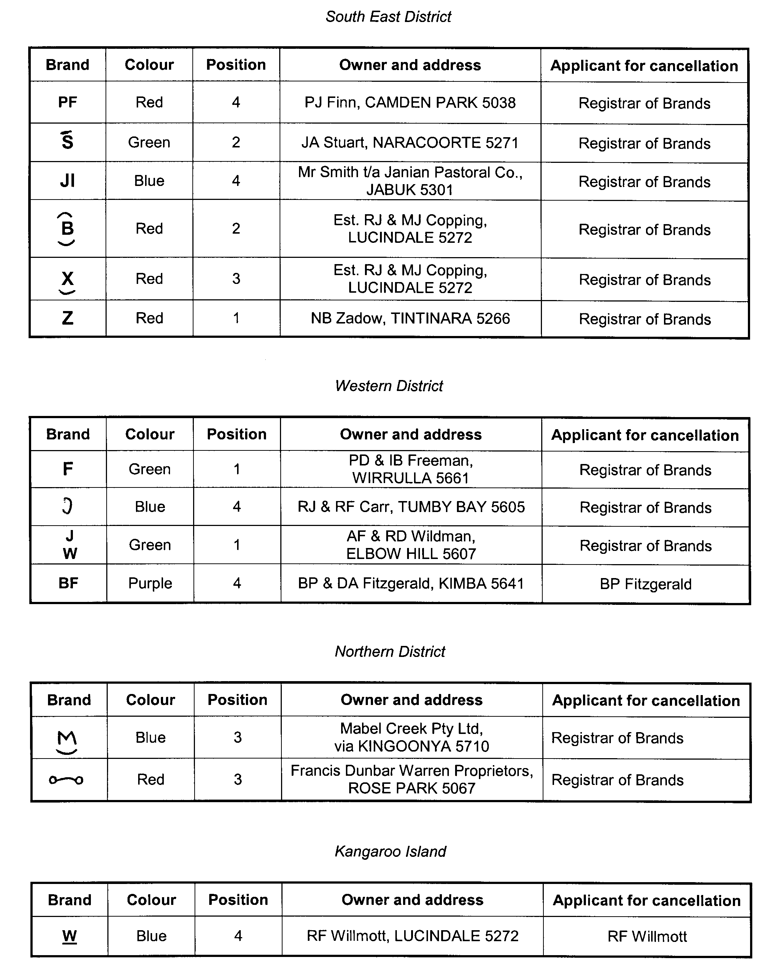
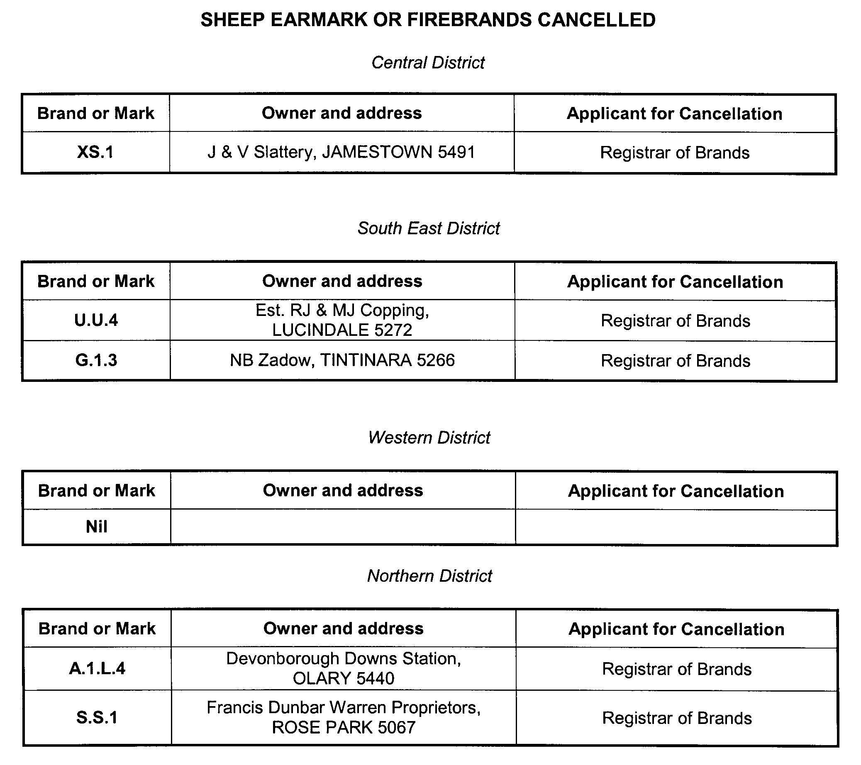

AQUACULTURE ACT 2001
Grant of Aquaculture Lease
PURSUANT to the provisions of section 22 of the Aquaculture Act 2001, Paul Caica, Minister for Agriculture, Food and Fisheries, hereby gives notice of the grant of the following lease for the purposes of aquaculture in the waters of the state:
LA00256
Further details are available for all of the above lease granted on the PIRSA Aquaculture Public Register; which can be found at https://info.pir.sa.gov.au/aquapr/page/gui3/map.html.
P. Caica, Minister for Agriculture, Food and Fisheries

DEVELOPMENT ACT 1993: SECTION 48
Decision by The Development Assessment Commission Under Delegation From The Governor
Preamble
1. On 31 March 2005 the Minister for Urban Development and Planning, being of the opinion that a proposed development of a marina and residential development at Mannum (‘the development’) was a development of major environmental, social or economic importance, directed the proponent to prepare an Environmental Impact Statement, pursuant to section 46 of the Development Act 1993.
2. On 6 June 2007 an Environmental Impact Statement for the development was published in accordance with section 46 of the Development Act 1993. Subsequently, the Minister prepared an Assessment Report in accordance with section 46 of the Development Act 1993.
3. On 30 October 2008 the Governor gave notice in the Government Gazette that pursuant to section 48 of the Development Act 1993, a provisional development authorisation was granted to the development subject to reserved matters and conditions specified in that notice.
4. An application for approval of the reserved matters has been under consideration by the Development Assessment Commission as delegate of the Governor, under Division 2 of Part 4 of the Development Act 1993.
5. The Development Assessment Commission has, in con-sidering the application, had regard to all relevant matters under section 48 (5) of the Development Act 1993.
6. The Development Assessment Commission is satisfied there is no requirement to prepare a further or amended Environmental Impact Statement.
7. For ease of reference, the Development Assessment Com-mission has decided to revoke all conditions and substitute therefore the conditions contained herein.
Decision
PURSUANT to section 48 of the Development Act 1993, the Development Assessment Commission, as delegate of the Governor:
(a) grant a provisional development authorisation in relation to the proposed Major Development under section 48 (6) subject to the Conditions set out in Part B below;
(b) pursuant to section 48 (6) reserve a decision on the reserved matter specified in Part A below;
(c) specify all matters relating to this provisional development authorisation as matters in respect of which conditions of this authorisation may be varied or revoked, or new conditions attached; and
(d) specify for the purposes of section 48 (11) (b) the period until 30 October 2010 as the time within which substantial work must be commenced on site, failing which I may cancel this authorisation.
Part A: Reserved Matters
The following are the matters I have reserved for further assessment:
(a) Compliance with the Building Rules in relation to all aspects of the proposed Major Development.
Part B: Conditions of Provisional Development Authorisation
1. The development authorisation granted hereunder is provisional only, does not operate as a final development authorisation, and does not therefore authorise implementation of the proposed Major Development. Only an authorisation granted under section 48 (2) (b) (i) can operate to authorise implementa-tion of the proposed Major Development, which authorisation will only be granted after the reserved matter has been assessed and approved.
1a. Except where minor amendments may be required by other legislation, or by conditions imposed herein, the proposed Major Development shall be undertaken in strict accordance with the following documents:
• Development application dated 28 June 2005 (except to the extent that it may be varied by a subsequent document in this paragraph);
• Environmental Impact Statement (Volumes 1 and 2), Mannum Waters Marina and Residential Development by Tallwood Pty Ltd dated May 2007 (except to the extent that it may be varied by a subsequent document in this paragraph);
• Response to Submissions, Mannum Waters Marina and Residential Development by Tallwood Pty Ltd dated November 2007 (except to the extent that it may be varied by a subsequent document in this paragraph);
• Correspondence from Tallwood Pty Ltd to Planning SA dated 1 February 2008 and 18 February 2008 containing additional information and modified plans;
• Assessment Report prepared by the Minister for Urban Development and Planning dated August 2008 (except to the extent that it may be varied by a subsequent document in this paragraph);
• Application from Tallwood Pty Ltd for approval of Reserved Matters dated 15 February 2010, including the following documents:
(i) Reserved Matters—Information for Assessment (dated January 2010);
(ii) Construction Plan—Stages 1 to 4 (dated January 2010);
(iii) Mid Murray Council Development Deed (undated);
(iv) Construction Environmental Management and Monitoring Plan (dated January 2010);
(v) Environmental Management Implementation Plan (dated July 2009);
(vi) Operational Environmental Management and Monitoring Plan (dated January 2010);
(vii) Geotechnical Report—Geotechnical Investigation, Mannum Waters Marina Development (dated 30 September 2009);
(viii) Environmental Site Assessment—Phase 1, ‘Mannum Waters’ Site (dated 12 October 2007);
(ix) Environmental Site Assessment—Phase 2, Proposed Mannum Water Development (dated 28 July 2009);
(x) Environmental Site Assessment—Phase 2, SA Water Site (dated 15 December 2009);
(xi) Site Preparation, Revegetation, Hydrology and Management Plan for the Constructed Anabranch Wetland and Ephemeral Wetland System (dated January 2010);
(xii) Soil Erosion and Drainage Management Plan (dated January 2010);
(xiii) Stormwater Management and Monitoring Plan (dated January 2010);
(xiv) Revegetation Plan (dated January 2010);
(xv) Revegetation Management Plan (dated January 2010);
(xvi) Landscape Plan (dated January 2010);
(xvii) Traffic Management Plan (dated January 2010);
(xviii) Flood Management Plan (dated January 2010);
(xix) Entrance Channel, Marina Basin and Waterways Management and Monitoring Plan (dated January 2010);
(xx) Riverine and Wetland Management and Monitoring Plan (dated January 2010);
(xxi) Constructed Anabranch Channel Wetland Management Plan (dated January 2010);
(xxii) Waste and Pollutant Source Management Plan (dated January 2010);
(xxiii) Spill Contingency Plan (dated January 2010);
(xxiv) Wastewater Environmental Management Plan (dated January 2010);
(xxv) Weed and Feral Animal Management Plan (dated January 2010);
(xxvi) Native Vegetation Clearance Application (dated January 2010); and
• Site Contamination Audit Report—Residential Portion of ‘Area A’, Mannum Waters Development prepared by Soil & Groundwater Consulting dated 3 March 2010.
2. Subject to Condition 3, no building works on any part of the development shall commence until a favourable decision has been notified to the applicant by the Governor or the Governor’s delegate in respect of the reserved matter referred to in Part A paragraph (a) of the Decision section above.
3. The applicant may commence a stage of building works without the Governor or his delegate having granted a development authorisation in respect of the reserved matter, if the Governor or his delegate has notified the applicant in writing that that particular stage complies with the building rules.
4. All works and site activities shall be undertaken in accordance with an approved Construction Environmental Management and Monitoring Plan and an approved Environmental Management Implementation Plan.
5. Waterways shall not be flooded with water from the River Murray for a period of two years from the date of 30 October 2008.
6. All contamination management or remediation works shall be undertaken in accordance with an approved Site Contamination Audit Report and Remediation Plan and to the reasonable satisfaction of the Environment Protection Authority.
7. Transport routes for the delivery of construction materials shall be selected to the reasonable satisfaction of the Mid Murray Council.
8. Stockpiled soils shall be suitably managed to control dust emissions, erosion and weed infestation.
9. Armour rock used for waterway revetments shall not be contaminated by fine sediment.
10 The proponent must maintain a 50 m wide strip of land adjacent the river’s edge as public land.
11. The wastewater collection and treatment system shall be designed to ensure that the general obligations of the Environment Protection (Water Quality) Policy 2003 are met and to ensure that effluent does not overflow or escape from any drains, pipes, sumps, tanks, storage/treatment basins into any watercourse, or into stormwater drains which do not drain into the effluent collection, treatment and disposal system; except where the effluent complies with criteria in the above policy.
12. All marina moorings shall be connected to a vacuum sewer system.
13. The proponent shall provide underground public lighting, power supply, water supply and telephone supply to each allotment in accordance with and to engineering design standard plans approved by the electricity, mains water and telephone public utility authorities.
14. The proponent shall ensure that all waters discharged to the River Murray are equal to, or better than, the quality of water in the River Murray at the point of discharge.
15. The land to be used for land-based allotments shall be formed to prevent stormwater flows entering into the waterways without suitable treatment.
16. Water-sensitive urban design measures and practices shall be adopted for the management of run-off, including stormwater capture and reuse.
17. All buildings shall have a floor level above the 1956 flood level.
18. All infrastructure relating to the management of stormwater (including rainwater tanks) shall be located above the 1956 flood level and/or be designed so as not to be affected by flooding.
19. All residential allotments that are a minimum of 40 m in length shall be constructed to have a finished slope of approximately 1:16 (3.6 degrees).
20. All residential allotments that are a minimum of 70 m in length shall be constructed to have a finished slope of approximately 1:42 (1.4 degrees).
21. Setbacks from building envelopes to pool level shall be no less than 19 m for all residential allotments that are a minimum of 40 m in length and 40 m for all residential allotments that are a minimum of 70 m in length.
22. Undeveloped allotments shall be left in a neat and tidy condition, with soil surfaces stabilised to minimise erosion.
23. Riparian buffer strips shall be established by the proponent for all waterfront allotments, prior to titles being issued for residential allotments. The buffer shall be a minimum of 5 m wide and be planted with suitable species of native vegetation.
24. The edges of all residential waterways shall be designed and constructed to replicate a natural river bank as far as practicable.
25. Road designs shall not affect existing natural lines in such a way as to cause flooding. All roads and drainage works shall be built according to approved designs.
26. Appropriate navigational aids shall be erected in prominent locations, in consultation with the Department of Transport, Energy & Infrastructure, prior to use of the facility for boating purposes.
27. Access systems for all floating boat moorings shall be capable of adjustment or be readily adaptable to variable river levels and all marina mooring structures shall be designed in accordance with the Australian Standard AS 3962-2001 Guidelines for Design of Marinas and AS 4997-2005 Guidelines for the Design of Maritime Structures.
28. The public boat ramp facility shall be designed in accordance with the South Australian Boating Advisory Committee’s Guidelines for Planning, Design and Construction of Boat Launching Facilities.
29. The boat refuelling area and boat effluent/greywater pump-out connection points shall be designed to meet the requirements of the Environment Protection Authority, the Department for Transport, Energy & Infrastructure and the Country Fire Service (CFS) respectively, and shall be in place prior to commencement of operation of the marina.
30. The proponent shall ensure satisfactory oil-spill and fire-fighting facilities and contingency plans, determined in consultation with responsible officers within the Department for Transport, Energy & Infrastructure and the Metropolitan Fire Service (MFS) or the Country Fire Service (CFS) (as applicable), are in place prior to commencement of operation of the marina.
31. The water contained in the marina basin shall be kept as a minimum to a quality appropriate for secondary contact recreation, public amenity and the maintenance of aquatic ecosystems, as stipulated from time to time by the ANZECC Australian Water Quality Guidelines for Fresh and Marine Waters.
32. Normal operating hours for construction activities and truck movements to and from the site shall be from 7 a.m. to 7 p.m., Monday to Saturday inclusive. Only if it is considered necessary by the proponent, shall construction be undertaken on Sundays, in which case construction hours shall be from 9 a.m. to 6 p.m.
33. The Environment Protection (Noise) Policy 2007 shall be complied with during construction activities and truck movements.
34. Landscaping and street scaping of the site shall commence prior to the issuing of Certificates of Title for each stage of the land division and when established shall be maintained in good health and condition at all times. A plant shall be replaced if or when it dies or becomes seriously diseased within the first growing season after the plant dies or becomes seriously diseased. A weed control program shall also be implemented.
35. Permanent water flow and water quality monitoring stations shall be established at suitable sites within the development, to the reasonable satisfaction of the Minister for Environment and Conservation prior to the commencement of operation.
36. All water pumps within the development must be metered to the reasonable satisfaction of Minister for Environment and Conservation.
37. The Mid Murray Council shall be given seven days notice, prior to the commencement of works, and be provided with the name and contact facilities for the person responsible for co-ordinating site works by this approval.
38. A site audit report, completed by an Environmental Auditor (Contaminated Land), must be presented to all purchasers of allotments.
39. A Management Plan must be prepared for the Crown Reserve north of the entrance channel, in consultation with the Mid Murray Council, and responsible officers of the Department for Environment and Heritage, the Department of Water, Land and Biodiversity Conservation and the South Australian Murray Darling Basin Natural Resources Management Board, prior to the transfer of land to the Mid Murray Council.
40. The proponent shall address the reserved matter and submit relevant documentation to the Development Assessment Com-mission for its approval.
Part C: Notes to Proponent
1. In respect of the reserved matter, the following is advised to the proponent:
(a) Building Rules
The proponent must obtain a Building Rules assessment and certification from either the Mid-Murray Council or a private certifier (at the proponent’s option) and forward to the Development Assessment Commission all relevant certification documents as outlined in Regulation 64 of the Development Regulations 2008.
Pursuant to Development Regulation 64, the proponent is especially advised that the Mid-Murray Council or private certifier conducting a Building Rules assessment must-
• provide to the Minister for urban Development and Planning a certification in the form set out in Schedule 12A of the Development Regulations 2008 in relation to the building works in question; and
• to the extent that may be relevant and appropriate:
(i) issue a Schedule of Essential Safety Provisions under Division 4 of Part 12;
(ii) assign a classification of the building under these regulations; and
(iii) ensure that the appropriate levy has been paid under the Construction Industry Training Fund 1993.
Regulation 64 of the Development Regulations 2008 provides further information about the type and quantity of all Building Rules certification documentation for Major Developments required for referral to the Minister for Urban Development & Planning. The Mid Murray Council or private certifier undertaking Building Rules assessments must ensure that the assessment and certification are consistent with this provisional development authorisation (including its Conditions and Notes).
2. Should the proponent wish to vary the Major Development or any of the components of the Major Development, an application may be submitted, provided that the development application variation remains within the ambit of the Environmental Impact Statement and Assessment Report referred to in this provisional development authorisation. If an application for variation involves substantial changes to the proposal, it will be processed pursuant to section 47 (2) (b) of the Development Act 1993.
3. The proponent is advised that a suitable water licence and water allocation would need to be secured under the Natural Resources Management Act 2004 for the initial filling of the marina basin, waterways and the constructed anabranch/wetland system and for the on-going maintenance of water levels.
4. The following activities in relation to the components of the development hereby approved and/or requiring future approval will require licences under the Environment Protection Act 1993:
• Earthworks Drainage: the conduct of earthworks operations in the course of which more than 100 kilolitres of waste water containing suspended solids in a concentration exceeding 25 milligrams per litre is discharged directly or indirectly to marine waters or inland waters.
• Marinas and Boating Facilities: the conduct of:
(a) facilities comprising pontoons, jetties, piers or other structures (whether on water or land) designed or used to provide moorings or dry storage for 50 or more powered vessels at any one time; or
(b) works for the repair or maintenance of vessels with the capacity to handle five or more vessels at any one time or vessels 12 m or more in length.
• Dredging: removing solid matter from the bed or any marine waters by any digging or suction apparatus, but excluding works carried out for the establishment of a visual aid to navigation and any lawful fishing or recreational activity.
It is likely that as a condition of such licences the Environment Protection Authority will require the licensee to carry out specified environmental monitoring of water quality and to make reports of the results of such monitoring to it.
5. All works associated with the rehabilitation and remediation of the site are required by law to be undertaken in accordance with section 25 (1) of the Environment Protection Act 1993 which requires that a person must not undertake any activity, which pollutes, or may pollute without taking all reasonable and practical measures to prevent or minimise harm to the environment); the Environment Protection (Water Quality) Policy 2003; other relevant Environment Protection Policies made under Part 5 of the Environment Protection Act 1993. Works should also be undertaken in accordance with the ANZECC Best Practice Guidelines for Waste Reception Facilities at Ports, Marinas and Boat Harbours in Australia and New Zealand, guideline Environmental Management of On-Site Remediation and other relevant Environment Protection and Authorisation publications and guidelines.
6. The proponent is advised of the Duty of Care under the River Murray Act 2003, which requires that a person shall ensure that their actions do not cause harm to the River Murray.
7. The proponent is advised of the requirement under the Native Vegetation Act 1991 to obtain permission under that Act for any clearance of native vegetation or otherwise to bring itself within an exemption under that Act. Neither this development authorisation nor any final development authorisation granted under section 48 (2) (b) (i) of the Development Act 1993 operates as an authorisation to clear native vegetation.
8. The proponent is reminded of its obligations under the Aboriginal Heritage Act 1988 whereby any ‘clearance’ work, which may require permission to disturb damage or destroy Aboriginal Sites, must be undertaken with the full authorisation of the Minister for Aboriginal Affairs and Reconciliation, according to section 23 of the Aboriginal Heritage Act 1988.
9. The proponent, and all agents, employees and contractors, such as construction crews, should be conversant with the provisions of the Aboriginal Heritage Act 1988, particularly the requirement to immediately contact the Department of Premier & Cabinet (Aboriginal Affairs and Reconciliation) in the event that archaeological items (especially skeletal material) are uncovered during earthmoving.
10. The proponent, and the Council after hand-over, should comply with the Public and Environmental Health Act 1987 in regard to the maintenance of suitable water quality within the marina basin, residential waterways, stormwater retention ponds and the constructed anabranch/wetland system to protect public health and amenity.
11. For the purposes of condition 31, it is noted that the expression ‘secondary contact recreation’ includes activities such as wading, boating and fishing in which some human contact with the water may occur, but in which the probability of bodily immersion or the intake of significant amounts of water is minimal.
12. It is recommended that the proponent approach the Mid-Murray District Council with a view to the Council enacting by-laws to manage activities associated with the:
• Entrance channel and waterways to ensure safe navigation and to protect water quality.
• Boat ramp, boat lift and boat maintenance facilities (including car parking and access).
• Refuelling facility and boat effluent/greywater pump-out connection points.
• Residential development and reserves (including stormwater management devices and the pedestrian bridge).
• Constructed anabranch/wetland system.
• Crown land reserve along the river bank and associated wetlands and buffer zones.
13. The Mid Murray Council will need to review and amend the zoning policies in the relevant Development Plan to reflect any development approved by the Governor and for future assessment and decision-making for buildings and structures not forming part of this provisional development authorisation. In particular, policies will need to address sustainability matters (especially water and energy efficiency), environmental protection requirements, flood protection requirements and amenity aspects.
14. A common building scheme encumbrance or equivalent device for the purpose of ensuring compliance with design standards for residential and other buildings will be required at the land division stage.
15. Binding legal arrangements (e.g. easements, encumbrances, charge-back arrangements etc, as appropriate) between the proponent and allotment owners must be put in place, prior to application to the Registrar General for the issue of new Certificates of Title, to ensure financial and management responsibilities related to the maintenance of edge treatments, the maintenance of the riparian buffer strip and the design and appearance of structures are clearly allocated. These arrangements must be to the reasonable satisfaction of the Development Assessment Commission.
16. The proponent will need to satisfy the requirements of the Mid Murray Council relating to the provision of 12.5% Open Space as part of any land division application.
17. The Marina Owner’s Charter and House Owner’s Charter documents should be finalised to the satisfaction of Planning SA, prior to application to the Registrar General for the issue of new Certificates of Title. The relevant Charters should be presented to purchasers of marina berths or allotments.
18. Approvals from the Environment Protection Authority and the Department of Health would need to be sought for the Waste Water Treatment Plant and the use of reclaimed water for irrigation purposes. An Environmental Management Plan for Wastewater and an Irrigation Plan would be required.
19. The Minister has a specific power to require testing, monitoring and auditing under section 48C of the Development Act 1993.
20. It is noted that the provisional development authorisation granted herein does not apply to any residential, commercial, retail, tourist-related or other buildings, for which a separate application for approval, addressed to Council, will be required. Additional design and infrastructure/service plans will be required by Council when application is made for approval for any such buildings.
Dated 25 March 2010.
T. Byrt, Presiding Member, Development Assessment Commission

DOG FENCE ACT 1946
Statement of Receipts and Payments
PURSUANT to the provision of section 34 (2) of the Dog Fence Act 1946, the Dog Fence Board hereby publishes a copy of the receipts and payments for the financial year 2008-2009.
 | 2009  Inflows  (Outflows)  $’000 | 2008  Inflows  (Outflows)  $’000
Cash Flows from Operating Activities
Cash Outflows
Subsidies paid | (656) | (556)
Payments to employees | (146) | (136)
Fence maintenance | (80) | (32)
Hire of motor vehicles | (28) | (14)
Other expenses | (48) | (65)
Cash used in operations | (958) | (803)
Cash Inflows
Rates and levies received | 441 | 437
Interest received | 22 | 22
Other receipts | 18 | 6
Cash generated in operations | 481 | 465
Cash Flows from SA Government
Receipts from SA Government | 438 | 441
Cash generated from SA Government | 438 | 441
Net Cash provided by (used in) operating activities | (39) | 103
Net increase (decrease) in cash and cash equivalents | (39) | 103
Cash and cash equivalents at the beginning of the period | 207 | 104
Cash and cash equivalents at the end  of the period | 168 | 207
M. J. Balharry, Executive Officer, Dog Fence Board

ENVIRONMENT PROTECTION ACT 1993
Variation to Existing Approval of Collection Depot
I, ANDREA KAYE WOODS, Delegate of the Environment Protection Authority (‘the Authority’), pursuant to section 69 of the Environment Protection Act 1993 (SA) (‘the Act’) hereby:
Variation to Existing Approval of Collection Depot
(i) Variation to Existing Approval of Collection Depot:
Vary the approval of the collection depot listed at Schedule 1 of this notice, that was granted under the Act prior to the date of this notice and impose the conditions of this approval to be as follows:
Approval of Collection Depot:
The collection depot identified by reference to the following matters is approved:
(a) the name of the collection depot described in Column 1 of Schedule 1 of this Notice;
(b) the name of the proprietor of the depot identified in Column 3 of Schedule 1 of this Notice; and
(c) the location of the depot described in Columns 4-6 of Schedule 1 of this Notice.
The collection depot listed at Schedule 1 of this Notice is approved in relation to all classes of containers, which were approved under the Act, at or subsequent to the date of this notice, as Category B Containers.
(ii) Conditions of Approval:
Impose the following conditions of these approvals:
(a) The person in charge of a collection depot shall ensure the depot premises complies with Council planning regulations and shall be kept in an orderly condition.
(b) The person in charge of a collection depot who wishes to transfer the operation of a depot to another person or intends to change the location of a depot shall notify the Authority in writing within one month of the change occurring.
(c) The person in charge of a collection depot who wishes to cease operation of that depot shall give notice in writing to the Authority.
(d) The person in charge of a collection depot shall take such measures as are necessary in the operation and maintenance of the depot to prevent or control:
(i) a nuisance or offensive condition;
(ii) a risk to health or safety; and
(iii) damage to the environment.
(e) The person in charge of a collection depot is reminded of the general environmental duty, as required by section 25 of the Environment Protection Act, to take all reasonable and practical measures to ensure that the activities on the whole site, do not pollute the environment in a way which causes or may cause environmental harm.
(f) The holder of an approval must not pay a refund on, or seek reimbursement for, containers that the approval holder knows were not purchased in South Australia.
Schedule 1

Column 1 | Column 2 | Column 3 | Column 4 | Column 5 | Column 6
Depot Name | Company/Trading Name | Proprietor | Depot Location  Street | Depot Location  Suburb | Certificate of Title No.  Volume/Folio No.
Warooka Depot | W. A. & M. J. cadd Carriers) | Bill, Joan, Robert and David Cadd | Lot 25, Fourth Street | Warooka, S.A. 5577 | 4227/779

ENVIRONMENT PROTECTION ACT 1993
Revocation of Approval of Category B Containers
I, ANDREA KAYE WOODS, Delegate of the Environment Protection Authority (‘the Authority’), pursuant to section 68 of the Environment Protection Act 1993 (SA) (‘the Act’) hereby revoke the approvals of the classes of Category B containers sold in South Australia as identified by reference to the following matters, which are described in the first 4 columns of Schedule 1 of this Notice:
(a) the product which each class of containers shall contain;
(b) the size of the containers;
(c) the type of containers; and
(d) the name of the holders of these approvals.
These approvals are revoked as the Authority is satisfied that the waste management arrangement between the approval holder and the party named in Column 5 of Schedule 1 of this Notice has been cancelled.
Schedule 1

Column 1 |  | Column 2 |  | Column 3 |  | Column 4 |  | Column 5
Product Name |  | Container  Size (mL) |  | Container Type |  | Approval Holder |  | Collection  Arrangements
L eau de Dieu Pure Unpolluted Australian Water | 600 |  | PET |  | AB Support Group |  | Statewide Recycling
MET RX 51 Chocolate | 443 |  | Can—Aluminium |  | Alpha Sports Distribution |  | Statewide Recycling
MET RX 51 Cookies and Cream | 443 |  | Can—Aluminium |  | Alpha Sports Distribution |  | Statewide Recycling
MET RX 51 Mocha Blast | 443 |  | Can—Aluminium |  | Alpha Sports Distribution |  | Statewide Recycling
MET RX 51 Vanilla | 443 |  | Can—Aluminium |  | Alpha Sports Distribution |  | Statewide Recycling
Another Bloody Water | 590 |  | PET |  | Another Bloody Water |  | Statewide Recycling
Frooti Cool Mango | 200 |  | LPB—Aseptic |  | Continental Marketing Pty Ltd |  | Statewide Recycling
Frooti Cool Mango | 500 |  | PET |  | Continental Marketing Pty Ltd |  | Statewide Recycling
Frooti Cool Mango | 1 000 |  | PET |  | Continental Marketing Pty Ltd |  | Statewide Recycling
Red Devil Energy Drink | 250 |  | Can—Aluminium |  | Devilish Beverages Pty Ltd |  | Statewide Recycling
Amino Ok By Oishi Cherry Flavour | 470 |  | PET |  | Exoriens Pty Ltd |  | Statewide Recycling
Amino Ok By Oishi Muscat flavour | 470 |  | PET |  | Exoriens Pty Ltd |  | Statewide Recycling
Amino Ok by Oishi Grapefruit flavour | 470 |  | PET |  | Exoriens Pty Ltd |  | Statewide Recycling
Amino Ok by Oishi Lemon flavour | 470 |  | PET |  | Exoriens Pty Ltd |  | Statewide Recycling
Birdy Ice Coffee Black | 180 |  | Can—Steel |  | Exoriens Pty Ltd |  | Statewide Recycling
Birdy Ice Coffee Milky | 180 |  | Can—Steel |  | Exoriens Pty Ltd |  | Statewide Recycling
Birdy Ice Coffee Robusta | 180 |  | Can—Steel |  | Exoriens Pty Ltd |  | Statewide Recycling
Birdy Ice Coffee with Fresh Milk | 180 |  | Can—Steel |  | Exoriens Pty Ltd |  | Statewide Recycling
Oishi Black Tea Lemon | 500 |  | PET |  | Exoriens Pty Ltd |  | Statewide Recycling
Oishi Green Tea Genmai | 500 |  | PET |  | Exoriens Pty Ltd |  | Statewide Recycling
Oishi Green Tea Honey Lemon | 1 000 |  | LiquidPaperBoard |  | Exoriens Pty Ltd |  | Statewide Recycling
Oishi Green Tea Honey Lemon | 500 |  | PET |  | Exoriens Pty Ltd |  | Statewide Recycling
Oishi Green Tea Original | 1 000 |  | LiquidPaperBoard |  | Exoriens Pty Ltd |  | Statewide Recycling
Oishi Green Tea Original | 500 |  | PET |  | Exoriens Pty Ltd |  | Statewide Recycling
Oishi Green Tea Strawberry | 500 |  | PET |  | Exoriens Pty Ltd |  | Statewide Recycling
Feral White | 330 |  | Glass |  | Feral Brewing Company Pty Ltd |  | Statewide Recycling
Superman Energy Drink | 250 |  | Can—Aluminium |  | Hero Energy Pty Ltd |  | Statewide Recycling
One 4 One Natural Spring Water | 600 |  | PET |  | HoBo Co Pty Ltd |  | Statewide Recycling
The Switch Citrus Weld Real Juice | 250 |  | Can—Aluminium |  | Intermark International Brands Pty Ltd |  | Statewide Recycling
The Switch Lemon Rush Real Juice | 250 |  | Can—Aluminium |  | Intermark International Brands Pty Ltd |  | Statewide Recycling
The Switch Orange Fusion Real Juice | 250 |  | Can—Aluminium |  | Intermark International Brands Pty Ltd |  | Statewide Recycling
The Switch Solar Splash Real Juice | 250 |  | Can—Aluminium |  | Intermark International Brands Pty Ltd |  | Statewide Recycling
The Switch Strawberry Melon Crush Real Juice | 250 |  | Can—Aluminium |  | Intermark International Brands Pty Ltd |  | Statewide Recycling
Akta Vite Chocolate | 200 |  | LPB—Aseptic |  | Myerton Australia Pty Ltd |  | Statewide Recycling
Ami Blood Red Orange | 330 |  | Glass |  | Occasio Australia Pty Ltd |  | Statewide Recycling
Ami Lime & Cranberry | 330 |  | Glass |  | Occasio Australia Pty Ltd |  | Statewide Recycling
Ami Mango & Dragon Fruit | 330 |  | Glass |  | Occasio Australia Pty Ltd |  | Statewide Recycling
Ami Pink Grapefruit | 330 |  | Glass |  | Occasio Australia Pty Ltd |  | Statewide Recycling
Irn Bru Original and Best Diet | 1 250 |  | PET |  | Occasio Australia Pty Ltd |  | Statewide Recycling
Irn Bru Sparkling Flavoured Soft Drink | 500 |  | PET |  | Occasio Australia Pty Ltd |  | Statewide Recycling
Irn Bru Sparkling Flavoured Soft Drink | 1 250 |  | PET |  | Occasio Australia Pty Ltd |  | Statewide Recycling
Only Organic First Thirst Apple Dew Juice Drink | 140 |  | Glass |  | Only Organic (2003) Ltd |  | Statewide Recycling
Only Organic First Thirst Peach & Pear Juice Drink | 140 |  | Glass |  | Only Organic (2003) Ltd |  | Statewide Recycling
Zatec Beer | 330 |  | Glass |  | Padster Pty Ltd t/as Zatec Beer Australia |  | Statewide Recycling
U Organic Spring Water | 1 500 |  | PET |  | Premium Wines Direct |  | Statewide Recycling
U Organic Spring Water | 500 |  | PET |  | Premium Wines Direct |  | Statewide Recycling
Crystal Spring Water | 500 |  | Plastic |  | Southern Beverage Corporation Pty Ltd |  | Flagcan Distributors
Crystal Spring Water | 1 500 |  | Plastic |  | Southern Beverage Corporation Pty Ltd |  | Flagcan Distributors
Crystal Spring Water | 300 |  | Plastic |  | Southern Beverage Corporation Pty Ltd |  | Flagcan Distributors
Kaffe Cappuccino | 330 |  | Glass |  | Southern Beverage Corporation Pty Ltd |  | Flagcan Distributors
Column 1 |  | Column 2 |  | Column 3 |  | Column 4 |  | Column 5
Product Name |  | Container  Size (mL) |  | Container Type |  | Approval Holder |  | Collection  Arrangements
Kaffe Expresso | 330 |  | Glass |  | Southern Beverage Corporation Pty Ltd |  | Flagcan Distributors
Kaffe Iced Coffee | 330 |  | Glass |  | Southern Beverage Corporation Pty Ltd |  | Flagcan Distributors
Hiro Vitality | 250 |  | Can—Aluminium |  | Tahitian Noni International |  | Statewide Recycling
Springleaf Lemon Organic Ice | 750 |  | Glass |  | Teavolution Pty Ltd T/as Springleaf Iced Tea |  | Statewide Recycling
Springleaf Lemon Organic Ice | 300 |  | Glass |  | Teavolution Pty Ltd T/as Springleaf Iced Tea |  | Statewide Recycling
Springleaf Organic Green Tea Lime & Ginger | 750 |  | Glass |  | Teavolution Pty Ltd T/as Springleaf Iced Tea |  | Statewide Recycling
Springleaf Organic Green Tea Lime & Ginger | 300 |  | Glass |  | Teavolution Pty Ltd T/as Springleaf Iced Tea |  | Statewide Recycling
Springleaf Organic Leaf Tea with Honey & Ginseng | 300 |  | Glass |  | Teavolution Pty Ltd T/as Springleaf Iced Tea |  | Statewide Recycling
Springleaf Organic Tea with Pineapple & Mint | 300 |  | Glass |  | Teavolution Pty Ltd T/as Springleaf Iced Tea |  | Statewide Recycling
Springleaf Organic White Tea | 300 |  | Glass |  | Teavolution Pty Ltd T/as Springleaf Iced Tea |  | Statewide Recycling
Springleaf Raspberry Organic Ice | 750 |  | Glass |  | Teavolution Pty Ltd T/as Springleaf Iced Tea |  | Statewide Recycling
Springleaf Raspberry Organic Ice | 300 |  | Glass |  | Teavolution Pty Ltd T/as Springleaf Iced Tea |  | Statewide Recycling
Springleaf Tea Lemon Organic Ice | 300 |  | Glass |  | Teavolution Pty Ltd T/as Springleaf Iced Tea |  | Statewide Recycling
Springleaf Tea Lemon Organic Ice | 750 |  | Glass |  | Teavolution Pty Ltd T/as Springleaf Iced Tea |  | Statewide Recycling
Gatorade Blue Bolt | 500 |  | PET |  | The Reject Shop Ltd |  | Statewide Recycling
Gatorade Orange Chill | 500 |  | PET |  | The Reject Shop Ltd |  | Statewide Recycling
Gatorade Tropical Fruit | 500 |  | PET |  | The Reject Shop Ltd |  | Statewide Recycling
Liquid Health | 600 |  | Plastic |  | Tranz Pty Ltd |  | Flagcan Distributors
Cowboy Cocktail | 500 |  | Plastic |  | Unique Beverages Australia Pty Ltd |  | Statewide Recycling
Cowboy Cocktail | 250 |  | Can |  | Unique Beverages Australia Pty Ltd |  | Statewide Recycling
Johnny Reb & Cola | 500 |  | Can |  | Unique Beverages Australia Pty Ltd |  | Statewide Recycling
Spider Cola | 250 |  | Can |  | Unique Beverages Australia Pty Ltd |  | Statewide Recycling
Spider Lemonade | 250 |  | Can |  | Unique Beverages Australia Pty Ltd |  | Statewide Recycling
Spider Lime | 250 |  | Can |  | Unique Beverages Australia Pty Ltd |  | Statewide Recycling
Spider Orange | 250 |  | Can |  | Unique Beverages Australia Pty Ltd |  | Statewide Recycling
Spider Raspberry | 250 |  | Can |  | Unique Beverages Australia Pty Ltd |  | Statewide Recycling
Wimmers Apple Fruit Juice And Ginger | 600 |  | PET |  | Wimmer Beverage Distribution |  | Statewide Recycling
Wimmers Classic Creaming Soda | 600 |  | PET |  | Wimmer Beverage Distribution |  | Statewide Recycling
Wimmers Double Sarsaparilla | 600 |  | PET |  | Wimmer Beverage Distribution |  | Statewide Recycling
Wimmers Lemon Lime & Bitters | 600 |  | PET |  | Wimmer Beverage Distribution |  | Statewide Recycling
Wimmers Lemonade | 600 |  | PET |  | Wimmer Beverage Distribution |  | Statewide Recycling
Wimmers Lemonade Squash | 600 |  | PET |  | Wimmer Beverage Distribution |  | Statewide Recycling
Wimmers Lime Cooler | 600 |  | PET |  | Wimmer Beverage Distribution |  | Statewide Recycling
Wimmers Orange Crush | 600 |  | PET |  | Wimmer Beverage Distribution |  | Statewide Recycling
Wimmers Passionfruit Delight | 600 |  | PET |  | Wimmer Beverage Distribution |  | Statewide Recycling
Wimmers Pineapple Crush | 600 |  | PET |  | Wimmer Beverage Distribution |  | Statewide Recycling
Wimmers Portino | 600 |  | PET |  | Wimmer Beverage Distribution |  | Statewide Recycling
Wimmers Raspberry Lemonade | 600 |  | PET |  | Wimmer Beverage Distribution |  | Statewide Recycling
Wimmers American Cream & Soda | 1 250 |  | Plastic |  | Wimmer Beverage Distribution Pty Ltd |  | Statewide Recycling
Wimmers American Cream & Soda | 500 |  | Plastic |  | Wimmer Beverage Distribution Pty Ltd |  | Statewide Recycling
Wimmers Bitter Lemon | 300 |  | Glass |  | Wimmer Beverage Distribution Pty Ltd |  | Statewide Recycling
Wimmers Creaming Soda | 300 |  | Glass |  | Wimmer Beverage Distribution Pty Ltd |  | Statewide Recycling
Wimmers Double Sarsaparilla | 1 250 |  | Plastic |  | Wimmer Beverage Distribution Pty Ltd |  | Statewide Recycling
Wimmers Double Sarsaparilla | 300 |  | Glass |  | Wimmer Beverage Distribution Pty Ltd |  | Statewide Recycling
Wimmers Double Sarsaparilla | 500 |  | Plastic |  | Wimmer Beverage Distribution Pty Ltd |  | Statewide Recycling
Wimmers Dry Ginger Ale | 300 |  | Glass |  | Wimmer Beverage Distribution Pty Ltd |  | Statewide Recycling
Wimmers Lemon Lime & Bitters | 1 250 |  | Plastic |  | Wimmer Beverage Distribution Pty Ltd |  | Statewide Recycling
Wimmers Lemon Lime & Bitters | 300 |  | Glass |  | Wimmer Beverage Distribution Pty Ltd |  | Statewide Recycling
Wimmers Lemon Lime & Bitters | 500 |  | Plastic |  | Wimmer Beverage Distribution Pty Ltd |  | Statewide Recycling
Column 1 |  | Column 2 |  | Column 3 |  | Column 4 |  | Column 5
Product Name |  | Container  Size (mL) |  | Container Type |  | Approval Holder |  | Collection  Arrangements
Wimmers Lemonade | 1 250 |  | Plastic |  | Wimmer Beverage Distribution Pty Ltd |  | Statewide Recycling
Wimmers Lemonade | 300 |  | Glass |  | Wimmer Beverage Distribution Pty Ltd |  | Statewide Recycling
Wimmers Lemonade | 500 |  | Plastic |  | Wimmer Beverage Distribution Pty Ltd |  | Statewide Recycling
Wimmers Lemonade Squash | 1 250 |  | Plastic |  | Wimmer Beverage Distribution Pty Ltd |  | Statewide Recycling
Wimmers Lemonade Squash | 300 |  | Glass |  | Wimmer Beverage Distribution Pty Ltd |  | Statewide Recycling
Wimmers Lemonade Squash | 500 |  | Plastic |  | Wimmer Beverage Distribution Pty Ltd |  | Statewide Recycling
Wimmers Lime Cooler | 1 250 |  | Plastic |  | Wimmer Beverage Distribution Pty Ltd |  | Statewide Recycling
Wimmers Lime Cooler | 300 |  | Glass |  | Wimmer Beverage Distribution Pty Ltd |  | Statewide Recycling
Wimmers Lime Cooler | 500 |  | Plastic |  | Wimmer Beverage Distribution Pty Ltd |  | Statewide Recycling
Wimmers Passionfruit | 1 250 |  | Plastic |  | Wimmer Beverage Distribution Pty Ltd |  | Statewide Recycling
Wimmers Passionfruit | 300 |  | Glass |  | Wimmer Beverage Distribution Pty Ltd |  | Statewide Recycling
Wimmers Passionfruit | 500 |  | Plastic |  | Wimmer Beverage Distribution Pty Ltd |  | Statewide Recycling
Wimmers Raspberry Lemonade | 1 250 |  | Plastic |  | Wimmer Beverage Distribution Pty Ltd |  | Statewide Recycling
Wimmers Raspberry Lemonade | 500 |  | Plastic |  | Wimmer Beverage Distribution Pty Ltd |  | Statewide Recycling
Wimmers Raspberry Lemonade | 300 |  | Glass |  | Wimmer Beverage Distribution Pty Ltd |  | Statewide Recycling
Wimmers Soda Water | 300 |  | Glass |  | Wimmer Beverage Distribution Pty Ltd |  | Statewide Recycling
Wimmers Tangerine Orange | 1 250 |  | Plastic |  | Wimmer Beverage Distribution Pty Ltd |  | Statewide Recycling
Wimmers Tangerine Orange | 300 |  | Glass |  | Wimmer Beverage Distribution Pty Ltd |  | Statewide Recycling
Wimmers Tangerine Orange | 500 |  | Plastic |  | Wimmer Beverage Distribution Pty Ltd |  | Statewide Recycling
Wimmers Tonic Water | 300 |  | Glass |  | Wimmer Beverage Distribution Pty Ltd |  | Statewide Recycling

HOUSING IMPROVEMENT ACT 1940
WHEREAS by notice published in the Government Gazette on the dates mentioned in the following table the South Australian Housing Trust Board Delegate did declare the houses described in the said table to be substandard for the purposes of Part 7 of the Housing Improvement Act 1940, the South Australian Housing Trust Board Delegate in the exercise of the powers conferred by the said Part, does hereby fix as the maximum rental per week which shall be payable subject to section 55 of the Residential Tenancies Act 1995, in respect of each house described in the following table the amount shown in the said table opposite the description of such house and this notice shall come into force on the date of this publication in the Gazette.
Address of House | Allotment, Section, etc. | Certificate of Title  Volume Folio | Date and page of Government Gazette in which notice declaring house to be substandard published | Maximum rental per week payable in respect of each house  $

27 Clyde Street, Parkside |  | Allotment 128 in Filed Plan 14380, Hundred of Adelaide | 5485 | 324 |  | 21.9.78, page 1004 | 155.00
11 Geoge Street, Mount Gambier |  | Allotment 101 in Deposited Plan 58698, Hundred of Blanche | 5866 | 492 |  | 30.11.95, page 1513 | 205.00
22 Little Sturt Street, Adelaide |  | Allotment 1 in Filed Plan 106698, Hundred of Adelaide | 5175 | 625 |  | 22.12.77, page 2304 | 285.00
59 Milner Street, Prospect |  | Allotment 37 in Deposited Plan 696, Hundred of Yatala | 5758 | 214 |  | 7.1.99, page 7 | 250.00
47 Palm Avenue, Royal Park |  | Allotment 111 in Filed Plan 215961, Hundred of Yatala | 5691 | 565 |  | 2.3.95, page 752 | 310.00
160 Strathalbyn Road, Mylor (also known as Aldgate) |  | Section 926, Hundred of Noralunga in the area named Mylor | 5221 | 505 |  | 29.6.00, page 3453 | 180.00
58 Tapleys Hill Road, Royal Park |  | Allotment 345 in Deposited Plan 1040, Hundred of Yatala | 5678 | 75 |  | 1.3.01, page 805 | 245.00

Dated at Adelaide, 1 April 2010. D. Huxley, Director, Corporate Services, Housing SA

HOUSING IMPROVEMENT ACT 1940
WHEREAS by notice published in the Government Gazette on the dates mentioned in the following table, the South Australian Housing Trust Board Delegate did declare the houses described in the following table to be substandard for the purposes of Part 7 of the Housing Improvement Act 1940, and whereas the South Australian Housing Trust Board Delegate is satisfied that each of the houses described hereunder has ceased to be substandard, notice is hereby given that, in exercise of the powers conferred by the said Part, the South Australian Housing Trust does hereby revoke the said declaration in respect of each house.
Address of House | Allotment, Section, etc. | Certificate of Title  Volume Folio | Date and page of Government Gazette in which notice declaring house to be substandard published

92 Addison road, Pennington |  | Allotment 80 in Filed Plan 120999, Hundred of Yatala | 5239 | 290 |  | 26.5.94, page 1277
118 Grand Junction Road, Rosewater |  | Allotment 73 in Filed Plan 120792, Hundred of Yatala | 5689 | 546 |  | 26.6.75, page 2465
109 Gawler River Road, Gawler River |  | Allotment comprising pieces 1 and 2 in Deposited Plan 51380, Hundred of Mudla Wirra | 5665 | 857 |  | 24.5.01, page 1868
7 Grenfell Street, Hove |  | Allotment 31 in Deposited Plan 65452, Hundred of Noarlunga | 5931 | 620 |  | 14.5.81, page 1486
Flat at rear of 47 Heath Street, Birkenhead (also known as Flat 1) |  | Allotment 131 in Filed Plan 4207, Hundred of Port Adelaide | 5490 | 138 |  | 6.7.67, page 38
18 Loral Street, Modbury |  | Allotment 1, 2, 3 and 4 in Deposited Plan 81841, Hundred of Yatala  Originally | 6045  6045  6045  6045  5158 | 984  985  986  987  644 |  | 31.1.08, page 330
Flat 2, 213-215 Melbourne Street, North Adelaide |  | Allotment 582 in Filed Plan 183854, Hundred of Yatala | 5545 | 515 |  | 26.6.97, page 3078
2 Ottawa Avenue, Panorama |  | Allotment 380 in Deposited Plan 3691, Hundred of Adelaide | 5678 | 904 |  | 30.1.92, page 283
27 River Street, St Peters |  | Allotment 25 in Filed Plan 136776, Hundred of Adelaide | 5798 | 637 |  | 2.2.95, page 207

Dated at Adelaide, 1 April 2010. D. Huxley, Director, Corporate Services, Housing SA

HOUSING IMPROVEMENT ACT 1940
NOTICE is hereby given that the South Australian Housing Trust Board Delegate in the exercise of the powers conferred by the Housing Improvement Act 1940, does hereby declare the houses described in the table hereunder to be substandard for the purposes of Part 7 of the Housing Improvement Act 1940.
No. of House and Street | Locality | Allotment, Section, etc. | Certificate of Title  Volume Folio

570 Portrush Road |  | Glen Osmond | Allotment 3 in Deposited Plan 24979, Hundred of Adelaide | 5075 | 955
Unit 1, 303 Seaview Road |  | Henley Beach | Allotment 18 in Filed Plan 252, Hundred of Yatala | 5505 | 810
12-12A Wilford Avenue |  | Underdale | Allotments 71 and 72 in Deposited Plan 3427, Hundred of Adelaide | 5622 | 425

Dated at Adelaide, 1 April 2010. D. Huxley, Director, Corporate Services, Housing SA

GEOGRAPHICAL NAMES ACT 1991
Notice of Declaration of Names of Places
Corrigendum
IN the Government Gazette of 15 October 1992 at page 1342 first notice appearing, under the heading Mapsheet 1:50 000 4845-I, the declared name shown as RAKIWANDI CREEK should have been included PAKIWANDI CREEK and under the heading Mapsheet 1:50 000 4745-III, the feature named Champ De Mars declared as a PLAIN should have been a VALLEY.
Dated 23 March 2010.
P. M. Kentish, Surveyor-General
DTEI.2009/29925/01

HYDROPONICS INDUSTRY CONTROL ACT 2009
Notice of Exemption
TAKE notice that, pursuant to section 9 of the Hydroponics Industry Control Act 2009 (the Act), I, Michael Wright, Minister for Police, hereby exempt Shannon Electrics, 305 Port Elliot Road, Victor Harbor, S.A. 5211, to the legislative provisions of the Act.
This exemption, granted under section 9, subsection (1) is subject to the following conditions:
1. the advertising of any prescribed items of equipment for sale by retail in connection with hydroponics or related activities, is prohibited;
2. the prescribed items Shannon Electrics intends to sell, as indicated in its application for Ministerial Exemption, do not change;
3. the exemption from the Act, applies to Shannon Electrics selling by retail:
(a) metal halide lights, high pressure sodium lights and mercury vapour lights of 400 watts or greater;
(b) ballast boxes designed or intended for the use in association with a light of a kind referred to in (a); and
(c) devices (including control gear, lamp mounts and reflectors) designed to amplify light or heat and capable of being used in association with a light of a kind referred to in (a).
Dated 18 March 2010.
Approved,
Michael Wright, Minister for Police

HYDROPONICS INDUSTRY CONTROL ACT 2009
Notice of Exemption
TAKE notice that, pursuant to section 9 of the Hydroponics Industry Control Act 2009 (the Act), I, Michael Wright, Minister for Police, hereby exempt Globebusters, 254 Franklin Street Adelaide, S.A. 5000, to the legislative provisions of the Act.
This exemption, granted under section 9, subsection (1) is subject to the following conditions:
1. the advertising of any prescribed items of equipment for sale by retail in connection with hydroponics or related activities, is prohibited;
2. the prescribed items Globebusters intends to sell, as indicated in its application for Ministerial Exemption, do not change;
3. the exemption from the Act, applies to Globebusters selling by retail:
(a) metal halide lights, high pressure sodium lights and mercury vapour lights of 400 watts or greater;
(b) ballast boxes designed or intended for the use in association with a light of a kind referred to in (a).
Dated 19 March 2010.
Approved,
Michael Wright, Minister for Police

HYDROPONICS INDUSTRY CONTROL ACT 2009
Notice of Exemption
TAKE notice that, pursuant to section 9 of the Hydroponics Industry Control Act 2009 (the Act), I, Michael Wright, Minister for Police, hereby exempt Meredona Electrical, Shop 5, 7 Lebrun Street, Port Lincoln, S.A. 5606, to the legislative provisions of the Act.
This exemption, granted under section 9, subsection (1) is subject to the following conditions:
1. the advertising of any prescribed items of equipment for sale by retail in connection with hydroponics or related activities, is prohibited;
2. the prescribed items Meredona Electrical intends to sell, as indicated in its application for Ministerial Exemption, do not change;
3. the exemption from the Act, applies to Meredona Electrical selling by retail:
(a) metal halide lights, high pressure sodium lights and mercury vapour lights of 400 watts or greater;
(b) ballast boxes designed or intended for the use in association with a light of a kind referred to in (a).
Dated 19 March 2010.
Approved,
Michael Wright, Minister for Police

HYDROPONICS INDUSTRY CONTROL ACT 2009
Notice of Exemption
TAKE notice that, pursuant to section 9 of the Hydroponics Industry Control Act 2009 (the Act), I, Michael Wright, Minister for Police, hereby exempt MM Electrical Merchandising, 423 Henley Beach Road, Brooklyn Park, S.A. 5032 and its trading locations, to the legislative provisions of the Act.
This exemption, granted under section 9, subsection (1) is subject to the following conditions:
1. the advertising of any prescribed items of equipment for sale by retail in connection with hydroponics or related activities, is prohibited;
2. the prescribed items MM Electrical Merchandising intends to sell, as indicated in its application for Ministerial Exemption, do not change;
3. the exemption from the Act, applies to MM Electrical Merchandising selling by retail:
(a) metal halide lights, high pressure sodium lights and mercury vapour lights of 400 watts or greater;
(b) ballast boxes designed or intended for the use in association with a light of a kind referred to in (a); and
(c) devices (including control gear, lamp mounts and reflectors) designed to amplify light or heat and capable of being used in association with a light of a kind referred to in (a).
Dated 17 March 2010.
Approved,
Michael Wright, Minister for Police

HYDROPONICS INDUSTRY CONTROL ACT 2009
Notice of Exemption
TAKE notice that, pursuant to section 9 of the Hydroponics Industry Control Act 2009 (the Act), I, Michael Wright, Minister for Police, hereby exempt P & R Electrical Wholesalers Pty Ltd, 603 North East Road, Gilles Plains, S.A. 5086 and its trading locations, to the legislative provisions of the Act.
This exemption, granted under section 9, subsection (1) is subject to the following conditions:
1. the advertising of any prescribed items of equipment for sale by retail in connection with hydroponics or related activities, is prohibited;
2. the prescribed items P & R Electrical Wholesalers Pty Ltd intends to sell, as indicated in its application for Ministerial Exemption, do not change;
3. the exemption from the Act, applies to P & R Electrical Wholesalers Pty Ltd selling by retail:
(a) metal halide lights, high pressure sodium lights and mercury vapour lights of 400 watts or greater;
(b) ballast boxes designed or intended for the use in association with a light of a kind referred to in (a); and
(c) devices (including control gear, lamp mounts and reflectors) designed to amplify light or heat and capable of being used in association with a light of a kind referred to in (a).
Dated 19 March 2010.
Approved,
Michael Wright, Minister for Police

HYDROPONICS INDUSTRY CONTROL ACT 2009
Notice of Exemption
TAKE notice that, pursuant to Section 9 of the Hydroponics Industry Control Act 2009 (the Act), I, Michael Wright, Minister for Police, hereby exempt Seacombe Electrical Wholesalers Pty Ltd, 919 South Road, Clarence Gardens, S.A. 5039, to the legislative provisions of the Act.
This exemption, granted under section 9, subsection (1) is subject to the following conditions:
1. the advertising of any prescribed items of equipment for sale by retail in connection with hydroponics or related activities, is prohibited;
2. the prescribed items Seacombe Electrical Wholesalers Pty Ltd intends to sell, as indicated in its application for Ministerial Exemption, do not change;
3. the exemption from the Act, applies to Seacombe Electrical Wholesalers Pty Ltd selling by retail:
(a) metal halide lights, high pressure sodium lights and mercury vapour lights of 400 watts or greater;
(b) ballast boxes designed or intended for the use in association with a light of a kind referred to in (a); and
(c) devices (including control gear, lamp mounts and reflectors) designed to amplify light or heat and capable of being used in association with a light of a kind referred to in (a).
Dated 18 March 2010.
Approved,
Michael Wright, Minister for Police

LIQUOR LICENSING ACT 1997
Notice of Application
NOTICE is hereby given, pursuant to section 52 (2) (b) of the Liquor Licensing Act 1997, that Hindley Holdings Pty Ltd has applied to the Licensing Authority for an Entertainment Venue Licence in respect of premises situated at 114-116 Hindley Street, Adelaide, S.A. 5000 and to be known as Amsterdam.
The application has been set down for hearing on 21 April 2010 at 9.30 a.m.
Any person may object to the application by lodging a notice of objection in the prescribed form with the Liquor and Gambling Commissioner and serving a copy of the notice on the applicant at the applicant’s address, at least one day before the hearing date (viz: 20 April 2010).
The applicant’s address for service is c/o James Packham, 258A Hindley Street, Adelaide, S.A. 5000.
Plans in respect of the premises the subject of the application are open to public inspection without fee at the Office of the Liquor and Gambling Commissioner, 9th Floor, East Wing, 50 Grenfell Street, Adelaide, S.A. 5000. Phone 8226 8410, Fax:
8226 8512. Email: olgc@agd.sa.gov.au.
Dated 24 March 2010.
Applicant

LIQUOR LICENSING ACT 1997
Notice of Application
NOTICE is hereby given, pursuant to section 52 (2) (b) of the Liquor Licensing Act 1997, that Gilbey Pty Ltd as trustee for the Peter Gilbert Family Trust, 3A Clovelly Avenue, Glenelg North, S.A. 5045 has applied to the Licensing Authority for the transfer of a Special Circumstances Licence currently known as Southside Wedding & Hire Cars & Holdfast Bay Limos to be known as Holdfast Bay Limousines.
The application has been set down for hearing on 27 April 2010 at 11.30 a.m.
Any person may object to the application by lodging a notice of objection in the prescribed form with the Liquor and Gambling Commissioner and serving a copy of the notice on the applicant at the applicant’s address, at least one day before the hearing date (viz: 26 April 2010).
The applicant’s address for service is c/o Peter Gilbert, P.O. Box 740, Glenelg, S.A. 5045.
Plans in respect of the premises the subject of the application are open to public inspection without fee at the Office of the Liquor and Gambling Commissioner, 9th Floor, East Wing, 50 Grenfell Street, Adelaide, S.A. 5000. Phone 8226 8410, Fax:
8226 8512. Email: olgc@agd.sa.gov.au.
Dated 29 March 2010.
Applicant

LIQUOR LICENSING ACT 1997
Notice of Application
NOTICE is hereby given, pursuant to section 52 (2) (b) of the Liquor Licensing Act 1997, that Tania Margaret Conaghty, 2 York Crescent, Kingscote, S.A. 5223 has applied to the Licensing Authority for a Direct Sales Licence in respect of the business to be known as KI2U.
The application has been set down for hearing on 3 May 2010 at 9.30 a.m.
Any person may object to the application by lodging a notice of objection in the prescribed form with the Liquor and Gambling Commissioner and serving a copy of the notice on the applicant at the applicant’s address, at least seven days before the hearing date (viz: 26 April 2010).
The applicant’s address for service is c/o Tania Conaghty,
2 York Crescent, Kingscote, S.A. 5223.
Plans in respect of the premises the subject of the application are open to public inspection without fee at the Office of the Liquor and Gambling Commissioner, 9th Floor, East Wing, 50 Grenfell Street, Adelaide, S.A. 5000. Phone 8226 8410, Fax:
8226 8512. Email: olgc@agd.sa.gov.au.
Dated 23 March 2010.
Applicant

LIQUOR LICENSING ACT 1997
Notice of Application
NOTICE is hereby given, pursuant to section 52 (2) (b) of the Liquor Licensing Act 1997, that S. G. M. Hotels Pty Ltd as trustee for the Tintinara Hotel Trust and the Cramond Holdings Hotel Trust has applied to the Licensing authority for the transfer of a Hotel and Gaming Machine Licence, alterations and redefinition in respect of premises situated at Dukes Highway, Tintinara, S.A. 5266 and known as Tintinara Hotel.
The application has been set down for hearing on 3 May 2010 at 10 a.m.
Conditions
The following licence conditions are sought:
• Alterations to construct an internal wall in Area 3 as per plans lodged with this office.
Any person may object to the application by lodging a notice of objection in the prescribed form with the Liquor and Gambling Commissioner and serving a copy of the notice on the applicant at the applicant’s address, at least seven days before the hearing date (viz: 26 April 2010).
The applicant’s address for service is c/o Foreman Legal, 69 Mount Barker Road, Stirling, S.A. 5152 (Attention: Philip Foreman).
Plans in respect of the premises the subject of the application are open to public inspection without fee at the Office of the Liquor and Gambling Commissioner, 9th Floor, East Wing, 50 Grenfell Street, Adelaide, S.A. 5000. Phone 8226 8410, Fax:
8226 8512. Email: olgc@agd.sa.gov.au.
Dated 29 March 2010.
Applicant

LIQUOR LICENSING ACT 1997
Notice of Application
NOTICE is hereby given, pursuant to section 52 (2) (b) of the Liquor Licensing Act 1997, that Amanda Jane Pritchard and Glenn David James have applied to the Licensing Authority for a Direct Sales Licence in respect of the business to be known as Ducks in a Row Winemakers.
The application has been set down for hearing on 5 May 2010 at 9 a.m.
Any person may object to the application by lodging a notice of objection in the prescribed form with the Liquor and Gambling Commissioner and serving a copy of the notice on the applicants at the applicants’ address, at least seven days before the hearing date (viz: 28 April 2010).
The applicants’ address for service is c/o Wallmans Lawyers, G.P.O. Box 1018, Adelaide, S.A. 5001 (Attention: Peter Hoban or Ben Allen).
Plans in respect of the premises the subject of the application are open to public inspection without fee at the Office of the Liquor and Gambling Commissioner, 9th Floor, East Wing, 50 Grenfell Street, Adelaide, S.A. 5000. Phone 8226 8410, Fax:
8226 8512. Email: olgc@agd.sa.gov.au.
Dated 24 March 2010.
Applicants

LIQUOR LICENSING ACT 1997
Notice of Application
NOTICE is hereby given, pursuant to section 52 (2) (b) of the Liquor Licensing Act 1997, that Michael Lee Papps and Susan Michelle Papps as trustee for the Yelland and Papps Trust have applied to the Licensing Authority for the removal of a Producer’s Licence in respect of premises currently situated at 36 Branson Road, Greenock, S.A. 5360 to be situated at Lot 501 Nuraip Road, Nuriootpa, S.A. 5355 and known as Yelland and Papps.
The application has been set down for hearing on 5 May 2010 at 9.30 a.m.
Any person may object to the application by lodging a notice of objection in the prescribed form with the Liquor and Gambling Commissioner and serving a copy of the notice on the applicants at the applicants’ address, at least seven days before the hearing date (viz: 28 April 2010).
The applicants’ address for service is c/o Clelands Lawyers, 208 Carrington Street, Adelaide, S.A. 5000 (Attention: Rinaldo D’Aloia).
Plans in respect of the premises the subject of the application are open to public inspection without fee at the Office of the Liquor and Gambling Commissioner, 9th Floor, East Wing, 50 Grenfell Street, Adelaide, S.A. 5000. Phone 8226 8410, Fax:
8226 8512. Email: olgc@agd.sa.gov.au.
Dated 24 March 2010.
Applicants

LIQUOR LICENSING ACT 1997
Notice of Application
NOTICE is hereby given, pursuant to section 52 (2) (b) of the Liquor Licensing Act 1997, that Rudy Heng and Ivan Faizal have applied to the Licensing Authority for the transfer of a Restaurant Licence in respect of premises situated at 760 Anzac Highway, Glenelg, S.A. 5045 and known as Top of the World Revolving Restaurant.
The application has been set down for hearing on 5 May 2010 at 10.30 a.m.
Any person may object to the application by lodging a notice of objection in the prescribed form with the Liquor and Gambling Commissioner and serving a copy of the notice on the applicants at the applicants’ address, at least seven days before the hearing date (viz: 28 April 2010).
The applicants’ address for service is c/o Yapp Hau Pehn, First Floor, 149 Flinders Street, Adelaide, S.A. 5000.
Plans in respect of the premises the subject of the application are open to public inspection without fee at the Office of the Liquor and Gambling Commissioner, 9th Floor, East Wing, 50 Grenfell Street, Adelaide, S.A. 5000. Phone 8226 8410, Fax:
8226 8512. Email: olgc@agd.sa.gov.au.
Dated 26 March 2010.
Applicants

LIQUOR LICENSING ACT 1997
Notice of Application
NOTICE is hereby given, pursuant to section 52 (2) (b) of the Liquor Licensing Act 1997, that Sophie Kate Newland has applied to the Licensing Authority for a variation to Conditions in respect of premises situated at 43 North Terrace, Penneshaw, S.A. 5222 and known as Isola Pizza.
The application has been set down for hearing on 5 May 2010 at 10 a.m.
Conditions
The following licence conditions are sought:
• Variation to licence conditions to delete the following condition:
− The hours of operation of the licence will be 11 a.m. to 10 p.m. except Sunday.
• Consequent variation to Section 34 (1) (c) condition.
Any person may object to the application by lodging a notice of objection in the prescribed form with the Liquor and Gambling Commissioner and serving a copy of the notice on the applicant at the applicant’s address, at least seven days before the hearing date (viz: 28 April 2010).
The applicant’s address for service is c/o Wallmans Lawyers, G.P.O. Box 1018, Adelaide, S.A. 5001 (Attention Ben Allen or Peter Hoban).
Plans in respect of the premises the subject of the application are open to public inspection without fee at the Office of the Liquor and Gambling Commissioner, 9th Floor, East Wing, 50 Grenfell Street, Adelaide, S.A. 5000. Phone 8226 8410, Fax:
8226 8512. Email: olgc@agd.sa.gov.au.
Dated 29 March 2010.
Applicant

LIQUOR LICENSING ACT 1997
Notice of Application
NOTICE is hereby given, pursuant to section 52 (2) (b) of the Liquor Licensing Act 1997, that TM Coober Pedy Pty Ltd as trustee for TM Unit Trust has applied to the Licensing Authority for the transfer of a Restaurant Licence in respect of premises situated at Shop 4, 2 Hutchinson Street, Coober Pedy, S.A. 5723 and known as Tom and Mary’s Greek Taverna.
The application has been set down for hearing on 5 May 2010 at 11.30 a.m.
Any person may object to the application by lodging a notice of objection in the prescribed form with the Liquor and Gambling Commissioner and serving a copy of the notice on the applicant at the applicant’s address, at least seven days before the hearing date (viz: 28 April 2010).
The applicant’s address for service is c/o Hunt & Hunt Lawyers, Level 12, 26 Flinders Street, Adelaide, S.A. 5001 (Attention: Rick Harley).
Plans in respect of the premises the subject of the application are open to public inspection without fee at the Office of the Liquor and Gambling Commissioner, 9th Floor, East Wing, 50 Grenfell Street, Adelaide, S.A. 5000. Phone 8226 8410, Fax:
8226 8512. Email: olgc@agd.sa.gov.au.
Dated 29 March 2010.
Applicant

LIQUOR LICENSING ACT 1997
Notice of Application
NOTICE is hereby given, pursuant to section 52 (2) (b) of the Liquor Licensing Act 1997, that D & W International Pty Ltd has applied to the Licensing Authority for the transfer of an Entertainment Venue Licence in respect of premises situated at 120-130 Gouger Street, Adelaide, S.A. 5000 currently known as Channel Events to be known as YY Pool & Grill.
The application has been set down for hearing on 6 May 2010 at 11 a.m.
Any person may object to the application by lodging a notice of objection in the prescribed form with the Liquor and Gambling Commissioner and serving a copy of the notice on the applicant at the applicant’s address, at least seven days before the hearing date (viz: 29 April 2010).
The applicant’s address for service is c/o Zhenyu Dong, 120-128 Gouger Street, Adelaide, S.A. 5000.
Plans in respect of the premises the subject of the application are open to public inspection without fee at the Office of the Liquor and Gambling Commissioner, 9th Floor, East Wing, 50 Grenfell Street, Adelaide, S.A. 5000. Phone 8226 8410, Fax:
8226 8512. Email: olgc@agd.sa.gov.au.
Dated 29 March 2010.
Applicant

LIQUOR LICENSING ACT 1997
Notice of Application
NOTICE is hereby given, pursuant to section 52 (2) (b) of the Liquor Licensing Act 1997, that Mark Robert Day and Anna Maria Grazyna Koltunow, Lot 5, Adams Road, Blewitt Springs, S.A. 5171 has applied to the Licensing Authority for a Direct Sales Licence in respect of the business to be known as Day Wines.
The application has been set down for hearing on 6 May 2010 at 10.30 a.m.
Any person may object to the application by lodging a notice of objection in the prescribed form with the Liquor and Gambling Commissioner and serving a copy of the notice on the applicants at the applicants’ address, at least seven days before the hearing date (viz: 29 April 2010).
The applicants’ address for service is c/o David Watts & Associates, 1 Cator Street, Glenside, S.A. 5065 (Attention: David Watts).
Plans in respect of the premises the subject of the application are open to public inspection without fee at the Office of the Liquor and Gambling Commissioner, 9th Floor, East Wing, 50 Grenfell Street, Adelaide, S.A. 5000. Phone 8226 8410, Fax:
8226 8512. Email: olgc@agd.sa.gov.au.
Dated 29 March 2010.
Applicants

LIQUOR LICENSING ACT 1997
Notice of Application
NOTICE is hereby given, pursuant to section 52 (2) (b) of the Liquor Licensing Act 1997, that George Abboud has applied to the Licensing Authority for the transfer of a Restaurant Licence in respect of premises situated at Shop 26-27 Seaford Shopping Centre, Commercial Road, Seaford, S.A. 5169, currently known as Deep Blue Cafe—Seaford to be known as Breeze Coffee Lounge.
The application has been set down for hearing on 6 May 2010 at 9.30 a.m.
Any person may object to the application by lodging a notice of objection in the prescribed form with the Liquor and Gambling Commissioner and serving a copy of the notice on the applicant at the applicant’s address, at least seven days before the hearing date (viz: 29 April 2010).
The applicant’s address for service is c/o George Abboud, 61 Erebus Circuit, Morphett Vale, S.A. 5162.
Plans in respect of the premises the subject of the application are open to public inspection without fee at the Office of the Liquor and Gambling Commissioner, 9th Floor, East Wing, 50 Grenfell Street, Adelaide, S.A. 5000. Phone 8226 8410, Fax:
8226 8512. Email: olgc@agd.sa.gov.au.
Dated 29 March 2010.
Applicant

MINING ACT 1971
NOTICE is hereby given in accordance with section 28 (5) of the Mining Act 1971, that the Minister for Mineral Resources Development proposes to grant an Exploration Licence over the undermentioned area:
Applicant: Saltbush Flat Mine Nominees Pty Ltd
Location: Booborowie area—Approximately 130 km south-east of Port Augusta.
Term: 1 year
Area in km²: 26
Ref.: 2009/00311
Plan and co-ordinates can be found on the PIRSA website: http://www.pir.sa.gov.au/minerals/public_notices or by phoning Mineral Tenements on (08) 8463 3103.
J. Martin, Acting Mining Registrar

MINING ACT 1971
NOTICE is hereby given in accordance with section 28 (5) of the Mining Act 1971, that the Minister for Mineral Resources Development proposes to grant an Exploration Licence over the undermentioned area:
Applicant: Tianda Uranium Australia Pty Ltd
Location: Hamilton Creek area—Approximately 120 km north of Marla.
Pastoral Lease: Tieyon
Term: 1 year
Area in km²: 892
Ref.: 2009/00336
Plan and co-ordinates can be found on the PIRSA website: http://www.pir.sa.gov.au/minerals/public_notices or by phoning Mineral Tenements on (08) 8463 3103.
J. Martin, Acting Mining Registrar

MINING ACT 1971
NOTICE is hereby given in accordance with section 28 (5) of the Mining Act 1971, that the Minister for Mineral Resources Development proposes to grant an Exploration Licence over the undermentioned area:
Applicant: Arckaringa Energy Pty Ltd
Location: England Hill area—Approximately 110 km north-west of Coober Pedy.
Pastoral Lease: Mount Willoughby
Term: 1 year
Area in km²: 920
Ref.: 2010/00037
Plan and co-ordinates can be found on the PIRSA website: http://www.pir.sa.gov.au/minerals/public_notices or by phoning Mineral Tenements on (08) 8463 3103.
J. Martin, Acting Mining Registrar

MINING ACT 1971
NOTICE is hereby given in accordance with section 28 (5) of the Mining Act 1971, that the Minister for Mineral Resources Development proposes to grant an Exploration Licence over the undermentioned area:
Applicant: Arckaringa Energy Pty Ltd
Location: Arckaringa area—Approximately 110 km north of Coober Pedy.
Pastoral Leases: Mount Barry, Arckaringa
Term: 1 year
Area in km²: 868
Ref.: 2010/00038
Plan and co-ordinates can be found on the PIRSA website: http://www.pir.sa.gov.au/minerals/public_notices or by phoning Mineral Tenements on (08) 8463 3103.
J. Martin, Acting Mining Registrar

MINING ACT 1971
NOTICE is hereby given in accordance with section 28 (5) of the Mining Act 1971, that the Minister for Mineral Resources Development proposes to grant an Exploration Licence over the undermentioned area:
Applicant: Arckaringa Energy Pty Ltd
Location: Copper Hill area—Approximately 120 km north-north-west of Coober Pedy.
Pastoral Leases: Mount Willoughby, Evelyn Downs
Term: 1 year
Area in km²: 804
Ref.: 2010/00039
Plan and co-ordinates can be found on the PIRSA website: http://www.pir.sa.gov.au/minerals/public_notices or by phoning Mineral Tenements on (08) 8463 3103.
J. Martin, Acting Mining Registrar

MINING ACT 1971
NOTICE is hereby given in accordance with section 28 (5) of the Mining Act 1971, that the Minister for Mineral Resources Development proposes to grant an Exploration Licence over the undermentioned area:
Applicant: Iluka Resources Limited
Location: Kalanbie area—Approximately 50 km north-west of Ceduna.
Term: 2 years
Area in km²: 1404
Ref.: 2010/00046
Plan and co-ordinates can be found on the PIRSA website: http://www.pir.sa.gov.au/minerals/public_notices or by phoning Mineral Tenements on (08) 8463 3103.
J. Martin, Acting Mining Registrar

MINING ACT 1971
NOTICE is hereby given in accordance with section 28 (5) of the Mining Act 1971, that the Minister for Mineral Resources Development proposes to grant an Exploration Licence over the undermentioned area:
Applicant: Iluka Resources Limited
Location: Eucla Basin area—Approximately 70 km south-east of Ooldea.
Pastoral Lease: Chundaria
Term: 2 years
Area in km²: 126
Ref.: 2010/00047
Plan and co-ordinates can be found on the PIRSA website: http://www.pir.sa.gov.au/minerals/public_notices or by phoning Mineral Tenements on (08) 8463 3103.
J. Martin, Acting Mining Registrar

MINING ACT 1971
NOTICE is hereby given in accordance with section 28 (5) of the Mining Act 1971, that the Minister for Mineral Resources Development proposes to grant an Exploration Licence over the undermentioned area:
Applicant: Hiltaba Gold Pty Ltd
Location: Robin Rise area—Approximately 40 km south-west of Coober Pedy.
Pastoral Leases: Mount Clarence, Mount Penrhyn, Mabel Creek.
Term: 2 years
Area in km²: 818
Ref.: 2010/00050
Plan and co-ordinates can be found on the PIRSA website: http://www.pir.sa.gov.au/minerals/public_notices or by phoning Mineral Tenements on (08) 8463 3103.
J. Martin, Acting Mining Registrar

MINING ACT 1971
NOTICE is hereby given in accordance with section 28 (5) of the Mining Act 1971, that the Minister for Mineral Resources Development proposes to grant an Exploration Licence over the undermentioned area:
Applicant: SAPEX Limited
Location: Williams Bore area—Approximately 90 km north-east of Coober Pedy.
Pastoral Lease: Nilpinna
Term: 2 years
Area in km²: 304
Ref: 2010/00051
Plan and co-ordinates can be found on the PIRSA website: http://www.pir.sa.gov.au/minerals/public_notices or by phoning Mineral Tenements on (08) 8463 3103.
J. Martin, Acting Mining Registrar

MINING ACT 1971
NOTICE is hereby given in accordance with section 28 (5) of the Mining Act 1971, that the Minister for Mineral Resources Development proposes to grant an Exploration Licence over the undermentioned area:
Applicant: SAPEX Limited
Location: Arckaringa area—Approximately 130 km north-east of Coober Pedy.
Pastoral Leases: Arckaringa, Coorikiana
Term: 2 years
Area in km²: 185
Ref.: 2010/00052
Plan and co-ordinates can be found on the PIRSA website: http://www.pir.sa.gov.au/minerals/public_notices or by phoning Mineral Tenements on 08 8463 3103.
J. Martin, Acting Mining Registrar

NATIONAL ELECTRICITY LAW
THE Australian Energy Market Commission (AEMC) gives notice under the National Electricity Law of the following matters.
Under section 107, the period of time for the making of the draft Rule determination on the Provision of Metering Data Services and Clarification of Existing Metrology Requirements Rule proposal has been extended to 22 April 2010.
Under section 95, the Ministerial Council on Energy has requested the Scale Efficient Network Extensions Rule proposal (Project Ref. ERC0100). The proposal seeks to introduce a new framework for the efficient connection of clusters of new generation that are expected to request connection over a period of time. Submissions must be received by 13 May 2010.
Submissions on this proposal can be lodged online via the AEMC’s website at www.aemc.gov.au. Before lodging your submission, you must review the AEMC’s privacy collection statement on its website.
Submissions should be made in accordance with the AEMC’s Guidelines for making written submissions on Rule change proposals. The AEMC publishes all submissions on its website subject to a claim of confidentiality.
All documents in relation to the above matters are published on the AEMC’s website and are available for inspection at the offices of the AEMC.
John Tamblyn
Chairman
Australian Energy Market Commission
Level 5, 201 Elizabeth Street
Sydney, N.S.W. 2000
Telephone: (02) 8296 7800
Facsimile: (02) 8296 7899
1 April 2010.

GOVERNMENT GAZETTE ADVERTISEMENT RATES

To apply from 1 July 2009

$  Agents, Ceasing to Act as 42.75  Associations:  Incorporation 21.70  Intention of Incorporation 53.50  Transfer of Properties 53.50  Attorney, Appointment of 42.75  Bailiff’s Sale 53.50  Cemetery Curator Appointed 31.75  Companies:  Alteration to Constitution 42.75  Capital, Increase or Decrease of 53.50  Ceasing to Carry on Business 31.75  Declaration of Dividend 31.75  Incorporation 42.75  Lost Share Certificates:  First Name 31.75  Each Subsequent Name 10.90  Meeting Final 35.75  Meeting Final Regarding Liquidator’s Report on  Conduct of Winding Up (equivalent to ‘Final  Meeting’)  First Name 42.75  Each Subsequent Name 10.90  Notices:  Call 53.50  Change of Name 21.70  Creditors 42.75  Creditors Compromise of Arrangement 42.75  Creditors (extraordinary resolution that ‘the Com-pany be wound up voluntarily and that a liquidator be appointed’) 53.50  Release of Liquidator⎯Application⎯Large Ad. 85.00  ⎯Release Granted 53.50  Receiver and Manager Appointed 49.50  Receiver and Manager Ceasing to Act 42.75  Restored Name 40.00  Petition to Supreme Court for Winding Up 74.50  Summons in Action 63.50  Order of Supreme Court for Winding Up Action 42.75  Register of Interests⎯Section 84 (1) Exempt 96.00  Removal of Office 21.70  Proof of Debts 42.75  Sales of Shares and Forfeiture 42.75  Estates:  Assigned 31.75  Deceased Persons⎯Notice to Creditors, etc. 53.50  Each Subsequent Name 10.90  Deceased Persons⎯Closed Estates 31.75  Each Subsequent Estate 1.40  Probate, Selling of 42.75  Public Trustee, each Estate 10.90 |  | $  Firms:  Ceasing to Carry on Business (each insertion) 28.50  Discontinuance Place of Business 28.50  Land⎯Real Property Act:  Intention to Sell, Notice of 53.50  Lost Certificate of Title Notices 53.50  Cancellation, Notice of (Strata Plan) 53.50  Mortgages:  Caveat Lodgement 21.70  Discharge of 22.70  Foreclosures 21.70  Transfer of 21.70  Sublet 10.90  Leases⎯Application for Transfer (2 insertions) each 10.90  Lost Treasury Receipts (3 insertions) each 31.75  Licensing 63.50  Municipal or District Councils:  Annual Financial Statement⎯Forms 1 and 2 598.00  Electricity Supply⎯Forms 19 and 20 425.00  Default in Payment of Rates:  First Name 85.00  Each Subsequent Name 10.90  Noxious Trade 31.75  Partnership, Dissolution of 31.75  Petitions (small) 21.70  Registered Building Societies (from Registrar-  General) 21.70  Register of Unclaimed Moneys⎯First Name 31.75  Each Subsequent Name 10.90  Registers of Members⎯Three pages and over:  Rate per page (in 8pt) 272.00  Rate per page (in 6pt) 359.00  Sale of Land by Public Auction 54.00  Advertisements 3.00  ¼ page advertisement 127.00  ½ page advertisement 254.00  Full page advertisement 498.00  Advertisements, other than those listed are charged at $3.00 per column line, tabular one-third extra.  Notices by Colleges, Universities, Corporations and District Councils to be charged at $3.00 per line.  Where the notice inserted varies significantly in length from that which is usually published a charge of $3.00 per column line will be applied in lieu of advertisement rates listed.  South Australian Government publications are sold on the condition that they will not be reproduced without prior permission from the Government Printer.
All the above prices include GST

GOVERNMENT GAZETTE NOTICES
ALL private advertisements forwarded for publication in the South Australian Government Gazette must be PAID FOR PRIOR TO INSERTION; and all notices, from whatever source, should be legibly written on one side of the paper only and sent to Government Publishing SA so as to be received no later than 4 p.m. Tuesday preceding the day of publication. Phone 8207 1045 or Fax 8207 1040. E-mail: governmentgazette@dpc.sa.gov.au. Send as attachments in Word format. Please include date the notice is to be published and to whom the notice will be charged. The Government Gazette is available online at: www.governmentgazette.sa.gov.au.

MISCELLANEOUS LEGISLATION AND GOVERNMENT PUBLICATIONS PRICES AS FROM 1 JULY 2009

Acts, Bills, Rules, Parliamentary Papers and Regulations
Pages | Main | Amends | Pages | Main | Amends

1-16 | 2.60 | 1.20 | 497-512 | 36.25 | 35.25
17-32 | 3.50 | 2.20 | 513-528 | 37.25 | 36.00
33-48 | 4.55 | 3.25 | 529-544 | 38.50 | 37.25
49-64 | 5.75 | 4.40 | 545-560 | 39.50 | 38.50
65-80 | 6.70 | 5.55 | 561-576 | 40.50 | 39.50
81-96 | 7.80 | 6.45 | 577-592 | 41.75 | 40.00
97-112 | 8.90 | 7.60 | 593-608 | 43.00 | 41.50
113-128 | 9.95 | 8.75 | 609-624 | 43.75 | 42.75
129-144 | 11.10 | 9.85 | 625-640 | 45.00 | 43.25
145-160 | 12.20 | 10.90 | 641-656 | 46.00 | 45.00
161-176 | 13.30 | 12.00 | 657-672 | 46.75 | 45.50
177-192 | 14.50 | 13.10 | 673-688 | 48.75 | 46.75
193-208 | 15.60 | 14.40 | 689-704 | 49.50 | 47.75
209-224 | 16.50 | 15.20 | 705-720 | 50.25 | 49.00
225-240 | 17.60 | 16.30 | 721-736 | 52.00 | 50.00
241-257 | 18.90 | 17.20 | 737-752 | 52.50 | 51.00
258-272 | 19.90 | 18.30 | 753-768 | 53.50 | 52.00
273-288 | 21.00 | 19.70 | 769-784 | 54.50 | 53.50
289-304 | 21.90 | 20.60 | 785-800 | 55.50 | 54.50
305-320 | 23.20 | 21.80 | 801-816 | 57.00 | 55.00
321-336 | 24.20 | 22.80 | 817-832 | 58.00 | 57.00
337-352 | 25.40 | 24.10 | 833-848 | 59.00 | 58.00
353-368 | 26.25 | 25.20 | 849-864 | 60.00 | 58.50
369-384 | 27.50 | 26.25 | 865-880 | 61.50 | 60.00
385-400 | 28.75 | 27.25 | 881-896 | 62.00 | 60.50
401-416 | 29.75 | 28.25 | 897-912 | 63.50 | 62.00
417-432 | 31.00 | 29.50 | 913-928 | 64.00 | 63.50
433-448 | 32.00 | 30.75 | 929-944 | 65.00 | 64.00
449-464 | 32.75 | 31.50 | 945-960 | 66.00 | 64.50
465-480 | 33.25 | 32.50 | 961-976 | 68.50 | 65.50
481-496 | 35.25 | 33.25 | 977-992 | 69.50 | 66.00

Legislation—Acts, Regulations, etc: $
Subscriptions:
Acts 223.00
All Bills as Laid 536.00
Rules and Regulations 536.00
Parliamentary Papers 536.00
Bound Acts 248.00
Index 124.00
Government Gazette
Copy 5.85
Subscription 296.00
Hansard
Copy 16.30
Subscription—per session (issued weekly) 465.00
Cloth bound—per volume 199.00
Subscription—per session (issued daily) 465.00
Legislation on Disk
Whole Database 3 443.00
Annual Subscription for fortnightly updates 1 058.00
Individual Act(s) including updates POA
Notice of Vacancies
Annual Subscription 164.00
Compendium
Subscriptions:
New Subscriptions 2 039.00
Updates 719.00
(All the above prices include GST)

All Legislation, Government Gazette, Hansard and Legislation on disk are available from:
Counter Sales Government Legislation⁺ Outlet
and Mail Orders: Service SA Customer Service Centre,
Ground Floor—EDS Centre, 108 North Terrace, Adelaide, S.A. 5000
Phone: 13 23 24 (local call cost), Fax: (08) 8204 1909
Postal: G.P.O. Box 1707, Adelaide, S.A. 5001

Online Shop: www.shop.service.sa.gov.au

Subscriptions and Government Publishing SA
Standing Orders: Box 9, Plaza Level, Riverside Centre, North Terrace, Adelaide, S.A. 5000
Phone: (08) 8207 1043, (08) 8207 0910, Fax: (08) 8207 1040

PETROLEUM AND GEOTHERMAL ENERGY ACT 2000
Section 25 (5) (b)
Variation of Petroleum Exploration Licence—PEL 218
NOTICE is hereby given that under the provisions of the Petroleum and Geothermal Energy Act 2000, pursuant to delegated powers dated 1 October 2009, the conditions of the abovementioned Exploration Licence have been varied as follows:
Condition 1 of the licence is omitted and the following substituted:
‘1. During the term of the licence, the Licensee shall carry out or cause to be carried out exploratory operations on the area comprised in the licence in accordance with such work programs as are approved by the Minister from time to time. Years one to three exploratory operations are guaranteed and any subsequent licence year becomes guaranteed upon entry into any such licence year. These exploratory operations shall include but not necessarily be limited to:

Year of  Term of  Licence | Minimum Work Requirements
One | • Acquire 180 km 2D seismic survey; and  • Geological and Geophysical studies
Two | • Drill one well; and  • Acquire 100 km 2D seismic survey; and  • Geological and Geophysical studies
Three | • Drill three wells; and  • Acquire 100 km 2D seismic survey; and  • Geological and Geophysical studies.
Four | • Drill two wells
Five | • Drill two wells
’
The revised work requirements as a result of this variation would not have altered the outcome of the original competitive tender process.
Dated 25 March 2010.
B. A. Goldstein,
Director Petroleum and Geothermal
Minerals and Energy Resources
Primary Industries and Resources SA
Delegate of the Minister for Mineral Resources Development

PETROLEUM AND GEOTHERMAL ENERGY ACT 2000
Surrender of Geothermal Exploration Licences GELs 175 and 176
NOTICE is hereby given that I have accepted surrender of the abovementioned Geothermal Exploration Licences under the provisions of the Petroleum and Geothermal Energy Act 2000, pursuant to delegated powers dated 1 October 2009.

No. of Licence | Licensee | Date of Surrender | Area in km² | Reference
GEL 175 | Eden Energy Limited | 7 April 2009 | 499 | 27/2/298
GEL 176 | Eden Energy Limited | 7 April 2009 | 495 | 27/2/299

Description of Area—GEL 175
All that part of the State of South Australia, bounded as follows:
Commencing at a point being the intersection of latitude 33°36′00″S GDA94 and longitude 140°48′00″E GDA94, thence north-easterly to a northern boundary of Chowilla Regional Reserve, thence generally easterly and southerly along the boundary of the said Regional Reserve to latitude 33°47′00″S, west to longitude 140°56′00″E GDA94, south to latitude 33°49′00″S GDA94, west to longitude 140°55′00″E GDA94, south to latitude 33°50′00″S GDA94, west to a western boundary of Chowilla Regional Reserve, thence generally northerly, westerly and northerly along the boundary of the said Regional Reserve to latitude 33°41′00″S GDA94, east to longitude 140°43′00″E GDA94, north to latitude 33°40′00″S GDA94, east to longitude 140°44′00″E GDA94, north to latitude 33°39′00″S GDA94, east to longitude 140°45′00″E GDA94, north to latitude 33°38′00″S GDA94, east to longitude 140°46′00″E GDA94, north to latitude 33°37′00″S GDA94, east to longitude 140°47′00″E GDA94, north to latitude 33°36′00″S GDA94 and east to point of commencement.
Area: 499 km² approximately.
Description of Area—GEL 176
All that part of the State of South Australia, bounded as follows:
Commencing at a point being the intersection of latitude 33°36′00″S GDA94 and longitude 140°43′00″E GDA94, thence east to longitude 140°47′00″E GDA94, south to latitude 33°37′00″S GDA94, west to longitude 140°46′00″E GDA94, south to latitude 33°38′00″S GDA94, west to longitude 140°45′00″E GDA94, south to latitude 33°39′00″S GDA94, west to longitude 140°44′00″E GDA94, south to latitude 33°40′00″S GDA94, west to longitude 140°43′00″E GDA94, south to latitude 33°41′00″S GDA94, west to a western boundary of Chowilla Regional Reserve, thence generally southerly, easterly and southerly along the boundary of the said Regional Reserve to latitude 33°50′00″S GDA94, east to longitude 140°55′00″E GDA94, north to latitude 33°49′00″S GDA94, east to longitude 140°56′00″E GDA94, north to latitude 33°47′00″S GDA94, east to the eastern boundary of Chowilla Regional Reserve, thence southerly along the boundary of the said Regional Reserve to latitude 33°52′00″S GDA94, west to longitude 140°35′00″E GDA94, north to latitude 33°51′00″S GDA94, west to longitude 140°34′00″E GDA94, north to latitude 33°48′00″S GDA94, east to longitude 140°36′00″E GDA94, north to latitude 33°47′00″S GDA94, east to longitude 140°37′00″E GDA94, north to latitude 33°46′00″S GDA94, east to longitude 140°38′00″E GDA94, north to latitude 33°45′00″S GDA94, east to longitude 140°39′00″E GDA94, north to latitude 33°44′00″S GDA94, east to longitude 140°40′00″E GDA94, north to latitude 33°40′00″S GDA94, east to longitude 140°41′00″E GDA94, north to latitude 33°38′00″S GDA94, east to longitude 140°42′00″E GDA94, north to latitude 33°37′00″S GDA94, east to longitude 140°43′00″E GDA94 and north to point of commencement.
Area: 495 km² approximately.
Dated 22 March 2010.
E. Alexander,
Acting Director Petroleum and Geothermal
Minerals and Energy Resources
Primary Industries and Resources SA
Delegate of the Minister for Mineral Resources Development

PETROLEUM AND GEOTHERMAL ENERGY ACT 2000
Suspension of Petroleum Exploration Licence PEL 500
PURSUANT to section 90 of the Petroleum and Geothermal Energy Act 2000, notice is hereby given that the abovementioned Petroleum Exploration Licence has been suspended under the provisions of the Petroleum and Geothermal Energy Act 2000, for the period from and including 1 April 2010 to 31 March 2011, pursuant to delegated powers dated 1 October 2009.
The expiry date of Petroleum Exploration Licence PEL 500 is now determined to be 12 April 2014.
Dated 24 March 2010.
B. A. Goldstein
Director Petroleum and Geothermal
Minerals and Energy Resources
Primary Industries and Resources SA
Delegate of the Minister for Mineral
Resources Development

PASTORAL LAND MANAGEMENT AND CONSERVATION ACT 1989
Notice of Intent to Temporarily Close Public Access Route
No. 13, Halligan Point PAR
NOTICE is hereby given of the intent to temporarily close the Halligan Point Public Access Route from the Oodnadatta Track to Lake Eyre National Park, due to flood damage, pursuant to section 45 (7) of the Pastoral Land Management and Conservation Act 1989.
Dated 30 March 2010.
C. Turner, Senior Pastoral Inspector and Pastoral Board Delegate

PASTORAL LAND MANAGEMENT AND CONSERVATION ACT 1989: SECTION 45
TAKE notice that pursuant to the Pastoral Land Management and Conservation Act 1989, I, Michael McBride, Presiding Member Pastoral Board of South Australia, do hereby dedicate the Pastoral Land defined in The Schedule as a Public Access Route.
The Schedule
Public Access Route No. 22 (Googs Track)—That portion of Pastoral Lease 2507, Out of Hundreds (Malbooma), situated approximately between UTM co-ordinates 53J 417169, 6591579 and 53J 412071, 6607494 delineated in pastoral map ‘Wilgena’ deposited with the Department of Water Land and Biodiversity Conservation, SA.
Dated 24 March 2010.
M. McBride, Presiding Member Pastoral Board of South Australia

PASTORAL LAND MANAGEMENT AND CONSERVATION ACT 1989: SECTION 45
TAKE notice that pursuant to the Pastoral Land Management and Conservation Act 1989, I, Michael McBride, Presiding Member Pastoral Board of South Australia, do hereby dedicate the Pastoral Land defined in The Schedule as a Public Access Route.
The Schedule
Public Access Route No. 23 (Nonning)—That portion of Pastoral Lease 2328, Out of Hundreds (Nonning), situated approximately between UTM co-ordinates 53H 639934, 6402143 and 53H 628493, 6376161 delineated on pastoral map ‘Nonning’ deposited with the Department of Water Land and Biodiversity Conservation, SA.
Dated 24 March 2010.
M. McBride, Presiding Member Pastoral Board of South Australia

PASTORAL LAND MANAGEMENT AND CONSERVATION ACT 1989: SECTION 45
TAKE notice that pursuant to the Pastoral Land Management and Conservation Act 1989, I, Michael McBride, Presiding Member Pastoral Board of South Australia, do hereby dedicate the Pastoral Land defined in The Schedule as a Public Access Route.
The Schedule
Public Access Route No. 24 (Secret Rocks)—That portion of Pastoral Lease 2542, Out of Hundreds (Nilginee), situated approximately at MGA co-ordinates 53H 671704, 6326591 delineated on pastoral map ‘Secret Rocks’ deposited with the Department of Water Land and Biodiversity Conservation, SA.
Dated 24 March 2010.
M. McBride, Presiding Member Pastoral Board of South Australia

DETERMINATION OF THE REMUNERATION TRIBUNAL
No. 1 of 2010
Ministers of the Crown and Offices and Members of
Parliament
A. REPORT
1. Introduction
1.1 Section 4 (1) (c) of the Parliamentary Remuneration Act 1990, confers jurisdiction on the Remuneration Tribunal to determine from time to time electorate allowances and other allowances and expenses for members of Parliament.
1.2 The last determination covering these matters was issued on April 2009, viz Determination No. 3 of 2009, with the increases detailed within the determination operating from 4 May 2009.
2. Travelling and Accommodation Allowances for Ministers and The Leader and Deputy Leader of The Opposition
2.1 Having regard to the increased travelling and accommodation allowances granted to the South Australian public sector and to Court Officers, Judges and Statutory Officers the Tribunal believes justification exists to increase these allowances. Consequently, the Tribunal has determined to provide equivalent increases to the travelling and accommodation allowances for Ministers of the Crown, the Leader of the Opposition and the Deputy Leader of the Opposition to operate on and from 3 May 2010.
3. Country Members Accommodation Allowance
3.1 Also having regard to increased accommodation allowances granted to the South Australian public sector and to Court Officers, Judges and Statutory Officers the Tribunal believes justification exists to increase the Country Members Accommodation allowance.
B. DETERMINATION
1. Scope of Determination
This Determination applies to Ministers of the Crown, the Leader and Deputy Leader of the Opposition and the Country Members of Parliament.
2. Travelling and Accommodation Allowances
2.1 A Minister who actually incurs expenditure when travelling on official business shall be paid:
2.1.1 Outside the metropolitan area, as defined by the Development Act 1993, but within the State—up to two hundred and forty-one dollars ($241) per day;
2.1.2 Interstate—up to four hundred and forty-one dollars ($441) per day for Sydney and up to four hundred and eight dollars ($408) per day for places other than Sydney;
2.1.3 Any extra expenditure necessarily incurred in addition to the allowances provided in 2.1.1 and 2.1.2.
2.2 The allowances provided by this clause shall also be payable to the Leader of the Opposition who actually incurs expenditure when travelling on official business, and to the Deputy Leader of the Opposition when he or she deputises, at the Leader’s request, for the Leader of the Opposition in his or her official capacity.
3. Country Members Accommodation Allowance
3.1 A Member of either House of Parliament (including a Minister of the Crown or the Leader of the Opposition in the House of Assembly) whose usual place of residence is more than 75 km by road from the General Post Office at Adelaide and who is required to stay in Adelaide overnight in order to attend not only to parliamentary duties but also to the Member’s duty to be actively involved in community affairs and to represent and assist constituents in dealings with governmental and other public agencies and authorities, shall be paid an accommodation allowance of two hundred and eight dollars ($208) for each such night up to a maximum of twenty-eight thousand and eighty dollars ($28 080) for each 12 month period commencing on and from 1 July 2010.
4. Date of Operation
The allowances prescribed in Clause 2 and 3 of this Determination shall operate on and from 1 April 2010 unless otherwise prescribed in this Determination and supersede those prescribed previously in Determination No. 3 of 2009.
Dated 25 March 2010.
H. R. Bachmann, President
J. A. Meeking Obst, Member
D. J. Smythe, Member

ROADS (OPENING AND CLOSING) ACT 1991:
SECTION 24
NOTICE OF CONFIRMATION OF ROAD
PROCESS ORDER
Road Closure
Annesley Close and Dan Court, Salisbury Heights
BY Road Process Order made on 29 October 2009, the City of Salisbury ordered that:
1. Portion of Annesley Close situate north of Taylor Avenue and adjoining allotment 507 in Deposited Plan 10236 and portions of Annesley Close and Dan Court situate north of Birt Avenue and adjoining allotments 63 and 62 in Filed Plan 5717 and allotment 1 in Filed Plan 5819, more particularly lettered ‘A’ and ‘B’ respectively on Preliminary Plan No. 09/0013, be closed.
2. Issue Certificates of Title to City of Salisbury for the whole of the land subject to closure which land is being retained by Council for Public Purposes.
3. The following easements are granted over portions of the land subject to that closure:
Grant to the South Australian Water Corporation easements for water supply and sewerage purposes.
Grant to Distribution Lessor Corporation an easement for overhead and underground electricity supply purposes.
On 7 December 2009 that order was confirmed by the Minister for Infrastructure conditionally upon the deposit by the Registrar-General of Deposited Plan 82793 being the authority for the new boundaries.
Pursuant to section 24 (5) of the Roads (Opening and Closing) Act 1991, NOTICE of the order referred to above and its confirmation is hereby given.
Dated 1 April 2010.
P. M. Kentish, Surveyor-General

SHOP TRADING HOURS ACT 1977
Temporary Closure of Shops
NOTICE is hereby given that pursuant to section 5A (1) of the Shop Trading Hours Act 1977, I, Paul Holloway MLC, Minister for Industrial Relations, do hereby declare the following classes of shops throughout the State of South Australia, to be closed during the hours stipulated below on Sunday, 25 April 2010:
• non-exempt shops situated within the Greater Adelaide Shopping District—from 11 a.m. until 12 noon; and
• shops within the ambit of section 13 (5e) of the Shop Trading Hours Act 1977 in all Shopping Districts (other than exempt shops under section 4 of the Shop Trading Hours 1977)—from 9 a.m. until 12 noon.
Dated 30 March 2010.
P. Holloway, Minister for Industrial Relations

NOTICE TO MARINERS
No. 13 of 2010.
South Australia—Port Wakefield Proof Range—New Navigation Markers Installed
THE following lit markers have been installed to indicate the outer boundaries of the Prohibited Firing Practice Area used by the Department of Defence:
B0—Starboard hand marker, latitude 34°33.877′S, longitude 138°08.526′E—Qk.Fl. (G).
B8—Starboard hand marker, latitude 34°33.937′S, longitude 138°18.077′E—Fl. (G) every 2 secs.
B9—Starboard hand marker, latitude 34°33.912′S, longitude 138°13.343′E—Fixed (G).
B10—Starboard hand marker, latitude 34°29.112′S, longitude 138°08.482′E—Fl. (G) every 2 secs.
B11—Starboard hand marker, latitude 34°26.681′S, longitude 138°08.589′E—Fixed (G).
B12—Starboard hand marker, latitude 34°24.049′S, longitude 138°08.607′E—Qk Fl (G).
B13—Starboard hand marker, latitude 34°20.145′S, longitude 138°08.581′E—Fl. (G) every 2 secs.
Mariners are advised to exercise extreme caution when navigating in the area at all times.
Charts affected: Aus 781.
Adelaide, 24 March 2010.
Patrick Conlon, Minister for Transport.
DTEI 2010/01461

WATER MAINS AND SEWERS

Office of the South Australian Water Corporation
Adelaide, 1 April 2010

WATER MAINS LAID

Notice is hereby given that the following main pipes or parts of main pipes have been laid down by the South Australian Water Corporation in or near the undermentioned water districts and are now available for a constant supply of water to adjacent land.

ADELAIDE WATER DISTRICT

ADELAIDE CITY COUNCIL
King William Road, Adelaide. p18

CITY OF MITCHAM
Little Street, Cumberland Park. p19

DISTRICT COUNCIL OF MOUNT BARKER
In and across North Terrace, Littlehampton. p9 and 11
In and across Junction Road, Littlehampton. p9 and 10
In and across West Terrace, Littlehampton. p9 and 10

CITY OF ONKAPARINGA
Exmouth Street, Port Noarlunga South. p12

BEACHPORT WATER DISTRICT

WATTLE RANGE COUNCIL
Lanky Street, Beachport. p3

BEETALOO COUNTRY LANDS WATER DISTRICT

DISTRICT COUNCIL OF THE COPPER COAST
In and across Moonta-Kadina Road, Kadina. p22 and 23

CEDUNA WATER DISTRICT

DISTRICT COUNCIL OF CEDUNA
In and across Eyre Highway, Ceduna. p13
Across and in OTC Road, Ceduna. p13

NURIOOTPA WATER DISTRICT

THE BAROSSA COUNCIL
Staehr Street, Nuriootpa. p8

PORT ELLIOT WATER DISTRICT

CITY OF VICTOR HARBOR
Sandgate Grove, Hayborough. p20

TOD RIVER COUNTRY LANDS WATER DISTRICT

DISTRICT COUNCIL OF CEDUNA
Eyre Highway, Ceduna. p13
Easement in lot 21 in LTRO DP 55491, Eyre Highway, Ceduna. p13
Public road (lot 22 in LTRO DP 55491), Ceduna. p13

WALLAROO WATER DISTRICT

DISTRICT COUNCIL OF THE COPPER COAST
Kadina Road, Wallaroo. p6

WATER MAINS ABANDONED

Notice is hereby given that the undermentioned water mains have been abandoned by the South Australian Water Corporation.

ADELAIDE WATER DISTRICT

ADELAIDE CITY COUNCIL
King William Road, Adelaide. p18

DISTRICT COUNCIL OF MOUNT BARKER
North terrace, Littlehampton. p9 and 11
Junction Road, Littlehampton. p9 and 10
West Terrace, Littlehampton. p9 and 10

CITY OF ONKAPARINGA
Elly Court, Flagstaff Hill. p4

CITY OF PORT ADELAIDE ENFIELD
Easement in reserve (lot 200 in LTRO DP 44150), Welkin Street, Windsor Gardens. p2

BEETALOO COUNTRY LANDS WATER DISTRICT

DISTRICT COUNCIL OF THE COPPER COAST
Moonta-Kadina Road, Kadina. p22 and 23

WALLAROO WATER DISTRICT

DISTRICT COUNCIL OF THE COPPER COAST
Kadina Road, Wallaroo. p6
ADDENDA

Addendum to notice in “Government Gazette” of 24 August 1961.

“WATER MAINS LAID”

“Notice is hereby given that main pipes have been laid down by the Minister of Works in the undermentioned streets and that he is prepared to distribute constant supply of water therefrom to the lands and premises situate in such streets.”

“TOWNSHIP OF CLARE WATER DISTRICT”

“District of Clare”

“Paxton Street, Donnybrook” (now Main North Road, Clare) “and continuation of same through sections 75 and 76, hundred of Clare.—1,900ft of 4in. A.C. main and 3,869 ft. of 3in. A.C. main from 3in. main Government road south of section 85 running south-easterly.”

To this notice add “This main is not available for constant rateable supply for the last 1074.6 metres.” p21

Addendum to notice in “Government Gazette” of 6 July 1978.

“WATER MAINS REPLACED”

“TOWNSHIP OF CLARE WATER DISTRICT”

“District of Clare”

“Main North Road, Clare—444.9 m of 150 mm A.C. main continuation from 80 mm main running southerly to section 76, hundred of Clare; replacing 444.9 m of 80 mm main.”

To this notice add “This main is not available for constant rateable supply.” p21

SEWERS LAID

Notice is hereby given that the following sewers have been laid down by the South Australian Water Corporation in the undermentioned drainage areas and are now available for house connections.

ADELAIDE DRAINAGE AREA

CITY OF BURNSIDE
Elinor Terrace, Glen Osmond. FB 1191 p4

CITY OF CHARLES STURT
Easements in lot 1 in LTRO DP 67075, Burford Road and lot 11 in LTRO DP 81914, HMAS Australia Road, Henley Beach South. FB 1189 p56
Dorset Avenue, Fulham Gardens. FB 1189 p57
Wotton Street, Cheltenham. FB 1191 p12

CITY OF MARION
Henty Street, Seacombe Gardens. FB 1189 p59

CITY OF MITCHAM
Little Street, Cumberland Park. FB 1191 p6
Goodwood Road, Cumberland Park and Daw Park. FB 1165 p22
Arthur Street, Clarence Gardens. FB 1191 p9
Across Red Road, Blackwood. FB 1191 p14
Easement in lot 9 in LTRO DP 5389, Red Road and lot 8 in LTRO DP 5389, The Parkway, Blackwood. FB 1191 p14

CITY OF ONKAPARINGA
Exmouth Street, Port Noarlunga South. FB 1191 p5
Easement in reserve (allotment piece 3 in LTRO DP 71726), Chandlers Hill Road, Happy Valley. FB 1165 p21
In and across Serafino Drive, Noarlunga Downs. FB 1192 p32-34
In and across Sabella Place, Noarlunga Downs. FB 1192 p32-34
Easement in lots 1078 and 1079 in LTRO DP 80148, Serafino Drive and lot 1082 in LTRO DP 80148, Thorpe Close, Noarlunga Downs. FB 1192 p32-34
Easement in lots 1053-1056 in LTRO DP 80148, Sabella Place, Noarlunga Downs. FB 1192 p32-34
In and across Serafino Drive, Noarlunga Downs. FB 1192 p35-37
Thorpe Close, Noarlunga Downs. FB 1192 p35-37
Easement in lots 1082-1084 in LTRO DP 80148, Thorpe Close, Noarlunga Downs. FB 1192 p35-37
Tara Street, O’Sullivan Beach. FB 1191 p11

CITY OF PLAYFORD
Easements in lot 578 in LTRO DP 6711, Midway Road and lot 203 in LTRO DP 80351, Cullen Street, Elizabeth Park. FB 1191 p13
Kell Street, Elizabeth Downs. FB 1191 p15

CITY OF PORT ADELAIDE ENFIELD
Military Road, Semaphore. FB 1165 p23
Down Drive, Valley View. FB 1191 p10

CITY OF SALISBURY
Camira Way, Salisbury North. FB 1189 p58
In and across Elder Drive, Mawson Lakes. FB 1192 p38
Riverside Street, Mawson Lakes. FB 1192 p38
In and across Riverside Street, Mawson Lakes. FB 1192 p39-41
In and across Ridley Street, Mawson Lakes. FB 1192 p39-41
Gover Lane, Mawson Lakes. FB 1192 p39-41
Augustine Street, Mawson Lakes. FB 1192 p39-41
In and across Augustine Street, Mawson Lakes. FB 1192 p42-44
Gover Lane, Mawson Lakes. FB 1192 p42-44
Ridley Street, Mawson Lakes. FB 1192 p42-44

CITY OF TEA TREE GULLY
Eric Street, Ridgehaven. FB 1191 p8

ANGASTON COUNTRY DRAINAGE AREA

THE BAROSSA COUNCIL
Lindsay Street, Angaston. FB 1191 p16 and 17

MOUNT GAMBIER COUNTRY DRAINAGE AREA

CITY OF MOUNT GAMBIER
Peppermint Drive, Mount Gambier. FB 1175 p16 and 17

MURRAY BRIDGE COUNTRY DRAINAGE AREA

THE RURAL CITY OF MURRAY BRIDGE
Hume Avenue, Murray Bridge. FB 1189 p55

STIRLING COUNTRY DRAINAGE AREA

ADELAIDE HILLS COUNCIL
Churinga Road, Aldgate—50 mm PE80 pressure sewer system main. This main is available on application only. FB 1191 p1
In and across Cricklewood Road, Aldgate—50 mm PE80 pressure sewer system main. This main is available on application only. FB 1191 p1
Lot 56 in LTRO FP 158602, Cricklewood Road, Aldgate—40 mm PE80 pressure sewer system main. This main is available on application only. FB 1191 p1
Lot 99 in LTRO DP 1949, Mount Barker Road, Bridgewater—40 mm PE80 pressure sewer system main. This main is available on application only. FB 1191 p18

VICTOR HARBOR COUNTRY DRAINAGE AREA

CITY OF VICTOR HARBOR
Sandgate Grove, Hayborough. FB 1191 p7

SEWERS ABANDONED

Notice is hereby given that the undermentioned sewers have been abandoned by the South Australian Water Corporation.

ADELAIDE DRAINAGE AREA

CITY OF MITCHAM
Goodwood Road, Cumberland Park and Daw Park. FB 1165 p22

CITY OF PORT ADELAIDE ENFIELD
Military Road, Semaphore. FB 1165 p23

CITY OF UNLEY
Young Street, Parkside and Unley. FB 1191 p2
Greenhill Road, Parkside and Unley. FB 1191 p3

CITY OF ONKAPARINGA
Easement in reserve (allotment piece 3 in LTRO DP 71726), Chandlers Hill Road, Happy Valley. FB 1165 p21

PORT PIRIE COUNTRY DRAINAGE AREA

PORT PIRIE REGIONAL COUNCIL
Broadway Road, Port Pirie West—375 mm AC and 375 mm MSCL pumping main. FB 1189 p60

OUTSIDE ADELAIDE DRAINAGE AREA

CITY OF ONKAPARINGA
Across Chandlers Hill Road, Happy Valley. FB 1165 p21
Sewerage land (lot 7 in LTRO DP 45907), Chandlers Hill Road, Happy Valley. FB 1165 p21
Sewerage land (allotment piece 604 in LTRO DP 56823), Chandlers Hill Road, Happy Valley. FB 1165 p21

SEWERS LAID

Notice is hereby given that the undermentioned sewers have been laid down by the South Australian Water Corporation and are not available for house connections.

PORT PIRIE COUNTRY DRAINAGE AREA

PORT PIRIE REGIONAL COUNCIL
Broadway Road, Port Pirie West—375 mm PVCO pumping main. FB 1189 p60

OUTSIDE ADELAIDE DRAINAGE AREA

CITY OF ONKAPARINGA
Across Chandlers Hill Road, Happy Valley. FB 1165 p21
Sewerage land (lot 7 in LTRO DP 45907), Chandlers Hill Road, Happy Valley. FB 1165 p21
Sewerage land (allotment piece 604 in LTRO DP 56823), Chandlers Hill Road, Happy Valley. FB 1165 p21
A. Howe, Chief Executive Officer, South Australian Water Corporation

REAL PROPERTY ACT 1886
WHEREAS the persons named at the foot hereof have each respectively for himself made application to have the land set forth and described before his name at the foot hereof brought under the operation of the Real Property Act: Notice is hereby given that unless caveat be lodged with the Registrar-General by some person having estate or interest in the said lands on or before the expiration of the period herein below for each case specified, the said several pieces of land will be brought under the operation of the said Act as by law directed. Diagrams delineating these parcels of land may be inspected at the Lands Titles Registration Office, Adelaide, and in the offices of the several corporations or district councils in which the lands are situated.

The Schedule
No. of  Application | Description of Property |  | Name |  | Residence | Date up to and  inclusive of which  caveat may be  lodged

31154 | Portion of Section 31, Hundred of Inkerman, Town of Port Wakefield, being the whole of the land in Limited Certificate of Title, volume 5557, folio 158 |  | Summerfield Investments Pty Ltd |  | G.P.O. Box 462, Adelaide, S.A. 5001 | 1 June 2010

Dated 1 April 2010, at the Lands Titles Registration Office, Adelaide. I. Gant, Deputy Registrar-General

WATERWORKS ACT 1932
Constitution of Hindmarsh Island Country Lands Water District
Erratum
IN Government Gazette dated 11 March 2010 at page 1012, fourth line appearing ‘Hinmarsh Island Country Lands Water District’; should read ‘Hindmarsh Island Country Lands Water District’;.

WATERWORKS ACT 1932
Restrictions on the Use of Water from the River Murray and Myponga Reservoir
PURSUANT to section 33A of the Waterworks Act 1932, the South Australian Water Corporation (SA Water) with the approval of the Minister for Water with effect from midnight on 3 April 2010 revokes the notice of Level 3 Enhanced (warm weather hours) water restrictions imposed by notice dated 16 November 2009 (published in the Government Gazette on 19 November 2009) and further pursuant to section 33A of the Waterworks Act 1932, SA Water with the approval of the Minister for Water with effect from 4 April 2010, until further notice hereby prohibits, restricts and regulates the purposes for which water supplied to properties by SA Water may be used, the manner in which water may be used and the means by which water may be used and the times at which water may be used as set out in Schedule 1 within the following Water Districts (‘WD’) and Country Lands Water Districts (‘CLWD’): Adelaide WD, Alford WD, Angaston WD, Appila WD, Ardrossan WD, Arthurton WD, Balaklava WD, Barmera WD, Barossa CLWD, Beetaloo CLWD, Berri WD, Birdwood WD, Blanchetown WD, Blyth WD, Booborowie WD, Booleroo Centre WD, Bowmans WD, Brinkley CLWD, Brinkworth WD, Bundaleer CLWD, Burdett CLWD, Burra WD, Bute WD, Cadell WD, Callington WD, Caltowie WD, Cambrai WD, Clayton WD, Clinton WD, Cobdogla WD, Coobowie WD, Cooltong WD, Coonalpyn Downs CLWD, Coonalpyn WD, Crystal Brook WD, Cudlee Creek WD, Curramulka WD, Dublin WD, Eden Valley WD, Edithburgh WD, Encounter Bay CLWD, Eudunda WD, Farrell Flat WD, Georgetown WD, Gladstone WD, Glossop WD, Goolwa WD, Greenock WD, Gulnare WD, Gumeracha WD, Halbury WD, Hamley Bridge WD, Hampden WD, Hoyleton WD, Iron Knob CLWD, Jamestown CLWD, Jervois WD, Jutland CLWD, Kadina WD, Kanmantoo CLWD, Kanmantoo WD, Kapunda WD, Karoonda WD, Keith WD, Kersbrook WD, Kingston-on-Murray WD, Koolunga WD, Laura WD, Loxton CLWD, Lyndoch WD, Maitland WD, Mallala WD, Mannum WD, Mannum-Adelaide CLWD, Marrabel WD, Meningie WD, Middleton WD, Milang WD, Minlaton WD, Moculta WD, Monash WD, Monteith WD, Moonta Mines WD, Moonta WD, Moorook CLWD, Moorook WD, Morgan WD, Morgan-Whyalla CLWD, Mount Compass WD, Mount Pleasant WD, Mundallio CLWD, Mundoora WD, Murray Bridge WD, Mypolonga WD, Myponga WD, Napperby WD, Nectar Brook CLWD, Neeta-Cowirra WD, Nuriootpa WD, Owen WD, Palmer WD, Paringa Township WD, Paskeville WD, Peterborough WD, Pine Point WD, Point Pass WD, Pompoota WD, Port Augusta WD, Port Broughton WD, Port Elliot WD, Port Germein WD, Port Hughes WD, Port Parham/Webb Beach WD, Port Pirie WD (subject to SCHEDULE 2 conditions), Port Victor WD, Port Victoria WD, Port Vincent WD, Price WD, Redbanks WD, Redhill WD, Renmark WD, Rhynie WD, Riverton WD, Robertstown WD, Roseworthy WD, Rowland Flat WD, Saddleworth WD, Sedan WD, Seppeltsfield WD, Snowtown WD, South Kilkerran WD, Spalding WD, Springton WD, St Kilda WD, Stansbury WD, Stockport WD, Stockwell WD, Strathalbyn CLWD, Strathalbyn WD, Sutherlands WD, Swan Reach WD, Tailem Bend WD, Tanunda WD, Tarlee WD, The Township of Freeling WD, Tintinara WD, Township of Auburn WD, Township of Clare WD, Township of Jamestown WD, Township of Loxton WD, Truro WD, Tungkillo WD, Two Wells WD, Virginia WD, Waikerie WD, Wakefield WD, Wall WD, Wallaroo Mines WD, Wallaroo WD, Warnertown WD, Warren CLWD, Wasley WD, Whyalla WD (subject to SCHEDULE 2 conditions), Williamstown WD, Windsor WD, Wirrabara WD, Wool Bay WD, Yacka WD, Yongala WD, Yorke Peninsula CLWD, Yorketown WD, Township of Leasingham WD, Township of Mintaro WD, Township of Penwortham WD, Township of Sevenhill WD, Township of Watervale WD, together with all properties under a Supply by Measure Agreement connected directly or indirectly to any of the following trunk mains: Morgan-Whyalla No. 1, Morgan-Whyalla No. 2, Swan Reach-Stockwell, Mannum-Adelaide, Murray Bridge-Onkaparinga, Tailem Bend-Keith, or from a pipeline situated within any of the above Water Districts or Country Lands Water Districts (either directly or indirectly).
Schedule 1
WATER RESTRICTIONS—LEVEL 3—ENHANCED (Non daylight saving hours)
PURPOSE | WATER RESTRICTIONS
GARDENS and LAWNS | Watering cans and buckets may be used at any time to water outdoor trees, shrubs, plants and lawns.  Hand-held hoses fitted with a trigger nozzle or drip-watering system may be used for a maximum of five hours per week to water outdoor trees, shrubs, plants and lawns on any day of the week between 7 a.m.-10 a.m. and/or 4 p.m.-7 p.m.  All sprinkler systems are prohibited for use in watering outdoor trees, shrubs, plants and lawns.
SPORTS GROUNDS and RECREATIONAL FACILITIES | Hand-held hoses fitted with a trigger nozzle may be used on any day but only before 8 a.m. or after 8 p.m.  Watering cans and buckets may be used at any time.  Sprinkler systems may be used once a week between the hours of 8 p.m. and 8 a.m. The day of the week and time of operation for each of the sprinkler systems is to be determined in conjunction with SA Water and subject to a permit.  Testing of sprinklers will not be permitted without prior approval of SA Water.
HARD SURFACES | Water must not be used to wash paved or concreted areas, decking, walls or roofs of a building at any time unless it is necessary to do so to protect public health, ensure safety of people using the area, ensure the health and welfare of animals using the area or in case of accident, fire or other emergency.  Windows may be cleaned from a bucket filled directly from a tap.
FOUNTAINS and PONDS | A fountain, pond or water feature that does not recycle water must not be operated and must not be topped up unless it supports fish.  The level of water in a fountain, pond or water feature that recycles water may be topped up only with water from a hand-held hose or bucket.
SWIMMING POOLS and SPAS | Existing pools and spas must not be refilled from empty.  The level of water in a swimming pool or spa that has been previously filled with water may be topped up or maintained only with water from a hand-held hose or bucket.  New pools or spas may be filled only under the authority of a permit from SA Water. A permit will not be granted unless there is proof a cover has been purchased to prevent water loss through evaporation.  Children’s wading pools must not be filled with more than 250 litres of water.
WASHING CARS and BOATS | Water must not be used to wash a vehicle except by means of a commercial car wash or a bucket filled directly from a tap.  Hoses are not to be used.  Boat owners are permitted to flush out motors and rinse off metal parts to prevent corrosion.
BUILDING DEVELOPMENT/  CONSTRUCTION ACTIVITIES | Water must not be used for dust suppression and compaction unless it is applied from a hand-held hose fitted with a trigger nozzle or directly from a motor vehicle designed and approved to carry/deposit water.
FARMS or RURAL PROPERTIES USING SA WATER SUPPLY | A farm dam or tank must not be filled with water unless it is being used for domestic or stock consumption or fire-fighting. A permit is required to fill a dam or tank for any other reason.  If a rainwater tank has been plumbed directly into a house by a licensed plumbing contractor it is acceptable to have a quantity of mains water in the tank.
COMMERCIAL NURSERIES and GARDEN CENTRES | Hand-held hoses fitted with a trigger nozzle, watering cans, buckets and drip-watering systems may be used at any time to water plants in commercial nurseries and garden centres. Sprinkler systems may be used between the hours of 8 p.m. and 8 a.m.  On days when the maximum temperature is forecast to exceed 30 degrees sprinkler systems may also be used between the hours of 1 p.m. and 2 p.m.
CARAVAN and CAMPING SITES | PERMITS ARE REQUIRED TO WATER OUTSIDE THE GARDEN AND LAWN GUIDELINES.  Permits allow watering under the following conditions:  October-March  Grassed sites that have been damaged by cars, caravans and/or tents may be watered with a sprinkler for not more than 30 minutes on the day the area is vacated. If grassed areas are not being used then they may be watered with a sprinkler no more than once per week, for no more than 30 minutes at any time.  April-September  Grassed sites that have been damaged by cars, caravans and tents may be watered with a sprinkler no more than once per week at any time for no more than 30 minutes at any time.
Schedule 2
WATER RESTRICTIONS
Designated zone in Whyalla and all of Port Pirie
Residents living in the designated zone in Whyalla (being in the area bounded by Playford Avenue, McBryde Terrace, Broadbent/Newton Street and the foreshore) and all residents living in Port Pirie are permitted to water gardens and lawns and paths and roofs as follows:
Hand held hoses fitted with a trigger nozzle may be used at any time to hose off dust from paths and roofs.
Hand held hoses fitted with a trigger nozzle may be used between 8 p.m. and 8 a.m. to water outdoor trees, shrubs, plants and lawns.
Sprinklers may be used to water outdoor trees, shrubs, plants and lawns in accordance with the following:
• Even numbered properties on Tuesday and Saturday between 7 to 10 a.m. and/or 4 to 7 p.m.
• Odd numbered properties on Wednesday and Sunday between 7 to 10 a.m. and/or 4 to 7 p.m.
Except as set out above all water restrictions set out in Schedule 1 apply to Whyalla and Port Pirie.
Using water in a manner other than in accordance with the specified restricted use of water above is prohibited except under authority of a permit issued by SA Water pursuant to the Waterworks Regulations 1996.
Dated 30 March 2010.
SIGNED for and on behalf of the SOUTH AUSTRALIAN WATER CORPORATION, by a person duly authorised so to do in the presence of:
John Ringham, Acting Chief Executive
Geoff Henstock, Corporation Secretary

WATERWORKS ACT 1932
Restrictions on the Use of Water—Eyre Peninsula
PURSUANT to section 33A of the Waterworks Act 1932, the South Australian Water Corporation (SA Water) with the approval of the Minister for Water with effect from midnight on 3 April 2010 revokes the notice of Level 3 Enhanced Eyre Peninsula (Warm weather hours) water restrictions imposed by notice dated 16 November 2009 (published in the Government Gazette on 19 November 2009) and further pursuant to section 33A of the Waterworks Act 1932, SA Water with the approval of the Minister for Water with effect from
4 April 2010, until further notice hereby prohibits, restricts and regulates the purposes for which water supplied to properties by SA Water may be used, the manner in which water may be used and the means by which water may be used and the times at which water may be used as set out in the Schedule within the following Water Districts (‘WD’) and Country Lands Water Districts (‘CLWD’) on the Eyre Peninsula: Arno Bay WD, Ceduna WD, Cleve WD, Coffin Bay WD, Cowell WD, Cummins WD, Haslam WD, Kimba WD, Lipson WD, Lock WD, Louth Bay WD, Minnipa WD, Poochera WD, Port Lincoln WD, Port Neill WD, Rudall WD, Smoky Bay WD, Streaky Bay CLWD, Streaky Bay Township WD, Tod River CLWD, Tumby Bay WD, Ungarra WD, Warramboo WD, Wirrulla WD, Wudinna WD, Yaninee WD and Yeelanna WD or from a pipeline situated within any of the above Water Districts or Country Lands Water Districts (either directly or indirectly).
Schedule
WATER RESTRICTIONS—LEVEL 3—ENHANCED—EYRE PENINSULA (Non daylight saving hours)
PURPOSE | WATER RESTRICTIONS
GARDENS and LAWNS | Watering cans and buckets may be used at any time to water outdoor trees, shrubs, plants and lawns.  Hand-held hoses fitted with a trigger nozzle or drip-watering system may be used for a maximum of five hours per week to water outdoor trees, shrubs, plants and lawns on any day of the week between 7 a.m.-10 a.m. and/or 4 p.m.-7 p.m.  All sprinkler systems are prohibited for use in watering outdoor trees, shrubs, plants and lawns.
SPORTS GROUNDS and RECREATIONAL FACILITIES | Hand-held hoses fitted with a trigger nozzle may be used on any day but only before 8 a.m. or after 8 p.m.  Watering cans and buckets may be used at any time.  Sprinkler systems may be used once a week between the hours of 8 p.m. and 8 a.m. The day of the week and time of operation for each of the sprinkler systems is to be determined in conjunction with SA Water and subject to a permit.  Testing of sprinklers will not be permitted without prior approval of SA Water.
HARD SURFACES | Water must not be used to wash paved or concreted areas, decking, walls or roofs of a building at any time unless it is necessary to do so to protect public health, ensure safety of people using the area, ensure the health and welfare of animals using the area or in case of accident, fire or other emergency.  Windows may be cleaned from a bucket filled directly from a tap.
FOUNTAINS and PONDS | A fountain, pond or water feature that does not recycle water must not be operated and must not be topped up unless it supports fish.  The level of water in a fountain, pond or water feature that recycles water may be topped up only with water from a hand-held hose or bucket.
SWIMMING POOLS and SPAS | Existing pools and spas must not be refilled from empty.  The level of water in a swimming pool or spa that has been previously filled with water may be topped up or maintained only with water from a hand-held hose or bucket.  New pools or spas may be filled only under the authority of a permit from SA Water. A permit will not be granted unless there is proof a cover has been purchased to prevent water loss through evaporation.  Children’s wading pools must not be filled with more than 250 litres of water.
WASHING CARS and BOATS | Water must not be used to wash a vehicle except by means of a commercial car wash or a bucket filled directly from a tap.  Hoses are not to be used.  Boat owners are permitted to flush out motors and rinse off metal parts to prevent corrosion.
BUILDING DEVELOPMENT/  CONSTRUCTION ACTIVITIES | Water must not be used for dust suppression and compaction unless it is applied from a hand-held hose fitted with a trigger nozzle or directly from a motor vehicle designed and approved to carry/deposit water.
FARMS or RURAL PROPERTIES USING SA WATER SUPPLY | A farm dam or tank must not be filled with water unless it is being used for domestic or stock consumption or fire-fighting. A permit is required to fill a dam or tank for any other reason.  If a rainwater tank has been plumbed directly into a house by a licensed plumbing contractor it is acceptable to have a quantity of mains water in the tank.
COMMERCIAL NURSERIES and GARDEN CENTRES | Hand-held hoses fitted with a trigger nozzle, watering cans, buckets and drip-watering systems may be used at any time to water plants in commercial nurseries and garden centres. Sprinkler systems may be used between the hours of 8 p.m. and 8 a.m.  On days when the maximum temperature is forecast to exceed 30 degrees sprinkler systems may also be used between the hours of 1 p.m. and 2 p.m.
CARAVAN and CAMPING SITES | PERMITS ARE REQUIRED TO WATER OUTSIDE THE GARDEN AND LAWN GUIDELINES.  Permits allow watering under the following conditions:  October-March  Grassed sites that have been damaged by cars, caravans and/or tents may be watered with a sprinkler for not more than 30 minutes on the day the area is vacated. If grassed areas are not being used then they may be watered with a sprinkler no more than once per week, for no more than 30 minutes at any time.  April-September  Grassed sites that have been damaged by cars, caravans and tents may be watered with a sprinkler no more than once per week at any time for no more than 30 minutes at any time.
Using water in a manner other than in accordance with the specified restricted use of water above is prohibited except under authority of a permit issued by SA Water, pursuant to the Waterworks Regulations 1996.
Dated 30 March 2010.
SIGNED for and on behalf of the SOUTH AUSTRALIAN WATER CORPORATION, by a person duly authorised so to do in the presence of:
John Ringham, Acting Chief Executive
Geoff Henstock, Corporation Secretary

WATERWORKS ACT 1932
Constitution of Langhorne Creek Water District
PURSUANT to section 6 of the Waterworks Act 1932, the South Australian Water Corporation:
(a) the land shown on the plans in the Schedule to be the Langhorne Creek Water District;
(b) adds to the Langhorne Creek Water District the land shown on the plans in the Schedule; and
(c) declares that this notice will have effect from 1 July 2010.
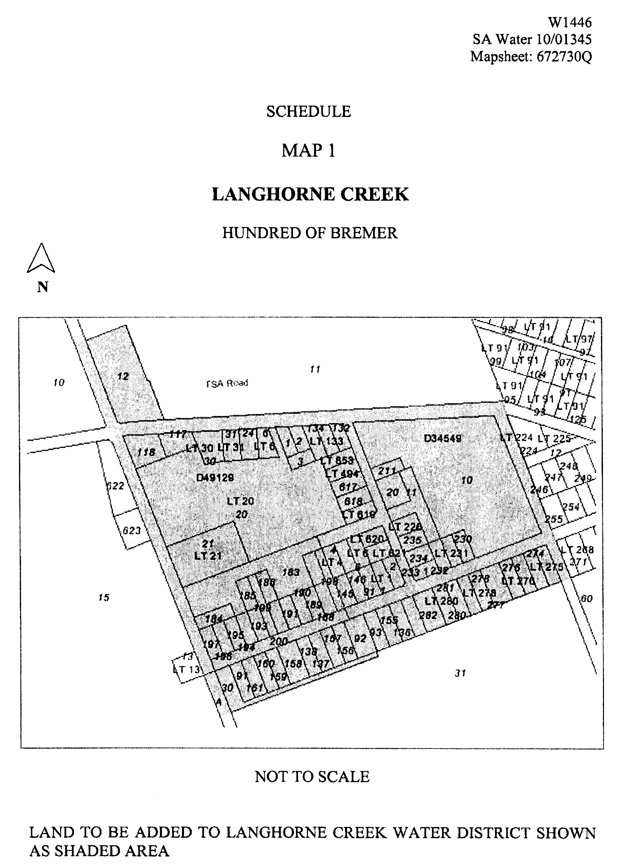
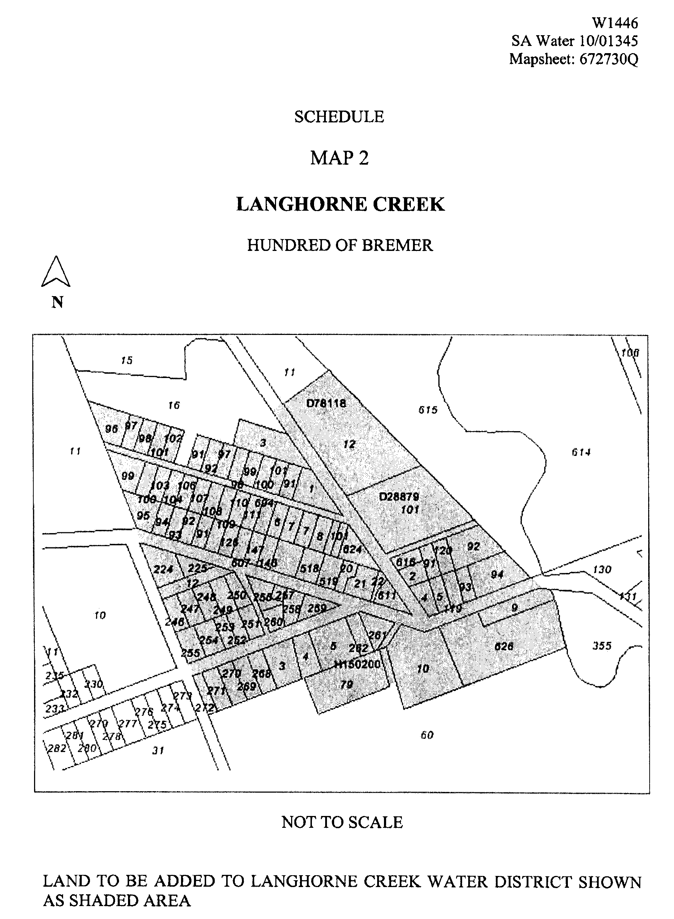
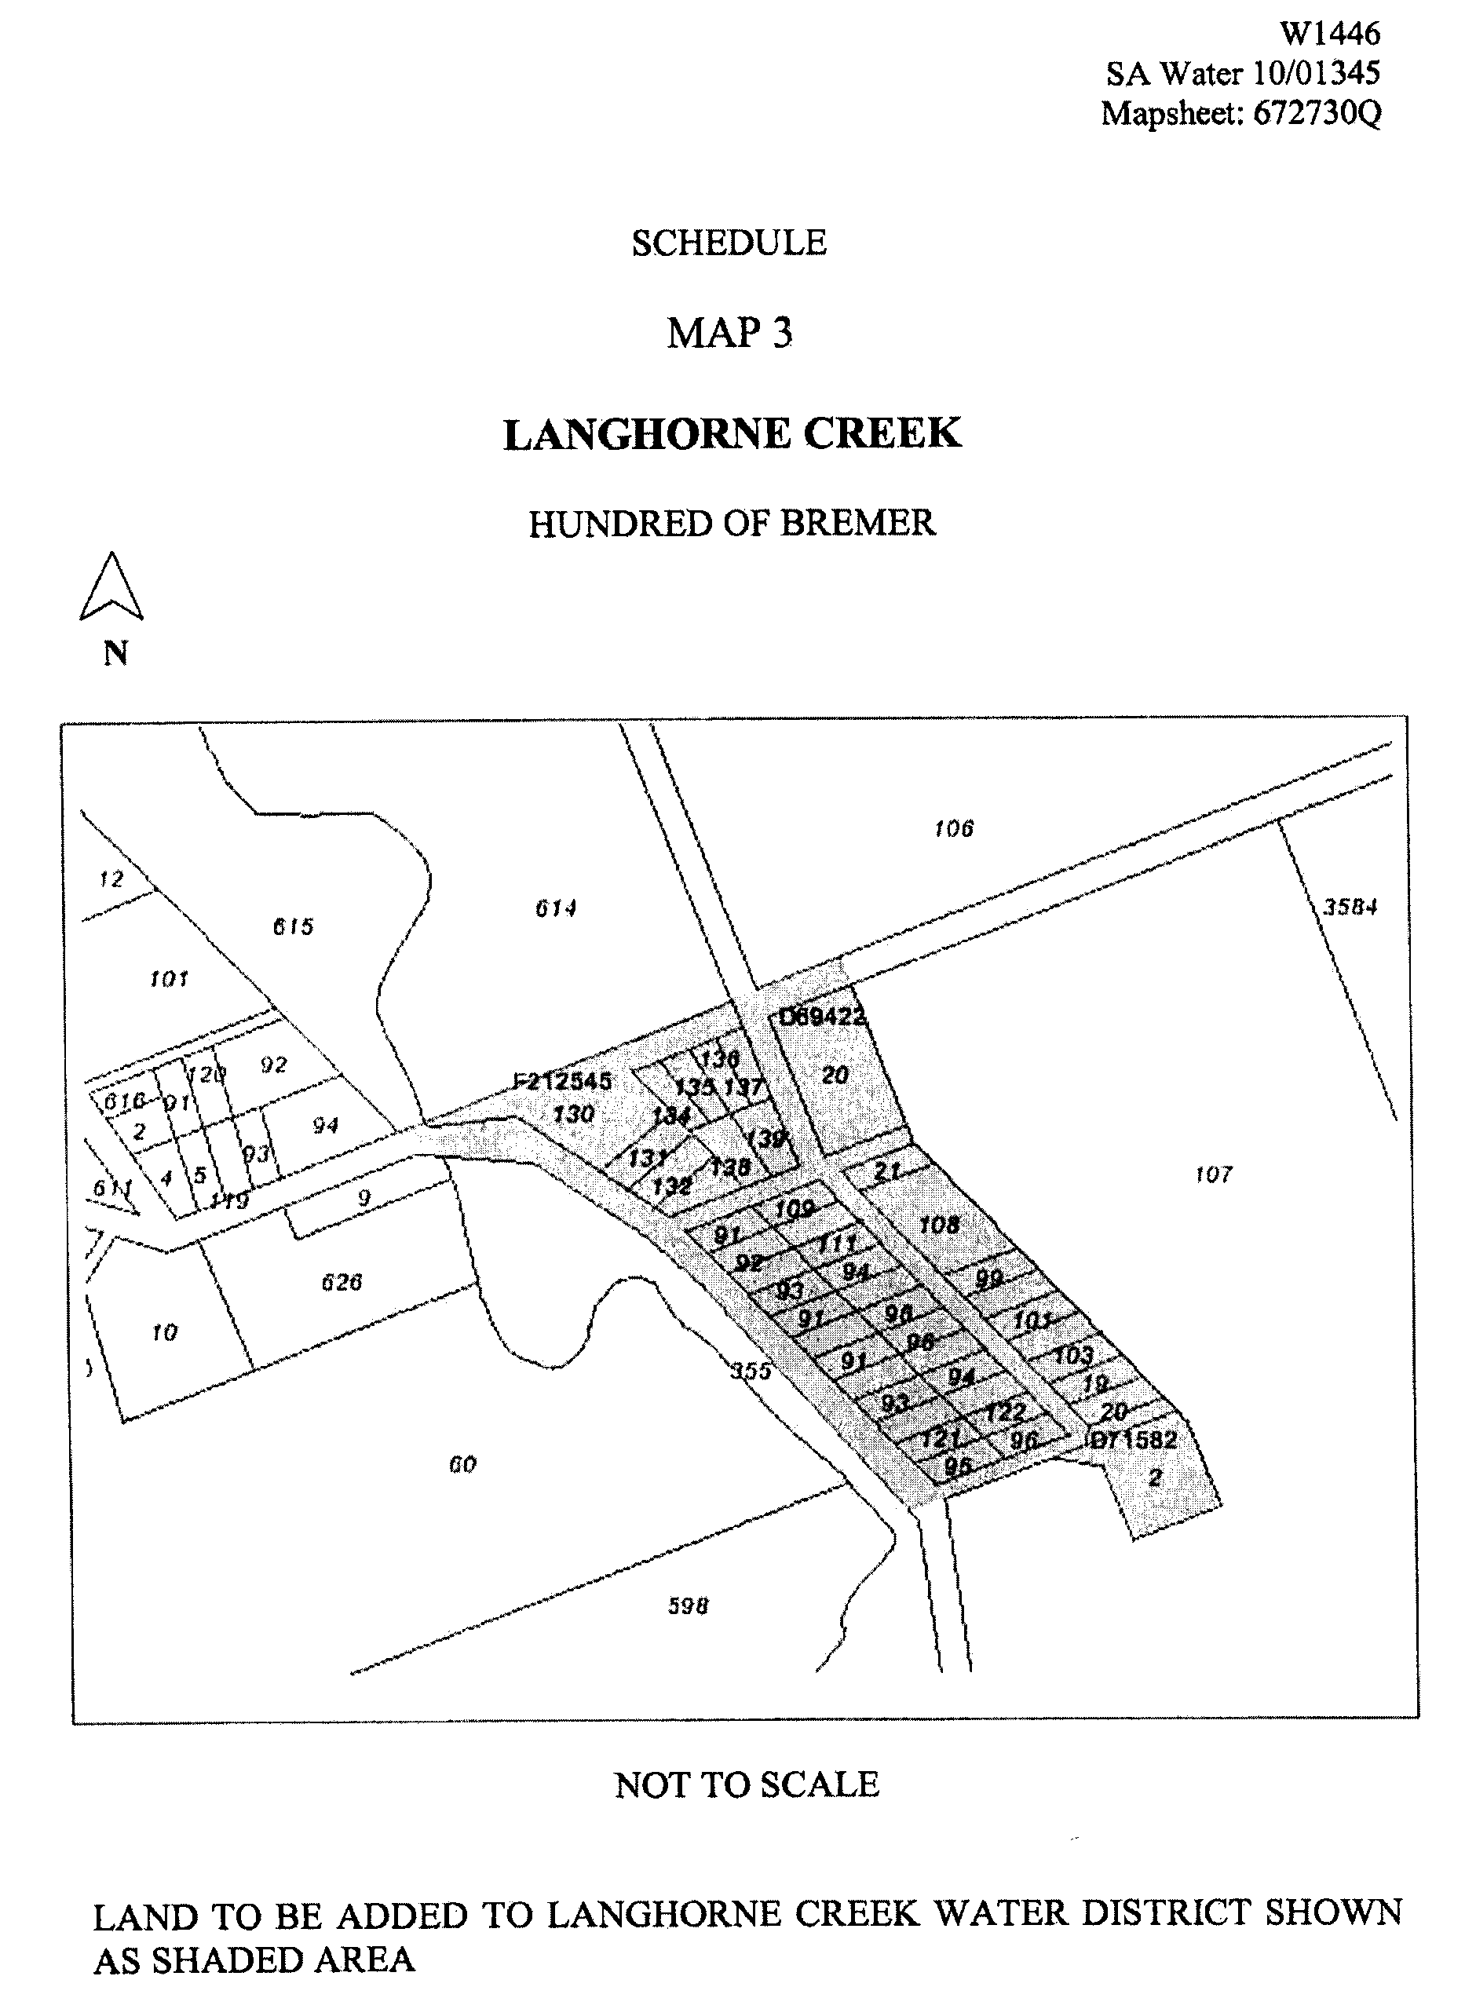
Dated 4 March 2010.
Signed for and on behalf of the South Australian Water Corporation by a person duly authorised so to do:
A. Schirripa, Manager Billing and Collection
In the presence of:
P. Weeks, Team Leader Rating
SAWATER 10/01345 W1446

FAXING COPY?
IF you fax copy to Government Publishing SA for inclusion in the Government Gazette, there is no need to send a Confirmation Copy to us as well.
This creates confusion and may well result in your notice being printed twice.
Please use the following fax number:
Fax transmission: (08) 8207 1040
Phone Inquiries: (08) 8207 1045
Please include a contact person, phone number and order number so that we can phone back with any queries we may have regarding the fax copy.
NOTE: Closing time for lodging new copy (fax, hard copy or email) is 4 p.m. on Tuesday preceding the day of publication.

Government Gazette notices can be E-mailed.
The address is:
governmentgazette@dpc.sa.gov.au
Documents should be sent as attachments in Word format.
When sending a document via E-mail, please confirm your transmission with a faxed copy of your document, including the date the notice is to be published.
Fax transmission: (08) 8207 1040
Enquiries: (08) 8207 1045
NOTE: Closing time for lodging new copy (fax, hard copy or email) is 4 p.m. on Tuesday preceding the day of publication.

CITY OF MITCHAM
By-law made under the Dog and Cat Management Act 1995 and the Local Government Act 1999
By-law No. 6—Cats
TO limit the number of cats that can be kept on premises and to provide for the control and management of cats within the Council’s area.
1. Definitions
1.1 In this by-law:
1.1.1 ‘Approved Kennel Establishment’ means a building, structure, premises or area approved by the relevant authority pursuant to the Development Act 1993 for the keeping of cats on a temporary or permanent basis.
1.1.2 ‘Cat’ has the same meaning as in the Dog and Cat Management Act 1995.
1.1.3 ‘Keep’ includes the provision of food or shelter.
1.1.4 ‘Premises’ includes land and a part of any premises or land whether used or occupied for domestic or non-domestic purposes except on Approved Kennel Establishments;
2. Registration of Cats
2.1 A person must not keep a Cat over three months in age in the Council’s area for more than 14 days unless the Cat is registered in accordance with this by-law.
2.2 An application for registration of a Cat over three months in age must:
2.2.1 be made to the Council in the manner, the form (if any) and accompanied by the fee (if any) as the Council may prescribe by resolution; and
2.2.2 nominate a person of or over 16 years of age who consents to the Cat being registered in his or her name; and
2.2.3 nominate Premises at which the Cat will be kept.
2.3 Registration under this by-law remains in force until 30 June next ensuing after registration was granted and may be renewed from time to time for further periods of 12 months.
3. Identification of Cats
A person must not without the Council’s permission keep a Cat over three months in age on any Premises unless the Cat is identified by means of having a microchip implanted in its body containing information that may be used to obtain the current address or telephone number of the owner or other person entitled to possession of the Cat.
4. Limit on Cat Numbers
4.1 A person must not on any Premises, without the Council’s permission, Keep more than two Cats over three months in age.
4.2 The limit in subparagraph 4.1 of this by-law does not apply:
4.2.1 to those Cats being kept on Premises when this by-law comes into effect however the limit does apply if the number of Cats kept on those Premises increases after that time; or
4.2.2 to an Approved Kennel Establishment; or
4.2.3 where—
4.2.3.1 the Council is satisfied that no insanitary condition is being caused by Cats being kept on the Premises; and
4.2.3.2 the Council is satisfied that no nuisance is being caused to any neighbour by reason of odour from cat urine or by reason of any of the Cats wandering from the Premises; and
4.2.3.3 all the Cats over the age of three months (or such later age as is considered appropriate and advised in writing by a veterinary surgeon) kept on the Premises are desexed.
5. Notice to remedy
5.1 If the Council is satisfied that any Cat kept or allowed to remain on any Premises is or is likely to become a nuisance or injurious to health, the Council may by notice in writing require the owner or occupier of those Premises, within the time stated in the notice, to take such measures as the Council considers necessary to prevent the Cat from being or continuing to be a nuisance or injurious to health;
5.2 Any person to whom a notice is given pursuant to this by-law must comply with the requirements of the notice;
5.3 If any person to whom a notice is given pursuant to this by-law fails to comply with the requirements of the notice, the Council may carry out the requirements of the notice and recover its costs in doing so from the person who failed to comply with the notice.
This foregoing by-law was duly made and passed at a meeting of the Council of the City of Mitcham held on 23 March 2010, by an absolute majority of the members for the time being constituting the Council, there being at least two-thirds of the members present.
H. Dyer, Chief Executive Officer

BERRI BARMERA COUNCIL
Riverland Regional Development Assessment Panel
Appointment
NOTICE is hereby given that at its meeting held on 11 March 2010, pursuant to section 34 (18a) of the Development Act 1993, the Riverland Regional Development Assessment Panel resolved to appoint David Beaton as its Public Officer.
D. Beaton, Chief Executive Officer

NARACOORTE LUCINDALE COUNCIL
Appointment
NOTICE is hereby given that at a meeting of Council held on 23 March 2010 and pursuant to section 102 of the Local Government Act 1999, Stephen John Loane was appointed Acting Chief Executive Officer, for the period from Tuesday, 20 April 2010 to Friday, 14 May 2010, inclusive while the Chief Executive Officer is on leave.
A. Evans, Chief Executive Officer

NARACOORTE LUCINDALE COUNCIL
Appointments
NOTICE is hereby given that at a meeting of Council, held on 23 March 2010, it was resolved that:
• pursuant to section 105B of the Fire and Emergency Services Act 2005, Darren Blain Callaghan is appointed as a Fire Prevention Officer;
• pursuant to section 105B of the Fire and Emergency Services Act 2005, Bradley James Lang is appointed as a Fire Prevention Officer;
• pursuant to section 105B of the Fire and Emergency Services Act 2005, Russell William Rehn is appointed as a Fire Prevention Officer;
• pursuant to section 81 of the Fire and Emergency Services Act 2005, Margaret Patricia Congdon is appointed as an Authorised Officer;
• pursuant to section 81 of the Fire and Emergency Services Act 2005, Karen Fitzgerald is appointed as an Authorised Officer;
• pursuant to section 81 of the Fire and Emergency Services Act 2005, Jane Elizabeth Haynes is appointed as an Authorised Officer;
• pursuant to section 81 of the Fire and Emergency Services Act 2005, Melissa Joy Irvine is appointed as an Authorised Officer;
• pursuant to section 81 of the Fire and Emergency Services Act 2005, Cathy Ellen Lawrie is appointed as an Authorised Officer;
• pursuant to section 81 of the Fire and Emergency Services Act 2005, Robin Heather Loechel is appointed as an Authorised Officer;
• pursuant to section 81 of the Fire and Emergency Services Act 2005, Grantley Malcolm Possingham is appointed as an Authorised Officer;
• pursuant to section 81 of the Fire and Emergency Services Act 2005, Russell William Rehn is appointed as an Authorised Officer;
• pursuant to section 18 (1) of the Development Act 1993, John Martin Best is appointed as an Authorised Officer;
• pursuant to section 260 (1) of the Local Government Act 1999, John Martin Best is appointed as an Authorised Officer;
• pursuant to section 18 (1) of the Development Act 1993, Edward Wolinski is appointed as an Authorised Officer;
• pursuant to section 27 of the Dog and Cat Management Act 1995, Edward Wolinski is appointed as a Dog Management Officer;
• pursuant to section 85 (3) of the Environment Protection Act 1993, Edward Wolinski is appointed as an Authorised Officer;
• pursuant to section 105B of the Fire and Emergency Services Act 2005, Edward Wolinski is appointed as a Fire Prevention Officer;
• pursuant to the provisions of section 94 (1) of the Food Act 2001, Edward Wolinski is appointed as an Authorised Officer;
• pursuant to sections 23 and 67 of the Housing Improvement Act 1940, Edward Wolinski is appointed as an Authorised Officer;
• pursuant to section 14 of the Impounding Act 1920, Edward Wolinski is appointed as a Ranger;
• pursuant to section 260 (1) of the Local Government Act 1999, Edward Wolinski is appointed as an Authorised Person;
• pursuant to the provisions of section 7 (1) of the Public and Environmental Health Act 1987, Edward Wolinski is appointed as an Authorised Officer; and
• pursuant to the provisions of section 21 (1) of the Supported Residential Facilities Act 1992, Edward Wolinski is appointed as an Authorised Officer.
A. Evans, Chief Executive Officer

DISTRICT COUNCIL OF STREAKY BAY
Change of Road Name
NOTICE is hereby given that Council resolved the following at their meeting held on 17 December 2009:
That Council endorse the re-naming of the piece of land known as Lot 601, Public Road to that of Kennedy Road.
M. Faulkner, Deputy Chief Executive Officer

IN the matter of the estates of the undermentioned deceased persons:
Beswick, Julia Eugene, late of 9 Brenchley Grove, Kingswood, retired shorthand typist, who died on 30 December 2009.
Blades, Vivien Lesley, late of 5 Cocos Grove, West Lakes, retired telephonist, who died on 16 December 2009.
Brooks, Sydney Arthur, late of 26 River Road, Port Noarlunga, retired clerk, who died on 19 December 2009.
Harvey, Phyllis, late of 56 High Street, Grange, of no occupation, who died on 2 January 2010.
Kernich, Elsa Claire, late of 40 Nyonga Avenue, Croydon Park, widow, who died on 6 January 2010.
Kitto, Nellie, late of 4 Ross Street, Brighton, home duties, who died on 3 December 2009.
Mathys, Eric Rupert, late of 17-19 Victoria Road, Clare, retired orchadist, who died on 23 December 2009.
Noble, Robert Lance, late of 10 Kelmscott Street, Rosewater, of no occupation, who died on 30 December 2009.
Prowse, Marjorie Eleanor, late of Grainger Road, Somerton Park, of no occupation, who died on 10 December 2009.
Vowles, Roma Constance, late of 29 Austral Terrace, Morphettville, of no occupation, who died on 23 September 2009.
Notice is hereby given pursuant to the Trustee Act 1936, as amended, the Inheritance (Family Provision) Act 1972, and the Family Relationships Act 1975, that all creditors, beneficiaries, and other persons having claims against the said estates are required to send, in writing, to the Public Trustee, 25 Franklin Street, Adelaide, S.A. 5000, full particulars and proof of such claims, on or before 30 April 2010, otherwise they will be excluded from the distribution of the said estate; and notice is also hereby given that all persons who are indebted to the said estates are required to pay the amount of their debts to the Public Trustee or proceedings will be taken for the recovery thereof; and all persons having any property belonging to the said estates are forthwith to deliver the same to the Public Trustee.
Dated 1 April 2010.
M. I. BodycoAt, Public Trustee

ATTENTION

CUSTOMERS requiring a proof of their notice for inclusion in the Government Gazette, please note that the onus is on you to inform Government Publishing SA of any subsequent corrections by 10 a.m. on Thursday, which is our publication deadline.

For any corrections to your notice please phone 8207 1045 or Fax 8207 1040 before 10 a.m. on Thursday.

If we do not receive any communication by 10 a.m. on Thursday (day of publication) we will presume the notice is correct and will print it as it is.

Remember—the onus is on you to inform us of any corrections necessary to your notice.

NOTE: Closing time for lodging new copy (electronically, fax or hard copy) is 4 p.m. on Tuesday preceding the day of publication. Phone 8207 1045—Fax 8207 1040.
Email: governmentgazette@dpc.sa.gov.au

Printed and published by authority every Thursday by B. MORRIS, Government Printer, South Australia
Price: $5.60, plus postage; to subscribers, $284.00 per annum.
(The above prices are inclusive of GST)

