No. 27 1633

THE SOUTH AUSTRALIAN

GOVERNMENT GAZETTE
www.governmentgazette.sa.gov.au

PUBLISHED BY AUTHORITY

ALL PUBLIC ACTS appearing in this GAZETTE are to be considered official, and obeyed as such

ADELAIDE, THURSDAY, 29 APRIL 2010

CONTENTS

Page
Appointments, Resignations, Etc. 1634
Corporations and District Councils—Notices 1691
Crown Lands Act 1929—Notice 1634
Development Act 1993—Notices 1634
Electoral Act 1985—Notice 1637
Fire and Emergency Services Act 2005—Notices 1636
Fisheries Management Act 2007—Notices 1635
Geographical Names Act 1991—Corrigendum 1639
Harbors and Navigation Act 1993—Notice 1639
Housing Improvement Act 1940—
Notices 1637
[Republished] 1639
Land Acquisition Act 1969—Notice 1639
Land Agents Act 1994—Notice 1640
Liquor Licensing Act 1997—Notices 1640
Medical Board of South Australia—Guidelines 1642
Mining Act 1971—Notices 1648
National Parks and Wildlife (National Parks) Regulations
2001—Notices 1649

Page
Petroleum and Geothermal Energy Act 2000—Notice 1681
Port Augusta Circuit Court—Notice 1681
Proclamation 1688
Public Trustee Office—Administration of Estates 1691
Remuneration Tribunal—Determinations 1650
Roads (Opening and Closing) Act 1991—Notices 1681

RULES OF COURT
District Court Civil Rules 2006—
(Amendment No. 13) 1654
District Court (Criminal and Miscellaneous) Rules 1992—
(Amendment No. 9) 1662
Supreme Court Civil Rules 2006—
(Amendment No. 11) 1669
Supreme Court Criminal Rules 1992—
(Amendment No. 26) 1675
Survey Act 1992—Notices 1681
Water Mains and Sewers—Mains Laid, Replaced, Etc 1682
Waterworks Act 1932—Notices 1684

GOVERNMENT GAZETTE NOTICES
ALL poundkeepers’ and private advertisements forwarded for publication in the South Australian Government Gazette must be PAID FOR PRIOR TO INSERTION; and all notices, from whatever source, should be legibly written on one side of the paper only and sent to Government Publishing SA so as to be received no later
than 4 p.m. on the Tuesday preceding the day of publication. Phone 8207 1045 or Fax 8207 1040. E-mail: governmentgazette@dpc.sa.gov.au. Send as attachments in Word format and please confirm your transmission with a faxed copy of your document, including the date the notice is to be published and to whom the notice will be charged. The Government Gazette is available online at: www.governmentgazette.sa.gov.au

Department of the Premier and Cabinet
Adelaide, 29 April 2010
HIS Excellency the Governor in Executive Council has been pleased to appoint the undermentioned to the Legal Practitioners Conduct Board, pursuant to the provision of the Legal Practitioners Act 1981:
Member: (from 9 May 2010 until 8 May 2013)
Anthony Abbott
Presiding Member: (from 9 May 2010 until 8 May 2013)
Anthony Abbott
By command,
Grace Portolesi, for Premier
AGO0068/03CS

Department of the Premier and Cabinet
Adelaide, 29 April 2010
HIS Excellency the Governor in Executive Council has been pleased to appoint Laura Ann Lee to the position of Commissioner for Integrated Design for a term of three years commencing on
1 July 2010 and expiring on 30 June 2013, pursuant to Section 68 of the Constitution Act 1934.
By command,
Grace Portolesi, for Premier
DPC10/009CS

CROWN LANDS ACT 1929: SECTION 5
TAKE NOTICE that pursuant to the Crown Lands Act 1929, I, PAUL CAICA, Minister for Environment and Conservation, Minister of the Crown to whom the administration of the Crown Lands Act 1929 is committed DO HEREBY dedicate the Crown Land defined in The Schedule as a Reserve for Jetty Purposes and declare that such land shall be under the care, control and management of the Minister for Transport.
The Schedule
Allotment 101 in Deposited Plan 79322, Hundred of Lacepede, County of MacDonnell, exclusive of all necessary roads, being the whole of the land comprised in Crown Record Volume 6046 Folio 71.
Dated 29 April 2010.
Paul Caica, Minister for Environment and Conservation
DL 2632/1983

DEVELOPMENT ACT 1993
Publication of Minister’s Specification SA A2.2—
Structural Engineering Software
Preamble
Section 108 (6) of the Development Act 1993 provides that the Regulations may refer to a standard or other document prepared or published by a prescribed body. Regulation 106 (2) prescribes the Minister as a prescribed body for the purposes of section 108 (6).
Notice
PURSUANT to section 108 (6) of the Development Act 1993 and Regulation 106 (2) of the Development Regulations 2008, notice is given of the publication of Minister’s Specification SA A2.2—Structural Engineering Software, dated May 2010, by the Minister for Urban Development and Planning for adoption under the Development Regulations as part of the Building Rules .
Dated 22 April 2010.
Paul Holloway, Minister for Urban Developmemt and Planning

DEVELOPMENT ACT 1993
Alteration to the Building Code of Australia
Preamble
1. The Building Code of Australia as in force from time to time is adopted by the Development Regulations 2008 as part of the Building Rules under the Development Act 1993.
2. The Building Code of Australia is altered annually for national adoption on 1 May each year.
3. The Development Act 1993 requires that notice of the alteration must be published before the alteration can take effect.
Notice
PURSUANT to section 4 (7) of the Development Act 1993, notice is given of an alteration to the 2009 edition of the Building Code of Australia. The Code has been amended and republished as BCA 2010 by the Australian Building Codes Board.
BCA 2010, as modified by the variations and additions for South Australia contained in the Appendix to that Code, will take effect for the purposes of the Development Act 1993 on 1 May 2010, with the following exceptions:
(a) additional bushfire requirements for ‘excluded areas’ as prescribed in sub-clauses SA G5.2 (d) and (e) of Volume One and sub-clauses SA 3.7.4.2 (d) and (e) in Volume Two of BCA 2010;
(b) the restriction on using child-resistant doorsets in swimming pool safety barrier requirements as prescribed in clause G1.1 of Volume One and clause 3.9.3.0 of Volume Two of BCA 2010; and
(c) amended energy efficiency provisions as prescribed in Part J of Volume One and Parts 2.6 and 3.12 of Volume Two of BCA 2010.
Exceptions (a) and (b) will be adopted on a date to be declared in a future gazettal notice. Until that time, the provisions of clause G1.1 of Volume One and clause 3.9.3.0 of Volume Two of BCA 2009 are still applicable in South Australia.
Exception (c) will be adopted on 1 September 2010. Until that time, the provisions of Part J of Volume One and Parts 2.6 and 3.12 of Volume Two of BCA 2009 are still applicable in South Australia.
Dated 21 April 2010.
Paul Holloway, Minister for Urban Developmemt and Planning

DEVELOPMENT ACT 1993
Alteration to the South Australian Housing Code
Preamble
1. The Building Code of Australia as in force from time to time is adopted by the Development Regulations 2008 as part of the Building Rules under the Development Act 1993.
2. The 2002 edition of the South Australian Housing Code is called up in the South Australian Appendix to Volume Two of the Building Code of Australia.
3. The South Australian Housing Code has been altered.
Notice
PURSUANT to section 4 (7) of the Development Act 1993, notice is given of an alteration to the 2002 edition of the South Australian Housing Code, that alteration being Amendment No.18 as published by the Department of Planning and Local Government.
Amendment 18 to the South Australian Housing Code will take effect for the purposes of the Development Act 1993 from 1 May 2010, with the following exceptions:
(a) the additional bushfire requirements for ‘excluded areas’ prescribed in subclauses F8.1 (iv) and (v) of Ap-
pendix F—Fire Safety in Amendment No. 18; and
(b) amended energy efficiency provisions as prescribed in Appendix H—Energy Efficiency.
Exception (a) will be adopted on a date to be declared in a future gazettal notice. Until that time, the current provisions of Appendix F—Fire Safety will still be applicable in South Australia.
Exception (b) will be adopted on 1 September 2010. Until that time, the current provisions of Appendix H—Energy Efficiency will still be applicable in South Australia.
Dated 21 April 2010.
Paul Holloway, Minister for Urban Development and Planning

FISHERIES MANAGEMENT ACT 2007: SECTION 79
TAKE note that the notice made under section 79 of the Fisheries Management Act 2007, dated 19 April 2010, referring to the Spencer Gulf Prawn Fishery, is hereby revoked.
Take note that the notice made under section 79 of the Fisheries Management Act 2007, dated 1 February 2010, referring to the Spencer Gulf Prawn Fishery, is hereby varied such that it will be unlawful for a person fishing, pursuant to a Spencer Gulf Prawn Fishery Licence to use prawn trawl nets in the areas specified in Schedule 1 during the period specified in Schedule 2.
Schedule 1
The waters of the Spencer Gulf Prawn Fishery that are:
1. North of the following co-ordinates: Commencing at latitude 33°46.00′S, longitude 137°44.00′E, then to position latitude 33°37.00′S, longitude 137°33.00′E, then to position latitude 33°43.00′S, longitude 137°30.00′E, then to position latitude 33°46.00′S, longitude 137°30.00′E, then to position latitude 33°48.74′S, longitude 137°33.89′E, then to position latitude 33°55.48′S, longitude 137°28.20′E, then to position latitude 33°50.20′S, longitude 137°20.85′E, then to position latitude 33°46.60′S, longitude 137°23.10′E, then to position latitude 33°37.50′S, longitude 137°13.20′E.
2. Within the following co-ordinates: Commencing at latitude 33°41.00′S, longitude 137°06.00′E, then to position latitude 33°52.00′S, longitude 137°15.00′E, then to position latitude 33°55.00′S, longitude 137°08.00′E, then to position latitude 34°02.00′S, longitude 137°10.00′E, then to position latitude 34°15.00′S, longitude 136°54.00′E, then to position latitude 34°18.00′S, longitude 136°54.00′E, then to position latitude 34°22.00′S, longitude 136°52.00′E, then to position latitude 34°22.00′S, longitude 136°44.00′E, then to position latitude 34°07.00′S, longitude 136°47.00′E, then to position latitude 34°07.00′S, longitude 136°43.00′E, then to position latitude 33°56.00′S, longitude 136°34.00′E.
3. Within the following co-ordinates adjacent to Wardang Island: Commencing at latitude 34°19.00′S, longitude 137°30.00′E, then to position latitude 34°19.00′S, longitude 137°20.00′E, then to position latitude 34°23.00′S, longitude 137°15.00′E, then to position latitude 34°54.00′S, longitude 137°15.00′E.
Schedule 2
From 2000 hours on 20 April 2010 to 0600 hours on 22 April 2010.
Dated 20 April 2010.
A. Fistr, Prawn Fishery Manager

FISHERIES MANAGEMENT ACT 2007: SECTION 79
TAKE note that the notice made under section 79 of the Fisheries Management Act 2007, dated 20 April 2010, referring to the Spencer Gulf Prawn Fishery, is hereby revoked.
Take note that the notice made under section 79 of the Fisheries Management Act 2007, dated 1 February 2010, referring to the Spencer Gulf Prawn Fishery, is hereby varied such that it will be unlawful for a person fishing, pursuant to a Spencer Gulf Prawn Fishery Licence to use prawn trawl nets in the areas specified in Schedule 1 during the period specified in Schedule 2.
Schedule 1
The waters of the Spencer Gulf Prawn Fishery that are:
1. North of the following co-ordinates: Commencing at latitude 33°46.14′S, longitude 137°43.80′E, then to position latitude 33°37.21′S, longitude 137°32.90′E, then to position latitude 33°43.00′S, longitude 137°30.00′E, then to position latitude 33°45.70′S, longitude 137°30.00′E, then to position latitude 33°48.69′S, longitude 137°34.18′E, then to position latitude 33°55.78′S, longitude 137°28.27′E, then to position latitude 33°50.37′S, longitude 137°20.74′E, then to position latitude 33°46.81′S, longitude 137°22.96′E, then to position latitude 33°37.67′S, longitude 137°13.02′E.
2. Within the following co-ordinates: Commencing at latitude 33°40.87′S, longitude 137°06.24′E, then to position latitude 33°51.88′S, longitude 137°15.22′E, then to position latitude 33°54.90′S, longitude 137°08.21′E, then to position latitude 34°01.76′S, longitude 137°10.22′E, then to position latitude 34°15.00′S, longitude 136°54.00′E, then to position latitude 34°18.00′S, longitude 136°54.00′E, then to position latitude 34°22.00′S, longitude 136°52.00′E, then to position latitude 34°22.00′S, longitude 136°44.00′E, then to position latitude 34°07.00′S, longitude 136°47.00′E, then to position latitude 34°07.00′S, longitude 136°43.00′E, then to position latitude 33°56.00′S, longitude 136°34.00′E.
3. Within the following co-ordinates adjacent to Wardang Island: Commencing at latitude 34°19.00′S, longitude 137°30.00′E, then to position latitude 34°19.00′S, longitude 137°20.00′E, then to position latitude 34°23.00′S, longitude 137°15.00′E, then to position latitude 34°54.00′S, longitude 137°15.00′E.
Schedule 2
From 2000 hours on 21 April 2010 to 0600 hours on 22 April 2010.
Dated 21 April 2010.
A. Fistr, Prawn Fishery Manager

FISHERIES MANAGEMENT ACT 2007: SECTION 79
TAKE note that the notice made under section 79 of the Fisheries Management Act 2007, dated 1 February 2010 and published in the South Australian Government Gazette on page 421, dated
4 February 2010, being the fourth notice on that page, referring to the Gulf St Vincent Prawn Fishery, is hereby varied such that it will not be unlawful for a person fishing, pursuant to a Gulf St Vincent Prawn Fishery Licence to use prawn trawl nets in the area specified in Schedule 1, during the period specified in Schedule 2.
Schedule 1
1. The waters of the Gulf St. Vincent Prawn Fishery, within the following co-ordinates: Commencing at latitude 35°12.00′S, longitude 137°59.00′E, then to position latitude 35°10.00′S, longitude 137°57.00′E, then to position latitude 35°08.00′S, longitude 138°00.00′E, then to position latitude 35°10.00′S, longitude 138°02.00′E, then returning to position latitude 35°12.00′S, longitude 137°59.00′E.
Schedule 2
From 1830 hours on 20 April 2010 to 0630 hours on 22 April 2010.
Dated 20 April 2010.
A. Fistr, Prawn Fishery Manager

FISHERIES MANAGEMENT ACT 2007: SECTION 115
TAKE notice that pursuant to section 115 of the Fisheries Management Act 2007, the person listed in Schedule 1 (the ‘exemption holder’) of Southern Australian Seafoods Pty Ltd, P.O. Box 2516, Port Lincoln, S.A. 5607, is exempt from section 52 of the Fisheries Management Act 2007, but only insofar as he may take Greenlip Abalone (Haliotis laevigata) and Blacklip Abalone (Haliotis rubra) for the purpose of aquaculture broodstock (the ‘exempted activity’), in the waters specified in Schedule 2, subject to the conditions in Schedule 3, from 21 April 2010 until 31 October 2010, unless varied or revoked earlier.
Schedule 1
Andrew Christian.
Schedule 2
‘Western Zone’—the South Australian coastal waters west of the meridian of longitude 136°30′E to the Western Australia border.
Schedule 3
1. The exemption holder may take a maximum 150 Greenlip Abalone (Haliotis laevigata) and 30 Blacklip Abalone (Haliotis rubra) from the Western Zone Abalone Fishery for the purpose of aquaculture broodstock.
2. Broodstock must not be sourced from known Perkinsus areas.
3. Abalone taken pursuant to this exemption must not be sold or transferred to another party.
4. All abalone taken pursuant to this exemption must be delivered to and retained on the registered aquaculture site of land-based Aquaculture Licence No. FT00620.
5. The exemption holder must notify PIRSA Fisheries Compliance on 1800 065 522 at least two hours prior to conducting the exempted activity answer a series of questions about the exempted activity. The exemption holder will need to have a copy of the exemption notice at the time of making the call, and be able to provide information about the area and time of the exempted activity, the vehicles and boats involved, the number of agents undertaking the exempted activity and other related questions. Exemption No. 9902351.
6. The exemption holder must, within 50 m of the point of landing of any abalone taken pursuant to this notice, complete the PIRSA form ‘Broodstock Collection Report Form’. Immediately upon arrival at the exemption holder’s registered aquaculture site, this form must be faxed to PIRSA Fisheries on (08) 8226 0434. Prior to release into the registered aquaculture site, all abalone taken pursuant to this notice must be tagged so as to be clearly identified as wild broodstock. A copy of this form must be retained at the aquaculture site as part of their broodstock records.
7. Broodstock taken under this exemption must be physically contained and separated from any farm-reared and growout animals, including no mixing of water used to hold wild-caught broodstock with areas used to hold grow-out stock.
8. Broodstock taken pursuant to this exemption must be held together in identifiable groups from specific geographic locations or if broodstock from different areas must be mixed due to on-farm logistics, broodstock must be tagged so that their date and location of capture can be determined.
9. PIRSA Fisheries retains the right for a PIRSA Fisheries Officer to accompany the exemption holder at any time during the exempted activity.
10. While engaged in the exempted activity the exemption holder must carry or have about or near his person a copy of this notice. Such notice must be produced to a PIRSA Fisheries Officer upon request.
11. The exemption holder must not contravene or fail to comply with the Fisheries Management Act 2007, or any regulations made under that Act, except where specifically exempted by this notice.
Dated 20 April 2010.
M. Smallridge, Director of Fisheries

FIRE AND EMERGENCY SERVICES ACT 2005
Instrument of Appointment
I, MICHAEL WRIGHT MP, Minister for Emergency Services in the State of South Australia, pursuant to Part 3, sections 29, 49, 51 and Schedule 1 of the Fire and Emergency Services Act 2005, as amended, do hereby appoint the persons named in Schedule A of this Instrument of Appointment, as an assessor nominated by the
United Firefighters Union of South Australia under the terms and conditions set out in Schedule B of this Instrument of Appointment.
Schedule A
David John Harvey
Michael Lucas Vander-Jeugd
Kevin Charles Fischer
Brendan Thomas West
Barry Elliott Luke
Neil James Mangelsdorf
Schedule B
Terms
Assessors are appointed for a term of three years. The term of appointment commences on 30 April 2010 and expires on 29 April 2013.
Conditions
(1) Assessors are subject to the conditions set out in Clauses 2-6 inclusive, of Schedule 1 of the Fire and Emergency Services Act 2005.
(2) Assessors will be remunerated in accordance with the Guidelines approved by the Commissioner for Public Employment in Circular 60, Section 8—‘Remuneration by Sessional Fee’.
Dated 27 April 2010.
Michael Wright, Minister for Emergency Services

FIRE AND EMERGENCY SERVICES ACT 2005
Instrument of Appointment
I, MICHAEL WRIGHT, Minister for Emergency Services in the State of South Australia, pursuant to Part 3, sections 29, 49, 51 and Schedule 1 of the Fire and Emergency Services Act 2005, as amended, do hereby appoint the persons named in Schedule A of this Instrument of Appointment, as an assessor nominated by the South Australian Metropolitan Fire Service under the terms and conditions set out in Schedule B of this Instrument of Appointment.
Schedule A
David Arthur Schmerl
Glenn Paul Benham
David John Kemp
Geoffrey Owen Matters
Scott Justin Thompson
Colin James Lindsay
Paul Michael Fletcher
Andrew Mark Lindsay
Peter James Mason
Schedule B
Terms
Assessors are appointed for a term of three years. The term of appointment commences on 30 April 2010 and expires on 29 April 2013.
Conditions
(1) Assessors are subject to the conditions set out in Clauses 2-6 inclusive, of Schedule 1 of the Fire and Emergency Services Act 2005.
(2) Assessors will be remunerated in accordance with the Guidelines approved by the Commissioner for Public Employment in Circular 60, Section 8—‘Remuneration by Sessional Fee’.
Dated 27 April 2010.
Michael Wright, Minister for Emergency Services

ELECTORAL ACT 1985
House of Assembly Results of the State Election held on 20 March 2010
PURSUANT to section 96 (11) of the Electoral Act 1985, the following are the votes attributed to the two unexcluded candidates in each House of Assembly election held on Saturday, 20 March 2010:
District | Result | Elected Candidate
Adelaide | LIB | Sanderson Rachel | 10909 | Lomax-Smith Jane | 9211
Ashford | ALP | Key Steph | 11625 | Pratt Penny | 9588
Bragg | LIB | Chapman Vickie | 15297 | Dineen Ben | 6148
Bright | ALP | Fox Chloe | 10777 | Kourtesis Maria | 10610
Chaffey | LIB | Whetstone Tim | 10770 | Maywald Karlene | 9265
Cheltenham | ALP | Weatherill Jay | 13328 | Bourke James | 6833
Colton | ALP | Caica Paul | 11432 | Morichovitis Peter | 9756
Croydon | ALP | Atkinson Michael | 12741 | McLennan Zack | 7067
Davenport | LIB | Evans Iain | 12642 | Wangmann James | 7816
Elder | ALP | Conlon Pat | 10904 | Turner Ben | 9440
Enfield | ALP | Rau John | 12094 | Westley Luke | 7881
Finniss | LIB | Pengilly Michael | 12421 | Corcoran Mary-Louise | 7878
Fisher | IND | Such Bob | 14831 | Moriarty Christopher | 7431
Flinders | LIB | Treloar Peter | 15361 | Sansbury Tauto | 4799
Florey | ALP | Bedford Frances | 11132 | Trainor Pat | 9650
Frome | IND | Brock Geoff | 12135 | Boylan Terry | 8976
Giles | CLP | Breuer Lyn | 11696 | Oldfield Chad | 7204
Goyder | LIB | Griffiths Steven | 14079 | Hansford Christopher | 6719
Hammond | LIB | Pederick Adrian | 14938 | MacLeod Hannah | 6646
Hartley | ALP | Portolesi Grace | 10322 | Scalzi Joe | 9428
Heysen | LIB | Redmond Isobel | 14368 | Gheller Stephanie | 7235
Kaurna | ALP | Hill John | 12290 | Bird Trisha | 8665
Kavel | LIB | Goldsworthy Mark | 13486 | Fulbrook John | 7007
Lee | ALP | Wright Michael | 12063 | Gow Sue | 8975
Light | ALP | Piccolo Tony | 11492 | Costa Cosie | 9301
Little Para | ALP | Odenwalder Lee | 12351 | Knoll Franz | 9457
MacKillop | LIB | Williams Mitch | 14112 | O’Halloran Darren | 6032
Mawson | ALP | Bignell Leon | 11659 | Donovan Matt | 9784
Mitchell | ALP | Sibbons Alan | 11597 | McCance Peta | 10647
Morialta | LIB | Gardner John | 11333 | Simmons Lindsay | 9600
Morphett | LIB | McFetridge Duncan | 12856 | Looker Tim | 8199
Mount Gambier | IND | Pegler Don | 10971 | Perryman Steve | 10810
Napier | ALP | O’Brien Michael | 13646 | Chomel Brenton | 7107
Newland | ALP | Kenyon Tom | 10841 | Draper Trish | 9942
Norwood | LIB | Marshall Steven | 11654 | Ciccarello Vini | 9601
Playford | ALP | Snelling Jack | 13551 | Faggotter Kerry | 7179
Port Adelaide | ALP | Foley Kevin | 13643 | Lawrie Sue | 8089
Ramsay | ALP | Rann Mike | 13431 | Balaza David | 6332
Reynell | ALP | Thompson Gay | 12187 | Howard Shane | 8004
Schubert | LIB | Venning Ivan | 14113 | Hopgood Lynda | 6714
Stuart | LIB | Van Holst Pellekaan Dan | 12015 | Holden Sean | 8836
Taylor | ALP | Vlahos Leesa | 13432 | Ludwig Cassandra | 8553
Torrens | ALP | Geraghty Robyn | 12025 | Lomax Stuart | 8764
Unley | LIB | Pisoni David | 12804 | Vartto Vanessa | 7768
Waite | LIB | Hamilton-Smith Martin | 13636 | Tisato Adrian | 8057
West Torrens | ALP | Koutsantonis Tom | 11660 | Wood Jassmine | 8817
Wright | ALP | Rankine Jennifer | 12125 | Celeste Tina | 10073

K. M. Mousley, Electoral Commissioner
ECSA 138/2009

HOUSING IMPROVEMENT ACT 1940
NOTICE is hereby given that the South Australian Housing Trust Board Delegate in the exercise of the powers conferred by the Housing Improvement Act 1940, does hereby declare the houses described in the table hereunder to be substandard for the purposes of Part 7 of the Housing Improvement Act 1940.
No. of House and Street | Locality | Allotment, Section, etc. | Certificate of Title  Volume Folio

36 Adelaide Terrace |  | St Marys | Allotment 323 in Deposited Plan 3843, Hundred of Adelaide | 5259 | 759
32 (also known as 30) Crabb Road |  | Smithfield Plains | Allotment 626 in Deposited Plan 9100, Hundred of Munno Para | 5492 | 709
40 William Street |  | Beverley | Allotment 13 in Filed Plan 122360, Hundred of Yatala | 5731 | 640

Dated at Adelaide, 27 April 2010. S. Trebilcock for D. Huxley, Director, Corporate Services, Housing SA

HOUSING IMPROVEMENT ACT 1940
WHEREAS by notice published in the Government Gazette on the dates mentioned in the following table the South Australian Housing Trust Board Delegate did declare the houses described in the said table to be substandard for the purposes of Part 7 of the Housing Improvement Act 1940, the South Australian Housing Trust Board Delegate in the exercise of the powers conferred by the said Part, does hereby fix as the maximum rental per week which shall be payable subject to section 55 of the Residential Tenancies Act 1995, in respect of each house described in the following table the amount shown in the said table opposite the description of such house and this notice shall come into force on the date of this publication in the Gazette.
Address of House | Allotment, Section, etc. | Certificate of Title  Volume Folio | Date and page of Government Gazette in which notice declaring house to be substandard published | Maximum rental per week payable in respect of each house  $

4 Clifton Street, Malvern |  | Allotment 12 in Deposited Plan 23634, Hundred of Adelaide | 5443 | 703 |  | 22.10.09, page 4900 | 240.00
 |  |  |  |  |  | (Please note rent date has been amended but rent amount of $240.00 will stay the same)
12 Harriet Street, Kapunda |  | Allotment 341 of portion of Section 1402, Hundred of Kapunda | 5753 | 603 |  | 28.11.85, page 1647 | 100.00
2 Larkhill Road, Elizabeth North |  | Allotment 602 in Deposited Plan 6445, Hundred of Munno Para | 5608 | 321 |  | 24.8.95, page 508 | 172.00
94 Rudall Avenue, Whyalla Playford |  | Allotment 1501, Town of Whyalla, in the area named Whyalla Playford, Hundred of Randell | 5726 | 64 |  | 3.12.09, page 5958 | 130.00
182 Salisbury Highway, Salisbury |  | Allotment 1 in Filed Plan 5511, Hundred of Yatala | 5504 | 191 |  | 8.11.07, page 4183 | 227.00
Flat 4, 29 Tusmore Avenue, Leabrook |  | Allotment 95 in Filed Plan 138675, Hundred of Adelaide | 5812 | 19 |  | 30.7.92, page 759 | 110.00
Flat 5, 29 Tusmore Avenue, Leabrook |  | Allotment 95 in Filed Plan 138675, Hundred of Adelaide | 5812 | 19 |  | 30.7.92, page 759 | 110.00
32 Ward Street, Whyalla |  | Allotment 824, Town of Whyalla, Hundred of Randell | 6033 | 261 |  | 21.1.2010, page 249 | 110.00

Dated at Adelaide, 27 April 2010. S. Trebilcock for D. Huxley, Director, Corporate Services, Housing SA

HOUSING IMPROVEMENT ACT 1940
WHEREAS by notice published in the Government Gazette on the dates mentioned in the following table, the South Australian Housing Trust Board Delegate did declare the houses described in the following table to be substandard for the purposes of Part 7 of the Housing Improvement Act 1940, and whereas the South Australian Housing Trust Board Delegate is satisfied that each of the houses described hereunder has ceased to be substandard, notice is hereby given that, in exercise of the powers conferred by the said Part, the South Australian Housing Trust does hereby revoke the said declaration in respect of each house.
Address of House | Allotment, Section, etc. | Certificate of Title  Volume Folio | Date and page of Government Gazette in which notice declaring house to be substandard published

18 Ada Street, Adelaide |  | Allotment 2 in Deposited Plan 79302, Hundred of Adelaide | 6052 | 211 |  | 30.8.62, page 571
16 Ashford Road, Keswick |  | Allotment 245 in Deposited Plan 1288, Hundred of Adelaide | 5160 | 235 |  | 25.10.90, page 1313
47 Bagot Road, Elizabeth South |  | Allotment 11 in Deposited Plan 36600, Hundred of Munno Para | 5130 | 282 |  | 18.2.10, page 778
13 Beach Road, St Kilda |  | Allotment 31 in Filed Plan 114692, Hundred of Port Adelaide | 5681 | 978 |  | 24.3.94, page 799
4 Cushen Street, Smithfield Plains |  | Allotment 359 in Deposited Plan 7888, Hundred of Munno Para | 5554 | 532 |  | 17.12.09, page 6321
Unit 3, 6 East Avenue, Beverley |  | Allotment 13 in Deposited Plan 2852, Hundred of Yatala | 5525 | 751 |  | 23.10.08, page 4899
18 Hill Street, Seacliff Park |  | Allotment 70 in Deposited Plan 146604, Hundred of Noarlunga | 5809 | 724 |  | 29.11.01, page 5222
467 South Road (House at rear of shop), Keswick |  | Allotment 314 in Filed Plan 19503, Hundred of Adelaide | 5919 | 727 |  | 19.6.08, page 2353
Flat 1, 6 Wilson Avenue, Felixstow |  | Allotment 15 in Deposited Plan 6762, Hundred of Adelaide | 5634  5634 | 133  135 |  | 26.1.89, page 227
Flat 2, 6 Wilson Avenue, Felixstow |  | Allotment 15 in Deposited Plan 6762, Hundred of Adelaide | 5634  5634 | 133  135 |  | 26.1.89, page 227

Dated at Adelaide, 27 April 2010. S. Trebilcock for D. Huxley, Director, Corporate Services, Housing SA

[Republished]
HOUSING IMPROVEMENT ACT 1940
NOTICE is hereby given that the South Australian Housing Trust Board Delegate in the exercise of the powers conferred by the Housing Improvement Act 1940, does hereby declare the houses described in the table hereunder to be substandard for the purposes of Part 7 of the Housing Improvement Act 1940.
No. of House and Street | Locality | Allotment, Section, etc. | Certificate of Title  Volume Folio

Lot 18, 151 Hayman Road, |  | Lewiston | Allotment 18 in Deposited Plan 16592, Hundred of Port Gawler | 5753 | 419
Unit 1, 18 Murray Street, |  | Tanunda | Allotment 553 in Filed Plan 172004, Hundred of Moorooroo | 5955 | 876
7 Rollison Road, |  | Elizabeth Vale | Allotment 1171 in Deposited Plan 6818, Hundred of Munno Para | 5275 | 249
26 Thomas Street, |  | Salisbury | Allotment 32 in Deposited Plan 5157, Hundred of Yatala | 5572 | 715

Dated at Adelaide, 15 April 2010. D. Huxley, Director, Corporate Services, Housing SA

GEOGRAPHICAL NAMES ACT 1991
Corrigendum
Notice of Declaration of Names of Places
IN the Government Gazette of 24 August 1992, page 979 fourth notice appearing under the heading Mapsheet 1:50 000 4745-I the declared name shown as NUMPANITIA PASS should have been NUMPANTJA PASS.
Dated 29 April 2010.
P. M. Kentish, Surveyor-General, Department for Transport, Energy and Infrastructure
DTEI.2009/29925/01

HARBORS AND NAVIGATION ACT 1993
Determination of the State Crewing Committee
THE following determination was made on 30 November 2009 by the State Crewing Committee, pursuant to part 6, section 45 of the Harbors and Navigation Act 1993.
Patrick Conlon, Minister for Transport
V28103

HARBORS AND NAVIGATION ACT 1993
Determination of the State Crewing Committee in respect of the
M.V. ‘Watermark’
THE following determination is made by the State Crewing Committee pursuant to part 6, section 45 of the Harbors and Navigation Act 1993, in respect of the Watermark. This notice revokes all previous notice issued for this vessel.
Operational Limits
Limit 1—Within Smooth Waters Limits as per Schedule 1 of the Harbors and Navigation Regulations 2009.
Limit 2—Within Partially Smooth Waters Limits as per Schedule 1 of the Harbors and Navigation Regulations 2009.
Limit 3—Inshore operations within 15 nautical miles of the Coast of South Australia.
Limit 4—Offshore operations within 200 nautical miles of the Coast of South Australia.
Minimum Crew
Limit 1—Three persons: Master, and two General Purpose Hands.
Limits 2 and 3—Two persons: Master and one General Purpose Hand.
Limit 4—Two persons: Master and Mate.

Minimum Qualifications
The Master is to hold a Master Class 5 Certificate of Competency.

The Mate is to hold a Coxswain Certificate of Competency.
General Purpose hand is to be a person, who is at least 16 years of age, is fit for the duties employed, holds a certificate for Elements of Shipboard Safety and has at least three months experience.
For all operational limits, the Master, Mate or GP is to hold a Marine Engine Driver Grade 3 Certificate of Competency.
Capt. W. Ferrao, Presiding Member, State Crewing Committee

LAND ACQUISITION ACT 1969
(Section 16)
Notice of Acquisition
THE COMMISSIONER OF HIGHWAYS (the ‘Authority’), 33 Warwick Street, Walkerville, S.A. 5081, acquires the following interests in the following land:
Definition of Land Acquired
Comprising an unencumbered estate in fee simple in that piece of land situated at Allotment 100, Cardiff Court, Cavan, S.A. 5094, being the whole of Allotment 100 in Deposited Plan 39553 and being portion of the land comprised in certificate of title volume 5506, folio 579 and being the whole of the land numbered 50 in Deposited Plan 82669, expressly excluding the free and unrestricted right of way referred to in the said Certificate of Title.
This notice is given under section 16 of the Land Acquisition Act 1969.
Compensation
A person who has or had an interest in the land that is divested or diminished by the acquisition or the enjoyment of which is adversely affected by the acquisition who does not receive an offer of compensation from the Authority may apply to the Authority for compensation.
Inquiries
Inquiries should be directed to:
Carlene Russell,
P.O. Box 1,
Walkerville, S.A. 5081
Telephone: (08) 8343 2454.
Dated 20 April 2010.
The Common Seal of the Commissioner of Highways was hereto affixed by authority of the Commissioner in the presence of:
D. Thomas, Manager, Property Planning and Management Services, Authorised Officer, Department for Transport, Energy and Infrastructure
DTEI 2009/26806/01

LAND AGENTS ACT 1994
Exemption
TAKE notice that, pursuant to section 51 of the Land Agents Act 1994, I, Gail Gago, Minister for Consumer Affairs, do hereby exempt the applicant, David John White, 5/94 Cliff Street, Glengowrie, S.A. 5044 from the requirements of section 8A (b) (i) of the Land Agents Act 1994, with respect to the offences for which the applicant was convicted on 5 August 1999, subject to the conditions specified in Schedule 1.
Schedule 1—Conditions
1. That the applicant act as a sales representative only in the commercial property management area and undertake only those activities which relate to the lease of land that is used for the purpose of a business; and
2. That the applicant notify the Minister for Consumer Affairs within seven days in writing upon being charged with an offence.
Note that, pursuant to section 51 (3) of the Land Agents Act 1994, the Minister may revoke or vary this exemption at her discretion.
Dated 21 April 2010.
Gail Gago, Minister for Consumer Affairs

LIQUOR LICENSING ACT 1997
Notice of Application
NOTICE is hereby given, pursuant to section 52 (2) (b) of the Liquor Licensing Act 1997, that Rudolphus Joseph Wrana and Somwong Mapakdee have applied to the Licensing Authority for the transfer of a Restaurant Licence in respect of premises situated at Shop 3, Rivoli Lane, Naracoorte, S.A. 5271 and known as the Blue Wattle Cafe.
The application has been set down for hearing on 31 May 2010 at 11 a.m.
Any person may object to the application by lodging a notice of objection in the prescribed form with the Liquor and Gambling Commissioner and serving a copy of the notice on the applicants at the applicants’ address, at least seven days before the hearing date (viz: 24 May 2010).
The applicants’ address for service is c/o Westley DiGiorgio, P.O. Box 1265, Naracoorte, S.A. 5271 (Attention: Peter Westley).
Plans in respect of the premises the subject of the application are open to public inspection without fee at the Office of the Liquor and Gambling Commissioner, 9th Floor, East Wing, 50 Grenfell Street, Adelaide, S.A. 5000. Phone 8226 8410, Fax:
8226 8512. Email: olgc@agd.sa.gov.au.
Dated 22 April 2010.
Applicants

LIQUOR LICENSING ACT 1997
Notice of Application
NOTICE is hereby given, pursuant to section 52 (2) (b) of the Liquor Licensing Act 1997, that Bianco Catering Pty Ltd has applied to the Licensing Authority for the transfer of a Special Circumstances Licence in respect of premises situated at Frome Road, Adelaide, S.A. 5000 known as Adelaide Zoo—Function Centre and to be known as Sanctuary Adelaide Zoo.
The application has been set down for hearing on 26 May 2010 at 11.30 a.m.
Any person may object to the application by lodging a notice of objection in the prescribed form with the Liquor and Gambling Commissioner and serving a copy of the notice on the applicant at the applicant’s address, at least seven days before the hearing date (viz: 19 May 2010).
The applicant’s address for service is c/o David Watts & Associates, 1 Cator Street, Glenside, S.A. 5065 (Attention: David Watts).
Plans in respect of the premises the subject of the application are open to public inspection without fee at the Office of the Liquor and Gambling Commissioner, 9th Floor, East Wing, 50 Grenfell Street, Adelaide, S.A. 5000. Phone 8226 8410, Fax:
8226 8512. Email: olgc@agd.sa.gov.au.
Dated 20 April 2010.
Applicant

LIQUOR LICENSING ACT 1997
Notice of Application
NOTICE is hereby given, pursuant to section 52 (2) (b) of the Liquor Licensing Act 1997, that Kamal Verma and Geraldine Carmel Verma have applied to the Licensing Authority for a Restaurant Licence with Section 34 (1) (c) in respect of premises situated at 2 Leith Street, Nairne, S.A. 5252 and to be known as Zigi Zaga.
The application has been set down for hearing on 31 May 2010 at 9.30 a.m.
Any person may object to the application by lodging a notice of objection in the prescribed form with the Liquor and Gambling Commissioner and serving a copy of the notice on the applicants at the applicants’ address, at least seven days before the hearing date (viz: 24 May 2010).
The applicants’ address for service is c/o Kamal Verma, 8 Adelaide Road, Mount Barker, S.A. 5251.
Plans in respect of the premises the subject of the application are open to public inspection without fee at the Office of the Liquor and Gambling Commissioner, 9th Floor, East Wing, 50 Grenfell Street, Adelaide, S.A. 5000. Phone 8226 8410, Fax:
8226 8512. Email: olgc@agd.sa.gov.au.
Dated 21 April 2010.
Applicants

LIQUOR LICENSING ACT 1997
Notice of Application
NOTICE is hereby given, pursuant to section 52 (2) (b) of the Liquor Licensing Act 1997, that Returned & Services League Murray Bridge Sub-Branch Incorporated has applied to the Licensing Authority for the removal of a Limited Club Licence in respect of premises currently situated at South Terrace, Murray Bridge, S.A. 5253 and to be situated at 2 Ross Road, Murray Bridge, S.A. 5253 and known as R.S.L. Murray Bridge Sub-Branch.
The application has been set down for hearing on 31 May 2010 at 10.30 a.m.
Any person may object to the application by lodging a notice of objection in the prescribed form with the Liquor and Gambling Commissioner and serving a copy of the notice on the applicant at the applicant’s address, at least seven days before the hearing date (viz: 24 May 2010).
The applicant’s address for service is c/o Brian Symons, P.O. Box 239, Murray Bridge, S.A. 5253.
Plans in respect of the premises the subject of the application are open to public inspection without fee at the Office of the Liquor and Gambling Commissioner, 9th Floor, East Wing, 50 Grenfell Street, Adelaide, S.A. 5000. Phone 8226 8410, Fax:
8226 8512. Email: olgc@agd.sa.gov.au.
Dated 21 April 2010.
Applicant

LIQUOR LICENSING ACT 1997
Notice of Application
NOTICE is hereby given, pursuant to section 52 (2) (b) of the Liquor Licensing Act 1997, that Lilijig Pty Ltd has applied to the Licensing Authority for Redefinition and variation to an Extended Trading Authorisation in respect of premises situated at Anzac Parade, Stansbury, S.A. 5582 and known as Dalrymple Hotel.
The application has been set down for hearing on 29 April 2010 at 11 a.m.
Conditions
The following licence conditions are sought:
• Redefinition to include a beer garden and the front boundary of the premises as per plans lodged with this office.
• Variation to an Extended Trading Authorisation for the areas that are currently approved with an Extended Trading Authorisation and to now include the abovementioned proposed redefined areas for the following days and times:
Monday to Wednesday: Midnight to 1 a.m. the following day;
Thursday to Saturday: Midnight to 2 a.m. the following day;
Sunday: 8 a.m. to 11 a.m. and 8 p.m. to midnight;
Days preceding other Public Holidays; Midnight to 1 a.m. the following day;
Sundays preceding Public Holidays: Midnight to 1 a.m. the following day.
Any person may object to the application by lodging a notice of objection in the prescribed form with the Liquor and Gambling Commissioner and serving a copy of the notice on the applicant at the applicant’s address, at least seven days before the hearing date (viz: 22 April 2010).
The applicant’s address for service is c/o Robert Rankine, P.O. Box 52, Stansbury, S.A. 5582.
Plans in respect of the premises the subject of the application are open to public inspection without fee at the Office of the Liquor and Gambling Commissioner, 9th Floor, East Wing, 50 Grenfell Street, Adelaide, S.A. 5000. Phone 8226 8410, Fax:
8226 8512. Email: olgc@agd.sa.gov.au.
Dated 21 April 2010.
Applicant

LIQUOR LICENSING ACT 1997
Notice of Application
NOTICE is hereby given, pursuant to section 52 (2) (b) of the Liquor Licensing Act 1997, that the Maltese Guild of S.A. Inc. has applied to the Licensing Authority for a Limited Club Licence in respect of premises situated at 6 Jeanes Street, Beverley, S.A. 5009 and to be known as Maltese Cultural Cuisine..
The application has been set down for hearing on 27 May 2010 at 11 a.m.
Any person may object to the application by lodging a notice of objection in the prescribed form with the Liquor and Gambling Commissioner and serving a copy of the notice on the applicant at the applicant’s address, at least seven days before the hearing date (viz: 20 May 2010).
The applicant’s address for service is c/o Joseph Briffa, 6 Jeanes Street, Beverley Street, S.A. 5009.
Plans in respect of the premises the subject of the application are open to public inspection without fee at the Office of the Liquor and Gambling Commissioner, 9th Floor, East Wing, 50 Grenfell Street, Adelaide, S.A. 5000. Phone 8226 8410, Fax:
8226 8512. Email: olgc@agd.sa.gov.au.
Dated 20 April 2010.
Applicant

LIQUOR LICENSING ACT 1997
Notice of Application
NOTICE is hereby given, pursuant to section 52 (2) (b) of the Liquor Licensing Act 1997, that West Adelaide Footballers’ Club Inc. has applied to the Licensing Authority for variation to an Extended Trading Authorisation in respect of premises situated at 57 Milner Road, Richmond, S.A. 5033 and known as West Adelaide Footballers’ Club.
The application has been set down for hearing on 24 May 2010 at 11.30 a.m.
Conditions
The following licence conditions are sought:
• Variation to an Extended Trading Authorisation for the hours currently approved with an Extended Trading Authorisation to now be as follows:
Monday to Saturday: Midnight to 3 a.m. the following day.
Sunday: 8 p.m. to 3 a.m. the following day.
Good Friday: Midnight to 3 a.m.
Christmas Day: Midnight to 2 a.m.
Sunday Christmas Eve: 8 p.m. to 2 a.m. the following day.
Days preceding other Public Holidays: Midnight to 3 a.m. the following day.
Sundays preceding Public Holidays: 8 p.m. to 3 a.m. the following day.
Any person may object to the application by lodging a notice of objection in the prescribed form with the Liquor and Gambling Commissioner and serving a copy of the notice on the applicant at the applicant’s address, at least seven days before the hearing date (viz: 17 May 2010).
The applicant’s address for service is c/o Tim Rogers, P.O. Box 164, Marleston, S.A. 5033.
Plans in respect of the premises the subject of the application are open to public inspection without fee at the Office of the Liquor and Gambling Commissioner, 9th Floor, East Wing, 50 Grenfell Street, Adelaide, S.A. 5000. Phone 8226 8410, Fax:
8226 8512. Email: olgc@agd.sa.gov.au.
Dated 20 April 2010.
Applicant

LIQUOR LICENSING ACT 1997
Notice of Application
NOTICE is hereby given, pursuant to section 52 (2) (b) of the Liquor Licensing Act 1997, that Billetime Pty Ltd has applied to the Licensing Authority for a Restaurant Licence with Section 34 (1) (c), Extended Trading Authorisation and Enter-tainment Consent in respect of premises situated at Adelaide Festival Centre, King William Road, Adelaide, S.A. 5000 and to be known as Bistro by the Food Business.
The application has been set down for hearing on 31 May 2010 at 9 a.m.
Conditions
The following licence conditions are sought:
• Approval under section 34 (1) (c) to sell liquor without meals for consumption by persons:
(a) seated at a table; or
(b) attending a function at which food is provided.
• Extended Trading Authorisation is sought as per plans lodged with this office for the following days and times in relation to the abovementioned condition:
Monday to Saturday: Midnight to 2 a.m. the following day.
Sunday: 8 p.m. to 2 a.m. the following day.
• Entertainment Consent is sought as per plans lodged with this office and for the following days and times:
Monday to Sunday: 8 a.m. to 2 a.m. the following day.
Any person may object to the application by lodging a notice of objection in the prescribed form with the Liquor and Gambling Commissioner and serving a copy of the notice on the applicant at the applicant’s address, at least seven days before the hearing date (viz: 24 May 2010).
The applicant’s address for service is c/o David Watts & Associates, 1 Cator Street, Glenside, S.A. 5065 (Attention: David Watts).
Plans in respect of the premises the subject of the application are open to public inspection without fee at the Office of the Liquor and Gambling Commissioner, 9th Floor, East Wing, 50 Grenfell Street, Adelaide, S.A. 5000. Phone 8226 8410, Fax:
8226 8512. Email: olgc@agd.sa.gov.au.
Dated 21 April 2010.
Applicant









MINING ACT 1971
NOTICE is hereby given in accordance with section 28 (5) of the Mining Act 1971, that the Minister for Mineral Resources Development proposes to grant an Exploration Licence over the undermentioned area:
Applicant: TC Development Corporation Pty Ltd
Location: Della area—Approximately 35 km east of Moomba
Pastoral Leases: Gidgealpa, Merty Merty, Innamincka
Term: 1 year
Area in km²: 746
Ref.: 2009/00279
Plan and co-ordinates can be found on the PIRSA website: http://www.pir.sa.gov.au/minerals/public_notices or by phoning Mineral Tenements on (08) 8463 3103.
J. Martin, Mining Registrar

MINING ACT 1971
NOTICE is hereby given in accordance with section 28 (5) of the Mining Act 1971, that the Minister for Mineral Resources Development proposes to grant an Exploration Licence over the undermentioned area:
Applicant: Red Metal Limited
Location: Teal Flat area—Approximately 40 km north-east of Murray Bridge.
Term: 2 years
Area in km²: 25
Ref.: 2009/00340
Plan and co-ordinates can be found on the PIRSA website: http://www.pir.sa.gov.au/minerals/public_notices or by phoning Mineral Tenements on (08) 8463 3103.
J. Martin, Mining Registrar

MINING ACT 1971
NOTICE is hereby given in accordance with section 28 (5) of the Mining Act 1971, that the Minister for Mineral Resources Development proposes to grant an Exploration Licence over the undermentioned area:
Applicant: Marmota Energy Limited
Location: Lake Callabonna area—Approximately 110 km and 210 km south of Moomba.
Pastoral Leases: Tinga Tingana, Lakeside, Quinyambie
Term: 2 years
Area in km²: 497
Ref.: 2009/00383
Plan and co-ordinates can be found on the PIRSA website: http://www.pir.sa.gov.au/minerals/public_notices or by phoning Mineral Tenements on (08) 8463 3103.
J. Martin, Mining Registrar

MINING ACT 1971
NOTICE is hereby given in accordance with section 28 (5) of the Mining Act 1971, that the Minister for Mineral Resources Development proposes to grant an Exploration Licence over the undermentioned area:
Applicant: Marmota Energy Limited
Location: North Shields area—Approximately 15 km north of Port Lincoln.
Term: 1 year
Area in km²: 86
Ref.: 2009/00286
Plan and co-ordinates can be found on the PIRSA website: http://www.pir.sa.gov.au/minerals/public_notices or by phoning Mineral Tenements on (08) 8463 3103.
J. Martin, Mining Registrar

MINING ACT 1971
NOTICE is hereby given in accordance with section 28 (5) of the Mining Act 1971, that the Minister for Mineral Resources Development proposes to grant an Exploration Licence over the undermentioned area:
Applicant: Wentworth Metal Group Pty Ltd
Location: Razorback Ridge area—Approximately 60 km south of Yunta.
Pastoral Leases: Manunda, Mutooroo
Term: 1 year
Area in km²: 205
Ref.: 2009/00300
Plan and co-ordinates can be found on the PIRSA website: http://www.pir.sa.gov.au/minerals/public_notices or by phoning Mineral Tenements on (08) 8463 3103.
J. Martin, Mining Registrar

MINING ACT 1971
NOTICE is hereby given in accordance with section 28 (5) of the Mining Act 1971, that the Minister for Mineral Resources Development proposes to grant an Exploration Licence over the undermentioned area:
Applicant: Ausmin Development Pty Ltd
Location: Roxby Downs North area—Approximately 60 km north-west of Andamooka.
Pastoral Leases: Stuarts Creek, Billa Kalina
Term: 1 year
Area in km²: 211
Ref.: 2009/00173
Plan and co-ordinates can be found on the PIRSA website: http://www.pir.sa.gov.au/minerals/public_notices or by phoning Mineral Tenements on (08) 8463 3103.
J. Martin, Mining Registrar

MINING ACT 1971
NOTICE is hereby given in accordance with section 28 (5) of the Mining Act 1971, that the Minister for Mineral Resources Development proposes to grant an Exploration Licence over the undermentioned area:
Applicant: Ausmin Development Pty Ltd
Location: Stuart Creek area—Approximately 75 km north-west of Andamooka.
Pastoral Leases: Billa Kalina, Stuarts Creek
Term: 1 year
Area in km²: 125
Ref.: 2009/00334
Plan and co-ordinates can be found on the PIRSA website: http://www.pir.sa.gov.au/minerals/public_notices or by phoning Mineral Tenements on (08) 8463 3103.
J. Martin, Mining Registrar

NATIONAL PARKS AND WILDLIFE (NATIONAL PARKS) REGULATIONS 2001
Closure of Brookfield Conservation Park
PURSUANT to Regulations 8 (3) (a) and 8 (3) (d) of the National Parks and Wildlife (National Parks) Regulations 2001, I, Edward Gregory Leaman, Director of National Parks and Wildlife, close to the public, the whole of Brookfield Conservation Park from 6 p.m. on Sunday, 27 June 2010 until 6 p.m. on Wednesday, 30 June 2010.
The purpose of the closure is to ensure the safety of the public during a pest control and monitoring program within the reserve during the period indicated.
Use of Firearms within the Reserve
Pursuant to Regulations 8 (4), 20 (1) and 41 of the National Parks and Wildlife (National Parks) Regulations 2001, I, Edward Gregory Leaman, Director of National Parks and Wildlife, grant permission to members of the Sporting Shooters Association of Australia Hunting & Conservation Branch (SA) Inc. in possession of both a current Hunting Permit and a firearm to enter and remain in the whole of Brookfield Conservation Park from 6 p.m. on Sunday, 27 June 2010 until 6 p.m. on Wednesday 30 June 2010 for the purpose of taking feral animals.
This permission is conditional upon the observance by each of those persons of the requirements of the National Parks and Wildlife Act 1972, National Parks and Wildlife (National Parks) Regulations 2001, and the National Parks and Wildlife (Hunting) Regulations 1996, including those requiring compliance with the Director’s requests, requirements and orders of a Warden.
Dated 23 April 2010.
E. G. Leaman, Director of National Parks and Wildlife

NATIONAL PARKS AND WILDLIFE (NATIONAL PARKS) REGULATIONS 2001
Closure of The Dutchmans Stern Conservation Park
PURSUANT to Regulations 8 (3) (a) and 8 (3) (d) of the National Parks and Wildlife (National Parks) Regulations 2001, I, Edward Gregory Leaman, Director of National Parks and Wildlife, close to the public, the whole of The Dutchmans Stern Conservation Park from 6 a.m. on Monday, 21 June 2010 until 6 p.m. on Friday, 25 June 2010.
The purpose of the closure is to ensure the safety of the public during a pest control and monitoring program within the reserve during the period indicated.
Use of Firearms within the Reserve
Pursuant to Regulations 8 (4), 20 (1) and 41 of the National Parks and Wildlife (National Parks) Regulations 2001, I, Edward Gregory Leaman, Director of National Parks and Wildlife, grant permission to members of the Sporting Shooters Association of Australia Hunting & Conservation Branch (SA) Inc. in possession of both a current Hunting Permit and a firearm to enter and remain in The Dutchmans Stern Conservation Park from 6 a.m. on Monday, 21 June 2010 until 6 p.m. on Friday, 25 June 2010 for the purpose of taking feral animals.
This permission is conditional upon the observance by each of those persons of the requirements of the National Parks and Wildlife Act 1972, National Parks and Wildlife (National Parks) Regulations 2001, and the National Parks and Wildlife (Hunting) Regulations 1996, including those requiring compliance with the Director’s requests, requirements and orders of a Warden.
Dated 23 April 2010.
E. G. Leaman, Director of National Parks and Wildlife

No. 2 of 2010
DETERMINATION AND REPORT OF THE REMUNERATION TRIBUNAL
ALTERNATIVE VEHICLE REQUEST—MAGISTRATE IULIANO
1. The Remuneration Tribunal has received a request from Magistrate T. Iuliano to obtain a Holden Captiva 7 LX from Fleet SA, which is not in the schedule of vehicles in current Conveyance Allowance Determination No. 6 of 2009 for Judicial Officers. The request is due to his family circumstances as none of the vehicles listed provide enough seating capacity to accommodate his family responsibilities.
2. The Tribunal has dealt with similar requests in the past.
3. The current determination relating to Conveyance Allowances (Determination No. 6 of 2009) states:
‘an alternative vehicle may be supplied where required because of a Judge’s, Court Officer’s or Statutory Officer’s disability. The annual charge for the use of the vehicle will be calculated on the same basis as the calculation made by Fleet SA for annual charges for use of motor vehicles by Executives.’
4. The Remuneration Tribunal has considered Magistrate T. Iuliano’s request. Having regard to similar circumstances dealt with in the past, the Tribunal has no objection to the proposal. However, as the requested vehicle model is not in the schedule of vehicles in the current Conveyance Allowance Determination of the Tribunal, the Tribunal makes this specific determination to allow Magistrate T. Iuliano to be supplied with a Holden Captiva 7 LX.
5. Magistrate T. Iuliano will be required to pay any difference between the amount determined from time to time by Fleet SA as the annual charge payable by Executives for a Holden Commodore VE Omega Sedan, less the sum of $758 and the amount determined from time to time by Fleet SA as the annual charge payable for a Holden Captiva 7 LX, less the sum of $758.
6. All other conditions of the current Conveyance Allowance (Determination No. 6 of 2009) as amended from time to time continue to apply.
DATE OF OPERATION
This determination will come into operation as from 23 April 2010.
Dated 23 April 2010.
H. R. Bachmann, President
J. A. Meeking, Member
D. J. Smythe, Member

No. 3 of 2010
REPORT AND DETERMINATION OF THE REMUNERATION TRIBUNAL
TRAVELLING AND ACCOMMODATION ALLOWANCES
A. REPORT
Adjustments have been made to these allowances having regard to the increased costs that have occurred since the Tribunal last adjusted them in May 2009 and to the increased travelling and accommodation allowances granted to the South Australian public sector.
B. DETERMINATION
1. SCOPE OF DETERMINATION
This Determination applies to Court Officers, Judges, and Statutory Officers.
2. INTERPRETATION
In this Determination, unless the contrary appears:
‘Court Officer’ means any of the following:
Commissioners of the Environment, Resources and Development Court.
‘Judges’ means any of the following members of the judiciary:
the Chief Justice of the Supreme Court;
Puisne Judges of the Supreme Court;
Masters of the Supreme Court;
the Chief Judge of the District Court;
Judges of the Environment, Resources and Development Court;
Masters of the District Court;
other District Court Judges;
the Chief Magistrate;
the Deputy Chief Magistrate;
Supervising Magistrates;
the Assisting Supervising Magistrate of the Adelaide Magistrates Court;
Stipendiary Magistrates;
the Supervising Industrial Magistrate;
other Industrial Magistrates;
the State Coroner;
the Deputy State Coroner;
the Senior Judge of the Industrial Relations Court and President of the Workers Compensation Tribunal; and
the President of the Industrial Relations Commission and Judge of the Industrial Relations Court.
‘Statutory Officers’ means any of the following statutory office holders:
Deputy Presidents of the Industrial Relations Commission;
Commissioners of the Industrial Relations Commission;
the Auditor General;
the Electoral Commissioner;
the Deputy Electoral Commissioner.
3. TRAVELLING AND ACCOMMODATION ALLOWANCES
A person who actually incurs expenditure when travelling on official business and which necessitates absence from home overnight shall be paid an allowance as follows:
3.1 Outside the metropolitan area as defined by the Development Act 1993 but within the State—at the rate of two hundred and forty-one dollars ($241) for each day that involves an overnight absence, plus any extra expenditure necessarily incurred.
3.2 Within the metropolitan area as defined by the Development Act 1993—at the rate of two hundred and eighty-six dollars ($286) for each day which involves an overnight absence, plus any extra expenditure necessarily incurred.
3.3 Interstate—at the rate of four hundred and forty-one dollars ($441) for Sydney and four hundred and eight dollars ($408) for places other than Sydney for each day which involves an overnight absence, plus any extra expenditure necessarily incurred.
3.4 When an additional period of less than 24 hours absence occurs without overnight accommodation, then a further payment calculated at the rate of one half of the allowance shall be paid with respect to the excess hours.
3.5 Reimbursement is not to be made for luncheon for single day absences within South Australia.
3.6 Employees who travel interstate and return on the same day may be reimbursed for luncheon on the basis of actual expenditure up to twenty dollars and seventy cents ($20.70).
4. DATE OF OPERATION
The allowances prescribed in Clause 3 of this Determination shall operate on and from 3 May 2010 and supersede those prescribed in previous Determinations covering persons whose office is listed herein.
Dated 23 April 2010.
H. R. Bachmann, President
J. A. Meeking, Member
D. J. Smythe, Member

GOVERNMENT GAZETTE ADVERTISEMENT RATES

To apply from 1 July 2009

$  Agents, Ceasing to Act as 42.75  Associations:  Incorporation 21.70  Intention of Incorporation 53.50  Transfer of Properties 53.50  Attorney, Appointment of 42.75  Bailiff’s Sale 53.50  Cemetery Curator Appointed 31.75  Companies:  Alteration to Constitution 42.75  Capital, Increase or Decrease of 53.50  Ceasing to Carry on Business 31.75  Declaration of Dividend 31.75  Incorporation 42.75  Lost Share Certificates:  First Name 31.75  Each Subsequent Name 10.90  Meeting Final 35.75  Meeting Final Regarding Liquidator’s Report on  Conduct of Winding Up (equivalent to ‘Final  Meeting’)  First Name 42.75  Each Subsequent Name 10.90  Notices:  Call 53.50  Change of Name 21.70  Creditors 42.75  Creditors Compromise of Arrangement 42.75  Creditors (extraordinary resolution that ‘the Com-pany be wound up voluntarily and that a liquidator be appointed’) 53.50  Release of Liquidator⎯Application⎯Large Ad. 85.00  ⎯Release Granted 53.50  Receiver and Manager Appointed 49.50  Receiver and Manager Ceasing to Act 42.75  Restored Name 40.00  Petition to Supreme Court for Winding Up 74.50  Summons in Action 63.50  Order of Supreme Court for Winding Up Action 42.75  Register of Interests⎯Section 84 (1) Exempt 96.00  Removal of Office 21.70  Proof of Debts 42.75  Sales of Shares and Forfeiture 42.75  Estates:  Assigned 31.75  Deceased Persons⎯Notice to Creditors, etc. 53.50  Each Subsequent Name 10.90  Deceased Persons⎯Closed Estates 31.75  Each Subsequent Estate 1.40  Probate, Selling of 42.75  Public Trustee, each Estate 10.90 |  | $  Firms:  Ceasing to Carry on Business (each insertion) 28.50  Discontinuance Place of Business 28.50  Land⎯Real Property Act:  Intention to Sell, Notice of 53.50  Lost Certificate of Title Notices 53.50  Cancellation, Notice of (Strata Plan) 53.50  Mortgages:  Caveat Lodgement 21.70  Discharge of 22.70  Foreclosures 21.70  Transfer of 21.70  Sublet 10.90  Leases⎯Application for Transfer (2 insertions) each 10.90  Lost Treasury Receipts (3 insertions) each 31.75  Licensing 63.50  Municipal or District Councils:  Annual Financial Statement⎯Forms 1 and 2 598.00  Electricity Supply⎯Forms 19 and 20 425.00  Default in Payment of Rates:  First Name 85.00  Each Subsequent Name 10.90  Noxious Trade 31.75  Partnership, Dissolution of 31.75  Petitions (small) 21.70  Registered Building Societies (from Registrar-  General) 21.70  Register of Unclaimed Moneys⎯First Name 31.75  Each Subsequent Name 10.90  Registers of Members⎯Three pages and over:  Rate per page (in 8pt) 272.00  Rate per page (in 6pt) 359.00  Sale of Land by Public Auction 54.00  Advertisements 3.00  ¼ page advertisement 127.00  ½ page advertisement 254.00  Full page advertisement 498.00  Advertisements, other than those listed are charged at $3.00 per column line, tabular one-third extra.  Notices by Colleges, Universities, Corporations and District Councils to be charged at $3.00 per line.  Where the notice inserted varies significantly in length from that which is usually published a charge of $3.00 per column line will be applied in lieu of advertisement rates listed.  South Australian Government publications are sold on the condition that they will not be reproduced without prior permission from the Government Printer.
All the above prices include GST

GOVERNMENT GAZETTE NOTICES
ALL private advertisements forwarded for publication in the South Australian Government Gazette must be PAID FOR PRIOR TO INSERTION; and all notices, from whatever source, should be legibly written on one side of the paper only and sent to Government Publishing SA so as to be received no later than 4 p.m. Tuesday preceding the day of publication. Phone 8207 1045 or Fax 8207 1040. E-mail: governmentgazette@dpc.sa.gov.au. Send as attachments in Word format. Please include date the notice is to be published and to whom the notice will be charged. The Government Gazette is available online at: www.governmentgazette.sa.gov.au.

MISCELLANEOUS LEGISLATION AND GOVERNMENT PUBLICATIONS PRICES AS FROM 1 JULY 2009

Acts, Bills, Rules, Parliamentary Papers and Regulations
Pages | Main | Amends | Pages | Main | Amends

1-16 | 2.60 | 1.20 | 497-512 | 36.25 | 35.25
17-32 | 3.50 | 2.20 | 513-528 | 37.25 | 36.00
33-48 | 4.55 | 3.25 | 529-544 | 38.50 | 37.25
49-64 | 5.75 | 4.40 | 545-560 | 39.50 | 38.50
65-80 | 6.70 | 5.55 | 561-576 | 40.50 | 39.50
81-96 | 7.80 | 6.45 | 577-592 | 41.75 | 40.00
97-112 | 8.90 | 7.60 | 593-608 | 43.00 | 41.50
113-128 | 9.95 | 8.75 | 609-624 | 43.75 | 42.75
129-144 | 11.10 | 9.85 | 625-640 | 45.00 | 43.25
145-160 | 12.20 | 10.90 | 641-656 | 46.00 | 45.00
161-176 | 13.30 | 12.00 | 657-672 | 46.75 | 45.50
177-192 | 14.50 | 13.10 | 673-688 | 48.75 | 46.75
193-208 | 15.60 | 14.40 | 689-704 | 49.50 | 47.75
209-224 | 16.50 | 15.20 | 705-720 | 50.25 | 49.00
225-240 | 17.60 | 16.30 | 721-736 | 52.00 | 50.00
241-257 | 18.90 | 17.20 | 737-752 | 52.50 | 51.00
258-272 | 19.90 | 18.30 | 753-768 | 53.50 | 52.00
273-288 | 21.00 | 19.70 | 769-784 | 54.50 | 53.50
289-304 | 21.90 | 20.60 | 785-800 | 55.50 | 54.50
305-320 | 23.20 | 21.80 | 801-816 | 57.00 | 55.00
321-336 | 24.20 | 22.80 | 817-832 | 58.00 | 57.00
337-352 | 25.40 | 24.10 | 833-848 | 59.00 | 58.00
353-368 | 26.25 | 25.20 | 849-864 | 60.00 | 58.50
369-384 | 27.50 | 26.25 | 865-880 | 61.50 | 60.00
385-400 | 28.75 | 27.25 | 881-896 | 62.00 | 60.50
401-416 | 29.75 | 28.25 | 897-912 | 63.50 | 62.00
417-432 | 31.00 | 29.50 | 913-928 | 64.00 | 63.50
433-448 | 32.00 | 30.75 | 929-944 | 65.00 | 64.00
449-464 | 32.75 | 31.50 | 945-960 | 66.00 | 64.50
465-480 | 33.25 | 32.50 | 961-976 | 68.50 | 65.50
481-496 | 35.25 | 33.25 | 977-992 | 69.50 | 66.00

Legislation—Acts, Regulations, etc: $
Subscriptions:
Acts 223.00
All Bills as Laid 536.00
Rules and Regulations 536.00
Parliamentary Papers 536.00
Bound Acts 248.00
Index 124.00
Government Gazette
Copy 5.85
Subscription 296.00
Hansard
Copy 16.30
Subscription—per session (issued weekly) 465.00
Cloth bound—per volume 199.00
Subscription—per session (issued daily) 465.00
Legislation on Disk
Whole Database 3 443.00
Annual Subscription for fortnightly updates 1 058.00
Individual Act(s) including updates POA
Notice of Vacancies
Annual Subscription 164.00
Compendium
Subscriptions:
New Subscriptions 2 039.00
Updates 719.00
(All the above prices include GST)

All Legislation, Government Gazette, Hansard and Legislation on disk are available from:
Counter Sales Government Legislation⁺ Outlet
and Mail Orders: Service SA Customer Service Centre,
Ground Floor—EDS Centre, 108 North Terrace, Adelaide, S.A. 5000
Phone: 13 23 24 (local call cost), Fax: (08) 8204 1909
Postal: G.P.O. Box 1707, Adelaide, S.A. 5001

Online Shop: www.shop.service.sa.gov.au

Subscriptions and Government Publishing SA
Standing Orders: Box 9, Plaza Level, Riverside Centre, North Terrace, Adelaide, S.A. 5000
Phone: (08) 8207 1043, (08) 8207 0910, Fax: (08) 8207 1040

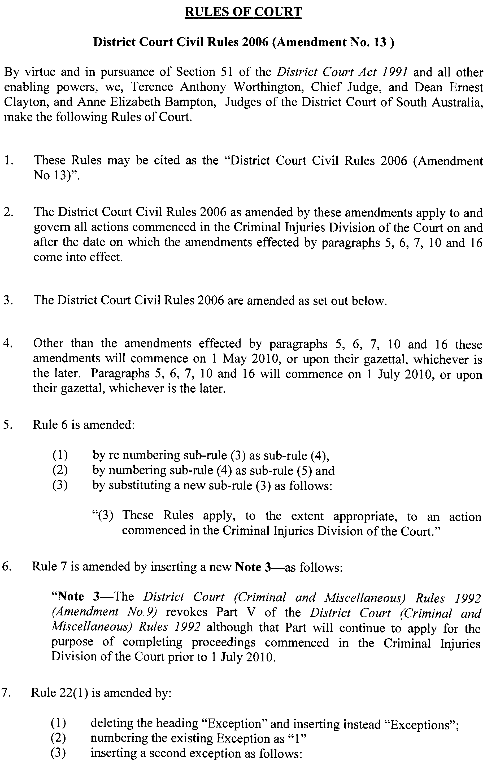
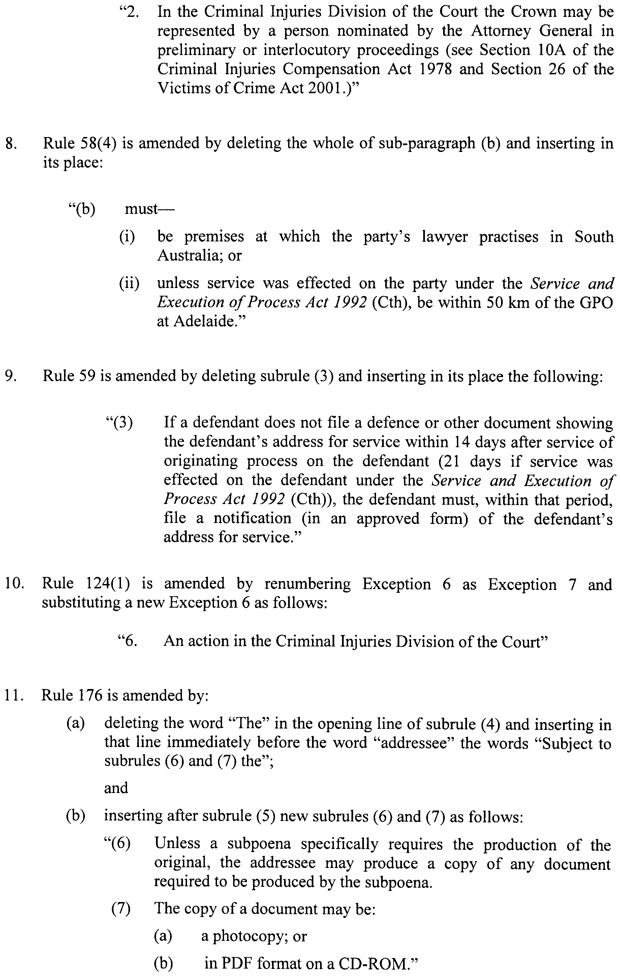
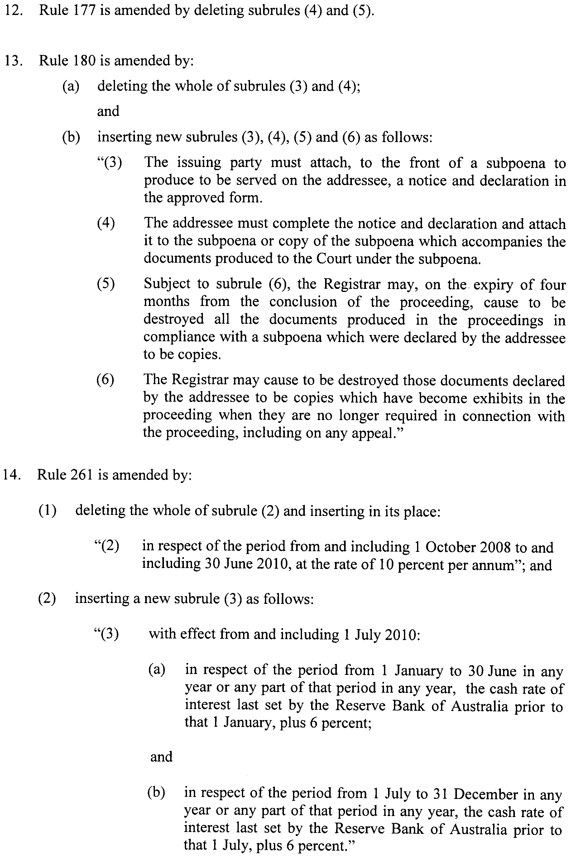
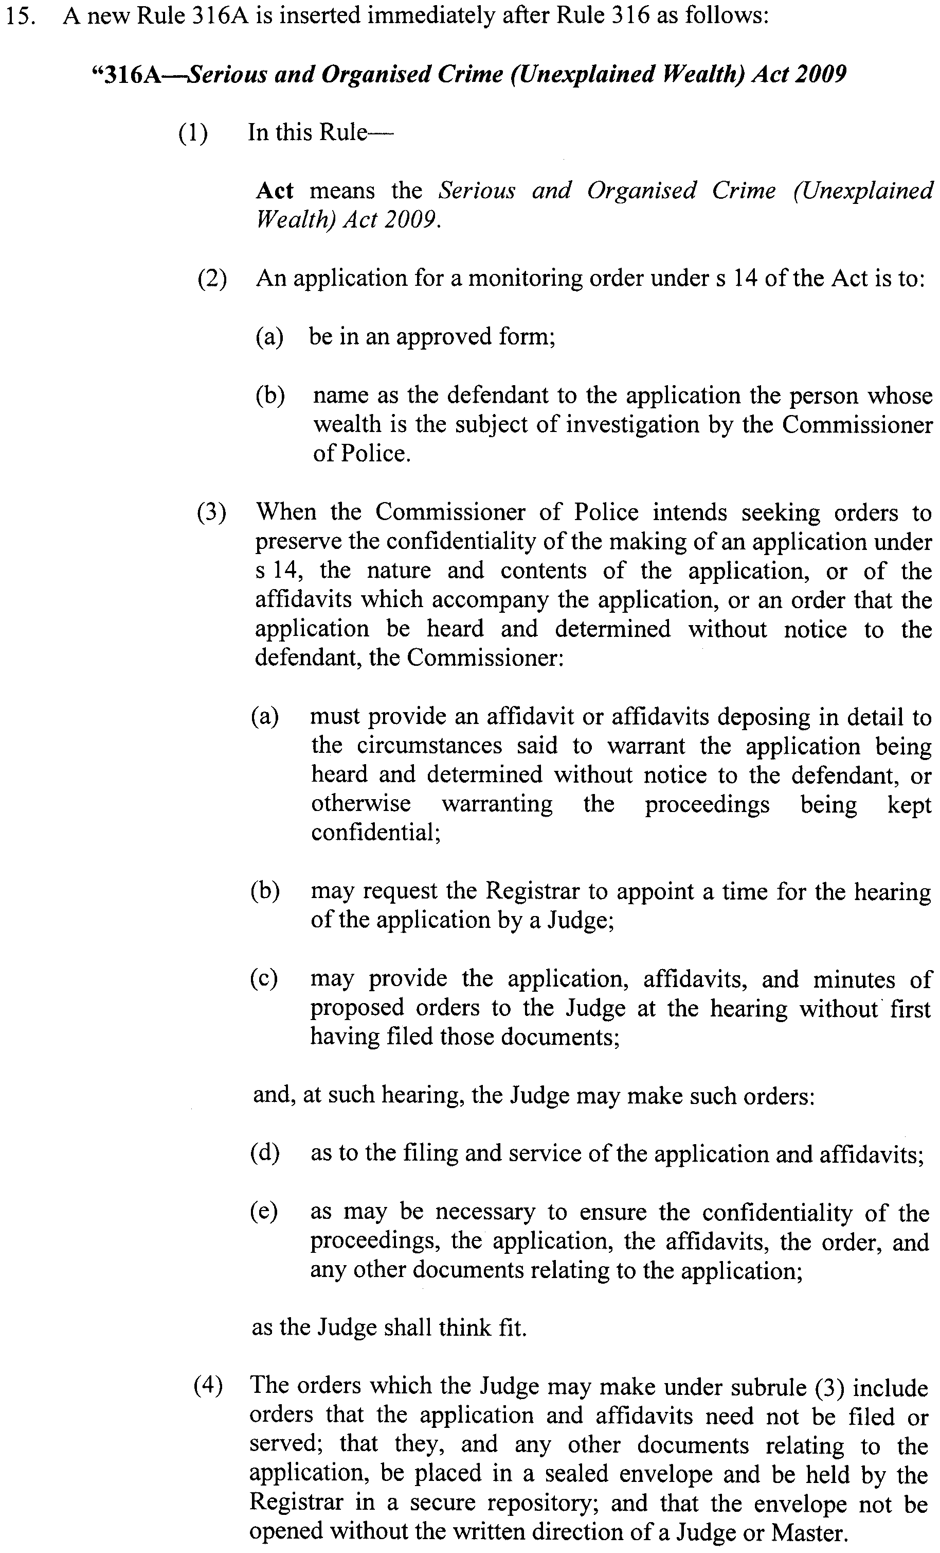
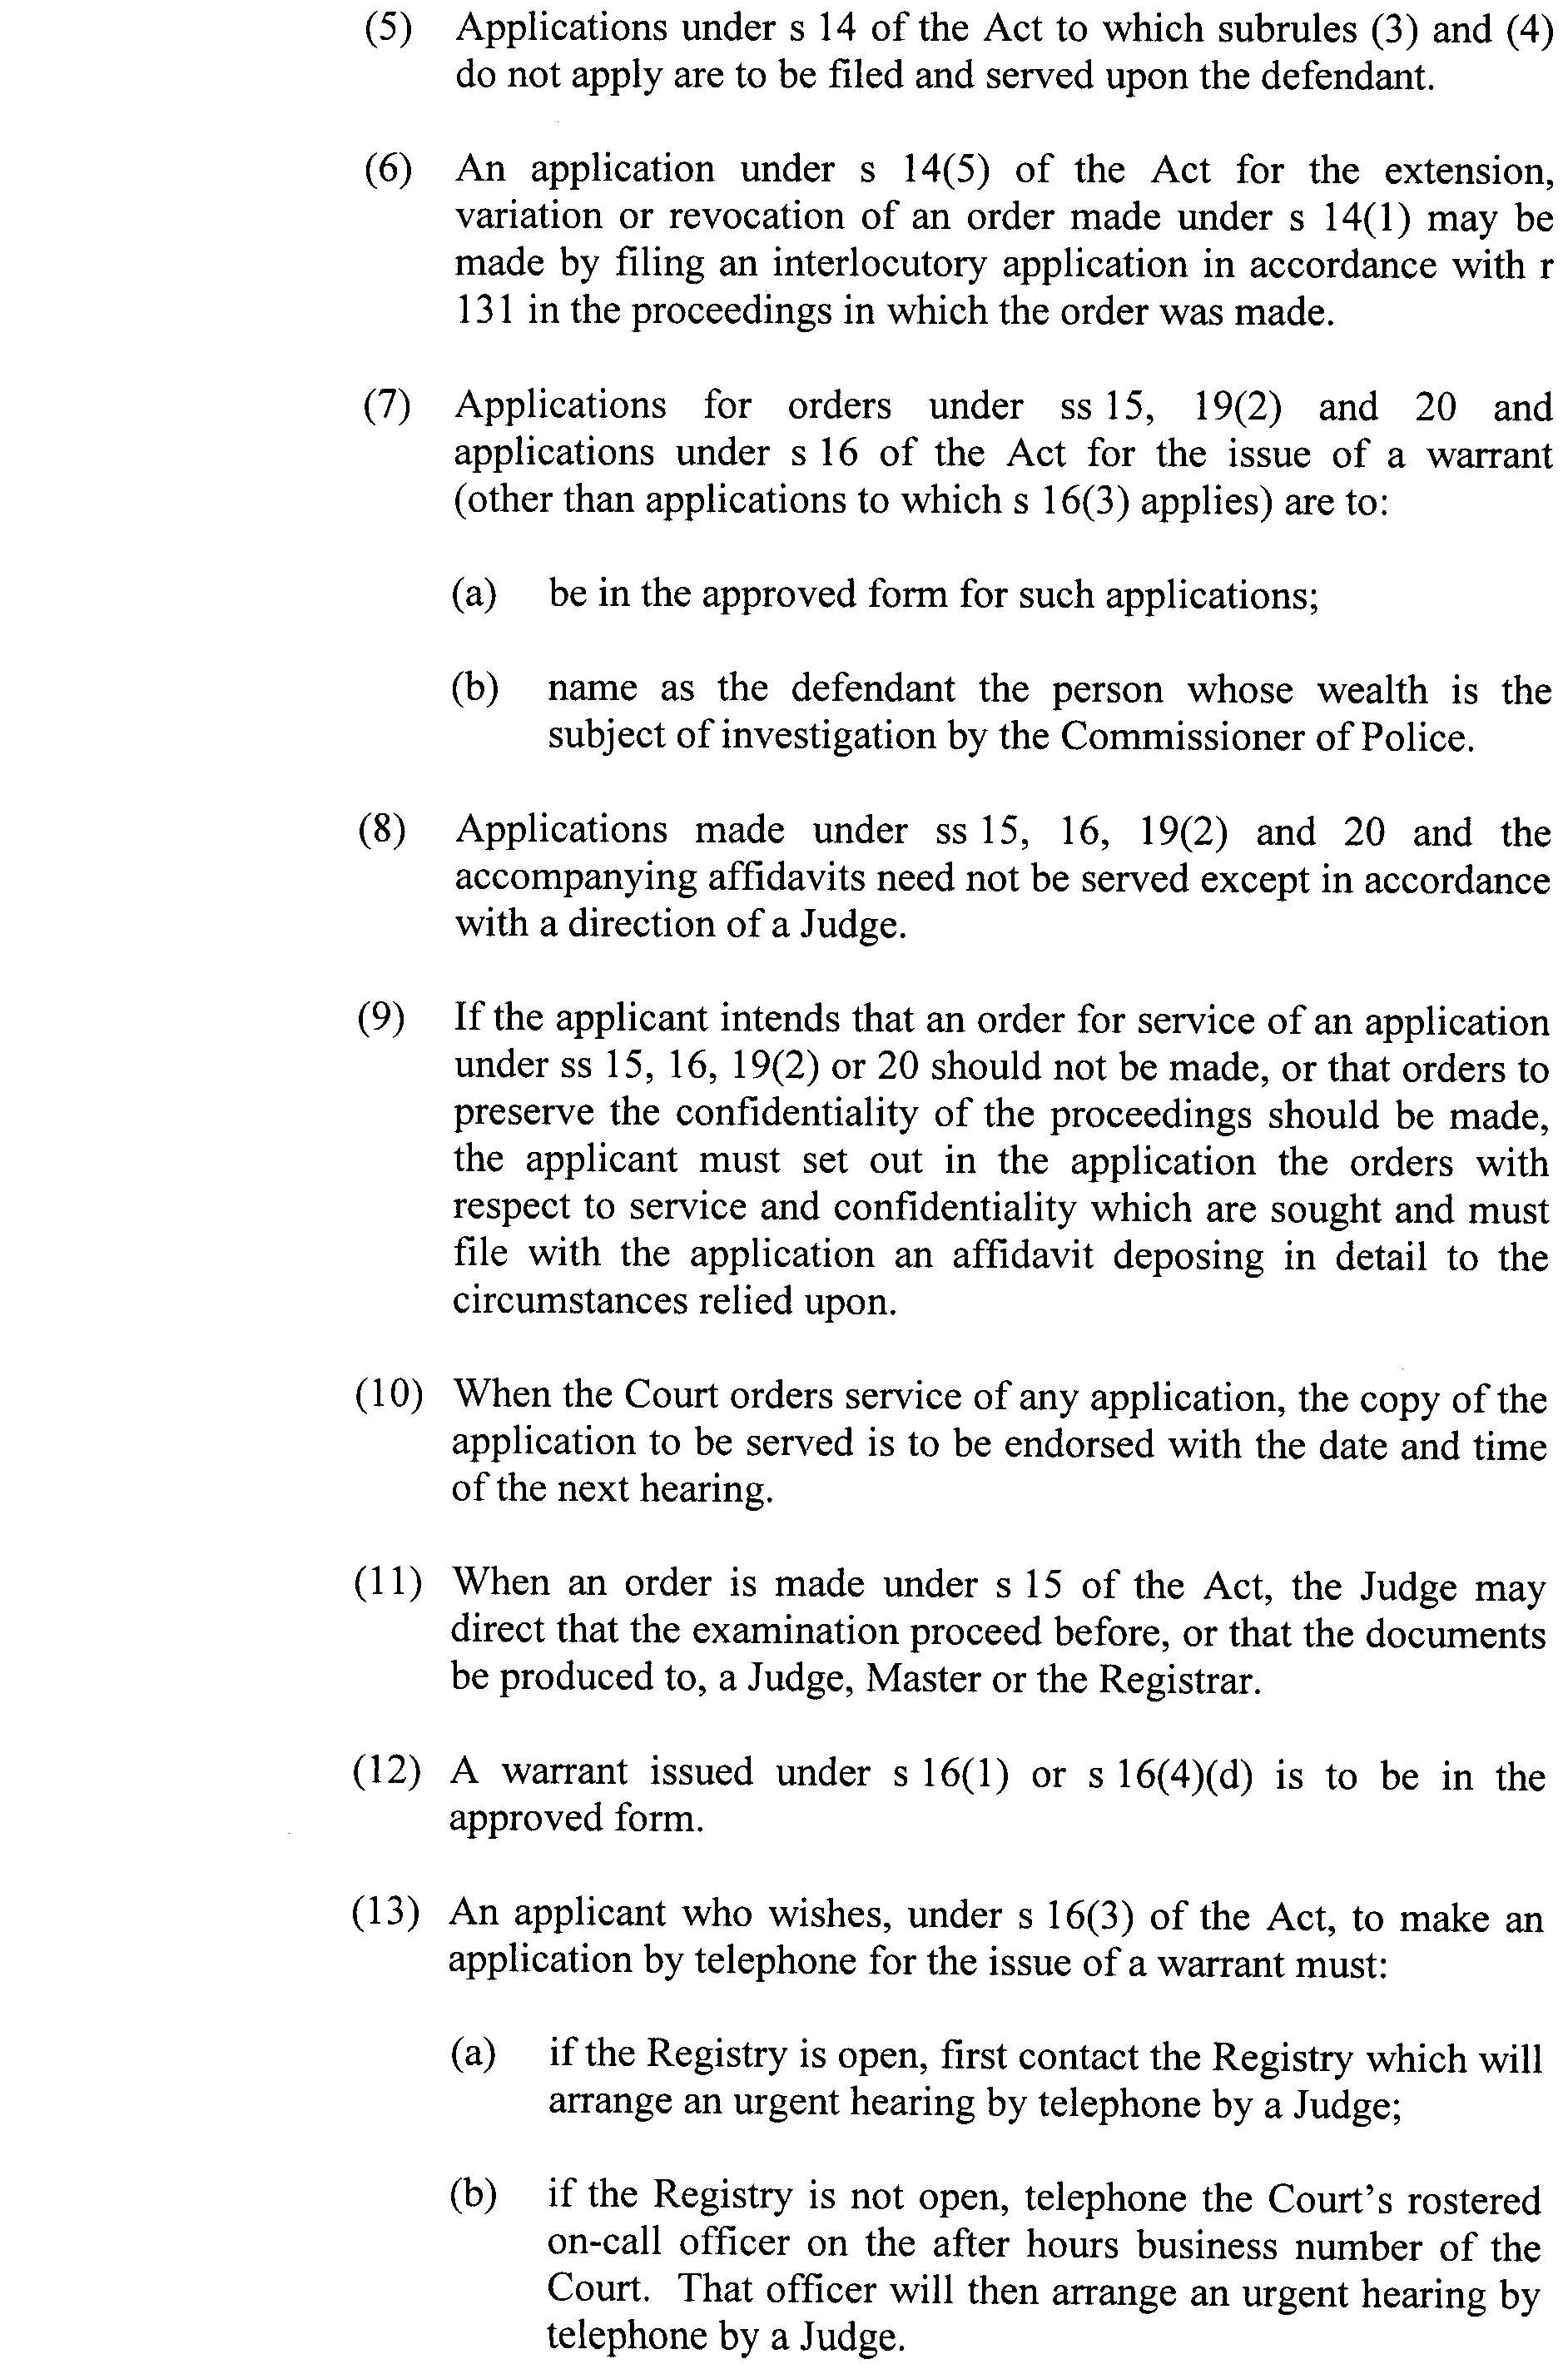
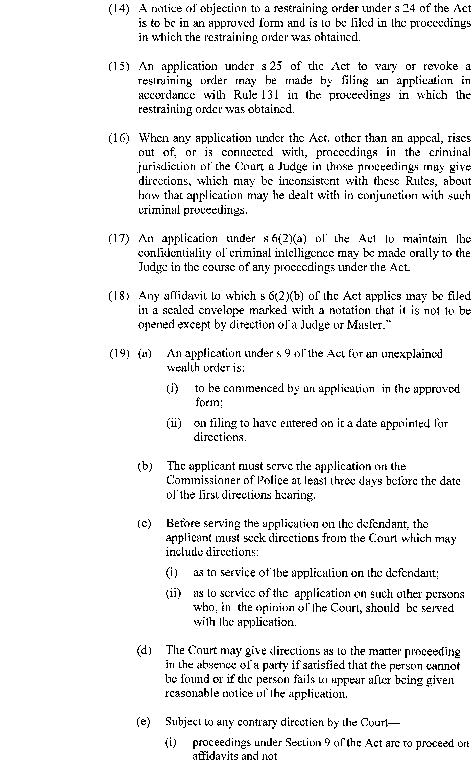
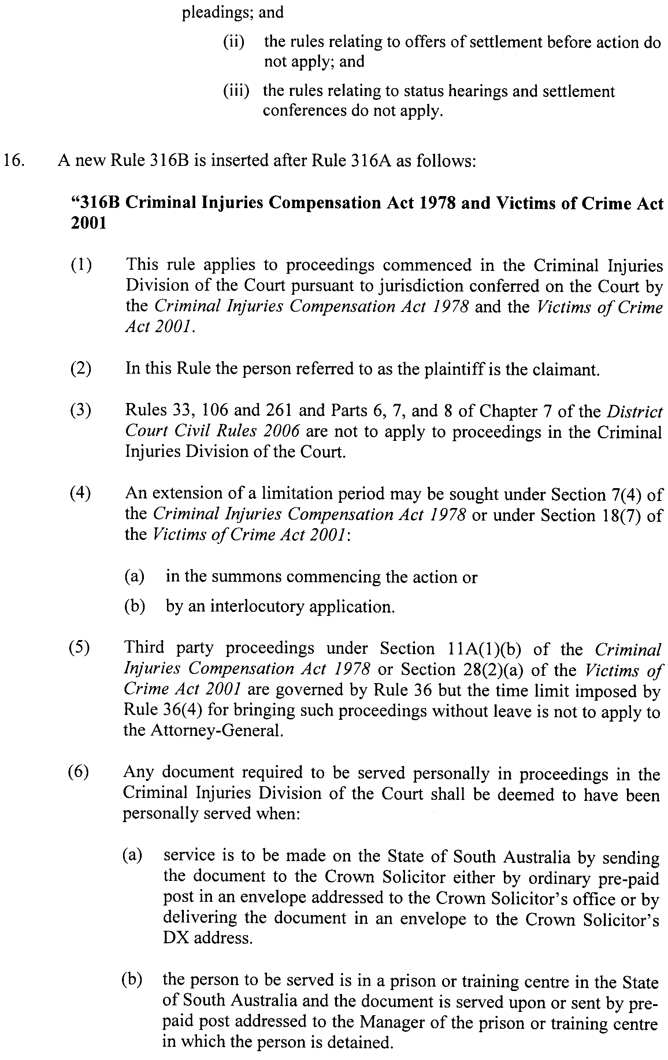

Dated 20 April 2010.
T. A. WORTHINGTON, CJ
D. E. CLAYTON, J
A. E. BAMPTON, J

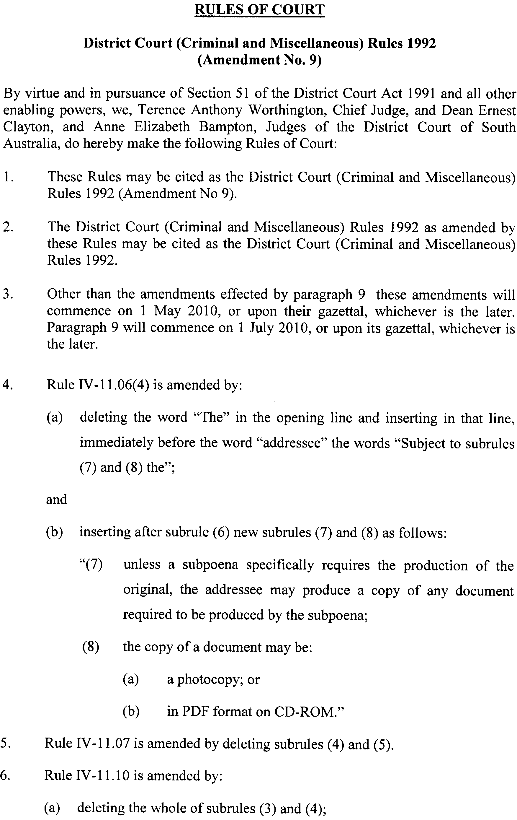
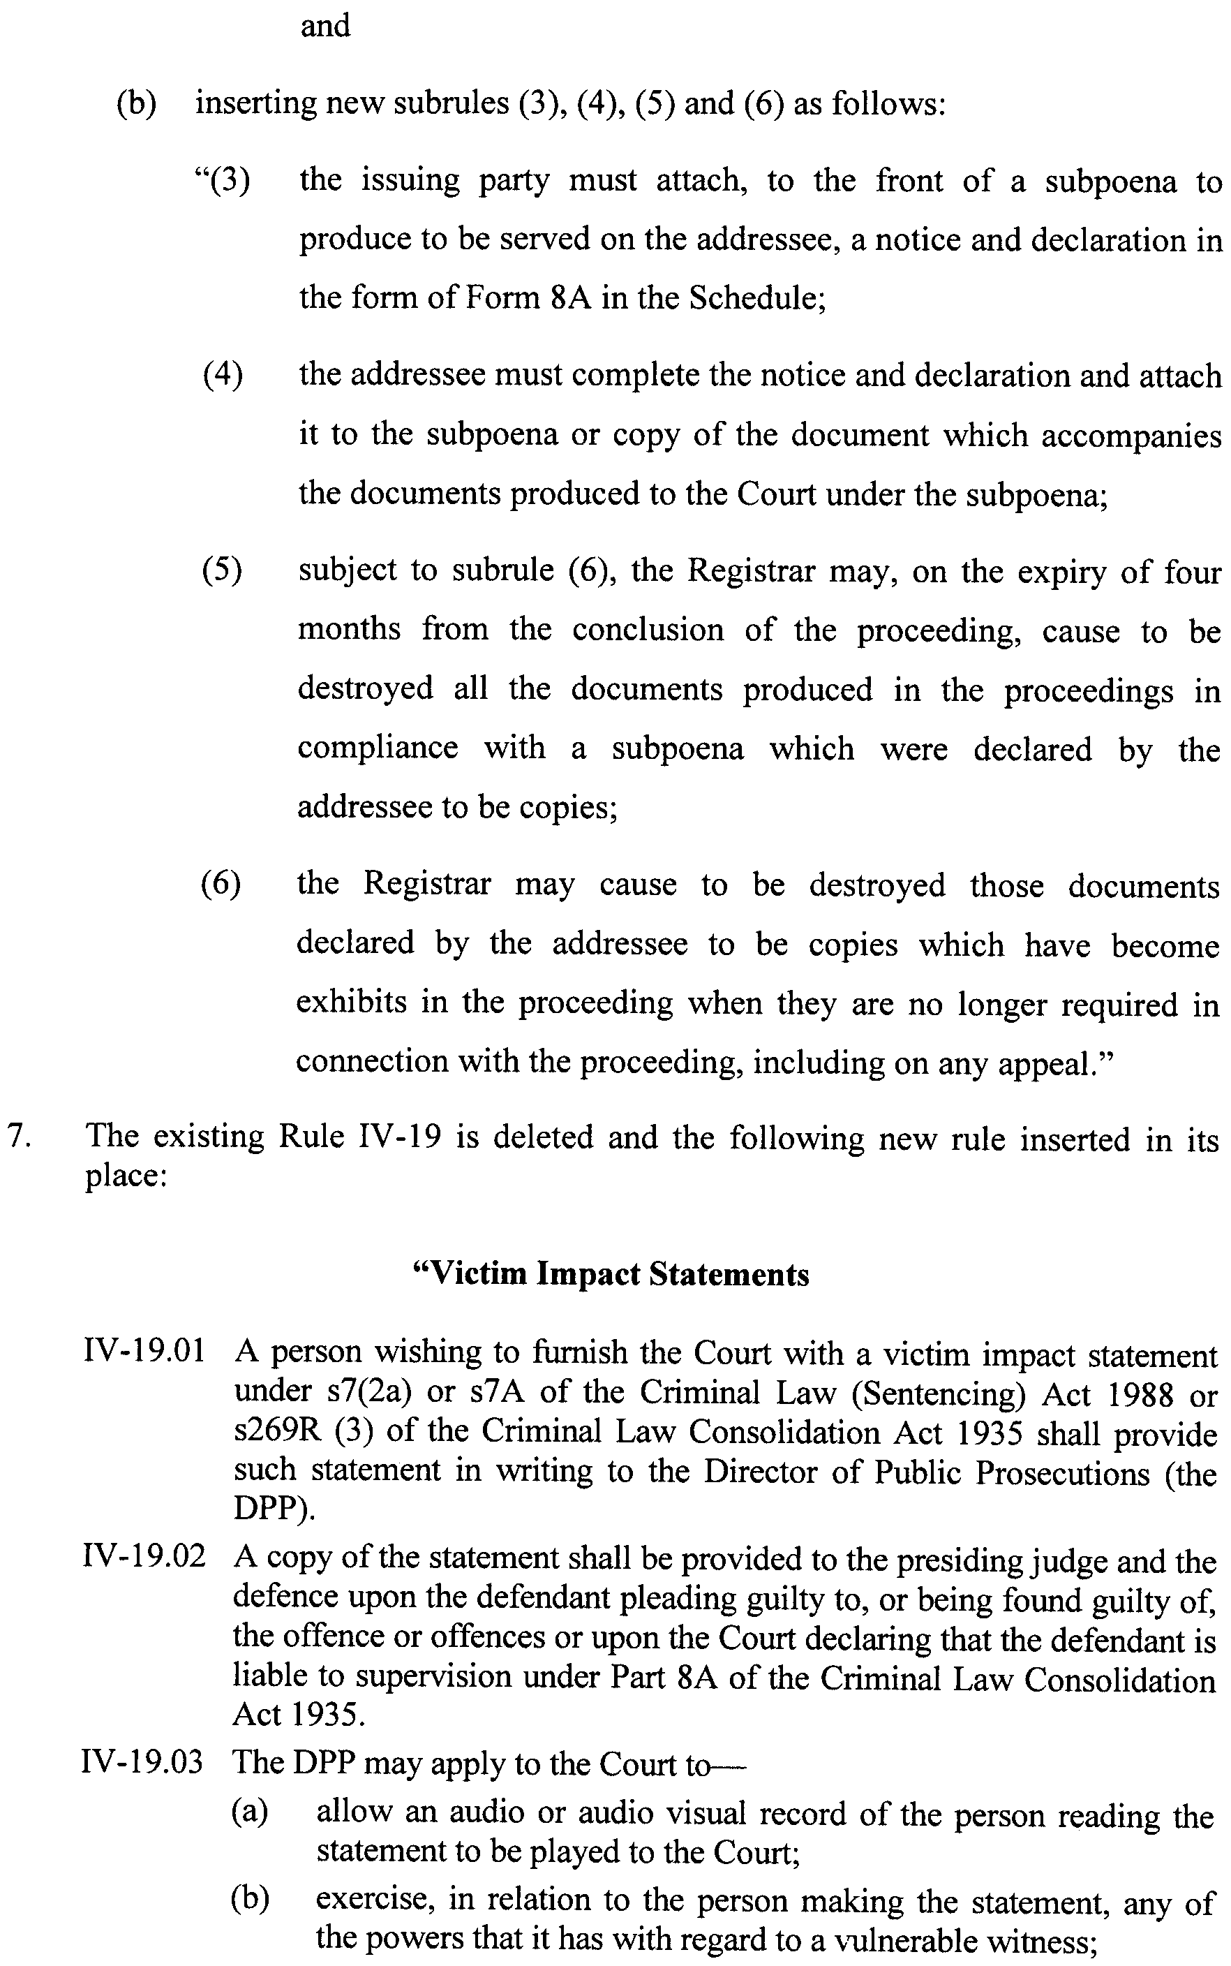
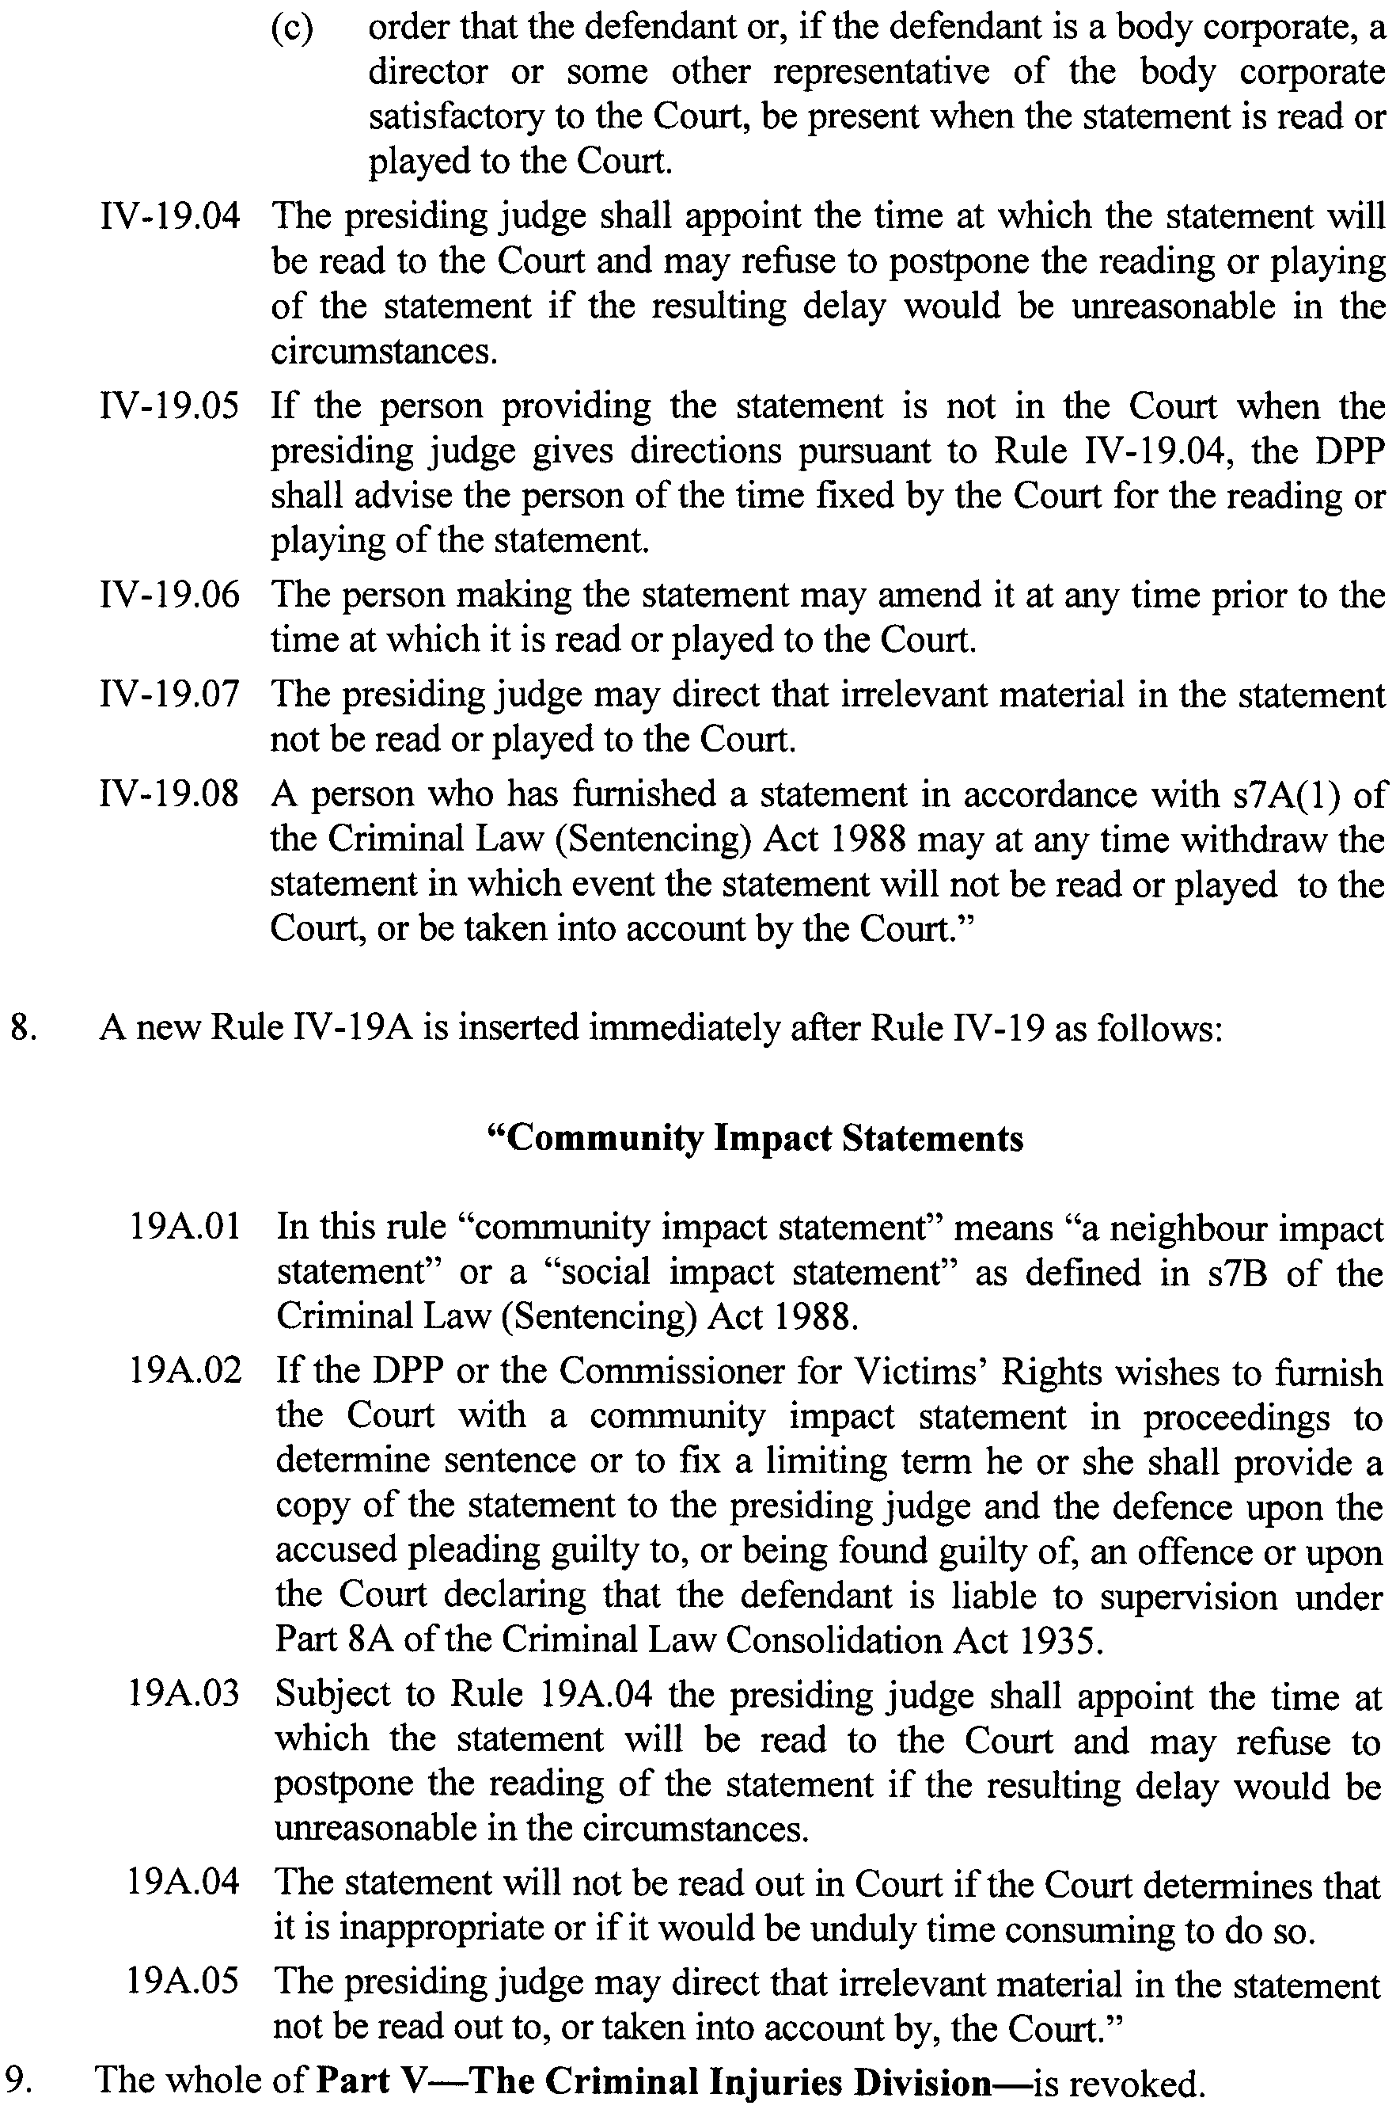
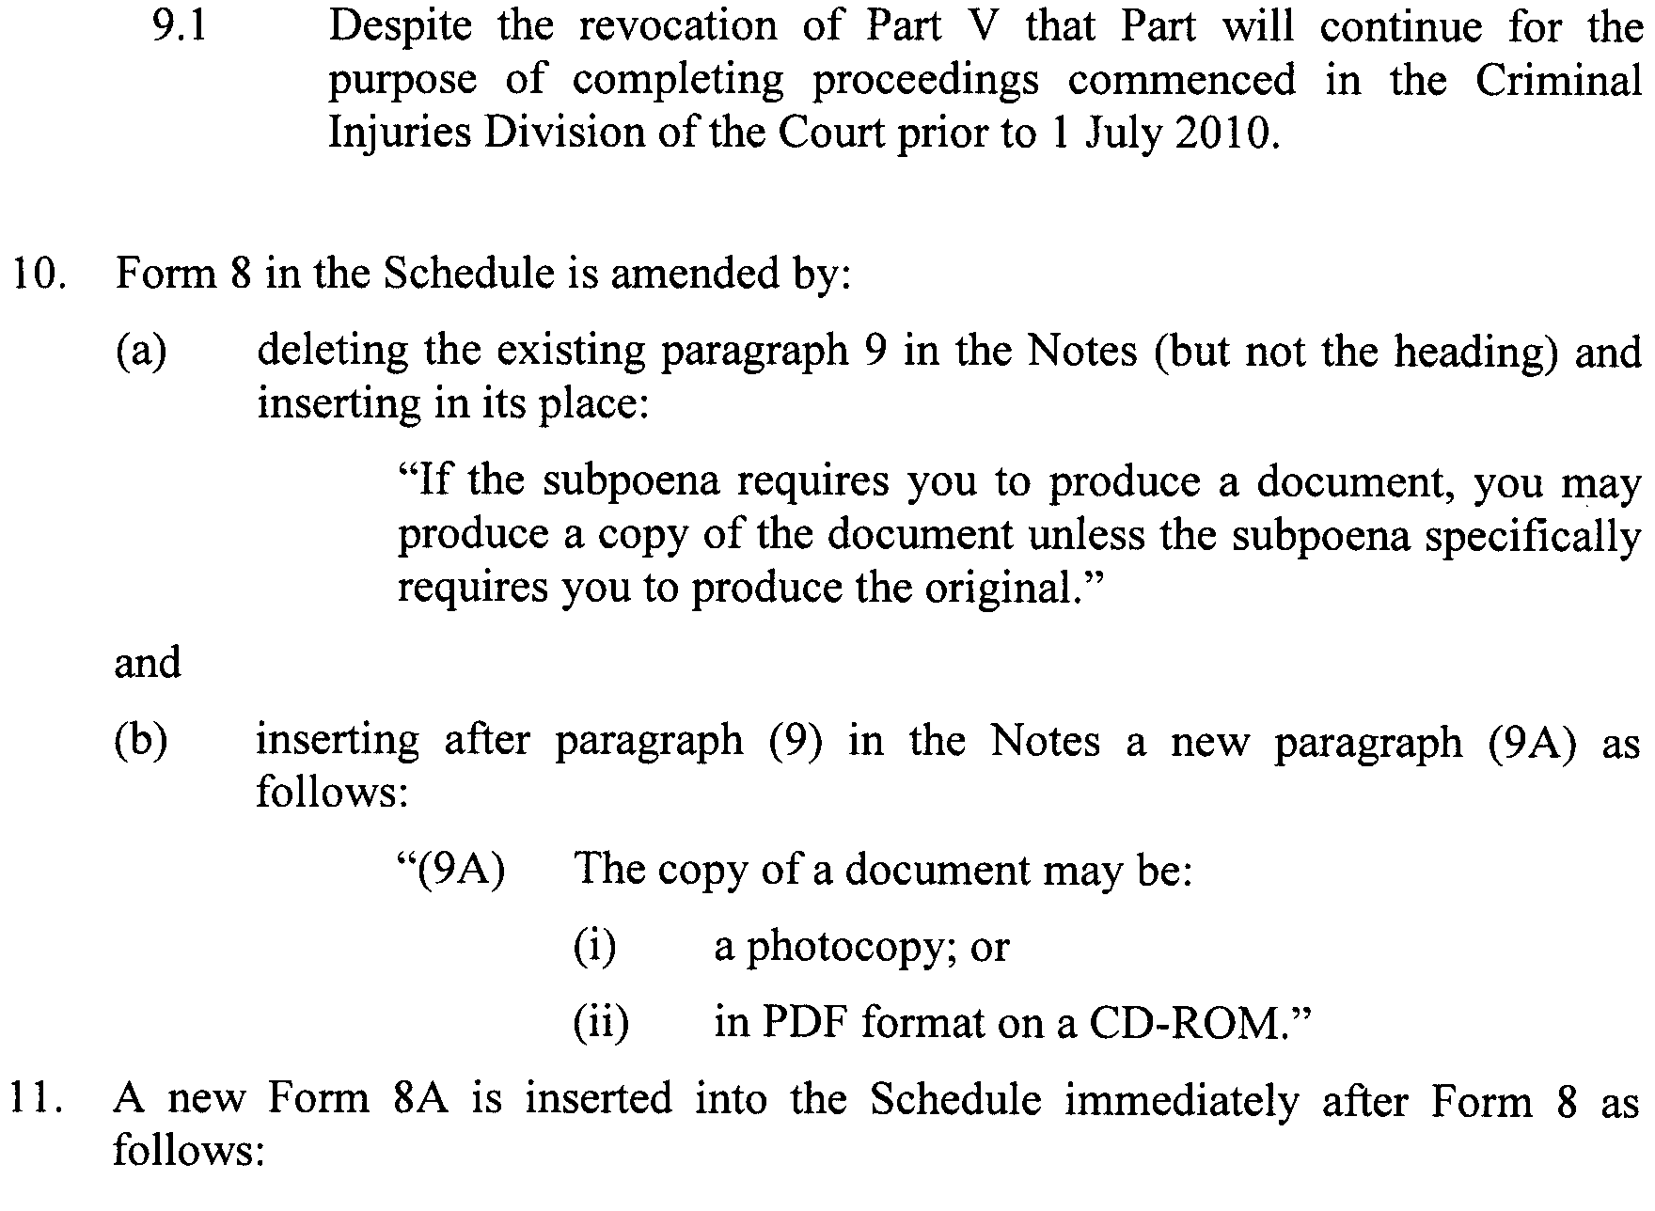
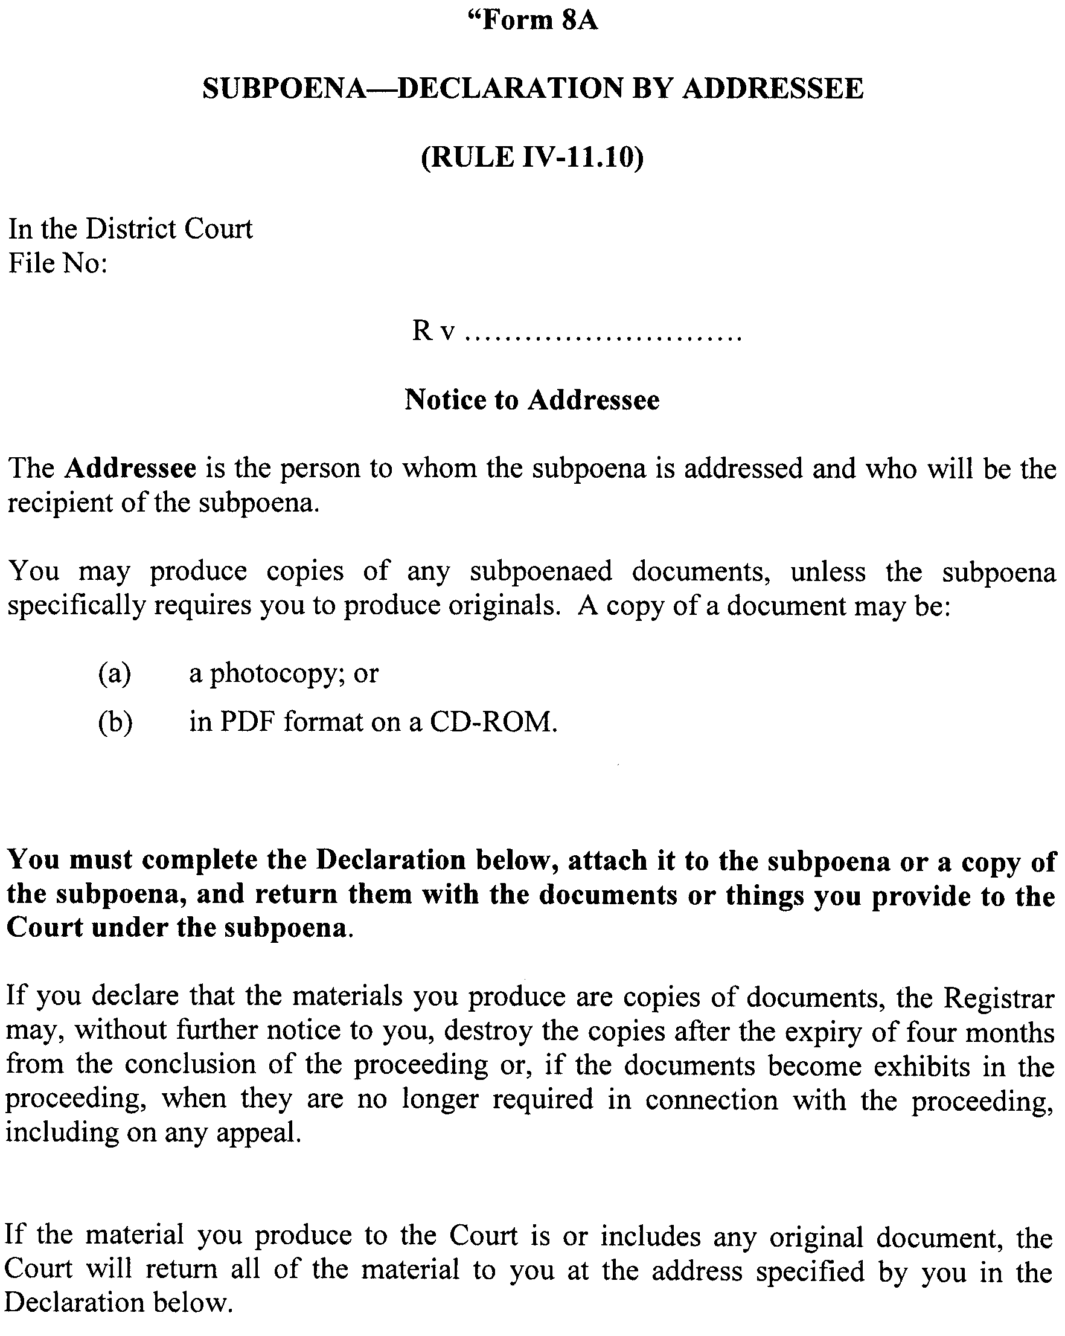
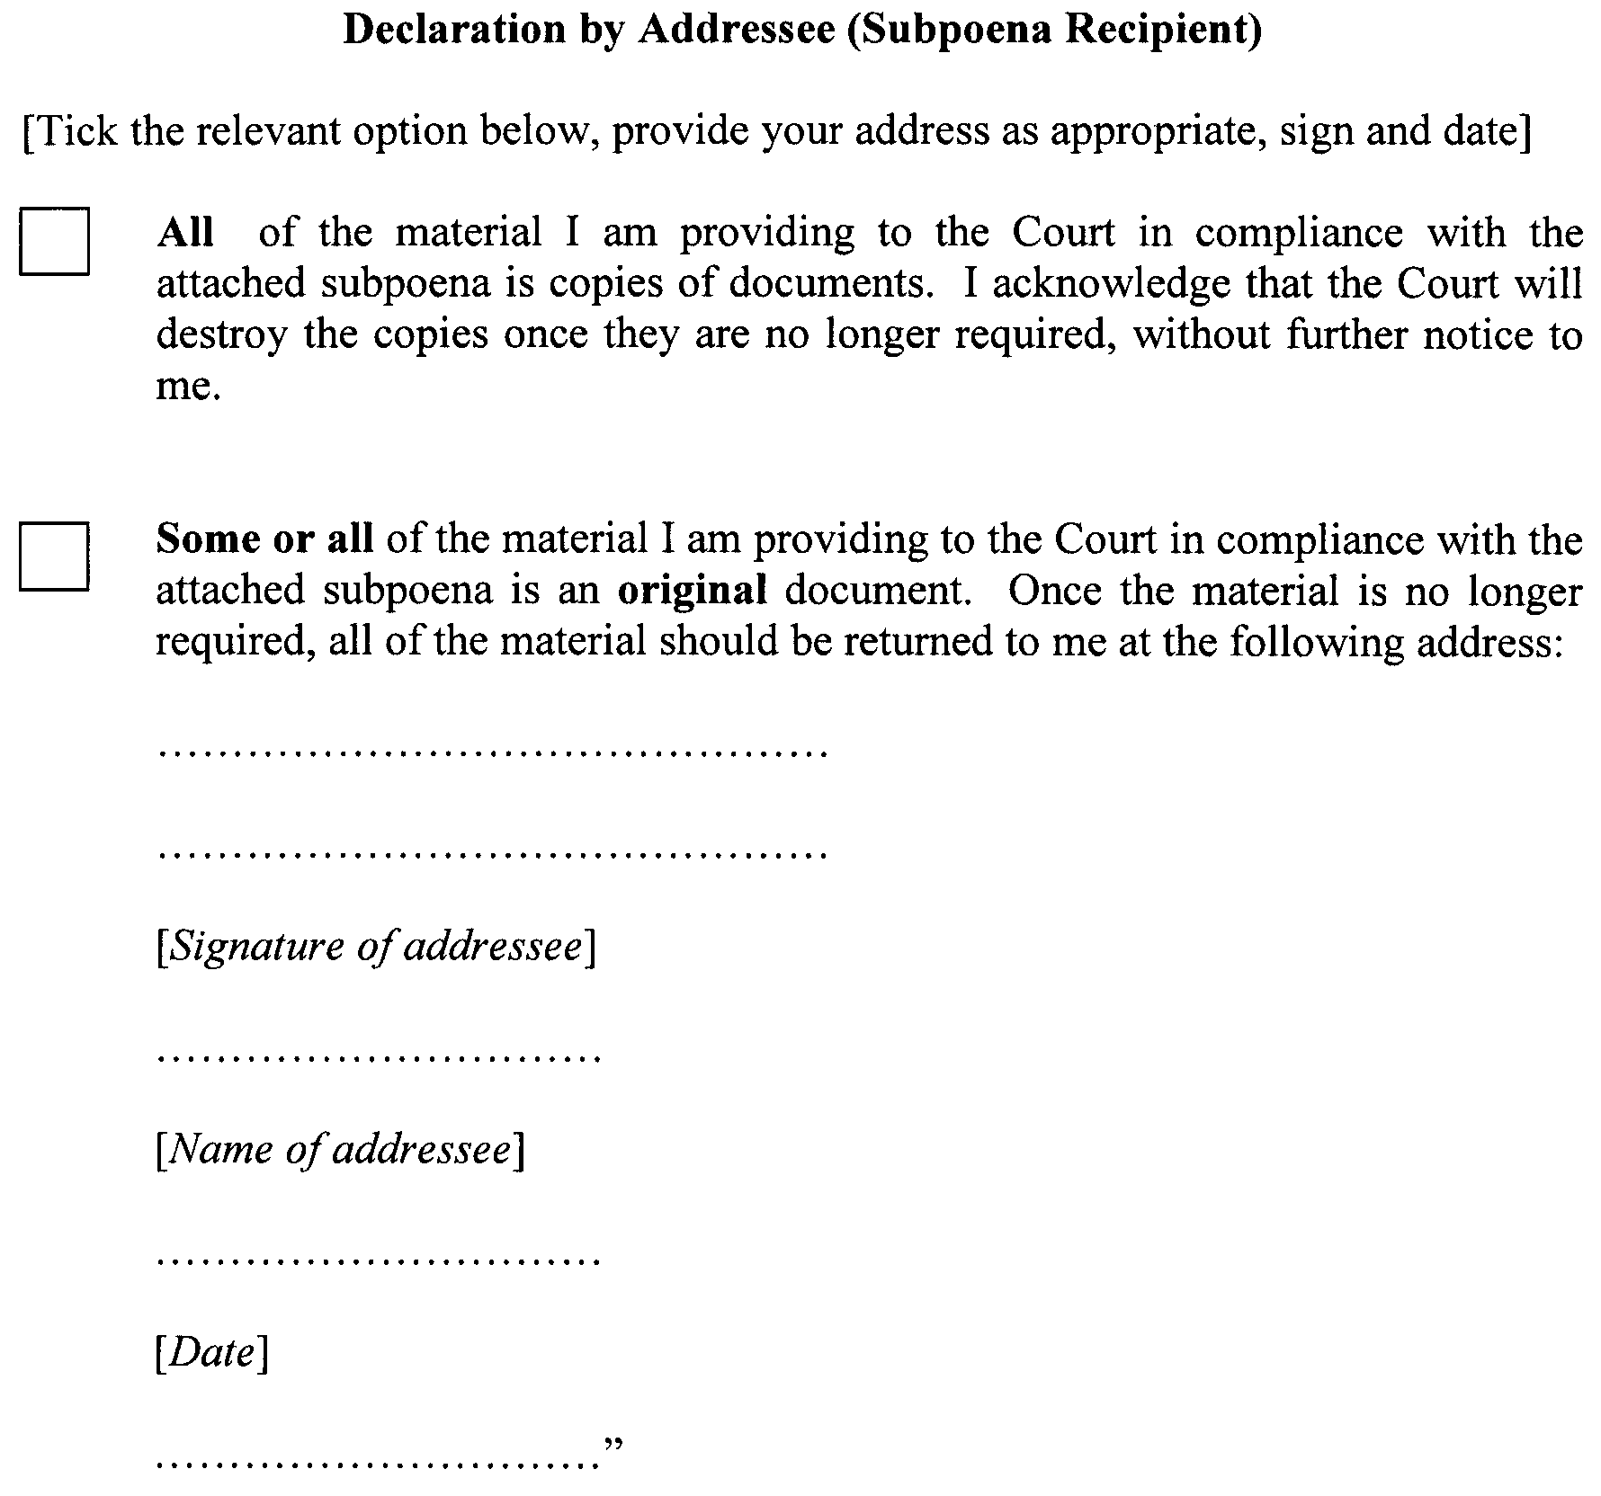

Dated 20 April 2010.
T. A. WORTHINGTON, CJ
D. E. CLAYTON, J
A. E. BAMPTON, J

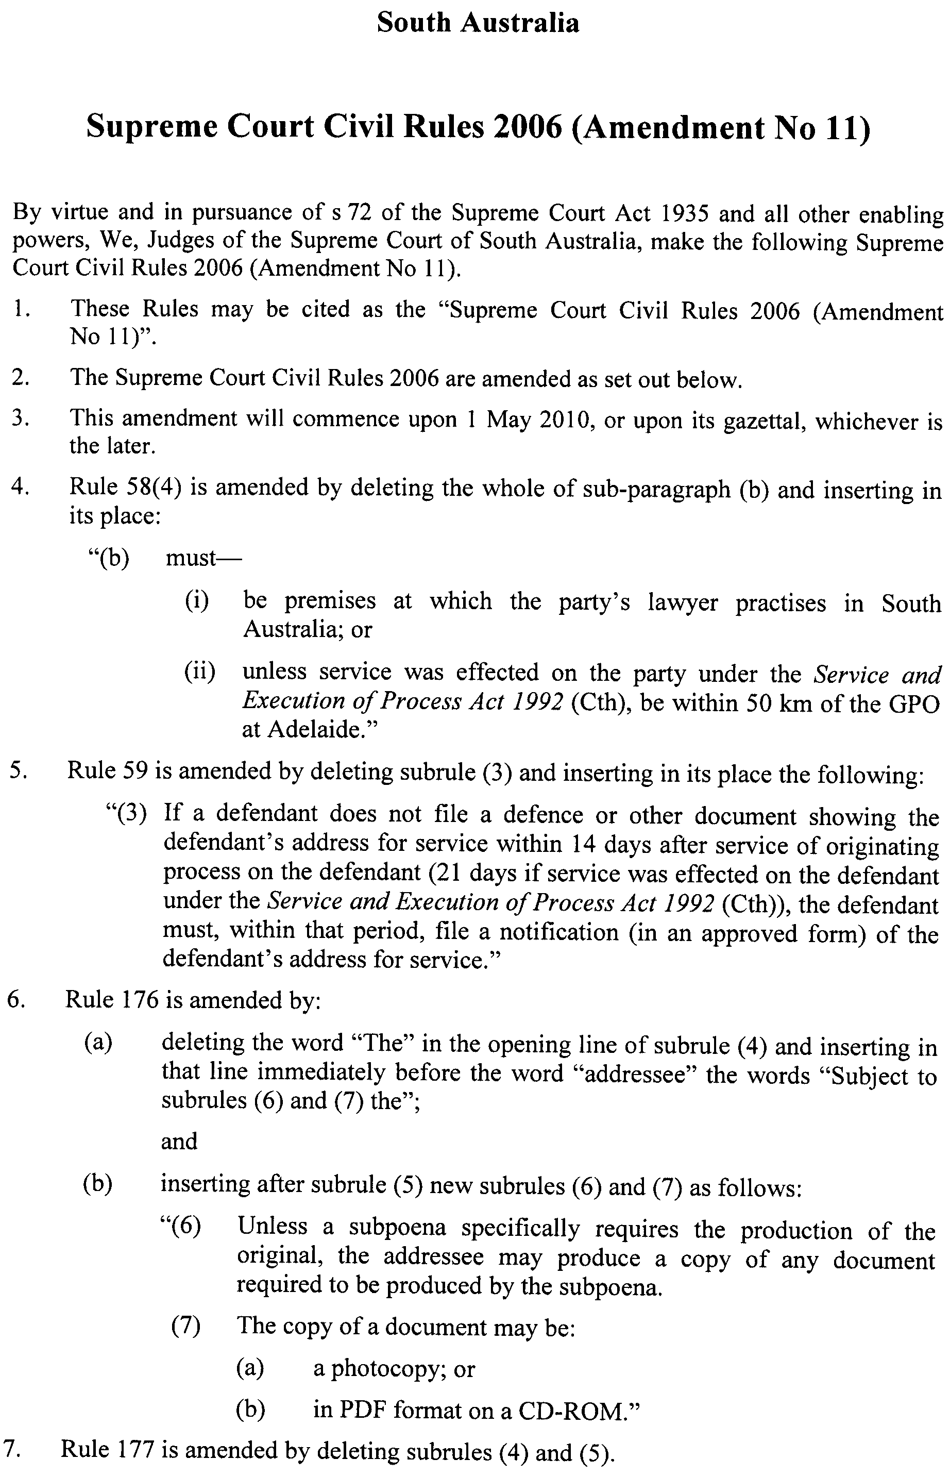
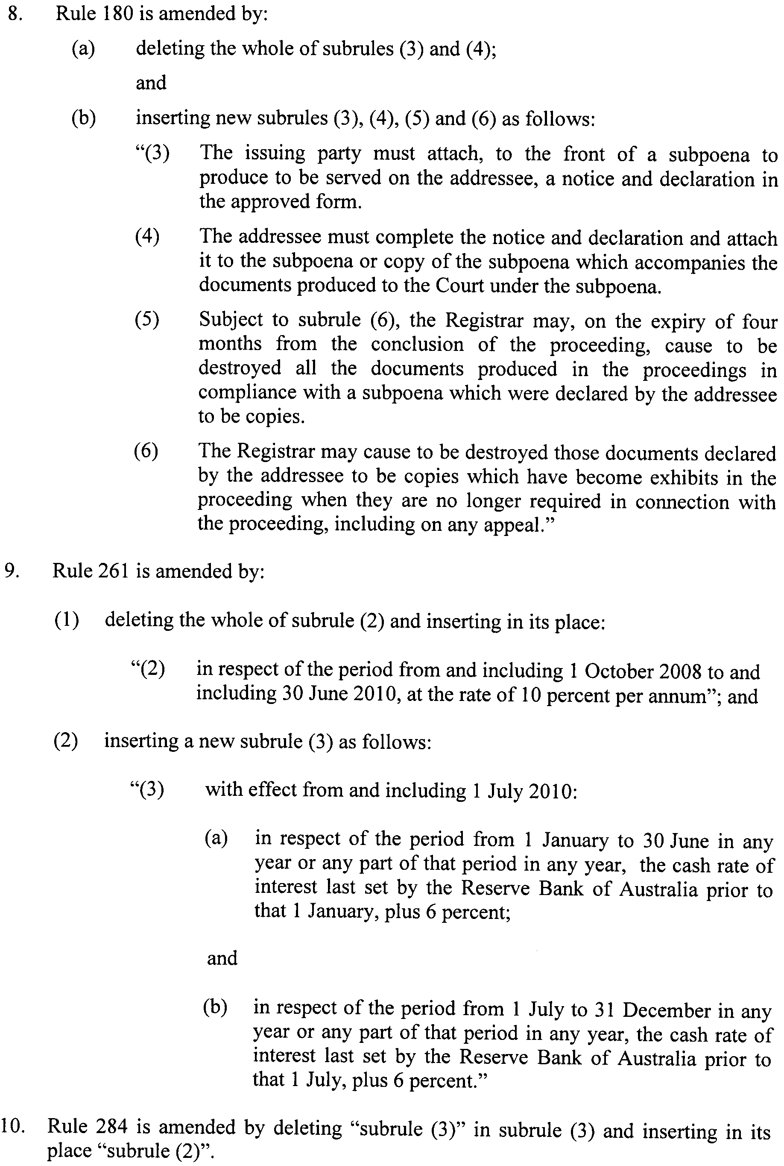
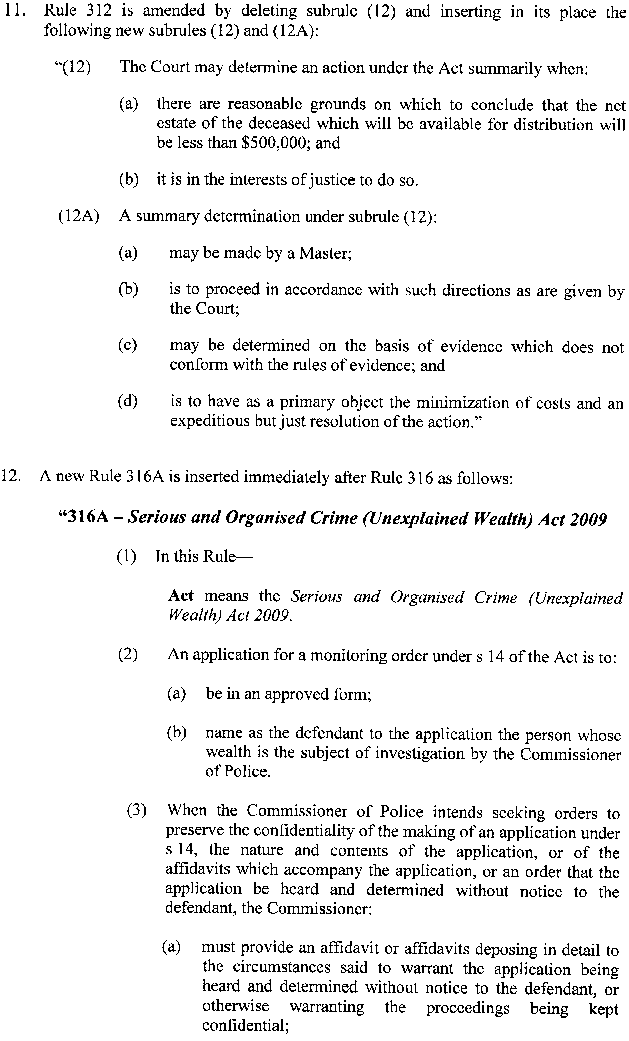
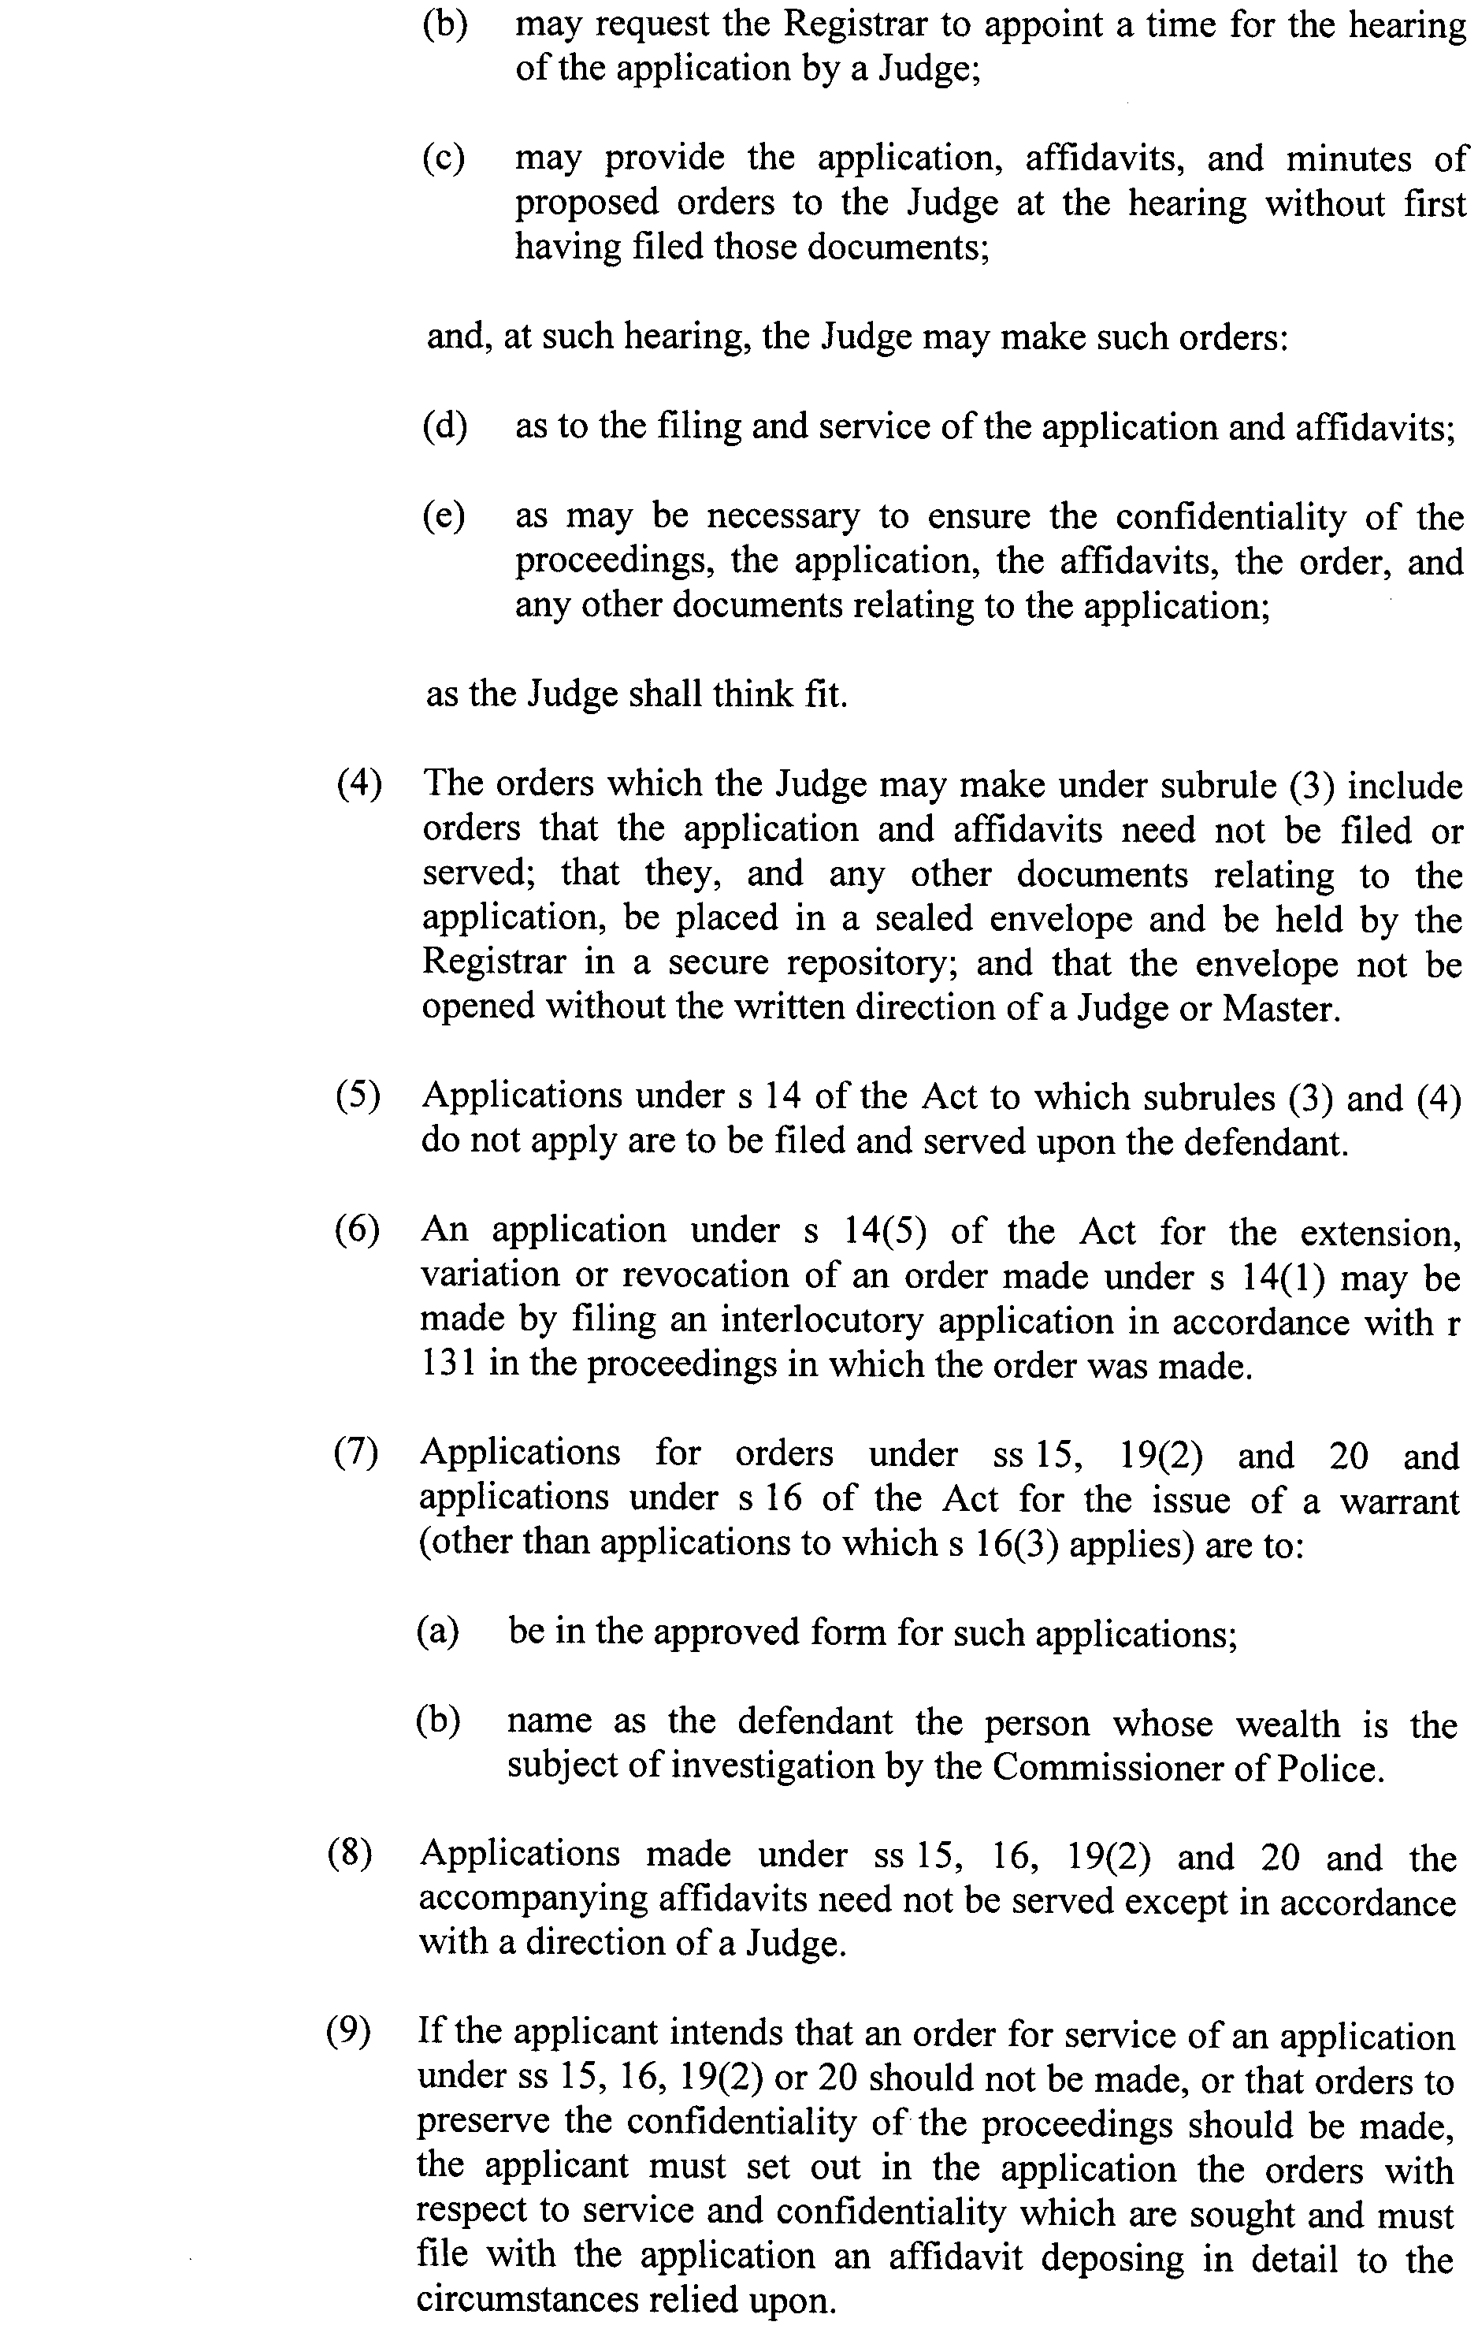
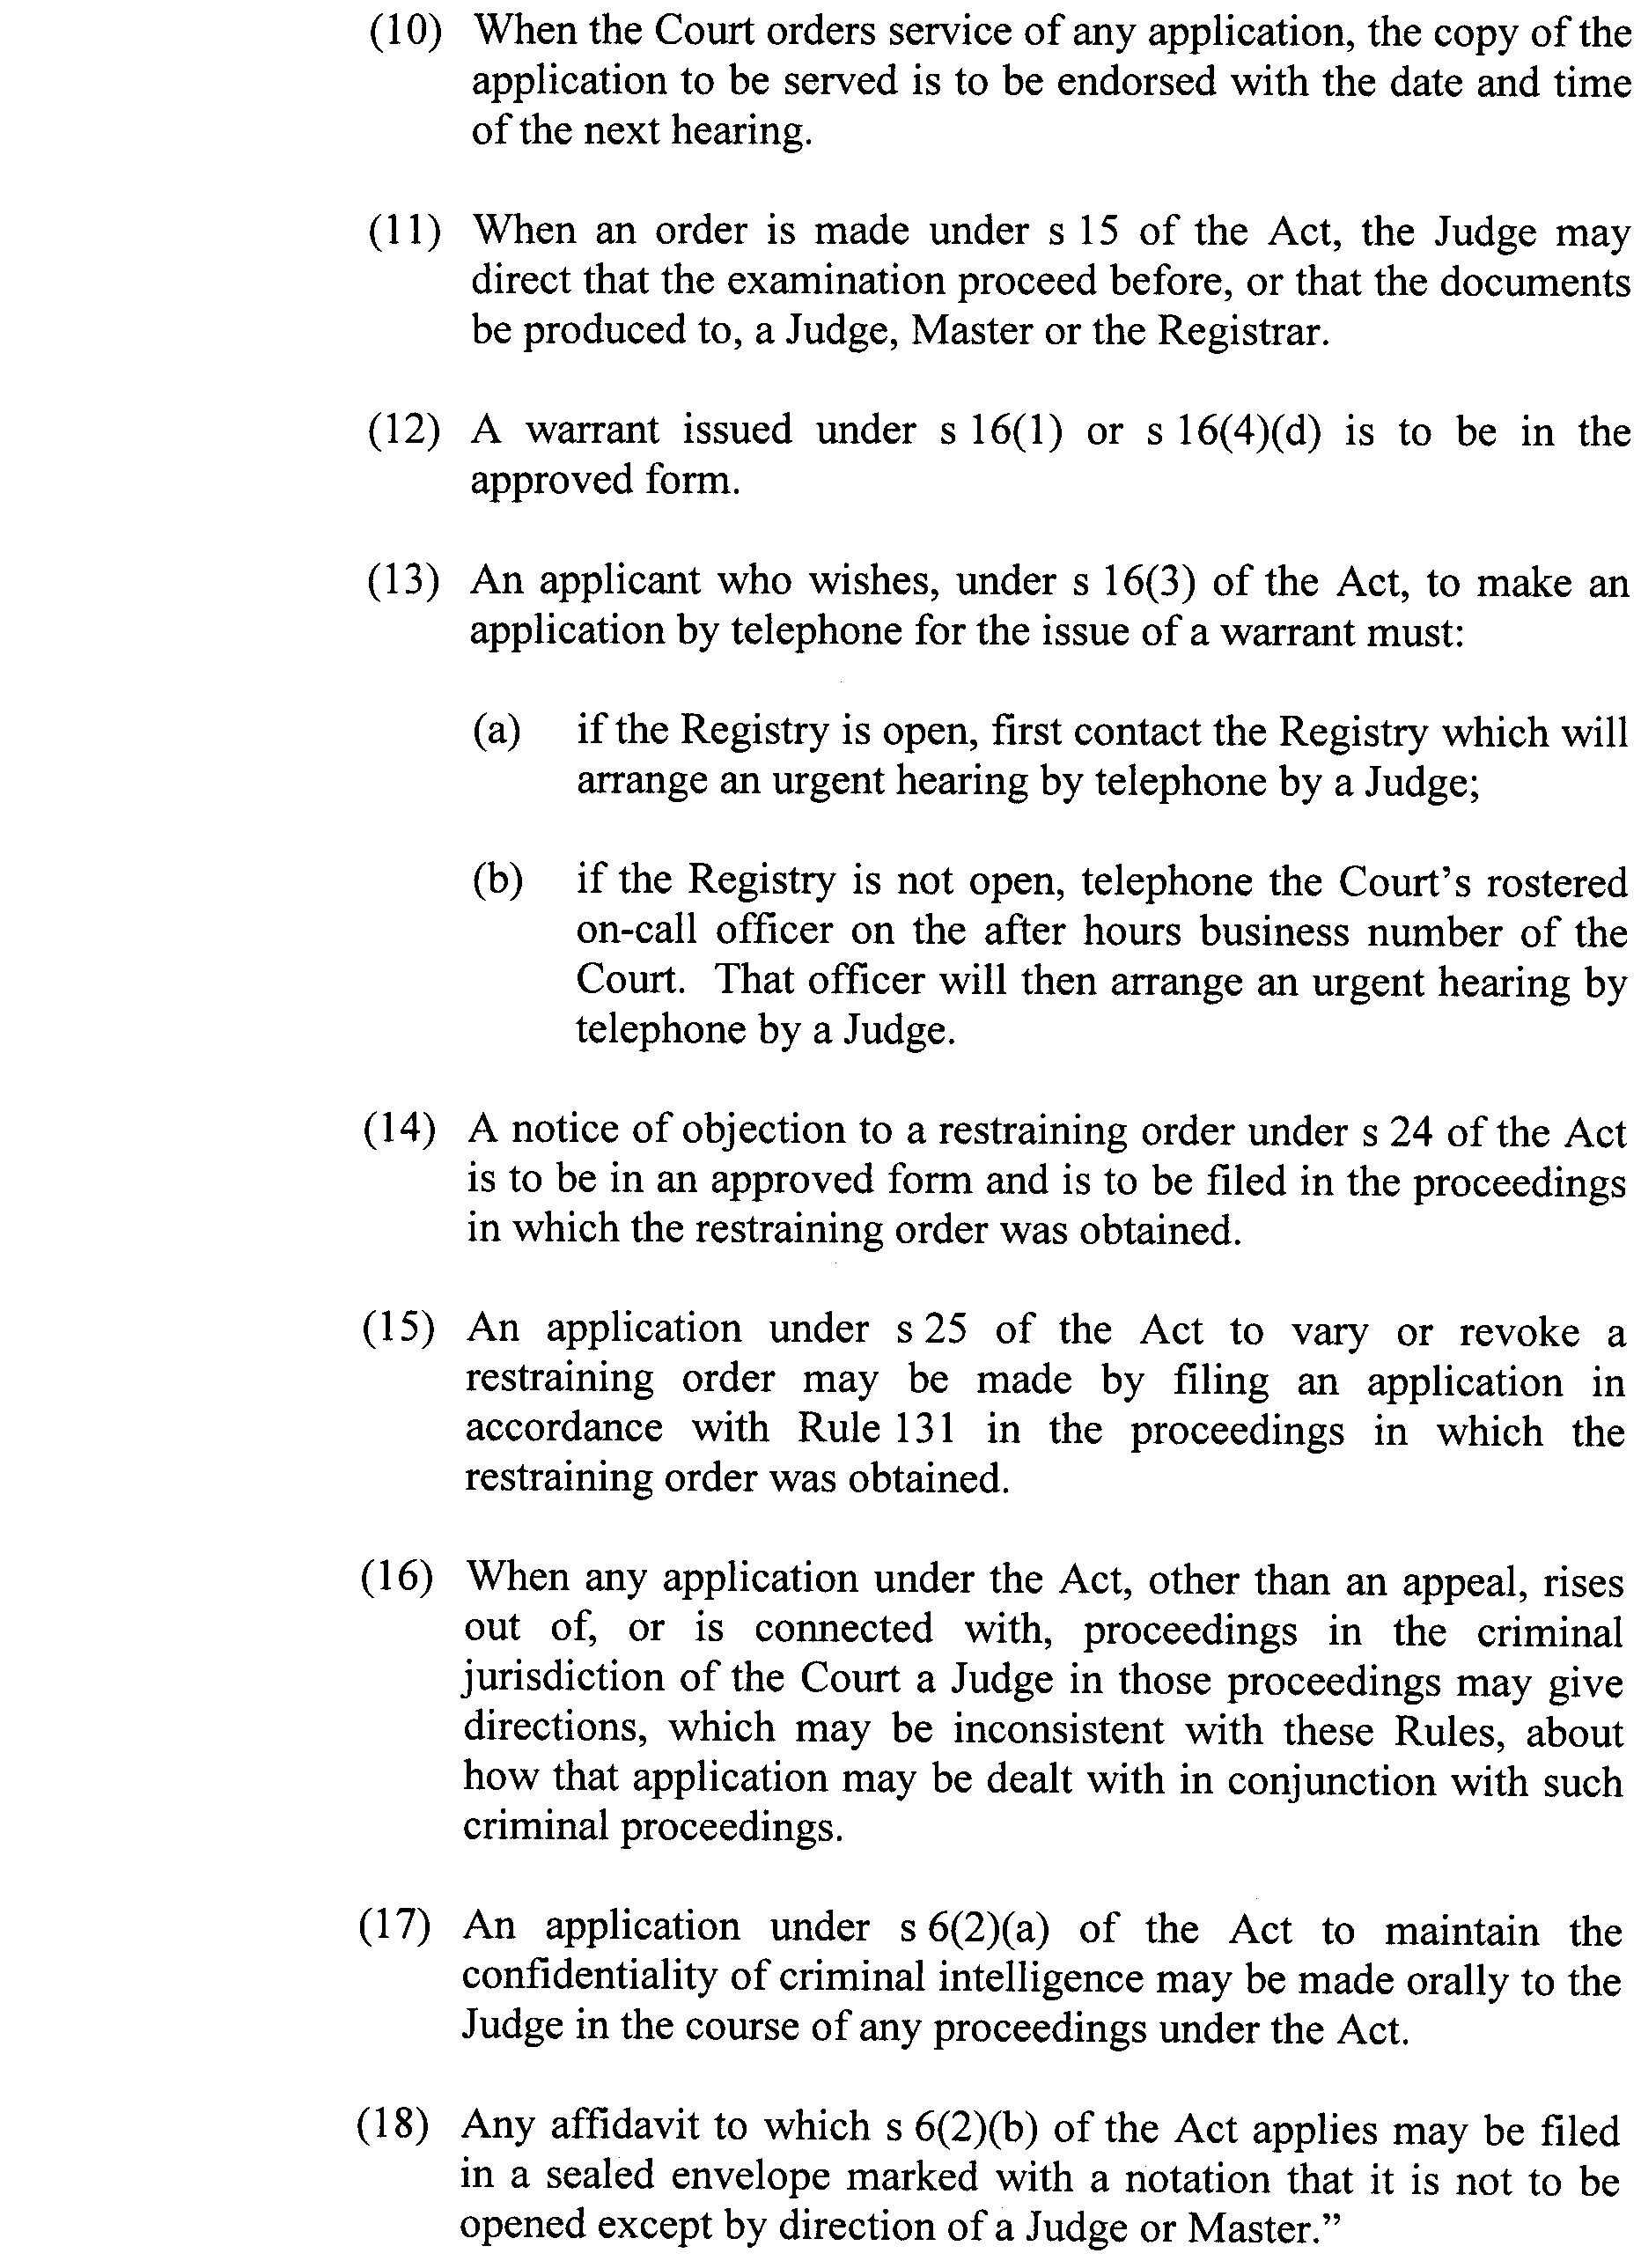
GIVEN under our hands and the Seal of the Supreme Court of South Australia this 29th day of March 2010.
K. P. DUGGAN, J
M. J. NYLAND, J
D. J. BLEBY, J
T. A. GRAY, J
J. R. SULAN, J
A. M. VANSTONE, J
T. R. ANDERSON, J
R. C. WHITE, J
R. A. LAYTON, J
P. KELLY, J
C. KOURAKIS, J

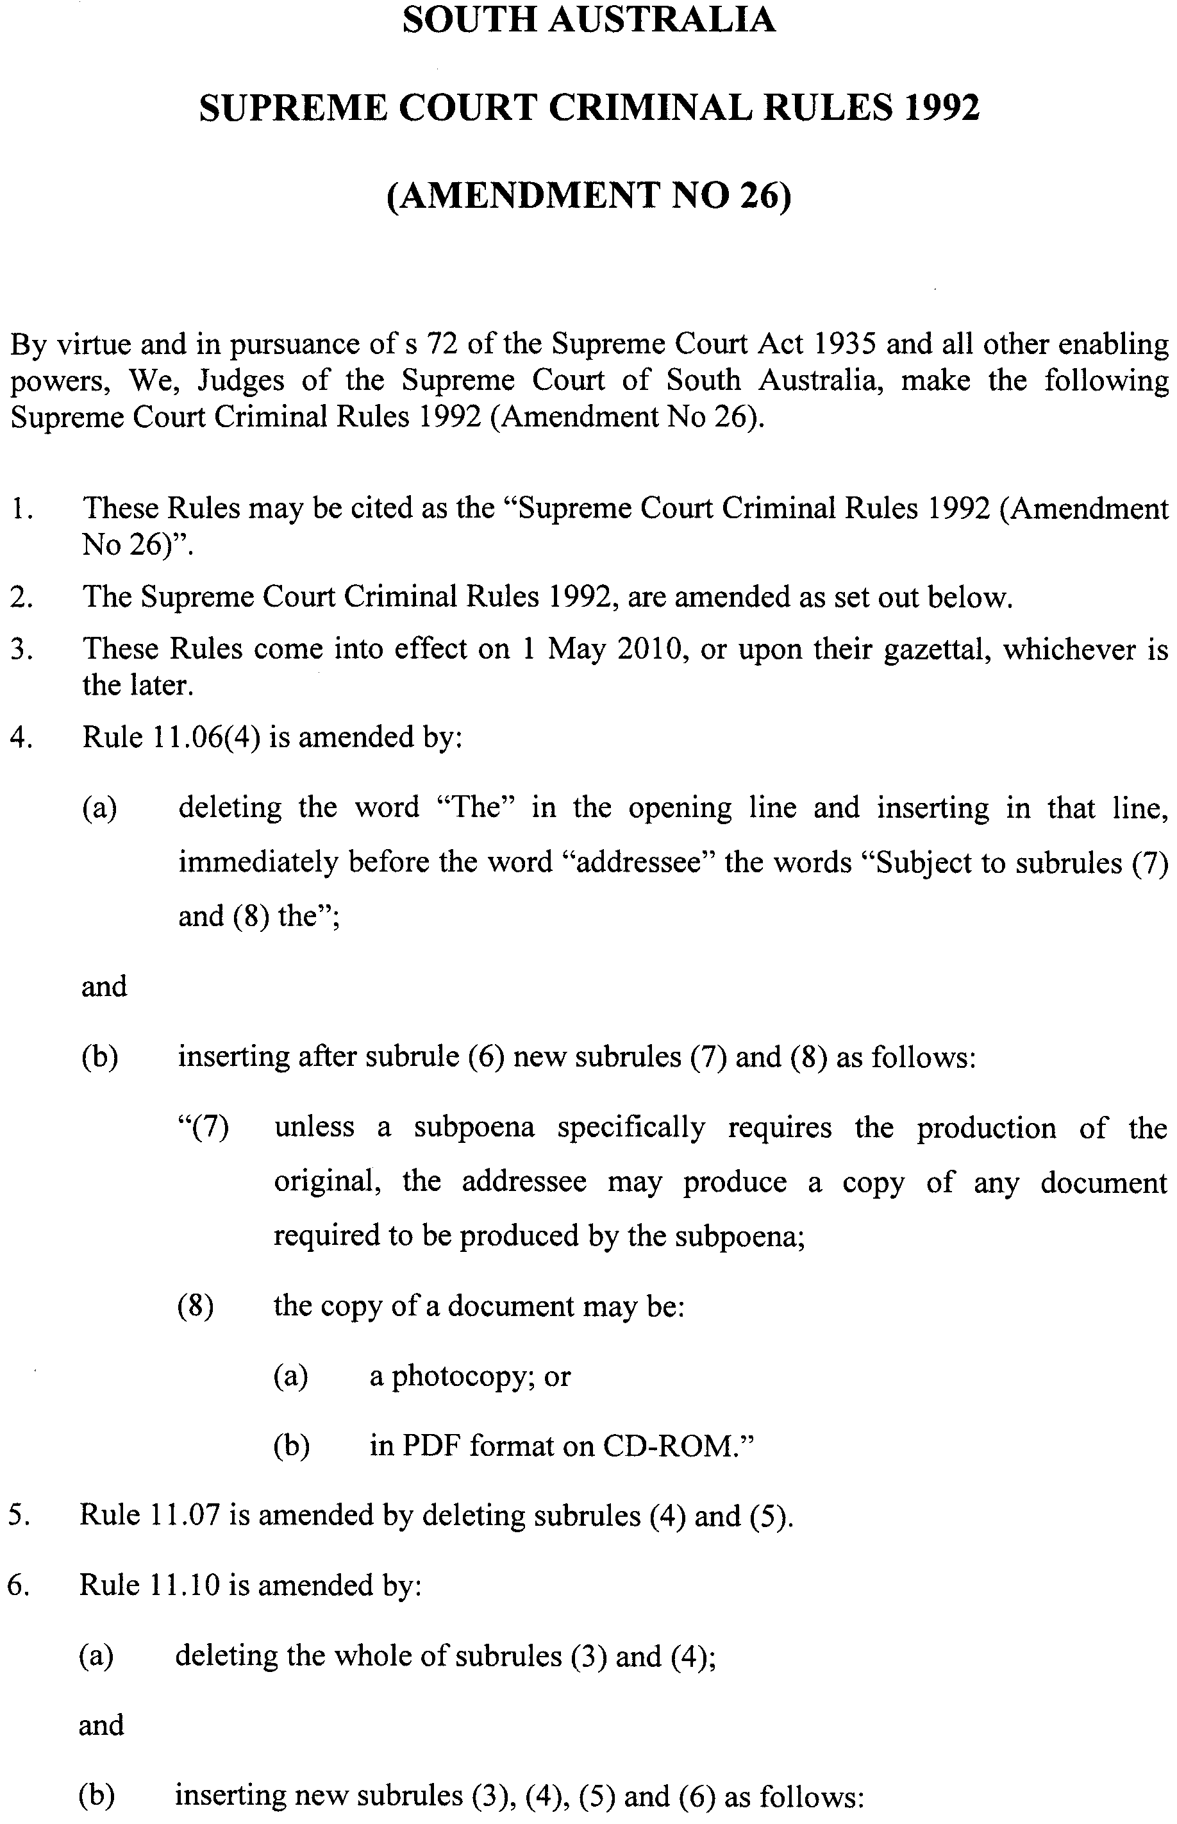
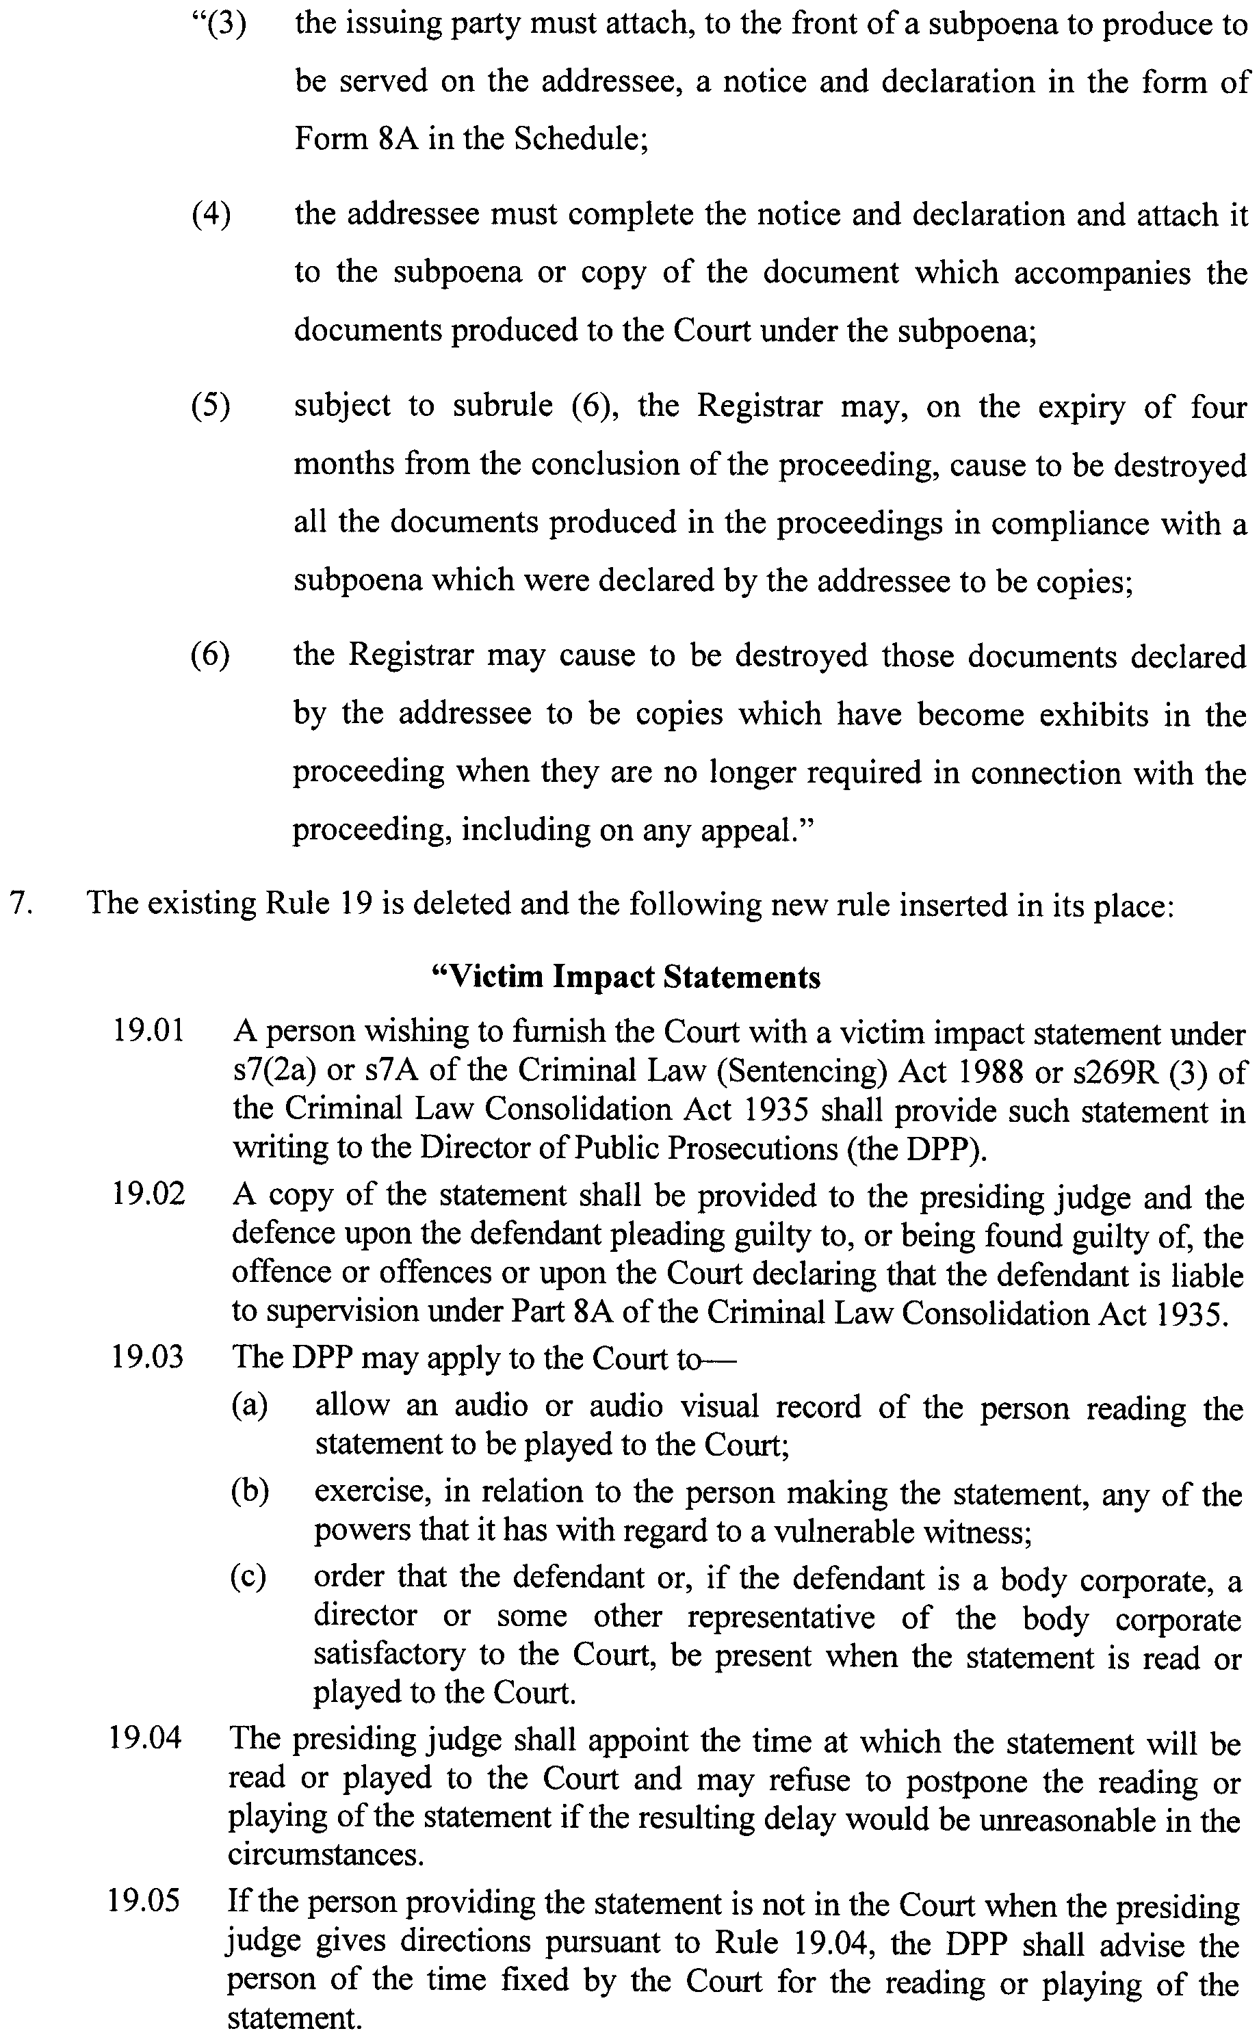
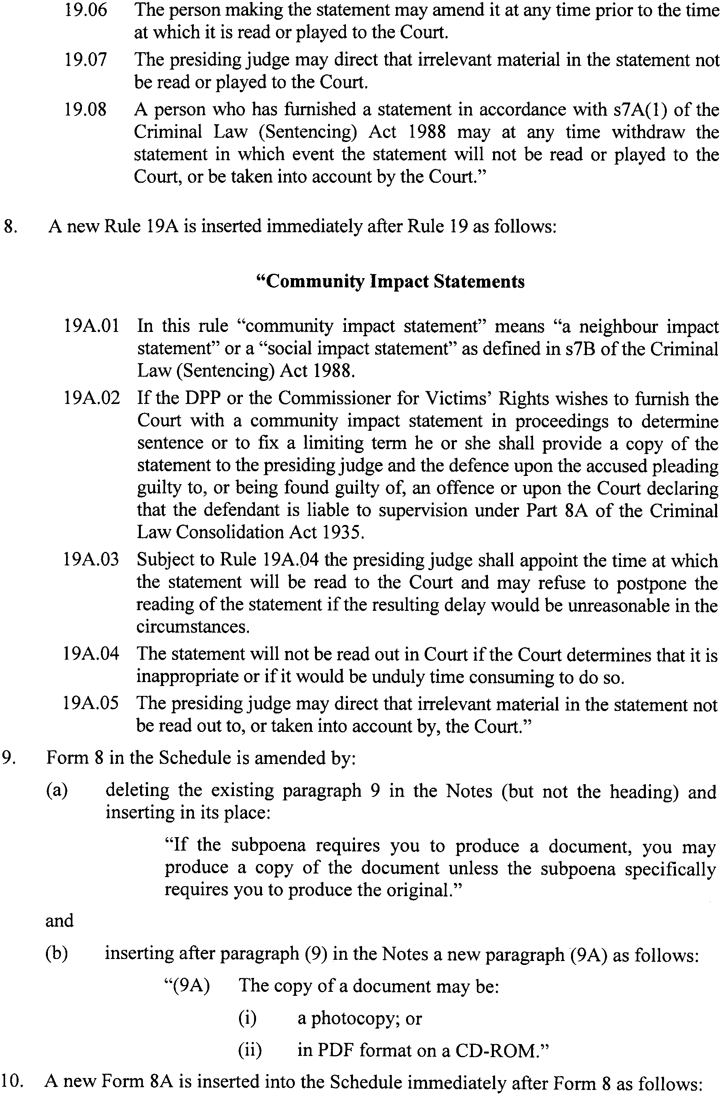
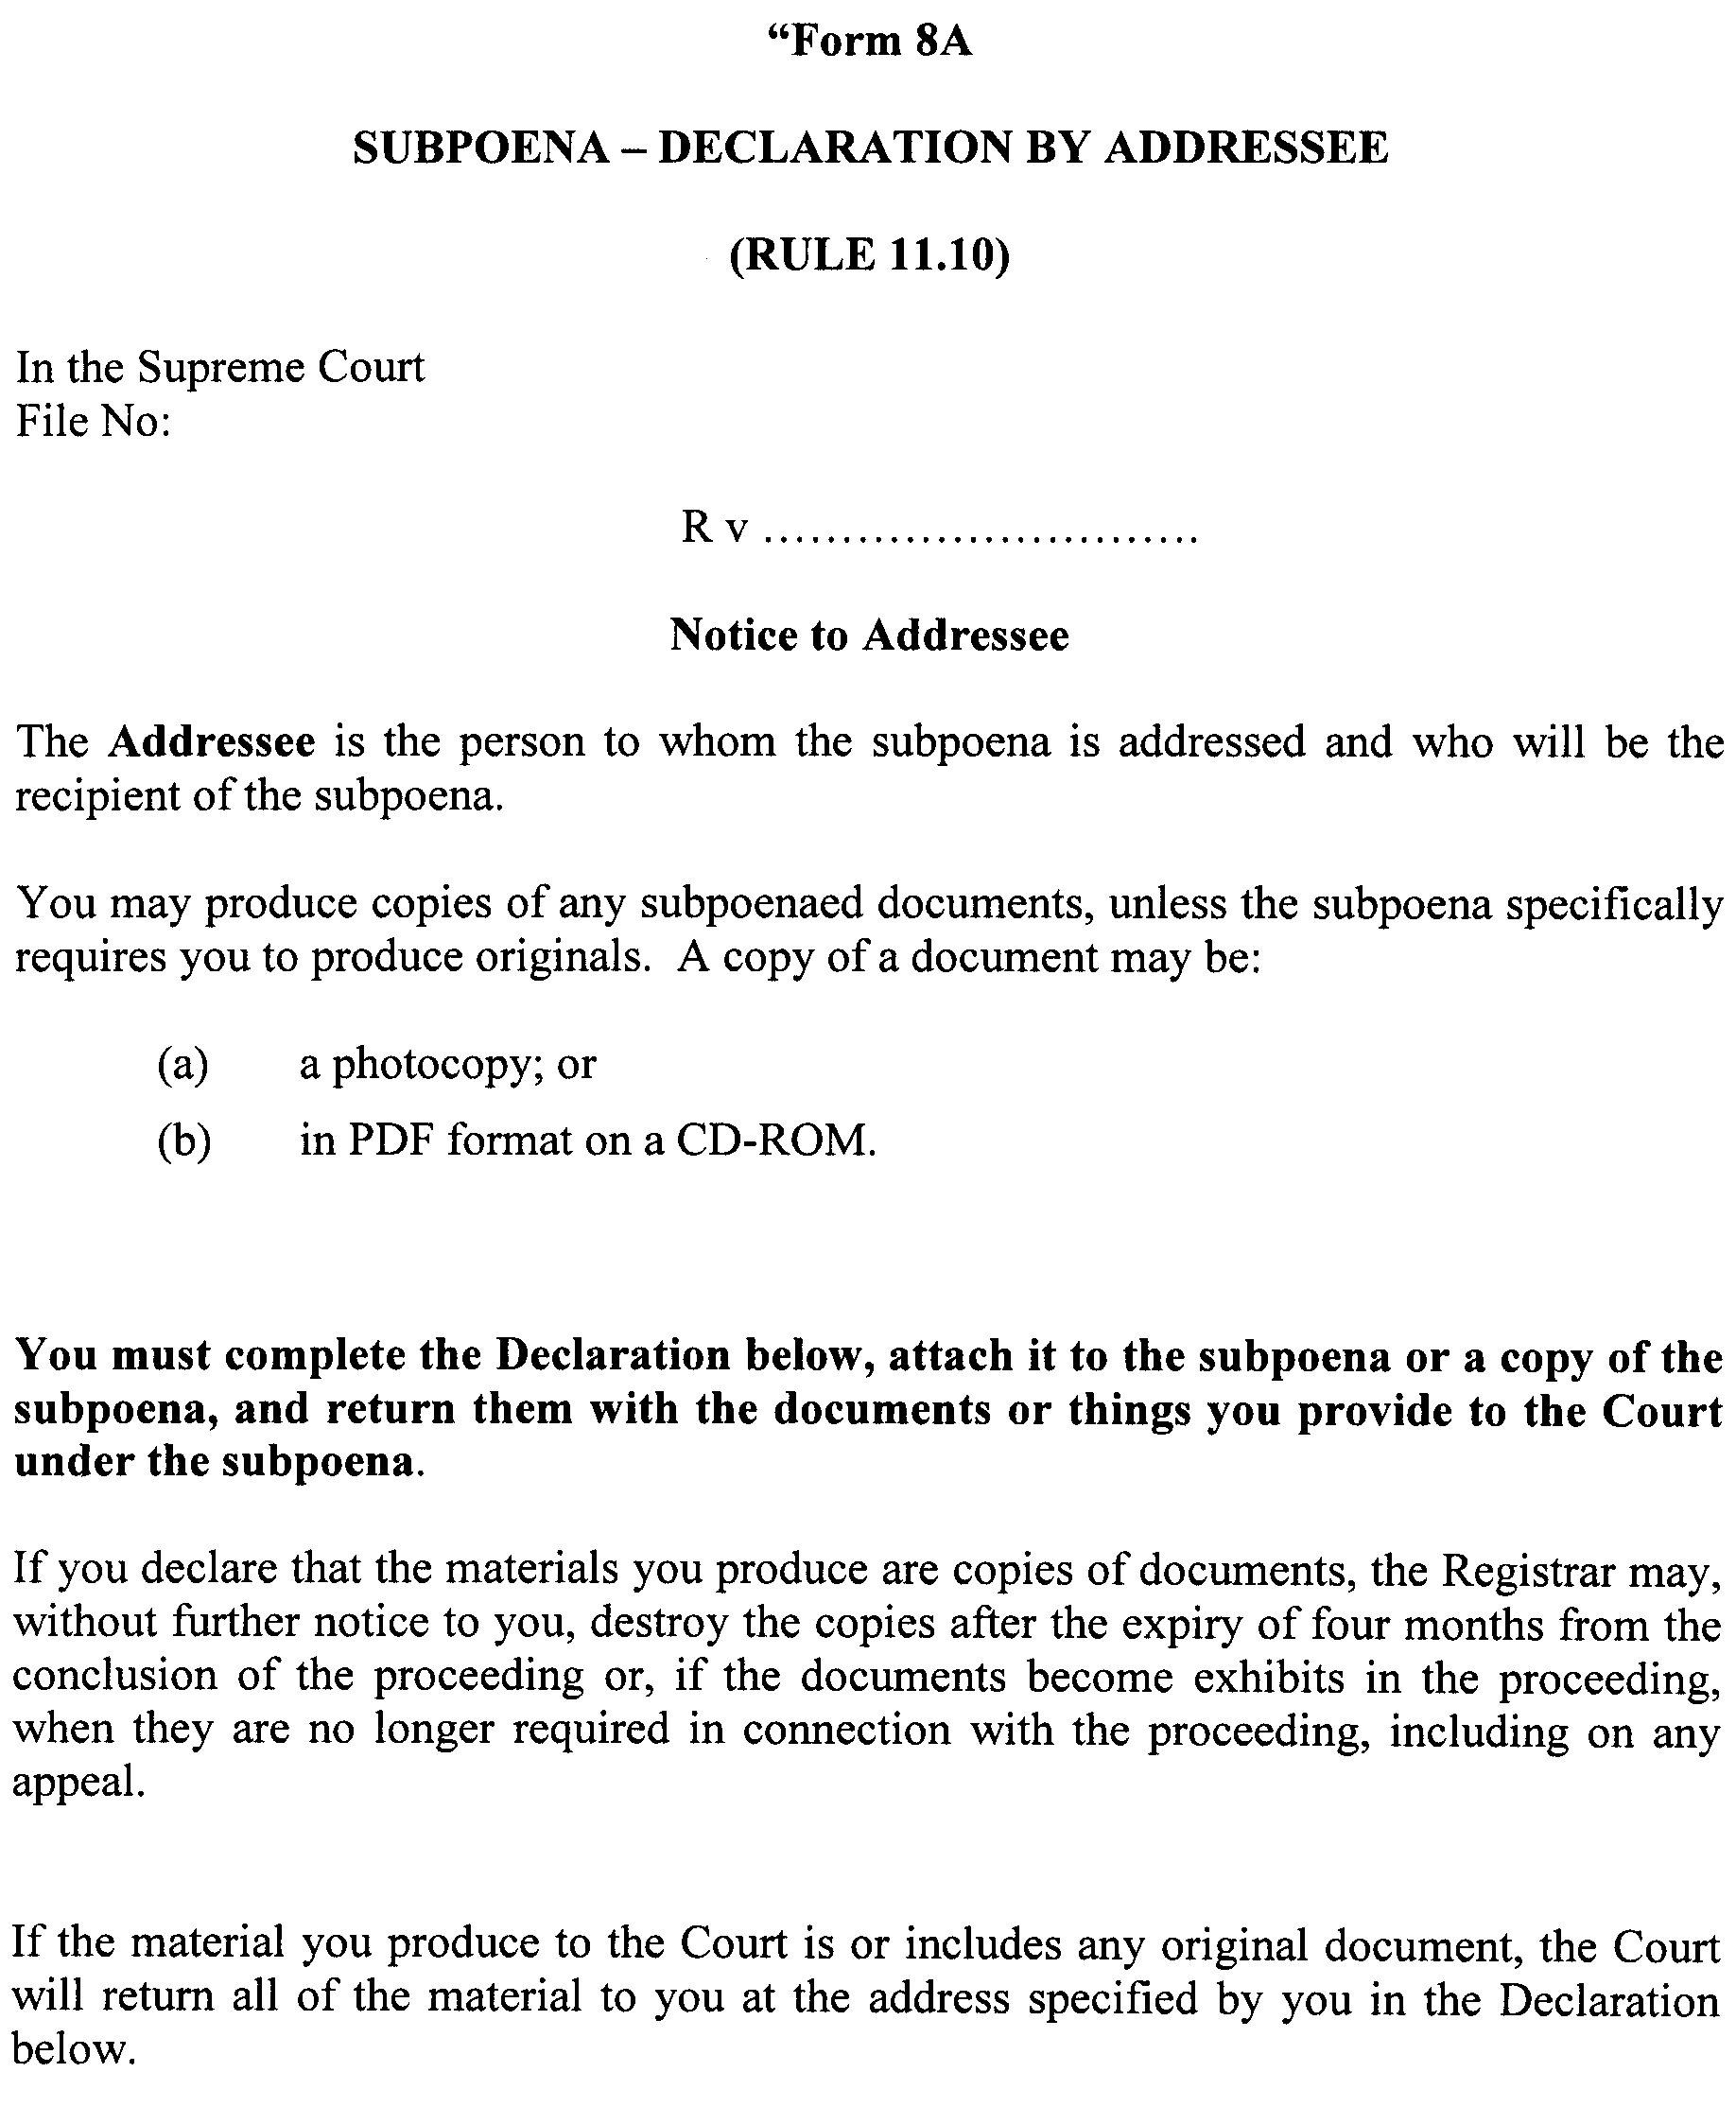
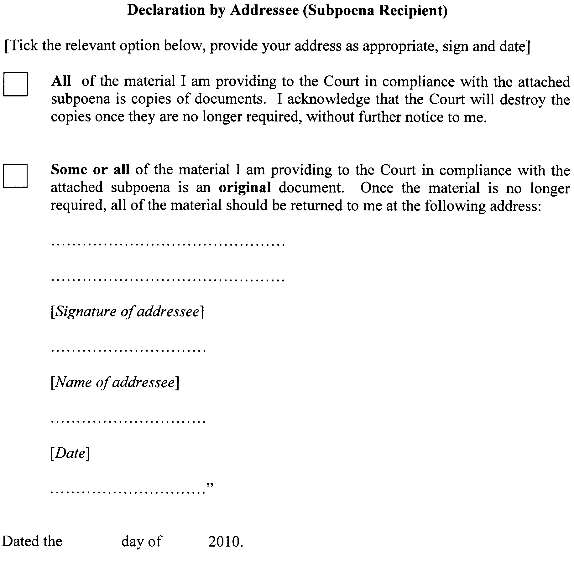
GIVEN under our hands and the Seal of the Supreme Court of South Australia this 29th day of March 2010.
K. P. DUGGAN, J
M. J. NYLAND, J
D. J. BLEBY, J
T. A. GRAY, J
J. R. SULAN, J
A. M. VANSTONE, J
T. R. ANDERSON, J
R. C. WHITE, J
R. A. LAYTON, J
P. KELLY, J
C. KOURAKIS, J

PETROLEUM AND GEOTHERMAL ENERGY ACT 2000
Suspension of Licence Condition Extension of
Licence Term Petroleum Exploration Licences—
PELs 154 and 155
PURSUANT to section 76A of the Petroleum and Geothermal Energy Act 2000, notice is hereby given that Condition 1 of the abovementioned Petroleum Exploration Licences have been suspended under the provisions of the Petroleum and Geothermal Energy Act 2000, pursuant to delegated powers dated 1 October 2009, for the period from and including 1 July 2010 until 31 December 2010.
The term of PELs 154 and 155 have been extended by a period corresponding to the period of suspension, such that the licences will now expire on 31 December 2010.
Dated 23 April 2010.
M. Malavazos,
Acting Director Petroleum and Geothermal
Minerals and Energy Division
Primary Industries and Resources SA
Delegate of the Minister for Mineral
Resources Development

ROADS (OPENING AND CLOSING) ACT 1991:
SECTION 24
NOTICE OF CONFIRMATION OF ROAD
PROCESS ORDER
Road Closure
Peters Road, Wongulla
BY Road Process Order made on 10 March 2010, the Mid Murray Council ordered that:
1. An irregularly shaped strip of Peters Road generally situate adjoining the south-eastern boundary of allotment 7 in Deposited Plan 78576, more particularly delineated and lettered ‘A’ on Preliminary Plan No. 09/0070 be closed.
2. The whole of the land subject to closure be transferred to Peter Barry Johns and Jillian Rae Johns in accordance with agreement for transfer dated 9 November 2009 entered into between the Mid Murray Council and P. B. and J. R. Johns.
3. The following easement be granted over the whole of the land subject to that closure:
Grant to Distribution Lessor Corporation an easement for electricity supply purposes.
On 20 April 2010 that order was confirmed by the Minister for Infrastructure conditionally upon the deposit by the Registrar-General of Deposited Plan 83696 being the authority for the new boundaries.
Pursuant to section 24 (5) of the Roads (Opening and Closing) Act 1991, NOTICE of the order referred to above and its confirmation is hereby given.
Dated 29 April 2010.
P. M. Kentish, Surveyor-General

ROADS (OPENING AND CLOSING) ACT 1991:
SECTION 24
NOTICE OF CONFIRMATION OF ROAD
PROCESS ORDER
Road Closure
Ellis Street, Carpenter Rocks
BY Road Process Order made on 10 February 2010, the District Council of Grant ordered that:
1. The whole of Ellis Street situate between allotment 1 in Deposited Plan 4378 and section 617, Hundred of Kongorong, more particularly delineated and lettered ‘A’ in Preliminary Plan No. 09/0076 be closed.
2. The whole of the land subject to closure be transferred to Mullan Pty Ltd in accordance with agreement for transfer dated 24 September 2009 entered into between the District Council of Grant and Mullan Pty Ltd.
On 11 March 2010 that order was confirmed by the Minister for Infrastructure conditionally upon the deposit by the Registrar-General of Deposited Plan 83447 being the authority for the new boundaries.
Pursuant to section 24 (5) of the Roads (Opening and Closing) Act 1991, NOTICE of the order referred to above and its confirmation is hereby given.
Dated 29 April 2010.
P. M. Kentish, Surveyor-General

SURVEY ACT 1992
Register of Surveyors
IT is hereby notified for general information that the names of the undermentioned persons are duly licensed under the above Act:
Name | Address | Date of Licence
Ryan, Kane Benjamin | c/o 1 King William Street, Kent Town, S.A. 5067 | 18.3.10
Langman, James Stephen | 14 Trezise Way, Clare, S.A. 5453 | 18.3.10
Kruimel, Daniel Nigel | c/o 1 King William Street, Kent Town, S.A. 5067 | 22.4.10
J. M. Schaefer, Registrar

SURVEY ACT 1992
Levy Increase
UNDER the provisions of the Survey Act 1992, section 58, the Institution of Surveyors Australia, South Australia Division Inc. may with the approval of the Minister for Infrastructure, impose a levy on each plan certified correct and lodged in the Lands Titles Registration Office.
Notice is hereby given that the Minister has approved the levy being increased from $55.50 to $85.50 effective from 1 July 2010.
J. M. Schaefer, Registrar

THE DISTRICT COURT OF SOUTH AUSTRALIA
PORT AUGUSTA CIRCUIT COURT
Sheriff’s Office, Adelaide, 3 May 2010
IN pursuance of a precept from the District Court of South Australia to me directed, I do hereby give notice that the said Court will sit as a Court of Oyer and Terminer and General Gaol Delivery at the Courthouse at Port Augusta on the day and time undermentioned and all parties bound to prosecute and give evidence and all jurors summoned and all others having business at the said Court are required to attend the sittings thereof and the order of such business will be unless a Judge otherwise orders as follows:
Monday, 3 May 2010 at 10 a.m. on the first day of the sittings the only business taken will be the arraignment of prisoners in gaol and the passing of sentences on prisoners in gaol committed for sentence; the surrender of prisoners on bail committed for sentence; the surrender of persons in response to ex officio informations or of persons on bail and committed for trial who have signified their intentions to plead guilty and the passing of sentences.
Juries will be summoned for Tuesday, 4 May 2010 and persons will be tried on this and subsequent days of the sittings.
Prisoners in H.M. Gaol and on bail for sentence and for trial at the sittings of the Port Augusta Courthouse, commencing Monday, 3 May 2010:
Bailey, Martin James |  | Unlawful sexual intercourse with a person under 12 | On bail
Baker, Tony |  | Aggravated causing harm with intent to cause harm; aggravated possessing a firearm without a license; aggravated threatening life | On bail
Bloemen, Paul Anthony |  | Aggravated serious criminal trespass in a place of residence; aggravated assault causing harm; theft | In gaol
Brady, Anthony James |  | Assault; aggravated causing harm with intent; aggravated threatening harm | In gaol
Griffiths, Brian Thomas |  | Indecent assault (3); unlawful sexual intercourse | On bail
Hay, Kevin Dean |  | Produce child pornography | On bail
Houghton, Craig James |  | Aggravated threatening to kill | In gaol
Lawrie, Ziggie John |  | Unlawful sexual intercourse with a person under 17; unlawful sexual intercourse | On bail
Williams, Dianne |  | Serious criminal trespass—residence occupied; commit assault by use of offensive weapon | On bail
Wright, Kenneth James |  | Unlawful sexual intercourse with a person under 17 | In gaol
Prisoners on bail must surrender at 10 a.m. of the day appointed for the respective trials. If they do not appear when called upon their recognizances and those of their bail will be estreated and a bench warrant issued forthwith.
By order of the Court,
M. A. Stokes, Sheriff

WATER MAINS AND SEWERS

Office of the South Australian Water Corporation
Adelaide, 29 April 2010

WATER MAINS LAID

Notice is hereby given that the following main pipes or parts of main pipes have been laid down by the South Australian Water Corporation in or near the undermentioned water districts and are now available for a constant supply of water to adjacent land.

ADELAIDE WATER DISTRICT

CITY OF MARION
Bay Street, Seacombe Gardens. p26
Russell Avenue, Seacombe Gardens. p26

BORDERTOWN WATER DISTRICT

TATIARA DISTRICT COUNCIL
First Street, Bordertown. p2

KAPUNDA WATER DISTRICT

LIGHT REGIONAL COUNCIL
Light Street, Kapunda. p30

LANGHORNE CREEK WATER DISTRICT

ALEXANDRINA COUNCIL
In and across Langhorne Creek Road, Langhorne Creek. This main is available on application only. p20 and 21

MURRAY BRIDGE WATER DISTRICT

THE RURAL CITY OF MURRAY BRIDGE
Sherwood Road, Murray Bridge. p1
In and across Grassmere Drive, Murray Bridge. p1
James Court, Murray Bridge. p1
Green Drive, Murray Bridge. p1

PORT LINCOLN WATER DISTRICT

CITY OF PORT LINCOLN
In and across Sleaford Terrace, Port Lincoln. p33
In and across Schultz Court, Port Lincoln. p33
Rischbieth Court, Port Lincoln. p33

STRATHALBYN WATER DISTRICT

ALEXANDRINA COUNCIL
Across Nine Mile Road, Strathalbyn and Willyaroo. This main is available on application only. p3
In and across Willyaroo Road, Willyaroo. This main is available on application only. p3 and 4
Across and in Callington Road, Strathalbyn. This main is available on application only. p22

STRATHALBYN COUNTRY LANDS WATER DISTRICT

ALEXANDRINA COUNCIL
Willyaroo Road, Willyaroo. This main is available on application only. p4
Across Langhorne Creek Road, Willyaroo. This main is available on application only. p4
Langhorne Creek Road, Willyaroo and Belvidere. This main is available on application only. p5-12
In and across Callington Road, Strathalbyn. This main is available on application only. p22-25
In and across Bletchley Road, Strathalbyn. This main is available on application only. p25

WATER MAINS ABANDONED

Notice is hereby given that the undermentioned water mains have been abandoned by the South Australian Water Corporation.

ADELAIDE WATER DISTRICT

CITY OF MARION
Bay Street, Seacombe Gardens. p26
Russell Avenue, Seacombe Gardens. p26

WATER MAINS LAID

Notice is hereby given that the undermentioned water mains have been laid down by the South Australian Water Corporation and are not available for a constant supply of water to adjacent land.

OUTSIDE WATER DISTRICTS

ALEXANDRINA COUNCIL
Langhorne Creek Road, Belvidere and Langhorne Creek. p12-20

SEWERS LAID

Notice is hereby given that the following sewers have been laid down by the South Australian Water Corporation in the undermentioned drainage areas and are now available for house connections.

ADELAIDE DRAINAGE AREA

CITY OF BURNSIDE
Across Glynburn Road, Hazelwood Park and Burnside. FB 1165 p28
Garden Avenue, Burnside. FB 1165 p28
CITY OF PORT ADELAIDE ENFIELD
Semaphore Road, Exeter. FB 1165 p29
Campbell Avenue, Rosewater. FB 1165 p30

CITY OF TEA TREE GULLY
Across Golden Grove Road, Modbury Heights. FB 1165 p27
Easements in lot 5 in LTRO FP 38, Golden Grove Road, reserve (lot 123 in LTRO DP 10812), Kingfisher Drive, lot 50 in LTRO DP 12175, Golden Grove Road, and reserve (lot 122 in LTRO DP 10832), Grenfell Road, Modbury Heights. FB 1165 p27
Across Grenfell Road, Modbury Heights and Wynn Vale. FB 1165 p27
Easements in reserves (lot 357 in LTRO DP 10440 and lot 356 in LTRO DP 10317), Kingfisher Drive, Modbury Heights. FB 1165 p27

MURRAY BRIDGE COUNTRY DRAINAGE AREA

THE RURAL CITY OF MURRAY BRIDGE
Sherwood Road, Murray Bridge. FB 1193 p1 and 2
Across and in Grassmere Drive, Murray Bridge. FB 1193 p1-3
James Court, Murray Bridge. FB 1193 p1-3
Easement in lot 14 in LTRO DP 78465, Grassmere Drive and lots 16-21 in LTRO DP 78465, Green Drive, Murray Bridge. FB 1193 p1 and 3

SEWERS ABANDONED

Notice is hereby given that the undermentioned sewers have been abandoned by the South Australian Water Corporation.

ADELAIDE DRAINAGE AREA

CITY OF BURNSIDE
Across Glynburn Road, Hazelwood Park and Burnside. FB 1165 p28
Garden Avenue, Burnside. FB 1165 p28

TOWN OF GAWLER
Sewerage land (lot 17 in LTRO FP 154118), Adelaide Road, Evanston—150 mm PVC pumping main. FB 1191 p26
Easement in lot 2 in LTRO DP 65835, Adelaide Road, Evanston—150 mm PVC pumping main. FB 1191 p26

CITY OF MARION
First Street, Hallett Cove—200 mm PVCU pumping main. FB 1191 p21

CITY OF PLAYFORD
Across Andrews Road, Munno Para West—100 mm PVC pumping main. FB 1191 p24

CITY OF PORT ADELAIDE ENFIELD
Semaphore Road, Exeter. FB 1165 p29
Campbell Avenue, Rosewater. FB 1165 p30

CITY OF TEA TREE GULLY
Across and in Golden Grove Road, Modbury Heights. FB 1165 p27
Easements in lot 5 in LTRO FP 38, Golden Grove Road, reserve (lot 123 in LTRO DP 10812), Kingfisher Drive, lot 50 in LTRO DP 12175, Golden Grove Road, and reserve (lot 122 in LTRO DP 10832), Grenfell Road, Modbury Heights. FB 1165 p27
Across Grenfell Road, Modbury Heights and Wynn Vale. FB 1165 p27
Easements in reserves (lot 357 in LTRO DP 10440 and lot 356 in LTRO DP 10317), Kingfisher Drive, Modbury Heights. FB 1165 p27

PORT AUGUSTA COUNTRY DRAINAGE AREA

PORT AUGUSTA CITY COUNCIL
Across and in Clontarf Street, Port Augusta—100 mm PVC pumping main. FB 1191 p22
Sewerage land (lot 258 in LTRO DP 48853), Clontarf Street, Port Augusta—100 mm PVC pumping main. FB 1191 p22

SEWERS LAID

Notice is hereby given that the undermentioned sewers have been laid down by the South Australian Water Corporation and are not available for house connections.

ADELAIDE DRAINAGE AREA

CAMPBELLTOWN CITY COUNCIL
Sewerage land (lot 32 in LTRO DP 73110), River Drive, Athelstone. FB 1191 p32
Sewerage land (lot 32 in LTRO DP 73110), River Drive, Athelstone—150 mm PE100 pumping main. FB 1191 p32

TOWN OF GAWLER
Sewerage land (lot 17 in LTRO FP 154118), Adelaide Road, Evanston—150 mm PVC pumping main. FB 1191 p26
Easements in lot 2 in LTRO DP 65835, Adelaide Road, Evanston and lot 110 in LTRO DP 56525, Cherry Street, Gawler South—150 mm PVC, 225 mm PE and 200 mm PVC pumping main. FB 1191 p26, 27 and 29
Across and in Cherry Street, Gawler South—200 mm PVC pumping main. FB 1191 p26, 27 and 29
Across and in Twentyfourth Street, Gawler South—200 mm PVC pumping main. FB 1191 p26, 27 and 29
Across and in Twentyfirst Street, Gawler South—200 mm PVC pumping main. FB 1191 p26-29
Across and in Twentythird Street, Gawler South—200 mm PVC and 225 mm PE pumping main. FB 1191 p26, 28 and 29
Easements in lots 22 and 20 in LTRO DP 65981, Twentythird Street, Gawler South and Gawler West—225 mm PE and 200 mm PVC pumping main. FB 1191 p26, 28-31
Across and in Railway Terrace, Gawler West—200 mm PVC pumping main. FB 1191 p26, 28 and 30
Across and in Elizabeth Street, Gawler West—200 mm PVC pumping main. FB 1191 p26, 28 and 30
Across Barnet Street, Gawler West and Evanston—200 mm PVC pumping main. FB 1191 p26, 28 and 30

CITY OF MARION
Easement in lot 201 in LTRO FP 28253, Central Avenue, Hallett Cove—200 mm PVCM pumping main. FB 1191 p20
Across Central Avenue, Hallett Cove—200 mm PVCM pumping main. FB 1191 p20
Third Street, Hallett Cove—200 mm PVCM pumping main. FB 1191 p20 and 21
Across and in South Avenue, Hallett Cove—200 mm PVCM pumping main. FB 1191 p21
Across First Street, Hallett Cove—200 mm PVCM pumping main. FB 1191 p21

CITY OF PLAYFORD
Across Andrews Road, Munno Para West—100 mm PVCU pumping main. FB 1191 p24

PORT AUGUSTA COUNTRY DRAINAGE AREA

PORT AUGUSTA CITY COUNCIL
Across and in Clontarf Street, Port Augusta—100 mm PVCO pumping main. FB 1191 p22
Sewerage land (lot 258 in LTRO DP 48853), Clontarf Street, Port Augusta—100 mm PVCO pumping main. FB 1191 p22

A. Howe, Chief Executive Officer, South Australian Water Corporation.

WATERWORKS ACT 1932
Restrictions on the Use of Water—Eyre Peninsula
PURSUANT to section 33A of the Waterworks Act 1932, the South Australian Water Corporation (SA Water) with the approval of the Minister for Water with effect from midnight on 30 April 2010 revokes the notice of Level 3 Enhanced Eyre Peninsula (Non daylight saving hours) water restrictions imposed by notice dated 30 March 2010 (published in the Government Gazette on 1 April 2010) and, further pursuant to section 33A of the Waterworks Act 1932, SA Water with the approval of the Minister for Water with effect from 1 May 2010, until further notice hereby prohibits, restricts and regulates the purposes for which water supplied to properties by SA Water may be used, the manner in which water may be used, and the means by which water may be used, and the times at which water may be used as set out in the Schedule within the following Water Districts (‘WD’) and Country Lands Water Districts (‘CLWD’) on the Eyre Peninsula: Arno Bay WD, Ceduna WD, Cleve WD, Coffin Bay WD, Cowell WD, Cummins WD, Haslam WD, Kimba WD, Lipson WD, Lock WD, Louth Bay WD, Minnipa WD, Poochera WD, Port Lincoln WD, Port Neill WD, Rudall WD, Smoky Bay WD, Streaky Bay CLWD, Streaky Bay Township WD, Tod River CLWD, Tumby Bay WD, Ungarra WD, Warramboo WD, Wirrulla WD, Wudinna WD, Yaninee WD and Yeelanna WD or from a pipeline situated within any of the above Water Districts or Country Lands Water Districts (either directly or indirectly).
Schedule
WATER RESTRICTIONS—LEVEL 3—ENHANCED—EYRE PENINSULA (7 hours)
PURPOSE | WATER RESTRICTIONS
GARDENS and LAWNS | Watering cans and buckets may be used at any time to water outdoor trees, shrubs, plants and lawns.  Hand held hoses fitted with a trigger nozzle or drip-watering system may be used for a maximum of 7 hours per week to water outdoor trees, shrubs, plants and lawns on any day of the week between 7 a.m.-10 a.m. and/or 4 p.m.-7 p.m.  All sprinkler systems are prohibited for use in watering outdoor trees, shrubs, plants and lawns.
SPORTS GROUNDS and RECREATIONAL FACILITIES | Hand-held hoses fitted with a trigger nozzle may be used on any day but only before 8 a.m. or after 8 p.m.  Watering cans and buckets may be used at any time.  Sprinkler systems may be used once a week between the hours of 8 p.m. and 8 a.m. The day of the week and time of operation for each of the sprinkler systems is to be determined in conjunction with SA Water and subject to a permit.  Testing of sprinklers will not be permitted without prior approval of SA Water.
HARD SURFACES | Water must not be used to wash paved or concreted areas, decking, walls or roofs of a building at any time unless it is necessary to do so to protect public health, ensure safety of people using the area, ensure the health and welfare of animals using the area or in case of accident, fire or other emergency.  Windows may be cleaned from a bucket filled directly from a tap.
FOUNTAINS and PONDS | A fountain, pond or water feature that does not recycle water must not be operated and must not be topped up unless it supports fish.  The level of water in a fountain, pond or water feature that recycles water may be topped up only with water from a hand held hose or bucket.
SWIMMING POOLS and SPAS | Existing pools and spas must not be refilled from empty.  The level of water in a swimming pool or spa that has been previously filled with water may be topped up or maintained only with water from a hand held hose or bucket.  New pools or spas may be filled only under the authority of a permit from SA Water. A permit will not be granted unless there is proof a cover has been purchased to prevent water loss through evaporation.  Children’s wading pools must not be filled with more than 250 litres of water.
WASHING CARS and BOATS | Water must not be used to wash a vehicle except by means of a commercial car wash or a bucket filled directly from a tap.  Hoses are not to be used.  Boat owners are permitted to flush out motors and rinse off metal parts to prevent corrosion.
BUILDING DEVELOPMENT/  CONSTRUCTION ACTIVITIES | Water must not be used for dust suppression and compaction unless it is applied from a hand held hose fitted with a trigger nozzle or directly from a motor vehicle designed and approved to carry/deposit water.
FARMS or RURAL PROPERTIES USING SA WATER SUPPLY | A farm dam or tank must not be filled with water unless it is being used for domestic or stock consumption or fire-fighting. A permit is required to fill a dam or tank for any other reason.  If a rainwater tank has been plumbed directly into a house by a licensed plumbing contractor it is acceptable to have a quantity of mains water in the tank.
COMMERCIAL NURSERIES and GARDEN CENTRES | Hand held hoses fitted with a trigger nozzle, watering cans, buckets and drip-watering systems may be used at any time to water plants in commercial nurseries and garden centres. Sprinkler systems may be used between the hours of 8 p.m. and 8 a.m.  On days when the maximum temperature is forecast to exceed 30 degrees sprinkler systems may also be used between the hours of 1 p.m. and 2 p.m.
CARAVAN and CAMPING SITES | PERMITS ARE REQUIRED TO WATER OUTSIDE THE GARDEN AND LAWN GUIDELINES.  Permits allow watering under the following conditions:  October-March  Grassed sites that have been damaged by cars, caravans and/or tents may be watered with a sprinkler for not more than 30 minutes on the day the area is vacated. If grassed areas are not being used then they may be watered with a sprinkler no more than once per week, for no more than 30 minutes at any time.  April-September  Grassed sites that have been damaged by cars, caravans and tents may be watered with a sprinkler no more than once per week at any time for no more than 30 minutes at any time.
Using water in a manner other than in accordance with the specified restricted use of water above is prohibited except under authority of a permit issued by SA Water pursuant to the Waterworks Regulations 1996.
Dated 27 April 2010.
SIGNED for and on behalf of the SOUTH AUSTRALIAN WATER CORPORATION, by a person duly authorised so to do in the presence of:
A. Howe, Chief Executive Officer
G. Henstock, Corporation Secretary

WATERWORKS ACT 1932
Restrictions on the Use of Water from the River Murray and Myponga Reservoir
PURSUANT to section 33A of the Waterworks Act 1932, the South Australian Water Corporation (SA Water) with the approval of the Minister for Water with effect from midnight on 30 April 2010 revokes the notice of Level 3 Enhanced (Non daylight saving hours) water restrictions imposed by notice dated 30 March 2010 (published in the Government Gazette on 1 April 2010) and, further pursuant to section 33A of the Waterworks Act 1932, SA Water with the approval of the Minister for Water with effect from 1 May 2010, until further notice hereby prohibits, restricts and regulates the purposes for which water supplied to properties by SA Water may be used, the manner in which water may be used, and the means by which water may be used, and the times at which water may be used as set out in Schedule 1 within the following Water Districts (‘WD’) and Country Lands Water Districts (‘CLWD’): Adelaide WD, Alford WD, Angaston WD, Appila WD, Ardrossan WD, Arthurton WD, Balaklava WD, Barmera WD, Barossa CLWD, Beetaloo CLWD, Berri WD, Birdwood WD, Blanchetown WD, Blyth WD, Booborowie WD, Booleroo Centre WD, Bowmans WD, Brinkley CLWD, Brinkworth WD, Bundaleer CLWD, Burdett CLWD, Burra WD, Bute WD, Cadell WD, Callington WD, Caltowie WD, Cambrai WD, Clayton WD, Clinton WD, Cobdogla WD, Coobowie WD, Cooltong WD, Coonalpyn Downs CLWD, Coonalpyn WD, Crystal Brook WD, Cudlee Creek WD, Curramulka WD, Dublin WD, Eden Valley WD, Edithburgh WD, Encounter Bay CLWD, Eudunda WD, Farrell Flat WD, Georgetown WD, Gladstone WD, Glossop WD, Goolwa WD, Greenock WD, Gulnare WD, Gumeracha WD, Halbury WD, Hamley Bridge WD, Hampden WD, Hoyleton WD, Hindmarsh Island WD, Iron Knob CLWD, Jamestown CLWD, Jervois WD, Jutland CLWD, Kadina WD, Kanmantoo CLWD, Kanmantoo WD, Kapunda WD, Karoonda WD, Keith WD, Kersbrook WD, Kingston-on-Murray WD, Koolunga WD, Langhorne Creek WD, Laura WD, Loxton CLWD, Lyndoch WD, Maitland WD, Mallala WD, Mannum WD, Mannum-Adelaide CLWD, Marrabel WD, Meningie WD, Middleton WD, Milang WD, Minlaton WD, Moculta WD, Monash WD, Monteith WD, Moonta Mines WD, Moonta WD, Moorook CLWD, Moorook WD, Morgan WD, Morgan-Whyalla CLWD, Mount Compass WD, Mount Pleasant WD, Mundallio CLWD, Mundoora WD, Murray Bridge WD, Mypolonga WD, Myponga WD, Napperby WD, Nectar Brook CLWD, Neeta-Cowirra WD, Nuriootpa WD, Owen WD, Palmer WD, Paringa Township WD, Paskeville WD, Peterborough WD, Pine Point WD, Point Pass WD, Pompoota WD, Port Augusta WD, Port Broughton WD, Port Elliot WD, Port Germein WD, Port Hughes WD, Port Parham/Webb Beach WD, Port Pirie WD (subject to SCHEDULE 2 conditions), Port Victor WD, Port Victoria WD, Port Vincent WD, Price WD, Redbanks WD, Redhill WD, Renmark WD, Rhynie WD, Riverton WD, Robertstown WD, Roseworthy WD, Rowland Flat WD, Saddleworth WD, Sedan WD, Seppeltsfield WD, Snowtown WD, South Kilkerran WD, Spalding WD, Springton WD, St Kilda WD, Stansbury WD, Stockport WD, Stockwell WD, Strathalbyn CLWD, Strathalbyn WD, Sutherlands WD, Swan Reach WD, Tailem Bend WD, Tanunda WD, Tarlee WD, The Township of Freeling WD, Tintinara WD, Township of Auburn WD, Township of Clare WD, Township of Jamestown WD, Township of Loxton WD, Truro WD, Tungkillo WD, Two Wells WD, Virginia WD, Waikerie WD, Wakefield WD, Wall WD, Wallaroo Mines WD, Wallaroo WD, Warnertown WD, Warren CLWD, Wasley WD, Whyalla WD (subject to SCHEDULE 2 conditions), Williamstown WD, Windsor WD, Wirrabara WD, Wool Bay WD, Yacka WD, Yongala WD, Yorke Peninsula CLWD, Yorketown WD, Township of Leasingham WD, Township of Mintaro WD, Township of Penwortham WD, Township of Sevenhill WD, Township of Watervale WD, together with all properties under a Supply by Measure Agreement connected directly or indirectly to any of the following trunk mains: Morgan-Whyalla No. 1, Morgan-Whyalla No. 2, Swan Reach-Stockwell, Mannum-Adelaide, Murray Bridge-Onkaparinga, Tailem Bend-Keith, or from a pipeline situated within any of the above Water Districts or Country Lands Water Districts (either directly or indirectly).
Schedule 1
WATER RESTRICTIONS—LEVEL 3—ENHANCED (7 hours)
PURPOSE | WATER RESTRICTIONS
GARDENS and LAWNS | Watering cans and buckets may be used at any time to water outdoor trees, shrubs, plants and lawns.  Hand held hoses fitted with a trigger nozzle or drip-watering system may be used for a maximum of 7 hours per week to water outdoor trees, shrubs, plants and lawns on any day of the week between 7 a.m.-10 a.m. and/or 4 p.m.-7 p.m.  All sprinkler systems are prohibited for use in watering outdoor trees, shrubs, plants and lawns.
SPORTS GROUNDS and RECREATIONAL FACILITIES | Hand-held hoses fitted with a trigger nozzle may be used on any day but only before 8 a.m. or after 8 p.m.  Watering cans and buckets may be used at any time.  Sprinkler systems may be used once a week between the hours of 8 p.m. and 8 a.m. The day of the week and time of operation for each of the sprinkler systems is to be determined in conjunction with SA Water and subject to a permit.  Testing of sprinklers will not be permitted without prior approval of SA Water.
HARD SURFACES | Water must not be used to wash paved or concreted areas, decking, walls or roofs of a building at any time unless it is necessary to do so to protect public health, ensure safety of people using the area, ensure the health and welfare of animals using the area or in case of accident, fire or other emergency.  Windows may be cleaned from a bucket filled directly from a tap.
FOUNTAINS and PONDS | A fountain, pond or water feature that does not recycle water must not be operated and must not be topped up unless it supports fish.  The level of water in a fountain, pond or water feature that recycles water may be topped up only with water from a hand held hose or bucket.
SWIMMING POOLS and SPAS | Existing pools and spas must not be refilled from empty.  The level of water in a swimming pool or spa that has been previously filled with water may be topped up or maintained only with water from a hand held hose or bucket.  New pools or spas may be filled only under the authority of a permit from SA Water. A permit will not be granted unless there is proof a cover has been purchased to prevent water loss through evaporation.  Children’s wading pools must not be filled with more than 250 litres of water.
WASHING CARS and BOATS | Water must not be used to wash a vehicle except by means of a commercial car wash or a bucket filled directly from a tap.  Hoses are not to be used.  Boat owners are permitted to flush out motors and rinse off metal parts to prevent corrosion.
BUILDING DEVELOPMENT/  CONSTRUCTION ACTIVITIES | Water must not be used for dust suppression and compaction unless it is applied from a hand held hose fitted with a trigger nozzle or directly from a motor vehicle designed and approved to carry/deposit water.
FARMS or RURAL PROPERTIES USING SA WATER SUPPLY | A farm dam or tank must not be filled with water unless it is being used for domestic or stock consumption or fire-fighting. A permit is required to fill a dam or tank for any other reason.  If a rainwater tank has been plumbed directly into a house by a licensed plumbing contractor it is acceptable to have a quantity of mains water in the tank.
COMMERCIAL NURSERIES and GARDEN CENTRES | Hand held hoses fitted with a trigger nozzle, watering cans, buckets and drip-watering systems may be used at any time to water plants in commercial nurseries and garden centres. Sprinkler systems may be used between the hours of 8 p.m. and 8 a.m.  On days when the maximum temperature is forecast to exceed 30 degrees sprinkler systems may also be used between the hours of 1 p.m. and 2 p.m.
CARAVAN and CAMPING SITES | PERMITS ARE REQUIRED TO WATER OUTSIDE THE GARDEN AND LAWN GUIDELINES.  Permits allow watering under the following conditions:  October-March  Grassed sites that have been damaged by cars, caravans and/or tents may be watered with a sprinkler for not more than 30 minutes on the day the area is vacated. If grassed areas are not being used then they may be watered with a sprinkler no more than once per week, for no more than 30 minutes at any time.  April-September  Grassed sites that have been damaged by cars, caravans and tents may be watered with a sprinkler no more than once per week at any time for no more than 30 minutes at any time.
Schedule 2
WATER RESTRICTIONS
Designated zone in Whyalla and all of Port Pirie
Residents living in the designated zone in Whyalla (being in the area bounded by Playford Avenue, McBryde Terrace, Broadbent/ Newton Street and the foreshore) and all residents living in Port Pirie are permitted to water gardens and lawns and paths and roofs as follows:
Hand held hoses fitted with a trigger nozzle may be used at any time to hose off dust from paths and roofs.
Hand held hoses fitted with a trigger nozzle may be used between 8 p.m. and 8 a.m. to water outdoor trees, shrubs, plants and lawns.
Sprinklers may be used to water outdoor trees, shrubs, plants and lawns in accordance with the following:
- Even numbered properties on Tuesday and Saturday between 7 a.m.–10 a.m. and/or 4 p.m.– 7 p.m.
- Odd numbered properties on Wednesday and Sunday between 7 a.m.–10 a.m. and/or 4 p.m.–7 p.m.
Except as set out above all water restrictions set out in Schedule 1 apply to Whyalla and Port Pirie.
Using water in a manner other than in accordance with the specified restricted use of water above is prohibited except under authority of a permit issued by SA Water pursuant to the Waterworks Regulations 1996.
Dated 27 April 2010.
SIGNED for and on behalf of the SOUTH AUSTRALIAN WATER CORPORATION, by a person duly authorised so to do in the presence of:
A. Howe, Chief Executive Officer
G. Henstock, Corporation Secretary

South Australia
Highways (Control of Access—Sturt Highway and Short Road, Barmera) Proclamation 2010
under section 30A(1)(a) of the Highways Act 1926
1—Short title
This proclamation may be cited as the Highways (Control of Access—Sturt Highway and Short Road, Barmera) Proclamation 2010.
2—Commencement
This proclamation comes into operation on the day on which it is made.
3—Declaration of controlled-access road
The land shaded in grey on the plan in Schedule 1 is a controlled-access road.
4—Routes and means of access
The routes and means of access by which persons and vehicles may enter or leave the controlled-access road declared in clause 3 are as shown on the plan referred to in that clause.
Schedule 1—Plan
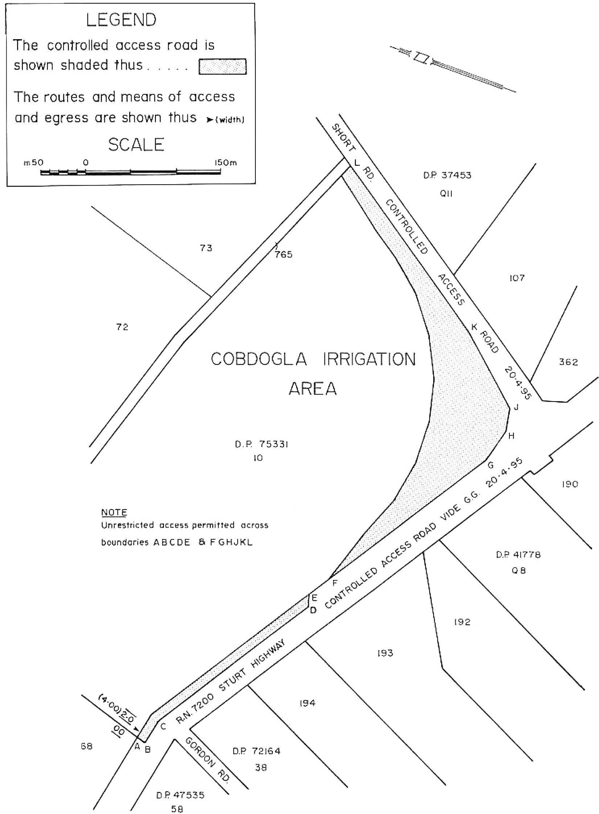
Made by the Governor
on the recommendation of the Commissioner of Highways and with the advice and consent of the Executive Council
on 29 April 2010
MTR10/014

FAXING COPY?
IF you fax copy to Government Publishing SA for inclusion in the Government Gazette, there is no need to send a Confirmation Copy to us as well.
This creates confusion and may well result in your notice being printed twice.
Please use the following fax number:
Fax transmission: (08) 8207 1040
Phone Inquiries: (08) 8207 1045
Please include a contact person, phone number and order number so that we can phone back with any queries we may have regarding the fax copy.
NOTE: Closing time for lodging new copy (fax, hard copy or email) is 4 p.m. on Tuesday preceding the day of publication.

Government Gazette notices can be E-mailed.
The address is:
governmentgazette@dpc.sa.gov.au
Documents should be sent as attachments in Word format.
When sending a document via E-mail, please confirm your transmission with a faxed copy of your document, including the date the notice is to be published.
Fax transmission: (08) 8207 1040
Enquiries: (08) 8207 1045
NOTE: Closing time for lodging new copy (fax, hard copy or email) is 4 p.m. on Tuesday preceding the day of publication.

CITY OF MOUNT GAMBIER
Road Name Change
NOTICE is hereby given pursuant to section 219 of the Local Government Act 1999 (‘the Act’) that the City of Mount Gambier, at its meeting held on Tuesday, 20 April 2010, resolved to correct a technical error made in naming a street, to formally change the name of a street from ‘New Road’ to ‘Megan Place’.
Dated 26 April 2010.
G. Muller, Chief Executive Officer
[1/2]

PORT AUGUSTA CITY COUNCIL
Notice of Vacancy—Councillor
NOTICE is hereby given in accordance with section 54 (6) of the Local Government Act 1999, that a vacancy has occurred in the office of Councillor due to the resignation of Renee S. Ellis on
14 April 2010.
In accordance with section 6 (2) of the Local Government (Elections) Act 1999, a Supplementary Election will not be held to fill the casual vacancy as it has arisen after 1 January in the year in which a periodical election is due to be heard.
G. Stephens, City Manager

DISTRICT COUNCIL OF GRANT
Declaration of Public Road
NOTICE is hereby given that, at a Council meeting held on Wednesday, 7 April 2010, pursuant to section 208 of the Local Government Act 1999, Council declared the following to be public roads and pursuant to section 219 formally adopted the following road names:
1. Land marked as Public Road in the Plan of Division of allotments 1, 2, 3, 4, 5, 6 and 7 in Filed Plan 193595, Hundred of Gambier and hereby assigns the following names to portion of the roads indicated thereon:
‘Terrell Road’—between Lots 1 and 3; and
‘Koenig Court’—between Lots 4 and 7, as shown on the approved Plan of Division.
R. J. Peate, Chief Executive Officer

DISTRICT COUNCIL OF GRANT
Change of Road Names
NOTICE is hereby given that Council has resolved to change the names of the following roads:
Meeting held on 7 September 2009:
• Un-named Road (from Punt Road to end, Wye)—Change to Wye Lane.
• Pleasant Park Road (from Paltridge Road to western end, Pleasant Park)—Change to McFarlane Road.
Meeting held on 18 January 2010:
• Hawkins Road (from Bishop Road to Clover Estate Road, Worrolong/Mil-Lel)—Change to Preece Road.
• Hawkins Road(from Clover Estate Road to Mingbool Road, Mil-Lel/Mingbool)—Change to Johanna Road.
• Feast Road (from Whites Flat Road to Mount Sinai Road, Yahl)—Change to Roland Lane.
Meeting held on 15 February 2010:
• Mingbool Road (from Riddoch Highway to Worrolong Road, Worrolong)—Change to Worrolong Road.
Meeting held on 15 March 2010:
• Millards Road (from Wye Lane to end, Wye)—Change to James Lane.
• Green Point Access Road (from Feasts Firebreak Road to end, Wye)—Change to Paradise Road.
The renaming of these roads is a result of the Local Government and State Government’s Rural Property Addressing Program.
R. J. Peate, Chief Executive Officer

IN the matter of the estates of the undermentioned deceased persons:
Bryant, Clem George, late of 32 Snell Avenue, Hillbank, retired fitter, who died on 1 July 2009.
Couzner, Joyce Lorraine, late of 95-97 Awoonga Road, Hope Valley, of no occupation, who died on 2 December 2009.
Davis, Allan Patrick, late of 34 Norman Terrace, Everard Park, retired basket maker, who died on 16 January 2010.
Edwards, Judith Ann, late of 4 Gordon Terrace, Morphettville, of no occupation, who died on 25 September 2009.
Land, Agnes, late of 7 Railway Terrace, Old Reynella, of no occupation, who died on 17 March 2009.
Owen, Hilda Dorothea, late of 29 Austral Terrace, Morphettville, widow, who died on 23 January 1996.
Tucker, Margaret Isabel, late of 150 Reynell Road, Woodcroft, of no occupation, who died on 28 February 2010.
Wicks, David George, late of 44 Raglan Avenue, Edwardstown, labourer, who died on 2 December 2009.
Notice is hereby given pursuant to the Trustee Act 1936, as amended, the Inheritance (Family Provision) Act 1972, and the Family Relationships Act 1975, that all creditors, beneficiaries, and other persons having claims against the said estates are required to send, in writing, to the Public Trustee, 25 Franklin Street, Adelaide, S.A. 5000, full particulars and proof of such claims, on or before 28 May 2010, otherwise they will be excluded from the distribution of the said estate; and notice is also hereby given that all persons who are indebted to the said estates are required to pay the amount of their debts to the Public Trustee or proceedings will be taken for the recovery thereof; and all persons having any property belonging to the said estates are forthwith to deliver the same to the Public Trustee.
Dated 29 April 2010.
M. I. Bodycoat, Public Trustee

ATTENTION

CUSTOMERS requiring a proof of their notice for inclusion in the Government Gazette, please note that the onus is on you to inform Government Publishing SA of any subsequent corrections by 10 a.m. on Thursday, which is our publication deadline.

For any corrections to your notice please phone 8207 1045 or Fax 8207 1040 before 10 a.m. on Thursday.

If we do not receive any communication by 10 a.m. on Thursday (day of publication) we will presume the notice is correct and will print it as it is.

Remember—the onus is on you to inform us of any corrections necessary to your notice.

NOTE: Closing time for lodging new copy (electronically, fax or hard copy) is 4 p.m. on Tuesday preceding the day of publication. Phone 8207 1045—Fax 8207 1040.
Email: governmentgazette@dpc.sa.gov.au

Printed and published by authority every Thursday by B. MORRIS, Government Printer, South Australia
Price: $5.60, plus postage; to subscribers, $284.00 per annum.
(The above prices are inclusive of GST)

