SUPPLEMENTARY GAZETTE



THE SOUTH AUSTRALIAN

GOVERNMENT GAZETTE
www.governmentgazette.sa.gov.au

PUBLISHED BY AUTHORITY

ALL PUBLIC ACTS appearing in this GAZETTE are to be considered official, and obeyed as such

ADELAIDE, THURSDAY, 9 DECEMBER 2010

CONTENTS

Page
RULES
Magistrates Court (Civil) Rules 1992—
(Amendment No. 35) 5626
Magistrates Court Rules 1992—
(Addendum to Amendment No. 36) 5644
(Addendum to Amendment No. 37) 5645

RULES OF COURT
Magistrates Court of South Australia
Amendment No. 35 to the Magistrates Court (Civil) Rules 1992

PURSUANT to section 49 of the Magistrates Court Act 1991 and all other enabling powers, we the undersigned do hereby make the following amendments to the MAGISTRATES COURT (CIVIL) RULES 1992:
1. These Rules may be cited as the ‘Magistrates Court (Civil) Rules 1992 (Amendment 35)’.
2. The Magistrates Court (Civil) Rules 1992, as amended, by these amendments apply to and govern all actions commenced in the civil division of the Court on and after the date on which these amendments are gazetted.
3. Form 17 of the Magistrates Court Civil Forms is deleted and replaced with the following Form 17.
4. Form 12 of the Magistrates Court Civil Forms is deleted and replaced with the following Form 12.
5. Third Schedule: Costs (Civil) Witness Fees and Disbursements, Scale 1: Routine Actions, Scale 2: Complex Actions and Witness Fees and Disbursements, Scale 3: Minor Civil Actions and Scale 4: Workers Liens, Charging Orders and Warrants of Sale are all deleted and replaced with the attached revised schedules which include the additional note that Goods and Services Tax is not included in the costs.

Signed on the 29th day of November 2010 by:

Elizabeth Mary Bolton Andrew James Cannon
Chief Magistrate Deputy Chief Magistrate

Kym Andrew Millard Simon Hugh Milazzo
Stipendiary Magistrate Stipendiary Magistrate

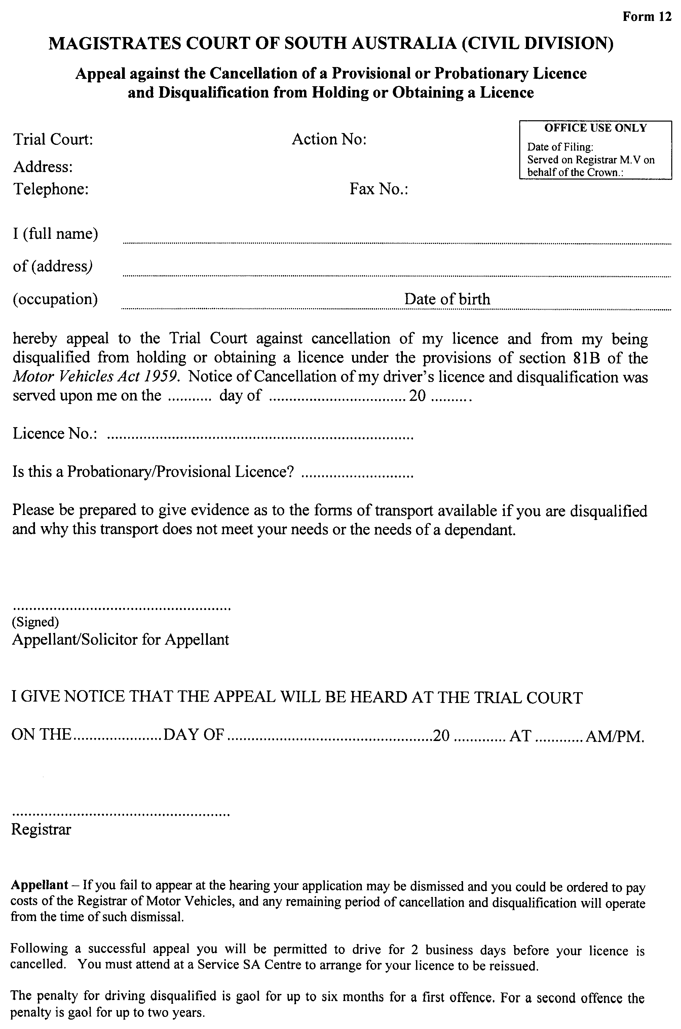
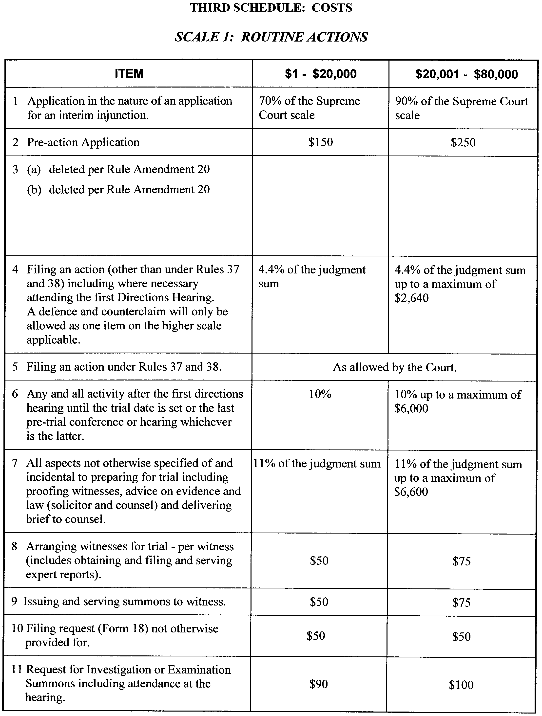
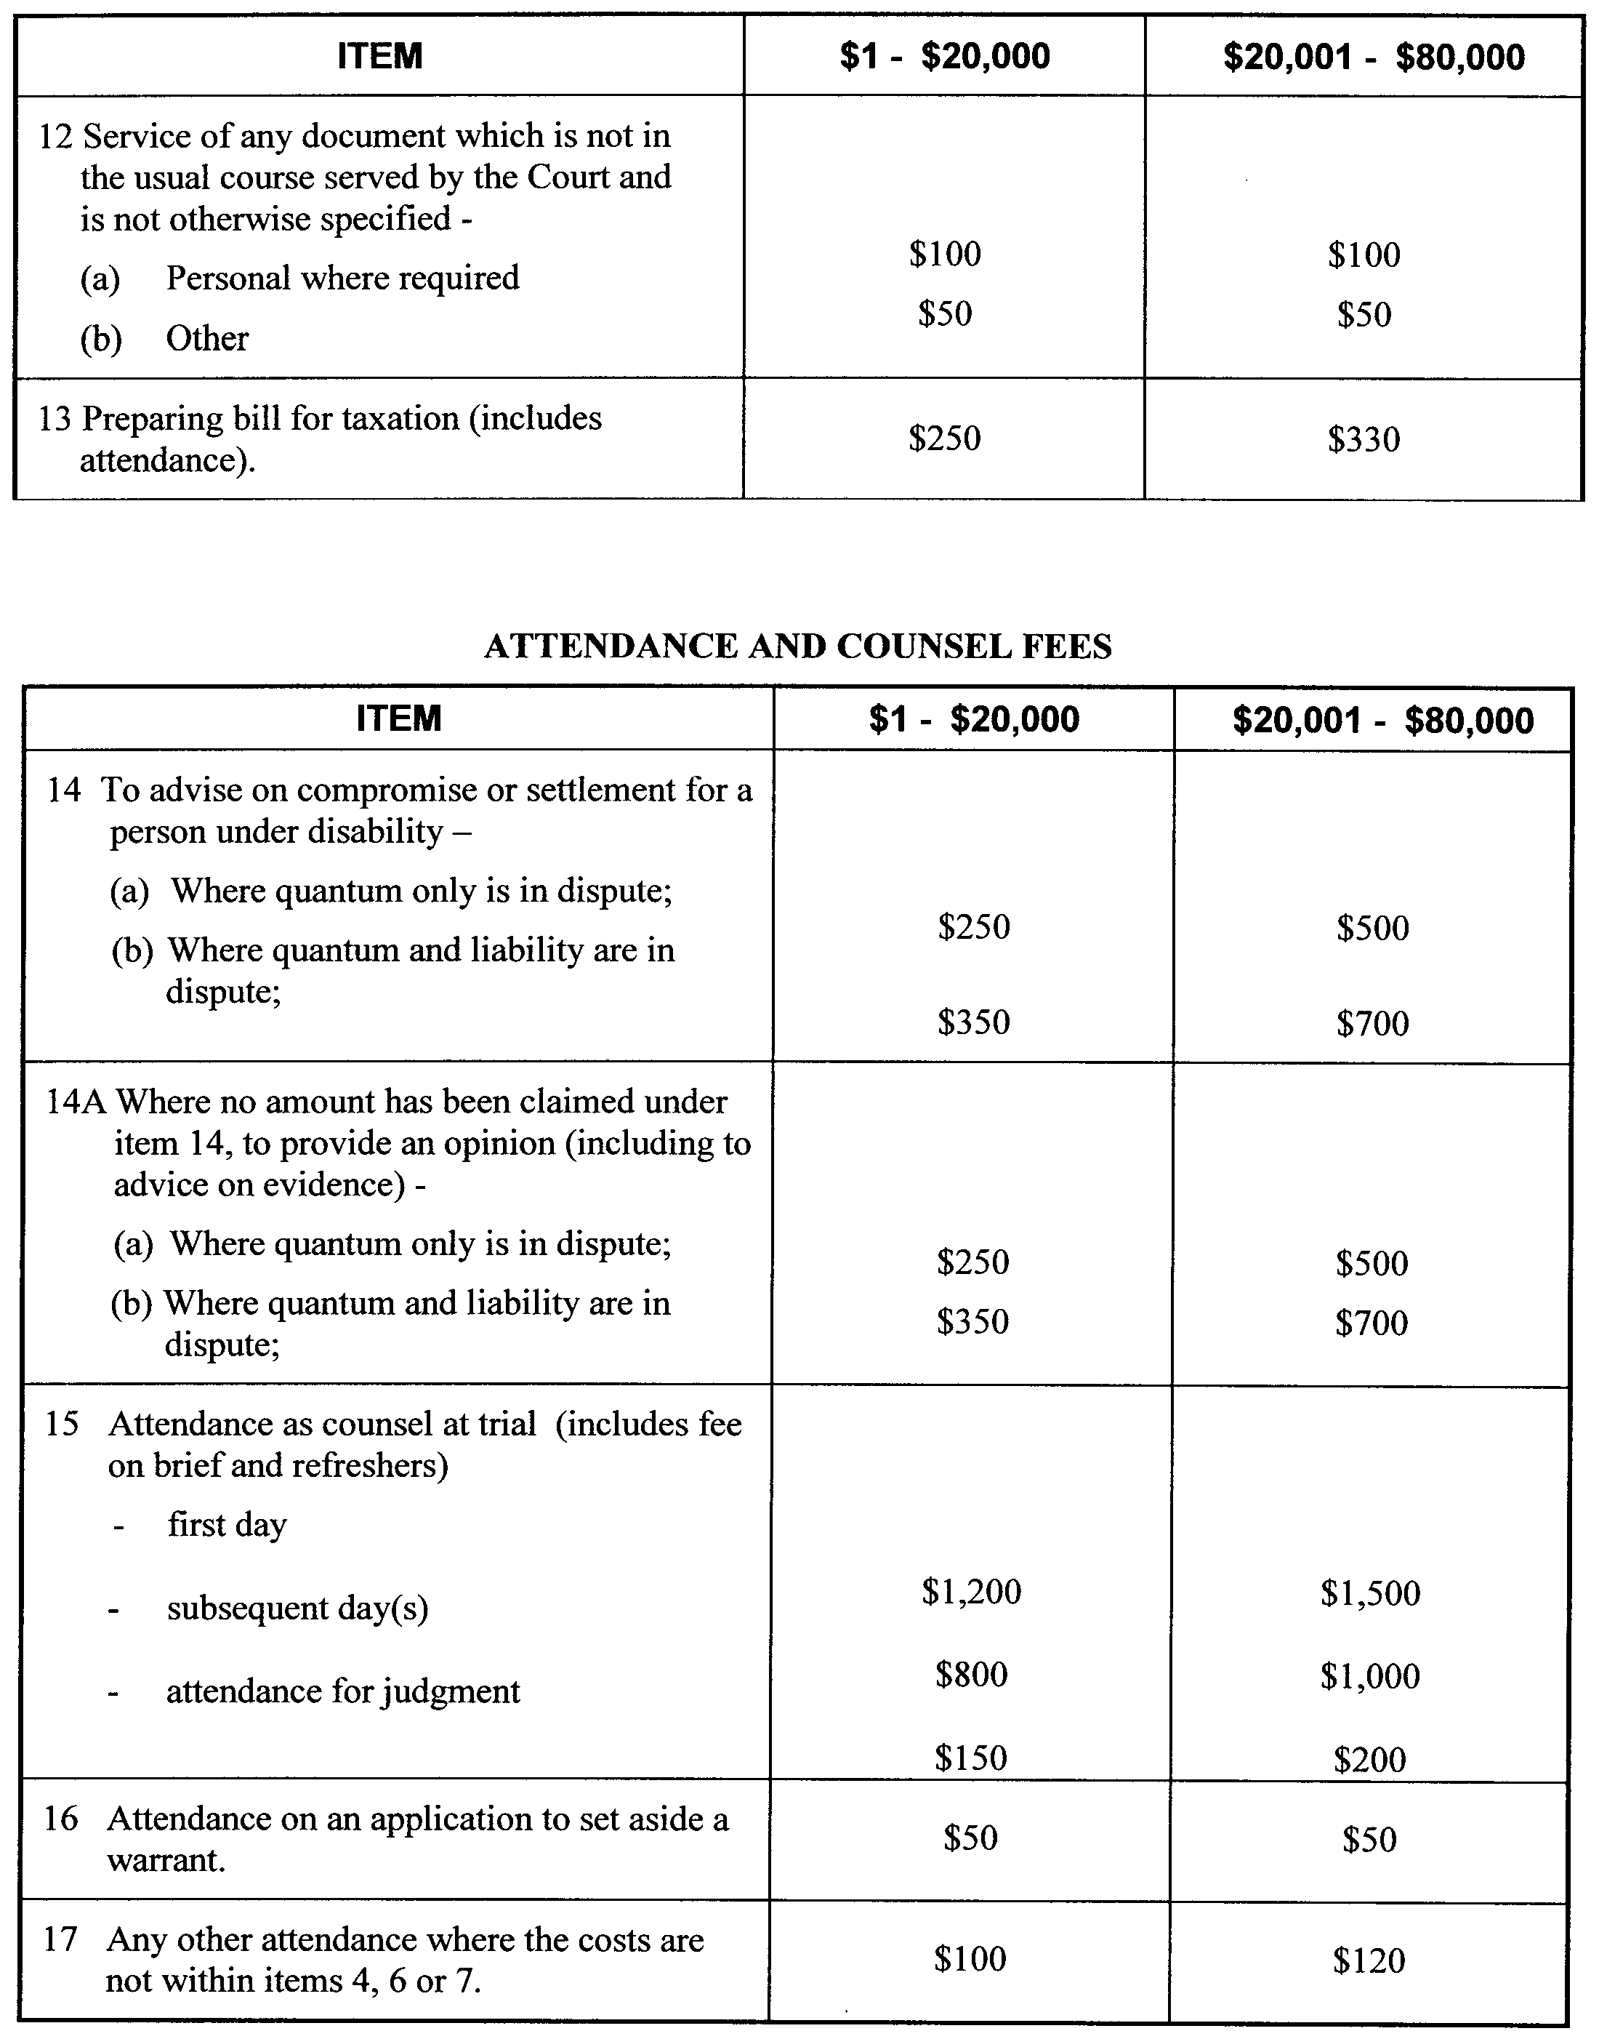
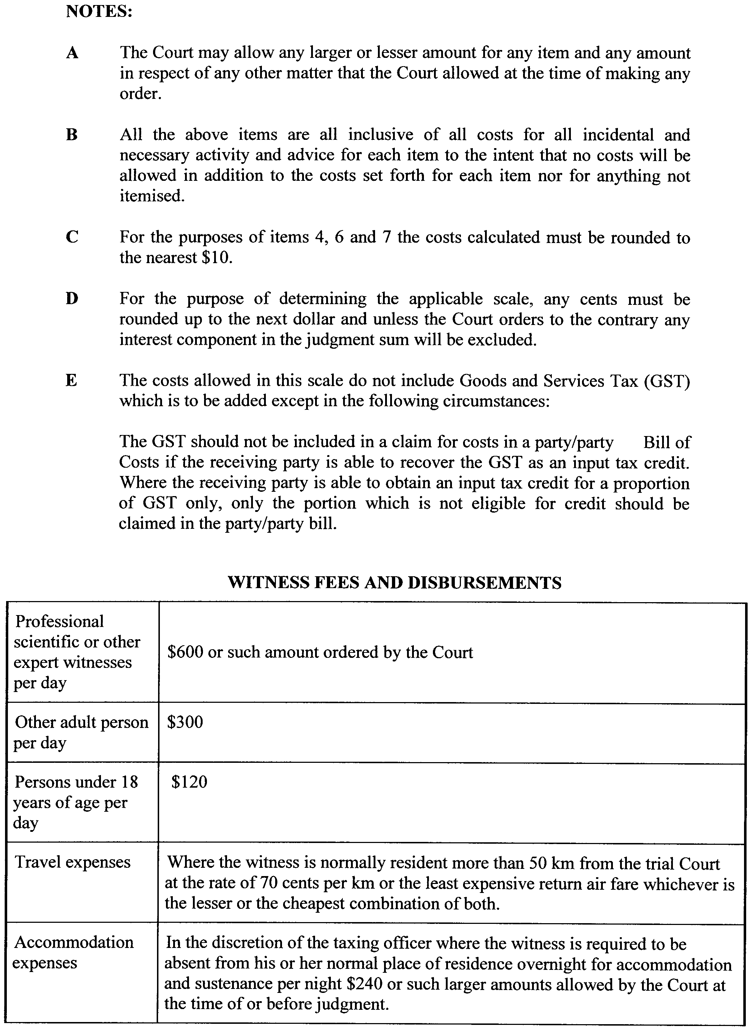
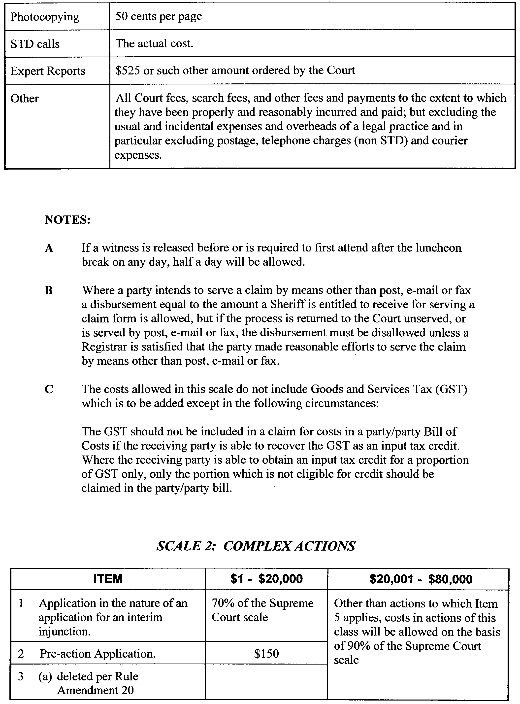
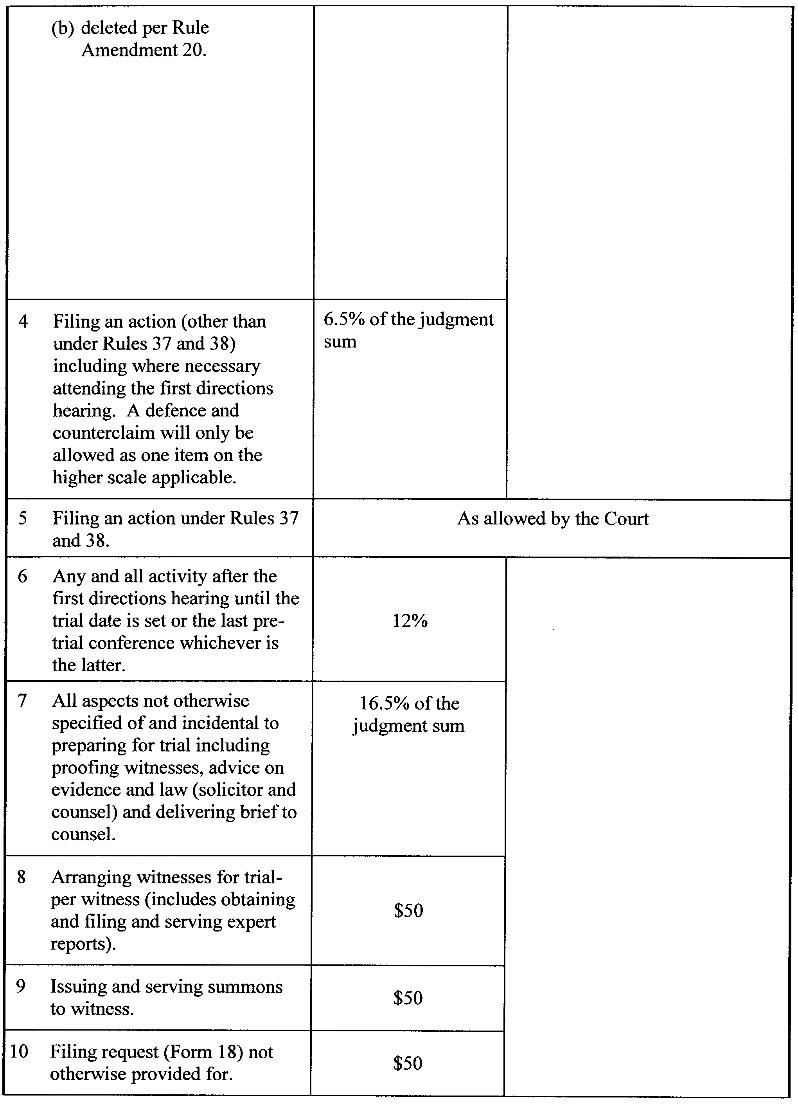
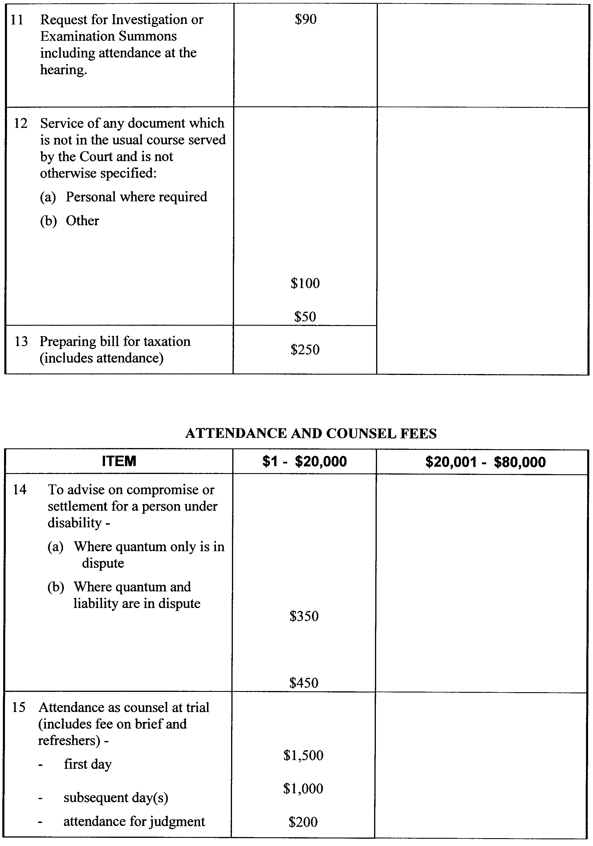
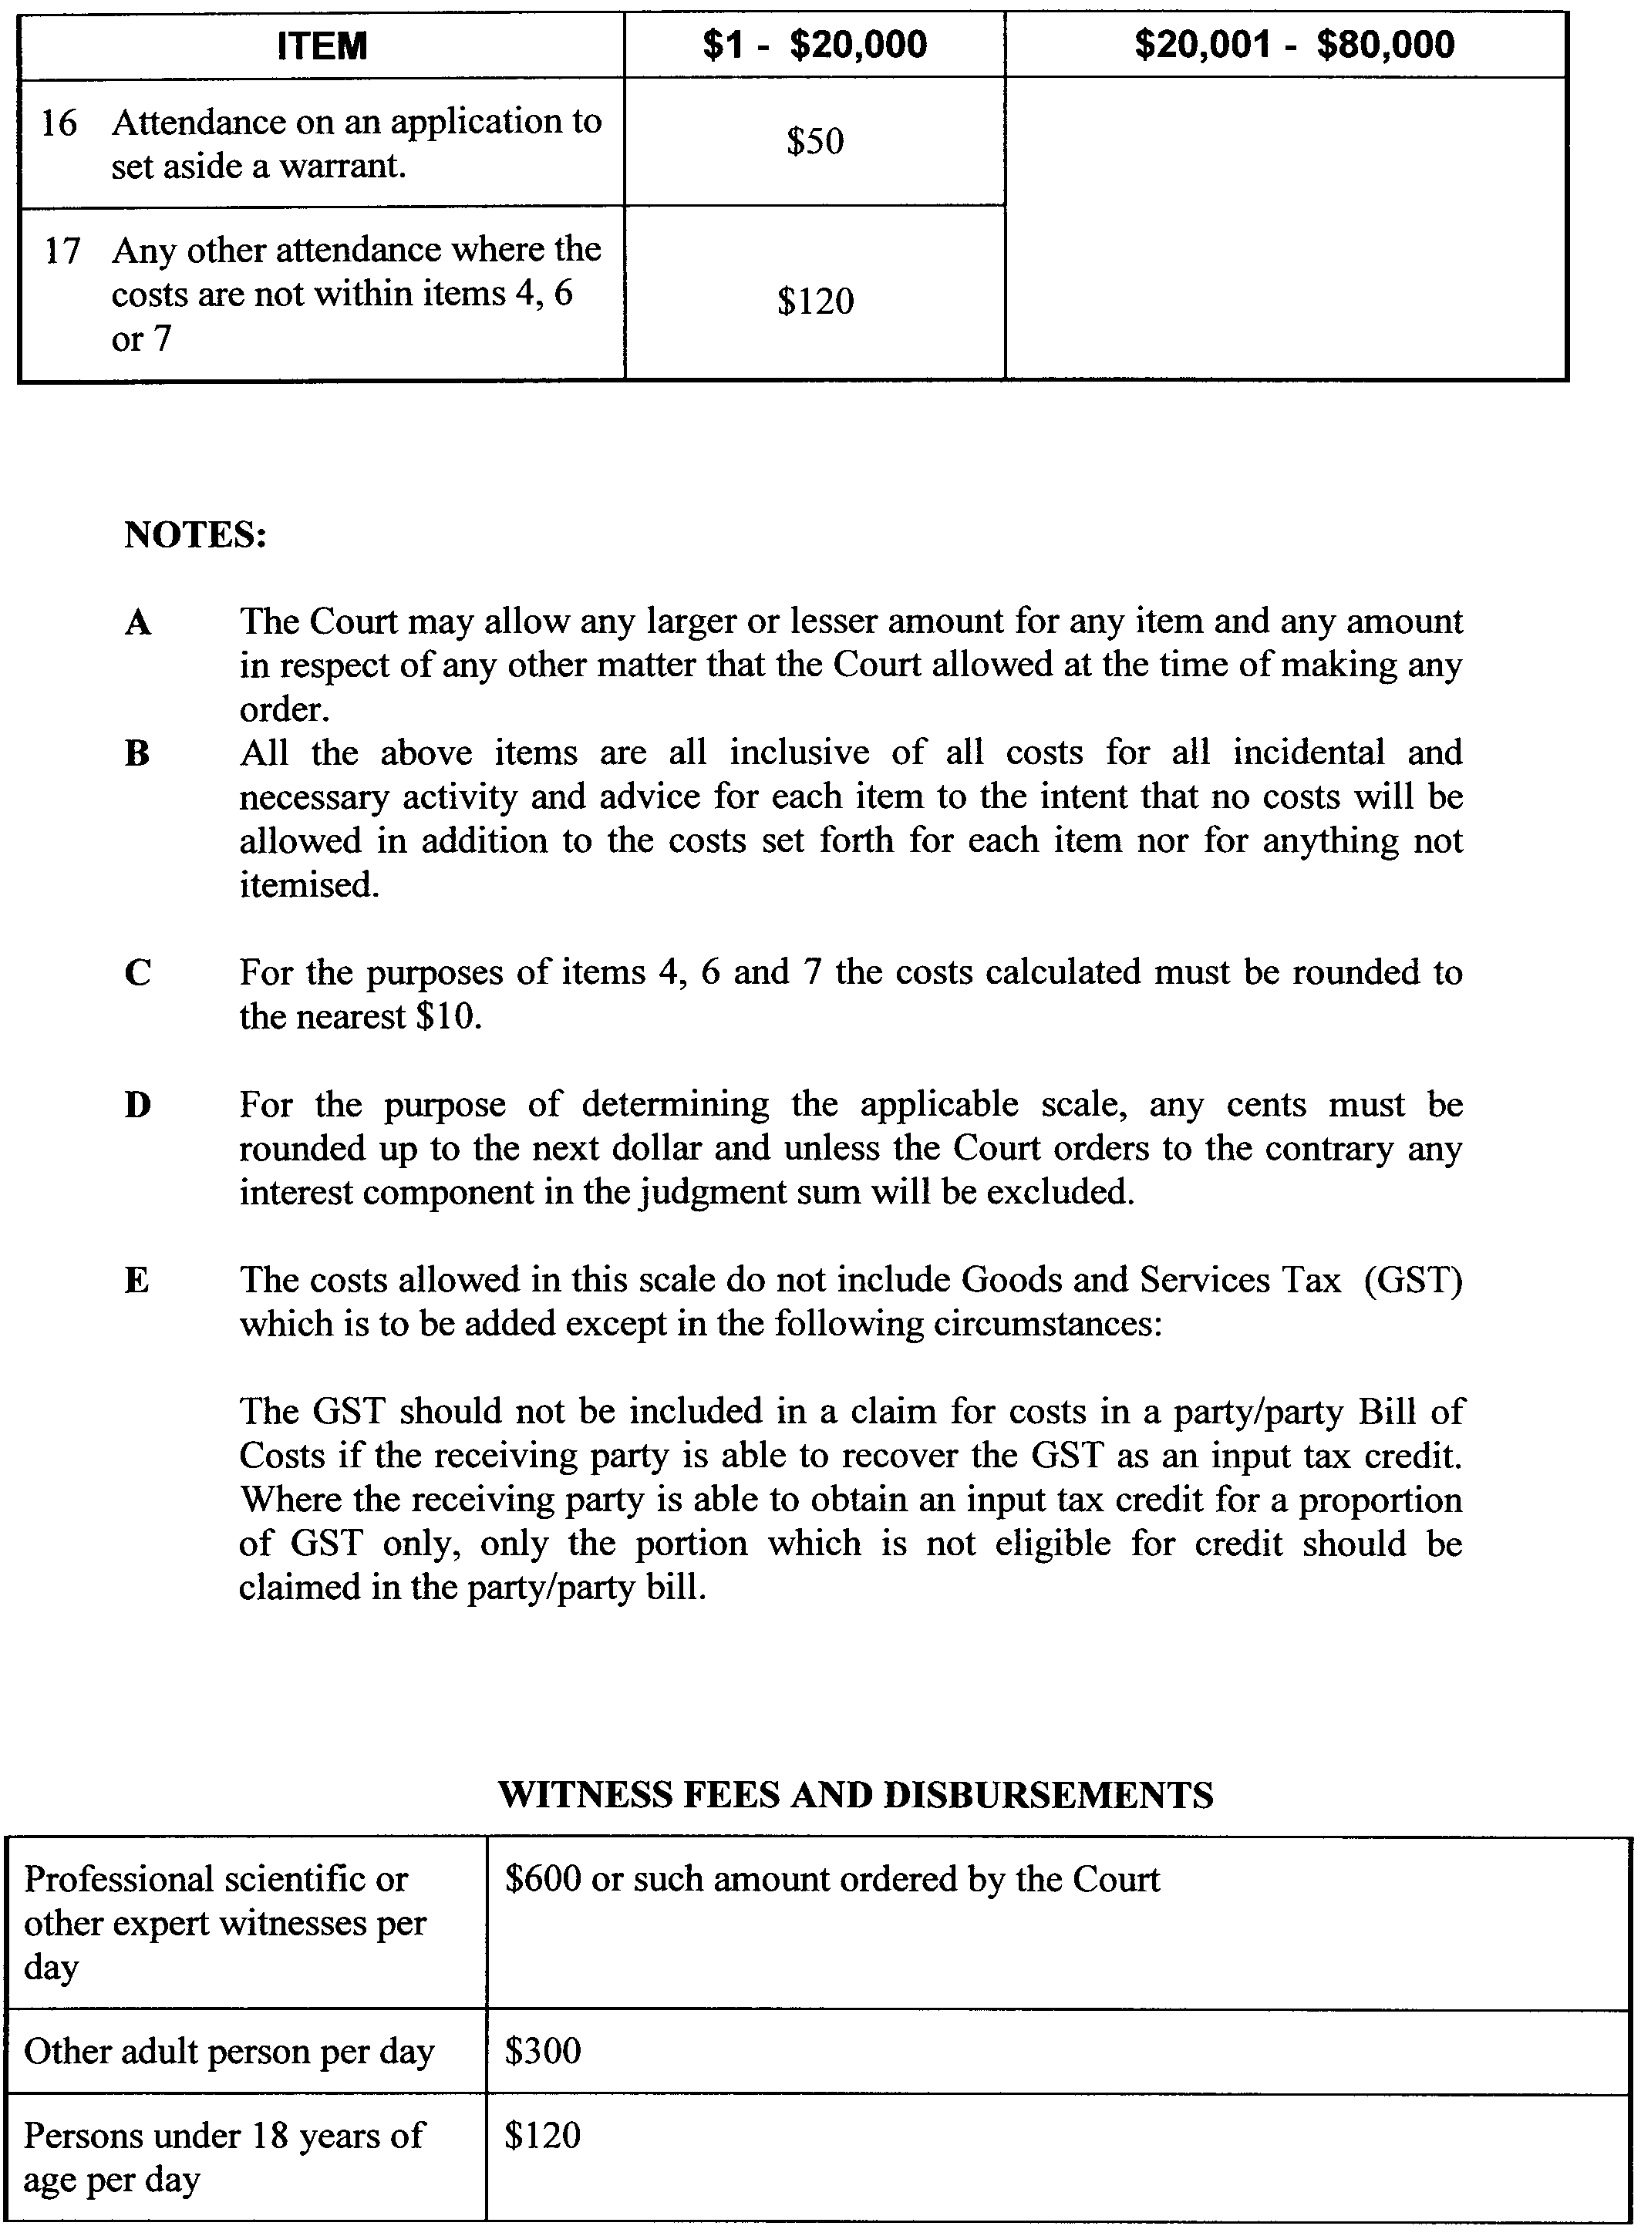
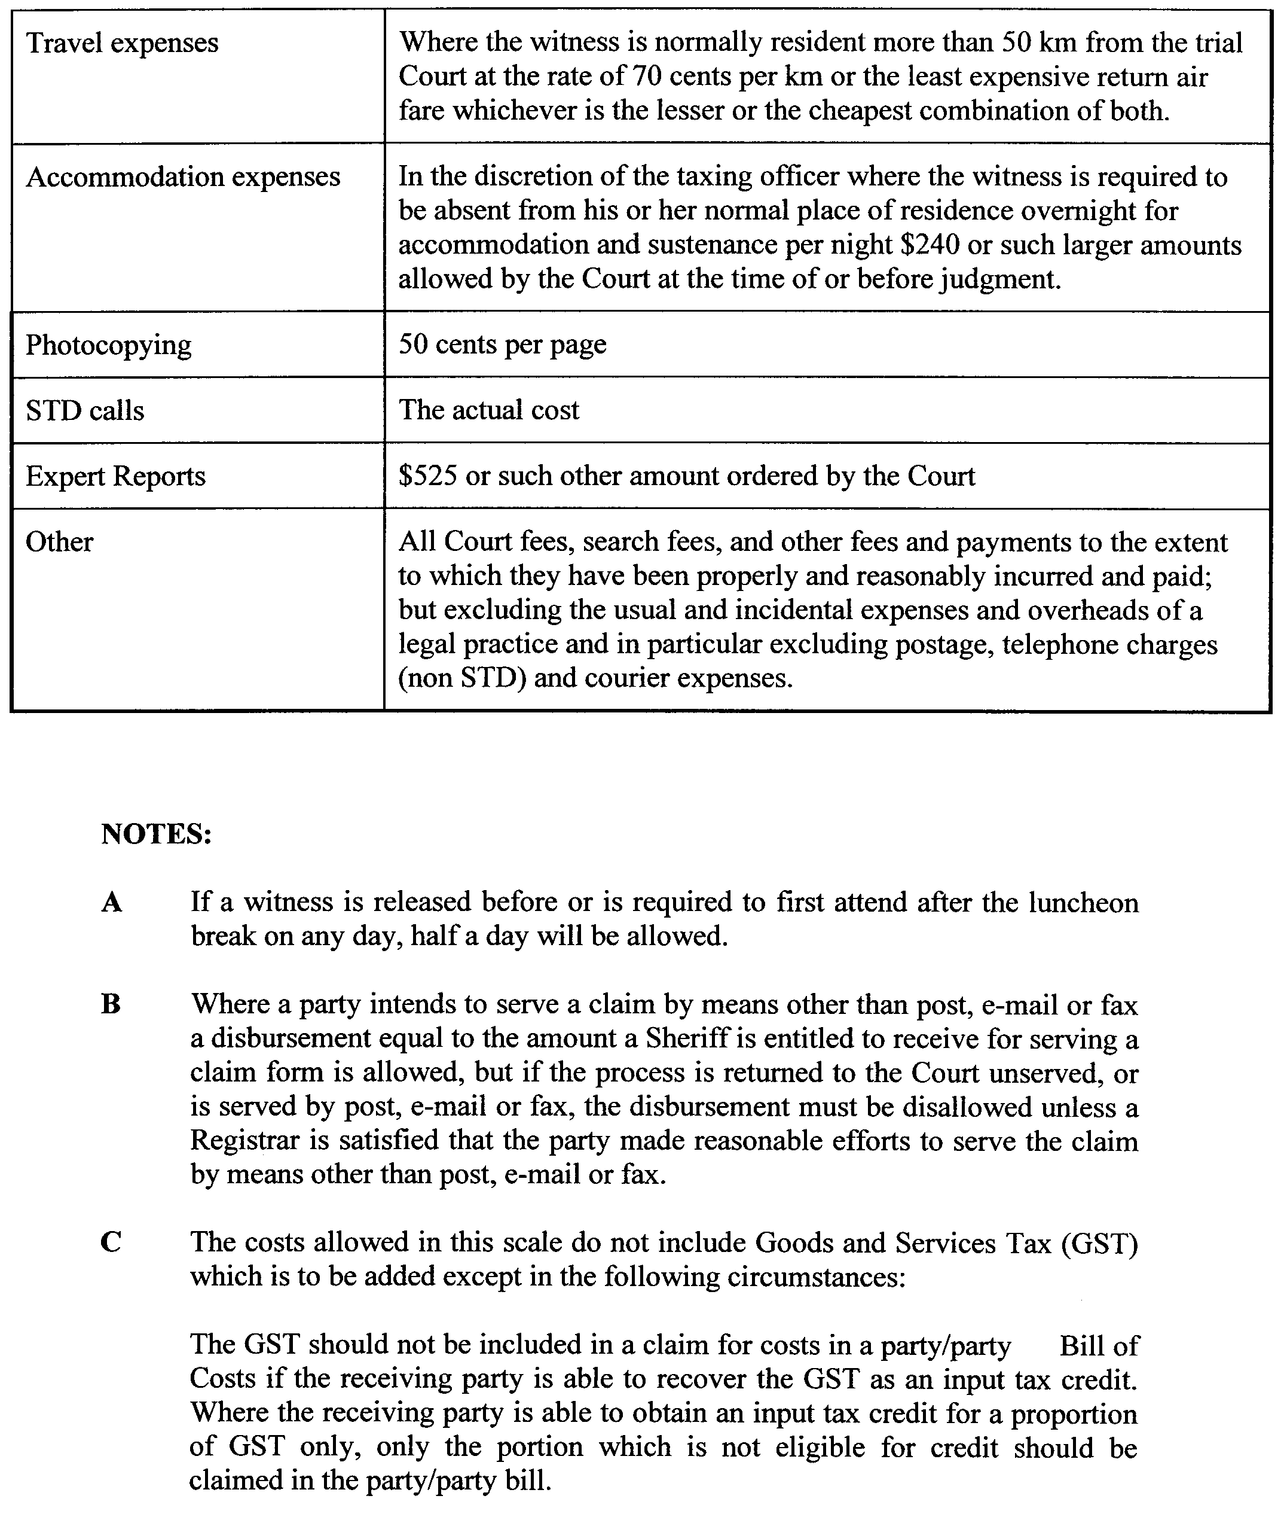
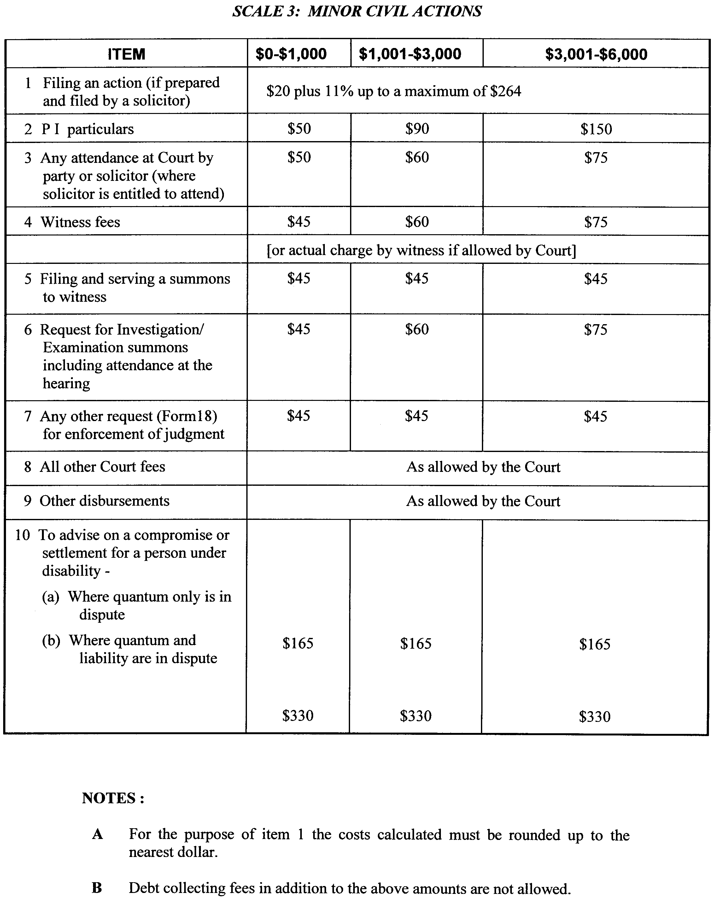
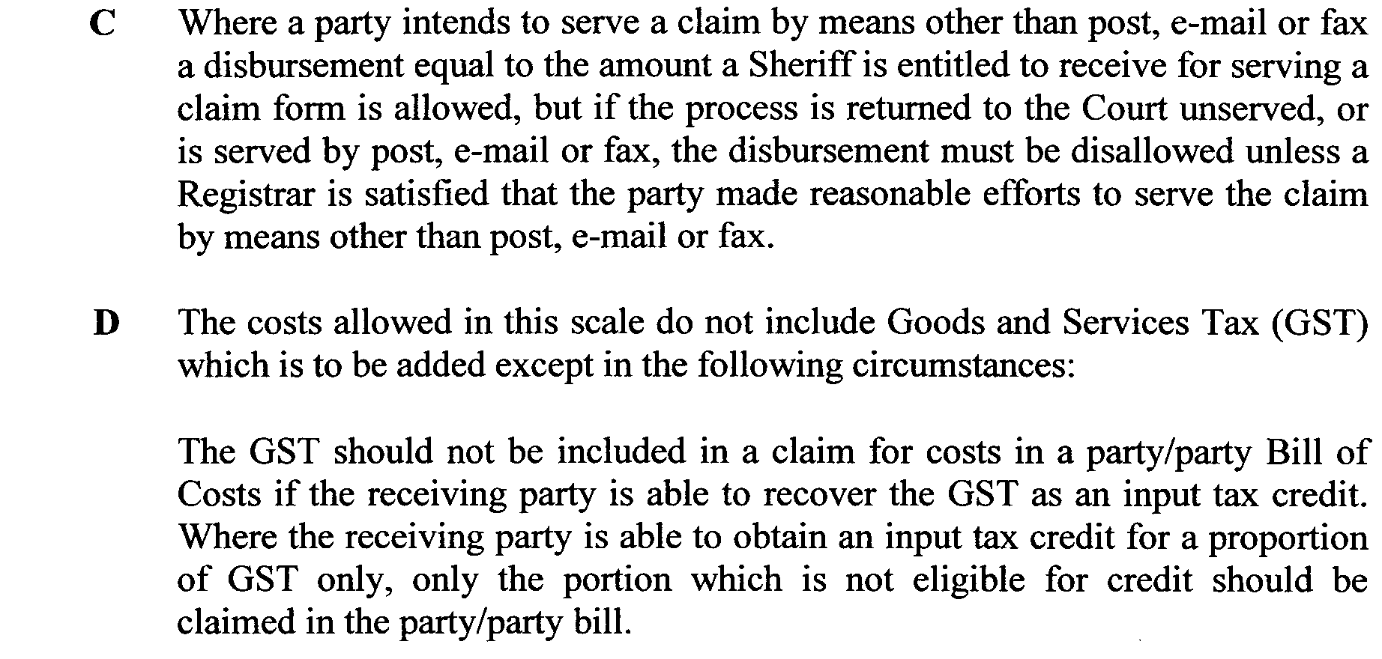
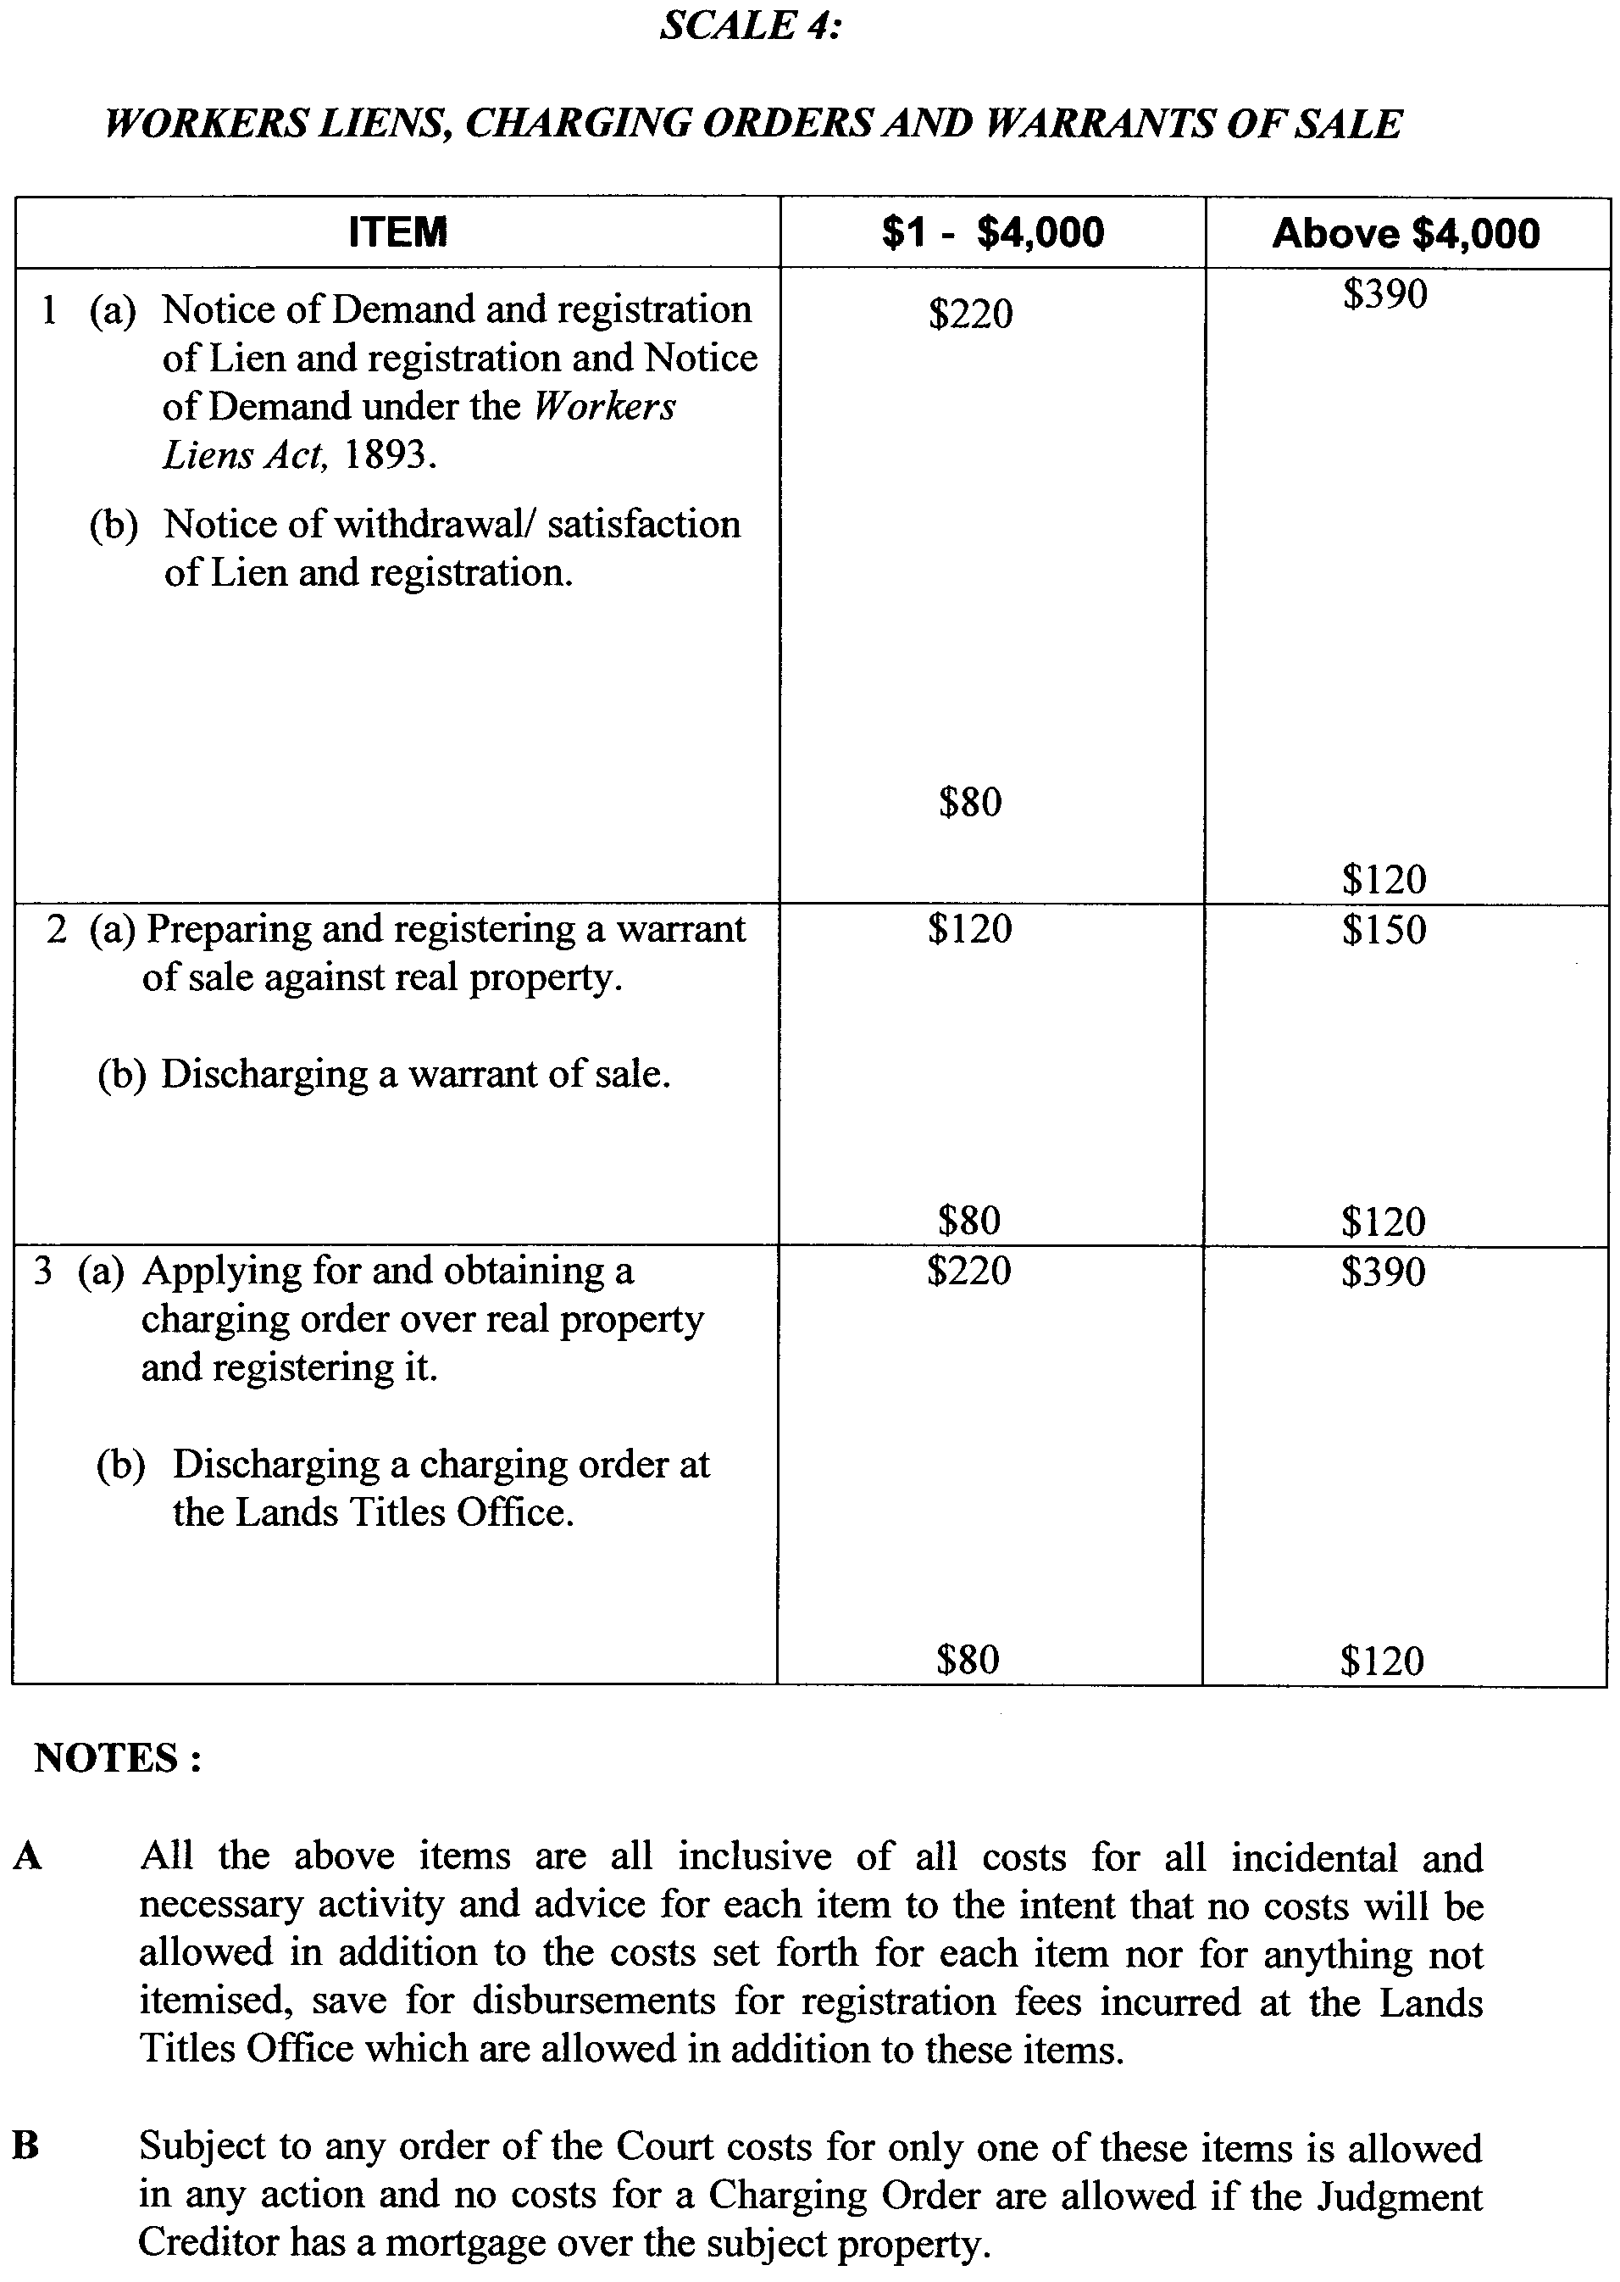
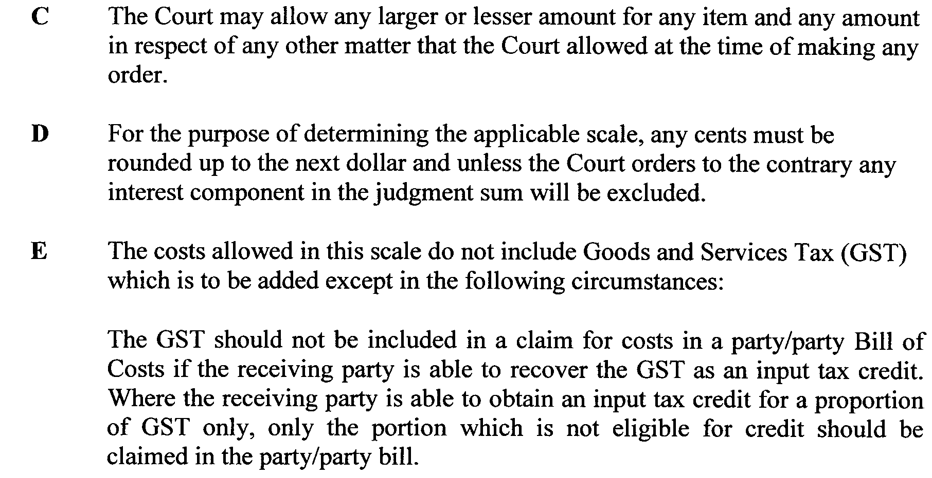

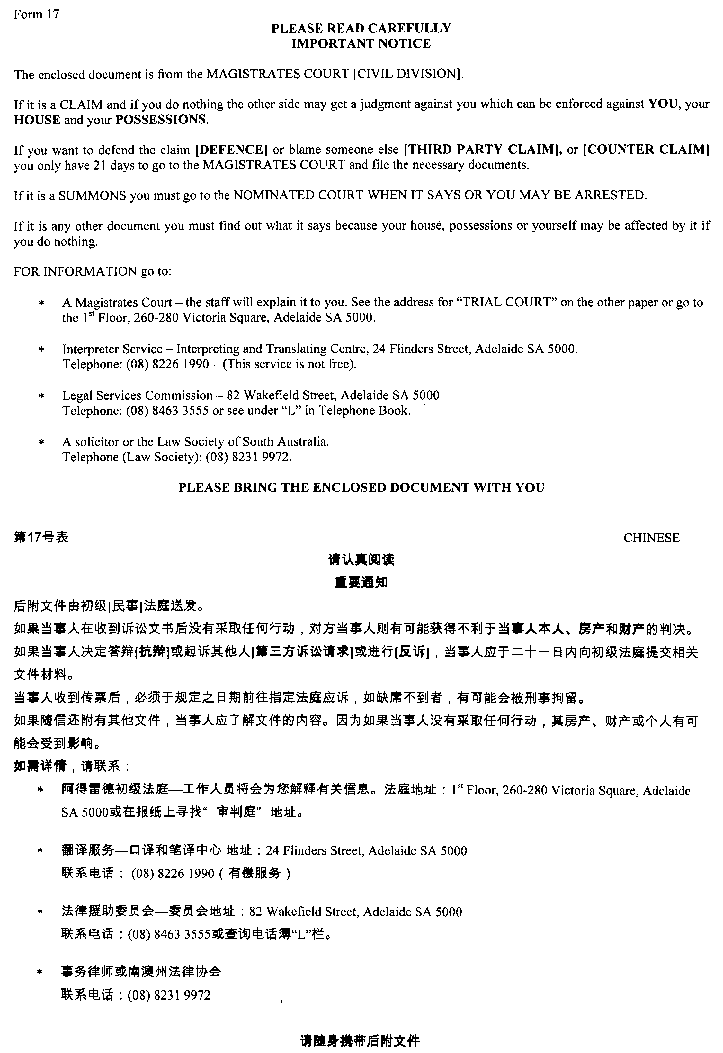
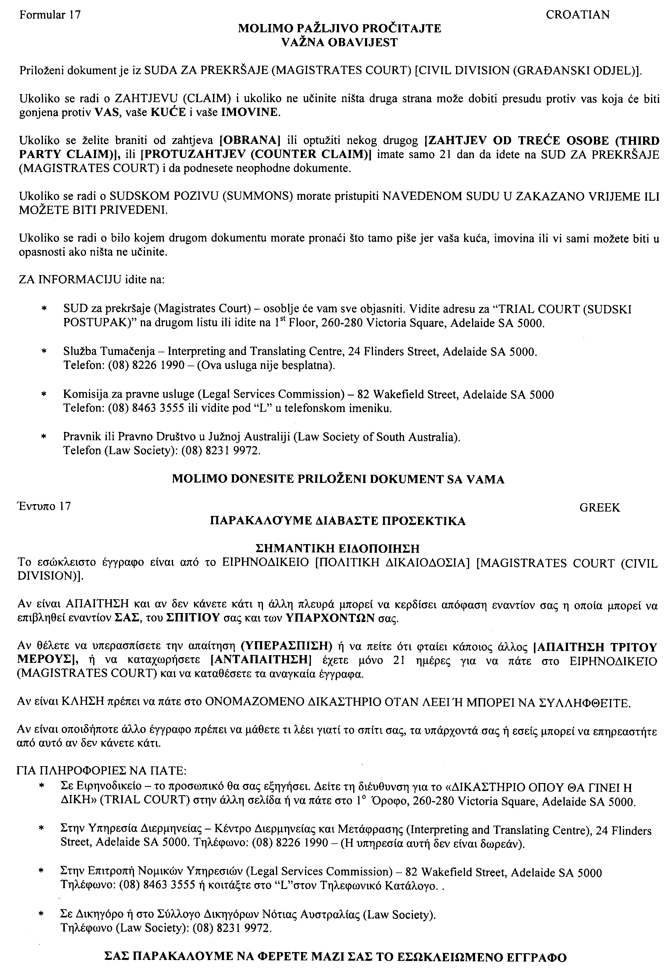
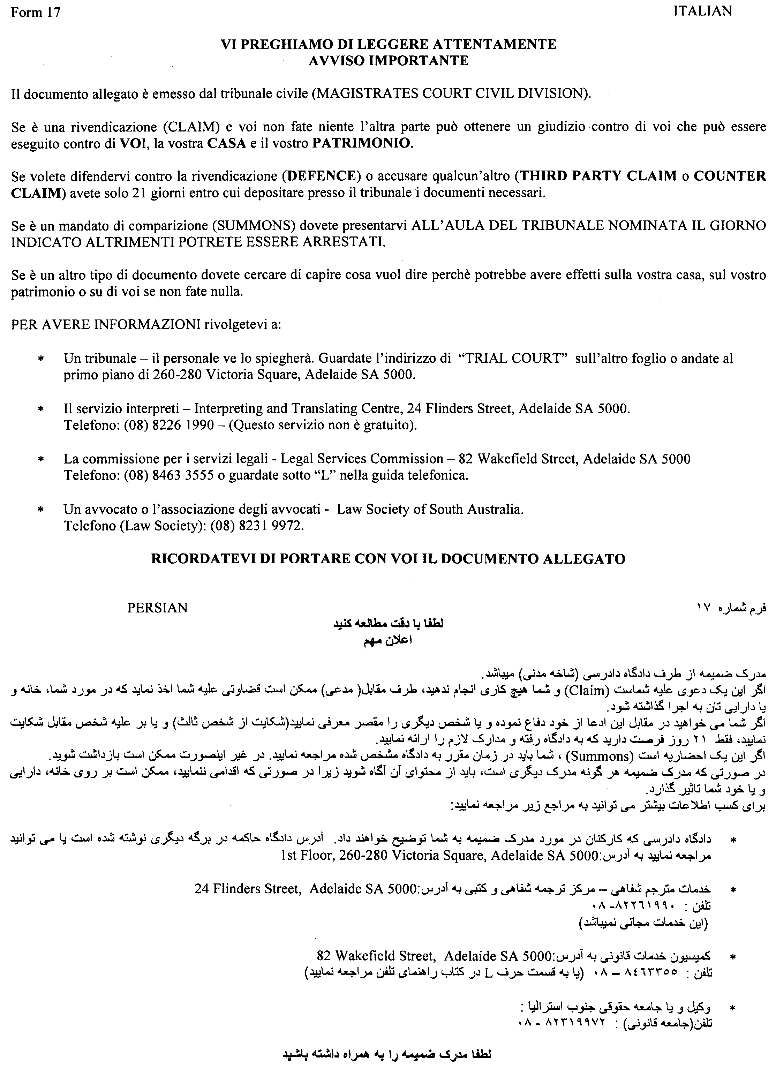
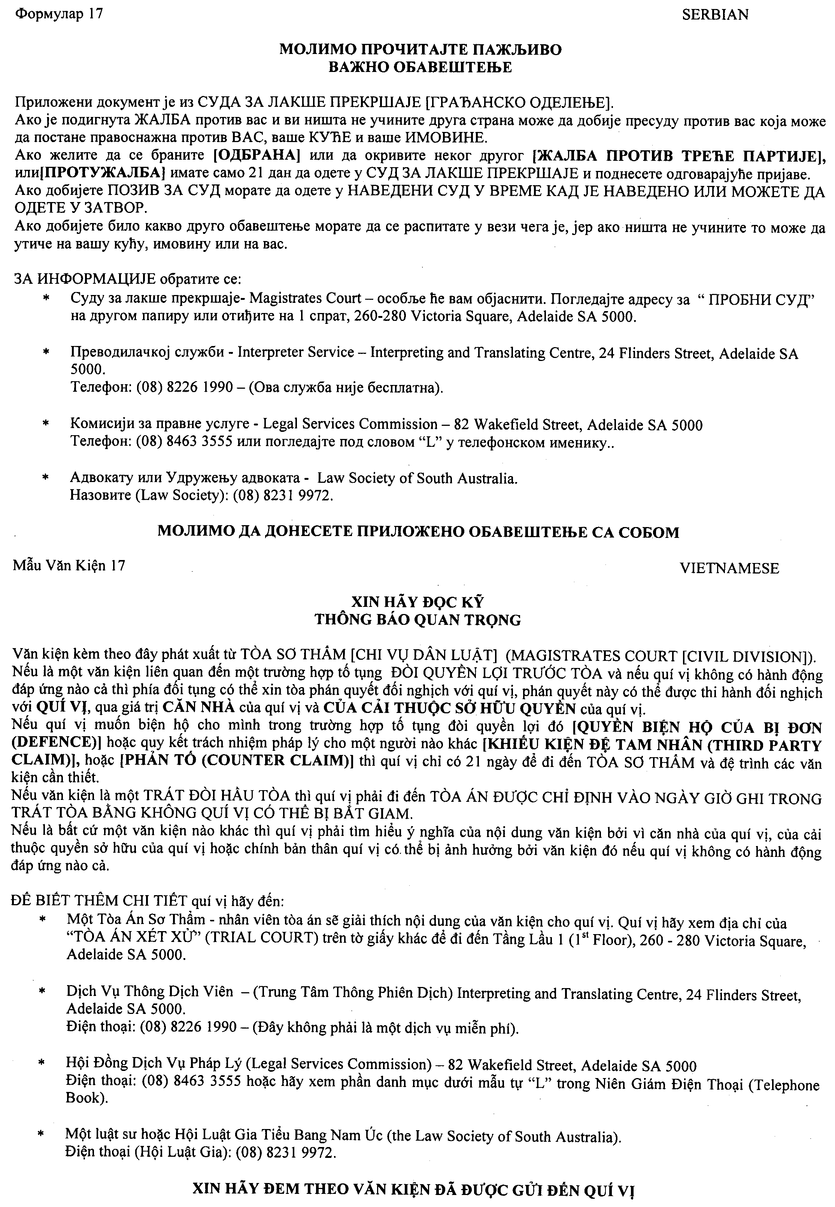

RULES OF COURT
Magistrates Court of South Australia
Addendum to Amendment 36 to the Magistrates Court Rules 1992

PURSUANT to section 49 of the Magistrates Court Act 1991 and all other enabling powers, we the undersigned do hereby make the following amendments to the MAGISTRATES COURT RULES 1992, as amended:

- Delete clause 4 of Amendment 36 in its entirety.
- Delete the following text from clause 5 of Amendment 36:
  - Third Schedule: Costs (Civil) Witness Fees and Disbursements, Scale 2: Complex Actions and Witness Fees and Disbursements, Scale 3: Minor Civil Actions and Scale 4: Workers Liens, Charging Orders and Warrants of Sale.
Signed on the 29th day of November 2010 by:

Elizabeth Mary Bolton Andrew James Cannon
Chief Magistrate Deputy Chief Magistrate

Kym Andrew Millard Simon Hugh Milazzo
Stipendiary Magistrate Stipendiary Magistrate

RULES OF COURT
Magistrates Court of South Australia
Addendum to Amendment 37 to the Magistrates Court Rules 1992

PURSUANT to section 49 of the Magistrates Court Act 1991 and all other enabling powers, we the undersigned do hereby make the following amendments to the MAGISTRATES COURT RULES 1992, as amended:
- The current form 83 is deleted and the new form 83 is inserted;
- The current form 84 is deleted and the new form 84 is inserted.

Signed on the 19th day of November 2010 by:

Elizabeth Mary Bolton Andrew James Cannon
Chief Magistrate Deputy Chief Magistrate

Kym Andrew Millard Simon Hugh Milazzo
Stipendiary Magistrate Stipendiary Magistrate

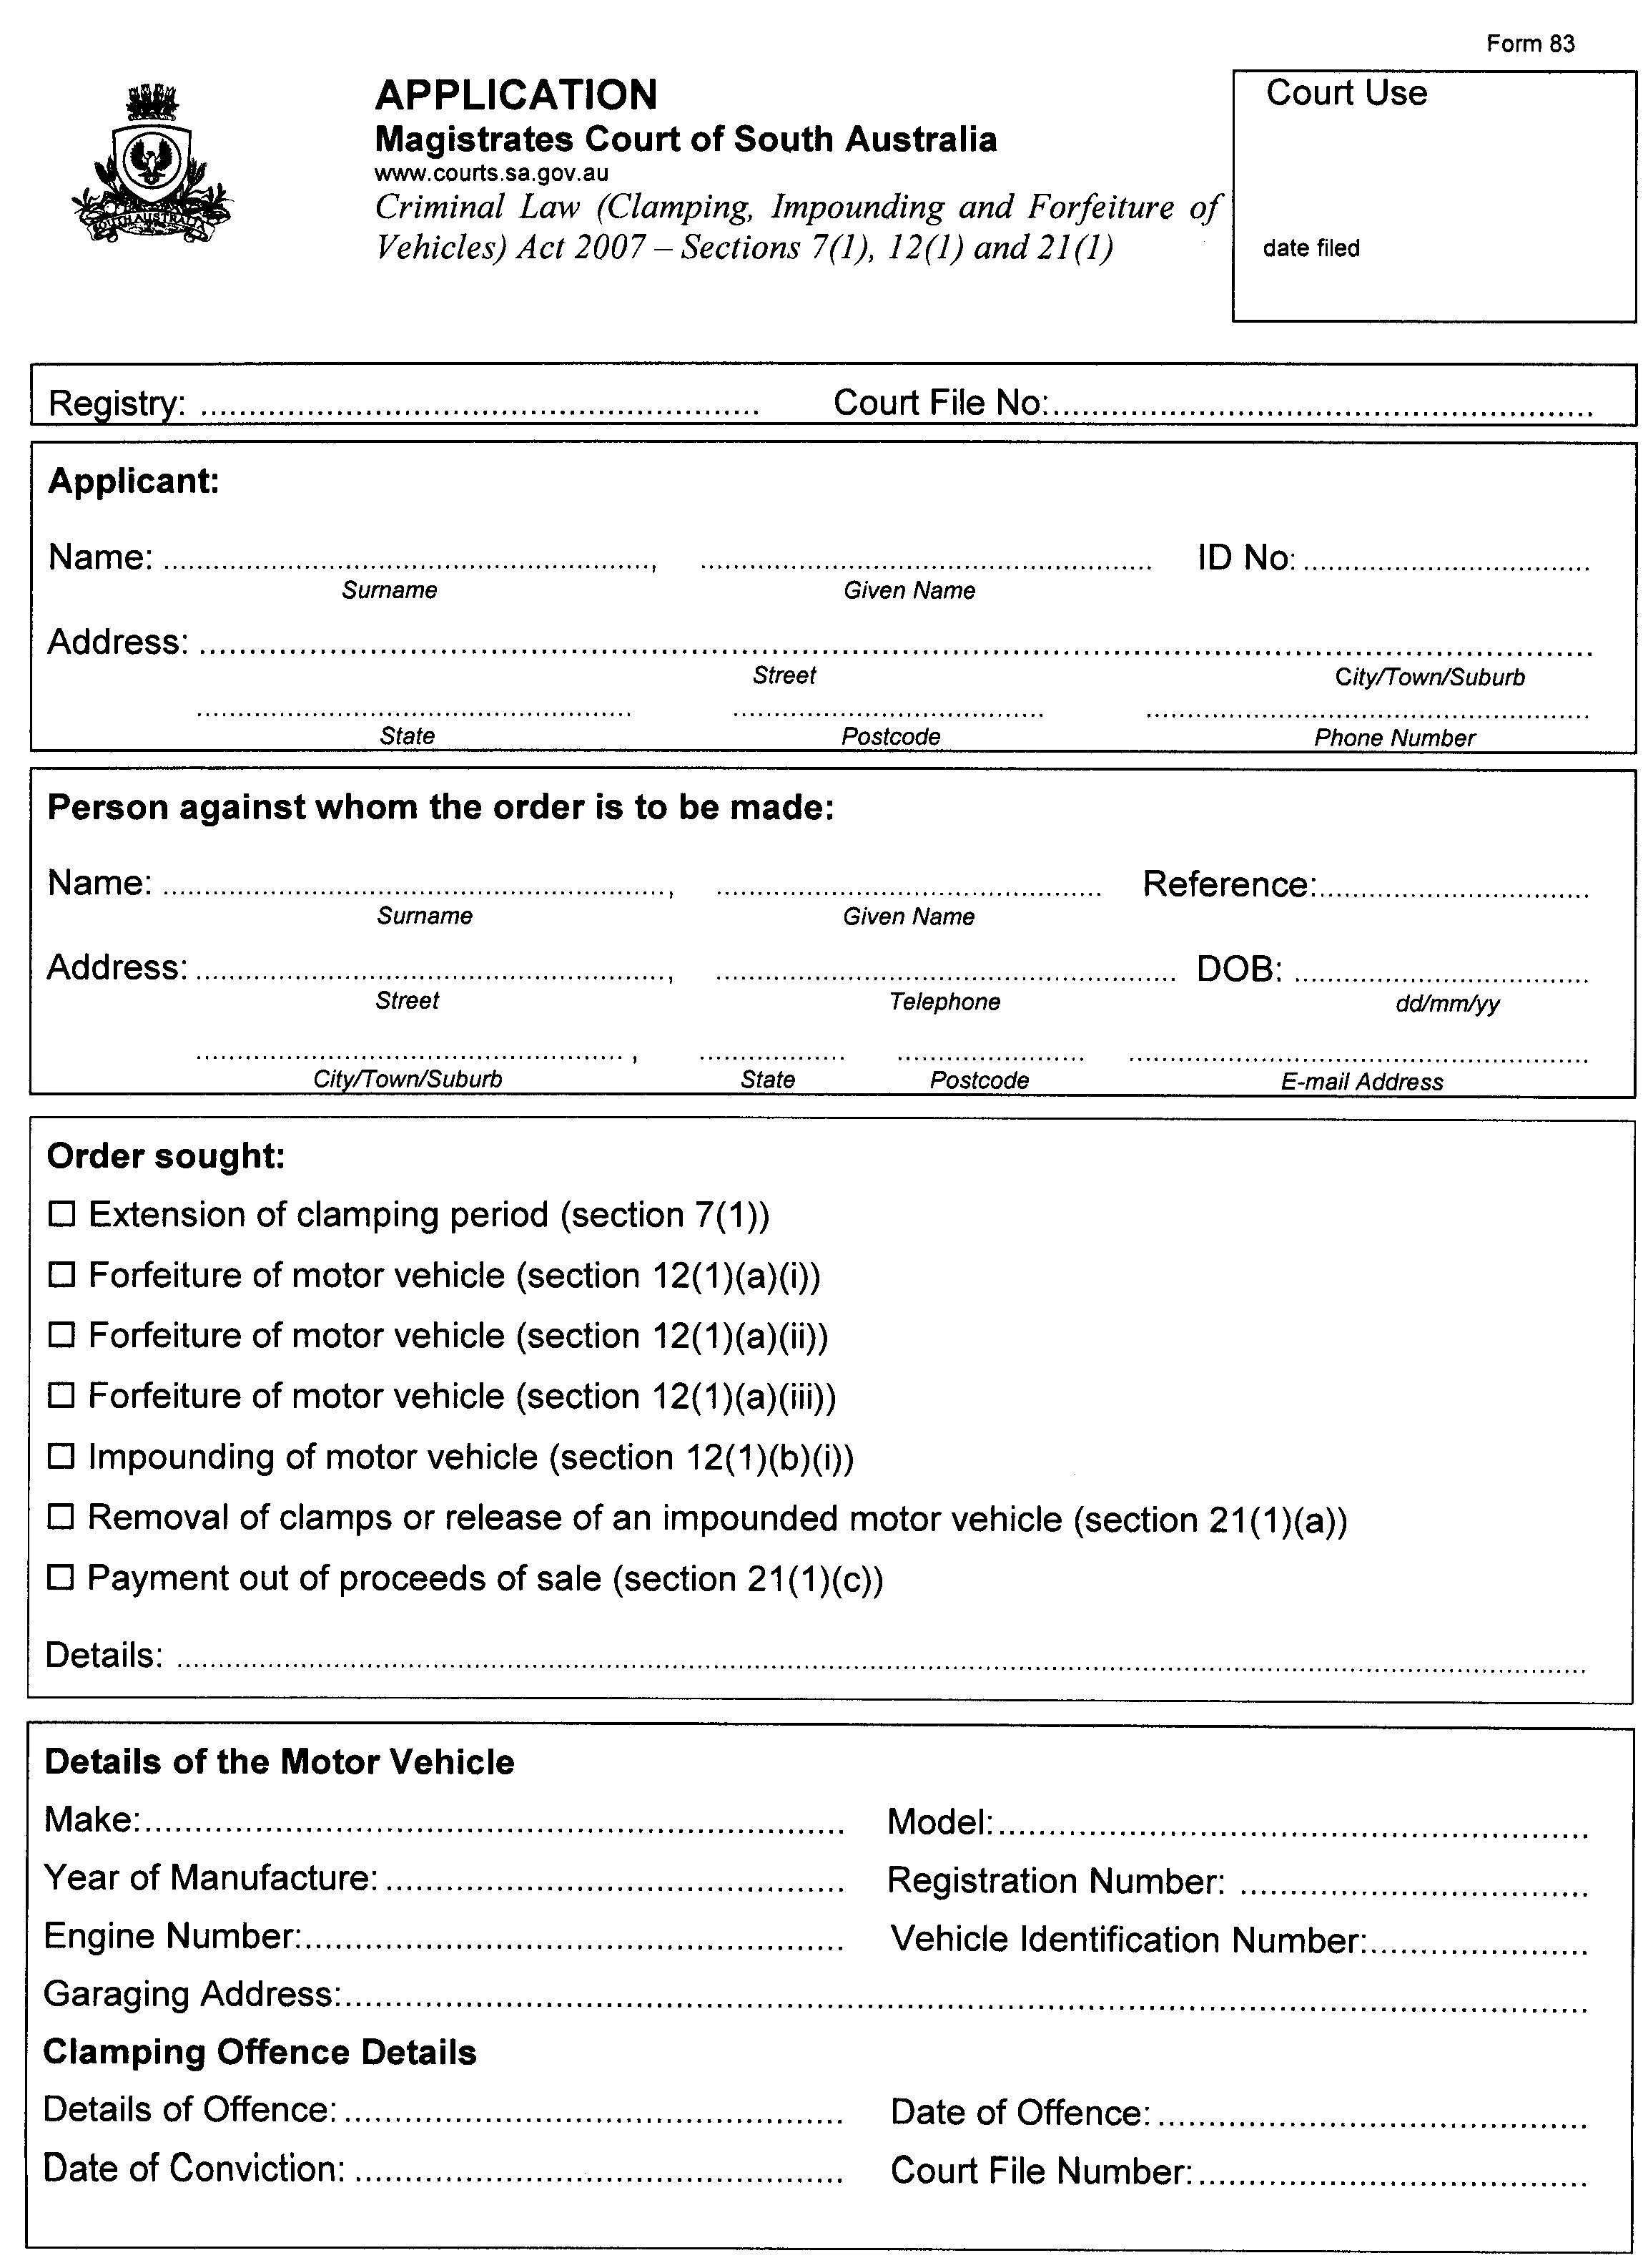
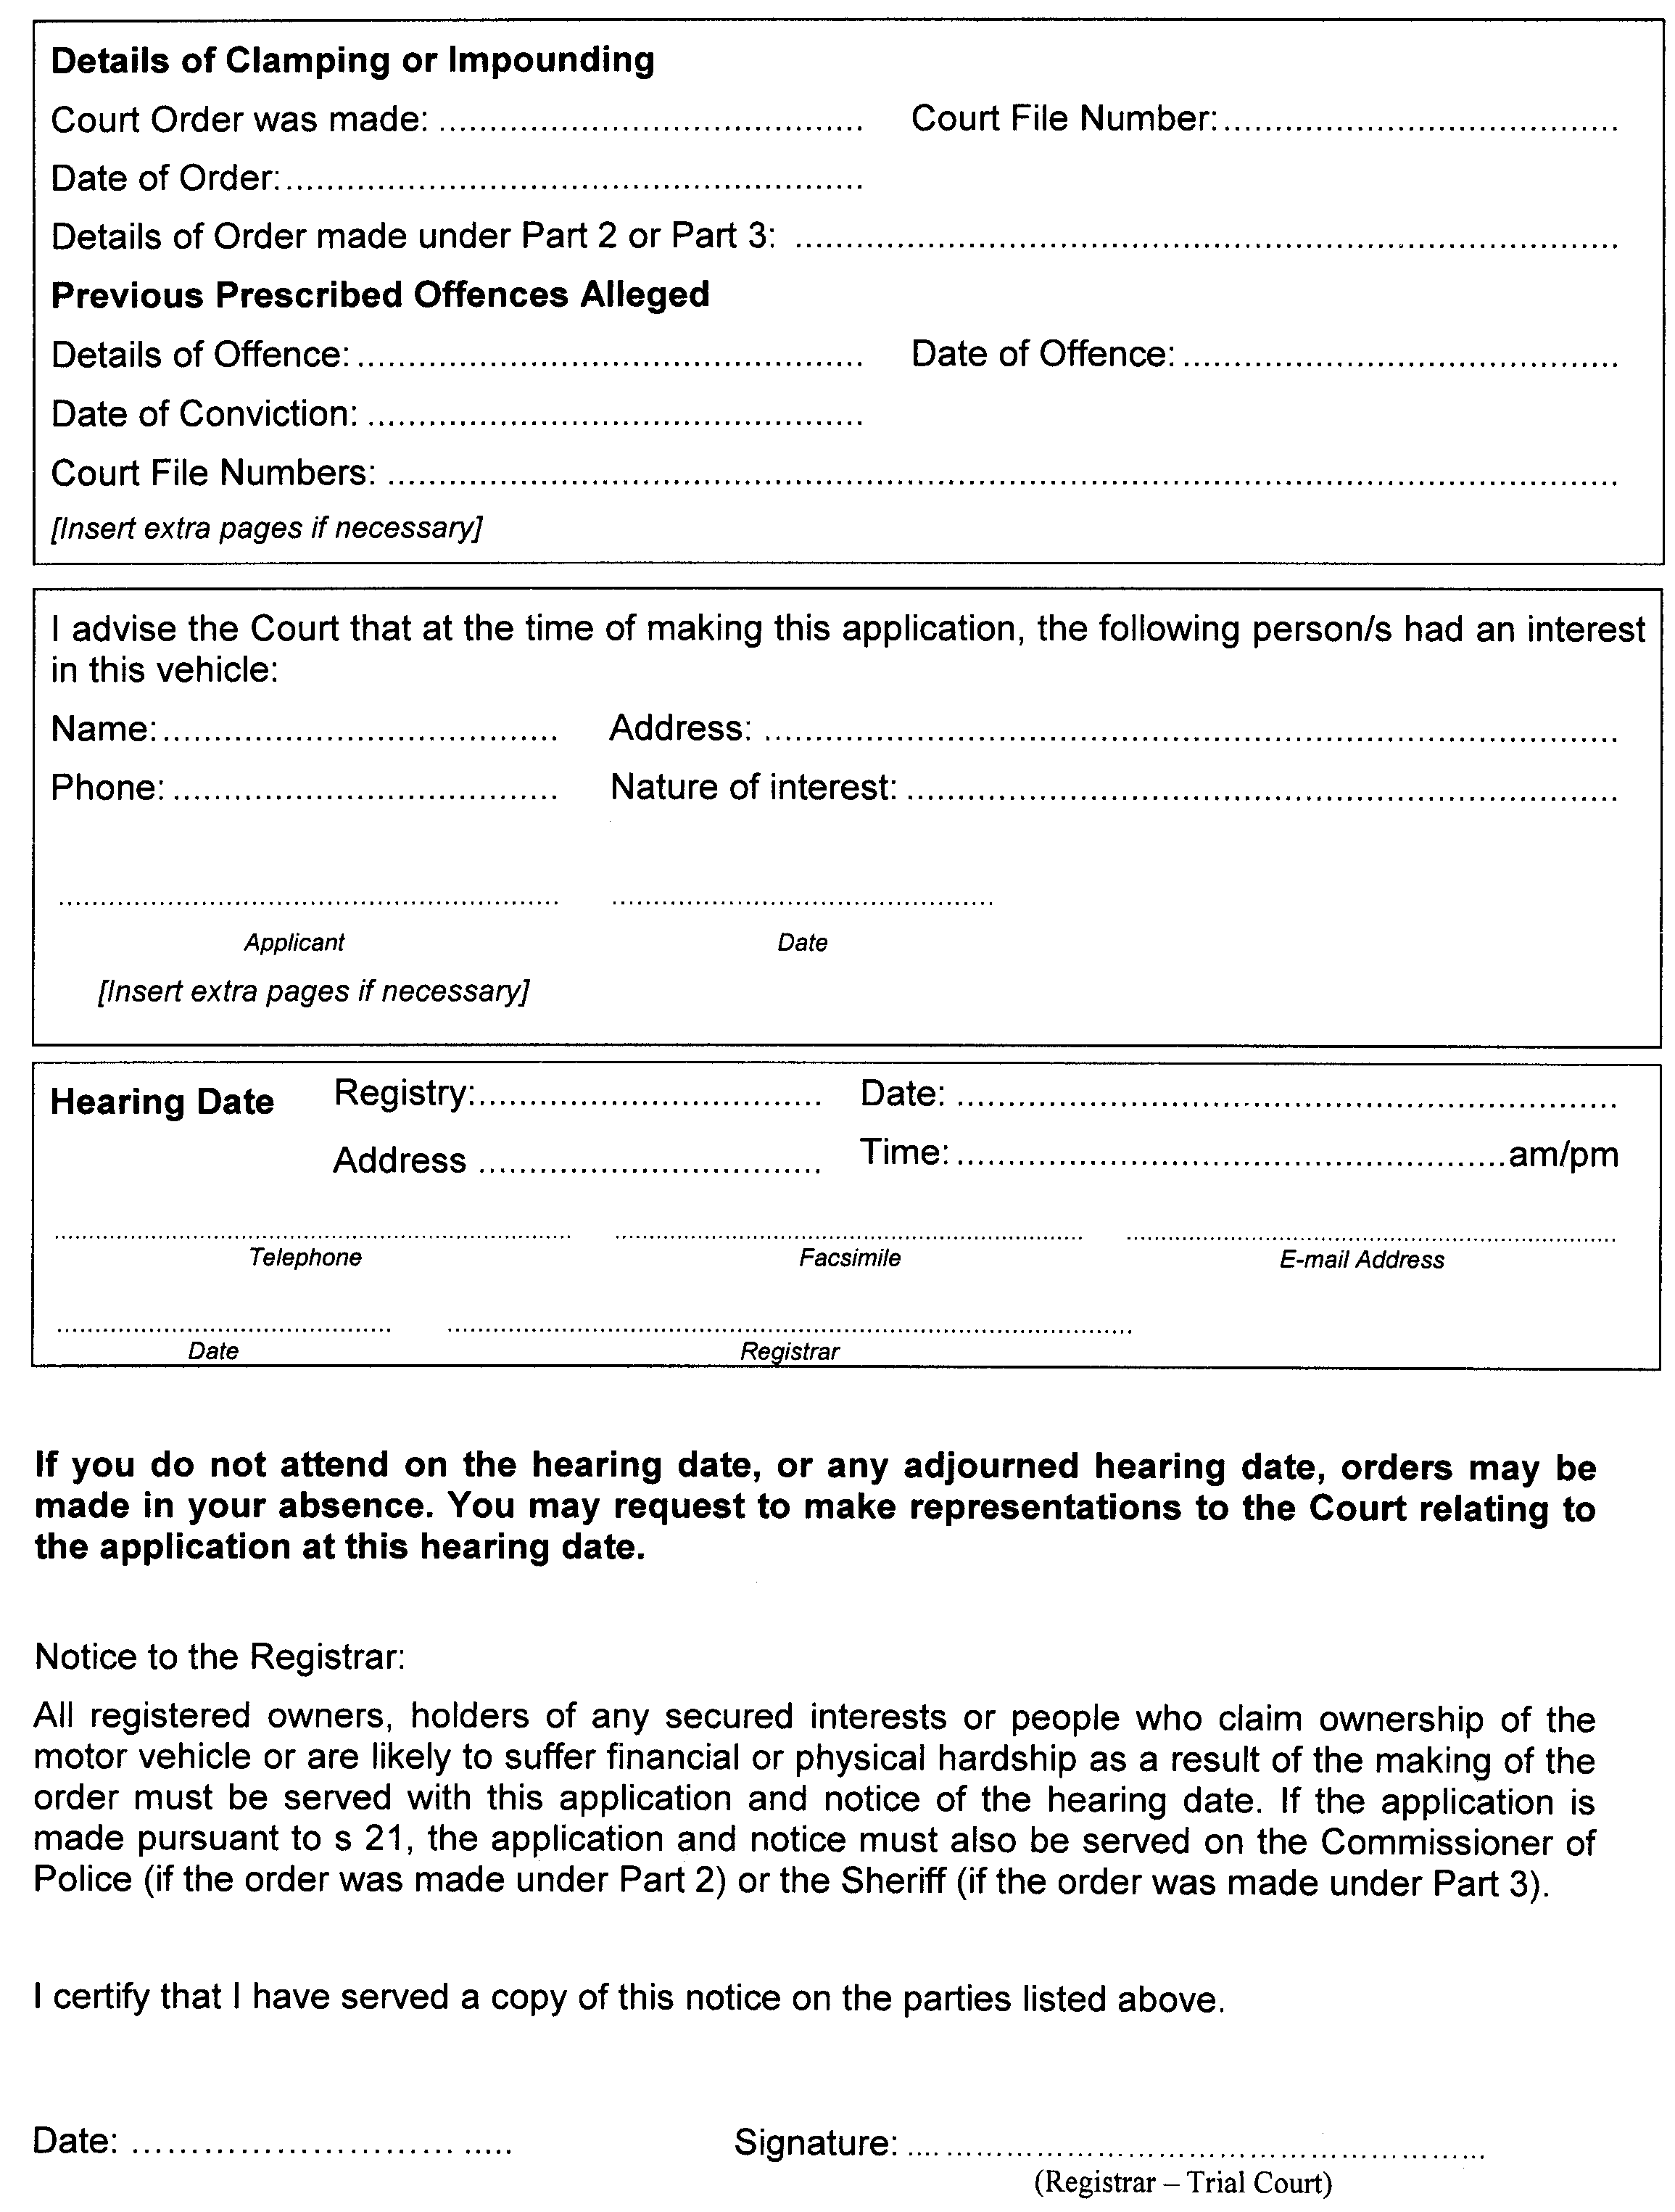
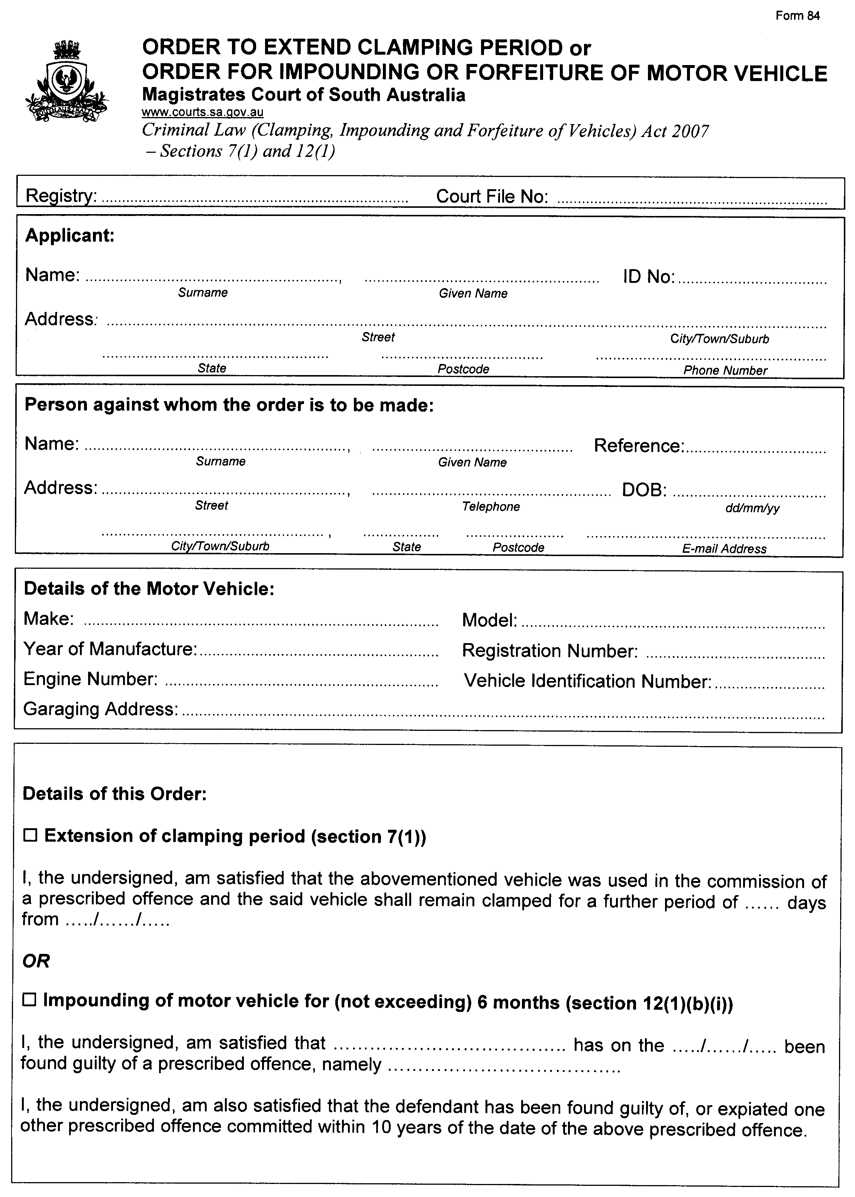

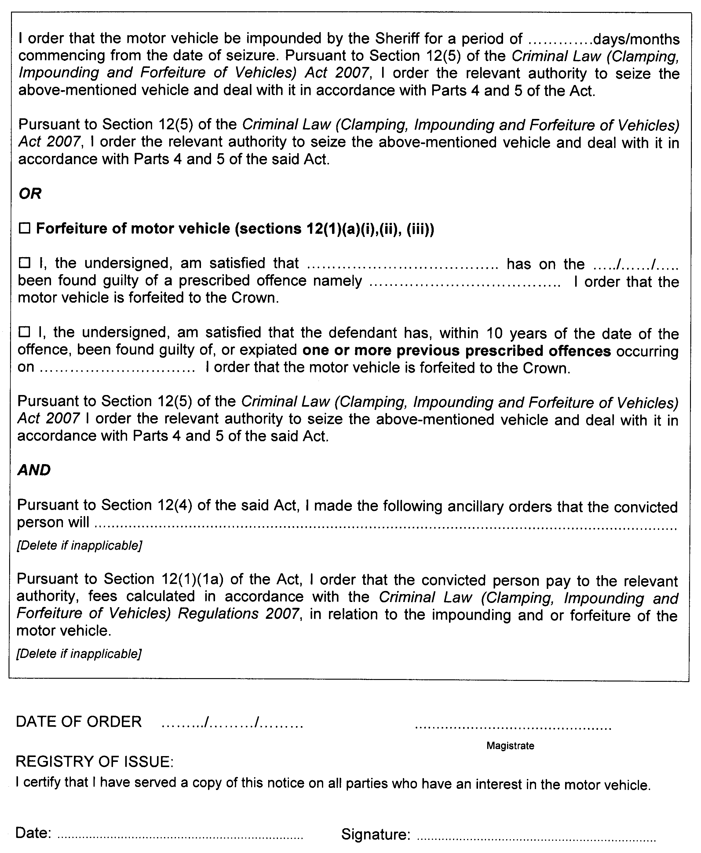

B. MORRIS, Government Printer, South Australia

