No. 91 5755

THE SOUTH AUSTRALIAN

GOVERNMENT GAZETTE
www.governmentgazette.sa.gov.au

PUBLISHED BY AUTHORITY

ALL PUBLIC ACTS appearing in this GAZETTE are to be considered official, and obeyed as such

ADELAIDE, THURSDAY, 23 DECEMBER 2010

CONTENTS

Page
Controlled Substances Act 1984—Notice 5756
Corporations and District Councils—Notices 5797
Development Act 1993—Notice 5756
Environment Protection Act 1993—Notices 5757
Essential Services Commission Act 2002—Notice 5762
Fisheries Management Act 2007—Notices 5762
Gaming Machines Act 1992—Notices 5762
Harbors and Navigation Act 1993—Notices 5763
Housing Improvement Act 1940—Notices 5766
Land Acquisition Act 1969—Notice 5765
Liquor Licensing Act 1997—Notices 5767
Mining Act 1971—Notices 5771
Motor Vehicles (Approval of Motor Bikes and Motor
Trikes) Notice 2010 5773
National Electricity Law—Notice 5772

Page
National Electricity (South Australia) Act 1996—
Notice 5789
National Gas Law—Notice 5789
National Parks and Wildlife (National Parks) Regulations
2001—Notices 5789
Native Title (South Australia) Act 1994—Notice 5772
Native Vegetation Act 1991—Notices 5789
Petroleum and Geothermal Energy Act 2000—Notice 5791
Public Trustee Office—Administration of Estates 5800
Roads (Opening and Closing) Act 1991—Notices 5791
Road Traffic Act 1961—Notices 5791
Training and Skills Development Act 2008—Notice 5795
Transport, Department of—Notice to Mariners 5791
Workers Rehabilitation and Compensation Act 1986—
Notices 5792

GOVERNMENT GAZETTE NOTICES
ALL poundkeepers’ and private advertisements forwarded for publication in the South Australian Government Gazette must be PAID FOR PRIOR TO INSERTION; and all notices, from whatever source, should be legibly written on one side of the paper only and sent to Government Publishing SA so as to be received no later
than 4 p.m. on the Tuesday preceding the day of publication. Phone 8207 1045 or Fax 8207 1040. E-mail: governmentgazette@dpc.sa.gov.au. Send as attachments in Word format and please confirm your transmission with a faxed copy of your document, including the date the notice is to be published and to whom the notice will be charged. The Government Gazette is available online at: www.governmentgazette.sa.gov.au

CONTROLLED SUBSTANCES ACT 1984
Prohibition of Administering Prescription Drugs
TAKE notice that on 10 December 2010, I, Simone Cormack, acting in the position of Executive Director of Drug and Alcohol Services South Australia, having formed the opinion that Jennifer Anne Pethick has administered prescription drugs in an irresponsible manner, exercised the authority delegated by the Minister for Mental Health and Substance Abuse under section 62A of the Controlled Substances Act 1984 and made the following order under section 57 (1) (c) of the Act:
Jennifer Anne Pethick, date of birth, 21 April 1968,
is prohibited from supplying, administering, using or having possession of the following substances or class of substances:
• a drug of dependence as declared by Regulation 7A of the Controlled Substances (Poisons) Regulations 1996, pursuant to section 12 (3) of the Controlled Substances Act 1984, namely any poison listed in Schedule 8 of the Standard for the Uniform Scheduling of Drugs and Poisons as published and amended by the Secretary to the Department of Health and Ageing under the Commonwealth’s Therapeutic Goods Act 1989’;
• prescription drugs that contain codeine or dextropropoxyphene; and
• benzodiazepines.
This order does not apply to any of the above drugs or class of drugs lawfully supplied or prescribed for the treatment of Jennifer Anne Pethick by a dentist or medical practitioner or by a veterinary surgeon for administration to an animal in her care.
This order took effect when it was served on Jennifer Anne Pethick on14 December 2010.
S. Cormack, Delegate for the Minister, Mental Health and Substance Abuse

DEVELOPMENT ACT 1993, SECTION 26 (9): BUCKLAND PARK URBAN GROWTH DEVELOPMENT PLAN AMENDMENT
Preamble
1. The Development Plan Amendment entitled ‘Buckland Park Urban Growth Development Plan Amendment’ (the Plan Amendment) has been finalised in accordance with the provisions of the Development Act 1993.
2. The Minister for Urban Development and Planning has decided to approve the Plan Amendment.
Notice
PURSUANT to section 26 of the Development Act 1993, I:
(a) approve the Plan Amendment; and
(b) fix the day on which this notice is published in the Gazette as the day on which the Plan Amendment will come into operation.
Dated 21 December 2010.
Jack Snelling, Acting Minister for Urban Development and Planning

ENVIRONMENT PROTECTION ACT 1993
Approval of Category B Containers
I, ANDREA KAYE WOODS, Team Leader, Container Deposit Legislation and Delegate of the Environment Protection Authority (‘the Authority’), pursuant to section 68 of the Environment Protection Act 1993 (SA) (‘the Act’) hereby:
Approval of Category B Containers:
Approve as Category B Containers, subject to the conditions in subclauses (1), (2), (3) and (4) below, each of the classes of containers identified by reference to the following matters described in the first 4 columns of Schedule 1 of this Notice which are sold in South Australia:
(a) the product which each class of containers shall contain;
(b) the size of the containers;
(c) the type of containers; and
(d) the name of the holders of these approvals.
(1) That containers of the class to which the approval relates must bear the refund marking specified by the Authority for containers of that class.
(2) The holder of the approval must have in place an effective and appropriate waste management arrangement in relation to containers of that class. For the purpose of this approval notice the company named in Column 5 of Schedule 1 of this Notice is the nominated super collector.
(3) In the case of an approval in relation to Category B containers that the waste management arrangement must require the holder of the approval to provide specified super collectors with a declaration in the form determined by the Authority in relation to each sale of such containers by the holder of the approval as soon as practicable after the sale.
(4) The holder of these approvals must ensure that if a sticker bearing the refund marking has been approved, and is applied to the container, then the sticker must not be placed on any portion of the opening mechanism or in any other place that would require complete or partial removal of the sticker before the contents may be consumed.
Schedule 1

Column 1 | Column 2 |  | Column 3 |  | Column 4 |  | Column 5
Product Name | Container  Size (mL) |  | Container Type |  | Approval Holder |  | Collection  Arrangements
Lobethal Bierhaus Christmas Ale |  | 330 |  | Glass |  | Adelaide Hills Craft Brewing Pty Ltd trading as Lobethal Bierhaus |  | Marine Stores Ltd
Lobethal Bierhaus Christmas Ale |  | 2 000 |  | Glass |  | Adelaide Hills Craft Brewing Pty Ltd trading as Lobethal Bierhaus |  | Marine Stores Ltd
Black Barrel Bourbon Whiskey & Cola 4.5% |  | 375 |  | Can—Aluminium |  | BDS Marketing |  | Marine Stores Ltd
Black Barrel Bourbon Whiskey & Cola 6% |  | 375 |  | Can—Aluminium |  | BDS Marketing |  | Marine Stores Ltd
Black Barrel Bourbon Whiskey & Cola 8% |  | 375 |  | Can—Aluminium |  | BDS Marketing |  | Marine Stores Ltd
Elevate Mini Vodka & Guarana 8% |  | 60 |  | PET |  | BDS Marketing |  | Marine Stores Ltd
Elevate Mini Vodka & Taurine 8% |  | 60 |  | PET |  | BDS Marketing |  | Marine Stores Ltd
Elevate Mini Vodka Bomb 8% |  | 60 |  | PET |  | BDS Marketing |  | Marine Stores Ltd
Shakem Premium Cocktails Cosmopolitan 10% |  | 700 |  | Glass |  | BDS Marketing |  | Marine Stores Ltd
Shakem Premium Cocktails Long Island Iced Tea 10% |  | 700 |  | Glass |  | BDS Marketing |  | Marine Stores Ltd
Shakem Premium Cocktails Mojito 10% |  | 700 |  | Glass |  | BDS Marketing |  | Marine Stores Ltd
Shakem Premium Cocktails Pina Colada 10% |  | 700 |  | Glass |  | BDS Marketing |  | Marine Stores Ltd
Guarana Antarctica Soft Drink |  | 350 |  | Can—Aluminium |  | Brazilian Style Foods |  | Statewide Recycling
Mount Franklin Spring Water |  | 500 |  | PET |  | Coca Cola Amatil (Aust.) Pty Ltd |  | Statewide Recycling
Powerade Silver Charge Isotonic |  | 600 |  | PET |  | Coca Cola Amatil (Aust.) Pty Ltd |  | Statewide Recycling
Bintang Pilsener 4.7% |  | 330 |  | Glass |  | Drinkworks |  | Marine Stores Ltd
Tymbark Fruit of The World Passion |  | 1 000 |  | LPB—Aseptic |  | F & G Kruse Global Trading |  | Marine Stores Ltd
Tymbark Fruit of The World Sour Cherry |  | 1 000 |  | LPB—Aseptic |  | F & G Kruse Global Trading |  | Marine Stores Ltd
Cabin Boy Halfwit |  | 330 |  | Glass |  | Gulf Brewery |  | Marine Stores Ltd
Gulf Brewery Trade Winds IPA |  | 330 |  | Glass |  | Gulf Brewery |  | Marine Stores Ltd
Harvest Moon Organic Beer |  | 330 |  | Glass |  | Gulf Brewery |  | Marine Stores Ltd
Madam Rouge Strawberry Beer |  | 330 |  | Glass |  | Gulf Brewery |  | Marine Stores Ltd
Sou Wester Stout |  | 330 |  | Glass |  | Gulf Brewery |  | Marine Stores Ltd
Sail & Anchor Bolt Premium Low Carb 4.6% |  | 330 |  | Glass |  | International Liquor Wholesalers |  | Marine Stores Ltd
Calpico Soda Water |  | 335 |  | Can—Aluminium |  | Japan Food Corp (Aust.) Pty Ltd |  | Marine Stores Ltd
Kimura Ramune |  | 200 |  | Glass |  | Japan Food Corp (Aust.) Pty Ltd |  | Marine Stores Ltd
Sapporo |  | 650 |  | Can—Aluminium |  | Japan Food Corp (Aust.) Pty Ltd |  | Marine Stores Ltd
Bacardi & Cola 4.5% |  | 375 |  | Can—Aluminium |  | Lion Nathan Australia Limited |  | Marine Stores Ltd
Bacardi & Ginger Ale 4.5% |  | 375 |  | Can —Aluminium |  | Lion Nathan Australia Limited |  | Marine Stores Ltd
Bacardi & Lemonade 4.5% |  | 375 |  | Can—Aluminium |  | Lion Nathan Australia Limited |  | Marine Stores Ltd
Hahn White 4.2% |  | 735 |  | Glass |  | Lion Nathan Australia Limited |  | Marine Stores Ltd
Hahn White 4.2% |  | 330 |  | Glass |  | Lion Nathan Australia Limited |  | Marine Stores Ltd
Mad Brewers Scribbly Gum Lager 6.5% |  | 640 |  | Glass |  | Lion Nathan Australia Limited |  | Marine Stores Ltd
Royale Lobo Apple Cider |  | 750 |  | Glass |  | Lobo Juice & Cider Pty Ltd |  | Marine Stores Ltd
Boothill Sasparilla |  | 355 |  | Glass |  | Manna Confectionery Pty Ltd |  | Statewide Recycling
Brainwash |  | 355 |  | Glass |  | Manna Confectionery Pty Ltd |  | Statewide Recycling
Moxie Blue Cream |  | 355 |  | Glass |  | Manna Confectionery Pty Ltd |  | Statewide Recycling
Sioux City Cherries n Mint |  | 355 |  | Glass |  | Manna Confectionery Pty Ltd |  | Statewide Recycling
Sioux City Orange Cream |  | 355 |  | Glass |  | Manna Confectionery Pty Ltd |  | Statewide Recycling
Genesis Cider |  | 330 |  | Glass |  | Marlborough Wine (Aust.) Pty Ltd |  | Marine Stores Ltd
Moo Brew Dark Ale |  | 330 |  | Glass |  | Moo Brew Pty Ltd |  | Marine Stores Ltd
Moo Brew Hefeweizen |  | 330 |  | Glass |  | Moo Brew Pty Ltd |  | Marine Stores Ltd
Moo Brew Pale Ale |  | 330 |  | Glass |  | Moo Brew Pty Ltd |  | Marine Stores Ltd
Moo Brew Pilsner |  | 330 |  | Glass |  | Moo Brew Pty Ltd |  | Marine Stores Ltd
Green Time Aloe Vera Mixed Fruit |  | 500 |  | PET |  | Narkena Pty Ltd |  | Marine Stores Ltd
Green Time Aloe Vera Wheat Grass Drink |  | 500 |  | PET |  | Narkena Pty Ltd |  | Marine Stores Ltd
Green Time Coconut Water Drink |  | 520 |  | Can—Steel |  | Narkena Pty Ltd |  | Marine Stores Ltd
Unif Brand Jasmine Tea Drink |  | 520 |  | PET |  | Narkena Pty Ltd |  | Marine Stores Ltd
Unif Brand Kumquar Lemon Tea Drink |  | 520 |  | PET |  | Narkena Pty Ltd |  | Marine Stores Ltd
Unif Brand Lemon Tea Drink |  | 520 |  | PET |  | Narkena Pty Ltd |  | Marine Stores Ltd
Unif Brand Plum Tea Drink |  | 520 |  | PET |  | Narkena Pty Ltd |  | Marine Stores Ltd
Valverde Lightly Sparkling Mineral Water |  | 750 |  | Glass |  | Nevica Pty Ltd |  | Marine Stores Ltd
Valverde Sparkling Mineral Water |  | 750 |  | Glass |  | Nevica Pty Ltd |  | Marine Stores Ltd
Valverde Still Mineral Water |  | 750 |  | Glass |  | Nevica Pty Ltd |  | Marine Stores Ltd
Acai Action |  | 90 |  | HDPE |  | Neways International Australia Pty Ltd |  | Statewide Recycling
Ferretti Sparkling Natural Mineral Water |  | 1 000 |  | Glass |  | Nievole Distributors |  | Statewide Recycling
Ferretti Sparkling Natural Mineral Water |  | 500 |  | Glass |  | Nievole Distributors |  | Statewide Recycling
Ferretti Still Natural Mineral Water |  | 500 |  | PET |  | Nievole Distributors |  | Statewide Recycling
Ferretti Still Natural Mineral Water |  | 1 500 |  | PET |  | Nievole Distributors |  | Statewide Recycling
Ferretti Still Natural Mineral Water |  | 1 000 |  | Glass |  | Nievole Distributors |  | Statewide Recycling
Yeos Chrysanthemum Tea Drink |  | 1 480 |  | PET |  | Oriental Merchant Pty Ltd |  | Statewide Recycling
Yeos Winter Melon Tea Drink |  | 1 480 |  | PET |  | Oriental Merchant Pty Ltd |  | Statewide Recycling
Frantelle Natural Spring Water |  | 750 |  | PET |  | P & N Beverages Australia Pty Ltd |  | Flagcan Distributors
Go Coco Coconut Water Drink Mango Guava |  | 500 |  | PET |  | P & N Beverages Australia Pty Ltd |  | Flagcan Distributors
Go Coco Coconut Water Drink Natural |  | 500 |  | PET |  | P & N Beverages Australia Pty Ltd |  | Flagcan Distributors
Go Coco Coconut Water Drink Pineapple |  | 500 |  | PET |  | P & N Beverages Australia Pty Ltd |  | Flagcan Distributors
Go Coco Coconut Water Drink Pomberry |  | 500 |  | PET |  | P & N Beverages Australia Pty Ltd |  | Flagcan Distributors
Toddler Pops Apple Blackcurrant |  | 150 |  | PET |  | P & N Beverages Australia Pty Ltd |  | Flagcan Distributors
Toddler Pops Apple Mango |  | 150 |  | PET |  | P & N Beverages Australia Pty Ltd |  | Flagcan Distributors
Toddler Pops Apple Pear |  | 150 |  | PET |  | P & N Beverages Australia Pty Ltd |  | Flagcan Distributors
Toddler Pops Apple Strawberry |  | 150 |  | PET |  | P & N Beverages Australia Pty Ltd |  | Flagcan Distributors
Arriba |  | 355 |  | Glass |  | Pacific Beverages |  | Statewide Recycling
Cerveza Cabana 4.6% |  | 355 |  | Glass |  | Pacific Beverages |  | Statewide Recycling
Cerveza Cantina 4.6% |  | 355 |  | Glass |  | Pacific Beverages |  | Statewide Recycling
Grolsch Premium Lager 5.0% |  | 1 500 |  | Glass |  | Pacific Beverages |  | Statewide Recycling
Santiago |  | 355 |  | Glass |  | Pacific Beverages |  | Statewide Recycling
Pauls Good to Go Fruit Smoothie Mango Passionfruit |  | 250 |  | HDPE |  | Parmalat Australia Pty Ltd |  | Statewide Recycling
Pauls Good to Go Fruit Smoothie Mixed Berries |  | 250 |  | HDPE |  | Parmalat Australia Pty Ltd |  | Statewide Recycling
Pauls Good to Go Fruit Smoothie Strawberry |  | 250 |  | HDPE |  | Parmalat Australia Pty Ltd |  | Statewide Recycling
Pauls Good to Go Fruit Smoothie Tropical |  | 250 |  | HDPE |  | Parmalat Australia Pty Ltd |  | Statewide Recycling
Vaalia Innergy Berry flavoured Probiotic Drink |  | 90 |  | HDPE |  | Parmalat Australia Pty Ltd |  | Statewide Recycling
Vaalia Innergy Natural Probiotic Drink |  | 90 |  | HDPE |  | Parmalat Australia Pty Ltd |  | Statewide Recycling
Vaalia Innergy Passionfruit flavoured Probiotic Drink |  | 90 |  | HDPE |  | Parmalat Australia Pty Ltd |  | Statewide Recycling
Pfanner Bio Organic Multi Gold Fruit Drink |  | 1 000 |  | LPB—Gable Top |  | Premier Food and Beverages Pty Ltd |  | Statewide Recycling
Pfanner Bio Organic Multi Gold Fruit Drink |  | 200 |  | LPB—Aseptic |  | Premier Food and Beverages Pty Ltd |  | Statewide Recycling
Pfanner Bio Organic Multi Rosso Fruit Drink |  | 1 000 |  | LPB—Gable Top |  | Premier Food and Beverages Pty Ltd |  | Statewide Recycling
Pfanner Bio Organic Multi Rosso Fruit Drink |  | 200 |  | LPB—Aseptic |  | Premier Food and Beverages Pty Ltd |  | Statewide Recycling
Pfanner Ice Tea Forest Berry |  | 2 000 |  | LPB—Gable Top |  | Premier Food and Beverages Pty Ltd |  | Statewide Recycling
Pfanner Ice Tea Lemon Lime |  | 2 000 |  | LPB—Gable Top |  | Premier Food and Beverages Pty Ltd |  | Statewide Recycling
Pfanner Ice Tea Lemon Lime |  | 500 |  | PET |  | Premier Food and Beverages Pty Ltd |  | Statewide Recycling
Pfanner Ice Tea Lemon Lime |  | 250 |  | Glass |  | Premier Food and Beverages Pty Ltd |  | Statewide Recycling
Pfanner Ice Tea Peach |  | 2 000 |  | LPB—Gable Top |  | Premier Food and Beverages Pty Ltd |  | Statewide Recycling
Pfanner Ice Tea Peach |  | 250 |  | Glass |  | Premier Food and Beverages Pty Ltd |  | Statewide Recycling
Pfanner Ice Tea Peach |  | 500 |  | PET |  | Premier Food and Beverages Pty Ltd |  | Statewide Recycling
Pfanner Ice Tea Wild Cherry |  | 2 000 |  | LPB—Gable Top |  | Premier Food and Beverages Pty Ltd |  | Statewide Recycling
Pfanner Light Ice Tea Lemon Lime |  | 2 000 |  | LPB—Gable Top |  | Premier Food and Beverages Pty Ltd |  | Statewide Recycling
Pfanner Light Ice Tea Peach |  | 2 000 |  | LPB—Gable Top |  | Premier Food and Beverages Pty Ltd |  | Statewide Recycling
Pfanner The Green Iced Tea Lemon and Prickly Pear |  | 2 000 |  | LPB—Gable Top |  | Premier Food and Beverages Pty Ltd |  | Statewide Recycling
Pfanner The Green Tea Lemon and Prickly Pear |  | 250 |  | Glass |  | Premier Food and Beverages Pty Ltd |  | Statewide Recycling
Pfanner The Green Tea Lemon and Prickly Pear |  | 500 |  | PET |  | Premier Food and Beverages Pty Ltd |  | Statewide Recycling
Pfanner The Red Iced Tea Lemon and Lotus Blossom |  | 2 000 |  | LPB—Gable Top |  | Premier Food and Beverages Pty Ltd |  | Statewide Recycling
Pfanner The Yellow Iced Tea Lemon and Physalis |  | 2 000 |  | LPB—Gable Top |  | Premier Food and Beverages Pty Ltd |  | Statewide Recycling
Q Tonic |  | 235 |  | Glass |  | Red Island Pty Ltd |  | Marine Stores Ltd
Rekorderlig Premium Wild Berries Cider |  | 500 |  | Glass |  | Red Island Pty Ltd |  | Marine Stores Ltd
Country Style Beverages Classic Diet Cola |  | 150 |  | PET |  | Rite Price Grocery Clearance Store |  | Statewide Recycling
Country Style Beverages Classic Diet Lemonade |  | 1 250 |  | PET |  | Rite Price Grocery Clearance Store |  | Statewide Recycling
Country Style Beverages Classic Ginger Ale |  | 1 250 |  | PET |  | Rite Price Grocery Clearance Store |  | Statewide Recycling
Country Style Beverages Classic Lemonade |  | 1 250 |  | PET |  | Rite Price Grocery Clearance Store |  | Statewide Recycling
Famous House Pink Guava Juice Drink |  | 340 |  | Can—Aluminium |  | Rockman (Australia) Pty Ltd |  | Statewide Recycling
Fanta Jelly Grape |  | 245 |  | Can—Aluminium |  | Rockman (Australia) Pty Ltd |  | Statewide Recycling
Fanta Jelly Orange |  | 245 |  | Can—Aluminium |  | Rockman (Australia) Pty Ltd |  | Statewide Recycling
Four Seas Milk Coffee Rich |  | 250 |  | Can—Aluminium |  | Rockman (Australia) Pty Ltd |  | Statewide Recycling
Hong Da Ma Jelly Drink Black Fungus |  | 460 |  | PET |  | Rockman (Australia) Pty Ltd |  | Statewide Recycling
Hung Fook Tong Black Soy Bean Drink |  | 500 |  | PET |  | Rockman (Australia) Pty Ltd |  | Statewide Recycling
Hung Fook Tong Chrysanthemum Aloe with Wolfberry |  | 500 |  | PET |  | Rockman (Australia) Pty Ltd |  | Statewide Recycling
Hung Fook Tong Fresh Lemon Juice with Honey |  | 500 |  | PET |  | Rockman (Australia) Pty Ltd |  | Statewide Recycling
Hung Fook Tong Jasmine Green Tea |  | 500 |  | PET |  | Rockman (Australia) Pty Ltd |  | Statewide Recycling
Hung Fook Tong Jasmine Green Tea |  | 1 500 |  | PET |  | Rockman (Australia) Pty Ltd |  | Statewide Recycling
Hung Fook Tong Lemon Juice with Honey |  | 500 |  | PET |  | Rockman (Australia) Pty Ltd |  | Statewide Recycling
Hung Fook Tong Salted Lemon with Pulps |  | 500 |  | PET |  | Rockman (Australia) Pty Ltd |  | Statewide Recycling
Hung Fook Tong Salted Mandarin with Pulps |  | 500 |  | PET |  | Rockman (Australia) Pty Ltd |  | Statewide Recycling
Hung Fook Tong Soy Bean Drink |  | 500 |  | PET |  | Rockman (Australia) Pty Ltd |  | Statewide Recycling
Hung Fook Tong Sugar Cane Juice with Aloe |  | 500 |  | PET |  | Rockman (Australia) Pty Ltd |  | Statewide Recycling
Hung Fook Tong Wild Dates Juice Drink |  | 500 |  | PET |  | Rockman (Australia) Pty Ltd |  | Statewide Recycling
Japan Sangaria Grape |  | 500 |  | PET |  | Rockman (Australia) Pty Ltd |  | Statewide Recycling
Japan Sangaria Melon |  | 500 |  | PET |  | Rockman (Australia) Pty Ltd |  | Statewide Recycling
Japan Sangaria Melon Gettin cool |  | 500 |  | PET |  | Rockman (Australia) Pty Ltd |  | Statewide Recycling
Japan Sangaria Miracle Body |  | 500 |  | PET |  | Rockman (Australia) Pty Ltd |  | Statewide Recycling
Japan Sangaria Orange |  | 500 |  | PET |  | Rockman (Australia) Pty Ltd |  | Statewide Recycling
Japan Sangaria Ramune |  | 500 |  | PET |  | Rockman (Australia) Pty Ltd |  | Statewide Recycling
Nescafe Coffee Extra Rich |  | 250 |  | Can—Aluminium |  | Rockman (Australia) Pty Ltd |  | Statewide Recycling
Nestle Honey Pear with Aloe |  | 500 |  | PET |  | Rockman (Australia) Pty Ltd |  | Statewide Recycling
Nestle Lemon Tea with Aloe |  | 480 |  | PET |  | Rockman (Australia) Pty Ltd |  | Statewide Recycling
Paldo Aloe Pomegranate |  | 1 500 |  | PET |  | Rockman (Australia) Pty Ltd |  | Statewide Recycling
Paldo Yo Plus Drink Fat Free |  | 350 |  | PET |  | Rockman (Australia) Pty Ltd |  | Statewide Recycling
Pokka Japanese Tea |  | 275 |  | Can—Aluminium |  | Rockman (Australia) Pty Ltd |  | Statewide Recycling
Pokka Jelly Drink Grape |  | 275 |  | Can—Aluminium |  | Rockman (Australia) Pty Ltd |  | Statewide Recycling
Pokka Lemon Tea |  | 275 |  | Can—Aluminium |  | Rockman (Australia) Pty Ltd |  | Statewide Recycling
Qoo Apple Drink |  | 160 |  | Can—Aluminium |  | Rockman (Australia) Pty Ltd |  | Statewide Recycling
Schweppes Ginger Beer |  | 330 |  | Can—Aluminium |  | Rockman (Australia) Pty Ltd |  | Statewide Recycling
Schweppes Golden Apple Soft Drink |  | 355 |  | Can—Aluminium |  | Rockman (Australia) Pty Ltd |  | Statewide Recycling
Schweppes Grapefruit |  | 330 |  | Can—Aluminium |  | Rockman (Australia) Pty Ltd |  | Statewide Recycling
Schweppes Mango Orange Soft Drink |  | 330 |  | Can—Aluminium |  | Rockman (Australia) Pty Ltd |  | Statewide Recycling
Schweppes Pina Colada Soft Drink |  | 355 |  | Can—Aluminium |  | Rockman (Australia) Pty Ltd |  | Statewide Recycling
Schweppes Pomelo Soft Drink |  | 355 |  | Can—Aluminium |  | Rockman (Australia) Pty Ltd |  | Statewide Recycling
Toddy Palm Extract |  | 330 |  | Glass |  | Rockman (Australia) Pty Ltd |  | Statewide Recycling
Slim Diva Mangosteen & Prickly Pear |  | 600 |  | PET |  | Slim Diva International Pty Ltd |  | Statewide Recycling
Coco Juice Coconut Water Plain Coconut |  | 500 |  | LPB—Gable Top |  | Steves Organics |  | Statewide Recycling
Coco Juice Coconut Water with Banana |  | 500 |  | LPB—Gable Top |  | Steves Organics |  | Statewide Recycling
Coco Juice Coconut Water with Pineapple |  | 500 |  | LPB—Gable Top |  | Steves Organics |  | Statewide Recycling
The Hills Cider Company |  | 330 |  | Glass |  | The Hills Cider Company Pty Ltd |  | Marine Stores Ltd
Ruski Mojito 4.5% |  | 300 |  | Glass |  | Vok Beverages Pty Ltd |  | Statewide Recycling

ENVIRONMENT PROTECTION ACT 1993
Revocation of Approval of Category B Containers
I, ANDREA KAY WOODS, Delegate of the Environment Protection Authority (‘the Authority’), pursuant to section 68 of the Environment Protection Act 1993 (SA) (‘the Act’) hereby revoke the approvals of the classes of Category B Containers sold in South Australia as identified by reference to the following matters, which are described in the first 4 columns of Schedule 1 of this Notice:
(a) the product which each class of containers shall contain;
(b) the size of the containers;
(c) the type of containers; and
(d) the name of the holders of these approvals.
These approvals are revoked as the Authority is satisfied that the waste management arrangement between the approval holder and the party named in column 5 of Schedule 1 of this Notice has been cancelled.
Schedule 1

Column 1 | Column 2 |  | Column 3 |  | Column 4 |  | Column 5
Product Name | Container  Size (mL) |  | Container Type |  | Approval Holder |  | Collection  Arrangements
Fairy Bomb Genuine Green Fairy Absinth Energy Drink | 250 | Can—Aluminium |  | Southtrade |  | Flagcan Distributors

ENVIRONMENT PROTECTION ACT 1993
Approval of Category A Containers
I, ANDREA KAYE WOODS, Team Leader, Container Deposit Legislation and Delegate of the Environment Protection Authority (‘the Authority’), pursuant to section 68 of the Environment Protection Act 1993 (SA) (‘the Act’) hereby:
Approval of Category A Containers
Approve as Category A Containers, subject to the conditions in sub-clauses (1), (2) and (3) below, each of the classes of containers identified by reference to the following matters described in the first 4 columns of Schedule 1 of this Notice which are sold in South Australia:
(a) the product which each class of containers shall contain;
(b) the size of the containers;
(c) the type of containers; and
(d) the name of the holders of these approvals.
(1) That containers of the class to which the approval relates must bear the refund marking specified by the Authority for containers of that class.
(2) The holder of the approval must have in place an effective and appropriate waste management arrangement in relation to containers of that class.
(3) The holder of these approvals must ensure that if a sticker bearing the refund marking has been approved, and is applied to the container, then the sticker must not be placed on any portion of the opening mechanism or in any other place that would require complete or partial removal of the sticker before the contents may be consumed.
Schedule 1

Column 1 | Column 2 | Column 3 | Column 4 | Column 5
Product Name | Container  Size (mL) | Container Type | Approval Holder | Collection  Arrangements
Coca Cola Cherry | 330 | Can—Aluminium | Ceylon Spices & Cargo Services | N/a—See Notes
Dr Pepper | 355 | Can—Aluminium | Ceylon Spices & Cargo Services | N/a—See Notes
Iron Brew Soft Drink | 330 | Can—Aluminium | Ceylon Spices & Cargo Services | N/a—See Notes
Tab | 330 | Can—Aluminium | Ceylon Spices & Cargo Services | N/a—See Notes

ENVIRONMENT PROTECTION ACT 1993
Revocation of Approval of Category A Containers
I, ANDREA KAYE WOODS, Delegate of the Environment Protection Authority (‘the Authority’), pursuant to section 68 of the Environment Protection Act 1993 (SA) (‘the Act’) hereby revoke the approvals of the classes of Category A Containers sold in South Australia as identified by reference to the following matters, which are described in the first 4 columns of Schedule 1 of this Notice:
(a) the product which each class of containers shall contain;
(b) the size of the containers;
(c) the type of containers; and
(d) the name of the holders of these approvals.
These approvals are revoked as the Authority is satisfied that the condition of approval relating to the waste management arrangement for the class of containers has been contravened.
Schedule 1

Column 1 | Column 2 |  | Column 3 |  | Column 4 |  | Column 5
Product Name | Container  Size (mL) |  | Container Type |  | Approval Holder |  | Collection  Arrangements
Crystal Spring Water | 750 | Glass |  | Southern Beverage Corporation Pty Ltd |  | N/a—See notes
Fruitspa | 300 | Glass |  | Southern Beverage Corporation Pty Ltd |  | N/a—See notes

ESSENTIAL SERVICES COMMISSION ACT 2002
Electricity Metering Code, Energy Price Disclosure Code and Energy Marketing Code
NOTICE is hereby given that:
1. Pursuant to section 28 (2) of the Essential Services Commission Act 2002, the Essential Services Commission has varied the Electricity Metering Code, Energy Price Disclosure Code and Energy Marketing Code.
2. The variations to the Electricity Metering Code will have effect on and from 23 December 2010. The variations to the Energy Price Disclosure Code and Energy Marketing Code will have effect on and from 7 March 2011.
3. Copies of the Electricity Metering Code (Reference: Issue No. EMC/07), Energy Price Disclosure Code (Reference: Issue No. EPDC/02) and the Energy Marketing Code (Reference: Issue No. EMC/02) as varied may be inspected or obtained from the Essential Services Commission, 8th Floor, 50 Pirie Street, Adelaide and are also available at http://www.escosa.sa.gov.au/.
4. Queries in relation to the Electricity Metering Code, Energy Price Disclosure Code and Energy Marketing Code may be directed to the Essential Services Commission, 8th Floor, 50 Pirie Street, Adelaide. Telephone (08) 8463 4444 or Freecall 1800 633 592 (mobiles and SA only).
Execution
The seal of the Essential Services Commission was affixed with due Authority by the Chairperson of the Essential Services Commission.
Dated 21 December 2010.
J. Hill, Acting Chairperson, Essential Services Commission

FISHERIES MANAGEMENT ACT 2007: SECTION 115
TAKE notice that pursuant to section 115 of the Fisheries Management Act 2007, Oisin Sweeney of the Department of Environment and Natural Resources, 11 Helen Street, Mount Gambier, S.A. 5290, (the ‘exemption holder’) or a person acting as his agent, is exempt from the provision of sections 72 of the Fisheries Management Act 2007, but only in so far as they may move 100 Yarra Pygmy Perch (Nannoperca obscura) from Kingston Community School to Millicent High School (the ‘exempted activity’), using the conditions set out in Schedule 1, from 15 December 2010 until 10 December 2011, unless varied or revoked earlier.
Schedule 1
1. The specimens removed and relocated by the exemption holders are for scientific and research purposes only and must not be sold.
2. All fish removed and relocated must be handled in a manner and form to reduce mortality.
3. Native fish removed and relocated to the Millicent High School cannot be further relocated without the written approval of the Executive Director, Fisheries and Aquaculture.
4. While engaged in the exempted activity, the exemption holder must be in possession of a copy of this exemption notice (9902397) and this exemption must be produced to a Fisheries Officer immediately upon request.
5. The exemption holder must provide a written report to the Executive Director, Fisheries and Aquaculture every three months on the number of fish being retained at Millicent High School and any mortalities during that period.
6. The exemption holder must not contravene or fail to comply with the Fisheries Management Act 2007, or any regulations made under that Act, except where specifically exempted by this notice.
Dated 15 December 2010.
Professor Mehdi Doroudi, Executive Director, Fisheries and Aquaculture

FISHERIES MANAGEMENT ACT 2007: SECTION 115
TAKE notice that pursuant to section 115 of the Fisheries Management Act 2007, Dr Kerstin Bilgmann of the School of Biological Sciences, Flinders University, P.O. Box 2100, Adelaide, S.A. 5001, (the ‘exemption holder’) or a person acting as her agent, is exempt from section 71 of the Fisheries Management Act 2007, but only insofar as the activities specified in Schedule 1, subject to the conditions set out in Schedule 2, will not be a breach of the provisions specified in section 71 of the Fisheries Management Act 2007, from 15 December 2010 until 3 December 2011, unless varied or revoked earlier.
Schedule 1
The collection of skin biopsy in samples from:
• Common dolphin Delphinus delphis (maximum 350);
• Bottlenose dolphin Tursiops spp (maximum 350);
• Blue whale Baleanoptera musculus (maximum 20);
• Sperm whale Physester macrocephalus (maximum 20);
• Fin whale B. physalus (maximum 20);
• Sei whale B. borealis (maximum 20);
• Humpback whale Megaptera novaeangliae (maximum 20);
• Killer whale Orcinus orca 20 (maximum 20); and
• Dusky dolphin Lagenorhynchus obscures (maximum 20).
Schedule 2
1. While engaged in the exempted activity, the exemption holder or agent is permitted in all South Australian Marine Coastal Waters excluding any Aquatic Reserve, Marine Conservation Park or the Adelaide Dolphin Sanctuary.
2. Before undertaking the exempted activity, the exemption holder or a person acting as an agent must contact PIRSA Fishwatch on 1800 065 522 and answer a series of questions about the exempted activity. The exemption holder will need to have a copy of the exemption at the time of making the call and be able to provide information about the area and time of the exempted activity, the vehicles and/or boats involved, the number of agents undertaking the exempted activity and other related questions. Exemption No. 9902404.
3. While engaged in the exempted activity, the exemption holder or agent must be in possession of a copy of this notice. Such notice must be produced to a Fisheries Officer immediately upon request.
4. The exemption holder must not contravene or fail to comply with the Fisheries Management Act 2007, or any regulations made under that Act, except where specifically exempted by this notice.
Dated 15 December 2010.
Professor Mehdi Doroudi, Executive Director, Fisheries and Aquaculture

GAMING MACHINES ACT 1992
Notice of Application for Grant of Increase in
Number of Gaming Machines
NOTICE is hereby given, pursuant to section 29 of the Gaming Machines Act 1992, that Para Hills Community Club Inc. has applied to the Liquor and Gambling Commissioner for Increase in Number of Approved Gaming Machines from 34 to 40 in respect of premises situated at Bridge Road, Para Hills West, S.A. 5096 and known as Para Hills Community Club.
The application has been set down for hearing on 13 January 2011.
Any person may object to the application by lodging a notice of objection in the prescribed form with the Liquor and Gambling Commissioner, and serving a copy of the notice on the applicant at the applicant’s address given above, at least one day before the hearing date (viz: 12 January 2011). The last day to lodge objections is 12 January 2011.
The applicant’s address for service is c/o Ian Rice, Griffins Lawyers, 49 Flinders Street, Adelaide, S.A. 5000.
Dated 17 December 2010.
Applicant

GAMING MACHINES ACT 1992
Notice of Application for Grant of Increase in
Number of Gaming Machines
NOTICE is hereby given, pursuant to section 29 of the Gaming Machines Act 1992, that Paul Lynch and Yvonne Marie Lynch have applied to the Liquor and Gambling Commissioner for Increase in Number of Approved Gaming Machines from 6 to 10 in respect of premises situated at 25 Mill Street, Laura, S.A. 5480 and known as North Laura Hotel.
The application has been set down for hearing on 24 January 2011.
Any person may object to the application by lodging a notice of objection in the prescribed form with the Liquor and Gambling Commissioner, and serving a copy of the notice on the applicants at the applicants’ address given above, at least seven days before the hearing date (viz: 17 January 2011). The last day to lodge objections is 17 January 2011.
The applicants’ address for service is c/o Paul Lynch, P.O. Box 62, Laura, S.A. 5480.
Dated 15 December 2010.
Applicants

HARBORS AND NAVIGATION ACT 1993
Determination of the State Crewing Committee
THE State Crewing Committee convened on 30 April 2009 and made the following determination, pursuant to part 6, section 45 of the Harbors and Navigation Act 1993.
Patrick Conlon, Minister for Transport
TSA V29497

HARBORS AND NAVIGATION ACT 1993
Determination of the State Crewing Committee in respect of the
M.V. ‘Islander’
THE following determination is made by the State Crewing Committee pursuant to part 6, section 45 of the Harbors and Navigation Act 1993 in respect of the Islander.
Operational Limits
Offshore operations within 200 nautical miles of the coast of South Australia.
Minimum Crew and Qualifications
Voyages up to 12 hours—Four persons—Master, Mate and two General Purpose Hands.
The Master is to hold a Master Class 4 Certificate of Competency.
The Mate is to hold a Master Class 5 Certificate of Competency.
The two General Purpose Hands are to be persons, who are at least 16 years of age, are medically fit for the duties employed, hold certificates for Elements of Shipboard Safety and have at least three months experience.
The Master or Mate is to hold a Marine Engine Driver Grade 2 Certificate of Competency.
Voyages greater than 12 hours—Five persons—Master, Mate, Engineer and two General Purpose Persons.
The Master is to hold a Master Class 4 Certificate of Competency.
The Mate is to hold a Master Class 5 Certificate of Competency.
The Engineer is to hold a Marine Engine Driver Grade 2 Certificate of Competency.
The two General Purpose Hands are to be persons, who are at least 16 years of age, are medically fit for the duties employed, hold certificates for Elements of Shipboard Safety and have at least three months experience.
Capt. W. Ferrao, Presiding Member, State Crewing Committee

HARBORS AND NAVIGATION ACT 1993
Determination of the State Crewing Committee
THE State Crewing Committee convened on 16 December 2010 and made the following determination, pursuant to part 6, section 45 of the Harbors and Navigation Act 1993.
Patrick Conlon, Minister for Transport
V29816

HARBORS AND NAVIGATION ACT 1993
Determination of the State Crewing Committee in respect of the
M.V. ‘Hot Chilli’
THE following determination is made by the State Crewing Committee pursuant to part 6, section 45 of the Harbors and Navigation Act 1993, in respect of the Hot Chilli.
Operational Limits
Voyages up to 12 hours for inshore operations within 15 nautical miles of the coast of South Australia.
Minimum Crew
One person—Master.
Minimum Qualifications
The Master is to hold a Coxswain Certificate of Competency.
Capt. W. Ferrao, Presiding Member, State Crewing Committee

HARBORS AND NAVIGATION ACT 1993
Determination of the State Crewing Committee
THE State Crewing Committee convened on 16 December 2010 and made the following determination, pursuant to part 6, Section 45 of the Harbors and Navigation Act 1993.
Patrick Conlon, Minister for Transport
V29922

HARBORS AND NAVIGATION ACT 1993
Determination of the State Crewing Committee in respect of the
P.V. ‘Remora’
THE following determination is made by the State Crewing Committee pursuant to part 6, section 45 of the Harbors and Navigation Act 1993, in respect of the Remora.
Operational Limits
Limit 1—Voyages up to 12 hours for inshore operations within 15 nautical miles of the coast of South Australia.
Limit 2—Voyages up to 12 hours for restricted offshore operations up to 30 nautical miles of the coast of South Australia.
Minimum Crew
Limit 1—One person—Master.
Limit 2—One person—Master.
Minimum Qualifications
Limit 1—The Master is to hold a Coxswain Certificate of Competency.
Limit 2—The Master is to hold a Master Class 5 Certificate of Competency.
Capt. W. Ferrao, Presiding Member, State Crewing Committee

HARBORS AND NAVIGATION ACT 1993
Determination of the State Crewing Committee
THE State Crewing Committee convened on 16 December 2010 and made the following determination, pursuant to part 6, section 45 of the Harbors and Navigation Act 1993.
Patrick Conlon, Minister for Transport
V29903

HARBORS AND NAVIGATION ACT 1993
Determination of the State Crewing Committee in respect of the
M.V. ‘HMF 2’
THE following determination is made by the State Crewing Committee pursuant to part 6, section 45 of the Harbors and Navigation Act 1993, in respect of the HMF 2.
Operational Limits
River Murray and inland waters north of Wellington.
Minimum Crew
One person—Master.
Minimum Qualifications
The Master is to hold a Restricted Coxswain Certificate of Competency.
Please note: The minimum qualification stated in this determination only applies when the vessel is owned/operated by Department of Water, Land and Biodiversity Conservation staff.

Capt. W. Ferrao, Presiding Member, State Crewing Committee

HARBORS AND NAVIGATION ACT 1993
Determination of the State Crewing Committee
THE State Crewing Committee convened on 16 December 2010 and made the following determination, pursuant to part 6, section 45 of the Harbors and Navigation Act 1993.
Patrick Conlon, Minister for Transport
V29904

HARBORS AND NAVIGATION ACT 1993
Determination of the State Crewing Committee in respect of the
M.V. ‘HMF 1’
THE following determination is made by the State Crewing Committee pursuant to part 6, section 45 of the Harbors and Navigation Act 1993, in respect of the HMF 1.
Operational Limits
River Murray and inland waters north of Wellington.
Minimum Crew
One person—Master.
Minimum Qualifications
The Master is to hold a Restricted Coxswain Certificate of Competency.
Please note: The minimum qualification stated in this determination only applies when the vessel is owned/operated by Department of Water, Land and Biodiversity Conservation staff.
Capt. W. Ferrao, Presiding Member, State Crewing Committee

HARBORS AND NAVIGATION ACT 1993
Determination of the State Crewing Committee
THE State Crewing Committee convened on 16 December 2010 and made the following determination, pursuant to part 6, section 45 of the Harbors and Navigation Act 1993.
Patrick Conlon, Minister for Transport
V29905

HARBORS AND NAVIGATION ACT 1993
Determination of the State Crewing Committee in respect of the
M.V. ‘Hornet’
THE following determination is made by the State Crewing Committee pursuant to part 6, section 45 of the Harbors and Navigation Act 1993, in respect of the Hornet.
Operational Limits
River Murray and inland waters north of Wellington.
Minimum Crew
One person—Master.
Minimum Qualifications
The Master is to hold a Restricted Coxswain Certificate of Competency.
Please note: The minimum qualification stated in this determination only applies when the vessel is owned/operated by Department of Water, Land and Biodiversity Conservation staff.
Capt. W. Ferrao, Presiding Member, State Crewing Committee

HARBORS AND NAVIGATION ACT 1993
Determination of the State Crewing Committee
THE State Crewing Committee convened on 16 December 2010 and made the following determination, pursuant to part 6, section 45 of the Harbors and Navigation Act 1993.
Patrick Conlon, Minister for Transport
V26091

HARBORS AND NAVIGATION ACT 1993
Determination of the State Crewing Committee in respect of the
M.V. ‘Jenny’
THE following determination is made by the State Crewing Committee pursuant to part 6, section 45 of the Harbors and Navigation Act 1993, in respect of the Jenny.
Operational Limits
River Murray and inland waters north of Wellington.
Minimum Crew
One person—Master.
Minimum Qualifications
The Master is to hold a Restricted Coxswain Certificate of Competency.
Please note: The minimum qualification stated in this determination only applies when the vessel is owned/operated by Department of Water, Land and Biodiversity Conservation staff.
Capt. W. Ferrao, Presiding Member, State Crewing Committee

HARBORS AND NAVIGATION ACT 1993
Determination of the State Crewing Committee
THE State Crewing Committee convened on 16 December 2010 and made the following determination, pursuant to part 6, section 45 of the Harbors and Navigation Act 1993.
Patrick Conlon, Minister for Transport
V29688

HARBORS AND NAVIGATION ACT 1993
Determination of the State Crewing Committee in respect of the
M.V. ‘Rosco’
THE following determination is made by the State Crewing Committee pursuant to part 6, section 45 of the Harbors and Navigation Act 1993, in respect of the Rosco.
Operational Limits
River Murray and inland waters north of Wellington.
Minimum Crew
One person—Master.
Minimum Qualifications
The Master is to hold a Restricted Coxswain Certificate of Competency.
Please note: The minimum qualification stated in this determination only applies when the vessel is owned/operated by Department of Water, Land and Biodiversity Conservation staff.
Capt. W. Ferrao, Presiding Member, State Crewing Committee

HARBORS AND NAVIGATION ACT 1993
Determination of the State Crewing Committee
THE State Crewing Committee convened on 16 December 2010 and made the following determination, pursuant to part 6, section 45 of the Harbors and Navigation Act 1993.
Patrick Conlon, Minister for Transport
V28869

HARBORS AND NAVIGATION ACT 1993
Determination of the State Crewing Committee in respect of the
M.V. ‘Masquerade’
THE following determination is made by the State Crewing Committee pursuant to part 6, section 45 of the Harbors and Navigation Act 1993, in respect of the Masquerade.
Operational Limits
Limit 1—Voyages up to 12 hours, diving operations not permitted, for inshore operations within 30 nautical miles of the coast of South Australia.
Limit 2—Voyages up to 12 hours, diving operations permitted, for restricted offshore operations within 30 nautical miles of the coast of South Australia.
Minimum Crew
Limit 1—Two persons—Master and Engineer.
Limit 2—Two persons—Master and General Purpose Hand.
Minimum Qualifications
Limit 1—The Master is to hold a Master Class 5 Certificate of Competency, the Engineer is to hold a Marine Engine Driver Grade 2 Certificate of Competency.
Limit 2—The Master is to hold a Master Class 5 Certificate of Competency, the General Purpose Hand is to be a person, who is at least 16 years of age, is medically fit for the duties employed, holds a certificate for Elements of Shipboard Safety and has at least three months experience.
Please note: For Limit 2, the General Purpose Hand is to hold a Marine Engine Driver Grade 2 Certificate of Competency, unless a separate Engineer holding a Marine Engine Driver Grade 2 Certificate of Competency is carried on board.
Capt. W. Ferrao, Presiding Member, State Crewing Committee

HARBORS AND NAVIGATION ACT 1993
Determination of the State Crewing Committee
THE State Crewing Committee convened on 16 December 2010 and made the following determination, pursuant to part 6, section 45 of the Harbors and Navigation Act 1993.
Patrick Conlon, Minister for Transport
V20220

HARBORS AND NAVIGATION ACT 1993
Determination of the State Crewing Committee in respect of the
M.V. ‘Alyeska’
THE following determination is made by the State Crewing Committee pursuant to part 6, section 45 of the Harbors and Navigation Act 1993, in respect of the Alyeska.
Operational Limits
Voyages up to 12 hours for inshore operations within 15 nautical miles of the coast of South Australia.
Minimum Crew
One person—Master.
Minimum Qualifications
The Master is to hold a Master Class 5 Certificate of Competency.
Please note: The Master is to hold a Marine Engine Driver Grade 3 Certificate of Competency, unless a separate Engineer holding a Marine Engine Driver Grade 3 Certificate of Competency is carried on board.
Capt. W. Ferrao, Presiding Member, State Crewing Committee

HARBORS AND NAVIGATION ACT 1993
Determination of the State Crewing Committee
THE State Crewing Committee convened on 16 December 2010 and made the following determination, pursuant to part 6, section 45 of the Harbors and Navigation Act 1993.
Patrick Conlon, Minister for Transport
V29722

HARBORS AND NAVIGATION ACT 1993
Determination of the State Crewing Committee in respect of the
M.V. ‘M259-1’
THE following determination is made by the State Crewing Committee pursuant to part 6, section 45 of the Harbors and Navigation Act 1993, in respect of the M259-1.
Operational Limits
Voyages up to 12 hours for inshore operations within 15 nautical miles of the coast of South Australia.
Minimum Crew
One person—Master.
Minimum Qualifications
The Master is to hold a Coxswain Certificate of Competency.
Capt. W. Ferrao, Presiding Member, State Crewing Committee

LAND ACQUISITION ACT 1969
(Section 16)
Notice of Acquisition
CITY OF SALISBURY (the ‘Authority’) of 12 James Street, Salisbury, S.A. 5108 acquires the following interest in the following land:
Definition of Land Acquired
An estate in fee simple in that portion of the land at 853-885 Port Wakefield Road, Bolivar, S.A. 5110 being allotment 26 in D85405 and being portion of the land comprised in certificate of title volume 6048, folio 155, subject to an easement under section 9 of the Natural Gas Act 1967, an easement over the portion of the land to the Natural Gas Authority of South Australia (T2989521) and an easement over portion of the land for the transmission of electricity by underground cable to the Commissioner of Highways (TG11211395).
This notice is given under section 16 of the Land Acquisition Act 1969.
Compensation
A person who has or had an interest in the land that is divested or diminished by the acquisition or the enjoyment of which is adversely affected by the acquisition who does not receive an offer of compensation from the Authority may apply to the Authority for compensation.
Inquiries
Inquiries should be directed to:
Tim Starr,
Property Services Officer,
City of Salisbury,
P.O. Box 8,
Salisbury, S.A. 5108
Dated 14 December 2010.
The Common Seal of the City of Salisbury was affixed in the presence of:
Gillian Aldridge, Mayor
Peter Fairlie-Jones, City Manager

HOUSING IMPROVEMENT ACT 1940
NOTICE is hereby given that the South Australian Housing Trust in the exercise of the powers conferred by the Housing Improvement Act 1940, does hereby declare the houses described in the table hereunder to be substandard for the purposes of Part 7 of the Housing Improvement Act 1940.
No. of House and Street | Locality | Allotment, Section, etc. | Certificate of Title  Volume Folio

Lot 15, Bowhill Road |  | Burdett | Allotment 15 in Filed Plan 3571, Hundred of Burdett | 5692 | 395
16 Downer Road |  | Kadina (also known as Wallaroo Mines) | Section 1571, Hundred of Wallaroo in the area named Wallaroo Mines | 5784 | 757
Section 241, Onkaparinga Valley Road |  | Oakbank | Section 241, Hundred of Onkaparinga, in the area named Oakbank | 5678 | 154

Dated at Adelaide, 23 December 2010. R. Hulm, Acting Director, Corporate Services, Housing SA

HOUSING IMPROVEMENT ACT 1940
WHEREAS by notice published in the Government Gazette on the dates mentioned in the following table the South Australian Housing Trust did declare the houses described in the said table to be substandard for the purposes of Part 7 of the Housing Improvement Act 1940, the South Australian Housing Trust in the exercise of the powers conferred by the said Part, does hereby fix as the maximum rental per week which shall be payable subject to section 55 of the Residential Tenancies Act 1995, in respect of each house described in the following table the amount shown in the said table opposite the description of such house and this notice shall come into force on the date of this publication in the Gazette.
Address of House | Allotment, Section, etc. | Certificate of Title  Volume Folio | Date and page of Government Gazette in which notice declaring house to be substandard published | Maximum rental per week payable in respect of each house  $

34 Cedar Avenue, Royal Park |  | Allotment 253 in Deposited Plan 1040, Hundred of Yatala | 5557 | 72 |  | 24.4.85, page 1338 | 164.00
35 Charles Street, Unley |  | Allotment 500 in Deposited Plan 35429, Hundred of Adelaide | 5099 | 828 |  | 27.5.10, page 2028 | 281.00
4 Hare Avenue, Kurralta Park |  | Allotment 12 in Filed Plan 7057, Hundred of Adelaide | 5079 | 224 |  | 24.4.08, page 1422 | 240.00
Lot 4, Hawthorn Road, Mount Barker |  | Allotment 4 in Deposited Plan 69888, Hundred of Macclesfield | 5975 | 572 |  | 28.10.10, page 5161 | 245.00
23 Kneebone Street, Goodwood |  | Allotment 556 in Filed Plan 10805, Hundred of Adelaide | 5219 | 264 |  | 30.9.04, page 3763 | 210.00
Lot 157, Reddens Road, (house at northern end), Verdun |  | Allotment 157 in Deposited Plan 21852, Hundred of Onkaparinga | 5082 | 30 |  | 16.5.85, page 1644 | 230.00
15 Robert Avenue, Broadview |  | Allotment 52 in Deposited Plan 3260, Hundered of Yatala | 5738 | 546 |  | 27.7.00, page 309 | 169.00

Dated at Adelaide, 23 December 2010. R. Hulm, Acting Director, Corporate Services, Housing SA

HOUSING IMPROVEMENT ACT 1940
WHEREAS by notice published in the Government Gazette on the dates mentioned in the following table, the South Australian Housing Trust Board Delegate did declare the houses described in the following table to be substandard for the purposes of Part 7 of the Housing Improvement Act 1940, and whereas the South Australian Housing Trust Board Delegate is satisfied that each of the houses described hereunder has ceased to be substandard, notice is hereby given that, in exercise of the powers conferred by the said Part, the South Australian Housing Trust does hereby revoke the said declaration in respect of each house.
Address of House | Allotment, Section, etc. | Certificate of Title  Volume Folio | Date and page of Government Gazette in which notice declaring house to be substandard published

Lot 70, Annie Watt Street, Price |  | Allotment 70 in Town of Price, Hundred of Cunningham | 5847 | 827 |  | 29.4.93, page 1556
Unit 12, 32 Broadbent Terrace, Whyalla |  | Lot 12, Primary Community Strata Plan 22346, Hundred of Randell | 5920 | 53 |  | 28.7.05, page 2512
22 Edward Street, Port Wakefield |  | Allotment 2 in Filed Plan 104875, Hundred of Inkerman | 5159 | 643 |  | 28.10.93, page 2118

Dated at Adelaide, 23 December 2010. R. Hulm, Acting Director, Corporate Services, Housing SA

LIQUOR LICENSING ACT 1997 AND GAMING MACHINES ACT 1992
Notice of Application
NOTICE is hereby given, pursuant to section 52 of the Liquor Licensing Act 1997 and section 29 of the Gaming Machines Act 1992, that Tenan Pty Ltd has applied to the Licensing Authority for Alterations, Redefinition, variation to Entertainment Consent, variation to Extended Trading Authorisation and Increase in Number of Gaming Machines in respect of premises situated at 9 Manton Street, Hindmarsh S.A. 5007 and known as Joiners Arms.
The applications have been set down for hearing on 24 January 2011 at 11.30 a.m.
Conditions
The following licence conditions are sought:
• Substantial internal alterations as per plans lodged with this office.
• Alterations and Redefinition to include new outdoor area as per plans lodged with this office.
• Variation to Extended Tradition Authorisation to include whole of licensed premises as per plans lodged with this office.
• Variation to Entertainment Consent to include whole of licensed premises as per plans lodged with this office.
• Increase in number of Gaming Machines from 20 to 26.
Any person may object to the application by lodging a notice of objection in the prescribed form with the Liquor and Gambling Commissioner and serving a copy of the notice on the applicant at the applicant’s address, at least seven days before the hearing date (viz: 17 January 2011).
The applicant’s address for service is c/o Peter Condon, 9 Manton Street, Hindmarsh, S.A. 5007.
The application and certain documents and material (including Plans) relevant to the application may be inspected without fee at a place and during a period specified by the Liquor and Gambling Commissioner, 9th Floor, East Wing, 50 Grenfell Street, Adelaide, S.A. 5000. Telephone 8226 8410, Facsimile: 8226 8512. Email: olgc@agd.sa.gov.au.
Dated 16 December 2010.
Applicant

LIQUOR LICENSING ACT 1997
Notice of Application
NOTICE is hereby given, pursuant to section 52 (2) (b) of the Liquor Licensing Act 1997, that Yankalilla Hotel (S.A.) Pty Ltd has applied to the Licensing Authority for variation to Conditions in respect of premises situated at 105 Main Street, Yankalilla, S.A. 5203 and known as Yankalilla Hotel.
The application has been set down for hearing on 4 January 2011 at 9 a.m.
Conditions
The following licence conditions are sought:
• Variation to Conditions to delete the following condition from the licence:
Liquor may only be sold or supplied for consumption by a patron whilst seated at a table within Areas 5, 6 and 7.
Any person may object to the application by lodging a notice of objection in the prescribed form with the Liquor and Gambling Commissioner and serving a copy of the notice on the applicant at the applicant’s address, on or before 3 January 2011.
The applicant’s address for service is c/o Australian Hotels Association, P.O. Box 3092, Rundle Mall, Adelaide, S.A. 5000 (Attention: Chris Thomson).
The application and certain documents and material (including Plans) relevant to the application may be inspected without fee at a place and during a period specified by the Liquor and Gambling Commissioner, 9th Floor, East Wing, 50 Grenfell Street, Adelaide, S.A. 5000. Telephone 8226 8410, Facsimile: 8226 8512. Email: olgc@agd.sa.gov.au.
Dated 14 December 2010.
Applicant

LIQUOR LICENSING ACT 1997
Notice of Application
NOTICE is hereby given, pursuant to section 52 (2) (b) of the Liquor Licensing Act 1997, that Burford B. D. & D. M. has applied to the Licensing Authority for Alterations and Redefinition in respect of premises situated at 201 Main Road, McLaren Vale, S.A. 5171 and known as Oscars Diner.
The application has been set down for hearing on 6 January 2011 at 9.30 a.m.

Conditions
The following licence conditions are sought:
• Alterations and Redefinition to extend the toilets, carpark and additional pergola as per plans lodged with this office..
Any person may object to the application by lodging a notice of objection in the prescribed form with the Liquor and Gambling Commissioner and serving a copy of the notice on the applicant at the applicant’s address, at least one day before the hearing date (viz: 5 January 2011).
The applicant’s address for service is c/o Paul Burford, P.O. Box 759, McLaren Vale, S.A. 5171.
The application and certain documents and material (including plans) relevant to the application may be inspected without fee at a place and during a period specified by the Liquor and Gambling Commissioner, 9th Floor, East Wing, 50 Grenfell Street, Adelaide, S.A. 5000. Telephone 8226 8410, Facsimile: 8226 8512. Email: olgc@agd.sa.gov.au.
Dated 15 December 2010.
Applicant

LIQUOR LICENSING ACT 1997
Notice of Application
NOTICE is hereby given, pursuant to section 52 (2) (b) of the Liquor Licensing Act 1997, that Edenmae Pty Ltd has applied to the Licensing Authority for variation to Conditions in respect of premises situated at Lot 75, Parkers Road, Mount Pleasant, S.A. 5235 and known as Edenmae.
The application has been set down for hearing on 12 January 2011 at 11 a.m.
Conditions
The following licence conditions are sought:
• To delete Condition 3:
All Activities associated with the Producer’s Licence are to meet the criteria under ‘Home Activity’ as defined in the Development Regulations 1993.
• Variation to Conditions to include Production Facility.
Any person may object to the application by lodging a notice of objection in the prescribed form with the Liquor and Gambling Commissioner and serving a copy of the notice on the applicant at the applicant’s address, at least one day before the hearing date (viz: 11 January 2011.
The applicant’s address for service is c/o David Redhead, R.S.D. 567, Mount Pleasant, S.A. 5235
The application and certain documents and material (including Plans) relevant to the application may be inspected without fee at a place and during a period specified by the Liquor and Gambling Commissioner, 9th Floor, East Wing, 50 Grenfell Street, Adelaide, S.A. 5000. Telephone 8226 8410, Facsimile: 8226 8512. Email: olgc@agd.sa.gov.au.
Dated 20 December 2010.
Applicant

LIQUOR LICENSING ACT 1997
Notice of Application
NOTICE is hereby given, pursuant to section 52 (2) (b) of the Liquor Licensing Act 1997, that Harcharan Singh Sidhu has applied to the Licensing Authority for a Restaurant Licence in respect of premises situated at 137 Fifteenth Street, Renmark, S.A. 5341 and to be known as Riverland Tandoor Indian Restaurant.
The application has been set down for hearing on 18 January 2011 at 9.30 a.m.
Any person may object to the application by lodging a notice of objection in the prescribed form with the Liquor and Gambling Commissioner and serving a copy of the notice on the applicant at the applicant’s address, at least seven days before the hearing date (viz: 11 January 2011).
The applicant’s address for service is c/o Harcharan Singh Sidhu, 137 Fifteenth Street, Renmark, S.A. 5341.
The application and certain documents and material (including Plans) relevant to the application may be inspected without fee at a place and during a period specified by the Liquor and Gambling Commissioner, 9th Floor, East Wing, 50 Grenfell Street, Adelaide, S.A. 5000. Telephone 8226 8410, Facsimile: 8226 8512. Email: olgc@agd.sa.gov.au.
Dated 14 December 2010.
Applicant

LIQUOR LICENSING ACT 1997
Notice of Application
NOTICE is hereby given, pursuant to section 52 (2) (b) of the Liquor Licensing Act 1997, that Barossa Valley Brewing Pty Ltd has applied to the Licensing Authority for the removal of a Producer’s Licence and variation to Conditions in respect of premises currently situated at Lot 99, Hermann Thumm Drive, Lyndoch, S.A. 5351 and to be situated at 2A Murray Street, Tanunda S.A. 5352 and known as Barossa Valley Brewing Pty Ltd.
The application has been set down for hearing on 19 January 2011 at 11.30 a.m.
Conditions
The following licence conditions are sought:
• Variation to Conditions to include designated sampling and designated dining areas as per plans lodged with this office.
Any person may object to the application by lodging a notice of objection in the prescribed form with the Liquor and Gambling Commissioner and serving a copy of the notice on the applicant at the applicant’s address, on or before 18 January 2011.
The applicant’s address for service is c/o Vaughan Heenan, P.O. Box 871, Lyndoch, S.A. 5351.
The application and certain documents and material (including Plans) relevant to the application may be inspected without fee at a place and during a period specified by the Liquor and Gambling Commissioner, 9th Floor, East Wing, 50 Grenfell Street, Adelaide, S.A. 5000. Telephone 8226 8410, Facsimile: 8226 8512. Email: olgc@agd.sa.gov.au.
Dated 21 December 2010.
Applicant

LIQUOR LICENSING ACT 1997
Notice of Application
NOTICE is hereby given, pursuant to section 52 (2) (b) of the Liquor Licensing Act 1997, that Zerella Wines Pty Ltd as trustee for Zerella Wines Trust, 182 Olivers Road, McLaren Vale, S.A. 5171, has applied to the Licensing Authority for a Direct Sales Licence in respect of business to be known as Zerella Wines.
The application has been set down for hearing on 19 January 2011 at 11.30 a.m.
Any person may object to the application by lodging a notice of objection in the prescribed form with the Liquor and Gambling Commissioner and serving a copy of the notice on the applicant at the applicant’s address, at least seven days before the hearing date (viz: 12 January 2011).
The applicant’s address for service is c/o David Watts & Associates, 1 Cator Street, Glenside, S.A. 5065 (Attention: David Watts).
The application and certain documents and material relevant to the application may be inspected without fee at a place and during a period specified by the Liquor and Gambling Commissioner,
9th Floor, East Wing, 50 Grenfell Street, Adelaide, S.A. 5000. Telephone 8226 8410, Facsimile: 8226 8512. Email: olgc@agd.sa.gov.au.
Dated 14 December 2010.
Applicant

LIQUOR LICENSING ACT 1997
Notice of Application
NOTICE is hereby given, pursuant to section 52 (2) (b) of the Liquor Licensing Act 1997, that Hassett Distributors (N.T.) Pty Ltd has applied to the Licensing Authority for the transfer of a Restaurant Licence, Extended Trading Authorisation and Entertainment Consent in respect of premises situated at 117 Main Road, Yankalilla, S.A. 5203 and known as Lilla’s.
The application has been set down for hearing on 19 January 2011 at 10 a.m.
Conditions
The following licence conditions are sought:
• Extended Trading Authorisation is sought for the whole of the licensed premises for:
Sunday: 9 a.m. to 11 a.m. and 8 p.m. to midnight.
• Entertainment Consent is sought for the whole of the licensed premises for the following days and times:
Monday to Sunday: 9 a.m. to midnight.
Any person may object to the application by lodging a notice of objection in the prescribed form with the Liquor and Gambling Commissioner and serving a copy of the notice on the applicant at the applicant’s address, at least one day before the hearing date (viz: 18 January 2011).
The applicant’s address for service is c/o Duncan Basheer Hannon, Barristers & Solicitors, G.P.O. Box 2, Adelaide, S.A. 5001 (Attention: Max Basheer or David Tillett).
The application and certain documents and material (including Plans) relevant to the application may be inspected without fee at a place and during a period specified by the Liquor and Gambling Commissioner, 9th Floor, East Wing, 50 Grenfell Street, Adelaide, S.A. 5000. Telephone 8226 8410, Facsimile: 8226 8512. Email: olgc@agd.sa.gov.au.
Dated 17 December 2010.
Applicant

LIQUOR LICENSING ACT 1997
Notice of Application
NOTICE is hereby given, pursuant to section 52 (2) (b) of the Liquor Licensing Act 1997, that Tony’s Maylands Pty Ltd, Peter’s Maylands Pty Ltd and Vicki’s Maylands Pty Ltd have applied to the Licensing Authority for an Extension of Trading Area and variation to Extended Trading Authorisation in respect of premises situated at 117 Kermode Street, North Adelaide, S.A. 5006 and known as Queens Head Hotel.
The application has been set down for hearing on 20 January 2011 at 10 a.m.
Conditions
The following licence conditions are sought:
• Extension of Trading Area to include the pavement area adjacent to the licensed premises as per plans lodged with this office:
On any day: 11 a.m. to 10 p.m.
• Variation to Extended Trading Authorisation to include the new area for the following day and time:
Sunday: 8 p.m. to 10 p.m.
Any person may object to the application by lodging a notice of objection in the prescribed form with the Liquor and Gambling Commissioner and serving a copy of the notice on the applicants at the applicants’ address, at least seven days before the hearing date (viz: 13 January 2011).
The applicants’ address for service is c/o Wallmans Lawyers, G.P.O. Box 1018, Adelaide, S.A. 5001 (Attention: Peter Hoban or Sam Ngai).
The application and certain documents and material (including Plans) relevant to the application may be inspected without fee at a place and during a period specified by the Liquor and Gambling Commissioner, 9th Floor, East Wing, 50 Grenfell Street, Adelaide, S.A. 5000. Telephone 8226 8410, Facsimile: 8226 8512. Email: olgc@agd.sa.gov.au.
Dated 14 December 2010.
Applicants

LIQUOR LICENSING ACT 1997
Notice of Application
NOTICE is hereby given, pursuant to section 52 (2) (b) of the Liquor Licensing Act 1997, that Southbank Tennis Club Incorporated has applied to the Licensing Authority for a Club Licence in respect of premises situated at Hessing Crescent, Trott Park, S.A. 5158 and to be in known as Southbank Tennis Club Incorporated.
The application has been set down for hearing on 20 January 2011 at 9 a.m.
Any person may object to the application by lodging a notice of objection in the prescribed form with the Liquor and Gambling Commissioner and serving a copy of the notice on the applicant at the applicant’s address, at least seven days before the hearing date (viz: 13 January 2011).
The applicant’s address for service is c/o Kay Digby, 3 Admella Court, Hallett Cove, S.A. 5158.
The application and certain documents and material (including Plans) relevant to the application may be inspected without fee at a place and during a period specified by the Liquor and Gambling Commissioner, 9th Floor, East Wing, 50 Grenfell Street, Adelaide, S.A. 5000. Telephone 8226 8410, Facsimile: 8226 8512. Email: olgc@agd.sa.gov.au.
Dated 15 December 2010.
Applicant

LIQUOR LICENSING ACT 1997
Notice of Application
NOTICE is hereby given, pursuant to section 52 (2) (b) of the Liquor Licensing Act 1997, that Capsa Developments Pty Ltd as Trustee for Pyper Family Trust has applied to the Licensing Authority for a Producer’s Licence in respect of premises situated at 600C Hahn Road, Sellicks Hill, S.A. 5174 and to be known as Vintners D’Vine.
The application has been set down for hearing on 20 January 2011 at 11 a.m.
Any person may object to the application by lodging a notice of objection in the prescribed form with the Liquor and Gambling Commissioner and serving a copy of the notice on the applicant at the applicant’s address, at least seven days before the hearing date (viz: 13 January 2011).
The applicant’s address for service is c/o Christo Pyper, P.O. Box 828, Willunga, S.A. 5172.
The application and certain documents and material (including Plans) relevant to the application may be inspected without fee at a place and during a period specified by the Liquor and Gambling Commissioner, 9th Floor, East Wing, 50 Grenfell Street, Adelaide, S.A. 5000. Telephone 8226 8410, Facsimile: 8226 8512. Email: olgc@agd.sa.gov.au.
Dated 15 December 2010.
Applicant

LIQUOR LICENSING ACT 1997
Notice of Application
NOTICE is hereby given, pursuant to section 52 (2) (b) of the Liquor Licensing Act 1997, that Stephen John O’Donnell and Vicki Lee have applied to the Licensing Authority for the Transfer of a Restaurant Licence in respect of premises situated at 114 Main Road, McLaren Vale, S.A. 5171 and known as McLaren Vale Continental Deli & Café and to be known as O’Donnells.
The application has been set down for hearing on 20 January 2011 at 11.30 a.m.
Any person may object to the application by lodging a notice of objection in the prescribed form with the Liquor and Gambling Commissioner and serving a copy of the notice on the applicants at the applicants’ address, on or before 19 January 2011.
The applicants’ address for service is c/o Stephen O’Donnell and Vicki Lee, Unit 4, 36 Wheatsheaf Road, Morphett Vale, S.A. 5162.
The application and certain documents and material (including Plans) relevant to the application may be inspected without fee at a place and during a period specified by the Liquor and Gambling Commissioner, 9th Floor, East Wing, 50 Grenfell Street, Adelaide, S.A. 5000. Telephone 8226 8410, Facsimile: 8226 8512. Email: olgc@agd.sa.gov.au.
Dated 16 December 2010.
Applicants

LIQUOR LICENSING ACT 1997
Notice of Application
NOTICE is hereby given, pursuant to section 52 (2) (b) of the Liquor Licensing Act 1997, that Beachport Wisata Pty Ltd as trustee for the DNA Hotel Trust has applied to the Licensing Authority for the transfer of a Hotel and Gaming Machine Licence in respect of premises situated at Fifth Street, Elliston, S.A. 5670 and known as Elliston Hotel.
The application has been set down for hearing on 24 January 2011 at 10 a.m.
Any person may object to the application by lodging a notice of objection in the prescribed form with the Liquor and Gambling Commissioner and serving a copy of the notice on the applicant at the applicant’s address, at least seven days before the hearing date (viz: 17 January 2011).
The applicant’s address for service is c/o DMAW Lawyers, Level 3, 80 King William Street, Adelaide, S.A. 5000 (Attention: Adrian Battison).
The application and certain documents and material (including Plans) relevant to the application may be inspected without fee at a place and during a period specified by the Liquor and Gambling Commissioner, 9th Floor, East Wing, 50 Grenfell Street, Adelaide, S.A. 5000. Telephone 8226 8410, Facsimile: 8226 8512. Email: olgc@agd.sa.gov.au.
Dated 21 December 2010.
Applicant

LIQUOR LICENSING ACT 1997
Notice of Application
NOTICE is hereby given, pursuant to section 52 (2) (b) of the Liquor Licensing Act 1997, that Shirkhund Pty Ltd has applied to the Licensing Authority for a Restaurant Licence in respect of the premises situated at 25 O’Connell Street, North Adelaide, S.A. 5067 and to be known as Chocolatree.
The application has been set down for hearing on 24 January 2011 at 10 a.m.
Any person may object to the application by lodging a notice of objection in the prescribed form with the Liquor and Gambling Commissioner and serving a copy of the notice on the applicant at the applicant’s address, at least seven days before the hearing date (viz: 17 January 2011).
The applicant’s address for service is c/o (Ron) Varun Kohli, 3/1 Garfield Avenue, Kurralta Park, S.A. 5037.
The application and certain documents and material (including Plans) relevant to the application may be inspected without fee at a place and during a period specified by the Liquor and Gambling Commissioner, 9th Floor, East Wing, 50 Grenfell Street, Adelaide, S.A. 5000. Telephone 8226 8410, Facsimile: 8226 8512. Email: olgc@agd.sa.gov.au.
Dated 15 December 2010.
Applicant

LIQUOR LICENSING ACT 1997
Notice of Application
NOTICE is hereby given, pursuant to section 52 (2) (b) of the Liquor Licensing Act 1997, that Roarvale Enterprises Pty Ltd as Trustee for P. J. & T. B. Fraser Trust has applied to the Licensing Authority for variation to Conditions and variation to Extended Trading Authorisation in respect of premises situated at 37 Broadway, Glenelg South, S.A. 5045 and known as The Organik Store Cafe.
The application has been set down for hearing on 24 January 2011 at 10.30 a.m.
Conditions
The following licence conditions are sought:
• Variation to Conditions and variation to Extended Trading Authorisation to vary the currently approved trading hours from:
Monday to Sunday: 8 a.m. to 8 p.m.
To (including Extended Trading Authorisation):
Sunday to Wednesday: 8 a.m. to midnight;
Thursday to Saturday: 8 a.m. to 1 a.m. the following day.
Any person may object to the application by lodging a notice of objection in the prescribed form with the Liquor and Gambling Commissioner and serving a copy of the notice on the applicant at the applicant’s address, at least seven days before the hearing date (viz: 17 January 2011).
The applicant’s address for service is c/o Tara Evans, 37 Broadway, Glenelg South, S.A. 5045.
The application and certain documents and material (including Plans) relevant to the application may be inspected without fee at a place and during a period specified by the Liquor and Gambling Commissioner, 9th Floor, East Wing, 50 Grenfell Street, Adelaide, S.A. 5000. Telephone 8226 8410, Facsimile: 8226 8512. Email: olgc@agd.sa.gov.au.
Dated 16 December 2010.
Applicant

LIQUOR LICENSING ACT 1997
Notice of Application
NOTICE is hereby given, pursuant to section 52 (2) (b) of the Liquor Licensing Act 1997, that Andrew Miller Wines Pty Ltd has applied to the Licensing Authority for a Producer’s Licence and a Direct Sales Licence in respect of premises situated at 3 Essery Street, Norwood, S.A. 5067 and to be known as Andrew Miller Wines of Watervale.
The application has been set down for hearing on 25 January 2011 at 9.30 a.m.
Any person may object to the application by lodging a notice of objection in the prescribed form with the Liquor and Gambling Commissioner and serving a copy of the notice on the applicant at the applicant’s address, at least seven days before the hearing date (viz: 18 January 2011).
The applicant’s address for service is c/o David Watts and Associates, 1 Cator Street, Glenside, S.A. 5065.
The application and certain documents and material (including Plans) relevant to the application may be inspected without fee at a place and during a period specified by the Liquor and Gambling Commissioner, 9th Floor, East Wing, 50 Grenfell Street, Adelaide, S.A. 5000. Telephone 8226 8410, Facsimile: 8226 8512. Email: olgc@agd.sa.gov.au.
Dated 16 December 2010.
Applicant

LIQUOR LICENSING ACT 1997
Notice of Application
NOTICE is hereby given, pursuant to section 52 (2) (b) of the Liquor Licensing Act 1997, that Duke of York Hotel (SA) No. 1 Pty Ltd has applied to the Licensing Authority for a variation to Extended Trading Authorisation and variation to an Entertainment Consent in respect of premises situated at 82 Currie Street, Adelaide, SA. 5000 and known as Duke of York Hotel.
The application has been set down for hearing on 25 January 2011 at 10 a.m.
Conditions
The following licence conditions are sought:
• Variation to the Extended Trading Authorisation to include the whole of the licensed premises for the following days and times:
Good Friday: Midnight to 2 a.m;
Christmas Day: Midnight to 2 a.m.
• Variation to Entertainment Consent is sought to include the abovementioned hours.
Any person may object to the application by lodging a notice of objection in the prescribed form with the Liquor and Gambling Commissioner and serving a copy of the notice on the applicant at the applicant’s address, at least seven days before the hearing date (viz: 18 January 2011).
The applicant’s address for service is c/o Wallmans Lawyers, G.P.O. Box 1018, Adelaide, S.A. 5001 (Attention: Ben Allen).
The application and certain documents and material (including Plans) relevant to the application may be inspected without fee at a place and during a period specified by the Liquor and Gambling Commissioner, 9th Floor, East Wing, 50 Grenfell Street, Adelaide, S.A. 5000. Telephone 8226 8410, Facsimile: 8226 8512. Email: olgc@agd.sa.gov.au.
Dated 20 December 2010.
Applicant

LIQUOR LICENSING ACT 1997
Notice of Application
NOTICE is hereby given, pursuant to section 52 (2) (b) of the Liquor Licensing Act 1997, that Julie Cooke has applied to the Licensing Authority for a Special Circumstances Licence in respect of premises situated at 46 Morphett Street, Adelaide, S.A. 5000 and to be known as Lady Love Pole Dance Studio.
The application has been set down for hearing on 25 January 2011 at 10 a.m.
Conditions
The following licence conditions are sought:
• Liquor will be served at booked functions for a maximum of 30 people.
• No access to the general public.
• The licence will authorise the Licensee to supply liquor with a limit of two complimentary glasses of champagne per person.
• Trading hours for functions:
Friday: 8.30 p.m. to midnight;
Saturday: Midday to midnight;
Sunday: Midday to midnight.
Any person may object to the application by lodging a notice of objection in the prescribed form with the Liquor and Gambling Commissioner and serving a copy of the notice on the applicant at the applicant’s address, at least seven days before the hearing date (viz: 18 January 2011).
The applicant’s address for service is c/o Julie Cooke, 25-211 Gilles Street, Adelaide, S.A. 5000.
The application and certain documents and material (including Plans) relevant to the application may be inspected without fee at a place and during a period specified by the Liquor and Gambling Commissioner, 9th Floor, East Wing, 50 Grenfell Street, Adelaide, S.A. 5000. Telephone 8226 8410, Facsimile: 8226 8512. Email: olgc@agd.sa.gov.au.
Dated 21 December 2010.
Applicant

MINING ACT 1971
NOTICE is hereby given in accordance with section 28 (5) of the Mining Act 1971, that the Minister for Mineral Resources Development proposes to grant an Exploration Licence over the undermentioned area:
Applicant: Frome Uranium Pty Ltd
Location: Culberta Bore area—Approximately 195 km east-north-east of Leigh Creek.
Pastoral Lease: Quinyambie
Term: 2 years
Area in km²: 183
Ref.: 2010/00095
Plan and co-ordinates can be found on the PIRSA website: http://www.pir.sa.gov.au/minerals/public_notices or by phoning Mineral Tenements on (08) 8463 3103.
J. Martin, Mining Registrar

MINING ACT 1971
NOTICE is hereby given in accordance with section 28 (5) of the Mining Act 1971, that the Minister for Mineral Resources Development proposes to grant an Exploration Licence over the undermentioned area:
Applicant: Ausquest Limited
Location: Little Mount Finke area—Approximately 40 km south-west of Tarcoola.
Term: 2 years
Area in km²: 477
Ref.: 2010/00114
Plan and co-ordinates can be found on the PIRSA website: http://www.pir.sa.gov.au/minerals/public_notices or by phoning Mineral Tenements on (08) 8463 3103.
J. Martin, Mining Registrar

MINING ACT 1971
NOTICE is hereby given in accordance with section 28 (5) of the Mining Act 1971, that the Minister for Mineral Resources Development proposes to grant an Exploration Licence over the undermentioned area:
Applicant: Southern Coal Holdings Pty Ltd
Location: Condowie area—Approximately 130 km north-north-west of Adelaide.
Term: 2 years
Area in km²: 374
Ref.: 2010/00185
Plan and co-ordinates can be found on the PIRSA website: http://www.pir.sa.gov.au/minerals/public_notices or by phoning Mineral Tenements on (08) 8463 3103.
J. Martin, Mining Registrar

MINING ACT 1971
NOTICE is hereby given in accordance with section 28 (5) of the Mining Act 1971, that the Minister for Mineral Resources Development proposes to grant an Exploration Licence over the undermentioned area:
Applicant: Renaissance Uranium Pty Ltd
Location: Western Lake Gairdner area—Approximately 100 km south-east of Tarcoola.
Pastoral Lease: Kokatha
Term: 1 year
Area in km²: 908
Ref.: 2010/00213
Plan and co-ordinates can be found on the PIRSA website: http://www.pir.sa.gov.au/minerals/public_notices or by phoning Mineral Tenements on (08) 8463 3103.
J. Martin, Mining Registrar

MINING ACT 1971
NOTICE is hereby given in accordance with section 28 (5) of the Mining Act 1971, that the Minister for Mineral Resources Development proposes to grant an Exploration Licence over the undermentioned area:
Applicant: Renaissance Uranium Pty Ltd
Location: Witchelina area—Approximately 15 km south of Marree.
Pastoral Leases: Marree, Callanna, St Stephens Pond, Witchelina, Mundowdna and Farina.
Term: 1 year
Area in km²: 593
Ref: 2010/00245
Plan and co-ordinates can be found on the PIRSA website: http://www.pir.sa.gov.au/minerals/public_notices or by phoning Mineral Tenements on (08) 8463 3103.
J. Martin, Mining Registrar

MINING ACT 1971
NOTICE is hereby given in accordance with section 28 (5) of the Mining Act 1971, that the Minister for Mineral Resources Development proposes to grant an Exploration Licence over the undermentioned area:
Applicant: Renaissance Uranium Pty Ltd
Location: Farina area—Approximately 40 km south of Marree.
Pastoral Leases: Witchelina, Farina, Myrtle Springs, Mount Lyndhurst.
Term: 1 year
Area in km²: 710
Ref: 2010/00246
Plan and co-ordinates can be found on the PIRSA website: http://www.pir.sa.gov.au/minerals/public_notices or by phoning Mineral Tenements on (08) 8463 3103.
J. Martin, Mining Registrar

MINING ACT 1971
NATIVE TITLE (SOUTH AUSTRALIA) ACT 1994
NOTICE is hereby given in accordance with sections 35A (1) and 53 (2) of the Mining Act 1971, and Part 5 of the Native Title (South Australia) Act 1994, that an application for a mining lease over the undermentioned mineral claim and an application for a miscellaneous purposes licence have been received. Details of the proposals may be inspected at the Department of Primary Industries and Resources, Mineral Resources Group, Level 7, 101 Grenfell Street, Adelaide, S.A. 5000:
Applicant: Exco Operations (SA) Ltd (75%) and Polymetals (White Dam) Pty Ltd (25%).
Claim Number: 4193
Location: Block 897, Out of Hundreds (Olary), approximately 15 km west of Mingary.
Area: 249.9
Purpose: For the recovery of gold
Reference: T02807
Applicant: Exco Operations (SA) Ltd (75%) and Polymetals (White Dam) Pty Ltd (25%).
Location: Block 897, Out of Hundreds (Olary), approximately 29 km north-east of Olary.
Area: 249.77
Purpose: For the purpose of development and operation of a groundwater borefield and associated infrastructure including headworks, power generation, pipelines and access tracks.
Reference: T02846
The Minister for Mineral Resources Development is required to have regard to any representations received from owners of the land (including native title holders) to which the applications relate and/or any interested members of the public in determining the applications or in fixing the conditions to be attached to the lease and licence if granted.
Written submissions in relation to the granting of the mining lease and miscellaneous purposes licence are invited to be received at the Department of Primary Industries and Resources, Mineral Resources Group, Level 7, 101 Grenfell Street, Adelaide, S.A. 5000 or G.P.O. Box 1671, Adelaide, S.A. 5001 no later than 23 January 2011.
Copies of all submissions will be forwarded to the applicant and may be made available for public inspection unless confidentiality is requested.
J. Martin, Mining Registrar

NATIONAL ELECTRICITY LAW
THE Australian Energy Market Commission (AEMC) gives notice under the National Electricity Law of the following matters.
Under sections 102 and 103, the making of the National Electricity Amendment (Release of Generator Information by AEMO) Rule 2010 No. 14 and related final determination. All provisions commence on 20 January 2011.
Under section 99, the making of a draft determination and draft National Electricity Amendment (Network Support and Control Ancillary Services) Rule 2010 (Project Ref. ERC0108). In relation to the draft determination:
• requests for a pre-determination hearing must be received by 13 January 2011;
• submissions must be received by 25 February 2011; and
• requests for a hearing should be forwarded to
submissions@aemc.gov.au and must cite the Project Ref. in its title.
Submissions can be lodged online via the AEMC’s website at www.aemc.gov.au. Before lodging your submission, you must review the AEMC’s privacy collection statement on its website.
Submissions should be made in accordance with the AEMC’s Guidelines for making written submissions on Rule change proposals. The AEMC publishes all submissions on its website subject to a claim of confidentiality.
All documents in relation to the above matters are published on the AEMC’s website and are available for inspection at the offices of the AEMC.
John Pierce
Chairman
Australian Energy Market Commission
Level 5, 201 Elizabeth Street
Sydney, N.S.W. 2000
Telephone: (02) 8296 7800
Facsimile: (02) 8296 7899
23 December 2010.


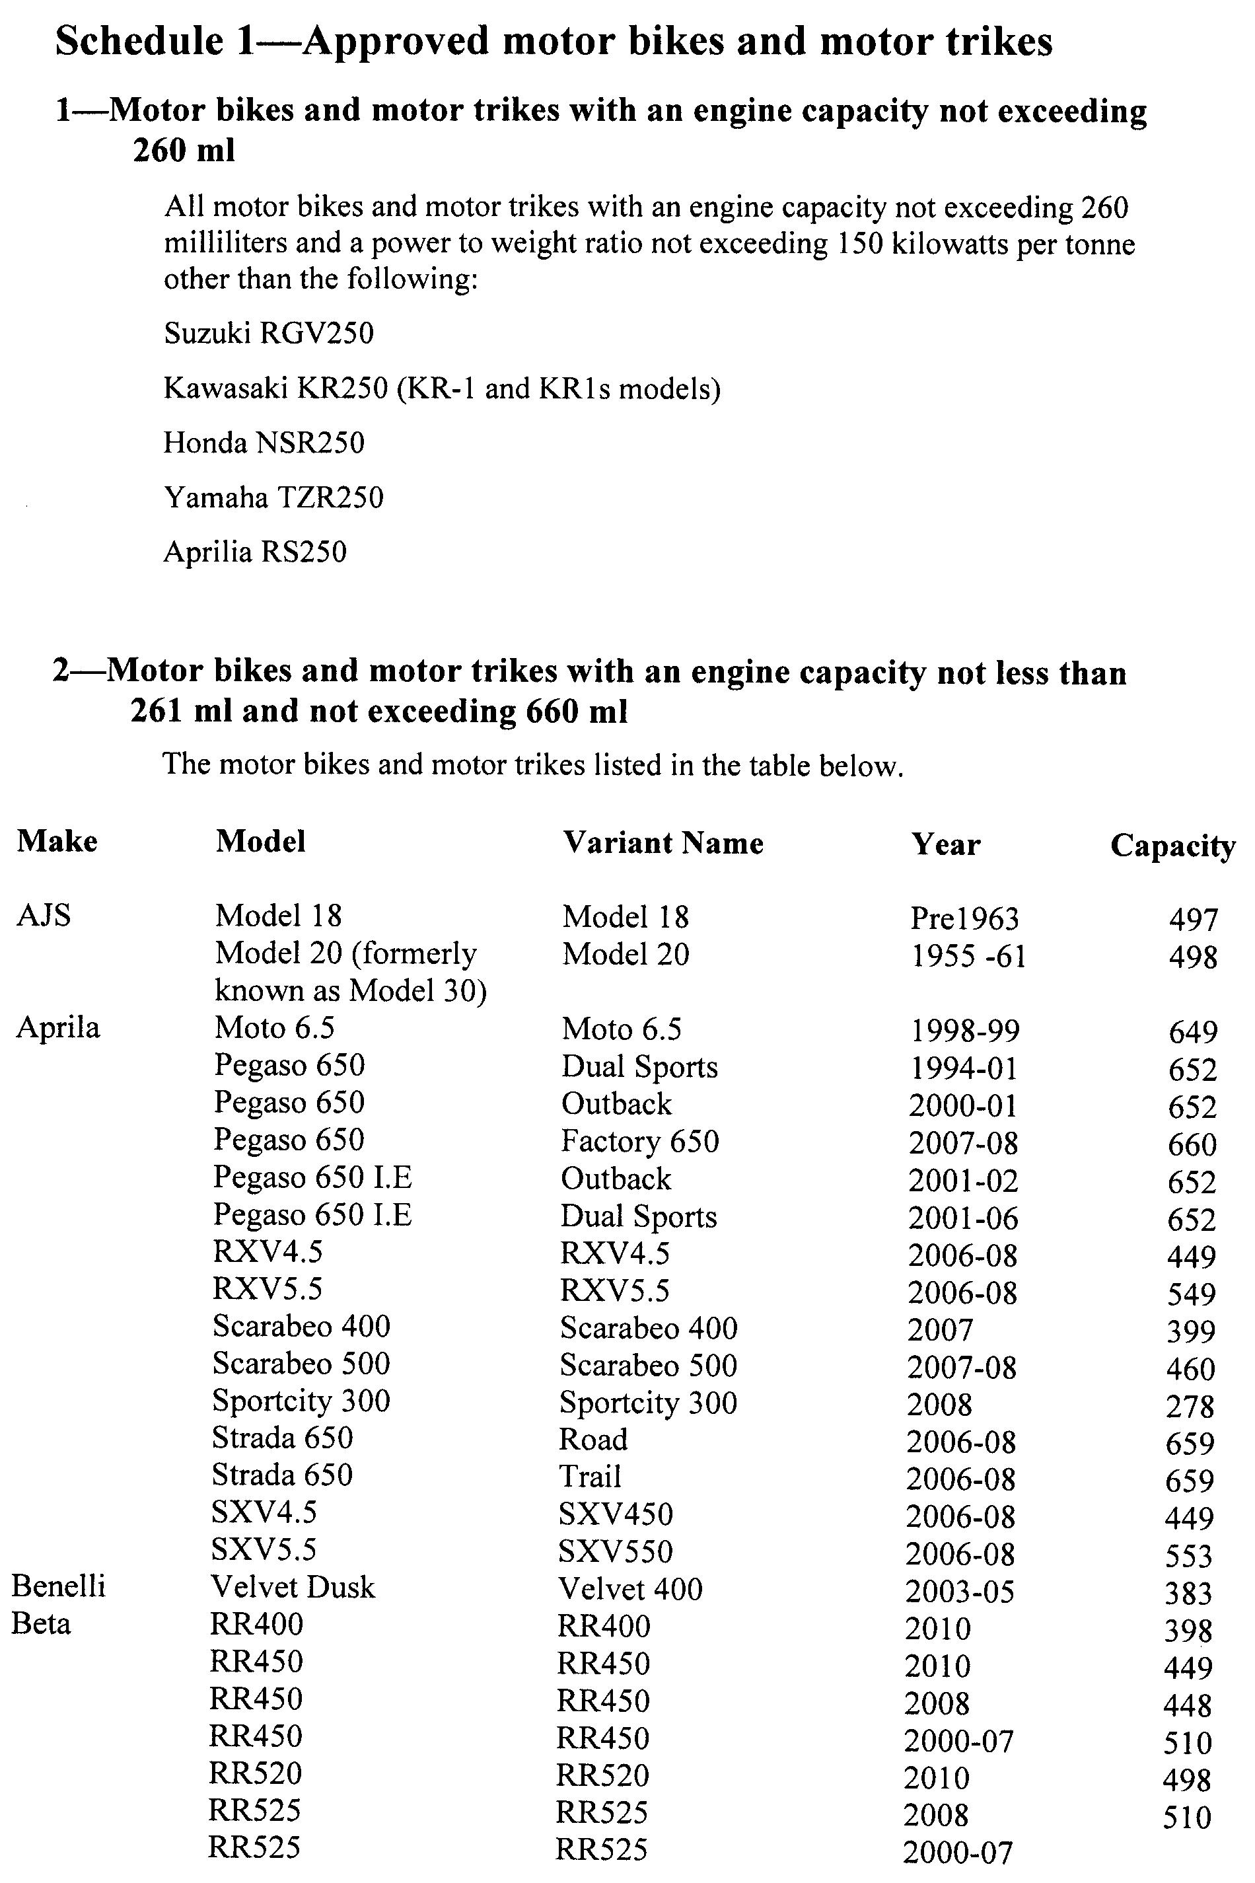
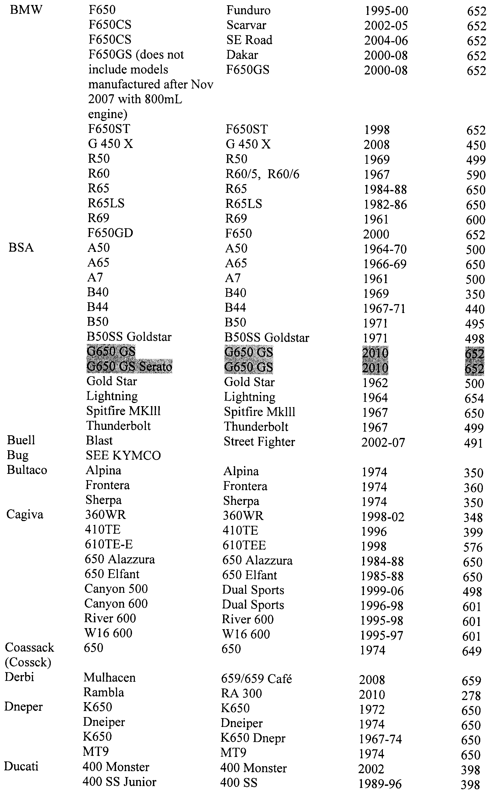
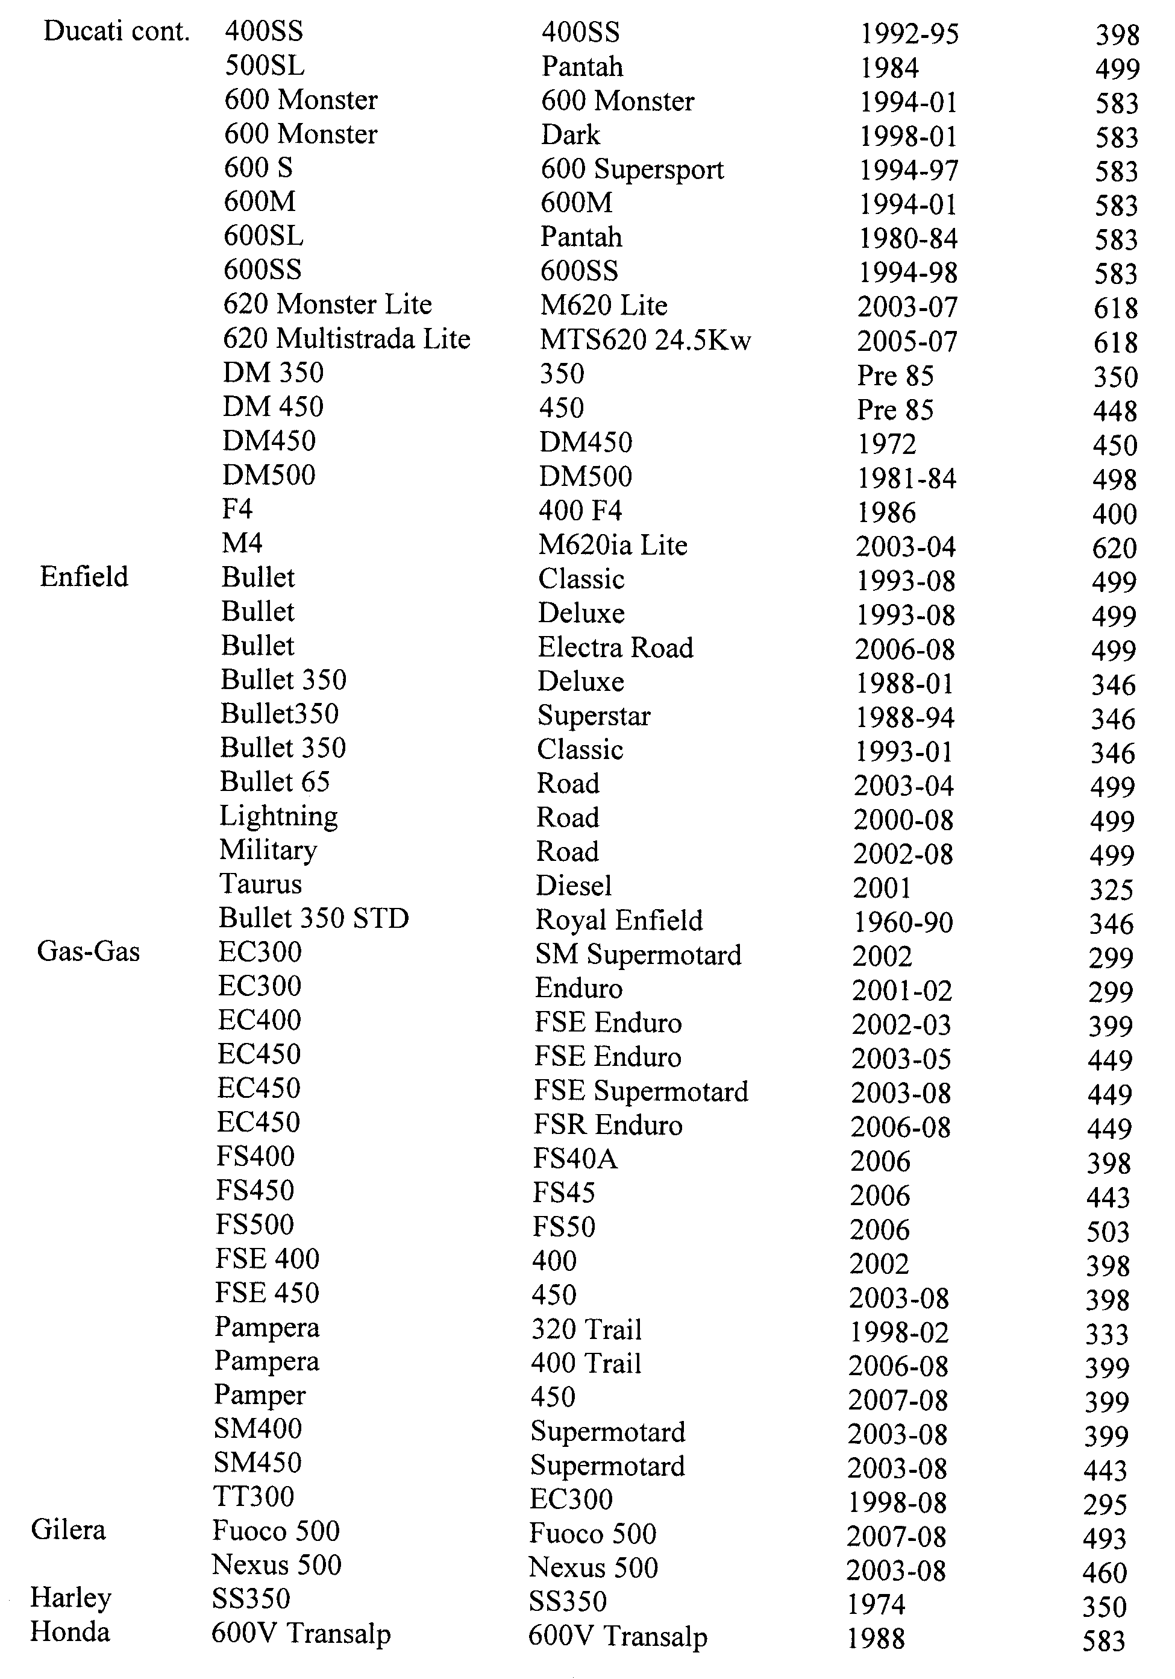
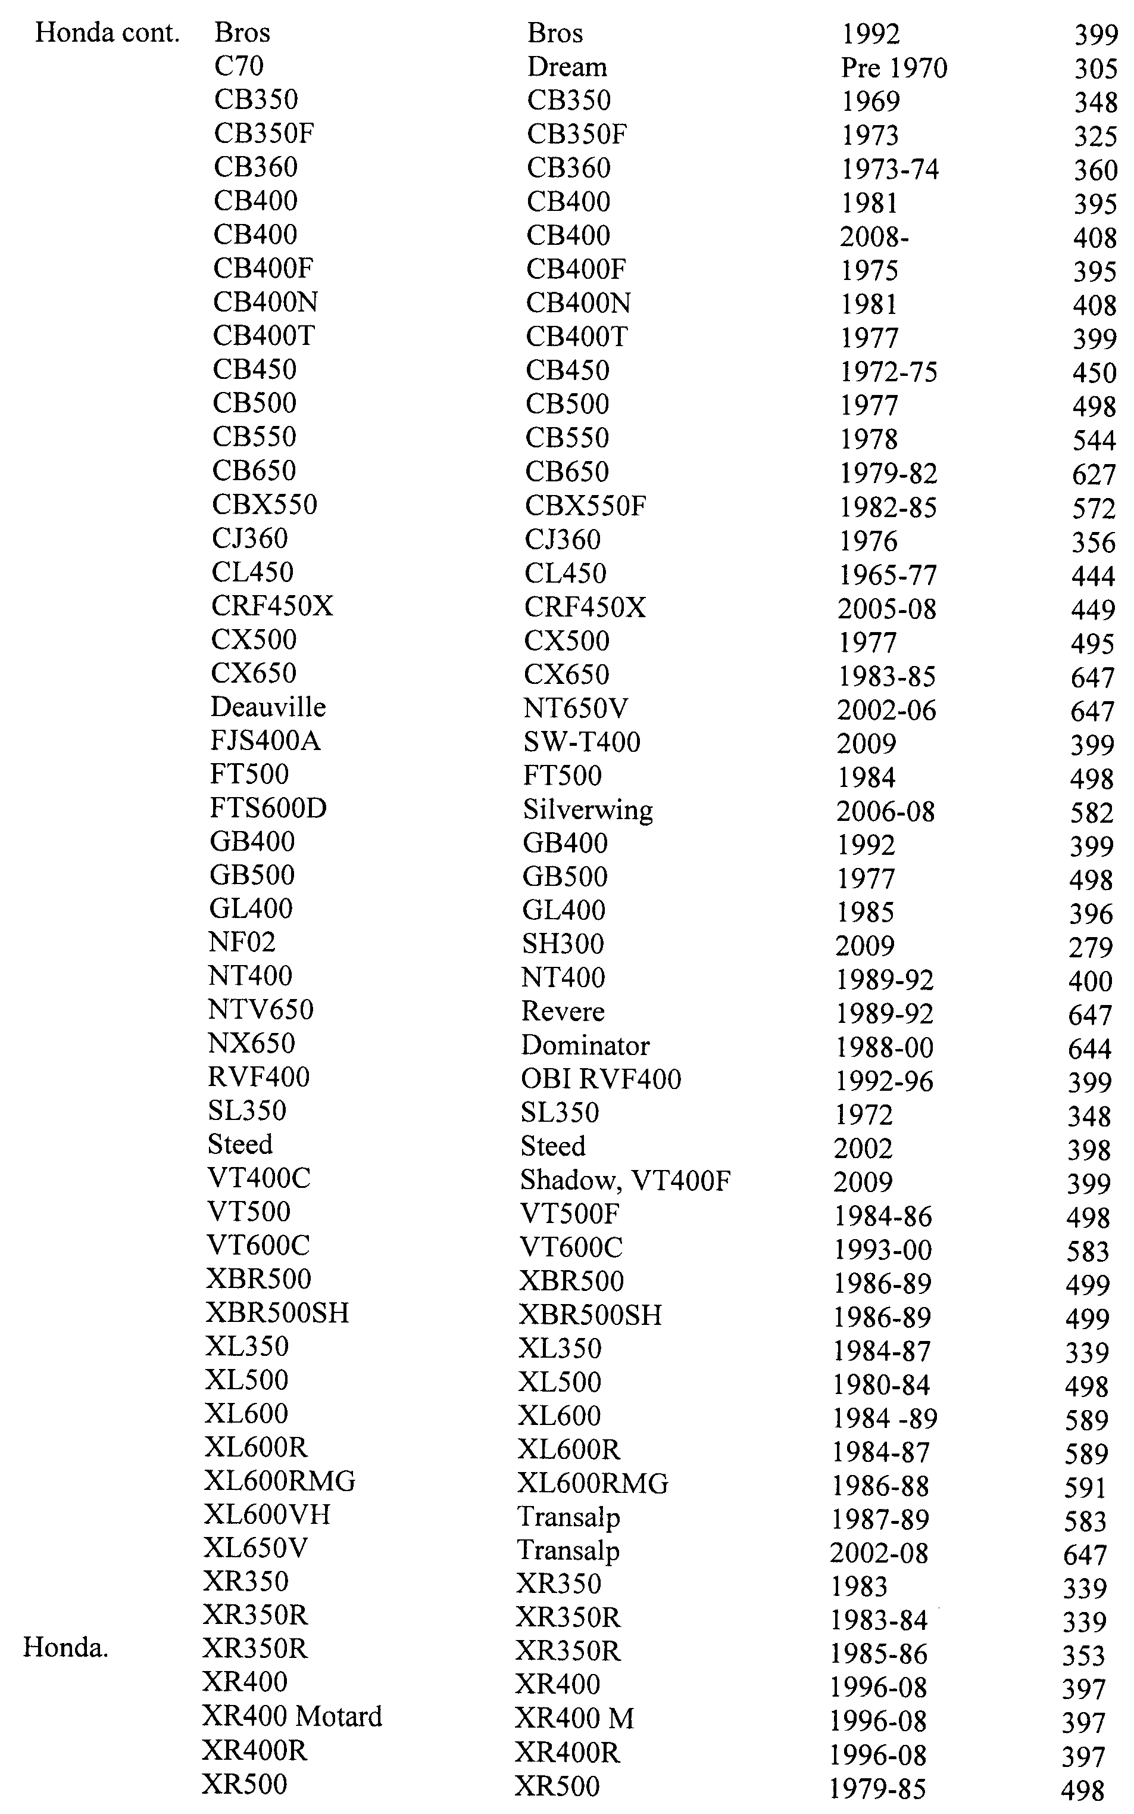
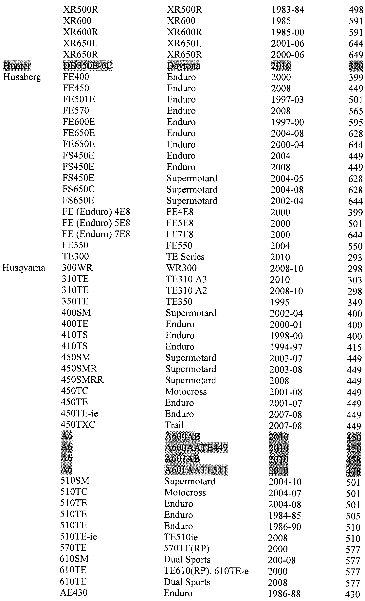
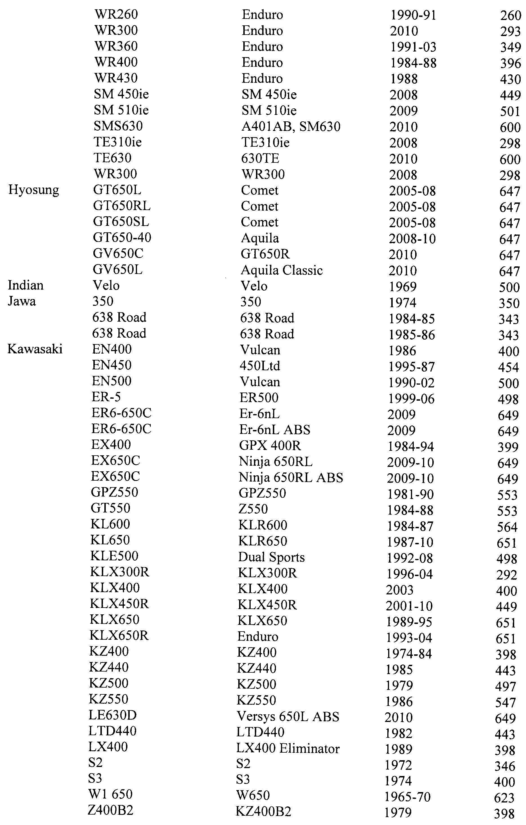
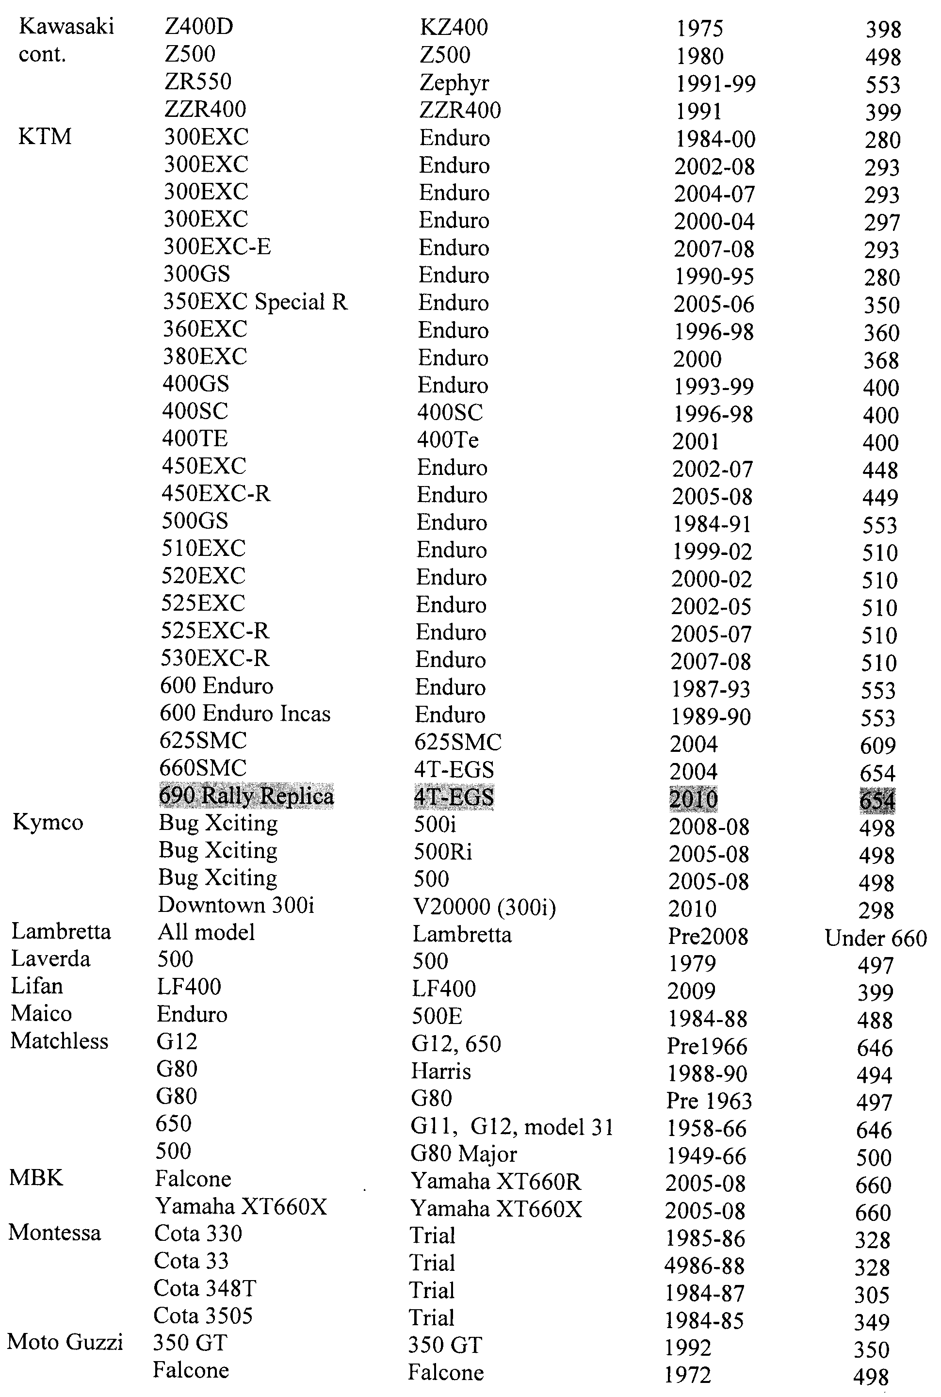
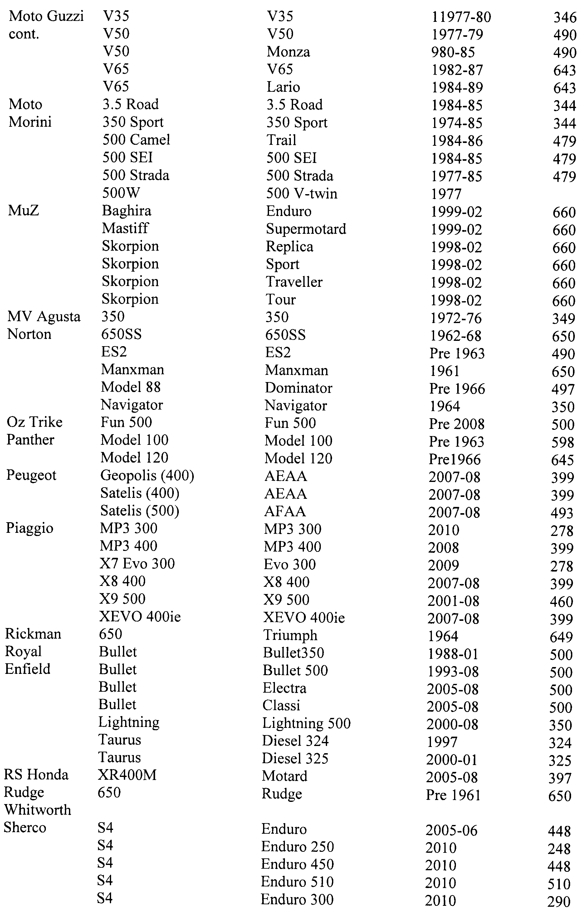
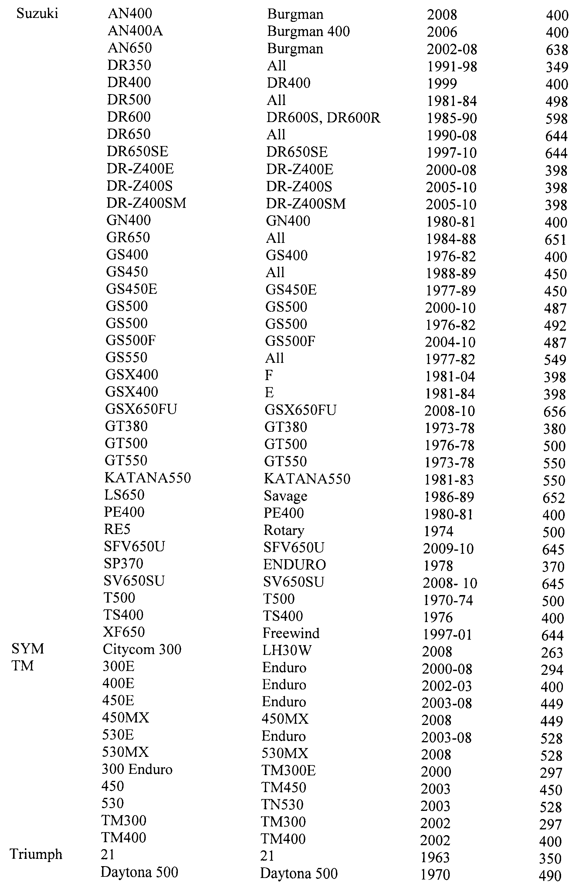
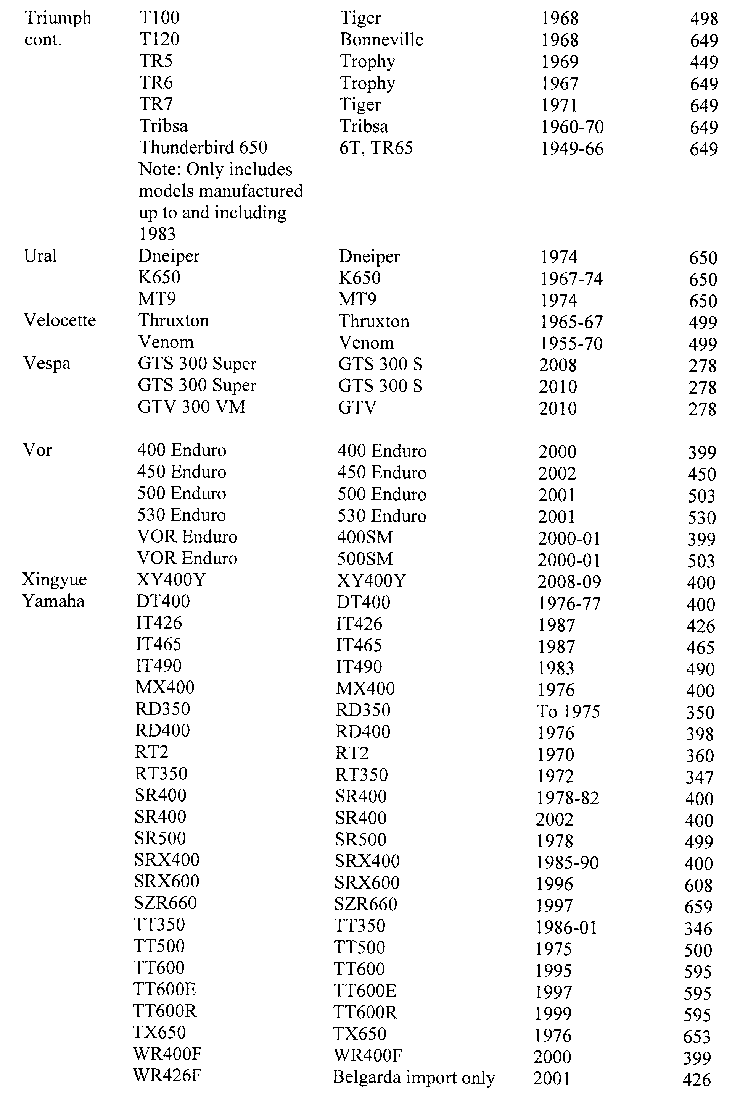
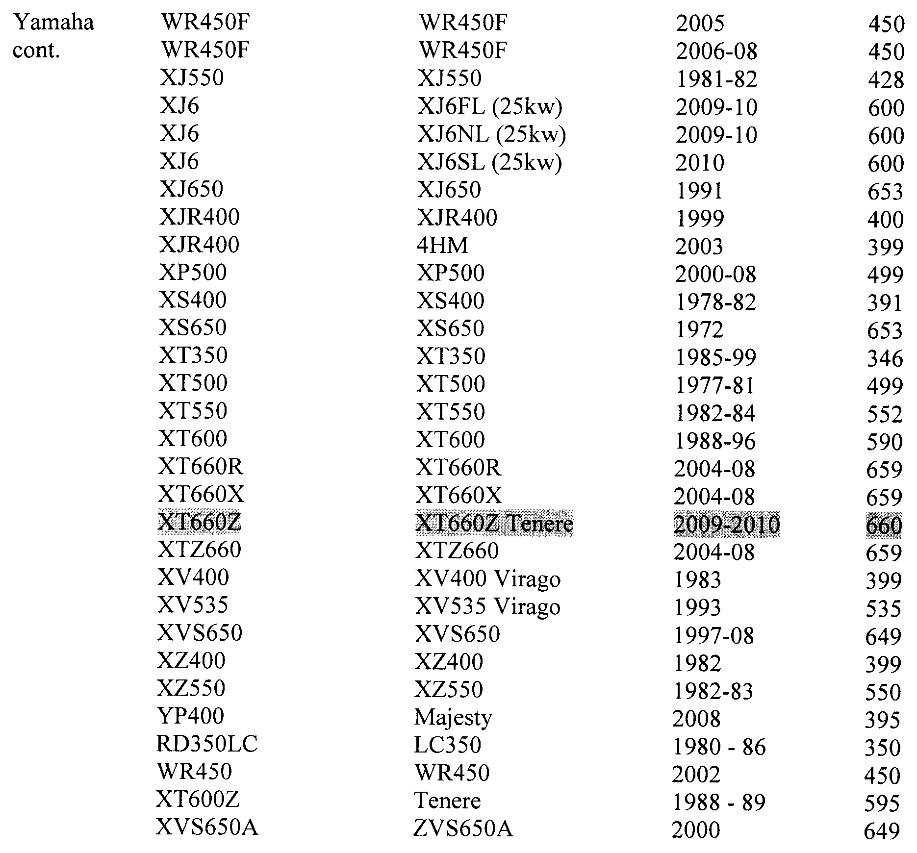
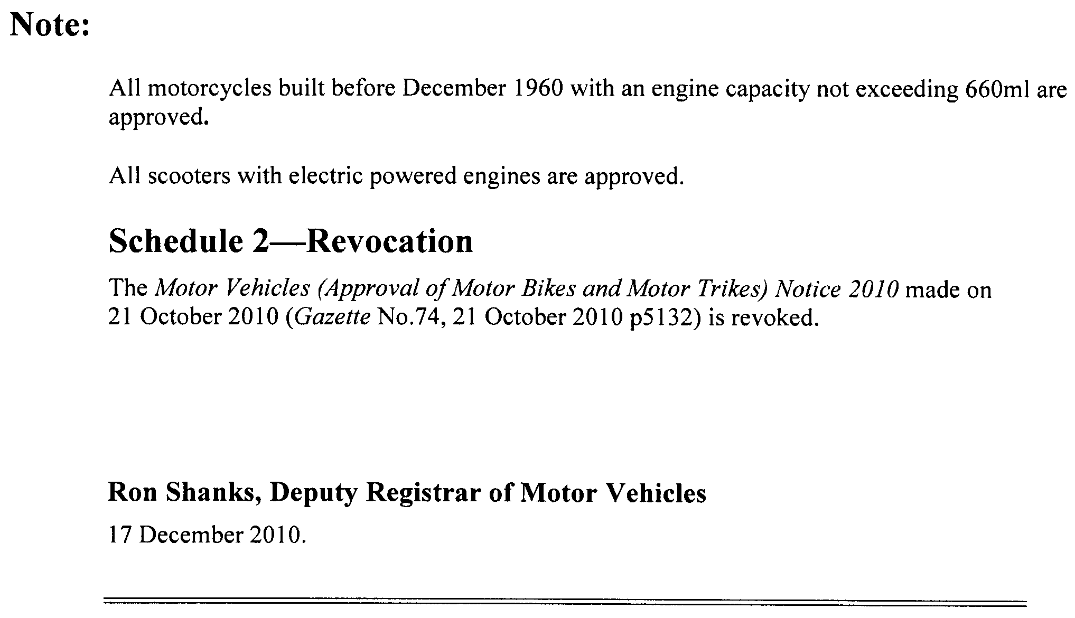

GOVERNMENT GAZETTE ADVERTISEMENT RATES

To apply from 1 July 2010

$  Agents, Ceasing to Act as 44.25  Associations:  Incorporation 22.40  Intention of Incorporation 55.50  Transfer of Properties 55.50  Attorney, Appointment of 44.25  Bailiff’s Sale 55.50  Cemetery Curator Appointed 32.75  Companies:  Alteration to Constitution 44.25  Capital, Increase or Decrease of 55.50  Ceasing to Carry on Business 32.75  Declaration of Dividend 32.75  Incorporation 44.25  Lost Share Certificates:  First Name 32.75  Each Subsequent Name 11.30  Meeting Final 37.00  Meeting Final Regarding Liquidator’s Report on  Conduct of Winding Up (equivalent to ‘Final  Meeting’)  First Name 44.25  Each Subsequent Name 11.30  Notices:  Call 55.50  Change of Name 22.40  Creditors 44.25  Creditors Compromise of Arrangement 44.25  Creditors (extraordinary resolution that ‘the Com-pany be wound up voluntarily and that a liquidator be appointed’) 55.50  Release of Liquidator⎯Application⎯Large Ad. 88.00  ⎯Release Granted 55.50  Receiver and Manager Appointed 51.00  Receiver and Manager Ceasing to Act 44.25  Restored Name 41.25  Petition to Supreme Court for Winding Up 77.00  Summons in Action 65.50  Order of Supreme Court for Winding Up Action 44.25  Register of Interests⎯Section 84 (1) Exempt 99.00  Removal of Office 22.40  Proof of Debts 44.25  Sales of Shares and Forfeiture 44.25  Estates:  Assigned 32.75  Deceased Persons⎯Notice to Creditors, etc. 55.50  Each Subsequent Name 11.30  Deceased Persons⎯Closed Estates 32.75  Each Subsequent Estate 1.45  Probate, Selling of 44.25  Public Trustee, each Estate 11.30 |  | $  Firms:  Ceasing to Carry on Business (each insertion) 29.50  Discontinuance Place of Business 29.50  Land⎯Real Property Act:  Intention to Sell, Notice of 55.50  Lost Certificate of Title Notices 55.50  Cancellation, Notice of (Strata Plan) 55.50  Mortgages:  Caveat Lodgement 22.40  Discharge of 23.40  Foreclosures 22.40  Transfer of 22.40  Sublet 11.30  Leases⎯Application for Transfer (2 insertions) each 11.30  Lost Treasury Receipts (3 insertions) each 32.75  Licensing 65.50  Municipal or District Councils:  Annual Financial Statement⎯Forms 1 and 2 618.00  Electricity Supply⎯Forms 19 and 20 439.00  Default in Payment of Rates:  First Name 88.00  Each Subsequent Name 11.30  Noxious Trade 32.75  Partnership, Dissolution of 32.75  Petitions (small) 22.40  Registered Building Societies (from Registrar-General) 22.40  Register of Unclaimed Moneys⎯First Name 32.75  Each Subsequent Name 11.30  Registers of Members⎯Three pages and over:  Rate per page (in 8pt) 281.00  Rate per page (in 6pt) 371.00  Sale of Land by Public Auction 56.00  Advertisements 3.10  ¼ page advertisement 131.00  ½ page advertisement 262.00  Full page advertisement 514.00  Advertisements, other than those listed are charged at $3.10 per column line, tabular one-third extra.  Notices by Colleges, Universities, Corporations and District Councils to be charged at $3.10 per line.  Where the notice inserted varies significantly in length from that which is usually published a charge of $3.10 per column line will be applied in lieu of advertisement rates listed.  South Australian Government publications are sold on the condition that they will not be reproduced without prior permission from the Government Printer.
All the above prices include GST

GOVERNMENT GAZETTE NOTICES
ALL private advertisements forwarded for publication in the South Australian Government Gazette must be PAID FOR PRIOR TO INSERTION; and all notices, from whatever source, should be legibly written on one side of the paper only and sent to Government Publishing SA so as to be received no later than 4 p.m. Tuesday preceding the day of publication. Phone 8207 1045 or Fax 8207 1040. E-mail: governmentgazette@dpc.sa.gov.au. Send as attachments in Word format. Please include date the notice is to be published and to whom the notice will be charged. The Government Gazette is available online at: www.governmentgazette.sa.gov.au.

MISCELLANEOUS LEGISLATION AND GOVERNMENT PUBLICATIONS PRICES AS FROM 1 JULY 2010

Acts, Bills, Rules, Parliamentary Papers and Regulations
Pages | Main | Amends | Pages | Main | Amends

1-16 | 2.70 | 1.25 | 497-512 | 37.50 | 36.50
17-32 | 3.60 | 2.25 | 513-528 | 38.50 | 37.25
33-48 | 4.70 | 3.35 | 529-544 | 39.75 | 38.50
49-64 | 5.95 | 4.55 | 545-560 | 40.75 | 39.75
65-80 | 6.90 | 5.75 | 561-576 | 41.75 | 40.75
81-96 | 8.05 | 6.65 | 577-592 | 43.25 | 41.25
97-112 | 9.20 | 7.85 | 593-608 | 44.50 | 42.75
113-128 | 10.30 | 9.05 | 609-624 | 45.25 | 44.25
129-144 | 11.50 | 10.20 | 625-640 | 46.50 | 44.75
145-160 | 12.60 | 11.30 | 641-656 | 47.50 | 46.50
161-176 | 13.70 | 12.40 | 657-672 | 48.25 | 47.00
177-192 | 15.00 | 13.50 | 673-688 | 50.25 | 48.25
193-208 | 16.10 | 14.90 | 689-704 | 51.25 | 49.25
209-224 | 17.00 | 15.70 | 705-720 | 52.00 | 50.50
225-240 | 18.20 | 16.80 | 721-736 | 53.50 | 51.50
241-257 | 19.50 | 17.80 | 737-752 | 54.00 | 52.50
258-272 | 20.60 | 18.90 | 753-768 | 55.50 | 53.50
273-288 | 21.70 | 20.40 | 769-784 | 56.50 | 55.50
289-304 | 22.60 | 21.30 | 785-800 | 57.50 | 56.50
305-320 | 24.00 | 22.50 | 801-816 | 59.00 | 57.00
321-336 | 25.00 | 23.60 | 817-832 | 60.00 | 59.00
337-352 | 26.20 | 24.90 | 833-848 | 61.00 | 60.00
353-368 | 27.00 | 26.00 | 849-864 | 62.00 | 60.50
369-384 | 28.50 | 27.00 | 865-880 | 63.50 | 62.00
385-400 | 29.75 | 28.25 | 881-896 | 64.00 | 62.50
401-416 | 30.75 | 29.25 | 897-912 | 65.50 | 64.00
417-432 | 32.00 | 30.50 | 913-928 | 66.00 | 65.50
433-448 | 33.00 | 31.75 | 929-944 | 67.00 | 66.00
449-464 | 33.75 | 32.50 | 945-960 | 68.00 | 66.50
465-480 | 34.25 | 33.50 | 961-976 | 71.00 | 67.50
481-496 | 36.50 | 34.25 | 977-992 | 72.00 | 68.00

Legislation—Acts, Regulations, etc: $
Subscriptions:
Acts 230.00
All Bills as Laid 554.00
Rules and Regulations 554.00
Parliamentary Papers 554.00
Bound Acts 256.00
Index 128.00
Government Gazette
Copy 6.05
Subscription 306.00
Hansard
Copy 16.80
Subscription—per session (issued weekly) 480.00
Cloth bound—per volume 206.00
Subscription—per session (issued daily) 480.00
Legislation on Disk
Whole Database 3 557.00
Annual Subscription for fortnightly updates 1 093.00
Individual Act(s) including updates POA
Notice of Vacancies
Annual Subscription 169.00
Compendium
Subscriptions:
New Subscriptions 2 106.00
Updates 743.00
(All the above prices include GST)

All Legislation, Government Gazette, Hansard and Legislation on disk are available from:
Counter Sales Government Legislation⁺ Outlet
and Mail Orders: Service SA Customer Service Centre,
Ground Floor—EDS Centre, 108 North Terrace, Adelaide, S.A. 5000
Phone: 13 23 24 (local call cost), Fax: (08) 8204 1909
Postal: G.P.O. Box 1707, Adelaide, S.A. 5001

Online Shop: www.shop.service.sa.gov.au

Subscriptions and Government Publishing SA
Standing Orders: Box 9, Plaza Level, Riverside Centre, North Terrace, Adelaide, S.A. 5000
Phone: (08) 8207 1043, (08) 8207 0910, Fax: (08) 8207 1040

NATIONAL GAS LAW
THE Australian Energy Market Commission (AEMC) gives notice under the National Gas Law of the following matter.
Under Clause 20 of Schedule 2, the amendment of the National Gas Amendment (Dandenong Liquefied Natural Gas Storage Facility) Rule 2010 No. 4. The amendment corrects an omission in that Rule to delete rules 280(2) to 280(4). The amendment commences on 23 December 2010.
Further details and all documents on the above matter are available on the AEMC’s website www.aemc.gov.au. The relevant documents are also available for inspection at the offices of the AEMC.
John Pierce
Chairman
Australian Energy Market Commission
Level 5, 201 Elizabeth Street
Sydney, N.S.W. 2000
Telephone: (02) 8296 7800
Facsimile: (02) 8296 7899
23 December 2010.

NATIVE VEGETATION ACT 1991
Appointment of Authorised Officers
Pursuant to section 33A (1) of the Native Vegetation Act 1991 (hereinafter referred to as ‘the Act’), I, Paul Caica, Minister for Environment and Conservation, in the State of South Australia, being the Minister of the Crown to whom the administration of the Act is for the time being committed do hereby appoint the following named persons as authorised officers:
(a) to exercise powers pursuant to section 33B and to issue directions pursuant to section 31E of the Act for the whole of the State of South Australia, unless otherwise stated:
Mark Aberdeen
Joanne Baulderstone
Kirrily Blaylock
Roger Brown
Amanda Camp
Graham Carpenter
Melanie Carson
Robert Causby
Tanja Chapman
Shane Childs
Ian Colquhoun
Thomas Dawson
Peter Farmer
Andrew Fisher
Paul Gould
Andrew Groom
Michael Hodder
Robert MacDonald
Melissa McCallum
Tanya Milne
Chris Nichols
Benjamin Della Torre
Paula Sanders
Stuart Southcombe
Mark Storry
Damien Vears
Teri Vosvotekas
Robert Wallace
John Winkworth
Sybille Winter
Mark Delaney
Beatrice Rogers
(b) to exercise only those powers pursuant to section 33B (1) (a), (b), (c), (f), (g), (j), (k), (l) and 33B (2) and (10) of the Act for the whole of the State of South Australia, unless otherwise stated:
Timothy Fraser
David Cooney
Hannah Dridan
Anthony Zidarich
This appointment will commence on the date of the notice and will end on 30 June 2012 unless earlier varied or revoked by notice in writing. Further, this appointment is revoked if the person named ceases to be an employee of the Crown or local council.
Dated 15 December 2010.
Paul Caica, Minister For Environment and Conservation

NATIVE VEGETATION ACT 1991
Revocation of Authorised Officer Appointments
PURSUANT to section 33A (6) of the Native Vegetation Act 1991 (hereinafter referred to as ‘the Act’), I, Paul Caica, Minister for Environment and Conservation, in the State of South Australia, being the Minister of the Crown to whom the administration of the Act is for the time being committed do hereby revoke the authorisations of the persons listed below:
Stephen Barry
Ian Hunter
Peter Marshman
Kym McAtee
Andrew Sheath
Kelvin Tierney
Philip Turnball
Craig Whisson
Dated 15 December 2010.
Paul Caica, Minister for Environment and Conservation

NATIONAL ELECTRICITY (SOUTH AUSTRALIA)
ACT 1996
Making of National Electricity Amendment
(Ministerial Smart Meter Roll Out Determinations)
Transitional Rule 2010
National Electricity (South Australia) Law—Section 90C
I, PATRICK CONLON, Minister for Energy for the Crown in right of the State of South Australia, as the Minister administering the National Electricity (South Australia) Act 1996 of South Australia, hereby give notice of the making of the National Electricity Amendment (Ministerial Smart Meter Roll Out Determinations) Transitional Rule 2010 under section 90C (1) of the National Electricity (South Australia) Law on the recommendation of the Ministerial Council on Energy.
The National Electricity Amendment (Ministerial Smart Meter Roll Out Determinations) Transitional Rule 2010 commences operation on 1 January 2011 and will, from commencement, be publicly available on the Australian Energy Market Commission website: www.aemc.gov.au.
Dated 19 December 2010.
Patrick Conlon, Minister for Energy

NATIONAL PARKS AND WILDLIFE (NATIONAL PARKS) REGULATIONS 2001
Closure of Flinders Ranges National Park including
Wilpena Pound
PURSUANT to Regulations 8 (3) (a) and 8 (3) (d) of the National Parks and Wildlife (National Parks) Regulations 2001, I, Edward Gregory Leaman, Director of National Parks and Wildlife, close to the public, the whole of Flinders Ranges National Park from 6 a.m. on Monday, 31 January 2011 until 9 p.m. on Friday, 4 February 2011 with the following exceptions:
Hawker to Blinman Road;
Hawker to Arkaroola (Wirrealpa) Road;
Sacred Canyon Road;
Brachina Gorge Road (open for through traffic only—no stopping);
Dingley Dell Campground;
Wilpena Pound Resort and Campground;
Wilpena Pound will be closed from 6 a.m. until 9 p.m. on Friday, 4 February 2011 only.
The purpose of the closure is to ensure the safety of the public during a pest control and monitoring program within the reserve during the period indicated.
Use of Firearms within the Reserve
Pursuant to Regulations 8 (4), 20 (1) and 41 of the National Parks and Wildlife (National Parks) Regulations 2001, I, Edward Gregory Leaman, Director of National Parks and Wildlife, grant permission to members of the Sporting Shooters Association of Australia Hunting & Conservation Branch (SA) Inc. in possession of both a current Hunting Permit and a firearm to enter and remain in Flinders Ranges National Park from 6 a.m. on Monday, 31 January 2011 until 9 p.m. on Friday, 4 February 2011 for the purpose of taking feral animals.
This permission is conditional upon the observance by each of those persons of the requirements of the National Parks and Wildlife Act 1972, National Parks and Wildlife (National Parks) Regulations 2001, and the National Parks and Wildlife (Hunting) Regulations 1996, including those requiring compliance with the Director’s requests, requirements and orders of a Warden.
Dated 21 December 2010.
E. G. Leaman, Director of National Parks and Wildlife

NATIONAL PARKS AND WILDLIFE (NATIONAL PARKS) REGULATIONS 2001
Closure of Flinders Ranges National Park including
Wilpena Pound
PURSUANT to Regulations 8 (3) (a) and 8 (3) (d) of the National Parks and Wildlife (National Parks) Regulations 2001, I, Edward Gregory Leaman, Director of National Parks and Wildlife, close to the public, the whole of Flinders Ranges National Park from 6 a.m. on Monday, 7 March 2011 until 6 a.m. on Wednesday, 9 March 2011 with the following exceptions:
Hawker to Blinman Road;
Hawker to Arkaroola (Wirrealpa) Road;
Sacred Canyon Road;
Brachina Gorge Road (open for through traffic only—no stopping);
Dingley Dell Campground;
Wilpena Pound Resort and Campground;
Wilpena Pound will be closed from 6 a.m. on Monday, 7 March 2011 until 6 a.m. on Tuesday, 8 March 2011 only.
The purpose of the closure is to ensure the safety of the public during a pest control and monitoring program within the reserve during the period indicated.
Dated 21 December 2010.
E. G. Leaman, Director of National Parks and Wildlife

NATIONAL PARKS AND WILDLIFE (NATIONAL PARKS) REGULATIONS 2001
Closure of Vulkathunha-Gammon Ranges National Park
PURSUANT to Regulations 8 (3) (a) and 8 (3) (d) of the National Parks and Wildlife (National Parks) Regulations 2001, I, Edward Gregory Leaman, Director of National Parks and Wildlife, an authorised delegate of the co-management board, close to the public, the whole of Vulkathunha-Gammon Ranges National Park from 6 a.m. on Monday, 7 March 2011 until 9 p.m. on Tuesday, 8 March 2011.
The purpose of the closure is to ensure the safety of the public during a pest control and monitoring program within the reserve during the period indicated.
Dated 21 December 2010.
E. G. Leaman, Director of National Parks and Wildlife

NATIONAL PARKS AND WILDLIFE (NATIONAL PARKS) REGULATIONS 2001
Closure of Pandappa Conservation Park
PURSUANT to Regulations 8 (3) (a) and 8 (3) (d) of the National Parks and Wildlife (National Parks) Regulations 2001, I, Edward Gregory Leaman, Director of National Parks and Wildlife, close to the public, the whole of Pandappa Conservation Park from 6 a.m. on Sunday, 2 January 2011 until 6 p.m. on Monday, 10 January 2011.
The purpose of the closure is to ensure the safety of the public during a pest control and monitoring program within the reserve during the period indicated.
Use of Firearms Within the Reserve
Pursuant to Regulations 8 (4), 20 (1) and 41 of the National Parks and Wildlife (National Parks) Regulations 2001, I, Edward Gregory Leaman, Director of National Parks and Wildlife, grant permission to members of the Sporting Shooters Association of Australia Hunting & Conservation Branch (SA) Inc. in possession of both a current Hunting Permit and a firearm to enter and remain in the whole of Pandappa Conservation Park from 6 p.m. on Sunday, 2 January 2011 until 6 a.m. on Monday, 10 January 2011 for the purpose of taking feral animals.
This permission is conditional upon the observance by each of those persons of the requirements of the National Parks and Wildlife Act 1972, National Parks and Wildlife (National Parks) Regulations 2001, and the National Parks and Wildlife (Hunting) Regulations 1996, including those requiring compliance with the Director’s requests, requirements and orders of a Warden.
Dated 21 December 2010.
E. G. Leaman, Director of National Parks and Wildlife

NATIONAL PARKS AND WILDLIFE (NATIONAL PARKS) REGULATIONS 2001
Closure of Caroona Creek Conservation Park
PURSUANT to Regulations 8 (3) (a) and 8 (3) (d) of the National Parks and Wildlife (National Parks) Regulations 2001, I, Edward Gregory Leaman, Director of National Parks and Wildlife, close to the public, the whole of Caroona Creek Conservation Park from 6 a.m. on Sunday, 2 January 2011 until 6 p.m. on Monday, 10 January 2011.
The purpose of the closure is to ensure the safety of the public during a pest control and monitoring program within the reserve during the period indicated.
Use of Firearms Within the Reserve
Pursuant to Regulations 8 (4), 20 (1) and 41 of the National Parks and Wildlife (National Parks) Regulations 2001, I, Edward Gregory Leaman, Director of National Parks and Wildlife, grant permission to members of the Sporting Shooters Association of Australia Hunting & Conservation Branch (SA) Inc. in possession of both a current Hunting Permit and a firearm to enter and remain in the whole of Caroona Creek Conservation Park from 6 p.m. on Sunday, 2 January 2011 until 6 a.m. on Monday, 10 January 2011 for the purpose of taking feral animals.
This permission is conditional upon the observance by each of those persons of the requirements of the National Parks and Wildlife Act 1972, National Parks and Wildlife (National Parks) Regulations 2001, and the National Parks and Wildlife (Hunting) Regulations 1996, including those requiring compliance with the Director’s requests, requirements and orders of a Warden.
Dated 21 December 2010.
E. G. Leaman, Director of National Parks and Wildlife

NOTICE TO MARINERS
No. 53 of 2010
South Australia—South of Kangaroo Island—Two Vessels Reported Sunk
MARINERS are advised that the following vessels have sunk in the position indicated below:
(1) Wendela—(Catamaran) latitude 37°30.66′S, longitude 136°20.96′E.
(2) Prowler—(Fishing vessel) latitude 36°56.16′S, longitude 137°56.82′E
Mariners are advised to exercise caution when navigating in the area.
Charts affected: Aus 346.
Adelaide, 16 December 2010.
Patrick Conlon, Minister for Transport
DTEI 2010/01461

PETROLEUM AND GEOTHERMAL ENERGY ACT 2000
Suspension of Petroleum Exploration Licence—PEL 110
PURSUANT to section 90 of the Petroleum and Geothermal Energy Act 2000, notice is hereby given that the abovementioned Petroleum Exploration Licence has been suspended under the provisions of the Petroleum and Geothermal Energy Act 2000, from and including 29 December 2010 until 28 December 2011, pursuant to delegated powers dated 1 October 2009.
The expiry date of PEL 110 is now determined to be 10 May 2015.
Dated 15 December 2010.
B. A. Goldstein,
Director Petroleum and Geothermal
Minerals and Energy Resources
Primary Industries and Resources SA
Delegate of the Minister for Mineral
Resources Development

ROADS (OPENING AND CLOSING) ACT 1991:
SECTION 24
NOTICE OF CONFIRMATION OF ROAD
PROCESS ORDER
Road Closure—Stirling North
BY Road Process Order made on 8 April 2010, The Corporation of the City of Port Augusta ordered that:
1. The whole of the unnamed public road situate north of Quorn Road and between pieces 1, 2, 3 and 4 in Filed Plan 101503 and piece 93 and allotment 94 in Filed Plan 206961, more particularly delineated and lettered ‘A’, ‘B’ & ‘C’ in Preliminary Plan No. 09/0072 be closed.
2. Transfer the whole of the land subject to closure lettered ‘A’ and ‘B’ to Heather June Summerton, in accordance with the agreement for transfer dated 3 March 2010 entered into between The Corporation of the City of Port Augusta and H. J. Summerton.
3. Vest in the Crown the whole of the land subject to closure lettered ‘C’ and add that land to allotment 94 in Filed Plan 206961 held by Pichi Richi Railway Preservation Society Inc. under Crown Lease Volume 1600 Folio 51 in accordance with the agreement for transfer dated 11 March 2010 entered into between The Corporation of the City of Port Augusta and Pichi Richi Railway Preservation Society Inc.
4. The following easement be granted over portion of the road closed by this order:
Grant to the Distribution Lessor Corporation an easement for overhead and underground electricity supply purposes.
On 5 July 2010 that order was confirmed by the Minister for Infrastructure conditionally upon the deposit by the Registrar-General of Deposited Plan 84379 being the authority for the new boundaries.
Pursuant to section 24 (5) of the Roads (Opening and Closing) Act 1991, NOTICE of the order referred to above and its confirmation is hereby given.
Dated 23 December 2010.
P. M. Kentish, Surveyor-General

ROADS (OPENING AND CLOSING) ACT 1991:
SECTION 34 (G)
ORDER BY THE MINISTER TO WIDEN ROAD
North Terrace and Port Road, Adelaide
PURSUANT to Section 34G of the Roads (Opening and Closing) Act 1991, the Minister for Infrastructure hereby makes an Order to make wider those portions of North Terrace and Port Road adjoining the Adelaide Parklands as shown on Deposited Plan 85638 upon the deposit of Deposited Plan 85638 by the Registrar-General.
Dated 23 December 2010.
P. M. Kentish, Surveyor-General
DTEI 08/0112

ROADS (OPENING AND CLOSING) ACT 1991:
SECTION 24
NOTICE OF CONFIRMATION OF ROAD
PROCESS ORDER
Road Closure—Rowland Flat
BY Road Process Order made on 10 June 2010, The Barossa Council ordered that:
1. The whole of the unnamed public road situate dividing allotment 513 in Filed Plan 169452 from allotment 512 in Filed Plan 169451, more particularly delineated and lettered ‘A’ on Preliminary Plan No. 09/0057 be closed.
2. Transfer the whole of the land subject to closure to James Anthony Mattner in accordance with the agreement for transfer dated 8 June 2010 entered into between The Barossa Council and J. A. Mattner.
On 6 July 2010 that order was confirmed by the Minister for Infrastructure conditionally upon the deposit by the Registrar-General of Deposited Plan 84490 being the authority for the new boundaries.
Pursuant to section 24 (5) of the Roads (Opening and Closing) Act 1991, NOTICE of the order referred to above and its confirmation is hereby given.
Dated 23 December 2010.
P. M. Kentish, Surveyor-General

ROAD TRAFFIC ACT 1961
Authorised Officers to Conduct Breath Analysis
I, MALCOLM ARTHUR HYDE, Commissioner of Police, pursuant to section 47K (3) (a) of the Road Traffic Act 1961, do hereby certify that on 14 December 2010, the following Police Officers were authorised to conduct breath analysis:

PD  Number | Officer Name
79742 | Bartlett, Matthew James
73087 | Burke, Melanie
79983 | Hirst, Dustin Wayne
42709 | Johnston, Tracy Lee
72880 | Parry, Timothy Alistair
79547 | Price, Nicholas John
79865 | Smith, Natasha Anne
79186 | Sutton, Jonathan David
73132 | Virgo, Aaron John
Dated 14 December 2010.
Malcolm Arthur Hyde, Commissioner of Police

ROAD TRAFFIC ACT 1961
Authorised Officers to Conduct Breath Analysis
I, MALCOLM ARTHUR HYDE, Commissioner of Police, pursuant to section 47K (3) (a) of the Road Traffic Act 1961, do hereby certify that on 31 July 2009, the following Police Officers were authorised to conduct breath analysis:

PD  Number | Officer Name
79038 | Burley, Ricky James
40594 | Flottman, Ian John
79356 | Jaremko, Ashley Michael
73561 | Jarman, Karyn Ann
73369 | Kelch, Derek John
49438 | Marriott, Anthony James
73267 | Napper, Jake Michael
73529 | Stewart, Michael John
Dated 14 December 2010.
Malcolm Arthur Hyde, Commissioner of Police

WORKERS REHABILITATION AND COMPENSATION
ACT 1986
Notice of Travel Allowance
Preamble
Section 32 (7) of the Workers Rehabilitation and Compensation Act 1986 states that:
‘Where a worker travels in a private vehicle to or from any place for the purpose of receiving medical services, hospitalisation or approved rehabilitation, and the travel is reasonably necessary in the circumstances of the case, the worker is entitled to a travel allowance at rates fixed by a scale published by the Minister under this section.’
Notice
I DECLARE that the rate for travel allowance in 2011 is hereby fixed for the purposes of section 32 (7) of the Workers Rehabilitation and Compensation Act 1986 (the Act) at 38.6 cents per kilometre, and this notice supersedes all previous notices of the travel allowance rate published under section 32 (7) of the Act.
This Notice is effective for travel on or after 1 January 2011.
Dated 16 December 2010.
Jack Snelling, Acting Minister for Industrial Relations

WORKERS REHABILITATION AND COMPENSATION ACT 1986
Determination
THE WORKCOVER CORPORATION OF SOUTH AUSTRALIA (‘the Corporation’) in accordance with those provisions of the WORKERS REHABILITATION AND COMPENSATION ACT 1986 as amended (‘the WRCA’) identified in Item I of the Schedule hereto (‘the Schedule’) make its determination in the terms set out in Item 2 of the Schedule upon the grounds set out in Item 3 of the Schedule, if any, to come into effect on the date set out in Item 4 of the Schedule and determines further that notice of this determination shall be provided in the manner set out in Item 5 of the Schedule.
SCHEDULE
Item 1 Section Empowering Determination
Section 65 (1).
Item 2 Terms of Determination
2.1 That the determination of the Corporation made on 31 July 2008 and published in the South Australian Government Gazette on 14 August 2008 at pages 3624 to 3626 is hereby revoked from the commencement of this determination.
2.2 Without limiting the generality of the expression ‘remuneration’, payments, whether made in cash or by cheque or negotiable instrument or by investment or capitalization or credit to any account, reserve or fund or in kind or in any other manner, and whether by piece work rates or otherwise, including specifically, without limiting the foregoing, payments made to or for the benefit of a worker for or by way of:
Accommodation allowance  Annual leave  All payments qualifying as credit  units (including trade dollars) arising  from or associated with a barter or  countertrade transaction to which the  value of any such credit units  (including trade dollars) is hereby  deemed to be valued as the equal of  one Australian dollar (or such  different value where it is  established, to the satisfaction of the  Corporation, a particular  organisation’s credit units (including  trade dollars) are being traded  consistently at a different value)  Back pay  Bonuses  Callout or call back allowance  Clothing allowance  Club subscriptions  Commission  Directors’ fees and emolument  Dirt money  Disability allowance  Dry cleaning  Employee (worker) Incentive Plan  contributions  Entertainment allowance  Fares for travel  First aid allowance  Follow-the-job allowance  Footwear allowance  Health insurance  Higher duty allowance  Holiday pay  Home entertainment allowance  Incentives  Industry allowance | Instructor’s allowance  Leave loadings  Life assurance  Living away from home allowance  Loadings  Locality allowance  Long service leave  Meal allowance  Motor vehicle allowance  Over award payment  Overtime allowance  Paid parental leave (other than payment(s)  under the Paid Parental Leave Act 2010 of  the Commonwealth  Penalty rates  Personal accident and sickness insurance  Piece work payments  Qualification allowance  Remote area allowance  Rental allowance  Representation allowance  Salary  Salary continuance insurance  School or education expenses for children, spouse or dependants of employees  Service increments  Sick pay  Site allowance  Skill allowance  Stand by or on call allowance  Studying allowance  Superannuation contributions  Supplementary payments  Telephone allowance  Tool allowance  Travelling allowance  Uniform allowance  Wages  All other allowances
constitute remuneration for the purposes of Part 5 of the Workers Rehabilitation and Compensation Act 1986:
(i) in relation to salary sacrifice benefit(s) or fringe benefit(s), ‘remuneration’ is the GST inclusive value of the benefit(s) (i.e. cost of the acquisition of the benefit by the employer (after deducting input tax credits to which the employer is entitled on account of the acquisition of the benefit) plus GST paid by the employer to the Australian Taxation Office);
(ii) in the case of payment(s) to contractors as a worker as defined under the Act, ‘remuneration’ is the GST exclusive amount of the prices paid by the employer to the contractor (i.e. amount paid to the contractor less any amount paid to the contractor on account of GST less any input tax credits to which the employer is entitled in relation to the acquisition of the contractor’s services).
2.3 Payments for or by way of:
2.3.1 Payments for reimbursement or compensation to a worker for payments or expenses actually made or incurred by the worker for goods or services for or on behalf of an employer or acquired by or provided to the worker, in the course of and for the purposes of work performed by the worker for that employer.
2.3.2 Travelling allowances paid to a worker in respect of the use of the worker’s own motor vehicle in the course of the worker’s employment by the employer, for the financial year concerned, at a rate that does not exceed:
(i) the rate prescribed by the regulations under section 28-25 of the Income Tax Assessment Act 1997 of the Commonwealth for calculating a deduction for car expenses for a large car using the ‘cents per kilometre method’; or
(ii) if no rate is prescribed as referred to in (i) above, the rate prescribed by the regulations under the South Australian Pay-roll Tax Act 1971,
for each kilometre actually travelled in the course of and for the purposes of that employment.
2.3.3 An accommodation allowance paid to a worker in respect of the cost of accommodation at a hotel. motel, guest house or other temporary lodging, while the worker is absent from his usual residence in the course of and for the purpose of the employment of the worker by the employer, for the financial year concerned, at a rate that does not exceed:
(i) the total reasonable amount for daily travel allowance expenses using the lowest capital city for the lowest salary band for the financial year determined by the Commissioner of Taxation of the Commonwealth; or
(ii) if no determination referred to (i) above is in force, the rate prescribed by the regulations under the South Australian Pay-roll Tax Act 1971.
2.3.4 All payments of compensation made by employers (including self insured employers) to workers under Part 4 of the Workers Rehabilitation and Compensation Act 1986.
2.3.5 An amount paid to or for the benefit of a worker as a consequence of cessation of employment either as termination payment or redundancy/severance pay or ‘eligible termination payment’ as defined in the Income Tax Assessment Act 1936 of the Commonwealth.
2.3.6 An amount in the form of contributions to a fund, by an employer bound by an award or registered industrial agreement or industrial agreement pursuant to an award to meet all or some of the liabilities of the employer in relation to redundancy/severance payments to a worker pursuant to an award or registered industrial agreement or industrial agreement to an award.
2.3.7 An amount paid to or for the benefit of a worker, as a consequence of cessation of employment, in the form of payment(s) made by a trustee or an employer in the capacity of trustee of a superannuation fund.
2.3.8 All payments paid to or for the benefit of a worker as a consequence of a worker’s eligibility to a payment by way of a determination in terms of the Paid Parental Leave Scheme under the Paid Parental Leave Act 2010 of the Commonwealth.
do not constitute remuneration for the purposes of Part 5 of the Workers Rehabilitation and Compensation Act 1986.
Item 3 Grounds for Determination
3.1 In respect of the inclusions:
That the same should be regarded as included within the scope of remuneration.
3.2 In respect of the exclusions:
That the same should not be regarded as within the scope of remuneration.
Item 4 Commencement Date of Determination
1 January 2011.
Item 5 Notice of Determination
That notice of this determination be published in the South Australian Government Gazette.
Confirmed as a true and accurate record of the decision of the Corporation.
Dated 16 December 2010.
P. Bentley, Chairperson

TRAINING AND SKILLS DEVELOPMENT ACT 2008

Part 4—Apprenticeships/Traineeships

Pursuant to the provision of the Training and Skills Development Act 2008, the Training
and Skills Commission (TaSC) gives notice that determines the following
Trades or Declared Vocations in addition to the gazette notices of:

- 25 September 2008 | - 23 October 2008 | - 13 November 2008 | - 4 December 2008
- 18 December 2008 | - 29 January 2009 | - 12 February 2009 | - 5 March 2009
- 12 March 2009 | - 26 March 2009 | - 30 April 2009 | - 18 June 2009
- 25 June 2009 | - 27 August 2009 | - 17 September 2009 | - 24 September 2009
- 9 October 2009 | - 22 October 2009 | - 3 December 2009 | - 17 December 2009
- 4 February 2010 | - 11 February 2010 | - 18 February 2010 | - 18 March 2010
- 8 April 2010 | - 6 May 2010 | - 20 May 2010 | - 3 June 2010
- 17 June 2010 | - 24 June 2010 | - 8 July 2010 | - 9 September 2010
- 23 September 2010 | - 4 November 2010 | - 25 November 2010 | - 16 December 2010

Trades or Declared Vocations and Required Qualifications and
Training Contract Conditions for the
Laboratory Operations Training Package (MSL09)

*Trade/ #  Declared Vocation/ Other  Occupation | Code | Title | Nominal  Term of  Training Contract | Probationary Period
# Laboratory Tester | MSL20109 | Certificate II in Sampling and Measurement | 12 | 1
# Laboratory Technician | MSL30109 | Certificate III in Laboratory Skills | 24 | 2
# Laboratory Technician | MSL40109 | Certificate IV in Laboratory Techniques | 36 | 3
# Laboratory Technician | MSL50109 | Diploma of Laboratory Technology | * 48 | 3
# Technical Officer | MSL60109 | Advanced Diploma of Laboratory Operations ** | 24 | 2

* Qualification MSL50109 Diploma of Laboratory Technology has a contract duration of 48 months, but can be completed in 24 months if MSL40109 Certificate IV in Laboratory Techniques has been satisfactorily completed.

** To enter the Advanced Diploma of Laboratory Operations, entrants must have completed the Diploma of Laboratory Technology or be able to demonstrate equivalent competency. It is recommended that entrants have had an appropriate period of employment at an occupational level commensurate with the Diploma of Laboratory Technology prior to entry to the Advanced Diploma of Laboratory Operations.

FAXING COPY?
IF you fax copy to Government Publishing SA for inclusion in the Government Gazette, there is no need to send a Confirmation Copy to us as well.
This creates confusion and may well result in your notice being printed twice.
Please use the following fax number:
Fax transmission: (08) 8207 1040
Phone Inquiries: (08) 8207 1045
Please include a contact person, phone number and order number so that we can phone back with any queries we may have regarding the fax copy.
NOTE: Closing time for lodging new copy (fax, hard copy or email) is 4 p.m. on Tuesday preceding the day of publication.

Government Gazette notices can be E-mailed.
The address is:
governmentgazette@dpc.sa.gov.au
Documents should be sent as attachments in Word format.
When sending a document via E-mail, please confirm your transmission with a faxed copy of your document, including the date the notice is to be published.
Fax transmission: (08) 8207 1040
Enquiries: (08) 8207 1045
NOTE: Closing time for lodging new copy (fax, hard copy or email) is 4 p.m. on Tuesday preceding the day of publication.

CITY OF BURNSIDE
Council Meeting Dates
NOTICE is hereby given that the Burnside Council at its meeting held on 14 December 2010, resolved that:
• There will be only one ordinary Meeting of Council for the month of January 2011 to be held on Tuesday, 18 January 2011, commencing at 7 p.m.
• From 8 February 2011, two ordinary Meetings of Council be held each calendar month on the second and fourth Tuesday of each month at the Council Chambers, 401 Greenhill Road, Tusmore, S.A. 5065, commencing at 7 p.m.
P. Deb, Acting Chief Executive Officer

CITY OF HOLDFAST BAY
Local Government Act 1999
Variation to Car Parking Fund Contribution Rate
NOTICE is hereby given that at its meeting on 26 October 2010, the City of Holdfast Bay, pursuant to section 50A (6) (b) of the Development Act 1993, resolved to vary the contribution rate under the City of Holdfast Bay Car Parking Contributions Fund to $31 500 (including GST) per car parking space for applications for development approval providing cash payment in lieu of car parking spaces.
The City of Holdfast Bay Car Parking Contributions Fund was approved by the former Minister for Transport and Urban Planning and gazetted on 28 February 2002, pursuant to section 50A of the Development Act 1993. The Fund is applicable to an area of Glenelg that is located within the District Centre Zone illustrated on Map HoB/5 of the City of Holdfast Bay Development Plan dated 11 December 2008.
The rate may be varied by further determination of Council, notice of which will be published in the Gazette.
J. P. Lynch, Chief Executive Officer

THE RURAL CITY OF MURRAY BRIDGE
Roads (Opening and Closing) Act 1991
Road Closure—Murray Bridge
NOTICE is hereby given, pursuant to section 10 of the Roads (Opening and Closing) Act 1991, that The Rural City of Murray Bridge proposes to make a Road Process Order to close the whole of the un-named public road situate adjacent to Leslie Street and merge with the adjoining Allotment 1 in Filed Plan 802, as delineated and lettered ‘B’ on the Preliminary Plan No. 10/0056.
A copy of the plan and a statement of persons affected are available for public inspection at the Council Office, 2 Seventh Street, Murray Bridge, S.A. 5253 and the Adelaide office of the Surveyor-General during normal office hours.
Any application for easement or objection must set out the full name, address and details of the submission and must be fully supported by reasons.
The application for easement or objection must be made in writing to the Council, P.O. Box 421, Murray Bridge, S.A. 5253 within 28 days of this notice and a copy must be forwarded to the Surveyor-General, G.P.O. Box 1354, Adelaide, S.A. 5001. Where a submission is made, the Council will give notification of a meeting at which the matter will be considered.
Dated 22 December 2010.
D. Maloney, Chief Executive Officer

CITY OF PORT ADELAIDE ENFIELD
Port Adelaide Centre Car Parking Fund
NOTICE is hereby given that the City of Port Adelaide Enfield has revised the designated area of the Port Adelaide Centre Car Parking Fund established pursuant to section 50A of the Development Act 1993. The revision is needed to align the boundaries of the designated area with revised Policy Area boundaries created on 26 February 2009, when the Port Adelaide Centre Development Plan Amendment was gazetted.
The Port Adelaide Centre Car Parking Fund now applies to a designated area consisting of the following Policy Areas as described in the Port Adelaide Enfield (City) Development Plan:
Policy Area 22: Port Adelaide State Heritage Policy Area;
Policy Area 23: Core Policy Area;
Policy Area 24: East End Policy Area;
Policy Area 26: Port Centre Mainstreets Historic (Con-servation) Policy Area;
Policy Area 27: McLaren’s Wharf Policy Area; and
Policy Area 30: Southern Gateway Policy Area.
The designated area is shown below:

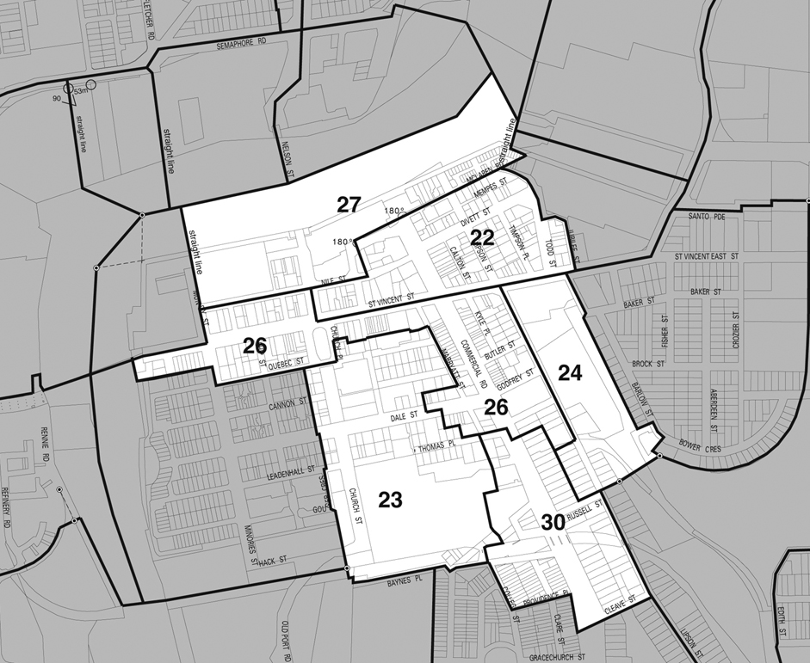
Subject to section 50A (5) of the Development Act 1993, a fee of $7 200 will be payable to the Port Adelaide Centre Car Parking Fund in lieu of the provision of each car parking space that is required.
The Port Adelaide Centre Car Parking Fund commenced operation on 10 August 2006.
Dated 23 December 2010.
H. Wierda, City Manager

CITY OF PORT LINCOLN
Appointment of Authorised Officer
NOTICE is hereby given that the City of Port Lincoln has duly appointed Sarah Poole as Authorised Officer, pursuant to the Land and Business (Sale and Conveyancing) Act 1994 and the Local Government Act 1999, Section 260.
All previous appointments for Lynne Jolley are hereby revoked; and notice is hereby given that the City of Port Lincoln has duly appointed Lynne Jolley as an Authorised officer, pursuant to the Local Government Act 1999, Section 260.
G. Dodd, Chief Executive Officer

CITY OF TEA TREE GULLY
Exclusion from Community Land Classification
NOTICE is hereby given, pursuant to section 193 (6) of the Local Government Act 1999, that the Council of the City of Tea Tree Gully at its meeting held on 31 August 2010, excluded from the Community Land Classification the following:
• Tenancy 2/926 North East Road, Modbury, portion of the land described in certificate of title volume 5996, folio 23, and defined as Tenancy A in Filed Plan 49819, 926 North East Road, Modbury.
D. I. Rogowski, Chief Executive Officer

CITY OF VICTOR HARBOR
Community Land Classification
NOTICE is hereby given, pursuant to section 194 (3) (b) of the Local Government Act 1999, that the City of Victor Harbor at its meetings held on 19 July 2010, resolved that the following land have its Classification as Community Land revoked:
165 Bay Road, Encounter Bay, being Allotment 43 in Deposited Plan 51476, contained in certificate of title volume 5672, folio 107.
G. K. Maxwell, City Manager

DISTRICT COUNCIL OF BARUNGA WEST
Appointment of Acting Chief Executive Officer
NOTICE is hereby given that Mark Marziale has been appointed Acting Chief Executive Officer for the Council for the period
5 January 2011 to 11 January 2011 (both dates inclusive), during the absence of the Chief Executive Officer.
N. Hand, Chief Executive Officer

DISTRICT COUNCIL OF BARUNGA WEST
Council Development Assessment Panel
NOTICE is hereby given that Council at its meeting of 14 December 2010, made the following appointments for its Development Assessment Panel, for the period 14 December 2010 to 13 December 2012:
Independent Members
John Meier (Presiding Member)
Stephen Horsell
Graham Hancock
Sandra Woods
Council Members
Cr Brian Rooney
Cr Rusty Smith
Cr Mark Weedon
Public Officer
Nigel Hand
Chief Executive Officer
Box 3
Port Broughton, S.A. 5522
N. Hand, Chief Executive Officer

DISTRICT COUNCIL OF BARUNGA WEST
Change of Meeting Venue
NOTICE is hereby given that the meetings of Council (on the 2nd Tuesday of each month) will be at the following locations for 2011:
Port Broughton Chambers—January to June 2011.
Bute Chambers—July to December 2011.
N. Hand, Chief Executive Officer

DISTRICT COUNCIL OF BARUNGA WEST
Development Act 1993: Section 50A
Establishment of the Barunga West District Council Carparking Fund
Preamble
1. The Barunga West DC Carparking Fund, was considered at its meeting held in December 2009. At that Meeting Council resolved to seek the Minister’s authorisation to establish the Carparking Fund.
2. The Minister for Urban Development and Planning, has decided to approve the Barunga West District Council’s proposed Car Parking Fund in accordance with section 50A of the Development Act 1993.
Notice
PURSUANT to section 50A of the Development Act 1993, I:
(a) confirm that Council has received the Minister’s authorisation to establish a Carparking Fund, for the designated area defined within the District of Barunga West Development Plan—Consolidated 21 February 2008, as set out below:
(i) The Town Centre Zone;

(b) determine that the dollar amount per carparking space, which the subject development proposal does not provide for, after taking account of the provisions of the Development Plan, for the designated area, be calculated as set out below:
(i) The Town Centre Zone—$2 500 per carparking space;
(c) more generally describe the carpark(s) to be funded by the Car Parking Fund, as set out below:
(i) to provide (new) carparking facilities within the Port Broughton town centre designated area; or
(ii) to provide funds for (or towards) the maintenance, operation or improvement of (existing) carparking facilities within the Port Broughton town centre; or
(iii) to provide funds for (or towards) the establishment, maintenance or improvement of transport facilities within the area of the council with a view to reducing the need or demand for carparking facilities within the Port Broughton town centre.
Dated 21 December 2010.
N. Hand, Chief Executive Officer

THE FLINDERS RANGES COUNCIL
Temporary Road Closure
NOTICE is hereby given that pursuant to section 33 of the Road Traffic Act 1961, that First Street, Quorn, between its intersections with Sixth Street and Seventh Street, be closed to all vehicles, excluding Council and emergency vehicles on Friday, 24 December 2010 from 4.30 p.m. until 9.30 p.m. for the purposes of the Quorn Christmas Eve Street Party.
J. K. Campbell, Acting Chief Executive Officer

KANGAROO ISLAND COUNCIL
Development Assessment Panel—Appointments
NOTICE is hereby given that the Kangaroo Island Council gives notice in accordance with the requirements of section 56A (5) of the Development Act 1993, of the appointment and term of appointment of the following persons as members of the Council Development Assessment Panel, established pursuant to section 56A (1) of the Development Act 1993:

Name | Term of Appointment
Craig Wickham, Presiding Member | 26 January 2011 to 26 January 2013
Janice Kelly, OAM | 26 January 2011 to 26 January 2013
Peter Dungey | 26 January 2011 to 26 January 2013
Roger Hartley | 26 January 2011 to 26 January 2013
Jayne Bates | 26 January 2011 to 26 January 2013
Joy Willson | 26 January 2011 to 26 January 2013
Malcolm Boxall | 26 January 2011 to 26 January 2013
It was further resolved by Council to appoint Carmel Noon as the Public Officer of the Council Development Assessment Panel, whose function includes ensuring the proper investigation of complaints about the conduct of a member of the Panel. The contact details of the Public Officer are:
Carmel Noon, Public Officer,
Kangaroo Island Council,
P.O. Box 121,
Kingscote, S.A. 5223
Telephone (08) 8553 4500
Dated 20 December 2010.
C. Noon, Chief Executive Officer

DISTRICT COUNCIL OF LOWER EYRE PENINSULA
Development Act 1993
North Shields Settlement Zone: Development Plan
Amendment—Draft for Public Consultation
NOTICE is hereby given that the District Council of Lower Eyre Peninsula, pursuant to sections 24 and 25 of the Development Act 1993, has prepared a draft Development Plan Amendment (DPA) to amend its Development Plan.
The Amendment proposes to change the Development Plan by:
• Amending the boundary of the Settlement Zone to incorporate rural land parcels to the west of the township;
• Amending the boundary of the Settlement Zone to remove land which is low lying and subject to inundation, and to incorporate that land into the Coastal Zone;
• Incorporating new policy provisions into the Settlement Zone which will introduce new controls applying to future development in relation to noise attenuation policies for new developments due to the proximity of Port Lincoln Airport, and policies aimed at reducing the risk of coastal erosion and inundation; and
• Introducing a North Shields (Settlement) Structure Plan, Map LEP/1 (Overlay 1) Enlargement E for the expanded settlement on the western side of Lincoln Highway.
Copies of the DPA are available for viewing or purchase at $5 per copy during normal business hours at the Council Offices, Railway Terrace, Cummins and Washington Street, Port Lincoln. Alternatively, the draft DPA can be downloaded from Council’s website:
www.lowereyrepeninsula.sa.gov.au
Written submissions regarding the draft DPA should be submitted by no later than 5 p.m. on Friday, 11 March 2011. All submissions should be addressed to the Chief Executive Officer, District Council of Lower Eyre Peninsula, P.O. Box 41, Cummins, S.A. 5631 and should clearly indicate whether the person making the submission wishes to be heard in support of the submission at the public hearing. Persons wishing to lodge their submissions electronically may do so by email to:
leithb@dclep.sa.gov.au
Copies of all submissions received will be available for inspection at the Council Offices from Tuesday, 15 March 2011 until the conclusion of the public hearing (see below).
A public hearing will be held on Wednesday, 23 March 2011 at 6 p.m. at the Council Offices, 38 Washington Street, Port Lincoln, at which time interested persons will be heard in relation to the DPA and the submissions. The public hearing will not be held if no submissions are received or if no persons making submissions request to be heard.
Dated 23 December 2010.
R. Pearson, Chief Executive Officer

IN the matter of the estates of the undermentioned deceased persons:
Allister, William Kenneth, late of 740 Torrens Road, Rosewater, retired accountant, who died on 7 September 2010.
Bushnell, Arthur William, late of 147 St Bernards Road, Rostrevor, retired truck driver, who died on 11 October 2010.
De Leeuw, Peter, late of 4 Farrant Street, Prospect, of no occupation, who died on 2 October 2010.
Harris Mary, late of 160 Walkerville Terrace, Walkerville, of no occupation, who died on 1 October 2009.
Keam, Charles Gordon, late of 7 Raymond Grove, Glenelg, retired medical orderly, who died on 23 October 2010.
Lawson, Garry James, late of 226 Fullarton Road, Glenside, of no occupation, who died on 25 June 2010.
Moller, Norma Eileen, late of 6 Booth Avenue, Linden Park, widow, who died on 1 September 2010.
Moreau, Edward Paul, late of 81-89 Woodend Road, Trott Park, retired bootmaker, who died on 11 September 2010.
Read, Irene Margaret, late of Pridham Boulevard, Aldinga Beach, of no occupation, who died on 16 April 2010.
Shepherdson, Linda Noel, late of 7 Lancelot Drive, Daw Park, of no occupation, who died on 22 September 2010.
Stidiford, June Shirley, late of Hazel Grove, Ridgehaven, retired telephonist, who died on 1 September 2010.
Wilson, Audrey Joyce, late of 9 Anselm Street, Christie Downs, home duties, who died on 12 October 2010.
Notice is hereby given pursuant to the Trustee Act 1936, as amended, the Inheritance (Family Provision) Act 1972 and the Family Relationships Act 1975, that all creditors, beneficiaries, and other persons having claims against the said estates are required to send, in writing, to the Office of Public Trustee, G.P.O. Box 1338, Adelaide, S.A. 5001, full particulars and proof of such claims, on or before 21 January 2011, otherwise they will be excluded from the distribution of the said estates; and notice is also hereby given that all persons indebted to the said estates are required to pay the amount of their debts to the Public Trustee or proceedings will be taken for the recovery thereof; and all persons having any property belonging to the said estates are forthwith to deliver same to the Public Trustee.
Dated 23 December 2010.
D. A. Contala, Public Trustee

ATTENTION

CUSTOMERS requiring a proof of their notice for inclusion in the Government Gazette, please note that the onus is on you to inform Government Publishing SA of any subsequent corrections.

For any corrections to your notice please phone 8207 1045 or Fax 8207 1040 before 4 p.m. on Wednesday.

If we do not receive any communication by 10 a.m. on Thursday (day of publication) we will presume the notice is correct and will print it as it is.

Remember—the onus is on you to inform us of any corrections necessary to your notice.

NOTE: Closing time for lodging new copy (electronically, fax or hard copy) is 4 p.m. on Tuesday preceding the day of publication.
Phone: 8207 1045
Fax: 8207 1040
Email: governmentgazette@dpc.sa.gov.au

Printed and published by authority every Thursday by B. MORRIS, Government Printer, South Australia
Price: $6.05, plus postage; to subscribers, $306.00 per annum.
(The above prices are inclusive of GST)

