No. 43 3257

THE SOUTH AUSTRALIAN

GOVERNMENT GAZETTE
www.governmentgazette.sa.gov.au

PUBLISHED BY AUTHORITY

ALL PUBLIC ACTS appearing in this GAZETTE are to be considered official, and obeyed as such

ADELAIDE, THURSDAY, 1 JULY 2010

CONTENTS

Page
Acts Assented To 3258
Appointments, Resignations, Etc. 3258
Aquaculture (Approval of Revocation Policy) Notice 2010 3331
Aquaculture Revocation Policy 2010 3330
Corporations and District Councils—Notices 3372
Defamation Act 2005—Notice 3264
Development Act 1993—Notice 3264
Electricity Act 1996—Notice 3260
Geographical Names Act 1991—Corrigenda 3264
Groundwater (Border Agreement) Act 1985—Notices 3264
Health Practitioner Regulation National Law
(South Australia) Act 2010—Notices 3266
Housing Improvement Act 1940—Corrigendum 3267
Liquor Licensing Act 1997—Notices 3267
Mining Act 1971—Notice 3270
Motor Vehicles Act 1959—
Notice 3286
[Republished] 3273
Mount Gambier Circuit Court—Notice 3298
National Electricity Law—Notice 3299
National Parks and Wildlife Act 1972—Notice 3299
Natural Resources Management Act 2004—Notices 3299
Occupational Health, Safety and Welfare Act 1986—
Notices 3302
Petroleum and Geothermal Energy Act 2000—Notices 3303
Primary Produce (Food Safety Schemes) Act 2004—
Notice 3311
Private Advertisements 3378
Proclamations 3337

Page
Public Sector Act 2009—Notice 3305
Public Sector (Reorganisation of Public Sector Operations)
Notice 2010 3332
Public Trustee Office—Administration of Estates 3378
Rail Safety Act 2007—Notice 3311
REGULATIONS
Development Act 1993 (No. 163 of 2010) 3343
Superannuation Funds Management Corporation of
South Australia Act 1995 (No. 164 of 2010) 3345
Liquor Licensing Act 1997 (No. 165 of 2010) 3352
Assisted Reproductive Treatment Act 1988
(No. 166 of 2010) 3356
National Electricity (South Australia) Act 1996
(No. 167 of 2010) 3359
Environment Protection Act 1993, Explosives Act 1936
and Road Traffic Act 1961 (No. 168 of 2010) 3361
Health Practitioner Regulation National Law (South
Australia) Act 2010 (No. 169 of 2010) 3363
Rates and Land Tax Remission Act 1986
(No. 170 of 2010) 3369
Roads (Opening and Closing) Act 1991—Notices 3311
RULES OF COURT
Corporation Rules 2003 (South Australia):
Amendment No. 6 3327
Magistrates Court (Civil) Rules 1992:
Amendment No. 33 3312
Sewerage Act 1929—Notice 3328
Waterworks Act 1932—Notices 3328

GOVERNMENT GAZETTE NOTICES
ALL poundkeepers’ and private advertisements forwarded for publication in the South Australian Government Gazette must be PAID FOR PRIOR TO INSERTION; and all notices, from whatever source, should be legibly written on one side of the paper only and sent to Government Publishing SA so as to be received no later
than 4 p.m. on the Tuesday preceding the day of publication. Phone 8207 1045 or Fax 8207 1040. E-mail: governmentgazette@dpc.sa.gov.au. Send as attachments in Word format and please confirm your transmission with a faxed copy of your document, including the date the notice is to be published and to whom the notice will be charged. The Government Gazette is available online at: www.governmentgazette.sa.gov.au

Department of the Premier and Cabinet
Adelaide, 1 July 2010
HIS Excellency the Governor directs it to be notified for general information that he has in the name and on behalf of Her Majesty The Queen, this day assented to the undermentioned Acts passed by the Legislative Council and House of Assembly in Parliament assembled, viz.:
No. 4 of 2010—Payroll Tax (Nexus) Amendment Act 2010. An Act to amend the Payroll Tax Act 2009 and to make a related amendment to the Taxation Administration Act 1996.
No. 5 of 2010—Health Practitioner Regulation National Law (South Australia) Act 2010. An Act to make provision for a national legislative scheme for the regulation of health practitioners; to make provision for local matters associated with the regulation of health practitioners, the registration of pharmacy premises and pharmacy depots and the supply of optical appliances; to make related amendments to other Acts; to repeal certain Acts associated with the regulation of health professions; and for other purposes.
No. 6 of 2010—Supply Act 2010. An Act for the appro-priation of money from the Consolidated Account for the financial year ending on 30 June 2011.
No. 7 of 2010—Land Tax (Miscellaneous) Amendment Act 2010. An Act to amend the Land Tax Act 1936.
By command,
Grace Portolesi, for Premier
DPC06/0875

Department of the Premier and Cabinet
Adelaide, 1 July 2010
HIS Excellency the Governor in Executive Council has been pleased to appoint the undermentioned to the South Eastern Water Conservation and Drainage Board, pursuant to the provisions of the South Eastern Water Conservation And Drainage Act 1992:
Member: (from 6 July 2010 until 5 July 2014)
James Leonard Osborne
Jodie Anne Carey
By command,
Grace Portolesi, for Premier
MEC10/0029CS

Department of the Premier and Cabinet
Adelaide, 1 July 2010
HIS Excellency the Governor in Executive Council has been pleased to appoint the undermentioned to the Marine Parks Council of South Australia, pursuant to the provisions of the Marine Parks Act 2007:
Member: (from 1 July 2010 until 30 June 2013)
David Craig Ellis
Douglas Neil James Milera
By command,
Grace Portolesi, for Premier
MEC10/0016CS

Department of the Premier and Cabinet
Adelaide, 1 July 2010
HIS Excellency the Governor in Executive Council has been pleased to appoint the undermentioned to the South Australian Council on Reproductive Technology, pursuant to the provisions of the Reproductive Technology (Clinical Practices) Act 1988:
Member: (from 9 July 2010 until 8 July 2011)
Oswald Marino Petrucco
Lisa Marie Bedson
Lorna Elizabeth Hallahan
Deputy Member: (from 9 July 2010 until 8 July 2011)
Robert John Norman (Deputy to Petrucco)
Hilary Margaret Whittle (Deputy to Bedson)
Robert Percy Pollnitz (Deputy to Hallahan)
By command,
Grace Portolesi, for Premier
HEAC-2010-00024

Department of the Premier and Cabinet
Adelaide, 1 July 2010
HIS Excellency the Governor in Executive Council has been pleased to appoint the undermentioned to the Northern and Yorke Natural Resources Management Board, pursuant to the provisions of the Natural Resources Management Act 2004:
Member: (from 1 July 2010 until 30 June 2013)
Caroline Veronica Schaefer
Member: (from 1 July 2010 until 13 April 2013)
Claudia Louisa Smith
Presiding Member: (from 1 July 2010 until 30 June 2013)
Caroline Veronica Schaefer
By command,
Grace Portolesi, for Premier
MEC10/0030CS

Department of the Premier and Cabinet
Adelaide, 1 July 2010
HIS Excellency the Governor in Executive Council has been pleased to appoint the Honourable Paul Holloway, MLC, Minister for Mineral Resources Development, Minister for Urban Development and Planning, Minister for Industrial Relations and Minister Assisting the Premier in Public Sector Management to be also Acting Deputy Premier, Acting Treasurer, Acting Minister for Federal/State Relations and Acting Minister for Defence Industries for the period from 3 July 2010 to 18 July 2010 inclusive, during the absence of the Honourable Kevin Owen Foley, MP.
By command,
Grace Portolesi, for Premier
T&F10/042CS

Department of the Premier and Cabinet
Adelaide, 1 July 2010
HIS Excellency the Governor in Executive Council has been pleased to appoint the Honourable Paul Holloway, MLC, Minister for Mineral Resources Development, Minister for Urban Development and Planning, Minister for Industrial Relations and Minister Assisting the Premier in Public Sector Management to be also Acting Minister for Transport, Acting Minister for Infrastructure and Acting Minister for Energy for the period from 4 July 2010 to 9 July 2010 inclusive, during the absence of the Honourable Patrick Frederick Conlon, MP.
By command,
Grace Portolesi, for Premier
MFI10/015

Department of the Premier and Cabinet
Adelaide, 1 July 2010
HIS Excellency the Governor in Executive Council has been pleased to appoint Leslie Trevor Olsson to the offices of Judge of the Industrial Relations Court of South Australia and Deputy President of the Workers Compensation Tribunal of South Australia both on an auxiliary basis, for a period of one year commencing on 1 July 2010 and expiring on 30 June 2011, it being a condition of appointment that the powers and jurisdictions of the offices should only be exercised during the time or times the actual duties are being undertaken, but at no other time throughout the period of appointment, pursuant to the Judicial Administration (Auxiliary Appointments and Powers) Act 1988.
By command,
Grace Portolesi, for Premier
MIR10/008CS

Department of the Premier and Cabinet
Adelaide, 1 July 2010
HIS Excellency the Governor in Executive Council has been pleased to appoint Timothy James Horton as Commissioner for Integrated Design for a term of two years commencing on 5 July 2010 and expiring on 4 July 2012, pursuant to Section 68 of the Constitution Act 1934.
By command,
Grace Portolesi, for Premier
DPC10/013CS

Department of the Premier and Cabinet
Adelaide, 1 July 2010
HIS Excellency the Governor in Executive Council has been pleased to appoint the people listed as Justices of the Peace for South Australia for a period of ten years commencing from 1 July 2010 and expiring on 30 June 2020, it being a condition of appointment that the Justices of the Peace must take the oaths required of a Justice under the Oaths Act 1936 and return the oaths form to the Justice of the Peace Services within 3 months of the date of appointment, pursuant to Section 4 of the Justices of the Peace Act 2005:
Teegan Marie Burnett
Luisa Maria Ciccozzi
Susan Therese Cunningham
Grazia Forrest
Janet Halls
Jodie-Anne Hughes
Jenny Low
Patricia Ann Matthews
Paula Marie Read
Julie Alise Reavley
Kim Darrell Thoday
Amanda Jane Vyner
Tanya Dawn Weeding
David Graham Wilkins
By command,
Grace Portolesi, for Premier
JP10/014CS

Department of the Premier and Cabinet
Adelaide, 1 July 2010
HIS Excellency the Governor in Executive Council has revoked the appointment of the people listed as Standards Officers for the purposes of the Trade Standards Act 1979 with effect from 1 July 2010, pursuant to the provisions of the Trade Standards Act 1979 and Section 36 of the Acts Interpretation Act 1915:
Bruno Robert Cinco
Tony Blefari
Terrence John Buckle
Shane Anthony Elson
Derek Lush
Robert George McCullum
Rodney Howard Pavlovich
David John Tudor
Frank Bruno Galletta
David Colin Schomburgk
Mark Bodycoat
By command,
Grace Portolesi, for Premier
10MCA0023CS

Department of the Premier and Cabinet
Adelaide, 1 July 2010
HIS Excellency the Governor in Executive Council has been pleased to appoint the people listed as Standards Officers for the purposes of the Trade Standards Act 1979 with effect from 1 July 2010, pursuant to the provisions of the Trade Standards Act 1979:
Elissa Jane Savage
Caroline Louise O’Connell
Mark Andrew Collett
Dini Soulio
Cassandra Darlene Britten
Damien Hutcheon
Gaynor Lee Arthurson
By command,
Grace Portolesi, for Premier
10MCA0023CS

Department of the Premier and Cabinet
Adelaide, 1 July 2010
HIS Excellency the Governor in Executive Council has been pleased to appoint Richard Evan Hardy to the position of President of the South Australian Health Practitioners Tribunal for a term commencing on 1 July 2010 and expiring on 28 February 2011, pursuant to the provisions of the Health Practitioner Regulation National Law (South Australia) Act 2010.
By command,
Grace Portolesi, for Premier
HEAC-2010-00030

Department of the Premier and Cabinet
Adelaide, 1 July 2010
HIS Excellency the Governor in Executive Council has been pleased to appoint David Cyril Gurry, Peter Yelverton Wilson and Anthony Ralph Newman as Deputy Presidents of the South Australian Health Practitioners Tribunal for a term commencing on 1 July 2010 and expiring on 28 February 2011, pursuant to the provisions of the Health Practitioner Regulation National Law (South Australia) Act 2010.
By command,
Grace Portolesi, for Premier
HEAC-2010-00030

ELECTRICITY ACT 1996
Standing and Default Contract Prices for Small Customers
Notice under the Electricity Standing Contract Price Determination and the Electricity Act 1996 of AGL South
Australia Pty Ltd (AGL SA) ABN 49 091 105 092 Standing and Default Contract Prices for Small Customers
IN accordance with the requirements of the Electricity Standing Contract Price Determination made by the Essential Services Commission of South Australia under the Essential Services Commission Act 2002 on 30 November 2007, notice is hereby given by AGL SA of its standing and default contract prices for customers who are consuming less than 160MWh per annum of electricity (‘small customers’). The standing contract prices are set out below in this notice and will apply from 1 August 2010. AGL SA’s price list, which contains a detailed make up of the standing and default contract prices, can be accessed on the AGL SA website (www.agl.com.au) or in the Government Gazette.
Pursuant to section 36AB of the Electricity Act 1996 notice is hereby given by AGL SA of its default contract prices for small customers who are purchasing electricity under AGL SA’s default contract terms and conditions. AGL SA has determined that its default contract prices will be the same as the standing contract prices set out in this notice. The default contract prices will apply from 1 August 2010.
Justification Statement—Default Contract Prices
The default contract prices set out in this notice are the same as AGL SA’s standing contract prices as fixed by the above Price Determination of 30 November 2007, and include an allowance for the costs associated with the Residential Energy Efficiency Scheme in accordance with ESCOSA’s decision.
For further information please call AGL on 131 245.
Paul McWilliams
Director
AGL South Australia Pty Limited

DEFAMATION ACT 2005
Declaration Under Section 33 (3)
I, JOHN RAU, Attorney-General, being the Minister to whom administration of the Defamation Act 2005, is committed, hereby declare in accordance with sub-section (3) of section 33 of the Defamation Act 2005, that on and from 1 July 2010 the maximum amount of damages that may be awarded for non-economic loss in defamation proceedings shall be $311 000.
John Rau, Attorney-General
AGO0160/09

DEVELOPMENT ACT 1993
Planning Strategy for South Australia—Alterations
PURSUANT to section 22 (5) (c) of the Development Act 1993, I declare that:
1. an alteration has been made to the ‘Planning Strategy—Regional South Australia, January 2003’ by deleting Chapter 8 titled ‘Outback Planning and Development Area’ including Figure 8 and pages 58 to 66 inclusive;
2. an alteration has been made to the Planning Strategy for the purposes of section 22 by creating a new volume of the strategy titled ‘Far North Region Plan, July 2010’.
Copies of the Far North Region Plan are available for inspection and purchase at the Department of Planning and Local Government, Level 5, Roma Mitchell House, 136 North Terrace, Adelaide.
Copies are also available for inspection on the internet:
www.planning.sa.gov.au/go/far-north-plan
Dated 24 June 2010.
Paul Holloway, Minister for Urban Development and Planning

GEOGRAPHICAL NAMES ACT 1991
Corrigenda
Notice of Declaration of Names of Places
LISTED below are a series of names incorrectly declared as geographical placenames under the Act in various Government Gazettes. This notice corrects the spellings of these placenames as shown.
In Government Gazette of 12 May 1994, page 1205, notice under subheading: 1:50 000 Mapsheet 5345-2 ‘Gilpin’.

Declared in Error | Correct Spelling
Intananya Rockhole | Iltananya Rockhole

In Government Gazette of 12 May 1994, page 1205 under subheading: 1:50 000 Mapsheet 5345-3 ‘Ernaballa’:

Declared in Error | Correct Spelling
Glen Ferdinand Valley | Glen Ferdinand (valley)

In Government Gazette of 12 May 1994, page 1205, notice under subheading: 1:50 000 Mapsheet 5345-4 ‘Duguid’:

Declared in Error | Correct Spelling
Alpanykanunya (gully) | Apanykanunya (gully)
Alpanykanunya Rockhole | Apanykanunya Rockhole
Arkalanja Rockhole | Arkalanya Rockhole
Atjinyunyanya Rockhole | Atjinyuntanya Rockhole
Wanyalyanya Creek | Wanalyanya Creek

In Government Gazette of 27 May 2010, page 2025, notice under subheading: 1:250 000 Mapsheet SG 52-11 (Mann):

Declared in Error | Correct Spelling
Ngankurnyanya (hill) | Ngankurnya (hill)

Dated 30 June 2010.
W. Watt for P. M. Kentish, Surveyor-General, Department for Transport, Energy and Infra-structure
DTEI.2009/29925/01

SE1A
GROUNDWATER (BORDER AGREEMENT) ACT 1985
Notice of Sub-zoning the Tertiary Limestone Aquifer in Zone 1A in the Designated Area 2010
1. This Declaration is made under the powers conferred by Subclauses 28 (2) and 28 (7) of the Border Groundwaters Agreement and all other available powers.
2. On and from this day on which this Declaration takes effect:
(a) Zone 1A for the Tertiary Limestone Aquifer is divided into two sub-zones, the boundary between which is shown on Plan No. 35/2010;
(b) the southern portion created by the division shall be known as Sub-zone 1A South and the area north of the division shown on the plan shall be known as Sub-zone 1A North;
(c) the Allowable Annual Volume for Sub-zone 1A South shall be 12 507 Megalitres; and
(d) the Plan No. 35/2010 referred to above in (a) can be viewed at the Lands Titles Office, 101 Grenfell Street, Adelaide, S.A. 5000, during business hours.
3. For and on behalf of the Border Groundwaters Agreement Review Committee.
Dated 29 June 2010.
N. Power, President, Border Groundwaters Agreement Review Committee

SE6A
GROUNDWATER (BORDER AGREEMENT) ACT 1985
Notice of Sub-zoning the Tertiary Limestone Aquifer in Zone 6A in the Designated Area 2010
1. This Declaration is made under the powers conferred by Subclauses 28 (2), 28 (4) and 28 (7) of the Border Groundwaters Agreement and all other available powers.
2. On and from this day on which this Declaration takes effect:
(a) Zone 6A for the Tertiary Limestone Aquifer is divided into two sub-zones, the boundary between which is shown on Plan No. 34/2010;
(b) the southern portion created by the division shall be known as Sub-zone 6A South and the area north of the division shown on the plan shall be known as Sub-zone 6A North;
(c) the Allowable Annual Volume for Sub-zone 6A South shall be 4 658 Megalitres; and
(d) the Plan No. 34/2010 referred to above in (a) can be viewed at the Lands Titles Office, 101 Grenfell Street, Adelaide, S.A. 5000, during business hours.
3. On and from this day which this Declaration takes effect:
(a) the permissible potentiometric surface lowering rate for the Tertiary Limestone Aquifer in Zone 6A shall be replaced by the permissible potentiometric surface lowering rates for Sub-zone 6A South and Sub-zone 6A North;
(b) the permissible potentiometric surface lowering rate for Sub-zone 6A South shall be 0.2 metres per annum; and
(c) the permissible potentiometric surface lowering rate for Sub-zone 6A North shall be 0.05 metres per annum.
4. For and on behalf of the Border Groundwaters Agreement Review Committee.
Dated 29 June 2010.
N. Power, President

SE9A
GROUNDWATER (BORDER AGREEMENT) ACT 1985
Notice of Sub-zoning the Tertiary Limestone Aquifer in Zone 9A in the Designated Area 2010
1. This Declaration is made under the powers conferred by Subclauses 28 (2) and 28 (7) of the Border Groundwaters Agreement and all other available powers.
2. On and from this day on which this Declaration takes effect:
(a) Zone 9A for the Tertiary Limestone Aquifer is divided into two Sub-zones, the boundary between which is shown on Plan No. 36/2010;
(b) the southern portion created by the division shall be known as Sub-zone 9A South and the area the north of the division shown on the plan shall be known as Sub-zone 9A North;
(c) the Allowable Annual Volume for Sub-zone 9A North shall be 2 400 Megalitres; and
(d) the Plan No. 36/2010 referred to above in (a) can be viewed at the Lands Titles Office, 101 Grenfell Street, Adelaide, S.A. 5000, during business hours.
3. On and from 1 July 2010 on which this Declaration takes effect:
(a) the Allowable Annual Volume for the Tertiary Limestone Aquifer in Sub-zone 9A South shall be 8 458 Megalitres;
(b) from 1 July 2011 the Allowable Annual Volume for the Tertiary Limestone Aquifer in Sub-zone 9A South shall be 8 109 Megalitres; and
(c) from 1 July 2012 the Allowable Annual Volume for the Tertiary Limestone Aquifer in Sub-zone 9A South shall be 7 760 Megalitres.
4. For and on behalf of the Border Groundwaters Agreement Review Committee.
Dated 29 June 2010.
N. Power, President, Border Groundwaters Agreement Review Committee

SE5A
GROUNDWATER (BORDER AGREEMENT) ACT 1985
Notice of Potentiometric Surface Lowering Rate for the Tertiary Limestone Aquifer in Zone 5A in the Designated Area 2010
1. This Declaration is made under the powers conferred by Subclause 28 (4) of the Border Groundwaters Agreement and all other available powers.
2. On and from this day on which this Declaration takes effect:
(a) the permissible potentiometric surface lowering rate for the Tertiary Limestone Aquifer in Zone 5A shall be 0.2 metres per annum.
3. For and on behalf of the Border Groundwaters Agreement Review Committee.
Dated 29 June 2010.
N. Power, President, Border Groundwaters Agreement Review Committee

SE1A_b
GROUNDWATER (BORDER AGREEMENT) ACT 1985
Notice of Alteration of the Permissible Annual Volume for
the Tertiary Limestone Aquifer in Zone 1A in the Designated
Area 2010
1. This Declaration is made under the powers conferred by Subclause 28 (2) of the Border Groundwaters Agreement and all other available powers.
2. On and from this day on which this Declaration takes effect:
(a) the Permissible Annual Volume for the Tertiary Limestone Aquifer for Zone 1A shall be 31 812 Megalitres.
3. For and on behalf of the Border Groundwaters Agreement Review Committee.
Dated 29 June 2010.
N. Power, President, Border Groundwaters Agreement Review Committee

SE3A
GROUNDWATER (BORDER AGREEMENT) ACT 1985
Notice of Alteration of Permissible Annual Volume for the Tertiary Limestone Aquifer in Zone 3A in the Designated Area 2010
1. This Declaration is made under the powers conferred by Subclause 28 (2) of the Border Groundwaters Agreement and all other available powers.
2. On and from this day on which this Declaration takes effect:
(a) the Permissible Annual Volume for Zone 3A shall be 24 054 Megalitres.
3. For and on behalf of the Border Groundwaters Agreement Review Committee.
Dated 29 June 2010.
N. Power, President, Border Groundwaters Agreement Review Committee

SE4A
GROUNDWATER (BORDER AGREEMENT) ACT 1985
Notice of Alteration of Permissible Annual Volume for the Tertiary Limestone Aquifer in Zone 4A in the Designated Area 2010
1. This Declaration is made under the powers conferred by Subclause 28 (2) of the Border Groundwaters Agreement and all other available powers.
2. On and from this day on which this Declaration takes effect:
(a) the Permissible Annual Volume for Zone 4A shall be 22 102 Megalitres.
3. For and on behalf of the Border Groundwaters Agreement Review Committee.
Dated 29 June 2010.
N. Power, President, Border Groundwaters Agreement Review Committee

SE5A_b
GROUNDWATER (BORDER AGREEMENT) ACT 1985
Notice of Alteration of Permissible Annual Volume for the Tertiary Limestone Aquifer in Zone 5A in the Designated Area 2010
1. This Declaration is made under the powers conferred by Subclause 28 (2) of the Border Groundwaters Agreement and all other available powers.
2. On and from this day on which this Declaration takes effect:
(a) the Permissible Annual Volume for Zone 5A shall be 18 943 Megalitres.
3. For and on behalf of the Border Groundwaters Agreement Review Committee.
Dated 29 June 2010.
N. Power, President, Border Groundwaters Agreement Review Committee

SE7A
GROUNDWATER (BORDER AGREEMENT) ACT 1985
Notice of Alteration of Permissible Annual Volume for the Tertiary Limestone Aquifer in Zone 7A in the Designated Area 2010
1. This Declaration is made under the powers conferred by Subclause 28 (2) of the Border Groundwaters Agreement and all other available powers.
2. On and from 1 July 2010 on which this Declaration takes effect:
(a) the Permissible Annual Volume for Tertiary Limestone Aquifer in Zone 7A shall be 9 346 Megalitres;
(b) from 1 July 2011 the Permissible Annual Volume for the Tertiary Limestone Aquifer for Zone 7A shall be 8 803 Megalitres; and
(c) from 1 July 2012 the Permissible Annual Volume for the Tertiary Limestone Aquifer for Zone 7A shall be 8 259 Megalitres.
3. For and on behalf of the Border Groundwaters Agreement Review Committee.
Dated 29 June 2010.
N. Power, President, Border Groundwaters Agreement Review Committee

MDB10A
GROUNDWATER (BORDER AGREEMENT) ACT 1985
Notice of Alteration of the Allowable Annual Volume for
the Tertiary Limestone Aquifer in Zone 10A in the Designated Area 2010
1. This Declaration is made under the powers conferred by Subclause 28 (2) of the Border Groundwaters Agreement and all other available powers.
2. On and from this day on which this Declaration takes effect:
(a) the Permissible Annual Volume for the Tertiary Limestone Aquifer for Zone 10A shall be 14 000 Megalitres.
3. For and on behalf of the Border Groundwaters Agreement Review Committee.
Dated 29 June 2010.
N. Power, President, Border Groundwaters Agreement Review Committee

MDB11A
GROUNDWATER (BORDER AGREEMENT) ACT 1985
Notice of Alteration of the Allowable Annual Volume for
the Tertiary Limestone Aquifer in Zone 11A in the Designated Area 2010
1. This Declaration is made under the powers conferred by Subclause 28 (2) of the Border Groundwaters Agreement and all other available powers.
2. On and from this day on which this Declaration takes effect:
(a) the Permissible Annual Volume for the Tertiary Limestone Aquifer for Zone 11A shall be 3 700 Megalitres.
3. For and on behalf of the Border Groundwaters Agreement Review Committee.
Dated 29 June 2010.
N. Power, President, Border Groundwaters Agreement Review Committee

HEALTH PRACTITIONER REGULATION NATIONAL LAW (SOUTH AUSTRALIA) ACT 2010
Fees and Charges for Pharmacy Practice
I, JOHN HILL, Minister for Health, hereby give notice pursuant to Regulation 11 of the Health Practitioner Regulation National Law (South Australia) Regulations 2010, under the Health Practitioner Regulation National Law (South Australia) Act 2010, of the following fees to apply from 1 July 2010, for the regulation of pharmacy practice in South Australia:
Dated 28 June 2010.
Service | Fee  (01/07/10 to  30/09/10) | Fee  (01/10/10 to  30/09/11)
 | $ | $
Pharmacy premises:  Initial registration | 350 | 450
Renewal of registration | 350 | 450
Notification of alterations to, or relocation of, premise | 100 | 150
Notification of change in pharmacy services provider | 350 | 450
Pharmacy depots:  Initial registration | 150 | 150
Renewal of registration | 150 | 150
Notification of alterations to, or relocation of, depot | 100 | 150
Notification of change in pharmacy services provider/corporate pharmacy services provider | 150 | 150
Pharmacy services providers:  Initial registration | 350 | 450
Renewal of registration | 350 | 450
Notification of change in directors, shareholders, beneficiaries, constitution, trust deeds etc. | 350 | 450
Other charges:  Reprint of registration certificate | 25 | 50
Extract from a register | 50 | 50
List of pharmacy premises/depots/pharmacy services providers | 200 | 250
John Hill, Minister for Health

HEALTH PRACTITIONER REGULATION NATIONAL LAW (SOUTH AUSTRALIA) ACT 2010
Registration Period for Dental Practitioners and Physiotherapists
I, JOHN HILL, Minister for Health, pursuant to Clause 50 of Schedule 1 of the Health Practitioner Regulation National Law (South Australia) Act 2010, do hereby declare that the period for the renewal of registration for the following practitioners with a South Australian practice address has been extended until 31 July 2010:
(a) dentists;
(b) dental hygienists;
(c) dental prosthetists;
(d) dental therapists; and
(e) physiotherapists.
Dated 28 June 2010.
John Hill, Minister for Health

HOUSING IMPROVEMENT ACT 1940
Corrigendum
IN Government Gazette No. 40 dated 24 June 2010, on page 3123, first notice appearing there was a typographical error and should be replaced with the following notice.
HOUSING IMPROVEMENT ACT 1940
NOTICE is hereby given that the South Australian Housing Trust Board Delegate in the exercise of the powers conferred by the Housing Improvement Act 1940, does hereby declare the houses described in the table hereunder to be substandard for the purposes of Part 7 of the Housing Improvement Act 1940.
No. of House and Street | Locality | Allotment, Section, etc. | Certificate of Title  Volume Folio

43 Jervois Avenue |  | West Hindmarsh | Allotment 1 in Deposited Plan 19325, Hundred of Yatala | 5465 | 940
Lot 3, Norman Road |  | Aldinga Beach | Allotment 3 in Deposited Plan 7917, Hundred of Willunga | 5976 | 943

Dated at Adelaide, 24 June 2010. S. Trebilcock for D. Huxley, Director, Corporate Services, Housing SA

LIQUOR LICENSING ACT 1997
Notice of Application
NOTICE is hereby given, pursuant to section 52 (2) (b) of the Liquor Licensing Act 1997, that Ursula Aileen Ruth Hyde has applied to the Licensing Authority for a Special Circumstances Licence in respect of premises situated at 19 Adela Crescent, Athelstone, S.A. 5076 and to be known as Adelaide Performance Limousines.
The application has been set down for hearing on 29 July 2010 at 11 a.m.
Conditions
The following licence conditions are sought:
• The licence will authorise the licensee for the sale and consumption of liquor within the vehicle by those parties travelling in the vehicle for the following days and times:
Monday to Saturday: 5 a.m. to midnight;
Sunday: 11 a.m. to 8 p.m.;
Sunday New Year’s Eve: 11 a.m. to midnight;
New Year’s Day: Midnight to 2 a.m.
• Passengers will be able to bring additional liquor into the vehicle for consumption in the vehicle.
Any person may object to the application by lodging a notice of objection in the prescribed form with the Liquor and Gambling Commissioner and serving a copy of the notice on the applicant at the applicant’s address, at least seven days before the hearing date (viz: 22 July 2010).
The applicant’s address for service is c/o Ursula Hyde, 19 Adela Crescent, Athelstone, S.A. 5076.
The application and certain documents and material (including Plans) relevant to the application may be inspected without fee at a place and during a period specified by the Liquor and Gambling Commissioner, 9th Floor, East Wing, 50 Grenfell Street, Adelaide, S.A. 5000. Telephone 8226 8410, Facsimile: 8226 8512. Email: olgc@agd.sa.gov.au.
Dated 22 June 2010.
Applicant

LIQUOR LICENSING ACT 1997
Notice of Application
NOTICE is hereby given, pursuant to section 52 (2) (b) of the Liquor Licensing Act 1997, that Thi Thu Ha Tran has applied to the Licensing Authority for the transfer of a Restaurant Licence in respect of premises situated at 3 Church Street, Salisbury, S.A. 5108 and known as Great Eastern Chinese Restaurant and to be known as Asian Central.
The application has been set down for hearing on 29 July 2010 at 10.30 a.m.
Any person may object to the application by lodging a notice of objection in the prescribed form with the Liquor and Gambling Commissioner and serving a copy of the notice on the applicant at the applicant’s address, at least seven days before the hearing date (viz: 22 July 2010).
The applicant’s address for service is c/o Aaron Conveyancers, P.O. Box 521, Salisbury, S.A. 5108 (Attention: Tom Manolakis).
The application and certain documents and material (including Plans) relevant to the application may be inspected without fee at a place and during a period specified by the Liquor and Gambling Commissioner, 9th Floor, East Wing, 50 Grenfell Street, Adelaide, S.A. 5000. Telephone 8226 8410, Facsimile: 8226 8512. Email: olgc@agd.sa.gov.au.
Dated 22 June 2010.
Applicant

LIQUOR LICENSING ACT 1997
Notice of Application
NOTICE is hereby given, pursuant to section 52 (2) (b) of the Liquor Licensing Act 1997, that Semler Investments Pty Ltd as trustee for Semler Family Trust has applied to the Licensing Authority for an Entertainment Consent Licence in respect of premises situated at 54 Dauncey Street, Kingscote, Kangaroo Island, S.A. 5223 and known as Restaurant Bella.
The application has been set down for hearing on 29 July 2010 at 11.30 a.m.
Conditions
The following licence conditions are sought:
• Entertainment Consent is sought for Areas 1 and 2 as per plans lodged with this office for the following days and times:
Monday to Sunday: Midday to midnight.
Any person may object to the application by lodging a notice of objection in the prescribed form with the Liquor and Gambling Commissioner and serving a copy of the notice on the applicant at the applicant’s address, at least seven days before the hearing date (viz: 22 July 2010).
The applicant’s address for service is c/o Suzanne Semler, 54 Dauncey Street, Kingscote, Kangaroo Island, S.A. 5223.
The application and certain documents and material (including Plans) relevant to the application may be inspected without fee at a place and during a period specified by the Liquor and Gambling Commissioner, 9th Floor, East Wing, 50 Grenfell Street, Adelaide, S.A. 5000. Telephone 8226 8410, Facsimile: 8226 8512. Email: olgc@agd.sa.gov.au.
Dated 22 June 2010.
Applicant

LIQUOR LICENSING ACT 1997
Notice of Application
NOTICE is hereby given, pursuant to section 52 (2) (b) of the Liquor Licensing Act 1997, that LK Global Pty Ltd as trustee for Lee and Kim Trust has applied to the Licensing Authority for the transfer of a Restaurant Licence in respect of premises situated at Pilgrim Lane (rear of Adelaide Town Hall), Adelaide, S.A. 5000 and known as Town Hall Garden Cafe.
The application has been set down for hearing on 2 August 2010 at 9 a.m.
Any person may object to the application by lodging a notice of objection in the prescribed form with the Liquor and Gambling Commissioner and serving a copy of the notice on the applicant at the applicant’s address, at least seven days before the hearing date (viz: 26 July 2010).
The applicant’s address for service is c/o Hee Sam Kim, 58 Gwynne Street, Firle, S.A. 5070.
The application and certain documents and material (including Plans) relevant to the application may be inspected without fee at a place and during a period specified by the Liquor and Gambling Commissioner, 9th Floor, East Wing, 50 Grenfell Street, Adelaide, S.A. 5000. Telephone 8226 8410, Facsimile: 8226 8512. Email: olgc@agd.sa.gov.au.
Dated 23 June 2010.
Applicant

LIQUOR LICENSING ACT 1997
Notice of Application
NOTICE is hereby given, pursuant to section 52 (2) (b) of the Liquor Licensing Act 1997, that Haybordon Pty Ltd as trustee for Hebart Family Trust has applied to the Licensing Authority for the transfer of a Restaurant Licence in respect of premises situated at 2 Sunnydale Avenue, Gawler East, S.A. 5118 known as Wheatsheaf Inn Restaurant and to be known as the Wheatsheaf Restaurant.
The application has been set down for hearing on 2 August 2010 at 11.30 a.m.
Any person may object to the application by lodging a notice of objection in the prescribed form with the Liquor and Gambling Commissioner and serving a copy of the notice on the applicant at the applicant’s address, at least seven days before the hearing date (viz: 26 July 2010).
The applicant’s address for service is c/o Christopher Werner Hebart, 2 Sunnydale Avenue, Gawler East, S.A. 5118.
The application and certain documents and material (including Plans) relevant to the application may be inspected without fee at a place and during a period specified by the Liquor and Gambling Commissioner, 9th Floor, East Wing, 50 Grenfell Street, Adelaide, S.A. 5000. Telephone 8226 8410, Facsimile: 8226 8512. Email: olgc@agd.sa.gov.au.
Dated 24 June 2010.
Applicant

LIQUOR LICENSING ACT 1997
Notice of Application
NOTICE is hereby given, pursuant to section 52 (2) (b) of the Liquor Licensing Act 1997, that Southern Vales Investments Pty Ltd has applied to the Licensing Authority for the transfer of a Special Circumstances Licence in respect of premises situated at Lot 250, Main Road and 27 Chalk Hill Road, McLaren Vale, S.A. 5171, known as Awganix and to be known as El Torro.
The application has been set down for hearing on 2 August 2010 at 9.30 a.m.
Any person may object to the application by lodging a notice of objection in the prescribed form with the Liquor and Gambling Commissioner and serving a copy of the notice on the applicant at the applicant’s address, at least seven days before the hearing date (viz: 26 July 2010).
The applicant’s address for service is c/o Carmel Sullivan, P.O. Box 2042, McLaren Vale, S.A. 5171.
The application and certain documents and material (including Plans) relevant to the application may be inspected without fee at a place and during a period specified by the Liquor and Gambling Commissioner, 9th Floor, East Wing, 50 Grenfell Street, Adelaide, S.A. 5000. Telephone 8226 8410, Facsimile: 8226 8512. Email: olgc@agd.sa.gov.au.
Dated 24 June 2010.
Applicant

LIQUOR LICENSING ACT 1997
Notice of Application
NOTICE is hereby given, pursuant to section 52 (2) (b) of the Liquor Licensing Act 1997, that Tea Tree Gully Tennis Club Inc. has applied to the Licensing Authority for variation to Conditions in respect of premises situated at 80-100 Elizabeth Street, Banksia Park S.A. 5091 and known as Tea Tree Gully Tennis Club Inc.
The application has been set down for hearing on 2 August 2010 at 11 a.m.
Conditions
The following licence conditions are sought:
• Variation to the existing trading hours:
From:
Saturday: 1 p.m. to midnight;
Tuesday: 7 p.m. to 11 p.m.
To:
Friday: 6 p.m. to 11 p.m.;
Saturday: 1 p.m. to midnight;
Tuesday: 7 p.m. to 11 p.m.
Any person may object to the application by lodging a notice of objection in the prescribed form with the Liquor and Gambling Commissioner and serving a copy of the notice on the applicant at the applicant’s address, at least seven days before the hearing date (viz: 26 July 2010).
The applicant’s address for service is c/o Mark Greenwood, P.O. Box 410, St Agnes, S.A. 5097.
The application and certain documents and material (including Plans) relevant to the application may be inspected without fee at a place and during a period specified by the Liquor and Gambling Commissioner, 9th Floor, East Wing, 50 Grenfell Street, Adelaide, S.A. 5000. Telephone 8226 8410, Facsimile: 8226 8512. Email: olgc@agd.sa.gov.au.
Dated 24 June 2010.
Applicant

LIQUOR LICENSING ACT 1997
Notice of Application
NOTICE is hereby given, pursuant to section 52 (2) (b) of the Liquor Licensing Act 1997, that Southern Cross Care (SA & NT) Incorporated has applied to the Licensing Authority for a Special Circumstances Licence in respect of premises situated at 16 Cross Road, Myrtle Bank, S.A. 5064 and to be known as Southern Cross Care (SA) Incorporated.
The application has been set down for hearing on 3 August 2010 at 10 a.m.
Conditions
The following licence conditions are sought:
• The licence will authorise the licensee to sell liquor for consumption on the licensed premises to members, staff, employees and residents of the licensee and the guests of such members, staff, employees and residents seated or standing between 11 a.m. and midnight on any day with or without a meal.
Any person may object to the application by lodging a notice of objection in the prescribed form with the Liquor and Gambling Commissioner and serving a copy of the notice on the applicant at the applicant’s address, at least seven days before the hearing date (viz: 27 July 2010).
The applicant’s address for service is c/o Lynch Meyer, G.P.O. Box 467, Adelaide, S.A. 5001 (Attention: Richard Jackson).
The application and certain documents and material (including Plans) relevant to the application may be inspected without fee at a place and during a period specified by the Liquor and Gambling Commissioner, 9th Floor, East Wing, 50 Grenfell Street, Adelaide, S.A. 5000. Telephone 8226 8410, Facsimile: 8226 8512. Email: olgc@agd.sa.gov.au.
Dated 24 June 2010.
Applicant

LIQUOR LICENSING ACT 1997
Notice of Application
NOTICE is hereby given, pursuant to section 52 (2) (b) of the Liquor Licensing Act 1997, that Himalayan Enterprises Pty Ltd as trustee for Himalayan Enterprises Trust has applied to the Licensing Authority for the transfer of a Restaurant Licence in respect of premises situated at 73 Melbourne Street, North Adelaide, S.A. 5006 and known as Archies Restaurant and to be known as the Himalayan Kitchen.
The application has been set down for hearing on 4 August 2010 at 9 a.m.
Any person may object to the application by lodging a notice of objection in the prescribed form with the Liquor and Gambling Commissioner and serving a copy of the notice on the applicant at the applicant’s address, at least seven days before the hearing date (viz: 28 July 2010).
The applicant’s address for service is c/o Holly Dangal, 66 Melbourne Street, North Adelaide, S.A. 5006.
The application and certain documents and material (including Plans) relevant to the application may be inspected without fee at a place and during a period specified by the Liquor and Gambling Commissioner, 9th Floor, East Wing, 50 Grenfell Street, Adelaide, S.A. 5000. Telephone 8226 8410, Facsimile: 8226 8512. Email: olgc@agd.sa.gov.au.
Dated 24 June 2010.
Applicant

LIQUOR LICENSING ACT 1997
Notice of Application
NOTICE is hereby given, pursuant to section 52 (2) (b) of the Liquor Licensing Act 1997, that Roverland Pty Ltd as trustee for Grant Heaslip Family Trust Number 2 has applied to the Licensing Authority for the transfer of a Hotel Licence in respect of premises situated at Princes Highway, Policemans Point via Meningie, S.A. 5264 and known as Coorong Hotel/Motel.
The application has been set down for hearing on 4 August 2010 at 10 a.m.
Any person may object to the application by lodging a notice of objection in the prescribed form with the Liquor and Gambling Commissioner and serving a copy of the notice on the applicant at the applicant’s address, at least seven days before the hearing date (viz: 28 July 2010).
The applicant’s address for service is c/o Piper Alderman, G.P.O. Box 65, Adelaide, S.A. 5001 (Attention: Geoff Forbes).
The application and certain documents and material (including Plans) relevant to the application may be inspected without fee at a place and during a period specified by the Liquor and Gambling Commissioner, 9th Floor, East Wing, 50 Grenfell Street, Adelaide, S.A. 5000. Telephone 8226 8410, Facsimile: 8226 8512. Email: olgc@agd.sa.gov.au.
Dated 25 June 2010.
Applicant

LIQUOR LICENSING ACT 1997
Notice of Application
NOTICE is hereby given, pursuant to section 52 (2) (b) of the Liquor Licensing Act 1997, that Sunjiv Sakhuka and Bhupinder Deep Singh have applied to the Licensing Authority for the transfer of a Restaurant Licence in respect of premises situated at 116-118 O’Connell Street, North Adelaide, S.A. 5006 and known as Caffe Feliciano and to be known as Legacy of India North Adelaide.
The application has been set down for hearing on 4 August 2010 at 11.30 a.m.
Any person may object to the application by lodging a notice of objection in the prescribed form with the Liquor and Gambling Commissioner and serving a copy of the notice on the applicants at the applicants’ address, at least seven days before the hearing date (viz: 28 July 2010).
The applicants’ address for service is c/o Jeff Stevens and Associates, Level 1, 86 Pirie Street, Adelaide, S.A. 5000 (Attention: Jeff Stevens).
The application and certain documents and material (including Plans) relevant to the application may be inspected without fee at a place and during a period specified by the Liquor and Gambling Commissioner, 9th Floor, East Wing, 50 Grenfell Street, Adelaide, S.A. 5000. Telephone 8226 8410, Facsimile: 8226 8512. Email: olgc@agd.sa.gov.au.
Dated 25 June 2010.
Applicants

LIQUOR LICENSING ACT 1997
Notice of Application
NOTICE is hereby given, pursuant to section 52 (2) (b) of the Liquor Licensing Act 1997, that Manterk Pty Ltd as trustee for Flanagans Irish Pub Trust has applied to the Licensing Authority for Alterations, Redefinition and variation to Extended Trading Authorisation in respect of premises situated at 6 Ferrers Street, Mount Gambier, S.A. 5290 and known as Flanagans Irish Pub.
The application has been set down for hearing on 4 August 2010 at 11.30 a.m.
Conditions
The following licence conditions are sought:
• Alterations and Redefinition to include a new smoking area adjacent to Area 1 as per plans lodged with this office.
• Variation to the areas currently approved with Extended Trading Authorisation and to include the abovementioned proposed new smoking area as per plans lodged with this office and for the following days and times:
Monday to Saturday: Midnight to 2 a.m.;
Sunday: 8 p.m. to 2 a.m.;
Christmas Day: Midnight to 2 a.m.;
Good Friday: Midnight to 2 a.m.
Any person may object to the application by lodging a notice of objection in the prescribed form with the Liquor and Gambling Commissioner and serving a copy of the notice on the applicant at the applicant’s address, at least seven days before the hearing date (viz: 28 July 2010).
The applicant’s address for service is c/o Australian Hotels Association, P.O. Box 3092, Rundle Mall, Adelaide, S.A. 5000 (Attention: Chris Thomson).
The application and certain documents and material (including Plans) relevant to the application may be inspected without fee at a place and during a period specified by the Liquor and Gambling Commissioner, 9th Floor, East Wing, 50 Grenfell Street, Adelaide, S.A. 5000. Telephone 8226 8410, Facsimile: 8226 8512. Email: olgc@agd.sa.gov.au.
Dated 28 June 2010.
Applicant

LIQUOR LICENSING ACT 1997
Notice of Application
NOTICE is hereby given, pursuant to section 52 (2) (b) of the Liquor Licensing Act 1997, that The Royal Institution of Australia Inc. has applied to the Licensing Authority for a Special Circumstances Licence with Extended Trading Authorisation and Entertainment Consent in respect of premises situated at 55 Exchange Place, Adelaide, S.A. and to be known as the Science Exchange.
The application has been set down for hearing on 4 August 2010 at 10.30 a.m.
Conditions
The following licence conditions are sought:
• The licence will authorise the licensee for the sale and supply of liquor for consumption on the licensed premises at anytime on any day.
• Entertainment Consent is sought for the licensed premises for the following days and times:
Monday to Saturday: 5 a.m. to 2 a.m. the following day;
Sunday: 8 a.m. to midnight;
Christmas Eve: 8 a.m. to 2 a.m. the following day;
New Year’s Eve: 8 a.m. to 2 a.m. the following day;
Days preceding other Public Holidays: 8 a.m. to 2 a.m. the following day;
Sundays preceding other Public Holidays: 8 a.m. to 2 a.m. the following day.
Any person may object to the application by lodging a notice of objection in the prescribed form with the Liquor and Gambling Commissioner and serving a copy of the notice on the applicant at the applicant’s address, at least seven days before the hearing date (viz: 28 July 2010).
The applicant’s address for service is c/o Damian Scanlon, P.O. Box 3652, Rundle Mall, Adelaide, S.A. 5000.
The application and certain documents and material (including Plans) relevant to the application may be inspected without fee at a place and during a period specified by the Liquor and Gambling Commissioner, 9th Floor, East Wing, 50 Grenfell Street, Adelaide, S.A. 5000. Telephone 8226 8410, Facsimile: 8226 8512. Email: olgc@agd.sa.gov.au.
Dated 28 June 2010.
Applicant

LIQUOR LICENSING ACT 1997
Notice of Application
NOTICE is hereby given, pursuant to section 52 (2) (b) of the Liquor Licensing Act 1997, that Haaseford Pty Ltd as trustee for Ruby’s Trust has applied to the Licensing Authority for the transfer of a Restaurant Licence in respect of premises situated at 3/29 Mount Barker Road, Stirling, S.A. 5152 and known as Ruby’s Organic Cafe.
The application has been set down for hearing on 5 August 2010 at 11 a.m.
Any person may object to the application by lodging a notice of objection in the prescribed form with the Liquor and Gambling Commissioner and serving a copy of the notice on the applicant at the applicant’s address, at least seven days before the hearing date (viz: 29 July 2010).
The applicant’s address for service is c/o Rachel Basford, 2/11 Mount Barker Road, Stirling, S.A. 5152
The application and certain documents and material (including Plans) relevant to the application may be inspected without fee at a place and during a period specified by the Liquor and Gambling Commissioner, 9th Floor, East Wing, 50 Grenfell Street, Adelaide, S.A. 5000. Telephone 8226 8410, Facsimile: 8226 8512. Email: olgc@agd.sa.gov.au.
Dated 28 June 2010.
Applicant

LIQUOR LICENSING ACT 1997
Notice of Application
NOTICE is hereby given, pursuant to section 52 (2) (b) of the Liquor Licensing Act 1997, that Normack Pty Ltd has applied to the Licensing Authority for the transfer of a Hotel Licence in respect of premises situated at 5-7 Peake Terrace, Port Neill, S.A. 5604 and known as Port Neill Hotel.
The application has been set down for hearing on 5 August 2010 at 9.30 a.m.
Any person may object to the application by lodging a notice of objection in the prescribed form with the Liquor and Gambling Commissioner and serving a copy of the notice on the applicant at the applicant’s address, at least seven days before the hearing date (viz: 29 July 2010).
The applicant’s address for service is c/o Piper Alderman, G.P.O Box 65, Adelaide, S.A. 5001 (Attention: Geoff Forbes or Jonathon Dodd).
The application and certain documents and material (including Plans) relevant to the application may be inspected without fee at a place and during a period specified by the Liquor and Gambling Commissioner, 9th Floor, East Wing, 50 Grenfell Street, Adelaide, S.A. 5000. Telephone 8226 8410, Facsimile: 8226 8512. Email: olgc@agd.sa.gov.au.
Dated 28 June 2010.
Applicant

LIQUOR LICENSING ACT 1997
Notice of Application
NOTICE is hereby given, pursuant to section 52 (2) (b) of the Liquor Licensing Act 1997, that Anjali Prakash Patel has applied to the Licensing Authority for the transfer of a Restaurant Licence in respect of premises situated at 218 Main South Road, Reynella, S.A. 5161 known as Candles Restaurant and to be known as Mr. India.
The application has been set down for hearing on 9 August 2010 at 9 a.m.
Any person may object to the application by lodging a notice of objection in the prescribed form with the Liquor and Gambling Commissioner and serving a copy of the notice on the applicant at the applicant’s address, at least seven days before the hearing date (viz: 2 August 2010).
The applicant’s address for service is c/o Anjali Prakash Patel, 4/588 Goodwood Road, Daw Park, S.A. 5041.
The application and certain documents and material (including Plans) relevant to the application may be inspected without fee at a place and during a period specified by the Liquor and Gambling Commissioner, 9th Floor, East Wing, 50 Grenfell Street, Adelaide, S.A. 5000. Telephone 8226 8410, Facsimile: 8226 8512. Email: olgc@agd.sa.gov.au.
Dated 28 June 2010.
Applicant

MINING ACT 1971
NOTICE is hereby given in accordance with section 28 (5) of the Mining Act 1971, that the Minister for Mineral Resources Development proposes to grant an Exploration Licence over the undermentioned area:
Applicant: Red Metal Limited
Location: Lagoon Hill area⎯Approximately 120 km south-east of Oodnadatta.
Pastoral Lease: The Peake
Term: 2 years
Area in km²: 245
Ref.: 2009/00305
Plan and co-ordinates can be found on the PIRSA website: http://www.pir.sa.gov.au/minerals/public_notices or by phoning Mineral Tenements on (08) 8463 3103.
J. Martin, Mining Registrar

GOVERNMENT GAZETTE ADVERTISEMENT RATES

To apply from 1 July 2010

$  Agents, Ceasing to Act as 44.25  Associations:  Incorporation 22.40  Intention of Incorporation 55.50  Transfer of Properties 55.50  Attorney, Appointment of 44.25  Bailiff’s Sale 55.50  Cemetery Curator Appointed 32.75  Companies:  Alteration to Constitution 44.25  Capital, Increase or Decrease of 55.50  Ceasing to Carry on Business 32.75  Declaration of Dividend 32.75  Incorporation 44.25  Lost Share Certificates:  First Name 32.75  Each Subsequent Name 11.30  Meeting Final 37.00  Meeting Final Regarding Liquidator’s Report on  Conduct of Winding Up (equivalent to ‘Final  Meeting’)  First Name 44.25  Each Subsequent Name 11.30  Notices:  Call 55.50  Change of Name 22.40  Creditors 44.25  Creditors Compromise of Arrangement 44.25  Creditors (extraordinary resolution that ‘the Com-pany be wound up voluntarily and that a liquidator be appointed’) 55.50  Release of Liquidator⎯Application⎯Large Ad. 88.00  ⎯Release Granted 55.50  Receiver and Manager Appointed 51.00  Receiver and Manager Ceasing to Act 44.25  Restored Name 41.25  Petition to Supreme Court for Winding Up 77.00  Summons in Action 65.50  Order of Supreme Court for Winding Up Action 44.25  Register of Interests⎯Section 84 (1) Exempt 99.00  Removal of Office 22.40  Proof of Debts 44.25  Sales of Shares and Forfeiture 44.25  Estates:  Assigned 32.75  Deceased Persons⎯Notice to Creditors, etc. 55.50  Each Subsequent Name 11.30  Deceased Persons⎯Closed Estates 32.75  Each Subsequent Estate 1.45  Probate, Selling of 44.25  Public Trustee, each Estate 11.30 |  | $  Firms:  Ceasing to Carry on Business (each insertion) 29.50  Discontinuance Place of Business 29.50  Land⎯Real Property Act:  Intention to Sell, Notice of 55.50  Lost Certificate of Title Notices 55.50  Cancellation, Notice of (Strata Plan) 55.50  Mortgages:  Caveat Lodgement 22.40  Discharge of 23.40  Foreclosures 22.40  Transfer of 22.40  Sublet 11.30  Leases⎯Application for Transfer (2 insertions) each 11.30  Lost Treasury Receipts (3 insertions) each 32.75  Licensing 65.50  Municipal or District Councils:  Annual Financial Statement⎯Forms 1 and 2 618.00  Electricity Supply⎯Forms 19 and 20 439.00  Default in Payment of Rates:  First Name 88.00  Each Subsequent Name 11.30  Noxious Trade 32.75  Partnership, Dissolution of 32.75  Petitions (small) 22.40  Registered Building Societies (from Registrar-  General) 22.40  Register of Unclaimed Moneys⎯First Name 32.75  Each Subsequent Name 11.30  Registers of Members⎯Three pages and over:  Rate per page (in 8pt) 281.00  Rate per page (in 6pt) 371.00  Sale of Land by Public Auction 56.00  Advertisements 3.10  ¼ page advertisement 131.00  ½ page advertisement 262.00  Full page advertisement 514.00  Advertisements, other than those listed are charged at $3.10 per column line, tabular one-third extra.  Notices by Colleges, Universities, Corporations and District Councils to be charged at $3.10 per line.  Where the notice inserted varies significantly in length from that which is usually published a charge of $3.10 per column line will be applied in lieu of advertisement rates listed.  South Australian Government publications are sold on the condition that they will not be reproduced without prior permission from the Government Printer.
All the above prices include GST

GOVERNMENT GAZETTE NOTICES
ALL private advertisements forwarded for publication in the South Australian Government Gazette must be PAID FOR PRIOR TO INSERTION; and all notices, from whatever source, should be legibly written on one side of the paper only and sent to Government Publishing SA so as to be received no later than 4 p.m. Tuesday preceding the day of publication. Phone 8207 1045 or Fax 8207 1040. E-mail: governmentgazette@dpc.sa.gov.au. Send as attachments in Word format. Please include date the notice is to be published and to whom the notice will be charged. The Government Gazette is available online at: www.governmentgazette.sa.gov.au.

MISCELLANEOUS LEGISLATION AND GOVERNMENT PUBLICATIONS PRICES AS FROM 1 JULY 2010

Acts, Bills, Rules, Parliamentary Papers and Regulations
Pages | Main | Amends | Pages | Main | Amends

1-16 | 2.70 | 1.25 | 497-512 | 37.50 | 36.50
17-32 | 3.60 | 2.25 | 513-528 | 38.50 | 37.25
33-48 | 4.70 | 3.35 | 529-544 | 39.75 | 38.50
49-64 | 5.95 | 4.55 | 545-560 | 40.75 | 39.75
65-80 | 6.90 | 5.75 | 561-576 | 41.75 | 40.75
81-96 | 8.05 | 6.65 | 577-592 | 43.25 | 41.25
97-112 | 9.20 | 7.85 | 593-608 | 44.50 | 42.75
113-128 | 10.30 | 9.05 | 609-624 | 45.25 | 44.25
129-144 | 11.50 | 10.20 | 625-640 | 46.50 | 44.75
145-160 | 12.60 | 11.30 | 641-656 | 47.50 | 46.50
161-176 | 13.70 | 12.40 | 657-672 | 48.25 | 47.00
177-192 | 15.00 | 13.50 | 673-688 | 50.25 | 48.25
193-208 | 16.10 | 14.90 | 689-704 | 51.25 | 49.25
209-224 | 17.00 | 15.70 | 705-720 | 52.00 | 50.50
225-240 | 18.20 | 16.80 | 721-736 | 53.50 | 51.50
241-257 | 19.50 | 17.80 | 737-752 | 54.00 | 52.50
258-272 | 20.60 | 18.90 | 753-768 | 55.50 | 53.50
273-288 | 21.70 | 20.40 | 769-784 | 56.50 | 55.50
289-304 | 22.60 | 21.30 | 785-800 | 57.50 | 56.50
305-320 | 24.00 | 22.50 | 801-816 | 59.00 | 57.00
321-336 | 25.00 | 23.60 | 817-832 | 60.00 | 59.00
337-352 | 26.20 | 24.90 | 833-848 | 61.00 | 60.00
353-368 | 27.00 | 26.00 | 849-864 | 62.00 | 60.50
369-384 | 28.50 | 27.00 | 865-880 | 63.50 | 62.00
385-400 | 29.75 | 28.25 | 881-896 | 64.00 | 62.50
401-416 | 30.75 | 29.25 | 897-912 | 65.50 | 64.00
417-432 | 32.00 | 30.50 | 913-928 | 66.00 | 65.50
433-448 | 33.00 | 31.75 | 929-944 | 67.00 | 66.00
449-464 | 33.75 | 32.50 | 945-960 | 68.00 | 66.50
465-480 | 34.25 | 33.50 | 961-976 | 71.00 | 67.50
481-496 | 36.50 | 34.25 | 977-992 | 72.00 | 68.00

Legislation—Acts, Regulations, etc: $
Subscriptions:
Acts 230.00
All Bills as Laid 554.00
Rules and Regulations 554.00
Parliamentary Papers 554.00
Bound Acts 256.00
Index 128.00
Government Gazette
Copy 6.05
Subscription 306.00
Hansard
Copy 16.80
Subscription—per session (issued weekly) 480.00
Cloth bound—per volume 206.00
Subscription—per session (issued daily) 480.00
Legislation on Disk
Whole Database 3 557.00
Annual Subscription for fortnightly updates 1 093.00
Individual Act(s) including updates POA
Notice of Vacancies
Annual Subscription 169.00
Compendium
Subscriptions:
New Subscriptions 2 106.00
Updates 743.00
(All the above prices include GST)

All Legislation, Government Gazette, Hansard and Legislation on disk are available from:
Counter Sales Government Legislation⁺ Outlet
and Mail Orders: Service SA Customer Service Centre,
Ground Floor—EDS Centre, 108 North Terrace, Adelaide, S.A. 5000
Phone: 13 23 24 (local call cost), Fax: (08) 8204 1909
Postal: G.P.O. Box 1707, Adelaide, S.A. 5001

Online Shop: www.shop.service.sa.gov.au

Subscriptions and Government Publishing SA
Standing Orders: Box 9, Plaza Level, Riverside Centre, North Terrace, Adelaide, S.A. 5000
Phone: (08) 8207 1043, (08) 8207 0910, Fax: (08) 8207 1040

[Republished]
South Australia
Motor Vehicles (Approval of Motor Bikes and Motor Trikes) Notice 2010
under the Motor Vehicles Act 1959
1—Short title
This notice may be cited as the Motor Vehicles (Approval of Motor Bikes and Motor Trikes) Notice 2010.
2—Commencement
This notice will come into operation on the date of publication in this Gazette.
3—Approved motor bikes and motor trikes
For the purposes of Schedules 2 and 3 of the Motor Vehicles Regulations 2010 and the transitional provisions of the Motor Vehicles Variation Regulations 2005 (No 233 of 2005), the motor bikes and motor trikes specified in Schedule 1 are approved.

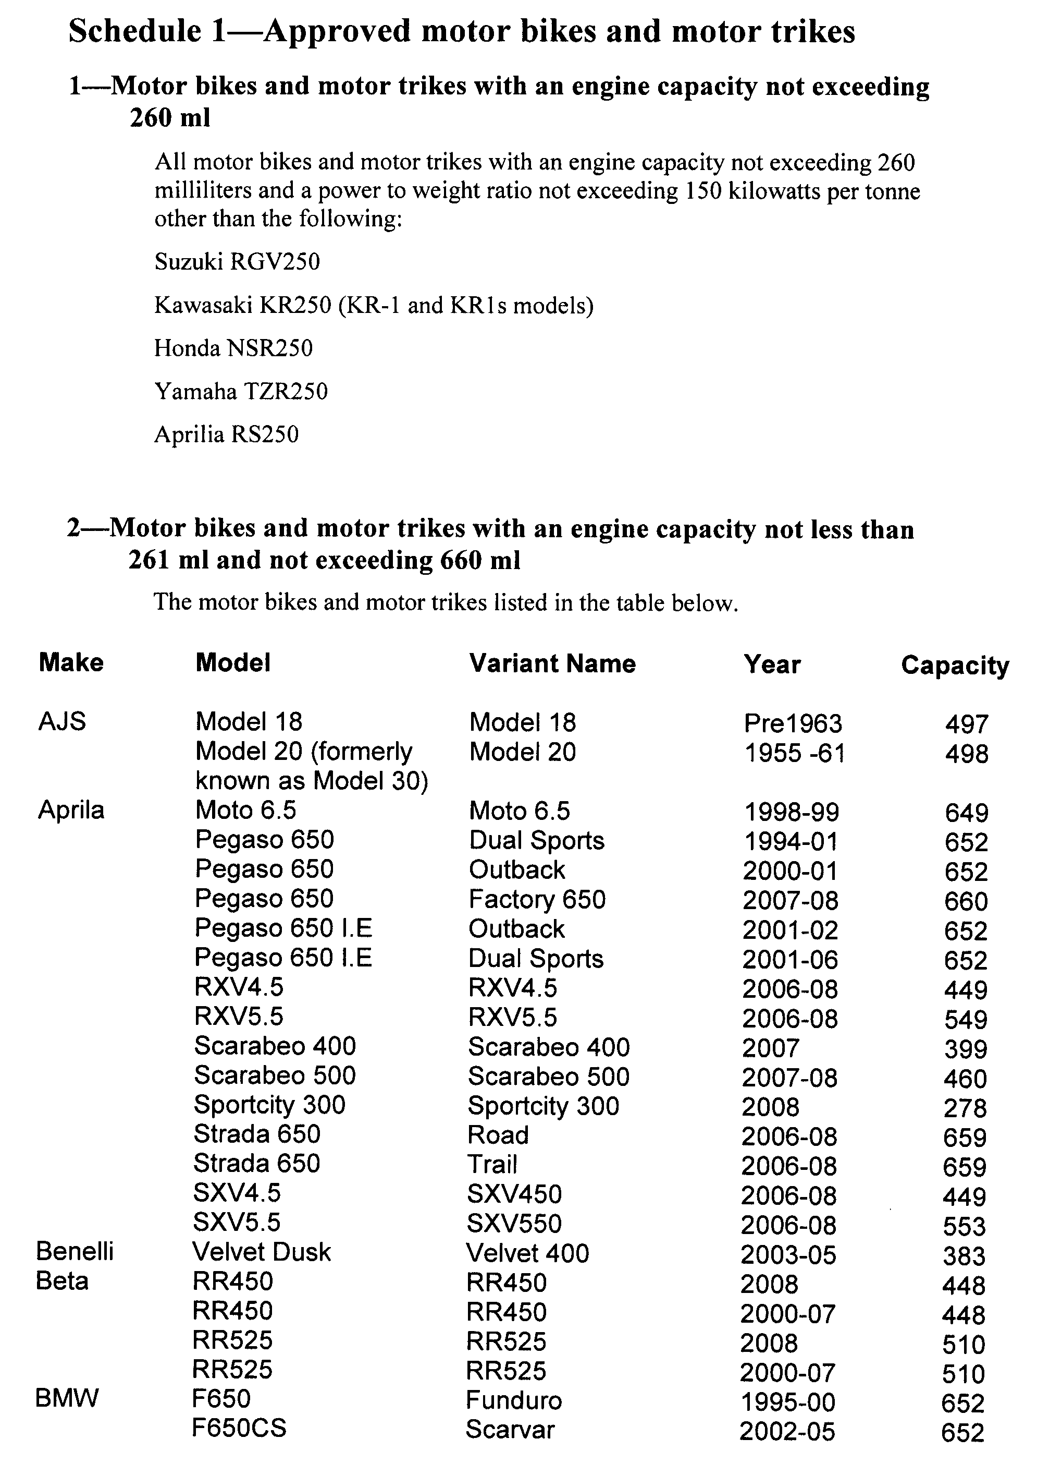
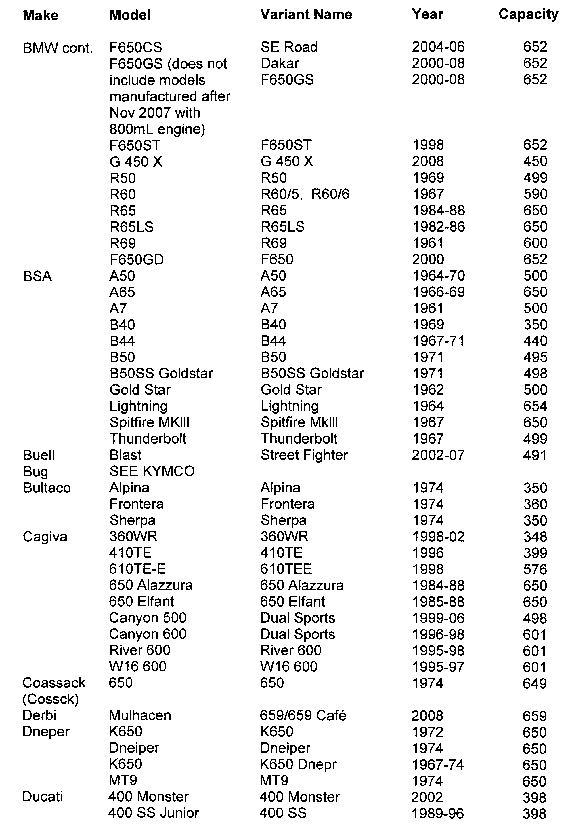
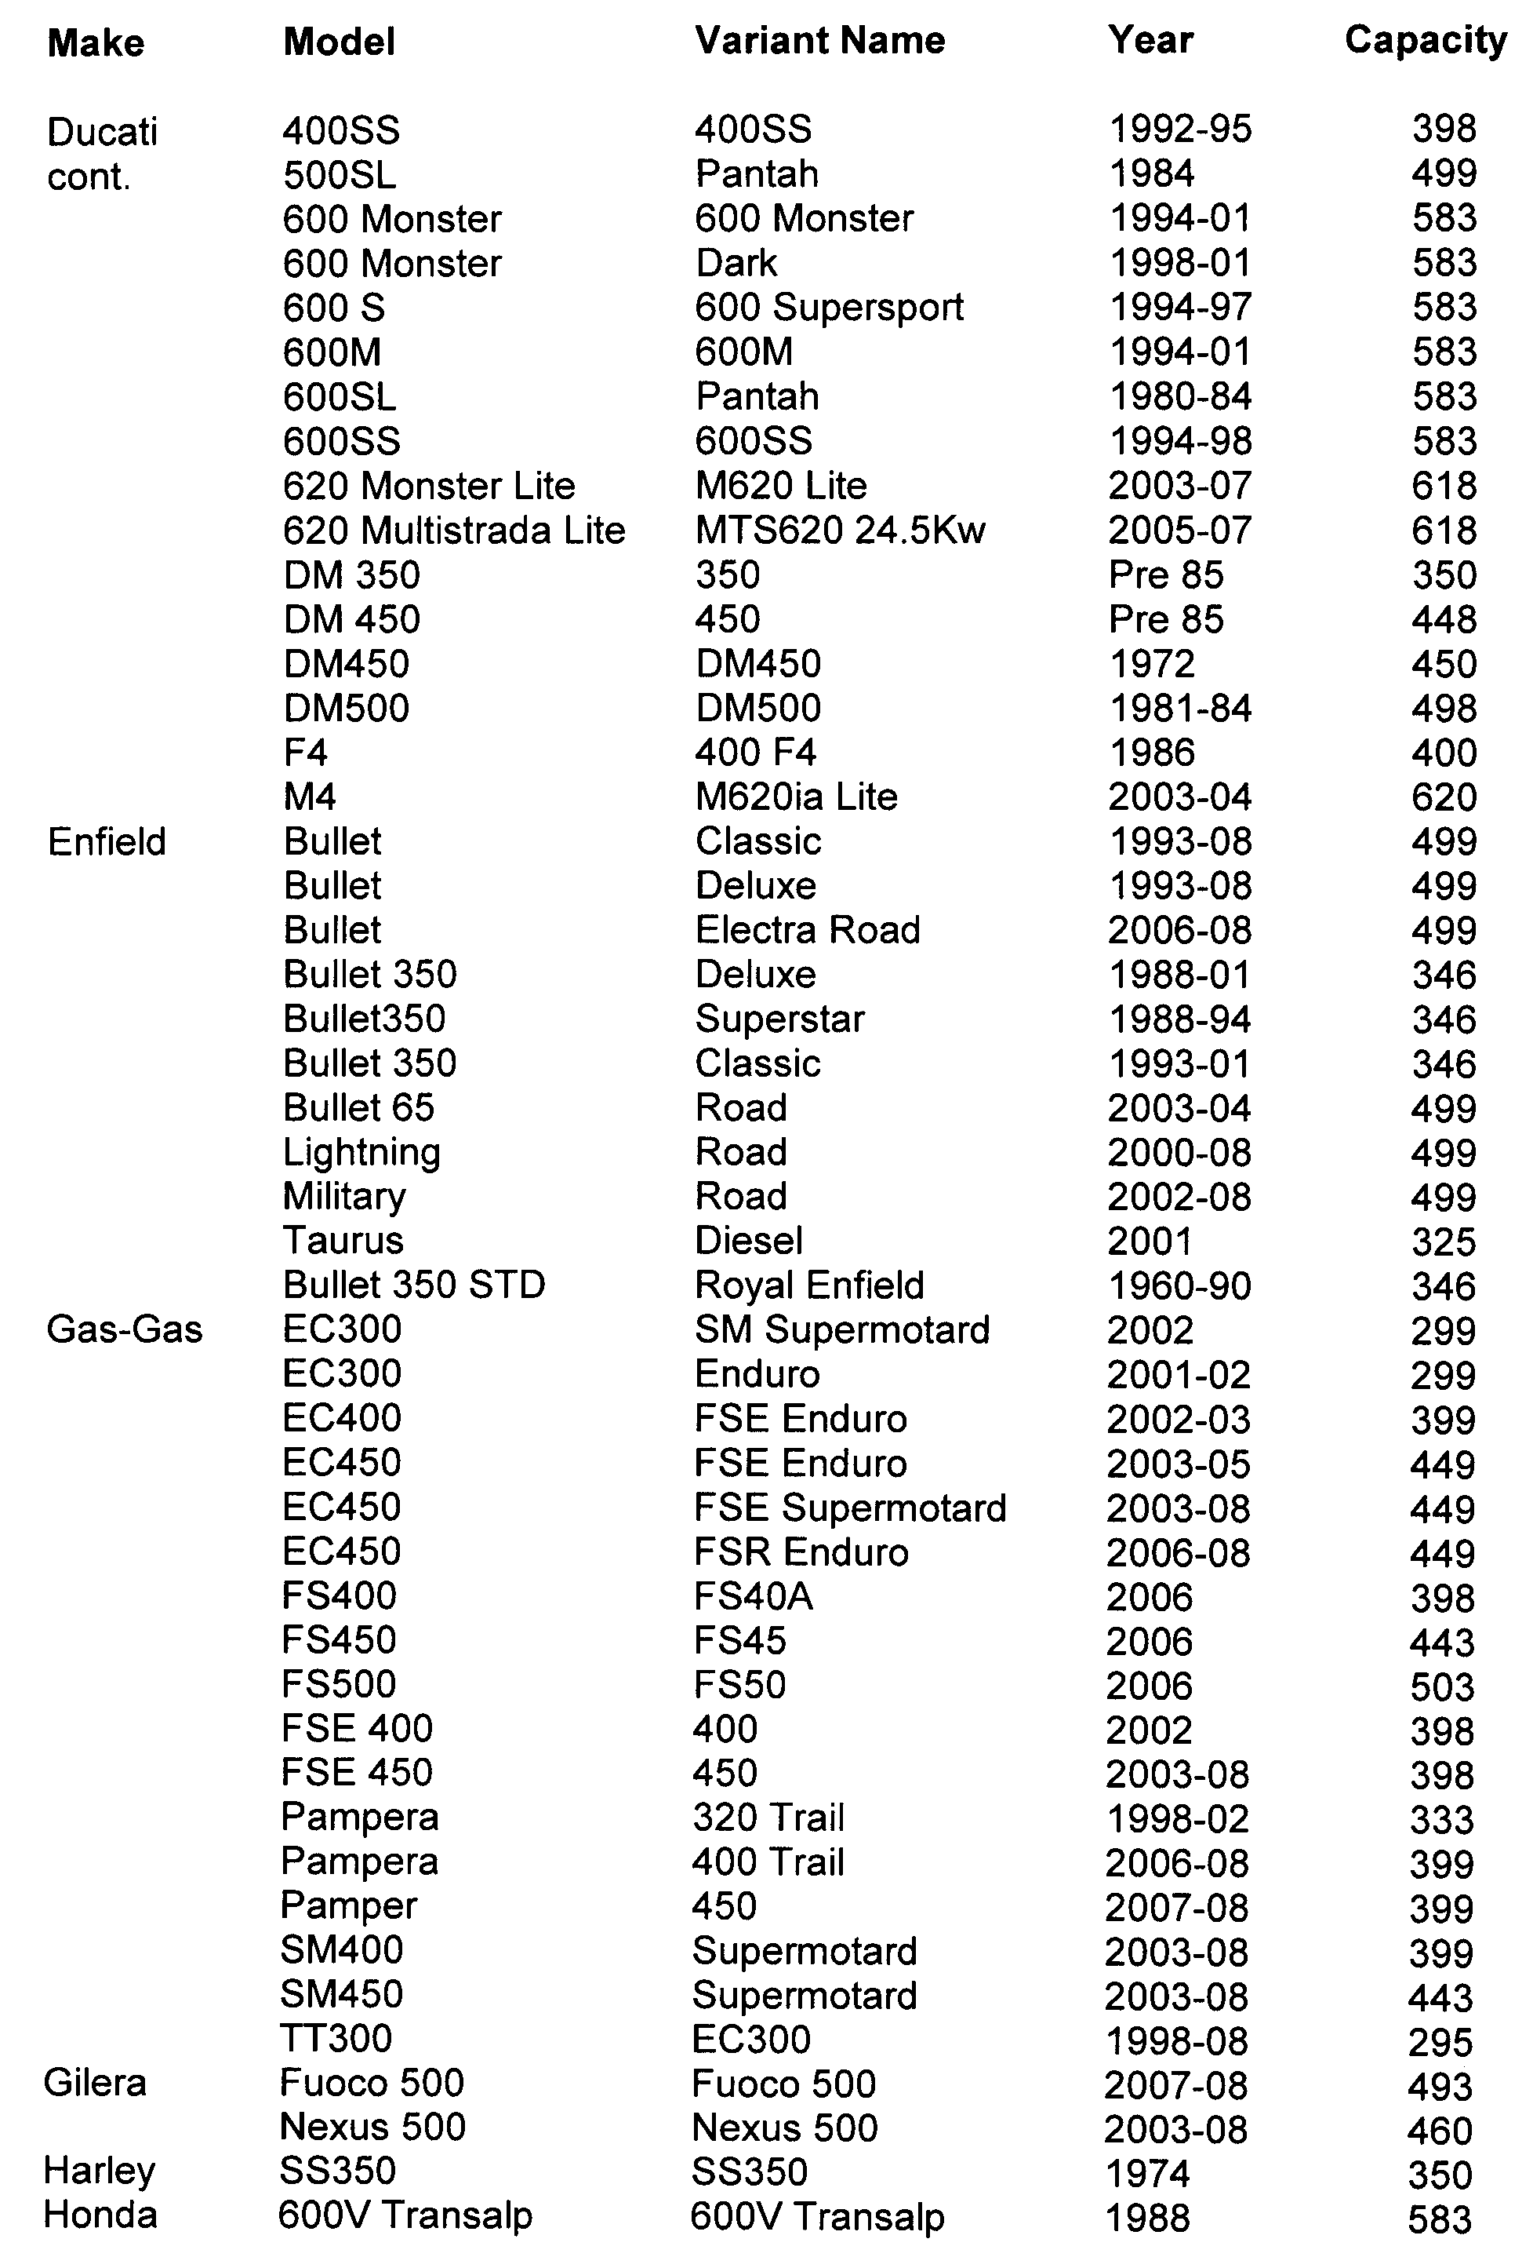
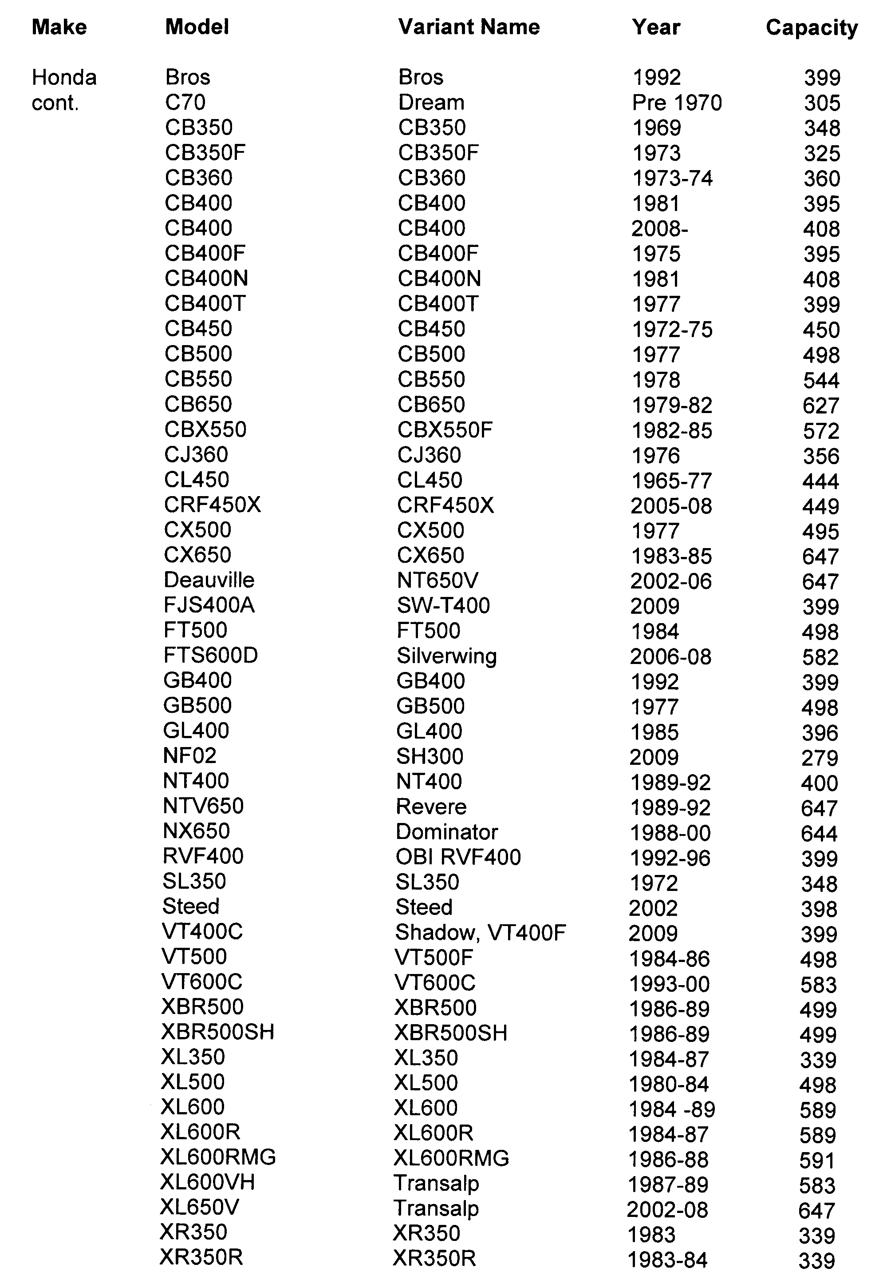
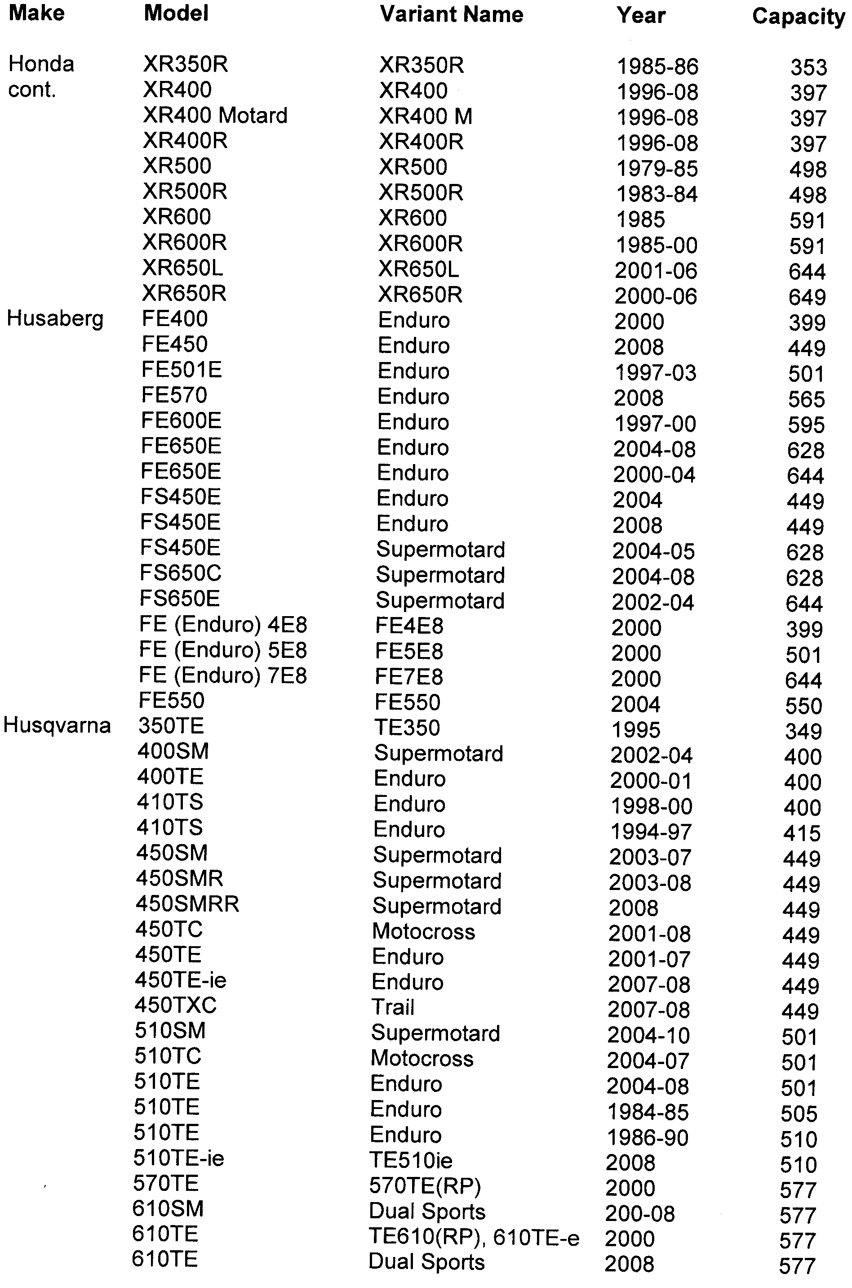
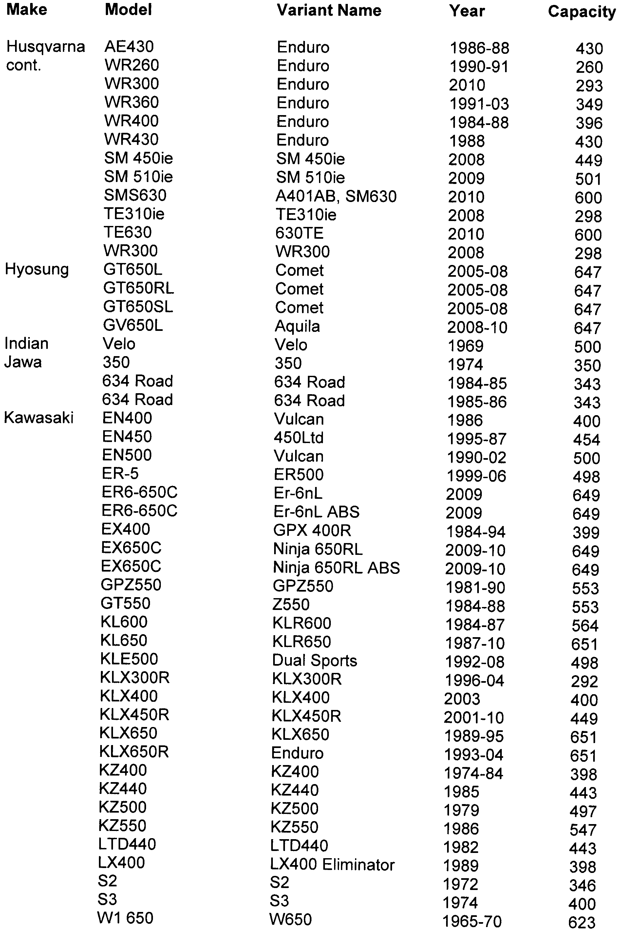
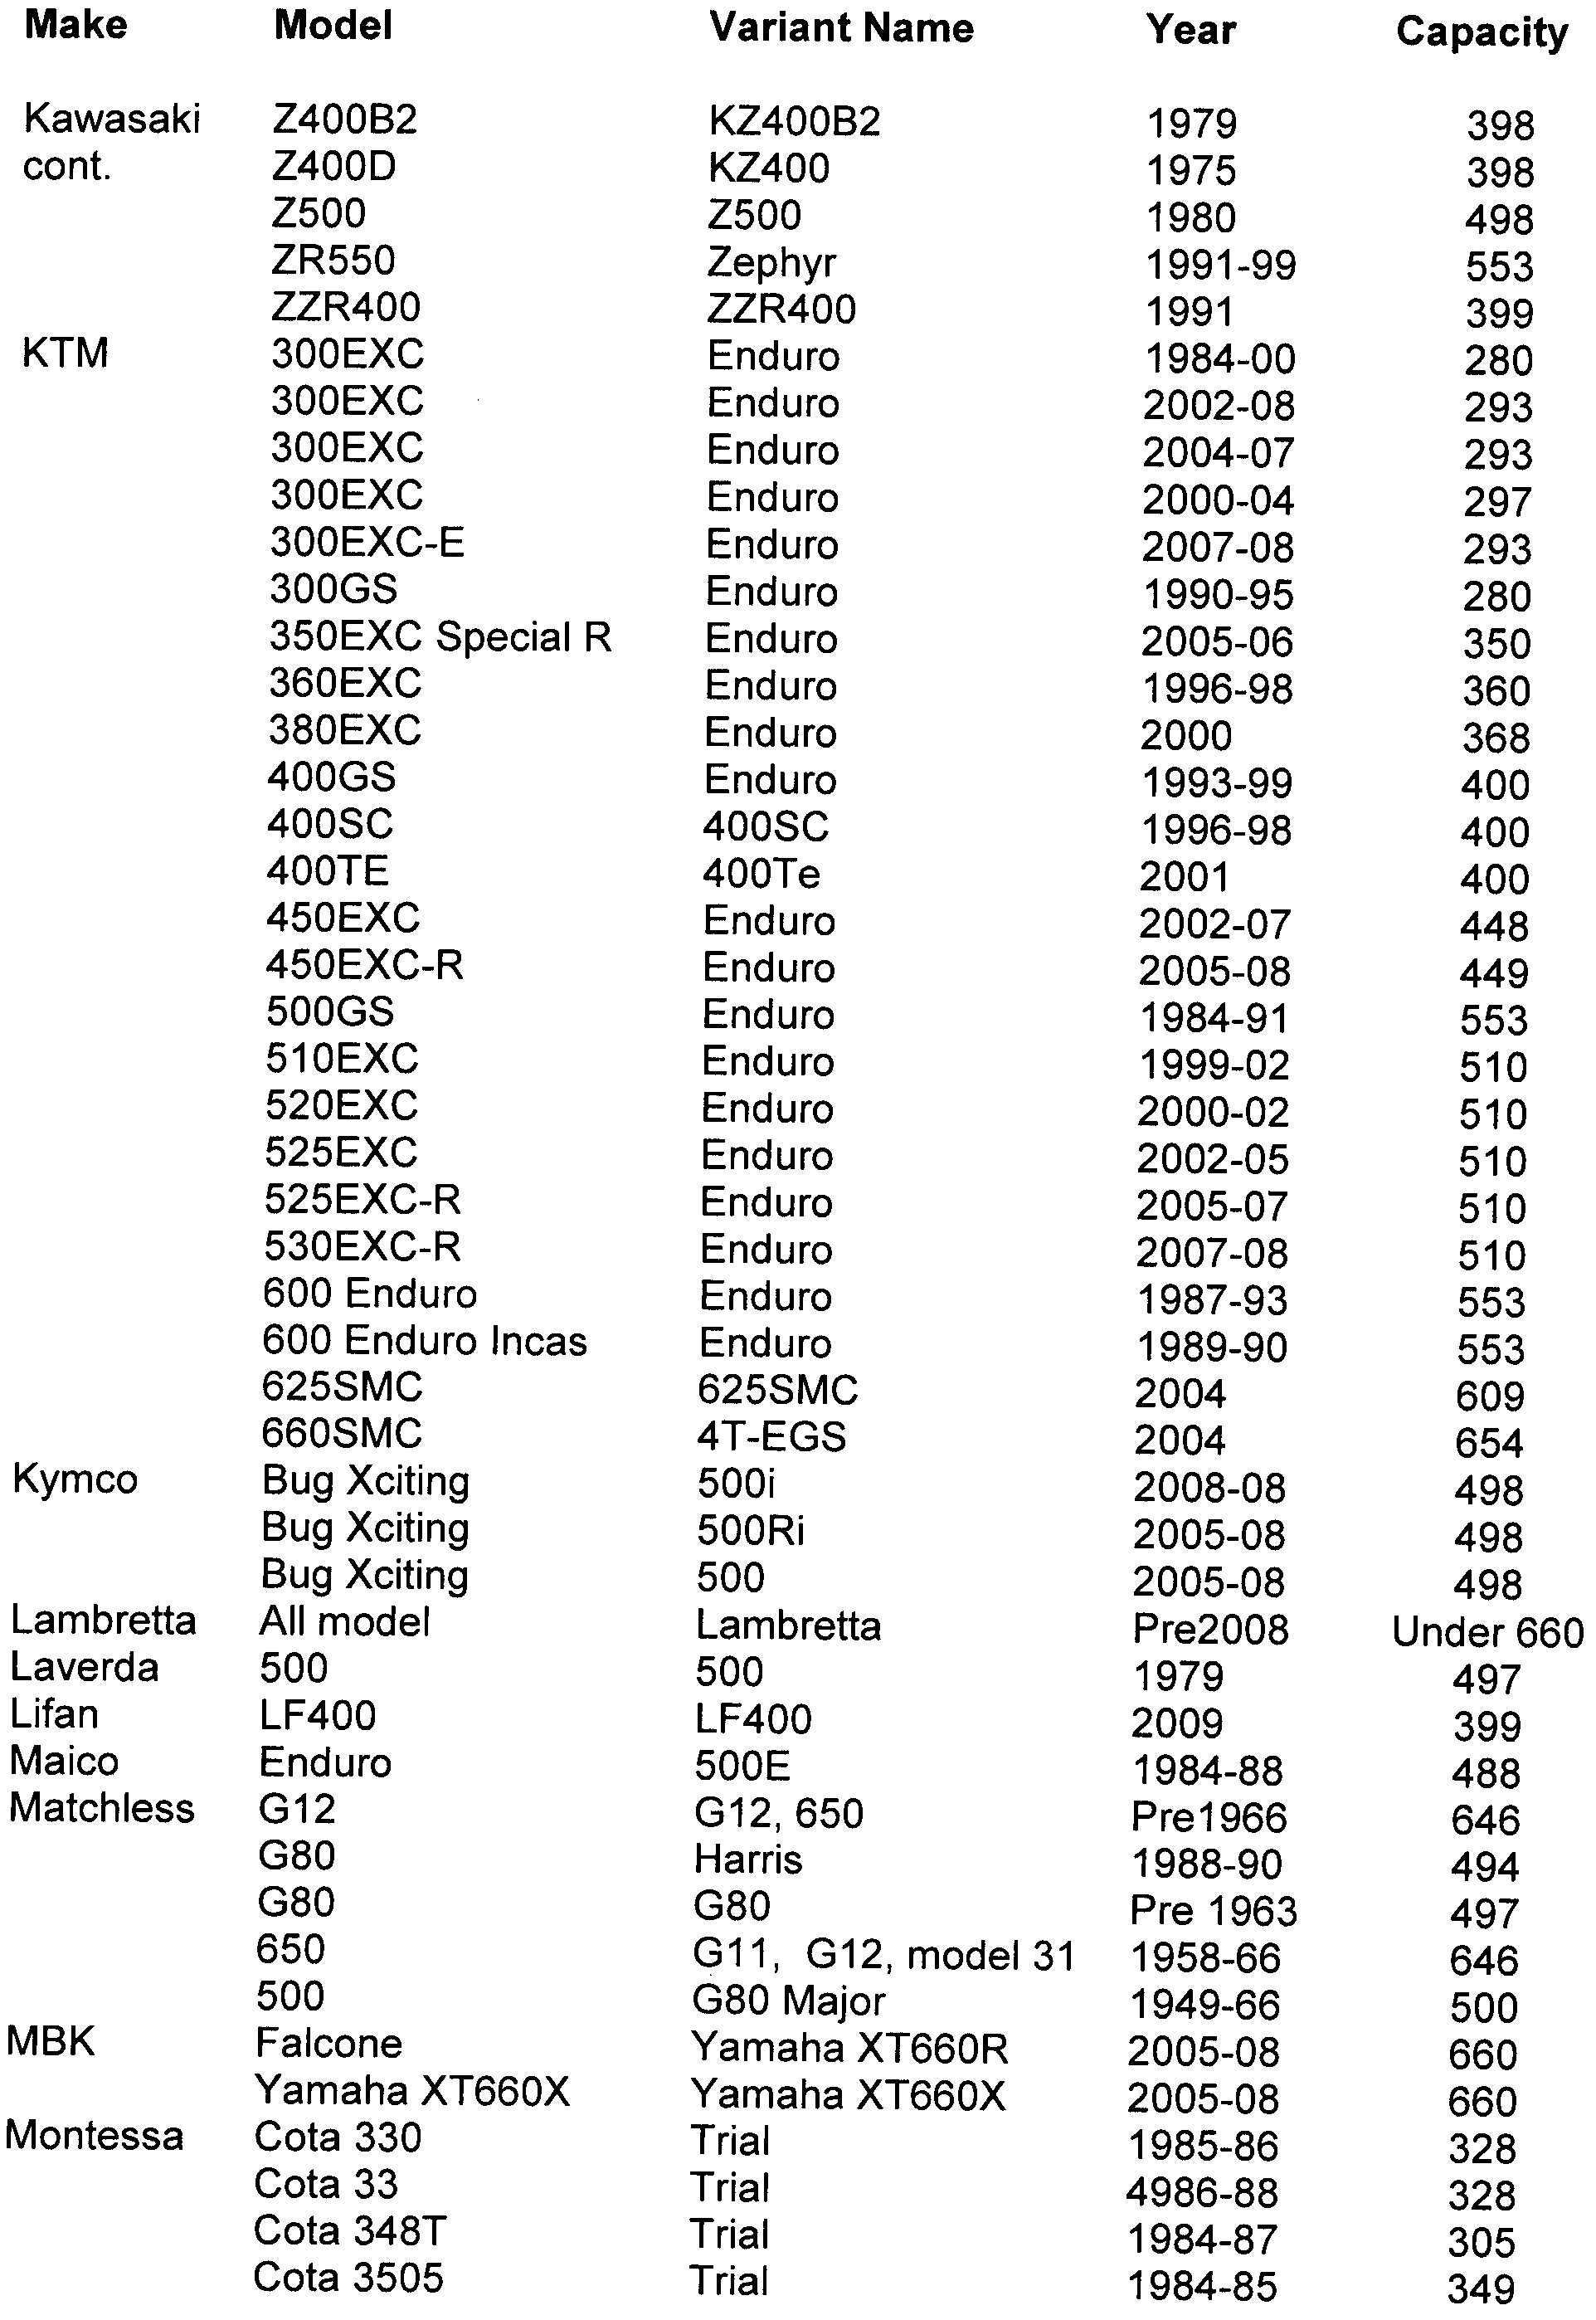
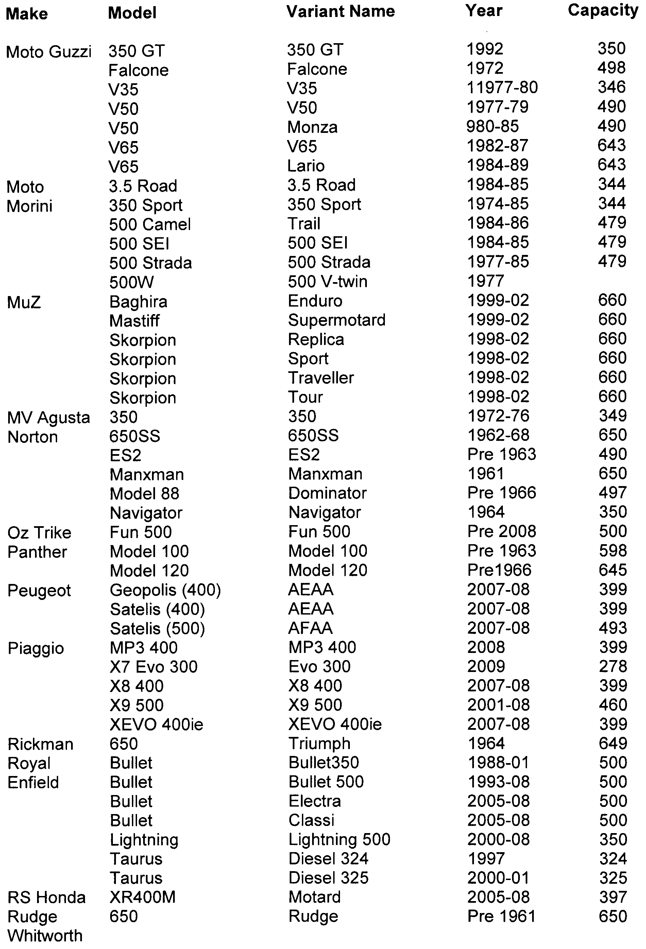
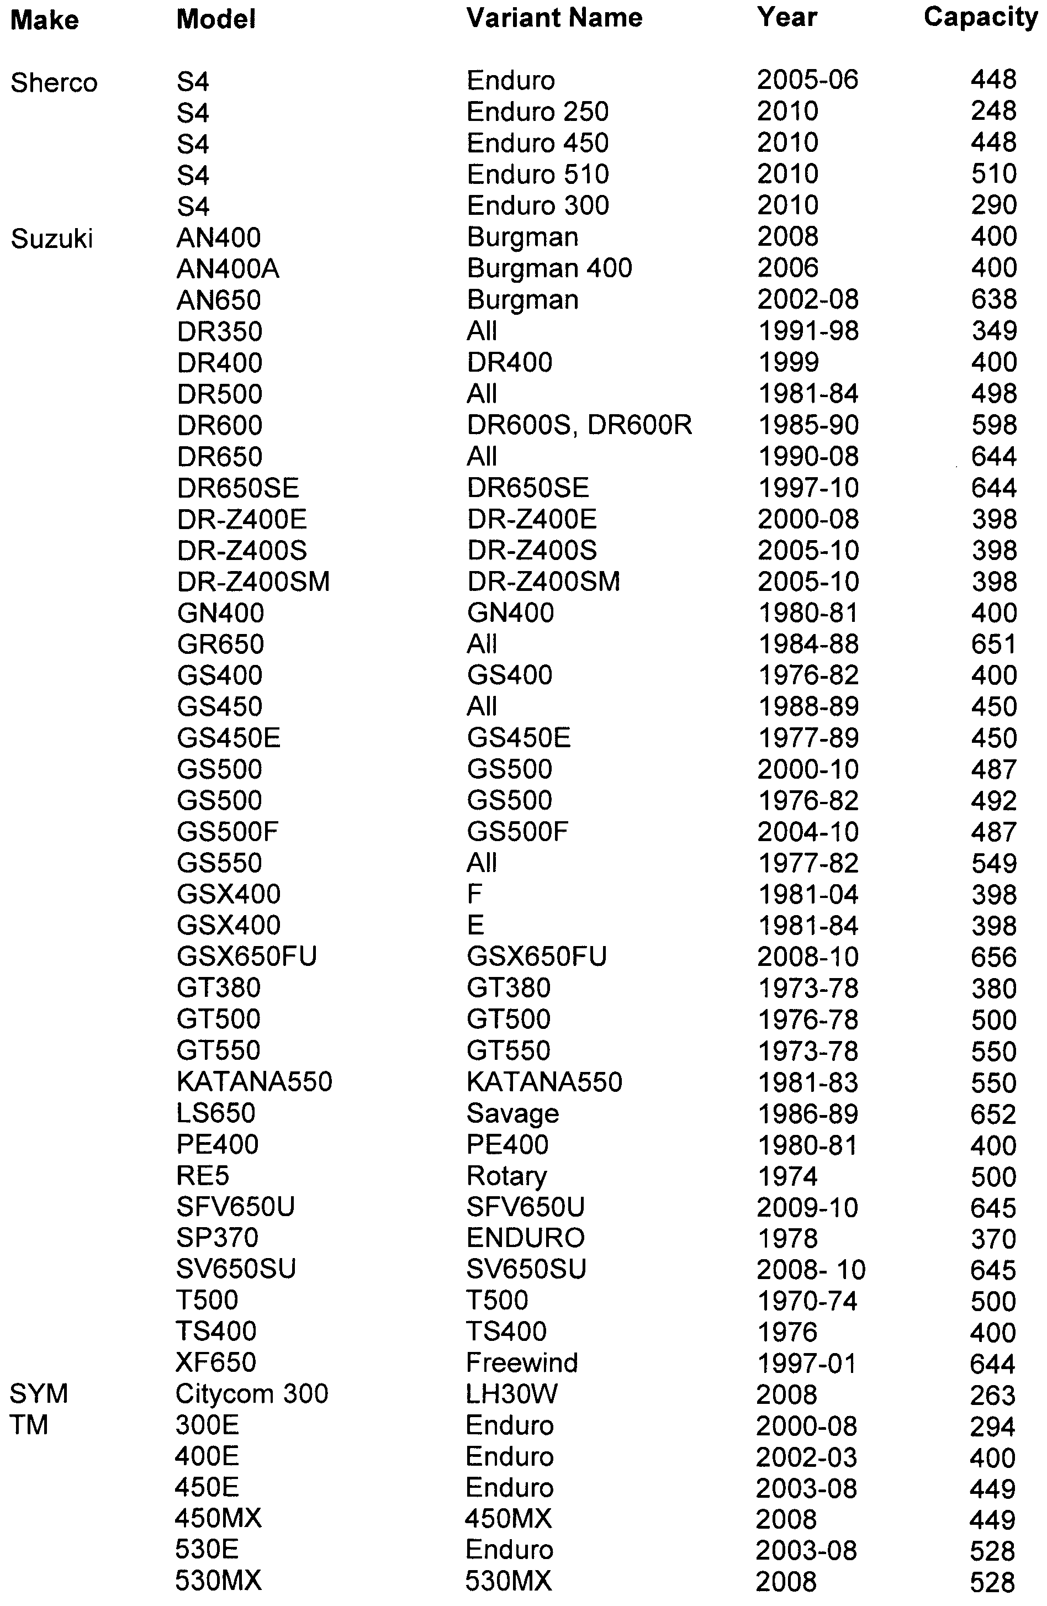
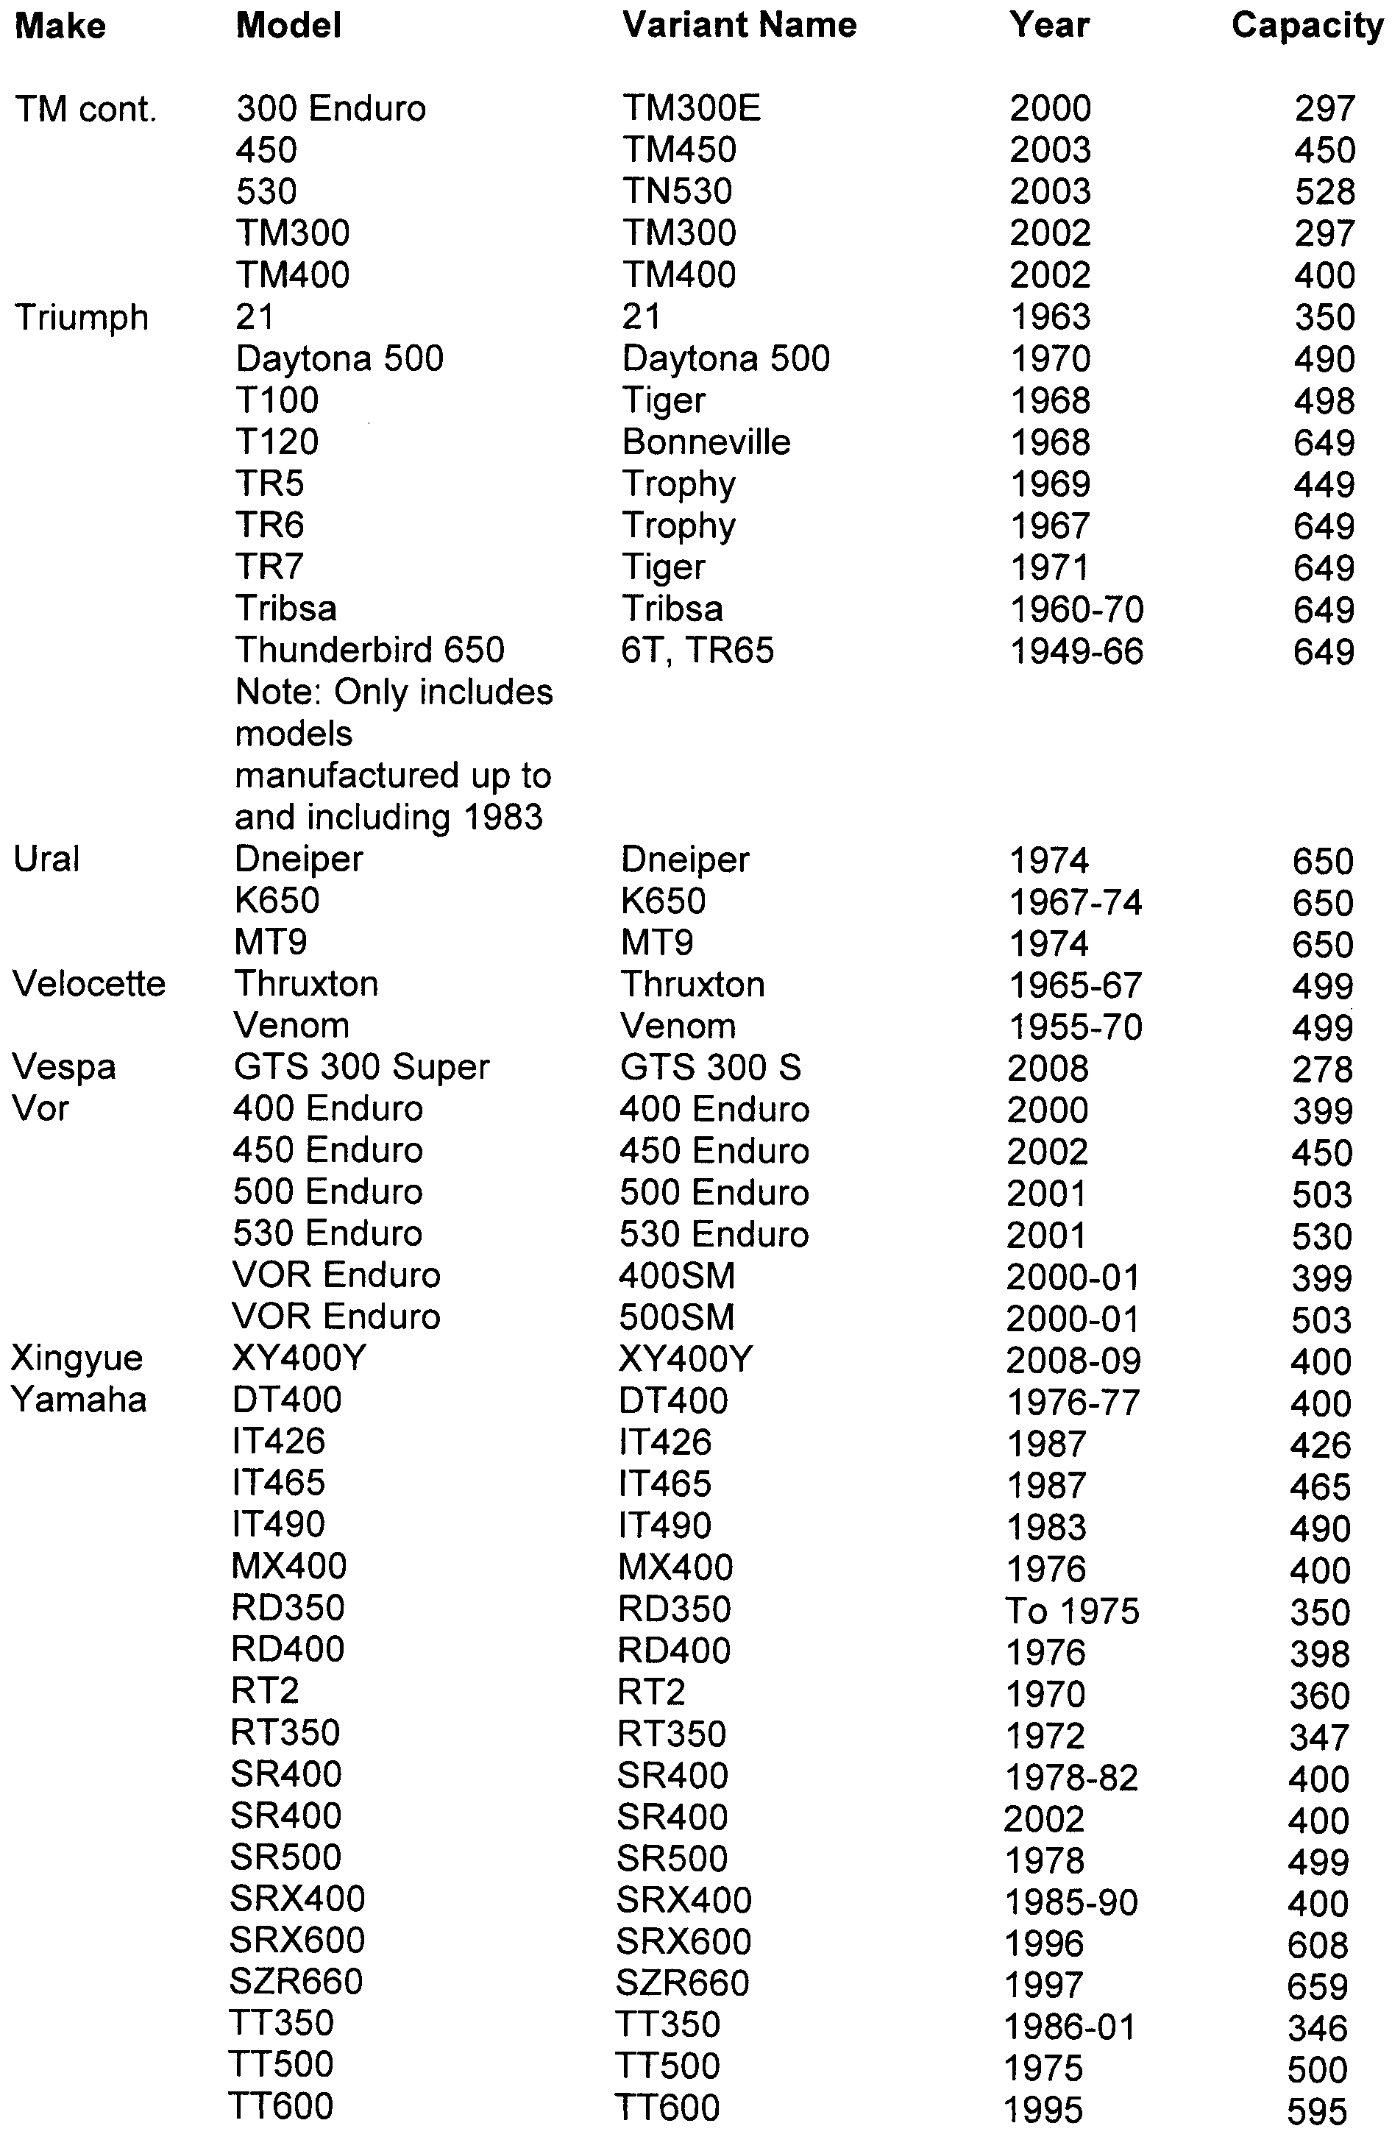
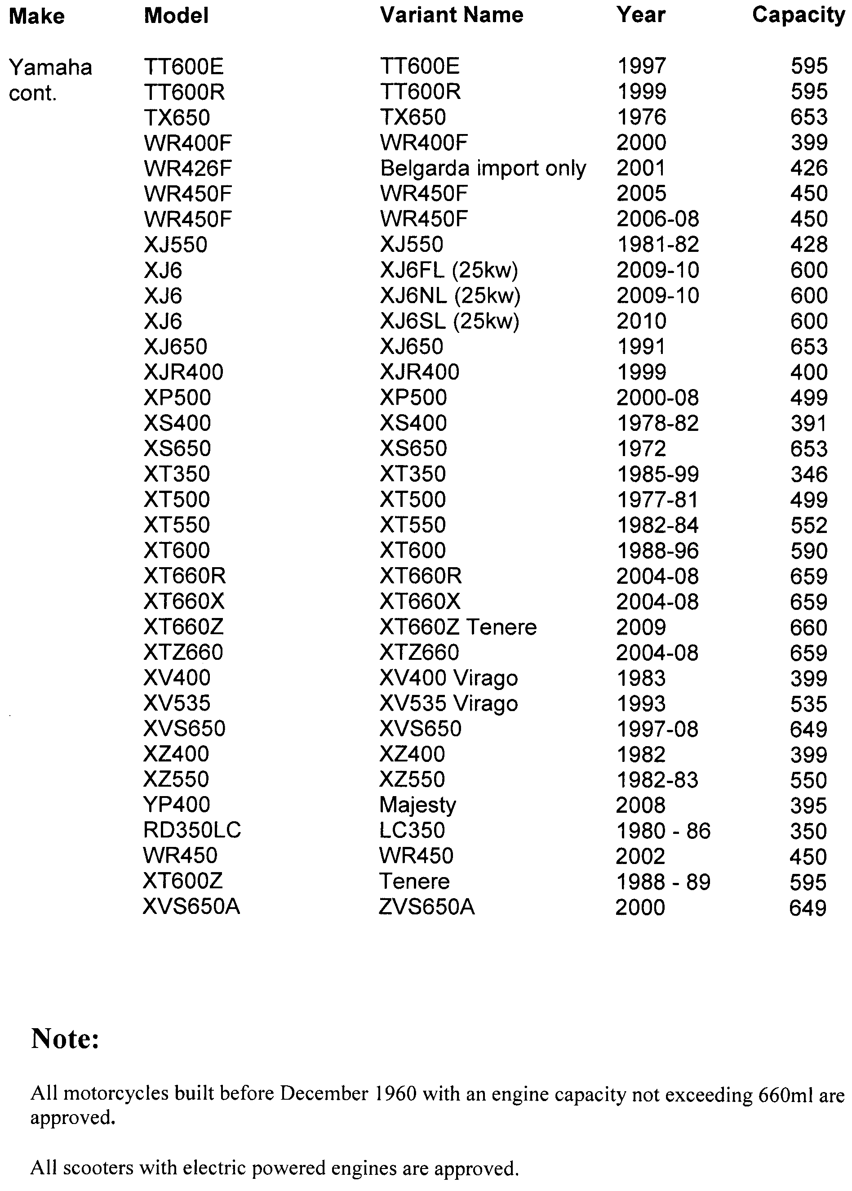
Schedule 2—Revocation
The Motor Vehicles (Approval of Motor Bikes and Motor Trikes) Notice 2010 made on 6 May 2010 (Gazette no. 28, 6 May 2010 p1708) is revoked.

Made by Ron Shanks, Deputy Registrar of Motor Vehicles
3 June 2010

South Australia
Motor Vehicles (High Powered Vehicles) Notice 2010
under the Motor Vehicles Act 1959
1—Short title
This notice may be cited as the Motor Vehicles (High Powered Vehicles) Notice 2010.
2—Commencement
This notice will come into operation on 4 September 2010.
3—Vehicles included in definition of high powered vehicle
In accordance with the definition of high powered vehicle in Section 5 of the Motor Vehicles Act 1959, vehicles of a kind specified in Schedule 1 are included in that definition.
4 –Vehicles excluded from definition of high powered vehicle
In accordance with the definition of high powered vehicle in Section 5 of the Motor Vehicles Act 1959, vehicles of a kind specified in Schedule 2 are excluded from that definition.

Schedule 1—Included Vehicles
1—The following vehicles are included in the definition of high powered vehicle:
- BMW M & M3
- Honda NSX
- Nissan 350Z and 370Z (including private or ‘grey’ import variants)
- All models of Porsche from 1994 onwards
- Mercedes Benz SLK350
Schedule 2—Excluded Vehicles
1 - The following vehicles are excluded from the definition of high powered vehicle:
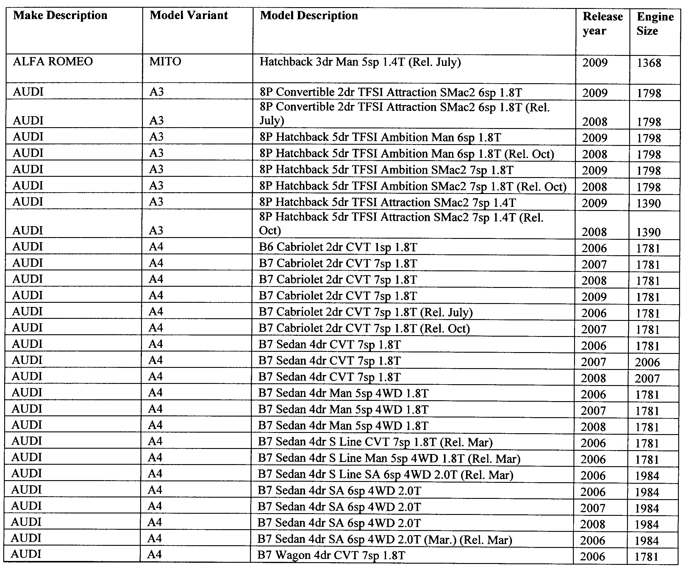

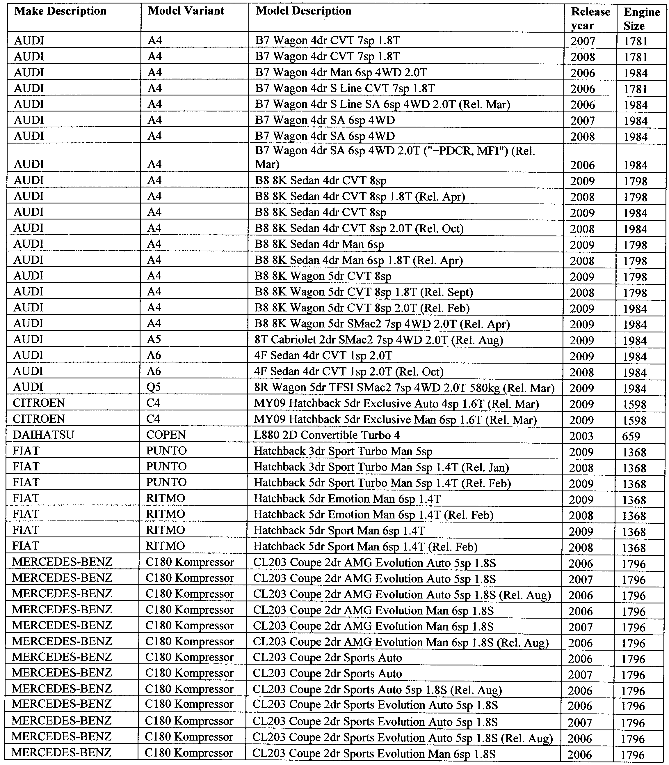
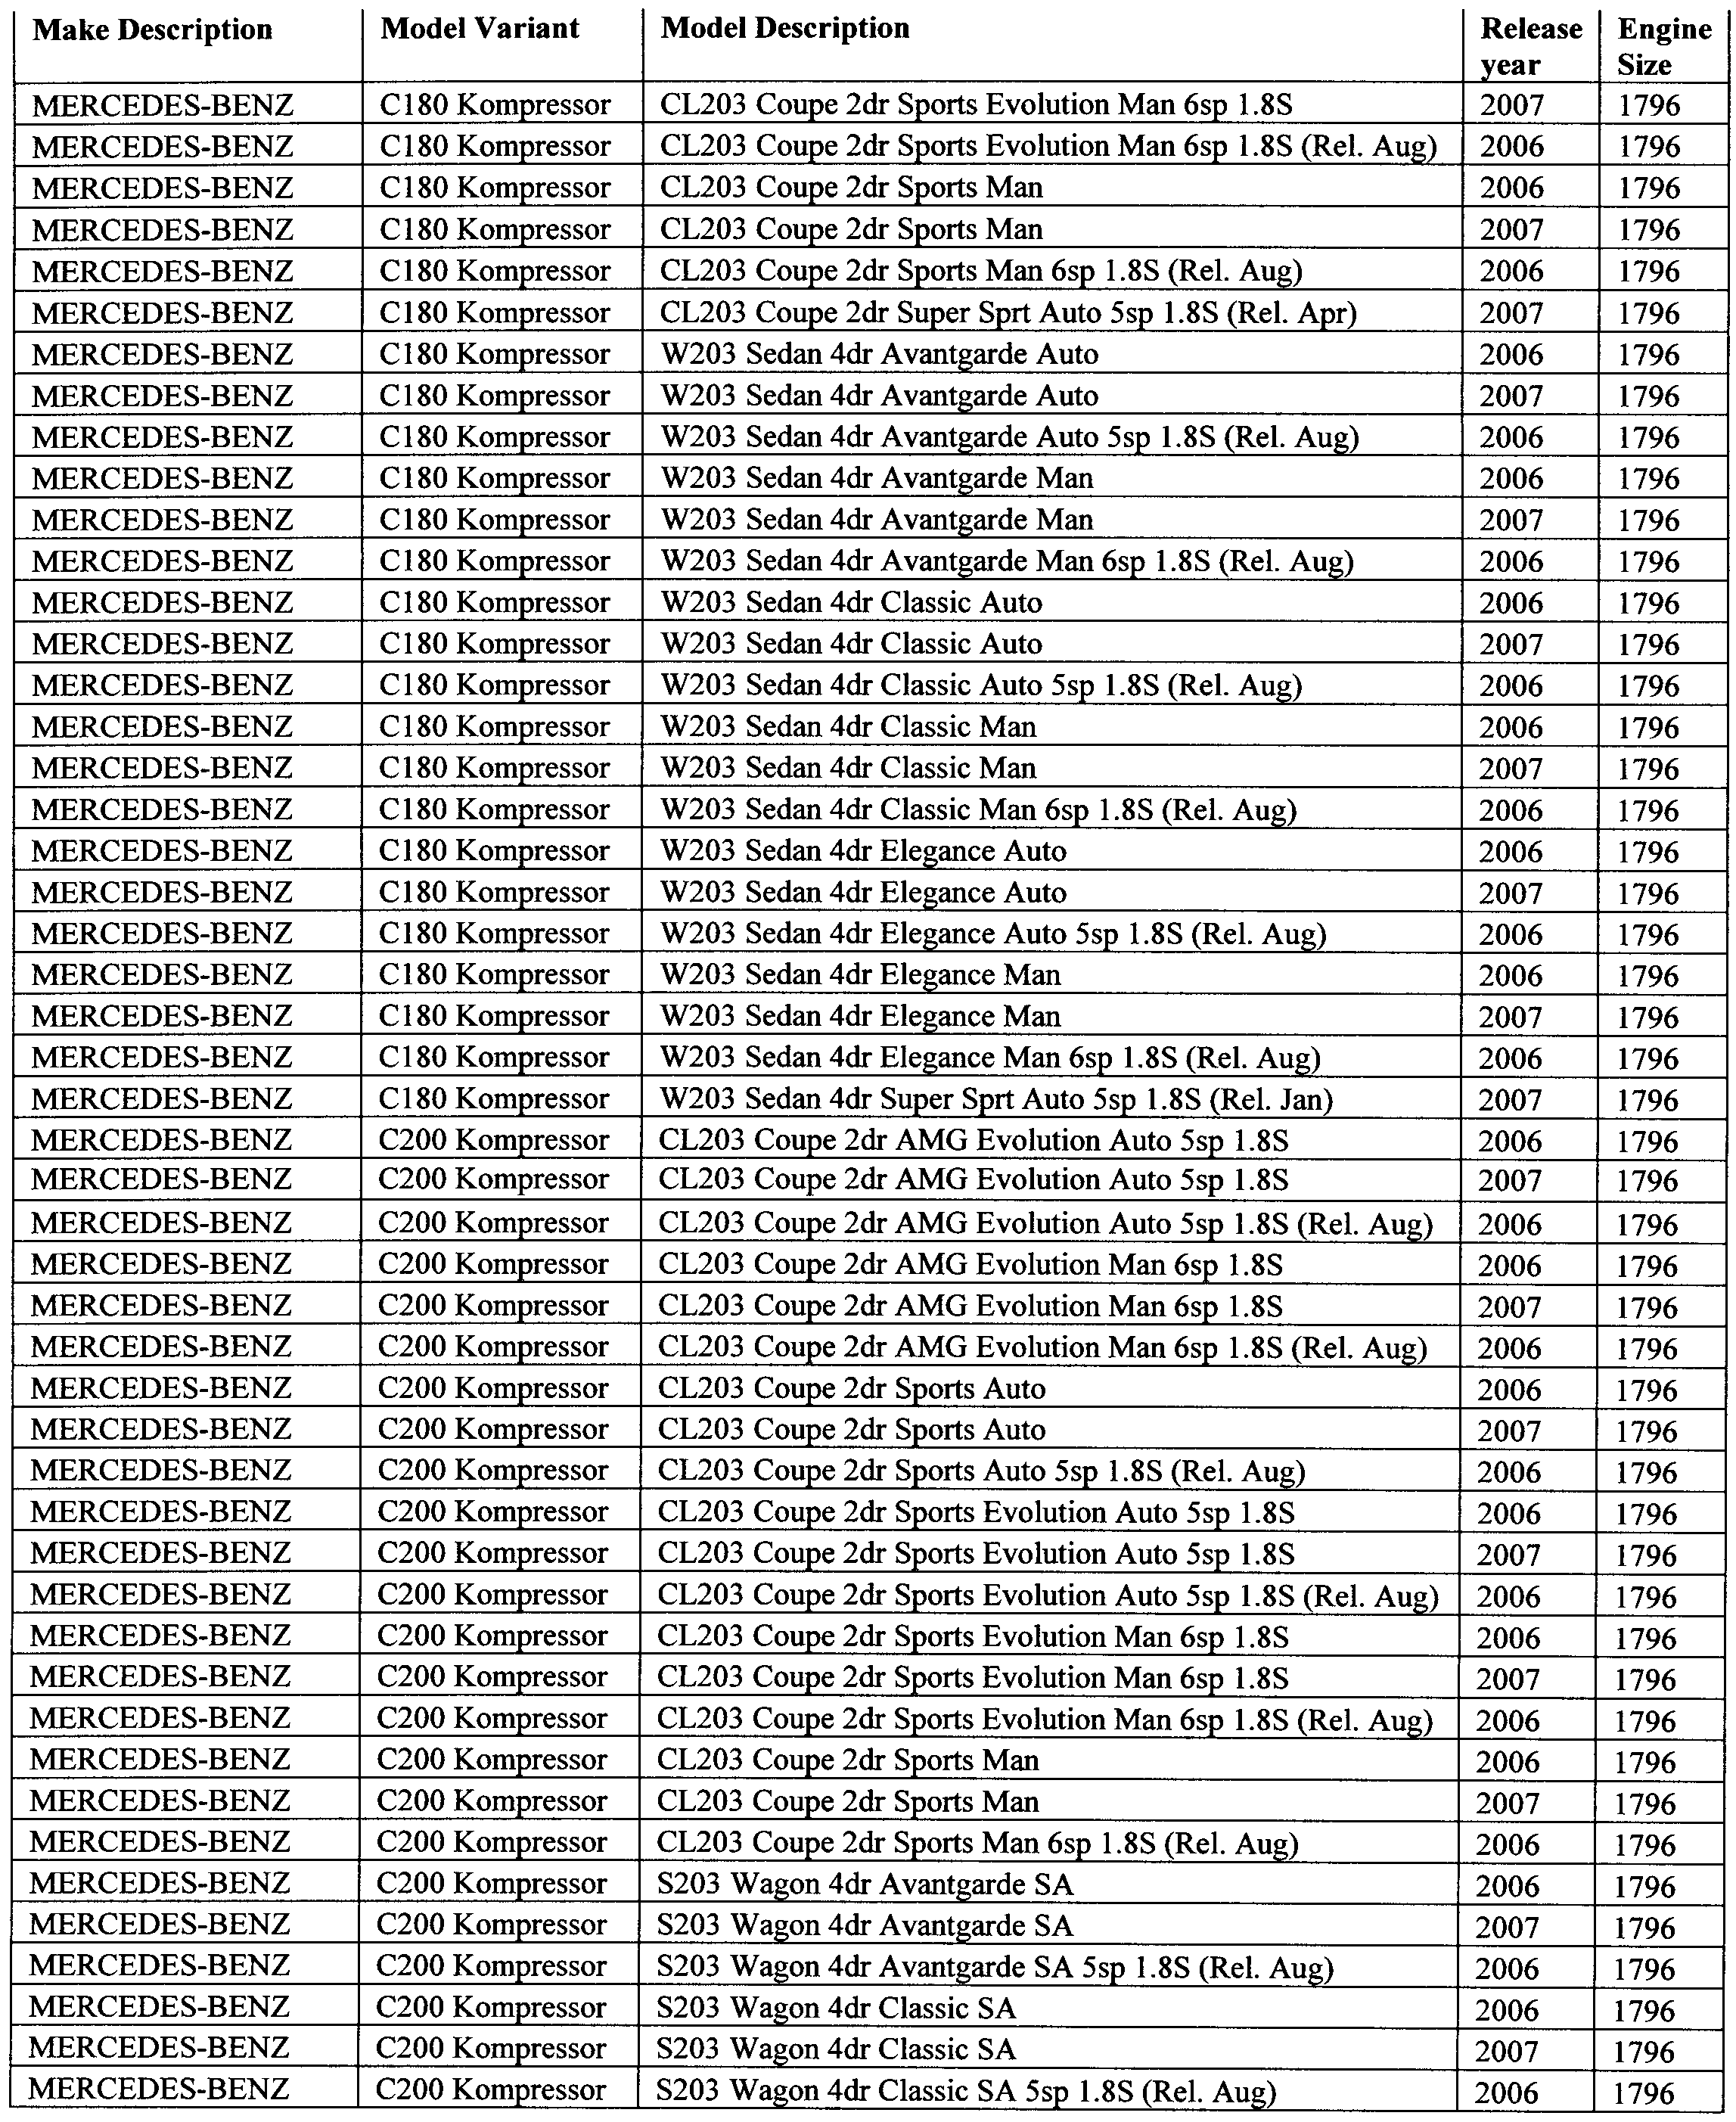
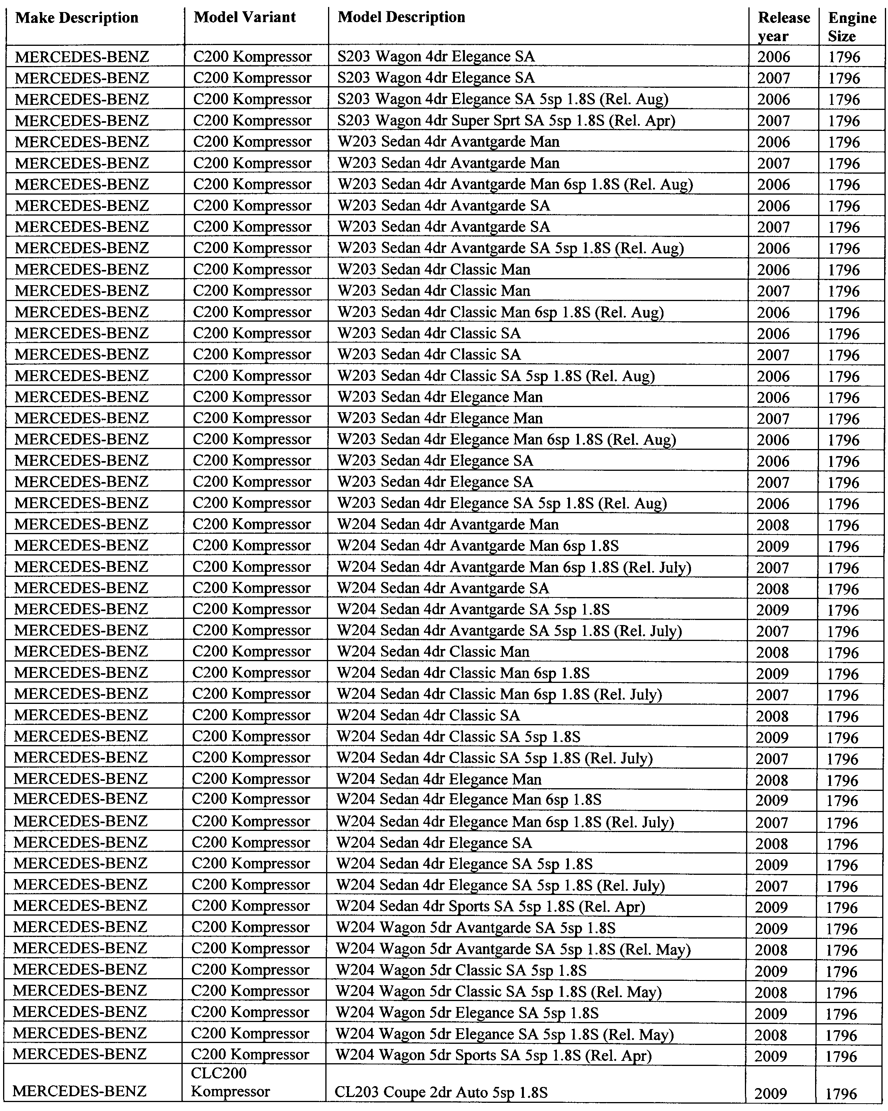
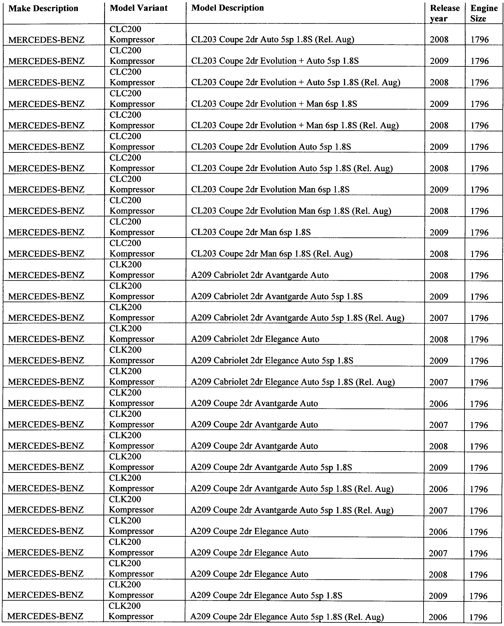
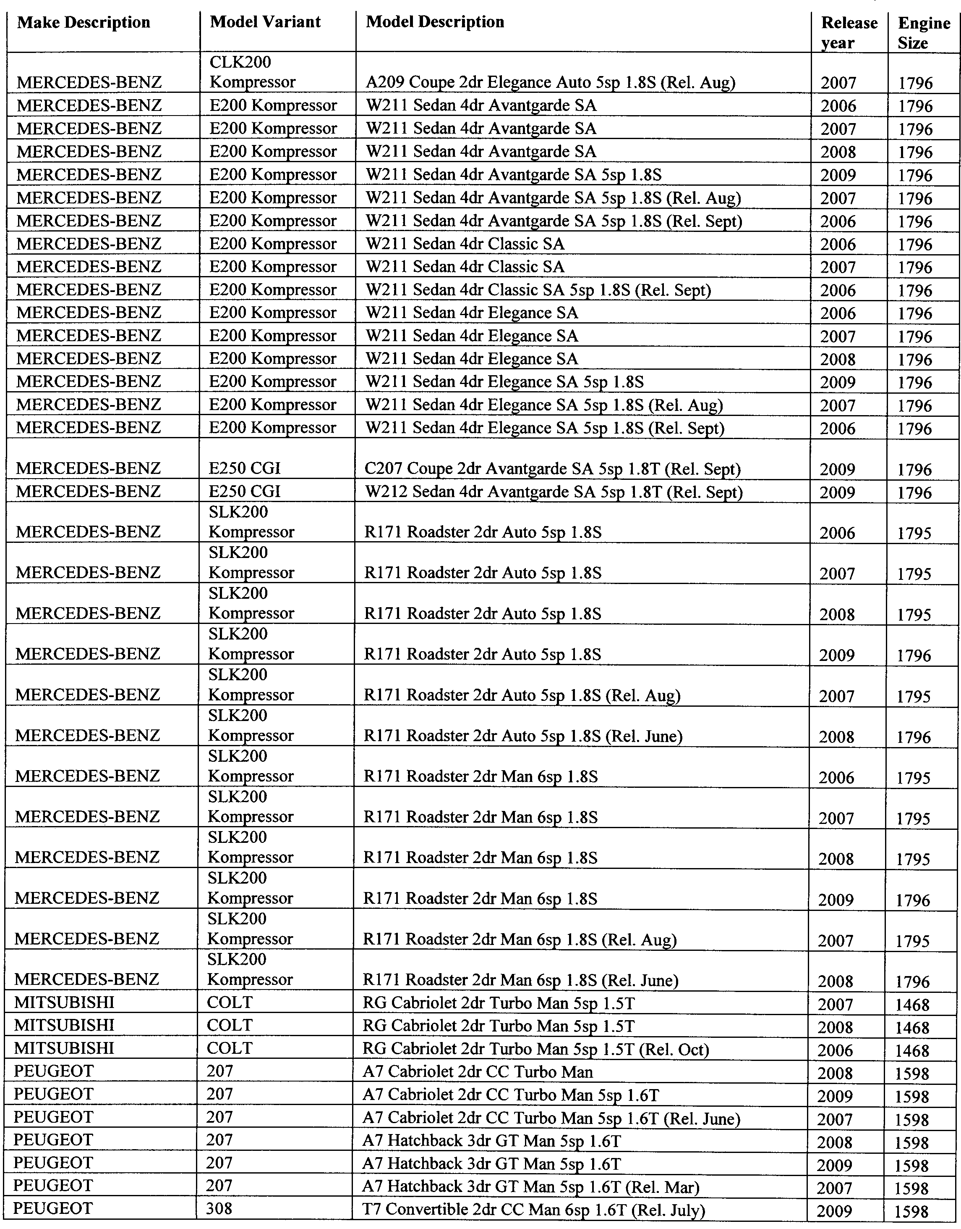
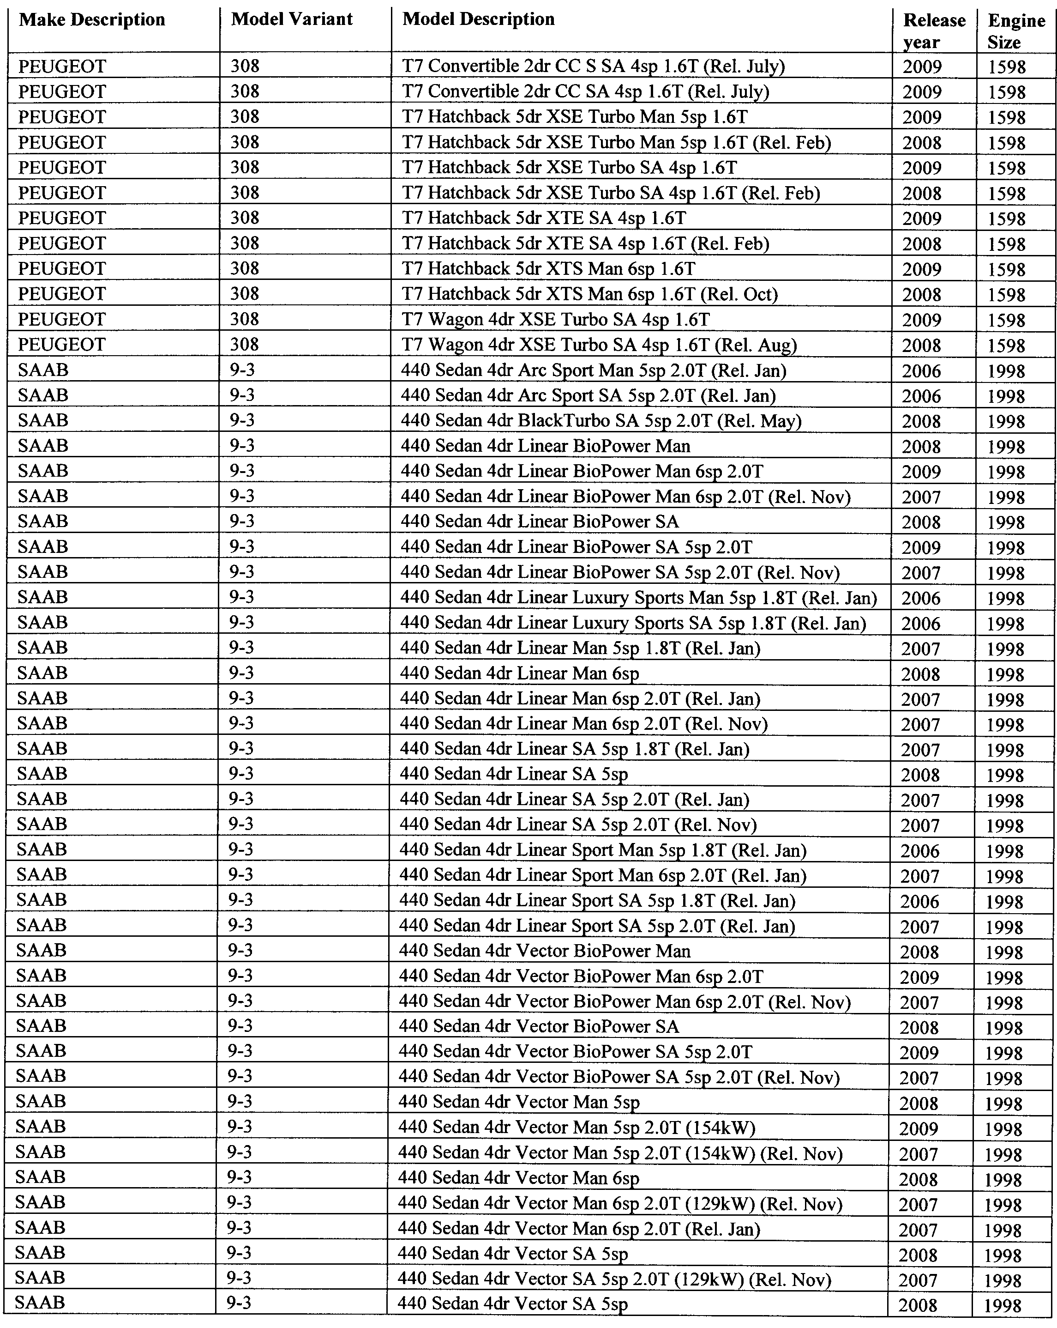
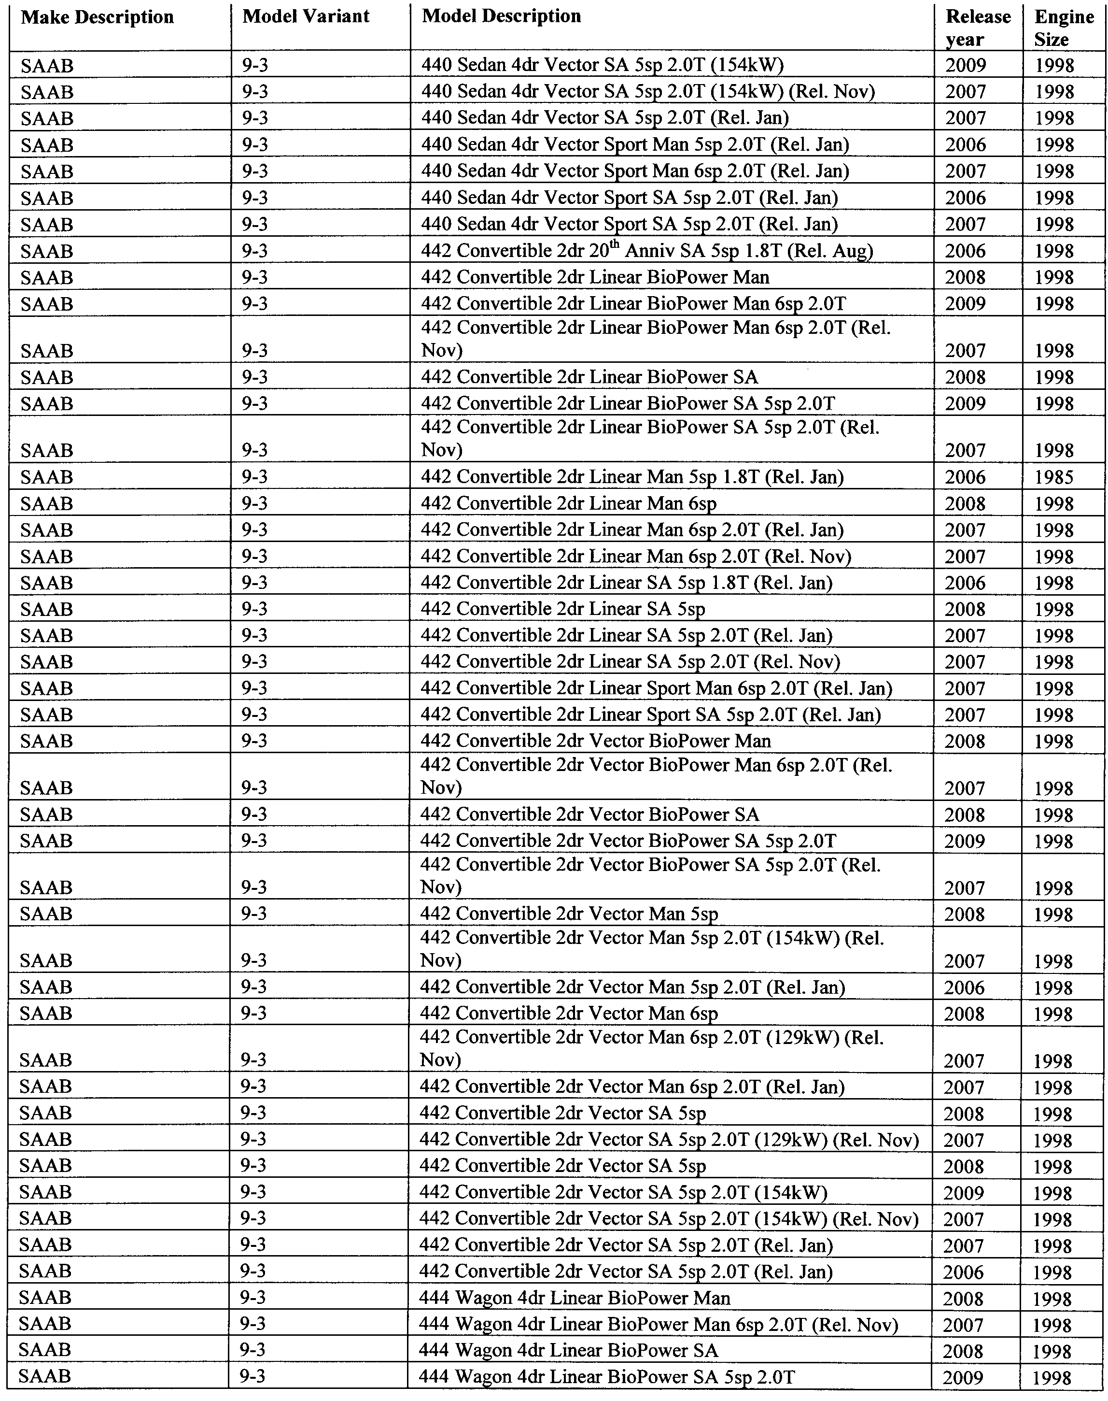
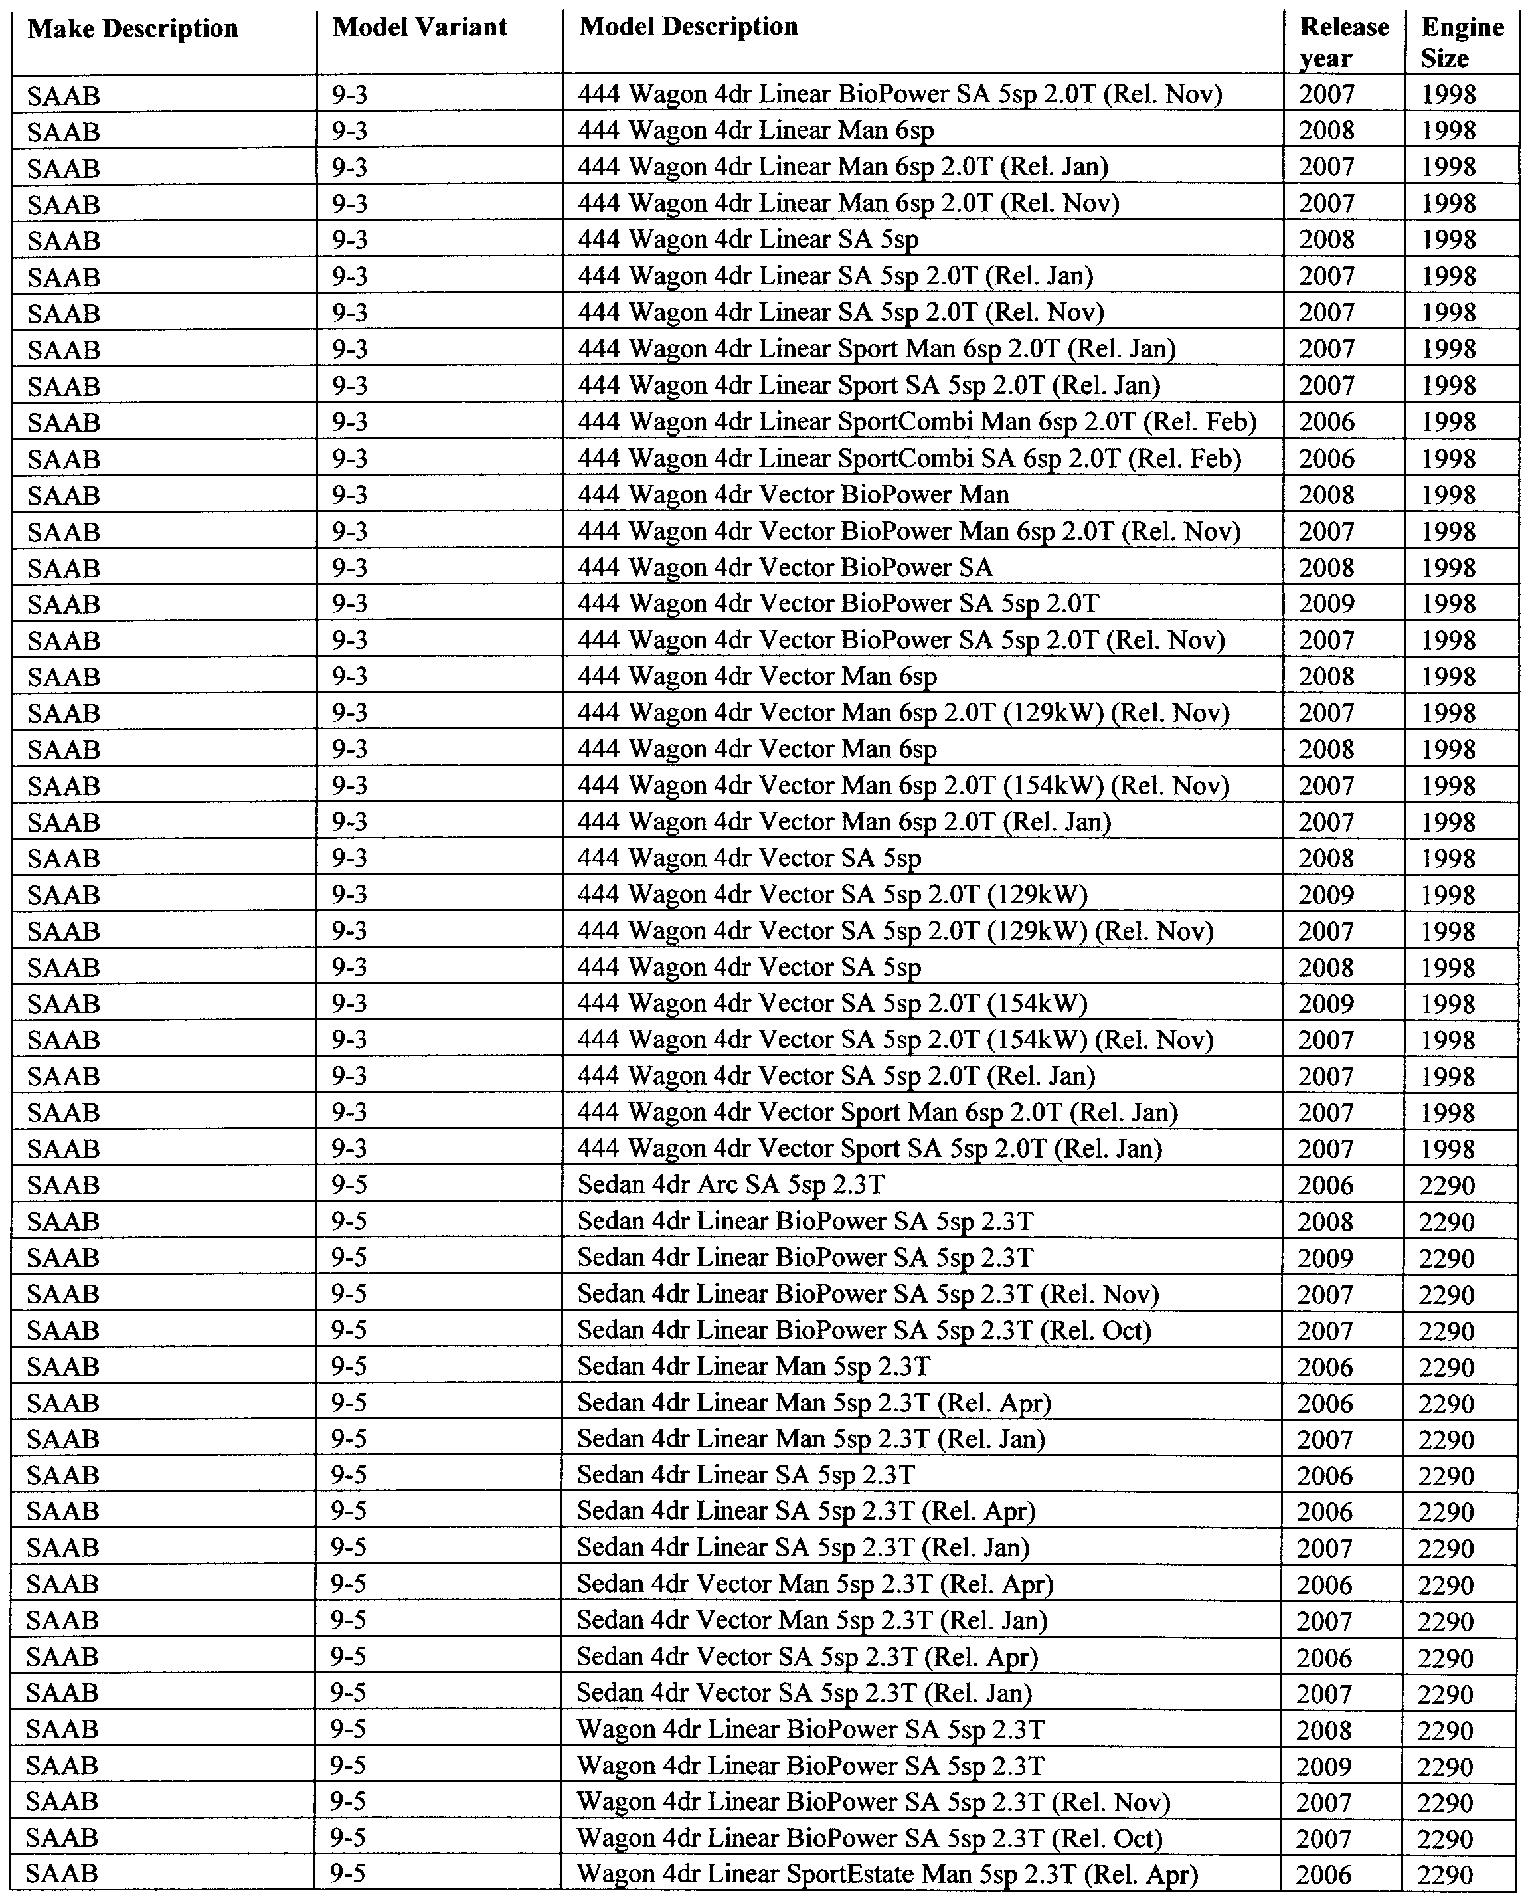
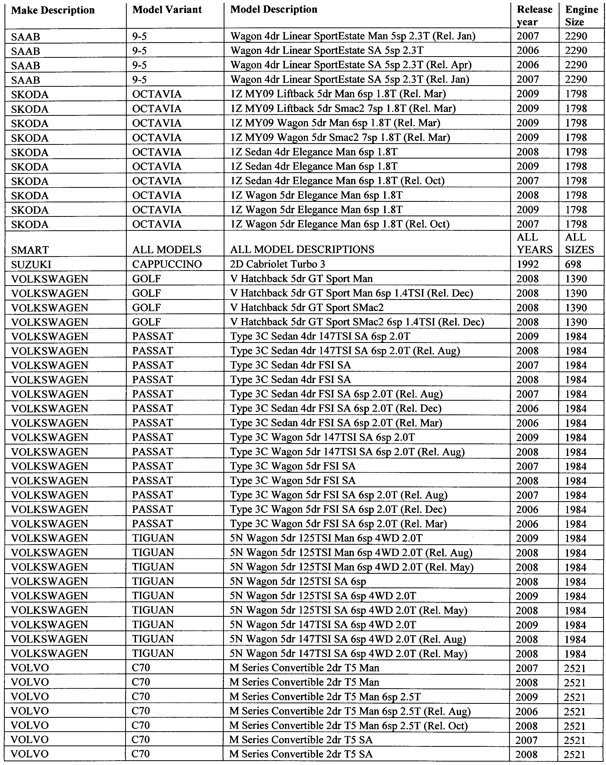
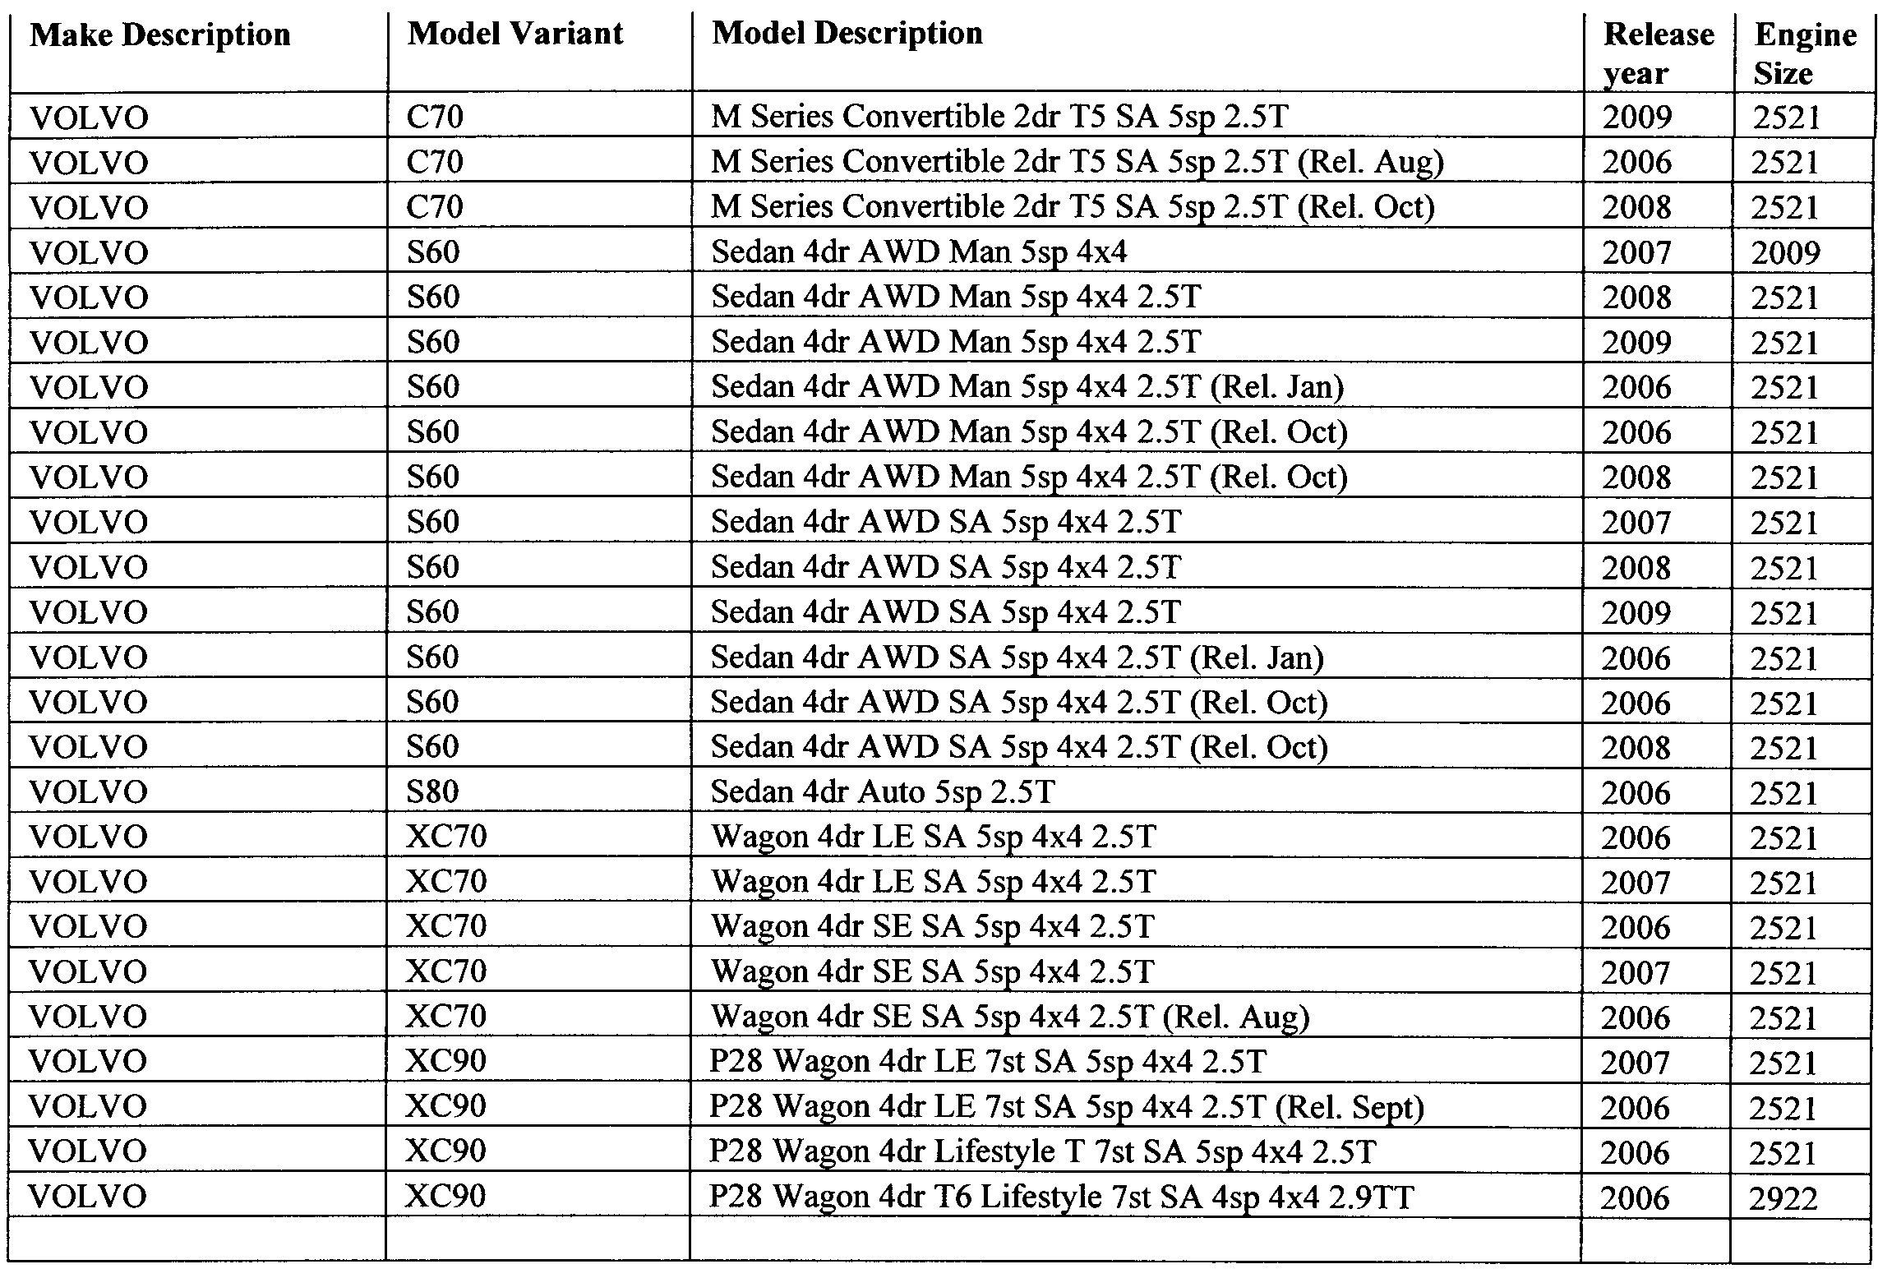

Made by Martin Small, Registrar of Motor Vehicles
1 July 2010

THE DISTRICT COURT OF SOUTH AUSTRALIA
MOUNT GAMBIER CIRCUIT COURT
Sheriff’s Office, Adelaide, 5 July 2010
IN pursuance of a precept from the District Court of South Australia to me directed, I do hereby give notice that the said court will sit as a Court of Oyer and Terminer and General Gaol Delivery at the Courthouse at Mount Gambier on the day and time undermentioned and all parties bound to prosecute and give evidence and all jurors summoned and all others having business at the said Court are required to attend the sittings thereof and the order of such business will be unless a Judge otherwise orders as follows:
Monday, 5 July 2010 at 10 a.m. on the first day of the sittings the only business taken will be the arraignment of prisoners in gaol and the passing of sentences on prisoners in gaol committed for sentence; the surrender of prisoners on bail committed for sentence; the surrender of persons in response to ex officio informations or of persons on bail and committed for trial who have signified their intentions to plead guilty and the passing of sentences.
Juries will be summoned for Tuesday, 6 July 2010 and persons will be tried on this and subsequent days of the sittings.
Prisoners in H.M. Gaol and on bail for sentence and for trial at the sittings of the Mount Gambier Courthouse, commencing Monday, 5 July 2010.
Adams, Sean O’Connor |  | Aggravated possessing child pornography | On bail
Barker, Daniel Raymond |  | Commit an assault that causes harm | On bail
B, N. V. |  | Persistent sexual exploitation of child; assault occasioning actual bodily harm | On bail
Bunnik, Harvey Laurens |  | Cultivate a commercial quantity of controlled plant | On bail
Clark, David Anthony |  | Taking part in the manufacture of methylamphetamine | On bail
Cornish, Dion |  | Commit assault; commit assault causing harm—aggravated—weapon used; damage property not by marking graffiti; damage type unknown | On bail
Davies, Jason Scott |  | Aggravated endangering life threaten to harm person (basic offence) | In gaol
Degaris, Lucas Edwin |  | Cultivate a commercial quantity of controlled plant | On bail
Dunn, James Arthur |  | Aggravated threatening life; dishonestly take property without owner’s consent | On bail
Furner, Trevor John |  | Import or export a border controlled drug or plant; import or export marketable quantity of controlled precursor | In gaol
Gale, Bradley Garry |  | Cultivate a commercial quantity of controlled plant | On bail
Gallery, Jamie Paul |  | Threaten to harm person—aggravated offence | In gaol
Gifford, Paul Douglas |  | Aggravated robbery | On bail
Goldsworthy, Lauren Christa |  | Aggravated serious criminal trespass in a place of residence; aggravated threatening life | In gaol
Hall, Janice Dawn |  | Have sexual intercourse with a person under 14 | On bail
Hansen, Trevor Shane |  | Assault; aggravated assault; threatening to cause harm; rape; damage property | In gaol
Hellyer, Jeremy Paul |  | Dishonestly take property without owner’s consent | On bail
Hill, Abbie Rosanna |  | Import or export a border controlled drug or plant, aid or abet | In gaol
Marlow, Richard Paul |  | Import or export a border controlled drug or plant, aid or abet | On bail
Hopgood, Mark Allan Brian |  | Aggravated causing harm with intent to cause harm | On bail
Hopkins, Alan Gregory |  | Indecent assault; unlawful sexual intercourse | On bail
H, B. A. |  | Aggravated producing child pornography; aggravated possession of child pornography | On bail
Jack, Luke Anderson |  | Trafficking in a controlled drug | On bail
Kearvell, Nathan Mark |  | Unlawful sexual intercourse with a person under 17 | On bail
Klatt, Michael Leigh |  | Aggravated assault; assault | On bail
Leddin, Adam Jody |  | Commit theft using force (aggravated offence) | On bail
Lloyd, Aaron Elias |  | Aggravated causing harm with intent; threatening a witness in judicial proceedings | On bail
Lysaght, Shawn Anthony |  | Commit assault; serious criminal trespass—residence occupied—aggravated; commit assault causing harm—aggravated—weapon used | In gaol
Marygold, Herbert Edmund |  | Indecent assault; aggravated indecent assault | On bail
Mason, Robert John |  | Indecently assault a person—aggravated offence | On bail
McCarthy, Damien James |  | Indecently assault a person—aggravated offence | In gaol
McIntyre, Anthony David |  | Cultivate a commercial quantity of controlled plant | On bail
McIntyre, Kevin John |  | Cultivate a commercial quantity of controlled plant | On bail
McNally, Tony John |  | Damage property not by marking graffiti; damage type unknown; commit assault; serious criminal trespass—residence occupied—aggravated | On bail
McPeake, Carly |  | Fail to comply with bail agreement; breach of bail; threaten a person involved in juridical proceedings | On bail
McSorley, Bradley Thomas |  | Aggravated causing harm with intent | On bail
Lloyd, Aaron Elias |  | Aggravated causing harm with intent; threatening a witness in judicial proceedings | On bail
Mohamed, Bashir Ali |  | Unlawful sexual intercourse; inciting an act of gross indecency | On bail
Munn, Jason Troy |  | Cultivate a commercial quantity of controlled plant | On bail
Nesbitt, Rickie Lee |  | Cultivate a controlled plant | On bail
Oborne, Ryan John |  | Carry offensive weapon; commit assault aggravated other by use of offensive weapon | On bail
Patzel, Jason Mark |  | Traffic (type unknown) in a controlled drug | On bail
Phillips, Terry William |  | Cultivate large commercial quantity of controlled plant | On bail
Plummer, Richard |  | Aggravated assault (no weapon) against child or spouse; threaten to kill or endanger life—aggravated offence | On bail
Pollock, Robert James |  | Threaten to harm person; aggravated serious criminal trespass residence occupied | In gaol
Rankine, Dale Lee |  | Intentionally cause harm—aggravated offence | On bail
Ritchie, Brendan Llewellyn |  | Gross indecency; aggravated attempting to procure a child to commit an indecent act | On bail
Simmonds, Michael Arthur |  | Aggravated serious criminal trespass in a place of residence; aggravated robbery; aggravated threatening harm | On bail

McPherson, Clay Justin |  | Aggravated serious criminal trespass in a place of residence; aggravated robbery; aggravated threatening harm | On bail
Bell, Darren Frederick Amos |  | Aggravated serious criminal trespass in a place of residence; aggravated robbery; aggravated threatening harm | On bail
Smith, Jake Timba |  | Serious criminal trespass—residence occupied—aggravated; commit an assault that causes harm; commit assault that causes harm—aggravated—no weapon | On bail
Smith, John Raymond |  | Commit theft using force (aggravated offence) | On bail
Smith, Michael John |  | Aggravated causing death by dangerous driving; aggravated causing harm by dangerous driving; leaving the scene of an accident | On bail
Steed, Paul Raymond |  | Recklessly cause serious harm to another | On bail
Stone, Shane Nathan |  | Aggravated causing harm with intent to cause harm | On bail
Sutherland, Scott Robert |  | Supply or administer drug (not cannabis) to another person; trafficking in a controlled drug | On bail
Taleporos, Peter Andrew |  | Damaged property not by marking graffiti; damage type unknown; threaten to kill | On bail
Tilley, Patrick Nigel |  | Serious criminal trespass—non-residential—aggravated offence; dishonestly take property without owner’s consent | In gaol
Uphill, Geoffrey John |  | Serious criminal trespass—non-residential—aggravated offence; dishonestly take property without owner’s consent | On bail
Vandepeer, Wayne Paul |  | Commit theft using force (aggravated offence) | On bail
Whitehead, Amanda Dee |  | Serious criminal trespass—residence occupied—aggravated; dishonestly take property without owner’s consent | In gaol

Prisoners on bail must surrender at 10 a.m. of the day appointed for the respective trials. If they do not appear when called upon their recognisances and those of their bail will be estreated and a bench warrant issued forthwith.
By Order of the Court,
M. A. Stokes, Sheriff

NATIONAL PARKS AND WILDLIFE ACT 1972
Co-management Agreement—Coongie Lakes National Park
I, PAUL CAICA, Minister for Environment and Conservation, hereby give notice under section 43F (6) of the National Parks and Wildlife Act 1972, that on 21 September 2009, a co-management agreement was entered into for the Coongie Lakes National Park between the State of South Australia and Yandruwandha Yawarrawarrka Traditional Land Owners (Aboriginal Corpor-ation).
Dated 8 June 2010.
Paul Caica Minister for Environment and Conservation

NATIONAL ELECTRICITY LAW
THE Australian Energy Market Commission (AEMC) gives notice under the National Electricity Law of the following matters.
Under section 107, in relation to the Scale Efficient Network Extensions Rule proposal the period of time for the making of the
draft Rule determination has been extended to 30 September 2010, and the period of time for the making of the final Rule determination has been extended to 3 February 2011.
Under sections 102 and 103, the making of the National Electricity Amendment (Payments under Feed-in Schemes and Climate Change Funds) Rule 2010 No. 7 and related final determination. All provisions commence on 1 July 2010.
Further details and all documents on the above matters are available on the AEMC’s website www.aemc.gov.au. The relevant documents are also available for inspection at the offices of the AEMC.
John Pierce
Chairman
Australian Energy Market Commission
Level 5, 201 Elizabeth Street,
Sydney, N.S.W. 2000
Telephone: (02) 8296 7800
Facsimile: (02) 8296 7899
1 July 2010.

NATURAL RESOURCES MANAGEMENT ACT 2004
Designation of Department
Notice
FOR the purposes of the definition of ‘Department’ under the Natural Resources Management Act 2004, I designate the Department of Environment and Natural Resources as being the Department primarily responsible for assisting the Minister in the administration of that Act.
This notice will come into operation on 1 July 2010.
Paul Caica, Minister for Environment and Conservation

NATURAL RESOURCES MANAGEMENT ACT 2004
Notice of Prohibition on Taking Surface Water, Water from Watercourses and Wells in the Western Mount Lofty Ranges Area
PURSUANT to section 132 (1) of the Natural Resources Management Act 2004 (‘the Act’), I, Paul Caica, Minister for Environment and Conservation in the State of South Australia, and Minister to whom the administration of the Act is committed, being of the opinion that:
• the rate at which surface water is taken in the area described in Schedule 1 (Area 1) is such that the surface water available can no longer meet the demand, or is having a serious effect on a watercourse or lake, or the level of water in an underground aquifer, that depends on the surface water for replenishment;
• the rate at which water is taken from watercourses described in Area 1 and in Schedule 3 (Area 3) is such that there is a risk that the available water will not be sufficient to meet future demand; and
• the rate at which water is being taken from wells in the area described in Schedule 2 (Area 2) is such that there is a risk that the available water will not be sufficient to meet future demand, or is likely to affect the quality of water in the underground aquifer;
hereby prohibit the taking of:
• surface water and water from watercourses in Area 1;
• water from wells in Area 2; and
• water from watercourses in Area 3;
except in the circumstances specified in Schedule 4.
This Notice does not apply to the taking of:
(a) water from a watercourse or well, or surface water, for domestic purposes or for watering stock (other than stock subject to intensive farming), provided that:
• in respect of the taking of water by a person from any of the watercourses described as the Swamps of the Fleurieu Peninsula that are listed as a Critically Endangered Ecological Community under the Environment Protection and Biodiversity Conservation Act 1999 (Commonwealth) the taking of that water for those purposes commenced before 20 October 2005; or
• where the water is collected in a dam for those purposes, the dam does not have a capacity of 5ML, or greater.
(b) water for fire-fighting purposes or public road making purposes;
(c) water for the purpose of the application of chemicals to non-irrigated crops or non-irrigated pasture, or for the application of chemicals to control a pest plant or animal;
(d) water from a watercourse, lake or well or surface water by a person who is a native title holder in relation to the land or waters on or in which that watercourse, lake or well, or surface water is situated, and the taking is for the purpose of satisfying that person’s personal, domestic, cultural, spiritual or non-commercial communal needs where they are doing so in the exercise or enjoyment of their native title rights and interests, provided that the taking does not involve stopping, impeding or diverting the flow of water for the purpose of collecting the water or diverting the flow of water from a watercourse;
(e) roof runoff (surface water), subject to the Notice of Authorisation to Take Water published in the Government Gazette on 16 March 2006 at pages 906-912;
(f) water from a well, pursuant to a water licence, or a section 128 authorisation, from the McLaren Vale Prescribed Wells Area, the Northern Adelaide Plains Prescribed Wells Area, or pursuant to a water licence or an authorisation in the Central Adelaide Area;
(g) surface water or water from a well or watercourse, pursuant to a water licence, or a section 128 authorisation, from the Barossa Prescribed Water Resources Area, the Marne Saunders Prescribed Water Resources Area or the Little Para River Prescribed Watercourse, or pursuant to a water licence or an authorisation in the Eastern Mount Lofty Ranges Area; or
(h) water from the River Torrens/Karrawirra Parri Prescribed Watercourse for the purpose of aquifer storage and recovery pursuant to the notice of Authorisation to Extract Water from the River Torrens Prescribed Watercourse of the Western Mount Lofty Ranges Prescribed Water Resources Area published in the Government Gazette on 1 July 2010 at page 3301.
Schedule 1: Area 1
The area bounded by the bold red line as shown in the GRO Plan No. 241/04.
Schedule 2: Area 2
The areas bounded by the bold red lines as shown in the GRO Plan No. 242/04.
Schedule 3: Area 3
The River Torrens/Karrawirra Parri downstream of Gorge Weir, the Onkaparinga River downstream of Clarendon Weir and the Gawler River downstream of the confluence of the North Para River and the South Para River as indicated by the bold red lines in GRO Plan No. 243/04.
Schedule 4
1. A person may take surface water and water from a watercourse in Area 1, or water from a well in Area 2, or water from a watercourse in Area 3, in accordance with the terms of a written authorisation granted by me or my authorised agent pursuant to this Notice or any of the following notices:
(a) a notice published in the Government Gazette on 14 October 2004 at page 3869 (the Notice of Prohibition on Taking Surface Water, Water from Watercourses and
Wells in the Western Mount Lofty Ranges Area) pursuant to section 16 (1) of the Water Resources Act 1997;
(b) a notice published in the Government Gazette on 20 October 2005 at page 3736 (the Notice of Variation to the Notice of Prohibition on Taking Surface Water, Water from Watercourses and Wells in the Western Mount Lofty Ranges Area) pursuant to section 132 (9) of the Act;
(c) a notice published in the Government Gazette on 26 October 2006 at page 3801 (the Notice of Prohibition on Taking Surface Water, Water from Watercourses and Wells in the Western Mount Lofty Ranges Area) pursuant to section 132 (1) of the Act;
(d) a notice published in the Government Gazette on 13 September 2007 at page 3684 (the Notice of Variation to the Notice of Prohibition on Taking Surface Water, Water from Watercourses and Wells in the Western Mount Lofty Ranges Area) pursuant to section 132 (9) of the Act;
(e) a notice published in the Government Gazette on 25 September 2008 at pages 4551-4552 (the Notice of Prohibition on Taking Surface Water, Water from Watercourses and Wells in the Western Mount Lofty Ranges Area) pursuant to section 132 (1) of the Act.
2. An authorisation under this Notice may be granted to:
(a) a Current User entitling that person to take, from the source specified in the authorisation:
• where the water taken during the Relevant Period was to water a crop or crops, the amount of water reasonably necessary, in my opinion or the opinion of my authorised agent, to water that crop or those crops, the amount being determined taking into account the maximum area of each crop or crops grown, the water requirements of the respective crop or crops and the irrigation capacity of the irrigation equipment used to water the crop or crops;
• where the water was taken during the Relevant Period for any other purpose, the amount of water which, in my opinion or the opinion of my authorised agent, is reasonably necessary to continue that purpose in the manner in which it had been undertaken during the Relevant Period.
The source specified will be the resource or resources from which water was taken during the Relevant Period:
(b) the transferee of an interest in land (including under a contract of sale or grant of a lease) (‘the new interest-holder’) where:
(i) the transferor or prior holder of an interest in the land (including as registered proprietor or lessee) (‘the prior interest-holder’) is the holder of an authorisation under this Notice; and
(ii) the prior interest-holder and the new interest-holder apply to the Minister (or his authorised agent) for the cancellation (in whole or in part) of the prior interest-holder’s authorisation under this Notice and grant of an authorisation for the same purpose and on the same land as the cancelled authorisation (or cancelled part of the authorisation) to the new interest-holder;
entitling the new interest-holder to take the same (or a lesser) quantity of water from the same resource or resources as the prior interest-holder was authorised to take under the cancelled authorisation (or cancelled part of the authorisation).
(c) subject to Clause 3, a Prospective User entitling that person to take the amount of surface water or water from a watercourse in Area 1, or water from a well in Area 2, or water from a watercourse in Area 3, which in my opinion or the opinion of my authorised agent, is reasonably necessary to undertake the development, project or undertaking to which that person was committed.
3. A Prospective User may not be granted an authorisation or may only be granted an authorisation subject to conditions relating
to the manner of taking water where, in my opinion or the opinion of my authorised agent:
(a) the taking of surface water, or water from watercourses or wells, will detrimentally affect the ability of other persons to take water from any watercourse, well or dam for domestic purposes or for watering of stock (other than stock being intensively farmed); or
(b) the taking of surface water, or water from watercourses or wells, will detrimentally affect the capacity of surface water or any watercourse or well to meet the current or future demand, including the demands of ecosystems dependent on that water resource.
4. Until authorised under this Notice, a Current User may continue to take an amount of water equivalent to the maximum amount taken in any one financial year during the Relevant Period, from the same sources and for the same purpose or purposes as that person took during the Relevant Period without a written authorisation.
In this Notice:
‘Current User’ is a person who has been taking surface water or water from a watercourse in Area 1, or water from a well in Area 2, or water from a watercourse in Area 3, during the Relevant Period.
‘Relevant Period’ is the period 1 July 2001 to 13 October 2004, inclusive.
‘Prospective User’ is a person who did not take any surface water or water from a watercourse in Area 1, or water from a well in Area 2, or water from a watercourse in Area 3, but who needs water for a development, project or undertaking:
• to which that person was legally committed during the Relevant Period; or
• in respect of which that person had, in my opinion or the opinion of my authorised agent, committed significant financial or other resources during the Relevant Period.
‘Maximum area’ for a particular crop means the maximum areas of land planted to a particular crop in any one financial year during the Relevant Period.
‘Water requirement’ of a crop means the reasonable rate of irrigation (expressed as a volume of water per hectare) to properly produce that crop.
‘Irrigation capacity’ of irrigation equipment means the amount of water that can be applied by the usual operation of that equipment in its condition at 13 October 2004 under usual pumping rates, hours of operation and seasonal fluctuations.
This Notice will have effect at the expiration of seven days from publication of this Notice in a newspaper circulating in that part of the State in which the water resources of the Western Mount Lofty Ranges Area are situated and will remain in effect for two years unless earlier varied or revoked.
Dated 28 June 2010.
Paul Caica, Minister for Environment and Conservation

NATURAL RESOURCES MANAGEMENT ACT 2004
Notice of Authorisation to Extract Water from the River Torrens Prescribed Watercourse of the Western Mount Lofty Ranges Prescribed Water Resources Area
PURSUANT to section 128 of the Natural Resources Management Act 2004, I, Paul Caica, Minister for Environment and Conservation, hereby authorise the taking of water from the River Torrens Prescribed Watercourse within that area of the Western Mount Lofty Ranges Prescribed Water Resources Area prescribed under the Natural Resources Management (Western Mount Lofty Ranges—Prescribed Watercourses) Regulations 2005, that is identified and described in Schedule A below, for the purposes set
out in Schedule B and subject to the conditions specified in Schedule C. This authorisation will commence on the date of publication of this notice in the Government Gazette until 31 October 2010.
Schedule A
Areas
1. Allotment Piece 24 of Deposited Plan 60083 and Allotment 197 of Filed Plan 2631, both within the Hundred of Yatala.
Schedule B
Purpose
2. Aquifer storage and recovery, to provide an alternate water source for irrigating land used for recreation.
Schedule C
Conditions
3. Only 300 megalitres (or a lesser amount) per annum shall be taken from the River Torrens Prescribed Watercourse, from the time that this Notice commences until 31 October 2010.
4. Water must not be taken from the River Torrens Prescribed Watercourse unless the flow rate of the river is greater than 650 litres per second (the threshold flow rate).
5. The water user must not take water except through a meter, fitted to the satisfaction of the Minister.
6. The water user must immediately report any fault or suspected fault with the meter or meters.
7. The user must not cause, suffer or permit any interference with a meter used for the purposes of measuring the quantity of water taken under this Notice or any interference with pipes or fittings that may affect the accuracy of a meter, without the Minister’s authority.
8. The water user must not adjust or alter the meter without the Minister’s authority.
9. The water user must not permit sand, soil or any other material to be deposited on or around a meter.
10. The water user must not permit deposits of sand, soil or any other material to build up around a meter.
11. The water user must keep vegetation cleared away from the meter.
12. The water user must not damage or destroy the meter.
Dated 28 June 2010.
Paul Caica, Minister for Environment and Conservation

NATURAL RESOURCES MANAGEMENT ACT 2004
Revocation of Notice of Prohibition
PURSUANT to section 132 (9) of the Natural Resources Management Act 2004 (‘the Act’), I, Paul Caica, Minister for Environment and Conservation in the State of South Australia, and Minister to whom the administration of the Act is committed, revoke the Notice of Prohibition on Taking Surface Water, Water from Watercourses and Wells in the Western Mount Lofty Ranges Area published in the Government Gazette (pages 4551-4552) on 25 September 2008.
This Notice will have effect at the expiration of seven days from publication of this Notice in a newspaper circulating in that part of the State in which the water resources of the Western Mount Lofty Ranges Area are situated.
Dated 28 June 2010.
Paul Caica, Minister for Environment and Conservation

NATURAL RESOURCES MANAGEMENT ACT 2004
Notice of Volume of Water Available for Allocation from the River Murray Consumptive Pool
PURSUANT to section 146 (4) of the Natural Resources Management Act 2004 (the Act) and pursuant to the delegation of functions and powers in section 146 (4) of the Act made to me by the Minister for the Environment and Conservation (under section 9 (1) of the Administrative Arrangements Act 1994, by the notice published in the Government Gazette of 25 June 2009, page 2875), I, Paul Caica, Minister for the River Murray, do hereby determine that the volume of water available from the River Murray Consumptive Pool for allocation to water access entitlement holders for the period commencing 1 July 2010 to 30 June 2011 is as set out in Schedule 1 below:
Schedule 1
Class of Water Access  Entitlement | Volume of Water Available  for Allocation | Water Allocation Rate | Water Allocation Rate  as a % of Nominal Maximum  Water Allocation Rate of  1 kL/unit share
 | (kL) | (kL/unit share) | (%)
Class 1 | 4 178 357 | 0.48 | 48
Class 2 | 14 550 000 | 0.29 | 29
Class 3a | 114 447 249 | 0.21 | 21
Class 3b | 4 150 678 | 0.21 | 21
Class 4 | 928 949 | 0.21 | 21
Class 5 | 2 649 524 | 0.48 | 48
Class 6 | 72 750 000 | 0.56 | 56
Class 7 | 8 056 976 | 0.21 | 21
Class 8 | 4 499 541 | 0.21 | 21
Class 9 | 787 910 | 0.21 | 21
This Notice will remain in effect until 30 June 2011, unless earlier varied.
Dated 1 July 2010.
Paul Caica, Minister for the River Murray

OCCUPATIONAL HEALTH, SAFETY AND WELFARE
ACT 1986
Revocation of Approved Code of Practice—Working Hours
NOTICE is hereby given that, pursuant to subsection 63 (4) (b) of the Occupational Health, Safety and Welfare Act 1986, the following is revoked as an approved code of practice:
Approved Code of Practice for Working Hours
The revocation of this Code of Practice shall have effect from 1 July 2010.
Paul Holloway, Minister for Industrial Relations

OCCUPATIONAL HEALTH, SAFETY AND WELFARE
ACT 1986
Approved Code of Practice for Working Hours
NOTICE is hereby given that pursuant to subsection 63 (1) of the Occupational Health, Safety and Welfare Act 1986, the following code of practice is an approved code of practice:
Code of Practice for Working Hours
The Code of Practice for Working Hours shall be read as incorporating the ‘Foreword’, which is included in this notice and shall have effect from 1 July 2010.
Paul Holloway, Minister for Industrial Relations

Foreword
The Minister for Industrial Relations on the recommendation of the SafeWork SA Advisory Committee has approved this code of practice pursuant to subsection 63 (1) of the Occupational Health, Safety and Welfare Act 1986 (the Act).
The SafeWork SA Advisory Committee is made up of employer, union and government representatives who jointly consider proposals for codes of practice, taking into account public comment. This code has been developed following a period
of public consultation and feedback and is based on the Western Australian Code of Practice on Working Hours. The Code was updated where necessary to reflect the South Australian jurisdiction, contemporary developments in fatigue management from New South Wales and Victorian publications and to recognise the impact of life responsibilities outside of the workplace on fatigue. The development of the Code has been part of the SafeWork SA Work Life Balance Strategy.
The term ‘Approved Code of Practice’ has a particular meaning under section 63 of the Occupational Health, Safety and Welfare Act 1986 (the Act).
A Code of Practice provides practical guidance on how a particular standard of health and safety can be achieved. It describes the preferred methods or courses of action for achieving this standard of safety. However, an Approved Code of Practice allows the flexibility to show that an equivalent or better standard of health and safety is achieved by alternative action. An Approved Code of Practice is therefore different from a Regulation where the responsible person must meet the specific requirement of the Regulation.
In summary, an Approved Code of Practice:
• provides practical guidance;
• should be followed unless there is another solution which achieves the same or a better standard of health and safety; and
• can be used to support a prosecution.
Industry-specific regulations on working hours, such as the Rail Safety (General) Regulations 2008 and the Road Traffic (Heavy Vehicle Fatigue) Regulations 2008, already exist in South Australia. These regulations should be referred to by those industries affected as the main tool in addressing working hours and will prevail to the extent of any inconsistency over an Approved Code of Practice.
There are particular considerations relating to employees and volunteers engaged in the provision of frontline emergency services and reference should be made to specific guidelines that will be developed in 2010 to be read in conjunction with this Code.

Regulation of working hours intersects both the areas of industrial relations and occupational health, safety and welfare. Industrial awards and enterprise agreements often specify ordinary hours of work for employees and the payments that attach to work that is outside of those parameters. Awards and agreements made under the relevant industrial relations legislation represent compulsory minimum requirements for workplaces. They will prevail over the Approved Code of Practice for Working Hours to the extent of any inconsistency. However the Approved Code of Practice for Working Hours is designed to be a complementary tool.

PETROLEUM AND GEOTHERMAL ENERGY ACT 2000
Suspension of Licence Condition
Extension of Licence Term
Petroleum Exploration Licences—PEL 106
PURSUANT to section 76A of the Petroleum and Geothermal Energy Act 2000, notice is hereby given that Condition 1 of the abovementioned Petroleum Exploration Licence has been suspended under the provisions of the Petroleum and Geothermal Energy Act 2000, pursuant to delegated powers dated 1 October 2009, for the period from and including 9 October 2010 to 8 March 2011.
The term of PEL 106 has been extended by a period corresponding to the period of suspension, such that PEL 106 will now expire on 8 March 2014.
Dated 23 June 2010.
B. A. Goldstein,
Director Petroleum and Geothermal
Minerals and Energy Resources
Primary Industries and Resources SA
Delegate of the Minister for
Mineral Resources Development

PETROLEUM AND GEOTHERMAL ENERGY ACT 2000
Suspension of Geothermal Exploration Licences
GELs 354, 355, 356, 357, 358, 359,
360, 361, 362, 363, 364, 365 and 377
PURSUANT to section 90 of the Petroleum and Geothermal Energy Act 2000, notice is hereby given that the abovementioned Geothermal Exploration Licences have been suspended under the provisions of the Petroleum and Geothermal Energy Act 2000, for the period from and including 24 May 2010 to 23 November 2010, pursuant to delegated powers dated 1 October 2009.
The expiry date of Geothermal Exploration Licences GELs 354, 355, 356, 357, 358, 359, 360, 361, 362, 363, 364, 365 and 377 is now determined to be 25 November 2013.
Dated 24 June 2010.
B. A. Goldstein,
Director Petroleum and Geothermal
Minerals and Energy Resources
Primary Industries and Resources SA
Delegate of the Minister for
Mineral Resources Development

PETROLEUM AND GEOTHERMAL ENERGY ACT 2000
Grant of Geothermal Exploration Licences—GELS 526 and 527
NOTICE is hereby given that the undermentioned Geothermal Exploration Licences have been granted with effect from and including 29 June 2010, under the provisions of the Petroleum and Geothermal Energy Act 2000, pursuant to delegated powers dated 1 October 2009.

No. of  Licences | Licensee | Locality | Date of Expiry | Reference
GEL 526  GEL 527 | Strike Energy Limited | Cooper Basin | 28/06/2015 | F2010/000157

Description of Area—GEL 526
All that part of the State of South Australia, bounded as follows:
Commencing at a point being the intersection of latitude 28°40′00″S AGD66 and longitude 139°41′00″E GDA94, thence east to longitude 140°09′00″E GDA94, south to latitude 28°45′00″S GDA94, east to longitude 140°24′00″E GDA94, south to latitude 28°46′00″S GDA94, west to longitude 140°23′00″E GDA94, south to latitude 28°47′00″S GDA94, west to longitude 140°22′00″E GDA94, south to latitude 28°48′00″S GDA94, west to longitude 140°21′00″E GDA94, south to latitude 28°49′00″S GDA94, west to longitude 140°20′00″E GDA94, south to latitude 28°51′00″S GDA94, west to longitude 140°19′00″E GDA94, south to latitude 29°00′00″S GDA94, west to longitude 139°41′00″E GDA94, and north to the point of commencement.
Area: 2 188 km² approximately.
Description of Area—GEL 527
All that part of the State of South Australia, bounded as follows:
Commencing at a point being the intersection of latitude 29°00′00″S GDA94 and longitude 139°41′00″E GDA94, thence east to longitude 140°19′00″E GDA94, south to latitude 29°17′45″S GDA94, west to longitude 139°41′00″E GDA94, and north to the point of commencement.
Area: 2 019 km² approximately.
Dated 29 June 2010.
B. A. Goldstein,
Director Petroleum and Geothermal
Minerals and Energy Resources
Primary Industries and Resources SA
Delegate of the Minister for Mineral Resources Development

PETROLEUM AND GEOTHERMAL ENERGY ACT 2000
Grant of Geothermal Exploration Licence—GEL 557
NOTICE is hereby given that the undermentioned Geothermal Exploration Licence has been granted with effect from and including 29 June 2010, under the provisions of the Petroleum and Geothermal Energy Act 2000, pursuant to delegated powers dated 1 October 2009.

No. of Licence | Licensee | Locality | Date of Expiry | Reference
GEL 557 | Green Rock Energy Limited | Olympic Dam | 28/06/2015 | F2010/000241

Description of Area—GEL 557
All that part of the State of South Australia, bounded as follows:
Commencing at a point being the intersection of longitude 137°01′00″E GDA94 and latitude 30°26′00″S GDA94, thence south to latitude 30°28′00″S GDA94, east to longitude 137°02′42″E GDA94, south to latitude 30°35′00″S GDA94, east to longitude 137°10′00″E GDA94, south to latitude 30°37′00″S GDA94, east to longitude 137°12′24″E GDA94, south to latitude 30°41′30″S GDA94, west to longitude 137°04′00″E GDA94, north to latitude 30°38′00″S GDA94, west to longitude 136°59′00″E GDA94, north to latitude 30°30′45″S GDA94, west to longitude 136°58′00″S GDA94, north to latitude 30°26′00″S GDA94, and east to the point of commencement.
Area: 294 km² approximately.
Dated 29 June 2010.
B. A. Goldstein,
Director Petroleum and Geothermal
Minerals and Energy Resources
Primary Industries and Resources SA
Delegate of the Minister for Mineral Resources Development

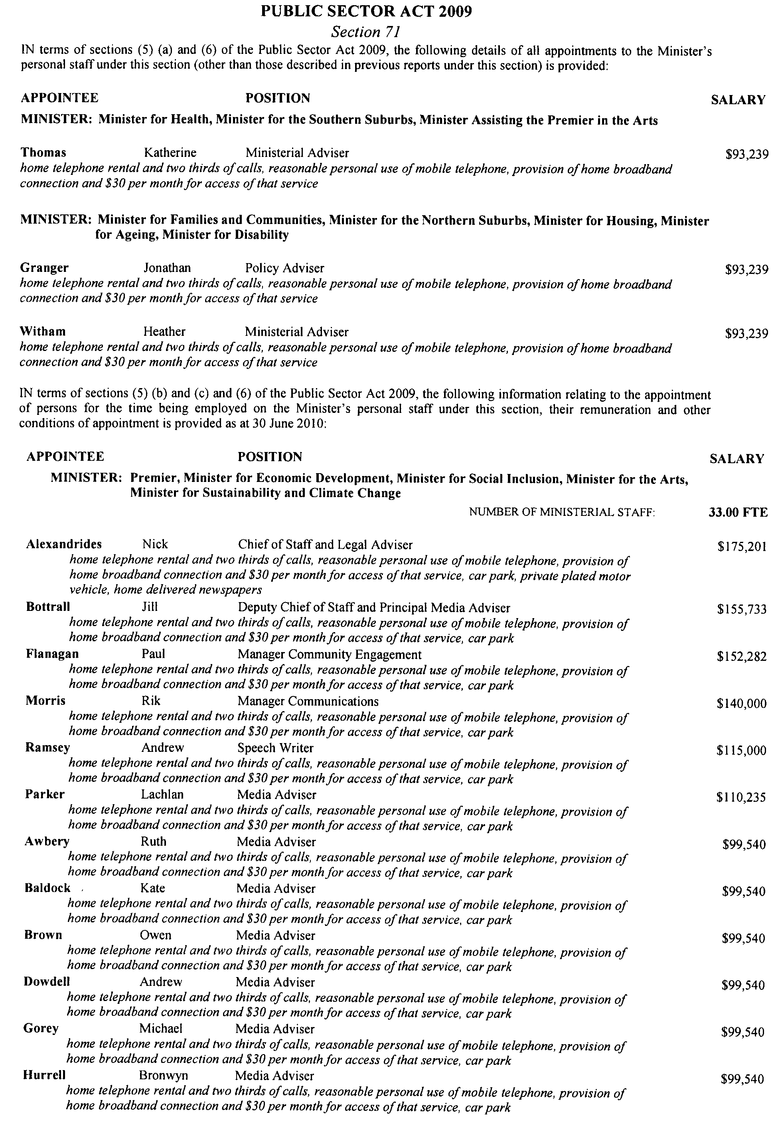
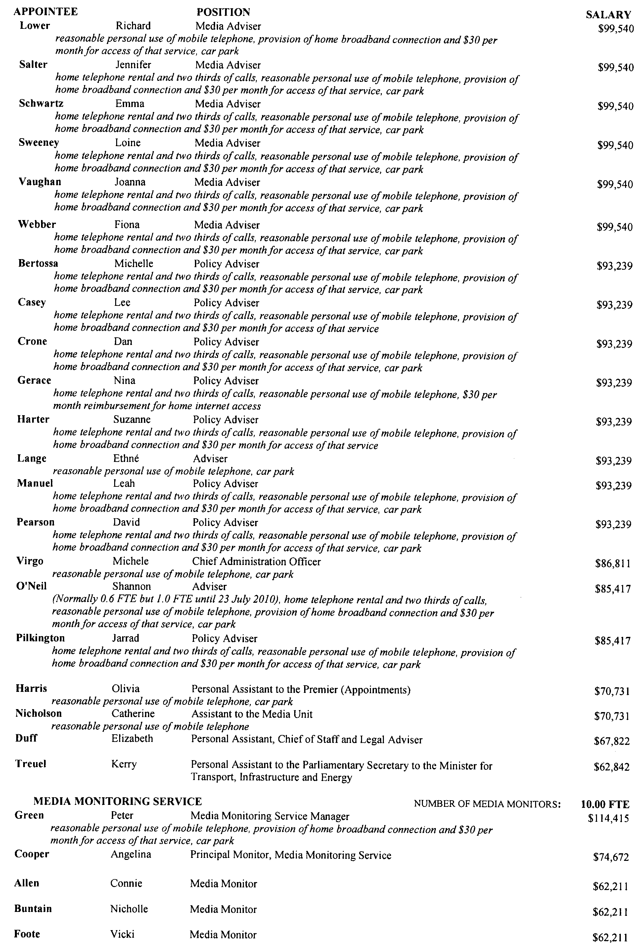
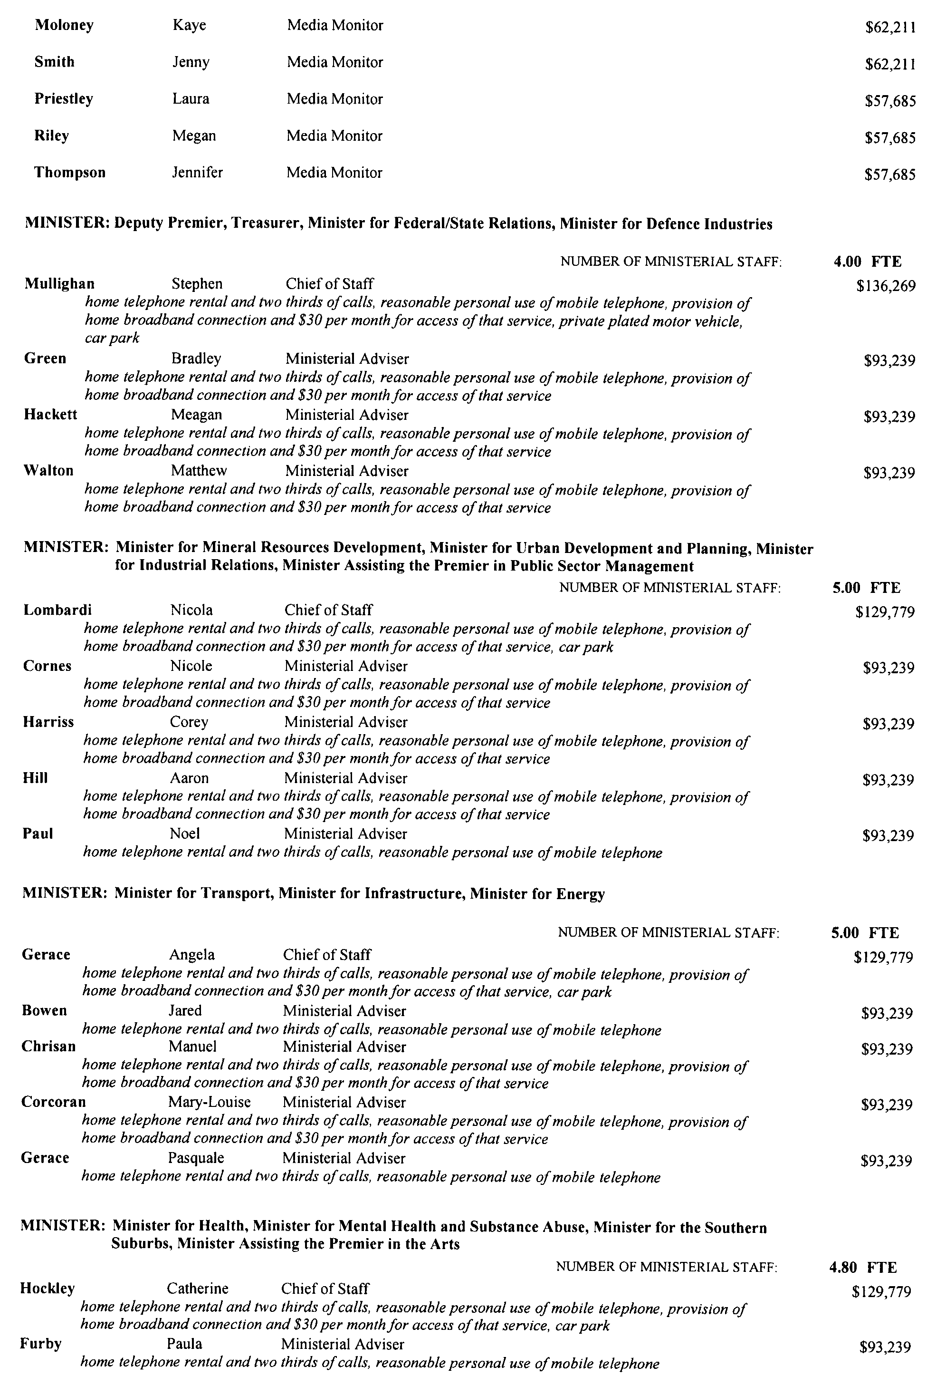
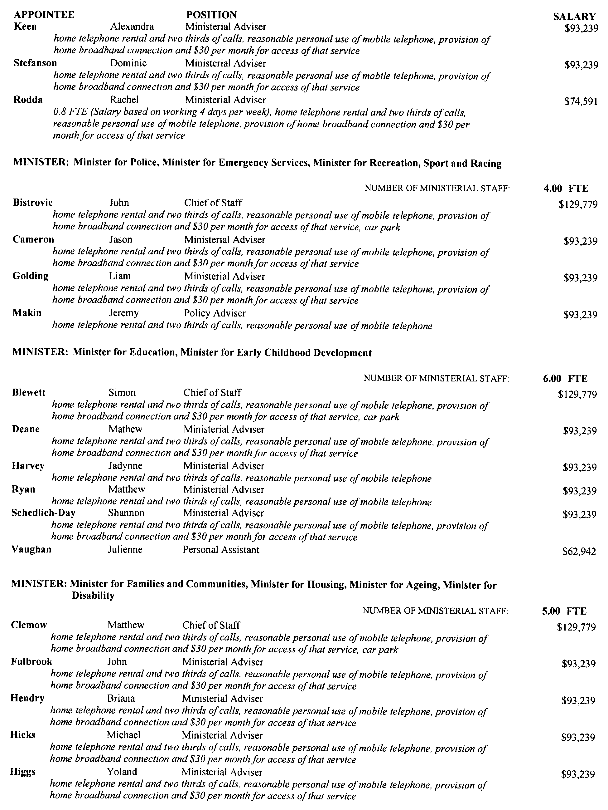
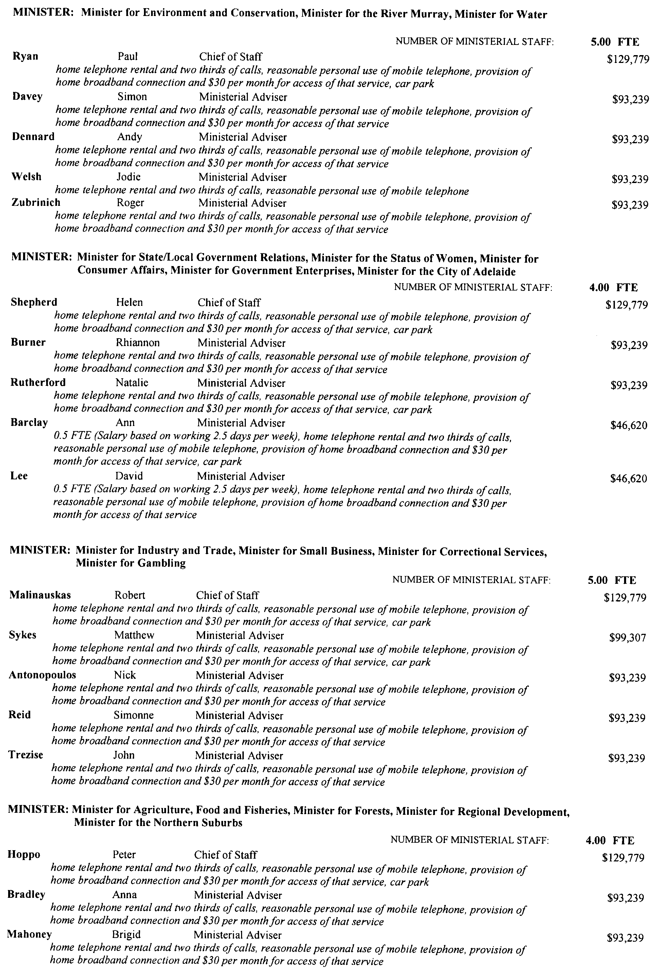

Dated 30 June 2010.
Michael D. Rann, MA, JP, MP, Premier
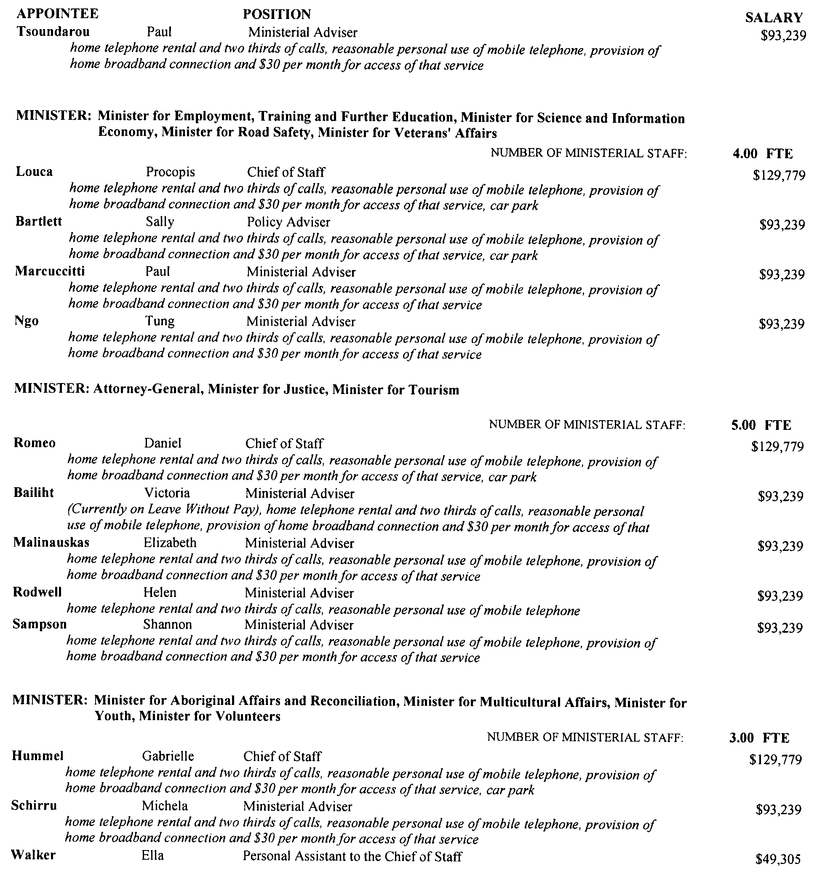

PRIMARY PRODUCE (FOOD SAFETY SCHEMES) ACT 2004
Delegation Pursuant to Section 36
In relation to the Seed Sprouts Food Safety Scheme
I, MICHAEL O’BRIEN, Minister for Agriculture, Food and Fisheries, hereby delegate pursuant to section 36 of the Primary Produce (Food Safety Schemes) Act 2004 (the Act), to the persons described in Paragraph 1 the powers and functions of the Minister specified in Paragraphs 2 and 3 subject to the conditions specified in Paragraph 4:
1. Delegate:
1.1 Manager, Plant and Food Standards, Department of Primary Industries and Resources, or any person from time to time acting in that position.
2. All of the powers and functions referred to in the following sections of the Act are delegated:
2.1 Section 13
2.2 Section 14
2.3 Section 15
2.4 Section 16 (1)
2.5 Section 17
2.6 Section 18
2.7 Section 19
2.8 Section 20
2.9 Section 21
2.10 Section 39
2.11 Section 41
2.12 Section 42 (1)
3. All of the powers and functions referred to in the following Regulations of the Primary Produce (Food Safety Schemes) (Plant Products) Regulations 2010:
3.1 Regulation 6
3.2 Regulation 8
3.3 Regulation 9 (1) (b)
3.4 Regulation 10 (1)
4. Conditions:
4.1 That the powers and functions referred to in Paragraph 2 hereof only be exercised in relation to the Seed Sprouts Food Safety Scheme established by the Primary Produce (Food Safety Schemes) (Plant Products) Regulations 2010.
4.2 That any powers and functions exercised by the delegate prior to the commencement of the Primary Produce (Food Safety Schemes) (Plant Products) Regulations 2010 do not take effect until after the commencement of the Regulations.
5. Any of the above functions or powers may be further delegated.
Date 27 June 2010.
Michael O’Brien, Minister for Agriculture, Food and Fisheries

RAIL SAFETY ACT 2007
Appointment of Authorised Officers
THE following Authorised Officers are currently appointed under section 22 of the Rail Safety Act 2007 as of 1 July 2010:
Derek Heneker
Philip Burrows
Susan Swincer
Wayne Robertson
Nicholas Doncaster
Benjamin Hannant
Angela Parsons
Justin Brown
The appointment of these Authorised Officers may be revoked or varied by me at anytime.
Dated 26 June 2010.
P. T. Allan, Rail Safety Regulator

ROADS (OPENING AND CLOSING) ACT 1991:
SECTION 24
NOTICE OF CONFIRMATION OF ROAD
PROCESS ORDER
Road Closure—Lower Portrush Road, Marden
BY Road Process Order made on 17 April 2009, The Corporation of the City of Norwood Payneham and St Peters ordered that:
1. Portion of Lower Portrush Road adjoining allotment 51 in Deposited Plan 38114, more particularly delineated and lettered ‘A’ in Preliminary Plan No. 08/0121 be closed.
2. The whole of the land subject to closure be transferred to the Azzurri Club Ltd in accordance with agreement for transfer dated 24 March 2009 entered into between The Corporation of the City of Norwood Payneham and St Peters and the Azzurri Club Ltd.
3. The following easements are granted over portions of the land subject to that closure:
Grant to the South Australian Water Corporation an easement for water supply and sewerage purposes.
Grant to The Corporation of The city of Norwood Payne-ham and Peters an easement for drainage purposes.
On 10 July 2009 that order was confirmed by the Minister for Infrastructure conditionally upon the deposit by the Registrar-General of Deposited Plan 81041 being the authority for the new boundaries.
Pursuant to section 24 (5) of the Roads (Opening and Closing) Act 1991, NOTICE of the order referred to above and its confirmation is hereby given.
Dated 1 July 2010.
P. M. Kentish, Surveyor-General

ROADS (OPENING AND CLOSING) ACT 1991:
SECTION 24
NOTICE OF CONFIRMATION OF ROAD
PROCESS ORDER
Road Closure—Telfers Road, Millicent
BY Road Process Order made on 26 February 2010, the Wattle Range Council ordered that:
1. Portion of Telfers Road situate west of Park Terrace and adjoining the northern eastern boundary of allotment 1 in Deposited Plan 59703, more particularly delineated and lettered ‘A’ on Preliminary Plan No. 09/0081 be closed.
2. The whole of the land subject to closure be transferred to Kym Arthur Hoffmann and Carmen Maria Hoffmann in accordance with agreement for transfer dated 4 January 2010 entered into between the Wattle Range Council and K. A. and C. M. Hoffmann.
On 22 June 2010 that order was confirmed by the Minister for Infrastructure conditionally upon the deposit by the Registrar-General of Deposited Plan 83565 being the authority for the new boundaries.
Pursuant to section 24 (5) of the Roads (Opening and Closing) Act 1991, notice of the order referred to above and its confirmation is hereby given.
Dated 1 July 2010.
P. M. Kentish, Surveyor-General

RULES OF COURT
The Magistrates Court of South Australia
Amendment 33 of Magistrates Court (Civil) Rules 1992
PURSUANT to section 49 of the Magistrates Court Act 1991 and all other enabling powers, we the undersigned do make the following amendments to the MAGISTRATES COURT (CIVIL) RULES 1992:
Form 16 is deleted.
Form 2 is deleted and replaced with the following Form 2.
Form 3 is deleted and replaced with the following Form 3.
Form 3A is deleted and replaced with the following Form 3A.
Form 3B is deleted and replaced with the following Form 3B.
Form 3C is deleted and replaced with the following Form 3C.
Form 3D is deleted and replaced with the following Form 3D.
Form 3F is deleted and replaced with the following Form 3F.
Form 3G is deleted and replaced with the following Form 3G.
Form 6 is deleted and replaced with the following Form 6.
Form 9 is deleted and replaced with the following Form 9
Form 15B is deleted and replaced with the following Form 15B.

Signed on the 18th day of June 2010 by:

Elizabeth Mary Bolton Andrew James Cannon
Chief Magistrate Deputy Chief Magistrate

Kym Andrew Millard Simon Hugh Milazzo
Stipendiary Magistrate Stipendiary Magistrate

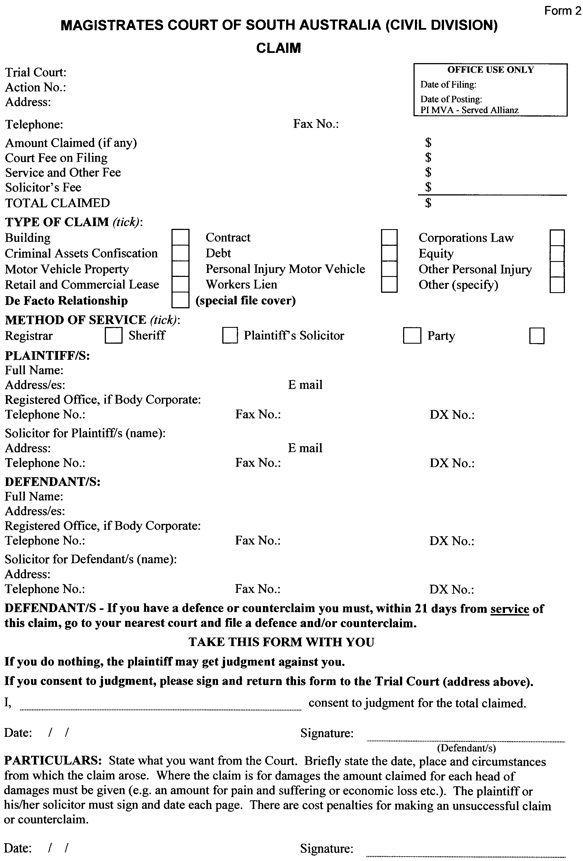

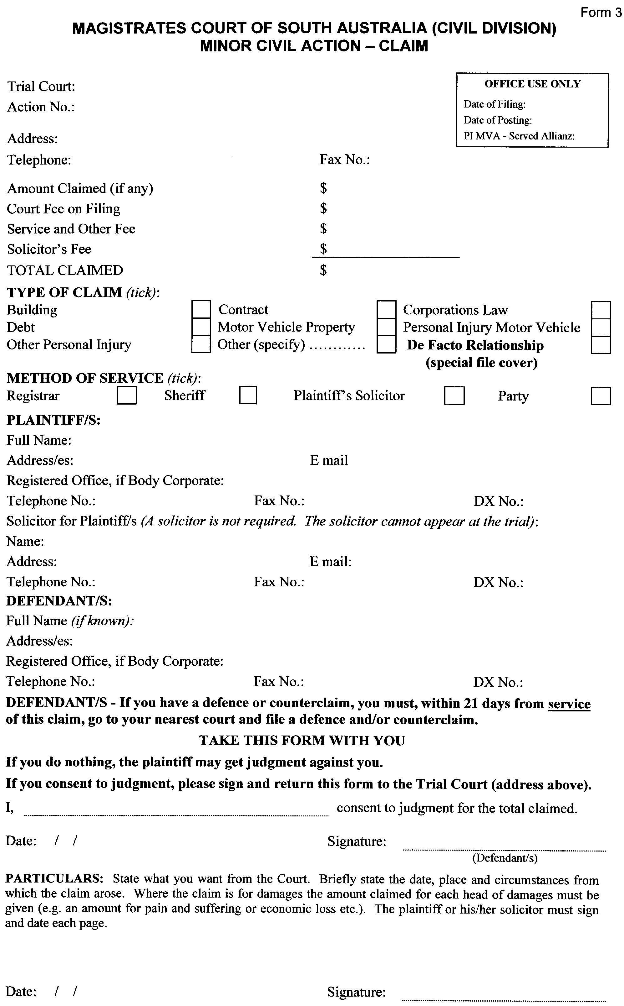
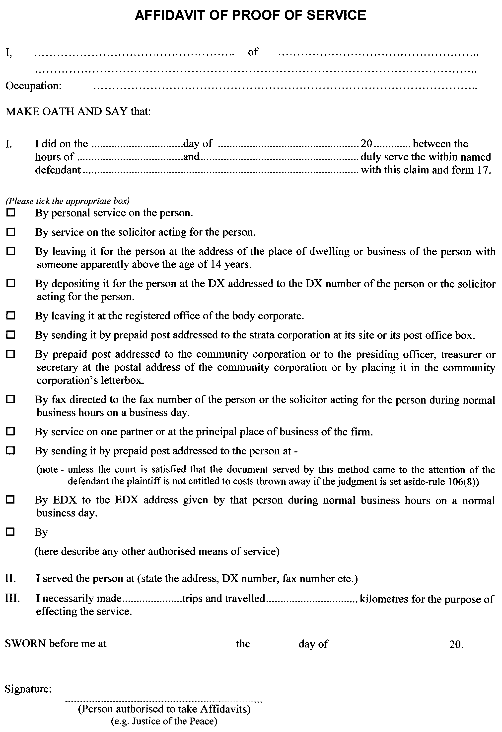
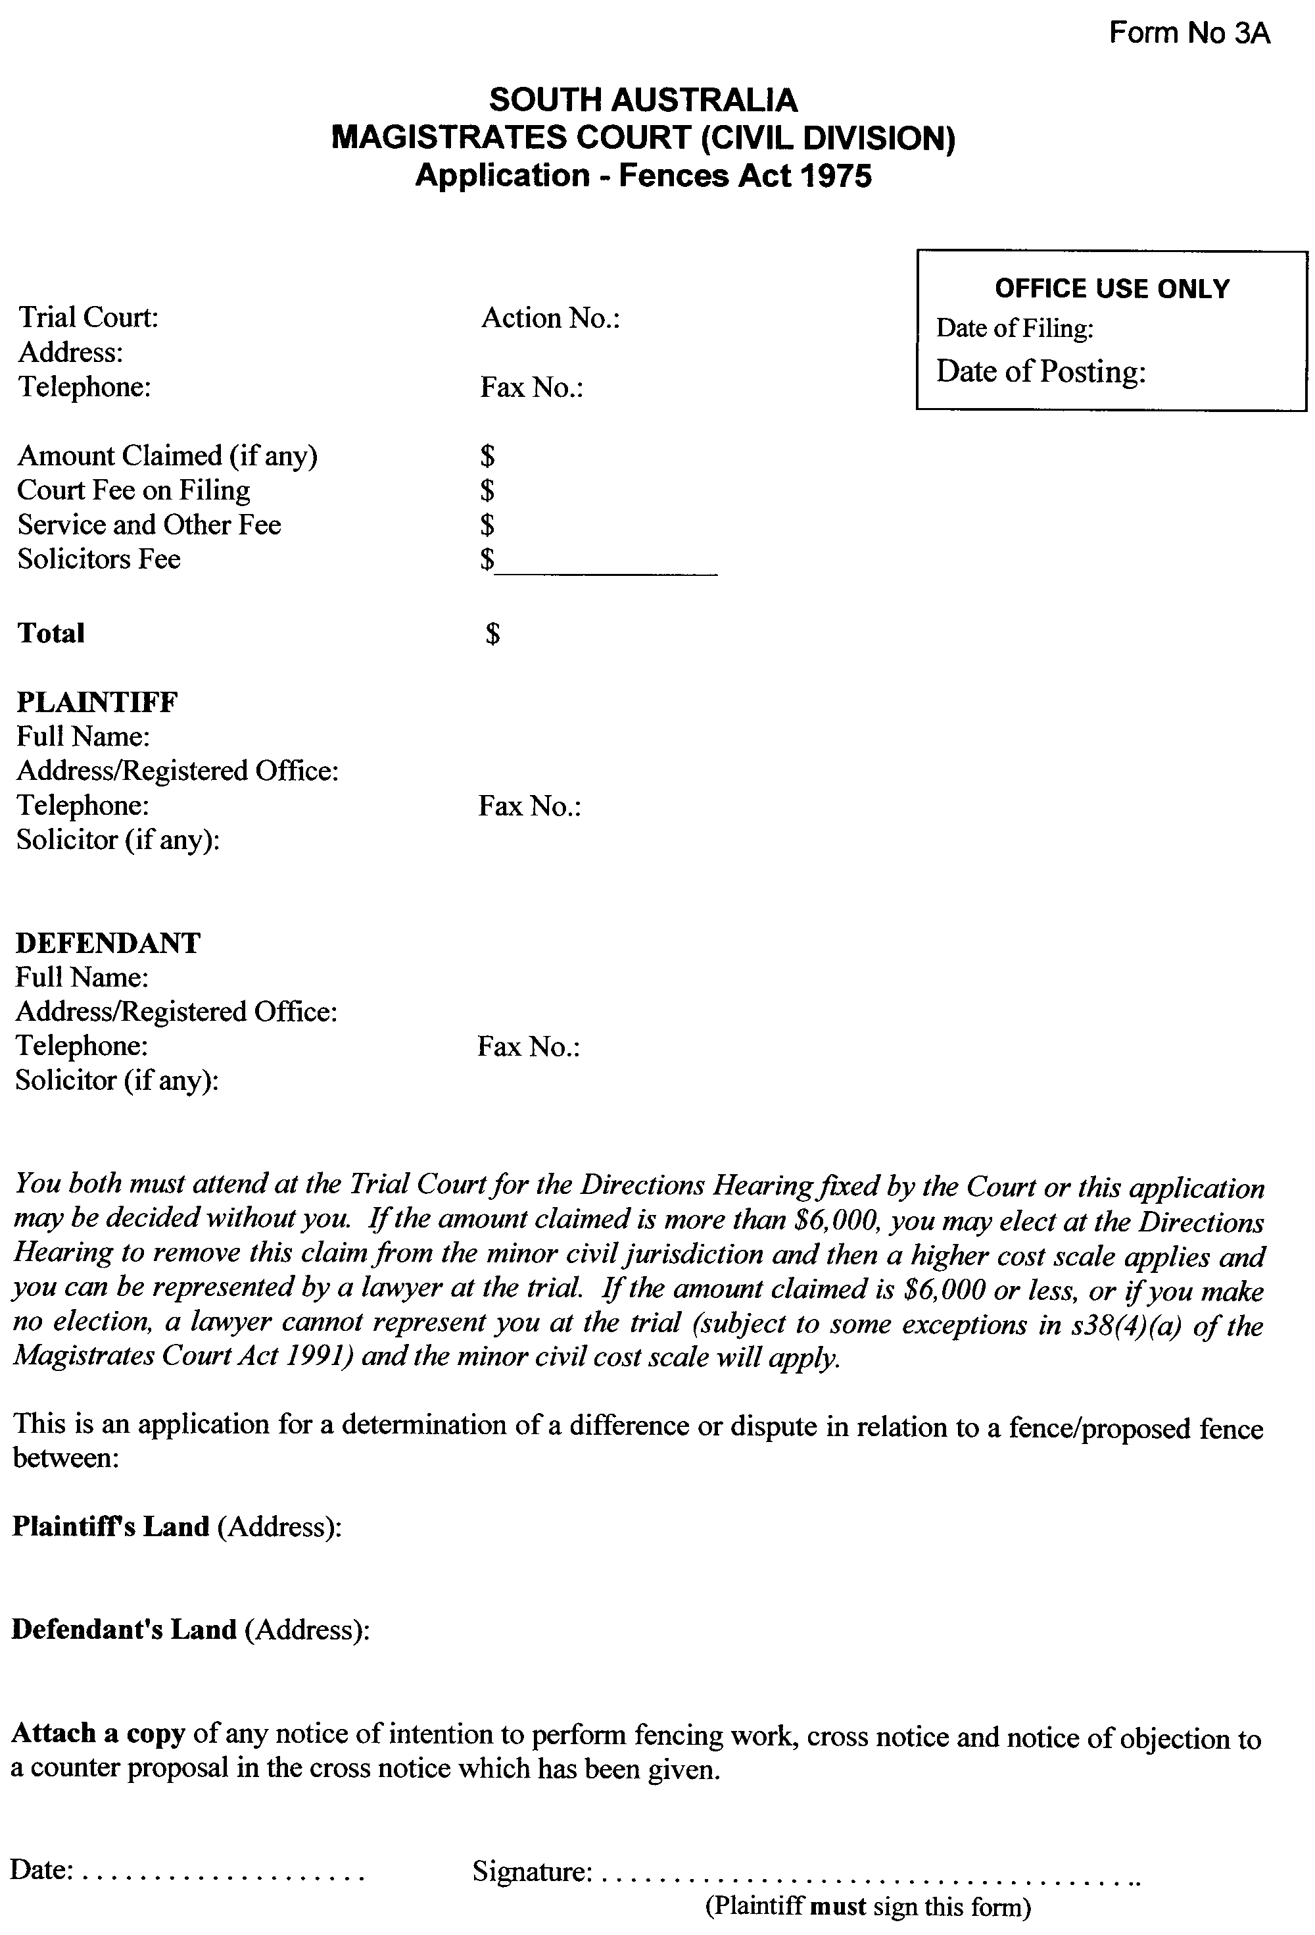
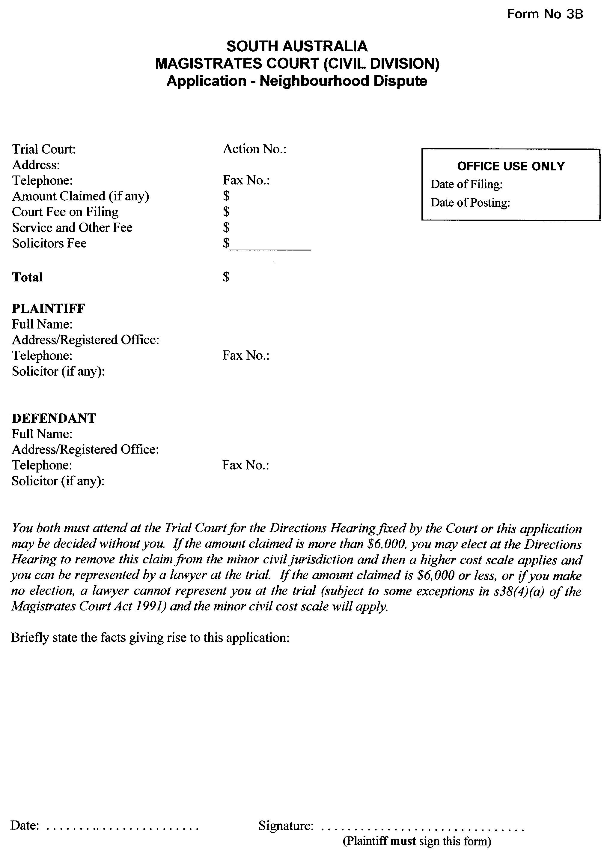
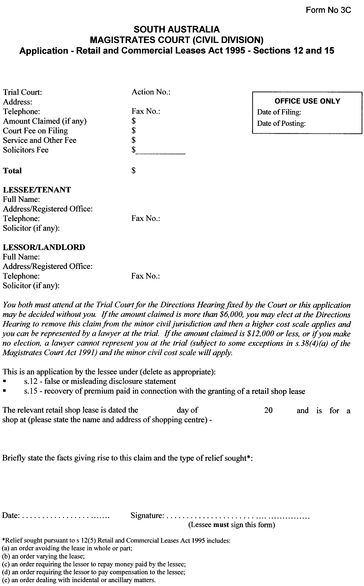
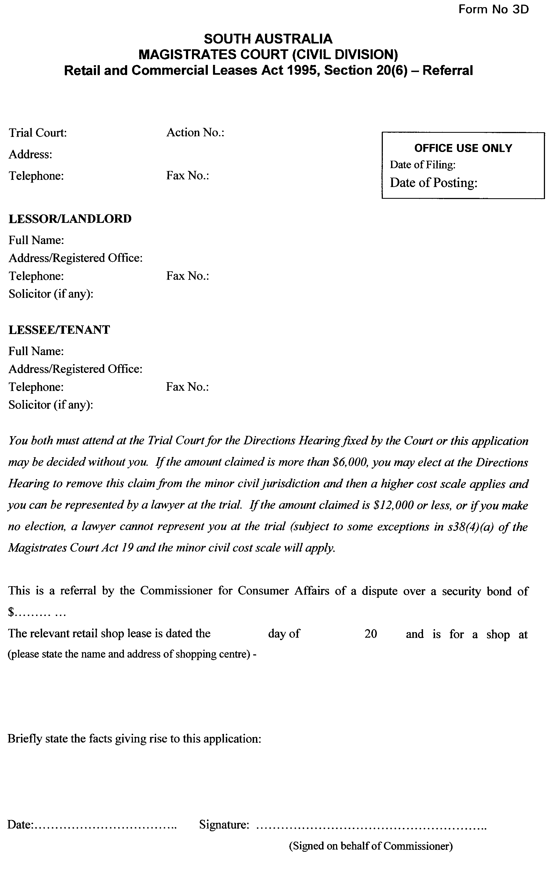
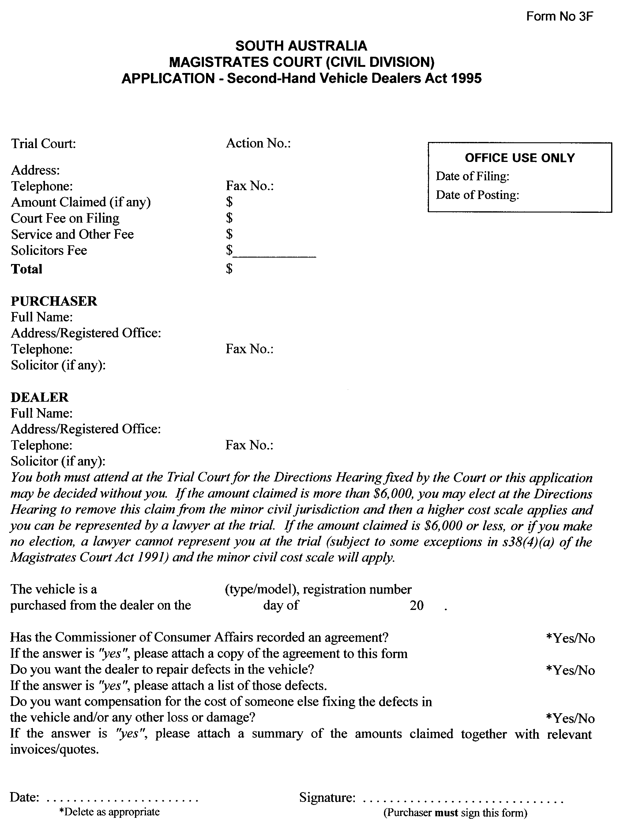
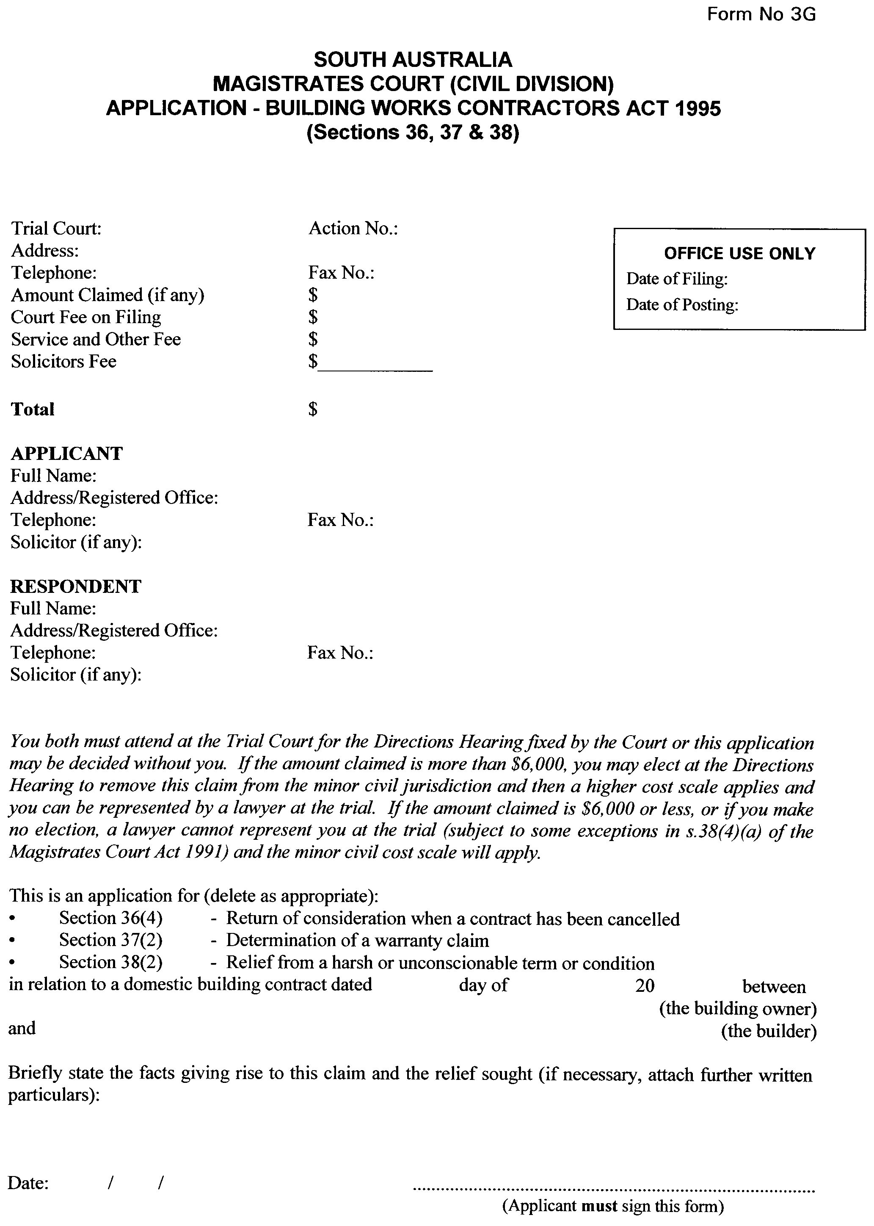
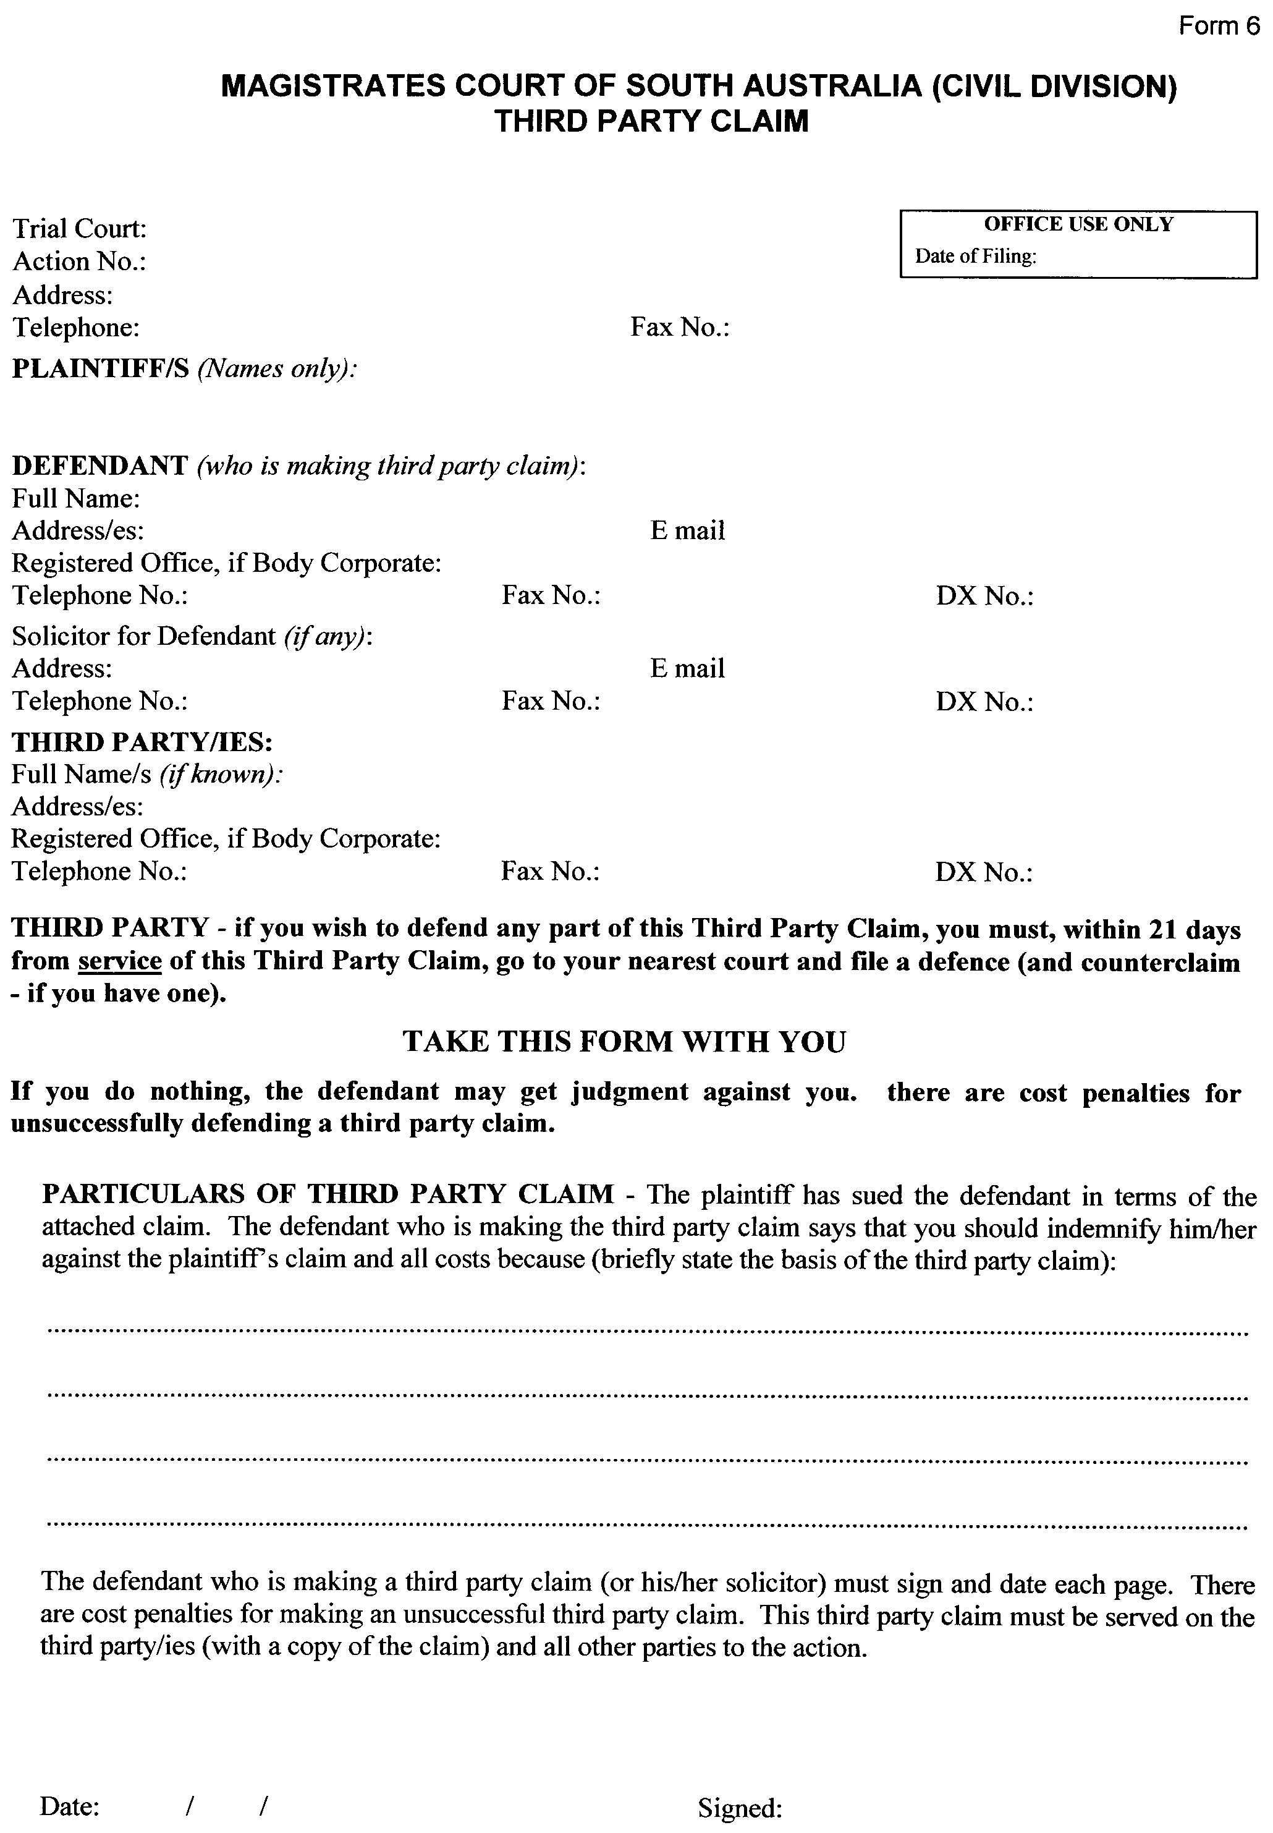
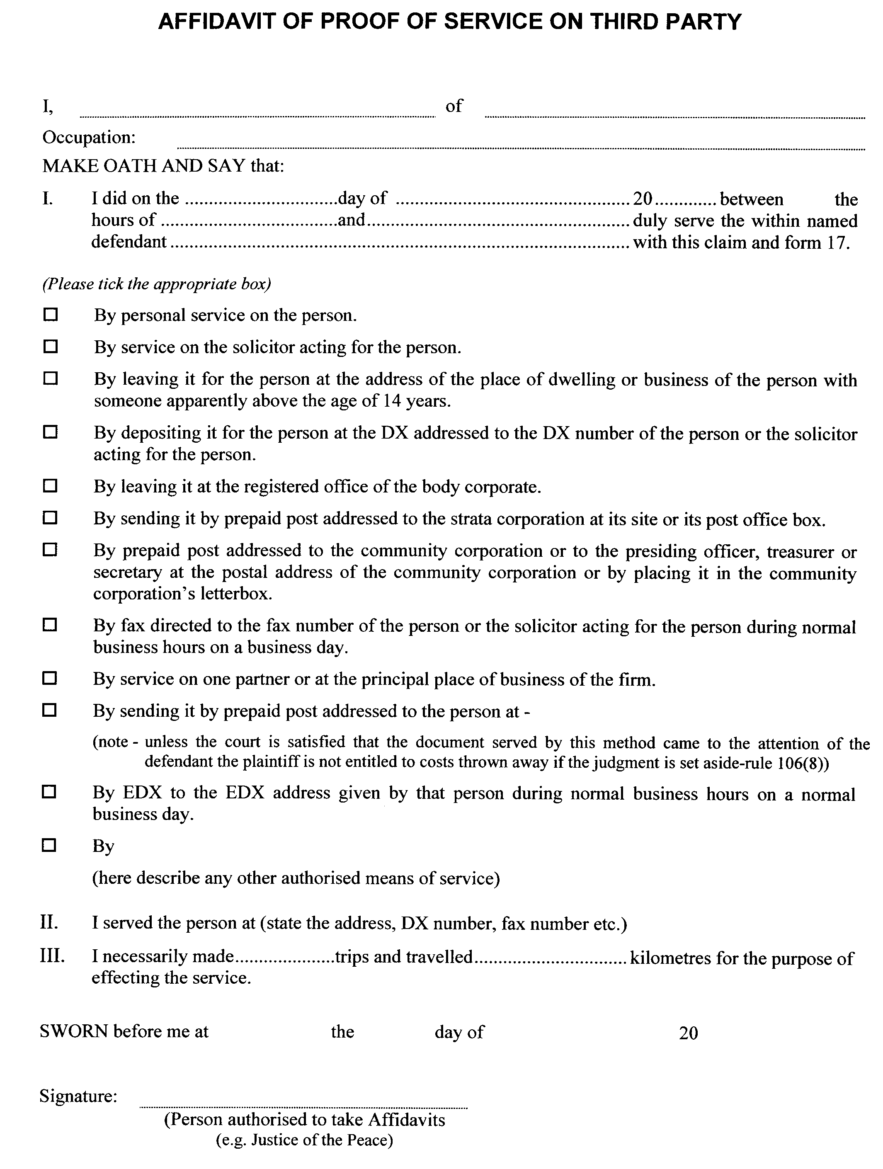
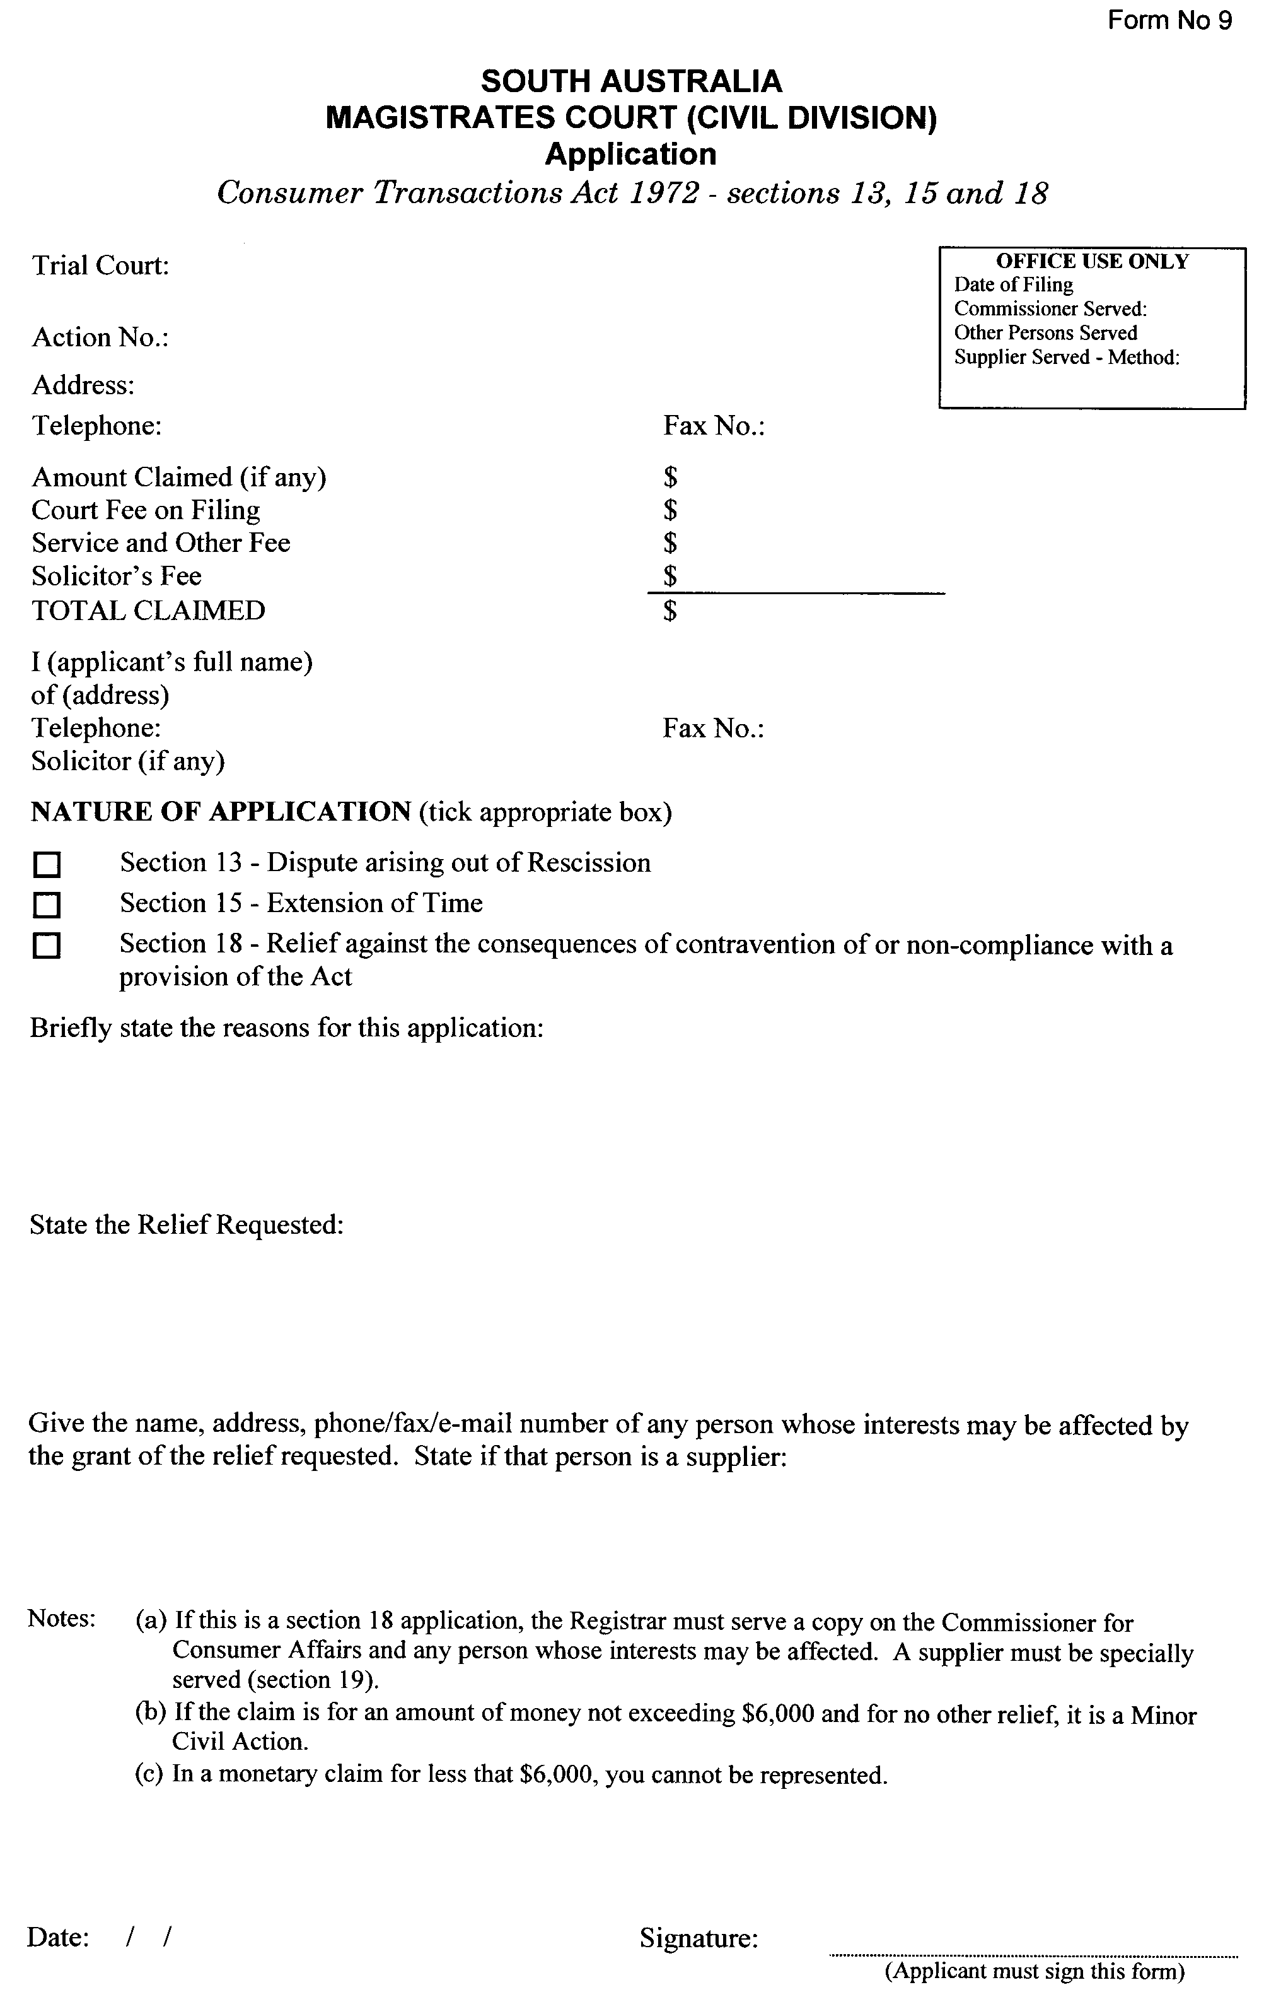
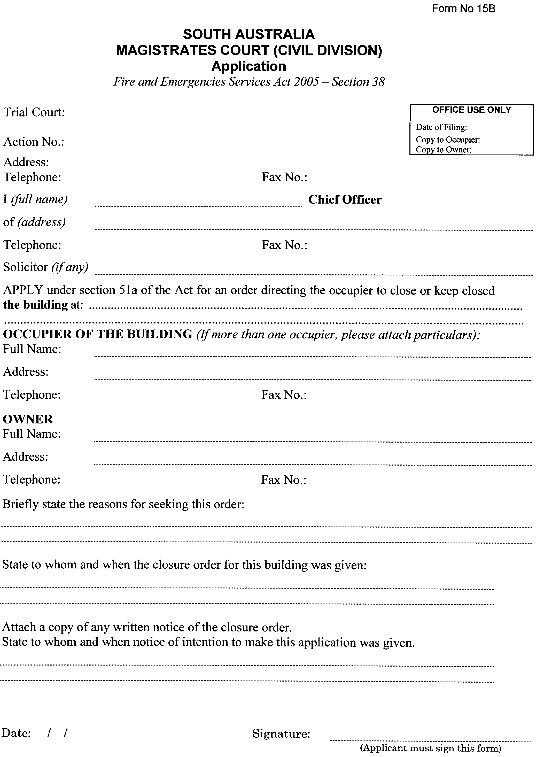

CORPORATIONS RULES 2003
(South Australia)
Amendment No. 6
BY virtue and in pursuance of section 72 of the Supreme Court Act 1935 and all other enabling powers, We, Judges of the Supreme Court of South Australia, do hereby make the following Rules to take effect as amendments to the Corporations Rules 2003 (South Australia).
1. These Rules may be cited as the ‘Corporations Rules 2003 (South Australia) Amendment No. 6’.
2. The Corporations Rules 2003 (South Australia) are amended as set out below.
3. These Rules come into operation on 1 July 2010, or upon their gazettal, whichever is the later.
4. Rule 15A.05 is deleted and the following rule inserted in its place:
‘15A.05—Official Liquidator’s Consent to Act
If any application is made for an order:
(a) under Article 19 or 21 of the Model Law to entrust the administration or realisation of all or part of the debtor’s assets to a person designated by the Court (other than the foreign representative); or
(b) under Article 21 to entrust the distribution of all or part of the debtor’s assets to a person designated by the Court (other than the foreign representative);
then, unless the Court otherwise orders, the person must:
(c) be an official liquidator; and
(d) have filed a Consent to Act, in accordance with Form 19, which specifies an address for service for a person within South Australia.’
GIVEN under our hands and the Seal of the Supreme Court of South Australia.
Dated 31 May 2010.
(l.s.) J. J. DOYLE, CJ
K. P. DUGGAN, J
M. J. NYLAND, J
A. VANSTONE, J
R. C. WHITE, J
M. DAVID, J
P. KELLY, J

SEWERAGE ACT 1929
Addition of Land to Balhannah Country Drainage Area
PURSUANT to section 18 of the Sewerage Act 1929, the South Australian Water Corporation:
(a) adds to the Balhannah Country Drainage Area all the land contained in:
(i) Community Plan 26096; and
(b) declares that this notice has effect from 1 July 2010.
Dated 22 June 2010.
Signed for and on behalf of the South Australian Water Corporation by a person duly authorised so to do:
A. Schirripa, Manager Billing and Collection
In the presence of:
N. Glass, Team Leader Rating
SAWATER 10/04021 D1454

WATERWORKS ACT 1932
Removal of Land from Yorke Peninsula Country Lands Water District and Addition to Coobowie Water District
PURSUANT to section 6 of the Waterworks Act 1932, the South Australian Water Corporation:
(a) removes from the Yorke Peninsula Country Lands Water District and adds to the Coobowie Water District all the land contained in 79710:
(b) allotment 20 in Deposited Plan 45977; and
(c) declares that this notice has effect from 1 of July 2010.
Dated 21 June 2010.
Signed for and on behalf of the South Australian Water Corporation by a person duly authorised so to do:
A. Schirripa, Manager Billing and Collection
In the presence of:
N. Glass, Team Leader Rating
SAWATER 10/04024 W1452

WATERWORKS ACT 1932
Removal of Land from Streaky Bay Country Lands Water District and Addition Streaky Bay Township Water District
PURSUANT to section 6 of the Waterworks Act 1932, the South Australian Water Corporation:
(a) removes from the Streaky Bay Country Lands Water District and adds to the Streaky Bay Township Water District all the land contained in allotment 100 in Deposited Plan 82922; and
(b) declares that this notice will have effect from 1 July 2010.
Dated 21 June 2010.
Signed for and on behalf of the South Australian Water Corporation by a person duly authorised so to do:
A. Schirripa, Manager Billing and Collection
In the presence of:
N. Glass, Team Leader Rating
SAWATER 10/04025 W1451

WATERWORKS ACT 1932
Addition of Land to Balhannah Country Drainage Area
PURSUANT to section 6 of the Waterworks Act 1932, the South Australian Water Corporation:
(a) adds to the Balhannah Country Drainage Area all the land contained in:
(i) Community Plan 26096; and
(c) declares that this notice has effect from 1 of July 2010.
Dated 21 June 2010.
Signed for and on behalf of the South Australian Water Corporation by a person duly authorised so to do:
A. Schirripa, Manager Billing and Collection
In the presence of:
N. Glass, Team Leader Rating
SAWATER 10/04021 W1454

WATERWORKS ACT 1932
Addition of Land to Adelaide Water District
PURSUANT to section 6 of the Waterworks Act 1932, the South Australian Water Corporation:
(a) adds to the Adelaide Water District the land shown on the plan in the schedule; and
(b) declares that this notice will have effect from 1 July 2010.
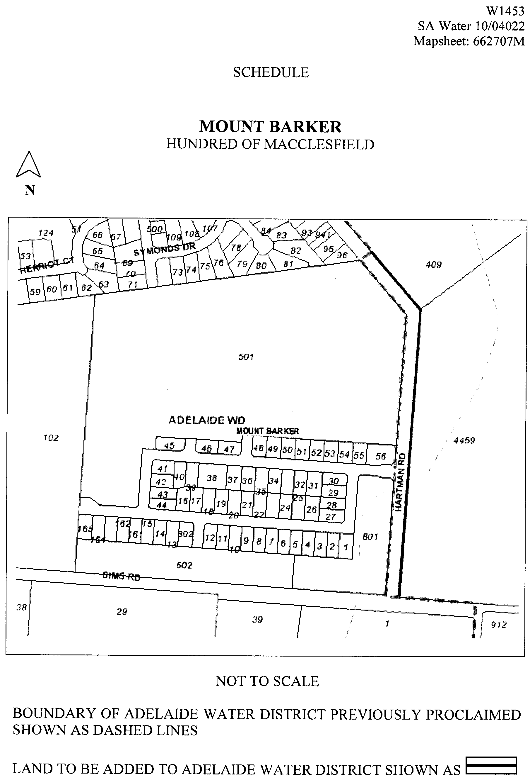

Dated 22 June 2010.
A. Schirripa, Manager Billing and Collection
In the presence of:
N. Glass, Team Leader Rating
SAWATER 10/04022 W1453

South Australia
Aquaculture Revocation Policy 2010
under the Aquaculture Act 2001

Contents
1 Short title
2 Revocation of aquaculture policies

1—Short title
This policy may be cited as the Aquaculture Revocation Policy 2010.
2—Revocation of aquaculture policies
The following aquaculture policies are revoked:
(a) Aquaculture Aquatic Organism Translocation Policy (see Gazette 9.6.2005 p1715);
(b) Aquaculture Environmental Management Framework Policy (see Gazette 12.8.2004 p3206);
(c) Aquaculture Leasing and Licensing Policy (see Gazette 4.3.2004 p622);
(d) Aquaculture Resource Management Framework and Ecologically Sustainable Development Policy (see Gazette 12.8.2004 p3206);
(e) Aquaculture Tenure Allocation Policy (see Gazette 4.3.2004 p623);
(f) Aquatic Animal Disease Emergency Response Manual (see Gazette 4.3.2004 p622);
(g) Aquatic Animal Health Policy (see Gazette 4.3.2004 p622);
(h) Mandatory Provisions (General) Policy (see Gazette 4.3.2004 p622);
(i) South Australian Shellfish Quality Assurance Program Policy (see Gazette 4.3.2004 p623).
South Australia
Aquaculture (Approval of Revocation Policy) Notice 2010
under section 12 of the Aquaculture Act 2001
1—Short title
This notice may be cited as the Aquaculture (Approval of Revocation Policy) Notice 2010.
2—Approval of aquaculture policy
(1) The Aquaculture Revocation Policy 2010 is approved.
(2) The policy comes into operation on the day on which this notice is published in the Gazette.
Made by the Minister for Agriculture, Food and Fisheries
on 1 July 2010

South Australia
Public Sector (Reorganisation of Public Sector
Operations) Notice 2010
under section 9(1) of the Public Sector Act 2009
1—Short title
This notice may be cited as the Public Sector (Reorganisation of Public Sector Operations) Notice 2010.
2—Commencement
This notice comes into operation on 1 July 2010, immediately after the Public Sector (Administrative Units of Public Service—Variation 1) Proclamation 2010 comes into operation.
3—Transfer of employees
An employee listed in column 1 of the table below is transferred—
(a) in the case of a Public Service employee—to employment in the public sector agency listed in column 2 opposite the reference to the employee; and
(b) in the case of an employee who is not a Public Service employee—to employment for the purposes of the public sector agency listed in column 2 opposite the reference to the employee,
on the same basis of engagement as applied before the transfer.

Employees | Public sector agency
Department of the Premier and Cabinet employees assigned to work—  (a) in the office of the Employee Ombudsman; or  (b) in the office of the WorkCover Ombudsman; or  (c) in the Industrial Relations Commission of South Australia; or  (d) in the Industrial Relations Court of South Australia; or  (e) in the Workers Compensation Tribunal; or  (f) in suppport of the Medical Panels under the Workers Rehabilitation and Compensation Act 1986. | Attorney-General's Department
The following Department of the Premier and Cabinet employee:  Linda Cooper | Department of Further Education, Employment, Science and Technology
Department of Trade and Economic Development employees assigned to work in the office of the Economic Development Board | Department of the Premier and Cabinet
The following Department for Water employees:  John ADAMS  Barbara ANDERSON  Priscilla ARGENT  Mica BALELA  Sara BANN  Tanya BATES  Craig BAULDERSTONE  Joanne BAULDERSTONE  Jennifer BEATON  Gareth BEER  Kirrily BLAYLOCK  Monica BOULTON  Martin BRINE  Debra BROWN  Elizabeth BYARD  Josephine CAMP  Lyndon CAMPBELL  Michael CANNELL  Graham CARPENTER  Melanie CARSON  Tanja CHAPMAN  Beau CICCARELLO  Melanie CLARKE  Michael COLAGROSSI  Neil COLLINS  Philip COLLINS  Ian COLQUHOUN  Robyn COX  Gino CRICELLI  Solange CRICELLI  Cerise CURNOW  Benjamin DELLA TORRE  Mark DUDART- ABERDEEN  Trudi DUFFIELD  Anna DUTKIEWICZ  Francisco FACELLI  Peter FARMER  Monique FARRELL  Christine FILSELL  David FINCH  Andrew FISHER  Michael FLEMING  Lynda FORREST  Giles FORWARD  Glenn GALE  Kevin GOGLER  Paul GOULD  Barry GRINTER  Andrew GROOM  James HALL  Rohan HAMDEN  Rachel HANDKE  David HANNA  Anne-Marie HAYES  Timothy HERRMANN  Trevor HOBBS  Michael HODDER  Samuel HOWARD  Beatrice HURRELL  Vicki JACOBS  Valdis JAUDZEMS  Michael JOHNSON  Ruth KELLER  Sharee KELLY  Fluer KLEINIG  George KNEZEVIC  Joshua LAYNES  Rochelle LECKIE  David LEEK  Sarah LEWIS  John MACONOCHIE  Dianna MAKOTTER  Elizabeth MATTHEWS  Ben MCCALLUM  Melissa MCCALLUM  Alison MCINERNEY  Caroline MICHALSKI  Mary MILES  Tanya MILNE  Toni MILNE  Sarah MORGAN  Felipe MOUAT-ROCHE  Gillian MULLER  Phillip MURRAY  Craig NEUMANN  Keith NICHOLAS  Christopher NICHOLS  Carol NIGHTINGALE  Angela NOACK  David OAG  Candice OCHSENHAM  Gillian PEACEY  Sarah PENNINGTON  Dennis PFEIFFER  Rachel PFITZNER  Hannah PITCHER  Deborah RAVESTEIN  Geoffrey ROGERS  Amanda ROSSETTO  Janet ROWLAND  Lynnette RUDGLEY  Rose RYAN  Jason SANDERS  Paula SANDERS  Sorel SANDERS  Gabriele SANTUCCI  Matthew SCHUTZ  Leonie SHEARING  Brenton SPENCER  Patti STOKES  Mark STORRY  Trudi STRAWBRIDGE  Jeffrey STRINGER  Francesca STROPIN  Nicholas SUTHERLAND  Todd SUTTON  Susan SWEENEY  Jacinta SWEET  Ceridwen SYNNOT  Fred TANNER  Lynette TAYLOR  Aubrey THOMAS  Deborah THOMAS  Mark THOMAS  Rabecca THOMAS  Suzanne THOMPSON-WRIGHT  Susy TOTANI  Mervyn TUCKER  Christopher TURNER  Dion TUXFORD  Margaret WALKER  Robert WALLACE  Naomi WALLIS  Heather WALRAVEN  Pauline WALTON  Matthew WESTOVER  Craig WHISSON  Leonie WHITTLESEA  Sarah WILLMOTT  Sybille WINTER  Carolyn WOODS  Sharon WYATT  Keita WYLD | Department of Environment and Natural Resources
The following Department for Water employees:  Barbara AFFORD  Richard ALLEN  Michael BALHARRY  Edward BAXTER  Peter BIRD  Adrian BORCHARDT  Steven BROCK  Peter BROPHY  Darryl BROWN  Dianne BURBIDGE  David BURGESS  Scott CARTER  Charles CARUANA  Craig COCKSHELL  Thomas CONNELL  David COOKE  Wayne CORNER  Raymond CORRELL  Andrew CRAIG  Thomas DANIEL  Carol DAWSON  Julie DEAN  Fiona FLAVEL  Mark GALLASCH  Donald GREEN  Peter HAGGER  Murray HANNAFORD  Robert HOGBEN  Lance HOLBERTON  Raymond HUTCHINSON  Rebecca JACKSON  Darren JACOBS  Suzanne JOHNS  Ingrid JURICA  John KENNY  Matthew KOENIG  John KOVALISKI  Stephen LAMEY  Merilyn LEWIS  Cameron LUNNEY  Ilona MACDONALD  Robert MANOUGE  Darryl MIEGEL  Gregory MUTZE  Nicholas O'CONNOR  David PEACOCK  Shauna POTTER  Jane PRIDER  Mark RAMSEY  Donald REED  Timothy REYNOLDS  William SANDOW  Yvette SCAIFE  Denis SEARLE  Nicholas SECOMB  Robert SELFE  Ronald SINCLAIR  Karen SOAR  Rodney STRAUSS  Gregory STREETER  Eric THOMAS  Barbara VEIT  John VIRTUE  Chloe WARD  Naomi WARD  Veronica WARD  Philip WARREN  Mark WILLIAMS  Donald WILSON  Luke WILSON  John WYNNE  Christopher ZADOW | Department of Primary Industries and Resources
Made by the Premier
on 1 July 2010
DPC10/005CS
South Australia
Credit (Commonwealth Powers) Act (Commencement) Proclamation 2010
1—Short title
This proclamation may be cited as the Credit (Commonwealth Powers) Act (Commencement) Proclamation 2010.
2—Commencement of Act
The Credit (Commonwealth Powers) Act 2010 (No 2 of 2010) will come into operation on 1 July 2010.
Made by the Governor
with the advice and consent of the Executive Council
on 1 July 2010
09MCA0027CS

South Australia
Credit (Transitional Arrangements) Act
(Commencement) Proclamation 2010
1—Short title
This proclamation may be cited as the Credit (Transitional Arrangements) Act (Commencement) Proclamation 2010.
2—Commencement of Act
The Credit (Transitional Arrangements) Act 2010 (No 3 of 2010) will come into operation on 1 July 2010.
Made by the Governor
with the advice and consent of the Executive Council
on 1 July 2010
09MCA0027CS

South Australia
Health Practitioner Regulation National Law (South Australia) Act (Commencement) Proclamation 2010
1—Short title
This proclamation may be cited as the Health Practitioner Regulation National Law (South Australia) Act (Commencement) Proclamation 2010.
2—Commencement of Act
The Health Practitioner Regulation National Law (South Australia) Act 2010 (No 5 of 2010) will come into operation on 1 July 2010.
Made by the Governor
with the advice and consent of the Executive Council
on 1 July 2010
HEAC-2010-00030

South Australia
Reproductive Technology (Clinical Practices) (Miscellaneous) Amendment Act (Commencement) Proclamation 2010
1—Short title
This proclamation may be cited as the Reproductive Technology (Clinical Practices) (Miscellaneous) Amendment Act (Commencement) Proclamation 2010.
2—Commencement of Act
The Reproductive Technology (Clinical Practices) (Miscellaneous) Amendment Act 2009 (No 43 of 2009) will come into operation on 1 September 2010.
Made by the Governor
with the advice and consent of the Executive Council
on 1 July 2010
HEAC-2009-00074

South Australia
Administrative Arrangements (Committal of Acts) Proclamation 2010
under section 5 of the Administrative Arrangements Act 1994
1—Short title
This proclamation may be cited as the Administrative Arrangements (Committal of Acts) Proclamation 2010.
2—Commencement
This proclamation will come into operation on 1 July 2010.
3—Committal of Acts
The administration of an Act referred to in Schedule 1 is committed to the Attorney-General.
Schedule 1—Acts committed to Attorney-General
Credit (Commonwealth Powers) Act 2010
Credit (Transitional Arrangements) Act 2010
Made by the Governor
with the advice and consent of the Executive Council
on 1 July 2010
09MCA0027CS

South Australia
Administrative Arrangements (Administration of Health Practitioner Regulation National Law (South Australia)
Act) Proclamation 2010
under section 5 of the Administrative Arrangements Act 1994
1—Short title
This proclamation may be cited as the Administrative Arrangements (Administration of Health Practitioner Regulation National Law (South Australia) Act) Proclamation 2010.
2—Commencement
This proclamation will come into operation on 1 July 2010.
3—Administration of Act committed to Minister for Health
The administration of the Health Practitioner Regulation National Law (South Australia) Act 2010 is committed to the Minister for Health.
Made by the Governor
with the advice and consent of the Executive Council
on 1 July 2010
HEAC-2010-00030

South Australia
Credit (Transitional Arrangements) (Relevant Day) Proclamation 2010
under section 3 of the Credit (Transitional Arrangements) Act 2010
1—Short title
This proclamation may be cited as the Credit (Transitional Arrangements) (Relevant Day) Proclamation 2010.
2—Commencement
This proclamation will come into operation on 1 July 2010.
3—Appointment of relevant day
For the purposes of the definition of relevant day in section 3 of the Credit (Transitional Arrangements) Act 2010, 1 July 2010 is appointed as the relevant day for the purposes of each provision in which the term is used.
Made by the Governor
with the advice and consent of the Executive Council
on 1 July 2010
09MCA0027CS

South Australia
Public Sector (Administrative Units of Public Service—Variation 1) Proclamation 2010
under sections 26 and 28 of the Public Sector Act 2009
1—Short title
This proclamation may be cited as the Public Sector (Administrative Units of Public Service—Variation 1) Proclamation 2010.
2—Commencement
This proclamation will come into operation on 1 July 2010.
3—Alteration of titles of administrative units
The title of an administrative unit listed in column 1 of the table below is altered to the title listed in column 2 opposite the reference to the administrative unit.

Current title of administrative unit | New title of administrative unit
Department for Environment and Heritage | Department of Environment and Natural Resources
Department of Water, Land and Biodiversity Conservation | Department for Water
4—Ministers responsible for administrative units
For each administrative unit listed in column 1 of the table below, the Minister listed in column 2 opposite the reference to the administrative unit is designated as the administrative unit's Minister with responsibility for the unit.

Administrative unit | Administrative unit's Minister
Defence SA | Minister for Defence Industries
Department of Environment and Natural Resources | Minister for Environment and Conservation
Department for Water | Minister for Water
Made by the Governor
with the advice and consent of the Executive Council
on 1 July 2010
DPC10/005CS

South Australia
Development (Open Space Contribution Scheme)
Variation Regulations 2010
under the Development Act 1993

Contents
Part 1—Preliminary
1 Short title
2 Commencement
3 Variation provisions
Part 2—Variation of Development Regulations 2008
4 Variation of regulation 56—Open space contribution scheme

Part 1—Preliminary
1—Short title
These regulations may be cited as the Development (Open Space Contribution Scheme) Variation Regulations 2010.
2—Commencement
These regulations will come into operation on 1 July 2010.
3—Variation provisions
In these regulations, a provision under a heading referring to the variation of specified regulations varies the regulations so specified.
Part 2—Variation of Development Regulations 2008
4—Variation of regulation 56—Open space contribution scheme
(1) Regulation 56(2)(a)—delete "$5 430" and substitute:
$5 627
(2) Regulation 56(2)(b)—delete "$4 380" and substitute:
$5 135
(3) Regulation 56(2)(c)—delete "$2 594" and substitute:
$2 680
Note—
As required by section 10AA(2) of the Subordinate Legislation Act 1978, the Minister has certified that, in the Minister's opinion, it is necessary or appropriate that these regulations come into operation as set out in these regulations.
Made by the Governor
with the advice and consent of the Executive Council
on 1 July 2010
No 163 of 2010
MMDP10/009CS

South Australia
Superannuation Funds Management Corporation of
South Australia Regulations 2010
under the Superannuation Funds Management Corporation of South Australia Act 1995

Contents
Part 1—Preliminary
1 Short title
2 Commencement
3 Interpretation
Part 2—Election of board members
4 Election of member
5 Timetable for election
6 Contributors eligible to vote
7 Nominations
8 Election without ballot
9 Ballot papers
10 Electoral material to be provided with ballot papers
11 Voting
12 Duplication and late return of ballot papers
13 Counting of votes
14 Scrutineers
15 Declaration of election
Part 3—General
16 Restrictions on investment of funds
17 Prescribed public authorities
Schedule 1—Related variations, revocation and transitional provisions
Part 1—Preliminary
1 Variation provisions
Part 2—Variation of Superannuation Funds Management Corporation of South Australia Regulations 1995
2 Variation of regulation 1—Short title
3 Revocation of Part 2
4 Revocation of regulation 17
Part 3—Revocation of Superannuation Funds Management Corporation of South Australia (Prescribed Public Authorities) Regulations 1995
5 Revocation of regulations
Part 4—Transitional provisions
6 Authorisations under revoked regulations
7 Declaration of prescribed public authorities

Part 1—Preliminary
1—Short title
These regulations may be cited as the Superannuation Funds Management Corporation of South Australia Regulations 2010.
2—Commencement
(1) Subject to subregulations (2) and (3), these regulations come into operation on the day on which they are made.
(2) Regulation 17 will come into operation on the day immediately following the day on which the time for disallowance of these regulations has passed (see section 3(6) of the Superannuation Funds Management Corporation of South Australia Act 1995).
(3) Schedule 1 Part 3 will come into operation on 31 August 2010.
3—Interpretation
In these regulations—
Act means the Superannuation Funds Management Corporation of South Australia Act 1995;
contributor means a contributor who is, by virtue of regulation 6, eligible to vote at an election;
hour of nomination means the hour by which nominations must be received by the Electoral Commissioner.
Part 2—Election of board members
4—Election of member
The election of a member of the board by contributors must be conducted by the Electoral Commissioner in accordance with this Part.
5—Timetable for election
(1) The Electoral Commissioner must publish in a daily newspaper circulating throughout the State a notice setting out the timetable for each election held under this Part.
(2) The notice must—
(a) fix the date (not being less than 14 days from publication of the notice) and the hour by which nominations must be received by the Electoral Commissioner; and
(b) fix the date on or before which the Commissioner will post ballot papers to contributors or give ballot papers to employers for distribution to contributors; and
(c) fix the date (not being less than 21 days nor more than 28 days after the date fixed under paragraph (b)) and the hour by which completed ballot papers must be returned to the Electoral Commissioner.
(3) The Electoral Commissioner must determine the timetable for an election in consultation with the board.
6—Contributors eligible to vote
(1) Persons who were contributors as defined in the Act on the last business day before the 7 day period immediately preceding the day on which notice was published under regulation 5 are eligible to vote at the election.
(2) Each of the superannuation boards must, within 7 days after publication of the notice, give the Electoral Commissioner a list of the contributors of whom the board knows who are eligible to vote at the election.
(3) In this regulation—
business day means any day other than a Saturday, Sunday or other public holiday.
7—Nominations
A nomination for election must—
(a) be in a form approved by the Electoral Commissioner; and
(b) be signed by at least 3 contributors; and
(c) be received by the Electoral Commissioner at or before the hour of nomination.
8—Election without ballot
(1) If only 1 person is nominated to fill the vacancy, the Electoral Commissioner must, by notice in the Gazette and in a daily newspaper circulating throughout the State—
(a) declare that the vacancy has been filled by the person nominated; and
(b) specify the day on which the person's term of office commences and the length of the term for which the person has been elected.
(2) If more than 1 person is nominated the following regulations apply.
9—Ballot papers
(1) The Electoral Commissioner must provide each contributor with a ballot paper and an envelope addressed to the Commissioner for the purpose of returning the ballot paper after completion.
(2) The names of the candidates must appear on the ballot papers in a vertical list in an order determined by the Electoral Commissioner by lot.
(3) If ballot papers are not printed on watermarked paper, they must be initialled by the Electoral Commissioner or by a person authorised for that purpose by the Commissioner.
(4) The Electoral Commissioner may provide a contributor with a ballot paper and envelope—
(a) by posting the ballot paper and envelope to the contributor at his or her last known address; or
(b) by giving the ballot paper and envelope to the contributor's employer to give to the contributor.
10—Electoral material to be provided with ballot papers
(1) Subject to this regulation, the Electoral Commissioner must, at the request of a candidate, include with ballot papers provided to contributors material provided by the candidate promoting the candidate's election.
(2) Promotional material must be provided to the Commissioner at or before the hour of nomination.
(3) The material must not include more than 200 words nor more than 1 photograph and may be printed by the Commissioner in such form as he or she thinks fit for the purpose of posting or distributing to contributors.
11—Voting
(1) A contributor who wishes to vote—
(a) must indicate on the ballot paper the candidate to whom the contributor gives his or her first preference and the contributor may indicate the order of his or her preference for the other candidates; and
(b) must place the ballot paper in the envelope provided, seal the envelope and sign it; and
(c) must return the envelope to the Electoral Commissioner.
(2) A voter's preference for candidates must be indicated by consecutive numbers (commencing with the number 1) placed in the squares opposite the names of the candidates on the ballot paper.
12—Duplication and late return of ballot papers
(1) If more than 1 ballot paper is returned under the name of the same contributor all, except the first to be returned, will be rejected or if the Electoral Commissioner does not know which was returned first all, except the first to be recorded against the name of the contributor, will be rejected.
(2) If more than 1 ballot paper is returned in an envelope, all of those ballot papers will be rejected.
(3) A ballot paper returned to the Electoral Commissioner after the close of the poll will be rejected.
13—Counting of votes
The following provisions apply to the counting of votes:
(a) after counting first preferences, the candidate with the fewest first preferences must be excluded and, if more than 1 candidate remains, each ballot paper counted to the excluded candidate must be counted to the candidate (if any) next in order of the voter's preference;
(b) this process must be continued until 1 candidate is left;
(c) if 2 candidates have an equal number of votes and 1 of them must be excluded, the Electoral Commissioner must determine the question by lot.
14—Scrutineers
(1) Subject to subregulation (2), the Electoral Commissioner may permit such scrutineers as he or she thinks fit to be present at the counting of votes.
(2) A candidate in the election cannot be a scrutineer.
15—Declaration of election
When 1 candidate is left, the Electoral Commissioner must, by notice in the Gazette and in a daily newspaper circulating throughout the State—
(a) declare the candidate to have been elected to fill the vacancy; and
(b) specify the day on which the elected person's term of office commences and the length of the term for which the person has been elected.
Part 3—General
16—Restrictions on investment of funds
(1) The Corporation must not invest the public sector superannuation funds or the nominated funds of an approved authority—
(a) in property outside Australia; or
(b) in real property outside the State,
unless the Minister has authorised the investment specifically or by reference to the class of investment to which it belongs.
(2) The Minister may vary or revoke an authorisation under subregulation (1).
(3) The Corporation must not enter into—
(a) futures contracts; or
(b) forward contracts; or
(c) interest rate swap contracts; or
(d) currency swap contracts; or
(e) forward exchange rate contracts; or
(f) forward interest rate contracts; or
(g) any similar contract or dealing,
in the course of investing the public sector superannuation funds or the nominated funds of an approved authority unless the contract or dealing has been authorised by the Minister specifically or by reference to the class of contracts or dealings to which it belongs.
(4) If it is possible to characterise the Corporation's entry into a contract or dealing referred to in subregulation (3) as the obtaining of financial accommodation by the Corporation, the Minister's authorisation of the contract or dealing under subregulation (3) will constitute authorisation for the purposes of section 6(2) of the Act as well.
(5) A certificate signed by the Minister certifying that a particular transaction has been authorised by the Minister under subregulation (1) or (3) will be accepted in any legal proceedings as conclusive evidence of the matter so certified.
17—Prescribed public authorities
For the purposes of the definition of prescribed public authority in section 3(1) of the Act, the following are declared to be prescribed public authorities:
(a) Adelaide Cemeteries Authority;
(b) South Australian Government Financing Authority;
(c) Public Trustee;
(d) Motor Accident Commission.
Schedule 1—Related variations, revocation and transitional provisions
Part 1—Preliminary
1—Variation provisions
In this Schedule, a provision under a heading referring to the variation of specified regulations varies the regulations so specified.
Part 2—Variation of Superannuation Funds Management Corporation of South Australia Regulations 1995
2—Variation of regulation 1—Short title
Regulation 1—delete "Superannuation Funds Management Corporation of South Australia Regulations 1995" and substitute:
Superannuation Funds Management Corporation of South Australia (Prescribed Public Authorities) Regulations 1995
3—Revocation of Part 2
Part 2—delete the Part
4—Revocation of regulation 17
Regulation 17—delete the regulation
Part 3—Revocation of Superannuation Funds Management Corporation of South Australia (Prescribed Public Authorities) Regulations 1995
5—Revocation of regulations
The Superannuation Funds Management Corporation of South Australia (Prescribed Public Authorities) Regulations 1995 are revoked.
Part 4—Transitional provisions
6—Authorisations under revoked regulations
(1) An authorisation in force under regulation 17(1) of the Superannuation Funds Management Corporation of South Australia Regulations 1995 immediately before the commencement of this clause will be taken to be an authorisation under regulation 16(1) of these regulations.
(2) An authorisation in force under regulation 17(3) of the Superannuation Funds Management Corporation of South Australia Regulations 1995 immediately before the commencement of this clause will be taken to be an authorisation under regulation 16(3) of these regulations.
7—Declaration of prescribed public authorities
The revocation of the Superannuation Funds Management Corporation of South Australia (Prescribed Public Authorities) Regulations 1995 by these regulations does not affect the declaration of any public authority under those regulations for the purposes of the definition of prescribed public authority under section 3(1) of the Act.
Note—
As required by section 10AA(2) of the Subordinate Legislation Act 1978, the Minister has certified that, in the Minister's opinion, it is necessary or appropriate that these regulations come into operation as set out in these regulations.
Made by the Governor
with the advice and consent of the Executive Council
on 1 July 2010
No 164 of 2010
T&F10/017CS

South Australia
Liquor Licensing (Dry Areas—Long Term) Variation Regulations 2010
under the Liquor Licensing Act 1997

Contents
Part 1—Preliminary
1 Short title
2 Commencement
3 Variation provisions
Part 2—Variation of Liquor Licensing (Dry Areas—Long Term) Regulations 1997
4 Variation of Schedule 1—Long term dry areas
5 Variation of Schedule 2—Plans of long term dry areas
Schedule 1—Plan to be substituted

Part 1—Preliminary
1—Short title
These regulations may be cited as the Liquor Licensing (Dry Areas—Long Term) Variation Regulations 2010.
2—Commencement
These regulations come into operation on the day on which they are made.
3—Variation provisions
In these regulations, a provision under a heading referring to the variation of specified regulations varies the regulations so specified.
Part 2—Variation of Liquor Licensing (Dry Areas—Long Term) Regulations 1997
4—Variation of Schedule 1—Long term dry areas
(1) Schedule 1, item headed "Grange—Area 1", column headed "Period"—delete "2010" and substitute:
2013
(2) Schedule 1, item headed "Henley Beach—Area 1", column headed "Period"—delete "2010" and substitute:
2013
(3) Schedule 1, item headed "Henley Beach—Area 2", column headed "Area"—delete "western kerb of Seaview Road, then southerly along the western kerb alignment of Seaview Road to its intersection with the easterly prolongation in a straight line of the northern boundary of Lot 2 of Filed Plan No. 583, Hundred of Yatala (the southern boundary of a car park and reserve area), then westerly along that prolongation and" and substitute:
eastern boundary of Seaview Road, then southerly along that boundary of Seaview Road to the northern boundary of Main Street, then easterly along that boundary of Main Street to the point at which it intersects the western boundary of Military Road, then in a straight line by the shortest route (across Main Street) to the point at which the southern boundary of Main Street intersects the western boundary of Military Road, then westerly along the southern boundary of Main Street to the eastern boundary of Seaview Road, then southerly along the eastern boundary of Seaview Road to the point at which it meets the southern boundary of Lot 29 of Filed Plan No. 583, Hundred of Yatala, then in a straight line by the shortest route (across Seaview Road) to the western boundary of Seaview Road, then northerly along that boundary of Seaview Road to the point at which it meets the northern boundary of Lot 2 of Filed Plan No. 583, Hundred of Yatala (the southern boundary of a car park and reserve area), then westerly along that
(4) Schedule 1, item headed "Henley Beach—Area 2", column headed "Period"—delete "2010" and substitute:
2013
(5) Schedule 1, item headed "Henley Beach South—Area 1", column headed "Period"—delete "2010" and substitute:
2013
(6) Schedule 1, item headed "West Beach—Area 1", column headed "Period"—delete "2010" and substitute:
2013
5—Variation of Schedule 2—Plans of long term dry areas
Schedule 2, plan headed "Henley Beach—Plan No 1"—delete the plan and substitute the plan headed "Henley Beach—Plan No 1" in Schedule 1 of these regulations
Schedule 1—Plan to be substituted
Henley Beach—Plan No 1
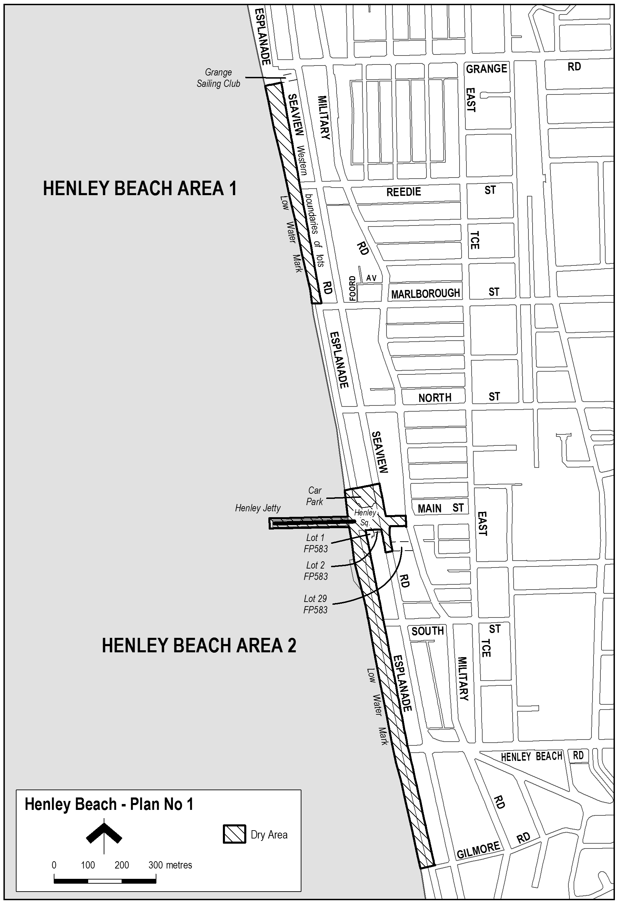
Note—
As required by section 10AA(2) of the Subordinate Legislation Act 1978, the Minister has certified that, in the Minister's opinion, it is necessary or appropriate that these regulations come into operation as set out in these regulations.
Made by the Governor
with the advice and consent of the Executive Council
on 1 July 2010
No 165 of 2010
10MCA0021CS

South Australia
Assisted Reproductive Treatment Regulations 2010
under the Assisted Reproductive Treatment Act 1988

Contents
1 Short title
2 Commencement
3 Interpretation
4 Act does not require provision of assisted reproductive treatment
5 Authorisation to provide assisted reproductive treatment
6 Requirements for registration
7 Register
8 Further conditions of registration
Schedule 1—Revocation of Reproductive Technology (Code of Ethical Clinical Practice) Regulations 1995

1—Short title
These regulations may be cited as the Assisted Reproductive Treatment Regulations 2010.
2—Commencement
These regulations will come into operation on the day on which section 8 of the Reproductive Technology (Clinical Practices) (Miscellaneous) Amendment Act 2009 comes into operation.
3—Interpretation
In these regulations—
Act means the Assisted Reproductive Treatment Act 1988;
NHMRC means the National Health and Medical Research Council established under the National Health and Medical Research Council Act 1992 of the Commonwealth;
NHMRC guidelines means the Ethical Guidelines on Assisted Reproductive Technology (2007) published by the NHMRC, as in force from time to time;
registration, in relation to a person, means registration under Part 2 of the Act;
RTAC means the Reproductive Technology Accreditation Committee of the Fertility Society of Australia;
RTAC licence means a licence to provide assisted reproductive treatment (however described) issued by RTAC.
4—Act does not require provision of assisted reproductive treatment
Nothing in the Act requires a registered person to provide assisted reproductive treatment to another person (whether or not assisted reproductive treatment may, pursuant to section 9(1)(c) of the Act, be provided in the particular circumstances of the person's case).
5—Authorisation to provide assisted reproductive treatment
For the purposes of section 5(1) of the Act, a person is authorised to provide assisted reproductive treatment if the person holds a current RTAC licence.
6—Requirements for registration
For the purposes of section 6(b) of the Act, a current RTAC licence is required for the purposes of registration.
7—Register
For the purposes of section 8(2)(c) of the Act, the following information is prescribed:
(a) the address of each premises at which the person provides assisted reproductive treatment;
(b) the date on which the person's RTAC licence expires;
(c) the URL of any website maintained by or on behalf of the person in relation to the provision of assisted reproductive treatment.
8—Further conditions of registration
(1) For the purposes of section 9(1)(c)(v) of the Act, assisted reproductive treatment may be provided in circumstances where—
(a) a woman who would be the mother of any child born as a consequence of the assisted reproductive treatment; or
(b) a man who is living with a woman (on a genuine domestic basis as her husband) who would be the mother of any child born as a consequence of the assisted reproductive treatment,
is suffering from an illness or other medical condition that may result in, or the appropriate treatment of which may result in, the woman or man becoming infertile at a future time.
(2) For the purposes of section 9(1)(e) of the Act, the Minister must impose the following conditions on the registration of a person:
(a) a condition requiring the person to comply with the NHMRC guidelines;
(b) a condition requiring the person to provide specified information to the Minister from time to time in a manner and form determined by the Minister.
(3) In the event of an inconsistency between a provision of the NHMRC guidelines and a condition imposed on the registration of a person (whether under the Act or otherwise), the provision of the NHMRC guidelines is, to the extent of the inconsistency, void and of no effect.
(4) For the purposes of section 18 of the Act—
(a) a condition imposed on the registration of a person (whether under the Act or otherwise); or
(b) a provision of the NHMRC guidelines,
that requires or authorises a person—
(c) to disclose the identity of a donor of human reproductive material; or
(d) to divulge confidential information obtained (whether by that person or some other person) for the purpose, or in the course, of providing assisted reproductive treatment,
will be taken to be a requirement or authorisation under the Act.
Schedule 1—Revocation of Reproductive Technology (Code of Ethical Clinical Practice) Regulations 1995
The Reproductive Technology (Code of Ethical Clinical Practice) Regulations 1995 are revoked.
Note—
As required by section 10AA(2) of the Subordinate Legislation Act 1978, the Minister has certified that, in the Minister's opinion, it is necessary or appropriate that these regulations come into operation as set out in these regulations.
Made by the Governor
with the advice and consent of the Executive Council
on 1 July 2010
No 166 of 2010
HEAC-2009-00074

South Australia
National Electricity (South Australia) Variation Regulations 2010
under the National Electricity (South Australia) Act 1996

Contents
Part 1—Preliminary
1 Short title
2 Commencement
3 Variation provisions
Part 2—Variation of National Electricity (South Australia) Regulations
4 Variation of regulation 15—Fees

Part 1—Preliminary
1—Short title
These regulations may be cited as the National Electricity (South Australia) Variation Regulations 2010.
2—Commencement
These regulations will come into operation on 1 July 2010.
3—Variation provisions
In these regulations, a provision under a heading referring to the variation of specified regulations varies the regulations so specified.
Part 2—Variation of National Electricity (South Australia) Regulations
4—Variation of regulation 15—Fees
Regulation 15—after its present contents (now to be designated as subregulation (1)) insert:
(2) A fee is not payable for the notification of an access dispute under section 125 of the new National Electricity Law if the notification is made by a user consuming less than 750 MWh of electricity per annum.
Made by the Governor
on the unanimous recommendation of the Ministers of the participating jurisdictions and with the advice and consent of the Executive Council
on 1 July 2010
No 167 of 2010
MEN0/005

South Australia
Regulations Variation (Trade Measurement) Regulations 2010
under the Environment Protection Act 1993, the Explosives Act 1936 and the Road Traffic Act 1961

Contents
Part 1—Preliminary
1 Short title
2 Commencement
3 Variation provisions
Part 2—Variation of Environment Protection Regulations 2009
4 Variation of regulation 3—Interpretation
Part 3—Variation of Explosives Regulations 1996
5 Variation of regulation 6.10—Marking of outer package of explosive
Part 4—Variation of Road Traffic (Miscellaneous) Regulations 1999
6 Variation of regulation 30—Determination of mass

Part 1—Preliminary
1—Short title
These regulations may be cited as the Regulations Variation (Trade Measurement) Regulations 2010.
2—Commencement
These regulations come into operation on the day on which they are made.
3—Variation provisions
In these regulations, a provision under a heading referring to the variation of specified regulations varies the regulations so specified.
Part 2—Variation of Environment Protection Regulations 2009
4—Variation of regulation 3—Interpretation
Regulation 3(1), definition of approved weighbridge, (a)—delete "Trade Measurement Act 1993" and substitute:
National Measurement Act 1960 of the Commonwealth
Part 3—Variation of Explosives Regulations 1996
5—Variation of regulation 6.10—Marking of outer package of explosive
Regulation 6.10(2)—delete "Trade Measurement Act 1993" and substitute:
National Measurement Act 1960 of the Commonwealth
Part 4—Variation of Road Traffic (Miscellaneous) Regulations 1999
6—Variation of regulation 30—Determination of mass
(1) Regulation 30(1)(a)(i)—delete "Trade Measurement Act 1993 and the regulations under that Act" and substitute:
National Measurement Act 1960 of the Commonwealth
(2) Regulation 30(1)(a)(iv)—delete "Trade Measurement Act 1993" and substitute:
National Measurement Act 1960 of the Commonwealth
Note—
As required by section 10AA(2) of the Subordinate Legislation Act 1978, the Minister has certified that, in the Minister's opinion, it is necessary or appropriate that these regulations come into operation as set out in these regulations.
Made by the Governor
with the advice and consent of the Executive Council
on 1 July 2010
No 168 of 2010
09MCA0029CS

South Australia
Health Practitioner Regulation National Law (South Australia) Regulations 2010
under the Health Practitioner Regulation National Law (South Australia) Act 2010

Contents
1 Short title
2 Commencement
3 Interpretation
4 Representative bodies
5 Restricted pharmacy services
6 Registration of premises as pharmacy
7 Registration of premises as pharmacy depot
8 Registration as pharmacy services providers
9 Provision of restricted pharmacy services by unqualified persons—prescribed circumstances
10 Information relating to claim against pharmacy services provider to be provided
11 Fees
12 Transitional provision—staff
13 Transitional provision—annual reports
Schedule 1—Revocation of regulations
1 Revocation of regulations

1—Short title
These regulations may be cited as the Health Practitioner Regulation National Law (South Australia) Regulations 2010.
2—Commencement
These regulations will come into operation on the day on which the Health Practitioner Regulation National Law (South Australia) Act 2010 comes into operation.
3—Interpretation
In these regulations—
Act means the Health Practitioner Regulation National Law (South Australia) Act 2010;
PRASA means the Pharmacy Regulation Authority SA constituted under Part 4 of the Act;
therapeutic goods has the same meaning as in the Therapeutic Goods Act 1989 of the Commonwealth.
4—Representative bodies
The following bodies are declared to be representative bodies for the purposes of the Act:
(a) Australasian College of Podiatric Surgeons;
(b) Australian College of Mental Health Nurses (SA Branch) Incorporated;
(c) Australian College of Midwives (SA Branch) Incorporated;
(d) Australian Dental Association South Australian Branch Incorporated;
(e) Australian Dental Prosthetists Association (SA) Incorporated;
(f) Australian Friendly Societies Pharmacies Association Incorporated;
(g) Australian Medical Association (South Australia) Incorporated;
(h) Australian Nursing and Midwifery Federation (SA Branch);
(i) Australian Osteopathic Association;
(j) Australian Pharmacy Council Ltd;
(k) Australian Physiotherapy Association;
(l) Australian Physiotherapy Council;
(m) Australian Podiatry Association SA Incorporated;
(n) The Australian Psychological Society (SA Branch) Ltd;
(o) Chiropractors' Association of Australia (South Australia) Limited;
(p) Council on Chiropractic Education Australasia Incorporated;
(q) The Dental Hygienists' Association of Australia (SA Branch) Incorporated;
(r) Health Consumers Alliance of South Australia Incorporated;
(s) Institute of Private Practising Psychologists Inc.;
(t) Optometrists Association Australia (SA Division) Incorporated;
(u) Pharmaceutical Society of Australia (South Australian Branch) Incorporated;
(v) The Pharmacy Guild of Australia (SA Branch);
(w) Royal College of Nursing, Australia;
(x) The Society of Hospital Pharmacists of Australia (SA & NT Branch);
(y) South Australian Dental Therapists' Association Incorporated;
(z) SA Salaried Medical Officers Association.
5—Restricted pharmacy services
For the purposes of the definition of restricted pharmacy services in section 26(1) of the Act, the following services are declared to be restricted pharmacy services:
(a) the assessment of a medication, whether on account of a prescription, recommendation or request, followed by the selection and preparation of the medication and its supply (with or without information about health outcomes associated with the medication);
(b) the custody, control or dispensing, provision and management of therapeutic goods, health care products and other products or items commonly associated with the practice of a pharmacist;
(c) the provision of information and other services commonly associated with the practice of a pharmacist.
6—Registration of premises as pharmacy
(1) For the purposes of section 41(3)(a) of the Act, premises proposed to be registered as a pharmacy must—
(a) consist of an enclosed area with access to a public place; and
(b) contain an area set aside for the dispensing of items on prescription that is not less that 9 square metres; and
(c) be kept in a hygienic condition and be adequately ventilated; and
(d) have provision for adequate lighting; and
(e) have provision for temperature control of therapeutic goods and health care products; and
(f) contain adequate provision for the safe, secure and hygienic storage of therapeutic goods and health care products; and
(g) contain adequate provision for the safe and secure storage of confidential and sensitive information; and
(h) be constructed in such a manner as to allow a pharmacist to supervise effectively the whole of that part of the premises used in the provision of restricted pharmacy services and the activities of persons in that part of the premises.
(2) For the purposes of the definition of supermarket in section 41(10) of the Act, a supermarket is a store or market the primary business of which is the sale of a range of food, beverages, groceries and other domestic goods.
7—Registration of premises as pharmacy depot
For the purposes of section 45(2)(a) of the Act, premises proposed to be registered as a pharmacy depot must—
(a) have provision for temperature control of therapeutic goods and health care products; and
(b) contain adequate provision for the safe, secure and hygienic storage of therapeutic goods and health care products; and
(c) contain adequate provision for the safe and secure storage of confidential and sensitive information.
8—Registration as pharmacy services providers
(1) For the purposes of section 49 of the Act, the following information must be provided to PRASA by a pharmacy services provider if the pharmacy services provider, or a prescribed relative of the pharmacy services provider, has an interest in a prescribed business:
(a) the full name and residential and postal address of the person who has the interest; and
(b) if the person who has the interest is a prescribed relative of a registered person—the relationship of the person to the registered person; and
(c) the name, address and nature of the prescribed business in which the person has the interest; and
(d) the nature of the interest and of any benefit derived from the interest; and
(e) if the interest consists of a shareholding in a prescribed business—the number, nominal value and class of shares held and particulars of any voting rights exercisable by the holder at a meeting of shareholders.
(2) A pharmacy services provider must, within 30 days after a change in the nature or extent of an interest under subregulation (1), give to PRASA information about the change (in accordance with any requirements determined by PRASA).
Maximum penalty: $5 000.
(3) In this regulation—
health product means a pharmaceutical product;
health service means—
(a) hospital, nursing home or aged care facility services; or
(b) medical, dental or pharmaceutical services; or
(c) chiropractic, occupational therapy, optometry, osteopathy, physiotherapy, podiatric or psychology services;
prescribed business means a business consisting of or involving—
(a) the provision of a health service; or
(b) the manufacture, sale or supply of a health product;
prescribed relative has the same meaning as in Part 4 of the Act.
9—Provision of restricted pharmacy services by unqualified persons—prescribed circumstances
Pursuant to section 51(3)(a) of the Act, restricted pharmacy services may be provided by the Little Company of Mary Health Care Limited at Calvary Hospital at North Adelaide through the instrumentality of a pharmacist who holds a current practising certificate.
10—Information relating to claim against pharmacy services provider to be provided
(1) For the purposes of section 69(1)(a) of the Act, the information relating to a claim referred to in that section to be provided to PRASA within 30 days after the claim is made is—
(a) the nature of the pharmacy service that is alleged to have been carried out negligently; and
(b) full details of the alleged negligence; and
(c) the address of the premises at which the negligence is alleged to have occurred; and
(d) the time at which and the date on which the negligence is alleged to have occurred; and
(e) full details of the injury suffered or allegedly suffered by the claimant as a result of the alleged negligence; and
(f) the date of the claim.
(2) For the purposes of section 69(1)(b) of the Act, the information relating to the claim referred to in that section to be provided to PRASA within 30 days after any order is made by a court to pay damages or other compensation in respect of that claim or any agreement has been entered into for payment of a sum of money in settlement of that claim (whether with or without a denial of liability) is—
(a) information adequate to identify the claim; and
(b) details of any change in information previously provided to PRASA relating to the claim; and
(c) details of the order or agreement (including the amount ordered or agreed to be paid).
11—Fees
(1) The Minister may fix—
(a) fees or charges for the purposes of Part 4 of the Act;
(b) fees or charges for services provided by PRASA in the exercise of its functions under Part 4 of the Act.
(2) PRASA may recover a fee or charge fixed under this regulation by action in a court of competent jurisdiction as a debt due to PRASA from the person liable for payment of the fee or charge.
12—Transitional provision—staff
(1) For the purposes of the definition of designated period in clause 37(4) of Schedule 1 of the Act, the period of 3 months from the day on which the person is determined by the National Agency to be excess to the requirements of the National Agency is prescribed.
(2) For the purposes of the definition of qualifying member of the staff of a prescribed body, 30 June 2010 is prescribed in relation to each prescribed body.
13—Transitional provision—annual reports
(1) The National Agency must, on or before 30 September 2010, deliver to the Minister a report on the activities of each prescribed body during the 2009/2010 financial year.
(2) The report must, in relation to each prescribed body—
(a) contain the following information in relation to the 2009/2010 financial year:
(i) the number of persons registered by the prescribed body in each category of registration under its relevant Act, as at 30 June 2010;
(ii) the number of complaints received by the prescribed body against registered persons or service providers under its relevant Act, and the outcome of each such complaint (including, if relevant, progress on as at 30 June 2010);
(iii) the number of disciplinary proceedings commenced by or on behalf of, or before, the prescribed body under its relevant Act, and the outcome of each of those proceedings (including, if relevant, progress as at 30 June 2010); and
(b) incorporate the audited accounts of the prescribed body for the 2009/2010 financial year.
(3) The Minister must, within 12 sitting days after receiving the report under subregulation (1), have copies of the report laid before both Houses of Parliament.
(4) In this regulation—
National Agency means the Australian Health Practitioner Regulation Agency;
prescribed body means a prescribed body under Part 18 of Schedule 1 of the Act;
relevant Act, in relation to a prescribed body, means the Act under which the prescribed body was constituted (being an Act repealed under Part 17 of Schedule 1 of the Act).
Schedule 1—Revocation of regulations
1—Revocation of regulations
The following regulations are revoked:
(a) the Chiropractic and Osteopathy Practice (Election) Regulations 2006;
(b) the Chiropractic and Osteopathy Practice (General) Regulations 2006;
(c) the Dental Practice (Election) Regulations 2007;
(d) the Dental Practice (General) Regulations 2007;
(e) the Medical Practice (Elections) Regulations 2005;
(f) the Medical Practice (General) Regulations 2005;
(g) the Nursing and Midwifery Practice Regulations 2009;
(h) the Optometry Practice (Elections) Regulations 2007;
(i) the Optometry Practice (General) Regulations 2007;
(j) the Pharmacy Practice Regulations 2007;
(k) the Physiotherapy Practice (Election) Regulations 2006;
(l) the Physiotherapy Practice (General) Regulations 2006;
(m) the Podiatry Practice (Election) Regulations 2006;
(n) the Podiatry Practice (General) Regulations 2006;
(o) the Psychological Practices Regulations 1996.
Note—
As required by section 10AA(2) of the Subordinate Legislation Act 1978, the Minister has certified that, in the Minister's opinion, it is necessary or appropriate that these regulations come into operation as set out in these regulations.
Made by the Governor
with the advice and consent of the Executive Council
on 1 July 2010
No 169 of 2010
HEACS-2010-00030

South Australia
Rates and Land Tax Remission Variation Regulations 2010
under the Rates and Land Tax Remission Act 1986

Contents
Part 1—Preliminary
1 Short title
2 Commencement
3 Variation provisions
Part 2—Variation of Rates and Land Tax Remission Regulations 2009
4 Variation of regulation 4—Remission of water rates
5 Variation of regulation 5—Remission of sewerage rates

Part 1—Preliminary
1—Short title
These regulations may be cited as the Rates and Land Tax Remission Variation Regulations 2010.
2—Commencement
These regulations will be taken to have come into operation on 1 July 2010.
3—Variation provisions
In these regulations, a provision under a heading referring to the variation of specified regulations varies the regulations so specified.
Part 2—Variation of Rates and Land Tax Remission Regulations 2009
4—Variation of regulation 4—Remission of water rates
(1) Regulation 4(4)—delete "subject to a minimum remission of $95 and a maximum remission of $200" and substitute:
subject to the prescribed minimum remission and the prescribed maximum remission for that year
(2) Regulation 4(5)—before the definition of relevant date insert:
prescribed maximum remission means—
(a) for the financial year commencing 1 July 2009—$200;
(b) for the financial year commencing 1 July 2010—$210;
(c) for the financial year commencing 1 July 2011—$221;
(d) for any subsequent financial year—$232;
prescribed minimum remission means—
(a) for the financial year commencing 1 July 2009—$95;
(b) for the financial year commencing 1 July 2010—$100;
(c) for the financial year commencing 1 July 2011—$105;
(d) for any subsequent financial year—$110;
5—Variation of regulation 5—Remission of sewerage rates
(1) Regulation 5(4)—delete "subject to a maximum remission of $95" and substitute:
subject to the prescribed maximum remission for that year
(2) Regulation 5(5)—before the definition of relevant date insert:
prescribed maximum remission means—
(a) for the financial year commencing 1 July 2009—$95;
(b) for the financial year commencing 1 July 2010—$100;
(c) for the financial year commencing 1 July 2011—$105;
(d) for any subsequent financial year—$110;
Note—
As required by section 10AA(2) of the Subordinate Legislation Act 1978, the Minister has certified that, in the Minister's opinion, it is necessary or appropriate that these regulations come into operation as set out in these regulations.
Made by the Governor
with the advice and consent of the Executive Council
on 1 July 2010
No 170 of 2010
DFCCS/10/010

FAXING COPY?
IF you fax copy to Government Publishing SA for inclusion in the Government Gazette, there is no need to send a Confirmation Copy to us as well.
This creates confusion and may well result in your notice being printed twice.
Please use the following fax number:
Fax transmission: (08) 8207 1040
Phone Inquiries: (08) 8207 1045
Please include a contact person, phone number and order number so that we can phone back with any queries we may have regarding the fax copy.
NOTE: Closing time for lodging new copy (fax, hard copy or email) is 4 p.m. on Tuesday preceding the day of publication.

Government Gazette notices can be E-mailed.
The address is:
governmentgazette@dpc.sa.gov.au
Documents should be sent as attachments in Word format.
When sending a document via E-mail, please confirm your transmission with a faxed copy of your document, including the date the notice is to be published.
Fax transmission: (08) 8207 1040
Enquiries: (08) 8207 1045
NOTE: Closing time for lodging new copy (fax, hard copy or email) is 4 p.m. on Tuesday preceding the day of publication.

ADELAIDE CITY COUNCIL
Adoption of Valuations and Declaration of Rates
NOTICE is hereby given that the Council of the Corporation of the City of Adelaide at its meeting held on 15 June 2010 and for the year ending 30 June 2011:
1. Adopted for rating purposes the valuations prepared by valuers employed by the Council of annual values applicable to land within the Council area totalling $753 357 770 of which $610 353 840 is for rateable land.
2. Declared differential general rates based upon the use of the land as follows:
2.1 0.11615 cents in the dollar for all rateable land with a residential land use; and
2.2 0.13433 cents in the dollar for all other rateable land in the Council area.
3. Declared a separate rate of 0.00165 cents in the dollar on all rateable land in the Council area to recover the amount of $943 936 payable to the Adelaide and Mount Lofty Ranges Natural Resource Management Board.
4. Declared a separate rate of 0.0264 cents in the dollar (the Rundle Mall Differential Separate Rate) on all rateable land except that with a residential land use within the ‘Rundle Mall Area’ (as defined) for the purposes of marketing and managing the said Area.
P. Smith, Chief Executive Officer

CITY OF CHARLES STURT
Roads (Opening and Closing) Act 1991
Road Closures—Alma Terrace/Todville Street/Sweeney Terrace, Woodville West
NOTICE is hereby given pursuant to section 10 of the said Act, that Council proposes to make a Road Process Order to close, sell and transfer to the South Australian Housing Trust the portions of Alma Terrace between Lawton Crescent and Todville Street, the whole of Sweeny Terrace (subject to re-alignment), and the northern portion of Todville Street more particularly delineated ‘A’, ‘B’ and ‘C’ on Preliminary Plan No. 10/0019.
A copy of the plan and statement of persons affected are available for public inspection at the Council Office, 72 Woodville Road, Woodville and the office of the Surveyor-General, 101 Grenfell Street, Adelaide, during normal office hours.
Any application for easement or objections must set out the full name, address and details of the submission and must be fully supported by reasons.
Any application for easement or objections must be made in writing within 28 days of this notice to the Council, P.O. Box 1, Woodville, S.A. 5011 and the Surveyor-General, G.P.O. Box 1354, Adelaide, S.A. 5001, setting out full details. Where a submission is made, Council will give notification of a meeting at which the matter will be considered.
Dated 1 July 2010.
M. Withers, Chief Executive Officer

CITY OF HOLDFAST BAY
Adoption of Valuations and Declaration of Rates
NOTICE is hereby given that at the meeting held on 22 June 2010 and in relation to the 2010-2011 financial year, the Council in exercise of the powers contained in Chapter 10 of the Local Government Act 1999:
1. Adopted the most recent valuations of the State Valuation Office of the capital value of land in its area (such valuations of the State Valuation Office being available to the Council as at the date it adopted its budget), and totalling $10 286 857 140.
2. Declared a differential general rate of 0.223816 cents in the dollar of the capital value of land, on rateable land within its area which is used for Residential and other land uses.
3. Declared a differential general rate of 0.33494 cents in the dollar for the capital value of land on rateable land within its area which is used for Commercial (Shop), Commercial (Office), Commercial (Other), Industrial (Light), Industrial (Other), and Vacant Land uses.
4. Imposed a minimum amount payable by way of the general rate of $785.
5. Fixed a maximum increase of 10% (subject to conditions) in the general rate charged on rateable land used for residential purposes and is the principal place of residence of a ratepayer.
6. Imposed the application of general rates on the owners of marina berths within the Patawalonga and in order to provide relief against this substantial change to the principal ratepayer, granted a transitional rebate for 2010-2011 of 20% of the General Rates payable.
7. In order to support and improve business viability, profitability and trade, commerce and industry in that part of the Council’s area comprising the following rateable land:
(a) with a frontage to Jetty Road, Glenelg or Moseley Square;
(b) within the side streets that intersect with Jetty Road, Glenelg between High Street, Glenelg and Augusta Street, Glenelg;
(c) the entire site referred to as the Holdfast Shores 2B Entertainment Centre; and
(d) with a land use of Category 2 (Commercial—Shop), Category 3 (Commercial—Office) and Category 4 (Commercial—Other),
declared a differential separate rate of 0.137298 cents in the dollar of the capital value of land on all rateable land within the above geographical boundary and land use categories set out in Regulation 10 (2) of the Local Government (General) Regulations 1999.
8.—
(a) In exercise of the powers contained in section 154 of the Local Government Act 1999 and in order to carry out the activity to the maintenance and upkeep of the boat lock in the Patawalonga basin, a separate rate of 1.7503 cents in the dollar of the capital value of land, be declared on all rateable land within the Patawalonga basin bounded by the high water mark.
(b) In exercise of the powers contained in section 158 of the Local Government Act 1999, the amount that would otherwise be payable by way of rates in respect of this separate rate is altered by fixing the amount of rates payable for assessments that are wholly or partly within the part of the area on which this separate rate is imposed and the capital values of which exceed $99 583 at $1 743.
9. In exercise of the powers contained in section 95 of the Natural Resources Management Act 2004 and in order to reimburse the Council for the amount contributed to the Adelaide and Mount Lofty Ranges Natural Resources Management Board being $768 133, imposed a levy comprising 0.0077552 cents in the dollar of the capital value of land, on rateable land in the Council’s area in the catchment area of
the Board, the Capital Value of such land comprising $10 046 472 700, the basis for the levy having been selected as the capital value of rateable land, by the Minister, after consul-tation with Constituent Councils in the Management Board Area, and submitted to and approved by the Governor.
J. P. Lynch, Chief Executive Officer

CITY OF MARION
Adoption of Valuation
NOTICE is hereby given that on 22 June 2010 the Council of the City of Marion, pursuant to the provisions of the Local Government Act 1999, for the year ending 30 June 2011, adopted the capital valuation to apply in its area for rating for the 2010-2011 financial year as supplied by the Valuer-General totalling $15 930 631 180.
Declaration of Rates
Notice is hereby given that the Council did on 22 June 2010, declare differential general rates in the dollar based on capital value as follows:
(a) 0.305243 cents in the dollar on rateable land of Category 1 (Residential), Category 7 (Primary Production) and Category 9 (Other);
(b) 0.549437 cents in the dollar on rateable land of Category 2 (Commercial—Shop), Category 3 (Commercial—Office), Category 4 (Commercial—Other);
(c) 0.488388 cents in the dollar on rateable land of Category 5 (Industrial—Light), Category 6 (Industrial—Other); and
(d) 0.518913 cents in the dollar on rateable land of Category 8 (Vacant Land).
The Council resolved that the minimum amount payable by way of rates in respect of rateable land within the area for the year ending 30 June 2011 shall be $771.
The Council declared a separate rate of 0.007762 cents in the dollar on all rateable land within the Adelaide and Mount Lofty Ranges Natural Resources Management Board Area within the area for the year ending 30 June 2011.
The Council resolved that rates will be payable in four equal or approximately equal instalments, and that the due dates for those instalments will be 1 September 2010, 1 December 2010, 1 March 2011 and 1 June 2011.
M. Searle, Chief Executive

CITY OF MITCHAM
Adoption of Valuation and Declaration of Rates
NOTICE is hereby given that at a meeting of the Council held on 22 June 2010, the Council resolved for the financial year commencing 1 July 2010, that:
Adoption of Assessment
Pursuant to section 167 (2) (a) of the Local Government Act 1999 to adopt the capital valuation made by the Valuer-General for the Council area, the assessed value of rateable property totalling $14 282 514 360.
Declaration of the Differential General Rates
Pursuant to sections 153 (1) (b) and 156 (1) (a) of the Local Government Act 1999, to declare differential general rates as follows:
(a) 0.25929 cents in the dollar on capital value of rateable land of Category 1 (Residential), Category 7 (Primary Production), Category 8 (Vacant Land) and Category 9 (Other); and
(b) 0.41486 cents in the dollar on capital value of rateable land in Category 2 (Commercial—Shop), Category 3 (Commercial—Office), Category 4 (Commercial—Other), Category 5 (Industry—Light) and Category 6 (Industry—Other).
Declaration of Minimum Rate
Pursuant to section 158 (1) (a) of the Local Government Act 1999, to fix a minimum amount payable by way of the general rates of $750 in respect of each assessment.
Declaration of Natural Resources Management Levy
Pursuant to section 95 of the Natural Resources Management Act 2004 and section 154 of the Local Government Act 1999, to declare a separate rate to recoup the Natural Resources Management levy of 0.00757 cents in the dollar on the capital value of rateable land in the Council area within the Adelaide and Mount Lofty Ranges Natural Resources Management Board area.
H. Dyer, Chief Executive Officer

CITY OF MITCHAM
Notification of Road Naming Policy
NOTICE is hereby given pursuant to section 219 of the Local Government Act 1999, that at its meeting held on 22 June 2010, the City of Mitcham adopted a Road Naming Policy.
H. Dyer, Chief Executive Officer

CITY OF ONKAPARINGA
Adoption of Valuation and Declaration of Rates for 2010-2011
NOTICE is hereby given that at the meeting held on 22 June 2010, the Council in accordance with the Local Government Act 1999 (the Act), adopted the Valuer-General’s valuation of capital value being $24 598 197 560 for the financial year ending 30 June 2011, effective from 1 July 2010.
Declaration of General Rates
declared differential general rates according to land use, as follows:
(1) Imposed a fixed charge of $262.
(2) Declared as follows:
(i) 0.269096 cents in the dollar on rateable land of Category 1 (Residential) use;
(ii) 0.358832 cents in the dollar on rateable land of Categories of 2, 3, 4, (Commercial—Shop, Office and Other) and 5 and 6 (Industrial—Light and Other) uses;
(iii) 0.281471 cents in the dollar on rateable land of Category 7 (Primary Production) use;
(iv) 0.416413 cents in the dollar on rateable land of Category 8 (Vacant Land) use; and
(v) 0.332909 cents in the dollar on rateable land of Category 9 (Other) use.
Declaration of Separate Rates—Natural Resources
Management Levies
As follows:
• 0.009076 cents in the dollar on all rateable land in the Council’s area in the region of the Adelaide and Mount Lofty Ranges Natural Resources Management Board; and
• 0.006313 cents in the dollar on all rateable land in the Council’s area in the region of the S.A. Murray-Darling Basin Natural Resources Management Board.
Service Charges
(1) Imposed community wastewater management annual service charge of:
• $480 per unit on each occupied allotment; and
• $480 per unit on each vacant allotment.
(2) Imposed an annual service charge for the disposal and treatment of major trade waste on a per kilolitre basis using the criteria specified in the City of Onkaparinga Trade Waste Guidelines.
Payment of Rates
Resolved that the above rates and charges will fall due on the following days:
1 September 2010;
1 December 2010;
1 March 2011;
1 June 2011.
J. Tate, Chief Executive Officer

City of Port Lincoln
Declaration of Rates 2010-2011
NOTICE is hereby given that the City of Port Lincoln, pursuant to section 167 (2) (a) of the Local Government Act 1999, has adopted the valuations made by the Valuer-General of Site Values of all land within the area of the City of Port Lincoln valued at $1 019 197 500 that are to apply to land within it’s area for rating purposes for the year ending 30 June 2011. The date upon which the valuations shall become and be the valuation of the Council is 1 July 2010.
Pursuant to the Local Government Act 1999, section 153 (3), the City of Port Lincoln has determined not to fix a maximum increase in the general rate to be charged on any rateable land.
Having taken into account the general principles of rating contained in section 150 of the Local Government Act 1999 and the requirements of section 153 (2) of the Local Government Act 1999, pursuant to section 152 (1) (c) of the Local Government Act 1999, the City of Port Lincoln declares the basis of general rates for the year ending 30 June 2011 to be that consisting of two components:
(i) one being based on the value of land subject to the rate; and
(ii) the other being a fixed charge.
Pursuant to sections 153 (1) (b) and 156 (1) (b) of the Local Government Act 1999, the City of Port Lincoln declares the following differential rates for the year ending 30 June 2011 varying on the basis of the locality of the land according to the zone in which the land is situated in the Port Lincoln (City) Development Plan, consolidated version dated 21 January 2010:
(i) a Differential General Rate of 0.4926 cents in the dollar on the site valuation of land within the Fringe Zone as delineated in the Port Lincoln (City) Development Plan Consolidated version dated 21 January 2010; and
(ii) a Differential General Rate of 0.5474 cents in the dollar on the site valuation of all other land within the area of the City of Port Lincoln as delineated in the Port Lincoln (City) Development Plan Consolidated version dated 21 January 2010.
Pursuant to section 155 of the Local Government Act 1999, the City of Port Lincoln declares a Recycling Annual Service Charge of $45 based on the nature of the service in respect of all land within the area of the City of Port Lincoln to which it provides or makes available the Recycling Service for the year ending 30 June 2011.
In accordance with section 95 of the Natural Resources Management Act 2004 and section 154 of the Local Government Act 1999, a separate rate based on a fixed charge of $55 be declared on all rateable land within the area of the City of Port Lincoln and the area of the Eyre Peninsula Natural Resources Management Board in order to reimburse the Council the amount contributed to the Eyre Peninsula Natural Resources Management Board for the year ending 30 June 2011.
Pursuant to section 181 of the Local Government Act 1999, the City of Port Lincoln advises that rates for the year ending 30 June 2011 shall be payable in four equal or approximately equal instalments and that the due date for payment of rate instalments be the first Friday of each quarter being 3 September 2010, 3 December 2010, 4 March 2011 and 3 June 2011.
The City of Port Lincoln will grant a discount pursuant to section 181 (11) (b) of the Local Government Act 1999, amounting to 2% of the total rates (not including the Natural Resources Management Levy or Recycling Service Charge), where rates are paid in full on or before 20 August 2010.
In exercise of the power contained in section 44 of the Local Government Act 1999, the City of Port Lincoln hereby delegates 21 June 2010 to the Chief Executive Officer of the Council the power pursuant to section 181 (4) (b) of the Local Government Act 1999, to agree with a principal ratepayer that rates will be payable in such instalments falling due on such days as may be specified in the agreement.
G. Dodd, Chief Executive Officer

CITY OF PROSPECT
Adoption of Valuations and Declaration of Rates 2010-2011
NOTICE is hereby given that the Council of the City of Prospect, at a meeting of the Council held on 22 June 2010 at which 10 of the eleven members of the Council were present, resolved that consideration of the 2010-2011 Annual Business Plan has taken into account:
• The capital valuation of the City as set by the Valuer-General of South Australia.
• The relationship of the amount of rates needed to meet the Objectives of the City of Prospect’s Strategic Plan for 2008-2011 and the Annual Business Plan 2010-2011 (Budget, Long Term Financial Plan, Infrastructure and Asset Management Plan, Rating Strategies).
• The City of Prospect’s Rating Strategy (per annual Business Plan 2010-2011) as adopted by Council on 22 June 2010.
• The relationship and impact of the rates and rate differen-tial between residential and non-residential assessments.
• The equity of the rate structure.
• Rate concessions and rebates that will apply.
A full copy of the Annual Business Plan is available for inspection at the Council’s Principal Office, 128 Prospect Road, Prospect or on Council’s website www.prospect.sa.gov.au.
Adoption of Valuations
That the Council of the City of Prospect, pursuant to section 167 (2) (a) of the Local Government Act 1999, adopts valuations of capital value made by the Valuer-General in relation to the area of the Council on 22 June 2010 and specifies that the total of the values that are to apply within the area for rating purposes for the year ending 30 June 2011 is $4 598 126 900.
Declaration of Differential General Rates
That the Council of the City of Prospect, pursuant to sections 153 (1) (b) and 156 (1) (a) of the Local Government Act 1999, hereby declares differential general rates on rateable land within the area, which rates vary by reference to the uses of land designated by Regulation 10 (2) of the Local Government (General) Regulations 1999:
(a) Residential: A rate of 0.27647 cents in the dollar on the capital value of such rateable land.
(b) Commercial—Shop: A rate of 0.49997 cents in the dollar on the capital value of such rateable land.
(c) Commercial—Office: A rate of 0.49997 cents in the dollar on the capital value of such rateable land.
(d) Commercial—Other: A rate of 0.49997 cents in the dollar on the capital value of such rateable land.
(e) Industry—Light: A rate of 0.49997 cents in the dollar on the capital value of such rateable land.
(f) Industry—Other: A rate of 0.49997 cents in the dollar on the capital value of such rateable land.
(g) Primary Production: A rate of 0.49997 cents in the dollar on the capital value of such rateable land.
(h) Vacant Land: A rate of 0.36699 cents in the dollar on the capital value of such rateable land.
(i) Other: A rate of 0.49997 cents in the dollar on the capital value of such rateable land.
Declaration of a Minimum Amount
That the Council of the City of Prospect, pursuant to section 158 (1) (a) of the Local Government Act 1999, hereby fixes, in respect of the year ending 30 June 2011, a minimum amount of $812 that shall be payable by way of general rates on rateable land within the Council’s area.
Declaration of a Separate Rate (Natural Resources
Management Levy)
That pursuant to section 95 of the Natural Water Resources Management Act 2004 and section 154 of the Local Government Act 1999, Council, in order to reimburse to the Council the amount contributed to the Adelaide and Mount Lofty Ranges Natural Resources Management Board Levy of $358 630 declares for the year ending 30 June 2011, a separate rate of 0.00798161 cents in the dollar on the capital valuation of all rateable properties within the area of the City of Prospect.
Payment of Rates
Notice is hereby given that pursuant to section 181 of the Local Government Act 1999, that the rates shall be payable in four equal or approximately equal instalments due and payable on 1 September 2010, 1 December 2010, 1 March 2011 and 1 June 2011.
M. Goldstone, Chief Executive Officer

CITY OF SALISBURY
Roads (Opening and Closing) Act 1991
Road Closure—Portions of Mangrove Street, St Kilda
NOTICE is hereby given pursuant to section 10 of the said Act that council proposes to make a Road Process Order to close and sell portions ‘A’, ‘B’ and ‘C’ of Mangrove Street on Preliminary Plan No. 10/0024 as follows:
• Closed road ‘A’ to be transferred to P. Sarvanidis and merged with Allotment 9 in Filed Plan 114670.
• Closed road ‘B’ to be transferred to D. S. Fallas and merged with Town Allotment 35.
• Closed road ‘C’ to be transferred and added to the Common Property in Strata Plan 7722 Inc.
A copy of the plans and statements of persons affected are available for public inspection at Council’s Office, 12 James Street, Salisbury and the office of the Surveyor-General, 101 Grenfell Street, Adelaide, during normal office hours.
Any applications for easements or objections must be made in writing and set out the full name, address and give details of the submission with fully supported reasons.
Any submissions must be made in writing within 28 days from 1 July 2010, to the Council, P.O. Box 8, Salisbury, S.A. 5108 and the Surveyor-General, G.P.O. Box 1354, Adelaide, S.A. 5001.
Where submissions are received, Council will give notification of a meeting to consider any representations.
Enquiries may be directed to Rob Adam on 8406 8357 or Karen Pepe on 8406 8397.
S. Hains, City Manager.

TOWN OF GAWLER
Development Act 1993
New Southern Urban Areas—
Development Plan Amendment (DPA)
Notice is hereby given that the Town of Gawler has, pursuant to sections 24 and 25 of the Development Act 1993, prepared a draft DPA to amend the Gawler (CT) Development Plan.
The amendment proposes zone and policy changes for the Development Plan to rezone land from Deferred Urban Residential and Rural to a series of urban zones to support a new community in Evanston Gardens and Evanston South. This is necessary to increase residential land supply in the Council area and Northern Adelaide in accordance with Government policy.
The DPA will be available for public inspection and purchase for $20 at the Council Offices and Library, 89-91 Murray Street, Gawler, during normal business hours from 1 July 2010, to 27 August 2010. The DPA is accessible on Council’s website:
www.gawler.sa.gov.au.
During this time, anyone may make a written submission about any of the changes the DPA is proposing.
Written submissions will be accepted at the Council Offices up to 5 p.m. on 27 August, 2010, or may be sent to Veronica Parker, P.O. Box 130, Gawler, S.A. 5118 (postmarked no later than 27 August 2010). Alternatively, electronic submissions can be made by 5 p.m. on 27 August 2010 to:
veronica.parker@gawler.sa.gov.au.
Submissions should indicate whether the author wishes to speak at a public meeting about the DPA. If no one requests to be heard, no public meeting will be held.
Copies of all written submission will be available for public inspection by interested persons at the Council Offices until the conclusion of the public meeting, on 31 August 2010.
If requested, a public hearing will be held on 31 August 2010, at 7.30 p.m. at the Rotary Room, Gawler Sport and Recreation Centre, Nixon Terrace, to enable interested persons to make verbal submissions to Council on the DPA.
For further information please contact Michael Wohlstadt on 8522 9231.
Dated 1 July 2010.
S. Kerrigan, Chief Executive Officer

DISTRICT COUNCIL OF CLEVE
Change of Meeting Date
NOTICE is hereby given that the normal August Council meeting will now be held on Wednesday, 18 August 2010 commencing at 9.30 a.m. in the Council Chambers, Main Street, Cleve in lieu of Wednesday, 11 August 2010.
P. J. Cameron, Chief Executive Officer

DISTRICT COUNCIL OF CLEVE
Adoption of 2010-2011 Annual Business Plan
NOTICE is hereby given that at its meeting held on 9 June 2010, the Council, in accordance with section 123 of the Local Government Act 1999, adopted the 2010-2011 Annual Business Plan.
Adoption of Valuations
Notice is hereby given that the District Council of Cleve in accordance with section 167 (2) (a) of the Local Government Act 1999, adopted for the year ending 30 June 2011, the site valuations of land within the Council area as made by the Valuer-General, being the most recent valuations available and totalling $270 862 020.
Declaration of Rates and Charges
Notice is hereby given pursuant to section 170 of the Local Government Act 1999, that the District Council of Cleve, declared the following rates and charges for the year ending 30 June 2011:
1. Pursuant to section 153 of the Local Government Act 1999, differential general rates be hereby declared for the financial year ending 30 June 2011, on the assessed site value of all rateable land within the area of the Council as follows:
Cents in
the $
Arno Bay—Town 1.0773
Arno Bay—Coastal Zone 0.5145
Cleve—Town 2.2254
Cleve—Rural Living/Fringe Zone 1.4975
Other Towns—Rudall, Darke Peak, etc. 23.4850
Outside Towns—Rural 0.5587
Special Industry Zone (Grain Storage Silos) 15.5438
2. Pursuant to section 158 (1) (a) of the Local Government Act 1999, a minimum amount was fixed by way of general rates of $383.
3. Pursuant to section 155 of the Local Government Act 1999, annual service charges were imposed on land serviced by prescribed services as hereunder:
Per Unit
$
Cleve Community Wastewater Management
Scheme 340
Arno Bay Community Wastewater Management
Scheme 340
Common TV Antenna Service:
Whyte Street/Cottages Division 195.75
Elson Subdivision 88.75
4. Pursuant to section 154 of the Local Government Act 1999, a separate rate of 1.8 cents in the dollar payable on the site value of all rateable properties abutting the Arno Bay Access Road/Serotzki Street Kerbing and Sealing Project, together with discretionary rebates pursuant to section 166 (1) (a) and (i) and (ii), on all such properties where valuation anomalies would result in any property ratepayers paying any more than $180 per year, to assist in defraying the capital cost of the works (being works to kerb and seal the abutting road) directly benefiting those properties.
5. Pursuant to section 95 of the Natural Resources Manage-ment Act 2004 and section 154 of the Local Government Act 1999, the Council declared a separate rate being a fixed Natural Resources Management Levy of $60 upon all rateable property in the Council area. The fixed Natural Resources Management Levy was declared in order to reimburse the Council the amount of $65 580 which Council is required to contribute towards the costs of operating the Eyre Peninsula Natural Resources Management Board for the 2010-2011 financial year.
Payment of Rates and Discounts
Pursuant to section 181 of the Local Government Act 1999, that rates shall be payable in four equal or approximately equal instalments due on 15 September 2010, 15 December 2010, 15 March 2011 and 15 June 2011 for the 2010-2011 financial year.
Pursuant to section 181 (11) of the Act, a general rates discount of 2% is offered if the annual rates amount is paid in full prior to 15 September 2010.
P. Cameron, Chief Executive Officer

KANGAROO ISLAND COUNCIL
Road Opening and Closing—Nepean Bay
NOTICE is hereby given pursuant to section 10 of the Roads (Opening and Closing) Act 1991, that the Kangaroo Island Council proposes to make a Road Process Order to:
(i) open as road portion of allotment 300 in Deposited Plan 69536, more particularly delineated and numbered ‘1’ on Preliminary Plan No. 10/0021, forming a re-alignment of the adjoining Min-Oil Road; and
(ii) close and merge portion of Min-Oil Road with the adjoining allotment 300 in Deposited Plan 69536, more particularly delineated and lettered ‘B’ on Preliminary Plan No. 10/0021 in exchange for land taken for new road ‘1’ (above).
A copy of the plan and a statement of persons affected are available for public inspection at the office of the Council at Dauncey Street, Kingscote and the Adelaide Office of the Surveyor-General during normal office hours.
Any application for easement or objection must set out the full name, address and details of the submission and must be fully supported by reasons.
The application for easement or objection must be made in writing to the Council, P.O. Box 121, Kingscote, S.A. 5223 within 28 days of this notice and a copy must be forwarded to the Surveyor-General, G.P.O. Box 1354, Adelaide, S.A. 5001. Where a submission is made, the Council will give notification of a meeting at which the matter will be considered.
Dated 1 July 2010.
C. Noon, Chief Executive Officer

NARACOORTE LUCINDALE COUNCIL
Adoption of 2010-2011 Annual Business Plan
NOTICE is hereby given that at its meeting held on 22 June 2010, the Council, in accordance with section 123 of the Local Govern-ment Act 1999, adopted the 2010-2011 Annual Business Plan.
Adoption of Valuations and Declaration of Rates
Notice is hereby given that at its meeting held on 22 June 2010, the Council, in exercise of the powers contained in Chapter 10
of the Local Government Act 1999, adopted the following resolutions:
Adoption of Assessment
That pursuant to section 167 (2) (a) of the Local Government Act 1999, Council adopts for the year ending 30 June 2011, the most recent valuations of the Valuer-General available to the Council of the capital value of land within the Council’s area being:
$
Rateable Properties 2 145 106 745
Non-rateable Properties 47 702 795
and specifies 1 July 2010, as the day from which such valuations shall become the valuations of the Council.
Adoption of Budget
That pursuant to the provisions of section 123 of the Local Government Act 1999, the 2010-2011 financial budget, as presented, including the:
• Budgeted Operating Statement;
• Budgeted Statement of Financial Position;
• Budgeted Statement of Changes in Equity;
• Budgeted Statement of Cash Flow;
• Budgeted Financial Indicators,
is adopted involving:
• a total operating expenditure of $13 898 693;
• a total capital expenditure and loan principle payments of $6 504 892;
• a total estimated income and borrowings (other than rates) of $5 248 986;
• a total amount required to be raised from general rates of $8 710 031.
Rate Capping
That pursuant to section 153 (3) of the Local Government Act 1999, the Council has determined that it will not fix a maximum increase in the general rate to be charged on any rateable land within its area that constitutes the principal place of residence.
Declaration of Rates
That pursuant to section 156 (1) (c) of the Local Government Act 1999, the Council declares differential general rates according to the locality and the use of the land and based upon the capital value of the land on all rateable properties within the area of the Council, for the year ending 30 June 2011, as follows:
Cents
Rural Living 0.405
Deferred Urban 0.405
Residential (Naracoorte) Zone 0.577
Recreation (Naracoorte) Zone 0.577
Conservation (Naracoorte) Zone 0.577
Country Living (Naracoorte) Zone 0.577
Mixed Use (Naracoorte) Zone 0.577
Deferred Industry (Naracoorte) Zone 0.577
Commercial (Naracoorte) Zone 0.600
Commercial/Industry (Naracoorte) Zone 0.600
Industry (Naracoorte) Zone 0.600
Town Centre (Naracoorte) Zone 0.600
General Industry (Naracoorte) Zone 0.600
Industry Zone 0.525
General Farming Zone 0.339
Forestry/Farming Zone 0.339
Horticulture Zone 0.339
Special Uses Aerodrome Zone 0.339
Town Centre (Lucindale) Zone 0.485
Commercial (Lucindale) Zone 0.485
Country/Towns Zone Vacant Land Use 0.485
Country Townships Zone 0.485
Residential (Lucindale) Zone 0.485
Vacant Land Use (Lucindale) Zone 0.485
Public Purpose (Lucindale) Zone 0.485
Minimum Rate
Pursuant to section 158 of the Local Government Act 1999, the Council fixes a minimum amount of $230 payable by way of rates for the year ending 30 June 2011.
Declaration of CWMS Service Charge
Pursuant to section 155 of the Local Government Act 1999, the Council fixes an annual service charge for the Lucindale Community Wastewater Management Scheme (CWMS) for the year ending 30 June 2011, as follows:
(a) in respect of all occupied properties serviced by that scheme in the township of Lucindale—$353;
(b) in respect of all vacant properties serviced by that scheme in the township of Lucindale—$128.
Declaration of Waste and Recycling Collection
Service Charge
Pursuant to section 155 of the Local Government Act 1999, the Council fixes an annual service charge for the Waste and Recycling Collection for the year ending 30 June 2011, as follows:
• in respect of all occupied rateable properties in the townships of Naracoorte, Lucindale, Frances, Hynam and Kybybolite and properties zoned Rural Living—$228.
Declaration of South East Natural Resources Management
Board Levy
Pursuant to the powers contained in the Natural Resources Management Act 2004 and section 154 (1) of the Local Government Act 1999, in order to reimburse the Council the
amount contributed to the South East Natural Resources Management Board, the Council fixed a separate levy of $36.80 in respect of each rateable property in the area of the Council in the catchment area of the Board.
Payment of Rates—Payment of Rates by Quarterly
Instalments
That pursuant to section 181 of the Act that the payment of rates may be made by four approximately equal instalments, the first of which shall be due on the first working day of September 2010, the second on the first working day of December 2010, the third on the first working day of March 2011 and the fourth on the first working day of June 2011.
A. Evans, Chief Executive Officer

[Re-advertised]
DISTRICT COUNCIL OF ROBE
Roads (Opening and Closing) Act 1991
Road Closure—Main Road, Robe
NOTICE is hereby given pursuant to section 10 of the Roads (Opening and Closing) Act 1991, that the District Council of Robe proposes to make a Road Process Order to close and sell by public auction or tender the portion of the public road (Main Road) adjoining Allotment 1 in Filed Plan 128516 and Allotment 141 in Filed Plan 205487, as more particularly delineated and lettered ‘A’ on Preliminary Plan No. 09/0027.
A copy of the plan and a statement of persons affected are available for public inspection at the Council Office, Royal Circus, Robe and the Adelaide Office of the Surveyor-General during normal office hours.
Any application for easement or objection must set out the full name, address and details of the submission and must be fully supported by reasons.
The application for easement or objection must be made in writing to the Council, P.O. Box 1, Robe, S.A. 5276 within 28 days of this notice and a copy must be forwarded to the Surveyor-General, G.P.O. Box 1354, Adelaide, S.A. 5001.
Where a submission is made, the Council will give notification of a meeting at which the matter will be considered.
Dated 1 July 2010.
B. Hender, Chief Executive Officer

WATTLE RANGE COUNCIL
Development Act 1993
Wattle Range Council Development Plan—Penola and General
Development Plan Amendment—Draft for Public Consultation
Notice is hereby given that the Wattle Range Council has prepared a draft Development Plan Amendment (DPA) to amend its Development Plan.
The DPA will:
• amend the land division policy within a new Policy Area of the Primary Production Zone east of Coonawarra and Penola;
• rezone the existing Commercial Zone to a Town Centre Zone in Penola; and
• amend the policy in the Primary Production Zone relating to the Millicent Golf Club.
The DPA report will be on public consultation from Thursday,
1 July 2010 until Thursday, 2 September 2010.
Copies of the DPA will be available for public inspection and purchase during normal office hours at the Council Offices, Civic Centre, George Street, Millicent and 27 Arthur Street, Penola and will be available on Council’s website at:
www.wattlerange.sa.gov.au.
Written submissions regarding the DPA should be submitted no later than 5 p.m. on Thursday, 2 September 2010. All submissions should be addressed to the Chief Executive Officer, Wattle Range Council, P.O. Box 27, Millicent, S.A. 5280 and should clearly indicate whether or not you wish to be heard in support of your submission at the public meeting.
Copies of all written submissions received will be available for inspection by interested persons at Council’s Offices from Friday, 3 September 2010 until the public meeting.
A Public Meeting will be held at the Penola RSL Hall, 22 Young Street, Penola on Thursday, 16 September 2010, commencing at 7 p.m. The public meeting will not be held if no submissions are received or if no submission makes a request to be heard.
Dated 1 July 2010.
F. Brennan, Chief Executive Officer

WUDINNA DISTRICT COUNCIL
Revoking Community Land Classification—Finalisation
NOTICE is hereby given pursuant to section 194 of the Local Government Act 1999, that at its meeting held on 16 June 2010 and upon approval from the Minister for State/Local Government Relations, Council resolved to finalise the revocation of the following parcel of land from the Classification of Community Land:
Lot 100, Richards Avenue, Wudinna, CT6042/760, which is known as the Wudinna Medical Centre.
Please contact Mike Thompson on 8680 2002 for further details.
A. F. McGuire, Chief Executive Officer

IN the matter of the estates of the undermentioned deceased persons:
Anderson, Trevor Frank, late of 21 Lancelot Drive, Daw Park, retired purchasing officer, who died on 14 March 2010.
Burgess, William Frank, late of 3 Honey Street, Woodville North, retired truck driver, who died on 30 April 2010.
Ey, Allan John, late of 91 Seaview Road, Yatala Vale, of no occupation, who died on 6 February 2010.
Gilby, Stephen Roy, late of 162 Grover Street, North Adelaide, plant operator, who died on 28 March 2010.
Graefling, Margaret Jean, late of 110 Park Terrace, Salisbury Plain, retired shop assistant, who died on 20 April 2010.
Hagedorn, Rita Mabel, late of 1 Dingera Avenue, North Plympton, of no occupation, who died on 8 April 2010.
Jew, Ronald William, late of 53-59 Austral Terrace, Morphettville, retired solicitor, who died on 23 May 2009.
Kenyon, John, late of 175 Main Road, Yankalilla, retired foreman, who died on 13 May 2010.
O’Sullivan, Philip Roger, late of 4 Alderwood Court, Hillbank, of no occupation, who died on 6 January 2010.
Reynolds, Marie Therese, late of 421 The Parade, Kensington Gardens, retired senior music therapist, who died on 2 May 2010.
Somerfield, Loris Jane, late of 52 Dunrobin Road, Hove, of no occupation, who died on 25 May 2010.
Wallis, Graeme Edmund Harvey, late of 28A Jervois Street, Port Augusta, retired public servant, who died on 16 March 2010.
Notice is hereby given pursuant to the Trustee Act 1936, the Inheritance (Family Provision) Act 1972, and the Family Relationships Act 1975, that all creditors, beneficiaries, and other persons having claims against any of the said estates are required to send, in writing, to the Public Trustee, G.P.O. Box 1338, Adelaide, S.A. 5001, full particulars and proof of such claims, on or before 30 July 2010, otherwise they will be excluded from the distribution of the said estates; and notice is also hereby given that all persons who are indebted to the said estates are required to pay the amount of their debts to the Public Trustee or proceedings will be taken for the recovery thereof; and all persons having any property belonging to the said estates are forthwith to deliver the same to the Public Trustee.
Dated 1 July 2010.
M. I. Bodycoat, Public Trustee

IN the matter of the estate of the undermentioned deceased person:
Brown, Grace Geraldine, late of 147 St Bernards Road, Rostrevor, widow, who died on 21 November 2009.
Notice is hereby given pursuant to the Trustee Act 1936, as amended, the Inheritance (Family Provision) Act 1972-1975 and the Family Relationships Act 1975, that all creditors, beneficiaries, and other persons having claims against the abovenamed estate are directed to send full particulars and evidence of such claims to the undersigned on or before 5 August 2010, otherwise they will be excluded from the distribution of the said estate; and notice is also
hereby given that all persons who are indebted to the above estate are required to pay the amount of their debt to the undersigned or proceedings will be taken for the recovery thereof; and all persons having any property belonging to the said estate are forthwith to deliver the same to the undersigned.
Finlaysons (Lawyers), 81 Flinders Street, Adelaide, S.A. 5000.

SOUTH AUSTRALIA—In the Supreme Court. No. 811 of 2010. In the matter of Road Sea Rail Logistics Pty Limited (ACN 097 268 454) and in the matter of the Corporations Act 2001.
Notice of Application of Winding-up Order
A proceeding for the winding up of Road Sea Rail Logistics Pty Limited was commenced by the plaintiff, Bendigo and Adelaide Bank Limited (ACN 068 049 178), on 24 June 2010 and will be heard by Judge Lunn at the Supreme Court of South Australia,
1 Gouger Street, Adelaide at 2.15 p.m. on 20 July 2010. Copies of documents filed may be obtained from the plaintiff’s address for service. The plaintiff’s address for service is c/o O’Loughlins Lawyers, Level 2, 99 Frome Street, Adelaide, S.A. 5000.
Any person intending to appear at the hearing must file a notice of appearance in accordance with the prescribed form, together with the affidavit on which the person intends to rely, and serve a copy of the notice and any affidavit on the plaintiff at the plaintiff’s address for service at least three days before the date fixed for the hearing.
Dated 1 July 2010.
A. McIntyre, Solicitor for the Plaintiff

SOUTH AUSTRALIA—In the Supreme Court. No. 812 of 2010. In the matter of Road Sea Rail Equipment Pty. Limited (ACN 105 164 118) and in the matter of the Corporations Act 2001.
Notice of Application of Winding-up Order
A proceeding for the winding up of Road Sea Rail Equipment Pty Limited was commenced by the plaintiff, Bendigo and Adelaide Bank Limited (ACN 068 049 178), on 24 June 2010 and will be heard by Judge Lunn at the Supreme Court of South Australia, 1 Gouger Street, Adelaide at 2.15 p.m. on 20 July 2010. Copies of documents filed may be obtained from the plaintiff’s address for service. The plaintiff’s address for service is c/o O’Loughlins Lawyers, Level 2, 99 Frome Street, Adelaide, S.A. 5000.
Any person intending to appear at the hearing must file a notice of appearance in accordance with the prescribed form, together with the affidavit on which the person intends to rely, and serve a copy of the notice and any affidavit on the plaintiff at the plaintiff’s address for service at least three days before the date fixed for the hearing.
Dated 1 July 2010.
A. McIntyre, Solicitor for the Plaintiff

ATTENTION

CUSTOMERS requiring a proof of their notice for inclusion in the Government Gazette, please note that the onus is on you to inform Government Publishing SA of any subsequent corrections by 10 a.m. on Thursday, which is our publication deadline.

For any corrections to your notice please phone 8207 1045 or Fax 8207 1040 before 10 a.m. on Thursday.

If we do not receive any communication by 10 a.m. on Thursday (day of publication) we will presume the notice is correct and will print it as it is.

Remember—the onus is on you to inform us of any corrections necessary to your notice.

NOTE: Closing time for lodging new copy (electronically, fax or hard copy) is 4 p.m. on Tuesday preceding the day of publication. Phone 8207 1045—Fax 8207 1040.
Email: governmentgazette@dpc.sa.gov.au

Printed and published by authority every Thursday by B. MORRIS, Government Printer, South Australia
Price: $6.05, plus postage; to subscribers, $306.00 per annum.
(The above prices are inclusive of GST)

