No. 46 3419

THE SOUTH AUSTRALIAN

GOVERNMENT GAZETTE
www.governmentgazette.sa.gov.au

PUBLISHED BY AUTHORITY

ALL PUBLIC ACTS appearing in this GAZETTE are to be considered official, and obeyed as such

ADELAIDE, THURSDAY, 15 JULY 2010

CONTENTS

Page
Appointments, Resignations, Etc. 3420
Authorised Betting Operations Act 2000—Notices 3421
Corporations and District Councils—Notices 3507
Development Act 1993—Notices 3420
Electricity Act 1996—Notice 3433
Environment Protection Act 1993—Notice 3435
Fisheries Management Act 2007—Notice 3420
Geographical Names Act 1991—Notice 3436
Liquor Licensing Act 1997—Notices 3436
Lottery and Gaming Act 1936—Notice 3440
Lottery and Gaming Regulations 2008—Notice 3440
Mining Act 1971—Notices 3439
Motor Vehicles Act 1959—Notice 3439
National Electricity Law—Notice 3451
National Parks and Wildlife (National Parks) Regulations
2001—Notices 3450

Page
Natural Resources Management Act 2004—Notice 3452
Petroleum and Geothermal Energy Act 2000—Notice 3439
Proclamations 3490
Public Trustee Office—Administration of Estates 3526
REGULATION
Architectural Practice Act 2009 (No. 171 of 2010) 3494
Road Traffic Act 1961—Notices 3441
RULES OF COURT
Magistrates Court (Civil) Rules 1992—
(Amendment No. 34) 3453
Magistrates Court Rules 1992—
(Amendment No. 35) 3466
Transport, Department of—Notices to Mariners 3451
Waterworks Act 1932—Notice 3486
Wilderness Protection Regulations 2006—Notices 3489

GOVERNMENT GAZETTE NOTICES
ALL poundkeepers’ and private advertisements forwarded for publication in the South Australian Government Gazette must be PAID FOR PRIOR TO INSERTION; and all notices, from whatever source, should be legibly written on one side of the paper only and sent to Government Publishing SA so as to be received no later
than 4 p.m. on the Tuesday preceding the day of publication. Phone 8207 1045 or Fax 8207 1040. E-mail: governmentgazette@dpc.sa.gov.au. Send as attachments in Word format and please confirm your transmission with a faxed copy of your document, including the date the notice is to be published and to whom the notice will be charged. The Government Gazette is available online at: www.governmentgazette.sa.gov.au

Department of the Premier and Cabinet
Adelaide, 15 July 2010
HIS Excellency the Governor’s Deputy in Executive Council has been pleased to appoint the undermentioned to the Motor Accident Commission Board, pursuant to the provisions of the Motor Accident Commission Act 1992:
Director: (from 15 July 2010 until 30 June 2012)
Terence Robert Groom
Director: (from 15 July 2010 until 30 June 2013)
Roger Anthony Cook
Juliet Helena Brown
Yvonne Sneddon
James Thomas Hazel
Chair: (from 15 July 2010 until 30 June 2013)
Roger Anthony Cook
By command,
John Snelling, for Premier
T&F10/035CS

Department of the Premier and Cabinet
Adelaide, 15 July 2010
HIS Excellency the Governor’s Deputy in Executive Council has been pleased to appoint the undermentioned to the Administrative And Disciplinary Division of the District Court, pursuant to the provisions of the Guardianship and Administration Act 1993:
Section 66 (3) Panel Assessor: (from 19 July 2010 until 18 July 2013)
Lyn English
Jean Carin Hutchinson
By command,
John Snelling, for Premier
AGO0320/04CS

Department of the Premier and Cabinet
Adelaide, 15 July 2010
HIS Excellency the Governor’s Deputy in Executive Council has revoked the appointments (incorrectly made on 8 July 2010) of the Members and Deputy Members to the Construction Industry Training Board, as listed, for the period commencing on 12 July 2012 and expiring on 11 July 2013, pursuant to the provisions of the Construction Industry Training Fund Act 1993 and Section 36 of the Acts Interpretation Act 1915:
Members:
Nathan Paine
Judith Mary Carr
Sandra Ellen Jaffer
Douglas Buchanan
Gary Henderson
Deputy Members:
Andrew George Fraser Inglis (Deputy to Paine)
Romana Wereszczak (Deputy to Carr)
Douglas Stevens (Deputy to Jaffer)
Kristen Rogers (Deputy to Henderson)
Robert Donnelly (Deputy to Buchanan)
By command,
John Snelling, for Premier
METFE10/005CS

DEVELOPMENT ACT 1993, SECTION 29 (2) (b) (ii): AMEND-MENT TO THE SALISBURY (CITY) COUNCIL—DEVELOPMENT PLAN
Preamble
It is necessary to amend Principle of Development Control 82 of the Industry Zone in the Salisbury Council Development Plan consolidated 11 December 2008.
Notice
PURSUANT to section 29 (2) (b) (ii) of the Development Act 1993, I, Paul Holloway, being the Minister administering the Act, amend the Salisbury Council Development Plan consolidated on 11 December 2008 by:
• Amending Principle of Development Control 82 of the Industry Zone to state:
Shop (except for a shop or group of shops having a gross leasable area less than 250 square metres at The Levels, Greenfields, or Pooraka Industrial Area and the replacement or renovation of shops existing at 21 July 1994, or shop or group of shops having a gross leasable area of less than 500 square metres in total within the Direk Industrial Area).
Dated 15 July 2010.
Paul Holloway, Minister for Urban Development and Planning

DEVELOPMENT ACT 1993, SECTION 25 (17): WUDINNA DISTRICT COUNCIL—BETTER DEVELOPMENT PLAN (BDP) AND MINOR AMENDMENTS—DEVELOPMENT PLAN AMENDMENT
Preamble
1. The Development Plan Amendment entitled ‘Wudinna District Council—Better Development Plan (BDP) and Minor Amendments Development Plan Amendment’ (the Plan Amend-ment) has been finalised in accordance with the provisions of the Development Act 1993.
2. The Minister for Urban Development and Planning has decided to approve the Plan Amendment.
Notice
PURSUANT to section 25 of the Development Act 1993, I:
(a) approve the Plan Amendment; and
(b) fix the day on which this notice is published in the Gazette as the day on which the Plan Amendment will come into operation.
Dated 15 July 2010.
Paul Holloway, Minister for Urban Development and Planning

FISHERIES MANAGEMENT ACT 2007: SECTION 79
TAKE notice that pursuant to section 79 of the Fisheries Management Act 2007, it is hereby declared that it shall be unlawful for any persons to engage in the act of, or an act preparatory to or involved in, taking fish from those waters specified in Schedule 1, during the period specified in Schedule 2.
Schedule 1
All waters within 150 m of the ‘carp cage’ installed in Chambers Creek, adjacent to Napper Bridge on the Morgan Road, Barmera.
Schedule 2
From 9 July 2010 to 30 June 2011.
Dated 9 July 2010.
A. Fistr, Manager, Fisheries Policy

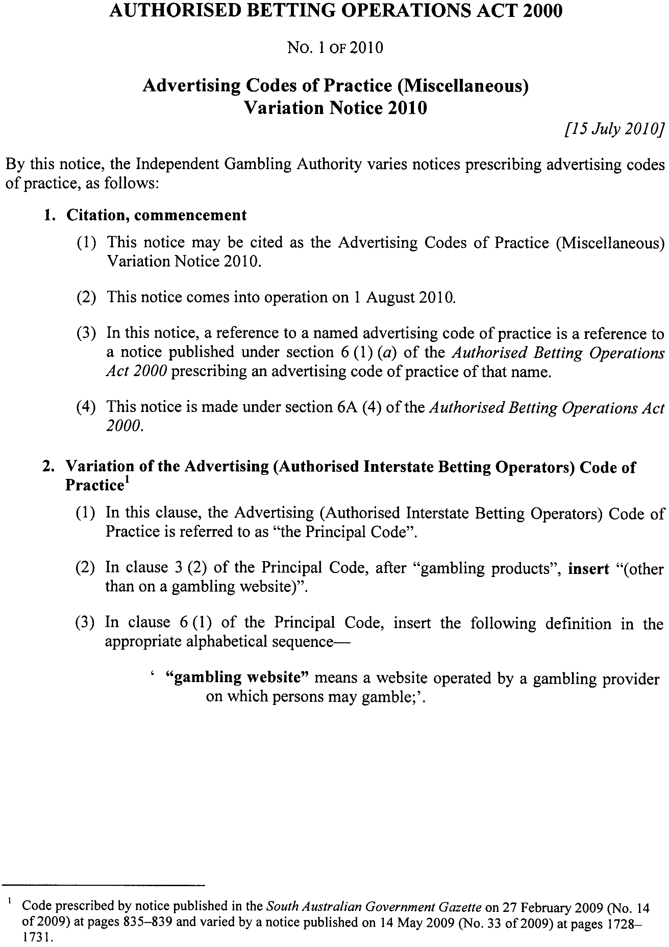
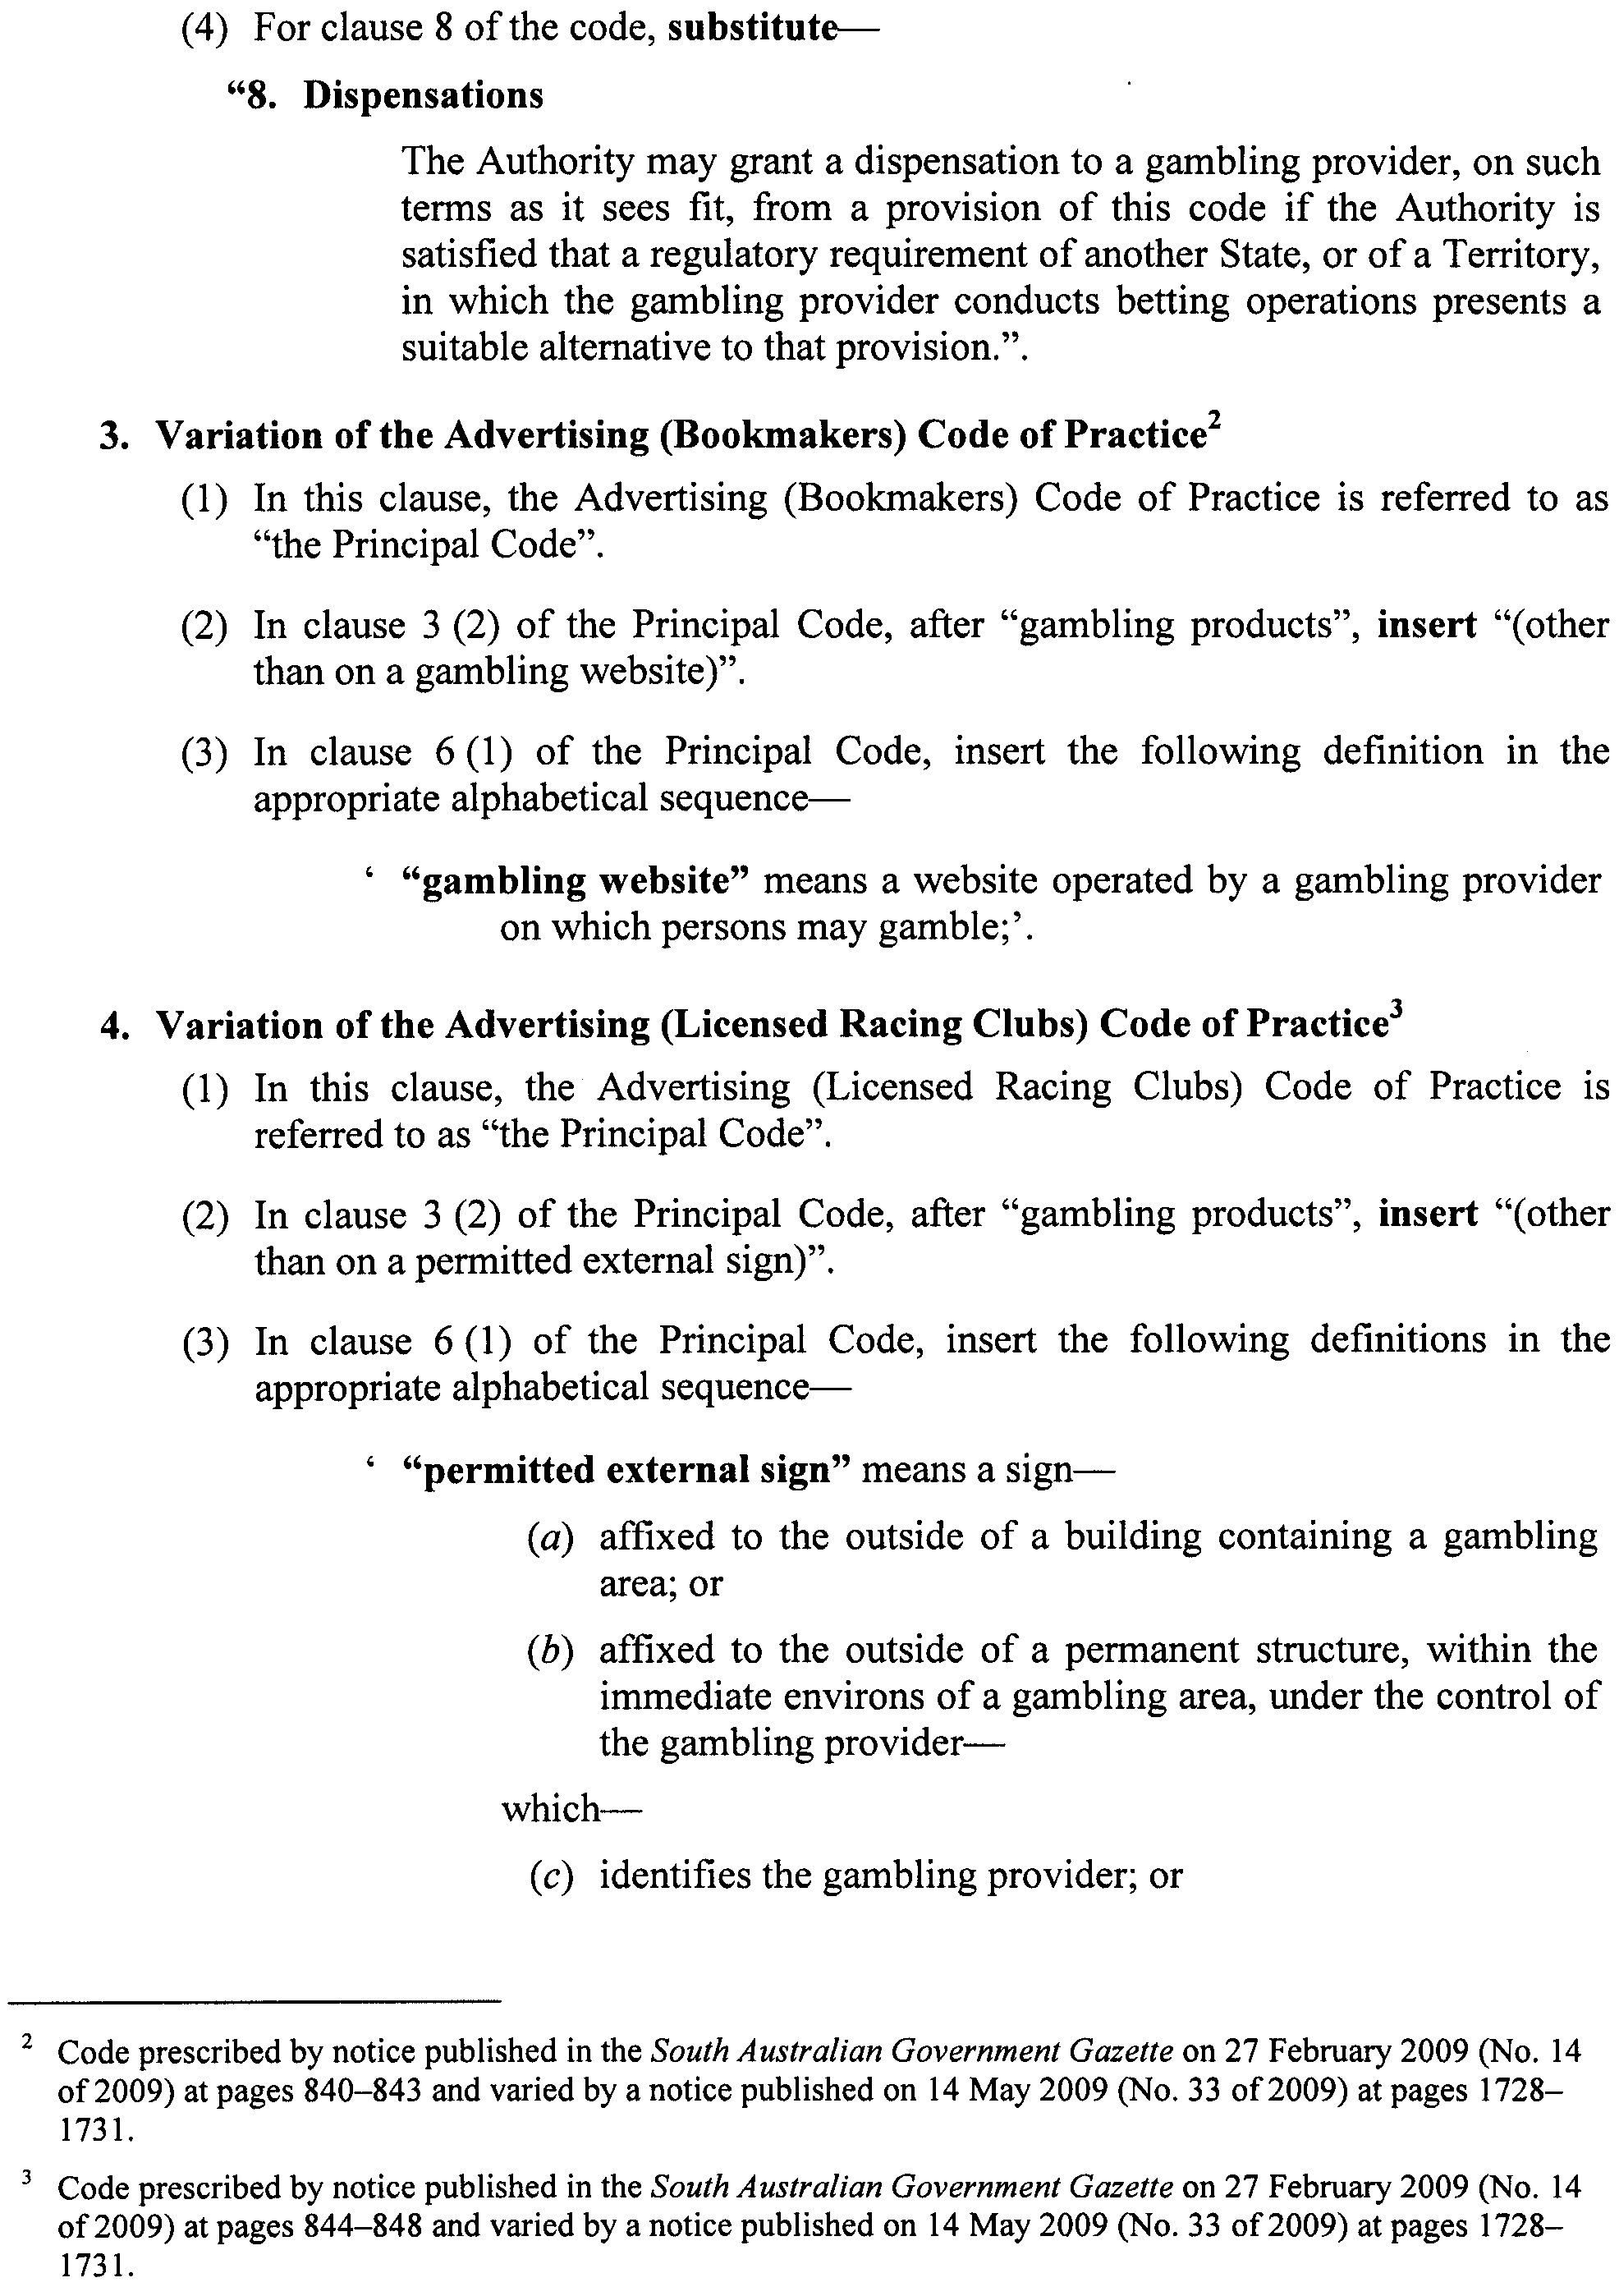

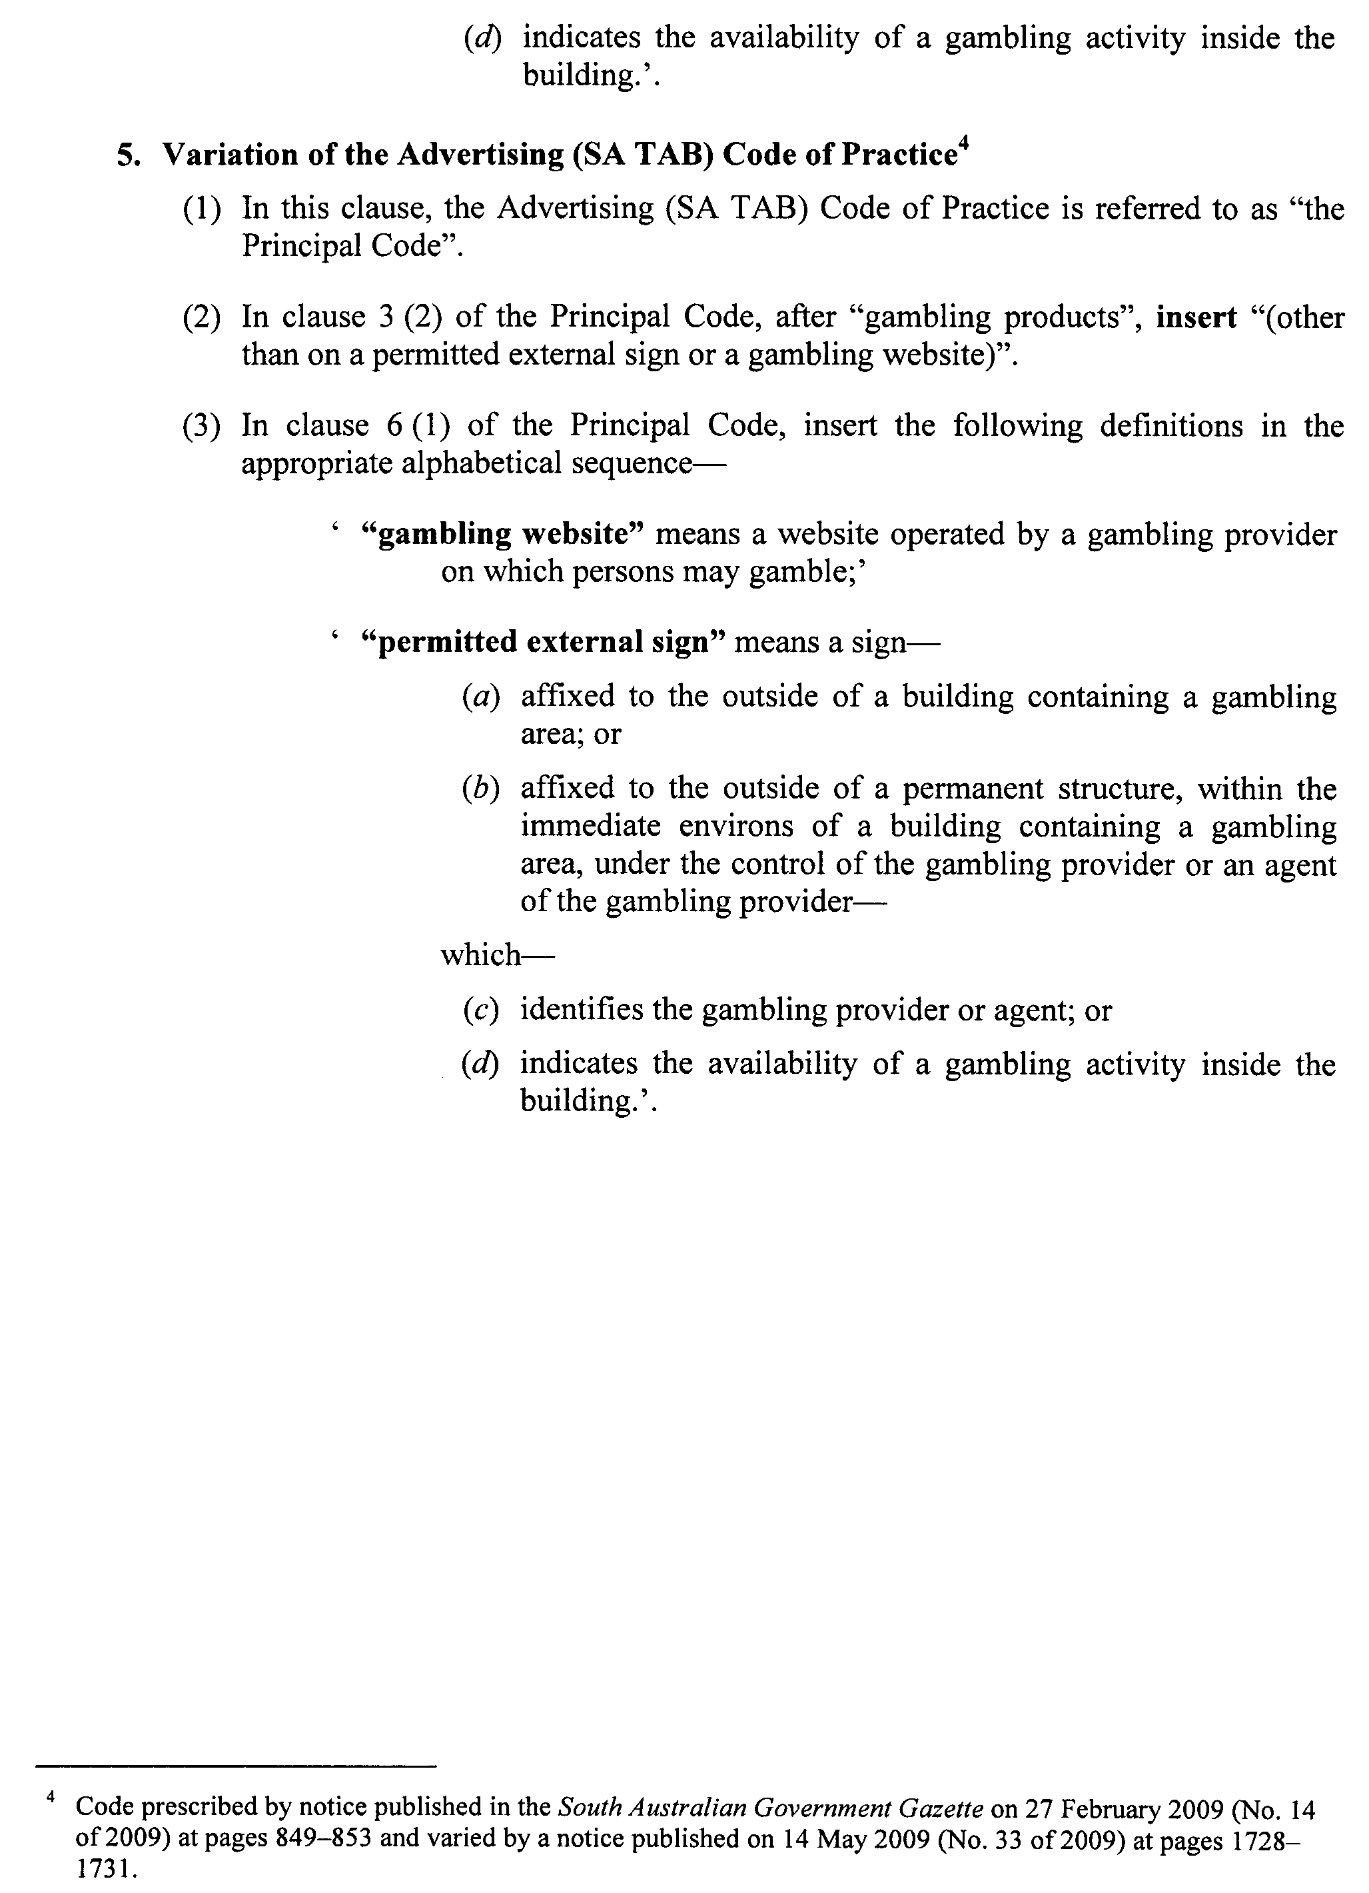

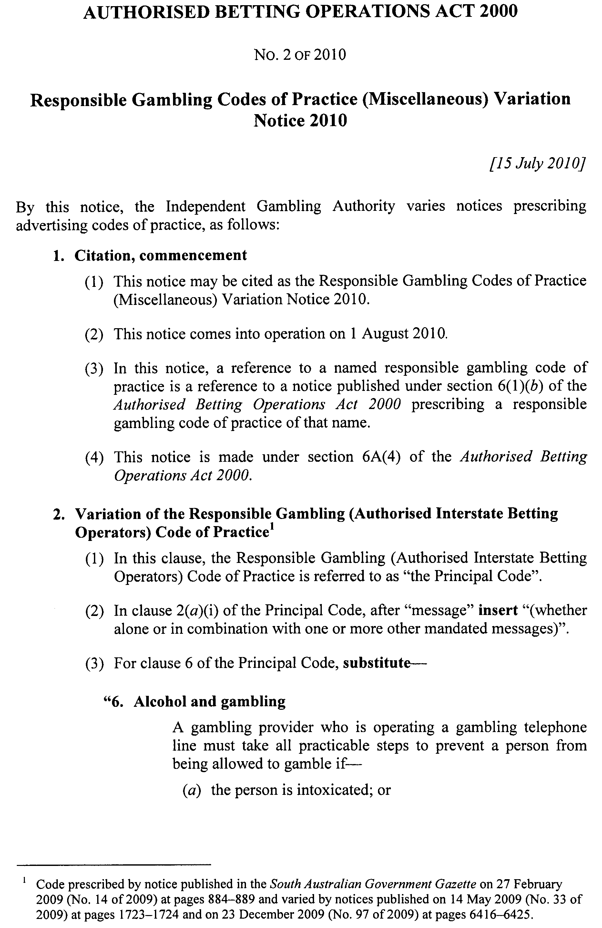
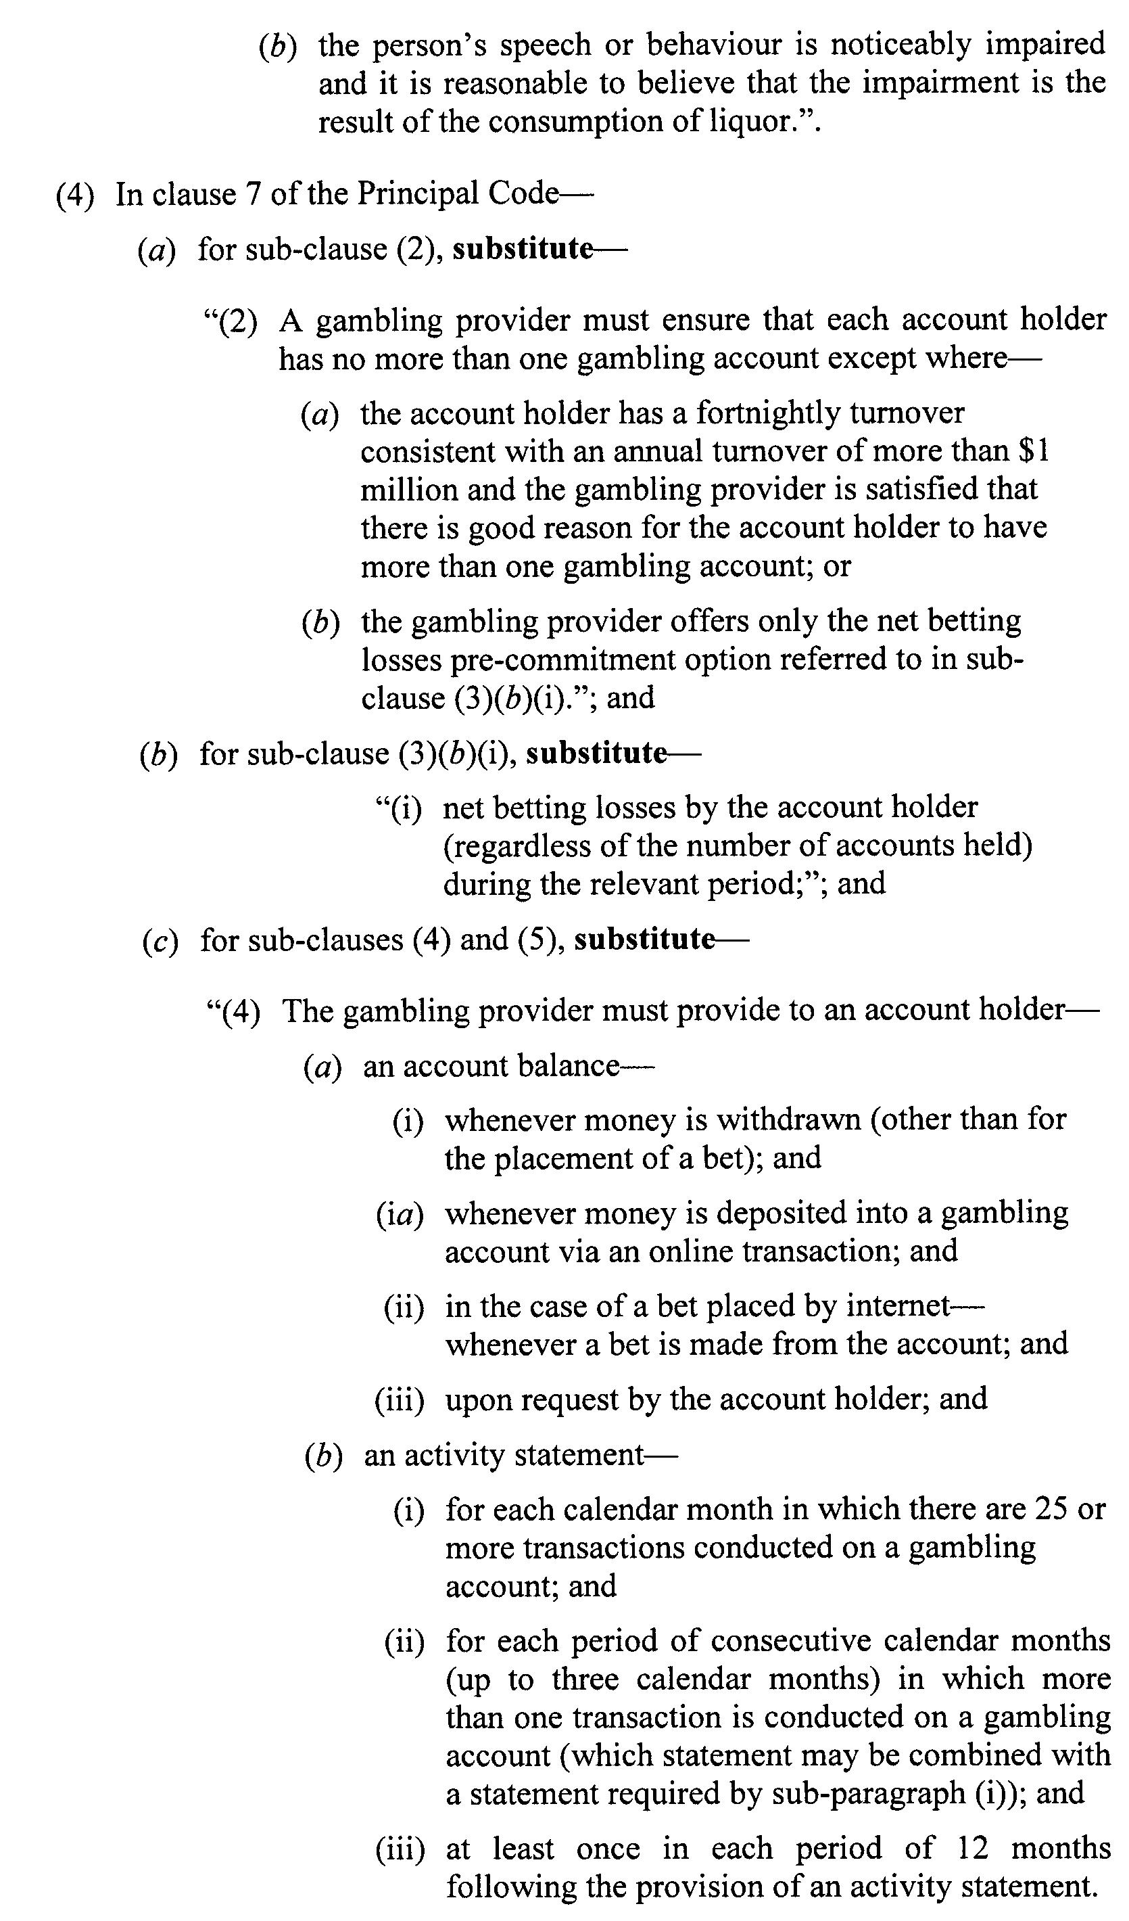
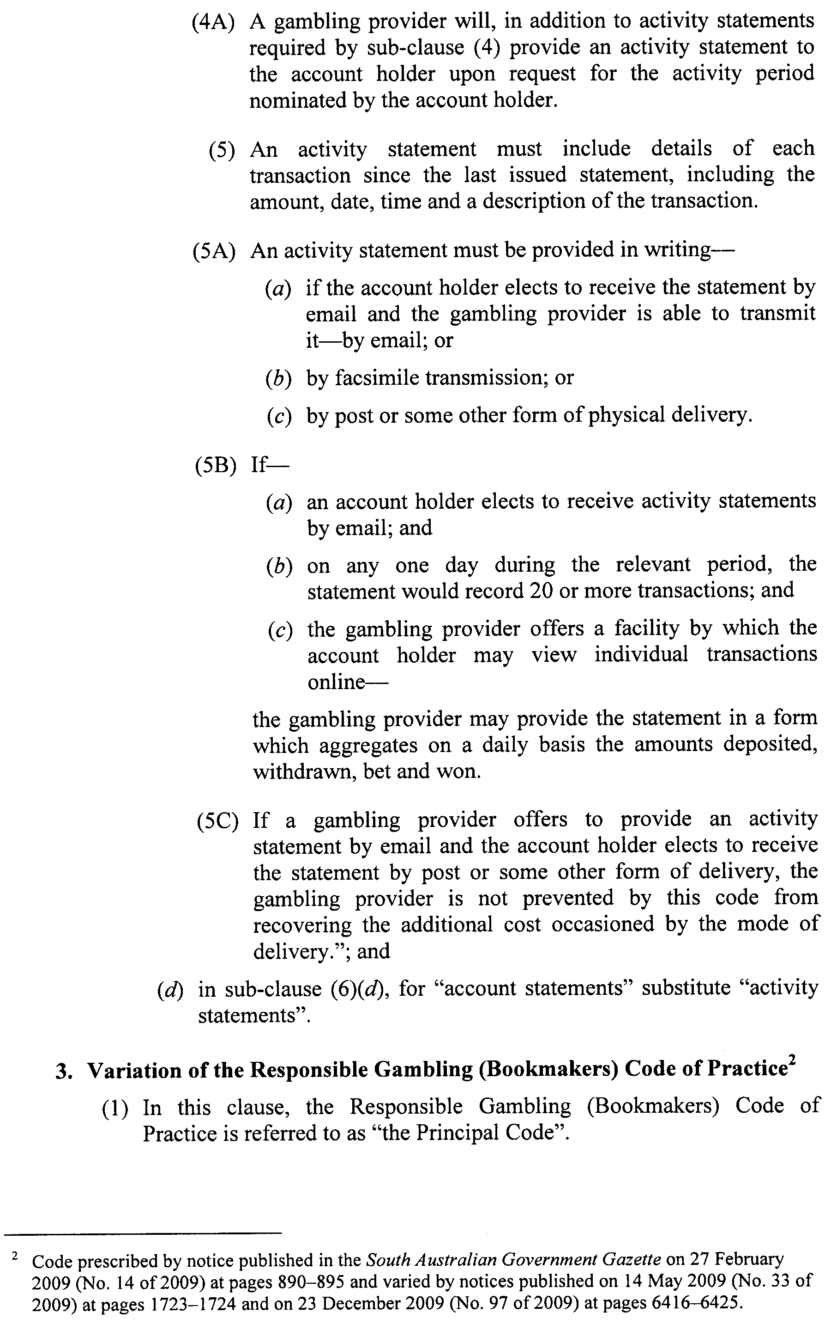
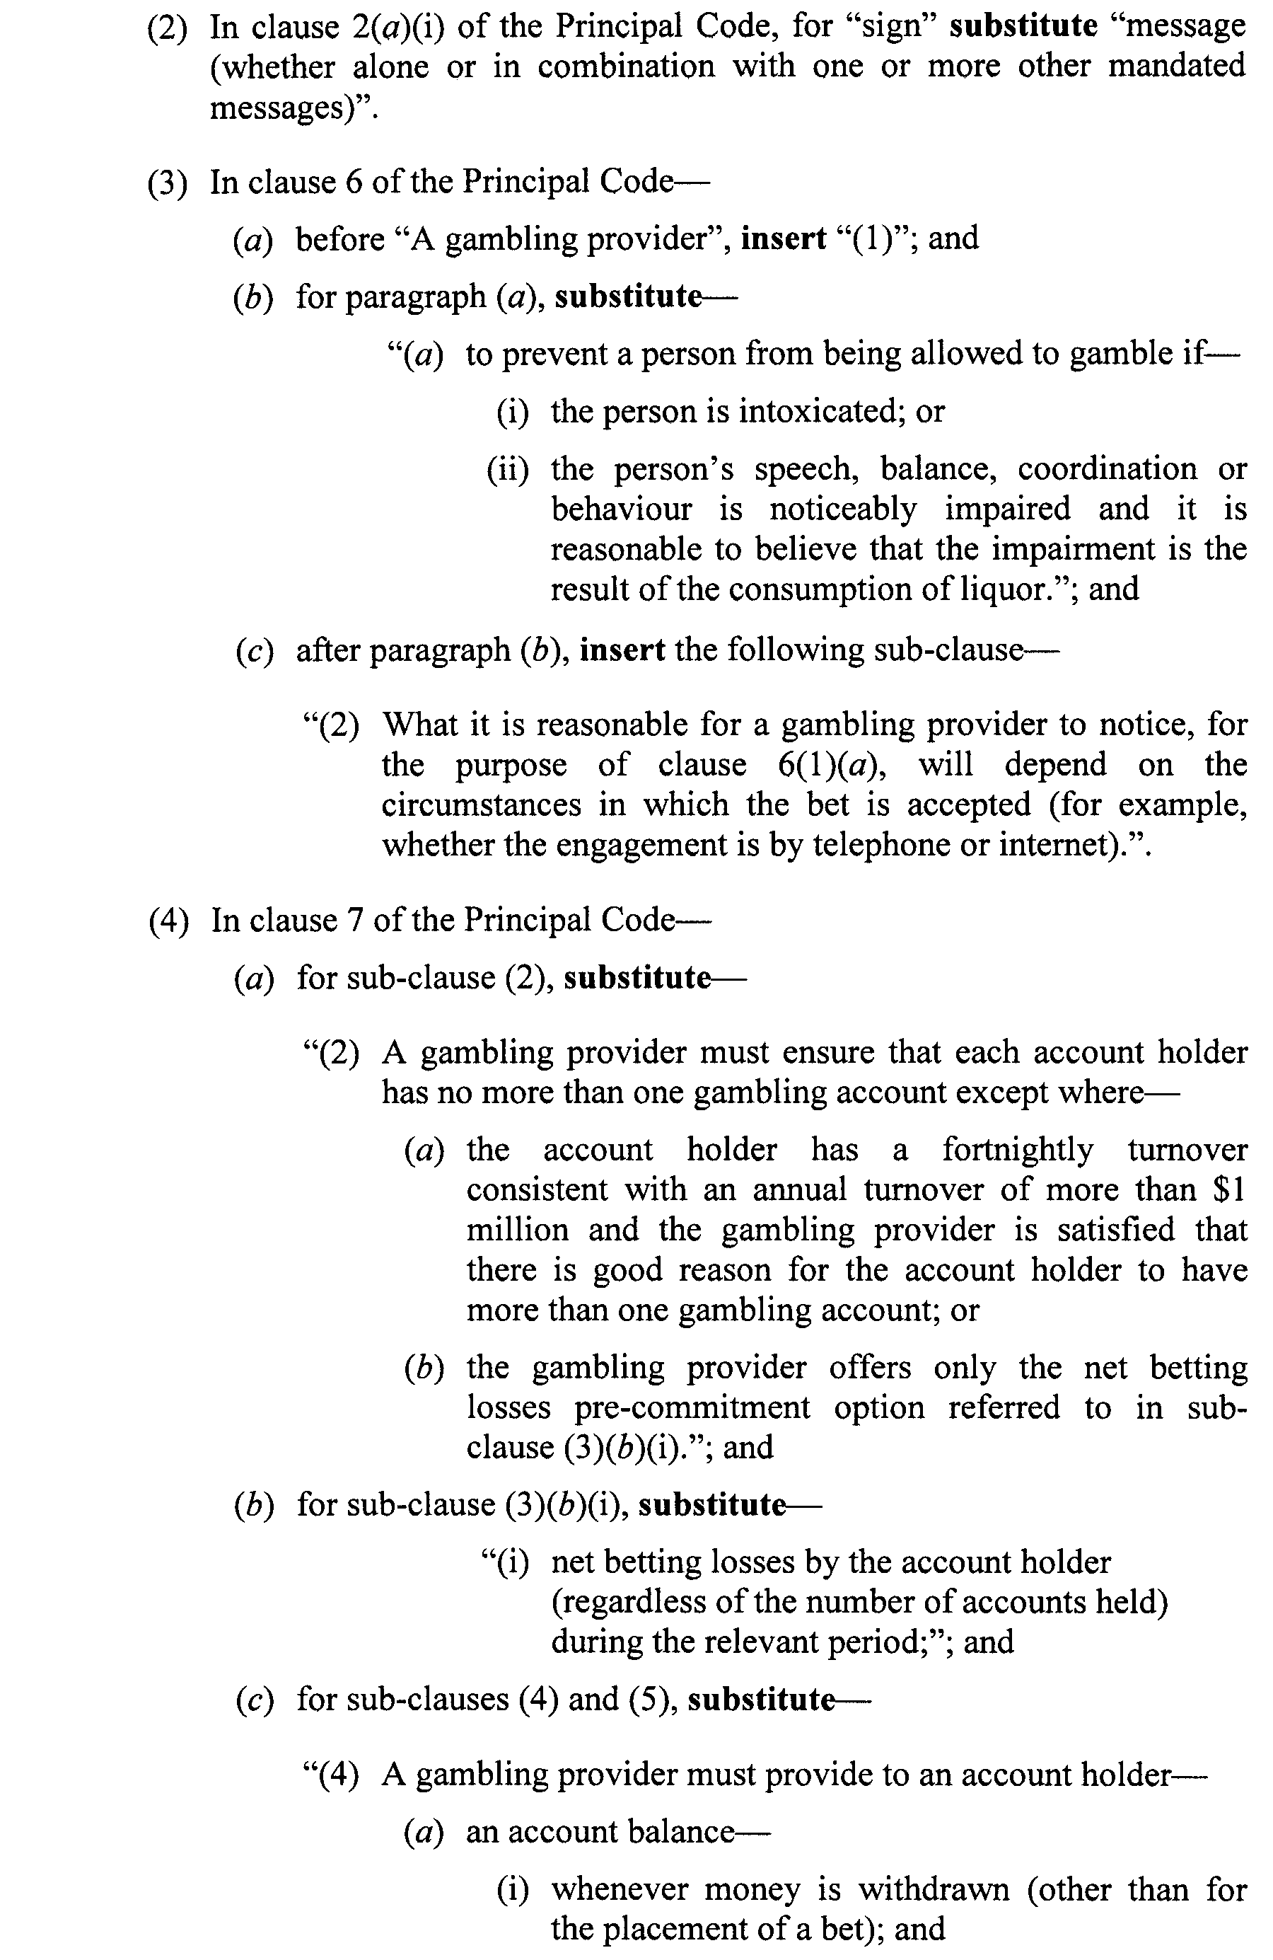
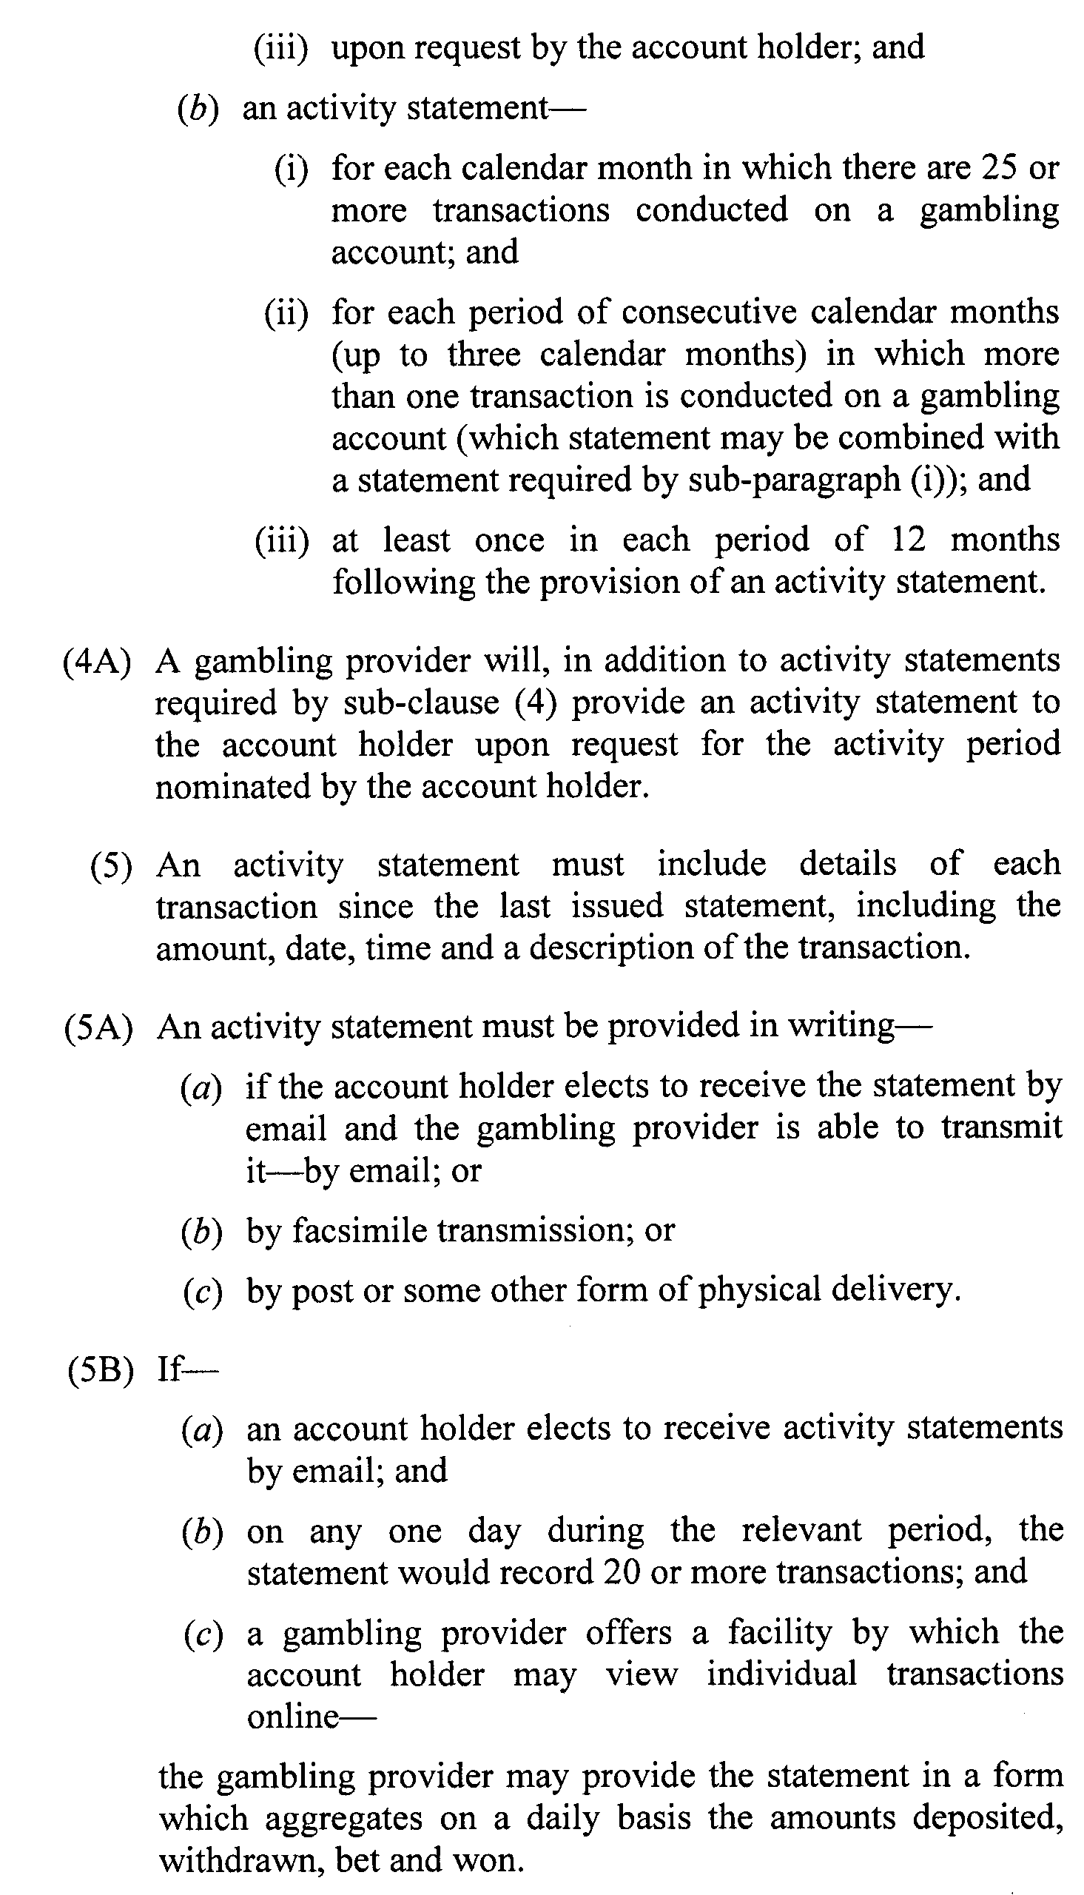
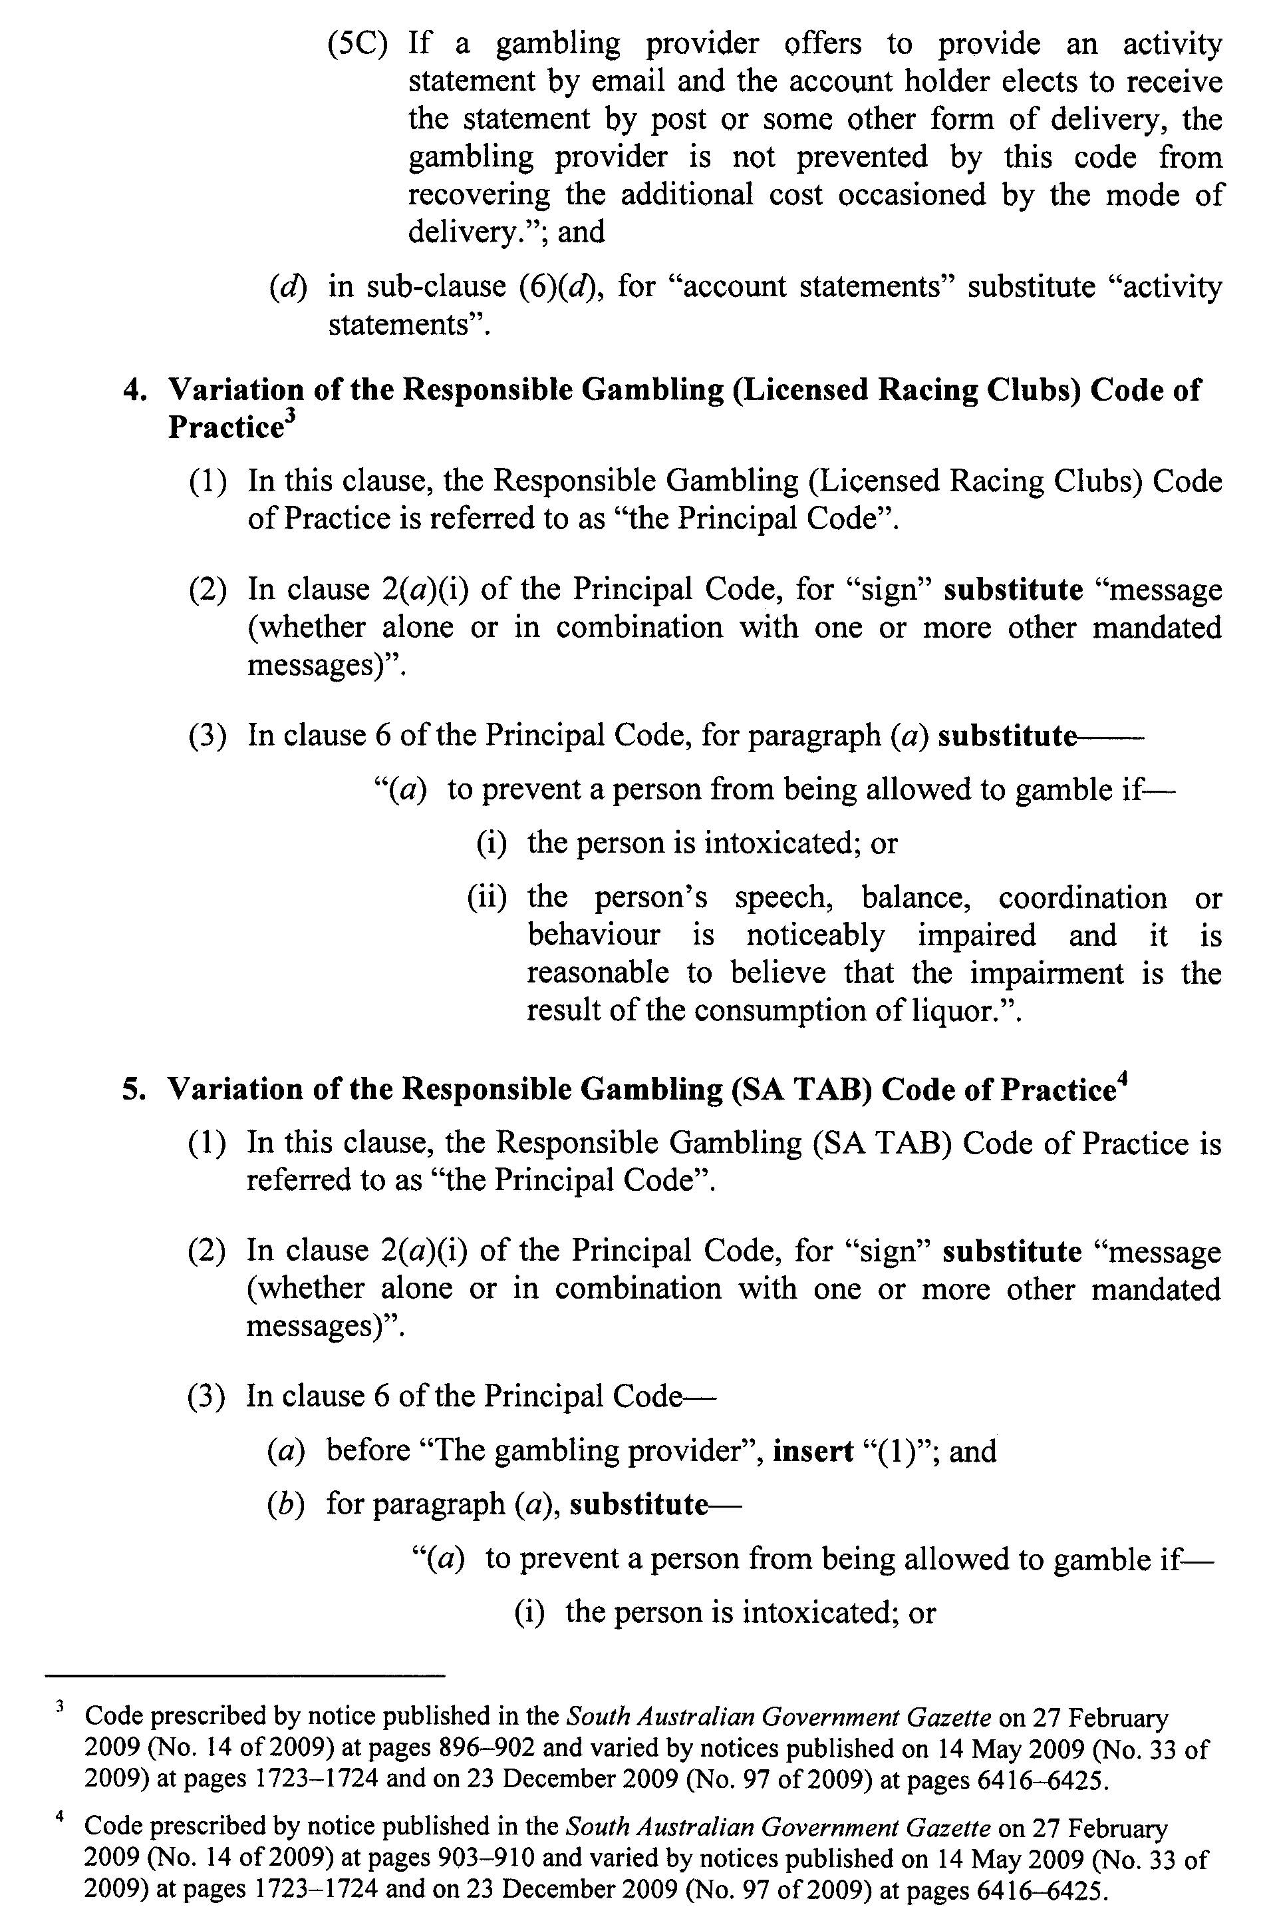
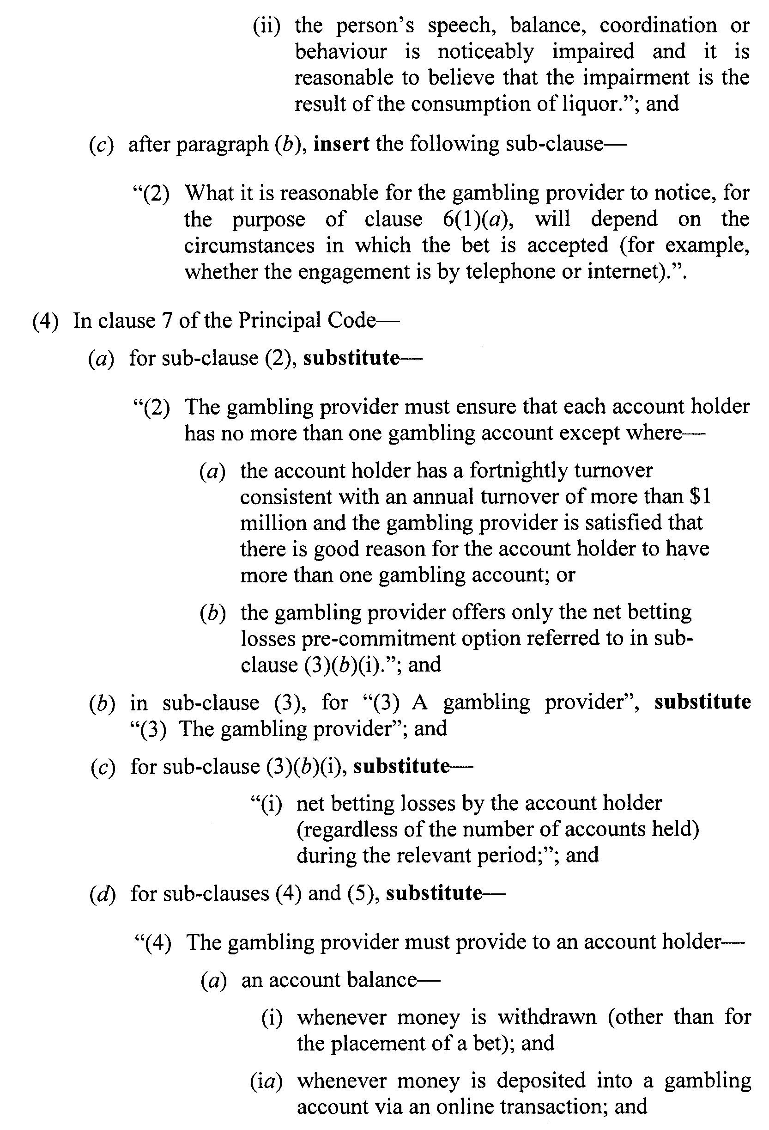
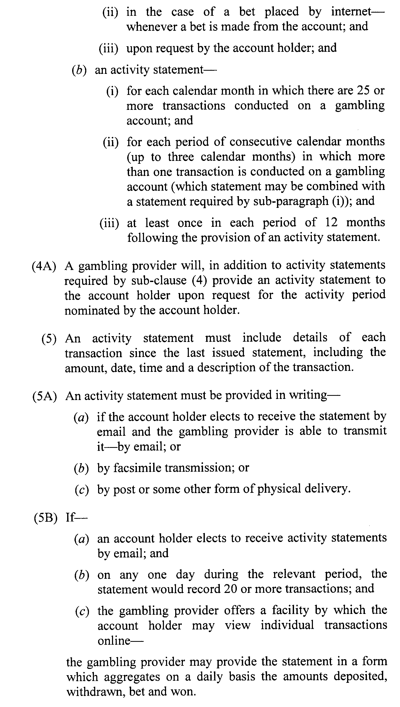

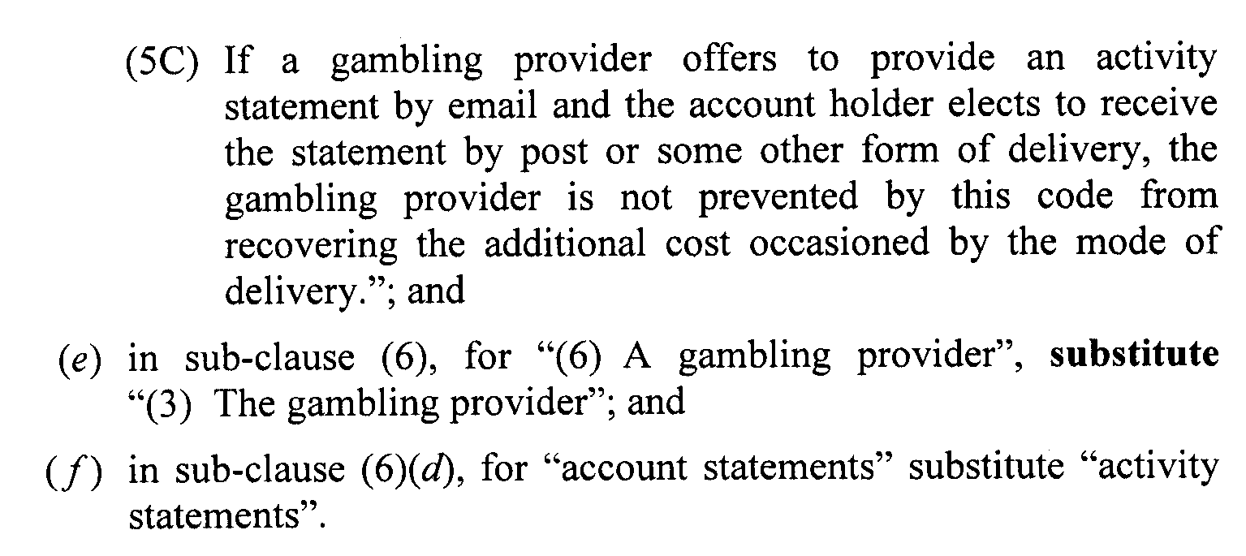

ELECTRICITY ACT 1996
Origin Energy’s Default Electricity Contract Prices for
Domestic and Business Customers
NOTICE under the Electricity Act 1996 by Origin Energy Electricity Limited (ABN 33 071 052 287) of Default Contract Prices for Small Customers pursuant to section 36AB of the Electricity Act 1996, notice is hereby given by Origin of its default contract prices for customers who are consuming less than 160 megawatt hours per annum of electricity (‘small customers’) and who are purchasing electricity under Origin’s default contract terms and conditions. The Default Contract Prices are set out below and will apply from 1 August 2010.
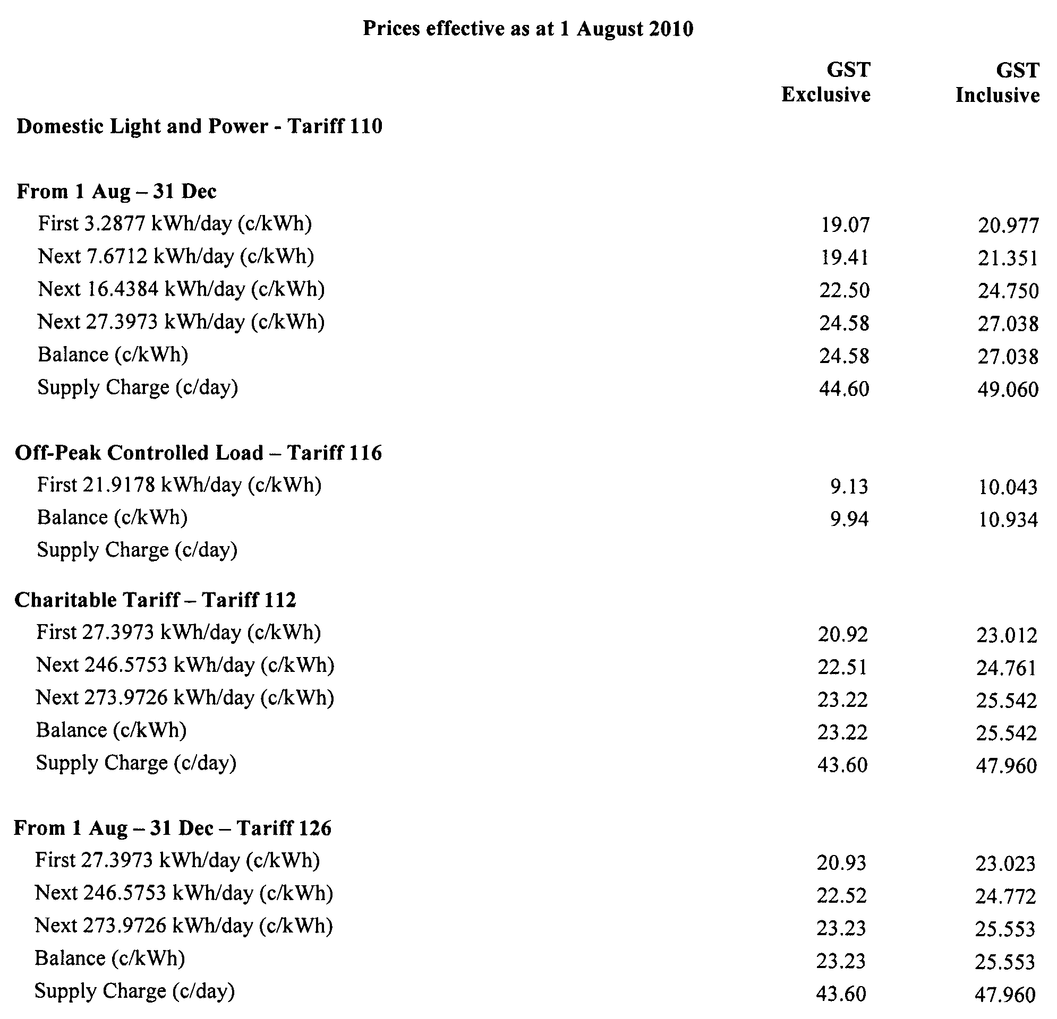
The default contract prices set out in this notice are the same as the standing contract prices for small customers as fixed by the Electricity Standing Contract Price Determination made by the Essential Services Commission of South Australia (‘ESCOSA’) on 30 November 2007.

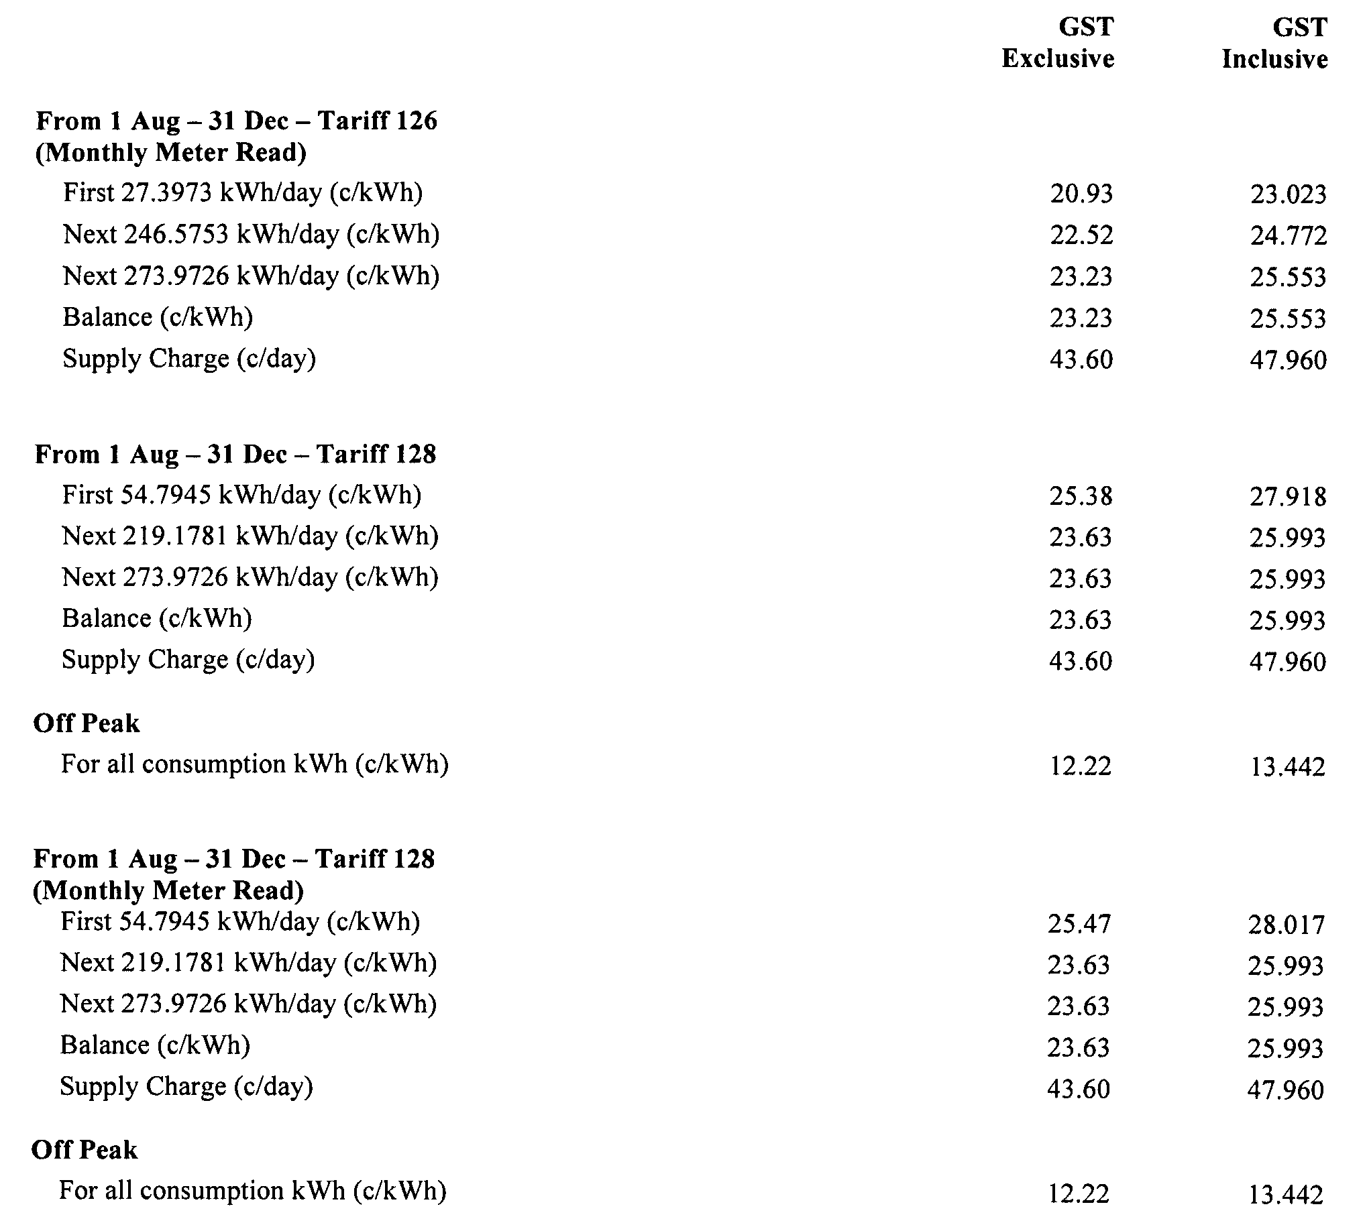
In addition to the charges or tariffs for the supply of electricity as set out above, customers should note that in certain circumstances Origin Energy Electricity Limited may require lodgement of security deposits or may impose fees and charges that are incidental to the supply of electricity to a customer, including but not limited to an account establishment fee, site call out fee, disconnection fee, reconnection fee, late payment fee, dishonoured cheque fee, monthly meter reading fee and special meter reading fee.
Further details are available from Origin’s National Customer Service Centre, phone 13 24 61.

ENVIRONMENT PROTECTION ACT 1993
Variation to Existing Approval of Collection Depot
I, ANDREA KAYE WOODS, Delegate of the Environment Protection Authority (‘the Authority’), pursuant to section 69 of the Environment Protection Act 1993 (SA) (‘the Act’) hereby:
Variation to Existing Approval of Collection Depot
Vary the approval of the collection depot listed at Schedule 1 of this notice, that was granted under the Act prior to the date of this Notice and impose the conditions of this approval to be as follows:
Approval of Collection Depot:
The collection depot identified by reference to the following matters is approved:
(a) the name of the collection depot described in Column 1 of Schedule 1 of this Notice;
(b) the name of the proprietor of the depot identified in Column 3 of Schedule 1 of this Notice;
(c) the location of the depot described in Columns 4-6 of Schedule 1 of this Notice; and
The collection depot listed at Schedule 1 of this Notice is approved in relation to all classes of containers, which were approved under the Act, at or subsequent to the date of this Notice, as Category B Containers.
Conditions of Approval:
Impose the following conditions on the approval:
(1) If the Approval Holder’s name or postal address (or both) changes, then the Approval Holder must inform the Authority in writing, within 28 days of the change occurring.
(2) If the collection depot is sold to another party, the Approval Holder must inform the Authority in writing, within 28 days of settlement.
(3) The Approval Holder who wishes to cease operation of the depot shall notify the Authority in writing, no less than 14 days from date of closing.
(4) The Approval Holder, or a person acting on his or her behalf, must not pay a refund on, or seek reimbursement for, containers that the Approval Holder, or the person acting on his or her behalf, knows were not purchased in South Australia.
(5) The Approval Holder must ensure that prominent signage is displayed, detailing the offence and the penalties under Section 69 of the Act, for presenting interstate containers for refund.
Schedule 1

Column 1 | Column 2 | Column 3 | Column 4 | Column 5 | Column 6
Depot Name | Company/Trading Name | Proprietors | Depot Location  Street | Depot Location  Suburb | Certificate of Title No.  Volume/Folio No.
Meningie Bottle  Yard | Meningie Bottle  Yard | Warren Eric Schultz | Corner of Princes Highway and Yumali Road | Meningie | —
Murray Bridge Recycling | Murray Bridge Recycling | Warren Eric Schultz | 56 Thomas Street | Murray Bridge | 1243/131, 1883/54
Strathalbyn Recycling | Strathalbyn Recycling Depot | Warren Eric Schultz | Dry Plains Road | Strathalbyn | 5352/882

GEOGRAPHICAL NAMES ACT 1991
For Public Consultation
Notice of Intention to Assign a Name to a Place
NOTICE is hereby given pursuant to the provisions of the above Act, that the Minister for Infrastructure seeks public comment on a proposal to assign the name MOUNT POONERY to that feature located on the 1:50 000 Wilmington Mapsheet (6532-4) as shown on the plan below.
The Plan
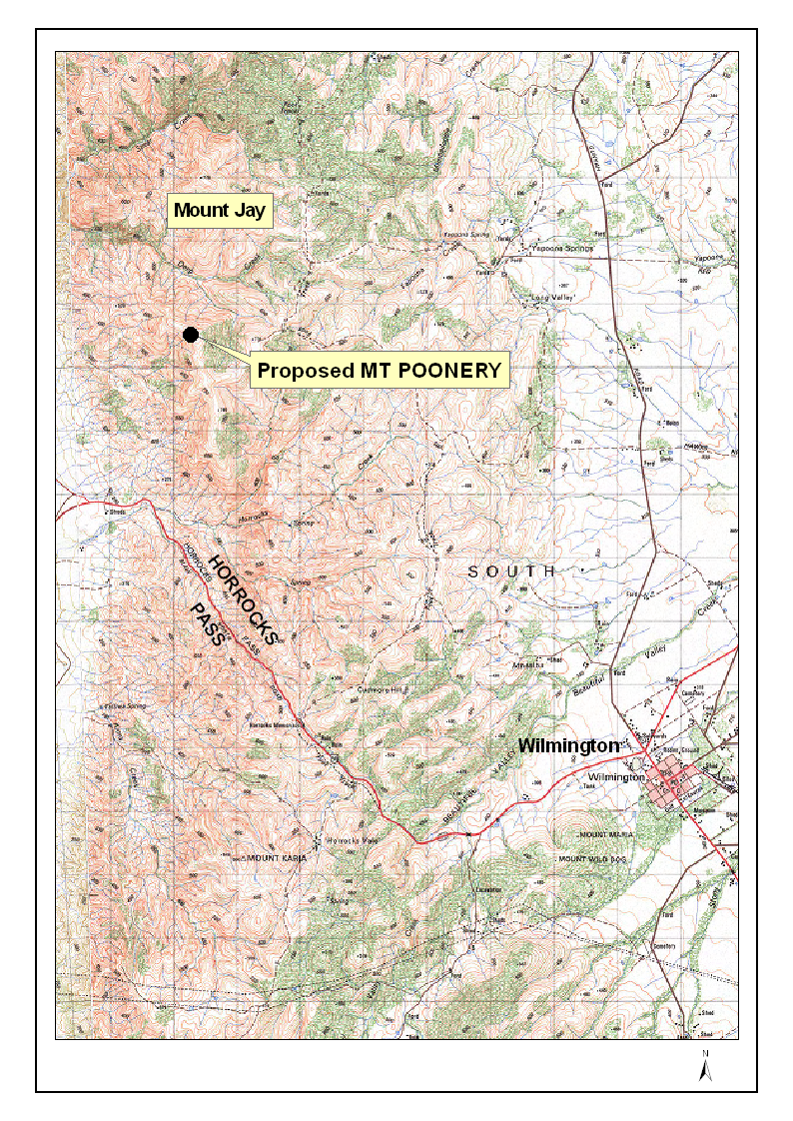
Submissions in writing regarding this proposal may be lodged with the Surveyor-General, G.P.O. Box 1354, Adelaide, S.A. 5001, within one month of the publication of this notice.
This Naming Proposal can be viewed on the Land Services web-site located at:
www.landservices.sa.gov.au/1Online_Services/55Place_Names/.
Dated 29 June 2010.
P. M. Kentish, Surveyor-General
DTEI.22-413/09/0020

LIQUOR LICENSING ACT 1997
Notice of Application
NOTICE is hereby given, pursuant to section 52 (2) (b) of the Liquor Licensing Act 1997, that Fiona Fu and Jun Guo have applied to the Licensing Authority for the transfer of a Restaurant Licence in respect of premises situated at 153 O’Connell Street, North Adelaide, S.A. 5006 and known as Saizen Sushi Bar.
The application has been set down for hearing on 17 August 2010 at 9 a.m.
Any person may object to the application by lodging a notice of objection in the prescribed form with the Liquor and Gambling Commissioner and serving a copy of the notice on the applicants at the applicants’ address, at least seven days before the hearing date (viz: 10 August 2010).
The applicants’ address for service is c/o Fiona Fu, 153 O’Connell Street, North Adelaide, S.A. 5006.
The application and certain documents and material (including Plans) relevant to the application may be inspected without fee at a place and during a period specified by the Liquor and Gambling Commissioner, 9th Floor, East Wing, 50 Grenfell Street, Adelaide, S.A. 5000. Telephone 8226 8410, Facsimile: 8226 8512. Email: olgc@agd.sa.gov.au.
Dated 8 July 2010.
Applicants

LIQUOR LICENSING ACT 1997
Notice of Application
NOTICE is hereby given, pursuant to section 52 (2) (b) of the Liquor Licensing Act 1997, that Pratt Wilksch Trading Pty Ltd has applied to the Licensing Authority for the transfer of a Restaurant Licence in respect of premises situated at Main Road, Lyndoch, S.A. 5351 and known as Lyndoch Bakery.
The application has been set down for hearing on 17 August 2010 at 9.30 a.m.
Any person may object to the application by lodging a notice of objection in the prescribed form with the Liquor and Gambling Commissioner and serving a copy of the notice on the applicant at the applicant’s address, at least seven days before the hearing date (viz: 10 August 2010).
The applicant’s address for service is c/o Caroline Wilksch, 14 Fern Street, Naracoorte, S.A. 5271.
The application and certain documents and material (including Plans) relevant to the application may be inspected without fee at a place and during a period specified by the Liquor and Gambling Commissioner, 9th Floor, East Wing, 50 Grenfell Street, Adelaide, S.A. 5000. Telephone 8226 8410, Facsimile: 8226 8512. Email: olgc@agd.sa.gov.au.
Dated 8 July 2010.
Applicant

LIQUOR LICENSING ACT 1997
Notice of Application
NOTICE is hereby given, pursuant to section 52 (2) (b) of the Liquor Licensing Act 1997, that George Antoniou and Evan John Thanos have applied to the Licensing Authority for the transfer of a Restaurant Licence in respect of premises situated at Shop 11, Magnet Shopping Centre, 10 Coromandel Parade, Blackwood, S.A. 5051 and known as Rocco’s Cafe—Blackwood.
The application has been set down for hearing on 17 August 2010 at 10 a.m.
Any person may object to the application by lodging a notice of objection in the prescribed form with the Liquor and Gambling Commissioner and serving a copy of the notice on the applicants at the applicants’ address, at least seven days before the hearing date (viz: 10 August 2010).
The applicants’ address for service is c/o George Antoniou, 37 Devon Street North, Goodwood, S.A. 5034.
The application and certain documents and material (including Plans) relevant to the application may be inspected without fee at a place and during a period specified by the Liquor and Gambling Commissioner, 9th Floor, East Wing, 50 Grenfell Street, Adelaide, S.A. 5000. Telephone 8226 8410, Facsimile: 8226 8512. Email: olgc@agd.sa.gov.au.
Dated 8 July 2010.
Applicants

LIQUOR LICENSING ACT 1997
Notice of Application
NOTICE is hereby given, pursuant to section 52 (2) (b) of the Liquor Licensing Act 1997, that Pocket Wines Pty Ltd, 19 The Parade, Norwood, S.A. 5067 has applied to the Licensing Authority for a Direct Sales Licence has applied to the Licensing in respect of the business to be known as Pocket Wines Pty Ltd.
The application has been set down for hearing on 17 August 2010 at 11 a.m.
Any person may object to the application by lodging a notice of objection in the prescribed form with the Liquor and Gambling Commissioner and serving a copy of the notice on the applicant at the applicant’s address, at least seven days before the hearing date (viz: 10 August 2010).
The applicant’s address for service is c/o Susan C. Chenery Barristers and Solicitors, 206/160 Fullarton Road, Rose Park, S.A. 5067 (Attention: Susan Chenery).
The application and certain documents and material (including Plans) relevant to the application may be inspected without fee at a place and during a period specified by the Liquor and Gambling Commissioner, 9th Floor, East Wing, 50 Grenfell Street, Adelaide, S.A. 5000. Telephone 8226 8410, Facsimile: 8226 8512. Email: olgc@agd.sa.gov.au.
Dated 9 July 2010.
Applicant

LIQUOR LICENSING ACT 1997
Notice of Application
NOTICE is hereby given, pursuant to section 52 (2) (b) of the Liquor Licensing Act 1997, that Mount Gambier Harness Racing Club Inc. has applied to the Licensing Authority for a Club Licence in respect of premises situated at Pick Avenue, Mount Gambier, S.A. 5290 and to be known as Mount Gambier Harness Racing Club.
The application has been set down for hearing on 17 August 2010 at 11.30 a.m.
Any person may object to the application by lodging a notice of objection in the prescribed form with the Liquor and Gambling Commissioner and serving a copy of the notice on the applicant at the applicant’s address, at least seven days before the hearing date (viz: 10 August 2010).
The applicant’s address for service is c/o Phil Wood, P.O. Box 623, Mount Gambier, S.A. 5290.
The application and certain documents and material (including Plans) relevant to the application may be inspected without fee at a place and during a period specified by the Liquor and Gambling Commissioner, 9th Floor, East Wing, 50 Grenfell Street, Adelaide, S.A. 5000. Telephone 8226 8410, Facsimile: 8226 8512. Email: olgc@agd.sa.gov.au.
Dated 12 July 2010.
Applicant

LIQUOR LICENSING ACT 1997
Notice of Application
NOTICE is hereby given, pursuant to section 52 (2) (b) of the Liquor Licensing Act 1997, that Jetty (SA) Pty Ltd as trustee for Dougherty-Allanson Family Trust has applied to the Licensing Authority for a Producer’s Licence in respect of premises situated at 48 Main Road, Normanville, S.A. 5204 and to be known as Jetty Food Store.
The application has been set down for hearing on 18 August 2010 at 11.30 a.m.
Any person may object to the application by lodging a notice of objection in the prescribed form with the Liquor and Gambling Commissioner and serving a copy of the notice on the applicant at the applicant’s address, at least seven days before the hearing date (viz: 11 August 2010).
The applicant’s address for service is c/o Peta Dougherty-Allanson, P.O. Box 39, Delamere, S.A. 5204.
The application and certain documents and material (including Plans) relevant to the application may be inspected without fee at a place and during a period specified by the Liquor and Gambling
Commissioner, 9th Floor, East Wing, 50 Grenfell Street, Adelaide, S.A. 5000. Telephone 8226 8410, Facsimile: 8226 8512. Email: olgc@agd.sa.gov.au.
Dated 12 July 2010.
Applicant

LIQUOR LICENSING ACT 1997
Notice of Application
NOTICE is hereby given, pursuant to section 52 (2) (b) of the Liquor Licensing Act 1997, that Coondambo Pastoral Co. Pty Ltd as trustee for Coondambo Land Trust, Coondambo Station, Sturt Highway, Glendambo, S.A. 5710 has applied to the Licensing Authority for a Direct Sales Licence in respect of the business to be known as Springfarm Cottage.
The application has been set down for hearing on 16 August 2010 at 10.30 a.m.
Any person may object to the application by lodging a notice of objection in the prescribed form with the Liquor and Gambling Commissioner and serving a copy of the notice on the applicant at the applicant’s address, at least seven days before the hearing date (viz: 9 August 2010).
The applicant’s address for service is c/o Rick and Julie Mould, Coondambo Station, PMB 103, via Port Augusta, S.A. 5710.
The application and certain documents and material (including Plans) relevant to the application may be inspected without fee at a place and during a period specified by the Liquor and Gambling Commissioner, 9th Floor, East Wing, 50 Grenfell Street, Adelaide, S.A. 5000. Telephone 8226 8410, Facsimile: 8226 8512. Email: olgc@agd.sa.gov.au.
Dated 7 July 2010.
Applicant

LIQUOR LICENSING ACT 1997
Notice of Application
NOTICE is hereby given, pursuant to section 52 (2) (b) of the Liquor Licensing Act 1997, that Endeavor Foundation Endowment Challenge Fund Limited as trustee for Endeavor Foundation Endowment Challenge Fund, 4 Elizabeth Street, Tanunda, S.A. 5352 has applied to the Licensing Authority for a Direct Sales Licence in respect of the business to be known as Endeavour Foundation Wine Club.
The application has been set down for hearing on 16 August 2010 at 11.30 a.m.
Any person may object to the application by lodging a notice of objection in the prescribed form with the Liquor and Gambling Commissioner and serving a copy of the notice on the applicant at the applicant’s address, at least seven days before the hearing date (viz: 9 August 2010).
The applicant’s address for service is c/o Teusner & Co., P.O. Box 70, Tanunda, S.A. 5352 (Attention: Julia Woithe).
The application and certain documents and material (including Plans) relevant to the application may be inspected without fee at a place and during a period specified by the Liquor and Gambling Commissioner, 9th Floor, East Wing, 50 Grenfell Street, Adelaide, S.A. 5000. Telephone 8226 8410, Facsimile: 8226 8512. Email: olgc@agd.sa.gov.au.
Dated 8 July 2010.
Applicant

LIQUOR LICENSING ACT 1997
Notice of Application
NOTICE is hereby given, pursuant to section 52 (2) (b) of the Liquor Licensing Act 1997, that Kenton Hill Vineyards Pty Ltd has applied to the Licensing Authority for Redefinition and variation to Conditions in respect of premises situated at Lot 34, Gumeracha—Lobethal Road, Gumeracha, S.A. 5072 and known as Protero Wines.
The application has been set down for hearing on 16 August 2010 at 11 a.m.
Conditions
The following licence conditions are sought:
• Redefinition to include a new upper floor office and store room and to include sampling as per plans lodged with this office.
• Variation to Conditions to remove the following conditions from the licence:
- The operation of the licensed premises is restricted to ‘House Activity’;
- The Activity is limited to a maximum of floor area of
30 m²;
- No goods shall be displayed around the building for retail sales. There shall be no cellar door sales or wine tastings undertaking from the premises;
- Only one other person who is not a resident of the dwelling can be employed in the business;
- No commercial vehicles over one tonne tare are to be used by the business for deliveries.
• Approval is sought under section 39 (1) (e) to sell the licensee’s product at any time for consumption within the approved tasting area.
Any person may object to the application by lodging a notice of objection in the prescribed form with the Liquor and Gambling Commissioner and serving a copy of the notice on the applicant at the applicant’s address, at least seven days before the hearing date (viz: 9 August 2010).
The applicant’s address for service is c/o David Watts and Associates, 1 Cator Street, Glenside, S.A. 5065 (Attention: David Watts).
The application and certain documents and material (including Plans) relevant to the application may be inspected without fee at a place and during a period specified by the Liquor and Gambling Commissioner, 9th Floor, East Wing, 50 Grenfell Street, Adelaide, S.A. 5000. Telephone 8226 8410, Facsimile: 8226 8512. Email: olgc@agd.sa.gov.au.
Dated 9 July 2010.
Applicant

LIQUOR LICENSING ACT 1997
Notice of Application
NOTICE is hereby given, pursuant to section 52 (2) (b) of the Liquor Licensing Act 1997, that The Boathouse Osborne Pty Ltd has applied to the Licensing Authority for a Redefinition in respect of premises situated at 481-483 Victoria Road, Taperoo, S.A. 5017 and known as the Boathouse Tavern Osborne.
The application has been set down for hearing on 2 August 2010 at 10.30 a.m.
Conditions
The following licence conditions are sought:
• Redefinition to include an outdoor smoking area adjacent to Area 5 as per plans lodged with this office.
Any person may object to the application by lodging a notice of objection in the prescribed form with the Liquor and Gambling Commissioner and serving a copy of the notice on the applicant at the applicant’s address, at least thee days before the hearing date (viz: 30 July 2010).
The applicant’s address for service is c/o Andrew John, 481 Victoria Road, Taperoo, S.A. 5017.
The application and certain documents and material (including Plans) relevant to the application may be inspected without fee at a place and during a period specified by the Liquor and Gambling Commissioner, 9th Floor, East Wing, 50 Grenfell Street, Adelaide, S.A. 5000. Telephone 8226 8410, Facsimile: 8226 8512. Email: olgc@agd.sa.gov.au.
Dated 6 July 2010.
Applicant

LIQUOR LICENSING ACT 1997
Notice of Application
NOTICE is hereby given, pursuant to section 52 (2) (b) of the Liquor Licensing Act 1997, that NSN Pty Ltd as trustee for NSN Family Trust, Fotops Corporation Pty Ltd as trustee for Fotopoulos Family Trust, D. Langley Financial Services Pty Ltd as trustee for CH Family Trust, A. & S. Hamra & Sons Nominees Pty Ltd as trustee for A. & S. Hamra Family Trust have applied to the Licensing Authority for the transfer of a Restaurant Licence in respect of premises situated at 4 John Street, Salisbury, S.A. 5108 and known as Caffe Acqua.
The application has been set down for hearing on 12 August 2010 at 11 a.m.
Any person may object to the application by lodging a notice of objection in the prescribed form with the Liquor and Gambling Commissioner and serving a copy of the notice on the applicants at the applicants’ address, at least seven days before the hearing date (viz: 5 August 2010).
The applicants’ address for service is c/o Pace Lawyers, 192 Gilbert Street, Adelaide, S.A. 5000 (Attention: Ben McKay).
The application and certain documents and material (including Plans) relevant to the application may be inspected without fee at a place and during a period specified by the Liquor and Gambling Commissioner, 9th Floor, East Wing, 50 Grenfell Street, Adelaide, S.A. 5000. Telephone 8226 8410, Facsimile: 8226 8512. Email: olgc@agd.sa.gov.au.
Dated 6 July 2010.
Applicants

LIQUOR LICENSING ACT 1997
Notice of Application
NOTICE is hereby given, pursuant to section 52 (2) (b) of the Liquor Licensing Act 1997, that Robe Golf Club Inc. has applied to the Licensing Authority for a Club Licence with Extended Trading Authorisation and Entertainment Consent in respect of premises situated at 129 Morphett Street, Robe, S.A. 5276 and to be known as Robe Golf Club Inc.
The application has been set down for hearing on 16 August 2010 at 10 a.m.
Conditions
The following licence conditions are sought:
• Extended Trading Authorisation is sought for the licensed premises as per plans lodged with this office and for the following days and times:
Monday to Saturday: Midnight to 1 a.m. the following day;
Sunday: 8 a.m. to 11 a.m. and 8 p.m. to midnight;
Good Friday: Midnight to 1 a.m.;
Christmas Day: Midnight to 1 a.m.;
Sunday Christmas Eve: 8 p.m. to 1 a.m. the following day;
Days preceding other Public Holidays: Midnight to 1 a.m. the following day;
Sundays preceding Public Holidays: 8 p.m. to 1 a.m. the following day.
• Entertainment Consent is sought for the licensed premises as per plans lodged with this office and for the following days and times:
Friday and Saturday: 8 p.m. to 1 a.m. the following day;
Sunday: Midday to 9 p.m.
Any person may object to the application by lodging a notice of objection in the prescribed form with the Liquor and Gambling Commissioner and serving a copy of the notice on the applicant at the applicant’s address, at least seven days before the hearing date (viz: 9 August 2010).
The applicant’s address for service is c/o Westley DiGiorgio, P.O. Box 1265, Naracoorte, S.A. 5271 (Attention: Peter Westley).
The application and certain documents and material (including Plans) relevant to the application may be inspected without fee at a place and during a period specified by the Liquor and Gambling Commissioner, 9th Floor, East Wing, 50 Grenfell Street, Adelaide, S.A. 5000. Telephone 8226 8410, Facsimile: 8226 8512. Email: olgc@agd.sa.gov.au.
Dated 7 July 2010.
Applicant

MINING ACT 1971
NOTICE is hereby given in accordance with section 28 (5) of the Mining Act 1971, that the Minister for Mineral Resources Development proposes to grant an Exploration Licence over the undermentioned area:
Applicant: Lincoln Minerals Limited
Location: Cockabidnie North area—Approximately 35 km south-south-west of Kimba.
Term: 2 years
Area in km²: 11
Ref: 2010/00020
Plan and co-ordinates can be found on the PIRSA website: http://www.pir.sa.gov.au/minerals/public_notices or by phoning Mineral Tenements on (08) 8463 3103.
J. Martin, Mining Registrar

MINING ACT 1971
NOTICE is hereby given in accordance with section 28 (5) of the Mining Act 1971, that the Minister for Mineral Resources Development proposes to grant an Exploration Licence over the undermentioned area:
Applicant: SAPEX Limited
Location: Weira Plain area—Approximately 90 km east-north-east of Port Augusta.
Term: 2 years
Area in km²: 87
Ref.: 2010/00025
Plan and co-ordinates can be found on the PIRSA website: http://www.pir.sa.gov.au/minerals/public_notices or by phoning Mineral Tenements on (08) 8463 3103.
J. Martin, Mining Registrar

MINING ACT 1971
NOTICE is hereby given in accordance with section 28 (5) of the Mining Act 1971, that the Minister for Mineral Resources Development proposes to grant an Exploration Licence over the undermentioned area:
Applicant: Red Metal Limited
Location: Anna Villa area—Approximately 20 km south of Moonta.
Term: 2 years
Area in km²: 40
Ref.: 2010/00060
Plan and co-ordinates can be found on the PIRSA website: http://www.pir.sa.gov.au/minerals/public_notices or by phoning Mineral Tenements on (08) 8463 3103.
J. Martin, Mining Registrar

MINING ACT 1971
NOTICE is hereby given in accordance with section 28 (5) of the Mining Act 1971, that the Minister for Mineral Resources Development proposes to grant an Exploration Licence over the undermentioned area:
Applicant: Teck Australia Pty Ltd
Location: Mount Clarence area—Approximately 40 km north-west of Coober Pedy.
Pastoral Leases: Mabel Creek, Mount Clarence and Mount Willoughby.
Term: 2 years
Area in km²: 477
Ref.: 2010/00076
Plan and co-ordinates can be found on the PIRSA website: http://www.pir.sa.gov.au/minerals/public_notices or by phoning Mineral Tenements on (08) 8463 3103.
J. Martin, Mining Registrar

MINING ACT 1971
NOTICE is hereby given in accordance with section 28 (5) of the Mining Act 1971, that the Minister for Mineral Resources Development proposes to grant an Exploration Licence over the undermentioned area.
Applicant: Teck Australia Pty Ltd
Location: Leonard Rise area—Approximately 15 km south-west of Coober Pedy.
Pastoral Lease: Mount Clarence
Term: 1 year
Area in km²: 296
Ref.: 2010/00077
Plan and co-ordinates can be found on the PIRSA website: http://www.pir.sa.gov.au/minerals/public_notices or by phoning Mineral Tenements on (08) 8463 3103.
J. Martin, Mining Registrar

MOTOR VEHICLES ACT 1959
Recognised Historical Motor Vehicle Club
NOTICE is hereby given that the undermentioned club is recognised as an historic motor vehicle club in accordance with Schedule 1, Clause 3 (3) (a) of the Motor Vehicles Act 1959:
RS Owners Club SA
Dated 6 July 2010.
M. Small, Registrar of Motor Vehicles

PETROLEUM AND GEOTHERMAL ENERGY ACT 2000
Statement of Environmental Objectives for
Existing Regulated Activities
PURSUANT to section 104 (1) of the Petroleum and Geothermal Energy Act 2000 (‘the Act’), I, Barry Alan Goldstein, Director Petroleum and Geothermal, Minerals and Energy Resources Division, Department of Primary Industries and Resources SA, Delegate of the Minister for Mineral Resources Development, pursuant to Delegation dated 1 October 2009, Gazetted 1 October 2009, do hereby publish the following document as having been approved as a statement of environmental objectives under the Act:
Document:
1. Santos, South Australia Cooper Basin, Statement of Environmental Objectives: Production and Processing Operations, June 2010.
This document is available for public inspection on the Environmental Register section of the Petroleum and Geothermal Group’s website (www.pir.sa.gov.au/petrol/envreg) or at the Public Office determined pursuant to section 107 (1) of the Act to be at:
Office of Minerals and Energy Resources,
Customer Services,
Level 7, 101 Grenfell Street,
Adelaide, S.A. 5000.
Dated 15 July 2010.
B. A. Goldstein,
Director Petroleum and Geothermal
Minerals and Energy Resources
Primary Industries and Resources SA
Delegate of the Minister for Mineral
Resources Development

LOTTERY AND GAMING ACT 1936
LOTTERY AND GAMING REGULATIONS 2008
Instrument of Authorisation
I, TOM KOUTSANTONIS, Minister for Gambling, hereby authorise the persons for the time being holding or acting in positions within the Office of the Liquor and Gambling Commissioner, Attorney General’s Department, to exercise for me and on my behalf the powers, functions, duties or responsibilities vested in, imposed on or delegated to the Minister for Gambling under the Lottery and Gaming Act 1936 (‘the Act’), as described in the third column of Schedule 1. I also delegate the powers and functions conferred upon me by the Lottery and Gaming Regulations 2008 (‘the Regulations’) as described in Schedule 2 below. In doing so, I expressly revoke all previous authorisations conferred by the Act and the Regulations.
This Instrument of authorisation is to take effect at 12.00 a.m. on Monday, 5 July 2010.
Dated 7 July 2010.
Tom Koutsantonis, Minister for Gambling

Schedule 1
Authorisation of Functions/Powers under the Lottery and Gaming Act 1936
to Positions within the Office of the Liquor and Gambling Commissioner

Section | Description | Authorised Position
17 (2) | To refuse to grant a licence if satisfied that the applicant is not a fit and proper person to hold a licence under this Part. | Liquor and Gambling Commissioner;  Deputy Commissioner Gambling  Assistant Commissioner Compliance;  Assistant Commissioner Licensing;  Assistant Liquor and Gambling Commissioner;  General Manager Business Services.
18 (1) | To grant a licence under Part 3 of the Act, subject to such conditions as the Minister thinks fit and specifies in the licence. | Liquor and Gambling Commissioner;  Deputy Commissioner Gambling  Assistant Commissioner Compliance;  Assistant Commissioner Licensing;  Assistant Liquor and Gambling Commissioner;  General Manager Business Services;  Manager Applications;  Manager Assessments;  Team Leader Lottery Licensing.
18 (2) | To vary or revoke a condition of a licence by notice in writing to the licence holder. | Liquor and Gambling Commissioner;  Deputy Commissioner Gambling  Assistant Commissioner Compliance;  Assistant Commissioner Licensing;  Assistant Liquor and Gambling Commissioner;  General Manager Business Services;  Manager Applications;  Manager Assessments;  Team Leader Lottery Licensing.
19 (2) | To renew the licence for a period of one year, if application for renewal and payment of the prescribed fee is made before the expiry of a licence under Part 3 of the Act. | Liquor and Gambling Commissioner;  Deputy Commissioner Gambling  Assistant Commissioner Compliance;  Assistant Commissioner Licensing;  Assistant Liquor and Gambling Commissioner;  General Manager Business Services;  Manager Applications;  Manager Assessments;  Team Leader Lottery Licensing.
19 (3) | To renew a licence, notwithstanding its expiry, if the Minister thinks it appropriate in any particular case. | Liquor and Gambling Commissioner;  Deputy Commissioner Gambling  Assistant Commissioner Compliance;  Assistant Commissioner Licensing;  Assistant Liquor and Gambling Commissioner;  General Manager Business Services;  Manager Applications;  Manager Assessments;  Team Leader Lottery Licensing.
20 (1) | To cancel a licence, by written notice to the holder of a licence, if the holder of the licence obtained the grant of the licence improperly.  To cancel or suspend a licence, by written notice to the holder of a licence, for a specified time or until further notice, if the holder of the licence contravened a provision of the Act or a condition of the licence. | Liquor and Gambling Commissioner;  Deputy Commissioner Gambling  Assistant Commissioner Compliance;  Assistant Commissioner Licensing;  Assistant Liquor and Gambling Commissioner;  General Manager Business Services.
21 (1) | To appoint such Public Service employees as lottery inspectors as may be necessary for the purposes of this Act. | Liquor and Gambling Commissioner.
21 (2) | To provide each inspector with a certificate of identity. | Liquor and Gambling Commissioner.

Schedule 2
Authorisation of Functions/Powers under the Lottery and Gaming Regulations 2008
to Positions within the Office of the Liquor and Gambling Commissioner

Regulation | Description | Authorised Position
 | To exercise all the powers, functions, duties or responsibilities vested in, imposed on or delegated to the Minister for Gambling as conferred by the Regulations except for the powers, functions, duties or responsibilities in Regulation 4 of the Regulations. | Liquor and Gambling Commissioner;  Deputy Commissioner Gambling;  Assistant Commissioner Compliance;  Assistant Commissioner Licensing;  Assistant Liquor and Gambling Commissioner;  General Manager Business Services;  Manager Applications;  Manager Assessments;  Manager Audit and Investigations;  Senior Consultant Lottery Licensing;  Team Leader Lottery Licensing.

ROAD TRAFFIC ACT 1961
NOTICE OF APPROVAL
Under Section 161A of the Road Traffic Act 1961
OPERATION OF CONTROLLED ACCESS BUSES IN SOUTH AUSTRALIA
1. REVOCATION OF PREVIOUS NOTICE AND OTHER EXEMPTION INSTRUMENTS
1.1. I hereby revoke the Notice of Approval and Exemption, titled ‘Operation of Controlled Access Buses in South Australia’ published in the South Australian Government Gazette on 19 May 2005.
1.2. I hereby revoke all Supplementary Notices of Approval, titled ‘Operation of Controlled Access Buses in South Australia’ as published in the South Australian Government Gazette that vary the conditions to and are read in conjunction with the Notice of Approval and Exemption identified in Clause 1.1 above.
2. APPROVAL
2.1 I hereby approve Controlled Access Buses to travel on Approved Routes subject to the conditions and limitations specified in this Notice.
3. CONDITIONS AND LIMITATIONS APPLYING TO THIS NOTICE
3.1 When you are operating under this Notice you must:
3.1.1 operate at all times in accordance with the conditions and limitations specified in the ‘Code of Practice for Controlled Access Buses’ dated July 2010 issued by the DTEI;
3.1.2 operate only on the approved routes as indicated on the maps specific to Controlled Access Buses posted on the DTEI Internet Site and in accordance with any conditions and limitations specified on those maps;
3.1.3 carry at all times a legible, current and complete copy of:
(i) this Notice;
(ii) the ‘Code of Practice for Controlled Access Buses’ dated July 2010; and
(iii) all current approved Controlled Access Bus Route Network map(s) (as appropriate) specific to the entire route being travelled/operated on during the particular journey being undertaken, including more specific detailed maps of routes and townships where available.
3.1.4 Produce any or all of the documents indicated in 3.1.3 above when requested by a DTEI Authorised Officer appointed under the Road Traffic Act 1961 or a Police Officer.
4. DEFINITIONS
4.1 For the purposes of this Notice:
4.1.1 A ‘Controlled Access Bus’ is a rigid bus, over 12.5 m long but not over 14.5 m long, as defined in the Road Traffic (Vehicle Standards) Rules 1999 and the Road Traffic (Miscellaneous) Regulations 1999.
4.1.2 ‘Approved Routes’ are roads that the Minister for Transport (or the Minister’s Delegate) has approved for the operation of Controlled Access Buses in accordance with section 161A of the Road Traffic Act 1961.
4.1.3 ‘DTEI’ means the Department for Transport, Energy and Infrastructure in South Australia.
5. COMMENCEMENT OF THIS NOTICE
5.1 This notice is valid from 12:01 a.m. on 1 August 2010.
6. AUTHORISATION
Dated 13 July 2010.
Brian Hemming,
Acting Executive Director, Safety and Regulation Division
Department for Transport, Energy & Infrastructure

ROAD TRAFFIC ACT 1961
NOTICE OF APPROVAL AND EXEMPTION
Pursuant to Sections 161A and 163AA of the Road Traffic Act 1961
HIGHER MASS LIMITS FOR VEHICLES FITTED WITH ROAD FRIENDLY SUSPENSION
1. REVOCATION OF PREVIOUS NOTICES
1.1 I hereby revoke the Notice of Approval and Exemption titled ‘Higher Mass Limits for Vehicles Fitted with Road Friendly Suspensions’ published in the South Australian Government Gazette, dated 17 September 2009.
2. APPROVAL
2.1 I hereby approve heavy vehicle configurations (as detailed in Table 1 of this Notice) that are fitted with Road Friendly Suspension to travel on Approved Routes subject to the conditions and limitations specified in this Notice.
2.2 For the purpose of this Notice, ‘Approved Routes’ are roads that the Minister for Transport (or the Minister’s Delegate) has approved for the operation of heavy vehicle configurations (as detailed in Table 1 of this Notice) that are fitted with Road Friendly Suspension in accordance with section 161A of the Road Traffic Act 1961.
3. EXEMPTION
3.1 I hereby exempt heavy vehicles from the following provisions of the Road Traffic (Mass and Loading Requirements) Regulations 1999:
3.1.1 Schedule 1, Part 1—Mass Limits, Table 1—Mass Limits for Single Axle and Axle Groups, in so far as it relates to axle or axle mass limits for axle or axle group configurations specified in Table 2 of this Notice.
3.1.2 Schedule 1, Part 1—Mass Limits, Clause 3 (1), (2) and (3) Mass Limits relating to axle spacing.
3.1.3 Schedule 1, Part 1, Clause 4 (1) Mass limits for combinations.
4. CONDITIONS
4.1 This Notice of Approval and Exemption is subject to the following conditions:
4.1.1 Approved Vehicles
4.1.1.1 Only the vehicles and/or combinations nominated in Table 1 of this Notice with the corresponding configuration codes and which have an axle, axles or axle group(s) fitted with Road Friendly Suspension are approved to operate at Higher Mass Limits under this Notice.
Table 1
Vehicle Configuration |  | Registration Configuration Code
a | Rigid Trucks fitted with a tandem drive axle group and operated without a trailer. | 2R3, 2R4, MR3, MR4, LR3, LR4, SR3, SR4
b | Articulated vehicles where the prime mover is fitted with a tandem drive axle group and the semi trailer is fitted with either a tandem or triaxle group. | SP3, SP4  TS2, TS3
c | Buses fitted with a single drive axle or a six tyred tandem axle group (which includes the drive axle) at the rear. | 2B2, 2B3
4.1.2 Vehicle Specifications
4.1.2.1 Vehicles operating under this Notice must not be driven or loaded in excess of:
4.1.2.1.1 the manufacturer’s rating for axle, suspension, tyre or coupling capacities; or
4.1.2.1.2 the manufacturer’s Gross Vehicle Mass or Gross Combination Mass ratings; or
4.1.2.1.3 the Gross Vehicle Mass and/or Gross Combination Mass as shown on the certificate of registration for that vehicle.
4.1.2.2 Vehicles must include at least one axle or axle group fitted with certified Road Friendly Suspension to be eligible for Higher Mass Limits under this Notice. Vehicles fitted with Road Friendly Suspension must have a valid Road Friendly Suspension certification plate affixed.
4.1.3 Routes
4.1.3.1 Vehicle configurations specified in Table 1 of this Notice must operate only on the approved routes specified in the maps titled ‘Route Network for Higher Mass Limits (HML) Vehicles’ posted on the DTEI Internet Site and in accordance with any conditions and limitations specified on those maps.
4.1.3.2 Vehicle combinations (other than Rigid Truck and Trailers) registered under the Commonwealth of Australia Interstate Road Transport Act 1985, operating at higher mass may operate on the routes specified in the Commonwealth of Australia Gazette notice titled ‘Determination of Routes for Vehicles, Other than B-Doubles and Rigid Truck and Trailer Combinations, Carrying Higher Mass Limits Under the Federal Interstate Registration Scheme (FIRS)’.
4.1.4 Axle Mass Limits and Axle Spacing
4.1.4.1 The total mass on the axle or axle group must not exceed the limits listed in Table 2 or Table 3 of this Notice for the specified axle or axle group.
4.1.4.2 The Higher Mass Limits specified in Table 2 of this Notice only apply to axles or axle groups fitted with a Road Friendly Suspension.
Table 2
Axle or Axle Group Configuration | General Mass Limit (tonnes) | Higher Mass Limit under this Notice (tonnes)
Single drive axle on buses fitted with  4 tyres | 9.0 | 10.0
Tandem axle groups fitted with 6 tyres | 13.0 | 14.0
Tandem axle groups fitted with 8 tyres | 16.5 | 17.0
Triaxle group fitted with 12 tyres | 20.0 | 22.5
4.1.4.3 In relation to only vehicle combination ‘b’ in Table 1 of this Notice, the mass on an axle or axle group not fitted with a Road Friendly Suspension must not exceed the limits specified in Table 3 of this Notice for the specified axle or axle group.
Table 3
Axle Group Configuration | General Mass Limit (tonnes) | Mass Limit under this Notice (tonnes)
Tandem axle groups fitted with 8 tyres | 16.5 | 17.0
Triaxle group fitted with 12 tyres | 20.0 | 21.0
Explanatory Note
The axle mass limits in Table 3 provide equity for those vehicles which are also eligible for operation under the Gazette Notice titled ‘Concessional Mass Limits for Vehicles Accredited in the Mass Management module of the National Heavy Vehicle Accreditation Scheme (NHVAS)’. Operators should note that the use of Road Friendly Suspension is encouraged on as many axles as possible. On triaxle groups, an additional 1.5 tonnes per axle group is allowed and for tandem axle groups, significantly reduced road wear results from Road Friendly Suspension.
4.1.4.4 Vehicles must comply with axle spacing appropriate to statutory mass limits (commonly referred to as the General Mass Limits) contained in Schedule 1, Part 1, Clause 3 of the Road Traffic (Mass and Loading Requirements) Regulations 1999.
4.1.4.5 The total mass of a vehicle combination may only exceed 42.5 tonnes by the amount that the sum of the masses of the axle or axle groups operating at higher mass limits exceed the mass limits specified in the columns titled General Mass Limit (tonnes) in Tables 2 and 3 above.
4.1.5 Mass Management Accreditation
4.1.5.1 Vehicles or vehicle configurations fitted with a triaxle group loaded in accordance with the Higher Mass Limits in Table 2 of this Notice, or where any axle or axle group is specified and loaded in accordance with Table 3 of this Notice, must be accredited under the Mass Management Module of the NHVAS.
4.1.5.2 The Prime Mover must display a valid NHVAS (Mass Module) label.
4.1.5.3 All tri-axle trailers in the vehicle combination, when loaded in accordance with the Higher Mass Limits in Table 2 of this Notice, must display a valid NHVAS (Mass Module) label, where displaying labels on trailers is a requirement of the accrediting agency.
4.1.5.4 Drivers of vehicles accredited in South Australia that are not operating under the IAP must carry documented evidence (which may be the Route Compliance Certificate) of route planning, confirming that a higher mass limit route is available by reference to the maps contained in this Notice, in accordance with Standard 4 (Records and Documentation) of the Mass Management Module of the NHVAS and shall produce the signed documented evidence if requested by an Authorised Officer appointed under the Road Traffic Act 1961, or a Police Officer.
4.1.5.4.1 Where a form other than a Route Compliance Certificate is used, the form must record the equivalent information that is required on the Route Compliance Certificate including axle and gross weight, route to be traversed, be dated and signed by the driver prior the commencement of the journey.
4.1.5.5 Vehicles accredited in states and territories other than South Australia under the scheme specified in 4.1.5.1 may operate in South Australia under the terms and conditions and on the routes detailed in this Notice provided;
4.1.5.5.1 the driver has determined that a higher mass limit route is available for the entire route intended to be travelled by reference to the maps described in 4.1.3, and
if not operating under the IAP:
(i) records the route details on the DTEI Higher Mass Limit Route Compliance Certificate and has signed the Certificate;
(ii) carries the completed Route Compliance Certificate in the vehicle when operating at higher mass limits; and
(iii) produces the Route Compliance Certificate if requested by an Authorised Officer appointed under the Road Traffic Act 1961, or a Police Officer; and
4.1.5.5.2 the scheme member retains the original copy of any Route Compliance Certificate for a period of not less than 12 months from the date it is signed for auditing purposes.
Explanatory Note
Only vehicles or vehicle combinations that are not operating under the IAP and include triaxle groups operating at higher mass limits are required to carry documented evidence of route compliance (e.g. DTEI Higher Mass Limit Route Compliance Certificate) when operating in South Australia under the terms and conditions and on the routes detailed in this Notice.
4.1.6 Documentation
4.1.6.1 When operating under this Notice, you must:
4.1.6.1.1 carry at all times a legible, current and complete copy of:
(i) this Notice;
(ii) all current approved ‘Route Network for Higher Mass Limits (HML) Vehicles’ route network map(s) specific to the entire route being travelled/operated on during the particular journey being undertaken, including more specific detailed maps of routes and townships where available; and
(iii) if not operating under the IAP, a completed Route Compliance certificate.
4.1.6.1.2 Produce any or all of the documents indicated in 4.1.6.1.1 above when requested by a DTEI Authorised Officer appointed under the Road Traffic Act 1961 or a Police Officer
4.2 Except as otherwise specified in this Notice, the standard form conditions prescribed in the Road Traffic (Oversize or Overmass Vehicle Exemptions) Regulations 1999 for the purposes of section 115 of the Act, shall not apply.
5. DEFINITIONS
5.1 For the purpose of this Notice the following definitions shall apply:
5.1.1 ‘Approved Intelligent Transport System’ means an intelligent transport system approved for the purposes of the IAP by Transport Certification Australia Limited (TCA).
5.1.2 ‘Authorised Officer’ means a DTEI Authorised Officer appointed under the Road Traffic Act 1961.
5.1.3 ‘DTEI’ means the South Australian Department for Transport, Energy and Infrastructure.
5.1.4 ‘Intelligent Access Program’ (IAP) means a program to allow heavy vehicles to have access, or improved access, to the road network in return for monitoring, by an approved intelligent transport system of their compliance with specified access conditions.
5.1.5 ‘Mass Management Accreditation Scheme’ means a scheme that is recognised by DTEI as meeting the requirement of the mass management module (including audit requirements) of the National Heavy Vehicle Accreditation Scheme (NHVAS).
5.1.6 ‘National Heavy Vehicle Accreditation Scheme’ (NHVAS) means the comprehensive accreditation package developed by the then National Road Transport Commission (now known as National Transport Commission (NTC)) and approved by the Australian Transport Council on 14 November 1997.
5.1.7 ‘Road Friendly Suspension’ means a suspension system certified as complying with the performance criteria detailed in the Commonwealth Department of Infrastructure, Transport, Regional Development and Local Government (DITRDLG) Vehicle Standards Bulletin 11—Certification of Road Friendly Suspension Systems, July 2004.
5.1.8 ‘Route Compliance Certificate’ means the DTEI Higher Mass Limit Route Compliance Certificate as available on the DTEI website.
5.1.9 ‘Valid National Heavy Vehicle Accreditation Scheme (Mass Module) label’ means a label:
5.1.9.1 issued to a scheme member (whose accreditation status has not been suspended or cancelled); and
5.1.9.2 that is legible and displayed on the nominated vehicle (owned or captured by the operator) for which the label was originally issued by the accrediting authority.
6. COMMENCEMENT OF THIS NOTICE
6.1 This Notice is valid from 12.01 a.m. on 30 July 2010.
7. AUTHORISATION
Brian E. Hemming,
Director, Transport Safety Regulation
for and on behalf of the Executive Director,
Safety and Regulation Division
Department for Transport, Energy & Infrastructure

ROAD TRAFFIC ACT 1961
NOTICE OF APPROVAL AND EXEMPTION
Pursuant to Sections 161A and 163AA of the Road Traffic Act 1961
OPERATION OF B-DOUBLE VEHICLES UP TO 25 M IN LENGTH
1. REVOCATION OF PREVIOUS NOTICE AND OTHER EXEMPTION INSTRUMENTS
1.1 I hereby revoke the Notice of Approval and Exemption, titled ‘Operation of B-Double Vehicles up to 25 m in Length’ published in the Government Gazette 18 October 2007.
2. APPROVAL
2.1 I hereby approve B-Doubles up to an overall length not exceeding 25 m, to operate on Approved Routes subject to the conditions and limitations specified in this Notice.
2.2 For the purpose of this Notice, ‘Approved Routes’ are roads that the Minister for Transport (or the Minister’s Delegate) has approved for the operation of B-Doubles in accordance with section 161A of the Road Traffic Act 1961.
3. EXEMPTION
3.1 I hereby exempt B-Doubles up to an overall length not exceeding 25 m from the following provisions of the:
3.1.1 Road Traffic (Mass and Loading Requirements) Regulations 1999—Schedule 1, Table 1, in so far as it relates to:
(i) tandem axle group fitted with dual tyres (8 tyres—for any vehicle other than a pig trailer 16.5 tonnes); and
(ii) triaxle group fitted with dual tyres (12 tyres—for any vehicle other than a pig trailer 20 tonnes); and
3.1.2 Road Traffic (Vehicle Standards) Rules 1999—Rule 72 (1)—Height (4.3 m),
3.2 This exemption is subject to the conditions and limitations specified in this Notice.
4. CONDITIONS AND LIMITATIONS APPLYING TO THIS NOTICE
4.1 When operating under this Notice you must:
4.1.1 Operate at all times in accordance with the conditions and limitations specified in the ‘Code of Practice for B-Doubles’, dated July 2010 as issued by the Department for Transport, Energy and Infrastructure (DTEI) as amended from time to time.
4.1.2 If operating at General Mass Limits, only operate on the approved routes shown on DTEI’s maps titled ‘Route Network for B-Double Vehicles up to 25 m in Length General Mass Limits (GML)’ posted on the DTEI Internet Site and in accordance with any conditions and limitations specified in those maps.
4.1.3 If operating at Higher Mass Limits only operate on the approved routes shown on DTEI’s maps titled ‘Route Network for B-Double Vehicles up to 25 m in Length Higher Mass Limits (HML)’ posted on the DTEI Internet Site and in accordance with any conditions and limitations specified in those maps.
4.1.4 If carrying a defined commodity, operate at General Mass Limits on the approved routes shown on DTEI’s maps titled ‘Commodity Routes for B-Doubles’ posted on the DTEI Internet Site and in accordance with any conditions and limitations specified in those maps.
4.1.5 If operating a B-Double accredited under the Mass Management Module of the National Heavy Vehicle Accreditation Scheme in a State or Territory other than South Australia at Higher Mass Limits but not operating under the IAP, complete and sign the Route Compliance Certificate.
4.1.6 Carry at all times a legible, current and complete copy of:
(i) this Notice;
(ii) the ‘Code of Practice for B-Doubles’, dated July 2010 issued by DTEI;
(iii) all current approved 25 m B-Double route network map(s) specific to the entire route being travelled/operated on during the particular journey being undertaken, including more specific detailed maps of routes and townships where available; and
(iv) if operating at Higher Mass Limits but not operating under the IAP, a completed Route Compliance Certificate.
4.1.7 Produce any or all of the documents indicated in 4.1.6 above when requested by a DTEI Authorised Officer appointed under the Road Traffic Act 1961 or a Police Officer.
Information Note
The current approved route network maps for B-Doubles are available from www.sa.gov.au/heavyvehicles or from a DTEI or Service SA Customer Service Centre
5. DEFINITIONS
5.1 For the purposes of this Notice:
5.1.1 A ‘B-Double’ is a vehicle combination consisting of a prime mover towing two semi-trailers where:
(i) the first semi-trailer is connected to the prime mover by a fifth wheel coupling; and
(ii) the second semi-trailer is connected to the first semi-trailer by a fifth wheel coupling; and
(iii) the constructed overall length of the combination does not exceed 25 m, unless permitted under the conditions of a separate Notice.
5.1.2 ‘Approved Intelligent Transport System’ means an intelligent transport system approved for the purposes of the IAP by Transport Certification Australia Limited (TCA)
5.1.3 ‘Approved Routes’ are roads that the Minister for Transport (or the Minister’s Delegate) has approved for the operation of Road Trains in accordance with section 161A of the Road Traffic Act 1961.
5.1.4 ‘DTEI’ means the South Australian Department for Transport, Energy and Infrastructure.
5.1.5 ‘Intelligent Access Program’ (IAP) means a program to allow heavy vehicles to have access, or improved access, to the road network in return for monitoring, by an approved intelligent transport system of their compliance with specified access conditions.
5.1.6 ‘Route Compliance Certificate’ means the DTEI Higher Mass Limit Route Compliance Certificate as available on the DTEI website.
6. COMMENCEMENT OF THIS NOTICE
6.1 This Notice is valid from 12.01 a.m. on 30 July 2010.
7. AUTHORISATION
Brian E. Hemming,
Director, Transport Safety Regulation
for and on behalf of the Executive Director,
Safety and Regulation Division
Department for Transport, Energy and Infrastructure
Authorised Delegate for the Minister for Transport

ROAD TRAFFIC ACT 1961
NOTICE OF APPROVAL AND EXEMPTION
Pursuant to Sections 161A and 163AA of the Road Traffic Act 1961
OPERATION OF ROAD TRAIN VEHICLES IN SOUTH AUSTRALIA
1. REVOCATION OF PREVIOUS NOTICE AND OTHER EXEMPTION INSTRUMENTS
1.1 I hereby revoke the Notice of Approval and Exemption, titled ‘Operation of Road Train Vehicles in South Australia’ published in the South Australian Government Gazette on 1 May 2008.
2. APPROVAL
2.1 I hereby approve Road Trains to operate on Approved Routes subject to the conditions and limitations specified in this Notice.
3. EXEMPTION
3.1 I hereby exempt Road Trains from the following provisions of the:
3.1.1 Road Traffic (Mass and Loading Requirements) Regulations 1999 Schedule 1, Table 1, in so far as it relates to:
(i) tandem axle group fitted with dual tyres (8 tyres—for any vehicle other than a pig trailer 16.5 tonnes); and
(ii) triaxle group fitted with dual tyres (12 tyres—for any vehicle other than a pig trailer 20 tonnes); and
3.1.2 Road Traffic (Vehicle Standards) Rules 1999 Rule 66 (1)—Width, (2.5 m).
3.1.3 Road Traffic (Vehicle Standards) Rules 1999 Rule 72 (1)—Height, (4.3 m).
3.1.4 Road Traffic (Vehicle Standards) Rules 1999 Rule 169 (c)—Coupling Height.
3.2 This exemption is subject to the conditions and limitations specified in this Notice.
4. CONDITIONS AND LIMITATIONS APPLYING TO THIS NOTICE
4.1 When you are operating under this Notice you must:
4.1.1 Operate at all times in accordance with the conditions and limitations specified in the ‘Code of Practice for Road Trains’, dated July 2010, issued by the DTEI.
4.1.2 Not exceed the lesser of 40 km/h or the posted limit within the following localities;
(i) a 50 or 60 km/h limit zone in Caltowie;
(ii) a 50 or 60 km/h limit zone in Gladstone;
(iii) a 50 or 60 km/h limit zone in Jamestown;
(iv) a 50 or 60 km/h limit zone in Orroroo;
(v) a 50 or 60 km/h limit zone in Peterborough;
(vi) a 50 or 60 km/h limit zone in Port Augusta;
(vii) a 50 or 60 km/h limit zone in Port Pirie;
(viii) a 50 or 60 km/h limit zone in Whyalla;
(ix) a 50 or 60 km/h limit zone in Yongala;
(x) within 200 m of the Peterborough—Mannanarie Road junction.
4.1.3 If operating at General Mass Limits, only operate on the approved routes shown on DTEI’s maps titled ‘Route Network for Road Trains General Mass Limits’ posted on the DTEI Internet Site and in accordance with any conditions and limitations specified in those maps.
4.1.4 If operating at Higher Mass Limits, only operate on the approved routes shown on DTEI’s maps titled ‘Route Network for Road Trains Higher Mass Limits’ posted on the DTEI Internet Site and in accordance with any conditions and limitations specified in those maps.
4.1.5 If operating as a prime mover and semi trailer towing a converter dolly at General Mass Limits, only operate on the approved routes shown on DTEI’s maps titled ‘Converter Dolly Route Network General Mass Limits’ posted on the DTEI Internet Site and in accordance with any conditions and limitations specified in those maps.
4.1.6 If operating as a prime mover and semi trailer towing a converter dolly at Higher Mass Limits, only operate on the approved routes shown on DTEI’s maps titled ‘Converter Dolly Route Network Higher Mass Limits’ posted on the DTEI Internet Site and in accordance with any conditions and limitations specified in those maps.
4.1.7 If carrying a defined commodity, operate at General Mass Limits on the approved routes shown on DTEI’s maps titled ‘Commodity Routes for Road Trains’ posted on the DTEI Internet Site and in accordance with any conditions and limitations specified in those maps.
4.1.8 If operating a Road Train accredited under the Mass Management Module of the National Heavy Vehicle Accreditation Scheme in a State or Territory other than South Australia at Higher Mass Limits but not operating under the IAP, complete and sign a Route Compliance Certificate for the journey being undertaken.
4.1.9 Carry at all times a legible, current and complete copy of:
(i) this Notice; and
(ii) the ‘Code of Practice for Road Trains’, dated July 2010 issued by DTEI; and
(iii) all current approved Road Train and Converter Dolly route network map(s) (as appropriate) specific to the entire route being travelled/operated on during the particular journey being undertaken, including more specific detailed maps of routes and townships where available, and
(iv) a current driver medical certificate where you are required to undergo and pass a medical examination; and
(v) if operating at Higher Mass Limits but not operating under the IAP, a completed Route Compliance Certificate.
4.1.10 Produce any or all of the documents indicated in 4.1.7 above when requested by a DTEI Authorised Officer appointed under the Road Traffic Act 1961 or a Police Officer.
Information Note
Operators of restricted Access vehicles operating under IAP are not required to complete and carry a
Route Compliance Certificate.
The current approved route network maps for Road Trains are available from the DTEI Internet site at:
www.sa.gov.au/heavyvehicles
or from a DTEI or Service SA Customer Service Centre.

5. DEFINITIONS
5.1 For the purposes of this Notice:
5.1.1 A ‘Road Train’ is a vehicle combination consisting of a prime mover towing:
(i) a semi trailer and a converter dolly; or
(ii) two trailers, where a converter dolly supporting a semi trailer is counted as a single trailer (double road train); or
(iii) two trailers as described above (double road train) and an additional converter dolly (considered to be a triple road train); or
(iv) three trailers, where a converter dolly supporting a semi trailer is counted as a single trailer (triple road train).
5.1.2 ‘Approved Intelligent Transport System’ means an intelligent transport system approved for the purposes of the IAP by Transport Certification Australia Limited (TCA).
5.1.3 ‘Approved Routes’ are roads that the Minister for Transport (or the Minister’s Delegate) has approved for the operation of Road Trains in accordance with section 161A of the Road Traffic Act 1961.
5.1.4 ‘DTEI’ means the South Australian Department for Transport, Energy and Infrastructure.
5.1.5 ‘Intelligent Access Program’ (IAP) means a program to allow heavy vehicles to have access, or improved access, to the road network in return for monitoring, by an approved intelligent transport system of their compliance with specified access conditions.
5.1.6 ‘Route Compliance Certificate’ means the DTEI Higher Mass Limit Route Compliance Certificate as available on the DTEI website.
6. COMMENCEMENT OF THIS NOTICE
6.1 This Notice is valid from 12.01 a.m. on 30 July 2010.
7. AUTHORISATION
Brian E. Hemming,
Director, Transport Safety Regulation
for and on behalf of the Executive Director,
Safety and Regulation Division
Department for Transport, Energy and Infrastructure
Authorised Delegate for the Minister for Transport

NATIONAL PARKS AND WILDLIFE (NATIONAL PARKS) REGULATIONS 2001
Closure of Kelly Hill Conservation Park
PURSUANT to Regulations 8 (3) (a), 8 (3) (d) of the National Parks and Wildlife (National Parks) Regulations 2001, I, Edward Gregory Leaman, Director of National Parks and Wildlife close to the public part of Kelly Hill Conservation Park from 6 a.m. on Tuesday, 21 September 2010 until 6 a.m. on Friday, 24 September 2010.
The closure applies to the whole of the reserve west of Easting 670000, Zone 53S (Universal Transverse Mercator Projection—Geocentric Datum of Australia 1994), including the area known as ‘Grassdale’.
The purpose of the closure is to ensure the safety of the public during a pest control and monitoring program within the reserve during the period indicated.
Use of Firearms Within the Reserve
Pursuant to Regulations 8 (4), 20 (1) and 41 of the National Parks Regulations 2001, I, Edward Gregory Leaman, Director of National Parks and Wildlife grant permission to staff employed by the Kangaroo Island Natural Resources Management Board, in possession of both a current hunting permit and a firearms licence to enter and remain in Kelly Hill Conservation Park from 6 a.m. on Tuesday, 21 September 2010 until 6 a.m. on Friday, 24 September 2010 for the purpose of taking feral animals.
This permission is conditional upon the observance by each of those persons of the requirements of the National Parks and Wildlife Act 1972, National Parks Regulations 2001 and the National Parks and Wildlife (Hunting) Regulations 1996, including those requiring compliance with the Director’s requests, requirements and orders of a Warden.
Dated 13 July 2010.
E. G. Leaman, Director of National Parks and Wildlife

NATIONAL PARKS AND WILDLIFE (NATIONAL PARKS) REGULATIONS 2001
Closure of Kelly Hill Conservation Park
PURSUANT to Regulations 8 (3) (a), 8 (3) (d) of the National Parks and Wildlife (National Parks) Regulations 2001, I, Edward Gregory Leaman, Director of National Parks and Wildlife close to the public part of Kelly Hill Conservation Park from 6 a.m. on Tuesday, 16 November 2010 until 6 a.m. on Friday, 19 November 2010.
The closure applies to the whole of the reserve west of Easting 670000, Zone 53S (Universal Transverse Mercator Projection—Geocentric Datum of Australia 1994), including the area known as ‘Grassdale’.
The purpose of the closure is to ensure the safety of the public during a pest control and monitoring program within the reserve during the period indicated.
Use of Firearms Within the Reserve
Pursuant to Regulations 8 (4), 20 (1) and 41 of the National Parks Regulations 2001, I, Edward Gregory Leaman, Director of National Parks and Wildlife grant permission to staff employed by the Kangaroo Island Natural Resources Management Board, in possession of both a current hunting permit and a firearms licence to enter and remain in Kelly Hill Conservation Park from 6 a.m. on Tuesday, 16 November 2010 until 6 a.m. on Friday, 19 November 2010 for the purpose of taking feral animals.
This permission is conditional upon the observance by each of those persons of the requirements of the National Parks and Wildlife Act 1972, National Parks Regulations 2001 and the National Parks and Wildlife (Hunting) Regulations 1996, including those requiring compliance with the Director’s requests, requirements and orders of a Warden.
Dated 13 July 2010.
E. G. Leaman, Director of National Parks and Wildlife

NATIONAL PARKS AND WILDLIFE (NATIONAL PARKS) REGULATIONS 2001
Closure of Kelly Hill Conservation Park
PURSUANT to Regulations 8 (3) (a), 8 (3) (d) of the National Parks and Wildlife (National Parks) Regulations 2001, I, Edward Gregory Leaman, Director of National Parks and Wildlife close to the public part of Kelly Hill Conservation Park from 6 a.m. on Tuesday, 19 October 2010 until 6 a.m. on Friday, 22 October 2010.
The closure applies to the whole of the reserve west of Easting 670000, Zone 53S (Universal Transverse Mercator Projection—Geocentric Datum of Australia 1994), including the area known as ‘Grassdale’.
The purpose of the closure is to ensure the safety of the public during a pest control and monitoring program within the reserve during the period indicated.
Use of Firearms Within the Reserve
Pursuant to Regulations 8 (4), 20 (1) and 41 of the National Parks Regulations 2001, I, Edward Gregory Leaman, Director of National Parks and Wildlife grant permission to staff employed by the Kangaroo Island Natural Resources Management Board, in possession of both a current hunting permit and a firearms licence to enter and remain in Kelly Hill Conservation Park from 6 a.m. on Tuesday, 19 October 2010 until 6 a.m. on Friday, 22 October 2010 for the purpose of taking feral animals.
This permission is conditional upon the observance by each of those persons of the requirements of the National Parks and Wildlife Act 1972, National Parks Regulations 2001 and the National Parks and Wildlife (Hunting) Regulations 1996, including those requiring compliance with the Director’s requests, requirements and orders of a Warden.
Dated 13 July 2010.
E. G. Leaman, Director of National Parks and Wildlife

NATIONAL PARKS AND WILDLIFE (NATIONAL PARKS) REGULATIONS 2001
Closure of Kelly Hill Conservation Park
PURSUANT to Regulations 8 (3) (a), 8 (3) (d) of the National Parks and Wildlife (National Parks) Regulations 2001, I, Edward Gregory Leaman, Director of National Parks and Wildlife close to the public part of Kelly Hill Conservation Park from 6 a.m. on Tuesday, 31 August 2010 until 6 a.m. on Friday, 3 September 2010.
The closure applies to the whole of the reserve west of Easting 670000, Zone 53S (Universal Transverse Mercator Projection—Geocentric Datum of Australia 1994), including the area known as ‘Grassdale’.
The purpose of the closure is to ensure the safety of the public during a pest control and monitoring program within the reserve during the period indicated.
Use of Firearms Within the Reserve
Pursuant to Regulations 8 (4), 20 (1) and 41 of the National Parks Regulations 2001, I, Edward Gregory Leaman, Director of National Parks and Wildlife grant permission to staff employed by the Kangaroo Island Natural Resources Management Board, in possession of both a current hunting permit and a firearms licence to enter and remain in Kelly Hill Conservation Park from 6 a.m. on Tuesday, 31 August 2010 until 6 a.m. on Friday, 3 September 2010 for the purpose of taking feral animals.
This permission is conditional upon the observance by each of those persons of the requirements of the National Parks and Wildlife Act 1972, National Parks Regulations 2001 and the National Parks and Wildlife (Hunting) Regulations 1996, including those requiring compliance with the Director’s requests, requirements and orders of a Warden.
Dated 13 July 2010.
E. G. Leaman, Director of National Parks and Wildlife

NOTICE TO MARINERS
No. 30 of 2010
South Australia—River Murray—Navigation Restrictions—
Chowilla Creek
BOAT OPERATORS are advised that navigation access in Chowilla Creek approximately 1.8 km upstream from the River Murray (at position latitude 34°0′9.3″S, longitude 140°51′44.9″E) will be closed to prevent safety risks to river users during construction of the Chowilla Creek Environmental Regulator.
All vessels will be unable to navigate through the construction area from 1 July 2010 until further notice. All other boating activities and access within the Chowilla Game Reserve remain unaffected. Creek flow will not be restricted during construction.
The S.A. Government apologises for any inconvenience and appreciates your co-operation while this important work is undertaken.
For further information please contact Matt Humphrey, DEH Murraylands Office, Berri on (08) 8595 2111.
Dated 12 July 2010.
Patrick Conlon, Minister for Transport.
DTEI 2010/01461

NOTICE TO MARINERS
No. 31 of 2010
South Australia—Kangaroo Island—Hog Bay—
Penneshaw Breakwater Light Washed Away
DUE to adverse weather conditions and heavy seas the breakwater light structure in position latitude 35°43.10′S, longitude 137°56.60′E (Fl. G 2secs.) has been damaged and washed away. Mariners are advised to exercise extreme caution when navigating in the vicinity.
Charts affected: Aus 346.
List of Lights: Volume K—No. 2106. (Edition 2009/10)
Adelaide, 12 July 2010.
Patrick Conlon, Minister for Transport
DTEI 2010/01461

NOTICE TO MARINERS
No. 32 of 2010
South Australia—South West Coast—Elliston—
Abalone Pens Adrift
DUE to adverse weather conditions and strong winds experienced over the week-end several abalone pens have broken from their moorings at Elliston and are floating free. They have been drifting in various directions and some pens have been washed up on Waldergrave Islands. Others have been sighted in the vicinity of Waterloo and Anxious Bay.
A search has been organised with the assistance of fishing vessels and by tuna spotter planes.
As the floating pens and associated debris are a potential hazard to navigation, mariners are advised to exercise extreme caution when navigating in the area.
Charts affected: Aus 121 and 342.
Adelaide, 12 July 2010.
Patrick Conlon, Minister for Transport.
DTEI 2010/01461

NOTICE TO MARINERS
No. 33 of 2010
South Australia—Spencer Gulf—Whyalla—Inner Harbour—
Lead Light Structure Damaged
DUE to adverse weather conditions and strong winds the front lead light structure (Lts in line 301°20′) in position latitude 33°00.81′S, longitude 137°35.33′E, holding the swinging basin lights is damaged and has blown over. The Fixed blue lights are currently not operating and repairs to the structure is expected to take several weeks.
Mariners are advised to exercise extreme caution when navigating in the vicinity.
Charts affected: Aus 136
List of Lights: Volume K—No 1943.91 (Edition 2009/10)
Adelaide, 13 July 2010.
Patrick Conlon, Minister for Transport.
DTEI 2010/01461

NATIONAL ELECTRICITY LAW
THE Australian Energy Market Commission (AEMC) gives notice under the National Electricity Law of the following matter.
Under section 95, Senergy Econnect Australia Pty Ltd has requested the Release of Generator Information by AEMO Rule proposal (Project Ref. ERC0112). The proposal seeks to bring forward the date when AEMO may release certain information to third parties, where that information relates to generation plant currently seeking to connect to the network. Submissions must be received by 12 August 2010.
Submissions can be lodged online via the AEMC’s website at www.aemc.gov.au. Before lodging your submission, you must review the AEMC’s privacy collection statement on its website.
Submissions should be made in accordance with the AEMC’s Guidelines for making written submissions on Rule change proposals. The AEMC publishes all submissions on its website subject to a claim of confidentiality.
All documents in relation to the above matter are published on the AEMC’s website and are available for inspection at the offices of the AEMC:
John Pierce
Chairman
Australian Energy Market Commission
Level 5, 201 Elizabeth Street,
Sydney, N.S.W. 2000
Telephone: (02) 8296 7800
Facsimile: (02) 8296 7899
15 July 2010.

NATURAL RESOURCES MANAGEMENT ACT 2004
Notice of Volume of Water Available for Allocation from the River Murray Consumptive Pool
PURSUANT to section 146 (5) of the Natural Resources Management Act 2004 (‘the Act’) and pursuant to the delegation of functions and powers in section 146 (5) of the Act made to me by the Minister for the Environment and Conservation (under section 9 (1) of the Administrative Arrangements Act 1994, by the notice published in the Government Gazette of 28 August 2009, page 4344), I, Paul Caica, Minister for the River Murray, do hereby determine that the volume of water available from the River Murray Consumptive Pool for allocation to water access entitlement holders for the period commencing 1 July 2010 to 30 June 2011, as declared under section 146 (4) of the act by the Notice published in the Government Gazette of 1 July 2010, page 3302 is hereby varied, as set out in Schedule 1 below:
Schedule 1

Class of Water  Access  Entitlement | Total Volume of  Water Available  for Allocation  under Notice  published on  1 July 2010 | Additional  Volume of  Water Available  for Allocation  in this Notice | Additional Water  Allocation Rate  in this Notice | Revised Water  Allocation Rate  as a % of  Nominal  Maximum Water  Allocation Rate  of 1 kL/unit  share
 | (kL) | (kL) | (kL/unit share) | (%)
Class 1 | 4 178 357 | 1 523 359 | 17.5 | 65.5
Class 2 | 14 550 000 | 5 250 000 | 10.5 | 39.5
Class 3a | 114 447 249 | 16 349 607 | 0.3 | 24
Class 3b | 4 150 678 | 592 954 | 0.3 | 24
Class 4 | 928 949 | 132 707 | 0.3 | 24
Class 5 | 2 649 524 | 965 972 | 17.5 | 65.5
Class 6 | 72 750 000 | 26 250 000 | 17.4 | 73.4
Class 7 | 8 056 976 | 1 150 996 | 0.3 | 24
Class 8 | 4 499 541 | 642 792 | 0.3 | 24
Class 9 | 787 910 | 112 558 | 0.3 | 24

This Notice will remain in effect until 30 June 2011, unless earlier varied.
Dated 15 July 2010.
Paul Caica, Minister for the River Murray

RULES OF COURT
Magistrates Court of South Australia
Amendment No. 34 to the Magistrates Court (Civil) Rules 1992
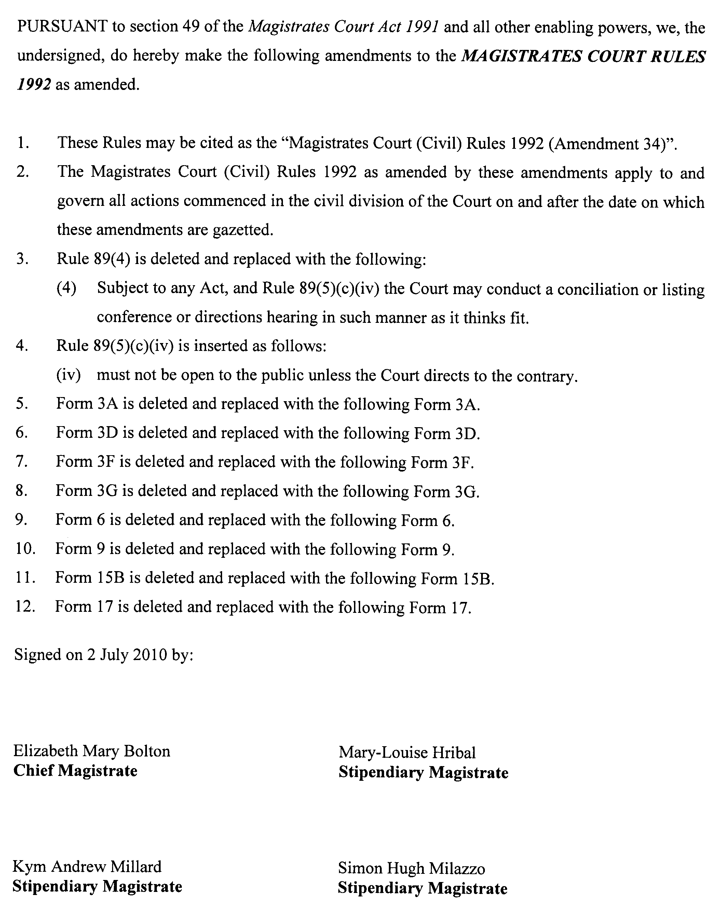
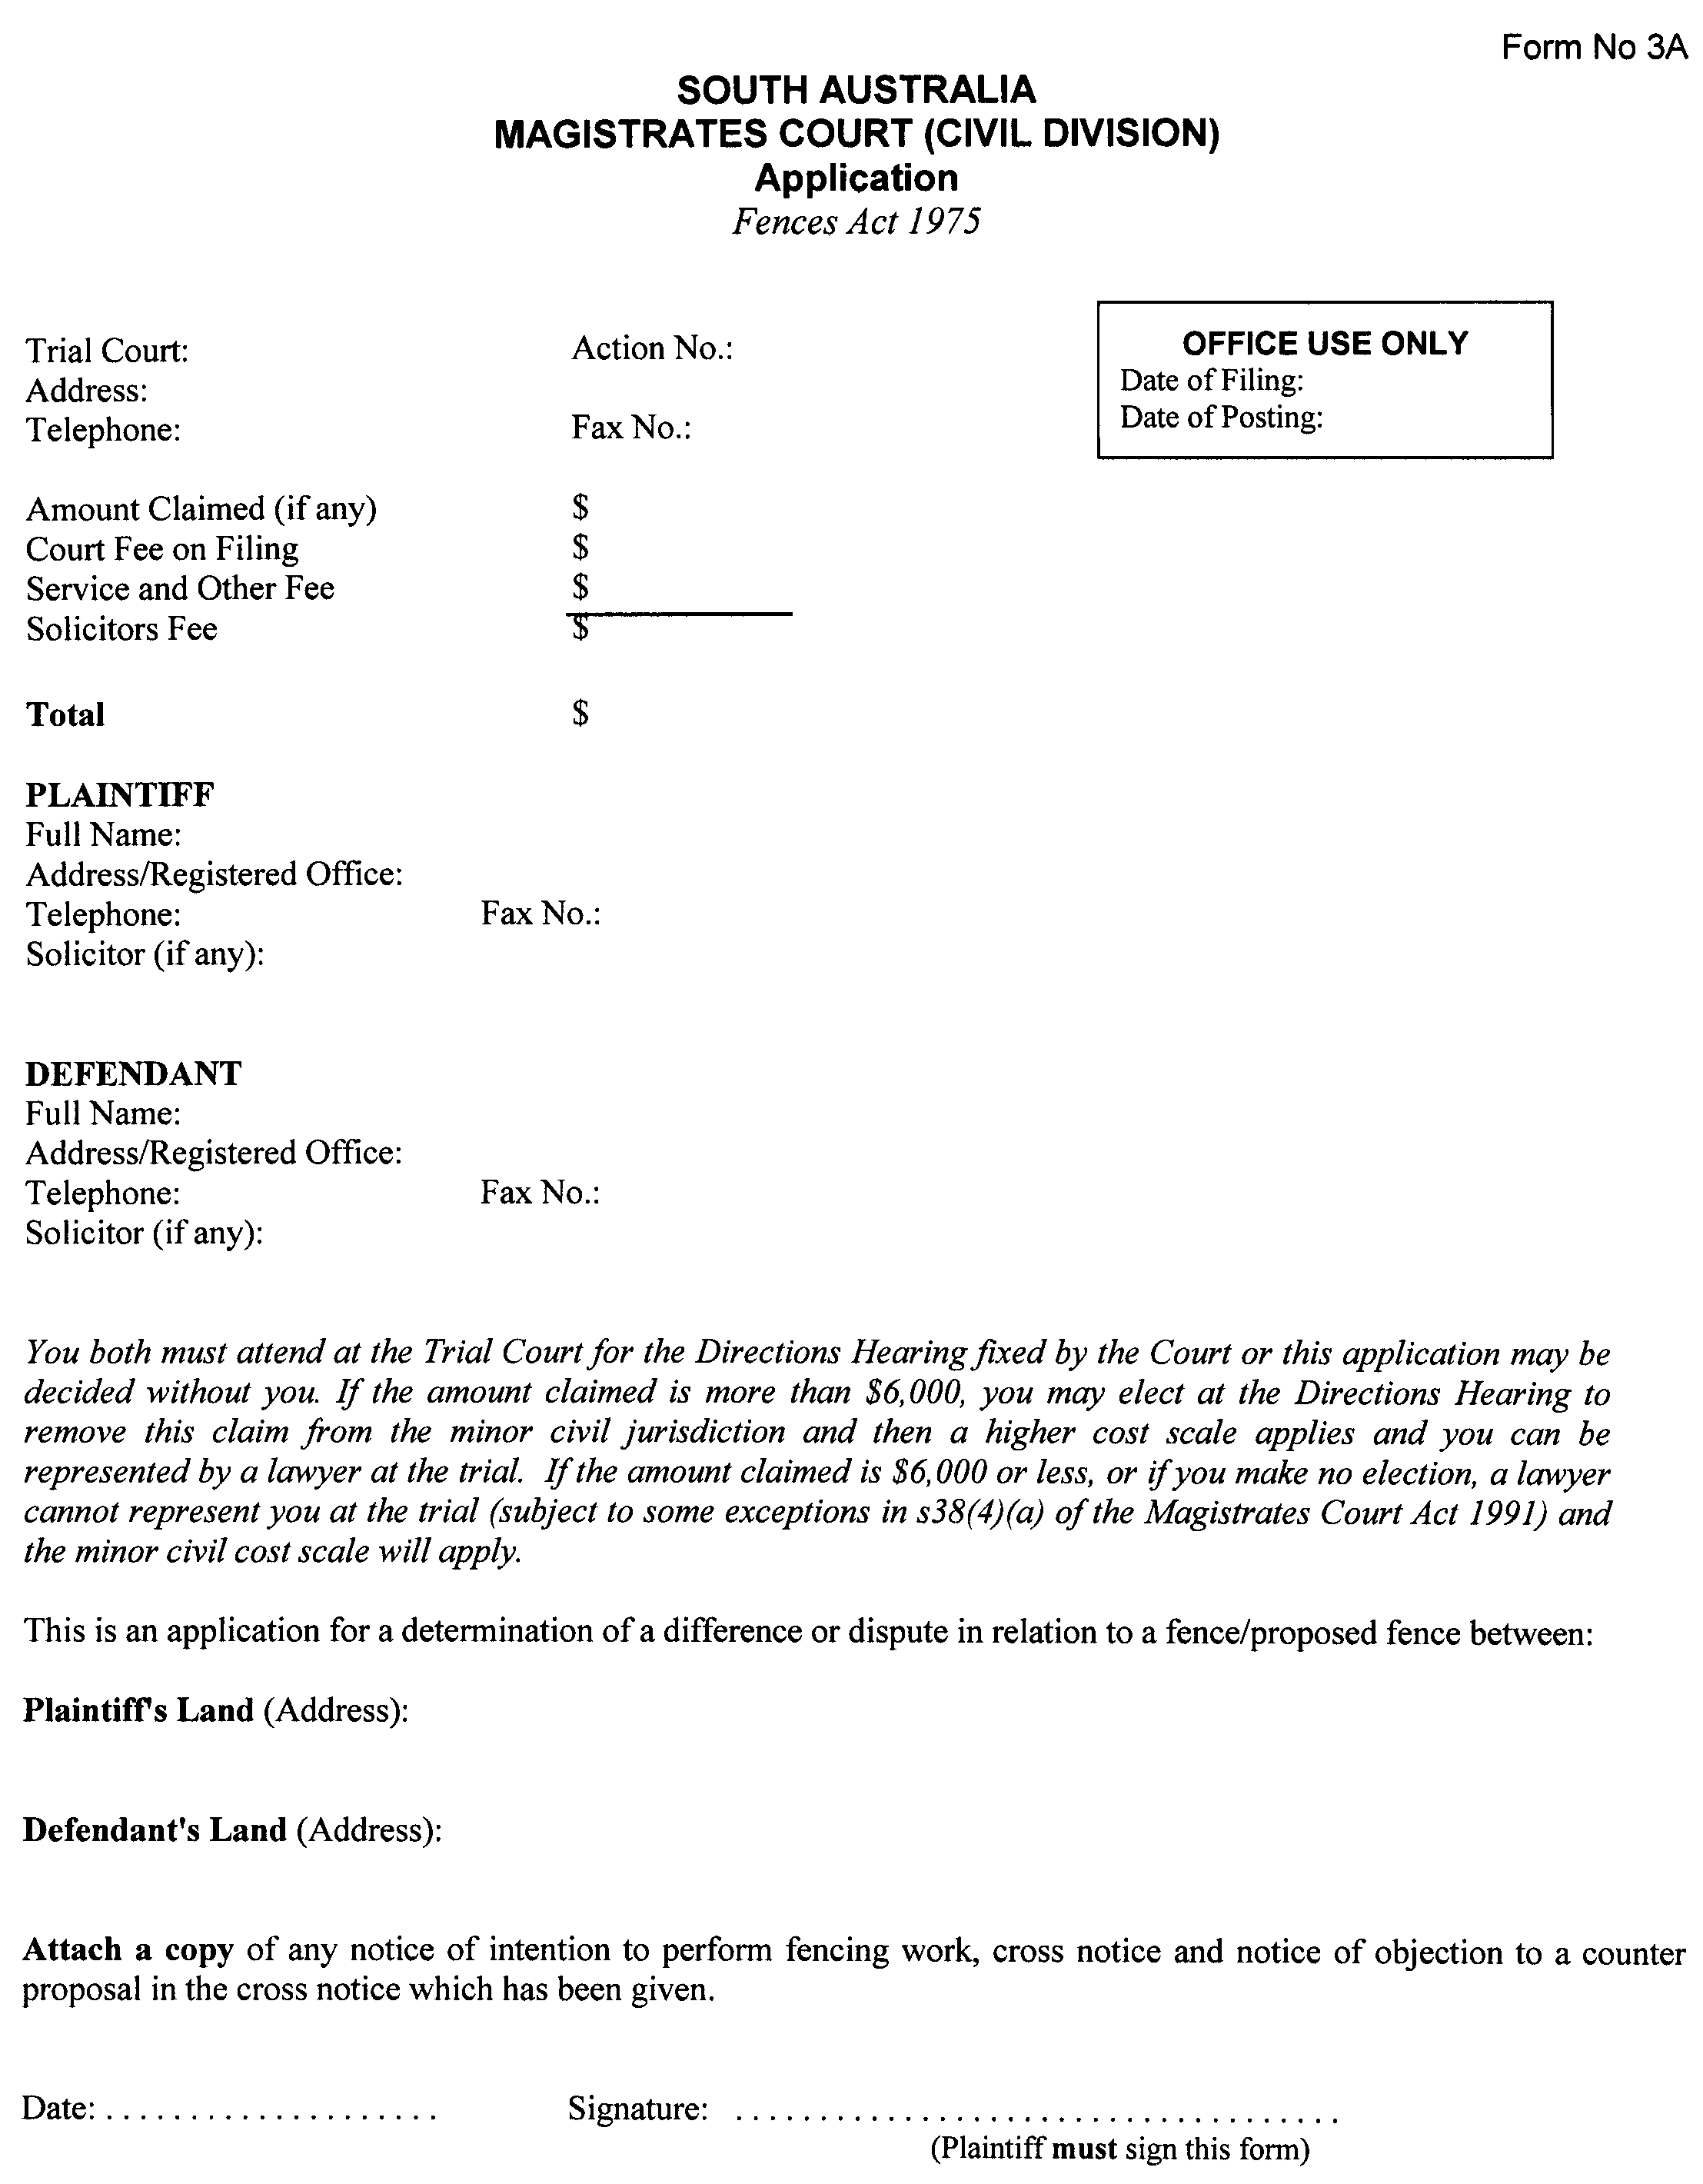
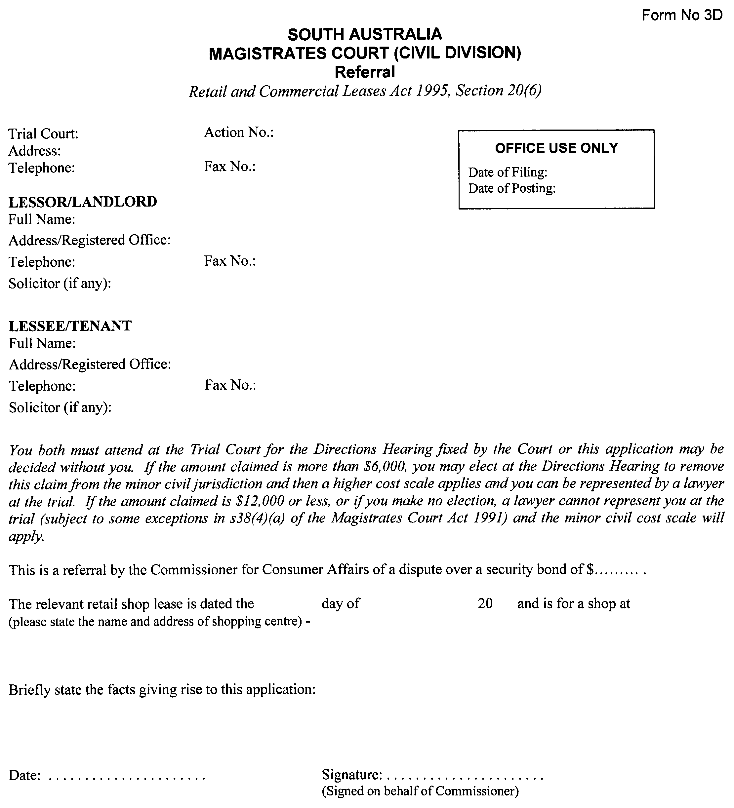
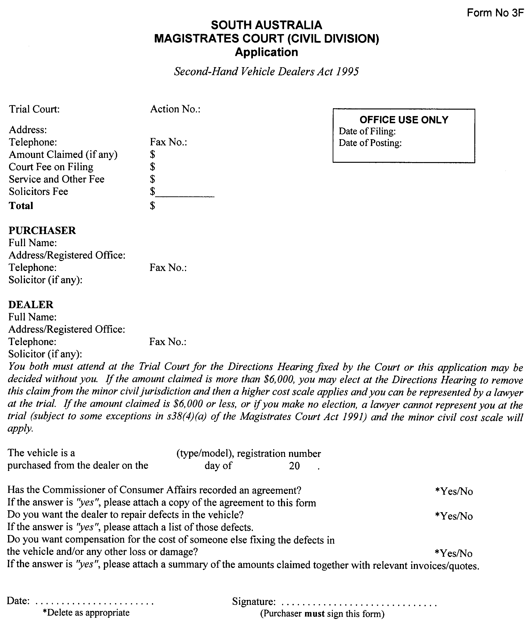
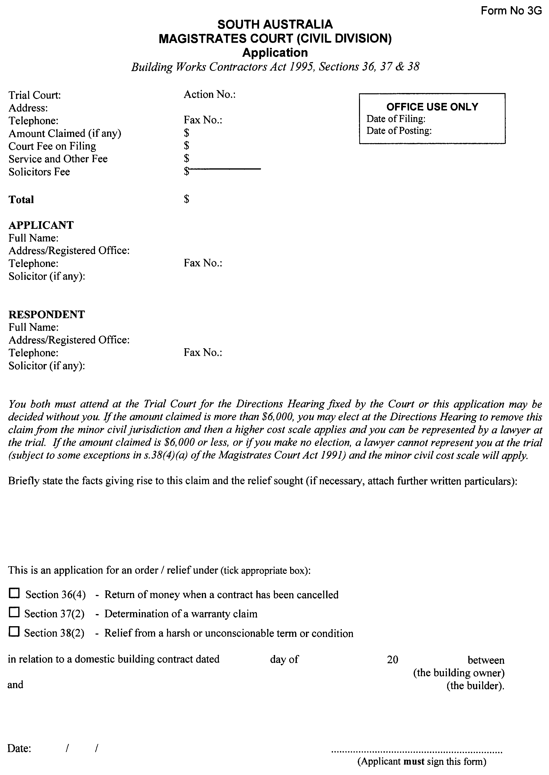
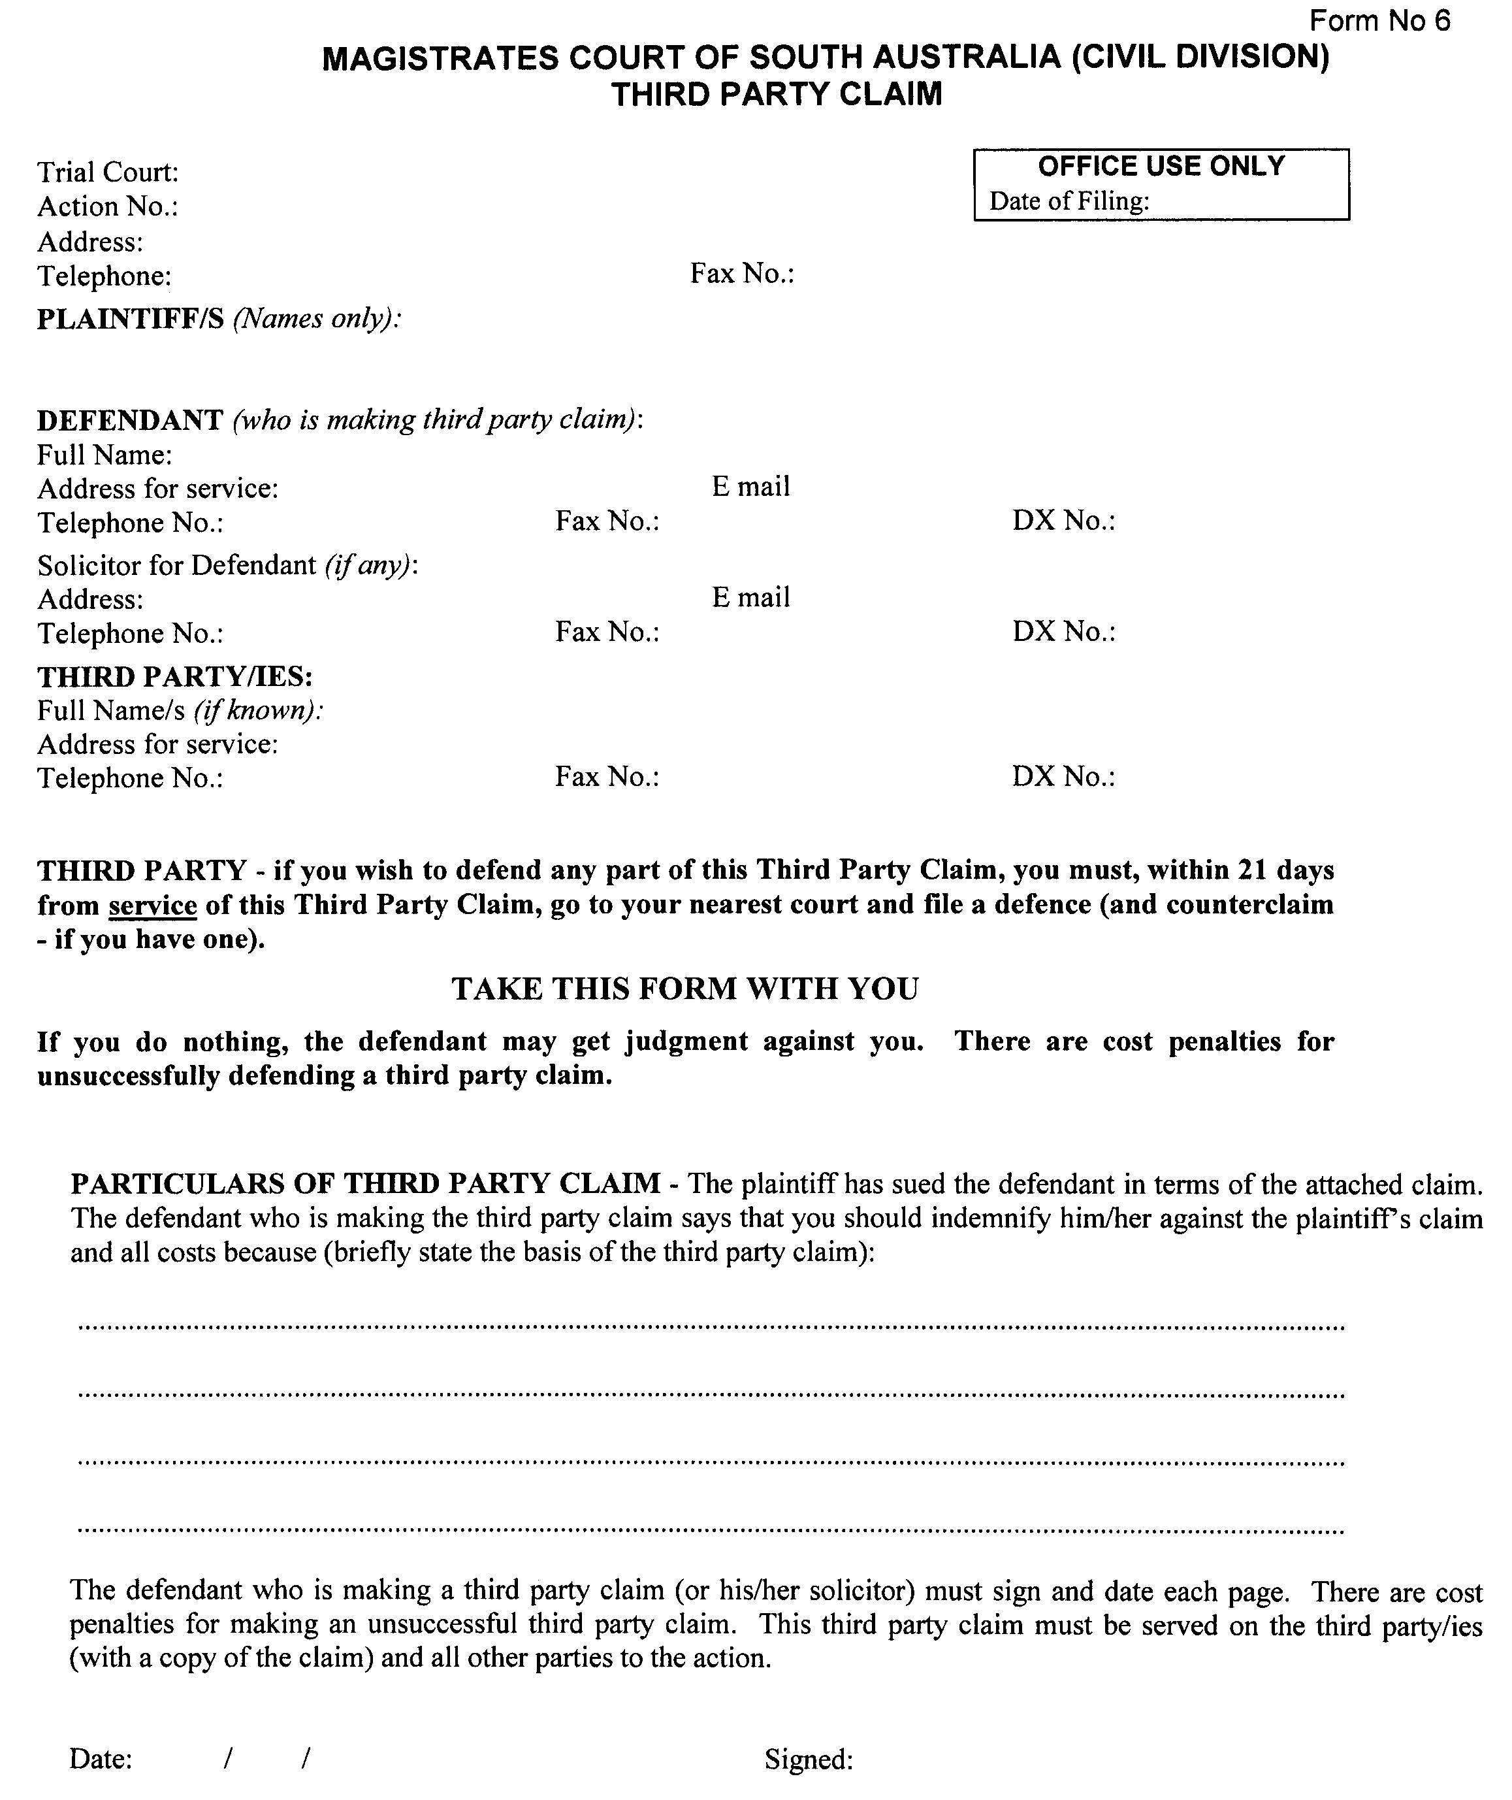
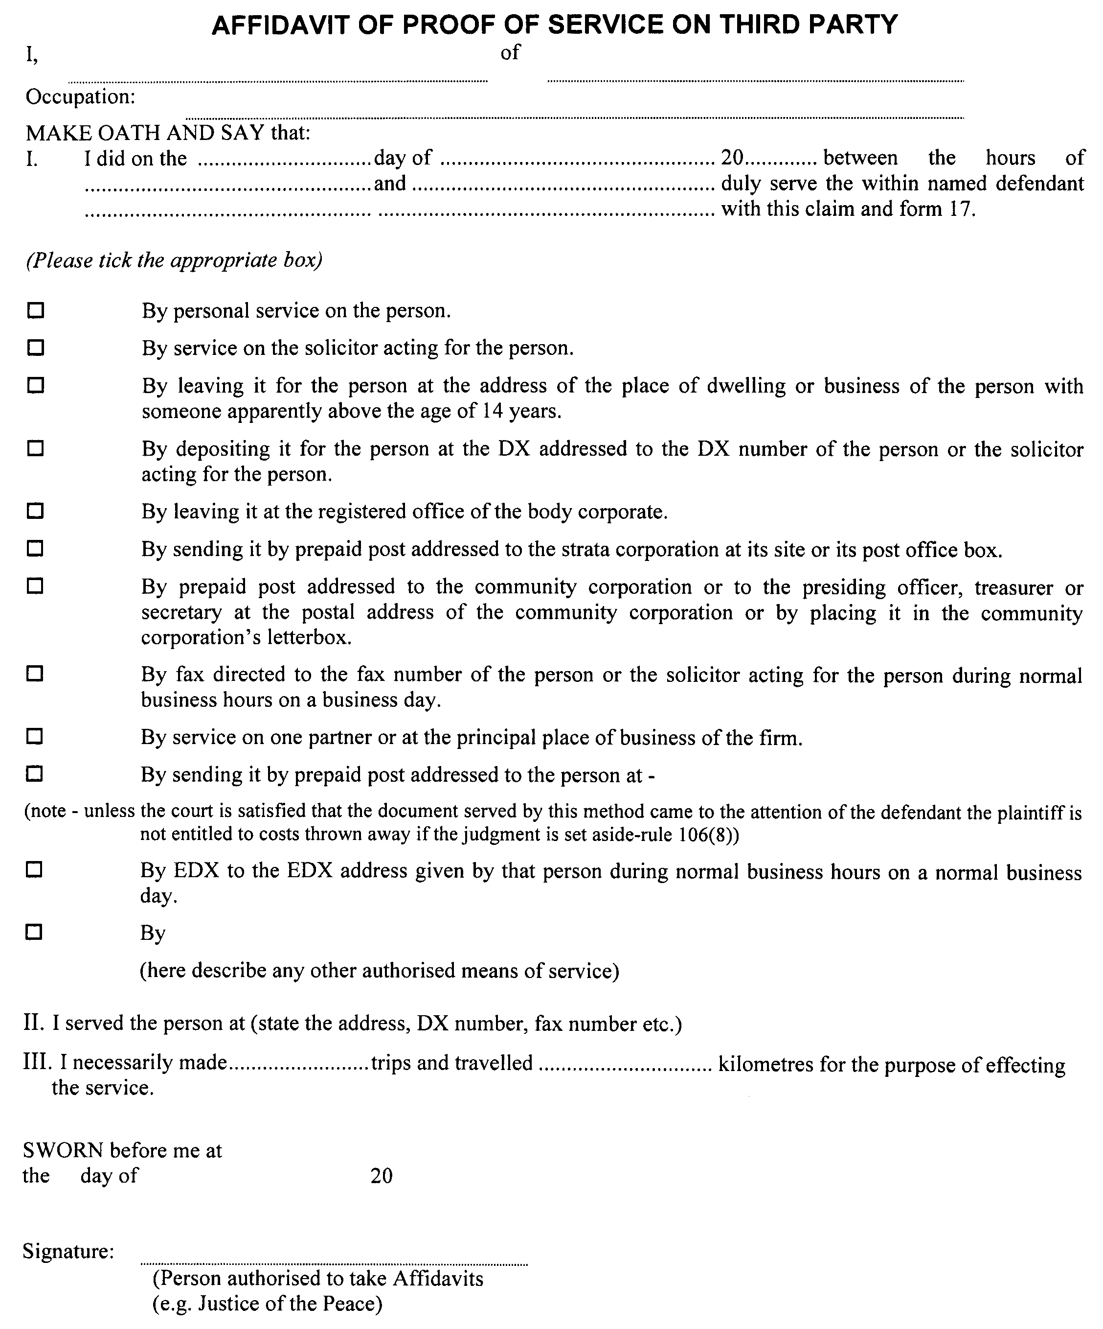
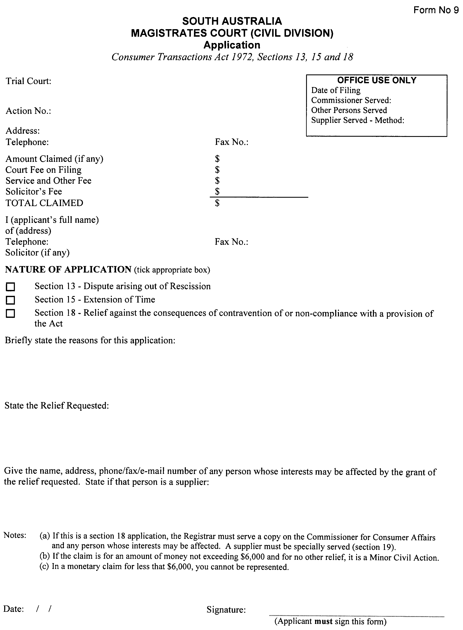
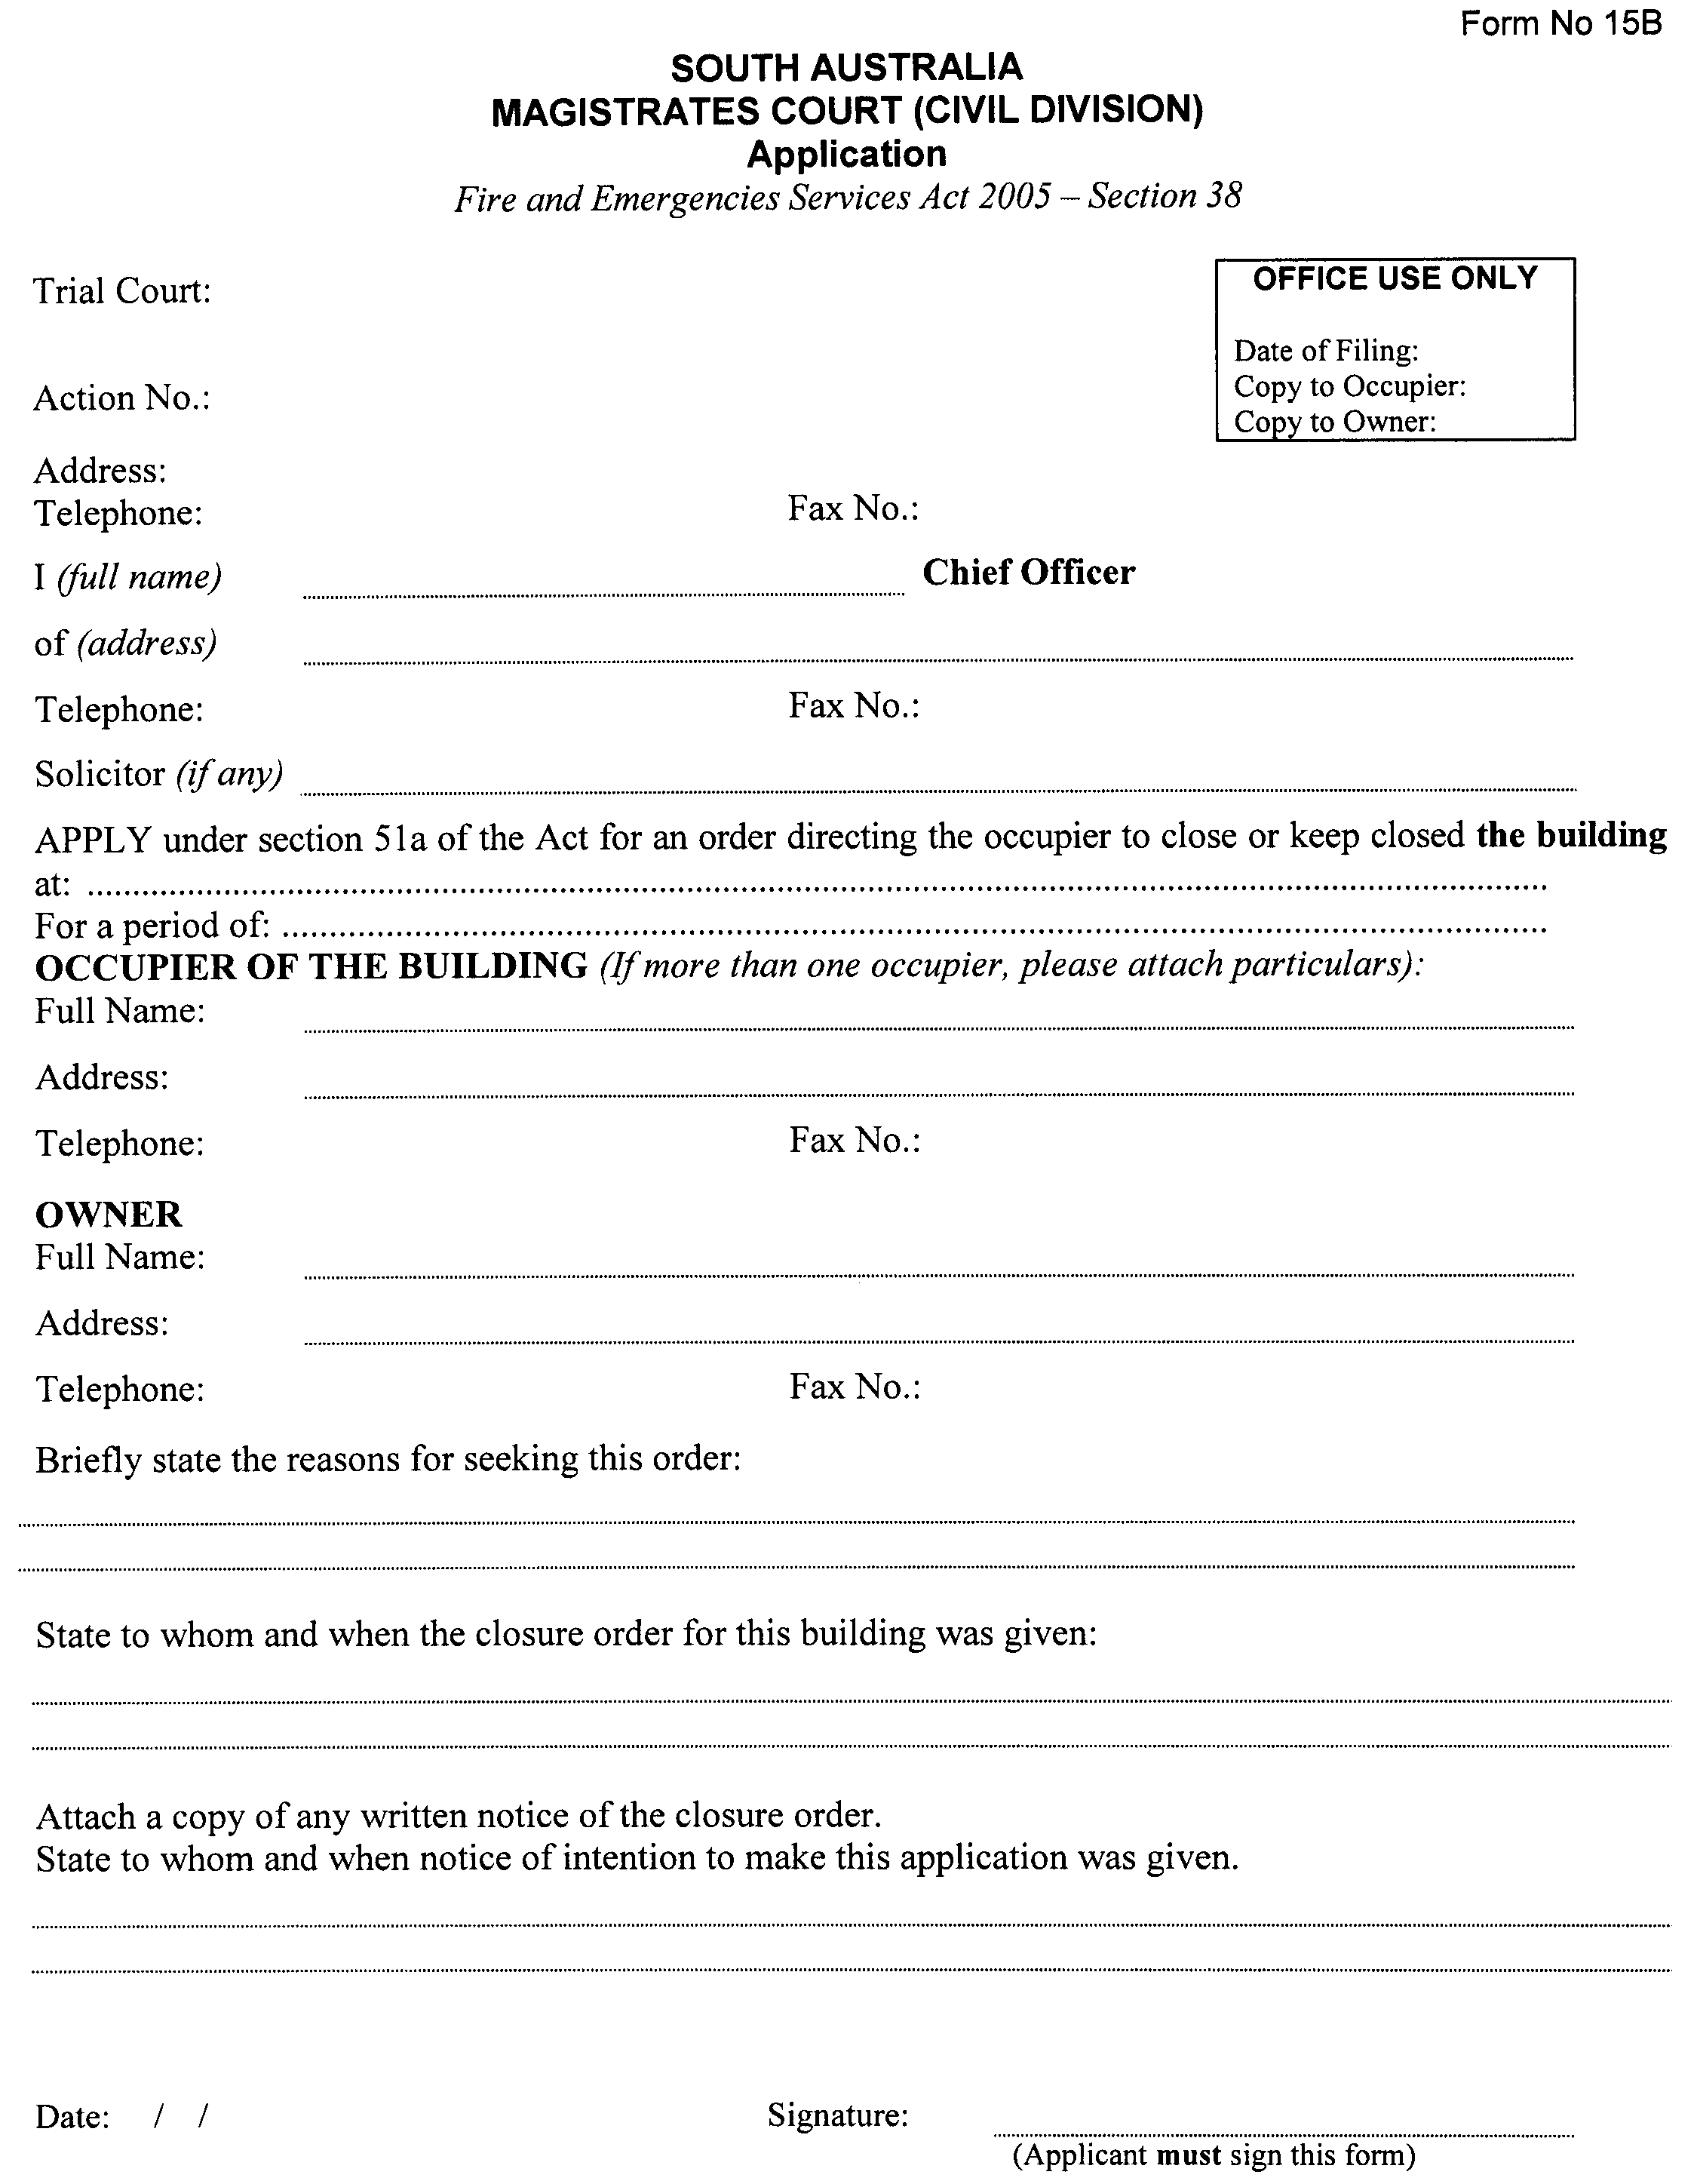
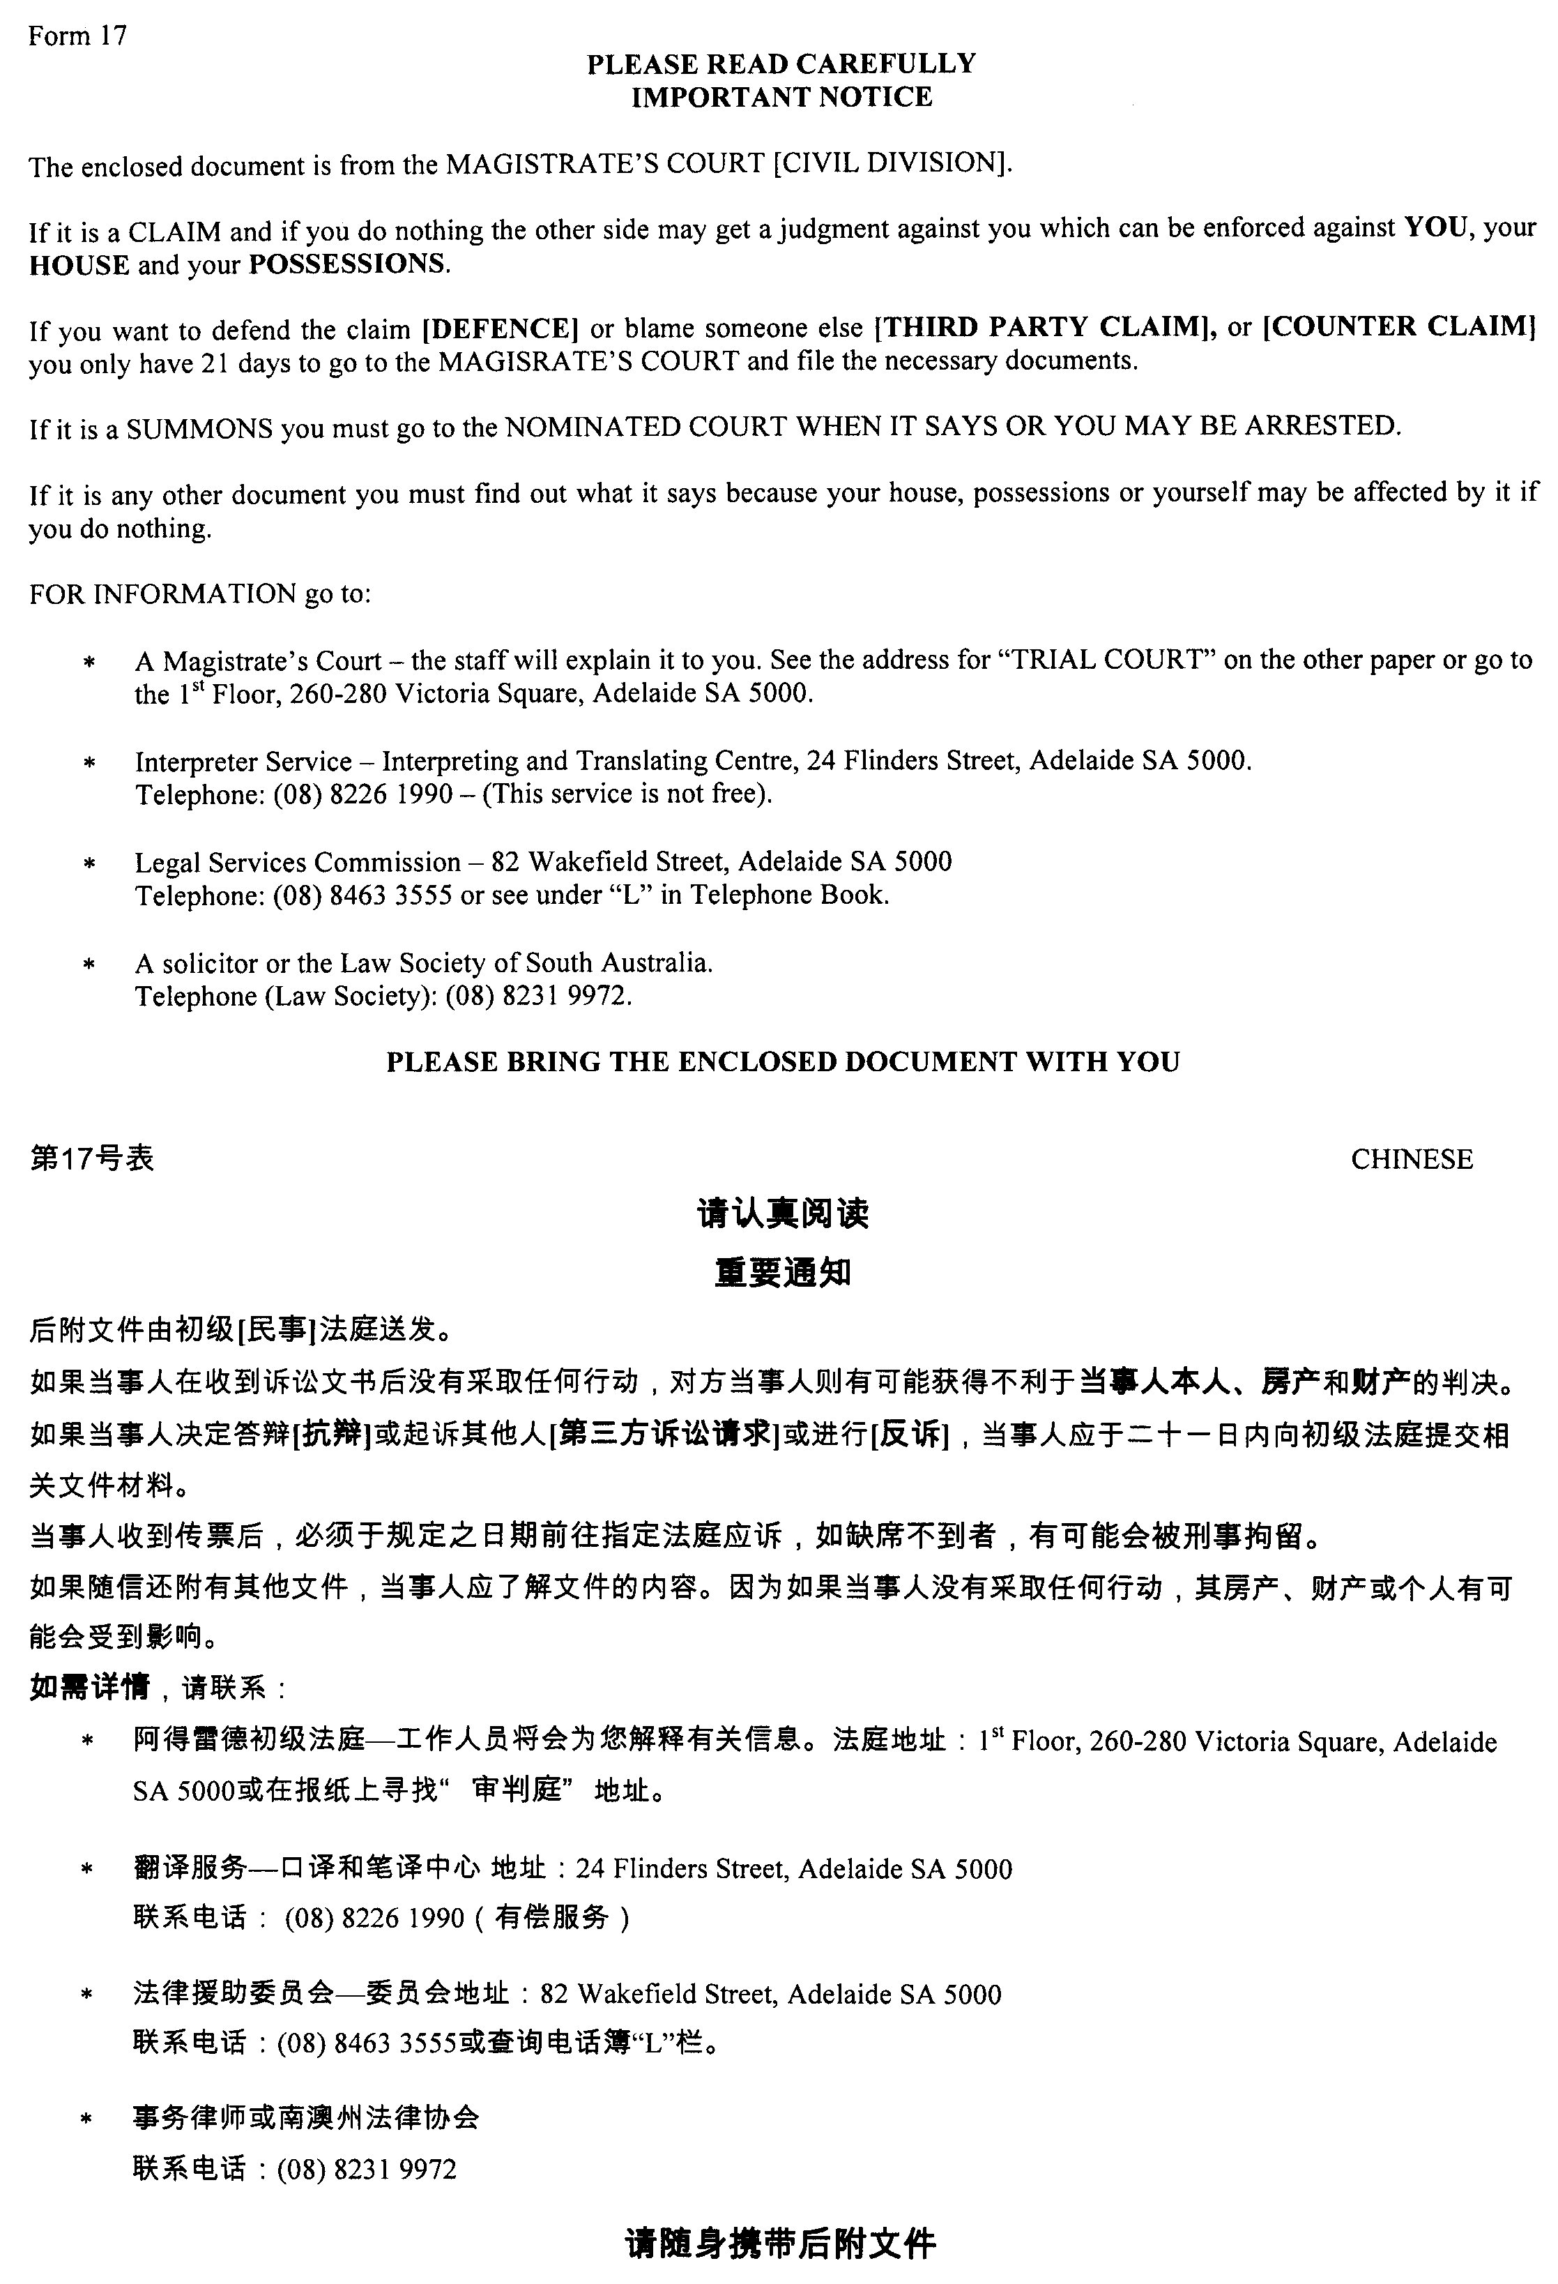
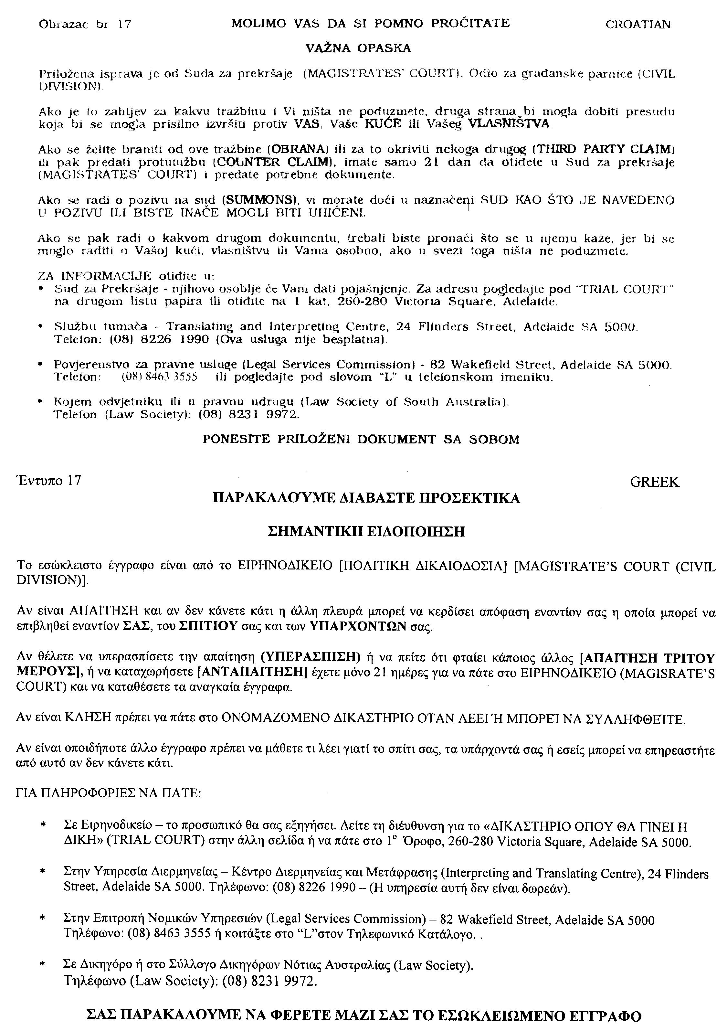
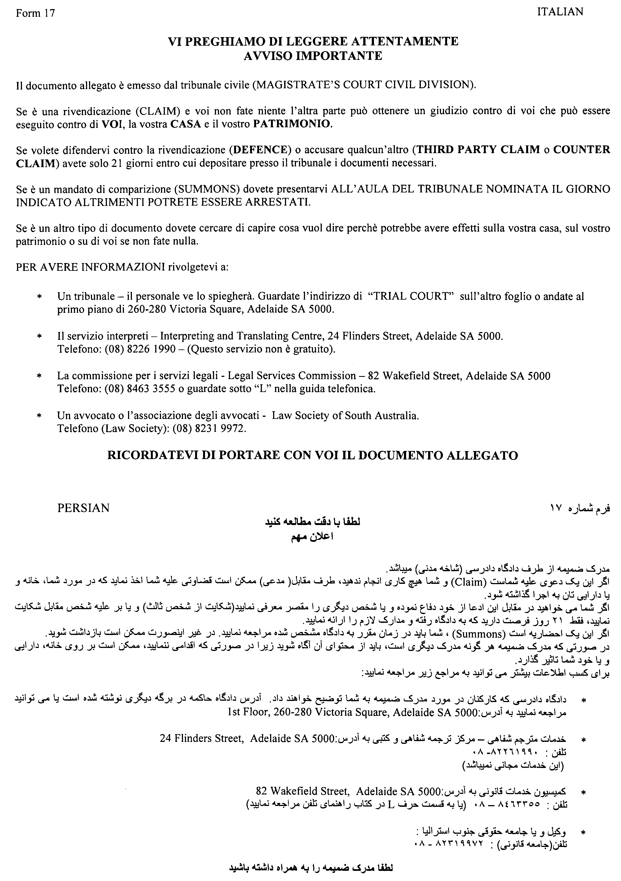

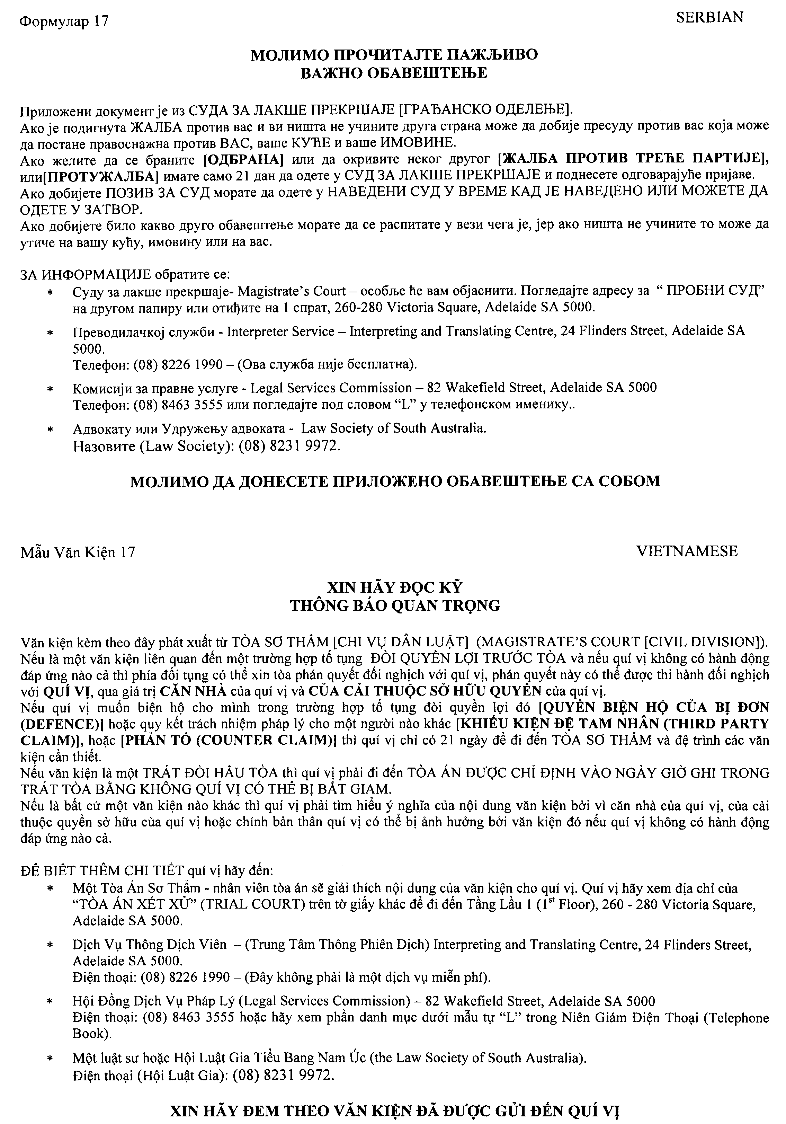

RULES OF COURT
Magistrates Court of South Australia
Amendment No. 35 to the Magistrates Court Rules 1992
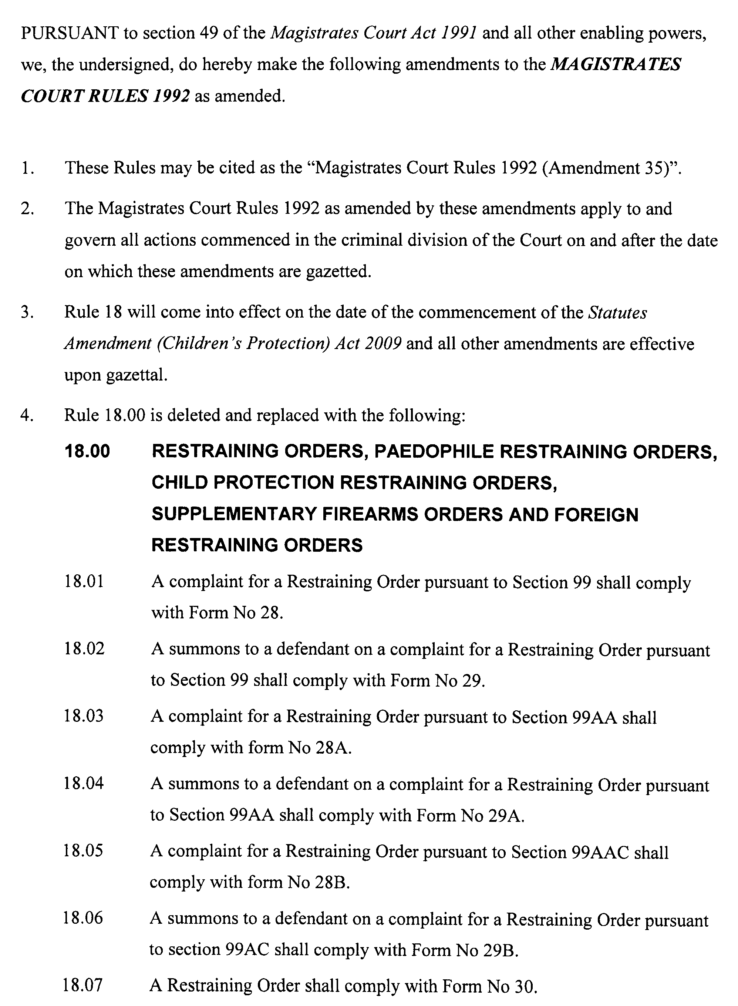
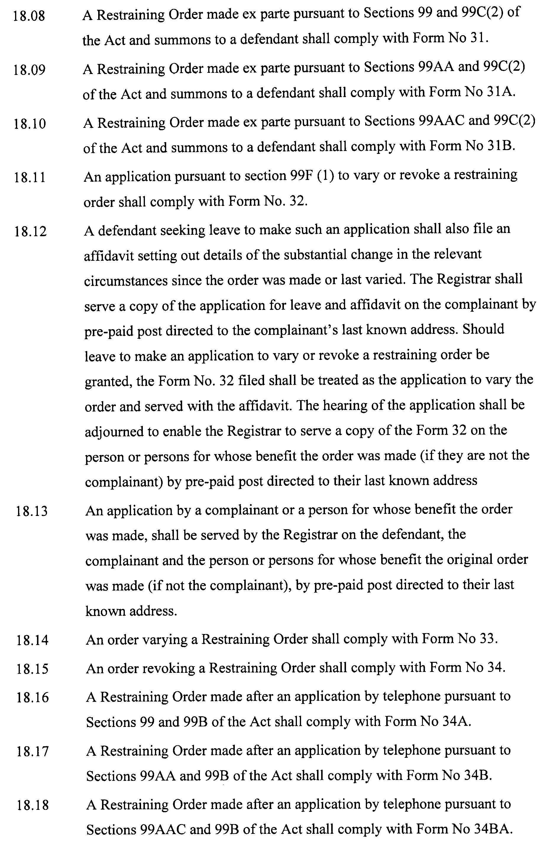
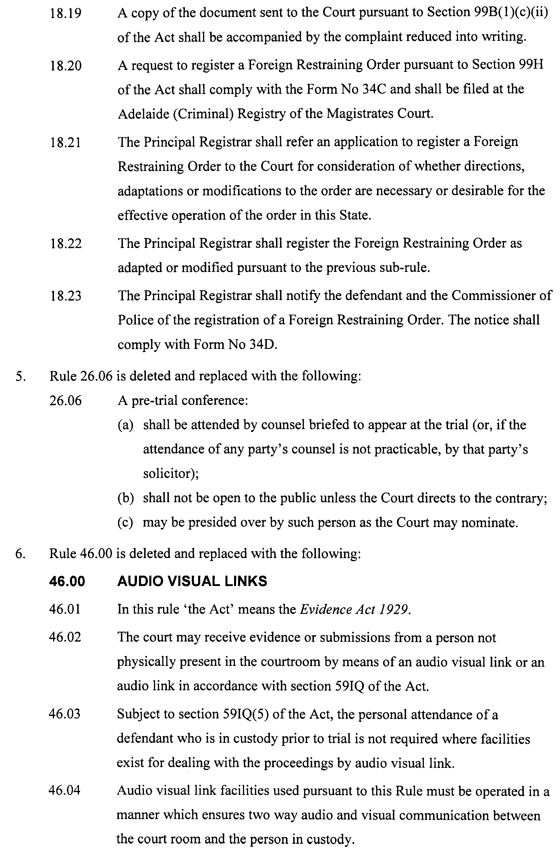
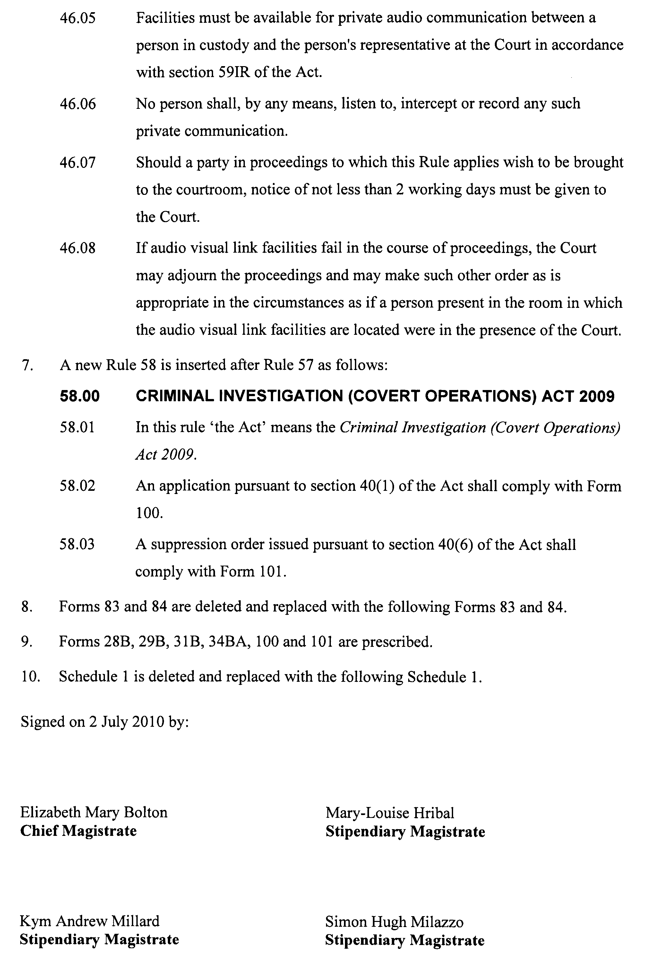
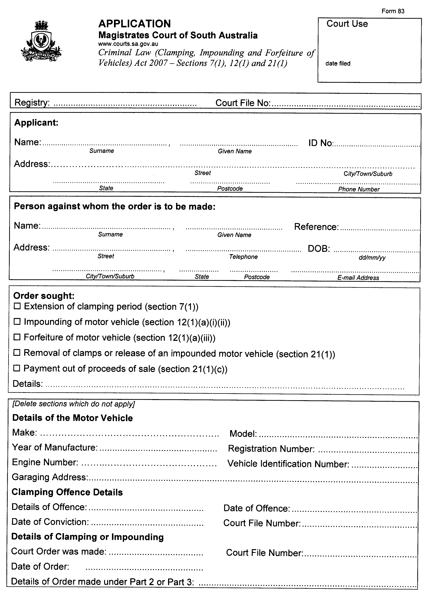

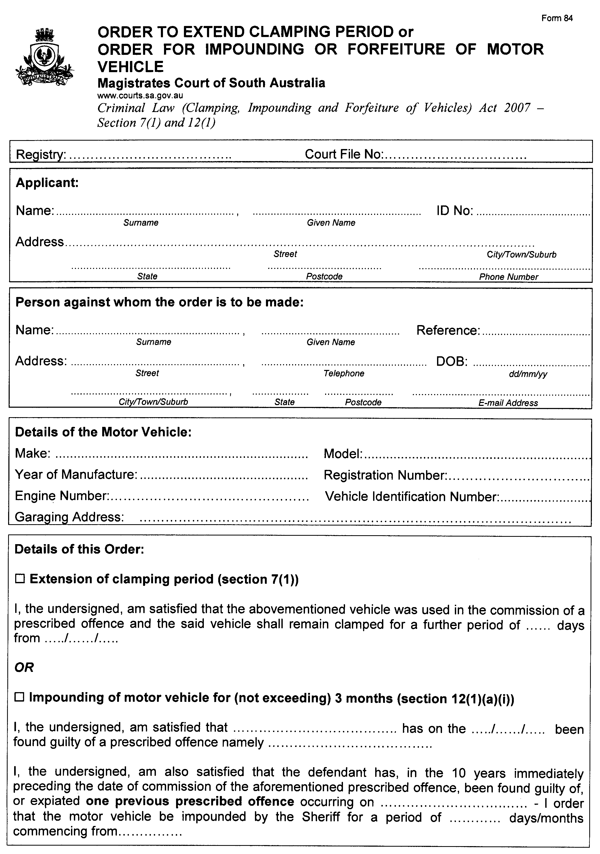
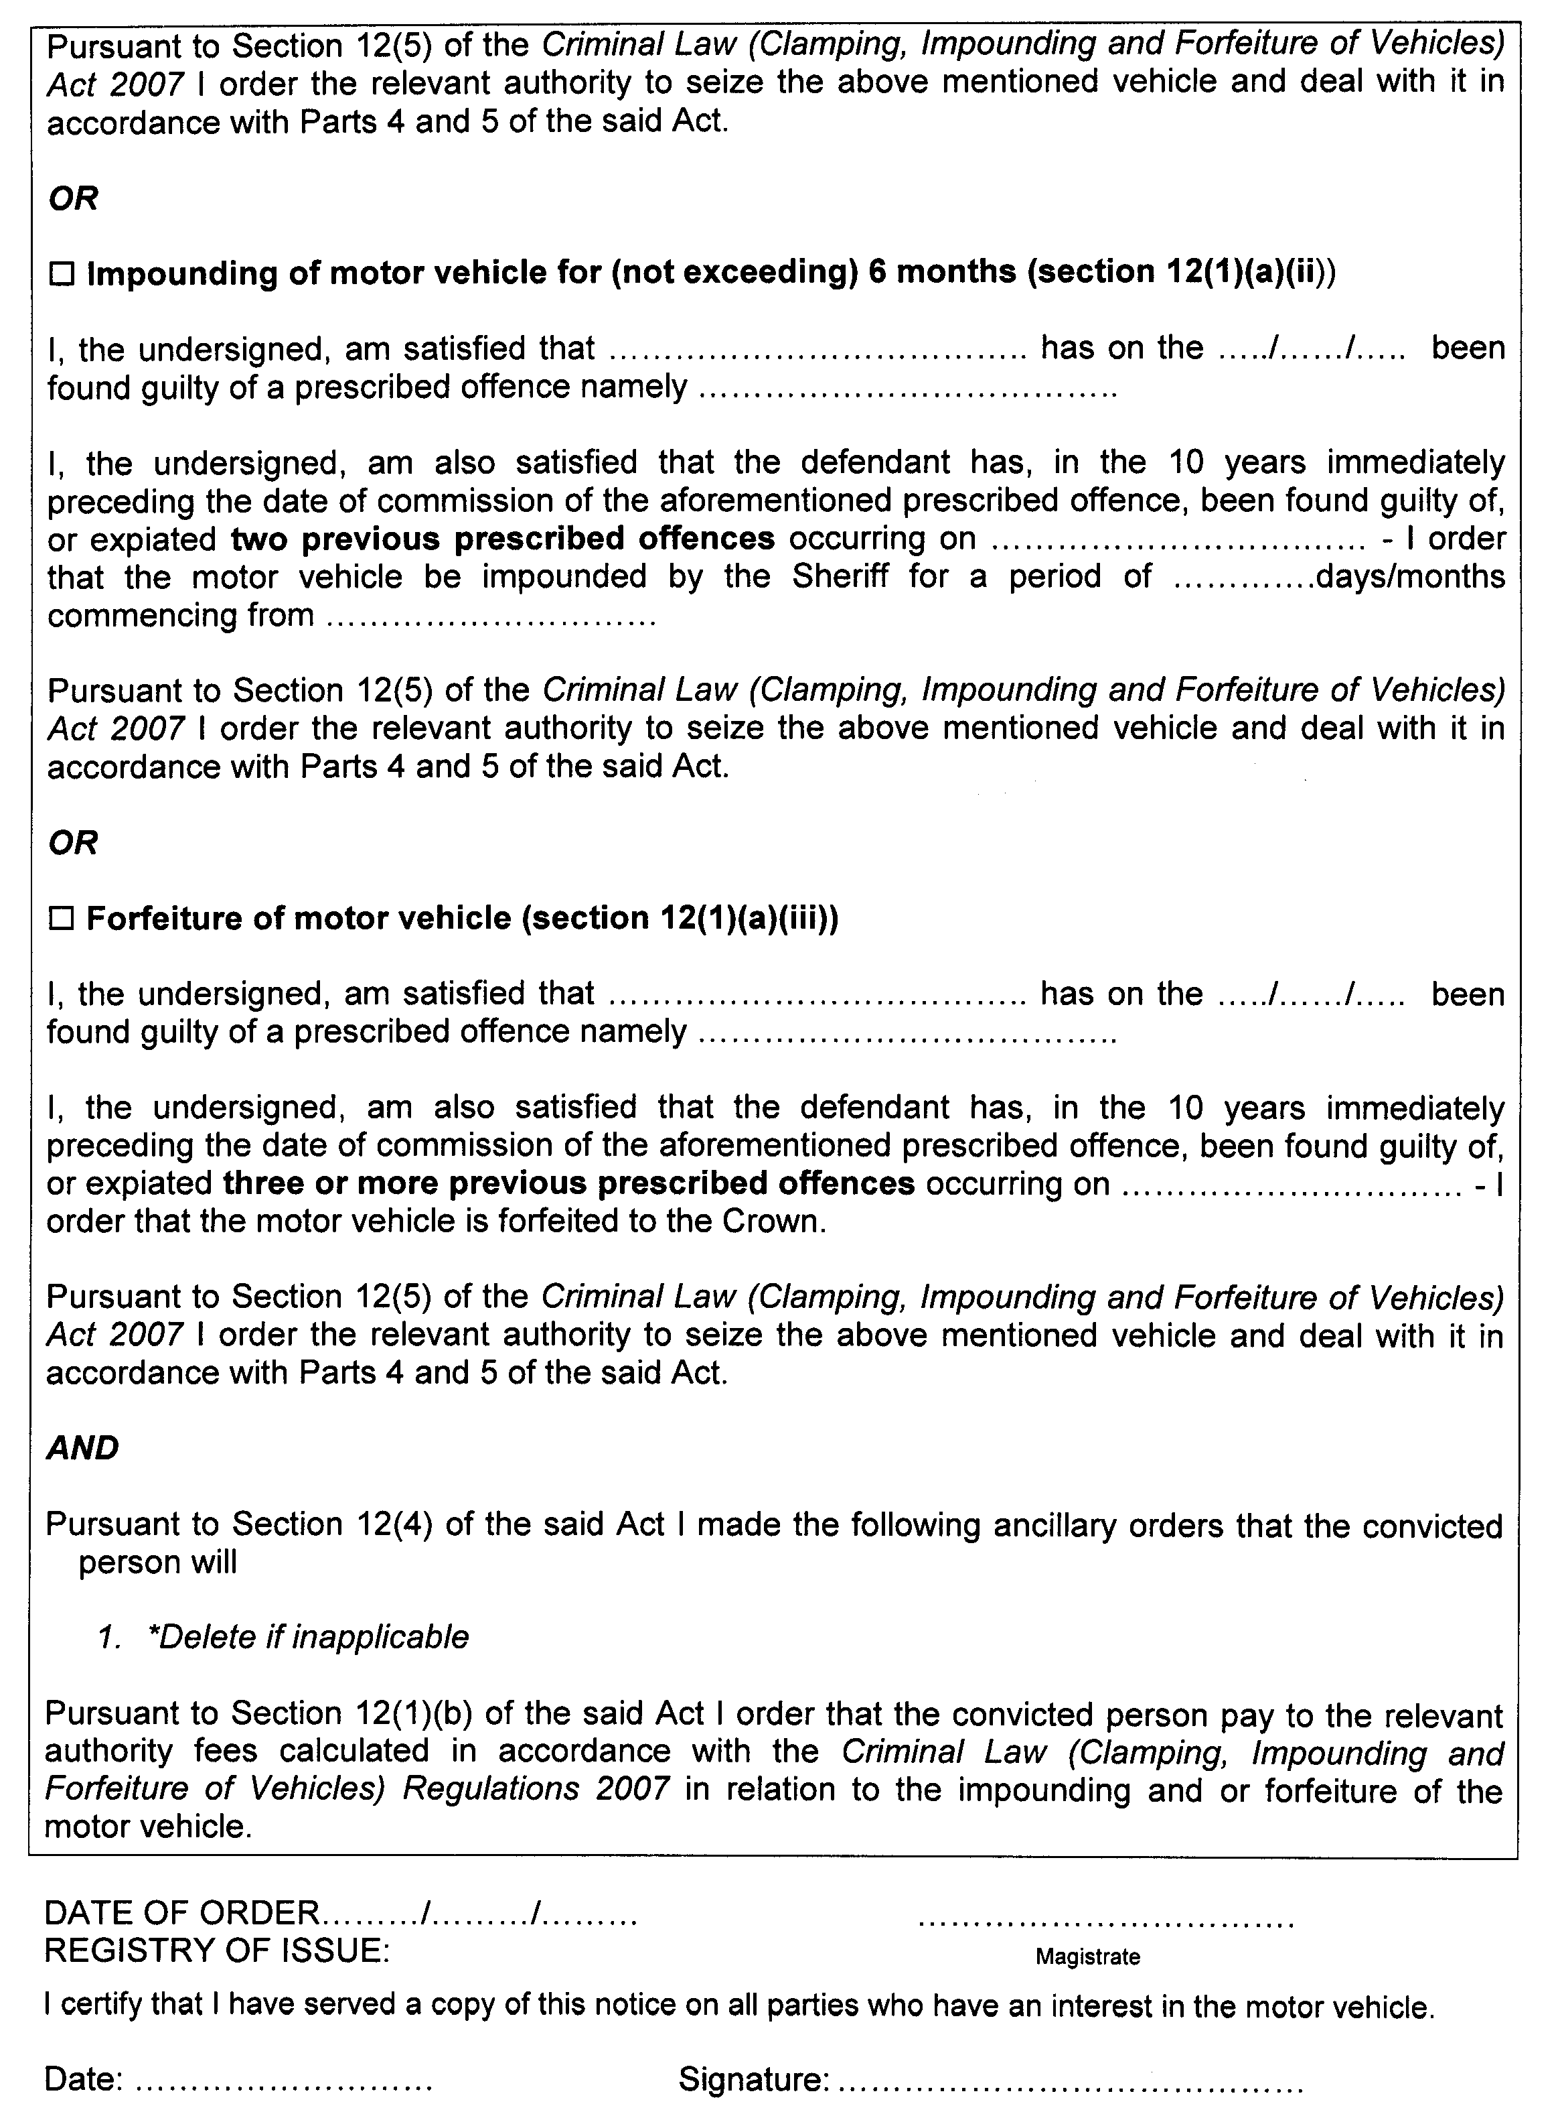
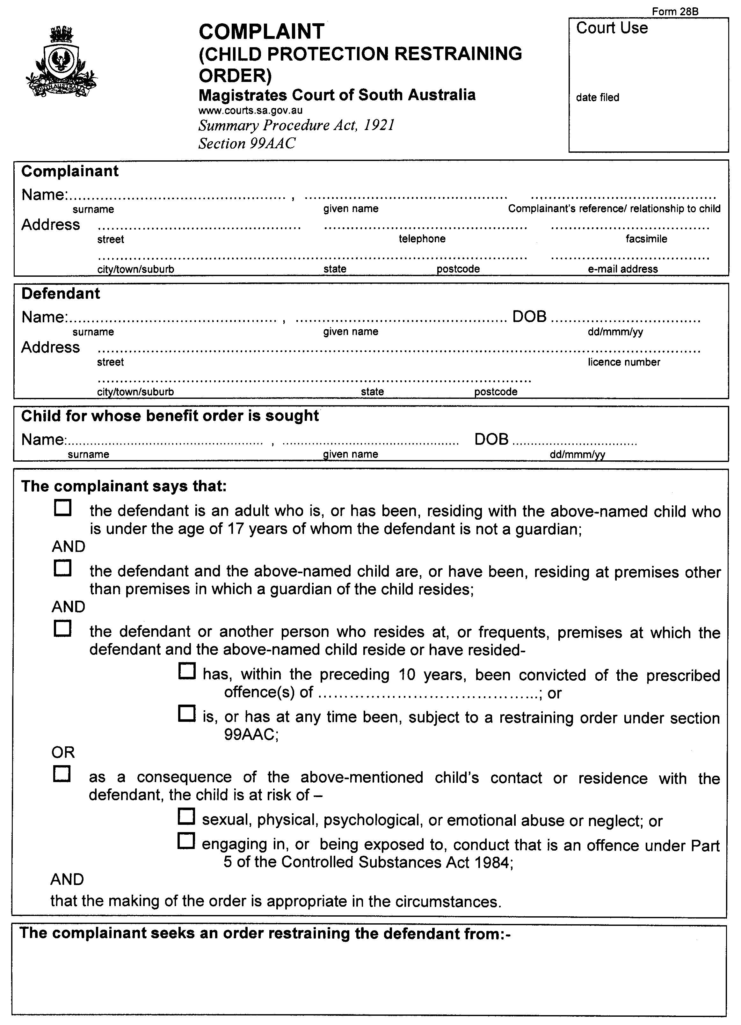
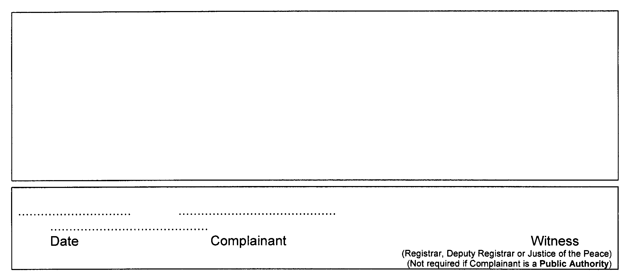
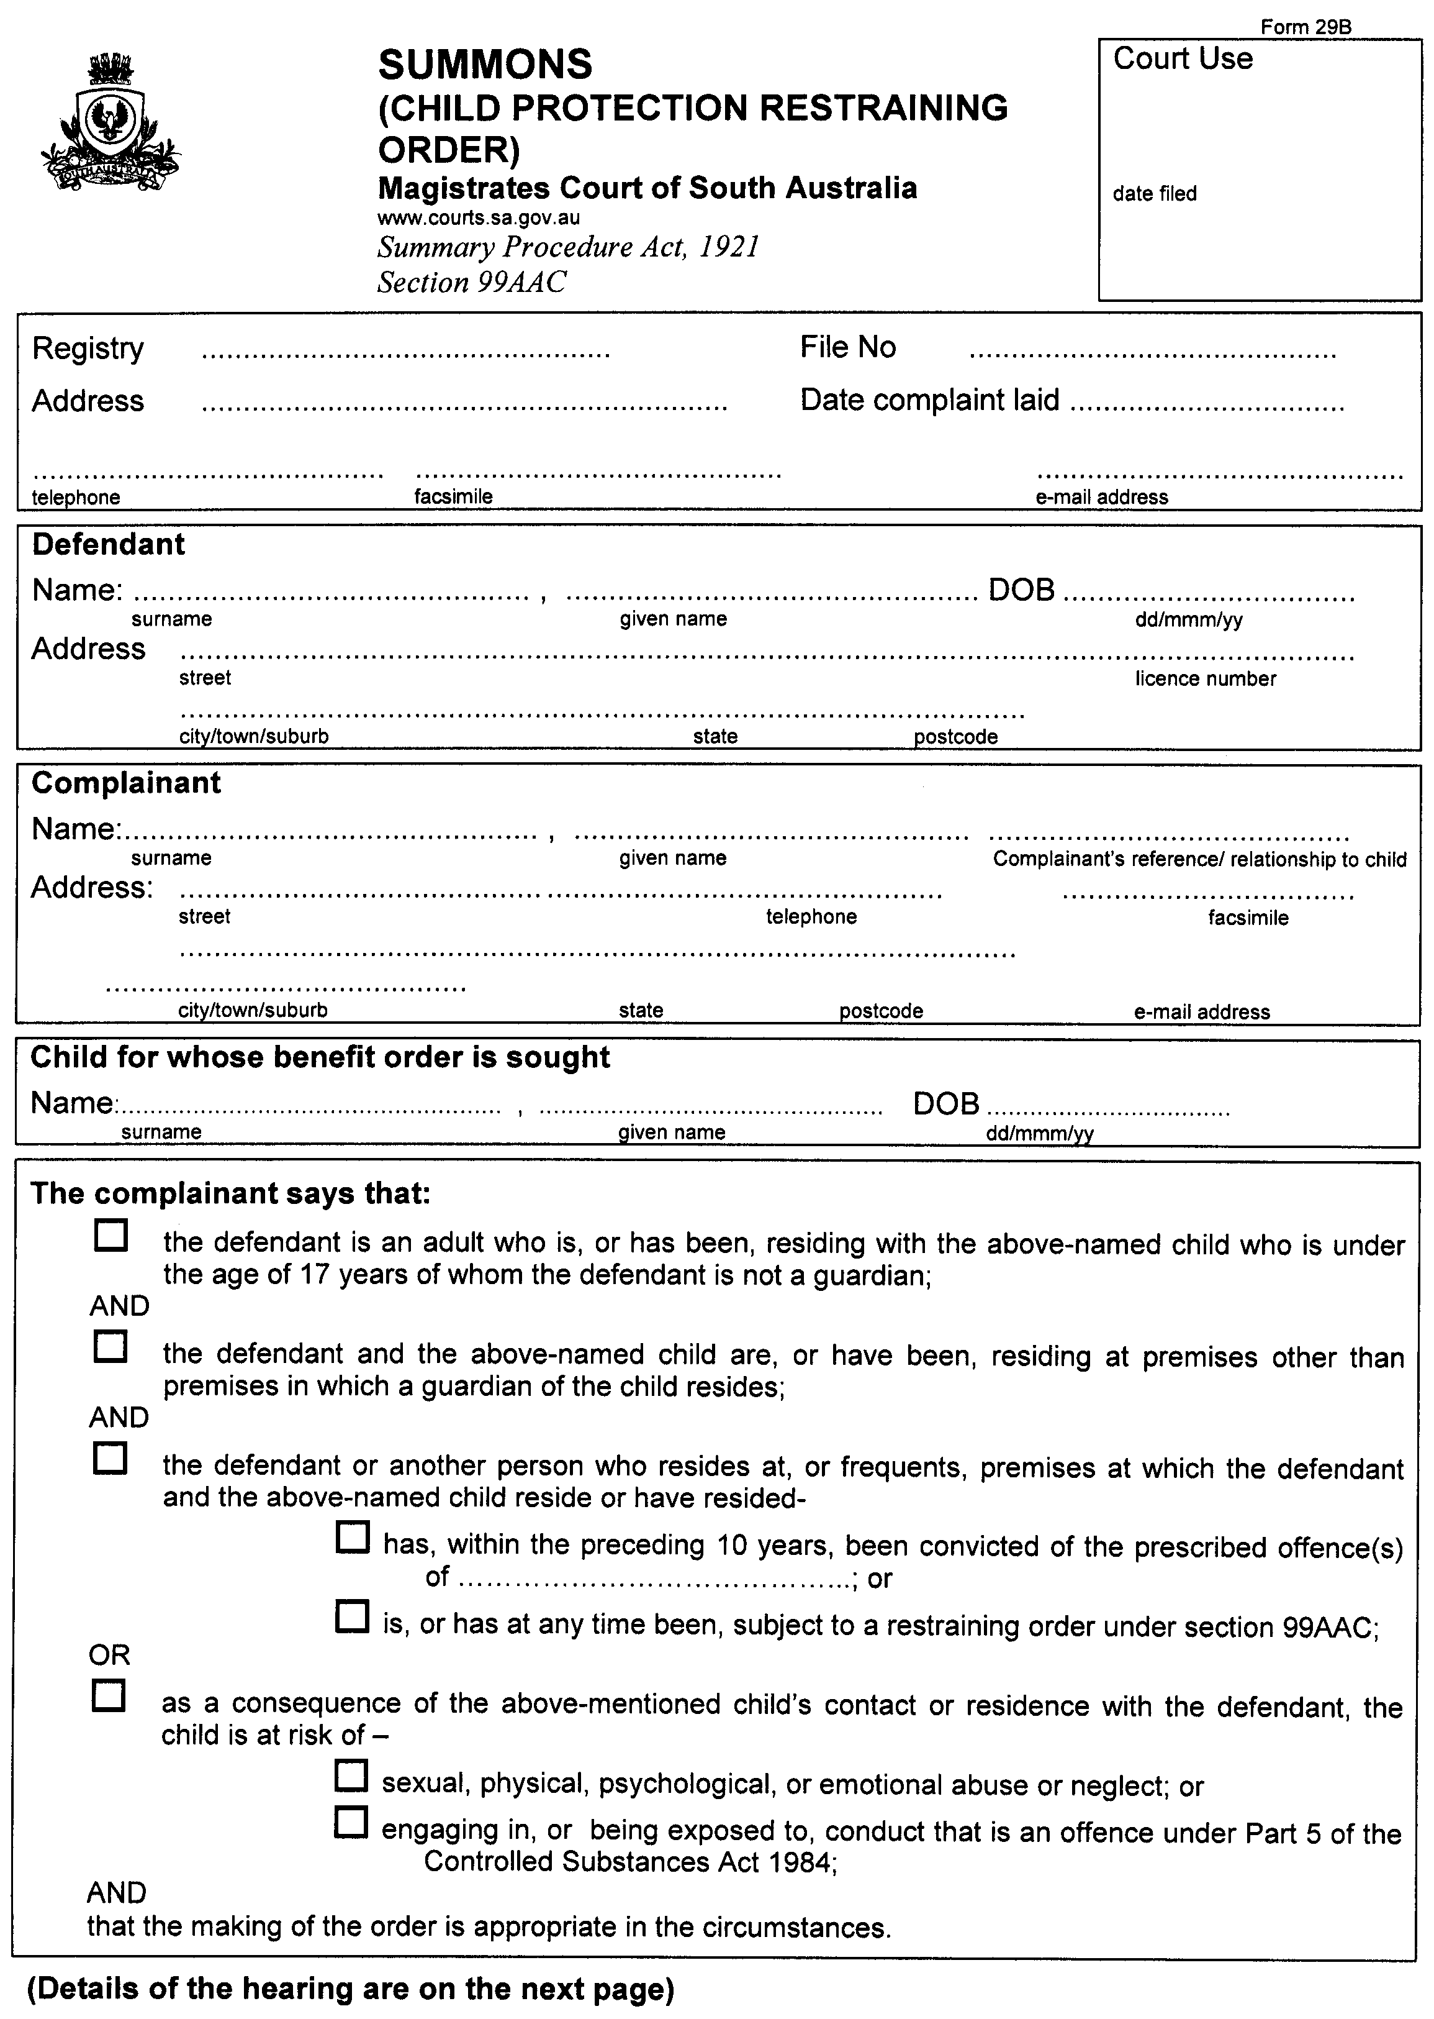
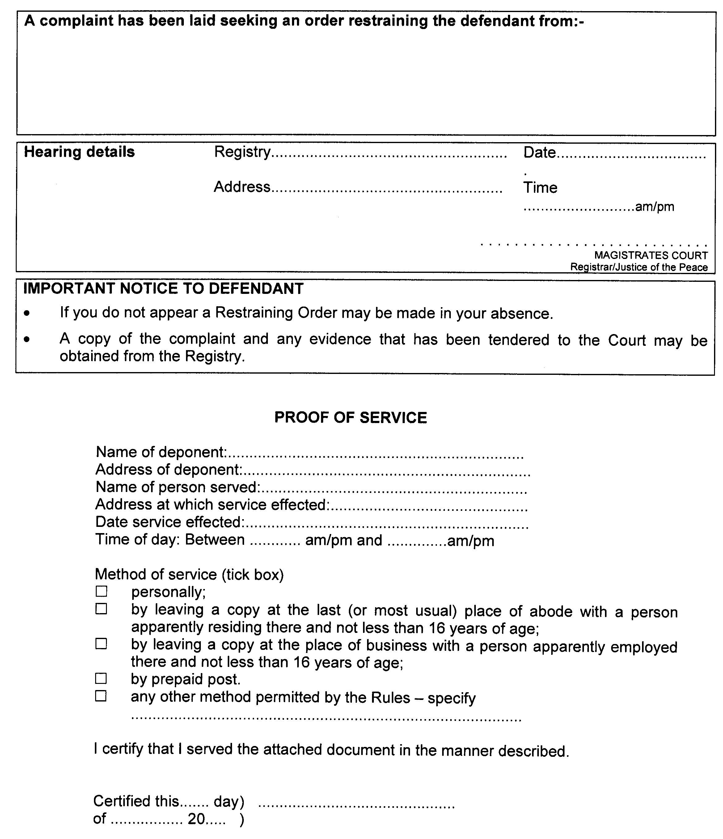
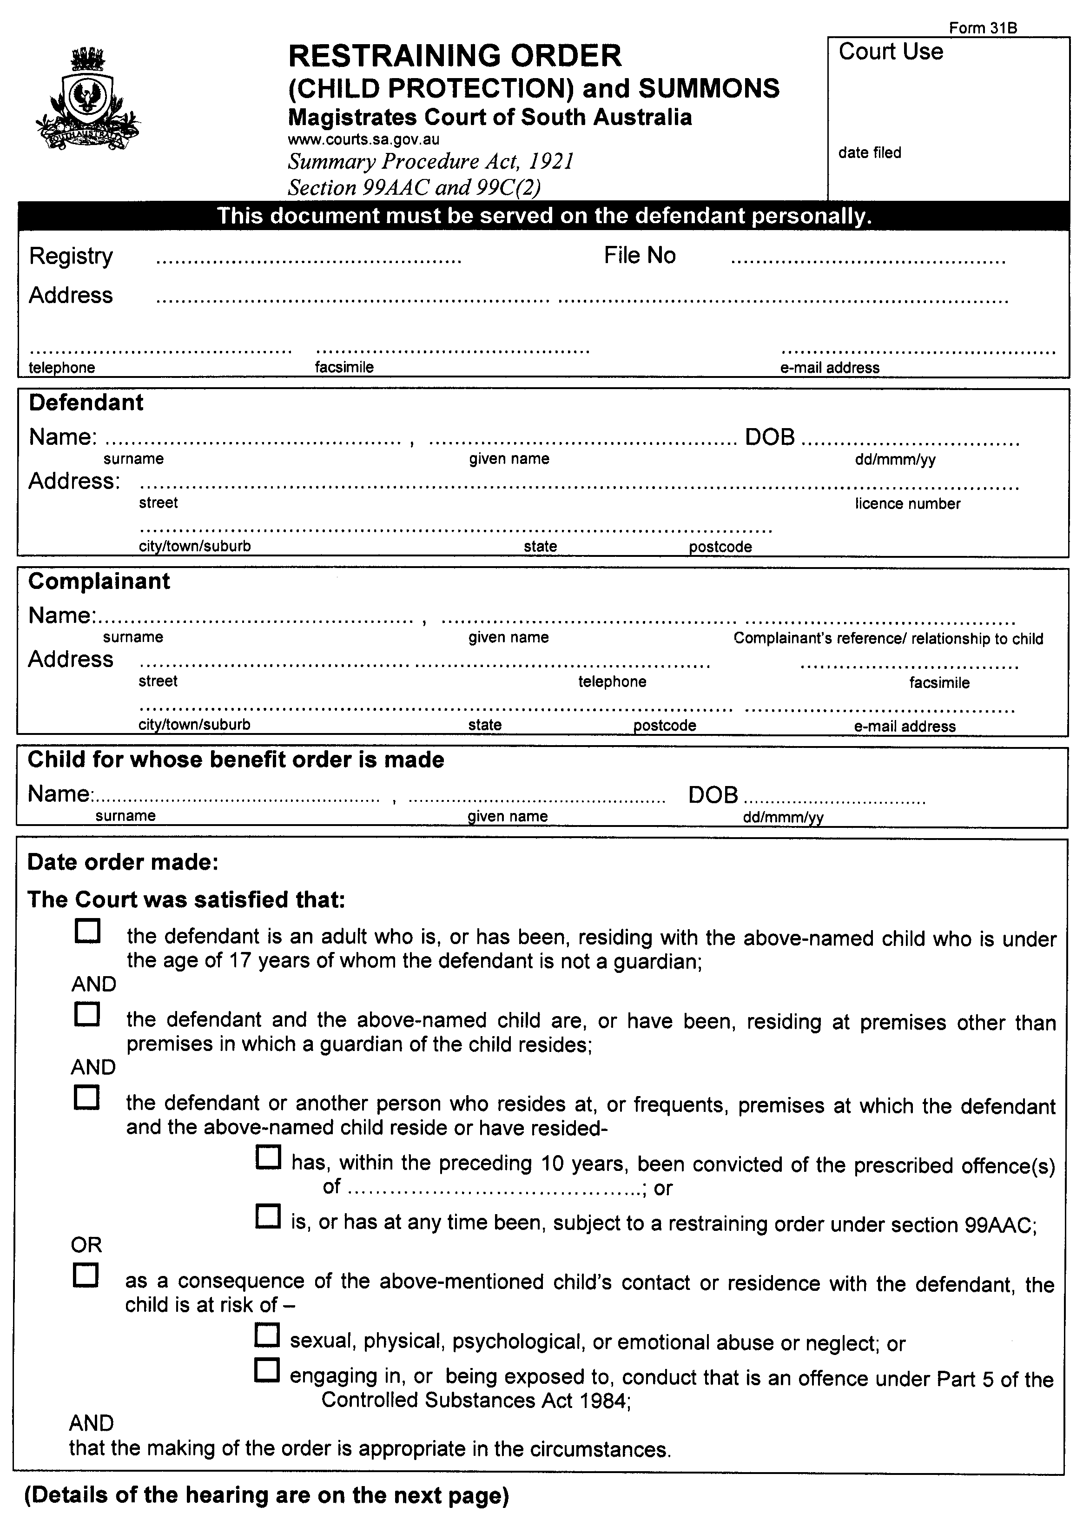
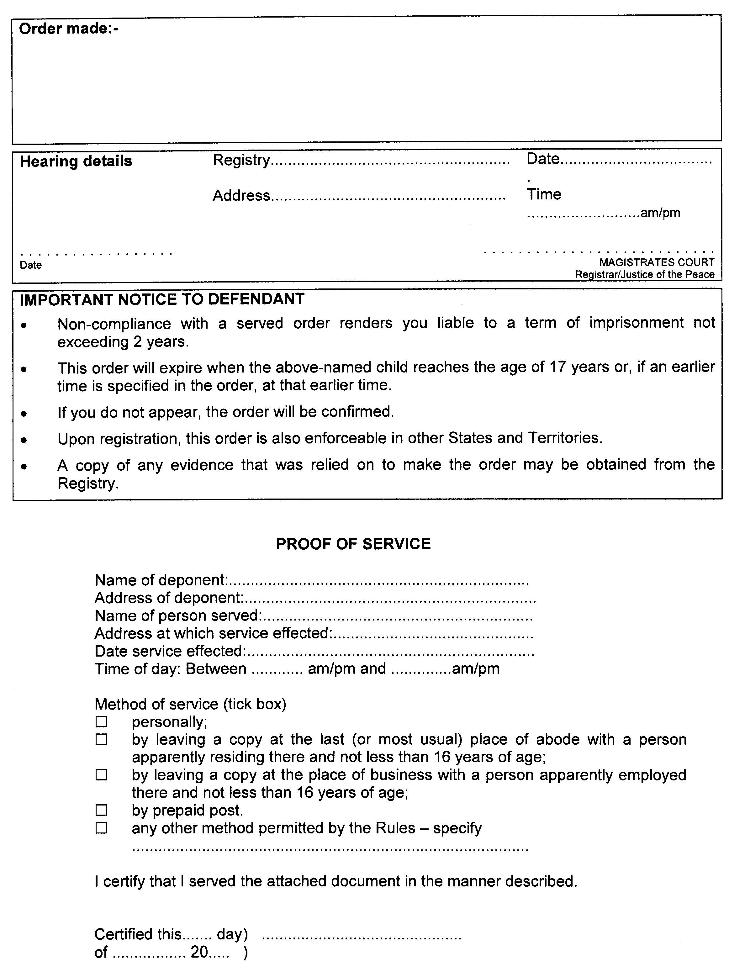


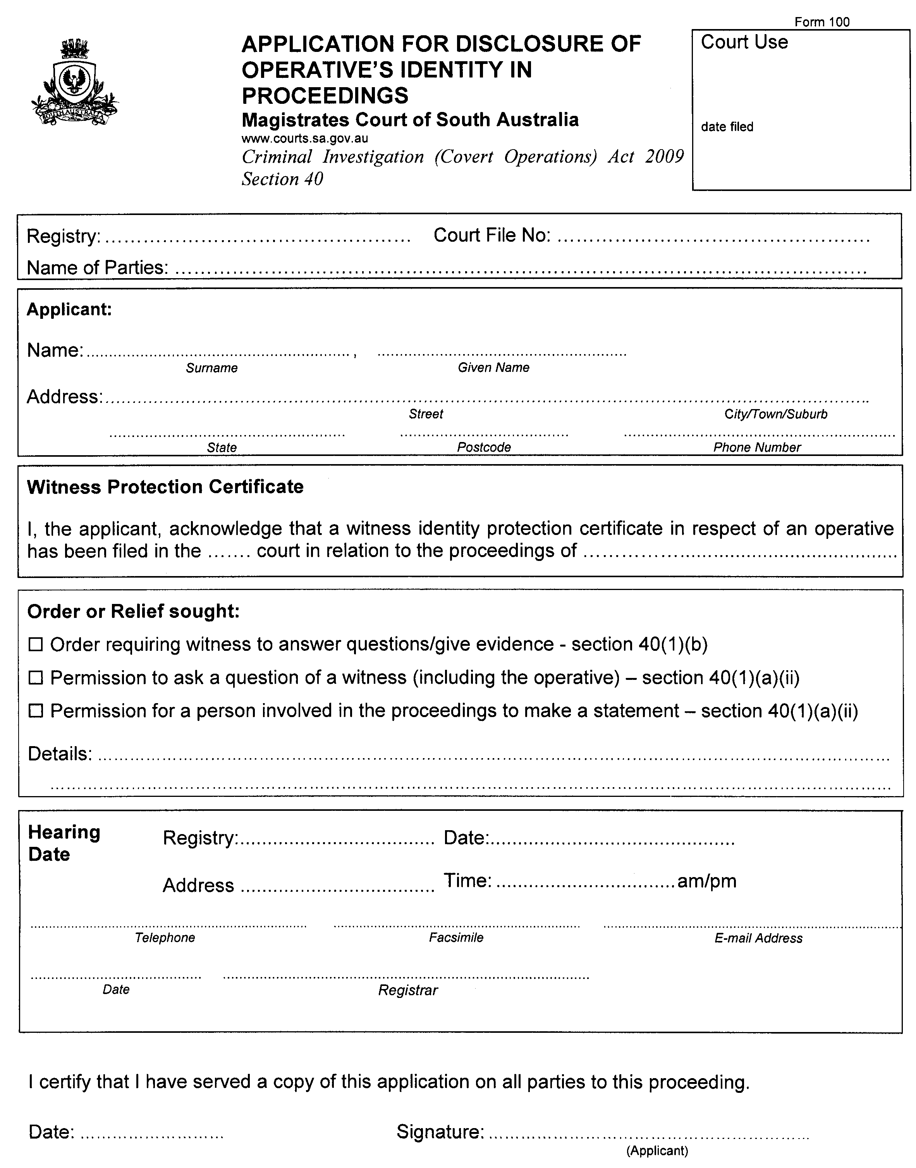
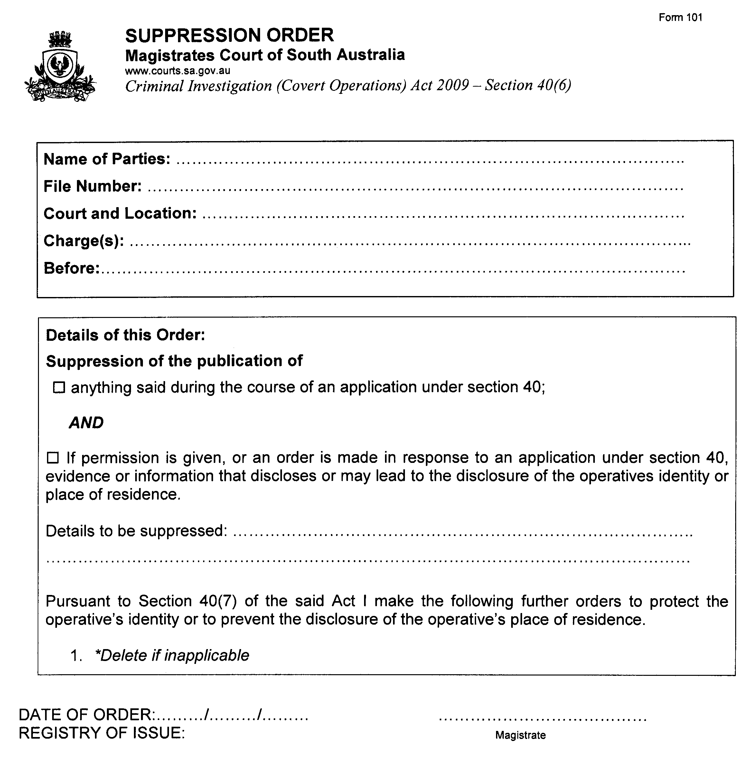
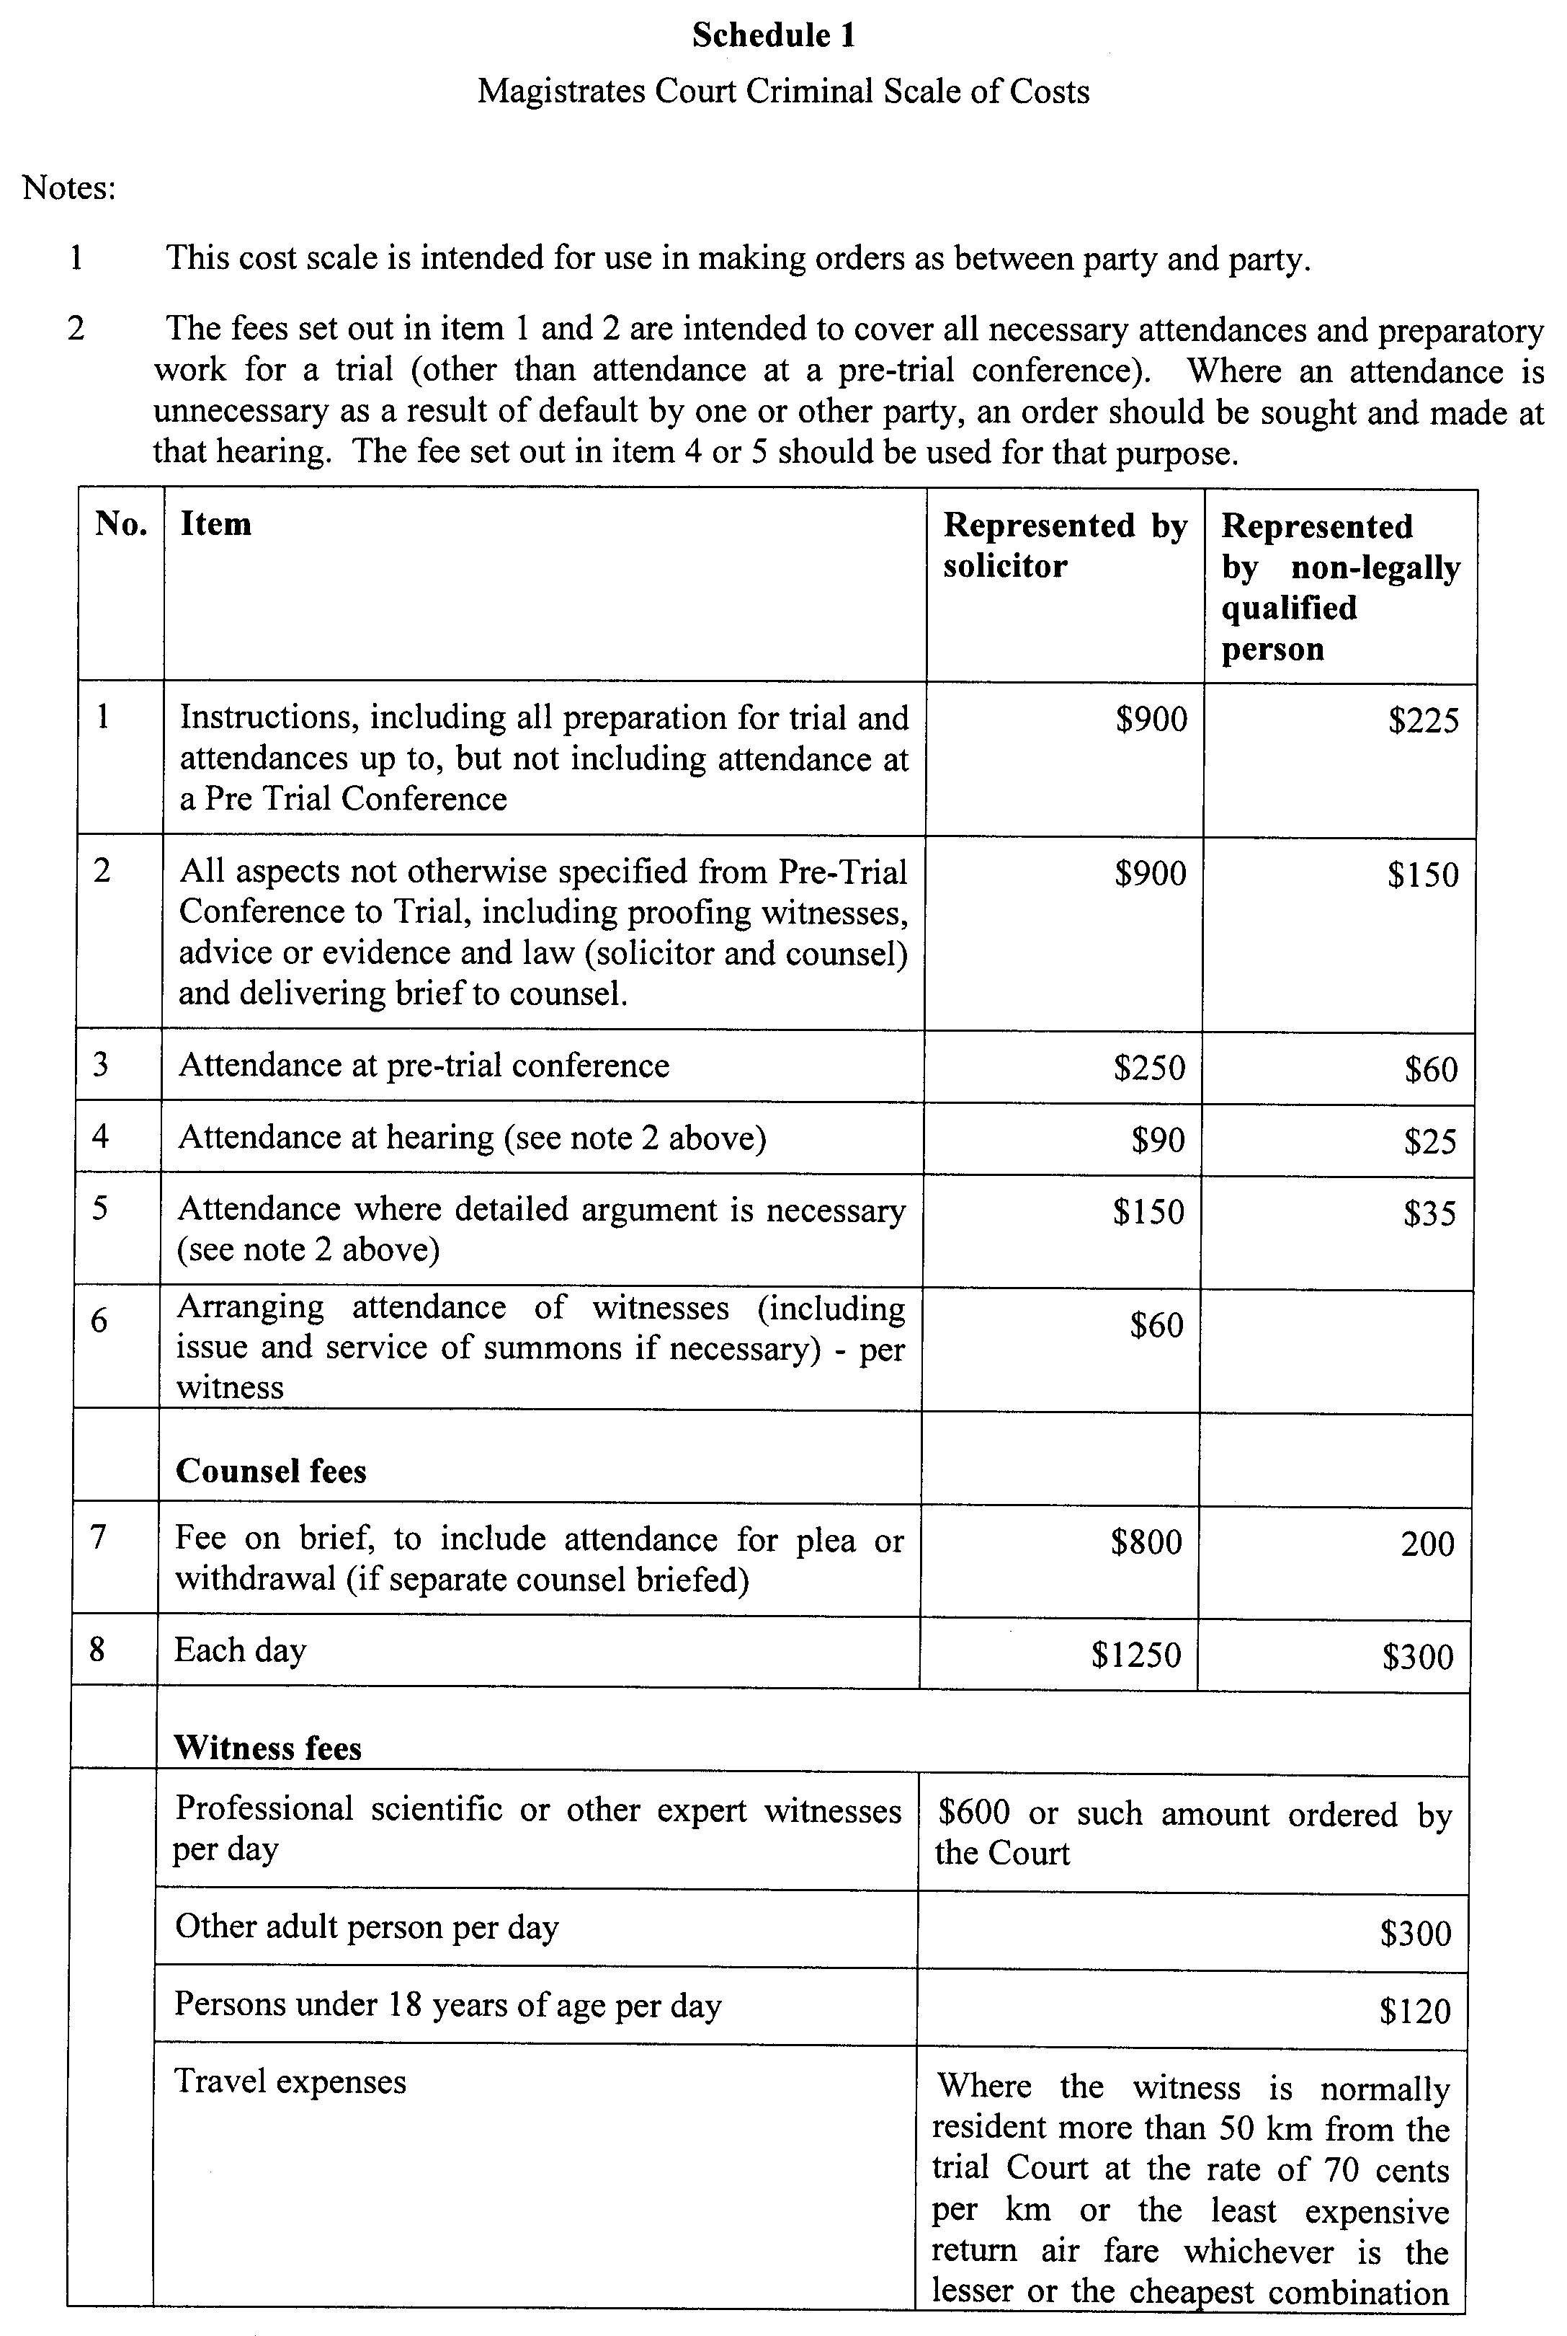

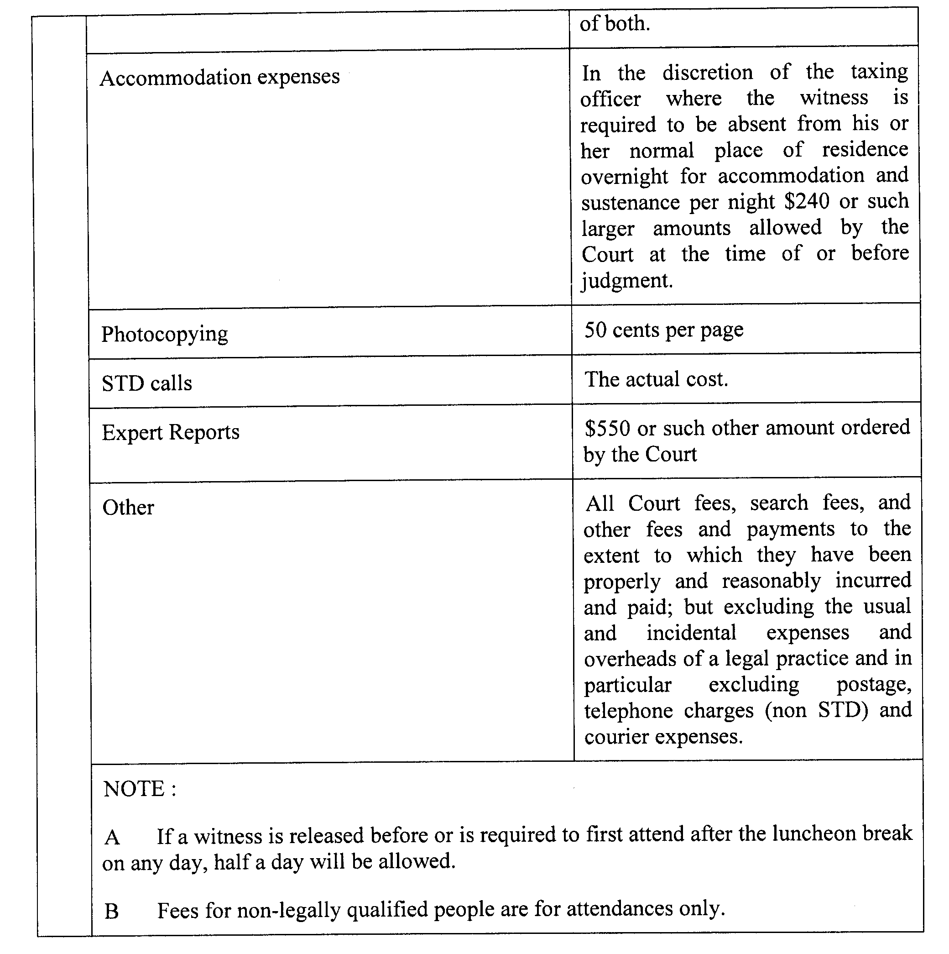

WATERWORKS ACT 1932
Removal of Land from Beetaloo Country Lands Water District and Addition to Wallaroo Mines Water District
PURSUANT to section 6 of the Waterworks Act 1932, the South Australian Water Corporation:
(a) removes from the Beetaloo Country Lands Water District and adds to the Wallaroo Mines Water District the land shown on the plan in the schedule; and
(b) declares that this notice will have effect from 1 July 2011.
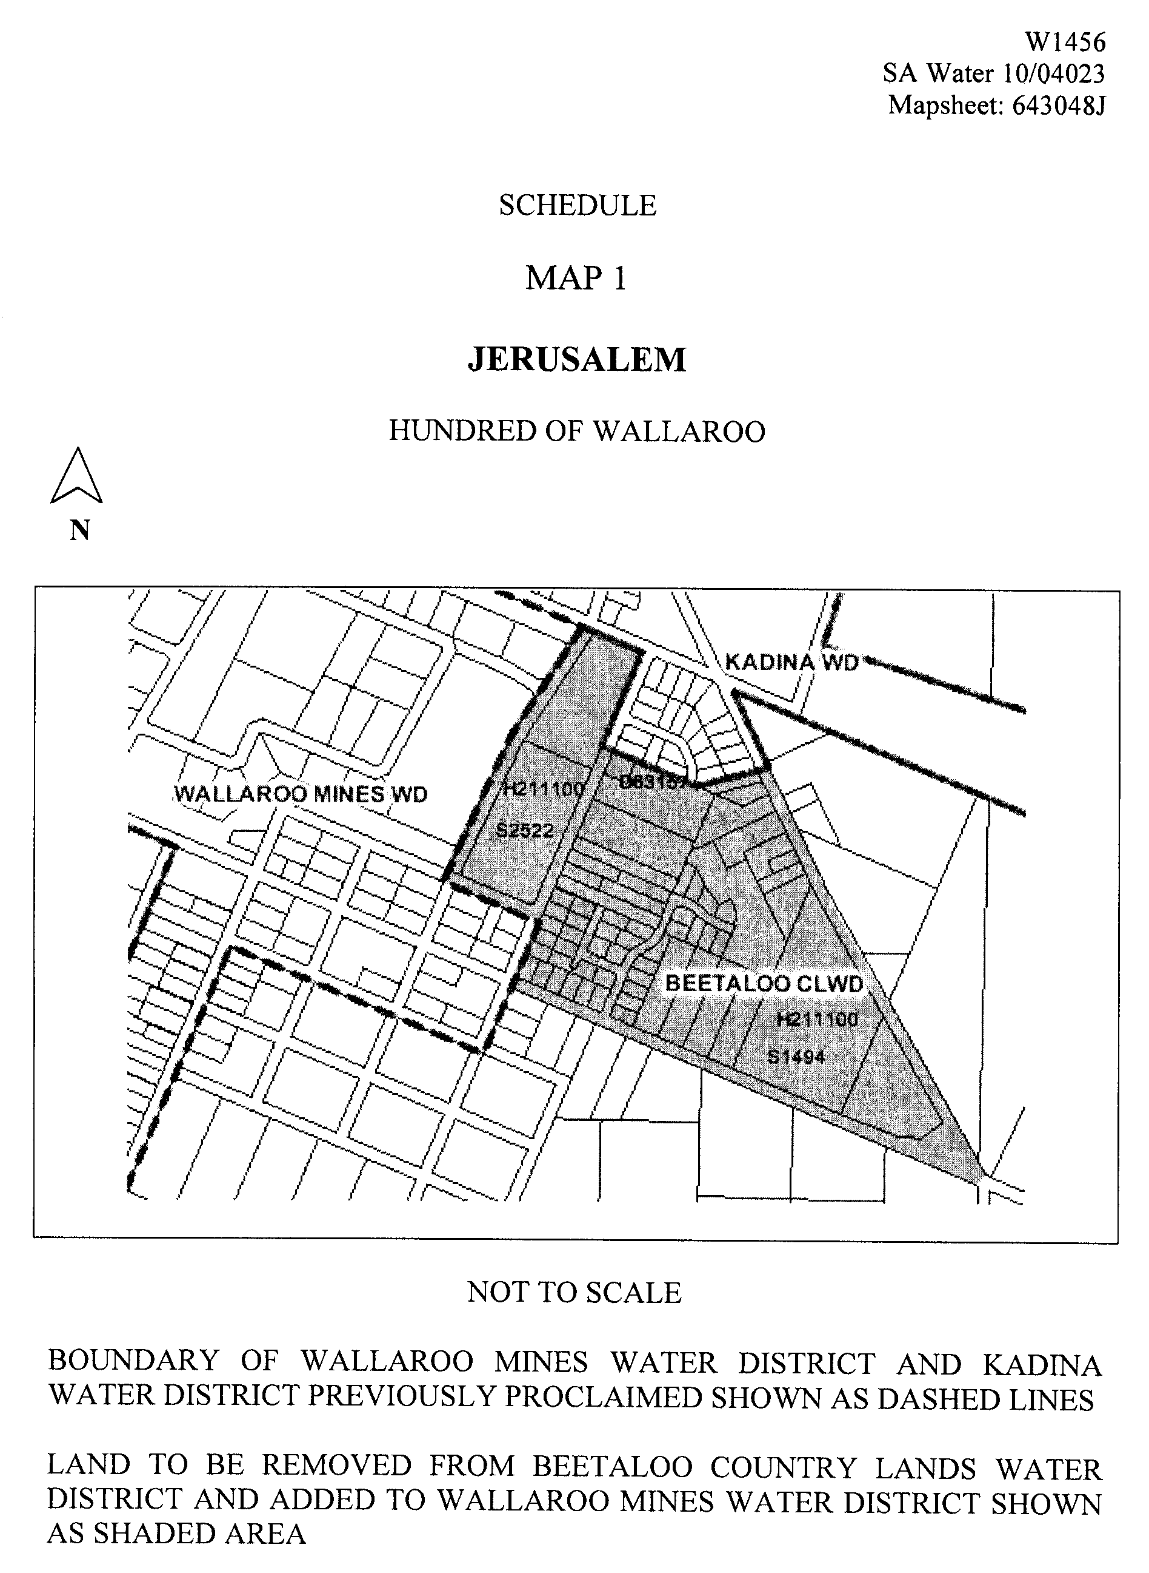
Dated 13 July 2010.
Signed for and on behalf of the South Australian Water Corporation by a person duly authorised so to do:
A. Schirripa, Manager Billing and Collection
In the presence of:
N. Glass, Team Leader Rating
SA WATER 10/04023 W1456

GOVERNMENT GAZETTE ADVERTISEMENT RATES

To apply from 1 July 2010

$  Agents, Ceasing to Act as 44.25  Associations:  Incorporation 22.40  Intention of Incorporation 55.50  Transfer of Properties 55.50  Attorney, Appointment of 44.25  Bailiff’s Sale 55.50  Cemetery Curator Appointed 32.75  Companies:  Alteration to Constitution 44.25  Capital, Increase or Decrease of 55.50  Ceasing to Carry on Business 32.75  Declaration of Dividend 32.75  Incorporation 44.25  Lost Share Certificates:  First Name 32.75  Each Subsequent Name 11.30  Meeting Final 37.00  Meeting Final Regarding Liquidator’s Report on  Conduct of Winding Up (equivalent to ‘Final  Meeting’)  First Name 44.25  Each Subsequent Name 11.30  Notices:  Call 55.50  Change of Name 22.40  Creditors 44.25  Creditors Compromise of Arrangement 44.25  Creditors (extraordinary resolution that ‘the Com-pany be wound up voluntarily and that a liquidator be appointed’) 55.50  Release of Liquidator⎯Application⎯Large Ad. 88.00  ⎯Release Granted 55.50  Receiver and Manager Appointed 51.00  Receiver and Manager Ceasing to Act 44.25  Restored Name 41.25  Petition to Supreme Court for Winding Up 77.00  Summons in Action 65.50  Order of Supreme Court for Winding Up Action 44.25  Register of Interests⎯Section 84 (1) Exempt 99.00  Removal of Office 22.40  Proof of Debts 44.25  Sales of Shares and Forfeiture 44.25  Estates:  Assigned 32.75  Deceased Persons⎯Notice to Creditors, etc. 55.50  Each Subsequent Name 11.30  Deceased Persons⎯Closed Estates 32.75  Each Subsequent Estate 1.45  Probate, Selling of 44.25  Public Trustee, each Estate 11.30 |  | $  Firms:  Ceasing to Carry on Business (each insertion) 29.50  Discontinuance Place of Business 29.50  Land⎯Real Property Act:  Intention to Sell, Notice of 55.50  Lost Certificate of Title Notices 55.50  Cancellation, Notice of (Strata Plan) 55.50  Mortgages:  Caveat Lodgement 22.40  Discharge of 23.40  Foreclosures 22.40  Transfer of 22.40  Sublet 11.30  Leases⎯Application for Transfer (2 insertions) each 11.30  Lost Treasury Receipts (3 insertions) each 32.75  Licensing 65.50  Municipal or District Councils:  Annual Financial Statement⎯Forms 1 and 2 618.00  Electricity Supply⎯Forms 19 and 20 439.00  Default in Payment of Rates:  First Name 88.00  Each Subsequent Name 11.30  Noxious Trade 32.75  Partnership, Dissolution of 32.75  Petitions (small) 22.40  Registered Building Societies (from Registrar-  General) 22.40  Register of Unclaimed Moneys⎯First Name 32.75  Each Subsequent Name 11.30  Registers of Members⎯Three pages and over:  Rate per page (in 8pt) 281.00  Rate per page (in 6pt) 371.00  Sale of Land by Public Auction 56.00  Advertisements 3.10  ¼ page advertisement 131.00  ½ page advertisement 262.00  Full page advertisement 514.00  Advertisements, other than those listed are charged at $3.10 per column line, tabular one-third extra.  Notices by Colleges, Universities, Corporations and District Councils to be charged at $3.10 per line.  Where the notice inserted varies significantly in length from that which is usually published a charge of $3.10 per column line will be applied in lieu of advertisement rates listed.  South Australian Government publications are sold on the condition that they will not be reproduced without prior permission from the Government Printer.
All the above prices include GST

GOVERNMENT GAZETTE NOTICES
ALL private advertisements forwarded for publication in the South Australian Government Gazette must be PAID FOR PRIOR TO INSERTION; and all notices, from whatever source, should be legibly written on one side of the paper only and sent to Government Publishing SA so as to be received no later than 4 p.m. Tuesday preceding the day of publication. Phone 8207 1045 or Fax 8207 1040. E-mail: governmentgazette@dpc.sa.gov.au. Send as attachments in Word format. Please include date the notice is to be published and to whom the notice will be charged. The Government Gazette is available online at: www.governmentgazette.sa.gov.au.

MISCELLANEOUS LEGISLATION AND GOVERNMENT PUBLICATIONS PRICES AS FROM 1 JULY 2010

Acts, Bills, Rules, Parliamentary Papers and Regulations
Pages | Main | Amends | Pages | Main | Amends

1-16 | 2.70 | 1.25 | 497-512 | 37.50 | 36.50
17-32 | 3.60 | 2.25 | 513-528 | 38.50 | 37.25
33-48 | 4.70 | 3.35 | 529-544 | 39.75 | 38.50
49-64 | 5.95 | 4.55 | 545-560 | 40.75 | 39.75
65-80 | 6.90 | 5.75 | 561-576 | 41.75 | 40.75
81-96 | 8.05 | 6.65 | 577-592 | 43.25 | 41.25
97-112 | 9.20 | 7.85 | 593-608 | 44.50 | 42.75
113-128 | 10.30 | 9.05 | 609-624 | 45.25 | 44.25
129-144 | 11.50 | 10.20 | 625-640 | 46.50 | 44.75
145-160 | 12.60 | 11.30 | 641-656 | 47.50 | 46.50
161-176 | 13.70 | 12.40 | 657-672 | 48.25 | 47.00
177-192 | 15.00 | 13.50 | 673-688 | 50.25 | 48.25
193-208 | 16.10 | 14.90 | 689-704 | 51.25 | 49.25
209-224 | 17.00 | 15.70 | 705-720 | 52.00 | 50.50
225-240 | 18.20 | 16.80 | 721-736 | 53.50 | 51.50
241-257 | 19.50 | 17.80 | 737-752 | 54.00 | 52.50
258-272 | 20.60 | 18.90 | 753-768 | 55.50 | 53.50
273-288 | 21.70 | 20.40 | 769-784 | 56.50 | 55.50
289-304 | 22.60 | 21.30 | 785-800 | 57.50 | 56.50
305-320 | 24.00 | 22.50 | 801-816 | 59.00 | 57.00
321-336 | 25.00 | 23.60 | 817-832 | 60.00 | 59.00
337-352 | 26.20 | 24.90 | 833-848 | 61.00 | 60.00
353-368 | 27.00 | 26.00 | 849-864 | 62.00 | 60.50
369-384 | 28.50 | 27.00 | 865-880 | 63.50 | 62.00
385-400 | 29.75 | 28.25 | 881-896 | 64.00 | 62.50
401-416 | 30.75 | 29.25 | 897-912 | 65.50 | 64.00
417-432 | 32.00 | 30.50 | 913-928 | 66.00 | 65.50
433-448 | 33.00 | 31.75 | 929-944 | 67.00 | 66.00
449-464 | 33.75 | 32.50 | 945-960 | 68.00 | 66.50
465-480 | 34.25 | 33.50 | 961-976 | 71.00 | 67.50
481-496 | 36.50 | 34.25 | 977-992 | 72.00 | 68.00

Legislation—Acts, Regulations, etc: $
Subscriptions:
Acts 230.00
All Bills as Laid 554.00
Rules and Regulations 554.00
Parliamentary Papers 554.00
Bound Acts 256.00
Index 128.00
Government Gazette
Copy 6.05
Subscription 306.00
Hansard
Copy 16.80
Subscription—per session (issued weekly) 480.00
Cloth bound—per volume 206.00
Subscription—per session (issued daily) 480.00
Legislation on Disk
Whole Database 3 557.00
Annual Subscription for fortnightly updates 1 093.00
Individual Act(s) including updates POA
Notice of Vacancies
Annual Subscription 169.00
Compendium
Subscriptions:
New Subscriptions 2 106.00
Updates 743.00
(All the above prices include GST)

All Legislation, Government Gazette, Hansard and Legislation on disk are available from:
Counter Sales Government Legislation⁺ Outlet
and Mail Orders: Service SA Customer Service Centre,
Ground Floor—EDS Centre, 108 North Terrace, Adelaide, S.A. 5000
Phone: 13 23 24 (local call cost), Fax: (08) 8204 1909
Postal: G.P.O. Box 1707, Adelaide, S.A. 5001

Online Shop: www.shop.service.sa.gov.au

Subscriptions and Government Publishing SA
Standing Orders: Box 9, Plaza Level, Riverside Centre, North Terrace, Adelaide, S.A. 5000
Phone: (08) 8207 1043, (08) 8207 0910, Fax: (08) 8207 1040

WILDERNESS PROTECTION REGULATIONS 2006
Closure of Cape Bouguer Wilderness Protection Area
PURSUANT to Regulations 6 (2) (c) of the Wilderness Protection Regulations 2006, I, Edward Gregory Leaman, Director of National Parks and Wildlife close to the public the whole of Cape Bouguer Wilderness Protection Area from 6 a.m. on Tuesday, 21 September 2010 until 6 a.m. on Friday, 24 September 2010.
The purpose of the closure is to ensure the safety of the public during a pest control and monitoring program within the reserve during the period indicated.
Use of Firearms within the Reserve
Pursuant to Regulations 6 (4), 16 (1) and 34 of the Wilderness Protection Regulations 2006, I, Edward Gregory Leaman, Director of National Parks and Wildlife grant permission to staff employed by the Kangaroo Island Natural Resources Management Board in possession of both a current Hunting Permit and a firearm to enter and remain in the whole of Cape Bouguer Wilderness Protection Area, from 6 a.m. on Tuesday, 21 September 2010 until 6 a.m. on Friday, 24 September 2010 for the purpose of taking feral animals.
This permission is conditional upon the observance by each of those persons of the requirements of the Wilderness Protection Act 1992, Wilderness Protection Regulations 2006 and the National Parks and Wildlife (Hunting) Regulations 1996, including those requiring compliance with the Director’s requests, requirements and orders of a Warden.
Dated 13 July 2010.
E. G. Leaman, Director of National Parks and Wildlife

WILDERNESS PROTECTION REGULATIONS 2006
Closure of Cape Bouguer Wilderness Protection Area
PURSUANT to Regulations 6 (2) (c) of the Wilderness Protection Regulations 2006, I, Edward Gregory Leaman, Director of National Parks and Wildlife close to the public the whole of Cape Bouguer Wilderness Protection Area from 6 a.m. on Tuesday, 31 August 2010 until 6 a.m. on Friday, 3 September 2010.
The purpose of the closure is to ensure the safety of the public during a pest control and monitoring program within the reserve during the period indicated.
Use of Firearms within the Reserve
Pursuant to Regulations 6 (4), 16 (1) and 34 of the Wilderness Protection Regulations 2006, I, Edward Gregory Leaman, Director of National Parks and Wildlife grant permission to staff employed by the Kangaroo Island Natural Resources Management Board in possession of both a current Hunting Permit and a firearm to enter and remain in the whole of Cape Bouguer Wilderness Protection Area, from 6 a.m. on Tuesday, 31 August 2010 until 6 a.m. on Friday, 3 September 2010 for the purpose of taking feral animals.
This permission is conditional upon the observance by each of those persons of the requirements of the Wilderness Protection Act 1992, Wilderness Protection Regulations 2006 and the National Parks and Wildlife (Hunting) Regulations 1996, including those requiring compliance with the Director’s requests, requirements and orders of a Warden.
Dated 13 July 2010.
E. G. Leaman, Director of National Parks and Wildlife

WILDERNESS PROTECTION REGULATIONS 2006
Closure of Cape Bouguer Wilderness Protection Area
PURSUANT to Regulations 6 (2) (c) of the Wilderness Protection Regulations 2006, I, Edward Gregory Leaman, Director of National Parks and Wildlife close to the public the whole of Cape Bouguer Wilderness Protection Area from 6 a.m. on Tuesday, 16 November 2010 until 6 a.m. on Friday, 19 November 2010.
The purpose of the closure is to ensure the safety of the public during a pest control and monitoring program within the reserve during the period indicated.
Use of Firearms within the Reserve
Pursuant to Regulations 6 (4), 16 (1) and 34 of the Wilderness Protection Regulations 2006, I, Edward Gregory Leaman, Director of National Parks and Wildlife grant permission to staff employed by the Kangaroo Island Natural Resources Management Board in possession of both a current Hunting Permit and a firearm to enter and remain in the whole of Cape Bouguer Wilderness Protection Area, from 6 a.m. Tuesday, 16 November 2010 until 6 a.m. on Friday, 19 November 2010 for the purpose of taking feral animals.
This permission is conditional upon the observance by each of those persons of the requirements of the Wilderness Protection Act 1992, Wilderness Protection Regulations 2006 and the National Parks and Wildlife (Hunting) Regulations 1996, including those requiring compliance with the Director’s requests, requirements and orders of a Warden.
Dated 13 July 2010.
E. G. Leaman, Director of National Parks and Wildlife

WILDERNESS PROTECTION REGULATIONS 2006
Closure of Cape Bouguer Wilderness Protection Area
PURSUANT to Regulations 6 (2) (c) of the Wilderness Protection Regulations 2006, I, Edward Gregory Leaman, Director of National Parks and Wildlife close to the public the whole of Cape Bouguer Wilderness Protection Area from 6 a.m. on Tuesday, 19 October 2010 until 6 a.m. on Friday, 22 October 2010.
The purpose of the closure is to ensure the safety of the public during a pest control and monitoring program within the reserve during the period indicated.
Use of Firearms within the Reserve
Pursuant to Regulations 6 (4), 16 (1) and 34 of the Wilderness Protection Regulations 2006, I, Edward Gregory Leaman, Director of National Parks and Wildlife grant permission to staff employed by the Kangaroo Island Natural Resources Management Board in possession of both a current Hunting Permit and a firearm to enter and remain in the whole of Cape Bouguer Wilderness Protection Area, from 6 a.m. on Tuesday, 19 October 2010 until 6 a.m. on Friday, 22 October 2010 for the purpose of taking feral animals.
This permission is conditional upon the observance by each of those persons of the requirements of the Wilderness Protection Act 1992, Wilderness Protection Regulations 2006 and the National Parks and Wildlife (Hunting) Regulations 1996, including those requiring compliance with the Director’s requests, requirements and orders of a Warden.
Dated 13 July 2010.
E. G. Leaman, Director of National Parks and Wildlife

South Australia
Architectural Practice Act (Commencement) Proclamation 2010
1—Short title
This proclamation may be cited as the Architectural Practice Act (Commencement) Proclamation 2010.
2—Commencement of Act and suspension of certain provisions
(1) The Architectural Practice Act 2009 (No 16 of 2009) will come into operation on 15 July 2010.
(2) The operation of the following provisions of the Act is suspended until a day or time or days or times to be fixed by subsequent proclamation or proclamations:
(a) sections 4 and 5;
(b) sections 7 to 70 (inclusive);
(c) Schedule 1 (other than clause 2(4) and clause 5).
Made by the Governor’s Deputy
with the advice and consent of the Executive Council
on 15 July 2010
MUDP10/002CS
South Australia
Administrative Arrangements (Administration of Architectural Practice Act) Proclamation 2010
under section 5 of the Administrative Arrangements Act 1994
1—Short title
This proclamation may be cited as the Administrative Arrangements (Administration of Architectural Practice Act) Proclamation 2010.
2—Commencement
This proclamation comes into operation on the day on which it is made.
3—Administration of Act committed to Minister for Urban Development and Planning
The administration of the Architectural Practice Act 2009 is committed to the Minister for Urban Development and Planning.
Made by the Governor’s Deputy
with the advice and consent of the Executive Council
on 15 July 2010
MUDP10/002CS
South Australia
Holidays (Adelaide Cup) Proclamation 2010
under section 5 of the Holidays Act 1910
1—Short title
This proclamation may be cited as the Holidays (Adelaide Cup) Proclamation 2010.
2—Commencement
This proclamation comes into operation on the day on which it is made.
3—Substitution of Adelaide Cup day in 2011
Monday 14 March 2011 is declared to be a public holiday and bank holiday instead of Monday 16 May 2011.
Made by the Governor’s Deputy
with the advice and consent of the Executive Council
on 15 July 2010
MIR10/010CS
South Australia
Mining (Variation of Private Mine) Proclamation 2010
under section 73N of the Mining Act 1971

Preamble
1 The following area was declared to be a private mine by proclamation on 15 April 1976 (Gazette 15.4.1976 p1978):
That portion of allotment 42 and those portions of allotment 44, section 402, hundred of Noarlunga, county of Adelaide being portion of the land contained in certificate of title register book, volume 1583, folio 47.
2 The Warden's Court has declared (on 6 April 2010 in Action No 192 of 2009) that proper grounds exist for varying the declaration referred to in clause 1 by excising the following land from the area of the private mine:
The portion of the private mine within Certificate of Title Register Book Volume 6027 Folio 155.

1—Short title
This proclamation may be cited as the Mining (Variation of Private Mine) Proclamation 2010.
2—Commencement
This proclamation comes into operation on the day on which it is made.
3—Variation of private mine
The declaration referred to in clause 1 of the preamble is varied by excising from the area of the private mine the portion of the private mine described in clause 2 of the preamble.
Made by the Governor’s Deputy
on the basis of the declaration of the Warden's Court referred to in clause 2 of the preamble and with the advice and consent of the Executive Council
on 15 July 2010
AGO0047/02CS
South Australia
Architectural Practice (Election) Regulations 2010
under the Architectural Practice Act 2009

Contents
1 Short title
2 Commencement
3 Interpretation
4 Returning officer
5 Election to be conducted by returning officer
6 Appointment of closing day and polling day
7 Advertisement of election
8 Registrar to prepare roll
9 Nomination
10 Uncontested elections
11 Preparation of ballot papers
12 Issue of voting papers
13 Method of voting
14 Scrutineers
15 Arranging papers for counting
16 Method for counting based on principles of proportional representation
17 Death of candidate
18 Declaration of result of election
19 Computer counting
Schedule 1—Method of counting votes
1 Interpretation
2 Method of counting votes
Schedule 2—Transitional provision

1—Short title
These regulations may be cited as the Architectural Practice (Election) Regulations 2010.
2—Commencement
These regulations will come into operation on the day on which section 71 of the Architectural Practice Act 2009 comes into operation.
3—Interpretation
(1) In these regulations, unless the contrary intention appears—
Act means the Architectural Practice Act 2009;
business day means any day other than a Saturday, Sunday or public holiday;
closing day, in relation to an election, means the day on which nomination of candidates for the election closes;
Electoral Commissioner means the person for the time being holding, or acting in, the office of the Electoral Commissioner under the Electoral Act 1985;
polling day, in relation to an election, means the day on which voting at the election closes;
returning officer—see regulation 4;
voter means a person entitled to vote at an election conducted under these regulations.
(2) The close of voting for an election is 9.30 am on polling day.
4—Returning officer
The returning officer for an election under these regulations will be the Electoral Commissioner.
5—Election to be conducted by returning officer
(1) An election for the purposes of section 5(1)(a) of the Act will be conducted by the returning officer—
(a) in accordance with these regulations; and
(b) to the extent that these regulations fail to deal with a matter that, in the opinion of the Electoral Commissioner, is necessary for the proper conduct of the election—in accordance with rules determined by the Electoral Commissioner in relation to that matter.
(2) The Board is responsible for the costs and expenses incurred by the returning officer in conducting an election.
6—Appointment of closing day and polling day
The returning officer will fix—
(a) a day as closing day for an election; and
(b) a day as polling day for an election.
7—Advertisement of election
(1) At least 14 days before the closing day for an election the returning officer must cause an advertisement relating to the election to be placed in a newspaper circulating generally throughout the State.
(2) The advertisement must set out—
(a) the day fixed as polling day; and
(b) the number of vacancies to be filled; and
(c) an invitation for nominations for the vacancies to be filled; and
(d) details about how a nomination may be made; and
(e) the day fixed as closing day.
8—Registrar to prepare roll
(1) The Registrar is responsible for the preparation of a voters roll for the purposes of an election.
Note—
Every person who is a registered architect at the time the voters roll is prepared is entitled to vote—see section 6(2) of the Act.
(2) The voters roll to be used in a particular election must reflect entitlements to vote as they exist at 5 pm on the third business day after the day on which the advertisement relating to the election is published.
(3) The Registrar must supply the returning officer with sufficient copies of the voters roll, certified by the Registrar, for use at an election.
(4) The voters roll may be supplied to the returning officer in electronic form, or in another manner agreed between the Registrar and the returning officer.
9—Nomination
(1) The returning officer must prepare a nomination form for the purposes of an election (in a form determined by the returning officer).
Note—
Every registered architect is eligible to be a candidate for election—see section 5(1)(a) of the Act.
(2) A registered architect may be nominated as a candidate for an election by lodgement of a nomination form with the returning officer by 12 noon on closing day.
(3) A nomination must be made by 2 persons who are entitled to vote at the election.
(4) A candidate for election must—
(a) make a declaration on the nomination form that he or she is eligible to be elected at the election; and
(b) signify his or her consent by signing the nomination form.
(5) A nomination must be accompanied by—
(a) a profile of the candidate; and
(b) other information required by the returning officer.
(6) A profile must comply with the following requirements:
(a) the profile must be limited to relevant professional information about the candidate and other information directly relevant to the functions or operations of the Board under the Act;
(b) the profile must be in typed form or in legible handwriting and comply with other requirements as to form determined by the returning officer;
(c) the profile must not exceed 200 words;
(d) the profile must be signed and dated by the candidate (but this signature and date will not form part of the profile for the purposes of the election).
(7) The returning officer may reject a nomination if, in the opinion of the returning officer, the name under which the candidate is nominated—
(a) is obscene; or
(b) is frivolous; or
(c) appears to have been assumed for an ulterior purpose.
(8) A nomination is invalid if—
(a) the nomination is not made by the use of a nomination form under this regulation; or
(b) the nomination form is not completed—
(i) in accordance with instructions contained in the form; or
(ii) in accordance with the requirements of this regulation; or
(c) the nomination form, the candidate profile and any other required information are not received by the returning officer by 12 noon on closing day.
(9) A dispute as to the validity of a nomination will be determined summarily by the returning officer.
(10) A nominated candidate may at any time before the close of nominations, by written notice signed by the candidate and given to the returning officer, withdraw the nomination.
10—Uncontested elections
(1) If, after nominations have closed, it appears that the number of candidates nominated to contest the election does not exceed the number of persons required to be elected, the returning officer must declare the nominated candidate or candidates elected.
(2) Within 7 days after making the declaration, the returning officer must cause a notice of the declaration to be placed in a newspaper circulating generally throughout the State.
(3) The notice must set out—
(a) the date of the declaration; and
(b) the name of each successful candidate.
(4) If, after nominations have closed, it appears that the number of candidates nominated to contest the election is less than the number of persons required to be elected, the returning officer, in addition to making a declaration and publishing a notice under subregulations (1) and (2), must extend the period for nominations for the remaining vacancy or vacancies by a period (not exceeding 7 days) determined by the returning officer and may fix a new day as polling day.
(5) If the returning officer is required to take action under subregulation (4), the returning officer must at the earliest opportunity cause a notice relating to the matter to be placed in a newspaper circulating generally throughout the State.
(6) The notice must set out—
(a) the day fixed as polling day; and
(b) the number of vacancies left to be filled; and
(c) an invitation for nominations for those vacancies; and
(d) details about how a nomination may be made; and
(e) the day by which nominations must be received.
(7) These regulations will then apply in the same manner as they applied (or would have applied) to earlier nominations.
(8) If the number of candidates nominated exceeds the required number of candidates, an election will be held to fill the relevant vacancies.
11—Preparation of ballot papers
(1) If an election is to be held, the returning officer must prepare a ballot paper showing the names of all candidates for election (on the basis of information provided to the returning officer as part of the nomination process).
(2) The ballot paper must be prepared as soon as is reasonably practicable after the closing day for the election.
(3) The names of the candidates must be arranged on the ballot paper, 1 under the other, in an order determined by lot.
(4) A square must be placed to the left of each name appearing on the ballot paper.
(5) A ballot paper will otherwise be in a form determined by the returning officer.
12—Issue of voting papers
(1) The returning officer must, at least 14 days before polling day for an election, send by post to every voter—
(a) a ballot paper (authenticated to the satisfaction of the returning officer); and
(b) a statement in writing setting out—
(i) instructions for the completion of a ballot paper; and
(ii) the manner in which the ballot paper is to be returned; and
(c) a set of candidate profiles in a form determined by the returning officer; and
(d) an opaque envelope bearing a declaration in a form determined by the returning officer, to be completed by the voter, declaring that the ballot paper contained in the envelope contains his or her vote and that he or she has not already voted at the election.
(2) The declaration must appear on a tear-off extension to the envelope flap.
(3) The envelope must be—
(a) a pre-paid envelope addressed to the returning officer; or
(b) accompanied by a pre-paid envelope addressed to the returning officer.
(4) If a person to whom voting papers are issued desires to vote at the relevant election, the following procedures must be followed:
(a) the voter must mark his or her vote in the manner prescribed by these regulations on the ballot paper supplied;
(b) the voter must then fold the ballot paper and place the folded ballot paper in the envelope;
(c) the voter must then seal the envelope;
(d) the voter must then ensure that the declaration on the flap is completed and signed by the voter;
(e) the sealed envelope must then be delivered to the returning officer (by post or personally) not later than the close of voting on polling day.
(5) If the returning officer is satisfied that voting papers issued to a voter—
(a) have not been received by the voter; or
(b) have been lost; or
(c) have been inadvertently spoiled,
the returning officer may issue fresh voting papers to the voter (before the close of voting).
(6) The issue of fresh voting papers automatically cancels the original voting papers.
13—Method of voting
(1) To make a formal vote at an election a person must make a vote on the ballot paper—
(a) if only 1 candidate is required to be elected—by placing the number 1 in the square opposite the name of the candidate of the voter's first preference and, if the voter so desires, by placing the number 2 and consecutive numbers in the squares opposite the names of other candidates in the order of the voter's preference for them;
(b) if more than 1 candidate is required to be elected—by placing consecutive numbers beginning with the number 1 in the squares opposite the names of candidates in the order of the voter's preference for them until the voter has indicated a vote for a number of candidates equal to the number of candidates required to be elected and then, if the voter so desires, by continuing to place consecutive numbers for 1 or more additional candidates in the order of the voter's preference.
(2) A tick or cross appearing on a ballot paper is equivalent to the number 1.
(3) If—
(a) a series of numbers (starting from the number 1) appearing on a ballot paper is non-consecutive by reason only of the omission of 1 or more numbers from the series or the repetition of a number (not being the number 1); and
(b) if more than 1 candidate is required to be elected—the numbers are at least consecutive up to the number of candidates required to be elected,
the ballot paper is not informal and the votes are valid up to the point at which the omission or repetition occurs.
(4) A ballot paper is not informal by reason of non-compliance with this regulation if the voter's intention is clearly indicated on the ballot paper.
14—Scrutineers
(1) Each candidate at an election may appoint a person to be a scrutineer for the purposes of the election.
(2) A candidate in an election is not eligible for appointment as a scrutineer for the election (and a candidate may not be present at the scrutiny).
(3) No more than 1 scrutineer may be appointed for each candidate.
(4) The appointment of a scrutineer may be made by written notice served on the returning officer (personally or by post).
15—Arranging papers for counting
(1) The returning officer will, as soon as practicable after the close of voting for an election, with the assistance of persons appointed or nominated by the returning officer, and in the presence of scrutineers or officers of the Board who may be present, ensure that all voting papers returned for the purposes of the election in accordance with these regulations are made available under this regulation.
(2) The returning officer will, for the purposes of the election (and with such assistance as may be necessary and appropriate)—
(a) examine the declaration on each envelope validly returned under these regulations and determine which votes are to be accepted for further scrutiny; and
(b) tear off the extensions to the envelope flaps on the envelopes accepted; and
(c) rearrange the envelopes that no longer bear tear off extensions so that the anonymity of voters is maintained; and
(d) remove the ballot papers from those envelopes; and
(e) examine the ballot papers and reject informal ballot papers; and
(f) arrange all unrejected ballot papers into appropriate parcels for counting.
16—Method for counting based on principles of proportional representation
The returning officer will conduct the counting of votes in an election in accordance with the method set out in Schedule 1.
17—Death of candidate
If a candidate dies between the close of nominations and polling day, the election will not fail and a vote indicated on a ballot paper opposite the name of the deceased candidate must be counted to the candidate next in order of the voter's preference, and the numbers indicating subsequent preferences will be altered accordingly.
18—Declaration of result of election
(1) When all vacancies have been filled by the making of provisional declarations under Schedule 1, the returning officer will formally declare the result of the election.
(2) Within 7 days after making a formal declaration the returning officer must—
(a) provide written notification of the result to the Minister; and
(b) cause a notice setting out the result to be published in a newspaper circulating generally throughout the State.
19—Computer counting
(1) The returning officer may decide to use a computer program to carry out steps involved in the recording, scrutiny or counting of votes in an election.
(2) However, the returning officer cannot do so unless the returning officer is reasonably satisfied that the proper use of the program would produce the same result in the recording, scrutiny or counting of votes as the result that would be achieved if the program were not to be used.
(3) If a computer program is used, the method of counting votes under Schedule 1 may be modified according to the determination of the returning officer.
Schedule 1—Method of counting votes
1—Interpretation
(1) In this Schedule—
continuing candidate means a candidate not already elected or excluded from the count;
election of a candidate means the making by the returning officer of a provisional declaration that the candidate has been elected, and elected has a corresponding meaning;
surplus votes of an elected candidate means the excess (if any) over the quota of the elected candidate's votes.
(2) For the purposes of clause 2, a reference to votes of or obtained or received by a candidate includes votes obtained or received by the candidate on transfer under that clause.
2—Method of counting votes
The conduct of the counting of the votes in an election will occur according to the following method:
(a) the number of first preference votes given for each candidate and the total number of all such votes must be ascertained and a quota determined by—
(i) dividing the total number of first preference votes by 1 more than the number of candidates required to be elected; and
(ii) increasing the quotient so obtained (disregarding any remainder) by 1,
and, if a candidate has received a number of first preference votes equal to or greater than the quota, the returning officer must make a provisional declaration that the candidate has been elected;
(b) if the total number of all first preference votes does not exceed 150, the number of votes of a particular kind contained in the ballot papers will, for the purposes of this clause (including paragraph (a)), be taken to be the number obtained by multiplying the number of votes of that kind contained in the ballot papers by 100;
(c) unless all the vacancies have been filled, the surplus votes of each elected candidate must be transferred to the continuing candidates as follows:
(i) the number of surplus votes of the elected candidate must be divided by the number of first preference votes received by that candidate and the resulting fraction will be the transfer value;
(ii) the total number of the first preference votes for the elected candidate that are contained in ballot papers that express the next available preference for a particular continuing candidate must be multiplied by the transfer value, the number so obtained (disregarding any fraction) must be added to the number of first preference votes of the continuing candidate and all those ballot papers must be transferred to the continuing candidate,
and, if a continuing candidate has received a number of votes equal to or greater than the quota on the completion of a transfer, the returning officer must make a provisional declaration that the candidate has been elected;
(d) unless all the vacancies have been filled, the surplus votes (if any) of a candidate elected under paragraph (c), or elected subsequently under this paragraph, must be transferred to the continuing candidates in accordance with paragraph (c)(i) and (ii) and, if a continuing candidate has received a number of votes equal to or greater than the quota on the completion of a transfer, the returning officer must make a provisional declaration that the candidate has been elected;
(e) if a continuing candidate has received a number of votes equal to or greater than the quota on the completion of a transfer under paragraph (c) or (d) of the surplus votes of a particular elected candidate, no votes of any other candidate may be transferred to the continuing candidate;
(f) for the purposes of the application of paragraph (c)(i) and (ii) in relation to a transfer under paragraph (d) or (h) of the surplus votes of an elected candidate, each ballot paper of the elected candidate that was obtained on a transfer under this clause must be dealt with as if any vote it expressed for the elected candidate were a first preference vote, as if the name of any other candidate previously elected or excluded had not been on the ballot paper and as if the numbers indicating subsequent preferences had been altered accordingly;
(g) if, after the counting of first preference votes or the election of a candidate and the transfer of the surplus votes (if any) of the elected candidate that are capable of being transferred, no candidate has, or less than the number of candidates required to be elected have, received a number of votes equal to the quota, the candidate who has the fewest votes must be excluded and all the excluded candidate's votes must be transferred to the continuing candidates as follows:
(i) the total number of the first preference votes for the excluded candidate that are contained in ballot papers that express the next available preference for a particular continuing candidate must be transferred, each first preference vote at a transfer value of 1, to the continuing candidate and added to the number of votes of the continuing candidate and all those ballot papers must be transferred to the continuing candidate;
(ii) the total number (if any) of other votes obtained by the excluded candidate on transfers under this clause must be transferred from the excluded candidate in the order of the transfers on which they were obtained, the votes obtained on the earliest transfer being transferred first, as follows:
(A) the total number of votes transferred to the excluded candidate from a particular candidate that are contained in ballot papers that express the next available preference for a particular continuing candidate must be multiplied by the transfer value at which the votes were so transferred to the excluded candidate;
(B) the number so obtained (disregarding any fraction) must be added to the number of votes of the continuing candidate;
(C) all those ballot papers must be transferred to the continuing candidate;
(h) if a continuing candidate has received a number of votes equal to or greater than the quota on the completion of a transfer under paragraph (g) or (i) of votes of an excluded candidate, the returning officer must make a provisional declaration that the candidate has been elected and, unless all the vacancies have been filled, the surplus votes (if any) of the candidate so elected must be transferred in accordance with paragraph (c)(i) and (ii), except that, if the candidate so elected is elected before all the votes of the excluded candidate have been transferred, the surplus votes (if any) of the candidate so elected must not be transferred until the remaining votes of the excluded candidate have been transferred in accordance with paragraph (g)(i) and (ii) to continuing candidates;
(i) subject to paragraph (k), if, after the exclusion of a candidate and the transfer of the votes (if any) of the excluded candidate that are capable of being transferred, no continuing candidate has received a number of votes greater than the quota, the continuing candidate who has the fewest votes must be excluded and his or her votes transferred in accordance with paragraph (g)(i) and (ii);
(j) if a candidate is elected as a result of a transfer of the first preference votes of an excluded candidate or a transfer of all the votes of an excluded candidate that were transferred to the excluded candidate from a particular candidate, no other votes of the excluded candidate may be transferred to the candidate so elected;
(k) in respect of the last vacancy for which 2 continuing candidates remain, the returning officer must make a provisional declaration that the continuing candidate who has the larger number of votes has been elected despite the fact that number is below the quota and, if those candidates have the same number of votes, the candidate with the larger number of votes at the last preceding count or transfer will be taken to be elected and, if the number of votes at that count or transfer was equal, the returning officer must, in the presence of any scrutineers who may be present, draw lots to determine which of the candidates is to be elected;
(l) despite any other provision of this clause, if, on the completion of a transfer of votes under this clause, the number of continuing candidates is equal to the number of remaining unfilled vacancies, the returning officer must make a provisional declaration that those candidates have been elected;
(m) for the purposes of this clause—
(i) the order of election of candidates will be taken to be in accordance with the order of the count or transfer as a result of which they were elected, the candidates (if any) elected on the count of first preference votes being taken to be the earliest elected; and
(ii) if 2 or more candidates are elected as a result of the same count or transfer, the order in which they will be taken to have been elected will be in accordance with the relative numbers of their votes, the candidate with the largest number of votes being taken to be the earliest elected but, if any 2 or more of those candidates each have the same number of votes, the order in which they will be taken to have been elected will be taken to be in accordance with the relative numbers of their votes at the last count or transfer before their election at which each of them had a different number of votes, the candidate with the largest number of votes at that count or transfer being taken to be the earliest elected and, if there has been no such count or transfer, the returning officer must, in the presence of any scrutineers who may be present, draw lots to determine the order in which they will be taken to have been elected;
(n) subject to paragraphs (o) and (p), if, after a count or transfer under this clause, 2 or more candidates have surplus votes, the order of transfers of the surplus votes of those candidates will be in accordance with the relative sizes of the surpluses, the largest surplus being transferred first;
(o) subject to paragraph (p), if, after a count or transfer under this clause, 2 or more candidates have equal surpluses, the order of transfers of the surplus votes of those candidates will be in accordance with the relative numbers of votes of those candidates at the last count or transfer at which each of those candidates had a different number of votes, the surplus of the candidate with the largest number of votes at that count or transfer being transferred first but, if there has been no such count or transfer, the returning officer must, in the presence of any scrutineers who may be present, draw lots to determine the order in which the surpluses will be dealt with;
(p) if, after a count or transfer under this clause, a candidate obtains surplus votes, those surplus votes will not be transferred before the transfer of surplus votes obtained by any other candidate on an earlier count or transfer;
(q) if the candidate who has the fewest votes is required to be excluded and 2 or more candidates each have the fewest votes, whichever of those candidates had the fewest votes at the last count or transfer at which each of those candidates had a different number of votes will be excluded but, if there has been no such count or transfer, the returning officer must, in the presence of any scrutineers who may be present, draw lots to determine which candidate will be excluded;
(r) if a candidate is elected by reason that the number of first preference votes received, or the aggregate of first preference votes received and all other votes obtained on transfers under this clause, is equal to the quota, all the ballot papers expressing those votes must be set aside as finally dealt with;
(s) a ballot paper must be set aside as exhausted where on a transfer it is found that the paper expresses no preference for a continuing candidate;
(t) for the purposes of this clause, a transfer under paragraph (c), (d) or (h) of the surplus votes of any elected candidate, a transfer in accordance with paragraph (g)(i) of all first preference votes of an excluded candidate or a transfer in accordance with paragraph (g)(ii) of all the votes of an excluded candidate that were transferred from a particular candidate will each be regarded as constituting a separate transfer.
Schedule 2—Transitional provision
An election may be held for the purposes of making appointments to the Board pursuant to the Acts Interpretation Act 1915 prior to the commencement of section 5 of the Act and for the purposes of such an election—
(a) a reference in these regulations to the Board is to be taken to be a reference to the Board as constituted under the repealed Act; and
(b) a reference in these regulations to a registered architect is to be taken to be a reference to a person who is a registered architect under the repealed Act; and
(c) a reference in these regulations to the Registrar is to be taken to be a reference to the person holding the office of Registrar of the Board under the repealed Act.
Note—
As required by section 10AA(2) of the Subordinate Legislation Act 1978, the Minister has certified that, in the Minister's opinion, it is necessary or appropriate that these regulations come into operation as set out in these regulations.
Made by the Governor’s Deputy
with the advice and consent of the Executive Council
on 15 July 2010
No 171 of 2010
MUDP10/002CS

FAXING COPY?
IF you fax copy to Government Publishing SA for inclusion in the Government Gazette, there is no need to send a Confirmation Copy to us as well.
This creates confusion and may well result in your notice being printed twice.
Please use the following fax number:
Fax transmission: (08) 8207 1040
Phone Inquiries: (08) 8207 1045
Please include a contact person, phone number and order number so that we can phone back with any queries we may have regarding the fax copy.
NOTE: Closing time for lodging new copy (fax, hard copy or email) is 4 p.m. on Tuesday preceding the day of publication.

Government Gazette notices can be E-mailed.
The address is:
governmentgazette@dpc.sa.gov.au
Documents should be sent as attachments in Word format.
When sending a document via E-mail, please confirm your transmission with a faxed copy of your document, including the date the notice is to be published.
Fax transmission: (08) 8207 1040
Enquiries: (08) 8207 1045
NOTE: Closing time for lodging new copy (fax, hard copy or email) is 4 p.m. on Tuesday preceding the day of publication.

CITY OF CAMBELLTOWN
Notice is hereby given that the City of Campbelltown, pursuant to section 219 (7) of the Local Government Act 1999, adopted a Street Naming Policy for its area on 6 July 2010.
Dated 8 July 2010.
P. Di Iulio, Chief Executive Officer

CITY OF MARION
Roads (Opening and Closing) Act 1991
Chesham Street, Glengowrie and Somerton Park
NOTICE is hereby given, pursuant to section 10 of the Roads (Opening and Closing) Act 1991, that the Corporation of the City of Marion proposes to make a Road Process Order to close portion of the Public Road (Chesham Street) adjoining Allotments 33 and 34 in Deposited Plan 4552 and Allotment 100 in Deposited Plan 73052, more particularly delineated and lettered ‘A’ in the Preliminary Plan No. 10/0030.
Closed road ‘A’ is to be transferred to Eldercare Inc.
A copy of the plan and a statement of persons affected are available for public inspection at the offices of the Council, 245 Sturt Road, Sturt and the Adelaide office of the Surveyor-General during normal office hours.
Any application for easement or objection must set out the full name, address and details of the submission and must be fully supported by reasons.
The application for easement or objection must be made in writing to the Council, P.O. Box 21, Oaklands Park, S.A. 5046 within 28 days of this notice and a copy must be forwarded to the Surveyor-General, G.P.O. Box 1354, Adelaide, S.A. 5001. Where a submission is made, the Council will give notification of a meeting at which the matter will be considered.
Dated 7 July 2010.
M. Searle, Chief Executive Officer

CITY OF MOUNT GAMBIER
Adoption of Capital Valuations and Declaration of Rates
NOTICE is hereby given that at a meeting of the Council of the City of Mount Gambier held on Tuesday, 6 July 2010 the Council resolved for the 2010-2011 financial year:
Adoption of Capital Valuations
Pursuant to section 167 (2) (a) of Local Government Act 1999, adopt for rating purposes the Valuer-General’s most recent valuations of the capital values applicable to land within the area of the Council, totalling $3 253 728 340 and that the date of adoption of the valuations is 6 July 2010.
Declaration of Rates
Pursuant to sections 152 (1) (c), 153 (1) (b) and 156 (1) (a) of the Local Government Act 1999 and in order to raise rates in the amount of $13 520 000 declared differential general rates for rateable land within the Council area as follows:
(1) 0.1843 cents in the dollar of assessed capital value on rateable land of Category 1 (Residential) use;
(2) 0.4976 cents in the dollar of assessed capital value on rateable land of Category 2 (Commercial—Shop) use;
(3) 0.4976 cents in the dollar of assessed capital value on rateable land of Category 3 (Commercial—Office) use;
(4) 0.4976 cents in the dollar of assessed capital value on rateable land of Category 4 (Commercial—Other) use;
(5) 0.4976 cents in the dollar of assessed capital value on rateable land of Category 5 (Industry—Light) use;
(6) 0.4976 cents in the dollar of assessed capital value on rateable land of Category 6 (Industry—Other) use;
(7) 0.1843 cents in the dollar of assessed capital value on rateable land of Category 7 (Primary Production) use;
(8) 0.4976 cents in the dollar of assessed capital value on rateable land of Category 8 (Vacant Land) use;
(9) 0.1843 cents in the dollar of assessed capital value on rateable land of Category 9 (Other) use.
Declaration of a Fixed Charge
Pursuant to section 152 (1) of the Local Government Act 1999, declared a fixed charge on rateable land within the Council area in the sum of $456.
Declaration of Separate Rate
In exercise of the powers contained in section 95 of the Natural Resources Management Act 2004 and section 154 of the Local Government Act 1999 and in order to reimburse to the Council the amount contributed to the South East Natural Resources Management Board being a net of $478 092, declared a separate rate of $36.20 per assessment based on a fixed charge of the same amount on all rateable land in the Council’s area and in the area of the said Board.
Dated 15 July 2010.
G. Muller, Chief Executive Officer

CITY OF PORT ADELAIDE ENFIELD
Adoption of Valuations and Declaration of Rates
NOTICE is hereby given that at its meeting held on 6 July 2010, the Council:
1. Adopted the capital valuations that are to apply in its area for rating purposes for the 2010-2011 financial year, totalling $23 084 067 119.
2. Declared differential general rates on rateable land within its area as follows:
• Residential—A differential general rate of $0.00245 in the dollar on the value of the land subject to the rate.
• Commercial (Shop)—A differential general rate of $0.00505 in the dollar on the value of the land subject to the rate.
• Commercial (Office)—A differential general rate of $0.00505 in the dollar on the value of the land subject to the rate.
• Commercial (Other)—A differential general rate of $0.00505 in the dollar on the value of the land subject to the rate.
• Industry (Light)—A differential general rate of $0.00505 in the dollar on the value of the land subject to the rate.
• Industry (Other)—A differential general rate of $0.00505 in the dollar on the value of the land subject to the rate.
• Primary Production—A differential general rate of $0.00505 in the dollar on the value of the land subject to the rate.
• Vacant Land—A differential general rate of $0.00505 in the dollar on the value of the land subject to the rate.
• Other—A differential general rate of $0.00505 in the dollar on the value of the land subject to the rate.
3. Fixed a minimum amount payable by way of rates, pursuant to section 158 of the Local Government Act 1999, in respect of the 2010-2011 financial year, in respect of rateable land within all parts of its area of $690, excluding the following areas defined in the Port Adelaide Enfield (City) Development Plan, consolidated 20 May 2010:
• The area defined as Industry (Port) Zone, maps PAdE/3, 4, 8, 9, 12 and 13.
• The Business Policy Area of the Marina (North Haven) Zone, map PAdE/44.
• The Boat Haven and Coast Policy Area of the Marina (North Haven) Zone, map PAdE/44.
4. Declared a separate rate in respect to the 2010-2011 financial year of $0.0000720 in the dollar on the value of rateable land in the area of the Adelaide and Mount Lofty Ranges Natural Resources Management Board.
5. Declared a separate rate in respect to the 2010-2011 financial year of $0.00143 in the dollar on the value of rateable land for each allotment contained within Deposited Plan No. 42580 comprising the New Haven Village at North Haven.
6. Declared that all rates declared or payable in respect of or during the 2010-2011 financial year will fall due (unless otherwise agreed with the Principal Ratepayer) in four equal or approximately equal instalments payable on 8 September 2010, 8 December 2010, 9 March 2011 and 8 June 2011,
with reference to categories of uses being the categories of uses as differentiating factors referred to in the Local Government (General) Regulations 1999.
H. J. Wierda, City Manager

WEST TORRENS CITY COUNCIL
By-law Made Under the Local Government Act 1999
By-law No. 1 of 2010—Permits and Penalities
A by-law to create a permit system for Council by-laws, to fix maximum and continuing penalties for offences, and for the construction of Council by-laws.
Part 1—Preliminary
1. Title
This by-law may be cited as the Permits and Penalties By-law 2010 and is By-law No. 1 of the City of West Torrens.
2. Authorising Law
This by-law is made under section 246 of the Act and sections 667 (1) 3.liv and 9.xvi of the Local Government Act 1934, as amended.
3. Purpose
The objectives of this by-law are to provide for the good rule and government of the Council area, and for the convenience, comfort and safety of its inhabitants by:
3.1 creating a permit system for Council by-laws;
3.2 providing for the enforcement of breaches of Council by-laws and fixing penalties; and
3.3 clarifying the construction of Council by-laws.
4. Commencement, Revocation and Expiry
4.1 The following by-laws previously made by the Council are revoked from the day on which this by-law comes into operation¹:
4.1.1 Permits and Penalties By-law 2003.²
4.2 This by-law will expire on 1 January 2018.³
Note:
¹ Generally a by-law comes into operation four months after the day on which it is gazetted: section 249 (5) of the Act.
² Section 253 of the Act provides that the revocation of a by-law by another by-law that contains substantially the same provisions, does not affect certain resolutions such as those applying a by-law to a part or parts of the Council area.
³ Pursuant to section 251 of the Act, a by-law will expire on 1 January following the seventh anniversary of the gazettal of the by-law.
5. Application
5.1 This by-law applies throughout the Council area.
6. Interpretation
In this by-law, unless the contrary intention appears:
6.1 Act means the Local Government Act 1999;
6.2 Council means the City of West Torrens;
6.3 person includes a body corporate.
Note:
Section 14 of the Interpretation Act 1915, provides that an expression used in this by-law has, unless the contrary intention appears, the same meaning as in the Act.
7. Construction of by-laws generally
7.1 Every by-law of the Council is subject to any Act of Parliament and Regulations made thereunder.
7.2 In any by-law of the Council, unless the contrary intention appears permission means permission of the Council, granted in writing prior to the act, event or activity to which it relates.
Part 2—Permits and Penalties
8. Permits
8.1 Where a by-law requires that permission be obtained any person seeking the grant of permission must submit a written application to the Council in the form (if any) and accompanied by the fee (if any) prescribed by the Council.
8.2 The Council may attach such conditions as it thinks fit to a grant of permission, and may vary or revoke such conditions or impose new conditions by notice in writing to the person granted permission.
8.3 A person granted permission must comply with every such condition.
8.4 The Council may suspend or revoke a grant of permission at any time by notice in writing to the person granted permission.
9. Offences and Penalties
9.1 A person who commits a breach of any by-law of the Council is guilty of an offence and is liable to a maximum penalty being the maximum penalty referred to in the Act that may be fixed by a by-law for any breach of a by-law.
9.2 A person who commits a breach of a by-law of the Council of a continuing nature is guilty of an offence and, in addition to any other penalty that may be imposed, is liable to a further penalty for every day on which the offence continues, such penalty being the maximum amount referred to in the Act that may be fixed by a by-law for a breach of a by-law of a continuing nature.
Note:
The maximum penalty for a breach of a by-law is currently $750, and the maximum penalty for every day in which a breach of a continuing nature continues is currently $50—see section 246 (3) (g) of the Act.
This by-law was duly made and passed at a meeting of the City of West Torrens held on 6 July 2010, by an absolute majority of the members for the time being constituting the Council, there being at least two-thirds of the members present.
T. Buss, Chief Executive Officer

WEST TORRENS CITY COUNCIL
By-law Made Under the Local Government Act 1999
By-law No. 2 of 2010—Local Government Land
A by-law to regulate the access to and use of Local Government land (other than roads), and certain public places.
Part 1—Preliminary
1. Title
This by-law may be cited as the Local Government Land By-law 2010 and is By-law No. 2 of the City of West Torrens.
2. Authorising Law
This by-law is made under sections 238 and 246 of the Act and sections 667 (1) 4.i and 9.xvi of the Local Government Act 1934, as amended.
3. Purpose
The objectives of this by-law are to regulate the access to and use of Local Government land (other than roads), and certain public places:
3.1 to prevent and mitigate nuisances;
3.2 to prevent damage to Local Government land;
3.3 to protect the convenience, comfort and safety of members of the public;
3.4 to enhance the amenity of the Council area; and
3.5 for the good rule and government of the area.
4. Commencement, Revocation and Expiry
4.1 The following by-laws previously made by the Council are revoked from the day on which this by-law comes into operation¹:
4.1.1 Local Government Land By-law 2003.²
4.2 This by-law will expire on 1 January 2018.³
Note:
¹ Generally a by-law comes into operation four months after the day on which it is gazetted: section 249 (5) of the Act.
² Section 253 of the Act provides that the revocation of a by-law by another by-law that contains substantially the same provisions, does not affect certain resolutions such as those applying a by-law to a part or parts of the Council area.
³ Pursuant to section 251 of the Act, a by-law will expire on 1 January following the seventh anniversary of the gazettal of the by-law.
5. Application
5.1 This by-law operates subject to the Council’s Permits and Penalties By-law 2010.
5.2 Subject to Clause 5.3, this by-law applies throughout the Council area.
5.3 Clauses 9.3, 9.9.1, 9.23.3, 10.3, 10.9.3 and 10.14 of this by-law only apply in such part or parts of the Council area as the Council may, by resolution direct in accordance with section 246 (3) (e) of the Act.
6. Interpretation
In this by-law, unless the contrary intention appears:
6.1 Act means the Local Government Act 1999;
6.2 animal or animals includes birds and insects but does not include a dog;
6.3 authorised person is a person appointed by Council under section 260 of the Act;
6.4 boat includes a raft, pontoon or personal watercraft or other similar device;
6.5 camp includes setting up a camp, or causing a tent, caravan or motor home to remain on the land for the purpose of staying overnight, whether or not any person is in attendance or sleeps on the land;
6.6 children’s playground means an enclosed area in which there is equipment or other devices installed for the purpose of children’s play (or within 3 m of such devices if there is no enclosed area);
6.7 Council means the City of West Torrens;
6.8 electoral matter has the same meaning as in the Electoral Act 1985 provided that such electoral matter is not capable of causing physical damage or injury to any person within its immediate vicinity;
6.9 effective control means a person exercising effective control of an animal either:
6.9.1 by means of a physical restraint; or
6.9.2 by command, the animal being in close proximity to the person and the person being able to see the animal at all times;
6.10 emergency worker has the same meaning as in the Road Traffic (Road Rules—Ancillary and Miscellaneous Provisions) Regulations 1999;
6.11 funeral ceremony means a ceremony only (i.e. a memorial service) and does not include a burial;
6.12 liquor has the same meaning as in the Liquor Licensing Act 1997;
6.13 Local Government land means all land owned by the Council or under the Council’s care, control and management (except roads);
6.14 offensive includes threatening, abusive, insulting or annoying behaviour and offend has a complementary meaning;
6.15 open container means a container which:
(a) after the contents of the container have been sealed at the time of manufacture:
(i) being a bottle, it has had its cap, cork or top removed (whether or not it has since been replaced);
(ii) being a can, it has been opened or punctured;
(iii) being a cask, it has had its tap placed in a position to allow it to be used;
(iv) being any other form of container, it has been opened, broken, punctured or manipulated in such a way as to allow access to its contents; or
(v) is a flask, glass, mug or other container able to contain liquid.
6.16 tobacco product has the same meaning as in the Tobacco Products Regulation Act 1997;
6.17 vehicle has the same meaning as in the Road Traffic Act 1961;
6.18 waters includes a body of water, including a pond, lake, river, creek or wetlands under the care, control and management of the Council.
Note:
Section 14 of the Interpretation Act 1915 provides that an expression used in a by-law has, unless the contrary intention appears, the same meaning as in the Acts under which the by-law was made.
Part 2—Access to Local Government Land
7. Access
Note:
Pursuant to section 238 (7) of the Act, if a Council makes a by-law about access to or use of a particular piece of Local Government land (under section 238), the Council must erect a sign in a prominent position on, or in the immediate vicinity of, the land to which the by-law applies.
The Council may:
7.1 close, or regulate or restrict access to, any part of Local Government land to the public for specified times and days; and
7.2 fix charges or fees payable for entry onto any part of Local Government land.
8. Closed Lands
A person must not without permission, enter or remain on any Local Government land:
8.1 which has been closed, or in respect of which access by the public is regulated or restricted in accordance with Clause 7.1;
8.2 where entry fees or charges are payable, without paying those fees or charges; or
8.3 where the land has been enclosed by fences and/or walls and gates that have been closed and locked.
Part 3—Use of Local Government Land
9. Activities Requiring Permission
Note:
Pursuant to section 238 (7) of the Act, if a Council makes a by-law about access to or use of a particular piece of Local Government land (under section 238), the Council must erect a sign in a prominent position on, or in the immediate vicinity of, the land to which the by-law applies.
A person must not without the permission of the Council, do any of the following on Local Government land:
9.1 Advertising
Subject to Clause 14.2, display, paint or erect any sign or hoarding for the purpose of commercial advertising or any other purpose.
9.2 Aircraft
Subject to the Civil Aviation Act 1988, land any aircraft on, or take off any aircraft from the land.
9.3 Alcohol
Consume, carry or be in possession or in charge of any liquor on Local Government land comprising parks or reserves to which the Council has determined this paragraph applies.
9.4 Amplification
Use an amplifier or other mechanical or electrical device for the purpose of broadcasting sound, or magnifying sound, to an audience.
9.5 Animals
9.5.1 On Local Government land other than the foreshore:
(a) cause or allow an animal to stray onto, move over, graze or be left unattended on Local Government land; or
(b) cause or allow an animal to enter, swim, bathe or remain in any waters located on Local Government land; or
(c) lead, herd or exercise an animal, except where the Council has set aside a track or other area for use by or in connection with an animal of that kind, and provided that the animal or animals are under effective control.
9.5.2 On Local Government land comprising the foreshore:
(a) cause or allow a sheep, cow, goat or horse to enter, swim, bathe or remain in any waters; or
(b) lead, herd or exercise a sheep, cow, goat or horse.
9.6 Annoyance
Do anything likely to offend or unreasonably interfere with any other person:
(a) using that land; or
(b) occupying nearby premises,
by making a noise or creating a disturbance.
9.7 Attachments
Subject to Clause 14.2, attach anything to a tree, plant, equipment, fence, post, structure or fixture on Local Government land.
9.8 Bees
Place a hive of bees on such land, or allow it to remain thereon.
9.9 Boats
Subject to the provisions of the Harbors and Navigation Act 1993:
9.9.1 launch or retrieve a boat to or from any waters where the Council has determined that this subclause applies;
9.9.2 launch or retrieve a boat other than from a boat ramp constructed for that purpose;
9.9.3 propel, float or otherwise use a boat on or in any waters;
9.9.4 hire out a boat or otherwise use a boat for commercial purposes; or
9.9.5 moor a boat on any waters or to a pontoon attached to Local Government land.
9.10 Buildings
Use a building, or structure on Local Government land for a purpose other than its intended purpose.
9.11 Burials and Memorials
9.11.1 Bury, inter or spread the ashes of any human or animal remains.
9.11.2 Erect any memorial.
9.12 Camping and Tents
9.12.1 Erect a tent or other structure of calico, canvas, plastic or similar material as a place of habitation.
9.12.2 Camp or sleep overnight except where a person is in a caravan park on Local Government land, the proprietor of which has been given permission to operate the caravan park on that land.
9.13 Canvassing
Convey any advertising, religious or other message to any bystander, passer-by or other.
9.14 Defacing Property
Deface, paint, spray, write, cut names, letters or make marks on any tree, rock, gate, fence, building, sign, bridge or property of the Council.
9.15 Distribution
Subject to Clause 14.2, place on a vehicle (without the consent of the owner of the vehicle), or give out or distribute any hand bill, book, notice, leaflet, or other printed matter to any bystander, passer-by or other person.
9.16 Donations
Ask for or receive or indicate that he or she desires a donation of money or any other thing.
9.17 Entertainment and Busking
9.17.1 Sing, busk or play a recording or use a musical instrument for the apparent purpose of either entertaining others or receiving money.
9.17.2 Conduct or hold a concert, festival, show, public gathering, circus, meeting, performance or any other similar activity.
9.18 Equipment
Use an item of equipment, facilities or property belonging to the Council if that person is of or over the age indicated by a sign or notice as the age limit for using such equipment, facility or property.
9.19 Fires
Subject to the Fire and Emergency Services Act 2005, light a fire except:
9.19.1 in a place provided by the Council for that purpose; or
9.19.2 in a portable barbeque, as long as the barbeque is used in an area that is clear of flammable material for a distance of at least 4 m.
9.20 Fireworks
Ignite or discharge any fireworks.
9.21 Flora and Fauna
Subject to the Native Vegetation Act 1991 and the National Parks and Wildlife Act 1972:
9.21.1 damage, pick, disturb, interfere with or remove any plant or flower thereon;
9.21.2 cause or allow an animal to stand or walk on any flower bed or garden plot;
9.21.3 deposit, dig, damage, disturb, interfere with or remove any soil, stone, wood, clay, gravel, pebbles, timber, bark or any part of the land;
9.21.4 take, interfere with, tease, harm or disturb any animal, bird or marine creature or the eggs or young of any animal, bird or marine creature;
9.21.5 pick, collect, take, interfere with or disturb any fruit, nuts, berries or native seeds;
9.21.6 disturb, interfere with or damage any burrow, nest or habitat of any animal or bird;
9.21.7 use, possess or have control of any device for the purpose of killing or capturing any animal, bird or marine creature; or
9.21.8 burn any timber or dead wood.
9.22 Foreshore
On Local Government land comprising the foreshore:
9.22.1 drive or propel a vehicle onto or from the foreshore other than by a ramp or thoroughfare constructed or set aside by the Council for that purpose;
9.22.2 allow a vehicle to remain stationary on the foreshore;
9.22.3 drive or propel a vehicle on the foreshore except on an area that is constructed or set aside by the Council for that purpose;
9.22.4 launch or retrieve a boat from the foreshore without using a boat ramp or thoroughfare constructed or set aside by the Council for that purpose;
9.22.5 allow a vehicle to remain stationary on a boat ramp longer than is necessary to launch or retrieve a boat; or
9.22.6 hire out a boat on or from the foreshore.
9.23 Games
9.23.1 Participate in, promote or organise any organised competition or sport, as distinct from organised social play.
9.23.2 Play or practise any game which involves kicking, hitting or throwing a ball or other object on Local Government land which may cause or be likely to cause injury or discomfort to a person being on or in the vicinity of that land or detract from or be likely to detract from another person’s lawful use and enjoyment of that land.
9.23.3 Play or practise the game of golf on Local Government land to which the Council has resolved this subclause applies.
9.24 Litter
9.24.1 Throw, cast, place, deposit or leave any rubbish, dirt or refuse of any kind whatsoever except in a garbage container provided for that purpose.
9.24.2 Deposit any soil, clay, stone, gravel, green waste or other putrescible waste or any other matter.
9.25 Marine Life
Introduce any aquatic flora and fauna to any waters located on Local Government land.
9.26 Model Aircraft, Boats and Cars
Fly or operate a model aircraft, boat or model or remote control vehicle in a manner which may cause or be likely to cause injury or discomfort to a person being on or in the vicinity of the land or detract from or be likely to detract from another person’s lawful use of and enjoyment of the land.
9.27 Overhanging Articles or Displaying Personal Items
Suspend or hang an article or object from a building, verandah, pergola, post or other structure on Local Government land where it might present a nuisance or danger to a person using the land or be of an unsightly nature.
9.28 Playing Area
Use or occupy a playing area:
9.28.1 in such a manner as to damage or be likely to damage the surface of the playing area or infrastructure (above and under ground level);
9.28.2 in a manner contrary to the purpose for which the playing area was intended to be used or occupied; or
9.28.3 contrary to directions of the Council made by resolution and indicated on a sign displayed adjacent to the playing area.
9.29 Pontoons
Install or maintain a pontoon or jetty in any waters.
9.30 Posting of Bills
Subject to Clause 14.2, post or allow or cause to be posted any bills, advertisements or other papers or items on a building or structure on Local Government land or in a public place.
9.31 Preaching
Preach, harangue or solicit for religious purposes.
9.32 Ropes
Place a buoy, cable, chain, hawser, rope or net in or across any waters.
9.33 Swimming
Subject to the provisions of the Harbors and Navigation Act 1993 swim in, bathe or enter any waters except:
9.33.1 in an area which the Council has determined may be used for such purposes; and
9.33.2 in accordance with any conditions that the Council may have determined by resolution apply to such use.
9.34 Trading
Sell, buy, offer or display anything for sale.
9.35 Vehicles
9.35.1 Drive or propel a vehicle except on an area constructed and set aside by the Council for that purpose.
9.35.2 Promote, organise or take part in a race, test or trial of any kind in which vehicles take part, except on an area properly constructed for that purpose.
9.35.3 Repair, wash, paint, panel beat or carry out other work to a vehicle, except for running repairs in the case of a breakdown.
9.36 Weddings, Functions and Special Events
9.36.1 Hold, conduct or participate in a marriage ceremony, funeral or special event.
9.36.2 Erect a marquee, stage or structure for the purpose of holding or conducting a wedding, funeral or special event.
9.36.3 Hold or conduct any filming where the filming is for a commercial purpose.
10. Prohibited activities
A person must not do any of the following on Local Government land.
10.1 Animals
10.1.1 Cause or allow any animal to enter, swim, bathe or remain in any waters to the inconvenience, annoyance or danger of any other person bathing or swimming.
10.1.2 Cause or allow an animal to damage a flowerbed, garden plot, tree, lawn or like thing or place.
10.1.3 Lead, herd or exercise a horse in such manner as to cause a nuisance or endanger the safety of a person.
10.2 Equipment
Use any item of equipment, facilities or property belonging to the Council other than in the manner and for the purpose for which it was designed, constructed or intended to be used or in such manner as is likely to damage or destroy it.
10.3 Fishing
Fish in any waters to which the Council has determined this subclause applies.
10.4 Glass
Willfully break any glass, china or other brittle material.
10.5 Interference with Land
Interfere with, alter or damage the land (including a building, structure or fixture located on the land) including:
10.5.1 altering the construction or arrangement of the land to permit or facilitate access from an adjacent property;
10.5.2 erecting or installing a structure in, on, across, under or over the land;
10.5.3 changing or interfering with the construction, arrangement or materials of the land;
10.5.4 planting a tree or other vegetation on the land, interfering with the vegetation on the land or removing vegetation from the land; or
10.5.5 otherwise use the land in a manner contrary to the purpose for which the land was designed to be used.
10.6 Interference with Permitted Use
Interrupt, disrupt or interfere with any other person’s use of Local Government land which is permitted or for which permission has been granted.
10.7 Nuisance
Behave in such a manner as to cause discomfort, inconvenience, annoyance or offence to any other person.
10.8 Playing Games
Play or practise a game:
10.8.1 which is likely to cause damage to the land or anything on it; or
10.8.2 in any area where a sign indicates that the game is prohibited.
10.9 Smoking
Smoke, hold or otherwise have control over an ignited tobacco product:
10.9.1 in any building;
10.9.2 in any children’s playground; or
10.9.3 on any land to which the Council has determined this subclause applies.
10.10 Throwing Objects
Throw, roll, project or discharge a stone, substance or other missile, excluding sport and recreational equipment designed to be used in that way.
10.11 Toilets
In any public convenience on Local Government land:
10.11.1 urinate other than in a urinal or pan or defecate other than in a pan set apart for that purpose;
10.11.2 deposit anything in a pan, urinal or drain which is likely to cause a blockage;
10.11.3 use it for a purpose for which it was not designed or constructed;
10.11.4 enter a toilet that is set aside for use of the opposite sex except:
(a) where a child under the age of eight years is accompanied by an adult parent or guardian of that sex; or
(b) to provide assistance to a disabled person; or
(c) in the case of a genuine emergency.
10.12 Solicitation
Tout or solicit customers for the parking of vehicles or for any other purpose whatsoever.
10.13 Waste
10.13.1 Deposit or leave thereon:
(a) anything obnoxious or offensive;
(b) any offal, dead animal, dung or filth; or
(c) any mineral, mineral waste, industrial waste or bi-products.
10.13.2 Foul or pollute any waters situated thereon.
10.13.3 Deposit any rubbish other than in receptacles provided by the Council for that purpose.
10.13.4 Deposit in a receptacle any rubbish emanating from domestic or trade purposes, unless designated by a sign or signs.
10.14 Wheeled Recreation Devices
Use roller-skates, rollerblades or similar wheeled devices, wheeled toys on Local Government land to which Council has determined this clause applies
Part 4—Enforcement
11. Directions
11.1 A person on Local Government land must comply with a reasonable direction from an authorised person relating to:
11.1.1 that person’s use of the land;
11.1.2 that person’s conduct and behaviour on the land;
11.1.3 that person’s safety on the land; or
11.1.4 the safety and enjoyment of other persons on the land.
11.2 A person who, in the opinion of an authorised person, is likely to commit or has committed, a breach of this by-law must immediately comply with a direction of an authorised person to leave that part of Local Government land.
12. Orders
If a person fails to comply with an order of an authorised person made pursuant to section 262 of the Act in respect of a breach of this by-law, the Council may recover its costs of any action taken under section 262 (3) of the Act from the person to whom the order was directed.
Note:
Section 262 (1) of the Act states:
(1) If a person (the offender) engages in conduct that is a contravention of this Act or a by-law under this Act, an authorised person may order the offender:
(a) if the conduct is still continuing—to stop the conduct; and
(b) whether or not the conduct is still continuing—to take specified action to remedy the contravention.
Subsections (2) and (3) of section 262 also provide that it is an offence to fail to comply with an order and that if a person does not comply, the authorised person may take action reasonably required to have the order carried out. For example, an authorised person may order a person to:
• cease smoking on Local Government land;
• remove an object or structure encroaching on Local Government land;
• dismantle and remove a structure erected on Local Government land without permission.
13. Removal of Animals and Objects
An authorised person may remove an animal or object that is on Local Government land in breach of a by-law if no person is in charge of, or apparently in charge of, the animal or object.
Part 5—Miscellaneous
14. Exemptions
14.1 The restrictions in this by-law do not apply to a police officer, emergency worker, Council officer or employee acting in the course and within the scope of that person’s normal duties, or to a contractor while performing work for the Council and while acting under the supervision of a Council officer.
14.2 The restrictions in Clauses 9.1, 9.7, 9.15 and 9.30 of this by-law do not apply to electoral matter authorised by a candidate and which is:
14.2.1 related to a Commonwealth or State election and occurs during the period commencing on the issue of the writ or writs for the election and ending at the close of polls on polling day; or
14.2.2 related to an election under the Act or the Local Government (Elections) Act 1999 and occurs during the period commencing four weeks immediately before the date that has been set (either by or under either Act) for polling day and ending at the close of voting on polling day; or
14.2.3 related to, and occurs during the course of and for the purpose of a referendum.
This by-law was duly made and passed at a meeting of the City of West Torrens held on 6 July 2010, by an absolute majority of the members for the time being constituting the Council, there being at least two-thirds of the members present.
T. Buss, Chief Executive Officer

WEST TORRENS CITY COUNCIL
By-law Made Under the Local Government Act 1999
By-law No. 3 of 2010—Roads By-Law
A by-law to regulate certain activities on roads in the Council area.
Part 1—Preliminary
1. Title
This by-law may be cited as the Roads By-law 2010 and is By-law No. 3 of the City of West Torrens.
2. Authorising Law
This by-law is made under sections 239 and 246 of the Act, Regulation 13 (1) (c) of the Local Government (Implementation) Regulations 1999, and sections 667 (1), 4.i, 5.vii, 7.ii and 9.xvi of the Local Government Act 1934, as amended.
3. Purpose
The objectives of this by-law are to manage and regulate the prescribed uses of roads in the Council area:
3.1 to protect the convenience, comfort and safety of road users and members of the public;
3.2 to prevent damage to buildings and structures on roads;
3.3 to prevent certain nuisances occurring on roads; and
3.4 for the good rule and government of the Council area.
4. Commencement, Revocation and Expiry
4.1 The following by-laws previously made by the Council are revoked from the day on which this by-law comes into operation¹:
4.1.1 Roads by-law 2003.²
4.2 This by-law will expire on 1 January 2018.³
Note-:
¹ Generally a by-law comes into operation four months after the day on which it is gazetted: section 249 (5) of the Act.
² Section 253 of the Act provides that the revocation of a by-law by another by-law that contains substantially the same provisions, does not affect certain resolutions such as those applying a by-law to a part or parts of the Council area.
³ Pursuant to section 251 of the Act, a by-law will expire on 1 January following the seventh anniversary of the gazettal of the by-law.
5. Application
5.1 This by-law operates subject to the Council’s Permits and Penalties By-law 2010.
5.2 This by-law applies throughout the Council area.
6. Interpretation
In this by-law, unless the contrary intention appears:
6.1 Act means the Local Government Act 1999;
6.2 animal includes birds, insects and poultry but does not include a dog or a cat;
6.3 authorised person is a person appointed by the Council under section 260 of the Act;
6.4 camp includes setting up a camp, or causing a tent, caravan or motor home to remain on the land for the purpose of staying overnight, whether or not any person is in attendance or sleeps on the land;
6.5 Council means the City of West Torrens;
6.6 effective control means a person exercising effective control of an animal either:
6.6.1 by means of a physical restraint; or
6.6.2 by command, the animal being in close proximity to the person, and the person being able to see the animal at all times;
6.7 electoral matter has the same meaning as in the Electoral Act 1995 provided that such electoral matter is not capable of causing physical damage or injury to a person within its immediate vicinity;
6.8 emergency worker has the same meaning as in the Road Traffic (Road Rules—Ancillary and Miscellaneous Provisions) Regulations 1999;
6.9 vehicle has the same meaning as in the Road Traffic Act 1961.
Note:
Section 14 of the Interpretation Act 1915 provides that an expression used in this by-law has, unless the contrary intention appears, the same meaning as in the Acts under which the by-law was made.
Part 2—Use of Roads
7. Activities Requiring Permission
A person must not do any of the following activities on a road without the permission of the Council:
7.1 Amplification
Use an amplifier or other device whether mechanical or electrical for the purpose of broadcasting announcements or advertisements.
7.2 Animals
7.2.1 Cause or allow an animal to stray onto, move over, or graze on a road except where the Council has set aside a track or other area for use by or in connection with an animal of that kind, and provided the animal or animals are under effective control.
7.2.2 Lead, herd or exercise an animal in such a manner as to cause a nuisance or endanger the safety of a person.
7.3 Camping and Tents
7.3.1 Erect a tent or other structure of calico, canvas, plastic or other similar material as a place of habitation.
7.3.2 Camp or sleep overnight.
7.4 Donations
Ask for or receive or indicate a desire for a donation of money or any other thing, or otherwise solicit for religious or charitable purposes.
7.4 Obstructions
Erect, install or place or cause to be erected, installed or placed any structure, object or material of any kind so as to obstruct a road or footway, water-channel, or watercourse in a road.
7.5 Posting of Bills
Subject to Clause 11.2, post or allow or cause to be posted any bills, advertisements, or other papers or items on a building or structure on a road.
7.6 Preaching
Preach, harangue or solicit for religious purposes.
7.7 Public Exhibitions and Displays
7.7.1 Sing, busk, play a recording or use a music instrument, or perform similar activities.
7.7.2 Conduct or hold a concert, festival, show, circus, performance or a similar activity.
7.7.3 Erect a stage or structure for the purpose of conducting or holding a concert, festival, show, circus, performance or a similar activity.
7.7.4 Cause any public exhibitions or displays.
7.9 Vehicles
Repair, wash, paint, panel beat or perform other work of a similar nature to a vehicle, except for running repairs in the case of a vehicle breakdown.
Note:
Movable signs on roads are regulated by sections 226 and 227 of the Act and the Council’s Moveable Signs by-law (if any).
Part 3—Enforcement
8. Directions
A person who, in the opinion of an authorised person is committing or has committed a breach of this by-law, must immediately comply with a direction of an authorised person to leave that part of the road.
9. Orders
If a person does not comply with an order of an authorised person made pursuant to section 262 of the Act in respect of a breach of this by-law, the Council may recover its costs of any action taken under section 262 (3) of the Act from the person to whom the order was directed.
Note:
Section 262 (1) of the Act states:
(1) If a person (the offender) engages in conduct that is a contravention of this Act or a by-law under this Act, an authorised person may order the offender:
(a) if the conduct is still continuing—to stop the conduct; and
(b) whether or not the conduct is still continuing—to take specified action to remedy the contravention.
Subsections (2) and (3) of section 262 also provide that it is an offence to fail to comply with an order and that if a person does not comply, the authorised person may take action reasonably required to have the order carried out. For example, an authorised person may order a person to:
• cease busking on a road;
• remove an object or structure blocking a footpath;
• remove bills posted on a structure on a road;
• dismantle and remove a tent from a road.
10. Removal of Animals and Objects
An authorised person may remove an animal, dog, cat or object that is on a road in breach of a by-law if no person is in charge, or apparently in charge, of the animal dog, cat or object.
Part 4—Miscellaneous
11. Exemptions
11.1 The restrictions in this by-law do not apply to a police officer, emergency worker, Council officer or employee acting in the course and within the scope of that person’s normal duties, or to a contractor while performing work for the Council and while acting under the supervision of a Council officer.
11.2 The restrictions in Clause 7.5 of this by-law do not apply to electoral matter authorised by a candidate and which is:
11.2.1 related to a Commonwealth or State election and occurs during the period commencing on the issue of the writ or writs for the election and ending at the close of polls on polling day; or
11.2.2 related to an election under the Act or the Local Government (Elections) Act 1999 and occurs during the period commencing four weeks immediately before the date that has been set (either by or under either Act) for polling day and ending at the close of voting on polling day; or
11.2.3 related to, and occurs during the course of and for the purpose of a referendum.
This by-law was duly made and passed at a meeting of the City of West Torrens held on 6 July 2010, by an absolute majority of the members for the time being constituting the Council, there being at least two-thirds of the members present.
T. Buss, Chief Executive Officer

WEST TORRENS CITY COUNCIL
By-law Made Under the Local Government Act 1999
By-law No. 4 of 2010— Moveable Signs By-Law
A by-law to set standards for moveable signs on roads and to provide conditions for the placement of such signs.
Part 1—Preliminary
1. Title
This by-law may be cited as the Moveable Signs By-law 2010 and is By-law No. 4 of the City of West Torrens.
2. Authorising Law
This by-law is made under sections 239 and 246 of the Act, and sections 667 (1), 4.i and 9.xvi of the Local Government Act 1934, as amended.
3. Purpose
The objectives of this by-law is to set standards for moveable signs on roads:
3.1 to protect the comfort and safety of road users and members of the public;
3.2 to enhance the amenity of roads and surrounding parts of the Council area;
3.3 to prevent nuisances occurring on roads;
3.4 to prevent unreasonable interference with the use of a road; and
3.5 for the good rule and government of the Council area.
4. Commencement, Revocation and Expiry
4.1 The following by-laws previously made by the Council are revoked from the day on which this by-law comes into operation¹:
4.1.1 Moveable Signs By-law 2003.²
4.2 This by-law will expire on 1 January 2018.³
Note:
¹ Generally a by-law comes into operation four months after the day on which it is gazetted: section 249 (5) of the Act.
² Section 253 of the Act provides that the revocation of a by-law by another by-law that contains substantially the same provisions, does not affect certain resolutions such as those applying a by-law to a part or parts of the Council area.
³ Pursuant to section 251 of the Act, a by-law will expire on 1 January following the seventh anniversary of the gazettal of the by-law.
5. Application
5.1 This by-law operates subject to the Council’s Permits and Penalties By-law 2010.
5.2 This by-law applies throughout the Council area.
6. Interpretation
In this by-law, unless the contrary intention appears:
6.1 Act means the Local Government Act 1999;
6.2 authorised person is a person appointed by the Council under section 260 of the Act;
6.3 business premises means premises from which a business is being conducted;
6.4 Council means the City of West Torrens;
6.5 footpath area means:
6.5.1 that part of a road between the property boundary of the road and the edge of the carriageway on the same side as that boundary;
6.5.2 a footway, lane or other place made or constructed for the use of pedestrians and not for the use of vehicles;
6.6 road has the same meaning as in the Local Government Act 1999 but excludes any roads in private ownership.
6.7 vehicle has the same meaning as in the Road Traffic Act 1961.
Note:
Section 14 of the Interpretation Act 1915 provides that an expression used in this by-law has, unless the contrary intention appears, the same meaning as in the Acts under which the by-law was made.
Part 2—Moveable Signs
7. Construction and Design
A moveable sign placed on a footpath area must:
7.1 be of kind known as an ‘A’ frame or sandwich board sign, an inverted ‘T’ sign, or a flat sign or, with the permission of the Council, a sign of some other kind;
7.2 be designed, constructed and maintained in good quality and condition;
7.3 be of strong construction and sufficiently stable or securely fixed so as to keep its position in adverse weather conditions;
7.4 have no sharp or jagged edges or corners;
7.5 not be unsightly or offensive in appearance or content;
7.6 be constructed of timber, metal, plastic or plastic coated cardboard, or a mixture of such materials;
7.7 not exceed 1 000 mm in height, 600 mm in width and 600 mm in depth;
7.8 in the case of an ‘A’ frame or sandwich board sign:
7.8.1 be hinged or joined at the top;
7.8.2 be of such construction that its sides are securely fixed or locked in position when erected; and
7.8.3 not have a base area in excess of 0.6 m²;
7.9 in the case of an inverted ‘T’ sign, not contain struts or members that run between the display area and the base of the sign.
8. Placement
A moveable sign must not be:
8.1 placed on any part of a road apart from the footpath area;
8.2 placed on a footpath that is less than 2.5 m wide;
8.3 placed closer than 2 m from another structure, fixed object, tree, bush or plant;
8.4 placed within 1 m of an entrance to any business premises;
8.5 placed on the sealed part of a footpath, if there is an unsealed part on which the sign can be placed in accordance with this by-law;
8.6 placed so as to interfere with the reasonable movement of persons or vehicles using the footpath or road in the vicinity of where the moveable sign is placed;
8.7 placed closer than 0.5 m to the kerb (or, if there is no kerb, to the edge of the carriageway of a road or the shoulder of the road, which ever is the greater);
8.8 placed on a landscaped area, other than landscaping that comprises only lawn;
8.9 placed within 10 m of an intersection of two or more roads;
8.10 placed on a footpath area with a minimum height clearance from a structure above it of less than 2 m;
8.11 placed on a designated parking area or within 1 m of an entrance to premises;
8.12 tied, fixed or attached to, or placed closer than 2 m to any other structure, object or thing (including another moveable sign);
8.13 displayed during the hours of darkness unless it is clearly lit; or
8.14 placed in such a position or in such circumstances that the safety of a user of the footpath area or road is at risk.
9. Appearance
A moveable sign placed on the footpath area of a road must, in the opinion of an authorised person:
9.1 be painted or otherwise detailed at a competent and professional manner;
9.2 be attractive, legible and simply worded to convey a precise message;
9.3 be of such design and contain such colours which are compatible with the architectural design of the premises adjacent to the sign, and which relate well to the town scope and overall amenity of the locality in which it is situated;
9.4 contain combinations of colour and typographical styles which blend in with and reinforce the heritage qualities of the locality and the buildings where it is situated;
9.5 not have balloons, flags, streamers or other things attached to it; and
9.6 not rotate or contain flashing parts.
10. Banners
A person must not erect or display a banner on a building or structure on a road without the Council’s permission.
Note:
A person must not erect or display a banner on a public road for a business purpose without a permit from the Council issued under section 222 of the Local Government Act 1999.
11. Restrictions
11.1 The owner or operator of a business must not cause or allow more than one moveable sign for each business premises to be displayed on the footpath area of a road at any time.
11.2 A person must not, without the Council’s permission, display a moveable sign on or attached to or adjacent to a vehicle that is parked on Local Government Land (including roads) primarily for the purpose of advertising or offering for sale a product (including the vehicle) or business to which the sign relates.
11.3 A person must not cause or allow a moveable sign to be placed on a footpath area unless:
11.3.1 it only displays material which advertises a business being conducted on premises adjacent to the moveable sign or the goods and services available from that business; and
11.3.2 the business premises to which it relates is open to the public.
11.4 If in the opinion of the Council a footpath area is unsafe for a moveable sign to be displayed, the Council may prohibit or restrict the display of a moveable sign on such conditions as the Council thinks fit.
12. Exemptions
12.1 Subclause 11.3 of this by-law do not apply to a moveable sign which:
12.1.1 advertises a garage sale taking place from residential premises;
12.1.2 is a directional sign to an event run by a community organisation or charitable body;
12.2 Subclauses 11.3.1 of this by-law do not apply to a flat sign which only contains a newspaper headline and the name of a newspaper or magazine.
12.3 A requirement of this by-law will not apply where the Council has granted permission for the moveable sign to be displayed contrary to that requirement.
Note:
This by-law does not apply to moveable signs placed and maintained on a road in accordance with section 226 (3) of the Act, which includes any sign:
• placed there pursuant to an authorisation under another Act;
• designed to direct people to the open inspection of any land or building that is available for purchase or lease;
• related to a State or Commonwealth election and is displayed during the period commencing on the issue of the writ of writs for the election and ending at the close of polls on polling day;
• related to an election held under this Act or the Local Government (Elections) Act 1999 and is displayed during the period commencing four weeks immediately before the date that has been set (either by or under either Act) for polling day and ending at the close of voting on polling day; or
• the sign is of a prescribed class.
Part 3—Enforcement
13. Removal of Moveable Signs
13.1 A person must immediately comply with the order of an authorised person to remove a moveable sign made pursuant to section 227 (1) of the Act.
13.2 The owner of or other person entitled to recover a moveable sign removed by an authorised person pursuant to section 227 (2) of the Act, may be required to pay to the Council any reasonable costs incurred by the Council in removing, storing, and/or disposing of the moveable sign before being entitled to recover the moveable sign.
13.3 The owner, or other person responsible for a moveable sign must remove or relocate the moveable sign at the request of an authorised person:
13.3.1 if, in the opinion of an authorised person, and not withstanding compliance with this by-law, there is any hazard or obstruction or there is likely to be a hazard or obstruction arising out of the location of the moveable sign; or
13.3.2 for the purpose of special events, parades, roadworks or in any other circumstances which, in the opinion of the authorised person, require relocation or removal of the moveable sign to protect public safety or to protect or enhance the amenity of a particular locality.
This by-law was duly made and passed at a meeting of the City of West Torrens held on 6 July 2010, by an absolute majority of the members for the time being constituting the Council, there being at least two-thirds of the members present.
T. Buss, Chief Executive Officer

WEST TORRENS CITY COUNCIL
By-law Made Under the Local Government Act 1999
By-law No. 5 of 2010—Dogs By-Law
A by-law to limit the number of dogs kept on premises and for the management and control of dogs in the Council area.
Part 1—Preliminary
1. Title
This by-law may be cited as the Dog By-law 2010 and is By-law No. 5 of the City of West Torrens.
2. Authorising law
This by-law is made under section 90 (5) of the Dog and Cat Management Act 1995, sections 238 and 246 of the Act, and sections 667 (1), 9.xvi of the Local Government Act 1934, as amended.
3. Purpose
The objectives of this by-law are to control and manage dogs in the Council area:
3.1 to reduce the incidence of environmental nuisance caused by dogs;
3.2 to promote responsible dog ownership;
3.3 to protect the convenience, comfort and safety of members of the public; and
3.4 for the good rule and government of the Council area.
4. Commencement, Revocation and Expiry
4.1 The following by-laws previously made by the Council are revoked from the day on which this by-law comes into operation¹:
4.1.1 Dogs By-law 2003.²
4.2 This by-law will expire on 1 January 2018.³
Note:
¹ Generally a by-law comes into operation 4 months after the day on which it is gazetted: section 249 (5) of the Act.
² Section 253 of the Act provides that the revocation of a by-law by another by-law that contains substantially the same provisions, does not affect certain resolutions such as those applying a by-law to a part or parts of the Council area.
³ Pursuant to section 251 of the Act, a by-law will expire on 1 January following the seventh anniversary of the gazettal of the by-law.
5. Application
5.1 This by-law operates subject to the Council’s Permits and Penalties By-law 2010.
5.2 Subject to Clause 5.3, this by-law applies throughout the Council area.
5.3 Clauses 9.1 and 10, of this by-law only apply in such part or parts of the Council area as the Council may, by resolution direct in accordance with section 246 (3) (e) of the Act.
6. Interpretation
In this by-law, unless the contrary intention appears:
6.1 Act means the Local Government Act 1999;
6.2 approved kennel establishment means a building, structure or area approved by a relevant authority, pursuant to the Development Act 1993 for the keeping of dogs on a temporary or permanent basis;
6.3 children’s playground means an enclosed area in which there is equipment or other installed devices for the purpose of children’s play (or within 3 m of such devices if there is no enclosed area);
6.4 Council means the City of West Torrens;
6.5 detached dwelling, row dwelling and semi-detached dwelling have the same meanings as in the Development Act 1993;
6.6 dog (except for in Clause 7.1) has the same meaning as in the Dog and Cat Management Act 1995;
6.7 effective control means a person exercising effective control of a dog either:
6.7.1 by means of a physical restraint; or
6.7.2 by command, the dog being in close proximity to the person and the person being able to see the dog at all times;
6.8 keep includes the provision of food or shelter;
6.9 premises includes land, whether used or occupied for domestic or non-domestic purposes, except an approved kennel establishment;
6.10 small dwelling means a self-contained residence that is:
6.10.1 a residential flat building;
6.10.2 contained in a separate strata unit;
6.10.3 on an allotment less than 400 m² in area; or
6.10.4 without a secure yard of at least 100 m² in area;
Note:
Section 14 of the Interpretation Act 1915 provides that an expression used in this by-law has, unless the contrary intention appears, the same meaning as in the Acts under which the by-laws was made.
Part 2—Limits on Dog Numbers
7. Limits on Dog Numbers in Private Premises
7.1 Subject to Clauses 7.3 and 7.5, a person must not, without the Council’s permission keep:
7.1.1 in a township, more than one dog in a small dwelling;
7.1.2 in a township, more than two dogs in premises other than a small dwelling;
7.2 For the purposes of Clause 7.1, ‘dog’ means a dog that is three months of age or older or, a dog that has lost its juvenile teeth.
7.3 Clause 7.1 does not apply to:
7.3.1 approved kennel establishments operating in accordance with all required approvals and consents; or
7.3.2 any business involving dogs provided that the business is registered in accordance with the Dog and Cat Management Act 1995.
7.4 The Council may require that premises which are the subject of an application for permission to keep additional dogs, must be inspected by an authorised person for the purpose of assessing the suitability of the premises for housing dogs.
7.5 No dog is to be kept on any premises where, in the opinion of an authorised person, there is no secure or appropriate area where a dog may be effectively confined.
Part 3—Dog Controls
8. Dog Exercise Areas
8.1 Subject to Clauses 9 and 10 of this by-law, a person may enter a park in the Council area for the purpose of exercising a dog under his or her effective control.
8.2 A person entering a dog exercise area designated by the Council must ensure that any dog under that person’s control, charge or authority is under effective control at all times.
9. Dog on Leash Areas
9.1 A person must not, without the Council’s permission, allow a dog under that person’s control, charge or authority (except an accredited guide dog, hearing dog or disability dog that is required to remain off-lead in order to fulfil its functions) to be or remain:
9.1.1 on Local Government Land or public place to which the Council has resolved that this subclause applies; and
9.1.2 on any park or reserve during times when organised sport is being played;
unless the dog is secured by a strong leash not exceeding 2 m in length which is either tethered securely to a fixed object capable of securing the dog or held by a person capable of controlling the dog and preventing it from being a nuisance or a danger to other persons.
10. Dog Prohibited Areas
A person must not allow a dog under that person’s control, charge or authority (except an accredited guide dog, hearing dog or disability dog) to enter or remain on Local Government Land or public place to which the Council has determined that this subclause applies.
11. Dog Faeces
No person is to allow a dog under that person’s control, charge or authority to be in a public place or on Local Government Land unless that person has in their possession a bag or other suitable container for the collection and lawful disposal of any faeces that the dog may deposit (for the purpose of complying with their obligation under section 45A (6) of the Dog and Cat Management Act 1995).
Part 4—Enforcement
12. Orders
12.1 If a person engages in conduct that is in contravention of this by-law, an authorised person may order that person:
12.1.1 if the conduct is still continuing—to stop the conduct; and
12.1.2 whether or not the conduct is still continuing—to take specified action to remedy the contravention.
12.2 A person must comply with an order under this clause.
12.3 If a person does not comply with an order, the authorised person may take action reasonably required to have the order carried out, and the Council may recover its costs of any action so taken from the person to whom the order was directed.
12.4 However, an authorised person may not use force against a person under this section.
Note:
For example, an authorised person may order a person to:
• cease keeping more than the permitted number of dogs on that person’s premises; or
• remove a dog from a dog prohibited area.
This by-law was duly made and passed at a meeting of the City of West Torrens held on 6 July 2010, by an absolute majority of the members for the time being constituting the Council, there being at least two-thirds of the members present.
T. Buss, Chief Executive Officer

CITY OF WHYALLA
Declaration of Rates
NOTICE is hereby given that having adopted the official valuation of the land (for rating purposes) in Council’s area to the amount of $975 766 080 at its meeting held on 5 July 2010 and given that at its meeting held on 5 July 2010, Council considered and adopted the Annual Business Plan and Budget in accordance with the requirements contained in section 123 of the Local Government Act 1999:
Notice is hereby given that, pursuant to section 152 (1) (c) and section 153 of the Local Government Act 1999, the Corporation of the City of Whyalla hereby declares that differential general rates based on the site value of all rateable property within its area apply for the year ending 30 June 2011, and:
1. The differential general rate shall vary according to the locality of the land in various zones defined in the City’s Development Plan, established pursuant to the Development Act 1993 and the use of the land, pursuant to section 156 of the Local Government Act 1999 and Regulation 10 (2) of the Local Government (General) Regulations 1999 and the rate applies as follows:
(A) Locality and Use as Differentiating Factors:
(i) In respect of all rateable land situated in Commercial, District Centre, Local Centre, Town Centre, Coastal Open space, Open Space and Recreation Zones, and so recorded in the assessment records of the Council, a differential general rate of 1.80 cents in the dollar on the assessed site value of the land, but excluding any land categorised as Residential in the said Regulations and for which the general differential rate is declared in paragraph (B) hereunder.
(ii) In respect of all rateable land situated in the Industry, Light Industry and Deferred Industry Zones, and so recorded in the assessment records of the Council, a differential general rate of 1.80 cents in the dollar on the assessed site value of the land, but excluding any land categorised as Residential in the said Regulations and for which the general differential rate is declared in paragraph (B) hereunder.
(iii) In respect of all rateable property situated in Residential, Residential Character and Community Zones and so recorded in the assessment records of the Council, a differential general rate of 0.647 cents in the dollar on the assessed site value of the land, but excluding any land categorised as Com-
mercial (Shop), Commercial (Office), Commercial (Other), Industry (Light) and Industry (Other) in the said Regulations, and for which the general differential rate is declared in paragraph (B) hereunder.
(iv) In respect of all rateable property situated in Rural Living Zones and so recorded in the assessment records of the Council, a differential general rate of 0.270 cents in the dollar on the assessed site value of the land, but excluding any land categorised as Commercial (Shop), Commercial (Office), Com-
mercial (Other), Industry (Light) and Industry (Other) in the said Regulations and for which the general differential rate is declared in paragraph (B) hereunder.
(v) In respect of all rateable property situated in Special Industry (Hydrocarbons) and Coastal Conservation Zones and so recorded in the assessment records of the Council, a differential general rate of 11.292 cents in the dollar on the assessed site value of the land, but excluding any land categorised as Residential, Commercial Other and Primary Production in the said Regulations and for which the general differential rate is declared in paragraph (B) hereunder.
(vi) In respect of all rateable properties situated in Coastal Settlement and Settlement Zones and so recorded in the assessment records of the Council, a differential general rate of 0.154 cents in the dollar on the assessed site value of the land, but excluding any land categorised as Commercial (Shop), Com-
mercial (Office), Commercial (Other), Industry (Light) and Industry (Other) in the said Regulations and for which the general differential rate is declared in paragraph (B) hereunder.
(vii) In respect of all rateable properties situated in Rural (Industry Buffer) Zones and so recorded in the assessment records of the Council, a differential general rate of 0.011 cents in the dollar on the assessed site value of the land, but excluding any land categorised as Commercial (Shop), Commer-
cial (Office), Commercial (Other), Industry (Light) and Industry (Other) in the said Regulations and for which the general differential rate is declared in paragraph (B) hereunder.
(viii) In respect of all rateable properties situated in the Regional Centre Zones and so recorded in the assessment records of the Council, a differential general rate of 2.186 cents in the dollar on the assessed site value of the land, but excluding any land categorised as Residential in the said Regulations and for which the general differential rate is declared in paragraph (B) hereunder.
(B) Land Use as a Differentiating Factor in accordance with, as follows:
(i) Residential—a differential general rate of 0.647 cents in the dollar on the assessed site value of each such property.
(ii) Commercial (Shop)—a differential general rate of 1.80 cents in the dollar on the assessed site value of each such property.
(iii) Commercial (Office)—a differential general rate of 1.80 cents in the dollar on the assessed site value of each such property.
(iv) Commercial (Other)—a differential general rate of 1.80 cents in the dollar on the assessed site value of each such property.
(v) Industry (Light)—a differential general rate of 1.80 cents in the dollar on the assessed site value of each such property.
(vi) Industry (Other)—a differential general rate of 1.80 cents in the dollar on the assessed site value of each such property.
(vii) Primary Production—a differential general rate of 0.011 cents in the dollar on the assessed site value of each such property.
(viii) Vacant Land—a differential general rate of 1.80 cents in the dollar on the assessed site value of each such property.
(ix) Other (any other land use not referred to in a previous category)—a differential general rate of 1.80 cents in the dollar on the assessed site value of each such property.
2. The fixed charge shall be in the sum of $315.
Declaration of a Service Rate
3. The Corporation of the City of Whyalla further declares a service rate of $170 on rateable land within its area for the provision of the service of collection, treatment or disposal of waste where such a service is provided pursuant to section 155 of the Local Government Act 1999.
Amount to be Raised
An amount of $12 818 845 be declared as the amount which the Council intends to raise by general rates, the fixed charge and the service rate, which amount is calculated as follows:
• General rates—$7 576 760.
• Fixed charge—$3 442 635.
• Service rate—$1 799 450.
Declaration of a Separate Rate—Main Street Rate
4. The Corporation of the City of Whyalla further declares, pursuant to section 154 of the Local Government Act 1999, a separate rate of 0.76 cents in the dollar based on the value of the land subject to the rate, situated in the area delineated in the Plan attached as Annexure ‘C’ to the Report under reference.
The purpose of the separate rate is to provide funds to be applied towards development of the City Plaza and surrounding district, promotional activities throughout the year, beautifying the City Plaza area for the benefit of Whyalla and servicing loan repayments.
Declaration of a Separate Rate—Natural Resources
Management Levy
5. The Corporation of the City of Whyalla further declares pursuant to section 95 of the Natural Resources Management Act 2004 and section 154 of the Local Government Act 1999, a separate rate based on a fixed charge of $54 on all rateable property within its area for the purpose of the Natural Resources Management Levy.
The Natural Resources Management (NRM) Levy is collected on behalf of the Eyre Peninsula Natural Resources Management Board. The levy funds various Natural Resources Management projects undertaken by the Regional Natural Resources Management Board.
Rates shall be Payable
6. All rates shall be payable in four instalments in the 2010-2011 financial year within 30 days of the date of the rate notice or on 3 September 2010 for the first instalment,
3 December 2010 for the second instalment, 4 March 2011 for the third instalment and 3 June 2011 for the fourth instalment, whichever is the earlier date, pursuant to section 181 of the Local Government Act 1999.
The Council may agree with the principal ratepayer that rates will be payable in such instalments falling due on such days as the Council sees fit and in that event, the ratepayers rates will be payable accordingly, pursuant to sub-section 181 (5) of that Act.
M. Hiscock, Acting Chief Executive Officer

CITY OF WHYALLA
Adoption of Valuations
NOTICE is hereby given that the Corporation of the City of Whyalla at its meeting held on 5 July 2010, in accordance with section 167 of the Local Government Act 1999, adopted the Valuer-General’s valuation of site value for rateable properties in the amount of $975 766 080 and hereby specifies that 1 July 2010, shall be the day as and from which such assessment shall become the assessment of the Council for the year ending 30 June 2011.
The said valuations are included in the Assessment Book, which is held in the office of the Council at Darling Terrace and may be inspected by any interested persons between the hours 9 a.m. and 5 p.m., Monday to Friday.
M. Hiscock, Acting Chief Executive Officer

ADELAIDE HILLS COUNCIL
Roads (Opening and Closing) Act 1991
Road Closure—Morgan Road, Kersbrook
NOTICE is hereby given, pursuant to section 10 of the Roads (Opening and Closing) Act 1991, that Adelaide Hills Council proposes to make a Road Process Order to close the unmade portion (western end) of Morgan Road situated east of Dooley Road, more particularly delineated and lettered ‘A’ in Preliminary Plan 10/0026.
Closed road ‘A’ is to be merged with the adjoining Section 207, Hundred of Para Wirra.
A copy of the plan and a statement of persons affected are available for public inspection at the offices of the Council at 28 Onkaparinga Valley Road, Woodside and the Adelaide Office of the Surveyor-General, 101 Grenfell Street, Adelaide, during normal office hours.
Any person is entitled to object to the proposed road process, or any person affected by the proposed closure is entitled to apply for an easement to be granted in that person’s favour over the land subject to the proposed closure. Such objection or application for an easement must set out the full name and address of the person making the objection or application and must be fully supported by reasons. Any application for an easement must give full particulars of the nature and location of the easement and where made by a person as the owner of adjoining or nearby land, specify the land to which the easement is to be annexed.
The objection or application for an easement must be made in writing to the Council, P.O. Box 44, Woodside, S.A. 5244, within 28 days of this notice and a copy shall be forwarded to the Surveyor-General, G.P.O. Box 1354, Adelaide, S.A. 5001. Where a submission is made, the Council will give notification of a meeting at which the matter will be considered, so that the person making the submission or a representative may attend, if so desired.
Dated 14 July 2010.
P. Peppin, Chief Executive Officer

ALEXANDRINA COUNCIL
Adoption of Valuation and Declaration of Rates
NOTICE is hereby given that the Alexandrina Council, at its meeting held on 5 July 2010, for the financial year ending 30 June 2011, in exercise of the powers contained in Chapters 8 and 10 of the Local Government Act 1999, resolved as follows:
Adoption of Valuation
Pursuant to section 167 (2) of the Act, adopt for rating purposes for the year ending 30 June 2011, the Valuer-General’s valuation of the capital value in relation to land within the
area of the Council and declared that the total valuation that
is to apply within the area is $6 224 384 700 of which $6 070 685 215 is the valuation of rateable land.
Declaration of Rates
That pursuant to sections 153 (1) (b), (3), (4) and 156 (1) (a) of the Act, declared the following differential general rates on rateable land within the Council area, based on the capital value of the land and by reference to land use as categorised within Regulation 10 of the Local Government (General) Regulations 1999:
• In respect of rateable land which is categorised by land use Category 1 (Residential), Category 2 (Commercial—Shops), Category 3 (Commercial—Office), Category 4 (Commercial—Other), Category 5 (Industrial—Light), Category 6 (Industrial—Other), Category 8 (Vacant Land) and Category 9 (Other), a differential general rate of 0.3685 cents in the dollar.
• In respect of rateable land which is categorised by land use Category 7 (Primary Production), a differential general rate of 0.3169 cents in the dollar.
• Determine that the maximum increase in the general rate to be charged on rateable land within its area that constitutes the principal place of residence of a principal ratepayer shall be 6%:
• provided, however, that the maximum increase shall not apply where:
(a) the property has been acquired by the ratepayer or has become their principal place of residence after 1 July 2008 (residential qualification period);
(b) the increase in general rate payable is due in whole or in part to an increase in valuation of the land in the assessment because of improvements (including maturing vines) made to it valued in excess of $20 000; and
(c) the increase in general rate payable is due in whole or in part to an increase in valuation of the property attributable to a change in the zoning of the land under the Development Act.
Minimum Rate
Pursuant to section 158 (1) (a) of the Act, a minimum amount payable by way of rates of $620 be fixed for rateable land within the Council’s area.
Declaration of Separate Rates—Natural Resources
Management Levy Valuations
In exercise of the powers contained in section 95 of the Natural Resources Management Act 2004 and section 154 of the Local Government Act 1999 and in order to reimburse to Council, the amount contributed to:
• The Adelaide and Mount Lofty Natural Resources Management Board, being $84 096 a separate rate of 0.0057 cents in the dollar, based on rateable land in the Council’s area within the area of the Board, the capital value of which comprises $1 475 067 000.
• The South Australian Murray-Darling Basin Natural Resources Management Board, being $330 671 a separate rate of 0.0073 cents in the dollar, based on rateable land in the Council’s area within the area of
the Board, the capital value of which comprises $4 592 162 000.
Rate Rebates
Pursuant to section 44 of the Local Government Act 1999, delegates its power to the Chief Executive Officer or his nominee to determine applications and to grant a discretionary rebate of rates in accordance with section 166 of the Local Government Act 1999.
Pursuant to Chapter 10, Division 5 of the Local Government Act 1999, adopt the Rate Rebate Policy as presented.
Service Charges
Pursuant to section 155 of the Act, the Alexandrina Council declare the following service charges for all properties serviced by these schemes for the year ending 30 June 2011 as follows:
(1) Common Effluent Service Charges:
(a) Strathalbyn:
occupied unit—$412
vacant unit—$309
(b) Goolwa:
occupied unit—$412
vacant unit—$309
(c) Port Elliot:
occupied unit—$412
vacant unit—$309
(d) Port Elliot (Waterport):
occupied unit—$412
vacant unit—$309
(e) Elliot Gardens:
occupied unit—$145
(f) Milang:
occupied unit—$412
half occupied—$206
vacant unit—$309
(g) Mount Compass:
occupied unit—$412
vacant unit—$309
(2) Water Schemes:
(a) Finniss Water Scheme:
(i) An access charge of $165 for properties connected to the Scheme with an additional charge of $2.98 per kilolitre for consumption.
Payment of Rates
That pursuant to section 181 (1) of the Local Government Act 1999, Council declares that all rates for the year ending 30 June 2011 are payable by quarterly instalments on the third day of the month of September 2010, December 2010, March 2011 and June 2011.
J. Coombe, Chief Executive

THE BAROSSA COUNCIL
Adoption of Valuation
NOTICE is hereby given that at its special meeting held on 29 June 2010 and in relation to the 2010-2011 financial year, Council, in accordance with section 167 (2) (a) of the Local Government Act 1999, adopts for rating purposes the Valuer-General’s valuations of capital value in relation to the area of the Council, which specifies that the total of the values that are to apply within the area is $4 208 667 100 of which $4 105 452 064 is rateable.
Declaration of Differential General Rates
That Council pursuant to sections 152 (1) (c) (i), 153 (1) (b) and 156 (1) (a) of the Local Government Act 1999, declares the following differential general rates on rateable land within its area, for the year ending 30 June 2011, based upon the capital value of the land which rates vary by reference to land use categories as per Regulation 10 of the Local Government (General) Regulations 1999:
(1) on rateable land of Category 1 use (Residential), a rate of 0.2661 cents in the dollar of the capital value of such land;
(2) on rateable land of Category 2 use (Commercial—Shop), Category 3 use (Commercial—Office) and Category 4 use (Commercial—Other), a rate of 0.4325 cents in the dollar of the capital value of such land;
(3) on rateable land of Category 5 use (Industry—Light), a rate of 0.4595 cents in the dollar of the capital value of such land;
(4) on rateable land of Category 6 use (Industry—Other), a rate of 1.2879 cents in the dollar of the capital value of such land;
(5) on rateable land of Category 7 use (Primary Production), a rate of 0.2916 cents in the dollar of the capital value of such land;
(6) on rateable land of Category 8 use (Vacant Land), a rate of 0.4970 cents in the dollar of the capital value of such land; and
(7) on rateable land of Category 9 use (Other), a rate of 0.448 cents in the dollar of the capital value of such land.
Fixed Charge
That Council, pursuant to section 152 (1) (c) (ii) of the Local Government Act 1999, declare a fixed charge of $240 on each separately valued piece of rateable land within the Council area for the year ending 30 June 2011.
Waste Collection Service Rate
That Council pursuant to section 155 of the Local Government Act 1999 and in order to provide the service of waste collection in those parts of the Council’s area described in (3) below, declare the following service charges by reference to the nature and/or level of usage of the service, for the year ending 30 June 2011:
(1) Non-recyclable Waste Collection:
(a) An annual service charge of $102.20 (73.00 cents per litre capacity) for 140 L collection receptacles).
(b) An annual service charge of $139.30 (58.04 cents per litre capacity) for 240 L collection receptacles:
except in instances where, subject to written application to and approved by the Council, residential households with six or more permanent residents may receive a 240 L receptacle at the same service rate cost of a 140 L receptacle.
(2) Recyclable Waste Collection:
An annual service charge of $49.10 (20.46 cents per litre capacity) for 240 L collection receptacles.
(3) Parts of the Area:
(a) the townships of Angaston, Lyndoch, Moculta, Mount Pleasant, Nuriootpa, Stockwell, Tanunda and Williamstown;
(b) the policy areas of Eden Valley and Springton;
(c) land in the Council’s area between Altona Road and Barossa Valley Way known as ‘Altona’; and
(d) any other part of the Council area not otherwise described in this section to which the Council makes available (as at this date) a waste collection service.
Community Wastewater Management Systems (CWMS) Rate and Service Charge
That Council pursuant to section 155 of the Local Government Act 1999, declare a service rate and service charge in the following areas to which Council makes available a Community Wastewater Management System (CWMS):
(1) Stockwell—Residential and Vacant Land Properties:
(a) an annual service charge of $335 (including a capital repayment contribution of $160) and a service rate of 0.04 cents in the dollar of the capital value of land on assessments of occupied residential rateable land;
(b) an annual service charge of $160 on assessments of occupied non-rateable land; and
(c) an annual service charge of $240 on each assess-ment of vacant rateable and non-rateable land.
(2) Stockwell—Non-Residential and Non-Vacant Land Properties:
A service rate of 0.111 cents in the dollar of the capital value of occupied non-residential rateable land.
(3) Lyndoch, Mount Pleasant, Nuriootpa, Penrice, Tanunda and Williamstown—Residential and Vacant Land Properties:
(a) an annual service charge of $175 and a service rate of 0.04 cents in the dollar of the capital value of assessments of occupied residential rateable land; and
(b) an annual service charge of $100 on each assess-ment of vacant rateable and non-rateable land.
(4) Lyndoch, Mount Pleasant, Nuriootpa, Penrice, Tanunda and Williamstown—Non-Residential and Non-Vacant Land Properties:
A service rate of 0.111 cents in the dollar of the capital value of occupied non-residential rateable land.
(5) Springton—Residential and Vacant Land Properties:
(a) an annual service charge of $520 (including a capital repayment contribution of $245) on assessments of occupied residential rateable land;
(b) an annual service charge of $245 on assessments of occupied non-rateable land; and
(c) an annual service charge of $55 on each assessment of vacant rateable and non-rateable land.
(6) Springton—Non-Residential and Non-Vacant Land Properties:
(a) a service rate of 0.111 cents in the dollar of the capital value of occupied non-residential rateable land; and
(b) an annual service charge of $160 on assessments of occupied non-rateable land.
Separate Rate for the Aquatic and Fitness Centre
That Council pursuant to sections 154 and 156 (1) (a) of the Local Government Act 1999, for the purpose of raising $871 551 to meet loan repayments for the funding of the activity which is the proposed Aquatic and Fitness Centre declares the following differential separate rates for year 2 of 6 years within the part of the area comprising all rateable land within its area except that land with a land use of ‘vacant’ for the year ending 30 June 2011, based upon the capital value of the land which rates vary by reference to land use categories as per Regulation 10 of the Local Government Act (General) Regulations 1999:
(1) on rateable land of Category 1 use (Residential), a rate of 0.02040 cents in the dollar of the capital value of such land;
(2) on rateable land of Category 2 use (Commercial—Shop), Category 3 use (Commercial—Office) and Category 4 use (Commercial—Other), a rate of 0.03619 cents in the dollar of the capital value of such land;
(3) on rateable land of Category 5 use (Industry—Light), a rate of 0.03619 cents in the dollar of the capital value of such land;
(4) on rateable land of Category 6 use (Industry—Other), a rate of 0.07781 cents in the dollar of the capital value of such land;
(5) on rateable land of Category 7 use (Primary Production), a rate of 0.00813 cents in the dollar of the capital value of such land; and
(6) on rateable land of Category 9 use (Other), a rate of 0.03619 cents in the dollar of the capital value of such land.
Further, that Council pursuant to section 166 (1) (b) of the Local Government Act 1999, grants a rebate of 50% on the separate rate to the principal ratepayer of rateable land within the land use Category 1 (Residential), Category 7 (Primary Production) and Category 9 (Other) where the principal ratepayer is eligible for a State Government concession on their Council rates.
Natural Resources Management Levies
That Council in exercise of the powers contained in section 154 of the Local Government Act 1999:
(1) and in order to reimburse the Council for the amount contributed to the Adelaide and Mount Lofty Ranges Natural Resources Management Board, a levy in the nature of a separate rate be imposed comprising of 0.008665 cents in the dollar of the capital value of land, on all rateable land in the Council’s area in the area of that Board in accordance with section 95 of the Natural Resources Management Act 2004; and
(2) in order to reimburse the Council for the amount contributed to the SA Murray-Darling Basin Natural Resources Management Board, a levy in the nature of a separate rate be imposed comprising of 0.007408 cents in the dollar of the capital value of land, on all rateable land in the Council’s area in the area of that Board in accordance with section 95 of the Natural Resources Management Act 2004.
Payment of Rates
(1) Pursuant to section 181 (1) of the Local Government Act 1999, all rates and charges will be payable in four quarterly instalments due on 14 September 2010, 7 December 2010, 8 March 2011 and 7 June 2011, provided that in cases where the initial account requiring payment of rates is not sent at least 30 days prior to these dates, or an amended account is required to be sent, authority to fix the date by which rates must be paid in respect of those assessments affected is hereby delegated pursuant to section 44 of the Act, to the Chief Executive Officer.
(2) Pursuant to section 44 of the Local Government Act 1999, the Chief Executive Officer be delegated power under section 181 (4) (b) of the Act to enter into agreements with ratepayers relating to the payment of rates in any case where the Chief Executive Officer thinks it necessary or desirable to do so.
(3) Pursuant to section 181 (11) of the Local Government Act 1999, all rates and charges paid in full on or before 14 September 2010 (first instalment date) will attract a discount of 2% (net of Council rebates if applicable).
Rebate of General Rates
That Council pursuant to section 166 (1) (b) of the Local Government Act 1999, grants a rebate of 15% on the general rate to the principal ratepayer of rateable land within the land use Category 6 (Industry—Other), for all land with the following State Valuation Office land use codes: 3110-3113 and 3121 (food manufacturing); 3200-3240 (textiles); 3310-3319 wood and wood products; 3410-3420 (paper and paper products, printing and publishing); 3560 (plastic products); 3720 (non-ferrous metal basic industries); 3810-3819 (fabricated metal products except machinery and equipment); 3824 (special industrial machinery and equipment); 3909 (other manufacturing industries); 6540-6550 (motor vehicle transportation); 8230 (dimension stone); 8240 (crushed stone); 8250-8259 (sand and gravel); 8260 (clay) and 8290 (non-metals).
Residential Rates Cap
That Council, pursuant to section 153 (3) and (4) of the Local Government Act 1999, has determined to fix a maximum increase in general rates levied upon a property which constitutes the principal place of residence of a principal ratepayer at:
(a) 7.5% over and above the general rates levied for the 2009-2010 financial year (for those who are eligible for a State Government concession on their Council rates); or
(b) 15% over and above the general rates levied for the 2009-2010 financial year (for all other such ratepayers), provided that:
(i) the property has been the principal place of residence of the principal ratepayer since at least
1 July 2009; and
(ii) the property has not been subject to improvements with a value of more than $20 000 since 1 July 2009.
D. Morcom, Chief Executive Officer

CLARE & GILBERT VALLEYS COUNCIL
Adoption of Valuations and Declaration of Rates
NOTICE is hereby given that the Clare & Gilbert Valleys Council at a Special Council Meeting held on 5 July 2010, in exercise of the powers contained in Chapter 10 of the Local Government Act 1999, resolved as follows:
Adoption of Valuations
1. Pursuant to section 167 (2) (a) of the Local Government Act 1999, the Council adopted for the year ending 30 June 2011, capital valuations made by the Valuer-General within Council’s area totalling $2 250 175 000 for rating purposes.
Declaration of Differential General Rates
2. Pursuant to sections 152 (1) (a), 153 (1) (b) and 156 (1) (a) of the Local Government Act 1999, Council declared differen-tial general rates for the financial year ending 30 June 2011, based on the capital value of the rateable land in the Council’s area and varying according to land use Category in accordance with Regulation 10 of the Local Government (General) Regulations as follows:
(a) in respect of rateable land attributed land use Category 1 (Residential), Category 8 (Vacant Land) and Category 9 (Other), a rate of 0.3969 cents in the dollar;
(b) in respect of rateable land attributed land use Category 2 (Commercial—Shop), Category 3 (Commercial—Office) and Category 4 (Commercial—Other) a rate of 0.5358 cents in the dollar;
(c) in respect of rateable land attributed land use Category 5 (Industrial—Light) and Category 6 (Industrial—Other) a rate of 0.5358 cents in the dollar;
(d) in respect of rateable land attributed land use Category 7 (Primary Production) a rate of 0.2977 cents in the dollar.
Declaration of Minimum Rate
3. Pursuant to section 158 (1) (a) of the Local Government Act 1999, the Council fixed a minimum amount of $550 payable by way of general rates for the financial year ending 30 June 2011.
Annual Service Charge—Community Wastewater
Management Systems
4. Pursuant to section 155 of the Local Government Act 1999 and Regulation 9A (3) (b) of the Local Government (General) Regulations 1999 and in accordance with the Community Wastewater Management System Property Units Code, the Council declared the following annual service charges for the financial year ending 30 June 2011 based on the level of usage of the service in respect of land to which it provides or makes available Community Wastewater Management System Services:
• within the Township of Clare an annual service charge of $350 per unit in respect of all land serviced by the Clare Scheme;
• within the Township of Riverton an annual service charge of $350 per unit in respect of all land serviced by the Riverton Scheme; and
• within the Township of Saddleworth an annual service charge of $350 per unit in respect of all land serviced by the Saddleworth Scheme.
Annual Service Charge—Waste Collection Service
5. Pursuant to section 155 of the Local Government Act 1999, the Council declared the following annual service charges for the year ending 30 June 2011, based on the nature of the service in respect of all land to which it provides or makes available the waste collection service:
(a) within the following towns of Clare, Riverton, Saddleworth, Mintaro, Sevenhill, Auburn, Watervale, Manoora, Rhynie, Marrabel, Stockport, Tarlee and Waterloo an annual service charge of $167; and
(b) for all properties outside of the above townships that have made application and have access along the route to the waste collection service (exclusive of recyclable collection), an annual service charge of $167.
Natural Resources Management Levy
6. That pursuant to section 95 of the Natural Resources Management Act 2004 and section 154 of the Local Govern-ment Act 1999 and in order to reimburse the Council the amount contributed to the Northern and Yorke Natural Resources Management Board for the financial year ending 30 June 2011 being $293 365, a separate rate of 0.0132 cents in the dollar based on the capital value of the rateable land be declared in respect of all rateable land in the Council area.
Payment of Rates and Charges
7. Pursuant to section 181 (1) of the Local Government Act 1999, rates and charges declared for the financial year ending 30 June 2011 will be payable in four equal or approximately equal instalments falling due on 3 September 2010, 3 December 2010,
4 March 2011 and 3 June 2011.
R. D. Blight, Chief Executive Officer

DISTRICT COUNCIL OF THE COPPER COAST
Adoption of Valuations and Declaration of Rates
NOTICE is hereby given that the District Council of the Copper Coast, at its meeting of Council, held on Wednesday, 7 July 2010, resolved as follows:
Adoption of Valuations
Pursuant to section 167 (2) (a) of the Local Government Act 1999 (‘the Act’), the most recent valuations of the Valuer-General available to the Council, of the capital value of land within the Council’s area, is adopted for rating purposes for the financial year ending 30 June 2011.
Adoption of Rates
1. That having taken into account the general principles of rating in section 150 of the Act and the requirements of section 153 (2) of the Act, and pursuant to section 152 (1) (c) of the Act, Council declares that the general rate in respect of rateable land within the area of the Council for the financial year ending 30 June 2011, will be a rate that consists of two components:
(i) one being the value of the rateable land; and
(ii) the other being the fixed charge applicable to the rateable land.
2. Pursuant to sections 153 (1) (b) and 156 (1) (a) of the Act the Council declares the following differential general rates varying according to the use of the land for the financial year ending 30 June 2011:
2.1 for all rateable land within the area of the Council which has a land use designated as Category 1 (Residential), a rate of 0.2061 cents in the dollar;
2.2 for all rateable land within the area of the Council which has a land use designated as Category 2 (Commercial—Shop), Category 3 (Commercial—Office) or Category 4 (Commercial), a rate of 0.4020 cents in the dollar;
2.3 for all rateable land within the area of the Council which has a land use designated as Category 5 (Industry), a rate of 0.4130 cents in the dollar;
2.4 for all rateable land within the area of the Council which a land use designated as Category 7 (Primary Production), a rate of 0.1709 cents in the dollar;
2.5 for all rateable land within the area of the Council which has a land use designated as Category 8 (Vacant Land), a rate of 0.3360 cents in the dollar; and
2.6 for all rateable land within the area of the Council which has a land use designated as Category 9 (Other) (any other land use not referred to in a previous category including marina berths), a rate of 0.2061 cents in the dollar.
3. Pursuant to section 152 (1) (c) (ii) of the Act, and in accordance with the provisions of section 152 of the Act, the Council declares an amount of $300 as a fixed charge in respect of each separate piece of rateable land in the area of the Council for the financial year ending 30 June 2011.
Adoption of Community Wastewater Management Scheme
Annual Service Charges
Pursuant to section 155 of the Act and Regulation 9A (3) (b) of the Local Government (General) Regulations 1999, the Council declares an annual service charge based on the nature of the service and the level of usage of the service in respect of all land to which the Council provides or makes available the prescribed service known as the Community Wastewater Management Scheme of $377 per property unit for the financial year ending 30 June 2011.
Adoption of Natural Resources Management Levy
Pursuant to section 95 of the Natural Resources Management Act 2004 and section 154 of the Act, Council declares a separate rate of 0.0139 cents in the dollar based on the capital value of all rateable land within the Council area and the area of the Northern and Yorke Natural Resources Management Board in order to reimburse the Council the amount of $404 470 payable to the Northern and Yorke Natural Resources Management Board for the financial year ending 30 June 2011.
Payment of Rates
Pursuant to section 181 of the Act all rates and charges declared by Council for the financial year ending 30 June 2011, will fall due in four equal or approximately equal instalments payable on or before the first day in each of the months of September 2010, December 2010, March 2011 and June 2011, failing which the said rates shall be regarded as being in arrears and subject to the imposition of fines and interest, as prescribed.
P. Dinning, Chief Executive Officer

DISTRICT COUNCIL OF GRANT
Selection of Road Names Policy
NOTICE is hereby given that Council, at a meeting held on Monday, 21 June 2010, adopted a Selection of Road Names Policy in accordance with section 219 of the Local Government Act 1999.
The Policy can be viewed at the Principal Office of the Council or downloaded from the Council website: www.dcgrant.sa.gov.au.
R. J. Peate, Chief Executive Officer

DISTRICT COUNCIL OF GRANT
Change of Road Names
NOTICE is hereby given that Council, at a meeting held on Monday, 5 July 2010, resolved to change the names of the following roads:
• Station Lane West, OB Flat (from Riddoch Highway to Louden Hill Road)—Change to King Lane.
• Station Lane East, OB Flat (from Louden Hill Road to Glenelg River Road)—Change to Station Lane.
• Earls Cave Road East, Eight Mile Creek—Change to Jess Road.
• Sewarts Road, Eight Mile Creek (from Earls Cave Road to Tervoerts Road)—Change to Bones Road.
• Clarke Road, Yahl (from Woodlands Road to Caroline Headquarters Road)—Change to Black Forest Road.
The renaming of these roads is a result of the Local Government and State Government’s Rural Property Addressing Program.
R. J. Peate, Chief Executive Officer

DISTRICT COUNCIL OF GRANT
Corrigendum
Review of Elector Representation
IN the Government Gazette No. 90 dated 3 December 2009, on pages 6004 and 6006 the reference to Port McDonnell appearing twice on each page should read as Port MacDonnell.
R. J. Peate, Chief Executive Officer

DISTRICT COUNCIL OF GRANT
Adoption of Valuations and Declaration of Rates
NOTICE is hereby given that at its meeting held on 12 July 2010, Council in exercise of the powers contained in Part 1 of Chapter 10 of the Local Government Act 1999, for the financial year ending 30 June 2011:
1. Pursuant to section 167 (2) (a) of the Local Government Act 1999, adopted for rating purposes capital valuations of land within the Council’s area made by the Valuer-General, totalling $2 195 100 360 comprising $2 152 106 684 in respect of rateable land and $42 993 676 in respect of non-rateable land before alteration.
2. Pursuant to section 153 (1) (a) of the Local Government Act 1999, declared a general rate on all rateable land within the Council’s area of 0.2416 cents in the dollar based on the capital value of rateable land.
3. Pursuant to section 158 (1) (a) of the Local Government Act 1999, fixed a minimum amount of $455 payable by way of general rates on rateable land within the Council’s area.
4. Pursuant to section 155 of the Local Government Act 1999, imposed an annual service charge based on the nature of the service of $194 for the prescribed service of collection and disposal (including recycling) of waste (Mobile Garbage Bins) on all land to which it provides or makes available the service as follows:
(a) in the townships of Port MacDonnell, Racecourse Bay, Donovans, Caveton, Carpenter Rocks, Blackfellows Caves, Nene Valley, Kongorong, Allendale East and the Pelican Point/Carpenter Rocks Shacks area;
(b) in the following streets and roads at Moorak: Kilsby Road, Orchard Road, Florence Street, Berkefeld Road, Johnston Road, Thompson Court, Northumberland Avenue and Bay Road (from the boundary of the City of Mount Gambier to Tarrant Road);
(c) in the following streets and roads at Yahl: Brim Brim Road, Church Street, Yahl Road (from Square Mile Road to Yahl Hall Road), Yahl Hall Road (from Brim Brim Road to Yahl Road), Lange Road (from Yahl Road to the eastern boundary of property A5325,
Lot 1, FP9406);
(d) in the following streets and roads at Tarpeena: bounded by McEnroe Road (from Riddoch Highway to Bailey Road), Bailey Road (from McEnroe Road to Clezy Road), Clezy Road (from Bailey Road to Quarry Road), Quarry Road (from Clezy Road to Medhurst Road), Medhurst Road (from Quarry Road to Riddoch Highway), Riddoch Highway (from Medhurst Road to Albinia Terrace West), Albinia Terrace West (from Riddoch Highway to Marion Terrace), Marion Terrace (from Albinia Terrace West to Boully Road) and Boully Road (from Marion Terrace to Riddoch Highway);
(e) in the following streets and roads at Worrolong: bounded by Hawkins Road (from Worrolong Road to Buchanan Road), Buchanan Road (from Hawkins Road to Triangle Road), Triangle Road (from Buchanan Road to Worrolong Road), Worrolong Road (from Triangle Road to Hawkins Road), including Williams Road, Kavanagh Road, Cutting Court, Billing Road, McMahon Road, Leggett Road and O’Neil Road (from Triangle Road to Worrolong Road); and
(f) in the following streets and roads at Cafpirco Road area including Cafpirco Road (from Princes Highway to Burnda Road), Burnda Road (from Mitchell Road to Railway line), Bells Lane, Allie Drive, John Fallas Drive, Bill James Court and Mulwala Road (from Cafpirco Road to the southern boundary of Lot 11 in division of Lots 22 and 23, DP1755).
5. Pursuant to section 155 of the Local Government Act 1999, imposed an annual service charge based on the nature of the service on any land to which the Council provides or makes available the Community Wastewater Management Systems being prescribed services for the collection, treatment and disposal of waste as follows:
(a) $136 per annum on all vacant land and $362 per annum on all occupied land in that part of the township of Port MacDonnell served by the Community Waste-water Management System;
(b) $126 per annum on all vacant land and $199 per annum on all occupied land in that part of the township of Tarpeena served by the Community Wastewater Management System;
(c) $1 401 per annum on all occupied land in that part of the Pelican Point area from sections 690 to 700, sections 702 to 726, Hundred of Kongorong, Lot 8, (DP5111) Newton Road and Lot 651, Newton Road, served by the Community Wastewater Management System;
(d) $357 per annum on all vacant land and $415 per annum on all occupied land in that part of the township of Allendale East served by the Community Waste-water Management System.
6. Pursuant to section 95 of the Natural Resources Manage-ment Act 2004 and section 152 of the Local Government Act 1999, in order to reimburse the Council for amounts contributed to the South East Natural Resources Management Board, declared a separate rate (Regional Natural Resources Manage-ment Levy) of $38.68 on all rateable land within the region of the Board and within the Council area, based on a fixed charge of the same amount on all rateable land.
7. Pursuant to section 181 (1) of the Local Government Act 1999, declared that all rates shall be payable in four equal or approximately equal instalments with the first instalment payable on or before 3 September 2010, the second instalment payable on or before 3 December 2010, the third instalment payable on or before 4 March 2011 and the fourth instalment payable on or before 3 June 2011.
Dated 13 July 2010.
R. J. Peate, Chief Executive Officer

DISTRICT COUNCIL OF KAROONDA EAST MURRAY
Adoption of Valuations and Declaration of Rates
NOTICE is hereby given that the District Council of Karoonda East Murray at its meeting held on Tuesday, 13 July 2010, resolved the following:
Adoption of Valuations
That in accordance with provision of section 167 (2) (a) of the Local Government Act 1999, the Council adopt the most recent valuation of the Valuer-General capital values that is to apply for rating purposes for the year ending 30 June 2011, being capital valuation totalling $239 217 420 of which $230 519 620 represents rateable land.
Adoption of 2010-2011 Annual Business Plan
That in accordance with section 123 of the Local Government Act 1999, the Council adopt the 2010-2011 Annual Business Plan.
Adoption of 2010-2011 Council Budget
That pursuant to section 123 of the Local Government Act 1999 and Regulation 5B of the Local Government (Financial Management) Regulations 1999, the Council adopt the Budget for the 2010-2011 financial year.
The Budget operating expenses including full cost attribution and depreciation for the 2010-2011 financial year total $2 646 900 with income being $3 118 980, net $472 080. Total Net Capital Expenditure for 2010-2011 is $1 453 700.
Declaration of General Rates
Pursuant to section 153 of the Local Government Act 1999, the Council declare a general rate of 0.38160 cents in the dollar on the capital value of all rateable land within the area for the 2010-2011 financial year.
Minimum Amount Payable
Pursuant to section 158 (1) (a) of the Local Government Act 1999, the Council declare a minimum rate of $150 to be fixed for rateable land within the whole of the Council area for the 2010-2011 financial year.
Service Charge
Pursuant to section 155 of the Local Government Act 1999, the Council declare a service charge for the Community Waste Water Management System of $225 per unit and $220 for vacant allotment in Karoonda, for properties serviced by the system for the 2010-2011 financial year.
Payment of Rates
Pursuant to section 181 (2) (a) of the Local Government Act 1999, the Council declare that the Council rates for the financial year ending 30 June 2011, shall be payable in four equal instalments with instalments falling due on 17 September 2010, 17 December 2010, 18 March 2011 and 18 June 2011.
Natural Resources Management Levy—Declaration of
Separate Rate
Pursuant to section 95 of the Natural Resources Management Act 2004 and section 154 of the Local Government Act 1999, in order to reimburse to the Council the amount contributed to the South Australian Murray Darling Basin Natural Resources Management Board being $16 858, the District Council of Karoonda East Murray declare a separate rate of 0.07330 cents in the dollar, based on the capital value of all rateable land for the 2010-2011 financial year.
P. Smithson, Chief Executive Officer

DISTRICT COUNCIL OF MALLALA
Adoption of Valuation
NOTICE is hereby given that the Council at its meeting held on
28 June 2010, resolved in accordance with section 167 (2) (a) of the Local Government Act 1999, adopts for rating purposes the most recent valuations of the Valuer-General available to the Council of the capital value of land within the Council’s area, totalling $1 360 312 120.
Declaration of Rates
Notice is hereby given that the Council at its meeting held on
28 June 2010, resolved pursuant to section 153 of the Local Government Act 1999 and in respect of the financial year ending 30 June 2011, in order to raise the amount of $5 584 715.54 from rate income:
Differential general rates pursuant to section 156 (1) (b) of the Act be declared on all rateable land as follows:
(1) 0.541 cents in the dollar in the Centre Zones in Mallala, Two Wells and the Industrial Zone in Two Wells.
(2) 0.411 cents in the dollar in the Residential and Recreational Zones in Mallala, Two Wells and Country Town Zone.
(3) 0.422 cents in the dollar in the Rural Living (1), the Rural Living (2) and the Rural Living (Animal Husbandry) Zones.
(4) 0.419 cents in the dollar in the Coastal Township and Settlements Zones.
(5) 0.403 cents in the dollar in the Horticulture Zone.
(6) 0.373 cents in the dollar in the Future Urban Mallala and Two Wells, Commercial (Bulk Handling), Special Use (Mallala Racecourse), Industry (Mallala Race-course), Regional Open Space System (Conservation), Regional Open Space System (Watercourse), Coastal and General Farming Zones.
A minimum amount payable by way of the general rates of $630 be fixed in respect of all rateable land within the Council’s area in accordance with section 158 (1) (a) of the Local Govern-
ment Act 1999.
Annual Service Charges
Pursuant to section 155 of the Local Government Act 1999, the Council having regard to the level of useage of the service imposes the following service charges payable in respect to rate-able and non-rateable land where a septic tank effluent disposal connection point is provided as follows:
Middle Beach—
$
Large Tank 360
Small Tank 335
Vacant Land 310
and an additional service charge component payable by those ratepayers who have chosen to fund their STED Scheme installation costs from loan funds raised by Council to finance the establishment of the Middle Beach STED scheme of $575.08.
Separate Rate—Dublin Water Supply
Pursuant to the provisions of section 154 (1) of the Local Government Act 1999, Council has declared a fixed charge of $541.46 in order to recover the amount paid for the installation of the Dublin Water Supply on rateable properties along Harris Road.
Natural Resources Management Levy
Pursuant to the provisions of section 95 of the Natural Resources Management Act 2004 and section 154 of the Local Government Act 1999, the District Council of Mallala declares a separate rate of 0.009268 cents in the dollar on rateable land within its area for the financial year ending 30 June 2011, for the purpose of raising the amount of $124 333 payable to the Adelaide and Mount Lofty Ranges Natural Resources Management Board in accordance with the requirements of the Natural Resources Management Act 2004.
C. Mansueto, Chief Executive Officer

SOUTHERN MALLEE DISTRICT COUNCIL
Adoption of Valuation and Declaration of Rates
NOTICE is hereby given that the Southern Mallee District Council at a meeting held on 7 July 2010, resolved as follows:
Adoption of Valuation
In accordance with section 167 (2) (a) of the Local Govern-ment Act 1999, Council adopts the Government assessment capital rateable value in relation to the area of the Council and totalling $446 535 200 and hereby specifies 1 July 2010, as the day as and from which such valuation shall become and be the valuation of the Council for the year ending 30 June 2011 (total valuation $466 818 900).
Declaration of Rates—Differential General Rates
Pursuant to section 153 (1) (b) and section 156 (1) (b) of the Local Government Act 1999, Council declares a differential general rate on property within its area for the financial year ending on 30 June 2011:
• 0.62 of a cent in the dollar—Township of Geranium, Parilla, Parrakie, Pinnaroo and Lameroo.
• 0.535 of a cent in the dollar—for all other rateable land in the Council’s area.
Minimum Amount Payable by Way of Rates
Pursuant to section 158 of the Local Government Act 1999, Council declares a minimum amount payable by way of general rates of $425 upon all rateable properties within this area.
Rate Rebates
Pursuant to Division 5 of the Local Government Act 1999, Council granted rebates on rates to achieve the following effect:
$
• Maximum residential only rate payable in towns 1 300
• Parilla and Geranium vacant unused land 190
• Lameroo and Pinnaroo vacant unused land 275
• Rest of area unused vacant land 95
Service Charges
Pursuant to section 155 (2) of the Local Government Act 1999, Council declares a service charge payable on the land benefited:
• Lameroo and Pinnaroo Township:
$415 per unit charge on each piece of occupied land $200 per unit on each piece of vacant land to which the prescribed service (Community Wastewater Management Scheme) is available.
‘Unit’ code is defined by the CWMS Property Unit Code under Regulation 9A of the Local Government (General) Regulations 1999.
Natural Resources Management Levy
Pursuant to section 95 of the Natural Resources Management Act 2004 and section 154 of the Local Government Act 1999, in order to reimburse to the Council the amount contributed to the SA Murray Darling Basin Natural Resources Management Board for the year ending 30 June 2011, a separate rate of 0.000075 in the dollar be declared on all rateable land in the Council’s area within the Board area.
Method of Payment
Pursuant to section 181 of the Local Government Act 1999, Council declares the above rates to be paid by four equal or approximately equal instalments on 15 September 2010, 15 December 2010, 9 March 2011 and 8 June 2011.
R. Ralph, Chief Executive Officer

TATIARA DISTRICT COUNCIL
Adoption of Valuations and Declaration of Rates
NOTICE is hereby given that the Tatiara District Council at its meeting held on 6 July 2010, resolved the following:
Adoption of Valuations
That pursuant to section 167 (2) (a) of the Local Government Act 1999, Council adopt for rating purposes for the financial year ending 30 June 2011, the most recent valuations of the Valuer-General available to Council of the Capital Values applicable to land within the area of the Council, totalling $1 598 417 800 and that the valuations have application for rating purposes from 1 July 2010.
Declaration of Rates
That having taken into account the general principles of rating contained in section 150 of the Local Government Act 1999 and the requirements of section 153 (2) of the Local Government Act 1999, pursuant to section 153 (1) (b) and section 156 (1) (b) of the Local Government Act 1999 Council declares the following differential general rates for the financial year ending 30 June 2011, on rateable land within its area, varying according to the locality of the land:
• 0.6072 cents in the dollar in respect of rateable land within the townships of Bordertown, Keith, Mundulla, Padthaway and Wolseley;
• 0.4051 cents in the dollar in respect of rateable land in the area outside the townships of Bordertown, Keith, Mundulla, Padthaway and Wolseley.
Declaration of Minimum Rate
That pursuant to section 158 (1) (a) of the Local Government Act 1999, the Council hereby fixes in respect of the financial year ending 30 June 2011, a minimum amount of $420 that shall be payable by way of general rates on rateable land in the Council’s area.
Declaration of Separate Rate—Natural Resources
Management Levy
That pursuant to section 95 of the Natural Resources Manage-ment Act 2004 and section 154 of the Local Government Act 1999, in order to reimburse to the Council the amount contributed to the South East Natural Resources Management Board, in the financial year ending 30 June 2011, Council declares a separate rate based on a fixed charge of the same amount on all rateable land in the area of the Council and in the area of the Board of $37.23.
Declaration of Separate Rate—Keith Hospital Levy
That pursuant to section 154 of the Local Government Act 1999, Council declares a separate rate based on a fixed charge of $24 for the financial year ending 30 June 2011 on all rateable properties in the West Ward for the purpose of funding the development of the Keith & District Hospital Inc. for medical practitioner facilities, being called a ‘Health Hub’.
Community Wastewater Management Schemes (STEDS)
That pursuant to section 155 of the Local Government Act 1999, in respect of the financial year ending 30 June 2011, Council declares an annual service charge, based on the nature of service and varying according to whether the land is vacant or occupied, on all land within its area to which Council provides or makes available the prescribed service of Community Wastewater Management Schemes (CWMS) of:
• $210 in respect of each piece of vacant land serviced by the Bordertown CWMS;
• $310 in respect of each piece of occupied land serviced by the Bordertown CWMS;
• $210 in respect of each piece of vacant land serviced by the Keith CWMS;
• $310 in respect of each piece of occupied land serviced by the Keith CWMS;
• $210 in respect of each piece of vacant land serviced by the Mundulla CWMS;
• $310 in respect of each piece of occupied land serviced by the Mundulla CWMS;
• $210 in respect of each piece of vacant land serviced by the Wolseley CWMS; and
• $310 in respect of each piece of occupied land serviced by the Wolseley CWMS.
Two-Bin Refuse Collection System Service Charge
That pursuant to section 155 of the Local Government Act 1999, in respect of the financial year ending 30 June 2011, Council declares an annual service charge, based on the nature of service, in respect of all land within its area, to which it provides or makes available the prescribed service known as the Bin Refuse Collection system of $180.
R. J. Harkness, Chief Executive Officer

IN the matter of the estates of the undermentioned deceased persons:
Brennen, Roma, late of 147 St Bernards Road, Rostrevor, of no occupation, who died on 5 February 2010.
Brown, Margaret Elizabeth, late of 2 North Lane, Salisbury, of no occupation, who died on 3 February 2010.
Collier, Paul Henry, late of 3 Cleveland Court, Woodcroft, retired public servant, who died on 9 March 2010.
Cranage, John, late of 1 Daphne Street, Millicent, retired builder, who died on 27 December 2009.
Joyce, Jeanette Helen, late of Hazel Grove, Ridgehaven, retired draftswoman, who died on 10 April 2010.
Koske, Neena, late of 26 Cambridge Terrace, Kingswood, home duties, who died on 17 November 2009.
Liptrott, Gordon Leslie, late of Towers Road, Millicent, retired mill hand, who died on 19 December 2009.
Martin, Allan Charles, late of 345 Fullarton Road, Fullarton, retired carpenter, who died on 18 May 2010.
May, Margaret Joan, late of 38 Brooker Terrace, Richmond, retired senior library assistant, who died on 23 February 2010.
Moss, Sylvia Dawn, late of 50 Kesters Road, Para Hills West, of no occupation, who died on 30 January 2009.
Praznik, Maureen Enid, late of 9 Pitcairn Avenue, Marion, retired clerk, who died on 16 October 2009.
Saunders, Ellen Emily, late of Shackleton Avenue, Ingle Farm, of no occupation, who died on 27 May 2010.
Schmidt, Dudley Brian, late of 6 Corey Street, Robertstown, retired leading hand, who died on 30 August 2008.
Smith, Leslie John, late of 6 Booth Avenue, Linden Park, retired boilermaker, who died on 6 October 2009.
Smith, Mathew Luke, late of 1 Greencroft Road, Salisbury North, apprentice boiler maker, who died on 16 August 2009.
Thomas, Maxwell Egerton, late of 6 Thirza Avenue, Mitchell Park, retired departmental manager, who died on 18 January 2010.
Webber, Delma May, late of 34 Norman Terrace, Everard Park, of no occupation, who died on 3 April 2010.
Notice is hereby given pursuant to the Trustee Act 1936, the Inheritance (Family Provision) Act 1972, and the Family Relationships Act 1975, that all creditors, beneficiaries, and other persons having claims against any of the said estates are required to send, in writing, to the Public Trustee, G.P.O. Box 1338, Adelaide, S.A. 5001, full particulars and proof of such claims, on or before 13 August 2010, otherwise they will be excluded from the distribution of the said estates; and notice is also hereby given that all persons who are indebted to the said estates are required to pay the amount of their debts to the Public Trustee or proceedings will be taken for the recovery thereof; and all persons having any property belonging to the said estates are forthwith to deliver the same to the Public Trustee.
Dated 15 July 2010.
M. I. Bodycoat, Public Trustee

ATTENTION

CUSTOMERS requiring a proof of their notice for inclusion in the Government Gazette, please note that the onus is on you to inform Government Publishing SA of any subsequent corrections by 10 a.m. on Thursday, which is our publication deadline.

For any corrections to your notice please phone 8207 1045 or Fax 8207 1040 before 10 a.m. on Thursday.

If we do not receive any communication by 10 a.m. on Thursday (day of publication) we will presume the notice is correct and will print it as it is.

Remember—the onus is on you to inform us of any corrections necessary to your notice.

NOTE: Closing time for lodging new copy (electronically, fax or hard copy) is 4 p.m. on Tuesday preceding the day of publication. Phone 8207 1045—Fax 8207 1040.
Email: governmentgazette@dpc.sa.gov.au

Printed and published by authority every Thursday by B. MORRIS, Government Printer, South Australia
Price: $6.05, plus postage; to subscribers, $306.00 per annum.
(The above prices are inclusive of GST)

