EXTRAORDINARY GAZETTE



THE SOUTH AUSTRALIAN

GOVERNMENT GAZETTE
www.governmentgazette.sa.gov.au

PUBLISHED BY AUTHORITY

ALL PUBLIC ACTS appearing in this GAZETTE are to be considered official, and obeyed as such

ADELAIDE, THURSDAY, 22 JULY 2010

CONTENTS

Page
Appointments, Resignations, Etc. 3586
Proclamations 3588
Public Finance and Audit Act 1987—Notice 3587

REGULATIONS
Public and Environmental Health Act 1987—
(No. 172 of 2010) 3595
Occupational Health, Safety and Welfare Act 1986—
(No. 173 of 2010) 3627
Plant Health Act 2009 (No. 174 of 2010) 3891
Liquor Licensing Act 1997 (No. 175 of 2010) 3895

Department of the Premier and Cabinet
Adelaide, 22 July 2010
HIS Excellency the Governor in Executive Council has revoked the appointment of Maurine Teresa Pyke as a Member and the Deputy Presiding Member of the Legal Practitioners Disciplinary Tribunal, with effect from 9 August 2010, pursuant to the provisions of the Legal Practitioners Act 1981 and Section 36 of the Acts Interpretation Act 1915.
By command,
Grace Portolesi, for Premier
AGO0067/07CS

Department of the Premier and Cabinet
Adelaide, 22 July 2010
HIS Excellency the Governor in Executive Council has been pleased to appoint the undermentioned to the South Australian Museum Board, pursuant to the provisions of the South Australian Museum Act 1976:
Member: (from 23 July 2010 until 22 July 2011)
Paul Gregory Ah Chee
Member: (from 23 July 2010 until 22 July 2013)
Noelene Joy Buddle
By command,
Grace Portolesi, for Premier
ASACAB003/02

Department of the Premier and Cabinet
Adelaide, 22 July 2010
HIS Excellency the Governor in Executive Council has been pleased to appoint the undermentioned to the Board of The Royal Zoological Society of South Australia Inc., pursuant to the provisions of the Associations Incorporation Act 1985:
Member: (from 22 July 2010 until 30 June 2012)
Vicki Michelle Linton
By command,
Grace Portolesi, for Premier
MEC10/0031CS

Department of the Premier and Cabinet
Adelaide, 22 July 2010
HIS Excellency the Governor in Executive Council has been pleased to appoint the undermentioned to the South Australian Murray-Darling Basin Natural Resources Management Board, pursuant to the provisions of the Natural Resources Management Act 2004:
Member: (from 22 July 2010 until 13 April 2013)
George Valentine Lovegrove
By command,
Grace Portolesi, for Premier
MRM10/0003CS

Department of the Premier and Cabinet
Adelaide, 22 July 2010
HIS Excellency the Governor in Executive Council has been pleased to appoint the undermentioned to the Legal Practitioners Disciplinary Tribunal, pursuant to the provisions of the Legal Practitioners Act 1981:
Member: (from 26 July 2010 until 25 July 2013)
Jonathan Charles Clarke
Member: (from 9 August 2010 until 8 August 2013)
Maurine Teresa Pyke
Member: (from 23 August 2010 until 22 August 2013)
Candida Jane D’Arcy
Presiding Member: (from 9 August 2010 until 8 August 2013)
Maurine Teresa Pyke
By command,
Grace Portolesi, for Premier
AGO0067/07CS

Department of the Premier and Cabinet
Adelaide, 22 July 2010
HIS Excellency the Governor in Executive Council has been pleased to appoint the undermentioned to the South Australian Local Government Grants Commission, pursuant to the provisions of the South Australian Local Government Grants Commission Act 1992:
Member: (from 1 August 2010 until 31 July 2013)
Claudia Jane Gascoigne
Member: (from 11 August 2010 until 10 August 2015)
Mary Patetsos
Presiding Member: (from 11 August 2010 until 10 August 2015)
Mary Patetsos
By command,
Grace Portolesi, for Premier
10MLG0012CS

Department of the Premier and Cabinet
Adelaide, 22 July 2010
HIS Excellency the Governor in Executive Council has been pleased to appoint the undermentioned to the Art Gallery Board, pursuant to the provisions of the Art Gallery Act 1939:
Member: (from 3 August 2010 until 2 August 2014)
Michael Lewis Abbott
Presiding Member: (from 3 August 2010 until 2 August 2014)
Michael Lewis Abbott
By command,
Grace Portolesi, for Premier
ASACAB007/02

Department of the Premier and Cabinet
Adelaide, 22 July 2010
HIS Excellency the Governor in Executive Council has been pleased to appoint Monsignor David John Cappo as Commissioner for Social Inclusion for the period commencing on 22 July 2010 and expiring on 26 April 2014, pursuant to Section 68 of the Constitution Act 1934.
By command,
Grace Portolesi, for Premier
DPC10/015CS

Department of the Premier and Cabinet
Adelaide, 22 July 2010
HIS Excellency the Governor in Executive Council has been pleased to appoint Barbara Rajkowska as a part-time Commissioner of the Essential Services Commission of South Australia for a period of two years commencing on 22 July 2010 and expiring on 21 July 2012, pursuant to Sections 12 and 13 of the Essential Services Commission Act 2002.
By command,
Grace Portolesi, for Premier
T&F10/047CS

Department of the Premier and Cabinet
Adelaide, 22 July 2010
HIS Excellency the Governor in Executive Council has been pleased to appoint John Thomas Hill as a part-time Commissioner and Acting Chairperson of the Essential Services Commission of South Australia for a period of two years commencing on 28 July 2010 and expiring on 27 July 2012, pursuant to Sections 12, 13 and 14 of the Essential Services Commission Act 2002.
By command,
Grace Portolesi, for Premier
T&F10/047CS

Department of the Premier and Cabinet
Adelaide, 22 July 2010
HIS Excellency the Governor in Executive Council has been pleased to appoint Peter Andrew Treloar and Jing Shyuan Lee as Justices of the Peace for South Australia effective from 22 July 2010 for the term during which they also hold office as a Member of Parliament, it being a condition of appointment that the Justices of the Peace must take the oaths required of a Justice under the Oaths Act 1936 and return the oaths form to the Justice of the Peace Services within three months of the date of appointment, pursuant to Section 5 of the Justices of the Peace Act 2005.
By command,
Grace Portolesi, for Premier
JP10/015CS

Department of the Premier and Cabinet
Adelaide, 22 July 2010
HIS Excellency the Governor in Executive Council has been pleased to appoint Lou Mark Jansen as a Secretary to the Industries Development Committee for a term of two years commencing on 22 July 2010 and expiring on 21 July 2012, pursuant to Section 11 of the Industries Development Act 1941.
By command,
Grace Portolesi, for Premier
MIT10/003SC

PUBLIC FINANCE AND AUDIT ACT 1987
Regulation 5a—Governor’s Appropriation Fund
Form 1
Approval to Appropriate Funds from the Consolidated Account
PURSUANT to section 12 of the Act, I appropriate from the Consolidated Account to the public purposes of the State an amount of $347 352 000 for the financial year ending 30 June 2011.
Given under my hand this 22nd day of July 2010.
Kevin Scarce, Governor

South Australia
Gene Technology (Miscellaneous) Amendment Act (Commencement) Proclamation 2010
1—Short title
This proclamation may be cited as the Gene Technology (Miscellaneous) Amendment Act (Commencement) Proclamation 2010.
2—Commencement of Act
The Gene Technology (Miscellaneous) Amendment Act 2008 (No 46 of 2008) will come into operation on 29 July 2010.
Made by the Governor
with the advice and consent of the Executive Council
on 22 July 2010
HEACS/07/219

South Australia
Forestry (Forest Reserve) Variation Proclamation 2010
under section 3(3) of the Forestry Act 1950

Preamble
1 It is intended that the following Crown land be declared to be forest reserve as part of the Mount Gambier Forest District:
Allotment 1 of Deposited Plan No. 47026, Hundred of Benara, County of Grey;
Allotment 630 of Filed Plan No. 195242, Hundred of Caroline, County of Grey.
2 It is intended that the following Crown land be declared to be forest reserve as part of the Mount Burr Forest District:
Section 429, Hundred of Hindmarsh, County of Grey;
Allotment 101 of Deposited Plan No. 49136, Hundred of Short, County of Grey;
Allotment 31 of Deposited Plan No. 52873, Hundred of Coles, County of Robe.

Part 1—Preliminary
1—Short title
This proclamation may be cited as the Forestry (Forest Reserve) Variation Proclamation 2010.
2—Commencement
This proclamation comes into operation on the day on which it is made.
3—Variation provisions
In this proclamation, a provision under a heading referring to the variation of a specified proclamation varies the proclamation so specified.
Part 2—Variation of proclamation under Forestry Act 1950 declaring forest reserve (Gazette 19.3.1992 p877) as varied
4—Variation of Schedule
(1) Schedule, clause 5(a)—after "Lot 50 Filed Plan 218035," insert:
, Lot 1 Deposited Plan 47026
(2) Schedule, clause 5(c)—after "Adelaide" insert:
, Lot 630 Filed Plan 195242;
(3) Schedule, clause 7—after paragraph (aaa) insert:
(aaab) Hundred of Coles—Lot 31 Deposited Plan 52873;
(4) Schedule, clause 7(a)(i)—after "428," insert:
429,
(5) Schedule, clause 7(eaa)—after "Lot 344 Filed Plan 191716" insert:
, Lot 101 Deposited Plan 49136
Made by the Governor
with the advice and consent of the Executive Council
on 22 July 2010
MFOR10/01CS
South Australia
National Parks and Wildlife (Hopkins Creek
Conservation Park—Mining Rights) Proclamation 2010
under section 43 of the National Parks and Wildlife Act 1972

Preamble
1 The Crown land described in Schedule 1 is, by another proclamation made on this day, constituted as a conservation park under section 30(1) of the National Parks and Wildlife Act 1972 and assigned the name Hopkins Creek Conservation Park.
2 It is intended that, by this proclamation, certain existing and future rights of entry, prospecting, exploration or mining be preserved in relation to that land.

1—Short title
This proclamation may be cited as the National Parks and Wildlife (Hopkins Creek Conservation Park—Mining Rights) Proclamation 2010.
2—Commencement
This proclamation comes into operation on the day on which it is made.
3—Interpretation
In this proclamation—
Environment Minister means the Minister for the time being administering the National Parks and Wildlife Act 1972;
Mining Minister means the Minister for the time being administering the Mining Act 1971.
4—Existing rights to continue
Subject to clause 6, existing rights of entry, prospecting, exploration or mining under
the Mining Act 1971 may continue to be exercised in respect of the land described in Schedule 1.
5—New rights may be acquired
Rights of entry, prospecting, exploration or mining may, with the approval of the Mining Minister and the Environment Minister, be acquired pursuant to the Mining Act 1971 in respect of the land described in Schedule 1 and may, subject to clause 6, be exercised in respect of that land.
6—Conditions for exercise of rights
A person in whom rights of entry, prospecting, exploration or mining are vested pursuant to the Mining Act 1971 (whether those rights were acquired before or after the making of this proclamation) must not exercise those rights in respect of the land described in Schedule 1 unless the person complies with the following conditions:
(a) if work to be carried out in relation to the land in the exercise of those rights has not previously been authorised, the person must give at least 3 months notice of the proposed work to the Mining Minister and the Environment Minister and must supply each Minister with such information relating to the proposed work as the Minister may require;
(b) if directions are agreed between the Mining Minister and the Environment Minister and given to the person in writing in relation to—
(i) carrying out work in relation to the land in a manner that minimises damage to the land (including the land's vegetation and wildlife) and the environment generally; or
(ii) preserving objects, structures or sites of historical, scientific or cultural interest; or
(iii) rehabilitating the land (including the land's vegetation and wildlife) on completion of the work; or
(iv) (where the work is being carried out in the exercise of rights acquired after the making of this proclamation) prohibiting or restricting access to any specified area of the land that the Ministers believe would suffer significant detriment as a result of carrying out the work,
the person must comply with those directions in carrying out the work;
(c) if a plan of management is in operation under section 38 of the National Parks and Wildlife Act 1972 in respect of the land, the person must have regard to the provisions of the plan of management;
(d) in addition to complying with the other requirements of this proclamation, the person—
(i) must take such steps as are reasonably necessary to ensure that objects, structures and sites of historical, scientific or cultural interest and the land's vegetation and wildlife are not unduly affected by any work; and
(ii) must maintain all work areas in a clean and tidy condition; and
(iii) must, on the completion of any work, obliterate or remove all installations and structures (other than installations and structures designated by the Mining Minister and the Environment Minister as suitable for retention) used exclusively for the purposes of that work;
(e) if no direction has been given by the Mining Minister and the Environment Minister under paragraph (b)(iii), the person must rehabilitate the land (including its vegetation and wildlife) on completion of any work to the satisfaction of the Environment Minister.
7—Governor may give approvals, directions
If the Mining Minister and the Environment Minister cannot agree as to whether—
(a) approval should be granted or refused under clause 5; or
(b) a direction should be given under clause 6(b),
the Governor may, with the advice and consent of the Executive Council—
(c) grant or refuse the necessary approval under clause 5; or
(d) give a direction in writing under clause 6(b).
Schedule 1—Description of land
Section B and Block C4, Hundred of Apoinga, County of Burra;
Section 467, Hundred of Apoinga, County of Burra.
Made by the Governor
with the advice and consent of the Executive Council
on 22 July 2010
MEC10/0033CS
South Australia
National Parks and Wildlife (Hopkins Creek
Conservation Park) Proclamation 2010
under section 30(1) of the National Parks and Wildlife Act 1972
1—Short title
This proclamation may be cited as the National Parks and Wildlife (Hopkins Creek Conservation Park) Proclamation 2010.
2—Commencement
This proclamation comes into operation on the day on which it is made.
3—Constitution of Hopkins Creek Conservation Park
The following Crown land is constituted as a conservation park and assigned the name Hopkins Creek Conservation Park:
Section B and Block C4, Hundred of Apoinga, County of Burra;
Section 467, Hundred of Apoinga, County of Burra.
Made by the Governor
being of the opinion that the Crown land described in clause 3 should be protected and preserved for the purpose of conserving any wildlife and the natural features of the land and with the advice and consent of the Executive Council
on 22 July 2010
MEC10/0033CS
South Australia
Public and Environmental Health (Waste Control) Regulations 2010
under the Public and Environmental Health Act 1987

Contents
Part 1—Preliminary
1 Short title
2 Commencement
3 Interpretation
4 Prescribed codes
5 Application
Part 2—Approvals
Division 1—Determination of relevant authority
6 Determination of relevant authority
Division 2—Requirement for approval of waste control systems
7 Installation or alteration
8 Disposal or use of waste
9 Manufacture of waste control systems
10 Sale of waste control systems
11 Use
Division 3—Procedural issues
12 Application and provision of information
13 Approval of disposal or reuse of waste
14 Conditions
15 Duration of approval
16 Reasons for refusal
17 Interim approval
Part 3—Inspections and compliance
Division 1—Mandatory notification stages
18 Mandatory notification stages
Division 2—Maintenance orders
19 Maintenance orders
Part 4—Miscellaneous
20 Ability of Minister to dispense with certain requirements
21 Retention of material
22 Fees
23 Compliance with codes etc
24 Requirement to connect system to STED scheme or sewer
25 Form of approvals and authorisations
Schedule 1—Prescribed codes—modifications
Schedule 2—Fees
Part 1—Fees applicable if the authority is a council
1 Installation or alteration of a waste control system—(other than a temporary facility)
2 Installation or alteration of a temporary waste control system
3 Connection of waste control system to a STED scheme or sewer
4 Referral to Minister
Part 2—Fees applicable if the authority is the Minister
5 Matters of a kind referred to in Part 1
6 Matters of any other kind
Schedule 3—Revocations and transitional provisions
Part 1—Revocation
1 Revocation of Public and Environmental Health (Waste Control) Regulations 1995
Part 2—Transitional provisions
2 Continuation of approvals

Part 1—Preliminary
1—Short title
These regulations may be cited as the Public and Environmental Health (Waste Control) Regulations 2010.
2—Commencement
These regulations come into operation on the day on which they are made.
3—Interpretation
(1) In these regulations, unless the contrary intention appears—
Act means the Public and Environmental Health Act 1987;
alter in relation to a waste control system, includes—
(a) to vary the system; and
(b) to enlarge or extend the system;
business day means a day other than a Saturday, Sunday or public holiday;
independent technical expert—see subregulation (2);
prescribed codes means the codes referred to in regulation 4 (subject to the exclusions and modifications prescribed by Schedule 1);
relevant authority—see regulation 6;
revoked regulations means the Public and Environmental Health (Waste Control) Regulations 1995;
sewer means a sewer or drain of any description connected to, or discharging into, a waste control system;
STED scheme means a septic tank effluent drainage scheme.
(2) For the purposes of these regulations, independent technical expert means a person who—
(a) in a case involving the installation or alteration of a waste control system—is not the owner or an employee of the owner of the premises where the system is located (or is proposed to be located); and
(b) —
(i) is a corporate member of the Institution of Engineers, Australia, or is registered on the National Professional Engineers Register administered by the Institution of Engineers, Australia, and has experience in the field of plumbing and drainage, design and construction techniques, or geotechnical engineering; or
(ii) has engineering or other qualifications that the Minister is satisfied qualify the person to act as a technical expert under these regulations.
Note—
For definition of divisional penalties (and divisional expiation fees) see Appendix.
4—Prescribed codes
(1) The following are prescribed codes:
(a) AS 3500.0—1990 (Glossary of Terms), AS 3500.1—1992 (Water Supply), Sections 8 and 9, and AS 3500.2—1990 (Sanitary Plumbing and Sanitary Drainage) (being Parts of the National Plumbing and Drainage Code published by the Standards Association of Australia), subject to the modifications prescribed by Schedule 1;
(b) South Australian Health Commission Code "Waste Control Systems—Standard For The Construction, Installation and Operation of Septic Tank Systems in South Australia", including Supplement "A" "Aerobic Sand Filters" and Supplement "B" "Aerobic Wastewater Treatment Systems" (as referred to in regulation 4(1) of the revoked regulations).
(2) The prescribed codes as in force from time to time are adopted by, and for the purposes of, these regulations.
(3) For the purposes of section 47(8)(c) of the Act, a copy of each of the prescribed codes will be available for inspection at the principal office of the Department at the following address:
Public Health and Clinical Coordination
Level 1
Citi Centre
11-13 Hindmarsh Square
Adelaide 5000.
5—Application
These regulations do not apply to—
(a) a waste control system, other than a STED scheme, that is within a drainage area proclaimed under the Sewerage Act 1929 and connected to the undertaking within the meaning of that Act, and that allows waste to be discharged directly into the undertaking without the need for pumping or other mechanical processes; or
(b) any part of a waste control system operated under an environmental authorisation under the Environment Protection Act 1993; or
(c) the disposal or reuse of waste from a waste control system that is subject to an environmental authorisation under the Environment Protection Act 1993.
Part 2—Approvals
Division 1—Determination of relevant authority
6—Determination of relevant authority
(1) The relevant authority, in relation to an application for an approval to install a waste control system, or to alter a waste control system that has been installed, will be ascertained as follows:
(a) if the waste control system is to be installed, or is located, within the area of a council, then, subject to paragraph (b), the council is the relevant authority;
(b) if—
(i) the waste control system is a STED scheme; or
(ii) the waste control system is to be installed, or is located, outside the area of a council; or
(iii) the waste control system is to be installed or altered by a council, or by a person acting in partnership or conjunction with a council; or
(iv) the waste control system does not (or would not) conform with a prescribed code,
then the Minister is the relevant authority.
(2) However, the following qualifications apply to subregulation (1):
(a) if, apart from this paragraph, the Minister would be the relevant authority for a proposal to install or alter a waste control system by virtue of subregulation (1)(b)(iii), a council that does not have a direct or indirect interest in the matter may act as the relevant authority unless to do so would be contrary to guidelines (if any) prepared and published by the Minister for the purposes of this paragraph;
(b) if, apart from this paragraph, the Minister would be the relevant authority for a proposal to install or alter a waste control system by virtue of subregulation (1)(b)(iv), a council may act as the relevant authority if the case only involves a minor variation of a prescribed code (taking into account guidelines (if any) prepared and published by the Minister for the purposes of this paragraph), subject to the qualification that if the variation relates to the setback distance of a waste control system from—
(i) a well, bore or dam used or likely to be used for human or domestic purposes; or
(ii) a watercourse that is used or likely to be used for human or domestic purposes; or
(iii) the River Murray or a related lake,
then the council must not approve the relevant application without first consulting with the Minister, obtaining the Minister's concurrence in the matter, and incorporating into the approval any conditions required by the Minister.
(3) A council must, at the request of the Minister, provide any additional information as the Minister may require in order to determine whether or not the Minister should grant his or her concurrence under subregulation (2).
(4) The relevant authority in any other case under these regulations is the Minister.
Division 2—Requirement for approval of waste control systems
7—Installation or alteration
A person must not install or alter a waste control system except as approved by the relevant authority under these regulations.
Penalty: Division 8 fine.
Expiation fee: $100.
8—Disposal or use of waste
A person must not dispose of, or reuse, waste from a waste control system except as approved by the relevant authority under these regulations.
Penalty: Division 8 fine.
Expiation fee: $100.
9—Manufacture of waste control systems
A person must not manufacture or construct a waste control system, or a component, part or product for a waste control system, except as approved by the relevant authority under these regulations.
Penalty: Division 8 fine.
Expiation fee: $100.
10—Sale of waste control systems
A person must not—
(a) sell; or
(b) expose for sale; or
(c) have in his or her possession for the purpose of sale,
a waste control system unless the waste control system has been manufactured or constructed under an approval issued by the relevant authority under these regulations.
Penalty: Division 8 fine.
Expiation fee: $100.
11—Use
A person must not use a waste control system except as approved by the relevant authority under these regulations.
Penalty: Division 8 fine.
Expiation fee: $100.
Division 3—Procedural issues
12—Application and provision of information
(1) An application to a relevant authority for an approval under this Part must be in a form determined by the Minister.
(2) An application must—
(a) include, or be accompanied by, the information or particulars required to be supplied by the form or a relevant code; and
(b) in the case of an application for approval under regulation 7, be accompanied by plans that set out site details, specifications and conditions, and show the location and type of fixtures and fittings, plumbing and drainage items, treatment unit, and disposal system.
(3) A relevant authority may require an applicant to provide (either with the application or subsequently) other or additional information or documents (including technical, scientific or engineering information or calculations) relevant to the application.
(4) A relevant authority may require an applicant to provide a certificate or certificates (including by the certification of technical details, particulars, plans, drawings or specifications) from an independent technical expert that the waste control system, or a component, part or product for a waste control system (as the case may be and as may be relevant to the particular application)—
(a) complies with a prescribed code;
(b) is capable of performing its proposed functions;
(c) is reliable and durable;
(d) will not cause a nuisance or an adverse public or environmental health condition.
(5) An application for an approval must be accompanied by the appropriate fee fixed by Schedule 2.
(6) A person must not, in furnishing information for the purposes of this regulation, make a statement that is false or misleading in a material particular (whether by the inclusion or omission of any particular).
Penalty: Division 7 fine.
13—Approval of disposal or reuse of waste
Where the disposal, or reuse, of waste from a waste control system involves an activity for which a permit is required under section 127 of the Natural Resources Management Act 2004, the relevant authority must not grant its approval for the disposal, or reuse, of the waste unless—
(a) the permit required under section 127 of the Natural Resources Management Act 2004 has been granted and is in force; or
(b) the approval does not operate until such a permit has been granted.
14—Conditions
(1) An approval under this Part will be subject to—
(a) unless otherwise determined by the relevant authority, the condition that a person bound by the condition (see subregulation (3)) must comply with any prescribed code that applies to the circumstances of the particular case; and
(b) other conditions (if any) imposed by the relevant authority.
(2) A relevant authority may, for example, grant an approval subject to a condition—
(a) that requires a person bound by the condition to monitor the performance of the waste control system and to provide to the relevant authority specified information in a manner, and at times, specified by the relevant authority; or
(b) that prevents activities that would adversely affect the operation or maintenance of a drain, treatment unit or disposal system; or
(c) that requires a waste control system to have various access points for maintenance or inspection (raised to or terminating at surface level, or as required by the relevant authority); or
(d) that requires a waste control system to be connected to a STED scheme or sewer; or
(e) that requires various records of a specified kind to be created, maintained, and provided to the relevant authority; or
(f) that requires a person who manufactures or constructs a waste control system to comply with an Australian Standard or other specified requirement; or
(g) that provides that a waste control system should not be used unless or until it has been inspected or tested by an independent technical expert and a certificate from the independent technical expert that the system has been installed in accordance with a prescribed code and complies with the conditions of an approval has been supplied to the relevant authority; or
(h) that provides that specified material must not, or that only specified material may, be discharged into, or from, the waste control system.
(3) A condition is binding on, and enforceable against—
(a) the person who obtains the approval; and
(b) the owners and occupiers of premises where a waste control system is located.
(4) The relevant authority may, if it considers it appropriate to do so, by notice in writing to a person bound by the condition, vary a condition under this regulation.
(5) A person may, on application made to the relevant authority in writing, request the variation of a condition and the relevant authority may, as it thinks fit—
(a) grant the variation; or
(b) refuse to grant the variation.
(6) A condition may be varied by the addition, substitution or deletion of 1 or more conditions.
(7) A person must not contravene, or fail to comply with, a condition imposed under this regulation.
Penalty: Division 8 fine.
Expiation fee: $100.
15—Duration of approval
(1) A relevant authority may, in giving an approval under this Part, specify a period for which the approval will remain operative (and that specification will have effect according to its terms).
(2) A relevant authority may, on its own initiative or on an application under this regulation, extend a period specified under subregulation (1).
16—Reasons for refusal
If a relevant authority decides to refuse an application for an approval under this Part, it must give the applicant written notice of its reasons for refusal.
17—Interim approval
An approval may be limited in its nature (with or without conditions), and will lapse at the end of the relevant period unless the relevant authority converts it into a full approval under this Part.
Part 3—Inspections and compliance
Division 1—Mandatory notification stages
18—Mandatory notification stages
(1) A relevant authority may, as part of an approval under these regulations relating to the installation of a waste control system, require a person to notify the relevant authority of the completion of specified work (a mandatory notification stage).
(2) A person who is installing a waste control system must, when a mandatory notification stage is reached—
(a) notify the relevant authority in a manner determined by the relevant authority for the purposes of this regulation; and
(b) stop the work pending an inspection by an authorised officer; and
(c) if the mandatory notification stage occurs at the end of the installation of the system, ensure that the system is not used until inspected by an authorised officer.
Penalty: Division 9 fine.
Expiation fee: $100.
(3) However, if an inspection is not carried out under subregulation (2) within 1 business day after the day on which the relevant notification is given under subregulation (2)(a), a person may proceed with the work, or proceed to use the relevant waste control system (as the case may be).
Division 2—Maintenance orders
19—Maintenance orders
(1) The relevant authority may, by notice in writing, require the owner or occupier of premises where a waste control system is located to take specified action (immediately or within a period specified in the notice)—
(a) to alter, repair or replace a fixture, fitting, appliance, plant, drain or other item associated with a waste control system; or
(b) to remove sludge or other material from a waste control system; or
(c) to service, maintain or cleanse a waste control system (or a fixture, fitting, appliance, plant, drain or other item associated with a waste control system); or
(d) if a waste control system is defective, inadequate or inappropriate—to replace the waste control system, or a fixture, fitting, appliance, plant, drain or other item associated with the waste control system.
(2) If the requirements of a notice under this regulation are not complied with, the authority may cause the requirements to be carried out (and a person authorised to do so by the authority may enter premises at any reasonable time for the purposes of carrying out the relevant work).
(3) The authority may recover the costs and expenses reasonably incurred in exercising a power under subregulation (2) from the person who failed to comply with the notice, as a debt.
(4) A person to whom a notice under this regulation is addressed must not, without reasonable excuse, fail to comply with the notice.
Penalty: Division 6 fine.
Expiation fee: $100.
Part 4—Miscellaneous
20—Ability of Minister to dispense with certain requirements
A requirement or condition under these regulations may, in respect of a particular person, or a person of a class determined by the Minister, be dispensed with according to the discretion of the Minister.
21—Retention of material
(1) A relevant authority must retain a copy of the following documents in relation to an approval under these regulations:
(a) the application;
(b) all technical, scientific or engineering information, calculations, particulars, plans, drawings, specifications or other information relating to the relevant waste control system;
(c) all certificates, opinions or other documents submitted to the relevant authority in connection with the application;
(d) the approval given to the applicant, including any condition imposed by the relevant authority;
(e) all reports and other information obtained by, or submitted to, the relevant authority in the enforcement or administration of this Act;
(f) a notice under these regulations in respect of the relevant waste control system.
(2) If a relevant authority becomes aware of—
(a) an unauthorised discharge from a waste control system; or
(b) a malfunction of a waste control system; or
(c) a breakdown or defect in an aspect of a waste control system,
the authority must prepare and retain a report on the matter.
(3) A relevant authority must—
(a) preserve a document referred to in subregulation (1)(a), (e) or (f), or prepared under subregulation (2), for at least 6 years; and
(b) preserve a document referred to in subregulation (1)(b), (c) or (d) for at least 3 years after the relevant waste control system is retired from service or removed.
22—Fees
(1) The fees set out in Schedule 2 are payable as specified in that Schedule.
(2) The Minister or a local council may refund, reduce or remit a fee specified in Schedule 2.
23—Compliance with codes etc
(1) A person must not, without the approval of the relevant authority, use a waste control system in a manner that contravenes, or fails to comply with, a prescribed code.
Penalty: Division 8 fine.
Expiation fee: $100.
(2) An owner or occupier of premises where a waste control system is located must ensure that the system is maintained in good order and condition.
Penalty: Division 8 fine.
Expiation fee: $100.
24—Requirement to connect system to STED scheme or sewer
(1) The Minister or a council may, by notice in writing, require the owner or occupier of premises where a waste control system is located—
(a) to take specified action (immediately or within a period specified in the notice) to connect the system to a STED scheme or sewer; or
(b) to disconnect, or to cease to use, a system.
(2) Unless the Minister or a council otherwise determines, a person who is subject to a requirement under subregulation (1)(a) must—
(a) make due application for any alteration to the waste control system that is necessary to make the relevant connection; and
(b) pay the fee prescribed by Schedule 2.
(3) If the requirements of a notice under this regulation are not complied with, the Minister or council may cause the requirements to be carried out (and a person authorised to do so by the Minister or council may enter land at any reasonable time for the purposes of carrying out the relevant work).
(4) The Minister or council may recover the costs and expenses reasonably incurred in exercising a power under subregulation (3) from the person who failed to comply with the notice, as a debt.
(5) A person to whom a notice under this regulation is addressed must not, without reasonable excuse, fail to comply with the notice.
Penalty: Division 6 fine.
Expiation fee: $100.
25—Form of approvals and authorisations
An approval or authorisation under these regulations may be given by way of a specific or general approval or authorisation.
Schedule 1—Prescribed codes—modifications
Modification of National Plumbing and Drainage Code

AS 3500.1-1992 Water supply
Clause | Action | Variation
Section 8—WATER STORAGE AND BREAK TANKS
8.2.2 | Add | Note—  'Tanks for potable, fire and flushing purposes shall not be common or inter-connected.'
8.5.1 |  | General. Water storage tanks shall be designed and constructed to withstand the applied forces and shall incorporate all details shown in Fig. 8.1.
8.5.3.3 | Add | g. The waste from a safe-tray shall discharge outside the building, clear of doors, windows or other openings and within the property boundaries.
8.5.6.2 | Amend | Discharge of Overflow  a. Overflow pipes shall not discharge into a safe-tray.  b. The discharge point shall not be higher than 300 mm from the finished floor or roof surface level.  c. The discharge point shall not be closer than 150 mm from the edge of any gully-trap or sump.  d. The discharge point shall be in a readily visible location.  e. Adequate protection must be taken to ensure that discharge from the overflow will not cause damage or nuisance.
8.10 | Delete | Common tanks not acceptable refer 8.2.2.
Section 9—WATER FOR SANITARY FLUSHING
9.3.2 | Replace with | Cistern Control. This type of automatic cistern incorporating a flush cycle is not authorised for use in South Australia.
9.4.2 | Replace with | 'Automatic Flushing Cisterns. Non-programmable automatic cisterns are not permitted to connect to the Authority's water supply system'.
9.4.3 | Add | Note—  'Minimum frequency for flushing shall be prescribed for programmed flushing devices'.
9.5.6 | Add to note | 'and comply with the requirements of Part 4 of this Standard'.
9.9.6 | Add | Note—  The number of outlets and flow requirements must be considered when the pipe sizes are established for a water service incorporating this type of valve.

AS 3500.2-1990 Sanitary plumbing and sanitary drainage
Clause | Action | Variation
Section 2—MATERIALS AND PRODUCTS
2.3 | Add (e) | The range of temperature permitted to discharge to the drainage system.
2.4.1 | Add (f) | Copper pipes shall not be used in waste lines receiving Trade Waste discharges which could have a deleterious effect upon the copper eg. wastes from photographic equipment.
2.4.2 | Alter (b) | To read all 'Fabricated bends and junctions shall be formed of Type B or heavier gauge material.'
 | Delete (d)
2.4.3 | Add (c) | Copper alloy pipes and fittings shall not be used in waste lines receiving a discharge which could have a deleterious effect upon the copper alloy.
2.4.9 | Add | UPVC pipes and fittings complying with AS1415 shall be used for all sanitary plumbing and drainage installations above ground and exposed to direct sunlight.
2.4.10 | Amend | Vitrified clay: Vitrified clay pipes shall not be used as a drain under buildings.
2.4.11 | Add (new) | Polyethylene  Polyethylene pipes and fittings shall only be installed in accordance with the manufacturer's instructions and the relevant Australian standards.
Section 3—DRAINAGE DESIGN
3.3.4 | Delete
3.4.2 | Amend | In the second sentence delete all words after Table 3.3 and the note.
3.5.2 | Alter (a) | To read: 'Drains in Easements shall comply with the guidelines in the encroachment manual.' Page 10.
 | Replace (b) | With 'Drains in water courses shall be installed in accordance with the requirements of the Authority controlling the water course or channel.'
3.9 | Delete
3.10.1(f) | Delete
Table 3.6 | Amend | Words in brackets to DN80 branches to read (Excluding WC/s and Slophoppers).
3.17 | Delete
Fig. 3.10 | Delete
Fig. 3.11 | Delete
Section 4—DRAINAGE SYSTEM
4.2.1 | Add | Note 2 (c) Fixtures installed in basements or other locations, where surcharge could damage the premises and contents, shall be connected to the sewerage system by means of a pumping installation.
4.3.2(b) | Alter | Delete V.C. (vitrified clay) from list of materials used for drains above ground.
4.4.1 | Amend | Inspection Shafts and Boundary Traps  General. An inspection shaft (Govt IP) will be provided at or near the boundary by the Authority. In boundary trap areas a Water Seal Connection will be provided.
4.4.2 | Delete | (4.4.2.2) (4.4.2.3)  (4.4.3) (4.4.3.1) (4.4.3.2)  (4.4.4) (4.4.4.1) (4.4.4.2) (4.4.4.3)
 | Add | Note—  Boundary traps to existing premises.  Where boundary traps remain on private property replacement and maintenance remain the responsibility of the owner/proprietor.
4.5.2 | Replace with | Installation. A reflux valve shall be installed where:  (a) The maximum height of the overflow relief gully and the lowest fixture specified in clause 4.6.6.6 cannot be achieved.  (b) A fixture is located in a basement and discharges to a sewage ejector or wetwell and can be affected by a surcharge from a fixture at a higher level.
4.5.3 | Amend | Stack discharge. A stack shall not discharge within 5 m of a reflux valve.
Table 4.2 | Amend | Delete DN80 from Table (size of gully and main drain).
Table 4.3 | Add | Note under Table 4.3  Floor waste gullies (including those in shower areas) that have a grate valve fitted to prevent backflow may be excluded.
4.6.6.5 | Delete | Note (a)
4.6.7.1 | Amend | Delete last sentence.
Table 4.4 | Replace with | Table 6.1A replaces Table 4.4
Table 4.6 | Amend | To read
 |  |  | ≥3 | DN50
 |  |  | ≥8 | DN65
 |  |  | ≥10 | DN80
4.6.7.3 | Replace with | Connection of fixtures.  Waste pipes shall connect to floor waste gullies at  (1) not less than normal minimum grades and  (2) not longer than the distances set in Table 6.1A.
4.6.7.4 | Add | Note—  Wastepipes discharging to F.W.G's shall not be extended by venting the waste line.
4.7.1 |  | Inspection Openings
4.7.1 | Amend | General. Except where inspection chambers are provided inspection openings for maintenance purposes shall be provided (see fig 4.4).
4.7.1 (a) |  | Outside a building on each branch connecting 1 or more W.C.'s or slophoppers.
4.7.1 (b) |  | With a minimum of 1 inspection point on each main drain and at each interval of not more than 30 m.
4.7.1 (c) |  | At the connection to the authority's sewer if not provided by the authority. (Note: Govt IP provided by EWS).
4.7.1 (d) |  | On the downstream end where any drain passes under a building except where domestic waste fixtures only are connected.
4.7.1 (e) |  | Where any new drain is connected to an existing drain.
4.7.1 (f) |  | Immediately at or upstream of the upper bend of a jump up.
4.7.1 (g) |  | Within 1.5 m of the furthermost fixture on any branch drain which exceeds 10 m in length.
4.7.1 (h) |  | Adjacent to the outlet of any floor type urinal (refer figure 4.4a - 4.4b).  Inspection Openings Raised To Surface  Inspection openings indicated in 4.7.1(b) and (h) - shall be brought to the ground or floor surface. All other inspection openings need not be raised to the surface provided they are not below paved, concreted, or floor surfaces.  At least 1 Inspection opening shall be brought to the surface on each main drain.  Note—  Inspection Openings brought to the surface from external drains shall be protected by a suitable cover and surround in such a manner that no traffic load can be transmitted to the drain.
4.8.1 | Amend | General. Inspection chambers shall be constructed where directed and be rectangular or circular in shape constructed in situ from concrete at least 150 mm thick or be prefabricated.
 | Add | Note—  Typical locations for Inspection chambers are:  1 In Commercial and Industrial sites.  2 When minimum grades apply.  3 When large volume discharges are involved.  4 When excessive depths are involved.  5 When Inspection chambers are used to reduce the number of IO's to surface required.  6 When large diameter drains are installed.
Table 4.7 | Add | Add note below table 4.7  'Refer minimum 1.2 m diameter 4.8.4.2(b)'
4.8.5 | Add | Note—  Expansion joints used below ground shall be covered with a plastic membrane to allow movement and exclude grit.
Section 5—EXCAVATION BEDDING SUPPORT AND BACKFILLING
5.8.6 |  | Drains beneath slabs in unstable ground or in filled ground.
 | Amend (a) | Delete 'or vitrified clay' in line 2.
Section 6—GENERAL DESIGN REQUIREMENTS FOR SANITARY PLUMBING SYSTEMS
6.2 | Amend | Second sentence: Replace 'Table 6.1' with 'Table 6.1A'.
Table 6.1 | Amend | Delete the whole of the last column 'Maximum length of unvented fixture discharge pipe m'.
 |  | TABLE 6.1—Fixture Unit Ratings
 |  | Fixture | Fixture Abbreviations | Size of Trap Outlet & Fixture Discharge Pipe | Fixture Unit Rating
 | Add to sinks | Utensil drainer |  | DN40 | 1
 | Add to urinals | Urinals wall slab or trough 5 m or 8 stalls |  | DN80/100 | 3
 | Delete | WC pan |  | DN80
 | Delete | Panroom and combination sink and flushing bowl |  | DN80
 | Add | Note 4—  Individual fixtures to drain refer to 3.11.3 and Fig 3.6 and Table 6.1A.  Note 5—  Waste fixtures to gullies refer Table 4.1 and Table 6.1A.
Table 6.1A | Add | Add new Table 6.1A providing unvented lengths to FWG, disconnector gullies, vented drains and stacks (fully vented, fully vented modified, single stack and single stack modified). Refer to Table 6.1A.
6.3.4 |  | Fixtures Pairs
6.3.4.1 | Amend | Delete (a) Basins  Add to (b) domestic kitchen sinks only
Fig 6.6 | Add | Termination of vents  'Add 600 mm above eaves'
Section 7—FULLY VENTED SYSTEMS AND FULLY VENTED MODIFIED SYSTEMS—DESIGN AND INSTALLATION
7.3 |  | Size of Discharge Pipes
7.3.1 | Delete words | 'Except in the case of water closets and slophoppers which may be connected to DN80 discharge pipes'.
7.3.4 | Delete
7.4(f) | Delete
Table 7.2 | Amend | Replace last figure in Table with 2850 loading units.
Table 7.3 | Amend | Replace DN32 with DN40.
7.5.3 | Amend | Size. The minimum size trap vents shall be DN40.
Table 7.4 | Replace | 32 mm with 40 mm (minimum size).
7.8.3 | Add new clause | Sizing of Relief Vents  The stack size is determined by the number of fixture units discharging at the base of the stack (refer section 7.4).  The relief vent size is determined by:  Step 1 Establish the stack size in Column 1 Table 7.5.  Step 2 Establish relative horizontal line according to fixture units (Column 2).  Step 3 Determine maximum developed length of vent (section 7.8.2) in metres 1 m = 1.  Step 4 Extend horizontally to nearest (above) figure for developed length of the vent.  Step 5 Project upwards and read off relief vent size in headings, eg Stack size DN100 (predetermined)  Stack F/Units discharging 450 f/units  Developed length of Vent = 40 m  Relief vent of DN80 required.
Table 7.7 | Amend | Replace DN32 with DN40.
7.11.5.5(f) | Delete
Section 8 - SINGLE STACK SYSTEMS AND SINGLE STACK MODIFIED SYSTEMS—DESIGN AND INSTALLATION
Table 8.2 | Amend | Delete DN80 WC pans
8.8 |  | Variations to Single Stack Systems
 | Add before 8 | Plumbing design for special projects must be submitted to and be authorised by the Water and Sewerage Authority prior to work commencing on site.  The Plumbing Consultant will be responsible to ensure that all documentation and indemnities are provided prior to the authorisation of any variation to the Single Stack and Single Stack modified systems.
8.8.1 | Add | At the end of the first paragraph 'in New South Wales'
8.8.2(c)(vi) | Delete | WC to 80 mm stack.
8.8.3(b)(vi) | Delete | WC to 80 mm stack.
Section 9—GENERAL INSTALLATION OF PIPEWORK
9.5.2 | Replace | DN25 with DN29, DN32 with DN38 to comply with minimum standards.
9.6.2.3 | Add | Note—  Additional expansion joints will be required when the graded discharge pipe exceeds 12 m in length.  Maximum spacing between expansion joints is 12 m.
9.7 | Add | Note—  UPVC material is acceptable when the temperature of the discharge does not exceed 65°C. Alternative materials or methods must be considered when the temperature of the discharge is likely to be 65°C or greater.
Fig 9.2 | Amend | Delete basement connecting to drain via a reflux valve (refer 4.5.2 as amended)
Section 10—PUMPED DISCHARGE
10.1 | Add | Note—  All pumping installations connecting to the Authority's drainage system are subject to a specific submission and approval prior to work commencing on the site.
10.7(h) | Amend to read | Directly to the Government Inspection Point.
10.10 | Add at end | Refer to 10.1
Fig 10.2 | Delete
Section 11—FIXTURES AND APPLIANCES
11.1 | Replace note | Note—  "For additional details on unvented lengths of discharge pipes to floor waste gullies, disconnector gullies, vented drains, fully vented stacks, fully vented stacks (modified), single stack, and single stack (modified). Refer to Table 6.1A".
11.3.3 | Add | at end. 'ablution troughs and bar sinks'
11.3.4 | Add | in accordance with 6.3.4 'as amended'
11.3.7 | Replace with | Sanitary flushing  'Every sanitary fixture connecting to the sewerage system shall have a water point discharging over or into it, or be supplied with a flushing apparatus in accordance with AS 3500-1.'
11.5 | Add | Pressurised Chamber  Add after floor waste gully (or trapped tundish)
11.8 | Amend | Basins  Delete 'except when installed as a fixture pair.'  Add. Refer Table 6.1A
11.11 | Add | Bidets for method of connection refer Table 6.1A
11.12.3 | Add | Dental Units for method of connection refer Table 6.1A
11.14 | Amend | Food Waste Disposal Units
11.14.3 | Add | Commercial type.  The outlet of commercial type food waste disposal unit shall connect through a 50 mm untrapped waste pipe (1.2 m maximum length) to the riser pipe of a 50 mm sealed trap connected directly to a vented drain, soil stack or graded and vented branch pipe.  Note 1—  Commercial units shall incorporate an automatic programmed water flush.  Note 2—  Food Waste disposal units shall not discharge through a Floor Waste gully, Disconnector Gully or Grease Arrester.
11.15 | Add | Floor Waste Gullies  Note—  Floor waste gullies shall not be installed within a refrigerated coolroom or freezer room.
11.16 | Add | Refrigerated and Deep Freeze Cabinets  For method of connection refer Table 6.1A.  Note—  Tundishes shall not be installed within a refrigerated coolroom or freezer room.
11.17 | Delete
11.19 |  | Sinks
11.19.4 | Add | Potsinks. Deep bowl sinks shall connect:  (a) through a separate 50 mm trap and waste to a disconnector gully or  (b) through separate 50 mm traps and waste pipes to a common 65 mm riser pipe positioned between adjacent sinks.  Note—  The waste may be required to connect through a Grease Arrester or Silt trap.
11.19.5 | Add | Laboratory Sinks  Laboratory sinks shall connect in accordance with Table 6.1A.  Note—  The waste pipe may be required to be connected through a neutraliser or buffer tank.
11.20.2 | Amend | Slophoppers  Connection. Slophoppers shall be connected to a DN100 trap for method of connection. Refer Table 6.1A.
11.22 | Add | Tundishes  Note—  Care must be taken to locate wastelines and tundishes clear of freezing cabinets as waste pipes can be affected (frozen) when installed within 600 mm below freezing cabinets.
11.23 | Delete
11.25.1 | Add | Urinals. For method of connection refer Tables 6 and 6.1A.
11.26.3 | Add | Commercial Dishwashing machines  Plans and specifications must be submitted to and be authorised by the relevant authority prior to the installation of all commercial dishwashing machines.  Note—  All commercial type dishwashing machines shall discharge through a Grease Arrester to a disconnector gully.
11.28.1 | Amend | DN80 to read DN100

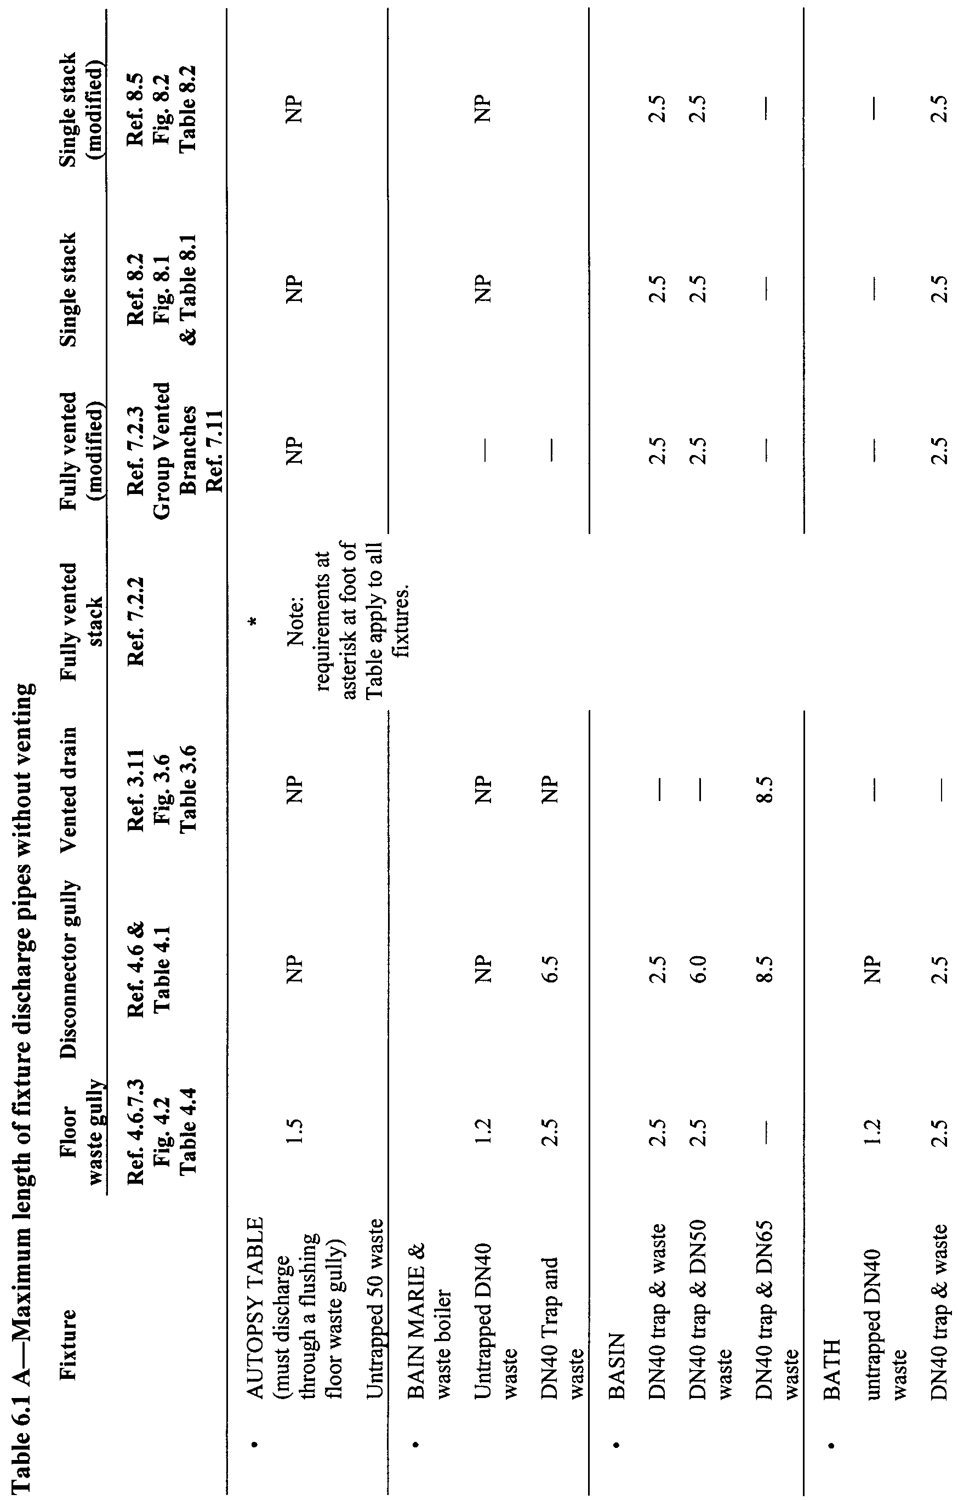
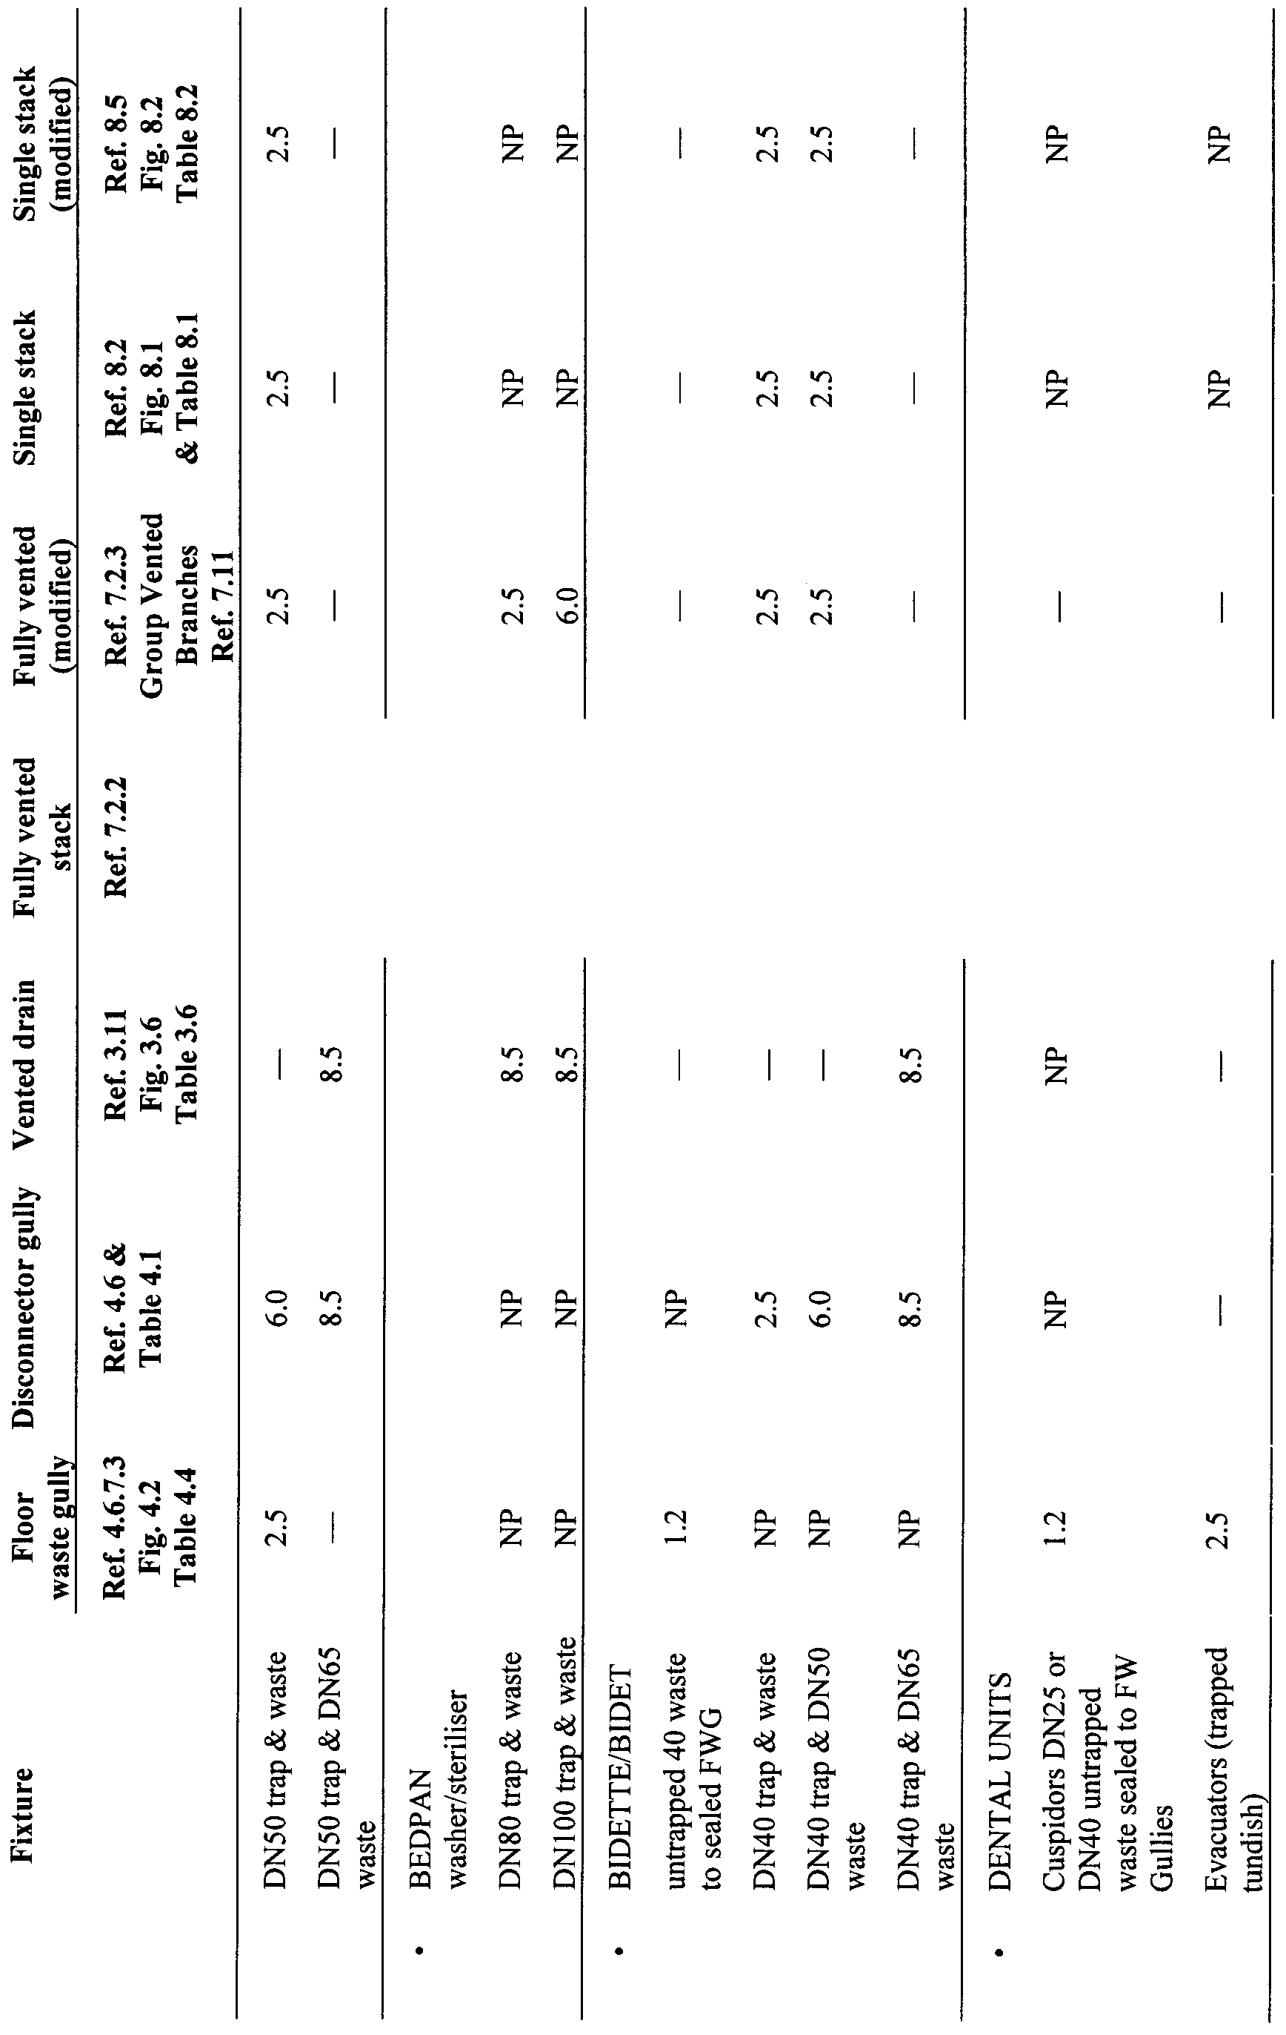
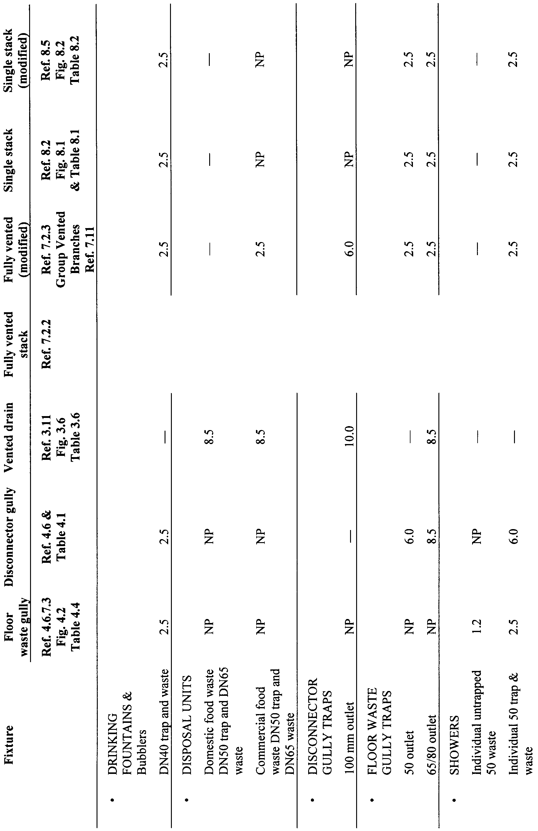
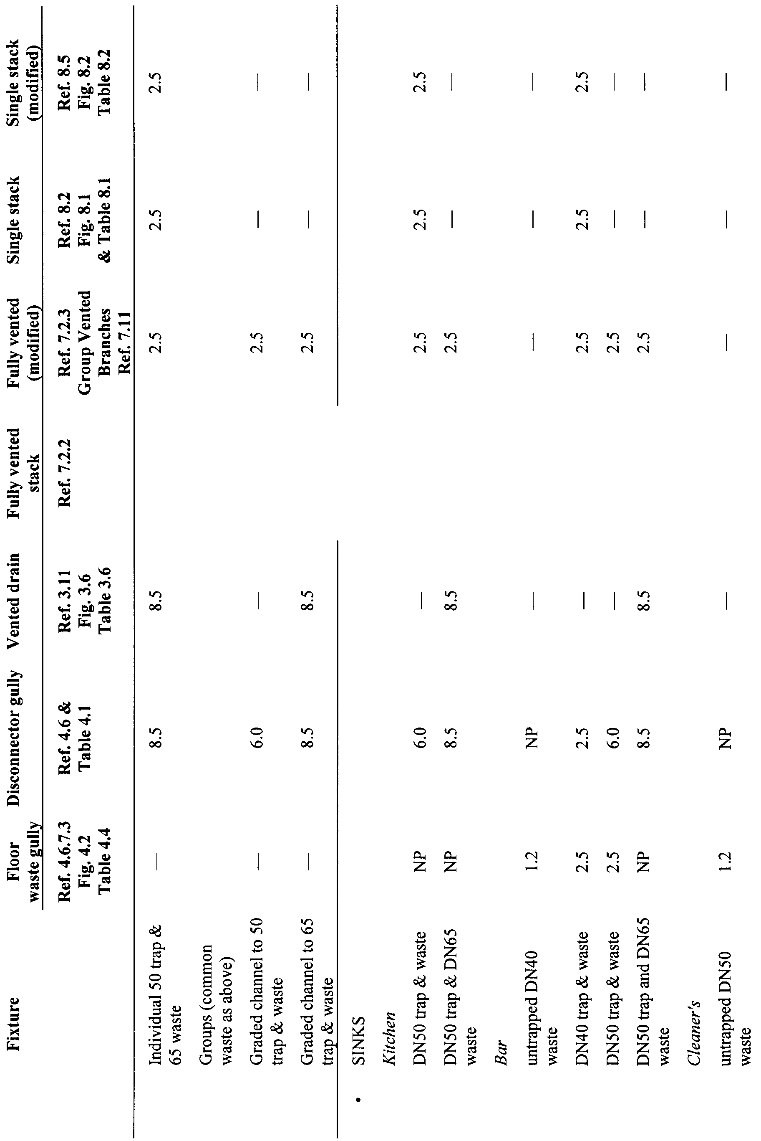
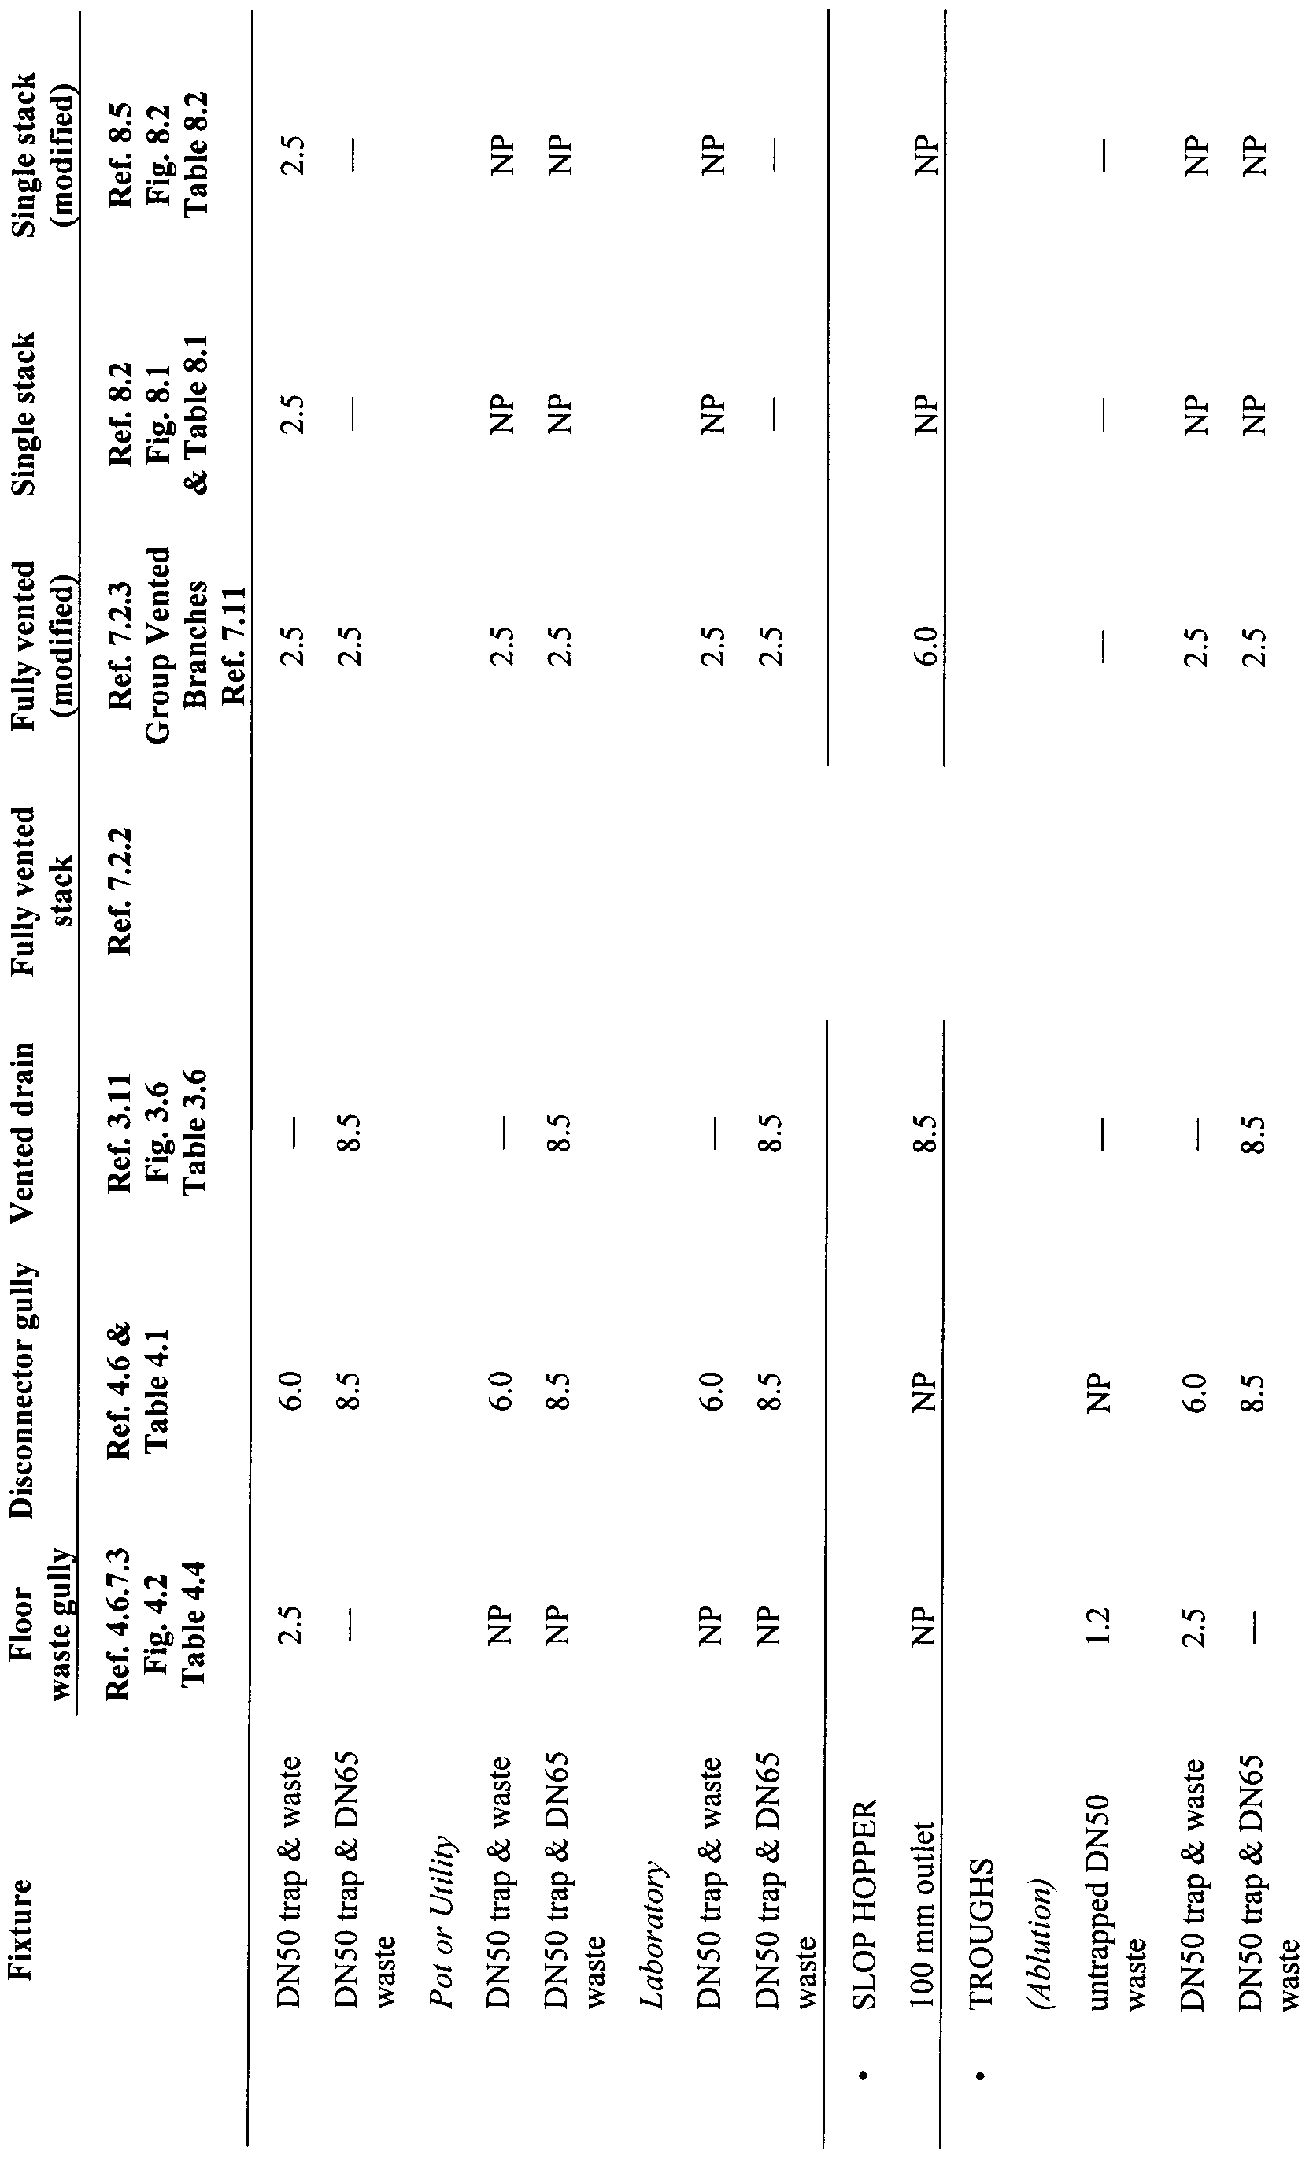
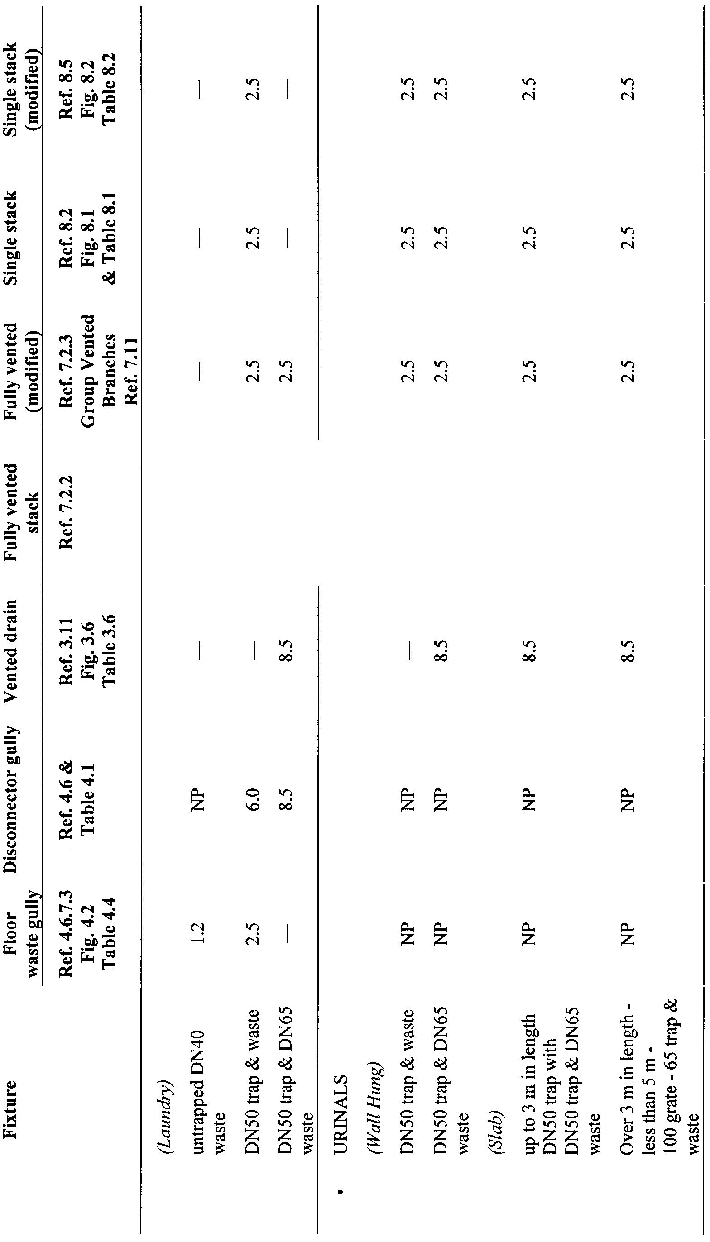
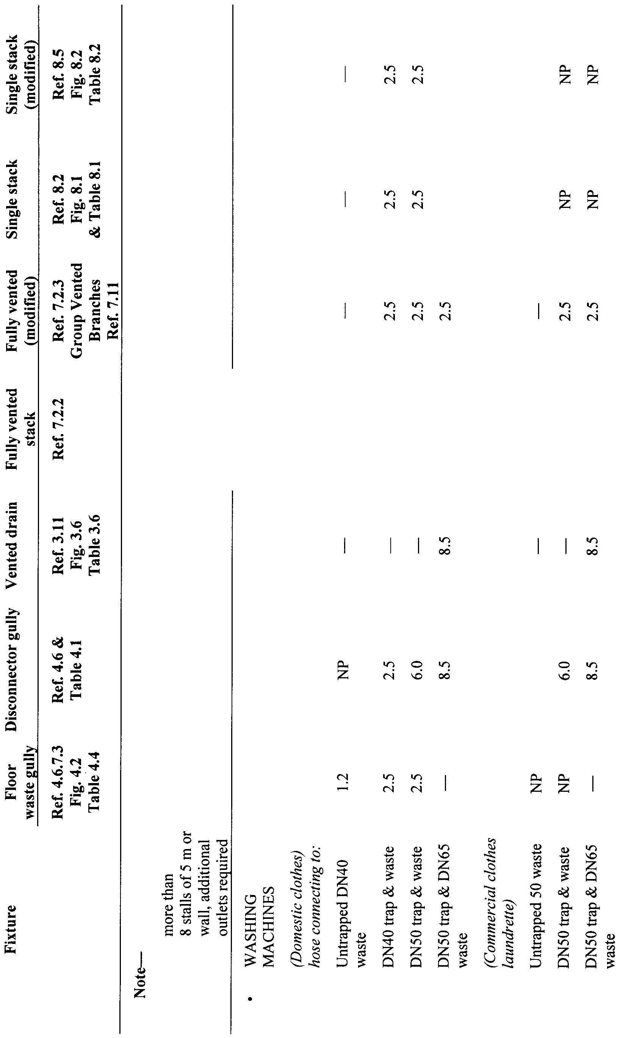
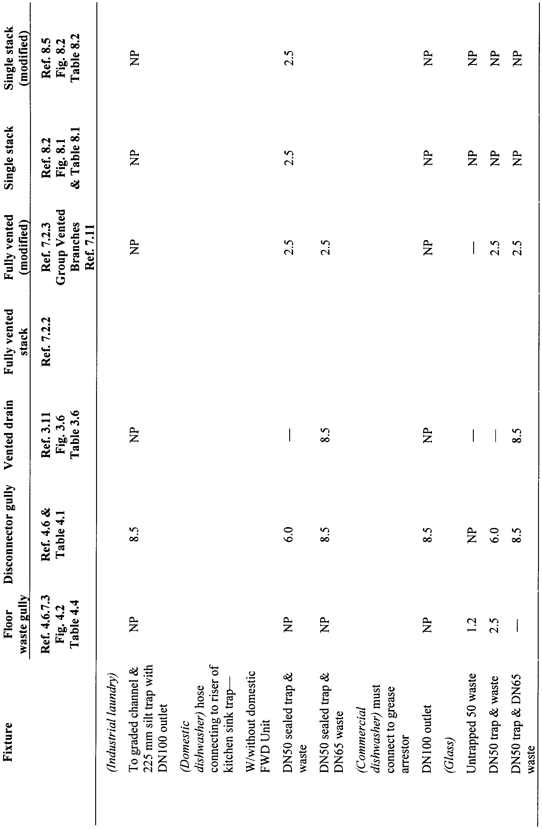
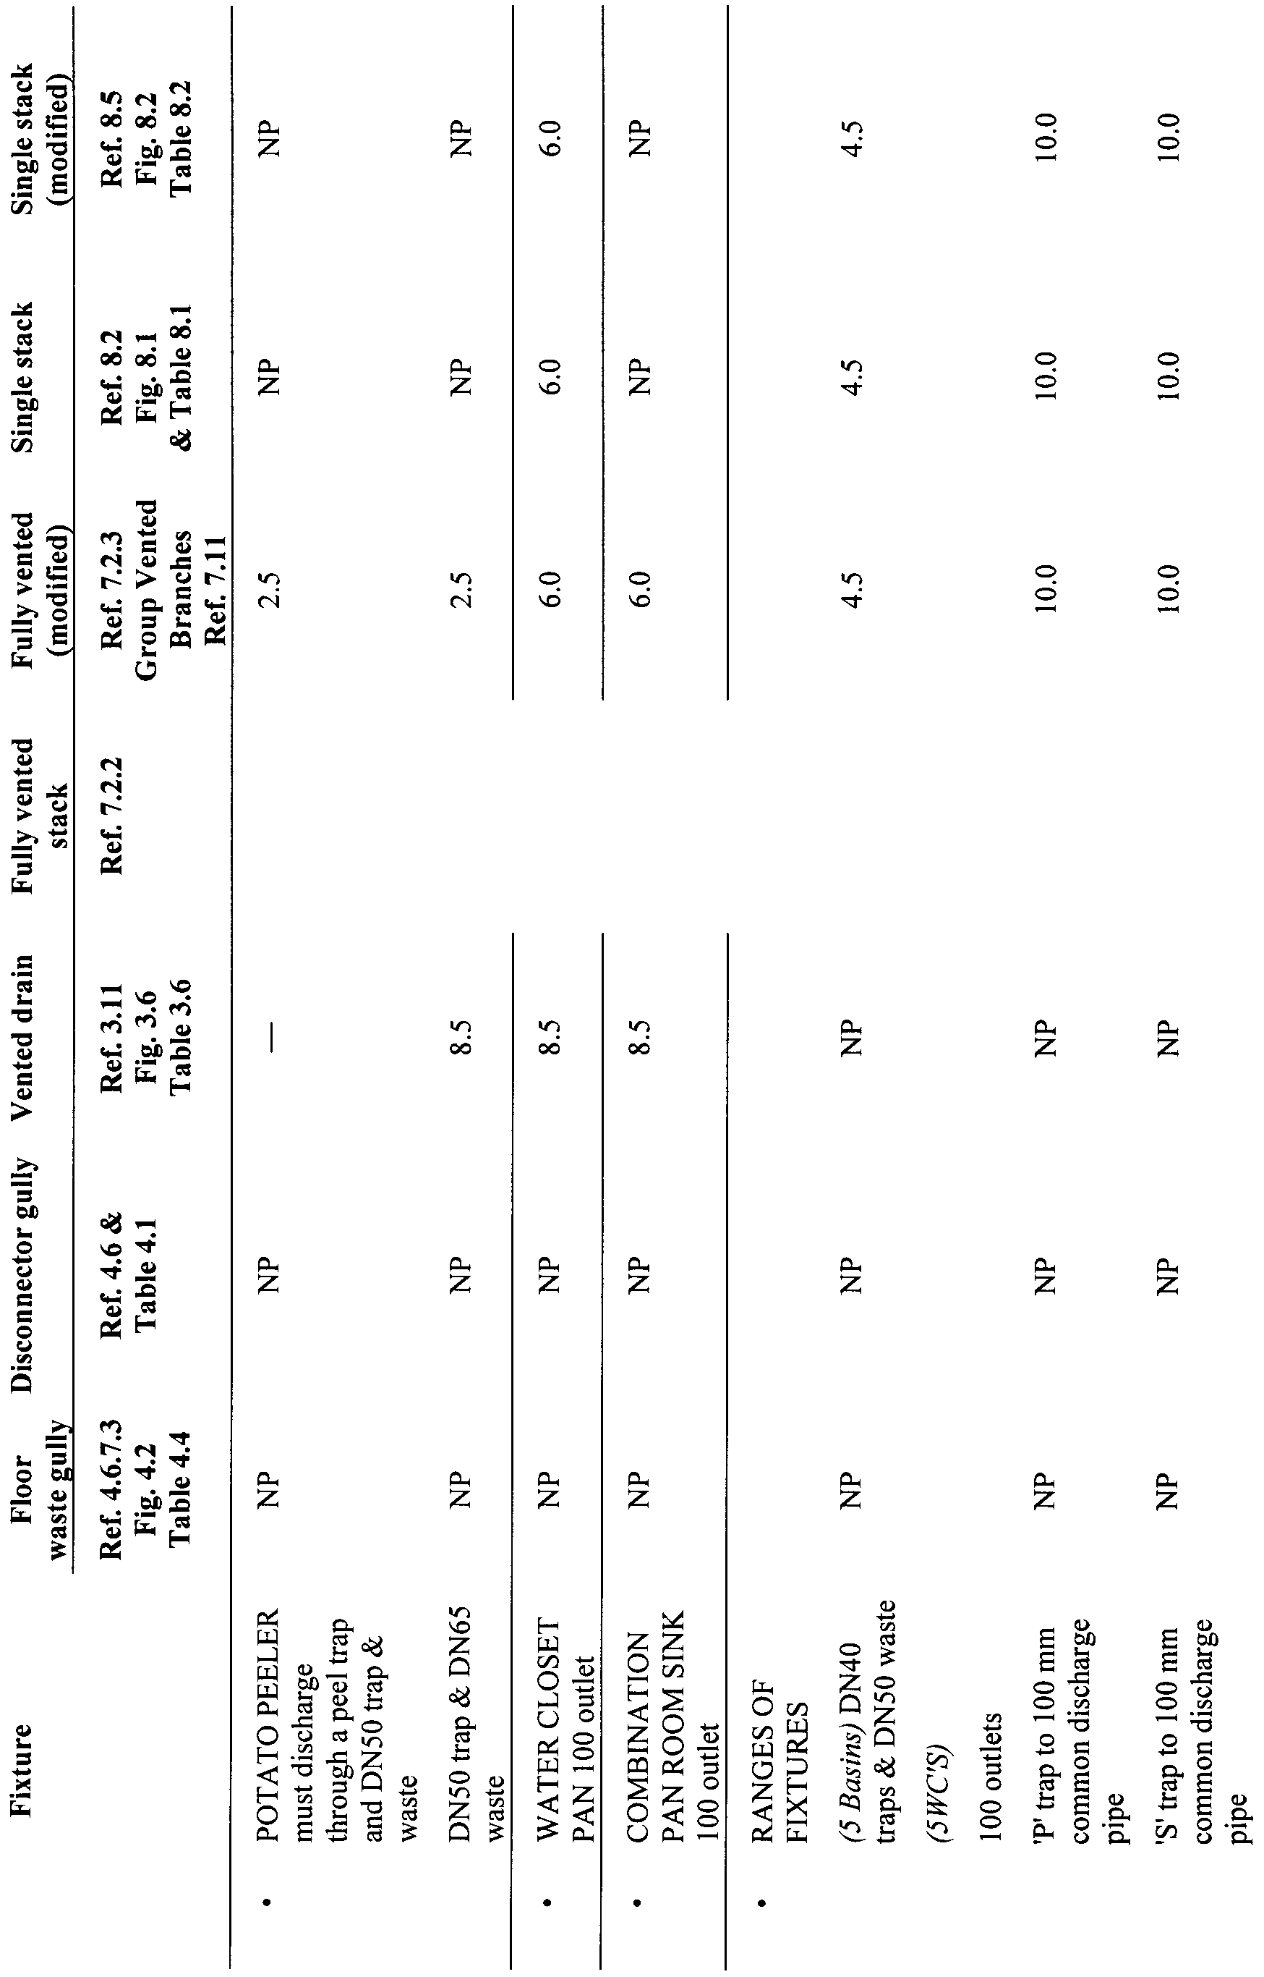
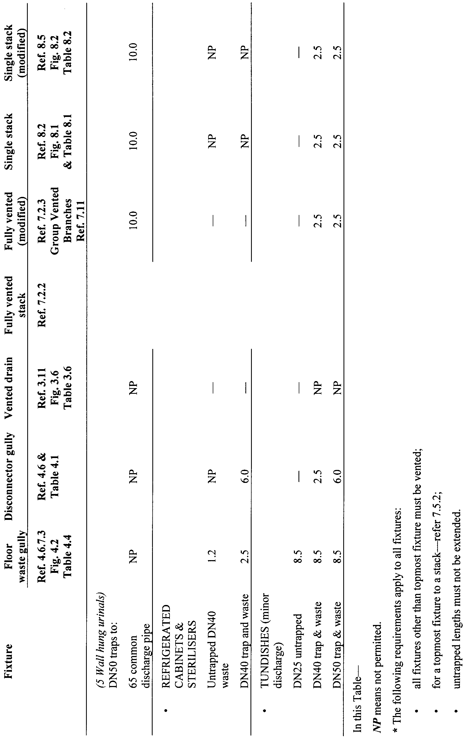
Schedule 2—Fees
Part 1—Fees applicable if the authority is a council
1—Installation or alteration of a waste control system—(other than a temporary facility)
(1) For the purposes of this item, the capacity of a waste control system will be taken to include (if relevant) the combined sludge scum and hydraulic loadings for both sewage and sullage waste material.
(2) Fees payable in relation to an application for approval to install or alter a waste control system—
(a) if the system's capacity does not exceed 5 000 litres—$89.00;
(b) if the system's capacity exceeds 5 000 litres—$89.00, plus $19.30 for each 1 000 litres (or part thereof) in capacity in excess of 5 000 litres,
plus $96.50 for each inspection required by the council.
2—Installation or alteration of a temporary waste control system
Fees payable in relation to an application for approval to install or alter a temporary waste control system—
(a) if the system will service not more than 10 persons—$39.25;
(b) if the system will service more than 10 persons, but not more than 100 persons—$79.00, plus $19.30 for each 1 000 litres (or part thereof) in capacity in excess of 5 000 litres (if any);
(c) if the system will service more than 100 persons—$89.00, plus $19.30 for each 1 000 litres (or part thereof) in capacity in excess of 5 000 litres (if any),
plus $96.50 for each inspection required by the council.
3—Connection of waste control system to a STED scheme or sewer
Fee payable in relation to the connection of a waste control system to a STED scheme or sewer—
(a) existing system—$89.00;
(b) new system—
(i) if the system's capacity does not exceed 5 000 litres—$89.00;
(ii) if the system's capacity exceeds 5 000 litres—$89.00, plus $19.30 for each 1 000 litres (or part thereof) in capacity in excess of 5 000 litres,
plus $96.50 for each inspection required by the council.
4—Referral to Minister
Fee payable if a matter must be referred to the Minister (referral fee)—$39.25, plus $96.50 for each inspection (if any) carried out by a person authorised by the Minister.
(A fee payable under this item is payable to the Minister but may be collected by the council on behalf of the Minister (and then forwarded to the Department)).
Part 2—Fees applicable if the authority is the Minister
5—Matters of a kind referred to in Part 1
In relation to a matter of a kind referred to in Part 1—the same fee that would be payable under that Part is payable to the Minister (as if the Minister were a council) (including a case where the waste control system is not the same as, but is similar to, a system that conforms with a prescribed code).
6—Matters of any other kind
In any other case—$402.00, plus, if more than 1 inspection is required, $159.00 for each additional inspection required by the Minister.
Schedule 3—Revocations and transitional provisions
Part 1—Revocation
1—Revocation of Public and Environmental Health (Waste Control) Regulations 1995
The Public and Environmental Health (Waste Control) Regulations 1995 are revoked.
Part 2—Transitional provisions
2—Continuation of approvals
(1) An approval in force under the revoked regulations immediately before the commencement of this clause will continue as an approval under these regulations.
(2) An approval continued under subclause (1) is subject to the same conditions as the approval under the revoked regulations and will expire on the date on which the approval would have expired under those regulations.
Made by the Governor
with the advice and consent of the Executive Council
on 22 July 2010
No 172 of 2010
HEAC-2009-00084
South Australia
Occupational Health, Safety and Welfare Regulations 2010
under the Occupational Health, Safety and Welfare Act 1986

Contents
Part 1—Preliminary
Division 1—Preliminary
1 Short title
2 Commencement
3 Interpretation
Division 2—Responsibilities under regulations
4 Employers
5 Employees
6 Self-employed persons
7 Occupiers of workplaces
8 Owners of buildings
9 Owners of plant
10 Designers of buildings
11 Designers of plant or structures
12 Manufacturers
13 Suppliers
14 Importers
15 Installers or erectors of plant or structures
16 Other persons
17 Specification of responsibilities
18 General defence
Division 3—General principles for implementation of regulations
Subdivision 1—Responsibilities of employers
19 Consultation
20 Hazard identification and risk assessment
21 Control of risk
22 Information, instruction and training
23 Induction to new work
24 Supervision
25 Employer action on reports
Subdivision 2—Responsibilities of employees
26 Responsibilities of employees
Part 2—General workplace
Division 1—Access and egress
27 Access and egress
Division 2—Amenities
28 Facilities for personal belongings
29 Facilities for changing clothes
30 Facilities for dining
31 Combined facilities
32 Toilets
33 Washing facilities
34 Drinking water
35 Arrangements for sick
36 Seating
Division 3—Buildings and their precincts
37 Application
38 Floors
39 Fragile roofing materials
40 Space per person
Division 4—Confined spaces
41 Preliminary
42 Design, manufacture, supply and modification
43 Hazard identification and risk assessment
44 Control of risk
45 Entry permit
46 Control of fire and explosion risk
47 Rescue arrangements
48 Education and training
Division 5—Electrical
49 Preliminary
50 Work in vicinity of electrical hazards
51 Competency requirements
52 Electrical installations etc
53 General requirement for hazard identification at workplace
54 Electrical installations—hazard identification, risk assessment and control of risk
55 Inspection and testing of electrical plant
56 Provision of R.C.D.s
57 Testing and maintenance of R.C.D.s
Division 6—Emergency facilities and procedures
58 Preliminary
59 Emergency exits, procedures and training
60 Emergency facilities
61 Rescue arrangements
Division 7—Fire prevention
62 Fire prevention
Division 8—Lighting
63 Lighting
Division 9—Manual handling
64 Preliminary
65 Design
66 Risk assessment
67 Risk control
68 Duties of employees
Division 10—Noise
69 Preliminary
70 Duties of designers, manufacturers, suppliers and importers
71 Duties of employers
72 Duties of employees
Division 11—Occupational health and first aid
73 Occupational health and first aid in workplace
Division 12—Personal protection
74 Personal protection
75 Use of air supplied respiratory equipment
Division 13—Prevention of falls
76 Prevention of falls
Division 14—Remote or isolated work
77 Isolated work
Division 15—Storage
78 Storage
Division 16—Traffic control
79 Traffic control
Division 17—Ventilation
80 Ventilation
Division 18—Workplace cleanliness and hygiene
81 Cleanliness and hygiene
Part 3—Plant
Division 1—Preliminary
82 Purpose
83 Definitions
84 Part does not apply to certain Plant
85 Part does not apply to amusement structures
86 Incorporation of references
87 Inspection fee
Division 2—Duties
Subdivision 1—Duties of designers
88 Hazard identification and risk assessment
89 Control of risk
90 Provision of information
Subdivision 2—Duties of manufacturers
91 Special duty
92 Hazard identification and risk assessment
93 Control of risk
94 Provision of information
Subdivision 3—Duties of importers
95 Special duty
96 Control of risk
97 Provision of information
Subdivision 4—Duties of suppliers
98 Control of risk
99 Provision of information
Subdivision 5—Duties of erectors or installers
100 Hazard identification and risk assessment
101 Control of risk
Subdivision 6—Duties of employers
102 Hazard identification and risk assessment
103 Training, information, instruction and supervision
104 Control of risk
105 Design
106 Installation and commissioning
107 Use
108 Repair
109 Alteration
110 Dismantling, storage and disposal of plant
Subdivision 7—Employer's specific duties for control of risk
111 Plant under pressure
112 Plant with moving parts
113 Powered mobile plant
114 Plant with hot or cold parts
115 Electrical plant and plant exposed to electrical hazards
116 Plant designed to lift or move
117 Industrial robots and other remotely or automatically energised equipment
118 Lasers
119 Scaffolds
120 Lifts
121 Record keeping
Subdivision 8—Duties of owners
122 Application
123 Hazard identification and risk assessment
124 Control of risk
125 Provision of information
126 Maintenance, inspection, repair and cleaning
127 Alteration
128 Dismantling, storage and disposal of plant
129 Specific duty for control of risk
130 Record keeping
Subdivision 9—Duties of self-employed persons
131 Hazard identification and risk assessment
132 Control of risk
133 Provision of information
134 Record keeping
Division 3—General requirements for hazard identification, risk assessment and control of risk
135 Hazard identification
136 Risk assessment
137 Control of risk
Division 4—Registration of plant designs and items of plant
138 Preliminary
139 Registration of plant design
140 Registration of items of plant
141 Renewal of registration
142 Notification of compliance
143 Periodic fees
144 Transitional provisions
Part 4—Amusement structures
Division 1—Preliminary
145 Purpose
146 Application of Act to amusement structures
147 Interpretation
148 Inconsistent safety instructions
Division 2—Duties associated with design, manufacture and supply of amusement structures
Subdivision 1—Duties of designers
149 Hazard identification and risk assessment
150 Control of risk
151 Provision of information (including as to classification)
Subdivision 2—Duties of manufacturers
152 Special duty
153 Hazard identification and risk assessment
154 Control of risk
155 Provision of information
Subdivision 3—Duties of importers
156 Special duty
Subdivision 4—Duties of suppliers
157 Control of risk
158 Provision of information
Division 3—Duties associated with installation, maintenance and use of amusement structures
159 Duties of proprietor
160 Erection or installation
161 Hazard identification and initial testing
162 Appointment of competent operators
163 Daily inspections
164 Maintenance and periodic inspections
165 Repairs and alterations
166 Dismantling and storage
167 Additional requirements
Division 4—General requirements for hazard identification, risk assessment and control of risk
168 Hazard identification
169 Risk assessment
170 Control of risk
Division 5—Registration of designs and amusement structures
171 Preliminary
172 Registration of designs
173 Registration of amusement structures
174 Registration may lapse in certain cases
175 Re-registration generally
176 Display of registration details
177 Notification of compliance
178 Transitional provision
Part 5—Hazardous substances
Division 1—General hazardous substances
Subdivision 1—Preliminary
179 Purpose
180 Scope
181 Interpretation
Subdivision 2—Supplier's duties
182 Classification of hazardous substances
183 Material Safety Data Sheets
184 Labels
185 Ingredient disclosure
186 Provision of other relevant information
Subdivision 3—Employer's duties
187 Material Safety Data Sheets
188 Labels
189 Hazardous substances registers
190 Provision of other relevant information
191 Prohibition of scheduled substances for specified uses
192 Instruction and training
193 Risk assessment
194 Risk control
195 Atmospheric monitoring
196 Health surveillance
197 Record keeping
198 Relevant emergency services
Division 2—Asbestos
199 Preliminary
200 Provision of information
201 Exposure standards
202 Licence to carry out asbestos removal work
203 Suspension of work pending an appeal
204 Prohibited or restricted processes
205 General duty
206 Duties of employers
207 Duties as to atmospheric monitoring
208 Duties of building owners and other persons in possession of asbestos
209 Personal safety
210 Special provisions relating to chrysotile asbestos
Division 3—Lead
211 Purpose
212 Work area
213 Furniture and equipment
214 Control of atmospheric contaminants
215 Amenities
216 Safe procedures
217 Personal protective equipment
Division 4—Synthetic mineral fibres
218 Purpose
219 Exposure standards
Part 6—Hazardous work
Division 1—Abrasive blasting
220 Purpose
221 Prohibited operations
222 Abrasive blasting equipment
223 Blasting chambers and cabinets
224 Safety and maintenance
225 Abrasive blasting outside blasting chamber or cabinet
226 Personal protective equipment and washing facilities
Division 2—Demolition
227 Preliminary
228 Risk assessment and control
229 Prevention of access and warning notices
230 Overhead protection
231 Working on or from fragile material
232 Use of existing stairs for access
233 Emergency measures in event of instability
234 Protection of persons in public places
235 Approval to carry out certain demolition work
Division 3—Diving
236 Purpose
237 Interpretation
238 General requirements
Division 4—Electroplating
239 Purpose
240 Work area
241 Storage of hazardous substances
242 Safety and maintenance
243 Control of atmospheric contaminants
244 Personal protective equipment and washing facilities
Division 5—Excavation work
245 Preliminary
246 Site report
247 Daily inspection
248 Performance of work
Division 6—Foundry work
249 Preliminary
250 Work area
251 Equipment and materials
252 Control of atmospheric contaminants
253 Moulding and casting
254 Rumbling
255 Personal protective equipment and washing facilities
Division 7—Logging
256 Purpose
257 Duty in relation to allocation of work
258 Proficiency of persons performing logging work
259 Communication systems
260 Felling or cross-cutting
261 Snigging or skidding
262 Warning signs
263 Equipment and machinery
264 Log transportation
265 Haul roads
266 Personal protective clothing and equipment
Division 8—Spray painting
267 Purpose
268 Work area
269 Spray booths—construction
270 Spray booths—exhaust ventilation
271 Safe working and maintenance procedures
272 Personal protective equipment
Division 9—Welding
273 Purpose
274 Work area
275 Use of manifolds
276 Safe procedures and personal protective equipment
Division 10—Construction work
277 Preliminary
278 Appointment of safety supervisors
279 Responsibilities
280 Additional duties
Division 11—Petroleum work
281 Preliminary
282 Application of Division
283 Siting of flares
284 Regulation of certain practices
285 Blowout prevention
286 Blowout preventer closing units
287 Testing blowout prevention equipment
288 Removal of blowout prevention equipment
289 Blowout prevention training and procedures
290 Well drilling fluids
291 Certain operations not to be conducted at night
Division 12—Mining work
292 Preliminary
293 Specific offence for managers
294 Inspection record system
295 Site report
296 Daily inspection
297 Performance of work
298 Self-rescuers
299 Stability of ground
300 Mode of working
301 Diesel exhaust
302 Winches and personnel transportation
303 Shafts and winding
304 Fuel use and storage underground
305 Electricity—particular provisions
306 Earthing—underground
307 Residual current devices
308 Earth continuity equipment
309 Cabling
310 Aerial conductors
311 Ventilation—general
312 Ventilation—design
313 Ventilation—plans
314 Ventilation—checking
315 Disused workings
316 Requirement to hold licence to conduct blasting operation
317 Grant or renewal of licence
318 Transitional provision
319 Conditions of blaster's licence
320 Acquisition of explosives under licence
321 Cancellation or suspension of licence
322 Return of licence
323 Retention of licence while explosives remain in possession
324 Responsibilities of shotfirer and employer or contractor
325 Attendance of shotfirer at blasting operation and supervision of others
326 Hazard identification and risk control etc
327 Storage of blasting explosives
328 Action in event of thunderstorm or duststorm
329 No other work in vicinity of blasting explosives
330 Ensuring explosives are not damaged or defective
331 Reduction of ground vibration and airblast
332 Use of explosives in darkness
333 Capping of fuses and preparation of primer cartridges
334 Charging of shotholes
335 Safety fuse firing
336 Electrical firing
337 Blasting in hot material
338 Exclusion of people from area
339 Butts and misfires
340 Disposal of blasting explosives
341 Requirements for storage in underground magazine at mine
Division 13—Opal mining
342 Preliminary
343 Interpretation
344 Safety performance
345 New and previously worked opal mines
346 Daily inspections
347 Underground fires
348 Ground support for underground opal mine
349 Ground support for surface opal mine
350 Diesel engines
351 Fuel use and storage underground
352 Winches for personnel transportation
353 Shafts and drill holes
354 Electricity installations and use
355 R.C.D.s
356 Earth continuity equipment
357 Cabling
358 Ventilation
359 Requirement to hold licence to conduct blasting operation
360 Grant or renewal of licence
361 Transitional provision
362 Conditions of blaster's licence
363 Cancellation or suspension of licence
364 Return of licence
365 Responsibilities of holder of blaster's licence
366 Responsibility of other persons involved in blasting operations
Part 7—Administration
Division 1—Health and safety representatives
367 Purpose
368 Preliminary
369 Notice of election day
370 Nomination
371 Voting
372 Election
373 Deputy health and safety representatives
374 Provision of information
375 Retention of voting material
376 Display of notices
377 Training
378 Default notices
379 Provision of Act and regulations
Division 2—Health and safety committees
380 Health and safety committees
Division 3—Confidentiality of health records
381 Confidentiality of health records
Division 4—High risk work licences, competency requirements and registration of assessors
Subdivision 1—Preliminary
382 Preliminary
Subdivision 2—Requirement to be licensed
383 Requirement to be licensed
384 Licence classes
Subdivision 3—Exemptions
385 High risk work—exemption of specified class of high risk work
386 High risk work—exemption granted on application by employer
Subdivision 4—Licensing process
387 Application for licence
388 Decision on application
389 Refusal to grant licence—process
390 Duration of licence
391 Form of licence
Subdivision 5—Conditions and licence document
392 Conditions of licence
393 Changes to information
394 Production of licence for inspection
395 Replacement licence
Subdivision 6—Amendment of licence
396 Amendment of licence conditions on Director's initiative
397 Amendment of licence conditions on application by licence holder
398 Licence holder to return licence
Subdivision 7—Renewal of licence
399 Director may renew licence
400 Renewal process
401 Renewal of expired licence
Subdivision 8—Suspension and cancellation of licence
402 Grounds for suspension or cancellation
403 Matters taken into account
404 Process for suspension and cancellation
405 Interim suspension
406 Return of suspended or cancelled licence
Subdivision 9—Appeals and other matters
407 Appeal against decision of Director
408 Recognition of existing certificate or exemption
409 Operator of self-erecting tower crane exempt until 1 September 2012
410 Carrying out high risk work while awaiting issue of licence
Subdivision 10—Loadshifting equipment
411 Loadshifting equipment
Subdivision 11—Registration of assessors
412 Registration of assessors
Subdivision 12—Miscellaneous
413 Director may require further assessment
414 Confidentiality
Division 5—Notification of commencement of certain work
415 Preliminary
416 Requirement to give notice of commencement of work
Division 6—Notification of certain occurrences
417 Preliminary
418 Notification of work-related injuries
419 Notification of dangerous occurrences
Division 7—Proceedings
420 Preliminary
421 Applications to Industrial Commission
422 Applications to Industrial Court
423 Summonses
424 Appeals to Industrial Court
425 Appeals to Full Industrial Court
Division 8—Registration of employers
426 Registration of employers
427 Prescription of fee
Division 9—Miscellaneous
428 Provision of statutory instruments
429 Duplicate documents
430 Fees
431 False information
432 Offences
Schedule 1—Responsibilities of employers, employees, self-employed persons, occupiers and owners and other people
Schedule 2—Responsibilities of designers, manufacturers, importers, suppliers and installers/erectors
Schedule 3—Plant standards
Schedule 4—Plant designs, and plant, which must be registered
Part 1—Plant requiring registration of design
Part 2—Items of plant which must be registered
Schedule 5—Hazardous substances prohibited for specified uses
Schedule 6—Hazardous substances for which health surveillance is required
Schedule 7—Form for application for licence or limited licence to carry out asbestos removal work
Schedule 8—Fees
Schedule 9—Proceedings
Schedule 10—Expiry of existing certificates and other evidence of competency
Schedule 11—Revocation of Occupational Health, Safety and Welfare Regulations 1995

Part 1—Preliminary
Division 1—Preliminary
1—Short title
These regulations may be cited as the Occupational Health, Safety and Welfare Regulations 2010.
2—Commencement
(1) Subject to subregulation (2), these regulations will come into operation on 1 September 2010.
(2) Regulation 414 will come into operation on the day immediately following the day on which the time for disallowance of these regulations has passed (see section 55(1a)(f) of the Occupational Health, Safety and Welfare Act 1986).
3—Interpretation
(1) In these regulations, unless the contrary intention appears—
abrasive blasting means the cleaning, smoothing, roughening or removal of the surface or part of the surface of an object by the use of an abrasive material propelled by a blast of compressed air or steam, a wheel, or other similar means;
abrasive material means a substance used or intended to be used as an abrasive for abrasive blasting;
Act means the Occupational Health, Safety and Welfare Act 1986;
ADG Code means the 7th edition (2007) of the Australian Code for the Transport of Dangerous Goods by Road and Rail published by the Commonwealth of Australia (ISBN 1 921168 57 9);
administrative noise control means a measure that reduces the noise to which a person at a workplace is exposed by means of work arrangements and includes—
(a) the scheduling of work; and
(b) job rotation; and
(c) limiting the entry of persons to noisy areas; and
(d) the observance of quiet work practices,
but does not include the use of personal hearing protectors;
alter, in relation to plant, means to change the design of, add to or take away from the plant where to do so may affect health or safety, but does not include undertaking routine maintenance, repair or replacement;
amusement structure means a structure or device operated for hire or reward, or provided on hire or lease—
(a) that is used or designed to be used for amusement, recreation, sightseeing or entertainment and on which persons may be moved, carried, raised, lowered or supported by any part of the structure or device, or on which persons may jump or slide; and
(b) that is—
(i) an arrangement of structural or mechanical elements (or both) that has as its prime function the provision of movement of a passenger or passengers in a controlled manner so that the passenger or passengers are not necessarily required to move themselves to obtain the desired effect (called an amusement ride); or
(ii) an arrangement of equipment through which, or on which, a rider moves, where the desired effect is achieved primarily by the rider's self-powered motion, or by some other process that is not referred to in the description of an amusement ride (called an amusement device); or
(iii) a structure or arrangement of equipment through or on which, or down which, a person moves, where the desired effect is achieved primarily by the person's self-powered motion, by motion induced by gravity, or by some other process or means associated with the design or operation of the structure or equipment;
but does not include—
(c) a miniature train and railway system owned and operated by a model railway society, club or association; or
(d) a ride or device that is used as a form of transport and that is, in relation to its use for that purpose, regulated under another Act (including an Act of the Commonwealth); or
(e) a boat or flotation device—
(i) that is solely propelled by a person who is in or on the boat or device; and
(ii) that is not attached to any mechanical elements or equipment outside the boat or device, and that does not rely on any artificial flow of water to move; or
(f) any plant specifically designed for a sporting, professional stunt, theatrical or acrobatic purpose or activity; or
(g) a coin-operated device that—
(i) is intended to be ridden, at the one time, by no more than 4 children below the age of 10 years; and
(ii) is usually located in a shopping centre or similar public location; and
(iii) does not necessarily have an operator;
article means an item—
(a) that is formed during production to a specific shape or design, or to have a specific surface; and
(b) that is used for a purpose that depends in whole or in part on its shape, design or surface; and
(c) that undergoes no change in chemical composition or physical state during use,
but does not include any fluid or particle;
asbestos means the fibrous form of mineral silicates that belong to the serpentine or amphibole groups of rock-forming minerals, including actinolite, amosite (brown asbestos), anthophyllite, crocidolite (blue asbestos), chrysotile (white asbestos) and tremolite, or a combination of 2 or more of these;
asbestos removal work means work involving the removal of—
(a) insulation material that consists of or contains asbestos, or other friable asbestos-containing material; or
(b) an asbestos-cement (fibro) product, or other non-friable asbestos-containing material;
asbestos work means any work where, in the course of that work, exposure to asbestos (or any material that consists of or contains asbestos) may occur;
associated temporary equipment means equipment specifically intended to provide a temporary platform, means of access, means of fall protection or means of protection from falling debris, and includes a temporary guardrail, temporary hoarding, temporary gantry, portable ladder, crane-lifted workbox, industrial safety net or individual fall-arrest system, but does not include a scaffold;
atmospheric contaminant means a harmful substance or agent that occurs in the form of any fume, mist, gas, dust, vapour or biological contaminant;
atmospheric monitoring means the sampling of the atmosphere at a workplace and deriving a quantitative estimate of the levels of hazardous substances in the air;
blasting cabinet means an enclosure used or intended to be used for the purpose of abrasive blasting and into which no person can enter or remain during an operating cycle;
blasting chamber means a structure in which a person is present during abrasive blasting;
boiler means a vessel, or an arrangement of vessels, and inter-connecting parts, in which steam or other vapour is generated, or water or other liquid is heated at a pressure greater than atmospheric pressure by the use of fire, the products of combustion, electrical power or other similar means, and includes a superheater, reheater, economiser, boiler piping support, mounting, valve, gauge, fitting, control, setting, or other equipment directly associated with a boiler, but does not include a fully flooded or pressurised system where water or other liquid is heated to a temperature lower than the normal atmospheric boiling temperature of the liquid;
boom-type elevating work platform means a telescoping device, hinged device, or articulated device, or any combination of 2 or more of these, used to support a platform on which a person, equipment or materials may be elevated;
bracket scaffold means a scaffold the platform of which is carried on frames attached to, or supported by, a permanent or temporary construction;
breathing zone in relation to a person means the area represented by an imaginary hemisphere 300 millimetres in radius that—
(a) extends in front of the face of the person; and
(b) is measured from the midpoint of an imaginary line joining his or her ears;
bridge crane means a crane that incorporates a bridge beam mounted at each end to an end carriage, is capable of travelling along elevated runways, and has 1 or more hoisting mechanisms arranged to traverse across the bridge;
BS means a standard of The British Standards Institution;
buffing means a process of polishing or abrading carried out by means of a powder, paste or other substance applied to the surface of a mechanically operated wheel, disc or band;
building has the same meaning as in the Development Act 1993;
building maintenance equipment means a suspended platform and associated equipment that incorporates permanently installed overhead supports to provide access to a face or other similar surface of a building for maintenance purposes, and includes a building maintenance unit and a swing stage, but does not include a suspended scaffold;
building maintenance unit means a power-operated suspended platform and associated equipment that is permanently installed on a building and specifically designed to provide access to a face of a building for maintenance purposes;
cantilevered scaffold means a scaffold that is supported by cantilevered load-bearing members, but does not include a bracket scaffold;
chemical name of a substance means the recognised chemical name of the substance used in scientific or technical texts;
commissioning in relation to plant means performing necessary adjustments, tests and inspections to ensure that the plant is in full working order to specified requirements, and includes recommissioning;
competent person means a person who is suitably qualified (whether by experience, training, or both) to carry out the work or function described in the relevant regulation;
concrete placing unit (truck mounted with boom) means plant used to place concrete in a particular place by pumping the concrete through a pipeline attached to, or forming part of, a boom, where the plant is capable of travelling over a supporting surface without a fixed runway or track and relies on gravity for stability and, accordingly, does not have a vertical restraining connection between itself and the supporting surface nor a horizontal restraining connection (other than frictional forces at the supporting surface level) to act as an aid to stability;
confined space means an enclosed or partially enclosed space that—
(a) is at atmospheric pressure during occupancy; and
(b) is not intended or designed primarily as a place of work; and
(c) may have restricted means of entry and exit; and
(d) may—
(i) have atmospheric contaminants or an unsafe oxygen level; or
(ii) cause engulfment,
and may include (but is not limited to)—
(e) a storage tank, tank car, process vessel, boiler, pressure vessel, silo or other tank-like compartment;
(f) an open-topped space (such as a degreaser or pit);
(g) a pipe, sewer, shaft, duct or similar structure;
(h) a shipboard space entered through a small hatchway or access point, or a cargo tank, cellular double bottom tank, duct keel, ballast or oil tank or other void space, other than a dry cargo hold;
consumer package means a package intended for retail display and sale (and includes a package that is transported and distributed as part of a larger consolidated package that consists of a number of identical consumer packages);
container means anything in or by which substances are or have been wholly (or partly) cased, covered, enclosed, contained or packed (whether such a container is empty, partially full or completely full), but does not include a tank or bulk storage container within the meaning of the ADG Code;
conveyor means an apparatus or equipment, worked by a form of power, other than human power, by means of which loads may be raised, lowered, transported or continuously driven by—
(a) an endless belt, rope, chain or other similar means; or
(b) buckets, trays or other containers or fittings moved by an endless belt, rope, chain or other similar means; or
(c) a rotating screw; or
(d) a vibration or walking beam; or
(e) a powered roller conveyor where the rolls are driven by an endless belt, rope, chain or other similar means,
and includes the supporting structure, auxiliary equipment and gear used in connection with such an apparatus or equipment;
crane means an appliance by means of which loads may be raised or lowered and moved horizontally and includes the supporting structure and foundations of such a structure, but does not include an industrial lift truck, earthmoving machinery, an amusement structure, a tractor, an industrial robot, a conveyor, building maintenance equipment, a suspended scaffold or a lift;
dB(A) means decibels of A-weighted sound pressure level;
dB(C) means decibels of C-weighted sound pressure level;
deluge facility means an eye-bath, deluge shower or hand-held tap attachment that is designed to drench a contaminated part of the body with water;
designer means a person who designs plant or structures, or who is responsible for the design of plant or structures;
dry abrasive blasting means abrasive blasting conducted without addition of water to the abrasive material or its propellant;
earthmoving machinery means an operator-controlled item of plant used to excavate, load, transport, spread or compact earth, overburden, rubble, spoil, aggregate or similar materials, but does not include a tractor or an industrial lift truck;
electrical installation means any electrical wiring, accessory, fitting, consuming device, control or protective gear, or other equipment associated with wiring situated in or on a workplace;
electrical plant means plant which consumes, converts or generates electricity;
electroplating or electroplating process means a process that involves applying a deposit of metal to something by electrolytic means;
electroplating substance means a poisonous or corrosive substance used for electroplating;
elevating work platform means a telescoping device, scissor device or articulating device (or any combination of 2 or more of these) used to move people, equipment and material to and from a work location above the device's support surface;
emergency service means—
(a) the South Australian Metropolitan Fire Service;
(b) the South Australian Country Fire Service;
(c) South Australia Police;
(d) any other department or agency or instrumentality of the Crown which may be required to attend at the scene of an emergency;
engineering noise control means a measure that reduces the noise to which a person at a workplace is exposed through the design or modification of plant or the physical working environment, including design or modification for—
(a) eliminating noisy plant;
(b) replacing noisy plant by quieter plant;
(c) reducing noise emission at its source;
(d) isolating or enclosing noisy plant;
(e) the acoustical treatment of the workplace,
but does not include the use of personal hearing protectors;
erector means a person who erects, dismantles or alters a structure, or the structure of plant;
ergonomic connotes a situation where steps have been taken to optimise the functioning of plant, or systems of work associated with plant, by adapting them to human capacity or need;
excavation work means work involving the removal of soil or rock from a site to form an open face, hole or cavity;
exposure standard—
(a) in relation to an atmospheric contaminant—see subregulation (5); and
(b) in relation to noise—see Part 2 Division 10;
extra-low voltage means voltage not exceeding 32V alternating current or 115V direct current;
faller means a person who fells or cross-cuts trees;
fault, in relation to plant, means a break or defect which may cause the plant to present a risk to health or safety, or in the case of a fault in the design of plant, fault means an aspect of the plant design which gives rise to, or may result in, a break or defect that may cause the plant to be a risk to health or safety if manufactured in accordance with the design specifications;
felling means the act of cutting, trimming, chopping or pulling down a tree, or any part of a tree;
fired heater means a pressure vessel in which a liquid is heated below its normal atmospheric boiling temperature, or a process fluid is heated in tubes above or below its normal atmospheric boiling temperature, by the application of fire, the products of combustion, electric power or similar high temperature means;
flammable solution means a liquid, mixture or solution that has a flash point of less than 61 °C;
flexible extension cord means a length of flexible cord 1 end of which is terminated in a plug and the other end of which is terminated in a cord extension socket;
flexible supply cord means a flexible cable or cord, for supply purposes, that has 1 end connected to a plug with pins designed to engage with a mains outlet socket, and the other end either—
(a) connected to terminals within the equipment; or
(b) fitted with an appliance connector designed to engage with an appliance inlet socket fitted to the equipment;
forest compartment means a continuous area of forest or plantation surrounded by haul or public roads;
forklift truck means a powered industrial truck equipped with a mast and an elevating load carriage to which is attached a pair of forkarms or another form of loadholding attachment, and includes a truck on which the operator is raised with an attachment for order picking, but does not include a pedestrian operated industrial truck;
foundry work means an operation—
(a) that involves the production of castings by casting metal in moulds made of sand, loam, metal, moulding composition or other material or mixture of materials, or by shell moulding, centrifugal casting or continuous casting; and
(b) in relation to which there occurs the preparation and mixing of materials, the preparation of moulds and cores (but not the making of patterns or dies in a separate room), knockout processes and dressing operations;
friable asbestos-containing material means—
(a) non-bonded asbestos fabric; or
(b) material that contains more than 1% asbestos by weight and—
(i) is in the form of powder; or
(ii) may be crumbled, pulverised or reduced to powder by hand pressure when dry;
gantry crane means a crane that has a bridge beam, supported at each end by legs mounted on end carriages, that is capable of travelling on supporting surfaces or deck levels (whether fixed or not) and that has a crab with 1 or more hoisting units that are arranged to travel across the bridge;
gas cylinder means an individual rigid pressure vessel that does not exceed 3 000 litres water capacity, does not have openings or integral attachments on the shell other than at the ends, is designed for the storage or transport of gas under pressure, and is covered by AS 2030 Gas cylinders Code;
gear means a ladder, plank, rope, chain, coupling, fastening, fitting, hoist block, pulley, hanger, sling, brace or other similar movable contrivance used or intended to be used on or in connection with rigging or scaffolding work, but does not include a ladder that exceeds 6 metres in length;
generic name of a substance means a name which describes the category or group of chemicals to which the substance belongs (for example, azo dyes or halogenated aromatic amines);
grinding means the abrading, by means of mechanical power, of an article or a part of an article by means of a wheel, disc or band;
guard means a device that prevents or reduces access to a danger point or area;
haul road means a road or track on, or leading to or from, a logging site, other than a public road;
hazard means the potential to cause injury or illness;
hazardous substance means a substance—
(a) that is listed on the HSIS if the concentration of the substance or its ingredients equals or exceeds the concentration cut-off levels listed on the HSIS that relate to health effects; or
(b) that is determined to be a hazardous substance by the manufacturer or importer of the substance on the basis of NOHSC's Approved Criteria for Classifying Hazardous Substances;
hoist means an appliance by means of which loads may be raised or lowered, and includes an elevating work platform, mast climbing work platform, people or materials hoist, scaffolding hoist and serial hoist, but does not include a lift or building maintenance equipment;
HSIS means the Hazardous Substances Information System published by Safe Work Australia on its website;
hung scaffold means a scaffold that is hung from another structure and that is not capable of being raised or lowered when in use;
importer means a person who imports plant, structures, materials for structures, or substances;
Industrial Commission means the Industrial Relations Commission of South Australia;
Industrial Court means the Industrial Relations Court of South Australia;
industrial lift truck means powered mobile plant, designed to move goods, materials or equipment, equipped with an elevating load carriage and, normally, a load-holding attachment, but does not include a mobile crane or earthmoving machinery;
industrial robot means a multifunctional manipulator (and its controllers) that is capable of handling materials, parts, tools or specialised devices through variable programmed motions for the performance of a variety of tasks;
infectious substance means a substance that contains an organism that can cause disease;
ingredient means any component of a substance (including any impurity which has been mixed in with the substance);
inspirable fibrous dust means particles of synthetic mineral fibre in the form of inspirable dust described by AS/NZS 3640 Workplace atmospheres - Method for sampling and gravimetric determination of inhalable dust;
installer means a person who installs plant or structures;
interlocked, in relation to plant, means fitted with a connection between a guard or machine element and the control system or power system of the plant that allows access to the moving parts of the plant at times when those parts are not moving and prevents those parts from starting or operating when access is available to them;
laser means a device that can produce or amplify electromagnetic radiation in the wave length range from 100 nanometres to 1 millimetre by the process of controlled stimulated emission, but does not include an electric light globe, fluorescent light tube, electric radiator used for heating, radio or video communication equipment, domestic cooking appliance that uses a high powered lamp, or navigation or search light;
laser product means any product or assembly of components which constitutes, incorporates or is intended to incorporate a laser;
lead material or lead compound means metallic lead, a compound of lead, or a substance that contains more than 4% by weight of lead;
lead process means a process by virtue of which a person is or may be exposed to dust, mist, fumes or gases containing a lead material or compound, and includes—
(a) the recovery and casting of lead or a lead compound;
(b) the buffing of lead or a lead compound;
(c) the manipulation, movement or other treatment of particles of metallic lead, molten lead, or a lead compound;
lift means a permanent apparatus (or apparatus intended to be permanent) that is in or attached to a building or structure and by means of which persons, goods or materials may be raised or lowered within or on a car, cage or platform and the movement of which is restricted by a guide or guides, and includes an apparatus in the nature of a chairlift, escalator, moving walk or stairway lift, and any supporting structure, machinery, equipment, gear, lift-well, enclosure and entrance;
logging site means a forest, plantation or other place where persons carry out logging work;
logging tractor means a vehicle used in, or for the purposes of—
(a) land clearing operations; or
(b) harvesting operations; or
(c) snigging or skidding; or
(d) pre-hauling; or
(e) loading or unloading logs onto or from a vehicle; or
(f) constructing a haul road,
but does not include a road transport vehicle;
logging work means work associated with obtaining timber from a forest or plantation and includes—
(a) felling, cross-cutting or snigging or skidding any tree or part of a tree;
(b) all forms of forest processing;
(c) pre-hauling;
(d) loading or unloading logs onto or from a vehicle;
(e) transporting logs on a vehicle;
lower explosive limit (LEL) in relation to a flammable contaminant means the concentration of the contaminant in air below which the propagation of a flame does not occur on contact with an ignition source;
lux means the unit of illuminance;
manual handling means an activity requiring the use of force exerted by a person to lift, lower, push, pull, carry or otherwise move, hold or restrain a person, animal or thing;
manufacturer means a person who manufactures plant, structures, materials for the purpose of a structure, or substances;
mast climbing work platform means a hoist with a working platform that is used for temporary purposes to raise people or materials to a working position by means of a drive system mounted on an extendable mast (including such a mast tied to a building);
material includes any substance;
minimise means to reduce to the lowest level that is reasonably practicable to achieve;
mobile crane means a crane capable of travelling over a supporting surface without the need for a fixed runway or track and relying only on gravity for stability and, accordingly, does not have a vertical restraining connection between itself and the supporting surface nor a horizontal restraining connection (other than frictional forces at the supporting surface level) to act as an aid to stability;
MSDS means a Material Safety Data Sheet prepared in accordance with the requirements of Part 5 Division 1;
NICNAS summary report means a summary report as defined in the Industrial Chemicals (Notification and Assessment) Act 1989 of the Commonwealth;
NOHSC means the National Occupational Health and Safety Commission;
noise assessment means an assessment, by a suitably qualified or experienced person, of the noise to which employees at a workplace or a part of a workplace are exposed, for the purposes of—
(a) establishing whether or not the noise to which an employee is exposed exceeds, or is likely to exceed, the exposure standard; and
(b) providing information about the noise to which an employee may be exposed that will assist the employer to achieve the exposure standard for noise;
non-friable asbestos-containing material means material that contains more than 1% asbestos by weight and in which the asbestos fibres are bonded by cement, vinyl, resin or other similar material;
occupational health service means a service that has essentially preventative functions and is responsible for—
(a) advising on the requirements for establishing and maintaining a safe and healthy working environment that will facilitate optimal physical and mental health in relation to work; or
(b) promoting the adaptation of work to the capabilities of workers in view of their physical and mental health; or
(c) providing vocational rehabilitation, health surveillance, or first aid or emergency treatment;
operator protective device includes a rollover protective structure, falling object protective structure, operator restraining device and seatbelt;
owner in relation to a building or plant means a person who has right of title to, and management of, or control over, the building or plant, and includes a person who is exercising such management or control as an agent of the owner;
personal information includes—
(a) an opinion or observation formed or made in relation to the health of a person; and
(b) the results of an examination or test carried out on, or performed in relation to the health of, a person, and an interpretation or assessment of those results;
plating area means a workroom or an area in a workplace where electroplating is carried on;
pole safety belt has the same meaning as in AS/NZS 1891 Industrial fall-arrest systems and devices;
power-driven means driven otherwise than by human or animal power;
prefabricated scaffolding means an integrated system of prefabricated components for a scaffold that is manufactured so that the geometry of the scaffold, when assembled, is pre-determined;
pre-hauling means the movement of logs from the place where felling occurs to the place where logs are loaded onto a road transport vehicle;
presence sensing safeguarding system includes—
(a) a sensing system that employs 1 or more forms of radiation that are either self-generated or otherwise generated by pressure; and
(b) the interface between the final switching devices of such a sensing system and the machine primary control elements; and
(c) a machine stopping capability that brings the dangerous parts of a machine to a safe state if the presence of a person (or part of a person) is detected within the sensing field;
pressure equipment means—
(a) a boiler; or
(b) a pressure vessel; or
(c) a pressure piping,
that is specifically covered by AS/NZS 1200 Pressure equipment and has a hazard level A, B, C or D according to the criteria specified in AS 4343 Pressure equipment - Hazard levels;
pressure piping means an assembly (other than a boiler or a pressure vessel or pipeline regulated under other legislation) consisting of pipes, pipe fittings, valves and pipe accessories which are subject to internal or external pressure and used to contain or convey fluid, or to transmit fluid pressure, and includes a distribution header, bolting, gasket, pipe support or pressure retaining accessory;
pressures means pressures expressed as gauge pressures relative to atmospheric pressure;
pressure vessel means a vessel (other than a boiler) that is subject to internal or external pressure greater than atmospheric pressure and includes an interconnected part, component, valve, gauge or other fitting up to the first point of connection to any piping, and a fired heater or gas cylinder;
product name, of a hazardous substance, means the brand name, trade name, code name or code number specified by the supplier of the substance;
public place means a public road, or a place to which the public ordinarily have access (even if by payment of a fee);
raw asbestos means asbestos as mined or subsequently processed to remove impurities, or to modify its physical properties, but does not include asbestos that has been mixed or combined with another substance, or that has been converted into a manufactured article or product;
R.C.D. means a residual current device as defined in AS/NZS 3760 In-service safety inspection and testing of electrical equipment;
record includes anything in which information is stored or from which information may be reproduced;
repair, in relation to plant, means to restore plant to an operating condition, but does not include routine maintenance, replacement or alteration;
respirable fibre means a particle of synthetic mineral fibre that has—
(a) a diameter less than 3 micrometres; and
(b) a length greater than 5 micrometres; and
(c) a length to width ratio greater than 3:1;
retailer means a person who sells substances to other persons who themselves are not engaged in any further resale of the goods;
retail warehouse operator means a person who operates a warehouse where unopened packaged goods intended for retail sale are held;
revoked regulations means the Occupational Health, Safety and Welfare Regulations 1995;
risk means the probability and consequences of occurrence of injury or illness;
risk assessment means the process of evaluating the probability and consequences of injury or illness arising from exposure to an identified hazard or hazards;
risk phrase means a phrase that describes the hazards of a substance, as provided in NOHSC's Approved Criteria for Classifying Hazardous Substances;
rumbling means the freeing of adherent sand from metal castings by rotating the castings in a revolving vessel;
safety harness has the same meaning as in AS/NZS 1891 Industrial fall-arrest systems and devices;
safety phrase means a phrase that describes the procedures for the safe handling or storage of a substance, or the use of personal protective equipment in conjunction with a substance, as provided in NOHSC's Approved Criteria for Classifying Hazardous Substances;
scaffold means a temporary structure specifically erected to support 1 or more access or working platforms;
scaffolding equipment means a component, assembly or machine used or intended to be used in the construction of a scaffold;
self-employed person means a person who works for gain or reward otherwise than under a contract of employment or apprenticeship, whether or not that person employs 1 or more other persons;
skylight means a part of a roof of a building that is designed to allow light into the building;
spray painting means a process in which—
(a) molten or powdered metal; or
(b) a form of paint, enamel, varnish, shellac or liquid containing nitrocellulose, or a mixture of these materials; or
(c) a flammable, injurious or toxic substance,
is applied to an object by spraying;
spur scaffold means a scaffold that is partially supported by inclined load bearing members;
structure includes part of a structure;
supplier—
(a) in relation to plant, structures or materials for structures—means a person who supplies plant or materials by way of sale, lease, exchange or hire, whether as a principal or agent, and includes an importer, wholesaler, distributor and retailer;
(b) in relation to a substance—means a manufacturer, importer, wholesaler or distributor of the substance, but does not include a retailer;
suspended scaffold means a scaffold incorporating a suspended platform that is capable of being raised or lowered when in use, and includes a boatswain's chair;
synthetic mineral fibre means—
(a) mineral wool, including rockwool and slagwool; and
(b) glassfibre, including superfine glassfibre, glasswool and reinforcing filament; and
(c) ceramic fibre;
temporarily erected structure means a temporary structure, other than a scaffold;
tower crane means a boom or jib crane mounted on a tower structure;
tractor means a motor vehicle, whether wheeled or track mounted, that is designed to provide power and movement to an attached machine or implement by a transmission shaft, belt or linkage system, but does not include earthmoving machinery;
trench means an excavation the length of which exceeds its depth or width;
trenching means excavation work to form a trench for the purposes of laying, maintaining, repairing or replacing conduits, pipes or cables;
use—
(a) in relation to plant—means to work from, operate, maintain, inspect or clean plant; and
(b) in relation to a substance—means the production, handling, storage, transportation or disposal of the substance;
vehicle hoist means a vehicle-hoisting device the purpose of which is to provide accessibility for an under-chassis examination or servicing of the vehicle;
wet abrasive blasting means abrasive blasting where water has been added to the abrasive material or its propellant;
wet abrasive blasting inhibitors means a substance added to water used in wet abrasive blasting to reduce the susceptibility of the cleaned surface to flash corrosion;
work box means a personnel carrying device, designed for attachment to a crane, to provide a working area for a person who is elevated by, and works from, the box;
workpiece means material, offcut or scrap (in any form) on which an item of plant is doing work, or any material, offcut or scrap (in any form) produced by an item of plant, but does not include a load being lifted or moved by the plant.
(2) A reference in these regulations to a document (including a code of practice) prepared or published by a body or authority will be taken as a reference to that document as in force from time to time, and if that document is revoked and remade (with or without modifications) includes a reference to the new document in force from time to time.
(3) If an inconsistency exists between a provision of these regulations and a document referred to in these regulations, the provision prevails over the document to the extent of the inconsistency.
(4) If—
(a) a building conforms with the requirements of the Building Rules under the Development Act 1993 with respect to a particular matter; and
(b) these regulations impose different requirements in relation to the same matter,
then these regulations will not apply to the extent of the inconsistency.
(5) A reference in these regulations to an exposure standard for an atmospheric contaminant is a reference to the relevant exposure standard prescribed by, and measured in accordance with, the Adopted National Exposure Standards for Atmospheric Contaminants in the Occupational Environment published by NOHSC.
(6) A reference in these regulations to the President of the Industrial Court is a reference to the principal judicial officer of that Court.
Note—
Section 4 of the Occupational Health, Safety and Welfare Act 1986 sets out various definitions which may be relevant to the interpretation and operation of these regulations.
Division 2—Responsibilities under regulations
4—Employers
(1) Subject to any express provision in a particular regulation to the contrary, an employer must, in respect of the health, safety or welfare of his or her employees, and the health or safety of any other person who could be adversely affected by the performance of work, ensure compliance with any regulation that, pursuant to regulation 17 and Schedule 1, applies to employers.
(2) In the event of a contravention of, or failure to comply with—
(a) subregulation (1); or
(b) a provision of these regulations that specifically applies to employers,
whether by the employer, an employee or a person engaged to perform work for the employer, the employer is guilty of an offence.
Maximum penalty:
(a) if the relevant regulation prescribes a penalty—that penalty;
(b) in any other case—a Division 6 fine.
5—Employees
(1) Subject to any express provision in a particular regulation to the contrary, an employee must, insofar as is within the employee's control (but without derogating from any common law right)—
(a) do all such things as are required of him or her by the employer to ensure compliance with these regulations; and
(b) use any plant, equipment, clothing, or other items or materials provided under or in accordance with these regulations; and
(c) ensure that he or she is not, by the consumption of alcohol or a drug, in such a state as to endanger his or her own safety at work or the safety of any other person; and
(d) without derogating from the operation of paragraphs (a), (b) and (c), comply with any regulation that, pursuant to regulation 17 and Schedule 1, applies to employees.
(2) In the event of a contravention of, or failure to comply with—
(a) subregulation (1); or
(b) any other regulation that specifically applies to employees,
the employee is guilty of an offence.
Maximum penalty: Division 7 fine.
6—Self-employed persons
(1) Subject to any express provision in a particular regulation to the contrary, a self-employed person must, in respect of his or her own health or safety while at work, and the health or safety of any other person who could be adversely affected by the performance of work, insofar as is relevant to the performance of work by the self-employed person and within his or her control, comply with any regulation that, pursuant to regulation 17 and Schedule 1, applies to self-employed persons.
(2) In the event of a contravention of, or failure to comply with—
(a) subregulation (1); or
(b) any other regulation that specifically applies to self-employed persons,
the self-employed person is guilty of an offence.
Maximum penalty:
(a) if the relevant regulation prescribes a penalty—that penalty;
(b) in any other case—a Division 6 fine.
7—Occupiers of workplaces
(1) Subject to any express provision in a particular regulation to the contrary, the occupier of a workplace must, insofar as is relevant to health, safety or welfare at the workplace, ensure compliance with any regulation that, pursuant to regulation 17 and Schedule 1, applies to occupiers of workplaces.
(2) In the event of a contravention of, or failure to comply with—
(a) subregulation (1); or
(b) any other regulation that specifically applies to the occupiers of workplaces,
the occupier is guilty of an offence.
Maximum penalty:
(a) if the relevant regulation prescribes a penalty—that penalty;
(b) in any other case—a Division 6 fine.
8—Owners of buildings
(1) Subject to any express provision in a particular regulation to the contrary, the owner of a building, other than domestic premises, that comprises or includes a workplace must, insofar as may be relevant to health, safety or welfare in, on or about the building, ensure compliance with any regulation that, pursuant to regulation 17 and Schedule 1, applies to the owners of buildings.
(2) In the event of a contravention of, or failure to comply with—
(a) subregulation (1); or
(b) any other regulation that specifically applies to the owners of buildings,
the owner is guilty of an offence.
Maximum penalty:
(a) if the relevant regulation prescribes a penalty—that penalty;
(b) in any other case—a Division 6 fine.
9—Owners of plant
(1) Subject to any express provision in a particular regulation to the contrary, a person who is the owner of any plant—
(a) that is used in a workplace; or
(b) to which the Act extends by virtue of Schedule 2 of the Act,
must, insofar as is relevant to any such plant, ensure compliance with any regulation that, pursuant to regulation 17 and Schedule 1, applies to the owners of plant.
(2) In the event of a contravention of, or failure to comply with—
(a) subregulation (1); or
(b) any other regulation that specifically applies to persons who are the owners of plant,
the person is guilty of an offence.
Maximum penalty:
(a) if the relevant regulation prescribes a penalty—that penalty;
(b) in any other case—a Division 6 fine.
(3) For the purposes of this regulation and Schedule 1, a reference to an owner of plant will be taken to include a reference to any proprietor of an amusement structure under Part 4.
10—Designers of buildings
(1) Subject to any express provision in a particular regulation to the contrary, a person who designs a building, other than domestic premises, that is reasonably expected to comprise or include a workplace must, insofar as may be relevant to health, safety or welfare in, on or about the building, ensure compliance with any regulation that, pursuant to regulation 17 and Schedule 2, applies to the designers of buildings.
(2) In the event of a contravention of, or failure to comply with—
(a) subregulation (1); or
(b) any other regulation that specifically applies to persons who design buildings,
the person is guilty of an offence.
Maximum penalty:
(a) if the relevant regulation prescribes a penalty—that penalty;
(b) in any other case—a Division 6 fine.
11—Designers of plant or structures
(1) Subject to any express provision in a particular regulation to the contrary, a person who designs any—
(a) plant—
(i) for use at work; or
(ii) to which the Act extends by virtue of Schedule 2 of the Act; or
(b) structure,
must, insofar as is relevant to any such plant or structure, ensure compliance with any regulation that, pursuant to regulation 17 and Schedule 2, applies to the designers of plant or structures.
(2) In the event of a contravention of, or failure to comply with—
(a) subregulation (1); or
(b) any other regulation that specifically applies to persons who design plant or structures,
the person is guilty of an offence.
Maximum penalty:
(a) if the relevant regulation prescribes a penalty—that penalty;
(b) in any other case—a Division 6 fine.
12—Manufacturers
(1) Subject to any express provision in a particular regulation to the contrary, a person who manufactures any—
(a) plant—
(i) for use at work; or
(ii) to which the Act extends by virtue of Schedule 2 of the Act; or
(b) structure; or
(c) materials to be used for the purpose of a structure; or
(d) substance for use at work,
must, insofar as is relevant to any such plant, structure, materials or substance, ensure compliance with any regulation that, pursuant to regulation 17 and Schedule 2, applies to manufacturers.
(2) In the event of a contravention of, or failure to comply with—
(a) subregulation (1); or
(b) any other regulation that specifically applies to persons who manufacture plant, structures, materials or substances,
the person is guilty of an offence.
Maximum penalty:
(a) if the relevant regulation prescribes a penalty—that penalty;
(b) in any other case—a Division 6 fine.
13—Suppliers
(1) Subject to any express provision in a particular regulation to the contrary, a person who supplies any—
(a) plant—
(i) for use at work; or
(ii) to which the Act extends by virtue of Schedule 2 of the Act; or
(b) structure; or
(c) materials to be used for the purpose of a structure; or
(d) substance for use at work,
must, insofar as is relevant to any such plant, structure, materials or substance, ensure compliance with any regulation that, pursuant to regulation 17 and Schedule 2, applies to suppliers.
(2) In the event of a contravention of, or failure to comply with—
(a) subregulation (1); or
(b) any other regulation that specifically applies to persons who supply plant, structures, materials or substances,
the person is guilty of an offence.
Maximum penalty:
(a) if the relevant regulation prescribes a penalty—that penalty;
(b) in any other case—a Division 6 fine.
14—Importers
(1) Subject to any express provision in a particular regulation to the contrary, a person who imports any—
(a) plant—
(i) for use at work; or
(ii) to which the Act extends by virtue of Schedule 2 of the Act; or
(b) structure; or
(c) materials to be used for the purpose of any structure; or
(d) substance for use at work,
must, insofar as is relevant to any such plant, structure, materials or substance, ensure compliance with any regulation that, pursuant to regulation 17 and Schedule 2, applies to importers.
(2) In the event of a contravention of, or failure to comply with—
(a) subregulation (1); or
(b) any other regulation that specifically applies to persons who import plant, structures, materials or substances,
the person is guilty of an offence.
Maximum penalty:
(a) if the relevant regulation prescribes a penalty—that penalty;
(b) in any other case—a Division 6 fine.
15—Installers or erectors of plant or structures
(1) Subject to any express provision in a particular regulation to the contrary, a person who installs or erects any—
(a) plant—
(i) at a workplace; or
(ii) to which the Act extends by virtue of Schedule 2 of the Act; or
(b) structure,
must, insofar as is relevant to any such plant or structure, ensure compliance with any regulation that, pursuant to regulation 17 and Schedule 2, applies to installers or erectors.
(2) In the event of a contravention of, or failure to comply with—
(a) subregulation (1); or
(b) any other regulation that specifically applies to persons who install or erect plant or structures,
the person is guilty of an offence.
Maximum penalty:
(a) if the relevant regulation prescribes a penalty—that penalty;
(b) in any other case—a Division 6 fine.
16—Other persons
(1) A person must not wilfully or recklessly interfere with or misuse anything provided in the interests of health, safety or welfare in accordance with a requirement under these regulations and, in particular, must comply with any regulation that, pursuant to regulation 17 and Schedule 1, applies to "other persons".
(2) In the event of a contravention of subregulation (1), the person is guilty of an offence.
17—Specification of responsibilities
(1) For the purposes of the operation of these regulations, a regulation referred to in the first column of Schedule 1 or Schedule 2 will, subject to any qualification contained in the relevant Schedule, apply to the person or persons who fall within the various categories indicated by the tick or ticks, or words, that appear in the same row of the Schedule as the reference to the regulation.
(2) Subregulation (1) (and Schedule 1 and Schedule 2) are subject to an express provision in a regulation that places a specific duty or responsibility on a person of a specified class.
(3) Subject to an express provision in a particular regulation to the contrary, if more than 1 person is under an obligation to comply with a regulation each person is required to comply with the regulation to its full extent and without regard to the fact that another person or persons are also under an obligation to comply with the regulation.
(4) The delegation of a duty or responsibility created or defined by a regulation does not excuse a person to whom the regulation applies by virtue of subregulation (1) from any non-compliance with the regulation.
18—General defence
It is a defence to a charge for an offence against these regulations for the accused to prove that the offence relates to a matter over which the accused did not have control and could not reasonably have been expected to have control.
Division 3—General principles for implementation of regulations
Subdivision 1—Responsibilities of employers
19—Consultation
(1) An employer must, in relation to the implementation of these regulations, consult with any relevant health and safety representative and health and safety committee where the implementation of these regulations requires a change to a workplace, work process, policy or procedure which may affect the health, safety or welfare of an employee at work.
(2) Without derogating from subregulation (1), in complying with the identification, assessment and control provisions of these regulations, an employer must—
(a) consult with any health and safety representative who represents an employee who is required to carry out the relevant work; and
(b) consult with any health and safety committee that has responsibility in relation to an employee who is required to carry out the relevant work; and
(c) if there is no health and safety representative or health and safety committee with which consultation can occur under paragraph (a) or (b), consult, so far as is reasonably practicable, with the particular employee or employees who are required to carry out the relevant work; and
(d) if an employee who is required to carry out the relevant work is a member of a registered association—
(i) at the request of a health and safety representative who represents the employee; or
(ii) if the employee is not represented by a health and safety representative, at the request of the employee,
invite the registered association to consult with the employer in relation to the performance of the work; and
(e) if an invitation under paragraph (d) is accepted—consult with the registered association.
(3) For the purposes of this regulation, consultation involves the sharing of information and the exchange of views between employers and the persons or bodies that must be consulted and the genuine opportunity for them to contribute effectively to any decision-making process to eliminate or control risks to health or safety.
(4) An employer who contravenes or fails to comply with this regulation is guilty of an offence.
Maximum penalty: Division 6 fine.
(5) If—
(a) an employer must, in order to comply with the requirements of this regulation, disclose information which—
(i) relates to a trade secret; or
(ii) is held by the employer on a confidential basis; and
(b) the employer, at the time that he or she discloses the information, declares that the information is confidential,
a person to whom the information is disclosed (either by the employer or by another person) must not (if he or she is aware of the confidential nature of the information) communicate the information to a third person unless—
(c) —
(i) that third person is directly involved in the consultation process; or
(ii) the disclosure of the information is necessary to protect the health, safety or welfare of another person; or
(iii) the disclosure is—
(A) necessary for the proper performance of an official duty; or
(B) made with the consent of the employer; or
(C) required by a court or tribunal constituted by law; and
(d) the person—
(i) informs the third person that the information is confidential information supplied for the purposes of these regulations; and
(ii) takes such other steps as are reasonable in the circumstances of the particular case to protect the confidentiality.
20—Hazard identification and risk assessment
(1) An employer must, in relation to the implementation of these regulations, ensure that appropriate steps are taken to identify all reasonably foreseeable hazards arising from work which may affect the health or safety of employees or other persons at the workplace.
(2) If a hazard is identified under subregulation (1), an employer must ensure that an assessment is made of the risks associated with the hazard.
(3) In carrying out an assessment under subregulation (2), an employer must, as far as is reasonably practicable, determine a method of assessment that adequately addresses the hazards identified, and includes 1, or a combination of 2 or more, of the following:
(a) a visual inspection;
(b) auditing;
(c) testing;
(d) technical or scientific evaluation;
(e) an analysis of injury and near-miss data;
(f) discussions with designers, manufacturers, suppliers, importers, employers, employees or other relevant parties;
(g) a quantitative hazard analysis.
(4) Without limiting the operation of subregulations (1) and (2), the identification of hazards and the assessment of associated risks must be undertaken—
(a) before the introduction of any plant or substance;
(b) before the introduction of a work practice or procedure;
(c) before changing the workplace, a work or work practice, or an activity or process, where to do so may give rise to a risk to health or safety.
(5) An employer who contravenes or fails to comply with this regulation is guilty of an offence.
Maximum penalty: Division 6 fine.
(6) This regulation does not derogate from the operation of any other regulation that expressly provides for the identification of hazards or the assessment of risks to the health or safety of a person at work.
21—Control of risk
(1) An employer must, on the basis of a risk assessment under regulation 20, ensure that any risks to health or safety arising out of work are eliminated or, where that is not reasonably practicable, minimised.
(2) An employer must, in the implementation of subregulation (1), ensure that the minimisation of any risk is achieved by the application of the following hierarchy of control measures:
(a) firstly, the application, so far as is reasonably practicable, of engineering controls, including substitution, isolation, modifications to design and guarding and mechanical ventilation;
(b) secondly, if steps taken under paragraph (a) do not minimise the risk, the application, so far as is reasonably practicable, of administrative controls, including safe work practices;
(c) thirdly, if steps taken under paragraph (a) and (b) do not minimise the risk, the provision of appropriate personal protective equipment.
(3) An employer who contravenes or fails to comply with this regulation is guilty of an offence.
Maximum penalty: Division 6 fine.
(4) This regulation does not derogate from the operation of any other regulation that expressly provides for the control of risks to the health or safety of a person at work.
22—Information, instruction and training
(1) An employer must, in relation to the implementation of these regulations, ensure that an employee receives suitable and adequate information, instruction and training for any task that he or she may be required to perform at work.
(2) For the purposes of this regulation—
(a) the amount of information, instruction and training (if any) required, and the time at which it must be provided, will be assessed according to the nature of the risks associated with the particular task; and
(b) the information, instruction and training must be reviewed and revised at reasonable intervals; and
(c) the information, instruction and training must be provided in a language that is appropriate to the relevant employee; and
(d) records must be kept (for a period of 5 years from the date of the last entry in them) in relation to the provision of information, instruction and training where the work involves any plant, substances or activity that is a risk to health or safety.
(3) An employer who contravenes or fails to comply with this regulation is guilty of an offence.
Maximum penalty: Division 6 fine.
(4) This regulation does not derogate from the operation of any other regulation that expressly provides for the provision of information, instruction or training in relation to the performance of any work.
23—Induction to new work
(1) An employer must, in relation to the implementation of these regulations, ensure that an employee receives suitable and adequate assistance in the performance of any task not previously undertaken by the employee.
(2) For the purposes of this regulation—
(a) the amount of assistance (if any) required, and the time at which the assistance must be provided, will be assessed according to the nature and degree of the risks associated with the particular task; and
(b) the assistance required includes, depending on what is reasonable in the circumstances of the particular case—
(i) the provision of proper information, instruction and training before the employee undertakes the task; and
(ii) the provision of appropriate supervision until the employee is reasonably competent to undertake the task without causing a risk to the health or safety of himself, herself or another.
(3) An employer who contravenes or fails to comply with this regulation is guilty of an offence.
Maximum penalty: Division 6 fine.
(4) This regulation does not derogate from the operation of any other regulation that expressly provides for the provision of information, instruction, training or supervision in relation to the performance of any work.
24—Supervision
(1) An employer must, in relation to the implementation of these regulations, ensure that an employee is provided with suitable and adequate supervision to ensure his or her health and safety at work.
(2) For the purposes of this regulation—
(a) the amount of supervision (if any) required, and the time at which it must be provided, will be assessed according to the nature of the risks at work; and
(b) the supervision must be—
(i) related to the employee's level of competence and experience; and
(ii) carried out by a competent person.
(3) An employer who contravenes or fails to comply with this regulation is guilty of an offence.
Maximum penalty: Division 6 fine.
(4) This regulation does not derogate from the operation of any other regulation that expressly provides for the provision of supervision in relation to the performance of any work.
25—Employer action on reports
(1) An employer must ensure that when the employer is notified of a hazardous situation, appropriate action is taken, so far as is reasonably practicable, to eliminate or control any risk associated with that situation.
Maximum penalty: Division 6 fine.
(2) If an employee suffers a work-related injury, the employer must ensure that a record of the injury is made, and that the record is kept for at least 3 years after the date of the injury.
Maximum penalty: Division 6 fine.
Subdivision 2—Responsibilities of employees
26—Responsibilities of employees
(1) If an employee becomes aware of a hazardous situation or incident, or of a situation that could be a source of danger to himself or herself, or to another person, the employee must—
(a) to the extent (if any) that is reasonable in the circumstances of the particular case—take reasonable steps to protect the health and safety of any person who may be immediately threatened by the situation; and
(b) immediately report the matter to the employer and any relevant health and safety representative.
Maximum penalty: Division 7 fine.
(2) An employee must, to his or her best ability, apply any information, instruction or training provided for the purposes of these regulations.
Maximum penalty: Division 7 fine.
(3) An employee must report to the employer any matter that, to the knowledge of the employee, may affect the employer's ability to comply with a provision of these regulations.
Maximum penalty: Division 7 fine.
Note—
AS 1885.1-1990 Measurement of occupational health and safety performance - Describing and reporting occupational injuries and disease (known as the National Standard for workplace injury and disease recording) is an approved code of practice under the Act and is relevant to the subject-matter of this Division.
Part 2—General workplace
Division 1—Access and egress
27—Access and egress
(1) The purpose of this regulation is to prescribe standards that must be observed at a workplace so that a person may—
(a) move conveniently and safely about the workplace; and
(b) leave the workplace in an emergency; and
(c) have safe access to any place or workplace amenity.
(2) A person who undertakes work at a workplace, or on or about a workplace, must be provided with a safe means of access to and egress from—
(a) the place where the work must be performed; and
(b) any amenities provided for the use of that person.
(3) A passage or other space used for normal movement about the workplace or intended for emergency egress must be kept free of any obstruction that could hinder or prevent the safe and rapid egress of a person in an emergency and if work must occur in the passage or space, the space for egress must be at least 600 millimetres wide.
(4) If—
(a) the side boundaries of an aisle are not otherwise clearly defined; and
(b) it is reasonable that the boundaries of the aisle be defined in the interests of health and safety,
the side boundaries of the aisle must be clearly marked by lines that are—
(c) not less than 50 millimetres wide; and
(d) painted or otherwise delineated on the floor in a permanent manner; and
(e) coloured sunflower yellow; and
(f) maintained in a clearly visible condition.
Note—
The following standard is an approved code of practice under the Act and is relevant to the subject-matter of this Division:
AS 1657 Fixed platforms, walkways, stairways and ladders - Design, construction and installation
Division 2—Amenities
28—Facilities for personal belongings
(1) The purpose of this regulation is to require the provision of reasonable access to facilities for keeping clothes and personal belongings at work.
(2) An employee must be provided with reasonable access to facilities for keeping clothes and personal belongings while at work.
29—Facilities for changing clothes
(1) The purpose of this regulation is to require the provision of reasonable access to facilities for changing clothes in certain cases.
(2) Buildings
If—
(a) the nature of work or the usual working conditions are such that an employee needs a change of clothes before, during or after work; and
(b) the work is usually performed at the same place; and
(c) —
(i) the workplace is within a building; or
(ii) a building where changing facilities can be provided is within close proximity to the workplace,
then—
(d) subject to subregulation (5), separate change rooms for males and females must be provided; and
(e) each change room must have sufficient space and adequate seating for the maximum number of persons who are changing at a particular time, and be provided with a reasonable number of mirrors and adequate shelving.
(3) Temporary workplaces
If—
(a) the nature of work or the usual working conditions are such that an employee needs a change of clothes before, during or after work; but
(b) either—
(i) the work is not usually performed at the same place; or
(ii) the workplace is not within a building, and no building where changing facilities can be provided is within close proximity to the workplace,
then—
(c) subject to subregulation (5), changing facilities must be provided or arranged for male and female employees that—
(i) are convenient to the workplace; and
(ii) are hygienic; and
(iii) afford reasonable privacy; and
(iv) if more than 5 employees are required to carry out the work at a particular place for 2 or more weeks—comply with the requirements of subregulation (4); and
(d) if clothing or boots usually become wet during the course of work and as a result may adversely affect the employee's health, safety or welfare, drying facilities must be provided or arranged.
(4) Changing facilities comply with the requirements of this subregulation if the facilities—
(a) have a floor area of at least 1 square metre per person for the maximum number of persons who must use the facility at a particular time, and in any event a floor area of at least 9 square metres; and
(b) are—
(i) weather proofed; and
(ii) well ventilated; and
(iii) lined; and
(iv) fitted with a dry floor and operable windows fitted with flyscreens; and
(v) equipped so as to allow persons using the facility to hang their clothes in a reasonable manner.
(5) If organisational arrangements can be made to provide privacy and security between male and female employees, it is only necessary to provide 1 change room under this regulation.
30—Facilities for dining
(1) The purpose of this regulation is to require the provision of reasonable access to hygienic facilities for eating meals at work.
(2) Buildings
If—
(a) the nature of work or the usual working conditions (including the number of persons at work and the hours worked) are such that it is reasonable that dining facilities for employees involved in the work be provided; and
(b) the work is usually performed at the same place; and
(c) —
(i) the workplace is within a building; or
(ii) a building where dining facilities can be provided is within close proximity to the workplace,
then—
(d) reasonable access to a dining area or dining room must be provided; and
(e) a dining area or dining room provided under this regulation must—
(i) be hygienic and waterproof; and
(ii) be separated from any hazard (including noise, dirt and atmospheric contaminants) produced by a work process; and
(iii) provide reasonable facilities for washing and storing utensils, boiling water, and storing food in a cool place; and
(iv) be fitted with a chair or seat for each person using the facility at a particular time, and provide at least 600 millimetres of table space per person; and
(v) be supplied with a reasonable number of refuse receptacles that are maintained in a clean and hygienic condition.
(3) Temporary workplaces
If—
(a) the nature of work or the usual working conditions are such that it is reasonable that dining facilities for employees involved in the work be provided; but
(b) the workplace is not within a building, and no building where dining facilities can be provided is within close proximity to the workplace,
then—
(c) the employees who are required to carry out the work must have access to reasonable dining facilities that are—
(i) separate from, but convenient to, the workplace; and
(ii) hygienic; and
(iii) protected from the weather; and
(d) if more than 5 employees are required to carry out the work at a particular place for 2 or more weeks, those facilities must comply with subregulation (4).
(4) Dining facilities comply with the requirements of this subregulation if the facilities—
(a) have a floor area of at least 1 square metre per person for the maximum number of persons who must use the facility at a particular time and in any event a floor area of at least 9 square metres; and
(b) are—
(i) well ventilated; and
(ii) lined; and
(iii) fitted with a dry floor and operable windows fitted with flyscreens; and
(iv) equipped with a reasonable table and seating accommodation; and
(v) provided with suitable facilities for washing and storing utensils, boiling water, and storing food in a cool place; and
(vi) supplied with a reasonable number of refuse receptacles which are maintained in a clean and hygienic condition.
31—Combined facilities
(1) The purpose of this regulation is to allow facilities for personal belongings, changing facilities and dining facilities to be combined in certain circumstances.
(2) If—
(a) no more than 15 persons are employed at a workplace; and
(b) the clothing worn by them at work would not cause a risk to persons who are eating,
the facilities required under the preceding regulations of this Division may be combined subject to the qualification that the facility must have a floor area of at least 1.2 square metres per person for the maximum number of persons who must use the facility at a particular time.
32—Toilets
(1) The purpose of this regulation is to ensure provision of reasonable access to toilet facilities at workplaces.
(2) Each employee at work must have reasonable access to toilet facilities provided in accordance with the following requirements:
(a) there must be at least 1 toilet per 15 employees (or portion of 15 employees) at work at any particular time; and
(b) if a female is employed at the workplace, adequate and hygienic means for sanitary disposal must be provided.
(3) A toilet provided pursuant to subregulation (2)—
(a) if situated at a permanent workplace in a sewered area—must be a watercloset attached to a sewer; and
(b) if situated at a permanent workplace outside a sewered area—must be a watercloset attached to a septic tank, or to some other system approved by the Director; and
(c) if situated at a temporary workplace—
(i) within the metropolitan area or a township—must be a watercloset attached to a sewer or septic tank, or a water flush chemical closet; or
(ii) outside the metropolitan area or a township—must be a water flush chemical closet, an earth closet, or a system that complies with the Public and Environmental Health Act 1987; and
(d) must be maintained in a clean and hygienic working condition.
(4) However, a toilet need not be provided at a temporary workplace if—
(a) premises with a clean and hygienic toilet facility are reasonably accessible on the site; and
(b) the owner of the premises has given permission for people working on the site to use the facility; and
(c) the number of people working on the site at any one time does not exceed 5 people.
(5) Access to separate toilets for males and females must be provided unless, taking into account the size of the workplace and the organisational arrangements that can be made to provide privacy and security between male and female employees, it is reasonable to provide access to a single facility.
(6) In this regulation—
township has the same meaning as in the Local Government Act 1999.
33—Washing facilities
(1) The purpose of this regulation is to ensure the provision of reasonable access to washing facilities at workplaces.
(2) Each employee at work must have reasonable access to handwashing facilities in the ratio of at least 1 washing facility per 15 employees (or portion of 15 employees) at work at a particular time.
(3) A handwashing facility provided under subregulation (2) must include running water or, if the provision of running water is not practicable, an adequate supply of clean water must be provided for use in the handwashing facility.
(4) If the nature of the work or the usual working conditions are such that an employee needs a shower after work, the employee must have access to shower facilities as follows:
(a) unless otherwise prescribed in relation to a particular kind of work—
(i) except where subparagraph (ii) applies—there must be at least 1 shower per 15 persons (or portion of 15 persons) who require a shower at a particular time;
(ii) where the work is hot, arduous or dirty, there must be at least 1 shower per 10 persons (or portion of 10 persons) who require a shower at a particular time;
(b) organisational arrangements must be made to provide privacy and security between male and female employees.
34—Drinking water
(1) The purpose of this regulation is to ensure that an adequate supply of cool and potable drinking water is available for persons at work.
(2) A supply of drinking water must be available for each employee at work.
35—Arrangements for sick
(1) The purpose of this regulation is to require that arrangements are made for the well-being of a person at work in case of sickness.
(2) If a first aid room or health centre is not provided at a workplace, a rest area must be provided or suitable administrative arrangements must be made to ensure the well-being of a person who becomes sick while at work.
36—Seating
(1) The purpose of this regulation is to require the provision of reasonable access to seating for employees.
(2) If a task can be effectively performed while seated and it is reasonable to provide a seat having regard to the nature of the work, a seat must be provided for the use of an employee who performs that task.
(3) If a task cannot be effectively performed while seated, but it is possible for an employee performing that task to sit from time to time, a seat must be available for the use of an employee who performs that task during the periods when sitting is possible.
(4) The type and design of a seat provided for the purposes of this regulation must—
(a) be ergonomically sound; and
(b) provide suitable support; and
(c) be appropriate to the type of work.
Division 3—Buildings and their precincts
37—Application
(1) Subject to subregulation (2), this Division applies to a building that comprises or includes a workplace.
(2) This Division does not apply in relation to—
(a) a place of residence, unless it is used as a workplace on a regular basis; or
(b) a workplace where a self-employed person works alone.
38—Floors
(1) The purpose of this regulation is to prescribe standards that must be observed in relation to the construction and maintenance of the floors of a workplace within a building.
(2) The floor of a workplace within a building—
(a) must be sufficiently strong to support safely plant and materials, and any person at work; and
(b) must have an even, unbroken and slip-resistant surface that as far as reasonable is free of indentations or other obstructions that could cause a person to trip or stumble; and
(c) must be designed in a manner that allows any work to be carried out safely; and
(d) must be designed to provide adequate drainage where, due to the nature of the work, liquids may come into contact with the floor; and
(e) if subject to use by vehicles, must be maintained in a condition that allows the safe operation and use of a vehicle; and
(f) if fixed coverings are used on only a part of the floor, must be such that the coverings are installed so as to prevent danger from tripping.
(3) If a spillage of a liquid or material occurs that could present a hazard to any person in the vicinity of that section of the floor, reasonable steps must be taken to warn persons of the risk and arrange for the removal of the hazard.
(4) If a person at work must stand for a significant proportion of a work shift in substantially the same position on a floor or work platform that would otherwise constitute a hard surface, a mat or other floor covering that is—
(a) of low thermal conductivity; and
(b) designed to give reasonable relief from the hard surface,
must be provided.
39—Fragile roofing materials
(1) The purpose of this regulation is to provide for—
(a) notices warning of fragile roofs; and
(b) safe access, and safe systems of work, for a person who must be on a fragile roof; and
(c) the safe guarding of any part of a roof that consists of fragile materials that allow light to enter a building or structure.
(2) If the whole or any part of the roof of a building or structure that comprises or includes a workplace consists of (or includes) any fragile material, then appropriate steps must be taken to warn persons who may be required to carry out work on the roof.
(3) Appropriate steps under subregulation (2) may include the display of a sign—
(a) that complies with AS 1319 Safety signs for the occupational environment and states:
DANGER
FRAGILE ROOFING
USE CRAWL BOARDS; or
(b) that advises a person to seek the advice of appropriate personnel before commencing work on the roof.
(4) If part of the roof of a building or structure that comprises or includes a workplace consists of a fragile skylight—
(a) safety wire mesh must be securely fixed immediately above or below the skylight (and in the case of mesh above the skylight, it must be resistant to corrosion); or
(b) securely fixed and adequately maintained barriers must be installed around the skylight.
(5) Subregulation (4) does not apply in relation to a skylight that satisfies the impact resistance test prescribed by AS 1562.3 Design and installation of sheet roof and wall cladding - Plastic.
(6) If work must be carried out on a roof that consists of (or includes) any fragile material—
(a) a person performing or assisting with the work must be provided with safe access to the roof; and
(b) a safe system of work must be provided and maintained in relation to the performance of the work; and
(c) if there is no reasonably practicable alternative to a person working on the roof, a person working on the roof must be provided with (and use) walkways or crawling boards of a suitable size and strength.
Note—
AS 1562.3 Design and installation of sheet roof and wall cladding - Plastic is an approved code of practice under the Act and is relevant to the subject-matter of this regulation.
40—Space per person
(1) The purpose of this regulation is—
(a) to prescribe minimum space requirements to allow a person who works in a building to perform his or her work in a safe manner; and
(b) to prevent overcrowding in workplaces within buildings.
(2) If a person performs work within a building, the person must have adequate working space to carry out the work in a safe manner.
(3) Without limiting the operation of subregulation (2), if the main part of the person's work is performed at a workstation and the person is required to stand or sit in the same place at that workstation for a substantial period of time, then—
(a) if the work is carried out at a desk (other than a desk situated in a cashier's booth or compartment)—a minimum of 3 square metres of working space must be provided; and
(b) in any other case—adequate working space must be determined taking into consideration—
(i) the type of work area; and
(ii) the physical actions required to perform the task; and
(iii) the mobility requirements of the work performed; and
(iv) other ergonomic factors which could affect performance of the task in a safe manner.
(4) The distance from the floor to a ceiling of a room where a person works on a regular basis must be at least 2.4 metres.
(5) Persons at work must not be so grouped in a building as to cause a risk to their health, safety or welfare.
(6) A workplace within a building must not become so crowded as to cause a risk to the safety of a person within the building.
(7) In this regulation—
working space means a floor area, excluding any area taken up by furniture, fittings or equipment, that is kept available for the person's use and that comprises the place where the person must stand or sit plus the area that is immediately adjacent to that place.
Division 4—Confined spaces
41—Preliminary
The purpose of this Division is to prescribe standards to ensure—
(a) that designers, manufacturers and suppliers of confined spaces eliminate, or where that is not reasonably practicable, minimise, the need to enter a confined space; and
(b) that persons in control of confined spaces eliminate, or where that is not reasonably practicable, minimise, risks to persons who must enter or work in a confined space.
42—Design, manufacture, supply and modification
(1) A person who designs, manufactures or supplies a confined space must ensure—
(a) so far as is reasonably practicable, that the design eliminates the need for persons to enter the confined space; and
(b) if entry may be required, that the confined space is provided with safe means of entry and exit.
(2) A person who modifies a confined space must ensure that the modification does not detrimentally affect the safe means of entry and exit.
43—Hazard identification and risk assessment
(1) An employer must identify any confined space associated with the performance of work and any reasonably foreseeable hazard associated with working in the confined space.
(2) An employer must ensure, before any work which involves entry into a confined space is commenced for the first time, that a risk assessment is undertaken by a competent person.
(3) A risk assessment undertaken for the purposes of subregulation (2) must at least include an assessment of the following:
(a) if the work can be carried out without the need to enter the confined space;
(b) the nature of the confined space and the work required to be carried out;
(c) the various ways in which the work could be carried out;
(d) the risks associated with the method of work selected, the plant to be used, and any potentially hazardous condition that may exist inside the confined space;
(e) the need for emergency and rescue procedures.
(4) An employer must ensure that the risk assessment required under subregulations (2) and (3) is revised whenever there is evidence that indicates that it is no longer valid.
(5) An employer must ensure that a report is prepared on any risk assessment under this regulation and that the report is retained for at least 5 years from the date of the last entry in the report.
44—Control of risk
(1) An employer must ensure before a person enters a confined space, so far as is reasonably practicable—
(a) that the confined space contains a safe oxygen level; and
(b) that any atmospheric contaminant in the confined space is reduced to below the relevant exposure standard (taking into account NOHSC's Adopted National Exposure Standards for Atmospheric Contaminants in the Occupational Environment); and
(c) that the concentration of any flammable contaminant in the atmosphere of the confined space is below 5% of its LEL; and
(d) that the confined space is free from extremes of temperature; and
(e) that appropriate steps are taken to control any risk associated with the presence of any vermin; and
(f) that all potentially hazardous services, including process services, normally connected to the confined space are positively isolated in order to prevent—
(i) the introduction of any material, contaminant, agent or condition harmful to a person in the confined space; and
(ii) the activation or energising of any equipment or service that may pose a risk to the health or safety of a person in the confined space.
(2) If a confined space must be cleared of contaminants in order to comply with subregulation (1), the employer must ensure—
(a) that the contaminants are removed with the use of a suitable purging agent; and
(b) that pure oxygen, or a gas mixture which has oxygen in a concentration greater than 21% by volume, is not used for purging or ventilation.
(3) If it is not reasonably practicable to provide a safe oxygen level, or atmospheric contaminants cannot be reduced to safe levels, an employer must ensure that a person does not enter a confined space unless the person is equipped with suitable respiratory protective equipment.
(4) If a need to enter a confined space has been identified and appropriate risk assessment has occurred, an employer must provide and maintain equipment that is appropriate to the work to be carried out, including equipment for—
(a) personal protection; and
(b) rescue; and
(c) first-aid; and
(d) fire suppression.
(5) An employer must ensure, before a person enters a confined space, and while a person is within a confined space, that appropriate signs and protective barriers are erected to prevent unauthorised persons from entering the area.
(6) An employer must ensure that atmospheric monitoring of the confined space that is consistent with the risk assessment is carried out (if required by virtue of that assessment).
45—Entry permit
(1) An employer must not allow a person to enter the confined space except with express permission to do so (an entry permit).
(2) An employer must ensure that an entry permit under subregulation (1)—
(a) is in writing; and
(b) includes any precautions or instructions necessary for safe entry to the confined space and the performance of the relevant work; and
(c) is kept for a period of at least 1 year.
(3) 1 permit may relate to—
(a) the person responsible for the direct control of the work; and
(b) the persons who must carry out the work.
(4) An employer must ensure that each person who must carry out the work described in the entry permit is advised of, and understands, the contents of the entry permit.
(5) An employer must ensure that a written acknowledgment of the completion of the work in the confined space is prepared and that all persons involved in the work have left the space before the confined space is returned to normal use.
46—Control of fire and explosion risk
(1) If the concentration of flammable contaminant in the atmosphere of a confined space is found to be between 5 and 10% of its LEL, an employer must ensure that a person does not enter or remain in the confined space unless a continuous monitoring and suitably calibrated flammable gas detector is used in the confined space while the person is present in the confined space.
(2) If the concentration of flammable contaminant in the atmosphere of a confined space is found to be 10% or more of its LEL, an employer must ensure that no person is allowed to enter or remain in the confined space.
(3) An employer must ensure that no work is carried out within a confined space, or on the outside surface of a confined space—
(a) if the work or any plant is likely to cause or create a risk to the health or safety of a person in the confined space; or
(b) if the work or any plant is likely to cause or create a risk of a fire or explosion.
47—Rescue arrangements
(1) If a risk assessment (or a review of a risk assessment) indicates a risk to health or safety, an employer must ensure that no person enters a confined space unless a person or persons are on stand-by outside the confined space to render assistance in the event of an emergency.
(2) An employer must provide appropriate arrangements for the effective rescue of a person from a confined space in the event of an emergency, including—
(a) openings for entry and exit to the confined space of adequate size to permit rescue of any person who may enter the confined space; and
(b) procedures to prevent obstruction of the openings by fittings or equipment which could impede rescue,
or, where compliance with paragraphs (a) and (b) is not reasonably practicable, by the provision of a suitable alternative means of rescue.
48—Education and training
(1) An employer must provide suitable and adequate training for each employee who—
(a) is required to carry out work in or on a confined space; or
(b) undertakes a risk assessment of a confined space; or
(c) issues an entry permit; or
(d) designs or lays out a workplace that incorporates, or could incorporate, a confined space; or
(e) manages or supervises persons working in or near a confined space; or
(f) maintains equipment used for or during work in a confined space; or
(g) purchases, distributes or maintains personal protective equipment for use in a confined space; or
(h) is on stand-by during the performance of work in a confined space; or
(i) could be involved in a rescue or first-aid procedure involving work in a confined space.
(2) The training must, insofar as is relevant to the performance of the particular work and the employee's duties, at least relate to the following:
(a) the hazards associated with confined spaces;
(b) risk assessment procedures;
(c) control measures for confined spaces;
(d) the selection, use, fit and maintenance of safety equipment.
(3) An employer must keep a record of the training provided to an employee for the purposes of this regulation, and—
(a) keep the record for at least 5 years from the date of the training; and
(b) make the record available, on request, to the relevant employee and an inspector under the Act.
Note—
The following standards are approved codes of practice under the Act and are relevant to the subject-matter of this Division:
(a) AS/NZS 1715 Selection, use and maintenance of respiratory protective equipment
(b) AS/NZS 1716 Respiratory protective devices
(c) AS 2865 Confined spaces
Division 5—Electrical
49—Preliminary
The purpose of this Division is—
(a) to ensure that persons at work are, as far as is reasonably practicable, safe from the risks of injury caused by electricity; and
(b) to minimise the risk of injury, electrical shock or fire at a workplace through the use of, or on account of, any electrical installation or electrical plant; and
(c) to ensure that any electrical work performed on any electrical installation or electrical plant is carried out by a competent person.
50—Work in vicinity of electrical hazards
Without limiting the operation of any other regulation, if work must be carried out in proximity to exposed live equipment or cables, or to any other electrical hazard, steps must be taken to ensure compliance with any relevant requirements of the Electricity Act 1996, and the regulations made under that Act.
51—Competency requirements
Any electrical work performed on any electrical installation or electrical plant at a workplace must be carried out by a competent person who must be, if required by the Plumbers, Gas Fitters and Electricians Act 1995, licensed under that Act.
52—Electrical installations etc
Any electrical installation, plant, materials, equipment or apparatus within a workplace must be so designed, constructed, installed, protected, maintained and tested so as to minimise the risk of injury, electrical shock or fire.
53—General requirement for hazard identification at workplace
An employer must ensure—
(a) that any electrical hazard at a workplace is identified and assessed in accordance with regulation 20; and
(b) that any risks to health or safety arising out of an electrical hazard identified under paragraph (a) are eliminated, or minimised and controlled, in accordance with regulation 21.
54—Electrical installations—hazard identification, risk assessment and control of risk
(1) An employer must ensure—
(a) that hazards are identified and risks assessed in accordance with regulation 20—
(i) before the connection and supply of electricity to a new electrical installation at a workplace; and
(ii) before the modification, maintenance or repair of an existing supply of electricity to or at a workplace, or of an existing electrical installation at a workplace; and
(b) that any risks to health or safety arising out of a hazard identified under paragraph (a) are eliminated, or minimised and controlled, in accordance with regulation 21.
(2) All electrical installations within the scope of AS/NZS 3000 Electrical installations (known as the Australian/New Zealand Wiring Rules) must be designed, constructed, installed, protected, maintained and tested so as to comply with that standard on the basis that—
(a) the standard as it exists at the time of installation of the electrical installation is the minimum standard that will apply; and
(b) if the electrical installation is modified, it is the standard as it exists at the time of modification that will be the minimum standard that will then apply with respect to the modification.
55—Inspection and testing of electrical plant
(1) Regular inspection and testing must be performed on electrical plant in the workplace if the supply of electricity is through a socket outlet to—
(a) hand held electrical plant; or
(b) electrical plant that is moved while in operation; or
(c) electrical plant that is moved between operations in circumstances where damage to the electrical plant or to a flexible supply cord could reasonably occur; or
(d) electrical plant where electrical safety could be affected by the operating environment.
(2) If electrical plant is fixed, it must be inspected and tested after taking into account—
(a) information provided by the designer or manufacturer of the electrical plant; and
(b) any hazard identification and risk assessment process that is relevant to the use of the electrical plant in its intended work environment.
56—Provision of R.C.D.s
(1) Subject to complying with any requirement of a preceding regulation under this Division, any risk associated with the supply of electricity through a socket outlet must be minimised so far as is reasonably practicable by the use of an R.C.D.
(2) If the supply of electricity in any situation in a workplace is through a socket outlet not exceeding 20 amps to—
(a) hand held electrical plant; or
(b) electrical plant that is moved while in operation; or
(c) electrical plant that is moved between operations in circumstances where damage to the electrical plant or to a flexible supply cord could reasonably occur; or
(d) electrical plant where electrical safety could be affected by the operating environment,
the electrical plant must be protected by an R.C.D. with a tripping current not greater than 30 milliamps.
(3) An R.C.D. under subregulation (1) or (2) must be—
(a) for a new electrical installation—a non-portable R.C.D.; and
(b) for a new or modified circuit on an existing electrical installation—a non-portable R.C.D.; and
(c) for an existing electrical installation where paragraph (b) does not apply—either a non-portable R.C.D. or a portable R.C.D., where a portable R.C.D. is connected at the socket outlet supplying electricity to any electrical plant.
(4) An R.C.D. must be provided for any final sub-circuit on a construction or demolition site within the scope and application of AS/NZS 3012 Electrical installations—Construction and demolition sites.
(5) The requirement for an R.C.D. does not apply where—
(a) the supply of electricity is to an extra low voltage system that is electrically separated from earth and from other systems in such a way that a single fault cannot give rise to the risk of electric shock; or
(b) the supply of electricity is to electrical plant and is—
(i) direct current (DC); or
(ii) provided through an isolating transformer that complies with AS/NZS 61558 Safety of power transformers, power supply units and similar; or
(iii) provided from a portable generator that complies with AS 2790 Electricity generating sets—Transportable (up to 25 kW).
57—Testing and maintenance of R.C.D.s
(1) An R.C.D. must be tested and maintained after taking into account the designer's or manufacturer's specifications and any hazard identification and risk assessment process required by these regulations, but in any event an R.C.D. must be tested as follows:
(a) in the case of a non-portable R.C.D. or an R.C.D. that is operated in a fixed position—
(i) a push-button test that is sufficient to ensure that the tripping mechanism does not fail must be undertaken at least once every 12 months; and
(ii) an operating time-test in accordance with AS/NZS3760 In-service safety inspection and testing of electrical equipment must be undertaken at least once every 3 years;
(b) in the case of a portable R.C.D. that is moved from place to place—
(i) push-button tests must be carried out in accordance with AS/NZS 3760 In-service safety inspection and testing of electrical equipment; and
(ii) operating time-tests must be carried out in accordance with AS/NZS 3760 In-service safety inspection and testing of electrical equipment;
(c) in the case of an R.C.D. located at a workplace within the scope and application of AS/NZS 3012 Electrical installations—Construction and demolition sites—tests must be carried out in accordance with the requirements of that standard.
(2) If an R.C.D. fails to meet the requirements of a test under subregulation (1), it must be repaired or replaced.
(3) A record of the results of a test carried out under this regulation, other than a daily test required under AS/NZS 3760, must be kept by the owner of the R.C.D. for a period of at least 5 years from the date of the test.
Division 6—Emergency facilities and procedures
58—Preliminary
The purpose of this Division is to ensure—
(a) that emergency exits, procedures and training are adequate in the event of emergencies; and
(b) the provision of appropriate emergency facilities; and
(c) access to rescue equipment and suitably trained personnel in cases where emergency situations are reasonably foreseeable.
59—Emergency exits, procedures and training
(1) A workplace must provide for the safe and rapid evacuation of persons in the event of an emergency.
(2) If the failure of an artificial lighting system at a workplace could cause a risk to the safety of persons at work, or to the safe and rapid evacuation of persons, a suitable emergency lighting system must be provided and maintained.
(3) If a workplace is within a building or located at a fixed site—
(a) adequate arrangements must exist for the shutdown and evacuation of the workplace in the event of an emergency, and the details of the arrangements for evacuation must be kept on display in an appropriate place; and
(b) 1 or more responsible persons must be appointed and trained in accordance with subregulation (4) to oversee evacuation and, where appropriate, the use of first-attack fire fighting equipment.
(4) The following provisions apply in relation to the appointment and training of responsible persons under subregulation (3):
(a) the number of persons appointed at a particular workplace must be adequate to ensure the reasonable protection of employees who work at the workplace, and in determining the number to be appointed the following factors must be taken into account:
(i) the nature of the hazards at the workplace;
(ii) the size, location and type of workplace;
(iii) the number and mobility of the employees;
(b) the training that must be provided must be adequate to ensure that the person can carry out his or her task competently and must include training in—
(i) evacuation procedures; and
(ii) the use of fire extinguishers.
60—Emergency facilities
(1) Appropriate fire-fighting facilities and, where appropriate, fire-protection facilities, must be—
(a) available at a workplace, and in determining the appropriateness of the facilities the nature of the hazards at the workplace must be assessed; and
(b) maintained in an effective condition by a competent person.
(2) Portable fire extinguishers must be provided and installed at a workplace in accordance with AS/NZS 2444 Portable fire extinguishers and fire blankets - Selection and location.
(3) If the accidental escape of a hazardous substance at a workplace could give rise to a risk to the health or safety of a person involved in a shutdown or cleanup procedure, suitable protective equipment and clothing must be provided and maintained.
(4) If there is a risk at a workplace that a person could come into contact with a corrosive substance, or any other substance that could cause injury to the skin or eyes, appropriate deluge facilities that are immediately accessible from the place of work must be provided and maintained.
61—Rescue arrangements
If—
(a) the nature of any work or the location of any workplace is particularly dangerous; or
(b) a safety harness or safety belt must be worn during the performance of work; or
(c) there is a risk of a person falling into water and drowning during the performance of work; or
(d) a person must enter a confined space during the performance of work,
then—
(e) adequate and suitable rescue equipment must be provided and maintained; and
(f) appropriate arrangements must be in place for the immediate rescue of a person in an emergency situation; and
(g) persons involved in the work must receive appropriate training and instruction in the action to be taken in an emergency situation (including established rescue procedures and the safe and proper use of rescue equipment provided).
Note—
The following standards are approved codes of practice under the Act and are relevant to the subject-matter of this Division:
(a) AS/NZS 1221 Fire hose reels
(b) AS/NZS 1715 Selection, use and maintenance of respiratory protective equipment
(c) AS/NZS 1716 Respiratory protective devices
(d) AS 1851 Maintenance of fire protection equipment:
(i) information contained in sections 12,13 & 15 of AS 1851-2005 Maintenance of fire protection systems and equipment relevant to the maintenance of portable fire extinguishers;
(ii) information contained in section 14 of AS 1851-2005 Maintenance of fire protection systems and equipment relevant to the maintenance of fire hose reels;
(iii) information contained in section 2 of AS 1851-2005 Maintenance of fire protection systems and equipment relevant to the maintenance of automatic fire sprinkler systems;
(iv) information contained in section 4 of AS 1851-2005 Maintenance of fire protection systems and equipment relevant to the maintenance of fire hydrant installations
(e) AS/NZS 1891 Industrial fall-arrest systems and devices
(f) AS/NZS 1891.4 Industrial fall-arrest systems and devices - Selection, use and maintenance
(g) AS 2865 Confined spaces
Division 7—Fire prevention
62—Fire prevention
(1) The purpose of this regulation is to ensure that the risk of accidental fire at a workplace is minimised.
(2) For the purposes of fire prevention at a workplace—
(a) waste materials and accumulated dust must be removed on a regular basis; and
(b) flammable materials must be kept and handled in a manner that minimises the risk of fire; and
(c) warning signs that comply with the appropriate requirements of AS 1319 Safety signs for the occupational environment must be displayed wherever a person could encounter materials that—
(i) would burn with extraordinary speed; or
(ii) could cause an explosion.
Division 8—Lighting
63—Lighting
(1) The purpose of this regulation is—
(a) to require that adequate lighting is provided for the purposes of any work; and
(b) to ensure that persons can move about a workplace safely (whether at work or in an emergency).
(2) Adequate and appropriate lighting must be provided at a workplace, and at any other place where a person may be required to go in the normal course of work (including accessways and emergency exits).
(3) Adequate and appropriate lighting must be provided for the tasks performed by each person at work.
Note—
AS/NZS 1680 Interior and workplace lighting is an approved code of practice under the Act and is relevant to the subject-matter of this Division.
Division 9—Manual handling
64—Preliminary
(1) The purpose of this Division is—
(a) to prevent the occurrence of injury and to reduce the severity of injuries resulting from manual handling tasks in workplaces; and
(b) to require employers to identify, assess and control risks arising from manual handling tasks in workplaces.
(2) In this Division, unless the contrary intention appears—
employer includes a self-employed person.
65—Design
An employer must ensure, so far as is reasonably practicable—
(a) that the plant and containers used in the workplace are designed, constructed and maintained so as to be, so far as is reasonably practicable, safe and without risk to health and safety when handled manually; and
(b) that work practices that involve manual handling are so designed, implemented and maintained as to be, so far as is reasonably practicable, safe and without risk to health and safety; and
(c) that the working environment is so designed, constructed and maintained as to be, so far as is reasonably practicable, consistent with safe manual handling practices.
66—Risk assessment
(1) An employer must ensure that any manual handling that is likely to be a risk to health and safety is identified and assessed.
(2) An assessment undertaken for the purposes of this regulation must take into account the following factors:
(a) the actions and movements involved in the manual handling;
(b) the workplace and workstation layout;
(c) the postures and positions that must be taken by each person involved in the manual handling;
(d) the duration and frequency of the manual handling;
(e) the location of the loads and the distances that they must be moved;
(f) the weights and forces involved;
(g) the characteristics of the loads and of any equipment that is used in the task;
(h) the organisation of work at the workplace;
(i) the work environment;
(j) the skill and experience of each person who must carry out the manual handling;
(k) the personal characteristics of each person who must carry out the manual handling;
(l) the clothing that is worn during the manual handling;
(m) any other relevant factor (as identified by the employer or any employee, health and safety representative or health and safety committee, or registered association consulted by the employer).
67—Risk control
(1) If a manual handling task is assessed as being a risk to health and safety, the employer must take such steps as are reasonably practicable to control the risk.
(2) For the purposes of subregulation (1)—
(a) the employer must—
(i) redesign the manual handling task to eliminate or control the risk factors; and
(ii) ensure that the employees involved in the manual handling task receive appropriate training, (including training in safe manual handling techniques) and appropriate supervision; and
(b) where redesign is not reasonably practicable, or as a short-term or temporary measure, the employer must—
(i) take 1, or a combination of 2 or more, of the following measures as may be appropriate:
(A) provide mechanical aids;
(B) provide personal protective equipment;
(C) arrange for team lifting; and
(ii) ensure that the employees receive appropriate training and supervision in the correct use or application of any mechanical aids, personal protective equipment or team lifting procedures supplied or introduced for the purposes of subparagraph (i).
68—Duties of employees
An employee must, so far as is reasonable (but without derogating from any common law right), apply any training provided for the purposes of this Division and comply with any instruction given in supervision of the manual handling task.
Note—
The following approved code of practice is also relevant to the subject-matter of this Division:
South Australian Occupational Health and Safety Commission—Approved Code of Practice for Manual Handling
Division 10—Noise
69—Preliminary
(1) The purpose of this Division is to ensure—
(a) that persons at work are not exposed to unsafe noise; and
(b) that unsafe noise in the workplace is minimised.
(2) For the purposes of this Division—
(a) the sound pressure level is the level of noise determined at an employee's ear position, determined in accordance with AS 1269 Occupational noise management, without taking into account any protection that may be afforded by a personal hearing protector; and
(b) the value of Lpeak must be determined by using sound-measuring equipment with a peak detector-indicator characteristic that complies with AS IEC 61672.1 Electroacoustics.
70—Duties of designers, manufacturers, suppliers and importers
(1) For the purposes of this regulation, the exposure standard is—
(a) an 8 hour equivalent continuous A-weighted sound pressure level, LAeq,8h of 85 dB(A) referenced to 20 micropascals; and
(b) a C-weighted peak sound pressure level, LC,peak of 140 dB(C) referenced to 20 micropascals.
(2) A designer, manufacturer, supplier or importer of plant that may emit an unsafe level of noise must ensure that the plant is designed and constructed so that the noise emitted by the plant is, when installed and used in a reasonable foreseeable circumstance—
(a) so far as is reasonably practicable, not above the exposure standard; and
(b) to the extent that is reasonably practicable in the circumstances, as low as can be achieved.
(3) A manufacturer, supplier or importer of plant that may emit an unsafe level of noise must make available to employers, on request, information about—
(a) the noise emitted by the plant; and
(b) ways to keep the noise to the lowest level that is reasonably practicable to achieve.
71—Duties of employers
(1) For the purposes of this regulation, the exposure standard is—
(a) an 8-hour equivalent continuous A-weighted sound pressure level, LAeq,8h of 85 dB(A) referenced to 20 micropascals; and
(b) a C-weighted peak sound pressure level, LC,peak of 140 dB(C) referenced to 20 micropascals.
(2) An employer must provide and maintain a workplace, plant and systems of work (including through the use of personal hearing protectors) to ensure that an employee is not, while at work, exposed to a noise level that exceeds the exposure standard.
(3) If an employer is required to take action to ensure that an employee is not exposed to a noise level that exceeds the exposure standard, an employer must—
(a) firstly, implement so far as is reasonably practicable, engineering noise controls in order to reduce the noise to which the employee is exposed; and
(b) secondly, if compliance with paragraph (a) does not reduce the noise to which the employee is exposed to a level that is less than or equal to the exposure standard, implement so far as is reasonably practicable, administrative noise controls in order to reduce the noise to which the employee is exposed; and
(c) thirdly, if compliance with paragraphs (a) and (b) does not reduce the noise to which the employee is exposed to a level that is less than or equal to the exposure standard, provide to the employee an appropriate personal hearing protector that has been selected according to the procedures specified in AS 1269 Occupational noise management,
and, in addition, an employer must—
(d) ensure that noise control measures are properly maintained; and
(e) provide to the employee information and training about any noise control measure implemented under paragraph (c); and
(f) ensure that personal hearing protectors (if required) are properly used and maintained.
72—Duties of employees
An employee must, so far as is reasonable (but without derogating from any common law right)—
(a) comply with noise control measures implemented under these regulations; and
(b) use a personal hearing protector provided for the purposes of these regulations; and
(c) report promptly to his or her employer any defect in any noise control equipment or in any personal hearing protector supplied to the employee of which the employee is aware.
Note—
The following is a code of practice under the Act and is relevant to the subject-matter of this Division:
NOHSC's National Code of Practice for Noise Management and Protection of Hearing at Work
Division 11—Occupational health and first aid
73—Occupational health and first aid in workplace
(1) Pursuant to section 19(1)(b) of the Act, occupational health and first aid facilities are prescribed as facilities that must be provided by an employer for the welfare of his or her employees.
(2) The Director may approve courses of training for the purpose of establishing appropriate standards in relation to the provision of first aid under the Act.
Note—
The following code of practice under the Act is relevant to the subject-matter of this Division:
South Australian Occupational Health and Safety Commission - Approved Code of Practice for Occupational Health and First Aid in the Workplace
Division 12—Personal protection
74—Personal protection
(1) The purpose of this regulation is to ensure that personal protective equipment and clothing is provided and maintained where a risk at work could be minimised by its use.
(2) If—
(a) work, a place of work or any working conditions give rise to a reasonably foreseeable risk to health or safety; and
(b) all reasonably practicable measures have been taken to control the risk according to regulation 21; and
(c) the provision and use of personal protective equipment or clothing would minimise the risk,
the employer must ensure that appropriate equipment or clothing is provided, maintained and used.
(3) In addition to the requirements of subregulation (2), an employer must ensure that appropriate personal protective equipment or clothing is provided to an employee if—
(a) it is reasonably foreseeable that the employee could, while at work—
(i) be struck on a part of the body by a falling object or other material capable of causing injury to the body part; or
(ii) be subject to a risk to health or safety through exposure to a substance, agent, contaminant, radiation, or extreme of temperature; or
(iii) be exposed to a risk of injury to eyesight, or to hearing capacity; or
(b) the nature of the employee's work is such that the employee should be highly visible due to risks arising from—
(i) poor lighting conditions; or
(ii) the proximity of the work to vehicles or other mobile plant.
(4) Any equipment or clothing provided or used for the purposes of this regulation must be—
(a) appropriate taking into account the nature of the particular hazard and the relevant work; and
(b) an effective size and fit, and reasonably comfortable, for a person who must use or wear it; and
(c) if the sharing of the equipment or clothing could present a hygiene risk, provided to a person for exclusive use, or sterilised after each use; and
(d) regularly cleaned, and maintained and stored in good order and effective condition.
(5) A person who must use or wear equipment or clothing under this regulation must receive proper training and instruction in the use and maintenance of the equipment or clothing.
(6) If the use or wearing of equipment or clothing could affect proper communication with another, appropriate steps must be taken to ensure that this situation does not create a risk to health or safety.
(7) This regulation does not require a person to use or wear equipment or clothing in circumstances where to do so would create a greater risk to health or safety.
(8) A hazardous area where personal protective equipment or clothing must be used or worn must be identified by signs that comply with the relevant requirements of AS 1319 Safety signs for the occupational environment.
Note—
The following are approved codes of practice under the Act and are relevant to the subject-matter of this regulation:
(a) AS/NZS 1336 Recommended practices for occupational eye protection
(b) AS/NZS 1338.1 Filters for protection against radiation generated in welding and allied operations
(c) AS/NZS 1338.2 Filters for protection against ultraviolet radiation
(d) AS/NZS 1338.3 Filters for protection against infrared radiation
(e) AS/NZS 1715 Selection, use and maintenance of respiratory protective equipment
(f) AS/NZS 1716 Respiratory protective devices
(g) AS/NZS 1801 Occupational protective helmets
(h) AS/NZS 1891 Industrial fall-arrest systems and devices
(i) AS 2161 Occupational protective gloves (Parts 2 to 5)
(j) AS 2210 Occupational protective footwear (Parts 2 to 5)
(k) AS/NZS 1891.4 Industrial fall-arrest systems and devices - Selection, use and maintenance
(l) NOHSC's National Code of Practice for Noise Management and Protection of Hearing at Work
75—Use of air supplied respiratory equipment
(1) The purpose of this regulation is to make special provision in relation to the use of air supplied respiratory equipment.
(2) If air supplied respiratory equipment is used in the performance of work—
(a) the equipment must supply air at a minimum rate of 170 litres per minute; and
(b) the air must contain not less that 19.5% and not more than 22% oxygen; and
(c) the air must, before reaching the person using the equipment, be passed through—
(i) an efficient purifying device that ensures that the air does not have an objectionable or nauseous odour and, if measured at 15 °C and 100 kilopascals, would contain not more than 11 milligrams per cubic metre of carbon monoxide, not more than 900 milligrams per cubic metre of carbon dioxide, and not more than 1 milligram per cubic metre of oil; and
(ii) an efficient conditioner that ensures that the air is supplied at a temperature not less than 15 °C and not more than 25°C, and within a humidity range not less than 20% and not more than 85%; and
(iii) an efficient condensate trap that is fitted with a drain cock to remove any condensed liquid; and
(iv) an efficient ring circuit or controlled leak-off system that eliminates stale air.
(3) Any equipment used to supply air to a person for breathing purposes must—
(a) be maintained in efficient working order; and
(b) be kept in a place where it cannot be contaminated; and
(c) be maintained in a way that ensures that the air supply does not overheat; and
(d) incorporate fittings that cannot be connected to any other compressed air equipment at the workplace.
(4) If—
(a) an auxiliary air supply is not provided; and
(b) an inadequacy in the air supply might represent an immediate hazard to the user of equipment used to supply air for breathing purposes,
then an automatic warning device must be used.
Note—
The following standards are approved codes of practice under the Act and are relevant to the subject-matter of this regulation:
(a) ASNZS 1715 Selection, use and maintenance of respiratory protective equipment
(b) AS/NZS 1716 Respiratory protective devices
Division 13—Prevention of falls
76—Prevention of falls
(1) The purpose of this regulation is—
(a) to guard against falls that cause injuries due to the distances fallen; and
(b) to guard against persons falling into enclosures or containers that contain a source of danger; and
(c) to ensure safe access to elevated workplaces; and
(d) to prescribe standards that must be observed in relation to the construction, maintenance and use of ladders; and
(e) to prescribe standards that must be observed in relation to the performance of maintenance work carried out above ground level on permanent structures.
(2) If—
(a) a person must work—
(i) in an elevated workplace from which he or she could fall; or
(ii) in the vicinity of an opening through which he or she could fall; or
(iii) in any other place from which he or she could fall,
and it is reasonably foreseeable that the person would be injured in such a fall due to the distance of the fall; or
(b) a person must work in the vicinity of an enclosure or container into which he or she could fall and there is a reasonable likelihood that the person would be injured in such a fall,
reasonable protection against a fall must be provided—
(c) by the provision of a safe means of access to the workplace; and
(d) by the provision of secure fences, covers or other forms of safeguarding or, if that is not reasonably practicable due to the nature of the work, by the provision and maintenance of safe systems of work.
(3) If a person at work must gain access to a place that cannot be reached conveniently from floor or ground level, and no appropriate means of mechanical access or fixed stairway is available, a suitable ladder or steps must be provided.
(4) Any safeguarding provided for the purposes of subregulation (2)(d) must be kept in good condition and must not be removed except so far as may be necessary to allow the access or egress of any person or the shifting of materials.
(5) In determining the appropriate system of work for the purposes of subregulation (2)(d), consideration must be given to—
(a) if a safe working platform cannot reasonably be provided—the use of a safety harness or a pole safety belt (if appropriate), attached to a secure structural support (either directly or if that is not reasonably practicable, through the use of an adequate static-line system);
(b) the use of a fall-arresting device (where appropriate);
(c) the undertaking of training in relation to the hazards that may be encountered in the performance of the work;
(d) the provision of supervision by a competent person;
(e) the provision of assistance by another person.
(6) Without derogating from a preceding provision of this regulation, if—
(a) a person carries out maintenance work on a structure; and
(b) the person must work in an elevated workplace; and
(c) it is reasonably foreseeable that the person would be injured if he or she fell due to the distance of the fall,
reasonable protection against any fall must be provided—
(d) by the use of a building maintenance unit installed by a competent person; or
(e) by the use of scaffolding or another type of working platform; or
(f) if compliance with paragraph (d) or (e) is not reasonably practicable—by the use of a safety harness attached to a safety line that is in turn attached to an appropriate anchorage (taking into account the situation of the work and the construction of the building).
(7) A safety harness or line supplied or used for the purposes of this regulation must be inspected on a regular basis and a harness or line that shows wear or weakness to an extent that may affect the integrity of the harness or line must not be used.
(8) An anchorage or system of anchorages must be inspected on a regular basis and, in the case of an anchorage that is permanently fixed to a structure, at least once in every 6 months.
(9) If the load-bearing capacity of the anchorage may be impaired, the anchorage must immediately be made inoperable so as to prevent accidental use.
(10) The following requirements must be observed in relation to the use of ladders at work, or to gain access to or egress from a workplace—
(a) a ladder must be of sound construction and maintained in a safe condition;
(b) a ladder must not be used in a manner that endangers the safety of any person;
(c) if a portable single ladder or extension ladder is used, the ladder must be—
(i) placed so that the horizontal distance between the top support point of the ladder and the foot of the ladder is approximately one quarter of the supported length of the ladder; and
(ii) located on a firm footing and effectively secured in position to prevent slipping and sideways movement;
(d) no ladder other than a trestle ladder may be used to support planks for a working platform, and any such platform may only be used for light duty work.
(11) In this regulation—
structure means a permanent structure (including a building).
Note—
The following standards are approved codes of practice under the Act and are relevant to the subject-matter of this Division:
(a) AS 1418 Cranes, hoists and winches—
(i) AS 1418.10 Cranes, hoists and winches - Part 10 - Elevating work platforms
(ii) AS 1418.13 Cranes, hoists and winches - Part 13 - Building maintenance units
(b) AS/NZS 1576 Scaffolding (Parts 1-4)
(c) AS 1657 Fixed platforms, walkways, stairways and ladders - Design, construction and installation
(d) AS/NZS 1891 Industrial fall-arrest systems and devices
(e) AS/NZS 1892 Portable ladders
(f) AS/NZS 1891.4 Industrial fall-arrest systems and devices - Selection, use and maintenance
Division 14—Remote or isolated work
77—Isolated work
(1) The purpose of this regulation is to ensure that communication is made on a regular basis with persons who work alone, for the purpose of ensuring their health, safety and welfare.
(2) If a person works alone—
(a) in an area that is remote from others or isolated from the assistance of others because of the time, location or nature of the work; or
(b) in a situation that involves the operation or maintenance of hazardous plant, or the handling of a hazardous substance; or
(c) in work that is dangerous for a person to perform alone,
an adequate and reliable system for ensuring regular communication with the person must be provided and maintained.
Division 15—Storage
78—Storage
(1) The purpose of this regulation is to ensure the safe stacking and storage of plant and materials at a workplace.
(2) The stacking or storage of plant or materials at a workplace must be carried out—
(a) in a safe and orderly manner; and
(b) so as to ensure that the plant or materials cannot, while stacked or stored, fall on a person; and
(c) in a manner that allows the safe retrieval of plant or materials from the stack or from storage.
(3) An item or equipment used in the storage of plant or materials must, so far as is reasonably practicable, be kept free of sharp edges, projections or rough surfaces that could cause injury to a person in the vicinity of the place where the plant or materials are stored.
(4) In this regulation—
materials include products, containers and other items encountered in the workplace.
Division 16—Traffic control
79—Traffic control
(1) The purpose of this regulation is—
(a) to regulate the movement of a vehicle entering or leaving a workplace, or used at a workplace; and
(b) to ensure that reasonable steps are taken to protect the safety of people who may be endangered while at work by the movement of vehicles that are not associated with their work.
(2) A person must not drive a vehicle for work purposes if he or she is not fit and competent to drive the vehicle safely.
(3) Reasonable steps must be taken to ensure reasonable traffic control at a workplace where vehicles are used, or are allowed to enter or leave in order to minimise any danger caused by the movement or use of vehicles at the workplace.
(4) If a person must work at a place where moving vehicles create a risk to safety, systems of work, and, where appropriate, signs, warning devices, barriers, detours and high visibility clothing, must be used to minimise the risk.
Division 17—Ventilation
80—Ventilation
(1) The purpose of this regulation is to ensure—
(a) that an adequate supply of clean air for the number of people at the workplace is provided and maintained; and
(b) if impurities are created or otherwise occur at any workplace, that exposure to those impurities is prevented or otherwise controlled so as to minimise any risk to health, safety or welfare.
(2) If a workplace is situated within a building, the workplace must be reasonably ventilated.
(3) If an atmospheric contaminant that arises or is present at any workplace could cause a risk to the health, safety or welfare of a person at work, exposure to that contaminant must be prevented or, where that is not reasonably practicable, adequately controlled, so as to minimise that risk.
(4) Insofar as is reasonably practicable, the prevention or control of exposure to a contaminant under subregulation (3) must be achieved by measures other than the provision of personal protective equipment.
(5) If an exhaust system is used to control exposure to a contaminant in accordance with subregulation (3), the exhaust system must be—
(a) located as near as practicable to the source of the contaminant in order to eliminate or minimise the risk of inhalation by any person at work; and
(b) used for so long as the contaminant is present; and
(c) kept free of accumulations and maintained in a clean state; and
(d) if the exhaust system is provided to control atmospheric contaminants arising from flammable substances, designed and constructed so as to prevent the occurrence of a fire or explosion.
(6) A duct fitted to an exhaust system must be fitted with an inspection point at any place where a blockage is likely to accumulate.
Division 18—Workplace cleanliness and hygiene
81—Cleanliness and hygiene
(1) The purpose of this regulation is to prescribe standards that must be observed in relation to the cleanliness and hygiene of—
(a) any workplace, and any other place where an employee may be required to go in the normal course of work; and
(b) any amenities provided for the use of employees while at work or in connection with the performance of their work,
(insofar as they are under the management and control of the employer).
(2) A workplace, any other place where an employee may be required to go in the normal course of work, and any amenities provided for employees, must be kept in a clean and hygienic state by cleaning as often as is necessary to ensure the health and safety of the employees.
(3) If a window or skylight is used to let light in to a workplace, it must be kept in a clean state to allow adequate light for the purpose of any work performed and for safe movement of persons about the workplace.
(4) This regulation does not apply in relation to a workplace or other place, or amenity, that is not under the management and control of the employer (either wholly or substantially).
Part 3—Plant
Division 1—Preliminary
82—Purpose
The purpose of this Part is to protect the health and safety of persons from hazards arising from plant and systems of work associated with plant by—
(a) ensuring that hazards associated with the use of plant in the workplace are identified and risks to health or safety are assessed and controlled; and
(b) eliminating or, where that is not reasonably practicable, minimising, risks to health or safety; and
(c) specifying various requirements with respect to the design, manufacture, testing, installation, commissioning, use, repair, alteration, dismantling, storage and disposal of plant; and
(d) requiring the provision of relevant information and training; and
(e) requiring the registration of certain plant designs and items of plant.
83—Definitions
For the purposes of paragraph (c) of the definition of pressure equipment in Schedule 2 of the Act (Extension of Act to Specified Plant), pressure piping is an assembly of a prescribed kind.
84—Part does not apply to certain Plant
This Part does not apply to manually powered hand-held plant.
85—Part does not apply to amusement structures
This Part does not apply to amusement structures.
Note—
Part 4 applies to amusement structures.
86—Incorporation of references
If a provision of this Part refers to a standard prepared or published by a body or authority, a comparable standard may, if so determined by the Director, be used in place of the standard to which the provision refers.
87—Inspection fee
(1) The Director may require that the appropriate fee specified by Schedule 8 be paid in respect of any inspection or testing of a kind specified in that Schedule carried out by an inspector on plant.
(2) If Schedule 8 does not specify a fee for a particular kind of inspection or testing carried out on plant by an inspector, the Director may determine a fee for the inspection or testing.
Division 2—Duties
Subdivision 1—Duties of designers
88—Hazard identification and risk assessment
(1) The designer of any plant must ensure that hazards are identified in accordance with regulation 135.
(2) If a hazard is identified under subregulation (1), the designer must ensure that an assessment is made of the risks associated with the hazard.
(3) In carrying out an assessment required by subregulation (2), the designer must—
(a) comply with the requirements of regulation 136; and
(b) ensure that the following are assessed:
(i) the impact of the plant on the work environment in which it is designed to operate;
(ii) the range of environmental and operational conditions in which the plant is intended to be manufactured, transported, installed, erected and used;
(iii) the ergonomic needs of persons who may use the plant;
(iv) the need for safe access and egress for persons who install, erect, use or dismantle the plant.
89—Control of risk
(1) If an assessment of risk under regulation 88 identifies a risk to health or safety, the designer must ensure that the risk is eliminated or, where that is not reasonably practicable, minimised.
(2) A designer must, in relation to the implementation of subregulation (1), ensure that the minimisation of a risk is achieved by applying—
(a) the appropriate requirements of regulation 137; and
(b) as may be appropriate, the following measures:
(i) the use of designs that minimise the risks to health and safety associated with the manufacture, transportation, installation, erection or use of the plant;
(ii) the use of designs that have regard to ergonomic principles;
(iii) the use of designs that enable components to be accessed for maintenance, repair or cleaning purposes with minimised risks to health and safety;
(iv) ensuring that any plant specified in Schedule 4 Part 1 is designed according to any relevant standard in Schedule 3;
(v) ensuring that powered mobile plant is designed to minimise the risk of the plant overturning, or of objects falling on an operator of the plant;
(vi) if the risk assessment for powered mobile plant has identified a risk of—
(A) the plant overturning; or
(B) objects falling on an operator of the plant; or
(C) an operator of the plant being ejected from the seat,
the use of an appropriate combination of operator protective devices to minimise the risk;
(vii) if a particular system of work or operator competency is a factor in the control of the risk—the specification of that system or competency;
(viii) if the risk assessment has identified an increased risk due to the build up of unwanted substances or materials—the use of designs that minimise that build up.
90—Provision of information
A designer must ensure that a manufacturer is provided with information for the plant to be manufactured in accordance with the design specifications and, so far as is reasonably practicable, with information relating to—
(a) the purpose for which the plant is designed; and
(b) the testing or inspections to be carried out on the plant; and
(c) the installation, commissioning, operation, maintenance, cleaning, transport, storage and, if the plant is capable of being dismantled, dismantling of the plant; and
(d) the systems of work necessary for the safe use of plant; and
(e) the knowledge, training or skill which should be possessed by a person who undertakes any inspection or testing of the plant; and
(f) emergency procedures.
Subdivision 2—Duties of manufacturers
91—Special duty
If the designer of any plant is situated outside Australia, the manufacturer must comply with the requirements of regulations 88 and 89 as if the manufacturer were the designer.
92—Hazard identification and risk assessment
If a hazard which arises from the design of any plant is identified during the manufacturing process, the manufacturer must comply with the requirements of regulation 136 in relation to a risk assessment.
93—Control of risk
(1) If an assessment under regulation 92 identifies a risk to health or safety, the manufacturer must—
(a) ensure that the design is altered to eliminate or, where that is not reasonably practicable, minimise the risk, taking into account the appropriate requirements of regulation 89; or
(b) ensure that the risk is eliminated or, where that is not reasonably practicable, minimised, taking into account the appropriate requirements of regulation 137.
(2) A manufacturer of plant must, subject to subregulation (3), ensure that the plant is manufactured, inspected and, where required, tested having regard to any relevant standard specified in Schedule 3 and to the designer's specifications.
(3) If a fault in the design of any plant that may affect health or safety is identified during the manufacturing process, the manufacturer must ensure—
(a) that the fault is not incorporated into the plant; and
(b) so far as is reasonably practicable, that the designer of the plant is consulted regarding rectification of the fault.
(4) If any plant is found after manufacture to have a fault that may affect health or safety, the manufacturer must, so far as is reasonably practicable, ensure that the persons to whom the plant has been supplied are notified of the fault and of the steps required to rectify it.
94—Provision of information
A manufacturer of any plant must ensure that a supplier who obtains the plant from the manufacturer is provided with—
(a) information provided by the designer relating to—
(i) the purpose for which the plant is designed; and
(ii) the testing or inspections to be carried out on the plant; and
(iii) the installation, commissioning, operation, maintenance, cleaning, transport, storage and, where plant is capable of being dismantled, dismantling of the plant; and
(iv) the systems of work necessary for the safe use of plant; and
(v) the knowledge, training or skill necessary which should be possessed by a person who undertakes any inspection or testing of the plant; and
(vi) emergency procedures; and
(b) any document relating to testing.
Subdivision 3—Duties of importers
95—Special duty
The importer of any plant designed or manufactured outside Australia must—
(a) comply with the requirements of regulation 88 relating to hazard identification and risk assessment as if the importer were the designer; and
(b) if an assessment identifies a risk to health or safety—
(i) ensure that the plant is altered to eliminate or, where that is not reasonably practicable, minimise the risk, taking into account the appropriate requirements of regulation 89; or
(ii) ensure that the risk is eliminated or, where that is not reasonably practicable, minimised, taking into account the appropriate requirements of regulation 137; and
(c) insofar as information of the kind referred to in regulations 90 and 94 is not available from the designer or manufacturer of the plant, arrange for a competent person to prepare that information; and
(d) ensure that any health or safety information from the designer or manufacturer, and any information prepared under paragraph (c), is provided to the person to whom the plant is supplied.
96—Control of risk
An importer of plant to be used for scrap or spare parts must, before the plant is supplied, advise the person to whom the plant is supplied, either in writing or by marking the plant, of the purposes for which the plant may be safely used and that the plant in its current form must not be placed in service.
97—Provision of information
An importer of used plant must ensure that the person to whom the plant is supplied is provided with the following information insofar as it is readily available:
(a) relevant health and safety information prepared by the designer or manufacturer of the plant;
(b) any additional information required to enable the plant to be used safely.
Subdivision 4—Duties of suppliers
98—Control of risk
(1) A supplier of plant must ensure—
(a) insofar as the supplier has control over the condition of the plant—that risks to health or safety from the use of plant are eliminated or, where that is not reasonably practicable, minimised;
(b) insofar as paragraph (a) does not apply—that any faults are, so far as is reasonably practicable, identified, and that the person to whom the plant is supplied is advised in writing, before the plant is supplied, of those faults and, where appropriate, that the plant should not be used until those faults are rectified.
(2) A supplier of plant to be used for scrap or spare parts must, before the plant is supplied, advise the person to whom the plant is supplied, either in writing or by marking the plant, of the purposes for which the plant may be safely used and that the plant in its current form must not be placed in service.
(3) A person who is a supplier of plant by virtue of hiring or leasing the plant to others must—
(a) assume the duties of an owner specified in regulations 122 to 130 (inclusive); and
(b) ensure that the plant is inspected between each hiring or leasing so as to identify and, if necessary, minimise any risk to health or safety; and
(c) ensure that an assessment is carried out on a regular basis to determine the need for testing the plant to check whether new or increased risks to health or safety have developed, and to determine the frequency for such testing; and
(d) ensure that the testing identified under paragraph (c) is carried out and recorded, and that the records are maintained for so long as the person hires or leases the plant to other persons.
99—Provision of information
A supplier of plant must ensure—
(a) in respect of new plant—that the person to whom the plant is supplied is provided with health and safety information provided to the supplier under these regulations; and
(b) in respect of used plant—that the person to whom the plant is supplied is provided with the following information insofar as it is readily available:
(i) relevant health or safety information prepared by the designer or manufacturer of the plant;
(ii) any record kept by the previous owner of the plant under these regulations.
Subdivision 5—Duties of erectors or installers
100—Hazard identification and risk assessment
(1) A person who erects or installs any plant must ensure that hazards associated with the erection or installation of the plant are identified in accordance with regulation 135 before and during the erection or installation of the plant.
(2) If a hazard is identified under subregulation (1), the erector or installer must ensure that an assessment is made of the risks associated with the hazard.
(3) In carrying out an assessment under subregulation (2), the erector or installer must—
(a) comply with the requirements of regulation 136; and
(b) ensure that the following are assessed:
(i) the impact of the erection or installation process on the work environment during erection or installation;
(ii) the need for safe access and egress during erection and installation, and for the subsequent use of the plant.
(4) A risk assessment under this regulation may be carried out on individual items of plant or, where multiple items of plant of the same design are to be installed and used under conditions which are the same for all practicable purposes, the risk assessment may be carried out on a representative sample subject to the qualification that where risk may vary from operator to operator, a separate assessment of the risk to each operator of the plant must be carried out on each item of plant.
101—Control of risk
(1) If an assessment of risk under regulation 100 identifies a risk to health or safety, the erector or installer must ensure that the risk is eliminated or, where that is not reasonably practicable, minimised.
(2) The erector or installer must—
(a) comply with the appropriate requirements of regulation 137; and
(b) ensure—
(i) that the plant is erected or installed—
(A) having regard to the instructions of the designer or manufacturer;
(B) —
• if the erector or installer does not have such instructions; or
• instructions have been developed by a competent person,
having regard to the instructions of a competent person,
insofar as those instructions relate to health or safety; and
(ii) that plant designed to be operated in a fixed position is positioned on and, if necessary, fixed to, a secure base in order to prevent inadvertent movement when power is applied or while the plant is in operation; and
(iii) that all electrical installations associated with plant are installed so as to minimise any risk to health or safety; and
(iv) that the erection or dismantling of scaffolds, temporarily erected structures and associated temporary equipment is carried out so as to minimise any risk to health or safety.
Subdivision 6—Duties of employers
Note—
These provisions do not make specific provision concerning consultation as the requirements of regulation 19 apply.
102—Hazard identification and risk assessment
(1) An employer must ensure that hazards are identified in accordance with regulation 135—
(a) before and during the introduction of plant to a workplace; and
(b) before and during—
(i) an alteration to plant; or
(ii) a change—
(A) in the way plant is used; or
(B) in a system of work associated with plant; or
(C) in the location of plant,
which is likely to involve a risk to health or safety; and
(c) if new or additional health or safety information relating to plant or systems of work associated with plant becomes available to the employer.
(2) If a hazard is identified under subregulation (1), the employer must ensure that an assessment is made of the risks associated with the hazard.
(3) In carrying out an assessment under subregulation (2), the employer must—
(a) comply with the requirements of regulation 136; and
(b) ensure the assessment of any risk that may arise from—
(i) any system of work associated with plant; and
(ii) the layout and condition of the work environment where plant is to be used; and
(iii) the capability, skill and experience of the person ordinarily using plant; and
(iv) any reasonably foreseeable abnormal condition; and
(c) ensure that the following are identified:
(i) items of plant that require records to be kept so as to minimise any risk to health or safety;
(ii) the type of records that should be kept, and the length of time the records should be kept.
(4) A risk assessment under this regulation may be carried out on individual items of plant or, where multiple items of plant of the same design are installed and used under conditions which are the same for all practical purposes within a workplace, the risk assessment may be carried out on a representative sample subject to the qualification that where risk may vary from operator to operator, a separate assessment of the risk to each operator of the particular plant must be carried out on each item of plant.
103—Training, information, instruction and supervision
If a hazard relating to plant or any system of work associated with plant is identified and assessed (or reassessed) under these regulations to be a risk to health or safety that requires control, the employer must ensure—
(a) that any person who is likely to be exposed to the risk, and anyone supervising any such person, is, where relevant, appropriately trained and provided with information and instruction relating to—
(i) the nature of the hazard and the processes used for the identification, assessment and control of any risk; and
(ii) the safety procedures associated with the plant at the workplace; and
(iii) the need for, and proper use and maintenance of, control measures; and
(iv) the use, fit, testing and storage of personal protective equipment; and
(v) the availability and use of specific information relevant to the plant; and
(b) that any person who uses the plant is provided with such information and instruction prior to its use as is necessary to enable the plant to be used so as to minimise any risk to health or safety; and
(c) that any person who uses the plant, with the exception of a member of the public using a lift, is appropriately trained and provided with such supervision as is necessary to enable the plant to be used so as to minimise any risk to health or safety; and
(d) that relevant health and safety information is provided to any person involved in—
(i) the installation, erection or commissioning of the plant; or
(ii) the use of the plant; or
(iii) the testing of the plant; or
(iv) the decommissioning, dismantling or disposal of the plant; and
(e) if relevant, that information on emergency procedures relating to the plant is displayed in a manner that can be readily observed by any person who may be affected by the operation of the plant.
104—Control of risk
(1) If an assessment of risk under these regulations identifies a risk to health or safety, the employer must ensure that the risk is eliminated or, where that is not reasonably practicable, minimised.
(2) An employer must, in relation to the implementation of subregulation (1)—
(a) comply with the appropriate requirements of regulation 137; and
(b) ensure—
(i) that control measures are maintained and systems of work are implemented and effectively supervised so as to minimise any risk to health or safety; and
(ii) where personal protective equipment is required, that it is provided and maintained so as to minimise any risk to health or safety; and
(iii) where a hazardous situation is reported, that persons are not placed at risk until the hazardous situation is rectified.
105—Design
If an employer engages another person to design any plant for use at the workplace, the employer must ensure that the person is provided with relevant information about matters in relation to the plant that may affect health or safety at the workplace.
106—Installation and commissioning
(1) An employer must ensure that any risk to health and safety arising during the installation, erection or commissioning of plant is eliminated or, where that is not reasonably practicable, minimised.
(2) Without limiting the generality of subregulation (1), an employer must ensure—
(a) that a competent person undertakes any installation, erection or commissioning, and is provided with such information as is necessary to enable the plant to be installed and commissioned so as to minimise any risk to health or safety; and
(b) that the plant is installed or erected in a location that is suitable for the operation being undertaken and the type of plant in use; and
(c) that there is sufficient space around the plant to allow the plant to be used and repaired so as to minimise any risk to health or safety; and
(d) that a proper layout of the workplace, and safe access and egress, is provided; and
(e) if the final means of safeguarding is not in place during any testing or start-up, that an interim safeguard is used; and
(f) as far as can be determined by commissioning, that the plant is in an appropriate state to be transferred into active service.
107—Use
(1) An employer must ensure that any risk to health and safety arising from plant in use, or associated systems of work, is eliminated or, where that is not reasonably practicable, minimised.
(2) Without limiting the generality of subregulation (1), an employer must ensure—
(a) that any plant, other than plant which is operated by members of the public, is not operated by a person unless that person has received adequate information and training, and is supervised to the extent necessary to minimise any risk to health or safety; and
(b) that plant is subject to appropriate checks, tests and inspections necessary to minimise any risk to health or safety; and
(c) if the function or condition of plant is impaired or damaged to an extent that gives rise to an immediate risk to health or safety, that the plant is withdrawn from use until the risk is controlled under regulation 104 or the plant is repaired under regulation 108; and
(d) that plant is used only for the purpose for which it was designed unless the employer has determined, and a competent person assessed, that the change in use does not present an increased risk to health or safety; and
(e) that measures are provided to prevent, so far as is reasonably practicable, any unauthorised interference, alteration or use of plant that is capable of making the plant a risk to health or safety; and
(f) if safety features or warning devices are incorporated into plant, that they are used in a proper manner; and
(g) that a person is not allowed to work between the fixed and traversing parts of any plant where there is a risk to health or safety; and
(h) that facilities and systems of work are provided and maintained so as to minimise any risk to the health or safety of a person who maintains, inspects, or cleans the plant; and
(i) that inspections, maintenance and cleaning are carried out having regard to procedures recommended by the designer or manufacturer, or those developed by a competent person; and
(j) if access is required for the purpose of maintenance, cleaning or repair, that the plant is stopped, and that 1 or more of the following are used to minimise any risk to health or safety:
(i) lockout or isolation devices;
(ii) danger tags;
(iii) permit to work systems;
(iv) other control measures; and
(k) if it is not reasonably practicable to carry out cleaning or maintenance while the plant is stopped, that operational controls which permit controlled movement of the plant are fitted and safe systems of work used; and
(l) that any safety feature or warning device of plant is maintained, and tested on a regular basis.
108—Repair
An employer must ensure—
(a) if the function or condition of plant is impaired or damaged to an extent that increases the risk to health or safety, that a competent person assesses the damage and advises the employer of—
(i) the nature of the damage; and
(ii) whether the plant is able to be repaired and, if so, what repairs must be carried out to minimise any risk to health or safety; and
(b) that any repairs, inspection or testing is carried out by a competent person; and
(c) that repairs to plant are carried out so as to retain the plant within its design limits.
109—Alteration
An employer must ensure, in respect to plant that is altered—
(a) that the design of the alteration is assessed in accordance with regulations 88, 89 and 90; and
(b) that the plant is altered, inspected and tested by a competent person, having regard to any relevant design specification (taking into account any alteration to the design), prior to the plant being returned to service.
110—Dismantling, storage and disposal of plant
(1) If plant is dismantled, an employer must ensure—
(a) that the dismantling is carried out by a competent person; and
(b) insofar as it is readily available, that any relevant information prepared for the purposes of these regulations is made available to the person carrying out the dismantling.
(2) If plant, including plant which is dismantled, is to be stored, an employer must ensure that the storage is carried out by a competent person.
(3) If plant to be disposed of contains materials presenting a risk to health or safety, an employer must ensure that the disposal is carried out by a competent person.
Subdivision 7—Employer's specific duties for control of risk
Note—
These duties are in addition to (and not in derogation of) any other duty prescribed by this Part.
Note that a comparable standard approved by the Director may, in appropriate cases, be used in place of a standard prescribed under this heading.
111—Plant under pressure
The following requirements specifically apply to plant under pressure:
(a) an employer must ensure that pressure equipment, other than a gas cylinder, that is covered by AS/NZS 1200 Pressure equipment and that is in use, is inspected or tested in accordance with AS/NZS 3788 Pressure equipment - In-service inspection;
(b) an employer who owns a gas cylinder must ensure that it is inspected or tested in accordance with AS 2030 Gas cylinders Code;
(c) an employer who operates a gas cylinder test station must ensure that when gas cylinders are presented for inspection or testing, they are inspected and tested in accordance with AS 2030 Gas cylinders Code and AS 2337 Gas cylinder test stations;
(d) an employer who operates a gas cylinder filling station must, when a gas cylinder is presented for filling, ensure—
(i) that the cylinder is only filled if it bears a current inspection mark in accordance with AS 2030 Gas cylinders Code and is in a good condition when filled; and
(ii) that the filling is carried out in accordance with AS 2030 Gas cylinders Code; and
(iii) that the fluid introduced into the cylinder is compatible with the gas cylinder.
112—Plant with moving parts
If a risk assessment identifies a risk to health or safety arising from the moving parts of any plant, an employer must ensure—
(a) that any cleaning, maintenance or repair of the plant is not undertaken while the plant is operating, unless there is no reasonably practicable alternative approach; and
(b) if guarding of a moving part does not completely eliminate the risk of entanglement, that a person does not operate or pass in close proximity to the plant, unless a safe system of work is introduced to minimise that risk.
113—Powered mobile plant
(1) An employer must ensure that powered mobile plant is used in a manner which minimises any risk to health or safety.
(2) If there remains a risk of—
(a) a powered mobile plant overturning; or
(b) objects falling on the operator of a powered mobile plant; or
(c) the operator of a powered mobile plant being ejected from the seat,
and that risk should be controlled, an employer must ensure, so far as is reasonably practicable, that an appropriate combination of operator protective devices are provided, maintained and, as may be appropriate, used.
(3) An employer must ensure that appropriate controls are implemented to eliminate or minimise the risk of powered mobile plant colliding with pedestrians or other powered mobile plant.
(4) An employer must ensure that a tractor to which the testing requirements of AS 1636 Tractors - Roll-over protective structures - Criteria and tests can be applied, is securely fitted with a rollover protective structure, except where the tractor is—
(a) manufactured, imported or originally purchased before 1 January 1981; or
(b) installed in a fixed position, and in a manner which would no longer permit it to be used as powered mobile plant; or
(c) primarily used under or in or about trees, or in another place which is too low for a tractor to work while fitted with a rollover protective structure; or
(d) a tractor with an unladen mass below 560 kilograms or above 3 860 kilograms.
(5) An employer must ensure that a tractor to which the testing requirements of AS 1636 Tractors - Roll-over protective structures - Criteria and tests can be applied is not sold, leased or hired for use in a workplace unless it is fitted with suitable and adequate operator protective devices to minimise the risk of injury to the operator.
(6) An employer must ensure that any earthmoving machinery within the scope of AS 2294 Earth-moving machinery - Protective structures is securely fitted with an appropriate combination of operator protective devices, except where the earthmoving machinery was manufactured, imported or originally purchased before 1 January 1989.
(7) An employer must ensure that a protective structure fitted to powered mobile plant under these regulations—
(a) complies with AS 1636 Tractors - Roll-over protective structures - Criteria and tests or AS 2294 Earth-moving machinery - Protective structures (as appropriate); or
(b) if a protective structure or the associated structural attachment which complies with paragraph (a) is not available, is designed by a suitably qualified engineer in accordance with the following provisions:
(i) the performance requirements of AS 2294 Earth-moving machinery - Protective structures must be used as design criteria for all rollover and falling object protective structures under this regulation;
(ii) calculated deformations may be used if the engineer is satisfied deformation testing is not required;
(iii) the protective structure must be identified with the information required by AS 2294 Earth-moving machinery - Protective structures (as appropriate).
(8) An employer must ensure that powered mobile plant is fitted with appropriate operator restraining devices if—
(a) the plant is fitted with a rollover protective structure or a falling object protective structure; and
(b) attaching points for the operator restraining devices have been incorporated in the original design of the plant.
(9) In this regulation—
unladen mass has the same meaning as in the Road Traffic Act 1961.
114—Plant with hot or cold parts
An employer must, in relation to plant which has hot or cold parts, ensure—
(a) if a person is exposed to the hot or cold parts, that the exposure is monitored and is appropriately managed to minimise any risk to health or safety; and
(b) if molten metal is transported, that arrangements are made to prevent access to the path along which it is transported while the transportation is underway; and
(c) that pipes and other parts of plant associated with any hot or cold plant are adequately guarded or insulated so as to minimise any risk to health or safety.
115—Electrical plant and plant exposed to electrical hazards
An employer must, in relation to electrical plant, or plant exposed to an electrical hazard, ensure—
(a) if damage to plant has created an electrical hazard, that the plant is disconnected from the electricity supply and is not used until the damaged part is repaired or replaced; and
(b) that plant is not used under conditions that are likely to give rise to electrical hazards; and
(c) that appropriate work systems are provided to avoid inadvertent energising of plant that has been isolated, but not physically disconnected, from the electrical supply; and
(d) that only a competent person is permitted to carry out electrical work on plant; and
(e) if excavations are to be carried out, that all relevant available information relating to the position of underground cables is obtained; and
(f) that control options for plant operating near overhead electrical power lines comply with the requirements of the relevant electricity entity.
116—Plant designed to lift or move
An employer must, in relation to plant designed to lift or move people, equipment or materials, ensure—
(a) so far as is reasonably practicable, that no loads are suspended over, or travel over, a person; and
(b) that persons are not lifted or suspended by any plant or attachment (other than plant specifically designed for the lifting or suspending of persons), unless—
(i) the use of another method is impracticable; and
(ii) a suitable and adequate personnel box or carrier, designed for the purpose, is used and securely attached to the plant; and
(iii) the plant is fitted with a means by which the personnel box or carrier may be safely lowered in the event of an emergency or the failure of the power supply; and
(iv) the plant is suitably stabilised at all times while the personnel box or carrier is in use; and
(v) a suitable safety harness, securely attached to a suitable point, is provided to and worn by all persons who are in a suspended personnel box or carrier, other than where the personnel box or carrier is fully enclosed; and
(c) if plant is used for lifting or moving a load which may become unstable, that the load is appropriately restrained; and
(d) that a crane or hoist is not used as an amusement structure; and
(e) that a crane, hoist or building maintenance unit is operated and maintained so as to minimise any risk to health or safety, and—
(i) having regard to the instructions of the designer or manufacturer; and
(ii) —
(A) if the erector or installer does not have such instructions; or
(B) instructions have been developed by a competent person,
having regard to the instructions of a competent person; and
(f) that no plant, other than a crane or hoist, is used to suspend a load unless the use of a crane or hoist is impracticable and—
(i) the load is only travelled with the lifting arm of the plant fully retracted; and
(ii) stabilisers are provided and used where necessary to achieve stability of the plant; and
(iii) no person is permitted under a suspended load; and
(iv) a welded lug is used as the lifting point; and
(v) if a bucket operated by a trip-type catch is used—the catch is bolted or otherwise positively engaged; and
(vi) an appropriate load chart is provided and all lifting is carried out within the safe working load limits of the plant; and
(vii) safe working load limits are displayed on the plant; and
(viii) any load is lifted using attachments suitable to the task to be performed; and
(g) so far as is reasonably practicable, that no load is simultaneously lifted by more than 1 plant; and
(h) that an industrial lift truck is—
(i) fitted with a warning device which effectively warns persons who are at risk from the movement of the industrial lift truck; and
(ii) used in a way which minimises exposure of the operator to risks arising from work practices or systems and the particular environment in which the industrial lift truck is used; and
(iii) equipped with appropriate lifting attachments specifically designed for the load to be lifted or moved; and
(i) that no person other than the operator is permitted to ride on an industrial lift truck or tractor unless the person is seated in a seat specifically designed for carrying a passenger, and the seat is fitted with appropriate seat restraints and is located within the zone of protection afforded by the required operator protective devices.
117—Industrial robots and other remotely or automatically energised equipment
An employer must, in relation to an industrial robot or other remotely or automatically energised equipment, ensure—
(a) that an employee is not permitted to work in the immediate vicinity of an item of plant that could start without warning and cause a hazard unless appropriate controls and systems of work are in place; and
(b) if an industrial robot can be remotely or automatically energised so as to create a risk to health or safety, that the immediate area becomes a restricted place and access to it is controlled at all times through isolation, or the provision of interlocked guards or presence sensing devices, and appropriate systems which require a specific permit to commence any work.
118—Lasers
An employer must ensure—
(a) that a laser or a laser product is not operated unless it has been classified and labelled in accordance with AS/NZS 2211 Safety of laser products; and
(b) that a Class 3 B or Class 4 laser or laser product (as defined in AS/NZS 2211) is not used in a building or construction operation; and
(c) that the use of a laser or a laser product in a building or construction operation is in accordance with AS 2397 Safe use of lasers in the building and construction industry.
119—Scaffolds
An employer must, in relation to a scaffold, ensure—
(a) that no work is carried out from—
(i) a suspended scaffold; or
(ii) a cantilevered scaffold; or
(iii) a spur scaffold; or
(iv) a hung scaffold; or
(v) any other scaffold from which a person or object could fall more than 4 metres,
unless or until the employer has obtained written confirmation from a competent person that the scaffold, or the relevant part or portion of the scaffold, is complete; and
(b) that a scaffold of a kind listed in paragraph (a), and its supporting structure, is inspected by a competent person for compliance with these regulations—
(i) prior to its first use; and
(ii) as soon as practicable, and prior to its use, following an occurrence that can reasonably be expected to affect the stability or adequacy of the scaffold (for example, severe storm conditions or earthquake); and
(iii) prior to its first use following repairs; and
(iv) in any event, at intervals not exceeding 30 days; and
(c) if an inspection of a scaffold or its supporting structure indicates an unsafe condition, that appropriate repairs, alterations and additions (as necessary) are carried out and re-inspected by a competent person prior to further use of the scaffold; and
(d) if a scaffold is incomplete and left unattended, that appropriate controls (including the use of danger tags or warning signs) are used to protect against unauthorised access to the scaffold.
120—Lifts
An employer must, in relation to a lift, ensure—
(a) that a clearly legible notice which specifies the safe working load, in appropriate metric units, or maximum number of people (as may be appropriate), is affixed, in a conspicuous place, on the lift or any lifting gear; and
(b) if an assessment shows a risk to the health or safety of a person working in a lift well through a fall, an object falling on the person, or a movement of the lift car, that protection is provided through the provision of—
(i) a safe working platform; and
(ii) adequate protection decking; and
(iii) suitable access to the lift well, safe working platform and protection decking; and
(c) that the lift is installed, inspected and tested so as to minimise any risk to health or safety, and having regard to the instructions of the designer and manufacturer.
121—Record keeping
(1) An employer must, in relation to any plant specified in subregulation (2), while the plant is operable and under the employer's control, make records on any relevant tests, maintenance, inspection, commissioning or alteration of the plant, and make those records available to any employee or relevant health and safety representative.
(2) The following plant is specified:
(a) registered plant listed in Schedule 4 Part 2 that must be registered under this Part;
(b) any of the following items of plant:
(i) concrete placing units;
(ii) industrial lift trucks;
(iii) mobile cranes;
(iv) hoists, with a platform movement in excess of 2.4 metres, designed to lift people;
(v) boom-type elevating work platforms;
(vi) presence sensing safeguarding systems;
(vii) vehicle hoists;
(viii) gantry cranes greater than 5 tonnes, bridge cranes greater than 10 tonnes, or gantry cranes or bridge cranes designed to handle molten metal or dangerous goods;
(ix) mast climbing work platforms;
(c) plant in relation to which records should be prepared on the basis of any risk assessment carried out in accordance with the requirements of regulation 102.
(3) If a risk assessment has resulted in the creation of a document, the employer must ensure that the document is kept for the currency of that assessment and is available to any employee or relevant health and safety representative.
(4) The employer must ensure that any health or safety records made under this regulation or regulation 3.2.35 of the revoked regulations are kept for at least 5 years or, if an approved code of practice specifies a different period, for that period, and that those records are transferred to any person who purchases or otherwise acquires the relevant plant from the employer, other than where the plant is being sold for scrap or as spare parts for other plant.
Subdivision 8—Duties of owners
122—Application
The requirements of this Subdivision apply to—
(a) plant that is available for hire or lease; and
(b) plant that falls within 1 of the following categories of plant where there is no employer or self-employed person who has the management or control of the plant:
(i) pressure equipment;
(ii) plant designed to lift or move people, equipment or materials;
(iii) lifts.
123—Hazard identification and risk assessment
(1) The owner of plant must, in relation to any plant to which the requirements of this Subdivision apply by virtue of regulation 122, ensure that hazards are identified in accordance with regulation 135 insofar as is relevant to the maintenance of the plant in a condition that eliminates or, where that is not reasonably practicable, minimises any risk to health or safety.
(2) If a hazard is identified under subregulation (1), the owner must ensure that an assessment is made of the risks associated with the hazard in accordance with regulation 136.
(3) A risk assessment under this regulation may be carried out on individual items of plant or, where multiple items of plant of the same design are installed and used under conditions which are the same for all practical purposes within a workplace, the risk assessment may be carried out on a representative sample subject to the qualification that where risk may vary from operator to operator, a separate assessment of the risk to each operator of the particular plant must be carried out on each item of plant.
124—Control of risk
If an assessment of risk under these regulations identifies a risk to health or safety, the owner of the plant must ensure that the risk is eliminated or, where that is not reasonably practicable, minimised in accordance with the appropriate requirements of regulation 137.
125—Provision of information
(1) The owner of plant to which the requirements of this Subdivision apply by virtue of regulation 122 must ensure, so far as is reasonably practicable, that relevant health and safety information is provided to a person who is involved in the installation, commissioning, use, repair, alteration or dismantling of the plant.
(2) An owner of plant to which the requirements of this Subdivision apply by virtue of regulation 122 that is installed in a building must ensure, so far as is reasonably practicable, that, where relevant, information on emergency procedures relating to the plant is displayed in a manner that can be readily observed by a person who may be exposed to risks arising from the operation of the plant.
126—Maintenance, inspection, repair and cleaning
An owner of plant to which the requirements of this Subdivision apply by virtue of regulation 122 must ensure—
(a) that the necessary facilities and systems of work are provided and maintained so as to minimise any risk to the health or safety of any person who maintains, inspects, repairs or cleans the plant; and
(b) that inspections, maintenance and cleaning are carried out having regard to procedures recommended by the designer or manufacturer, or those developed by a competent person; and
(c) that any safety feature or warning device is maintained, and tested on a regular basis; and
(d) if the plant has been damaged to the extent that its function or condition is impaired such that it increases the risk to health or safety, that a competent person assesses the damage and advises the owner of—
(i) the nature of the damage; and
(ii) whether the plant is able to be repaired and if so, what repairs must be carried out so as to minimise any risk to health or safety; and
(e) that repairs, inspection or testing is carried out by a competent person; and
(f) that repairs to the plant are carried out so as to retain the plant within its design limits.
127—Alteration
An owner of plant to which the requirements of this Subdivision apply by virtue of regulation 122 must, if the plant is altered, ensure—
(a) that the design of the alteration is assessed in accordance with regulations 88, 89 and 90; and
(b) that the plant is altered, inspected and tested by a competent person, having regard to any relevant design specification (taking into account any alteration to the design), prior to the plant being returned to service.
128—Dismantling, storage and disposal of plant
The owner of plant to which the requirements of this Subdivision apply by virtue of regulation 122 must ensure—
(a) if the plant is to be dismantled—
(i) that the dismantling is carried out by a competent person; and
(ii) insofar as it is readily available—that any relevant information provided by the designer or manufacturer which is relevant to the dismantling is made available to the competent person;
(b) if the plant is to be stored (including plant which has been dismantled)—that the storage is carried out by a competent person;
(c) if the plant contains any materials that may give rise to a risk to health or safety and the plant is to be disposed—that the disposal is carried out by a competent person.
129—Specific duty for control of risk
The owner of any plant referred to in regulation 122 must also comply with the requirements of regulations 111(a) and (b), 113, 116 and 120, insofar as the requirements of those regulations are relevant to maintaining the plant in a condition that eliminates or, where that is not reasonably practicable, minimises any risk to health or safety (including through carrying out or arranging necessary inspections or testing (and paying any appropriate fee), through the provision of information, through keeping records, or otherwise), and as if references in those regulations to an employer extended to the owner.
Note—
These duties are in addition to (and not in derogation of) any other duty prescribed by this Part.
130—Record keeping
The owner of plant to which the requirements of this Subdivision apply by virtue of regulation 122 must—
(a) make records of any relevant tests, maintenance, inspection, commissioning or alteration of the plant, or of any risk assessment carried out in accordance with regulation 123; and
(b) keep those records (and any records made for the purposes of regulation 3.2.44 of the revoked regulations) for at least 5 years or, if an approved code of practice specifies a different period, for that period; and
(c) except where the plant is being sold for scrap or as spare parts for other plant—ensure that those records (and any records made for the purposes of regulation 3.2.44 of the revoked regulations) are transferred to any person who purchases or otherwise acquires the plant (other than on hire or lease) from the owner.
Subdivision 9—Duties of self-employed persons
131—Hazard identification and risk assessment
(1) A self-employed person must ensure that hazards relating to plant are identified in accordance with regulation 135—
(a) before and during the introduction of the plant to the workplace; and
(b) before and during—
(i) an alteration to the plant; or
(ii) a change—
(A) in the way the plant is used; or
(B) in a system of work associated with the plant; or
(C) if relevant, in the location of the plant,
that is likely to involve a risk to health or safety; and
(c) if new or additional health or safety information relating to the plant or its associated systems of work becomes available to the person.
(2) If a hazard is identified under subregulation (1), the self-employed person must ensure that an assessment is made of the risks associated with the hazard in accordance with regulation 136.
132—Control of risk
(1) If an assessment of risk under these regulations identifies a risk to health or safety, the self-employed person must ensure that the risk is eliminated or, where that is not reasonably practicable, minimised in accordance with the appropriate requirements of regulation 137 insofar as is necessary to protect his or her own health and safety at work, or the health and safety of another person.
(2) Without limiting the operation of subregulation (1), a self-employed person must also comply with the requirements of regulations 111(a) and (b), 113, 116 and 120 insofar as the self-employed person has the management or control of any plant of a kind referred to in those regulations, and as if references in those regulations to an employer extended to the self-employed person.
133—Provision of information
If plant is under the management or control of a self-employed person, that person must, so far as is reasonably practicable, provide relevant health and safety information to any person involved with the installation, commissioning, use, repair, alteration or dismantling of the plant.
134—Record keeping
If plant is under the management or control of a self-employed person, the self-employed person must—
(a) make records of any relevant tests, maintenance, inspection, commissioning or alteration of the plant, or of any risk assessment carried out in accordance with regulation 131; and
(b) keep those records (and any records made for the purposes of regulation 3.2.48 of the revoked regulations) for at least 5 years or, if an approved code of practice specifies a different period, for that period; and
(c) except where the plant is being sold for scrap or as spare parts for other plant—ensure that those records (and any records made for the purposes of regulation 3.2.48 of the revoked regulations) are transferred to any person who purchases or otherwise acquires the plant from the self-employed person.
Note—
The following standards are approved codes of practice under the Act and are relevant to the subject-matter of this Division:
(a) AS/NZS 1200 Pressure equipment
(b) AS 1636 Tractors - Roll-over protective structures - Criteria and tests
(c) AS 2030 Gas cylinders Code
(d) AS/NZS 2211 Safety of laser products
(e) AS 2294 Earth-moving machinery - Protective structures
(f) AS/NZS 3788 Pressure equipment - In-service inspection
Division 3—General requirements for hazard identification, risk assessment and control of risk
135—Hazard identification
(1) This regulation requires the identification of all reasonably foreseeable hazards to health or safety arising from plant, or systems of work associated with plant.
(2) In particular, any hazard associated with the following factors must be identified, insofar as they are relevant to the design, manufacture, erection, installation, commissioning, use or dismantling of the plant:
(a) the suitability of the type of plant for the particular task;
(b) the actual and intended use of the plant;
(c) the environmental conditions and terrain in which plant may be used;
(d) any foreseeable abnormal situations, situations of misuse, or fluctuations of operating conditions;
(e) the potential for injury due to entanglement, crushing, trapping, cutting, stabbing, puncturing, shearing, abrasion, tearing or stretching;
(f) the generation of hazardous conditions due to pressurised content, electricity, noise, radiation, friction, vibration, fire, explosion, temperature, moisture, vapour, gases, dust, ice or hot or cold parts;
(g) the failure of the plant in a case involving the loss of contents, loss of load, unintended ejection of workpieces, explosion, fragmentation or collapse of parts;
(h) the capability of the plant to lift and move people, equipment and materials and the suitability of any secondary backup system to support the load;
(i) any control systems, including guarding and communication systems;
(j) the potential for falling objects, and for the plant to rollover;
(k) the suitability of materials used for the plant;
(l) the suitability and condition of all accessories;
(m) any ergonomic needs relating to installation and use;
(n) the possibility of a hazard arising through failure to use the appropriate plant;
(o) the location of the plant and the impact of the plant on the design or layout of any place;
(p) the suitability and stability of the plant and supports;
(q) any additional hazard that may arise from the presence of persons and other plant in the vicinity;
(r) the potential for inadvertent movement or operation of the plant;
(s) any systems of work associated with the plant;
(t) the need for, and the adequacy of, access and egress;
(u) the competency of operators.
136—Risk assessment
The method used for risk assessment must adequately address the hazards that have been identified and include 1 or more of the following:
(a) a visual inspection of the plant and its associated environment;
(b) auditing;
(c) testing;
(d) technical or scientific evaluation;
(e) an analysis of injury and near-miss data;
(f) discussions with designers, manufacturers, suppliers, importers, employers, employees or any other relevant parties;
(g) a quantitative hazard analysis.
137—Control of risk
(1) 1 or more of the following must be used to eliminate or, where that is not reasonably practicable, minimise any risk to health or safety:
(a) firstly, the application, so far as is reasonably practicable, of engineering controls, including substitution, isolation, modifications to design and guarding;
(b) secondly, if steps taken under paragraph (a) do not minimise the risk, the application, so far as is reasonably practicable, of administrative controls, including safe work practices;
(c) thirdly, if steps taken under paragraphs (a) and (b) do not minimise the risk, the provision of appropriate personal protective equipment.
(2) Access/Egress
There must be sufficient access and egress to—
(a) parts of plant which require cleaning and maintenance; and
(b) an operator's workstation.
(3) If access to plant is required as part of its normal operation, and a person could become entrapped and thus exposed to increased risk due to heat, cold or lack of oxygen, then the following must be provided:
(a) emergency lighting;
(b) safety doors;
(c) alarm systems.
(4) Dangerous parts
If risk assessment has identified a risk of exposure to a dangerous part during the operation, examination, lubrication, adjustment or maintenance of an item of plant, that risk must be eliminated or, where that is not reasonably practicable, minimised.
(5) Guarding
If guarding is used as a control measure, a person with the responsibility for the control of risk must ensure that any guard provided for the plant is—
(a) a permanently fixed physical barrier where no part of a person requires access to the dangerous area during normal operation, maintenance or cleaning; or
(b) an interlocked physical barrier where access to dangerous areas is required during the operating sequence; or
(c) if compliance with paragraph (a) or (b) is not reasonably practicable—a physical barrier securely fixed in position by means of fasteners or other suitable devices, which ensures that the guard cannot be altered or detached without the aid of a tool or key; or
(d) if compliance with paragraph (a), (b) or (c) is not reasonably practicable—a presence sensing safeguarding system.
(6) If a guard is used in accordance with subregulation (5), it must be—
(a) designed and constructed to make by-passing or defeating it, whether deliberately or by accident, as difficult as is reasonably possible; and
(b) of solid construction and securely mounted so as to resist impact and shock; and
(c) regularly maintained; and
(d) designed so as not to cause a risk in itself.
(7) If a part is designed to move at high speed and may break or disintegrate, or a workpiece may be ejected, any guarding must be adequate to effectively contain the fragments or workpiece.
(8) If a risk of jamming or blockage of moving parts cannot be eliminated, specific work procedures, devices and tools must be specified to ensure that the plant can be cleared in a way that minimises any risk to health or safety.
(9) Operational controls
Operational controls must be—
(a) suitably identified on plant so as to indicate their nature and function; and
(b) located so as to be readily and conveniently operated by each person using the plant; and
(c) located or guarded to prevent unintentional activation; and
(d) able to be locked into the "off" position to enable the disconnection of all motive power and forces.
(10) If it is not reasonably practicable to eliminate the need for plant to be operated during any maintenance or cleaning, the operational controls must permit controlled operation.
(11) If plant is designed to be operated or attended by more than 1 person and more than 1 control is fitted, the multiple controls must be of the "stop and lock-off" type so that the plant cannot be restarted after a stop control has been used unless each stop control is reset.
(12) Emergency stops and warning devices
Emergency stop devices must—
(a) be prominent, clearly and durably marked, and immediately accessible to each operator of the plant; and
(b) have handles, bars or push buttons which are coloured red; and
(c) as far as reasonably practicable operate reliably and be fail-safe.
(13) If a risk assessment identifies a need to have an emergency warning device, such a device must be installed in a position which enables its purpose to be achieved easily and effectively.
Division 4—Registration of plant designs and items of plant
138—Preliminary
(1) The purpose of this Division is to provide a registration system for plant designs, and certain individual items of plant.
(2) The provisions relating to the registration of plant designs apply to plant specified in Schedule 4 Part 1.
(3) The provisions relating to the registration of individual items of plant apply to plant specified in Schedule 4 Part 2.
(4) In this Division—
design verifier, in relation to the design, of an item of plant means a competent person who is responsible for the verification of the design.
(5) For the purposes of this Division—
(a) a design verifier must not have had any involvement in the design of the relevant plant; and
(b) the designer and design verifier of an item of plant must not be employed or engaged by the same person unless the person uses a quality system to undertake the design of items of plant and that system has been certified by a body accredited or approved by the Joint Accreditation System of Australia and New Zealand (commonly known as "JAS—ANZ").
(6) This Division does not apply to manually powered plant.
139—Registration of plant design
(1) Subject to subregulation (2)—
(a) a person must not manufacture or supply an item of plant specified in Schedule 4 Part 1 unless the plant has a current design registration number issued by the Director under this Division; and
(b) a person who has the management of an item of plant specified in Schedule 4 Part 1 must not use the plant, or permit or cause the plant to be used, unless the plant has a current design registration number issued by the Director under this Division.
Maximum penalty: Division 5 fine.
(2) Subregulation (1) does not apply to plant that has a current design registration number issued under the law of another State or a Territory, or of the Commonwealth, that corresponds to this Division.
(3) An application for the registration of a plant design must be made to the Director.
(4) A person who applies for the registration of a plant design must (subject to this regulation) ensure—
(a) that the design has been verified by a design verifier as complying with the relevant standards specified in Schedule 3; and
(b) in the case of pressure equipment, that the verification has been carried out in accordance with AS 4343 Pressure equipment - Hazard levels.
(5) An application for registration of a plant design—
(a) must be made in a manner and form determined by the Director; and
(b) must incorporate, or be accompanied by—
(i) a compliance statement, signed by the designer, that verifies compliance with the provisions of this Part relating to designers; and
(ii) unless the Director is to undertake verification under an agreement with the applicant, a verification statement, signed by the design verifier, that—
(A) verifies the matters referred to in subregulation (4); and
(B) specifies the name, business address and qualifications of the design verifier and, if applicable, the name and business address of the design verifier's employer; and
(iii) a representational drawing of the plant design; and
(c) must be accompanied by the appropriate fee specified by Schedule 8.
(6) A person who applies for the registration of a plant design must, at the request of the Director (made either at the time of the application, or at a later time), supply any of the following:
(a) detailed drawings of the plant design;
(b) design calculations;
(c) details of operating instructions;
(d) diagrams of control systems, including the sequence for operating the controls;
(e) details of maintenance requirements;
(f) a statement of limitations of use.
(7) If the Director decides to register the plant design—
(a) the registration may be made on such conditions (if any) as the Director thinks fit and specifies at the time of registration; and
(b) the Director must issue a design registration number.
(8) A person must not contravene or fail to comply with a condition imposed by the Director under subregulation (7).
Maximum penalty: Division 6 fine.
(9) If the Director decides to refuse to register the plant design, the Director must give the applicant a written notice setting out the reasons for the refusal.
(10) A person who is issued a design registration number under this Division must provide the number to any manufacturer, importer or supplier of the relevant plant who deals with the person and each manufacturer, importer or supplier must, in turn, provide that number to any person to whom he or she supplies the plant.
(11) Subject to subregulation (12), the Director must not disclose any information provided to the Director for the purposes of this regulation or regulation 3.4.2 of the revoked regulations on a confidential basis unless the disclosure is—
(a) necessary for the performance of an official duty; or
(b) made with the consent of the person who provided the information; or
(c) required by a court or tribunal constituted by law.
(12) The Director may, if he or she thinks fit, disclose any information provided by a person for the purposes of registration under this Division or Division 3.4 of the revoked regulations—
(a) if the disclosure is to another authority responsible for the registration of plant designs under the law of another State or a Territory, or of the Commonwealth that corresponds to this Division; or
(b) if the disclosure is to an employee, or a health and safety representative, who has a reasonable interest in the matter, and is limited to information contained in a verification statement under subregulation (5)(b)(ii); or
(c) if the Director cannot locate the person who provided the information, if the disclosure is to the owner of plant built to the relevant design, and the information is reasonably necessary to ensure the safe operation of the plant.
(13) If a plant design registered under this Division is altered, the design registration will lapse unless an application for re-registration is made to the Director within 21 days after the alteration.
(14) An application for re-registration must be in a manner and form determined by the Director and must be accompanied by the appropriate fee specified by Schedule 8.
(15) If an application for re-registration is made in accordance with subregulation (13) and (14), the registration continues pending the decision of the Director on the application.
(16) The Director may, if the Director thinks fit, by notice in writing to a person who has been issued a design registration number under this Division—
(a) cancel the registration; or
(b) suspend the registration for a period of up to 12 months; or
(c) vary a condition imposed under subregulation (7).
(17) A notice under subregulation (16) must include a statement of the grounds on which the decision of the Director is based.
(18) The owner of plant that requires a design registration number must ensure that the number is kept on display on or near the plant, or is available in such other manner as the Director may require or approve.
Maximum penalty: Division 7 fine.
140—Registration of items of plant
(1) Subject to subregulation (2), a person who has the management of an item of plant specified in Schedule 4 Part 2 must not use the plant, or permit or cause the plant to be used, unless the plant is registered with the Director.
Maximum penalty: Division 5 fine.
(2) An item of plant, other than plant which is normally fixed in a particular place, that is registered under the law of another State or a Territory, or of the Commonwealth, that corresponds to this Division is not required to be registered in this State.
(3) An application for the registration of an item of plant must be made to the Director.
(4) An application for registration of an item of plant—
(a) must be made in a manner and form determined by the Director; and
(b) must include, or be accompanied by—
(i) sufficient information to clearly identify the item of plant; and
(ii) if the plant requires design registration, a notification of—
(A) the design registration number; and
(B) the authority with which the plant design was registered; and
(iii) according to a direction of the Director—
(A) a statement that the plant has been inspected by a competent person and it is safe to use or operate; or
(B) a statement from a competent person that the competent person has inspected the plant and it is (in his or her opinion) safe to use or operate; and
(c) must be accompanied by the appropriate fee specified by Schedule 8.
(5) A person who applies for the registration of an item of plant must, at the request of the Director (made either at the time of the application or within a reasonable time after the making of the application), supply such additional information as the Director may reasonably require to determine the application.
(6) If the Director decides to register the plant, the registration may be made on such conditions (if any) as the Director thinks fit.
(7) Without limiting the operation of subregulation (6), the Director may specify that the registration is subject to the condition that the person who has the management of the plant must, at intervals determined by the Director, supply to the Director a statement from a competent person that the competent person has inspected the plant and it is, in his or her opinion, safe to use or operate.
(8) The Director may, if the Director considers it appropriate to do so, on his or her own initiative or on the application of the owner of the plant or a person who has the management of the plant, vary the conditions of registration.
(9) The conditions may be varied by the addition, substitution or deletion of 1 or more conditions.
(10) If a condition is not complied with—
(a) the person who has the management of the plant is guilty of an offence and liable to a Division 6 fine; and
(b) the Director may, by notice in writing to the owner of the plant, or the person who apparently has the management of the plant, cancel the registration of the plant.
(11) The Director may, if the Director thinks fit, register an item of plant for a period determined by the Director and specified in the instrument of registration.
(12) If the Director decides to refuse to register the plant, the Director must give the applicant a written notice setting out the reasons for the refusal.
(13) The owner of plant registered under this Division must ensure that the evidence of the registration is kept on display on or near the plant.
Maximum penalty: Division 7 fine.
(14) Subregulation (1) does not extend to a case where an item of plant is undergoing commissioning testing or, in the case of a lift, is being used by an installer prior to commissioning testing.
141—Renewal of registration
(1) If—
(a) registered plant is altered; or
(b) in the case of registered plant which is normally fixed in a particular place—registered plant is relocated; or
(c) a change in the ownership of registered plant occurs,
then the registration will lapse unless an application for the renewal of the registration is made to the Director within 21 days after the relevant event.
(2) An application for the renewal of a registration (including where a registration is expiring under regulation 140(11)) must be in a manner and form determined by the Director.
(3) If an application for the renewal of a registration is made in accordance with this regulation, the registration continues pending the decision of the Director on the application.
(4) If the Director decides to refuse to renew the registration, the Director must give the applicant a written notice setting out the reasons for the refusal.
142—Notification of compliance
(1) The Director may require that a person who has the management of a specified item of registered plant notify the Director, at intervals determined by the Director, of information concerning the maintenance of the plant.
(2) A notification under subregulation (1)—
(a) must be made in a manner and form determined by the Director; and
(b) must include—
(i) the registration number of the item of plant; and
(ii) a statement that the plant has been maintained in a safe condition and is safe to operate; and
(iii) other information (if any) required by the Director.
(3) The Director may, after the receipt of a notification under subregulation (1), require that additional information be supplied in relation to the notification.
(4) If a requirement of this regulation is not complied with—
(a) the person who has the management of the plant is guilty of an offence and liable to a Division 6 fine; and
(b) the Director may, by notice in writing to the owner of the plant, or a person who apparently has the management of the plant, cancel the registration of the plant.
143—Periodic fees
(1) The owner of registered plant must pay to the Director the annual fee specified by Schedule 8.
(2) An annual fee will be payable on each anniversary of the registration of the relevant plant and will be payable in a manner determined by the Director.
(3) If an annual fee is not paid under this regulation, the Director may, by notice in writing to the owner of the plant, or a person who apparently has the management of the plant, cancel the registration of the plant.
144—Transitional provisions
(1) A design, plan, specification, drawing or design calculation for plant specified in Schedule 4 Part 1 registered or approved—
(a) under the Act (including a regulation revoked by these regulations); or
(b) under an Act of another State or a Territory that corresponds to the Act,
immediately before the commencement of these regulations will be taken to be registered under this Division.
(2) A condition that applied immediately before the commencement of these regulations with respect to a registration of plant design will be taken to be a condition of registration imposed by the Director under regulation 139(7).
(3) A design registration number issued under Division 3.4 of the revoked regulations will be taken to have been issued under this Division.
(4) Any plant of a kind specified in Schedule 4 Part 2 registered or approved—
(a) under the Act (including a regulation revoked by these regulations); or
(b) under an Act of another State or a Territory that corresponds to the Act,
immediately before the commencement of these regulations will be taken to be registered under this Division.
(5) A condition that applied immediately before the commencement of these regulations with respect to a registration, approval or licence within the ambit of subregulation (4) will be taken to be a condition of registration under this Division.
(6) The annual fee payable under Schedule 8 in respect of plant referred to in subregulation (4) will be payable on each anniversary of the plant's registration or approval under the relevant Act referred to in that subregulation.
Note—
The following standards are approved codes of practice under the Act and are relevant to the subject-matter of this Division:
(a) AS 1121 Agricultural tractor power take-offs
(b) AS/NZS 1200 Pressure equipment
(c) AS 4024 Safety of machinery - Materials forming and shearing
(d) AS 1418 Cranes, hoists and winches
(e) AS 1473 Woodprocessing machinery
(f) AS/NZS 1576 Scaffolding (Parts 1-4)
(g) AS 1577 Scaffold Planks
(h) AS 1636 Tractors - Roll-over protective structures - Criteria and tests
(i) AS 1657 Fixed platforms, walkways, stairways and ladders - Design, construction and installation
(j) AS 1735 Lifts, escalators and moving walks
(k) AS 1755 Conveyors - Safety requirements
(l) AS 1788.1 Abrasive wheels - Design, construction and safeguarding
(m) AS 1788.2 Abrasive wheels - Selection, care and use
(n) AS/NZS 1891 Industrial fall-arrest systems and devices
(o) AS/NZS 1892 Portable ladders
(p) AS 1893 Code of Practice for the guarding and safe use of metal and paper cutting guillotines
(q) AS 2030 Gas cylinders Code
(r) AS/NZS 2211 Safety of laser products
(s) AS 2294 Earth-moving machinery - Protective structures
(t) AS 2397 Safe use of lasers in the building and construction industry
(u) AS 2550 Cranes, hoists and winches - Safe use
(v) AS 2593 Boilers - Safety management and supervision systems
(w) AS/NZS 1891.4 Industrial fall-arrest systems and devices - Selection, use and maintenance
(x) AS 2971 Serially produced pressure vessels
(y) AS/NZS 3000 Electrical installations (known as the Australian/New Zealand Wiring Rules)
(z) AS/NZS 3788 Pressure equipment - In-service inspection
(za) AS 4343 Pressure equipment - Hazard levels
(zb) AMBSC Pt 1 Australian Miniature Boiler Safety Committee Code for Copper Boilers
(zc) AMBSC Pt 2 Australian Miniature Boiler Safety Committee Code for Steel Boilers
Part 4—Amusement structures
Division 1—Preliminary
145—Purpose
The purpose of this Part is to protect the safety of persons from hazards arising from the use of amusement structures by—
(a) ensuring that hazards associated with the use of amusement structures are identified and risks to safety are assessed and controlled; and
(b) eliminating or, if that is not reasonably practicable, minimising, risks to safety; and
(c) specifying various requirements with respect to the design, manufacture, testing, installation, commissioning, use, maintenance, repair, alteration, erection, installation and dismantling of amusement structures; and
(d) requiring the provision of relevant information and training; and
(e) requiring the registration of certain amusement structure designs and amusements structures.
146—Application of Act to amusement structures
A structure or device that falls within the definition of amusement structure under these regulations is a structure or device of a prescribed kind for the purposes of the definition of amusement structure under Schedule 2 of the Act (Extension of Act to Specified Plant).
147—Interpretation
(1) In this Part—
Class 1 structure means—
(a) an amusement structure classified as a Class 1 structure under the prescribed standard; or
(b) a coin-operated amusement structure classified as a Class 2 structure under the prescribed standard only because of the operation of clause 2.1.6 of AS 3533.1 Amusement rides and devices - Design and construction;
operate—a person does not operate an amusement structure merely by—
(a) directing or assisting a person to a seat or position on the amusement structure, or securing a person before an amusement structure is activated; or
(b) undertaking any checking before a ride or other activity commences; or
(c) giving directions to a person in connection with the use of an amusement structure;
prescribed standard means AS 3533.1 Amusement rides and devices - Design and construction and AS 3533.2 Amusement rides and devices - Operation and maintenance;
professional engineer means a person—
(a) who is registered on the National Professional Engineers Register administered by the Institution of Engineers, Australia and has experience in dealing with amusement structures; or
(b) who is a member of the Institution of Engineers Australia with the status of Chartered Professional Engineer and has the competence to inspect plant or structures; or
(c) who has skills, qualifications and experience determined by the Director to be appropriate for the purposes of this Part;
proprietor, in relation to an amusement structure, means the owner of the amusement structure, and includes a person in possession of the amusement structure for the purposes of a business (including a business involving the hiring or leasing of the amusement structure to other persons);
safety instruction means—
(a) safety information contained in the prescribed standard; and
(b) information prepared under Division 2 by a designer, manufacturer, importer or supplier of an amusement structure; and
(c) information relating to an amusement structure prepared by a professional engineer for the purposes of this Part; and
(d) information prepared by the proprietor of an amusement structure for the purposes of this Part.
(2) For the purposes of the definition of proprietor under subregulation (1), if an amusement structure is the property of the Crown or a Minister (as distinct from any other entity), the administrative unit responsible for the management or control of the amusement structure will be taken to be the owner (rather than the Crown or the Minister).
148—Inconsistent safety instructions
In the event of an inconsistency between information prepared by a professional engineer for the purposes of this Part and any other safety instruction, the information prepared by the professional engineer will prevail (and a person must comply with the information prepared by the professional engineer, and need not comply with the other safety instruction, to the extent of the inconsistency).
Division 2—Duties associated with design, manufacture and supply of amusement structures
Subdivision 1—Duties of designers
149—Hazard identification and risk assessment
(1) The designer of any amusement structure must ensure that hazards are identified in accordance with regulation 168.
(2) If a hazard is identified under subregulation (1), the designer must ensure that an assessment is made of the risks associated with the hazard.
(3) In carrying out an assessment required by subregulation (2), the designer must—
(a) comply with the requirements of regulation 169; and
(b) ensure that the following are assessed:
(i) the range of environmental and operational conditions in which the amusement structure is intended to be transported, installed, erected and used;
(ii) the ergonomic and safety needs of persons who may use the amusement structure;
(iii) the need for safe access and egress for persons who install, erect, use, repair, maintain, clean or dismantle the amusement structure.
150—Control of risk
(1) If an assessment of risk under regulation 149 identifies a risk to safety, the designer must ensure that the risk is eliminated or, if that is not reasonably practicable, minimised.
(2) A designer must, in relation to the implementation of subregulation (1), ensure that the minimisation of a risk is achieved by applying—
(a) the appropriate requirements of regulation 170; and
(b) as may be appropriate, the following measures:
(i) the use of designs that minimise the risks to safety associated with the manufacture, transportation, erection, installation, use or dismantling of the amusement structure;
(ii) the use of designs that enable components to be accessed for maintenance, repair or cleaning purposes with minimised risks to health and safety;
(iii) the use of designs that have regard to ergonomic and safety principles;
(iv) ensuring that the amusement structure is designed according to the prescribed standard;
(v) ensuring that the amusement structure is designed to minimise the risk of the amusement structure overturning or collapsing, or of objects falling on a person who may be on, or in the vicinity of, the amusement structure;
(vi) if a risk assessment has identified a risk of a person being ejected from a seat, or from any other part of the amusement structure, the use of appropriate devices to eliminate or minimise the risk;
(vii) if a particular system of work or operator competency is a factor in the control of the risk—the specification of that system or competency;
(viii) if a risk assessment has identified an increased risk due to the build up of unwanted substances or materials—the use of designs that minimise that build up.
151—Provision of information (including as to classification)
(1) The designer of an amusement structure must ensure that a manufacturer is provided with information for the amusement structure to be manufactured in accordance with the design specifications and, so far as is reasonably practicable, with information relating to—
(a) the testing or inspections to be carried out on the amusement structure; and
(b) the erection, installation, commissioning, operation, maintenance, repairing, cleaning, transport, storage and, if the amusement structure is capable of being dismantled, dismantling of the amusement structure; and
(c) the systems necessary for the safe use of the amusement structure; and
(d) the knowledge, training or skill which should be possessed by a person who undertakes any inspection or testing of the amusement structure; and
(e) emergency procedures.
(2) The designer of an amusement structure must—
(a) determine the classification of the amusement structure in accordance with the prescribed standard; and
(b) ensure that written notice of that classification is provided to any person to whom the design specifications are issued.
Subdivision 2—Duties of manufacturers
152—Special duty
If the designer of an amusement structure is situated outside Australia, the manufacturer must comply with the requirements of regulations 149 and 150 as if the manufacturer were the designer.
153—Hazard identification and risk assessment
If a hazard which arises from the design of an amusement structure is identified during the manufacturing process, the manufacturer must comply with the requirements of regulation 169 in relation to risk assessment.
154—Control of risk
(1) If an assessment under regulation 153 identifies a risk to safety, the manufacturer must—
(a) ensure that the design is altered to eliminate or, if that is not reasonably practicable, minimise the risk, taking into account the appropriate requirements of regulation 150; or
(b) ensure that the risk is eliminated or, if that is not reasonably practicable, minimised, taking into account the appropriate requirements of regulation 170.
(2) A manufacturer of an amusement structure must, subject to subregulation (3), ensure that the amusement structure is manufactured, inspected and, where required, tested having regard to the prescribed standard and to the designer's specifications.
(3) If a fault in the design of an amusement structure that may affect safety is identified during the manufacturing process, the manufacturer must ensure—
(a) that the fault is not incorporated into the amusement structure; and
(b) so far as is reasonably practicable, that the designer of the amusement structure is consulted about the rectification of the fault.
(4) If an amusement structure is found after manufacture to have a fault that may affect safety, the manufacturer must, so far as is reasonably practicable, ensure that the persons to whom the amusement structure has been supplied are notified of the fault and of the steps required to rectify it.
155—Provision of information
The manufacturer of an amusement structure must ensure that a supplier who obtains the amusement structure from the manufacturer is provided with—
(a) information provided by the designer relating to—
(i) the testing or inspections to be carried out on the amusement structure; and
(ii) the erection, installation, commissioning, operation, maintenance, repairing, cleaning, transport, storage and, if the amusement structure is capable of being dismantled, dismantling of the amusement structure; and
(iii) the systems necessary for the safe use of amusement structure; and
(iv) the knowledge, training or skill necessary which should be possessed by a person who undertakes any inspection or testing of the amusement structure; and
(v) emergency procedures; and
(b) any document relating to testing; and
(c) a written notification of the classification of the amusement structure.
Subdivision 3—Duties of importers
156—Special duty
The importer of an amusement structure designed or manufactured outside Australia must—
(a) comply with the requirements of regulation 149 relating to hazard identification and risk assessment as if the importer were the designer; and
(b) if an assessment identifies a risk to safety, ensure that the amusement structure is altered to eliminate or, if that is not reasonably practicable, minimise the risk, taking into account the appropriate requirements of regulation 150; and
(c) insofar as information of the kind referred to in regulations 151 and 155 is not available from the designer or manufacturer of the amusement structure, arrange for a competent person to prepare that information; and
(d) ensure that any safety information from the designer or manufacturer, and any information prepared under paragraph (c), is provided to the person to whom the amusement structure is supplied; and
(e) ensure that a written notification of the classification of the amusement structure is provided to the person to whom the amusement structure is supplied.
Subdivision 4—Duties of suppliers
157—Control of risk
(1) The supplier of an amusement structure must ensure—
(a) insofar as the supplier has control over the condition of the amusement structure—that risks to safety from the use of an amusement structure are eliminated or, if that is not reasonably practicable, minimised; and
(b) insofar as paragraph (a) does not apply—that any faults are, so far as is reasonably practicable, identified, and that the person to whom the amusement structure is supplied is advised in writing, before the amusement structure is supplied, of those faults and, if appropriate, that the amusement structure should not be used until those faults are rectified.
(2) A person who is a supplier of an amusement structure by virtue of hiring or leasing the amusement structure to others must—
(a) ensure that the amusement structure is inspected between each hiring or leasing so as to identify and, if necessary, minimise any risk to safety; and
(b) ensure that an assessment is carried out on a regular basis to determine the need for testing the amusement structure to check whether new or increased risks to safety have developed, and to determine the frequency for such testing; and
(c) ensure that the testing identified under paragraph (b) is carried out and recorded, and that the records are maintained for so long as the person hires or leases the amusement structure to other persons; and
(d) in respect of each hiring or leasing, ensure that the amusement structure is erected or installed, and dismantled or removed, in accordance with the requirements of these regulations.
158—Provision of information
(1) The supplier of an amusement structure must ensure—
(a) in respect of a new amusement structure, that the person to whom the amusement structure is supplied is provided with safety information provided to the supplier under these regulations; and
(b) in any other case, that the person to whom the amusement structure is supplied is provided with the following information insofar as it is readily available:
(i) relevant safety information prepared by the designer or manufacturer of the amusement structure;
(ii) any records kept by a previous owner or proprietor of the amusement structure under these regulations.
(2) The supplier of an amusement structure must ensure that a written notification of the classification of the amusement structure is provided to any person to whom the amusement structure is supplied.
Division 3—Duties associated with installation, maintenance and use of amusement structures
159—Duties of proprietor
(1) The proprietor of an amusement structure must—
(a) subject to the operation of Division 5—ensure—
(i) that the amusement structure design is registered under this Part; and
(ii) that the amusement structure is registered under this Part; and
(b) ensure that the classification of the amusement structure has been determined in accordance with the requirements of these regulations, and that a record of that classification has been included in the log book required under paragraph (g); and
(c) ensure that the amusement structure is safe and that any steps necessary to maintain the amusement structure in a safe condition, or to comply with a maintenance and inspection program under this Division, are taken; and
(d) except in the case of a Class 1 structure—ensure that a person is appointed as supervisor for the amusement structure or, if the proprietor is suitably qualified and considers it appropriate to do so, assume responsibility as supervisor for the purposes of this Part; and
(e) ensure that all information relating to the amusement structure required or prepared under this Part is available and, if a supervisor has been appointed, make that information available to the supervisor; and
(f) to the extent that the information available under paragraph (e) does not provide comprehensive information and instructions for the safe operation and appropriate maintenance of the amusement structure, ensure that such information or instructions are prepared and available for use in connection with the amusement structure; and
(g) ensure that an up-to-date log book that complies with any requirements determined by the Director is kept for the amusement structure, taking into account the requirements of this Division; and
(h) in respect of the amusement structure, ensure compliance with all requirements of this Division.
(2) For the purposes of subregulation (1)(d), a supervisor must be a person who can demonstrate a level of competence and knowledge sufficient to ensure that an amusement structure is operated in a safe manner, and to ensure compliance with the other requirements of this Division.
(3) The proprietor must ensure that a supervisor is appropriately trained and undertakes appropriate refresher courses (if any) from time to time.
(4) A supervisor must have attained the age of 18 years.
(5) Any information or instructions required by subregulation (1)(f) must be prepared by a competent person.
(6) Except in the case of a Class 1 structure, the log book required by subregulation (1)(g) must be kept with the amusement structure.
(7) The proprietor of an amusement structure must—
(a) ensure that hazards associated with the use of the amusement structure are identified in accordance with regulation 168; and
(b) if a hazard is identified under paragraph (a), ensure that an assessment is made of the risks associated with the hazard in accordance with regulation 169; and
(c) if a risk to safety is identified under paragraph (b)—take reasonable steps to eliminate the risk or, if that is not reasonably practicable, to minimise the risk.
160—Erection or installation
(1) The erection or installation of an amusement structure must be carried out by, or under the direct supervision of, a competent person.
(2) A person who erects or installs an amusement structure must ensure that hazards associated with the erection or installation of the amusement structure are identified in accordance with regulation 168 before and during the erection or installation of the amusement structure.
(3) If a hazard is identified under subregulation (2), the erector or installer must ensure that an assessment is made of the risks associated with the hazard.
(4) In carrying out an assessment under subregulation (3), the erector or installer must—
(a) comply with the requirements of regulation 169; and
(b) ensure that the following are assessed:
(i) the impact of the erection or installation process on the work environment during erection or installation;
(ii) the need for safe access and egress during erection and installation, and for the subsequent use of the amusement structure.
(5) If an assessment of risk under subregulation (4) identifies a risk to safety, the erector or installer must ensure that the risk is eliminated or, if that is not reasonably practicable, minimised.
(6) The erector or installer must—
(a) comply with the appropriate requirements of regulation 170; and
(b) ensure—
(i) that the amusement structure is erected or installed having regard to any safety instruction that relates to the erection or installation of the amusement structure; and
(ii) that an amusement structure designed to be operated in a fixed position is positioned on and, if necessary, fixed to, a secure base in order to prevent inadvertent movement when power is applied or while the amusement structure is being used; and
(iii) that all components are installed so as to minimise any risk to safety.
(7) In addition to any other requirement, the proprietor (in the case of a Class 1 structure), or the supervisor (in any other case), must—
(a) provide any relevant safety instructions to the erector or installer; and
(b) ensure that the amusement structure is erected or installed in a location suitable for the type of structure; and
(c) ensure that there are sufficient space separation distances around the amusement structure to allow the amusement structure to be operated and used without causing a risk to the safety of any person who may be in the vicinity of the structure; and
(d) ensure that appropriate safeguarding is in place; and
(e) ensure that the following information is included in the log book for the amusement structure:
(i) the date of erection or installation;
(ii) the name, address and telephone number of the person undertaking the erection or installation;
(iii) information concerning any special issues or considerations that arose in connection with the erection or installation of the amusement structure;
(iv) information concerning any testing undertaken during the erection or installation of the amusement structure.
161—Hazard identification and initial testing
(1) The proprietor of an amusement structure must, before it is first used at a particular location—
(a) ensure that all hazards associated with the use of the amusement structure are identified in accordance with regulation 168; and
(b) comply with any safety instruction that relates to the testing, checking or inspection of the amusement structure before it is used.
(2) If a hazard is identified under subregulation (1)(a), the proprietor or supervisor (as the case may be) must ensure that an assessment is made of the risks associated with the hazard.
(3) In carrying out an assessment under subregulation (2), the proprietor or supervisor must comply with the requirement of regulation 169.
(4) If an assessment of risk under subregulation (3) identifies a risk to safety, the proprietor or supervisor must ensure that the risk is eliminated or, if that is not reasonably practicable, minimised.
(5) The proprietor or supervisor must, in relation to the implementation of subregulation (1)—
(a) comply with the appropriate requirements of regulation 170; and
(b) ensure that control measures are maintained, and systems implemented and effectively supervised, so as to minimise any risk to safety.
(6) The proprietor or supervisor must ensure that information concerning any measure or system required under subregulation (5) is recorded in the log book for the amusement structure.
162—Appointment of competent operators
(1) This regulation does not apply with respect to a Class 1 structure.
(2) A person must not operate an amusement structure with a classification under the prescribed standard that is at Class 3 or above unless the person has attained the age of 18 years.
(3) A person must not perform any task associated with the operation of an amusement structure (including as an attendant) unless the person—
(a) is the supervisor for the amusement structure; or
(b) is acting under the direct supervision of the supervisor for the amusement structure.
(4) The operator of an amusement structure must have a reasonable level of knowledge and skill with respect to—
(a) daily inspection procedures; and
(b) procedures for the normal operation of the amusement structure, and the procedures to be followed in the event of a malfunction or failure involving any part of the amusement structure, or in the event of any other emergency situation; and
(c) procedures to be followed in adverse weather conditions; and
(d) the safe speed limits, loads, ride-times and ride-frequencies; and
(e) how to manage any issues that may arise in connection with the location of the amusement structure; and
(f) any other issue or circumstance associated with the safe operation and use of the amusement structure.
(5) The proprietor of an amusement structure must ensure that an operator of the amusement structure is—
(a) provided with any safety instruction that relates to the operation and use of the amusement structure; and
(b) appropriately trained, including, insofar as may be reasonably practicable, by undertaking refresher courses (if any) from time to time.
163—Daily inspections
(1) This regulation does not apply with respect to a Class 1 structure.
(2) An amusement structure must be inspected or tested by a competent person on a daily basis in order to ensure that there is no defect, deficiency or other circumstance that could adversely affect the safe operation and use of the amusement structure.
(3) An inspection or test under subregulation (2)—
(a) should be undertaken—
(i) before the amusement structure is first used on a particular day; or
(ii) if the amusement structure is being used on a constant basis—at least once in every 24 hours; and
(b) must be undertaken in accordance with any relevant safety instruction but, subject to such an instruction, may be limited to visual inspections.
(4) The following information must be included in the log book for the amusement structure at the conclusion of an inspection or test under this regulation:
(a) the date and time of the inspection or testing;
(b) the name of the person who has undertaken the inspection or testing;
(c) information concerning any defect or problem found or encountered during the inspection or testing and, in such a case, the steps taken to rectify or address the defect or problem.
164—Maintenance and periodic inspections
(1) There must be a maintenance and inspection program for an amusement structure in order—
(a) to maintain its mechanical and structural integrity; and
(b) to identify any part that may be subject to excessive corrosion, wear, fatigue, stress or strain, or to identify any other situation or circumstance that may give rise to a risk to safety.
(2) A maintenance and inspection program must incorporate—
(a) any procedure or process specified by a safety instruction that relates to the maintenance or routine inspection of the amusement structure; and
(b) the identification of the critical components of the amusement structure (as identified by the designer or manufacturer, or by a professional engineer); and
(c) a detailed inspection at intervals that comply with any specifications or requirements determined by the designer or manufacturer of the amusement structure, or by a professional engineer, but in any event a detailed annual inspection by a professional engineer at least once in every 12 months; and
(d) any other procedures or processes necessary to ensure that the amusement structure is safe to use or operate.
(3) If the designer or manufacturer of an amusement structure has not provided a maintenance and inspection program, a professional engineer must be used to develop the maintenance and inspection program for the amusement structure.
(4) A detailed annual inspection carried out by a professional engineer under subregulation (2)(c) must include—
(a) a check of information relating to the operational history of the amusement structure since the last detailed inspection; and
(b) a check of the log book for the amusement structure; and
(c) a check that maintenance and inspections have been undertaken in accordance with the maintenance and inspection program; and
(d) a check that any required tests have been conducted, and that appropriate records have been maintained; and
(e) a detailed inspection of the amusement structure to ensure compliance with the Act and these regulations (including a specific inspection of the critical components of the amusement structure).
(5) If an amusement structure includes any electrical installation—
(a) the detailed inspection of the electrical installation under subregulation (2)(c) must include an inspection carried out by a person who is suitably qualified to inspect electrical installations; and
(b) the person who inspects the electrical installation must specifically provide a signed statement (to be recorded in the log book) that the electrical installation is safe to use or operate.
(6) Despite subregulation (2)(c), the Director may, in a particular year, on written application made to the Director, grant an extension of the period for an annual detailed inspection of an amusement structure by 1 month if satisfied that reasonable grounds exist for so doing.
(7) Subject to this regulation, a maintenance and inspection program must be carried out by a competent person.
(8) The person who carries out a maintenance and inspection program must record the following information in the log book for the amusement structure:
(a) the date on which it is undertaken;
(b) the name, address and telephone number of the person;
(c) the qualifications or status of the person;
(d) information that verifies that the steps taken comply with the requirements of the maintenance and inspection program (including specific information relating to the inspection of the critical components of the amusement structure);
(e) information concerning any defect or problem found or encountered during the maintenance and inspection program and, in such a case, the steps taken to rectify or address the defect or problem;
(f) information concerning any other work carried out on the amusement structure.
(9) A maintenance and inspection program under this regulation must be in writing.
(10) The proprietor of an amusement structure must ensure that a copy of the maintenance and inspection program is kept with the amusement structure at all times.
165—Repairs and alterations
(1) Any repair or alteration undertaken with respect to an amusement structure must be undertaken by a competent person.
(2) If the function or condition of an amusement structure has been impaired or damaged in a manner or to the extent that it increases a risk to safety—
(a) the amusement structure must be inspected by a professional engineer; and
(b) any repair must be carried out in accordance with—
(i) any relevant safety instruction; and
(ii) any direction of a professional engineer who has inspected the amusement structure; and
(c) the amusement structure must not be used again unless or until it has been inspected and certified safe to operate and use by a professional engineer.
(3) Any repair or alteration must not result in an amusement structure exceeding any design limitation (unless a new design has been registered under this Part).
(4) The design of any alteration to an amusement structure must be assessed in accordance with regulations 149, 150 and 151.
(5) If it appears that a repair is necessary because of a fault in the design of the amusement structure—
(a) the proprietor of the amusement structure must take reasonable steps to ensure that the matter is brought to the attention of the designer and the manufacturer of the amusement structure; and
(b) the person who carries out the repair must—
(i) take reasonable steps to consult with the designer or, if relevant, the manufacturer with respect to the repair that is to be undertaken; and
(ii) furnish to the Director a written report in relation to the matter.
(6) The person who carries out any repair or alteration must record the following information in the log book for the amusement structure:
(a) the date on which it is carried out;
(b) the name, address and telephone number of the person;
(c) the qualifications or status of the person;
(d) specific details of the repair or alteration (including information concerning the nature of any damage).
166—Dismantling and storage
(1) The dismantling or storage of an amusement structure must be carried out by, or under the direct supervision of, a competent person.
(2) The person undertaking the dismantling or storage of an amusement structure must have regard to any relevant safety instruction.
(3) The proprietor must—
(a) provide any relevant safety instruction to the person carrying out the dismantling or storage; and
(b) ensure that 1 or both of the following is included in the log book for the amusement structure:
(i) the date of the dismantling or storage;
(ii) the name, address and telephone number of the person undertaking the dismantling or storage.
167—Additional requirements
Without limiting any other regulation, the proprietor of an amusement structure must ensure—
(a) if the function or condition of the amusement structure is impaired or damaged to an extent that gives rise to a risk to safety—that the amusement structure is withdrawn from use until the risk is controlled or the amusement structure is repaired; and
(b) that measures are provided to prevent, so far as is reasonably practicable, any unauthorised interference, alteration or use of the amusement structure that is capable of making the amusement structure a risk to safety; and
(c) if safety features or warning devices are incorporated into the amusement structure—that they are used in a proper manner; and
(d) that a person is not allowed to work between any fixed and traversing parts so as to minimise any risk to the safety of a person who maintains, inspects or cleans the amusement structure; and
(e) that any safety feature or warning device is maintained, and tested on a regular basis.
Division 4—General requirements for hazard identification, risk assessment and control of risk
168—Hazard identification
(1) This regulation requires the identification of all reasonably foreseeable hazards to safety arising from an amusement structure, or systems associated with an amusement structure.
(2) In particular, any hazard associated with the following factors must be identified, insofar as they are relevant to the design, manufacture, erection, installation, commissioning, use or dismantling of the amusement structure:
(a) the environmental conditions and terrain in which the amusement structure may be used, any foreseeable abnormal situations, situations of misuse, or fluctuations of operating conditions;
(b) the potential for injury due to entanglement, crushing, trapping, cutting, stabbing, puncturing, shearing, abrasion, tearing or stretching;
(c) the generation of hazardous conditions due to pressurised content, electricity, noise, radiation, friction, vibration, fire, explosion, temperature, moisture, vapour, gases, dust or hot or cold parts;
(d) the failure of the amusement structure in a case involving the loss of load, unintended ejection of any piece or component, explosion, fragmentation or collapse of parts;
(e) the ability of the amusement structure to lift and move people, and materials and the suitability of any secondary backup system to support the load;
(f) any control systems, including guarding and communication systems;
(g) the potential for falling objects;
(h) the suitability of materials used for the amusement structure;
(i) the suitability and condition of all accessories;
(j) any ergonomic needs relating to installation and use;
(k) the possibility of a hazard arising through failure to comply with any specified procedure;
(l) the location of the amusement structure;
(m) the suitability and stability of the amusement structure and supports;
(n) any additional hazard that may arise from the presence of persons and plant in the vicinity;
(o) the potential for inadvertent movement or operation of the amusement structure;
(p) the need for, and the adequacy of, access and egress;
(q) the suitability and effectiveness of any restraints for riders.
(3) A person must, in undertaking the hazard identification required under this regulation, make (and retain) a written record of the hazards identified under subregulations (1) and (2).
169—Risk assessment
(1) The method used for risk assessment must adequately address the hazards that have been identified and include 1 or more of the following:
(a) a visual inspection of the amusement structure and any associated environment;
(b) auditing;
(c) testing;
(d) technical or scientific evaluation;
(e) an analysis of injury and near-miss data;
(f) discussions with designers, manufacturers, suppliers, importers, employers, employees or any other relevant parties;
(g) a quantitative hazard analysis.
(2) A person must, in undertaking the risk assessment required under this regulation, make (and retain) a written record of the assessment made under subregulation (1).
170—Control of risk
(1) 1 or more of the following must be used to eliminate or, if that is not reasonably practicable, minimise any risk to health or safety:
(a) firstly, the application, so far as is reasonably practicable, of engineering controls, including substitution, isolation, modifications to design and guarding;
(b) secondly, if steps taken under paragraph (a) do not minimise the risk, the application, so far as is reasonably practicable, of administrative controls, including safe work practices;
(c) thirdly, if steps taken under paragraphs (a) and (b) do not minimise the risk, the provision of appropriate personal protective equipment.
(2) Access/Egress
There must be sufficient access and egress to any place where a person who uses or works with the amusement structure is expected to go.
(3) Dangerous parts
If risk assessment has identified a risk of exposure to a dangerous part during the operation, examination, or maintenance of any part of the amusement structure, that risk must be eliminated or, if that is not reasonably practicable, minimised.
(4) Guarding
If guarding is used as a control measure, a person with the responsibility for the control of risk must ensure that any guard is—
(a) a permanently fixed physical barrier where no part of a person requires access to the dangerous area during normal operation; or
(b) an interlocked physical barrier; or
(c) if compliance with paragraph (a) or (b) is not reasonably practicable—a physical barrier securely fixed in position by means of fasteners or other suitable devices, which ensures that the guard cannot be inadvertently detached.
(5) If a guard is used in accordance with subregulation (4), it must be—
(a) of solid construction and securely mounted so as to resist impact and shock; and
(b) regularly maintained; and
(c) designed so as not to cause a risk in itself.
(6) Operational controls
Operational controls must be—
(a) suitably identified so as to indicate their nature and function; and
(b) located so as to be readily and conveniently operated; and
(c) located or guarded to prevent unintentional activation; and
(d) able to be locked into the "off" position to enable the disconnection of all motive power and forces.
(7) If the amusement structure is designed to be operated or attended by more than 1 person and more than 1 control is fitted, the multiple controls must be of the "stop and lock-off" type so that the amusement structure cannot be restarted after a stop control has been used unless each stop control is reset.
(8) Emergency stops and warning devices
Emergency stop devices must—
(a) be prominent, not recessed or shrouded, clearly and durably marked, and immediately accessible to each operator of the amusement structure; and
(b) have handles, bars or push buttons coloured red; and
(c) as far as reasonably practicable, operate reliably and be fail-safe.
(9) If a risk assessment identifies a need to have an emergency warning device, such a device must be installed in a position which enables its purpose to be achieved easily and effectively.
(10) A person must, in acting under this regulation, make (and retain) a written record of the steps taken in order to comply with a preceding subregulation.
Division 5—Registration of designs and amusement structures
171—Preliminary
(1) In this Division—
design verifier in relation to the design of an amusement structure means a competent person who is responsible for the verification of the design.
(2) For the purposes of this Division—
(a) a design verifier must not have had any involvement in the design of the relevant amusement structure; and
(b) the designer and design verifier of an amusement structure must not be employed or engaged by the same person unless the person uses a quality system to undertake the design of any amusement structure and that system has been certified by a body accredited or approved by the Joint Accreditation System of Australia and New Zealand (commonly known as "JAS—ANZ").
(3) This Division does not apply to a Class 1 structure.
172—Registration of designs
(1) Subject to subregulation (2), a person—
(a) must not manufacture or supply an amusement structure unless the amusement structure has a current design registration number issued by the Director under this Division; and
(b) must not use the amusement structure, or permit or cause the amusement structure to be used, unless the amusement structure has a current design registration number issued by the Director under this Division.
Maximum penalty: Division 6 fine.
(2) Subregulation (1) does not apply to—
(a) an amusement structure that has a current design registration number issued under the law of another State or a Territory, or of the Commonwealth, that is determined by the Director to correspond to this Part; or
(b) an amusement structure designed before 1 July 1996.
(3) An application for the registration of a design must be made to the Director.
(4) A person who applies for the registration of a design must (subject to this regulation) ensure that the design has been verified by a design verifier as complying with the prescribed standard.
(5) An application for registration of a design—
(a) must be made in a manner and form determined by the Director; and
(b) must incorporate, or be accompanied by—
(i) a compliance statement, signed by the designer, that verifies compliance with the provisions of this Part relating to designers; and
(ii) a verification statement, signed by the design verifier, that—
(A) verifies compliance with the prescribed standard; and
(B) specifies the name, business address and qualifications of the design verifier and, if applicable, the name and business address of the design verifier's employer; and
(iii) a representational drawing of the design; and
(iv) a written statement of the classification of the amusement structure, as determined by the designer or by a professional engineer; and
(c) must be accompanied by the appropriate fee specified by Schedule 8.
(6) A person who applies for the registration of a design must, at the request of the Director (made either at the time of the application, or at a later time), supply any of the following:
(a) detailed drawings of the design;
(b) design calculations;
(c) details of operating instructions;
(d) diagrams of control systems, including the sequence for operating the controls;
(e) details of maintenance requirements;
(f) a statement of limitations of use;
(g) such additional information as the Director may reasonably require to determine the application.
(7) If the Director decides to register the design—
(a) the registration may be made on such conditions (if any) as the Director thinks fit and specifies at the time of registration; and
(b) the Director must issue a design registration number.
(8) A person must not contravene or fail to comply with a condition imposed by the Director under subregulation (7).
Maximum penalty: Division 6 fine.
(9) If the Director decides to refuse to register the plant design, the Director must give the applicant a written notice setting out the reasons for the refusal.
(10) A person who is issued a design registration number under this Division must provide the number to any manufacturer, importer or supplier of the relevant amusement structure who deals with the person and each manufacturer, importer or supplier must, in turn, provide that number to any person to whom he or she supplies the amusement structure.
(11) Subject to subregulation (12), the Director must not disclose any information provided to the Director for the purposes of this regulation or regulation 3A.5.2 of the revoked regulations on a confidential basis unless the disclosure is—
(a) necessary for the performance of an official duty; or
(b) made with the consent of the person who provided the information; or
(c) required by a court or tribunal constituted by law.
(12) The Director may, if he or she thinks fit, disclose information provided by a person for the purposes of registration under this Division or Division 3A.5 of the revoked regulations—
(a) if the disclosure is to another authority responsible for the registration of plant designs under the law of another State or a Territory, or of the Commonwealth, that corresponds to this Division; or
(b) if the disclosure is to an employee, or a health and safety representative, who has a reasonable interest in the matter, and is limited to information contained in a verification statement under subregulation (5)(b)(ii); or
(c) if the Director cannot locate the person who provided the information, if the disclosure is to the owner of an amusement structure built to the relevant design, and the information is reasonably necessary to ensure the safe operation of the amusement structure.
(13) If a design registered under this Division is altered in a manner that may affect the safe operation of the amusement structure, the design registration will lapse unless an application for re-registration is made to the Director within 21 days after the alteration.
(14) An application for re-registration must be in a manner and form determined by the Director and must be accompanied by the appropriate fee specified by Schedule 8.
(15) Subject to subregulation (16), if an application for re-registration is made in accordance with subregulations (13) and (14), the registration continues pending the decision of the Director on the application.
(16) The Director may, if the Director thinks fit, by notice in writing to a person who has been issued a design registration number under this Division—
(a) cancel the registration; or
(b) suspend the registration for a period of up to 12 months; or
(c) vary a condition imposed under subregulation (7).
(17) A notice under subregulation (16) must include a statement of the grounds on which the decision of the Director is based.
173—Registration of amusement structures
(1) An amusement structure must not be used in this State unless it is registered with the Director.
Maximum penalty: Division 6 fine.
(2) An application for the registration of an amusement structure must be made to the Director.
(3) An application for registration of an amusement structure—
(a) must be made by the proprietor; and
(b) must be made in a manner and form determined by the Director; and
(c) must include, or be accompanied by—
(i) sufficient information to clearly identify the amusement structure; and
(ii) a signed statement from a professional engineer—
(A) that states the classification of the amusement structure, as determined by the professional engineer or adopted by the professional engineer after taking into account any determination that has been made by the designer or manufacturer of the amusement structure, and that states that the professional engineer has inspected the amusement structure on the basis of that classification; and
(B) that reports on the extent to which the inspections required by the maintenance and inspection program for the amusement structure have been undertaken; and
(C) that confirms that the critical components of the amusement structure have been identified and inspected, and that a record of this inspection has been recorded in the log book; and
(D) that states that the professional engineer considers that the amusement structure is safe to use or operate; and
(d) must be accompanied by the appropriate fee specified by Schedule 8.
(4) The professional engineer engaged to provide the statement required under subregulation (3)(c)(ii) must—
(a) —
(i) check whether the amusement structure has an up-to-date log book that complies with the requirements of this Part; and
(ii) check whether any other information required under this Part is available or recorded (as the case requires); and
(iii) check whether any work required to be carried out by a competent person has been so carried out; and
(b) if any check under paragraph (a) reveals a failure to comply with a requirement under this Part—ensure that the statement is not issued unless or until the matter is addressed.
(5) The statement under subregulation (3) must also be accompanied by a report from the professional engineer that provides details about the actual inspection of the amusement structure that has been undertaken by the professional engineer and about any matter that needed to be addressed under subregulation (4)(b).
(6) A person who applies for the registration of an amusement structure must, at the request of the Director (made either at the time of the application or within a reasonable time after the making of the application), supply such additional information as the Director may reasonably require to determine the application.
(7) If the Director decides to register the amusement structure, the registration will be subject to—
(a) a condition that a policy of public liability insurance, indemnifying the proprietor and any authorised operator of the amusement structure in an amount that is at least equal to a reasonable amount of cover in relation to death or bodily injury caused by, or arising out of, the use or operation of the amusement structure, must be in force wherever the amusement structure is in use, or available for use; and
(b) any other condition determined by the Director and specified in connection with the registration.
(8) Without limiting the operation of subregulation (7)(b), the Director may specify that the registration is subject to the condition that the proprietor must, at intervals determined by the Director, supply to the Director a statement from a professional engineer that the professional engineer has inspected the amusement structure and it is, in his or her opinion, safe to use or operate.
(9) The Director may, if the Director considers it appropriate to do so, on his or her own initiative or on application under this subregulation, vary a condition of registration previously specified by the Director.
(10) The conditions may be varied by the addition, substitution or deletion of 1 or more conditions.
(11) If a condition is not complied with—
(a) the proprietor is guilty of an offence and liable to a Division 6 fine; and
(b) the Director may, by notice in writing to the proprietor of the amusement structure, or the person who apparently has the management of the amusement structure, cancel the registration of the amusement structure.
(12) The Director will register an amusement structure for a period, not exceeding 12 months, determined by the Director and specified in the instrument of registration.
(13) Despite subregulation (12), the Director may, in relation to the initial registration of an amusement structure under this Part, register the amusement structure for a period, not exceeding 18 months, determined by the Director and specified in the instrument of registration.
(14) An application may be made for the re-registration of an amusement structure on the expiration of a period of registration.
(15) If the Director decides to refuse to register an amusement structure, the Director must give the applicant a written notice setting out the reasons for the refusal.
(16) Subregulation (1) does not extend to a case where an amusement structure is undergoing commissioning testing.
174—Registration may lapse in certain cases
(1) If—
(a) an amusement structure is altered; or
(b) in the case of an amusement structure normally fixed in a particular place—the amusement structure is relocated; or
(c) a change in the ownership of an amusement structure occurs,
then the registration will lapse unless an application for the re-registration of the amusement structure is made to the Director within 21 days after the relevant event.
(2) If an application for re-registration is made in accordance with this regulation, the registration continues pending the decision of the Director on the application.
175—Re-registration generally
An application for the re-registration of an amusement structure must be made in the same manner as an application for registration under regulation 173 and accompanied by the appropriate fee specified by Schedule 8 (and then regulation 173 will, subject to regulation 174, apply with respect to the matter).
176—Display of registration details
The proprietor of a registered amusement structure must ensure that a registration certificate issued by the Director is kept in the log book for the amusement structure, and that the amusement structure is clearly and permanently marked with its registration number in accordance with the following requirements:
(a) each digit making up the number must be at least 50 millimetres in height;
(b) the number must be easily visible to a person who is standing at the front of the amusement structure;
(c) the amusement structure must be marked so that the number remains easily visible at all times.
Maximum penalty: Division 6 fine.
177—Notification of compliance
(1) The Director may require that the proprietor of an amusement structure notify the Director, at intervals determined by the Director, of information concerning the maintenance of the amusement structure.
(2) A notification under subregulation (1)—
(a) must be made in a manner and form determined by the Director; and
(b) must include—
(i) the registration number of the amusement structure; and
(ii) a statement that the amusement structure has been maintained in a safe condition and is safe to operate; and
(iii) other information (if any) required by the Director.
(3) The Director may, after the receipt of a notification under subregulation (1), require that additional information be supplied in relation to the notification.
(4) If a requirement of this regulation is not complied with—
(a) the person to whom the requirement is addressed is guilty of an offence and liable to a Division 6 fine; and
(b) the Director may, by notice in writing to the proprietor of the amusement structure, or a person who apparently has the management of the amusement structure, cancel the registration of the amusement structure.
178—Transitional provision
(1) A design registration number issued under Division 3A.5 of the revoked regulations will be taken to have been issued under this Division.
(2) A condition that applied immediately before the commencement of these regulations with respect to a registration of a design will be taken to be a condition of registration imposed by the Director under regulation 172(7).
(3) A design or amusement structure registered under the Act (including a regulation revoked by these regulations) immediately before the commencement of these regulations will be taken to be registered under this Division.
(4) A condition that applied immediately before the commencement of these regulations with respect to a registration within the ambit of subregulation (3) will be taken to be a condition of registration under this Division.
(5) The annual fee payable under Schedule 8 in respect of an amusement structure referred to in subregulation (3) will be payable on each anniversary of the registration of the design or structure.
Note—
The following standards are approved codes of practice under the Act and are relevant to the subject-matter of this Division:
(a) AS 3533.1 Amusement rides and devices - Design and construction
(b) AS 3533.2 Amusement rides and devices - Operation and maintenance
(c) AS 3533.3 Amusement rides and devices - In-service inspection
(d) AS 3533.4.1 Amusement rides and devices - Specific requirements - Land-borne inflatable devices
Part 5—Hazardous substances
Division 1—General hazardous substances
Subdivision 1—Preliminary
179—Purpose
The purpose of this Division is to minimise the risk to health due to exposure to hazardous substances in the workplace by—
(a) ensuring that hazardous substances used at work are provided with labels and Material Safety Data Sheets; and
(b) ensuring that employees who could be exposed to hazardous substances used at work are provided with information and training on the nature of hazards and on the means of assessing and controlling exposure to such substances, and that employee representatives in the workplace have access to this information; and
(c) providing for the assessment of the risk of, and the control of, exposure to hazardous substances; and
(d) ensuring that emergency services have access to relevant information on hazardous substances in the workplace; and
(e) ensuring that relevant information from summary reports under the Industrial Chemicals (Notification and Assessment) Act 1989 of the Commonwealth is available to employers.
180—Scope
(1) This Division does not apply in relation to the following substances where their use is not related to a work process:
(a) food within the meaning of the Food Act 2001;
(b) therapeutic agents;
(c) cosmetics;
(d) tobacco, or products made of tobacco;
(e) toiletries and toilet products.
(2) This Division does not apply in relation to—
(a) radioactive substances that are subject to control under the Radiation Protection and Control Act 1982; or
(b) infectious substances.
(3) This Division does not apply in relation to a hazardous substance being transported in accordance with—
(a) the ADG Code; or
(b) the International Maritime Dangerous Goods Code of the International Maritime Organisation; or
(c) the Technical Instructions for the Safe Transport of Dangerous Goods by Air of the International Civil Aviation Organisation; or
(d) the Dangerous Goods Regulations of the International Air Transport Association.
(4) Regulations 190, 192 to 195 (inclusive), 197 and 198 do not apply in relation to asbestos.
181—Interpretation
In this Division, unless the contrary intention appears—
biological monitoring means the measurement and evaluation of hazardous substances or their metabolites in the body tissues, fluids or exhaled air of a person;
employer includes a self-employed person;
health surveillance means the monitoring of persons to identify changes (if any) in their health due to exposure to a hazardous substance, including biological monitoring but not including atmospheric monitoring;
risk to health means the likelihood that a substance will cause harm to health in the circumstances of its use;
substance includes a chemical entity, composite material, mixture or formulation, but does not include an article;
type I ingredient means an ingredient—
(a) that—
(i) is, according to NOHSC's Approved Criteria for Classifying Hazardous Substances, carcinogenic, mutagenic, teratogenic, a skin or respiratory sensitiser, corrosive, toxic or very toxic, a harmful substance which can cause irreversible effects after acute exposure, or a harmful substance which can cause serious damage to health after repeated or prolonged exposure; or
(ii) is specifically listed in NOHSC's Adopted National Exposure Standards for Atmospheric Contaminants in the Occupational Environment; and
(b) that is present in the particular hazardous substance in a quantity which exceeds the lowest relevant concentration cut-off level under NOHSC's Approved Criteria for Classifying Hazardous Substances;
type II ingredient means an ingredient—
(a) that is, according to NOHSC's Approved Criteria for Classifying Hazardous Substances, a harmful substance, but is not within the ambit of paragraph (a) of the definition of a type I ingredient; and
(b) that is present in the particular hazardous substance in a quantity which exceeds the lowest relevant concentration cut-off level under NOHSC's Approved Criteria for Classifying Hazardous Substances;
type III ingredient means an ingredient that is neither a type I ingredient nor a type II ingredient.
Subdivision 2—Supplier's duties
182—Classification of hazardous substances
(1) A manufacturer or importer of a substance must, before first supplying the substance for use at work, determine whether the substance is a hazardous substance in accordance with—
(a) its listing on the HSIS, having regard to the extent to which the concentration of the substance or its ingredients equals or exceeds the concentration cut-off levels listed in the HSIS that relate to health effects; or
(b) NOHSC's Approved Criteria for Classifying Hazardous Substances.
(2) If—
(a) a manufacturer or importer determines that a substance is a hazardous substance on the basis of NOHSC's Approved Criteria for Classifying Hazardous Substances; and
(b) the substance is a natural or artificial entity (and not any composite material, mixture or formulation); and
(c) the substance is not already included in the HSIS,
the manufacturer or importer must, by notice in writing, inform Safe Work Australia of the determination.
183—Material Safety Data Sheets
(1) A manufacturer or importer of a hazardous substance must, before first supplying the substance for use at work, prepare a Material Safety Data Sheet (an MSDS) for the substance.
(2) An MSDS prepared under this regulation must—
(a) set out the name, and Australian address and telephone numbers (including an emergency number), of the manufacturer or importer; and
(b) in relation to the hazardous substance to which it relates—
(i) clearly identify the substance; and
(ii) set out its recommended uses; and
(iii) describe its chemical and physical properties; and
(iv) disclose information relating to each ingredient to the extent prescribed by regulation 185(1); and
(v) set out any relevant health hazard information; and
(vi) set out information concerning the precautions to be followed in relation to its safe use and handling.
(3) The manufacturer or importer must—
(a) review and revise the MSDS as often as is reasonably necessary to keep it up-to-date and, in any event, at intervals not exceeding 5 years; and
(b) provide a copy of any MSDS (or revised MSDS) to the Australian National Material Safety Data Sheet Repository maintained by Safe Work Australia.
(4) A supplier of a hazardous substance must ensure, in relation to any hazardous substance supplied for use at work, that a current MSDS is provided—
(a) on the first occasion that the substance is supplied to a person who purchases the substance from the supplier; and
(b) at any other time, on the request of a person who reasonably requires a copy of the MSDS.
(5) Subregulation (4)(a) does not apply in relation to a hazardous substance which is supplied to a retailer or a retail warehouse operator in a consumer package holding less than 30 kilograms or 30 litres of the substance which is intended for retail sale and which is not intended to be opened on the premises of the retailer or operator.
184—Labels
(1) A supplier must ensure that any container which holds a hazardous substance supplied for use at work is appropriately labelled.
(2) Without limiting the operation of subregulation (1), a supplier must ensure that any label—
(a) clearly identifies the hazardous substance; and
(b) provides details of the Australian supplier; and
(c) discloses information relating to each ingredient to the extent prescribed by regulation 185(3); and
(d) provides basic health and safety information about the substance.
185—Ingredient disclosure
(1) Subject to this regulation, an MSDS must disclose the following information in relation to the ingredients of a hazardous substance:
(a) for each type I ingredient—its chemical name;
(b) for each type II ingredient—
(i) its chemical name; or
(ii) if the identity of the ingredient is commercially confidential—its generic name;
(c) subject to subregulation (2), for each type III ingredient—
(i) its chemical name; or
(ii) its generic name.
(2) If the manufacturer or importer considers that compliance with subregulation (1)(c) would not provide sufficient commercial protection for a type III ingredient, other than such an ingredient which has a known synergistic effect or which is hazardous to health, the MSDS may indicate that the ingredient has been determined not to be hazardous by the use of the phrase "Other ingredients determined not to be hazardous".
(3) Subject to this regulation, a label must disclose the following information in relation to the ingredients of a hazardous substance:
(a) for each type I ingredient—its chemical name;
(b) for each type II ingredient—
(i) its chemical name; or
(ii) if the identity of the ingredient is commercially confidential—its generic name.
(4) A label is not required to disclose any information in relation to a type III ingredient.
(5) If a generic name is used to identify a type II ingredient under subregulation (1)(b)(ii) or (3)(b)(ii), the manufacturer or importer must notify NOHSC of the use of the generic name in a manner and form determined by NOHSC.
(6) If an MSDS or label does not disclose the chemical name of an ingredient of a hazardous substance, a manufacturer or importer of the hazardous substance must disclose the chemical identity of the ingredient—
(a) to a legally qualified medical practitioner who has applied to the manufacturer or importer for the disclosure of that information on the basis that the information is necessary for the purposes of treating a person in an emergency situation; or
(b) to an employer or employee, or to a person authorised by the Director, who has applied to the manufacturer or importer for the disclosure of that information on the basis that the information is necessary to provide for, or protect, the health of any person who could be exposed to the hazardous substance through its use at work.
(7) A manufacturer or importer must forthwith respond to an application under subregulation (6)(a) but may, on or after supplying any information to a legally qualified medical practitioner, require the medical practitioner to sign, within a reasonable time, a written undertaking that he or she will only use the information for the purpose for which it has been provided.
(8) A manufacturer or importer may require that an application under subregulation (6)(b) be made in writing and set out details of the grounds on which the application is made.
(9) A manufacturer or importer must respond to an application under subregulation (6)(b) within 30 days after the date of receipt of the application.
(10) A manufacturer or importer may make it a condition of the provision of any information on an application under subregulation (6)(b) that the applicant sign a written undertaking that he or she will only use the information for the purpose for which it is provided.
(11) If a manufacturer or importer rejects an application, the manufacturer or importer must—
(a) provide the applicant with reasonable written reasons for the rejection; and
(b) provide such information as may be necessary to satisfy the grounds on which the application is made without disclosing the chemical identity of the ingredient.
186—Provision of other relevant information
A supplier of a hazardous substance supplied for use at work must provide to an employer, on request—
(a) any NICNAS summary report that relates to that substance; and
(b) any other relevant information (in addition to the information contained in an MSDS) that will assist in the safe use of the substance.
Subdivision 3—Employer's duties
187—Material Safety Data Sheets
(1) An employer must—
(a) obtain an MSDS before or on the first supply of a hazardous substance to a workplace of the employer; and
(b) ensure that an MSDS provided by the supplier of a hazardous substance is readily accessible to any employee who could be exposed to the substance; and
(c) ensure that an MSDS provided by the supplier of a hazardous substance is not altered, other than where it is appropriate that an overseas MSDS be reformatted by the employer.
(2) Subregulation (1)(a) or (b) does not apply to a retailer or retail warehouse operator in relation to any hazardous substance which is supplied in a consumer package holding less than 30 kilograms or 30 litres of the substance which is intended for retail sale and which is not intended to be opened on the premises of the retailer or operator.
188—Labels
(1) An employer must ensure—
(a) that any container which holds a hazardous substance used at work, including a container supplied to or produced within the workplace, is appropriately labelled; and
(b) that a person does not remove, deface, modify or alter any such label.
(2) Without limiting the operation of subregulation (1), an employer must ensure that a label—
(a) clearly identifies the hazardous substance; and
(b) provides basic health and safety information about the substance.
(3) If a hazardous substance is decanted and is not consumed immediately, the employer must ensure that the container into which the substance has been decanted is labelled with the product name, and the relevant risk phrases and safety phrases.
(4) If a hazardous substance is decanted and consumed immediately, and the container into which the substance has been decanted is cleaned so that it no longer contains the substance, the container does not require labelling.
(5) An employer must ensure that a container (other than a container to which subregulation (4) applies) remains correctly labelled until it has been cleaned so that it no longer contains the substance that was placed in it.
189—Hazardous substances registers
(1) An employer must ensure that a register is kept and maintained for all hazardous substances used at the workplace.
(2) The employer must ensure that the register includes—
(a) a list of all hazardous substances used at the workplace; and
(b) an MSDS for each hazardous substance (if an MSDS is required under these regulations).
(3) The employer must ensure that the register is readily accessible to all employees who could be exposed to a hazardous substance.
(4) Subregulations (1), (2) and (3) do not apply to a retailer or retail warehouse operator in relation to a hazardous substance that is intended for retail sale, that is supplied in a consumer package holding less than 30 kilograms or 30 litres of the substance and that is not intended to be opened on the premises of the retailer or operator.
190—Provision of other relevant information
An employer must ensure that a hazardous substance contained in an enclosed system (such as a pipe or piping system, or a process or reactor vessel) is identified to any person who could be exposed to the substance.
191—Prohibition of scheduled substances for specified uses
An employer must ensure that a hazardous substance referred to in Schedule 5 is not used as described in that Schedule in respect of that substance.
192—Instruction and training
(1) An employer must provide instruction and training in accordance with this regulation to any employee who could be exposed to hazardous substances in the workplace.
(2) The instruction and training must be commensurate with any risk to health caused by a hazardous substance that has been identified by the assessment process referred to in regulation 193.
(3) The instruction and training must be provided in a manner that is appropriate to the employees in the workplace.
(4) The employer must keep a record of any instruction and training provided under this regulation.
193—Risk assessment
(1) An employer must ensure that a suitable and sufficient assessment is made of the risks to health created by work that involves potential exposure to any hazardous substance.
(2) An assessment under subregulation (1) must include—
(a) the identification of each hazardous substance used or produced in the work; and
(b) a review of—
(i) the MSDS for each hazardous substance used or produced in the work; or
(ii) if an MSDS cannot be practicably obtained or does not exist, equivalent information relating to any health hazard and the precautions to be followed in relation to the safe use and handling of the substance; or
(iii) if a hazardous substance is held in an unopened consumer package, any label on the package; and
(c) the identification of any risk to health arising from exposure to each hazardous substance used or produced in the work.
(3) If hazardous substances are used or produced in work in the same or similar circumstances in more than 1 workplace, a single assessment of representative work with those substances, undertaken on a generic basis but applied to the specific work, will be considered to be a suitable and sufficient assessment of the work, for all of the workplaces, for the purposes of subregulation (1).
(4) If, after complying with subregulation (2), it is concluded by an employer that there is not a significant risk to health from the work, the employer must ensure that a notation is made in the register maintained under regulation 189 to indicate that each stage of the assessment process referred to in subregulation (2) has been completed.
(5) If an assessment identifies a significant risk to health from the work, the employer must ensure—
(a) that the steps necessary to comply with regulations 194, 195 and 196 are identified; and
(b) that a report is prepared on the assessment.
(6) The assessment must be—
(a) revised whenever there is evidence to indicate that the assessment is no longer valid, or when there has been a significant change in the work to which the assessment relates; and
(b) in any event, reviewed at intervals not exceeding 5 years.
(7) The employer must ensure that any report prepared under this regulation is readily accessible to any employee who could be exposed to a hazardous substance to which the report relates.
194—Risk control
(1) An employer must, on the basis of an assessment under regulation 193, ensure that exposure to any hazardous substance is prevented or, where that is not reasonably practicable, adequately controlled so as to minimise the risks to health caused by that substance and, in any event, must ensure that no employee is exposed to an airborne concentration of a hazardous substance in his or her breathing zone at a level above the appropriate exposure standard for the relevant period of time.
(2) For the purposes of subregulation (1), an exposure standard will be determined according to NOHSC's Adopted National Exposure Standards for Atmospheric Contaminants in the Occupational Environment.
(3) Insofar as is reasonably practicable, the prevention or adequate control of any exposure of an employee to a hazardous substance must be achieved by measures other than the provision of personal protective equipment.
(4) If measures undertaken in accordance with subregulation (3) do not prevent or provide adequate control of exposure of an employee to a hazardous substance, the employer must provide to the employee, in addition to taking those measures, suitable personal protective equipment which will adequately control the employee's exposure to the hazardous substance.
(5) The employer must ensure that all engineering controls, safe work practices and personal protective equipment are properly maintained and used.
195—Atmospheric monitoring
(1) If an assessment under regulation 193 indicates that atmospheric monitoring should be undertaken, the employer must undertake appropriate monitoring at the workplace in accordance with a suitable procedure.
(2) An employer must ensure that the results of the atmospheric monitoring are recorded.
(3) An employer must ensure—
(a) that an employee who has been, or could be, exposed to a hazardous substance which is subject to atmospheric monitoring is provided with the results of the monitoring; and
(b) that the records of atmospheric monitoring are readily accessible to any such employee at all reasonable times.
196—Health surveillance
(1) An employer must provide health surveillance for each employee who, as identified by an assessment under regulation 193, has the potential to be exposed to a hazardous substance if—
(a) there is a significant risk to the health of the employee from a substance referred to in Schedule 6; or
(b) any exposure of the employee to a hazardous substance is such that—
(i) an identifiable disease or other effect on health may be related to the exposure; and
(ii) there is a reasonable likelihood that the disease or other effect on health may occur under the particular conditions of work; and
(iii) there are valid techniques for detecting indications of the disease or other effect on health; or
(c) there is a valid biological monitoring procedure available and a reasonable likelihood that levels that could be hazardous to health could be exceeded.
(2) The employer must ensure—
(a) that the health surveillance is performed under the supervision of a legally qualified medical practitioner who is adequately trained in the requisite testing or medical examinations for the particular hazardous substance; and
(b) if there is a significant risk to the health of an employee from a substance referred to in Schedule 6—that the health surveillance includes the relevant procedure referred to in that Schedule.
(3) The selection of the medical practitioner who is to supervise the surveillance must be undertaken by the employer after consultation with the relevant employees.
(4) The health surveillance must be undertaken at the expense of the employer.
(5) If an employee undergoes health surveillance in accordance with this regulation, the medical practitioner must ensure that, as soon as practicable—
(a) the employee is notified of the results of the surveillance, and given any necessary explanation of those results; and
(b) the employer is notified of the outcome of health surveillance, and advised on the need for remedial action (if any); and
(c) the Director is notified of any adverse result detected in any health surveillance referred to in Schedule 6 that is consistent with exposure to the relevant hazardous substance.
(6) If an employer is advised by a medical practitioner under subregulation (5) of the need for remedial action, the employer must, as soon as is reasonably practicable, revise any assessment of the employee's exposure to the hazardous substance and take such steps as are necessary to comply with the requirements of these regulations.
(7) A medical practitioner must ensure that medical records obtained as a result of health surveillance (whether before or after the commencement of this regulation) are retained as confidential records.
(8) A record retained under subregulation (7) or regulation 4.1.18 of the revoked regulations constitutes a record of personal information to which Part 7 Division 3 applies.
(9) If a medical practitioner who is retaining records under subregulation (7) winds up his or her practice or otherwise ceases to practice in this State, the medical practitioner must offer the records to the Director.
(10) The employer must ensure that any results of health surveillance obtained under this regulation are kept confidential.
197—Record keeping
(1) The employer must retain, as a record, in a suitable form—
(a) assessment reports indicating a need for atmospheric monitoring or health surveillance and the results of any monitoring or health surveillance, for at least 30 years from the date of the last entry in them; and
(b) assessment reports not indicating a need for atmospheric monitoring or health surveillance, for at least 5 years from the date of the last entry in them; and
(c) records of instruction and training under this Division or Division 4.1 of the revoked regulations, for at least 5 years from the date of the last entry in them.
(2) If an employer who holds records in accordance with subregulation (1)(a) winds up his or her business or otherwise ceases operations in the State, the employer must provide those records to the Director.
(3) Subregulation (1) applies to reports and records prepared before or after the commencement of this regulation.
198—Relevant emergency services
An employer must ensure that all relevant records on workplace hazardous substances under this Division are readily accessible to any emergency service.
Note—
The following approved codes of practice under the Act are relevant to the subject-matter of this Division:
(a) The Approved Code of Practice for the Control of Workplace Hazardous Substances
(b) NOHSC's National Code for the Preparation of Material Safety Data Sheets (second edition)
(c) The Approved Code of Practice for the Labelling of Workplace Substances
Division 2—Asbestos
199—Preliminary
(1) The purpose of this Division is to minimise the risk to health due to exposure to asbestos in the workplace.
(2) For the purposes of this Division, asbestos (or any material that consists of or contains asbestos) will be taken as being installed at a place if it has been put into use at that place (whether as building material or cladding, to provide insulation or fire-proofing, or otherwise, and whether the asbestos is in or on a building or in or on any plant).
(3) A reference in this Division to the owner of a building will be taken to include a reference to any person appointed by the owner to manage the building on his or her behalf.
200—Provision of information
If a regulation requires that a person must provide information to an employee in connection with the performance of any work, the regulation will be taken to include a requirement that the person must provide information to any health and safety representative that has responsibility in relation to that employee and any health and safety committee that has responsibility in relation to the performance of that work.
201—Exposure standards
(1) For the purposes of this Division, exposure standards for airborne asbestos fibres will be determined according to NOHSC's Adopted National Exposure Standards for Atmospheric Contaminants in the Occupational Environment.
(2) The amount of airborne asbestos fibres to which a person is exposed will be taken to be the Time Weighted Average concentrations of those fibres in his or her breathing zone, as measured in accordance with the Guidance Note on the Membrane Filter Method for Estimating Airborne Asbestos Fibres published by NOHSC.
202—Licence to carry out asbestos removal work
(1) Subject to subregulation (2), a person (not being an employee) must not commence asbestos removal work unless the person is the holder of a current asbestos removal licence issued by the Director under this Division.
(2) A licence is not required—
(a) to remove samples in order to determine whether asbestos is present and, if so the kind of asbestos installed at the particular place; or
(b) to remove insulation material that consists of or contains asbestos, or other friable asbestos-containing material, for the purpose of carrying out maintenance or repair work, where—
(i) the material to be removed does not extend more than 1 metre in any direction from the place of maintenance or repair; and
(ii) the total amount of material to be removed does not cover more than 0.5 square metres; or
(c) to remove an asbestos-cement (fibro) product, or other non-friable asbestos-containing material, that covers less than 10 square metres.
(3) An application for an asbestos removal licence—
(a) must be in the form set out in Schedule 7; and
(b) must be accompanied by the appropriate fee specified by Schedule 8.
(4) The Director may grant an asbestos removal licence if the Director is satisfied—
(a) that the applicant is suitably qualified, or has 1 or more supervisors who are suitably qualified, (through having appropriate qualifications and experience) to supervise or direct any asbestos removal work carried out under the licence; and
(b) that the applicant has systems in place to ensure—
(i) that any person who undertakes the asbestos removal work is properly trained in the performance of the relevant work; and
(ii) that the asbestos removal work will be carried out in a safe and proper manner.
(5) Subject to subregulation (6), an asbestos removal licence is subject to the following conditions:
(a) that the licensee will carry out asbestos removal work in accordance with any conditions of the licence as determined by the Director;
(b) that the licensee will not commence asbestos removal work at a particular site (being work for which a licence is required) without first obtaining the approval of the Director (which may be given subject to conditions);
(c) that the licensee will not commence asbestos removal work at a particular site (being work for which a licence is required) without having a written plan outlining the measures and processes that are to be adopted by the licensee to ensure that the work is carried out safely and in accordance with the requirements of these regulations and the conditions of the licence, and that the licensee will ensure that a copy of that plan is retained at the site (while work is being carried out) until the completion of the work;
(d) that the licensee will ensure that any asbestos removal work is carried out under the supervision or direction of a person who has such qualifications and experience as are necessary to ensure that the work is carried out in a safe and proper manner;
(e) that the licensee will immediately give the Director written notice of any change in the licensee's workforce, equipment or work practices that would adversely affect the licensee's ability to remove and handle, in a safe and proper manner, materials that consist of or contain asbestos.
(6) The Director may vary a condition under subregulation (5) as the circumstances of the particular case may require.
(7) A licensee is not required to comply with subregulation (5)(b) in an emergency situation involving an immediate risk to health or safety where the licensee is unable to contact an inspector in order to obtain the approval of the Director in the immediate circumstances but, in such a case, the licensee must, at the earliest practicable opportunity, apply to the Director for the relevant approval (which may be given subject to conditions).
(8) An asbestos removal licence may, if the Director so determines, be limited to a licence to perform asbestos removal work of a class specified in the licence.
(9) Unless another period is specified in the licence, an asbestos removal licence is effective for a period of 2 years from the date on which it is issued.
(10) A licence is not transferable.
(11) If the Director considers, on reasonable grounds—
(a) that, due to changes in the licensee's workforce, equipment or work practices, the licensee can no longer carry out asbestos removal work in a safe and proper manner; or
(b) that the licensee has failed to comply with a condition imposed with respect to the licence; or
(c) that the licensee is no longer able to comply with such a condition,
the Director may, by notice in writing—
(d) cancel an asbestos removal licence; or
(e) suspend the licence for a period of up to 12 months.
(12) A person who contravenes or fails to comply with a requirement of this regulation is guilty of an offence.
Maximum penalty: Division 6 fine.
(13) An asbestos removal licence issued by the Director under Division 4.2 of the revoked regulations and in force immediately before the commencement of these regulations will be taken to have been issued by the Director under this Division.
(14) The licence under this Division is subject to the same conditions to which the licence was subject immediately before the revocation of Division 4.2 of the revoked regulations.
203—Suspension of work pending an appeal
Subject to an order of the Industrial Court to the contrary, the institution of an appeal pursuant to section 69(4) of the Act against a decision of the Director under this Division does not entitle the appellant, pending the determination of the appeal, to carry out asbestos removal work contrary to the terms of the Director's decision.
204—Prohibited or restricted processes
(1) A person must not, while at work—
(a) use or handle raw asbestos, other than for the purpose of sampling or analysis; or
(b) use a product that consists of or contains asbestos (but this paragraph does not prevent the handling of installed asbestos for maintenance purposes, or the removal, encapsulation or enclosure of asbestos in accordance with these regulations); or
(c) apply any material that consists of or contains asbestos by spraying; or
(d) install as insulation any material that consists of or contains asbestos; or
(e) use a high pressure process to clean the surface of any material that consists of or contains asbestos.
Maximum penalty: Division 4 fine.
(2) A person must not seal installed insulation material that consists of or contains asbestos.
Maximum penalty: Division 4 fine.
(3) A person must not, without the written authority of the Director, encapsulate or enclose installed insulation material that consists of or contains asbestos.
Maximum penalty: Division 6 fine.
(4) The Director must not give his or her approval under subregulation (3) unless the Director is satisfied that the encapsulation or enclosure of the material—
(a) is the only reasonable method of protecting the health of persons who may be in the vicinity of the material; and
(b) can be carried out safely.
(5) Subregulation (3) does not apply in relation to—
(a) the encapsulation or enclosure of any edges of insulation that have been exposed as a result of maintenance or repair work that does not require an asbestos removal licence; or
(b) an encapsulation that is in accordance with an approved code of practice.
(6) For the purposes of this regulation—
(a) a high pressure process includes the use of air, water or any other material or substance under pressure for the purpose of cleaning asbestos material where the process—
(i) may cause asbestos contamination of the surrounding environment so as to present a risk to health; or
(ii) relies on the use of a pressure which exceeds 200 kilopascals; and
(b) material is sealed if it is covered with a protective coating that is impermeable to asbestos fibres; and
(c) material is encapsulated if it is treated with a substance that penetrates to the surface beneath the material and hardens the material; and
(d) material is enclosed if a structural barrier that is impermeable to asbestos fibres is placed between the material and the surrounding environment.
205—General duty
(1) If—
(a) a person undertakes asbestos work (whether as an employer or self-employed person); or
(b) a person is the owner of a building where any material that consists of or contains asbestos is installed; or
(c) a person is in possession of plant that contains, or has on it, any material that consists of or contains asbestos,
the person must, subject to these regulations—
(d) ensure that the risk to health that exists, or may exist, on account of the presence of asbestos is assessed; and
(e) ensure that any person who might come into contact with asbestos during the course of any work is warned of the presence of the asbestos; and
(f) so far as is reasonably practicable, ensure that the health of any person who may be required to carry out asbestos work is not endangered by any asbestos fibres that may be released into the air.
Maximum penalty: Division 5 fine.
(2) A person undertaking asbestos work (whether as an employer or self-employed person) must take all reasonable steps to minimise the release of asbestos fibres into the air.
Maximum penalty: Division 5 fine.
(3) Without derogating from the requirements of subregulation (2)—
(a) an employer must not allow an employee to be exposed to air-borne asbestos fibres in excess of the exposure standards prescribed for the purposes of this Division; and
(b) an employer or a self-employed person must not expose himself or herself to airborne asbestos fibres in excess of the exposure standards prescribed for the purposes of this Division.
Maximum penalty: Division 5 fine.
(4) A person must not—
(a) supply or use a product that consists of or contains asbestos (but this paragraph does not prevent the handling of installed asbestos for maintenance purposes, or the removal, encapsulation or enclosure of asbestos in accordance with these regulations); or
(b) supply, use or install any material that consists of or contains asbestos.
Maximum penalty: Division 6 fine.
206—Duties of employers
(1) Without derogating from any other duty under these regulations, an employer who is to undertake asbestos work must—
(a) before an employee commences any of the work—
(i) ensure that an assessment of the work to be undertaken is carried out in order to identify the risks to health that may exist on account of the presence of asbestos; and
(ii) consult with his or her employees on the steps to be taken to protect their health during the performance of the work; and
(iii) ensure that adequate information, instruction and training are given to each employee to ensure that the employee is aware of any risks involved in the performance of the work and the precautions that should be taken to protect his or her health; and
(b) during the performance of the work—
(i) keep under consideration the conditions at the workplace; and
(ii) inform his or her employees of a change in the risks to health associated with the work; and
(iii) regularly consult with his or her employees on the safe performance of the work.
(2) Subject to subregulation (5), an employer must keep detailed records in relation to asbestos work carried out by his or her employees.
(3) The records must contain, under the name of each employee, detailed information in relation to the asbestos work carried out by the employee (including the dates on which the work is carried out, the place or places where the work is carried out, and the results of any atmospheric monitoring undertaken to determine the levels of airborne asbestos fibres).
(4) A record made for the purposes of this regulation or regulation 4.2.8 of the revoked regulations must be retained by the employer for 40 years from the date of the last entry in the records.
(5) An employer is not required to keep records in relation to any work where the exposure to airborne asbestos fibres is assessed as being no more than trivial, infrequent and of short duration.
(6) A record kept by an employer for the purposes of this regulation or regulation 4.2.8 of the revoked regulations must be made available to the person to whom it relates as follows:
(a) the employer must allow the person to inspect the record at any reasonable time;
(b) the employer must supply a copy of the record to the person—
(i) whenever the person makes a reasonable request for a copy; and
(ii) when the person ceases work with the employer;
(c) after the person has ceased work with the employer—the former employer must supply a copy of the record to the person whenever he or she makes a reasonable request for a copy.
(7) If an employer who has undertaken asbestos work winds up his or her business or otherwise ceases operations in the State, the employer must, within 1 month, send to the Director any records kept under this regulation.
(8) An employer who contravenes or fails to comply with a requirement of this regulation is guilty of an offence.
Maximum penalty: Division 6 fine.
207—Duties as to atmospheric monitoring
(1) For the purposes of this regulation—
(a) atmospheric monitoring must be—
(i) undertaken in accordance with the Guidance Note on the Membrane Filter Method for Estimating Airborne Asbestos Fibres published by NOHSC; and
(ii) supervised by a person who is competent in air sampling strategies; and
(b) samples that are taken during atmospheric monitoring must be analysed by a laboratory that is accredited by the National Association of Testing Authorities Australia or approved by the Director.
(2) A person who undertakes asbestos work (whether as an employer or self-employed person) must ensure that steps are taken to monitor the amount of airborne asbestos fibres to which any person who—
(a) performs the work; or
(b) may be required to work in the vicinity of the asbestos work,
may be exposed.
Maximum penalty: Division 5 fine.
(3) If asbestos removal work is being carried out, the atmospheric monitoring must be undertaken continuously during the performance of the work in accordance with a program approved by the Director.
Maximum penalty: Division 5 fine.
(4) If asbestos work other than asbestos removal work is being carried out, the atmospheric monitoring must be undertaken on a regular basis.
(5) Despite the preceding provisions of this regulation, atmospheric monitoring is not required in relation to any work—
(a) if the exposure to airborne asbestos fibres is no more than trivial, infrequent and of short duration; or
(b) if the Director has granted an exemption from the requirement to undertake monitoring in relation to the performance of that work.
(6) An exemption under subregulation (5) may be granted by the Director on such conditions as the Director thinks fit.
(7) If an exemption granted by the Director under regulation 4.2.9(5)(b) of the revoked regulations was in force immediately before the commencement of this regulation—
(a) the exemption will be taken to have been granted under subregulation (5); and
(b) any conditions on which the exemption was granted under regulation 4.2.9(6) of the revoked regulations will be taken to be conditions imposed by the Director under subregulation (6).
(8) The Director may, at any time, by notice in writing, revoke an exemption under subregulation (5).
(9) A person must not contravene or fail to comply with a condition imposed by the Director under subregulation (6).
Maximum penalty: Division 6 fine.
208—Duties of building owners and other persons in possession of asbestos
(1) A person must, by the use of a competent person, take reasonable steps to identify any asbestos that is installed in a building of which he or she is the owner or contained in, or located on, any plant in his or her possession.
(2) If a person—
(a) is the owner of a building where any material that consists of or contains asbestos is installed; or
(b) is in possession of plant that contains, or has on it, any material that consists of or contains asbestos,
the person must ensure—
(c) if the asbestos is assessed as being in an unstable condition or otherwise imposes a significant risk to health—that the asbestos is removed as soon as it is reasonably practicable to do so; and
(d) that policies and procedures are established to control the asbestos and to prevent (or where that is not reasonably practicable, to minimise) the exposure of any person to airborne asbestos fibres; and
(e) that the asbestos is only removed by a competent person (who must, except as otherwise provided by these regulations, be a person who holds an asbestos removal licence and who has obtained the approval of the Director to perform the relevant work).
Maximum penalty: Division 6 fine.
(3) The policies required under subregulation (2)(d) must address—
(a) an assessment of the degree of stability of the asbestos; and
(b) the steps that can be taken to restrict access to the place where the asbestos is situated; and
(c) the steps that can be taken to prevent disturbance of the asbestos; and
(d) the use of labels and signs to warn of the asbestos; and
(e) regular inspections of the asbestos (at least annually) by a competent person; and
(f) work practices in the vicinity of the asbestos.
(4) A person to whom subregulation (2) applies must maintain an asbestos register identifying the type, condition and location of the asbestos.
Maximum penalty: Division 7 fine.
(5) If an asbestos register under subregulation (4) relates to asbestos installed in a building and the owner of the building is not the occupier of the building, the owner must ensure that—
(a) a copy of the register; and
(b) a copy of any alterations made to the register from time to time,
is supplied to the occupier of the building.
Maximum penalty: Division 7 fine.
(6) A person who is required to maintain an asbestos register under subregulation (4), or who receives a copy of a register under subregulation (5), must present the register (or a copy of the register) for inspection when requested to do so by—
(a) an inspector; or
(b) a person authorised by the Director; or
(c) a person who, in the course of work, could come into contact with any material, or fibres from any material, required to be included in the register; or
(d) a health and safety representative, or a health and safety committee, that has any responsibility in relation to the performance of any work in the area of the asbestos.
Maximum penalty: Division 7 fine.
(7) This regulation does not apply in relation to asbestos in a private residence.
209—Personal safety
(1) A person who carries out asbestos work must, so far as is reasonable (but without derogating from any common law right)—
(a) use any equipment supplied for the safe handling of asbestos; and
(b) carry out the work in a manner that minimises the release of asbestos fibres into the air; and
(c) wear protective clothing and use respiratory protective equipment supplied to the person for the purposes of that work; and
(d) exercise due care to ensure that any protective clothing and respiratory protective equipment is in good condition; and
(e) practice a high standard of personal hygiene and make proper use of any decontamination facilities provided in relation to the performance of that work.
Maximum penalty: Division 7 fine.
(2) A person must not keep, prepare or consume any food or drink, or smoke, in the vicinity of a place where asbestos work is being carried out.
Maximum penalty: Division 7 fine.
(3) A person must not take home any clothing or equipment that is contaminated with asbestos.
Maximum penalty: Division 7 fine.
210—Special provisions relating to chrysotile asbestos
(1) Subject to this regulation, a prohibition under regulation 204 or 205 with respect to—
(a) the supply, use or handling of asbestos; or
(b) the supply or use of a product that consists of or contains asbestos; or
(c) the supply, use or installation of any material that consists of or contains asbestos,
does not apply in relation to chrysotile asbestos in a case prescribed for the purposes of this subregulation by subregulation (2).
(2) For the purposes of subregulation (1), the following cases are prescribed:
(a) the use of a product or material that consists of or contains chrysotile where the product or material was fixed or installed in a building, structure, plant, ship, vehicle or aircraft before 1 January 2004 (but this paragraph does not allow the re-use of any such product or material if it is removed on or after 1 January 2004);
(b) the handling of any chrysotile, or of any product or material that contains chrysotile, for the purposes of its removal and disposal;
(c) the supply, use, handling or installation of chrysotile, or of any product or material that contains chrysotile, for, or in connection with—
(i) the display of an item in a museum or other historical display (including any work involving the preparation, maintenance, conservation or restoration of an item, or the dismantling of an item or of a display); or
(ii) research involving asbestos or asbestos-containing material; or
(iii) sampling or analysis involving asbestos or asbestos-containing material (or suspected asbestos or asbestos-containing material);
(d) the handling of chrysotile if it is encountered during mining or quarrying operations for a mineral other than asbestos;
(e) the supply, use, handling or installation of chrysotile, or of any product or material that contains chrysotile, under an exemption published by Safe Work Australia as part of a national strategy or program relating to the use of asbestos in Australia.
Note—
The following approved codes of practice under the Act are relevant to the subject-matter of this Division:
(a) NOHSC's Code of Practice for the Safe Removal of Asbestos
(b) NOHSC's Code of Practice for the Management and Control of Asbestos in Workplaces
(c) Guidance Note on the Membrane Filter Method for Estimating Airborne Asbestos Fibres published by NOHSC
Division 3—Lead
211—Purpose
The purpose of this Division is to ensure that any lead process is carried out so as to prevent risks to the health or safety of any person who is involved in the performance of the work, or who is in the vicinity of the work.
212—Work area
(1) The floor (other than any sand bed) of a workroom in which a lead process is carried on must—
(a) be surfaced with smooth-faced concrete, or a similar material that is impervious to water; and
(b) be laid so as to enable liquids to drain from the floor into a suitable drainage system.
(2) The walls of a workroom in which a lead process is carried on must be smooth-faced so as not to absorb or accumulate lead dust.
(3) All floors, walls, rafters and other parts of buildings where a lead process is carried on must be kept, as far as possible, free from dust.
(4) A person must not sweep dust from a lead processing area unless the part to be swept has been wetted with water so as to prevent dust from being raised (although this subregulation does not apply if the sweeping is carried out by a vacuum cleaner that does not permit the dust to escape into the air).
(5) The floor of a lead processing area must be—
(a) thoroughly cleaned at least once daily with water; and
(b) kept damp (except in close proximity to lead melting pots, lead smelting furnaces and grid casting machines or pots).
(6) The walls and ceiling or, where there is no ceiling, the interior parts of the roof, of a lead processing area must be kept clean by washing with water or by vacuum cleaning at regular intervals.
213—Furniture and equipment
(1) A work bench at which any lead process is carried out must—
(a) have a smooth surface that is impervious to fluids; and
(b) be used solely for the carrying on of lead processes; and
(c) so far as is reasonably practicable, either be provided with raised edges and kept constantly wet and suitably drained, or have effective, adequate down-draught or cross-draught ventilation (and any such ventilation must effectively prevent the release of the dust and particles being removed into the atmosphere of the workplace).
(2) A work bench at which any lead process is carried out must be maintained in a clean condition and thoroughly cleaned by washing with water or vacuum cleaning after the end of each shift or period of work.
(3) The fittings, fixtures and furniture of a lead processing area must be kept clean.
214—Control of atmospheric contaminants
(1) The following processes must not be carried on unless an effective and adequate exhaust ventilation system is provided for the removal from the atmosphere of dust and fumes produced in the course of the process:
(a) the melting or smelting of lead or a lead compound at a temperature exceeding 450 °C;
(b) the manipulation of any dry lead compound, unless carried on in an enclosed apparatus capable of preventing the escape of dust into the atmosphere;
(c) the buffing of lead or a lead compound;
(d) the group assembly of accumulator plates;
(e) the trimming, brushing, filing or other abrading or cutting of pasted accumulator plates.
(2) An exhaust ventilation system provided in accordance with this regulation must ensure that dust or fume concentrations in the breathing zone of any person at work do not exceed the relevant exposure standards determined according to NOHSC's Adopted National Exposure Standards for Atmospheric Contaminants in the Occupational Environment.
(3) Lead material, other than ingots or other pieces of metallic lead, must not be moved to, or placed in, a furnace or melting pot unless the lead material is—
(a) under an effective and adequate exhaust draught; or
(b) enclosed to prevent the escape of lead dust into the air in any place where work is performed.
(4) If it is not reasonably practicable to comply with subregulation (3), lead material may be moved to a furnace by a person who is wearing a respiratory protective device in accordance with the relevant requirements of AS/NZS 1715 Selection, use and maintenance of respiratory protective equipment and AS/NZS 1716 Respiratory protective devices.
(5) A dust forming lead compound for use or processing, or which has been produced, must be kept in a closed dust tight container.
(6) Any dross, skimming or residue must be deposited and kept in a covered container and the lid of the container must only be removed when the container is being filled, emptied, or cleaned.
215—Amenities
(1) The following must be provided for the use of persons employed in a lead process at any workplace (in addition to the requirements of Part 2):
(a) a dining room—
(i) that is constructed and situated to prevent entry of dust or fumes generated in any workroom; and
(ii) that has no direct communication with any workroom; and
(iii) that is used exclusively for the distribution and consumption of meals; and
(b) —
(i) a change room for changing and depositing clothing worn to and from work; and
(ii) a separate change room for depositing and changing work clothing; and
(iii) washing facilities that are set up between the 2 change rooms.
(2) The Director may exempt the occupier of a workplace from the requirements that 2 change rooms be supplied under subregulation (1)(b) if the Director is satisfied that 1 change room with adequate facilities is available.
216—Safe procedures
(1) A person must not keep, prepare or consume any food or drink, or smoke, in a place where a lead process is carried on.
(2) A person leaving a workroom in which a lead process is carried on must not enter a dining room or consume any food until the person has—
(a) taken off his or her work clothing and placed it in the place provided for their storage; and
(b) thoroughly washed and dried his or her hands and face.
217—Personal protective equipment
(1) A person who is employed in a lead process at a workplace must be provided with, and use—
(a) a sufficient supply of work clothing; and
(b) a washable apron of waterproof material; and
(c) if a person is employed in a wet process—suitable footwear; and
(d) if a person is employed in work where there is any reasonable likelihood of contact between the skin of his or her hands and lead or any lead compound—suitable gloves; and
(e) if there is a risk of any dust or fumes of lead or a lead compound being present in the atmosphere breathed by a person—a head covering and a suitable respiratory protective device.
(2) An employer must ensure that a hood, helmet, face piece or mouth piece of a respiratory protective device provided under subregulation (1) is thoroughly cleaned, disinfected and checked before use (unless the person who last used the respiratory protective device is the person who is next using it).
(3) Any overalls provided in accordance with this regulation that are used on work requiring contact with lead dust or lead dross must be properly laundered at least once a week.
Note—
The following standards are approved codes of practice under the Act and are relevant to the subject-matter of this Division:
(a) AS/NZS 1336 Recommended practices for occupational eye protection
(b) AS/NZS 1715 Selection, use and maintenance of respiratory protective equipment
(c) AS/NZS 1716 Respiratory protective devices
(d) AS 2161 Occupational protective gloves (Parts 2 to 5)
(e) AS 2210 Occupational protective footwear (Parts 2 to 5)
Division 4—Synthetic mineral fibres
218—Purpose
The purpose of this Division is to minimise risks to health caused by exposure to synthetic mineral fibres in the workplace.
219—Exposure standards
(1) If synthetic mineral fibres are used or encountered in the workplace, steps must be taken to ensure, so far as is reasonably practicable, that exposure to, or contact with, the fibres is controlled so as to eliminate or minimise any risk to health.
(2) Without limiting the operation of subregulation (1), a person at work must not be exposed to airborne synthetic mineral fibres in excess of the relevant exposure standards determined according to NOHSC's Adopted National Exposure Standards for Atmospheric Contaminants in the Occupational Environment.
(3) The amount of airborne synthetic mineral fibres to which a person is exposed will be taken to be the Time Weighted Average concentration of those fibres, as measured in accordance with—
(a) in the case of respirable fibre—the Guidance Note on the Membrane Filter Method for the Estimation of Airborne Synthetic Mineral Fibres published by NOHSC;
(b) in the case of inspirable fibrous dust—AS/NZS 3640 Workplace atmospheres - Method for sampling and gravimetric determination of inhalable dust.
Note—
The SA Occupational Health and Safety Commission—Approved Code of Practice for the Safe Use of Synthetic Mineral Fibres is relevant to the subject-matter of this Division.
Part 6—Hazardous work
Division 1—Abrasive blasting
220—Purpose
The purpose of this Division is to ensure that work involving abrasive blasting is carried on so as to eliminate or minimise risks to the health or safety of any person who is involved in the performance of the work, or who is in the vicinity of the work.
221—Prohibited operations
Abrasive blasting must not be carried on outside an abrasive blasting chamber or cabinet unless the item to be blasted—
(a) is permanently fixed to a building or structure, or forms part of a fixed structure; or
(b) weighs more than 25 tonnes; or
(c) is of dimensions that would prevent the item being moved into a blasting chamber measuring not more than 300 cubic metres (except where a larger blasting chamber is available and it is reasonably practicable to move the object into the chamber); or
(d) is in an isolated location and there is no risk to a person who is not involved in the performance of the work.
222—Abrasive blasting equipment
Equipment used in abrasive blasting must—
(a) have a positive, fast acting mechanism or system, operated under the direct control of the nozzle operator, that prevents the flow of abrasive material when the mechanism or system is activated or the abrasive blasting nozzle is released in an emergency; and
(b) be fitted with hose whip checks, hose coupling safety locks, or both; and
(c) in the case of equipment used for dry abrasive blasting, have an efficient means for the discharge of static electricity from the abrasive blasting nozzle; and
(d) in the case of equipment used for wet abrasive blasting, have a device that ensures that the equipment always provides a water flow rate sufficient to prevent dust.
223—Blasting chambers and cabinets
(1) A blasting chamber or blasting cabinet must—
(a) be constructed of hard wearing, non-combustible materials; and
(b) be designed—
(i) to prevent the escape of dust; and
(ii) to minimise internal projections on which dust may settle; and
(c) in the case of a blasting chamber, be provided with a door for an emergency exit that is positioned at the furthermost position in the chamber from the primary entrance.
(2) Any window or inspection port in a blasting chamber or cabinet must—
(a) be made of toughened safety glass, laminated safety glass or safety wired glass manufactured to the requirements of sections 2, 3, 4 and 5 of AS 2208 Safety glazing materials in buildings; and
(b) be fixed in a metal sash; and
(c) be maintained so as to permit the effective inspection of operations.
(3) A blasting chamber, and, if appropriate, a blasting cabinet must—
(a) be luminated to at least 200 lux, measured on a horizontal plane situated 1 metre above the floor; and
(b) be equipped with an electrical installation that conforms to the relevant requirements of—
(i) AS 1076.7 Code of practice for selection, installation and maintenance of electrical apparatus and associated equipment for use in explosive atmospheres (other than mining applications) - Apparatus with type of protection 'n' - Non-sparking apparatus; and
(ii) AS 2381 Electrical Equipment for explosive gas atmospheres—Selection, installation and maintenance; and
(iii) AS/NZS 3000 Electrical installations (known as the Australian/New Zealand Wiring Rules), (hazardous areas - explosive gas or combustible dusts); and
(c) have an efficient ventilation system.
(4) A ventilation system provided for the purposes of subregulation (3)(c) must—
(a) be constructed and maintained so that extracted air is passed through a filtering or cleaning device that removes airborne contaminants before discharge; and
(b) in the case of a down-draught air flow blasting chamber, produce a minimum air velocity of 0.3 linear metres per second; and
(c) in the case of a cross-draught air flow blasting chamber, produce a minimum air velocity of 0.4 linear metres per second in the direction of extraction; and
(d) be equipped with ducts that are fitted with inspection ports and cleaning ports at places where dust might be reasonably expected to accumulate.
224—Safety and maintenance
(1) A ventilation system in a blasting chamber or blasting cabinet must be kept in continuous operation—
(a) wherever abrasive blasting is carried out within the chamber or cabinet, and for a minimum period of 5 minutes after the abrasive blasting has ceased; or
(b) wherever cleaning, maintenance or repair is carried out on the chamber or cabinet, except where the operation of the ventilation system may create a hazard (in which case effective alternative means of ventilation may be provided).
(2) Every door of a blasting chamber or blasting cabinet must be kept closed when abrasive blasting is occurring.
(3) Every door of a blasting chamber or blasting cabinet, other than a door that is opened as part of an automatic process for the conveying of articles into or out of the enclosure, must be interlocked to prevent blasting from taking place in the enclosure while a door is open.
(4) Every blasting chamber, blasting cabinet, ventilating system duct, filtering or cleaning device, item of abrasive blasting equipment and item of personal protective equipment must be inspected by a competent person at least once in every 3 months.
(5) A person who makes an inspection under subregulation (4) must—
(a) no later than 1 day after the day on which the inspection is concluded, furnish any relevant employer with a written report that—
(i) lists the components that were inspected; and
(ii) gives details of the results of the inspection of each component; and
(iii) makes any necessary recommendation for the maintenance or replacement of any components; and
(b) if immediate repair or replacement is necessary, immediately furnish any relevant employer with an oral report.
(6) An employer must retain a written report under subregulation (5) for at least 5 years from the date of the report.
(7) If an employer receives an oral report under subregulation (5), the employer must ensure that abrasive blasting does not occur until the necessary repair or replacement is undertaken.
225—Abrasive blasting outside blasting chamber or cabinet
If abrasive blasting is carried out other than in a blasting chamber or blasting cabinet, reasonable steps must be taken to ensure—
(a) that no siliceous or toxic dust from the process comes into contact with any person; and
(b) where practicable, that all siliceous and toxic dust is contained in an area that will substantially reduce the incidence of airborne dust; and
(c) if the abrasive blasting is carried out near a public place, that any abrasive overspray is trapped to prevent general pollution of the air; and
(d) that any residue from the blasting is cleaned from all surfaces, as soon as practicable after cessation of the process, in a manner that prevents the risk of inhalation of siliceous or toxic dusts.
226—Personal protective equipment and washing facilities
(1) A person who performs any abrasive blasting work (or assists in the performance of that work), other than in a blasting cabinet, must be provided with and use—
(a) an airline respirator of the hood or helmet type fitted with—
(i) an inner bib; and
(ii) a shoulder cape, jacket or protective suit; and
(b) skin and foot protection to the extent that adequate protection has not been provided under paragraph (a).
(2) Abrasive blasting work will be taken to be work that requires the provision of showers in accordance with regulation 33(4)(a)(ii).
Note—
The following standards are approved codes of practice under the Act and are relevant to the subject-matter of this Division:
(a) AS/NZS 1336 Recommended practices for occupational eye protection
(b) AS/NZS 1338.1 Filters for protection against radiation generated in welding and allied operations
(c) AS/NZS 1338.2 Filters for protection against ultraviolet radiation
(d) AS/NZS 1338.3 Filters for protection against infrared radiation
(e) AS/NZS 1715 Selection, use and maintenance of respiratory protective equipment
(f) AS/NZS 1716 Respiratory protective devices
(g) AS/NZS 1801 Occupational protective helmets
(h) AS/NZS 1891 Industrial fall-arrest systems and devices
(i) AS/NZS 1891.4 Industrial fall-arrest systems and devices - Selection, use and maintenance
(j) AS 2161 Occupational protective gloves (Parts 2 to 5)
(k) AS 2210 Occupational protective footwear (Parts 2 to 5)
Division 2—Demolition
227—Preliminary
(1) The purpose of this Division is to ensure that demolition work is carried out so as to eliminate or minimise risks to the health or safety of any person who carries out that work, or who is in the vicinity of that work.
(2) A reference in this Division to the height or number of storeys of a building or structure (or of a part of a building or structure) is a reference to the height or number of storeys above ground level at the point where the height is to be measured or the number of storeys ascertained.
228—Risk assessment and control
(1) Before the commencement of any demolition work, an employer must ensure—
(a) that an assessment of the risks associated with the building or structure to be demolished, and the site, is carried out by a person competent in all phases of demolition work; and
(b) that a work plan is prepared and documented, and maintained as a record until the demolition work is completed; and
(c) that all practicable steps are taken to prevent risks to the health or safety of any person in the performance of the demolition work, or in the vicinity of that work.
(2) In addition to the assessment and control measures carried out under subregulation (1), an employer must ensure that risks associated with—
(a) the type and location of utility services contained within the building or structure, or underground; and
(b) the location, condition and extent of any—
(i) dangerous materials (such as glazing); and
(ii) hazardous substances; and
(c) underground storage tanks,
are assessed and controlled by removal or disconnection (as appropriate) before the commencement of the demolition work.
229—Prevention of access and warning notices
The following provisions apply at all times during the performance of demolition work:
(a) any area where a person could be injured by falling or rebounding material must be fenced or barricaded so as to prevent persons from entering the area;
(b) all exterior wall openings of the building or structure being demolished must be barricaded to a height of at least 1 metre above floor level so as to prevent persons from passing through them, other than—
(i) openings on the storey on which demolition work is being carried out; and
(ii) openings that are used for access or egress in connection with the work;
(c) all roads, paths and other means of access to the site of the work must be closed off, other than when in use in connection with the work;
(d) clearly visible warning signs complying with the relevant requirements of AS 1319 Safety signs for the occupational environment, that clearly warn persons—
(i) that demolition work is in progress; and
(ii) that unauthorised persons are not permitted on the site,
must be exhibited at all points of access to the site of the demolition work;
(e) all practicable steps must be taken to ensure that no person enters or remains on the site unless the person is—
(i) engaged in the performance of the work; or
(ii) authorised to enter the site for a purpose connected with the performance of the work; or
(iii) entitled under an Act to enter or be present at the site.
230—Overhead protection
If in the performance of demolition work—
(a) a person must work below another; or
(b) there is a risk that a person could be injured by an object falling from above,
overhead protection must, where practicable, be provided in order to prevent the risk of injury.
231—Working on or from fragile material
(1) A person must not carry out demolition work from a place where the person is only supported by a roof, a surface that consists of asbestos cement, or some other surface that consists of fragile or brittle material.
(2) Demolition work on or above a roof or other surface of a kind referred to in subregulation (1) must be carried out from a scaffold or other working platform that is located and constructed so as to allow the work to be performed safely and conveniently.
232—Use of existing stairs for access
If the stairs of a building or structure that is being demolished are used or liable to be used as a means of access to a workplace, the stairs, together with any landings and stair railings, must be kept in place, in a safe condition, and free from debris or other materials.
233—Emergency measures in event of instability
If a building or structure becomes unstable during, or as a result of, demolition work and there is a danger that its collapse could injure a person—
(a) all practicable steps must be taken to prevent a collapse and to prevent persons from being injured by a collapse should it occur; and
(b) where a person could be injured in a public place, or in any place not under the occupation or control of the person undertaking the demolition work, an inspector must be immediately informed (by telephone or otherwise) of the danger of a collapse.
234—Protection of persons in public places
(1) This regulation does not apply if demolition work is carried out wholly within the perimeter walls of the building or structure and the demolished material is prevented from falling or rebounding outside those walls.
(2) If a building or structure to be demolished (or, where part of a building or structure is to be demolished, that part) is less than 4 metres from a boundary that adjoins a public place and is more than 8 metres in height, then—
(a) an overhead protective structure; and
(b) a hoarding; and
(c) heavy duty scaffolding,
must be erected for the protection of persons who are or may be in the public place.
(3) The heavy duty scaffolding must—
(a) comply with the requirements of Part 3 Division 2; and
(b) be effectively enclosed on the outer faces and ends for its full height with steel wire mesh that complies with the following requirements:
(i) the mesh must have a diameter of at least 1.4 millimetres and an aperture not greater than 25 millimetres;
(ii) the mesh must be securely fixed to the scaffolding at not more than 2 metres centres where the mesh is placed vertically and not more than 2.4 metres centres where the mesh is placed horizontally;
(iii) the edges of the mesh must overlap to a minimum of 100 millimetres;
(iv) if there is a horizontal lap, the upper rim of mesh must overlap the inner face of the lower mesh.
235—Approval to carry out certain demolition work
(1) If it is proposed to—
(a) use explosives on a demolition site; or
(b) demolish a building or structure using mechanical equipment that needs to be supported by any part of the building or structure,
the demolition must not be commenced before a proposed demolition work plan has been submitted to the Director, and the Director has given approval to the commencement of the work (and the Director may attach conditions to any such approval).
(2) A person must not contravene or fail to comply with a condition imposed by the Director under subregulation (1).
Maximum penalty: Division 6 fine.
Division 3—Diving
236—Purpose
The purpose of this Division is to ensure that work involving the use of underwater breathing apparatus for the purpose of construction diving work is carried out so as to eliminate or minimise risks to the health or safety of any person who is involved in the performance of the work, or who is in the vicinity of the work.
237—Interpretation
In this Division—
construction diving work means work that involves the use of underwater breathing apparatus performed in, or in connection with—
(a) the construction, repair, maintenance, survey or demolition of any building, structure shaft or tunnel; or
(b) a boat, ship, slipway, mooring or breakwater; or
(c) dredging; or
(d) the placing, laying, inspection or recovery of any pipe or cable; or
(e) the placing of explosives.
238—General requirements
(1) All construction diving work must be carried out in accordance with the requirements of AS/NZS 2299 Occupational diving operations.
(2) A person must not, except with the approval of the Director and subject to any reasonable conditions imposed by the Director, make a dive, or instruct or allow another person to dive, to a depth greater than 50 metres.
(3) An application to the Director for an approval under subregulation (2) with respect to an employee making a dive must be made by his or her employer.
(4) A person must not contravene or fail to comply with a condition imposed by the Director under subregulation (2).
Maximum penalty: Division 6 fine.
Division 4—Electroplating
239—Purpose
The purpose of this Division is to ensure that any electroplating process is carried out so as to eliminate or minimise risks to the health or safety of any person who is involved in the performance of the work, or who is in the vicinity of the work.
240—Work area
(1) The area where an electroplating process is carried out must be situated or arranged so as to prevent the accumulation of a harmful concentration of atmospheric contaminants.
(2) The floor of a plating area must—
(a) be impervious to the solutions used in the electroplating process carried out in that area; and
(b) be graded and fitted with collection sumps to prevent any liquid used in the process flowing into another part of the workplace, and to allow the floor to be easily cleaned.
(3) Every part of the ceiling of a plating area or, if there is no ceiling, every part of the roof of a plating area, must be at least 3 metres above any working platform in the plating area.
(4) Every part of the floor, fittings, fixtures and plant within a plating area must be maintained in good order and condition and kept free of any material or article that is not immediately required for the purposes of the electroplating.
241—Storage of hazardous substances
(1) An area or equipment used for, or in connection with, the storage of a poisonous or corrosive substance must be kept exclusively for that storage and maintained in good condition.
(2) A package store that contains an electroplating substance must be placarded in accordance with the relevant requirements of the Guidance Note for Placarding Stores for Dangerous Goods and Specified Hazardous Substances published by NOHSC.
(3) A vessel that contains an electroplating substance must be labelled in accordance with the requirements of Part 5 Division 1.
(4) An entrance to a plating area, or to an area where an electroplating substance is stored, must have a warning notice that complies with the relevant requirements of AS 1319 Safety signs for the occupational environment, is clearly visible to persons approaching the area and, where appropriate, is illuminated with artificial light.
(5) Reasonable steps must be taken to ensure that an unauthorised person cannot gain access to an area where an electroplating substance is being stored.
(6) If a vessel that contains an electroplating substance is out of storage, it must be kept in a safe place and away from any main passageway.
242—Safety and maintenance
(1) All practicable steps must be taken to prevent cyanide, or any substance that contains cyanide, from accidentally coming into contact with any acid and, in particular—
(a) solid cyanide must be kept in a container that is kept clear of any liquid that could flood the floor; and
(b) a vat or vessel that contains acid must, so far as is reasonably practicable, be kept in a room where cyanide is not present or, where that is not reasonably practicable, be located in a place where it is effectively separated by a water rinse tank, or otherwise, from any cyanide present in the room.
(2) Unless or until the vessel is thoroughly washed out with water, a vessel that has contained a poisonous or corrosive substance must not be left in a place where it is accessible to a person who is not directly involved in its use.
(3) If a poisonous or corrosive substance is spilt, the area must be immediately and effectively decontaminated with water or other appropriate neutralising agent and the waste material collected in a sump that is separated from the other sump drains.
(4) All practicable steps must be taken to ensure that a person who must clean a vat or vessel that has contained a poisonous or corrosive substance does not come into contact with any residual contaminant present in the vat or vessel.
243—Control of atmospheric contaminants
(1) An atmospheric contaminant that arises from an electroplating process must be controlled so as to keep the level of contaminants as low as is reasonably practicable and in any event so as not to exceed the relevant exposure standard, as measured in the breathing zone of any person involved in the work, or who may be in the vicinity of the work.
(2) Without limiting the operation of subregulation (1), if an electrolytic chromium process is carried out in a bath, the concentration of chromium or chromium compounds in any mist from the bath must not exceed the relevant exposure standard at any point beyond 200 millimetres from the surface of the liquid in the bath.
(3) The requirements of this regulation must be achieved through the use of an appropriate mechanical exhaust system, or in some other manner approved by the Director.
244—Personal protective equipment and washing facilities
(1) A person who works with, or handles, a poisonous or corrosive substance for, or in connection with, an electroplating process must be provided with, and use—
(a) eye protection equipment; and
(b) gloves; and
(c) if the person's work involves a wet process—a waterproof apron and waterproof footwear.
(2) If a person must enter a vessel that has contained cyanide, or any substance that contains cyanide—
(a) the person's clothing and equipment must be checked before he or she enters the vessel to ensure that it has not been contaminated by acid; and
(b) an air-supplied respirator must be provided and used.
(3) Deluge showers must be provided in accordance with regulation 60(4) in sufficient numbers to ensure that a person who works with, or handles, a poisonous or corrosive substance can immediately have such a shower if he or she comes into direct contact with the substance.
(4) Work involving electroplating will be taken to be work that requires the provision of showers in accordance with regulation 33(4)(a)(ii).
(5) If cyanide is used in an electroplating process—
(a) a suitable canister respirator must be available for use in an emergency; and
(b) adequate arrangements must be in place for the treatment of any person who might suffer cyanide poisoning.
Note—
The following standards are approved codes of practice under the Act and are relevant to the subject-matter of this Division:
(a) AS/NZS 1336 Recommended practices for occupational eye protection
(b) AS/NZS 1715 Selection, use and maintenance of respiratory protective equipment
(c) AS/NZS 1716 Respiratory protective devices
(d) AS 2161 Occupational protective gloves (Parts 2 to 5)
(e) AS 2210 Occupational protective footwear (Parts 2 to 5)
Division 5—Excavation work
245—Preliminary
(1) The purpose of this Division is to ensure—
(a) that risks to the safety of persons involved in the performance of excavation work, or in the vicinity of an excavation or excavation work, are identified before the work begins; and
(b) that measures are taken to eliminate or minimise those risks before, during and after the performance of the work; and
(c) that the work is carried out in a safe manner.
(2) This Division applies to excavation work if an excavation formed by the work is (or will be) more than 1.5 metres high when measured from the bottom of the excavation and—
(a) the excavation is capable of permitting the entry of a person; or
(b) there is a possibility that a person involved in the performance of the work, or in the vicinity of any excavation or excavation work, could be injured from a fall or dislodgment of soil or rock.
(3) This Division does not apply to mines that are subject to the application of the Mines and Works Inspection Act 1920.
(4) In this Division—
engineer means a person who holds a tertiary qualification in engineering and who has experience in excavation work in the building, construction or mining industries;
engineer's report means a report prepared by an engineer under this Division.
246—Site report
(1) Before excavation work to which this Division applies is commenced, an engineer must assess all site conditions that could affect the excavation and prepare a written report on—
(a) those site conditions; and
(b) the safety precautions that should be taken or observed during and after the performance of the excavation work, including recommendations as to the use of—
(i) temporary support systems; and
(ii) battering; and
(iii) other forms of retaining structures (whether of a temporary or permanent nature); and
(c) any other matter that may be relevant to protecting the safety of persons involved in the performance of the work, or in the vicinity of the excavation.
(2) The report (or a copy of the report) must be kept at the site at all times during the performance of the excavation work (but need not be maintained after the excavation work is completed).
(3) This regulation does not apply in relation to trenching.
247—Daily inspection
(1) Where excavation work to which this Division applies has commenced, a competent person must, at least once a day, carry out an inspection to ensure that conditions at the site are safe and that the work is being performed in accordance with any relevant engineer's report.
(2) A competent person who carries out an inspection under subregulation (1) must, immediately after completing the inspection, prepare and sign a written record of the inspection and that record (or a copy of the record) must be kept at the site until the completion of the excavation work.
248—Performance of work
In relation to the performance of excavation work—
(a) suitable materials must be provided and used to ensure that conditions at the site are safe; and
(b) systems of work must be employed to ensure that conditions at the site are safe; and
(c) the work must be carried out in accordance with any directions or recommendations given or made by a competent person after an inspection under this Division or contained in a relevant engineer's report (unless there is an emergency, or to do so would be dangerous due to a change in site conditions); and
(d) the site must be left in a safe condition when work is not in progress.
Division 6—Foundry work
249—Preliminary
(1) The purpose of this Division is to ensure that foundry work is carried out so as to eliminate or minimise risks to the health or safety of any person who is involved in the performance of the work, or who is in the vicinity of the work.
(2) This Division does not apply in relation to—
(a) non-ferrous die casting; or
(b) the casting of ingots in metal moulds; or
(c) the melting of metal for use in printing; or
(d) die casting carried out under pressure; or
(e) the refining of metal.
250—Work area
(1) A building must not be used as a foundry unless every part of the ceiling or, if there is no ceiling, every part of the roof, is at least 4.2 metres above the floor of the building.
(2) Each work room in a foundry must have an unobstructed main passageway, or a series of passageways, that are at least 1.2 metres wide and give access to any exit door.
(3) If a person at work at a foundry must carry molten metal by hand, unobstructed passageways or pouring aisles, that are at least 800 millimetres wide and allow the person to proceed safely about the foundry, must be provided.
(4) The floor of a foundry must be firm, durable and level-surfaced.
(5) If a foundry in which molten metal is poured or carried has a sand floor, the floor must be kept sufficiently moist to prevent, so far as is reasonably practicable, the raising of dust, subject to the qualification that water must not be allowed to accumulate so as to cause a risk of an explosion in the event of the spillage of molten metal.
(6) A floor (other than a sand floor), and the superstructure, shelves and fixtures and fittings in a foundry, must be cleaned at regular intervals to prevent the accumulation of dust.
(7) If practicable, the cleaning required under subregulation (6) must be carried out by vacuum cleaning or washing with water.
(8) A safe operating area, kept clear at all times of materials, stock, articles or other matter which might obstruct or prevent the safe use of the area, must be maintained in a foundry.
(9) The person in charge of a foundry must not permit the use of a cupola charging platform unless—
(a) the platform is sufficiently large to enable the safe and unimpeded handling of raw materials by the furnace operator; and
(b) the floor of the platform is—
(i) constructed of heavy timber or steel plate that is firmly fixed to the decking; and
(ii) sufficiently strong to support any load that it might be required to bear; and
(iii) surrounded by a wall that is of sound construction, of a height not less than 760 millimetres above the floor, and prevents objects falling from the platform; and
(iv) maintained in a level and safe condition; and
(c) access to the platform is provided by a properly constructed access stair or ramp, fitted with handrails; and
(d) the working area of the platform is covered by a roof; and
(e) the platform is adequately ventilated.
251—Equipment and materials
(1) Any foundry equipment, when not in actual use or when not required for any process that is to follow on immediately from the work in progress, must be stored in a safe and orderly manner that does not cause a risk to, or interfere with, the safety or free movement of any person at work in the foundry, or interfere with the free movement of materials or equipment about the foundry.
(2) Any sand, fuel, metal scrap or other materials or residues that are to be stored in bulk within a foundry must be safely stored in an area other than a work area.
(3) The following provisions apply in respect to ladles:
(a) a hand-carried ladle must be fitted with a suitable shield or guard to protect a person who carries the ladle from the effects of radiant heat;
(b) a lip pouring ladle that is not carried by hand must be fitted with a safety device to prevent the accidental tipping of the ladle;
(c) a lip pouring ladle that has a capacity of more than 500 kilograms must be fitted with a gear operated tilting or other suitable device that will give positive control at all times;
(d) a bottom pouring ladle must be so constructed that positive control of tilting is maintained at all times (even if the ladle strikes another object);
(e) if a ladle must be repaired or relined in the vicinity of casting operations, that work must be carried out in an area that is set aside for that purpose and is safe;
(f) an open coal, coke or wood fire must not be used for heating or drying ladles inside a foundry building unless adequate measures are taken to prevent fumes or other impurities from entering into or remaining in the atmosphere of the building.
252—Control of atmospheric contaminants
(1) Unless the building is fitted with an effective ventilation system, a source of heat in a foundry (including any furnace, core oven or cooling rack) must be effectively ventilated by means of a hood fitted with a flue or flues.
(2) A power-operated tool must not be used to clean or dress a casting unless—
(a) the casting has first been blasted or rumbled; or
(b) the work is performed in an effectively ventilated booth; or
(c) effective portable exhaust ventilation is provided.
(3) Grinding or glazing must not be carried out unless appliances that intercept dust and then provide for its removal and disposal are in use as near as practicable to the place from which the dust arises.
(4) Sand that contains less than 2% moisture must not be handled or prepared for use in a foundry by mechanical means unless—
(a) any mechanism used in that work is, so far as is reasonably practicable, enclosed; and
(b) a hood or hoods, or other appropriate appliances that intercept dust and then provide for its removal and disposal are in use as near as practicable to the place from which any dust arises in the performance of that work.
253—Moulding and casting
(1) A moulding or casting operation must not be carried out—
(a) within 3 metres of any part of a furnace while the furnace is in use; or
(b) within 3 metres of any part of any ladle or receptacle that is being used or is about to be used in the process of tapping hot metal from a furnace.
(2) A moulding or casting operation must be carried out on a level place and the area surrounding the place where the operation is occurring must, to a distance of at least 3 metres, be kept clear of any item or matter that might obstruct, hinder or prevent the safe use of that area.
(3) Subregulations (1) and (2) do not apply in relation to a moulding or casting operation that is a special process that requires the operation to be carried out in close proximity to, or in direct contact with, the furnace that is used for the moulding or casting.
(4) The following provisions apply in relation to the use of a pit or deep mould:
(a) the area comprised by the pit or mould must be securely fenced to a height of at least 1 metre (and the fence must not be removed except in connection with the performance of work);
(b) if a pot furnace is below ground level, the pit must be securely fenced in accordance with paragraph (a) or, to the extent that a fence is not used, covered by a substantial grating, that may be hinged or otherwise movable to allow the removal of metal from the furnace;
(c) the internal walls of a pit or deep mould that is used frequently must be lined with bricks, concrete or other suitable material so that adequate reinforcement is provided and the pit or mould is kept in a dry condition;
(d) if, in relation to a pouring pit, a ladle or ladles are used while molten metal is received from the furnace, there must be, unless an automatic guiding mechanism that prevents spillage is permanently fitted, a clearance of at least 300 millimetres between the side of the pit and any part of the ladle, or an attachment to a ladle.
(5) A person must not be allowed to work under a moulding box, core or casting unless it is securely supported.
(6) A mould or core that is giving off fumes or smoke must be removed to the open air or to a position under or adjacent to a hood, canopy, tunnel or similar device fitted with an exhaust system that effectively removes the fumes or smoke.
(7) Parting powder or facing powder containing free silica must not be used on the surface of any core or mould.
(8) Paint containing free silica must not be used on the surface of any core or mould.
(9) An adequate number of moulds or chills into which spare metal may be poured must be kept immediately available.
254—Rumbling
The following provisions apply in relation to rumbling:
(a) rumbling must not be carried out unless an effective exhaust apparatus is fitted to the rumbling appliance, or some other effective means is used to prevent dust from escaping into the atmosphere of the room, or any part of the workplace;
(b) a slat type rumbler must be housed in an enclosure that is fitted with an effective exhaust apparatus, and the rate of exhaust ventilation must be not less than 10 air changes per minute, calculated on the overall internal dimensions of the enclosure;
(c) the enclosure around a slat type rumbler must be constructed of iron or other suitable material and have a solid floor;
(d) the air intake into the enclosure around a slat type rumbler must be located at the front and bottom of the enclosure and be of a size that enables the average air velocity through the opening to be not less than 120 metres per minute;
(e) an internally ventilated rumbler must be exhausted at the rate of not less than 20 air changes per minute, calculated on the internal overall dimensions of the rumbler when empty.
255—Personal protective equipment and washing facilities
(1) A person who works in a foundry must be provided with, and use—
(a) if the person carries out a task that involves the handling of molten metal, or would otherwise be at risk from the spilling or splashing of molten metal—suitable leggings or spats;
(b) if the person's eyes could be exposed to the risk of injury by molten metal, flying chips or radiation—eye protection equipment;
(c) if the person must handle scrap, castings or other raw material—gauntlet gloves.
(2) Work within a foundry will be taken to be work that requires the provision of showers in accordance with regulation 33(4)(a)(ii).
Note—
The following standards are approved codes of practice under the Act and are relevant to the subject-matter of this Division:
(a) AS/NZS 1336 Recommended practices for occupational eye protection
(b) AS/NZS 1715 Selection, use and maintenance of respiratory protective equipment
(c) AS/NZS 1716 Respiratory protective devices
(d) AS 2161 Occupational protective gloves (Parts 2 to 5)
(e) AS 2210 Occupational protective footwear (Parts 2 to 5)
Division 7—Logging
256—Purpose
(1) The purpose of this Division is to ensure, in relation to the performance of logging work—
(a) that safe work practices are applied; and
(b) that the work is only carried out by persons who are reasonably proficient; and
(c) that machinery and equipment are safe, and used in a safe manner; and
(d) that persons in the vicinity of logging work, or any hazard associated with the performance of logging work, are given adequate warning of the relevant situation and may keep themselves safe; and
(e) that logs are loaded, transported and unloaded in a safe manner.
(2) In this Division—
bolster means a horizontal cross-member attached to the chassis of a road transport vehicle;
bulkhead means a structure attached to a road transport vehicle to protect the occupants of the vehicle cabin from any forward movement of a load;
road transport vehicle means a vehicle used to transport logs on a public road;
snigging or skidding means hauling a log by steel wire rope, cable, chain or grapple;
stanchion means an upright member that extends from a bolster and that is used to retain logs on a vehicle.
257—Duty in relation to allocation of work
An employer must, in respect of each person employed or engaged by the employer to carry out logging work, ensure so far as is reasonably practicable that the person is not assigned to work—
(a) that the person is not, or would not be, able to perform without endangering himself or herself, or another person; or
(b) that could involve hazardous situations that the person is not reasonably competent to handle.
Maximum penalty: Division 5 fine.
258—Proficiency of persons performing logging work
(1) A person must not use or operate any power-driven hand-tool, equipment or machinery in the performance of logging work unless the person is the holder of a certificate of proficiency in the safe use or operation of that hand-tool, equipment or machinery issued by an approved authority.
Maximum penalty: Division 7 fine.
(2) An employer—
(a) must not assign a person to any work that would involve the use or operation of any power-driven hand-tool, equipment or machinery in contravention of subregulation (1); and
(b) must ensure that a person who must use or operate any power-driven hand-tool, equipment or machinery understands any dangers associated with the use or operation of the hand-tool, equipment or machinery.
Maximum penalty: Division 7 fine.
(3) A certificate of proficiency may be issued to a person—
(a) if the person successfully completes an appropriate course of training conducted by an approved authority; or
(b) if an approved authority is satisfied that the person has obtained an appropriate degree of proficiency through practical experience; or
(c) if an approved authority is satisfied that the person has, through a combination of course work and practical experience, obtained an appropriate degree of proficiency in the use or operation of the particular tool, equipment or machinery.
(4) This regulation does not prevent—
(a) the use or operation of any hand-tool, equipment or machinery in a case of emergency to avert a serious and immediate threat to the safety of a person; or
(b) the use or operation of any hand-tool, equipment or machinery for training purposes under the direct supervision of a competent person.
(5) In this regulation—
approved authority means a person or organisation approved by the Director for the purposes of—
(a) this regulation; or
(b) regulation 5.7.3 of the revoked regulations if the approval was in force immediately before the commencement of this regulation.
259—Communication systems
A reliable system for summoning help in the event of an injury or other emergency on a logging site must be kept in place at all times at the logging site.
260—Felling or cross-cutting
Any felling or cross-cutting undertaken on a logging site must be properly planned and supervised, and carried out in a safe manner and, in particular—
(a) a tree that has been cut must be brought down immediately; and
(b) an area where felling or cross-cutting are to occur must be placed under the control of a competent person; and
(c) all persons in the area must be told where the work is to be carried out; and
(d) a distance of not less than 2 times the length of the tallest tree being felled must be maintained—
(i) between each faller and any other person at work; and
(ii) between each faller and any fallen tree that has become lodged in a standing tree; and
(e) so far as is reasonably practicable, each person must work within hailing distance of another person or, where that is not reasonably practicable, the safety of a person who must work outside hailing distance must be checked at least once every 2 hours while he or she is at work; and
(f) if a person undertakes manual felling, a scarf and back cut must be used; and
(g) manual felling or cross-cutting must only be undertaken during daylight hours; and
(h) if mechanical felling or cross-cutting is undertaken at night, adequate illumination of the task (measuring at least 50 lux) must be provided to ensure that the work can be carried out safely; and
(i) if a falling tree becomes lodged in a standing tree during felling—
(i) reasonable steps must be taken to bring the tree to the ground before felling continues; and
(ii) while the tree remains lodged, reasonable steps must be taken to warn any person who is in, or who might reasonably be expected to come into, the vicinity of the danger; and
(iii) if it is not possible at that time to bring the tree to the ground, a red hang-up flag that is rectangular in shape and measures at least 200 millimetres x 250 millimetres must be attached to the felled tree, and similar flags must be placed at any place on the edge of the forest compartment where persons might reasonably be expected to enter.
261—Snigging or skidding
Any snigging or skidding undertaken on a logging site must be properly planned and supervised, and carried out in a safe manner and, in particular—
(a) all ropes, cables, chains, grapples, shackles, hooks or other equipment used in the work must be in good order and condition; and
(b) if the distance between the persons involved in the work is such that signals should be used to coordinate the work—
(i) any machinery or vehicle must be fitted with a device that can be used to signal each person involved in the work; and
(ii) a set of signals must be known to, and used by, those persons.
262—Warning signs
If the performance of logging work could endanger the safety of any other person working in the area, or using a road or track in the area, clearly visible signs that—
(a) are square in shape and measure at least 450 millimetres on each side; and
(b) clearly bear the words "Danger—Falling Trees—Keep Out" in letters that are at least 50 millimetres high; and
(c) are red, black and white in accordance with the relevant requirements of AS 1319 Safety signs for the occupational environment,
must be exhibited in such a manner, and in such positions, as may be necessary to give adequate warning to any such person.
263—Equipment and machinery
(1) A logging tractor used on a logging site must be—
(a) operated in a safe manner (having regard to the gradients that it must negotiate, the surface conditions where the tractor is to be used, and the loads that it must handle); and
(b) equipped with brakes that will hold the tractor on any gradient that must be negotiated; and
(c) equipped with a dry chemical powder fire extinguisher that—
(i) has a capacity of not less that 4.5 kilograms; and
(ii) is securely mounted on the tractor; and
(iii) complies with the relevant requirements of AS 1841.5 Portable fire extinguishers - Specific requirements for powder type extinguishers; and
(d) equipped with lights (for any work undertaken at night) that can provide—
(i) adequate illumination of the general work area to ensure that the work can be carried out safely; and
(ii) adequate illumination (measuring at least 50 lux) for any task that is undertaken; and
(e) equipped with steps and handholds; and
(f) fitted with a roll-over protective structure and a falling-object protective structure that complies with the requirements of Part 3 and that—
(i) provides the driver of the tractor with protection from the weather and from dangerous objects that may come into contact with the tractor; and
(ii) does not unduly impair the vision or movement of the driver of the tractor; and
(iii) allows the driver to leave the tractor quickly and safely through an alternative escape exit in an emergency.
(2) A person must not ride on a logging tractor unless he or she is seated in a properly fitted seat.
Maximum penalty: Division 7 fine.
(3) Subregulation (2) does not apply to a person who is riding inside a cabin fitted to a tractor in accordance with subregulation (1) for the purpose of providing training to its operator.
(4) The following requirements apply in relation to the use of a winch at a logging site:
(a) the winch must be safely and securely anchored before it is used;
(b) any rope or cable must be securely fitted to the drum of the winch and be long enough to ensure that, in any working position, there are always at least 2 complete turns of rope or cable on the drum;
(c) if the distance between the persons involved in the work is such that it is appropriate that signals be used to coordinate the work—
(i) the winch must be fitted with a device that can be used to signal each person involved in the work; and
(ii) a set of signals must be known to, and used by, those persons.
(5) If an employer provides a vehicle to transport persons in association with logging work, the vehicle must—
(a) be in good order and condition; and
(b) provide adequate seating, in an enclosed compartment, for its driver and any passengers; and
(c) be equipped with interior lighting and have adequate ventilation throughout any compartment occupied by the driver and any passenger; and
(d) be designed and fitted out so as to enable the driver to communicate with any passenger; and
(e) be fitted with ashtrays in any compartment occupied by the driver and any passenger; and
(f) be equipped with a dry chemical powder fire extinguisher that—
(i) has a capacity of not less that 2.25 kilograms; and
(ii) is securely mounted on the vehicle; and
(iii) complies with the relevant requirements of AS 1841.5 Portable fire extinguishers - Specific requirements for powder type extinguishers; and
(g) be fitted with a properly constructed tool box—
(i) that is sufficient to hold any tools that must be carried on the vehicle; and
(ii) that is securely fixed to the vehicle.
(6) An employer must ensure that a motor vehicle that could transport a sick or injured person to an appropriate place for medical treatment is kept available on a logging site while work is in progress.
264—Log transportation
(1) Logs must not be loaded onto a road transport vehicle at a logging site unless the vehicle complies with the following requirements:
(a) the vehicle must have a bulkhead that—
(i) is fitted between the forward most logs and the rear of the cabin; and
(ii) is securely fixed to the vehicle;
(b) any bolsters on the vehicle must be in good condition and securely fixed to the chassis of the vehicle;
(c) if the logs are to be loaded parallel to the side of the vehicle, the vehicle must be fitted, subject to subregulation (2), with fixed stanchions that are securely fixed to the vehicle;
(d) the vehicle must be fitted with an appropriate load binder or winch (in good working condition) of adequate strength to tighten any bindings required by these regulations.
(2) The following requirements apply in relation to a road transport vehicle:
(a) any stanchions on the vehicle must be inspected on a regular basis, and at least monthly;
(b) separately dismountable extension pins must not be used in conjunction with any stanchions on the vehicle;
(c) a person must not be permitted to ride on the vehicle unless the person is seated in a properly fitted seat.
Maximum penalty: Division 6 fine.
(3) The following requirements apply in relation to the loading of logs onto a road transport vehicle at a logging site:
(a) the bolsters on the vehicle must, so far as is reasonably practicable, be kept in a horizontal position during loading;
(b) stanchions must be used to prevent the displacement of logs and—
(i) if the logs are loaded parallel to the side of the vehicle—there must be at least 2 fixed stanchions on each side of the load for each length of logs on the vehicle; and
(ii) if the logs are loaded crosswise—there must be at least 2 fixed stanchions or 2 pivoting stanchions at the rear of the load;
(c) the logs must not extend above any stanchion when loaded;
(d) the load must be secured to the vehicle by bindings as follows:
(i) any binding must have a safe working load of at least 1.28 tonnes and be high tensile steel chain, wire rope, or nylon webbing;
(ii) if the logs are loaded parallel to the side of the vehicle—
(A) in the case of logs that are less than 2.5 metres in length—the load must be secured by at least 1 binding that is secured across the middle of the load; and
(B) in the case of logs that are 2.5 metres in length, or longer—the load must be secured by at least 2 bindings each end of which is secured as close as possible to a stanchion;
(iii) if the logs are loaded crosswise—the load must be secured by at least 2 bindings;
(e) the bindings must be tightened by a load binder or winch;
(f) the load must be crowned so that as many logs as possible are in contact with the bindings.
(4) In addition to the requirements of subregulation (3)—
(a) a vehicle that is being loaded or unloaded must be parked at a place that provides sufficient space and an even surface to allow the safe manoeuvring of vehicles involved in the performance of the work; and
(b) any person involved in a loading or unloading operation must remain in a safe position; and
(c) the driver of a vehicle that is being loaded or unloaded must remain in a safe position and be visible to the operator of any mechanical loader or unloader; and
(d) the driver of a vehicle must not secure or release a load on the vehicle while a loader is in operation in the vicinity of the vehicle; and
(e) any tractor used to unload logs or to move logs about a log yard must be fitted with a power-operated top clamp or grab; and
(f) any tractor used to load logs at a logging site must be fitted with a power-operated top clamp or grab.
(5) The driver of a road transport vehicle must—
(a) ensure that any load is secured in accordance with the requirements of these regulations before the vehicle is first put into motion; and
(b) inspect the load immediately before the vehicle is driven from a haul road on to a public road and ensure that all bindings are securely fastened; and
(c) ensure that the bindings remain securely fastened until the unchaining area is reached; and
(d) drive the vehicle between the unchaining area and the unloading area in a manner that does not endanger any person by the unchained load; and
(e) in the case of a road transport vehicle that is to be used to carry an empty jinker—ensure that the jinker is secured to the prime mover by—
(i) a latching mechanism and a safety chain; or
(ii) 2 safety chains.
Maximum penalty: Division 6 fine.
265—Haul roads
(1) A person who owns a forest in which logging work is undertaken must ensure—
(a) that any haul road in the forest is constructed and maintained to a standard that allows vehicles to use the road safely; and
(b) if a haul road in the forest is no wider than a road transport vehicle—that passing bays are constructed and maintained to allow vehicles to pass or pull up safely; and
(c) if a bridge forms part of a haul road in the forest—
(i) that the road on both sides of the bridge is, so far as is reasonably practicable, constructed in a manner that allows a straight access way for any vehicle that uses the bridge and clear visibility for the driver of any such vehicle; and
(ii) that the bridge is fitted with curb rails that are at least 150 millimetres x 150 millimetres square or 150 millimetres in diameter.
Maximum penalty: Division 6 fine.
(2) A person must not drive a vehicle on a haul road at a speed in excess of the highest speed at which the vehicle can be safely brought to a complete stop within a distance of one half of the unobstructed view that he or she has of the road ahead.
Maximum penalty: Division 7 fine.
266—Personal protective clothing and equipment
A person carrying out any work at a logging site must—
(a) except where the person is in the cabin of a vehicle, wear a safety helmet; and
(b) in the case of a manual faller—wear suitable safety footwear that provides ankle support and has non-slip, deep tread soles, or metal sprigs or cleats, that provide a good foothold; and
(c) wear a vest or similar garment that is made of high visibility material and, where the work is being carried out at night, is highly reflective; and
(d) if the work involves exposure to a noise level that exceeds 90 db(A)—wear a suitable hearing protective device; and
(e) if the person is operating a chain saw or brush-cutter—wear appropriate cut-resistant leg protection.
Maximum penalty: Division 7 fine.
Note—
The following code and standards are approved codes of practice under the Act and are relevant to the subject-matter of this Division:
(a) SA Occupational Health and Safety Commission - Approved Code of Practice for Logging Stanchions and Bulkheads
(b) AS 1636 Tractors - Roll-over protective structures - Criteria and tests
(c) AS/NZS 1801 Occupational protective helmets
(d) AS 2210 Occupational protective footwear (Parts 2 to 5)
(e) AS 2294 Earth-moving machinery - Protective structures
Division 8—Spray painting
267—Purpose
The purpose of this Division is to ensure that spray painting is carried out so as to eliminate or minimise risks to the health or safety of any person who is involved in the performance of the work, or who is in the vicinity of the work.
268—Work area
Spray painting must be carried out in a booth unless—
(a) the painting consists of minor spotting or touching up operations; or
(b) the painting is carried out on any plant or item that is fixed or too large to move into a booth.
269—Spray booths—construction
(1) A booth for spray painting must be 1 of the following types (or a combination of 2 or more of them):
(a) a Room or Cabinet Booth—being an enclosure so arranged, constructed and equipped as to confine and control air motion in a manner that effectively protects the spray operator and any other persons in the vicinity;
(b) a Tunnel Booth—being an arrangement of enclosing walls, floor and ceiling, with 2 opposite ends open, to permit the continuous movement through the booth of articles being sprayed (and in this case the booth must be designed and equipped to effectively protect any person in or near it);
(c) a Canopy Booth—being an arrangement of walls and ceiling to form a canopy or hood that is designed and equipped so that when it is in position over an article being spray painted the operator, and any other person in the vicinity, are effectively protected;
(d) any other form of booth which, in the opinion of the Director, gives adequate protection and which is approved, in writing, by the Director.
(2) The internal walls and ceiling of a spray painting booth must be constructed entirely of, or be entirely lined internally with, sheet steel or some other substantial incombustible material, and must be free from any obstruction.
(3) The floor of a booth and the floor area to a distance of at least 1 metre beyond its entrance must be of impervious, incombustible material.
(4) Any exit door fitted to a booth must be fitted so as to open outwards from the booth.
(5) Every exit from a booth must be kept clear and free from obstructions at all times.
(6) The electrical equipment and wiring fitted to or in a booth must comply with the relevant specifications of AS/NZS 3000 Electrical installations (known as the Australian/New Zealand Wiring Rules).
270—Spray booths—exhaust ventilation
(1) A spray painting booth must be fitted with a suction exhaust ventilation system that is capable of maintaining air changes at a rate that keeps the concentration of contaminants in the booth at the lowest practical level (as measured in the breathing zone of the operator).
(2) The method of ventilation used in a spray painting booth must be 1 (or more) of the following:
(a) induced or syphon type ventilation, for which the fans and motors are entirely outside the booth and duct;
(b) directly driven fans within a duct, where the motor driving the fan is an explosion proof type and is shielded against vapours and dust;
(c) fans within a duct which are belt driven by an external motor, where the belt and pulley within the duct or spray painting booth are completely enclosed and the enclosure electrically earthed;
(d) any other method of ventilation which is similarly effective and is approved, in writing, by the Director.
(3) Unless otherwise approved by an inspector, if more than 1 fan is used, the control must be connected to each fan so that 1 fan cannot be operated without operating all the fans.
(4) A booth must be fitted with 1 or more ventilation exhaust ducts that have air tight joints and sufficient capacity to discharge all spray laden or contaminated air from the booth.
(5) The exterior termination of all exhaust ducts that are open to the outside atmosphere must be protected from the detrimental effects of weather and fire hazards, and must not be such as to cause a nuisance or fire hazard.
(6) The ventilation of a workroom in which a spray painting booth is erected must permit the free flow of the outer air to ensure further that the spray painting occurs between the source of air and the exhaust fan.
271—Safe working and maintenance procedures
(1) A spray painting booth must be cleaned on a regular basis to ensure that any overspray or residue from painting is removed.
(2) An article to be spray painted within a booth must be placed in a position where the person using the spray gun always has the spray between himself or herself and the exhaust fan or appliance.
(3) Turntables or other mechanical appliances of impervious incombustible material must be provided, where necessary, to ensure compliance with subregulation (2).
(4) If a person is required to work in a compartment, space or place that requires the person to work in a stooped or cramped position and without adequate ventilation in order to carry on any spraying operations, the person must be provided with a respiratory protective device that complies with the specifications of AS/NZS 1715 Selection, use and maintenance of respiratory protective equipment and AS/NZS 1716 Respiratory protective devices.
(5) While any spray painting is being carried out outside a spray painting booth, a person must not, within 6 metres of the immediate vicinity in which the spray painting is being carried out, light or introduce any source of ignition, or start or set in motion the engine of any plant.
272—Personal protective equipment
If isocyanates are used in spray painting, a person employed in the performance of the work must be provided with, and use, a suitable respiratory protective device that complies with the specifications of AS/NZS 1715 Selection, use and maintenance of respiratory protective equipment and AS/NZS 1716 Respiratory protective devices and that is, if the work is being carried out in a spray painting booth, air supplied, or of a type otherwise approved by the Director.
Note—
The following standards are approved codes of practice under the Act and are relevant to the subject-matter of this Division:
(a) AS/NZS 1715 Selection, use and maintenance of respiratory protective equipment
(b) AS/NZS 1716 Respiratory protective devices
Division 9—Welding
273—Purpose
The purpose of this Division is to ensure that welding and allied processes are carried out so as to eliminate or minimise risks to the health or safety of any person who is involved in the performance of the work, or who is in the vicinity of the work.
274—Work area
(1) Suitable protective screens must be used, where practicable, to provide protection from harmful rays produced by any electric welding process.
(2) If a welding process—
(a) is being carried out in a wholly or substantially closed space; or
(b) causes fumes that may be a risk to a person's health,
effective and appropriate means for the removal of fumes must be provided as near as practicable to the point where the welding occurs.
275—Use of manifolds
(1) This regulation applies where, in connection with the performance of a welding process, a manifold that consists of a stationary pipe-type header to which a number of cylinders are connected, and in which 1 or more permanently mounted regulators serve to reduce and regulate the pressure of gas flowing from the cylinders, is used.
(2) Where this regulation applies—
(a) any manifold must be located and guarded to protect it from damage; and
(b) if 2 or more manifolds, each supplying 1 or more machines or items of equipment, are located in the same room, the manifolds must be separated by a distance of at least 15 metres.
276—Safe procedures and personal protective equipment
(1) A person must not use any welding or allied process to repair, or attempt to repair, a drain, tank or container in which any flammable solution, gas or other substance is or has been manufactured, used, handled or stored unless and until the drum, tank or container has been rendered free of the gas or any trace of any solution or substance that might produce flammable gas.
(2) If it is not reasonably practicable to remove any fumes caused by a welding or allied process by reason of the nature of the process, a person involved in the performance of the work must be provided with a suitable respiratory device.
(3) If there is a risk of injury to a person from a welding or allied process, protective clothing and equipment appropriate to the risk must be provided and used.
Note—
The following standards and note are approved codes of practice under the Act and are relevant to the subject-matter of this Division:
(a) AS/NZS 1336 Recommended practices for occupational eye protection
(b) AS/NZS 1338.1 Filters for protection against radiation generated in welding and allied operations
(c) AS/NZS 1715 Selection, use and maintenance of respiratory protective equipment
(d) AS/NZS 1716 Respiratory protective devices
(e) AS 2161 Occupational protective gloves (Parts 2 to 5)
(f) AS 2210 Occupational protective footwear (Parts 2 to 5)
(g) AS 2865 Confined spaces
(h) Welding Technology Institute of Australia—Technical Note 7—2004—Health and Safety in Welding
Division 10—Construction work
277—Preliminary
(1) The purpose of this Division is to ensure that, on account of the mobile nature of work in the construction industry, there is a degree of continuity in the implementation of these regulations in order to eliminate or minimise risks to the health or safety of any person who is involved in the performance of construction work, or who is in the vicinity of construction work.
(2) In this Division—
construction site means a site where 1 or more of the following activities are carried on:
(a) the construction, erection, alteration, repair, equipping, finishing, painting, cleaning, marking or demolition of a building, structure or ship;
(b) excavating, shaft sinking or tunnelling;
(c) the construction or maintenance of—
(i) roadworks; or
(ii) the permanent way of a railway, busway or tramway;
(d) dredging;
(e) the placing, laying or maintenance of pipes or cables (whether the pipes or cables are placed or laid above or below ground level);
(f) earth moving by power driven equipment.
278—Appointment of safety supervisors
(1) An employer must ensure that a person holds the position of safety supervisor in respect of a construction site if 20 or more people could be involved in the performance of work at a particular time.
(2) An appointment to the position of safety supervisor must be made within 24 hours after the commencement of work at the construction site, and within 24 hours after the position of safety supervisor becomes vacant.
(3) An employer must ensure that a safety supervisor appointed for the purposes of this Division is present on the construction site if 20 or more people are at work on the site.
(4) The employer must ensure that the name of the safety supervisor is posted on a notice board at the site within 24 hours after the appointment is made, and that the notice is kept on display during the term of the appointment.
(5) A person is not eligible for appointment as a safety supervisor unless the person—
(a) is generally recognised as being competent in the work which is being undertaken at the construction site; and
(b) has attended a course on occupational health and safety of not less than 12 hours duration; and
(c) has at least 5 years experience in the building and construction industry; and
(d) has an adequate working knowledge of these regulations.
279—Responsibilities
(1) A safety supervisor must—
(a) generally supervise, consult with and assist any employer, health and safety representative, health and safety committee or other person on site in relation to the general observance of these regulations; and
(b) promote the safe performance of work on the site.
Maximum penalty: Division 7 fine.
(2) An employer must provide a reasonable response to any reasonable request by a safety supervisor in relation to the health, safety or welfare of a person on site.
Maximum penalty: Division 6 fine.
(3) An employee, or any other person, on a site must, so far as it is within his or her control, comply with any reasonable request by a safety supervisor in respect of compliance with these regulations.
Maximum penalty: Division 7 fine.
280—Additional duties
(1) An employer may assign any additional duty to a safety supervisor (but any such duty may not be such that the safety supervisor is prevented from exercising the responsibilities of a safety supervisor under these regulations).
(2) 2 or more employers must appoint the same person as a safety supervisor for the purposes of these regulations.
Note—
The following are approved codes of practice under the Act and are relevant to the subject-matter of this Division:
(a) NOHSC's National Code of Practice for Induction for Construction Work
(b) NOHSC's National Code of Practice for Precast, Tilt-Up and Concrete Elements in Building Construction
Division 11—Petroleum work
281—Preliminary
In this Division—
A.P.I. means the American Petroleum Institute;
drilling rig includes a workover or well-service rig, but does not include a seismic shot hole drilling rig;
mast includes portable or collapsible framework used over a well in supporting, hoisting or lowering operations;
petroleum has the same meaning as in the Petroleum and Geothermal Energy Act 2000;
plant includes a vehicle, article, tank, vessel or pipeline;
process vessel means a vessel used to process fluids or solids by mechanical, fluid mechanical, chemical, thermal or other means;
production facility means a discrete system of plant used in the production, processing, or transportation of produced fluids from or to a well or group of wells in a single proven petroleum accumulation or group of proven petroleum accumulations and includes wellhead piping and gathering pipelines, hydrocarbon processing plants, scraper stations, compressor stations, injection stations, meter stations, and plant used to treat or dispose of waste materials that result from petroleum production;
separator means an apparatus used at the surface to separate fluids produced from a well;
shot hole means a hole drilled for the purpose of firing an explosive charge;
well means a hole in the ground made for the purpose of—
(a) searching for, or producing, petroleum; or
(b) underground petroleum storage; or
(c) injecting fluid into an underground petroleum reservoir; or
(d) disposing of waste fluids that result from production operations,
and includes casing or down hole equipment used in conjunction with a well and any wellhead installed in or on the hole from time to time, but does not include a water bore or a seismic shot hole;
wellhead means the casing head and includes a casing hanger or spool, or a tubing hanger, and any flow control equipment up to and including the wing valves.
282—Application of Division
This Division applies to work, plant and operations associated with exploration for, or the production of, petroleum.
283—Siting of flares
(1) A flare pit or the end of a flare line must be located a safe distance from—
(a) the outside of a well, separator, pipeline, storage tank or temporary production facility; or
(b) an unprotected source of flammable vapour; or
(c) an unprotected source of ignition; or
(d) a road, railway or building.
(2) An access road must be sited a safe distance from a flare pit or the end of a flare line.
(3) A flare line must be constrained.
(4) Permanent flare installations must be fenced off and a safe method provided to ignite each flare.
(5) A flare pit must be sited and constructed so as not to create a hazard to persons or property.
(6) Flaring operations must be carried out under proper supervision.
(7) If a flare could be extinguished during production or testing operations, provision must be made for relighting the flare safely.
284—Regulation of certain practices
A person must not—
(a) snap-up a tool joint with an automatic cathead or pipe joint breaker—jaw clutch type that automatically disengages its clutch at the completion of a fixed cycle or travel; or
(b) use the rotary table for the final making-up or initial breaking-out of a pipe connection; or
(c) handle the spinning chain over the rotary table while it is in motion.
285—Blowout prevention
(1) Proper blowout prevention equipment must be fitted whenever a well is being drilled, tested, completed or worked over.
(2) For the purposes of subregulation (1), the casing and equipment must be adequate for the circumstances of the particular case, taking into account—
(a) the depth to be drilled; and
(b) maximum expected formation pressures; and
(c) the need, in the event of an influx, to effect a shut-off on an open hole, or around a tool (including drill collars, drillpipe, tubing or casing) being used in the well.
(3) Hydraulically operated blowout prevention equipment—
(a) must be installed, operated and tested, in accordance with the relevant requirements of A.P.I. RP 53 Recommended Practices for Blowout Prevention Systems for Drilling Wells, before drilling is undertaken below the surface casing string, or before a completed well is re-entered; and
(b) subject to these regulations, must be maintained ready for use until suspension, completion, recompletion or abandonment operations are completed.
(4) Any manual control for blowout preventers must be located outside the rig substructure at the greatest practicable distance from the wellhead.
(5) Whenever a drilling or workover operation is being undertaken, an inside blowout preventer assembly, and a full opening safety valve in the open position, with cross-overs as needed to fit all tool joints in the drill or tubing string, must be maintained on the rig floor.
(6) An upper kelly cock must be installed below the swivel and, if high pressures are anticipated, another kelly cock that can be run through the blowout preventers must be installed at the bottom of the kelly.
(7) Choke and kill lines of flange, weld or clamp connected steel, or fire resistant hose, must be fitted and equipped in accordance with A.P.I. RP 53 Recommended Practices for Blowout Prevention Systems for Drilling Wells.
(8) Apart from the choke, there must be no reduction in diameter from the primary choke line to the flare.
(9) The choke manifold must be located outside the rig substructure in accordance with the following requirements:
(a) choke and flare lines must contain the minimum possible number of bends;
(b) the driller must have clear communication with a person operating the chokes or monitoring pressures.
(10) An adequately constrained flare line must be fitted, subject to complying with the requirements of regulation 283.
286—Blowout preventer closing units
(1) Blowout preventer activating accumulator units, that accord with the relevant requirements of A.P.I. RP 53 Recommended Practices for Blowout Prevention Systems for Drilling Wells, must be located at least 15 metres from the wellhead and, without accumulator pump assistance, must have sufficient capacity to—
(a) open or close the hydraulically operated choke line valve; and
(b) close or open the annular type blowout preventer; and
(c) close or open 2 blowout preventer pipe rams.
(2) Accumulator pumps must be capable of rebuilding fluid pressure in the accumulator within 3 minutes to a level that is sufficiently high to—
(a) open the hydraulically operated choke line valve; and
(b) close the annular type blowout preventer.
(3) Subject to subregulation (4), accumulators must be connected to the blowout preventers by lines that have a safe working pressure at least equal to the working pressure of the accumulator, and if those lines are located within and adjacent to the substructure, must be of steel construction.
(4) Fire resistant hose, installed and maintained to the manufacturer's specifications, may be used on blowout preventers rated at 35 Mpa or less.
(5) Accumulator pumps must have 2 independent sources of power.
(6) An inert gas pressure backup system must also be fitted on each drilling rig when drilling open hole below surface casing.
(7) During a drilling or workover operation, a control manifold for operating the blowout preventers must be accessible to the driller on the rig floor, and a master control unit must be located at least 15 metres from the well.
(8) The master control unit must be capable of operating all blowout preventer functions in the event that the rig floor controls are rendered inoperable.
287—Testing blowout prevention equipment
(1) Blowout prevention equipment must be tested in accordance with this regulation.
(2) The ram type preventers, the annular preventer, choke and kill lines and valves, the choke manifold, and the kelly cock, must each be pressure tested on installation, prior to drilling out each string of casing, and prior to commencing completion or workover operations.
(3) At least once in every 14 days the blowout preventers and choke manifold must be pressure tested using a suitable testing device.
(4) Each test must use an appropriate liquid and be conducted to pressures consistent with the maximum anticipated wellhead pressure (as approved in the drilling and well construction programme).
(5) The pipe rams, the annular preventer, and all remotely controlled valves, must be function tested, and the manual closing controls checked, at least on a daily basis, and the blind rams operated on each trip out of the hole.
(6) If a test indicates that the equipment is not operating correctly, it must be made serviceable before operations are commenced or recommenced.
(7) Each closing of the blowout preventer system, the reasons for the closing, and the results of all tests, must be included in the tour report.
288—Removal of blowout prevention equipment
(1) Installed blowout prevention equipment must not be removed until reasonable steps are taken to ensure that the well is safe.
(2) The Director must be notified—
(a) whenever blowout prevention equipment is removed for a reason other than for routine operations; and
(b) whenever blowout prevention equipment is re-installed.
(3) A notification under subregulation (2)(a) must include the reason for the removal of the equipment and information on the steps taken to make the well safe.
289—Blowout prevention training and procedures
(1) Personnel involved in drilling operations must include—
(a) an on-site supervisor; and
(b) a rig worker holding the position of driller, or a more senior position,
who have within the last 2 years successfully completed an accredited well-control course acceptable to the Director.
(2) Blowout prevention drills must be conducted at least on a weekly basis to ensure that crews are properly trained in emergency procedures.
(3) Each blowout prevention drill, and relevant response times, must be recorded in the tour report and the daily report.
(4) A well-control instruction, setting out step by step procedures to be adopted in controlling pressure kicks, must be kept on permanent display on the rig.
290—Well drilling fluids
(1) The use, properties, and testing of drilling mud, and the conduct of drilling procedures, must be such as to minimise the likelihood of blowout (without inducing unnecessary formation damage).
(2) Sufficient quantities of mud materials to ensure well control must always be readily available at the well site.
(3) Mud testing equipment must be maintained at the well site at all times and tests consistent with good operating practice must be performed daily, or more frequently as conditions warrant.
(4) The mud system must include—
(a) a mud pit level indicator to indicate gains and losses; and
(b) a pump stroke counter; and
(c) a gas detector; and
(d) a trip tank to indicate the flow of liquid to or from the well bore; and
(e) a gas separator or gas knock-out pot; and
(f) unless otherwise approved by the Director, a mud degasser.
(5) When pulling drill pipe or tubing from an uncased or perforated well, the fluid level must be maintained to the extent necessary to provide sufficient hydrostatic pressure to contain anticipated formation pressures safely.
291—Certain operations not to be conducted at night
The following operations must not be commenced between sunset and sunrise:
(a) swabbing operations;
(b) down-hole shooting operations;
(c) clean up operations and tests that use temporary well site facilities.
Note—
The following standards and publications are approved codes of practice under the Act and are relevant to the subject-matter of this Division:
(a) AS 2187 Explosives - Storage, transport and use
(b) AS/NZS 60079.10.1 Explosive atmospheres - Classification of areas - Explosive gas atmospheres
(c) A.P.I. Specification 5CT Specification for Casing and Tubing (metric units)
(d) A.P.I. Specification 6A Specifications for Wellhead and Christmas Tree Equipment
(e) A.P.I. Specification 8A Specification for Drilling and Production Hoisting Equipment
(f) A.P.I. Specification 9A Specification for Wire Rope
(g) A.P.I. RP9B Recommended Practice on Application, Care and Use of Wire Ropes for Oilfield Service
Division 12—Mining work
292—Preliminary
(1) The purpose of this Division is to ensure—
(a) that hazards to the health and safety of persons involved in the performance of mining work, or in the vicinity of a mine or mining work, are identified before the work begins; and
(b) that measures are taken to eliminate or minimise those risks before, during and after the performance of the work; and
(c) that the work is carried out in a safe manner.
(2) This Division applies to work, plant and operations associated with mining operations.
(3) This Division does not apply to work, plant or operations associated with mining operations under the Opal Mining Act 1995.
(4) In this Division—
ammonium nitrate mixture means an explosive of classification code 1.1D or 1.5D comprising ammonium nitrate and another substance or substances;
Australian Explosives Code means the Australian Code for the Transport of Explosives by Road and Rail (Australian Explosives Code) published by the Workplace Relations Ministers' Council (third edition, April 2009), as amended or substituted from time to time;
blaster's licence means a licence authorising the conduct of a blasting operation;
blasting explosive means an explosive of classification code 1.1B, 1.4B., 1.1D or 1.5D and includes ammonium nitrate mixture and blasting powder;
blasting operation means an operation or that part of an operation consisting of the use of blasting explosives conducted in the course of a mining operation;
butt means any portion of a shothole that remains in the ground or other material being blasted after a charge has been fired;
charge means blasting explosives that are placed in a shothole or other place for firing;
classification code—see subregulation (5);
detonator means a plain, electric or non-electric type detonator, detonating relay, connector or bunch block or other device with detonators;
explosive means an explosive within the meaning of the Explosives Act 1936;
high temperature blasting and hot material have the same meaning as in AS 2187.2 Explosives - Storage and use - Part 2 - Use of explosives;
licensee means the holder of a blaster's licence under this Division;
manager or mine manager means a person for the time being having the immediate charge or direction of operations at a mine;
mine means a mine within the meaning of the Mines and Works Inspection Act 1920, but does not include an excavation involved in construction, pipe laying or cable laying work;
mining or mining operation have the same meaning as in the Mines and Works Inspection Act 1920;
mining work means work carried out at a mine;
shotfirer means a natural person responsible for the conduct of a blasting operation;
shothole means a hole made for the purposes of placing in position explosives which are to be fired;
site means the site of a mine and includes the area in the vicinity of a mine;
site report means a report prepared under regulation 295;
use, in relation to explosives, means the preparation, assembling, charging or firing of explosives.
(5) In these regulations—
(a) a reference to a classification code is a reference to the code as set out in the Australian Explosives Code representing the hazard division and the compatibility group to which an explosive has been assigned; and
(b) a reference to a hazard division is a reference to a division of Class 1 dangerous goods within the meaning of the Australian Explosives Code; and
(c) a reference to a compatibility group is a reference to a compatibility group within the meaning of the Australian Explosives Code.
(6) For the purposes of these regulations the classification code or hazard division appropriate to a quantity of explosives of different kinds is to be determined in accordance with the Australian Explosives Code.
(7) In these regulations, a reference to a quantity of explosives is, in the case of an explosive article that contains explosive and non-explosive components, a reference to the mass (in kilograms) of the explosive components exclusive of any non-explosive components (ie the net explosive quantity).
(8) However, if the net explosive quantity cannot be readily determined, the quantity of explosives in the article will be taken to be the mass of the article (in kilograms).
293—Specific offence for managers
If a manager contravenes or fails to comply with a regulation under this Division that specifically applies to mine managers, the manager is guilty of an offence.
Maximum penalty: Division 6 fine.
294—Inspection record system
(1) A mine manager must ensure that an Inspection Record System is established and maintained at the mine, and kept at the site of the mine until the completion of mining work at the mine.
(2) An Inspection Record System must be—
(a) a book; or
(b) an electronic record that can be reproduced by integrated printing equipment.
(3) An entry in an Inspection Record System must—
(a) be accurate; and
(b) include the date and time of entry.
(4) If an electronic system is used, a printed record of daily entries must be generated (and kept) on a daily basis.
(5) An entry must be made in the Inspection Record System if required by these regulations, or by an inspector.
(6) A person who has the custody or control of an Inspection Record System for the time being must allow an inspector to inspect entries in the system on request.
(7) An inspector may make entries, and give instructions, in the Inspection Record System.
295—Site report
(1) If a mine is of a kind that requires the appointment of a mine manager under the Mines and Works Inspection Act 1920 then, before the mine is opened (or, in the case of a previously worked mine, reopened), a competent person must assess all site conditions that could affect the mine and provide a specific report on—
(a) those site conditions; and
(b) the safety precautions that should be taken or observed during and after the performance of mining work, including recommendations as to the use of—
(i) ground support systems; and
(ii) battering; and
(iii) other forms of retaining structures (whether of a temporary or permanent nature); and
(c) other matters that may be relevant to protecting the safety of persons involved in the performance of mining work, or who may be in the vicinity of the mine from time to time.
(2) The report (or a copy of the report) must be kept at the site at all times during the performance of the mining work (but need not be maintained after mining work at the mine is completed).
296—Daily inspection
(1) If mining work has commenced at a mine, a competent person must, at least once a day, carry out an inspection of all machinery, equipment, appliances, apparatus, shafts, levels and places used in working, traversing or resting in the mine.
(2) A competent person who carries out an inspection under subregulation (1) must, immediately after completing the inspection, enter into the Inspection Record System at the mine a record of the inspection and information on any alterations or repairs that are necessary or desirable in the interests of safety.
(3) If an inspection is carried out by a person other than the mine manager, the person who carries out the inspection must, at the earliest opportunity, inform the mine manager about the record made under subregulation (2), and the manager must then enter an acknowledgment in the Inspection Record System.
297—Performance of work
In relation to the performance of mining work—
(a) suitable resources must be provided and used to ensure that conditions at the site are safe; and
(b) systems of work must be employed to ensure that conditions at the site are safe; and
(c) the work must be properly planned and supervised and carried out in a safe manner; and
(d) the work must be carried out in accordance with any directions or recommendations given or made by a competent person after an inspection under this Division or contained in the relevant site report (unless there is an emergency, or to do so would be dangerous due to a change in site conditions); and
(e) the site must be left in a safe condition when work is not in progress.
298—Self-rescuers
(1) If an underground mine has more than 1 diesel engine underground, any person working in the mine must be supplied with a suitable self-rescuer and be fully trained in the operation and use of the self-rescuer.
(2) If an underground mine is susceptible to fire or gas outbursts, any person working in the mine must be supplied with a suitable self-contained self-rescuer and be fully trained in the operation and use of the self-rescuer.
299—Stability of ground
In an area required for, or to give access to, mining work, stability of the ground must be maintained by—
(a) monitoring and controlling the movement of strata; and
(b) providing effective support of the roof, sides and floor of the mine, other than where the mining method provides for the controlled collapse of the ground; and
(c) in the case of a surface mine, monitoring and controlling the sides of the mine to prevent material from falling or sliding so as to endanger a worker; and
(d) ensuring that dams, lagoons, tailings and other such impoundments are adequately designed, constructed and controlled to prevent dangers from sliding materials, leakage and collapse.
300—Mode of working
In an open cut or surface cut mine, unless otherwise approved by the Director—
(a) the height of a mine face must not exceed 20 metres; and
(b) an undercut or overhang must not be created in a mine face.
301—Diesel exhaust
(1) An internal combustion engine, other than a diesel engine, must not be used in an underground mine.
(2) The Director must be notified when a diesel engine is to be used in an underground mine.
(3) The Director must be notified when an engine is withdrawn from service.
(4) A notification under subregulation (2) or (3) must be made in a manner and form determined by the Director.
(5) The exhaust emissions from a diesel engine operating underground must be maintained at their lowest practicable levels.
(6) A diesel engine may be used in an underground mine before notification under subregulation (2) if—
(a) the engine has been tested by a competent person; and
(b) the test shows that the engine is safe to use in the particular situation; and
(c) arrangements are in place to ensure that notification will occur in the immediate future.
302—Winches and personnel transportation
(1) A winch used for personnel transportation in an underground mine must be designed and constructed in accordance with AS 1418 Cranes, hoists and winches - Parts 1-15.
(2) The Director must be notified when a winch is to be used for personnel transportation in an underground mine.
(3) The Director must be notified when a winch is withdrawn from service.
(4) A notification under subregulation (2) or (3) must be made in a manner and form determined by the Director.
303—Shafts and winding
(1) A winder must be equipped with indicators, and interlocked control and braking systems, to prevent the risk of injury from the operation of the winder, including risk from—
(a) excessive acceleration or deceleration; and
(b) overspeeding; and
(c) a failure to stop; and
(d) the failure of a component; and
(e) the movement of a shaft conveyance when it is unsafe to do so; and
(f) a slack rope forming.
(2) The driving sheaves and the deflection sheaves of a friction winder must be of sufficient size and design to ensure that there is no slip or damage to the rope when the winder is in operation.
(3) A winding rope—
(a) must be of sufficient strength and suitable material to ensure that conveyances and loads are safely raised and lowered under operating conditions; and
(b) must be regularly tested to determine its strength.
(4) The results of a test under subregulation (3)(b) must be recorded in the Inspection Record System at the mine.
(5) A record that relates to a winding rope must be kept on site for at least 7 years after the rope is withdrawn from service.
(6) A shaft conveyance, and any attachment, must be suitably constructed, tested and maintained in order to minimise the risk of component failure.
(7) Information on testing or maintenance under subregulation (6) must be recorded in the Inspection Record System at the mine.
(8) A shaft entrance must be securely fenced or guarded.
(9) A suitable means to support safely a conveyance used for handling materials must be provided at each entrance to a shaft.
(10) If a person or materials are to be lowered more than 50 metres down a shaft, suitable means to steady the conveyance and the load must be used.
(11) A headframe must be equipped with overwind perimeters and overwind conveyance arresters.
(12) A shaft in which a conveyance is used must be provided with suitable means to communicate or signal to and from any place in order to ensure that the winder is operated safely.
(13) If bells are fitted for communication or signalling, a suitable signal code must be known to all relevant personnel.
(14) If the usual means of egress from a mine is by using a winding engine, the engine must be kept ready for use while persons are underground.
(15) A winding engine must only be operated by a nominated driver who is a competent person.
(16) A person who works in or adjacent to a shaft must be competent to do so.
(17) Whenever a person travels in or on a conveyance in a shaft, adequate protection must be provided to prevent—
(a) injury from falling objects, or from the movement of objects; or
(b) a person falling from the conveyance.
(18) The following requirements apply with respect to the sinking of a shaft:
(a) a crane must not be used when the shaft is deeper than 50 metres;
(b) an alternative means to travel to the surface must be provided;
(c) measures must be taken to prevent spillage into the shaft;
(d) a refuge for blasting must be provided (if relevant);
(e) measures must be adopted in order to prevent a person falling from a stage.
(19) If an automatic (driverless) winder is used, the manager of the mine must ensure—
(a) that winder functions and warning systems are monitored at a location outside the winder house by a person in constant attendance while the winder is in use; and
(b) that persons trained to deal with emergencies in the shaft are readily available, and that adequate warning systems are available to alert persons to emergencies (both as they develop and if they actually occur); and
(c) that reliable voice communication is provided between the surface and any shaft conveyance carrying persons; and
(d) that persons using shaft conveyances are adequately trained; and
(e) that a person who is competent to operate the winder is readily available in the event of a malfunction of the winder or an emergency.
304—Fuel use and storage underground
(1) All fuel used or stored underground in a mine must have a closed cup flashpoint greater than 61 °C, other than quantities less than 5 litres used for specific purposes (such as cable jointing) with the written permission of the manager of the mine.
(2) Fuel used or stored underground in a mine must have a sulphur content below 0.5%.
(3) Fuel used or stored underground in a mine must not contain additives unless those additives have been approved by the Director.
(4) Fuel stored or dispensed underground in a mine must be stored or dispensed at locations selected, designed, equipped and identified to minimise the risk of fire or injury to persons from smoke and fumes.
305—Electricity—particular provisions
(1) The manager of a mine must ensure—
(a) that electrical installations at the mine are designed, installed and maintained to minimise the potential for electric shock, burns, injury, explosion, fire, overheating or mechanical damage; and
(b) that suitable inspection and testing of electrical installations at the mine is carried out at the time of installation, and then on a periodical basis to identify any deficiencies; and
(c) that deficiencies are corrected immediately; and
(d) that electrical installations at the mine comply with the relevant requirements of AS/NZS 3000 Electrical installations (known as the Australian/New Zealand Wiring Rules).
(2) The manager of a mine must notify an inspector of an intention—
(a) to introduce an electricity supply to underground workings at the mine; or
(b) to introduce an electricity supply to the mine; or
(c) to cease using electricity at the mine; or
(d) to make major additions or alterations to fixed electricity generating equipment at the mine; or
(e) to install or extend fixed electricity generating capacity at the mine.
(3) The manager must make available to the inspector information, plans or details required by the inspector.
(4) The manager of a mine that has an electricity supply must ensure that a means of communication between major supply points, and between surface and underground supply points, is provided for use in case of danger or a fault in the supply.
(5) Any maintenance work performed on an electrical installation must be carried out by a competent person.
306—Earthing—underground
(1) Unless otherwise approved by the Director, underground electrical installations must be earthed at the surface only.
(2) Metallic earth continuity must be maintained throughout the system.
(3) Unless otherwise directed or approved by the Director, earthing electrodes must be located as close as practicable to the mine entrance.
(4) If more than 1 voltage is to be used underground, the earthing arrangements must be approved by the Director before use.
307—Residual current devices
(1) An R.C.D. must be used in the following cases if the potential to earth exceeds extra low voltage:
(a) a case involving supply of electricity underground;
(b) a case involving the use of moveable electrical equipment;
(c) a case involving the provision of electricity through a trailing cable or flexible extension cord.
(2) Subregulation (1) does not apply to a welder secondary circuit.
308—Earth continuity equipment
(1) Earth continuity equipment must be used in respect of equipment supplied with electricity through a trailing or reeling cable.
(2) The equipment must isolate the power supply if a break in the earthing circuit occurs.
309—Cabling
(1) A cable in a shaft or haulage way must be properly supported and have a minimum clearance of 300 millimetres from any conveyance unless specially protected from that situation.
(2) A fixed cable installed aboveground that has a capacity exceeding 650 volts must be armoured or screened, or given equivalent mechanical and electrical protection.
(3) A fixed cable installed underground that has a capacity exceeding 110 volts must be armoured.
310—Aerial conductors
(1) Aerial conductors or overhead power lines must be installed in accordance with the requirements of the Minister responsible for the administration of the Electricity Act 1996, and aerial conductors passing over an operation must have a clearance above the tallest vehicle or machine used at the mine (when used in its tallest mode of operation (for example, with a raised tray)) as follows:
(a) in the case of voltages not exceeding 650 volts, not less than 1 metre;
(b) in the case of voltages not exceeding 33 kilovolts, not less than 1.5 metres;
(c) in the case of voltages not exceeding 66 kilovolts, not less than 2 metres;
(d) in the case of voltages not exceeding 132 kilovolts, not less than 3 metres;
(e) in the case of voltages not exceeding 275 kilovolts, not less than 4 metres;
(f) in the case of voltages exceeding 275 kilovolts, not less than 6 metres.
(2) In special circumstances, a vehicle or machine that does not have the clearance required by subregulation (1) may move under an aerial conductor if—
(a) the movement is supervised by a competent person appointed by the manager of the mine for the purpose; and
(b) the vehicle or machine does not remain in a stationary position under the aerial conductor.
311—Ventilation—general
(1) The manager of a mine must ensure that the atmosphere at all work places at the mine, and at all means of access to and egress from those work places, is not a hazard to the health and safety of a person working or passing through the relevant area and, in particular, that the atmosphere is adequately oxygenated, does not contain unsafe levels of contaminants, does not induce heat stress and is visually clear (at least to a substantial degree).
(2) In special circumstances, a person who is required to do so may work in or pass through an atmosphere that does not meet the requirements of subregulation (1), but in such a case the person must be provided with appropriate protection and precautions must be put in place by a competent person appointed by the manager to ensure the safety of the person.
312—Ventilation—design
The manager of a mine must ensure—
(a) that the ventilation circuits of the mine are designed and maintained so that they do not allow airflows to recirculate; and
(b) that controls for the regulation of airflows are provided and maintained in operating condition; and
(c) that ventilating air does not pass through a number of work places if it is likely to result in the air becoming a hazard to breathing; and
(d) that dead end openings at the mine are not worked unless adequate auxiliary ventilation is provided; and
(e) that air exhausting from underground workings or contaminated air at the surface of the mine is not used for ventilating the underground workings.
313—Ventilation—plans
(1) The manager of a mine must ensure—
(a) that all major ventilating fans, air doors, brattices or other ventilating devices or controls in use at the mine are recorded on the plans and sections of the mine; and
(b) that the direction, course and quantity of air currents in the mine are measured and recorded on the plans and sections at such intervals as will ensure the air in the mine is adequately monitored.
(2) The manager of a mine must ensure that the information required to be recorded under subregulation (1) is maintained up to date, and is made available to an inspector on request.
314—Ventilation—checking
(1) A person in charge of an enclosed or underground area at a mine must be satisfied, before entering the area or allowing a person to enter the area, that there is adequate ventilation in the area and, if the area is force-ventilated, that the air in the area is not recirculating.
(2) A person must not enter an enclosed or underground area at a mine unless the person is satisfied that there is adequate ventilation in the area and, if the area is force ventilated, that the air in the area is not recirculating.
315—Disused workings
(1) Despite the other provisions of these regulations, a disused underground part of a mine may be left unventilated if:
(a) it is isolated from the ventilation system; and
(b) it is securely barricaded to prevent access; and
(c) it is indicated on the plans and sections of the mine; and
(d) proper measures are taken to prevent hazardous accumulations of gas or hazardous contamination of the mine atmosphere.
(2) The manager of a mine must, before work is resumed in workings that have been disused, ensure that the ventilation is restored so as to comply with these regulations.
316—Requirement to hold licence to conduct blasting operation
(1) A person must not conduct a blasting operation unless the person holds a licence (a blaster's licence) authorising the conduct of the operation.
Maximum penalty: Division 6 fine.
(2) However, a person is not required to hold a licence authorising the conduct of the blasting operation if the person holds a current permit, licence or other authority granted under the law of another State or a Territory of the Commonwealth authorising the person to conduct a blasting operation of the same kind and the person complies with any conditions of that permit, licence or other authority.
317—Grant or renewal of licence
(1) The Director may, on application by a person, grant or renew, or refuse to grant or renew, a blaster's licence.
(2) A body corporate is not entitled to apply for (or to be issued) a blaster's licence.
(3) An application for the grant or renewal of a blaster's licence must be made to the Director in a manner and form approved by the Director and contain the information required by the Director.
(4) An applicant must provide further information, or cause assessments or investigations to be carried out (at his or her expense), reasonably required by the Director for the purposes of determining the application.
(5) A natural person is not entitled to be granted a blaster's licence unless the person—
(a) has attained the age of 18 years; and
(b) has qualifications and experience considered appropriate by the Director.
(6) The Director may refuse to grant or renew a blaster's licence on 1 or more of the following grounds:
(a) the protection of the safety or health of persons or the safety of property;
(b) that the applicant is not a fit and proper person to hold the licence having regard, in particular, to—
(i) the applicant's record of non-compliance with these regulations, the Act or other relevant laws; and
(ii) any mental illness or incapacity suffered or previously suffered by the applicant;
(c) that there is no genuine reason for the applicant to be engaged in the activity authorised or proposed to be authorised by the licence or to acquire explosives authorised or proposed to be authorised by the licence;
(d) any other relevant ground.
318—Transitional provision
(1) A blaster's licence in force under Division 5.12 of the revoked regulations immediately before the revocation of that Division will be taken to be a blaster's licence under this Division.
(2) The licence under this Division is subject to the same conditions to which the licence was subject immediately before the revocation of Division 5.12 of the revoked regulations.
319—Conditions of blaster's licence
(1) A blaster's licence is subject to the condition that the licensee—
(a) must only use or dispose of blasting explosives of a kind specified in the licence; and
(b) must only use an initiation method of a type specified in the licence; and
(c) must only conduct types of blasting operations specified in the licence.
(2) The Director may fix other conditions that will apply to a blaster's licence.
(3) The Director may, on application or at the Director's own initiative, substitute, add, remove or vary a condition of a blaster's licence.
(4) Without limiting subregulation (3), the Director may vary a condition on the Director's own initiative if satisfied that the licensee has contravened or failed to comply with the Act or these regulations or another relevant law or that other sufficient cause exists.
320—Acquisition of explosives under licence
Subject to conditions of the licence to the contrary, a blaster's licence authorises the licensee, and any person over the age of 18 years authorised by the licensee to act on his or her behalf, to acquire explosives of a kind that may be used in blasting operations under the licence.
321—Cancellation or suspension of licence
The Director may suspend or cancel a blaster's licence if satisfied that—
(a) the licensee has contravened or failed to comply with these regulations, the Act or another relevant law; or
(b) the licensee has contravened or failed to comply with a condition of the licence; or
(c) events have occurred such that the licensee would not now be granted the licence; or
(d) other sufficient cause exists.
322—Return of licence
If a blaster's licence granted to a person is suspended or cancelled, that person must, at the direction of the Director, return the licence to the Director.
Maximum penalty: Division 7 fine.
323—Retention of licence while explosives remain in possession
(1) A licensee or former licensee must retain the licence (even after it has expired) for so long as explosives acquired under the licence remain in the person's custody, possession or control.
Maximum penalty: Division 7 fine.
(2) If an original or replacement licence is lost, stolen or destroyed, it is sufficient for the purposes of subregulation (1) if a replacement licence is retained.
324—Responsibilities of shotfirer and employer or contractor
(1) If a following requirement of this Division is not complied with in respect of a blasting operation, the following persons are each guilty of an offence:
(a) the shotfirer who conducted the operation;
(b) any person who employed the shotfirer to conduct the operation;
(c) if the blasting operation was conducted at a mine—the manager of the mine.
Maximum penalty: Division 6 fine.
(2) A person who employs or engages a shotfirer in connection with blasting operations must comply with all reasonable requests of the shotfirer in regard to matters necessary to enable the shotfirer to comply with these regulations and to observe safe practices.
Maximum penalty: Division 6 fine.
325—Attendance of shotfirer at blasting operation and supervision of others
The shotfirer must personally supervise the blasting operation and in particular—
(a) the shotfirer must be present at the immediate site of the operation while—
(i) explosives are placed in a shothole; or
(ii) a charge is fired; or
(iii) the area is inspected for misfires after a charge is fired; and
(b) the shotfirer must, at all times while work is being undertaken in connection with the operation, be readily available to attend the immediate site of the operation to provide direction or deal with any accident or emergency.
326—Hazard identification and risk control etc
(1) The shotfirer who is supervising a blasting operation must ensure—
(a) that he or she has sufficient knowledge about the explosives and their safe handling for the proper performance of his or her responsibilities (including the responsibility of taking action in an emergency); and
(b) that appropriate steps are taken (before the blasting operation is commenced and as reasonably required during the blasting operation)—
(i) to identify all reasonably foreseeable hazards arising from the blasting operation; and
(ii) to assess the risks associated with each hazard identified; and
(iii) to eliminate, or where that is not reasonably practicable, minimise those risks; and
(iv) to ensure that each other person engaged in the blasting operation receives—
(A) sufficient information, instruction and training for the proper performance of his or her responsibilities in relation to the explosives; and
(B) where reasonably necessary—suitable and adequate assistance and supervision.
(2) If a blasting operation involves use of explosives of hazard division 1.1, 1.2 or 1.3, risk assessment and control must take place under subregulation (1)(b)(ii) and (iii) immediately before each occasion on which the explosives are used.
(3) For the purposes of eliminating or minimising risks associated with hazards involved in the blasting operation (identified in accordance with this regulation), consideration must be given to limiting the size or number of the explosive charges used and using blasting mats or other means to provide protection against debris resulting from the blast.
(4) A shotfirer who is supervising a blasting operation must, immediately on becoming aware of a dangerous situation or potentially dangerous situation arising from the blasting operation, ensure that appropriate action is taken, so far as is reasonably practicable—
(a) to protect the safety or health of any person or the safety of property immediately endangered; and
(b) to eliminate or minimise any risk associated with the situation.
327—Storage of blasting explosives
Blasting explosives being used or awaiting use in a blasting operation must be stored in suitable, robust containers conspicuously marked to indicate their contents under the supervision of a competent person responsible for the explosives.
328—Action in event of thunderstorm or duststorm
On the approach of a thunderstorm or duststorm to the site of a blasting operation—
(a) all explosives not loaded into shotholes must be safely and securely stored; and
(b) all persons must withdraw from the vicinity of the blasting operation until the storm has passed; and
(c) if explosives have been loaded into shotholes, the area must be kept under observation by a competent person, or made reasonably secure against unauthorised access, until the operation is resumed.
329—No other work in vicinity of blasting explosives
Work not connected with a blasting operation must not be carried out in the immediate vicinity of a place at which blasting explosives are awaiting use or being used in the blasting operation.
330—Ensuring explosives are not damaged or defective
Explosives that are damaged or defective must not be used in a blasting operation.
331—Reduction of ground vibration and airblast
Appropriate steps must be taken to reduce ground vibration and airblast from the blasting operation (see AS 2187.2 Explosives - Storage and use - Part 2 - Use of explosives).
332—Use of explosives in darkness
If blasting explosives are used or disposed of in a blasting operation between sunset and sunrise, an adequate level of artificial light must be provided to ensure that the operations can be conducted safely and in accordance with these regulations.
333—Capping of fuses and preparation of primer cartridges
(1) Fuses must not be capped nor primer cartridges prepared within 10 metres of any explosives.
(2) No person not directly engaged in the work of capping fuses or preparing primer cartridges may come within 7 metres of the place where the work is being carried out.
334—Charging of shotholes
(1) Metal tools, bars or rods or implements with exposed metal must not be used for the purpose of placing blasting explosives into shotholes.
(2) Blasting explosives must not be rammed or forced into a shothole.
(3) Each detonator used in connection with blasting explosives in a shothole must be protected from impact.
335—Safety fuse firing
(1) Before a roll or coil of safety fuse is first used, the burning rate of the fuse must be determined by burning a 1 metre sample of the fuse.
(2) The fuse must not be used unless the burning rate of the sample is between 90 and 120 seconds per metre.
(3) The length of safety fuse used to fire explosives must be sufficient to allow a person to unhurriedly withdraw to a safe place after igniting the fuse and, in any event, must not be less than 1 metre.
(4) If more than 1 fuse but not more than 8 fuses are to be ignited at the 1 firing, 1 of the following means of ignition must be used:
(a) a 2-minute fuse igniter;
(b) a non-electric multiple fuse igniter;
(c) plastic igniter cord;
(d) electric igniters of a kind approved by the Director.
(5) If more than 8 fuses are to be ignited at the 1 firing, 1 of the following means of ignition must be used:
(a) if each fuse is at least 2 metres in length and not more than 15 fuses are to be ignited at the 1 firing—
(i) a 2-minute fuse igniter;
(ii) a non-electric multiple fuse igniter;
(b) in any case—
(i) plastic igniter cord;
(ii) electric igniters of a kind approved by the Director.
(6) If more than 8 fuses are to be ignited at the 1 firing, a person (in addition to the shotfirer) must be present and readily available to provide assistance in case of accident or emergency.
336—Electrical firing
(1) Storage or dry cell batteries must not be used to fire explosives unless the batteries are part of an exploder.
(2) Exploders, circuit testers and firing cables used in a blasting operation must be constructed, tested and maintained in accordance with Appendix B of AS 2187.2 Explosives - Storage and use - Part 2 - Use of explosives (although exploders and circuit testers do not require approval of the Director).
337—Blasting in hot material
Any blasting in hot material or high temperature blasting must be conducted in accordance with clauses 12.6 and 12.7 of AS 2187.2 Explosives - Storage and use - Part 2 - Use of explosives.
338—Exclusion of people from area
(1) Before a charge is fired, steps must be taken to ensure that no person is in a position where he or she could be injured or killed by the blast or affected by dust or gases generated by the blast.
(2) After firing a charge, steps must be taken to ensure that—
(a) no person enters the area until fumes and toxic gases generated by the blast are no longer present;
(b) no person (other than the shotfirer or a person authorised by the shotfirer) enters the area until the area has been thoroughly inspected for butts, unexploded charges or parts of charges and any butts and unexploded charges or parts of charges dealt with in accordance with this Division.
339—Butts and misfires
(1) If a butt is found after a charge has been fired, no work (except work necessary to make the butt and surrounding area safe) may be performed in the vicinity of the butt until the shotfirer is satisfied that it is safe to do so and, in particular, no holes may be drilled into, or within 150 millimetres of, the butt.
(2) If an unexploded charge is found after firing or there is reason to suspect all or part of a charge failed to explode (ie, a misfire occurred), the requirements of clause 10 of AS 2187.2 Explosives - Storage and use - Part 2 - Use of explosives must be complied with.
340—Disposal of blasting explosives
Blasting explosives must not be disposed of except by a method allowed by clause 11 of AS 2187.2 Explosives - Storage and use - Part 2 - Use of explosives.
341—Requirements for storage in underground magazine at mine
(1) If a requirement of this regulation is not complied with in relation to an underground magazine at a mine, the manager of the mine is guilty of an offence.
Maximum penalty: Division 6 fine.
(2) At least 2 days before an underground magazine is constructed or located at a mine, an inspector must be given written notice of the proposed location of the magazine.
(3) An underground magazine for the storage of explosives at a mine must—
(a) be located as far as practicable from any shaft or other mine access, winder, electrical substation, pump station, primary or circuit fan or other significant installation but readily accessible to any means of bulk transport; and
(b) not be located in an area until the area has been thoroughly searched for boreholes and any boreholes found securely plugged with a sufficient column of cement grout; and
(c) be located and constructed so as to minimise or mitigate the effect of fumes resulting from any accidental explosion or fire in the magazine on any person likely to be effected; and
(d) be located and constructed so as to minimise the risk of fire in the magazine and its general vicinity; and
(e) be adequately ventilated; and
(f) be able to be securely locked against unauthorised access.
(4) The quantity of explosives stored in an underground magazine at a mine must not exceed by more than 500 kilograms the quantity normally required for 1 weeks work at the mine.
(5) Detonators must be separated from other explosives in an underground magazine at a mine by an effective barrier or, if there is no barrier, by at least 9 metres.
Division 13—Opal mining
342—Preliminary
(1) The purpose of this Division is to ensure—
(a) that hazards to the health and safety of persons involved in the performance of opal mining, or in the vicinity of an opal mine or other place where opal mining is carried out, are identified before work begins; and
(b) that measures are taken to eliminate or minimise any risks before, during and after the performance of opal mining; and
(c) that opal mining is carried out in a safe manner.
(2) This Division applies to work, plant and operations associated with mining operations under the Opal Mining Act 1995.
343—Interpretation
In this Division—
benching of a wall means making substantial steps in the wall to add strength to the wall;
blaster's licence means a licence authorising the conduct of blasting operations in accordance with regulation 359;
blasting operation means an operation or that part of an operation consisting of the use of explosives conducted in the course of opal mining operations;
blind or dead shaft means a vertical shaft with no connections to the surface by means of other shafts or tunnels;
charge means explosives that are used in a hole for a blasting operation;
claim owner means a person who has pegged an area for a precious stones tenement under the Opal Mining Act 1995;
explosive means an explosive within the meaning of the Explosives Act 1936;
occupier means a person, other than a claim owner, who is for the time being in charge of opal mining operations at an opal mine;
opal mine means a place where an opal miner works prospecting or mining for precious stones;
opal miner means a person who prospects or mines for precious stones;
opal mining or opal mining operations means operations carried out in the course of prospecting or mining for precious stones;
precious stones means opal and other minerals declared to be precious stones under the Opal Mining Act 1995;
precious stones field means land declared to be a precious stones field under the Opal Mining Act 1995;
site means the site of an opal mine and includes the area in the vicinity of an opal mine;
winch means a mechanical device used for lowering or hoisting persons into and out of an opal mine.
344—Safety performance
In relation to the safe performance of opal mining—
(a) suitable resources must be provided and used to ensure that conditions at the opal mine are safe; and
(b) systems of work must be employed to ensure that conditions at the site are safe; and
(c) employees' work must be supervised and the work carried out in a safe manner; and
(d) a self-employed person must take reasonable care to protect his or her own health and safety and the safety of others; and
(e) the work must be carried out in accordance with any direction or recommendation given by a competent person or by an occupier of land in control of the activity.
345—New and previously worked opal mines
An opal miner who wishes to enter a new or previously worked opal mine must, before the mine is opened or reopened, complete a risk assessment of the mine to ensure that it is safe to enter and so as to ensure that steps are taken—
(a) to eliminate or minimise any risks; and
(b) to ensure that opal mining operations at the mine do not adversely affect the health and safety of any person.
346—Daily inspections
A competent person must, before any person commences work in an opal mine on any day, check—
(a) the entrances to any shafts, travelways, drives or tunnels that are to be used during the day for loose rocks, and all machinery and equipment to ensure it is safe; and
(b) the top edges and walls of any bulldozer cuts for loose rocks, stress cracks, slumping or other signs of unstable ground; and
(c) underground travelways and escape routes for any visible signs of ground instability.
347—Underground fires
(1) If a risk assessment under these regulations shows that equipment in an underground opal mine is susceptible to fire, an opal miner or occupier must ensure—
(a) that suitable fire extinguishing equipment is immediately available; and
(b) that any person in the opal mine always has a rapid escape route to the surface (subject to the operation of subregulation (2)); and
(c) that any escape route has a source of fresh air.
(2) If it is not possible to provide a means for rapid escape, the opal miner or occupier must ensure that air supplied respiratory equipment that complies with the standards prescribed by regulation 75(2) is immediately available for each person who may be in the mine at a particular time.
348—Ground support for underground opal mine
(1) The stability of the ground in an area required for the purposes of, or to give access to, an underground opal mine must be ensured by—
(a) monitoring and controlling the movement of strata; and
(b) providing effective support for the roof, sides and floor of the mine; and
(c) where it is reasonably practicable—preventing flooding of the mine.
(2) A controlled collapse of ground in a mine may be carried out if—
(a) a risk assessment has been undertaken and appropriate steps taken to eliminate or minimise risks; and
(b) a safe escape route is maintained.
349—Ground support for surface opal mine
In an area that forms part of an open cut or surface opal mine—
(a) if the area has been created by a bulldozer cut—the sides of the mine must be monitored and controlled to prevent material falling or sliding so as to endanger the safety of any person at work; and
(b) if there is any deterioration of ground conditions—regular stepping or benching of the walls must be undertaken to give support to the walls; and
(c) horizontal excavations along the face of a wall must not be deeper than 0.5 metres unless undertaken to access an opal bearing level, in which case any opening or entrance must be kept as small as possible to prevent weakening of the wall; and
(d) steps must be taken to ensure that underground drives and tunnels do not run in close proximity to the outside of a wall so as to weaken the wall and, if a drive or tunnel is discovered, reasonable steps must be taken to minimise risks.
350—Diesel engines
(1) An internal combustion engine, other than a diesel engine, must not be used or stored in an underground opal mine.
(2) The Director must be notified—
(a) when a diesel engine is first to be used underground in an opal mine; and
(b) when a diesel engine is finally withdrawn from underground service in all opal mines.
(3) A notification under subregulation (2) must be made in a manner and form determined by the Director.
(4) The exhaust gas emissions from a diesel engine operating underground must not have more than—
(a) 1 000 parts per million of nitrous oxide; and
(b) 1 500 parts per million of carbon monoxide.
351—Fuel use and storage underground
Fuel for an internal combustion engine, other than diesel fuel, must not be used or stored in an underground opal mine.
352—Winches for personnel transportation
(1) A winch used to provide transport for a person to gain access to an opal mine must be safe to use and—
(a) have a direct drive; and
(b) not to be used to lower a person by a brake alone; and
(c) have 2 braking systems.
(2) The Director must be notified—
(a) when a winch is first to be used in an opal mine; and
(b) when a winch is finally withdrawn from service in all opal mines.
(3) A notification under subregulation (2) must be made in a manner and form determined by the Director.
(4) An alternative way to leave an underground opal mine that is independent of a winch must be available in case a winch fails to operate.
353—Shafts and drill holes
(1) The risks associated with—
(a) objects falling down shafts; and
(b) loose rocks on or near a surface collar; and
(c) the stability of shaft walls and any other part of a shaft; and
(d) persons falling into or down a shaft or drill hole,
must be minimised by the use of an appropriate combination of signs, flagging, fencing, guards, braces and shaft support as required.
(2) If a person remains on the surface at an opal mine, an appropriate method of communicating with a person travelling in a shaft must be maintained at all times.
(3) Ladders and ladder supports used in a shaft must be strong, firmly fixed, in good condition and at all times must be fit for use.
354—Electricity installations and use
(1) All electrical installations and equipment used in an opal mine must be provided with metallic earth continuity maintained throughout the system.
(2) Unless otherwise directed or approved by the Director, if earthing electrodes are required in an opal mine, they must be installed as close as practicable to the entrance of the mine.
(3) This regulation does not derogate from the provisions of Part 2 Division 5 or any other regulation that expressly provides for the control of risks associated with the application of electricity.
355—R.C.D.s
(1) An R.C.D. must be used in connection with opal mining operations as follows:
(a) in a case involving the supply of electricity underground—a type II or III R.C.D. in accordance with AS/NZS 3190 Approval and test specification - Residual current devices (current-operated earth-leakage devices) must be used;
(b) in a case involving the supply of electricity through a flexible extension cord—a type II R.C.D. in accordance with AS/NZS 3190 Approval and test specification - Residual current devices (current-operated earth-leakage devices) must be used;
(c) in a case involving the supply of electricity through a trailing cable—a type II or III R.C.D. in accordance with AS/NZS 3190 Approval and test specification - Residual current devices (current-operated earth-leakage devices) must be used.
(2) Subregulation (1) does not apply where—
(a) the supply of electricity is to an extra low voltage system that is electrically separated from earth and from other systems in such a way that a single fault cannot give rise to the risk of electric shock; or
(b) the supply of electricity is to electrical plant and is—
(i) direct current (DC); or
(ii) provided through an isolating transformer that complies with AS/NZS 61558 Safety of power transformers, power supply units and similar; or
(iii) provided from a portable generator that complies with AS 2790 Electricity generating sets—Transportable (up to 25 kW).
356—Earth continuity equipment
If equipment is supplied with electricity through a trailing or reeling cable and the risks associated with the use of that equipment and cable cannot be adequately addressed by the use of an R.C.D., earth continuity equipment that will isolate the power supply if a break in the earthing circuit occurs must be used in connection with the equipment.
357—Cabling
(1) A cable in a shaft or haulage way must be properly supported and have a minimum clearance of 300 millimetres from any conveyance unless specially protected from that situation.
(2) A fixed cable installed above ground that has a capacity exceeding 650 volts must be armoured or screened, or given equivalent mechanical and electrical protection.
(3) A fixed cable installed underground that has a capacity exceeding 110 volts must be armoured.
358—Ventilation
(1) An opal miner, occupier or other person in control of operations in an underground opal mine must ensure that adequate air flow is supplied to all persons working underground.
(2) Forced ventilation must be used—
(a) before entering a blind or dead shaft after explosives have been used; or
(b) if there is no natural air flow, or an inadequate air flow to maintain a constant supply of fresh air; or
(c) in an underground decline opal mine if diesel equipment is being used more than 10 metres from the decline entrance; or
(d) in any other form of underground opal mine if diesel equipment is being used.
359—Requirement to hold licence to conduct blasting operation
(1) A person must not conduct a blasting operation unless the person holds a licence (a blaster's licence) specifically endorsed for opal mining and authorising the conduct of the operation.
Maximum penalty: Division 6 fine.
(2) However, subject to subregulation (3), a person is not required to hold a licence authorising the conduct of the blasting operation if the person holds a current permit, licence or other authority granted under another law of another State or a Territory of the Commonwealth authorising the person to conduct a blasting operation of the same kind and the person complies with any conditions of that permit, licence or other authority, and any instruction of an inspector.
(3) Subregulation (2) does not apply to a person if—
(a) the person has been residing in the State for at least 6 months; or
(b) the person has relied on the permit, licence or other authority to conduct a blasting operation in the State within the last 6 months; or
(c) the Director determines, by notice in writing to the person, that is inappropriate for the person to rely on the permit, licence or other authority for the purposes of this regulation.
(4) A person who assists the holder of a blaster's licence to conduct a blasting operation need not hold a blaster's licence.
360—Grant or renewal of licence
(1) The Director may, on application by a person, grant or renew, or refuse to grant or renew, a blaster's licence.
(2) A body corporate is not entitled to apply for (or to be issued) a blaster's licence.
(3) An application for the grant or renewal of a blaster's licence must be made to the Director in a manner and form approved by the Director and contain the information required by the Director.
(4) A natural person is not entitled to be granted a blaster's licence unless the person—
(a) has attained the age of 18 years; and
(b) has qualifications and experience considered appropriate by the Director.
(5) The Director may refuse to grant or renew a blaster's licence on any relevant ground.
361—Transitional provision
(1) A blaster's licence in force under Division 5.13 of the revoked regulations immediately before the revocation of that Division will be taken to be a blaster's licence under this Division.
(2) The licence under this Division is subject to the same conditions to which the licence was subject immediately before the revocation of Division 5.13 of the revoked regulations.
362—Conditions of blaster's licence
(1) A blaster's licence is subject to the condition that the licensee—
(a) must only use or dispose of explosives of a kind specified in the licence; and
(b) must only conduct types of blasting operations specified in the licence,
(and may be subject to other conditions fixed by the Director).
(2) The Director may, on application or at the Director's own initiative, substitute, add, remove or vary a condition of a blaster's licence.
363—Cancellation or suspension of licence
The Director may suspend or cancel a blaster's licence if satisfied that sufficient cause exists.
364—Return of licence
If a blaster's licence granted to a person is suspended or cancelled, that person must, at the direction of the Director, return the licence to the Director.
Maximum penalty: Division 7 fine.
365—Responsibilities of holder of blaster's licence
(1) A person who is responsible for the conduct of a blasting operation is responsible for the safety of all persons who could be endangered by the blasting operation.
(2) A person who is responsible for the conduct of a blasting operation must, before the blasting operation is commenced, conduct a risk assessment of the blasting operation and ensure that appropriate steps are taken to eliminate, or where that is not reasonably practicable, to minimise any risk that is identified by that risk assessment.
(3) A risk assessment under subregulation (2) must include consideration of the following matters:
(a) static electricity, lightning, electrical activity and dust storms;
(b) naked flames;
(c) fly rock;
(d) fumes;
(e) dust;
(f) the location of plant and equipment;
(g) possible affects on neighbouring mines;
(h) the possibility of a person entering the area;
(i) the means for leaving the blasting site;
(j) the need to check after the blast for—
(i) loose rocks in roofs and walls; and
(ii) misfires, or unexploded charges; and
(iii) blasting fumes.
(4) Explosives must be disposed of in a safe manner in accordance with AS 2187.2 Explosives - Storage and use - Part 2 - Use of explosives.
(5) An inspector must be given written notice of the location and storage capacity of any underground magazine before it is first used for the storage of explosives.
(6) If a requirement of this regulation is not complied with, the holder of the relevant blaster's licence is guilty of an offence.
Maximum penalty: Division 6 fine.
366—Responsibility of other persons involved in blasting operations
A person who assists the holder of a blaster's licence in the conduct of a blasting operation must comply with all reasonable instructions or directions of the licence holder in regard to the matters necessary to enable compliance with these regulations and to observe safe practices.
Maximum penalty: Division 6 fine.
Note—
AS/NZS 3190 Approval and test specification - Residual current devices (current-operated earth-leakage devices) is an approved code of practice under the Act and is relevant to the subject-matter of this Division.
Part 7—Administration
Division 1—Health and safety representatives
367—Purpose
The purpose of this Division is to prescribe—
(a) procedures for the conduct of an election of a health and safety representative where, pursuant to section 28 of the Act, an election is called; and
(b) training entitlements for health and safety representatives pursuant to section 31A(1) of the Act; and
(c) procedures relating to the use of default notices pursuant to section 35 of the Act; and
(d) facilities and assistance to health and safety representatives pursuant to section 34(1)(j) of the Act.
368—Preliminary
(1) For the purposes of this Division, the returning officer in relation to the election of a health and safety representative for a particular work group is the person selected or nominated pursuant to section 28(3) of the Act to carry out the election.
(2) In this Division—
recognised member of a group has the same meaning as under Part 4 Division 2 of the Act.
369—Notice of election day
(1) A returning officer must, as soon as is practicable after his or her appointment—
(a) fix the day for the election of the health and safety representative; and
(b) cause a notice relating to the election to be prominently displayed at the workplace for at least 8 business days before the election is to occur.
(2) A notice under subregulation (1)(b) must—
(a) set out the day, time and place of the election; and
(b) invite nominations for candidates; and
(c) set out the closing day for nominations.
(3) A returning officer must, in fixing a day, time and place for the election of a health and safety representative, take into account the convenience of the recognised members of the work group that the health and safety representative is to represent, including their location and availability.
370—Nomination
(1) A nomination of a candidate for election must—
(a) be received by the returning officer at least 3 business days before the day set for the election; and
(b) be made in writing.
(2) A person ceases to be a returning officer for an election if he or she accepts nomination as a candidate.
371—Voting
(1) The returning officer must make up ballot papers that can be used at the election.
(2) The ballot papers must list the names of the candidates for election in the alphabetical order of their surnames.
(3) If a secret ballot is requested by a recognised member of the work group, ballot papers must be used by all persons voting at the election.
(4) Each recognised member of the work group is only entitled to receive 1 ballot paper.
(5) If ballot papers are used, a person votes by placing a cross next to the name of the candidate of his or her preference.
(6) A ballot paper is not informal by reason of non-compliance with subregulation (5) if the voter's intention is clearly indicated on the ballot paper.
(7) If ballot papers are not required to be used, voting is by show of hands.
372—Election
(1) The candidate who receives the most number of votes is elected as the health and safety representative for the particular work group.
(2) In the event of an equality of votes between 2 or more candidates, the successful candidate will be determined by the drawing of lots.
(3) A returning officer must, as soon as practicable after the completion of the ballot, declare the results of the ballot and cause a notice relating to the results of the election to be prominently displayed at the workplace.
373—Deputy health and safety representatives
The election of a deputy health and safety representative must be carried out in a manner agreed amongst the recognised members of the particular work group or, in default of agreement, in the manner prescribed by these regulations for the election of health and safety representatives.
374—Provision of information
(1) Pursuant to section 28(12) of the Act, the following information is prescribed and must be provided under that section by a health and safety representative within 14 days after his or her election:
(a) his or her full name, address and occupation or duties;
(b) his or her place of employment;
(c) his or her length of service in that employment;
(d) the date of his or her election as a health and safety representative;
(e) the work group that the health and safety representative is to represent;
(f) the name of any registered association of which the health and safety representative is a member and details of any official position held in or on behalf of that association;
(g) his or her place of birth and details of any language other than English that the health and safety representative speaks;
(h) details of any training that the health and safety representative has received in occupational health, safety or welfare.
(2) The information required under subregulation (1) must be provided in a form approved by the Minister.
(3) The employer must, on being informed of the election of a health and safety representative, ascertain whether the health and safety representative has provided the information in accordance with the requirements of subregulation (1) and, if the health and safety representative has not done so—
(a) supply the health and safety representative with a copy of the form required under subregulation (2); and
(b) at the request of the health and safety representative, provide reasonable assistance to the health and safety representative to ensure compliance with subregulation (1).
375—Retention of voting material
A returning officer must retain, for the period of 6 months after an election—
(a) a copy of any notices displayed for the purposes of these regulations; and
(b) nomination forms; and
(c) any ballot papers used in the election.
Maximum penalty: Division 7 fine.
376—Display of notices
(1) An employer must allow notices to be displayed for the purposes of these regulations.
(2) A person must not remove any such notice while it is in force.
Maximum penalty: Division 7 fine.
377—Training
For the purposes of section 34(3) of the Act (but subject to section 34(4)), a health and safety representative is entitled to take at least 5 days per year off work, without loss of income, for the purposes of taking part in courses of training approved by the Minister under that subsection.
378—Default notices
(1) A default notice issued by a health and safety representative under the Act should be in a form approved by the Minister.
(2) For the purposes of section 35(12)(c) of the Act, an employer must keep a copy of a default notice that is given to him or her for at least 3 years.
Maximum penalty: Division 7 fine.
379—Provision of Act and regulations
Pursuant to section 34(1)(j) of the Act, an employer must, at the request of a health and safety representative, produce a copy of the Act or these regulations, and afford the health and safety representative a reasonable opportunity to peruse it.
Division 2—Health and safety committees
380—Health and safety committees
(1) For the purposes of section 31 of the Act, the prescribed number of employees who may request that an employer establish a health and safety committee is 5.
(2) Section 31 of the Act does not apply to an employer who employs less than 20 employees.
(3) For the purposes of the proceedings of a health and safety committee—
(a) the committee must appoint a member to chair meetings of the committee (who may hold office for up to 12 months); and
(b) a quorum of the committee is a number ascertained by dividing the number of members of the committee by 2, ignoring any fraction resulting from the division, and adding 1; and
(c) the committee must keep minutes of its proceedings, and retain those minutes for at least 3 years.
(4) The following provisions also apply in relation to a health and safety committee:
(a) the term of office of a member of the committee is 3 years;
(b) a person is disqualified from acting, or continuing to act, as a member of the committee if—
(i) the person, being an employee, leaves his or her employment with the employer; or
(ii) the person is absent, without leave of the committee, for 3 or more consecutive meetings of the committee; or
(iii) the person discloses information obtained in the performance of his or her functions as a member of the committee in contravention of section 55 of the Act;
(c) if a casual vacancy occurs in the membership of the committee—
(i) if the former member was an employee—the remaining member or members who are employees may appoint a person to the vacancy for the balance of the term of the former member;
(ii) if the former member was not an employee—the employer may appoint a person to the vacancy for the balance of the term of the former member.
(5) The disqualification of a person under subregulation (4)(b) does not disqualify the person from again being a member of a health and safety committee.
(6) The employer must provide the following information to the Director within 14 days after a health and safety committee is established:
(a) the name and address of the employer;
(b) the total number of members of the committee;
(c) the number of employee representatives on the committee;
(d) the name of a person who may be contacted for further information in relation to the committee.
(7) In the event of a change in any information previously provided under subregulation (6), the employer must, within 14 days after the change, furnish the new information to the Director
(8) The employer must provide to the Director other information concerning the health and safety committee as the Director may request from time to time.
(9) For the purposes of this regulation—
employee does not include a person excluded from the definition of employee pursuant to section 26 of the Act.
Division 3—Confidentiality of health records
381—Confidentiality of health records
(1) Subject to this regulation, an employer must take reasonable steps to ensure that a person engaged or employed by the employer to provide an occupational health service for the benefit of his or her employees does not divulge to any other person (including the employer) personal information regarding the health of an employee that comes to the knowledge of the person in the course of the provision of that service.
Maximum penalty: Division 6 fine.
(2) Subject to this regulation, a person who works in an occupational health service must not divulge to any other person (including the employer) personal information regarding the health of an employee that comes to the knowledge of the person in the course of work.
Maximum penalty: Division 7 fine.
(3) Subregulations (1) and (2) do not prevent—
(a) a disclosure to an employer of information relating to the provision of first aid to an employee; or
(b) a disclosure of information that is required or authorised by or under any other law; or
(c) the disclosure of information before a court or tribunal constituted by law; or
(d) the disclosure of information with the written consent of the person to whom the information relates; or
(e) the disclosure of information on a confidential basis to another person who works for the same occupational health service, insofar as to do so is relevant to the health, safety or welfare of the person to whom the information relates; or
(f) the disclosure of information by a person who believes on reasonable grounds that the disclosure is necessary to avert, eliminate or minimise a serious and immediate danger to the health or safety of any person.
(4) The following qualifications apply in relation to the operation of subregulation (3)(d):
(a) the person to whom the information relates must be informed of the purpose of the proposed disclosure before his or her consent is obtained, and the person who makes the disclosure must be satisfied that this has occurred;
(b) agreement must be reached on—
(i) the information that may be disclosed; and
(ii) the person or persons to whom the information may be disclosed, or the situation or situations in which the information may be disclosed; and
(iii) the period for which the consent is to operate.
(5) If an occupational health service is provided by or on behalf of an employer for the benefit of his or her employees, the employer must take reasonable steps to ensure that the following information relating to the records kept by or on behalf of the service (insofar as they relate to personal information) is provided whenever a person first uses the service:
(a) the nature of those records;
(b) the reason or reasons for the creation of those records and the period for which they are kept;
(c) the grounds on which a person may gain access to those records, the steps that must be taken to gain such access, and the conditions under which access may be given.
Division 4—High risk work licences, competency requirements and registration of assessors
Subdivision 1—Preliminary
382—Preliminary
(1) The purpose of this Division is—
(a) to minimise the incidence and severity of injuries associated with—
(i) various classes of high risk work; and
(ii) the operation of loadshifting equipment,
by requiring—
(iii) persons performing high risk work to possess a licence to carry out the relevant work; and
(iv) operators of loadshifting equipment to undertake an assessment of competency,
thereby ensuring that those persons have the expertise and knowledge required to carry out the work or operate the equipment; and
(b) to provide for the issuing, suspension and cancellation of licences; and
(c) to provide for the registration of assessors to assess competency in various classes of high risk work and in the operation of loadshifting equipment.
(2) In this Division—
Commonwealth regulatory authority means the body responsible for the administration of the Occupational Health and Safety Act 1991;
corresponding regulator means a person who, under the law of another State, a Territory or the Commonwealth, has power to issue a licence or equivalent authorisation in accordance with the national standard;
endorsed unit of competency, in relation to a class of high risk work, means the course or unit of competency for the work endorsed by Safe Work Australia;
evidence of competency means evidence that satisfies the Director of the competency of a person in a class of high risk work or in the operation of loadshifting equipment and includes a notice of satisfactory assessment or other document of a kind specified by the Director for the purposes of this definition;
high risk work means the work of a person involved in any work or task which is within the ambit of the national standard, being work or tasks within the following classes of work—
(a) scaffolding;
(b) rigging (including dogging);
(c) crane and hoist operation;
(d) forklift operation;
(e) pressure equipment operation;
licence means—
(a) a licence granted by the Director; or
(b) an equivalent licence issued by a corresponding regulator;
loadshifting equipment means loadshifting equipment within the ambit of the national loadshifting guidelines, other than a forklift truck or an order-picking forklift truck;
national loadshifting guidelines means the National Guidelines for Occupational Health and Safety Competency Standards for the Operators of Loadshifting and Other Types of Specified Equipment issued by the National Occupational Health and Safety Commission;
national standard means the National Standard for Licensing Persons Performing High Risk Work 2006 issued by the Australian Safety and Compensation Council;
notice of satisfactory assessment means—
(a) in relation to an applicant for a licence to carry out high risk work—a notice issued by a registered assessor stating that the applicant has successfully completed an assessment of competency in the relevant endorsed unit of competency for the class of high risk work to which the application relates;
(b) in relation to an operator of loadshifting equipment—a notice issued by a registered assessor stating that the applicant is competent to operate the equipment in accordance with the competency standards in the national loadshifting guidelines;
registered assessor means a person who is registered as an assessor under regulation 412;
relevant certificate means—
(a) a certificate of competency as defined in regulation 6.4.1 of the Occupational Health, Safety and Welfare Regulations 1995 as in force immediately before the commencement of these regulations;
(b) other evidence of competency.
(3) For the purposes of this Division, direct supervision of a person performing high risk work or operating loadshifting equipment must include the overseeing of the high risk work or the operation of the equipment by the person and ensuring, through directing, demonstrating, monitoring and checking, that the person can perform the work or operate the equipment to a level appropriate to the particular work or operation and can respond immediately and safely to an emergency situation.
Subdivision 2—Requirement to be licensed
383—Requirement to be licensed
(1) A person must not carry out high risk work unless the person holds a licence for the appropriate class of work.
Maximum Penalty: Division 7 fine.
(2) An employer must not allow an employee to carry out high risk work unless the employee holds a licence for the appropriate class of work.
Maximum Penalty: Division 6 fine.
(3) Subregulations (1) and (2) do not apply to high risk work—
(a) carried out by a person—
(i) in the course of training in accordance with the national standard under the direct supervision of a competent person for the purpose of obtaining a notice of satisfactory assessment in order to be licensed to carry out high risk work; or
(ii) who has been exempted under this Division from the requirement to hold a licence; or
(iii) to whom regulation 408 or 410 applies; or
(iv) acting in a case of emergency to avert a serious and immediate threat to the safety of a person; or
(b) if the work—
(i) does not involve operating or using plant for the purpose for which the plant was designed; and
(ii) is carried out solely for the purpose of the testing, trialing, installation, commissioning, maintenance, servicing, repair, alteration or disposal of the plant; or
(c) if the work—
(i) involves the operation of a crane or hoist solely for the purpose of setting up or dismantling the crane or hoist; and
(ii) the person carrying out the work holds a licence or other evidence of competency in relation to rigging that qualifies the person to set up or dismantle a crane or hoist; or
(d) if the equipment with which the person is doing the work is being used or operated—
(i) in the course of its manufacture, maintenance or repair; and
(ii) at the workplace at which it is being manufactured, maintained or repaired; and
(iii) without a load.
384—Licence classes
A licence under this Division will be a licence to carry out high risk work of a particular class under the national standard.
Subdivision 3—Exemptions
385—High risk work—exemption of specified class of high risk work
(1) The Director may, on the Director's own initiative, exempt a specified class of high risk work from the requirement that the work be carried out by a person who holds a relevant licence.
(2) The Director must not grant an exemption unless the Director is satisfied that granting the exemption will result in a level of health and safety at any workplace where the exempted work is carried out that is at least equivalent to the level that would be achieved if the work were carried out by persons who hold a relevant licence.
(3) For the purposes of subregulation (2), the Director may have regard to any matter the Director considers relevant, including whether or not, in the circumstances to which the exemption is to relate—
(a) the obtaining of a licence would be impractical; and
(b) the competencies of any person who is to carry out the work exceed those acquired by completing the relevant endorsed unit of competency.
(4) An exemption must specify—
(a) the class of high risk work to which the exemption relates; and
(b) if relevant, that the exemption applies in the circumstances specified in subregulation (3)(a) and (b); and
(c) the duration of the exemption.
(5) The Director may grant an exemption subject to conditions determined by the Director.
(6) A person must not contravene or fail to comply with a condition imposed by the Director under subregulation (5).
Maximum Penalty: Division 7 fine.
386—High risk work—exemption granted on application by employer
(1) The Director may, on application by an employer, exempt high risk work to be carried out in the course of the employer's business from the requirement that the work be carried out by a person who holds a relevant licence.
(2) An application for an exemption must be made in the manner and form required by the Director.
(3) The Director must not grant an exemption unless the Director is satisfied that—
(a) granting the exemption will result in a level of health and safety at the relevant workplace, or with respect to the employer's business, that is at least equivalent to the level that would be achieved if the relevant high risk work were carried out by persons who hold a relevant licence; and
(b) the application discloses exceptional circumstances which justify the exemption.
(4) For the purposes of subregulation (3)(a), the Director may have regard to any matter the Director considers relevant, including whether or not—
(a) the obtaining of a licence is impractical; and
(b) whether or not competencies of any person who is to carry out the work for the applicant exceed those acquired by completing the relevant endorsed unit of competency.
(5) An exemption must specify—
(a) the high risk work to which the exemption relates; and
(b) the workplace where the exempted work is to be carried out; and
(c) the persons, or the specified group of persons, who may carry out the exempted work; and
(d) the exceptional circumstances which justify the exemption under subregulation (3)(b); and
(e) if relevant, that the exemption applies in the circumstances specified in subregulation (4)(a) and (b); and
(f) the duration of the exemption.
(6) The Director may grant an exemption subject to conditions determined by the Director.
(7) A person must not contravene or fail to comply with a condition imposed by the Director under subregulation (6).
Maximum Penalty: Division 7 fine.
Subdivision 4—Licensing process
387—Application for licence
(1) An application for a licence must be made in the manner and form required by the Director.
(2) The applicant must include the following information in the application:
(a) the applicant's name;
(b) if required by the Director—a photograph of the applicant of the size, and in the form, specified by the Director;
(c) any other evidence of identity required by the Director;
(d) any evidence of the applicant's age required by the Director;
(e) evidence of competency in relation to the class of high risk work to be authorised by the licence;
(f) a declaration to the effect that the information contained in the application is, to the best of the applicant's knowledge, true;
(g) a declaration that the applicant does not hold an equivalent licence or other authorisation issued by a corresponding regulator;
(h) any other information required by the Director.
(3) The Director may refuse to accept an application if the evidence of competency submitted with the application relates to an assessment of competency conducted more than 60 days before the lodgment of the application.
(4) An application for a licence must be accompanied by the fee specified by Schedule 8.
388—Decision on application
(1) If the Director is not required to refuse to grant a licence under subregulation (2), the Director must grant the licence.
(2) The Director must refuse to grant a licence if—
(a) the application has not been made in accordance with these regulations; or
(b) the applicant holds an equivalent licence or other authorisation issued by a corresponding regulator (unless the applicant states an intention to transfer that licence or authorisation from the jurisdiction in which it is held to this State); or
(c) the assessment of the applicant for the purposes of issuing evidence of competency (such as a notice of satisfactory assessment) to the applicant was not conducted in this State, unless the applicant satisfies the Director that circumstances exist which justify the grant of the licence; or
(d) the Director is not satisfied that the applicant will be able to safely and competently carry out the work that is the subject of the application; or
(e) the Director is not satisfied that the applicant is likely to comply with the conditions that will apply to the licence; or
(f) the Director is not satisfied as to the identity of the applicant; or
(g) the Director is not satisfied that the applicant holds evidence of competency for the relevant type of licence; or
(h) the Director is satisfied that, in making the application, the applicant has—
(i) given information that is false or misleading in a material particular; or
(ii) failed to give any material information that should have been given; or
(i) the applicant is not at least 18 years of age; or
(j) the Director is not satisfied that the applicant is medically fit to safely carry out the work that would be authorised by the licence.
(3) For the purposes of subregulation (2)(d) and (2)(e), the Director may have regard to any matter the Director considers relevant, including—
(a) any offence under the Act or these regulations of which the applicant has been convicted or found guilty; and
(b) any suspension or cancellation of a licence or other authorisation held by the applicant under the Act, these regulations or issued by a corresponding regulator; and
(c) the applicant's record with respect to any matter arising under the Act or these regulations.
389—Refusal to grant licence—process
(1) If the Director proposes to refuse to grant a licence, the Director must provide a written notice to the applicant—
(a) informing the applicant of the reasons for the proposed refusal; and
(b) advising the applicant that the applicant may make a submission to the Director in relation to the proposed refusal.
(2) The notice to make a submission must specify the date by which the submission must be made.
(3) Within 6 weeks after the date specified under subregulation (2), the Director must—
(a) if the applicant has made a submission in relation to the proposed refusal to grant the licence—consider that submission; and
(b) whether or not the applicant has made a submission—decide whether to grant or refuse to grant the licence; and
(c) give the applicant written notice of the decision, including the reasons for the decision.
390—Duration of licence
A licence takes effect on the day it is granted and expires 5 years after that day.
391—Form of licence
(1) A licence granted under this Division must be issued in the form determined by the Director.
(2) The licence must contain the following information:
(a) the name of the licence holder;
(b) the date on which the licence was granted;
(c) the expiry date of the licence;
(d) a photograph of the licence holder;
(e) the date of birth of the licence holder;
(f) a copy of the signature of the licence holder or provision for the inclusion of such signature;
(g) a description of the class of high risk work authorised by the licence.
(3) If a licence holder holds a licence that authorises the holder to carry out more than one class of work, the Director must issue to the licence holder one licence that describes all the classes of work authorised by the licence.
Subdivision 5—Conditions and licence document
392—Conditions of licence
(1) In granting or renewing a licence, the Director may impose on the licence any conditions the Director considers appropriate.
(2) Without limiting subregulation (1), the Director may impose, in relation to any activity the licence holder may carry out under the licence, conditions that—
(a) limit the activities that may be carried out under the licence; or
(b) limit the circumstances in which activities that are authorised by the licence may be carried out.
(3) A person must not contravene or fail to comply with a condition imposed on a licence.
Maximum Penalty: Division 7 fine.
393—Changes to information
(1) A licence holder must advise the Director in writing of any change to the name, address or identity given at any time by the licence holder to the Director in relation to the licence within 14 days after the licence holder becomes aware of the change.
Maximum Penalty: Division 7 fine.
(2) Subregulation (1) applies whether the information was given in the application for grant or renewal of the licence or in any other circumstance.
394—Production of licence for inspection
A licence holder must, on the request of the Director or an inspector, produce the licence to the Director or inspector within the time specified in the request.
Maximum Penalty: Division 7 fine.
395—Replacement licence
(1) If a licence issued by the Director is lost, stolen or destroyed, the licence holder must apply to the Director for a replacement licence if the licence holder proposes to continue to perform the work authorised by the licence.
Maximum Penalty: Division 7 fine.
(2) An application for a replacement licence must include a description of the circumstances in which the licence was lost, stolen or destroyed.
(3) The Director may issue a replacement licence if satisfied that the licence was lost, stolen or destroyed.
(4) If the Director refuses to issue a replacement licence, the Director must give the licence holder written notice of this decision, including the reasons for the decision.
Subdivision 6—Amendment of licence
396—Amendment of licence conditions on Director's initiative
(1) The Director may, on the Director's own initiative, amend a licence, including by making an amendment that—
(a) varies or deletes a condition of the licence; or
(b) imposes a new condition on the licence.
(2) Before amending a licence the Director must give the licence holder written notice that—
(a) sets out the proposed amendment and the reasons for it; and
(b) advises the licence holder that the licence holder may make a submission to the Director in relation to the proposed amendment within a specified period.
(3) If the licence holder makes a submission within the time specified in the notice, the Director must consider that submission.
(4) After the time specified in the notice, the Director may—
(a) make the proposed amendment; or
(b) make a different amendment that results from consideration of any submission made by the licence holder.
(5) If the Director makes an amendment, the Director must give the licence holder a written notice that—
(a) sets out the amendment; and
(b) if a submission was made in relation to the proposed amendment—sets out the Director's reasons for making the amendment; and
(c) specifies the date, being less than 14 days after the licence holder is given the second notice, on which the amendment takes effect.
397—Amendment of licence conditions on application by licence holder
(1) The Director may, on application by the licence holder, amend a licence, including by making an amendment that varies or deletes a condition of the licence.
(2) If the Director proposes to refuse to make the amendment, the Director must give the licence holder written notice that—
(a) states the intention to refuse to make the amendment and the reasons for that intention; and
(b) advises the licence holder that the licence holder may make a submission to the Director in relation to the proposed refusal within a specified period.
(3) If the licence holder makes a submission within the time specified in the notice, the Director must consider that submission.
(4) After the time specified in the notice, the Director may—
(a) make the amendment; or
(b) refuse to make the amendment; or
(c) make a different amendment that results from consideration of any submission made by the licence holder.
(5) If the Director refuses to make the amendment or makes a different amendment, the Director must give the licence holder a written notice that—
(a) if a submission was made in relation to the proposed amendment—sets out the reasons for the Director's decision; and
(b) if the Director makes a different amendment—
(i) sets out the amendment; and
(ii) specifies the date, being less than 14 days after the licence holder is given the second notice, on which the amendment takes effect.
398—Licence holder to return licence
If requested in writing by the Director to do so, the holder of a licence that has been amended must return the licence to the Director within the time specified in the request.
Subdivision 7—Renewal of licence
399—Director may renew licence
The Director may renew a licence on application by the licence holder.
400—Renewal process
(1) A licence holder may apply to the Director to renew a licence.
(2) A licence holder who intends to apply for renewal of a licence must—
(a) apply in the manner and form required by the Director; and
(b) include in the application—
(i) a declaration that the licence holder has evidence of competency in the class of high risk work authorised by the licence; and
(ii) if the licence holder is required to obtain retraining or take any other action under regulation 404(5)(b)(ii) or (d)(ii)—written evidence that the applicant has obtained the retraining or taken the action required; and
(c) pay the fee specified by Schedule 8.
(3) For the purposes of this regulation—
(a) regulation 387 applies as if a reference in that regulation to an application for a licence were a reference to an application to renew a licence; and
(b) regulation 389 applies as if a reference in that regulation to the refusal to grant a licence were a reference to a refusal to renew a licence.
401—Renewal of expired licence
If a person whose licence has expired requires a new licence, the person may apply in accordance with regulations 399 and 400 for a renewal of the licence previously held as if it had not expired if the person applies—
(a) within 30 days after the expiry of the licence previously held; or
(b) within such longer period as the Director determines on application.
Subdivision 8—Suspension and cancellation of licence
402—Grounds for suspension or cancellation
(1) The Director may suspend or cancel a licence if the Director is satisfied that—
(a) the licence holder is not complying or has not complied with a condition imposed on the licence, including a condition requiring the licence holder to undergo retraining during the term of the licence; or
(b) the licence was granted or renewed on the basis of evidence of competency that was obtained on the basis of the giving of false or misleading information by any person or body; or
(c) the licence holder is not, or has not been, safely carrying out the work authorised by the licence; or
(d) the licence holder is no longer medically fit to carry out the work authorised by the licence.
(2) The Director may—
(a) limit the suspension or cancellation of a licence to a particular class, or particular classes, of high risk work; or
(b) extend the suspension or cancellation to all classes of work authorised by the licence.
(3) For the purposes of subregulation (1)(a), a notice of satisfactory assessment or other written evidence specified by the Director (at the time of imposing the condition that the licence holder undergo retraining) in relation to retraining is evidence that a licence holder has undergone the retraining.
(4) If the Director receives—
(a) a recommendation from a corresponding regulator or the Commonwealth regulatory authority that a licence issued under this Division should be suspended or cancelled; and
(b) a notification from that authority that it reached its decision after providing the licence holder with a reasonable opportunity to give reasons why the licence should not be suspended or cancelled,
the Director may suspend or cancel the licence in accordance with the recommendation without providing the licence holder with a further opportunity under this Division to provide reasons why the licence should not be suspended or cancelled.
(5) The grounds for suspension or cancellation in subregulation (1) also apply to existing certificates recognised under regulation 408.
403—Matters taken into account
For the purposes of regulation 402, the Director may have regard to any matter the Director considers relevant, including any of the following matters:
(a) any offence under the Act or these regulations, of which the licence holder has been convicted or found guilty;
(b) any suspension or cancellation of a licence or other authorisation held by the licence holder under the Act or these regulations;
(c) the licence holder's record with respect to any matters arising under the Act or these regulations;
(d) the results of any inquiry conducted by the Director under regulation 404.
404—Process for suspension and cancellation
(1) The Director may conduct an inquiry to determine whether or not there are grounds to suspend or cancel a licence—
(a) on the Director's own initiative; or
(b) on receiving a complaint from any person; or
(c) on receiving advice from a corresponding regulator.
(2) The Director must, during an inquiry, inform the licence holder that the licence holder may make a submission to the inquiry within a reasonable period of time (to be specified by the Director), and the Director must, before taking any action under this regulation, consider any submission made by the licence holder within the specified time.
(3) After conducting an inquiry under this regulation, the Director may suspend or cancel a licence.
(4) If the Director cancels a licence under subregulation (3), the Director may disqualify the licence holder from applying for a licence for a specified period.
(5) The Director must give the licence holder written notice of the Director's decision, that—
(a) states whether or not the licence is to be suspended or cancelled; and
(b) if the licence is to be suspended—
(i) states when the suspension begins and ends; and
(ii) states whether or not the suspension ending is conditional on the licence holder obtaining retraining or taking any other action; and
(c) if the licence is to be cancelled—
(i) states when the cancellation takes effect; and
(ii) states whether or not the licence holder is disqualified from applying for a licence for a specified period; and
(d) if the licence holder is disqualified from applying for a licence for a specified period—
(i) states when the disqualification ends; and
(ii) states whether or not the disqualification ending is conditional on the licence holder obtaining retraining or taking any other action.
(6) For the purposes of subregulation (5)(b)(ii) and (d)(ii), a notice of satisfactory assessment or other written evidence of a kind specified by the Director in relation to retraining is evidence that a licence holder has undergone the retraining.
405—Interim suspension
(1) The Director may suspend a licence without conducting an inquiry under regulation 404 if satisfied that, in circumstances which create an imminent risk to health and safety, it is necessary that the licence holder ceases the work authorised by the licence.
(2) If the Director decides to suspend a licence under this regulation—
(a) the Director must give the licence holder written notice of the suspension and the reasons for the suspension; and
(b) the suspension of the licence takes effect on the giving of that notice.
(3) The Director must commence an inquiry under regulation 404 within 7 days after a licence is suspended under this regulation, and if the Director fails to commence an inquiry within that time the suspension ends.
(4) If the Director conducts an inquiry under regulation 404, the licence remains suspended until the inquiry is concluded.
406—Return of suspended or cancelled licence
A licence holder must, within 14 days of receiving notice of the suspension or cancellation of his or her licence, return the licence to the Director.
Maximum Penalty: Division 7 fine.
Subdivision 9—Appeals and other matters
407—Appeal against decision of Director
(1) An applicant for a licence may appeal to the Industrial Court against a decision of the Director to refuse to grant the licence.
(2) A licence holder may appeal to the Industrial Court against the following decisions of the Director:
(a) to suspend or cancel the licence;
(b) to refuse to renew the licence;
(c) to impose (including by amendment under regulations 396 or 397) a condition on, or vary a condition of, the licence;
(d) to direct the licence holder to undertake a further assessment of competency under regulation 413.
(3) A person affected by a refusal to grant an exemption under this Division may appeal to the Industrial Court against the refusal.
(4) The procedures for an appeal and the powers of the Industrial Court in relation to an appeal will be the same as the powers set out in section 69 of the Act in relation to a registration or licence.
408—Recognition of existing certificate or exemption
(1) A person who holds a relevant certificate—
(a) that was in force immediately before the commencement of these regulations; and
(b) that relates to high risk work,
may, after the commencement of these regulations, continue to perform the work for which the certificate was granted until the certificate expires in accordance with Schedule 10 (subject to any terms and conditions granted with the certificate).
(2) An exemption from the requirement to hold a licence that was in force immediately before the commencement of these regulations (being an exemption from the requirement to hold a certificate of competency)—
(a) is taken to have been granted under regulation 386; and
(b) continues to be in force until—
(i) if the exemption specifies a date, being a date not later than 1 January 2012, on which the exemption expires—that date; or
(ii) in any other case—1 January 2012.
409—Operator of self-erecting tower crane exempt until 1 September 2012
An operator of a self-erecting tower crane within the ambit of the national standard who holds a relevant certificate may continue to perform that class of high risk work without a licence under this Division until 1 September 2012.
410—Carrying out high risk work while awaiting issue of licence
A person who holds a written notice of satisfactory assessment for high risk work issued by a registered assessor in accordance with the national standard may, pending the issue of a licence under these regulations, for a period of up to 60 days from the date of the assessment to which the notice relates, carry out the high risk work without holding a licence.
Subdivision 10—Loadshifting equipment
411—Loadshifting equipment
(1) In this regulation—
operator means a person who operates loadshifting equipment;
repealed regulations means—
(a) any of the following:
(i) regulation 162.1 of the Occupational Health, Safety and Welfare (Construction Safety) Regulations 1987;
(ii) regulation 27.2 of the Occupational Health, Safety and Welfare (Industrial Safety) Regulations 1987;
(iii) regulation 13 of the Occupational Health, Safety and Welfare (Commercial Safety) Regulations 1987,
(as in force immediately before the commencement of the Occupational Health, Safety and Welfare Regulations 1995);
(b) regulation 6.4.15 of the Occupational Health, Safety and Welfare Regulations 1995 (as in force immediately before the commencement of these regulations).
(2) Subject to this regulation and regulation 413, a person must not operate, or allow an employee to operate, loadshifting equipment unless—
(a) the operator holds a notice of satisfactory assessment that states that the person has been assessed by a registered assessor as being competent to operate the equipment in accordance with the competency standards in the national loadshifting guidelines; and
(b) in the case of an operator ordered to undertake further assessment under regulation 413—the operator is given a notice by the Director on the basis of the results of that further assessment to the effect that the operator may operate loadshifting equipment.
(3) A registered assessor may not issue a notice of satisfactory assessment under subregulation (2) to a person under the age of 18 years.
(4) Subregulation (2) does not apply—
(a) to the operation of loadshifting equipment in a case of emergency to avert a serious and immediate threat to the safety of a person; or
(b) to the operation of loadshifting equipment for training purposes under the direct supervision of a competent person; or
(c) to the operation of loadshifting equipment by a person who has attended a course of training in another State or a Territory, as evidenced by a licence or certificate issued by a licensing, certifying or training authority recognised by the Director as being suitable for the purposes of this regulation; or
(d) to the operation of loadshifting equipment which—
(i) does not involve operating the equipment for the purpose for which the equipment was designed; and
(ii) is carried out solely for the purpose of the testing, trialing, installation, commissioning, maintenance, servicing, repair, alteration or disposal of the equipment; or
(e) to the operation of loadshifting equipment if the equipment is being used or operated—
(i) in the course of its manufacture, maintenance or repair; and
(ii) at the workplace at which it is being manufactured, maintained or repaired; and
(iii) without a load.
(5) The Director may grant an exemption subject to conditions determined by the Director.
(6) A person must not contravene or fail to comply with a condition imposed by the Director under subregulation (5).
Maximum Penalty: Division 6 fine.
(7) A course of training approved by the Director under the repealed regulations will be taken to be a course of training approved by the Director for the purposes of this regulation.
Subdivision 11—Registration of assessors
412—Registration of assessors
(1) The Director may register any person to be an assessor under these regulations.
(2) An application for registration must—
(a) be made in a manner and form determined by the Director; and
(b) be accompanied by information as to the qualifications and experience of the applicant; and
(c) subject to subregulation (15)—be accompanied by the appropriate fee specified by Schedule 8.
(3) The Director may only register the applicant if the Director is satisfied that the applicant has the appropriate qualifications and experience for registration.
(4) After 1 September 2012, the Director—
(a) may not register an applicant unless the applicant is—
(i) a registered training provider; or
(ii) employed by, or contracted to provide assessments for, a registered training provider; and
(b) must cancel the registration of an assessor who is not—
(i) a registered training provider; or
(ii) employed by, or contracted to provide assessments for, a registered training provider.
(5) An application may be granted on such conditions as the Director thinks fit.
(6) Without limiting subregulation (5), the Director must make a registration subject to conditions determined by the Director requiring compliance with the Conditions of Registration and Instructions for Registered Assessors issued by the Director as in force from time to time.
(7) A person must not contravene or fail to comply with a condition imposed by the Director.
Maximum Penalty: Division 6 fine.
(8) The Director may, if the Director thinks fit, by notice in writing to a registered assessor—
(a) cancel the registration of the assessor; or
(b) suspend the registration of the assessor for a period of up to 12 months; or
(c) vary a condition of the registration of the assessor.
(9) A decision of the Director under subregulation (8) to cancel a registration may be based on such grounds as the Director thinks fit, including the following grounds:
(a) the Director is no longer satisfied that the assessor has the qualifications and experience required by subregulation (3);
(b) the assessor has failed to pay the annual fee under subregulation (14) on or before an anniversary of registration;
(c) the assessor has contravened or failed to comply with condition imposed by the Director under subregulation (5).
(10) A notice under subregulation (8) must include a statement of the grounds on which the decision of the Director is based.
(11) An applicant under this regulation may appeal to the Industrial Court against a decision of the Director to refuse to register the applicant.
(12) A person who has been registered under this regulation may appeal to the Industrial Court against a decision of the Director under subregulation (8).
(13) The procedures for an appeal and the powers of the Industrial Court in relation to an appeal will be the same as the powers set out in section 69 of the Act in relation to a registration or licence.
(14) Subject to subregulation (15), a registered assessor must pay to the Director the annual fee specified by Schedule 8.
(15) A person who is registered as an assessor under a law of another State, a Territory or the Commonwealth that corresponds to the provisions of this Division who intends to perform the function of a registered assessor under this Division—
(a) must apply for registration under this regulation; and
(b) is not required to pay the registration fee or the annual fee specified by Schedule 8.
(16) A notice of satisfactory assessment is void and of no effect if the notice is issued by—
(a) a person purporting to be a registered assessor but who was not a registered assessor under this Division; or
(b) a registered assessor whose registration as an assessor was obtained fraudulently or through the provision of false information.
(17) A person registered as an assessor under this Division as in force immediately before the commencement of these regulations may, after the commencement of these regulations, continue to act as a registered assessor until 31 December 2011.
(18) The powers of the Director under this regulation to cancel, suspend or vary a condition of a registration also apply to a person whose registration is recognised under subregulation (17).
(19) In this regulation—
registered training provider means a training provider registered under the Training and Skills Development Act 2008 authorised by the scope of the registration to conduct training in the endorsed units of competency relevant to the issue of notices of satisfactory assessment in relation to the performance of high risk work and the operation of loadshifting equipment.
Subdivision 12—Miscellaneous
413—Director may require further assessment
(1) If the Director believes on reasonable grounds that—
(a) a licence holder, while performing high risk work; or
(b) an operator of loadshifting equipment, while operating that equipment,
has placed at risk the health or safety of the licence holder, the operator or any other person, the Director may direct the licence holder or operator to undertake a further assessment of competency in the relevant class or classes of high risk work or in the operation of loadshifting equipment (as the case requires).
(2) A direction under subregulation (1) must be given by written notice to the licence holder or operator.
(3) The recipient of a notice under subregulation (2) must, within 30 days of receiving the notice—
(a) undertake the further assessment in accordance with the notice; and
(b) if the recipient successfully completes the assessment—provide to the Director a copy of the notice of satisfactory assessment; and
(c) whether or not the recipient successfully completes the assessment—provide to the Director a copy of a summary of the assessment by the registered assessor who conducted the assessment.
(4) A summary under subregulation (3)(c) must comply with the provisions relating to assessment summaries in the Conditions of Registration and Instructions for Registered Assessors issued by the Director.
(5) If a licence holder does not successfully complete an assessment under this regulation, the Director may cancel or suspend the licence in accordance with the procedures in this Division.
(6) If an operator of loadshifting equipment does not successfully complete an assessment under this regulation, the Director may give a notice to the operator under regulation 411(2)(b).
(7) Failure to comply with this regulation constitutes a ground on which a licence may be cancelled or suspended under this Division.
(8) The grounds for giving a direction in subregulation (1) also apply to existing certificates recognised under regulation 408.
414—Confidentiality
For the purposes of section 55 of the Act, the Director may, if he or she thinks fit, disclose any information obtained in the course of carrying out functions in the administration of this Division to a corresponding regulator on request from the regulator.
Division 5—Notification of commencement of certain work
415—Preliminary
(1) In this Division—
notifiable work means—
(a) work involving the construction, alteration, repair, maintenance or cleaning of a structure where a crane or scaffolding is used in connection with the performance of that work; or
(b) work involving the demolition or partial demolition of a structure that is more than 6 metres high; or
(c) excavation work if an excavation formed by the work is more than 1.5 metres high when measured from the bottom of the excavation and—
(i) the excavation is capable of permitting the entry of a person; or
(ii) there is a possibility that person involved in the performance of the work, or in the vicinity of any excavation or excavation work, could be injured from a fall or dislodgment of soil or rock;
public authority means—
(a) the Crown;
(b) an agency or instrumentality of the Crown;
(c) a council under the Local Government Act 1999, or any other body established for local government purposes by or under an Act;
(d) an entity involved in the provision of—
(i) reticulated gas, electricity or water or sewerage to the public; or
(ii) telecommunications services;
structure does not include scaffolding.
(2) This Division does not apply to or in relation to—
(a) work carried out by a public authority in an emergency; or
(b) work involving the erection, removal or replacement of single poles by an electricity entity (within the meaning of the Electricity Act 1996) during normal maintenance activities; or
(c) work carried out in relation to a mine to which the Mines and Works Inspection Act 1920 applies; or
(d) operations to which the Petroleum and Geothermal Energy Act 2000 or the Petroleum (Submerged Lands) Act 1982 apply; or
(e) work involving the repair, maintenance or cleaning of a workplace carried out by a person who is an employee of the occupier of the workplace; or
(f) work involving the use of a plank or planks supported on step ladders or trestle ladders where—
(i) at no time will more than 2 persons be at work on the plank or planks; and
(ii) no person on the plank or planks will be required to work at a height exceeding 3 metres above ground level or floor level; and
(iii) the weight of tools and materials to be placed on the plank or planks will not exceed 25 kilograms; or
(g) work involving the painting, cleaning or marking of a ship or floating structure; or
(h) work carried out in relation to single storey residential premises.
(3) In addition to subregulation (2), the Director may, if he or she thinks fit, subject to stipulated conditions (if any), dispense with the requirement to give notice in relation to the commencement of specified work, or work of a specified class.
416—Requirement to give notice of commencement of work
(1) Subject to these regulations, if notifiable work is to be undertaken, notice of the proposed commencement of the work must be given to the Director at least 24 hours before the work is commenced.
(2) The notice required under subregulation (1) must be given (either personally or through an agent)—
(a) if a person has been engaged to perform all of the work—by that person; or
(b) in any other case—by the owner or occupier of the place where the work is to occur.
(3) A notice given under subregulation (1) in relation to notifiable work must—
(a) be in writing; and
(b) set out—
(i) the date on which it is proposed to commence the work; and
(ii) the location of the relevant workplace; and
(iii) the name and business address of the person giving the notice.
(4) A person who—
(a) fails to give a notice that he or she is required to give under this regulation; or
(b) gives a notice that he or she knows to be false or misleading in a material particular,
is guilty of an offence.
Maximum penalty: Division 6 fine.
Division 6—Notification of certain occurrences
417—Preliminary
(1) For the purposes of this Division, the following are immediately notifiable work-related injuries:
(a) a work-related injury that causes death;
(b) a work-related injury that has acute symptoms associated with exposure to a substance at work;
(c) a work-related injury that requires treatment as an in-patient in a hospital immediately after the injury (disregarding any time taken for emergency treatment or to get the person to hospital).
(2) For the purposes of this Division, a notifiable dangerous occurrence means an incident or event—
(a) where there is an immediate and significant risk to any person in, on or near the relevant place, or who could have been in, on or near the relevant place (whether or not a work-related injury occurs); and
(b) that is attributable to any of the following:
(i) the collapse, overturning or failure of the load-bearing part of a scaffolding, lift, crane, hoist or mine-winding equipment;
(ii) damage to, or malfunction of, other major plant;
(iii) the unintended collapse or failure of an excavation that is more than 1.5 metres deep, or of any shoring;
(iv) the unintended collapse or partial collapse—
(A) of a building or structure under construction, reconstruction, alteration, repair or demolition; or
(B) the floor, wall or ceiling of a building being used as a workplace;
(v) an uncontrolled explosion, fire or escape of any gas, hazardous substance or steam;
(vi) the unintended ignition or explosion of an explosive;
(vii) an electrical short circuit, malfunction or explosion;
(viii) an unintended event involving a flood of water, rockburst, rock fall, or any collapse of ground;
(ix) an incident where breathing apparatus intended to permit the user to breathe independently of the surrounding atmosphere malfunctions in such a way that the wearer is deprived of breathing air or exposed to an atmospheric contaminant to an extent that may endanger health;
(x) any other unintended or uncontrolled incident or event arising from operations carried on at a workplace.
418—Notification of work-related injuries
(1) Subject to these regulations, if an employee suffers an immediately notifiable work-related injury, the employer must notify the Department of the injury by telephone or fax as soon as practicable after the occurrence of the injury.
(2) Subject to subregulation (3), if an employee suffers an immediately notifiable work-related injury, the employer must not, without the permission of an inspector—
(a) alter the site where the injury occurred; or
(b) reuse, repair or remove any plant, or reuse or remove any substance, that caused, or was connected with the occurrence of, the death or injury.
(3) An employer must, pending the granting of permission by an inspector under subregulation (2), take such steps as are necessary—
(a) to rescue an injured person; or
(b) to retrieve a dead body; or
(c) to protect the health or safety of any person who may be in the vicinity of the site,
and may prevent undue damage to property.
419—Notification of dangerous occurrences
(1) Subject to these regulations, if a notifiable dangerous occurrence occurs at a workplace, the person in charge of the workplace must give notice of the occurrence as follows:
(a) the person must give preliminary notice of the occurrence by contacting the Department by telephone or facsimile as soon as practicable after it occurs;
(b) the person must give written notice of the occurrence by sending to the office of the Director a notice in a form determined by the Director containing the information required under subregulation (2) within 24 hours after it occurs.
(2) A written notice under subregulation (1)(b) must include the following information:
(a) the name and business address of the person giving the notice;
(b) the date and time of the dangerous occurrence;
(c) the place of the dangerous occurrence;
(d) the apparent cause of the dangerous occurrence;
(e) the nature and extent of any damage caused;
(f) the work (if any) that was being carried out at the time of the dangerous occurrence.
(3) Subject to subregulation (4), if a notifiable dangerous occurrence involves—
(a) the collapse, overturning or failure of the load-bearing part of any scaffolding, lift, crane, hoist or mine-winding equipment; or
(b) the collapse or failure of any excavation or shoring; or
(c) the collapse or partial collapse of any building or structure; or
(d) the collapse or partial collapse of a floor, wall or ceiling,
the person in charge of the workplace must not, without the permission of an inspector—
(e) alter the site where the occurrence occurred; or
(f) reuse, repair or remove any scaffolding, lift, crane, hoist, mine-winding equipment, shoring, plant or apparatus that was connected with the occurrence.
(4) A person must, pending the granting of permission by an inspector under subregulation (3), take such steps as are necessary—
(a) to rescue an injured person; or
(b) to retrieve a dead body; or
(c) to protect the health or safety of any person who may be in the vicinity of the site,
and may prevent undue damage to property.
Note—
The National Occupational Health and Safety Commission: Workplace Injury and Disease Recording Standard is an approved code of practice under the Act and is relevant to the subject-matter of this regulation.
Division 7—Proceedings
420—Preliminary
(1) In this Division—
Registrar means the Industrial Registrar.
(2) For the purposes of this Division, an application must be made to the Registrar, or lodged with the Registrar, at the Registry of the Industrial Court and Commission at Adelaide.
421—Applications to Industrial Commission
(1) Subject to subregulation (2), a matter may be referred under the Act to the Industrial Commission by personal or written application to the Registrar.
(2) An application to refer a dispute under Part 4 of the Act to the Industrial Commission must be made in accordance with the rules of the Commission.
(3) On the receipt of an application under this regulation, the Registrar must immediately refer the matter to the President of the Industrial Commission so that a member of the Industrial Commission can be assigned to act in the matter.
422—Applications to Industrial Court
(1) An application under the Act to the President of the Industrial Court for determination of a matter by a review committee must be in the appropriate form set out in Schedule 9—
(a) completed in accordance with the instructions contained in that form; and
(b) lodged with the Registrar.
(2) On the receipt of an application under this regulation, the Registrar must immediately refer the matter to the President of the Industrial Court so that a review committee may be constituted.
423—Summonses
(1) A summons to require a person to attend before a review committee will be in the appropriate form set out in Schedule 9.
(2) A summons—
(a) to require a witness to attend before a review committee; or
(b) to require a person to produce any document, object or material before a review committee,
will be in the appropriate form set out in Schedule 9.
(3) An application to issue a summons under subregulation (2) must be—
(a) made in a manner and form approved by the Registrar; and
(b) lodged with the Registrar.
(4) A person who appears as a witness before a review committee is entitled to reimbursement for such wages, salary, travelling accommodation and out-of-pocket expenses as the presiding member of the committee certifies to be reasonable in the circumstances.
(5) An application for reimbursement of expenses must be made in a form determined by the Commission.
424—Appeals to Industrial Court
(1) An appeal under section 69(4) of the Act to the Industrial Court must be in the appropriate form set out in Schedule 9—
(a) completed in accordance with the instructions contained in that form; and
(b) lodged with the Registrar.
(2) On the receipt of an appeal under this regulation, the Registrar must immediately refer the appeal to the President of the Industrial Court so that a Judge of the Court can be assigned to hear and determine the appeal.
(3) Any other procedure relating to the appeal must be carried out in accordance with the rules of the Industrial Court or a direction of the President of the Industrial Court.
425—Appeals to Full Industrial Court
(1) An application under section 69(8) of the Act for permission to appeal to the Full Industrial Court must be in the appropriate form set out in Schedule 9—
(a) completed in accordance with the instructions contained in that form; and
(b) lodged with the Registrar.
(2) On the receipt of an application under this regulation the Registrar must immediately refer the application to the President of the Industrial Court so that—
(a) the President can constitute the Court; and
(b) a date, time and place for the hearing of the application can be fixed; and
(c) the President can make such directions in relation to the proceedings on the application as may be appropriate.
(3) Any other procedure relating to the application must be carried out in accordance with the rules of the Industrial Court or a direction of the President of the Industrial Court.
Division 8—Registration of employers
426—Registration of employers
(1) Pursuant to section 67A(8c) of the Act, the periodical fee that applies under section 67A of the Act is payable by an employer to the Corporation whenever the employer must furnish the Corporation with a return under Part 5 Division 6 of the Workers Rehabilitation and Compensation Act 1986.
(2) No fee is payable in relation to an organisation that is the subject of an exemption under section 114 of the Fair Work Act 1994.
(3) Pursuant to section 67A(2) of the Act (and in addition to the persons who are exempt from the obligation to be registered as employers under the Workers Rehabilitation and Compensation Act 1986), the following persons are exempt from the obligation to be registered as employers under the Act:
(a) a person carrying out work in relation to a mine to which the Mines and Works Inspection Act 1920 applies;
(b) a person carrying out operations to which the Petroleum and Geothermal Energy Act 2000 or the Petroleum (Submerged Lands) Act 1982 apply.
427—Prescription of fee
(1) For the purposes of section 67A of the Act, the prescribed amount for the 2010/2011 financial year is $6 812 000.
(2) The prescribed percentage of the prescribed amount payable to the Department for the 2010/2011 financial year is 97.61%.
Division 9—Miscellaneous
428—Provision of statutory instruments
An employer must, at the request of an employee, produce a copy of the Act or these regulations and afford the employee a reasonable opportunity to peruse it.
Maximum penalty: Division 7 fine.
429—Duplicate documents
(1) A person may apply to the Director for a duplicate copy of a certificate, licence or other document issued under these regulations that has been lost or damaged.
(2) The application must be accompanied by the appropriate fee specified by Schedule 8.
430—Fees
(1) The fees set out in Schedule 8 are payable as specified in that Schedule.
(2) The Director may waive payment of the whole or a part of a fee, or refund a fee (in whole or in part).
431—False information
A person who, in furnishing information to the Director under or for the purposes of these regulations, makes a statement that is false or misleading in a material particular is guilty of an offence.
Maximum penalty: Division 6 fine.
432—Offences
A person who contravenes or fails to comply with a provision of these regulations for which no penalty is specifically provided is guilty of an offence.
Maximum penalty: Division 6 fine.
Schedule 1—Responsibilities of employers, employees,
self-employed persons, occupiers and owners and other
people

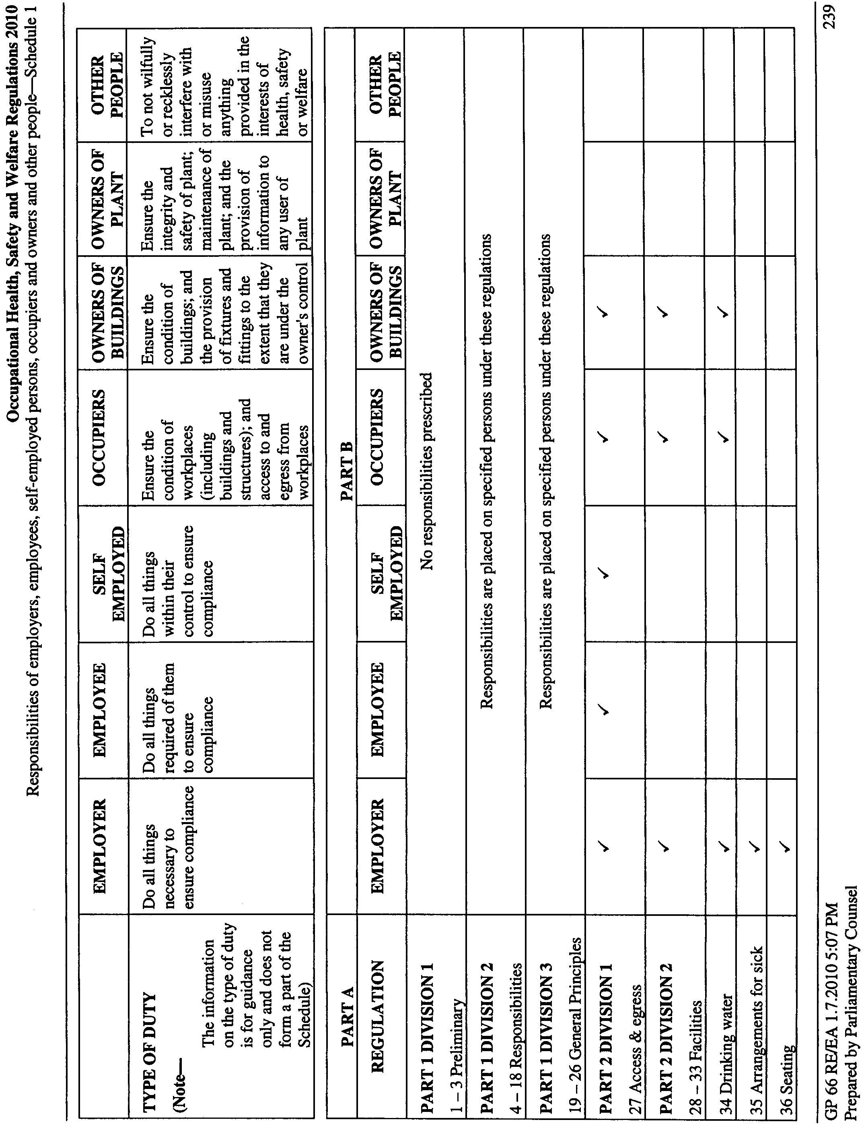
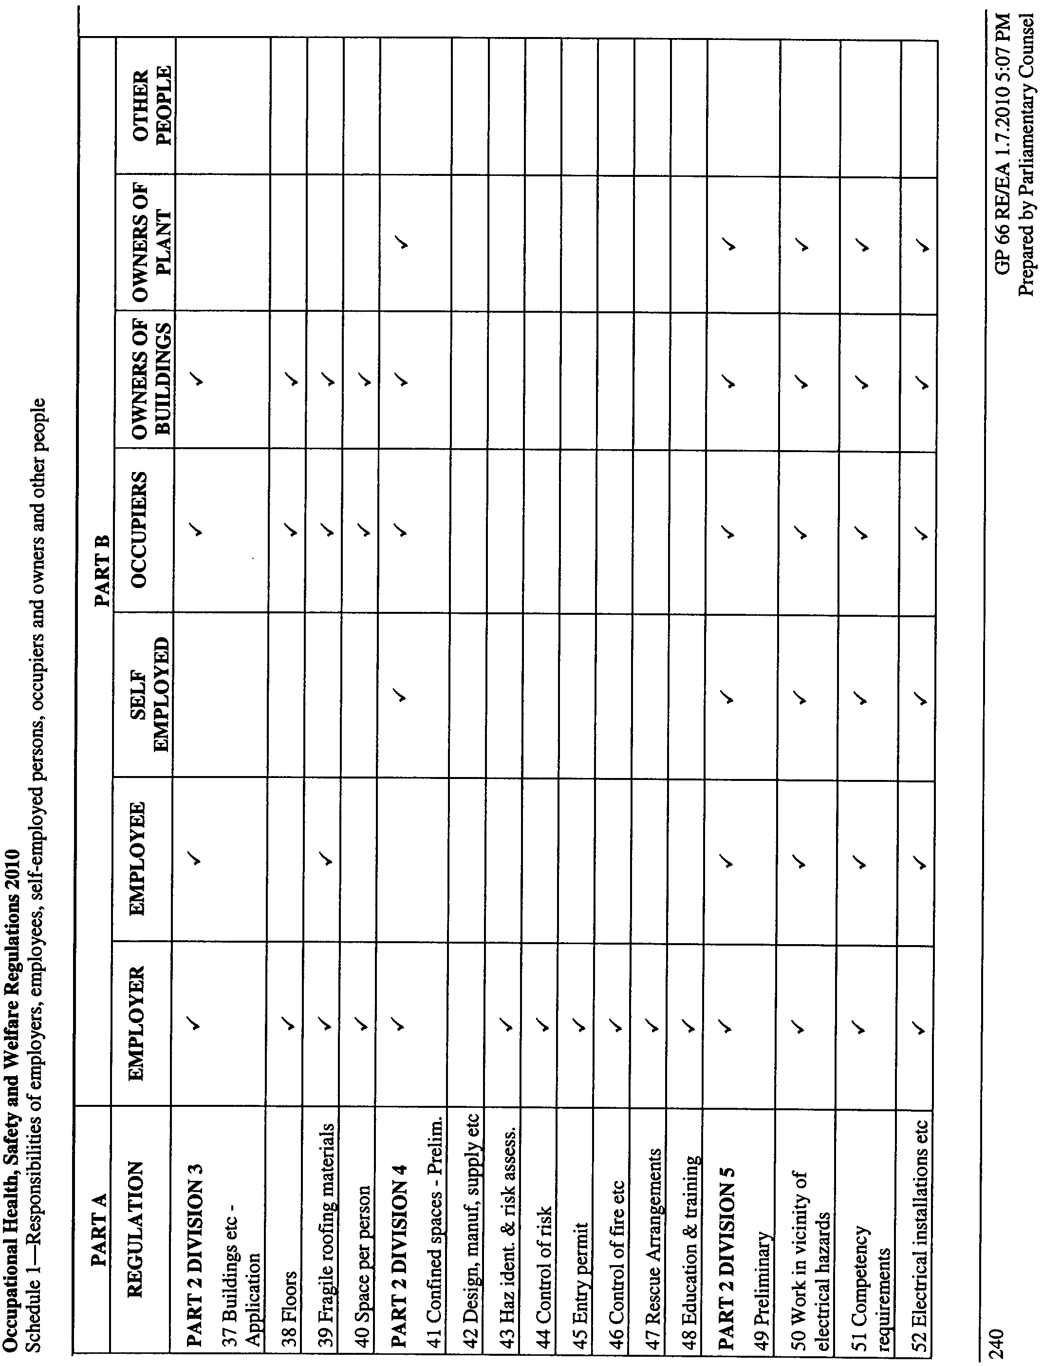
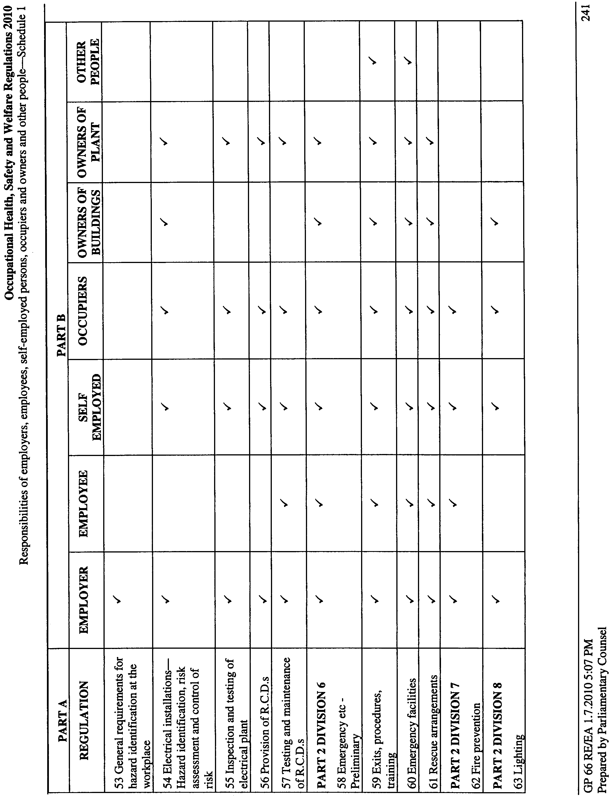
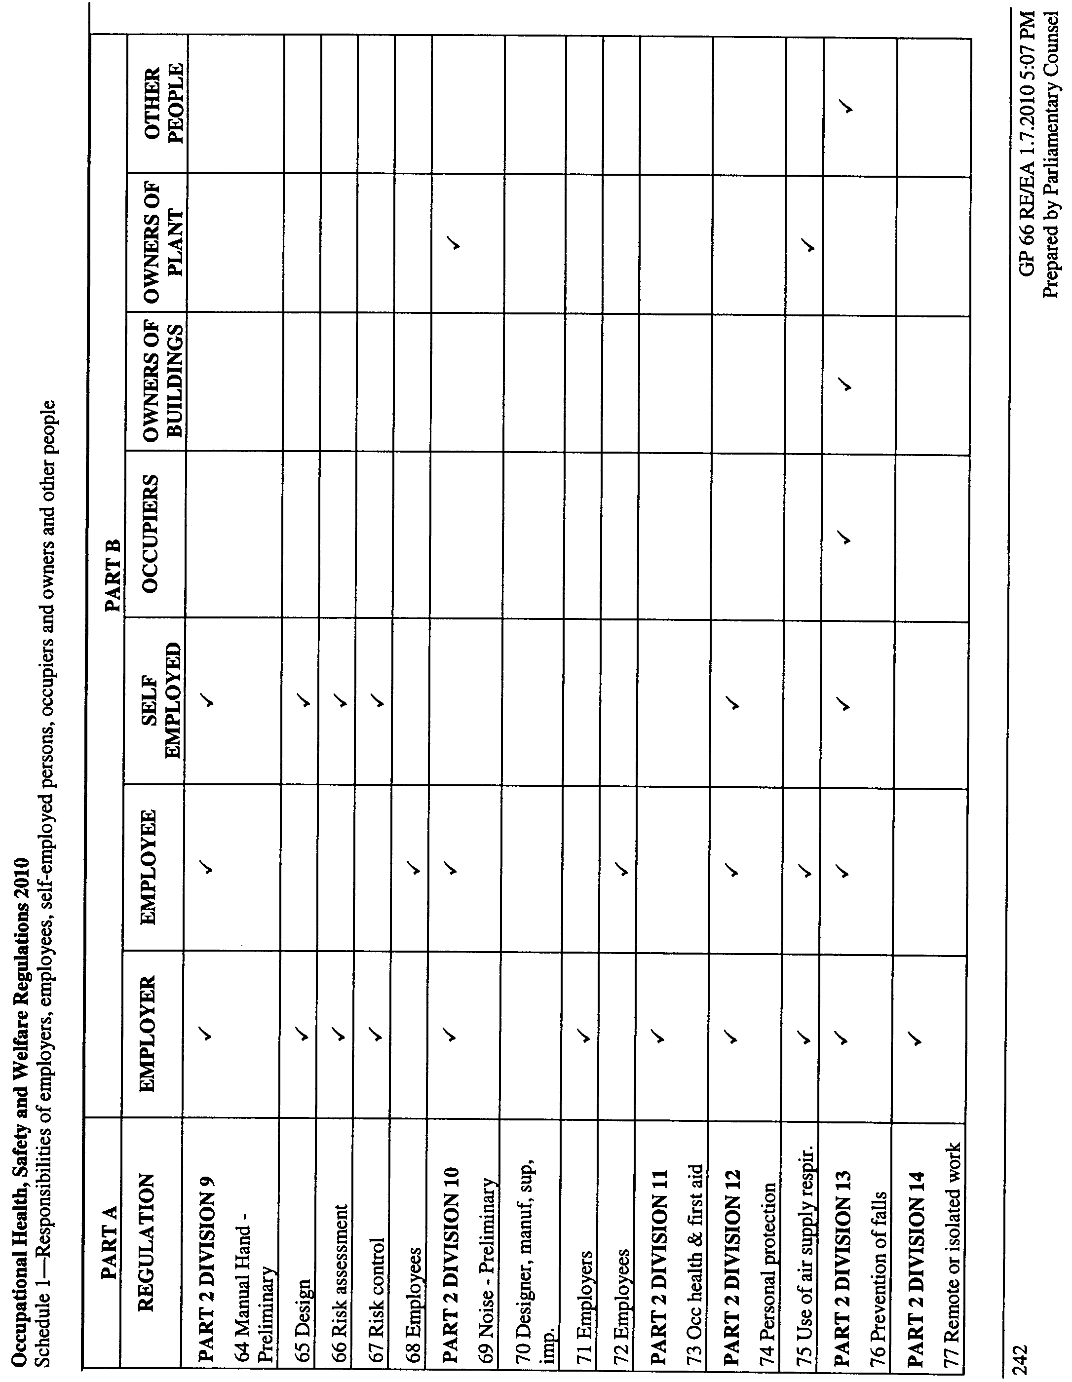
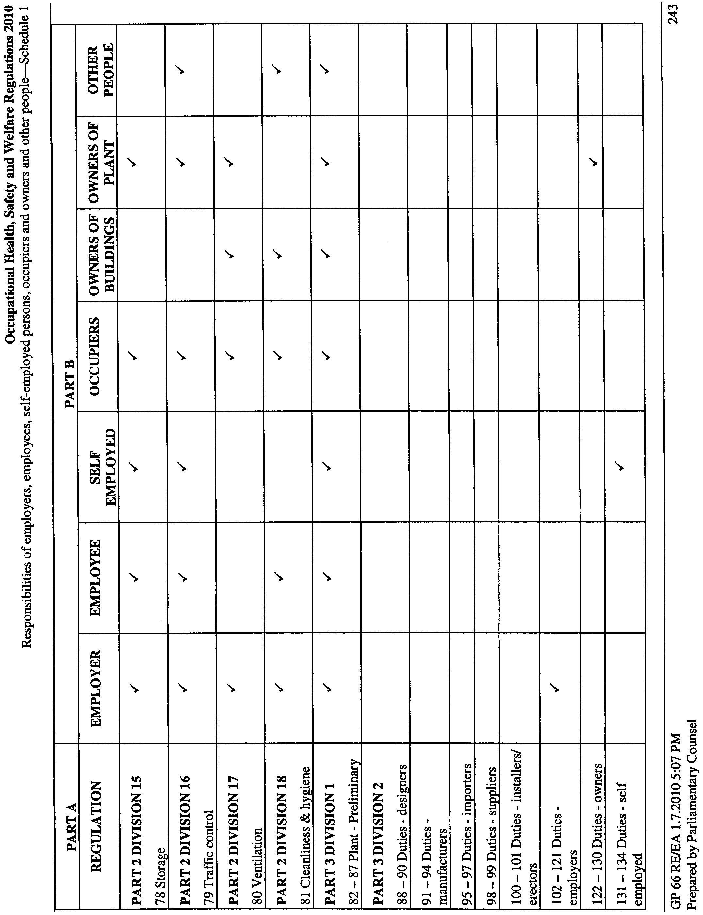
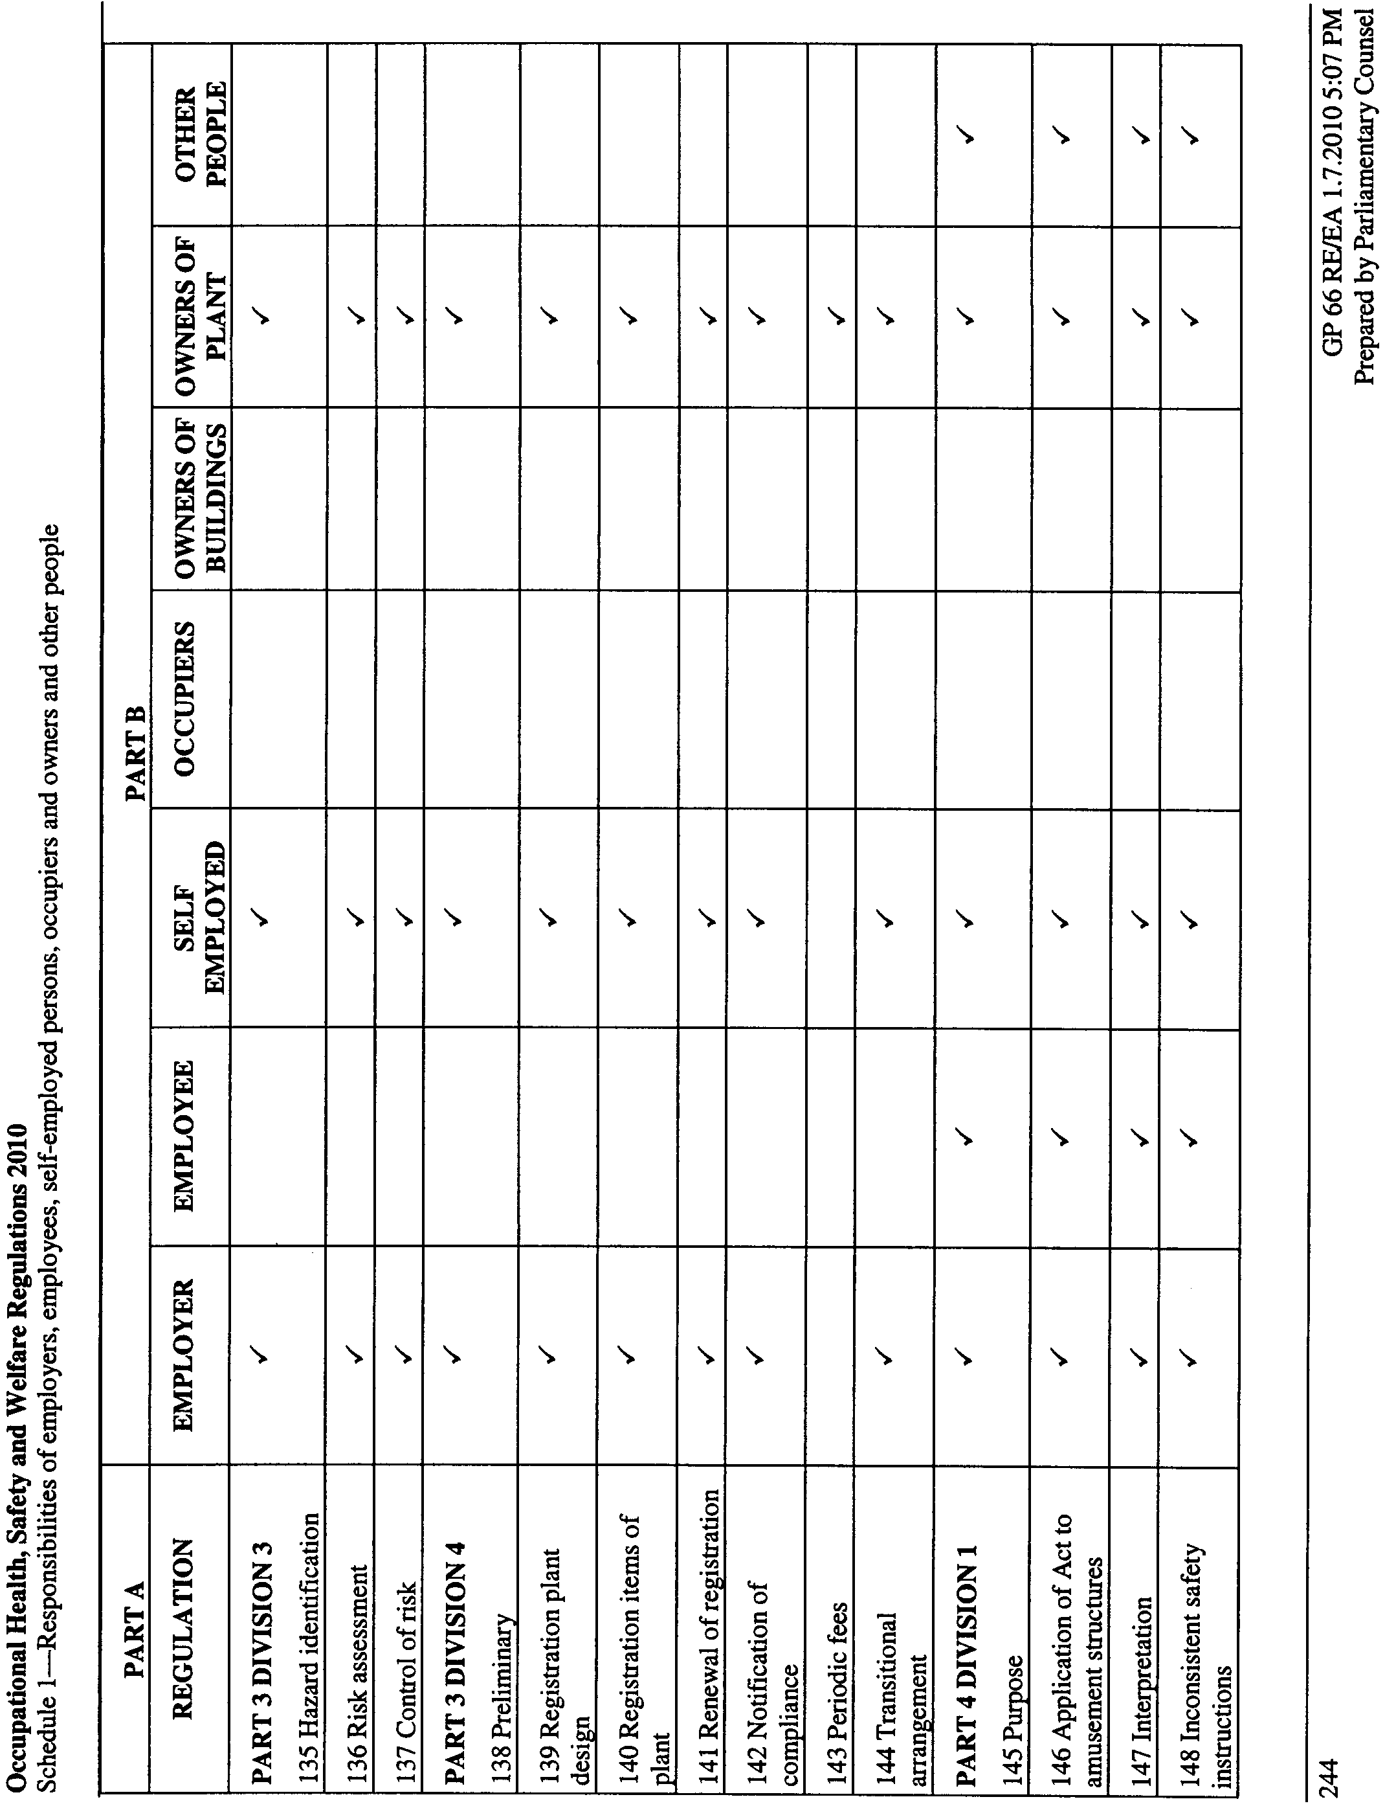
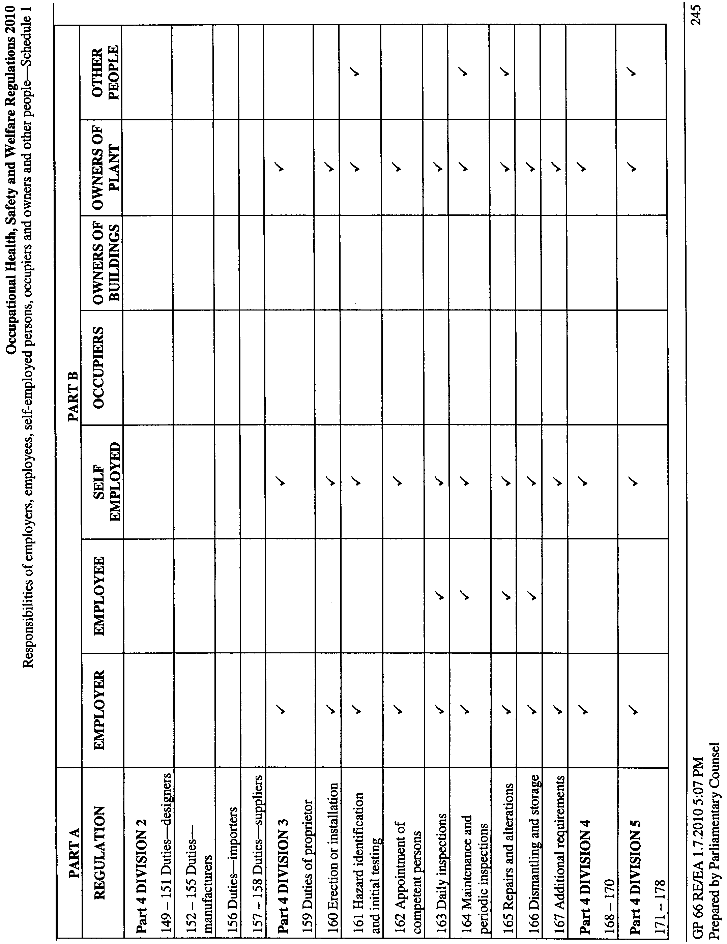
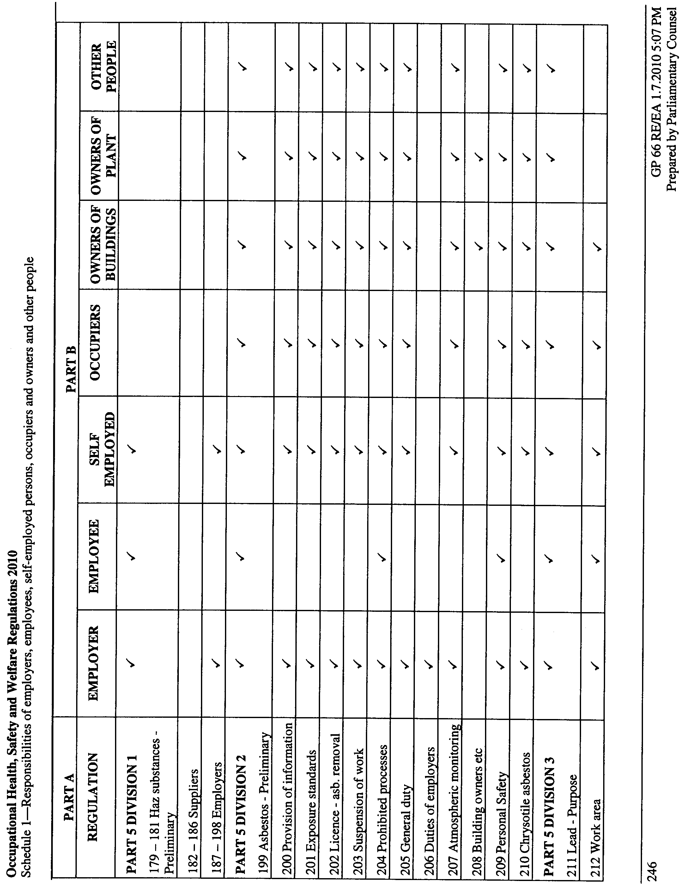
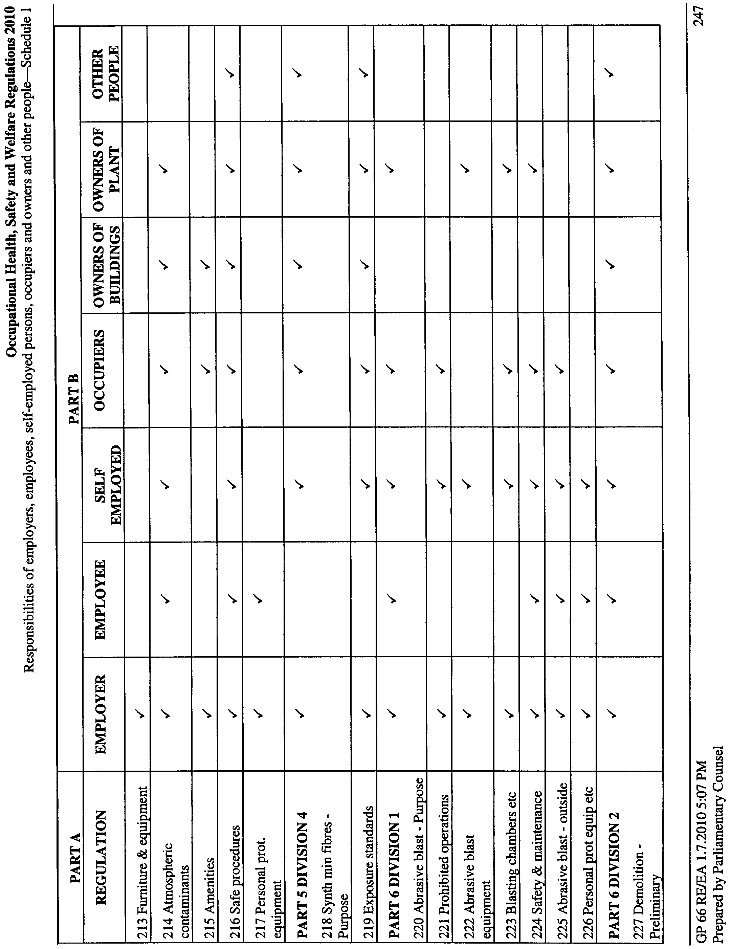
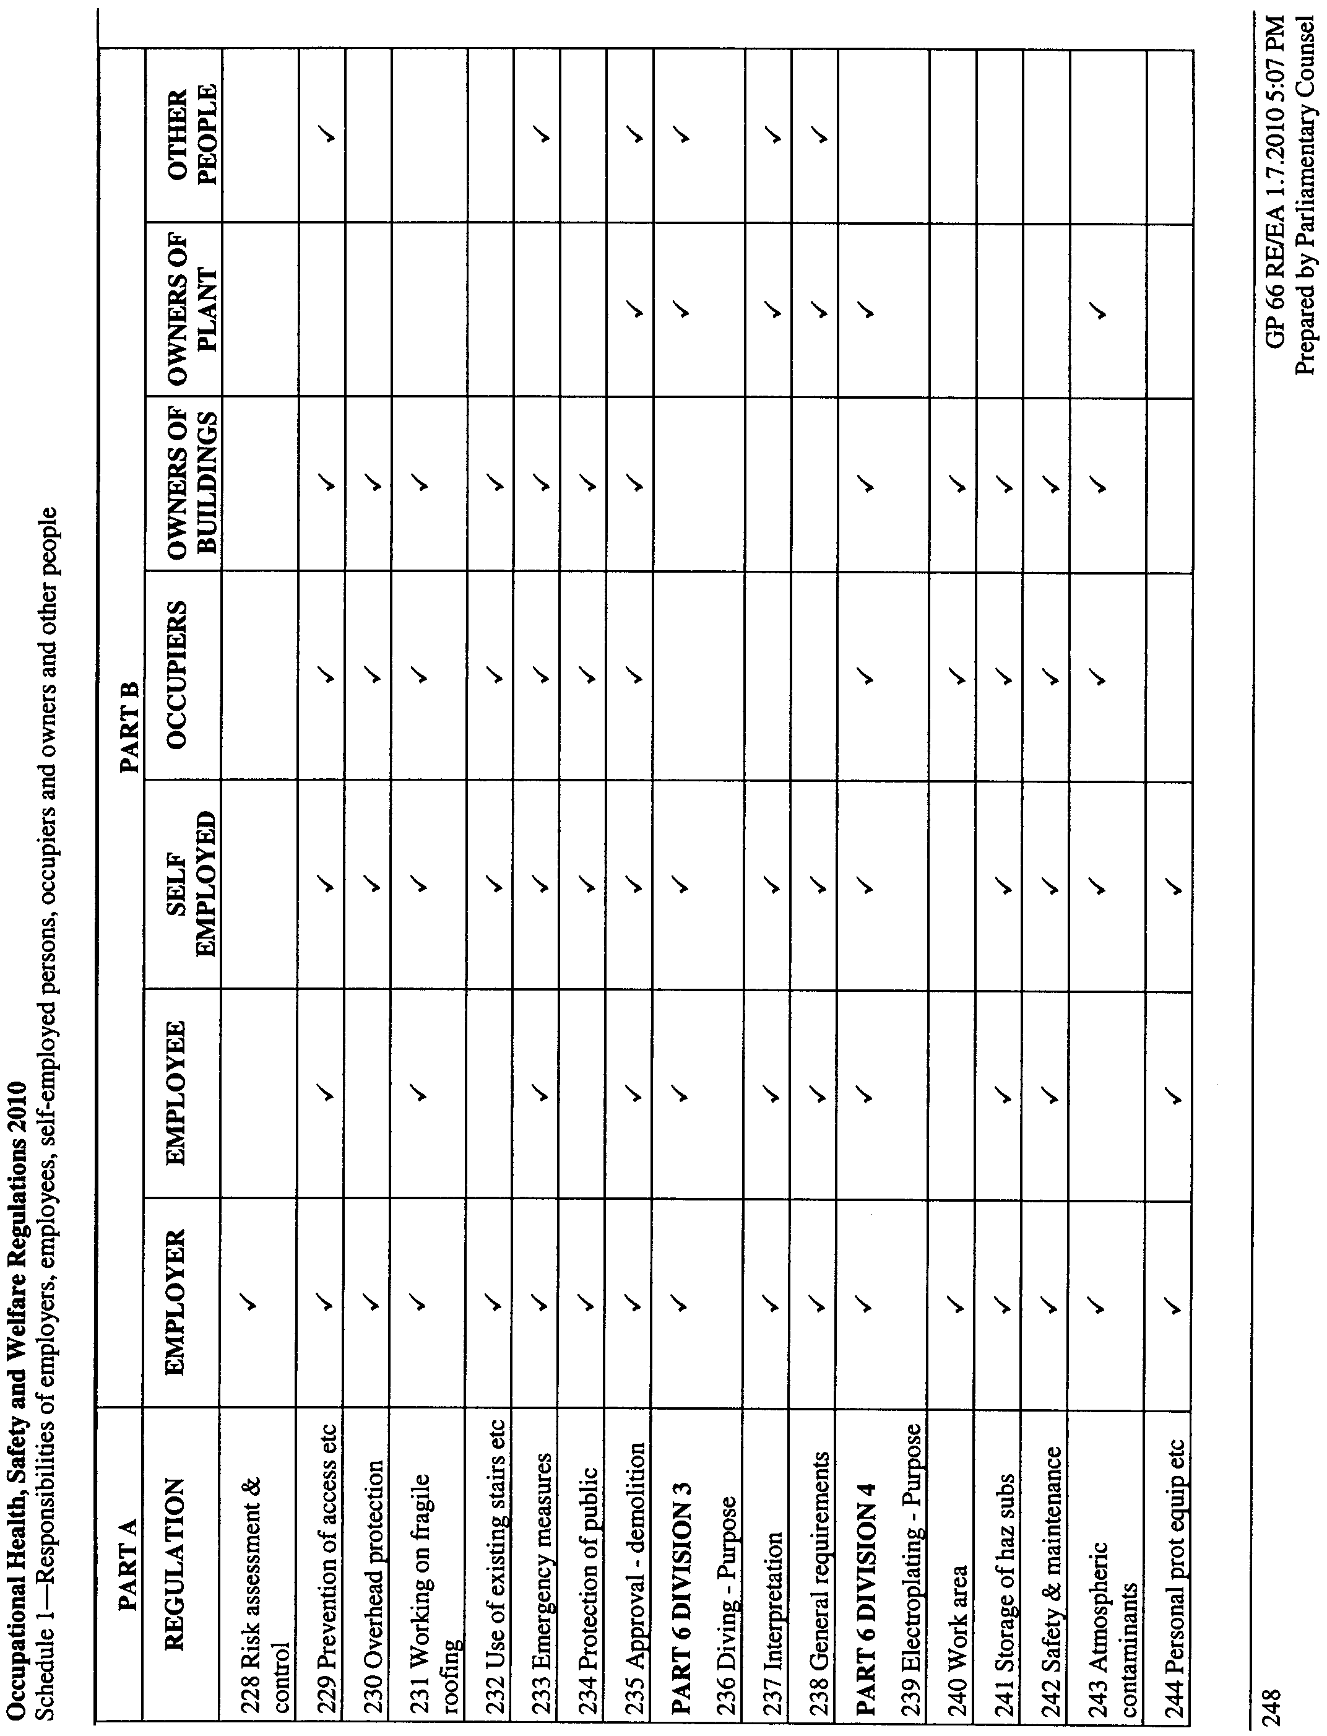
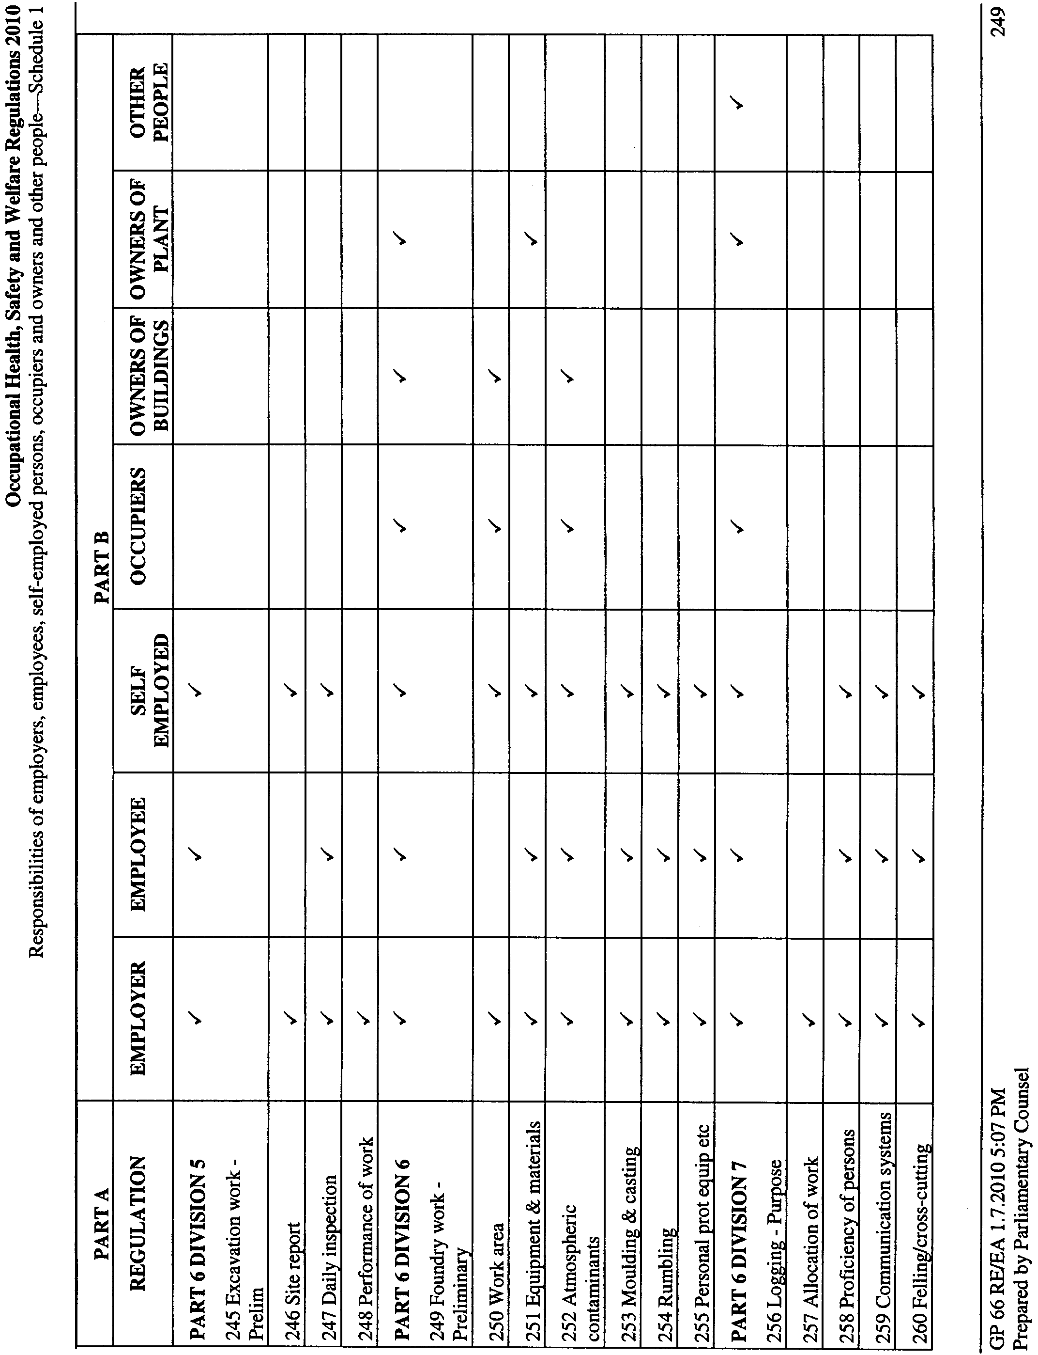
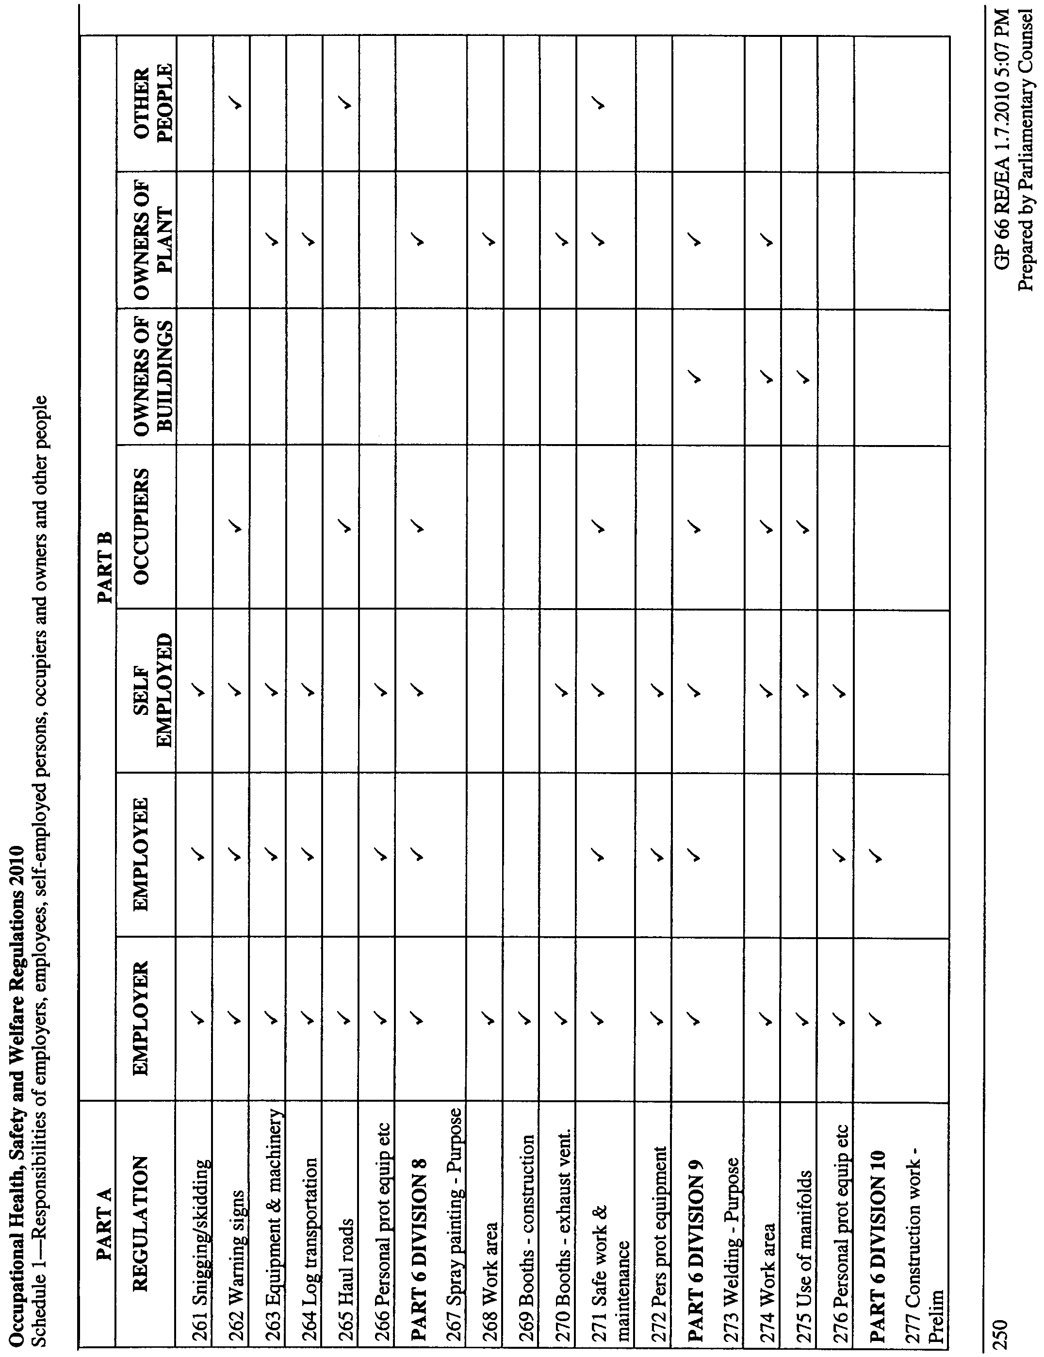
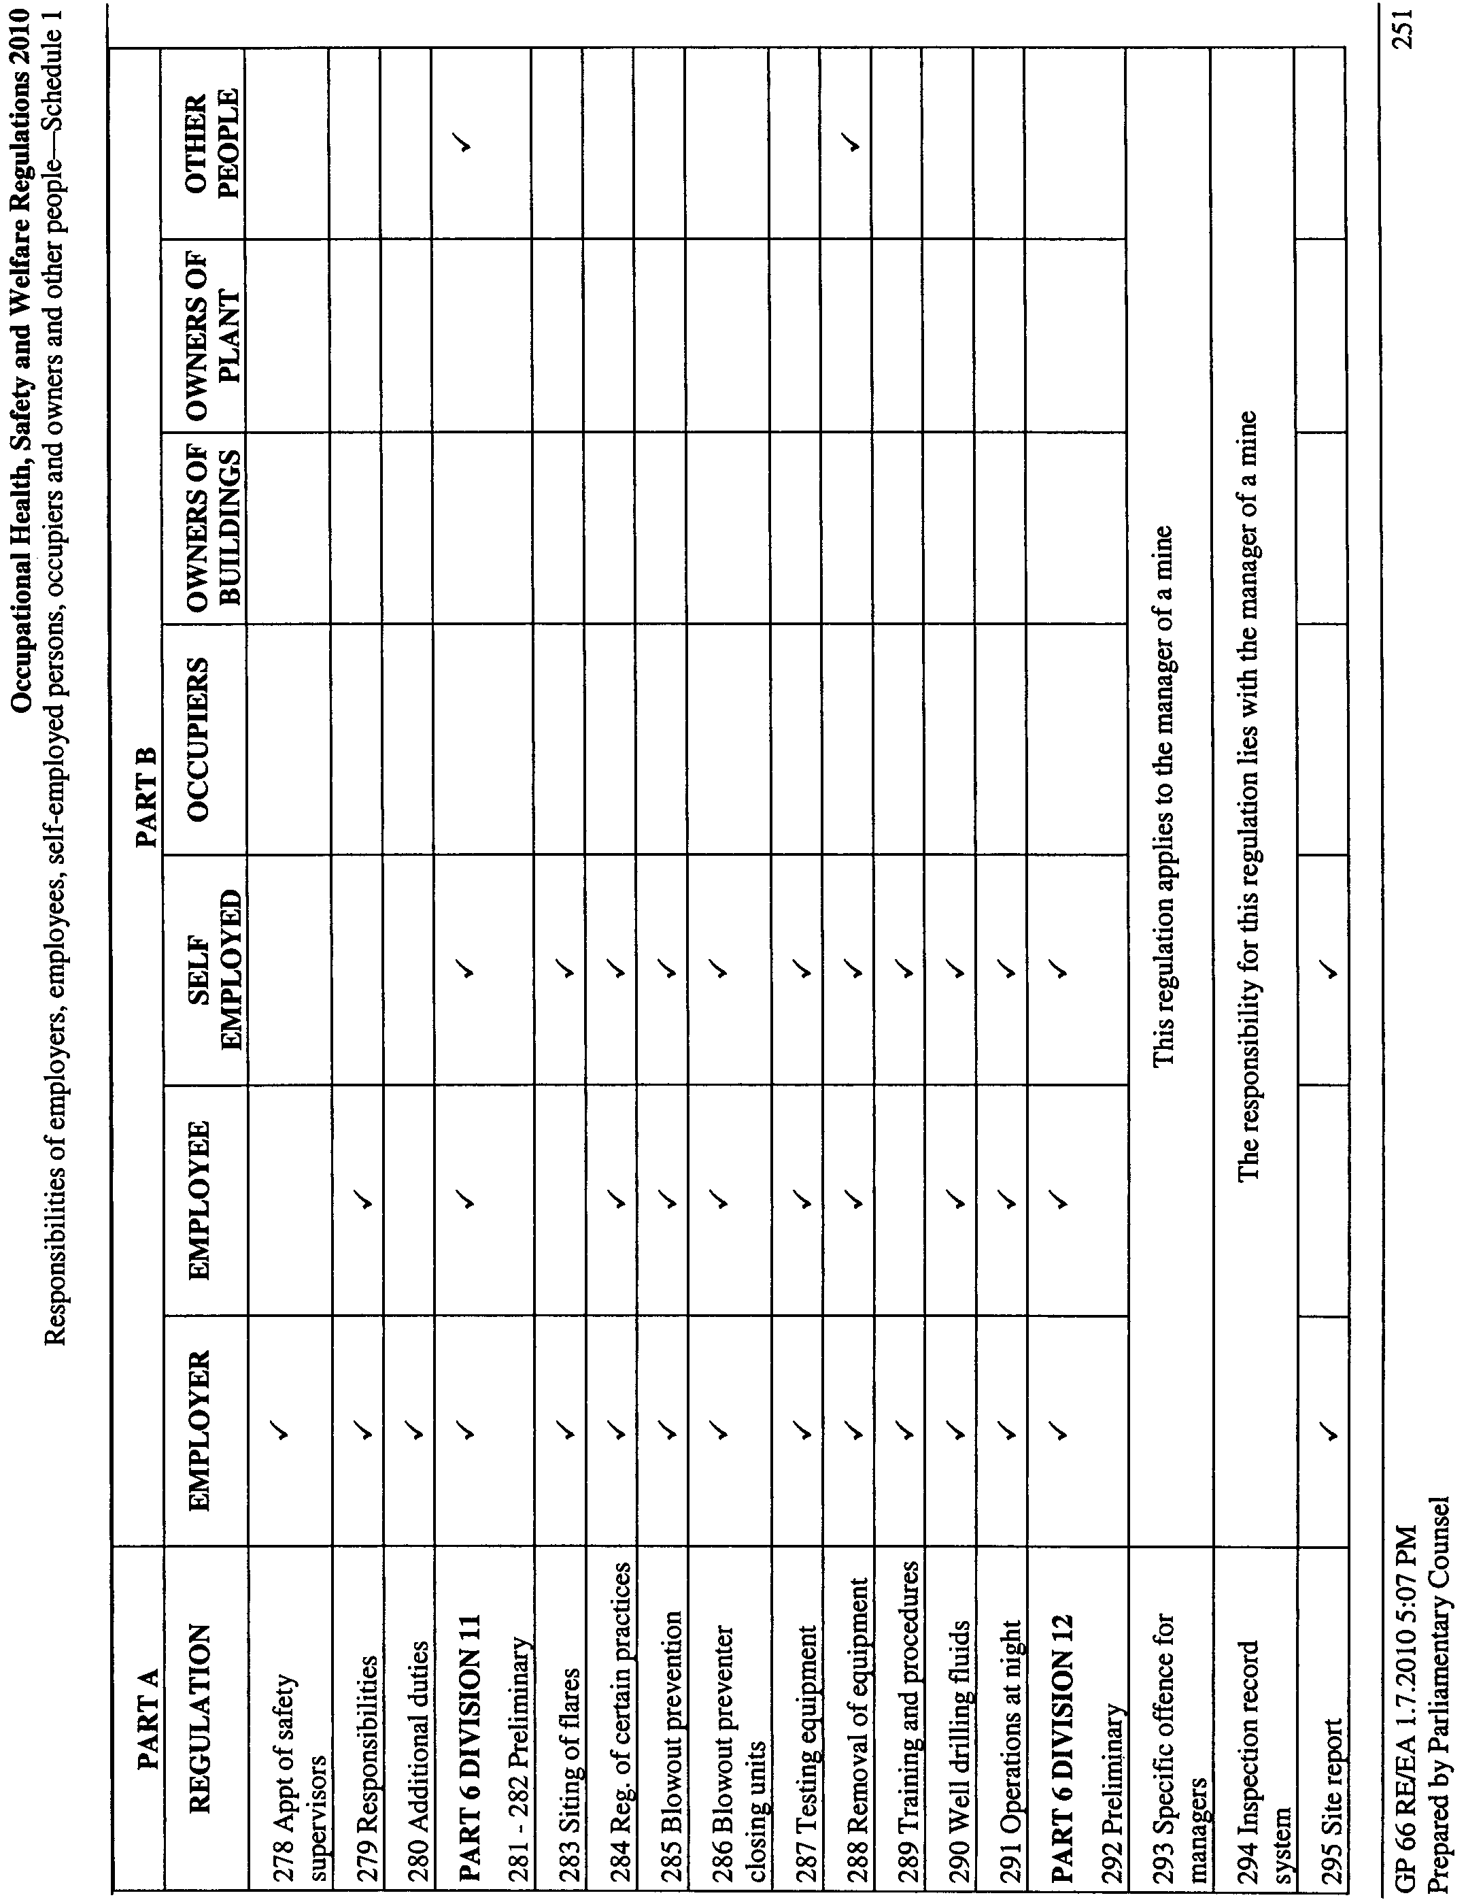
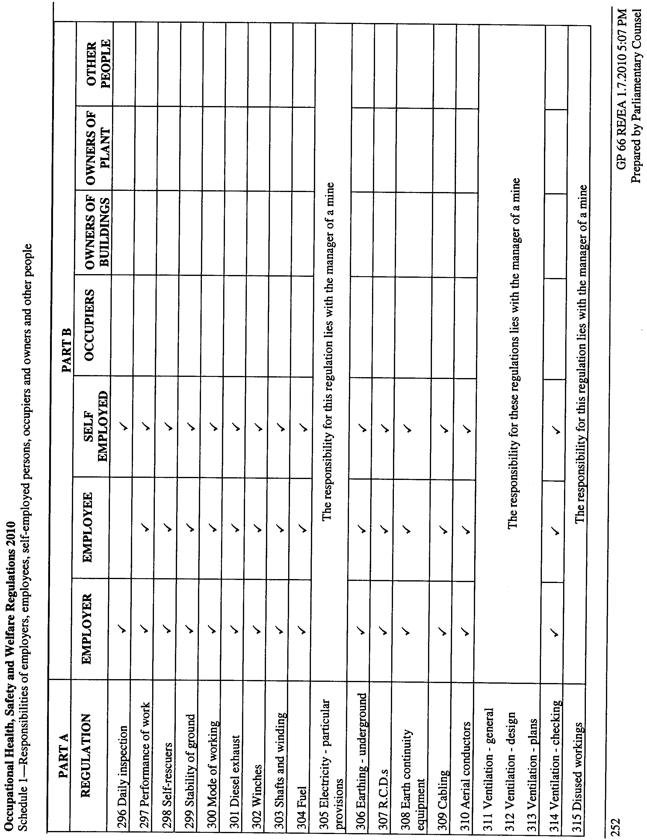
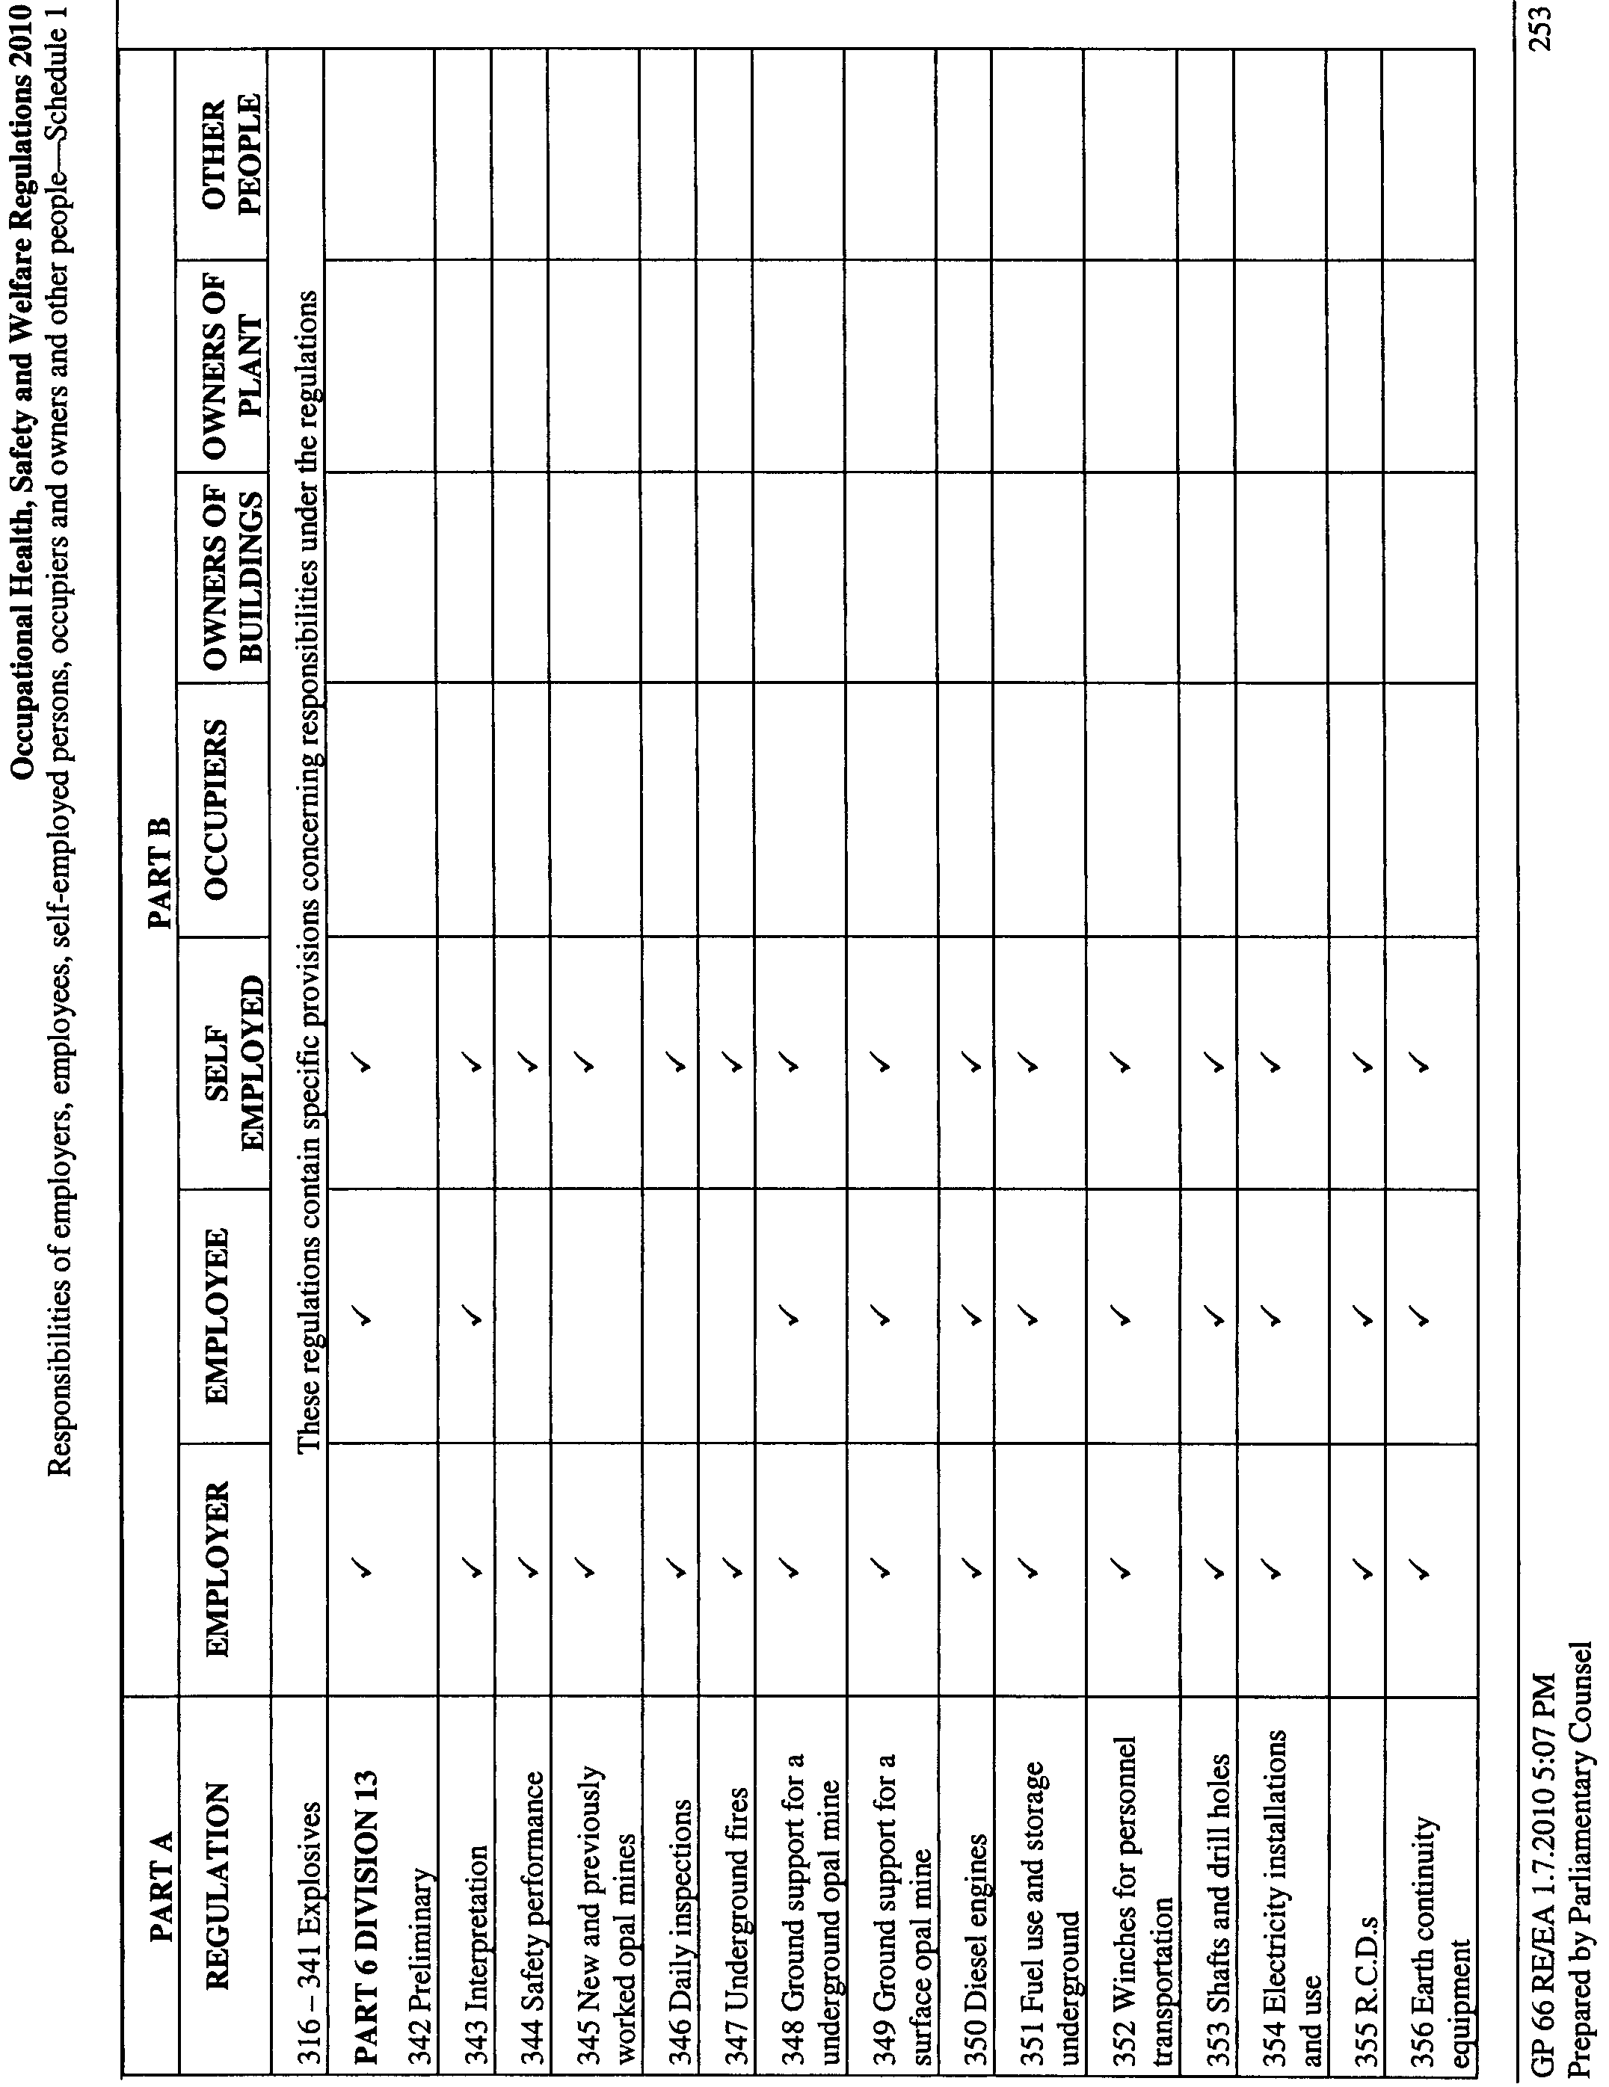
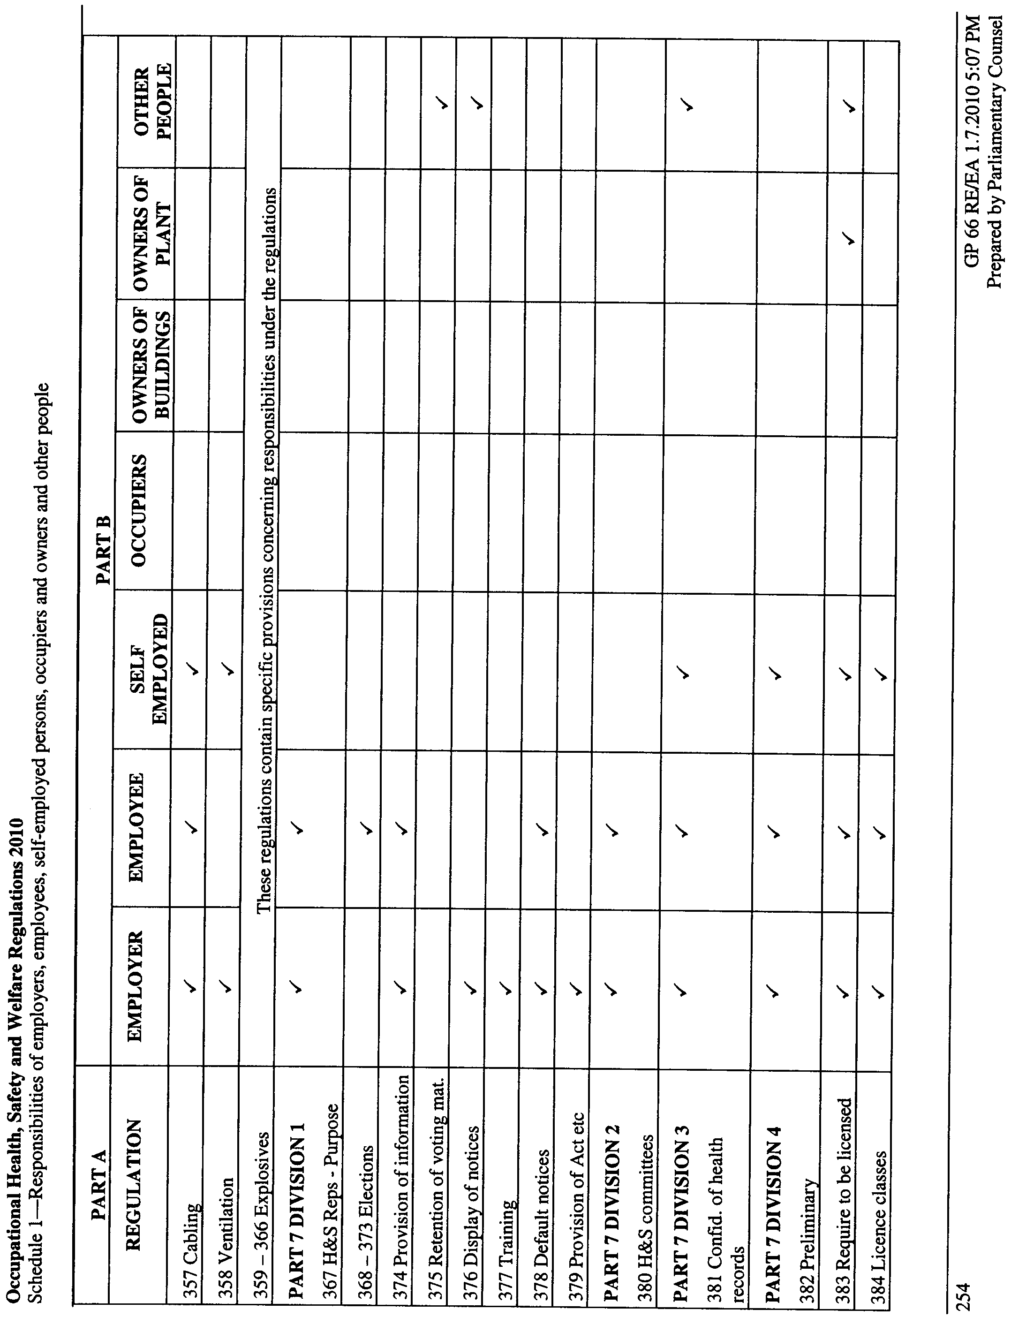
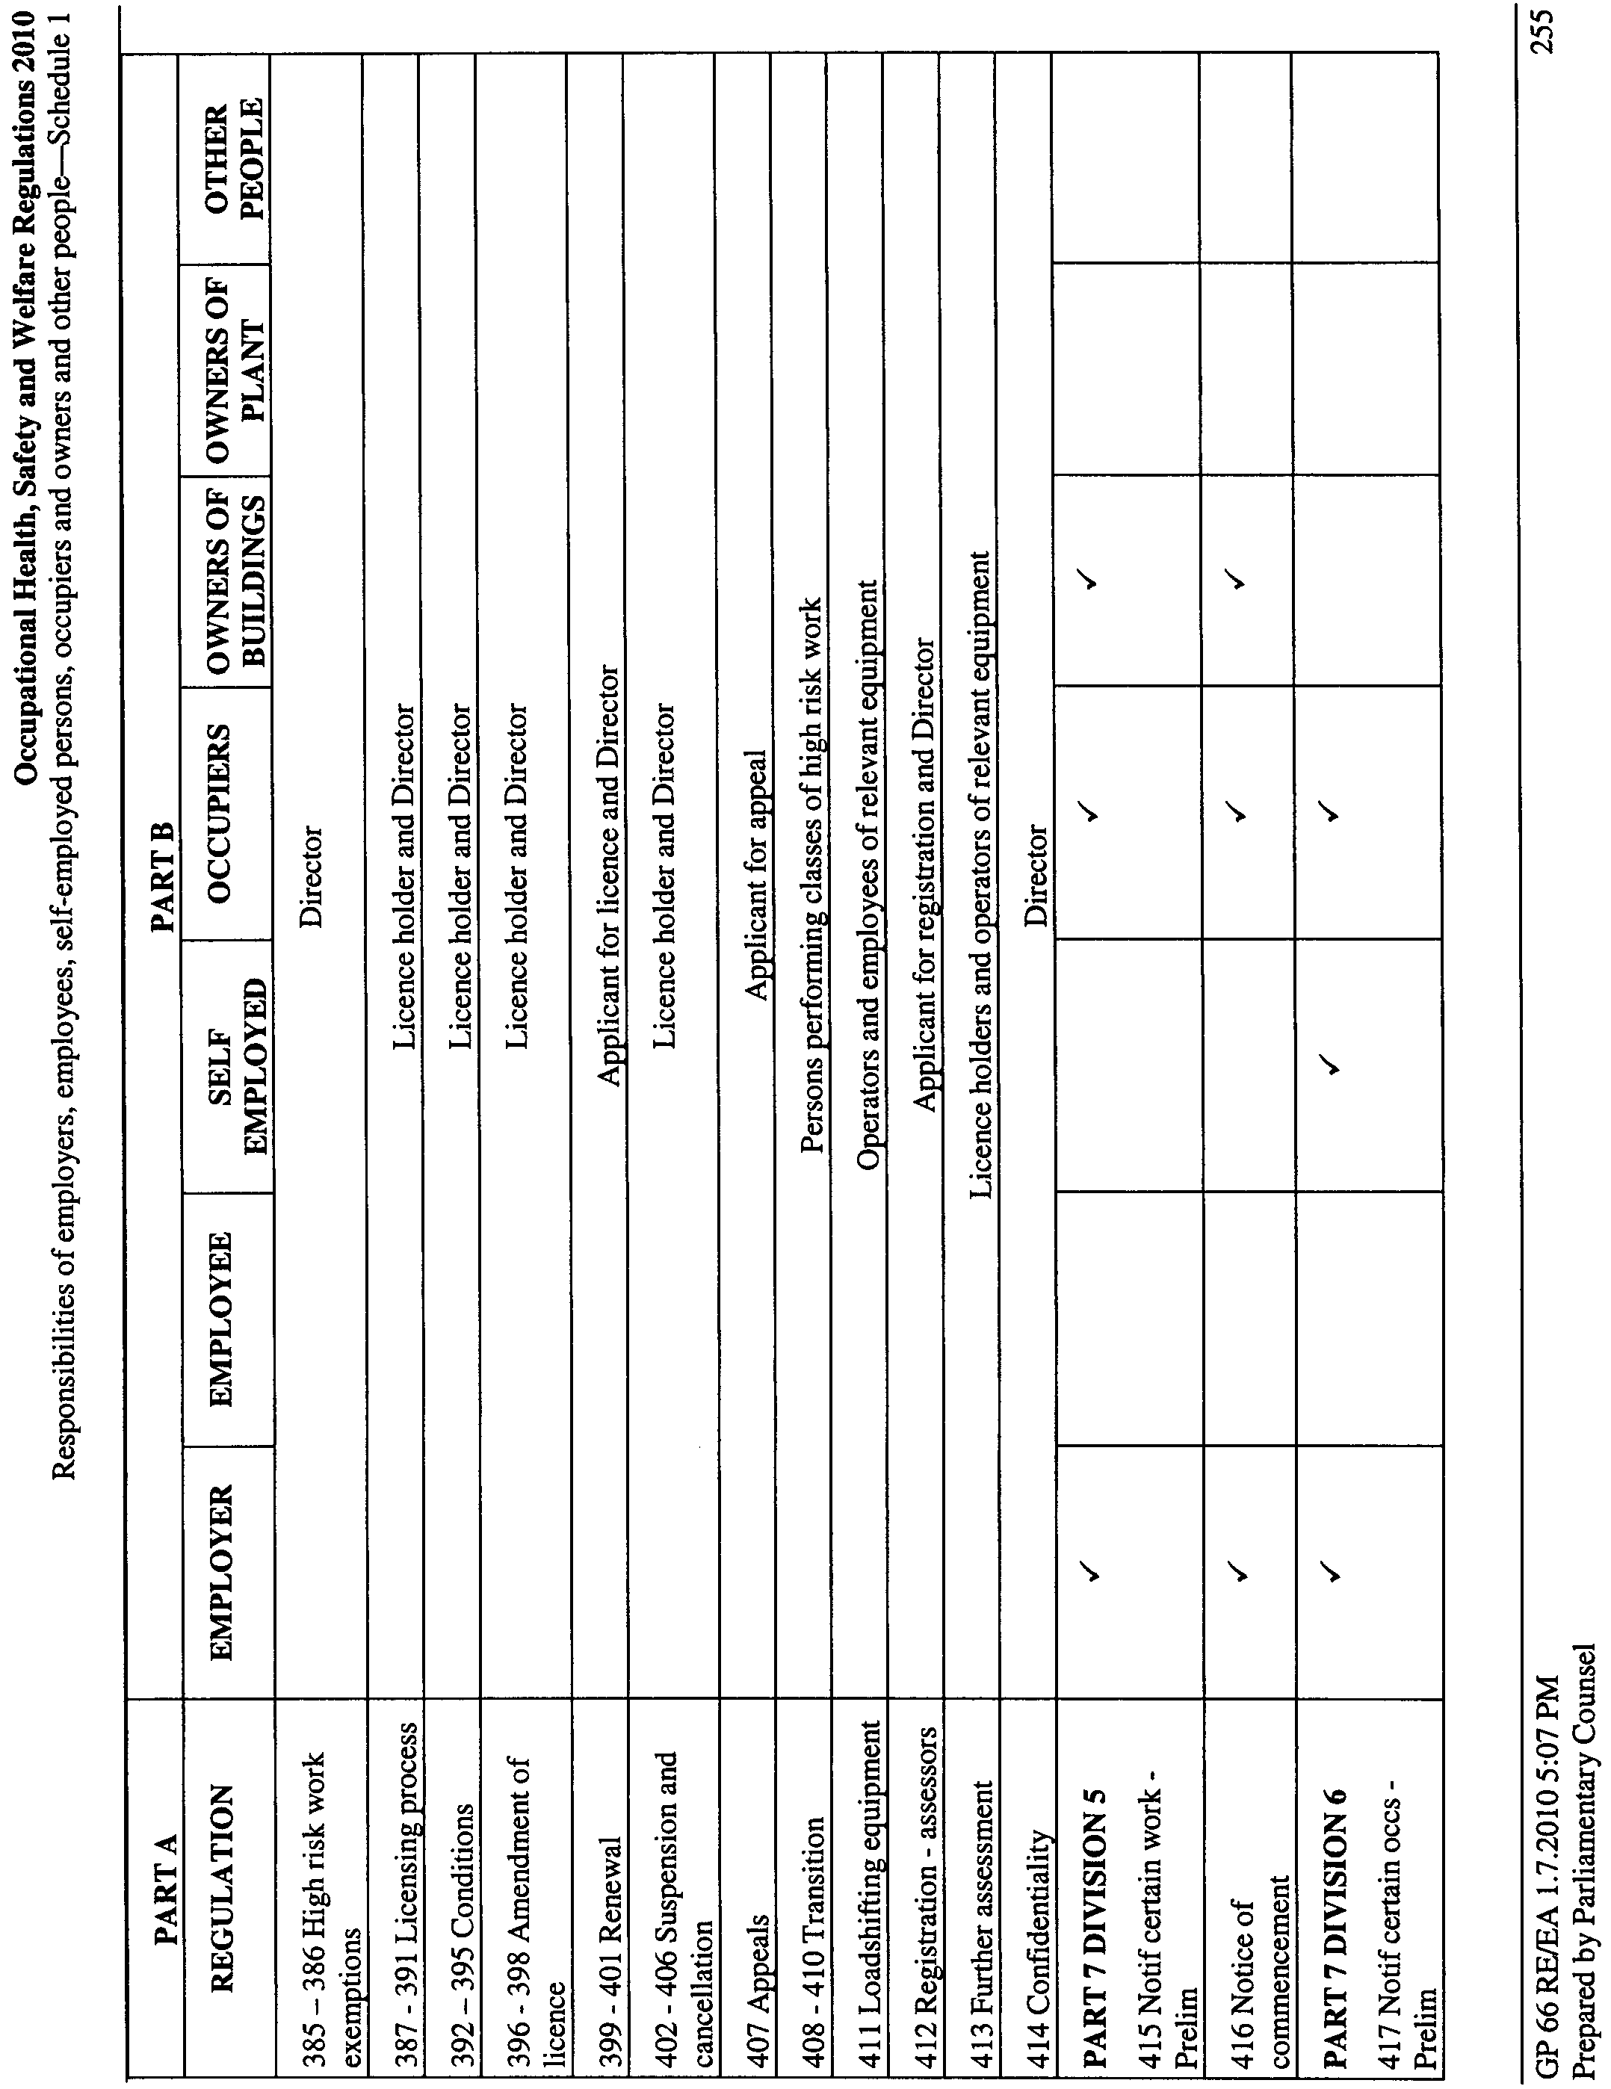
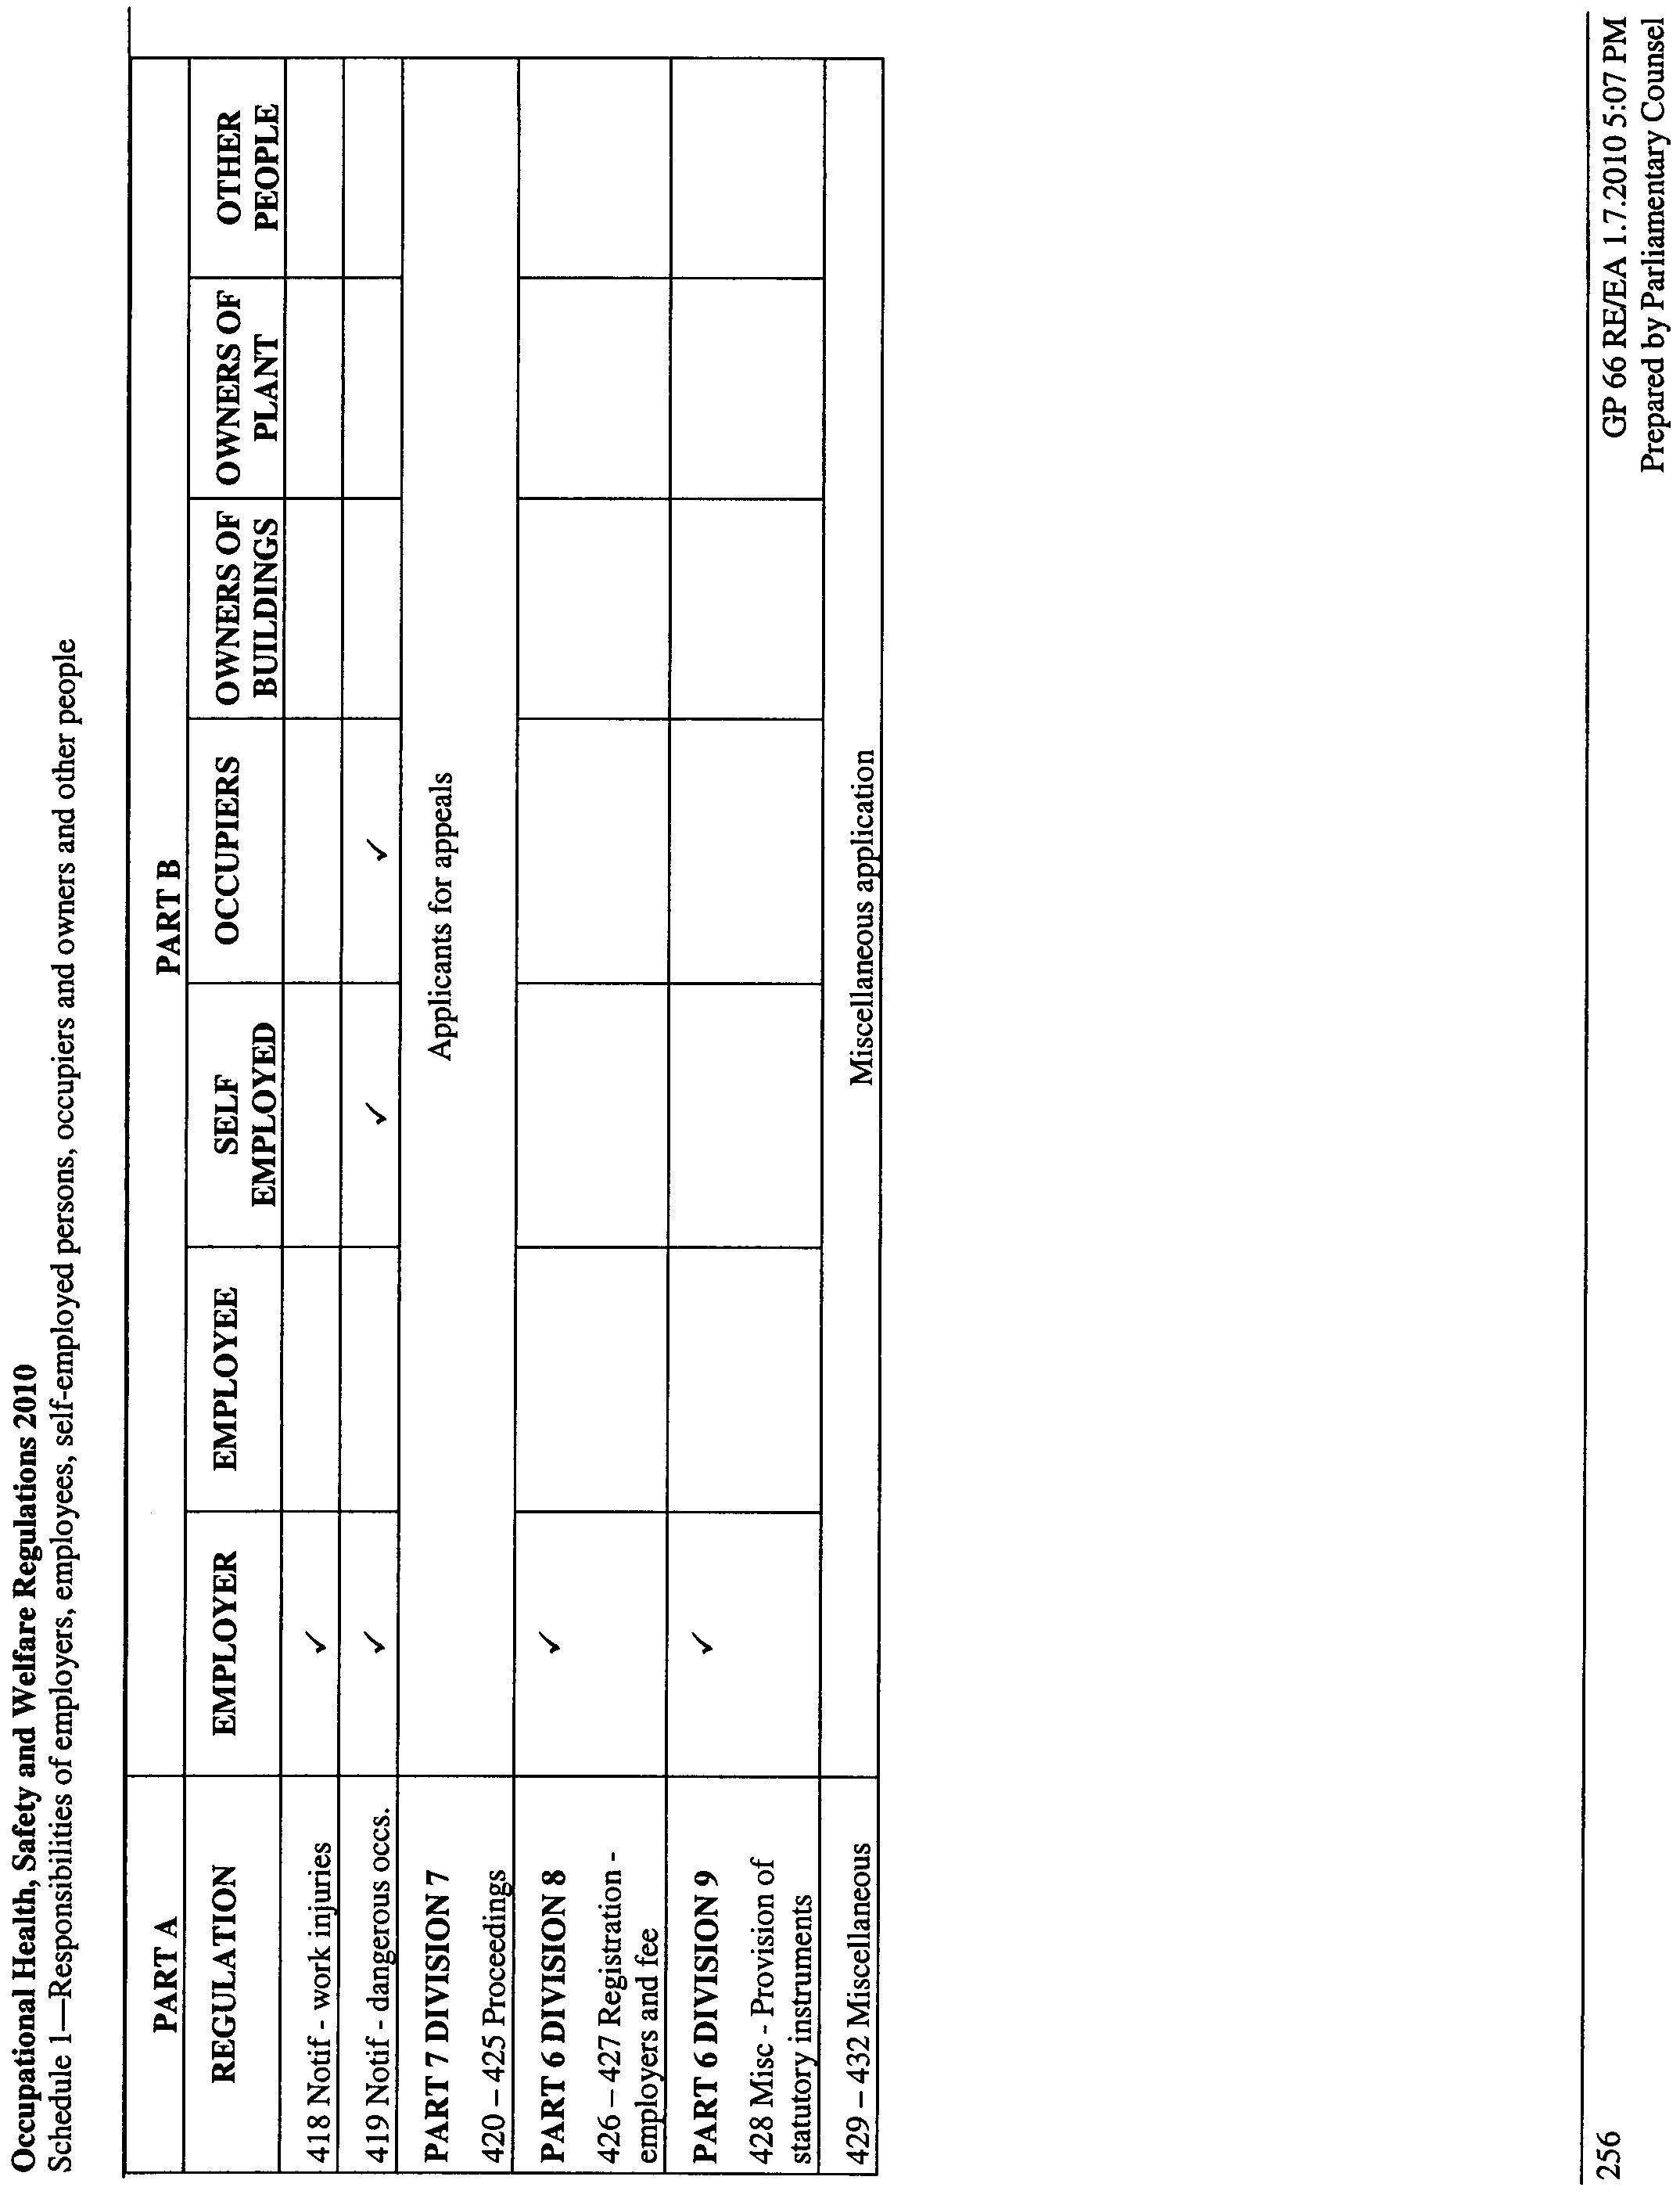

Schedule 2—Responsibilities of designers, manufacturers, importers, suppliers and installers/erectors

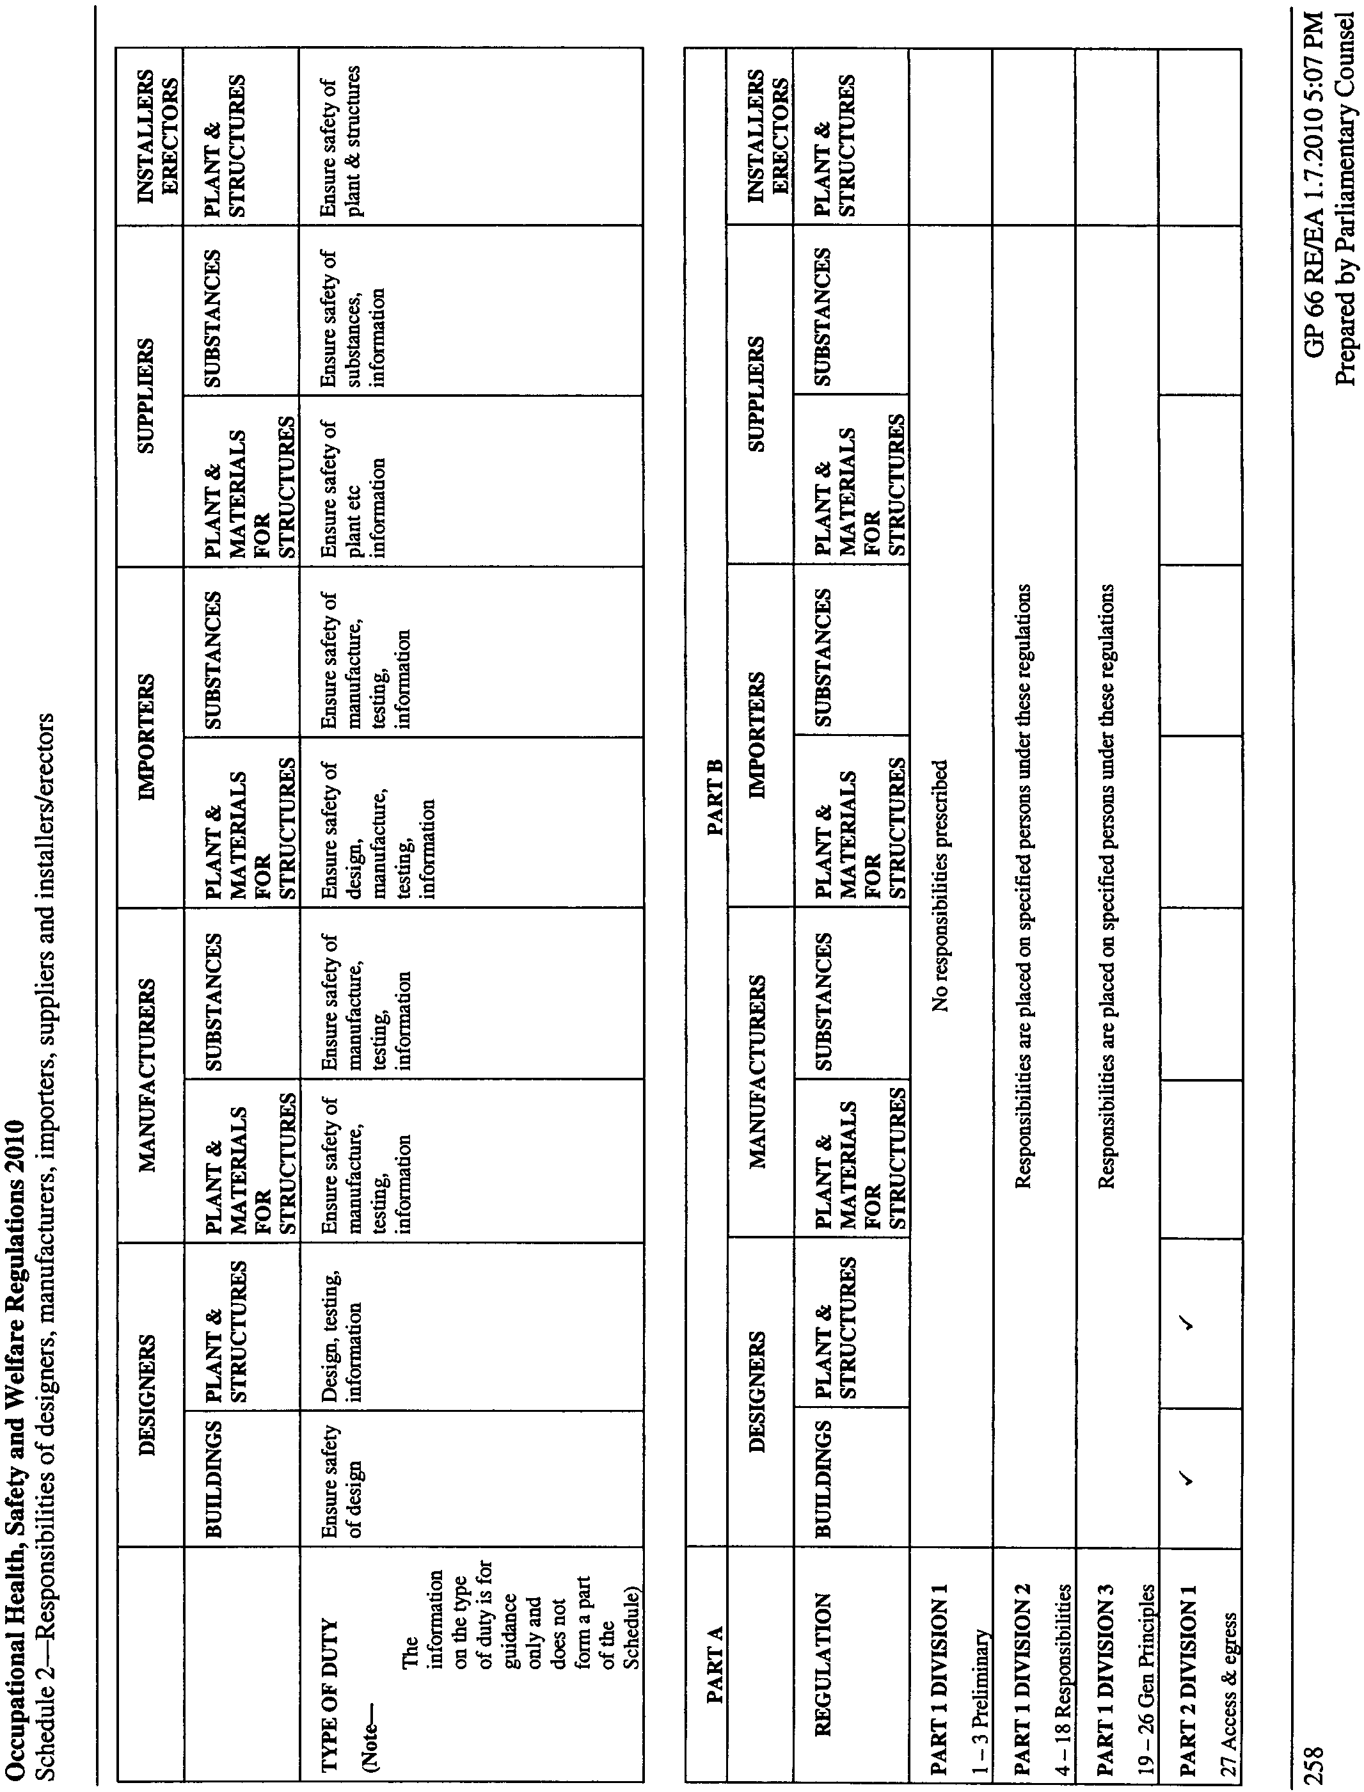
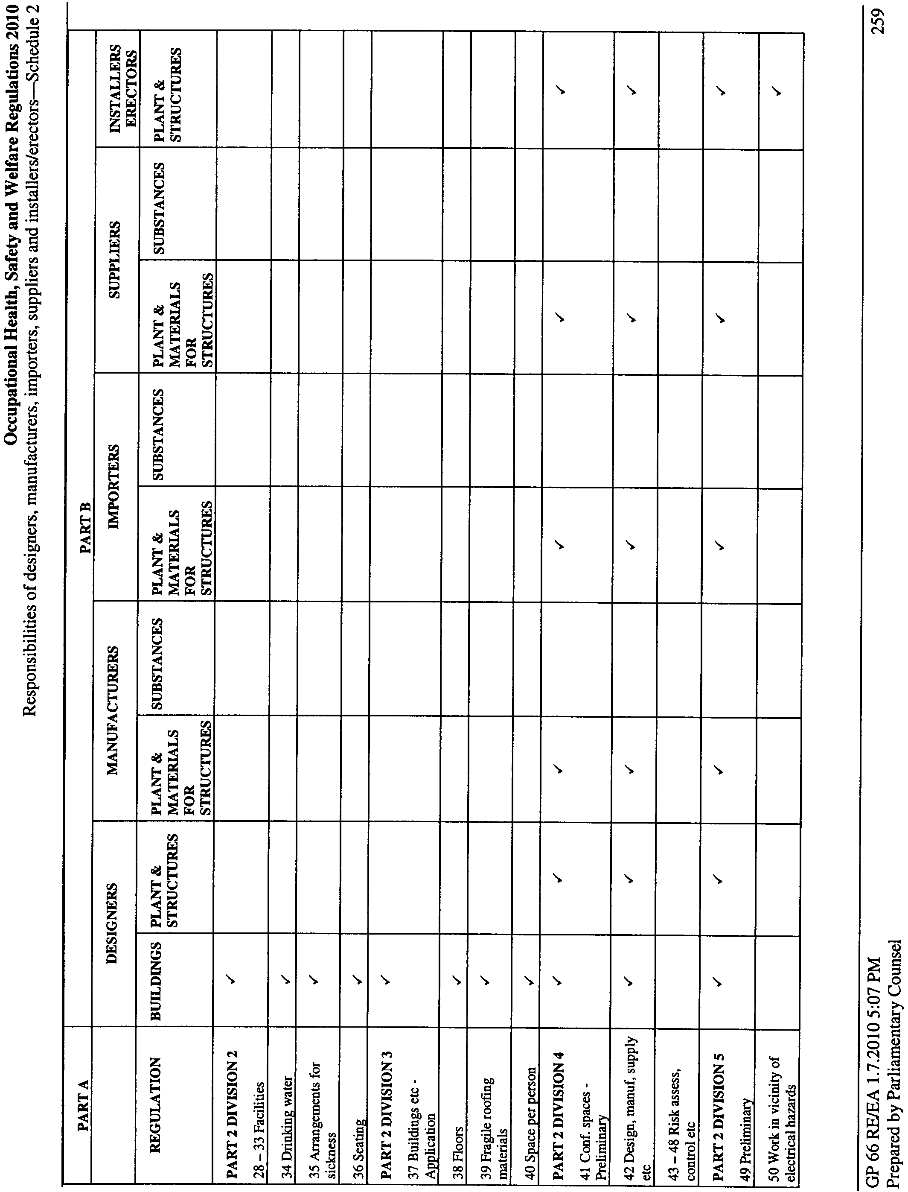
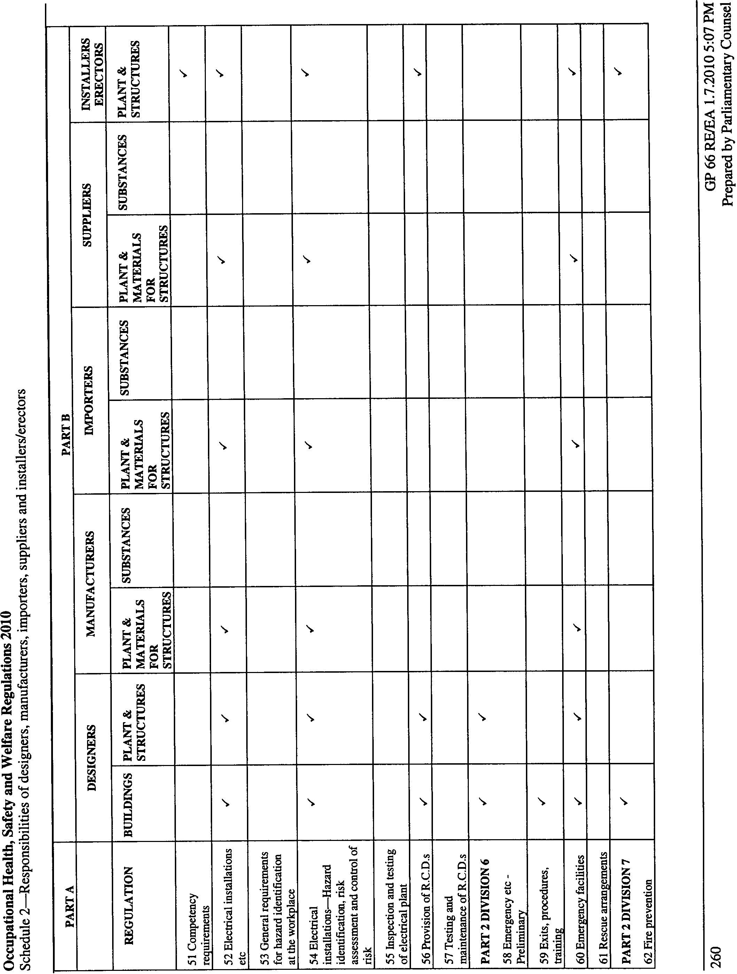
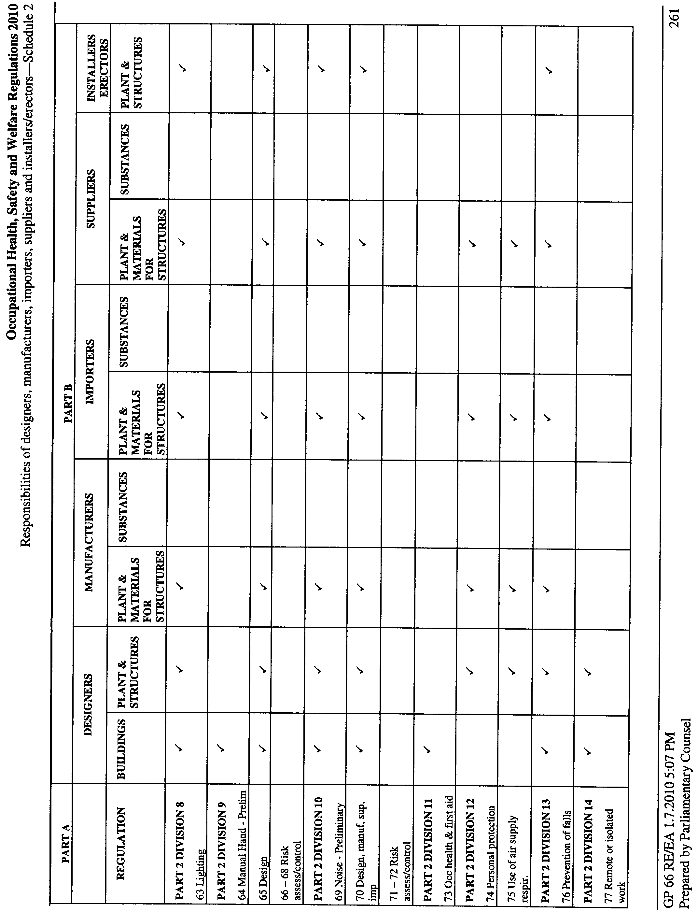
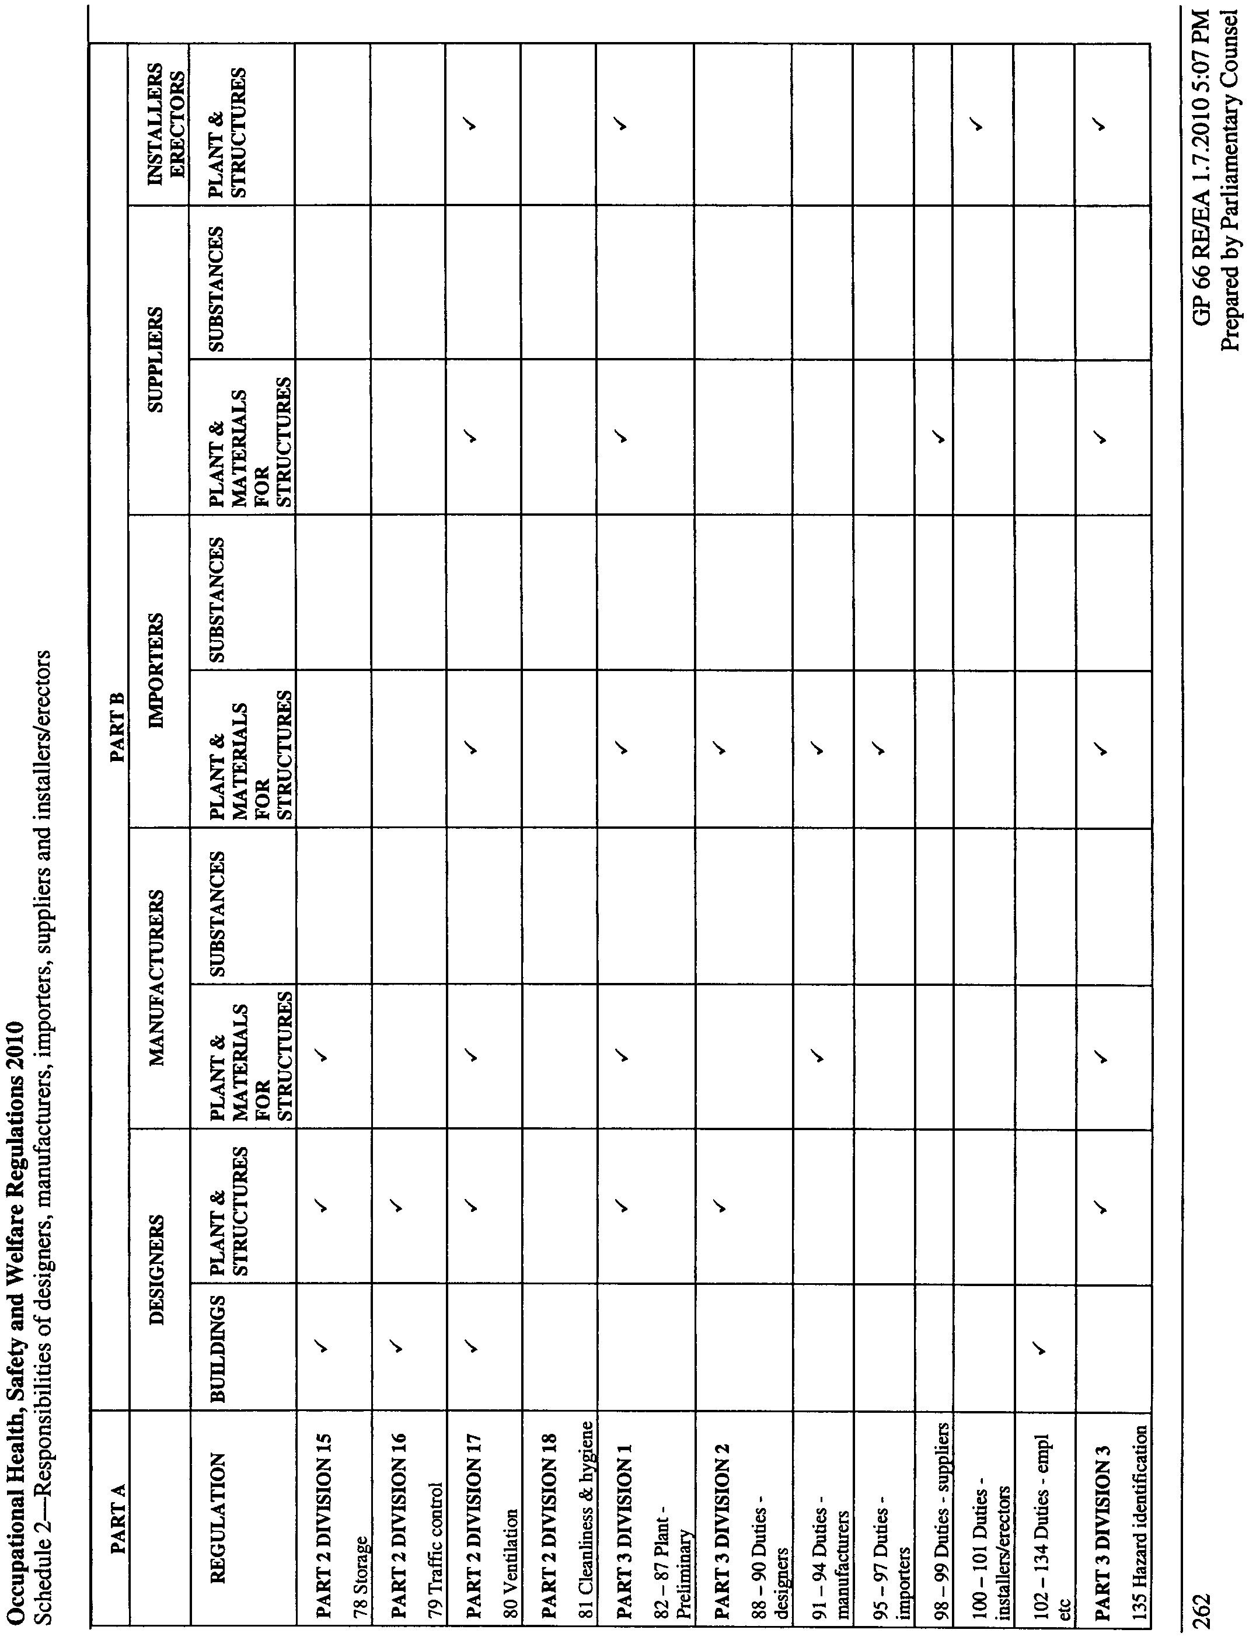
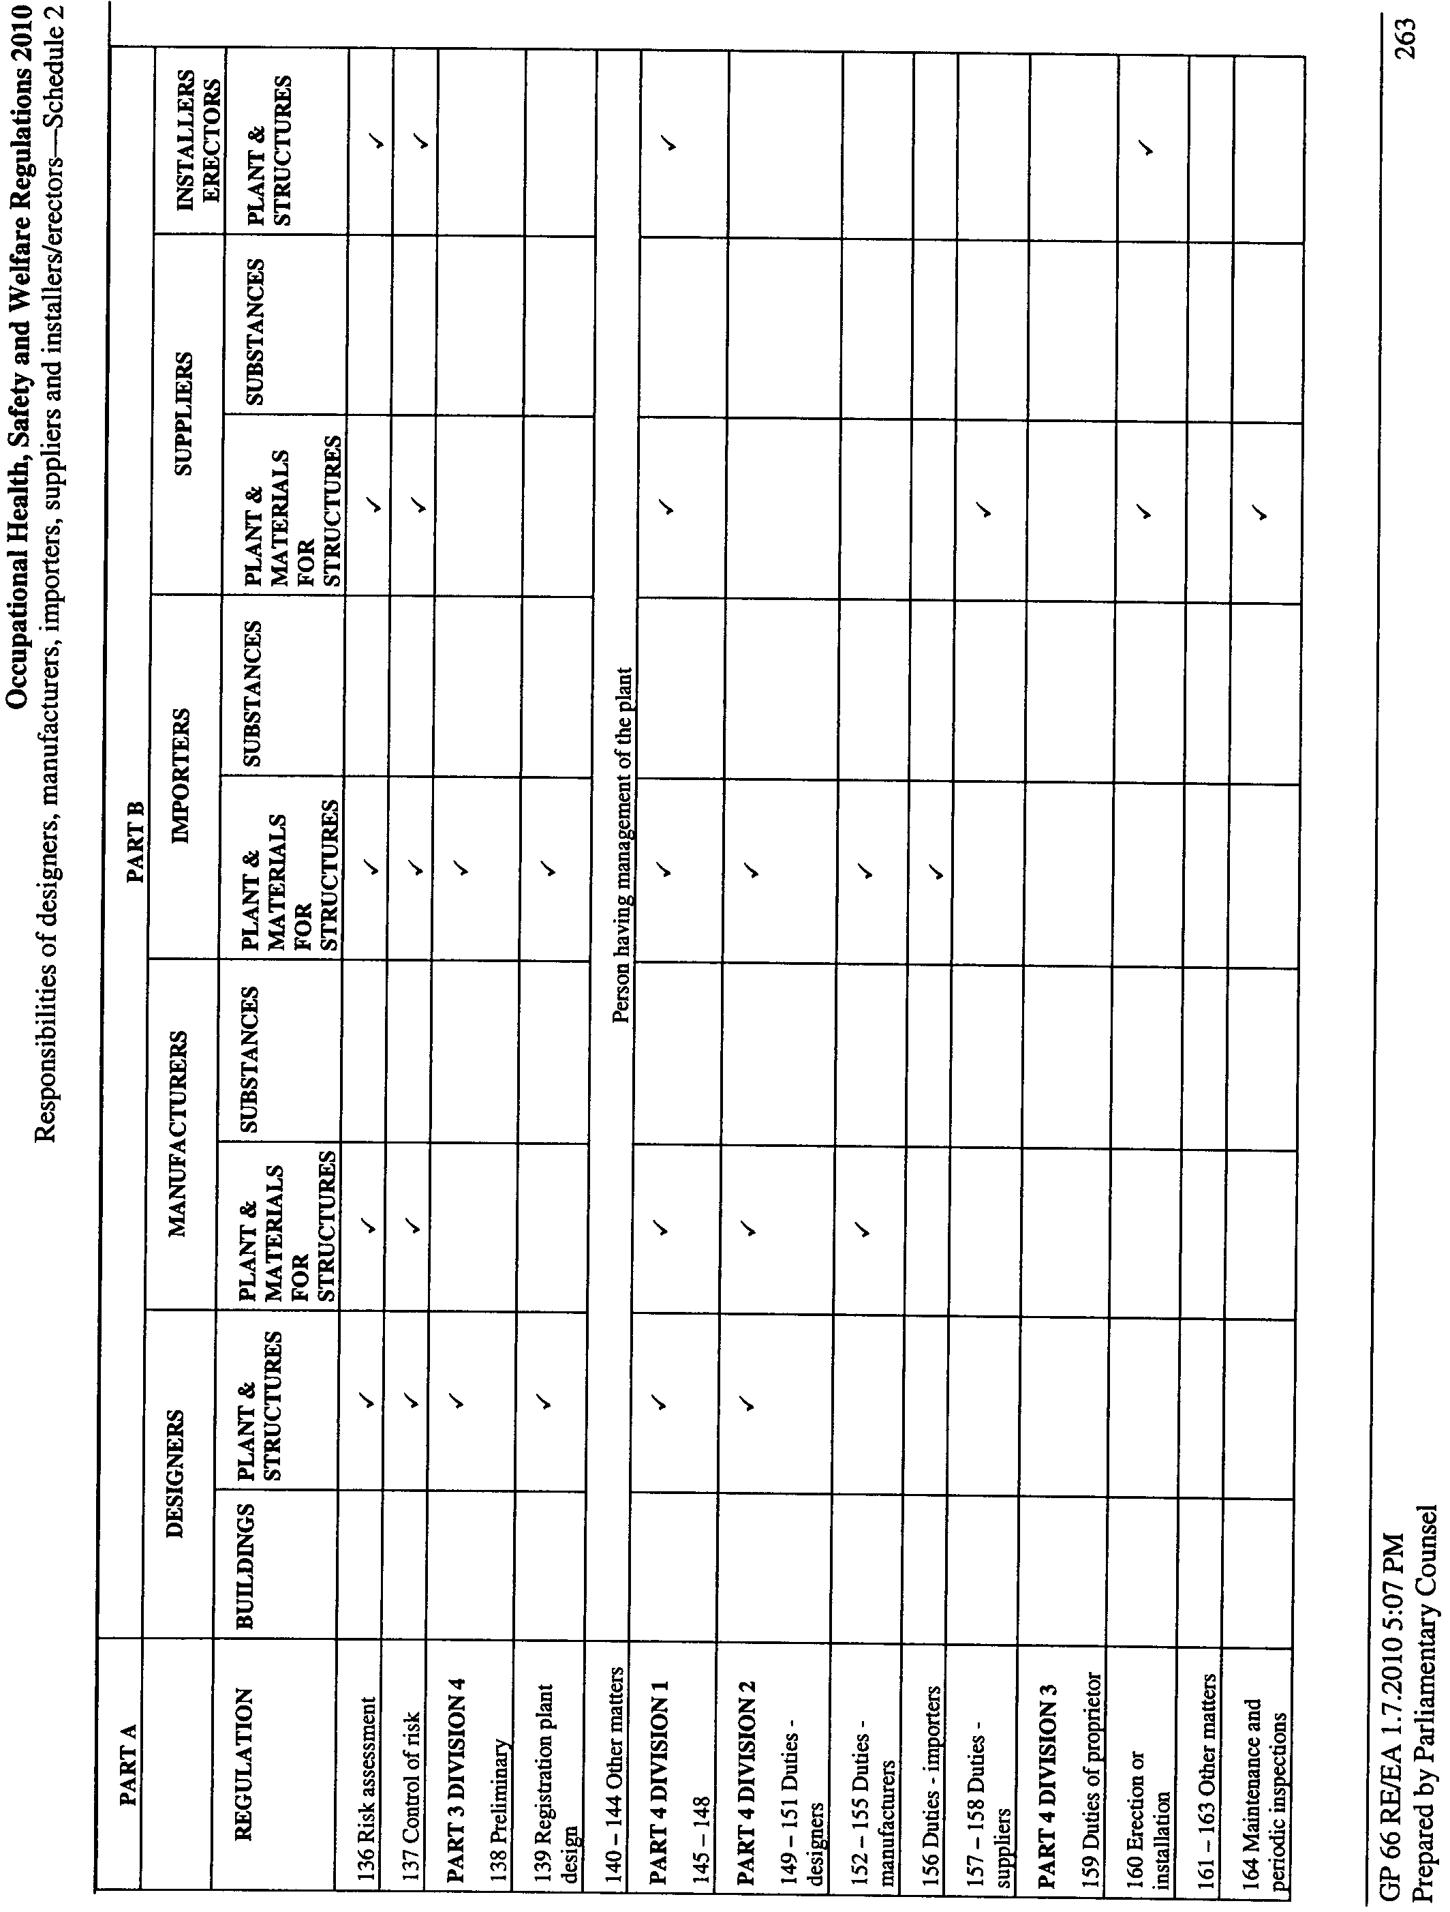
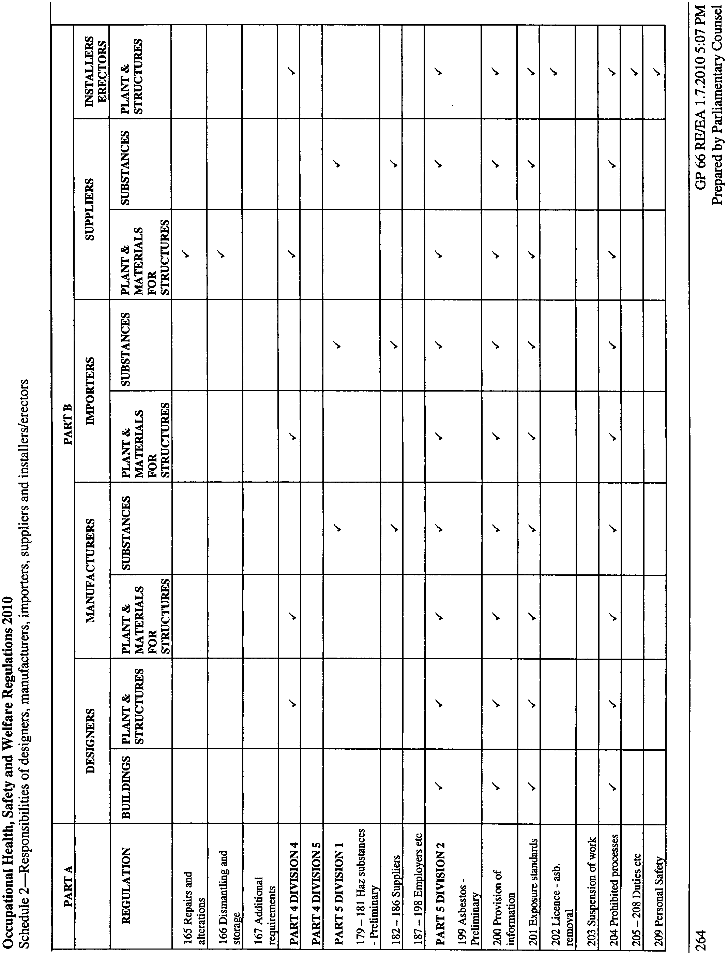
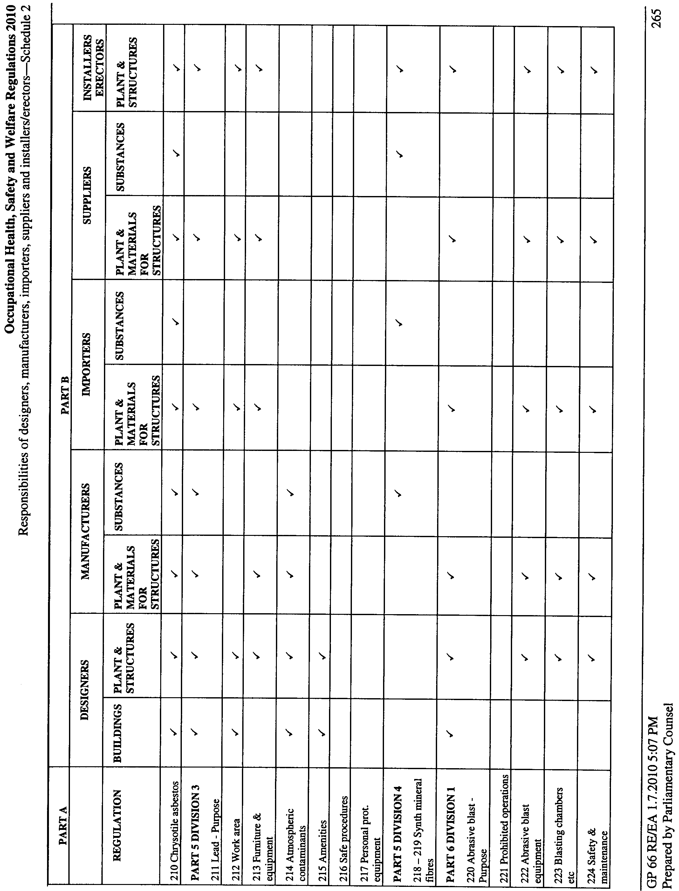
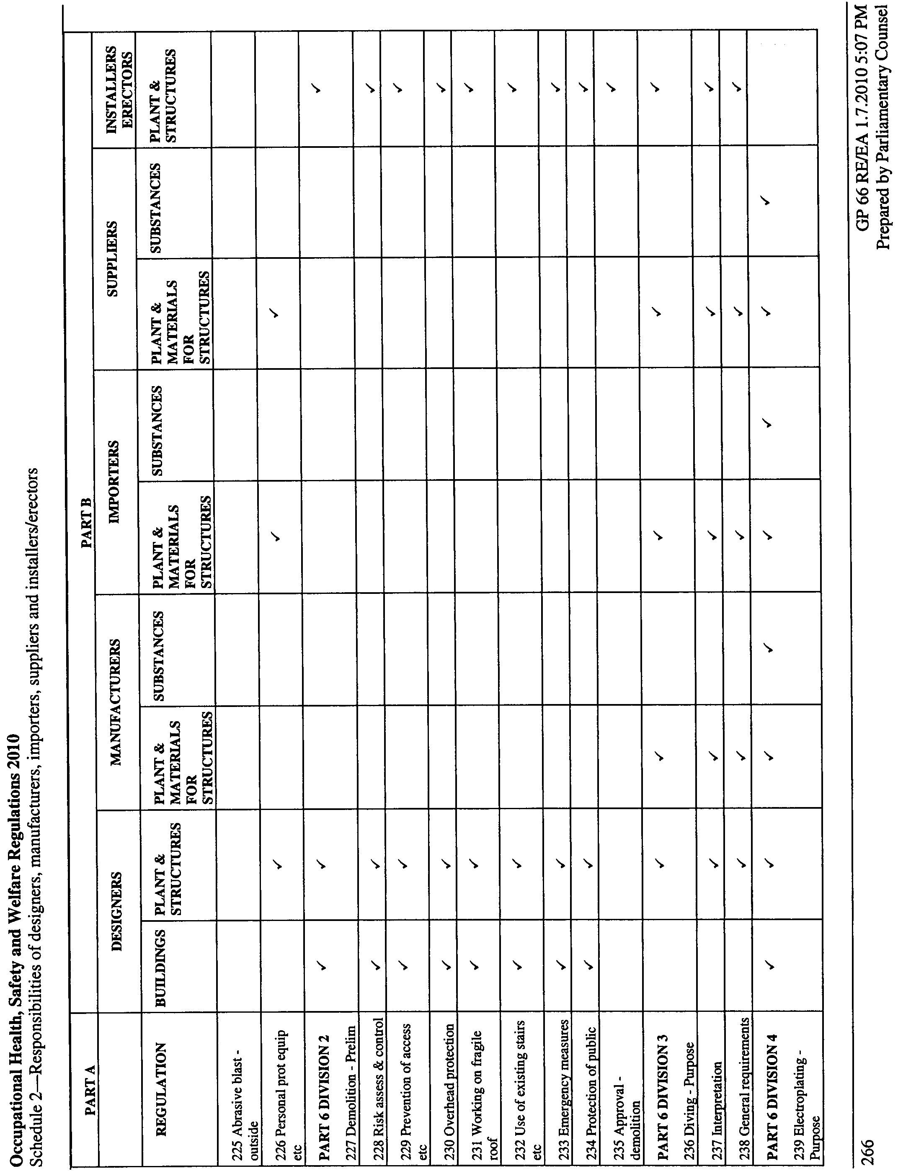
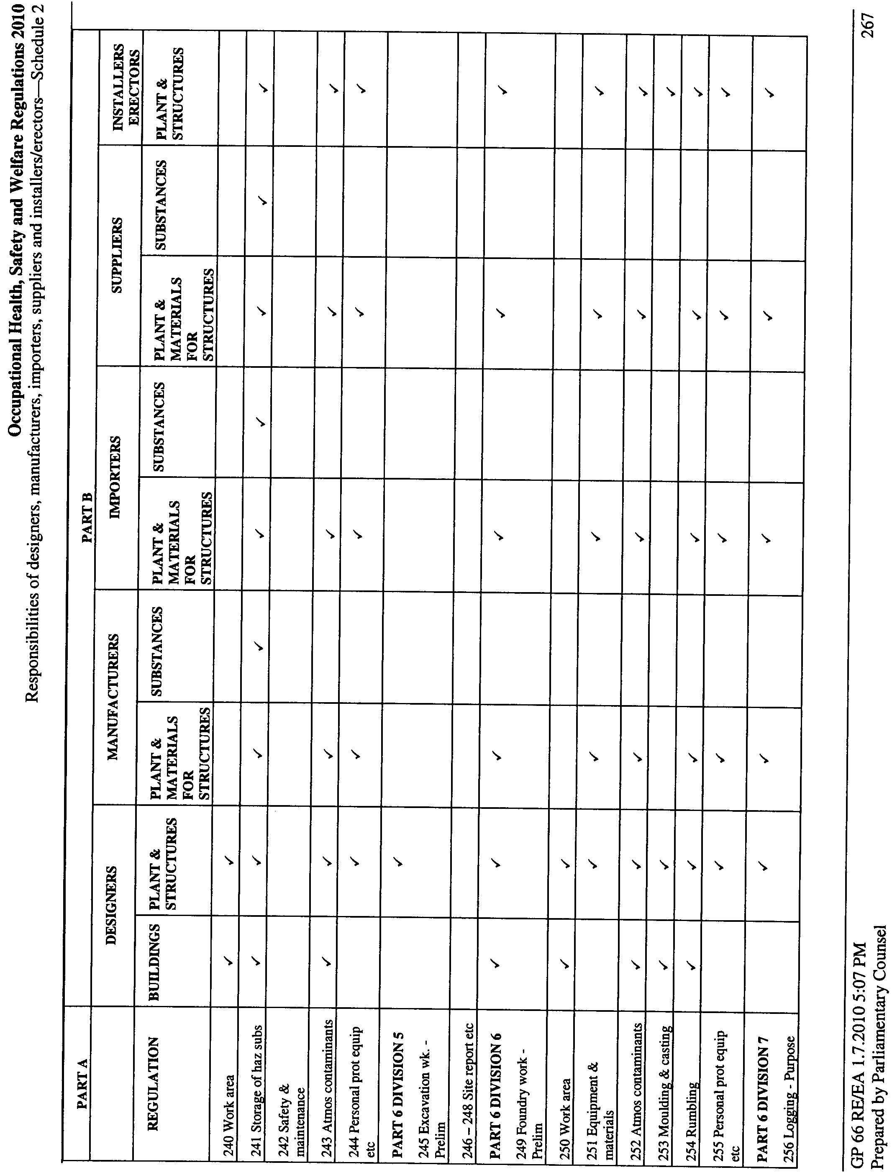
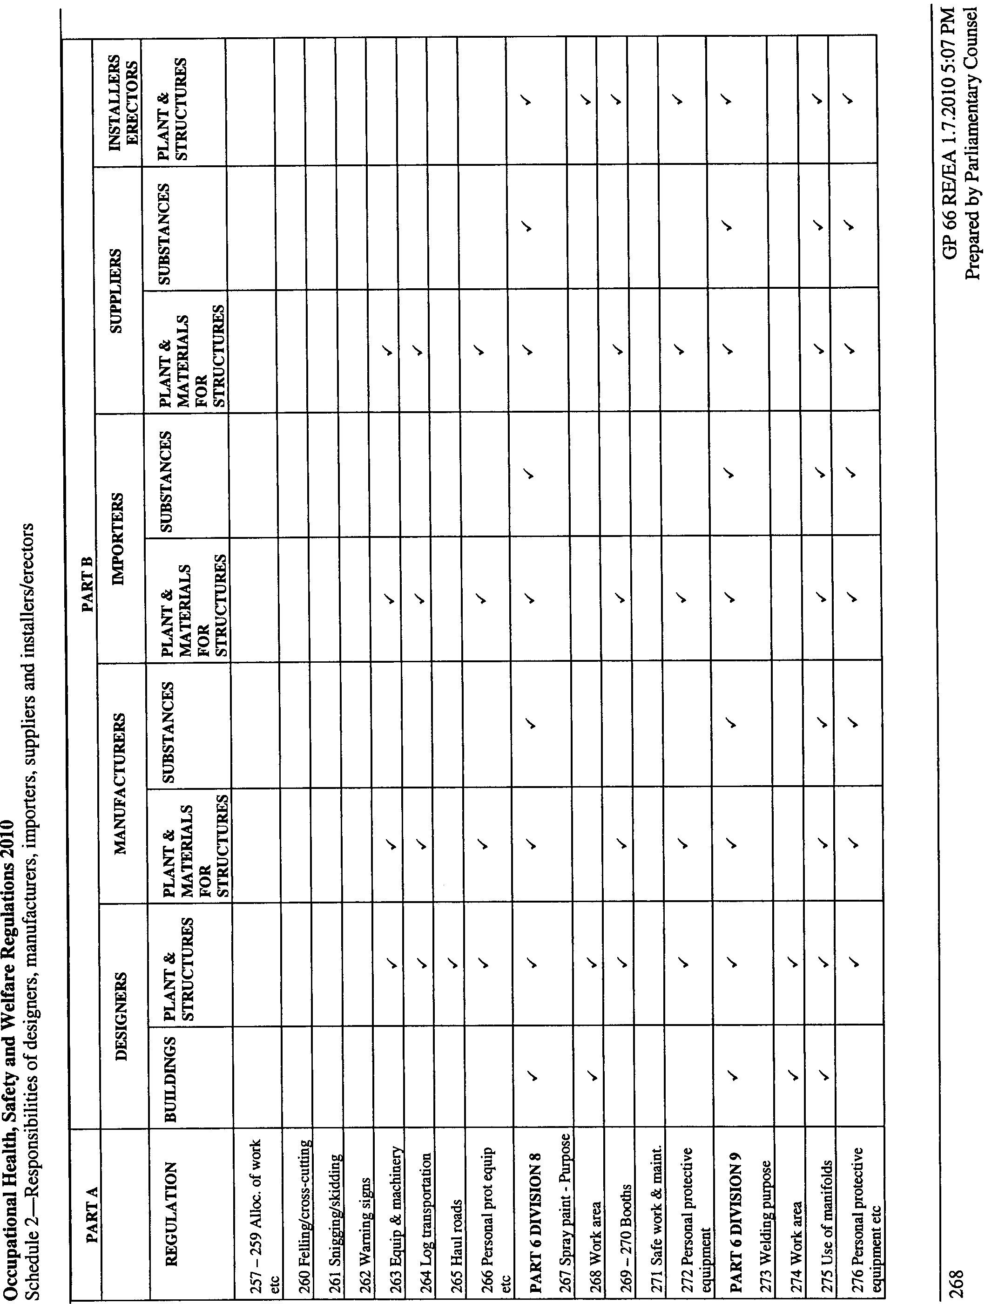
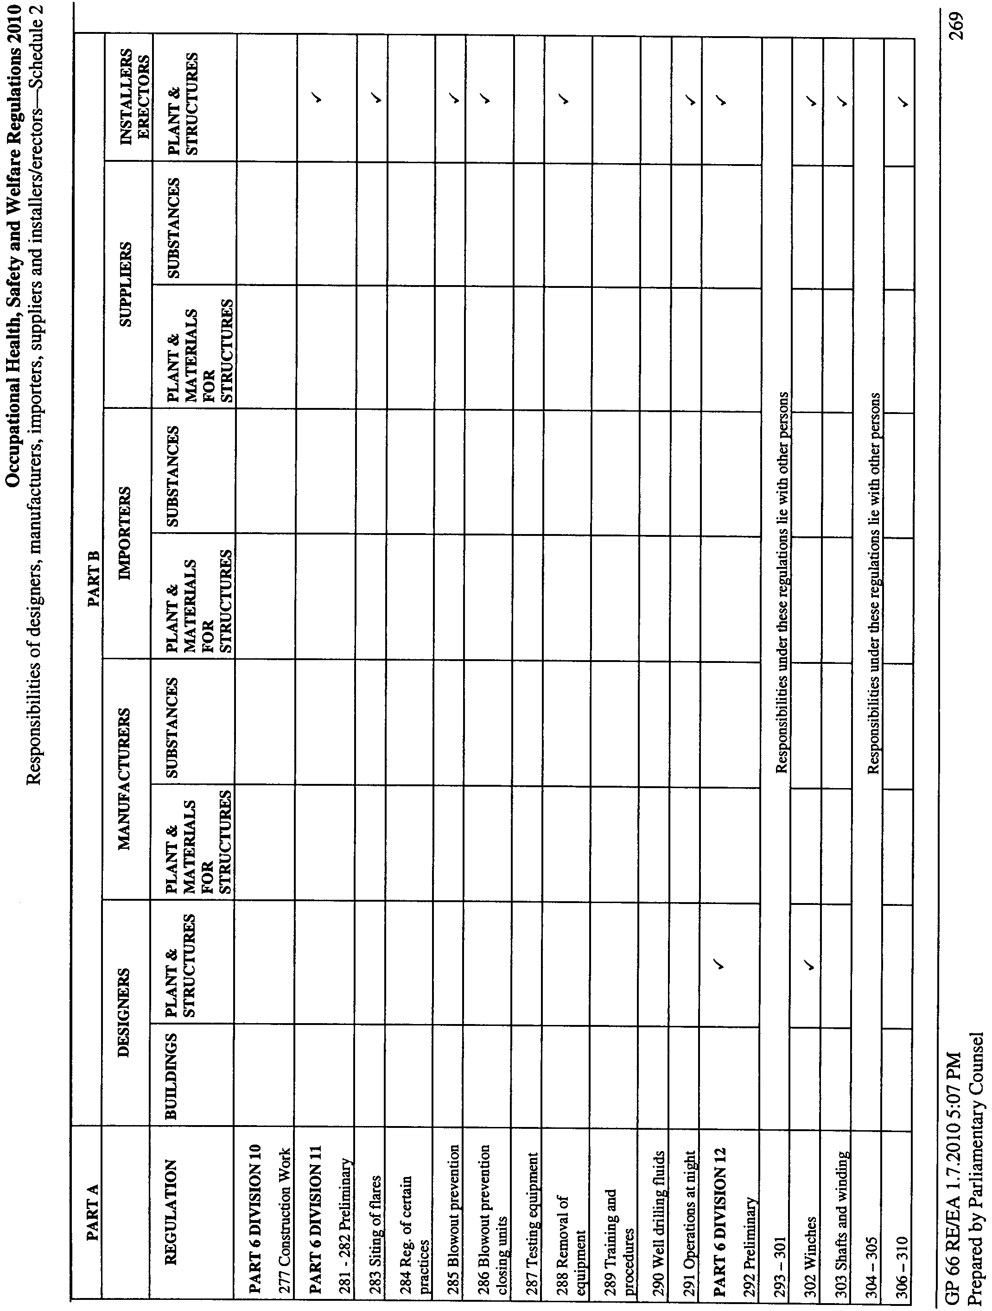
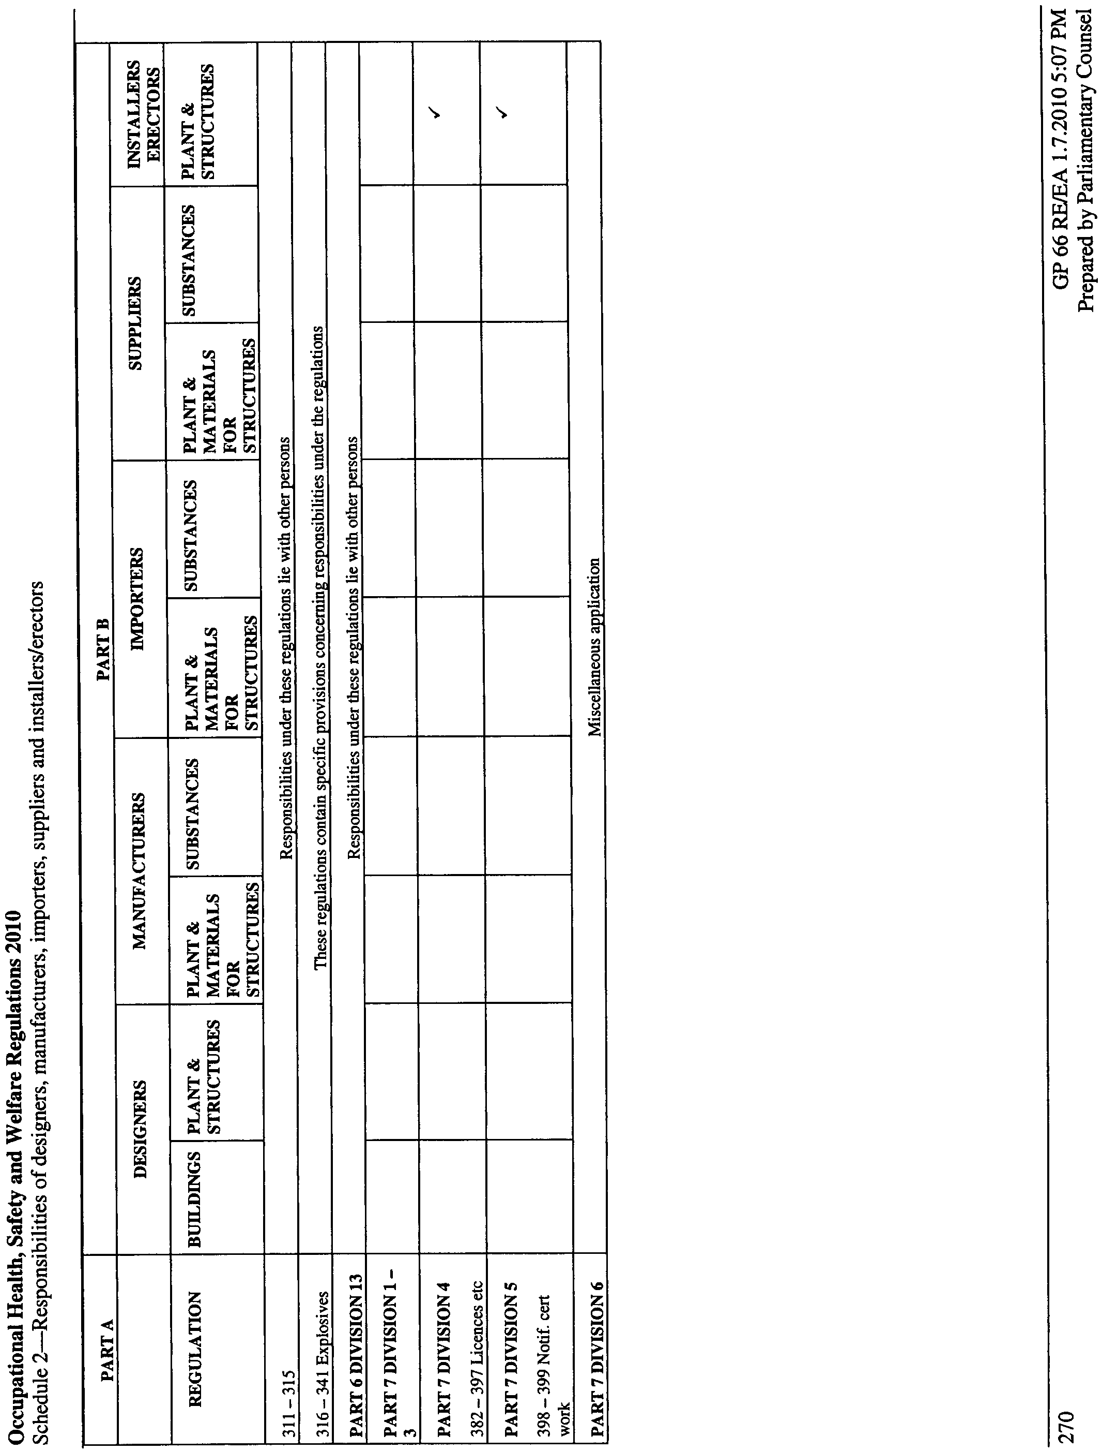

Schedule 3—Plant standards

AS/NZS 1200 | Pressure equipment
AS 1418 | Cranes, hoists and winches
AS/NZS 1576 | Scaffolding (Parts 1-4)
AS 1735 | Lifts, escalators and moving walks
AS 2030 | Gas cylinders Code
AS/NZS 3509 | LP gas fuels for automotive use
AS 4343 | Pressure equipment - Hazard levels
Schedule 4—Plant designs, and plant, which must be registered
Part 1—Plant requiring registration of design
1 Pressure equipment, other than pressure piping
2 Gas cylinders covered by AS 2030
3 Tower cranes
4 Lifts
5 Building maintenance units
6 Hoists that are designed to lift people and have a platform movement in excess of 2.4 metres, other than scissor elevating work platforms
7 Work boxes that are suspended from cranes
8 Prefabricated scaffolding
9 Boom-type elevating work platforms
10 Gantry cranes—
(a) with a safe working load exceeding 5 tonnes; or
(b) designed to handle molten metal or dangerous goods within the meaning of the ADG Code
11 Bridge cranes—
(a) with a safe working load exceeding 10 tonnes; or
(b) designed to handle molten metal or dangerous goods within the meaning of the ADG Code
12 Vehicle hoists
13 Mast climbing work platforms
14 Mobile cranes with a safe working load exceeding 10 tonnes, other than tow-trucks.
Part 2—Items of plant which must be registered
15 Boilers with a hazard level of A, B or C according to the criteria specified in AS 4343.
16 Pressure vessels with a hazard level of A, B or C according to the criteria specified in AS 4343, other than—
(a) gas cylinders covered by AS 2030; and
(b) LP gas fuel vessels for automotive use covered by AS 3509; and
(c) serial produced vessels covered by AS 2971
17 Tower cranes
18 Lifts
19 Building maintenance units
20 Concrete placing units (truck mounted with boom)
21 Mobile cranes with a safe working load exceeding 10 tonnes.
Schedule 5—Hazardous substances prohibited for specified uses

Hazardous substance | Prohibited use
Asbestos work
Raw asbestos | All use or handling other than for the purpose of sampling or analysis
Any product that consists of or contains asbestos | All use or handling except handling of installed asbestos for maintenance purposes, removal, encapsulation or enclosure in accordance with the Asbestos Regulations, or the supply, use or handling of chrysotile, or of any product or material that contains chrysotile, under regulation 210
Any substance that consists of or contains asbestos | Application by spraying
Any substance that consists of or contains asbestos | Installation as insulation
Any material that consists of or contains asbestos | High pressure cleaning of any such material
Installed insulation that consists of or contains asbestos | Sealing of such insulation
Abrasive blasting
A substance that contains more than 5% free silica (crystalline silicon dioxide) | As an abrasive in abrasive blasting
A recycled material that has not been treated to remove respirable dust | As an abrasive in abrasive blasting
A substance capable of causing harm to the upper respiratory tract of a person | As an abrasive in abrasive blasting
Any substance that contains more than 2% arsenic, lead, beryllium, cadmium, nickel, antimony, cobalt, chromium or tin | As an abrasive in blasting
Any substance that contains chromate, nitrate or nitrite | As a wet abrasive blasting inhibitor in wet abrasive blasting
Schedule 6—Hazardous substances for which health surveillance is required

Hazardous substance | Type of health surveillance
4,4' Methylenebis (2-chloroaniline) (MOCA) | (a) Urinary total MOCA  (b) Dipstick analysis of urine for haematuria  (c) Urine cytology
Asbestos | (a) Occupational and demographic data  (b) Medical interview  (c) Records of personal exposure
Crystalline Silica | (a) Completion of a standardised respiratory questionnaire  (b) Standardised respiratory function test, such as FEV1, FVC and FEV1/FVC  (c) Chest X-ray, full size PA view
Vinyl Chloride | (a) Occupational and demographic data  (b) Record of personal exposure
Schedule 7—Form for application for licence or limited licence to carry out asbestos removal work
Form 1—Form for application for licence or limited licence to carry out asbestos removal work
Pursuant to the Occupational Health, Safety and Welfare Regulations the following application is made for a licence to carry out asbestos removal work:
1 Full name of applicant and details of any business name:
2 Business address and telephone number of applicant:
3 Postal address of applicant:
4 In the case of a body corporate—the address of its registered office:
5 Details of asbestos removal work previously undertaken by the applicant:
6 Describe fully the make, type etc of equipment to be used for asbestos removal work, including personal protective equipment and waste disposal equipment:
7 State arrangements for asbestos monitoring:
8 Describe fully the training in safe methods for performing asbestos removal work undertaken by any person who is to carry out the work (whether employed or otherwise engaged by the applicant on a regular basis):
9 Describe the method of transport and final disposal of asbestos waste material:
10 State the regulations, codes of practice and other procedures to be observed for the safe removal of asbestos or materials containing asbestos:
11 State whether a limited licence only is required and, if so, the type of work proposed to be undertaken:
12 The prescribed fee accompanies this application.
13 I certify that the information in this application (including any attachments) is true to the best of my knowledge and belief.
Date:
Signature of applicant (or, in the case of a body corporate, its authorised agent):
Schedule 8—Fees

1 | Inspection fees under Part 3 (regulation 87)—
 | (a) inspection fee payable when an inspector carries out an inspection under regulation 93 | $177.00 per hour
 | (b) inspection fee payable when an inspector carries out an inspection under regulation 111 | $177.00 per hour
 | (c) inspection fee payable when an inspector carries out an inspection of plant in connection with an application to register, or to renew the registration of, an item of plant (regulation 140 and 141) | $177.00 per hour
2 | Application fee for the registration of a plant design under Part 3, or for the re-registration of a plant design (regulation 139)—
 | (a) general application fee | $101.00
 | PLUS
 | (b) if the Director is to undertake the verification of the plant design under an agreement with the applicant—a fee determined by the Director
3 | Application fee for the registration of an amusement structure design under Part 4, or for the re-registration of an amusement structure design (regulation 172) | $101.00
4 | Application fee for the registration of an item of plant under Part 3 (regulation 140) | $58.50
5 | Annual fee payable by the owner of registered plant under Part 3 (regulation 143) | $58.50
6 | Application fee for the registration, or re-registration, of an amusement structure under Part 4 | $58.50
7 | Application fee for an asbestos removal licence under Part 5 Division 2—
 | (a) in the case of a licence limited to the removal of asbestos-cement (fibro) products or other non-friable asbestos containing material | $1 199.00
 | (b) in any other case | $7 877.00
8 | Application fee for a blaster's licence under Part 6 Division 12 or Division 13 (for 3 years) | $61.00
9 | Renewal of a blaster's licence under Part 6 Division 12 or Division 13 (for 3 years) | $61.00
10 | Application fee for registration as an assessor under Part 7 Division 4 | $337.00
11 | Annual fee for registration as an assessor under Part 7 Division 4 | $337.00
12 | Application fee for a high risk work licence under Part 7 Division 4 | $65.00
13 | Renewal of a high risk work licence under Part 7 Division 4 | $65.00
14 | Fee payable—
 | (a) subject to paragraph (b)—for a copy of a certificate or other document under these regulations | $64.00
 | (b) for a copy of a high risk work licence under Part 7 Division 4 | $35.00
15 | Fee for application by high risk work licence holder for addition of new class of high risk work to licence under Part 7 Division 4 | $35.00
Schedule 9—Proceedings
Form 1
South Australia
Number:
Application to the President for determination by a review committee
Application is hereby made by [set out name and address of party marking application or in the case of a majority of members of a designated work group the names and addresses of the majority] being a/an employer/employee/health and safety representative/registered association/majority of members of a designated work group* entitled to make application for a determination by a review committee pursuant to section [insert section of Act] of the Occupational Health, Safety and Welfare Act 1986.
The grounds/reason* for the application are—
[Here set out brief details of grounds/reason]
The application is made against—
[Here set out the name and address and designation of the party against whom the application is made or in the case of a notice or action made or taken under the Act brief details of same or where the notice or action is in writing attach a copy of same to this application.]
Date:
Signature of Employee/Health and Safety Representative/Majority of members of a designated work group/for and on behalf of Employer/Registered Association*:
*Strike out whichever is not applicable.
Form 2
South Australia
Before a review committee
Number:
Summons to attend before a review committee
To:
and to:
You are hereby summoned to attend proceedings before a review committee presided over by [insert name of presiding member] to be held at [place of proceedings] on [insert date]at [insert time] in the matter of [set out brief description of matter].
You will be required to continue in attendance at the proceedings until released by the presiding member.
Date:
Signature of presiding member:
If you do not attend a decision may be made in your absence without further notice
Note—
Section 48 of the Occupational Health, Safety and Welfare Act 1986 provides that it is an offence for any person who has been served with a summons to fail, without reasonable excuse, to attend in disobedience to that summons.
Form 3
South Australia
Before a review committee
Number:
Summons to witness
To: [Insert name and address of person summoned]
You are hereby summoned to attend and appear before a review committee presided over by[insert name of presiding member] at [insert place] or such other place as the summons is to be returnable on [insert date]at insert time and thereafter from day to day until discharged from attendance, to give evidence concerning the above matter.
*You are further required to bring with you and produce the following documents, objects or material—
[set out items required]
*Strike out if not applicable.
Date:
Signature of presiding member:
This summons to witness was issued on the application of [set out name of party or representative] being a party/representative** for [if a representative set out name of party on whose behalf the summons is issued] whose address for service is [set out address for service of party].
**Strike out whichever is not applicable.
Note—
Section 48 of the Occupational Health, Safety and Welfare Act 1986 provides that it is an offence for any person who has been served with a summons to fail, without reasonable excuse, to attend in obedience to or to comply with that summons.
Form 4
South Australia
Before the Industrial Relations Court
Number:
Notice of appeal pursuant to section 69(4) and (5) of the Occupational Health, Safety and Welfare Act 1986
To the Industrial Registrar
And to [set out name and address of respondent to the appeal]
Take notice that an appeal is hereby made by [set out name and address of appellant] to the Industrial Relations Court against the decision made/refusal which occurred* on [insert date] by [set out name of person or authority appealed against] whereby [set out brief description of matter complained of including the specific part or parts of any decision appealed against or of the relevant refusal].
The following orders will be sought on the appeal:
[set out details of the relief claimed]
The grounds of the appeal are—
[set out detailed grounds relied on]
Date:
Signature of applicant/representative:
Address for service:
*Strike out whichever is not applicable.
Form 5
South Australia
Before the Full Court
Number:
Application for leave to appeal to the Full Court of the Industrial Relations Court pursuant to section 69(8) of the Occupational Health, Safety and Welfare Act 1986
To the Industrial Registrar
And to [set out name and address of respondent to the appeal]
Take notice that application is hereby made by [set out name and address of appellant] to the Full Court of the Industrial Relations Court for leave to appeal against the act, decision or order of the Industrial Relations Court made on [insert date] whereby [set out description of act, decision or order complained of].
The following orders will be sought on the appeal if leave is granted:
[set out details of relief which will be sought]
The grounds on which the appeal is sought are—
[set out proposed grounds of appeal]
Date:
Signature of applicant/representative:
Address for service:
Schedule 10—Expiry of existing certificates and other evidence of competency

Date of issue of certificate, notice of satisfactory assessment or "old style ticket" | Date of expiry
Before 3 April 1995 | 1 September 2011
4 April 1995 to 31 December 1998 | 1 September 2012
1 January 1999 to 31 December 2001 | 1 September 2013
1 January 2002 to 31 December 2004 | 1 September 2014
1 January 2005 to 31 August 2010 | 1 September 2015
Schedule 11—Revocation of Occupational Health, Safety and Welfare Regulations 1995
The Occupational Health, Safety and Welfare Regulations 1995 are revoked.
Note—
As required by section 10AA(2) of the Subordinate Legislation Act 1978, the Minister has certified that, in the Minister's opinion, it is necessary or appropriate that these regulations come into operation as set out in these regulations.
Made by the Governor
following consultation by the Minister with the SafeWork SA Advisory Committee and with the advice and consent of the Executive Council
on 22 July 2010
No 173 of 2010
MIR10-009CS
South Australia
Plant Health (Fees) Variation Regulations 2010
under the Plant Health Act 2009

Contents
Part 1—Preliminary
1 Short title
2 Commencement
3 Variation provisions
Part 2—Variation of Plant Health Regulations 2009
4 Substitution of Schedule 2
Schedule 2—Fees

Part 1—Preliminary
1—Short title
These regulations may be cited as the Plant Health (Fees) Variation Regulations 2010.
2—Commencement
These regulations will come into operation on 1 August 2010.
3—Variation provisions
In these regulations, a provision under a heading referring to the variation of specified regulations varies the regulations so specified.
Part 2—Variation of Plant Health Regulations 2009
4—Substitution of Schedule 2
Schedule 2—delete the Schedule and substitute:
Schedule 2—Fees

1 | In this Schedule—
 | (a) inspection includes a survey inspection;
 | (b) survey inspection means an inspection by an inspector of a growing crop to determine if the crop is free from pests;
 | (c) if a charge for a service or time taken to travel to or from the site of an audit or inspection is expressed as an amount per hour—
 | (i) a charge is payable for services provided or travelling time for less than or more than an hour (with a minimum charge payable for 15 minutes for services provided or travelling time); and
 | (ii) the amount payable is to be determined by multiplying the amount per hour by the proportion that the number of minutes for which the services are provided or the time is taken to travel rounded to the nearest 5 minutes bears to 60 minutes.
2 | Application fees—
 | (a) on lodging an application for accreditation authorising the carrying out of an activity at only 1 specified premises (section 16 of the Act) | $280.00
 | (b) on lodging an application for accreditation authorising the carrying out of an activity at more than 1 specified premises (section 16 of the Act) | $280.00 plus $280.00 for each additional premises
 | (c) on lodging an application for variation of accreditation (section 22 of the Act)—
 | (i) if the variation is to authorise the carrying out of the activity authorised under the accreditation at additional specified premises | $280.00 for each additional premises
 | (ii) for any other variation  Note—  If more than 1 application for variation of the type referred to in subparagraph (ii) is made in any year, the fee is payable only on lodging the first such application. | $55.00
(d) on lodging an application for registration as importer (section 26 of the Act)—
Note—
An accredited person applying for registration is not required to pay this fee.
 | (i) if registration is restricted to the importing of diagnostic samples for testing | $40.00
 | (ii) in any other case | $110.00
 | (e) on lodging an application for variation of registration as importer (section 30 of the Act)  Note—  An accredited person applying for variation of registration is not required to pay this fee. | $30.00
 | (f) on lodging an application for review by the Minister (section 35 of the Act) | $30.00
3 | Annual fees—
 | (a) for a person whose accreditation authorises the carrying out of an activity at only 1 specified premises (section 21 of the Act) | $110.00
 | (b) for a person whose accreditation authorises the carrying out of an activity at more than 1 specified premises (section 21 of the Act) | $110.00 plus $110.00 for each additional premises
 | (c) for a registered importer (section 29 of the Act)  Note—  A registered importer who is also an accredited person is not required to pay this fee. | $60.00
4 | Penalty for default in payment of an annual fee or lodgment of an annual return—
 | (a) for an accredited person (section 21 of the Act) | $165.00
 | (b) for a registered importer (section 29 of the Act) | $90.00
5 | Fee for a book of certificates to be issued by an accredited person under the Act | $22.00
6 | Fee for issue of plant health certificate under the Act | $22.00
7 | Fees for audits and inspections—
 | (a) for an audit or inspection during ordinary business hours | $95.70 per hour
 | (b) for an audit or inspection after hours—
 | (i) on a week day | $144.10 plus $144.10 per hour
 | (ii) on a weekend or public holiday—
 | (A) if the inspection has been prearranged with the auditor or inspector | $192.50 plus $192.50 per hour
 | (B) in any other case | $239.80 plus $239.80 per hour
8 | Fees for time taken to travel to or from the site of an audit or inspection—
Notes—
(1) These fees are in addition to the fees under clause 7.
(2) If, on any particular trip, more than 1 site is visited for an audit or inspection, the fees under this clause will be apportioned on an equitable basis between the persons responsible for the fees charged for the relevant audits or inspections.
 | (a) for travelling time to or from the site during ordinary business hours | $95.70 per hour
 | (b) for travelling time to or from the site after hours—
 | (i) on a week day—
 | (A) if not more than 3 hours | $144.10 per hour, up to a maximum of $385.00
 | (B) if more than 3 hours  Note—  If it takes more than 3 hours to travel to or from a site, the fee for the travelling time is set at a fixed rate. | $385.00
 | (ii) on a weekend or public holiday | $192.50 per hour
9 | Fee for disposal of plants or plant related products affected by a pest | Actual cost incurred
Note—
As required by section 10AA(2) of the Subordinate Legislation Act 1978, the Minister has certified that, in the Minister's opinion, it is necessary or appropriate that these regulations come into operation as set out in these regulations.
Made by the Governor
with the advice and consent of the Executive Council
on 22 July 2010
No 174 of 2010
MAFF10/15CS
South Australia
Liquor Licensing (Dry Areas—Long Term) Variation Regulations 2010
under the Liquor Licensing Act 1997

Contents
Part 1—Preliminary
1 Short title
2 Commencement
3 Variation provisions
Part 2—Variation of Liquor Licensing (Dry Areas—Long Term) Regulations 1997
4 Variation of Schedule 1—Long term dry areas

Part 1—Preliminary
1—Short title
These regulations may be cited as the Liquor Licensing (Dry Areas—Long Term) Variation Regulations 2010.
2—Commencement
These regulations come into operation on the day on which they are made.
3—Variation provisions
In these regulations, a provision under a heading referring to the variation of specified regulations varies the regulations so specified.
Part 2—Variation of Liquor Licensing (Dry Areas—Long Term) Regulations 1997
4—Variation of Schedule 1—Long term dry areas
Schedule 1, item headed "Coober Pedy—Area 1", column headed "Period"—delete "2010" and substitute:
2013
Note—
As required by section 10AA(2) of the Subordinate Legislation Act 1978, the Minister has certified that, in the Minister's opinion, it is necessary or appropriate that these regulations come into operation as set out in these regulations.
Made by the Governor
with the advice and consent of the Executive Council
on 22 July 2010
No 175 of 2010
10MCA0022CS

B. MORRIS, Government Printer, South Australia

