No. 37 2553

THE SOUTH AUSTRALIAN

GOVERNMENT GAZETTE
www.governmentgazette.sa.gov.au

PUBLISHED BY AUTHORITY

ALL PUBLIC ACTS appearing in this GAZETTE are to be considered official, and obeyed as such

ADELAIDE, THURSDAY, 10 JUNE 2010

CONTENTS

Page
Appointments, Resignations, Etc. 2554
Aquaculture Act 2001—Notice 2554
Associations Incorporation Act 1985—Notice 2554
Consumer and Business Affairs, Office of—Notice 2615
Corporations and District Councils—Notices 2670
Development Act 1993—Notices 2555
Development Regulations 2008—Notice 2555
Disability SA—Notice 2556
Emergency Services Funding Act 1998—Notice 2556
Environment Protection Act 1993—Notices 2557
Families and Communities, Department for—
Notice 2555
Fisheries Management Act 2007—Notice 2556
Health Care Act 2008—Notices 2564
Housing Improvement Act 1940—Notices 2607
Land Acquisition Act 1969—Notices 2608
Local Government Act 1999—Notice 2612
Liquor Licensing Act 1997—Notices 2609
Medical Practice Act 2004—Notice 2613

Page
Motor Vehicles (Approval of Motor Bikes and
Motor Trikes) Notice 2010 2626
Passenger Transport Regulations—Notice 2616
Petroleum and Geothermal Energy Act 2000—Notices 2617
Police Service Fees and Charges—Notices 2618
Proclamation 2639
Public Trustee Office—Administration of Estates 2670
REGULATIONS
Public Corporations Act 1993—
(No. 41 of 2010) 2641
(No. 42 of 2010) 2649
(No. 43 of 2010) 2657
Residential Tenancies Act 1995 (No. 145 of 2010) 2666
Rail Safety Act 2007—Notice 2621
Roads (Opening and Closing) Act 1991—Notice 2621
Road Traffic Act 1961—Notice 2622
Survey Act 1992—Notices 2623
Transport, Department of—Notices to Mariners 2623
Water Mains and Sewers—Mains Laid, Replaced, Etc 2623

GOVERNMENT GAZETTE NOTICES
ALL poundkeepers’ and private advertisements forwarded for publication in the South Australian Government Gazette must be PAID FOR PRIOR TO INSERTION; and all notices, from whatever source, should be legibly written on one side of the paper only and sent to Government Publishing SA so as to be received no later
than 4 p.m. on the Tuesday preceding the day of publication. Phone 8207 1045 or Fax 8207 1040. E-mail: governmentgazette@dpc.sa.gov.au. Send as attachments in Word format and please confirm your transmission with a faxed copy of your document, including the date the notice is to be published and to whom the notice will be charged. The Government Gazette is available online at: www.governmentgazette.sa.gov.au

Department of the Premier and Cabinet
Adelaide, 10 June 2010
HIS Excellency the Governor in Executive Council has been pleased to appoint the undermentioned to the Medical Board of South Australia, pursuant to the provisions of the Medical Practice Act 2004:
Deputy Member: (from 10 June 2010 until 11 November 2012)
Stephen Neil Stranks (Deputy to Tonkin)
By command,
John Rau, for Acting Premier
HEAC-2009-00088

Department of the Premier and Cabinet
Adelaide, 10 June 2010
HIS Excellency the Governor in Executive Council has been pleased to appoint the undermentioned to the HomeStart Finance Board of Management, pursuant to the provisions of the Housing and Urban Development (Administrative Arrangements) Act 1995:
Member: (from 14 June 2010 until 13 June 2012)
Estelle Rosemary Bowman
Member: (from 14 June 2010 until 13 June 2013)
Sandra De Poi
Member: (from 27 September 2010 until 26 March 2012)
Claude Arthur Long
Member: (from 27 September 2010 until 26 September 2013)
Jim Constantine Kouts
Presiding Member: (from 27 September 2010 until 26 March 2012)
Claude Arthur Long
Deputy Presiding Member: (from 27 September 2010 until 26 September 2013)
Jim Constantine Kouts
By command,
John Rau, for Acting Premier
DFCCS/10/017

Department of the Premier and Cabinet
Adelaide, 10 June 2010
HIS Excellency the Governor in Executive Council has been pleased to appoint the undermentioned to the State Procurement Board, pursuant to the provisions of the State Procurement Act 2004:
Member: (from 10 June 2010 until 9 June 2012)
Steven John Archer
Virginia Deegan
Katrina Ball
By command,
John Rau, for Acting Premier
T&F10/022CS

Department of the Premier and Cabinet
Adelaide, 10 June 2010
HIS Excellency the Governor in Executive Council has accepted the resignation of Linda Rae Matthews as Commissioner for Equal Opportunity, with effect from 11 June 2010.
By command,
John Rau, for Acting Premier
AGO0062/06CS

Department of the Premier and Cabinet
Adelaide, 10 June 2010
HIS Excellency the Governor in Executive Council has been pleased to appoint the Honourable John David Hill, MP, Minister for Health, Minister for Mental Health and Substance Abuse, Minister for the Southern Suburbs and Minister Assisting the Premier in the Arts to be also Acting Minister for Education and
Acting Minister for Early Childhood Development for the period from 11 June 2010 to 21 June 2010 inclusive, during the absence of the Honourable Jay Wilson Weatherill, MP.
By command,
John Rau, for Acting Premier
MEDU10/0008CS

Department of the Premier and Cabinet
Adelaide, 10 June 2010
HIS Excellency the Governor in Executive Council has been pleased to appoint Anne Gordon Burgess as Acting Commissioner for Equal Opportunity for a term of six months commencing on 12 June 2010 and expiring on 11 December 2010, pursuant to Section 8 (5) of the Equal Opportunity Act 1984.
By command,
John Rau, for Acting Premier
AGO0062/06CS

Department of the Premier and Cabinet
Adelaide, 10 June 2010
HIS Excellency the Governor in Executive Council has been pleased to accept the 2009 University of Adelaide Annual Report, pursuant to Section 25 (1) of the University of Adelaide Act 1971.
By command,
John Rau, for Acting Premier
MET10/002CS

AQUACULTURE ACT 2001
Grant of Aquaculture Lease
PURSUANT to the provisions of section 22 of the Aquaculture Act 2001, Michael O’Brien, Minister for Agriculture, Food and Fisheries, hereby gives notice of the grant of the following leases for the purposes of aquaculture in the waters of the state:
LA00241
LA00242
Further details are available for all of the above leases granted on the PIRSA Aquaculture Public Register; which can be found at https://info.pir.sa.gov.au/aquapr/page/gui3/map.html.
Michael O’Brien, Minister for Agriculture, Food and Fisheries

ASSOCIATIONS INCORPORATION ACT 1985
Deregistration of Associations
NOTICE is hereby given that the Corporate Affairs Commission approves the applications for deregistration received from the associations named below, pursuant to section 43A of the Associations Incorporation Act 1985. Deregistration takes effect on the date of publication of this notice:
Abilympics South Australia Association Incorporated
Association Representing Mothers Separated from their Children by Adoption (SA) Incorporated
Family Life Association of South Australia Incorporated
Goolwa Great Air Spectacular Incorporated
Grange Road Skillshare Incorporated
Green Room Community Youth Centre Incorporated
Haemochromatosis Society Australia Incorporated
International Council for Control of Iodine Deficiency Disorders Incorporated
Lingsu Exoterics & Esoterics Incorporated
Lower Murray Toy Library Incorporated
Pooraka Memorial Hall Incorporated
Stirling East Tennis Club Incorporated
The Cathedral College, Murray Bridge, Incorporated
Zion Lutheran Church, Black Hill Incorporated
Given at Adelaide, 8 June 2010.
S. Monterosso, a Delegate of the Corporate Affairs Commission

DEPARTMENT FOR FAMILIES AND COMMUNITIES
Notice by the Minister for Families and Communities
Fees Payable for Services Provided by the
Screening and Licensing Branch
THE fees set out in the table below will be charged by the Department for Families and Communities for services specified in the table as provided by the Screening and Licensing Branch.
The Chief Executive of the department may waive payment of, or remit, the whole or any part of a fee payable under this notice
Table of Fees
 |  | $
1. | Screening and Licensing Branch—employed individual—Fee for criminal history check and background screening service | 57.20
2. | Screening and Licensing Branch—volunteer or student individual—Fee for criminal history check and background screening service | 37.40

In this notice:
Department means the Department for Families and Communities;
This notice will come into operation on 1 July 2010.
Jennifer Rankine, Minister for Families and Communities

DEVELOPMENT ACT 1993, MOUNT BARKER URBAN GROWTH DEVELOPMENT PLAN AMENDMENT PRE-PARED BY THE MINISTER—DRAFT FOR PUBLIC CONSULTATION
NOTICE is hereby given that the Minister for Urban Development and Planning, pursuant to sections 24 and 26 of the Development Act 1993, has prepared a Mount Barker Urban Growth Development Plan Amendment (DPA) to amend the Mount Barker (DC) Development Plan.
The DPA proposes to introduce a planning policy framework that guides the expansion of the Mount Barker and Nairne townships with an overall objective of supporting the development of at least 7 000 new houses across some 1 300 hectares.
An expanded Mount Barker township is proposed to accommodate most of the new houses. The DPA envisages a range of housing types supported by community services and facilities as well as retail, commercial and industrial uses that can provide local employment opportunities.
A portion of land is also proposed to be rezoned adjacent to the established residential areas at Nairne, which will also encourage a mix of housing types.
The DPA will be on public consultation from Thursday, 10 June until Wednesday, 4 August 2010.
Copies of the DPA are available during normal office hours at the following locations:
• the Department of Planning and Local Government, Level 5, 136 North Terrace, Adelaide;
• the District Council of Mount Barker Offices, 6 Dutton Road, Mount Barker.
The DPA can also be viewed on the internet at www.dplg.sa.gov.au/go/mount-barker-urban-growth-dpa.
Written submissions regarding the DPA should be submitted no later than 5 p.m. on Wednesday, 4 August 2010. Submissions should be addressed to:
The Presiding Member, Development Policy Advisory Committee,
Mount Barker Urban Growth DPA
c/o Department of Planning and Local Government
Post: G.P.O. Box 1815, Adelaide, S.A. 5001.
Email: dpac@saugov.sa.gov.au.
Your submission should clearly indicate whether you wish to be heard at the public meeting.
Copies of all public submissions will be available for inspection by interested persons at the Department of Planning and Local Government, Level 5, 136 North Terrace, Adelaide, S.A. 5000,
from 5 August 2010 until the conclusion of the public meeting, and will also be available for viewing on the Department of Planning and Local Government website.
The public meeting may be held on Tuesday, 31 August 2010 at 7 p.m. at Cinema 3, Wallis Cinemas, 17 Adelaide Road, Mount Barker at which time interested persons may appear to be heard in relation to the DPA and the submissions. The public meeting may not be held if no submissions are received or if no-one requests to be heard. Please check the Department of Planning and Local Government’s website before the scheduled date of the meeting to find out whether it is being held.
If you would like more information about the draft DPA, please contact Steven Copus on telephone number 8303 0659 or via email at copus.steven@sa.gov.au.
Dated 10 June 2010.
S. Underwood, Secretary, Development Policy Advisory Committee

DEVELOPMENT ACT 1993, SECTION 25 (17): CITY OF CHARLES STURT WEST LAKES COUNCIL DEPOT
Preamble
1. The Development Plan Amendment entitled West Lakes Council Depot Development Plan Amendment (the Amendment) by the City of Charles Sturt, has been finalised in accordance with the provisions of the Development Act 1993.
2. The Minister for Urban Development and Planning has decided to approve the Amendment.
Notice
PURSUANT to section 25 of the Development Act 1993, I:
(a) approve the Amendment; and
(b) fix the day on which this notice is published in the Gazette as the day on which the Amendment will come into operation.
Dated 1 June 2010.
Paul Holloway, Minister for Urban Development and Planning

DEVELOPMENT REGULATIONS 2008
Notice under Schedule 6
Preamble
Schedule 6 of the Development Regulations 2008 refers to a construction index determined by the Minister from time to time and set out in the Schedule of Construction Indices. The Construction Indices will be used in the determination of fees payable by applicants seeking assessment against the Building Rules under the Development Act 1993.
Notice
PURSUANT to Schedule 6 of the Development Regulations 2008, I have determined the Construction Indices in the Schedule for the purposes of Schedule 6 of the Development Regulations 2008.
This notice will come into effect on 1 July 2010.
Schedule
Schedule of 2010 Construction Indices
Building Classes | Construction Indices
Class 1, 2, 4 | 1066
Class 3, 5, 6 | 1419
Class 7, 8 | 941
Class 9a and 9c | 1610
Class 9b | 1415
Class 10 | 318
Dated 5 June 2010.
Paul Holloway, Minister for Urban Development and Planning

DISABILITY SA
Notice by the Minister for Disability
Fees Payable for Services Provided by Disability SA
THE fees set out in the table below will be charged by Disability SA for services specified in the table where the services are provided to a patient:
(a) who is a compensable patient; or
(b) who is not a Medicare patient.
The Chief Executive of the department may waive payment of, or remit, the whole or any part of a fee payable under this notice.
Table of Fees
 |  | $
1. | Disability SA—Compensable patient—fee for  campus based or residential accommodation—  per day or part day | 411.00
2. | Disability SA—Fee for arrangement or  co-ordination of access of patient to disability  services—per hour or part hour | 33.30
3. | Disability SA—Fee for preparation of report  on access of patient to disability services (for  purpose of compensation or legal proceedings)—  per report | 331.00
4. | In addition, where transportation is provided  or arranged by Disability SA, an additional fee  equal to the cost of providing, or arranging for  the provision of that transportation is payable.

In this notice:
Department means the Department for Families and Communities;
Disability SA means the division of the department known as Disability SA;
Compensable patient means a patient receiving services who is, or may be, entitled to payment, or has received payment, by way of compensation in respect of the injury, illness or disease for which the patient is receiving those services;
Day means 24 hours (whether a continuous period or in aggregate);
Medicare patient means a patient who is an eligible person for the purposes of receiving medical benefits under the Health Insurance Act 1973 of the Commonwealth; and
Patient means a person to whom treatment or care is provided.
This notice will come into operation on 1 July 2010.
Jennifer Rankine, Minister for Disability

EMERGENCY SERVICES FUNDING ACT 1998
Section 14 Fees
I, KEVIN OWEN FOLEY, Treasurer of South Australia, set the fee, pursuant to section 14 of the Emergency Services Funding Act 1998 at $12.90:
• to inspect the Assessment Book during ordinary office hours; or
• for a copy of an entry made in the Assessment Book;
commencing on 1 July 2010.
Dated 4 June 2010.
Kevin Foley, Deputy Premier, Treasurer

FISHERIES MANAGEMENT ACT 2007 : SECTION 115
TAKE notice that pursuant to section 115 of the Fisheries Management Act 2007, all holders of a Blue Crab Fishery Licence (the ‘exemption holders') or their registered master, are exempt from sections 53 (2) of the Fisheries Management Act 2007, Clause 21 of Schedule 6 of the Fisheries Management (General) Regulations 2007 and Regulation 14 of the Fisheries Management (Blue Crab Fishery) Regulations 1998, but only insofar as the exemption holder, or a person acting as his agent, may take Blue Swimmer Crab (Portunus pelagicus) using 2 unregistered fish traps described as a modified crab pot as set out in Schedule 1 for the purpose of trade or business (the ‘exempted activity’) within the area specified in Schedule 2, subject to the conditions in Schedule 3, from 3 June 2010 until 30 June 2011, unless varied or revoked earlier.
Schedule 1
A modified crab pot of the following dimensions and specifications:
• Has a maximum height of 650 mm;
• Has a maximum diameter of 1.4 m; and
• Has a mesh size of 55 mm.
Schedule 2
All waters of the Gulf St Vincent and Spencer Gulf Crab Fishing Zone (subject to licence holder quota holdings).
Schedule 3
1. The exemption holders may only conduct the exempted activity from a boat registered on their Blue Crab Fishery Licence.
2. All undersize Blue Swimmer Crabs and other species taken in the modified blue crab pots must be returned to the water immediately.
3. The following information must be recorded in relation to each Blue Swimmer Crab retained within a modified pot:
• Length in millimetres;
• Sex (male or female);
• Condition (soft, hard or berried);
• Location of the pot (longitude and latitude); and
• The date of capture.
4. The information recorded in accordance with Condition 3 must be provided to SARDI in relation to each calendar month and sent to:
Graham Hooper,
Research Officer,
South Australian Research Development Institute (SARDI),
P.O. Box 120,
Henley Beach, S.A. 5022.
5. While engaged in the exempted activity, the exemption holder or their registered master must have in their possession a copy of this notice. Such notice must be produced to a PIRSA Fisheries Compliance Officer if requested.
6. The exemption holders must not contravene or fail to comply with the Fisheries Management Act 2007, or any regulations made under that Act except where specifically exempted by this notice.
Dated 2 June 2010.
M. Smallridge, Director of Fisheries

ENVIRONMENT PROTECTION ACT 1993
Approval of Category A Containers
I, ANDREA KAYE WOODS, Team Leader, Container Deposit Legislation and Delegate of the Environment Protection Authority (‘the Authority’), pursuant to section 68 of the Environment Protection Act 1993 (SA) (‘the Act’) hereby:
Approval of Category A Containers:
Approve as Category A Containers, subject to the conditions in sub-clauses (1), (2) and (3) below, each of the classes of containers identified by reference to the following matters described in the first 4 columns of Schedule 1 of this Notice which are sold in South Australia:
(a) the product which each class of containers shall contain;
(b) the size of the containers;
(c) the type of containers; and
(d) the name of the holders of these approvals.
(1) That containers of the class to which the approval relates must bear the refund marking specified by the Authority for containers of that class.
(2) The holder of the approval must have in place an effective and appropriate waste management arrangement in relation to containers of that class.
(3) The holder of these approvals must ensure that if a sticker bearing the refund marking has been approved, and is applied to the container, then the sticker must not be placed on any portion of the opening mechanism or in any other place that would require complete or partial removal of the sticker before the contents may be consumed.
Schedule 1

Column 1 | Column 2 | Column 3 | Column 4 | Column 5
Product Name | Container  Size (mL) | Container Type | Approval Holder | Collection  Arrangements
Elephant Ginger Beer | 325 | Can—Aluminium | Ceylon Spices and Cargo Services | N/A—see notes
Elephant Orange Barley | 325 | Can—Aluminium | Ceylon Spices and Cargo Services | N/A—see notes
MD Real Mango Nectar | 200 | Glass | Ceylon Spices and Cargo Services | N/A—see notes
MD Real Mixed Fruit Nectar | 200 | Glass | Ceylon Spices and Cargo Services | N/A—see notes
Power Malt Extra Energy Drink | 330 | Glass | Ceylon Spices and Cargo Services | N/A—see notes
Power Malt Extra Energy Drink | 330 | Glass | Ceylon Spices and Cargo Services | N/A—see notes
Vita Malt Classic | 330 | Glass | Ceylon Spices and Cargo Services | N/A—see notes
Vita Malt G Power | 330 | Can—Aluminium | Ceylon Spices and Cargo Services | N/A—see notes
Barleta Lemon Flavour Drink | 300 | Glass | Persian Grocery | N/A—see notes
Barleta Pineapple Flavour Drink | 300 | Glass | Persian Grocery | N/A—see notes
Sundis Pomegranate Juice | 330 | Can—Aluminium | Persian Grocery | N/A—see notes
Sundis Sour Cherry Juice | 330 | Can—Aluminium | Persian Grocery | N/A—see notes

ENVIRONMENT PROTECTION ACT 1993
Approval of Category B Containers
I, ANDREA KAYE WOODS, Team Leader, Container Deposit Legislation and Delegate of the Environment Protection Authority (‘the Authority’), pursuant to section 68 of the Environment Protection Act 1993 (SA) (‘the Act’) hereby:
Approval of Category B Containers:
Approve as Category B Containers, subject to the conditions in sub-clauses (1), (2), (3) and (4) below, each of the classes of containers identified by reference to the following matters described in the first 4 columns of Schedule 1 of this Notice which are sold in South Australia:
(a) the product which each class of containers shall contain;
(b) the size of the containers;
(c) the type of containers; and
(d) the name of the holders of these approvals.
(1) That containers of the class to which the approval relates must bear the refund marking specified by the Authority for containers of that class.
(2) The holder of the approval must have in place an effective and appropriate waste management arrangement in relation to containers of that class. For the purpose of this approval notice the company named in Column 5 of Schedule 1 of this Notice is the nominated super collector.
(3) In the case of an approval in relation to Category B containers that the waste management arrangement must require the holder of the approval to provide specified super collectors with a declaration in the form determined by the Authority in relation to each sale of such containers by the holder of the approval as soon as practicable after the sale.
(4) The holder of these approvals must ensure that if a sticker bearing the refund marking has been approved, and is applied to the container, then the sticker must not be placed on any portion of the opening mechanism or in any other place that would require complete or partial removal of the sticker before the contents may be consumed.
Schedule 1

Column 1 | Column 2 | Column 3 | Column 4 | Column 5
Product Name | Container  Size (mL) | Container Type | Approval Holder | Collection  Arrangements
American Brown Ale | 500 | Glass | Applied Food Studies | Statewide Recycling
Campus Brewery Pale Ale | 330 | Glass | Applied Food Studies | Statewide Recycling
Campus Brewery Premium Lager | 330 | Glass | Applied Food Studies | Statewide Recycling
Cherry Beer | 500 | Glass | Applied Food Studies | Statewide Recycling
Aussie O Smileys Blackcurrant & Apple | 250 | HDPE | Aussie O Fruit Juice Co. Pty Ltd | Flagcan Distributors
Aussie O Smileys Lime | 250 | HDPE | Aussie O Fruit Juice Co. Pty Ltd | Flagcan Distributors
Aussie O Smileys Orange | 250 | HDPE | Aussie O Fruit Juice Co. Pty Ltd | Flagcan Distributors
Aussie O Smileys Raspberry & Apple | 250 | HDPE | Aussie O Fruit Juice Co. Pty Ltd | Flagcan Distributors
Erdinger Alcohol Free | 330 | Glass | Australasian Import Group Pty Ltd | Statewide Recycling
Erdinger Champ | 330 | Glass | Australasian Import Group Pty Ltd | Statewide Recycling
Erdinger Wheat Beer Dark | 500 | Glass | Australasian Import Group Pty Ltd | Statewide Recycling
Erdinger Wheat Beer Kristall | 500 | Glass | Australasian Import Group Pty Ltd | Statewide Recycling
Erdinger Wheat Beer Pikantus | 500 | Glass | Australasian Import Group Pty Ltd | Statewide Recycling
Erdinger Wheat Beer with Fine Yeast | 500 | Glass | Australasian Import Group Pty Ltd | Statewide Recycling
88 Balls Lager | 330 | Glass | Barons Brewing Trading Company Pty Ltd | Marine Stores Ltd
Byron Bay Premium Ale | 330 | Glass | Barons Brewing Trading Company Pty Ltd | Marine Stores Ltd
Lucky Beer | 330 | Glass | Barons Brewing Trading Company Pty Ltd | Marine Stores Ltd
Snowy Mountains Bullocks Pilsner | 330 | Glass | Barons Brewing Trading Company Pty Ltd | Marine Stores Ltd
Snowy Mountains Charlottes Hefeweizen | 330 | Glass | Barons Brewing Trading Company Pty Ltd | Marine Stores Ltd
Snowy Mountains Crackenback Pale Ale | 330 | Glass | Barons Brewing Trading Company Pty Ltd | Marine Stores Ltd
Snowy Mountains Razorback Red Ale | 330 | Glass | Barons Brewing Trading Company Pty Ltd | Marine Stores Ltd
Stay Well Pure Water | 600 | PET | Bupa Australia Health Pty Ltd trading as Mutual Community | Flagcan Distributors
Dr Pepper Diet | 355 | Can—Aluminium | Chile Mojo | Marine Stores Ltd
Kerns Guava Nectar | 340 | Can—Aluminium | Chile Mojo | Marine Stores Ltd
Kerns Mango Nectar | 340 | Can—Aluminium | Chile Mojo | Marine Stores Ltd
Kerns Peach Nectar | 340 | Can—Aluminium | Chile Mojo | Marine Stores Ltd
Malta Polar Non Alcoholic Malt Beverage | 250 | Glass | Chile Mojo | Marine Stores Ltd
Mountain Dew Voltage | 355 | Can—Aluminium | Chile Mojo | Marine Stores Ltd
Mr & Mrs Ts Bloody Mary Mix | 163 | Can—Aluminium | Chile Mojo | Marine Stores Ltd
Castle Lager | 330 | Glass | Coca Cola Amatil (Aust) Pty Ltd | Statewide Recycling
Matilda Bay Long Shot Coffee Infused Dark Ale | 345 | Glass | Fosters Australia | Marine Stores Ltd
Gage Premium Lager | 330 | Glass | Gage Roads Brewing Co. | Statewide Recycling
Hofbrau Original Premium Lager | 330 | Glass | German Beverage Imports Pty Ltd | Marine Stores Ltd
Vodka Cruiser Black Ice 6.5% | 250 | Can—Aluminium | Independent Distillers (Aust) Pty Ltd | Statewide Recycling
Vodka Cruiser Black Wild Apple 6.5% | 250 | Can—Aluminium | Independent Distillers (Aust) Pty Ltd | Statewide Recycling
Woodstock Kentucky Bourbon & Cola Mid Strength 3.5% | 375 | Can—Aluminium | Independent Distillers (Aust) Pty Ltd | Statewide Recycling
Froopers Santa Fruit Drink Apple Blackcurrant | 200 | HDPE | Intertrading Australia Pty Ltd | Statewide Recycling
Froopers Santa Fruit Drink Orange | 200 | HDPE | Intertrading Australia Pty Ltd | Statewide Recycling
Bare Cove Radler | 330 | Glass | Lion Nathan Australia Limited | Marine Stores Ltd
XXXX Summer Bright Lager | 330 | Glass | Lion Nathan Australia Limited | Marine Stores Ltd
Ice House Spring Water | 350 | PET | Mountain H2O Pty Ltd | Statewide Recycling
Calpis Water Drink | 500 | PET | Narkena Pty Ltd | Marine Stores Ltd
Calpis Water Drink | 340 | Can—Aluminium | Narkena Pty Ltd | Marine Stores Ltd
Green Time Aloe Vera Drink | 1 500 | PET | Narkena Pty Ltd | Marine Stores Ltd
Green Time Aloe Vera Drink | 1 000 | PET | Narkena Pty Ltd | Marine Stores Ltd
Green Time Aloe Vera Drink | 500 | PET | Narkena Pty Ltd | Marine Stores Ltd
Green Time Aloe Vera Green Tea Drink | 500 | PET | Narkena Pty Ltd | Marine Stores Ltd
Green Time Green Tea Drink | 1 500 | PET | Narkena Pty Ltd | Marine Stores Ltd
Green Time Green Tea with Milk Flavoured Drink | 600 | PET | Narkena Pty Ltd | Marine Stores Ltd
Green Time Jasmine Green Tea Drink | 500 | PET | Narkena Pty Ltd | Marine Stores Ltd
Green Time Milk Flavoured Tea Drink | 1 500 | PET | Narkena Pty Ltd | Marine Stores Ltd
Green Time Milk Flavoured Tea Drink | 600 | PET | Narkena Pty Ltd | Marine Stores Ltd
Green Time Plum Drink | 500 | PET | Narkena Pty Ltd | Marine Stores Ltd
Huiyuan Almond Drink | 240 | Can—Steel | Narkena Pty Ltd | Marine Stores Ltd
Huiyuan Apple Juice | 1 000 | LPB—Aseptic | Narkena Pty Ltd | Marine Stores Ltd
Huiyuan Grape Juice | 1 000 | LPB—Aseptic | Narkena Pty Ltd | Marine Stores Ltd
Huiyuan Mixed Veg & Fruit Drink | 1 500 | PET | Narkena Pty Ltd | Marine Stores Ltd
Huiyuan Mixed Veg & Fruit Drink | 500 | PET | Narkena Pty Ltd | Marine Stores Ltd
Huiyuan Orange Juice | 1 000 | LPB—Aseptic | Narkena Pty Ltd | Marine Stores Ltd
Huiyuan Orange Juice Drink | 500 | PET | Narkena Pty Ltd | Marine Stores Ltd
Huiyuan Orange Juice Drink | 2 500 | PET | Narkena Pty Ltd | Marine Stores Ltd
Huiyuan Orange Juice Drink | 1 500 | PET | Narkena Pty Ltd | Marine Stores Ltd
Huiyuan Peach Juice | 1 000 | LPB—Aseptic | Narkena Pty Ltd | Marine Stores Ltd
Huiyuan Peach Juice Drink | 500 | PET | Narkena Pty Ltd | Marine Stores Ltd
Huiyuan Peach Juice Drink | 2 500 | PET | Narkena Pty Ltd | Marine Stores Ltd
Huiyuan Peach Juice Drink | 1 500 | PET | Narkena Pty Ltd | Marine Stores Ltd
Huiyuan Pear Juice | 1 000 | LPB—Aseptic | Narkena Pty Ltd | Marine Stores Ltd
Huiyuan Walnut Drink | 240 | Can—Steel | Narkena Pty Ltd | Marine Stores Ltd
Pocari Iron Supply Drink | 1 500 | PET | Narkena Pty Ltd | Marine Stores Ltd
Pocari Iron Supply Drink | 580 | PET | Narkena Pty Ltd | Marine Stores Ltd
Taisun Grass Jelly Drink | 330 | Can—Steel | Narkena Pty Ltd | Marine Stores Ltd
Taisun Iced Black Tea Drink | 590 | PET | Narkena Pty Ltd | Marine Stores Ltd
Taisun Iced Black Tea Drink | 375 | LPB—Aseptic | Narkena Pty Ltd | Marine Stores Ltd
Taisun Iced Fruit Tea Drink | 590 | PET | Narkena Pty Ltd | Marine Stores Ltd
Taisun Iced Fruit Tea Drink | 375 | LPB—Aseptic | Narkena Pty Ltd | Marine Stores Ltd
Taisun Lychee Jelly Drink | 320 | Can—Steel | Narkena Pty Ltd | Marine Stores Ltd
Unif Apple Drink | 330 | LPB—Aseptic | Narkena Pty Ltd | Marine Stores Ltd
Unif Black Tea Drink | 1 225 | PET | Narkena Pty Ltd | Marine Stores Ltd
Unif Black Tea Drink | 600 | PET | Narkena Pty Ltd | Marine Stores Ltd
Unif Black Tea Drink | 300 | LPB—Aseptic | Narkena Pty Ltd | Marine Stores Ltd
Unif Black Tea Drink | 375 | LPB—Aseptic | Narkena Pty Ltd | Marine Stores Ltd
Unif Cha Li Won A Li Shang Woolong Tea Drink | 600 | PET | Narkena Pty Ltd | Marine Stores Ltd
Unif Cha Li Won Baihao Woolong Tea Drink | 600 | PET | Narkena Pty Ltd | Marine Stores Ltd
Unif Cha Li Won Japanese Green Tea Drink | 600 | PET | Narkena Pty Ltd | Marine Stores Ltd
Unif Cha Li Won Jin Gang Green Tea Drink | 600 | PET | Narkena Pty Ltd | Marine Stores Ltd
Unif Cha Li Won Taiwanese Green Tea Drink | 600 | PET | Narkena Pty Ltd | Marine Stores Ltd
Unif Colombia Master Cafe | 240 | Can—Steel | Narkena Pty Ltd | Marine Stores Ltd
Unif Grape Drink | 2 000 | PET | Narkena Pty Ltd | Marine Stores Ltd
Unif Grape Drink | 330 | LPB—Aseptic | Narkena Pty Ltd | Marine Stores Ltd
Unif Grape Drink | 450 | PET | Narkena Pty Ltd | Marine Stores Ltd
Unif Grape Juice Drink | 600 | PET | Narkena Pty Ltd | Marine Stores Ltd
Unif Grass Drink | 600 | PET | Narkena Pty Ltd | Marine Stores Ltd
Unif Green Pumpkin Drink | 600 | PET | Narkena Pty Ltd | Marine Stores Ltd
Unif Green Pumpkin Drink | 500 | LPB—Aseptic | Narkena Pty Ltd | Marine Stores Ltd
Unif Green Pumpkin Drink | 300 | LPB—Aseptic | Narkena Pty Ltd | Marine Stores Ltd
Unif Green Tea Drink | 300 | LPB—Aseptic | Narkena Pty Ltd | Marine Stores Ltd
Unif Green Tea Drink Jasmine | 1 500 | PET | Narkena Pty Ltd | Marine Stores Ltd
Unif Green Tea Drink Jasmine | 500 | PET | Narkena Pty Ltd | Marine Stores Ltd
Unif Guava Juice Drink | 330 | LPB—Aseptic | Narkena Pty Ltd | Marine Stores Ltd
Unif Iced Black Tea Drink | 1 500 | PET | Narkena Pty Ltd | Marine Stores Ltd
Unif Iced Black Tea Drink | 500 | PET | Narkena Pty Ltd | Marine Stores Ltd
Unif Iced Green Tea Drink | 500 | PET | Narkena Pty Ltd | Marine Stores Ltd
Unif Milk Flavour Tea Drink | 300 | LPB—Aseptic | Narkena Pty Ltd | Marine Stores Ltd
Unif Milk Flavoured Tea Drink | 350 | Can—Steel | Narkena Pty Ltd | Marine Stores Ltd
Unif Milk Flavoured Tea Drink | 375 | LPB—Aseptic | Narkena Pty Ltd | Marine Stores Ltd
Unif Mineshine Wu Hu Milk Tea Flavoured Tea Drink | 600 | PET | Narkena Pty Ltd | Marine Stores Ltd
Unif Orange Drink | 2 000 | PET | Narkena Pty Ltd | Marine Stores Ltd
Unif Orange Drink | 450 | PET | Narkena Pty Ltd | Marine Stores Ltd
Unif Orange Juice Drink | 330 | LPB—Aseptic | Narkena Pty Ltd | Marine Stores Ltd
Unif Orange Juice Drink | 600 | PET | Narkena Pty Ltd | Marine Stores Ltd
Unif Peach Drink | 2 000 | PET | Narkena Pty Ltd | Marine Stores Ltd
Unif Peach Drink | 450 | PET | Narkena Pty Ltd | Marine Stores Ltd
Nudie Coconut Water Straight Up | 350 | PET | Nudie Foods Pty Ltd | Statewide Recycling
Nudie Coconut Water with Lychee & Lime | 350 | PET | Nudie Foods Pty Ltd | Statewide Recycling
Nudie Coconut Water with Orange & Passion Fruit | 350 | PET | Nudie Foods Pty Ltd | Statewide Recycling
Nudie Coconut Water with Pomegranate & Acai | 350 | PET | Nudie Foods Pty Ltd | Statewide Recycling
VW Zero Sugar Dragonfruit | 500 | PET | P & N Beverages Australia Pty Ltd | Flagcan Distributors
VW Zero Sugar Kiwi Strawberry | 500 | PET | P & N Beverages Australia Pty Ltd | Flagcan Distributors
VW Zero Sugar Lemon Lime | 500 | PET | P & N Beverages Australia Pty Ltd | Flagcan Distributors
VW Zero Sugar Pomegranate Blueberry | 500 | PET | P & N Beverages Australia Pty Ltd | Flagcan Distributors
Purest Kangaroo Island Rainwater | 1 500 | PET | Purest Kangaroo Island Rainwater | Statewide Recycling
Purest Kangaroo Island Rainwater | 600 | PET | Purest Kangaroo Island Rainwater | Statewide Recycling
Rekordelig Premium Pear Cider | 500 | Glass | Red Island Pty Ltd | Marine Stores Ltd
Rekorderlig Premium Apple Cider | 500 | Glass | Red Island Pty Ltd | Marine Stores Ltd
Rekorderlig Premium Strawberry Lime Cider | 500 | Glass | Red Island Pty Ltd | Marine Stores Ltd
Sanitarium Up & Go Energize Choc | 250 | LPB—Aseptic | Sanitarium Health Food Company | Statewide Recycling
Sanitarium Up & Go Energize Vanilla | 250 | LPB—Aseptic | Sanitarium Health Food Company | Statewide Recycling
Schweppes Natural Mineral Water Apple & Pink Grapefruit | 1 250 | PET | Schweppes Australia Pty Ltd | Statewide Recycling
Schweppes Natural Mineral Water Lemon | 1 250 | PET | Schweppes Australia Pty Ltd | Statewide Recycling
Schweppes Natural Mineral Water Lemon | 300 | Glass | Schweppes Australia Pty Ltd | Statewide Recycling
Schweppes Natural Mineral Water Lemon & Lime | 300 | Glass | Schweppes Australia Pty Ltd | Statewide Recycling
Schweppes Natural Mineral Water Lemon & Lime | 375 | Can—Aluminium | Schweppes Australia Pty Ltd | Statewide Recycling
Schweppes Natural Mineral Water Lemon & Lime | 1 250 | PET | Schweppes Australia Pty Ltd | Statewide Recycling
Schweppes Natural Mineral Water Lemon Orange & Lime | 1 250 | PET | Schweppes Australia Pty Ltd | Statewide Recycling
Schweppes Natural Mineral Water Orange & Mango | 300 | Glass | Schweppes Australia Pty Ltd | Statewide Recycling
Schweppes Natural Mineral Water Orange & Mango | 375 | Can—Aluminium | Schweppes Australia Pty Ltd | Statewide Recycling
Schweppes Natural Mineral Water Orange & Mango | 1 250 | PET | Schweppes Australia Pty Ltd | Statewide Recycling
Schweppes Natural Mineral Water Orange & Passionfruit | 1 250 | PET | Schweppes Australia Pty Ltd | Statewide Recycling
Solo Original Lemon | 300 | Glass | Schweppes Australia Pty Ltd | Statewide Recycling
Spring Valley Cranberry Fruit Drink | 1 250 | PET | Schweppes Australia Pty Ltd | Statewide Recycling
Acqua San Carlo Natural Mineral Water | 1 000 | Glass | Snif Pty Ltd | Statewide Recycling
Acqua San Carlo Sparkling Mineral Water | 1 000 | Glass | Snif Pty Ltd | Statewide Recycling
Surprise 5 Blackcurrant Flavoured Drink | 300 | PET | Steel City Beverage Co Pty Ltd | Statewide Recycling
Surprise 5 Blueberry Flavoured Drink | 300 | PET | Steel City Beverage Co Pty Ltd | Statewide Recycling
Surprise 5 Lime Flavoured Drink | 300 | PET | Steel City Beverage Co Pty Ltd | Statewide Recycling
Surprise 5 Orange Flavoured Drink | 300 | PET | Steel City Beverage Co Pty Ltd | Statewide Recycling
Surprise 5 Raspberry Flavoured Drink | 300 | PET | Steel City Beverage Co Pty Ltd | Statewide Recycling
Halida Premium Lager | 330 | Glass | The Tetleys Company Pty Ltd | Statewide Recycling
ORO Artesian Water Naturally Sparkling | 1 500 | PET | Trepeza | Marine Stores Ltd
ORO Artesian Water Naturally Sparkling | 330 | PET | Trepeza | Marine Stores Ltd
ORO Artesian Water Naturally Sparkling | 250 | Glass | Trepeza | Marine Stores Ltd
ORO Artesian Water Naturally Sparkling | 500 | PET | Trepeza | Marine Stores Ltd
Antiox Super Juice Mangosteen & Pomegranate | 800 | HDPE | Vitality Brands Worldwide Pty Ltd | Statewide Recycling

ENVIRONMENT PROTECTION ACT 1993
Revocation of Approval of Category B Containers
I, ANDREA KAYE WOODS, Delegate of the Environment Protection Authority (‘the Authority’), pursuant to section 68 of the Environment Protection Act 1993 (SA) (‘the Act’) hereby:
Revocation of Approval of Category B Containers:
Revoke the approvals of the classes of Category B containers sold in South Australia as identified by reference to the following matters, which are described in the first 4 columns of Schedule 1 of this Notice:
(a) the product which each class of containers shall contain;
(b) the size of the containers;
(c) the type of containers; and
(d) the name of the holders of these approvals.
These approvals are revoked as the Authority is satisfied that the waste management arrangement between the approval holder and the party named in Column 5 of Schedule 1 of this Notice has been cancelled.
Schedule 1

Column 1 |  | Column 2 |  | Column 3 |  | Column 4 |  | Column 5
Product Name |  | Container  Size (mL) |  | Container Type |  | Approval Holder |  | Collection  Arrangements
Shezan Fruit Punch Juice Drink | 240 |  | Glass |  | Afghan Supermarket |  | Statewide Recycling
Shezan Lemon Barley Juice Drink | 240 |  | Glass |  | Afghan Supermarket |  | Statewide Recycling
Shezan Mango Juice Drink | 240 |  | Glass |  | Afghan Supermarket |  | Statewide Recycling
Shezen Lychee Juice Drink | 240 |  | Glass |  | Afghan Supermarket |  | Statewide Recycling
Takdaneh Mango Nectar | 240 |  | Can—Aluminium |  | Afghan Supermarket |  | Statewide Recycling
Takdaneh Orange Nectar | 240 |  | Can—Aluminium |  | Afghan Supermarket |  | Statewide Recycling
Takdaneh Pineapple Nectar | 240 |  | Can—Aluminium |  | Afghan Supermarket |  | Statewide Recycling
B Pure Blueberry Juice | 500 |  | Glass |  | Australian Food Innovators |  | Flagcan Distributors
Berry Sweet Juice Blueberry | 300 |  | Glass |  | Australian Food Innovators |  | Flagcan Distributors
Berry Sweet Juice Raspberry | 300 |  | Glass |  | Australian Food Innovators |  | Flagcan Distributors
Berry Sweet Juice Raspberry Blueberry | 300 |  | Glass |  | Australian Food Innovators |  | Flagcan Distributors
Fresh Attitude Antioxidant Daily Dose | 100 |  | PET |  | Australian Food Innovators |  | Flagcan Distributors
Fresh Attitude Apple Carrot Ginger | 300 |  | Glass |  | Australian Food Innovators |  | Flagcan Distributors
Fresh Attitude Juices Apple & Muntries | 200 |  | PET |  | Australian Food Innovators |  | Flagcan Distributors
Fresh Attitude Juices Apple & Wild Rosella | 200 |  | PET |  | Australian Food Innovators |  | Flagcan Distributors
Fresh Attitude Juices Carrot Lemon & Myrtle | 200 |  | PET |  | Australian Food Innovators |  | Flagcan Distributors
Fresh Attitude Juices Grapefruit Honey & Desert Lime | 200 |  | PET |  | Australian Food Innovators |  | Flagcan Distributors
Fresh Attitude Juices Pineapple & River Mint | 200 |  | PET |  | Australian Food Innovators |  | Flagcan Distributors
Fresh Attitude Juices Tomato & Pepper Leaf | 200 |  | PET |  | Australian Food Innovators |  | Flagcan Distributors
Fresh Attitude Orange | 300 |  | Glass |  | Australian Food Innovators |  | Flagcan Distributors
Fresh Attitude Organic Apple | 300 |  | Glass |  | Australian Food Innovators |  | Flagcan Distributors
Fresh Attitude Organic Apple Blackcurrant | 300 |  | Glass |  | Australian Food Innovators |  | Flagcan Distributors
Fresh Attitude Organic Carrot Apple Apricot | 300 |  | Glass |  | Australian Food Innovators |  | Flagcan Distributors
Fresh Attitude Organic Carrot Apple Celery | 300 |  | Glass |  | Australian Food Innovators |  | Flagcan Distributors
Fresh Attitude Organic Carrot Apple Ginger | 300 |  | Glass |  | Australian Food Innovators |  | Flagcan Distributors
Fresh Attitude Organic Cloudy Apple | 300 |  | Glass |  | Australian Food Innovators |  | Flagcan Distributors
Fresh Attitude Organic Cloudy Apple Guava | 300 |  | Glass |  | Australian Food Innovators |  | Flagcan Distributors
Fresh Attitude Organic Orange | 300 |  | Glass |  | Australian Food Innovators |  | Flagcan Distributors
R Pure Raspberry Juice | 500 |  | Glass |  | Australian Food Innovators |  | Flagcan Distributors
RB Pure Raspberry Blueberry Juice | 500 |  | Glass |  | Australian Food Innovators |  | Flagcan Distributors
Premium Choice Goji Juice Organic Beverage | 750 |  | PET |  | Priority Health Pty Ltd |  | Statewide Recycling
Vitasoy Calci Plus Carob Supreme | 250 |  | LPB—Aseptic |  | Priority Health Pty Ltd |  | Statewide Recycling
Vitasoy Calci Plus Rich Chocolate Flavour | 250 |  | LPB—Aseptic |  | Priority Health Pty Ltd |  | Statewide Recycling
Vitasoy Calci Plus Vanilla Delite | 250 |  | LPB—Aseptic |  | Priority Health Pty Ltd |  | Statewide Recycling
Granini Apple | 200 |  | Glass |  | Spiroski Foods Pty Ltd |  | Statewide Recycling
Granini Apricot | 200 |  | Glass |  | Spiroski Foods Pty Ltd |  | Statewide Recycling
Granini Apricot | 750 |  | Glass |  | Spiroski Foods Pty Ltd |  | Statewide Recycling
Granini Banana | 750 |  | Glass |  | Spiroski Foods Pty Ltd |  | Statewide Recycling
Granini Black Currant | 200 |  | Glass |  | Spiroski Foods Pty Ltd |  | Statewide Recycling
Granini Black Currant | 750 |  | Glass |  | Spiroski Foods Pty Ltd |  | Statewide Recycling
Granini Mango | 200 |  | Glass |  | Spiroski Foods Pty Ltd |  | Statewide Recycling
Granini Orange | 200 |  | Glass |  | Spiroski Foods Pty Ltd |  | Statewide Recycling
Granini Orange | 750 |  | Glass |  | Spiroski Foods Pty Ltd |  | Statewide Recycling
Granini Peach | 200 |  | Glass |  | Spiroski Foods Pty Ltd |  | Statewide Recycling
Granini Peach | 750 |  | Glass |  | Spiroski Foods Pty Ltd |  | Statewide Recycling
Granini Pear | 200 |  | Glass |  | Spiroski Foods Pty Ltd |  | Statewide Recycling
Granini Raisin | 200 |  | Glass |  | Spiroski Foods Pty Ltd |  | Statewide Recycling
Granini Red Grapefruit | 750 |  | Glass |  | Spiroski Foods Pty Ltd |  | Statewide Recycling
Nativa Green Tea | 1 000 |  | LPB—Aseptic |  | Spiroski Foods Pty Ltd |  | Statewide Recycling
Nativa White Tea | 1 000 |  | LPB—Aseptic |  | Spiroski Foods Pty Ltd |  | Statewide Recycling
Rauch Happy Day Blackcurrant Juice | 1 000 |  | LPB—Aseptic |  | Spiroski Foods Pty Ltd |  | Statewide Recycling
Rauch Happy Day Cherry Juice | 1 000 |  | LPB—Aseptic |  | Spiroski Foods Pty Ltd |  | Statewide Recycling
Rauch Happy Day Cranberry Juice | 1 000 |  | LPB—Aseptic |  | Spiroski Foods Pty Ltd |  | Statewide Recycling
Rauch Happy Day Gingko Juice | 1 000 |  | LPB—Aseptic |  | Spiroski Foods Pty Ltd |  | Statewide Recycling
Rauch Happy Day Multivitamin Juice | 1 000 |  | LPB—Aseptic |  | Spiroski Foods Pty Ltd |  | Statewide Recycling
Rauch Happy Day Orange Juice | 1 000 |  | LPB—Aseptic |  | Spiroski Foods Pty Ltd |  | Statewide Recycling
Rauch Happy Day Peach Juice | 1 000 |  | LPB—Aseptic |  | Spiroski Foods Pty Ltd |  | Statewide Recycling
Rauch Happy Day Pomegranate Juice | 1 000 |  | LPB—Aseptic |  | Spiroski Foods Pty Ltd |  | Statewide Recycling
Rauch Happy Day Strawberry Juice | 1 000 |  | LPB—Aseptic |  | Spiroski Foods Pty Ltd |  | Statewide Recycling
Rauch Ice Tea Lemon | 500 |  | PET |  | Spiroski Foods Pty Ltd |  | Statewide Recycling
Rauch Ice Tea Lemon | 330 |  | Glass |  | Spiroski Foods Pty Ltd |  | Statewide Recycling
Rauch Ice Tea Lemon & Mango | 1 000 |  | LPB—Aseptic |  | Spiroski Foods Pty Ltd |  | Statewide Recycling
Rauch Ice Tea Lemon Light | 500 |  | PET |  | Spiroski Foods Pty Ltd |  | Statewide Recycling
Rauch Ice Tea Mango | 500 |  | PET |  | Spiroski Foods Pty Ltd |  | Statewide Recycling
Rauch Ice Tea Mango | 330 |  | Glass |  | Spiroski Foods Pty Ltd |  | Statewide Recycling
Rauch Ice Tea Peach | 1 000 |  | LPB—Aseptic |  | Spiroski Foods Pty Ltd |  | Statewide Recycling
Rauch Ice Tea Peach | 500 |  | PET |  | Spiroski Foods Pty Ltd |  | Statewide Recycling
Rauch Ice Tea Peach | 330 |  | Glass |  | Spiroski Foods Pty Ltd |  | Statewide Recycling
Rauch Ice Tea Peach Light | 500 |  | PET |  | Spiroski Foods Pty Ltd |  | Statewide Recycling
Rauch Nativa Ginkgo Green Tea | 500 |  | PET |  | Spiroski Foods Pty Ltd |  | Statewide Recycling
Rauch Nativa Ginkgo Green Tea | 1 500 |  | PET |  | Spiroski Foods Pty Ltd |  | Statewide Recycling
Rauch Nativa Green Tea Lemon | 500 |  | PET |  | Spiroski Foods Pty Ltd |  | Statewide Recycling
Rauch Nativa Green Tea Lemon | 1 500 |  | PET |  | Spiroski Foods Pty Ltd |  | Statewide Recycling
Synergy Premium Energy Drink | 250 |  | Can—Aluminium |  | Synergy Drinks Pty Ltd |  | Statewide Recycling
Alfa Beer | 330 |  | Glass |  | Tirnavos Imports |  | Statewide Recycling
Furstenbrau Quality Lager Beer | 330 |  | Can—Aluminium |  | Tirnavos Imports |  | Statewide Recycling
Furstenbrau Quality Lager Beer | 500 |  | Can—Aluminium |  | Tirnavos Imports |  | Statewide Recycling
Ioli Natural Spring Water | 1 000 |  | Glass |  | Tirnavos Imports |  | Statewide Recycling
Ioli Natural Spring Water | 1 500 |  | Glass |  | Tirnavos Imports |  | Statewide Recycling
Ioli Sparkling Natural Mineral Water | 750 |  | Glass |  | Tirnavos Imports |  | Statewide Recycling
Ioli Sparkling Natural Mineral Water | 250 |  | Glass |  | Tirnavos Imports |  | Statewide Recycling
Loux Gazoza Drink | 250 |  | Glass |  | Tirnavos Imports |  | Statewide Recycling
Loux Lemon Juice Drink | 250 |  | Glass |  | Tirnavos Imports |  | Statewide Recycling
Loux Orange Juice Drink | 250 |  | Glass |  | Tirnavos Imports |  | Statewide Recycling
Loux Sour Cherry Drink | 250 |  | Glass |  | Tirnavos Imports |  | Statewide Recycling

GOVERNMENT GAZETTE ADVERTISEMENT RATES

To apply from 1 July 2009

$  Agents, Ceasing to Act as 42.75  Associations:  Incorporation 21.70  Intention of Incorporation 53.50  Transfer of Properties 53.50  Attorney, Appointment of 42.75  Bailiff’s Sale 53.50  Cemetery Curator Appointed 31.75  Companies:  Alteration to Constitution 42.75  Capital, Increase or Decrease of 53.50  Ceasing to Carry on Business 31.75  Declaration of Dividend 31.75  Incorporation 42.75  Lost Share Certificates:  First Name 31.75  Each Subsequent Name 10.90  Meeting Final 35.75  Meeting Final Regarding Liquidator’s Report on  Conduct of Winding Up (equivalent to ‘Final  Meeting’)  First Name 42.75  Each Subsequent Name 10.90  Notices:  Call 53.50  Change of Name 21.70  Creditors 42.75  Creditors Compromise of Arrangement 42.75  Creditors (extraordinary resolution that ‘the Com-pany be wound up voluntarily and that a liquidator be appointed’) 53.50  Release of Liquidator⎯Application⎯Large Ad. 85.00  ⎯Release Granted 53.50  Receiver and Manager Appointed 49.50  Receiver and Manager Ceasing to Act 42.75  Restored Name 40.00  Petition to Supreme Court for Winding Up 74.50  Summons in Action 63.50  Order of Supreme Court for Winding Up Action 42.75  Register of Interests⎯Section 84 (1) Exempt 96.00  Removal of Office 21.70  Proof of Debts 42.75  Sales of Shares and Forfeiture 42.75  Estates:  Assigned 31.75  Deceased Persons⎯Notice to Creditors, etc. 53.50  Each Subsequent Name 10.90  Deceased Persons⎯Closed Estates 31.75  Each Subsequent Estate 1.40  Probate, Selling of 42.75  Public Trustee, each Estate 10.90 |  | $  Firms:  Ceasing to Carry on Business (each insertion) 28.50  Discontinuance Place of Business 28.50  Land⎯Real Property Act:  Intention to Sell, Notice of 53.50  Lost Certificate of Title Notices 53.50  Cancellation, Notice of (Strata Plan) 53.50  Mortgages:  Caveat Lodgement 21.70  Discharge of 22.70  Foreclosures 21.70  Transfer of 21.70  Sublet 10.90  Leases⎯Application for Transfer (2 insertions) each 10.90  Lost Treasury Receipts (3 insertions) each 31.75  Licensing 63.50  Municipal or District Councils:  Annual Financial Statement⎯Forms 1 and 2 598.00  Electricity Supply⎯Forms 19 and 20 425.00  Default in Payment of Rates:  First Name 85.00  Each Subsequent Name 10.90  Noxious Trade 31.75  Partnership, Dissolution of 31.75  Petitions (small) 21.70  Registered Building Societies (from Registrar-  General) 21.70  Register of Unclaimed Moneys⎯First Name 31.75  Each Subsequent Name 10.90  Registers of Members⎯Three pages and over:  Rate per page (in 8pt) 272.00  Rate per page (in 6pt) 359.00  Sale of Land by Public Auction 54.00  Advertisements 3.00  ¼ page advertisement 127.00  ½ page advertisement 254.00  Full page advertisement 498.00  Advertisements, other than those listed are charged at $3.00 per column line, tabular one-third extra.  Notices by Colleges, Universities, Corporations and District Councils to be charged at $3.00 per line.  Where the notice inserted varies significantly in length from that which is usually published a charge of $3.00 per column line will be applied in lieu of advertisement rates listed.  South Australian Government publications are sold on the condition that they will not be reproduced without prior permission from the Government Printer.
All the above prices include GST

GOVERNMENT GAZETTE NOTICES
ALL private advertisements forwarded for publication in the South Australian Government Gazette must be PAID FOR PRIOR TO INSERTION; and all notices, from whatever source, should be legibly written on one side of the paper only and sent to Government Publishing SA so as to be received no later than 4 p.m. Tuesday preceding the day of publication. Phone 8207 1045 or Fax 8207 1040. E-mail: governmentgazette@dpc.sa.gov.au. Send as attachments in Word format. Please include date the notice is to be published and to whom the notice will be charged. The Government Gazette is available online at: www.governmentgazette.sa.gov.au.

MISCELLANEOUS LEGISLATION AND GOVERNMENT PUBLICATIONS PRICES AS FROM 1 JULY 2009

Acts, Bills, Rules, Parliamentary Papers and Regulations
Pages | Main | Amends | Pages | Main | Amends

1-16 | 2.60 | 1.20 | 497-512 | 36.25 | 35.25
17-32 | 3.50 | 2.20 | 513-528 | 37.25 | 36.00
33-48 | 4.55 | 3.25 | 529-544 | 38.50 | 37.25
49-64 | 5.75 | 4.40 | 545-560 | 39.50 | 38.50
65-80 | 6.70 | 5.55 | 561-576 | 40.50 | 39.50
81-96 | 7.80 | 6.45 | 577-592 | 41.75 | 40.00
97-112 | 8.90 | 7.60 | 593-608 | 43.00 | 41.50
113-128 | 9.95 | 8.75 | 609-624 | 43.75 | 42.75
129-144 | 11.10 | 9.85 | 625-640 | 45.00 | 43.25
145-160 | 12.20 | 10.90 | 641-656 | 46.00 | 45.00
161-176 | 13.30 | 12.00 | 657-672 | 46.75 | 45.50
177-192 | 14.50 | 13.10 | 673-688 | 48.75 | 46.75
193-208 | 15.60 | 14.40 | 689-704 | 49.50 | 47.75
209-224 | 16.50 | 15.20 | 705-720 | 50.25 | 49.00
225-240 | 17.60 | 16.30 | 721-736 | 52.00 | 50.00
241-257 | 18.90 | 17.20 | 737-752 | 52.50 | 51.00
258-272 | 19.90 | 18.30 | 753-768 | 53.50 | 52.00
273-288 | 21.00 | 19.70 | 769-784 | 54.50 | 53.50
289-304 | 21.90 | 20.60 | 785-800 | 55.50 | 54.50
305-320 | 23.20 | 21.80 | 801-816 | 57.00 | 55.00
321-336 | 24.20 | 22.80 | 817-832 | 58.00 | 57.00
337-352 | 25.40 | 24.10 | 833-848 | 59.00 | 58.00
353-368 | 26.25 | 25.20 | 849-864 | 60.00 | 58.50
369-384 | 27.50 | 26.25 | 865-880 | 61.50 | 60.00
385-400 | 28.75 | 27.25 | 881-896 | 62.00 | 60.50
401-416 | 29.75 | 28.25 | 897-912 | 63.50 | 62.00
417-432 | 31.00 | 29.50 | 913-928 | 64.00 | 63.50
433-448 | 32.00 | 30.75 | 929-944 | 65.00 | 64.00
449-464 | 32.75 | 31.50 | 945-960 | 66.00 | 64.50
465-480 | 33.25 | 32.50 | 961-976 | 68.50 | 65.50
481-496 | 35.25 | 33.25 | 977-992 | 69.50 | 66.00

Legislation—Acts, Regulations, etc: $
Subscriptions:
Acts 223.00
All Bills as Laid 536.00
Rules and Regulations 536.00
Parliamentary Papers 536.00
Bound Acts 248.00
Index 124.00
Government Gazette
Copy 5.85
Subscription 296.00
Hansard
Copy 16.30
Subscription—per session (issued weekly) 465.00
Cloth bound—per volume 199.00
Subscription—per session (issued daily) 465.00
Legislation on Disk
Whole Database 3 443.00
Annual Subscription for fortnightly updates 1 058.00
Individual Act(s) including updates POA
Notice of Vacancies
Annual Subscription 164.00
Compendium
Subscriptions:
New Subscriptions 2 039.00
Updates 719.00
(All the above prices include GST)

All Legislation, Government Gazette, Hansard and Legislation on disk are available from:
Counter Sales Government Legislation⁺ Outlet
and Mail Orders: Service SA Customer Service Centre,
Ground Floor—EDS Centre, 108 North Terrace, Adelaide, S.A. 5000
Phone: 13 23 24 (local call cost), Fax: (08) 8204 1909
Postal: G.P.O. Box 1707, Adelaide, S.A. 5001

Online Shop: www.shop.service.sa.gov.au

Subscriptions and Government Publishing SA
Standing Orders: Box 9, Plaza Level, Riverside Centre, North Terrace, Adelaide, S.A. 5000
Phone: (08) 8207 1043, (08) 8207 0910, Fax: (08) 8207 1040

HEALTH CARE ACT 2008
Fees and Charges
I, JOHN HILL, Minister for Health, hereby give notice pursuant to section 59 of the Health Care Act 2008, of the following fees to apply for ambulance services:
These charges will operate from 1 July 2010 to 30 June 2011.
 | $
Emergency 1 call out fee | 797.00
Emergency 2 call out fee | 574.00
Non Emergency Fee | 178.00
Per Kilometre Charge | 4.60
These charges will be Goods and Services Tax (GST) free where the service is in the course of treatment of a patient who pays for the supply of the ambulance service. GST may be charged in addition to the above amounts in circumstances where the Commissioner of Taxation has ruled that the services are not GST-free, for example, for services contracted by a hospital.
Dated 20 April 2010.
John Hill, Minister for Health

HEALTH CARE ACT 2008
Fees and Charges
I, JOHN HILL, Minister for Health, hereby give notice pursuant to the Health Care Act 2008, of the following fees to apply for the purpose of private hospital licensing:
These charges will operate from 1 July 2010 to 30 June 2011.
 | $
Licence application fee (section 80 (2)) | 194.00
Fee for grant of licence (section 81 (3)) | 194.00
Annual licence fee (section 84 (2)) | 194.00
Application fee for transfer of licence (section 85 (2)) | 27.75
Dated 20 April 2010.
John Hill, Minister for Health

HEALTH CARE ACT 2008
Fees and Charges
I, JOHN HILL, Minister for Health, hereby give notice pursuant to section 58 of the Health Care Act 2008, of the following fee to apply for the application of a non-emergency ambulance licence:
These charges will operate from 1 July 2010 to 30 June 2011.
Application fee for licence—$146.00.
Dated 20 April 2010.
John Hill, Minister for Health

HEALTH CARE ACT 2008
Fees and Charges
I, JOHN HILL, Minister for Health, hereby give notice pursuant to section 44 of the Health Care Act 2008, of the fees in the list attached to apply to a compensable patient:
These charges will operate from 1 July 2010 to 30 June 2011.
Dated 20 April 2010.
John Hill, Minister for Health

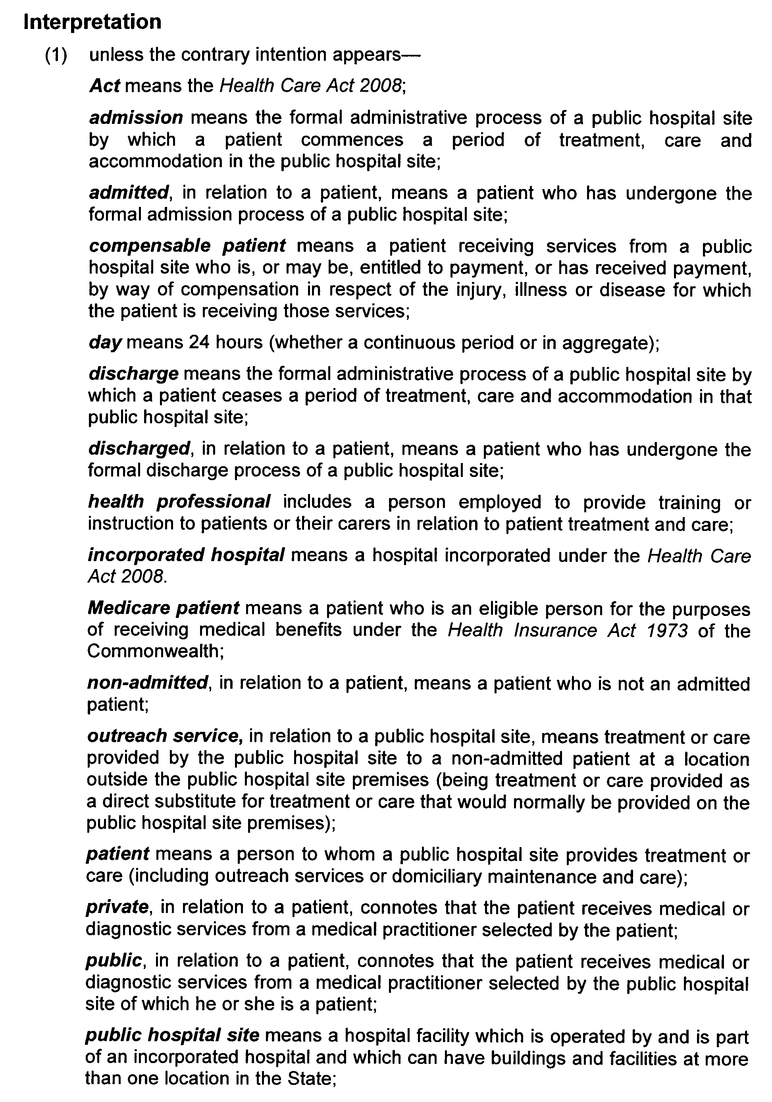
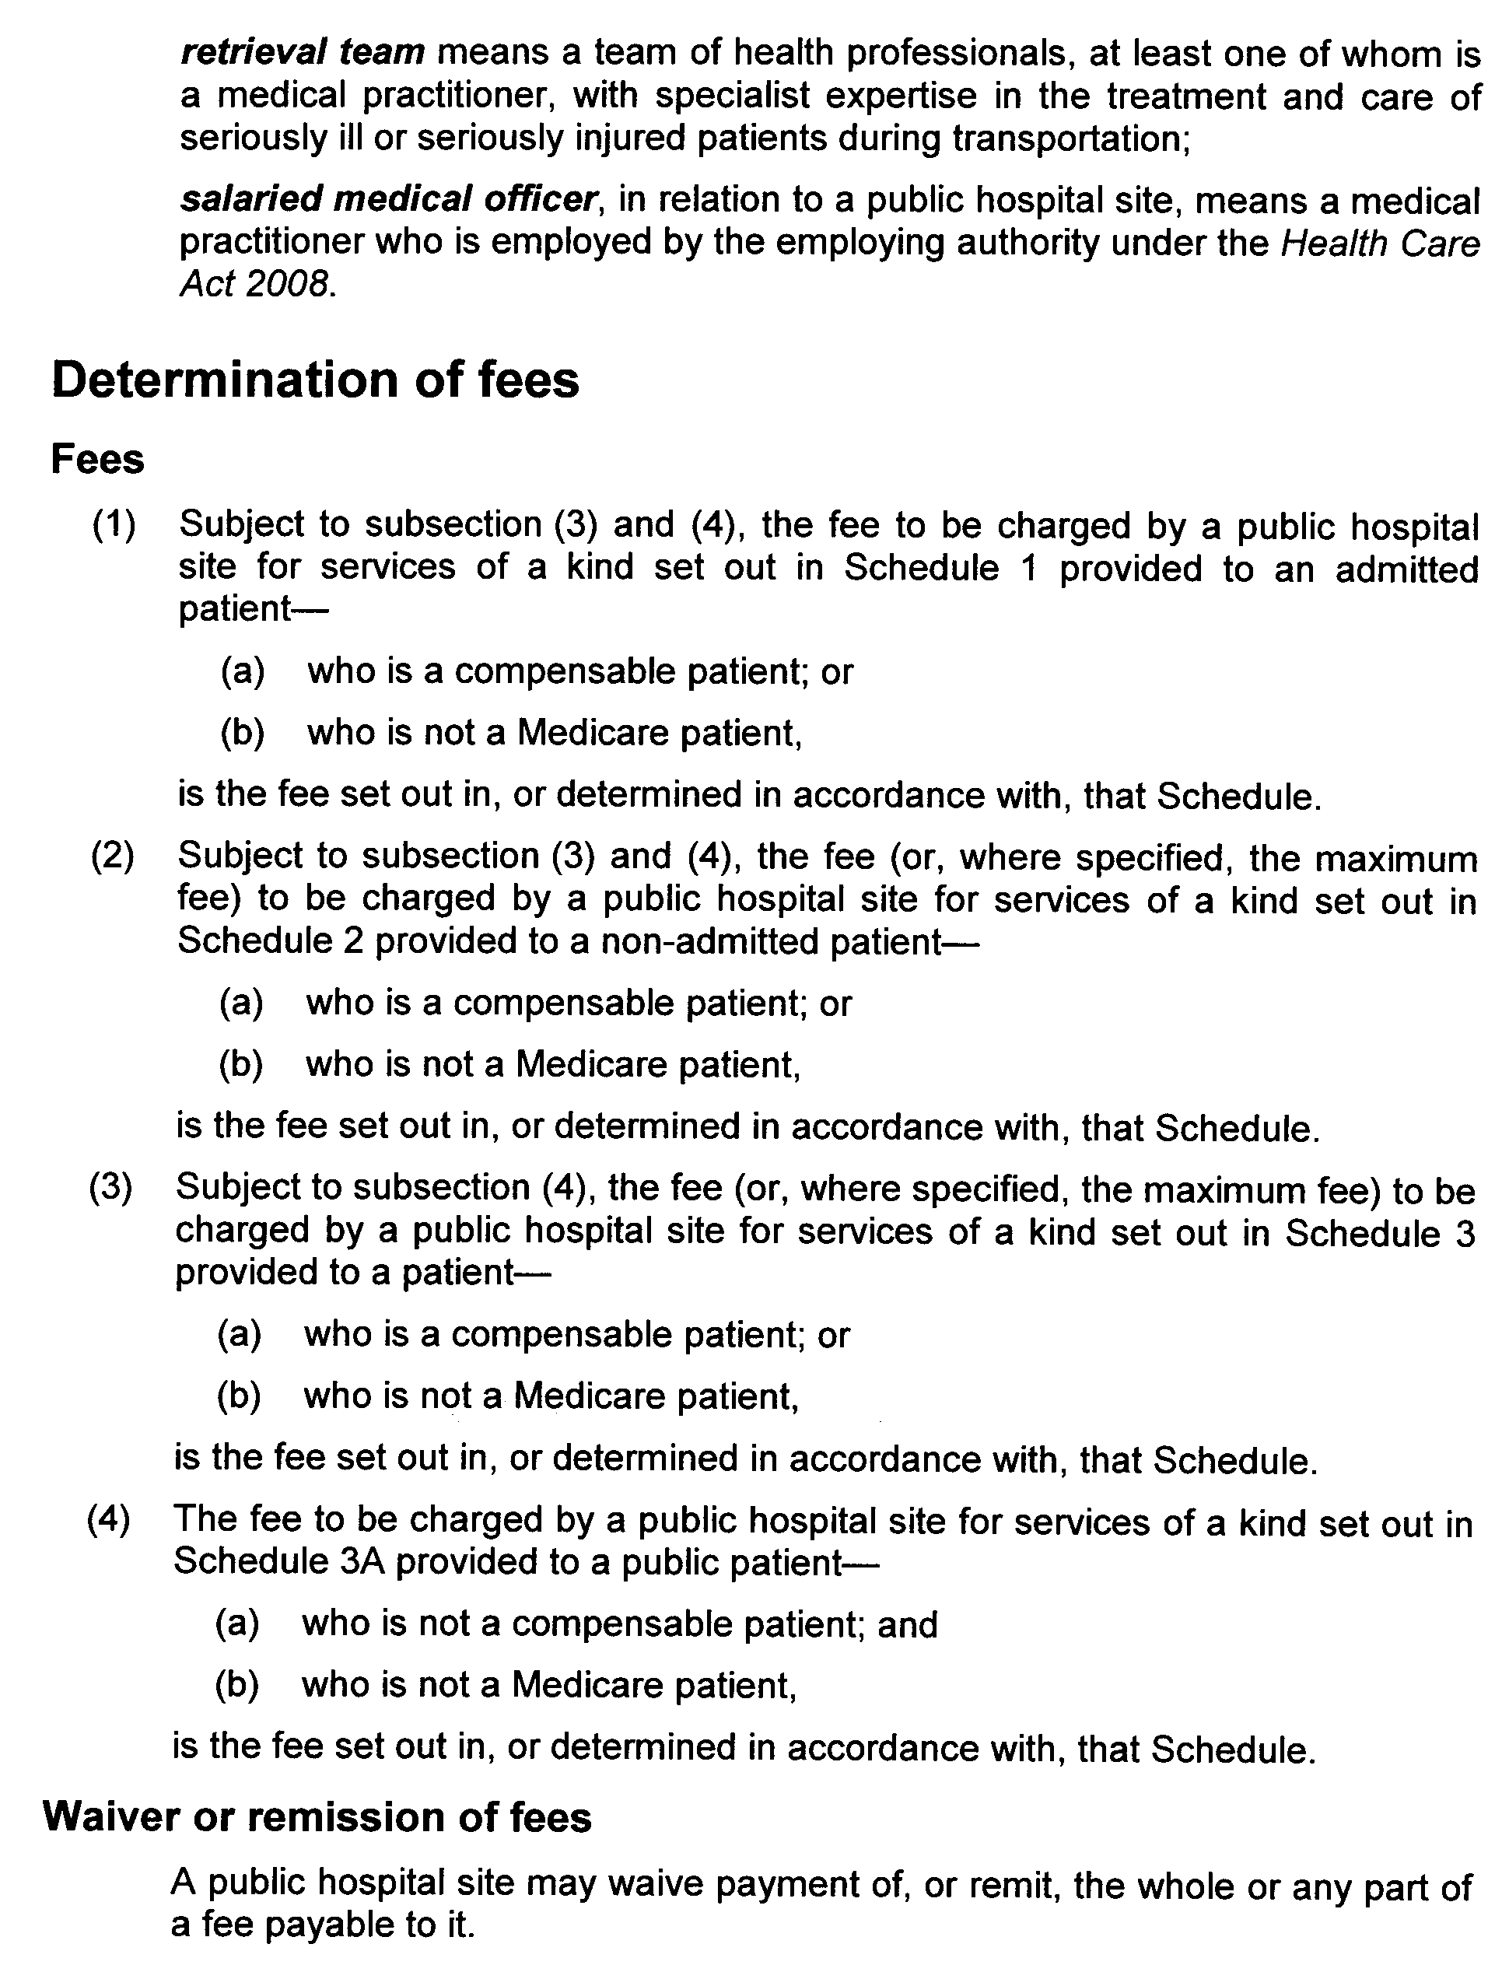
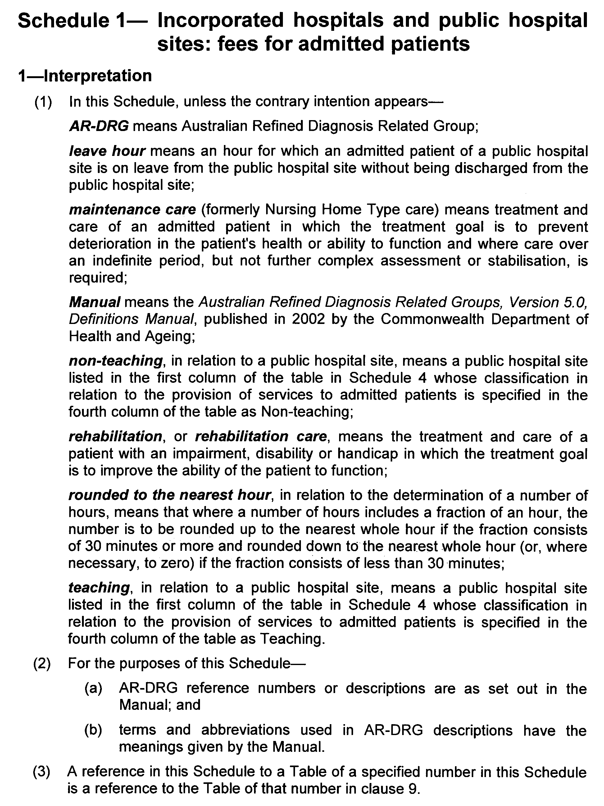
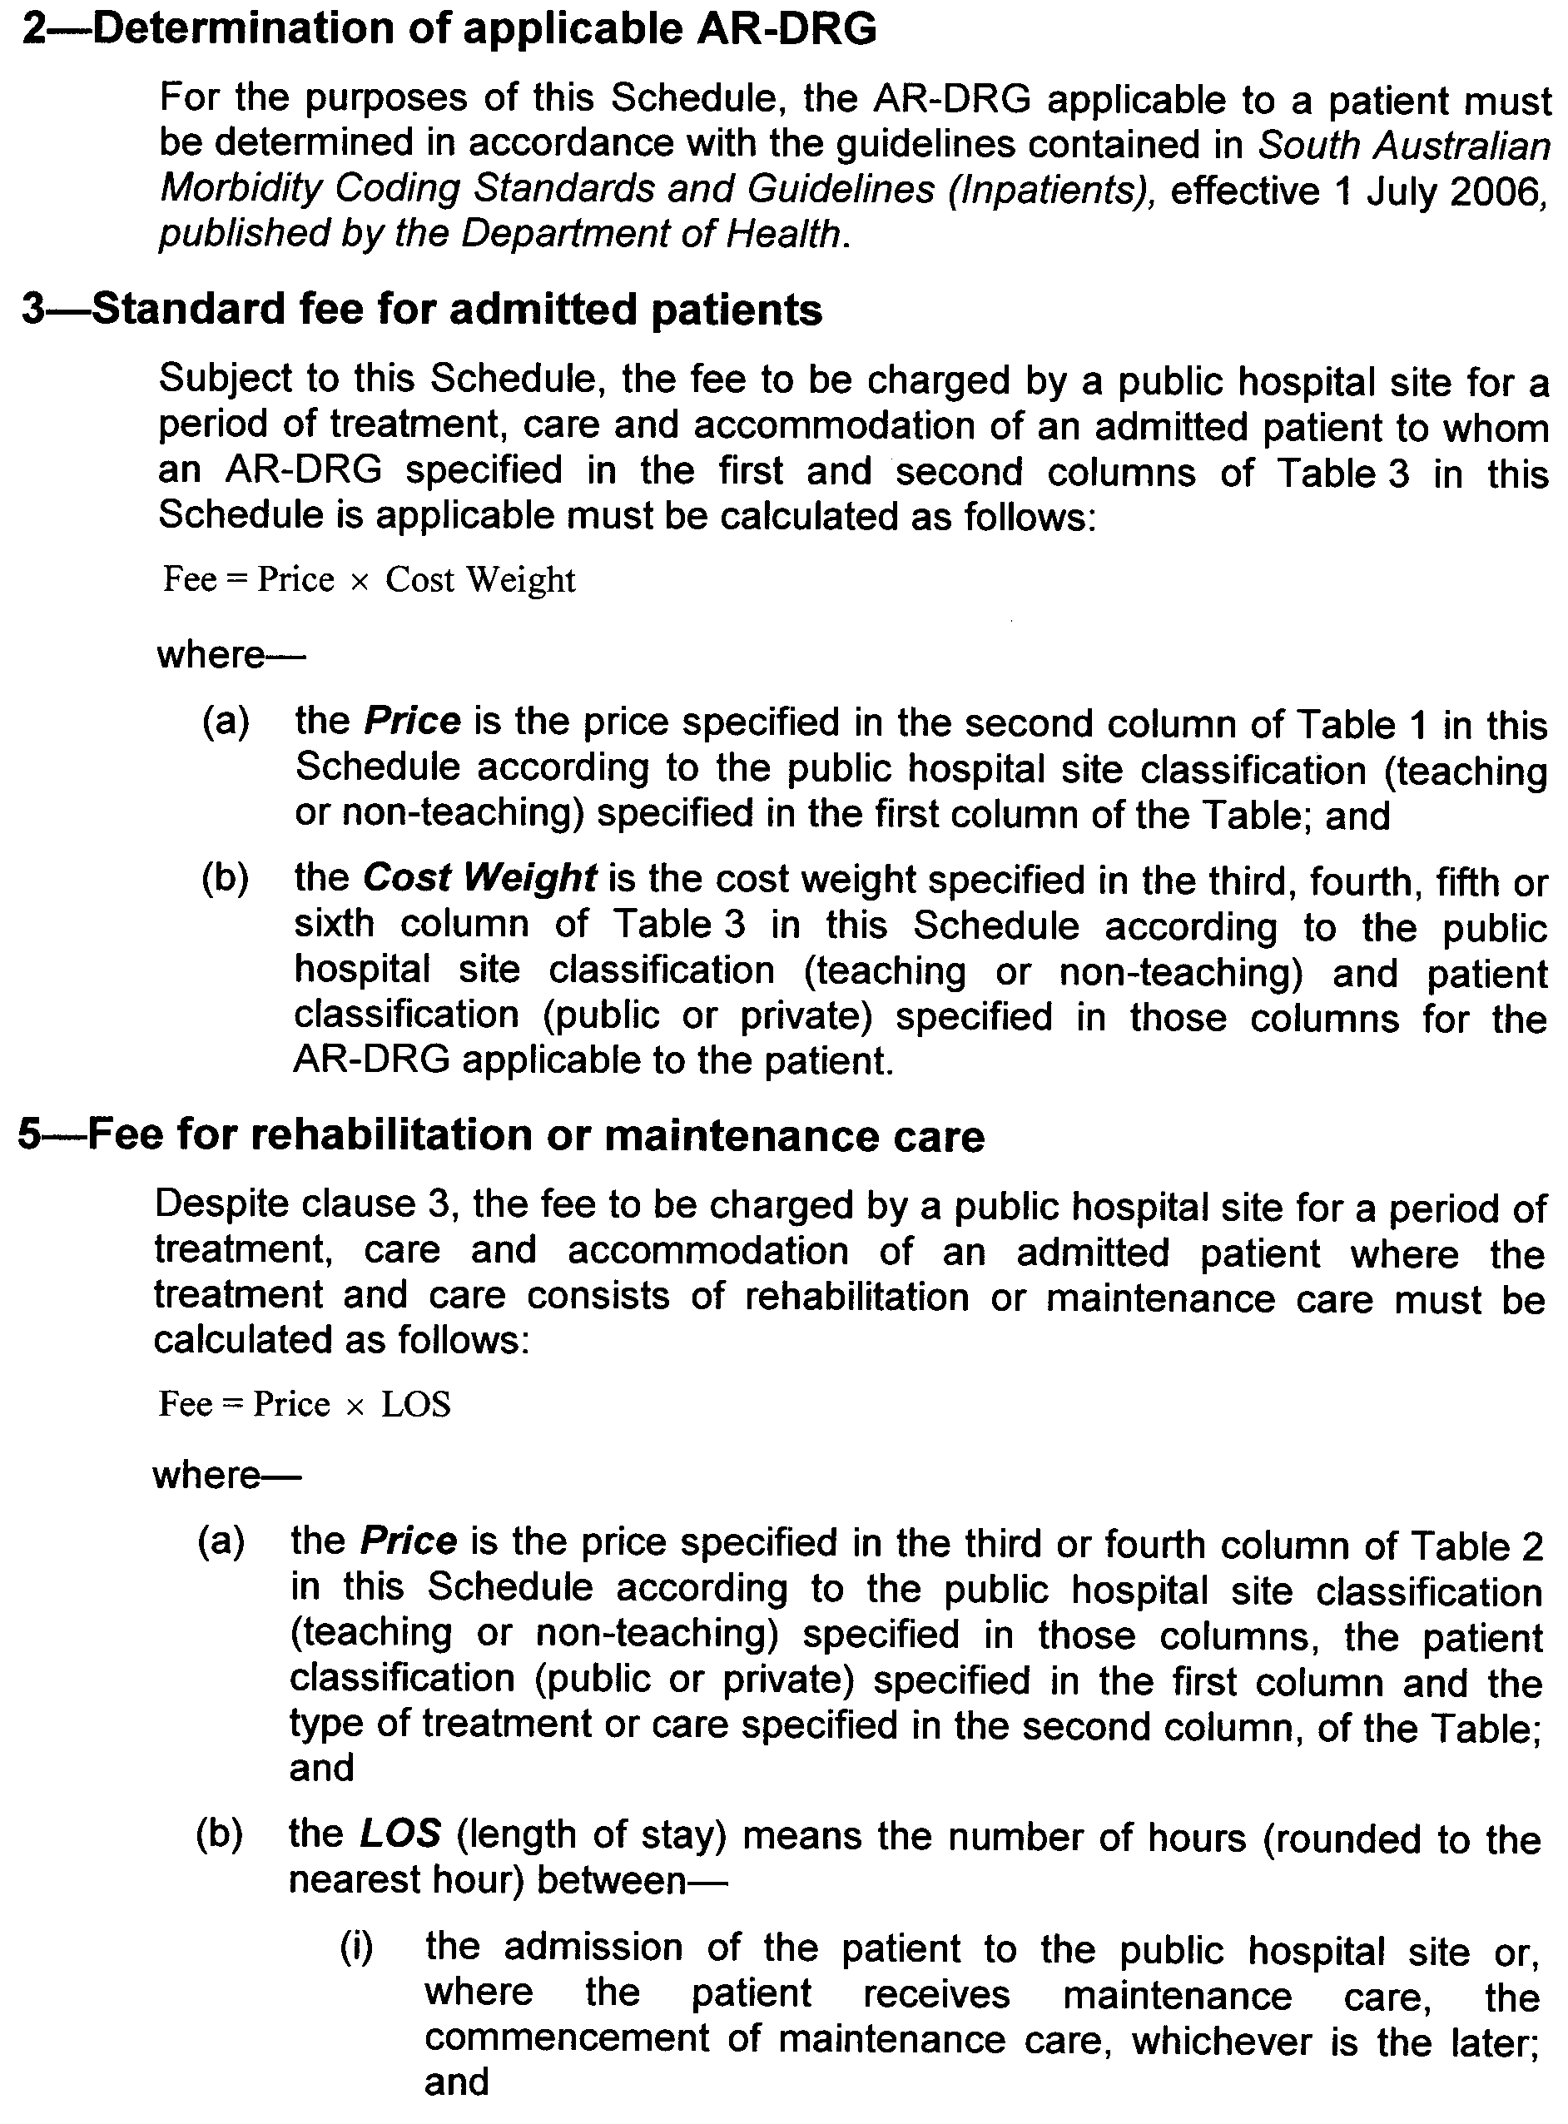
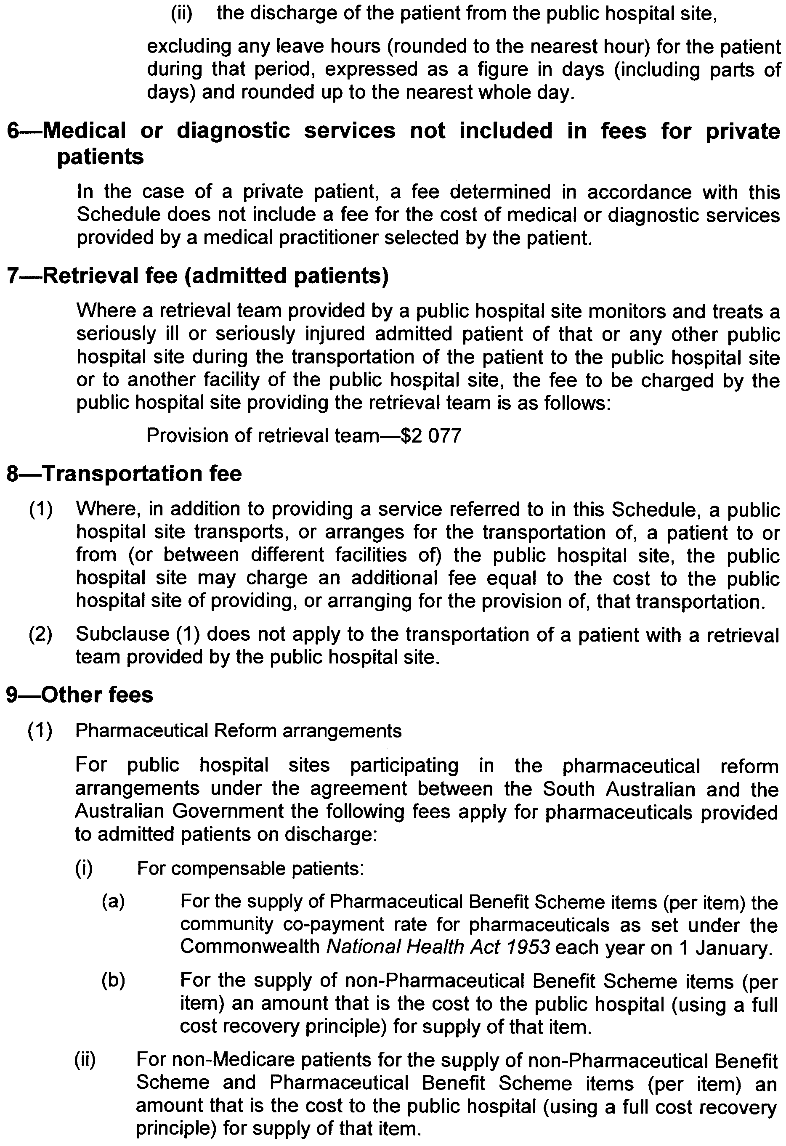
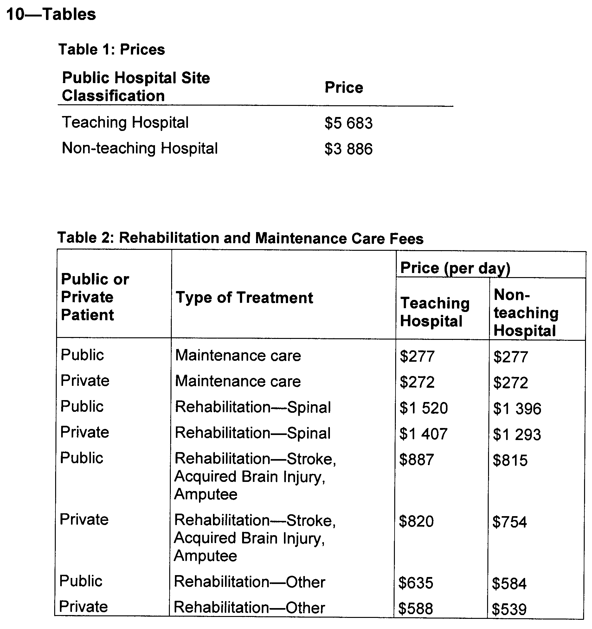
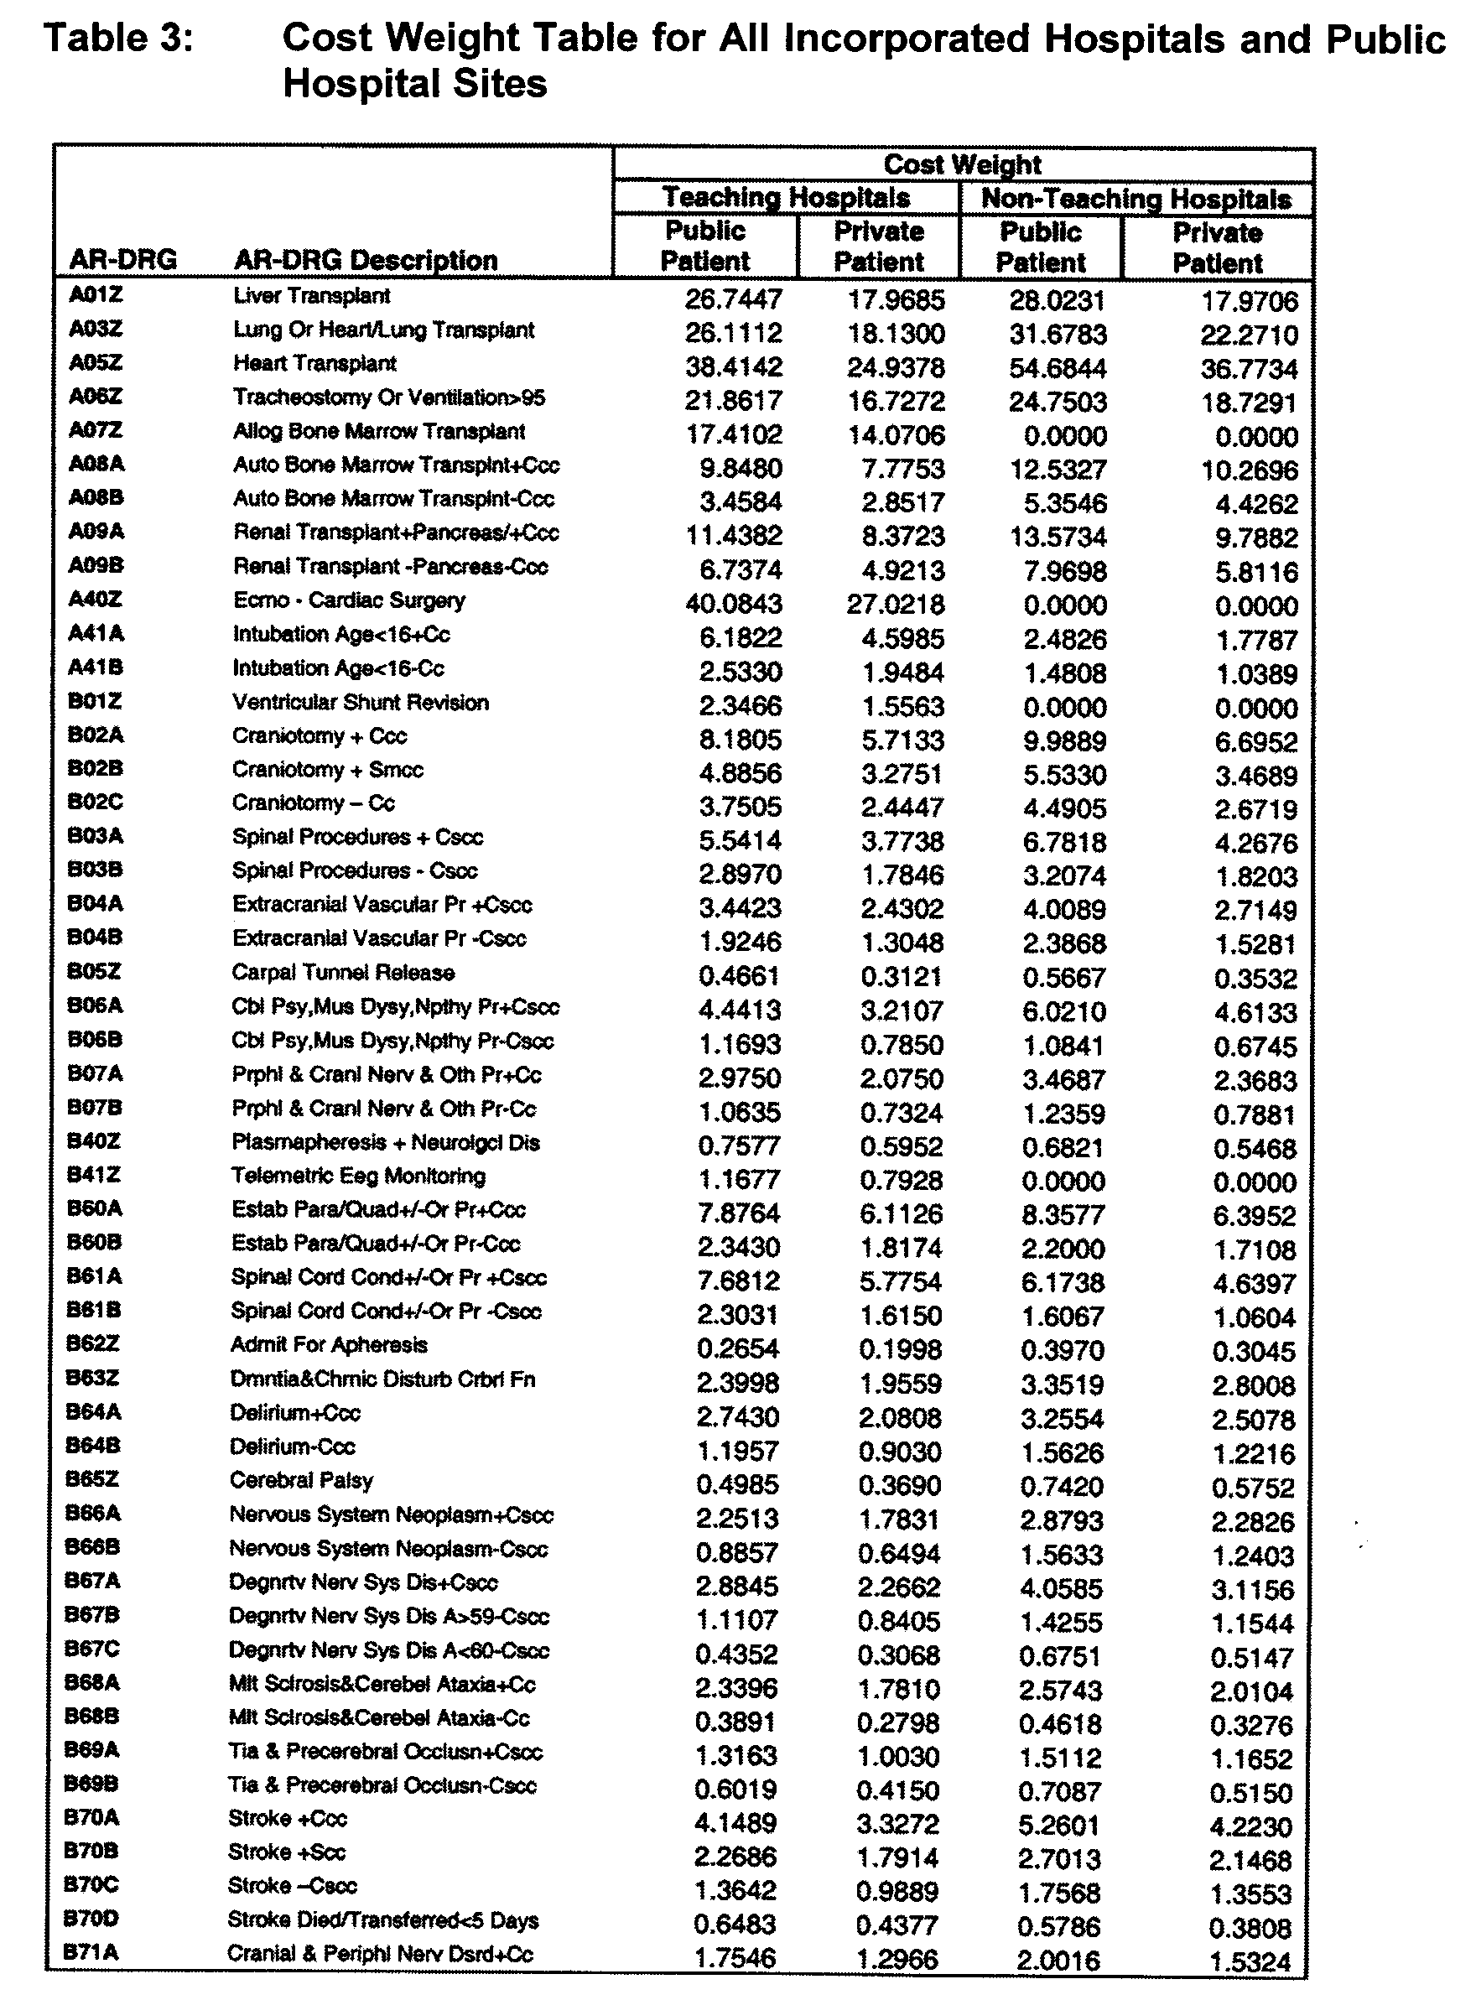
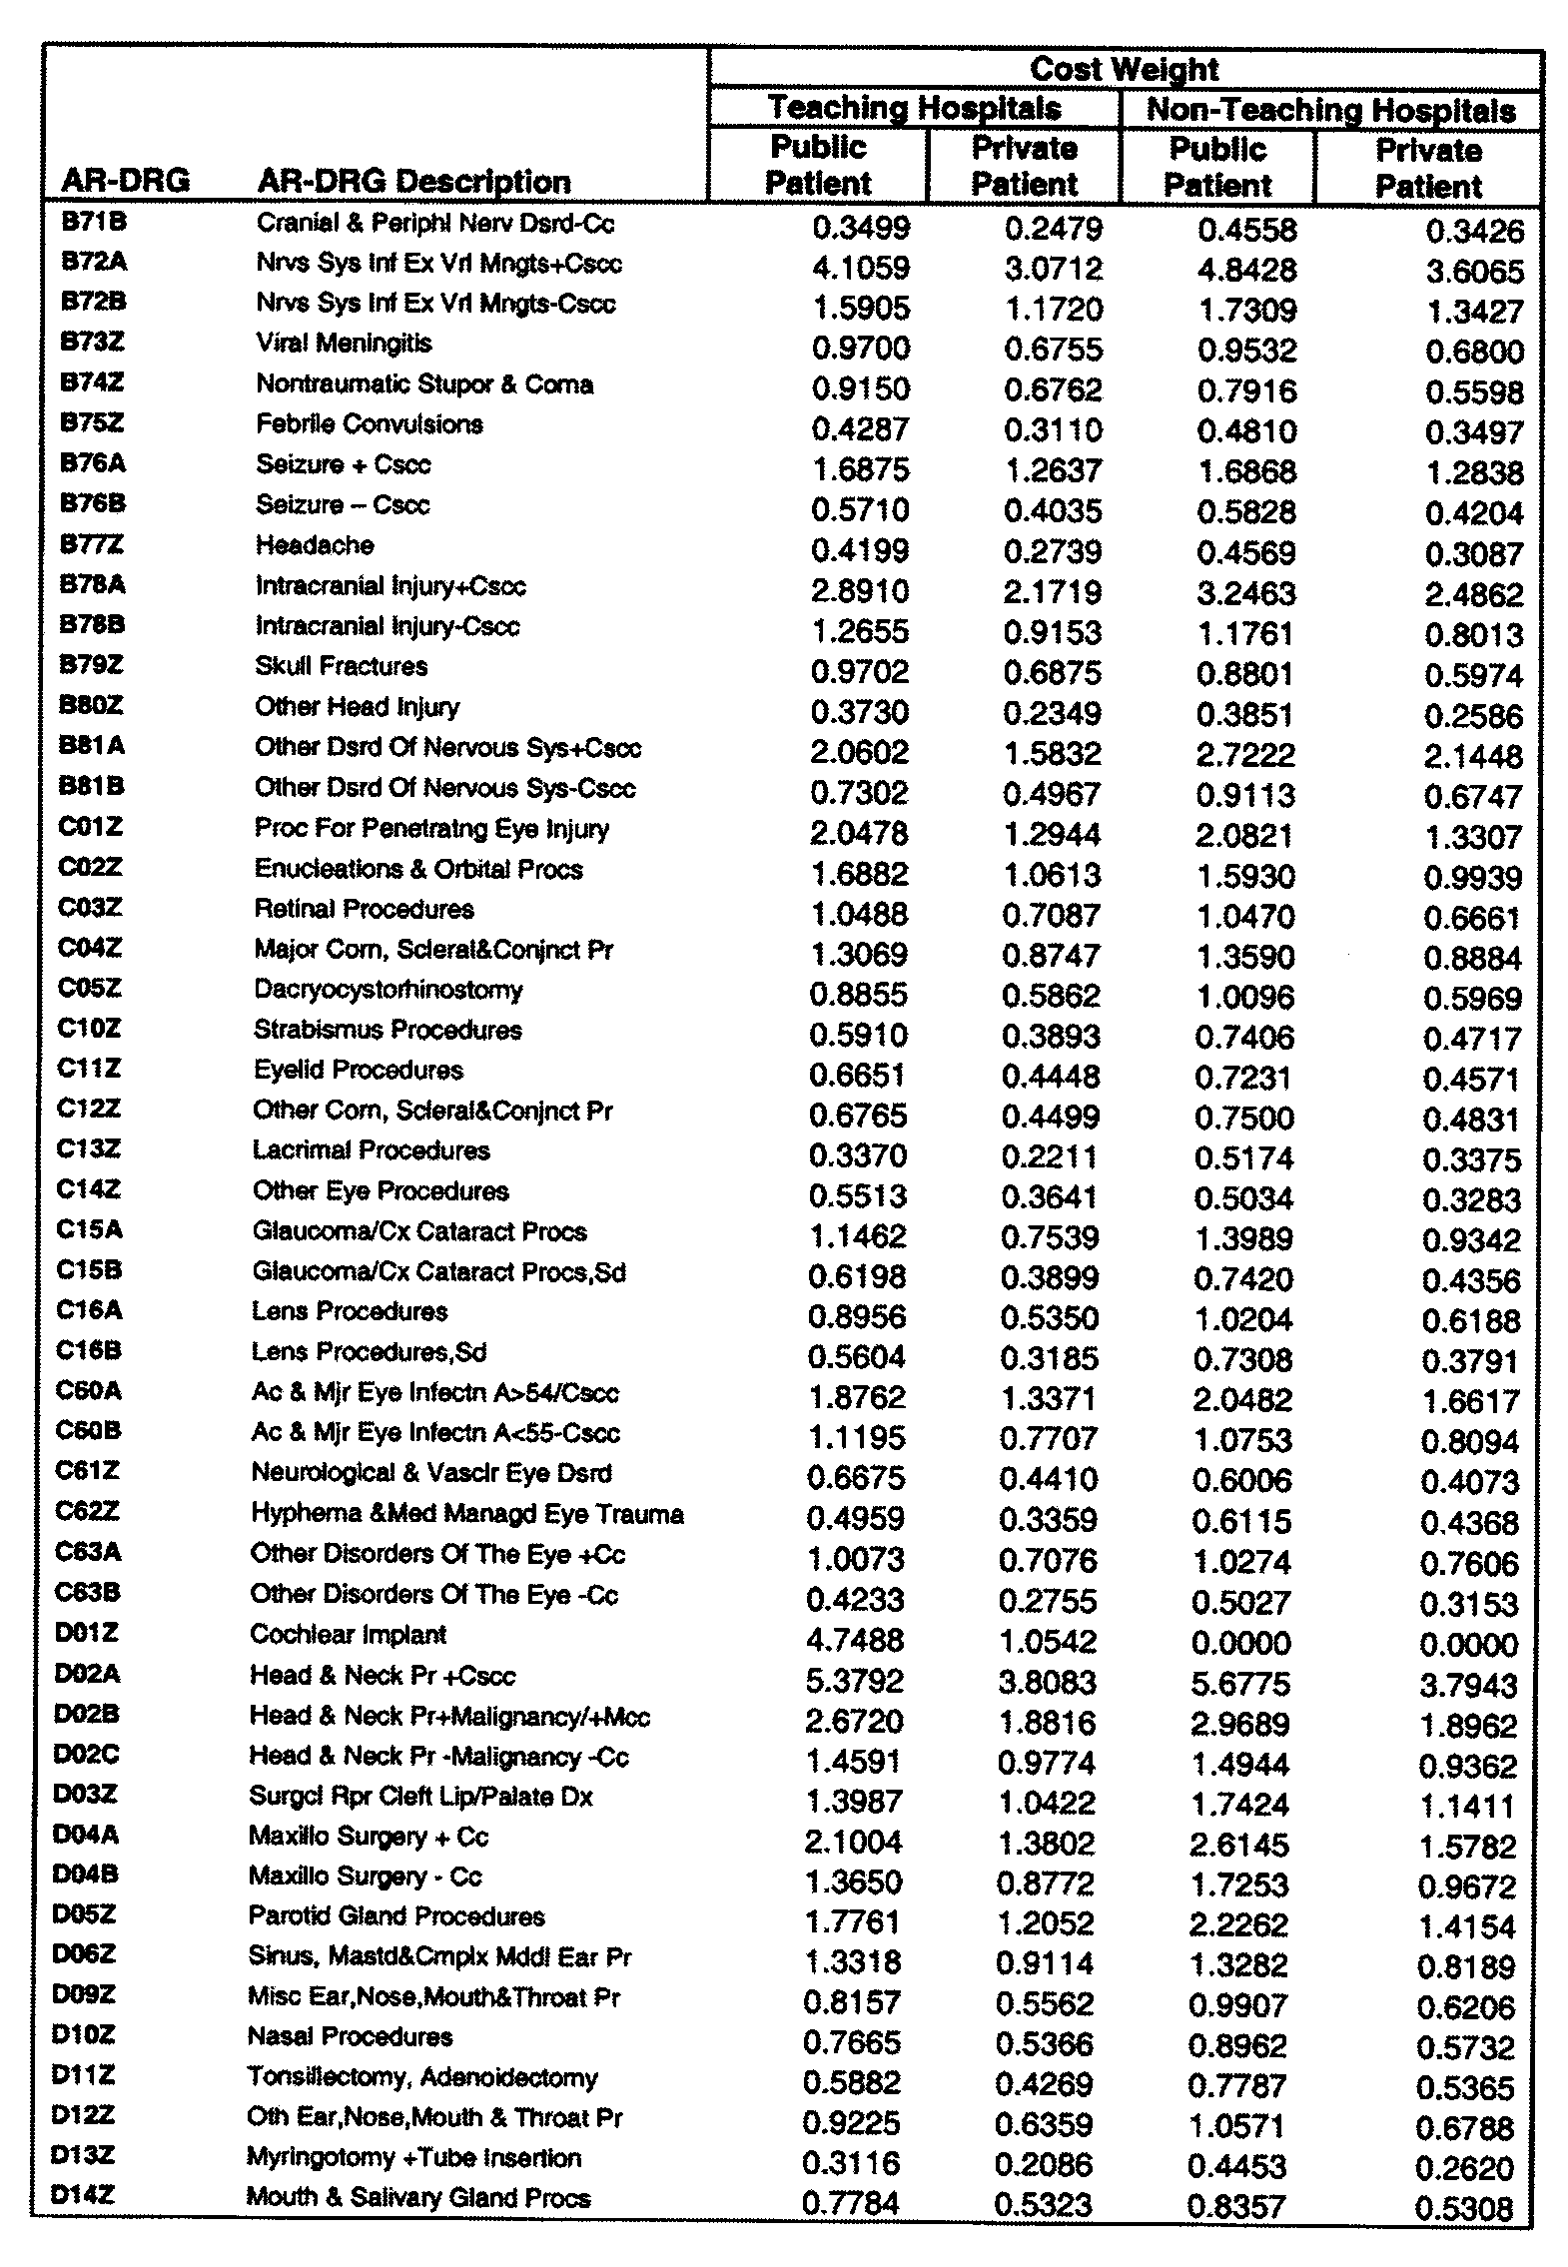
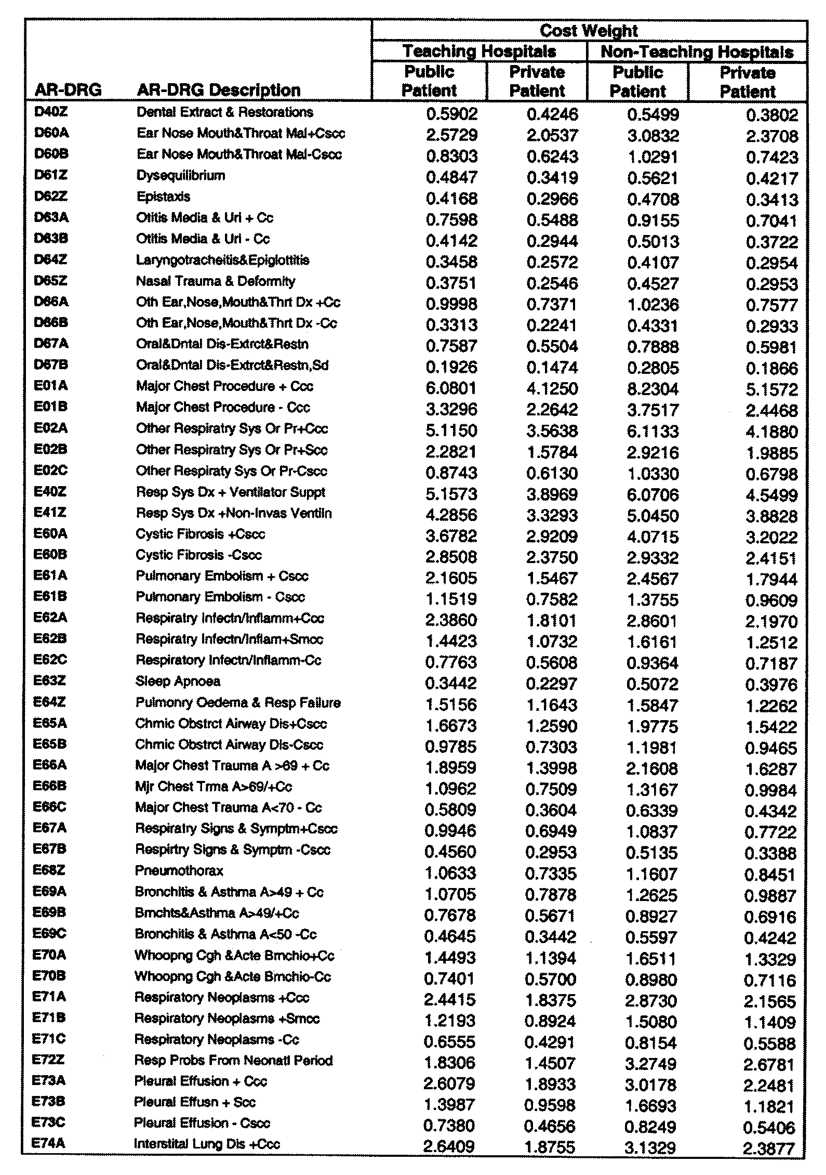
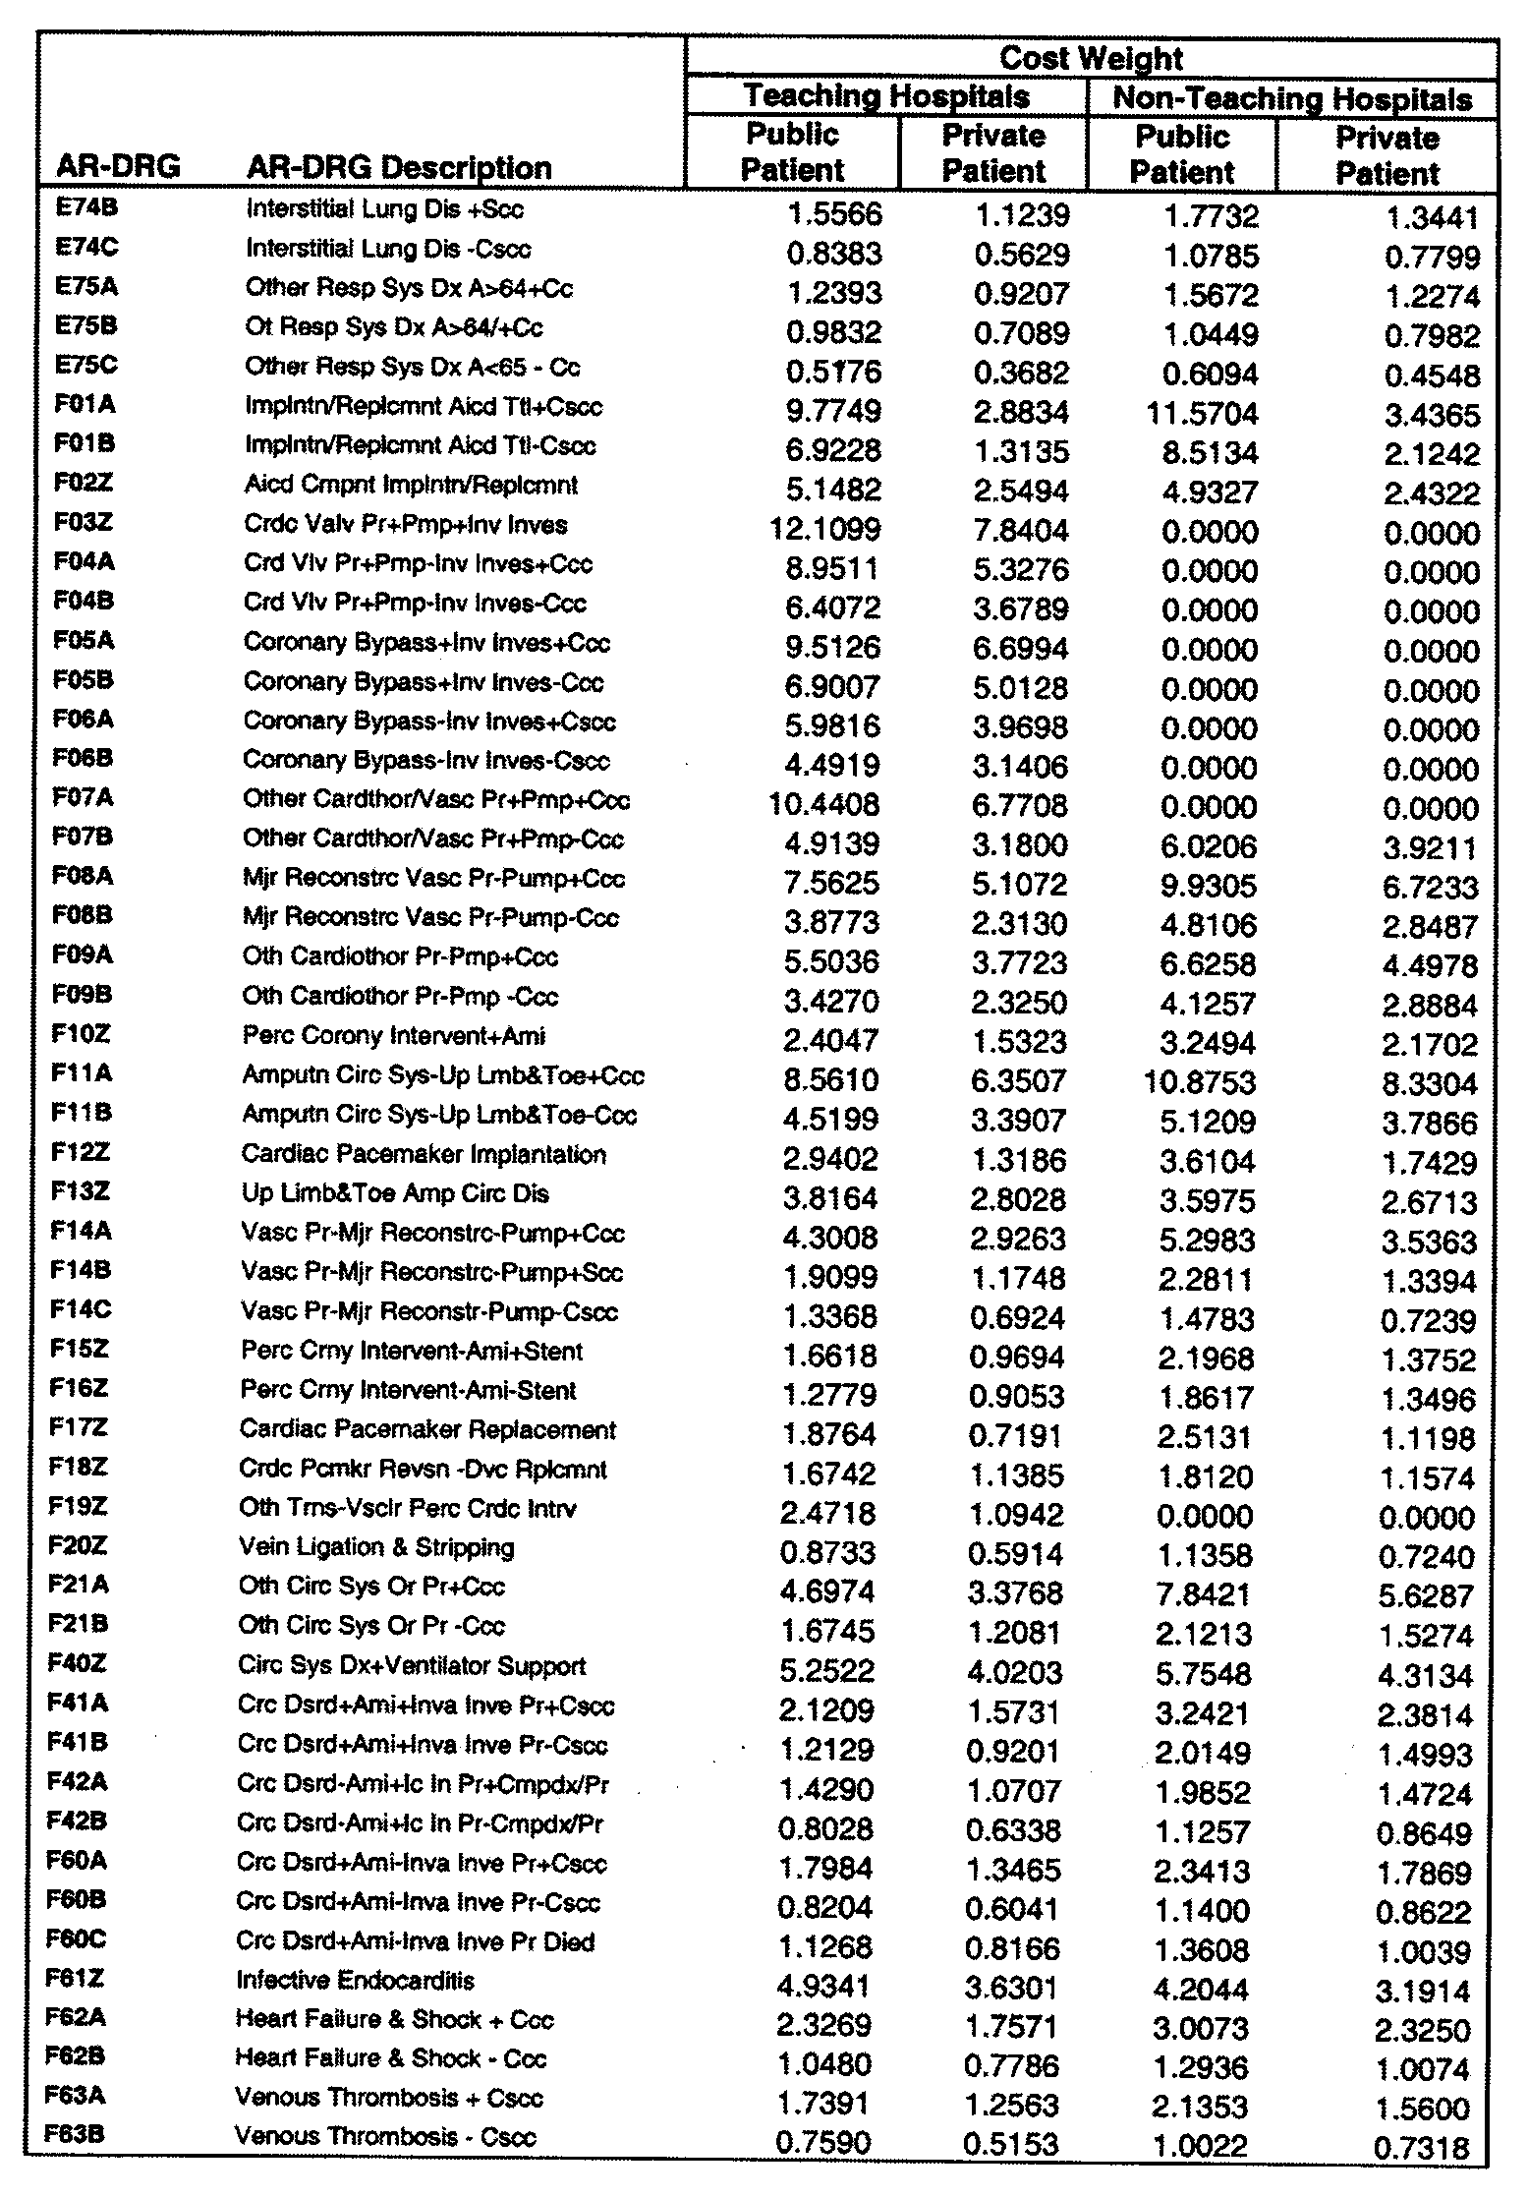
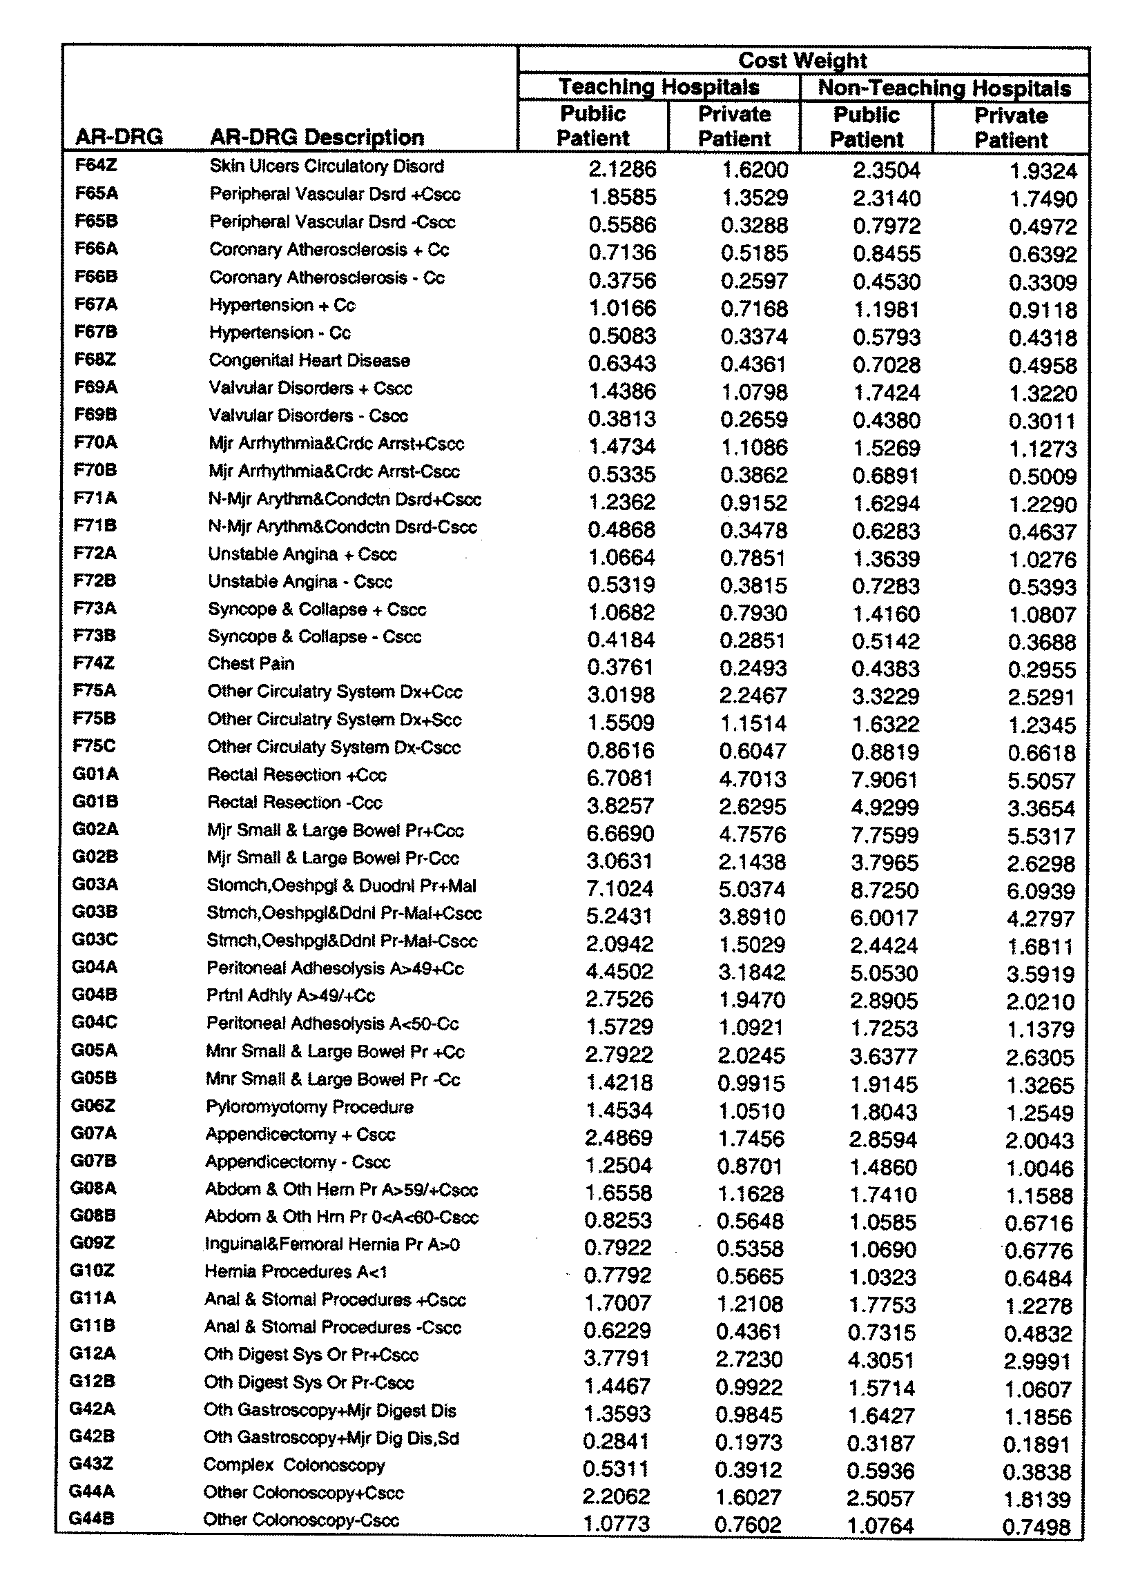
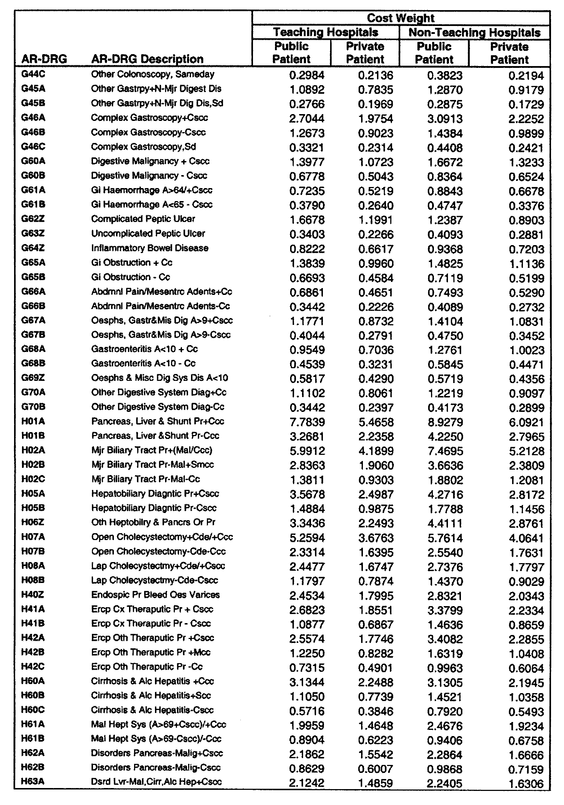
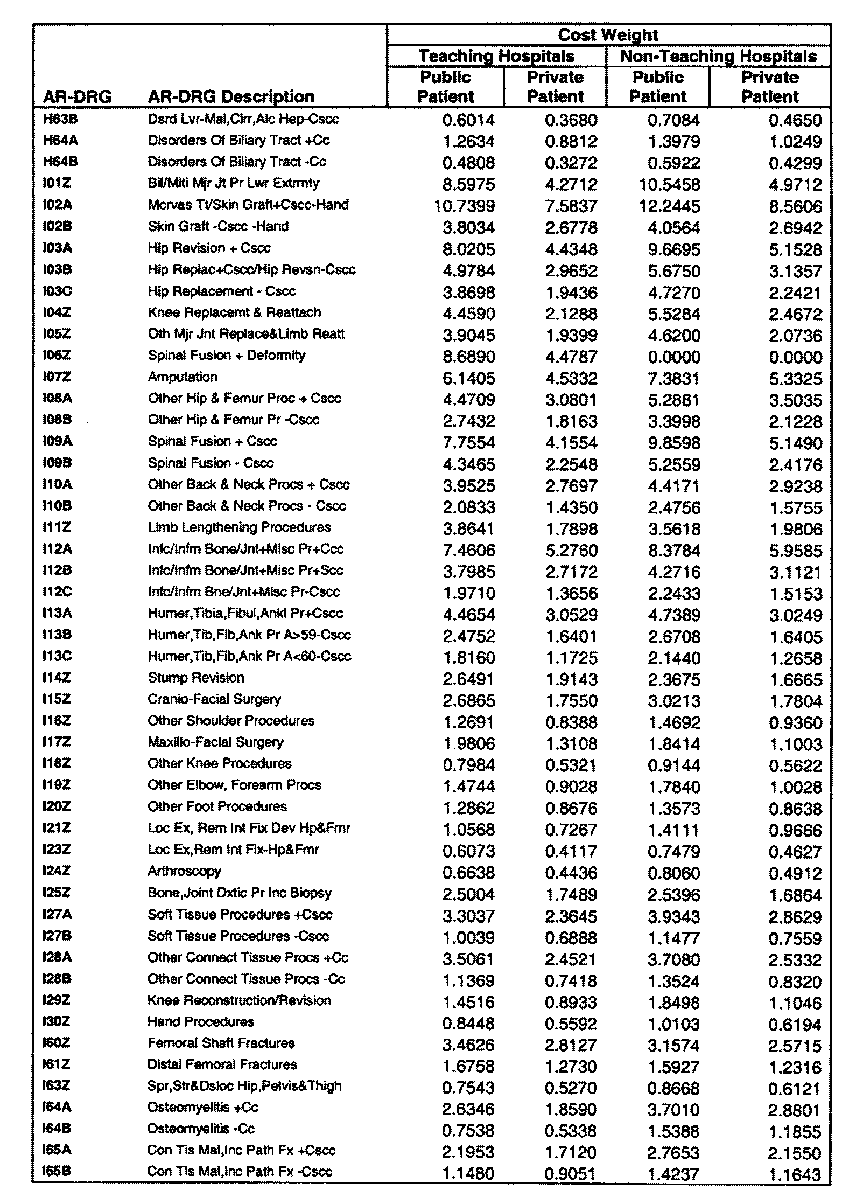
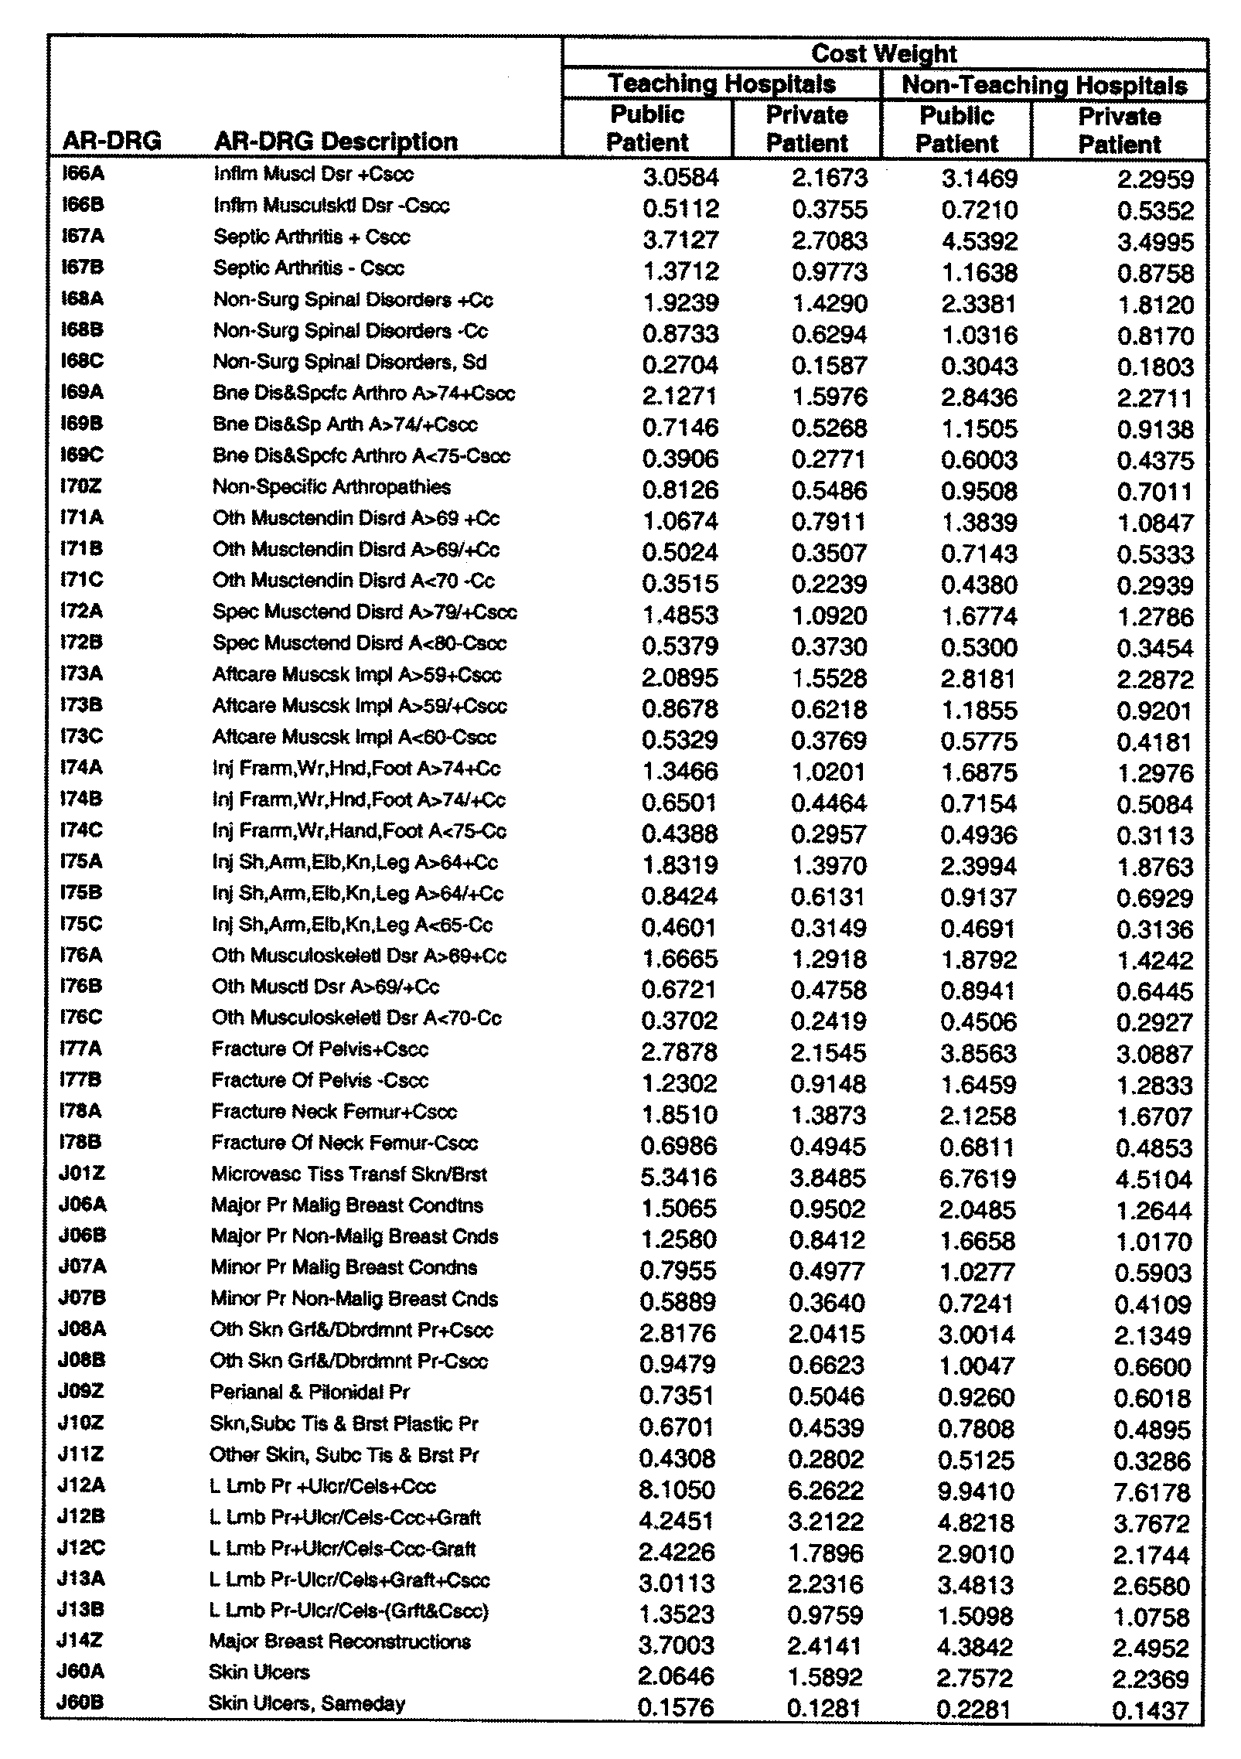
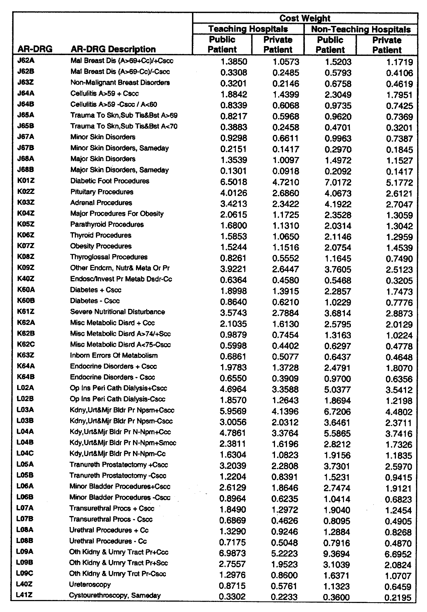
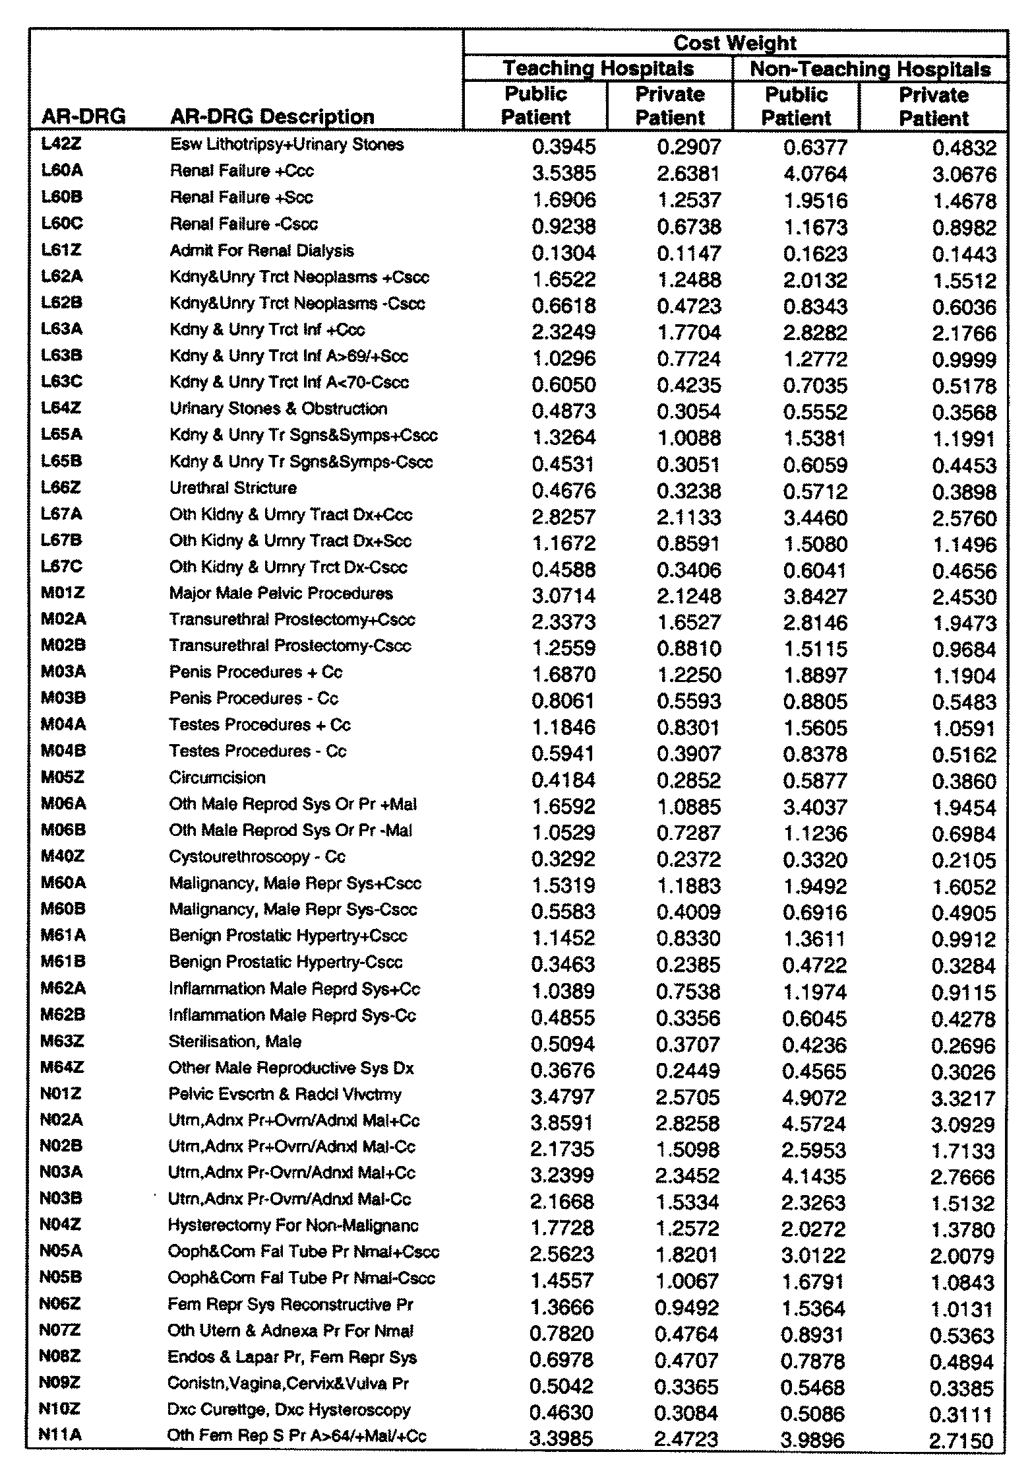
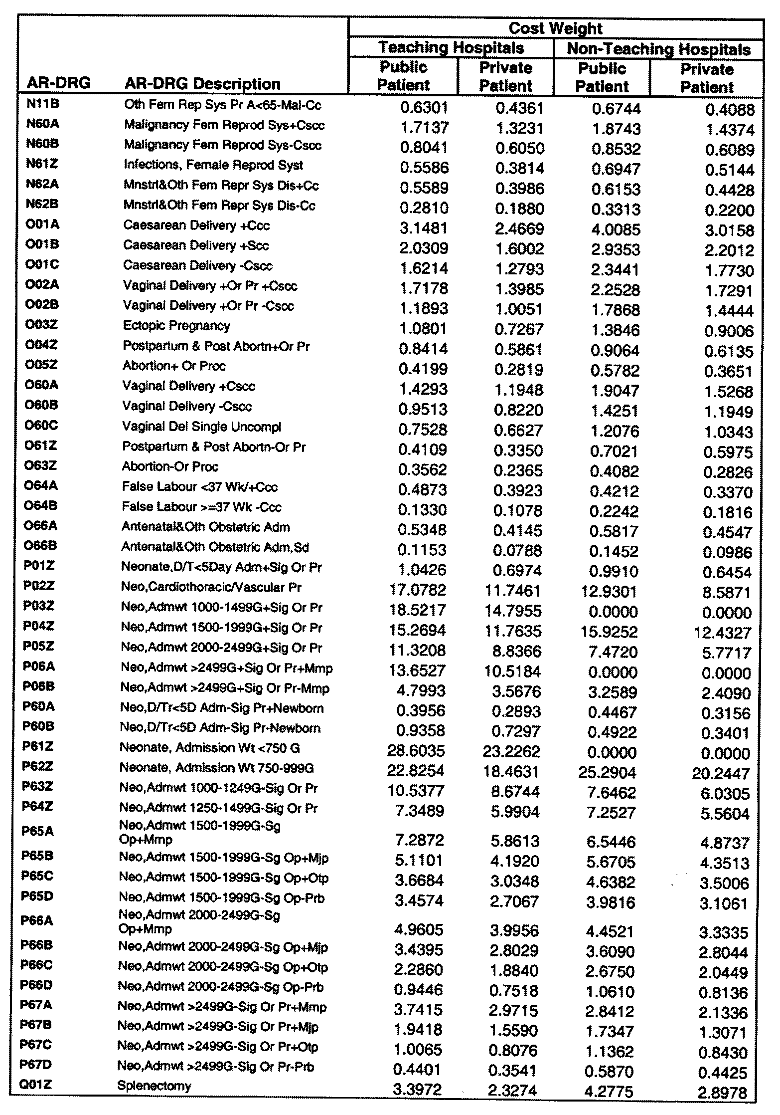
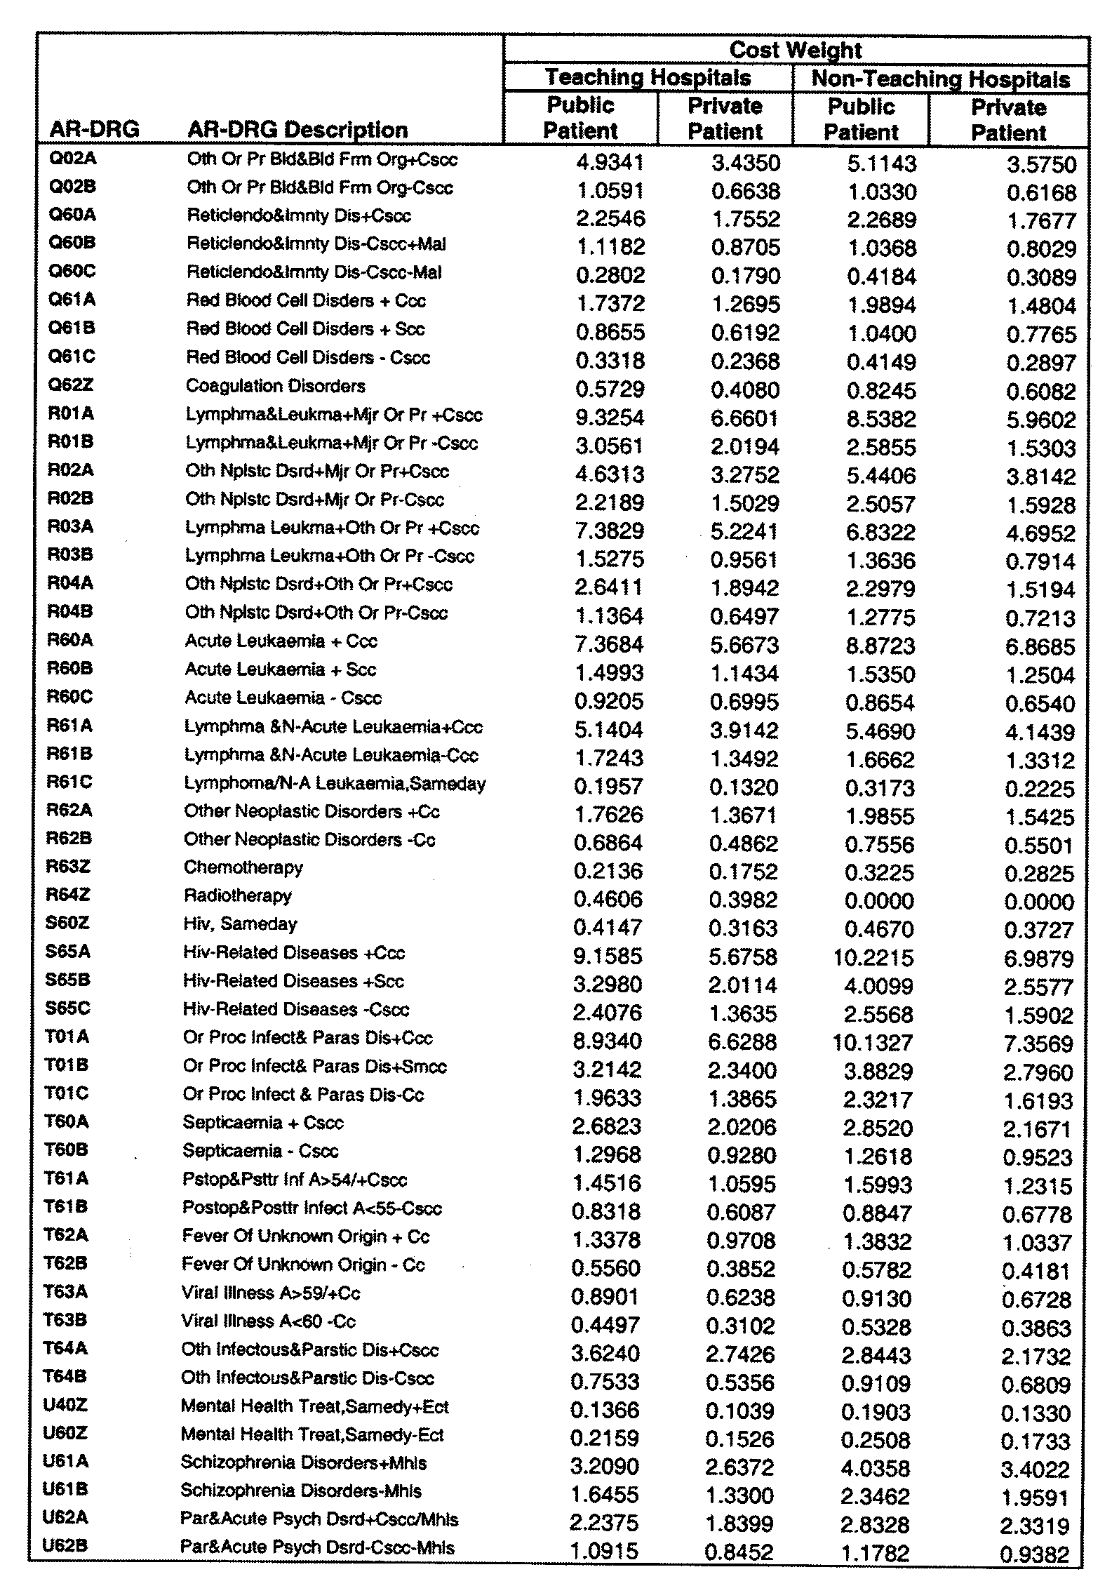
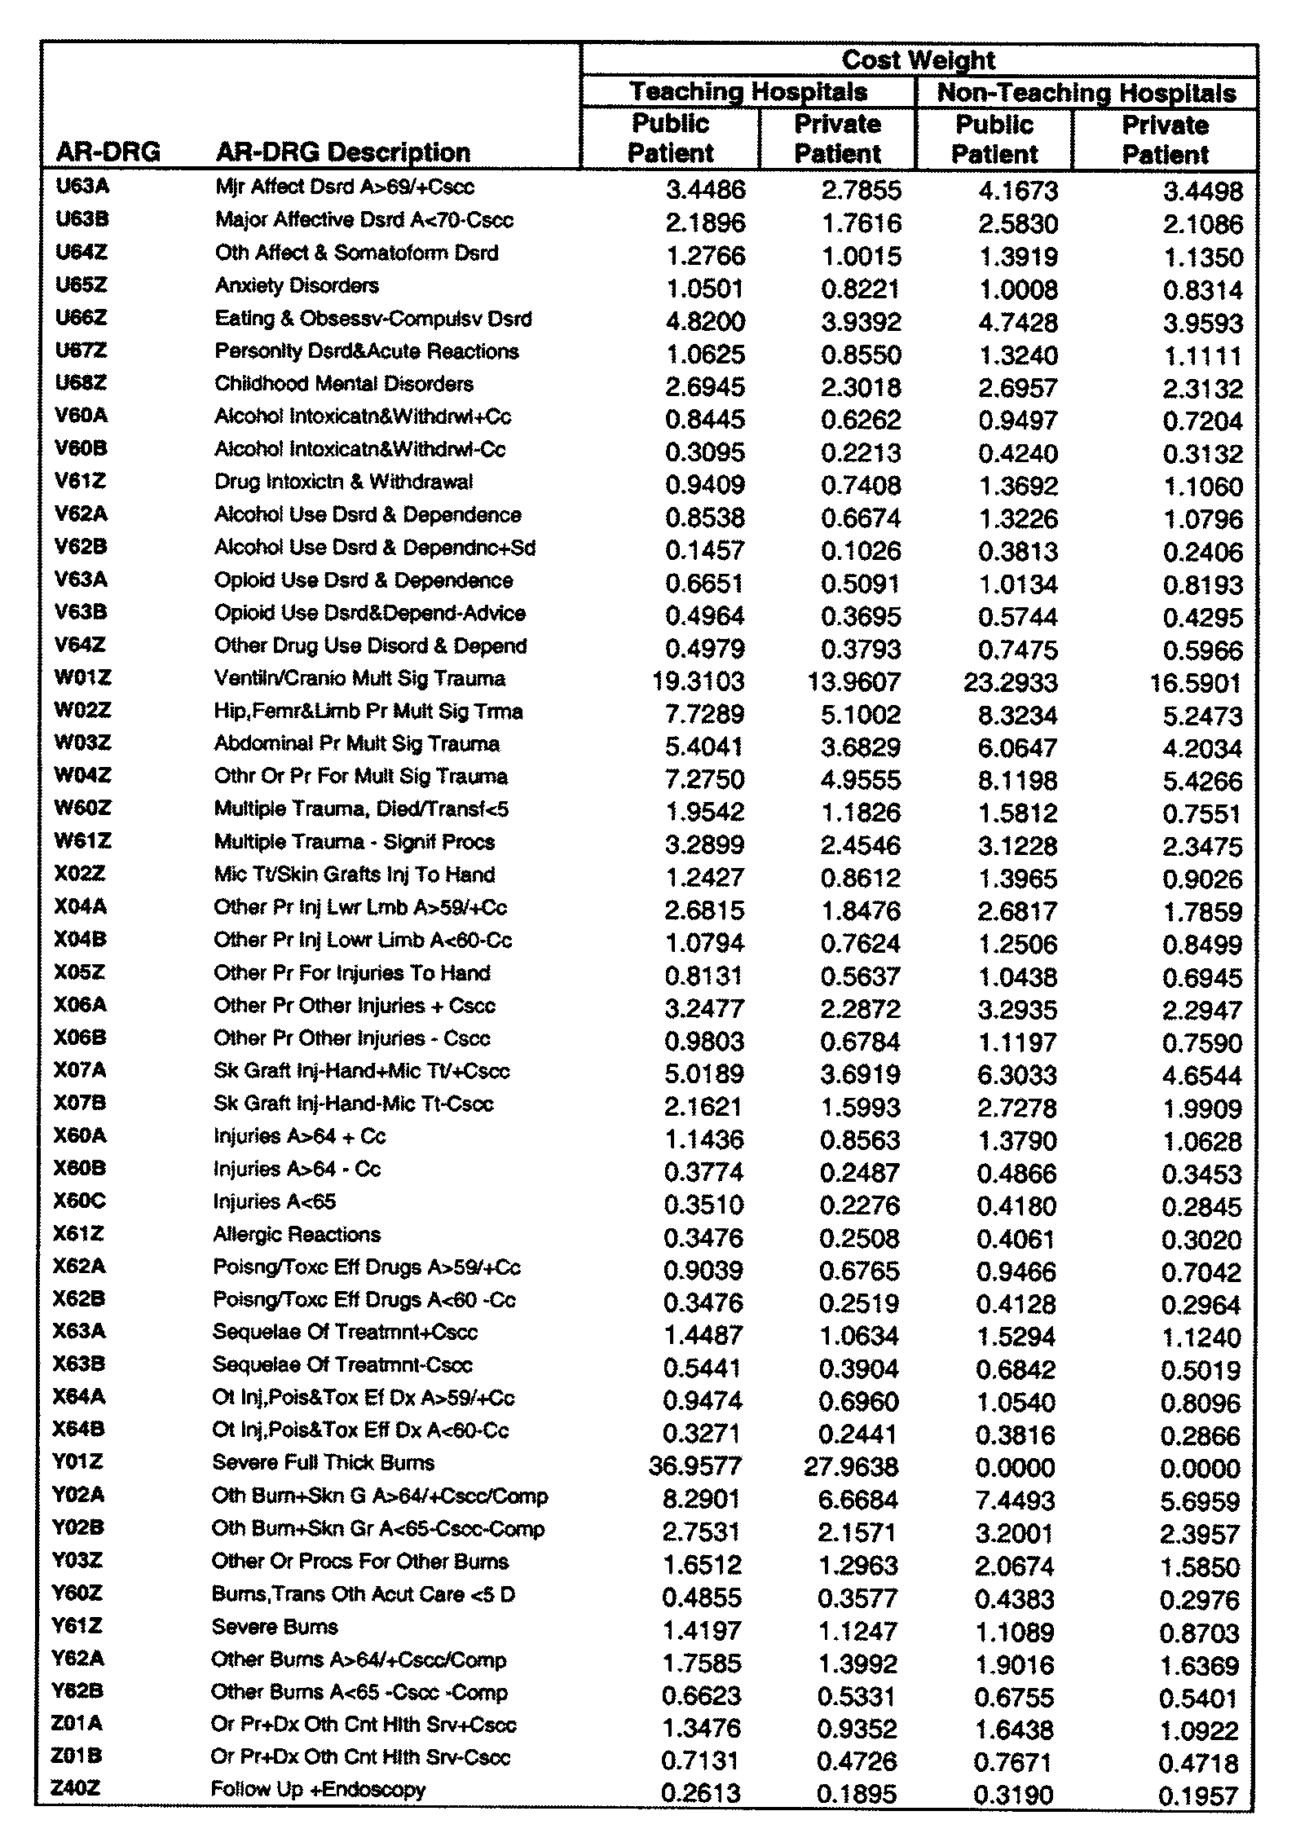
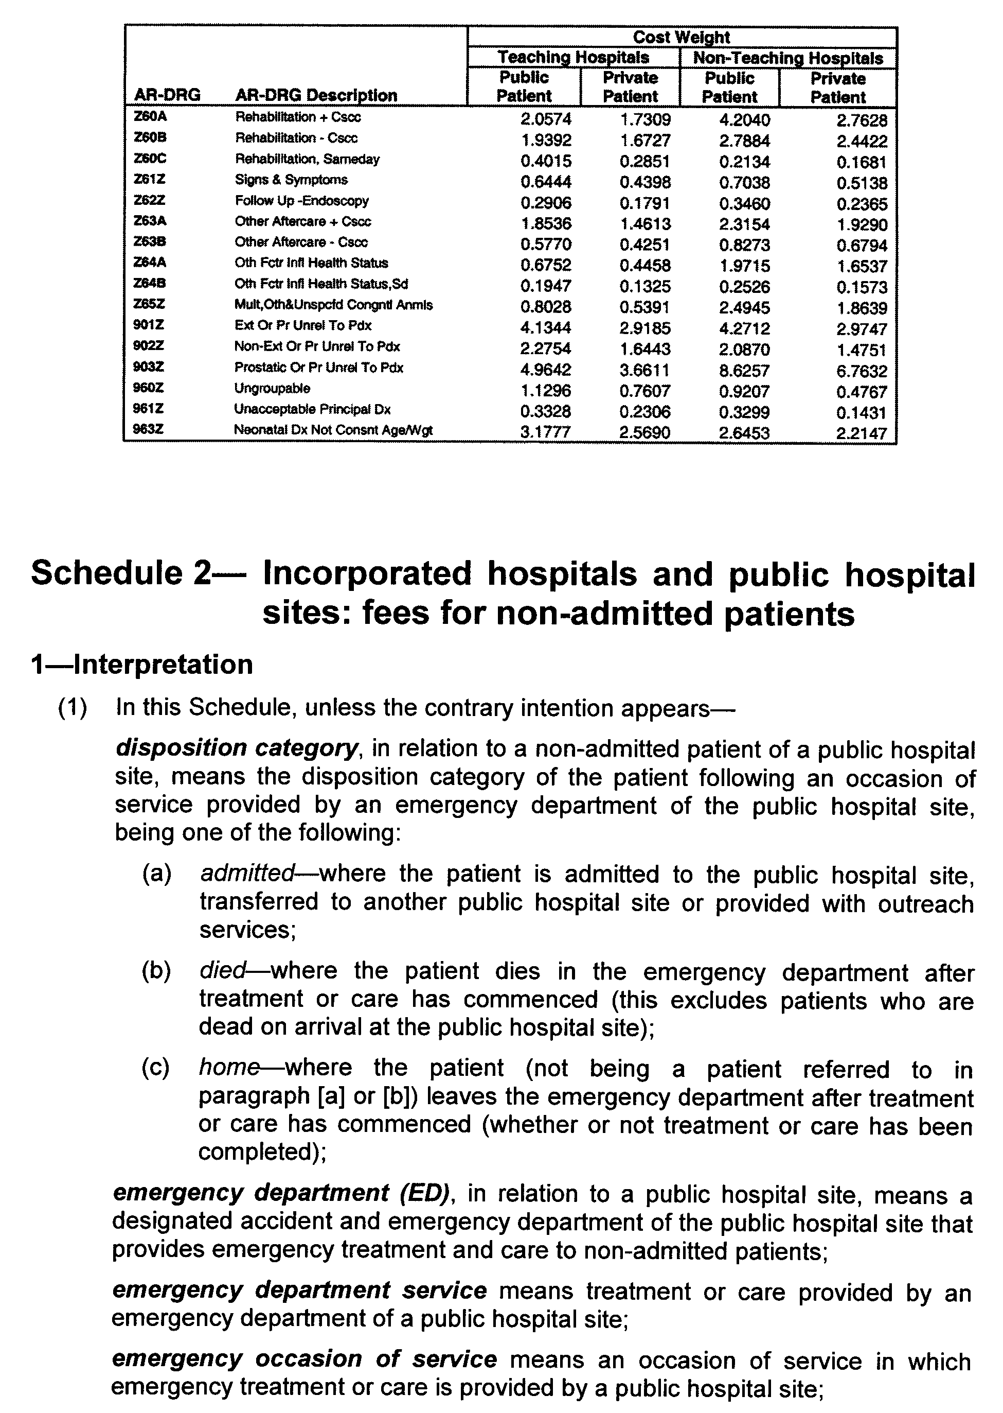
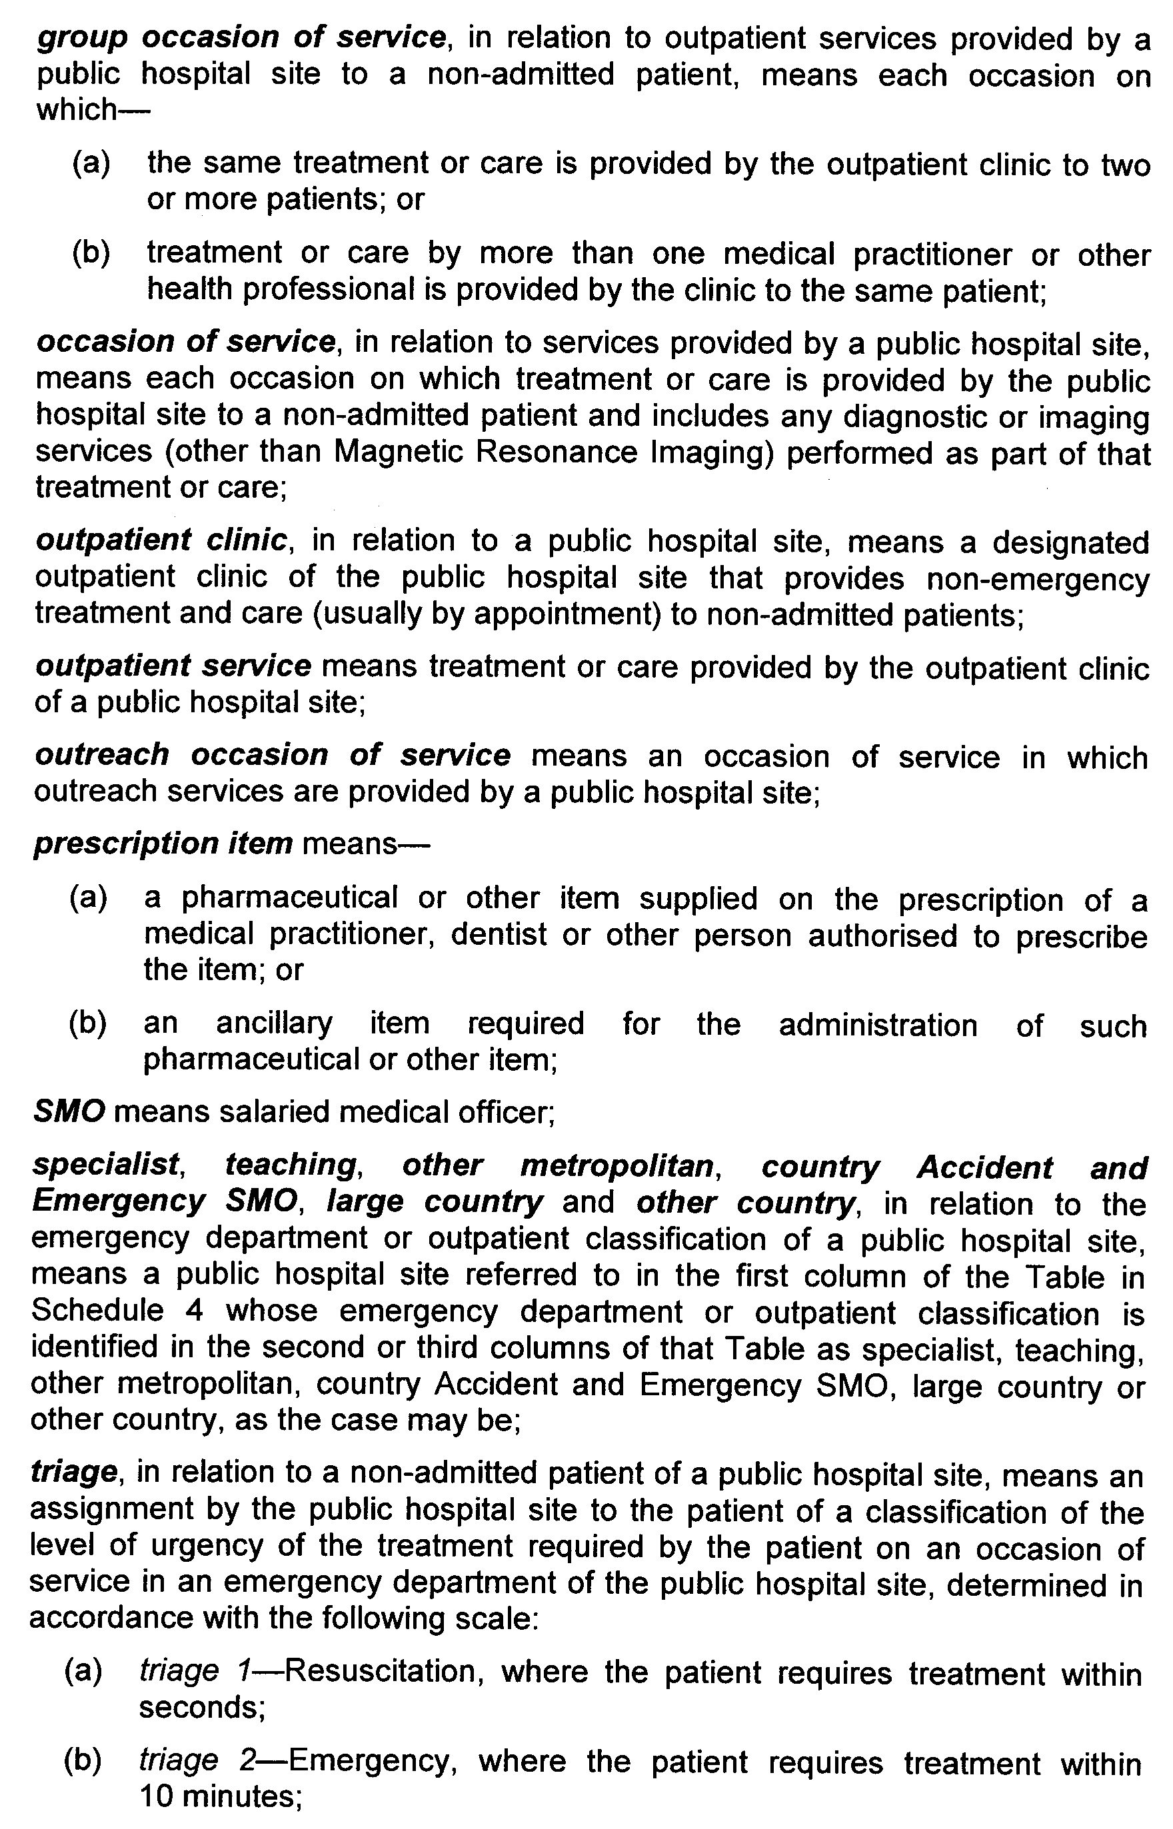
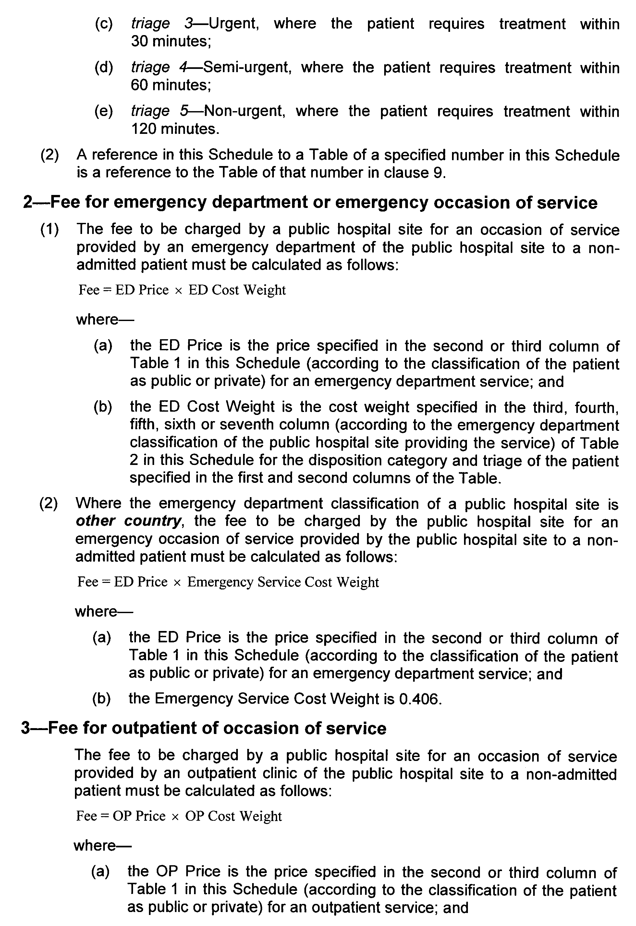
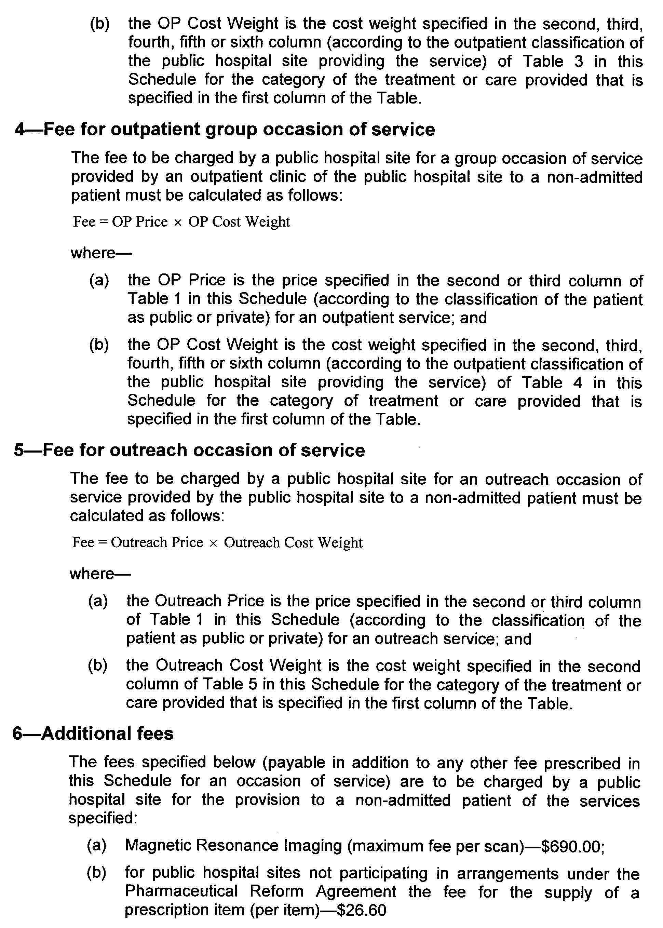
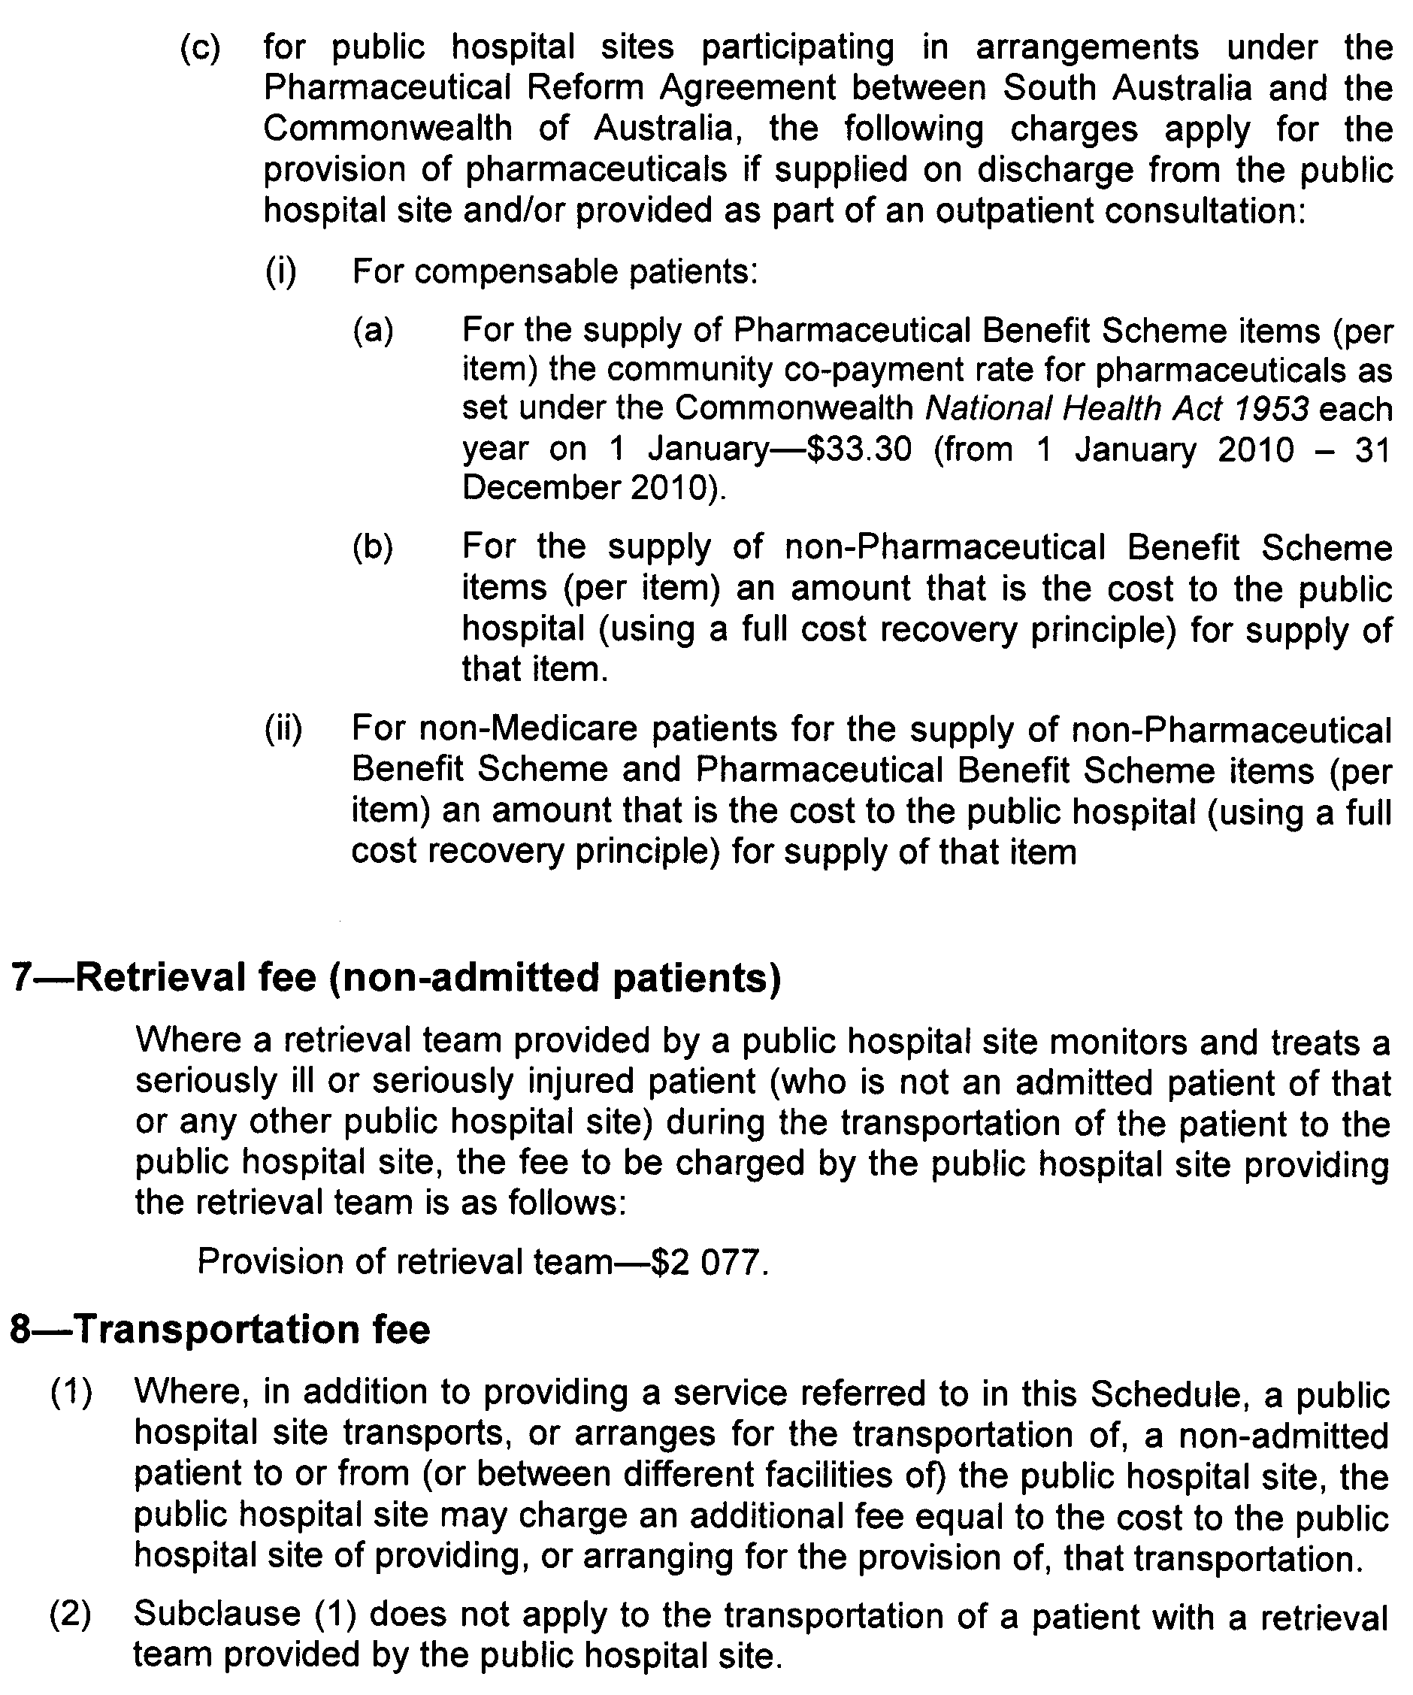
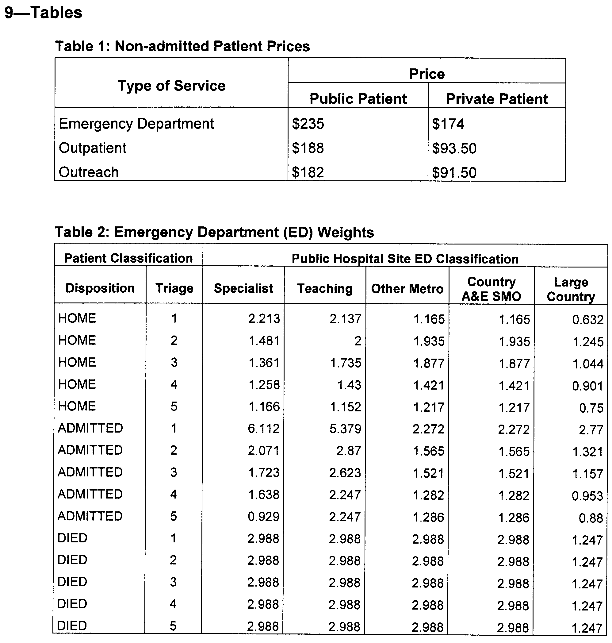
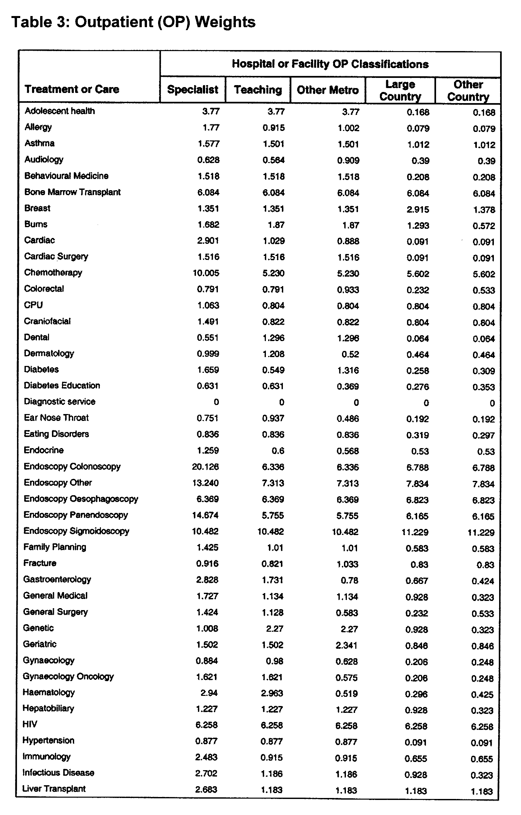
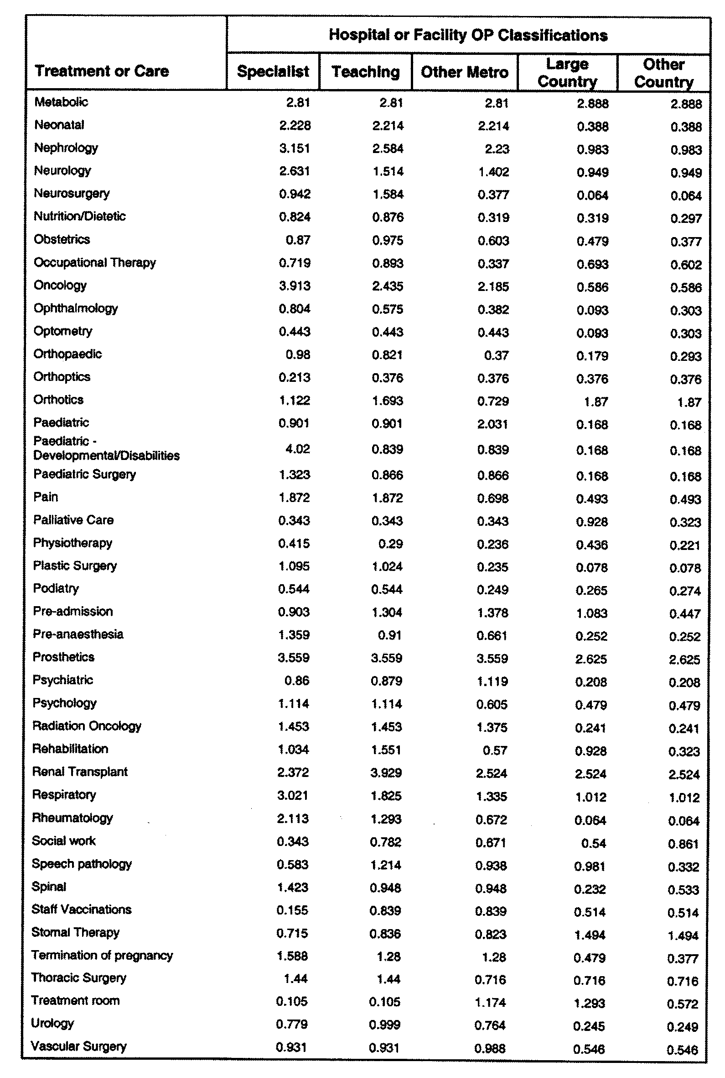
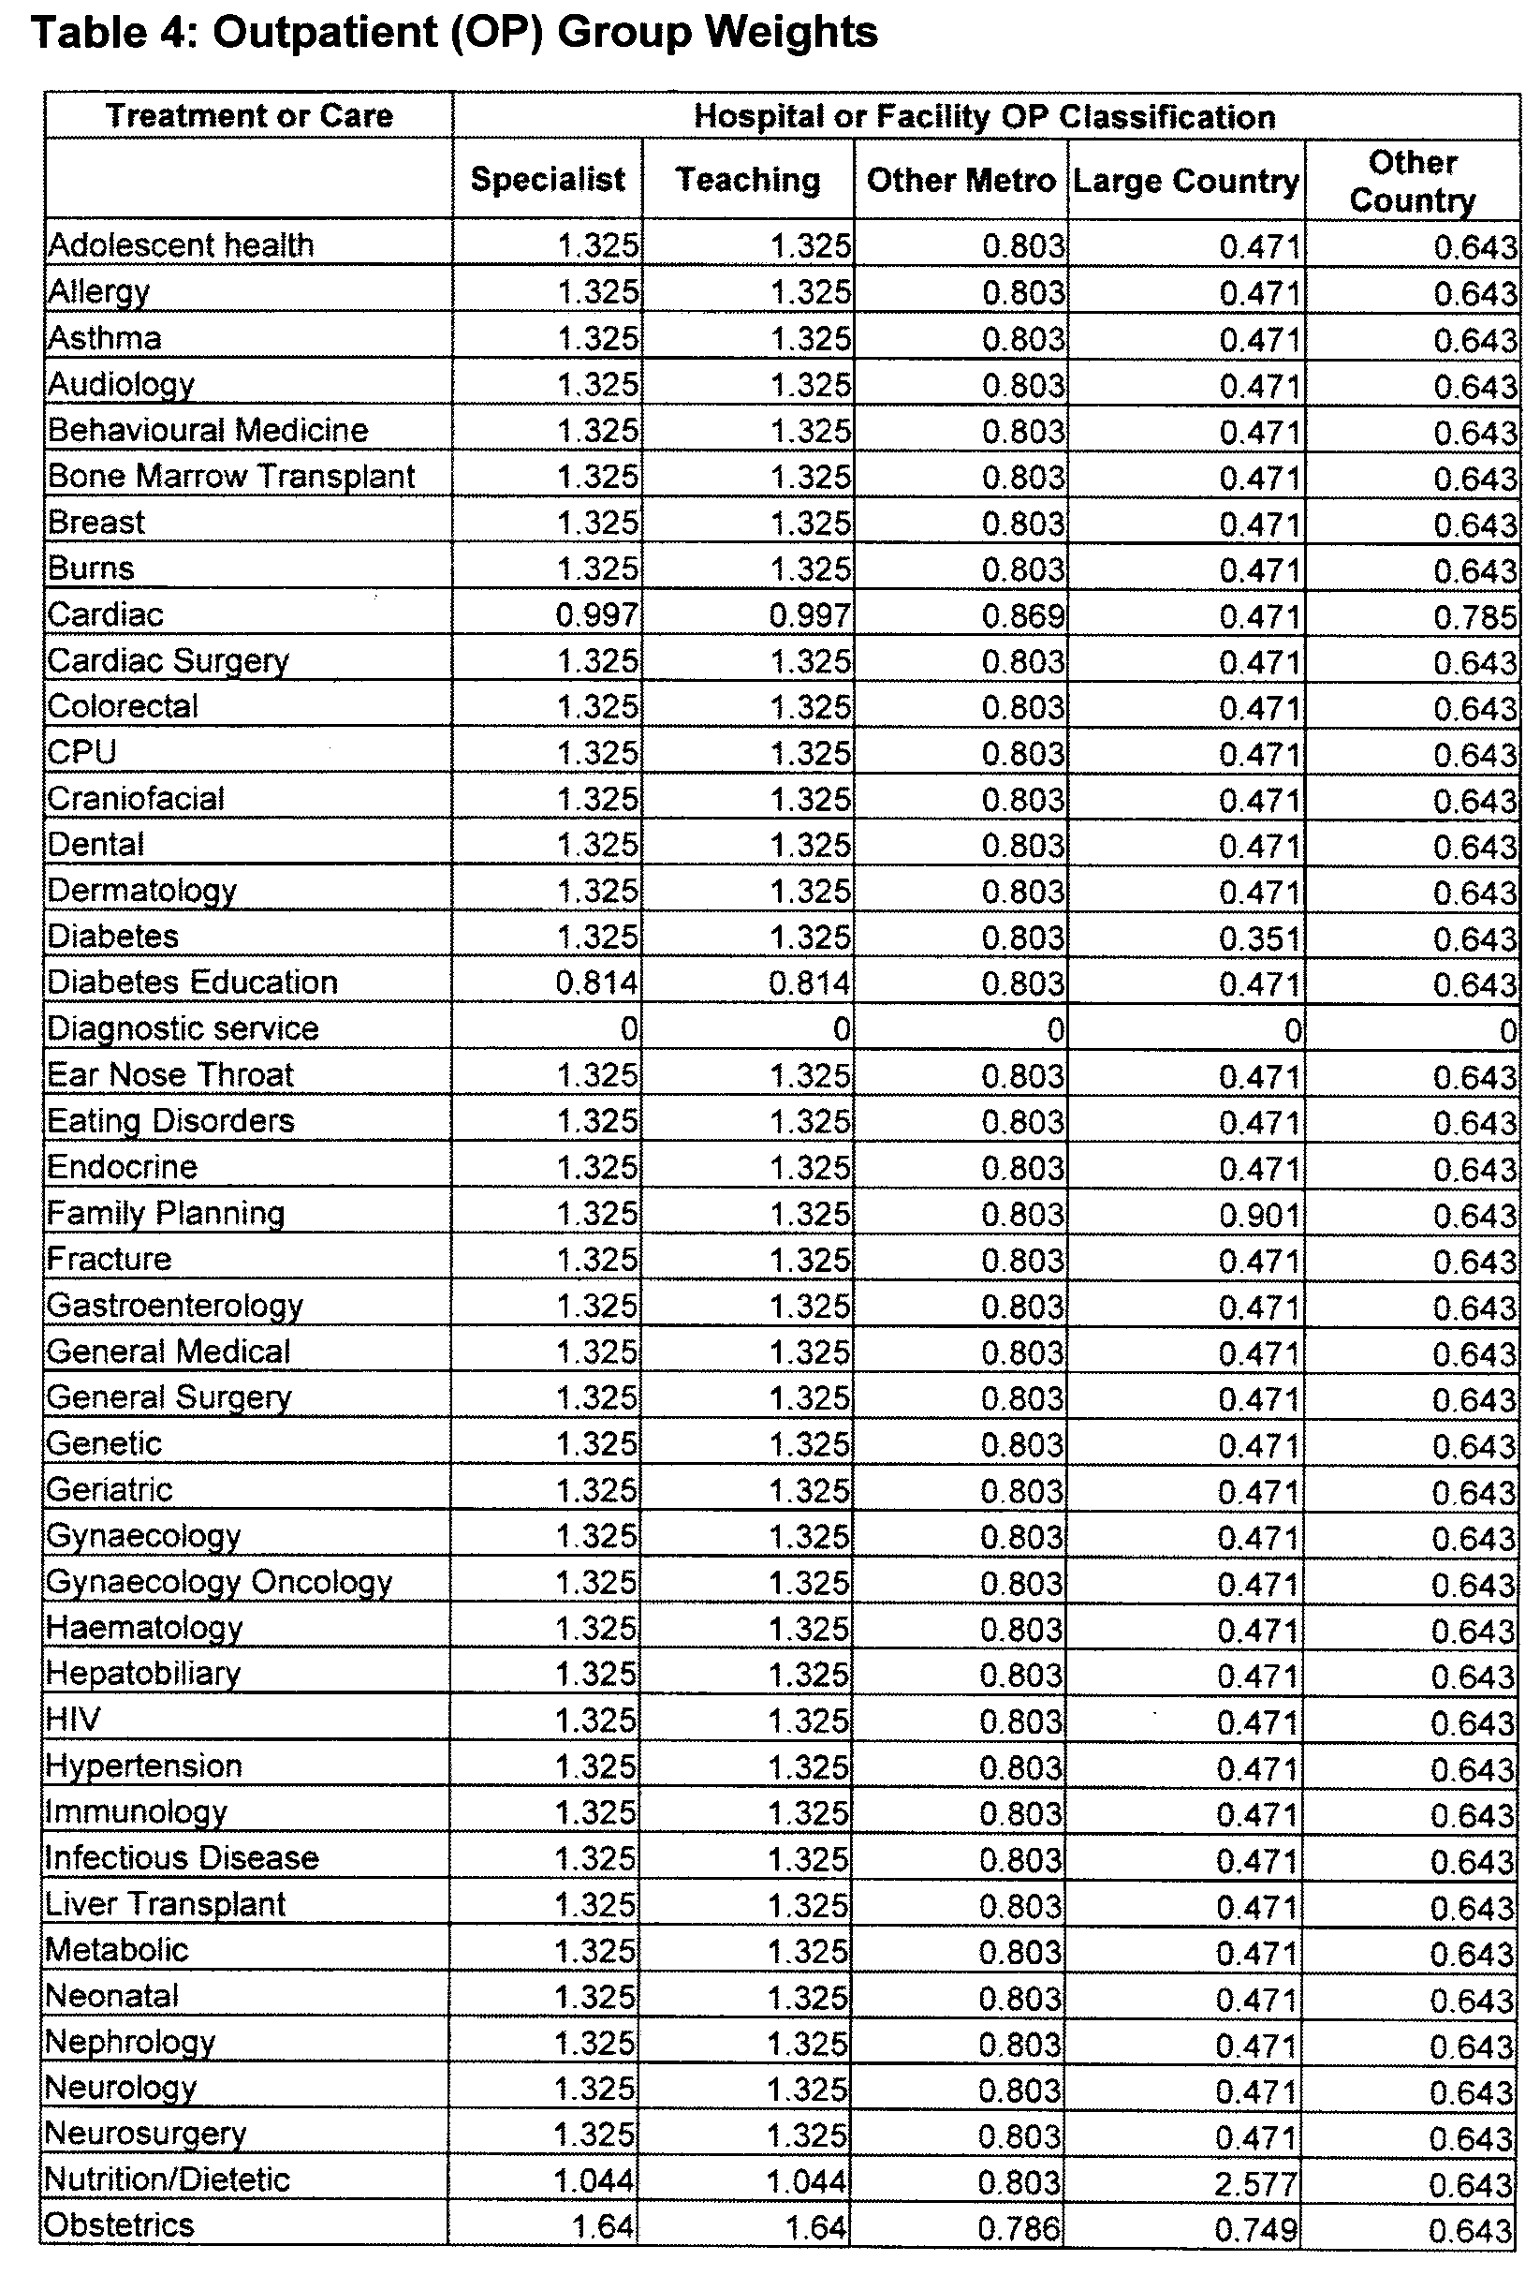
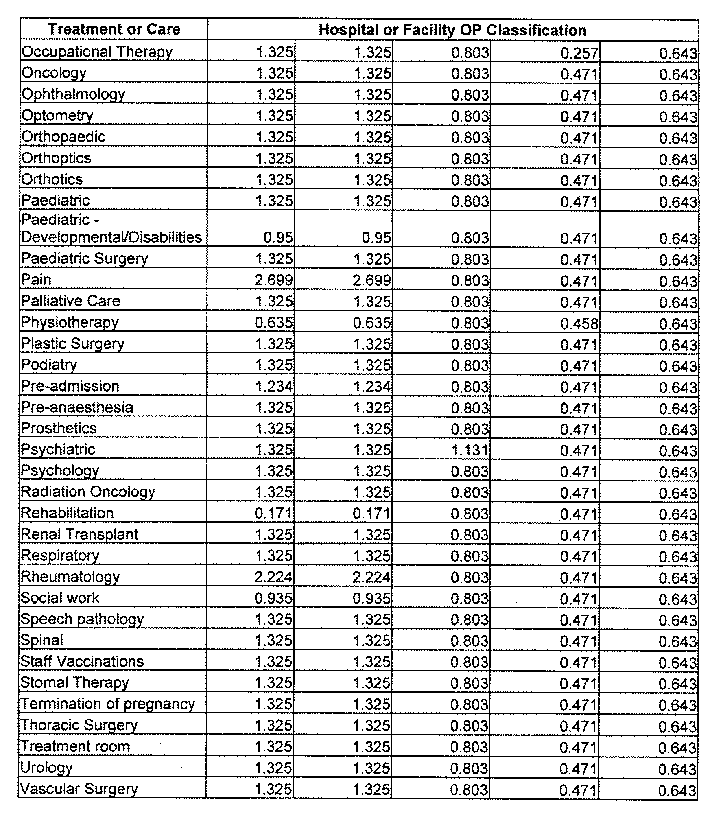
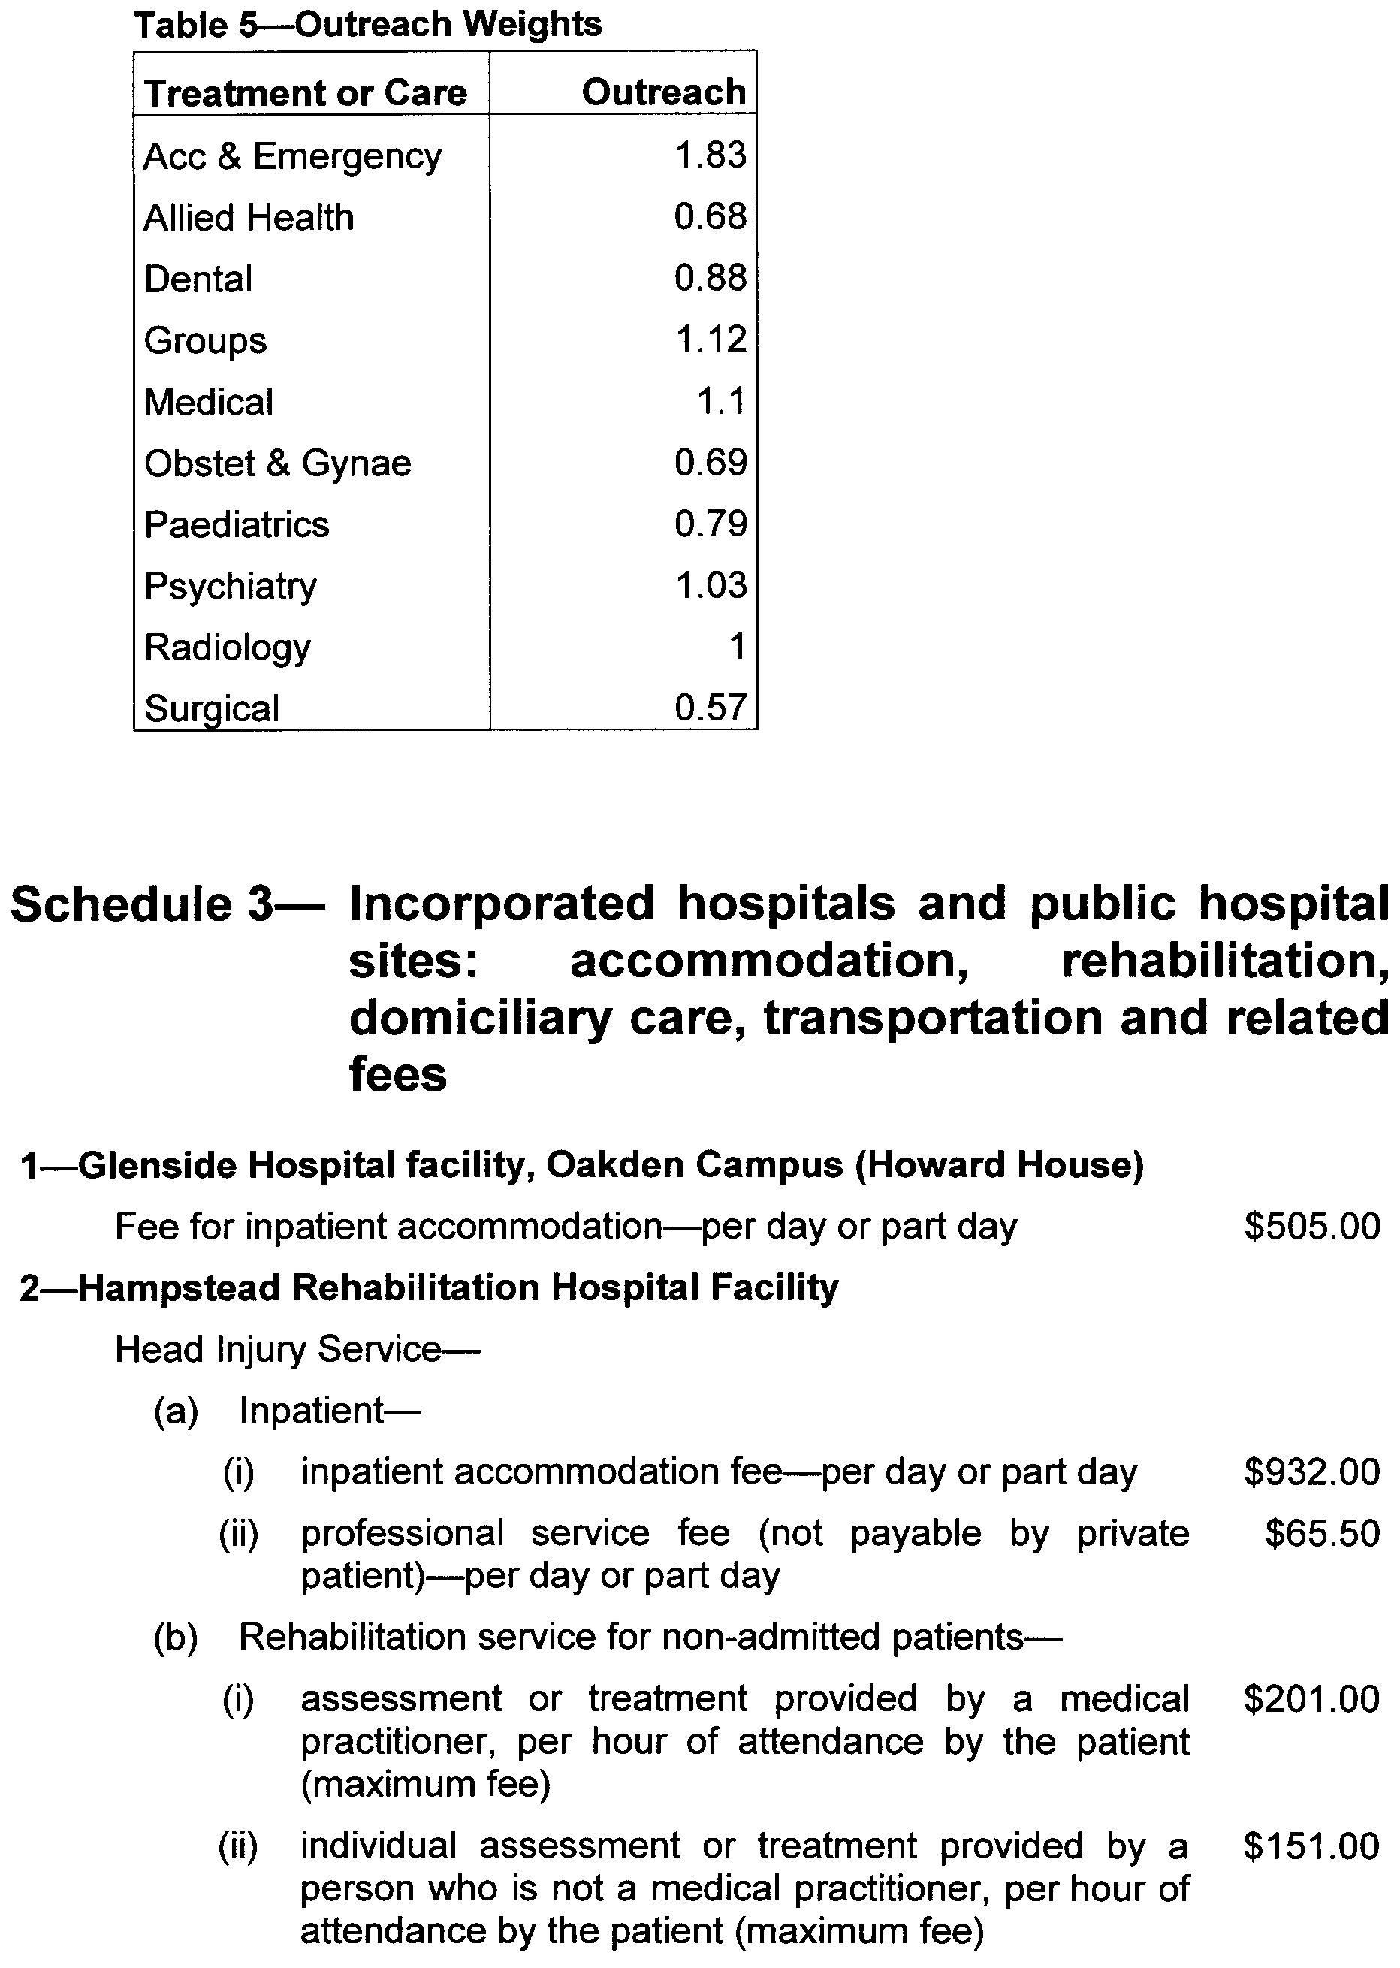
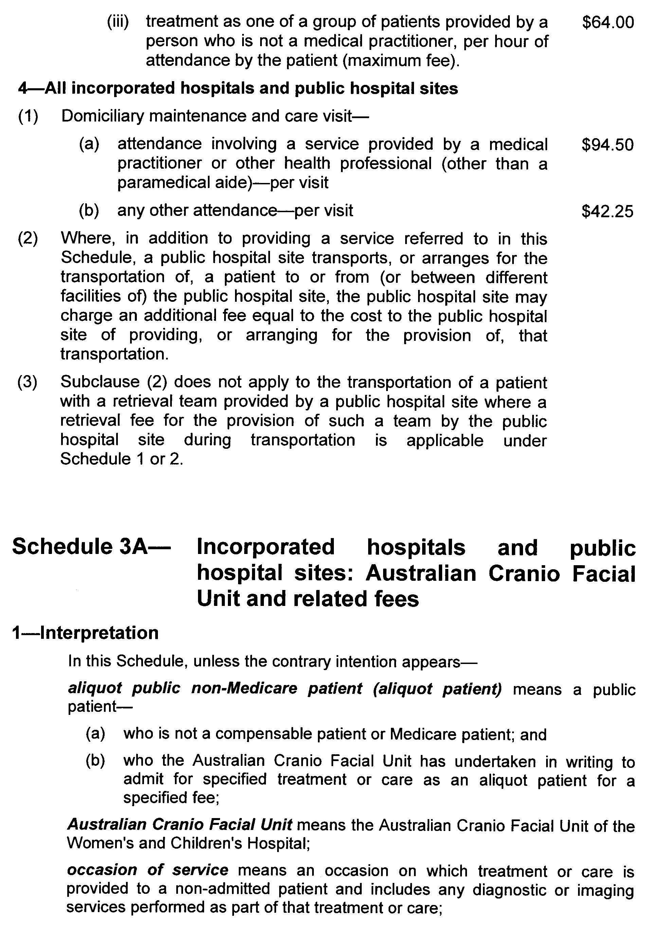
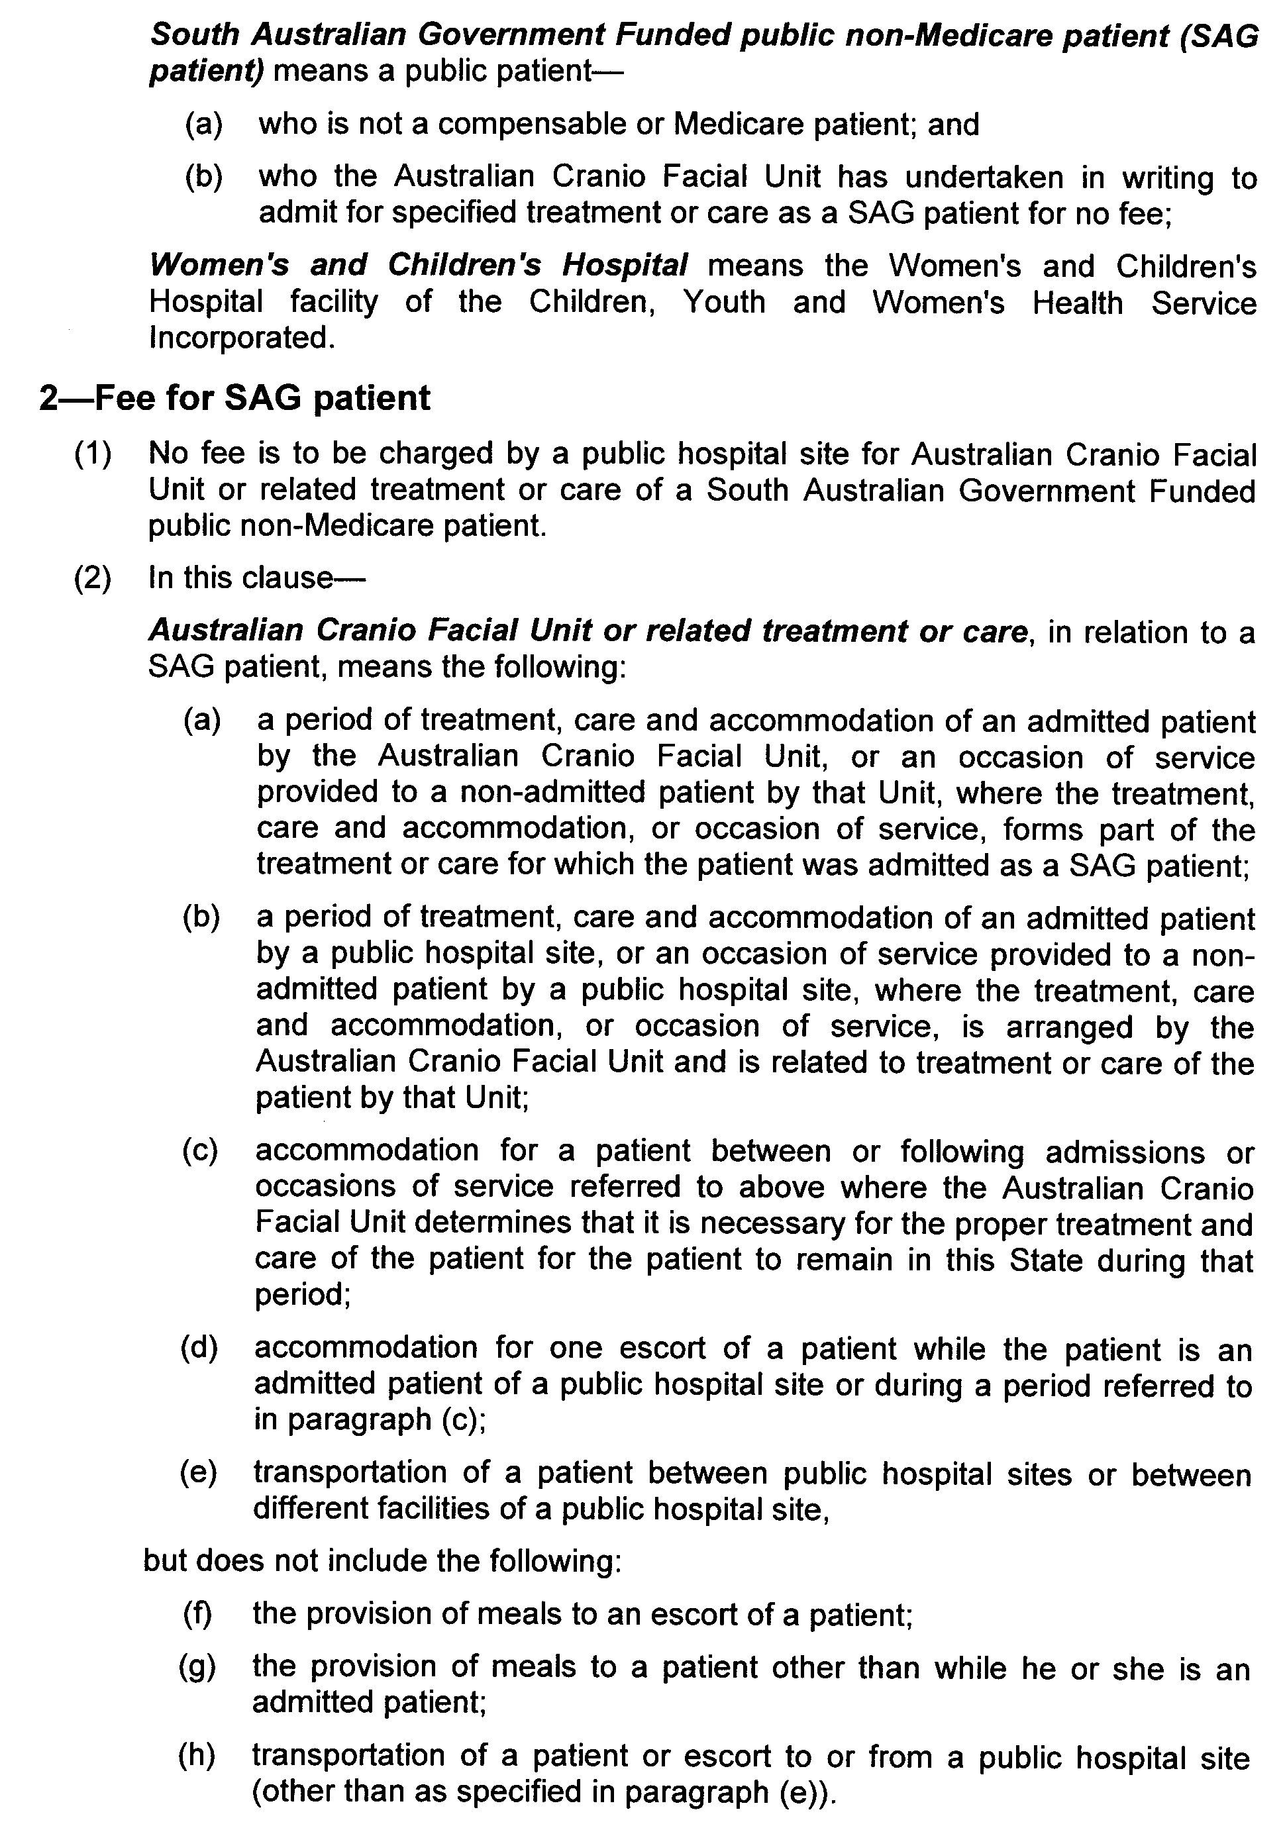
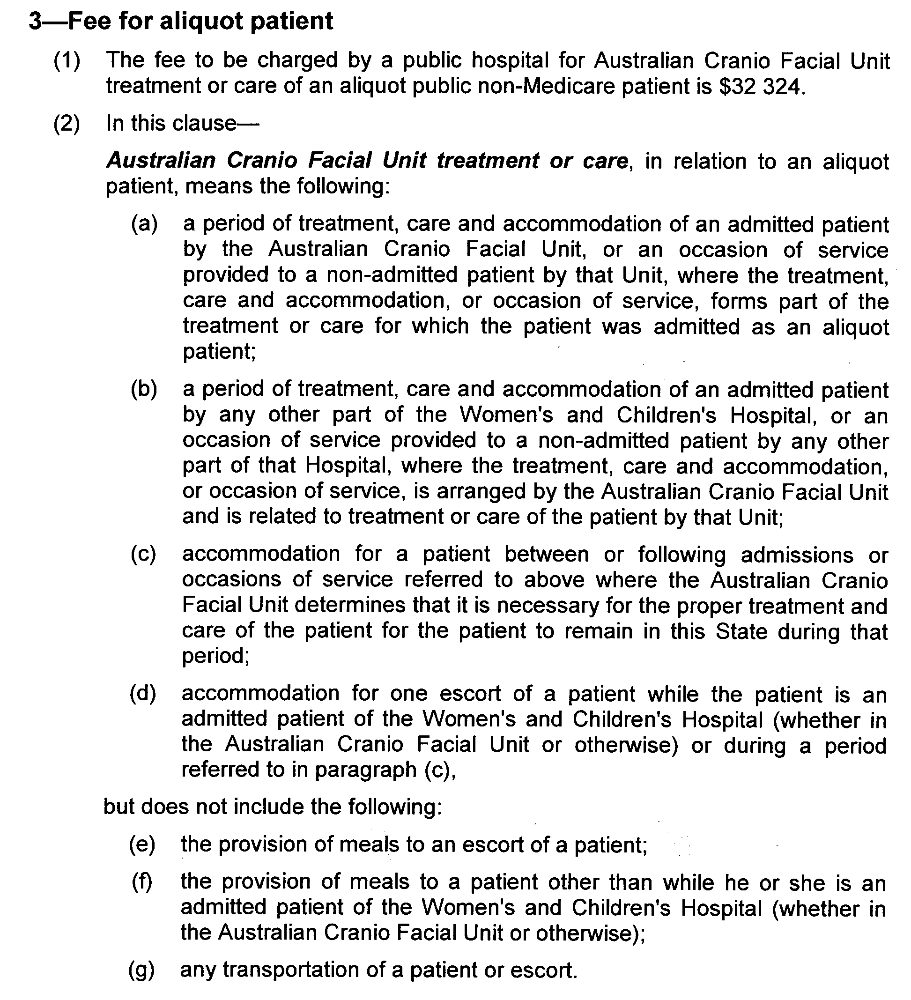
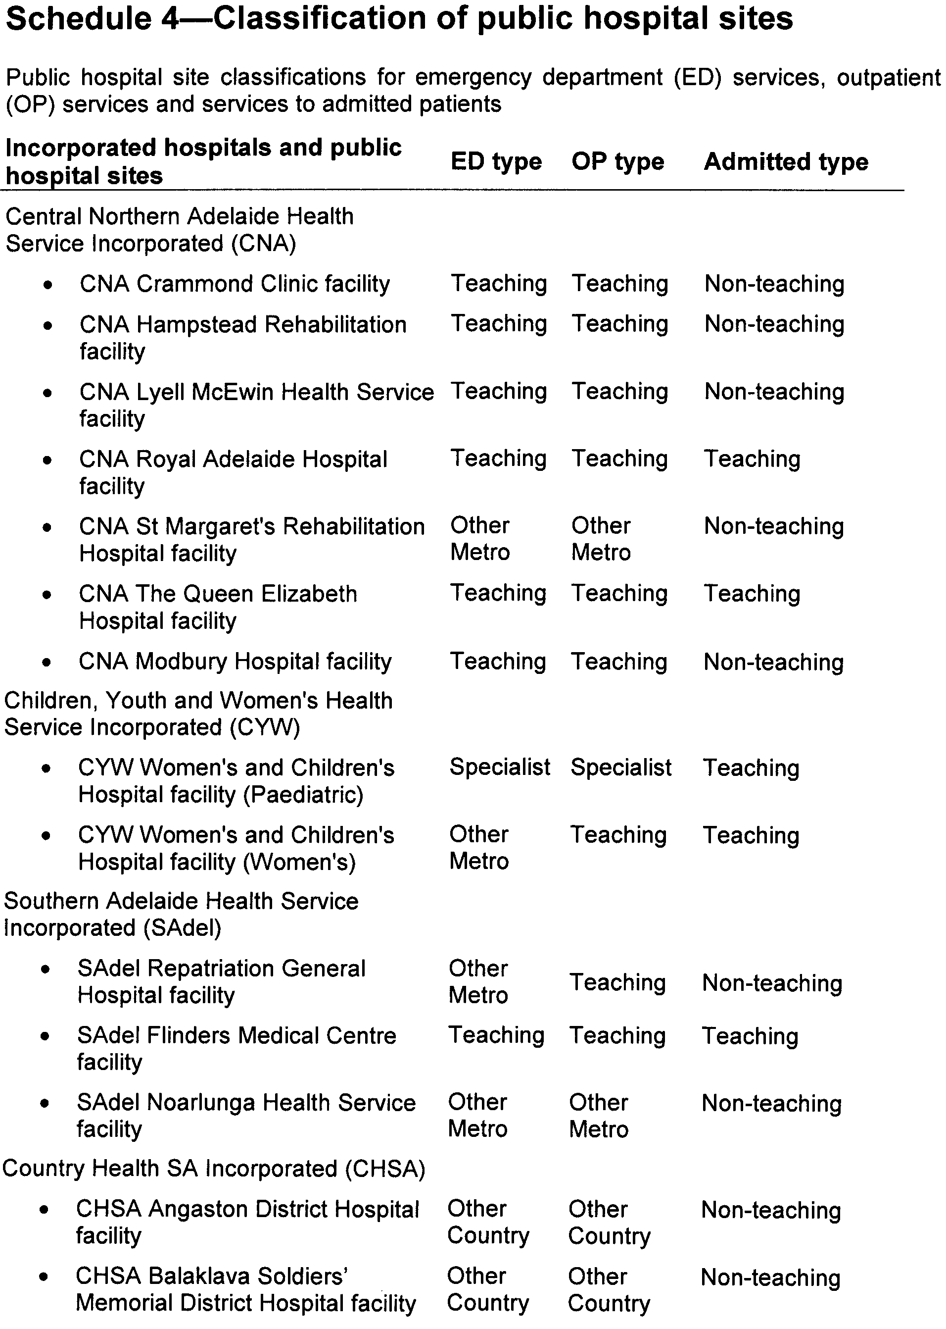
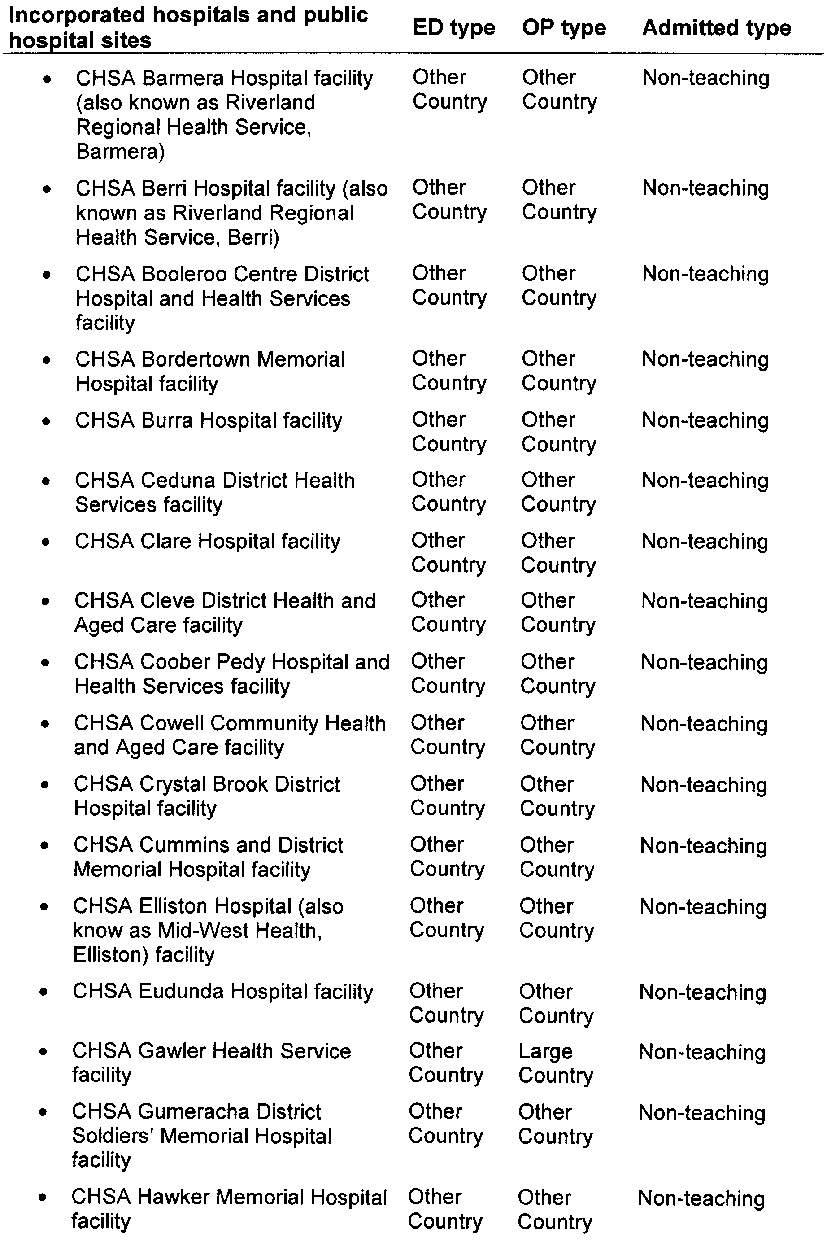
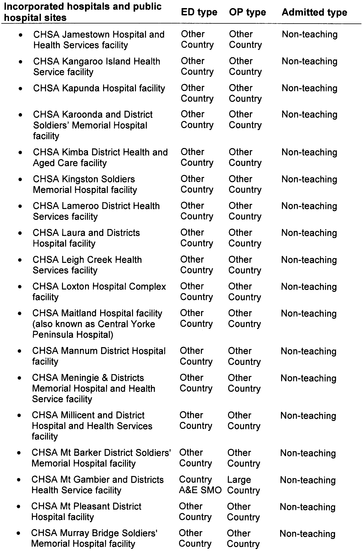
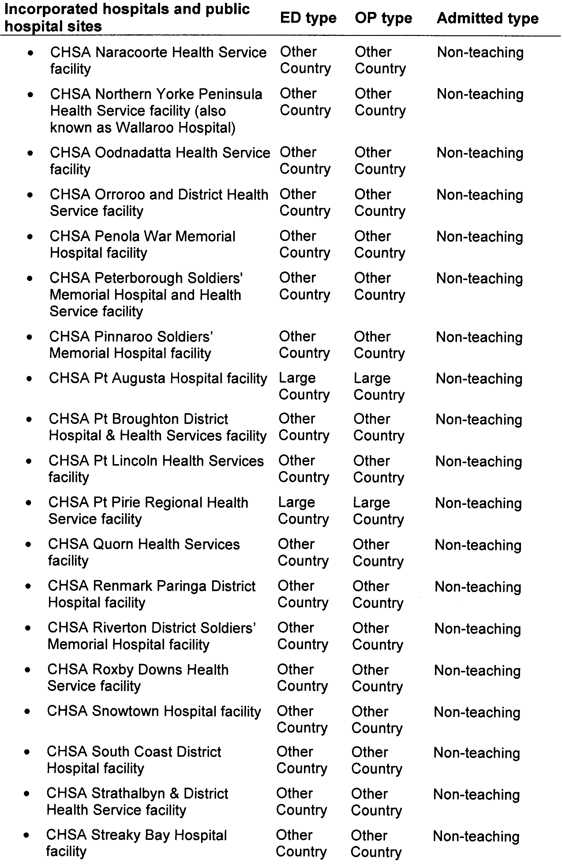
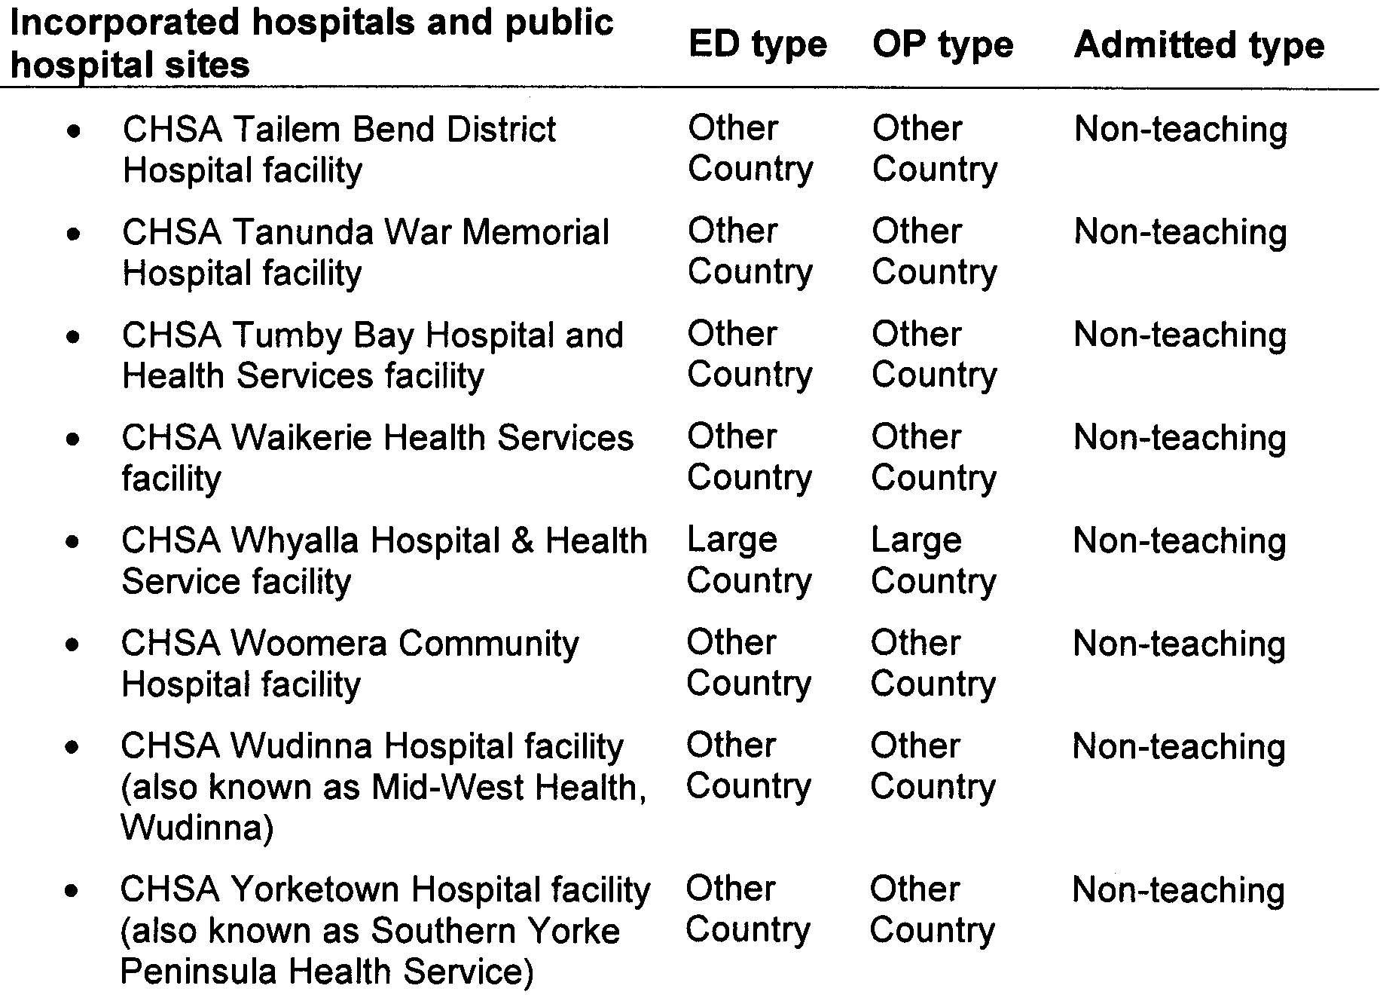

HEALTH CARE ACT 2008
Fees and Charges
I, JOHN HILL, Minister for Health, hereby give notice pursuant to section 44 of the Health Care Act 2008, of the fees in the list attached to apply to a Medicare patient who is not a compensable patient.
These charges will operate from 1 July 2010 to 30 June 2011.
Dated 18 May 2010.
John Hill, Minister for Health

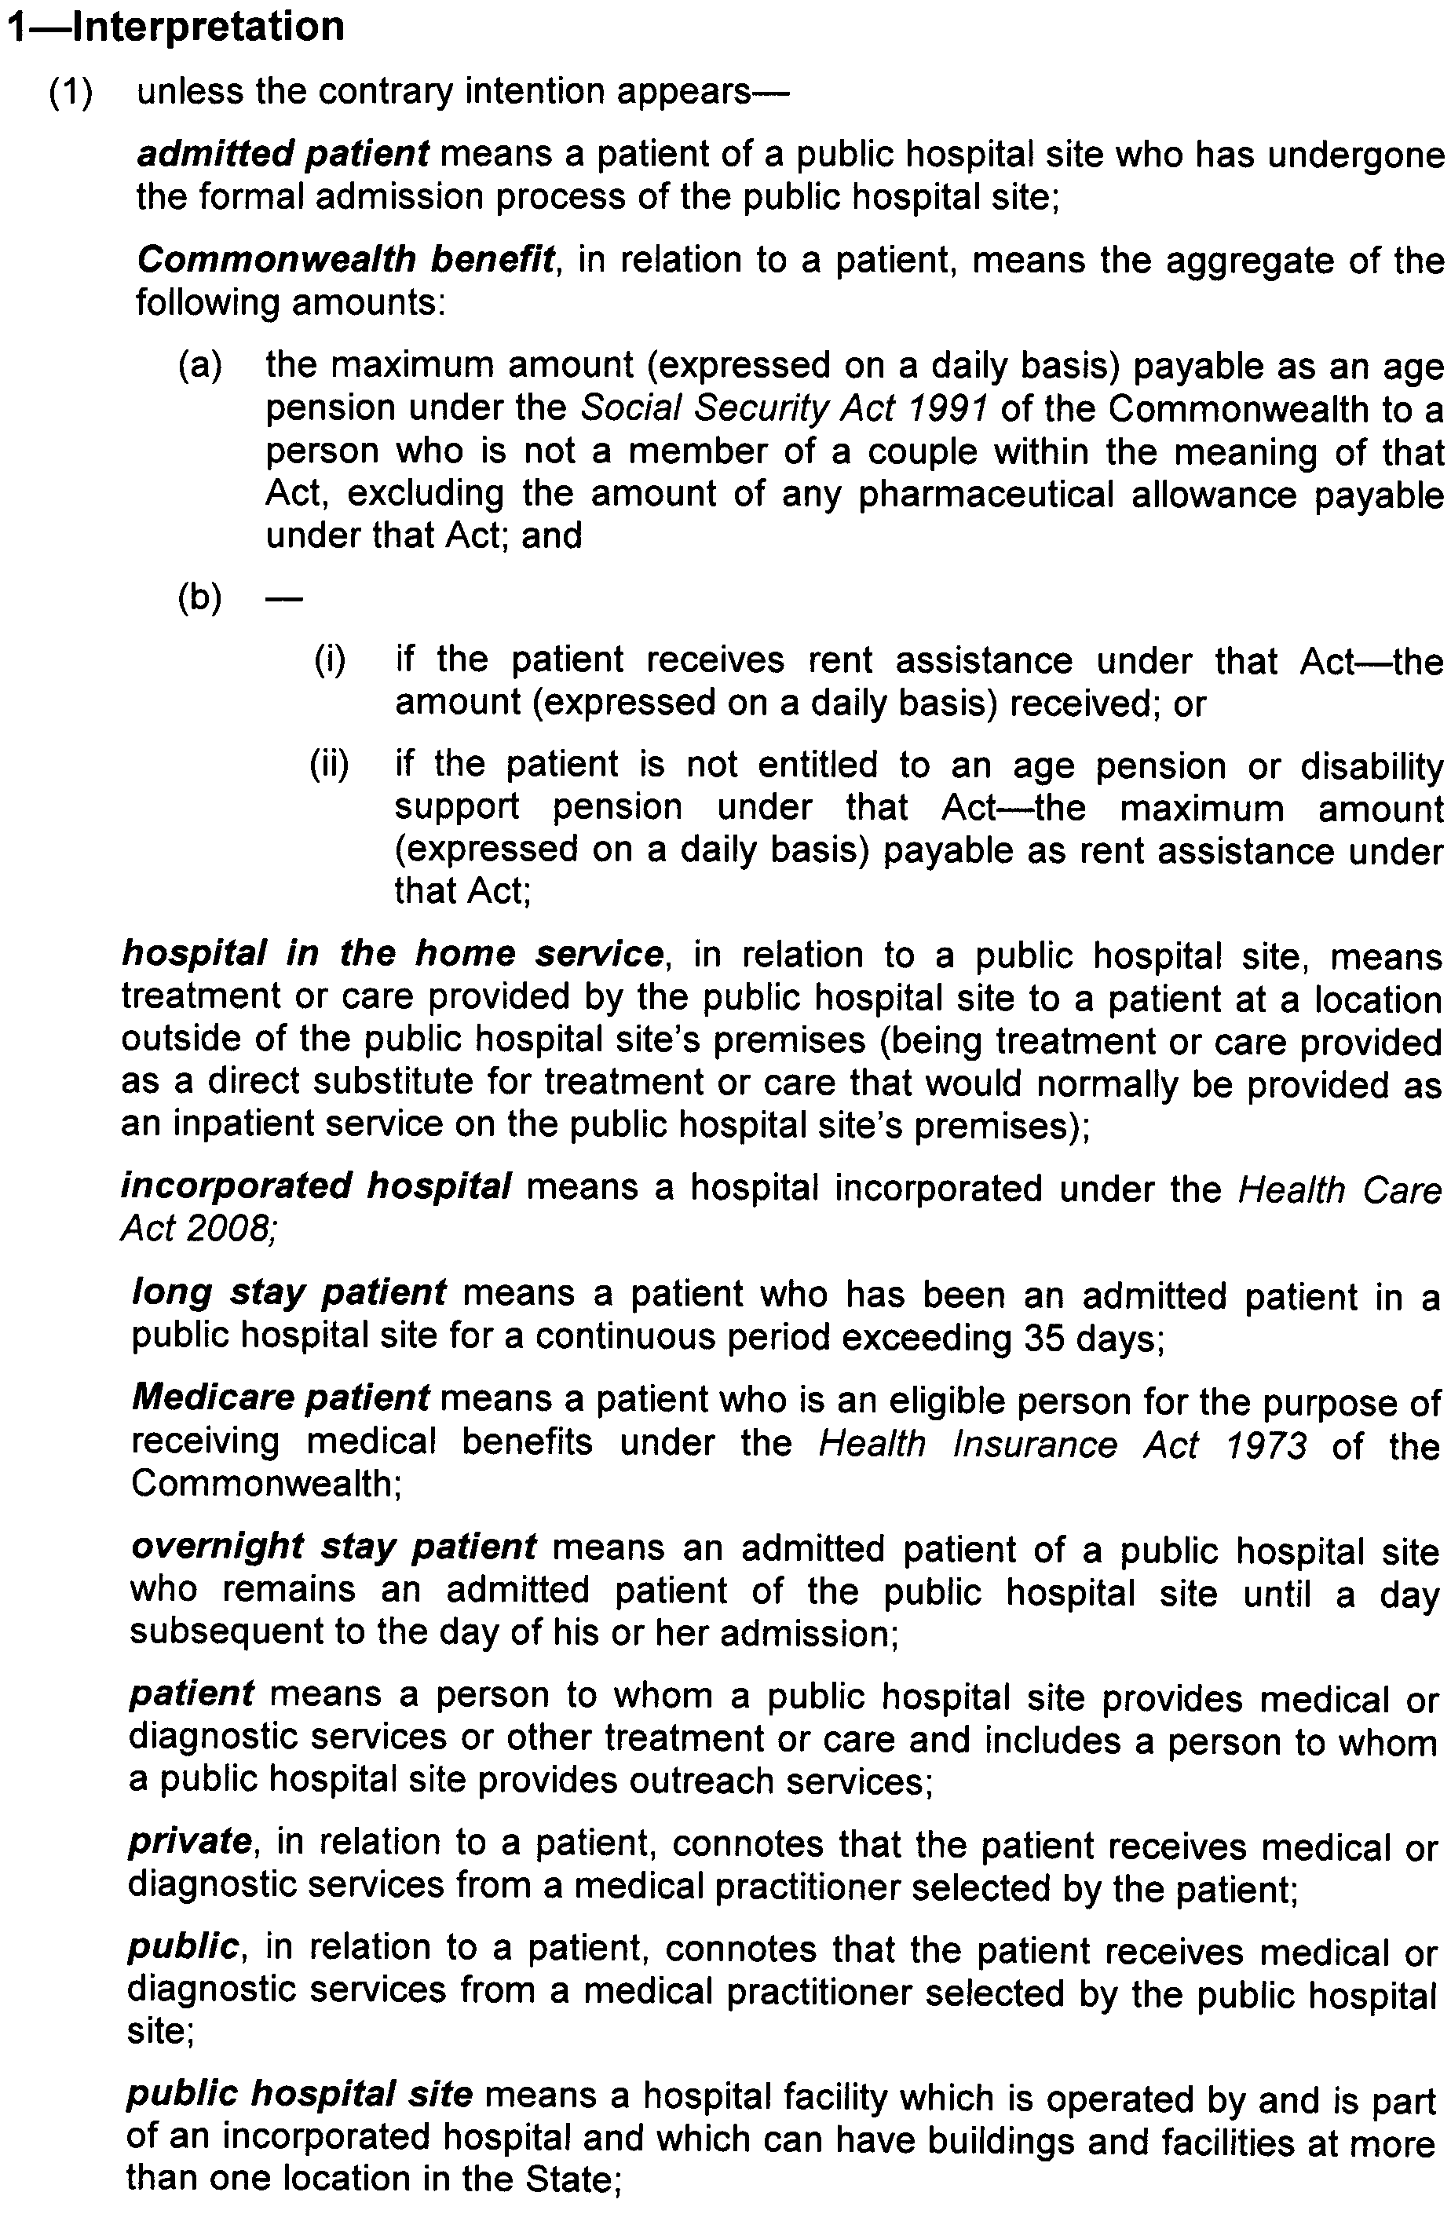
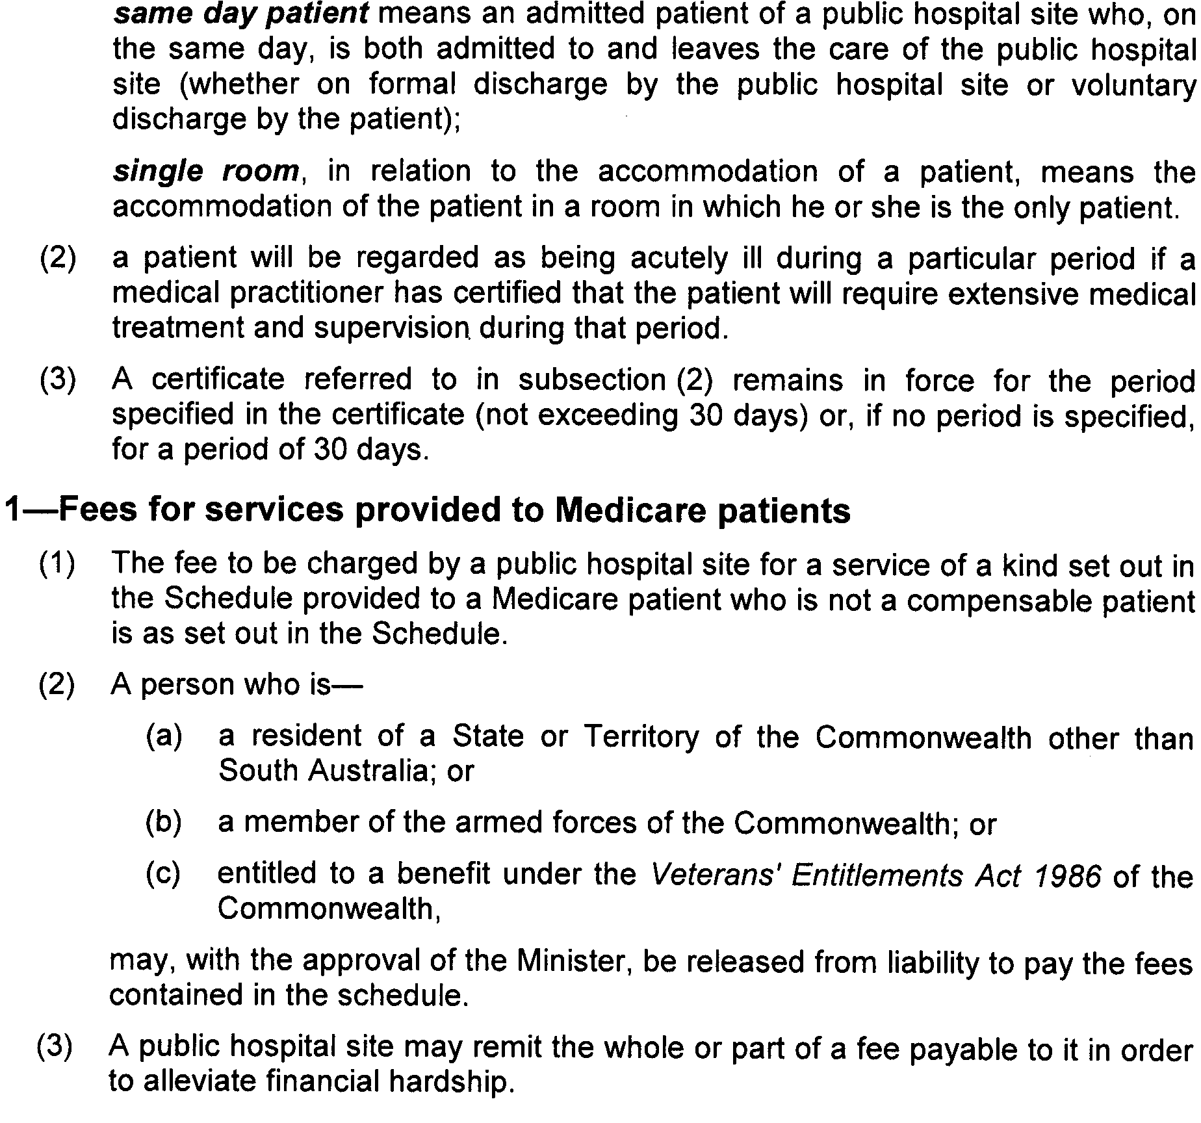
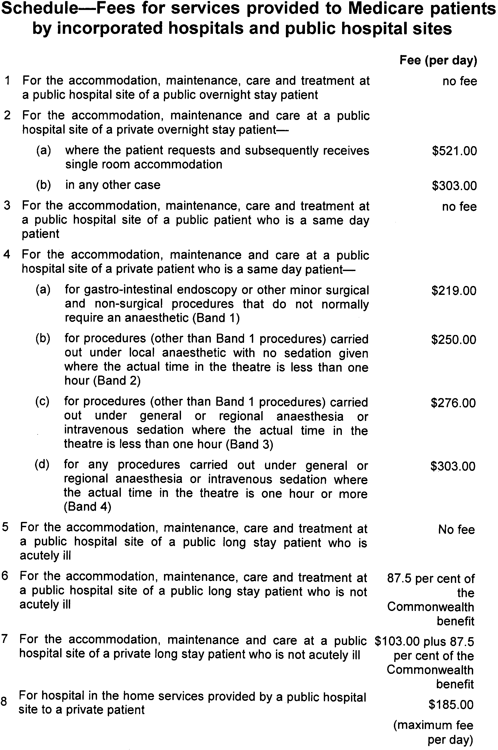

HOUSING IMPROVEMENT ACT 1940
NOTICE is hereby given that the South Australian Housing Trust Board Delegate in the exercise of the powers conferred by the Housing Improvement Act 1940, does hereby declare the houses described in the table hereunder to be substandard for the purposes of Part 7 of the Housing Improvement Act 1940.
No. of House and Street | Locality | Allotment, Section, etc. | Certificate of Title  Volume Folio

73 Fairview Terrace, |  | Clearview | Allotment 364 in Deposited Plan 4807, Hundred of Yatala | 5665 | 540
Lot 112 Gomersal Road, |  | Sheaoak Log | Allotment 1 in Filed Plan 155993, Hundred of Nuriootpa | 5281 | 748
16 Jennifer Drive, |  | Happy Valley | Allotment 187 in Deposited Plan 9947, Hundred of Noarlunga | 5085 | 938
5 Staude Street, |  | Naracoorte | Allotment 7 in Deposited Plan 5065, Hundred of Naracoorte | 5631 | 336
10 Wells Street |  | Birkenhead | Allotment 106 in Filed Plan 3636, Hundred of Port Adelaide | 5088 | 954

Dated at Adelaide, 10 June 2010. S. Trebilcock for D. Huxley, Director, Corporate Services, Housing SA

HOUSING IMPROVEMENT ACT 1940
WHEREAS by notice published in the Government Gazette on the dates mentioned in the following table the South Australian Housing Trust Board Delegate did declare the houses described in the said table to be substandard for the purposes of Part 7 of the Housing Improvement Act 1940, the South Australian Housing Trust Board Delegate in the exercise of the powers conferred by the said Part, does hereby fix as the maximum rental per week which shall be payable subject to section 55 of the Residential Tenancies Act 1995, in respect of each house described in the following table the amount shown in the said table opposite the description of such house and this notice shall come into force on the date of this publication in the Gazette.
Address of House | Allotment, Section, etc. | Certificate of Title  Volume Folio | Date and page of Government Gazette in which notice declaring house to be substandard published | Maximum rental per week payable in respect of each house  $

41 Anderson Avenue, Port Noarlunga |  | Allotment 78 in Filed Plan 151954, Hundred of Noarlunga | 5760 | 154 |  | 26.9.91, page 901 | 150.00
Lot 1, Carrickalinga Road, Normanville (Nina’s Estate) |  | Allotment 1 in Deposited Plan 15227, Hundred of Yankalilla | 5747 | 459 |  | 4.3.10, page 940 | 145.00
313 Esplanade, Moana |  | Allotment 60 in Deposited Plan 3752, Hundred of Willunga | 5720 | 695 |  | 26.10.06, page 3774 | 237.00
18 First Street, Minlaton |  | Allotment 871 in Filed Plan 196293, Hundred of Minlacowie | 5551 | 360 |  | 18.3.10, page 1054 | 129.00
8 Kalara Street, Brahma Lodge |  | Allotment 115 in Deposited Plan 7840 of Yatala | 5169 | 603 |  | 18.3.10, page 1054 | 195.00
2, 16 Meadow Avenue, Campbelltown |  | Allotment 123 in Deposited Plan 3766, Hundred of Adelaide | 5661 | 971 |  | 21.1.10, page 249 | 150.00
122 Moscow Street, Peterborough |  | Allotment 110 in Deposited Plan 1544 Hundred of Yongala | 5157 | 833 |  | 30.11.95, page 1513 | 78.00
Unit 1, 18 Murray Street, Tanunda |  | Allotment 553 in Filed Plan 172004, Hundred of Moorooroo | 5955 | 876 |  | 15.4.10, page 1257 | 90.00
570 Portrush Road, Glen Osmond |  | Allotment 3 in Deposited Plan 24979, Hundred of Adelaide | 5075 | 955 |  | 1.4.10, page 1180 | 194.00
26 Thomas Street, Salisbury |  | Allotment 32 in Deposited Plan 5157, Hundred of Yatala | 5572 | 715 |  | 15.4.10, page 1257 | 160.00
12-12A Wilford Avenue, Underdale |  | Allotment 71 and 72 in Deposited Plan 3427, Hundred of Adelaide | 5622 | 425 |  | 1.4.10, page 1180 | 197.00
40 William Street, Beverley |  | Allotment 13 in Filed Plan 122360, Hundred of Yatala | 5731 | 640 |  | 29.4.10, page 1637 | 240.00

Dated at Adelaide, 10 June 2010. S. Trebilcock for D. Huxley, Director, Corporate Services, Housing SA

HOUSING IMPROVEMENT ACT 1940
WHEREAS by notice published in the Government Gazette on the dates mentioned in the following table, the South Australian Housing Trust Board Delegate did declare the houses described in the following table to be substandard for the purposes of Part 7 of the Housing Improvement Act 1940, and whereas the South Australian Housing Trust Board Delegate is satisfied that each of the houses described hereunder has ceased to be substandard, notice is hereby given that, in exercise of the powers conferred by the said Part, the South Australian Housing Trust does hereby revoke the said declaration in respect of each house.
Address of House | Allotment, Section, etc. | Certificate of Title  Volume Folio | Date and page of Government Gazette in which notice declaring house to be substandard published

5 Bracken Avenue, Gilles Plains |  | Allotment 503 in Deposited Plan 65192, Hundred of Yatala | 5927 | 202 |  | 22.3.07, page 848
46 Carrickalinga Road, Carrackalinga |  | Allotment 273 in Deposited Plan 6398, Hundred of Myponga | 5378 | 81 |  | 8.10.09, page 4809
6 Clara Street, Wallaroo |  | Allotment 716 in Filed Plan 189658, Hundred of Wallaroo | 5449 | 661 |  | 10.4.08, page 1256
24 Durdin Road, Elizabeth Vale |  | Allotment 3 in Deposited Plan 18029, Hundred of Munno Para | 5124 | 278 |  | 13.5.10, page 1820
10 Green Street, Elizabeth Park |  | Allotment 14 in Deposited Plan 53572, Hundred of Munno Para | 5732 | 835 |  | 25.5.06, page 1384
87 Halsey Road, Elizabeth East |  | Allotment 269 of subdivision of Section 3131, Hundred of Munno Para | 5581 | 341 |  | 9.1.97, page 92
300 Hampstead Road, Clearview |  | Allotment 34 in Filed Plan 127968, Hundred of Yatala | 5381 | 316 |  | 13.5.10, page 1820
255 Lyons Road, Dernancourt |  | Allotment 140 in Deposited Plan 3073, Hundred of Yatala | 5633 | 615 |  | 14.12.06, page 4321

Dated at Adelaide, 10 June 2010. S. Trebilcock for D. Huxley, Director, Corporate Services, Housing SA

LAND ACQUISITION ACT 1969
(Section 16)
Notice of Acquisition
THE COMMISSIONER OF HIGHWAYS (the ‘Authority’), 136 North Terrace, Adelaide, S.A. 5000, acquires the following interests in the following land:
Definition of Land Acquired
Comprising an estate in fee simple in that piece of land situated at Lot 4, South Terrace, Wingfield, being the whole of Allotment 4 in Deposited Plan No. 41775, comprised in Certificate of Title volume 5268, folio 37
This notice is given under section 16 of the Land Acquisition Act 1969.
Compensation
A person who has or had an interest in the land that is divested or diminished by the acquisition or the enjoyment of which is adversely affected by the acquisition who does not receive an offer of compensation from the Authority may apply to the Authority for compensation.
Inquiries
Inquiries should be directed to:
Mary Rose Ward,
G.P.O. Box 1533,
Adelaide, S.A. 5001
Phone (08) 8343 2706
Dated 8 June 2010.
The Common Seal of the Commissioner of Highways was hereto affixed by authority of the Commissioner of Highways in the presence of:
D. Thomas, Manager, Property Planning and Management Services (Authorised Officer), Department for Transport, Energy and Infrastructure
DTEI 2008/14744/01

LAND ACQUISITION ACT 1969
(Section 16)
Notice of Acquisition
THE COMMISSIONER OF HIGHWAYS (the ‘Authority’), 136 North Terrace, Adelaide, S.A. 5000, acquires the following interests in the following land:
Definition of Land Acquired
Comprising an estate in fee simple in that piece of land situated at Lot 5, Davis Street, Wingfield, being the whole of Allotment 5 in Deposited Plan No. 20820, comprised in Certificate of Title volume 5451, folio 784, subject to the easement created by T2020479 to the council for the area
This notice is given under section 16 of the Land Acquisition Act 1969.
Compensation
A person who has or had an interest in the land that is divested or diminished by the acquisition or the enjoyment of which is adversely affected by the acquisition who does not receive an offer of compensation from the Authority may apply to the Authority for compensation.
Inquiries
Inquiries should be directed to:
Mary Rose Ward,
G.P.O. Box 1533,
Adelaide, S.A. 5001
Phone (08) 8343 2706
Dated 8 June 2010.
The Common Seal of the Commissioner of Highways was hereto affixed by authority of the Commissioner of Highways in the presence of:
D. Thomas, Manager, Property Planning and Management Services (Authorised Officer), Department for Transport, Energy and Infrastructure
DTEI 2009/27856/01

LAND ACQUISITION ACT 1969
(Section 16)
Notice of Acquisition
CKI UTILITIES DEVELOPMENT LIMITED (ARBN 090 718 880) and HEI Utilities Development Ltd (ARBN 090 718 951) each incorporated in the Bahamas and Spark Infrastructure SA (No. 1) Pty Ltd (ACN 091 142 380), Spark Infrastructure SA (No. 2) Pty Ltd (ACN 091 143 038) and Spark Infrastructure SA (No. 3) Pty Ltd (ACN 091 142 362) each incorporated in Australia trading as ETSA Utilities (ABN 13 332 330 749) (the ‘Authority’) all of 1 Anzac Highway, Keswick, S.A. 5035 acquires the following interests in the following land:
Definition of Land Acquired
An easement over that portion of Allotment 1 in Deposited Plan 21959 marked ‘B’ in Filed Plan 54218 and being portion of the land comprised in certificate of title volume 5254, folio 147.
Extent of interest vested in the Authority:
For it, its agents, servants or workmen at any time and from time to time:
(1) to lay under the surface of the said land ducts, pipes, cables, spare conduits and associated infrastructure (Electricity Infrastructure);
(2) to inspect, alter, maintain, repair, remove and replace any or all of the Electricity Infrastructure; and
(3) to use the Electricity Infrastructure for the purpose of transmitting electricity;
and for any of the aforesaid purposes:
(4) to break the surface of, dig, open up, bore into and use the land;
(5) to demolish and remove any existing buildings;
(6) to redirect traffic, erect or remove any safety or traffic barriers, erect or remove any signage and erect and remove temporary lighting;
(7) to carry out any other necessary works or works ancillary to any of the works; and
(8) to enter and occupy the land at any time (if necessary with vehicles and equipment) and from time to time.
This notice is given under section 16 of the Land Acquisition Act 1969.
Compensation
A person who has or had an interest in the land that is divested or diminished by the acquisition or the enjoyment of which is adversely affected by the acquisition who does not receive an offer of compensation from the Authority may apply to the Authority for compensation.
Inquiries
Inquiries should be directed to:
Teresa Sergi—Real Estate Advisor
ETSA Utilities—Real Estate Branch
G.P.O. Box 77,
Adelaide, S.A. 5001
Telephone: (08) 8404 4065.
Dated 10 June 2010.
D. J. Brumpton, Manager, Property Services—ETSA Utilities

LIQUOR LICENSING ACT 1997 AND GAMING MACHINES ACT 1992
Notice of Application
NOTICE is hereby given, pursuant to section 52 of the Liquor Licensing Act 1997 and section 29 of the Gaming Machines Act 1992, that Peppertree Hotels Pty Ltd has applied to the Licensing Authority for the transfer of a Hotel and Gaming Machine Licence in respect of premises situated at 17 Light Street, Hamley Bridge, S.A. 5401 and known as Hamley Bridge Hotel.
The applications have been set down for hearing on 12 July 2010 at 9.30 a.m.
Any person may object to the application by lodging a notice of objection in the prescribed form with the Liquor and Gambling Commissioner and serving a copy of the notice on the applicant at the applicant’s address, at least seven days before the hearing date (viz: 5 July 2010).
The applicant’s address for service is c/o Philip Foreman, Foreman Legal, 69 Mount Barker Road, Stirling, S.A. 5152.
The application and certain documents and material (including Plans) relevant to the application may be inspected without fee at a place and during a period specified by the Liquor and Gambling Commissioner, 9th Floor, East Wing, 50 Grenfell Street, Adelaide, S.A. 5000. Telephone 8226 8410, Facsimile: 8226 8512. Email: olgc@agd.sa.gov.au.
Dated 2 June 2010.
Applicant

LIQUOR LICENSING ACT 1997
Notice of Application
NOTICE is hereby given, pursuant to section 52 (2) (b) of the Liquor Licensing Act 1997, that Aroma BBQ Pty Ltd has applied to the Licensing Authority for a Restaurant Licence with Section 34 (1) (c) Authorisation and Extended Trading Authorisation in respect of premises situated at Shop 4, 31-39 Gouger Street, Adelaide, S.A. 5000 and to be known as Aroma Charcoal Grill BBQ Restaurant.
The application has been set down for hearing on 7 July 2010 at 11.30 a.m.
Conditions
The following licence conditions are sought:
• Approval under Section 34 (1) (c) to sell liquor on any day except Good Friday and Christmas Day for consumption on the Licensed Premises by a person:
Seated at a table; or
Attending a function at which food is provided.
• Extended Trading Authorisation is sought for the following days and times in relation to the abovementioned condition:
Sunday: 8 a.m. to 11 a.m. and 8 p.m. to Midnight.
Any person may object to the application by lodging a notice of objection in the prescribed form with the Liquor and Gambling Commissioner and serving a copy of the notice on the applicant at the applicant’s address, at least seven days before the hearing date (viz: 30 June 2010).
The applicant’s address for service is c/o Robert Lempens, Camatta Lempens Pty Ltd Lawyers, First Floor, 345 King William Street, Adelaide, S.A. 5000.
The application and certain documents and material (including Plans) relevant to the application may be inspected without fee at a place and during a period specified by the Liquor and Gambling Commissioner, 9th Floor, East Wing, 50 Grenfell Street, Adelaide, S.A. 5000. Telephone 8226 8410, Facsimile: 8226 8512. Email: olgc@agd.sa.gov.au.
Dated 1 June 2010.
Applicant

LIQUOR LICENSING ACT 1997
Notice of Application
NOTICE is hereby given, pursuant to section 52 (2) (b) of the Liquor Licensing Act 1997, that Gow Holdings Pty Ltd has applied to the Licensing Authority for a variation to an Extended Trading Authorisation and variation to Entertainment Consent in respect of premises situated at 208 Main Road, McLaren Vale, S.A. 5171 and known as Hotel McLaren.
The application has been set down for hearing on 8 July 2010 at 9 a.m.
Conditions
The following licence conditions are sought:
• Variation to an Extended Trading Authorisation for the premises to include:
For consumption on the licensed premises:
Sunday (including Sundays preceding Public Holidays): 8 a.m. to 10 a.m.
Good Friday: Midnight to 2 a.m.
Christmas Day: Midnight to 2 a.m.
For consumption off the licensed premises:
Sunday: 8 a.m. to 11 a.m. and 8 p.m. to 9 p.m.
• Variation to Entertainment Consent to include the abovementioned hours for the currently approved areas.
Any person may object to the application by lodging a notice of objection in the prescribed form with the Liquor and Gambling Commissioner and serving a copy of the notice on the applicant at the applicant’s address, at least seven days before the hearing date (viz: 1 July 2010).
The applicant’s address for service is c/o DMAW Laywers, Level 3, 80 King William Street, Adelaide, S.A. 5000 (Attention: Craig Vozzo).
The application and certain documents and material (including Plans) relevant to the application may be inspected without fee at a place and during a period specified by the Liquor and Gambling Commissioner, 9th Floor, East Wing, 50 Grenfell Street, Adelaide, S.A. 5000. Telephone 8226 8410, Facsimile: 8226 8512. Email: olgc@agd.sa.gov.au.
Dated 31 May 2010.
Applicant

LIQUOR LICENSING ACT 1997
Notice of Application
NOTICE is hereby given, pursuant to section 52 (2) (b) of the Liquor Licensing Act 1997, that Ulrich Walter Grey-Smith, 13 Memorial Drive, Connawarra, S.A. 5263 has applied to the Licensing Authority for a Direct Sales Licence in respect of the business to be known as Ulrich Water Grey-Smith.
The application has been set down for hearing on 8 July 2010 at 11 a.m.
Any person may object to the application by lodging a notice of objection in the prescribed form with the Liquor and Gambling Commissioner and serving a copy of the notice on the applicant at the applicant’s address, at least seven days before the hearing date (viz: 1 July 2010).
The applicant’s address for service is c/o Ulrich Walter Grey-Smith, P.O. Box 228, Coonawarra, S.A. 5263.
Plans in respect of the premises the subject of the application are open to public inspection without fee at the Office of the Liquor and Gambling Commissioner, 9th Floor, East Wing, 50 Grenfell Street, Adelaide, S.A. 5000. Phone 8226 8410, Fax:
8226 8512. Email: olgc@agd.sa.gov.au.
Dated 1 June 2010.
Applicant

LIQUOR LICENSING ACT 1997
Notice of Application
NOTICE is hereby given, pursuant to section 52 (2) (b) of the Liquor Licensing Act 1997, that Kowald Dunn Pty Ltd as trustee for V. & A. Seppelt Trust has applied to the Licensing Authority for a Special Circumstances Licence with an Extended Trading Authorisation and Entertainment Consent in respect of premises situated at Lot 723, Murray Street, Greenock, S.A. 5360 and to be known as Murray Street Vineyards.
The application has been set down for hearing on 8 July 2010 at 11.30 a.m.
Conditions
The following licence conditions are sought:
• For consumption on the licensed premises:
Monday to Sunday: 9 a.m. to midnight:
with or ancillary to food provided by the licensee; or
by persons attending a pre-booked function at which food is provided; or
by persons attending a reception; or
by persons seated at a table or by way of sample.
• For consumption off the licensed premises:
Monday to Sunday: 9 a.m. to midnight:
liquor sold and supplied for consumption off the licensed premises is restricted to liquor produced by the licensee or related body corporate.
• Entertainment Consent is sought for the premises as per plans lodged with this office and for the following days and times:
Monday to Sunday: 9 a.m. to midnight.
Any person may object to the application by lodging a notice of objection in the prescribed form with the Liquor and Gambling Commissioner and serving a copy of the notice on the applicant at the applicant’s address, at least seven days before the hearing date (viz: 1 July 2010).
The applicant’s address for service is c/o David Watts, 1 Cator Street, Glenside, S.A. 5065.
The application and certain documents and material (including Plans) relevant to the application may be inspected without fee at a place and during a period specified by the Liquor and Gambling Commissioner, 9th Floor, East Wing, 50 Grenfell Street, Adelaide, S.A. 5000. Telephone 8226 8410, Facsimile: 8226 8512. Email: olgc@agd.sa.gov.au.
Dated 1 June 2010.
Applicant

LIQUOR LICENSING ACT 1997
Notice of Application
NOTICE is hereby given, pursuant to section 52 (2) (b) of the Liquor Licensing Act 1997, that David Craig Holdings Pty Ltd has applied to the Licensing Authority for the transfer of a Hotel Licence in respect of premises situated at Miller Street, Springton, S.A. 5235 and known as Springton Hotel.
The application has been set down for hearing on 12 July 2010 at 9 a.m.
Any person may object to the application by lodging a notice of objection in the prescribed form with the Liquor and Gambling Commissioner and serving a copy of the notice on the applicant at the applicant’s address, at least seven days before the hearing date (viz: 5 July 2010).
The applicant’s address for service is c/o Piper Alderman, G.P.O. Box 65, Adelaide, S.A. 5001 (Attention: Geoff Forbes).
The application and certain documents and material (including Plans) relevant to the application may be inspected without fee at a place and during a period specified by the Liquor and Gambling Commissioner, 9th Floor, East Wing, 50 Grenfell Street, Adelaide, S.A. 5000. Telephone 8226 8410, Facsimile: 8226 8512. Email: olgc@agd.sa.gov.au.
Dated 1 June 2010.
Applicant

LIQUOR LICENSING ACT 1997
Notice of Application
NOTICE is hereby given, pursuant to section 52 (2) (b) of the Liquor Licensing Act 1997, that ETSA Bowling and Croquet Club Inc. has applied to the Licensing Authority for a Limited Club Licence with an Extended Trading Authorisation and Entertainment Consent in respect of premises situated at Hannagan Street, Port Augusta, S.A. 5700 and to be known as ETSA Bowling & Croquet Club Inc.
The application has been set down for hearing on 12 July 2010 at 10.30 a.m.
Conditions
The following licence conditions are sought:
• Extended Trading Authorisation is sought for the premises as per plans lodged with this office and for the following days and times:
Sunday: 9 a.m. to 11 a.m.
• Entertainment Consent is sought for the premises as per plans lodged with this office and for the following days and times:
Monday to Saturday: 9 a.m. to midnight.
Sunday: 9 a.m. to 8 p.m.
Any person may object to the application by lodging a notice of objection in the prescribed form with the Liquor and Gambling Commissioner and serving a copy of the notice on the applicant at the applicant’s address, at least seven days before the hearing date (viz: 5 July 2010).
The applicant’s address for service is c/o Kevin Miller, P.O. Box 659, Port Augusta, S.A. 5700.
The application and certain documents and material (including Plans) relevant to the application may be inspected without fee at a place and during a period specified by the Liquor and Gambling Commissioner, 9th Floor, East Wing, 50 Grenfell Street, Adelaide, S.A. 5000. Telephone 8226 8410, Facsimile: 8226 8512. Email: olgc@agd.sa.gov.au.
Dated 2 June 2010.
Applicant

LIQUOR LICENSING ACT 1997
Notice of Application
NOTICE is hereby given, pursuant to section 52 (2) (b) of the Liquor Licensing Act 1997, that Jonathon David Holmes-Ross and Heather Lynn Holmes-Ross as trustee for the Holmes-Ross Family Trust have applied to the Licensing Authority for a Restaurant Licence with Entertainment Consent in respect of premises situated at Shops 1 and 2, 252 Main Road, Blackwood, S.A. 5051 to be known as the Artisan Cafe.
The application has been set down for hearing on 13 July 2010 at 9 a.m.
Condition
The following licence conditions are sought:
• Entertainment Consent is sought for the licensed premises as per plans lodged with this office and for the following days and times:
Monday and Sunday: Midday to midnight.
Any person may object to the application by lodging a notice of objection in the prescribed form with the Liquor and Gambling Commissioner and serving a copy of the notice on the applicants at the applicants’ address, at least seven days before the hearing date (viz: 6 July 2010).
The applicants’ address for service is c/o David Watts & Associates, 1 Cator Street, Glenside, S.A. 5065 (Attention: David Watts).
The application and certain documents and material (including Plans) relevant to the application may be inspected without fee at a place and during a period specified by the Liquor and Gambling Commissioner, 9th Floor, East Wing, 50 Grenfell Street, Adelaide, S.A. 5000. Telephone 8226 8410, Facsimile: 8226 8512. Email: olgc@agd.sa.gov.au.
Dated 4 June 2010.
Applicants

LIQUOR LICENSING ACT 1997
Notice of Application
NOTICE is hereby given, pursuant to section 52 (2) (b) of the Liquor Licensing Act 1997, that Forstar International Pty Ltd has applied to the Licensing Authority for the transfer of a Restaurant Licence in respect of premises situated at Shop 8, 562 Magill Raod, Magill, S.A. 5072 and known as Zen Chinese Restaurant.
The application has been set down for hearing on 13 July 2010 at 9.30 a.m.
Any person may object to the application by lodging a notice of objection in the prescribed form with the Liquor and Gambling Commissioner and serving a copy of the notice on the applicant at the applicant’s address, at least seven days before the hearing date (viz: 6 July 2010).
The applicant’s address for service is c/o David Watts & Associates, 1 Cator Street, Glenside, S.A. 5065 (Attention: David Watts).
The application and certain documents and material (including Plans) relevant to the application may be inspected without fee at a place and during a period specified by the Liquor and Gambling Commissioner, 9th Floor, East Wing, 50 Grenfell Street, Adelaide, S.A. 5000. Telephone 8226 8410, Facsimile: 8226 8512. Email: olgc@agd.sa.gov.au.
Dated 4 June 2010.
Applicant

LIQUOR LICENSING ACT 1997
Notice of Application
NOTICE is hereby given, pursuant to section 52 (2) (b) of the Liquor Licensing Act 1997, that Kangaroo Island Seaside Inn Pty Ltd has applied to the Licensing Authority for the transfer of a Residential Licence in respect of premises situated at 7 Cygnet Road, Kingscote, Kangaroo Island, S.A. 5223 and known as Comfort Inn Wisteria Lodge.
The application has been set down for hearing on 13 July 2010 at 10.30 a.m.
Any person may object to the application by lodging a notice of objection in the prescribed form with the Liquor and Gambling Commissioner and serving a copy of the notice on the applicant at the applicant’s address, at least seven days before the hearing date (viz: 6 July 2010).
The applicant’s address for service is c/o Chris Schumann,
7 Cygnet Road, Kingscote, Kangaroo Island, S.A. 5223.
The application and certain documents and material (including Plans) relevant to the application may be inspected without fee at a place and during a period specified by the Liquor and Gambling Commissioner, 9th Floor, East Wing, 50 Grenfell Street, Adelaide, S.A. 5000. Telephone 8226 8410, Facsimile: 8226 8512. Email: olgc@agd.sa.gov.au.
Dated 7 May 2010.
Applicant

LIQUOR LICENSING ACT 1997
Notice of Application
NOTICE is hereby given, pursuant to section 52 (2) (b) of the Liquor Licensing Act 1997, that Belair Turf Management Pty Ltd has applied to the Licensing Authority for the transfer of a Special Circumstances Licence in respect of premises situated at corner Steboneath and Fradd Roads, Munno Para, S.A. 5115 and known as North Lakes Community Golf Course.
The application has been set down for hearing on 13 July 2010 at 11 a.m.
Any person may object to the application by lodging a notice of objection in the prescribed form with the Liquor and Gambling Commissioner and serving a copy of the notice on the applicant at the applicant’s address, at least seven days before the hearing date (viz: 6 July 2010).
The applicant’s address for service is c/o Simon Foord, P.O. Box 154, Blackwood, S.A. 5051.
The application and certain documents and material (including Plans) relevant to the application may be inspected without fee at a place and during a period specified by the Liquor and Gambling Commissioner, 9th Floor, East Wing, 50 Grenfell Street, Adelaide, S.A. 5000. Telephone 8226 8410, Facsimile: 8226 8512. Email: olgc@agd.sa.gov.au.
Dated 7 June 2010.
Applicant

LIQUOR LICENSING ACT 1997
Notice of Application
NOTICE is hereby given, pursuant to section 52 (2) (b) of the Liquor Licensing Act 1997, that Geoffrey David Albrecht and Christine Ruth Albrecht, 125 Sea Parade, Port MacDonnell, S.A. 5291 have applied to the Licensing Authority for a Producer’s Licence in respect of the business to be known as G.D. & C.R. Albrecht.
The application has been set down for hearing on 14 July 2010 at 10 a.m.
Any person may object to the application by lodging a notice of objection in the prescribed form with the Liquor and Gambling Commissioner and serving a copy of the notice on the applicants at the applicants’ address, at least seven days before the hearing date (viz: 7 July 2010).
The applicants’ address for service is c/o Westley DiGiorgio, P.O. Box 1265, Naracoorte, S.A. 5271 (Attention: Peter Westley).
The application and certain documents and material (including Plans) relevant to the application may be inspected without fee at a place and during a period specified by the Liquor and Gambling Commissioner, 9th Floor, East Wing, 50 Grenfell Street, Adelaide, S.A. 5000. Telephone 8226 8410, Facsimile: 8226 8512. Email: olgc@agd.sa.gov.au.
Dated 7 June 2010.
Applicants

LIQUOR LICENSING ACT 1997
Notice of Application
NOTICE is hereby given, pursuant to section 52 (2) (b) of the Liquor Licensing Act 1997, that Steven James Morris has applied to the Licensing Authority for the transfer of a Restaurant Licence in respect of premises situated at 4 Goyder Street, Kadina, S.A. 5554 and known as Kahuna Café and to be known as 18 Sixty-One.
The application has been set down for hearing on 14 July 2010 at 10.30 a.m.
Any person may object to the application by lodging a notice of objection in the prescribed form with the Liquor and Gambling Commissioner and serving a copy of the notice on the applicant at the applicant’s address, at least seven days before the hearing date (viz: 7 July 2010).
The applicant’s address for service is c/o Steven James Morris, 20 Forster Street, Kadina, S.A. 5554.
The application and certain documents and material (including Plans) relevant to the application may be inspected without fee at a place and during a period specified by the Liquor and Gambling Commissioner, 9th Floor, East Wing, 50 Grenfell Street, Adelaide, S.A. 5000. Telephone 8226 8410, Facsimile: 8226 8512. Email: olgc@agd.sa.gov.au.
Dated 7 June 2010.
Applicant

LOCAL GOVERNMENT ACT 1999
City of Salisbury
Boundary Adjustment Facilitation Panel—
Structural Reform Proposal
PURSUANT to section 27 (3) of the Local Government Act 1999, notice is hereby given that the Boundary Adjustment Facilitation Panel has received a structural reform proposal from the City of Salisbury for a boundary alteration at St Kilda.
A copy of the proposal is available for inspection at the Office for State/Local Government Relations, Level 7, Roma Mitchell House, 136 North Terrace, Adelaide.
Any person or organisation wishing to make a written submission to the Boundary Adjustment Facilitation Panel about this proposal is invited to do so by 5 p.m. on Friday, 30 July 2010.
Enquiries or correspondence to:
Lynne Flavel,
Executive Officer,
G.P.O. Box 1815,
Adelaide, S.A. 5001
Telephone: (08) 8204 8700
Facsimile: (08) 8204 8734
Email: lynne.flavel@sa.gov.au.
M. Wagstaff, Chair, Boundary Adjustment Facilitation Panel

MEDICAL PRACTICE ACT 2004
Section 13 (1) (e)

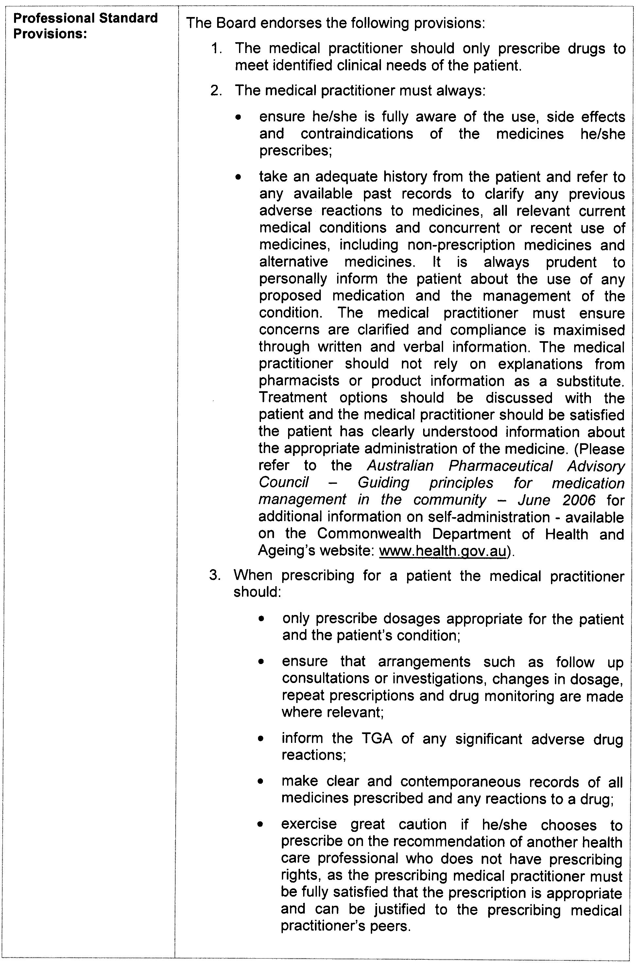
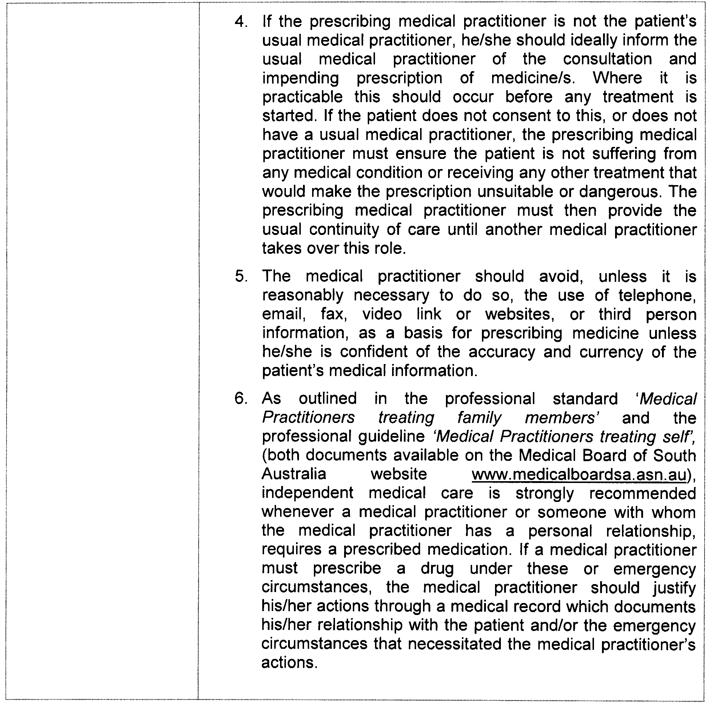

OFFICE OF CONSUMER AND BUSINESS AFFAIRS
Fees Payable for Marriage Services Provided by
Births, Deaths and Marriages Registration Office
I, JOHN R. RAU, Attorney-General, hereby give notice that the fees set out below will be charged by the Office of Consumer and Business Affairs for marriage services at the Births, Deaths and Marriages Registration Office:
$
Lodgement Fee 90.00
Solemnisation Fee 153.00
These charges are inclusive of G.S.T. and will come into operation from 1 July 2010.
In this notice:
Marriage has the same meaning as that under the Commonwealth Marriage Act 1961 defined as the union of a man and a woman to the exclusion of all others, voluntarily entered into for life.
Lodgement means notice to be given under section 42 of the Commonwealth Marriage Act 1961.
Dated 22 April 2010.
John r. Rau, Attorney-General

PASSENGER TRANSPORT REGULATIONS 2009
Determination of Fares and Charges for Regular Passenger Services within Metropolitan Adelaide 2010
PURSUANT to Regulations 149 (1) (a) of the Passenger Transport Regulations 2009, I have determined that the fares and charges to be paid by passengers on a regular passenger service are the fares and charges set out in Schedule 1.
These fares and charges will be effective from 4 July 2010.
Dated 23 April 2010.
Patrick Conlon, Minister for Transport

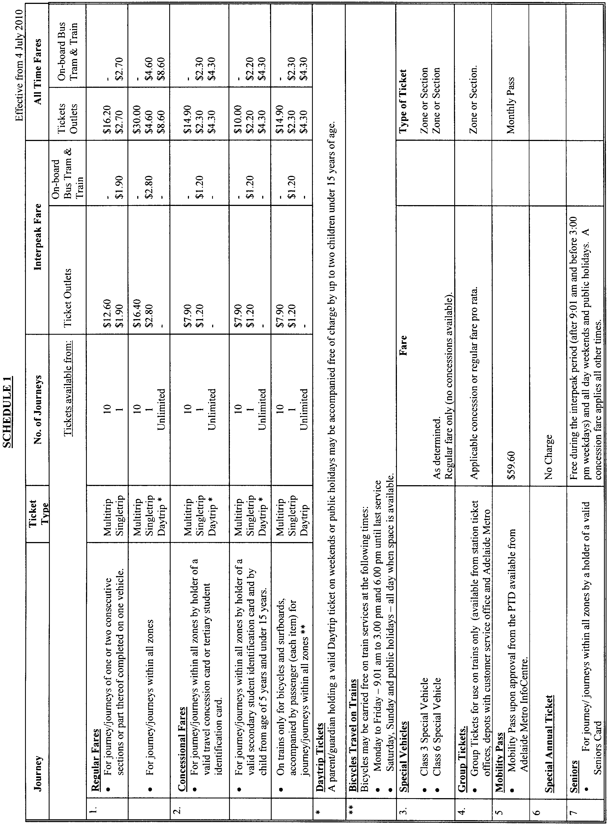

PETROLEUM AND GEOTHERMAL ENERGY ACT 2000
Surrender of Petroleum Exploration Licence—PEL 219
Notice is hereby given that I have accepted surrender of the abovementioned Petroleum Exploration Licence under the provisions of the Petroleum and Geothermal Energy Act 2000, pursuant to delegated powers dated 1 October 2009:

No of  Licence | Licensee | Date of Surrender | Area in  km² | Reference
PEL 219 | Syngas Limited | 26 May 2010 | 191 | 27/02/369

Description of Area—PEL 219
All that part of the State of South Australia, bounded as follows:
Commencing at a point being the intersection of latitude 35°11′00″S GDA94 and longitude 139°37′00″E GDA94, thence east to longitude 139°42′00″E GDA94, south to latitude 35°18′00″S GDA94, west to longitude 139°40′00″E GDA94, south to latitude 35°19′00″S GDA94, west to longitude 139°39′00″E GDA94, south to latitude 35°19′54″S GDA94, west to longitude 139°35′04″E GDA94, south to latitude 35°21′00″S GDA94, west to longitude 139°32′05″E GDA94, north to latitude 35°16′00″S GDA94, east to longitude 139°34′00″E GDA94, north to latitude 35°15′00″S GDA94, east to longitude 139°36′00″E GDA94, north to latitude 35°12′00″S GDA94, east to longitude 139°37′00″E GDA94 and north to point of commencement.
Area: 191 square kilometres approximately.
Dated 2 June 2010.
B. A. Goldstein,
Director Petroleum and Geothermal
Minerals and Energy Resources
Primary Industries and Resources SA
Delegate of the Minister for Mineral Resources Development

PETROLEUM AND GEOTHERMAL ENERGY ACT 2000
Grant of Geothermal Exploration Licences—GELs 523, 524 and 525
Notice is hereby given that the undermentioned Geothermal Exploration Licences have been granted with effect from and including 4 June 2010, under the provisions of the Petroleum and Geothermal Energy Act 2000, pursuant to delegated powers dated 1 October 2009.
No. of  Licence | Licensee | Locality | Expiry | Reference
GEL 523  GEL 524  GEL 525 | Earth Heat Australia Pty Ltd | Adjacent Spencer Gulf,  South Australia | 3 June 2015 | F2010/000142
Description of Area—GEL 523
All that part of the State of South Australia, bounded as follows:
Commencing at a point being the intersection of latitude 32°00′00″S GDA94 and longitude 138°17′00″E GDA94, thence east to longitude 138°40′00″E GDA94, south to latitude 32°02′00″S GDA94, west to longitude 138°39′00″E GDA94, south to latitude 32°09′00″S GDA94, west to longitude 138°37′00″E GDA94, south to latitude 32°11′00″S GDA94, west to longitude 138°34′00″E GDA94, south to latitude 32°16′00″S GDA94, east to longitude 138°42′00″E GDA94, south to latitude 32°17′00″S GDA94, west to longitude 138°38′00″E GDA94, south to latitude 32°22′00″S GDA94, east to longitude 138°42′00″E GDA94, north to latitude 32°21′00″S GDA94, east to longitude 138°43′00″E GDA94, north to latitude 32°19′00″S GDA94, east to longitude 138°49′00″E GDA94, south to latitude 32°30′00″S GDA94, west to longitude 138°20′00″E GDA94, north to latitude 32°29′00″S GDA94, west to longitude 138°19′00″E GDA94, north to latitude 32°17′00″S GDA94, west to longitude 138°18′00″E GDA94, north to latitude 32°04′00″S GDA94, west to longitude 138°17′00″E GDA94 and north to the point of commencement.
Area: 2 004 km² approximately.
Description of Area—GEL 524
All that part of the State of South Australia, bounded as follows:
Commencing at a point being the intersection of latitude 32°30′00″S GDA94 and longitude 138°20′00″E GDA94, thence east to longitude 138°49′00″E GDA94, south to latitude 32°38′00″S GDA94, east to longitude 138°57′00″E GDA94, south to latitude 32°56′00″S GDA94, east to longitude 139°13′00″E GDA94, south to latitude 32°58′00″S GDA94, east to longitude 139°21′00″E GDA94, south to latitude 32°59′00″S GDA94, west to longitude 138°46′00″E GDA94, north to latitude 32°56′00″S GDA94, west to longitude 138°25′00″E GDA94, north to latitude 32°55′00″S GDA94, west to longitude 138°23′00″E GDA94, north to latitude 32°35′00″S GDA94, west to longitude 138°22′00″E GDA94, north to latitude 32°34′00″S GDA94, west to longitude 138°21′00″E GDA94, north to latitude 32°31′00″S GDA94, west to longitude 138°20′00″E GDA94 and north to the point of commencement, but excluding Black Rock Conservation Park.
Area: 2 646 km² approximately.
Description of Area—GEL 525
All that part of the State of South Australia, bounded as follows:
Commencing at a point being the intersection of latitude 32°59′00″S GDA94 and longitude 138°46′00″E GDA94, thence east to longitude 139°35′00″E GDA94, south to latitude 33°20′00″S GDA94, west to longitude 138°46′00″E GDA94 and north to the point of commencement, but excluding Pandappa Conservation Park.
Area: 2 947 km² approximately.
Dated 4 June 2010.
B. A. Goldstein,
Director Petroleum and Geothermal
Minerals and Energy Resources
Primary Industries and Resources SA
Delegate of the Minister for Mineral Resources Development

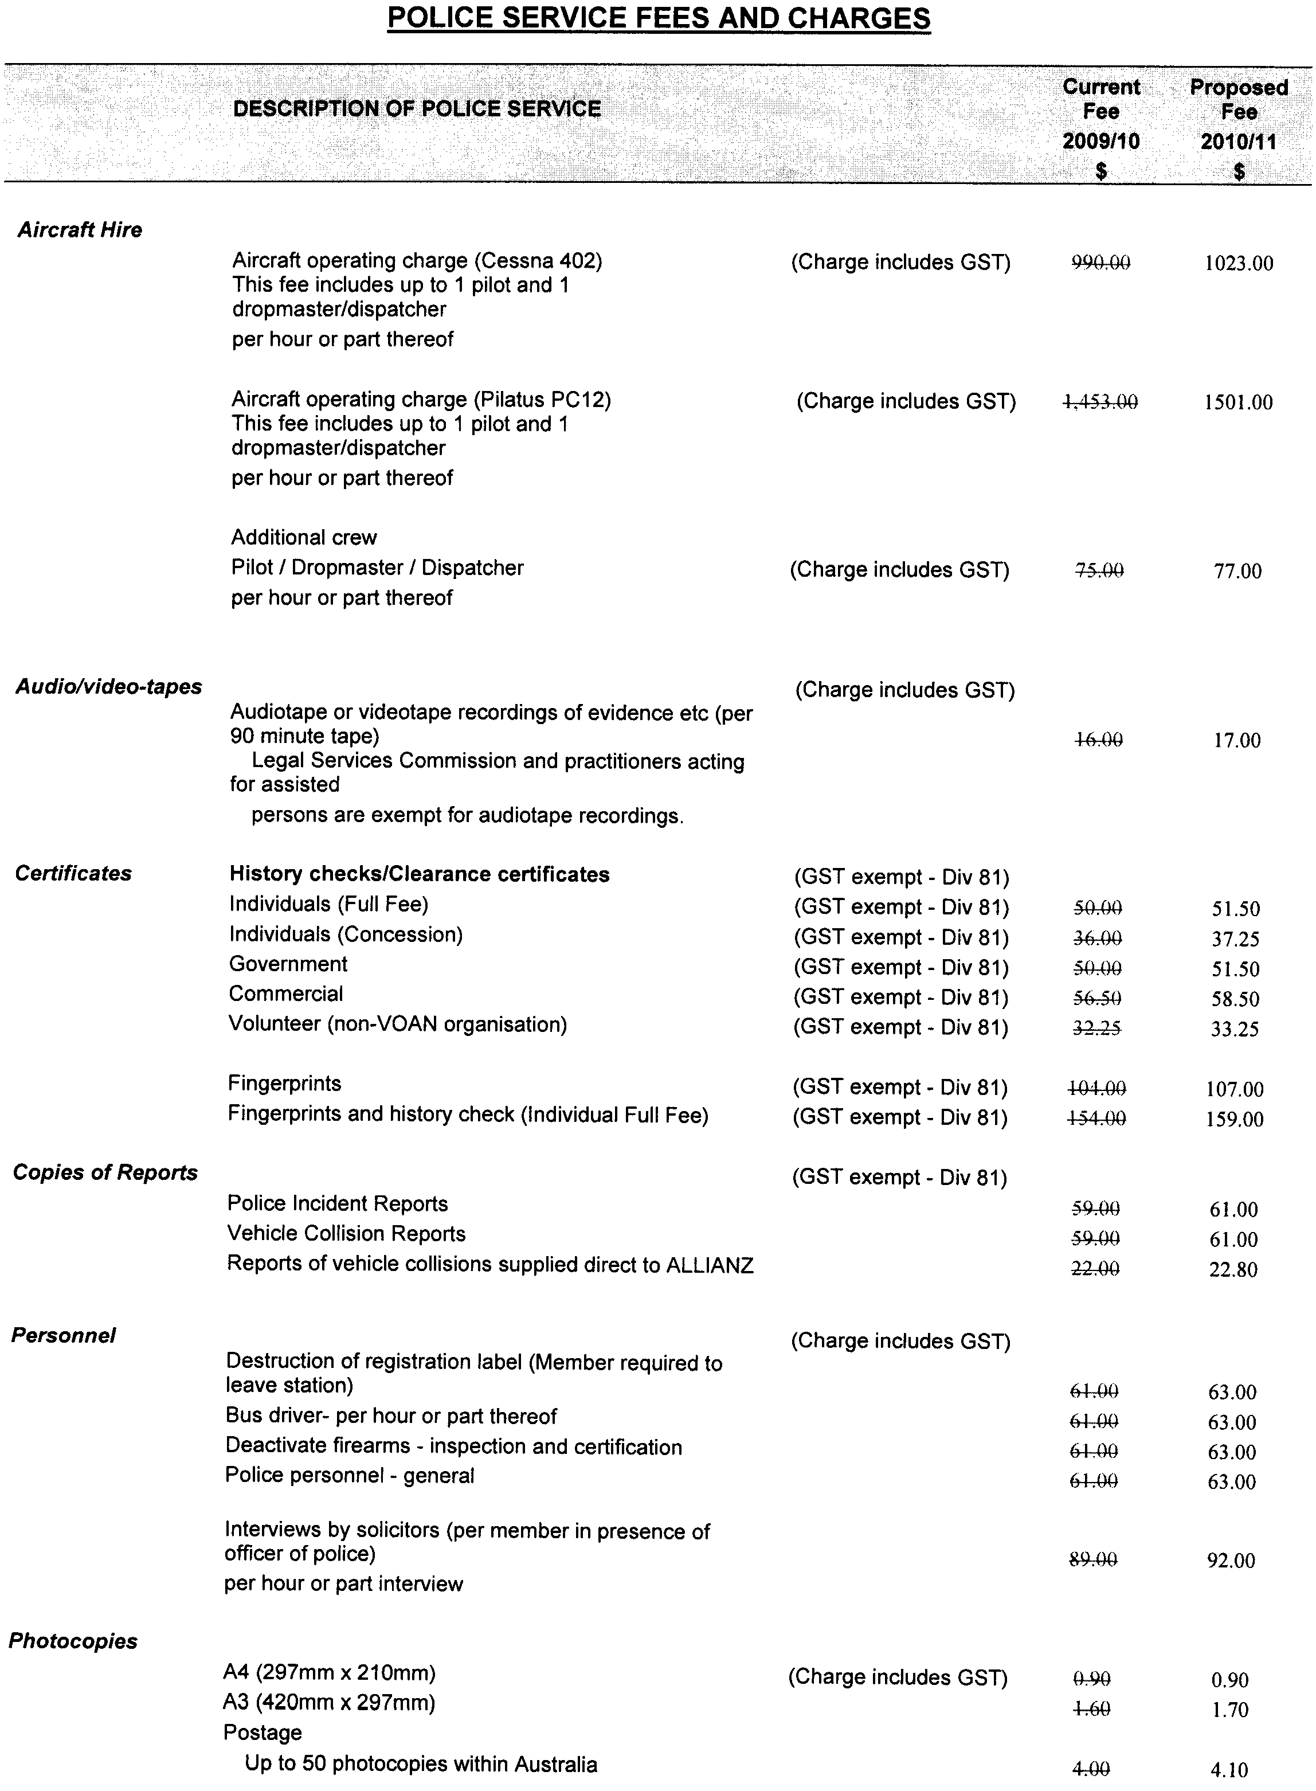
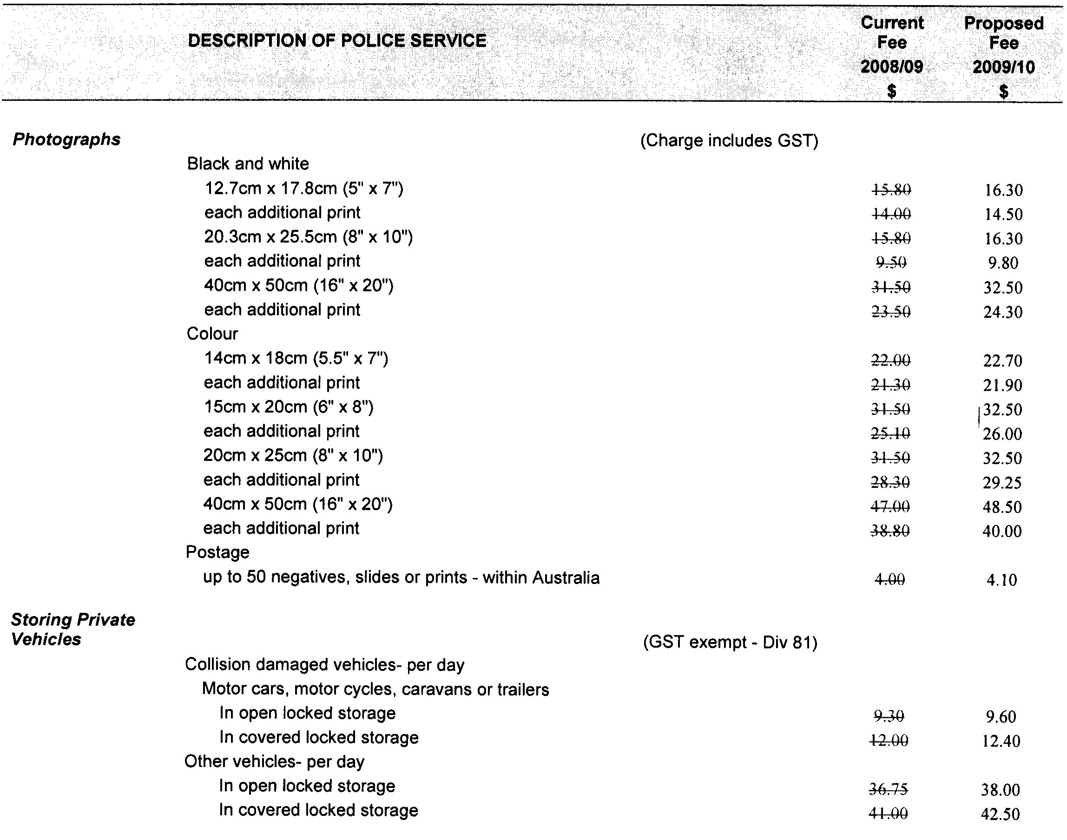
Michael Wright, Minister for Police

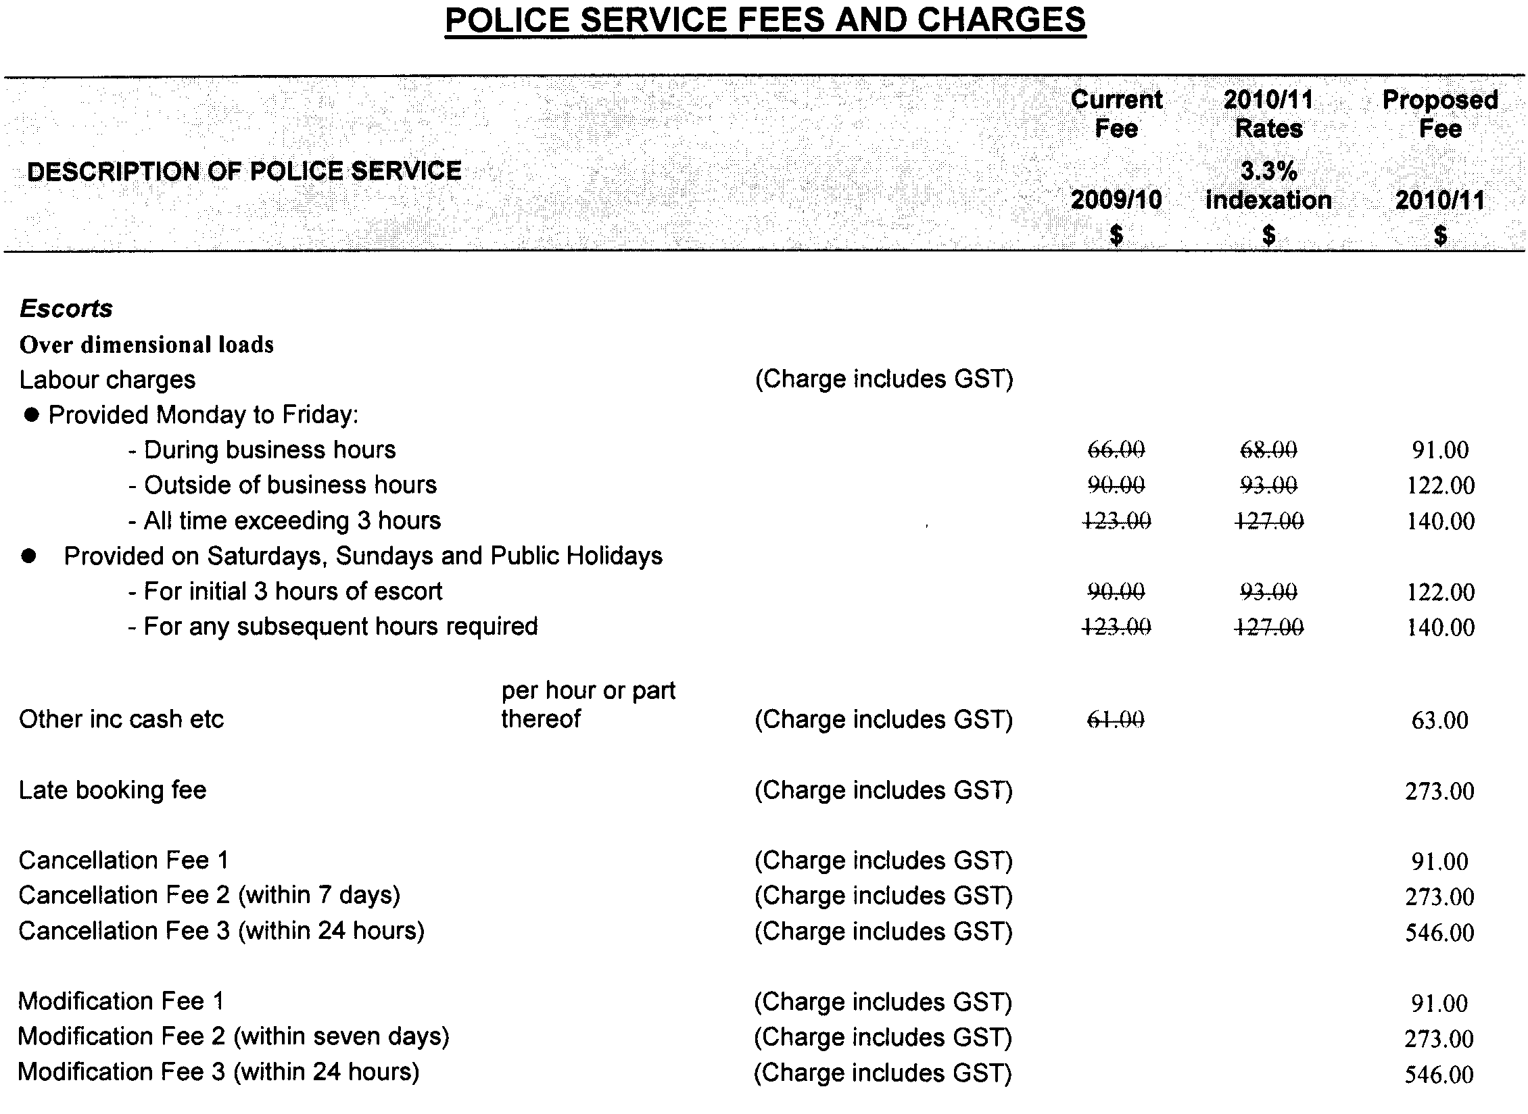
Michael Wright, Minister for Police

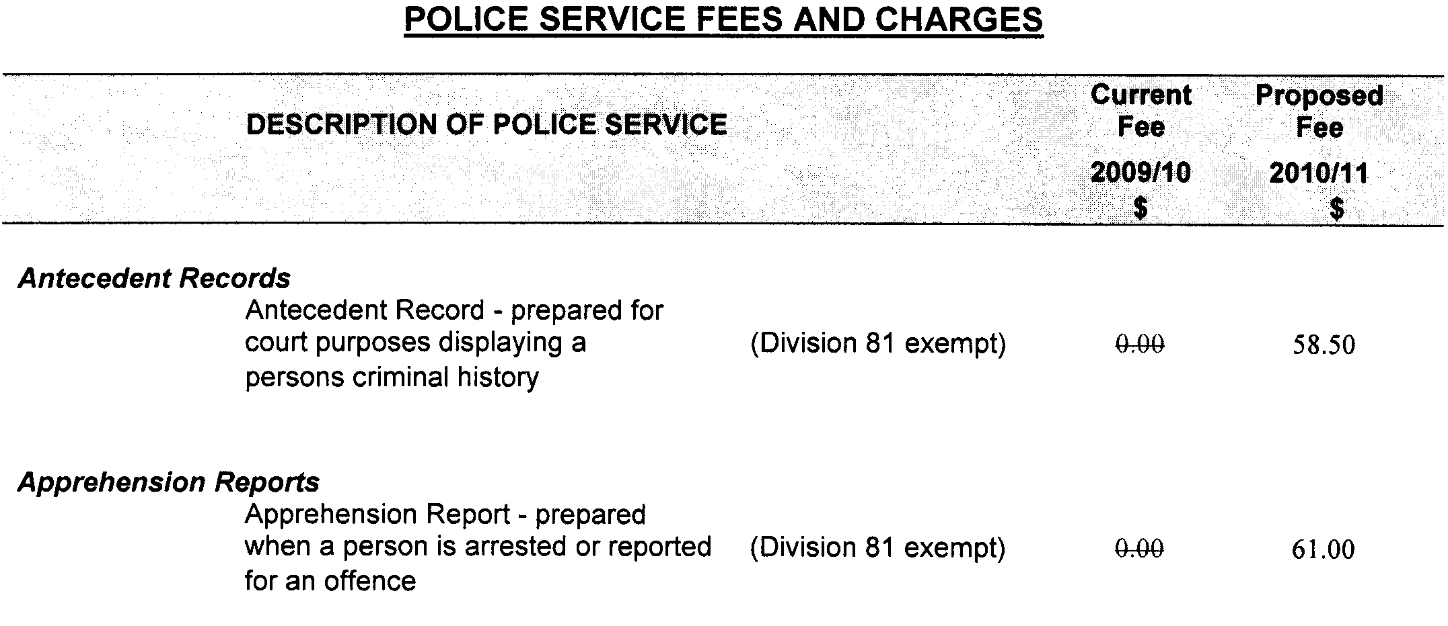
Michael Wright, Minister for Police

RAIL SAFETY ACT 2007
Annual Fees Payable by Accredited Rail Transport Operators
I, PATRICK CONLON, the Minister for Transport, pursuant to section 41 of the Rail Safety Act 2007, fix the following fees for 2010-2011.
Dated 26 May 2010.
Patrick Conlon, Minister for Transport

Schedule of Fees 2010-2011
Fees Payable by Accredited Rail Infrastructure Managers and Rolling Stock Operators and Rail Infrastructure Managers of Registered Private Sidings
Annual Fee—Commercial Rail Infrastructure Managers and Rolling Stock Operators
An accredited person shall pay annual accreditation fees according to their accreditation category or categories.
A person accredited at the beginning of the financial year as both a rail infrastructure manager and a rolling stock operator shall pay an annual fee equal to the total of both the rail infrastructure manager and rolling stock operator annual fee. A person accredited at the beginning of the financial year as both a category 4 rail infrastructure manager and a category 4 rolling stock operator shall pay a maximum combined annual fee of $13 369.
For an accreditation granted during the financial year, the amount shall be payable at the time of accreditation and the fee shall be based on the estimated annual fee adjusted on a pro rata basis to reflect the actual number of weeks, or part thereof, that the accreditation will remain in force for the balance of the financial year.
For an accreditation that is granted for a portion of the financial year, the amount payable shall be based on the estimated annual fee adjusted on a pro rata basis to reflect the actual number of weeks, or part thereof, that the accreditation will remain in force. A minimum fee of $6 685 applies for an accreditation granted for a fixed period less than six months.
Commercial Rail Transport Operator Annual Fee
Accreditation  Category | Rail Infrastructure Manager  Annual Fee ($) | Rolling Stock Operator  Annual Fee ($)
1  2  3  4 (minimum fee) | 120 319  80 212  40 106  13 369 | 120 319  80 212  40 106  13 369
Annual Fee—Not-for-Profit Heritage/Tourist Rail Infrastructure Managers and Rolling Stock Operators
No fee payable.
Annual Fee—Rail Infrastructure Manager of a Registered Private Siding
No fee payable.
Due Date for Annual Fees
The annual fee must be paid on or before 30 September 2010.
The annual fee may be paid in accordance with an agreement, for example, payment of fees by instalments. This agreement must be finalised prior to 30 September 2010.
Fee for Late Payment of Annual Fees
Where payment of fees is made after the due date, then a late payment fee of 5% of the amount outstanding on the due date shall also be paid in addition to the annual fee.
RAIL INFRASTRUCTURE MANAGER AND ROLLING STOCK OPERATOR ACCREDITATION CATEGORY SCHEDULE
Historical information for the preceding financial year, where available, will be used for the purpose of determining the accreditation category. Where historical information is not available, a projected assessment will be used.
Rail Infrastructure Manager Criteria
Track Managed  (Main Line Kilometres) | Accreditation  Category
Greater than 1 000  Greater than 500 up to 1 000  Greater than 50 up to 500  From 0 to 50  A Rail Infrastructure Manager of a passenger or freight terminal, marshalling yard, or undertaking rail infrastructure construction or maintenance only. | 1  2  3  4  4
Rolling Stock Operator Criteria
Train Kilometres Operated  (Main Line Kilometres) | Accreditation  Category
Greater than 3 million per annum  Greater than 1 million up to 3 million  per annum  Greater than 50 000 up to 1 million per annum  Up to 50 000 per annum  Operates rolling stock only for the purpose of:  • construction, maintenance or commissioning of rolling stock;  • construction, maintenance or commissioning of track infrastructure using track maintenance machinery or road/  rail vehicles; or  • providing a hook-and-pull service to an accredited rolling stock operator. | 1  2  3  4  4
Note: Train kilometres operated by a Rolling Stock Operator providing a hook-and-pull service are attributable to the accredited Rolling Stock Operator who has engaged the services of the hook-and-pull Rolling Stock Operator.

ROADS (OPENING AND CLOSING) ACT 1991:
SECTION 24
NOTICE OF CONFIRMATION OF ROAD
PROCESS ORDER
Road Opening—
Agricultural Bureau Drive, Millicent/Tantanoola
BY Road Process Order made on 4 January 2010, the Wattle Range Council ordered that:
Portions of section 40, Hundred of Hindmarsh, section 110, Hundred of Mayurra, Allotment 4 in Filed Plan 148326 and portions of Allotment 2 in Filed Plan 13755, more particularly delineated and numbered ‘6’, ‘7’, ‘8’, ‘9’ and ‘10’ respectively in Preliminary Plan No. 08/0091 be opened as road, forming a widening of the adjoining Agricultural Bureau Drive.
On 8 April 2010 that order was confirmed by the Minister for Infrastructure conditionally upon the deposit by the Registrar-General of Deposited Plan 83568 being the authority for the new boundaries.
Pursuant to section 24 (5) of the Roads (Opening and Closing) Act 1991, NOTICE of the order referred to above and its confirmation is hereby given.
Dated 10 June 2010.
P. M. Kentish, Surveyor-General

ROAD TRAFFIC ACT 1961
Pursuant to Section 161A of the Road Traffic Act 1961
OPERATION OF HEAVY VEHICLE CONFIGURATIONS OVER RAILWAY LEVEL CROSSINGS ON APPROVED COMMODITY ROUTES
1. APPROVAL
Information Note
The railway level crossings identified on the existing approved commodity route maps (denoted with a star symbol) are currently under review and access to these crossings may be subject to change in the future.
1.1 I hereby approve heavy vehicle configurations (as detailed in Clause 2.1 of this Notice) to travel over railway level crossings as identified on the approved Commodity route network maps subject to the conditions and limitations specified in this Notice.
2. CONDITIONS
This Notice of Approval is subject to the following conditions:
2.1 Approved Vehicles
2.1.1 Only the vehicle combinations nominated below are approved to operate under this Notice.
(i) B-Doubles operating in accordance with the Government Gazette Notice titled ‘Operation of B-Double Vehicles Up To 25m in Length’;
(ii) Road Trains operating in accordance with the Government Gazette Notice titled ‘Operation of Road Train Vehicles in South Australia’;
(iii) Medium Articulated vehicles towing a Dog trailer (MAD) operating in accordance with a current permit issued by DTEI;
(iv) Rigid Truck and Dog trailer combination operating in accordance with a current permit issued by DTEI
2.2 Railway Crossings
2.2.1 This Notice allows the use of heavy vehicle configurations listed above in 2.1.1 to travel over the railway level crossings identified (denoted with a star symbol) on the approved commodity route maps (specific to the configuration) in place of the previously issued permits administered by DTEI allowing travel over the railway level crossings denoted with a star symbol.
2.2.2 In addition to compliance with the requirements of the Road Traffic Act 1961 and Australian Road Rules at all times whilst operating a vehicle, drivers are further required to exercise extreme caution when travelling over these railway crossings.
2.3 Documentation
When operating under this Notice, you must:
2.3.1 carry at all times a legible current and complete copy of:
(i) this Notice; and
(ii) all current documentation and approved route network map(s) required to be carried while operating the particular vehicle combination.
2.3.2 produce any or all of the documents indicated in 2.3.1, above, when requested by a DTEI Authorised Officer appointed under the Road Traffic Act 1961 or a Police Officer.
3. DEFINITIONS
For the purpose of this Notice the following definitions shall apply:
3.1 ‘DTEI’ means the Department for Transport, Energy and Infrastructure.
4. COMMENCEMENT OF THIS NOTICE
4.1 This Notice is valid from 12.01 a.m. on 1 July 2010.
5. EXPIRY OF THIS NOTICE
5.1 This Notice is valid until 12.00 a.m. on 31 March 2011.
6. AUTHORISATION

Phil Allan
Executive Director,
Safety and Regulation Division
Department for Transport, Energy & Infrastructure

SURVEY ACT 1992
PURSUANT to section 50 of the Survey Act 1992, notice is given that a Confused Boundary Area is declared for the area bounded by Exmouth Road, Stewart Street, Bucknall Road and Swan Terrace in the area of Glanville.
Dated 31 May 2010.
P. M. Kentish, Surveyor General
REF: LTO 39/2010

SURVEY ACT 1992
PURSUANT to section 50 of the Survey Act 1992, notice is given that a Confused Boundary Area is declared for the area bounded by Palm Avenue, Gum Street, Maple Avenue and A407/D1375 in the area of Royal Park.
Dated 26 May 2010.
P. M. Kentish, Surveyor General
REF: LTO 34/2010

NOTICE TO MARINERS
No. 26 of 2010
South Australia—Safety Equipments Changes
MARINERS are advised that legislative changes affect recreational boat operators from 1 June 2010.
While operating in semi-protected waters the following additional equipment is required:
• Personal Flotation Device (PFD) type 1 for each person aboard the vessel.
• Two red hand held flares.
• Two hand held orange smoke signals.
Semi-protected waters are those within two nautical miles seaward from the mainland coast, Kangaroo Island and the banks of Lakes Alexandrina and Albert, and include inland waters that are subject to tidal influence (e.g. the Coorong or the Port River).
Adelaide, 27 May 2010.
Patrick Conlon, Minister for Transport.
DTEI 2010/01461

NOTICE TO MARINERS
No. 27 of 2010
South Australia—Drug Law Changes
MARINERS are reminded that legislative changes relating to drugs and alcohol are now in force and affect all commercial and recreational vessel operators and essential crew.
Police can undertake on-the-spot drug tests as well as testing for alcohol. This involves an initial screening test which may be followed by more comprehensive testing if a positive response is identified for drugs like:
• Cannabis—(delta-9-tetrahydrocannabinol—THC).
• Speed (methylamphetamine).
• Ecstasy (3, 4-methylenedioxymethamphetamine).
Any accident where a person requires medical attention, that person will have a blood sample taken for the purpose of testing for alcohol and drugs.
The legislation allows for heavy penalties if an alcohol or drug related offence is detected. Alcohol and drugs inhibit normal function of operators and crew and the consumption of these may result in loss of life at sea.
Adelaide, 27 May 2010.
Patrick Conlon, Minister for Transport.
DTEI 2010/01461

WATER MAINS AND SEWERS

Office of the South Australian Water Corporation
Adelaide, 10 June 2010

WATER MAINS LAID

Notice is hereby given that the following main pipes or parts of main pipes have been laid down by the South Australian Water Corporation in or near the undermentioned water districts and are now available for a constant supply of water to adjacent land.

ADELAIDE WATER DISTRICT

ADELAIDE HILLS COUNCIL
Across Lobethal-Mount Torrens Road, Lobethal. p15
Kleinschmidt Street, Lobethal. p15

CITY OF MARION
In and across Railway Terrace, Ascot Park. p1 and 2
Third Avenue, Ascot Park. p1
Fourth Avenue, Ascot Park. p2
Fifth Avenue, Ascot Park. p2
Sixth Avenue, Ascot Park. p2
Oliphant Way, Oaklands Park. p4

CITY OF MITCHAM
Easement in lot 1 in LTRO FP 33628 (known as Norman Walk), Mitcham. p32

DISTRICT COUNCIL OF MOUNT BARKER
Across Gum Tree Drive, Littlehampton. p13
Lloyd Crescent, Littlehampton. p13
Hillcrest Court, Littlehampton. p13 and 14
In and across Hartman Road, Mount Barker. p16 and 17
In and across Belmont Crescent, Mount Barker. p17
Barzona Street, Mount Barker. p17, 19 and 18
Holstein Close, Mount Barker. p19
Highland Street, Mount Barker. p17 and 18
Across Sims Road, Mount Barker. p18
Douglas Drive, Mount Barker. p17
Easements in lot 501 in LTRO DP 82642, Barzona Street, Mount Barker. p17
Across and in Sims Road, Mount Barker. p19-21
In and across Wellington Road, Mount Barker. p21
Wattle Street, Mount Barker. p21

CITY OF ONKAPARINGA
Across Reynell Road, Old Reynella. p25
In and across Sauvignon Way, Old Reynella. p25
Cabernet Close, Old Reynella. p25
Phoenix Crescent, Old Reynella. p25
Bowering Hill Road, Port Willunga. p30
Quadrant Terrace, Seaford. p31

CITY OF PORT ADELAIDE ENFIELD
Acacia Avenue, Klemzig. p34

CITY OF SALISBURY
Across Jolsen Street, Salisbury Downs. p26
Don Street, Salisbury Downs. p26
Maria Street, Salisbury Downs. p26

CITY OF TEA TREE GULLY
Lyons Road, Dernancourt. p3

CLEVE WATER DISTRICT

DISTRICT COUNCIL OF CLEVE
Forbes Street, Cleve. p10
Stubing Street, Cleve. p10

KADINA WATER DISTRICT

DISTRICT COUNCIL OF THE COPPER COAST
Drain Road, New Town. p24
In and across Inglis Street, New Town. p24
Across and in Larcombe Crescent, New Town. p24

KAROONDA WATER DISTRICT

DISTRICT COUNCIL OF KAROONDA EAST MURRAY
Across Sherlock Road, Karoonda. p11
Golf View Drive, Karoonda. p11
In and across Morris Road, Karoonda. p11
Ponderosa Crescent, Karoonda. p11
Morris Road, Karoonda. p12
In and across Farr Street, Karoonda. p12

MURRAY BRIDGE WATER DISTRICT

THE RURAL CITY OF MURRAY BRIDGE
Across Ridge Road, Murray Bridge. p22
In and across Parkview Drive, Murray Bridge. p22
In and across Paperbark Place, Murray Bridge. p22 and 23
Melaleuca Way, Murray Bridge. p22
Easements in lot 204 in LTRO DP 79454, Melaleuca Way, Murray Bridge. p22
Willowbark Crescent, Murray Bridge. p22
Tussock Place, Murray Bridge. p23

ROBE WATER DISTRICT

DISTRICT COUNCIL OF ROBE
Backler Street, Robe. p29
Adam Lindsay Gordon Drive, Robe. p29

WARREN COUNTRY LANDS WATER DISTRICT

LIGHT REGIONAL COUNCIL
In and across Sturt Highway, Daveyston. p35 and 36

WILLIAMSTOWN WATER DISTRICT

THE BAROSSA COUNCIL
Across Mount Crawford Road, Williamstown. p27
Carlisle Street, Williamstown. p27 and 28
Marr Court, Williamstown. p27

WATER MAINS ABANDONED

Notice is hereby given that the undermentioned water mains have been abandoned by the South Australian Water Corporation.

ADELAIDE WATER DISTRICT

CITY OF MARION
In and across Railway Terrace, Ascot Park. p1 and 2
Third Avenue, Ascot Park. p1
Fourth Avenue, Ascot Park. p2
Fifth Avenue, Ascot Park. p2
Sixth Avenue, Ascot Park. p2

KADINA WATER DISTRICT

DISTRICT COUNCIL OF THE COPPER COAST
Drain Road, New Town. p24

WARREN COUNTRY LANDS WATER DISTRICT

LIGHT REGIONAL COUNCIL
Sturt Highway, Daveyston. p35 and 36

WHYALLA WATER DISTRICT

THE CORPORATION OF THE CITY OF WHYALLA
Riches Street, Whyalla. p37 and 38
Easements in section 77, hundred of Randell, Meares Street, Whyalla. p38, 41 and 44
Waterworks land (section 486, hundred of Randell), Whyalla. p38, 41 and 44
Gebhardt Street, Whyalla. p40 and 41
Meares Street, Whyalla. p43 and 44

SEWERS LAID

Notice is hereby given that the following sewers have been laid down by the South Australian Water Corporation in the undermentioned drainage areas and are now available for house connections.

ADELAIDE DRAINAGE AREA

CAMPBELLTOWN CITY COUNCIL
Milton Avenue, Tranmere. FB 1191 p54
Rostrevor Avenue, Rostrevor. FB 1191 p58
Willow Drive, Paradise. FB 1191 p59

CITY OF CHARLES STURT
Sewerage land (lot 82 in LTRO DP 9888), Sportsmans Drive, West Lakes. FB 1165 p56
Across and in Sportsmans Drive, West Lakes. FB 1165 p56
In and across Beeston Way, West Lakes. FB 1165 p56
Easements in lot 67 in LTRO DP 10133, Sportsmans Drive and Walkway (lot 72 in LTRO DP 10133), Sims Crescent, West Lakes. FB 1165 p56
Across and in Sims Crescent, West Lakes. FB 1165 p56
Beryl Street, Woodville West. FB 1191 p56

CITY OF MARION
Kurrajong Place, Seacombe Gardens. FB 1194 p2
Across Masters Avenue, Oaklands Park. FB 1194 p8
Oliphant Way, Oaklands Park. FB 1194 p8

CITY OF NORWOOD PAYNEHAM AND ST PETERS
Fisher Street, Felixstow. FB 1191 p55
Bishops Place, Kensington. FB 1194 p1

CITY OF ONKAPARINGA
Quadrant Terrace, Seaford. FB 1194 p9

CITY OF PLAYFORD
Catalina Road, Elizabeth East. FB 1191 p52
Easement in lot 390 in LTRO DP 6189, Sampson Road, Elizabeth Grove. FB 1191 p53

CITY OF PORT ADELAIDE ENFIELD
Across and in Regency Road, Enfield and Broadview. FB 1165 p55
Stevens Avenue, Kilburn. FB 1191 p57

CITY OF SALISBURY
Easement in lot 14 in LTRO DP 80770, Caribou Drive, Direk. FB 1195 p1, 2 and 6
Across and in Caribou Drive, Direk. FB 1195 p1, 2 and 6
Orion Road, Direk. FB 1195 p1-3 and 7
Easements in lot 1000 in LTRO DP 80770, Mirage Road, Direk. FB 1195 p1-3, 6 and 7
Easement in lot 21 in LTRO DP 83179, Mirage Road, Direk. FB 1195 p1, 2 and 6
Across and in Mirage Road, Direk. FB 1195 p1, 2 and 6

MANNUM COUNTRY DRAINAGE AREA

MID MURRAY COUNCIL
In and across public road south-east of lot 6 in LTRO DP 43479, Mannum. FB 1193 p47, 48 and 50
Across and in Preiss Street, Mannum. FB 1193 p47, 48 and 50
Easements in lot 500 in LTRO DP 78288, North Terrace, Mannum. FB 1193 p47-50
Easement in lot 2 in LTRO DP 35951, North Terrace, Mannum. FB 1193 p47, 48 and 50
Across North Terrace, Port Mannum. FB 1193 p47, 49 and 50

MURRAY BRIDGE COUNTRY DRAINAGE AREA

THE RURAL CITY OF MURRAY BRIDGE
Gray Street, Murray Bridge. FB 1161 p19
Schottelius Avenue, Murray Bridge. FB 1161 p20

STIRLING COUNTRY DRAIANGE AREA

ADELAIDE HILLS COUNCIL
Railway Avenue, Bridgewater. FB 1191 p60

SEWERS ABANDONED

Notice is hereby given that the undermentioned sewers have been abandoned by the South Australian Water Corporation.

ADELAIDE DRAINAGE AREA

CITY OF CHARLES STURT
Sewerage land (lot 82 in LTRO DP 9888), Sportsmans Drive, West Lakes. FB 1165 p56
Across and in Sportsmans Drive, West Lakes. FB 1165 p56
In and across Beeston Way, West Lakes. FB 1165 p56
Easements in lot 67 in LTRO DP 10133, Sportsmans Drive and Walkway (lot 72 in LTRO DP 10133), Sims Crescent, West Lakes. FB 1165 p56
Across and in Sims Crescent, West Lakes. FB 1165 p56
Across Rowley Terrace, Woodville. FB 1194 p6
Easement in lot 92 in LTRO FP 213916, Port Road and lot 127 in LTRO FP 208503, Woodville Road, Woodville. FB 1194 p6
Across Cheltenham Parade, Woodville. FB 1194 p7
Easement in lot 9 in LTRO FP 125906, Cheltenham Parade, Woodville. FB 1194 p7

CITY OF PORT ADELAIDE ENFIELD
Across and in Regency Road, Enfield and Broadview. FB 1165 p55

SEWERS LAID

Notice is hereby given that the undermentioned sewers have been laid down by the South Australian Water Corporation and are not available for house connections.

ADELAIDE DRAINAGE AREA

CITY OF SALISBURY
Easement in lot 14 in LTRO DP 80770, Caribou Drive, Direk—150 mm PVCO pumping main. FB 1195 p1, 4, 8 and 12
Across and in Caribou Drive, Direk—150 mm PVCO pumping main. FB 1195 p1, 4 and 8
Easements in reserve (lot 305 in LTRO DP 80770), Edinburgh Road, Direk—150 mm PVCO pumping main. FB 1195 p1, 4 and 8
Across and in Edinburgh Road, Direk—150 mm PVCO pumping main. FB 1195 p1, 4 and 8
Easements in drainage reserves (lot 73 in LTRO DP 82430, Edinburgh Road and lot 71 in LTRO DP 82429, Diment Road), Direk—150 mm PVCO pumping main. FB 1195 p1, 5 and 8
Across and in Diment Road, Direk—150 mm PVCO pumping main. FB 1195 p1, 5, 8 and 9
Easement in lot 21 in LTRO DP 83179, Mirage Road, Direk—100 mm PVCO pumping main. FB 1195 p1, 4, 10 and 11
Across and in Mirage Road, Direk—100 mm PVCO pumping main. FB 1195 p1, 4 and 10
Caribou Drive, Direk—100 mm PVCO pumping main. FB 1195 p1, 4 and 10
Easement in lot 50 in LTRO DP 73203, Edinburgh Road, Direk—100 mm PVCO pumping main. FB 1195 p1, 4 and 10

A. Howe, Chief Executive Officer South Australian Water Corporation

South Australia
Motor Vehicles (Approval of Motor Bikes and Motor Trikes) Notice 2010
under the Motor Vehicles Act 1959
1—Short title
This notice may be cited as the Motor Vehicles (Approval of Motor Bikes and Motor Trikes) Notice 2010.
2—Commencement
This notice will come into operation on the date of publication in this Gazette.
3—Approved motor bikes and motor trikes
For the purposes of Schedules 2 and 3 of the Motor Vehicles Regulations 1996 and the transitional provisions of the Motor Vehicles Variation Regulations 2005 (No 233 of 2005), the motor bikes and motor trikes specified in Schedule 1 are approved.

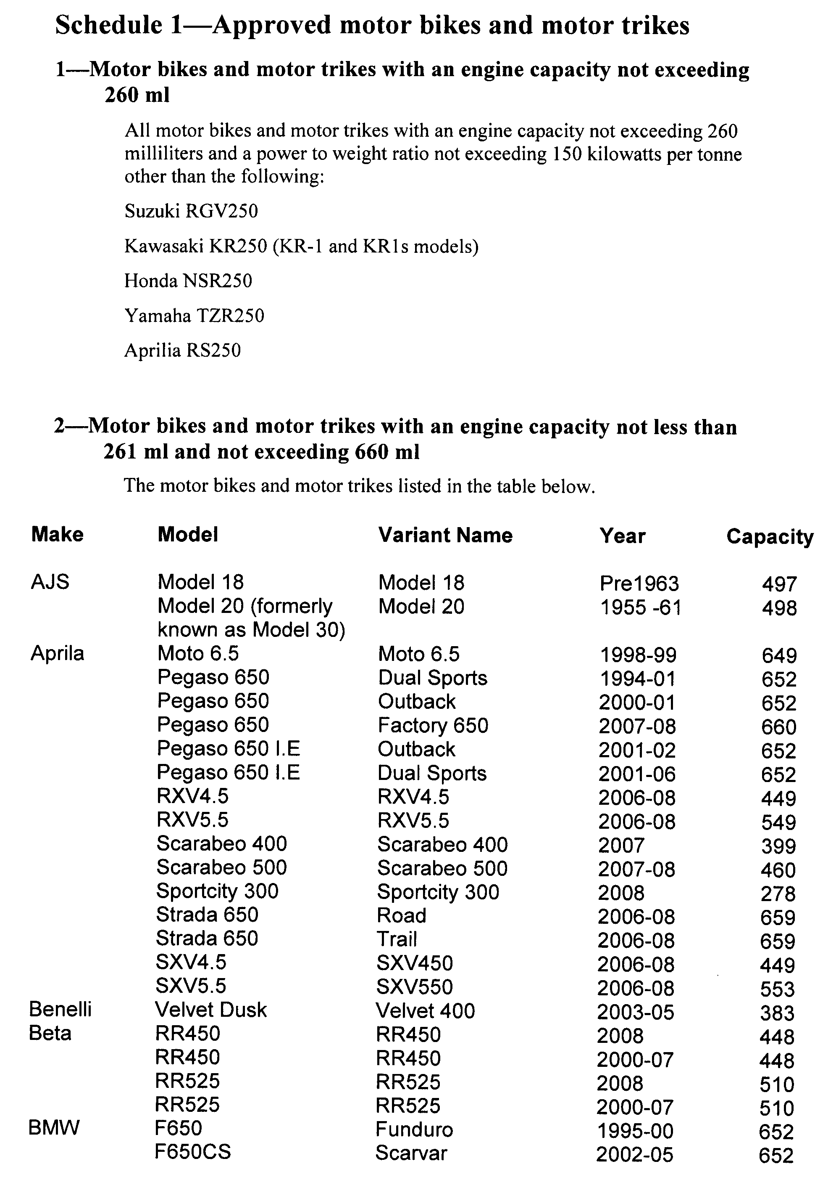
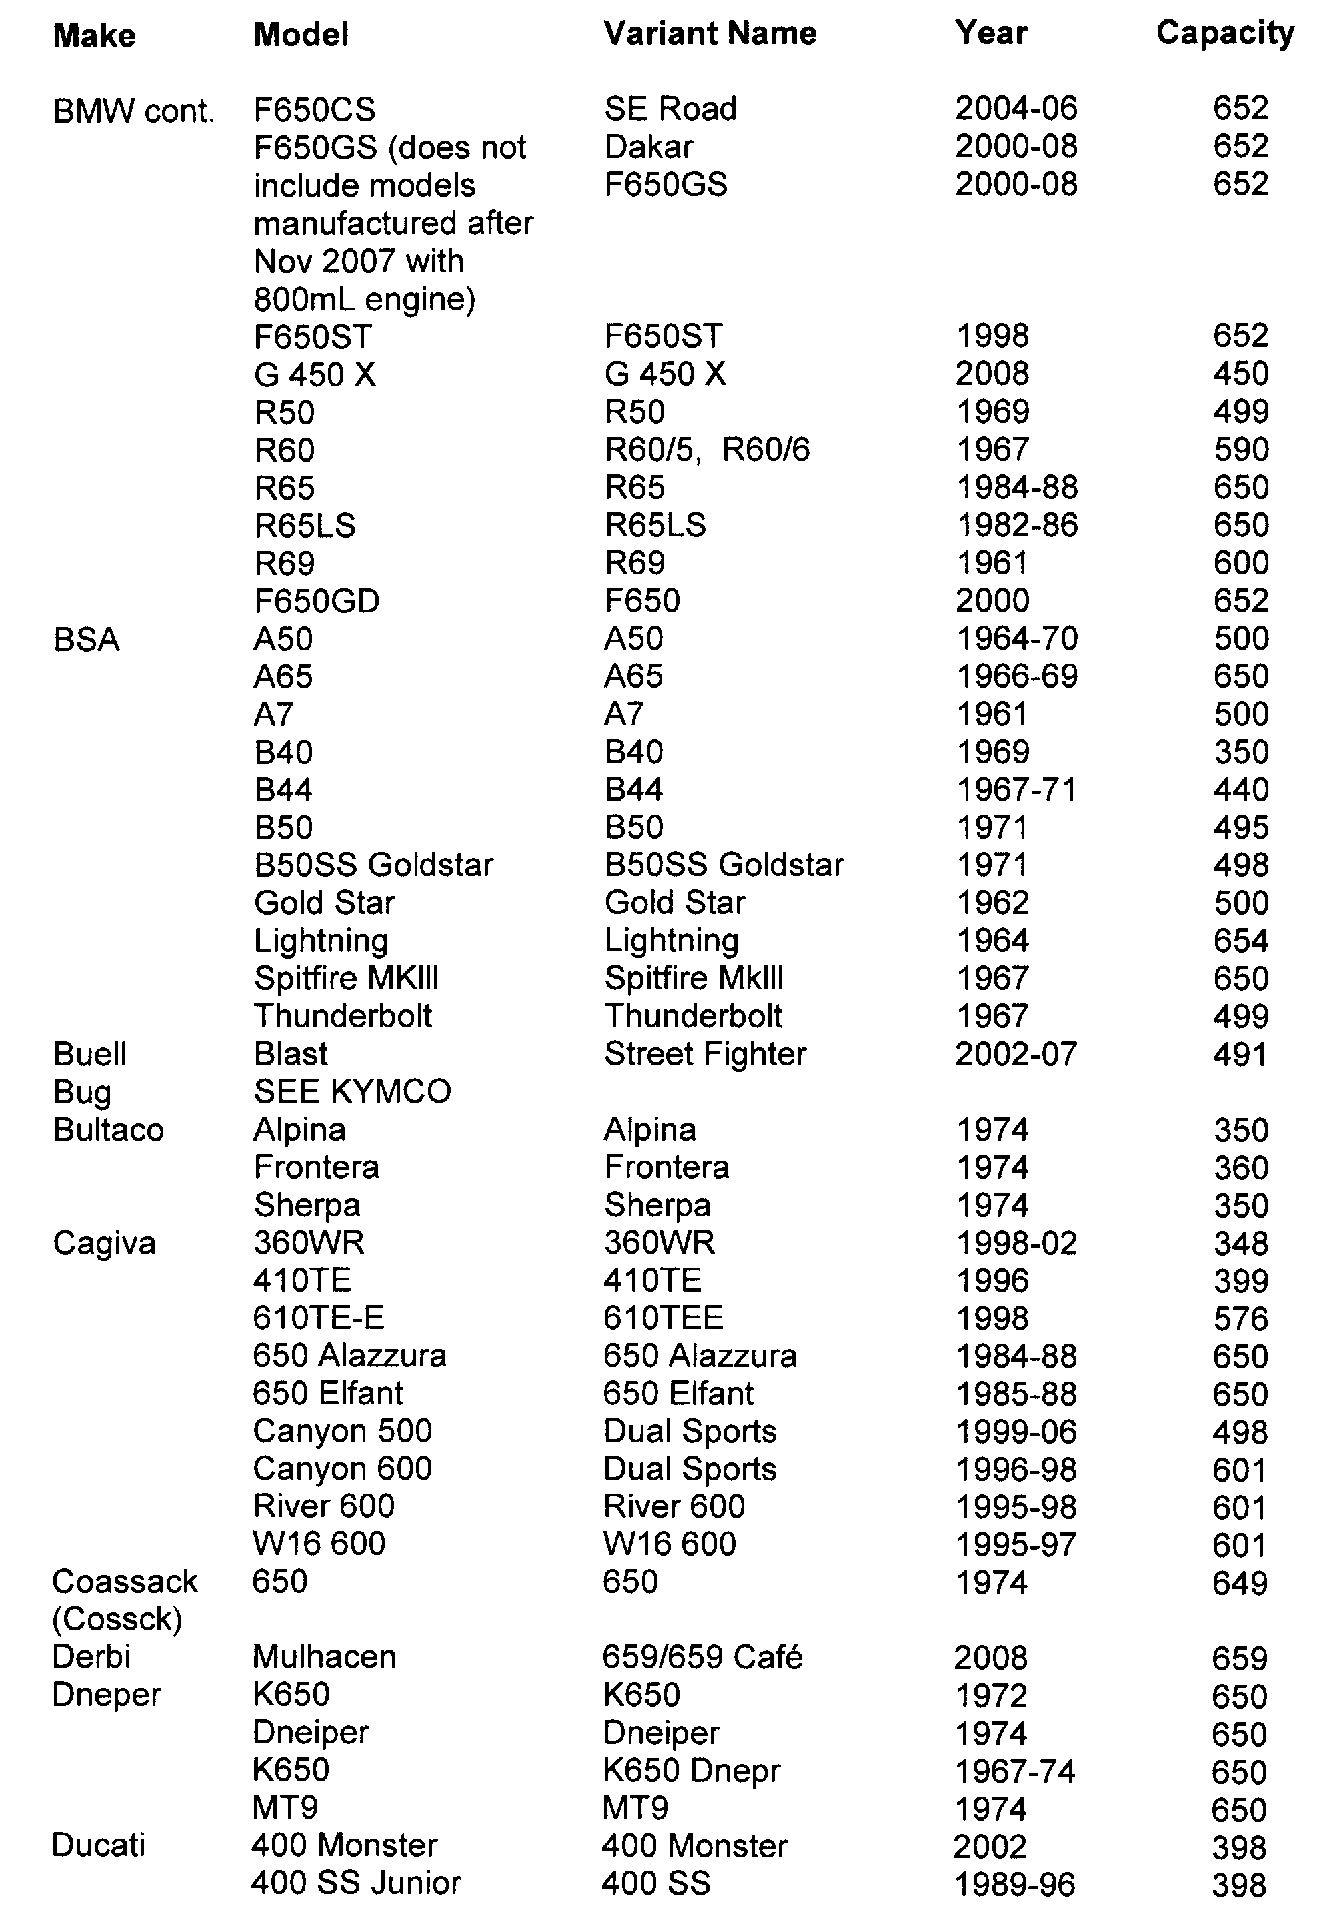
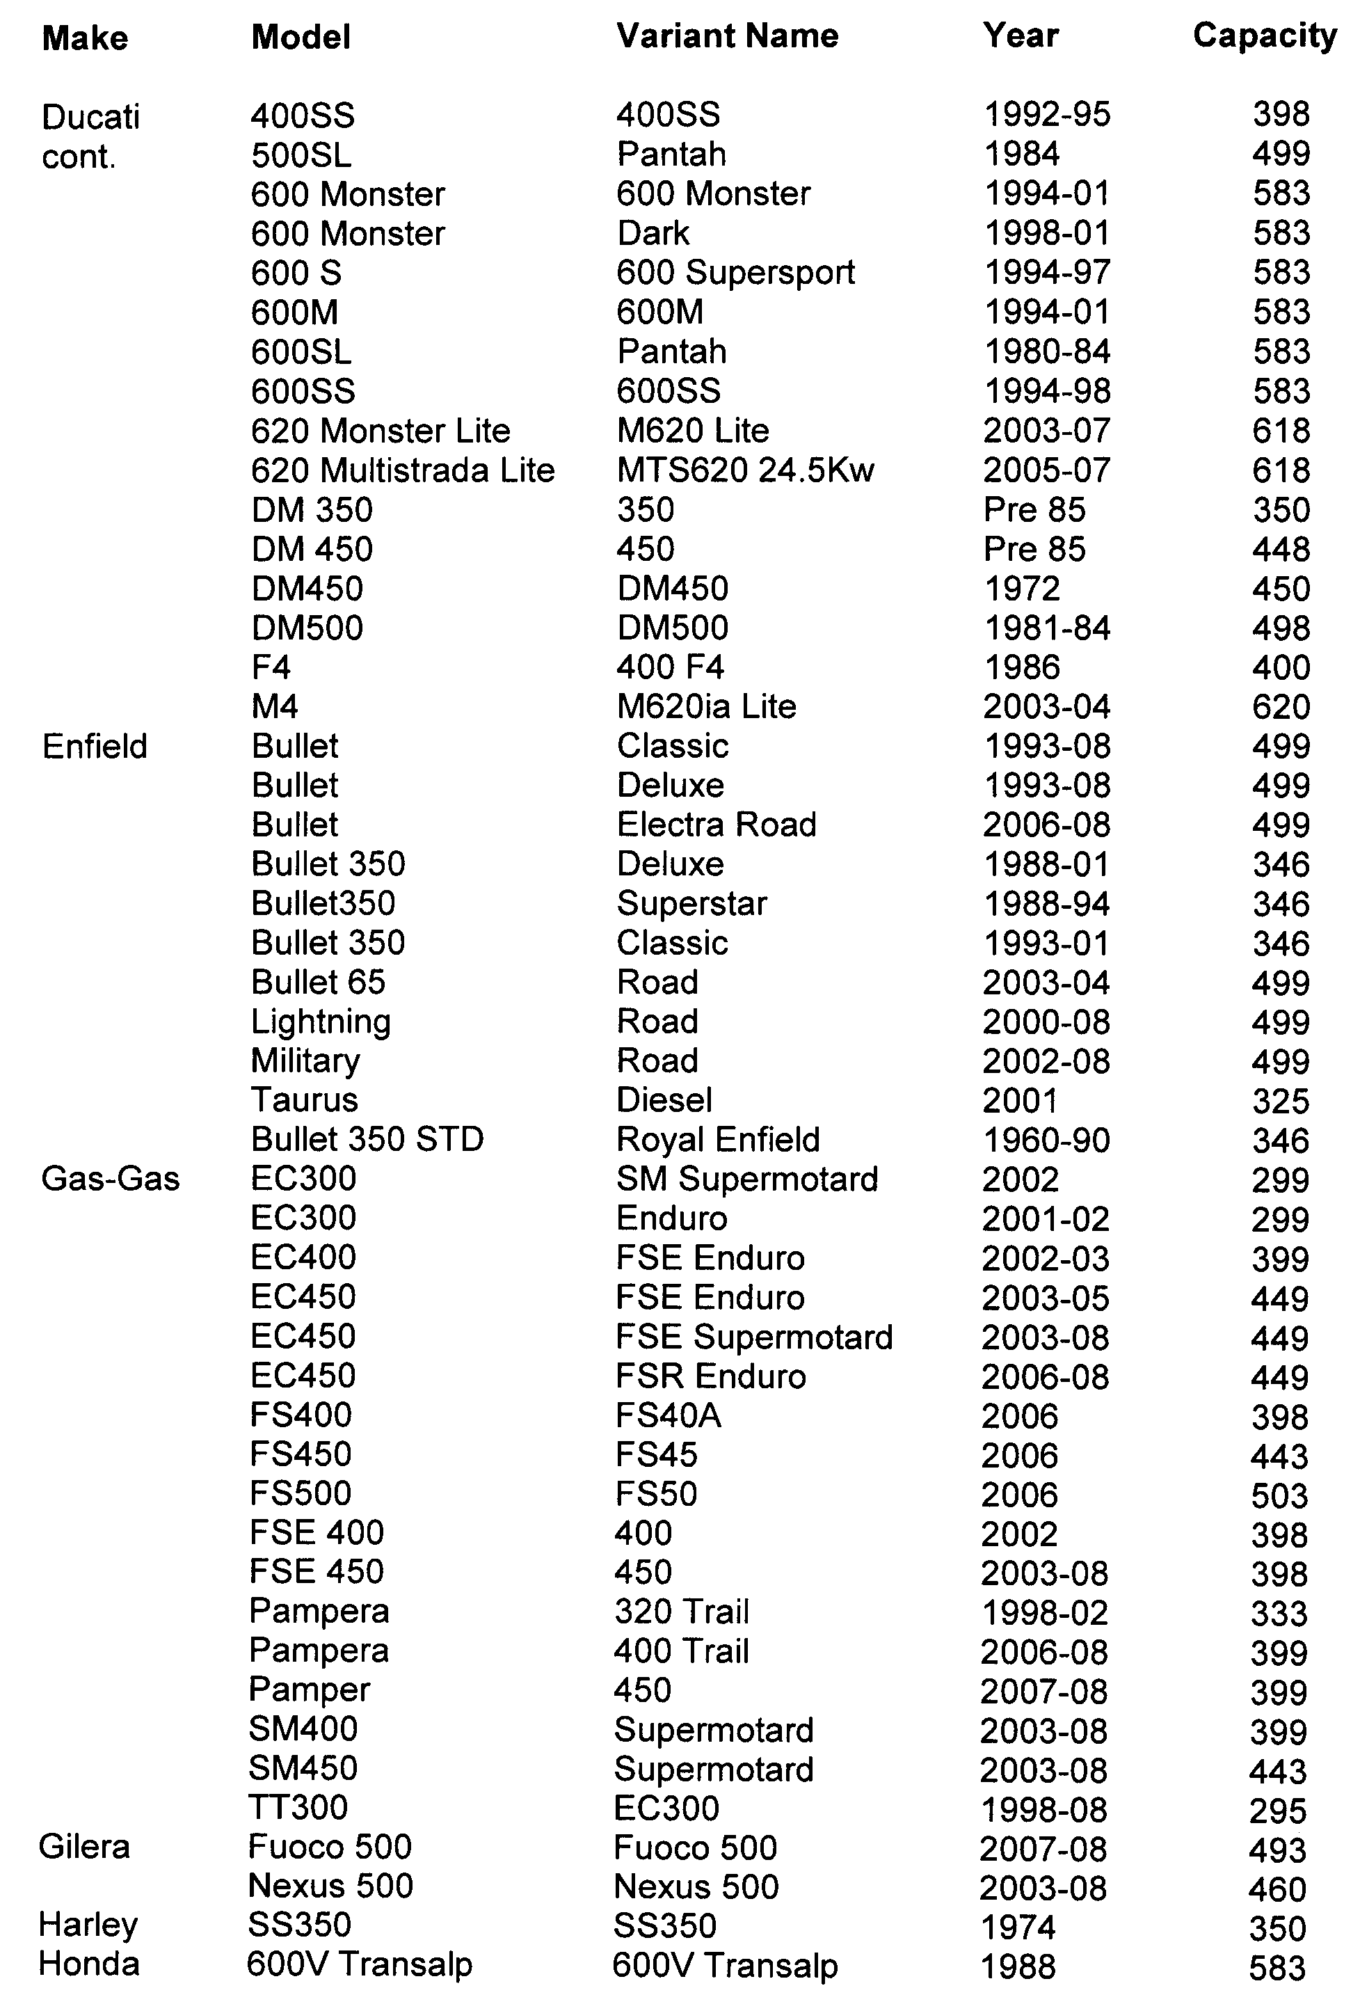
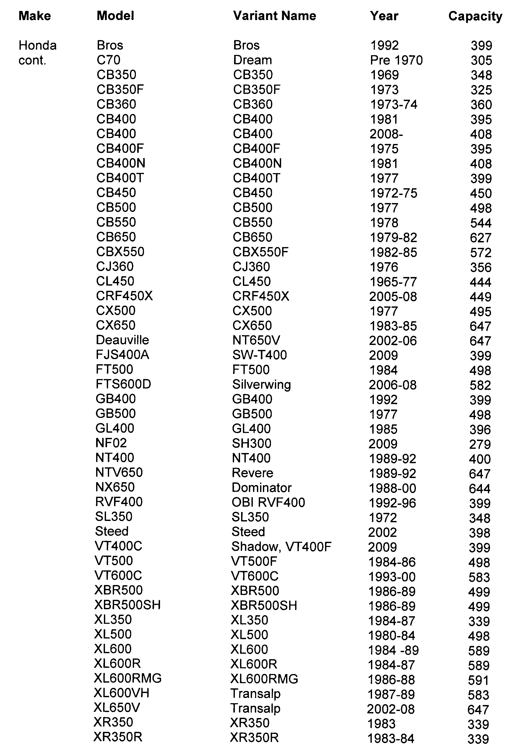
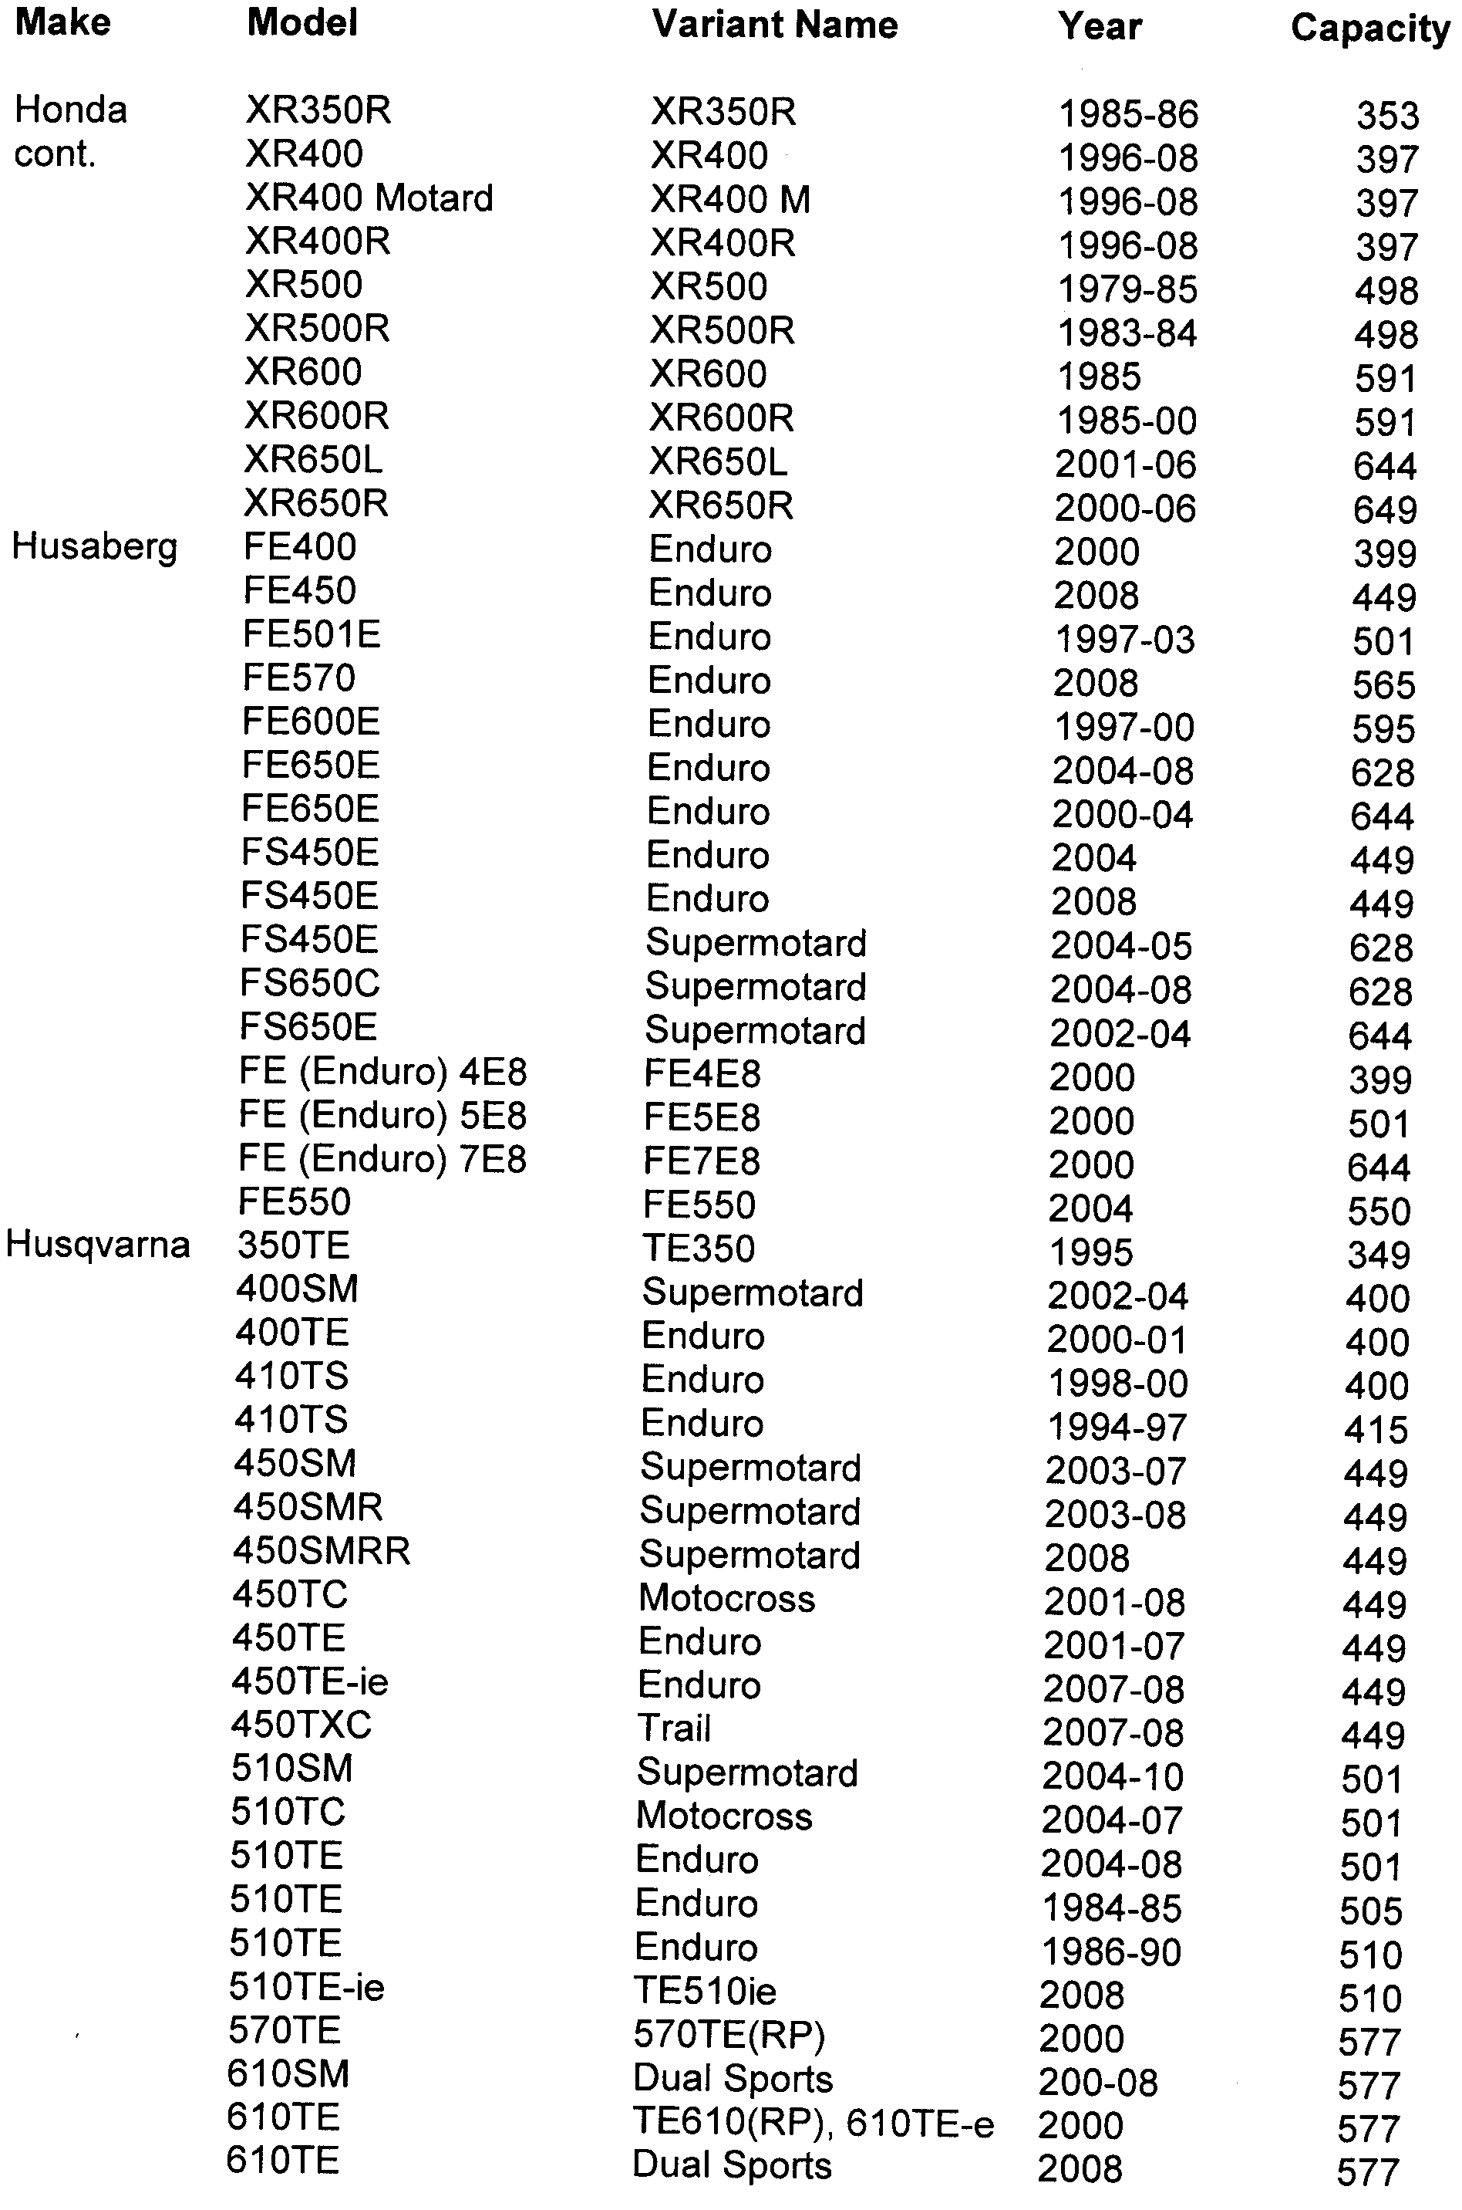
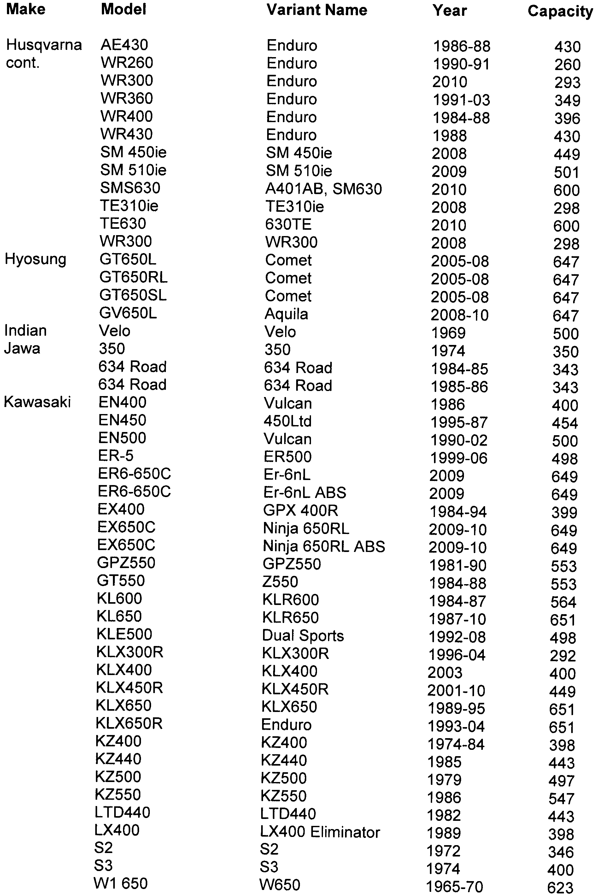
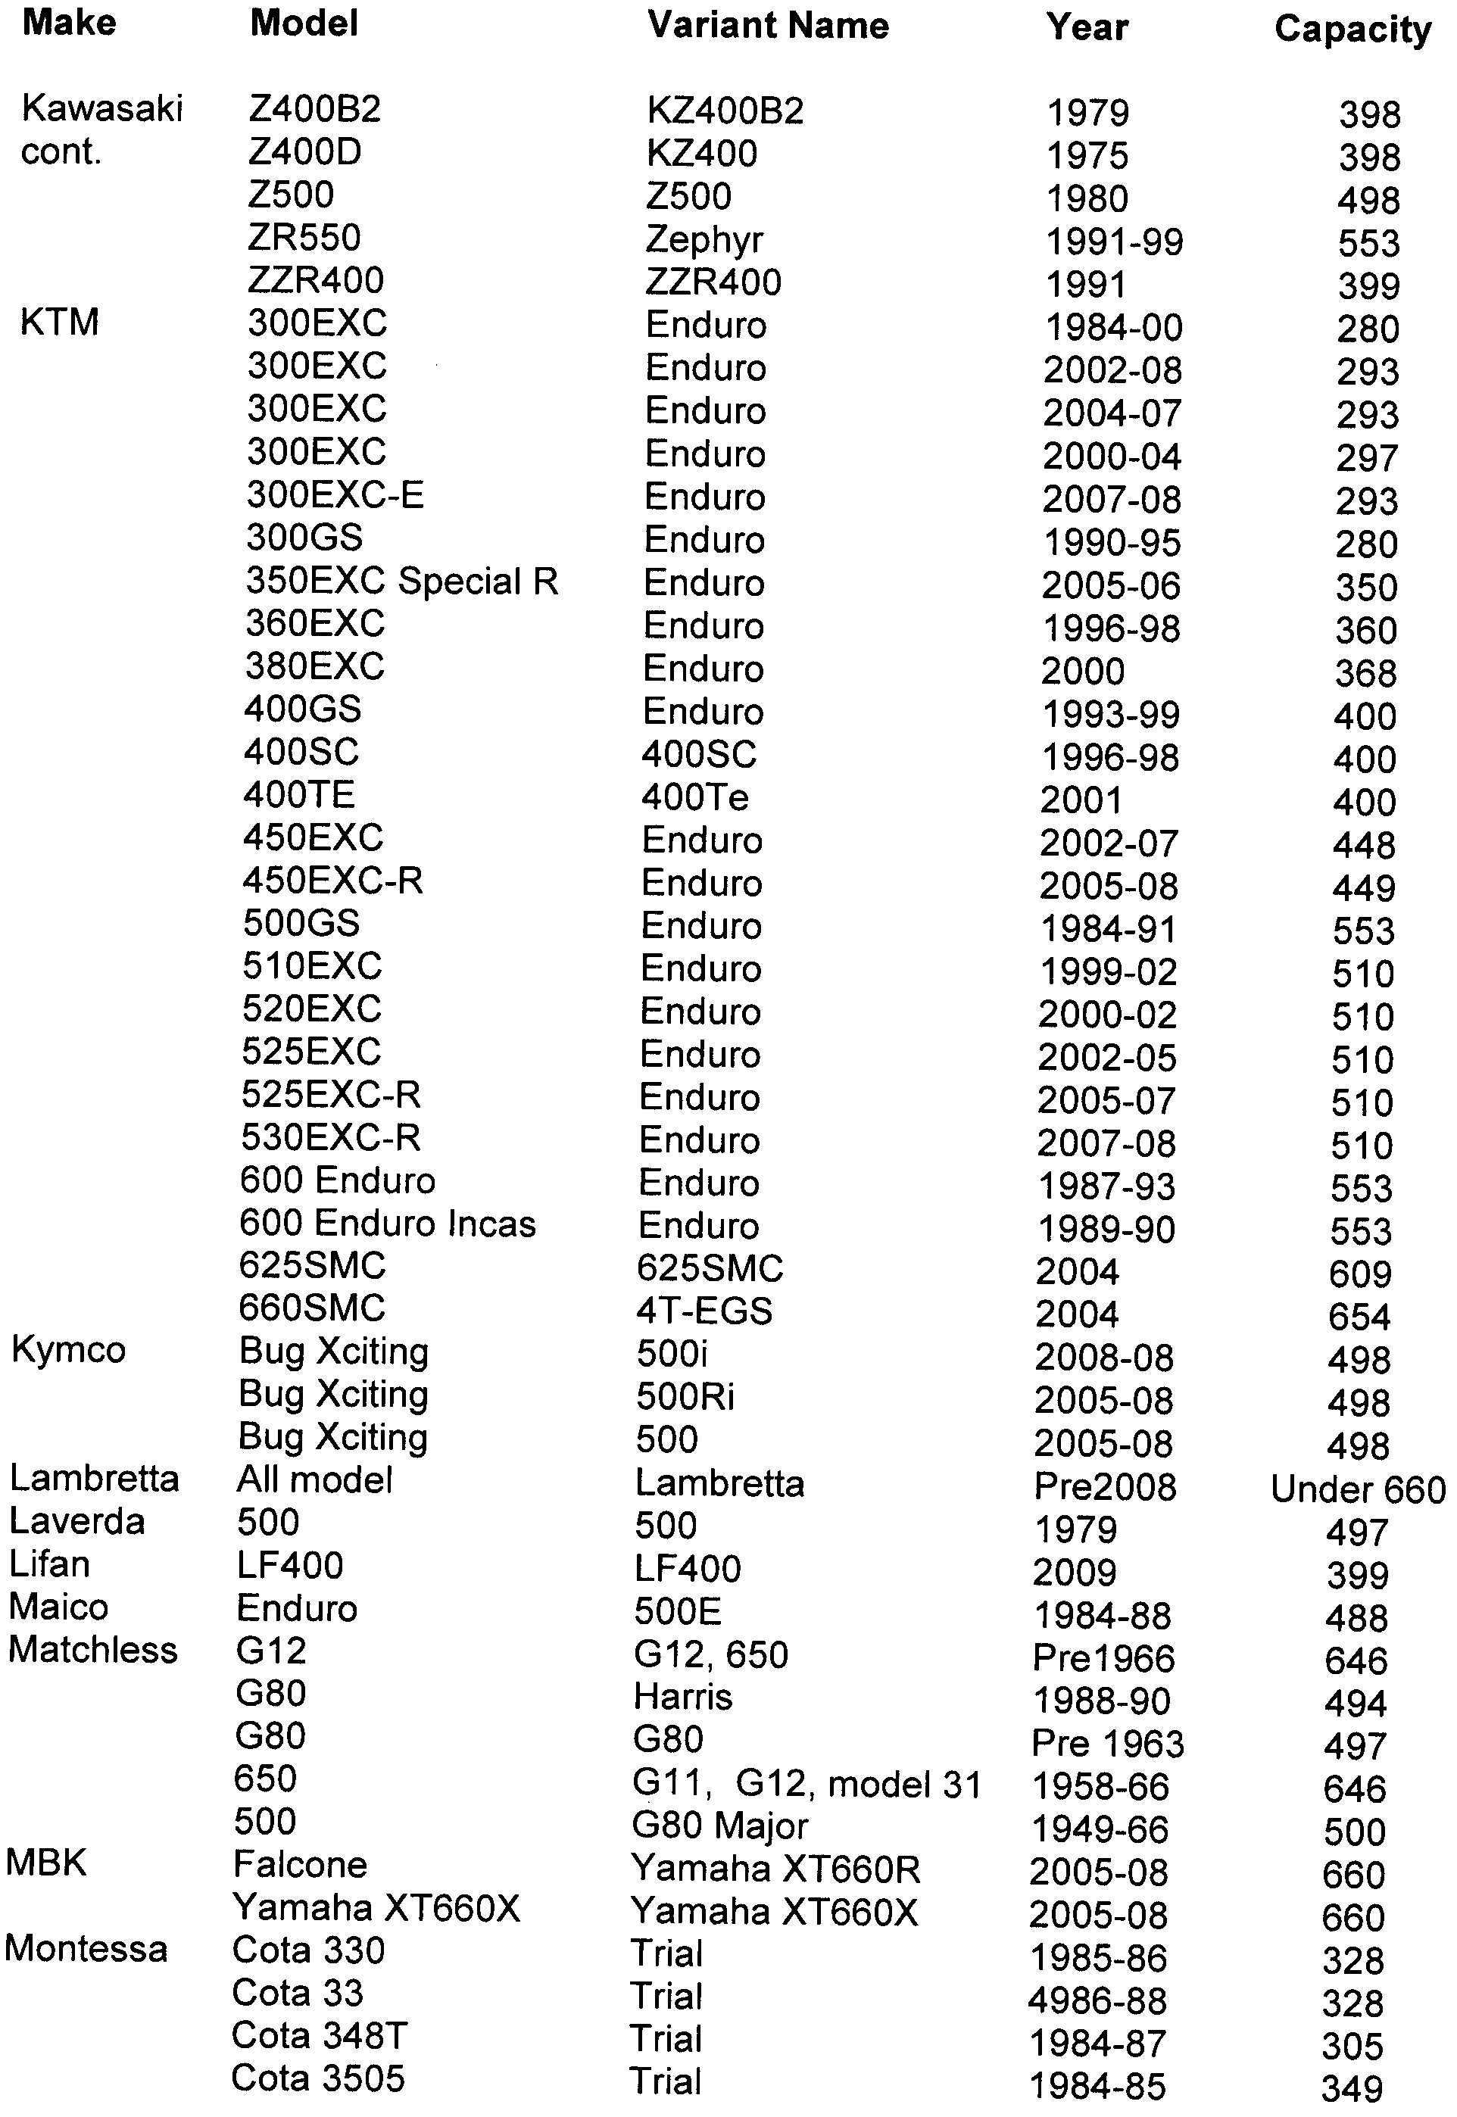
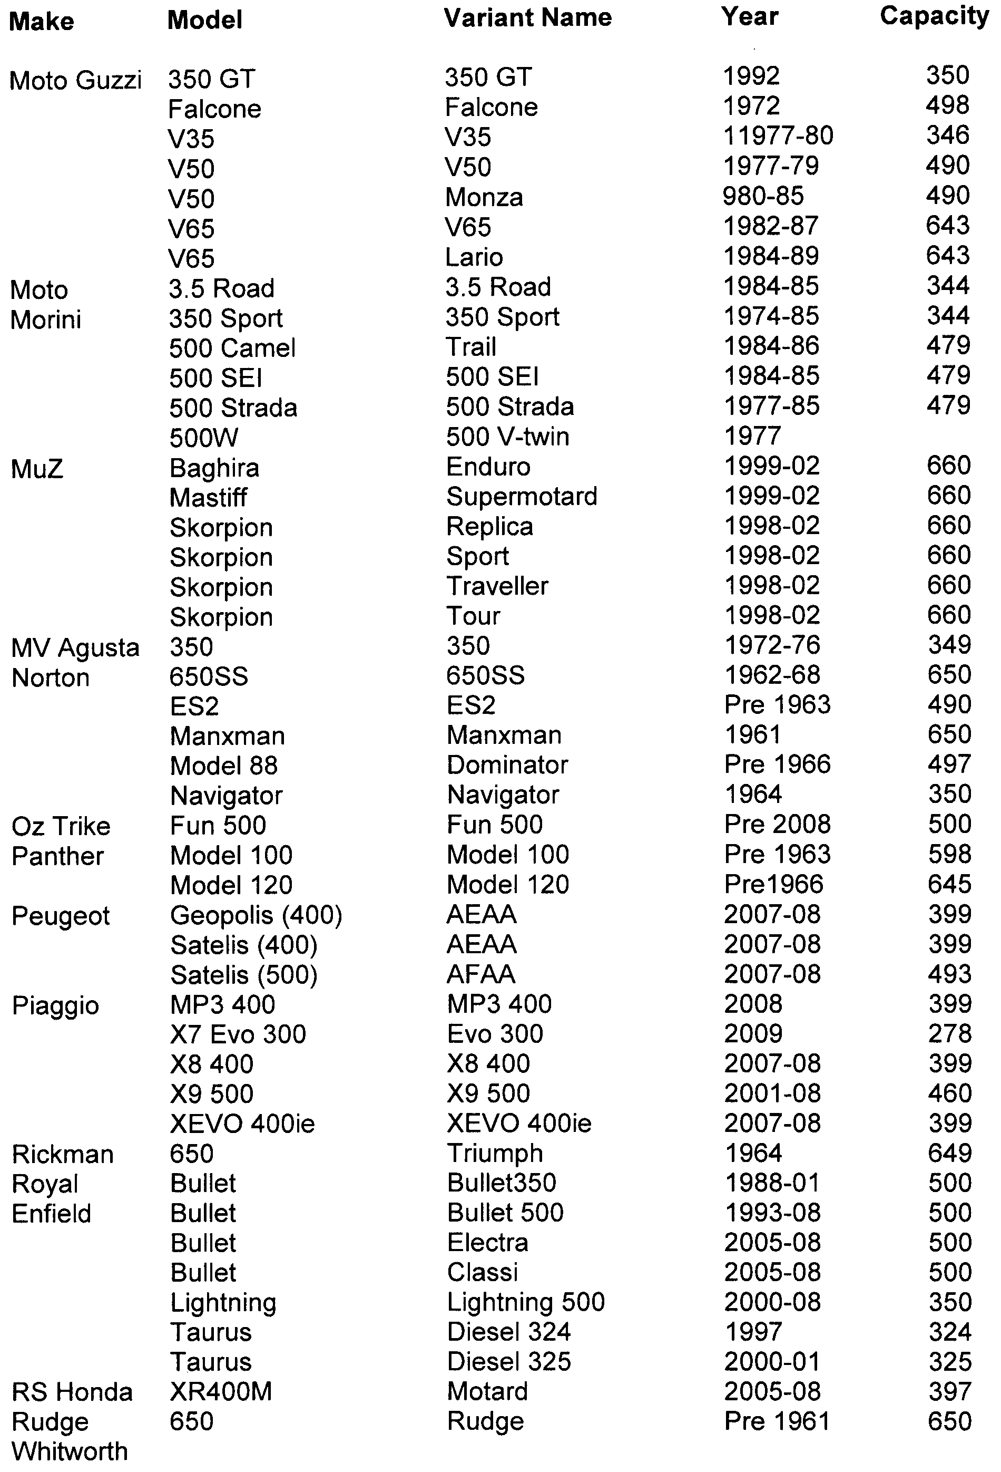
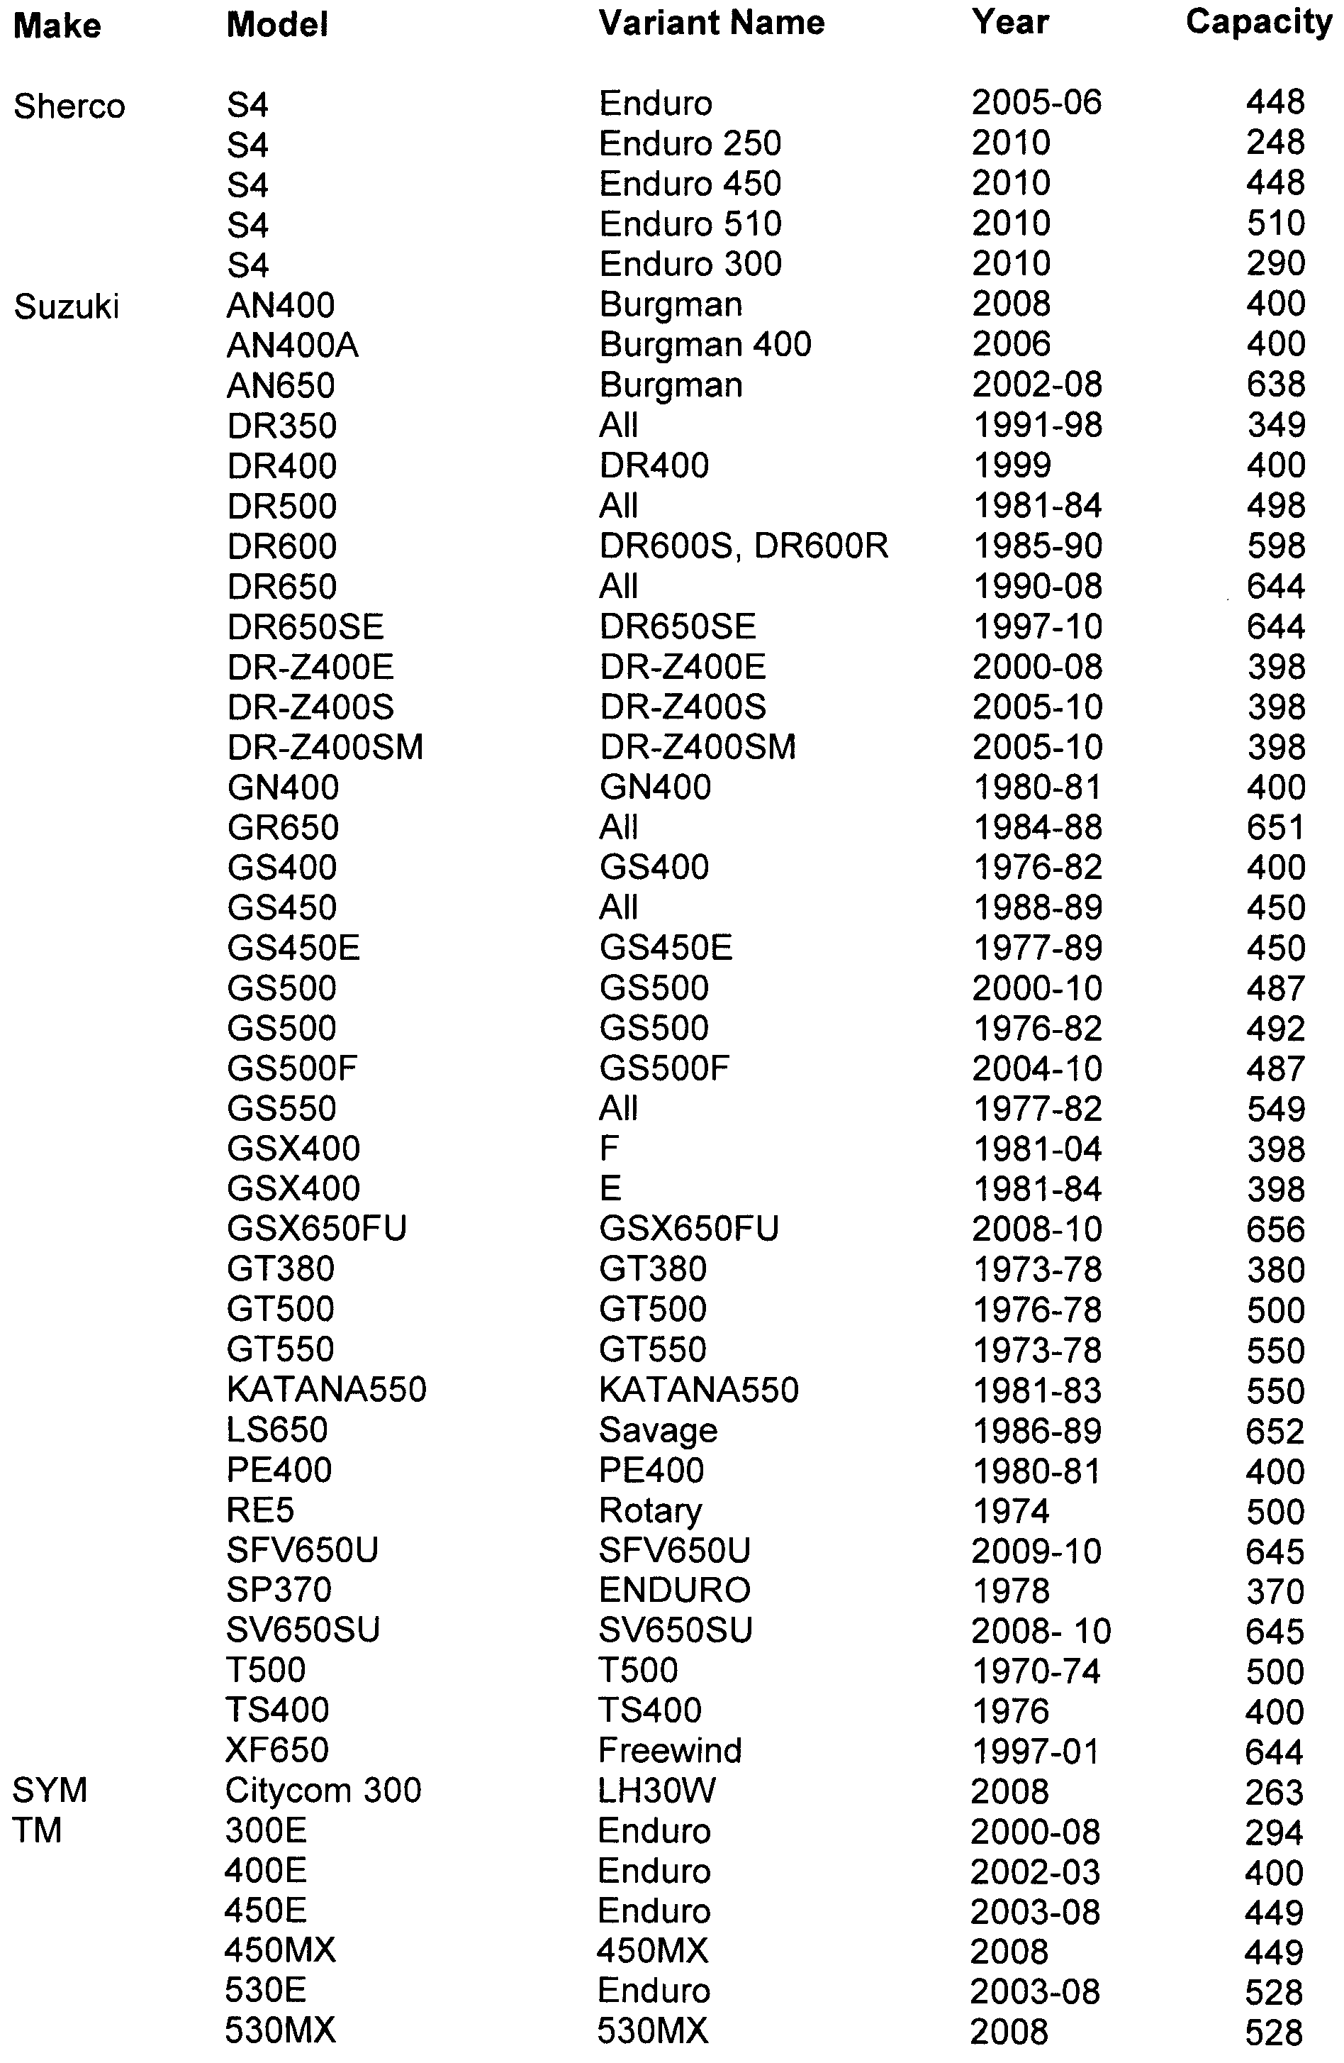
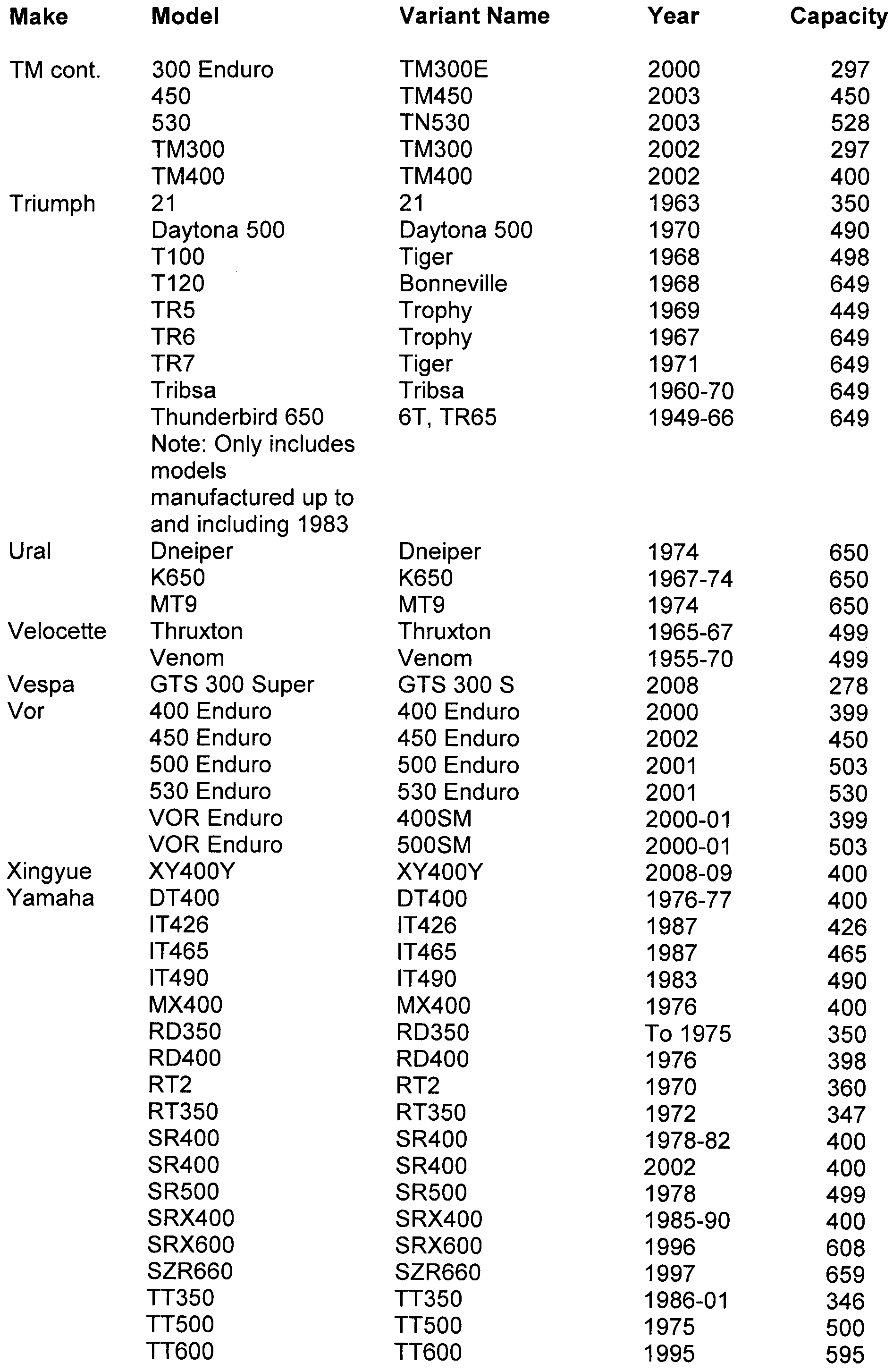
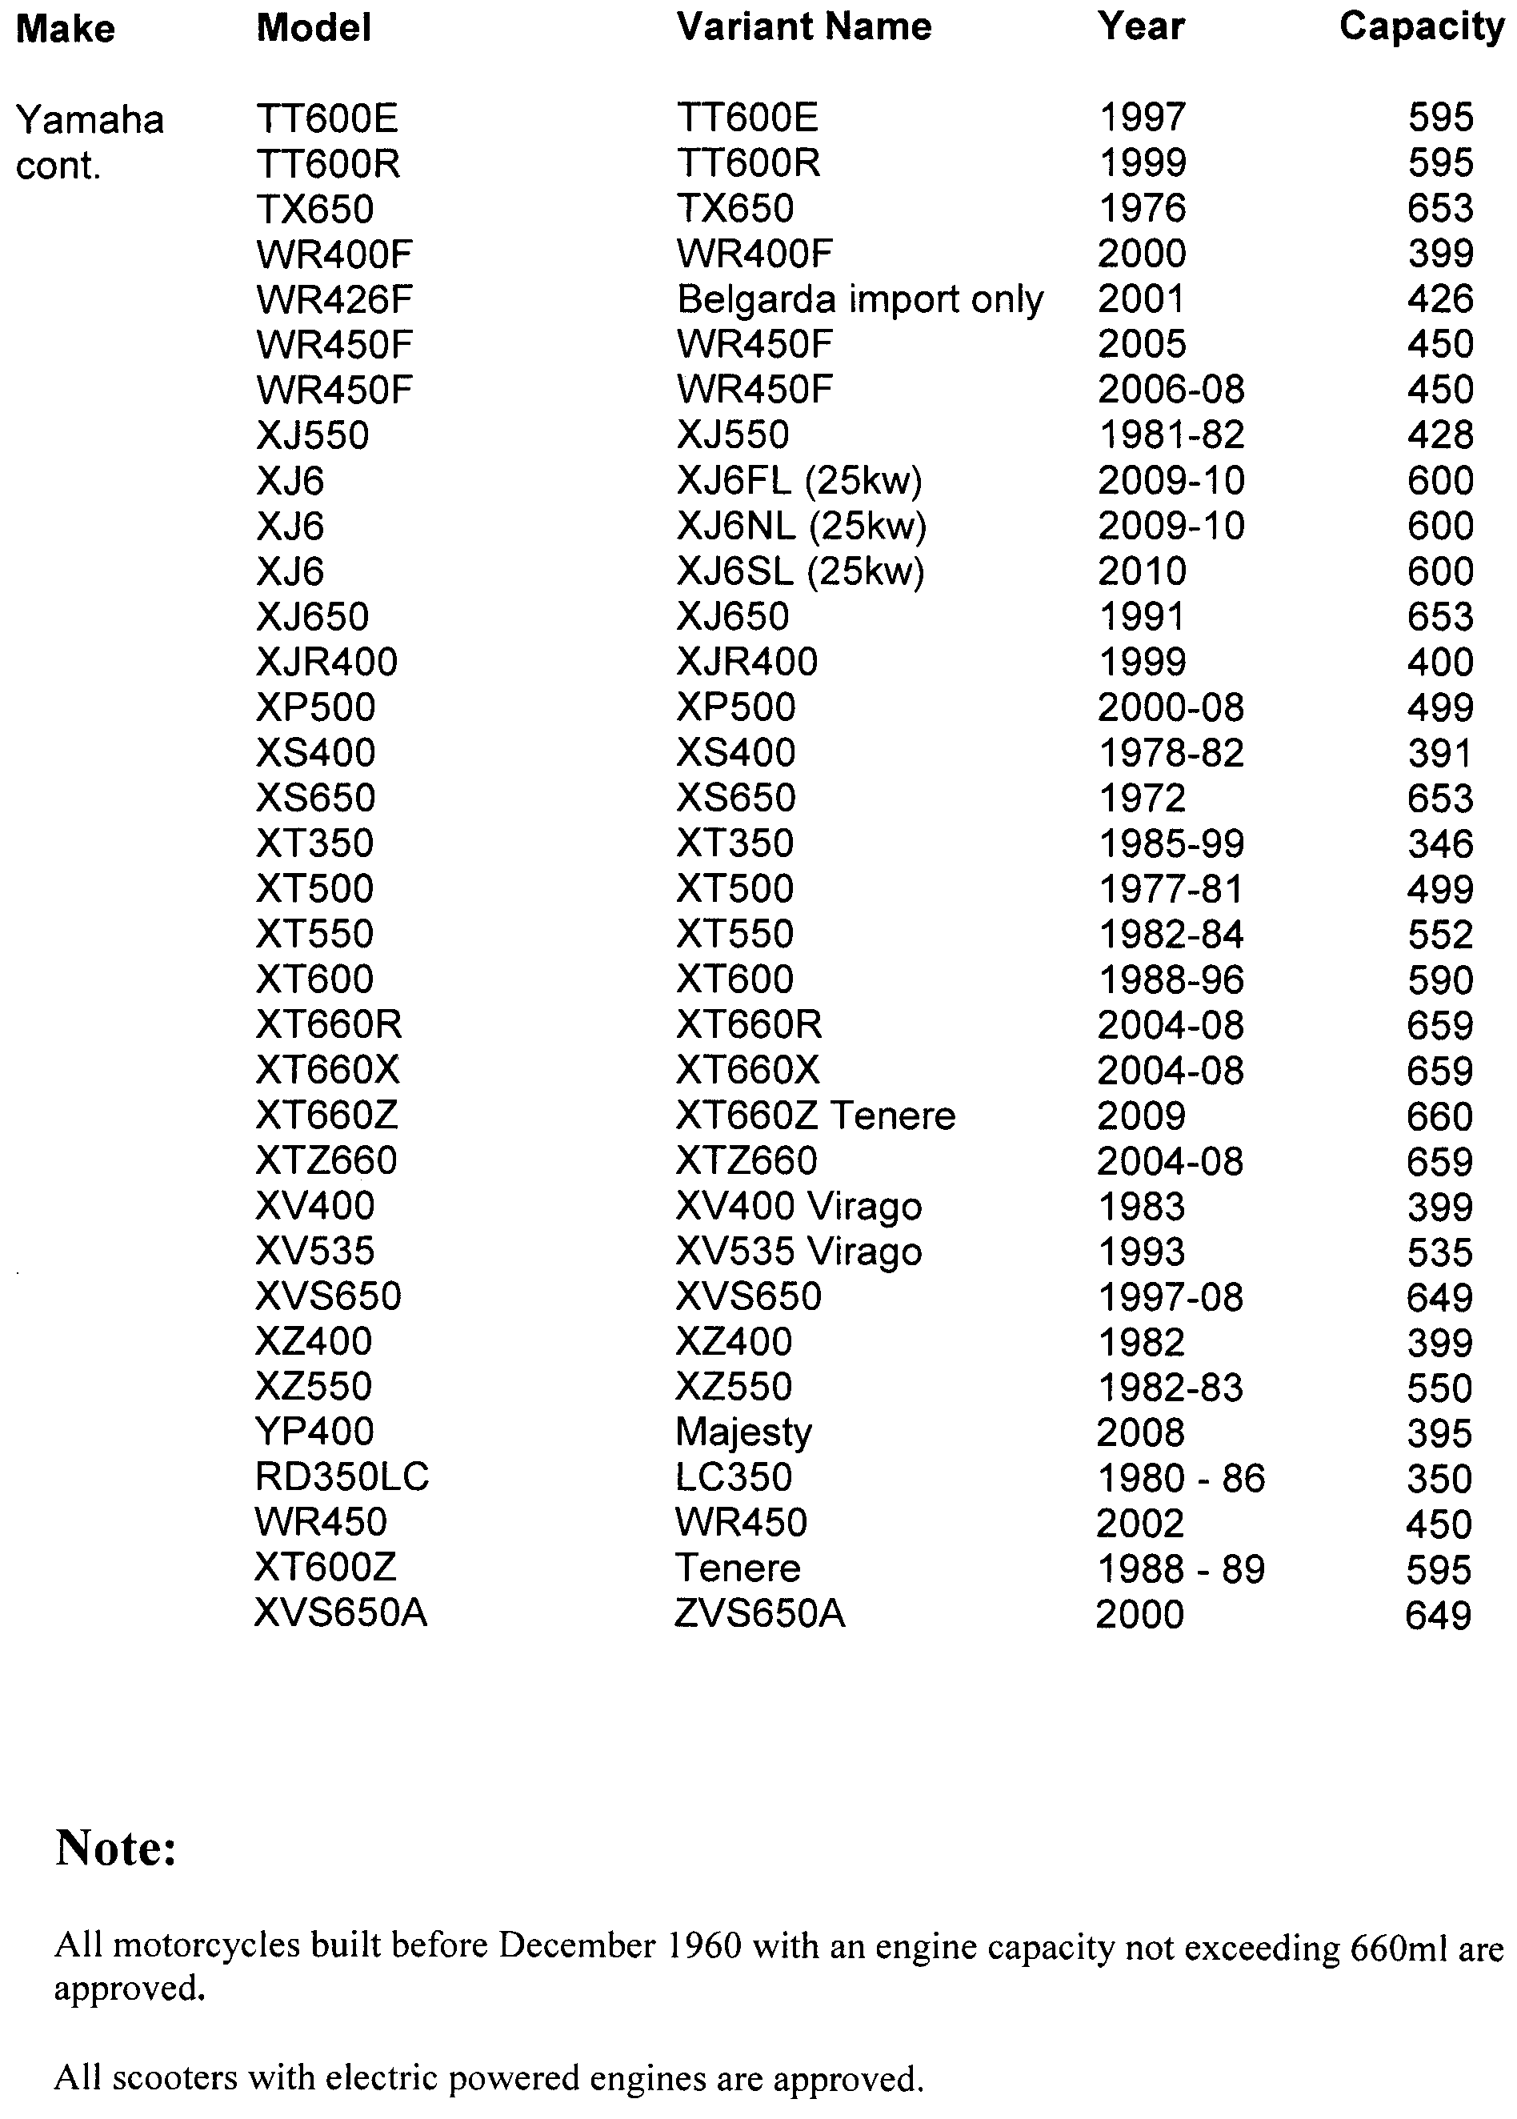
Schedule 2—Revocation
The Motor Vehicles (Approval of Motor Bikes and Motor Trikes) Notice 2010 made on 6 May 2010 (Gazette no. 28, 6 May 2010 p1708) is revoked.

Made by Ron Shanks, Deputy Registrar of Motor Vehicles
3 June 2010

South Australia
Mining (Revocation of Private Mine) Proclamation 2010
under section 73N of the Mining Act 1971

Preamble
1 The following area was declared to be a private mine by proclamation made pursuant to the Mining Act 1971 on 1 March 1973 (Gazette 1.3.1973 p738):
The whole of the land edged red in the plan on memorandum of lease registered number 2922518 between Maxwell Reuben James Hannaford and Amelia Sara Hannaford dated the 8th day of October, 1965 in respect of portion of the land comprised in certificate of title, Register Book volume 2081 folio 60.
2 The Warden's Court has declared (on 2 February 2010 in Action No 245 of 2009) that proper grounds exist for revoking the declaration referred to in clause 1.

1—Short title
This proclamation may be cited as the Mining (Revocation of Private Mine) Proclamation 2010.
2—Commencement
This proclamation comes into operation on the day on which it is made.
3—Revocation of private mine
The declaration referred to in clause 1 of the preamble is revoked.
Made by the Governor
on the basis of the declaration of the Warden's Court referred to in clause 2 of the preamble and with the advice and consent of the Executive Council
on 10 June 2010
AGO0047/02CS

[Regulations 44 to 144—please see Extraordinary Gazette No. 38,
dated 10 June 2010, pages 2675 to 2994.]
South Australia
Public Corporations (Distribution Lessor Corporation) Regulations 2010
under the Public Corporations Act 1993

Contents
Part 1—Preliminary
1 Short title
2 Commencement
3 Interpretation
Part 2—Application of Act to Treasurer
4 Application of Act to Treasurer
Part 3—Distribution Lessor Corporation
Division 1—Distribution Lessor Corporation continues as a subsidiary of Treasurer
5 Establishment of subsidiary (section 24)
6 Establishment of board
7 Composition of board
8 Conditions of membership
9 Vacancies or defects in appointment of directors
10 Remuneration
11 Proceedings
12 Disclosure
Division 2—Functions and powers
13 Functions of subsidiary
14 Charter
15 Other subsidiary companies
16 Guarantee or indemnity for other subsidiary company subject to Treasurer's approval
17 Indirect or joint operations
18 Chief executive
Division 3—Financial and related matters
19 Internal audit
20 Loans, borrowings etc require approval
21 Provision of information
22 Common seal and execution of documents
23 Annual report
Schedule 1—Revocation of Public Corporations (Distribution Lessor Corporation) Regulations 1999
1 Revocation of regulations

Part 1—Preliminary
1—Short title
These regulations may be cited as the Public Corporations (Distribution Lessor Corporation) Regulations 2010.
2—Commencement
These regulations will come into operation on 1 July 2010.
3—Interpretation
In these regulations, unless the contrary intention appears—
Act means the Public Corporations Act 1993;
board means the board of directors established as the governing body of the subsidiary under Part 3;
director means a person appointed or holding office as a member of the board under Part 3;
the subsidiary means Distribution Lessor Corporation continued in existence under Part 3;
Treasurer means the Treasurer for the State of South Australia.
Part 2—Application of Act to Treasurer
4—Application of Act to Treasurer
The following provisions of the Act apply to the Treasurer:
(a) Part 1 (Preliminary);
(b) section 24 (Formation of subsidiary by regulation);
(c) section 25 (Dissolution of subsidiary established by regulation);
(d) the Schedule (Provisions applicable to subsidiaries).
Part 3—Distribution Lessor Corporation
Division 1—Distribution Lessor Corporation continues as a subsidiary of Treasurer
5—Establishment of subsidiary (section 24)
(1) Distribution Lessor Corporation continues as a subsidiary of the Treasurer.
(2) The subsidiary—
(a) is a body corporate; and
(b) has perpetual succession and a common seal; and
(c) is capable of suing and being sued in its corporate name.
6—Establishment of board
(1) A board of directors continues as the governing body of the subsidiary.
(2) Anything done by the board in the administration of the subsidiary's affairs is binding on the subsidiary.
7—Composition of board
(1) The board consists of 3 members appointed by the Treasurer.
(2) One director will be appointed by the Treasurer to chair meetings of the board.
(3) The Treasurer may appoint a director to be the deputy of the director appointed to chair meetings of the board and the deputy may perform or exercise the functions and powers of that director in his or her absence.
(4) On the office of a director becoming vacant, a person may be appointed in accordance with this regulation to the vacant office.
(5) The Treasurer may appoint a suitable person to be deputy of a member of the board during any period of absence of the member (and any reference to a director in these regulations will be taken to include, unless the contrary intention appears, a reference to a deputy while acting as a member of the board).
8—Conditions of membership
(1) A director will be appointed for a term, not exceeding 3 years, specified in the instrument of appointment and, at the expiration of a term of appointment, will be eligible for reappointment.
(2) The Treasurer may remove a director from office by written notice on any ground that the Treasurer considers sufficient.
(3) The office of a director becomes vacant if the director—
(a) dies; or
(b) completes a term of office and is not reappointed; or
(c) resigns by written notice to the Treasurer; or
(d) becomes bankrupt or applies to take the benefit of a law for the relief of insolvent debtors; or
(e) is convicted of an indictable offence or sentenced to imprisonment for an offence; or
(f) is removed from office under subregulation (2).
9—Vacancies or defects in appointment of directors
An act of the board is not invalid by reason only of a vacancy in its membership or a defect in the appointment of a director.
10—Remuneration
A director is entitled to be paid from the funds of the subsidiary such remuneration, allowances and expenses as may be determined by the Treasurer.
11—Proceedings
(1) A quorum of the board consists of 2 directors.
(2) The director appointed to chair meetings of the board will preside at a meeting of the board at which the director is present.
(3) If the director appointed to chair meetings of the board is absent from a meeting of the board, the following provisions apply:
(a) if another director has been appointed as that director's deputy and is present at the meeting—the deputy will preside at the meeting;
(b) in any other case—a director chosen by the directors present at the meeting will preside at the meeting.
(4) A decision carried by a majority of the votes cast by directors at a meeting is a decision of the board.
(5) Each director present at a meeting of the board has 1 vote on a question arising for decision and, if the votes are equal, the director presiding at the meeting may exercise a casting vote.
(6) A telephone or video conference between directors will, for the purposes of this regulation, be taken to be a meeting of the board at which the participating directors are present if—
(a) notice of the conference is given to all directors in the manner determined by the board for that purpose; and
(b) each participating director is capable of communicating with every other participating director during the conference.
(7) A proposed resolution of the board becomes a valid decision of the board despite the fact that it is not voted on at a meeting of the board if—
(a) notice of the proposed resolution is given to all directors in accordance with procedures determined by the board; and
(b) a majority of the directors express their concurrence in the proposed resolution by letter, fax or other written communication setting out the terms of the resolution.
(8) The board must cause accurate minutes to be kept of its proceedings.
(9) A representative of the Treasurer authorised in writing by the Treasurer may attend a meeting of the board and may have access to papers provided to directors for the purpose of the meeting.
(10) If the board considers that a matter dealt with at a meeting attended by a representative of the Treasurer should be treated as confidential, the board may advise the Treasurer of that opinion giving the reason for the opinion and the Treasurer may, subject to subregulation (11), act on that advice as the Treasurer thinks fit.
(11) If the Treasurer is satisfied on the basis of the board's advice under subregulation (10) that the subsidiary owes a duty of confidence in respect of a matter, the Treasurer must ensure the observance of that duty in respect of that matter, but this subregulation does not prevent a disclosure as required in the proper performance of ministerial functions or duties.
(12) Subject to these regulations, the board may determine its own procedures.
12—Disclosure
(1) If the subsidiary discloses to the Treasurer in pursuance of the Act or these regulations a matter in respect of which the subsidiary owes a duty of confidence, the subsidiary must give notice in writing of the disclosure to the person to whom the duty is owed.
(2) A director of the subsidiary does not commit any breach of duty by reporting a matter relating to the affairs of the subsidiary to the Treasurer.
Division 2—Functions and powers
13—Functions of subsidiary
(1) The subsidiary's functions are limited to the following:
(a) to be the lessor under a lease granted in respect of prescribed assets by a transfer order or a sale/lease agreement made under the Electricity Corporations (Restructuring and Disposal) Act 1999;
(b) to be a party to any instrument related to a lease referred to in paragraph (a) or related to property the subject matter of such a lease;
(c) to be the operator of prescribed assets on the expiration or sooner termination of such a lease;
(d) to hold prescribed assets as owner or lessee for the purposes of a function referred to in a preceding paragraph;
(e) to carry out other functions conferred on the subsidiary by the Treasurer;
(f) to do anything necessary or expedient to be done for the purposes of a function referred to in a preceding paragraph.
(2) In this regulation—
asset, lease, lessor and lessee have the same meanings as in the Electricity Corporations (Restructuring and Disposal) Act 1999;
prescribed assets means—
(a) powerlines within the meaning of the Electricity Act 1996; or
(b) substations for converting, transforming or controlling electricity; or
(c) land on or under which infrastructure referred to in paragraph (a) or (b) is situated; or
(d) any other assets that are, have been or may be used in connection with the operation of a distribution network.
14—Charter
(1) The subsidiary must continue to have a charter prepared by the Treasurer.
(2) The charter must address—
(a) the nature and scope of the subsidiary's operations;
(b) the subsidiary's obligations to report on its operations;
(c) the form and contents of the subsidiary's accounts and financial statements;
(d) any accounting, internal auditing or financial systems or practices to be established or observed by the subsidiary;
(e) the acquisition or disposal of capital or assets or the borrowing or lending of money.
(3) The charter may—
(a) limit or otherwise regulate the functions or powers of the subsidiary; and
(b) deal with any other matter not specifically referred to in subregulation (2).
(4) The Treasurer must, after consultation with the subsidiary, review the charter at the end of each financial year.
(5) The Treasurer may, after consultation with the subsidiary, amend the charter at any time.
(6) The charter, or an amendment to the charter, comes into force and is binding on the subsidiary on a day specified in the charter or amendment (but without affecting any contractual obligations previously incurred by the subsidiary).
(7) On the charter or an amendment to the charter coming into force, the Treasurer must, within 12 sitting days, have copies of the charter, or the charter in its amended form, laid before both Houses of Parliament.
15—Other subsidiary companies
(1) The subsidiary must not, without the approval of the Treasurer—
(a) form a subsidiary company; or
(b) acquire, or enter into any arrangement under which it will at a future time or would on the happening of some contingency hold, relevant interests in shares in a company such that the company becomes a subsidiary of the subsidiary.
(2) The Treasurer may, as a condition of approval under this regulation, or by direction, require the subsidiary to take steps to include in a subsidiary company's constitution such provisions as the Treasurer considers appropriate—
(a) imposing limitations on the nature or scope of the company's operations; or
(b) imposing other controls or practices,
consistent with those applicable to the subsidiary.
16—Guarantee or indemnity for other subsidiary company subject to Treasurer's approval
The subsidiary must not, without the approval of the Treasurer, give a guarantee or provide an indemnity in respect of liabilities of a company that is a subsidiary of the subsidiary.
17—Indirect or joint operations
The subsidiary must not, without the approval of the Treasurer, establish a trust scheme or a partnership or other scheme or arrangement for sharing of profits or joint venture with another person or undertake any operations or transactions pursuant to such a scheme or arrangement.
18—Chief executive
The board must not appoint or remove a person as chief executive of the subsidiary unless it has first consulted the Treasurer.
Division 3—Financial and related matters
19—Internal audit
(1) The subsidiary must, unless exempted by the Treasurer, maintain effective internal auditing of its operations.
(2) The subsidiary must, unless exempted by the Treasurer, have an audit committee.
(3) The audit committee will comprise—
(a) a member of the board of the subsidiary, or such members of the board, as the board may from time to time determine; and
(b) such other person or persons as the board may from time to time appoint,
but may not include the chief executive (if any) of the subsidiary.
(4) The functions of the audit committee include—
(a) reviewing annual financial statements to ensure that they provide a true and fair view of the state of affairs of the subsidiary; and
(b) liaising with external auditors; and
(c) reviewing the adequacy of the accounting, internal auditing, reporting and other financial management systems and practices of the subsidiary on a regular basis.
20—Loans, borrowings etc require approval
(1) The subsidiary must not lend or advance to any person any money, securities or property without the approval of the Treasurer.
(2) The subsidiary must not borrow money or obtain any other form of financial accommodation unless authorised to do so by the Treasurer.
21—Provision of information
(1) The subsidiary must, at the request in writing of the Treasurer, furnish the Treasurer with such information or records in the possession or control of the subsidiary as the Treasurer may require in such manner and form as the Treasurer may require.
(2) If a record in the possession or control of the subsidiary is furnished to the Treasurer under this regulation, the Treasurer may make, retain and deal with copies of the record as the Treasurer thinks fit.
(3) If the board considers that information or a record furnished under this regulation contains matters that should be treated as confidential, the board may advise the Treasurer of that opinion giving the reason for the opinion and the Treasurer may, subject to subregulation (4), act on that advice as the Treasurer thinks fit.
(4) If the Treasurer is satisfied on the basis of the board's advice under subregulation (3) that the subsidiary owes a duty of confidence in respect of a matter, the Treasurer must ensure the observance of that duty in respect of the matter, but this subregulation does not prevent a disclosure as required in the proper performance of ministerial functions or duties.
22—Common seal and execution of documents
(1) The common seal of the subsidiary must not be affixed to a document except in pursuance of a decision of the board, and the affixing of the seal must be attested by the signatures of 2 directors.
(2) The board may, by instrument under the common seal of the subsidiary, authorise a director, an employee of the subsidiary (whether nominated by name or by office or title) or any other person to execute documents on behalf of the subsidiary subject to limitations (if any) specified in the instrument of authority.
(3) Without limiting subregulation (2), an authority may be given so as to authorise 2 or more persons to execute documents jointly on behalf of the subsidiary.
(4) A document is duly executed by the subsidiary if—
(a) the common seal of the subsidiary is affixed to the document in accordance with this regulation; or
(b) the document is signed on behalf of the subsidiary by a person or persons in accordance with authority conferred under this regulation.
23—Annual report
(1) The subsidiary must, within 3 months after the end of each financial year, deliver to the Treasurer a report on the financial operations of the subsidiary during that financial year.
(2) The Treasurer must cause a copy of the report to be laid before both Houses of Parliament within 12 sitting days after receipt of the report.
Schedule 1—Revocation of Public Corporations (Distribution Lessor Corporation) Regulations 1999
1—Revocation of regulations
The Public Corporations (Distribution Lessor Corporation) Regulations 1999 are revoked.
Note—
As required by section 10AA(2) of the Subordinate Legislation Act 1978, the Minister has certified that, in the Minister's opinion, it is necessary or appropriate that these regulations come into operation as set out in these regulations.
Made by the Governor
with the advice and consent of the Executive Council
on 10 June 2010
No 41 of 2010
South Australia
Public Corporations (Generation Lessor Corporation) Regulations 2010
under the Public Corporations Act 1993

Contents
Part 1—Preliminary
1 Short title
2 Commencement
3 Interpretation
Part 2—Application of Act to Treasurer
4 Application of Act to Treasurer
Part 3—Generation Lessor Corporation
Division 1—Generation Lessor Corporation continues as a subsidiary of Treasurer
5 Establishment of subsidiary (section 24)
6 Establishment of board
7 Composition of board
8 Conditions of membership
9 Vacancies or defects in appointment of directors
10 Remuneration
11 Proceedings
12 Disclosure
Division 2—Functions and powers
13 Functions of subsidiary
14 Charter
15 Other subsidiary companies
16 Guarantee or indemnity for other subsidiary company subject to Treasurer's approval
17 Indirect or joint operations
18 Chief executive
Division 3—Financial and related matters
19 Internal audit
20 Loans, borrowings etc require approval
21 Provision of information
22 Common seal and execution of documents
23 Annual report
Schedule 1—Revocation of Public Corporations (Generation Lessor Corporation) Regulations 1999
1 Revocation of regulations

Part 1—Preliminary
1—Short title
These regulations may be cited as the Public Corporations (Generation Lessor Corporation) Regulations 2010.
2—Commencement
These regulations will come into operation on 1 July 2010.
3—Interpretation
In these regulations, unless the contrary intention appears—
Act means the Public Corporations Act 1993;
board means the board of directors established as the governing body of the subsidiary under Part 3;
director means a person appointed or holding office as a member of the board under Part 3;
the subsidiary means Generation Lessor Corporation continued in existence under Part 3;
Treasurer means the Treasurer for the State of South Australia.
Part 2—Application of Act to Treasurer
4—Application of Act to Treasurer
The following provisions of the Act apply to the Treasurer:
(a) Part 1 (Preliminary);
(b) section 24 (Formation of subsidiary by regulation);
(c) section 25 (Dissolution of subsidiary established by regulation);
(d) the Schedule (Provisions applicable to subsidiaries).
Part 3—Generation Lessor Corporation
Division 1—Generation Lessor Corporation continues as a subsidiary of Treasurer
5—Establishment of subsidiary (section 24)
(1) Generation Lessor Corporation continues as a subsidiary of the Treasurer.
(2) The subsidiary—
(a) is a body corporate; and
(b) has perpetual succession and a common seal; and
(c) is capable of suing and being sued in its corporate name.
6—Establishment of board
(1) A board of directors continues as the governing body of the subsidiary.
(2) Anything done by the board in the administration of the subsidiary's affairs is binding on the subsidiary.
7—Composition of board
(1) The board consists of 3 members appointed by the Treasurer.
(2) One director will be appointed by the Treasurer to chair meetings of the board.
(3) The Treasurer may appoint a director to be the deputy of the director appointed to chair meetings of the board and the deputy may perform or exercise the functions and powers of that director in his or her absence.
(4) On the office of a director becoming vacant, a person may be appointed in accordance with this regulation to the vacant office.
(5) The Treasurer may appoint a suitable person to be deputy of a member of the board during any period of absence of the member (and any reference to a director in these regulations will be taken to include, unless the contrary intention appears, a reference to a deputy while acting as a member of the board).
8—Conditions of membership
(1) A director will be appointed for a term, not exceeding 3 years, specified in the instrument of appointment and, at the expiration of a term of appointment, will be eligible for reappointment.
(2) The Treasurer may remove a director from office by written notice on any ground that the Treasurer considers sufficient.
(3) The office of a director becomes vacant if the director—
(a) dies; or
(b) completes a term of office and is not reappointed; or
(c) resigns by written notice to the Treasurer; or
(d) becomes bankrupt or applies to take the benefit of a law for the relief of insolvent debtors; or
(e) is convicted of an indictable offence or sentenced to imprisonment for an offence; or
(f) is removed from office under subregulation (2).
9—Vacancies or defects in appointment of directors
An act of the board is not invalid by reason only of a vacancy in its membership or a defect in the appointment of a director.
10—Remuneration
A director is entitled to be paid from the funds of the subsidiary such remuneration, allowances and expenses as may be determined by the Treasurer.
11—Proceedings
(1) A quorum of the board consists of 2 directors.
(2) The director appointed to chair meetings of the board will preside at a meeting of the board at which the director is present.
(3) If the director appointed to chair meetings of the board is absent from a meeting of the board, the following provisions apply:
(a) if another director has been appointed as that director's deputy and is present at the meeting—the deputy will preside at the meeting;
(b) in any other case—a director chosen by the directors present at the meeting will preside at the meeting.
(4) A decision carried by a majority of the votes cast by directors at a meeting is a decision of the board.
(5) Each director present at a meeting of the board has 1 vote on a question arising for decision and, if the votes are equal, the director presiding at the meeting may exercise a casting vote.
(6) A telephone or video conference between directors will, for the purposes of this regulation, be taken to be a meeting of the board at which the participating directors are present if—
(a) notice of the conference is given to all directors in the manner determined by the board for that purpose; and
(b) each participating director is capable of communicating with every other participating director during the conference.
(7) A proposed resolution of the board becomes a valid decision of the board despite the fact that it is not voted on at a meeting of the board if—
(a) notice of the proposed resolution is given to all directors in accordance with procedures determined by the board; and
(b) a majority of the directors express their concurrence in the proposed resolution by letter, fax or other written communication setting out the terms of the resolution.
(8) The board must cause accurate minutes to be kept of its proceedings.
(9) A representative of the Treasurer authorised in writing by the Treasurer may attend a meeting of the board and may have access to papers provided to directors for the purpose of the meeting.
(10) If the board considers that a matter dealt with at a meeting attended by a representative of the Treasurer should be treated as confidential, the board may advise the Treasurer of that opinion giving the reason for the opinion and the Treasurer may, subject to subregulation (11), act on that advice as the Treasurer thinks fit.
(11) If the Treasurer is satisfied on the basis of the board's advice under subregulation (10) that the subsidiary owes a duty of confidence in respect of a matter, the Treasurer must ensure the observance of that duty in respect of that matter, but this subregulation does not prevent a disclosure as required in the proper performance of ministerial functions or duties.
(12) Subject to these regulations, the board may determine its own procedures.
12—Disclosure
(1) If the subsidiary discloses to the Treasurer in pursuance of the Act or these regulations a matter in respect of which the subsidiary owes a duty of confidence, the subsidiary must give notice in writing of the disclosure to the person to whom the duty is owed.
(2) A director of the subsidiary does not commit any breach of duty by reporting a matter relating to the affairs of the subsidiary to the Treasurer.
Division 2—Functions and powers
13—Functions of subsidiary
(1) The subsidiary's functions are limited to the following:
(a) to be the lessor under a lease granted in respect of prescribed assets by a transfer order or a sale/lease agreement made under the Electricity Corporations (Restructuring and Disposal) Act 1999;
(b) to be a party to any instrument related to a lease referred to in paragraph (a) or related to property the subject matter of such a lease;
(c) to be the operator of prescribed assets on the expiration or sooner termination of such a lease;
(d) to hold prescribed assets as owner or lessee for the purposes of a function referred to in a preceding paragraph;
(e) to carry out other functions conferred on the subsidiary by the Treasurer;
(f) to do anything necessary or expedient to be done for the purposes of a function referred to in a preceding paragraph.
(2) In this regulation—
asset, lease, lessor and lessee have the same meanings as in the Electricity Corporations (Restructuring and Disposal) Act 1999;
prescribed assets means—
(a) electricity generating plant; or
(b) land on which electricity generating plant is situated; or
(c) any other assets that are, have been or may be used in connection with the operation of an electricity generating plant.
14—Charter
(1) The subsidiary must continue to have a charter prepared by the Treasurer.
(2) The charter must address—
(a) the nature and scope of the subsidiary's operations;
(b) the subsidiary's obligations to report on its operations;
(c) the form and contents of the subsidiary's accounts and financial statements;
(d) any accounting, internal auditing or financial systems or practices to be established or observed by the subsidiary;
(e) the acquisition or disposal of capital or assets or the borrowing or lending of money.
(3) The charter may—
(a) limit or otherwise regulate the functions or powers of the subsidiary; and
(b) deal with any other matter not specifically referred to in subregulation (2).
(4) The Treasurer must, after consultation with the subsidiary, review the charter at the end of each financial year.
(5) The Treasurer may, after consultation with the subsidiary, amend the charter at any time.
(6) The charter, or an amendment to the charter, comes into force and is binding on the subsidiary on a day specified in the charter or amendment (but without affecting any contractual obligations previously incurred by the subsidiary).
(7) On the charter or an amendment to the charter coming into force, the Treasurer must, within 12 sitting days, have copies of the charter, or the charter in its amended form, laid before both Houses of Parliament.
15—Other subsidiary companies
(1) The subsidiary must not, without the approval of the Treasurer—
(a) form a subsidiary company; or
(b) acquire, or enter into any arrangement under which it will at a future time or would on the happening of some contingency hold, relevant interests in shares in a company such that the company becomes a subsidiary of the subsidiary.
(2) The Treasurer may, as a condition of approval under this regulation, or by direction, require the subsidiary to take steps to include in a subsidiary company's constitution such provisions as the Treasurer considers appropriate—
(a) imposing limitations on the nature or scope of the company's operations; or
(b) imposing other controls or practices,
consistent with those applicable to the subsidiary.
16—Guarantee or indemnity for other subsidiary company subject to Treasurer's approval
The subsidiary must not, without the approval of the Treasurer, give a guarantee or provide an indemnity in respect of liabilities of a company that is a subsidiary of the subsidiary.
17—Indirect or joint operations
The subsidiary must not, without the approval of the Treasurer, establish a trust scheme or a partnership or other scheme or arrangement for sharing of profits or joint venture with another person or undertake any operations or transactions pursuant to such a scheme or arrangement.
18—Chief executive
The board must not appoint or remove a person as chief executive of the subsidiary unless it has first consulted the Treasurer.
Division 3—Financial and related matters
19—Internal audit
(1) The subsidiary must, unless exempted by the Treasurer, maintain effective internal auditing of its operations.
(2) The subsidiary must, unless exempted by the Treasurer, have an audit committee.
(3) The audit committee will comprise—
(a) a member of the board of the subsidiary, or such members of the board, as the board may from time to time determine; and
(b) such other person or persons as the board may from time to time appoint,
but may not include the chief executive (if any) of the subsidiary.
(4) The functions of the audit committee include—
(a) reviewing annual financial statements to ensure that they provide a true and fair view of the state of affairs of the subsidiary; and
(b) liaising with external auditors; and
(c) reviewing the adequacy of the accounting, internal auditing, reporting and other financial management systems and practices of the subsidiary on a regular basis.
20—Loans, borrowings etc require approval
(1) The subsidiary must not lend or advance to any person any money, securities or property without the approval of the Treasurer.
(2) The subsidiary must not borrow money or obtain any other form of financial accommodation unless authorised to do so by the Treasurer.
21—Provision of information
(1) The subsidiary must, at the request in writing of the Treasurer, furnish the Treasurer with such information or records in the possession or control of the subsidiary as the Treasurer may require in such manner and form as the Treasurer may require.
(2) If a record in the possession or control of the subsidiary is furnished to the Treasurer under this regulation, the Treasurer may make, retain and deal with copies of the record as the Treasurer thinks fit.
(3) If the board considers that information or a record furnished under this regulation contains matters that should be treated as confidential, the board may advise the Treasurer of that opinion giving the reason for the opinion and the Treasurer may, subject to subregulation (4), act on that advice as the Treasurer thinks fit.
(4) If the Treasurer is satisfied on the basis of the board's advice under subregulation (3) that the subsidiary owes a duty of confidence in respect of a matter, the Treasurer must ensure the observance of that duty in respect of the matter, but this subregulation does not prevent a disclosure as required in the proper performance of ministerial functions or duties.
22—Common seal and execution of documents
(1) The common seal of the subsidiary must not be affixed to a document except in pursuance of a decision of the board, and the affixing of the seal must be attested by the signatures of 2 directors.
(2) The board may, by instrument under the common seal of the subsidiary, authorise a director, an employee of the subsidiary (whether nominated by name or by office or title) or any other person to execute documents on behalf of the subsidiary subject to limitations (if any) specified in the instrument of authority.
(3) Without limiting subregulation (2), an authority may be given so as to authorise 2 or more persons to execute documents jointly on behalf of the subsidiary.
(4) A document is duly executed by the subsidiary if—
(a) the common seal of the subsidiary is affixed to the document in accordance with this regulation; or
(b) the document is signed on behalf of the subsidiary by a person or persons in accordance with authority conferred under this regulation.
23—Annual report
(1) The subsidiary must, within 3 months after the end of each financial year, deliver to the Treasurer a report on the financial operations of the subsidiary during that financial year.
(2) The Treasurer must cause a copy of the report to be laid before both Houses of Parliament within 12 sitting days after receipt of the report.
Schedule 1—Revocation of Public Corporations (Generation Lessor Corporation) Regulations 1999
1—Revocation of regulations
The Public Corporations (Generation Lessor Corporation) Regulations 1999 are revoked.
Note—
As required by section 10AA(2) of the Subordinate Legislation Act 1978, the Minister has certified that, in the Minister's opinion, it is necessary or appropriate that these regulations come into operation as set out in these regulations.
Made by the Governor
with the advice and consent of the Executive Council
on 10 June 2010
No 42 of 2010
South Australia
Public Corporations (Transmission Lessor Corporation) Regulations 2010
under the Public Corporations Act 1993

Contents
Part 1—Preliminary
1 Short title
2 Commencement
3 Interpretation
Part 2—Application of Act to Treasurer
4 Application of Act to Treasurer
Part 3—Transmission Lessor Corporation
Division 1—Continuation of Transmission Lessor Corporation
5 Transmission Lessor Corporation continues as a subsidiary of Treasurer
6 Establishment of board
7 Composition of board
8 Conditions of membership
9 Vacancies or defects in appointment of directors
10 Remuneration
11 Proceedings
12 Disclosure
Division 2—Functions and powers
13 Functions of subsidiary
14 Charter
15 Other subsidiary companies
16 Guarantee or indemnity for other subsidiary company subject to Treasurer's approval
17 Indirect or joint operations
18 Chief executive
Division 3—Financial and related matters
19 Internal audit
20 Loans, borrowings etc require approval
21 Provision of information
22 Common seal and execution of documents
23 Annual report
Schedule 1—Revocation of Public Corporations (Transmission Lessor Corporation) Regulations 1995
1 Revocation of regulations

Part 1—Preliminary
1—Short title
These regulations may be cited as the Public Corporations (Transmission Lessor Corporation) Regulations 2010.
2—Commencement
These regulations will come into operation on 1 July 2010.
3—Interpretation
In these regulations, unless the contrary intention appears—
Act means the Public Corporations Act 1993;
board means the board of directors established as the governing body of the subsidiary under Part 3;
director means a person holding office as a member of the board under these regulations;
the subsidiary means the Transmission Lessor Corporation continued in existence under these regulations as a subsidiary of the Treasurer;
Treasurer means the Treasurer for the State of South Australia.
Part 2—Application of Act to Treasurer
4—Application of Act to Treasurer
The following provisions of the Act apply to the Treasurer:
(a) Part 1 (Preliminary);
(b) section 24 (Formation of subsidiary by regulation);
(c) section 25 (Dissolution of subsidiary established by regulation);
(d) the Schedule (Provisions applicable to subsidiaries).
Part 3—Transmission Lessor Corporation
Division 1—Continuation of Transmission Lessor Corporation
5—Transmission Lessor Corporation continues as a subsidiary of Treasurer
(1) Transmission Lessor Corporation continues in existence as a subsidiary of the Treasurer.
(2) The subsidiary—
(a) is a body corporate; and
(b) has perpetual succession and a common seal; and
(c) is capable of suing and being sued in its corporate name.
6—Establishment of board
(1) A board of directors is established as the governing body of the subsidiary.
(2) Anything done by the board in the administration of the subsidiary's affairs is binding on the subsidiary.
7—Composition of board
(1) The board consists of 3 members appointed by the Treasurer.
(2) One director will be appointed by the Treasurer to chair meetings of the board.
(3) The Treasurer may appoint a director to be the deputy of the director appointed to chair meetings of the board and the deputy may perform or exercise the functions and powers of that director in his or her absence.
(4) On the office of a director becoming vacant, a person may be appointed in accordance with this regulation to the vacant office.
(5) The Treasurer may appoint a suitable person to be deputy of a member of the board during any period of absence of the member (and any reference to a director in these regulations will be taken to include, unless the contrary intention appears, a reference to a deputy while acting as a member of the board).
8—Conditions of membership
(1) A director will be appointed for a term, not exceeding 3 years, specified in the instrument of appointment and, at the expiration of a term of appointment, will be eligible for reappointment.
(2) The office of a director becomes vacant if the director—
(a) dies; or
(b) completes a term of office and is not reappointed; or
(c) resigns by written notice to the Treasurer; or
(d) becomes bankrupt or applies to take the benefit of a law for the relief of insolvent debtors; or
(e) is convicted of an indictable offence; or
(f) is removed from office by the Treasurer by written notice on any ground that the Treasurer considers sufficient.
9—Vacancies or defects in appointment of directors
An act of the board is not invalid by reason only of a vacancy in its membership or a defect in the appointment of a director.
10—Remuneration
A director is entitled to be paid from the funds of the subsidiary such remuneration, allowances and expenses as may be determined by the Treasurer.
11—Proceedings
(1) A quorum of the board consists of 2 directors.
(2) The director appointed to chair a meeting of the board will preside at a meeting of the board at which he or she is present.
(3) If the director appointed to chair meetings of the board is absent from a meeting of the board, the following provisions will apply:
(a) if another director has been appointed as that director's deputy and is present at the meeting—the deputy will preside at the meeting; or
(b) in any other case—a director chosen by the directors present at the meeting will preside at the meeting.
(4) A decision carried by a majority of the votes cast by directors at a meeting is a decision of the board.
(5) Each director present at a meeting of the board has 1 vote on a question arising for decision and, if the votes are equal, the director presiding at the meeting may exercise a casting vote.
(6) A telephone or video conference between directors will, for the purposes of this regulation, be taken to be a meeting of the board at which the participating directors are present if—
(a) notice of the conference is given to all directors in the manner determined by the board for that purpose; and
(b) each participating director is capable of communicating with every other participating director during the conference.
(7) A proposed resolution of the board becomes a valid decision of the board despite the fact that it is not voted on at a meeting of the board if—
(a) notice of the proposed resolution is given to all directors in accordance with procedures determined by the board; and
(b) a majority of the directors express their concurrence in the proposed resolution by letter, fax or other written communication setting out the terms of the resolution.
(8) The board must cause accurate minutes to be kept of its proceedings.
(9) A representative of the Treasurer authorised in writing by the Treasurer may attend a meeting of the board and may have access to papers provided to directors for the purpose of the meeting.
(10) If the board considers that a matter dealt with at a meeting attended by a representative of the Treasurer should be treated as confidential, the board may advise the Treasurer of that opinion giving the reason for the opinion and the Treasurer may, subject to subregulation (11), act on that advice as the Treasurer thinks fit.
(11) If the Treasurer is satisfied on the basis of the board's advice under subregulation (10) that the subsidiary owes a duty of confidence in respect of a matter, the Treasurer must ensure the observance of that duty in respect of that matter, but this subregulation does not prevent a disclosure as required in the proper performance of ministerial functions or duties.
(12) Subject to these regulations, the board may determine its own procedures.
12—Disclosure
(1) If the subsidiary discloses to the Treasurer in pursuance of the Act or these regulations a matter in respect of which the subsidiary owes a duty of confidence, the subsidiary must give notice in writing of the disclosure to the person to whom the duty is owed.
(2) A director of the subsidiary does not commit any breach of duty by reporting a matter relating to the affairs of the subsidiary to the Treasurer.
Division 2—Functions and powers
13—Functions of subsidiary
(1) The subsidiary's functions are limited to the following:
(a) to be the lessor under a lease granted in respect of prescribed assets by a transfer order or a sale/lease agreement made under the Electricity Corporations (Restructuring and Disposal) Act 1999;
(b) to be a party to an instrument related to a lease referred to in paragraph (a) or related to property the subject matter of such a lease;
(c) to be the operator of prescribed assets on the expiration or sooner termination of such a lease;
(d) to hold prescribed assets as owner or lessee for the purposes of a function referred to in a preceding paragraph;
(e) to carry out other functions conferred on the subsidiary by the Treasurer;
(f) to do anything necessary or expedient to be done for the purposes of a function referred to in a preceding paragraph.
(2) In this regulation—
asset, lease, lessor and lessee have the same meanings as in the Electricity Corporations (Restructuring and Disposal) Act 1999;
prescribed assets means—
(a) powerlines (within the meaning of the Electricity Act 1996); or
(b) substations for converting, transforming or controlling electricity; or
(c) equipment for metering, monitoring or controlling electricity; or
(d) any wires, equipment or other things (including tunnels and cavities) used for, or in connection with, the transmission of electricity; or
(e) any other assets that are, have been or may be used in connection with the operation of a transmission network (within the meaning of the Electricity Act 1996); or
(f) land or interests in land on, over or under which infrastructure referred to in a preceding paragraph is situated or by which access is obtained to such infrastructure.
14—Charter
(1) The Treasurer must prepare a charter for the subsidiary after consultation with the subsidiary.
(2) The charter must address—
(a) the nature and scope of the subsidiary's operations;
(b) the subsidiary's obligations to report on its operations;
(c) the form and contents of the subsidiary's accounts and financial statements;
(d) any accounting, internal auditing or financial systems or practices to be established or observed by the subsidiary;
(e) the acquisition or disposal of capital or assets or the borrowing or lending of money.
(3) The charter may—
(a) limit or otherwise regulate the functions or powers of the subsidiary; and
(b) deal with any other matter not specifically referred to in subregulation (2).
(4) The Treasurer must, after consultation with the subsidiary, review the charter at the end of each financial year.
(5) The Treasurer may, after consultation with the subsidiary, amend the charter at any time.
(6) The charter, or an amendment to the charter, comes into force and is binding on the subsidiary on a day specified in the charter or amendment (but without affecting any contractual obligations previously incurred by the subsidiary).
(7) On the charter or an amendment to the charter coming into force, the Treasurer must, within 12 sitting days, have copies of the charter, or the charter in its amended form, laid before both Houses of Parliament.
15—Other subsidiary companies
(1) The subsidiary must not, without the approval of the Treasurer—
(a) form a subsidiary company; or
(b) acquire, or enter into any arrangement under which it will at a future time or would on the happening of some contingency hold, relevant interest in shares in a company such that the company becomes a subsidiary of the subsidiary.
(2) The Treasurer may, as a condition of approval under this regulation, or by direction, require the subsidiary to take steps to include in a subsidiary company's constitution such provisions as the Treasurer considers appropriate—
(a) imposing limitations on the nature or scope of the company's operations; or
(b) imposing other controls or practices,
consistent with those applicable to the subsidiary.
16—Guarantee or indemnity for other subsidiary company subject to Treasurer's approval
The subsidiary must not, without the approval of the Treasurer, give a guarantee or provide an indemnity in respect of liabilities of a company that is a subsidiary of the subsidiary.
17—Indirect or joint operations
The subsidiary must not, without the approval of the Treasurer, establish a trust scheme or a partnership or other scheme or arrangement for sharing of profits or joint venture with another person or undertake any operations or transactions pursuant to such a scheme or arrangement.
18—Chief executive
The board must not appoint or remove a person as chief executive of the subsidiary unless it has first consulted the Treasurer.
Division 3—Financial and related matters
19—Internal audit
(1) The subsidiary must, unless exempted by the Treasurer, establish and maintain effective internal auditing of its operations.
(2) The subsidiary must, unless exempted by the Treasurer, establish an audit committee.
(3) The audit committee will comprise—
(a) a member of the board of the subsidiary, or such members of the board, as the board may from time to time determine; and
(b) such other person or persons as the board may from time to time appoint,
but may not include the chief executive (if any) of the subsidiary.
(4) The functions of the audit committee include—
(a) reviewing annual financial statements to ensure that they provide a true and fair view of the state of affairs of the subsidiary; and
(b) liaising with external auditors; and
(c) reviewing the adequacy of the accounting, internal auditing, reporting and other financial management systems and practices of the subsidiary on a regular basis.
20—Loans, borrowings etc require approval
(1) The subsidiary must not lend or advance to any person any money, securities or property without the approval of the Treasurer.
(2) The subsidiary must not borrow money or obtain any other form of financial accommodation unless authorised to do so by the Treasurer.
21—Provision of information
(1) The subsidiary must, at the request in writing of the Treasurer, furnish the Treasurer with such information or records in the possession or control of the subsidiary as the Treasurer may require in such manner and form as the Treasurer may require.
(2) If a record in the possession or control of the subsidiary is furnished to the Treasurer under this regulation, the Treasurer may make, retain and deal with copies of the record as the Treasurer thinks fit.
(3) If the board considers that information or a record furnished under this regulation contains matters that should be treated as confidential, the board may advise the Treasurer of that opinion giving the reason for the opinion and the Treasurer may, subject to subregulation (4), act on that advice as the Treasurer thinks fit.
(4) If the Treasurer is satisfied on the basis of the board's advice under subregulation (3) that the subsidiary owes a duty of confidence in respect of a matter, the Treasurer must ensure the observance of that duty in respect of the matter, but this subregulation does not prevent a disclosure as required in the proper performance of ministerial functions or duties.
22—Common seal and execution of documents
(1) The common seal of the subsidiary must not be affixed to a document except in pursuance of a decision of the board, and the affixing of the seal must be attested by the signatures of 2 directors.
(2) The board may, by instrument under the common seal of the subsidiary, authorise a director, an employee of the subsidiary (whether nominated by name or by office or title) or any other person to execute documents on behalf of the subsidiary subject to limitations (if any) specified in the instrument of authority.
(3) Without limiting subregulation (2), an authority may be given so as to authorise 2 or more persons to execute documents jointly on behalf of the subsidiary.
(4) A document is duly executed by the subsidiary if—
(a) the common seal of the subsidiary is affixed to the document in accordance with this regulation; or
(b) the document is signed on behalf of the subsidiary by a person or persons in accordance with authority conferred under this regulation.
23—Annual report
(1) The subsidiary must, within 3 months after the end of each financial year, deliver to the Treasurer a report on the financial operations of the subsidiary during that financial year.
(2) The Treasurer must cause a copy of the report to be laid before both Houses of Parliament within 12 sitting days after receipt of the report.
Schedule 1—Revocation of Public Corporations (Transmission Lessor Corporation) Regulations 1995
1—Revocation of regulations
The Public Corporations (Transmission Lessor Corporation) Regulations 1995 are revoked.
Note—
As required by section 10AA(2) of the Subordinate Legislation Act 1978, the Minister has certified that, in the Minister's opinion, it is necessary or appropriate that these regulations come into operation as set out in these regulations.
Made by the Governor
with the advice and consent of the Executive Council
on 10 June 2010
No 43 of 2010

[Regulation 146—please see Extraordinary Gazette No. 38,
dated 10 June 2010, page 2996.]

South Australia
Residential Tenancies (General) Variation
Regulations 2010
under the Residential Tenancies Act 1995

Contents
Part 1—Preliminary
1 Short title
2 Commencement
3 Variation provisions
Part 2—Variation of Residential Tenancies (General) Regulations 1995
4 Variation of regulation 4—Short fixed term tenancies
5 Variation of regulation 12—Notice of termination—landlords
6 Variation of regulation 13—Notice of termination—tenants
7 Variation of regulation 14—Abandoned goods
8 Variation of regulation 17—Application to Tribunal
9 Insertion of regulation 19
19 Fees
10 Substitution of heading to Schedule
11 Insertion of Schedule 2
Schedule 2—Fees

Part 1—Preliminary
1—Short title
These regulations may be cited as the Residential Tenancies (General) Variation Regulations 2010.
2—Commencement
These regulations will come into operation on 1 July 2010.
3—Variation provisions
In these regulations, a provision under a heading referring to the variation of specified regulations varies the regulations so specified.
Part 2—Variation of Residential Tenancies (General) Regulations 1995
4—Variation of regulation 4—Short fixed term tenancies
Regulation 4—delete "the Schedule" wherever occurring and substitute in each case:
Schedule 1
5—Variation of regulation 12—Notice of termination—landlords
Regulation 12—delete "the Schedule" wherever occurring and substitute in each case:
Schedule 1
6—Variation of regulation 13—Notice of termination—tenants
Regulation 13—delete "the Schedule" wherever occurring and substitute in each case:
Schedule 1
7—Variation of regulation 14—Abandoned goods
Regulation 14—delete "the Schedule" and substitute:
Schedule 1
8—Variation of regulation 17—Application to Tribunal
(1) Regulation 17—delete "the Schedule" wherever occurring and substitute in each case:
Schedule 1
(2) Regulation 17(6)—delete subregulation (6)
9—Insertion of regulation 19
After regulation 18 insert:
19—Fees
Pursuant to section 46(1) of the Act, the fees set out in Schedule 2 are prescribed.
10—Substitution of heading to Schedule
Heading to Schedule—delete the heading and substitute:
Schedule 1—Forms
11—Insertion of Schedule 2
After Schedule 1 (as designated by regulation 10) insert:
Schedule 2—Fees

Application to Tribunal | $35
Note—
As required by section 10AA(2) of the Subordinate Legislation Act 1978, the Minister has certified that, in the Minister's opinion, it is necessary or appropriate that these regulations come into operation as set out in these regulations.
Made by the Governor
with the advice and consent of the Executive Council
on 10 June 2010
No 145 of 2010
10MCA0010CS

FAXING COPY?
IF you fax copy to Government Publishing SA for inclusion in the Government Gazette, there is no need to send a Confirmation Copy to us as well.
This creates confusion and may well result in your notice being printed twice.
Please use the following fax number:
Fax transmission: (08) 8207 1040
Phone Inquiries: (08) 8207 1045
Please include a contact person, phone number and order number so that we can phone back with any queries we may have regarding the fax copy.
NOTE: Closing time for lodging new copy (fax, hard copy or email) is 4 p.m. on Tuesday preceding the day of publication.

Government Gazette notices can be E-mailed.
The address is:
governmentgazette@dpc.sa.gov.au
Documents should be sent as attachments in Word format.
When sending a document via E-mail, please confirm your transmission with a faxed copy of your document, including the date the notice is to be published.
Fax transmission: (08) 8207 1040
Enquiries: (08) 8207 1045
NOTE: Closing time for lodging new copy (fax, hard copy or email) is 4 p.m. on Tuesday preceding the day of publication.

City of Charles Sturt
Roads (Opening and Closing) Act 1991
Road Closure—Mary Street, Woodville North
Notice is hereby given pursuant to section 10 of the Roads (Opening and Closing) Act 1991, that the City of Charles Sturt proposes to make a Road Process Order to close and sell to
S. E. Wall and D. I. Maddern, Mary Street situated between Fletcher Street and Sheridan Street shown as ‘A’ and ‘B’ (respectively) on Preliminary Plan No.10/0018.
A copy of the plan and statement of persons affected are available for public inspection at Council’s office, 72 Woodville Road, Woodville and the office of the Surveyor-General, 101 Grenfell Street, Adelaide during normal office hours.
Any application for easement or objections must be made in writing within 28 days from 10 June 2010, to the Council, P.O. Box 1, Woodville, S.A. 5011 and the Surveyor-General, G.P.O. Box 1354, Adelaide, S.A. 5001, setting out full details.
Where a submission is made, Council will give notification of a meeting to deal with the matter.
M. Withers, Chief Executive Officer

CITY OF MARION
Ward names for the City of Marion
NOTICE is hereby given that the City of Marion is seeking public comment on the proposed names of the Wards within the Council area.
The names include:
• Mullawirra for the suburbs of Glengowrie, Morphettville, Park Holme and Plympton Park;
• Woodlands for the suburbs of South Plympton, Glandore, Ascot Park and Edwardstown;
• Warracowie for the suburbs of Warradale, Oaklands Park, Dover Gardens and Seacombe;
• Warriparinga for the suburbs of Marion, Mitchell Park, Clovelly Park, Sturt and Bedford Park;
• Coastal for the suburbs of Marino, Seacliff Park and Hallett Cove; and
• Southern Hills for the suburbs of Seaview Downs, Seacombe Heights, Darlington, O’Halloran Hill, Trott Park and Sheidow Park.
All submissions on the proposed names must be received by no later than 5 p.m. on 22 July 2010, and addressed to:
Kate McKenzie, Executive Officer,
City of Marion,
P.O. Box 21,
Oaklands Park, S.A. 5046.
The outcome of the consultation will be presented to the 27 July 2010 Council meeting. Anyone wishing to speak to their submission will have the opportunity to do so at this meeting.
K. McKenzie, Executive Officer

RURAL CITY OF MURRAY BRIDGE
Appointment of Public Officer
NOTICE is hereby given that pursuant to section 56A of the Development Act 1992, Council appointed Chris Vounasis, Consultant Planner, as a Public Officer of the Council Development Assessment Panel:
Chris Vounasis’ contact details are:
Postal: P.O. Box 421, Murray Bridge, S.A. 5253.
Delivery: Local Government Centre, 2 Seventh Street, Murray Bridge.
Email: council@murraybridge.sa.gov.au
Telephone: (08) 8539 1100
Facsimile: (08) 8532 2766
D. Moloney, Chief Executive Officer

DISTRICT COUNCIL OF MALLALA
Erratum
Rename Roads
IN Government Gazette No. 33 dated 27 May 2010 on page 2095, fourth notice appearing the last paragraph should read:
That the service road adjacent to A76, D26412 to CT 5146/761, D026496, Hundred of Dublin, be named Lemmey Road.

IN the matter of the estates of the undermentioned deceased persons:
Bamford, Colin Staniforth, late of 29 Homestead Avenue, Walkley Heights, retired public servant, who died on 11 February 2010.
Barnden, Eric George, late of 82 Battams Road, Marden, retired technical officer, who died on 10 March 2010.
Bonnett, Noelle Daphne, late of 43 Marlborough Street, Malvern, widow, who died on 13 April 2010.
Brooks, Hilda Ivy, late of Grainger Road, Somerton Park, widow, who died on 24 March 2010.
Fisher, Andrew Stuart, late of 88 Riverside Drive, Fulham, specialist spray painter, who died on 26 February 2010.
Hurley, Thomas John, late of 3 Harris Street, Netley, retired transport executive, who died on 22 March 2010.
Keiller, Mignon, late of 77 Sydenham Road, Norwood, of no occupation, who died on 23 February 2010.
Marotti, Marla Teresa, late of 26 Sando Avenue, Tranmere, retired hospital domestic, who died on 24 February 2010.
Scanlan, Walter, James, late of 54 Lower Portrush Road, Marden, retired railway employee, who died on 19 March 2010.
Wiltshire, Irene, late of 3 Xavier Street, Highbury, retired dressmaker, who died on 12 August 2009.
Wood, Gordon Robert, late of 50 Gulfview Road, Christies Beach, retired engineering fitter, who died on 12 April 2010.
Wood, Jessie, late of 50 Gulfview Road, Christies Beach, retired clerk, who died on 11 January 2010.
Notice is hereby given pursuant to the Trustee Act 1936, the Inheritance (Family Provision) Act 1972, and the Family Relationships Act 1975, that all creditors, beneficiaries, and other persons having claims against any of the said estates are required to send, in writing, to the Public Trustee, G.P.O. Box 1338, Adelaide, S.A. 5001, full particulars and proof of such claims, on or before 9 July 2010, otherwise they will be excluded from the distribution of the said estates; and notice is also hereby given that all persons who are indebted to the said estates are required to pay the amount of their debts to the Public Trustee or proceedings will be taken for the recovery thereof; and all persons having any property belonging to the said estates are forthwith to deliver the same to the Public Trustee.
Dated 10 June 2010.
M. I. Bodycoat, Public Trustee

ATTENTION

CUSTOMERS requiring a proof of their notice for inclusion in the Government Gazette, please note that the onus is on you to inform Government Publishing SA of any subsequent corrections by 10 a.m. on Thursday, which is our publication deadline.

For any corrections to your notice please phone 8207 1045 or Fax 8207 1040 before 10 a.m. on Thursday.

If we do not receive any communication by 10 a.m. on Thursday (day of publication) we will presume the notice is correct and will print it as it is.

Remember—the onus is on you to inform us of any corrections necessary to your notice.

NOTE: Closing time for lodging new copy (electronically, fax or hard copy) is 4 p.m. on Tuesday preceding the day of publication. Phone 8207 1045—Fax 8207 1040.
Email: governmentgazette@dpc.sa.gov.au

Printed and published by authority every Thursday by B. MORRIS, Government Printer, South Australia
Price: $5.60, plus postage; to subscribers, $284.00 per annum.
(The above prices are inclusive of GST)

