No. 39 2999

THE SOUTH AUSTRALIAN

GOVERNMENT GAZETTE
www.governmentgazette.sa.gov.au

PUBLISHED BY AUTHORITY

ALL PUBLIC ACTS appearing in this GAZETTE are to be considered official, and obeyed as such

ADELAIDE, THURSDAY, 17 JUNE 2010

CONTENTS

Page
Appointments, Resignations, Etc. 3000
Corporations and District Councils—Notices 3105
Crown Lands Act 1929—Notice 3000
Development Act 1993—Notice 3000
Emergency Services Funding (Declaration of Levy and
Area and Land Use Factors) Notice 2010 3071
Emergency Services Funding (Declaration of Levy for
Vehicles and Vessels) Notice 2010 3073
Fisheries Management Act 2007—Notices 3000
Health Care Act 2008—By-laws 3002
Liquor Licensing Act 1997—Notices 3056
Mining Act 1971—Notices 3059
National Electricity Law—Notice 3061
Native Title (South Australia) Act 1994—Notices 3059
Petroleum and Geothermal Energy Act 2000—
Notices 3061

Page
Proclamations 3077
Public Trustee Office—Administration of Estates 3106
REGULATIONS
Young Offenders Act 1993 (No. 147 of 2010) 3080
Local Government Act 1999 (No. 148 of 2010) 3083
Emergency Services Funding Act 1998:
(No. 149 of 2010) 3085
South Australian Co-operative and Community
Housing Act 1991 (No. 150 of 2010) 3087
Motor Vehicles Act 1959 (No. 151 of 2010) 3098
Road Traffic Act 1961—
(No. 152 of 2010) 3100
(No. 153 of 2010) 3102
Road Traffic Act 1961—Notices 3063
Training and Skills Development Act 2008—Notice 3070
Transport, Department of—Notice to Mariners 3061

GOVERNMENT GAZETTE NOTICES
ALL poundkeepers’ and private advertisements forwarded for publication in the South Australian Government Gazette must be PAID FOR PRIOR TO INSERTION; and all notices, from whatever source, should be legibly written on one side of the paper only and sent to Government Publishing SA so as to be received no later
than 4 p.m. on the Tuesday preceding the day of publication. Phone 8207 1045 or Fax 8207 1040. E-mail: governmentgazette@dpc.sa.gov.au. Send as attachments in Word format and please confirm your transmission with a faxed copy of your document, including the date the notice is to be published and to whom the notice will be charged. The Government Gazette is available online at: www.governmentgazette.sa.gov.au

Department of the Premier and Cabinet
Adelaide, 17 June 2010
HIS Excellency the Governor in Executive Council has been pleased to appoint the undermentioned to the Training Centre Review Board, pursuant to the provisions of the Young Offenders Act 1993 and Section 14C of the Acts Interpretation Act 1915:
Member: (from 17 June 2010 until 16 June 2013)
Christopher Cornelius Boltje
Katrina Susanne Dee
By command,
Grace Portolesi, for Premier
AGO0428/0CS

Department of the Premier and Cabinet
Adelaide, 17 June 2010
HIS Excellency the Governor in Executive Council has been pleased to appoint Judith Helen Worrall as a Commissioner of Charitable Funds for a term of three years commencing on 1 July 2010 and expiring on 30 June 2013, pursuant to the Public Charities Funds Act 1935.
By command,
Grace Portolesi, for Premier
HEAC-2010-00019

CROWN LANDS ACT 1929: SECTION 5
TAKE NOTICE that pursuant to the Crown Lands Act 1929, I, PAUL CAICA, Minister for Environment and Conservation, Minister of the Crown to whom the administration of the Crown Lands Act 1929 is committed DO HEREBY resume the land defined in The Schedule.
The Schedule
Waterworks Reserve, Section 698, Hundred of Jutland, County of Sturt, the proclamation of which was published in the Government Gazette of 16 February 1978 at pages 538 and 539, being the whole of the land comprised in Crown Record Volume 5759, Folio 518.
Dated 17 June 2010.
Paul Caica, Minister for Environment and Conservation
DEH 17/2609

DEVELOPMENT ACT 1993
Adoption of Minister’s Code:
Undertaking Development in Bushfire Protection Areas February 2009 (as amended May 2010)
Preamble
Regulation 106 of the Development Regulations 2008 prescribes the Minister for Urban Development and Planning for the purposes of section 23 (5) of the Development Act 1993. This section provides that a Development Plan may adopt, wholly or partially and with or without modification a code prepared or published by the Minister for Urban Development and Planning under Regulation 106.
The Minister for Urban Development and Planning has prepared the ‘Minister’s Code—Undertaking Development in Bushfire Protection Areas February 2009 (as amended May 2010)’. Relevant Development Plans will require that an application for a development plan consent or a land division consent in relation to development in a bushfire protection area must be assessed taking into account the mandatory requirements of the Minister’s Code.
Notice
PURSUANT to regulation 106 of the Development Regulations 2008, notice is given of the adoption of the Minister’s Code—Undertaking development in Bushfire Protection Areas—February 2009 (as amended May 2010) as published by the Minister for Urban Development and Planning.
The adoption of the Minister’s Code—Undertaking development in Bushfire Protection Areas—February 2009 (as amended May 2010) will take effect for the purposes of the Development Regulations 2008, on the day in which this notice is published.
Dated 7 June 2010.
Paul Holloway, Minister for Urban Development and Planning

FISHERIES MANAGEMENT ACT 2007: SECTION 115
TAKE notice that pursuant to section 115 of the Fisheries Management Act 2007, Todreel Pty Ltd, holder of Gulf St Vincent Prawn Fishery Licence No. V06 issued pursuant to the Fisheries Management (Prawn Fisheries) Regulations 2006, (the ‘exemption holder’) or a master registered on the licence, are exempt from the notices made under section 79 of the Fisheries Management Act 2007 prohibiting the taking of King Prawn (Melicertus latisulcatus) and section 52 of the Fisheries Management Act 2007, but only insofar as the exemption holder shall not be guilty of an offence when using prawn trawl nets in accordance with the conditions of their fishery licence for the purpose of research activities, as directed by SARDI Aquatic Sciences (the ‘exempted activity’), subject to the conditions contained in Schedule 1, from 1200 hours on 10 June 2010 until 1200 hours on 12 June 2010.
Schedule 1
1. The exempted activity may only be conducted whilst using the boat, Anna Pearl, that is registered on Gulf St Vincent Prawn Fishery Licence No. V06
2. The exemption holder must comply with instructions from the SARDI Scientist and work within the allotted research area determined by SARDI.
3. All fish, other than King Prawns, Southern Calamari (Sepioteuthis australis) and Bug (Ibacus spp), taken pursuant to the exempted activity must not be retained by the exemption holder, his agent or crew and must be provided to SARDI Aquatic Sciences.
4. King Prawns, Southern Calamari (Sepioteuthis australis) and Bug (Ibacus spp), taken pursuant to this notice may be retained by the exemption holder and may be sold.
5. While engaged in the exempted activity, the exemption holder must have on board his boat or near his person a copy of this notice. Such notice must be produced to a PIRSA Fisheries Compliance Officer if requested.
6. The exemption holder must not contravene or fail to comply with the Fisheries Management Act 2007, or any other regulations made under that Act except where specifically exempted by this notice.
Dated 9 June 2010.
M. Smallridge, Director of Fisheries

FISHERIES MANAGEMENT ACT 2007: SECTION 115
Exemption for SARDI Employees and
Specified Affiliates of SARDI
TAKE notice that pursuant to section 115 of the Fisheries Management Act 2007, the Chief Scientist and employees of the South Australian Research and Development Institute (SARDI) and in certain cases Specified Affiliates of SARDI (hereinafter referred to as the ‘exemption holder’), are exempt from sections 70, 71, 72, 73, 74 (1) (b), 76, 77, 79, 127, 128 and 129 of the Fisheries Management Act 2007, (the ‘exempted activity’), subject to the conditions specified in Schedule 1, from 2 June 2010 until 2 June 2011, unless varied or revoked earlier.
Schedule 1
1. All fish shall be taken, released or imported for research purposes only.
2. The exemption holder may take any species of fish using any type of device, except explosives, from any waters of the state.
3. The exemption holder, while engaged in activities pursuant to this exemption, must carry an identification card issued by the SARDI.
4. At least one hour before conducting the exempted activity, the exemption holder must contact the PIRSA Fisheries Compliance Unit on 1800 065 522 and answer a series of questions about the exempted activity. The exemption holder will need to have a copy of this notice in their possession at the time of making the call, and be able to provide information about the area and time of the exempted activity, the vehicles and/or boats involved, and other related issues. Exemption No. 9902364.
5. Before conducting the proposed exempted activity within the Adelaide Dolphin Sanctuary, the exemption holder must inform the Adelaide Dolphin Sanctuary on 0400 998 656 of the nature of the proposed activity.
6. While engaging in the exempted activity, the exemption holder must be in possession of a copy of this exemption. Such exemption must be produced to a PIRSA Fisheries Compliance Officer if requested.
7. The exemption holder must not contravene or fail to comply with the Fisheries Management Act 2007 or any regulations made under that Act, except where specifically exempted by this notice.
8. This exemption will only apply to Specified Affiliates of SARDI (including, but not limited to, independent contractors, research students, volunteers, and other affiliates) provided the following additional pre-conditions are met:
• The affiliates are at all times in the presence of, and under the direct supervision, of a SARDI employee whilst undertaking the exempted activity.
• At least one clear business day (the ‘consideration period’) prior to undertaking the exempted activity the Chief Scientist of SARDI (or his delegate) notifies the Director of Fisheries (or his delegate) in writing of the names of the affiliates together with any other identifying information about the affiliates that may be specifically required from time to time.
• No objection is taken to the affiliates nominated by SARDI during the consideration period (with any such objection being communicated to the Chief Scientist of SARDI or his delegate during the consideration period).
9. For the purpose of this instrument the delegate of the Director of Fisheries is:
Gerard Ferrao,
Legislation Programs Coordinator,
Phone: (08) 8226 2934
Fax: (08) 8226 0434
Dated 2 June 2010.
M. Smallridge, Director of Fisheries

CENTRAL NORTHERN ADELAIDE HEALTH SERVICE INCORPORATED

By-laws made by the Central Northern Adelaide Health Service Incorporated, pursuant to section 42 of the Health Care Act 2008, as amended

These by-laws are in substitution of all previous by-laws made by or for the Central Northern Adelaide Health Service Incorporated or any health service or hospital site that forms part of the Central Northern Adelaide Health Service Incorporated.

BY-LAWS MADE BY

CENTRAL NORTHERN ADELAIDE HEALTH SERVICE INCORPORATED

PURSUANT TO SECTION 42 OF THE HEALTH CARE ACT 2008

These by-laws were approved by the Minister for Health in accordance with section 42 (2) of the Health Care Act 2008 on 9 June 2010.
John Hill, Minister for Health

These by-laws come into force on confirmation by the Governor pursuant to section 42 (3) of the Health Care Act 2008.

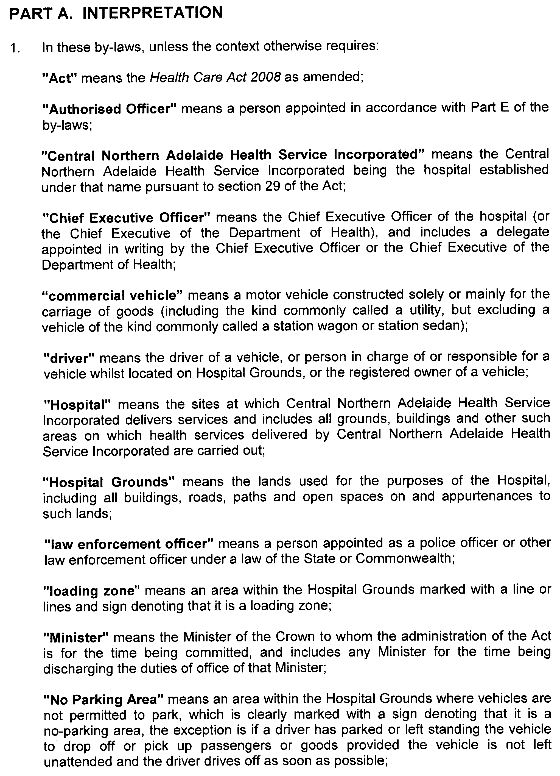
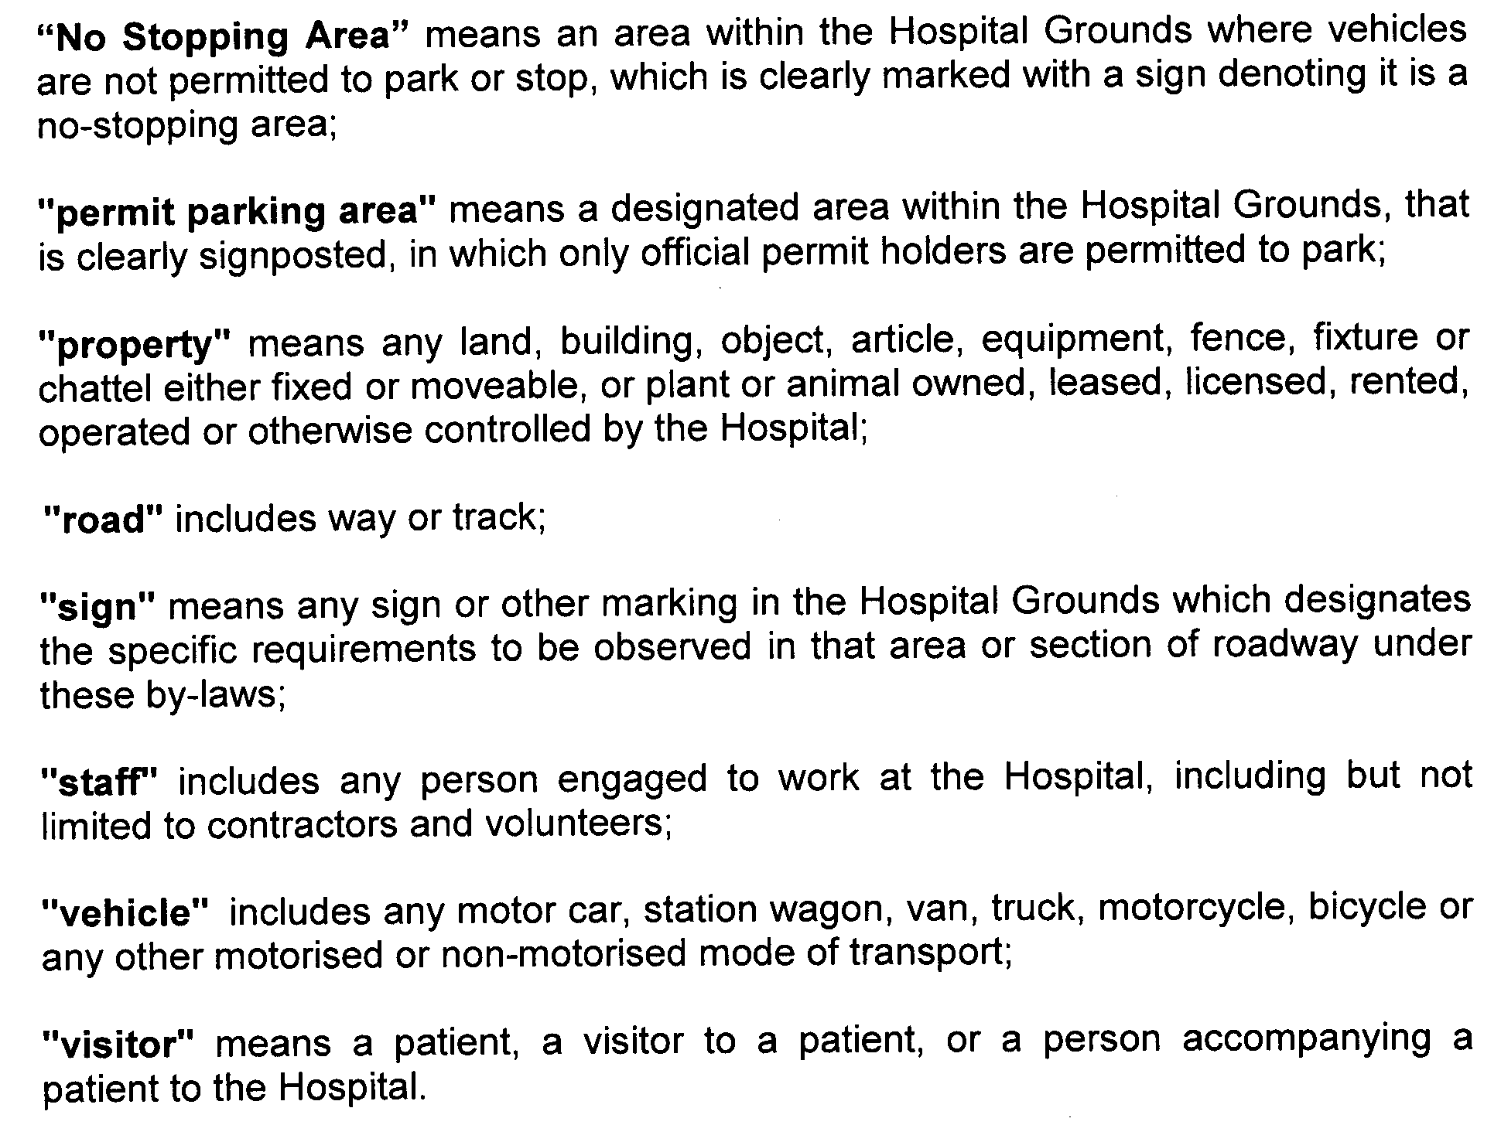
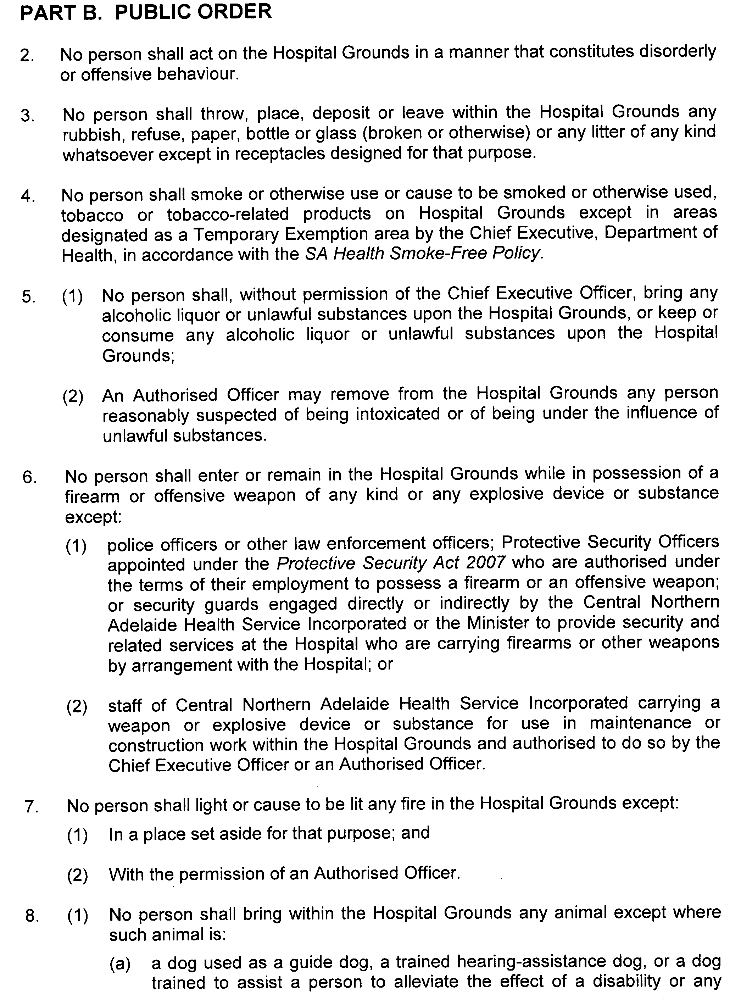
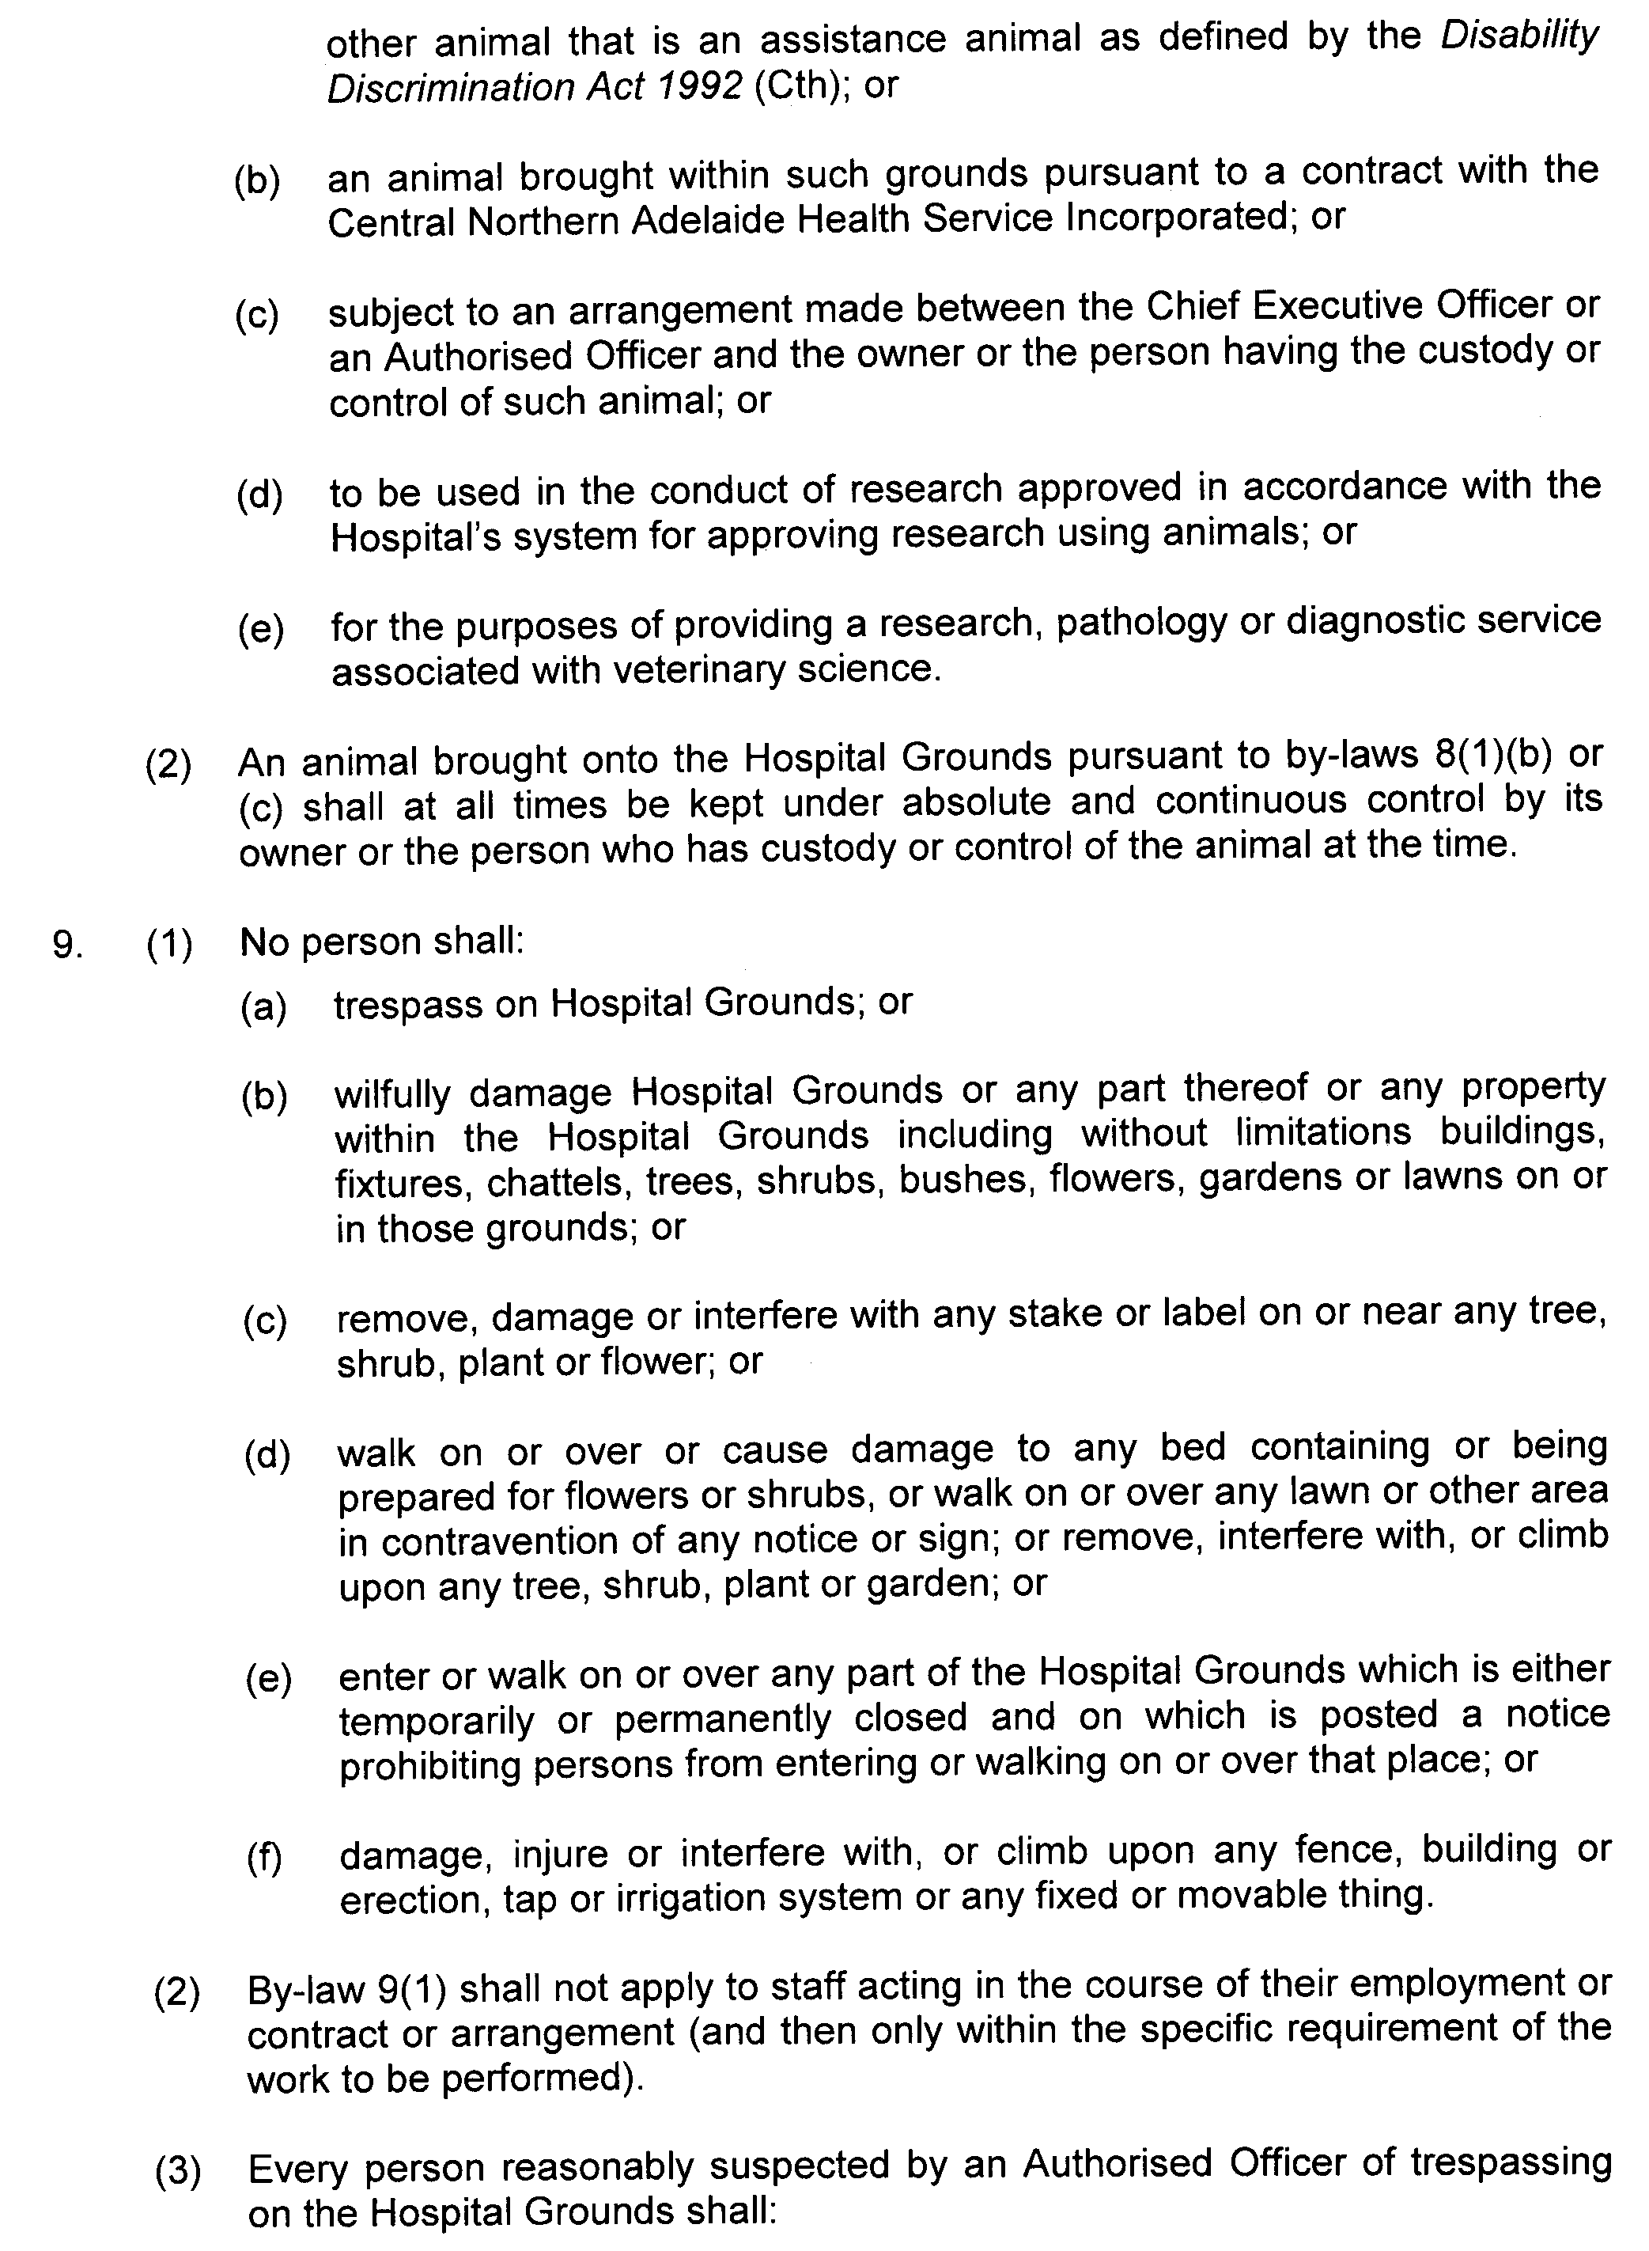
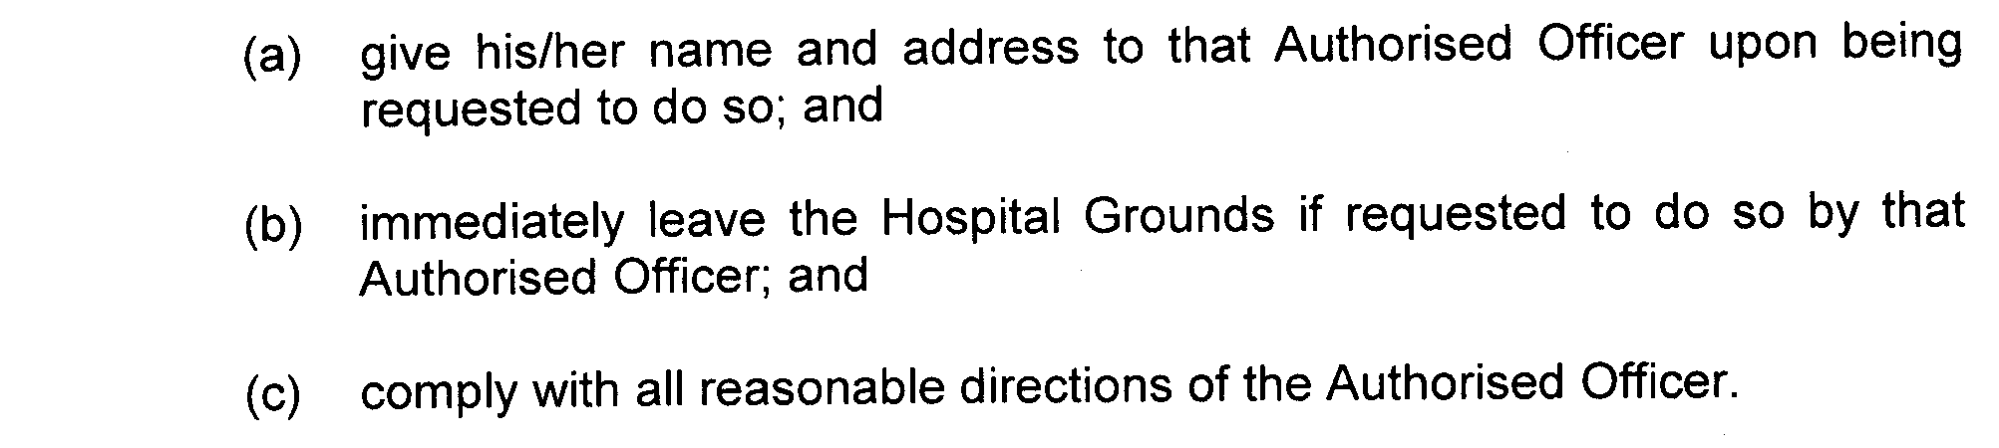
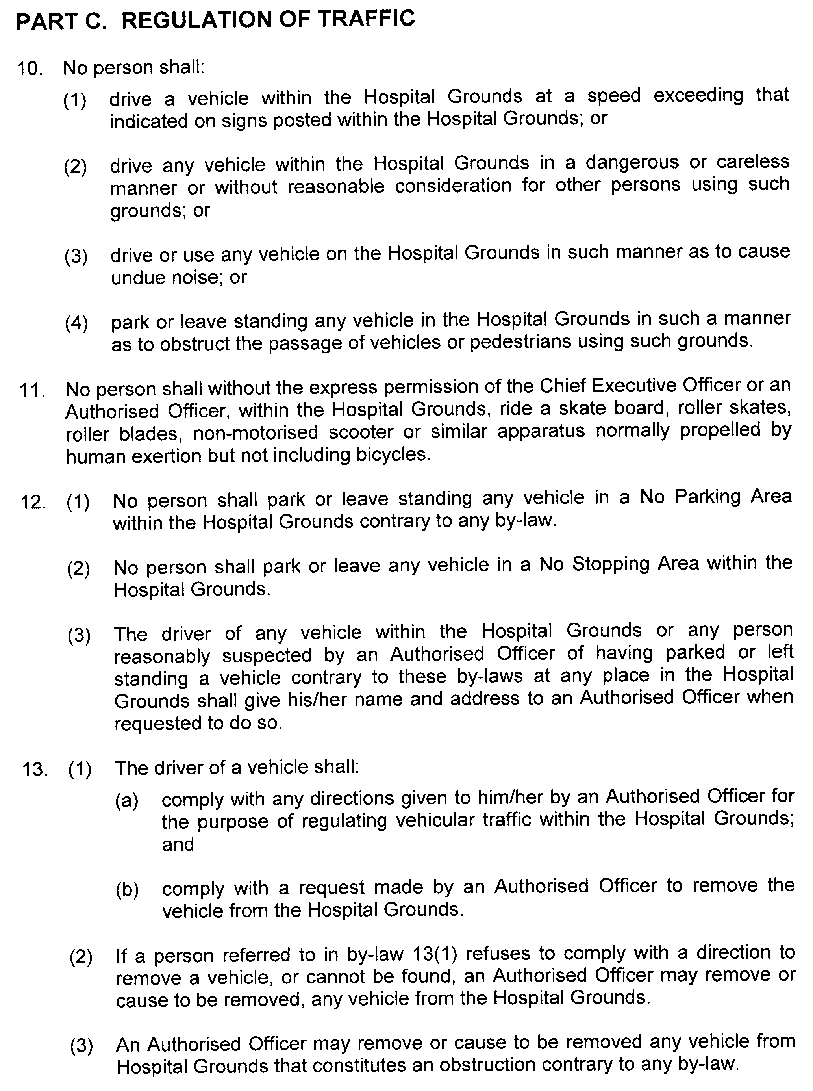
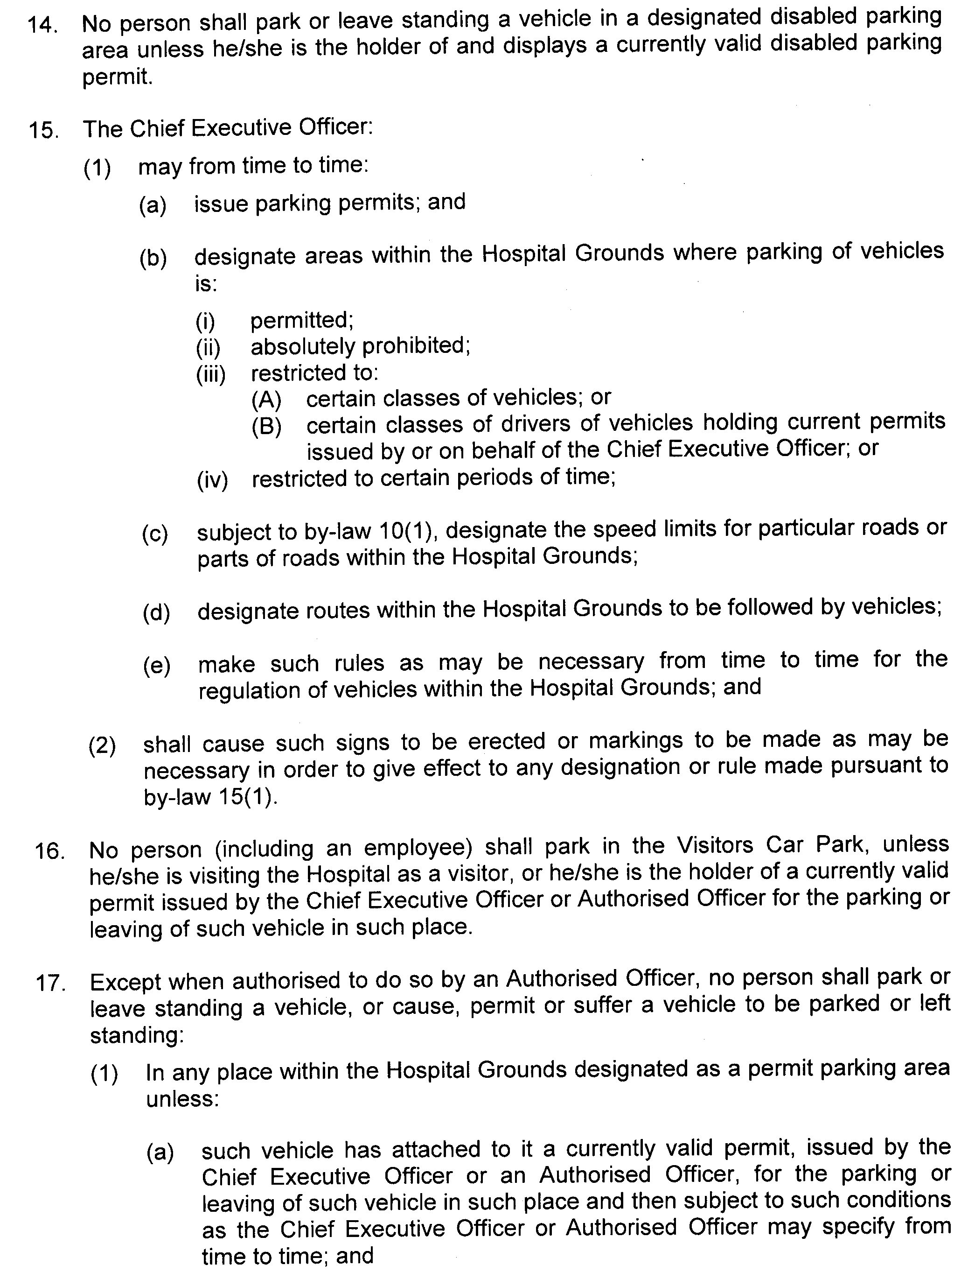
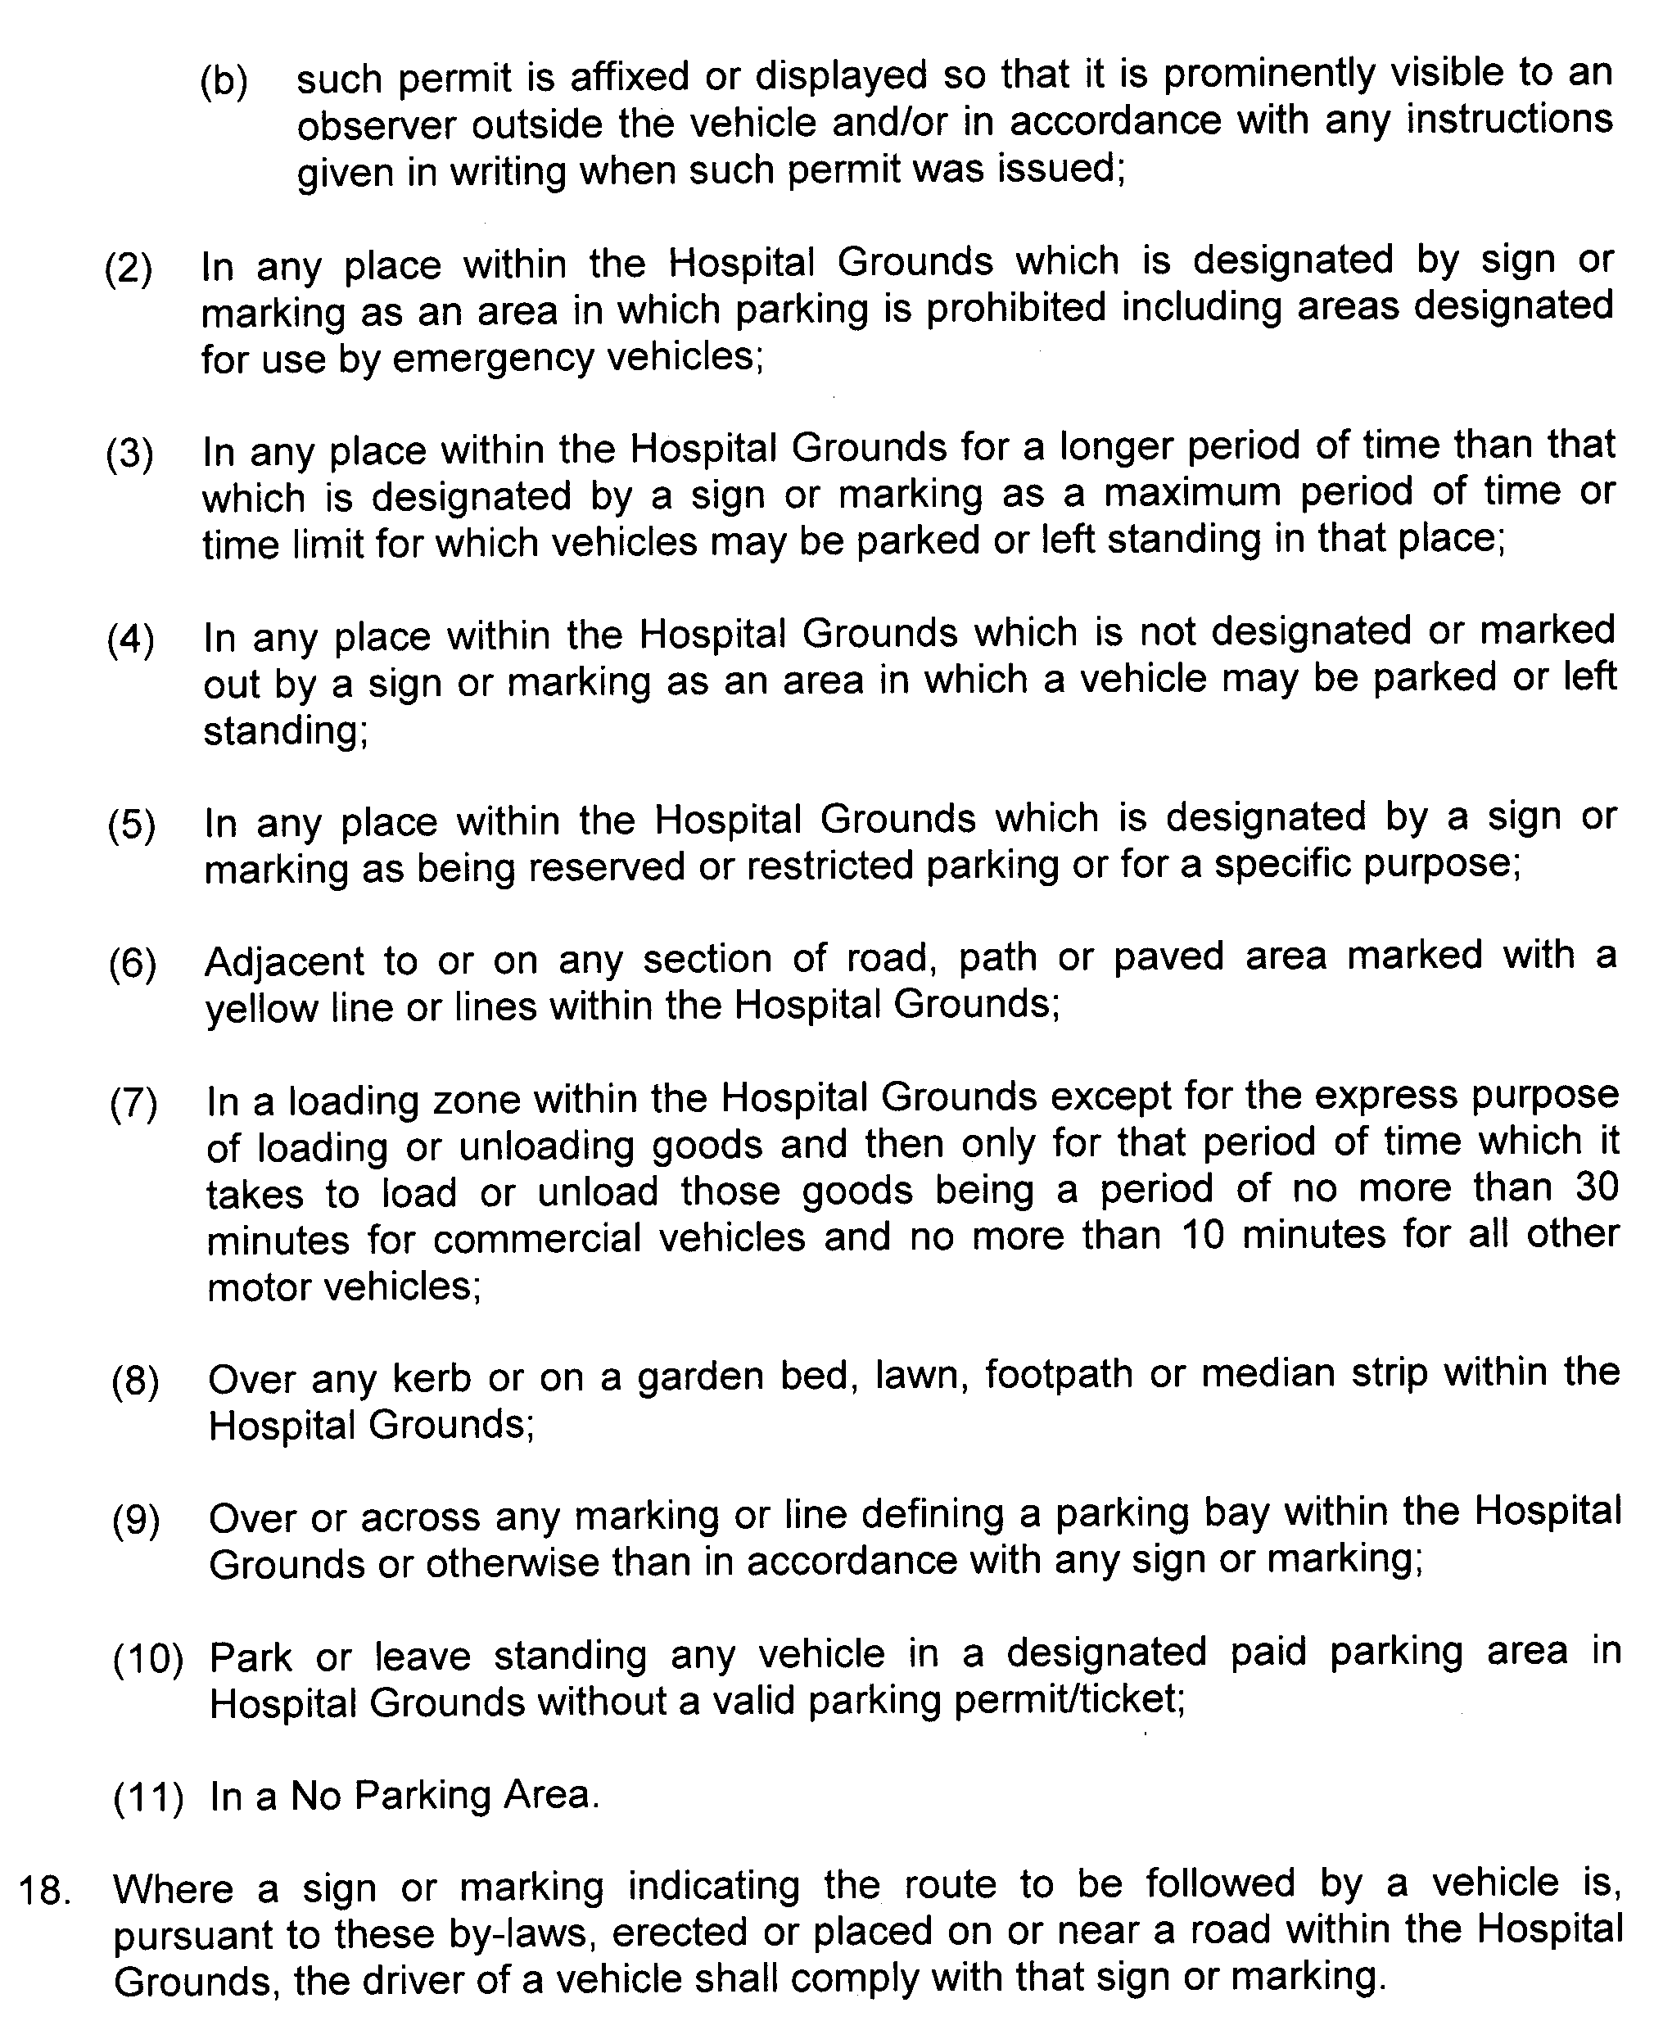
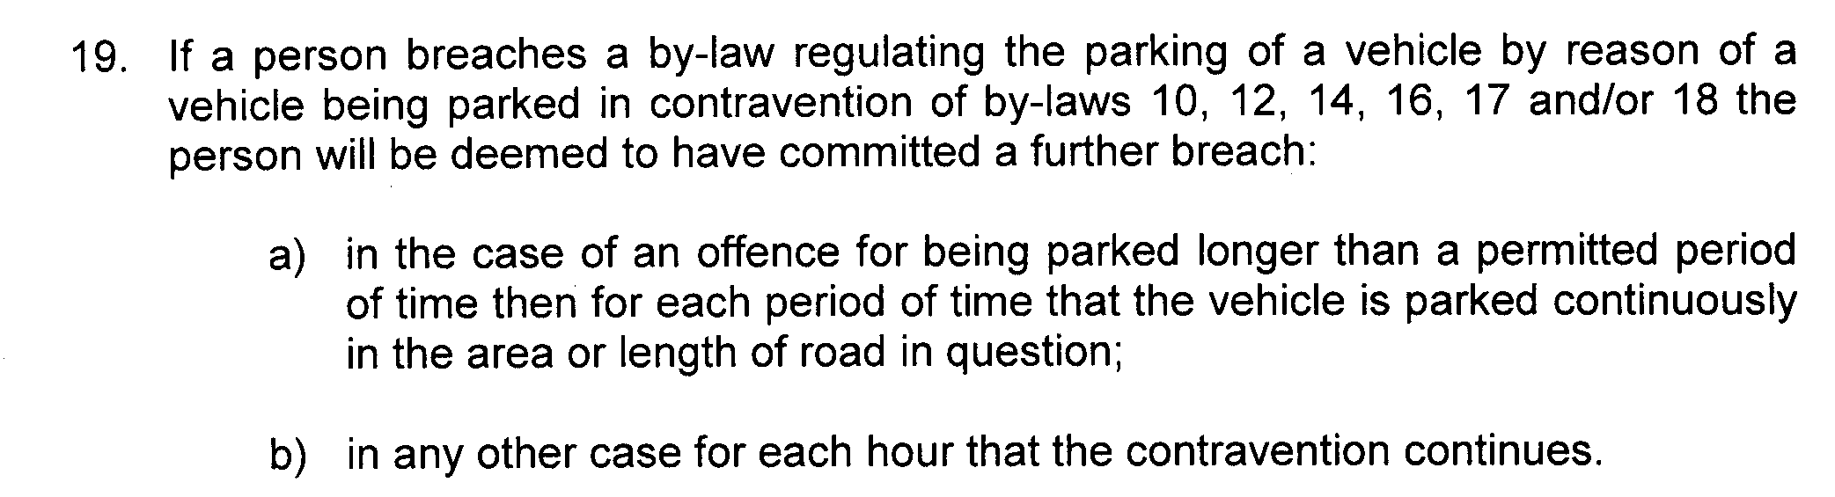
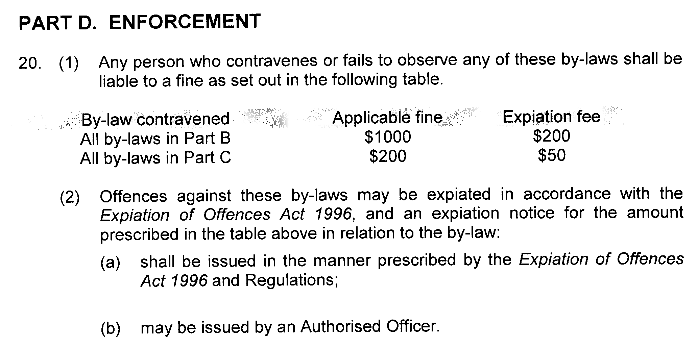

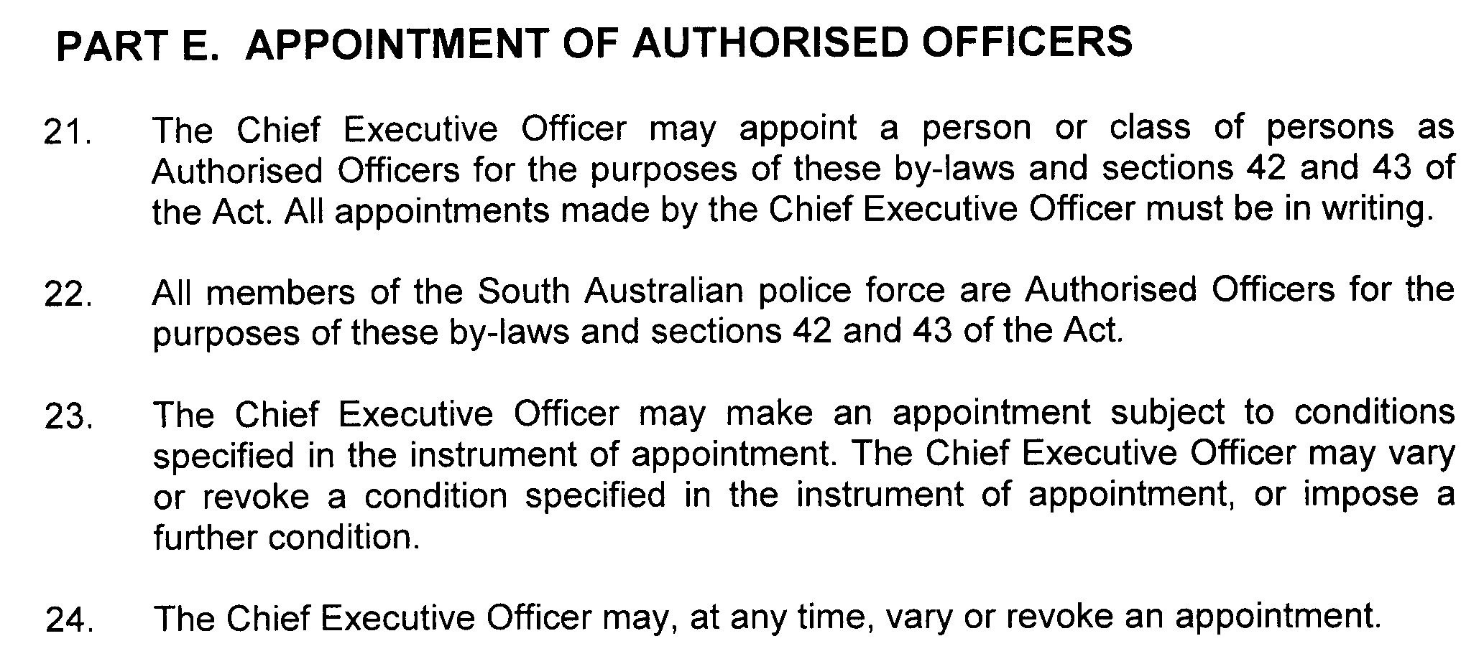

CHILDREN, YOUTH AND WOMEN’S HEALTH SERVICE INCORPORATED

By-laws made by the Children, Youth and Women’s Health Service Incorporated, pursuant to section 42 of the Health Care Act 2008, as amended

These by-laws are in substitution of all previous by-laws made by or for the Children, Youth and Women’s Health Service Incorporated or any health service or hospital site that forms part of the Children, Youth and Women’s Health Service Incorporated.

BY-LAWS MADE BY

CHILDREN, YOUTH AND WOMEN’S HEALTH SERVICE INCORPORATED

PURSUANT TO SECTION 42 OF THE HEALTH CARE ACT 2008

These by-laws were approved by the Minister for Health in accordance with section 42 (2) of the Health Care Act 2008 on 9 June 2010.
John Hill, Minister for Health

These by-laws come into force on confirmation by the Governor pursuant to section 42 (3) of the Health Care Act 2008.

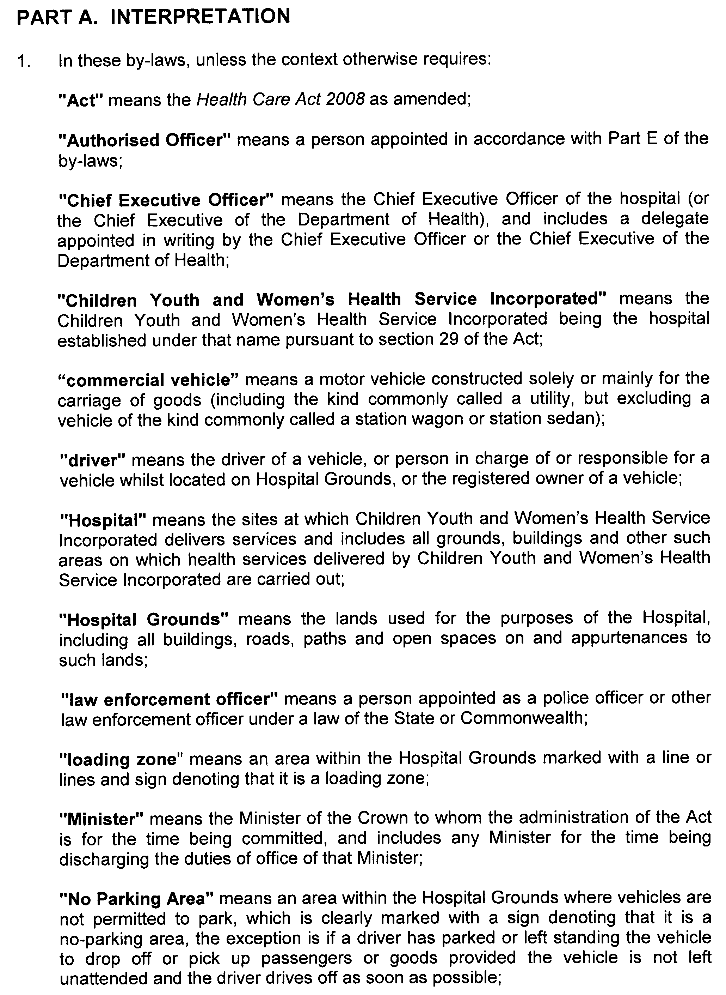
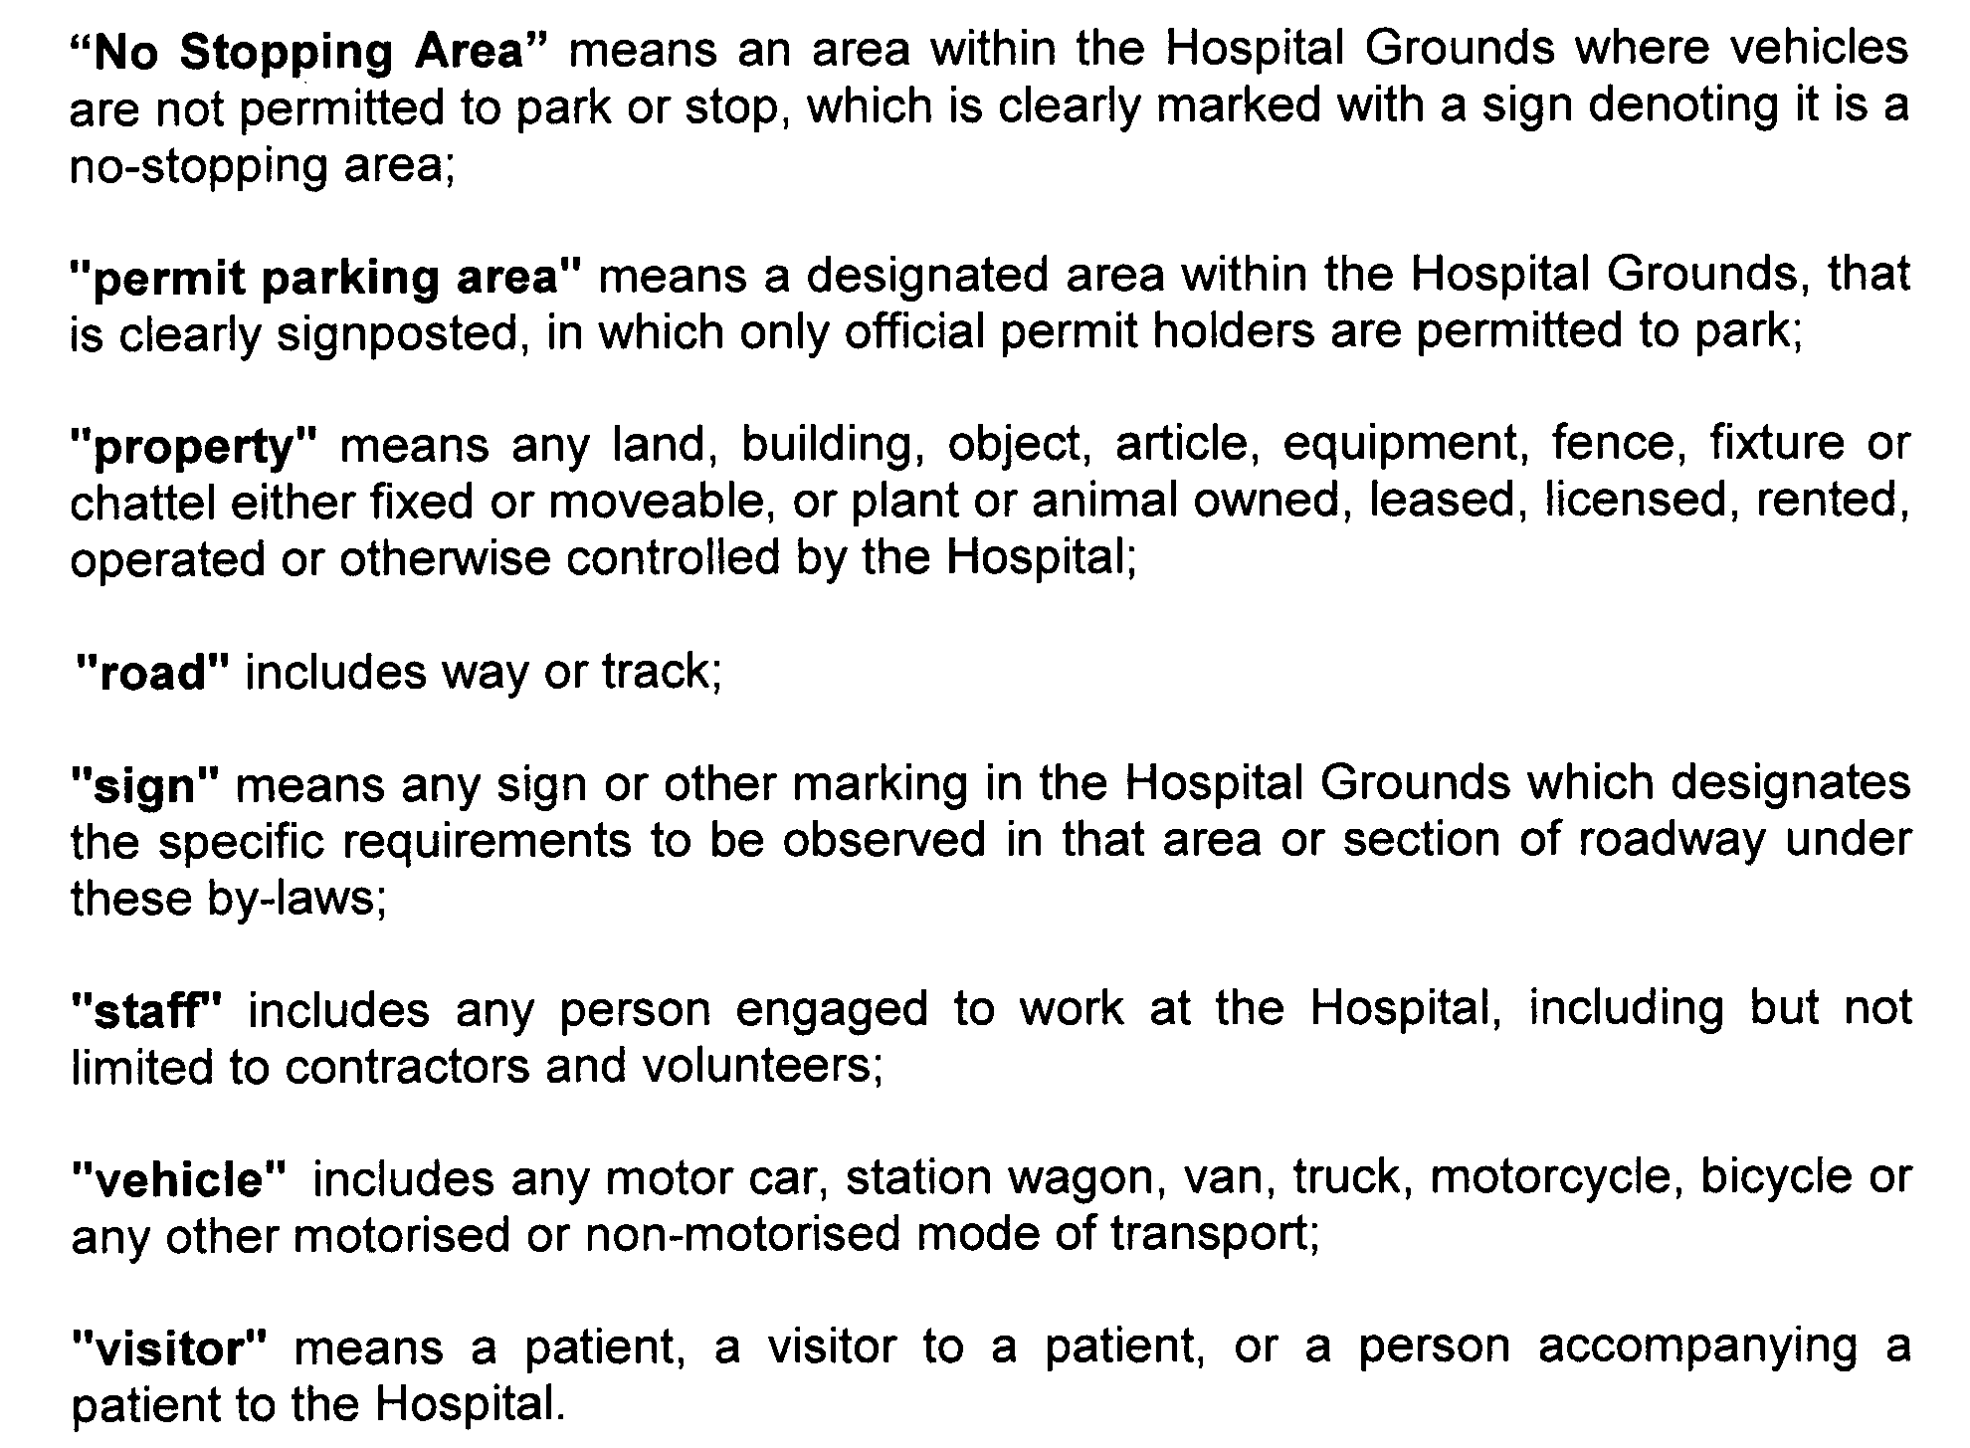
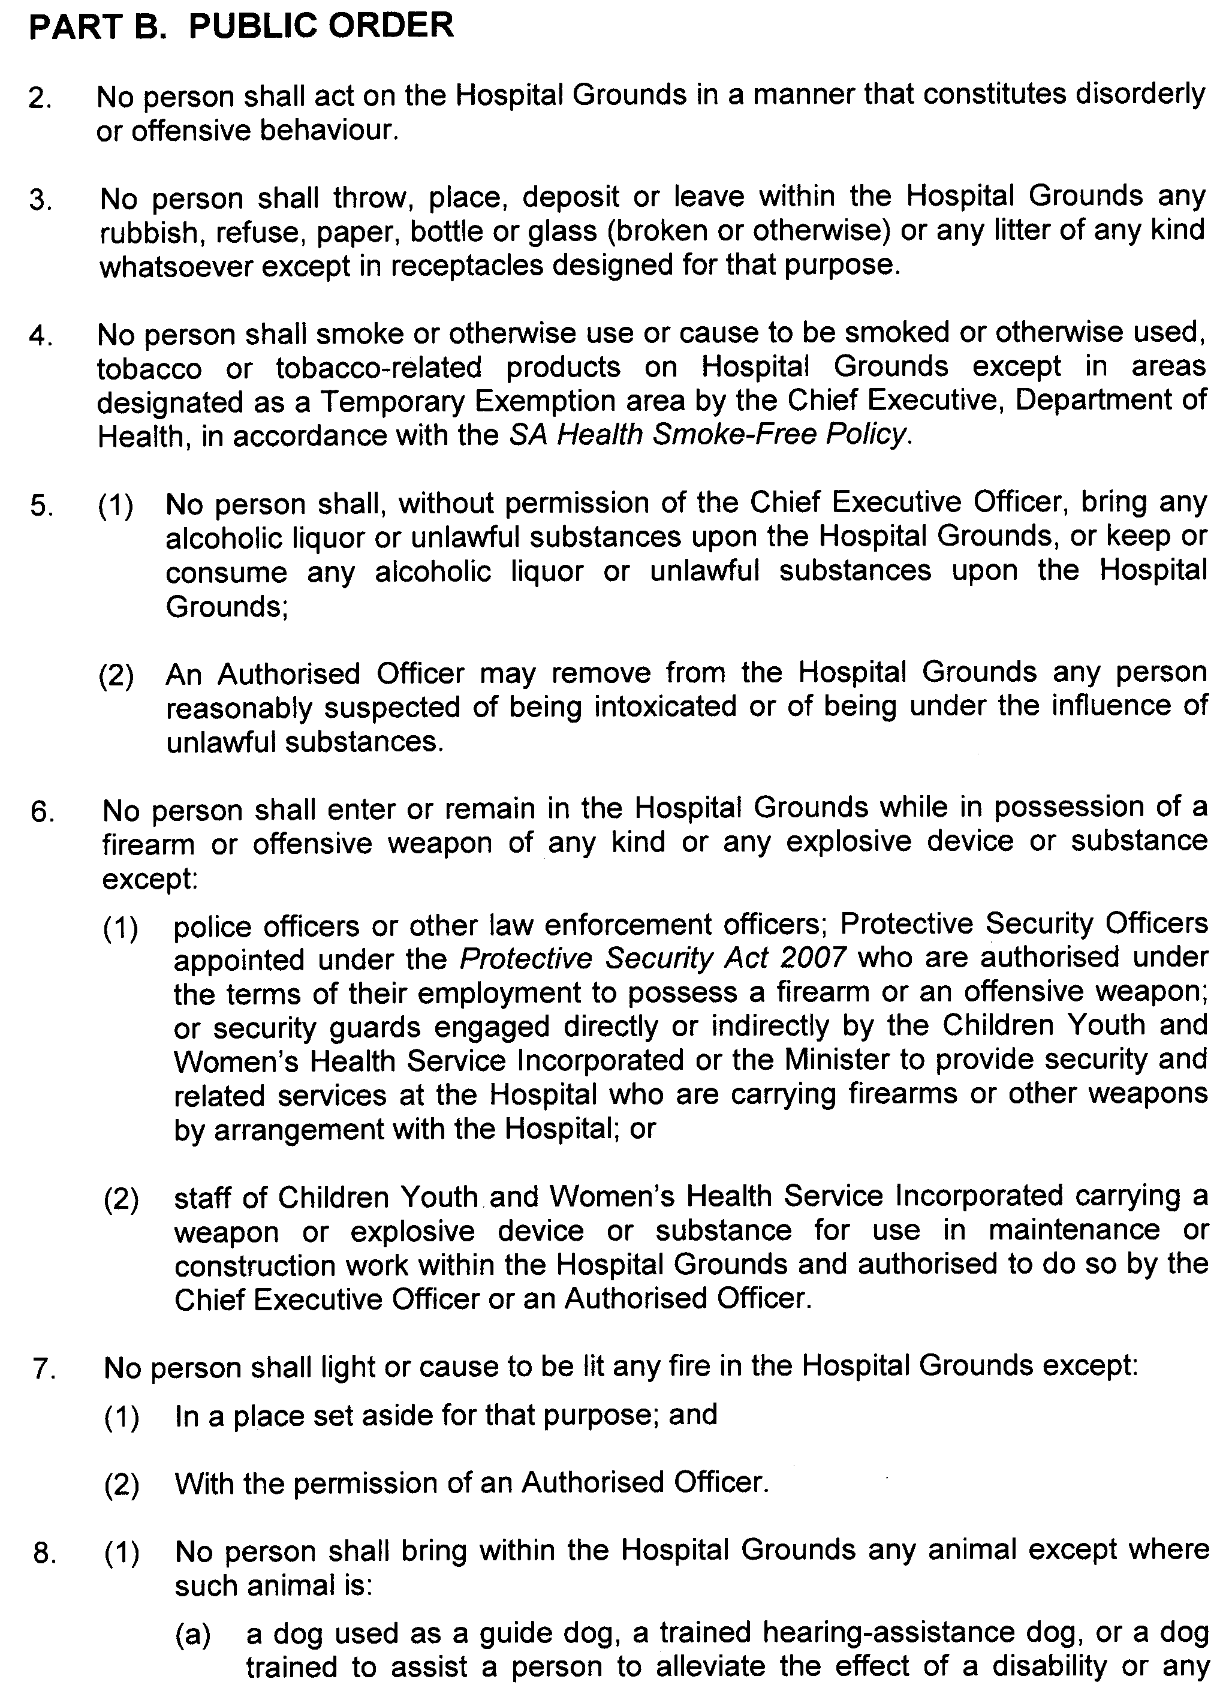
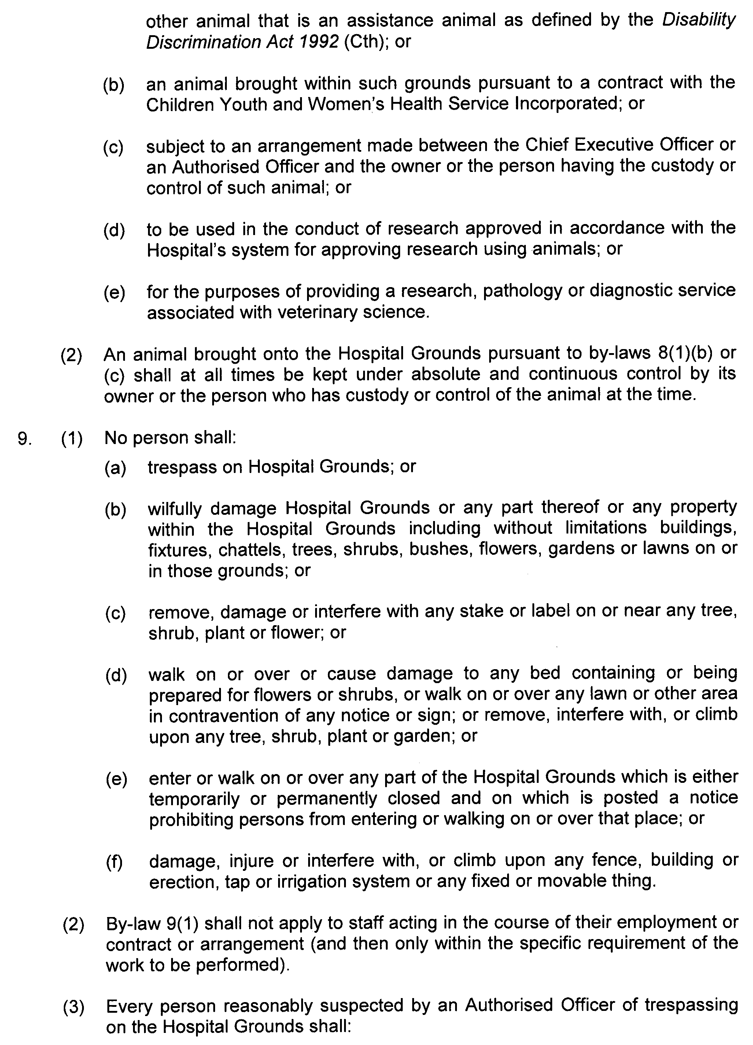
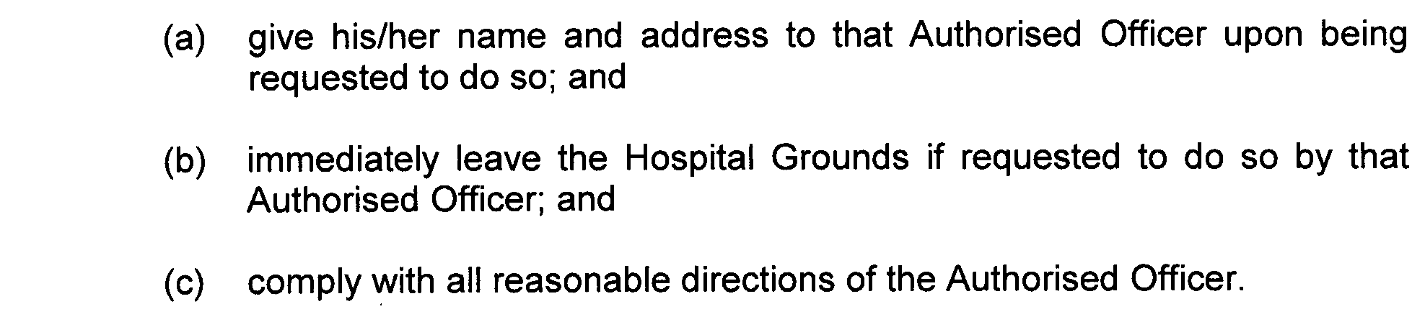
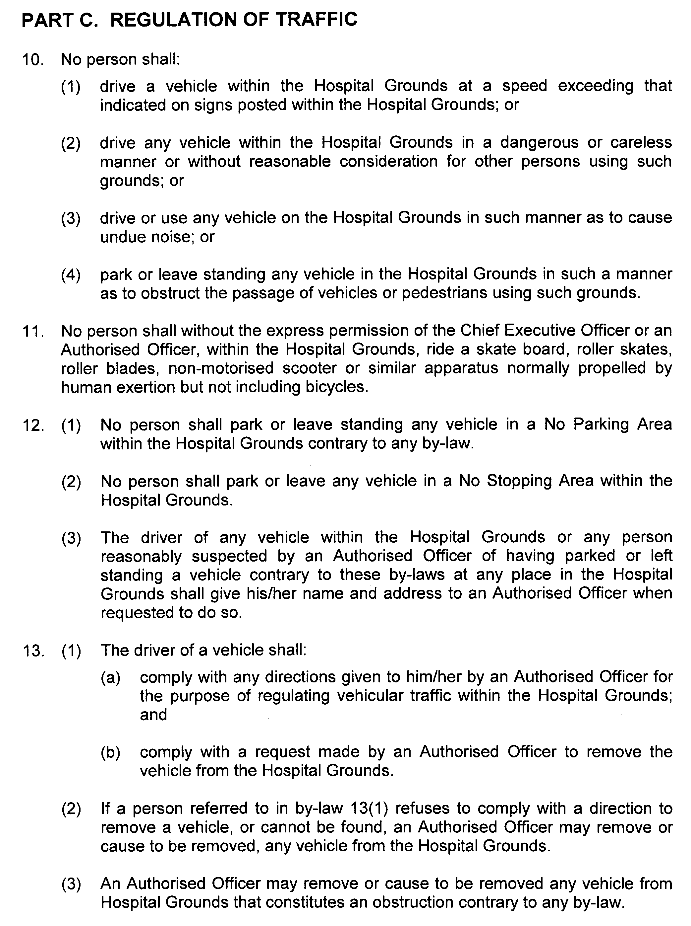
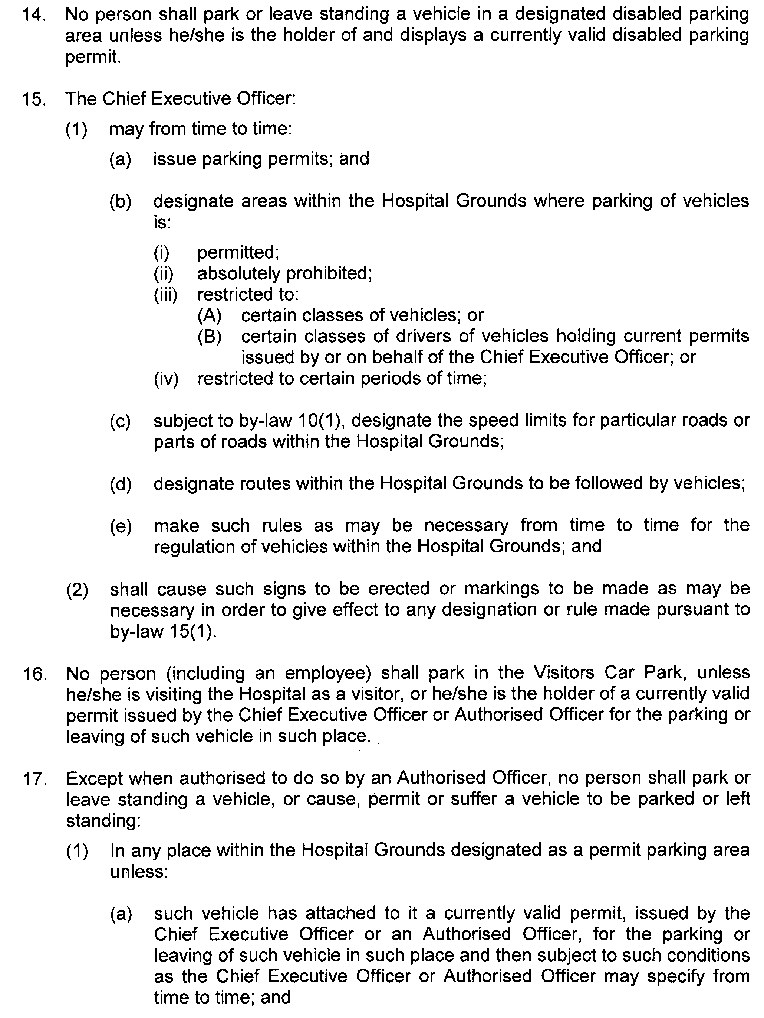
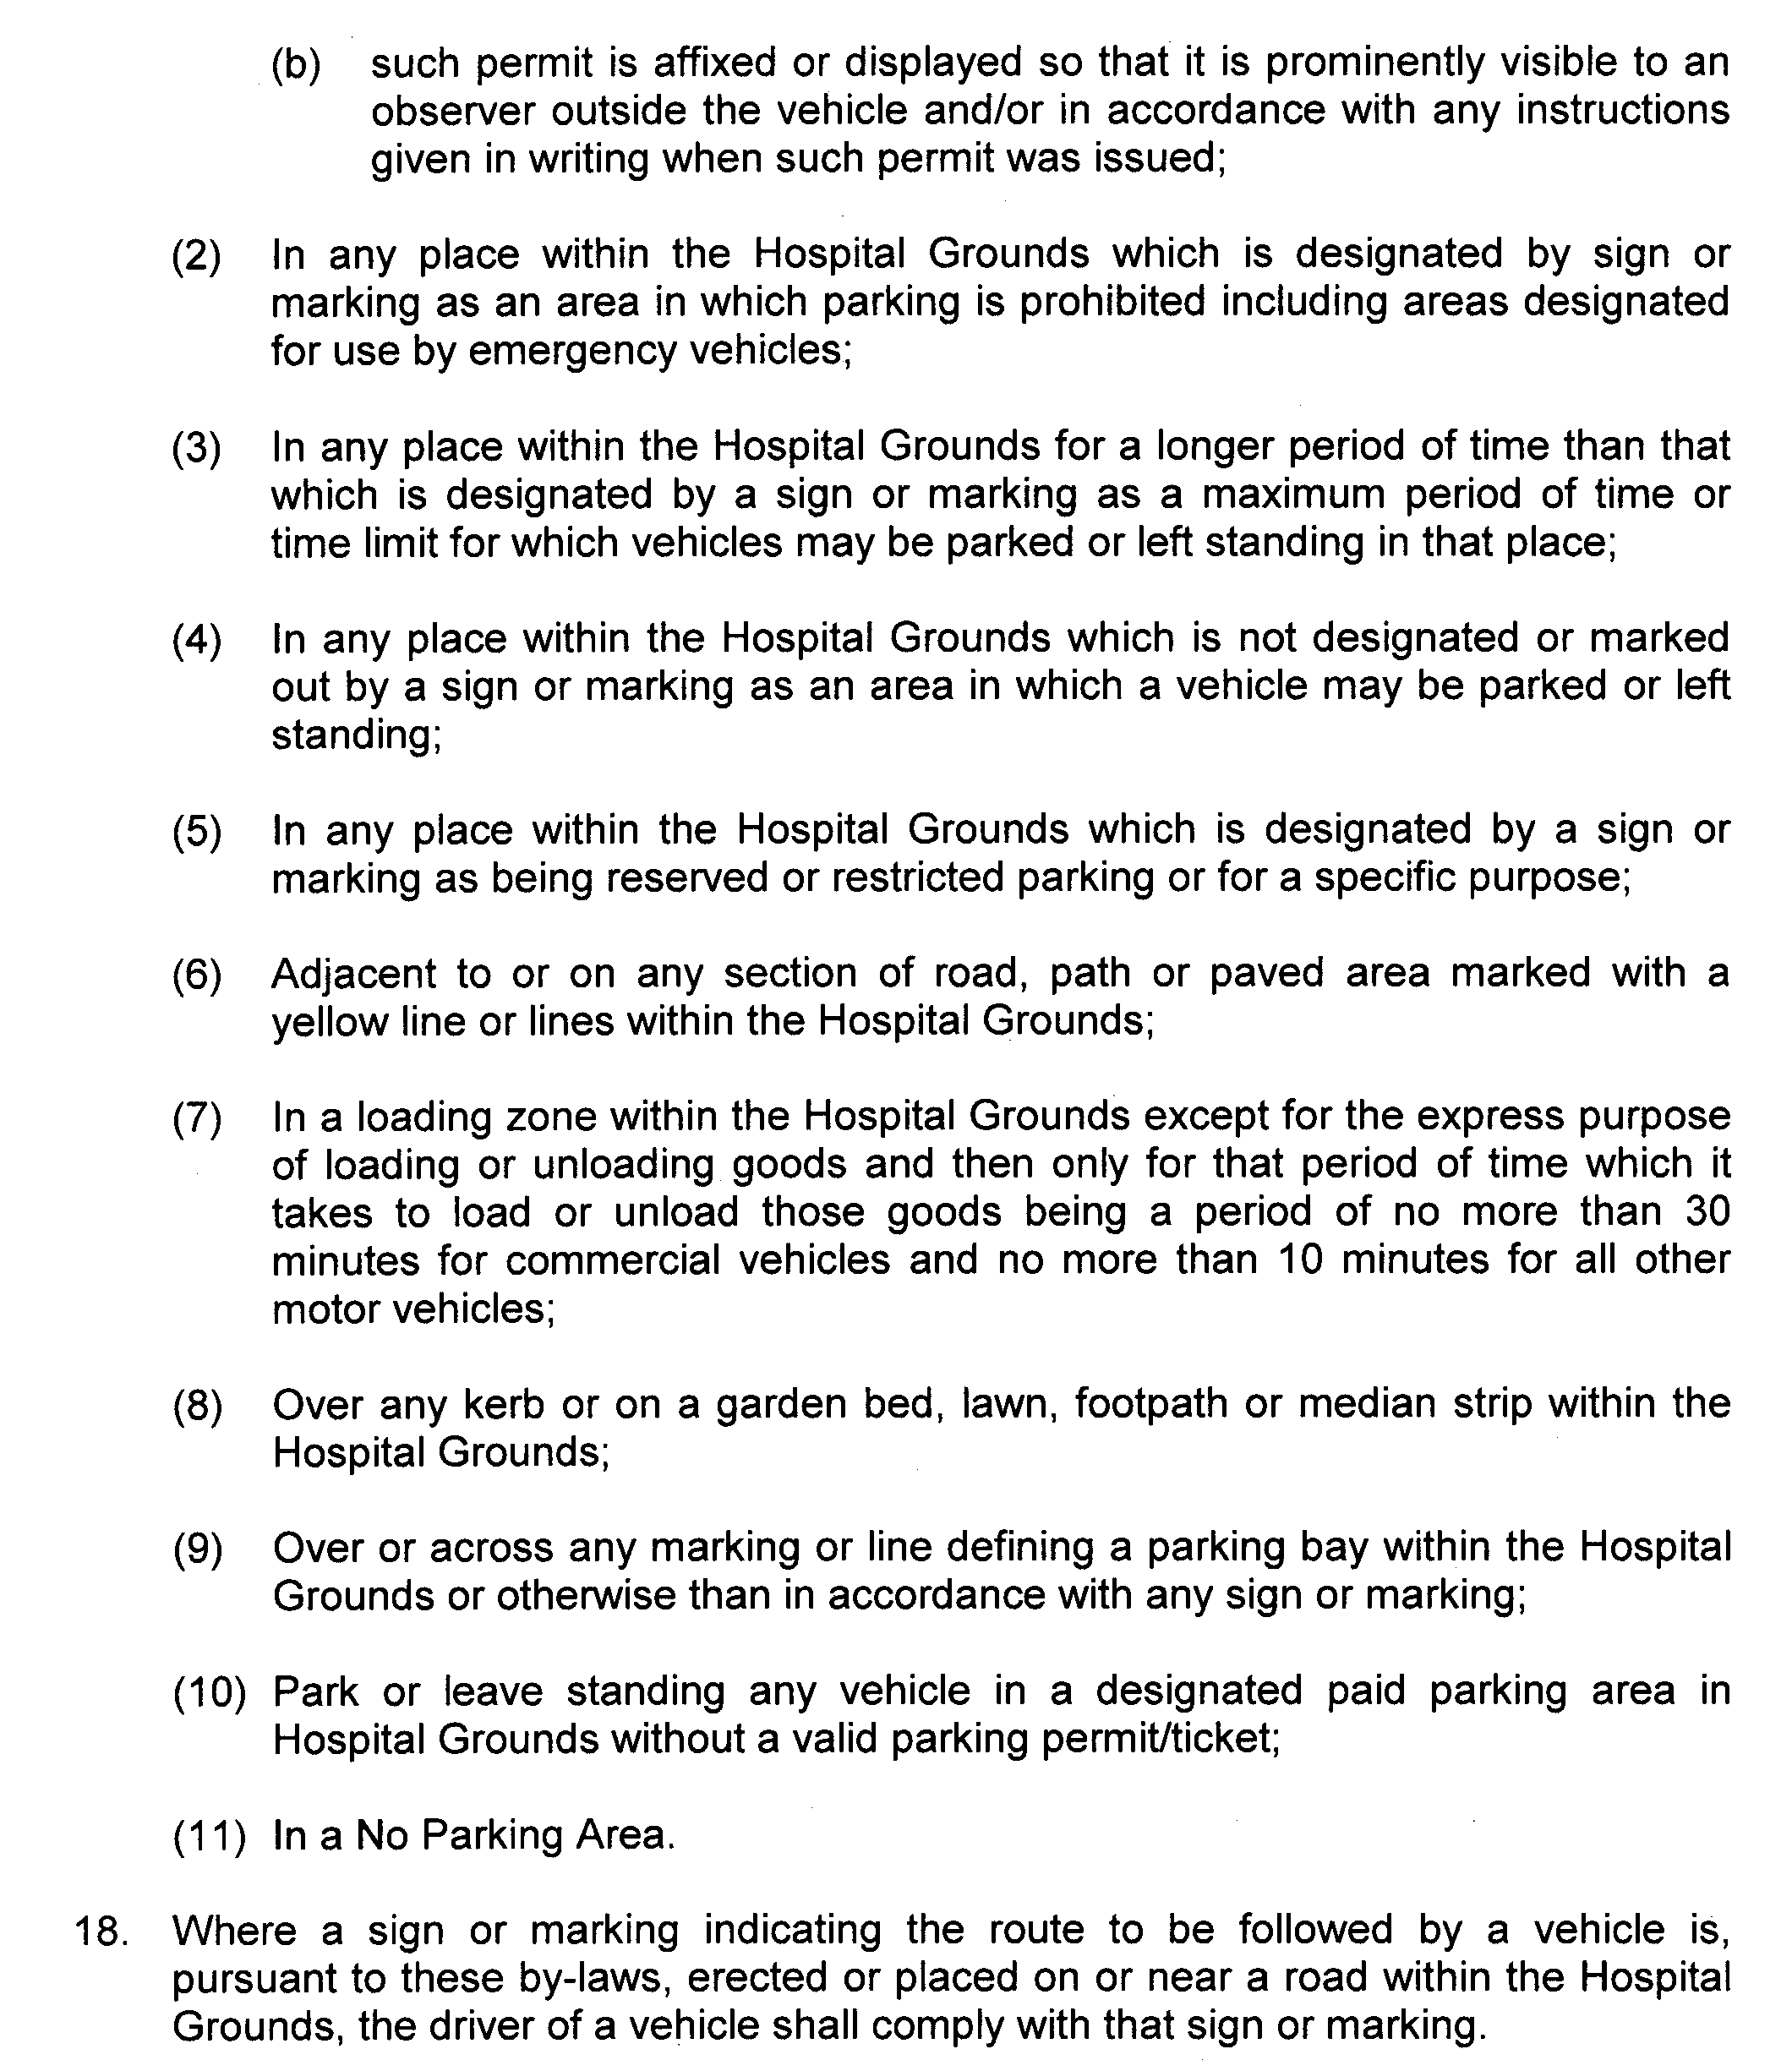
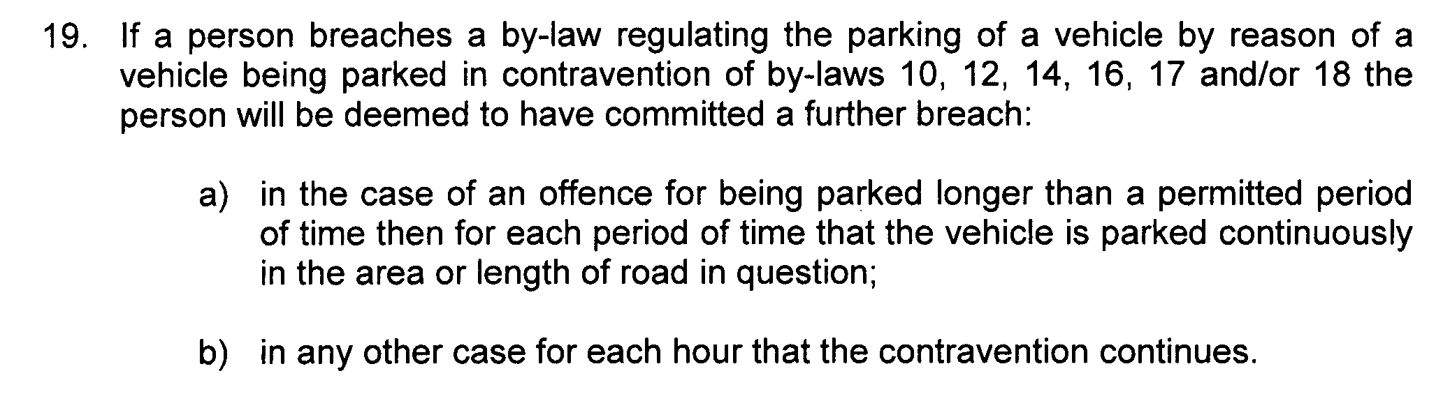
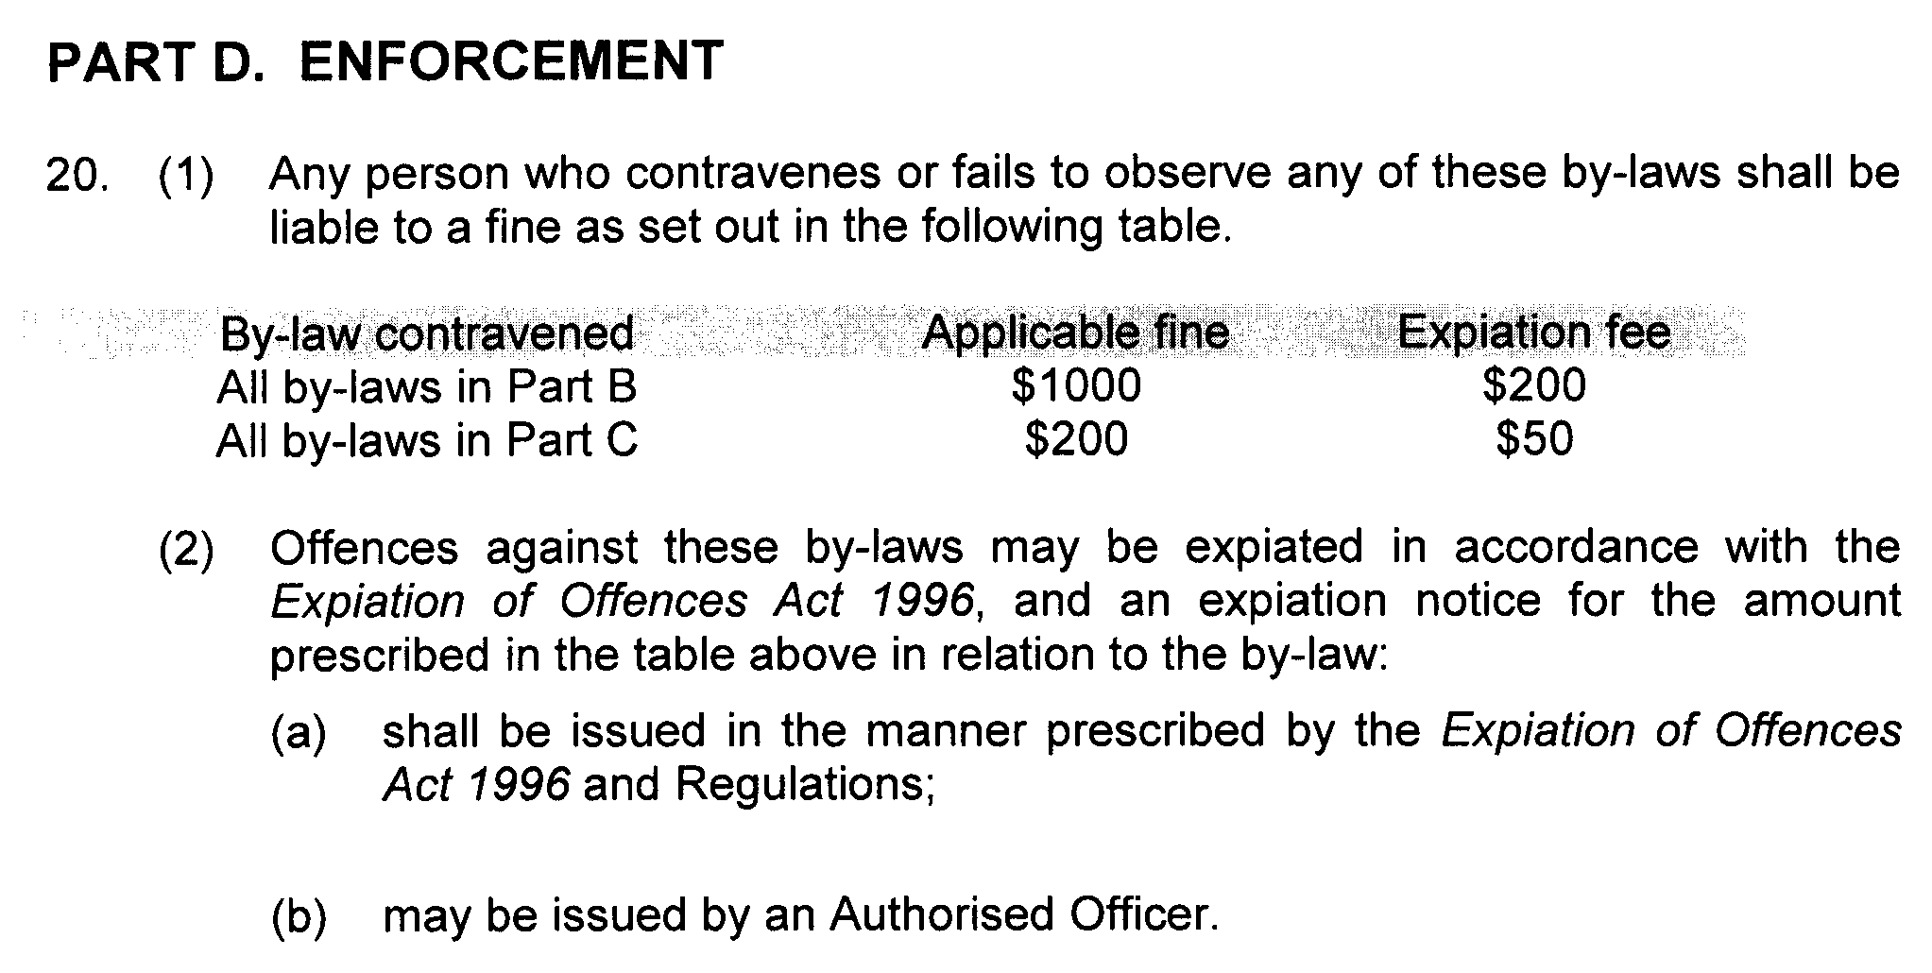
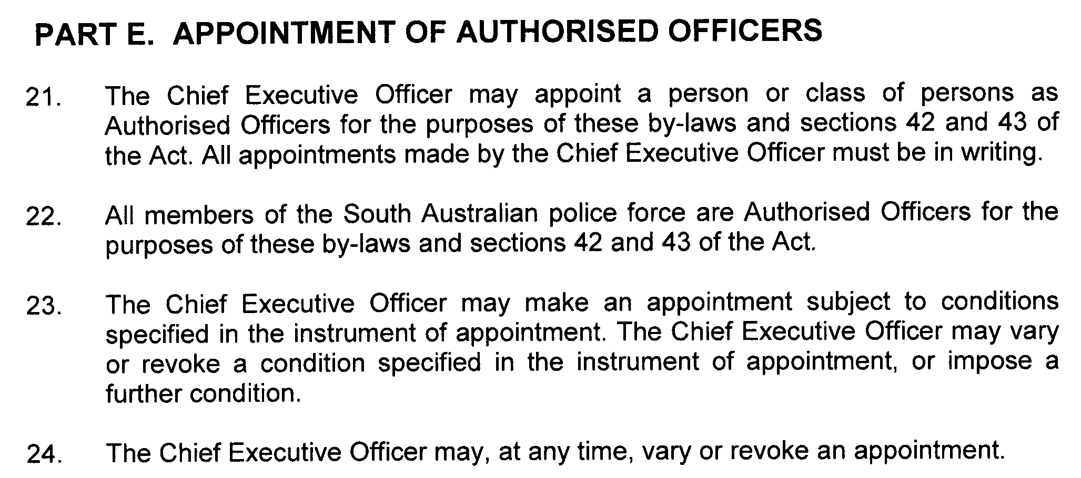

COUNTRY HEALTH SA HOSPITAL INCORPORATED

By-laws made by the Country Health SA Hospital Incorporated, pursuant to section 42 of the Health Care Act 2008, as amended

These by-laws are in substitution of all previous by-laws made by or for the Country Health SA Hospital Incorporated or any health service or hospital site that forms part of the Country Health SA Hospital Incorporated.

BY-LAWS MADE BY

COUNTRY HEALTH SA HOSPITAL INCORPORATED

PURSUANT TO SECTION 42 OF THE HEALTH CARE ACT 2008

These by-laws were approved by the Minister for Health in accordance with section 42 (2) of the Health Care Act 2008 on 9 June 2010.
John Hill, Minister for Health

These by-laws come into force on confirmation by the Governor pursuant to section 42 (3) of the Health Care Act 2008.

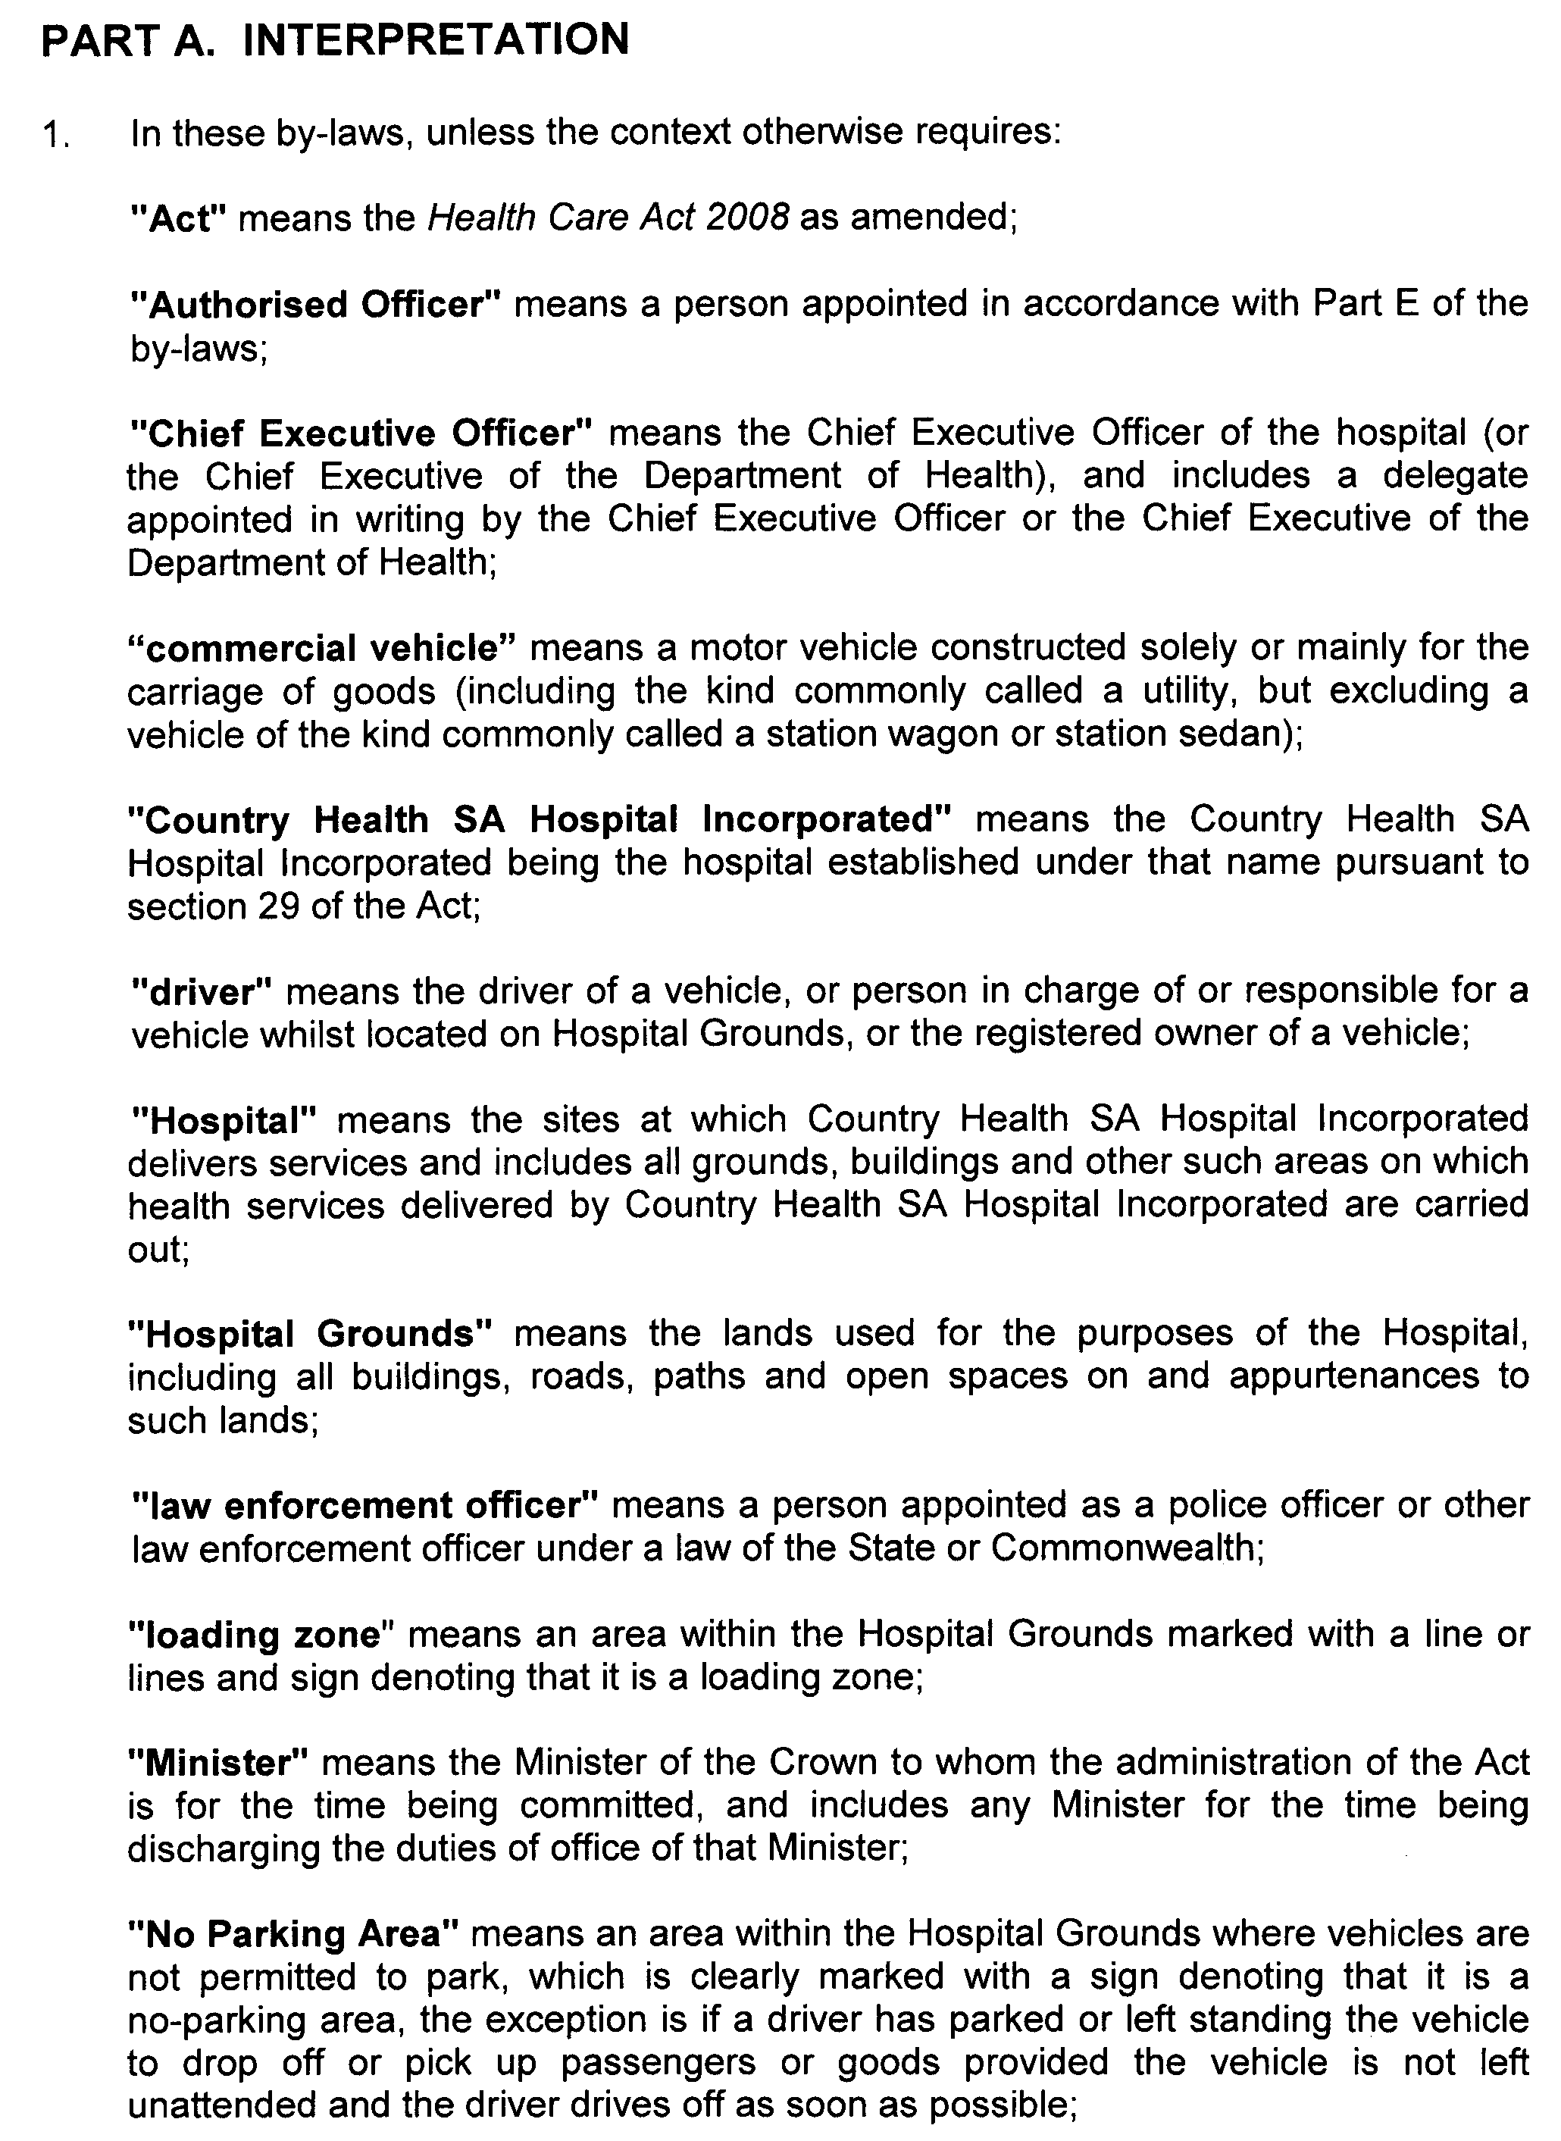
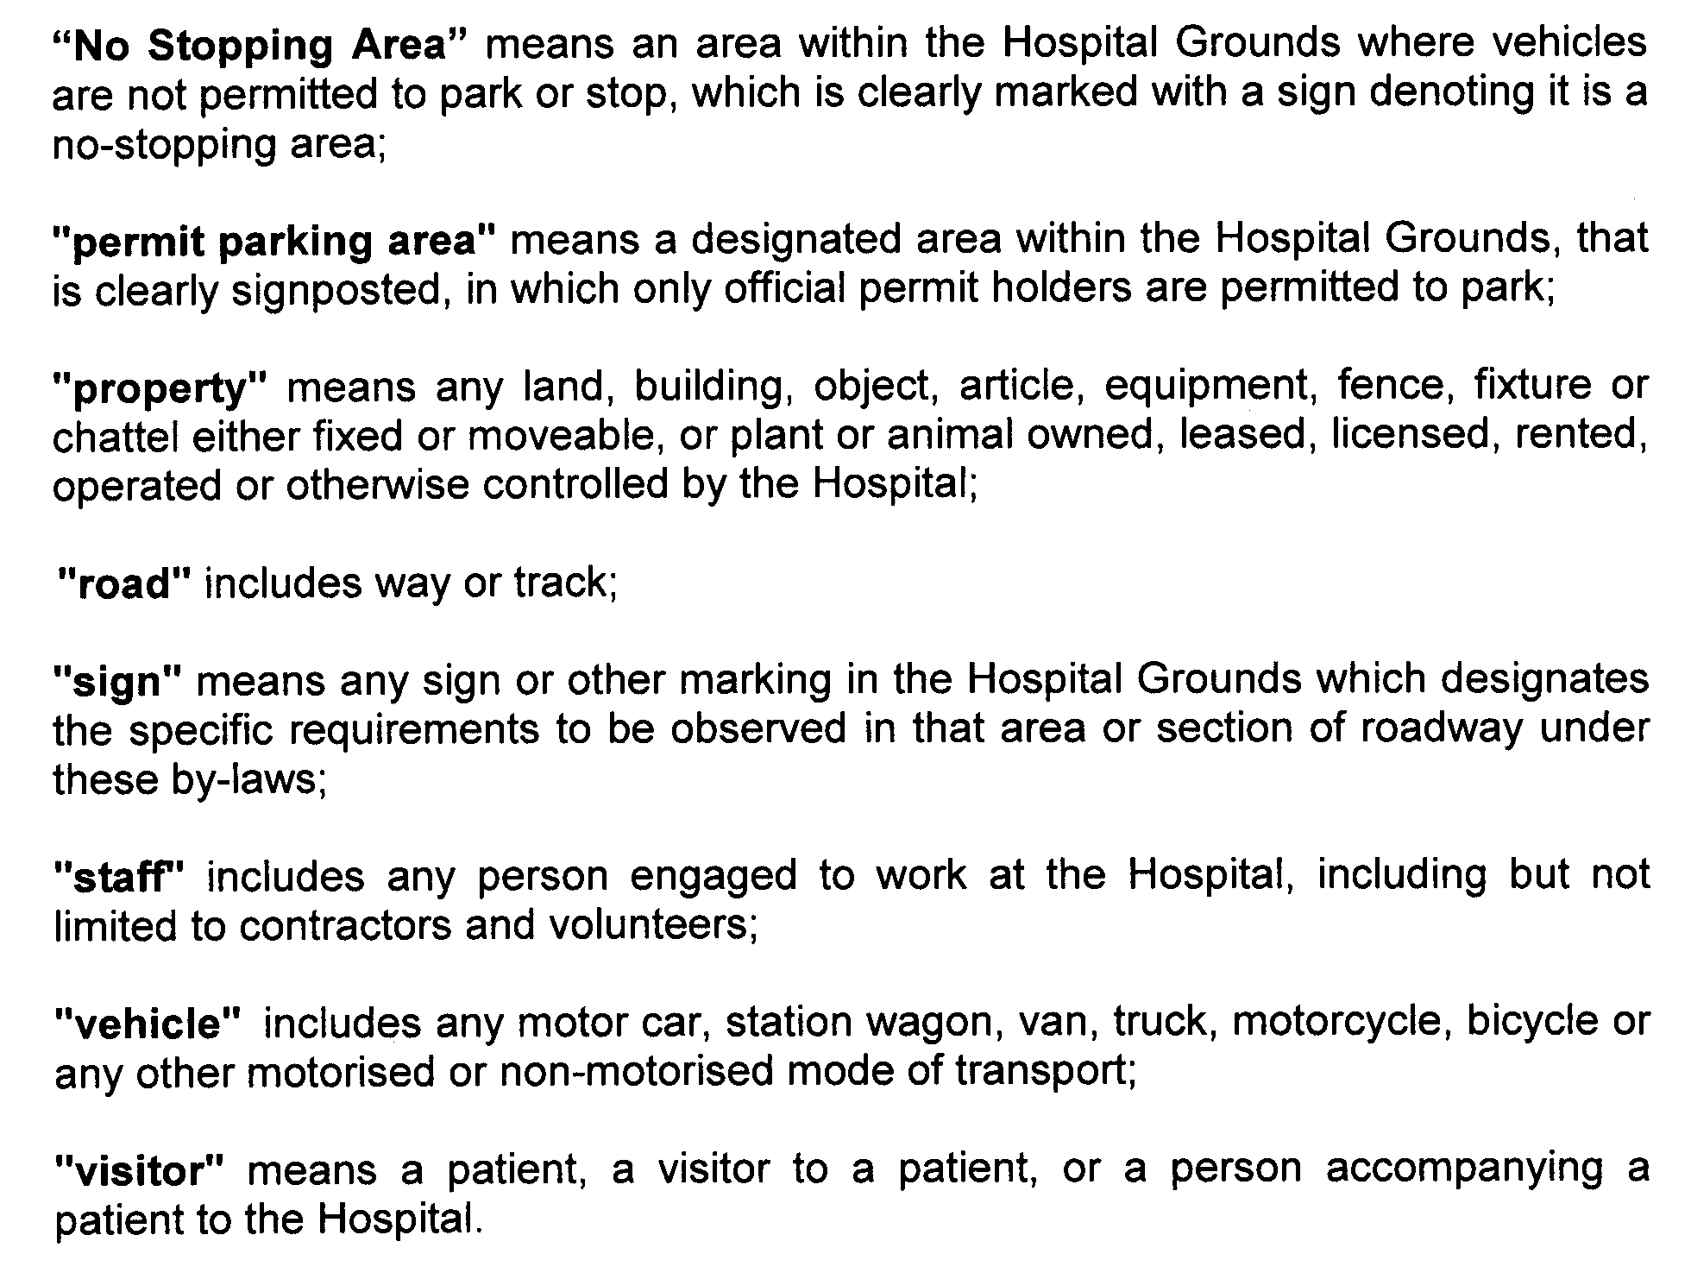
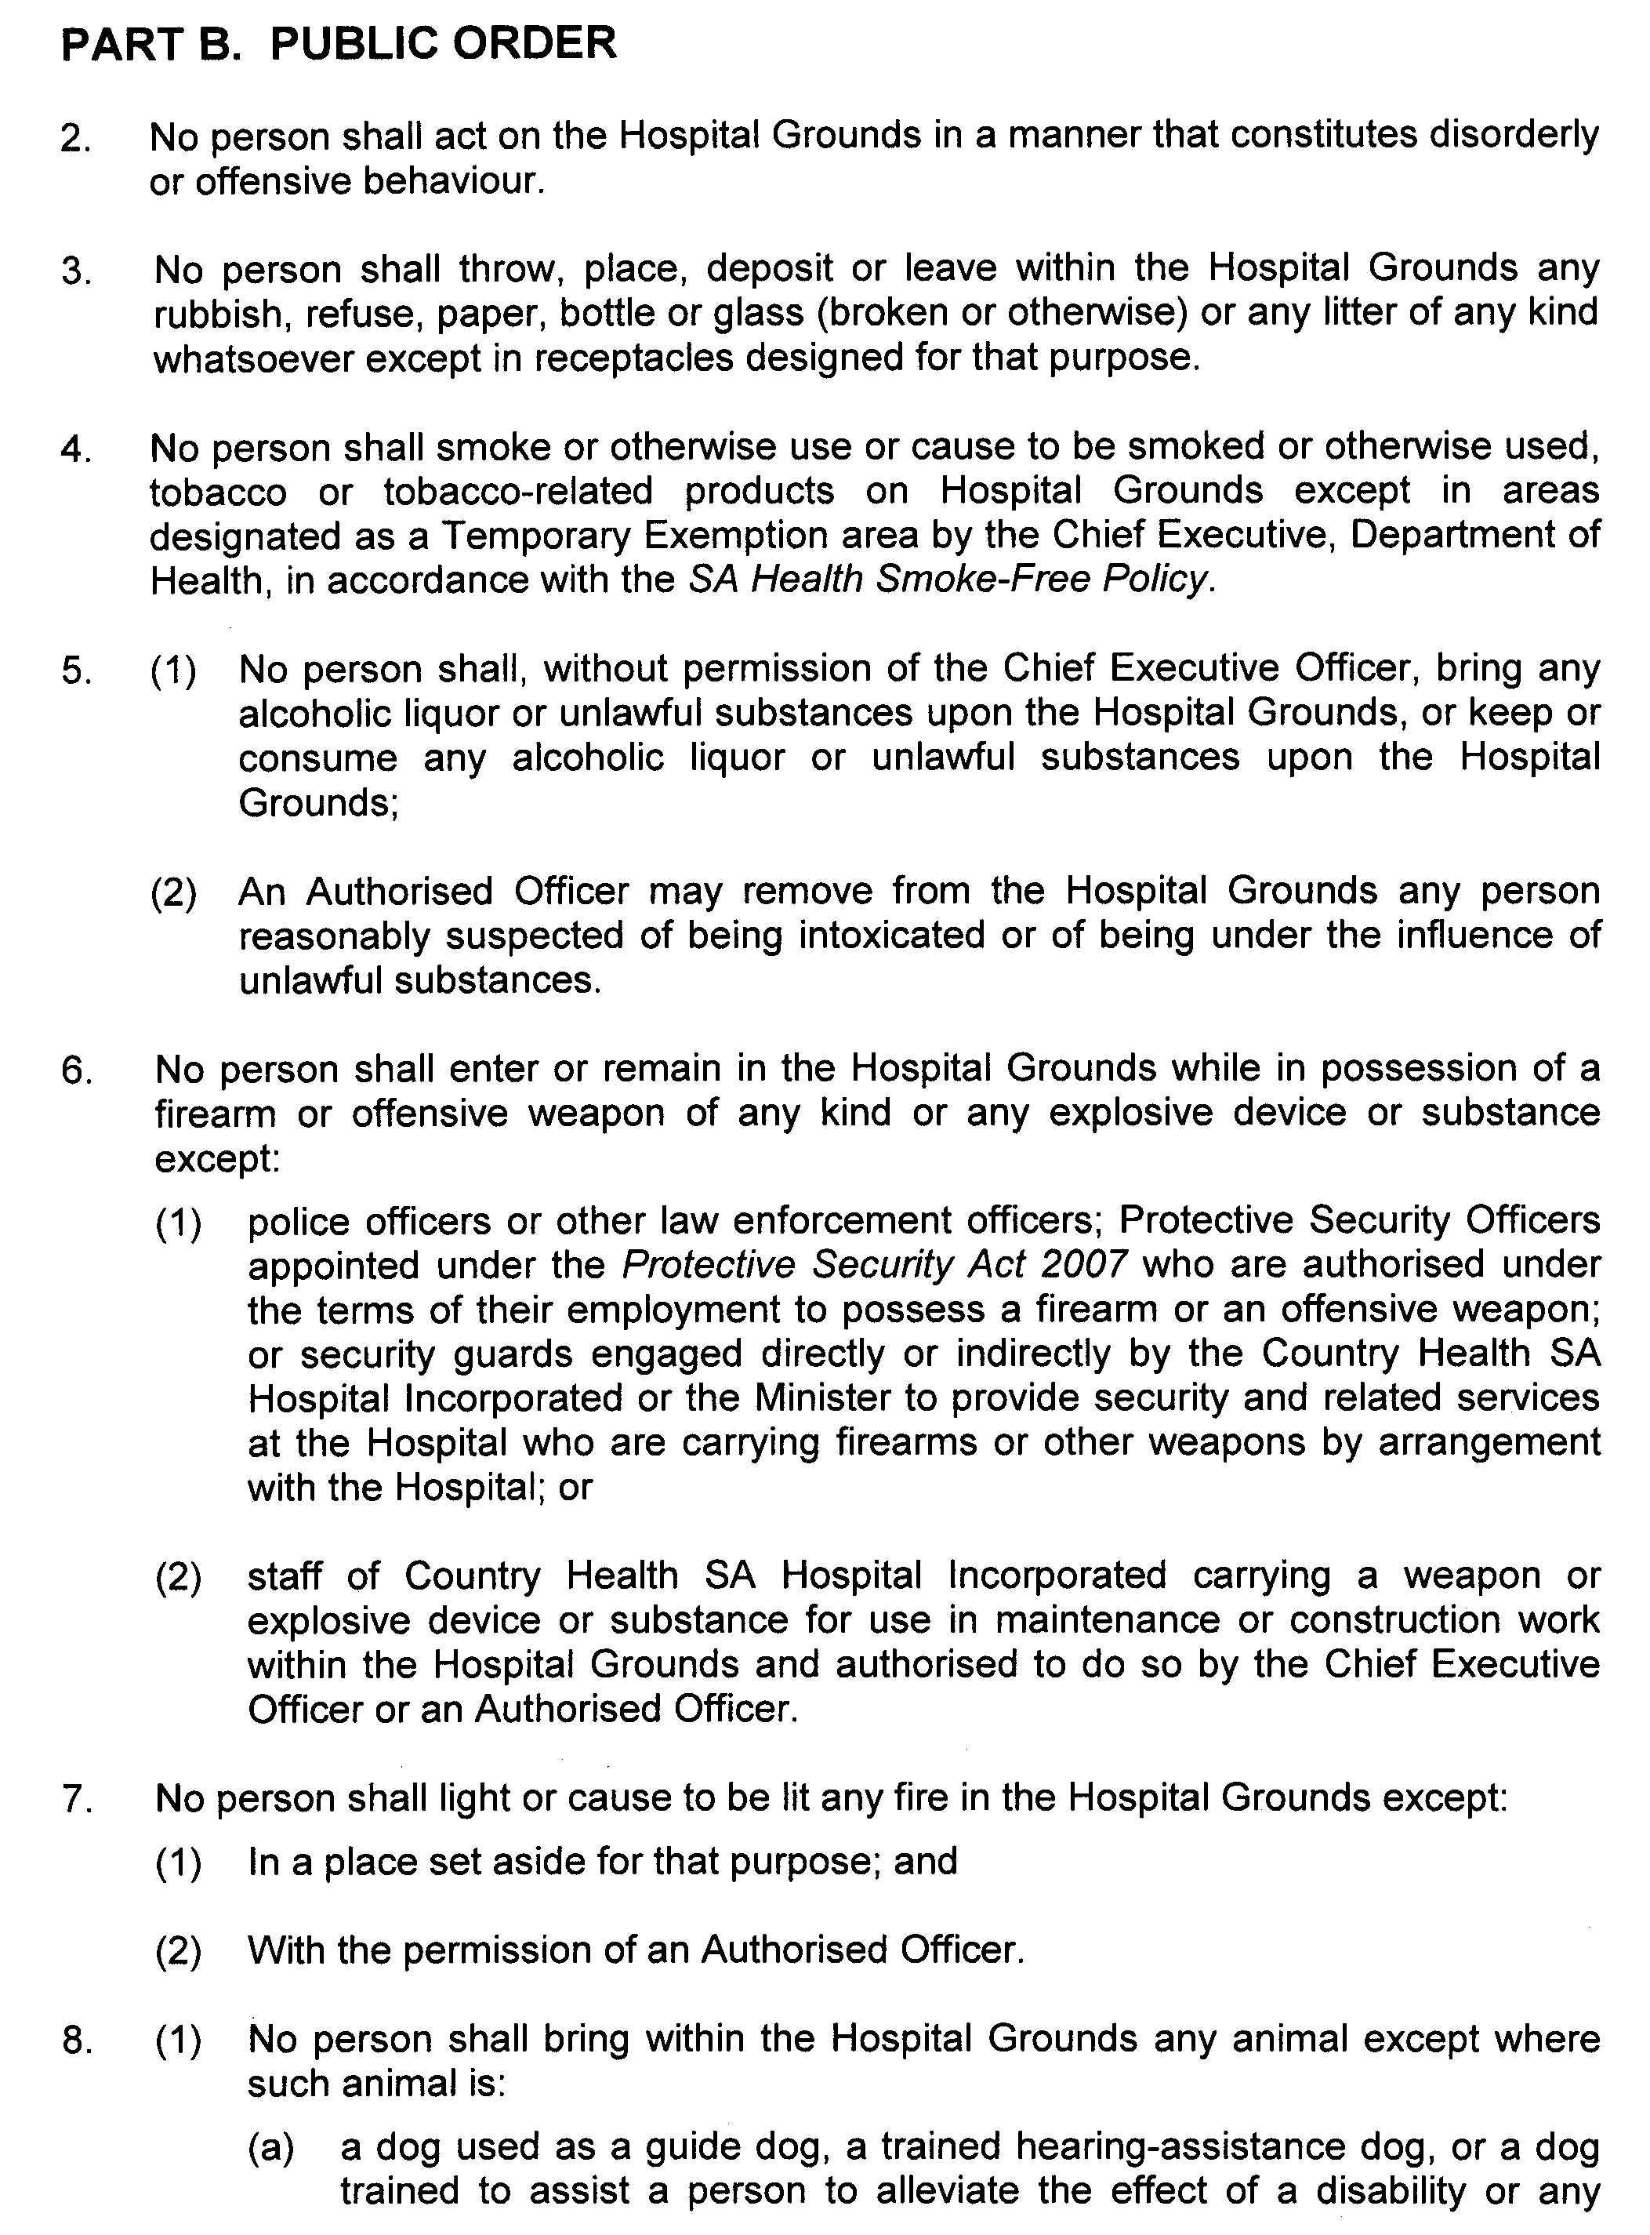
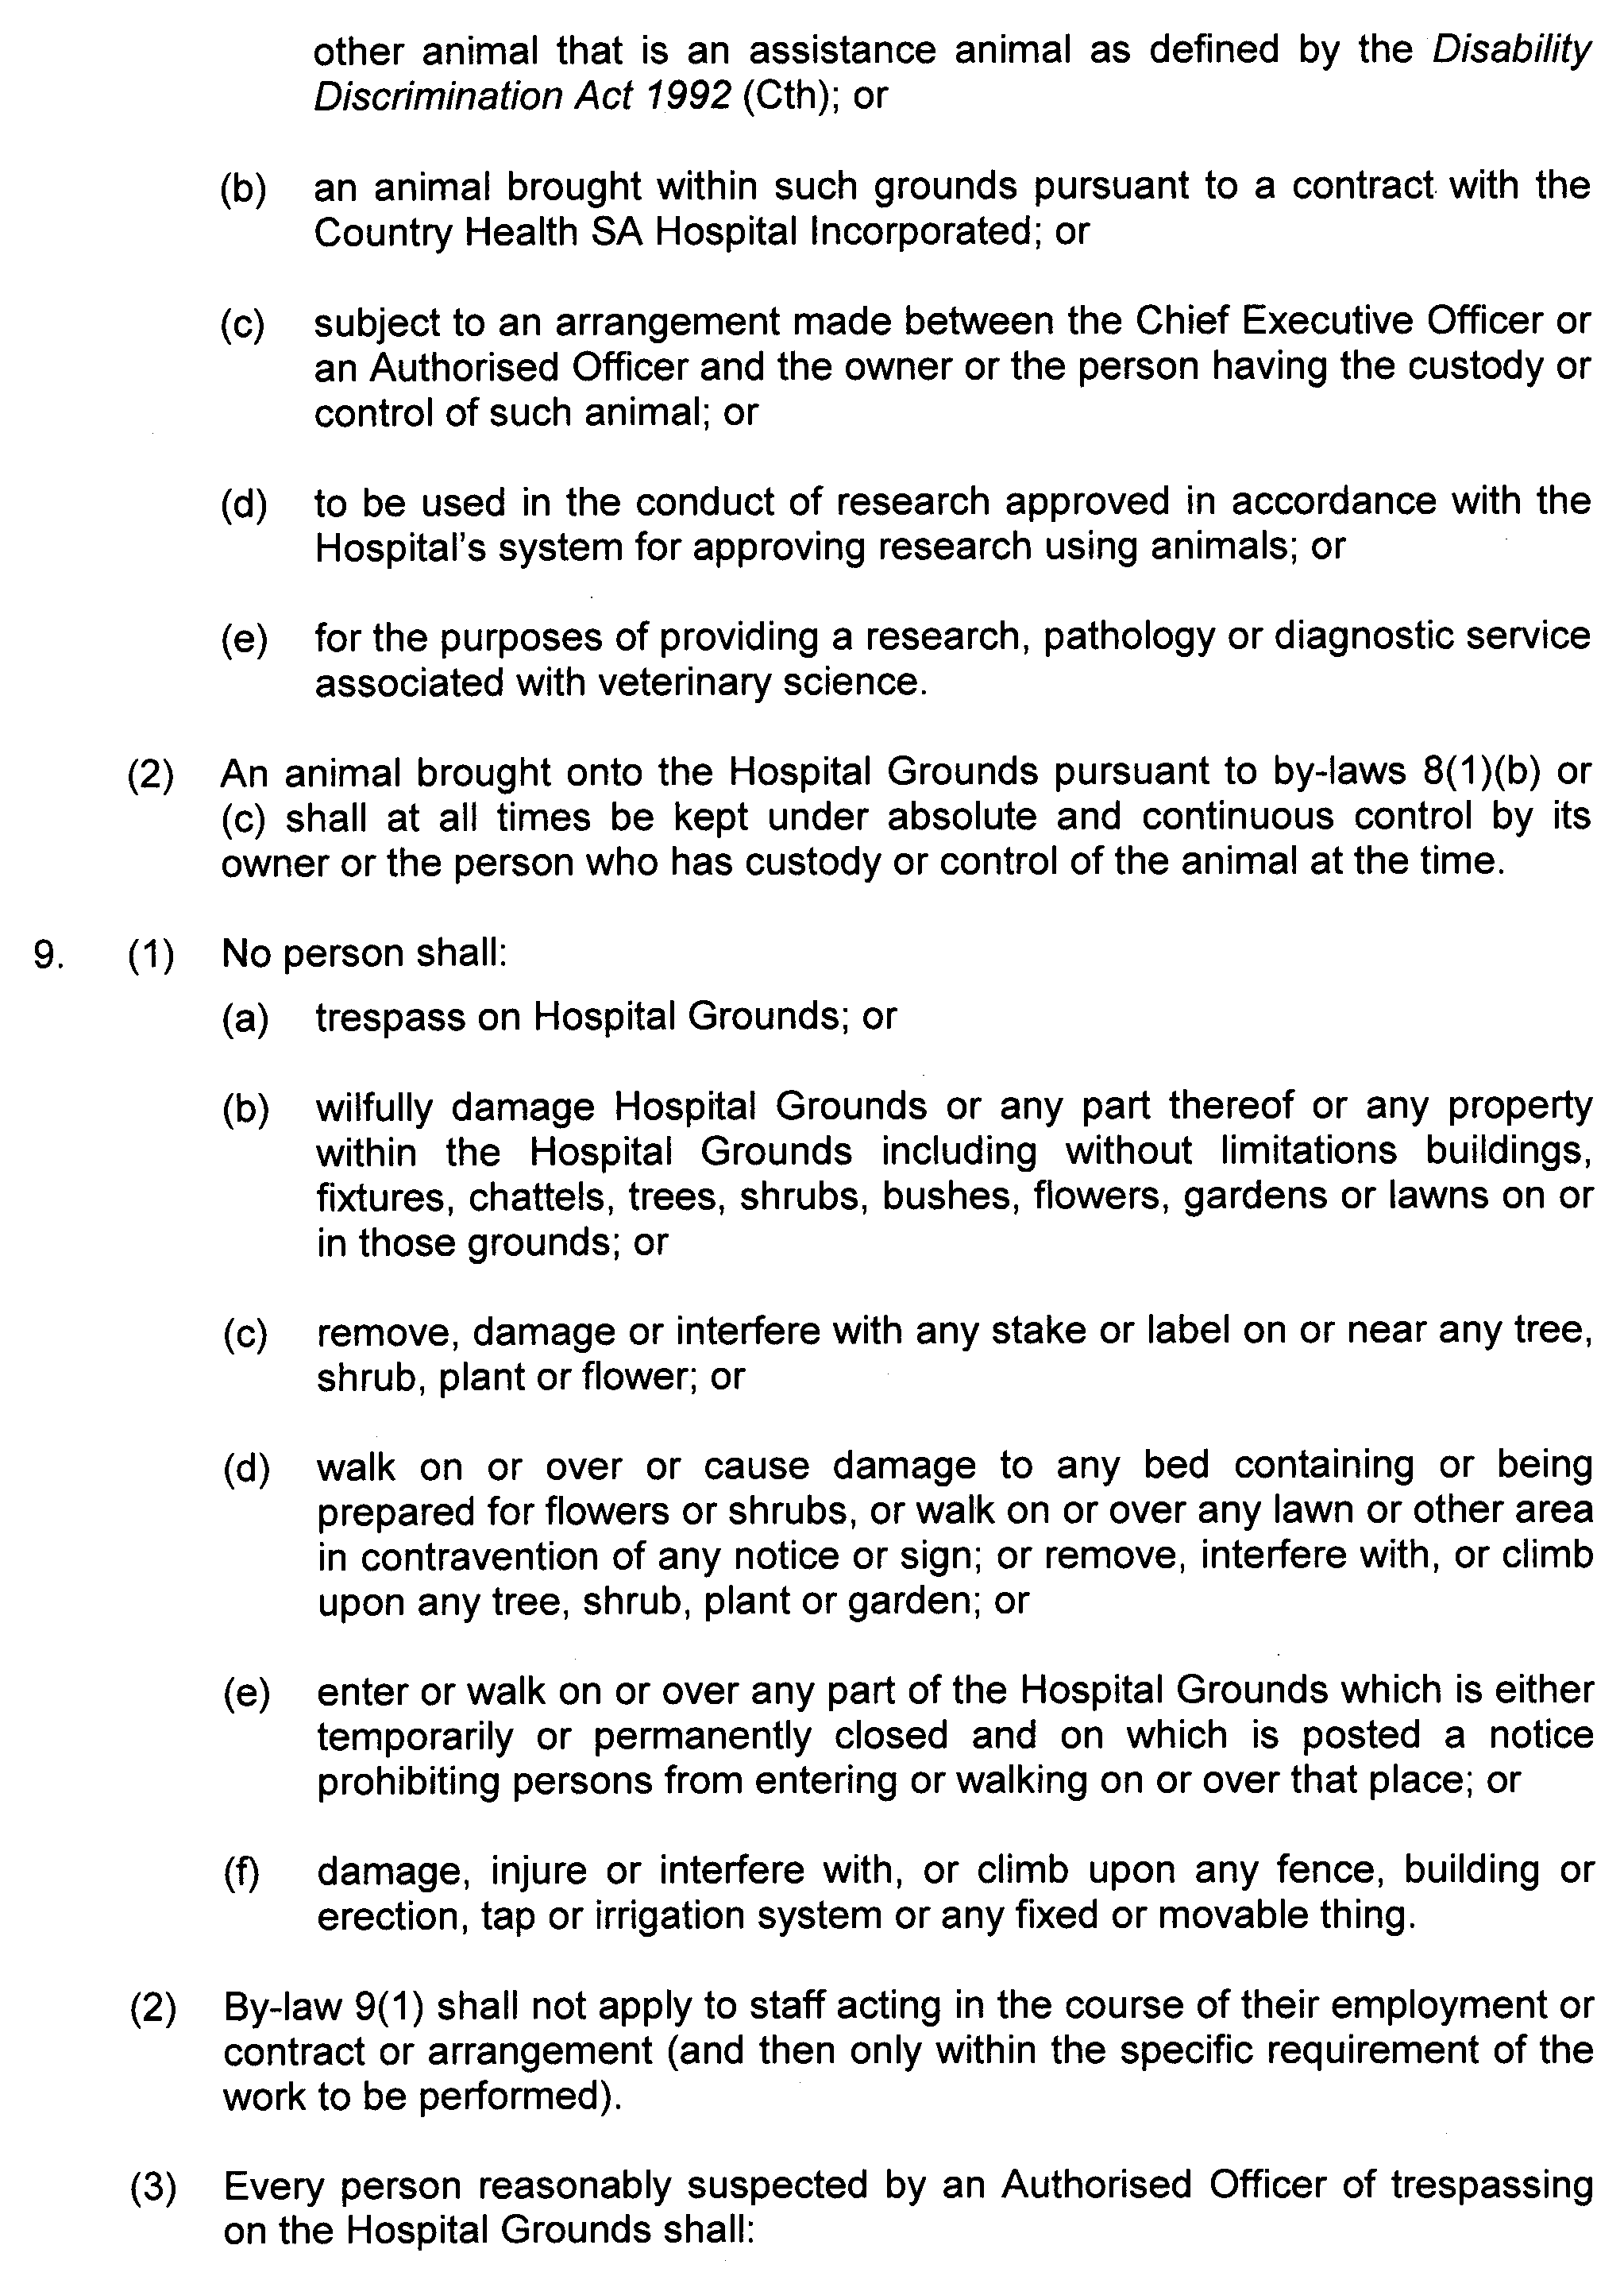
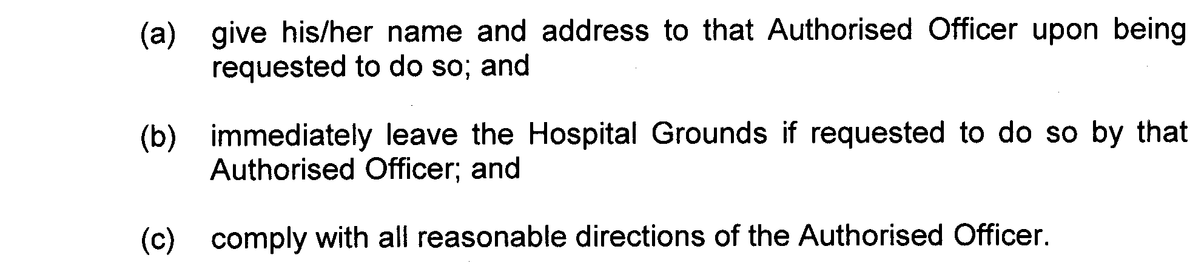
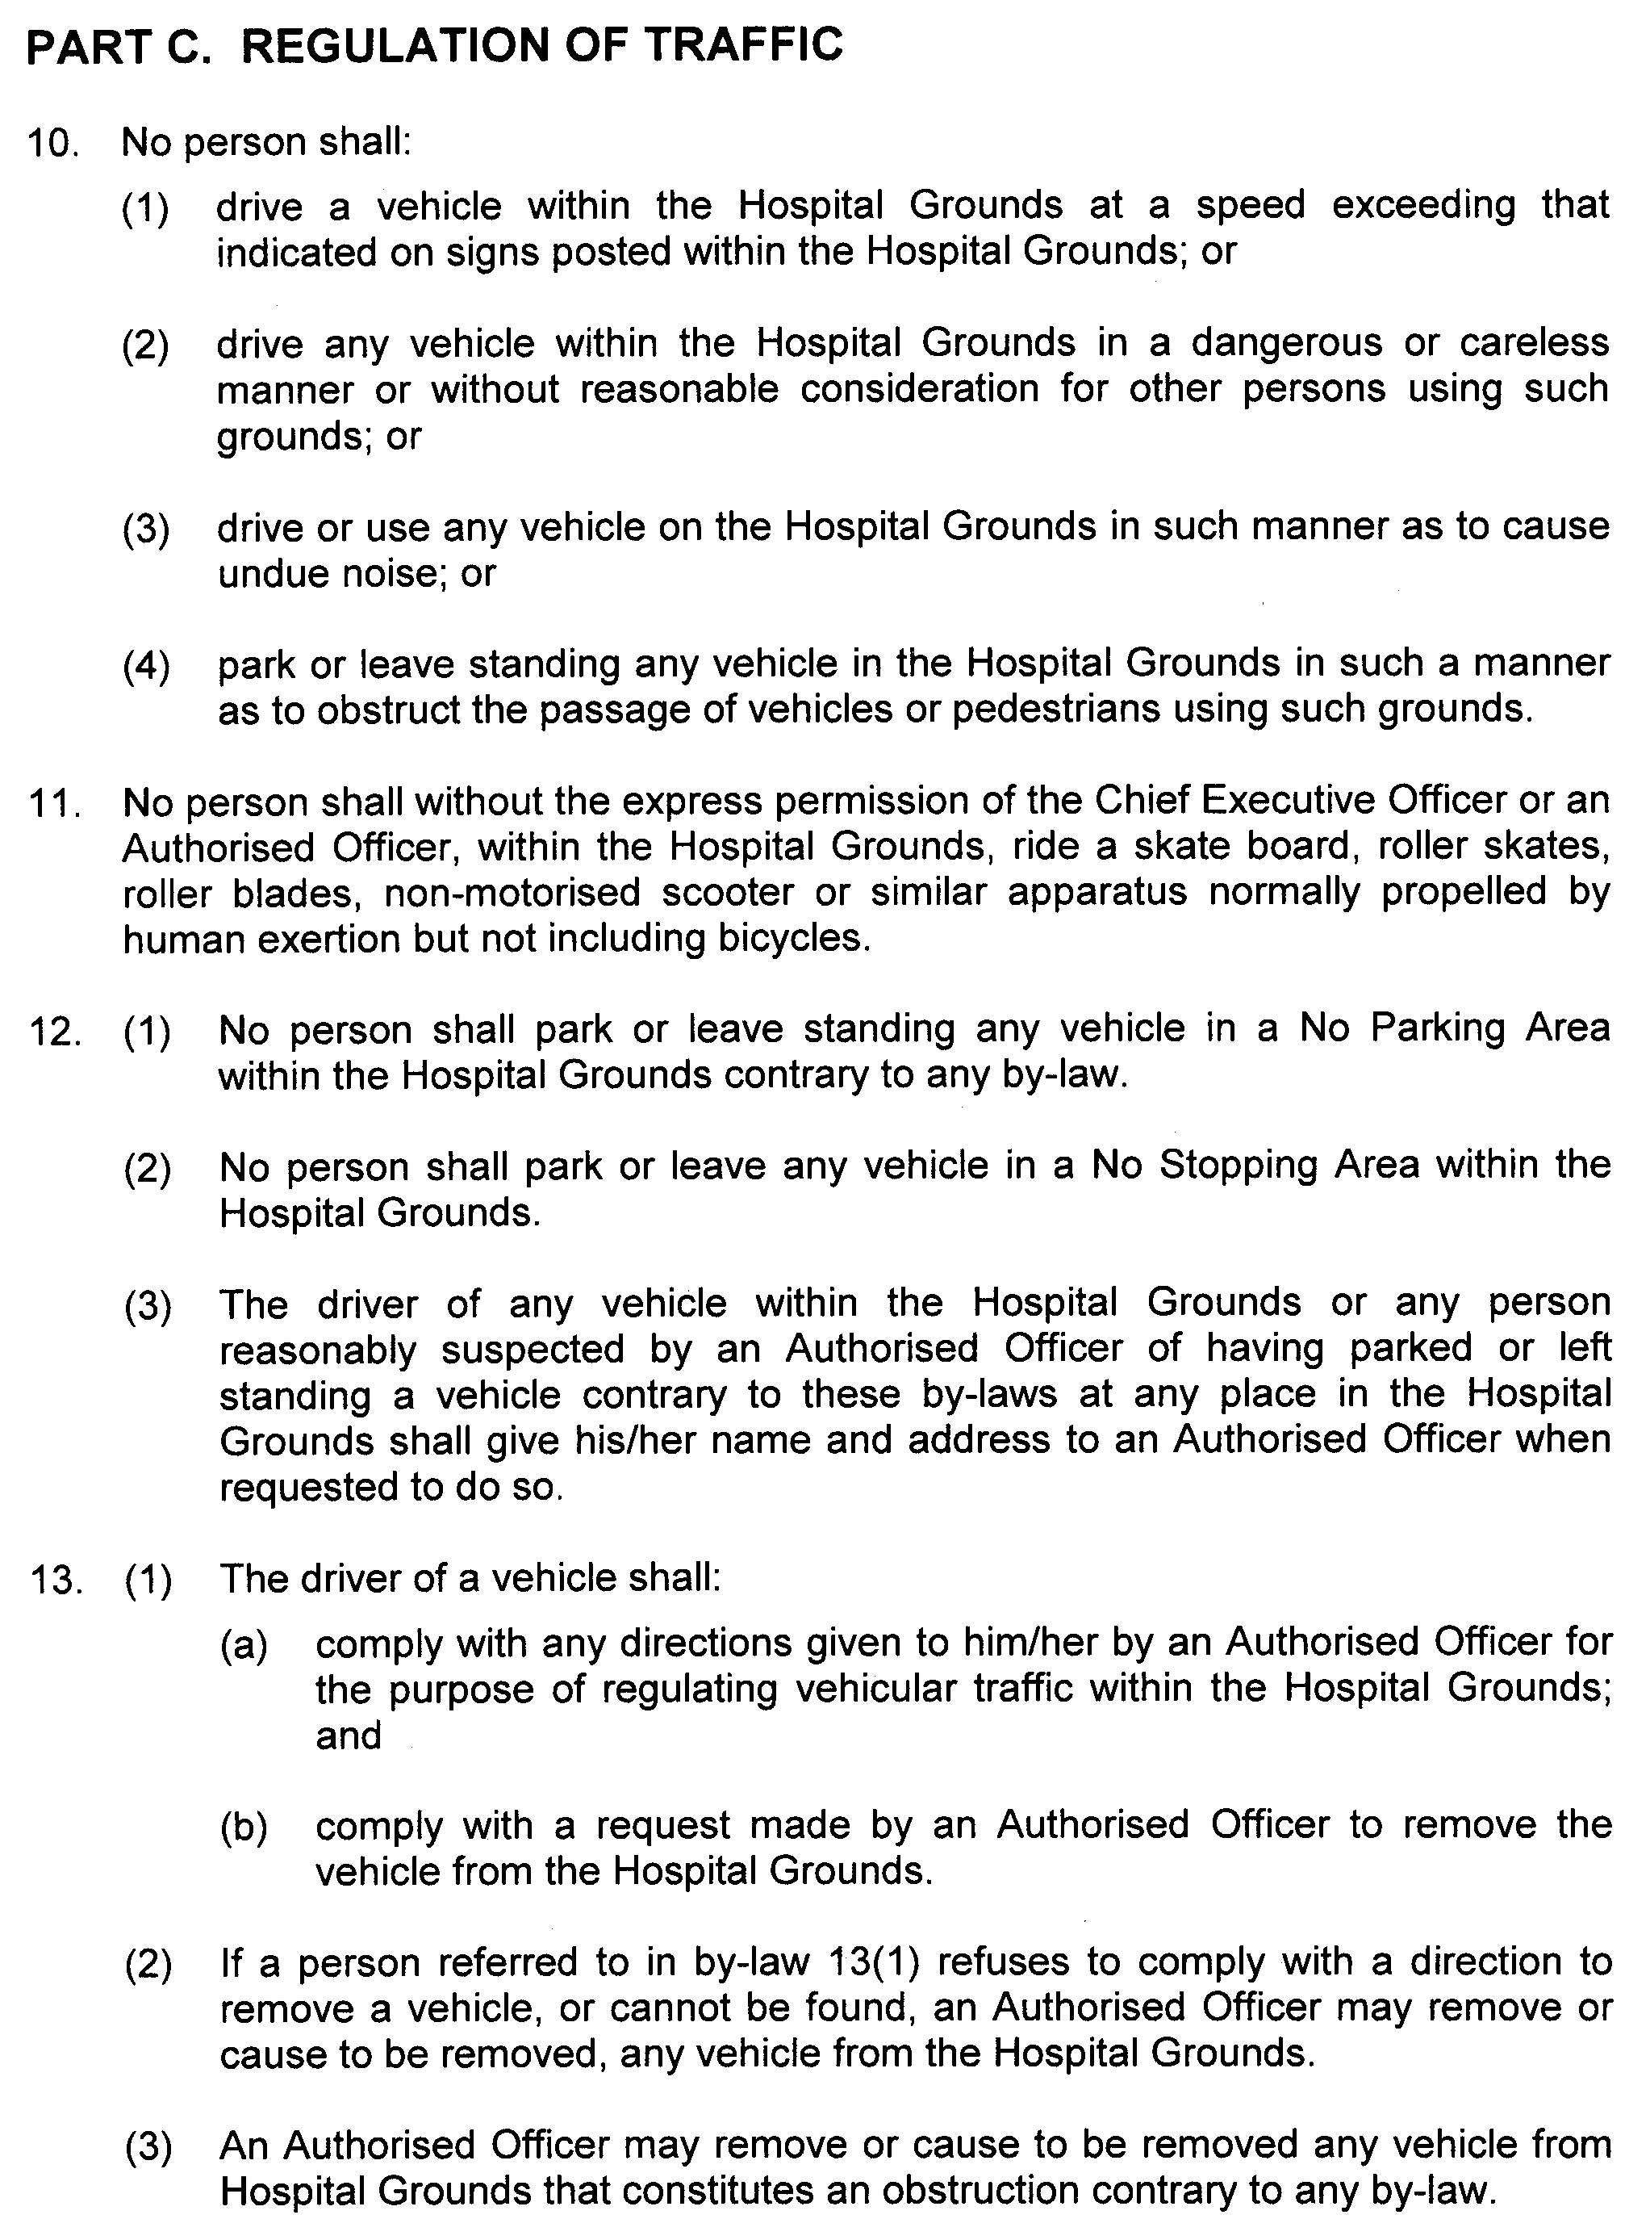
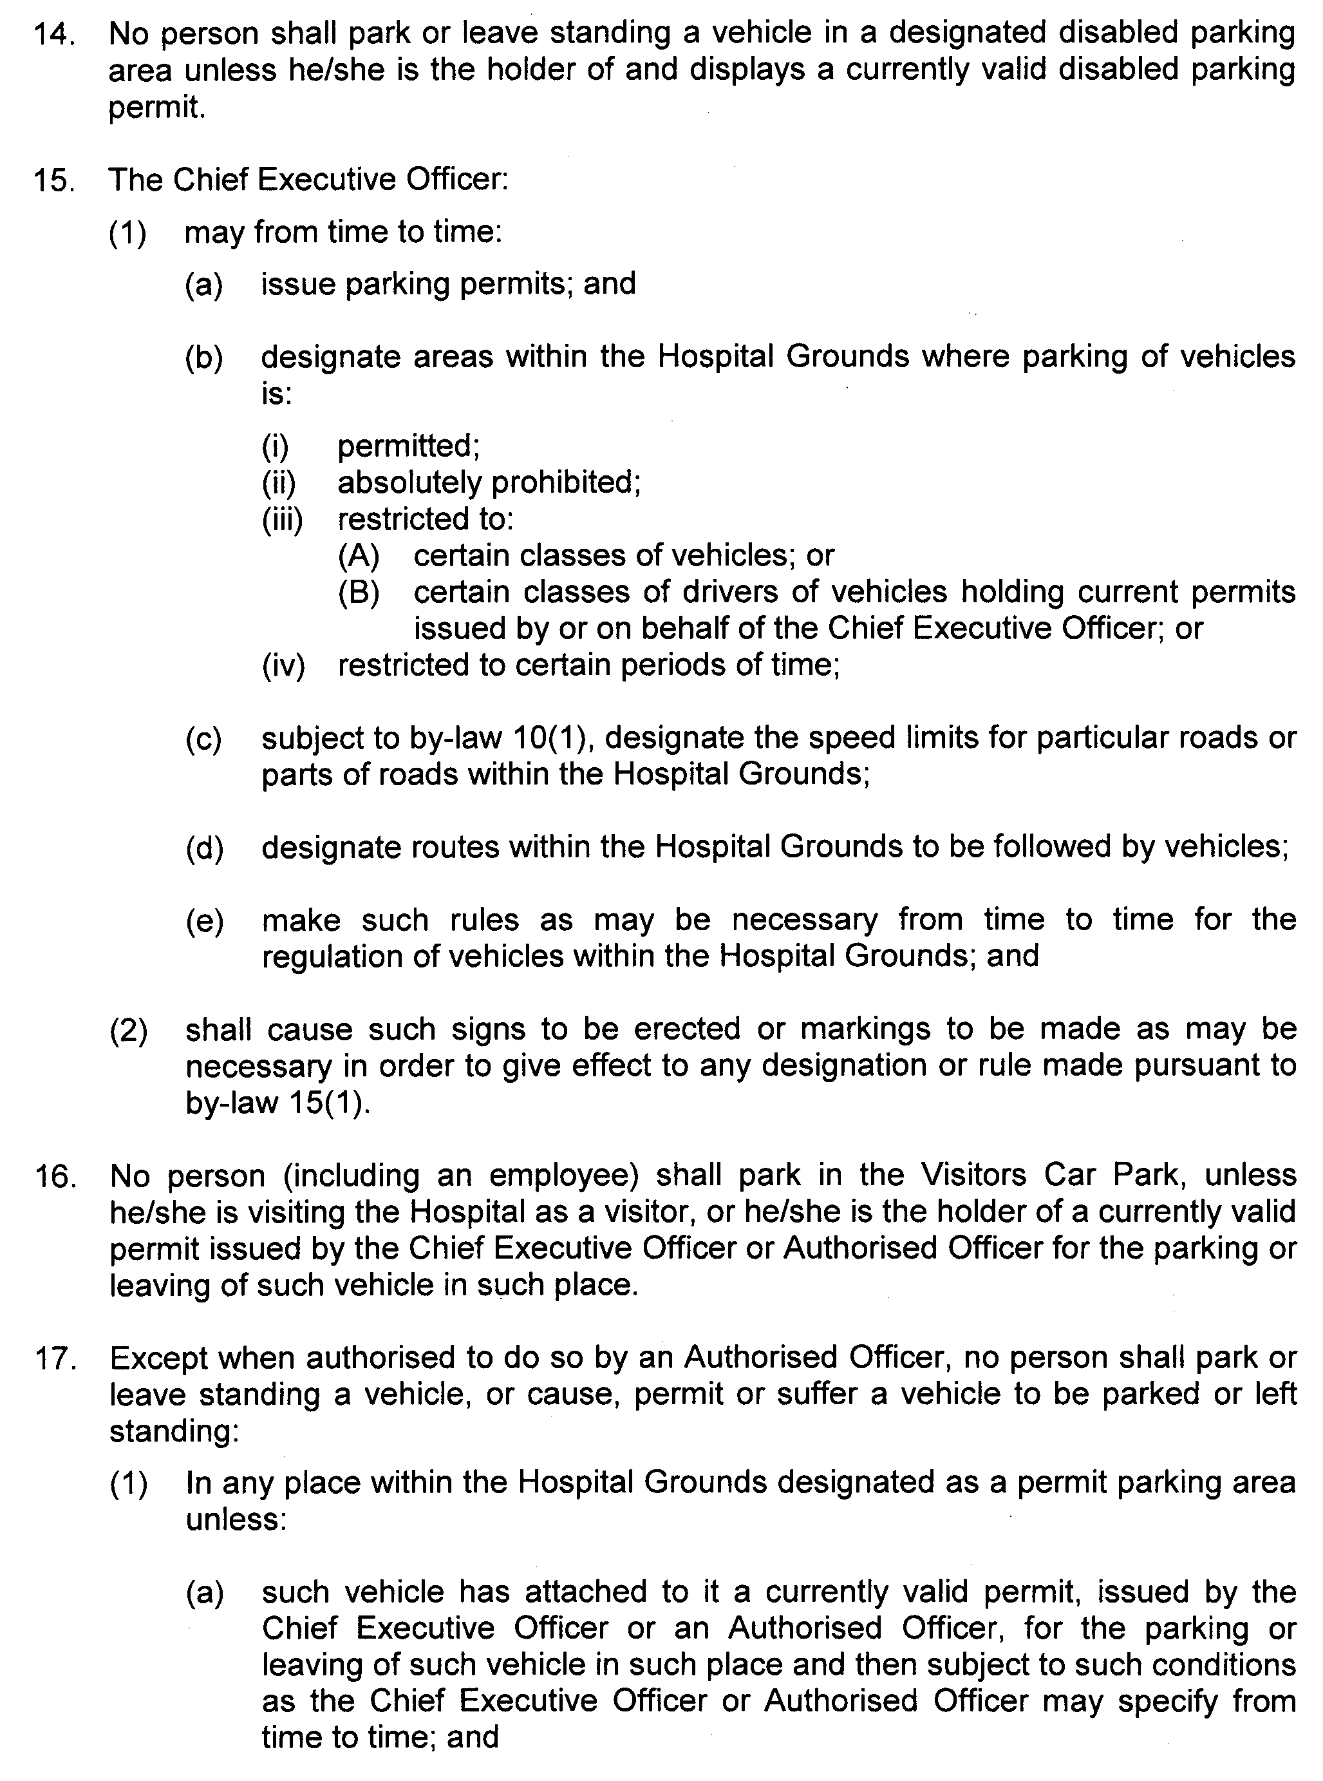
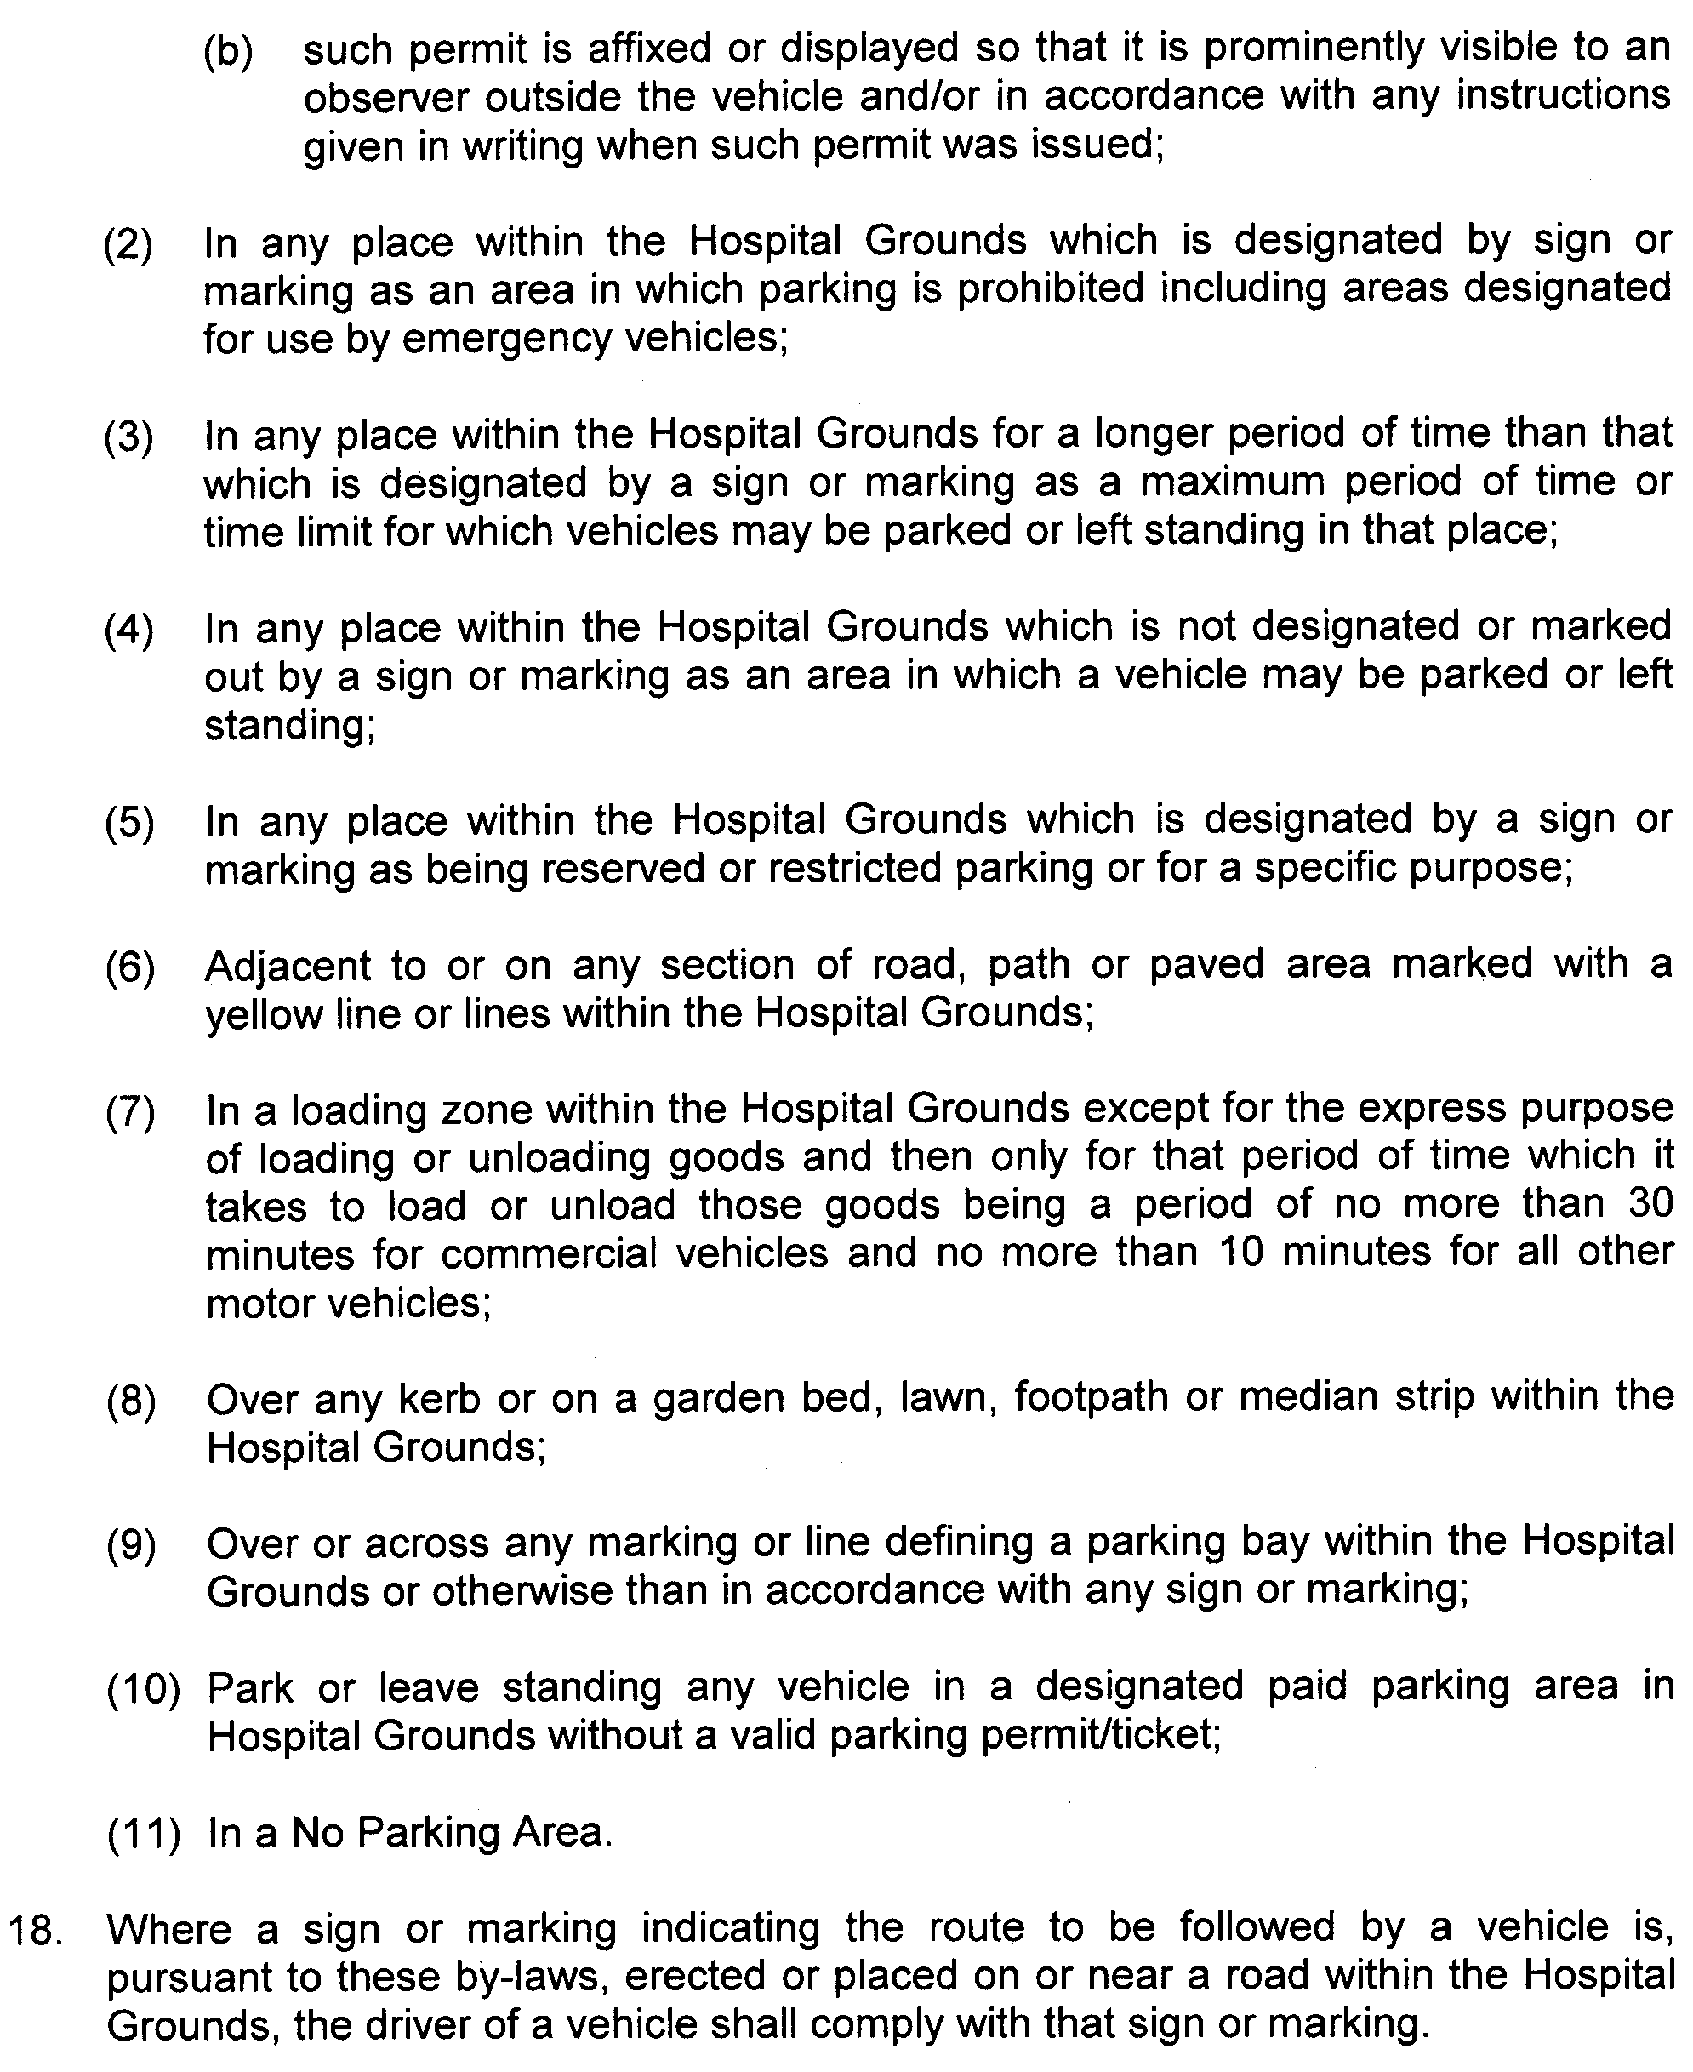
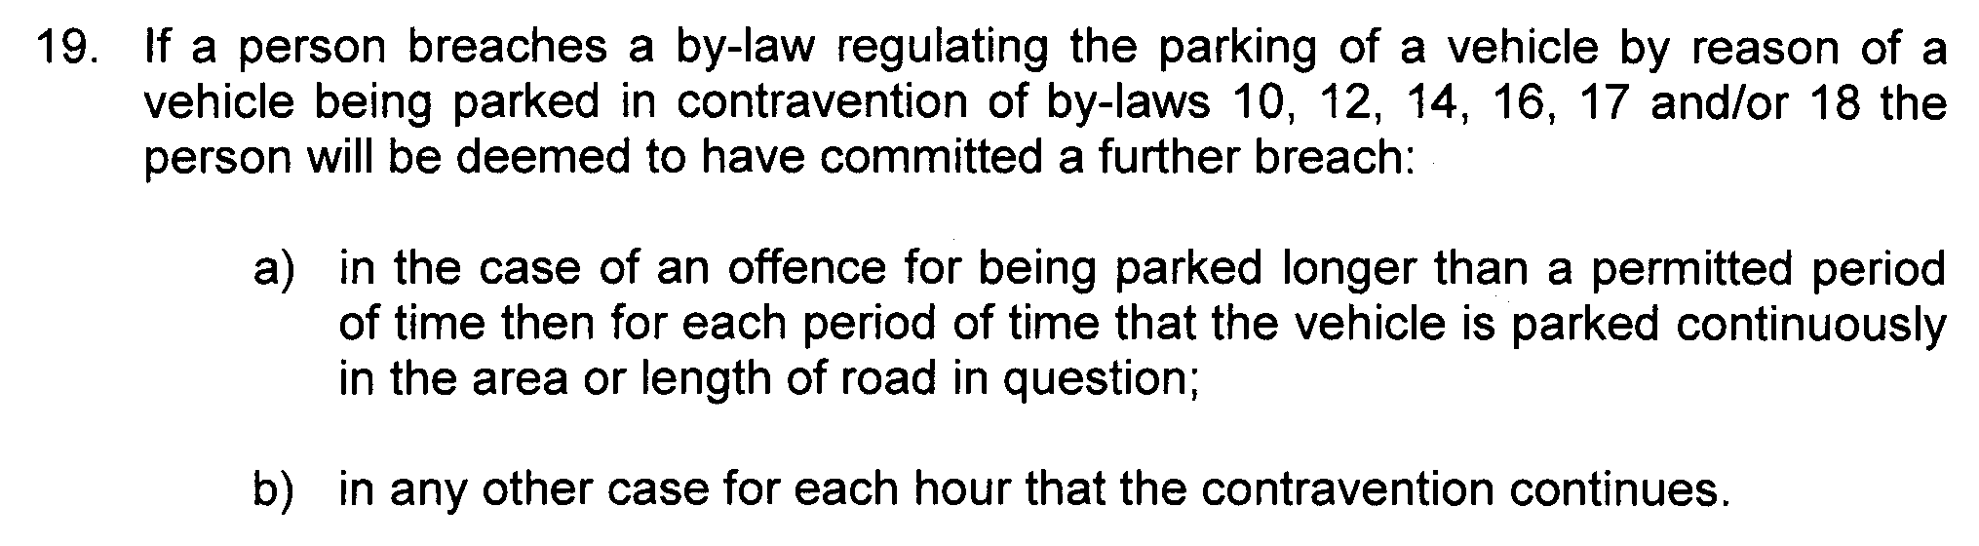
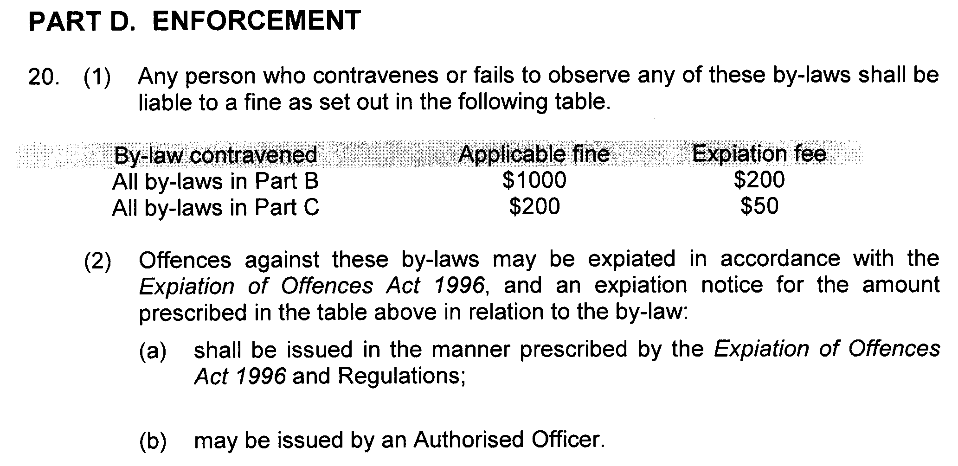
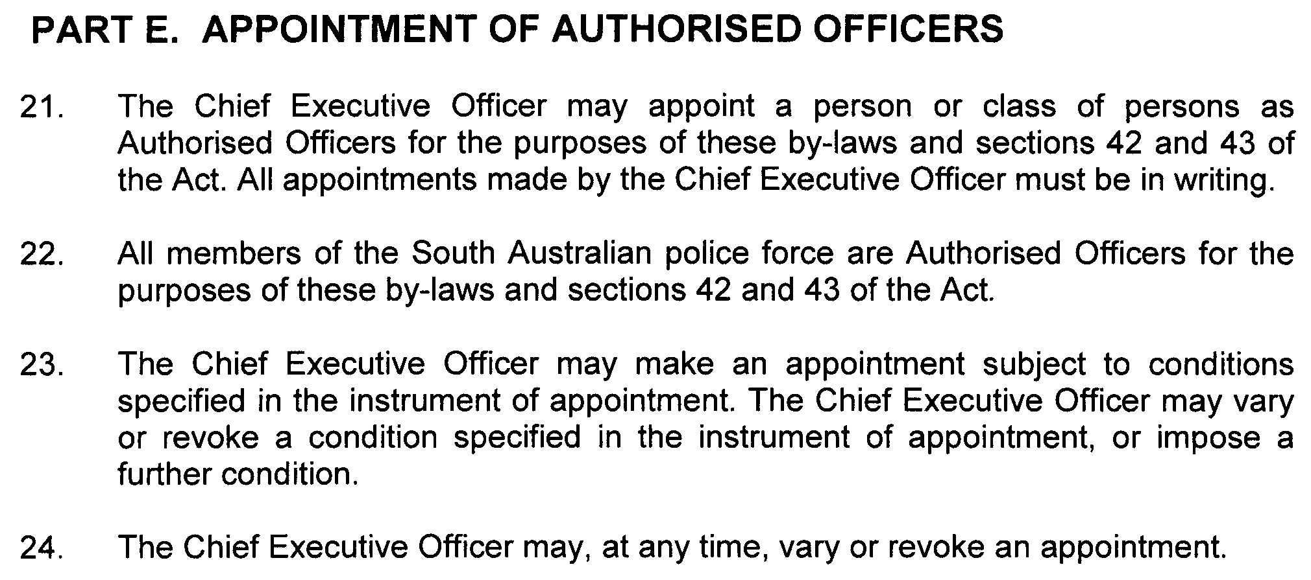

SOUTHERN ADELAIDE HEALTH SERVICE INCORPORATED

By-laws made by the Southern Adelaide Health Service Incorporated, pursuant to section 42 of the Health Care Act 2008, as amended

These by-laws are in substitution of all previous by-laws made by or for the Southern Adelaide Health Service Incorporated or any health service or hospital site that forms part of the Southern Adelaide Health Service Incorporated.

BY-LAWS MADE BY

SOUTHERN ADELAIDE HEALTH SERVICE INCORPORATED

PURSUANT TO SECTION 42 OF THE HEALTH CARE ACT 2008

These by-laws were approved by the Minister for Health in accordance with section 42 (2) of the Health Care Act 2008 on 9 June 2010.
John Hill, Minister for Health

These by-laws come into force on confirmation by the Governor pursuant to section 42 (3) of the Health Care Act 2008.

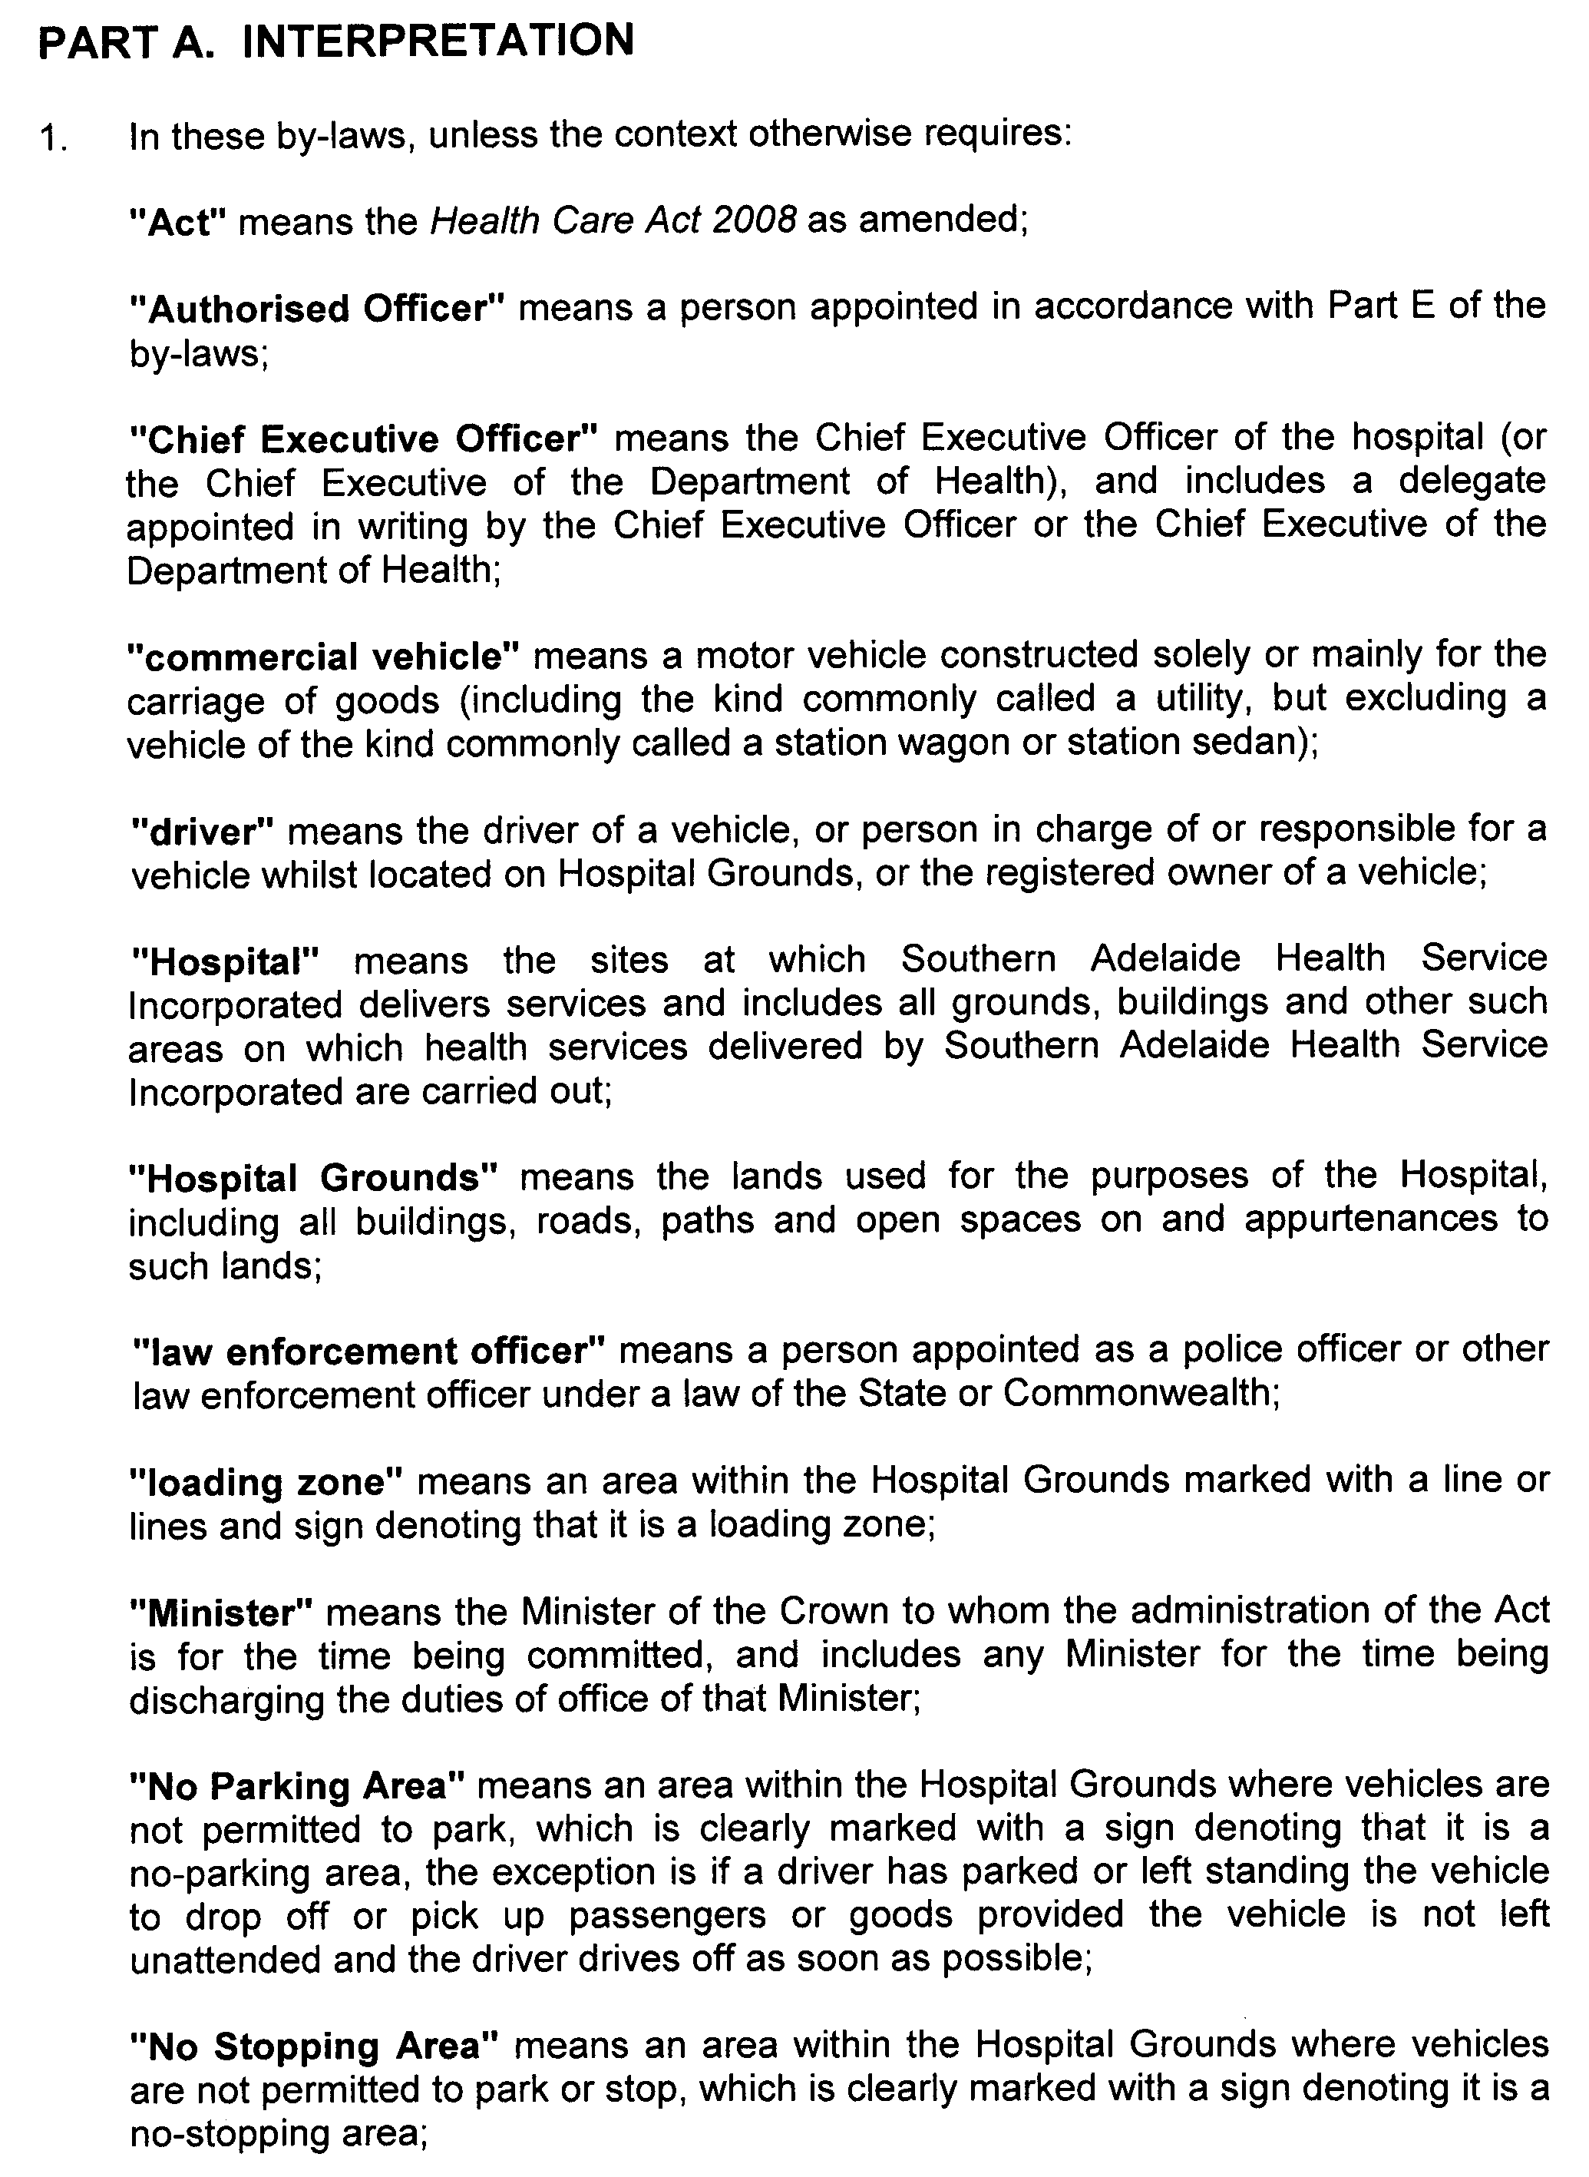
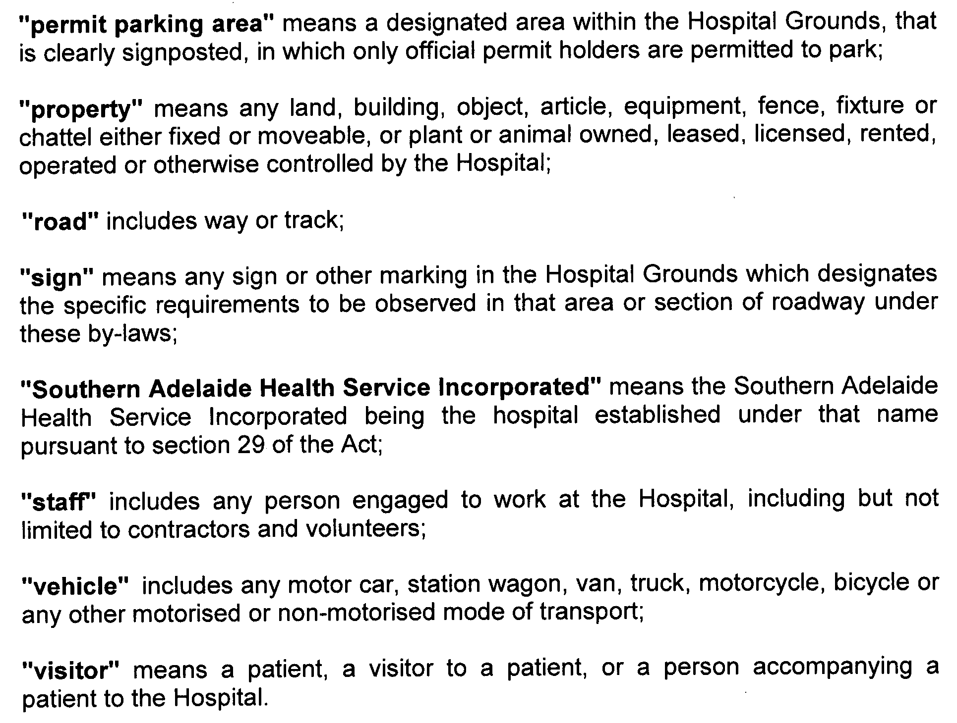
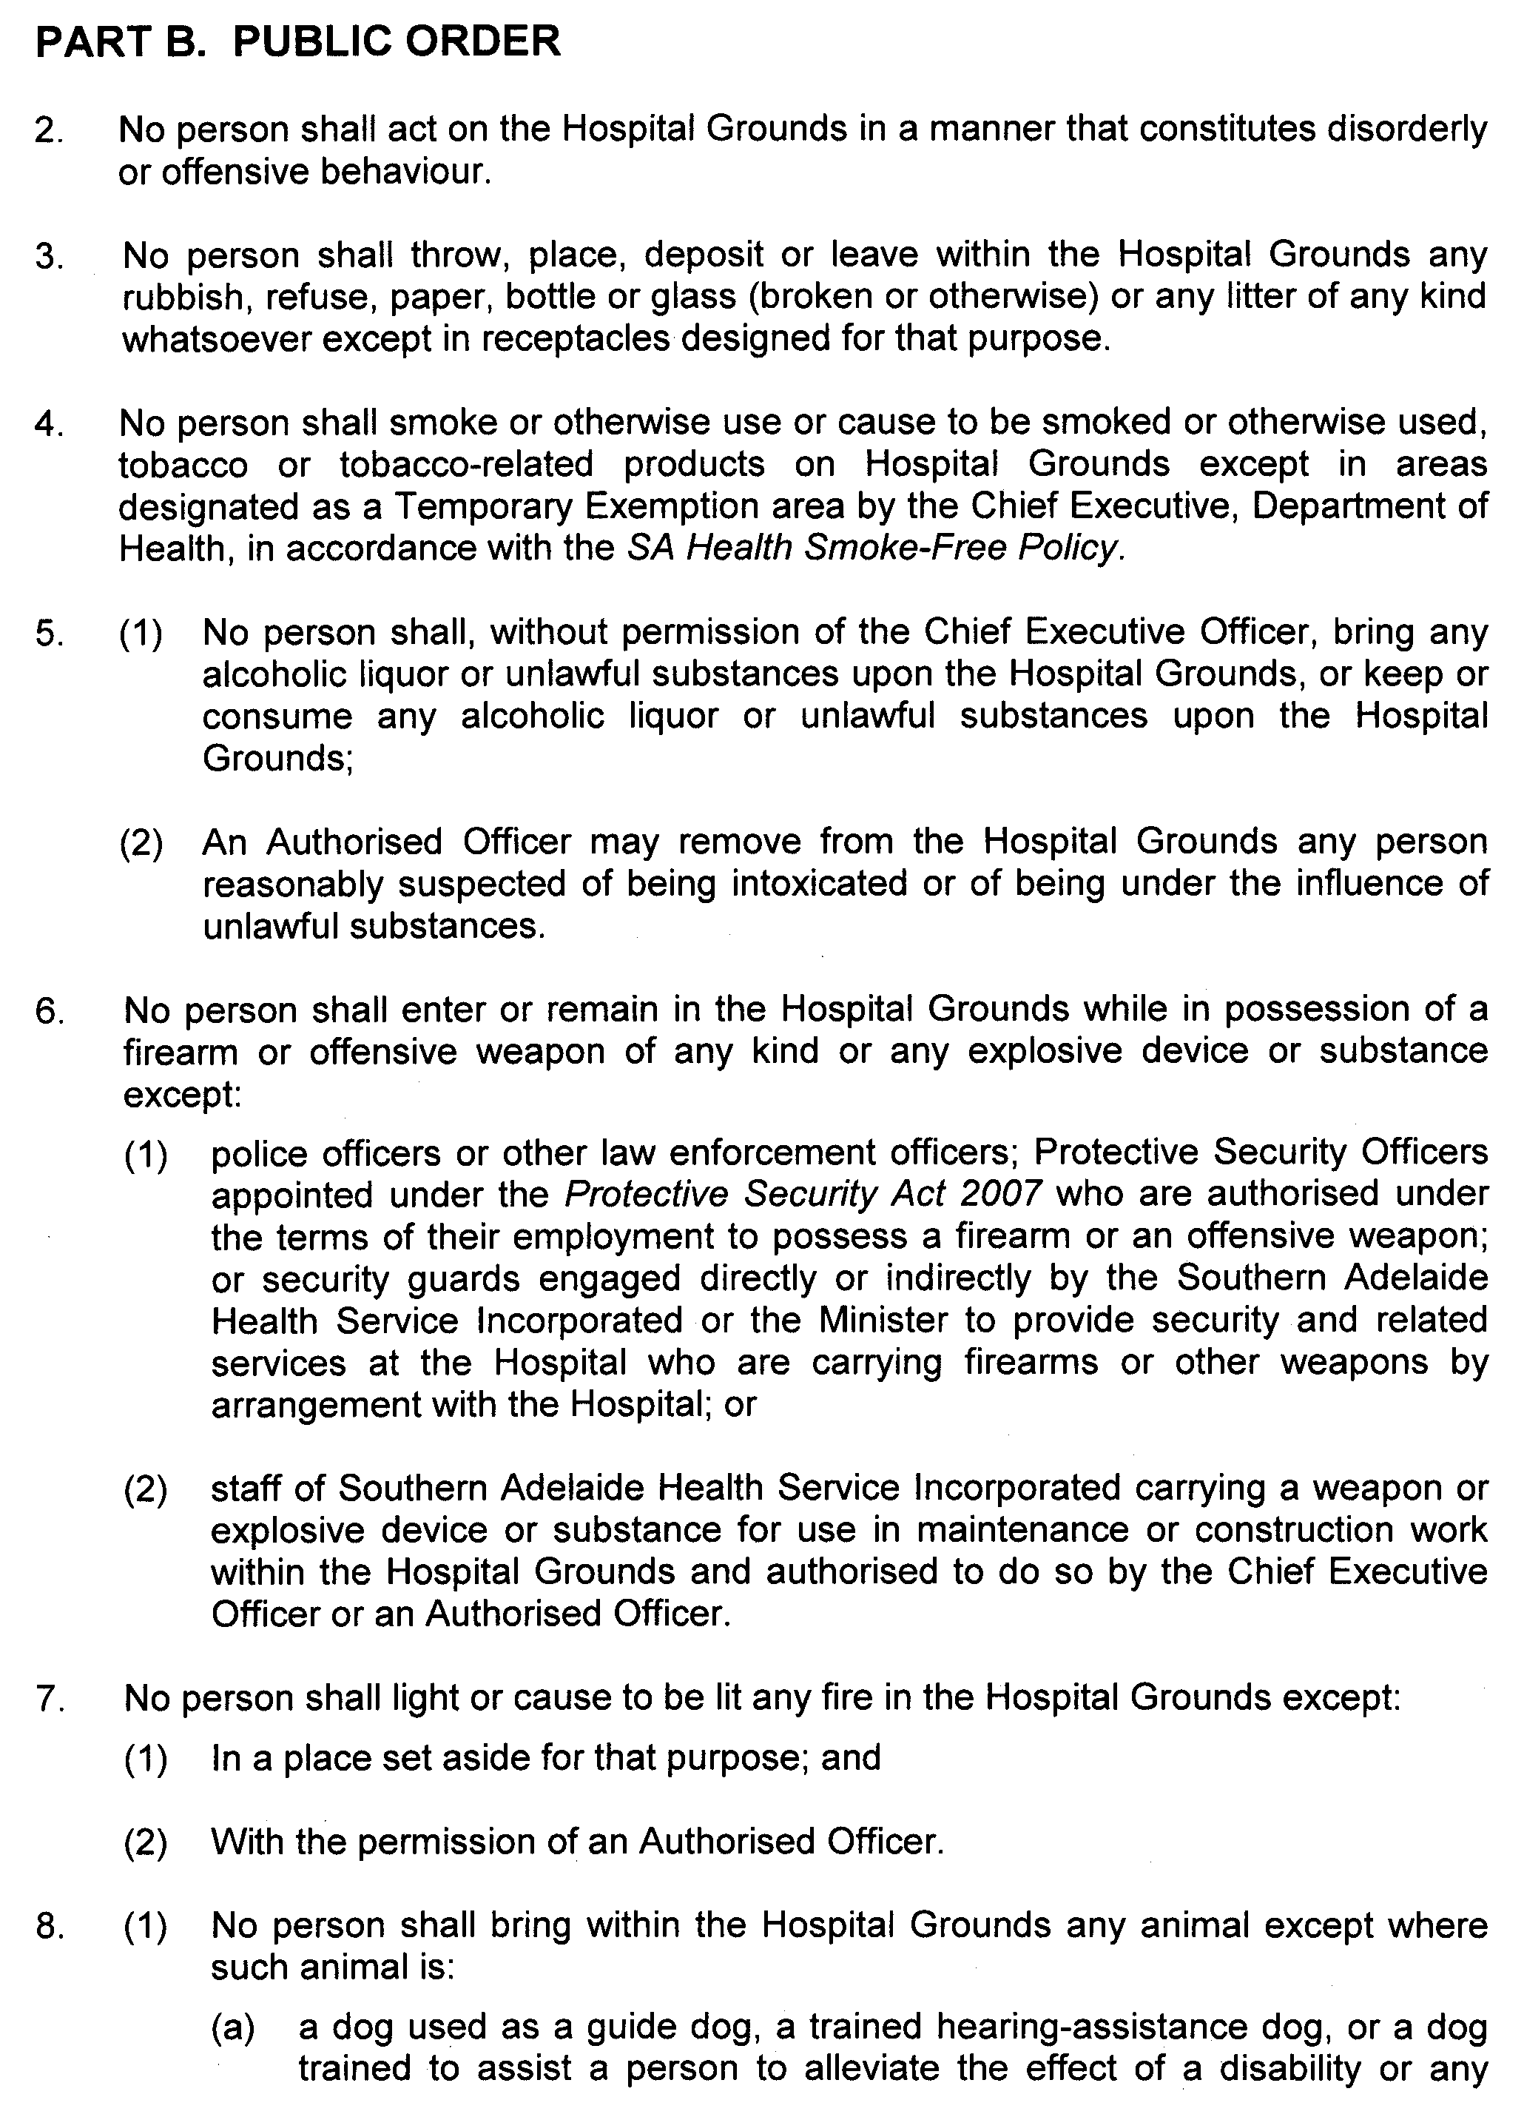
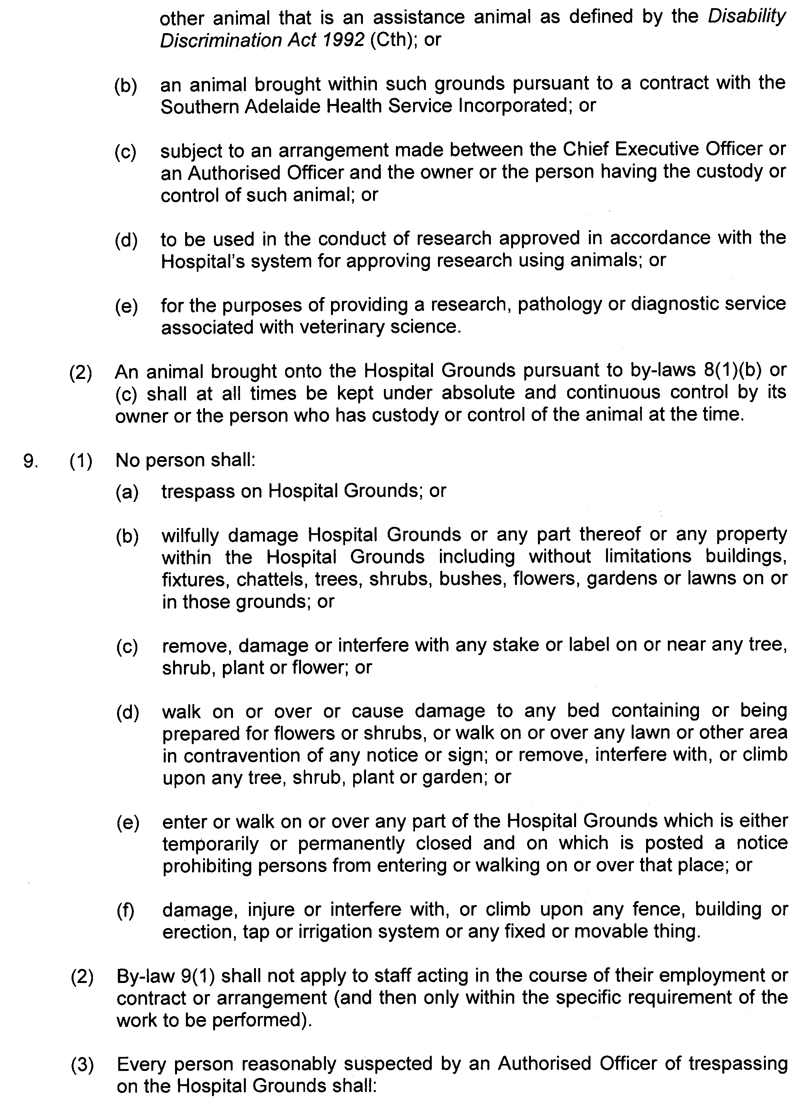
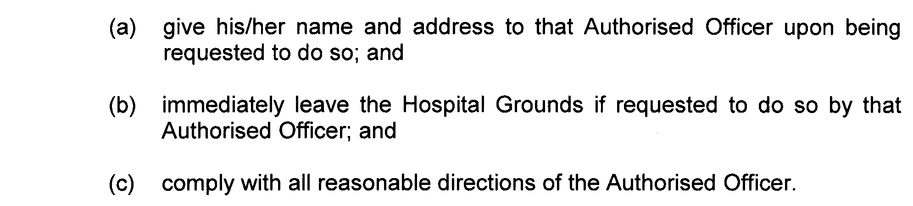
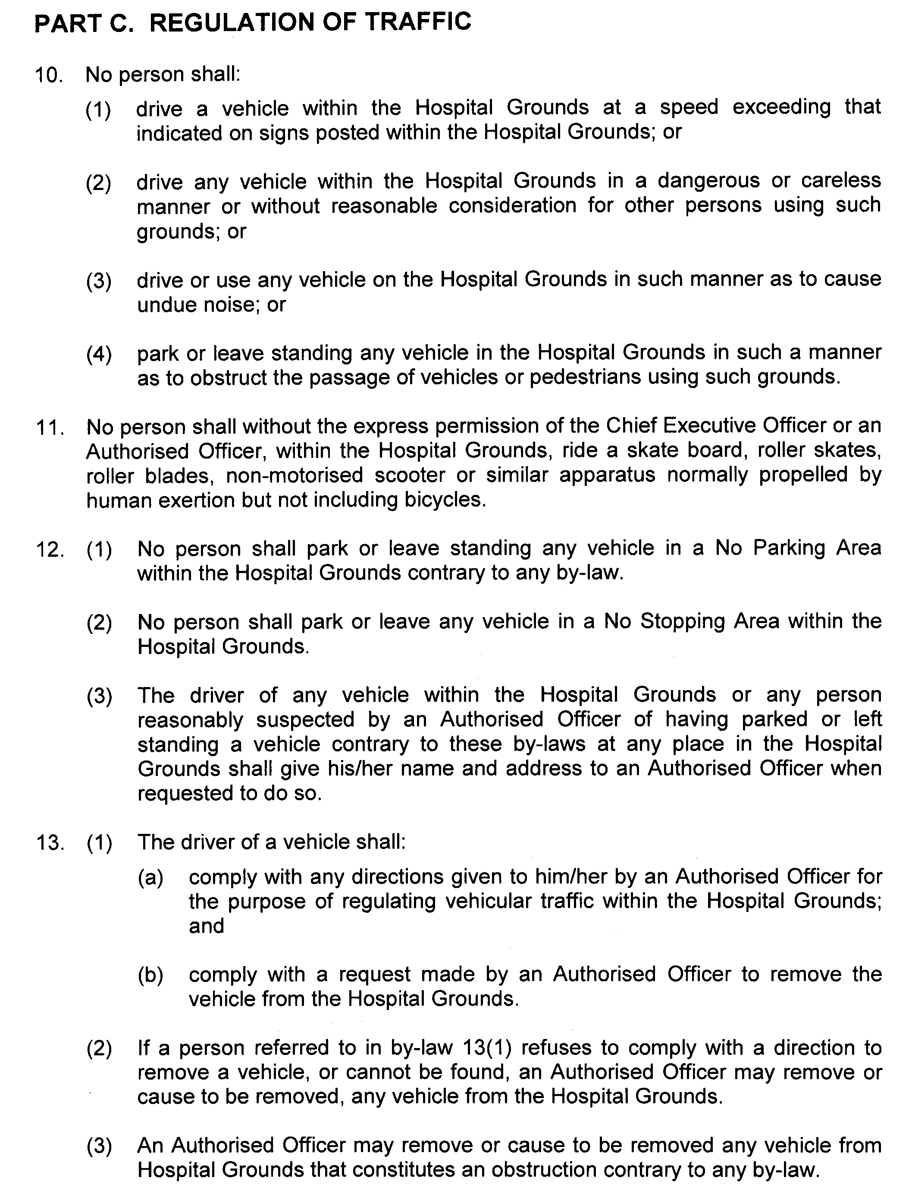
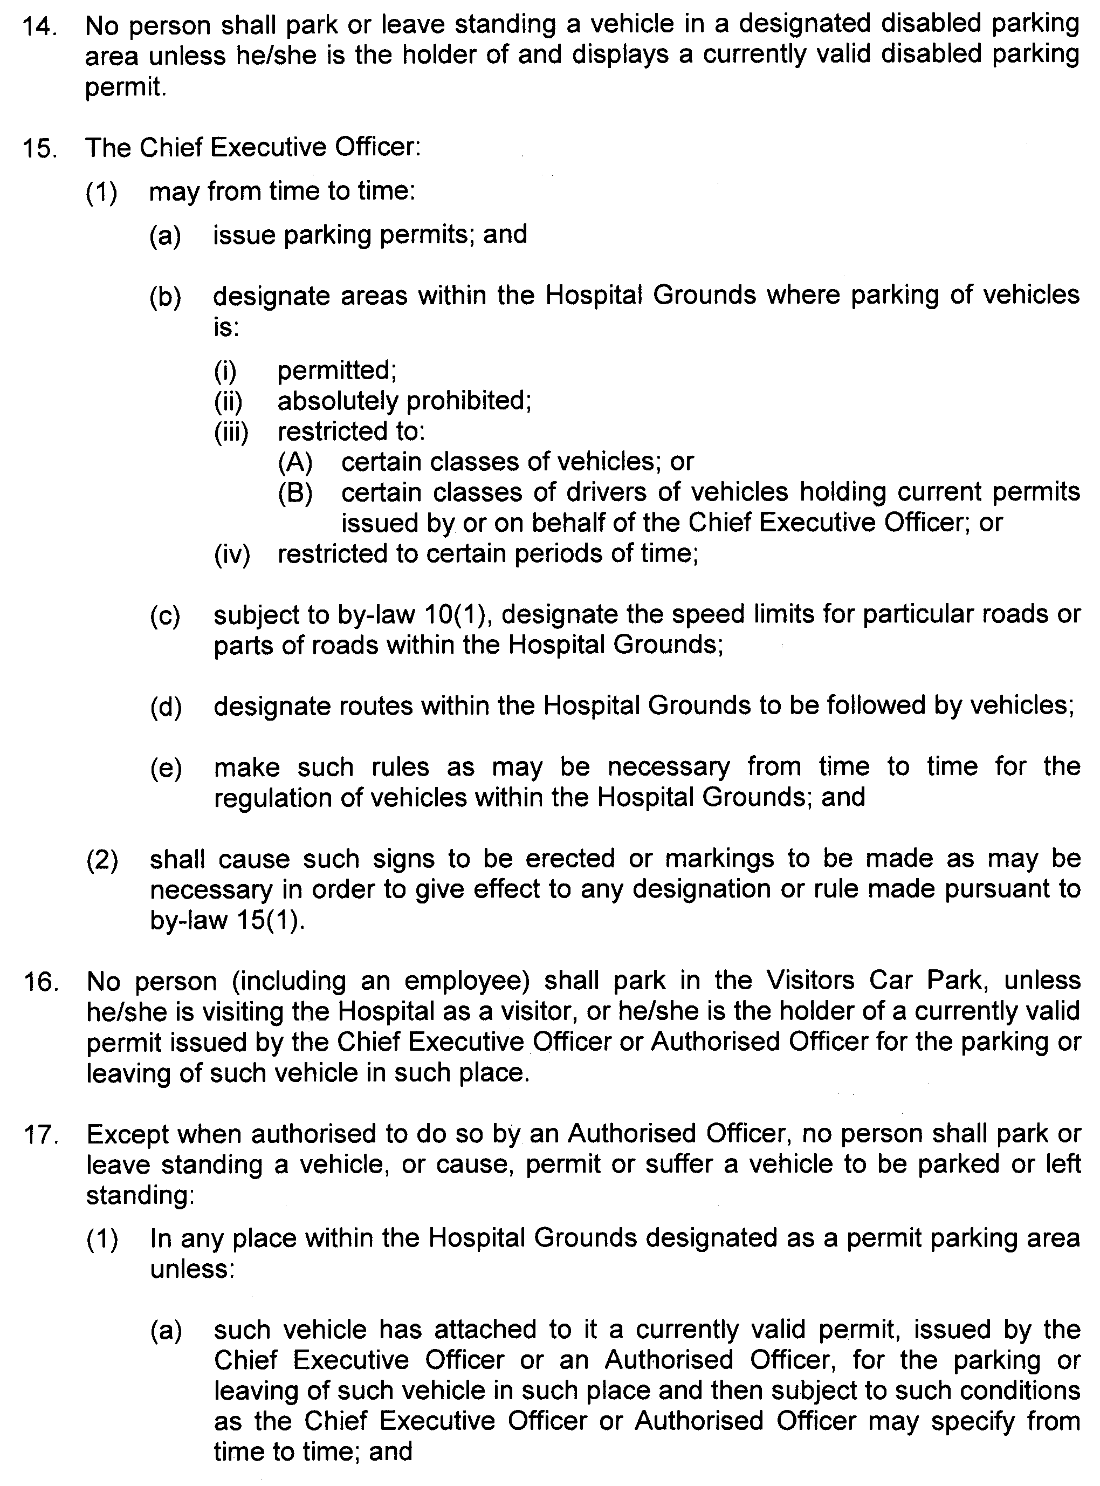
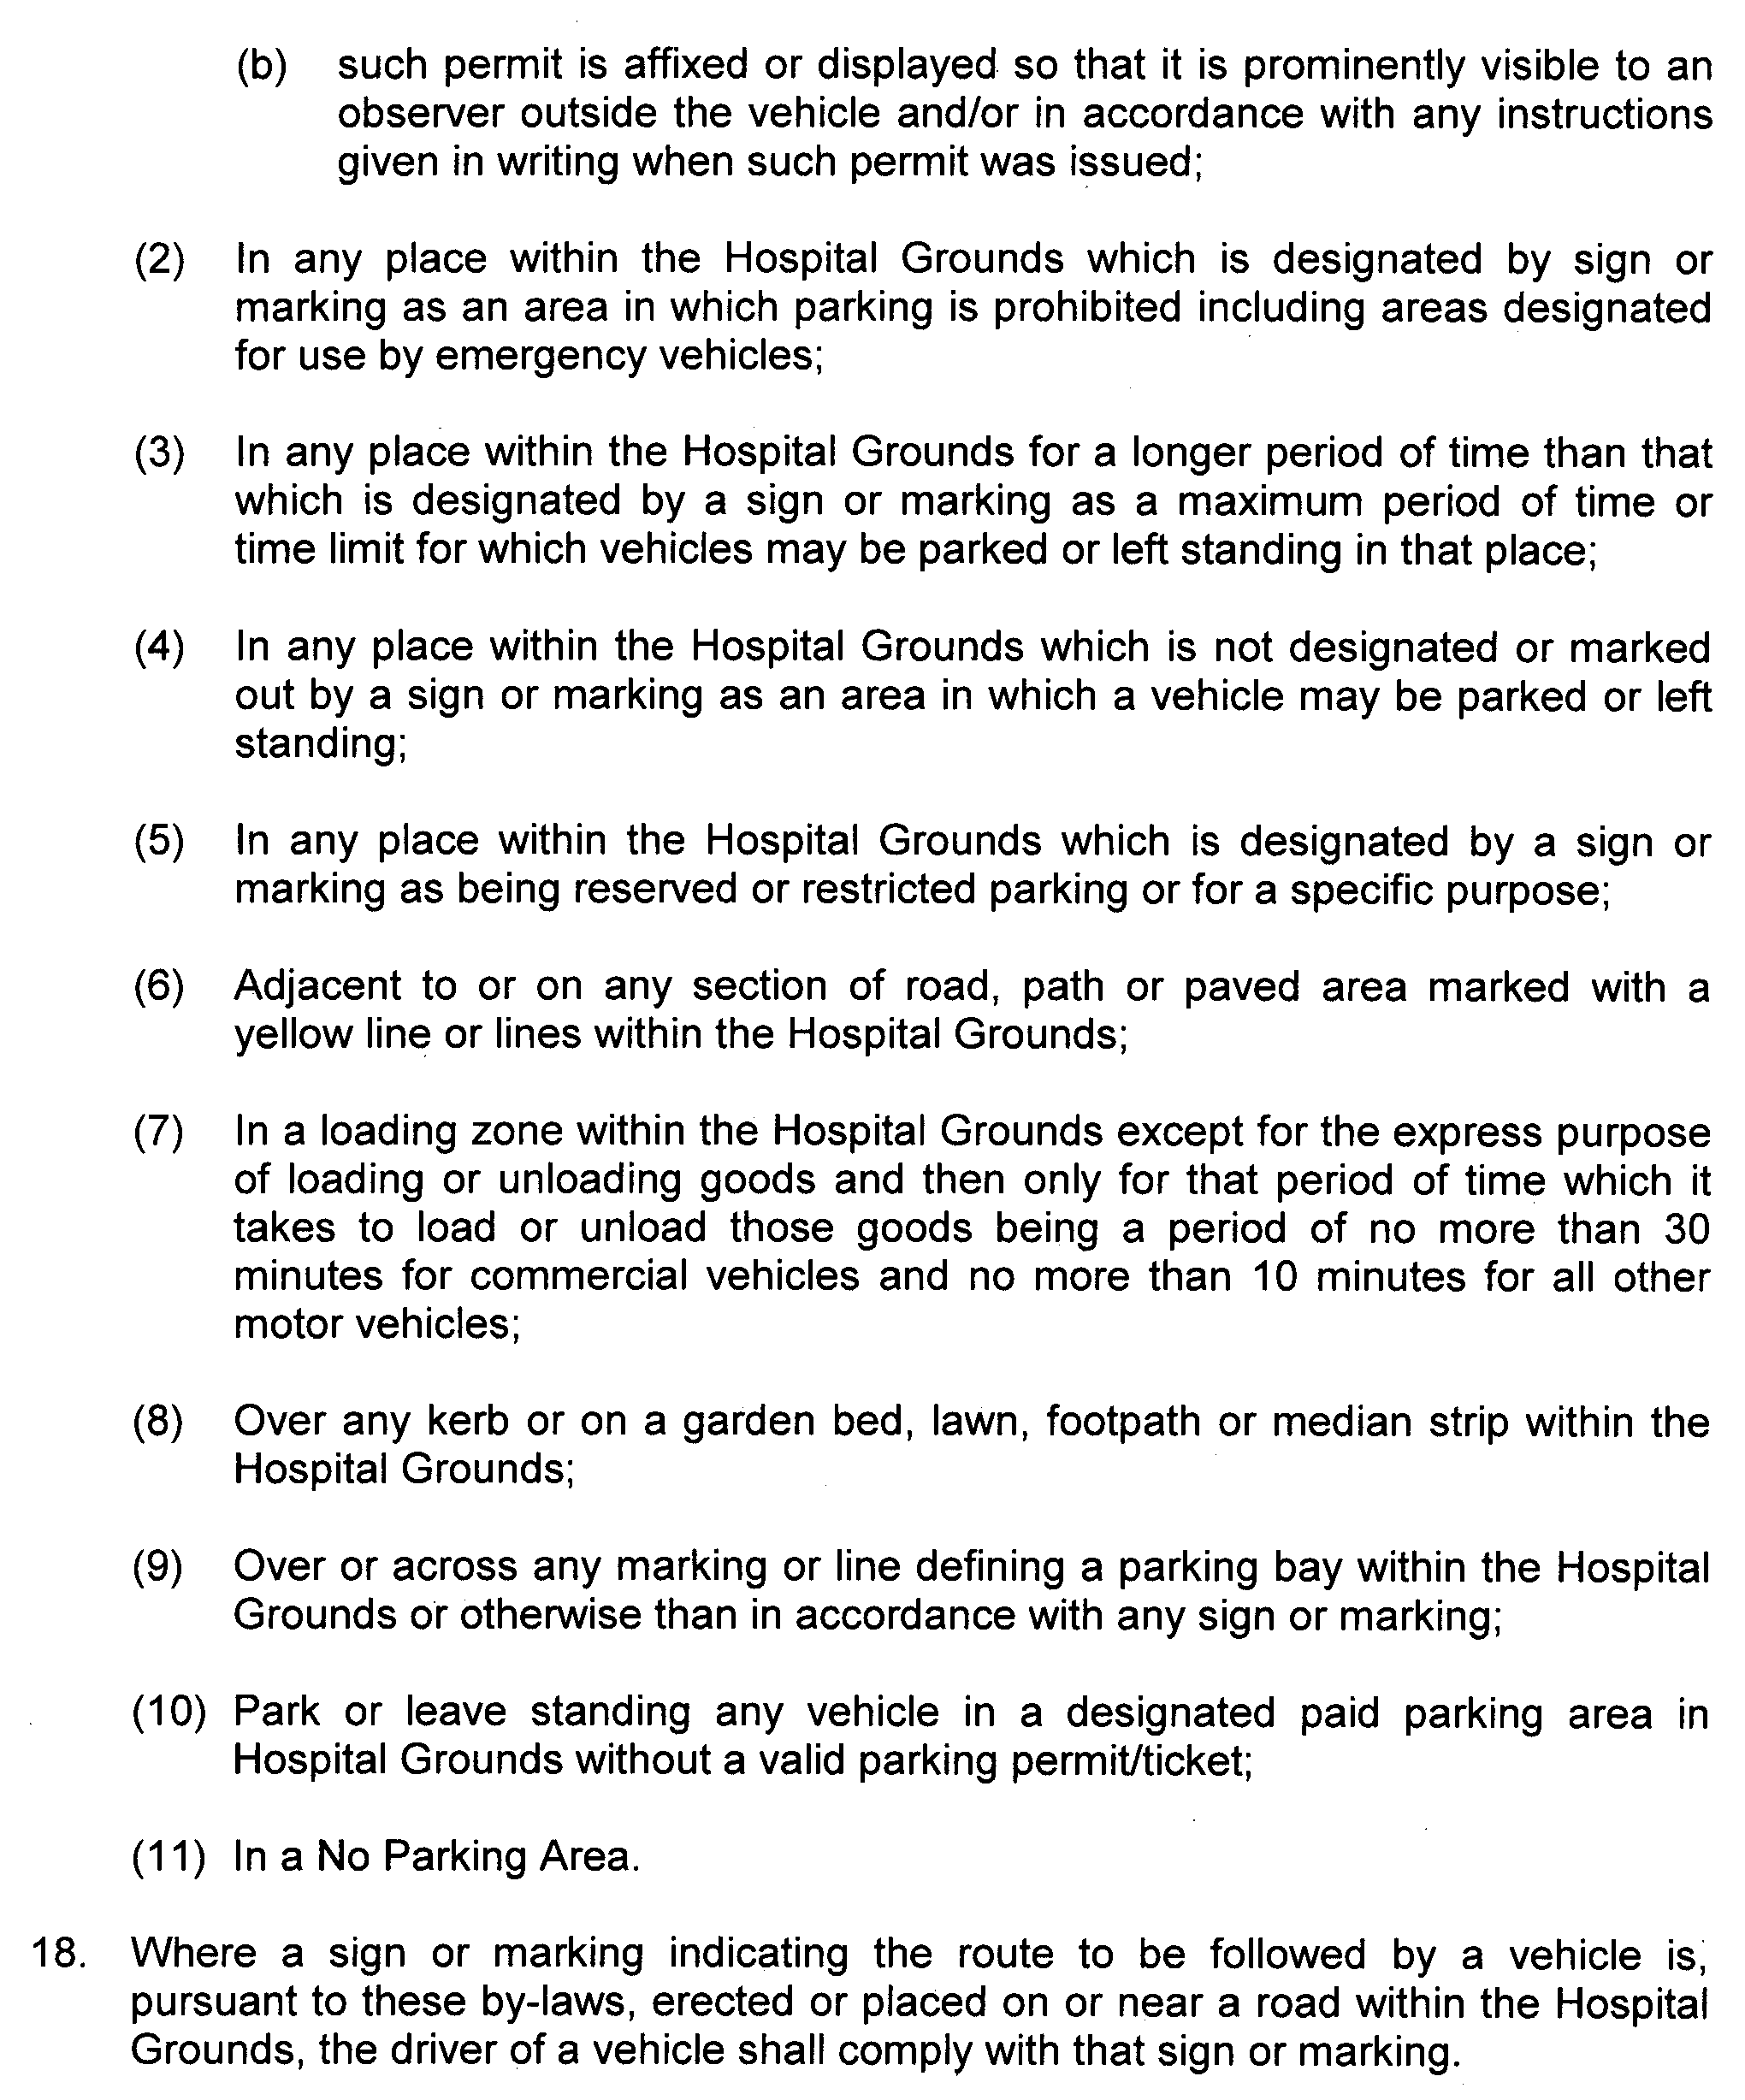
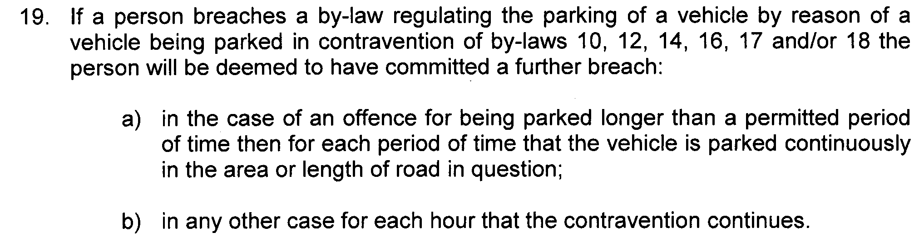
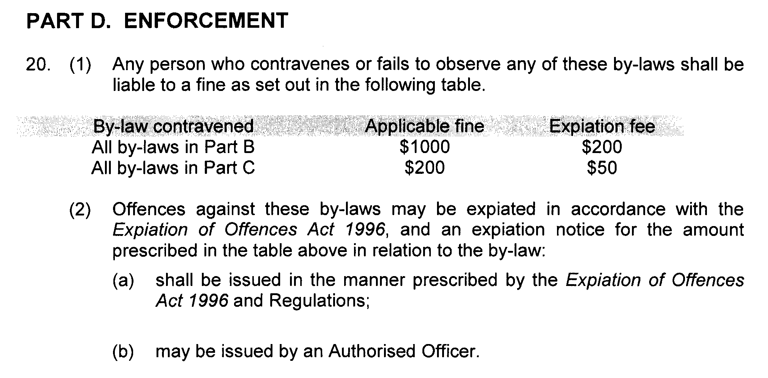
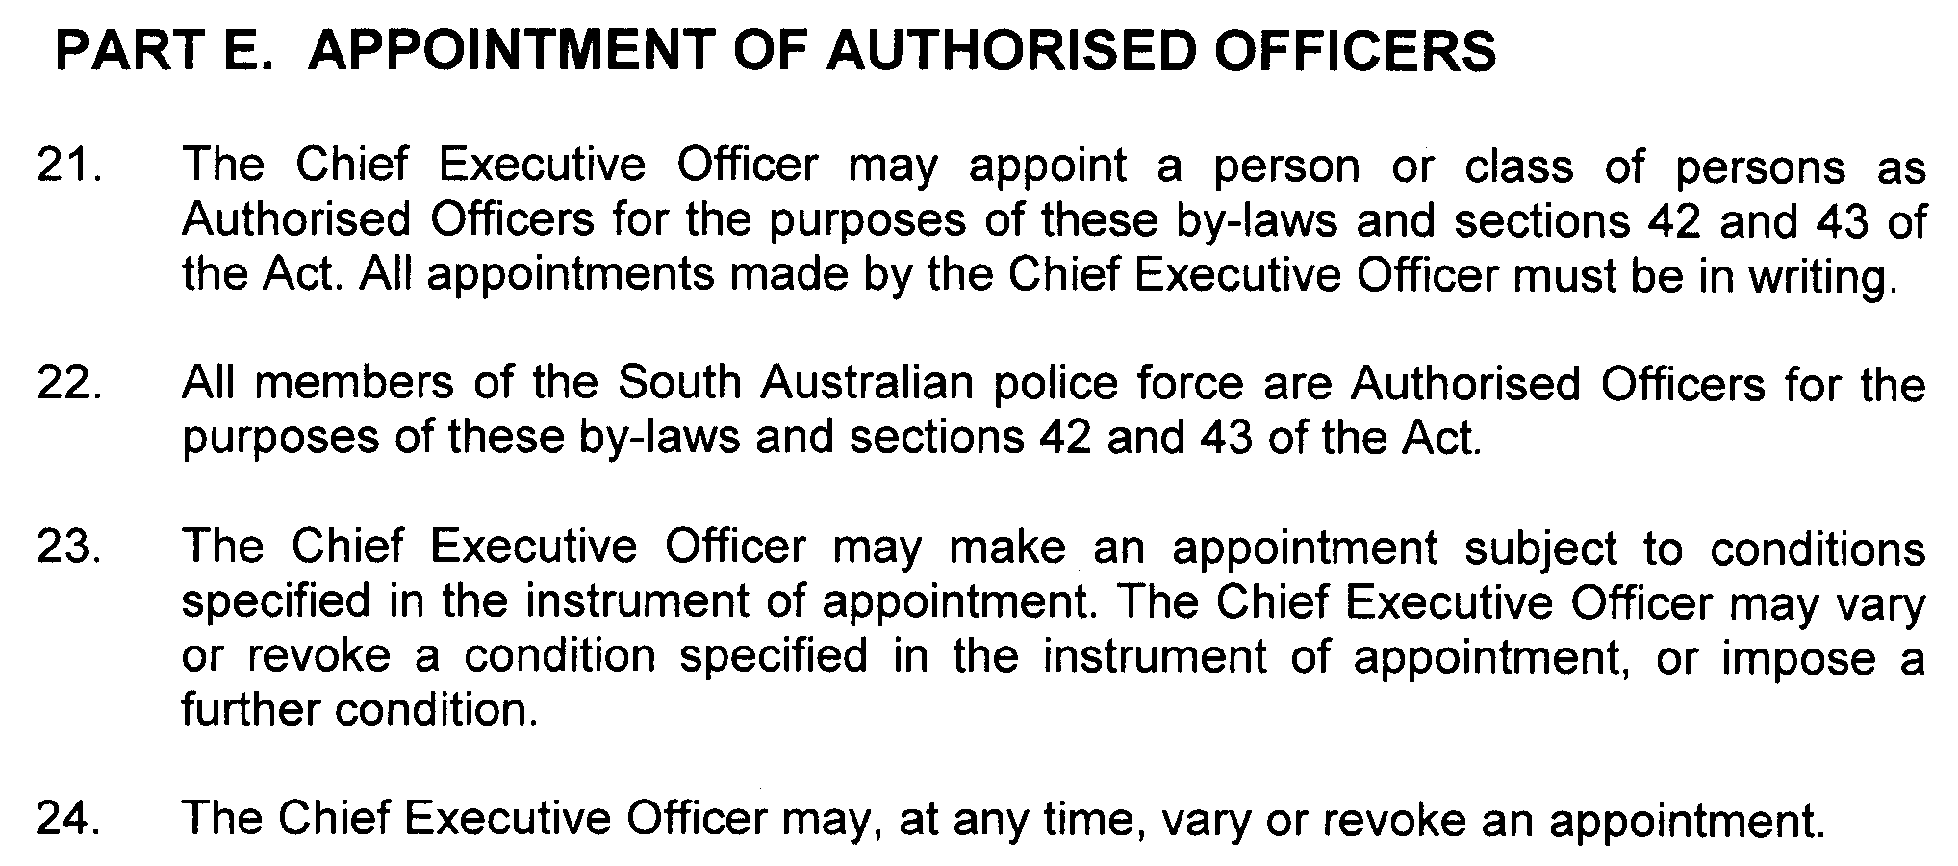

GOVERNMENT GAZETTE ADVERTISEMENT RATES

To apply from 1 July 2009

$  Agents, Ceasing to Act as 42.75  Associations:  Incorporation 21.70  Intention of Incorporation 53.50  Transfer of Properties 53.50  Attorney, Appointment of 42.75  Bailiff’s Sale 53.50  Cemetery Curator Appointed 31.75  Companies:  Alteration to Constitution 42.75  Capital, Increase or Decrease of 53.50  Ceasing to Carry on Business 31.75  Declaration of Dividend 31.75  Incorporation 42.75  Lost Share Certificates:  First Name 31.75  Each Subsequent Name 10.90  Meeting Final 35.75  Meeting Final Regarding Liquidator’s Report on  Conduct of Winding Up (equivalent to ‘Final  Meeting’)  First Name 42.75  Each Subsequent Name 10.90  Notices:  Call 53.50  Change of Name 21.70  Creditors 42.75  Creditors Compromise of Arrangement 42.75  Creditors (extraordinary resolution that ‘the Com-pany be wound up voluntarily and that a liquidator be appointed’) 53.50  Release of Liquidator⎯Application⎯Large Ad. 85.00  ⎯Release Granted 53.50  Receiver and Manager Appointed 49.50  Receiver and Manager Ceasing to Act 42.75  Restored Name 40.00  Petition to Supreme Court for Winding Up 74.50  Summons in Action 63.50  Order of Supreme Court for Winding Up Action 42.75  Register of Interests⎯Section 84 (1) Exempt 96.00  Removal of Office 21.70  Proof of Debts 42.75  Sales of Shares and Forfeiture 42.75  Estates:  Assigned 31.75  Deceased Persons⎯Notice to Creditors, etc. 53.50  Each Subsequent Name 10.90  Deceased Persons⎯Closed Estates 31.75  Each Subsequent Estate 1.40  Probate, Selling of 42.75  Public Trustee, each Estate 10.90 |  | $  Firms:  Ceasing to Carry on Business (each insertion) 28.50  Discontinuance Place of Business 28.50  Land⎯Real Property Act:  Intention to Sell, Notice of 53.50  Lost Certificate of Title Notices 53.50  Cancellation, Notice of (Strata Plan) 53.50  Mortgages:  Caveat Lodgement 21.70  Discharge of 22.70  Foreclosures 21.70  Transfer of 21.70  Sublet 10.90  Leases⎯Application for Transfer (2 insertions) each 10.90  Lost Treasury Receipts (3 insertions) each 31.75  Licensing 63.50  Municipal or District Councils:  Annual Financial Statement⎯Forms 1 and 2 598.00  Electricity Supply⎯Forms 19 and 20 425.00  Default in Payment of Rates:  First Name 85.00  Each Subsequent Name 10.90  Noxious Trade 31.75  Partnership, Dissolution of 31.75  Petitions (small) 21.70  Registered Building Societies (from Registrar-  General) 21.70  Register of Unclaimed Moneys⎯First Name 31.75  Each Subsequent Name 10.90  Registers of Members⎯Three pages and over:  Rate per page (in 8pt) 272.00  Rate per page (in 6pt) 359.00  Sale of Land by Public Auction 54.00  Advertisements 3.00  ¼ page advertisement 127.00  ½ page advertisement 254.00  Full page advertisement 498.00  Advertisements, other than those listed are charged at $3.00 per column line, tabular one-third extra.  Notices by Colleges, Universities, Corporations and District Councils to be charged at $3.00 per line.  Where the notice inserted varies significantly in length from that which is usually published a charge of $3.00 per column line will be applied in lieu of advertisement rates listed.  South Australian Government publications are sold on the condition that they will not be reproduced without prior permission from the Government Printer.
All the above prices include GST

GOVERNMENT GAZETTE NOTICES
ALL private advertisements forwarded for publication in the South Australian Government Gazette must be PAID FOR PRIOR TO INSERTION; and all notices, from whatever source, should be legibly written on one side of the paper only and sent to Government Publishing SA so as to be received no later than 4 p.m. Tuesday preceding the day of publication. Phone 8207 1045 or Fax 8207 1040. E-mail: governmentgazette@dpc.sa.gov.au. Send as attachments in Word format. Please include date the notice is to be published and to whom the notice will be charged. The Government Gazette is available online at: www.governmentgazette.sa.gov.au.

MISCELLANEOUS LEGISLATION AND GOVERNMENT PUBLICATIONS PRICES AS FROM 1 JULY 2009

Acts, Bills, Rules, Parliamentary Papers and Regulations
Pages | Main | Amends | Pages | Main | Amends

1-16 | 2.60 | 1.20 | 497-512 | 36.25 | 35.25
17-32 | 3.50 | 2.20 | 513-528 | 37.25 | 36.00
33-48 | 4.55 | 3.25 | 529-544 | 38.50 | 37.25
49-64 | 5.75 | 4.40 | 545-560 | 39.50 | 38.50
65-80 | 6.70 | 5.55 | 561-576 | 40.50 | 39.50
81-96 | 7.80 | 6.45 | 577-592 | 41.75 | 40.00
97-112 | 8.90 | 7.60 | 593-608 | 43.00 | 41.50
113-128 | 9.95 | 8.75 | 609-624 | 43.75 | 42.75
129-144 | 11.10 | 9.85 | 625-640 | 45.00 | 43.25
145-160 | 12.20 | 10.90 | 641-656 | 46.00 | 45.00
161-176 | 13.30 | 12.00 | 657-672 | 46.75 | 45.50
177-192 | 14.50 | 13.10 | 673-688 | 48.75 | 46.75
193-208 | 15.60 | 14.40 | 689-704 | 49.50 | 47.75
209-224 | 16.50 | 15.20 | 705-720 | 50.25 | 49.00
225-240 | 17.60 | 16.30 | 721-736 | 52.00 | 50.00
241-257 | 18.90 | 17.20 | 737-752 | 52.50 | 51.00
258-272 | 19.90 | 18.30 | 753-768 | 53.50 | 52.00
273-288 | 21.00 | 19.70 | 769-784 | 54.50 | 53.50
289-304 | 21.90 | 20.60 | 785-800 | 55.50 | 54.50
305-320 | 23.20 | 21.80 | 801-816 | 57.00 | 55.00
321-336 | 24.20 | 22.80 | 817-832 | 58.00 | 57.00
337-352 | 25.40 | 24.10 | 833-848 | 59.00 | 58.00
353-368 | 26.25 | 25.20 | 849-864 | 60.00 | 58.50
369-384 | 27.50 | 26.25 | 865-880 | 61.50 | 60.00
385-400 | 28.75 | 27.25 | 881-896 | 62.00 | 60.50
401-416 | 29.75 | 28.25 | 897-912 | 63.50 | 62.00
417-432 | 31.00 | 29.50 | 913-928 | 64.00 | 63.50
433-448 | 32.00 | 30.75 | 929-944 | 65.00 | 64.00
449-464 | 32.75 | 31.50 | 945-960 | 66.00 | 64.50
465-480 | 33.25 | 32.50 | 961-976 | 68.50 | 65.50
481-496 | 35.25 | 33.25 | 977-992 | 69.50 | 66.00

Legislation—Acts, Regulations, etc: $
Subscriptions:
Acts 223.00
All Bills as Laid 536.00
Rules and Regulations 536.00
Parliamentary Papers 536.00
Bound Acts 248.00
Index 124.00
Government Gazette
Copy 5.85
Subscription 296.00
Hansard
Copy 16.30
Subscription—per session (issued weekly) 465.00
Cloth bound—per volume 199.00
Subscription—per session (issued daily) 465.00
Legislation on Disk
Whole Database 3 443.00
Annual Subscription for fortnightly updates 1 058.00
Individual Act(s) including updates POA
Notice of Vacancies
Annual Subscription 164.00
Compendium
Subscriptions:
New Subscriptions 2 039.00
Updates 719.00
(All the above prices include GST)

All Legislation, Government Gazette, Hansard and Legislation on disk are available from:
Counter Sales Government Legislation⁺ Outlet
and Mail Orders: Service SA Customer Service Centre,
Ground Floor—EDS Centre, 108 North Terrace, Adelaide, S.A. 5000
Phone: 13 23 24 (local call cost), Fax: (08) 8204 1909
Postal: G.P.O. Box 1707, Adelaide, S.A. 5001

Online Shop: www.shop.service.sa.gov.au

Subscriptions and Government Publishing SA
Standing Orders: Box 9, Plaza Level, Riverside Centre, North Terrace, Adelaide, S.A. 5000
Phone: (08) 8207 1043, (08) 8207 0910, Fax: (08) 8207 1040

LIQUOR LICENSING ACT 1997
Notice of Application
NOTICE is hereby given, pursuant to section 52 (2) (b) of the Liquor Licensing Act 1997, that Hurley Hotels Pty Ltd has applied to the Licensing Authority for a variation to Extended Trading Authorisation in respect of premises situated at 926 South Road, Edwardstown, S.A. 5039 and known as Maid of Auckland Hotel.
Conditions
The following licence conditions are sought:
• Variation to Extended Trading Authorisation to include Area 7 as per plans lodged with this office.
• The current Extended Trading Authorisation hours are to apply to the proposed area.
The application has been set down for hearing on 13 July 2010 at 10 a.m.
Any person may object to the application by lodging a notice of objection in the prescribed form with the Liquor and Gambling Commissioner and serving a copy of the notice on the applicant at the applicant’s address, at least seven days before the hearing date (viz: 6 July 2010).
The applicant’s address for service is c/o Wally Woehlert (Australian Hotels Association) P.O. Box 3092, Rundle Mall, Adelaide, S.A. 5000.
The application and certain documents and material (including Plans) relevant to the application may be inspected without fee at a place and during a period specified by the Liquor and Gambling Commissioner, 9th Floor, East Wing, 50 Grenfell Street, Adelaide, S.A. 5000. Telephone 8226 8410, Facsimile: 8226 8512. Email: olgc@agd.sa.gov.au.
Dated 8 June 2010.
Applicant

LIQUOR LICENSING ACT 1997
Notice of Application
NOTICE is hereby given, pursuant to section 52 (2) (b) of the Liquor Licensing Act 1997, that SA Pizza and Pasta Holdings Pty Ltd as trustee for Amici Pizza Café Unit Trust has applied to the Licensing Authority for the transfer of a Restaurant Licence in respect of premises situated at Shop 9, 184 Frederick Road, Grange, S.A. 5022 and known as Amici Pizza Cafe.
The application has been set down for hearing on 13 July 2010 at 11.30 a.m.
Any person may object to the application by lodging a notice of objection in the prescribed form with the Liquor and Gambling Commissioner and serving a copy of the notice on the applicant at the applicant’s address, at least seven days before the hearing date (viz: 6 July 2010).
The applicant’s address for service is c/o Joseph Paladino, 9/178 Frederick Road, Grange, S.A. 5022.
The application and certain documents and material (including Plans) relevant to the application may be inspected without fee at a place and during a period specified by the Liquor and Gambling Commissioner, 9th Floor, East Wing, 50 Grenfell Street, Adelaide, S.A. 5000. Telephone 8226 8410, Facsimile: 8226 8512. Email: olgc@agd.sa.gov.au.
Dated 8 June 2010.
Applicant

LIQUOR LICENSING ACT 1997
Notice of Application
NOTICE is hereby given, pursuant to section 52 (2) (b) of the Liquor Licensing Act 1997, that Fonthill Cellars Pty Ltd has applied to the Licensing Authority for the transfer of a Retail Liquor Merchant’s Licence in respect of premises situated at 101 Churchill Road, Prospect, S.A. 5082 and known as Hamood’s Plonk!
The application has been set down for hearing on 14 July 2010 at 11 a.m.
Any person may object to the application by lodging a notice of objection in the prescribed form with the Liquor and Gambling Commissioner and serving a copy of the notice on the applicant at the applicant’s address, at least seven days before the hearing date (viz: 7 July 2010).
The applicant’s address for service is c/o Moody Rossi & Co., 7th Floor, 185 Victoria Square, Adelaide, S.A. 5000 (Attention: Bill Moody).
The application and certain documents and material (including Plans) relevant to the application may be inspected without fee at a place and during a period specified by the Liquor and Gambling Commissioner, 9th Floor, East Wing, 50 Grenfell Street, Adelaide, S.A. 5000. Telephone 8226 8410, Facsimile: 8226 8512. Email: olgc@agd.sa.gov.au.
Dated 8 June 2010.
Applicant

LIQUOR LICENSING ACT 1997
Notice of Application
NOTICE is hereby given, pursuant to section 52 (2) (b) of the Liquor Licensing Act 1997, that Taylor St Pty Ltd as trustee for Bellagio Unit Trust has applied to the Licensing Authority for a Restaurant Licence with section 34 (1) (c), Extended Trading Authorisation, Entertainment Consent and an Extended Trading Area in respect of premises situated at Unit 1, Taylor Street, Kadina, S.A. 5554 and to be known as Thia Chow.
The application has been set down for hearing on 14 July 2010 at 9 a.m.
Conditions
The following licence conditions are sought:
• Approval under section 34 (1) (c) to sell liquor on any day except Good Friday and Christmas Day for consumption the licensed premises by persons:
(a) seated at a table; or
(b) atending a function at where a food is provided.
• Extended Trading Authorisation is sought for the following days and times and in relation to the abovementioned condition:
Friday and Saturday: Midnight to 3 a.m. the following day;
Christmas Day: Midnight to 2 a.m;
Sunday Christmas Eve: 8 p.m. to 2 a.m. the following day;
New Year’s Eve: 2 a.m. to 3 a.m. the following day;
Days preceding other Public Holidays: Midnight to 3 a.m. the following day.
Sundays preceding Public Holidays: 8 p.m. to 3 a.m. the following day.
• Entertainment Consent is sought for the licensed premises as per plans lodged with this office.
• Extension of trading area is sought to include the outdoor dining area as per plans lodged with this office.
Any person may object to the application by lodging a notice of objection in the prescribed form with the Liquor and Gambling Commissioner and serving a copy of the notice on the applicant at the applicant’s address, at least seven days before the hearing date (viz: 7 July 2010).
The applicant’s address for service is c/o Starke & Associates Lawyers, 28 Hurtle Street, Adelaide, S.A. 5081 (Attention: David Starke).
The application and certain documents and material (including Plans) relevant to the application may be inspected without fee at a place and during a period specified by the Liquor and Gambling Commissioner, 9th Floor, East Wing, 50 Grenfell Street, Adelaide, S.A. 5000. Telephone 8226 8410, Facsimile: 8226 8512. Email: olgc@agd.sa.gov.au.
Dated 11 June 2010.
Applicant

LIQUOR LICENSING ACT 1997
Notice of Application
NOTICE is hereby given, pursuant to section 52 (2) (b) of the Liquor Licensing Act 1997, that NM & Ed Dodd Pty Ltd as trustee for Neil Dodd Family Trust has applied to the Licensing Authority for a Restaurant Licence in respect of premises situated at 1 Main Road, Lyndhurst, S.A. 5731 and to be known as Lyndhurst Roadhouse.
The application has been set down for hearing on 15 July 2010 at 9 a.m.
Any person may object to the application by lodging a notice of objection in the prescribed form with the Liquor and Gambling Commissioner and serving a copy of the notice on the applicant at the applicant’s address, at least seven days before the hearing date (viz: 8 July 2010).
The applicant’s address for service is c/o Nicholls Gervasi Lawyers, P.O. Box 3121, Norwood, S.A. 5067 (Attention: Leah Annese).
The application and certain documents and material (including Plans) relevant to the application may be inspected without fee at a place and during a period specified by the Liquor and Gambling Commissioner, 9th Floor, East Wing, 50 Grenfell Street, Adelaide, S.A. 5000. Telephone 8226 8410, Facsimile: 8226 8512. Email: olgc@agd.sa.gov.au.
Dated 8 June 2010.
Applicant

LIQUOR LICENSING ACT 1997
Notice of Application
NOTICE is hereby given, pursuant to section 52 (2) (b) of the Liquor Licensing Act 1997, that Gary Myers Nominees Pty Ltd as trustee for the Myers Trust has applied to the Licensing Authority for the transfer of a Restaurant Licence in respect of premises situated at Shop 1, Glenelg Shopping Centre, Colley Terrace, Glenelg, S.A. 5045 and known as Gringo’s Mexicana Cantina.
The application has been set down for hearing on 15 July 2010 at 10 a.m.
Any person may object to the application by lodging a notice of objection in the prescribed form with the Liquor and Gambling Commissioner and serving a copy of the notice on the applicant at the applicant’s address, at least seven days before the hearing date (viz: 8 July 2010).
The applicant’s address for service is c/o Gary Myers, P.O. Box 114, Seacliff Park, S.A. 5048.
The application and certain documents and material (including Plans) relevant to the application may be inspected without fee at a place and during a period specified by the Liquor and Gambling Commissioner, 9th Floor, East Wing, 50 Grenfell Street, Adelaide, S.A. 5000. Telephone 8226 8410, Facsimile: 8226 8512. Email: olgc@agd.sa.gov.au.
Dated 9 June 2010.
Applicant

LIQUOR LICENSING ACT 1997
Notice of Application
NOTICE is hereby given, pursuant to section 52 (2) (b) of the Liquor Licensing Act 1997, that Goodearth Hotels (Empire) Pty Ltd has applied to the Licensing Authority for Alterations, variation to Extended Trading Authorisation and variation to Entertainment Consent in respect of premises situated at 414 Prospect Road, Kilburn, S.A. 5084 and known Empire Hotel.
The application has been set down for hearing on 15 July 2010 at 9.30 a.m.
Conditions
The following licence conditions are sought:
• Minor alterations to remove wall between Area 1 and Area 2 as per plans lodged with this office.
• Variation to Extended Trading Authorisation for areas currently approved with Extended Trading Authorisation and to include Area 1 in accordance with the currently approved hours and to now include the following:
Sunday: 8 p.m. to 3 a.m. the following day.
• Variation to Entertainment Consent to include Area 1 as per plans lodged with this office.
Any person may object to the application by lodging a notice of objection in the prescribed form with the Liquor and Gambling Commissioner and serving a copy of the notice on the applicant at the applicant’s address, at least seven days before the hearing date (viz: 8 July 2010).
The applicant’s address for service is c/o William Kieboom, 337 Torrens Road, West Croydon, S.A. 5008.
The application and certain documents and material (including Plans) relevant to the application may be inspected without fee at a place and during a period specified by the Liquor and Gambling Commissioner, 9th Floor, East Wing, 50 Grenfell Street, Adelaide, S.A. 5000. Telephone 8226 8410, Facsimile: 8226 8512. Email: olgc@agd.sa.gov.au.
Dated 9 June 2010.
Applicant

LIQUOR LICENSING ACT 1997
Notice of Application
NOTICE is hereby given, pursuant to section 52 (2) (b) of the Liquor Licensing Act 1997, that Lan Thien Huong Ngo has applied to the Licensing Authority for a Restaurant Licence in respect of premises situated at 4/34 Wright Street, Ferryden Park, S.A. 5010 and to be known as Nghi Ngan Quan.
The application has been set down for hearing on 15 July 2010 at 11.30 a.m.
Any person may object to the application by lodging a notice of objection in the prescribed form with the Liquor and Gambling Commissioner and serving a copy of the notice on the applicant at the applicant’s address, at least seven days before the hearing date (viz: 8 July 2010).
The applicant’s address for service is c/o Duc Mai Lawyers, P.O. Box 149, Kilkenny, S.A. (Attention: Duc Mai).
The application and certain documents and material (including Plans) relevant to the application may be inspected without fee at a place and during a period specified by the Liquor and Gambling Commissioner, 9th Floor, East Wing, 50 Grenfell Street, Adelaide, S.A. 5000. Telephone 8226 8410, Facsimile: 8226 8512. Email: olgc@agd.sa.gov.au.
Dated 9 June 2010.
Applicant

LIQUOR LICENSING ACT 1997
Notice of Application
NOTICE is hereby given, pursuant to section 52 (2) (b) of the Liquor Licensing Act 1997, that Darren Andrew Guy and Anthea Simone Tidd have applied to the Licensing Authority for the transfer of a Hotel Licence in respect of premises situated at 1 Sturt Street, Cambrai, S.A. 5353 and known as Cambrai Hotel.
The application has been set down for hearing on 19 July 2010 at 9.30 a.m.
Any person may object to the application by lodging a notice of objection in the prescribed form with the Liquor and Gambling Commissioner and serving a copy of the notice on the applicants at the applicants’ address, at least seven days before the hearing date (viz: 12 July 2010).
The applicants’ address for service is c/o Brad Tarbotton (T:Legal), 253 St Vincent Street, Port Adelaide, S.A. 5015.
The application and certain documents and material (including Plans) relevant to the application may be inspected without fee at a place and during a period specified by the Liquor and Gambling Commissioner, 9th Floor, East Wing, 50 Grenfell Street, Adelaide, S.A. 5000. Telephone 8226 8410, Facsimile: 8226 8512. Email: olgc@agd.sa.gov.au.
Dated 15 June 2010.
Applicants

LIQUOR LICENSING ACT 1997
Notice of Application
NOTICE is hereby given, pursuant to section 52 (2) (b) of the Liquor Licensing Act 1997, that Triple 8 Imports Pty Ltd has applied to the Licensing Authority for the transfer of a Retail Liquor Merchant’s Licence in respect of premises situated at 8 Bogan Road, Hillbank, S.A. 5112 and known as Hillbank Liquor.
The application has been set down for hearing on 19 July 2010 at 11 a.m.
Any person may object to the application by lodging a notice of objection in the prescribed form with the Liquor and Gambling Commissioner and serving a copy of the notice on the applicant at the applicant’s address, at least seven days before the hearing date (viz: 12 July 2010).
The applicant’s address for service is c/o David Watts & Associates, 1 Cator Street, Glenside, S.A. 5065 (Attention: David Watts).
The application and certain documents and material (including Plans) relevant to the application may be inspected without fee at a place and during a period specified by the Liquor and Gambling Commissioner, 9th Floor, East Wing, 50 Grenfell Street, Adelaide, S.A. 5000. Telephone 8226 8410, Facsimile: 8226 8512. Email: olgc@agd.sa.gov.au.
Dated 10 June 2010.
Applicant

LIQUOR LICENSING ACT 1997
Notice of Application
NOTICE is hereby given, pursuant to section 52 (2) (b) of the Liquor Licensing Act 1997, that Donato Di Ieso, 47 Florence Street, Fullarton, S.A. 5063 has applied to the Licensing Authority for a Direct Sales Licence in respect of the business to be known as Australian Wine Classics.
The application has been set down for hearing on 20 July 2010 at 9.30 a.m.
Any person may object to the application by lodging a notice of objection in the prescribed form with the Liquor and Gambling Commissioner and serving a copy of the notice on the applicant at the applicant’s address, at least seven days before the hearing date (viz: 13 July 2010).
The applicant’s address for service is c/o David Watts & Associates, 1 Cator Street, Glenside, S.A. 5065 (Attention: David Watts).
The application and certain documents and material (including Plans) relevant to the application may be inspected without fee at a place and during a period specified by the Liquor and Gambling Commissioner, 9th Floor, East Wing, 50 Grenfell Street, Adelaide, S.A. 5000. Telephone 8226 8410, Facsimile: 8226 8512. Email: olgc@agd.sa.gov.au.
Dated 10 July 2010.
Applicant

LIQUOR LICENSING ACT 1997
Notice of Application
NOTICE is hereby given, pursuant to section 52 (2) (b) of the Liquor Licensing Act 1997, that Ha and Han Pty Ltd as trustee for Ha and Han Trust has applied to the Licensing Authority for the transfer of a Restaurant Licence in respect of premises situated at Shop 25/26, Gawler Northern Market, Murray Street, Gawler, S.A. 5118 and known as Billy Baxter’s Gawler.
The application has been set down for hearing on 20 July 2010 at 10 a.m.
Any person may object to the application by lodging a notice of objection in the prescribed form with the Liquor and Gambling Commissioner and serving a copy of the notice on the applicant at the applicant’s address, at least seven days before the hearing date (viz: 13 July 2010).
The applicant’s address for service is c/o Won Yong Ha, 6 Baird Street, Mawson Lakes, S.A. 5095.
The application and certain documents and material (including Plans) relevant to the application may be inspected without fee at a place and during a period specified by the Liquor and Gambling Commissioner, 9th Floor, East Wing, 50 Grenfell Street, Adelaide, S.A. 5000. Telephone 8226 8410, Facsimile: 8226 8512. Email: olgc@agd.sa.gov.au.
Dated 10 June 2010.
Applicant

LIQUOR LICENSING ACT 1997
Notice of Application
NOTICE is hereby given, pursuant to section 52 (2) (b) of the Liquor Licensing Act 1997, that National Aboriginal Cultural Institute Inc. has applied to the Licensing Authority for Redefinition, variation to Extended Trading Authorisation and variation to Entertainment Consent in respect of premises situated at 253 Grenfell Street, Adelaide, S.A. 5000 and known as Tandanya.
The application has been set down for hearing on 20 July 2010 at 9 a.m.
Conditions
The following licence conditions are sought:
• Redefinition to include the conference room and the café as per plans lodged with this office.
• Variation to Extended Trading Authorisation to include the abovementioned proposed redefined areas in accordance with the currently approved Extended Trading Authori-
sation as per plans lodged with this office.
• Variation to Entertainment Consent to include the abovementioned proposed redefined areas as per plans lodged with this office.
Any person may object to the application by lodging a notice of objection in the prescribed form with the Liquor and Gambling Commissioner and serving a copy of the notice on the applicant at the applicant’s address, at least seven days before the hearing date (viz: 13 July 2010).
The applicant’s address for service is c/o Kate Greenshields, 253 Grenfell Street, Adelaide, S.A. 5000.
The application and certain documents and material (including Plans) relevant to the application may be inspected without fee at a place and during a period specified by the Liquor and Gambling Commissioner, 9th Floor, East Wing, 50 Grenfell Street, Adelaide, S.A. 5000. Telephone 8226 8410, Facsimile: 8226 8512. Email: olgc@agd.sa.gov.au.
Dated 10 June 2010.
Applicant

LIQUOR LICENSING ACT 1997
Notice of Application
NOTICE is hereby given, pursuant to section 52 (2) (b) of the Liquor Licensing Act 1997, that Kylie Ellen Turner has applied to the Licensing Authority for the transfer of a Restaurant Licence with Entertainment Consent in respect of premises situated at Shops 5 and 7, 40 Murray Street, Gawler, S.A. 5118 and known as Conversations Cafe.
The application has been set down for hearing on 20 July 2010 at 10.30 a.m.
Conditions
The following licence conditions are sought:
• Entertainment Consent is sought for Area 1 as per plans lodged with the office and for the following days and times:
Monday to Friday: 7.30 a.m. to Midnight;
Saturday and Sunday: 8 a.m. to Midnight;
Maundy Thursday: 7.30 a.m. to Midnight;
Christmas Eve: 7.30 a.m. to Midnight;
Sunday Christmas Eve: 7.30 a.m. to Midnight;
New Year’s Eve: 7.30 a.m. to 2 a.m. the following day;
Days preceding other Public Holidays: 7.30 a.m. to Midnight;
Sundays preceding Public Holidays: 7.30 a.m. to Midnight.
Any person may object to the application by lodging a notice of objection in the prescribed form with the Liquor and Gambling Commissioner and serving a copy of the notice on the applicant at the applicant’s address, at least seven days before the hearing date (viz: 13 July 2010).
The applicant’s address for service is c/o Kylie Ellen Turner, Shops 5 and 7, 40 Murrary Street, Gawler, S.A. 5118.
The application and certain documents and material (including Plans) relevant to the application may be inspected without fee at a place and during a period specified by the Liquor and Gambling Commissioner, 9th Floor, East Wing, 50 Grenfell Street, Adelaide, S.A. 5000. Telephone 8226 8410, Facsimile: 8226 8512. Email: olgc@agd.sa.gov.au.
Dated 11 June 2010.
Applicant

MINING ACT 1971
NOTICE is hereby given in accordance with section 35A (1) of the Mining Act 1971, that an application for a mining lease over the undermentioned mineral claim has been received. Details of the proposal may be inspected at the Department of Primary Industries and Resources, Mineral Resources Group, Level 7, 101 Grenfell Street, Adelaide, S.A. 5000:
Applicant: Frederick Charles Baker
Claim No.: 4238
Location: Allotment 3 in Deposited Plan 50533, Hundred of Mobilong, approximately 4 km south of Murray Bridge.
Area: 1.88 hectares
Purpose: For the recovery of extractive minerals (limestone)
Reference: T02822
A copy of the proposal has been provided to the Rural City of Murray Bridge.
Written submissions in relation to the granting of the mining lease are invited to be received at the Department of Primary Industries and Resources, Mineral Resources Group, Level 7, 101 Grenfell Street, Adelaide, S.A. 5000 or G.P.O. Box 1671, Adelaide, S.A. 5001 no later than 1 July 2010.
Copies of all submissions will be forwarded to the applicant and may be made available for public inspection unless confidentiality is requested.
J. Martin, Mining Registrar

MINING ACT 1971
NATIVE TITLE (SOUTH AUSTRALIA) ACT 1994
NOTICE is hereby given in accordance with section 53 (2) of the Mining Act 1971 and Part 5 of the Native Title (South Australia) Act 1994 and the Regulations thereunder that seven (7) applications for miscellaneous purposes licences have been received. Details of the proposals may be inspected at the Department of Primary Industries and Resources, Mineral Resources Group, Level 7, 101 Grenfell Street, Adelaide, S.A. 5000:
Applicant: Southern Iron Pty Ltd
Location: Block 473, Out of Hundred (Billa Kalina), McDouall Peak Station and Block 1139, Out of Hundred (Coober Pedy), Ingomar Station, approximately 75 km south-east of Coober Pedy.
Area: 214.65 hectares
Purpose: Haul/access road
Location: Block 1139, Out of Hundred (Billa Kalina), Ingomar Station and Block 1269, Out of Hundred (Billa Kalina), Mount Penrhyn Station, approximately 55 km south-east of Coober Pedy.
Area: 211.25 hectares
Purpose: Haul/access road
Location: Block 1269, Out of Hundred (Coober Pedy), approximately 55 km south of Coober Pedy, Mount Penrhyn Station.
Area: 157.87 hectares
Purpose: Haul/access road and accommodation village
Location: Block 1269, Out of Hundred (Coober Pedy), Mount Penrhyn Station and Block 1139, Out of Hundred (Coober Pedy), Ingomar Station, approximately 55 km south of Coober Pedy.
Area: 195.74 hectares
Purpose: Haul/access road
Location: Block 1269, Out of Hundred (Coober Pedy), approximately 55 km south of Coober Pedy, Mount Penrhyn Station.
Area: 190.44 hectares
Purpose: Haul/access road
Location: Block 1269, Out of Hundred (Coober Pedy), approximately 55 km south of Coober Pedy, Mount Penrhyn Station.
Area: 249.02 hectares
Purpose: Rail loop/siding and crusher plant
Location: Block 473, Out of Hundred (Billa Kalina), approximately 80 km south-east of Coober Pedy, McDouall Peak Station.
Area: 47.40 hectares
Purpose: Haul/access road
Reference: T02813
The Minister for Mineral Resources Development is required to have regard to any representations received from owners of the land (including native title holders) to which the applications relate and/or any interested members of the public in determining the applications or in fixing the conditions to be attached to the licences if granted.
Written submissions in relation to the granting of the miscellaneous purposes licences are invited to be received at the Department of Primary Industries and Resources, Mineral Resources Group, Level 7, 101 Grenfell Street, Adelaide, S.A. 5000 or G.P.O. Box 1671, Adelaide, S.A. 5001 no later than 29 July 2010.
Copies of all submissions will be forwarded to the applicant and may be made available for public inspection unless confidentiality is requested.
J. Martin, Mining Registrar

MINING ACT 1971
NATIVE TITLE (SOUTH AUSTRALIA) ACT 1994
NOTICE is hereby given in accordance with section 35A (1) of the Mining Act 1971 and Part 5 of the Native Title (South Australia) Act 1994 and the Regulations thereunder that twenty (20) applications for mining leases have been received. Details of the proposals may be inspected at the Department of Primary Industries and Resources, Mineral Resources Group, Level 7, 101 Grenfell Street, Adelaide, S.A. 5000:
Applicant: Southern Iron Pty Ltd
Claim No.: 4241
Location: Block 473, Out of Hundred (Billa Kalina), approximately 90 km south-east of Coober Pedy, McDouall Peak Station.
Area: 4.49 hectares
Purpose: For the recovery of extractive minerals (calcrete and gravel-road base).
Claim No.: 4242
Location: Block 473, Out of Hundred (Billa Kalina), approximately 85 km south-east of Coober Pedy, McDouall Peak Station.
Area: 4.51 hectares
Purpose: For the recovery of extractive minerals (calcrete and gravel-road base).
Claim No.: 4243
Location: Block 473, Out of Hundred (Billa Kalina), approximately 80 km south-east of Coober Pedy, McDouall Peak Station.
Area: 4.53 hectares
Purpose: For the recovery of extractive minerals (calcrete and gravel-road base).
Claim No.: 4244
Location: Block 1139, Out of Hundred (Billa Kalina), approximately 70 km south-east of Coober Pedy, Ingomar Station.
Area: 4.49 hectares
Purpose: For the recovery of extractive minerals (calcrete and gravel-road base).
Claim No.: 4245
Location: Block 1139, Out of Hundred (Coober Pedy), approximately 65 km south-east of Coober Pedy, Ingomar Station.
Area: 4.52 hectares
Purpose: For the recovery of extractive minerals (calcrete and gravel-road base).
Claim No.: 4246
Location: Block 1269, Out of Hundred (Coober Pedy), approximately 60 km south-east of Coober Pedy, Mount Penrhyn Station.
Area: 4.51 hectares
Purpose: For the recovery of extractive minerals (calcrete and gravel-road base).
Claim No.: 4247
Location: Block 1269, Out of Hundred (Billa Kalina), approximately 60 km south-south-east of Coober Pedy, Mount Penrhyn Station.
Area: 4.5 hectares
Purpose: For the recovery of extractive minerals (calcrete and gravel-road base).
Claim No.: 4248
Location: Block 1269, Out of Hundred (Coober Pedy), approximately 60 km south-south-east of Coober Pedy, Mount Penrhyn Station.
Area: 4.49 hectares
Purpose: For the recovery of extractive minerals (calcrete and gravel-road base).
Claim No.: 4249
Location: Block 1269, Out of Hundred (Coober Pedy), approximately 60 km south of Coober Pedy, Mount Penrhyn Station.
Area: 8.74 hectares
Purpose: For the recovery of extractive minerals (calcrete and gravel-road base).
Claim No.: 4250
Location: Block 1269, Out of Hundred (Coober Pedy), approximately 60 km south of Coober Pedy, Mount Penrhyn Station.
Area: 4.48 hectares
Purpose: For the recovery of extractive minerals (calcrete and gravel-road base).
Claim No.: 4251
Location: Block 1139, Out of Hundred (Coober Pedy), approximately 60 km south of Coober Pedy, Ingomar Station.
Area: 8.75 hectares
Purpose: For the recovery of extractive minerals (calcrete and gravel-road base).
Claim No.: 4252
Location: Block 1139, Out of Hundred (Coober Pedy), approximately 60 km south of Coober Pedy, Ingomar Station.
Area: 4.49 hectares
Purpose: For the recovery of extractive minerals (calcrete and gravel-road base).
Claim No.: 4253
Location: Block 1269, Out of Hundred (Coober Pedy), approximately 60 km south of Coober Pedy, Mount Penrhyn Station.
Area: 4.5 hectares
Purpose: For the recovery of extractive minerals (calcrete and gravel-road base).
Claim No.: 4254
Location: Block 1269, Out of Hundred (Coober Pedy), approximately 60 km south of Coober Pedy, Mount Penrhyn Station.
Area: 4.51 hectares
Purpose: For the recovery of extractive minerals (calcrete and gravel-road base).
Claim No.: 4255
Location: Block 1269, Out of Hundred (Coober Pedy), approximately 60 km south of Coober Pedy, Mount Penrhyn Station.
Area: 4.5 hectares
Purpose: For the recovery of extractive minerals (calcrete and gravel-road base).
Claim No.: 4256
Location: Block 1269, Out of Hundred (Coober Pedy), approximately 60 km south-west of Coober Pedy, Mount Penrhyn Station.
Area: 4.52 hectares
Purpose: For the recovery of extractive minerals (calcrete and gravel-road base).
Claim No.: 4257
Location: Block 1269, Out of Hundred (Coober Pedy), approximately 60 km south-west of Coober Pedy, Mount Penrhyn Station.
Area: 8.77 hectares
Purpose: For the recovery of extractive minerals (calcrete and gravel-road base).
Claim No.: 4258
Location: Block 1269, Out of Hundred (Coober Pedy), approximately 60 km south-west of Coober Pedy, Mount Penrhyn Station.
Area: 8.76 hectares
Purpose: For the recovery of extractive minerals (calcrete and gravel-road base).
Claim No.: 4259
Location: Block 1269, Out of Hundred (Coober Pedy), approximately 60 km south-west of Coober Pedy, Mount Penrhyn Station.
Area: 8.76 hectares
Purpose: For the recovery of extractive minerals (calcrete and gravel-road base).
Claim No.: 4260
Location: Block 473, Out of Hundred (Billa Kalina), approximately 81 km south-east of Coober Pedy, McDouall Peak Station.
Area: 249.48 hectares
Purpose: For the recovery of extractive minerals (calcrete and gravel-road base).
Ref.: T02812
The Minister for Mineral Resources Development is required to have regard to any representations received from owners of the land (including native title holders) to which the applications relate and/or any interested members of the public in determining the applications or in fixing the conditions to be attached to the leases if granted.
Written submissions in relation to the granting of the mining leases are invited to be received at the Department of Primary Industries and Resources, Mineral Resources Group, Level 7, 101 Grenfell Street, Adelaide, S.A. 5000 or G.P.O. Box 1671, Adelaide, S.A. 5001 no later than 29 July 2010
Copies of all submissions will be forwarded to the applicant and may be made available for public inspection unless confidentiality is requested.
J. Martin, Mining Registrar

NATIONAL ELECTRICITY LAW
THE Australian Energy Market Commission (AEMC) gives notice under the National Electricity Law of the following matters.
Under section 99, the making of a draft determination and draft National Electricity Amendment (Victoria Generator Technical Performance Standards Derogations) Rule 2010 (Project Ref. ERC0102). In relation to the draft determination:
• requests for a pre-determination hearing must be received by 24 June 2010;
• submissions must be received by 30 July 2010; and
• requests for a hearing should be forwarded to submissions@aemc.gov.au and must cite the Project Ref. in its title.
Under section 95, the AER has requested the Timing for spot price reporting Rule proposal (Project Ref. ERC0111). The proposal seeks to extend the timeframe for publishing reports on trading intervals in which the spot price exceeds $5000/MWh from within 20 business days of the end of the week in which the spot price exceeded $5000/MWh to within 40 business days of the end of the week in which the spot price exceeded $5000/MWh. The AEMC intends to expedite the proposal under section 96 on the grounds that it considers the proposed Rule is non-controversial, subject to the receipt of written objections.
In relation to the proposal:
• written objections must be received by 1 July 2010; and
• submissions must be received by 15 July 2010.
Submissions can be lodged online via the AEMC’s website at www.aemc.gov.au Before lodging your submission, you must review the AEMC’s privacy collection statement on its website.
Submissions should be made in accordance with the AEMC’s Guidelines for making written submissions on Rule change proposals. The AEMC publishes all submissions on its website subject to a claim of confidentiality.
Objections can be forwarded to submissions@aemc.gov.au and must cite the relevant Project Ref. in the title. Before lodging your objection, you must review the AEMC’s privacy collection statement on its website at www.aemc.gov.au.
All documents in relation to the above matters are published on the AEMC’s website and are available for inspection at the offices of the AEMC.
John Pierce
Chairman
Australian Energy Market Commission
Level 5, 201 Elizabeth Street
Sydney, N.S.W. 2000
Telephone: (02) 8296 7800
Facsimile: (02) 8296 7899
17 June 2010.

NOTICE TO MARINERS
No. 28 of 2010
South Australia Spencer Gulf—Wallaroo Bay
THE vessel Bahia which was anchored in Wallaroo Bay last week has lost the flukes of her anchor in approximate location latitude 33°54.20′S, longitude 137°30.02′E.
Mariners and fishing trawlers in particular, are advised to exercise extreme caution when navigating in the area.
Charts affected: Aus 778.
Adelaide, 7 June 2010.
Patrick Conlon, Minister for Transport
DTEI 2010/01461

PETROLEUM AND GEOTHERMAL ENERGY ACT 2000
Suspension of Petroleum Exploration Licence—PEL 124
PURSUANT to section 90 of the Petroleum and Geothermal Energy Act 2000, notice is hereby given that the abovementioned Petroleum Exploration Licence has been suspended under the provisions of the Petroleum and Geothermal Energy Act 2000, from and including 10 June 2010 until 9 June 2011, pursuant to delegated powers dated 1 October 2009.
The expiry date of PEL 124 is now determined to be 1 October 2013.
Dated 11 June 2010.
B. A. Goldstein,
Director Petroleum and Geothermal
Minerals and Energy Resources
Primary Industries and Resources SA
Delegate of the Minister for Mineral
Resources Development

PETROLEUM AND GEOTHERMAL ENERGY ACT 2000
Surrender of Geothermal Exploration Licence—GEL 353
NOTICE is hereby given that I have accepted surrender of the abovementioned Geothermal Exploration Licence under the provisions of the Petroleum and Geothermal Energy Act 2000, pursuant to delegated powers dated 1 October 2009.

No. of  Licence | Licensee | Locality | Date of Surrender | Reference
353 | New World Energy  Solutions Pty Ltd | Renmark Trough | 9 June 2010 | 27/2/515

Description of Area
All that part of the State of South Australia, bounded as follows:
Commencing at a point being the intersection of latitude 33°36′00″S GDA94 and latitude 140°48′00″S GDA94, thence west to longitude 140°43′00″E GDA94, south to latitude 33°37′00″S GDA94, west to longitude 140°42′00″E GDA94, south to latitude 33°38′00″S GDA94, west to longitude 140°41′00″E GDA94, south to latitude 33°40′00″S GDA94, west to longitude 140°40′00″E GDA94, south to latitude 33°44′00″S GDA94, west to longitude 140°39′00″E GDA94, south to latitude 33°45′00″S GDA94, west to longitude 140°38′00″E GDA94, south to latitude 33°46′00″S GDA94, west to longitude 140°37′00″E GDA94, south to latitude 33°47′00″S GDA94, west to longitude 140°36′00″E GDA94, south to latitude 33°48′00″S GDA94, west to longitude 140°32′03″E GDA94, north to the southern boundary of Danggali Conservation Park, thence generally easterly and southerly along the boundary of the said conservation park to a northern boundary of Chowilla Regional Reserve and south-westerly to the point of commencement.
Area: 497 km² approximately.
Dated 9 June 2010.
B. A. Goldstein,
Director Petroleum and Geothermal
Minerals and Energy Resources
Primary Industries and Resources SA
Delegate of the Minister for Mineral Resources Development

PETROLEUM AND GEOTHERMAL ENERGY ACT 2000
Surrender of Associated Activities Licence—AAL 148
NOTICE is hereby given that I have accepted surrender of the abovementioned Associated Activities Licence under the provisions of the Petroleum and Geothermal Energy Act 2000, pursuant to delegated powers dated 1 October 2009:

No. of  Licence | Licensee | Date of Surrender | Area in  km² | Reference
AAL 148 | Torrens Energy Limited | 9 June 2010 | 2.45 | 27/02/554

Description of Area—PEL 219
All that part of the State of South Australia, bounded as follows:
Commencing at a point being the intersection of latitude 31°07′30″S GDA94 and longitude 138°27′20″E GDA94, thence east to longitude 138°29′00″E GDA94, south to latitude 31°08′00″S GDA94, west to longitude 138°27′20″E GDA94 and north to the point of commencement.
Area: 2.45 km² approximately.
Dated 11 June 2010.
B. A. Goldstein,
Director Petroleum and Geothermal
Minerals and Energy Resources
Primary Industries and Resources SA
Delegate of the Minister for Mineral Resources Development

ROAD TRAFFIC ACT 1961
Pursuant to Section 161A and 163AA of the Road Traffic Act 1961
LIGHTING, BRAKING AND MUDGUARD EXEMPTION FOR CITRUS TRAILERS
1. EXEMPTION
In accordance with the powers delegated to me by the Minister for Transport, under section 163AA of the Road Traffic Act 1961, I hereby exempt trailers transporting citrus fruit from the following provisions of the Road Traffic (Vehicle Standards) Rules 1999:
• Rule 33—Mudguards;
• Rules 132 (1) and 133 (1)—Trailer Braking Systems;
• Part 8—Lights and Reflectors;
• Rule 19—Compliance with second edition Australian Design Rules but only in so far as it relates to ADR 38—Heavy Trailer Braking System; and
• Rule 20—Compliance with third edition Australian Design Rules but only in so far as it relates to ADR 38—Trailer Brake Systems.
2. CONDITIONS AND LIMITATIONS APPLYING TO THIS NOTICE
This exemption is subject to the conditions and limitations specified in this notice.
When operating under this Notice you must comply with the following conditions:
1. Direction indicator and brake lights must be fitted to the rear of the trailer(s) if the direction indicator and brake lights of the towing vehicle are not clearly visible at all times to other drivers approaching from the rear.
Note: Direction indicator and brake lights fitted to trailers must comply with the requirements of the Part 8—Lights and Reflectors of the Road Traffic (Vehicle Standards) Rules 1999.
2. At least one rear-facing red reflector not over 1.5 m above ground level must be fitted at the rear of the trailer(s).
3. The mass of each trailer including any load must not exceed 1.9 tonnes.
4. The trailer(s) must not be towed between the hours of sunset and sunrise as specified in the Proof of Sunrise and Sunset Act 1923, as amended, and published in the South Australian Government Gazette or during periods of low visibility.
4.1 For the purposes of this notice ‘a period of low visibility’ means any time, when, owing to insufficient daylight or unfavourable conditions, persons or vehicles on a road are not clearly visible at a distance of 250 m to a person of normal vision.
5. The trailer(s) must not be towed at a speed greater than 25 km/h.
6. This exemption only applies while the trailers are transporting citrus fruit from a place of production to a place of processing and return.
Note: Citrus trailer bins when being transported (laden or unladen) must be secured to the trailer in accordance with the requirements of the Load Restraint Guide.
7. The towing vehicle and trailer(s) must comply with all other requirements of the Road Traffic Act 1961 and Regulations.
Note: Motor vehicles with a Gross Vehicle Mass over 4.5 tonnes and tractors are permitted to tow 2 trailers under Regulation 20A of the Road Traffic (Miscellaneous) Regulations 1999.
3. COMMENCEMENT OF THIS NOTICE
This notice is valid from 12.01 a.m. on 1 July 2010 until midnight 30 June 2011.
4. AUTHORISATION

Peter Hale
Acting Director, Transport Safety Regulation
For and on behalf of
Executive Director,
Safety and Regulation Division
Department for Transport, Energy and Infrastructure

ROAD TRAFFIC ACT 1961
Pursuant to Section 161A and 163AA of the Road Traffic Act 1961
EXEMPTION FROM THE FITTING OF LIGHTING EQUIPMENT, REAR VISION MIRRORS, HORN AND OTHER EQUIPMENT TO AGRICULTURAL VEHICLES WHICH ARE MORE THAN 3 M IN WIDTH
1. DEFINITIONS
1. ‘Agricultural implement’ means a vehicle without its own motive power built to perform agricultural tasks.
2. ‘Agricultural machine’ means a machine with its own motive power, built to perform agricultural tasks.
3. ‘Agricultural vehicle’ means an agricultural implement, agricultural machine or tractor.
4. ‘Tractor’ means a motor vehicle usually fitted with deeply treaded tyres, that can be used to draw agricultural implements or loads and that also provides a source of power for driving agricultural implements or other power driven equipment.
2. EXEMPTION
In accordance with the powers delegated to me by the Minister for Transport, under section 163AA of the Road Traffic Act 1961, I hereby grant exemption for:
1. Tractors used for agricultural purposes and self propelled agricultural machines, with an overall width of more than 3 m from the following provisions of the Road Traffic (Vehicle Standards) Rules 1999:
• Part 8, Division 2—Headlights;
• Part 8, Division 3—Parking Lights;
• Part 8, Division 5—Tail Lights;
• Part 8, Division 6—Number Plate Lights;
• Part 8, Division 7—Clearance Lights;
• Part 8, Division 8—Side Marker Lights;
• Part 8, Division 9—Brake Lights;
• Part 8, Division 11—Rule 104 (1)—Operation and Visibility of Direction Indicator Lights;
• Part 8, Division 14—Reflectors Generally;
• Part 8, Division 15—Rear Reflectors;
• Part 8, Division 19—Other Lights, Reflectors, Rear Marking Plates or Signals;
• Rule 34—Horns, alarms etc;
• Rule 35—Rear vision mirrors;
• Rule 129—Motor vehicle braking system requirements;
• Rule 146—Crank case gases;
• Rule 148—Exhaust systems; and
2. Agricultural implements with an overall width of more than 3 m from the following provisions of the Road Traffic (Vehicle Standards) Rules 1999:
• Part 8, Division 5—Tail Lights;
• Part 8, Division 6—Number Plate Lights;
• Part 8, Division 7—Clearance Lights;
• Part 8, Division 8—Side Marker Lights;
• Part 8, Division 9—Brake Lights;
• Part 8, Division 11—Rule 104 (1)—Operation and Visibility of Direction Indicator Lights;
• Part 8, Division 14—Reflectors Generally;
• Part 8, Division 15—Rear Reflectors;
• Part 8, Division 17—Front Reflectors;
• Part 8, Division 19—Other Lights, Reflectors, Rear Marking Plates or Signals;
• Rule 132—Trailer braking requirements:
3. CONDITIONS AND LIMITATIONS APPLYING TO THIS NOTICE
This exemption is subject to the conditions and limitations specified in this Notice.
When operating under this Notice you must comply with the following conditions:
1. The vehicle is only permitted to travel on a road or road related area for the purpose of:
1.1 Undertaking activities involved directly with primary production; or
1.2 Transport from a farm machinery dealership to a place of agricultural operation, display or repair and return; or
1.3 Transport from a place of agricultural operation to another place of agricultural operation.
2. The vehicle shall not be driven or used on a road or road related area between the hours of sunset and sunrise as specified in the Proof of Sunrise and Sunset Act 1923, as amended, and published in the South Australian Government Gazette.
3. The vehicle shall not be driven or used on a road or road related area during periods of low visibility.
3.1 For the purpose of this notice ‘a period of low visibility’ means any time when, owing to insufficient daylight or unfavourable conditions, persons or vehicles on a road are not clearly visible at a distance of 250 m to a person of normal vision.
4. Agricultural vehicles built prior to 1 July 2011 are exempt from the fitting of brake lights. If brake lights are not fitted to an agricultural vehicle it is subject to the additional conditions contained in Clause 6 of this notice.
5. Agricultural vehicles not fitted with brake lights shall comply with the following additional conditions:
5.1 The agricultural vehicle shall not travel within the ‘Adelaide Area (Metropolitan)’ and the ‘Adelaide Hills Area’.
5.2 For the purposes of this notice, the ‘Adelaide Area (Metropolitan)’ is defined as the area described in ‘Map 1 Adelaide Area (Metropolitan)—Overwidth Agricultural Vehicles’ of this notice.
5.3 For the purposes of this notice the ‘Adelaide Hills Area’ is defined as the shaded areas shown in ‘Map 2, Adelaide Hills Area—Overwidth Agricultural Vehicles’ of this notice.
5.4 The agricultural vehicle shall not be operated at a speed exceeding 25 km/h, on roads where a speed limit of 60 km/h or less applies.
5.5 The agricultural vehicle shall not be operated at a speed exceeding 40 km/h, on roads where a speed limit exceeding 60 km/h applies.
5.6 The agricultural vehicle shall display a warning light or lights (revolving yellow flashing lights) so that the light emanating from at least one of them is clearly visible at a distance of 500 m in any direction and which meet the following specifications:
5.6.1 Emit a rotating, flashing, yellow coloured light; and
5.6.2 Flash at a rate between 120 and 200 times per minute; and
5.6.3 Have a power of at least 55 watts; and
5.6.4 Not be a strobe light.
5.7 Warning light(s) shall be either permanently connected into the electrical system of the vehicle or use standard automotive connectors to allow easy electrical disconnection and removal of the light(s) when not required.
5.8 Warning light(s) shall have incorporated into their electrical system, an ‘on/off’switch control which is located within easy reach of the driver.
6. Agricultural vehicles built prior to 1 July 2011 are exempt from the fitting of direction indicator lights complying with the Rule 104 (1) of the Road Traffic (Vehicle Standards) Rules 1999, provided that the agricultural vehicle is fitted with direction indicator lights which conform with the requirements of the American Society of Agricultural Engineers (ASAE) Standard S279—Lighting and Marking of Agricultural Equipment on Highways.
7. Agricultural vehicles fitted with direction indicator lights which conform with the requirements of ASAE Standard S279 shall comply with the following additional conditions:
7.1 The agricultural vehicle shall not travel within the ‘Adelaide Area (Metropolitan)’ and the ‘Adelaide Hills Area’.
7.2 For the purposes of this notice, the ‘Adelaide Area (Metropolitan)’ is defined as the area described in Map 1 ‘Adelaide Area (Metropolitan)—Overwidth Agricultural Vehicles’ of this notice.
7.3 For the purposes of this notice the ‘Adelaide Hills Area’ is defined as the shaded areas shown in ‘Map 2, Adelaide Hills Area—Overwidth Agricultural Vehicles’ of this notice.
8. If the vehicle is a tractor or a self propelled agricultural machine it shall be fitted with:
8.1 A horn complying with Rule 34 of the Road Traffic (Vehicle Standards) Rules 1999, if the vehicle was manufactured on or after 1 July 1996.
8.2 A rear vision mirror or mirrors complying with the requirements of Rules 35 and 36 of the Road Traffic (Vehicle Standards) Rules 1999, if the vehicle was manufactured on or after 1 July 1996, unless the primary use of the tractor or machine is under or in or about trees or vines, or any other place which is too low, or too narrow, for a tractor to work when the vehicle is fitted with mirrors.
8.3 Parking lights, clearance lights and side marker lights that are operating effectively and are clearly visible, if the vehicle is left standing on a road or road related area between the hours of sunset and sunrise or during periods of low visibility.
8.4 Service brakes:
8.4.1 Operating on two or more wheels complying with the performance requirements of Rule 128 of the Road Traffic (Vehicles Standards) Rules 1999; or
8.4.2 Utilising a vehicular transmission retardation system, commonly referred to as a ‘hydrostatic braking system’, complying with the performance requirements of Rule 128 of the Road Traffic (Vehicles Standards) Rules 1999.
8.5 A parking brake that operates on at least two wheels and that is capable of holding the vehicle stationary on a 12 percent gradient.
8.6 An actuating mechanism for the parking brake that incorporates a device that prevents accidental release of that mechanism and holds the brake in the applied position unless intentionally released by the driver.
9. For the purpose of this notice a vehicle which incorporates a positive transmission locking system that operates by locking two transmission gears together or engaging a transmission parking pawl is deemed to satisfy the requirements of Clauses 8.5 and 8.6 above provided that the mechanism is capable of holding the vehicle stationary on a 12 per cent gradient.
Note: In accordance with Rule 226 of the Australian Road Rules a person shall not drive a vehicle with a Gross Vehicle Mass (GVM) over 12 tonnes unless the vehicle is equipped with at least three portable warning triangles that must be used in accordance with Rule 227 of the Australian Road Rules. If the GVM of the vehicle is not specified, the unladen mass of the vehicle shall apply.
10. If the vehicle is an agricultural implement and it is left standing on a road or road related area between the hours of sunset and sunrise or during periods of low visibility, it shall be fitted with clearance lights and side marker lights that are operating effectively and are clearly visible.
11. An agricultural implement, not fitted with brakes that can be operated by the driver of the towing vehicle, which is towed by a tractor or a self propelled agricultural machine shall not be towed at a speed greater than the lesser of:
11.1 20 km/h less than the speed limit set under the Road Traffic Act 1961; and
11.2 50 km/h.
Note: The owner of an agricultural vehicle must ensure that all other relevant requirements under the Road Traffic Act 1961 and the Motor Vehicles Act 1959 are met, for example registration requirements.
4. COMMENCEMENT OF THIS NOTICE
This notice is valid from 12.01 a.m. on 1 July 2010 until midnight 30 June 2011.
5. AUTHORISATION
Peter Hale
Acting Director, Transport Safety Regulation
For and on behalf of
Executive Director,
Safety and Regulation Division
Department for Transport, Energy & Infrastructure

ROAD TRAFFIC ACT 1961
Pursuant to Section 161A of the Road Traffic Act 1961
EXEMPTION FROM THE FITTING OF BRAKES TO TRAILERS WITH A LADEN MASS NOT EXCEEDING
6 TONNES AND NOT TOWED AT A SPEED GREATER THAN 25 KM/H
1. DEFINITIONS
1. For the purpose of this notice ‘Laden Mass’ means the mass of the trailer and its load borne on the surfaces on which it is standing or stationary when disconnected from the towing vehicle.
2. For the purposes of this notice ‘Gross Trailer Mass’ means the mass of the trailer and its load borne on the surfaces on which it is standing or stationary when connected to the towing vehicle.
2. EXEMPTION
In accordance with the powers delegated to me by the Minister for Transport, under section 163AA of the Road Traffic Act 1961, I hereby grant exemption for trailers with a Gross Trailer Mass over 750 kilograms from the following provisions of the Road Traffic (Vehicle Standards) Rules 1999:
• Rule 132 (1)—Trailer braking requirements;
• Rule 133—Operation of brakes on trailers;
• Rule 19—Compliance with Second Edition Australian Design Rules but only in so far as it relates to ADR 38—Heavy Trailer Braking System; and
• Rule 20—Compliance with Third Edition Australian Design Rules but only in so far as it relates to ADR 38—Trailer Braking Systems.
3. CONDITIONS AND LIMITATIONS APPLYING TO THIS NOTICE
This exemption is subject to the conditions and limitations specified in this notice.
When operating under this Notice you must ensure:
1. The trailer has a laden mass not exceeding 6 tonnes.
2. The trailer is towed at a speed not exceeding 25 km/h.
3. The trailer complies with all other requirements of the Road Traffic Act 1961 and Regulations.
4. COMMENCEMENT OF THIS NOTICE
This notice is valid from 12.01 a.m. on 1 July 2010 until midnight 30 June 2011.
5. AUTHORISATION
Peter Hale
Acting Director, Transport Safety Regulation
For and on behalf of
Executive Director,
Safety and Regulation Division
Department for Transport, Energy & Infrastructure

TRAINING AND SKILLS DEVELOPMENT ACT 2008

Part 4 – Apprenticeships/Traineeships

Pursuant to the provision of the Training and Skills Development Act 2008, the Training and Skills Commission (TaSC) gives notice that determines the following
Trades or Declared Vocations in addition to the gazette notices of:

- 25 September 2008 | - 23 October 2008 | - 13 November 2008 | - 4 December 2008
- 18 December 2008 | - 29 January 2009 | - 12 February 2009 | - 5 March 2009
- 12 March 2009 | - 26 March 2009 | - 30 April 2009 | - 18 June 2009
- 25 June 2009 | - 27 August 2009 | - 17 September 2009 | - 24 September 2009
17. 9 October 2009 | 18. 22 October 2009 | 19. 3 December 2009 | 20. 17 December 2009
21. 22 October 2009 | 22. 3 December 2009 | 23. 17 December 2009 | 24. 11 February 2010
25. 19 February 2010 | 26. 18 March 2010 | 27. 8 April 2010 | 28. 6 May 2010
29. 20 May 2010 | 30. 3 June 2010

Trades or Declared Vocations and Required Qualifications and Training Contract Conditions for the
CPP07 Property Services Training Package

Trade*/Declared Vocation# | Code | Title | Duration | Probationary Period
#Spatial Information | CPP30109 | Certificate III in Spatial Information Services | 12 | 1
#Surveyor’s Assistant | CPP40109 | Certificate IV in Surveying | 24 | 2
#Technical Officer in the Spatial Information Industry | CPP40209 | Certificate IV in Spatial Information Services | 24 | 2
#Town Planner’s Assistant
#GIS Assistant

South Australia
Emergency Services Funding (Declaration of Levy and
Area and Land Use Factors) Notice 2010
under section 10 of the Emergency Services Funding Act 1998
1—Short title
This notice may be cited as the Emergency Services Funding (Declaration of Levy and
Area and Land Use Factors) Notice 2010.
2—Commencement
This notice comes into operation on the day on which it is made.
3—Interpretation
In this notice—
Act means the Emergency Services Funding Act 1998.
4—Declaration of levy
The levy under Part 3 Division 1 of the Act for the 2010/2011 financial year comprises—
(a) an amount of 0.0990 cents in respect of each dollar of the value of land subject to assessment; and
(b) a fixed charge of $50 for each piece, section or aggregation of contiguous or non-contiguous land subject to separate assessment.
5—Declaration of area factors
The area factors for each of the emergency services areas for the 2010/2011 financial year are as follows:
(a) Regional area 1—0.8;
(b) Regional area 2—0.5;
(c) Regional area 3—0.2;
(d) Regional area 4—1.0.
6—Declaration of land use factors
The land use factors for each of the land uses referred to in section 8(1) of the Act for the 2010/2011 financial year are as follows:
(a) commercial—1.016;
(b) industrial—1.768;
(c) residential—0.4;
(d) rural—0.3;
(e) all other uses—0.5.
7—Relevant day
The relevant day for the purposes of section 8 of the Act in respect of the 2010/2011 financial year is 30 June 2010.
8—Required statement of amount and description of method used to determine amount
The following information is provided in accordance with section 10(6) of the Act:
(a) the Minister has determined under section 10(4)(a) of the Act that $172.2 million needs to be raised by means of the levy under Part 3 Division 1 of the Act to fund emergency services in the 2010/2011 financial year, of which $89.5 million (net of remissions) needs to be raised from private and local government property ownerships;
(b) the method used for determining the amount referred to in paragraph (a) is as follows:
(i) a strategic and business planning process was undertaken to establish a strategic context for assessing amounts to be expended for the kinds of emergency services and other purposes referred to in section 28(4) of the Act;
(ii) the amount to be raised from the levy under Part 3 Division 1 of the Act was determined on the basis of—
(A) forward estimates of expenditure for emergency services during the 2010/2011 financial year, excluding expenditure carried over from previous years, consistent with the 2009/2010 mid-year budget review; and
(B) the shortfall between projected 2010/2011 emergency services expenditure and projected 2010/2011 revenue from the levy under Part 3 Division 2 of the Act and non-levy revenue (such as interest earnings) paid into the Community Emergency Services Fund.
Made by the Governor
on the recommendation of the Treasurer and with the advice and consent of the Executive Council
on 17 June 2010
T&F10/011CS

South Australia
Emergency Services Funding (Declaration of Levy for Vehicles and Vessels) Notice 2010
under section 24 of the Emergency Services Funding Act 1998
1—Short title
This notice may be cited as the Emergency Services Funding (Declaration of Levy for Vehicles and Vessels) Notice 2010.
2—Commencement
This notice comes into operation on the day on which it is made.
3—Interpretation
In this notice—
Act means the Emergency Services Funding Act 1998.
4—Financial year to which notice applies
This notice applies in relation to the 2010/2011 financial year.
5—Declaration of levy in respect of vehicles and vessels
For the purposes of section 24 of the Act—
(a) motor vehicles are divided into the same classes as the Premium Class Code published by the Motor Accident Commission (and in force at the time of publication of this notice); and
(b) those classes are grouped into tiers and exempt motor vehicles as set out in Schedule 1; and
(c) the amount of the levy in respect of the tiers of motor vehicles is as follows:
(i) Tier 1—$32;
(ii) Tier 2—$12;
(iii) Tier 3—$8; and
(d) the amount of the levy in respect of vessels is $12.
Note—
The Minister may, by notice in the Gazette under section 25 of the Act, exempt motor vehicles or vessels of a class specified in the notice from the imposition of a levy.
Schedule 1—Classes of motor vehicles

Tier 1—
 | 1—District 1 | Cars, multi passenger or motor homes seating up to 12 No ITC entitlement
 | 2—District 1 | Light goods No ITC entitlement
 | 3—District 1 | Medium goods ITC entitled
 | 4—District 1 | Primary production—goods ITC entitled
 | 5—District 1 | Taxis ITC entitled
 | 6—District 1 | Hire and drive yourself
 | 7—District 1 | Public passenger—up to 12 passengers ITC entitled
 | 8—District 1 | Public passenger—13-35 passengers ITC entitled
 | 9—District 1 | Public passenger—35+ passengers ITC entitled
 | 10—District 1 | Public passenger, no fare No ITC entitlement
 | 15—District 1 | Motorcycle—51cc-250cc No ITC entitlement
 | 16—District 1 | Motorcycle—251cc-660cc No ITC entitlement
 | 20—District 1 | Motorcycle—661cc+ No ITC entitlement
 | 21—District 1 | Heavy goods (over 35 tonnes GVM) ITC entitled
 | 22—District 1 | Light car carrier ITC entitled
 | 23—District 1 | Medium car carrier ITC entitled
 | 24—District 1 | Heavy car carrier ITC entitled
 | 25—District 1 | Trailer car carrier ITC entitled
 | 26—District 1 | Light car carrier No ITC entitlement
 | 27—District 1 | Medium car carrier No ITC entitlement
 | 28—District 1 | Heavy car carrier No ITC entitlement
 | 29—District 1 | Special purpose/miscellaneous ITC entitled
 | 32—District 1 | Municipal bus ITC entitled
 | 33—District 1 | Special purpose/miscellaneous No ITC entitlement
 | 35—District 1 | Motorcycle—51cc-250cc ITC entitled
 | 36—District 1 | Motorcycle—251cc-660cc ITC entitled
 | 40—District 1 | Motorcycle—661cc+ ITC entitled
 | 41—District 1 | Cars, multi passenger or motor homes seating up to 12 ITC entitled
 | 42—District 1 | Light goods ITC entitled
 | 43—District 1 | Medium goods No ITC entitlement
 | 44—District 1 | Goods carrying, primary producers No ITC entitlement
 | 45—District 1 | Public passenger, no fare ITC entitled
 | 46—District 1 | Heavy goods No ITC entitlement
 | 47—District 1 | Public passenger—up to 12 passengers No ITC entitlement
 | 50—District 1 | Municipal bus No ITC entitlement
 | 105—District 1 | Taxis No ITC entitlement
 | 106—District 1 | Hire and drive yourself No ITC entitlement
 | 108—District 1 | Public passenger—13-35 passengers No ITC entitlement
 | 109—District 1 | Public passenger—35+ passengers No ITC entitlement
 | 125—District 1 | Trailer car carrier No ITC entitlement
 | 51—District 2 | Cars, multi passenger or motor home seating up to 12 No ITC entitlement
 | 52—District 2 | Light goods carrier No ITC entitlement
 | 53—District 2 | Medium goods carrier ITC entitled
 | 55—District 2 | Taxis ITC entitled
 | 56—District 2 | Hire and drive yourself ITC entitled
 | 57—District 2 | Public passenger—up to 12 passengers ITC entitled
 | 58—District 2 | Public passenger —13-35 passengers ITC entitled
 | 59—District 2 | Public passenger —35+ passengers ITC entitled
 | 66—District 2 | Motorcycle—251cc-660cc No ITC entitlement
 | 70—District 2 | Motorcycle—661cc+ No ITC entitlement
 | 71—District 2 | Heavy goods ITC entitled
 | 72—District 2 | Light car carrier ITC entitled
 | 73—District 2 | Medium car carrier ITC entitled
 | 74—District 2 | Heavy car carrier ITC entitled
 | 76—District 2 | Light car carrier No ITC entitlement
 | 77—District 2 | Medium car carrier No ITC entitlement
 | 78—District 2 | Heavy car carrier No ITC entitlement
 | 82—District 2 | Municipal bus ITC entitled
 | 86—District 2 | Motorcycle—251cc-660cc ITC entitled
 | 90—District 2 | Motorcycle—661cc+ ITC entitled
 | 91—District 2 | Cars, multi passenger or motor homes seating up to 12 ITC entitled
 | 92—District 2 | Light goods ITC entitled
 | 93—District 2 | Medium goods carrier No ITC entitlement
 | 96—District 2 | Heavy goods No ITC entitlement
 | 97—District 2 | Public passenger—up to 12 passengers No ITC entitlement
 | 100—District 2 | Municipal bus No ITC entitlement
 | 155—District 2 | Taxis No ITC entitlement
 | 156—District 2 | Hire and drive yourself No ITC entitlement
 | 158—District 2 | Public passenger—13-35 passengers No ITC entitlement
 | 159—District 2 | Public passenger—35+ passengers No ITC entitlement
Tier 2—
 | 14—District 1 | Motorcycle—not exceeding 50cc No ITC entitlement
 | 34—District 1 | Motorcycle—not exceeding 50cc ITC entitled
 | 54—District 2 | Primary producer's goods carrying vehicles ITC entitled
 | 60—District 2 | Public passenger no fare No ITC entitlement
 | 64—District 2 | Motorcycle—not exceeding 50cc No ITC entitlement
 | 65—District 2 | Motorcycle—51cc-250cc No ITC entitlement
 | 75—District 2 | Car carrier—trailers ITC entitled
 | 79—District 2 | Special purpose/miscellaneous ITC entitled
 | 83—District 2 | Special purpose/miscellaneous No ITC entitlement
 | 84—District 2 | Motorcycle—not exceeding 50cc ITC entitled
 | 85—District 2 | Motorcycle—51cc-250cc ITC entitled
 | 94—District 2 | Goods carrying, primary producers No ITC entitlement
 | 95—District 2 | Public passenger no fare ITC entitled
 | 175—District 2 | Car carrier—trailers No ITC entitlement
Tier 3—
 | 11—District 1 | Trailers No ITC entitlement
 | 19—District 1 | Historic and left hand drive ITC entitled
 | 31—District 1 | Trailers ITC entitled
 | 39—District 1 | Historic and left hand drive No ITC entitlement
 | 61—District 2 | Trailers No ITC entitlement
 | 69—District 2 | Historic and left hand drive ITC entitled
 | 81—District 2 | Trailers ITC entitled
 | 89—District 2 | Historic and left hand drive No ITC entitlement
Exempt motor vehicles (vehicles of a class exempt from imposition of levy by Minister by notice under section 25 of Act)—
 | 12—District 1 | Motor trade plate ITC entitled
 | 17—District 1 | Permit No ITC entitlement
 | 18—District 1 | Conditionally registered farm tractors etc No ITC entitlement
 | 37—District 1 | Permit ITC entitled
 | 38—District 1 | Conditionally registered farm tractors ITC entitled
 | 102—District 1 | Motor trade plate No ITC entitlement
 | 62—District 2 | Motor trade plate ITC entitled
 | 67—District 2 | Permit No ITC entitlement
 | 68—District 2 | Conditionally registered farm tractors No ITC entitlement
 | 87—District 2 | Permit ITC entitled
 | 88—District 2 | Conditionally registered farm tractors ITC entitled
 | 152—District 2 | Motor trade plate No ITC entitlement
Made by the Governor
on the recommendation of the Treasurer and with the advice and consent of the Executive Council
on 17 June 2010
T&F10/011CS

South Australia
Statutes Amendment (Children's Protection) Act (Commencement) Proclamation 2010
1—Short title
This proclamation may be cited as the Statutes Amendment (Children's Protection) Act (Commencement) Proclamation 2010.
2—Commencement of Act
The Statutes Amendment (Children's Protection) Act 2009 (No 78 of 2009) will come into operation on 1 August 2010.
Made by the Governor
with the advice and consent of the Executive Council
on 17 June 2010
AGO0134/06CS

South Australia
Statutes Amendment (Recidivist Young Offenders and Youth Parole Board) Act (Commencement) Proclamation 2010
1—Short title
This proclamation may be cited as the Statutes Amendment (Recidivist Young Offenders and Youth Parole Board) Act (Commencement) Proclamation 2010.
2—Commencement of Act
The Statutes Amendment (Recidivist Young Offenders and Youth Parole Board) Act 2009 (No 52 of 2009) will come into operation on 27 June 2010.
Made by the Governor
with the advice and consent of the Executive Council
on 17 June 2010
AGO0100/07CS

South Australia
Local Government (Boundary Adjustment—District Council of Grant and City of Mount Gambier) Proclamation 2010
under sections 9 and 11 of the Local Government Act 1999
1—Short title
This proclamation may be cited as the Local Government (Boundary Adjustment—District Council of Grant and City of Mount Gambier) Proclamation 2010.
2—Commencement
This proclamation will come into operation on 1 July 2010.
3—Interpretation
In this proclamation—
Rack Plan means a plan lodged as a Rack Plan in the Surveyor-General's Office at Adelaide.
4—Boundary adjustment
The boundaries of the areas of the District Council of Grant and the City of Mount Gambier are altered so that—
(a) the area of the District Council of Grant is as defined in Rack Plan No 949; and
(b) the area of the City of Mount Gambier is as defined in Rack Plan No 950,
(and consequential amendments are made to the boundaries of any relevant wards).
Made by the Governor
on the recommendation of the Boundary Adjustment Facilitation Panel and with the advice and consent of the Executive Council
on 17 June 2010
10MLG0009CS

South Australia
National Parks and Wildlife (Newland Head Conservation Park) Proclamation 2010
under section 30(2) of the National Parks and Wildlife Act 1972
1—Short title
This proclamation may be cited as the National Parks and Wildlife (Newland Head Conservation Park) Proclamation 2010.
2—Commencement
This proclamation comes into operation on the day on which it is made.
3—Alteration of boundaries of Newland Head Conservation Park
The boundaries of the Newland Head Conservation Park are altered by adding to the Park the following Crown land:
Allotment 22 of Deposited Plan 56999, Hundred of Waitpinga;
Allotment 40 of Deposited Plan 57000, Hundred of Waitpinga;
Allotment 11 of Deposited Plan 57083, Hundred of Waitpinga;
Allotment 48 of Deposited Plan 57084, Hundred of Waitpinga;
Allotments 100 and 101 of Deposited Plan 67254, Hundred of Waitpinga;
Allotment 100 of Deposited Plan 67809, Hundred of Waitpinga;
Sections 399 and 400, Hundred of Waitpinga.
Made by the Governor
with the advice and consent of the Executive Council
on 17 June 2010
MEC10/0018CS

South Australia
Young Offenders Variation Regulations 2010
under the Young Offenders Act 1993

Contents
Part 1—Preliminary
1 Short title
2 Commencement
3 Variation provisions
Part 2—Variation of Young Offenders Regulations 2008
4 Variation of regulation 3—Interpretation
5 Variation of Part 2 heading
6 Variation of regulation 4—Training Centre Review Board meeting procedures
7 Variation of regulation 5—Obtaining information from Youth Court
8 Variation of regulation 6—Reviews, etc and proceedings of Training Centre Review Board
9 Variation of regulation 7—Conditional release from detention

Part 1—Preliminary
1—Short title
These regulations may be cited as the Young Offenders Variation Regulations 2010.
2—Commencement
These regulations will come into operation on the day on which Part 4 of the Statutes Amendment (Recidivist Young Offenders and Youth Parole Board) Act 2009 comes into operation.
3—Variation provisions
In these regulations, a provision under a heading referring to the variation of specified regulations varies the regulations so specified.
Part 2—Variation of Young Offenders Regulations 2008
4—Variation of regulation 3—Interpretation
(1) Regulation 3, definition of Board—delete the definition
(2) Regulation 3—after its present contents as varied by this regulation (now to be designated as subregulation (1)) insert:
(2) In these regulations, a reference to the Training Centre Review Board, or the Board, if made in relation to a youth who is a recidivist young offender, will be taken to be a reference to the Training Centre Review Board sitting as the Youth Parole Board and constituted in accordance with section 39(2)(b) of the Act.
5—Variation of Part 2 heading
Part 2, heading—before "Board" insert:
Training Centre Review
6—Variation of regulation 4—Training Centre Review Board meeting procedures
Regulation 4(1)—before "Board" first occurring insert:
Training Centre Review
7—Variation of regulation 5—Obtaining information from Youth Court
(1) Regulation 5—before "Board" first occurring insert:
Training Centre Review
(2) Regulation 5—delete "case under consideration by it" and substitute:
matter under consideration by the Board
8—Variation of regulation 6—Reviews, etc and proceedings of Training Centre Review Board
(1) Regulation 6(1) and (2)—delete subregulations (1) and (2) and substitute:
(1) If the Training Centre Review Board is to meet at a training centre—
(a) to conduct a review of the progress and circumstances of a youth while in the training centre; or
(b) to hear and determine any other matter relating to the youth,
the manager of the training centre must, not later than 7 days (or such lesser period as is approved by the Board) before the meeting, provide the Board and the youth with a copy of a report in respect of the youth.
(2) Regulation 6(4)—delete subregulation (4) and substitute:
(4) The following persons (and only the following persons) may attend a meeting of the Board during a review by the Board of the progress and circumstances of a youth while in a training centre:
(a) the manager of the training centre;
(b) the youth to whom the review relates;
(c) a guardian of the youth;
(d) the legal representative of the youth;
(e) if, in relation to an offence for which the youth was detained, there is a registered victim and he or she has made prior arrangement with the Board to attend the meeting—the registered victim;
(f) any other person who has the permission of the Board to so attend.
9—Variation of regulation 7—Conditional release from detention
(1) Regulation 7(1)—delete subregulation (1) and substitute:
(1) The Training Centre Review Board must give consideration to the recommendations of the manager of a training centre as to—
(a) authorising the Chief Executive to grant a youth a period of unsupervised leave from the training centre under section 40A of the Act; or
(b) releasing a youth from detention in the training centre under Part 5 Division 3 Subdivision 3 of the Act.
(2) Regulation 7(2)—delete "section 41" and substitute:
Part 5 Division 3 Subdivision 3
(3) Regulation 7(3)—delete "section 41" and substitute:
Part 5 Division 3 Subdivision 3
Note—
As required by section 10AA(2) of the Subordinate Legislation Act 1978, the Minister has certified that, in the Minister's opinion, it is necessary or appropriate that these regulations come into operation as set out in these regulations.
Made by the Governor
with the advice and consent of the Executive Council
on 17 June 2010
No 147 of 2010
AGO0100/07CS

South Australia
Local Government (General) Variation Regulations 2010
under the Local Government Act 1999

Contents
Part 1—Preliminary
1 Short title
2 Commencement
3 Variation provisions
Part 2—Variation of Local Government (General) Regulations 1999
4 Variation of Schedule 3—Local government sector employers

Part 1—Preliminary
1—Short title
These regulations may be cited as the Local Government (General) Variation Regulations 2010.
2—Commencement
These regulations come into operation on the day on which they are made.
3—Variation provisions
In these regulations, a provision under a heading referring to the variation of specified regulations varies the regulations so specified.
Part 2—Variation of Local Government (General)
Regulations 1999
4—Variation of Schedule 3—Local government sector employers
Schedule 3, under the heading Regional subsidiaries established under section 43 of Act— after "Eyre Peninsula Local Government Association" insert:
Fleurieu Regional Waste Authority
Note—
As required by section 10AA(2) of the Subordinate Legislation Act 1978, the Minister has certified that, in the Minister's opinion, it is necessary or appropriate that these regulations come into operation as set out in these regulations.
Made by the Governor
with the advice and consent of the Executive Council
on 17 June 2010
No 148 of 2010

South Australia
Emergency Services Funding (Remissions—Land)
Variation Regulations 2010
under the Emergency Services Funding Act 1998

Contents
Part 1—Preliminary
1 Short title
2 Commencement
3 Variation provisions
Part 2—Variation of Emergency Services Funding (Remissions—Land) Regulations 2000
4 Variation of regulation 4—Interpretation
5 Variation of regulation 6—Amount of remission
6 Variation of regulation 6B—Amount of remission
7 Variation of regulation 9—Further remission in respect of principal place of residence
8 Variation of regulation 11—Amount of remission
9 Variation of regulation 13—Classes of persons entitled

Part 1—Preliminary
1—Short title
These regulations may be cited as the Emergency Services Funding (Remissions—Land) Variation Regulations 2010.
2—Commencement
These regulations will come into operation on 1 July 2010.
3—Variation provisions
In these regulations, a provision under a heading referring to the variation of specified regulations varies the regulations so specified.
Part 2—Variation of Emergency Services Funding (Remissions—Land) Regulations 2000
4—Variation of regulation 4—Interpretation
Regulation 4, definition of relevant financial year—delete "2009/2010" and substitute:
2010/2011
5—Variation of regulation 6—Amount of remission
Regulation 6—delete "0.001005" and substitute:
0.000990
6—Variation of regulation 6B—Amount of remission
Regulation 6B—delete "0.001092" and substitute:
0.000990
7—Variation of regulation 9—Further remission in respect of principal place of residence
Regulation 9(5)(b)—delete "of 20 hours per week or more" and substitute:
that exceeds 20 hours per week
8—Variation of regulation 11—Amount of remission
Regulation 11(3)—delete "$40" and substitute:
$42
9—Variation of regulation 13—Classes of persons entitled
Regulation 13(1)—after paragraph (d) insert:
(da) the holder of a Low Income Health Care Card issued by the Commonwealth Government; or
Note—
As required by section 10AA(2) of the Subordinate Legislation Act 1978, the Minister has certified that, in the Minister's opinion, it is necessary or appropriate that these regulations come into operation as set out in these regulations.
Made by the Governor
on the recommendation of the Treasurer and with the advice and consent of the Executive Council
on 17 June 2010
No 149 of 2010
T&F10/011CS

South Australia
South Australian Co-operative and Community Housing (Housing Associations) Regulations 2010
under the South Australian Co-operative and Community Housing Act 1991

Contents
1 Short title
2 Commencement
3 Interpretation
4 Mandatory provisions of rules (Schedule 1 clause 2(5)(e) of Act)
5 Accounts (Schedule 1 clause 4(2) of Act)
6 Auditor's report—prescribed associations (Schedule 1 clause 4(5) and (6) of Act)
7 Right of inspection (Schedule 1 clause 6 of Act)
8 Special powers of intervention (Schedule 1 clause 10 of Act)
9 Registers to be kept by a registered housing association (Schedule 1 clause 16(b) of Act)
10 Mandatory provision in funding agreement (Schedule 1 clause 16(d) of Act)
11 Forms
12 Fees
Schedule 1—Accounts
1 Income and expenditure statement
2 Balance sheet
3 Interim balance sheet
Schedule 2—Forms
Schedule 3—Fees
Schedule 4—Revocation of South Australian Co-operative and Community Housing (Housing Associations) Regulations 1996

1—Short title
These regulations may be cited as the South Australian Co-operative and Community Housing (Housing Associations) Regulations 2010.
2—Commencement
These regulations come into operation on the day on which they are made.
3—Interpretation
In these regulations—
Act means the South Australian Co-operative and Community Housing Act 1991.
4—Mandatory provisions of rules (Schedule 1 clause 2(5)(e) of Act)
The rules of a registered housing association must contain the following provisions:
(a) the name of the association;
(b) the principal address of the association;
(c) the objects of the association;
(d) if the association has members—
(i) the manner in which applications for membership of the association may be made;
(ii) the conditions of admission to the association;
(iii) the circumstances under which a membership will be suspended or cease;
(iv) the procedure to be followed in taking action against a member, including provisions to the effect that the association will not—
(A) without the consent of the member, take action to suspend or terminate the membership of a member; or
(B) take action that would cause detriment to a member (being a detriment that is not to be suffered by all or a substantial proportion of the members of the association),
unless and until the member has been given—
(C) a notice in writing setting out—
• the circumstances surrounding the proposed course of action; and
• a statement of the member's rights in the matter; and
(D) a reasonable opportunity to make representations about the matter at a general meeting of the association;
(e) the appointment of an appeals committee within the association;
(f) the manner in which an auditor is appointed;
(g) the number of members of the committee of management;
(h) the manner in which committee members are appointed;
(i) the appointment of a person to the office of Treasurer of the association, and the powers and functions of the person who holds that office;
(j) the powers and duties of the committee of management and the manner of calling meetings, the quorum for meetings, and the procedure at meetings of the committee of management;
(k) the manner of calling meetings of the association and the frequency of those meetings;
(l) the manner in which notice of a meeting of the association is to be given to members of the association;
(m) if the association has a common seal, the custody and use of the common seal;
(n) the specification of the financial year of the association as being from 1 July in any year to the following 30 June;
(o) the manner in which the assets of the association are to be managed and applied;
(p) a provision to the effect that a surplus or saving arising from the operations of the association will be applied to the provision of housing (or housing services), or in some other manner approved by the Minister;
(q) the manner in which the association may be wound up;
(r) the distribution of the assets of the association on a winding up.
5—Accounts (Schedule 1 clause 4(2) of Act)
(1) A registered housing association must prepare any—
(a) income and expenditure statement; or
(b) balance sheet,
in accordance with the requirements of Schedule 1 clauses 1 and 2.
(2) A housing association that owns or manages more than 100 houses or dwellings must, in addition to complying with the other requirements under the Act and these regulations relating to accounts, at the request of the Minister by notice in writing, lodge with the Minister—
(a) an interim income and expenditure statement for the period specified in the notice, prepared in accordance with the requirements of Schedule 1 clause 1; and
(b) an interim balance sheet showing current assets, current liabilities and non-current liabilities as at a date specified in the notice, prepared in accordance with the requirements of Schedule 1 clause 3.
6—Auditor's report—prescribed associations (Schedule 1 clause 4(5) and (6) of Act)
(1) The report required under Schedule 1 clause 4(5) of the Act must include—
(a) a statement whether the financial statements are, in the opinion of the auditor, properly prepared—
(i) so as to give a true and fair view of income and expenditure of the association for the relevant financial year, and so as to give a true and fair view of the assets and liabilities of the association, and the general state of affairs of the association, as at the end of that financial year; and
(ii) in accordance with the provisions of the Act;
(b) a statement of any defect or irregularity in the financial statements or accounting records of the association and any matter not set out in the financial statements without regard to which a true and fair view of the results for the relevant financial year and the state of affairs of the association as at the end of that financial year would not be obtained; and
(c) if he or she is not satisfied as to any matter referred to in paragraph (a), a statement of the reasons for not being so satisfied.
(2) The copy of the audited financial statements and the auditor's report (together with accompanying material) required to be furnished to the Minister under Schedule 1 clause 4(6) of the Act must be furnished on or before 30 September immediately following the financial year to which they relate.
7—Right of inspection (Schedule 1 clause 6 of Act)
For the purposes of the application of section 50 of the Act to a registered housing association—
(a) a reference in section 50 to a member will be taken to include a reference to a tenant of a registered housing association (as that section applies to a registered housing association); and
(b) the following documentary material is prescribed for the purposes of section 50(1)(e) in relation to registered housing associations:
(i) policy documents adopted by the association or the committee of management of the association;
(ii) documents that directly relate to the member or tenant;
(iii) other documentary material that the association has resolved to make generally available for inspection by members and tenants of the association; and
(c) the following information is excluded from the operation of section 50 in relation to registered housing associations:
(i) minutes of any meeting that relates to—
(A) a dispute between a member or tenant and an association;
(B) proceedings before an appeals committee established by the association;
(C) action to evict a tenant, or to suspend or terminate the membership of a member,
other than where the member or tenant requesting the information is directly involved in the dispute or proceedings, or is the member or tenant against whom the action is or has been, or is proposed to be, taken;
(ii) information relating to a member or tenant of the association, or supplied to the association, that the association has agreed by special resolution to keep confidential.
8—Special powers of intervention (Schedule 1 clause 10 of Act)
(1) A failure by a registered housing association to comply with regulation 10 is prescribed for the purposes of Schedule 1 clause 10(2)(l) of the Act.
(2) A requirement to engage an expert, consultant or other person to assist it in the conduct of its affairs is prescribed for the purposes of Schedule 1 clause 10(5)(m) of the Act.
9—Registers to be kept by a registered housing association (Schedule 1 clause 16(b) of Act)
A registered housing association must keep the following registers:
(a) if the association has members—
(i) a register of members (setting out the full name of each member); and
(ii) a register of applications for membership (setting out the full name of each applicant and the date of the application);
(b) a register of tenants (setting out the full name of each tenant);
(c) a register of land or premises owned or occupied by the association (setting out the full address of the land or premises).
Maximum penalty: $5 000.
10—Mandatory provision in funding agreement (Schedule 1 clause 16(d) of Act)
An agreement for the provision of funding to a registered housing association must (subject to any determination of the Minister) contain a provision of a form determined or approved from time to time by the Minister, on the advice of SAHT after consultation with registered housing associations, and notified in the Gazette that—
(a) fixes tenancy eligibility criteria and conditions relating to tenancy by reference to financial circumstances and special needs;
(b) requires periodic reporting by tenants to the association as to their financial circumstances and special needs;
(c) provides for the review of tenants' financial circumstances on a periodic basis and the variation of the conditions of tenancy in specified circumstances
11—Forms
(1) The forms set out in Schedule 2 must—
(a) be used for the purposes specified in the Schedule; and
(b) contain the information required by and be presented and completed in accordance with the instructions contained in the forms.
(2) If the space provided in a form is insufficient to contain all the required information—
(a) the information must be set out in an annexure to the form; and
(b) the annexure must have a distinguishing mark such as a letter or numeral; and
(c) the space in the form must contain the statement "See Annexure" together with the distinguishing mark for the annexure, or words to similar effect.
12—Fees
The fees set out in Schedule 3 are payable to the Minister for the purposes of the Act.
Schedule 1—Accounts
1—Income and expenditure statement
(1) An income and expenditure statement must include the following information:
INCOME
Rental income
Donations
Fundraising
Membership fees
Levies from tenants
Interest received
Rebates, refunds and credits
Capital contributions (deficit funding) receivable from SAHT
Other receipts
TOTAL INCOME
EXPENSES
Administration expenses
Capital contributions payable to SAHT
Depreciation (optional)
Insurance
Maintenance expenses—
maintenance expenses incurred in accordance with funding agreement
levy paid to Comhouse Cooperative Limited
maintenance expenses incurred outside funding agreement
Rates and taxes
Write-offs (rent adjustments)
Other expenses
TOTAL EXPENSES
NET OPERATING SURPLUS
TRANSFERS TO/FROM PROVISIONS
NET SURPLUS
(2) Such of the words set out in subclause (1) as are relevant must be specified in an income and expenditure statement with the aggregate amount to which those words refer as an entry or part of an entry.
(3) The entries in an income and expenditure statement must be set out in the same sequence as the groups of words are set out in subclause (1).
(4) An income and expenditure statement must also show separately the amounts and particulars of any other matters necessary to present a true and fair view of the income and expenditure of the housing association.
2—Balance sheet
(1) A balance sheet must include the following information:
CURRENT ASSETS
Cash on hand
Cash with an ADI—
cheque account
investment account
maintenance fund account
Trade and other receivable debts—
rent arrears
GST
other
Deficit funding receivable from SAHT
Overpayment of capital contributions to SAHT
Other current assets
TOTAL CURRENT ASSETS
NON-CURRENT ASSETS
Property, plant and equipment
less: provision for depreciation
Intangible contractual rights (debentured assets)
Other non-current assets
TOTAL NON-CURRENT ASSETS
TOTAL ASSETS
CURRENT LIABILITIES
Trade and other payables to creditors
Capital contributions payable to SAHT
Provisions/other liabilities
Borrowings
TOTAL CURRENT LIABILITIES
NON-CURRENT LIABILITIES
Contributed debentured property
Maintenance provision
Borrowings
Other non-current liabilities
TOTAL NON-CURRENT LIABILITIES
TOTAL LIABILITIES
NET ASSETS
MEMBERS FUNDS
Asset revaluation reserves
Accumulated surpluses balance brought forward
Surplus/deficit this year
TOTAL MEMBERS FUNDS
(2) The headings set out in subclause (1), to the extent that they are relevant, must be specified in a balance sheet.
(3) Such of the words set out in subclause (1) as are relevant and do not comprise a heading must be specified in a balance sheet with the aggregate amount to which those words refer as a subheading or part of a subheading.
(4) Each amount specified in a balance sheet forming part of the accounts as the amount of assets of the housing association as at the end of a financial year must be aggregate of the amounts in respect of which those assets are recorded in the books of the housing association at the end of that period less the aggregate provided for in respect of those assets by way of depreciation, amortisation, diminution in value or doubtful debts in those books as at the end of that period.
(5) The headings and subheadings, in a balance sheet must be specified in the same sequence as the headings and words, or groups of words, are set out in subclause (1).
(6) In relation to the headings referred to in the balance sheet there must be shown separately the amounts and particulars necessary to present a true and fair view of the state of the affairs of the housing association.
3—Interim balance sheet
(1) An interim balance sheet must include the following information:
CURRENT ASSETS
Cash on hand
Cash with an ADI—
cheque account
investment account
maintenance fund account
Trade and other receivable debts—
rent arrears
GST
other
Other current assets
Deficit funding receivable from SAHT
Overpayment of capital contributions to SAHT
TOTAL CURRENT ASSETS
CURRENT LIABILITIES
Trade and other payables to creditors
Capital contributions payable to SAHT
Provisions/other liabilities
Borrowings
TOTAL CURRENT LIABILITIES
NON-CURRENT LIABILITIES
Contributed debentured property
Maintenance provision
Borrowings
Other non-current liabilities
TOTAL NON-CURRENT LIABILITIES
MEMBERS FUNDS
Asset revaluation reserves
Accumulated surpluses balance brought forward
Surplus/deficit this year
TOTAL MEMBERS FUNDS
(2) The headings set out in subclause (1), to the extent that they are relevant, must be specified in an interim balance sheet.
(3) Such of the words set out in subclause (1) as are relevant and do not comprise a heading must be specified in a balance sheet with the aggregate amount to which those words refer as a subheading or part of a subheading.
(4) Each amount specified in a balance sheet forming part of the accounts as the amount of assets of the housing association for a specified period must be an aggregate of the amounts in respect of which those assets are recorded in the books of the housing association at the end of that period less the aggregate provided for in respect of those assets by way of depreciation, amortisation, diminution in value or doubtful debts in those books as at the end of that period.
(5) The headings and subheadings in a balance sheet must be specified in the same sequence as the headings and words, or groups of words, are set out in subclause (1).
(6) In relation to the headings referred to in the balance sheet there must be shown separately the amounts and particulars necessary to present a true and fair view of the state of the affairs of the housing association.
Note—
An interim balance sheet is only required in relation to housing associations that own or manage more than 100 houses or dwellings—see regulation 5(2).
Schedule 2—Forms
Form 1—Application for registration of a housing association
South Australian Co-operative and Community Housing Act 1991
To: The Minister
1 Full name of association:
2 If association has registered office—
Address:
Phone number:
3 Details of incorporation of association—
Act under which association is incorporated:
Date of incorporation:
4 Objects of association: [insert brief description]
5 Details of each member of the committee of the association—
Full name:
Residential address:
Occupation:
Office in association (if any) held by that member:
6 Details of auditor of association—
Full name:
Address:
7 Details demonstrating that the association will be able to pay its debts as and when they are due and payable:
8 Details of person authorised by association to apply for registration—
Full name:
Residential address:
Phone number:
Email (optional):
Date:
Signature of person authorised by association to make application:
The following must accompany this application:
(a) a copy of the rules of the housing association marked "A";
(b) a statutory declaration relating to this application;
(c) the prescribed fee.
The following statement must be written on the copy of the rules of the housing association and signed by the person who takes the statutory declaration:
This is the annexure marked "A" referred to in the statutory declaration of [name of applicant] made on [date] before me.
Form 2—Statutory declaration to accompany application for registration of housing association
South Australian Co-operative and Community Housing Act 1991
I [insert full name of applicant] of [insert full residential address of applicant], [insert occupation], do solemnly and sincerely declare that:
• I am the person authorised to apply for registration of [insert full name of association] under the South Australian Co-operative and Community Housing Act 1991 as a housing association; and
• the particulars set out in the accompanying application for registration of the association under the South Australian Co-operative and Community Housing Act 1991 dated [insert date] are true; and
• the annexed document marked "A" is a true copy of the rules of the housing association.
And I make this solemn declaration conscientiously believing the same to be true, and by virtue of the provisions of the Oaths Act 1936.
Signature of applicant:
Declared before me at [insert location] this [insert date].
Signature of person taking declaration:
Schedule 3—Fees

Application for registration of housing association | $75
Schedule 4—Revocation of South Australian Co-operative and Community Housing (Housing Associations) Regulations 1996
The South Australian Co-operative and Community Housing (Housing Associations) Regulations 1996 are revoked.
Note—
As required by section 10AA(2) of the Subordinate Legislation Act 1978, the Minister has certified that, in the Minister's opinion, it is necessary or appropriate that these regulations come into operation as set out in these regulations.
Made by the Governor
with the advice and consent of the Executive Council
on 17 June 2010
No 150 of 2010
DFCCS/09/054

South Australia
Motor Vehicles (Reduction of Fees—Temporary Configuration Certificates) Variation Regulations 2010
under the Motor Vehicles Act 1959

Contents
Part 1—Preliminary
1 Short title
2 Commencement
3 Variation provisions
Part 2—Variation of Motor Vehicles Regulations 2010
4 Insertion of regulation 79A
79A Reduction of fee—temporary configuration certificate

Part 1—Preliminary
1—Short title
These regulations may be cited as the Motor Vehicles (Reduction of Fees—Temporary Configuration Certificates) Variation Regulations 2010.
2—Commencement
These regulations will come into operation on 1 July 2010.
3—Variation provisions
In these regulations, a provision under a heading referring to the variation of specified regulations varies the regulations so specified.
Part 2—Variation of Motor Vehicles Regulations 2010
4—Insertion of regulation 79A
After regulation 79 insert:
79A—Reduction of fee—temporary configuration certificate
(1) This regulation applies to an application under section 43A(4) of the Act for a temporary configuration certificate in respect of a registered heavy vehicle—
(a) that is a convertible B-double lead trailer; and
(b) that is to be used pursuant to the certificate as a B-double lead trailer.
(2) Pursuant to section 145(1)(g) of the Act, the fee payable under section 43A(4)(b) of the Act in relation to an application to which this regulation applies is reduced to—
(a) a fee equal to the product obtained by multiplying the number of days in the period for which the certificate is to be in force or 28 days (whichever is the greater) by one-three hundred and sixty fifth of the difference between—
(i) the prescribed registration fee that would be payable for registration of the vehicle for 12 months if the configuration being applied for were nominated in an application for such registration; and
(ii) the prescribed registration fee that would be payable for registration of the vehicle for 12 months if its registered configuration were nominated in an application for such registration,
(a fraction of 1 dollar being counted as 1 dollar); and
(b) the prescribed administration fee (being the fee prescribed for the purposes of section 43A(4)(b)(ii) of the Act).
(3) In this regulation—
B-double combination has the same meaning as in the Motor Vehicles (National Heavy Vehicles Registration Fees) Regulations 2008;
B-double lead trailer means a semi-trailer used as the lead trailer in a B-double combination;
convertible B-double lead trailer means a trailer, the registered configuration of which is as a semi-trailer, that is capable of being used as a B-double lead trailer;
semi-trailer has the same meaning as in the Motor Vehicles (National Heavy Vehicles Registration Fees) Regulations 2008.
Note—
As required by section 10AA(2) of the Subordinate Legislation Act 1978, the Minister has certified that, in the Minister's opinion, it is necessary or appropriate that these regulations come into operation as set out in these regulations.
Made by the Governor
with the advice and consent of the Executive Council
on 17 June 2010
No 151 of 2010
MTR10/022

South Australia
Road Traffic (Traffic Experiment—Road Trains) Regulations 2010
under the Road Traffic Act 1961

Contents
1 Short title
2 Commencement
3 Interpretation
4 Variation of speed limit
5 Expiry of regulations

1—Short title
These regulations may be cited as the Road Traffic (Traffic Experiment—Road Trains) Regulations 2010.
2—Commencement
These regulations come into operation on the day on which they are made.
3—Interpretation
In these regulations—
Act means the Road Traffic Act 1961;
Department means the administrative unit of the Public Service that is, under the Minister, responsible for the administration of the Act;
prescribed traffic experiment means the traffic experiment (consisting of 1 or more components) approved by the Minister and conducted by or on behalf of the Department for the purpose of assessing a 100 kilometre per hour speed limit for road trains;
road train has the same meaning as in regulation 9A of the Road Traffic (Road Rules—Ancillary and Miscellaneous Provisions) Regulations 1999.
4—Variation of speed limit
(1) This regulation applies in relation to a driver of a road train while he or she is taking part in the prescribed traffic experiment.
(2) Pursuant to section 176(3) of the Act, regulation 9A(1) of the Road Traffic (Road Rules—Ancillary and Miscellaneous Provisions) Regulations 1999 is varied in relation to a driver to whom this regulation applies by deleting "90 kilometres per hour" and substituting "100 kilometres per hour".
5—Expiry of regulations
These regulations will expire 6 months after the day on which they were made.
Note—
The Governor may, by additional regulations, extend the period of operation of these regulations for any period not exceeding 3 months for any 1 extension—see section 176(3) of the Act.
Note—
As required by section 10AA(2) of the Subordinate Legislation Act 1978, the Minister has certified that, in the Minister's opinion, it is necessary or appropriate that these regulations come into operation as set out in these regulations.
Made by the Governor
with the advice and consent of the Executive Council
on 17 June 2010
No 152 of 2010
MTR09/092

South Australia
Road Traffic (Intelligent Access Program) Variation Regulations 2010
under the Road Traffic Act 1961

Contents
Part 1—Preliminary
1 Short title
2 Commencement
3 Variation provisions
Part 2—Variation of Road Traffic (Intelligent Access Program) Regulations 2009
4 Variation of regulation 3—Interpretation

Part 1—Preliminary
1—Short title
These regulations may be cited as the Road Traffic (Intelligent Access Program) Variation Regulations 2010.
2—Commencement
These regulations come into operation on the day on which they are made.
3—Variation provisions
In these regulations, a provision under a heading referring to the variation of specified regulations varies the regulations so specified.
Part 2—Variation of Road Traffic (Intelligent Access Program) Regulations 2009
4—Variation of regulation 3—Interpretation
Regulation 3(1)—after the definition of "approved intelligent transport system" insert:
Authority means the Minister;
Note—
As required by section 10AA(2) of the Subordinate Legislation Act 1978, the Minister has certified that, in the Minister's opinion, it is necessary or appropriate that these regulations come into operation as set out in these regulations.
Made by the Governor
with the advice and consent of the Executive Council
on 17 June 2010
No 153 of 2010
MTR09/092

FAXING COPY?
IF you fax copy to Government Publishing SA for inclusion in the Government Gazette, there is no need to send a Confirmation Copy to us as well.
This creates confusion and may well result in your notice being printed twice.
Please use the following fax number:
Fax transmission: (08) 8207 1040
Phone Inquiries: (08) 8207 1045
Please include a contact person, phone number and order number so that we can phone back with any queries we may have regarding the fax copy.
NOTE: Closing time for lodging new copy (fax, hard copy or email) is 4 p.m. on Tuesday preceding the day of publication.

Government Gazette notices can be E-mailed.
The address is:
governmentgazette@dpc.sa.gov.au
Documents should be sent as attachments in Word format.
When sending a document via E-mail, please confirm your transmission with a faxed copy of your document, including the date the notice is to be published.
Fax transmission: (08) 8207 1040
Enquiries: (08) 8207 1045
NOTE: Closing time for lodging new copy (fax, hard copy or email) is 4 p.m. on Tuesday preceding the day of publication.

CITY OF PLAYFORD
Development Act 1993
City of Playford Neighbourhood Activity Centres Development Plan Amendment—Public Consultation
NOTICE is hereby given that the City of Playford, pursuant to sections 24 and 25 of the Development Act 1993, has prepared a Development Plan Amendment (DPA) to amend its Development Plan.
The Amendment proposes changes to eight neighbourhood centres located at Elizabeth North, Elizabeth Downs, Elizabeth East, Elizabeth Grove, Elizabeth Park, Elizabeth South, Elizabeth Vale, Craigmore and the local centre at Andrew’s Farm by:
• Rezoning four Neighbourhood Centres to Local Centres (Elizabeth North, Elizabeth East, Elizabeth Grove and Elizabeth Downs).
• Encouraging new residential development in some centres.
• Establishing new community facilities policy areas in some centres.
• Providing guidance on how the centres should develop in the future.
• A small extension to the Elizabeth Vale Centre site.
• Reducing the area of the Local Centre Zone at Andrew’s Farm by removing the St Columba College land from the zone.
The DPA report will be on public consultation from 17 June 2010 until 13 August 2010.
Copies of the DPA report are available during normal office hours at the Playford Civic Centre, 10 Playford Boulevard, Elizabeth, S.A. 5112. Alternatively the DPA report and additional information can be viewed on the internet at www.playford.sa.gov.au (then click on ‘current community consultation’) or during normal office hours at the following locations:
• The Customer Service and Playford Library at the Civic Centre (at the above address).*
• Customer Service and Playford Library, Shop 51, Munno Para Shopping City.*
*Library opening times are available on:
www.playford.sa.gov.au (click on library service).
Written submissions regarding the DPA should be submitted no later than 5 p.m. on 13 August 2010. All submissions should be addressed to the Chief Executive Officer City of Playford, 12 Bishopstone Road, Davoren Park and marked ‘Neighbourhood Centres DPA’ and should clearly indicate whether you wish to be heard in support of your submission at the public hearing. If you wish to lodge your submission electronically, please email it to playford@playford.sa.gov.au.
Copies of all submissions will be available for inspection at the Civic Centre, 10 Playford Boulevard, Elizabeth from Monday, 16 August until the conclusion of the public hearing.
A public hearing will be held on Tuesday, 17 August at 7 p.m. at the Civic Centre, 10 Playford Boulevard, Elizabeth at which time interested persons may be heard in relation to the DPA and the submissions. The public hearing will not be held if no submissions are received or if no submission makes a request to be heard.
If you would like further information about the DPA, contact Paul Johnson on telephone 8256 0332 or by e-mail: phjohnson@playford.sa.gov.au.
Dated 17 June 2010.
T. Jackson, Chief Executive Officer

City of Port Adelaide Enfield
Assignment of Names for New Roads
NOTICE is hereby given that the Council of the City of Port Adelaide Enfield at its meeting held on 11 May 2010, resolved that pursuant to section 219 (1) of the Local Government Act 1999, that certain new roads all located in the suburb of Northgate be assigned the street names, as detailed below:
• New roads as shown on Map 2, be assigned the names:
North Parkway, Clyde Road, Corunna Lane, St Vincent Lane, Holdfast Lane, Jones Street and Welsh Road.
Maps which delineate the new roads that have been assigned the street names, together with a copy of the Council’s resolution are all available for inspection at the Council’s principal office, 163 St Vincent Street, Port Adelaide; The Parks—Library Council Office, 2-46 Cowan Street, Angle Park; Enfield Library—Council Office, 1-9 Kensington Crescent, Enfield and Greenacres—Library Council Office, 2 Fosters Road, Greenacres, during their normal business hours.
H. J. Wierda, City Manager

DISTRICT COUNCIL OF BARUNGA WEST
Adoption of Valuation and Declaration of Rates
NOTICE is hereby given that the District Council of Barunga West announces the following:
Notice is hereby given that Council has adopted the 2010-2011 valuations for rating purposes, the Annual Business Plan, the financial budget and declared rates as follows:
2010-2011 Annual Business Plan
Notice is hereby given that at a meeting of Council held on 8 June 2010, it was resolved that the District Council of Barunga West adopts the 2010-2011 Annual Business Plan.
Adoption of Valuations for Rating
Notice is hereby given that at a meeting of Council held on
8 June 2010, it was resolved that the District Council of Barunga West adopts the capital valuations of the Valuer-General, dated 31 May 2010, that are to apply for the area of rating purposes for the 2010-2011 financial year, being capital valuations totalling $914 289 580, comprising $880 607 200 for rateable land and $33 682 380 for non-rateable land.
Adoption of Budget and Declaration of Rates
Notice is hereby given that by virtue of the powers vested in it by the Local Government Act 1999, and all other powers there unto enabling the Council of the District Council of Barunga West (hereinafter called ‘the Council’) at a meeting on 8 June 2010:
1. Adopts the Annual Budget as prepared pursuant to section 123 of the Local Government Act 1999 and Regulation 5B of the Local Government (Financial Management) Regulations 1999, including Estimates of Income (excluding general rate income) totalling $1 574 123 as amended and the Estimates of Cash Expenditure of $4 672 736 as amended for the financial year ending 30 June 2011.
2. Declared differential general rates on rateable land with the area of the Council for the financial year ended 30 June 2011, which differential general rates are pursuant to section 152 (1) (c) based on two components—(1) one being the value of the rateable land and (2) the other being the fixed charge applicable to the rateable land and which general rates vary according to the use in accordance with section 156 (1) (a) of the Local Government Act 1999.
3. Declared that an amount of $325 as a fixed charge on each separate piece of rateable land in the area of the Council for the purposes of rates, pursuant to section 152 of the Local Govern-ment Act 1999, for the year ending 30 June 2011.
4. That the amounts of differential general rates are as follows:
(a) that the differential general rate for all rateable land within the area of the Council which has a land use of Residential be declared at 0.2259 cents in the dollar; and
(b) that the differential general rate for all rateable land within the area of the Council which has a land use
of Commercial—Shop, Commercial—Office or Com-mercial—Other, Industrial—Light or Industrial—Other be declared at 0.4448 cents in the dollar; and
(c) that the differential general rate for all rateable land within the area of the Council which has a land use of Primary Production be declared at 0.2218 cents in the dollar; and
(d) that the differential general rate for all rateable land within the area of the Council which has a land use of Vacant be declared at 0.1846 cents in the dollar.
Community Wastewater Management System Schemes
1. PORT BROUGHTON SCHEME
(1) Adopts the Estimates of Expenditure totalling $214 155 (excluding depreciation), relating to the operation, main-tenance, replacement and improvements and residual balance being allocated to reserves for the financial year 2010-2011.
(2) Pursuant to section 155 of the Local Government Act 1999, imposes annual service charges on rateable and non-rateable land within the District to which this service is provided as specified:
• in respect of each effluent unit applying to occupied allotments a charge of $290; and
• in respect of each vacant allotment, a charge of $205.
2. BUTE SCHEME
(1) Adopts the Estimates of Expenditure totalling $38 845 (excluding depreciation), relating to the operation, main-tenance, replacement and improvements and residual balance being allocated to reserves for the financial year 2010-2011.
(2) Pursuant to section 155 of the Local Government Act 1999, imposes annual service charges on rateable and non-rateable land within the District to which this service is provided as specified:
• in respect of each effluent unit applying to occupied allotments a charge of $270; and
• in respect of each vacant allotment, a charge of $55.
3. Any reference to a ‘unit’ being as defined in the CWMS Property Units Code in accordance with Regulation 9A of the Local Government (General) Regulations 1999.
Natural Resources Management Levy
That pursuant to section 95 of the Natural Resources Manage-ment Act 2004 and section 154 of the Local Government Act 1999 and in order to reimburse the Council the amount contributed to the Northern and Yorke Natural Resources Management Board for the year ending 30 June 2011, being $121 269 a separate rate in the dollar of 0.0138 is declared on all rateable land in the Council’s area.
Payment of Rates
Notice is hereby given that the requirements for the payments of rates are as follows:
1. Rates (i.e. Differential General Rates plus Fixed Charges, Service Charges and Separate Rates) declared by Council for the financial year ending 30 June 2011, will fall due in four equal or approximately equal instalments.
2. The said instalments shall be payable on or before 8 September 2010, 8 December 2010, 8 March 2011 and 8 June 2011, failing which the said rates shall be regarded as being in arrears and subject to the imposition of fines, as prescribed.
N. Hand, District Manager

DISTRICT COUNCIL OF KIMBA
Adoption of Valuation and Declaration of Rates
NOTICE is hereby given that the District Council of Kimba at its meeting held on Wednesday, 9 June 2010 for the financial year ending 30 June 2011:
1. Adopted for rating purposes the Valuer-General’s valuation of site values applicable to land within the Council area totalling $146 852 520.
2. Declared differential general rates based upon the locality of the land as follows:
2.1 1.9777 cents in the dollar on the site value of all rateable land in the township of Kimba, and
2.2 0.5977 cents in the dollar on the site value of all other rateable land in the Council area.
3. Fixed a minimum amount payable by way of general rates of $150.
4. Imposed annual service charges as follows:
4.1 in respect of land serviced by the Kimba Township Community Wastewater Management Scheme, $110 for vacant allotments and $150 for occupied allotments; and
4.2 in respect of land serviced by the Council’s waste management (collection) service, $130 for properties with a commercial land use and $75 for properties with a residential or other land use.
5. Declared a separate rate of a fixed amount of $60 per assessment on all rateable land in the Council area to recover the amount of $36 619 payable to the Eyre Peninsula Natural Resource Management Board.
D. Cearns, Chief Executive Officer

DISTRICT COUNCIL OF KIMBA
Change of Meeting Time
NOTICE is hereby given that at Council’s Ordinary Meeting held on Wednesday, 9 June, 2010, Council agreed that the General Meeting of Council on Wednesday, 14 July 2010, will commence at noon.
D. A. Cearns, Chief Executive Officer

IN the matter of the estates of the undermentioned deceased persons:
Ashton, Roland Ashley, late of 45 Nelson Road, Valley View, carpenter, who died on 13 March 2008.
Chisholm, Walter John, late of 80 Moseley Street, Glenelg South, of no occupation, who died on 3 May 2010.
Davies, David Alwin, late of 15 Elizabeth Street, Wallaroo, retired school principal, who died on 28 March 2010.
Fieldhouse, Robert Norman, late of 580 Brighton Road, South Brighton, retired purchasing officer, who died on 26 March 2010.
Frances, Ansis, late of 10 Shackleton Avenue, Ingle Farm, retired painter, who died on 30 April 2010.
Grosskopf, Karl Ewald Ferdinand, late of 7 Shearwater Place, Noarlunga Downs, retired salesman, who died on 23 April 2010.
Parker, Dulcie Etna, late of 81 Tapleys Hill Road, Hendon, retired shop assistant, who died on 5 December 2009.
Semmler, Neta Alma, late of 14 Frew Street, Fullarton, retired factory hand, who died on 22 February 2010.
Stanton, Mavis Dorothea, late of 226 Fullarton road, Glenside, of no occupation, who died on 3 May 2010.
Notice is hereby given pursuant to the Trustee Act 1936, the Inheritance (Family Provision) Act 1972, and the Family Relationships Act 1975, that all creditors, beneficiaries, and other persons having claims against any of the said estates are required to send, in writing, to the Public Trustee, G.P.O. Box 1338, Adelaide, S.A. 5001, full particulars and proof of such claims, on or before 16 July 2010, otherwise they will be excluded from the distribution of the said estates; and notice is also hereby given that all persons who are indebted to the said estates are required to pay the amount of their debts to the Public Trustee or proceedings will be taken for the recovery thereof; and all persons having any property belonging to the said estates are forthwith to deliver the same to the Public Trustee.
Dated 17 June 2010.
M. I. Bodycoat, Public Trustee

ATTENTION

CUSTOMERS requiring a proof of their notice for inclusion in the Government Gazette, please note that the onus is on you to inform Government Publishing SA of any subsequent corrections by 10 a.m. on Thursday, which is our publication deadline.

For any corrections to your notice please phone 8207 1045 or Fax 8207 1040 before 10 a.m. on Thursday.

If we do not receive any communication by 10 a.m. on Thursday (day of publication) we will presume the notice is correct and will print it as it is.

Remember—the onus is on you to inform us of any corrections necessary to your notice.

NOTE: Closing time for lodging new copy (electronically, fax or hard copy) is 4 p.m. on Tuesday preceding the day of publication. Phone 8207 1045—Fax 8207 1040.
Email: governmentgazette@dpc.sa.gov.au

Printed and published by authority every Thursday by B. MORRIS, Government Printer, South Australia
Price: $5.60, plus postage; to subscribers, $284.00 per annum.
(The above prices are inclusive of GST)

