SUPPLEMENTARY GAZETTE



THE SOUTH AUSTRALIAN

GOVERNMENT GAZETTE
www.governmentgazette.sa.gov.au

PUBLISHED BY AUTHORITY

ALL PUBLIC ACTS appearing in this GAZETTE are to be considered official, and obeyed as such

ADELAIDE, MONDAY, 15 MARCH 2010

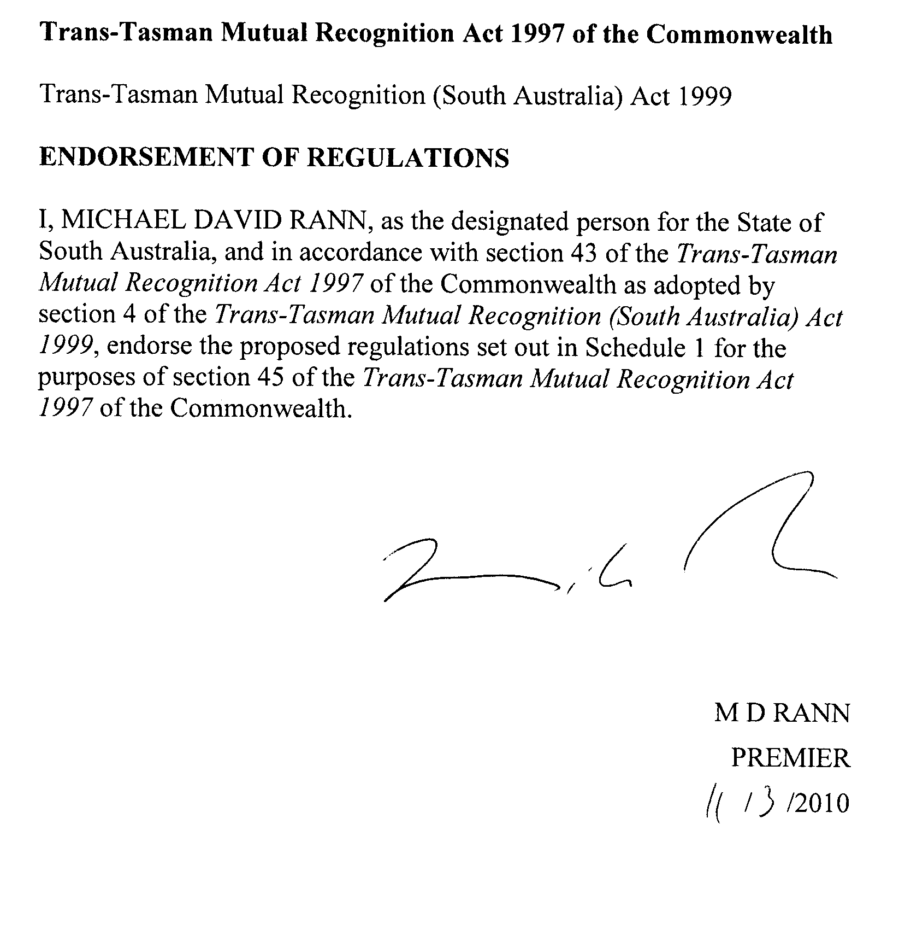

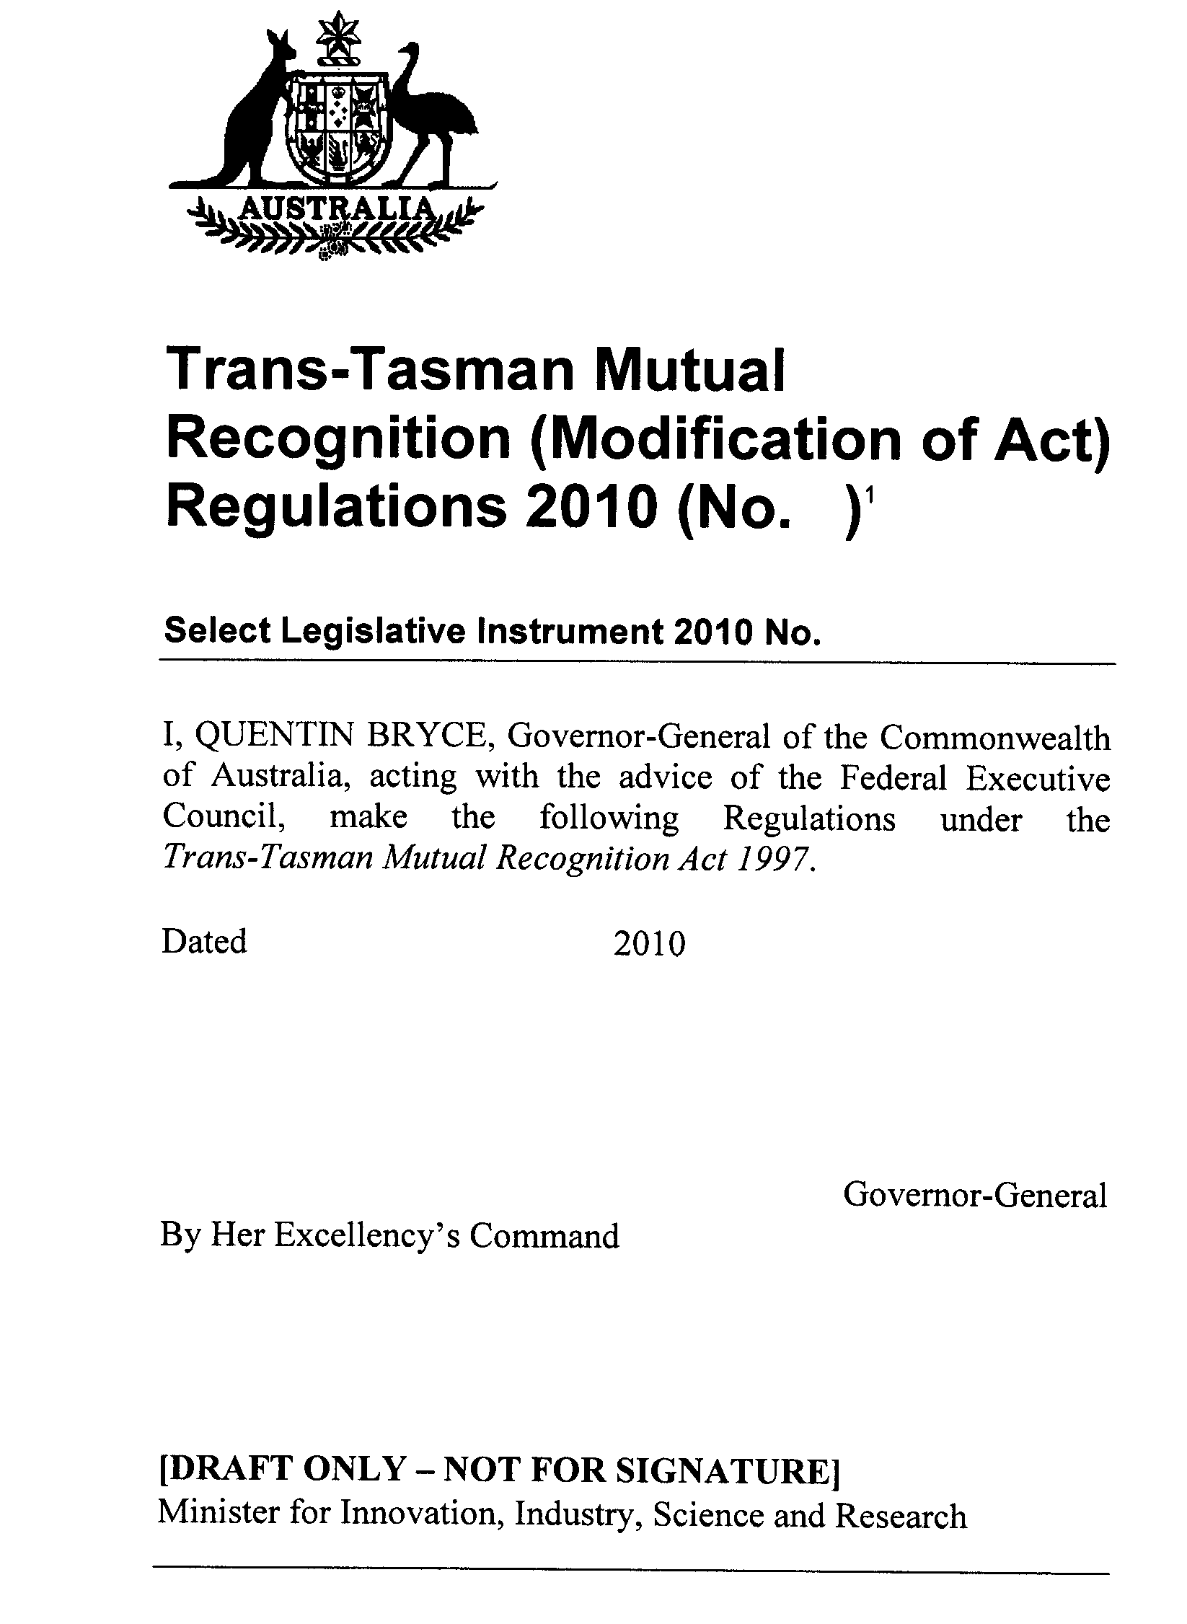
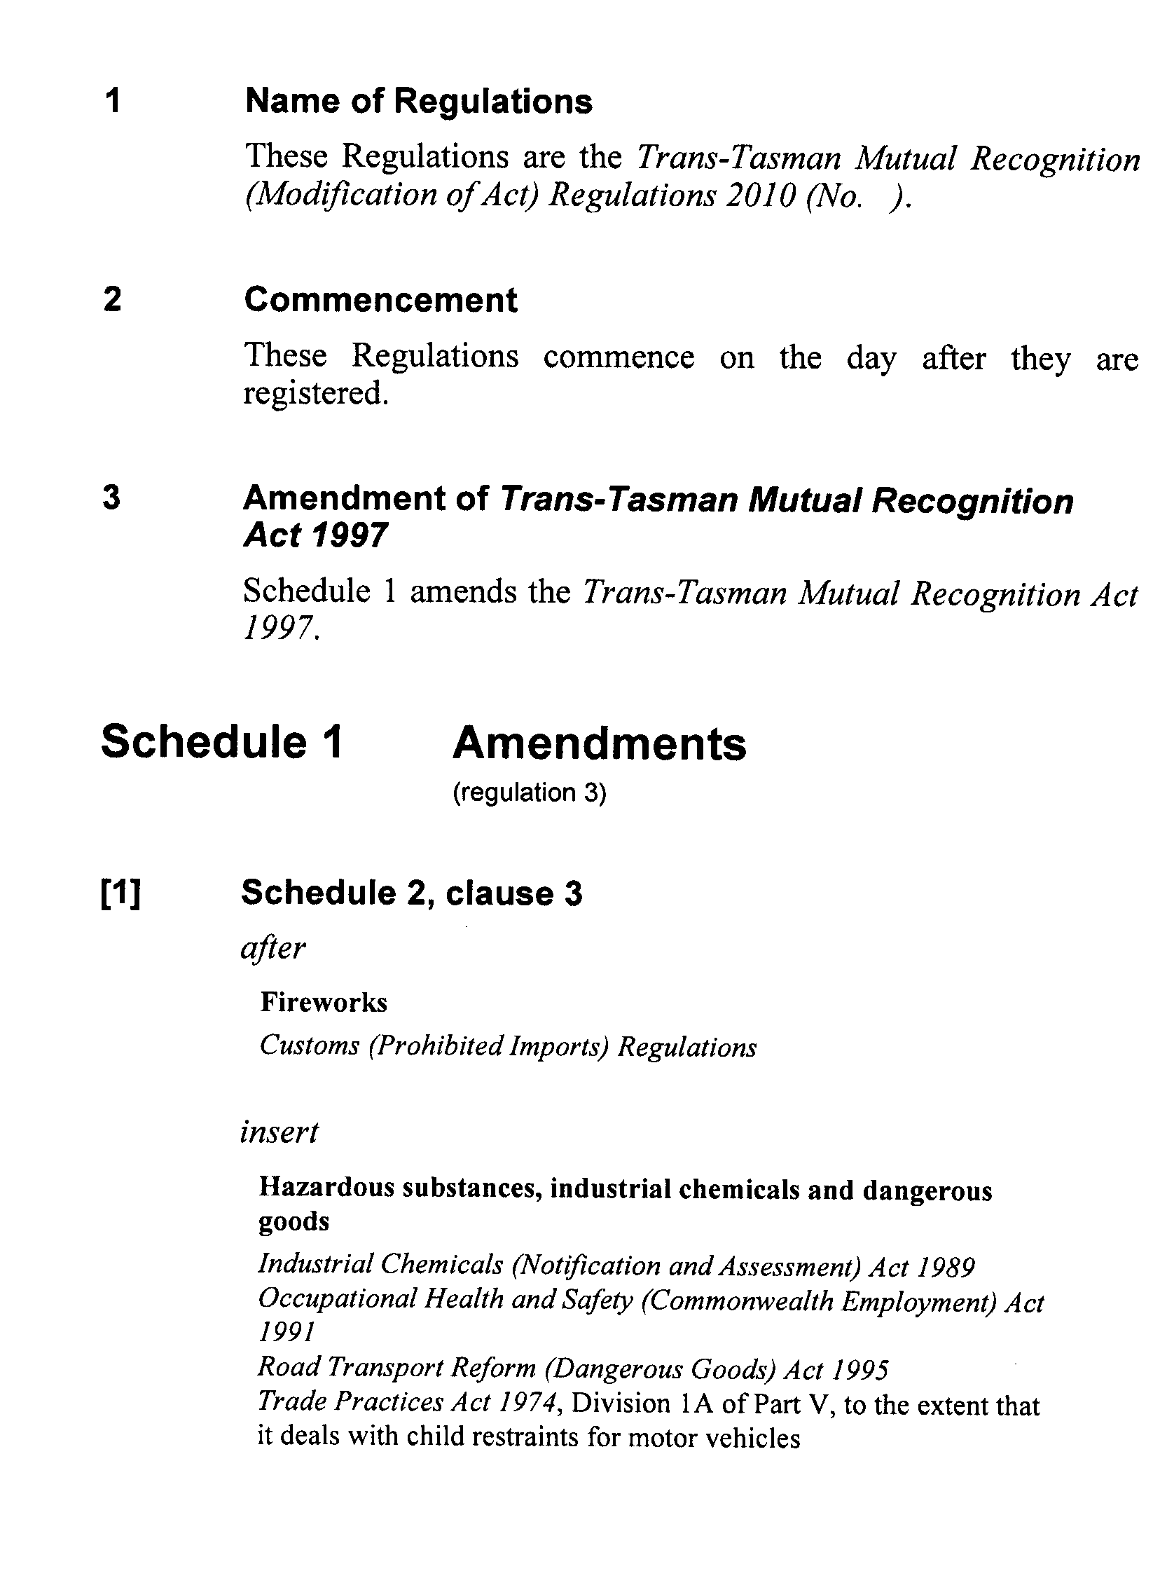
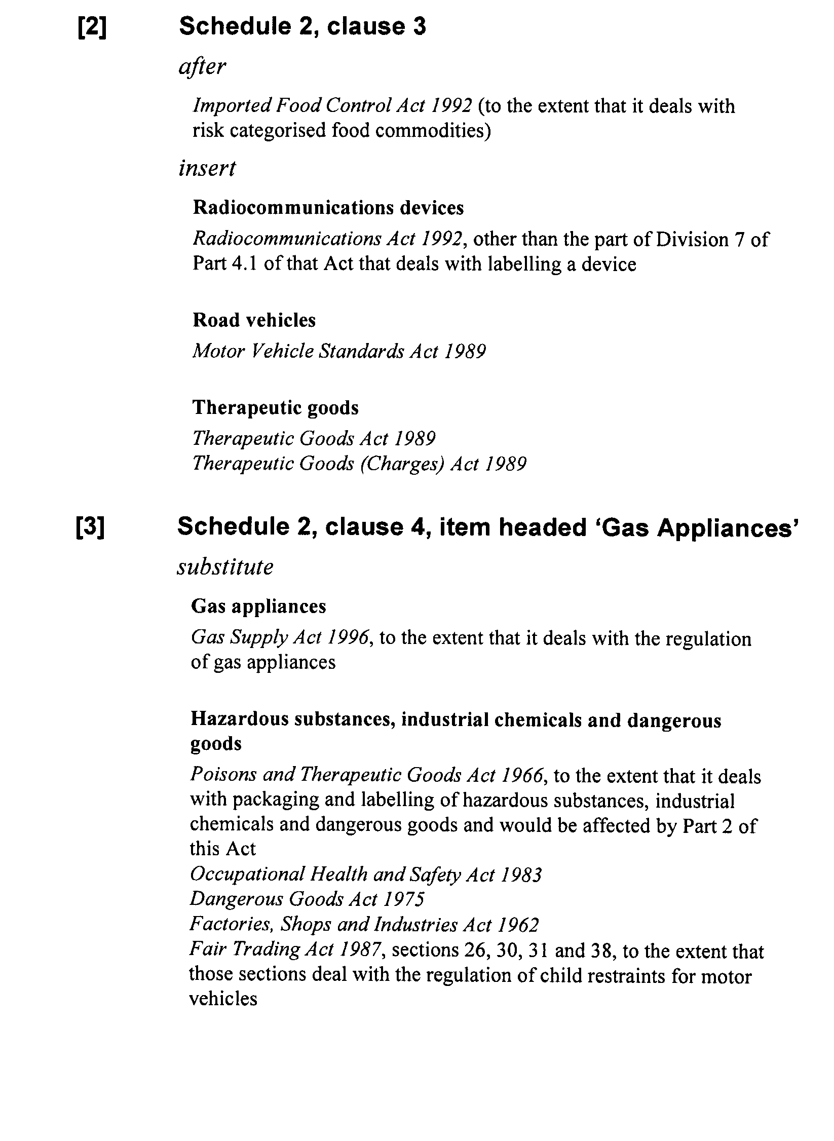
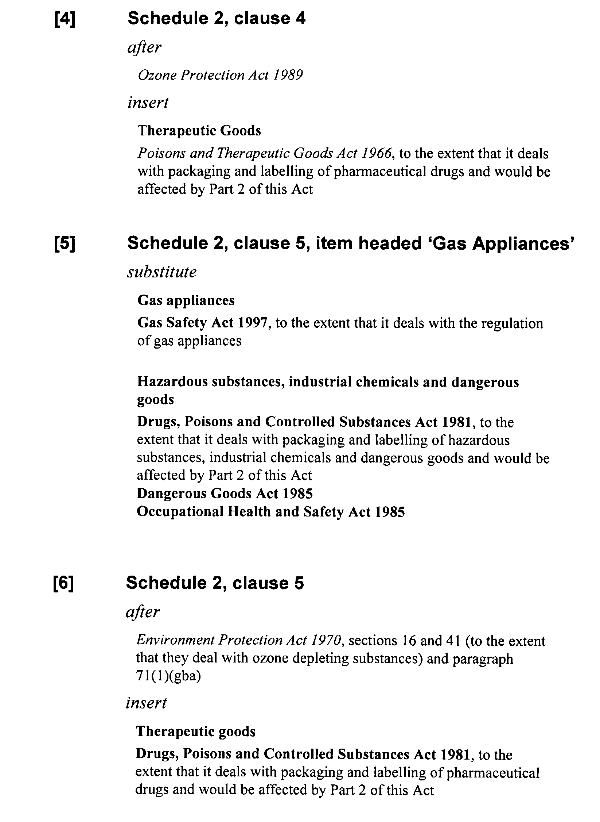
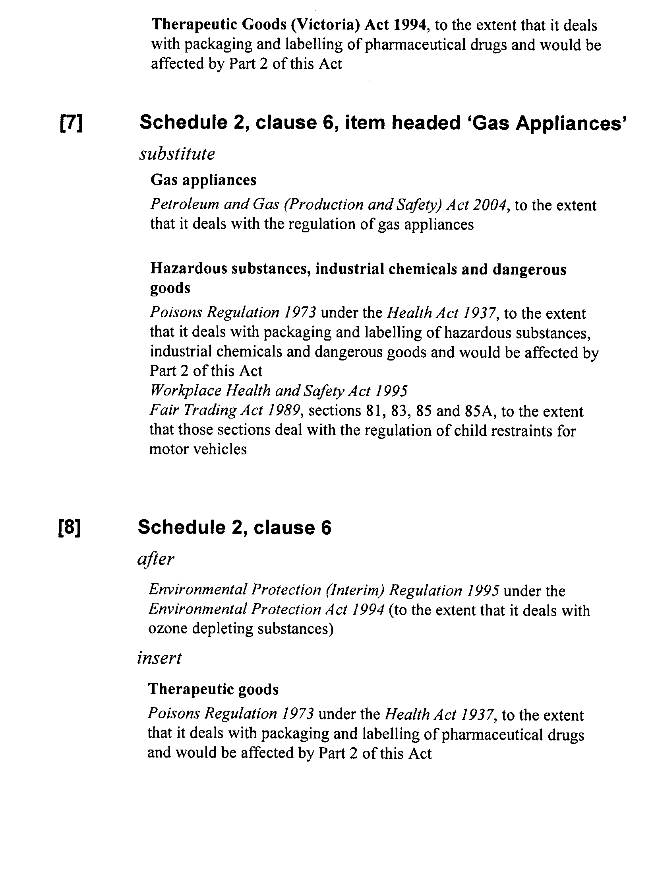
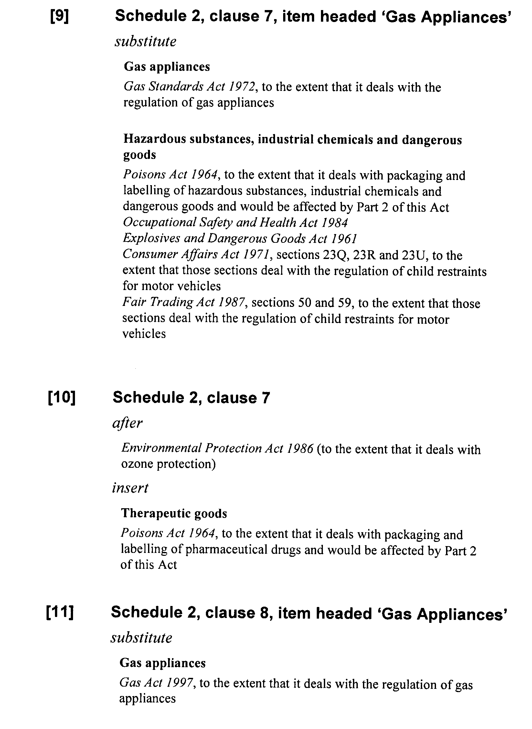
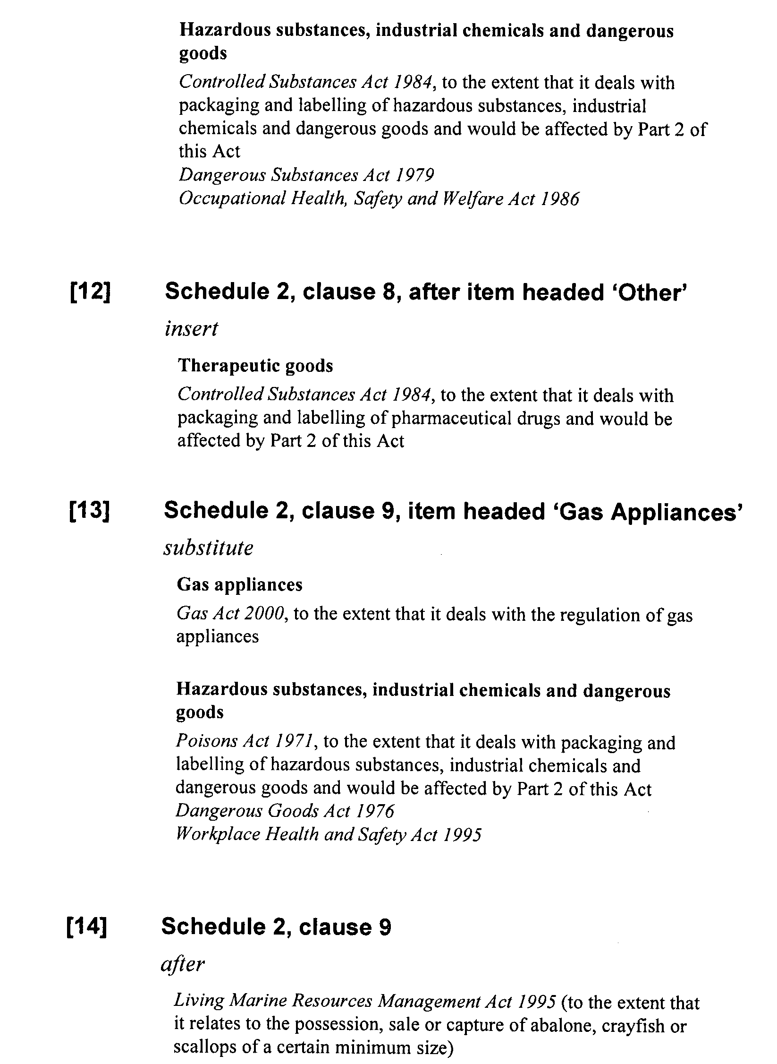
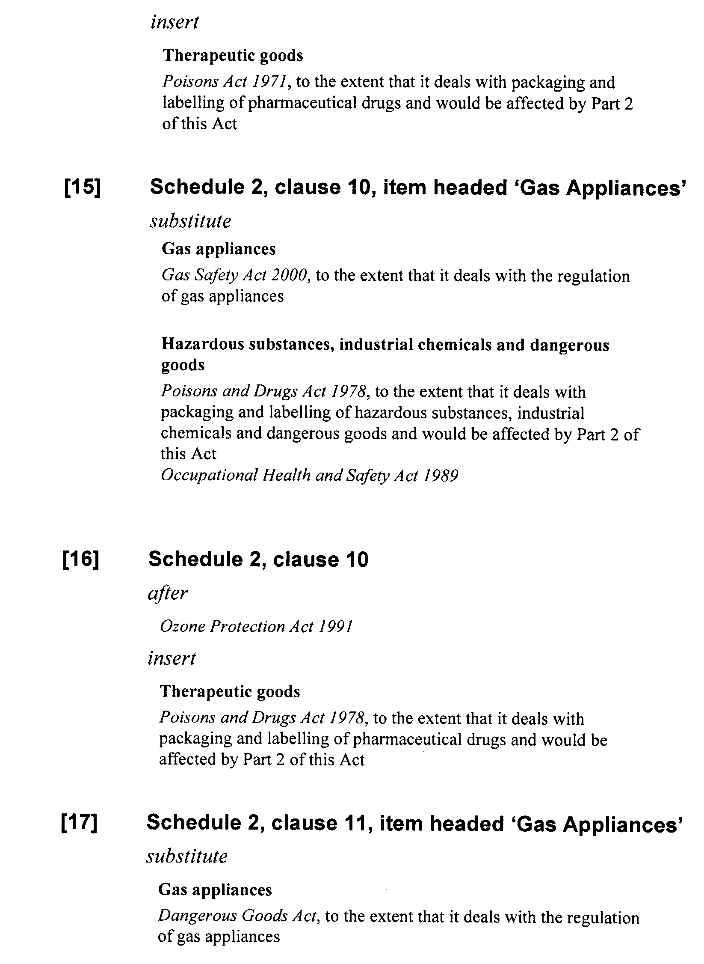
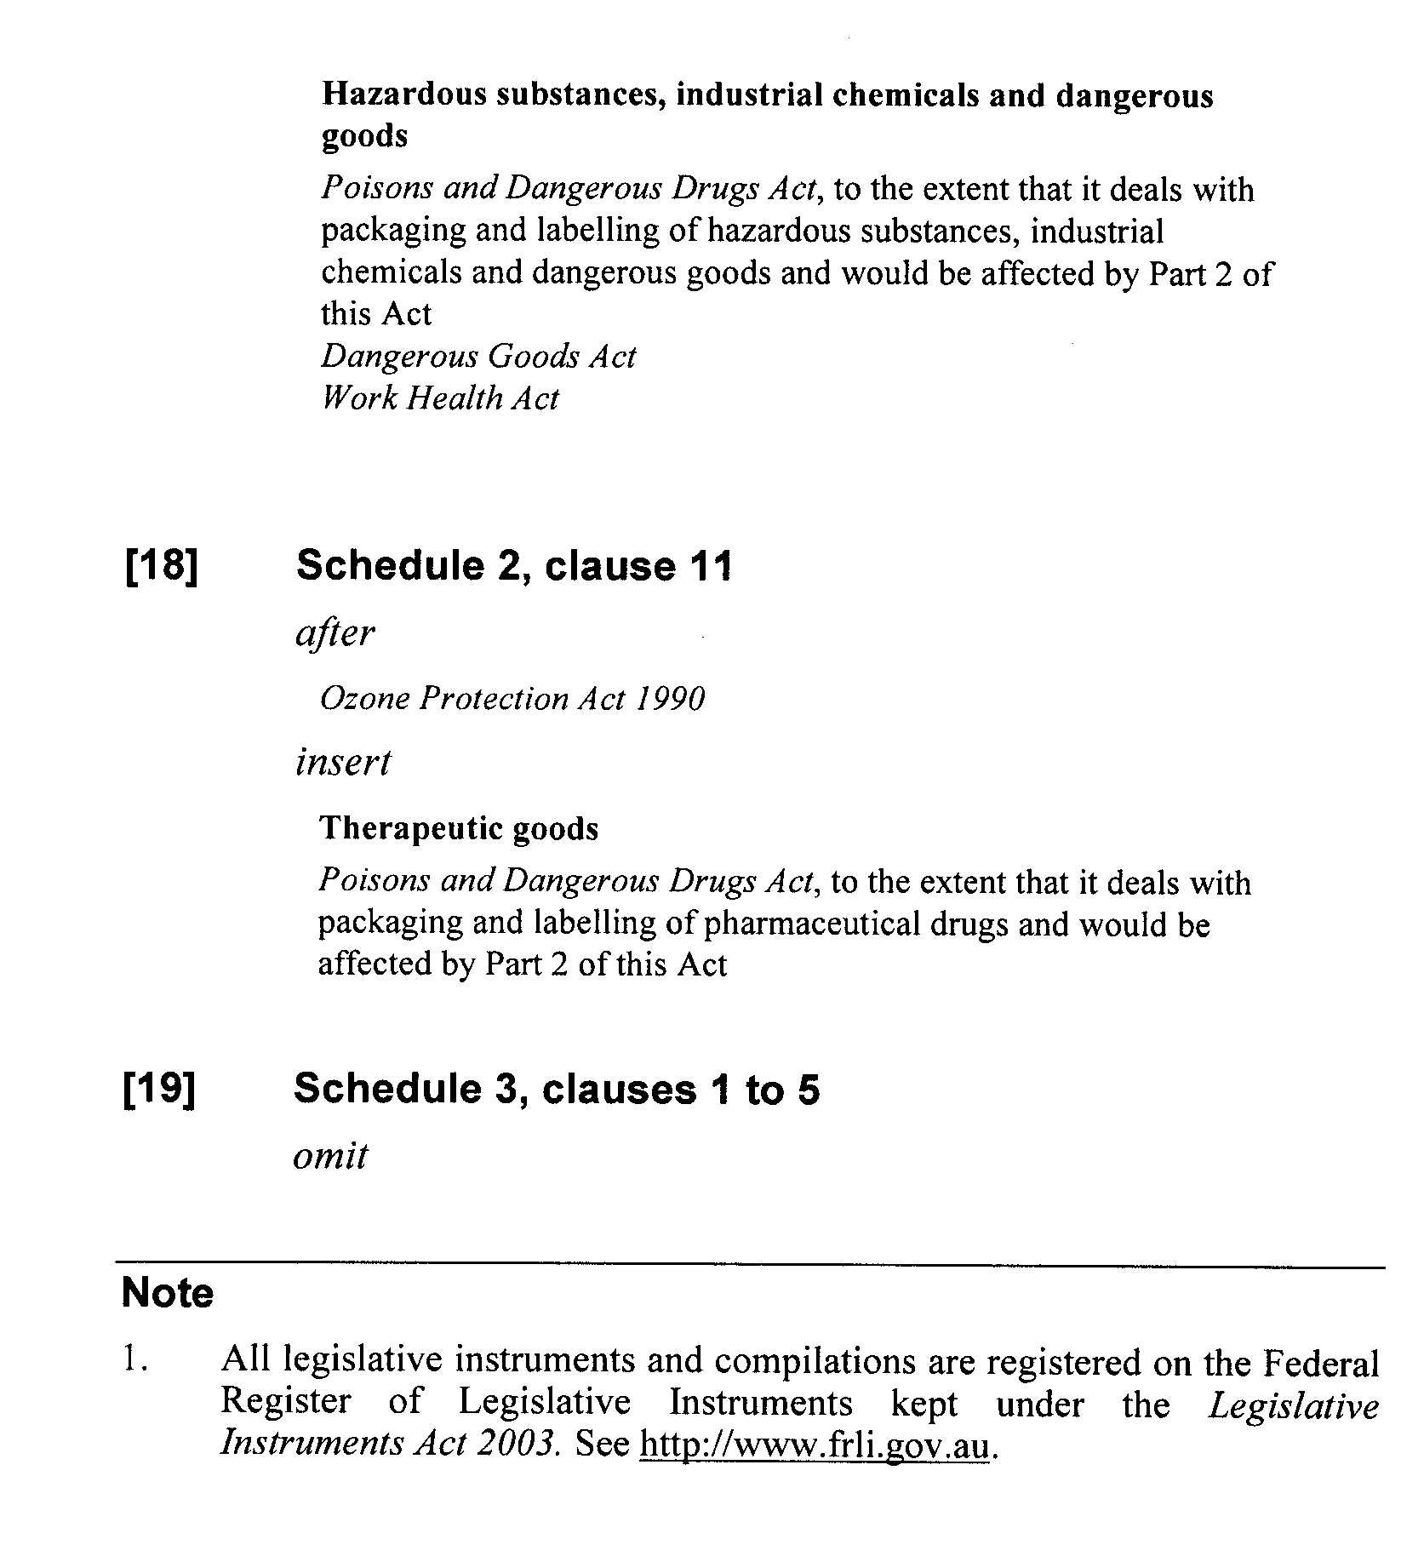

B. MORRIS, Government Printer, South Australia

