No. 29 1805

THE SOUTH AUSTRALIAN

GOVERNMENT GAZETTE
www.governmentgazette.sa.gov.au

PUBLISHED BY AUTHORITY

ALL PUBLIC ACTS appearing in this GAZETTE are to be considered official, and obeyed as such

ADELAIDE, THURSDAY, 13 MAY 2010

CONTENTS

Page
Appointments, Resignations, Etc. 1806
Corporations and District Councils—Notices 1842
Dangerous Substances Act 1979—Notice 1806
Development Act 1993—Notices 1806
Environment Protection Act 1993—Notice 1814
Explosives Act 1936—Notice 1807
Fair Work Act 1994—Notices 1807
Fisheries Management Act 2007—Notices 1817
Geographical Names Act 1991—Corrigendum 1817
Housing Improvement Act 1940—Notices 1820
Land Acquisition Act 1969—Notices 1822
Liquor Licensing Act 1997—Notices 1823
Mining Act 1971—Notice 1825
National Electricity Law—Notice 1825
National Electricity (South Australia) Act 1996—Notice 1826

Page
Occupational Health, Safety and Welfare Act 1986—
Notice 1827
Petroleum and Geothermal Energy Act 2000—Notices 1827
Petroleum Products Regulation Act 1995—Notice 1827
Public Trustee Office—Administration of Estates 1843
Private Advertisement 1843
REGULATIONS
Primary Produce (Food Safety Schemes) Act 2004
(No. 31 of 2010) 1832
National Gas (South Australia) Act 2008
(No. 32 of 2010) 1836
Roads (Opening and Closing) Act 1991—Notice 1827
Transport, Department of—Notice to Mariners 1828
Water Mains and Sewers—Mains Laid, Replaced,
Etc 1828

GOVERNMENT GAZETTE NOTICES
ALL poundkeepers’ and private advertisements forwarded for publication in the South Australian Government Gazette must be PAID FOR PRIOR TO INSERTION; and all notices, from whatever source, should be legibly written on one side of the paper only and sent to Government Publishing SA so as to be received no later
than 4 p.m. on the Tuesday preceding the day of publication. Phone 8207 1045 or Fax 8207 1040. E-mail: governmentgazette@dpc.sa.gov.au. Send as attachments in Word format and please confirm your transmission with a faxed copy of your document, including the date the notice is to be published and to whom the notice will be charged. The Government Gazette is available online at: www.governmentgazette.sa.gov.au

Department of the Premier and Cabinet
Adelaide, 13 May 2010
HIS Excellency the Governor in Executive Council has been pleased to appoint the undermentioned to the Industrial Relations Advisory Committee, pursuant to the provisions of the Fair Work Act 1994:
Member: (from 13 May 2010 until 12 May 2012)
Janet Margaret Giles
David Gray
Justin Hanson
Donald Blairs
Fay Donaghy
Jan McMahon
Theressa Hines
Trevor Edwin Evans
Paul George Eblen
Paulette Jaqueline Kolarz
Brian Smedley
Thomas Earls
By command,
Grace Portolesi, for Premier
MIR10/004CS

Department of the Premier and Cabinet
Adelaide, 13 May 2010
HIS Excellency the Governor in Executive Council has been pleased to appoint Hieu Van Le, the Honourable the Chief Justice John Jeremy Doyle, AC, and the Honourable Justice Kevin Patrick Duggan as Governor’s Deputy of South Australia for the periods set out below:
• Hieu Van Le for the period from 4 p.m. on Tuesday, 18 May 2010 until 11.59 p.m. on Wednesday, 26 May 2010.
• The Honourable the Chief Justice John Jeremy Doyle, AC, for the period from 12 a.m. on Thursday, 27 May 2010 until 11.59 p.m. on Thursday, 27 May 2010.
• The Honourable Justice Kevin Patrick Duggan for the period from 12 a.m. on Friday, 28 May 2010 until 2 p.m. on Saturday, 29 May 2010.
By command,
Grace Portolesi, for Premier

Department of the Premier and Cabinet
Adelaide, 13 May 2010
HIS Excellency the Governor in Executive Council has been pleased to appoint the Honourable Paul Caica, MP, Minister for Environment and Conservation, Minister for the River Murray and Minister for Water to be also Acting Minister for Agriculture, Food and Fisheries, Acting Minister for Forests, Acting Minister for Regional Development and Acting Minister for the Northern Suburbs for the period from 2 July 2010 to 16 July 2010 inclusive, during the absence of the Honourable Michael Francis O’Brien, MP.
By command,
Grace Portolesi, for Premier
MAFF10/08CS

Department of the Premier and Cabinet
Adelaide, 13 May 2010
HIS Excellency the Governor in Executive Council has suspended from the office of Justice of the Peace Phillip Neale Black, from 13 May 2010 until further notice, pursuant to Section 10 of the Justices of the Peace Act 2005.
By command,
Grace Portolesi, for Premier
JP10/010CS

DANGEROUS SUBSTANCES ACT 1979
Appointment
I, PAUL HOLLOWAY, Minister for Industrial Relations in and for the State of South Australia, hereby appoint the following person as an Authorised Officer for the purposes of the Dangerous Substances Act 1979, pursuant to section 7 (1) of the Dangerous Substances Act 1979:
Brett Trevor Chalmers
Dated 11 May 2010.
Paul Holloway, Minister for Industrial Relations

DEVELOPMENT ACT 1993: SECTION 46 (4)
Preamble
1. Subsection (4) of section 46 of the Development Act 1993 provides that the Minister may, by notice in the Gazette, revoke a declaration previously made under subsection (1) of that section.
2. The Minister has decided to revoke various declarations that have effect under section 46 of the Development Act 1993.
Notice
PURSUANT to subsection (4) of section 46 of the Development Act 1993, I revoke the following declarations of the Minister under section 46 of the Development Act 1993:
(i) the declaration published in the Gazette on 27 March 2003 at pages 1183 and 1184, relating to the Hindmarsh Square Apartment Complex—at the RAA corner of Grenfell Street and Hindmarsh Square in the City of Adelaide;
(ii) the declaration published in the Gazette on 1 March 2007 at pages 601, 602 and 603, relating to the Stansbury Marina—Stansbury;
(iv) the declaration published in the Gazette on 29 November 2007 at page 4341, relating to the Jurlique Expansion—Mylor.
Dated 5 May 2010.
Paul Holloway, Minister for Urban Development and Planning

DEVELOPMENT ACT 1993, SECTION 25 (17): KANGAROO ISLAND COUNCIL—GENERAL DPA
Preamble
1. The Development Plan Amendment entitled Kangaroo Island Council Kangaroo Island Council—General DPA has been finalised in accordance with the provisions of the Development Act 1993.
2. The Minister Holloway has decided to approve the Amendment.
Notice
PURSUANT to section 25 of the Development Act 1993, I—
(a) approve the Amendment; and
(b) fix the day on which this notice is published in the Gazette as the day on which the Amendment will come into operation.
Dated 13 May 2010.
Paul Holloway, Minister for Urban Development and Planning

DEVELOPMENT ACT 1993, SECTION 25 (17): DISTRICT COUNCIL OF ORROROO CARRIETON—COMMER-CIAL ZONE DEVELOPMENT PLAN AMENDMENT
Preamble
1. The Development Plan Amendment entitled District Council of Orroroo Carrieton—Commercial Zone Development Plan Amendment has been finalised in accordance with the provisions of the Development Act 1993.
2. The Minister for Urban Development and Planning has decided to approve the Amendment.
Notice
PURSUANT to section 25 of the Development Act 1993, I—
(a) approve the Amendment; and
(b) fix the day on which this notice is published in the Gazette as the day on which the Amendment will come into operation.
Dated 13 May 2010.
Paul Holloway, Minister for Urban Development and Planning

DEVELOPMENT ACT 1993, SECTION 25 (17): CITY OF WEST TORRENS—BRICKWORKS MARKETS PRECINCT
Preamble
1. The Development Plan Amendment entitled City of West Torrens—Brickworks Markets Precinct has been finalised in accordance with the provisions of the Development Act 1993.
2. The Minister for Urban Development and Planning has decided to approve the Amendment.
PURSUANT to section 25 of the Development Act 1993, I—
(a) approve the Amendment; and
(b) fix the day on which this notice is published in the Gazette as the day on which the Amendment will come into operation.
Dated 23 April 2010.
Paul Holloway, Minister for Urban Development and Planning

EXPLOSIVES ACT 1936
Appointment
I, PAUL HOLLOWAY, Minister for Industrial Relations in and for the State of South Australia, hereby appoint the following person to be an Authorised officer for the purposes of the Explosives Act 1936, pursuant to section 9 (1) of the Explosives Act 1936:
Brett Trevor Chalmers
Dated 11 May 2010.
Paul Holloway, Minister for Industrial Relations

FAIR WORK ACT 1994
Appointment
I, PAUL HOLLOWAY, Minister for Industrial Relations in and for the State of South Australia, hereby appoint the following person to be an Inspector for the purposes of the Fair Work Act 1994, pursuant to section 64 (1) (b) of the Fair Work Act 1994:
Brett Trevor Chalmers
Dated 11 May 2010.
Paul Holloway, Minister for Industrial Relations

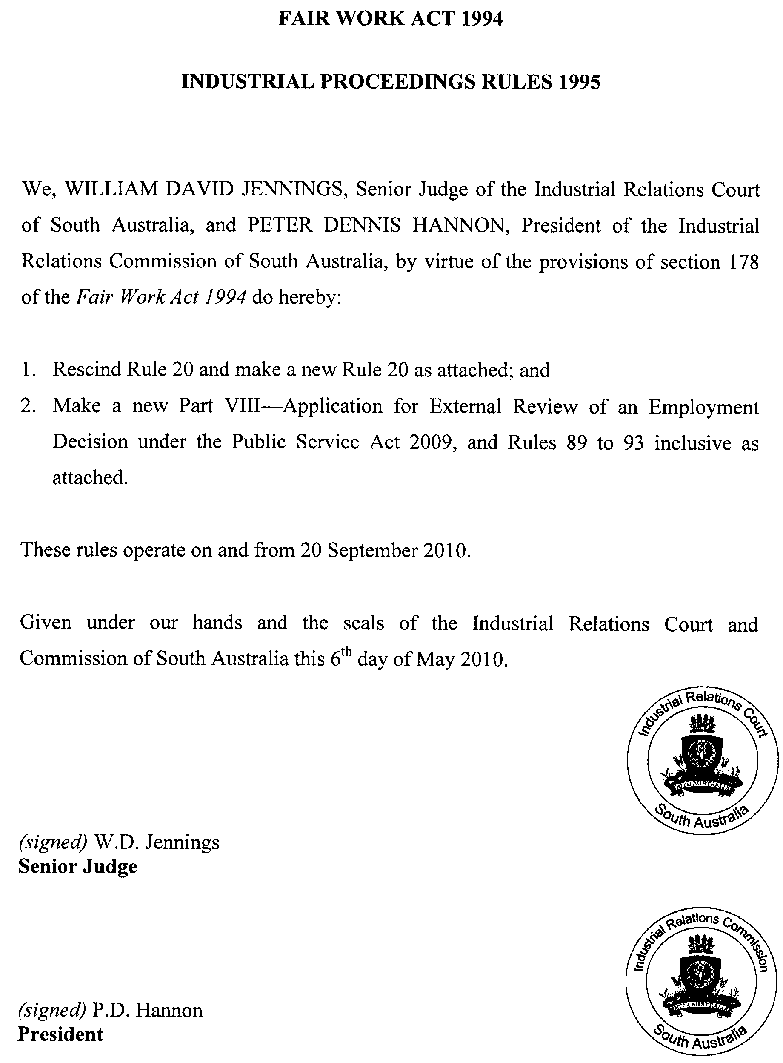
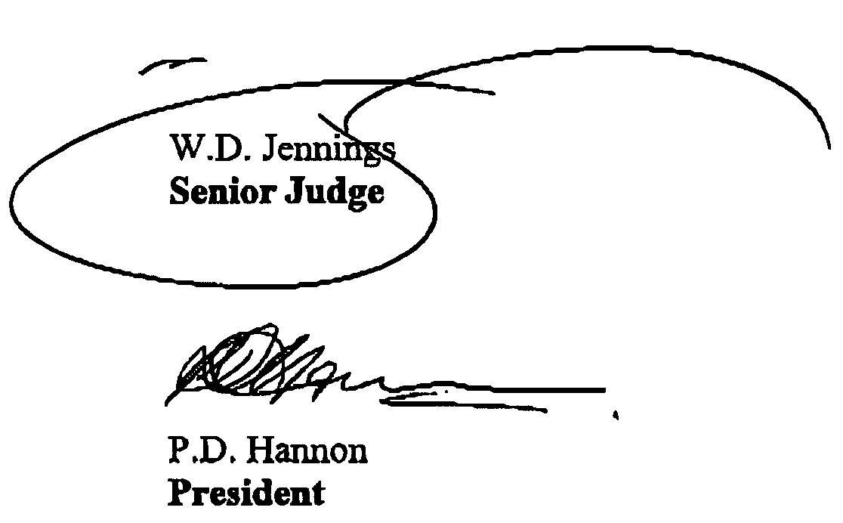
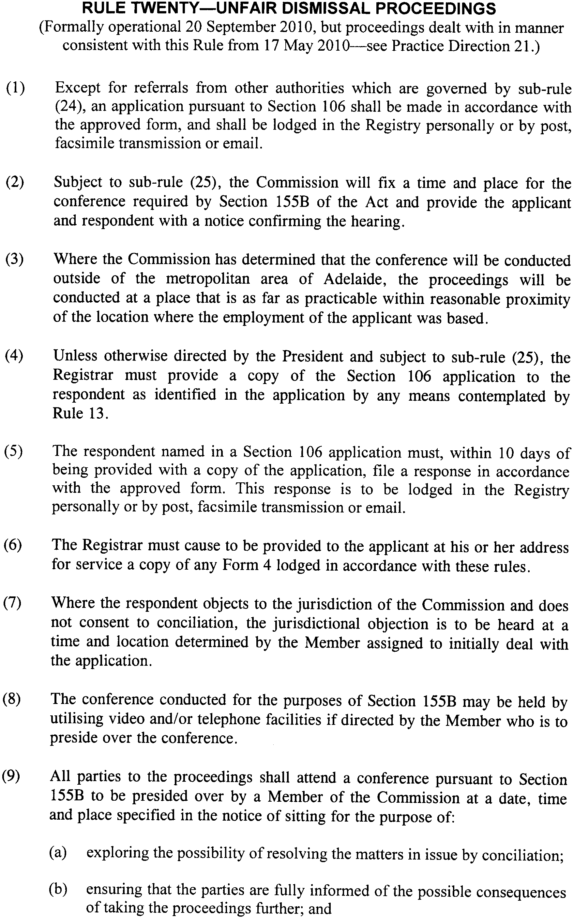
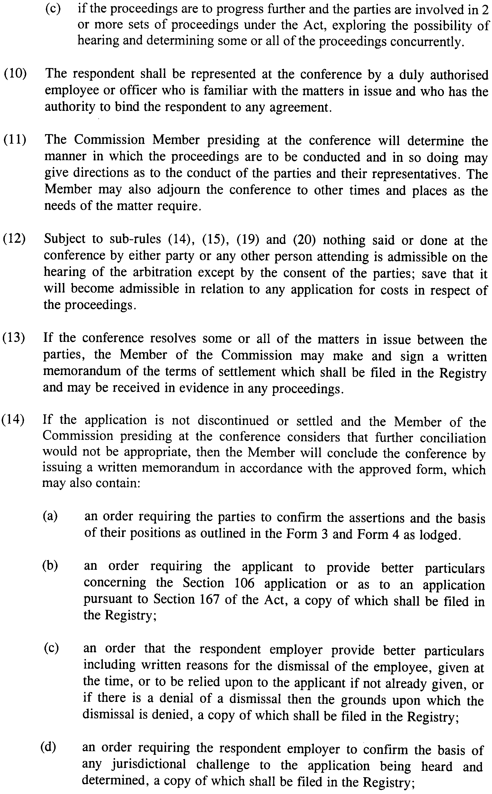
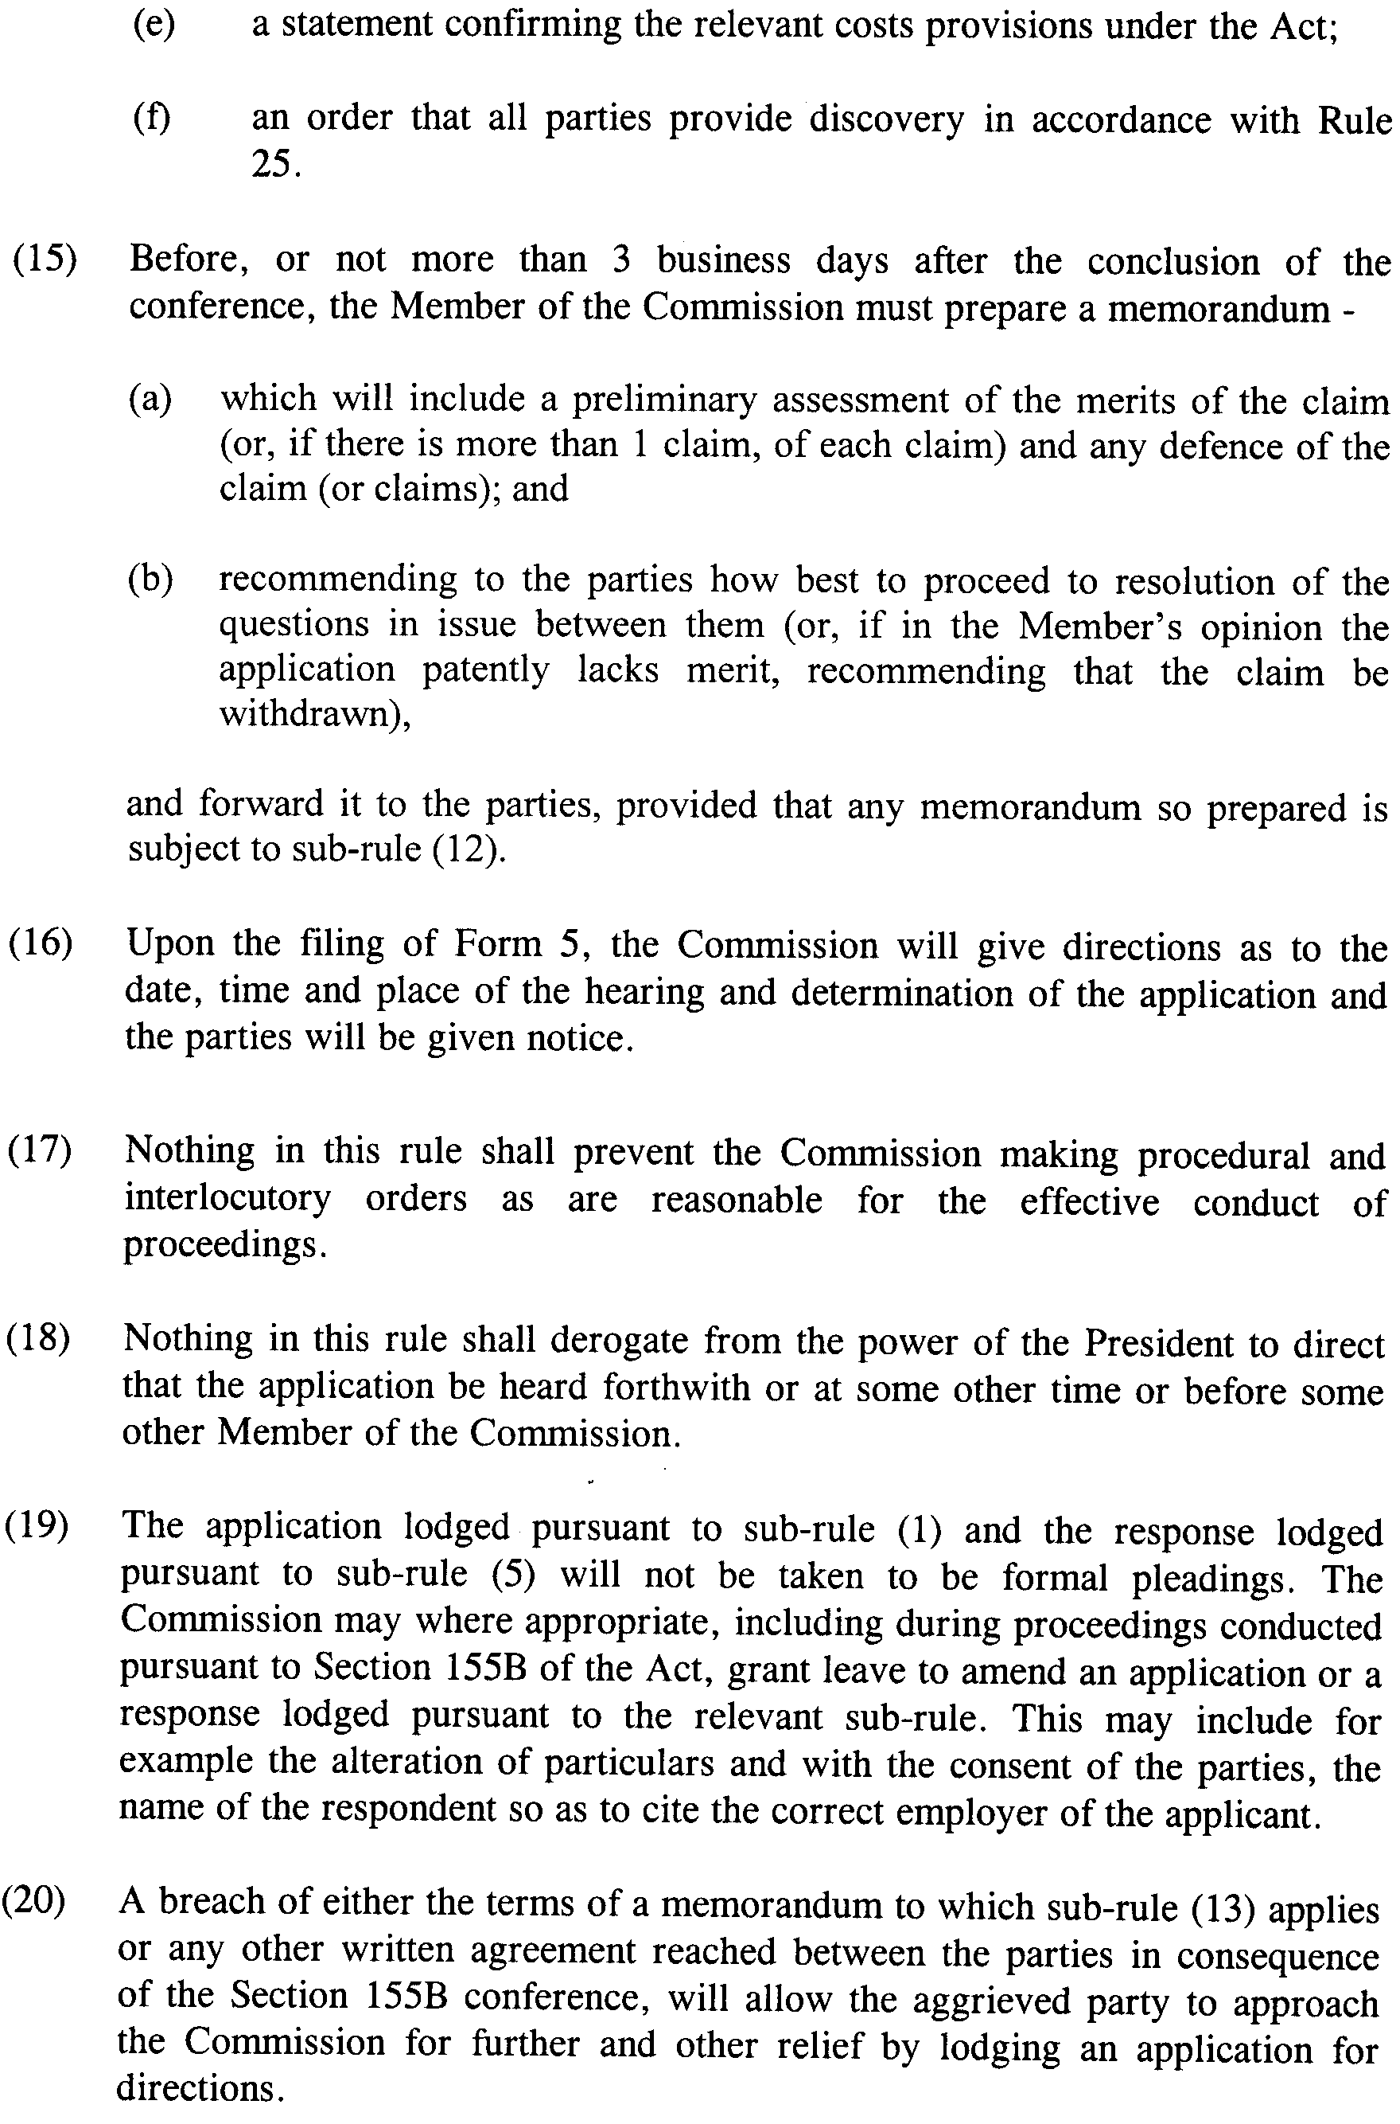
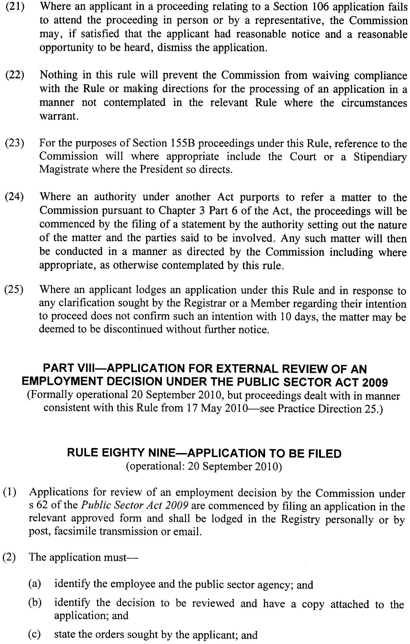
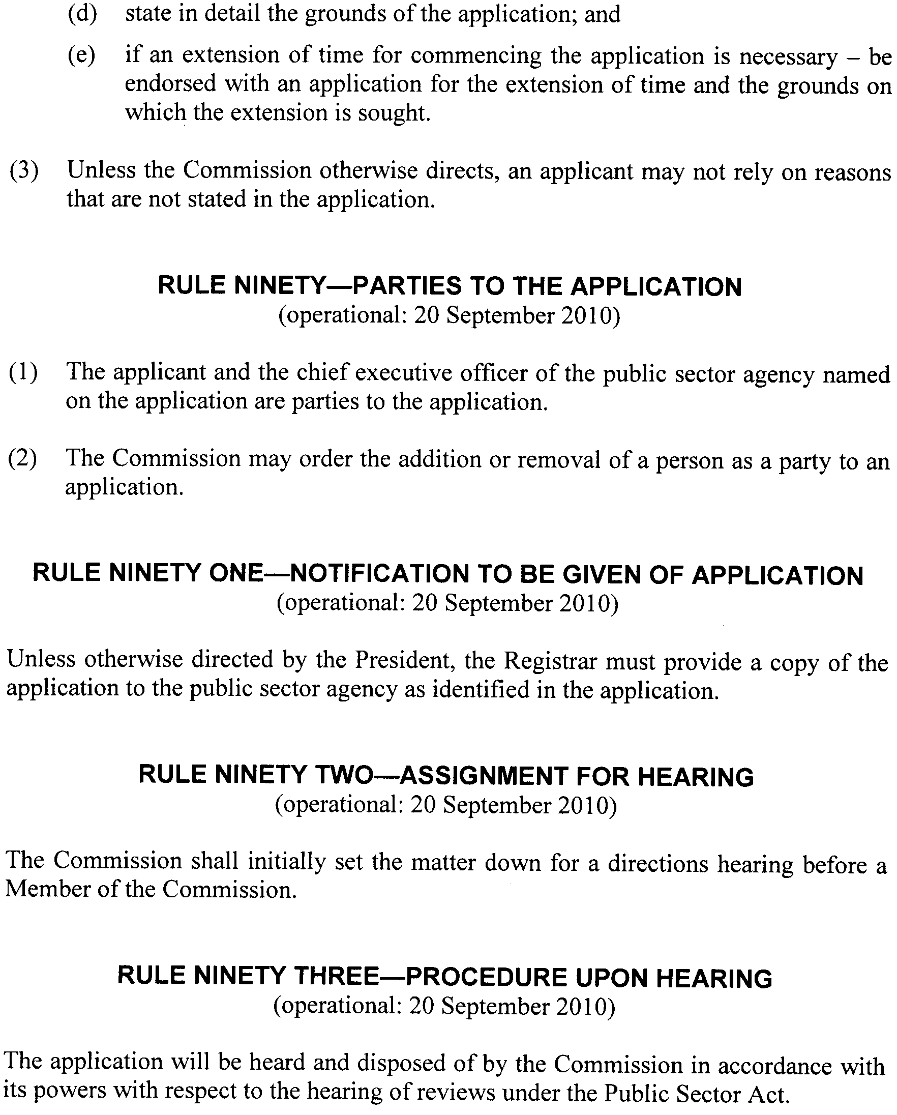

ENVIRONMENT PROTECTION ACT 1993
Approval of Category B Containers
I, ANDREA KAYE WOODS, Team Leader, Container Deposit Legislation and Delegate of the Environment Protection Authority (‘the Authority’), pursuant to section 68 of the Environment Protection Act 1993 (SA) (‘the Act’) hereby:
Approval of Category B Containers:
Approve as Category B Containers, subject to the conditions in subclauses (1), (2), (3) and (4) below, each of the classes of containers identified by reference to the following matters described in the first 4 columns of Schedule 1 of this Notice which are sold in South Australia:
(a) the product which each class of containers shall contain;
(b) the size of the containers;
(c) the type of containers; and
(d) the name of the holders of these approvals.
(1) That containers of the class to which the approval relates must bear the refund marking specified by the Authority for containers of that class.
(2) The holder of the approval must have in place an effective and appropriate waste management arrangement in relation to containers of that class. For the purpose of this approval notice the company named in Column 5 of Schedule 1 of this Notice is the nominated super collector.
(3) In the case of an approval in relation to Category B containers that the waste management arrangement must require the holder of the approval to provide specified super collectors with a declaration in the form determined by the Authority in relation to each sale of such containers by the holder of the approval as soon as practicable after the sale.
(4) The holder of these approvals must ensure that if a sticker bearing the refund marking has been approved, and is applied to the container, then the sticker must not be placed on any portion of the opening mechanism or in any other place that would require complete or partial removal of the sticker before the contents may be consumed.
Schedule 1

Column 1 | Column 2 | Column 3 | Column 4 | Column 5
Product Name | Container  Size (mL) | Container Type | Approval Holder | Collection  Arrangements
7 UP | 355 | Glass | Adelaide Lebanese Bakery | Marine Stores Ltd
Coca Cola | 250 | Glass | Adelaide Lebanese Bakery | Marine Stores Ltd
Mizo Guava | 296 | Glass | Alnigma Enterprises Pty Ltd | Marine Stores Ltd
Mizo Mango | 296 | Glass | Alnigma Enterprises Pty Ltd | Marine Stores Ltd
Mizo Tamarind | 296 | Glass | Alnigma Enterprises Pty Ltd | Marine Stores Ltd
Dragon Blackcurrant Flavoured Fruit Drink | 250 | HDPE | Aussie O Fruit Juice Co. Pty Ltd | Flagcan Distributors
Dragon Raspberry Flavoured Fruit Drink | 250 | HDPE | Aussie O Fruit Juice Co. Pty Ltd | Flagcan Distributors
Finley Blackcurrant Flavoured Fruit Drink | 250 | HDPE | Aussie O Fruit Juice Co. Pty Ltd | Flagcan Distributors
Finley Raspberry Flavoured Fruit Drink | 250 | HDPE | Aussie O Fruit Juice Co. Pty Ltd | Flagcan Distributors
Focus Apple Raspberry | 500 | PET | Aussie O Fruit Juice Co. Pty Ltd | Flagcan Distributors
Focus Blackcurrant | 500 | PET | Aussie O Fruit Juice Co. Pty Ltd | Flagcan Distributors
Focus Blackcurrant | 350 | PET | Aussie O Fruit Juice Co. Pty Ltd | Flagcan Distributors
Focus Dragon Fruit | 500 | PET | Aussie O Fruit Juice Co. Pty Ltd | Flagcan Distributors
Focus Fruit Fix | 500 | PET | Aussie O Fruit Juice Co. Pty Ltd | Flagcan Distributors
Focus Fruit Fix | 350 | PET | Aussie O Fruit Juice Co. Pty Ltd | Flagcan Distributors
Focus Lemonade | 500 | PET | Aussie O Fruit Juice Co. Pty Ltd | Flagcan Distributors
Focus Lemonade | 350 | PET | Aussie O Fruit Juice Co. Pty Ltd | Flagcan Distributors
Focus Orange Pine | 500 | PET | Aussie O Fruit Juice Co. Pty Ltd | Flagcan Distributors
Focus Raspberry | 350 | PET | Aussie O Fruit Juice Co. Pty Ltd | Flagcan Distributors
Focus Raspberry | 500 | PET | Aussie O Fruit Juice Co. Pty Ltd | Flagcan Distributors
Focus Wild Berry | 500 | PET | Aussie O Fruit Juice Co. Pty Ltd | Flagcan Distributors
Littlest Pet Shop Orange Flavoured Fruit Drink | 250 | HDPE | Aussie O Fruit Juice Co. Pty Ltd | Flagcan Distributors
Littlest Pet Shop Raspberry Flavoured Fruit Drink | 250 | HDPE | Aussie O Fruit Juice Co. Pty Ltd | Flagcan Distributors
My Little Pony Blueberry Flavoured Fruit Drink | 250 | HDPE | Aussie O Fruit Juice Co. Pty Ltd | Flagcan Distributors
My Little Pony Raspberry Flavoured Fruit Drink | 250 | HDPE | Aussie O Fruit Juice Co. Pty Ltd | Flagcan Distributors
SA Water | 500 | PET | Bickfords Australia Pty Ltd | Statewide Recycling
Mother | 300 | Can—Aluminium | Coca Cola Amatil (Aust.) Pty Ltd | Statewide Recycling
Nestea Green Tea Lemon | 300 | Can—Aluminium | Coca Cola Amatil (Aust.) Pty Ltd | Statewide Recycling
Nestea Iced Tea Lemon Lime | 300 | Can—Aluminium | Coca Cola Amatil (Aust.) Pty Ltd | Statewide Recycling
Nestea Iced Tea Peach | 300 | Can—Aluminium | Coca Cola Amatil (Aust.) Pty Ltd | Statewide Recycling
Hardys Oomoo Shiraz | 187 | PET | Constellation Wines Australia | Statewide Recycling
Ta Ku Sauvignon Blanc | 187 | PET | Constellation Wines Australia | Statewide Recycling
Archipelago Explorer | 330 | Glass | Empire Liquor | Statewide Recycling
Archipelago Samui | 330 | Glass | Empire Liquor | Statewide Recycling
Archipelago Straits Pale | 330 | Glass | Empire Liquor | Statewide Recycling
Brugge Tripel | 330 | Glass | Empire Liquor | Statewide Recycling
Cuvee Des Trolls | 250 | Glass | Empire Liquor | Statewide Recycling
Gribousine Blonde De Malonne | 330 | Glass | Empire Liquor | Statewide Recycling
Gribousine Brune De Malonne | 330 | Glass | Empire Liquor | Statewide Recycling
Maisels Weisse Alkoholfrei | 500 | Glass | Empire Liquor | Statewide Recycling
Ottakringer Helles | 500 | Can—Aluminium | Empire Liquor | Statewide Recycling
Monster Milk Banana | 591 | HDPE | Flush Fitness Pty Ltd | Statewide Recycling
Monster Milk Chocolate | 591 | HDPE | Flush Fitness Pty Ltd | Statewide Recycling
Monster Milk Cookies N Creme | 591 | HDPE | Flush Fitness Pty Ltd | Statewide Recycling
Monster Milk Vanilla | 591 | HDPE | Flush Fitness Pty Ltd | Statewide Recycling
Muscle Milk Banana Creme | 500 | LPB—Aseptic | Flush Fitness Pty Ltd | Statewide Recycling
Muscle Milk Banana Creme | 414 | HDPE | Flush Fitness Pty Ltd | Statewide Recycling
Muscle Milk Cafe Latte | 500 | LPB—Aseptic | Flush Fitness Pty Ltd | Statewide Recycling
Muscle Milk Cake Batter | 500 | LPB—Aseptic | Flush Fitness Pty Ltd | Statewide Recycling
Muscle Milk Choc Malt | 414 | HDPE | Flush Fitness Pty Ltd | Statewide Recycling
Muscle Milk Chocolate | 500 | LPB—Aseptic | Flush Fitness Pty Ltd | Statewide Recycling
Muscle Milk Chocolate | 414 | HDPE | Flush Fitness Pty Ltd | Statewide Recycling
Muscle Milk Chocolate Malt | 500 | LPB—Aseptic | Flush Fitness Pty Ltd | Statewide Recycling
Muscle Milk Cookies N Creme | 500 | LPB—Aseptic | Flush Fitness Pty Ltd | Statewide Recycling
Muscle Milk Light Chocolate | 414 | HDPE | Flush Fitness Pty Ltd | Statewide Recycling
Muscle Milk Light Vanilla | 414 | HDPE | Flush Fitness Pty Ltd | Statewide Recycling
Muscle Milk Light Vanilla Creme | 500 | LPB—Aseptic | Flush Fitness Pty Ltd | Statewide Recycling
Muscle Milk Strawberries N Creme | 414 | HDPE | Flush Fitness Pty Ltd | Statewide Recycling
Muscle Milk Strawberry | 500 | LPB—Aseptic | Flush Fitness Pty Ltd | Statewide Recycling
Muscle Milk Strawberry | 414 | HDPE | Flush Fitness Pty Ltd | Statewide Recycling
Muscle Milk Vanilla Creme | 500 | LPB—Aseptic | Flush Fitness Pty Ltd | Statewide Recycling
Muscle Milk Vanilla Creme | 414 | HDPE | Flush Fitness Pty Ltd | Statewide Recycling
Cherry Up Antioxidant | 355 | Can—Aluminium | Funworks | Marine Stores Ltd
Club Orange | 355 | Can—Aluminium | Funworks | Marine Stores Ltd
Dr Pepper Diet | 355 | Can—Aluminium | Funworks | Marine Stores Ltd
Fanta Grape | 355 | Can—Aluminium | Funworks | Marine Stores Ltd
Fanta Grapefruit Caffeine Free | 355 | Can—Aluminium | Funworks | Flagcan Distributors
Pepsi Wild Cherry | 355 | Can—Aluminium | Funworks | Marine Stores Ltd
Welchs Sparkling Strawberry Soda | 355 | Can—Aluminium | Funworks | Marine Stores Ltd
Stiegl Goldbrau | 330 | Glass | German Beverage Imports Pty Ltd | Marine Stores Ltd
Gaudianello Sparkling Natural Mineral Water | 1 000 | PET | Global Food Distributors Pty Ltd | Statewide Recycling
Cruiser Free Lemon & Lime | 275 | Glass | Independent Distillers (Aust.) Pty Ltd | Statewide Recycling
Cruiser Free Passion Lychee | 275 | Glass | Independent Distillers (Aust.) Pty Ltd | Statewide Recycling
Cruiser Free Pink Grapefruit | 275 | Glass | Independent Distillers (Aust.) Pty Ltd | Statewide Recycling
Woodstock Kentucky Bourbon & Cola 4.0% | 375 | Can—Aluminium | Independent Distillers (Aust.) Pty Ltd | Statewide Recycling
Woodstock Premium Draught 4.6% | 375 | Can—Aluminium | Independent Distillers (Aust.) Pty Ltd | Statewide Recycling
A & W Root Beer | 300 | Can—Aluminium | Intradco Pty Ltd | Marine Stores Ltd
A & W Root Beer | 1 500 | PET | Intradco Pty Ltd | Marine Stores Ltd
F & N 100 Plus | 300 | Can—Aluminium | Intradco Pty Ltd | Marine Stores Ltd
F & N 100 Plus | 1 500 | PET | Intradco Pty Ltd | Marine Stores Ltd
F & N Grape | 300 | Can—Aluminium | Intradco Pty Ltd | Marine Stores Ltd
F & N Ice Cream Soda | 300 | Can—Aluminium | Intradco Pty Ltd | Marine Stores Ltd
F & N Sarsi | 300 | Can—Aluminium | Intradco Pty Ltd | Marine Stores Ltd
F & N Sarsi | 1 500 | PET | Intradco Pty Ltd | Marine Stores Ltd
F & N Zappel | 300 | Can—Aluminium | Intradco Pty Ltd | Marine Stores Ltd
Kickapoo Joy Juice | 300 | Can—Aluminium | Intradco Pty Ltd | Marine Stores Ltd
Pokka Aloe V White Grape Tea | 300 | Can—Aluminium | Intradco Pty Ltd | Marine Stores Ltd
Pokka Apple Tea | 500 | PET | Intradco Pty Ltd | Marine Stores Ltd
Pokka Blueberry Tea | 500 | PET | Intradco Pty Ltd | Marine Stores Ltd
Pokka Blueberry Tea | 1 500 | PET | Intradco Pty Ltd | Marine Stores Ltd
Pokka Chrysanthemum Tea | 500 | PET | Intradco Pty Ltd | Marine Stores Ltd
Pokka Chrysanthemum Tea | 1 500 | PET | Intradco Pty Ltd | Marine Stores Ltd
Pokka Guava | 300 | Can—Aluminium | Intradco Pty Ltd | Marine Stores Ltd
Pokka Ice Tea Lychee | 330 | Can—Aluminium | Intradco Pty Ltd | Marine Stores Ltd
Pokka Japanese Green Tea | 300 | Can—Aluminium | Intradco Pty Ltd | Marine Stores Ltd
Pokka Jasmine Green Tea | 500 | PET | Intradco Pty Ltd | Marine Stores Ltd
Pokka Jasmine Green Tea | 1 500 | PET | Intradco Pty Ltd | Marine Stores Ltd
Pokka Lemon Tea | 500 | PET | Intradco Pty Ltd | Marine Stores Ltd
Pokka Lemon Tea | 1 500 | PET | Intradco Pty Ltd | Marine Stores Ltd
Pokka Lemon Tea | 300 | Can—Aluminium | Intradco Pty Ltd | Marine Stores Ltd
Pokka Lychee Tea | 500 | PET | Intradco Pty Ltd | Marine Stores Ltd
Pokka Mango Tea | 500 | PET | Intradco Pty Ltd | Marine Stores Ltd
Pokka Mango Tea | 300 | Can—Aluminium | Intradco Pty Ltd | Marine Stores Ltd
Pokka Milk Coffee | 300 | Can—Aluminium | Intradco Pty Ltd | Marine Stores Ltd
Pokka Oolong Tea | 500 | PET | Intradco Pty Ltd | Marine Stores Ltd
Pokka Oolong Tea | 300 | Can—Aluminium | Intradco Pty Ltd | Marine Stores Ltd
Pokka Oolong Tea | 1 500 | PET | Intradco Pty Ltd | Marine Stores Ltd
Pokka Peach Tea | 500 | PET | Intradco Pty Ltd | Marine Stores Ltd
Pokka Peach Tea | 300 | Can—Aluminium | Intradco Pty Ltd | Marine Stores Ltd
Pokka Peach Tea | 1 500 | PET | Intradco Pty Ltd | Marine Stores Ltd
Wong Coco Coconut Juice with Pulp | 320 | Can—Aluminium | Intradco Pty Ltd | Marine Stores Ltd
Aleve Ice Green Tea Lemon Flavour | 500 | PET | L Z Enterprises Pty Ltd | Statewide Recycling
Aleve Ice Tea Lemon Flavour | 500 | PET | L Z Enterprises Pty Ltd | Statewide Recycling
Aleve Ice Tea Peach Flavour | 500 | PET | L Z Enterprises Pty Ltd | Statewide Recycling
Henninger Lager Bier | 330 | Glass | Liquorland Aust Pty Ltd | Statewide Recycling
Henninger Lager Bier | 660 | Glass | Liquorland Aust Pty Ltd | Statewide Recycling
Maxx Dry Premium Lager | 330 | Glass | Liquorland Aust Pty Ltd | Statewide Recycling
Radeberger Pilsner | 330 | Glass | Liquorland Aust Pty Ltd | Statewide Recycling
A & W Root Beer | 355 | Can—Aluminium | Nutcracker Sweet | Statewide Recycling
L & P Lemon & Paeroa | 355 | Can—Aluminium | Nutcracker Sweet | Statewide Recycling
Sanitarium Up & Go Energize Choc | 350 | LPB—Aseptic | Sanitarium Health Food Company | Statewide Recycling
Sanitarium Up & Go Liquid Breakfast Banana | 350 | LPB—Aseptic | Sanitarium Health Food Company | Statewide Recycling
Sanitarium Up & Go Liquid Breakfast Choc Ice | 350 | LPB—Aseptic | Sanitarium Health Food Company | Statewide Recycling
Sanitarium Up & Go Liquid Breakfast Choc Ice | 250 | LPB—Aseptic | Sanitarium Health Food Company | Statewide Recycling
Sanitarium Up & Go Liquid Breakfast Strawberry | 350 | LPB—Aseptic | Sanitarium Health Food Company | Statewide Recycling
Sanitarium Up & Go Liquid Breakfast Vanilla Ice | 350 | LPB—Aseptic | Sanitarium Health Food Company | Statewide Recycling
Brasilena Carbonated Coffee Drink | 250 | Glass | Snif Pty Ltd | Statewide Recycling
Fabrizia Natural Mineral Water | 2 000 | PET | Snif Pty Ltd | Statewide Recycling
Fabrizia Natural Mineral Water | 1 000 | PET | Snif Pty Ltd | Statewide Recycling
Fabrizia Natural Mineral Water | 500 | PET | Snif Pty Ltd | Statewide Recycling
Fabrizia Natural Mineral Water | 1 500 | PET | Snif Pty Ltd | Statewide Recycling
Spitwater Natural Spring Water | 600 | PET | Spring Water Beverages Pty Ltd | Statewide Recycling
Cape Grim Natural Water Sparkling | 375 | Glass | The Cape Grim Water Company Pty Ltd | Marine Stores Ltd
Cape Grim Natural Water Sparkling | 750 | Glass | The Cape Grim Water Company Pty Ltd | Marine Stores Ltd
Cape Grim Natural Water Still | 375 | Glass | The Cape Grim Water Company Pty Ltd | Marine Stores Ltd
Cape Grim Natural Water Still | 750 | Glass | The Cape Grim Water Company Pty Ltd | Marine Stores Ltd
Lipton Ice Green Tea Original | 500 | PET | Unilever Australia Ltd | Statewide Recycling
Lipton Ice Tea Raspberry | 500 | PET | Unilever Australia Ltd | Statewide Recycling
Infused Rush Apple Guava | 275 | Glass | Vok Beverages Pty Ltd | Statewide Recycling
Infused Rush Strawberry | 275 | Glass | Vok Beverages Pty Ltd | Statewide Recycling

FISHERIES MANAGEMENT ACT 2007: SECTION 79
TAKE note that the notice made under section 79 of the Fisheries Management Act 2007, dated 1 February 2010, referring to the Spencer Gulf Prawn Fishery, is hereby varied such that it will be unlawful for a person fishing pursuant to a Spencer Gulf Prawn Fishery Licence to use prawn trawl nets in the areas specified in Schedule 1 during the period specified in Schedule 2.
Schedule 1
The waters of the Spencer Gulf Prawn Fishery that are:
1. North of the following co-ordinates: Commencing at latitude 33°46.00′S, longitude 137°44.00′E, then to position latitude 33°37.00′S, longitude 137°33.00′E, then to position latitude 33°43.00′S, longitude 137°30.00′E, then to position latitude 33°46.00′S, longitude 137°30.00′E, then to position latitude 33°48.50′S, longitude 137°33.50′E, then to position latitude 33°55.00′S, longitude 137°28.00′E, then to position latitude 33°41.00′S, longitude 137°08.00′E.
2. Within the following co-ordinates: Commencing at latitude 33°41.00′S, longitude 137°06.00′E, then to position latitude 33°52.00′S, longitude 137°15.00′E, then to position latitude 33°55.00′S, longitude 137°08.00′E, then to position latitude 34°02.00′S, longitude 137°10.00′E, then to position latitude 34°15.00′S, longitude 136°54.00′E, then to position latitude 34°18.00′S, longitude 136°54.00′E, then to position latitude 34°22.00′S, longitude 136°52.00′E, then to position latitude 34°22.00′S, longitude 136°44.00′E, then to position latitude 34°07.00′S, longitude 136°47.00′E, then to position latitude 34°07.00′S, longitude 136°43.00′E, then to position latitude 33°56.00′S, longitude 136°34.00′E.
3. Within the following co-ordinates adjacent to Wardang Island: Commencing at latitude 34°19.00′S, longitude 137°30.00′E, then to position latitude 34°19.00′S, longitude 137°20.00′E, then to position latitude 34°23.00′S, longitude 137°15.00′E, then to position latitude 34°54.00′S, longitude 137°15.00′E.
Schedule 2
From 1830 hours 10 May 2010 to 0600 hours on 13 May 2010.
Dated 5 May 2010.
A. Fistr, Program Leader, Prawn Fishery Manager

FISHERIES MANAGEMENT ACT 2007: SECTION 79
TAKE note that the notice made under section 79 of the Fisheries Management Act 2007, dated 1 February 2010 and published in the South Australian Government Gazette on page 421, dated 4 February 2010, being the fourth notice on that page, referring to the Gulf St Vincent Prawn Fishery, is hereby varied such that it will not be unlawful for a person fishing, pursuant to a Gulf St Vincent Prawn Fishery Licence to use prawn trawl nets in the area specified in Schedule 1, during the period specified in Schedule 2.
Schedule 1
The waters of the Gulf St Vincent Prawn Fishery, within the following co-ordinates: Commencing at latitude 35°01.00′S, longitude 138°21.00′E, then to position latitude 35°05.00′S, longitude 138°23.00′E, then to position latitude 35°06.00′S, longitude 138°17.00′E, then to position latitude 35°00.00′S, longitude 138°16.00'E, then returning to position latitude 35°01.00′S, longitude 138°21.00′E.
Schedule 2
From 1830 hours on 12 May 2010 to 0630 hours on 14 May 2010.
Dated 11 May 2010.
A. Fistr, Prawn Fishery Manager

GEOGRAPHICAL NAMES ACT 1991
Corrigendum
Notice of Declaration of Names of Places
IN the Government Gazette of 21 August 1986, page 607 first notice appearing, under the heading Mapsheet 1:50 000 6833-III the feature named Alindee declared as a TRIG should have been a HILL and the feature named WINNINEE TRIG should have been declared as WINNININNIE HILL.
Dated 10 May 2010.
P. M. Kentish, Surveyor-General, Department for Transport, Energy and Infrastructure
DTEI.2009/29925/01

GOVERNMENT GAZETTE ADVERTISEMENT RATES

To apply from 1 July 2009

$  Agents, Ceasing to Act as 42.75  Associations:  Incorporation 21.70  Intention of Incorporation 53.50  Transfer of Properties 53.50  Attorney, Appointment of 42.75  Bailiff’s Sale 53.50  Cemetery Curator Appointed 31.75  Companies:  Alteration to Constitution 42.75  Capital, Increase or Decrease of 53.50  Ceasing to Carry on Business 31.75  Declaration of Dividend 31.75  Incorporation 42.75  Lost Share Certificates:  First Name 31.75  Each Subsequent Name 10.90  Meeting Final 35.75  Meeting Final Regarding Liquidator’s Report on  Conduct of Winding Up (equivalent to ‘Final  Meeting’)  First Name 42.75  Each Subsequent Name 10.90  Notices:  Call 53.50  Change of Name 21.70  Creditors 42.75  Creditors Compromise of Arrangement 42.75  Creditors (extraordinary resolution that ‘the Com-pany be wound up voluntarily and that a liquidator be appointed’) 53.50  Release of Liquidator⎯Application⎯Large Ad. 85.00  ⎯Release Granted 53.50  Receiver and Manager Appointed 49.50  Receiver and Manager Ceasing to Act 42.75  Restored Name 40.00  Petition to Supreme Court for Winding Up 74.50  Summons in Action 63.50  Order of Supreme Court for Winding Up Action 42.75  Register of Interests⎯Section 84 (1) Exempt 96.00  Removal of Office 21.70  Proof of Debts 42.75  Sales of Shares and Forfeiture 42.75  Estates:  Assigned 31.75  Deceased Persons⎯Notice to Creditors, etc. 53.50  Each Subsequent Name 10.90  Deceased Persons⎯Closed Estates 31.75  Each Subsequent Estate 1.40  Probate, Selling of 42.75  Public Trustee, each Estate 10.90 |  | $  Firms:  Ceasing to Carry on Business (each insertion) 28.50  Discontinuance Place of Business 28.50  Land⎯Real Property Act:  Intention to Sell, Notice of 53.50  Lost Certificate of Title Notices 53.50  Cancellation, Notice of (Strata Plan) 53.50  Mortgages:  Caveat Lodgement 21.70  Discharge of 22.70  Foreclosures 21.70  Transfer of 21.70  Sublet 10.90  Leases⎯Application for Transfer (2 insertions) each 10.90  Lost Treasury Receipts (3 insertions) each 31.75  Licensing 63.50  Municipal or District Councils:  Annual Financial Statement⎯Forms 1 and 2 598.00  Electricity Supply⎯Forms 19 and 20 425.00  Default in Payment of Rates:  First Name 85.00  Each Subsequent Name 10.90  Noxious Trade 31.75  Partnership, Dissolution of 31.75  Petitions (small) 21.70  Registered Building Societies (from Registrar-  General) 21.70  Register of Unclaimed Moneys⎯First Name 31.75  Each Subsequent Name 10.90  Registers of Members⎯Three pages and over:  Rate per page (in 8pt) 272.00  Rate per page (in 6pt) 359.00  Sale of Land by Public Auction 54.00  Advertisements 3.00  ¼ page advertisement 127.00  ½ page advertisement 254.00  Full page advertisement 498.00  Advertisements, other than those listed are charged at $3.00 per column line, tabular one-third extra.  Notices by Colleges, Universities, Corporations and District Councils to be charged at $3.00 per line.  Where the notice inserted varies significantly in length from that which is usually published a charge of $3.00 per column line will be applied in lieu of advertisement rates listed.  South Australian Government publications are sold on the condition that they will not be reproduced without prior permission from the Government Printer.
All the above prices include GST

GOVERNMENT GAZETTE NOTICES
ALL private advertisements forwarded for publication in the South Australian Government Gazette must be PAID FOR PRIOR TO INSERTION; and all notices, from whatever source, should be legibly written on one side of the paper only and sent to Government Publishing SA so as to be received no later than 4 p.m. Tuesday preceding the day of publication. Phone 8207 1045 or Fax 8207 1040. E-mail: governmentgazette@dpc.sa.gov.au. Send as attachments in Word format. Please include date the notice is to be published and to whom the notice will be charged. The Government Gazette is available online at: www.governmentgazette.sa.gov.au.

MISCELLANEOUS LEGISLATION AND GOVERNMENT PUBLICATIONS PRICES AS FROM 1 JULY 2009

Acts, Bills, Rules, Parliamentary Papers and Regulations
Pages | Main | Amends | Pages | Main | Amends

1-16 | 2.60 | 1.20 | 497-512 | 36.25 | 35.25
17-32 | 3.50 | 2.20 | 513-528 | 37.25 | 36.00
33-48 | 4.55 | 3.25 | 529-544 | 38.50 | 37.25
49-64 | 5.75 | 4.40 | 545-560 | 39.50 | 38.50
65-80 | 6.70 | 5.55 | 561-576 | 40.50 | 39.50
81-96 | 7.80 | 6.45 | 577-592 | 41.75 | 40.00
97-112 | 8.90 | 7.60 | 593-608 | 43.00 | 41.50
113-128 | 9.95 | 8.75 | 609-624 | 43.75 | 42.75
129-144 | 11.10 | 9.85 | 625-640 | 45.00 | 43.25
145-160 | 12.20 | 10.90 | 641-656 | 46.00 | 45.00
161-176 | 13.30 | 12.00 | 657-672 | 46.75 | 45.50
177-192 | 14.50 | 13.10 | 673-688 | 48.75 | 46.75
193-208 | 15.60 | 14.40 | 689-704 | 49.50 | 47.75
209-224 | 16.50 | 15.20 | 705-720 | 50.25 | 49.00
225-240 | 17.60 | 16.30 | 721-736 | 52.00 | 50.00
241-257 | 18.90 | 17.20 | 737-752 | 52.50 | 51.00
258-272 | 19.90 | 18.30 | 753-768 | 53.50 | 52.00
273-288 | 21.00 | 19.70 | 769-784 | 54.50 | 53.50
289-304 | 21.90 | 20.60 | 785-800 | 55.50 | 54.50
305-320 | 23.20 | 21.80 | 801-816 | 57.00 | 55.00
321-336 | 24.20 | 22.80 | 817-832 | 58.00 | 57.00
337-352 | 25.40 | 24.10 | 833-848 | 59.00 | 58.00
353-368 | 26.25 | 25.20 | 849-864 | 60.00 | 58.50
369-384 | 27.50 | 26.25 | 865-880 | 61.50 | 60.00
385-400 | 28.75 | 27.25 | 881-896 | 62.00 | 60.50
401-416 | 29.75 | 28.25 | 897-912 | 63.50 | 62.00
417-432 | 31.00 | 29.50 | 913-928 | 64.00 | 63.50
433-448 | 32.00 | 30.75 | 929-944 | 65.00 | 64.00
449-464 | 32.75 | 31.50 | 945-960 | 66.00 | 64.50
465-480 | 33.25 | 32.50 | 961-976 | 68.50 | 65.50
481-496 | 35.25 | 33.25 | 977-992 | 69.50 | 66.00

Legislation—Acts, Regulations, etc: $
Subscriptions:
Acts 223.00
All Bills as Laid 536.00
Rules and Regulations 536.00
Parliamentary Papers 536.00
Bound Acts 248.00
Index 124.00
Government Gazette
Copy 5.85
Subscription 296.00
Hansard
Copy 16.30
Subscription—per session (issued weekly) 465.00
Cloth bound—per volume 199.00
Subscription—per session (issued daily) 465.00
Legislation on Disk
Whole Database 3 443.00
Annual Subscription for fortnightly updates 1 058.00
Individual Act(s) including updates POA
Notice of Vacancies
Annual Subscription 164.00
Compendium
Subscriptions:
New Subscriptions 2 039.00
Updates 719.00
(All the above prices include GST)

All Legislation, Government Gazette, Hansard and Legislation on disk are available from:
Counter Sales Government Legislation⁺ Outlet
and Mail Orders: Service SA Customer Service Centre,
Ground Floor—EDS Centre, 108 North Terrace, Adelaide, S.A. 5000
Phone: 13 23 24 (local call cost), Fax: (08) 8204 1909
Postal: G.P.O. Box 1707, Adelaide, S.A. 5001

Online Shop: www.shop.service.sa.gov.au

Subscriptions and Government Publishing SA
Standing Orders: Box 9, Plaza Level, Riverside Centre, North Terrace, Adelaide, S.A. 5000
Phone: (08) 8207 1043, (08) 8207 0910, Fax: (08) 8207 1040

HOUSING IMPROVEMENT ACT 1940
NOTICE is hereby given that the South Australian Housing Trust Board Delegate in the exercise of the powers conferred by the Housing Improvement Act 1940, does hereby declare the houses described in the table hereunder to be substandard for the purposes of Part 7 of the Housing Improvement Act 1940.
No. of House and Street | Locality | Allotment, Section, etc. | Certificate of Title  Volume Folio

10 Amport Street |  | Elizabeth North | Allotment 37 in Deposited Plan 40651, Hundred of Munno Para | 5232 | 219
139 St Bernards Road |  | Rostrevor | Allotment 79 in Deposited Plan 21837, Hundred of Adelaide | 5434 | 509
24 Durdin Road |  | Elizabeth Vale | Allotment 3 in Deposited Plan 18029, Hundred of Munno Para | 5124 | 278
355 Grenfell Road |  | Redwood Park | Allotment 137 in Deposited Plan 7661, Hundred of Yatala | 5219 | 209
300 Hampstead Road |  | Clearview | Allotment 34 in Filed Plan 127968, Hundred of Yatala | 5381 | 316
4 Hull Street |  | Elizabeth East | Allotment 688 in Deposited Plan 6552, Hundred of Munno Para | 5632 | 6
23 Seaview Grove |  | Blair Athol | Allotment 20 in Deposited Plan 3055, Hundred of Yatala | 5733 | 702
7 Turnbull Road |  | Elizabeth Downs | Allotment 255 in Deposited Plan 7072, Hundred of Munno Para | 5941 | 391

Dated at Adelaide, 13 May 2010. S. Trebilcock for D. Huxley, Director, Corporate Services, Housing SA

HOUSING IMPROVEMENT ACT 1940
WHEREAS by notice published in the Government Gazette on the dates mentioned in the following table, the South Australian Housing Trust Board Delegate did declare the houses described in the following table to be substandard for the purposes of Part 7 of the Housing Improvement Act 1940, and whereas the South Australian Housing Trust Board Delegate is satisfied that each of the houses described hereunder has ceased to be substandard, notice is hereby given that, in exercise of the powers conferred by the said Part, the South Australian Housing Trust does hereby revoke the said declaration in respect of each house.
Address of House | Allotment, Section, etc. | Certificate of Title  Volume Folio | Date and page of Government Gazette in which notice declaring house to be substandard published

52 Emilie Street, Sefton Park |  | Allotments 1 and 2 in Deposited Plan 63009, Hundred of Yatala | 5906  5906 | 573  572 |  | 28.10.93, page 2119
8 First Street, Orroroo |  | Allotments 3 and 5 in Filed Plan 105506, Hundred of Walloway | 5160 | 881 |  | 25.7.96, page 182
67 Le Hunte Avenue, Prospect |  | Allotment 101 in Deposited Plan 1749, Hundred of Yatala | 5570 | 423 |  | 19.11.09, page 5199
2 Leonard Street, Wallaroo |  | Allotment 7 in Deposited Plan 60635, Hundred of Wallaroo | 5883 | 893 |  | 29.6.95, page 3061
9 Leslie Place, Port Adelaide |  | Allotment 5 in Filed Plan 142346, Hundred of Yatala | 5723 | 870 |  | 14.12.78, page 2266
11 Leslie Place, Port Adelaide |  | Allotment 5 in Filed Plan 142346, Hundred of Yatala | 5723 | 870 |  | 2.12.76, page 1863
97 Whitington Road, Davoren Park |  | Allotment 7 in Deposited Plan 50759, Hundred of Munno Para | 5609 | 926 |  | 30.7.09, page 3420

Dated at Adelaide, 13 May 2010. S. Trebilcock for D. Huxley, Director, Corporate Services, Housing SA

HOUSING IMPROVEMENT ACT 1940
WHEREAS by notice published in the Government Gazette on the dates mentioned in the following table the South Australian Housing Trust Board Delegate did declare the houses described in the said table to be substandard for the purposes of Part 7 of the Housing Improvement Act 1940, the South Australian Housing Trust Board Delegate in the exercise of the powers conferred by the said Part, does hereby fix as the maximum rental per week which shall be payable subject to section 55 of the Residential Tenancies Act 1995, in respect of each house described in the following table the amount shown in the said table opposite the description of such house and this notice shall come into force on the date of this publication in the Gazette.
Address of House | Allotment, Section, etc. | Certificate of Title  Volume Folio | Date and page of Government Gazette in which notice declaring house to be substandard published | Maximum rental per week payable in respect of each house  $

27 Beauchamp Street, Kurralta Park |  | Allotment 334 in Filed Plan 19503, Hundred of Adelaide | 5168 | 987 |  | 4.12.08, page 5311 | 235.00
575 Bower Street, Moonta Mines (also known as Section 2140) |  | Section 2140, Hundred of Wallaroo in the area named Moonta Mines | 5446 | 561 |  | 11.2.10, page 702 | 200.00
14 Edward Street, Adelaide |  | Allotment 401 in Filed Plan 182863, Hundred of Adelaide | 6024 | 174 |  | 16.1.75, page 224 | 290.00
18-20 George Street (rear unit), Moonta |  | Allotment comprising pieces 95 and 96 in Filed Plan 200282, Hundred of Wallaroo | 5461 | 377 |  | 26.9.02, page 3466 | 210.00
212 (back of 210) Main North Road (also known as 208-210), Clare |  | Allotment 3 in Filed Plan 22514, Hundred of Clare | 5457 | 703 |  | 21.1.10, page 249 | 88.00
7A Razorback Road, Kangarilla |  | Allotment 64 in Deposited Plan 66191, Hundred of Kuitpo | 5991 | 481 |  | 26.10.95, page 1185 | 35.00
Main house at 120 South Road, Croydon |  | Allotment 57 in Filed Plan 115769, Hundred of Yatala | 5348 | 779 |  | 29.5.86, page 1424 | 140.00
Flat at rear of 120 South Road, Croydon (converted to one dwelling) |  | Allotment 57 in Filed Plan 115769, Hundred of Yatala | 5348 | 779 |  | 29.5.86, page 1423 | 140.00
8 Sydney Place, Adelaide (does not include attached flat at rear) |  | Allotment 568 in Filed Plan 182220, Hundred of Adelaide | 6012 | 950 |  | 1.3.62, page 468 | 215.00
34 Wilkins Road, Elizabeth Downs |  | Allotment 34 in Deposited Plan 53536, Hundred of Munno Para | 5729 | 347 |  | 4.3.10, page 940 | 174.00

Dated at Adelaide, 13 May 2010. S. Trebilcock for D. Huxley, Director, Corporate Services, Housing SA

LAND ACQUISITION ACT 1969
(Section 16)
Notice of Acquisition
THE COMMISSIONER OF HIGHWAYS (the ‘Authority’), 136 North Terrace, Adelaide, S.A. 5000, acquires the following interests in the following land:
Definition of Land Acquired
Comprising an unencumbered estate in fee simple in that piece of land situated at Lot 1, Grand Junction Road, Angle Park, being portion of Allotment 1 in Deposited Plan 40276 comprised in certificate of title volume 5267, folio 581 and being the whole of the land marked ‘42’ on the unapproved plan numbered D83987 that has been lodged in the Lands Titles Office.
This notice is given under section 16 of the Land Acquisition Act 1969.
Compensation
A person who has or had an interest in the land that is divested or diminished by the acquisition or the enjoyment of which is adversely affected by the acquisition who does not receive an offer of compensation from the Authority may apply to the Authority for compensation.
Inquiries
Inquiries should be directed to:
Mary Rose Ward,
G.P.O. Box 1533,
Adelaide, S.A. 5001
Phone (08) 8343 2706
Dated 11 May 2010.
The Common Seal of the Commissioner of Highways was hereto affixed by direction of the Commissioner of Highways in the presence of:
D. Thomas, Manager, Property Planning and Management Services (Authorised Officer), Department for Transport, Energy and Infrastructure
DTEI 2008/13959/01

LAND ACQUISITION ACT 1969
(Section 16)
Notice of Acquisition
THE COMMISSIONER OF HIGHWAYS (the ‘Authority’), 136 North Terrace, Adelaide, S.A. 5000, acquires the following interests in the following land:
Definition of Land Acquired
Comprising an estate in fee simple in that piece of land situated at Lot 501, South Road, Wingfield, being the whole of Lot 501, Primary Community Plan 25122 and being the whole of the land comprised in certificate of title volume 6029, folio 989, subject to the easement to Distribution Lessor Corporation as created by TG 7578310 over the land marked ‘E’ on Community Plan 25122.
This notice is given under section 16 of the Land Acquisition Act 1969.
Compensation
A person who has or had an interest in the land that is divested or diminished by the acquisition or the enjoyment of which is adversely affected by the acquisition who does not receive an offer of compensation from the Authority may apply to the Authority for compensation.
Inquiries
Inquiries should be directed to:
Mary Rose Ward,
G.P.O. Box 1533,
Adelaide, S.A. 5001
Phone (08) 8343 2706
Dated 11 May 2010.
The Common Seal of the Commissioner of Highways was hereto affixed by direction of the Commissioner of Highways in the presence of:
D. Thomas, Manager, Property Planning and Management Services (Authorised Officer), Department for Transport, Energy and Infrastructure
DTEI 2009/23948/01

LAND ACQUISITION ACT 1969
(Section 16)
Notice of Acquisition
THE COMMISSIONER OF HIGHWAYS (the ‘Authority’), 136 North Terrace, Adelaide, S.A. 5000, acquires the following interests in the following land:
Definition of Land Acquired
Comprising an estate in fee simple in that piece of land situated at Lot 201, South Road, Angle Park, being the whole of the land numbered 201 in Deposited Plan 72079 comprised in certificate of title volume 5985, folio 835, subject to all easements described in the said Certificate of Title and subject to a free and unrestricted Right of Way over the land marked ‘A’ in the said Certificate of Title.
This notice is given under section 16 of the Land Acquisition Act 1969.
Compensation
A person who has or had an interest in the land that is divested or diminished by the acquisition or the enjoyment of which is adversely affected by the acquisition who does not receive an offer of compensation from the Authority may apply to the Authority for compensation.
Inquiries
Inquiries should be directed to:
Mary Rose Ward,
G.P.O. Box 1533,
Adelaide, S.A. 5001
Phone (08) 8343 2706
Dated 11 May 2010.
The Common Seal of the Commissioner of Highways was hereto affixed by direction of the Commissioner of Highways in the presence of:
D. Thomas, Manager, Property Planning and Management Services (Authorised Officer), Department for Transport, Energy and Infrastructure
DTEI 2008/14716/01

LAND ACQUISITION ACT 1969
(Section 16)
Notice of Acquisition
THE COMMISSIONER OF HIGHWAYS (the ‘Authority’), 136 North Terrace, Adelaide, S.A. 5000, acquires the following interests in the following land:
Definition of Land Acquired
Comprising an unencumbered estate in fee simple in that piece of land situated at 648-650 South Road, Angle Park, being the whole of Allotment 2 in Deposited Plan 40276 comprised in certificate of title volume 5267, folio 582.
This notice is given under section 16 of the Land Acquisition Act 1969.
Compensation
A person who has or had an interest in the land that is divested or diminished by the acquisition or the enjoyment of which is adversely affected by the acquisition who does not receive an offer of compensation from the Authority may apply to the Authority for compensation.
Inquiries
Inquiries should be directed to:
Matthew Hogan,
G.P.O. Box 1533,
Adelaide, S.A. 5001
Phone (08) 8343 2668
Dated 11 May 2010.
The Common Seal of the Commissioner of Highways was hereto affixed by direction of the Commissioner of Highways in the presence of:
D. Thomas, Manager, Property Planning and Management Services (Authorised Officer), Department for Transport, Energy and Infrastructure
DTEI 2008/14718/01

LAND ACQUISITION ACT 1969
(Section 16)
Notice of Acquisition
THE COMMISSIONER OF HIGHWAYS (the ‘Authority’), 136 North Terrace, Adelaide, S.A. 5000, acquires the following interests in the following land:
Definition of Land Acquired
Comprising an unencumbered estate in fee simple in that piece of land situated at 640 South Road, Angle Park, being the whole of Allotment 507 in Deposited Plan 34436 comprised in certificate of title volume 5115, folio 126.
This notice is given under section 16 of the Land Acquisition Act 1969.
Compensation
A person who has or had an interest in the land that is divested or diminished by the acquisition or the enjoyment of which is adversely affected by the acquisition who does not receive an offer of compensation from the Authority may apply to the Authority for compensation.
Inquiries
Inquiries should be directed to:
Matthew Hogan,
G.P.O. Box 1533,
Adelaide, S.A. 5001
Phone (08) 8343 2668
Dated 11 May 2010.
The Common Seal of the Commissioner of Highways was hereto affixed by direction of the Commissioner of Highways in the presence of:
D. Thomas, Manager, Property Planning and Management Services (Authorised Officer), Department for Transport, Energy and Infrastructure
DTEI 2008/14717/01

LIQUOR LICENSING ACT 1997
Notice of Application
NOTICE is hereby given, pursuant to section 52 (2) (b) of the Liquor Licensing Act 1997, that Kanakaris Enterprises Pty Ltd as trustee for Kanakaris Family Trust has applied to the Licensing Authority for a Restaurant Licence with Section 34 (1) (c) and Entertainment Consent in respect of premises situated at 101B Prospect Road, Prospect, S.A. 5082 and to be known as Nisos.
The application has been set down for hearing on 27 May 2010 at 10 a.m.
Conditions
The following licence conditions are sought:
• Entertainment Consent is sought for the licensed premises as per plans lodged with this office and for the following days and times:
Friday to Sunday: 5.30 p.m. to midnight;
Maundy Thursday: 5.30 p.m. to midnight;
Christmas Eve: 5.30 p.m. to midnight;
Sunday Christmas Eve: 5.30 p.m. to midnight;
New Year’s Eve: 5.30 p.m. to midnight;
Days preceding other Public Holidays: 5.30 p.m. to midnight;
Sundays preceding Public Holidays: 5.30 p.m. to midnight.
Any person may object to the application by lodging a notice of objection in the prescribed form with the Liquor and Gambling Commissioner and serving a copy of the notice on the applicant at the applicant’s address, at least seven days before the hearing date (viz: 26 May 2010).
The applicant’s address for service is c/o Gregory Kanakaris, 40 St Andrews Crescent, Novar Gardens, S.A. 5040.
The application and certain documents and material (including Plans) relevant to the application may be inspected without fee at a place and during a period specified by the Liquor and Gambling Commissioner, 9th Floor, East Wing, 50 Grenfell Street, Adelaide, S.A. 5000. Telephone 8226 8410, Facsimile: 8226 8512. Email: olgc@agd.sa.gov.au.
Dated 4 May 2010.
Applicant

LIQUOR LICENSING ACT 1997
Notice of Application
NOTICE is hereby given, pursuant to section 52 (2) (b) of the Liquor Licensing Act 1997, that Morambro Creek Pty Ltd has applied to the Licensing Authority for a Producer’s Licence in respect of premises situated at 12 Huntingdale Court, Mount Gambier, S.A. 5290 and to be known as Morambro Creek Pty Ltd.
The application has been set down for hearing on 8 June 2010 at 11.30 a.m.
Any person may object to the application by lodging a notice of objection in the prescribed form with the Liquor and Gambling Commissioner and serving a copy of the notice on the applicant at the applicant’s address, at least seven days before the hearing date (viz: 1 June 2010).
The applicant’s address for service is c/o Westley Digiorgio, P.O. Box 1265, Naracoorte, S.A. 5271 (Attention: Peter Westley).
The application and certain documents and material (including Plans) relevant to the application may be inspected without fee at a place and during a period specified by the Liquor and Gambling Commissioner, 9th Floor, East Wing, 50 Grenfell Street, Adelaide, S.A. 5000. Telephone 8226 8410, Facsimile: 8226 8512. Email: olgc@agd.sa.gov.au.
Dated 5 May 2010.
Applicant

LIQUOR LICENSING ACT 1997
Notice of Application
NOTICE is hereby given, pursuant to section 52 (2) (b) of the Liquor Licensing Act 1997, that Dera Pty Ltd has applied to the Licensing Authority for Restaurant Licence in respect of premises situated at 5-6/178 Frederick Road, Grange, S.A. 5022 and to be known as Dera—The Hub of Indian Delicacies.
The application has been set down for hearing on 8 June 2010 at 11 a.m.
Any person may object to the application by lodging a notice of objection in the prescribed form with the Liquor and Gambling Commissioner and serving a copy of the notice on the applicant at the applicant’s address, at least seven days before the hearing date (viz: 1 June 2010).
The applicant’s address for service is c/o Dilpreet Bagga, 5 Motley Avenue, Fulham Gardens, S.A. 5024.
The application and certain documents and material (including Plans) relevant to the application may be inspected without fee at a place and during a period specified by the Liquor and Gambling
Commissioner, 9th Floor, East Wing, 50 Grenfell Street, Adelaide, S.A. 5000. Telephone 8226 8410, Facsimile: 8226 8512. Email: olgc@agd.sa.gov.au.
Dated 5 May 2010.
Applicant

LIQUOR LICENSING ACT 1997
Notice of Application
NOTICE is hereby given, pursuant to section 52 (2) (b) of the Liquor Licensing Act 1997, that Bridgewater Pub Pty Ltd has applied to the Licensing Authority for Redefinition and variation to Extended Trading Authorisation in respect of premises situated at 387 Mount Barker Road, Bridgewater, S.A. 5155 and known as Bridgewater Inn.
The application has been set down for hearing on 8 June 2010 at 10 a.m.
Conditions
The following licence conditions are sought:
• Redefinition to include the area referred to as ‘Creek-side Paved Area’ as per plans lodged with this office.
• Variation to Extended Trading Authorisation to include the abovementioned proposed redefined area as per plans lodged with this office and for the following days and times:
Sunday: 8 a.m. to 11 a.m. and 8 p.m. to 10 p.m.
Any person may object to the application by lodging a notice of objection in the prescribed form with the Liquor and Gambling Commissioner and serving a copy of the notice on the applicant at the applicant’s address, at least seven days before the hearing date (viz: 1 June 2010).
The applicant’s address for service is c/o DMAW Lawyers, Level 3, 80 King William Street, Adelaide, S.A. 5000.
The application and certain documents and material (including Plans) relevant to the application may be inspected without fee at a place and during a period specified by the Liquor and Gambling Commissioner, 9th Floor, East Wing, 50 Grenfell Street, Adelaide, S.A. 5000. Telephone 8226 8410, Facsimile: 8226 8512. Email: olgc@agd.sa.gov.au.
Dated 5 May 2010.
Applicant

LIQUOR LICENSING ACT 1997
Notice of Application
NOTICE is hereby given, pursuant to section 52 (2) (b) of the Liquor Licensing Act 1997, that En Garde Pty Ltd as trustee for Dennis Nesbitt Family Trust has applied to the Licensing Authority for a Restaurant Licence with Section 34 (1) (c) authorisation and Extended Trading Authorisation in respect of premises situated at Shop 2052B, Westfield Shopping Centre, 298 Diagonal Park, Oaklands Park, S.A. 5046 and to be known as Outback Jacks Marion.
The application has been set down for hearing on 8 June 2010 at 11.30 a.m.
Conditions
The following licence conditions are sought:
• Approval under Section 34 (1) (c) to sell liquor on any day except Good Friday and Christmas Day for consumption on the licensed premises by persons:
(a) seated at table; or
(b) attending a function at which food is provided.
• Extended Trading Authorisation is sought for the whole of the premises for the following times:
Sunday: 8 a.m. to 11 a.m. and 8 p.m. and midnight.
Any person may object to the application by lodging a notice of objection in the prescribed form with the Liquor and Gambling Commissioner and serving a copy of the notice on the applicant at the applicant’s address, at least seven days before the hearing date (viz: 1 June 2010).
The applicant’s address for service is c/o Wallmans Lawyers, G.P.O. Box 1018, Adelaide, S.A. 5001 (Attention: Peter Hoban or Ben Allen).
The application and certain documents and material (including Plans) relevant to the application may be inspected without fee at a place and during a period specified by the Liquor and Gambling Commissioner, 9th Floor, East Wing, 50 Grenfell Street, Adelaide, S.A. 5000. Telephone 8226 8410, Facsimile: 8226 8512. Email: olgc@agd.sa.gov.au.
Dated 6 May 2010.
Applicant

LIQUOR LICENSING ACT 1997
Notice of Application
NOTICE is hereby given, pursuant to section 52 (2) (b) of the Liquor Licensing Act 1997, that Fortune Tiger Pty Ltd has applied to the Licensing Authority for the transfer of a Restaurant Licence in respect of premises situated at 31 Moonta Street, Adelaide, S.A. 5000 known as Han Kuk Kwan Korean Restaurant and to be known as Zhou’s Meat Pie Old Beijing Restaurant.
The application has been set down for hearing on 9 June 2010 at 11 a.m.
Any person may object to the application by lodging a notice of objection in the prescribed form with the Liquor and Gambling Commissioner and serving a copy of the notice on the applicant at the applicant’s address, at least seven days before the hearing date (viz: 2 June 2010).
The applicant’s address for service is c/o Ching Yee, 31 Moonta Street, Adelaide, S.A. 5000.
The application and certain documents and material (including Plans) relevant to the application may be inspected without fee at a place and during a period specified by the Liquor and Gambling Commissioner, 9th Floor, East Wing, 50 Grenfell Street, Adelaide, S.A. 5000. Telephone 8226 8410, Facsimile: 8226 8512. Email: olgc@agd.sa.gov.au.
Dated 5 May 2010.
Applicant

LIQUOR LICENSING ACT 1997
Notice of Application
NOTICE is hereby given, pursuant to section 52 (2) (b) of the Liquor Licensing Act 1997, that Loxton North Sports Club Inc. has applied to the Licensing Authority for an Order of the Liquor and Gambling Commissioner in respect of premises situated at Balfour-Ogilvy Road, Loxton North, S.A. 5333 and known as Loxton North Sports Club.
The application has been set down for hearing on 9 June 2010 at 11.30 a.m.
Conditions
The following licence conditions are sought:
• In accordance with section 36 (1) (i) (i) of the Act the licensee is seeking a condition authorising the sale of liquor to a member of the club for consumption off the licensed premises.
Any person may object to the application by lodging a notice of objection in the prescribed form with the Liquor and Gambling Commissioner and serving a copy of the notice on the applicant at the applicant’s address, at least seven days before the hearing date (viz: 2 June 2010).
The applicant’s address for service is c/o Josh Deren, Balfour-Ogilvy Road, Loxton, S.A. 5333.
The application and certain documents and material (including Plans) relevant to the application may be inspected without fee at a place and during a period specified by the Liquor and Gambling Commissioner, 9th Floor, East Wing, 50 Grenfell Street, Adelaide, S.A. 5000. Telephone 8226 8410, Facsimile: 8226 8512. Email: olgc@agd.sa.gov.au.
Dated 5 May 2010.
Applicant

LIQUOR LICENSING ACT 1997
Notice of Application
NOTICE is hereby given, pursuant to section 52 (2) (b) of the Liquor Licensing Act 1997, that Roger Geoffrey Richard Harris, Shenade Marion Harris, Ursula Anna Herrmann and Ian Douglas Telfer as trustees for Wineclear Trust have applied to the Licensing Authority for a Direct Sales Licence in respect of premises situated at Level 24, 91 King William Street, Adelaide, S.A. 5000 and to be known as Wineclear.
The application has been set down for hearing on 10 June 2010 at 10 a.m.
Any person may object to the application by lodging a notice of objection in the prescribed form with the Liquor and Gambling Commissioner and serving a copy of the notice on the applicants at the applicants’ address, at least seven days before the hearing date (viz: 3 June 2010).
The applicants’ address for service is c/o Roger Harris, Level 24, 91 King William Street, Adelaide, S.A. 5000.
The application and certain documents and material relevant to the application may be inspected without fee at a place and during a period specified by the Liquor and Gambling Commissioner, 9th Floor, East Wing, 50 Grenfell Street, Adelaide, S.A. 5000. Telephone 8226 8410, Facsimile: 8226 8512. Email: olgc@agd.sa.gov.au.
Dated 6 May 2010.
Applicants

LIQUOR LICENSING ACT 1997
Notice of Application
NOTICE is hereby given, pursuant to section 52 (2) (b) of the Liquor Licensing Act 1997, that Erin Eyes Pty Ltd as trustee for Erin Eyes Trust has applied to the Licensing Authority for a Producer’s Licence in respect of premises situated at 13 Main North Road, Auburn, S.A. 5451 and to be known as Erin Eyes Wines.
The application has been set down for hearing on 10 June 2010 at 10.30 a.m.
Any person may object to the application by lodging a notice of objection in the prescribed form with the Liquor and Gambling Commissioner and serving a copy of the notice on the applicant at the applicant’s address, at least seven days before the hearing date (viz: 3 June 2010).
The applicant’s address for service is c/o Stephen Wiblin, P.O. Box 9903, Clare, S.A. 5453.
The application and certain documents and material (including Plans) relevant to the application may be inspected without fee at a place and during a period specified by the Liquor and Gambling Commissioner, 9th Floor, East Wing, 50 Grenfell Street, Adelaide, S.A. 5000. Telephone 8226 8410, Facsimile: 8226 8512. Email: olgc@agd.sa.gov.au.
Dated 6 May 2010.
Applicant

LIQUOR LICENSING ACT 1997
Notice of Application
NOTICE is hereby given, pursuant to section 52 (2) (b) of the Liquor Licensing Act 1997, that Darren James Pretlove and Helen Dawn Pretlove have applied to the Licensing Authority for the transfer of a Restaurant Licence in respect of premises situated at 288 Main North Road, Clare, S.A. 5453 and known as Wild Saffron.
The application has been set down for hearing on 15 June 2010 at 10 a.m.
Any person may object to the application by lodging a notice of objection in the prescribed form with the Liquor and Gambling Commissioner and serving a copy of the notice on the applicants at the applicants’ address, at least seven days before the hearing date (viz: 8 June 2010).
The applicants’ address for service is c/o Heather Pretlove, 288 Main North Road, Clare, S.A. 5453.
The application and certain documents and material (including Plans) relevant to the application may be inspected without fee at a place and during a period specified by the Liquor and Gambling Commissioner, 9th Floor, East Wing, 50 Grenfell Street, Adelaide, S.A. 5000. Telephone 8226 8410, Facsimile: 8226 8512. Email: olgc@agd.sa.gov.au.
Dated 7 May 2010.
Applicants

LIQUOR LICENSING ACT 1997
Notice of Application
NOTICE is hereby given, pursuant to section 52 (2) (b) of the Liquor Licensing Act 1997, that Andrew Douglas Drummond and Lucie Amanda Walker have applied to the Licensing Authority for a Producer’s Licence in respect of premises situated at 763 Cherry Gardens Road, Cherry Gardens, S.A. 5157 and to be known as Walkers Run Wines.
The application has been set down for hearing on 16 June 2010 at 10 a.m.
Any person may object to the application by lodging a notice of objection in the prescribed form with the Liquor and Gambling Commissioner and serving a copy of the notice on the applicants at the applicants’ address, at least seven days before the hearing date (viz: 9 June 2010).
The applicants’ address for service is c/o Andrew Drummond, P.O. Box 1954, McLaren Flat, S.A. 5171.
The application and certain documents and material (including Plans) relevant to the application may be inspected without fee at a place and during a period specified by the Liquor and Gambling Commissioner, 9th Floor, East Wing, 50 Grenfell Street, Adelaide, S.A. 5000. Telephone 8226 8410, Facsimile: 8226 8512. Email: olgc@agd.sa.gov.au.
Dated 10 May 2010.
Applicants

MINING ACT 1971
NOTICE is hereby given in accordance with section 28 (5) of the Mining Act 1971, that the Minister for Mineral Resources Development proposes to grant an Exploration Licence over the undermentioned area:
Applicant: Westernx Pty Ltd
Location: Yalymboo area—Approximately 110 km north-west of Port Augusta.
Pastoral Leases: Oakden Hills, Yalymboo, Lake Blyth
Term: 1 year
Area in km²: 280
Ref.: 2009/00331
Plan and co-ordinates can be found on the PIRSA website: http://www.pir.sa.gov.au/minerals/public_notices or by phoning Mineral Tenements on (08) 8463 3103.
J. Martin, Mining Registrar

NATIONAL ELECTRICITY LAW
THE Australian Energy Market Commission (AEMC) gives notice under the National Electricity Law of the following matter.
Under sections 102 and 103, the making of the National Electricity Amendment (Transparency of Operating Data) Rule 2010 No. 4 and related final Rule determination. All provisions commence on 13 May 2010.
Under sections 102 and 103, the making of the National Electricity Amendment (Cost Recovery for Other Services Directions) Rule 2010 No. 5 and related final Rule determination. All provisions commence on 1 July 2011.
Under section 95, the Ministerial Council on Energy has requested the Inter-regional Transmission Charging Rule proposal (Project Ref. ERC0106). The proposal seeks to introduce an inter-regional transmission charging mechanism in the form of a load export charge. Submissions must be received by 24 June 2010.
Under section 107, the period of time for the making of the draft Rule determination on the Inter-regional Transmission Charging Rule proposal has been extended to 30 September 2010.
Submissions can be lodged online via the AEMC’s website
at www.aemc.gov.au. Before lodging your submission, you must review the AEMC’s privacy collection statement on its website.
Submissions should be made in accordance with the AEMC’s Guidelines for making written submissions on Rule change proposals. The AEMC publishes all submissions on its website subject to a claim of confidentiality.
All documents in relation to the above matter are published on the AEMC’s website and are available for inspection at the offices of the AEMC.
John Tamblyn
Chairman
Australian Energy Market Commission
Level 5, 201 Elizabeth Street
Sydney, N.S.W. 2000
Telephone: (02) 8296 7800
Facsimile: (02) 8296 7899
13 May 2010.

NATIONAL ELECTRICITY (SOUTH AUSTRALIA) ACT 1996
PURSUANT to section 41 (3) of the National Electricity Law (NEL), the Australian Energy Market Commission (AEMC) hereby publishes the following Ministerial Council on Energy (MCE) direction:
MCE direction to the AEMC
Section 41 of the NEL enables the MCE to direct the AEMC to review any matter relating to the National Electricity Market (NEM) or any other market for electricity.
Pursuant to section 41 of the NEL, the MCE directs the AEMC to conduct a review of the arrangements for the provision and utilisation of electricity transmission services and the implications for the market frameworks governing transmission investment in the NEM, particularly in light of the anticipated impacts of climate change policies and the potential impact of extreme weather events.
The AEMC’s review should focus on identifying any inefficiencies or weaknesses in the inter-relationship between transmission and generation investment and operational decisions under the current market frameworks and amendments recently approved, having due regard for the limited time some of them have been in place. Where appropriate, the AEMC should recommend changes which would better align incentives for efficient generation and network investment and operation with a view to promoting more efficient and reliable service delivery across the integrated electricity supply chain.
Where deficiencies are identified in the incentives provided by the market frameworks, the AEMC should consider whether they could be satisfactorily addressed by incremental changes to the transmission arrangements or whether more fundamental changes are required, noting recent and ongoing reforms to the transmission framework. If the AEMC concludes that fundamental changes are essential, it shall consider whether there are any implications for the existing arrangements in the NEM and, if required, identify relevant options for change for consideration by the MCE.
In reviewing the existing arrangements and identifying any options for reform, the AEMC shall have regard to the National Electricity Objective in the NEL and the Council of Australian Governments (CoAG) agreed principles detailed above*. When considering potential proposals to amend the market frameworks, the AEMC should also have regard to the implications for trading and contracting risks and for investment and regulatory uncertainty, as well as the need for transitional and other arrangements to mitigate or manage such impacts.
This work should also take into account potential impacts of new transmission-related measures recommended in the Review of Energy Market Frameworks in Light of Climate Change Policies. The MCE notes in its response to that Review that any future work should take into account the interaction of initiatives, including Scale Efficient Network Extensions and Inter-Regional Transmission Charging.
Specific areas for consideration
In conducting its review, the AEMC shall have regard to the key areas outlined below, as well as any other matters it considers relevant.
These key areas should be considered together in a holistic manner, including assessment of the appropriate future role for transmission in providing efficient services to the competitive sectors of the NEM. The AEMC shall examine the nature, incentive properties and effectiveness of the existing access arrangements and alternative approaches to transmission service provision to the extent necessary for the purpose of this review. This should include consideration of the appropriate allocation and management of costs and risks across the market.
Transmission investment. The AEMC shall consider the extent to which the regulatory framework provides appropriate financial incentives on transmission businesses to ensure efficient and timely service provision. The AEMC should also assess the extent to which the planning framework is effectively aligned with the regulatory process governing transmission investment, including whether sufficiently robust information is provided to inform regulatory decision making. In addressing these issues, the AEMC should consider the impacts of climate change policies and the introduction of the National Transmission Network Development Plan and Regulatory Investment Test for Transmission .
Network operation. The AEMC shall consider the nature, transparency and effectiveness of the current incentive arrangements governing network operation, availability and efficient service delivery. In particular, the AEMC shall assess whether these arrangements provide network businesses with sufficient financial incentives to operate their networks in a manner that optimises overall network availability and market efficiency.
Management of network congestion. The AEMC shall consider and, as appropriate, develop mechanisms that promote more efficient bidding and pricing behaviour by generators in congested parts of the network. It is key that, in developing mechanisms that address network congestion, the AEMC should assess the extent to which congestion, and measures to manage congestion, may impact on generation investment and the liquidity of forward markets (including intra- and inter-regional contracting). In particular, the AEMC should consider how dispatch and price risks might be mitigated with the objective of providing an increased level of certainty to all market participants.
Network charging, access and connection. The AEMC shall consider the effectiveness of the existing transmission network charging and access arrangements. In particular, the AEMC shall consider the development of improved locational signals for generators, and, if necessary, any implications for transmission pricing more broadly, including transmission pricing for load. The AEMC shall also examine the impacts of the existing access regime on generator investment decisions, and should assess the effectiveness of the current arrangements for connection services for generators.
Establishing a Consultative Committee
In tasking the AEMC to undertake this review, the MCE notes the importance of engaging with the energy sector and drawing upon relevant technical expertise.
In this regard, the AEMC is to establish a Consultative Committee comprising representatives from:
• the Australian Energy Market Operator;
• the Australian Energy Regulator;
• industry groups and representatives from electricity networks, electricity generators (including renewable generation), and electricity retailers; and
• energy user representatives.
Timing and process
The MCE requires that the AEMC:
• undertake a formal stakeholder consultation process, including the release at least one interim report consulting on its interim conclusions and recommendations;
• if considered appropriate by the AEMC, hold a public forum; and
• provide a final report setting out its policy conclusions and recommendations to the MCE by 30 November 2011.
The AEMC must publish a copy of the final report on its website once MCE has had at least two weeks to consider its recommendations.
* The CoAG agreed principles as outlined in the Terms of Reference relate to reforms to the framework supporting network investment that have been, and are continuing to be, implemented. These principles are:
• accountability for jurisdictional transmission investment, operation and performance will remain with transmission network service providers;
• where possible, the new regime must at a minimum be no slower than the present time taken to gain regulatory approval for transmission investment; and
• the new regime must not reduce or adversely impact on the ability for urgent and unforeseen transmission investment to take place.
Further details on the above matter are available on the AEMC’s website www.aemc.gov.au. All documents in relation to the above matter are published on the AEMC’s website and are available for inspection at the offices of the AEMC.
John Tamblyn
Chairman
Australian Energy Market Commission
Level 5, 201 Elizabeth Street
Sydney, N.S.W. 2000
Telephone: (02) 8296 7800
Facsimile: (02) 8296 7899
13 May 2010.

OCCUPATIONAL HEALTH, SAFETY AND WELFARE
ACT 1986
Exercise the Powers of an Inspector
I, PAUL HOLLOWAY, Minister for Industrial Relations in and for the State of South Australia, under the Occupational Health, Safety and Welfare Act 1986, hereby authorise the following public service employee to exercise the powers of an Inspector, pursuant to the Occupational Health, Safety and Welfare Act 1986:
Brett Trevor Chalmers
Dated 11 May 2010.
Paul Holloway, Minister for Industrial Relations

PETROLEUM AND GEOTHERMAL ENERGY ACT 2000
Suspension of Petroleum Exploration Licence—PEL 90
PURSUANT to section 90 of the Petroleum and Geothermal Energy Act 2000, notice is hereby given that the abovementioned Petroleum Exploration Licence has been suspended under the provisions of the Petroleum and Geothermal Energy Act 2000, for the period from and including 7 May 2010 to 6 November 2010, pursuant to delegated powers dated 1 October 2009.
The expiry date of Petroleum Exploration Licence PEL 90 is now determined to be 1 May 2013.
Dated 7 May 2010.
B. A. Goldstein,
Director Petroleum and Geothermal
Minerals and Energy Resources
Primary Industries and Resources SA
Delegate of the Minister for Mineral
Resources Development

PETROLEUM AND GEOTHERMAL ENERGY ACT 2000
Suspension of Licence Condition
Extension of Licence Term
Petroleum Exploration Licence—PEL 105
PURSUANT to section 76A of the Petroleum and Geothermal Energy Act 2000, notice is hereby given that Condition 1 of the abovementioned Petroleum Exploration Licence has been suspended under the provisions of the Petroleum and Geothermal Energy Act 2000, pursuant to delegated powers dated 1 October 2009, for the period from and including 9 January 2011 until
8 July 2011.
The term of PEL 105 has been extended by a period corresponding to the period of suspension, such that the licence will now expire on 8 July 2011.
Dated 5 May 2010.
B. A. Goldstein,
Director Petroleum and Geothermal
Minerals and Energy Resources
Primary Industries and Resources SA
Delegate of the Minister for Mineral
Resources Development

PETROLEUM PRODUCTS REGULATION ACT 1995
Appointment
I, PAUL HOLLOWAY, Minister for Industrial Relations in and for the State of South Australia, hereby appoint the following person as an Authorised Officer for the purposes of the Petroleum Products Regulation Act 1995, in accordance with my delegated authority under section 49 of the Petroleum Products Regulation Act 1995:
Brett Trevor Chalmers
Dated 11 May 2010.
Paul Holloway, Minister for Industrial Relations

ROADS (OPENING AND CLOSING) ACT 1991:
SECTION 24
NOTICE OF CONFIRMATION OF ROAD
PROCESS ORDER
Road Closure
Public Road, Seacombe Heights
BY Road Process Order made on 5 March 2010, The Corporation of the City of Marion ordered that:
1. Portion of the Public Road adjoining the southern boundaries of allotment 219 in Deposited Plan 4762, more particularly delineated and lettered ‘A’ in Preliminary Plan No. 09/0079 be closed.
2. The whole of the land subject to closure be transferred to Agostino Caruso and Tiresa Tonietta Caruso in accordance with agreement for transfer dated 4 March 2010, entered into between The Corporation of the City of Marion and A. and T. T. Caruso.
On 8 April 2010 that order was confirmed by the Minister for Infrastructure conditionally upon the deposit by the Registrar-General of Deposited Plan 83679 being the authority for the new boundaries.
Pursuant to section 24 (5) of the Roads (Opening and Closing) Act 1991, NOTICE of the order referred to above and its confirmation is hereby given.
Dated 13 May 2010.
P. M. Kentish, Surveyor-General

NOTICE TO MARINERS
No. 22 of 2010
South Australia—Spencer Gulf—Port Augusta—Bridge Works
DEPARTMENT for Transport, Energy and Infrastructure contractors will be carrying out bridge works on the Port Augusta Bridge from 11 May 2010 for a period of six to eight weeks. Some work during nights will also be involved.
Works involve the construction of a concrete jacket around the base of Pier 14.
A small boat will be engaged to ferry equipment and assist in the works.
Mariners are advised to exercise extreme caution when navigating in the area.
Charts affected: Aus 778.
Adelaide, 10 May 2010.
Patrick Conlon, Minister for Transport
DTEI 2010/01461

WATER MAINS AND SEWERS

Office of the South Australian Water Corporation
Adelaide, 13 May 2010

WATER MAINS LAID

Notice is hereby given that the following main pipes or parts of main pipes have been laid down by the South Australian Water Corporation in or near the undermentioned water districts and are now available for a constant supply of water to adjacent land.

ADELAIDE WATER DISTRICT

CITY OF CHARLES STURT
Connaught Street, Grange. p37

DISTRICT COUNCIL OF MOUNT BARKER
Monks Avenue, Littlehampton. p20

CITY OF ONKAPARINGA
Tidewater Street, Aldinga Beach. p17

CITY OF PLAYFORD
In and across Newton Boulevard, Munno Para West. p27
In and across Douglas Drive, Munno Para West. p27-32
In and across Coventry Road, Munno Para West. p30 and 32
Elphick Street, Munno Para West. p28
Orchard Street, Munno Para West. p28
Roma Street, Munno Para West. p29
In and across Light Avenue, Munno Para West. p29 and 30
Mackillop Street, Munno Para West. p30
In and across Freeman Avenue, Munno Para West. p31
Catherine Place, Munno Para West. p31
Easement in lot 8007 in LTRO DP 82620, Coventry Road, Munno Para West. p32
Easement in lot 9000 in LTRO DP 82297, Curtis Road, Munno Para West. p32
Flynn Street, Munno Para West. p29, 31 and 32
In and across Faulding Avenue, Munno Para West. p29 and 31
Major Street, Munno Para West. p30
Newchurch Street, Munno Para West. p29
Chang Place, Munno Para West. p31
In and across Freeman Avenue, Munno Para West. p31
In and across Faulding Avenue, Munno Para West. p33 and 34
Elphick Street, Munno Para West. p33
Roma Street, Munno Para West. p34
Easement in lot 8007 in LTRO DP 82620, Coventry Road, Munno Para West. p33
Eyre Street, Munno Para West. p33 and 34
Across Playford Boulevard, Elizabeth. p36
Easement in lot 1000 in LTRO DP 82828, Playford Boulevard, Elizabeth. p36
CITY OF SALISBURY
Hawker Road, Burton. p23
Leaf Street, Parafield Gardens. p35
Field Street, Parafield Gardens. p35

TOWNSHIP OF CLARE WATER DISTRICT

CLARE AND GILBERT VALLEYS COUNCIL
Across and in York Road, Clare. p24
Alexander Avenue, Clare. p24
Easements in lot 72 in LTRO DP 45290, and lots 1 and 2 in LTRO FP 12161, Farrell Flat Road, Clare. p24 and 25

CLAYTON BAY WATER DISTRICT

ALEXANDRINA COUNCIL
Easement in lot 104 in LTRO DP 68182, Alexandrina Drive, Clayton Bay. p1
Across and in Alexandrina Drive, Clayton Bay. p1-3
Green Road, Clayton Bay. p2
Across and in Webers Way, Clayton Bay. p2
Easements in reserves (lot 506 in LTRO DP 73461, lot 501 in LTRO DP 72971, Webers Way, and lot 505 in LTRO DP 72971, Terry Way), and lot 201 in LTRO DP 72971, Alexandrina Drive, Clayton Bay. p2 and 3

ENCOUNTER BAY COUNTRY LANDS WATER DISTRICT

CITY OF VICTOR HARBOR
Across Strawberry Hill Road, Hayborough and Hindmarsh Valley. p26

LANGHORNE CREEK WATER DISTRICT

ALEXANDRINA COUNCIL
In and across Bridge Road, Langhorne Creek. p4
Wellington Road, Langhorne Creek. p4
Murray Road, Langhorne Creek. p4
Langhorne Street, Langhorne Creek. p4
Victoria Street, Langhorne Creek. p4
In and across Meechi Road, Langhorne Creek. p4
Scott Road, Langhorne Creek. p4

MORGAN-WHYALLA COUNTRY LANDS WATER DISTRICT

CLARE AND GILBERT VALLEYS COUNCIL
Easements in lot 1 in LTRO DP 58677, Farrell Flat Road, Clare. p25
Across Farrell Flat Road, Clare. p25

PORT AUGUSTA WATER DISTRICT

PORT AUGUSTA CITY COUNCIL
Across Flinders Terrace, Port Augusta. p21
Easements in lot 60 in LTRO DP 77909, Flinders Terrace, Port Augusta. p21

PORT BROUGHTON WATER DISTRICT

DISTRICT COUNCIL OF BARUNGA WEST
Grace Harwar Drive, Port Broughton. p16
Moshula Street, Port Broughton. p16
Easements in lot 103 in LTRO DP 82741, Moshula Street, Port Broughton. p16

PORT ELLIOT WATER DISTRICT

CITY OF VICTOR HARBOR
Springbett Drive, Hayborough. p26
In and across Dutton Circuit, Hayborough. p26
Easements in lot 500 in LTRO DP 83857, Dutton Circuit, Hayborough. p26
ROBE WATER DISTRICT

DISTRICT COUNCIL OF ROBE
Smillie Street, Robe. p41

TUNGKILLO WATER DISTRICT

MID MURRAY COUNCIL
In and across Hoopers Road, Tungkillo. p18 and 19
Across Adelaide-Mannum Road, Tungkillo. p19

WARREN COUNTRY LANDS WATER DISTRICT

LIGHT REGIONAL COUNCIL
In and across Sturt Highway, Greenock. p38-40
Easements in lot 79 in LTRO DP 76377, Sturt Highway, Greenock. p38
In and across Adelaide Road, Greenock. p40

WATER MAINS ABANDONED

Notice is hereby given that the undermentioned water mains have been abandoned by the South Australian Water Corporation.

ADELAIDE WATER DISTRICT

CITY OF PLAYFORD
Across Oxenham Drive, Elizabeth. p36
Easement in lot 1000 in LTRO DP 82828, Playford Boulevard, Elizabeth. p36

TOWNSHIP OF CLARE WATER DISTRICT

CLARE AND GILBERT VALLEYS COUNCIL
Across York Road, Clare. p24

ROBE WATER DISTRICT

DISTRICT COUNCIL OF ROBE
Smillie Street, Robe. p41

WARREN COUNTRY LANDS WATER DISTRICT

LIGHT REGIONAL COUNCIL
In and across Sturt Highway, Greenock. p38-40
Seppeltsfield Road, Greenock. p38
Adelaide Road, Greenock. p40

WATER MAINS LAID

Notice is hereby given that the undermentioned water mains have been laid down by the South Australian Water Corporation and are not available for a constant supply of water to adjacent land.

CLAYTON BAY WATER DISTRICT

ALEXANDRINA COUNCIL
Easement in lot 1 in LTRO FP 32512, Alexandrina Drive, Clayton Bay. p1
Across Alexandrina Drive, Clayton Bay. p1
Easements in lot 104 in LTRO DP 68182, Alexandrina Drive, Clayton Bay. p1

OUTSIDE LANGHORNE CREEK WATER DISTRICT

ALEXANDRINA COUNCIL
In and across Wellington Road, Langhorne Creek. p4

ADDENDA

Addenda to notices in “Government Gazette” of 28 July 1896.

“WOOLSHED FLAT WATER DISTRICT”
(now Mundallio Country Lands Water District)

“Mains have been laid in the undermentioned roads, etc., and the water is now ready for distribution:”
“District of Woolundunga” (now The Flinders Ranges Council)
“1 946ft. (593.1 metres) of 2in. main Government road, south of sections 174, 173, and 172, hundred of Woolundunga.”
“2 155ft. (656.8 metres) of 2in. main Government road, south-west of sections 171 and 170, hundred of Woolundunga.”
“468ft. (142.6 metres) of 2in. main Government road, west of section 167, hundred of Woolundunga.”
To each of these notices add “This main is not available for constant rateable supply.” p5

Addendum to notice in “Government Gazette” of 20 October 1938

“WATER MAINS LAID”

“REPLACING OLD MAINS”

“WOOLSHED FLAT WATER DISTRICT”
(now Mundallio Country Lands Water District)

“District of Kanyaka” (now The Flinders Ranges Council)
“Waterworks reserve north of sections S and 182, and Government road north-west of sections 182 to 178, hundred of Woolun-dunga—273ft. (83.2 metres) of 3in. main and 8 703ft. (2 562.7 metres) of 2in. main, from weir, running south-westerly, north-westerly, and again south-westerly, connecting mains. Replacing 8 976ft. (2 735.9 metres) of 3in. main.”

To this notice add “This main is not available for constant rateable supply.” p7 and 8.

Addenda to notices in “Government Gazette” of 22 August 1940.

“WATER MAINS LAID”

“REPLACING OLD MAINS”

“WOOLSHED FLAT WATER DISTRICT”
(now Mundallio Country Lands Water District)

“District of Kanyaka” (now The Flinders Ranges Council)
“Government road north-west of section 178, easement through sections 175 and 174, and Government road south-west of section 174, hundred of Woolundunga—2 697ft. (822.0 metres) of 2in. main, continuation of 2in. main, running south-westerly, southerly, and south easterly, connecting mains. Replacing 2 697ft. (822.0 metres) of 3in. main.”
“Waterworks reserve north-east of section S, hundred of Woolundunga—32ft. (9.8 metres) of 3in. main and 1 632ft. (497.4 metres) of 2in. main, from Top Spring Well, running westerly, northerly, and again westerly, connecting mains. Replacing 1 664ft. (507.2 metres) of 3in. main”

To each of these notices add “This main is not available for constant rateable supply.” p6 and 8

SEWERS LAID

Notice is hereby given that the following sewers have been laid down by the South Australian Water Corporation in the undermentioned drainage areas and are now available for house connections.

ADELAIDE DRAINAGE AREA

CITY OF ONKAPARINGA
Bishop Mews, Flagstaff Hill. FB 1192 p59 and 60
CITY OF PLAYFORD
Across Andrews Road, Munno Para West. FB 1191 p42
Brandis Road, Munno Para West. FB 1191 p42

CITY OF PORT ADELAIDE ENFIELD
Coppin Street, Semaphore. FB 1165 p51
Robin Road, Semaphore South. FB 1165 p31
Across Swan Terrace, Glanville and Semaphore. FB 1165 p32
Company Street, Semaphore. FB 1165 p32

CITY OF TEA TREE GULLY
Easements in reserve (lot 314 in LTRO DP 51679), Golden Grove Road, Golden Grove. FB 1183 p33, 34 and 38
Across and in Golden Grove Road, Greenwith and Golden Grove. FB 1183 p33, 34, 38 and 40
Easement in lot 2018 in LTRO DP 78146, Hallett Road, Golden Grove. FB 1183 p33-35 and 38
In and across Sandstock Boulevard, Golden Grove. FB 1183 p33, 34, 38 and 40
Easement in lot 602 in LTRO DP 79908, Sandstock Boulevard, Golden Grove. FB 1183 p33-35 and 38
Across and in Hallett Road, Golden Grove. FB 1183 p33, 35, 36 and 38-40
Easements in lots 211-201 in LTRO DP 78146, Captain Robertson Avenue, Golden Grove. FB 1183 p33, 36, 38 and 39
Clinker Circuit, Golden Grove. FB 1183 p33, 35, 36 and 39
Adam Street, Golden Grove. FB 1183 p33, 35, 36 and 40
Crouch Road, Golden Grove. FB 1183 p33, 34 and 40
Easements in lot 4010 in LTRO DP 82843, Settlers Hill Drive, Golden Grove. FB 1183 p33, 37 and 41
Across and in Settlers Hill Drive, Golden Grove. FB 1183 p33, 37 and 41
Easement in lots 78-75 in LTRO DP 82843, Settlers Hill Drive, Golden Grove. FB 1183 p33, 37 and 41

MOUNT GAMBIER COUNTRY DRAINAGE AREA

CITY OF MOUNT GAMBIER
In and across Veldarose Lane, Mount Gambier. FB 1175 p14 and 15
Rosemont Place, Mount Gambier. FB 1175 p14 and 15

MURRAY BRIDGE COUNTRY DRAINAGE AREA

THE RURAL CITY OF MURRAY BRIDGE
Seventh Street, Murray Bridge. FB 1161 p21
Across Maurice Road, Murray Bridge. FB 1161 p17
Cornwall Street, Murray Bridge. FB 1161 p17

PORT AUGUSTA COUNTRY DRAINAGE AREA

PORT AUGUSTA CITY COUNCIL
In and across Flinders Terrace, Port Augusta. FB 1191 p43
Easements in lot 60 in LTRO DP 77909, Flinders Terrace, Port Augusta. FB 1191 p43

PORT PIRIE COUNTRY DRAINAGE AREA

PORT PIRIE REGIONAL COUNCIL
Cunningham Boulevard, Risdon Park South. FB 1122 p19
Priya Court, Risdon Park South. FB 1122 p21
Dawn Court, Risdon Park South. FB 1122 p20

WHYALLA COUNTRY DRAINAGE AREA

THE CORPORATION OF THE CITY OF WHYALLA
Jenkins Avenue, Whyalla Jenkins. FB 1193 p5-7

SEWERS ABANDONED

Notice is hereby given that the undermentioned sewers have been abandoned by the South Australian Water Corporation.

ADELAIDE DRAINAGE AREA

ADELAIDE CITY COUNCIL
Across Grenfell Street, Adelaide. FB 1191 p34
Easement in lot 5 in LTRO DP 38968, Frome Street, Adelaide. FB 1191 p34
Across Sturt Street, Adelaide. FB 1191 p36
Easement in lot 50 in LTRO DP 69386, West Terrace, Adelaide. FB 1191 p36

CAMPBELLTOWN CITY COUNCIL
Bradbrook Road, Athelstone—100 mm PVC pumping main. FB 1144 p27

CITY OF MARION
Sewerage land (lot 174 in LTRO FP 9842), Third Street, Hallett Cove—200 mm PVCU pumping main. FB 1191 p44
Easement in lot 201 in LTRO FP 28253, Central Avenue, Hallett Cove—200 mm PVCU pumping main. FB 1191 p44

CITY OF PORT ADELAIDE ENFIELD
Coppin Street, Semaphore. FB 1165 p51
Robin Road, Semaphore South. FB 1165 p31
Across Swan Terrace, Glanville and Semaphore. FB 1165 p32
Company Street, Semaphore. FB 1165 p32

SEWERS LAID

Notice is hereby given that the undermentioned sewers have been laid down by the South Australian Water Corporation and are not available for house connections.

ADELAIDE DRAINAGE AREA

CITY OF MARION
Sewerage land (lot 174 in LTRO FP 9842), Third Street, Hallett Cove—200 mm PVCM pumping main. FB 1191 p44
Easement in lot 201 in LTRO FP 28253, Central Avenue, Hallett Cove—200 mm PVCM pumping main. FB 1191 p44

CITY OF ONKAPARINGA
Sewerage land (lot 1191 in LTRO DP 10275), Glenhuntly Drive, Flagstaff Hill—200 mm MSCL pumping main. FB 1191 p37, 39 and 41

OUTSIDE ADELAIDE DRAINAGE AREA

CITY OF ONKAPARINGA
Sewerage land (allotment piece 603 in LTRO DP 56823), Chandlers Hill Road, Happy Valley—200 mm MSCL and 200 mm PVCM pumping main. FB 1191 p37-41
Across Manning Road, Happy Valley—200 mm PVCM and 200 mm PVCU pumping main. FB 1191 p38 and 40, FB 1145 p46

DELETION

Deletion of notice in “Government Gazette” of 22 August 2002

“SEWERS LAID”

“Notice is hereby given that the following sewers have been laid down by the South Australian Water Corporation in the undermentioned drainage areas and are now available for house connections.”

“PORT PIRIE COUNTRY DRAINAGE AREA”

“PORT PIRIE REGIONAL COUNCIL”
“Sir Sjostrom Drive, Risdon Park South. FB 1107 p45 and 47”

Delete this notice.

CORRECTION

Correction to notice in “Government Gazette” of 22 August 2002

“SEWERS LAID”

“Notice is hereby given that the following sewers have been laid down by the South Australian Water Corporation in the undermentioned drainage areas and are now available for house connections.”

“PORT PIRIE COUNTRY DRAINAGE AREA”

“PORT PIRIE REGIONAL COUNCIL”
“Alexandria Avenue, Risdon Park South. FB 1107 p45 and 47”
For “FB 1107 p45 and 47” read “FB 1105 p45 and 47”

A. Howe, Chief Executive Officer, South Australian Water Corporation.

South Australia
Primary Produce (Food Safety Schemes) (Plant
Products) Regulations 2010
under the Primary Produce (Food Safety Schemes) Act 2004

Contents
Part 1—Preliminary
1 Short title
2 Commencement
3 Interpretation
Part 2—Seed sprouts
4 Seed sprouts food safety scheme
5 Obligation to be accredited
6 Requirements for accreditation
7 Compliance with Standards 3.2.2 and 3.2.3 of Food Standards Code
8 Approved food safety arrangements
9 Auditing approved food safety arrangements
10 Annual fees and returns
11 Fee payable before grant of accreditation
12 Fees generally
Schedule 1—Fees

Part 1—Preliminary
1—Short title
These regulations may be cited as the Primary Produce (Food Safety Schemes) (Plant Products) Regulations 2010.
2—Commencement
These regulations will come into operation on 1 July 2010.
3—Interpretation
In these regulations, unless the contrary intention appears—
accredited producer means a person accredited under these regulations to carry on a seed sprouts production business;
Act means the Primary Produce (Food Safety Schemes) Act 2004;
Food Standards Code has the same meaning as in the Food Act 2001;
seed sprouts production means the production of seed sprouts intended for consumption by humans;
seed sprouts means young seedlings grown from—
(a) alfalfa, broccoli, clover, onion, radish or sunflower seeds or other seeds;
(b) mung beans or other beans;
(c) snow peas or other peas.
Part 2—Seed sprouts
4—Seed sprouts food safety scheme
(1) This Part establishes a food safety scheme for carrying on the business of seed sprouts production.
(2) The Minister is the accreditation body for the seed sprouts food safety scheme.
5—Obligation to be accredited
For the purposes of section 12 of the Act, a person must not carry on the business of seed sprouts production without an accreditation.
6—Requirements for accreditation
For the purposes of section 15(1)(c) of the Act, an applicant for accreditation must satisfy the Minister that the applicant has the capacity, or has made or proposes to make appropriate arrangements, to satisfy the requirements of the Act and these regulations applicable to the activities to be accredited.
7—Compliance with Standards 3.2.2 and 3.2.3 of Food Standards Code
An accredited producer must ensure that the activities under the accreditation are carried on in compliance with Standards 3.2.2 and 3.2.3 of the Food Standards Code (despite the fact that those Standards exclude food businesses that fall under the definition of primary food production from compliance with those Standards).
Maximum penalty: $5 000.
Expiation fee: $315.
8—Approved food safety arrangements
An accredited producer must have a food safety arrangement approved by the Minister.
9—Auditing approved food safety arrangements
(1) An accredited producer must allow an approved auditor to perform, without notice to the producer—
(a) the number of periodic audits of the producer's compliance with the producer's approved food safety arrangement required by the terms of that arrangement; and
(b) if an audit shows a failure to comply with the food safety arrangement—such additional audits as the Minister considers appropriate.
(2) An accredited producer must pay all of the costs associated with the audits.
10—Annual fees and returns
(1) For the purposes of section 17 of the Act, for each year, an accredited producer must, not later than the day and month specified by the Minister by notice in writing to the accredited producer—
(a) pay to the Minister the annual fee fixed by Schedule 1; and
(b) lodge with the Minister a return that conforms to the requirements of the Minister about its form, contents and the manner in which it is made.
(2) The penalty for default in payment of an annual fee or lodging an annual return is as set out in Schedule 1.
11—Fee payable before grant of accreditation
Before a person is granted accreditation, the person must pay a fee of an amount calculated by multiplying—
(a) the annual fee that would have been payable by or on behalf of the person had the person been an accredited producer at the last date for payment of the annual fee; and
(b) the proportion that the number of whole months between the grant of accreditation and the next date for payment of the annual fee bears to 12 months.
12—Fees generally
(1) Further fees are payable as set out in Schedule 1.
(2) The Minister may waive or reduce a fee payable under these regulations if the Minister considers that appropriate in the circumstances.
Schedule 1—Fees

1 | Application for accreditation* | $300
 | * No fee is payable if the applicant carried on the business of seed sprouts production immediately before the commencement of these regulations and the application is made no later than 1 month after that commencement.
2 | Application for approval of a food safety arrangement other than in conjunction with an application for accreditation | $265
3 | Application for variation of an approved food safety arrangement | $265
4 | Annual fee | $265
5 | Penalty for default in payment of an annual fee or lodging of annual return | $100
Note—
As required by section 10AA(2) of the Subordinate Legislation Act 1978, the Minister has certified that, in the Minister's opinion, it is necessary or appropriate that these regulations come into operation as set out in these regulations.
Made by the Governor
following compliance by the Minister with section 11(4) of the Act with the advice and consent of the Executive Council
on 13 May 2010
No 31 of 2010
MAFF09/029CS

South Australia
National Gas (South Australia) (Short Term Trading
Market) Variation Regulations 2010
under the National Gas (South Australia) Act 2008

Contents
Part 1—Preliminary
1 Short title
2 Commencement
3 Variation provisions
Part 2—Variation of National Gas (South Australia) Regulations
4 Variation of regulation 10—Maximum civil monetary liabilities
5 Variation of Schedule 3—Civil penalties
6 Variation of Schedule 4—Conduct provisions

Part 1—Preliminary
1—Short title
These regulations may be cited as the National Gas (South Australia) (Short Term Trading Market) Variation Regulations 2010.
2—Commencement
These regulations come into operation on the day on which they are made.
3—Variation provisions
In these regulations, a provision under a heading referring to the variation of specified regulations varies the regulations so specified.
Part 2—Variation of National Gas (South Australia) Regulations
4—Variation of regulation 10—Maximum civil monetary liabilities
(1) Regulation 10(1)—after "purposes of section" insert:
91 FED,
(2) Regulation 10(1)(a)—after subparagraph (i) insert:
(ia) in the case of the performance or exercise, or purported performance or exercise, of a function or power relating to AEMO's STTM functions—$2 million;
(3) Regulation 10(1)—after paragraph (d) insert:
(da) the maximum amount of each person's civil monetary liability with respect to giving STTM information to AEMO to each person who suffers loss as a result of a relevant event is, in respect of that event, $2 million;
(db) however, if the amount of a person's civil monetary liability with respect to giving STTM information to AEMO in respect of that event (as affected, if at all, by paragraph (da)) exceeds the prescribed amount in respect of the relevant event, the maximum amount of the person's civil monetary liability to a person in respect of that event is the prescribed amount;
(4) Regulation 10(1)(e)—delete "paragraphs (a), (b), (c) and (d)" and substitute:
paragraphs (a) to (db) (inclusive)
(5) Regulation 10—after subregulation (2) insert:
(2a) AEMO and each person who gives STTM information to AEMO must ensure that the following provisions are complied with in relation to claims against AEMO or a person who gives STTM information to AEMO alleging civil monetary liabilities in respect of relevant events:
(a) the claims must be dealt with in an orderly manner, without bad faith and with reasonable dispatch;
(b) a register must be maintained containing the following in relation to each claim lodged with it:
(i) a unique identifier assigned to the claim and linked to each entry in the register relating to the claim;
(ii) the date on which the claim was lodged;
(iii) the amount of the claim (if stated by the claimant);
(iv) the date or dates on which the relevant event to which the claim relates is alleged to have occurred;
(v) the date of payment of the claim;
(vi) the amount paid on the claim;
(c) separate running totals must be kept in the register of—
(i) the amounts of the claims (as stated by the claimants) in relation to relevant events alleged to have occurred during the same prescribed 12 month period; and
(ii) the amounts paid on the claims in relation to relevant events alleged to have occurred during the same prescribed 12 month period;
(d) the running totals kept in the register must be made available for inspection by the public, during ordinary business hours and at no fee, in each participating jurisdiction in which AEMO or the person who gives STTM information to AEMO carries on business;
(e) a person appointed by the AER must be allowed, at any time during ordinary business hours, to conduct inspections of the register and other records of AEMO or the person who gives STTM information to AEMO, and to question officers and employees of AEMO or the person who gives STTM information to AEMO, for the sole purpose of checking the accuracy of the register.
(6) Regulation 10(3), definition of prescribed amount—after paragraph (b) insert:
(c) in relation to a person who gives STTM information to AEMO—the amount obtained by deducting from $100 million the aggregate of the amounts already paid by the person in discharge of the person's civil monetary liabilities to persons suffering losses as a result of relevant events occurring during the same prescribed 12 month period as that in which the relevant event occurred;
(7) Regulation 10(3), definition of relevant event, (a)—after subparagraph (ii) insert:
(iia) AEMO's STTM functions;
(8) Regulation 10(3), definition of relevant event—after paragraph (b) insert:
(ba) in relation to a person who gives STTM information to AEMO—a negligent act or omission, or a series of negligent acts or omissions, in giving STTM information to AEMO;
5—Variation of Schedule 3—Civil penalties
Schedule 3—after "Rule 138A(4)" insert:
Rule 369
Rule 380(1)
Rule 387
Rule 390(2)
Rule 399(1)
Rule 399(2)
Rule 399(5)
Rule 399(6)
Rule 410(1)
Rule 414(1)
Rule 418(3)
Rule 419(7)(b)
Rule 420(6)(b)
Rule 435(4)
Rule 436(4)
Rule 440(2)
Rule 440(3)
Rule 442(3)
Rule 442(4)
Rule 442(5)
Rule 445(3)
Rule 446(4)
Rule 470
Rule 474(4)
Rule 476(1)
Rule 478(1)
Rule 485(2)
Rule 487(3)
Rule 488(3)
Rule 488(10)
6—Variation of Schedule 4—Conduct provisions
Schedule 4—after "Rule 138AC" insert:
Rule 369
Rule 387
Rule 390(1)
Rule 394
Rule 399(1)
Rule 399(2)
Rule 399(5)
Rule 399(6)
Rule 410(1)
Rule 418(4)
Rule 419(7)(b)
Rule 420(6)(b)
Rule 421(1)
Rule 421(2)
Rule 421(3)
Rule 421(4)
Rule 421(6)
Rule 424(6)
Rule 435(4)
Rule 436(4)
Rule 440(3)
Rule 446(4)
Rule 452(6)
Rule 470
Rule 474(4)
Rule 476(1)
Rule 478(1)
Rule 485(2)
Rule 487(3)
Rule 488(3)
Rule 488(10)
Schedule 1, clause 26(4) and (7)
Made by the Governor
on the unanimous recommendation of the Ministers of the participating jurisdictions and with the advice and consent of the Executive Council
on 13 May 2010
No 32 of 2010

FAXING COPY?
IF you fax copy to Government Publishing SA for inclusion in the Government Gazette, there is no need to send a Confirmation Copy to us as well.
This creates confusion and may well result in your notice being printed twice.
Please use the following fax number:
Fax transmission: (08) 8207 1040
Phone Inquiries: (08) 8207 1045
Please include a contact person, phone number and order number so that we can phone back with any queries we may have regarding the fax copy.
NOTE: Closing time for lodging new copy (fax, hard copy or email) is 4 p.m. on Tuesday preceding the day of publication.

Government Gazette notices can be E-mailed.
The address is:
governmentgazette@dpc.sa.gov.au
Documents should be sent as attachments in Word format.
When sending a document via E-mail, please confirm your transmission with a faxed copy of your document, including the date the notice is to be published.
Fax transmission: (08) 8207 1040
Enquiries: (08) 8207 1045
NOTE: Closing time for lodging new copy (fax, hard copy or email) is 4 p.m. on Tuesday preceding the day of publication.

CITY OF MITCHAM
Roads (Opening and Closing) Act 1991
Road Closing—Portion of High Street, Mitcham
NOTICE is hereby given pursuant to section 10 of the said Act, that Council proposes to make a Road Process Order to close and retain as council land, the portion of High Street, situate between Albert Street and Old Belair Road, shown as ‘A’ on Preliminary Plan No. 10/0014.
A copy of the plan and a statement of persons affected are available for public inspection at 131 Belair Road, Torrens Park, together with the office of the Surveyor-General, 101 Grenfell Street, Adelaide, during normal office hours.
Any application for easement or objection must be made in writing within 28 days from 13 May 2010, to the Council, P.O. Box 21, Mitcham Shopping Centre, Torrens Park, S.A. 5062 and the Surveyor-General, G.P.O. Box 1354, Adelaide, S.A. 5001, setting out details.
Where a submission is made, Council will given notification of a meeting to deal with the matter.
H. L. Dyer, Chief Executive Officer

CITY OF ONKAPARINGA
Development Act 1993
Draft Seaford Heights Development Plan Amendment—
Public Consultation
NOTICE is hereby given that the City of Onkaparinga, pursuant to sections 24 and 25 of the Development Act 1993, has prepared a Development Plan Amendment Report (DPA) to amend its Development Plan(s).
The Amendment will change the Development Plan by proposing to update the Seaford Development Area Structure Plan and introduce supporting policy and related zone amendments to outline the preferred approach for the development of Seaford Heights. The policy update is designed to provide a framework to enable the land to develop as a sustainable urban community in line with the direction of the State Government’s 30 Year Plan for Greater Adelaide and the City of Onkaparinga’s Community Plan 2028.
The DPA report will be on public consultation from 13 May 2010 until 9 July 2010.
Copies of the DPA and accompanying Council report are available during normal office hours at Council’s Aberfoyle Park, Noarlunga and Willunga offices or at the following locations:
• Aberfoyle Park Library, Hub Drive, Aberfoyle Park.
• Noarlunga Library, Hannah Road, Noarlunga Centre.
• Willunga Library, St Peters Terrace, Willunga.
Alternatively the DPA report can be viewed at www.onkaparingacity.com and accompanying Council report.
Written submissions regarding the DPA should be submitted no later than 5 p.m. on 9 July 2010. All submissions should be addressed to:
Chief Executive Officer
City of Onkaparinga
P.O. Box 1,
Noarlunga Centre, S.A. 5168
Attention: Andrea Thompson
The submission should clearly indicate whether you wish to be heard in support of your submission at a formal public hearing.
Copies of all submissions will be available for inspection at Council’s Noarlunga offices from 12 July 2010 until the conclusion of the public hearing.
The public hearing will be held on 27 July 2010 at 7 p.m. at Council’s Noarlunga Office, Civic Centre, Ramsay Place, Noarlunga Centre. The public hearing will not be held if no submissions are received or if no submission makes a request to be heard.
If you would like further information about the DPA, contact Andrea Thompson, Senior Strategic Policy Planner on 8384 0547 or email andtho@onkaparinga.sa.gov.au.
Dated 13 May 2010.
J. Tate, Chief Executive Officer

TOWN OF GAWLER
Development Act 1993
Willaston Main Street Development Plan Amendment (DPA)
NOTICE is hereby given that the Town of Gawler has, pursuant to sections 24 and 25 of the Development Act 1993, prepared a draft DPA to amend the Gawler (CT) Development Plan.
The amendment proposes zone and policy changes for the Development Plan, including the introduction of a new zone—the Mixed Use Historic (Conservation) Zone, which will recognise and encourage a mixture of residential, retail, services and commercial uses along Main Street, Willaston. The DPA affects the Residential Historic (Conservation) Zone—Willaston Policy Area, the District Shopping Zone/District Shopping Zone Historic (Conservation) Policy Area and the Residential Zone—Willaston Policy Area, in the vicinity of Main Street Willaston and the intersection of Redbanks and Main North Roads.
The DPA will be available for public inspection and purchase for $18 at the Council Offices and Library, 89-91 Murray Street, Gawler, during normal business hours from 12 May 2010 to 14 July 2010. The DPA will also be accessible on Council’s website:
www.gawler.sa.gov.au.
During this time, anyone may make a written submission about any of the changes the DPA is proposing.
Written submissions will be accepted at the Council offices up to 5 p.m. on 14 July 2010, or may be sent to Joshua McDonnell, Development and Strategic Planner, P.O. Box 130, Gawler, S.A. 5118 (postmarked no later than 14 July 2010). Alternatively, electronic submissions can be made by 5 p.m. on 14 July 2010 to:
joshua.mcdonnell@gawler.sa.gov.au.
Submissions should indicate whether the author wishes to speak at a public meeting about the DPA. If no one requests to be heard, no public meeting will be held.
Copies of all written submission will be available for public inspection by interested persons at the Council offices until the conclusion of the public meeting on 18 August 2010.
If requested, a public hearing will be held on 18 August 2010, at 7.30 p.m. at the Rotary Room, Gawler Sport and Recreation Centre, Nixon Terrace, to enable interested persons to make verbal submissions to Council on the DPA.
For further information please contact Joshua McDonnell on 8522 9271.
Dated 11 May 2010.
S. Kerrigan, Chief Executive Officer

THE FLINDERS RANGES COUNCIL
Temporary Road Closure
NOTICE is hereby given that in accordance with section 33 of the Road Traffic Act 1961, The Flinders Ranges Council at its meeting held on Tuesday, 11 May 2010, passed a resolution that a small section of Wirreanda Terrace, Hawker (approximately 50 m west from the intersection of Chace View Terrace) be closed to all vehicles excluding Council and emergency vehicles during daylight hours only, from 6 a.m. on 13 May 2010 until 6 p.m. on 24 May 2010, for the purpose of accessing a mains water hydrant to fill the new swimming pool.
C. J. Davies, Chief Executive Officer

DISTRICT COUNCIL OF GRANT
Notice of Vacancy—Port MacDonnell Ward
NOTICE is hereby given in accordance with section 54 (6) of the Local Government Act 1999, that a vacancy has occurred in the office of Councillor for the Port MacDonnell Ward due to Councillor Richard John Sage being chosen to act in the office of Mayor from 7 April 2010 until the conclusion of the next periodic Council election, due to former Mayor Donald William Pegler being elected to State Parliament as Member for Mount Gambier.
In accordance with section 6 (2) (a) (i) of the Local Government (Elections) Act 1999, a supplementary election will not be held to fill the casual vacancy as it arose after 1 January in the year in which a periodical election is due to be held.
R. J. Peate, Chief Executive Officer

DISTRICT COUNCIL OF MALLALA
Alteration to Load Limit—Drew Street, Two Wells
NOTICE is hereby given that the Council at its meeting held on Tuesday, 27 April 2010, resolved that in accordance with the provisions of section 32 of the Road Traffic Act 1961, a load limit of five tonnes, emergency vehicles, council vehicles, buses and service vehicles exempted, be applied to Drew Street, Two Wells, effective 2 June 2010.
C. Mansueto, Chief Executive Officer

IN the matter of the estates of the undermentioned deceased persons:
Allen, Gordon Lloyd, late of 18 Trafford Street, Angle Park, retired line inspector, who died on 13 June 2009.
Condor, Chris Lee, late of 470 Churchill Road, Kilburn, retired driver, who died on 9 January 2010.
Hayes, Colin Francis, late of 6 James Street, Cheltenham, retired foreman, who died on 8 November 2009.
Healy, Bridget, late of 29 Austral Terrace, Morphettville, of no occupation, who died on 14 December 2009.
Howard, Olive Jean, late of 56 Maple Avenue, Royal Park, widow, who died on 19 January 2010.
Kerslake, Muriel Olive, late of 9 Lee Terrace, Rosewater, home duties, who died on 24 January 2010.
Moore, David, late of Wheatsheaf Avenue, Concordia, retired manager, who died on 27 February 2010.
Phillips, Melva Doris, late of 52 Sir James Hardy Way, Woodcroft, retired administration clerk, who died on 24 February 2010.
Scott, Alvie Florence, late of Grainger Road, Somerton Park, widow, who died on 18 December 2009.
Stanley, Bruce Robert, late of 30 Roger Pitt Street, Modbury Heights, of no occupation, who died on 4 December 2009.
Tonkin, Thelma Rosina, late of 95-97 Awoonga Road, Hope Valley, of no occupation, who died on 15 March 2010.
Walton, Olive Alma, late of 1099 Grand Junction Road, Hope Valley, widow, who died on 17 February 2010.
Notice is hereby given pursuant to the Trustee Act 1936, as amended, the Inheritance (Family Provision) Act 1972, and the Family Relationships Act 1975, that all creditors, beneficiaries, and other persons having claims against the said estates are required to send, in writing, to the Public Trustee, 25 Franklin Street, Adelaide, S.A. 5000, full particulars and proof of such claims, on or before 11 June 2010, otherwise they will be excluded from the distribution of the said estate; and notice is also hereby given that all persons who are indebted to the said estates are required to pay the amount of their debts to the Public Trustee or proceedings will be taken for the recovery thereof; and all persons having any property belonging to the said estates are forthwith to deliver the same to the Public Trustee.
Dated 13 May 2010.
M. I. Bodycoat, Public Trustee

IN the matter of the estate of the undermentioned deceased person:
Mills, Eirian Olivia, late of Yarrah Vale Road, Quorn, widow, who died on 30 November 2009.
Notice is hereby given pursuant to the Trustee Act 1936, as amended, the Inheritance (Family Provision) Act 1972-1975 and the Family Relationships Act 1975, that all creditors, beneficiaries and other persons having claims against the abovenamed estate are directed to send full particulars and evidence of such claims to the undersigned, on or before 18 June 2010, otherwise they will be excluded from the distribution of the said estate; and notice is also hereby given that all persons who are indebted to the said estate are required to pay the amount of their debt to the undersigned or proceedings will be taken for the recovery thereof; and all persons having any property belonging to the said estate are forthwith to deliver the same to the undersigned.
National Australia Trustees Limited, Debbie Haworth, Level 1, 22 King William Street, Adelaide, S.A. 5000

ATTENTION

CUSTOMERS requiring a proof of their notice for inclusion in the Government Gazette, please note that the onus is on you to inform Government Publishing SA of any subsequent corrections by 10 a.m. on Thursday, which is our publication deadline.

For any corrections to your notice please phone 8207 1045 or Fax 8207 1040 before 10 a.m. on Thursday.

If we do not receive any communication by 10 a.m. on Thursday (day of publication) we will presume the notice is correct and will print it as it is.

Remember—the onus is on you to inform us of any corrections necessary to your notice.

NOTE: Closing time for lodging new copy (electronically, fax or hard copy) is 4 p.m. on Tuesday preceding the day of publication. Phone 8207 1045—Fax 8207 1040.
Email: governmentgazette@dpc.sa.gov.au

Printed and published by authority every Thursday by B. MORRIS, Government Printer, South Australia
Price: $5.60, plus postage; to subscribers, $284.00 per annum.
(The above prices are inclusive of GST)

