No. 71 5015

THE SOUTH AUSTRALIAN

GOVERNMENT GAZETTE
www.governmentgazette.sa.gov.au

PUBLISHED BY AUTHORITY

ALL PUBLIC ACTS appearing in this GAZETTE are to be considered official, and obeyed as such

ADELAIDE, THURSDAY, 7 OCTOBER 2010

CONTENTS

Page
Acts Assented To 5016
Appointments, Resignations, Etc. 5016
Corporations and District Councils—Notices 5057
Development Act 1993—Notices 5017
Education Act 1972—Notice 5018
Environment Protection Act 1993—Notices 5019
Firearms Act 1977—Notice 5026
Fisheries Management Act 2007—Notice 5026
Liquor Licensing Act 1997—Notices 5026
Mining Act 1971—Notices 5029
National Parks and Wildlife Act 1972—Notice 5029
Natural Resources Management Act 2004—Notice 5029
Petroleum and Geothermal Energy Act 2000—Notices 5031
Public Trustee Office—Administration of Estates 5057

Page
REGULATIONS
Liquor Licensing Act 1997—
(No. 209 of 2010) 5050
(No. 210 of 2010) 5054
Roads (Opening and Closing) Act 1991—
Notice 5032
Road Traffic Act 1961—Notices 5032

RULES OF COURT
Magistrates Court Rules 1992—
(Amendment No. 36) 5034
Shop Trading Hours Act 1977—Notices 5033
Wilderness Protection Act 1992—Notice 5029
Wilderness Protection Regulations 2006—Notice 5033

GOVERNMENT GAZETTE NOTICES
ALL poundkeepers’ and private advertisements forwarded for publication in the South Australian Government Gazette must be PAID FOR PRIOR TO INSERTION; and all notices, from whatever source, should be legibly written on one side of the paper only and sent to Government Publishing SA so as to be received no later
than 4 p.m. on the Tuesday preceding the day of publication. Phone 8207 1045 or Fax 8207 1040. E-mail: governmentgazette@dpc.sa.gov.au. Send as attachments in Word format and please confirm your transmission with a faxed copy of your document, including the date the notice is to be published and to whom the notice will be charged. The Government Gazette is available online at: www.governmentgazette.sa.gov.au

Department of the Premier and Cabinet
Adelaide, 7 October 2010
HIS Excellency the Governor directs it to be notified for general information that he has in the name and on behalf of Her Majesty The Queen, this day assented to the undermentioned Act passed by the Legislative Council and House of Assembly in Parliament assembled, viz.:
No. 15 of 2010—Statutes Amendment (Members’ Benefits) Act 2010. An Act to amend the Parliamentary Remuneration Act 1990 and the Parliamentary Superannuation Act 1974.
By command,
Grace Portolesi, for Premier
DPC06/0875

Department of the Premier and Cabinet
Adelaide, 7 October 2010
HIS Excellency the Governor in Executive Council has been pleased to appoint the undermentioned to the South Australian National Parks and Wildlife Council, pursuant to the provisions of the National Parks and Wildlife Act 1972:
Member: (from 7 October 2010 until 7 March 2012)
Suzanne Miller
By command,
Grace Portolesi, for Premier
MEC10/0049CS

Department of the Premier and Cabinet
Adelaide, 7 October 2010
HIS Excellency the Governor in Executive Council has been pleased to appoint the undermentioned to the Board of the Botanic Gardens and State Herbarium, pursuant to the provisions of the Botanic Gardens and State Herbarium Act 1978:
Member: (from 7 October 2010 until 9 July 2012)
Gary David Storkey
By command,
Grace Portolesi, for Premier
MEC10/0050CS

Department of the Premier and Cabinet
Adelaide, 7 October 2010
HIS Excellency the Governor in Executive Council has been pleased to appoint the undermentioned to the Board of Zero Waste SA, pursuant to the provisions of the Zero Waste SA Act 2004:
Member: (from 7 October 2010 until 6 October 2012)
Allan Norman Holmes
Mark Peter Withers
Francis Newman Brennan
Lachlan Mark Jeffries
Presiding Member: (from 7 October 2010 until 6 October 2012)
Allan Norman Holmes
By command,
Grace Portolesi, for Premier
MEC10/0051CS

Department of the Premier and Cabinet
Adelaide, 7 October 2010
HIS Excellency the Governor in Executive Council has been pleased to appoint the undermentioned to the South Australian Housing Trust Board of Management, pursuant to the provisions of the South Australian Housing Trust Act 1995:
Member: (from 7 October 2010 until 13 January 2011)
Kerrynne Jeanette Liddle
Carole Margaret Davidson
Gregory John Crafter
Edward Michael Byrt
By command,
Grace Portolesi, for Premier
DFCCN/10/064

Department of the Premier and Cabinet
Adelaide, 7 October 2010
HIS Excellency the Governor in Executive Council has been pleased to appoint the Honourable Paul Holloway, MLC, Minister for Mineral Resources Development, Minister for Urban Development and Planning, Minister for Industrial Relations and Minister Assisting the Premier in Public Sector Management to be also Acting Minister for Transport, Acting Minister for Infrastructure and Acting Minister for Energy for the period from 8 October 2010 to 15 October 2010 inclusive, during the absence of the Honourable Patrick Frederick Conlon, MP.
By command,
Grace Portolesi, for Premier
MFI/10/005

Department of the Premier and Cabinet
Adelaide, 7 October 2010
HIS Excellency the Governor in Executive Council has been pleased to appoint the Honourable John James Snelling, MP, Minister for Employment, Training and Further Education, Minister for Science and Information Economy, Minister for Road Safety and Minister for Veterans’ Affairs to be also Acting Minister for Industry and Trade, Acting Minister for Small Business, Acting Minister for Correctional Services and Acting Minister for Gambling for the period from 10 October 2010 to 17 October 2010 inclusive, during the absence of the Honourable Tom Koutsantonis, MP.
By command,
Grace Portolesi, for Premier
MIT10/005 SC

Department of the Premier and Cabinet
Adelaide, 7 October 2010
HIS Excellency the Governor in Executive Council has been pleased to appoint the Honourable Grace Portolesi, MP, Minister for Aboriginal Affairs and Reconciliation, Minister for Multicultural Affairs, Minister for Youth and Minister for Volunteers to be also Acting Minister for Industry and Trade, Acting Minister for Small Business, Acting Minister for Correctional Services and Acting Minister for Gambling for the period from 18 October 2010 to 21 October 2010 inclusive, during the absence of the Honourable Tom Koutsantonis, MP.
By command,
Grace Portolesi, for Premier
MIT10/005 SC

Department of the Premier and Cabinet
Adelaide, 7 October 2010
HIS Excellency the Governor in Executive Council has accepted the resignation of Neil Andrew Bray as Valuer-General with effect from 8 October 2010, pursuant to Section 9 (4) (b) of the Valuation of Land Act 1971.
By command,
Grace Portolesi, for Premier
MFI/10/004

Department of the Premier and Cabinet
Adelaide, 7 October 2010
HIS Excellency the Governor in Executive Council has been pleased to appoint Stephen John O’Loughlin as Deputy Valuer-General for a period commencing on 8 October 2010 and expiring on 7 October 2011 or until the appointment of a Valuer-General, whichever is sooner, pursuant to Section 6 of the Valuation of Land Act 1971.
By command,
Grace Portolesi, for Premier
MFI/10/004

Department of the Premier and Cabinet
Adelaide, 7 October 2010
HIS Excellency the Governor in Executive Council has been pleased to appoint Karen Marie Hannon as a Member of the Residential Tenancies Tribunal for a term of three years commencing on 6 October 2010 and expiring on 5 October 2013, pursuant to Section 12 of the Residential Tenancies Act 1995.
By command,
Grace Portolesi, for Premier
10MCA0036CS

Department of the Premier and Cabinet
Adelaide, 7 October 2010
HIS Excellency the Governor in Executive Council has been pleased to appoint Karen Marie Hannon to the position of Presiding Member of the Residential Tenancies Tribunal for a term of three years commencing on 6 November 2010 and expiring on 5 November 2013, pursuant to the Residential Tenancies Act 1995.
By command,
Grace Portolesi, for Premier
10MCA0036CS

DEVELOPMENT ACT 1993, SECTION 25 (17): PORT PIRIE REGIONAL COUNCIL—RISDON PARK RESIDENTIAL DEVELOPMENT PLAN AMENDMENT
Preamble
1. The Development Plan Amendment entitled Port Pirie Regional Council—Risdon Park Residential has been finalised in accordance with the provisions of the Development Act 1993.
2. The Honourable Paul Holloway has decided to approve the Amendment.
Notice
PURSUANT to section 25 of the Development Act 1993, I:
(a) approve the Amendment; and
(b) fix the day on which this notice is published in the Gazette as the day on which the Amendment will come into operation.
Dated 24 September 2010.
Paul Holloway, Minister for Urban Development and Planning

DEVELOPMENT ACT 1993, SECTION 25 (17): DISTRICT COUNCIL OF YORKE PENINSULA—ARDROSSAN RURAL LIVING DEVELOPMENT PLAN AMENDMENT
Preamble
1. The Development Plan Amendment entitled District Council of Yorke Peninsula—Ardrossan Rural Living Development Plan Amendment has been finalised in accordance with the provisions of the Development Act 1993.
2. The Minister for Urban Development and Planning has decided to approve the Amendment.
Notice
PURSUANT to section 25 of the Development Act 1993, I:
(a) approve the Amendment; and
(b) fix the day on which this notice is published in the Gazette as the day on which the Amendment will come into operation.
Dated 22 September 2010.
Paul Holloway, Minister for Urban Development and Planning

DEVELOPMENT ACT 1993, SECTION 25 (17): CITY OF TEA TREE GULLY FENCES IN THE GOLDEN GROVE RESIDENTIAL ZONES DEVELOPMENT PLAN AMENDMENT
Preamble
1. The Development Plan Amendment entitled the City of Tea Tree Gully—Fences in the Golden Grove Residential Zones Development Plan Amendment has been finalised in accordance with the provisions of the Development Act 1993.
2. The Minister for Urban Development and Planning has decided to approve the Amendment.
Notice
PURSUANT to section 25 of the Development Act 1993, I:
(a) approve the Amendment; and
(b) fix the day on which this notice is published in the Gazette as the day on which the Amendment will come into operation.
Dated 23 September 2010.
Paul Holloway, Minister for Urban Development and Planning

DEVELOPMENT ACT 1993, SECTION 25 (17): CITY OF MOUNT GAMBIER—CENTRES, COMMERCIAL AND LOCAL SHOPPING ZONES DEVELOPMENT PLAN AMENDMENT
Preamble
1. The Development Plan Amendment entitled City of Mount Gambier—Centres, Commercial and Local Shopping Zones Development Plan Amendment has been finalised in accordance with the provisions of the Development Act 1993.
2. The Minister for Urban Development and Planning has decided to approve the Amendment.
Notice
PURSUANT to section 25 of the Development Act 1993, I:
(a) approve the Amendment; and
(b) fix the day on which this notice is published in the Gazette as the day on which the Amendment will come into operation.
Dated 22 September 2010.
Paul Holloway, Minister for Urban Development and Planning

DEVELOPMENT ACT 1993, SECTION 25 (17): WAKEFIELD REGIONAL COUNCIL—RURAL LIVING DEVELOP-MENT PLAN AMENDMENT (PART 1)
Preamble
1. The Development Plan Amendment entitled Wakefield Regional Council—Rural Living Development Plan Amendment (Part 1) has been finalised in accordance with the provisions of the Development Act 1993.
2. The Minister has decided to approve the Amendment.
Notice
PURSUANT to section 25 of the Development Act 1993, I:
(a) approve the Amendment; and
(b) fix the day on which this notice is published in the Gazette as the day on which the Amendment will come into operation.
Dated 24 September 2010.
Paul Holloway, Minister for Urban Development and Planning

DEVELOPMENT ACT 1993, SECTION 25 (17): CITY OF MARION—BETTER DEVELOPMENT PLAN CON-VERSION AND GENERAL DEVELOPMENT PLAN AMENDMENT
Preamble
1. The Development Plan Amendment entitled City of Marion—Better Development Plan Conversion and General Development Plan Amendment has been finalised in accordance with the provisions of the Development Act 1993.
2. The Minister for Urban Development and Planning has decided to approve the Amendment.
Notice
PURSUANT to section 25 of the Development Act 1993, I:
(a) approve the Amendment; and
(b) fix the day on which this notice is published in the Gazette as the day on which the Amendment will come into operation.
Dated 21 September 2010.
Paul Holloway, Minister for Urban Development and Planning

DEVELOPMENT ACT 1993, SECTION 25 (17): THE BAROSSA COUNCIL—MOUNT PLEASANT RESI-DENTIAL AND EMPLOYMENT AREA EXPANSION DEVELOPMENT PLAN AMENDMENT
Preamble
1. The Development Plan Amendment entitled The Barossa Council—Mount Pleasant Residential and Employment Area Expansion Development Plan Amendment has been finalised in accordance with the provisions of the Development Act 1993.
2. The Hon. Paul Holloway has decided to approve the Amendment.
Notice
PURSUANT to section 25 of the Development Act 1993, I:
(a) approve the Amendment; and
(b) fix the day on which this notice is published in the Gazette as the day on which the Amendment will come into operation.
Dated 6 October 2010.
Paul Holloway, Minister for Urban Development and Planning

EDUCATION ACT 1972
Establishment of a School Council for a Government School
PURSUANT to section 85 (1) (a) of the Education Act 1972, I, do hereby establish the Roma Mitchell Secondary College School Council.
Transitional Provisions (section 85 (2))
All decisions made as a body prior to this notice by the persons forming the interim school council for the Roma Mitchell Secondary College will be taken to be decisions of the Council established by this notice.
Dated 30 September 2010.
J. Andrews, Deputy Chief Executive, Department of Education and Children’s Services as Delegate for Minister for Education

ENVIRONMENT PROTECTION ACT 1993
Revocation of Approval of Category B Containers
I, ANDREA KAYE WOODS, Delegate of the Environment Protection Authority (‘the Authority’), pursuant to section 68 of the Environment Protection Act 1993 (SA) (‘the Act’) hereby revoke the approvals of the classes of Category B Containers sold in South Australia as identified by reference to the following matters, which are described in the first 4 columns of Schedule 1 of this Notice:
(a) the product which each class of containers shall contain;
(b) the size of the containers;
(c) the type of containers; and
(d) the name of the holders of these approvals.
These approvals are revoked as the Authority is satisfied that the waste management arrangement between the approval holder and the party named in Column 5 of Schedule 1 of this Notice has been cancelled.
Schedule 1

Column 1 | Column 2 |  | Column 3 |  | Column 4 |  | Column 5
Product Name | Container  Size (mL) |  | Container Type |  | Approval Holder |  | Collection  Arrangements
Dole Apple Jumble | 250 | Can—Steel |  | Austmark International Pty Ltd |  | Statewide Recycling
Dole Citrus Sunrise | 250 | Can—Steel |  | Austmark International Pty Ltd |  | Statewide Recycling
Dole Mango Mambo | 250 | Can—Steel |  | Austmark International Pty Ltd |  | Statewide Recycling
Dole Singles Pineapple Juice | 240 | Can—Steel |  | Austmark International Pty Ltd |  | Statewide Recycling
Hekwap Export Beer | 330 | Glass |  | Belriva Imports |  | Marine Stores Ltd
Hekwap Lager Beer | 500 | Glass |  | Belriva Imports |  | Marine Stores Ltd
Yphm Hophe Dark Beer | 330 | Glass |  | Belriva Imports |  | Marine Stores Ltd
Buzz Monkey Energy Drink | 250 | Can—Aluminium |  | Buzz Monkey Energy Australia Pty Ltd |  | Flagcan Distributors
Byron Bay Premium Ale | 330 | Glass |  | Byron Bay Beverages |  | Statewide Recycling
Jodis IQ Cranberry Infusion | 600 | PET |  | Jodis Australasia Pty Ltd |  | Marine Stores Ltd
Jodis IQ Lemon & Lime Infusion | 600 | PET |  | Jodis Australasia Pty Ltd |  | Marine Stores Ltd
Jodis IQ Mandarin Infusion | 600 | PET |  | Jodis Australasia Pty Ltd |  | Marine Stores Ltd
Jodis IQ Passionfruit Infusion | 600 | PET |  | Jodis Australasia Pty Ltd |  | Marine Stores Ltd
Kangaroo Island Rainwater | 600 | Plastic |  | Kangaroo Island Rainwater |  | Statewide Recycling
Kangaroo Island Rainwater | 1 500 | Plastic |  | Kangaroo Island Rainwater |  | Statewide Recycling
Delta Be Natural Guava Drink | 296 | Glass |  | Mimos Pty Ltd |  | Marine Stores Ltd
Delta Be Natural Mango Drink | 296 | Glass |  | Mimos Pty Ltd |  | Marine Stores Ltd
Moussy Apple Non Alcoholic Malt Beverage | 330 | Glass |  | Mimos Pty Ltd |  | Marine Stores Ltd
Moussy Classic Non Alcoholic Malt Beverage | 330 | Glass |  | Mimos Pty Ltd |  | Marine Stores Ltd
Moussy Strawberry Non Alcoholic Malt Beverage | 330 | Glass |  | Mimos Pty Ltd |  | Marine Stores Ltd
Ballydooly Draught Cider | 330 | Glass |  | Old Valley Pty Ltd |  | Marine Stores Ltd
Ballydooly Dry Cider | 330 | Glass |  | Old Valley Pty Ltd |  | Marine Stores Ltd
Ballydooly Sweet Cider | 330 | Glass |  | Old Valley Pty Ltd |  | Marine Stores Ltd
A & W Root Beer | 330 | Can—Aluminium |  | Ong Company Pty Ltd trading as Kim Wang Supermarket |  | Marine Stores Ltd
Calpico Soda Grape Flavour | 330 | Can—Aluminium |  | Ong Company Pty Ltd trading as Kim Wang Supermarket |  | Marine Stores Ltd
Calpico Soda Melon Flavour | 330 | Can—Aluminium |  | Ong Company Pty Ltd trading as Kim Wang Supermarket |  | Marine Stores Ltd
Calpico Soda Orange Flavour | 330 | Can—Aluminium |  | Ong Company Pty Ltd trading as Kim Wang Supermarket |  | Marine Stores Ltd
Calpico Soda Pineapple Flavour | 330 | Can—Aluminium |  | Ong Company Pty Ltd trading as Kim Wang Supermarket |  | Marine Stores Ltd
Lipton Ice Tea Lemon Flavour | 325 | Can—Aluminium |  | Ong Company Pty Ltd trading as Kim Wang Supermarket |  | Marine Stores Ltd
Lipton Ice Tea Peach Flavour | 325 | Can—Aluminium |  | Ong Company Pty Ltd trading as Kim Wang Supermarket |  | Marine Stores Ltd
OK Barley Black Tea | 350 | Can—Steel |  | Ong Company Pty Ltd trading as Kim Wang Supermarket |  | Marine Stores Ltd
OK Oolong Tea | 350 | Can—Steel |  | Ong Company Pty Ltd trading as Kim Wang Supermarket |  | Marine Stores Ltd
Elephant Ginger Beer | 375 | Glass |  | Orange Circle Australia Pty Ltd |  | Marine Stores Ltd
Elephant Ginger Beer | 750 | Glass |  | Orange Circle Australia Pty Ltd |  | Marine Stores Ltd
Best Cocktail Juice Drink | 1 000 | Glass |  | Perfect Snacks |  | Marine Stores Ltd
Best Guava Juice Drink | 1 000 | Glass |  | Perfect Snacks |  | Marine Stores Ltd
Best Mango Juice Drink | 1 000 | Glass |  | Perfect Snacks |  | Marine Stores Ltd
Rockstar Energy Drink | 710 | Can—Aluminium |  | Rockstar Beverages Australia Pty Ltd |  | Flagcan Distributors
Rockstar Energy Drink | 473 | Can—Aluminium |  | Rockstar Beverages Australia Pty Ltd |  | Flagcan Distributors
Rockstar Energy Water Acai Blueberry Pomegranate | 660 | PET |  | Rockstar Beverages Australia Pty Ltd |  | Flagcan Distributors
Rockstar Energy Water Citrus | 660 | PET |  | Rockstar Beverages Australia Pty Ltd |  | Flagcan Distributors
Rockstar Energy Water Orange Mango Passion Fruit | 660 | PET |  | Rockstar Beverages Australia Pty Ltd |  | Flagcan Distributors
Rockstar Juiced Energy + Juice | 473 | Can—Aluminium |  | Rockstar Beverages Australia Pty Ltd |  | Flagcan Distributors
Rockstar Punched Energy + Citrus | 473 | Can—Aluminium |  | Rockstar Beverages Australia Pty Ltd |  | Flagcan Distributors
Rockstar Punched Energy + Guava | 473 | Can—Aluminium |  | Rockstar Beverages Australia Pty Ltd |  | Flagcan Distributors
Rockstar Sugar Free | 473 | Can—Aluminium |  | Rockstar Beverages Australia Pty Ltd |  | Flagcan Distributors
Hype Energy | 250 | Can—Aluminium |  | Rybu Pty Ltd |  | Flagcan Distributors
Hype Energy Gold | 250 | Can—Aluminium |  | Rybu Pty Ltd |  | Flagcan Distributors
Hype Energy MFP | 250 | Can—Aluminium |  | Rybu Pty Ltd |  | Flagcan Distributors
Energizer Blue Lightning Sports Drink | 500 | PET |  | Snowy Mountain Beverage Pty Ltd |  | Marine Stores Ltd
Energizer Mega Berry Sports Drink | 500 | PET |  | Snowy Mountain Beverage Pty Ltd |  | Marine Stores Ltd
Energizer Orange Burst Sports Drink | 500 | PET |  | Snowy Mountain Beverage Pty Ltd |  | Marine Stores Ltd
Energizer Sports Drink Lemon Tang | 500 | PET |  | Snowy Mountain Beverage Pty Ltd |  | Marine Stores Ltd
H+ Lemon Natural Flavoured Organic Spring Water | 500 | PET |  | Snowy Mountain Beverage Pty Ltd |  | Marine Stores Ltd
H+ Lime Natural Flavoured Organic Spring Water | 500 | PET |  | Snowy Mountain Beverage Pty Ltd |  | Marine Stores Ltd
H+ Naturally Flavoured Spring Water Tropical Berry | 500 | PET |  | Snowy Mountain Beverage Pty Ltd |  | Marine Stores Ltd
H+ Orange Natural Flavoured Organic Spring Water | 500 | PET |  | Snowy Mountain Beverage Pty Ltd |  | Marine Stores Ltd
IGA Evita Natural Spring Water | 600 | PET |  | Snowy Mountain Beverage Pty Ltd |  | Marine Stores Ltd
IGA Evita Natural Spring Water | 1 500 | PET |  | Snowy Mountain Beverage Pty Ltd |  | Marine Stores Ltd
Snowy Mountain Natural Spring Water | 350 | PET |  | Snowy Mountain Beverage Pty Ltd |  | Marine Stores Ltd
Snowy Mountain Natural Spring Water | 600 | PET |  | Snowy Mountain Beverage Pty Ltd |  | Marine Stores Ltd
Snowy Mountain Natural Spring Water | 1 500 | PET |  | Snowy Mountain Beverage Pty Ltd |  | Marine Stores Ltd
Capi Fruit Soda Blackcurrant | 300 | Glass |  | Sparkling Juice Company |  | Statewide Recycling
Capi Fruit Soda Blood Orange | 300 | Glass |  | Sparkling Juice Company |  | Statewide Recycling
Capi Fruit Soda Limonata | 300 | Glass |  | Sparkling Juice Company |  | Statewide Recycling
Capi Fruit Soda Pink Grapefruit | 300 | Glass |  | Sparkling Juice Company |  | Statewide Recycling
Capi Fuit Soda Pomegranate | 300 | Glass |  | Sparkling Juice Company |  | Statewide Recycling
Capi Sparkling Mineral Water | 300 | Glass |  | Sparkling Juice Company |  | Statewide Recycling
Cactus Natural Spring Water | 600 | PET |  | Sun Pacific Pty Limited |  | Marine Stores Ltd
Lipton Ice Tea Lemon | 300 | Can—Aluminium |  | Sun Pacific Pty Limited |  | Marine Stores Ltd
Lipton Ice Tea Mango | 300 | Can—Aluminium |  | Sun Pacific Pty Limited |  | Marine Stores Ltd
Sunisi Aloe Vera Blueberry | 600 | PET |  | Sunisi Australia Pty Ltd |  | Marine Stores Ltd
Sunisi Aloe Vera Lime | 600 | PET |  | Sunisi Australia Pty Ltd |  | Marine Stores Ltd
Sunisi Aloe Vera Lychee | 600 | PET |  | Sunisi Australia Pty Ltd |  | Marine Stores Ltd
Sunisi Green Tea | 600 | PET |  | Sunisi Australia Pty Ltd |  | Marine Stores Ltd
Sunisi Green Tea Sugar Free | 600 | PET |  | Sunisi Australia Pty Ltd |  | Marine Stores Ltd
Harbin Imported Premium Lager | 330 | Glass |  | Wattle Peony Australasia Pty Ltd |  | Marine Stores Ltd
Wild Potion Wort Organic Berry & Ginger | 300 | PET |  | Wort Organic Pty Ltd |  | Marine Stores Ltd
Wort Organic Lemon & Ginger Wort | 330 | Glass |  | Wort Organic Pty Ltd |  | Marine Stores Ltd
Wort Organic Traveleasy Peppermint & Ginger | 330 | Glass |  | Wort Organic Pty Ltd |  | Marine Stores Ltd

ENVIRONMENT PROTECTION ACT 1993
Approval of Category B Containers
I, ANDREA KAYE WOODS, Team Leader, Container Deposit Legislation and Delegate of the Environment Protection Authority (‘the Authority’), pursuant to section 68 of the Environment Protection Act 1993 (SA) (‘the Act’) hereby:
Approval of Category B Containers:
Approve as Category B Containers, subject to the conditions in subclauses (1), (2), (3) and (4) below, each of the classes of containers identified by reference to the following matters described in the first 4 columns of Schedule 1 of this Notice which are sold in South Australia:
(a) the product which each class of containers shall contain;
(b) the size of the containers;
(c) the type of containers; and
(d) the name of the holders of these approvals.
(1) The containers of the class to which the approval relates must bear the refund marking specified by the authority for containers of that class.
(2) The holder of the approval must have in place an effective and aoppropriate waste management arrangement in relation to containers of that class. For the purpose of this approval notice the company named in Column 5 of Schedule 1 of this Notice is the nominated super collector.
(3) In the case of an approval in relation to Category B containers that the waste management arrangement must require the holder of the approval to provide specified super collectors with a declaration in the form determined by the Authority in relation to each sale of such containers by the holder of the approval as soon as practicable after the sale.
(4) The holder of these approvals must ensure that if a sticker bearing the refund marking has been approved, and is applied to the container, then the sticker must not be placed on any portion of the opening mechanism or in any other place that would require complete or partial removal of the sticker before the contents may be consumed.
Schedule 1

Column 1 | Column 2 |  | Column 3 |  | Column 4 |  | Column 5
Product Name | Container  Size (mL) |  | Container Type |  | Approval Holder |  | Collection  Arrangements
Phoenix Beer |  | 330 |  | Glass |  | Allstates Liquor Wholesalers |  | Statewide Recycling
Corona Extra |  | 355 |  | Glass |  | Australian Wine & Liquor Wholesalers Pty Ltd |  | Marine Stores Ltd
Tooheys Extra Dry |  | 345 |  | Glass |  | Australian Wine & Liquor Wholesalers Pty Ltd |  | Marine Stores Ltd
TI Tonics Blueberry White Tea |  | 350 |  | Glass |  | Bevex Distribution |  | Marine Stores Ltd
TI Tonics Mango Acai White Tea |  | 350 |  | Glass |  | Bevex Distribution |  | Marine Stores Ltd
TI Tonics Nectarine White Tea |  | 350 |  | Glass |  | Bevex Distribution |  | Marine Stores Ltd
TI Tonics Pomegranate Green Tea |  | 350 |  | Glass |  | Bevex Distribution |  | Marine Stores Ltd
TI Tonics Yumberry Green Tea |  | 350 |  | Glass |  | Bevex Distribution |  | Marine Stores Ltd
Blu Energy Drink |  | 250 |  | Can—Aluminium |  | Blu Australia |  | Statewide Recycling
Blu Energy Drink |  | 500 |  | Can—Aluminium |  | Blu Australia |  | Statewide Recycling
Blu Energy Drink Cranberry Flavour |  | 250 |  | Can—Aluminium |  | Blu Australia |  | Statewide Recycling
Skyy Vodka & Soda |  | 275 |  | Glass |  | Campari Australia |  | Statewide Recycling
Skyy Vodka Lemon Lime Bitters |  | 275 |  | Glass |  | Campari Australia |  | Statewide Recycling
Skyy Vodka Lime & Soda |  | 275 |  | Glass |  | Campari Australia |  | Statewide Recycling
Skyy Vodka Wild Berry |  | 275 |  | Glass |  | Campari Australia |  | Statewide Recycling
Wild Turkey Kentucky Straight Bourbon Whiskey & Cola 5.5% |  | 340 |  | Glass |  | Campari Australia |  | Statewide Recycling
Wild Turkey Kentucky Straight Bourbon Whiskey & Cola 5.5% |  | 375 |  | Can—Aluminium |  | Campari Australia |  | Statewide Recycling
Wild Turkey Kentucky Straight Bourbon Whiskey & Dry 5.5% |  | 340 |  | Glass |  | Campari Australia |  | Statewide Recycling
Wild Turkey Kentucky Straight Bourbon Whiskey & Dry 5.5% |  | 375 |  | Can—Aluminium |  | Campari Australia |  | Statewide Recycling
Deep Spring Avner Sparkling Natural Spring Water |  | 1 250 |  | PET |  | Coca Cola Amatil (Aust.) Pty Ltd |  | Statewide Recycling
Deep Spring Avner Sparkling Natural Spring Water |  | 1 250 |  | PET |  | Coca Cola Amatil (Aust.) Pty Ltd |  | Statewide Recycling
Deep Spring Avner Still Natural Spring Water |  | 600 |  | PET |  | Coca Cola Amatil (Aust.) Pty Ltd |  | Statewide Recycling
Mother Lemon Bite |  | 500 |  | Can—Aluminium |  | Coca Cola Amatil (Aust.) Pty Ltd |  | Statewide Recycling
Mother Low Carb |  | 500 |  | Can—Aluminium |  | Coca Cola Amatil (Aust.) Pty Ltd |  | Statewide Recycling
Kelly Brothers Sparkling Cider |  | 330 |  | Glass |  | Empire Liquor |  | Statewide Recycling
Vergina Lager Beer |  | 330 |  | Glass |  | Flox Wines & Spirits Pty Ltd |  | Marine Stores Ltd
Asahi Super Dry 5.0% |  | 350 |  | Bottle—Aluminium |  | Fosters Australia |  | Marine Stores Ltd
Carlton Dry Fusion Black 4.2% |  | 355 |  | Glass |  | Fosters Australia |  | Marine Stores Ltd
Cascade Pure All Malt Lager Low Carb 4.5% |  | 330 |  | Glass |  | Fosters Australia |  | Marine Stores Ltd
Pure Blonde White 4.6% |  | 355 |  | Glass |  | Fosters Australia |  | Marine Stores Ltd
Rockstar Energy Cola |  | 500 |  | Can—Aluminium |  | Frucor Beverage Ltd |  | Statewide Recycling
Rockstar Energy Drink Double Kick |  | 500 |  | Can—Aluminium |  | Frucor Beverage Ltd |  | Statewide Recycling
Rockstar Energy Drink Triple Kick |  | 710 |  | Can—Aluminium |  | Frucor Beverage Ltd |  | Statewide Recycling
Rockstar Juiced Mango Orange Passionfruit Flavour |  | 500 |  | Can—Aluminium |  | Frucor Beverage Ltd |  | Statewide Recycling
Rockstar Punched Energy Guava Flavour |  | 710 |  | Can—Aluminium |  | Frucor Beverage Ltd |  | Statewide Recycling
Rockstar Punched Tropical Guava Flavour |  | 500 |  | Can—Aluminium |  | Frucor Beverage Ltd |  | Statewide Recycling
Rockstar Recovery Lemonade |  | 500 |  | Can—Aluminium |  | Frucor Beverage Ltd |  | Statewide Recycling
Rockstar Sugar Free |  | 500 |  | Can—Aluminium |  | Frucor Beverage Ltd |  | Statewide Recycling
Holgate Brewhouse Double Trouble Abbey Ale 8.0% |  | 330 |  | Glass |  | Holgate Brewhouse Pty Ltd |  | Marine Stores Ltd
Holgate Brewhouse ESB Extra Special Bitter 5.0% |  | 330 |  | Glass |  | Holgate Brewhouse Pty Ltd |  | Marine Stores Ltd
Holgate Brewhouse Hopinator Double IPA 7.0% |  | 330 |  | Glass |  | Holgate Brewhouse Pty Ltd |  | Marine Stores Ltd
Holgate Brewhouse Mt Macedon Ale 4.5% |  | 330 |  | Glass |  | Holgate Brewhouse Pty Ltd |  | Marine Stores Ltd
Holgate Brewhouse Pilsner 4.5 % |  | 330 |  | Glass |  | Holgate Brewhouse Pty Ltd |  | Marine Stores Ltd
Holgate Brewhouse Temptress Chocolate Porter 6.0% |  | 330 |  | Glass |  | Holgate Brewhouse Pty Ltd |  | Marine Stores Ltd
Cobber Beer |  | 330 |  | Glass |  | Ignite Corp Pty Ltd |  | Statewide Recycling
Hartleys Water |  | 600 |  | PET |  | Ignite Corp Pty Ltd |  | Statewide Recycling
Hartleys Water |  | 350 |  | PET |  | Ignite Corp Pty Ltd |  | Statewide Recycling
Juiced Up Apple & Blackcurrant Juice |  | 250 |  | Can—Aluminium |  | Ignite Corp Pty Ltd |  | Statewide Recycling
Juiced Up Apple Juice |  | 500 |  | PET |  | Ignite Corp Pty Ltd |  | Statewide Recycling
Juiced Up Apple Juice |  | 250 |  | Glass |  | Ignite Corp Pty Ltd |  | Statewide Recycling
Juiced Up Apple Juice |  | 250 |  | PET |  | Ignite Corp Pty Ltd |  | Statewide Recycling
Juiced Up Mango Juice |  | 250 |  | Can—Aluminium |  | Ignite Corp Pty Ltd |  | Statewide Recycling
Juiced Up Orange Juice |  | 500 |  | PET |  | Ignite Corp Pty Ltd |  | Statewide Recycling
Juiced Up Orange Juice |  | 250 |  | Glass |  | Ignite Corp Pty Ltd |  | Statewide Recycling
Juiced Up Orange Juice |  | 250 |  | Can—Aluminium |  | Ignite Corp Pty Ltd |  | Statewide Recycling
Juiced Up Orange Juice |  | 250 |  | PET |  | Ignite Corp Pty Ltd |  | Statewide Recycling
Juiced Up Pineapple Juice |  | 500 |  | PET |  | Ignite Corp Pty Ltd |  | Statewide Recycling
Juiced Up Pineapple Juice |  | 250 |  | Glass |  | Ignite Corp Pty Ltd |  | Statewide Recycling
Juiced Up Pineapple Juice |  | 250 |  | PET |  | Ignite Corp Pty Ltd |  | Statewide Recycling
Lil Sippa Apple & Banana Juice |  | 250 |  | PET |  | Ignite Corp Pty Ltd |  | Statewide Recycling
Lil Sippa Apple & Blackcurrant Juice |  | 250 |  | PET |  | Ignite Corp Pty Ltd |  | Statewide Recycling
Lil Sippa White Grape Juice |  | 250 |  | PET |  | Ignite Corp Pty Ltd |  | Statewide Recycling
Multi Vitamin Water Dragonfruit Flavour |  | 500 |  | PET |  | Ignite Corp Pty Ltd |  | Statewide Recycling
Multi Vitamin Water Dragonfruit Flavour |  | 350 |  | PET |  | Ignite Corp Pty Ltd |  | Statewide Recycling
Rock Energy Drink |  | 500 |  | Can—Aluminium |  | Ignite Corp Pty Ltd |  | Statewide Recycling
Rock Energy Drink Sugar Free |  | 250 |  | Can—Aluminium |  | Ignite Corp Pty Ltd |  | Statewide Recycling
Rogue Lager |  | 330 |  | Glass |  | Ignite Corp Pty Ltd |  | Statewide Recycling
Ferrarelle Sparkling Mineral Water |  | 500 |  | PET |  | Imma & Marios Mercato |  | Statewide Recycling
Ferrarelle Sparkling Mineral Water |  | 1 500 |  | PET |  | Imma & Marios Mercato |  | Statewide Recycling
Woodstock Kentucky Blended Bourbon & Dry Cola |  | 355 |  | Can—Aluminium |  | Independent Distillers (Aust.) Pty Ltd |  | Statewide Recycling
Hopman Premium Pale |  | 330 |  | Glass |  | JMB Beverages |  | Statewide Recycling
Fruits Ore |  | 500 |  | PET |  | Kaisi Pty Ltd |  | Marine Stores Ltd
Ichigo Ore Strawberry |  | 500 |  | PET |  | Kaisi Pty Ltd |  | Marine Stores Ltd
Miracle Body |  | 500 |  | Bottle—Aluminium |  | Kaisi Pty Ltd |  | Marine Stores Ltd
Oisii Ocha |  | 500 |  | PET |  | Kaisi Pty Ltd |  | Marine Stores Ltd
Oisii Oolong Cha |  | 500 |  | PET |  | Kaisi Pty Ltd |  | Marine Stores Ltd
Ramu Bottle |  | 500 |  | Bottle—Aluminium |  | Kaisi Pty Ltd |  | Marine Stores Ltd
Shuwa Shuwa Melon |  | 500 |  | Bottle—Aluminium |  | Kaisi Pty Ltd |  | Marine Stores Ltd
Shuwa Shuwa Orange |  | 500 |  | Bottle—Aluminium |  | Kaisi Pty Ltd |  | Marine Stores Ltd
Wong Lokat |  | 310 |  | Can—Aluminium |  | Kaisi Pty Ltd |  | Marine Stores Ltd
Ned Kelly Red |  | 330 |  | Glass |  | Mical Nominees trading as Callipari Wine & Food |  | Statewide Recycling
Ned Kelly Red |  | 750 |  | Glass |  | Mical Nominees trading as Callipari Wine & Food |  | Statewide Recycling
Ned Kelly Red Heavy |  | 330 |  | Glass |  | Mical Nominees trading as Callipari Wine & Food |  | Statewide Recycling
Ned Kelly Red Heavy |  | 750 |  | Glass |  | Mical Nominees trading as Callipari Wine & Food |  | Statewide Recycling
Rock Mountain Spring Water |  | 600 |  | PET |  | NZ Beverages Pty Ltd |  | Statewide Recycling
Acqua Silva Natural Italian Mineral Water |  | 2 000 |  | PET |  | North Adelaide Service Partnership trading as North Adelaide Foodland |  | Marine Stores Ltd
Acqua Silva Natural Italian Mineral Water |  | 1 500 |  | PET |  | North Adelaide Service Partnership trading as North Adelaide Foodland |  | Marine Stores Ltd
Acqua Silva Natural Italian Mineral Water |  | 500 |  | PET |  | North Adelaide Service Partnership trading as North Adelaide Foodland |  | Marine Stores Ltd
Acqua Silva Sparkling Italian Mineral Water |  | 1 500 |  | PET |  | North Adelaide Service Partnership trading as North Adelaide Foodland |  | Marine Stores Ltd
Acqua Silva Sparkling Italian Mineral Water |  | 500 |  | PET |  | North Adelaide Service Partnership trading as North Adelaide Foodland |  | Marine Stores Ltd
Malibu Cocktails Caribbean Cosmo 12.5% |  | 700 |  | Glass |  | Pernod Ricard Pacific |  | Marine Stores Ltd
Malibu Cocktails Island Punch 12.5% |  | 700 |  | Glass |  | Pernod Ricard Pacific |  | Marine Stores Ltd
Malibu Cocktails Tropical Crush 12.5% |  | 700 |  | Glass |  | Pernod Ricard Pacific |  | Marine Stores Ltd
Beer Lao |  | 330 |  | Glass |  | Phouthone Pty Ltd trading as SAF Omega Imports Pty Ltd |  | Marine Stores Ltd
Monster X Presso Coffee Energy Drink |  | 285 |  | Can—Aluminium |  | Schweppes Australia Pty Ltd |  | Statewide Recycling
Schweppes Agrum Blood Orange Flavour |  | 250 |  | Can—Aluminium |  | Schweppes Australia Pty Ltd |  | Statewide Recycling
Schweppes Agrum Citrus Blend Flavour |  | 250 |  | Can—Aluminium |  | Schweppes Australia Pty Ltd |  | Statewide Recycling
Schweppes Dry Ginger Ale |  | 250 |  | Can—Aluminium |  | Schweppes Australia Pty Ltd |  | Statewide Recycling
Schweppes Indian Tonic Water |  | 250 |  | Can—Aluminium |  | Schweppes Australia Pty Ltd |  | Statewide Recycling
Schweppes Soda Water |  | 250 |  | Can—Aluminium |  | Schweppes Australia Pty Ltd |  | Statewide Recycling
Fruitful Apricot Nectar |  | 250 |  | Glass |  | Siena Foods Pty Ltd |  | Statewide Recycling
Fruitful Guava Nectar |  | 250 |  | Glass |  | Siena Foods Pty Ltd |  | Statewide Recycling
Fruitful Mango Nectar |  | 250 |  | Glass |  | Siena Foods Pty Ltd |  | Statewide Recycling
Fruitful Tropical Nectar |  | 250 |  | Glass |  | Siena Foods Pty Ltd |  | Statewide Recycling
Jones Soda Strawberry Lime |  | 355 |  | Glass |  | Siena Foods Pty Ltd |  | Statewide Recycling
Tour Barossa Natural Still Spring Water |  | 600 |  | PET |  | Springwater Beverages Pty Ltd |  | Statewide Recycling
Swell Golden Ale 4.5% |  | 500 |  | Glass |  | Swell Brewing Co. Pty Ltd |  | Marine Stores Ltd
Swell Pale Ale 4.5% |  | 500 |  | Glass |  | Swell Brewing Co. Pty Ltd |  | Marine Stores Ltd
Thankyou Water |  | 600 |  | PET |  | Thankyou Water Pty Ltd |  | Statewide Recycling
FC Grubb Old Style Lime |  | 330 |  | Glass |  | Trend Drinks |  | Statewide Recycling
Langers Cranberry Fruit Drink Cocktail |  | 1 890 |  | PET |  | Woolworths Limited |  | Marine Stores Ltd
Langers Cranberry Zero Sugar Added |  | 1 890 |  | PET |  | Woolworths Limited |  | Marine Stores Ltd
Henry Westons 2009 Vintage Cider |  | 500 |  | Glass |  | World Brands Australia Pty Ltd |  | Statewide Recycling
Henry Westons Old Rosie Cloudy Scrumpy |  | 2 000 |  | Glass |  | World Brands Australia Pty Ltd |  | Statewide Recycling
Henry Westons Old Rosie Cloudy Scrumpy |  | 500 |  | Glass |  | World Brands Australia Pty Ltd |  | Statewide Recycling
Henry Westons Perry |  | 500 |  | Glass |  | World Brands Australia Pty Ltd |  | Statewide Recycling
Henry Westons Premium Organic Cider |  | 500 |  | Glass |  | World Brands Australia Pty Ltd |  | Statewide Recycling
Henry Westons Premium Organic Pear Cider |  | 500 |  | Glass |  | World Brands Australia Pty Ltd |  | Statewide Recycling

GOVERNMENT GAZETTE ADVERTISEMENT RATES

To apply from 1 July 2010

$  Agents, Ceasing to Act as 44.25  Associations:  Incorporation 22.40  Intention of Incorporation 55.50  Transfer of Properties 55.50  Attorney, Appointment of 44.25  Bailiff’s Sale 55.50  Cemetery Curator Appointed 32.75  Companies:  Alteration to Constitution 44.25  Capital, Increase or Decrease of 55.50  Ceasing to Carry on Business 32.75  Declaration of Dividend 32.75  Incorporation 44.25  Lost Share Certificates:  First Name 32.75  Each Subsequent Name 11.30  Meeting Final 37.00  Meeting Final Regarding Liquidator’s Report on  Conduct of Winding Up (equivalent to ‘Final  Meeting’)  First Name 44.25  Each Subsequent Name 11.30  Notices:  Call 55.50  Change of Name 22.40  Creditors 44.25  Creditors Compromise of Arrangement 44.25  Creditors (extraordinary resolution that ‘the Com-pany be wound up voluntarily and that a liquidator be appointed’) 55.50  Release of Liquidator⎯Application⎯Large Ad. 88.00  ⎯Release Granted 55.50  Receiver and Manager Appointed 51.00  Receiver and Manager Ceasing to Act 44.25  Restored Name 41.25  Petition to Supreme Court for Winding Up 77.00  Summons in Action 65.50  Order of Supreme Court for Winding Up Action 44.25  Register of Interests⎯Section 84 (1) Exempt 99.00  Removal of Office 22.40  Proof of Debts 44.25  Sales of Shares and Forfeiture 44.25  Estates:  Assigned 32.75  Deceased Persons⎯Notice to Creditors, etc. 55.50  Each Subsequent Name 11.30  Deceased Persons⎯Closed Estates 32.75  Each Subsequent Estate 1.45  Probate, Selling of 44.25  Public Trustee, each Estate 11.30 |  | $  Firms:  Ceasing to Carry on Business (each insertion) 29.50  Discontinuance Place of Business 29.50  Land⎯Real Property Act:  Intention to Sell, Notice of 55.50  Lost Certificate of Title Notices 55.50  Cancellation, Notice of (Strata Plan) 55.50  Mortgages:  Caveat Lodgement 22.40  Discharge of 23.40  Foreclosures 22.40  Transfer of 22.40  Sublet 11.30  Leases⎯Application for Transfer (2 insertions) each 11.30  Lost Treasury Receipts (3 insertions) each 32.75  Licensing 65.50  Municipal or District Councils:  Annual Financial Statement⎯Forms 1 and 2 618.00  Electricity Supply⎯Forms 19 and 20 439.00  Default in Payment of Rates:  First Name 88.00  Each Subsequent Name 11.30  Noxious Trade 32.75  Partnership, Dissolution of 32.75  Petitions (small) 22.40  Registered Building Societies (from Registrar-General) 22.40  Register of Unclaimed Moneys⎯First Name 32.75  Each Subsequent Name 11.30  Registers of Members⎯Three pages and over:  Rate per page (in 8pt) 281.00  Rate per page (in 6pt) 371.00  Sale of Land by Public Auction 56.00  Advertisements 3.10  ¼ page advertisement 131.00  ½ page advertisement 262.00  Full page advertisement 514.00  Advertisements, other than those listed are charged at $3.10 per column line, tabular one-third extra.  Notices by Colleges, Universities, Corporations and District Councils to be charged at $3.10 per line.  Where the notice inserted varies significantly in length from that which is usually published a charge of $3.10 per column line will be applied in lieu of advertisement rates listed.  South Australian Government publications are sold on the condition that they will not be reproduced without prior permission from the Government Printer.
All the above prices include GST

GOVERNMENT GAZETTE NOTICES
ALL private advertisements forwarded for publication in the South Australian Government Gazette must be PAID FOR PRIOR TO INSERTION; and all notices, from whatever source, should be legibly written on one side of the paper only and sent to Government Publishing SA so as to be received no later than 4 p.m. Tuesday preceding the day of publication. Phone 8207 1045 or Fax 8207 1040. E-mail: governmentgazette@dpc.sa.gov.au. Send as attachments in Word format. Please include date the notice is to be published and to whom the notice will be charged. The Government Gazette is available online at: www.governmentgazette.sa.gov.au.

MISCELLANEOUS LEGISLATION AND GOVERNMENT PUBLICATIONS PRICES AS FROM 1 JULY 2010

Acts, Bills, Rules, Parliamentary Papers and Regulations
Pages | Main | Amends | Pages | Main | Amends

1-16 | 2.70 | 1.25 | 497-512 | 37.50 | 36.50
17-32 | 3.60 | 2.25 | 513-528 | 38.50 | 37.25
33-48 | 4.70 | 3.35 | 529-544 | 39.75 | 38.50
49-64 | 5.95 | 4.55 | 545-560 | 40.75 | 39.75
65-80 | 6.90 | 5.75 | 561-576 | 41.75 | 40.75
81-96 | 8.05 | 6.65 | 577-592 | 43.25 | 41.25
97-112 | 9.20 | 7.85 | 593-608 | 44.50 | 42.75
113-128 | 10.30 | 9.05 | 609-624 | 45.25 | 44.25
129-144 | 11.50 | 10.20 | 625-640 | 46.50 | 44.75
145-160 | 12.60 | 11.30 | 641-656 | 47.50 | 46.50
161-176 | 13.70 | 12.40 | 657-672 | 48.25 | 47.00
177-192 | 15.00 | 13.50 | 673-688 | 50.25 | 48.25
193-208 | 16.10 | 14.90 | 689-704 | 51.25 | 49.25
209-224 | 17.00 | 15.70 | 705-720 | 52.00 | 50.50
225-240 | 18.20 | 16.80 | 721-736 | 53.50 | 51.50
241-257 | 19.50 | 17.80 | 737-752 | 54.00 | 52.50
258-272 | 20.60 | 18.90 | 753-768 | 55.50 | 53.50
273-288 | 21.70 | 20.40 | 769-784 | 56.50 | 55.50
289-304 | 22.60 | 21.30 | 785-800 | 57.50 | 56.50
305-320 | 24.00 | 22.50 | 801-816 | 59.00 | 57.00
321-336 | 25.00 | 23.60 | 817-832 | 60.00 | 59.00
337-352 | 26.20 | 24.90 | 833-848 | 61.00 | 60.00
353-368 | 27.00 | 26.00 | 849-864 | 62.00 | 60.50
369-384 | 28.50 | 27.00 | 865-880 | 63.50 | 62.00
385-400 | 29.75 | 28.25 | 881-896 | 64.00 | 62.50
401-416 | 30.75 | 29.25 | 897-912 | 65.50 | 64.00
417-432 | 32.00 | 30.50 | 913-928 | 66.00 | 65.50
433-448 | 33.00 | 31.75 | 929-944 | 67.00 | 66.00
449-464 | 33.75 | 32.50 | 945-960 | 68.00 | 66.50
465-480 | 34.25 | 33.50 | 961-976 | 71.00 | 67.50
481-496 | 36.50 | 34.25 | 977-992 | 72.00 | 68.00

Legislation—Acts, Regulations, etc: $
Subscriptions:
Acts 230.00
All Bills as Laid 554.00
Rules and Regulations 554.00
Parliamentary Papers 554.00
Bound Acts 256.00
Index 128.00
Government Gazette
Copy 6.05
Subscription 306.00
Hansard
Copy 16.80
Subscription—per session (issued weekly) 480.00
Cloth bound—per volume 206.00
Subscription—per session (issued daily) 480.00
Legislation on Disk
Whole Database 3 557.00
Annual Subscription for fortnightly updates 1 093.00
Individual Act(s) including updates POA
Notice of Vacancies
Annual Subscription 169.00
Compendium
Subscriptions:
New Subscriptions 2 106.00
Updates 743.00
(All the above prices include GST)

All Legislation, Government Gazette, Hansard and Legislation on disk are available from:
Counter Sales Government Legislation⁺ Outlet
and Mail Orders: Service SA Customer Service Centre,
Ground Floor—EDS Centre, 108 North Terrace, Adelaide, S.A. 5000
Phone: 13 23 24 (local call cost), Fax: (08) 8204 1909
Postal: G.P.O. Box 1707, Adelaide, S.A. 5001

Online Shop: www.shop.service.sa.gov.au

Subscriptions and Government Publishing SA
Standing Orders: Box 9, Plaza Level, Riverside Centre, North Terrace, Adelaide, S.A. 5000
Phone: (08) 8207 1043, (08) 8207 0910, Fax: (08) 8207 1040

FIREARMS ACT 1977
Recognised Firearms Clubs
I DECLARE the Sporting Shooters Association of Australia Big Game Rifle Club Incorporated, to be a recognised firearms club, pursuant to section 21C of the Firearms Act 1977.
Dated 27 September 2010.
Michael Wright, Minister for Police, Minister for Recreation, Sport and Racing and Minister for Emergency Services

FISHERIES MANAGEMENT ACT 2007
TAKE note that the notice made under section 79 of the Fisheries Management Act 2007, published in the South Australian Government Gazette, dated 1 February 2010, referring to the West Coast Prawn Fishery, is hereby varied such that it will not be unlawful for a person fishing pursuant to a West Coast Prawn Fishery Licence to use prawn trawl nets in the waters specified in Schedule 1, under the conditions specified in Schedule 2, during the period specified in Schedule 3.
Schedule 1
The waters of the West Coast Prawn Fishery adjacent to Coffin Bay and Venus Bay.
Schedule 2
1. Each licence holder must ensure that a representative sample of the catch (a ‘bucket count’) is taken at least three times per night during the fishing activity.
2. Each ‘bucket count’ sample must be accurately weighed to 7 kg where possible and the total number of prawns contained in the bucket must be recorded on the daily catch and effort return.
3. Fishing must cease if one or both of the following limits are reached:
(a) the average catch per vessel, per night (for all three vessels) drops below 300 kg for two consecutive nights; and
(b) the average prawn ‘bucket count’ for all three vessels exceeds 240 prawns per bucket on any single fishing night in the Coffin Bay area or the Venus Bay area.
4. The fleet must nominate a licence holder to provide a daily update by telephone or SMS message to the PIRSA Fisheries Manager, to report the average prawn catch per vessel and the average prawn ‘bucket count’ information.
5. No fishing activity may be undertaken between 0630 hours and 1830 hours on any day during the period of this notice.
Schedule 3
From 1830 hours on 8 October 2010 to 0630 hours on 15 October 2010.
Dated 29 September 2010.
M. Smallridge, Director of Fisheries

LIQUOR LICENSING ACT 1997
Notice of Application
NOTICE is hereby given, pursuant to section 52 (2) (b) of the Liquor Licensing Act 1997, that Wallcann Pty Ltd, 209 Richmond Road, Richmond, S.A. 5033 has applied to the Licensing Authority for a Direct Sales Licence in respect of the business to be known as Wallcann IP.
The application has been set down for hearing on 1 November 2010 at 11 a.m.
Any person may object to the application by lodging a notice of objection in the prescribed form with the Liquor and Gambling Commissioner and serving a copy of the notice on the applicant at the applicant’s address, at least seven days before the hearing date (viz: 25 October 2010).
The applicant’s address for service is c/o David Watts and Associates, 1 Cator Street, Glenside, S.A. 5065.
The application and certain documents and material relevant
to the application may be inspected without fee at a place and
during a period specified by the Liquor and Gambling Commissioner, 9th Floor, East Wing, 50 Grenfell Street, Adelaide,
S.A. 5000. Telephone 8226 8410, Facsimile: 8226 8512. Email:
olgc@agd.sa.gov.au.
Dated 28 September 2010.
Applicant

LIQUOR LICENSING ACT 1997
Notice of Application
NOTICE is hereby given, pursuant to section 52 (2) (b) of the Liquor Licensing Act 1997, that Ratzmer & Fullgrabe Pty Ltd has applied to the Licensing Authority for a Producer’s Licence in respect of premises situated at 8 Argyle Terrace, Klemzig, S.A. 5087 and to be known as Kastambul Vintners.
The application has been set down for hearing on 1 November 2010 at 9.30 a.m.
Any person may object to the application by lodging a notice of objection in the prescribed form with the Liquor and Gambling Commissioner and serving a copy of the notice on the applicant at the applicant’s address, at least seven days before the hearing date (viz: 25 October 2010).
The applicant’s address for service is c/o Nathan Fullgrabe, 8 Argyle Terrace, Klemzig, S.A. 5087.
The application and certain documents and material (including Plans) relevant to the application may be inspected without fee at a place and during a period specified by the Liquor and Gambling Commissioner, 9th Floor, East Wing, 50 Grenfell Street, Adelaide, S.A. 5000. Telephone 8226 8410, Facsimile: 8226 8512. Email: olgc@agd.sa.gov.au.
Dated 28 September 2010.
Applicant

LIQUOR LICENSING ACT 1997
Notice of Application
NOTICE is hereby given, pursuant to section 52 (2) (b) of the Liquor Licensing Act 1997, that Good Brewing Pty Ltd as trustee for Good Brewing Trust has applied to the Licensing Authority for variation to Conditions in respect of premises situated at 40 Sand Road, McLaren Vale, S.A. 5171 and known as Goodieson Brewery.
The application has been set down for hearing on 2 November 2010 at 11.30 a.m.
Conditions
The following licence conditions are sought:
• Variation to Conditions to include a sampling area and a designated dining area as per plans lodged with this office.
Any person may object to the application by lodging a notice of objection in the prescribed form with the Liquor and Gambling Commissioner and serving a copy of the notice on the applicant at the applicant’s address, at least seven days before the hearing date (viz: 26 October 2010).
The applicant’s address for service is c/o Mary Goodieson, 40 Sand Road, McLaren Vale, S.A. 5171.
The application and certain documents and material (including Plans) relevant to the application may be inspected without fee at a place and during a period specified by the Liquor and Gambling Commissioner, 9th Floor, East Wing, 50 Grenfell Street, Adelaide, S.A. 5000. Telephone 8226 8410, Facsimile: 8226 8512. Email: olgc@agd.sa.gov.au.
Dated 28 September 2010.
Applicant

LIQUOR LICENSING ACT 1997
Notice of Application
NOTICE is hereby given, pursuant to section 52 (2) (b) of the Liquor Licensing Act 1997, that Pan Jiang has applied to the Licensing Authority for the transfer of a Restaurant Licence in respect of premises situated at 104 Flinders Street, Adelaide, S.A. 5000 and known as Botticelli Bistro and to be known as Brilliant Restaurant.
The application has been set down for hearing on 3 November 2010 at 11 a.m.
Any person may object to the application by lodging a notice of objection in the prescribed form with the Liquor and Gambling Commissioner and serving a copy of the notice on the applicant at the applicant’s address, at least seven days before the hearing date (viz: 27 October 2010).
The applicant’s address for service is c/o Pan Jiang, 11 Mahar Street, Kingston Gardens, S.A. 5068.
The application and certain documents and material (including Plans) relevant to the application may be inspected without fee at a place and during a period specified by the Liquor and Gambling Commissioner, 9th Floor, East Wing, 50 Grenfell Street, Adelaide, S.A. 5000. Telephone 8226 8410, Facsimile: 8226 8512. Email: olgc@agd.sa.gov.au.
Dated 28 September 2010.
Applicant

LIQUOR LICENSING ACT 1997
Notice of Application
NOTICE is hereby given, pursuant to section 52 (2) (b) of the Liquor Licensing Act 1997, that Keith Garfield Dobson and Bianca Bruce Dobson have applied to the Licensing Authority for the removal of a Wholesale Liquor Merchant’s Licence in respect of premises situated at 36C/18 Bewes Street, Adelaide, S.A. 5000 and to now be situated at Lot 100, Main Road, Finnis, S.A. 5255 and known as Allied Wine Merchants.
The application has been set down for hearing on 4 November 2010 at 9 a.m.
Any person may object to the application by lodging a notice of objection in the prescribed form with the Liquor and Gambling Commissioner and serving a copy of the notice on the applicants at the applicants’ address, at least seven days before the hearing date (viz: 28 October 2010).
The applicants’ address for service is c/o David Watts & Associates, 1 Cator Street, Glenside, S.A. 5065 (Attention: David Watts).
The application and certain documents and material (including Plans) relevant to the application may be inspected without fee at a place and during a period specified by the Liquor and Gambling Commissioner, 9th Floor, East Wing, 50 Grenfell Street, Adelaide, S.A. 5000. Telephone 8226 8410, Facsimile: 8226 8512. Email: olgc@agd.sa.gov.au.
Dated 28 September 2010.
Applicants

LIQUOR LICENSING ACT 1997
Notice of Application
NOTICE is hereby given, pursuant to section 52 (2) (b) of the Liquor Licensing Act 1997, that Grace Emily Holdings Pty Ltd has applied to the Licensing Authority for the transfer of a Hotel Licence in respect of premises situated at 232 Waymouth Street, Adelaide, S.A. 5000 and known as Grace Emily Hotel.
The application has been set down for hearing on 4 November 2010 at 9.30 a.m.
Any person may object to the application by lodging a notice of objection in the prescribed form with the Liquor and Gambling Commissioner and serving a copy of the notice on the applicant at the applicant’s address, at least seven days before the hearing date (viz: 28 October 2010).
The applicant’s address for service is c/o DMAW Lawyers, Level 3, 80 King William Street, Adelaide, S.A. 5000 (Attention: Adrian Battiston).
The application and certain documents and material (including Plans) relevant to the application may be inspected without fee at a place and during a period specified by the Liquor and Gambling Commissioner, 9th Floor, East Wing, 50 Grenfell Street, Adelaide, S.A. 5000. Telephone 8226 8410, Facsimile: 8226 8512. Email: olgc@agd.sa.gov.au.
Dated 28 September 2010.
Applicant

LIQUOR LICENSING ACT 1997
Notice of Application
NOTICE is hereby given, pursuant to section 52 (2) (b) of the Liquor Licensing Act 1997, that Cafe Cove Pty Ltd has applied to the Licensing Authority for transfer of a Restaurant Licence, Extended Trading Authorisation and Entertainment Consent in respect of premises situated at Shops TA2 and TA8, Hallett Cove Shopping Centre, 246 Lonsdale Road, Hallett Cove, S.A. 5158 known as Cafe Rimini Cove and to be known as Café Rimini.
The application has been set down for hearing on 8 November 2010 at 9.30 a.m.
Conditions
The following licence conditions are sought:
• Extended Trading Authorisation is sought for the whole of the premises as per plans lodged with this office and for the following days and times:
Sunday: 8 p.m. to 10 p.m.
• Entertainment Consent is sought for Area 1 as per plans sought with this office and to include the abovementioned Extended Trading Authorisation hours.
Any person may object to the application by lodging a notice of objection in the prescribed form with the Liquor and Gambling Commissioner and serving a copy of the notice on the applicant at the applicant’s address, at least seven days before the hearing date (viz: 1 November 2010).
The applicant’s address for service is c/o Wallmans Lawyers, G.P.O. Box 1018, Adelaide, S.A. 5001 (Attention: Peter Hoban or Sam Ngai).
The application and certain documents and material (including Plans) relevant to the application may be inspected without fee at a place and during a period specified by the Liquor and Gambling Commissioner, 9th Floor, East Wing, 50 Grenfell Street, Adelaide, S.A. 5000. Telephone 8226 8410, Facsimile: 8226 8512. Email: olgc@agd.sa.gov.au.
Dated 29 September 2010.
Applicant

LIQUOR LICENSING ACT 1997
Notice of Application
NOTICE is hereby given, pursuant to section 52 (2) (b) of the Liquor Licensing Act 1997, that Seven Fields Management Limited as trustee for Howcroft Estate Unit Trust and Howcroft Estate Units Trust 2 have applied to the Licensing Authority for a Producers Licence in respect of premises situated at Section 42, Buckingham Road, Mundulla, S.A. 5270 and to be known as Seven Fields.
The application has been set down for hearing on 8 November 2010 at 10.30 a.m.
Any person may object to the application by lodging a notice of objection in the prescribed form with the Liquor and Gambling Commissioner and serving a copy of the notice on the applicants at the applicants’ address, at least seven days before the hearing date (viz: 1 November 2010).
The applicants’ address for service is c/o Peter Newell, P.O. Box 3441, South Brisbane, Qld 4101.
The application and certain documents and material (including Plans) relevant to the application may be inspected without fee at a place and during a period specified by the Liquor and Gambling Commissioner, 9th Floor, East Wing, 50 Grenfell Street, Adelaide, S.A. 5000. Telephone 8226 8410, Facsimile: 8226 8512. Email: olgc@agd.sa.gov.au.
Dated 29 September 2010.
Applicants

LIQUOR LICENSING ACT 1997
Notice of Application
NOTICE is hereby given, pursuant to section 52 (2) (b) of the Liquor Licensing Act 1997, that FP Mount Barker Pty Ltd. as trustee for FP Mount Barker Unit Trust has applied to the Licensing Authority for a Restaurant Licence in respect of premises situated at 18A Stephens Street, Mount Barker, S.A. 5251 and to be known as Fast Pasta Mount Barker.
The application has been set down for hearing on 8 November 2010 at 11.30 a.m.
Any person may object to the application by lodging a notice of objection in the prescribed form with the Liquor and Gambling Commissioner and serving a copy of the notice on the applicant at the applicant’s address, at least seven days before the hearing date (viz: 1 November 2010).
The applicant’s address for service is c/o David Watts & Associates, 1 Cator Steet, Glenside, S.A. 5065 (Attention: David Watts).
The application and certain documents and material (including Plans) relevant to the application may be inspected without fee at a place and during a period specified by the Liquor and Gambling Commissioner, 9th Floor, East Wing, 50 Grenfell Street, Adelaide, S.A. 5000. Telephone 8226 8410, Facsimile: 8226 8512. Email: olgc@agd.sa.gov.au.
Dated 29 September 2010.
Applicant

LIQUOR LICENSING ACT 1997
Notice of Application
NOTICE is hereby given, pursuant to section 52 (2) (b) of the Liquor Licensing Act 1997, that The Salopian Inn Pty Ltd has applied to the Licensing Authority for variation to Conditions in respect of premises situated at corner McMurtrie and Willunga Roads, McLaren Vale, S.A. 5171 and known as The Salopian Inn.
The application has been set down for hearing on 9 November 2010 at 9 a.m.
Conditions
The following licence conditions are sought:
• Variation to Conditions to vary the existing trading hours (including Extended Trading Authorisation) for consump-tion on the licensed premises from:
Monday to Sunday: 11 a.m. to 1 a.m. the following day;
Public Holidays: 11 a.m. to 1 a.m. the following day.
To:
Any Day: 9 a.m. to 1 a.m. the following day.
Any person may object to the application by lodging a notice of objection in the prescribed form with the Liquor and Gambling Commissioner and serving a copy of the notice on the applicant at the applicant’s address, at least seven days before the hearing date (viz: 2 November 2010).
The applicant’s address for service is c/o David Watts & Associates, 1 Cator Street, Glenside, S.A. 5065 (Attention: David Watts).
The application and certain documents and material (including Plans) relevant to the application may be inspected without fee at a place and during a period specified by the Liquor and Gambling Commissioner, 9th Floor, East Wing, 50 Grenfell Street, Adelaide, S.A. 5000. Telephone 8226 8410, Facsimile: 8226 8512. Email: olgc@agd.sa.gov.au.
Dated 30 September 2010.
Applicant

LIQUOR LICENSING ACT 1997
Notice of Application
NOTICE is hereby given, pursuant to section 52 (2) (b) of the Liquor Licensing Act 1997, that Paskeville Trading Pty Ltd has applied to the Licensing Authority for the transfer of a Hotel Licence in respect of premises situated at Railway Terrace, Paskeville, S.A. 5552 and known as Paskeville Hotel.
The application has been set down for hearing on 9 November 2010 at 10 a.m.
Any person may object to the application by lodging a notice of objection in the prescribed form with the Liquor and Gambling Commissioner and serving a copy of the notice on the applicant at the applicant’s address, at least seven days before the hearing date (viz: 2 November 2010).
The applicant’s address for service is c/o Foreman Legal, 69 Mount Barker Road, Stirling, S.A. 5152.
The application and certain documents and material (including Plans) relevant to the application may be inspected without fee at a place and during a period specified by the Liquor and Gambling Commissioner, 9th Floor, East Wing, 50 Grenfell Street, Adelaide, S.A. 5000. Telephone 8226 8410, Facsimile: 8226 8512. Email: olgc@agd.sa.gov.au.
Dated 30 September 2010.
Applicant

LIQUOR LICENSING ACT 1997
Notice of Application
NOTICE is hereby given, pursuant to section 52 (2) (b) of the Liquor Licensing Act 1997, that Whistler Wines Pty Ltd has applied to the Licensing Authority for a Special Circumstances Licence with Extended Trading Authorisation and Entertainment Consent in respect of premises situated at Seppeltsfield Road, Section 152, Hundred of Nuriootpa, Nuriootpa, S.A. 5355 and known as Whistler Wines.
The application has been set down for hearing on 9 November 2010 at 9.30 a.m.
Conditions
The following licence conditions are sought:
• The licence will authorise the sale and supply to and consumption of liquor by persons on the licensed premises:
– Attending a function or reception;
– with ancillary to a meal;
– seated at a table;
– by way of a sample; and/or
– where liquor is produced by or at the direction of the licensee or a related body corporate.
• The licensee will authorise the sale of liquor for consumption off the licensed premises:
– Where liquor is produced by or at the direction of the licensee or a related body corporate; and/or
– by way of direct sales transactions.
• Hours of operation (including Extended Trading Authorisation) are to be:
Monday to Saturday: 9 a.m. to midnight;
Sunday: 9 a.m. to 5 p.m.
• Entertainment Consent is to apply to the whole of the licensed premises, including the hours sought for Extended Trading Authorisation.
Any person may object to the application by lodging a notice of objection in the prescribed form with the Liquor and Gambling Commissioner and serving a copy of the notice on the applicant at the applicant’s address, at least seven days before the hearing date (viz: 2 November 2010).
The applicant’s address for service is c/o Wallmans Lawyers, G.P.O. Box 1018, Adelaide, S.A. 5001 (Attention: Sam Ngai or Ben Allen).
The application and certain documents and material (including Plans) relevant to the application may be inspected without fee at a place and during a period specified by the Liquor and Gambling Commissioner, 9th Floor, East Wing, 50 Grenfell Street, Adelaide, S.A. 5000. Telephone 8226 8410, Facsimile: 8226 8512. Email: olgc@agd.sa.gov.au.
Dated 30 September 2010.
Applicant

MINING ACT 1971
NOTICE is hereby given in accordance with section 28 (5) of the Mining Act 1971, that the Minister for Mineral Resources Development proposes to grant an Exploration Licence over the undermentioned area:
Applicant: Teck Australia Pty Ltd
Location: Mabel Creek area—Approximately 65 km west-north-west of Coober Pedy.
Pastoral Lease: Mabel Creek
Term: 2 years
Area in km²: 747
Ref.: 2010/00075
Plan and co-ordinates can be found on the PIRSA website: http://www.pir.sa.gov.au/minerals/public_notices or by phoning Mineral Tenements on (08) 8463 3103.
J. Martin, Mining Registrar

MINING ACT 1971
NOTICE is hereby given in accordance with section 28 (5) of the Mining Act 1971, that the Minister for Mineral Resources Development proposes to grant an Exploration Licence over the undermentioned area:
Applicant: AFMECO Mining and Exploration Pty Ltd
Location: South Tent Hill area—Immediately north-west of Port Augusta.
Pastoral Leases: Cariewerloo, Illeroo, Corraberra, Mount Arden.
Term: 2 years
Area in km²: 779
Ref.: 2010/00267
Plan and co-ordinates can be found on the PIRSA website: http://www.pir.sa.gov.au/minerals/public_notices or by phoning Mineral Tenements on (08) 8463 3103.
J. Martin, Mining Registrar

MINING ACT 1971
NOTICE is hereby given in accordance with section 28 (5) of the Mining Act 1971, that the Minister for Mineral Resources Development proposes to grant an Exploration Licence over the undermentioned area:
Applicant: AFMECO Mining and Exploration Pty Ltd
Location: North Tent Hill area—Approximately 35 km north-west of Port Augusta.
Pastoral Leases: Cariewerloo, Yudnapinna, Hesso, Mount Arden.
Term: 2 years
Area in km²: 796
Ref.: 2010/00268
Plan and co-ordinates can be found on the PIRSA website: http://www.pir.sa.gov.au/minerals/public_notices or by phoning Mineral Tenements on (08) 8463 3103.
J. Martin, Mining Registrar

NATIONAL PARKS AND WILDLIFE ACT 1972
WILDERNESS PROTECTION ACT 1992
Danggali Wilderness Protection Area and Danggali Conservation Park Management Plan—Draft
I, EDWARD GREGORY LEAMAN, Director of National Parks and Wildlife, hereby give notice under the provisions of section 38 of the National Parks and Wildlife Act 1972 and section 31 of the Wilderness Protection Act 1992, that a draft management plan has been proposed for Danggali Wilderness Protection Area and Danggali Conservation Park.
Copies of the draft plan may be inspected at or obtained from the offices of the Department of Environment and Natural Resources at:
• DENR Information Line (Level 1, 100 Pirie Street, Adelaide, S.A. 5000, e-mail denrinformation@sa.gov.au, telephone (08) 8204 1910;
• http://www.environment.sa.gov.au/parks/management/plans.html;
• DENR Murraylands District Office (Vaughan Terrace, Berri, S.A. 5343), telephone (08) 8595 2111.
Any person may make representations in connection with the draft management plan during the period up to and including Saturday, 8 January 2011.
Written comments should be forwarded to the Team Leader, Protected Area Management, Department of Environment and Natural Resources, G.P.O. Box 1047, Adelaide, S.A. 5001 or e-mailed to DENRProtectedAreaManagement@sa.gov.au.
E. G. Leaman, Director of National Parks and Wildlife, Delegate of the Minister for Environment and Conservation

NATURAL RESOURCES MANAGEMENT ACT 2004
Declaration of Penalty in Relation to the
Unauthorised Taking of Water
I, PAUL CAICA, Minister for Environment and Conservation, to whom administration of the Natural Resources Management Act 2004 (‘the Act’) is committed, hereby declare that pursuant to section 115 of the Act, the following penalties are payable in relation to the unauthorised or unlawful taking or use of water during the consumption period that corresponds to the financial year 1 July 2010 to 30 June 2011 inclusive:
1. Where a licensee takes water from a prescribed well in the Northern Adelaide Plains Prescribed Wells Area in excess of the water allocation endorsed on the water licence, or a person who takes water in excess of the amount authorised for use by a notice under section 132 of the Act:
(a) a rate of 38 cents per kilolitre for all water taken in excess of the water allocation endorsed on the licence, up to and including a quantity equal to 10% of the water allocation endorsed on the water licence; and
(b) a rate of $1.29 per kilolitre for all water taken in excess of the quantity of water referred to in paragraph (a).
2. Where, in the Barossa Prescribed Water Resources Area:
• water is taken by a licensee from a prescribed well or watercourse; or
• surface water is taken by a licensee,
in excess of the water allocation endorsed on the water licence, or a person who takes water in excess of the amount authorised for use by a notice under section 132 of the Act:
(a) a rate of $1.29 per kilolitre for all water taken in excess of the water allocation endorsed on the licence, up to and including a quantity equal to 10% of the water allocation endorsed on the licence; and
(b) a rate of $2.01 per kilolitre for all water taken in excess of the quantity of water referred to in paragraph (a).
3. Where a licensee takes water from the River Murray Prescribed Watercourse in excess of the water allocation endorsed on the water management authorisation, or exceeds their volumetric limit in relation to a water resource works approval or site use approval, or a person who takes water in excess of the amount authorised for use by a notice under section 132 of the Act:
(a) a rate of $1.20 per kilolitre for all water taken in excess of the water allocation endorsed on the water management authorisation or the amount authorised for use by a notice under section 132 of the Act, up to and including a quantity equal to 10% of the water allocation endorsed on the water management authorisation or amount authorised by the notice; and
(b) a rate of $2.40 per kilolitre for all water taken in excess of the quantity referred to in paragraph (a).
4. Where a licensee takes water from a prescribed well in the Angas Bremer Prescribed Wells Area in excess of the water allocation endorsed on the water licence, or a person who takes water in excess of the amount authorised for use by a notice under section 132 of the Act:
(a) a rate of 25 cents per kilolitre for all water taken in excess of the water allocation endorsed on the licence, up to and including a quantity equal to 10% of the water allocation endorsed on the licence; and
(b) a rate of 47 cents per kilolitre for all water taken in excess of the quantity of water referred to in paragraph (a).
5. Where a licensee takes water from a prescribed well in the Mallee Prescribed Wells Area in excess of the water allocation endorsed on the water licence or a person who takes water in excess of the amount authorised for use by a notice under section 132 of the Act:
(a) a rate of 22 cents per kilolitre for all water taken in excess of the water allocation endorsed on the licence or the amount authorised for use by a notice under section 132 of the Act, up to and including a quantity equal to 10% of the water allocation endorsed on the licence; and
(b) a rate of 38 cents per kilolitre for all water taken in excess of the quantity of water referred to in paragraph (a).
6. Where a licensee takes water from a prescribed well in the Peake, Roby and Sherlock Prescribed Wells Area in excess of the water allocation endorsed on the water licence or a person who takes water in excess of the amount authorised for use by a notice under section 132 of the Act:
(a) a rate of 22 cents per kilolitre for all water taken in excess of the water allocation endorsed on the licence or the amount authorised for use by a notice under section 132 of the Act, up to and including a quantity equal to 10% of the water allocation endorsed on the licence; and
(b) a rate of 38 cents per kilolitre for all water taken in excess of the quantity of water referred to in paragraph (a).
7. Where a licensee takes water from a prescribed well in the Southern Basins Prescribed Wells Area or the Musgrave Prescribed Wells Area in excess of the water allocation endorsed on the water licence, or a person who takes water in excess of the amount authorised for use by a notice under section 132 of the Act:
(a) a rate of 22 cents per kilolitre for all water taken in excess of the water allocation endorsed on the licence, up to and including a quantity equal to 10% of the water allocation endorsed on the licence; and
(b) a rate of $1.29 per kilolitre for all water taken in excess of the quantity of water referred to in paragraph (a).
8. Where a licensee takes water from a prescribed well in the McLaren Vale Prescribed Wells Area in excess of the water allocation endorsed on the water licence, or a person who takes water in excess of the amount authorised for use by a notice under section 132 of the Act:
(a) a rate of $3.87 per kilolitre for all water taken in excess of the water allocation endorsed on the licence, up to and including a quantity equal to 10% of the water allocation endorsed on the licence; and
(b) a rate of $12.30 per kilolitre for all water taken in excess of the quantity of water referred to in paragraph (a).
9. Where a licensee takes water from a prescribed well in the Lower Limestone Coast Prescribed Wells Area, or the Padthaway Prescribed Wells Area, or the Tatiara Prescribed Wells Area, or the Tintinara Coonalpyn Prescribed Wells Area, in excess of the water allocation endorsed on the water licence or a person who takes water in excess of the amount authorised for use by a notice under section 132 of the Act:
(a) a rate of 65 cents per kilolitre for all water taken in excess of the water allocation endorsed on the licence or the amount authorised for use by a notice under section 132 of the Act, up to and including a quantity equal to 10% of the water allocation endorsed on the licence; and
(b) a rate of $1.34 per kilolitre for all water taken in excess of the quantity of water referred to in paragraph (a).
10. Where a licensee takes water from a prescribed well in the Far North Prescribed Wells Area in excess of the water allocation endorsed on the water licence or a person who takes water in excess of the amount authorised for use by a notice under section 132 of the Act:
(a) a rate of 22 cents per kilolitre for all water taken in excess of the water allocation endorsed on the licence or the amount authorised for use by a notice under section 132 of the Act, up to and including a quantity equal to 10% of the water allocation endorsed on the licence; and
(b) a rate of 38 cents per kilolitre for all water taken in excess of the quantity of water referred to in paragraph (a).
11. Where in the Clare Valley Prescribed Water Resources Area water is taken by a licensee from a prescribed well or watercourse, or surface water is taken by a licensee in excess of the water allocation endorsed on the water licence, or a person who takes water in excess of the amount authorised for use by a notice under section 132 of the Act:
(a) a rate of $1.29 per kilolitre for all water taken in excess of the water allocation endorsed on the licence, up to and including a quantity equal to 10% of the water allocation endorsed on the licence; and
(b) a rate of $2.01 per kilolitre for all water taken in excess of the quantity of water referred to in paragraph (a).
12. Where in the Marne Saunders Prescribed Water Resources Area water is taken by a licensee from a prescribed well or watercourse, or surface water is taken by a licensee in excess of the water allocation endorsed on the water licence, or a person who takes water in excess of the amount authorised for use by a notice under section 132 of the Act:
(a) a rate of $1.29 per kilolitre for all water taken in excess of the water allocation endorsed on the licence, up to and including a quantity equal to 10% of the water allocation endorsed on the licence; and
(b) a rate of $2.01 per kilolitre for all water taken in excess of the quantity of water referred to in paragraph (a).
13. Where water is taken from any prescribed water resource by a person who is not the holder of a water licence or who is not authorised under section 128 of the Act to take the water:
(a) a rate of $19.75 per kilolitre of water determined or assessed to have been taken in accordance with section 106 of the Act:
14. Where water is taken from any water resource in South Australia subject to a notice under section 132 of the Act, by a person who is not the holder of a water licence or who is not authorised under section 132 of the Act:
(a) a rate of $19.75 per kilolitre of water determined or assessed to have been taken in accordance with section 106 of the Act.
In this notice:
‘the Northern Adelaide Plains Prescribed Wells Area’ means the area declared to be the Northern Adelaide Plains Proclaimed Region by proclamation under section 41 of the Water Resources Act 1976 (see Gazette 13 May 1976 page 2459), and as further proclaimed under section 125 of the Natural Resources Management Act 2004 (see Gazette 22 July 2004, p. 2600);
‘the River Murray Prescribed Watercourse’ means the watercourses and lakes declared to be the River Murray Proclaimed Watercourse by proclamation under section 25 of the Water Resources Act 1976 (see Gazette 10 August 1978, p. 467);
‘the Angas Bremer Prescribed Wells Area’ means the area declared to be the Angas Bremer Proclaimed Region by proclamation under section 41 of the Water Resources Act 1976 (see Gazette 23 October 1980 p. 1192);
‘the Mallee Prescribed Wells Area’ means the area declared to be the Mallee Prescribed Wells Area by proclamation under section 41 of the Water Resources Act 1997 (see Gazette 28 July 1983, page 205 and varied on 9 January 1986, page 19) and as further proclaimed under section 125 of the Natural Resources Management Act 2004 (see Gazette 27 October 2005, p 3833);
‘the Barossa Prescribed Water Resources Area’ means the area declared by proclamation under section 125 of the Natural Resources Management Act 2004 (see Gazette 19 May 2005, p. 1295);
‘the Southern Basins Prescribed Wells Area’ means the area declared to be the Southern Basins Proclaimed Region by proclamation under section 41 of the Water Resources Act 1976 (see Gazette 12 March 1987 p. 596);
‘the Musgrave Prescribed Wells Area’ means the area declared to be the Musgrave Proclaimed Region by proclamation under section 41 of the Water Resources Act 1976 (see Gazette 12 March 1987 p. 596);
‘the McLaren Vale Prescribed Wells Area’ means the area gazetted on 7 January 1999 page 13, under the provisions of the Water Resources Act 1997;
‘the Lower Limestone Coast Prescribed Wells Area’ means the area declared by proclamation under section 8 of the Water Resources Act 1997 (see Gazette 2 December 2004 p. 4462);
‘the Padthaway Prescribed Wells Area’ means the area declared to be the Padthaway Proclaimed Region by proclamation under section 41 of the Water Resources Act 1976 (see Gazette 13 May 1976);
‘the Peake, Roby and Sherlock Prescribed Wells Area’ means the area declared by proclamation under section 125 of the Natural Resources Management Act 2004 (see Gazette 27 October 2005 p. 3836);
‘the Tatiara Prescribed Wells Area’ means the area declared to be the Tatiara Proclaimed Region by proclamation under section 41 of the Water Resources Act 1976 (see Gazette 12 July 1984 p. 134, as varied on 9 January 1986 p. 64 and varied on 30 January 1986 p. 206);
‘the Tintinara Coonalpyn Prescribed Wells Area’ means the area declared to be the Tintinara Coonalpyn Prescribed wells Area by proclamation under section 41 of the Water Resources Act 1997 (see Gazette 2 November 1999 p. 2933);
‘the Far North Prescribed Wells Area’ means the area declared by proclamation under section 125 of the Natural Resources Management Act 2004 (see Gazette 27 March 2003, p. 1249);
‘the Clare Valley Prescribed Water Resources Area’ means the area declared by proclamation under section 125 of the Natural Resources Management Act 2004 (see Gazette 15 January 2009, p.281);
‘the Marne Saunders Prescribed Water Resources Area’ means the area declared by proclamation under section 125 of the Natural Resources Management Act 2004 (see Gazette 20 March 2003, p.1111).
A reference in this notice to the water allocation endorsed on the water licence is a reference to a water (taking) or water (holding) allocation in respect of the water resource to which the reference relates.
Dated 28 September 2010.
Paul Caica, Minister for Environment and Conservation

PETROLEUM AND GEOTHERMAL ENERGY ACT 2000
Suspension of Geothermal Exploration Licence—GEL 211
PURSUANT to section 90 of the Petroleum and Geothermal Energy Act 2000, notice is hereby given that the abovementioned Geothermal Exploration Licence has been suspended under the provisions of the Petroleum and Geothermal Energy Act 2000, from and including 27 September 2010 until 26 March 2011, pursuant to delegated powers dated 1 October 2009.
The expiry date of GEL 211 is now determined to be 13 May 2011.
Dated 29 September 2010.
E. Alexander,
Acting Director Petroleum and Geothermal
Minerals and Energy Resources
Primary Industries and Resources SA
Delegate of the Minister for Mineral Resources Development

PETROLEUM AND GEOTHERMAL ENERGY ACT 2000
Statements of Environmental Objectives for
New Regulated Activities
PURSUANT to section 104 (1) of the Petroleum and Geothermal Energy Act 2000 (‘the Act’) I, Barry Goldstein, Director Petroleum and Geothermal, Minerals and Energy Resources, Department of Primary Industries and Resources SA, Delegate of the Minister for Mineral Resources Development, pursuant to Delegation dated 1 October 2009, Gazetted 1 October 2009, do hereby publish the following document as having been approved as a statement of environmental objectives under the Act:
Document
Rodinia Oil Corp, Drilling Activities in PELs 81 and 253, Officer Basin, Statement of Environmental Objectives, September 2010.
This document is available for public inspection on the Environmental Register section of PIRSA’s website: (www.pir.sa.gov.au/petrol/envreg) or at the Public Office deter-
mined pursuant to section 107 (1) of the Act to be at:
Office of Minerals and Energy Resources,
Customer Services ,
Level 7, 101 Grenfell Street,
Adelaide, S.A. 5000.
Dated 7 October 2010.
B. A. Goldstein,
Director Petroleum and Geothermal
Delegate of the Minister for
Mineral Resources Development

PETROLEUM AND GEOTHERMAL ENERGY ACT 2000
Application for Grant of Associated Activities Licence—AAL 157
PURSUANT to section 65 (6) of the Petroleum and Geothermal Energy Act 2000 (‘the Act’) and Delegation dated 1 October 2009, notice is hereby given that an application for the grant of an Associated Activities Licence over the area described below has been received from Beach Energy Limited and Cooper Energy Limited, and will be determined on or after 22 October 2010.
Description of Application Area
All that part of the State of South Australia, bounded by a line joining points of co-ordinates set out in the following tables:
MGA Zone 54
Area A
336889.986mE 6909768.802mN
336833.262mE 6909837.124mN
336658.474mE 6910184.013mN
336337.612mE 6910215.317mN
336242.861mE 6910066.113mN
336424.232mE 6909338.648mN
Area B
328239mE 6901380mN
328078mE 6903653mN
328058mE 6904285mN
328357mE 6904304mN
328545mE 6901982mN
328434mE 6901382mN
Area: 1.26 km² approximately.
Dated 5 October 2010.
Elinor Alexander,
Acting Director Petroleum and Geothermal
Minerals and Energy Resources
Primary Industries and Resources SA
Delegate of the Minister for
Mineral Resources Development

ROADS (OPENING AND CLOSING) ACT 1991:
SECTION 24
NOTICE OF CONFIRMATION OF ROAD
PROCESS ORDER
Road Closure
South Terrace, East Terrace and Price Street, Caltowie
BY Road Process Order made on 25 November 2009, the Northern Areas Council ordered that:
1. Portions of South Terrace, East Terrace, Price Street and Un-named Public Roads situate adjoining section 80, Hundred of Caltowie, more particularly delineated and lettered ‘A’, ‘B’ and ‘C’ on Preliminary Plan No. 09/0043 be closed.
2. The whole of land subject to closure be transferred to Australian Rail Track Corporation Ltd in accordance with agreement for transfer dated 25 November 2009 entered into between the Northern Areas Council and Australian Rail Track Corporation Ltd.
On 8 April 2010 that order was confirmed by the Minister for Infrastructure conditionally upon the deposit by the Registrar-General of Deposited Plan 83698 being the authority for the new boundaries.
Pursuant to section 24 (5) of the Roads (Opening and Closing) Act 1991, NOTICE of the order referred to above and its confirmation is hereby given.
Dated 7 October 2010.
P. M. Kentish, Surveyor-General

ROAD TRAFFIC ACT 1961
Authorised Officers to Conduct Oral Fluid Screening
I, MALCOLM ARTHUR HYDE, Commissioner of Police, pursuant to section 47EAA (7) of the Road Traffic Act 1961, do hereby certify that on 22 September 2010, the following police officers were authorised to conduct oral fluid screening:
PD  Number | Officer Name
219 | Allen, Brenton Paul
47867 | Climatianos, Vasilios
72518 | Firth, Robin Michael
33981 | Hunt, Craig Lee
37673 | Jacobs, Mark Lee
47487 | Lind, Brenton John
48985 | Lock, Andrew David
72767 | Martin, David James Earl
73523 | McCulloch, Daniel
40695 | Patching, Richard Edward John
72703 | Robertson, Craig Lamond
49609 | Romeo, Domenic Joseph
49902 | Thomas, Samuel Peter
79409 | Willshire, Anita
94692 | Wondimu, Thewodros
Dated 22 September 2010.
Malcolm Arthur Hyde, Commissioner of Police

ROAD TRAFFIC ACT 1961
Authorised Officers to Conduct Oral Fluid Analysis
I, MALCOLM ARTHUR HYDE, Commissioner of Police, pursuant to section 47K (9) (a) of the Road Traffic Act 1961, do hereby certify that on 22 September 2010, the following police officers were authorised to conduct oral fluid analysis:
PD  Number | Officer Name
14931 | Busby, Christopher Alan
58883 | Dowsett, Jase Liam
75419 | Kungel, Arno Mathias
27799 | Lapworth, John Roland
78449 | Newall, Jessica Jade
Dated 22 September 2010.
Malcolm Arthur Hyde, Commissioner of Police

ROAD TRAFFIC ACT 1961
Authorised Officers to Conduct Oral Fluid Screening
I, MALCOLM ARTHUR HYDE, Commissioner of Police, pursuant to section 47EAA (7) of the Road Traffic Act 1961, do hereby certify that on 22 September 2010, the following police officers were authorised to conduct oral fluid screening:
PD  Number | Officer Name
41186 | Borgas, Martin Murray
79037 | Burke, Kevin Francis
77198 | Ellison, Cale John
25476 | Lewcock, Kym Edward
Dated 22 September 2010.
Malcolm Arthur Hyde, Commissioner of Police

SHOP TRADING HOURS ACT 1977
Trading Hours—Closure
NOTICE is hereby given that pursuant to section 5A (1) of the Shop Trading Hours Act 1977, I, Paul Holloway MLC, Minister for Industrial Relations, do hereby declare the following classes of shops throughout the State of South Australia, to be closed during the hours stipulated below on Friday, 24 December 2010:
• non-exempt shops situated within the Greater Adelaide Shopping District—from 6 p.m. until 9 p.m.; and
• shops within the ambit of section 13 (5e) of the Shop Trading Hours Act 1977 in all Shopping Districts (other than exempt shops under section 4 of the Shop Trading Hours Act 1977)—from 6 p.m. until 9 p.m.
Dated 1 October 2010.
Paul Holloway, Minister for Industrial Relations

SHOP TRADING HOURS ACT 1977
Trading Hours—Closure
NOTICE is hereby given that pursuant to section 5A (1) of the Shop Trading Hours Act 1977, I, Paul Holloway MLC, Minister for Industrial Relations, do hereby declare the following classes of shops throughout the State of South Australia, to be closed during the hours stipulated below on Friday, 31 December 2010:
• non-exempt shops situated within the Greater Adelaide Shopping District—from 6 p.m. until 9 p.m.; and
• shops within the ambit of section 13 (5e) of the Shop Trading Hours Act 1977 in all Shopping Districts (other than exempt shops under section 4 of the Shop Trading Hours Act 1977)—from 6 p.m. until 9 p.m..
Dated 1 October 2010.
Paul Holloway, Minister for Industrial Relations

SHOP TRADING HOURS ACT 1977
Trading Hours—Closure
NOTICE is hereby given that pursuant to section 5A (1) of the Shop Trading Hours Act 1977, I, Paul Holloway MLC, Minister for Industrial Relations, do hereby declare the following classes of shops throughout the State of South Australia, to be closed during the hours stipulated below on Sunday, 2 January 2011:
• non-exempt shops situated within the Greater Adelaide Shopping District—from 12 a.m. until 9 p.m.
Dated 1 October 2010.
Paul Holloway, Minister for Industrial Relations

WILDERNESS PROTECTION REGULATIONS 2006
Temporary, Partial Closure of Western River Wilderness Protection Area
PURSUANT to Regulations 6 (2) (c) of the Wilderness Protection Regulations 2006, I, Brenton Paul Grear, Acting Director of National Parks and Wildlife, close to the public a part of the Western River Wilderness Protection Area from 6 a.m. on Saturday, 11 December 2010 until 6 a.m. on Saturday, 25 June 2011.
The closure applies to that part of the Wilderness Protection Area lying south of a line between the following co-ordinates:
674800E to 6046800N and 678400E to 6046800N, Zone 53S (Universal Transverse Mercator Projection—Geocentric Datum of Australia 1994) and bordered by Colman’s Boundary and Watters Boundary Tracks.
The purpose of the closure is to ensure the safety of the public during a feral animal control and monitoring program within this part of the Wilderness Protection Area during the period indicated.
Use of Firearms Within the Wilderness Protection Area
Pursuant to Regulations 6 (4), 16 (1) and 34 of the Wilderness Protection Regulations 2006, I, Brenton Paul Grear, Acting Director of National Parks and Wildlife, grant permission to staff employed by the Kangaroo Island Natural Resources Management Board in possession of both a current Hunting Permit and a firearm to enter and remain in the closed part of Western River Wilderness Protection Area from 6 a.m. on Saturday, 11 December 2010 until 6 a.m. on Saturday, 25 June 2011 for the purpose of taking feral animals.
This permission is conditional upon the observance by each of those persons of the requirements of the Wilderness Protection Act 1992, Wilderness Protection Regulations 2006 and the National Parks and Wildlife (Hunting) Regulations 1996, including those requiring compliance with the Director’s requests, requirements and orders of a Warden.
Dated 30 September 2010.
B. P. Grear, Acting Director of National Parks and Wildlife

RULES OF COURT
Magistrates Court of South Australia
Amendment 36
to the Magistrates Court Rules 1992
PURSUANT to section 49 of the Magistrates Court Act 1991 and all other enabling powers, we, the undersigned, do hereby make the following amendments to the MAGISTRATES COURT RULES 1992, as amended:
1. These Rules may be cited as the ‘Magistrates Court Rules 1992 (Amendment 36)’.
2. The Magistrates Court Rules 1992, as amended by these amendments apply to and govern all actions commenced in the criminal division of the Court on and after the date on which these amendments are gazetted.
3. Rule 28.01 is deleted and replaced with the following:
28.01 Where a member of the police force gives a person a notice of immediate licence disqualification under section 47IAA (2) of the Road Traffic Act 1961 and has made a determination pursuant to section 47IAA (7a) (a), then if a complaint is made, it must be filed in the court within a reasonable time. The complaint must note the fact that a notice of immediate licence disqualification or suspension has been given and include the relevant notice ‘I’ number.
Rule 28.05 is deleted and replaced with the following:
28.05 At the directions hearing the magistrate may appoint a time and place for hearing the application and give directions as to the service of the application and notice of hearing and other matters.
Rule 28.07 is deleted and replaced with the following:
28.07 Once the Commissioner of Police is served with an application, an apprehension report detailing the police case must be available at the hearing of the application.
4. Form 12 of the Magistrates Court Civil Forms is deleted and replaced with the following Form 12.
5. Schedule 1 of the Magistrates Court Criminal Scale of Costs, Third Schedule: Costs (Civil) Witness Fees and Disbursements, Scale 2: Complex Actions and Witness Fees and Disbursements, Scale 3: Minor Civil Actions and Scale 4: Workers Liens, Charging Orders and Warrants of Sale are all deleted and replaced with the attached revised schedules which include the additional note that Goods and Services Tax is not included in the costs.
Signed on the 22 day of September 2010 by:
Elizabeth Mary Bolton, Chief Magistrate
Andrew James Cannon, Deputy Chief Magistrate
Kym Andrew Millard, Stipendiary Magistrate
Simon Hugh Milazzo, Stipendiary Magistrate

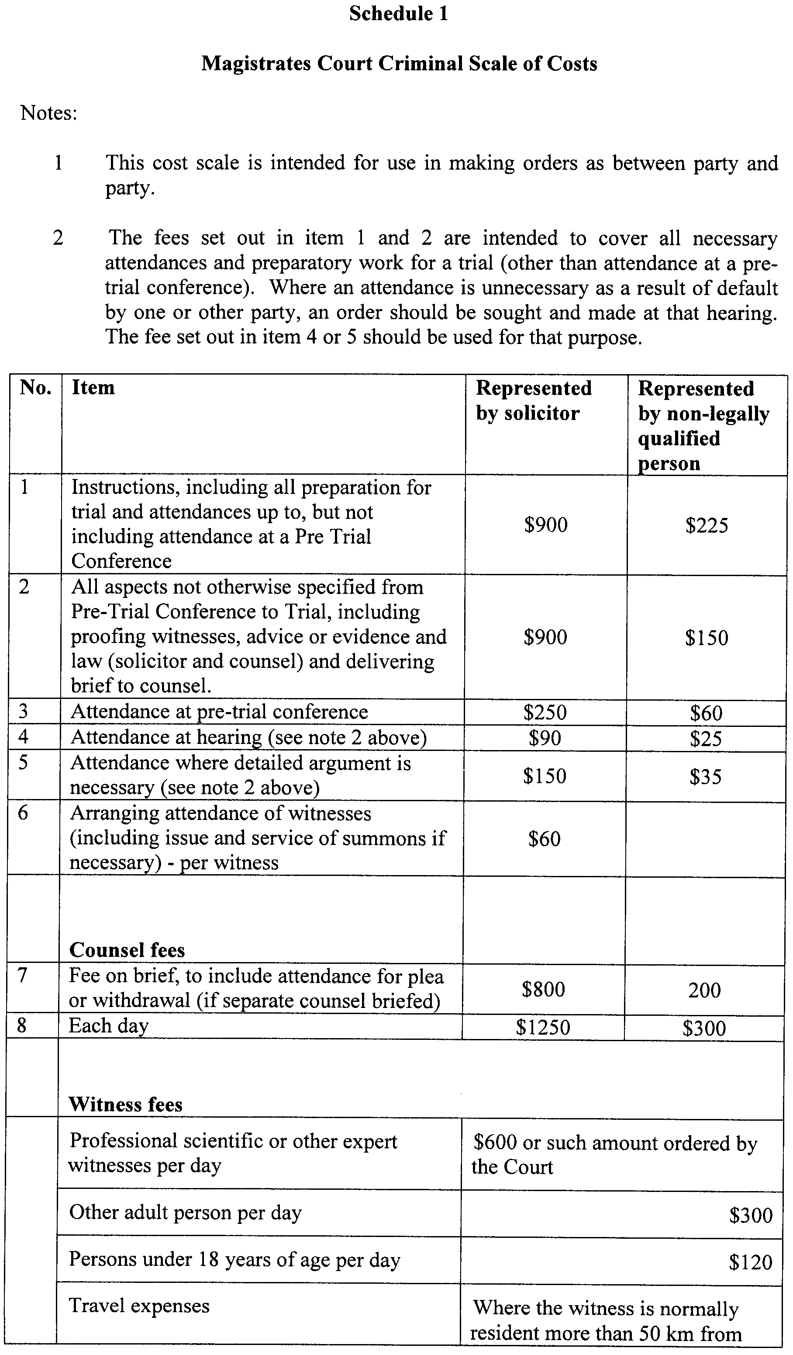
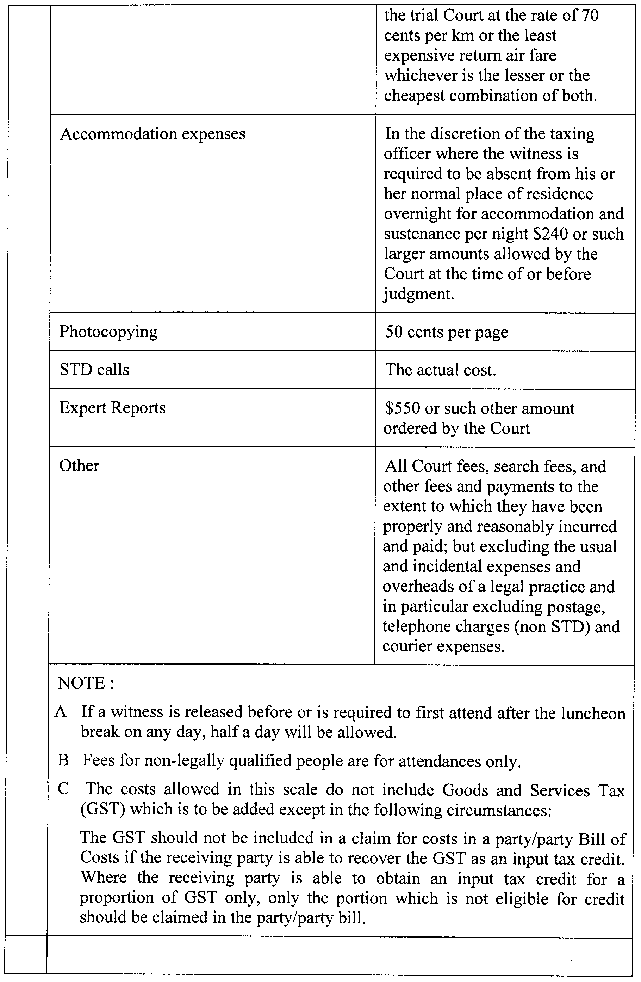
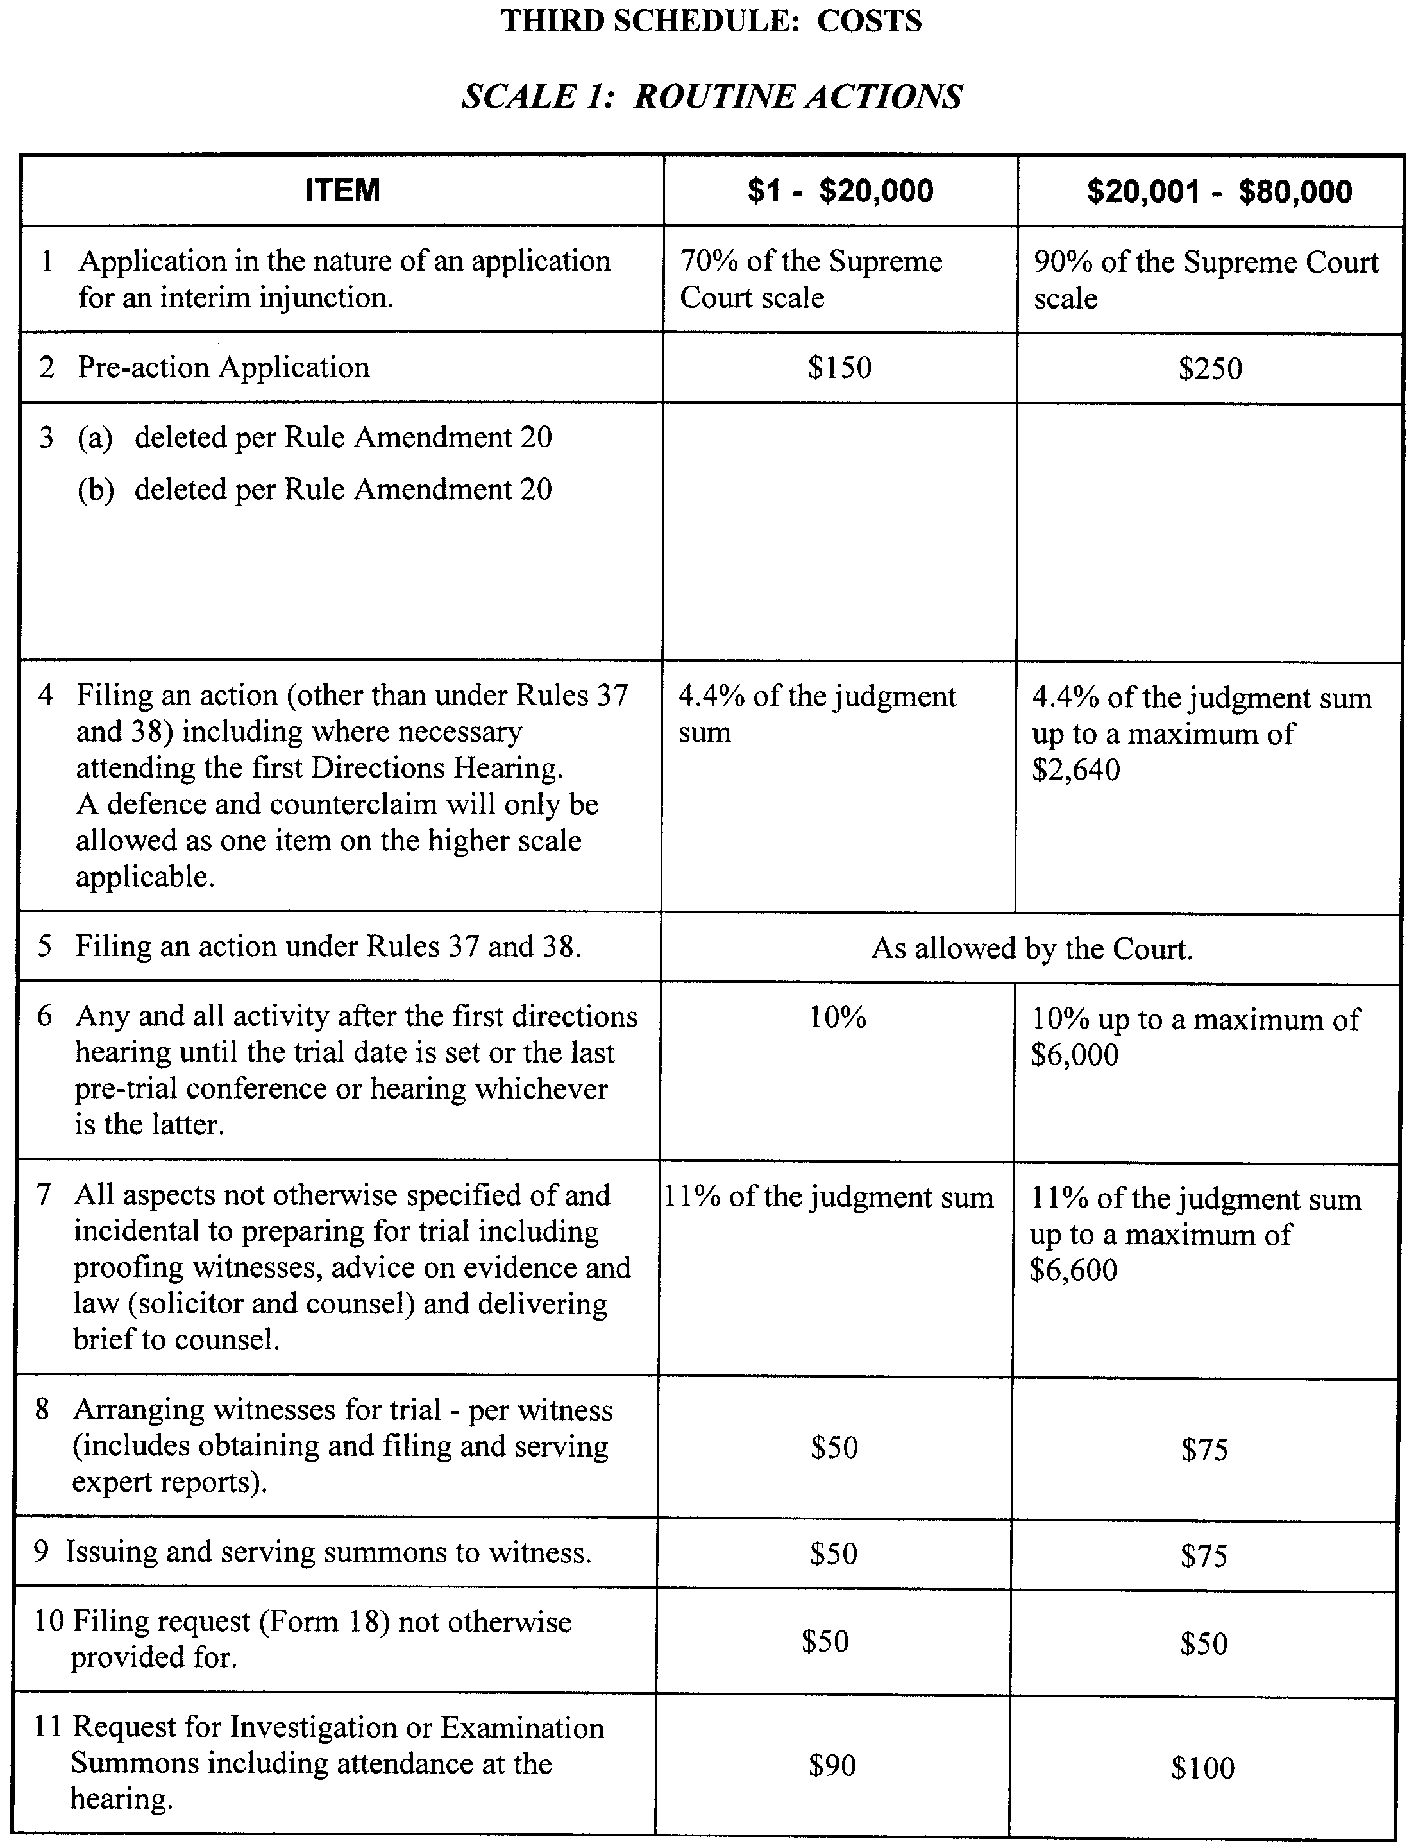
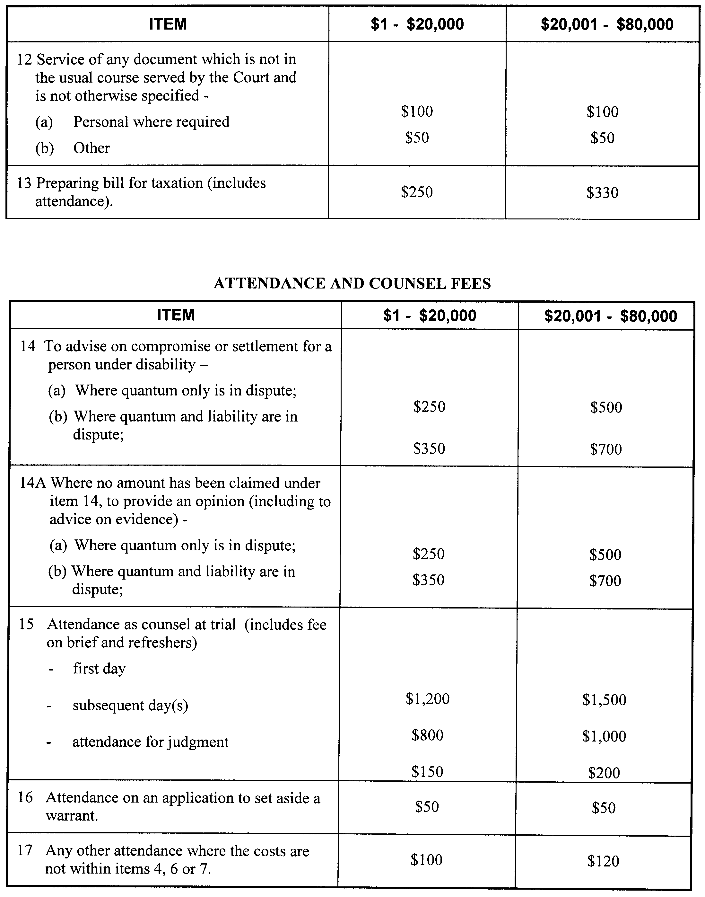
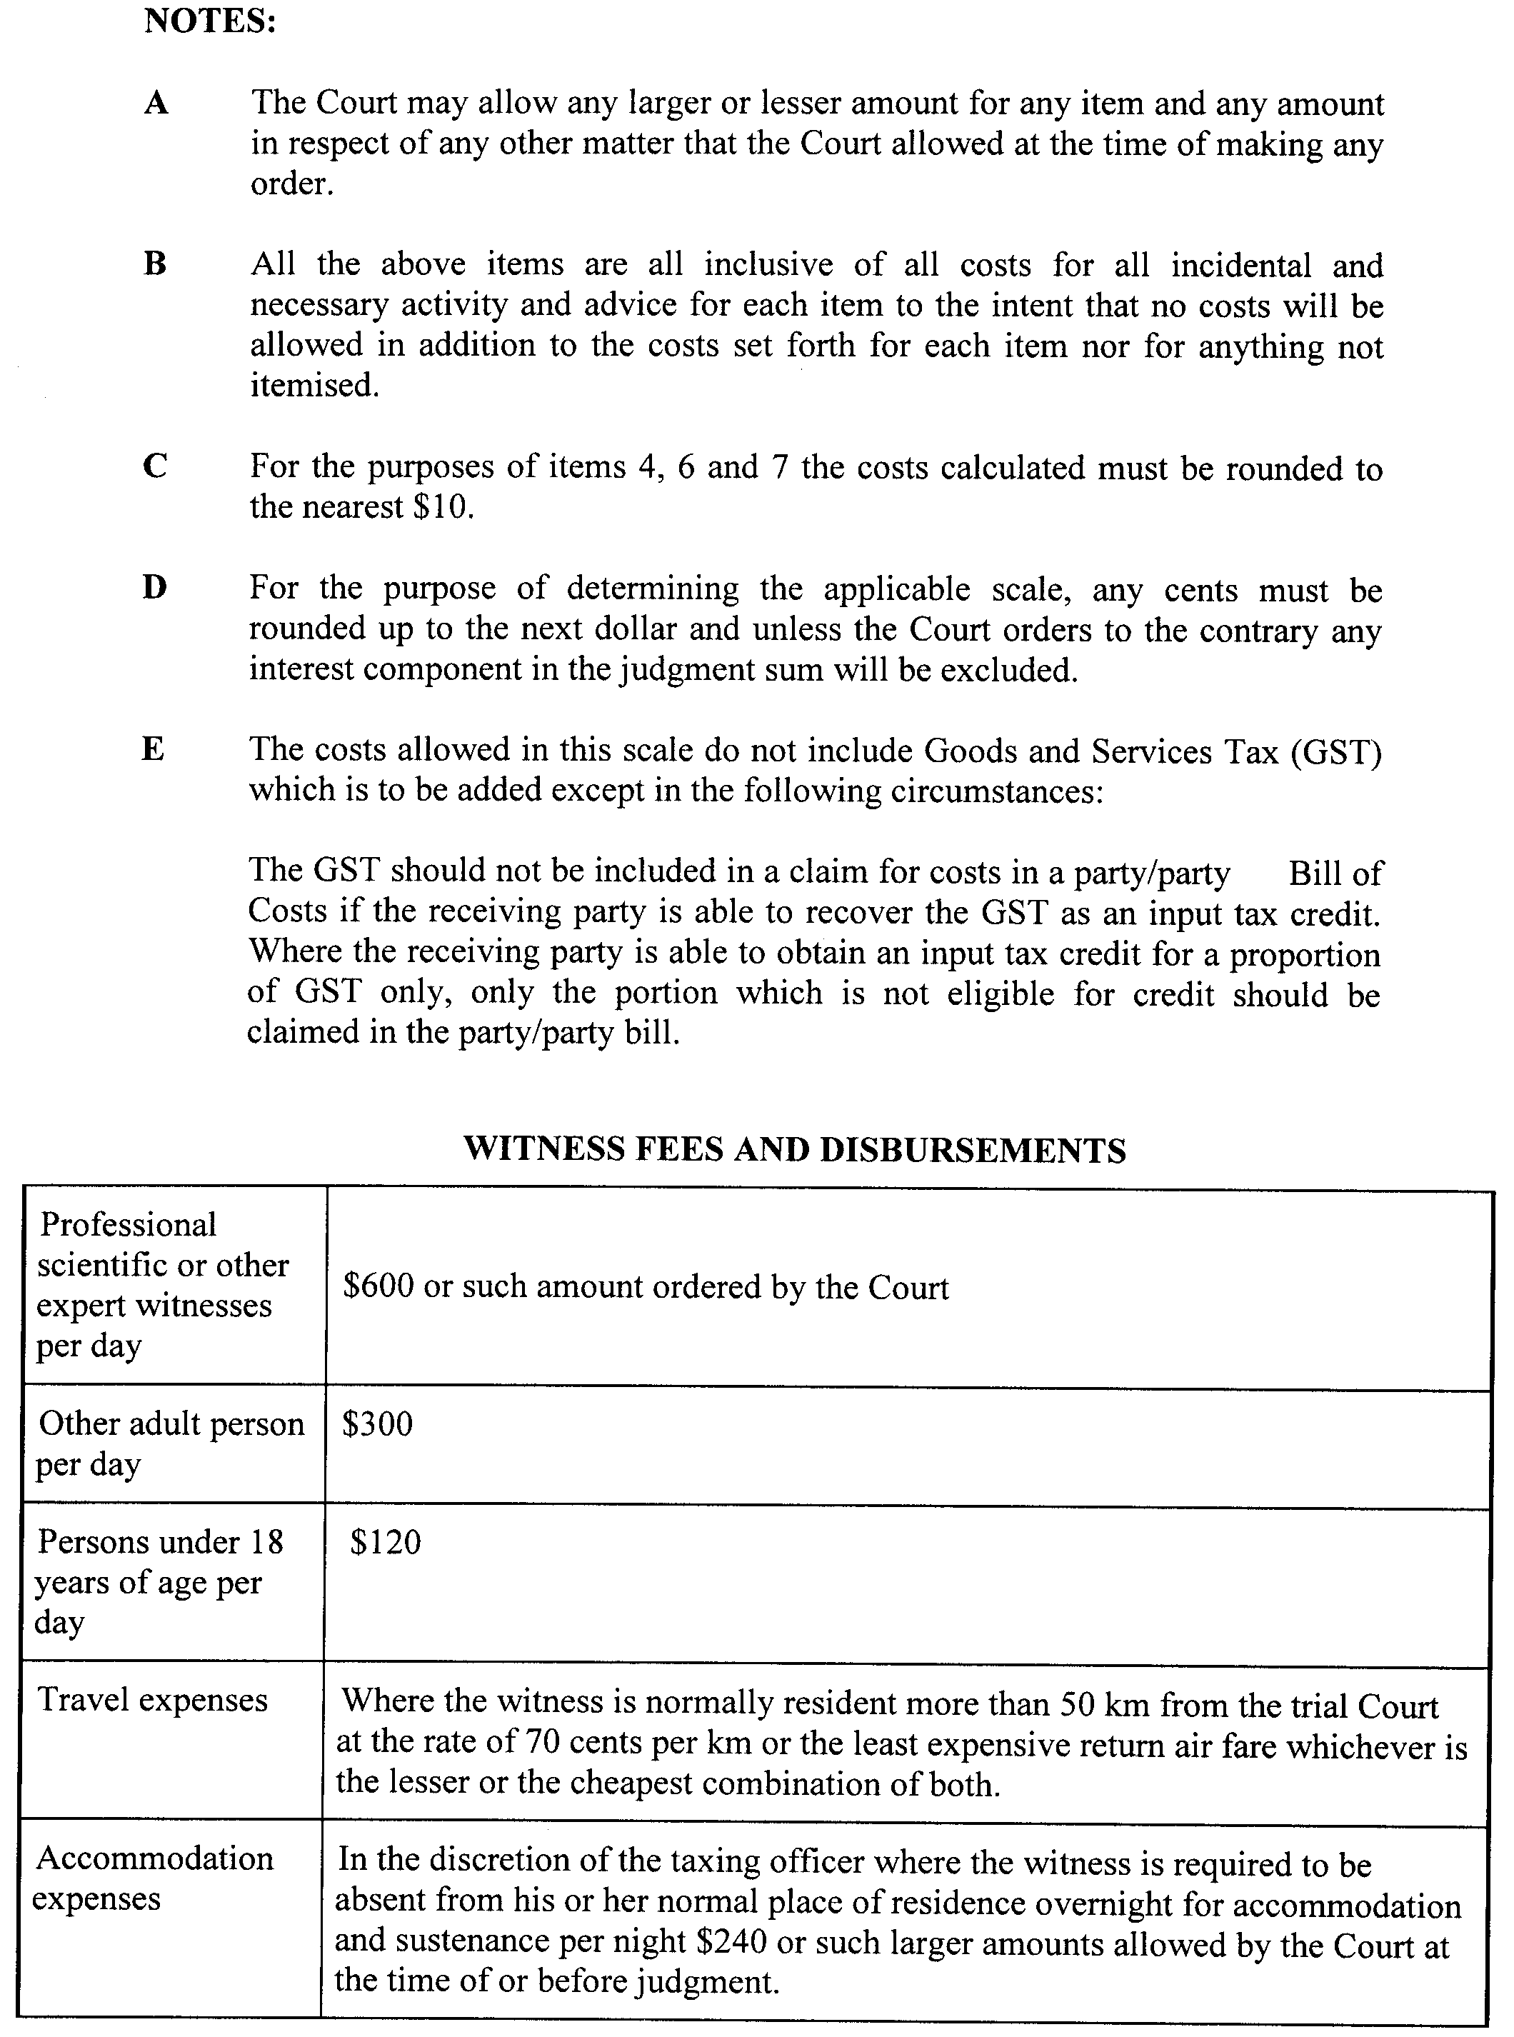
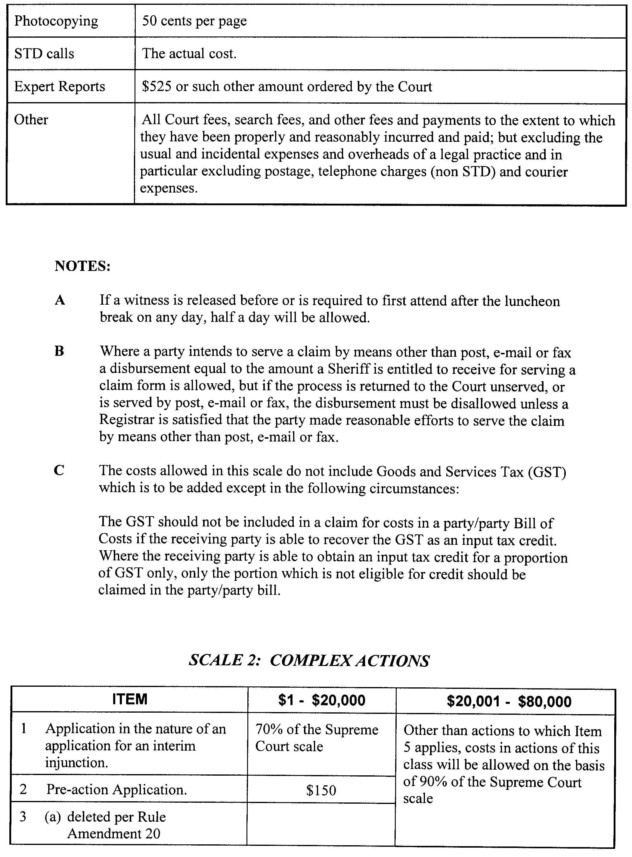
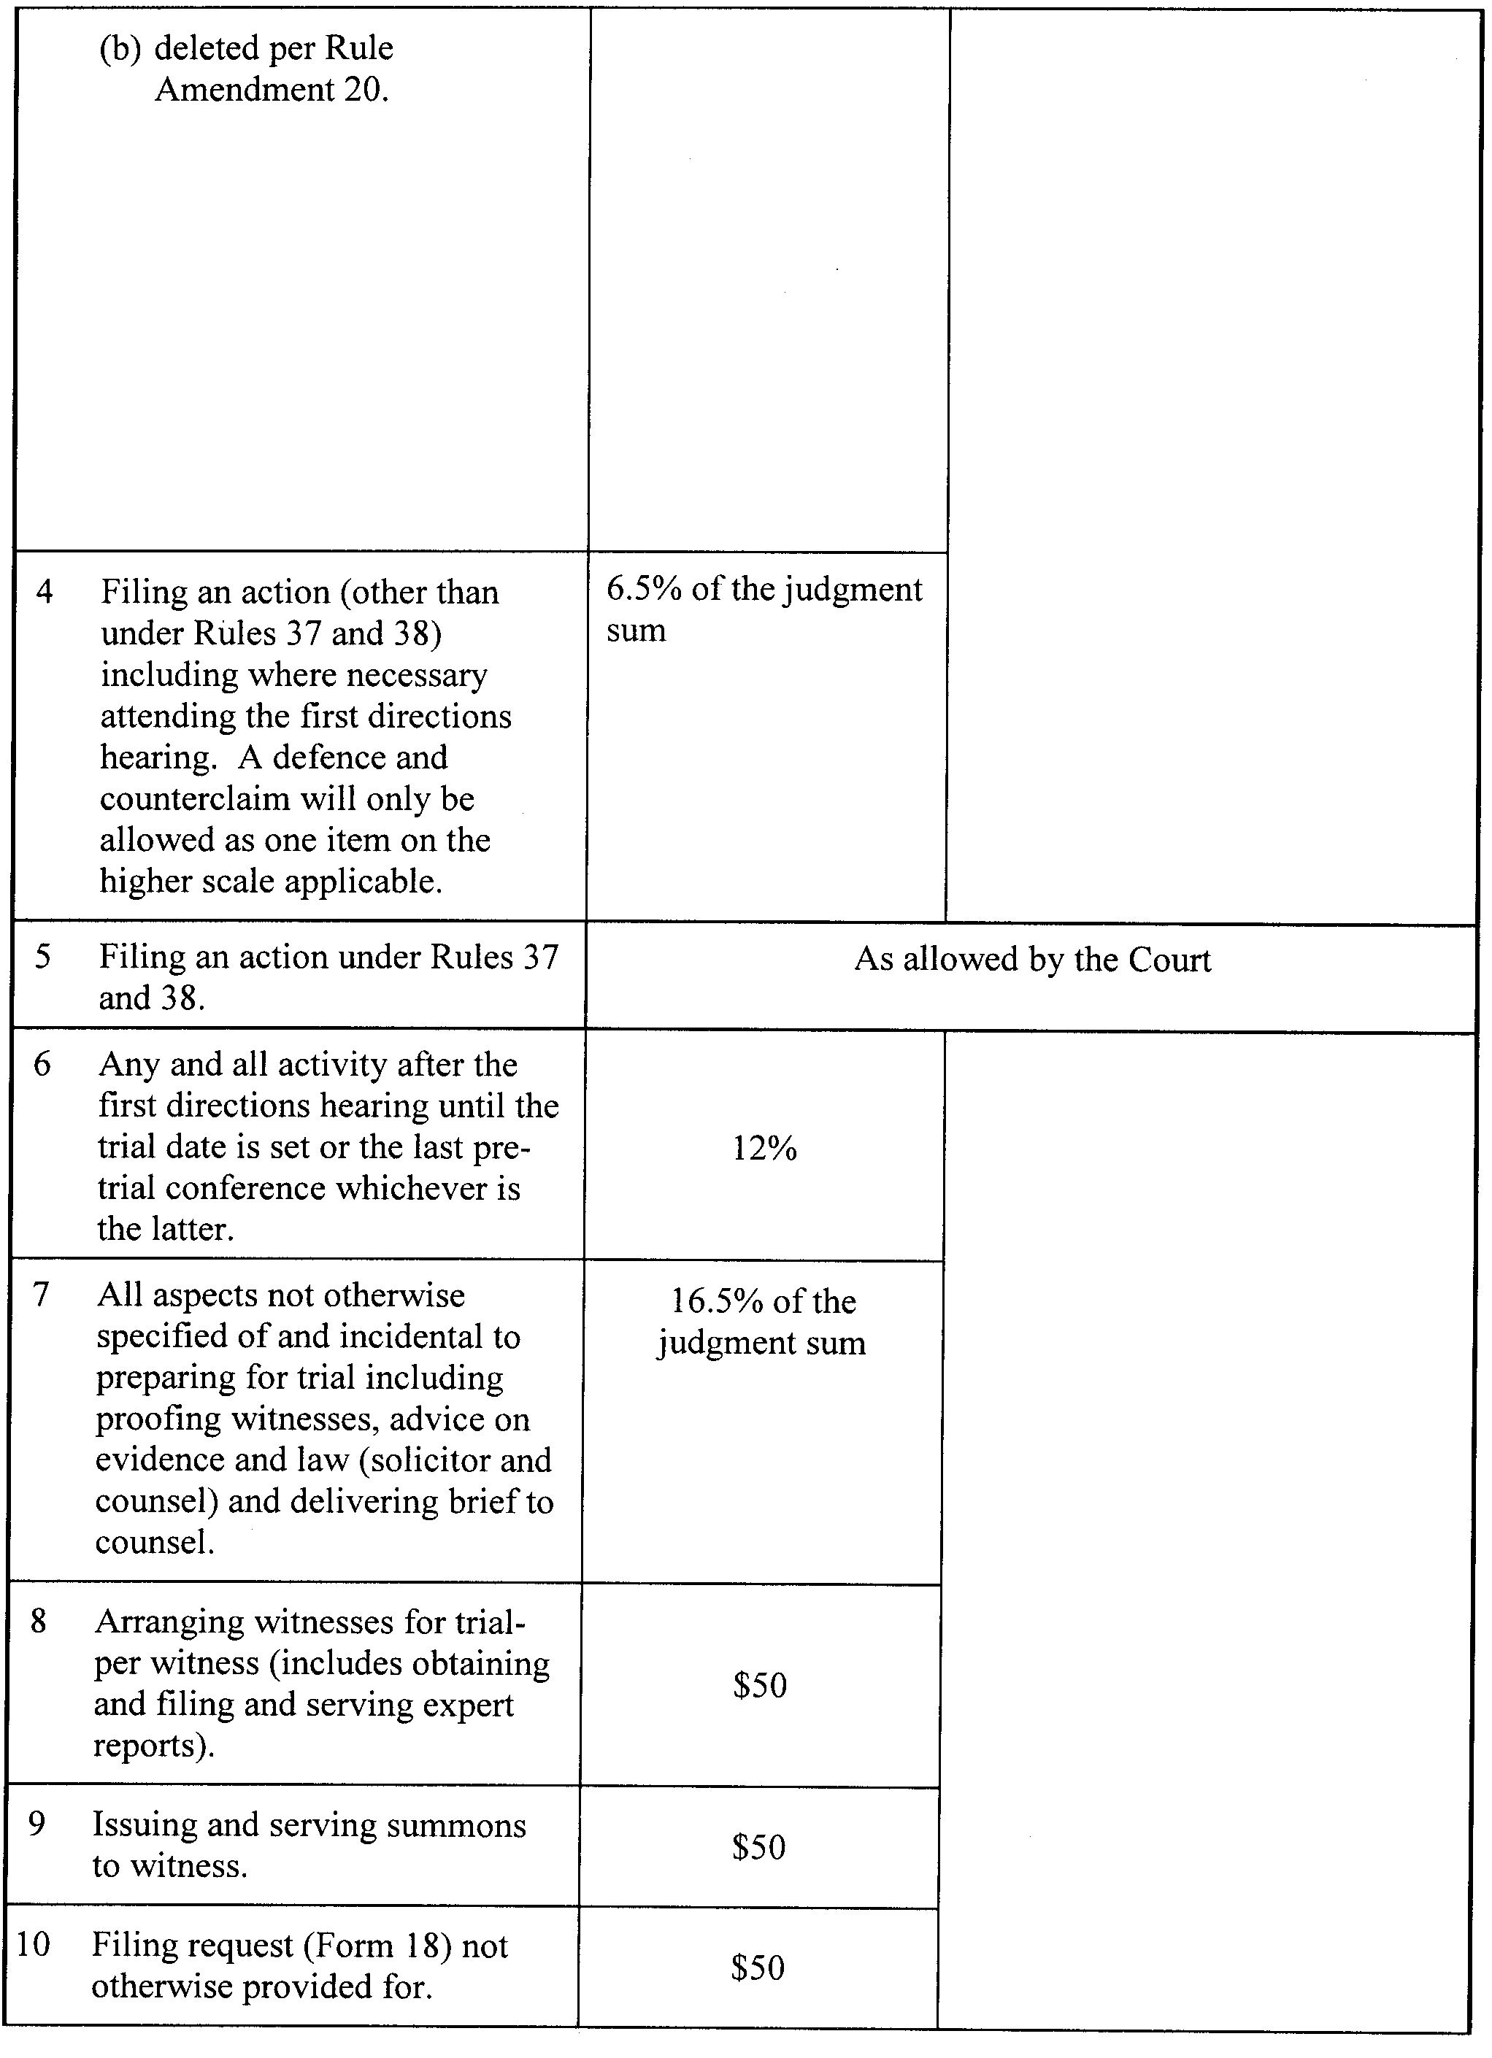
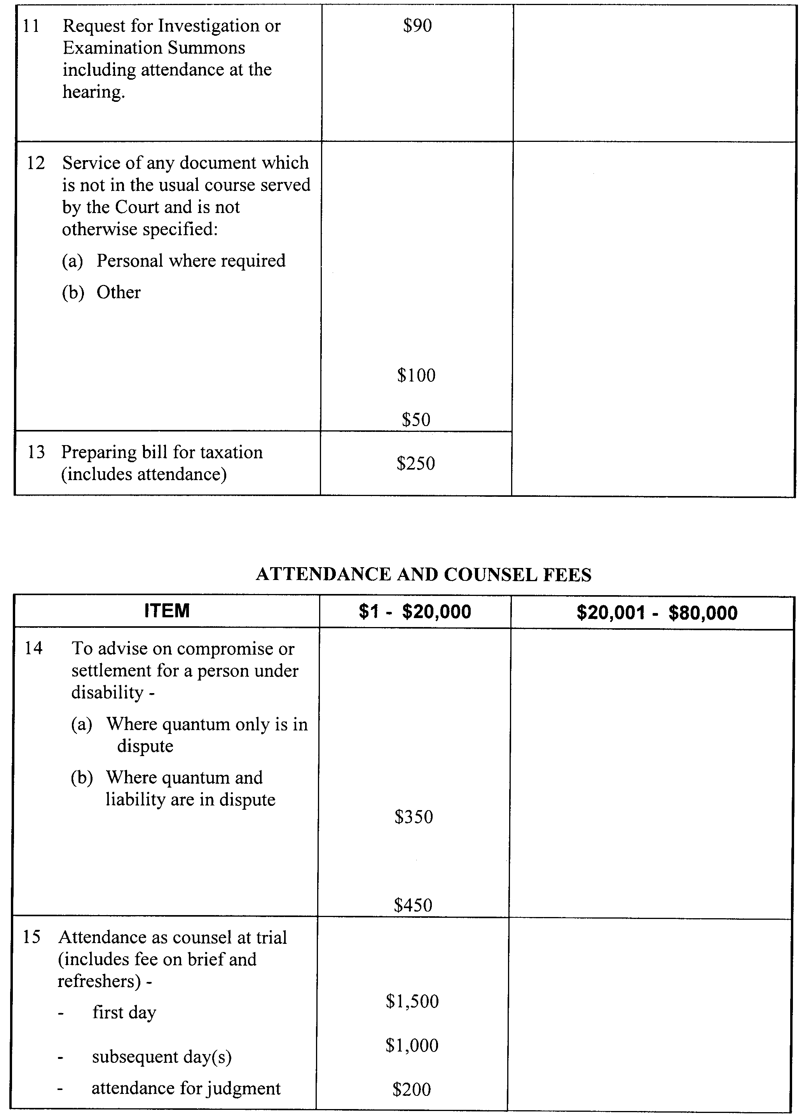
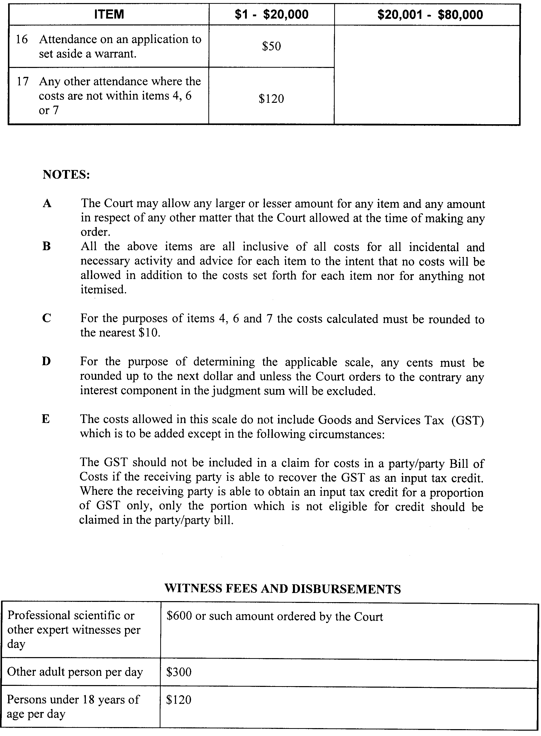
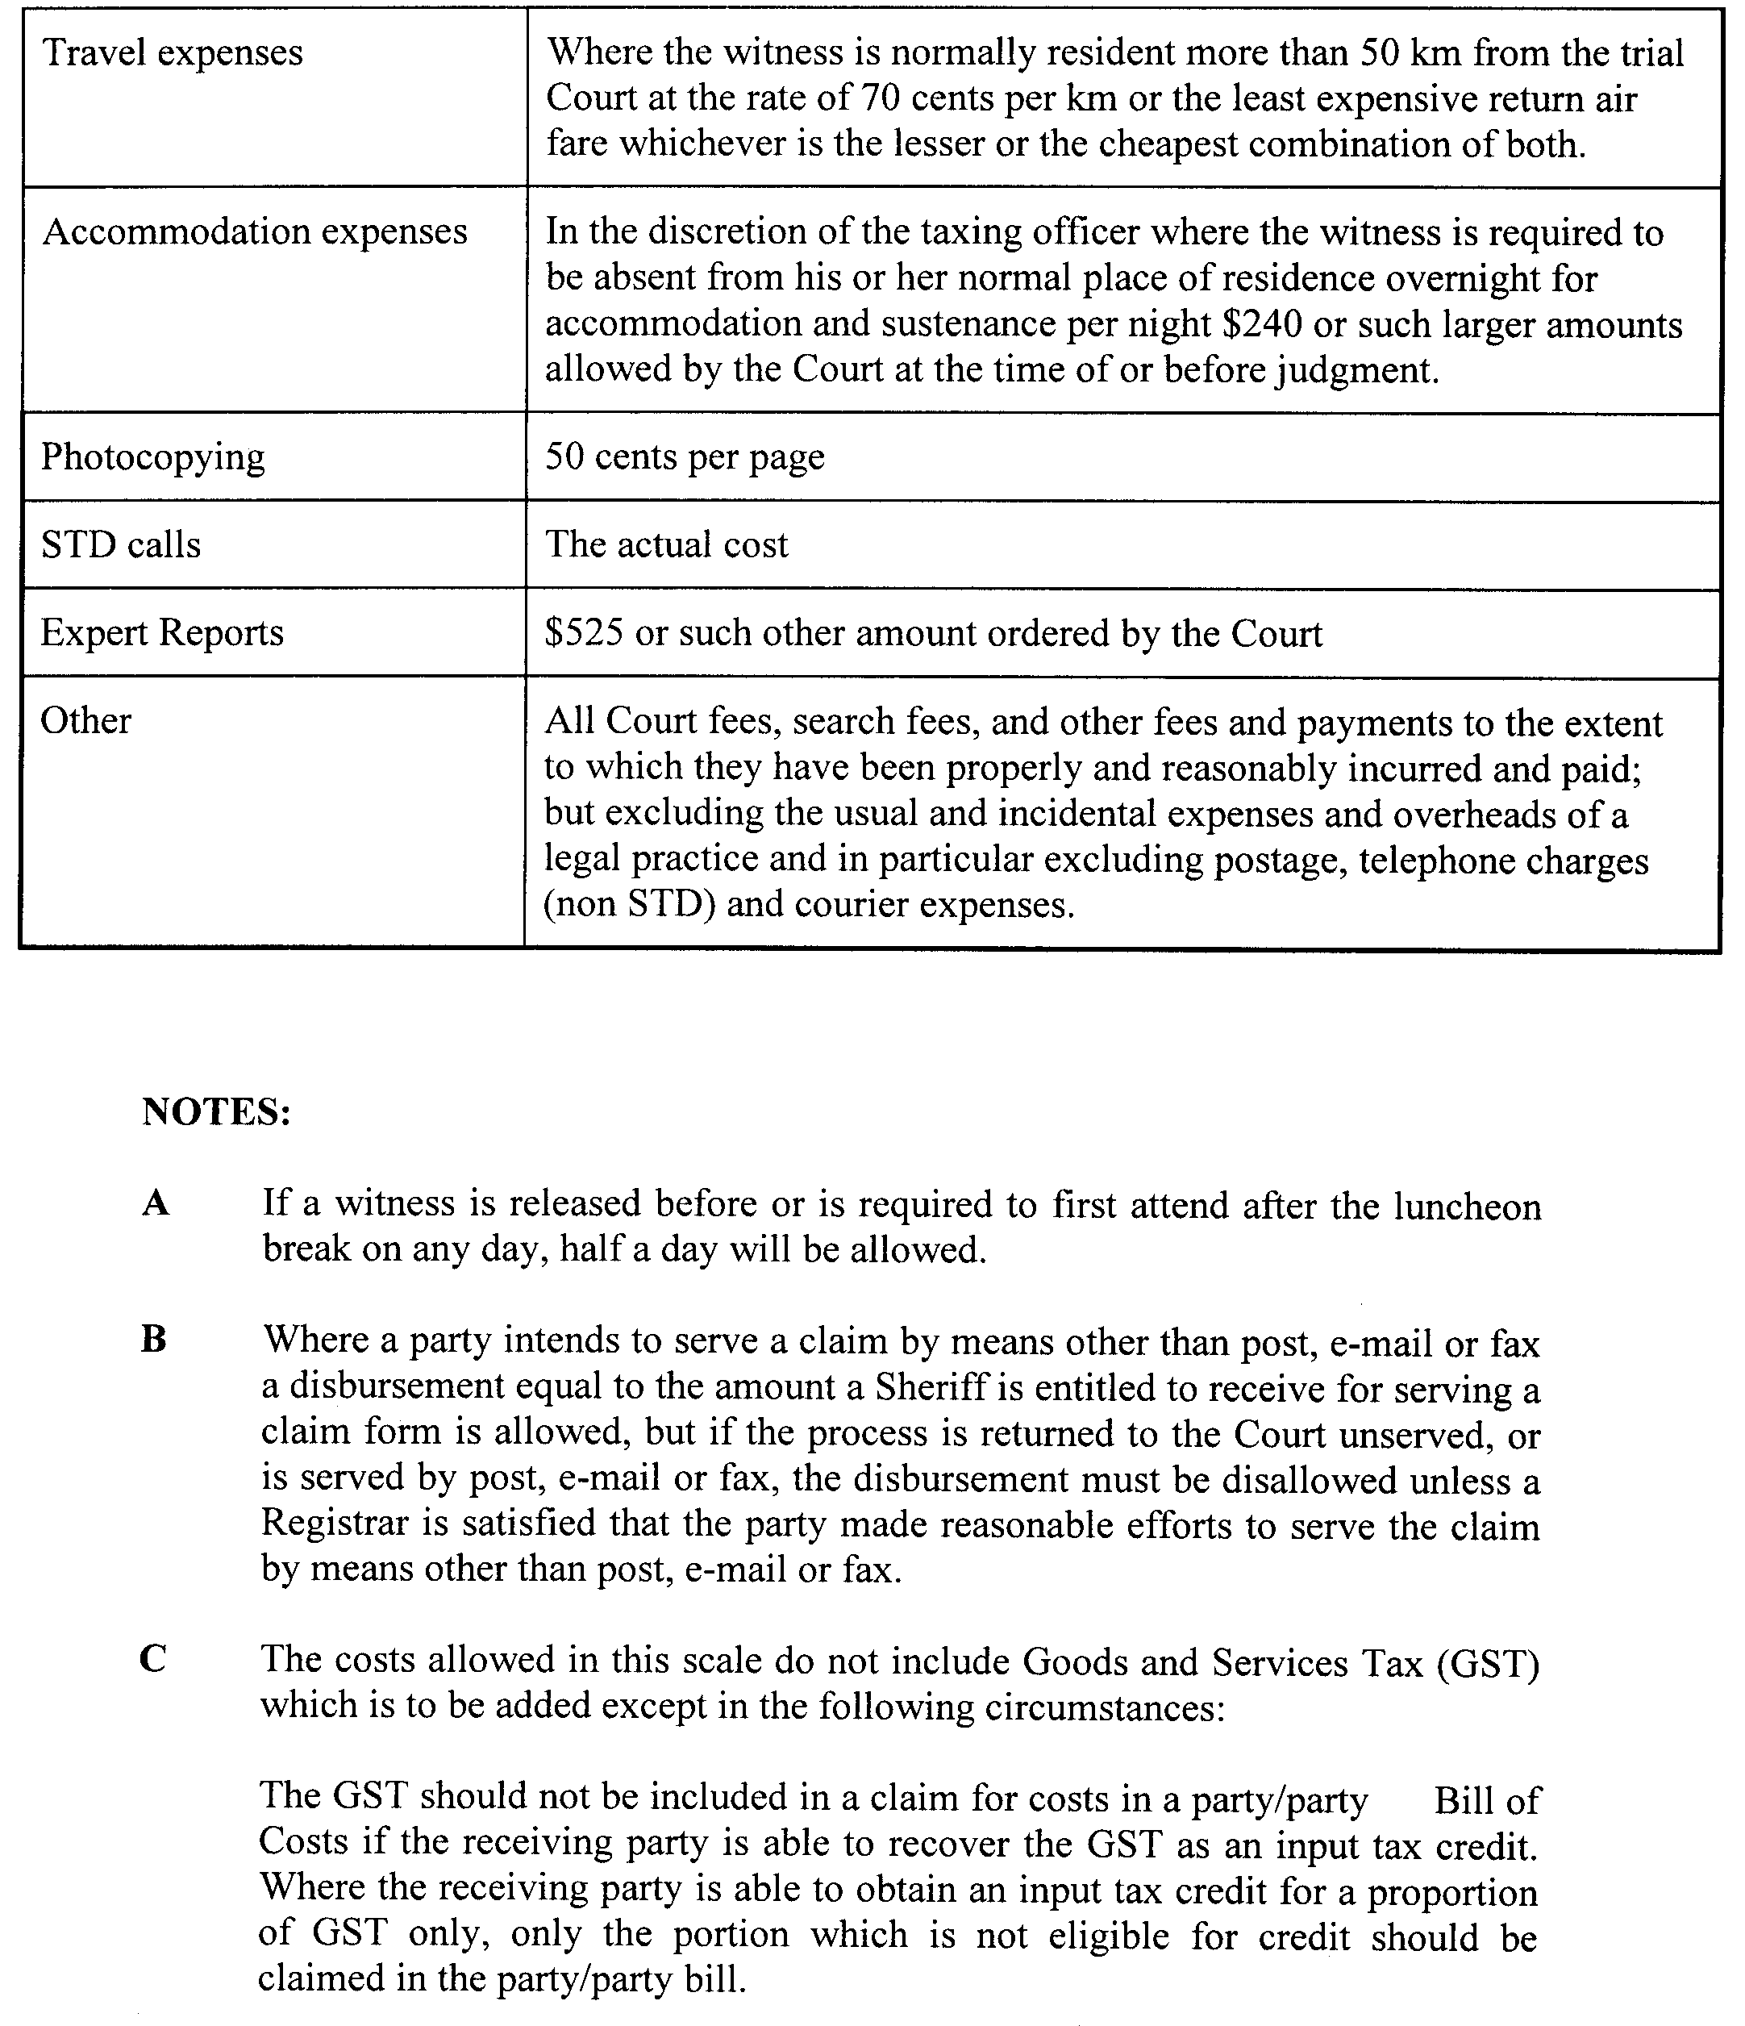
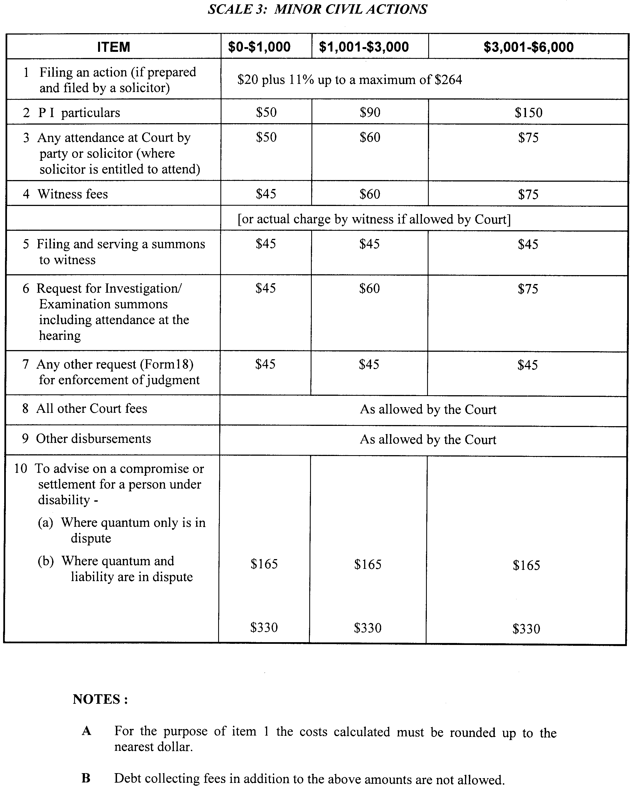
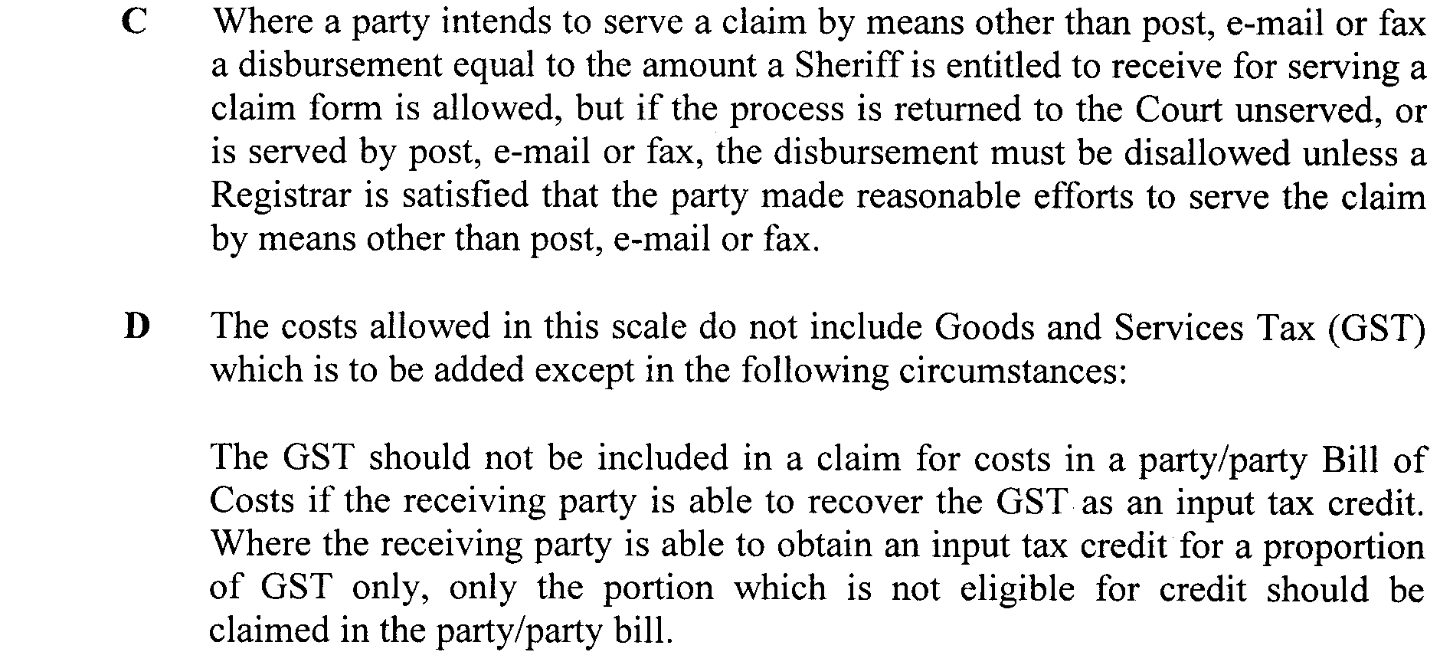
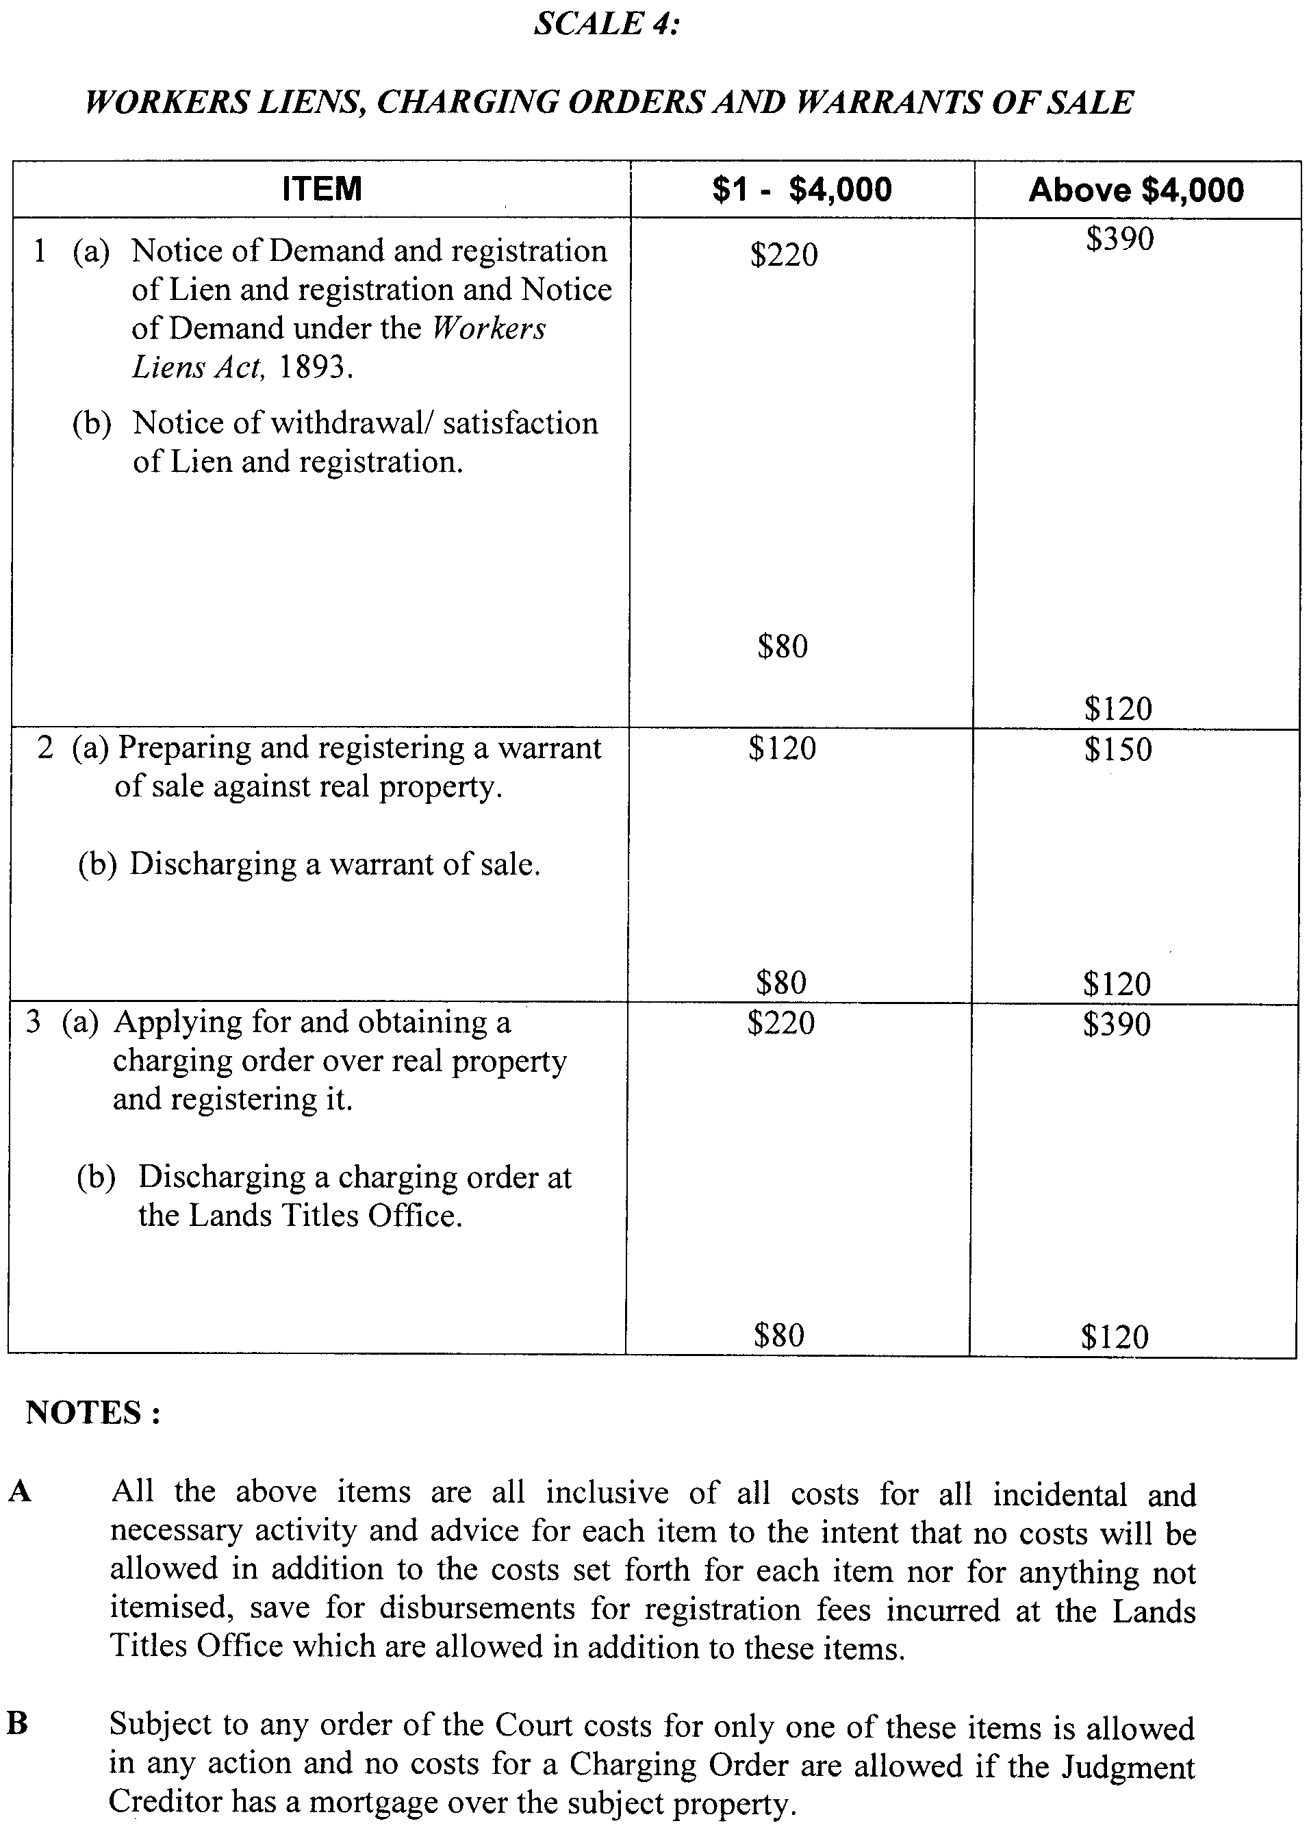
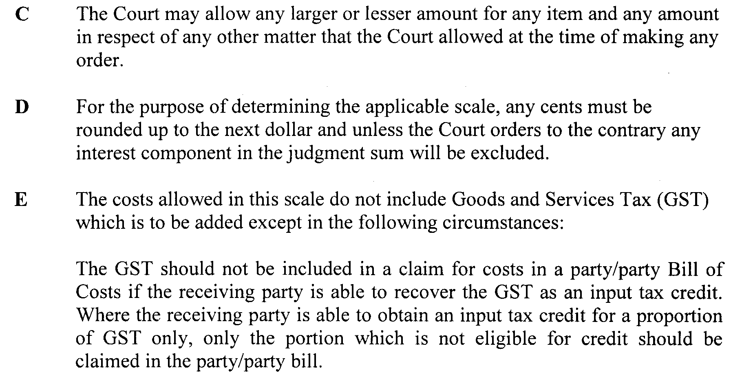
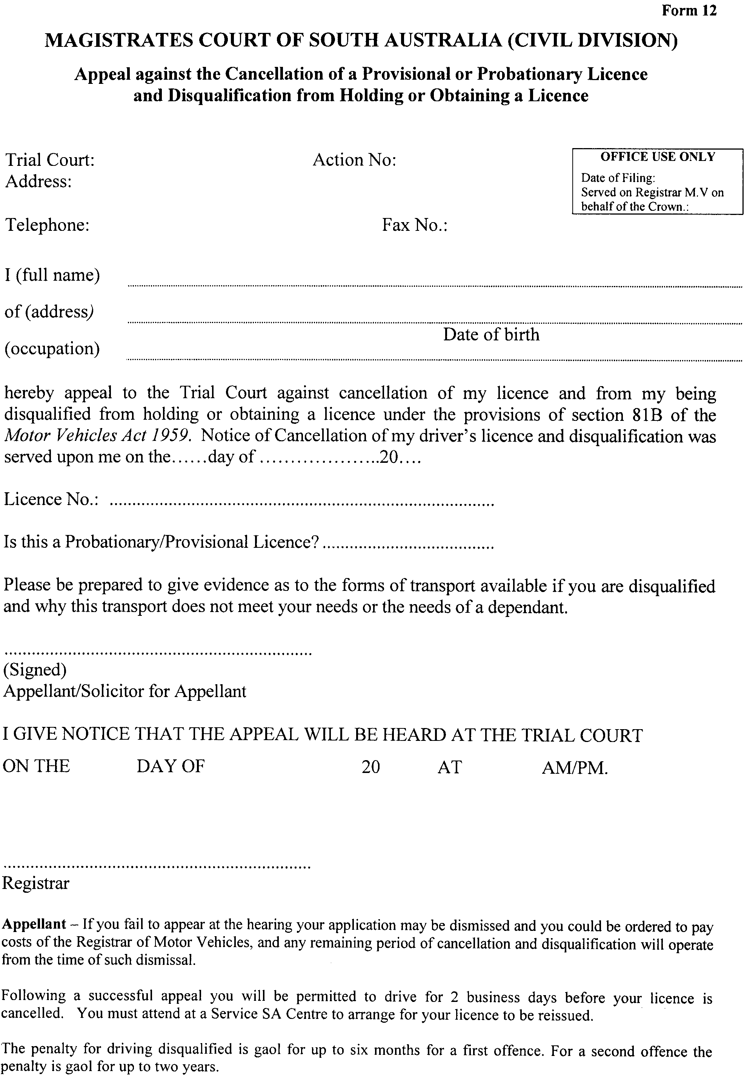

South Australia
Liquor Licensing (Dry Areas—Short Term) Variation Regulations 2010
under the Liquor Licensing Act 1997

Contents
Part 1—Preliminary
1 Short title
2 Commencement
3 Variation provisions
Part 2—Variation of Liquor Licensing (Dry Areas—Short Term) Regulations 1997
4 Variation of Schedule 1—Short term dry areas
5 Variation of Schedule 2—Plans of short term dry areas
Schedule 1—Plan to be inserted

Part 1—Preliminary
1—Short title
These regulations may be cited as the Liquor Licensing (Dry Areas—Short Term) Variation Regulations 2010.
2—Commencement
These regulations come into operation on the day on which they are made.
3—Variation provisions
In these regulations, a provision under a heading referring to the variation of specified regulations varies the regulations so specified.
Part 2—Variation of Liquor Licensing (Dry Areas—Short Term) Regulations 1997
4—Variation of Schedule 1—Short term dry areas
(1) Schedule 1, item headed "Coffin Bay—Area 1"—delete "(there is no plan for this area)" and substitute:
(see Schedule 2: Coffin Bay—Plan 1)

(2) Schedule 1, item headed "Coffin Bay—Area 1", column headed "Period"—delete "5 pm on 31 December 2009 to 9 am on 1 January 2010." and substitute:
5 pm on 31 December 2010 to 9 am on 1 January 2011.
5—Variation of Schedule 2—Plans of short term dry areas
Schedule 2—after the plan headed "Beachport—Plan 1" insert the plan headed "Coffin Bay—Plan 1" in Schedule 1 of these regulations
Schedule 1—Plan to be inserted
Coffin Bay—Plan 1
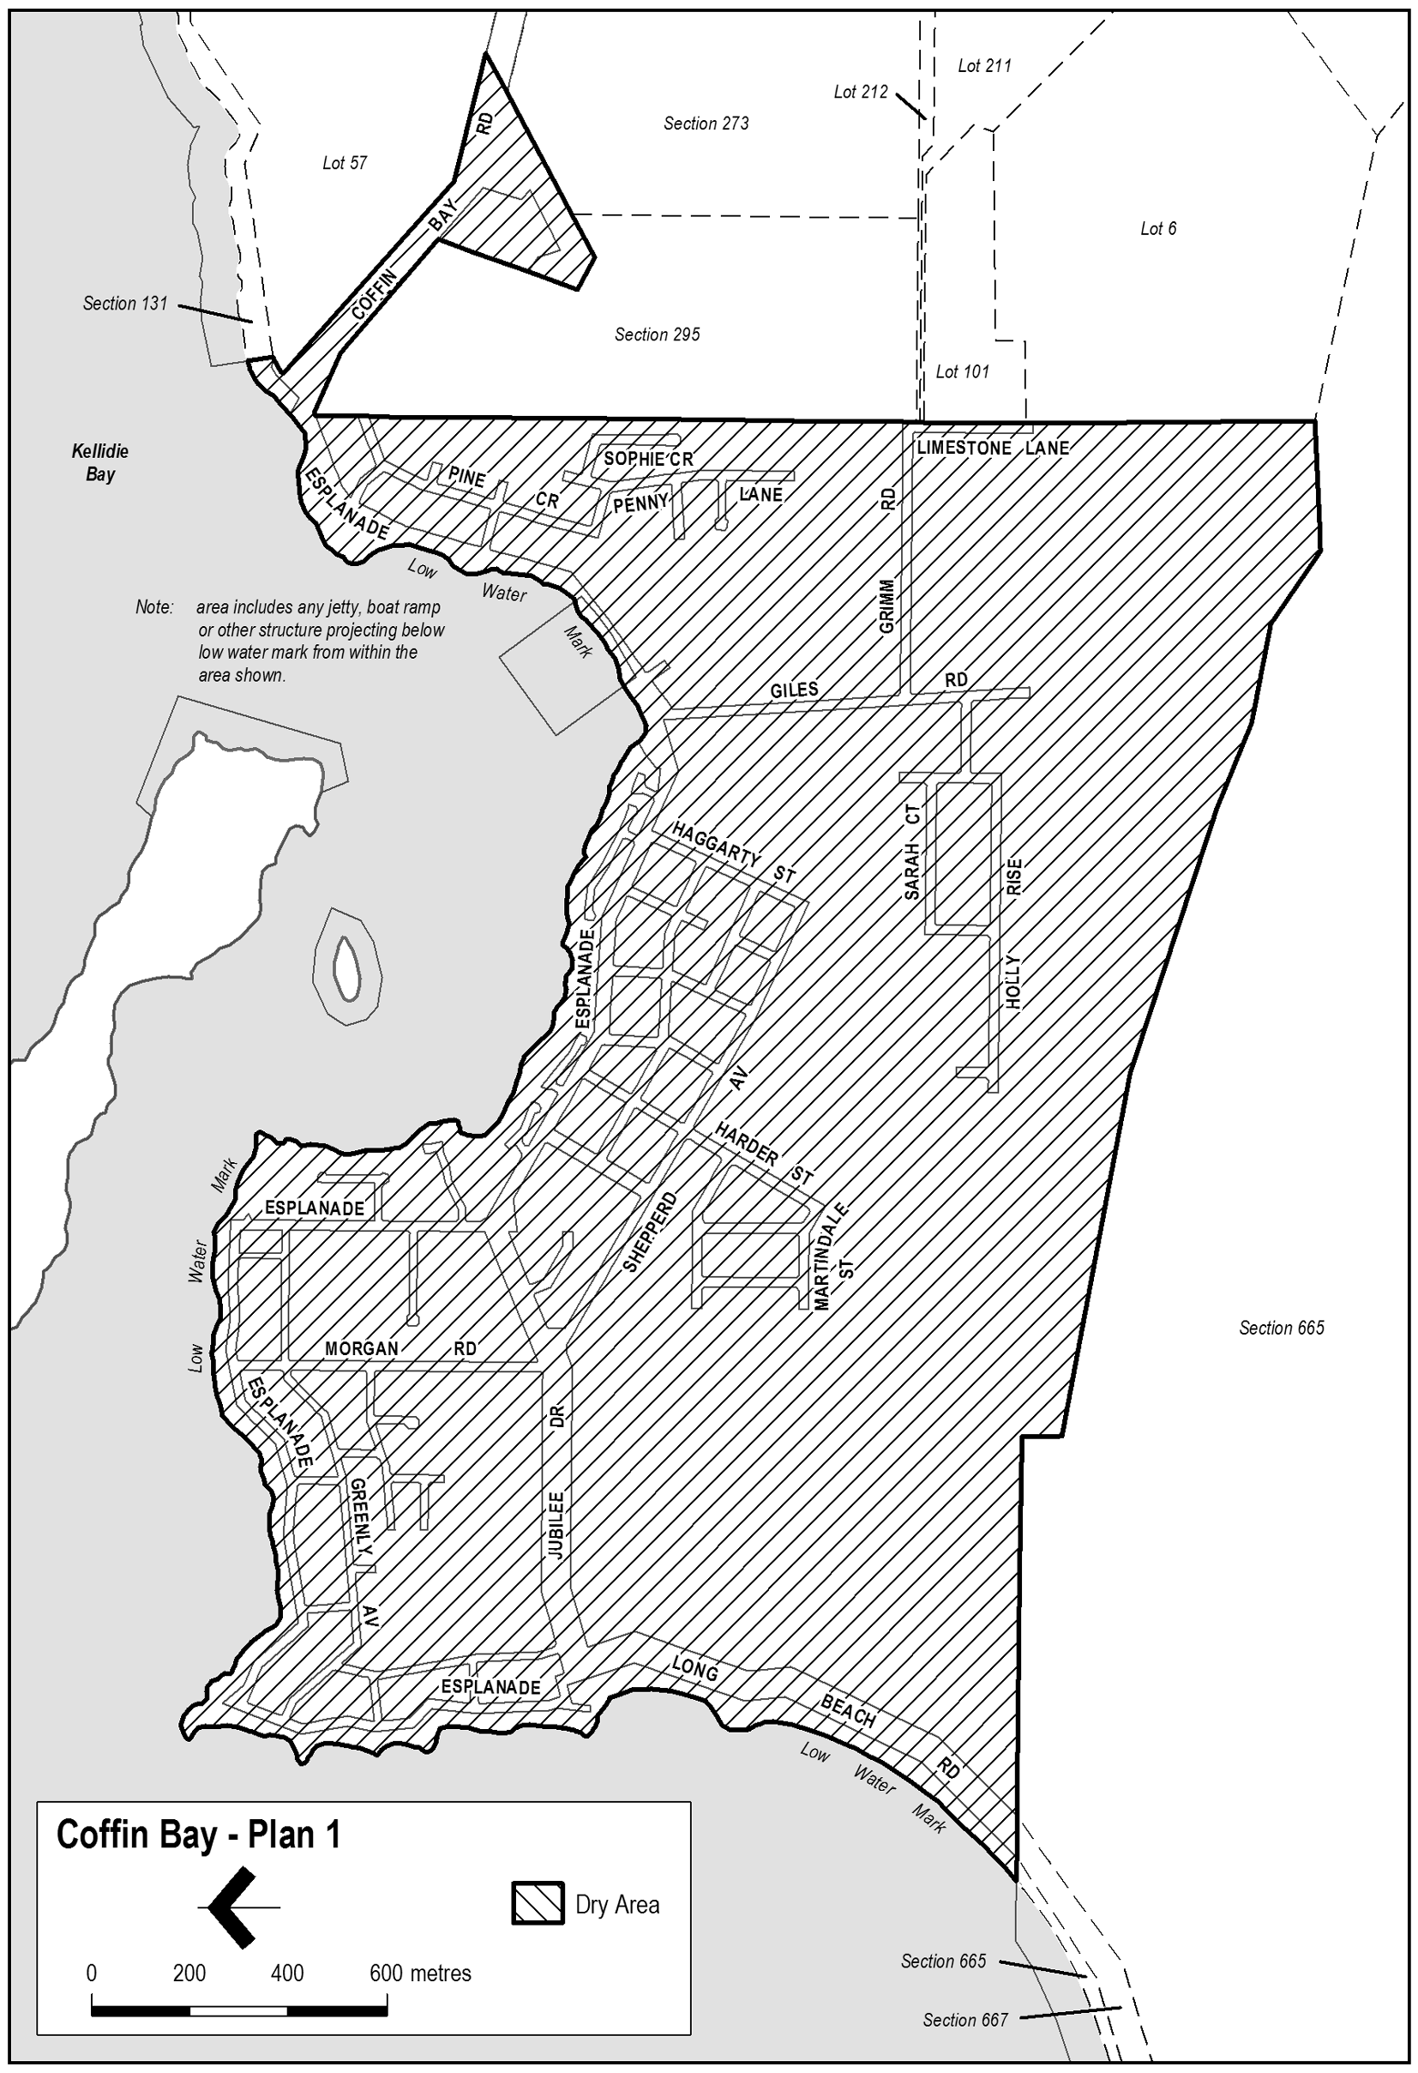
Note—
As required by section 10AA(2) of the Subordinate Legislation Act 1978, the Minister has certified that, in the Minister's opinion, it is necessary or appropriate that these regulations come into operation as set out in these regulations.
Made by the Governor
with the advice and consent of the Executive Council
on 7 October 2010
No 209 of 2010
10MCA0029CS

South Australia
Liquor Licensing (Dry Areas—Short Term) Variation Regulations 2010
under the Liquor Licensing Act 1997

Contents
Part 1—Preliminary
1 Short title
2 Commencement
3 Variation provisions
Part 2—Variation of Liquor Licensing (Dry Areas—Short Term) Regulations 1997
4 Variation of Schedule 1—Short term dry areas

Part 1—Preliminary
1—Short title
These regulations may be cited as the Liquor Licensing (Dry Areas—Short Term) Variation Regulations 2010.
2—Commencement
These regulations come into operation on the day on which they are made.
3—Variation provisions
In these regulations, a provision under a heading referring to the variation of specified regulations varies the regulations so specified.
Part 2—Variation of Liquor Licensing (Dry Areas—Short Term) Regulations 1997
4—Variation of Schedule 1—Short term dry areas
Schedule 1, item headed "Semaphore—Area 1", column headed "Period", (a), (b)—delete paragraphs (a) and (b) and substitute:
(a) 12 noon on 31 December 2010 to 12 noon on 1 January 2011;
(b) 12 noon on 26 January 2011 to 12 noon on 27 January 2011.

Note—
As required by section 10AA(2) of the Subordinate Legislation Act 1978, the Minister has certified that, in the Minister's opinion, it is necessary or appropriate that these regulations come into operation as set out in these regulations.
Made by the Governor
with the advice and consent of the Executive Council
on 7 October 2010
No 210 of 2010
10MCA0035CS

FAXING COPY?
IF you fax copy to Government Publishing SA for inclusion in the Government Gazette, there is no need to send a Confirmation Copy to us as well.
This creates confusion and may well result in your notice being printed twice.
Please use the following fax number:
Fax transmission: (08) 8207 1040
Phone Inquiries: (08) 8207 1045
Please include a contact person, phone number and order number so that we can phone back with any queries we may have regarding the fax copy.
NOTE: Closing time for lodging new copy (fax, hard copy or email) is 4 p.m. on Tuesday preceding the day of publication.

Government Gazette notices can be E-mailed.
The address is:
governmentgazette@dpc.sa.gov.au
Documents should be sent as attachments in Word format.
When sending a document via E-mail, please confirm your transmission with a faxed copy of your document, including the date the notice is to be published.
Fax transmission: (08) 8207 1040
Enquiries: (08) 8207 1045
NOTE: Closing time for lodging new copy (fax, hard copy or email) is 4 p.m. on Tuesday preceding the day of publication.

ADELAIDE HILLS COUNCIL
Proposed Road Naming of Sires Road, Kersbrook
NOTICE is hereby given that the Adelaide Hills Council resolved at its meeting held on 7 September 2010, to change/rename the two sections of road known as Sires Road to Sires Road West, and Sires Road East, Kersbrook.
The change of name on this road is a result of the Local Government and State Government’s Rural Property Addressing Program which is to simplify property addressing within rural areas for better access of emergency and delivery services.
Location maps are enclosed along with an excerpt from the Council meeting minutes.
If you have any further queries, please do not hesitate to contact me on 8408 0540.
P. J. Muller, Technical Officer

DISTRICT COUNCIL OF MOUNT BARKER
Assigning a Road Name
NOTICE is hereby given that pursuant to section 219 of the Local Government Act 1999, Council has resolved to name and assign road names within the District Council of Mount Barker to the following government road:
That the name Firestone Road be assigned to a currently unknown public road that runs in a south-west direction, from Peggy Buxton Road to Piney Ridge Road, within the locality of Brukunga.
A. Stuart, Chief Executive Officer

WATTLE RANGE COUNCIL
Revocation of Community Land Classification
Millicent Walkways
NOTICE is hereby given that at a meeting of the Wattle Range Council, held on Tuesday, 14 September 2010 and following approval of the Minister for State Local Government Relations pursuant to section 194 (1) (d) of the Local Government Act 1999, the Council resolved to revoke the following land from Classification as Community Land in accordance with section 194 (3) (b) of the Local Government Act 1999:
• The walkways between Holzgrefe Street and Bowman Streets, and Bowman Street and Smith Street, Millicent being Allotment 197 in Deposited Plan 7843, Allotments 167 and 168 in Deposited Plan 7681 and Allotment 144 in Deposited Plan 7445 and contained in certificate of title volume 3154, folio 184.
The revocation of this land from Classification as Community Land is to provide for the land to be declared to be public road.
F. N. Brennan, Chief Executive Officer

WATTLE RANGE COUNCIL
Declaration of Public Road
Millicent Walkways
NOTICE is hereby given that the Wattle Range Council at its meeting held on 14 September 2010, in accordance with the provisions of section 208 of the Local Government Act 1999, declared the walkways between Holzgrefe Street and Bowman Streets, and Bowman Street and Smith Street, Millicent being Allotment 197 in Deposited Plan 7843, Allotments 167 and 168 in Deposited Plan 7681 and Allotment 144 in Deposited Plan 7445 and contained in certificate of title volume 3154, folio 184 to be public road.
F. N. Brennan, Chief Executive Officer

WATTLE RANGE COUNCIL
Revocation of Authorisation
NOTICE is hereby given that in accordance with the powers delegated by Wattle Range Council, Francis Newman Brennan, Chief Executive Officer has duly revoked all previous appointments made by the Wattle Range Council to Deborah Anne Kelly.
F. N. Brennan, Chief Executive Officer

DISTRICT COUNCIL OF YORKE PENINSULA
Appointment of Acting Chief Executive Officer
NOTICE is hereby given that Trevor Dean Graham has been appointed Acting Chief Executive Officer for the period from
25 October 2010 (inclusive), until the commencement of duties of the incoming new Chief Executive Officer at a date to be determined.
R. K. Bruhn, Chief Executive Officer

IN the matter of the estates of the undermentioned deceased persons:
Behrndt, Andrew John, late of 2 Alyssum Court, Para Hills West, gardener, who died on 26 October 2009.
Boehm, Dorothy Evangeline Alice, late of 9-13 Atze Parade, Nuriootpa, widow, who died on 15 August 2010.
Bunce, Barbara Pauline, late of Kennedy Court, Largs Bay, of no occupation, who died on 5 July 2010.
Gifford, Ivan Douglas, late of 60 States Road, Morphett Vale, retired diesel engineer, who died on 23 July 2010.
Higgs, John William, late of 43 Sportsmans Drive, West Lakes, retired wharfinger, who died on 15 August 2010.
Jackson, Joan Esther, late of 20 Caulfield Avenue, Cumberland Park, home duties, who died on 17 July 2010.
Leng, Marion Mary Ada, late of 2-16 Cardigan Street, Angle Park, of no occupation, who died on 23 June 2010.
Mander, Joan Florence, late of 18 Trafford Street, Angle Park, of no occupation, who died on 1 August 2010.
Marsh, Grace Evelyn, late of 47 Glen Osmond Road, Eastwood, widow, who died on 19 June 2010.
Old, Harry, late of Shackleton Avenue, Ingle Farm, retired bus driver, who died on 26 June 2010.
Rankin, Jeanette Ann, late of 34 Baradine Drive, Ingle Farm, home duties, who died on 2 July 2010.
Sappiatzer, Amy Jean, late of 16-24 Pennys Hill Road, Hackham, of no occupation, who died on 17 June 2010.
Williamson, Robert Scoresby, late of 42 Galloway Road, O’Sullivan Beach, retired business proprietor, who died on 6 August 2010.
Wilson, Margaret Laurel, late of 251 Payneham Road, Joslin, married woman, who died on 8 August 2010.
Notice is hereby given pursuant to the Trustee Act 1936, as amended, the Inheritance (Family Provision) Act 1972 and the Family Relationships Act 1975, that all creditors, beneficiaries, and other persons having claims against the said estates are required to send, in writing, to the Office of Public Trustee, G.P.O. Box 1338, Adelaide, S.A. 5001, full particulars and proof of such claims, on or before 5 November 2010, otherwise they will be excluded from the distribution of the said estates; and notice is also hereby given that all persons indebted to the said estates are required to pay the amount of their debts to the Public Trustee or proceedings will be taken for the recovery thereof; and all persons having any property belonging to the said estates are forthwith to deliver same to the Public Trustee.
Dated 7 October 2010.
P. J. Martin, Acting Public Trustee

ATTENTION

CUSTOMERS requiring a proof of their notice for inclusion in the Government Gazette, please note that the onus is on you to inform Government Publishing SA of any subsequent corrections.

For any corrections to your notice please phone 8207 1045 or Fax 8207 1040 before 4 p.m. on Wednesday.

If we do not receive any communication by 10 a.m. on Thursday (day of publication) we will presume the notice is correct and will print it as it is.

Remember—the onus is on you to inform us of any corrections necessary to your notice.

NOTE: Closing time for lodging new copy (electronically, fax or hard copy) is 4 p.m. on Tuesday preceding the day of publication.
Phone: 8207 1045
Fax: 8207 1040
Email: governmentgazette@dpc.sa.gov.au

Printed and published by authority every Thursday by B. MORRIS, Government Printer, South Australia
Price: $6.05, plus postage; to subscribers, $306.00 per annum.
(The above prices are inclusive of GST)

