No. 74 5113

THE SOUTH AUSTRALIAN

GOVERNMENT GAZETTE
www.governmentgazette.sa.gov.au

PUBLISHED BY AUTHORITY

ALL PUBLIC ACTS appearing in this GAZETTE are to be considered official, and obeyed as such

ADELAIDE, THURSDAY, 21 OCTOBER 2010

CONTENTS

Page
Appointments, Resignations, Etc. 5114
Associations Incorporation Act 1985—Notices 5114
Corporations and District Councils—Notices 5150
Development Act 1993—Notices 5116
Fisheries Management Act 2007—Notices 5124
Geographical Names Act 1991—Notice 5124
Liquor Licensing Act 1997—Notices 5124
Motor Vehicles (Approval of Motor Bikes and Motor Trikes) Notice 2010 5132
National Electricity Law—Notice 5129
National Parks and Wildlife (National Parks) Regulations
2001—Notices 5129
Petroleum and Geothermal Energy Act 2000—
Notices 5129
Public Trustee Office—Administration of Estates 5151
REGULATION
Liquor Licensing Act 1997 (No. 213 of 2010) 5145
Remuneration Tribunal, Determination of 5114
Roads (Opening and Closing) Act 1991—Notices 5130
Security and Investigation Agents Act 1995—Notice 5131
Sewerage Act 1929—Notice 5131
Transport, Department of—Notice to Mariners 5131
Waterworks Act 1932—Notice 5131

GOVERNMENT GAZETTE NOTICES
ALL poundkeepers’ and private advertisements forwarded for publication in the South Australian Government Gazette must be PAID FOR PRIOR TO INSERTION; and all notices, from whatever source, should be legibly written on one side of the paper only and sent to Government Publishing SA so as to be received no later
than 4 p.m. on the Tuesday preceding the day of publication. Phone 8207 1045 or Fax 8207 1040. E-mail: governmentgazette@dpc.sa.gov.au. Send as attachments in Word format and please confirm your transmission with a faxed copy of your document, including the date the notice is to be published and to whom the notice will be charged. The Government Gazette is available online at: www.governmentgazette.sa.gov.au

Department of the Premier and Cabinet
Adelaide, 21 October 2010
HIS Excellency the Governor in Executive Council has revoked the appointment of Mardi Colleen Barry as a Deputy Member to Barry John Thompson of the Teachers Registration Board of South Australia pursuant to the provisions of the Teachers Registration and Standards Act 2004 and Section 36 of the Acts Interpretation Act 1915.
By command,
Grace Portolesi, for Premier
MEDU10/029CS

Department of the Premier and Cabinet
Adelaide, 21 October 2010
HIS Excellency the Governor in Executive Council has been pleased to appoint the undermentioned to the Teachers Registration Board of South Australia, pursuant to the provisions of the Teachers Registration and Standards Act 2004:
Member: (from 21 October 2010 until 30 March 2011)
Mardi Colleen Barry
Deputy Member: (from 21 October 2010 until 30 March 2011)
Tassi Georgiadis (Deputy to Barry)
David Wayne Freeman (Deputy to Firrell)
By command,
Grace Portolesi, for Premier
MEDU10/029CS

Department of the Premier and Cabinet
Adelaide, 21 October 2010
HIS Excellency the Governor in Executive Council has been pleased to appoint the Honourable Paul Caica, MP, Minister for Environment and Conservation, Minister for the River Murray and Minister for Water to be also Acting Minister for Agriculture, Food and Fisheries, Acting Minister for Forests, Acting Minister for Regional Development and Acting Minister for the Northern Suburbs for the period from 29 October 2010 to 8 November 2010 inclusive, during the absence of the Honourable Michael Francis O’Brien, MP.
By command,
Grace Portolesi, for Premier
MAFF10/20CS

Department of the Premier and Cabinet
Adelaide, 21 October 2010
HIS Excellency the Governor in Executive Council has been pleased to appoint the Members to the Natural Resources Management Boards set out below, for a term commencing on 21 October 2010 and expiring on 13 April 2013, pursuant to the Natural Resources Management Act 2004:
Adelaide and Mount Lofty Ranges Natural Resources Management Board:
Robert Keer Lewis
Angus Carl Williams
Eyre Peninsula Natural Resources Management Board:
Bryan Paxton Smith
Margaret Rose Binell
By command,
Grace Portolesi, for Premier
MEC10/0056CS

ASSOCIATIONS INCORPORATION ACT 1985
Notice Pursuant to Section 44 (2)
PURSUANT to Section 44 (1) of the Associations Incorporation Act 1985 (‘the Act’), the Corporate Affairs Commission (‘the Commission’) is of the opinion that Yaitya Warra Wodli Language Centre Incorporated (‘the Association’) being an incorporated association under the Act is defunct, and on 13
September 2010 served a notice on the Association and on 14 September 2010 by notice in The Advertiser required the Association to show good cause why the Association should not be dissolved.
Pursuant to section 44 (2) of the Act, the Commission is satisfied that Yaitya Warra Wodli Language Centre Incorporated should be dissolved and the Commission hereby cancels the incorporation of the Association.
Given at Adelaide, 18 October 2010.
A. J. Baehnisch, a Delegate of the Corporate Affairs Commission

ASSOCIATIONS INCORPORATION ACT 1985
Deregistration of Associations
NOTICE is hereby given that the Corporate Affairs Commission approves the applications for deregistration received from the associations named below pursuant to section 43A of the Associations Incorporation Act 1985. Deregistration takes effect on the date of publication of this notice:
Adelaide Metropolitan Area Consultative Committee Incorporated
Baptist Education Foundation Incorporated
Barossa Hills and Plains Rural Counselling Service Incorporated
Camp Sunshine Incorporated
Cricket Union of South Australia Incorporated
Elizabeth Blue Light Disco Incorporated
Integrated Natural Resource Management Group for the South Australian Murray-Darling Basin Incorporated
Royal South Australian Bowling Association Incorporated
Southern Districts Philatelic Society Incorporated
The South Australian Store and Associated Workers Benevolent Association Incorporated
Torrens Valley Vocational Education Service Incorporated
Given at Adelaide, 18 October 2010.
A. J. Baehnisch, a Delegate of the Corporate Affairs Commission

DETERMINATION OF THE REMUNERATION TRIBUNAL
No. 7 of 2010
Auditor General, Electoral Commissioner, Deputy Electoral Commissioner, Employee Ombudsman and Health and Community Services Complaints Commissioner
1. Scope of Determination
This Determination applies to the separate offices of Auditor-General, Electoral Commissioner, Deputy Electoral Com-missioner, Employee Ombudsman and Health and Community Services Complaints Commissioner.
2. Salary
2.1 Auditor-General
The salary of the office of Auditor-General shall be $280 900 per annum.
2.2 Electoral Commissioner
The salary of the office of Electoral Commissioner shall be $176 000 per annum.
2.3 Deputy Electoral Commissioner
The salary of the office of Deputy Electoral Commissioner shall be $128 000 per annum, except when acting as Electoral Commissioner for a continuous period of more than one week, in which case the Deputy Electoral Commissioner will be paid for the acting period at the rate of the salary for the Electoral Commissioner.
2.4 Employee Ombudsman
The salary of the office of Employee Ombudsman shall be $132 500 per annum.
2.5 Health and Community Services Complaints Commissioner
The salary of the office of Health and Community Services Complaints Commissioner shall be $207 000 per annum.
3. Telephone Rental and Calls Allowance
When a person to whom this Determination applies is required to have a telephone at home for official purposes, that person shall be paid the whole of the telephone rental for a single point connection without extra services and one third of the cost of metered local calls. Reimbursement should be made for international, STD and mobile official calls on the basis of actual costs incurred.
4. Travelling and Accommodation Allowances
Allowances to be paid will be in accordance with the Tribunal’s most recent Determination on these allowances as amended from time to time.
5. Conveyance Allowances
Allowances to be paid will be in accordance with the Tribunal’s most recent Determination on these allowances as amended from time to time.
6. Date of Operation
The salaries prescribed in Clause 2 are operative from 1 July 2010 and supersede those of all previous Determinations covering persons whose office is listed herein.
Dated 19 October 2010.
H. R. Bachmann, am President
J. A. Obst, Member
D. J. Smythe, Member

REMUNERATION TRIBUNAL
Report Relating to Determination No. 7 of 2010
1. Introduction
1.1 The Remuneration Tribunal (‘the Tribunal’) is responsible for determining the remuneration payable to Statutory Office Holders including:
1.1.1 the Auditor General;
1.1.2 the Electoral Commissioner and the Deputy Electoral Commissioner;
1.1.3 the Employee Ombudsman; and
1.1.4 the Health and Community Services Complaints Commissioner (‘HCSCC’).
1.2 Prior to 30 October 2008 the Tribunal determined the remuneration for the South Australian Ombudsman (‘the Ombudsman’). The South Australian Government Gazette published on 30 October 2008 removed the Ombudsman from the jurisdiction of the Tribunal. This occurred without any consultation with the Tribunal or any explanation as to why the change was deemed necessary.
1.3 Prior to the Tribunal’s 2009 Determination, the remuneration and classification of the HCSCC was linked directly to the remuneration of the Ombudsman.
1.4 As part of the 2008 and 2009 reviews of remuneration of Statutory Office holders, the Tribunal received written and verbal submissions from the HCSCC.
1.5 Amongst other things the HCSCC submitted that the Tribunal note that:
1.5.1 the remuneration for the Ombudsman had been increased without a work value assessment;
1.5.2 the annual salary now applicable to the positions of WorkCover Ombudsman and Ombudsman is the salary applicable to a Stipendiary Magistrate;
1.5.3 prior to this increase it was believed that the salary of the HCSCC was fixed at 90% of the salary of the Ombudsman;
1.5.4 the work value principles needed to be upheld otherwise there were negative implications in the possible widening of the gender gap; and
1.5.5 the handling of the Ombudsman’s remuneration cast into question the principles of scrutiny, explicitness and visibility.
1.6 In light of:
1.6.1 The previous linkage in remuneration between the Ombudsman and other Statutory Officers;
1.6.2 The lack of clarity regarding the rationale for removal of the Ombudsman from the Tribunal’s jurisdiction; and
1.6.3 Continued submissions by Statutory Office Holders regarding changes in work value and by reference to the new remuneration of the Ombudsman,
the Tribunal initiated an independent work value review of the Statutory Offices within its jurisdiction.
2. Work Value Review
2.1 As noted in its Determination 7 of 2009 and Report 7 of 2009, and in accordance with the provisions of the Remuneration Act 1990, the Remuneration Tribunal engaged consultants, Mercer, to conduct an independent review and evaluation (‘the Mercer Review’) of the following Statutory Offices within its jurisdiction:
2.1.1 Electoral Commissioner;
2.1.2 Deputy Electoral Commissioner;
2.1.3 Employee Ombudsman; and
2.1.4 HCSCC.
2.2 The Mercer Review was conducted in early 2010. The Tribunal provided supporting and relevant information to Mercer, such as annual reports, strategic plans, organisational reviews and copies of the relevant legislation and submissions for review.
2.3 Mercer conducted interviews with each of the incumbents, and where necessary sought additional information or clarification via telephone.
2.4 Mercer provided a draft report to the Tribunal on 9 February 2010. The Tribunal then provided copies of the draft report to each of the four Statutory Office holders, for their information and seeking their comments.
2.5 Comments and further information supplied by the Statutory Office holders in response to this request by the Tribunal were then provided to Mercer.
2.6 Mercer delivered its final report (‘the Mercer Report’) to the Remuneration Tribunal on 30 April 2010.
2.7 The Tribunal sought comments from Premier regarding the Mercer Report, (as the Minister responsible for the Remuneration Act 1990 (SA)) to make submissions in the public interest.
2.8 The Premier made the same submission in respect of all of the offices covered by the Mercer Report. In doing so the Premier submitted, on 7 July 2010, that in relation to the Mercer points assessment and Mercer Report, ‘the primary considerations for the Tribunal are the elements and requirements of Principle 8: “Work Value Change” and the Tribunal should form its own views in that regard in relation to these four statutory offices’.
2.9 The Premier further submitted that the points assessment within the Mercer Report should not be relied upon for a number of reasons, including:
2.9.1 That the Mercer CED Evaluation Model uses a methodology that does not make ‘work value’ assessments against Principle 8 or by having regard to other offices within the jurisdiction of the Tribunal;
2.9.2 The Mercer Report does not detail the basis upon which it points assessment is based; and
2.9.3 The Mercer Report does not provide information about what comparisons where made when it states that ‘it conducted benchmarking with similar positions with the Public Sector in other Australian jurisdictions’.
2.10 The Premier submitted that ‘in referring to [South Australian Executive Salary] Levels, the Mercer Report omits to note that these levels (and the Mercer points assessments) refer to the [Total Remuneration Package Value] applicable, whereas the Tribunal makes its determination in relation to salaries’.
2.11 In all the circumstances, the Tribunal concluded that an upward adjustment of the salaries of the offices the subject of the Mercer Report was warranted and that such movement should occur within the current classification structure for South Australian Public Sector Executive Officers.
3. Annual Review
3.1 In accordance with the provisions of the Remuneration Act 1990 (SA) the Tribunal by letters dated 16 September 2010 invited the office holders of the statutory positions of Auditor-General, Electoral Commissioner, Deputy Electoral Commissioner, Employee Ombudsman and Health and Community Services Complaints Commissioner to make submissions in relation to the remuneration of those offices, for the purposes of its annual review of remuneration.
3.2 The Tribunal also invited the Premier (as the Minister responsible for the Remuneration Act 1990 (SA)) to make submissions in the public interest.
3.3 The Tribunal received written submissions from the Premier, the Deputy Electoral Commissioner and the Auditor-General.
3.4 The Premier submitted that the Tribunal should have regard to the following economic factors in its review of remuneration:
3.4.1 The economic indicia published by the Australian Bureau of Statistics, such as the Labour Price Index, the Average Weekly Earnings, and the Consumer Price Index;
3.4.2 The global economic uncertainty and its impact on South Australia’s finances; and
3.4.3 The limited economic impact of the 2.5% general salary increase applicable to public sector salaried employees, applicable from 1 October 2009, and the 2.5% general salary increase for 2010 for public sector executives.
3.5 The Auditor-General submitted ‘the adverse effects of the global financial crisis on the South Australian public sector and its workforce require constraint to be exercised. The recent 2010-11 budget will also adversely affect the public sector workforce and reinforces the need for continuation of the exercise of constraint’ and as such that ‘there should be no alteration to my remuneration’.
3.6 The Deputy Electoral Commissioner submitted that the salary for the office of Deputy Electoral Commissioner should be ‘increased to bring the effective TRPV into line with the work value assessed within Level B of the Tenured Contact Appointment schedule as at 1 July 2010, thereby including the annual increase equivalent of that paid to Public Sector Executives’.
4. Conclusion
4.1 After reviewing previous Tribunal Determinations, the Mercer Report, comments and submissions from Statutory Office holders and the Premier, the Tribunal has determined that salary increases are appropriate. The increases incorporate the Tribunal’s determination regarding work value changes, and a 2.5% general increase to Total Salary Packages granted to South Australian Public Sector Executives.
4.2 The Tribunal has determined that the salary for the Auditor-General will be $280 900 per annum. Telephone rental and calls allowance for this Office will remain unaffected by this Determination.
4.3 The Tribunal has determined that the salary for the Office of the Electoral Commissioner will be $176 000 per annum. Telephone rental and calls allowance for this Office will remain unaffected by this Determination.
4.4 The Tribunal has determined that the salary for the Office of Deputy Electoral Commissioner will be $128 000 per annum. Telephone rental and calls allowance for this Office will remain unaffected by this Determination.
4.5 The Tribunal has determined that the salary for the Office of the Employee Ombudsman will be $132 500 per annum. Telephone rental and calls allowance for this Office will remain unaffected by this Determination.
4.6 The Tribunal has determined that the salary for this Office of the HCSCC will be $207 000 per annum. Telephone rental and calls allowance for this Office will remain unaffected by this Determination.
5. Operative Date
5.1 Salaries determined herein will operate from 1 July 2010.
Dated 19 October 2010.
H. R. Bachmann, am President

DEVELOPMENT ACT 1993: SECTION 48
Notice by the Minister for Urban Development and Planning
Preamble
1. The Governor has given a provisional development authorisation pursuant to Section 48 of the Development Act 1993 for the Buckland Park Residential Development (near Virginia) by the Walker Corporation Pty Ltd, which authorisation is published in the Gazette of 4 February 2010.
2. The Governor delegated certain of his powers to the Minister for Urban Development and Planning.
3. It is appropriate to now further sub delegate my powers under Section 48 (9) (b) of the Development Act 1993 to the Develop-ment Assessment Commission (DAC) for Stage 1 of the development only.
Delegation
PURSUANT to Section 48 (9) (b) of the Development Act 1993, I delegate to:
1. The Development Assessment Commission:
(a) the power to make a decision on any reserved matters for Stage 1 of this development specified within the (delegated) provisional development authorisation provided on this date in a separate notice (provided the essential nature of the development is not changed);
(b) the power to grant or permit any variation associated with that provisional development authorisation (provided that the essential nature of the development is not changed); and
(c) in relation to that provisional development authorisation, or any variation the power to vary or revoke conditions, or to attach new conditions, under Section 48 (7) of the Development Act 1993 (provided that the essential nature of the development is not changed).
for the proposed development, as amended from time to time.
Given under my hand at Adelaide, 11 October 2010.
Paul Holloway, Minister for Urban Development and Planning

DEVELOPMENT ACT 1993: SECTION 48
Decision by the Minister on Behalf of the Governor
Preamble
1. On 5 June 2003 a major development declaration was made for the subdivision and development of land at Buckland Park near Virginia north of Adelaide. I, as the Minister for Urban Development and Planning gave notice in the Government Gazette that I, was of the opinion that it was appropriate for the proper assessment of the development of major environmental, social or economic importance that Section 46 of the Development Act 1993 applied to any development of a kind listed in Schedule 1 of that notice in parts of the State listed in Schedule 2 of that notice.
2. On 4 January 2007, the earlier declaration from 5 June 2003 was varied to amongst other things, expand the major development declaration.
3. The declaration was subsequently varied again by notice in the Government Gazette on 12 June 2008 to include some extra land parcels within the major development declaration.
4. A proposal from Walker Corporation Pty Ltd (hereafter ‘the proponent’) to develop a substantial staged residential and commercial development at Buckland Park, was the subject of a development application lodged in May 2007 (‘the major development’).
5. The major development has been the subject of an Environmental Impact Statement (EIS) and has been assessed in accordance with Section 46 and Section 46B of the Development Act 1993. On the 4 February 2010 provisional development approval with reserved matters was granted for the following components:
• Land Division, creating eight super lots which include the five residential land division stages, employment lands, recreation/water management and transport infrastructure areas shown in plans 19000p01-r3, r5 and r6, 5 November 2009 (Fyfe Engineers Surveyors).
• Stage 1 land division (Super Lot 1 under the land division application) which will comprise 614 residential allotments, a school site, display centre and shopping /community centre over 62.23 hectares.
• Proposed partial closure of Legoe Road under Part 7A (Section 34C (2) (a) (ii)) of the Roads (Opening and Closing) Act 1991 (to take effect on a day to be fixed by subsequent order of the Governor or Planning Minister published in the Gazette).
• Construction of a Neighbourhood Centre as set out in the detailed drawings.
• Construction of a display village as detailed by the proponent.
Future stages of the development (2-5) which will be determined when detailed land division applications are lodged.
6. The proponents have requested modifications to the decision notice provided on 4 February 2010 to allow more practicality in implementing the proposal and satisfying the reserved matters and conditions of approval. I, as Minister for Urban Development and Planning have agreed to the changes to the extent outlined in points 7-17 below.
7. In the case of Buckland Park there is no need for a Scheme Description or By-laws as the proposal will be Torrens Titled. Residential Design guidelines will be enforced by an ‘Encumbrance Manager’.
8. The procedure for implementing a Land Management Agreement (LMA) for affordable housing has changed and requires only the submission of a Stage 1 Affordable Housing Plan to the Minister for Urban Development and Planning or his delegate for decision and an LMA applied to allotments is then a condition of consent and complied with at the time of the lot’s registration.
9. A Construction Environment Management Plan (CEMMP) is really only required before construction commences rather than as a reserved matter and is therefore appropriate as a requirement as a condition of approval.
10. An Ongoing Environment Monitoring and Management Plan is also only required as a Condition of Consent and applies only to the Neighbourhood Centre building and Display village.
11. Approval for signage is ‘caught’ by the Development Act 1993 in any case and therefore approval for signage for the Neighbourhood centre can be moved from being a Reserved Matter to a ‘Note’ in the Decision Notice.
12. The ‘Schedule of Commitments’ Schedule 1 is proposed to be modified to all individual agreements to form the commitments rather than every agency and the City of Playford having to sign off on things which may be of limited interest to them.
13. Within the Schedule 1 a number of commitments will be transferred from ‘Reserved Matters’ to ‘Conditions of Consent’ for practicality reasons. These are existing items 3, 7, 8, 10 and 15. The wording of existing items 11 and 19 will be altered slightly. Existing items 12, 13 and 14 will be combined into one item relating to gas provision.
14. In some cases conditions of consent or reserved matters will only apply to the Neighbourhood centre and Display village and not the whole of Stage 1.
15. The proponent will complete the reserved matters within 12 months or 31 October 2011 with a further two years to 31 October 2013 for the construction of the intersection with Port Wakefield Road which marks ‘substantial commencement’.
16. I am satisfied that an appropriate EIS and Assessment Report have been prepared in relation to the major development, in accordance with sections 46 and 46B, Division 2 of Part 4 of the Development Act 1993, and have had regard when considering the major development, to all relevant matters under Section 48 (5) of the Development Act 1993.
17. I have decided to grant this provisional development authorisation to specified components of the major development under Section 48 (6) of the Development Act 1993, whilst reserving the decision on specific matters until further assessment of the major development.
18. Pursuant to Section 48 (8) of the Development Act 1993 a delegation to me as the Minister was provided by the Governor in a gazette notice on 4 February 2010. The delegation permitted me to have:
(a) the power to assess the reserve matters and to issue a final development authorisation for the purposes of Section 48 (2) (b) (i) of the Act; and
(b) in relation to that provisional development authorisation, or any variation—the power to vary or revoke conditions, or attach new conditions, under Section 48 (7) of the Development Act 1993 (provided that the essential nature of the development is not changed).
Decision
I intend in this gazette notice to change the following reserved matters in the notice of 4 February 2010 and in some cases move from reserved matters to conditions of approval:
(b) Residential Design Details and a Scheme Description and By-laws requirement incorporating all details as per the Response Document shall be provided for any Community Titled and Torrens Titled allotments.
(c) Provision of an Affordable Housing Land Management Agreement (LMA) pursuant to Section 57 of the Development Act 1993, in relation to the provision of affordable housing in the land division for Stage 1. The LMA will be registered on each new house allotment title for affordable blocks.
(e) A Construction Environment Monitoring and Manage-ment Plan for Stage 1 is completed to the satisfaction of the Environment Protection Agency (EPA) and approval of the Development Assessment Commission on behalf of the Governor.
(f) An ongoing Environment Monitoring and Management Plan for Stage 1 (Neighbourhood Centre and Display Village) completed to the satisfaction of the Environment Protection Authority and approval of the Development Assessment Commission on behalf of the Governor.
Schedule 1—Schedule of Commitments
Item 3 Detailed design of local roads to be constructed and commissioned in accordance with the City of Playford specifications and to the City of Playford’s approval.
Item 7 Proponent to prepare detailed landscape and engineering designs for Playford City Council approval including details on:
• Hard and soft paving;
• Plant locations, numbers, size and species;
• Street furniture, including rubbish bins;
• Play equipment type and location;
• Lighting and signage; and
• Irrigation systems and application of WSUD principles.
(maintenance schedules and handover and defects liability periods to remain as a reserved matter)
Item 8 Proponent to provide accurate projections of resident populations to allow the Department of Health to plan for local and regional health services (also add that this be staged such that projections to be provided prior to registration of the first residential allotment and thereafter at 12 month intervals.
Item 10 Proponent to prepare water storage treatment and re-use system within Stage 1 for City of Playford approval (allied to condition 13 and 20).
The following items 12, 13 and 14 will combined into one item:
Item 12 Proponent to commit to provide a new 200 mm steel main from Epic Gas station to site.
Item 13 Proponent to enter agreement with APA Gas Services for provision of gas to the site.
Item 14 Proponent to negotiate with APA Gas Services on amplification of Epic Gas Gate Station.
The combined item 10 to read as follows and to move from reserved matter to condition:
Item 10 Proponent to demonstrate that adequate arrangements have been made for the provision of gas to Stage 1, which includes a new 200 mm steel main from the Epic Gas Gate Station to the site.
Item 15 Engineering construction plans for roads, drainage and footpaths and intersections to the satisfaction of the City of Playford.
I intend in this gazette notice to change the following reserved matter to a Note;
(g) Signage associated with the proposed Neighbourhood Centre.
I intend in this gazette notice for the following reserved matter to be retained as a reserved matter but in a modified form;
(h) Final design of the 32 dwellings proposed in the display village (to be staged).
(i) Draft Residential Guidelines and draft Encumbrance document shall be provided for any Community Titled and Torrens Titled allotments
I intend in this gazette notice to retain the following as a reserved matter but allowing the commitments to be signed by the relevant parties without requiring each matter to be signed by State Government, City of Playford and the Walker Corporation;
(j) A Schedule of Commitments as specified in Schedule 1 will be required for Stage 1 to be signed by the State Government, City of Playford and the Walker Corporation. The Commitments identified will need to be satisfied before residents move into Stage 1.
The wording of item 11 to be changed from;
Item 11 Proponent to enter into an agreement with ETSA for the provision of required upgrades.
To the following:
Item 9 Proponent to enter into an agreement with an electricity provider for the provision of required upgrades.
The wording of item 19 be changed from:
Item 19 Preparation of implementation of a Flood Access Plan for Port Wakefield Road by the Northern Adelaide Zone Emergency Committee and DTEI.
To the following:
Item 14 Preparation by the proponents of a Flood Access Plan for Port Wakefield Road in consultation with the Northern Adelaide Zone Emergency Committee and DTEI.
For ease of understanding the entire Provisional Development Authorisation notice is reproduced below including the amendments.
Notice
PURSUANT to Section 48 of the Development Act 1993 and with the advice and consent of the Executive Council, and having due regard to the matters set out in Section 48 (5) and all other relevant matters, I:
(a) grant this provisional development authorisation in relation to Stage 1 (Land Division for 614 residential allotments, construction of a neighbourhood centre and display village and construction of necessary roads and reserves and the land division (‘Super Lot Plan’) under Section 48 (6) subject to the conditions set out in Part B below);
(b) pursuant to section 48 (6) reserve my decision on the matters specified in Part A below;
(c) specify all matters relating to this provisional development authorisation as matters in respect of which conditions of this authorisation may be varied revoked, or new conditions attached;
(d) specify that all Reserved Matters will be completed by 31 October 2011; and
(e) specify for the purposes of section 48 (1) (b) (i) the period up until 31 October 2013 as the time within which substantial work must be commenced on site, failing which I may cancel this authorisation.
Part A: Reserved Matters
The following are the matters reserved for further assessment:
(a) Draft Residential Guidelines and a draft Encumbrance document incorporating all details as per the Response Document shall be provided for any Community titled and Torrens Titled allotments.
(b) Provision of an Affordable Housing Plan, in relation to the provision of affordable housing in the land division for Stage 1.
(c) A reconfigured land division plan be submitted to affect the need for a 40 m buffer between the SA Potato grower’s horticultural activity (on the southern side of the land division) and the outer boundary of the subdivision area.
(d) The commitments specified in Schedule 1 will be required for Stage 1 to be signed by Walker Corporation and the State Government, City of Playford or agencies as specified. The commitments identified need to be approved by DAC (as delegate of the Governor) before residents move into Stage 1.
Schedule 1—Schedule of Commitments
(1) Final Design drawings for the signalised intersection of Legoe Road with Port Wakefield Road to the satisfaction of the Department of Transport Energy and Infrastructure (DTEI).
(2) Proponent to prepare a strategy for the provision of a second access if main entry is blocked or unserviceable by vehicles in accordance with DTEI and City of Playford specifications.
(3) Agreement between the City of Playford and the proponent for the provision, timetabling and staffing of the community bus to be provided by the proponent as per the Infrastructure Schedule in the supporting information provided by the proponent in November 2009.
(4) Proponent to commit to employment of a Community worker after discussions with the City of Playford on the role and employment conditions of the worker.
(5) Proponent to prepare a Recreation Facilities Strategy for Stage 1 in collaboration with the City of Playford’s Buckland Park Project Control Group.
(6) Proponent to liaise with the City of Playford in relation to the provision of library services to Buckland Park.
(7) Proponent to prepare detailed landscape and engineering designs (as a Condition of Consent in part B) for Playford City Council approval with the exception of the following items which are retained as reserved matters:
• maintenance schedules; and
• handover and defects liability periods.
(8) Proponent to enter into an SA Water Agreement for all water and wastewater requirements for Stage 1.
(9) Proponent to enter into an agreement with an electricity provider for the provision of required upgrades.
(10) Proponent to demonstrate that adequate arrangements have been made for the provision of reticulated gas to Stage 1, which includes a new 200 mm steel main from the Epic Gas Gate station to the site.
(11) Proponent to negotiate with Department of Education and Children’s Services on suitable timing of additional demountable class rooms for Virginia Primary School.
(12) Proponent to identify land within Stage 1 for Telstra facilities and negotiate fibre connections from Port Wakefield Road to site.
(13) Preparation by the proponents of a Flood Access Plan for Port Wakefield Road in consultation with the Northern Adelaide Zone Emergency Management Committee and DTEI.
The following are the matters reserved for further assessment prior to the approval of the neighbour hood centre:
(e) Compliance with the Building Rules in relation to the Neighbourhood Centre of the Major Development for Stage 1.
The following are the matters reserved for further assessment prior to the approval of the display homes (which can be staged).
(f) Compliance with the Building Rules in relation to the Display Village of the major development for Stage 1.
(g) Final design of the 32 dwellings proposed in the display centre.
Part B: Conditions of Provisional Development Authorisation
1. The development authorisation granted hereunder is provisional only, does not operate as a final development authorisation, and does not therefore authorise implementation of the major development. Authorisation will only be granted after the reserved matters have been assessed and approved.
1a. except where minor amendments may be required by other legislation, or conditions imposed herein, the major development shall be undertaken in strict accordance with the following documents:
• Development Application from Walker Corporation dated May 2007 (except to the extent that it may be varied by a subsequent document in this paragraph);
• Buckland Park Environmental Impact Statement and Appendices dated March 2009 Walker Corporation (except to the extent that it may be varied by a subsequent document in this paragraph);
• Buckland Park Response Document and Appendices dated October 2009 Walker Corporation (except to the extent that it may be varied by a subsequent document in this paragraph);
• Letter dated 10 November 2009 from Walker Corporation—Additional information on Sea Level Rise;
• Letter dated 10 November 2009 from Walker Corporation—Additional information on Access during a Flood Event;
• Letter dated 12 November 2009 from Walker Corporation—Redesigned illustrations of the Super Lot Proposal for the Master Plan;
• Letter dated 17 November 2009 from Walker Corporation—Additional Information on Mosquitoes;
• Letter dated 18 November 2009 from the Walker Corporation—Schedule of Infrastructure;
• Letter dated 24 November 2009 from Walker Corporation—Additional Information on Flood and Stormwater;
• And drawing Numbers specified below provided in consolidated maps dated 9 November 2009 Cover sheet Revision 3;
• Letter dated 17 December 2009 setting out the details of the ‘Display Homes’ in the display village;
• Assessment Report prepared by the Minister for Urban Development and Planning dated January 2010; and
• Letter dated 1 March 2010 Re Provisional Approval February 2010.
Drawings
• 19000P01 –r5 Issue 6 Fyfe Engineers Surveyors Super Lots—Sheet 1 dated 5 November 2009;
• 19000P01 –r6 Issue 6 Fyfe Engineers Surveyors Super Lots—Sheet 2 dated 5 November 2009;
• 19000P01 –r3 Issue 4 Fyfe Engineers Surveyors Super Lots—Sheet 3 dated 5 November 2009;
• 19000P02 –r5 Issue 5 Fyfe Engineers Surveyors Stage 1 Concept Land Division—Sheets 1-4;
• Version 1 Revision G Connor Holmes Buckland Park Special Fencing control dated 22 September 2009;
• CMS-01 Revision 1 Walker Corporation Concept Neigh-bourhood Centre dated February 2009;
• CMS-02 Revision 1 Walker Corporation Display Village Location dated February 2009; and
• 071315SK29 Revision 0 Swanbury Penglase Stage 1 Neighbourhood Centre Landscape Concept Dated 5 March 2009.
Neighbourhood Centre
2. The layout of parking areas for the Neighbourhood centre shall meet the Australian/New Zealand Standard 2890.1:2004, Parking Facilities—Off-street car parking and line markings and Australian Standard 2890.2-2002 Parking Facilities—Off-street commercial vehicle facilities (including service areas).
3. Access and egress from the car parking areas of the Neighbourhood centre shall be designed in accordance with the Australian/New Zealand Standard 2890.1 2004, Parking Facilities, Part 1 off-street car parking.
4. All car parking areas, driveways and vehicle manoeuvring areas for the neighbourhood centre and display village shall be properly maintained at all times.
5. Any traffic control devices shall be designed and constructed in accordance with the main standard of the Manual of Uniform Traffic Control Devices—AS 1742.
6. Lighting shall be provided within the car parking area of the Neighbourhood Centre including the open space/park/playground and land division in accordance with the following:
Street lighting and lighting for outdoor car parks AS/NZS; Lighting for roads and public spaces, in particular, lighting for outdoor car parks AS/NZS.
7. Access and egress from the car parking areas of the Neighbourhood centre shall be designed in accordance with the Australian/New Zealand Standards for Commercial vehicles 2890.2.
8. That all plant that is located on the roofed area of the Neighbourhood centre shall be housed within a contained area as part of the roof design and shall not be openly visible.
Engineering Design
9. Stormwater Management Plan for Stage 1 be negotiated with City of Playford, the Environment Protection Agency and the Department for Water and to the satisfaction of the Development Assessment Commission as delegate of the Minister.
10. Water-sensitive urban design measures and practices shall be adopted for the management of run-off, including stormwater capture and reuse.
11. Proponent to prepare water storage treatment and re-use system within Stage 1 for City of Playford approval.
12. The proponent will prepare a landscape strategy for Stage 1, which will:
• set desired character;
• set urban design objectives;
• set design themes and principles;
• nominate street tree themes;
• design pedestrian paths and cycle ways (including provision for bicycle parking); and
• include Management plans for landscape items.
13. A signalised intersection at the junction of Port Wakefield Road/Legoe Road must be provided by the proponent to the satisfaction of Department of Transport, Energy and Infrastructure (DTEI) and approved by the Development Assessment Commis-sion on behalf of the Minister.
14. Detailed design of local roads to be constructed and commissioned in accordance with City of Playford specifications and to the City of Playford’s approval.
15. Any traffic control devices shall be designed and constructed in accordance with the main standard of the Manual of Uniform Traffic Control Devices—AS 1742.
16. Engineering construction plans for roads, drainage and footpaths and intersections to the satisfaction of the City of Playford.
17. Any Traffic control devices shall be designed and constructed in accordance with the main standard of the Manual of Uniform Traffic Control Devices—AS 1742.
18. Cut and fill batters required for road works shall be in accordance with the requirements of the Engineering Design Guidelines of the City of Playford.
Prior to Commencement of Construction Work
19. A construction Environment Monitoring and Management Plan for Stage 1 is completed to the satisfaction of the Environment Protection Agency (EPA) and the Development Assessment Commission on behalf of the Governor.
20. An Operational Environment Monitoring and Management Plan for Stage 1 is completed to the satisfaction of the EPA and the Development Assessment Commission on behalf of the Governor.
During Construction
21. Normal operating hours for construction activities and construction truck movements to and from the site shall be from 7 a.m. to 7 p.m., Monday to Saturday inclusive.
22. Stockpiled soils shall be suitably managed to control dust emissions, erosion and weed infestation.
23. Undeveloped allotments shall be left in a neat and tidy condition, with soil surfaces stabilised to minimise erosion.
Prior to Registration of New Allotments
24. The Proponent must:
(a) enter into a legally binding agreement with the Minister for Urban Development and Planning or his delegate dedicating a portion of the total Stage 1 residential allotments to the provision of affordable housing such that 15% of the total residential development will meet the ‘affordable housing criteria’ as determined by the Minister by notice in the South Australian Government Gazette on October 2009 as amended by further notice from time to time; and
(b) provide a Plan, developed to the satisfaction of the Director, Affordable Housing and Asset Strategy within the Department of Families and Communities, for Stage 1 of the development showing the proposed location of the 15% of dwellings that will meet the affordable housing criteria.
25. The proponent shall provide two copies of certified surveyed plans for Stage 1, which satisfy compliance with Section 51 and the subsequent issue of Certificates of Title.
26. Landscaping and streetscaping of the common areas of the site shall commence prior to the issuing of the Certificates of Title for Stage 1 of the land division, and when established shall be maintained in good health and condition at all times. A plant shall be replaced if and when it dies or becomes seriously diseased. A weed control plan shall also be implemented.
27. That the acoustic barriers and fencing surrounding the open space and along the boulevards shall be treated with a suitable anti-graffiti coating to facilitate easy removal of graffiti.
28. Proponent to provide accurate projections of resident populations to allow Department of Health to plan for local and regional health services prior to the registration of the first residential allotment, and thereafter at 12 month intervals.
During the Neighbourhood Centre’s Operation
29. All car parking areas, driveways and vehicle manoeuvring areas for the neighbourhood centre and display village shall be properly maintained at all times.
30. Waste disposal vehicles and general delivery vehicles shall only service the Neighbourhood centre development between the hours of 7 a.m. and 7 p.m., Monday to Saturday inclusive, and shall only load or unload within the confines of the subject land.
31. The waste and any general storage areas of the Neighbourhood Centre buildings and car parking areas shall be kept in a neat, tidy safe, healthy condition, contained and hidden from view at all times.
Completion of Reserved Matters and Deemed ‘Substantial Commencement’.
All reserved matters should be satisfied by October 2011 and Substantial Commencement will be deemed to be the completion of the road intersection works with Port Wakefield Road and are to be completed by 30 October 2013.
Part C: Notes to Proponent
1. In respect of the reserved matters, the following is advised to the proponent:
(a) Building Rules
The proponent must obtain a Building Rules assessment and certification from either the City of Playford or a private certifier (at the proponent’s option) and forward to the Minister all relevant certification documents as outlined in Regulation 64 of the Development Regulations, 2008 in relation to the building works for the Neighbourhood Centre and Display village; and
Pursuant to Development Regulation 64, the proponent is especially advised that the City of Playford or private certifier conducting a Building Rules assessment must:
• provide to the Minister for Urban Development and Planning a certification in the form set out in Schedule 12A of the Development Regulations 2008 in relation to the building works in question; and
• to the extent that may be relevant and appropriate:
(i) issue a Schedule of Essential Safety Provisions under Division 4 of Part 12;
(ii) assign a classification of the buildings under these regulations; and
(iii) ensure that the appropriate levy has been paid under the Construction Industry Training Fund 1993.
Regulation 64 of the Development Regulations 2008 provides further information about the type and quantity of all Building Rules certification documentation for major developments required for referral to the Minister for Urban Development and Planning. The City of Playford or private certifier undertaking Building Rules assessments must ensure that the assessment and certification are consistent with the provisional development authorisation (including its Conditions and Notes).
(b) A Construction, Environmental Management and Monitoring Plan covering Preconstruction and Cons-truction Phases
A Construction Environmental Management and Monitoring Plan (CEMMP) covering both pre-construction and construction phases shall be prepared in consultation with the EPA, before its submission to the Development Assessment Commission on behalf of the Governor. The CEMMP shall include the following:
• reference to, and methods of adherence to, all relevant EPA policies and codes of practice for construction sites, including the inclusion of a copy of Schedule 1 of the Environment Protection Act 1993 as an Appendix to the Construction Environmental Management and Monitoring Plan to ensure contractors are aware of EPA requirements;
• address management issues during construction and including a site audit (or as required by EPA);
• timing, staging and methodology of the construction process and working hours (refer also to conditions outlining working hours);
• a risk assessment relating to the potential impacts of construction activities;
• traffic management strategies during construction, including transport beyond the development site;
• management of infrastructure services during construction;
• control and management of construction noise, vibration, dust and mud;
• stormwater and groundwater management during construction;
• control and management of any floodwater risk across the site;
• identification and management of contaminated soils and groundwater, should these be encountered;
• site security, fencing and safety and management of impacts on local amenity for residents, traffic and pedestrians;
• disposal of construction waste, any hazardous waste and refuse in an appropriate manner according to the nature of the waste;
• protection and cleaning of roads and pathways as appropriate; and
• overall site clean-up.
The CEMMP should be prepared taking into consideration, and with explicit reference to, relevant Environment Protection Authority policies and guideline documents, including the Environment Protection (Noise) Policy 2007.
(c) Operational Environment Management Plan
The Operational Environment Management Plan would need to be prepared the commercial components, to the reasonable satisfaction of the EPA, the Department for Water and the City of Playford, prior to construction commencing, for approval by the Development Assessment commission on behalf of the Governor.
2. The proponent is advised that noise emissions from the Neighbourhood centre and residential (Display village) development will be subject to the Environment Protection (Noise) Policy 2007 and the Environment Protection Act 1993.
3. If the development is not substantially commenced by October 2013 the Governor may cancel this development authorisation.
4. The proponent is advised of the General Environmental Duty under Section 25 of the Environment Protection Act 1993, which provides that a person must not undertake any activity, which pollutes, or may pollute, without taking all reasonable and practical measures to prevent or minimise harm to the environment.
5. The proponent is advised of the requirement to comply with the EPA’s ‘Stormwater Pollution Prevention Code of Practice for the Building and Construction Industry’ during demolition and construction of the development.
6. The proponent is advised that the Development Act 1993 outlines the roles and responsibilities of the applicant and the City of Playford for matters relating to building works during and after construction of the neighbourhood centre and display village and associated works.
7. Partial closure of Legoe Road under Part 7A (Section 34C (2) (a) (ii)) of the Roads (Opening and Closing) Act 1991 as described in drawing number 19000PO2 –r5 Issue 5—Sheets 1-4 to take effect on a day to be fixed by subsequent order
of the Governor or Planning Minister published in the Gazette, once surveyed Land Division plans have been submitted and alternate physical access is provided to all affected allotments.
8. Section 51 of the Development Act 1993 will apply to the land division in that the proponent will need to satisfy the requirements of this section in order to implement this land division.
9. This approval does not include any approval for dwellings as it is not part of this application.
10. This approval does not include any approval for signs (as defined as ‘Development’ under the Development Act 1993) as it is not part of this application.
11. The provisions of the Food Act 2001 and associated food regulations apply.
12. Any Sanitation units installed in the Neighbourhood Centre will be installed as per the requirements of the Public and Environmental Health Act (1987).
13. That provision shall be made for secure storage of shopping trolleys within the neighbourhood complex at night to the reasonable satisfaction of the City of Playford.
14. In addition to the Building Code of Australia, the proponent must comply with the Commonwealth Disability Discrimination Act 1992 in planning access for the disabled.
15. The main standard for traffic control devices is the Manual of Uniform Traffic Control Devices—AS 1742. There are many standards under AS 1742 covering the various traffic control devices that may need to be referred to.
16. As per Schedule 8, Item 23, Development Regulations 2008, and the Affordable Housing Act 2007, for the proposal to include 15% affordable housing.
17. The proponent should note that they and their contractors must comply with the requirements of the Aboriginal Heritage Act 1988.
18. The proponent should note that they and their contractors must comply with the Adelaide Dolphin Sanctuary Act 2005 and the general duty of care under that Act.
19. Proponent to undertake vegetation surveys and to complete a Significant Environmental Benefit (SEB) with attached Vegetation Management Plans to the satisfaction of the Department of Environment and Heritage for Stages 2-5 where native vegetation exists on the site (there is no native vegetation in Stage 1).
20. Approval for further Road closures under the Roads (Opening and Closing Act) 1991, will be required in future stages of the development and will proceed through the normal (Council) process in relation to this matter.
21. The Minister has a specific power to require testing, monitoring and auditing under Section 48C of the Development Act 1993.
Given under my hand at Adelaide, 11 October 2010.
Paul Holloway, Minister for Urban Development and Planning

GOVERNMENT GAZETTE ADVERTISEMENT RATES

To apply from 1 July 2010

$  Agents, Ceasing to Act as 44.25  Associations:  Incorporation 22.40  Intention of Incorporation 55.50  Transfer of Properties 55.50  Attorney, Appointment of 44.25  Bailiff’s Sale 55.50  Cemetery Curator Appointed 32.75  Companies:  Alteration to Constitution 44.25  Capital, Increase or Decrease of 55.50  Ceasing to Carry on Business 32.75  Declaration of Dividend 32.75  Incorporation 44.25  Lost Share Certificates:  First Name 32.75  Each Subsequent Name 11.30  Meeting Final 37.00  Meeting Final Regarding Liquidator’s Report on  Conduct of Winding Up (equivalent to ‘Final  Meeting’)  First Name 44.25  Each Subsequent Name 11.30  Notices:  Call 55.50  Change of Name 22.40  Creditors 44.25  Creditors Compromise of Arrangement 44.25  Creditors (extraordinary resolution that ‘the Com-pany be wound up voluntarily and that a liquidator be appointed’) 55.50  Release of Liquidator⎯Application⎯Large Ad. 88.00  ⎯Release Granted 55.50  Receiver and Manager Appointed 51.00  Receiver and Manager Ceasing to Act 44.25  Restored Name 41.25  Petition to Supreme Court for Winding Up 77.00  Summons in Action 65.50  Order of Supreme Court for Winding Up Action 44.25  Register of Interests⎯Section 84 (1) Exempt 99.00  Removal of Office 22.40  Proof of Debts 44.25  Sales of Shares and Forfeiture 44.25  Estates:  Assigned 32.75  Deceased Persons⎯Notice to Creditors, etc. 55.50  Each Subsequent Name 11.30  Deceased Persons⎯Closed Estates 32.75  Each Subsequent Estate 1.45  Probate, Selling of 44.25  Public Trustee, each Estate 11.30 |  | $  Firms:  Ceasing to Carry on Business (each insertion) 29.50  Discontinuance Place of Business 29.50  Land⎯Real Property Act:  Intention to Sell, Notice of 55.50  Lost Certificate of Title Notices 55.50  Cancellation, Notice of (Strata Plan) 55.50  Mortgages:  Caveat Lodgement 22.40  Discharge of 23.40  Foreclosures 22.40  Transfer of 22.40  Sublet 11.30  Leases⎯Application for Transfer (2 insertions) each 11.30  Lost Treasury Receipts (3 insertions) each 32.75  Licensing 65.50  Municipal or District Councils:  Annual Financial Statement⎯Forms 1 and 2 618.00  Electricity Supply⎯Forms 19 and 20 439.00  Default in Payment of Rates:  First Name 88.00  Each Subsequent Name 11.30  Noxious Trade 32.75  Partnership, Dissolution of 32.75  Petitions (small) 22.40  Registered Building Societies (from Registrar-General) 22.40  Register of Unclaimed Moneys⎯First Name 32.75  Each Subsequent Name 11.30  Registers of Members⎯Three pages and over:  Rate per page (in 8pt) 281.00  Rate per page (in 6pt) 371.00  Sale of Land by Public Auction 56.00  Advertisements 3.10  ¼ page advertisement 131.00  ½ page advertisement 262.00  Full page advertisement 514.00  Advertisements, other than those listed are charged at $3.10 per column line, tabular one-third extra.  Notices by Colleges, Universities, Corporations and District Councils to be charged at $3.10 per line.  Where the notice inserted varies significantly in length from that which is usually published a charge of $3.10 per column line will be applied in lieu of advertisement rates listed.  South Australian Government publications are sold on the condition that they will not be reproduced without prior permission from the Government Printer.
All the above prices include GST

GOVERNMENT GAZETTE NOTICES
ALL private advertisements forwarded for publication in the South Australian Government Gazette must be PAID FOR PRIOR TO INSERTION; and all notices, from whatever source, should be legibly written on one side of the paper only and sent to Government Publishing SA so as to be received no later than 4 p.m. Tuesday preceding the day of publication. Phone 8207 1045 or Fax 8207 1040. E-mail: governmentgazette@dpc.sa.gov.au. Send as attachments in Word format. Please include date the notice is to be published and to whom the notice will be charged. The Government Gazette is available online at: www.governmentgazette.sa.gov.au.

MISCELLANEOUS LEGISLATION AND GOVERNMENT PUBLICATIONS PRICES AS FROM 1 JULY 2010

Acts, Bills, Rules, Parliamentary Papers and Regulations
Pages | Main | Amends | Pages | Main | Amends

1-16 | 2.70 | 1.25 | 497-512 | 37.50 | 36.50
17-32 | 3.60 | 2.25 | 513-528 | 38.50 | 37.25
33-48 | 4.70 | 3.35 | 529-544 | 39.75 | 38.50
49-64 | 5.95 | 4.55 | 545-560 | 40.75 | 39.75
65-80 | 6.90 | 5.75 | 561-576 | 41.75 | 40.75
81-96 | 8.05 | 6.65 | 577-592 | 43.25 | 41.25
97-112 | 9.20 | 7.85 | 593-608 | 44.50 | 42.75
113-128 | 10.30 | 9.05 | 609-624 | 45.25 | 44.25
129-144 | 11.50 | 10.20 | 625-640 | 46.50 | 44.75
145-160 | 12.60 | 11.30 | 641-656 | 47.50 | 46.50
161-176 | 13.70 | 12.40 | 657-672 | 48.25 | 47.00
177-192 | 15.00 | 13.50 | 673-688 | 50.25 | 48.25
193-208 | 16.10 | 14.90 | 689-704 | 51.25 | 49.25
209-224 | 17.00 | 15.70 | 705-720 | 52.00 | 50.50
225-240 | 18.20 | 16.80 | 721-736 | 53.50 | 51.50
241-257 | 19.50 | 17.80 | 737-752 | 54.00 | 52.50
258-272 | 20.60 | 18.90 | 753-768 | 55.50 | 53.50
273-288 | 21.70 | 20.40 | 769-784 | 56.50 | 55.50
289-304 | 22.60 | 21.30 | 785-800 | 57.50 | 56.50
305-320 | 24.00 | 22.50 | 801-816 | 59.00 | 57.00
321-336 | 25.00 | 23.60 | 817-832 | 60.00 | 59.00
337-352 | 26.20 | 24.90 | 833-848 | 61.00 | 60.00
353-368 | 27.00 | 26.00 | 849-864 | 62.00 | 60.50
369-384 | 28.50 | 27.00 | 865-880 | 63.50 | 62.00
385-400 | 29.75 | 28.25 | 881-896 | 64.00 | 62.50
401-416 | 30.75 | 29.25 | 897-912 | 65.50 | 64.00
417-432 | 32.00 | 30.50 | 913-928 | 66.00 | 65.50
433-448 | 33.00 | 31.75 | 929-944 | 67.00 | 66.00
449-464 | 33.75 | 32.50 | 945-960 | 68.00 | 66.50
465-480 | 34.25 | 33.50 | 961-976 | 71.00 | 67.50
481-496 | 36.50 | 34.25 | 977-992 | 72.00 | 68.00

Legislation—Acts, Regulations, etc: $
Subscriptions:
Acts 230.00
All Bills as Laid 554.00
Rules and Regulations 554.00
Parliamentary Papers 554.00
Bound Acts 256.00
Index 128.00
Government Gazette
Copy 6.05
Subscription 306.00
Hansard
Copy 16.80
Subscription—per session (issued weekly) 480.00
Cloth bound—per volume 206.00
Subscription—per session (issued daily) 480.00
Legislation on Disk
Whole Database 3 557.00
Annual Subscription for fortnightly updates 1 093.00
Individual Act(s) including updates POA
Notice of Vacancies
Annual Subscription 169.00
Compendium
Subscriptions:
New Subscriptions 2 106.00
Updates 743.00
(All the above prices include GST)

All Legislation, Government Gazette, Hansard and Legislation on disk are available from:
Counter Sales Government Legislation⁺ Outlet
and Mail Orders: Service SA Customer Service Centre,
Ground Floor—EDS Centre, 108 North Terrace, Adelaide, S.A. 5000
Phone: 13 23 24 (local call cost), Fax: (08) 8204 1909
Postal: G.P.O. Box 1707, Adelaide, S.A. 5001

Online Shop: www.shop.service.sa.gov.au

Subscriptions and Government Publishing SA
Standing Orders: Box 9, Plaza Level, Riverside Centre, North Terrace, Adelaide, S.A. 5000
Phone: (08) 8207 1043, (08) 8207 0910, Fax: (08) 8207 1040

FISHERIES MANAGEMENT ACT 2007: SECTION 79
TAKE notice that it is hereby declared that it shall be unlawful for any person to engage in the class of fishing activity specified in schedule 1 during the period specified in Schedule 2.
Schedule 1
The act of taking or an act preparatory to or involved in the taking of snapper (Pagrus auratus) in all waters of the State.
Schedule 2
From 1200 hours on 1 November 2010 until 1200 hours on 30 November 2010.
Dated 30 September 2010.
M. Smallridge, Director of Fisheries

FISHERIES MANAGEMENT ACT 2007: SECTION 115
TAKE notice that pursuant to section 115 of the Fisheries Management Act 2007, Callie Nickolai of the South Australian Murray-Darling Basin Natural Resources Management Board, P.O. Box 1374, Berri, S.A. 5343 or persons acting as her agents (the ‘exemption holders’) are exempt from section 70 of the Fisheries Management Act 2007 and Regulation 10 of the Fisheries Management (General) Regulations 2007, but only insofar as they may engage in the collection of fish from the waters described in Schedule 1 (the ‘exempted activity’), using the gear specified in Schedule 2, subject to the conditions set out in Schedule 3, from 18 October 2010 until 31 October 2011, unless varied or revoked earlier.
Schedule 1
The backwaters and wetlands of the River Murray between the South Australian, Victorian and New South Wales border and Blanchetown.
Schedule 2
• 2 dip nets.
• 20 shrimp traps.
• 20 fyke nets (the maximum length of which does not exceed 10 m and minimum mesh size 8.5 mm).
• 2 seine nets (the maximum length of which does not exceed 10 m and minimum mesh size of 10 mm).
Schedule 3
1. The specimens collected by the exemption holders are for scientific and research purposes only and must not be sold.
2. All native fish taken pursuant to the exempted activity must be immediately returned to the water unless retained for the purpose of species identification.
3. A maximum of five fish of any species per location may be taken for the purpose of species identification.
4. The exemption holder must notify PIRSA Fishwatch on 1800 065 522 or PIRSA Fisheries Compliance at least two hours prior to conducting the exempted activity and answer a series of questions about the exempted activity. The exemption holder will need to have a copy of the exemption notice at the time of making the call, and be able to provide information about the area and time of the exempted activity, the vehicles and boats involved, the number of agents undertaking the exempted activity and other related questions. Exemption No. 9902390.
5. The exemption holders must provide a report in writing detailing the outcomes of the research and the collection of organisms pursuant to this notice to the Director of Fisheries, (G.P.O. Box 1625, Adelaide, S.A. 5001) within three months of the expiry of this notice, giving the following details:
• the date, soak time and location of collection;
• the number of nets used;
• the description of all species collected (fish, invertebrates, turtles);
• the number of each species collected; and
• any other information regarding size, breeding or anything deemed relevant or of interest that is able to be volunteered.
6. While engaging in the exempted activity, the exemption holders must be in possession of a copy of this notice. Such notice must be produced to a PIRSA Fisheries Compliance Officer if such an officer requests that it be produced.
7. The exemption holders must not contravene or fail to comply with the Fisheries Management Act 2007, or any regulations made under that Act, except where specifically exempted by this notice.
Dated 18 October 2010.
M. Smallridge, Director of Fisheries

GEOGRAPHICAL NAMES ACT 1991
Notice of Declaration of Names of Places
NOTICE is hereby given pursuant to section 11A of the Geographical Names Act 1991, that the names of those places set out in The Schedule hereunder shall be the geographical names
of those said places. Precise location of the said features can
be obtained from the South Australian Government Gazette at www.placenames.sa.gov.au or by contacting the Geographical Name Unit, DTEI on (08) 8204 8539.
The Schedule
Mapsheet | Feature
1:250 000 Mapsheet SG 52-16 (Lindsay) | Camp Oven Creek  Carey Creek  Cattle Creek  Kulitjaranya/Briscoe Creek (dual naming)  Palyurinya (creek)  Ulkatanya/Witchity Bush Creek  Walputinya (creek)  Wanmaranya (creek)
1:50 000 Mapsheet 6737-3 (Illinawortina) | Red Hill (dual name with Niparraakanha)
1:50 000 Mapsheet 6736-4 (Nepabunna) | Ithala Awi (spring)  Ukapudunha Vari (portion of Mount McKinlay Creek)  Warnngalyunha/Reedy Spring  Wayanha (dual name with Mount McKinlay)

Note: Words shown in parentheses are not part of the name.
Dated 19 October 2010.
P. M. Kentish, Surveyor-General, Department for Transport, Energy and Infrastructure
DTEI.2009/29925/01

LIQUOR LICENSING ACT 1997 AND GAMING MACHINES ACT 1992
Notice of Application
NOTICE is hereby given, pursuant to section 52 of the Liquor Licensing Act 1997 and section 29 of the Gaming Machines Act 1992, that Redress Pty Ltd as trustee for Redress Trust has applied to the Licensing Authority for the transfer of a Hotel and Gaming Machine Licence in respect of premises situated at Yankalilla to Cape Jervis Road, Second Valley, S.A. 5204 and known as Leonards Mill.
The applications have been set down for hearing on 15 November 2010 at 9 a.m.
Any person may object to the application by lodging a notice of objection in the prescribed form with the Liquor and Gambling Commissioner and serving a copy of the notice on the applicant at the applicant’s address, at least seven days before the hearing date (viz: 8 November 2010).
The applicant’s address for service is c/o Rinaldo D’Aloia, (Clelands Lawyers), 208 Carrington Street, Adelaide, S.A. 5000.
The application and certain documents and material (including Plans) relevant to the application may be inspected without fee at a place and during a period specified by the Liquor and Gambling Commissioner, 9th Floor, East Wing, 50 Grenfell Street, Adelaide, S.A. 5000. Telephone 8226 8410, Facsimile: 8226 8512. Email: olgc@agd.sa.gov.au.
Dated 8 October 2010.
Applicant

LIQUOR LICENSING ACT 1997 AND GAMING MACHINES ACT 1992
Notice of Application
NOTICE is hereby given, pursuant to section 52 of the Liquor Licensing Act 1997 and section 29 of the Gaming Machines Act 1992, that Glynde Nominees Pty Ltd as nominee of the Glynde Hotel Partnership has applied to the Licensing Authority for the transfer of a Hotel and Gaming Machine Licence and variation to an Extended Trading Authorisation in respect of premises situated at 492 Payneham Road, Glynde, S.A. 5070 and known as Glynde Hotel.
The applications have been set down for hearing on 15 November 2010 at 11.30 a.m.
Conditions
The following licence conditions are sought:
• Variation to an Extended Trading Authorisation for the whole of the Licensed Premises to include:
Good Friday: Midnight to 2 a.m; and
Christmas Day: Midnight to 2 a.m.
Any person may object to the application by lodging a notice of objection in the prescribed form with the Liquor and Gambling Commissioner and serving a copy of the notice on the applicant at the applicant’s address, at least seven days before the hearing date (viz: 8 November 2010).
The applicant’s address for service is c/o Wallmans Lawyers, G.P.O. Box 1018, Adelaide, S.A. 5001 (Attention: Peter Hoban or Andrew Fisher).
The application and certain documents and material (including Plans) relevant to the application may be inspected without fee at a place and during a period specified by the Liquor and Gambling Commissioner, 9th Floor, East Wing, 50 Grenfell Street, Adelaide, S.A. 5000. Telephone 8226 8410, Facsimile: 8226 8512. Email: olgc@agd.sa.gov.au.
Dated 12 October 2010.
Applicant

LIQUOR LICENSING ACT 1997 AND GAMING MACHINES ACT 1992
Notice of Application
NOTICE is hereby given, pursuant to section 52 of the Liquor Licensing Act 1997 and section 29 of the Gaming Machines Act 1992, that Hughes Hotels Pty Ltd as trustee for Hughes Blacksmith Inn Trust and Munn Hotels Pty Ltd as trustee for Hughes Hotels Pty Ltd as trustee for Hughes Blacksmith Inn Trust and Munn Hotels Pty Ltd as trustee for Munn Blacksmith Inn Trust have applied to the Licensing Authority for the transfer of a Hotel and Gaming Machine Licence in respect of premises situated at Blacktop Road, One Tree Hill, S.A. 5114 and known as Blacksmiths Inn.
The applications have been set down for hearing on 17 November 2010 at 10 a.m.
Any person may object to the application by lodging a notice of objection in the prescribed form with the Liquor and Gambling Commissioner and serving a copy of the notice on the applicants at the applicants’ address, at least seven days before the hearing date (viz: 10 November 2010).
The applicants’ address for service is c/o DMAW Lawyers, Level 3, 80 King William Street, Adelaide, S.A. 5000 (Attention: Craig Vozzo or Adrian Battiston).
The application and certain documents and material (including Plans) relevant to the application may be inspected without fee at a place and during a period specified by the Liquor and Gambling Commissioner, 9th Floor, East Wing, 50 Grenfell Street, Adelaide, S.A. 5000. Telephone 8226 8410, Facsimile: 8226 8512. Email: olgc@agd.sa.gov.au.
Dated 11 October 2010.
Applicants

LIQUOR LICENSING ACT 1997 AND GAMING MACHINES ACT 1992
Notice of Application
NOTICE is hereby given, pursuant to section 52 of the Liquor Licensing Act 1997 and section 29 of the Gaming Machines Act 1992, that Danelle Anne Clark, Allan Rex Fuller and Kylie Alison Fuller as trustees for the 3 Monkeys Hotel Trust have applied to the Licensing authority for the transfer of a Hotel and Gaming Machine Licence in respect of premises situated at Main Street, Wilmington, S.A. 5485 and known as Wilmington Hotel.
The applications have been set down for hearing on 22 November 2010 at 11 a.m.
Any person may object to the application by lodging a notice of objection in the prescribed form with the Liquor and Gambling Commissioner and serving a copy of the notice on the applicants at the applicants’ address, at least seven days before the hearing date (viz: 15 November 2010).
The applicants’ address for service is c/o Clelands Lawyers, 208 Carrington Street, Adelaide, S.A. 5000 (Attention: Rinaldo D’Aloia or Leon McEvoy).
The application and certain documents and material (including Plans) relevant to the application may be inspected without fee at a place and during a period specified by the Liquor and Gambling Commissioner, 9th Floor, East Wing, 50 Grenfell Street, Adelaide, S.A. 5000. Telephone 8226 8410, Facsimile: 8226 8512. Email: olgc@agd.sa.gov.au.
Dated 14 October 2010.
Applicants

LIQUOR LICENSING ACT 1997
Notice of Application
NOTICE is hereby given, pursuant to section 52 (2) (b) of the Liquor Licensing Act 1997, that Stephenson Group Pty Ltd as trustee for Stephenson Family Trust has applied to the Licensing Authority for the transfer of a Residential Licence in respect of premises situated at Old Jail, Margaret Street, Mount Gambier, S.A. 5290 and known as Great Escapes South East and to be known as the Old Mount Gambier Gaol.
The application has been set down for hearing on 16 November 2010 at 11.30 a.m.
Conditions
The following licence conditions are sought:
• Delete the following condition relating to Entertainment Consent:
– ‘Limited to light background or non-amplified music in areas 4 and 5.’
Any person may object to the application by lodging a notice of objection in the prescribed form with the Liquor and Gambling Commissioner and serving a copy of the notice on the applicant at the applicant’s address, at least seven days before the hearing date (viz: 9 November 2010).
The applicant’s address for service is c/o James Stephenson, 25 Margaret Street, Mount Gambier, S.A. 5290.
The application and certain documents and material (including Plans) relevant to the application may be inspected without fee at a place and during a period specified by the Liquor and Gambling Commissioner, 9th Floor, East Wing, 50 Grenfell Street, Adelaide, S.A. 5000. Telephone 8226 8410, Facsimile: 8226 8512. Email: olgc@agd.sa.gov.au.
Dated 11 October 2010.
Applicant

LIQUOR LICENSING ACT 1997
Notice of Application
NOTICE is hereby given, pursuant to section 52 (2) (b) of the Liquor Licensing Act 1997, that Dana Ashley White and Alister Peter Robertson have applied to the Licensing Authority for a Special Circumstances Licence in respect of premises situated at 31 East Terrace, Adelaide, S.A. 5000 and to be known as Vinyl.
The application has been set down for hearing on 16 November 2010 at 9.30 a.m.
Conditions
The following licence conditions are sought:
• Alcohol consumption strictly limited to on premises.
• Tapas/antipasto available at all times.
• Strictly no tap beer.
• Table service to be provided.
• Range of alcohol to be boutique/premium/limited.
• Trading hours will be as follows:
Wednesday to Saturday: 3 p.m. to midnight;
Sunday: 3 p.m. to 8 p.m.
Any person may object to the application by lodging a notice of objection in the prescribed form with the Liquor and Gambling Commissioner and serving a copy of the notice on the applicants at the applicants’ address, at least seven days before the hearing date (viz: 9 November 2010).
The applicants’ address for service is c/o Dana Whyte, 22/42 Charlick Circuit, Adelaide, S.A. 5000.
The application and certain documents and material (including Plans) relevant to the application may be inspected without fee at a place and during a period specified by the Liquor and Gambling Commissioner, 9th Floor, East Wing, 50 Grenfell Street, Adelaide, S.A. 5000. Telephone 8226 8410, Facsimile: 8226 8512. Email: olgc@agd.sa.gov.au.
Dated 13 October 2010.
Applicants

LIQUOR LICENSING ACT 1997
Notice of Application
NOTICE is hereby given, pursuant to section 52 (2) (b) of the Liquor Licensing Act 1997, that Kymm Mervyn Apostolidies and Simon Gordon Douthwaite have applied to the Licensing Authority for the transfer of a Hotel Licence in respect of premises situated at 15 Railway Parade, Mount Bryan, S.A. 5418 and known as Mount Bryan Hotel.
The application has been set down for hearing on 17 November 2010 at 10.30 a.m.
Any person may object to the application by lodging a notice of objection in the prescribed form with the Liquor and Gambling Commissioner and serving a copy of the notice on the applicants at the applicants’ address, at least seven days before the hearing date (viz: 10 November 2010).
The applicants’ address for service is c/o Foreman Legal, 69 Mount Barker Road, Stirling, S.A. 5152.
The application and certain documents and material (including Plans) relevant to the application may be inspected without fee at a place and during a period specified by the Liquor and Gambling Commissioner, 9th Floor, East Wing, 50 Grenfell Street, Adelaide, S.A. 5000. Telephone 8226 8410, Facsimile: 8226 8512. Email: olgc@agd.sa.gov.au.
Dated 12 October 2010.
Applicants

LIQUOR LICENSING ACT 1997
Notice of Application
NOTICE is hereby given, pursuant to section 52 (2) (b) of the Liquor Licensing Act 1997, that Australian National Institute Incorporated has applied to the Licensing Authority for a Limited Club Licence in respect of premises situated at Australian National Institute Complex, 32 Flinders Terrace, Port Augusta, S.A. 5700 and to be known as Port Augusta Tennis Club.
The application has been set down for hearing on 17 November 2010 at 11 a.m.
Any person may object to the application by lodging a notice of objection in the prescribed form with the Liquor and Gambling Commissioner and serving a copy of the notice on the applicant at the applicant’s address, at least seven days before the hearing date (viz: 10 November 2010).
The applicant’s address for service is c/o Bernadette Reichstein, P.O. Box 1968, Port Augusta, S.A. 5700.
The application and certain documents and material (including Plans) relevant to the application may be inspected without fee at a place and during a period specified by the Liquor and Gambling Commissioner, 9th Floor, East Wing, 50 Grenfell Street, Adelaide, S.A. 5000. Telephone 8226 8410, Facsimile: 8226 8512. Email: olgc@agd.sa.gov.au.
Dated 12 October 2010.
Applicant

LIQUOR LICENSING ACT 1997
Notice of Application
NOTICE is hereby given, pursuant to section 52 (2) (b) of the Liquor Licensing Act 1997, that Southend Progress Association Inc. has applied to the Licensing Authority for a variation to Conditions in respect of premises situated at Watson Street, Southend, S.A. 5280 and known as Southend Progress Association.
The application has been set down for hearing on 17 November 2010 at 11.30 a.m.
Conditions
The following licence conditions are sought:
• In accordance with section 36 (1) (i) (i) of the act the licensee is seeking a condition authorising the sale of liquor to a member of the club for consumption off the licensed premises.
Any person may object to the application by lodging a notice of objection in the prescribed form with the Liquor and Gambling Commissioner and serving a copy of the notice on the applicant at the applicant’s address, at least seven days before the hearing date (viz: 10 November 2010).
The applicant’s address for service is c/o Clinton Douglas, c/o Post Office, Southend, S.A. 5290.
The application and certain documents and material (including Plans) relevant to the application may be inspected without fee at a place and during a period specified by the Liquor and Gambling Commissioner, 9th Floor, East Wing, 50 Grenfell Street, Adelaide, S.A. 5000. Telephone 8226 8410, Facsimile: 8226 8512. Email: olgc@agd.sa.gov.au.
Dated 12 October 2010.
Applicant

LIQUOR LICENSING ACT 1997
Notice of Application
NOTICE is hereby given, pursuant to section 52 (2) (b) of the Liquor Licensing Act 1997, that Bidstrup Holdings Pty Ltd as trustee for Bidstrup Family Trust, Steven Louie Cerutti, James Bidstrup and Joanne Marie Pickering have applied to the Licensing Authority for a Producer’s Licence in respect of premises situated at Allotment 628, Government Road, Stanley Flat, S.A. 5453 and to be known as Square Mile Vineyard.
The application has been set down for hearing on 18 November 2010 at 10 a.m.
Any person may object to the application by lodging a notice of objection in the prescribed form with the Liquor and Gambling Commissioner and serving a copy of the notice on the applicants at the applicants’ address, at least seven days before the hearing date (viz: 11 November 2010).
The applicants’ address for service is c/o Jim Bidstrup, Ground Floor, 15 Bentham Street, Adelaide, S.A. 5000.
The application and certain documents and material (including Plans) relevant to the application may be inspected without fee at a place and during a period specified by the Liquor and Gambling Commissioner, 9th Floor, East Wing, 50 Grenfell Street, Adelaide, S.A. 5000. Telephone 8226 8410, Facsimile: 8226 8512. Email: olgc@agd.sa.gov.au.
Dated 12 October 2010.
Applicants

LIQUOR LICENSING ACT 1997
Notice of Application
NOTICE is hereby given, pursuant to section 52 (2) (b) of the Liquor Licensing Act 1997, that Lock Football Club Inc. has applied to the Licensing Authority for Alterations and Redefinition in respect of premises situated at P.O. Box 35, Lock, S.A. 5633 and known as Lock Football Club.
The application has been set down for hearing on 18 November 2010 at 11 a.m.
Conditions
The following licence conditions are sought:
• Alterations and Redefinition to extend and include a room adjacent to the home change rooms as per plans lodged with this office.
Any person may object to the application by lodging a notice of objection in the prescribed form with the Liquor and Gambling Commissioner and serving a copy of the notice on the applicant at the applicant’s address, at least seven days before the hearing date (viz: 11 November 2010).
The applicant’s address for service is c/o David Beard, P.O. Box 35, Lock, S.A. 5633.
The application and certain documents and material (including Plans) relevant to the application may be inspected without fee at a place and during a period specified by the Liquor and Gambling Commissioner, 9th Floor, East Wing, 50 Grenfell Street, Adelaide, S.A. 5000. Telephone 8226 8410, Facsimile: 8226 8512. Email: olgc@agd.sa.gov.au.
Dated 13 October 2010.
Applicant

LIQUOR LICENSING ACT 1997
Notice of Application
NOTICE is hereby given, pursuant to section 52 (2) (b) of the Liquor Licensing Act 1997, that Salanthill Pty Ltd as trustee for the Hill Family Trust, 95 Mount Barker Road, Hahndorf, S.A. 5245 has applied to the Licensing Authority for a Direct Sales Licence in respect of the business to be known as Behind the Door Wine Merchant’s.
The application has been set down for hearing on 18 November 2010 at 10.30 a.m.
Any person may object to the application by lodging a notice of objection in the prescribed form with the Liquor and Gambling Commissioner and serving a copy of the notice on the applicant at the applicant’s address, at least seven days before the hearing date (viz: 11 November 2010).
The applicant’s address for service is c/o Sally Hill, 95 Mount Barker Road, Hahndorf, S.A. 5245.
The application and certain documents and material (including Plans) relevant to the application may be inspected without fee at a place and during a period specified by the Liquor and Gambling Commissioner, 9th Floor, East Wing, 50 Grenfell Street, Adelaide, S.A. 5000. Telephone 8226 8410, Facsimile: 8226 8512. Email: olgc@agd.sa.gov.au.
Dated 13 October 2010.
Applicant

LIQUOR LICENSING ACT 1997
Notice of Application
NOTICE is hereby given, pursuant to section 52 (2) (b) of the Liquor Licensing Act 1997, that Millicent & District Community Club Inc. has applied to the Licensing Authority for variation to Conditions in respect of premises situated at 28 Davenport Street, Millicent, S.A. 5280 and known as Millicent & District Community Club.
The application has been set down for hearing on 18 November 2010 at 11.30 a.m.
Conditions
The following licence conditions are sought:
• Variation to Conditions to remove the following condition:
– Entertainment must cease at midnight on Friday and Saturday.
Any person may object to the application by lodging a notice of objection in the prescribed form with the Liquor and Gambling Commissioner and serving a copy of the notice on the applicant at the applicant’s address, at least seven days before the hearing date (viz: 11 November 2010).
The applicant’s address for service is c/o Jenny Taylor, P.O. Box 62, Millicent, S.A. 5280.
The application and certain documents and material (including Plans) relevant to the application may be inspected without fee at a place and during a period specified by the Liquor and Gambling Commissioner, 9th Floor, East Wing, 50 Grenfell Street, Adelaide, S.A. 5000. Telephone 8226 8410, Facsimile: 8226 8512. Email: olgc@agd.sa.gov.au.
Dated 13 October 2010.
Applicant

LIQUOR LICENSING ACT 1997
Notice of Application
NOTICE is hereby given, pursuant to section 52 (2) (b) of the Liquor Licensing Act 1997, that Allison Halliday as trustee for the Bealina Family Trust has applied to the Licensing Authority for the transfer of a Restaurant Licence in respect of premises situated at 69B Main Road, Normanville, S.A. 5204 and known as Lady Norma Café and to be known as Café La Mer.
The application has been set down for hearing on 22 November 2010 at 9 a.m.
Any person may object to the application by lodging a notice of objection in the prescribed form with the Liquor and Gambling Commissioner and serving a copy of the notice on the applicant at the applicant’s address, at least seven days before the hearing date (viz: 15 November 2010).
The applicant’s address for service is c/o Allison Halliday, RSD 1021, Kallora Road, Avon, S.A. 5501.
The application and certain documents and material (including Plans) relevant to the application may be inspected without fee at a place and during a period specified by the Liquor and Gambling Commissioner, 9th Floor, East Wing, 50 Grenfell Street, Adelaide, S.A. 5000. Telephone 8226 8410, Facsimile: 8226 8512. Email: olgc@agd.sa.gov.au.
Dated 13 October 2010.
Applicant

LIQUOR LICENSING ACT 1997
Notice of Application
NOTICE is hereby given, pursuant to section 52 (2) (b) of the Liquor Licensing Act 1997, that Kok Fon Lau has applied to the Licensing Authority for the removal of a Restaurant Licence in respect of premises situated at 172 Glynburn Road, Tranmere, S.A. 5073 and to be situated at 264 Montacute Road, Rostrevor, S.A. 5073 and known as Genghis Khan Mongolian BBQ Restaurant.
The application has been set down for hearing on 22 November 2010 at 9.30 a.m.
Any person may object to the application by lodging a notice of objection in the prescribed form with the Liquor and Gambling Commissioner and serving a copy of the notice on the applicant at the applicant’s address, at least seven days before the hearing date (viz: 15 November 2010).
The applicant’s address for service is c/o Kok Lay, 104 Oxford Crescent, Oakden, S.A. 5086.
The application and certain documents and material (including Plans) relevant to the application may be inspected without fee at a place and during a period specified by the Liquor and Gambling Commissioner, 9th Floor, East Wing, 50 Grenfell Street, Adelaide, S.A. 5000. Telephone 8226 8410, Facsimile: 8226 8512. Email: olgc@agd.sa.gov.au.
Dated 13 October 2010.
Applicant

LIQUOR LICENSING ACT 1997
Notice of Application
NOTICE is hereby given, pursuant to section 52 (2) (b) of the Liquor Licensing Act 1997, that Gregory Gordon Marshall has applied to the Licensing Authority for the transfer of a Hotel Licence in respect of premises situated at 110 Grote Street, Adelaide, S.A. 5000 and known as Hampshire Hotel.
The application has been set down for hearing on 23 November 2010 at 9.30 a.m.
Any person may object to the application by lodging a notice of objection in the prescribed form with the Liquor and Gambling Commissioner and serving a copy of the notice on the applicant at the applicant’s address, at least seven days before the hearing date (viz: 16 November 2010).
The applicant’s address for service is c/o Gregory Gordon Marshall, 110 Grote Street, Adelaide, S.A. 5000.
The application and certain documents and material (including Plans) relevant to the application may be inspected without fee at a place and during a period specified by the Liquor and Gambling Commissioner, 9th Floor, East Wing, 50 Grenfell Street, Adelaide, S.A. 5000. Telephone 8226 8410, Facsimile: 8226 8512. Email: olgc@agd.sa.gov.au.
Dated 14 October 2010.
Applicant

LIQUOR LICENSING ACT 1997
Notice of Application
NOTICE is hereby given, pursuant to section 52 (2) (b) of the Liquor Licensing Act 1997, that Quatre Vins Pty Ltd has applied to the Licensing Authority for a Producer’s Licence in respect of premises situated at 11 Nation Ridge Road, Aldgate, S.A. 5154 and to be known as Quatre Vins Pty Ltd.
The application has been set down for hearing on 23 November 2010 at 11 a.m.
Any person may object to the application by lodging a notice of objection in the prescribed form with the Liquor and Gambling Commissioner and serving a copy of the notice on the applicant at the applicant’s address, at least seven days before the hearing date (viz: 16 November 2010).
The applicant’s address for service is c/o Jane Moularadellis, 11 Nation Ridge Road, Aldgate, S.A. 5154.
The application and certain documents and material (including Plans) relevant to the application may be inspected without fee at a place and during a period specified by the Liquor and Gambling Commissioner, 9th Floor, East Wing, 50 Grenfell Street, Adelaide, S.A. 5000. Telephone 8226 8410, Facsimile: 8226 8512. Email: olgc@agd.sa.gov.au.
Dated 15 October 2010.
Applicant

LIQUOR LICENSING ACT 1997
Notice of Application
NOTICE is hereby given, pursuant to section 52 (2) (b) of the Liquor Licensing Act 1997, that Tuoi Thi Do as trustee for Do Dickson Family Trust has applied to the Licensing Authority for the transfer of a Restaurant Licence in respect of premises situated at 90 Murray Street Tanunda, S.A. 5352 and known as Jaspers Brasserie and to be known as Ferment Asian.
The application has been set down for hearing on 23 November 2010 at 10 a.m.
Any person may object to the application by lodging a notice of objection in the prescribed form with the Liquor and Gambling Commissioner and serving a copy of the notice on the applicant at the applicant’s address, at least seven days before the hearing date (viz: 16 November 2010).
The applicant’s address for service is c/o Tuo Thi Do, P.O. Box 263, Tanunda, S.A. 5352.
The application and certain documents and material (including Plans) relevant to the application may be inspected without fee at a place and during a period specified by the Liquor and Gambling Commissioner, 9th Floor, East Wing, 50 Grenfell Street, Adelaide, S.A. 5000. Telephone 8226 8410, Facsimile: 8226 8512. Email: olgc@agd.sa.gov.au.
Dated 18 October 2010.
Applicant

LIQUOR LICENSING ACT 1997
Notice of Application
NOTICE is hereby given, pursuant to section 52 (2) (b) of the Liquor Licensing Act 1997, that NQS Pty Ltd has applied to the Licensing Authority for the transfer of a Restaurant Licence in respect of premises situated at Lot 92, Main Street, Hahndorf, S.A. 5245 and known as Gourmet House Chinese Restaurant.
The application has been set down for hearing on 24 November 2010 at 10 a.m.
Any person may object to the application by lodging a notice of objection in the prescribed form with the Liquor and Gambling Commissioner and serving a copy of the notice on the applicant at the applicant’s address, at least seven days before the hearing date (viz: 17 November 2010).
The applicant’s address for service is c/o Nancy Sun, 33/4-8 Charles Street, Adelaide, S.A. 5000.
The application and certain documents and material (including Plans) relevant to the application may be inspected without fee at a place and during a period specified by the Liquor and Gambling Commissioner, 9th Floor, East Wing, 50 Grenfell Street, Adelaide, S.A. 5000. Telephone 8226 8410, Facsimile: 8226 8512. Email: olgc@agd.sa.gov.au.
Dated 18 October 2010.
Applicant

LIQUOR LICENSING ACT 1997
Notice of Application
NOTICE is hereby given, pursuant to section 52 (2) (b) of the Liquor Licensing Act 1997, that Peter Granville Douglas and Jane Mary Kitchen as trustees for P. and J. Douglas Family Trust have applied to the Licensing Authority for a Producer’s Licence in respect of premises situated at Lot 50, Queen Street, Penola, S.A. 5277 and to be known as Peter Douglas Winemaking Services.
The application has been set down for hearing on 24 November 2010 at 9 a.m.
Any person may object to the application by lodging a notice of objection in the prescribed form with the Liquor and Gambling Commissioner and serving a copy of the notice on the applicants at the applicants’ address, at least seven days before the hearing date (viz: 17 November 2010).
The applicants’ address for service is c/o Wallmans Lawyers, G.P.O. Box 1018, Adelaide, S.A. 5001 (Attention: Peter Hoban).
The application and certain documents and material (including Plans) relevant to the application may be inspected without fee at a place and during a period specified by the Liquor and Gambling Commissioner, 9th Floor, East Wing, 50 Grenfell Street, Adelaide, S.A. 5000. Telephone 8226 8410, Facsimile: 8226 8512. Email: olgc@agd.sa.gov.au.
Dated 18 October 2010.
Applicants

NATIONAL ELECTRICITY LAW
THE Australian Energy Market Commission (AEMC) gives notice under the National Electricity Law of the following matter.
Under section 99, the making of a draft determination and draft National Electricity Amendment (Release of Generator Information by AEMO) Rule 2010 (Project Ref. ERC0112). In relation to the draft determination:
• requests for a pre-determination hearing must be received by 28 October 2010;
• submissions must be received by 2 December 2010; and
• requests for a hearing should be forwarded to submissions@aemc.gov.au and must cite the Project Ref. in its title.
Submissions can be lodged online via the AEMC’s website at www.aemc.gov.au. Before lodging your submission, you must review the AEMC’s privacy collection statement on its website.
Submissions should be made in accordance with the AEMC’s Guidelines for making written submissions on Rule change proposals. The AEMC publishes all submissions on its website subject to a claim of confidentiality.
All documents in relation to the above matter are published on the AEMC’s website and are available for inspection at the offices of the AEMC.
John Pierce
Chairman
Australian Energy Market Commission
Level 5, 201 Elizabeth Street,
Sydney, N.S.W. 2000
Telephone: (02) 8296 7800
Facsimile: (02) 8296 7899
21 October 2010.

NATIONAL PARKS AND WILDLIFE
(NATIONAL PARKS) REGULATIONS 2001
Partial, Temporary Closure of
Mount Remarkable National Park
PURSUANT to Regulations 8 (3) (a) and 8 (3) (d) of the National Parks and Wildlife (National Parks) Regulations 2001, I, Edward Gregory Leaman, Director of National Parks and Wildlife, close to the public that part of Mount Remarkable National Park known as the Napperby Block and defined as sections 321, 322, 323, 325, 326, 327, 329 and 347 (Hundred of Napperby).
The temporary closure will apply from 6 a.m. on Sunday, 26 December 2010 until 6 p.m. on Friday, 31 December 2010.
The purpose of the closure is to ensure the safety of the public during a feral animal control and monitoring program within the reserve during the period indicated.
Use of Firearms Within the Reserve
Pursuant to Regulations 8 (4), 20 (1) and 41 of the National Parks and Wildlife (National Parks) Regulations 2001, I, Edward Gregory Leaman, Director of National Parks and Wildlife, grant permission to members of the Sporting Shooters Association of Australia Hunting & Conservation Branch (SA) Inc. in possession
of both a current Hunting Permit and a firearm to enter and remain in the closed part of Mount Remarkable National Park from 6 a.m. on Sunday, 26 December 2010 until 6 p.m. on Friday, 31 December 2010 for the purpose of taking feral animals.
This permission is conditional upon the observance by each of those persons of the requirements of the National Parks and Wildlife Act 1972, National Parks and Wildlife (National Parks) Regulations 2001 and the National Parks and Wildlife (Hunting) Regulations 1996, including those requiring compliance with the Director’s requests, requirements and orders of a Warden.
Dated 15 October 2010.
E. G. Leaman, Director of National Parks and Wildlife

NATIONAL PARKS AND WILDLIFE
(NATIONAL PARKS) REGULATIONS 2001
Temporary Closure of Telowie Gorge Conservation Park
PURSUANT to Regulations 8 (3) (a) and 8 (3) (d) of the National Parks and Wildlife (National Parks) Regulations 2001, I, Edward Gregory Leaman, Director of National Parks and Wildlife, close to the public, the whole of Telowie Gorge Conservation Park from 6 a.m. on Sunday, 26 December 2010 until 6 p.m. on Friday, 31 December 2010.
The purpose of the closure is to ensure the safety of the public during a feral animal control and monitoring program within the reserve during the period indicated.
Use of Firearms Within the Reserve
Pursuant to Regulations 8 (4), 20 (1) and 41 of the National Parks and Wildlife (National Parks) Regulations 2001, I, Edward Gregory Leaman, Director of National Parks and Wildlife, grant permission to members of the Sporting Shooters Association of Australia Hunting & Conservation Branch (SA) Inc. in possession of both a current Hunting Permit and a firearm to enter and remain in Telowie Gorge Conservation Park from 6 a.m. on Sunday, 26 December 2010 until 6 p.m. on Friday, 31 December 2010 for the purpose of taking feral animals.
This permission is conditional upon the observance by each of those persons of the requirements of the National Parks and Wildlife Act 1972, National Parks and Wildlife (National Parks) Regulations 2001 and the National Parks and Wildlife (Hunting) Regulations 1996, including those requiring compliance with the Director’s requests, requirements and orders of a Warden.
Dated 15 October 2010.
E. G. Leaman, Director of National Parks and Wildlife

PETROLEUM AND GEOTHERMAL ENERGY ACT 2000
Suspension of Petroleum Exploration Licence—PEL 516
PURSUANT to section 90 of the Petroleum and Geothermal Energy Act 2000, notice is hereby given that the abovementioned Petroleum Exploration Licence has been suspended under the provisions of the Petroleum and Geothermal Energy Act 2000, for the period from and including 13 October 2010 to 12 October 2011, pursuant to delegated powers dated 1 October 2009.
The expiry date of Petroleum Exploration Licence PEL 516 is now determined to be 18 May 2016.
Dated 13 October 2010.
B. A. Goldstein,
Director Petroleum and Geothermal
Minerals and Energy Resources
Primary Industries and Resources SA
Delegate of the Minister for Mineral
Resources Development

PETROLEUM AND GEOTHERMAL ENERGY ACT 2000
Grant of Associated Activities Licence—AAL 156
(Adjunct to Petroleum Retention Licence PRL 15)
NOTICE is hereby given that the undermentioned Associated Activities Licence has been granted under the provisions of the Petroleum and Geothermal Energy Act 2000, pursuant to delegated powers dated 1 October 2009.

No of  Licence | Licensees | Locality | Expiry | Reference
AAL 156 | Victoria Oil Exploration (1977) Pty Ltd  Permian Oil Pty Ltd  Springfield Oil & Gas Pty Ltd  Impress (Cooper Basin) Pty Ltd | Cooper Basin | 30.09.2011 | F2010/000733

Description of Area
All that part of the State of South Australia, bounded by a line joining points of coordinates set out in the following table:
MGA Zone 54
355807.876mE 6950563.576mN
367381.816mE 6950694.637mN
374973.451mE 6882663.216mN
364473.949mE 6882548.366mN
AREA: 752 km² approximately.
Dated 13 October 2010.
B. A. Goldstein,
Director Petroleum and Geothermal
Minerals and Energy Resources
Primary Industries and Resources SA
Delegate of the Minister for Mineral Resources Development

ROADS (OPENING AND CLOSING) ACT 1991:
SECTION 24
NOTICE OF CONFIRMATION OF ROAD
PROCESS ORDER
Road Closure—Melton/Paskeville
BY Road Process Order made on 29 August 2010, the District Council of Barunga West ordered that:
1. The whole of the unnamed public road situate north of Pridhams-Paskeville Road and adjoining section 433, Hundred of Kulpara, more particularly delineated and lettered ‘A’ on Preliminary Plan No. 09/0063 be closed.
2. The whole of the land subject to closure be transferred to Brenton Reginald Pridham and Debra Joan Pridham in accordance with agreement for transfer dated 29 August 2010 entered into between the District Council of Barunga West and B. R. and D. J. Pridham.
On 12 October 2010 that order was confirmed by the Minister for Infrastructure conditionally upon the deposit by the Registrar-General of Deposited Plan 85193 being the authority for the new boundaries.
Pursuant to section 24 (5) of the Roads (Opening and Closing) Act 1991, NOTICE of the order referred to above and its confirmation is hereby given.
Dated 21 October 2010.
P. M. Kentish, Surveyor-General

ROADS (OPENING AND CLOSING) ACT 1991:
SECTION 24
NOTICE OF CONFIRMATION OF ROAD
PROCESS ORDER
Road Closure—G Meiers Road, Paskeville
BY Road Process Order made on 1 September 2010, the District Council of Barunga West ordered that:
1. The whole of the public road (G Meiers Road) situate west of Pontifex Road and between sections 357 and 358, Hundred of Kulpara, more particularly delineated and lettered ‘A’ on Preliminary Plan No. 09/0049 be closed.
2. The whole of the land subject to closure be transferred to Andrew Donald Bowey in accordance with agreement for transfer dated 13 October 2009 entered into between the District Council of Barunga West and A. D. Bowey.
3. The following easement be granted over portion of the road closed by this order:
Grant to Transmission Lessor Corporation of 1 undivided 2nd part (subject to L. 9061500) and ElectraNet Pty Ltd of 1 undivided 2nd part an easement for overhead electricity supply purposes.
On 6 October 2010 that order was confirmed by the Minister for Infrastructure conditionally upon the deposit by the Registrar-General of Deposited Plan 83651 being the authority for the new boundaries.
Pursuant to section 24 (5) of the Roads (Opening and Closing) Act 1991, NOTICE of the order referred to above and its confirmation is hereby given.
Dated 21 October 2010.
P. M. Kentish, Surveyor-General

ROADS (OPENING AND CLOSING) ACT 1991:
SECTION 24
NOTICE OF CONFIRMATION OF ROAD
PROCESS ORDER
Road Closure—Kennedy Court, Largs Bay
BY Road Process Order made on 16 September 2010, the City of Port Adelaide Enfield ordered that:
1. The whole of the public road (Kennedy Court) situate west of Military Road and adjoining allotment 283 in Deposited Plan 1195, more particularly delineated and lettered ‘A’ on Preliminary Plan No. 10/0008 be closed.
2. The whole of the land subject to closure be transferred to Southern Cross Care (S.A.) Inc. in accordance with agreement for transfer dated 5 August 2010 entered into between the City of Port Adelaide Enfield and Southern Cross Care (S.A.) Inc.
3. The following easements are granted over portions of the road closed by this order:
Grant to the Distribution Lessor Corporation an easement for underground electricity supply purposes.
Grant to the South Australian Water Corporation easements for water supply and sewerage purposes.
On 5 October 2010 that order was confirmed by the Minister for Infrastructure conditionally upon the deposit by the Registrar-General of Deposited Plan 85191 being the authority for the new boundaries.
Pursuant to section 24 (5) of the Roads (Opening and Closing) Act 1991, NOTICE of the order referred to above and its confirmation is hereby given.
Dated 21 October 2010.
P. M. Kentish, Surveyor-General

SECURITY AND INVESTIGATION AGENTS ACT 1995
Exemption
I, THE ATTORNEY-GENERAL, pursuant to section 33 (1) of the Security and Investigation Agents Act 1995 (‘the Act’), HEREBY EXEMPTS Christos (Chris) Nikolopoulos from the obligation to comply with section 9 (1) (b) of the Act on the condition set out in Schedule 1.
Schedule 1
This exemption only applies to the offence listed in Schedule 2.
Schedule 2
Carry Offensive Weapon, convicted 20 February 2001.
Given at Adelaide, 7 October 2010.
John Rau, Attorney-General

SEWERAGE ACT 1929
Addition of Land to Adelaide Drainage Area
PURSUANT to section 18 of the Sewerage Act 1929, the South Australian Water Corporation:
(a) adds to the Adelaide Drainage Area all the land contained in:
(i) allotments 601 and 602 in Deposited Plan 80137;
(ii) allotments 605 and 606 in Deposited Plan 80279; and
(b) declares that this notice has effect from the commencement of the financial year in which it is published in the Government Gazette.
Dated 14 October 2010.
Signed for and on behalf of the South Australian Water Corporation by a person duly authorised so to do:
A. Schirripa, Manager Billing and Collection
In the presence of:
N. Glass, Team Leader Rating
SAWATER 10/07897 D1464

NOTICE TO MARINERS
No. 43 of 2010
South Australia—Yorke Peninsula—Wardang Island—
Light Not Operating
MARINERS are advised that Wardang Island light Fl (3) W.R.15 secs in position latitude 34°29′58.68″S, longitude 137°20′44.16″E is not operating. The light will be repaired in due course. Mariners are advised to exercise extreme caution when navigating in the area.
Charts affected: Aus 776.
Admiralty List of Lights and Fog Signals—Vol. K—1986.
Adelaide, 18 October 2010.
Patrick Conlon, Minister for Transport
DTEI 2010/01461

WATERWORKS ACT 1932
Addition of Land to Adelaide Water District
PURSUANT to section 6 of the Waterworks Act 1932, the South Australian Water Corporation:
(a) adds to the Adelaide Water District all the land contained in:
(i) allotments 601 and 602 in Deposited Plan 80137;
(ii) allotments 605 and 606 in Deposited Plan 80279; and
(b) declares that this notice has effect from the commencement of the financial year in which it is published in the Government Gazette.
Dated 14 October 2010.
Signed for and on behalf of the South Australian Water Corporation by a person duly authorised so to do:
A. Schirripa, Manager Billing and Collection
In the presence of:
N. Glass, Team Leader Rating
SAWATER 10/06420 D1463


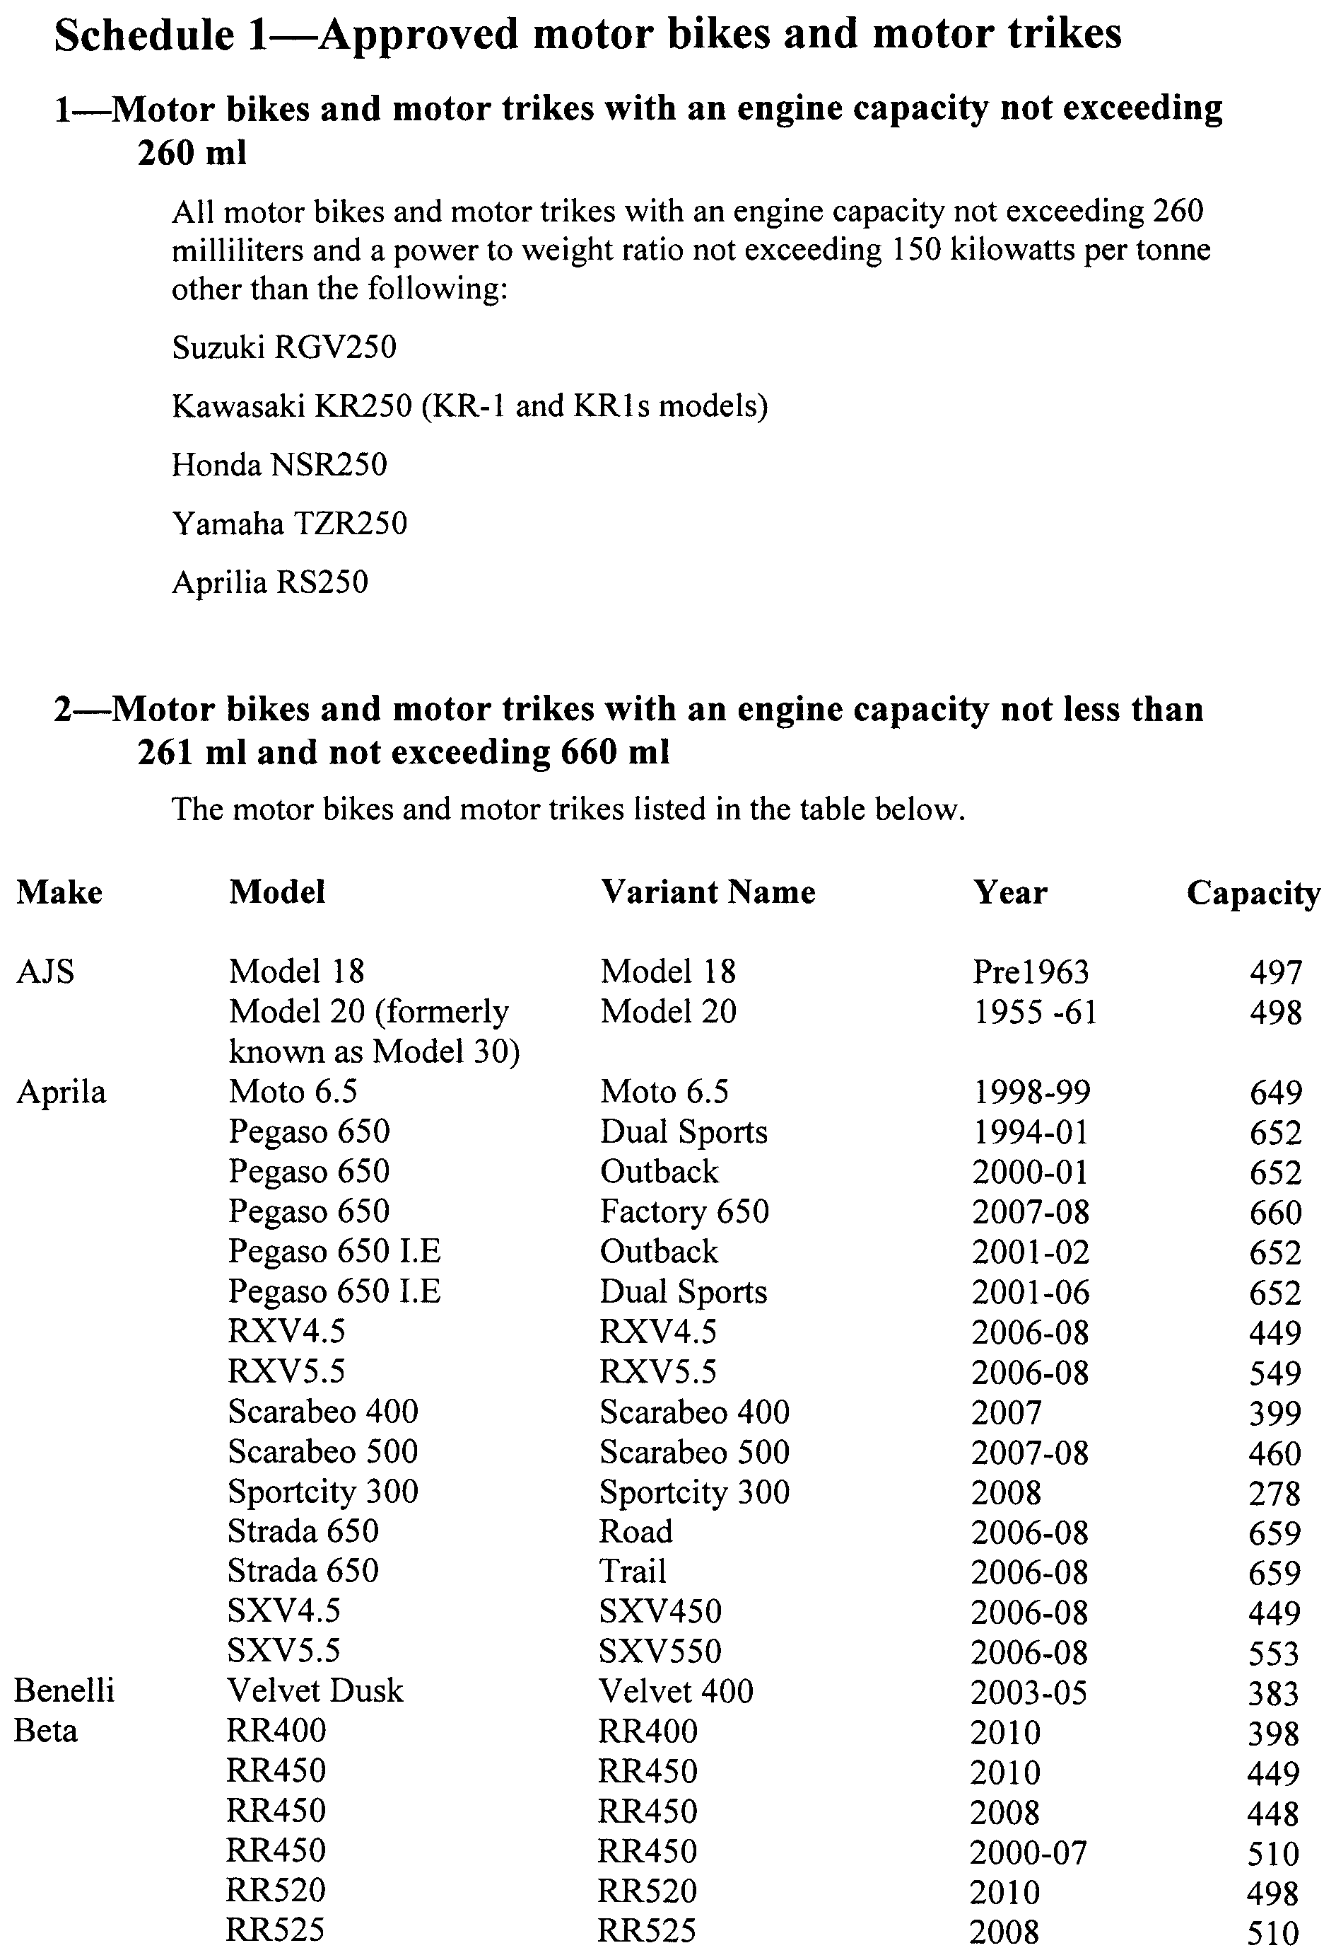
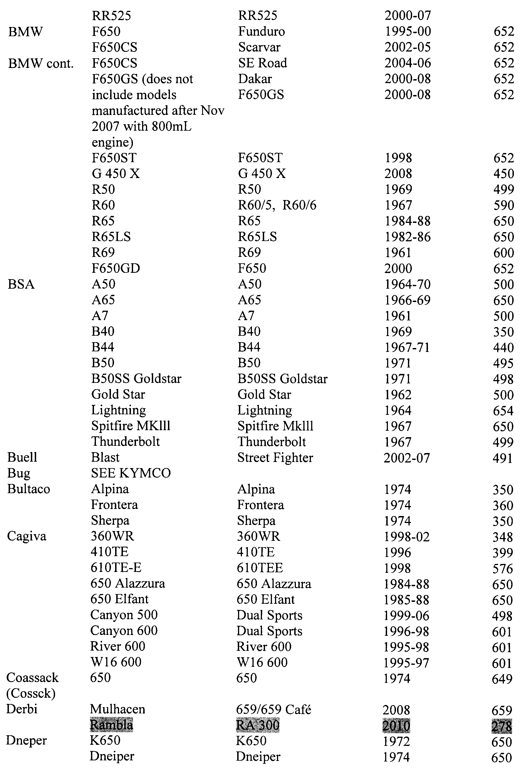
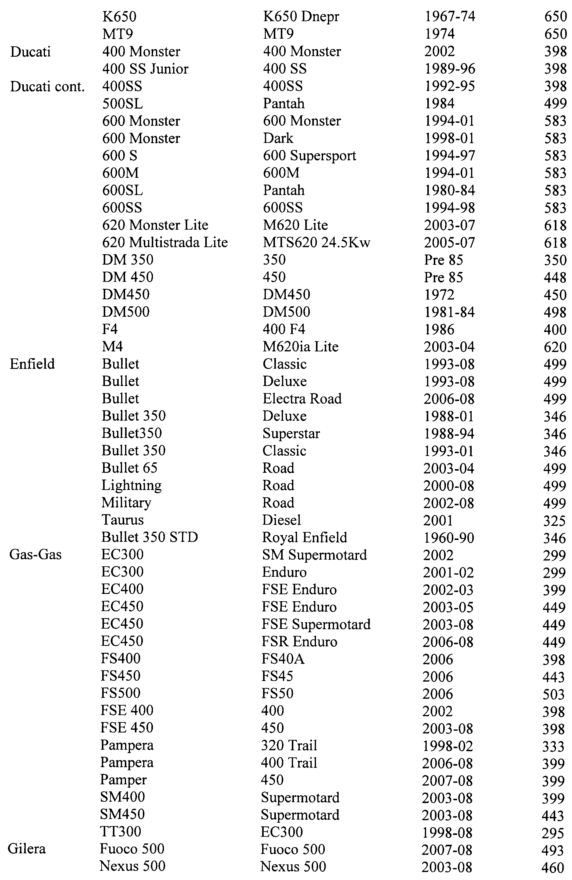
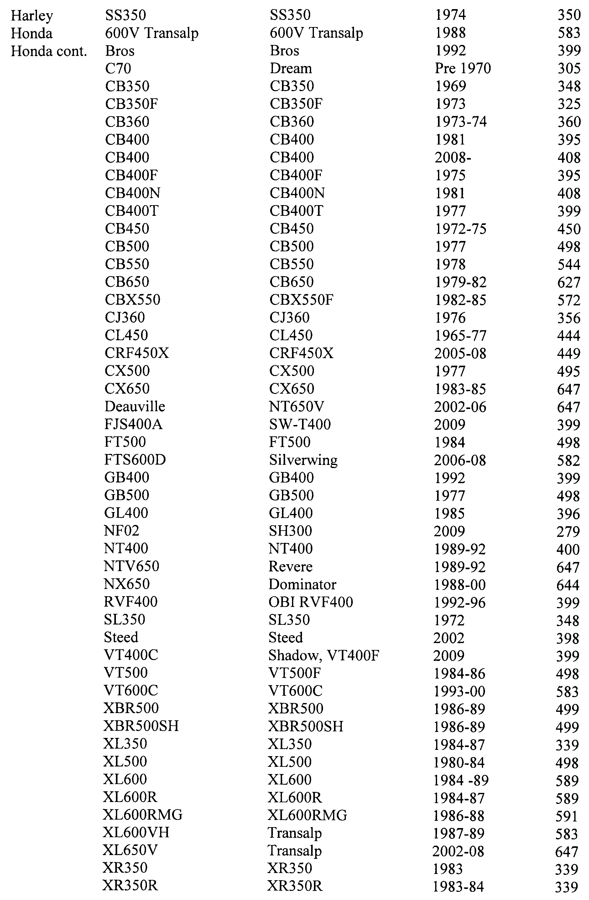
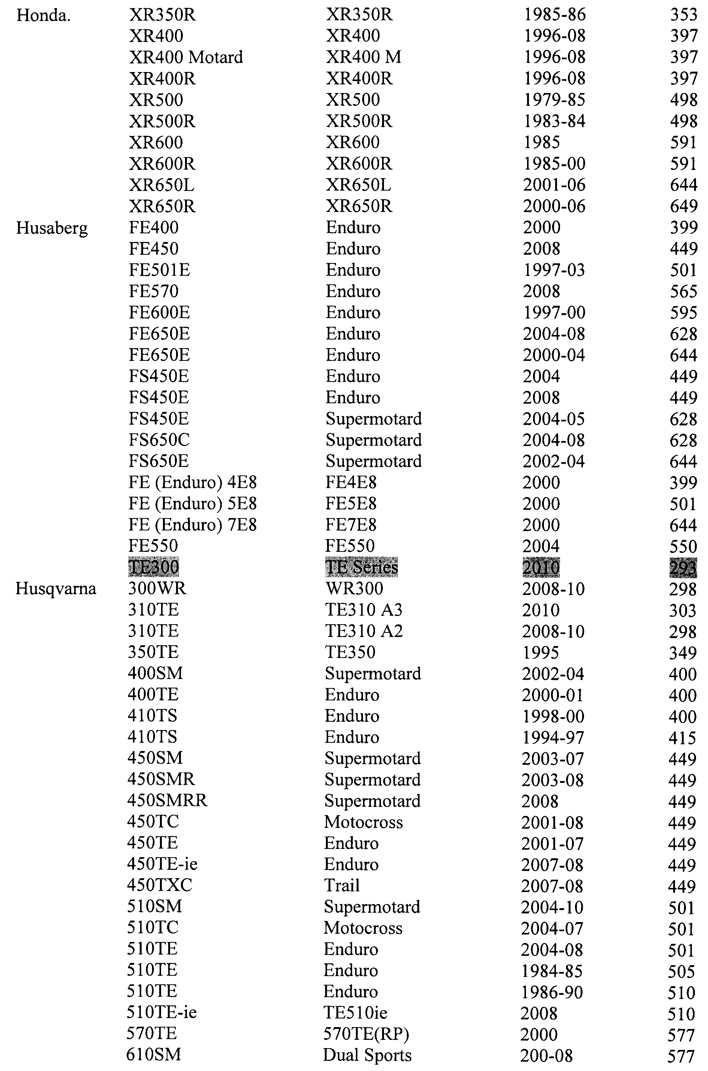
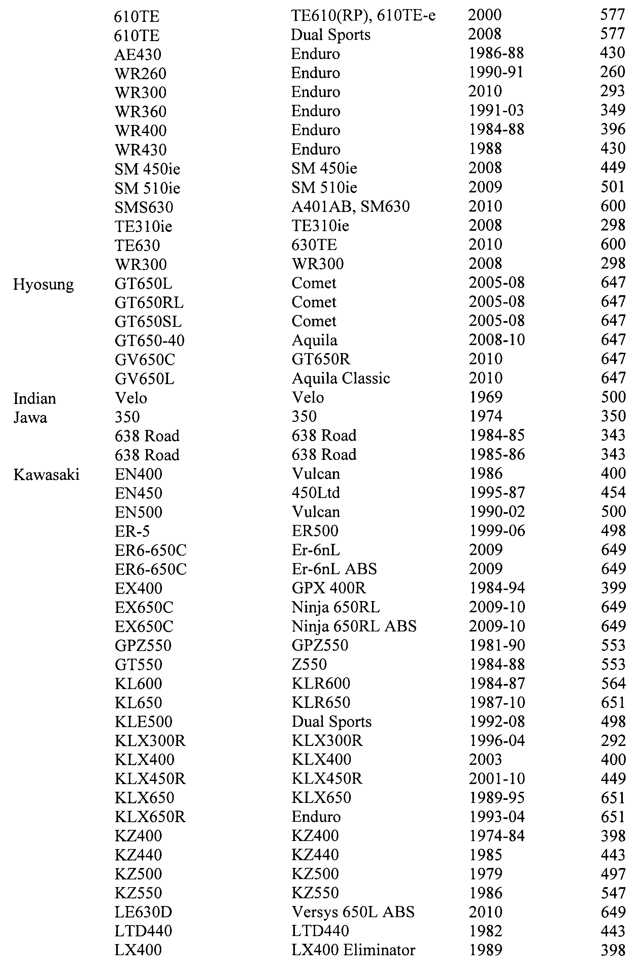
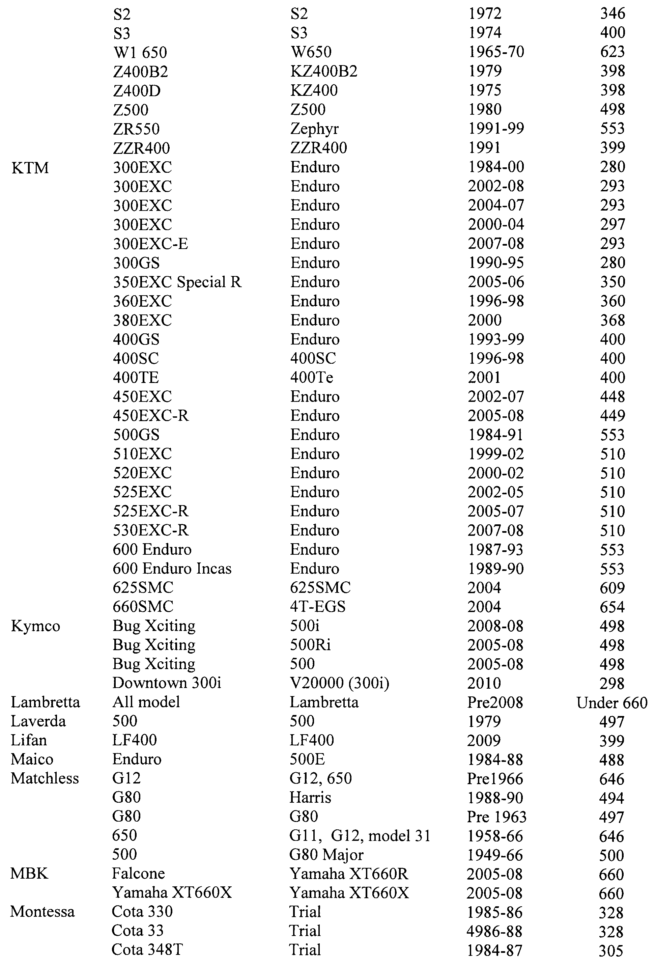
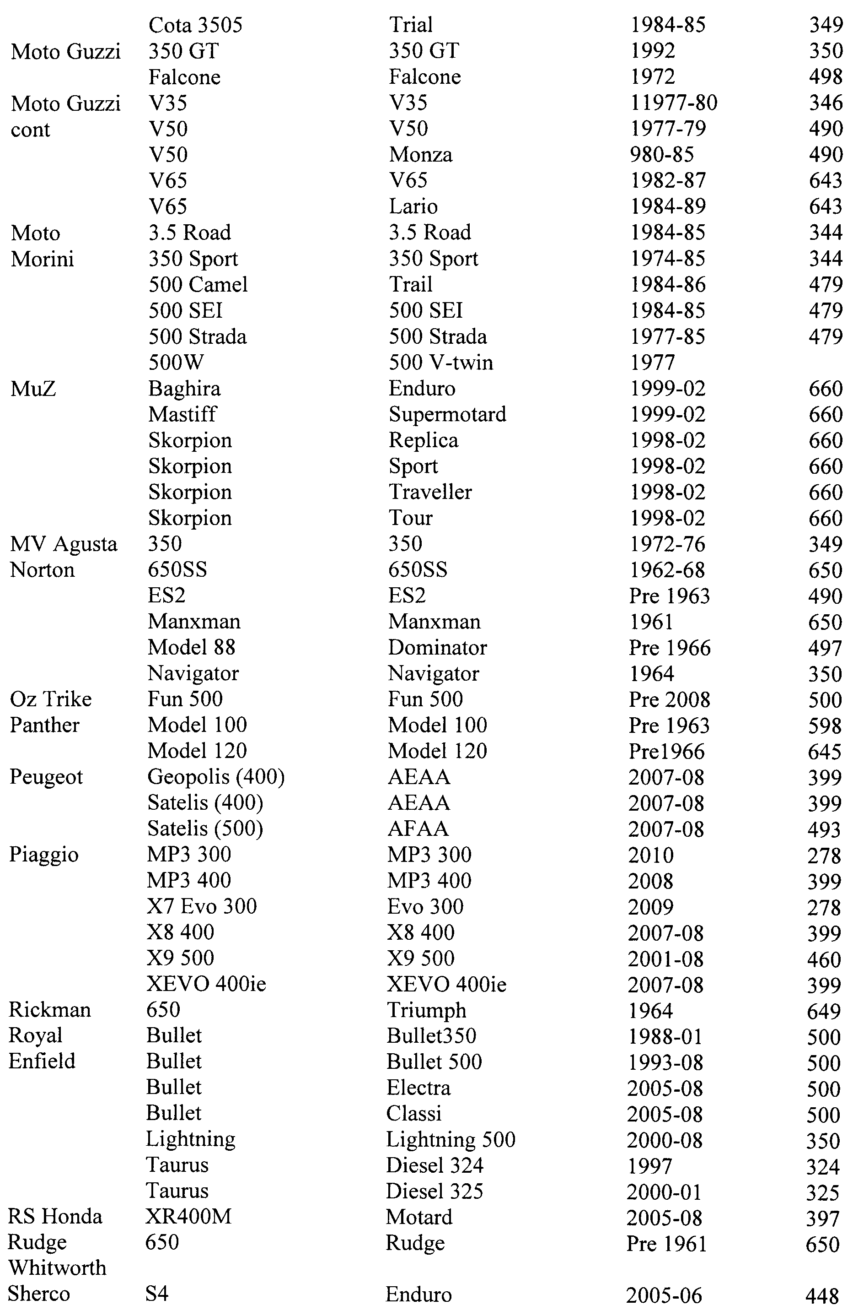
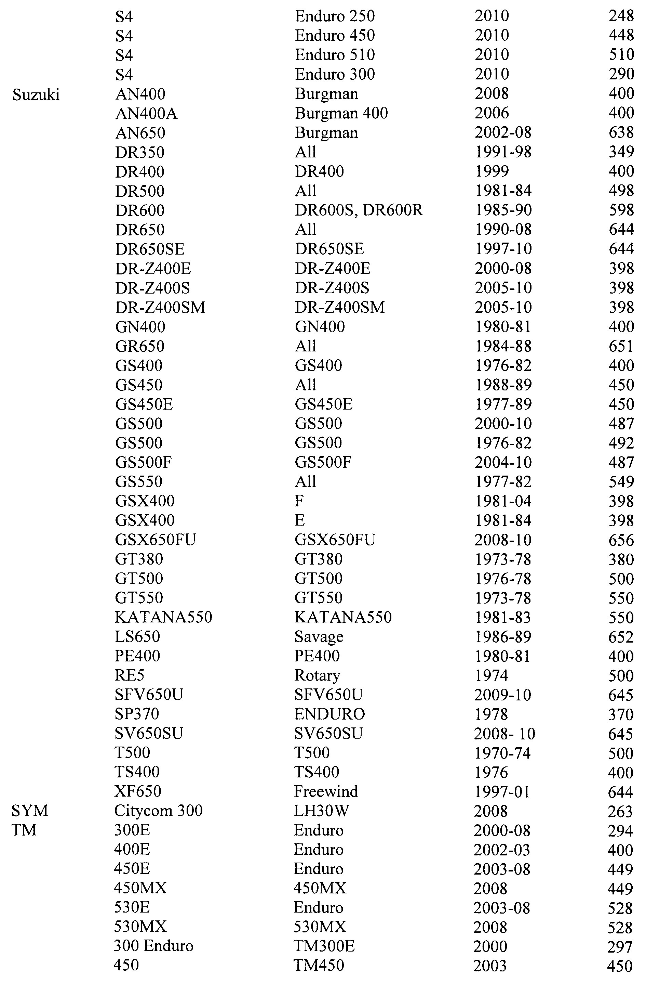
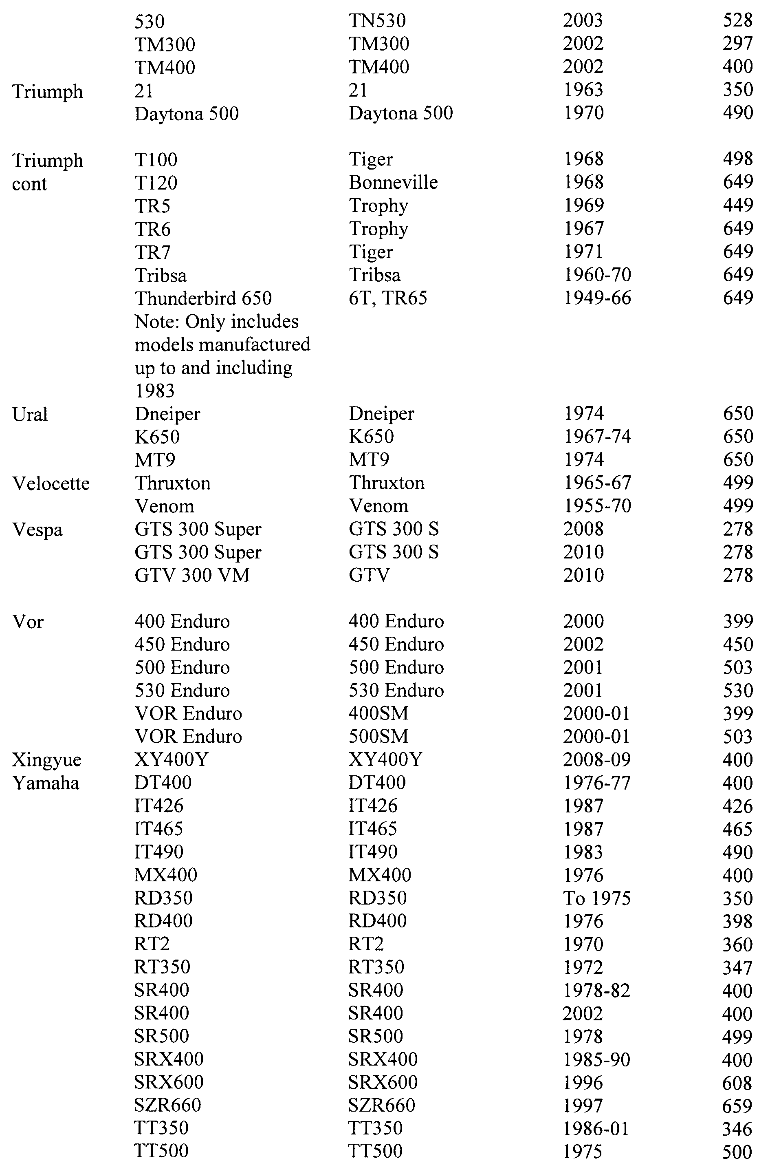
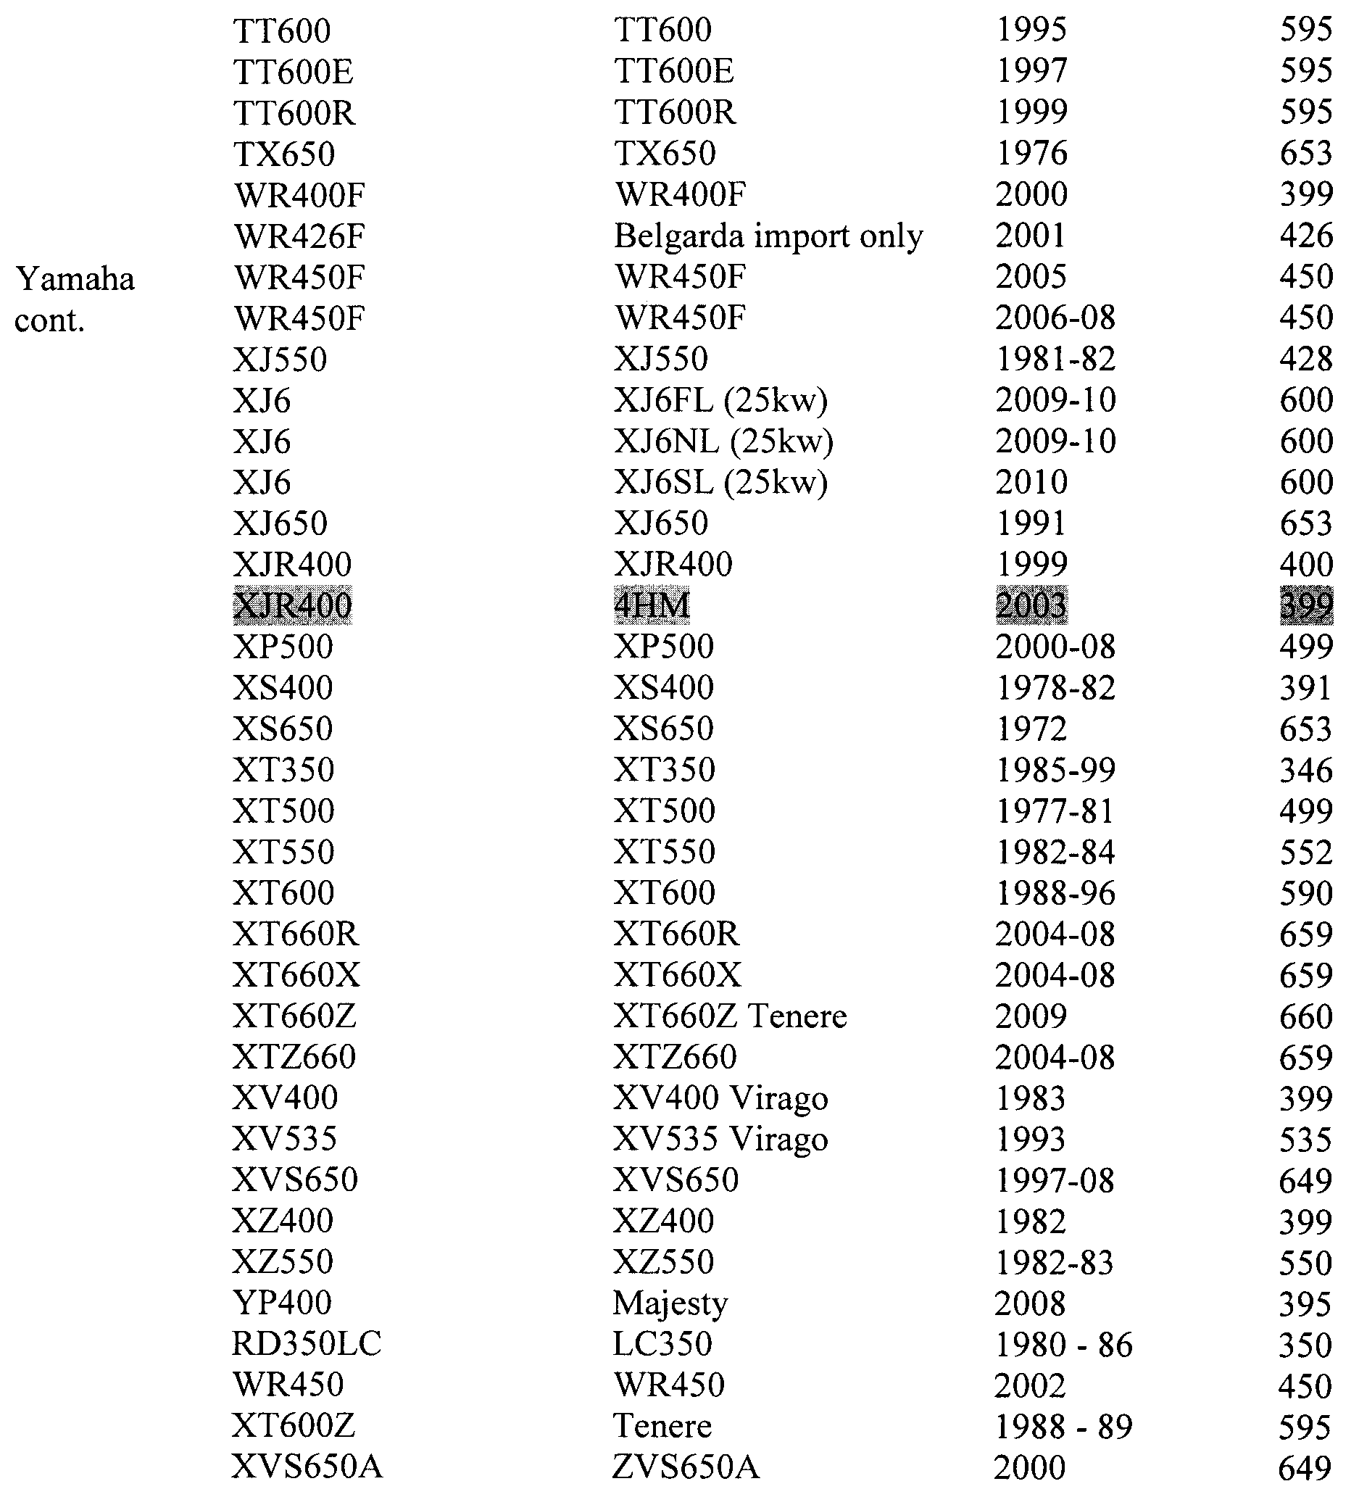



South Australia
Liquor Licensing (Dry Areas—Long Term) Variation Regulations 2010
under the Liquor Licensing Act 1997

Contents
Part 1—Preliminary
1 Short title
2 Commencement
3 Variation provisions
Part 2—Variation of Liquor Licensing (Dry Areas—Long Term) Regulations 1997
4 Variation of Schedule 1—Long term dry areas
5 Variation of Schedule 2—Plans of long term dry areas
Schedule 1—Plan to be inserted

Part 1—Preliminary
1—Short title
These regulations may be cited as the Liquor Licensing (Dry Areas—Long Term) Variation Regulations 2010.
2—Commencement
These regulations come into operation on the day on which they are made.
3—Variation provisions
In these regulations, a provision under a heading referring to the variation of specified regulations varies the regulations so specified.
Part 2—Variation of Liquor Licensing (Dry Areas—Long Term) Regulations 1997
4—Variation of Schedule 1—Long term dry areas
(1) Schedule 1, item headed "Edithburgh—Area 1"—delete "(there is no plan for this area)" and substitute:
(see Schedule 2: Edithburgh—Plan No 1)
(2) Schedule 1, item headed "Edithburgh—Area 1", column headed "Area", description of area—delete "the western boundary of Park Terrace, then northerly along that prolongation and boundary of Park Terrace to the point at which it intersects" and substitute:
the western boundary of Park Terrace South, then northerly along that prolongation and boundary of Park Terrace South and the western boundary of Park Terrace North to the point at which the western boundary of Park Terrace North intersects
(3) Schedule 1, item headed "Edithburgh—Area 1", column headed "Period"—delete "2010" and substitute:
2013
5—Variation of Schedule 2—Plans of long term dry areas
Schedule 2—after the plan headed "Coober Pedy—Plan No 1" insert the plan headed "Edithburgh—Plan No 1" in Schedule 1 of these regulations

Schedule 1—Plan to be inserted
Edithburgh—Plan No 1
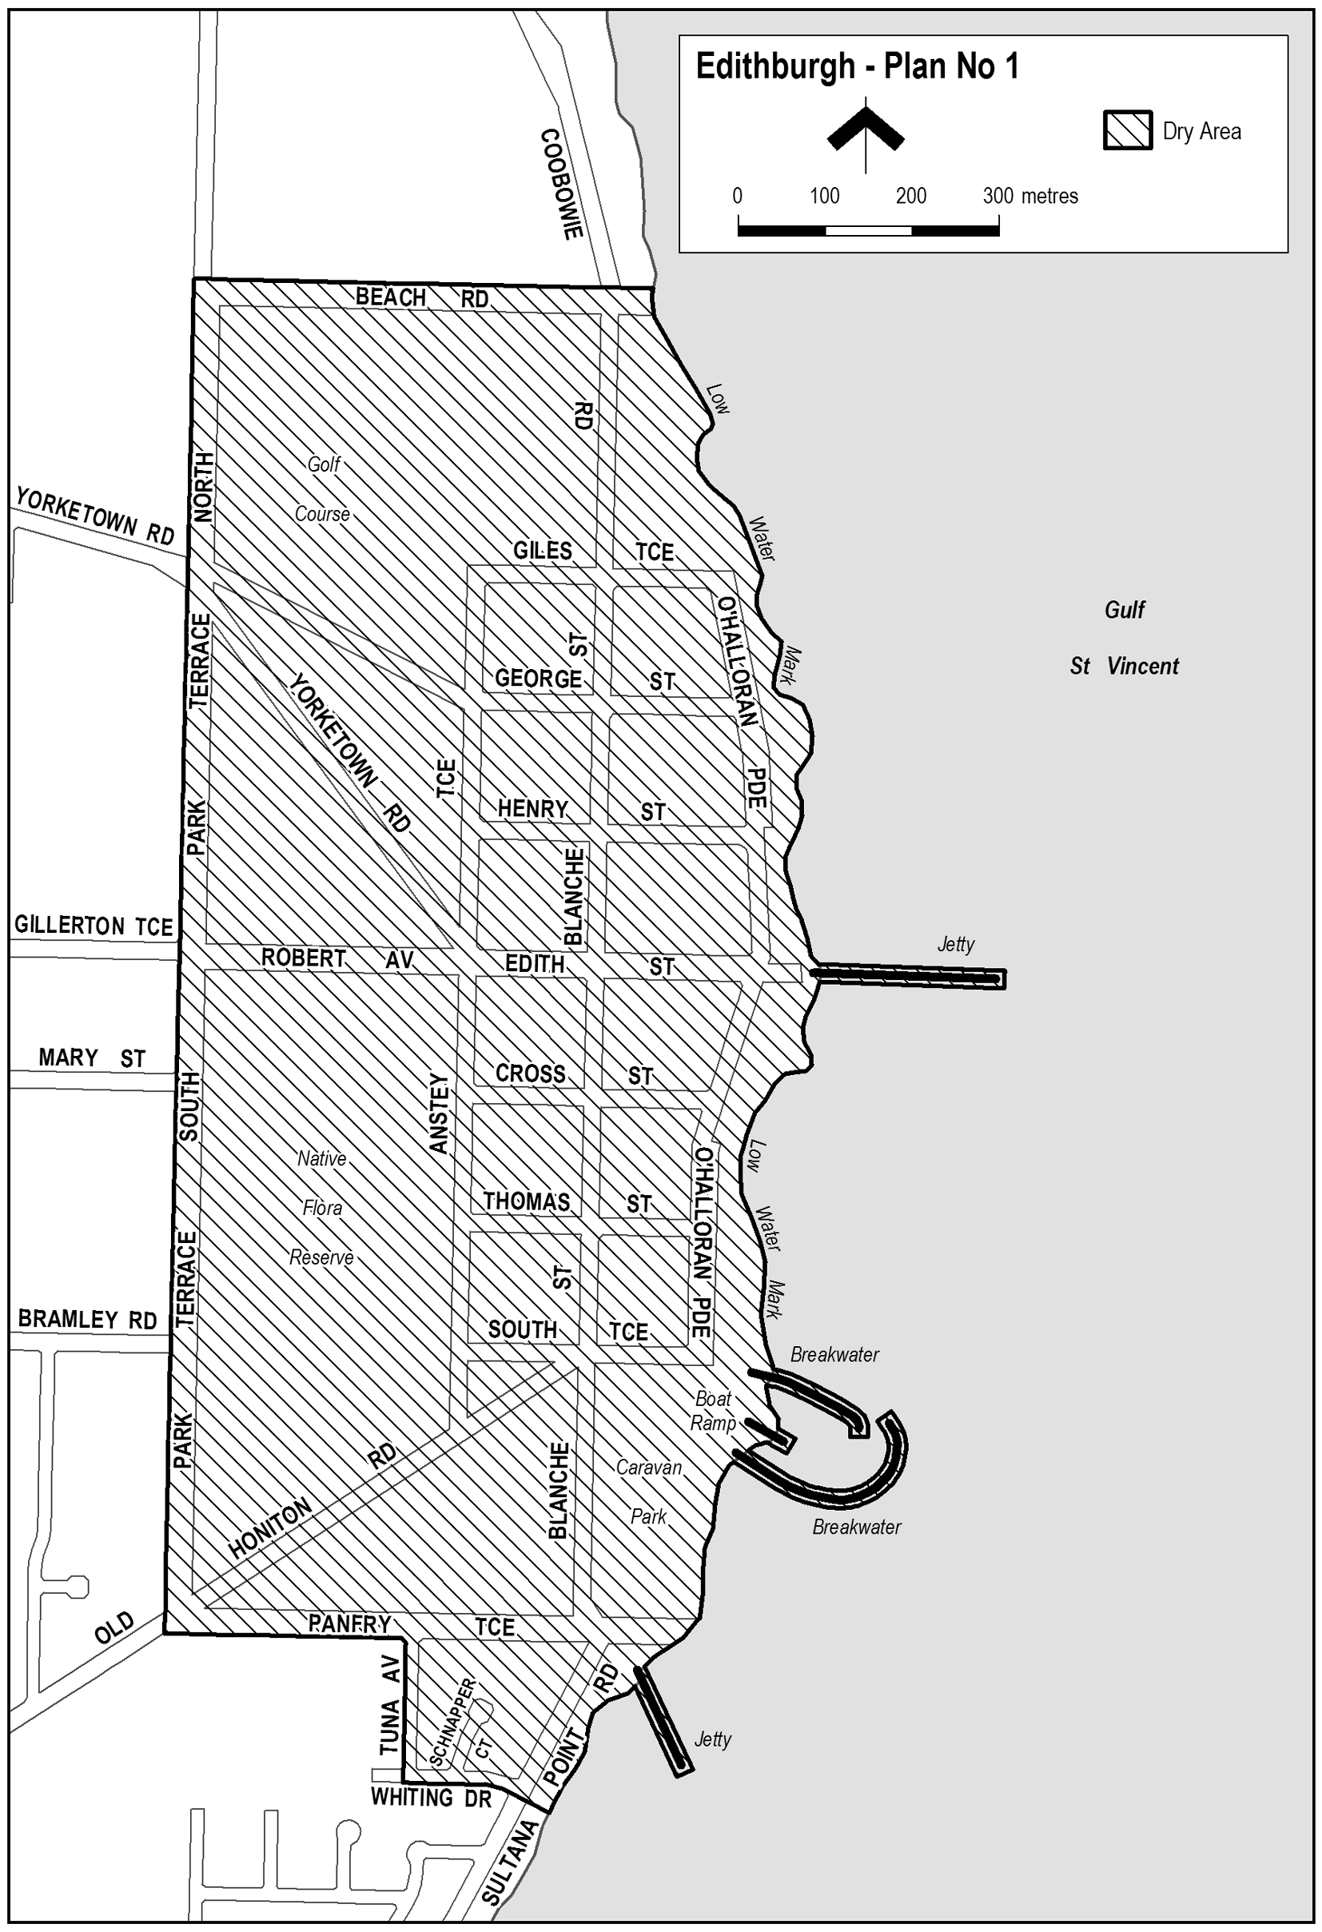
Note—
As required by section 10AA(2) of the Subordinate Legislation Act 1978, the Minister has certified that, in the Minister's opinion, it is necessary or appropriate that these regulations come into operation as set out in these regulations.
Made by the Governor
with the advice and consent of the Executive Council
on 21 October 2010
No 213 of 2010
10MCA0039CS

FAXING COPY?
IF you fax copy to Government Publishing SA for inclusion in the Government Gazette, there is no need to send a Confirmation Copy to us as well.
This creates confusion and may well result in your notice being printed twice.
Please use the following fax number:
Fax transmission: (08) 8207 1040
Phone Inquiries: (08) 8207 1045
Please include a contact person, phone number and order number so that we can phone back with any queries we may have regarding the fax copy.
NOTE: Closing time for lodging new copy (fax, hard copy or email) is 4 p.m. on Tuesday preceding the day of publication.

Government Gazette notices can be E-mailed.
The address is:
governmentgazette@dpc.sa.gov.au
Documents should be sent as attachments in Word format.
When sending a document via E-mail, please confirm your transmission with a faxed copy of your document, including the date the notice is to be published.
Fax transmission: (08) 8207 1040
Enquiries: (08) 8207 1045
NOTE: Closing time for lodging new copy (fax, hard copy or email) is 4 p.m. on Tuesday preceding the day of publication.

CITY OF MITCHAM
Appointment of Development Assessment Panel Public Officer
NOTICE is hereby given that pursuant to section 56A (22) of the Development Act 1993, that Council at its meeting held on 28 September 2010, appointed Judith Jones, Acting Chief Executive Officer as the Public Officer for the Development Assessment Panel. The Development Assessment Panel’s Public Officer can be contacted at the City of Mitcham, 131 Belair Road, Torrens Park or by telephone: 8372 8851 and by email:
mitcham@mitchamcouncil.sa.gov.au.
J. Jones, Acting Chief Executive Officer

District Council of Barunga West
Better Development Plan (BDP) and
General Development Plan Amendment (DPA)—October 2010
NOTICE is hereby given that this Development Plan Amendment (DPA) will be available for inspection by the public at the Barunga West District Council Offices, Port Broughton and Bute, and electronic copies will be made available on request, from Thursday, 21 October 2010 until Wednesday, 15 December 2010.
During this time anyone may make a written submission about any of the changes the DPA is proposing.
Submissions should be sent by post to:
Nigel Hand,
Chief Executive Officer,
P.O. Box 3,
Port Broughton, S.A. 5522,
or by email to: barunga@barungawest.sa.gov.au.
Submissions should indicate whether the author wishes to speak at a public meeting about the DPA. If no-one requests to be heard, no public meeting will be held. If requests to be heard are received, a public meeting will be held on 9 February 2011.
Dated 18 October 2010.
N. Hand, Chief Executive Officer

DISTRICT COUNCIL OF BARUNGA WEST
Notice of Change of Council Meeting Date
NOTICE is hereby given that at the Council meeting held on Tuesday, 12 October 2010, Council agreed that the November meeting of Council will be held on Tuesday, 23 November 2010 in lieu of 9 November 2010.
N. Hand, Chief Executive Officer

NARACOORTE LUCINDALE COUNCIL
Roads (Opening and Closing) Act 1991
Concrete Bridge Road, Hundred of Joanna
PURSUANT to section 10 of the Roads (Opening and Closing) Act 1991, the Naracoorte Lucindale Council hereby gives notice of its intent to implement a Road Process Order to:
Close and transfer portion of Public Road (Concrete Bridge Road), and merge with the adjoining Allotment 7 in Deposited Plan 62964 in the name of George Robert Hooper, shown delineated as ‘A’ on Preliminary Plan PP No. 10/0045.
A copy of the plan and a statement of persons affected are available for public inspection at the office of the Council, Degaris Place, Naracoorte and the Adelaide office of the Surveyor-General during normal office hours.
Any application for easement or objection must set out the full name, address and details of the submission and must be fully supported by reasons.
The application for easement or objection must be made in writing to the Council, P.O. Box 555, Naracoorte, S.A. 5271 within 28 days of this notice and a copy must be forwarded to the Surveyor-General, G.P.O. Box 1354, Adelaide, S.A. 5001.
Where a submission is made, the Council will give notification of a meeting at which the matter will be considered.
Dated 19 October 2010.
T. Krieger, Manager of Technical Services

DISTRICT COUNCIL OF LOWER EYRE PENINSULA
Development Act 1993
Coffin Bay Deferred Urban Zone: Development Plan
Amendment—Draft for Public Consultation
NOTICE is hereby given that the District Council of Lower Eyre Peninsula, pursuant to sections 24 and 25 of the Development Act 1993, has prepared a draft Development Plan Amendment report (DPA) to amend its Development Plan.
The Amendment proposes to change the Development Plan by:
• rezoning most of the Deferred Urban Zone to Residential Zone, and including the southern part of this rezoned area into a new ‘Long Beach Policy Area’ of the Residential Zone;
• rezoning the remainder of the Deferred Urban Zone adjacent to the Industry Zone to Industry Zone;
• rezoning the western-most end of the nearby Special Uses Zone to Industry Zone;
• amending the Coffin Bay Structure Plan so that it is consistent with the above rezoning pattern; and
• introducing a new Concept Plan for the Area Affected in order to reflect the above zoning changes and to guide with more particularity future development, including nominated access points to adjacent roads and buffer reserves/open spaces.
Copies of the DPA are available for viewing or purchase at $5 a copy during normal business hours at the Council Offices, Railway Terrace, Cummins and Washington Street, Port Lincoln. Alternatively, the draft DPA can be downloaded from Council’s website:
www.lowereyrepeninsula.sa.gov.au.
Written submissions regarding the draft DPA should be submitted no later than 5 p.m. on Friday, 24 December 2010. All submissions should be addressed to the Chief Executive Officer, District Council of Lower Eyre Peninsula, P.O. Box 41, Cummins, S.A. 5631 and should clearly indicate whether the person making the submission wishes to be heard in support of the submission at the public hearing. Persons wishing to lodge their submissions electronically may do so by email to:
leithb@dclep.sa.gov.au.
Copies of all submissions received will be available for inspection at the Council Offices from Tuesday, 4 January 2011 until the conclusion of the public hearing (see below).
A public hearing will be held on Friday, 21 January 2011 at 1.30 p.m. in the Council Chambers, Railway Terrace, Cummins, at which time interested persons will be heard in relation to the DPA and the submissions. The public hearing will not be held if no submissions are received or if no persons making submissions request to be heard.
Dated 21 October 2010.
R. Pearson, Chief Executive Officer

PORT PIRIE REGIONAL COUNCIL
Roads (Opening and Closing) Act 1991
Road Opening and Closing—Solomontown/Port Pirie South
NOTICE is hereby given that pursuant to section 10 of the Roads (Opening and Closing) Act 1991, that the Port Pirie Regional Council proposes to make a Road Process Order to:
1. Open as road the whole of closed road ‘A’ in Road Plan 3276 and closed road ‘K’ in Road Plan 3279 and portions of pieces 50 and 52 in Filed Plan 217380, more particularly delineated and marked ‘1’, ‘2’, ‘3’ and ‘4’ (respectively) on Preliminary Plan No. 10/0011, forming a realignment of Railway Terrace.
2. Close portions of Railway Terrace situate adjoining pieces 50, 51 and 52 in Filed Plan 217380, closed road ‘J’ in Road Plan 3279 and allotment 103 in Filed Plan 216451, more particularly delineated and marked ‘A’, ‘B’ and ‘C’ on Preliminary Plan No. 10/0011.
Closed roads to be merged: ‘A’ with piece 1 in Filed Plan 218652 and ‘B’ and ‘C’ with pieces 50, 51 and 52 in Filed Plan 217380.
A copy of this plan and a statement of persons affected are available for public inspection at the Council Office, 115 Ellen Street, Port Pirie and at the Adelaide office of the Surveyor-General during normal office hours.
Any application for easement or objection must set out the full name, address and details of the submission and must be fully supported by reasons. The application for easement or objection must be made in writing to the Port Pirie Regional Council, P.O. Box 45, Port Pirie, S.A. 5540, within 28 days of the publication of this notice, and a copy shall be forwarded to the Surveyor-General, G.P.O. Box 1354, Adelaide, S.A. 5001. Where a submission is made, the Council will give notification of a meeting at which the matter will be considered.
Dated 21 October 2010.
Dr A. Johnson, Chief Executive Officer

IN the matter of the estates of the undermentioned deceased persons:
Adams, Yvonne Jean, late of 1215 Grand Junction Road, Hope Valley, retired domestic, who died on 19 July 2010.
Billeley, Sydney John, late of 84 Reservoir Road, Modbury, retired truck driver, who died on 9 January 2010.
Dutton, Joan Ellen, late of 18 Cross Road, Myrtle Bank, of no occupation, who died on 8 August 2010.
Jarratt, Irene Lillian, late of 9 Aspara Crescent, Ingle Farm, home duties, who died on 3 August 2010.
Kopka, Anneliese Magarethe, late of 51 Eighth Avenue, St Peters, of no occupation, who died on 30 May 2004.
Peake, Archibald Bruce, late of 2 Jean Street, Oaklands Park, retired public servant, who died on 14 August 2010.
Sanderson, Kenneth Villiers, late of 11 Trinidad Court, West Lakes, retired doctor, who died on 4 December 2009.
Satchell, Lexie Avril, late of 48 Smith-Dorrien Street, Mitcham, retired school secretary, who died on 8 August 2010.
Sinclair, Mary Lois, late of 2 Lochiel Avenue, Campbelltown, home duties, who died on 11 June 2010.
Smith, Frances Elizabeth, late of Allora Drive, Maroochydore, Queensland, of no occupation, who died on 13 August 2010.
Stelmachers, Irmgarde Alvine, late of 10 Holt Street, Netley, home duties, who died on 23 August 2010.
Sullivan, Neil Leslie, late of 15 Inverway Street, Ferryden Park, retired maintenance worker, who died on 18 August 2010.
Sywanicz, Andrzej, late of 6A Dianne Street, Klemzig, retired factory worker, who died on 26 March 2010.
Thiele, Charlotte Maureen, late of 27 Proud Avenue, Loxton North, home duties, who died on 7 August 2010.
Notice is hereby given pursuant to the Trustee Act 1936, as amended, the Inheritance (Family Provision) Act 1972 and the Family Relationships Act 1975, that all creditors, beneficiaries, and other persons having claims against the said estates are required to send, in writing, to the Office of Public Trustee, G.P.O. Box 1338, Adelaide, S.A. 5001, full particulars and proof of such claims, on or before 19 November 2010, otherwise they will be excluded from the distribution of the said estates; and notice is also hereby given that all persons indebted to the said estates are required to pay the amount of their debts to the Public Trustee or proceedings will be taken for the recovery thereof; and all persons having any property belonging to the said estates are forthwith to deliver same to the Public Trustee.
Dated 21 October 2010.
P. J. Martin, Acting Public Trustee

ATTENTION

CUSTOMERS requiring a proof of their notice for inclusion in the Government Gazette, please note that the onus is on you to inform Government Publishing SA of any subsequent corrections.

For any corrections to your notice please phone 8207 1045 or Fax 8207 1040 before 4 p.m. on Wednesday.

If we do not receive any communication by 10 a.m. on Thursday (day of publication) we will presume the notice is correct and will print it as it is.

Remember—the onus is on you to inform us of any corrections necessary to your notice.

NOTE: Closing time for lodging new copy (electronically, fax or hard copy) is 4 p.m. on Tuesday preceding the day of publication.
Phone: 8207 1045
Fax: 8207 1040
Email: governmentgazette@dpc.sa.gov.au

Printed and published by authority every Thursday by B. MORRIS, Government Printer, South Australia
Price: $6.05, plus postage; to subscribers, $306.00 per annum.
(The above prices are inclusive of GST)

