No. 60 4637

THE SOUTH AUSTRALIAN

GOVERNMENT GAZETTE
www.governmentgazette.sa.gov.au

PUBLISHED BY AUTHORITY

ALL PUBLIC ACTS appearing in this GAZETTE are to be considered official, and obeyed as such

ADELAIDE, THURSDAY, 2 SEPTEMBER 2010

CONTENTS

Page
Anangu Pitjantjatjara Yankunytjatjara Land Rights
Act 1981—By-law 4639
Appointments, Resignations, Etc. 4638
Associations Incorporation Act 1985—Notice 4638
Brands Act 1933—Third Quarter 2009 4642
Corporations and District Councils—Notices 4695
Development Act 1993—Notice 4662
Environment Protection (Waste to Resources) Amendment
Notice 2010—Notice 4692
Environment Protection (Water Quality) Amendment
Notice 2010—Notice 4690
Fisheries Management Act 2007—Notices 4666
Geographical Names Act 1991—Notices 4672
Health Care Act 2008—Notice 4674
Housing Improvement Act 1940—Notices 4676

Page
Legal Practitioners Act 1981—Notice 4677
Liquor Licensing Act 1997—Notices 4677
Mining Act 1971—Notices 4681
National Electricity Law—Notice 4682
National Parks and Wildlife (National Parks)
Regulations 2001—Notice 4682
Partnership Act 1891—Notice 4706
Port Augusta Circuit Court—Notice 4682
Proclamation 4693
Public Trustee Office—Administration of Estates 4706
Roads (Opening and Closing) Act 1991—Notice 4683
Training and Skills Development Act 2008—Notice 4687
Water Mains and Sewers—Mains Laid,
Replaced, Etc. 4683
Waterworks Act 1932—Notice 4686

GOVERNMENT GAZETTE NOTICES
ALL poundkeepers’ and private advertisements forwarded for publication in the South Australian Government Gazette must be PAID FOR PRIOR TO INSERTION; and all notices, from whatever source, should be legibly written on one side of the paper only and sent to Government Publishing SA so as to be received no later
than 4 p.m. on the Tuesday preceding the day of publication. Phone 8207 1045 or Fax 8207 1040. E-mail: governmentgazette@dpc.sa.gov.au. Send as attachments in Word format and please confirm your transmission with a faxed copy of your document, including the date the notice is to be published and to whom the notice will be charged. The Government Gazette is available online at: www.governmentgazette.sa.gov.au

Department of the Premier and Cabinet
Adelaide, 2 September 2010
HIS Excellency the Governor in Executive Council has been pleased to appoint the undermentioned to the Public and Environmental Health Council, pursuant to the provisions of the Public and Environmental Health Act 1987:
Member: (from 9 September 2010 until 8 September 2013)
John Alfred Cugley
Ian James Hawkins
Deputy Member: (from 9 September 2010 until 8 September 2013)
Fiona Louise Harvey (Deputy to Cugley)
Rebekah Louise Schubert (Deputy to Hawkins)
Member: (from 1 November 2010 until 31 October 2013)
Michael David Henningsen
Deputy Member: (from 1 November 2010 until 31 October 2013)
Susan Carol Lonie (Deputy to Henningsen)
By command,
John Snelling, for Acting Premier
HEAC-2010-00045

Department of the Premier and Cabinet
Adelaide, 2 September 2010
HIS Excellency the Governor in Executive Council has been pleased to appoint the Honourable Jay Wilson Weatherill, MP, Minister for Education and Minister for Early Childhood Development to be also Acting Minister for Aboriginal Affairs and Reconciliation for the period from 2 September 2010 to 15 September 2010 inclusive, during the absence of the Honourable Grace Portolesi, MP.
By command,
John Snelling, for Acting Premier
MMA 10/016CS

Department of the Premier and Cabinet
Adelaide, 2 September 2010
HIS Excellency the Governor in Executive Council has been pleased to appoint the Honourable Tom Koutsantonis, MP, Minister for Industry and Trade, Minister for Small Business, Minister for Correctional Services and Minister for Gambling to be also Acting Minister for Multicultural Affairs, Acting Minister for Youth and Acting Minister for Volunteers for the period from 2 September 2010 to 15 September 2010 inclusive, during the absence of the Honourable Grace Portolesi, MP.
By command,
John Snelling, for Acting Premier
MMA 10/016CS

Department of the Premier and Cabinet
Adelaide, 2 September 2010
HIS Excellency the Governor in Executive Council has been pleased to appoint Pam Simmons to the position of Guardian for Children and Young Persons, for a three month term commencing on 6 September 2010 and expiring on 5 December 2010, pursuant to Part 52A of the Children’s Protection Act 1993.
By command,
John Snelling, for Acting Premier
DFCCS/10/028

ASSOCIATIONS INCORPORATION ACT 1985
Notice Pursuant To Section 44 (2)
Pursuant to section 44 (1) of the Associations Incorporation Act 1985 (‘the Act’), the Corporate Affairs Commission (‘the Commission’) is of the opinion that Edinburgh Community Centre Incorporated (‘the Association’) being an incorporated association under the Act is defunct and on 21 July 2010, served a notice on the Association and on 24 July 2010, by notice in The Advertiser required the Association to show good cause why the Association should not be dissolved.
Pursuant to section 44 (2) of the Act, the Commission is satisfied that Edinburgh Community Centre Incorporated should be dissolved and the Commission hereby cancels the incorporation of the Association.
Dated 30 August 2010.
A. J. Baehnisch, Delegate of the Corporate Affairs Commission

ANANGU PITJANTJATJARA YANKUNYTJATJARA LAND RIGHTS ACT 1981
Permit By-Law
Pursuant to the Anangu Pitjantjatjara Yankunytjatjara Land Rights Act 1981, Anangu Pitjantjatjara Yankunytjatjara makes the following by-law:
1. This by-law may be cited as the Anangu Pitjantjatjara Yankunytjatjara Land Rights (Entry to the Lands) By-Law 2009.
2. In this by-law, unless the contrary intention appears:
The Act means the Anangu Pitjantjatjara Yankunytjatjara Land Rights Act 1981;
an authorised person means a natural person authorised in writing by the Minister for the purposes of this by-law, while that person is complying with any conditions of the authorisation and until the term of the authorisation (should there be one) has expired or until the authorisation is revoked by the Minister;
Anangu means Anangu Pitjantjatjara Yankunytjatjara;
Approved in relation to any works on the lands means approved by Anangu;
APS employee has the same meaning as in the Public Service Act 1999 of the Commonwealth;
Arbitrator means a person appointed by Anangu and the Minister as the Arbitrator for the purposes of this by law;
journalist means a person engaged in writing for, filming or otherwise producing a newspaper, periodical, television or radio program or similar production;
the lands means the lands described in Schedule 1 to the Act.
3. This by-law only applies to the extent that permission to enter the land is required under Section 19 of the Act and has no application to any person who is exempted from the operation of that section by Section 19 (8) of the Act.
4. Subject to the provisions of this by law, and for the purposes of Section 19 (1) of the Act, Anangu grants permission to the following persons to enter the lands:
(a) members of the Australian Federal Police acting in the course of carrying out their official duties;
(b) APS employees acting in the course of their official duties;
(c) any officer appointed by or under a Commonwealth statute who is acting in the course of his or her official duties;
(d) an authorised person who is carrying out a function of or works relating to one or more of the following:
(i) a Minister of the Crown in right of the Commonwealth; or
(ii) a Commonwealth Department, agency or instrumentality; or
(iii) a Commonwealth or State funded or contracted service provider; or
(iv) any approved installation, operation, maintenance or upgrade on the lands of roads, electricity, telecommunications, water, sewer, waste removal, community or airfield infrastructure, and or municipal services; and,
(v) journalists (other than those journalists who have, in the last ten years been convicted of an offence listed in paragraph 4) who enter the lands for the purpose of the genuine investigation or reporting of a matter occurring on the lands provided that it is in the public interest to investigate or report on that matter.
5. A journalist who has been convicted of any of the following offences in the ten years prior to entering the lands is not granted permission to enter the lands under these by-laws and must apply for permission to enter the lands under Section 19 of the Act:
(a) An offence of a sexual nature against a minor; or
(b) Child pornography offences; or
(c) Criminal trespass, or an offence under Section 19 of the Act or Section 18 of the Maralinga Tjarutja Land Rights Act 1984; or
(d) An offence of dishonesty; or
(e) An offence under Section 42D or Section 43 of the Act; or
(f) An offence under the Controlled Substances Act 1984; or
(g) An offence under the Aboriginal Heritage Act 1988; or
(h) An offence under the Liquor Licensing Act 1997; or
(i) An offence of selling or supplying alcohol or petrol under the Aboriginal Lands Trust Act 1966; or
(j) An offence under legislation of another jurisdiction, of a similar nature to these offences listed above.
6. In the event that the permission granted under this by law to enter the lands is given in relation to a function, or to enable duties to be carried out, the permission to enter and remain on the lands shall continue only for so long as the duties or functions for which the permission has been given are continuing to be performed or carried out and for such further time as may be reasonably necessary so as to allow the person to leave the lands.
7. (a) A person granted permission to enter the lands under this by-law who proposes to enter the lands must give reasonable notice of the time, place and purpose of the proposed entry to Anangu.
(b) Notice given under this by-law must indicate the places on the lands the person intends to access and must be in the form set out in Schedule A to these by-laws.
8. Permission to enter the lands under this by-law is given on the following conditions:
(a) That the person must carry identification of a kind approved by Anangu for the purposes of this by-law (should any such identification have been approved by Anangu);
(b) That the person must not access any places on the lands that have not previously been notified to Anangu under Clause 7;
(c) That the person must not access any area of the lands that Anangu have advised is not to be accessed in response to notification given under Clause 7;
(d) That the person must at all times respect the privacy and rights of Anangu.
9. A person other than a member of the Australian Federal Police, who has been granted permission to enter the lands by Anangu under this by-law may have that permission revoked or modified by Anangu, on reasonable grounds subject to a reasonable period of notice having been given to that person of the intention to revoke or modify that permission.
10. (a) A person aggrieved by a decision of Anangu to revoke or modify the permission for that person to enter the lands may appeal to the Arbitrator against that decision and the process followed by the Arbitrator in deciding that appeal should be consistent with the processes that would apply under Sections 36 (1a)-(4) to an appeal under Section 36 (1) of the Act;
(b) In the event that the Arbitrator is satisfied that the decision to revoke or modify permission granted under this by law was made without there being reasonable grounds for doing so, the Arbitrator may vary or reverse the decision or remit it back to Anangu to be determined in accordance with the Arbitrator’s directions;
(c) A person who appeals to the Arbitrator may apply to the Arbitrator for the decision to revoke or modify the permission to be suspended pending the outcome of the hearing of the appeal and the Arbitrator may suspend or vary the decision pending the hearing of the appeal on such terms as the Arbitrator deems appropriate.
11. Subject to this by-law, a person who has been granted permission to enter the lands by Anangu under this by-law may reside, or otherwise remain, on the lands for as long as is necessary or desirable to carry out his or her duties or functions and for such time as may be necessary so as to allow the person to leave the lands.
12. Anangu may revoke this by-law at any time after the expiration of 12 months from when it first comes into operation subject to notice being given under section 43 (5) of the Act.
13. This by-law shall come into operation on the day that it is confirmed by the Governor.
Dated 2 September 2010.
Confirmed in Executive Council,
Kevin Scarce, Governor

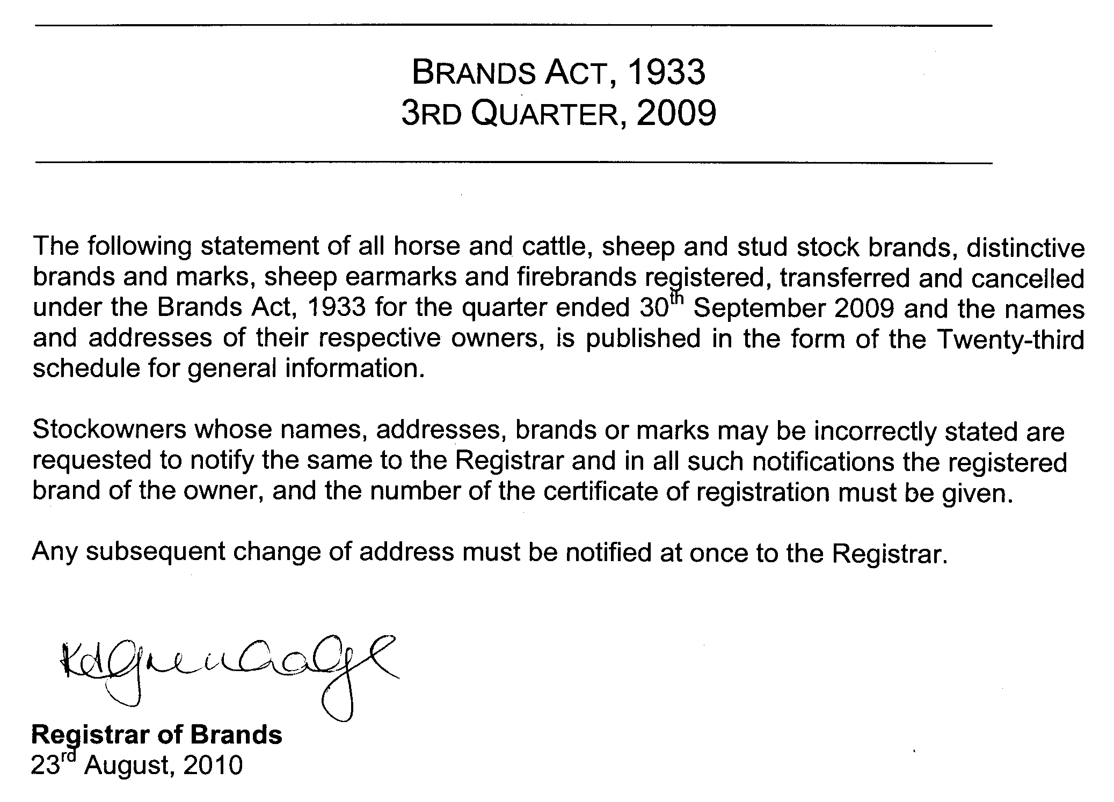
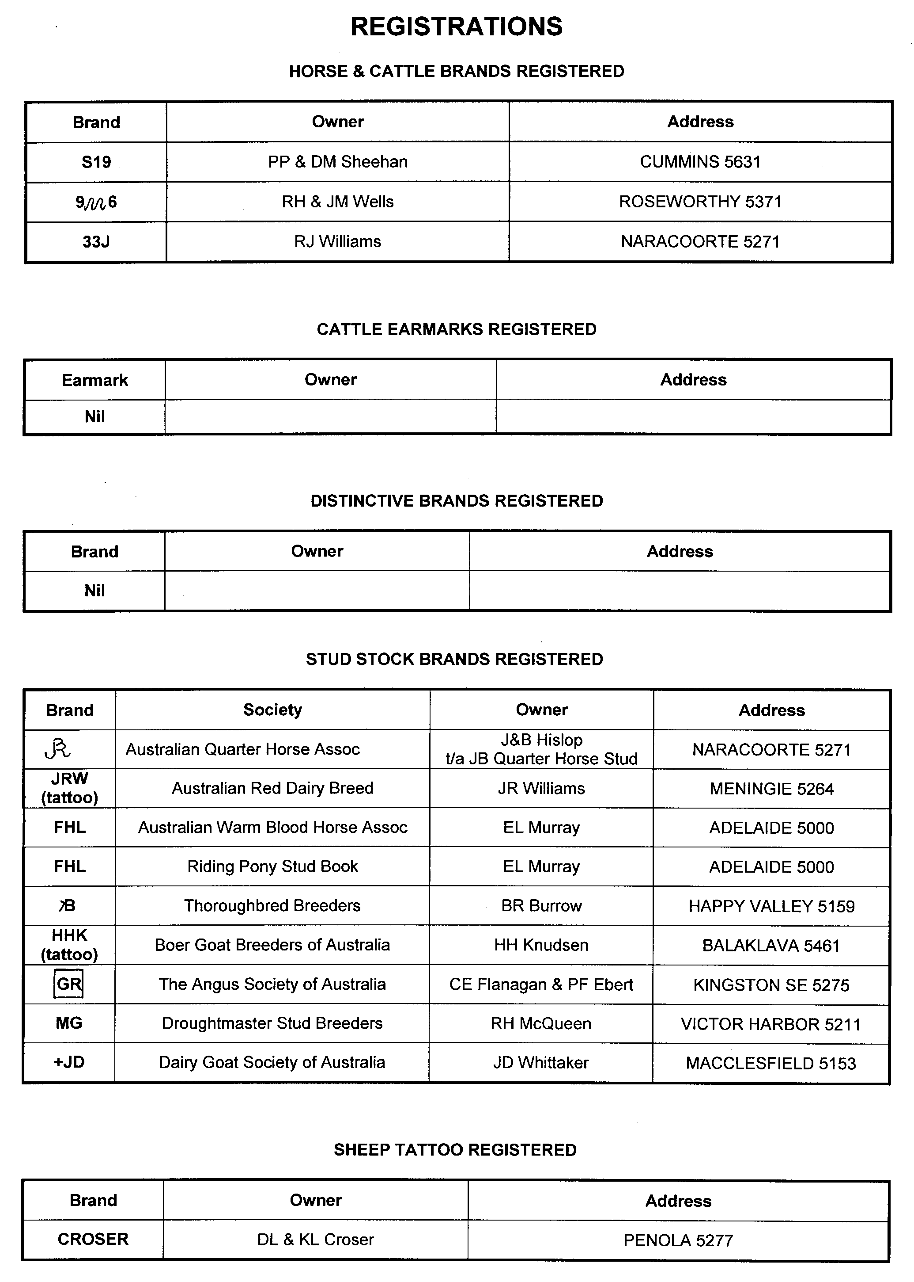
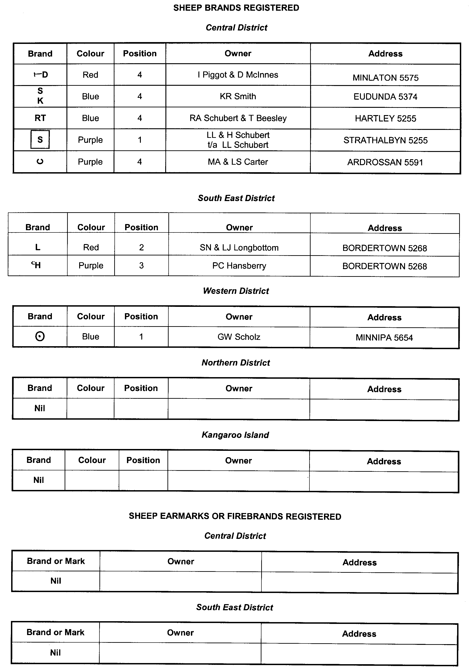
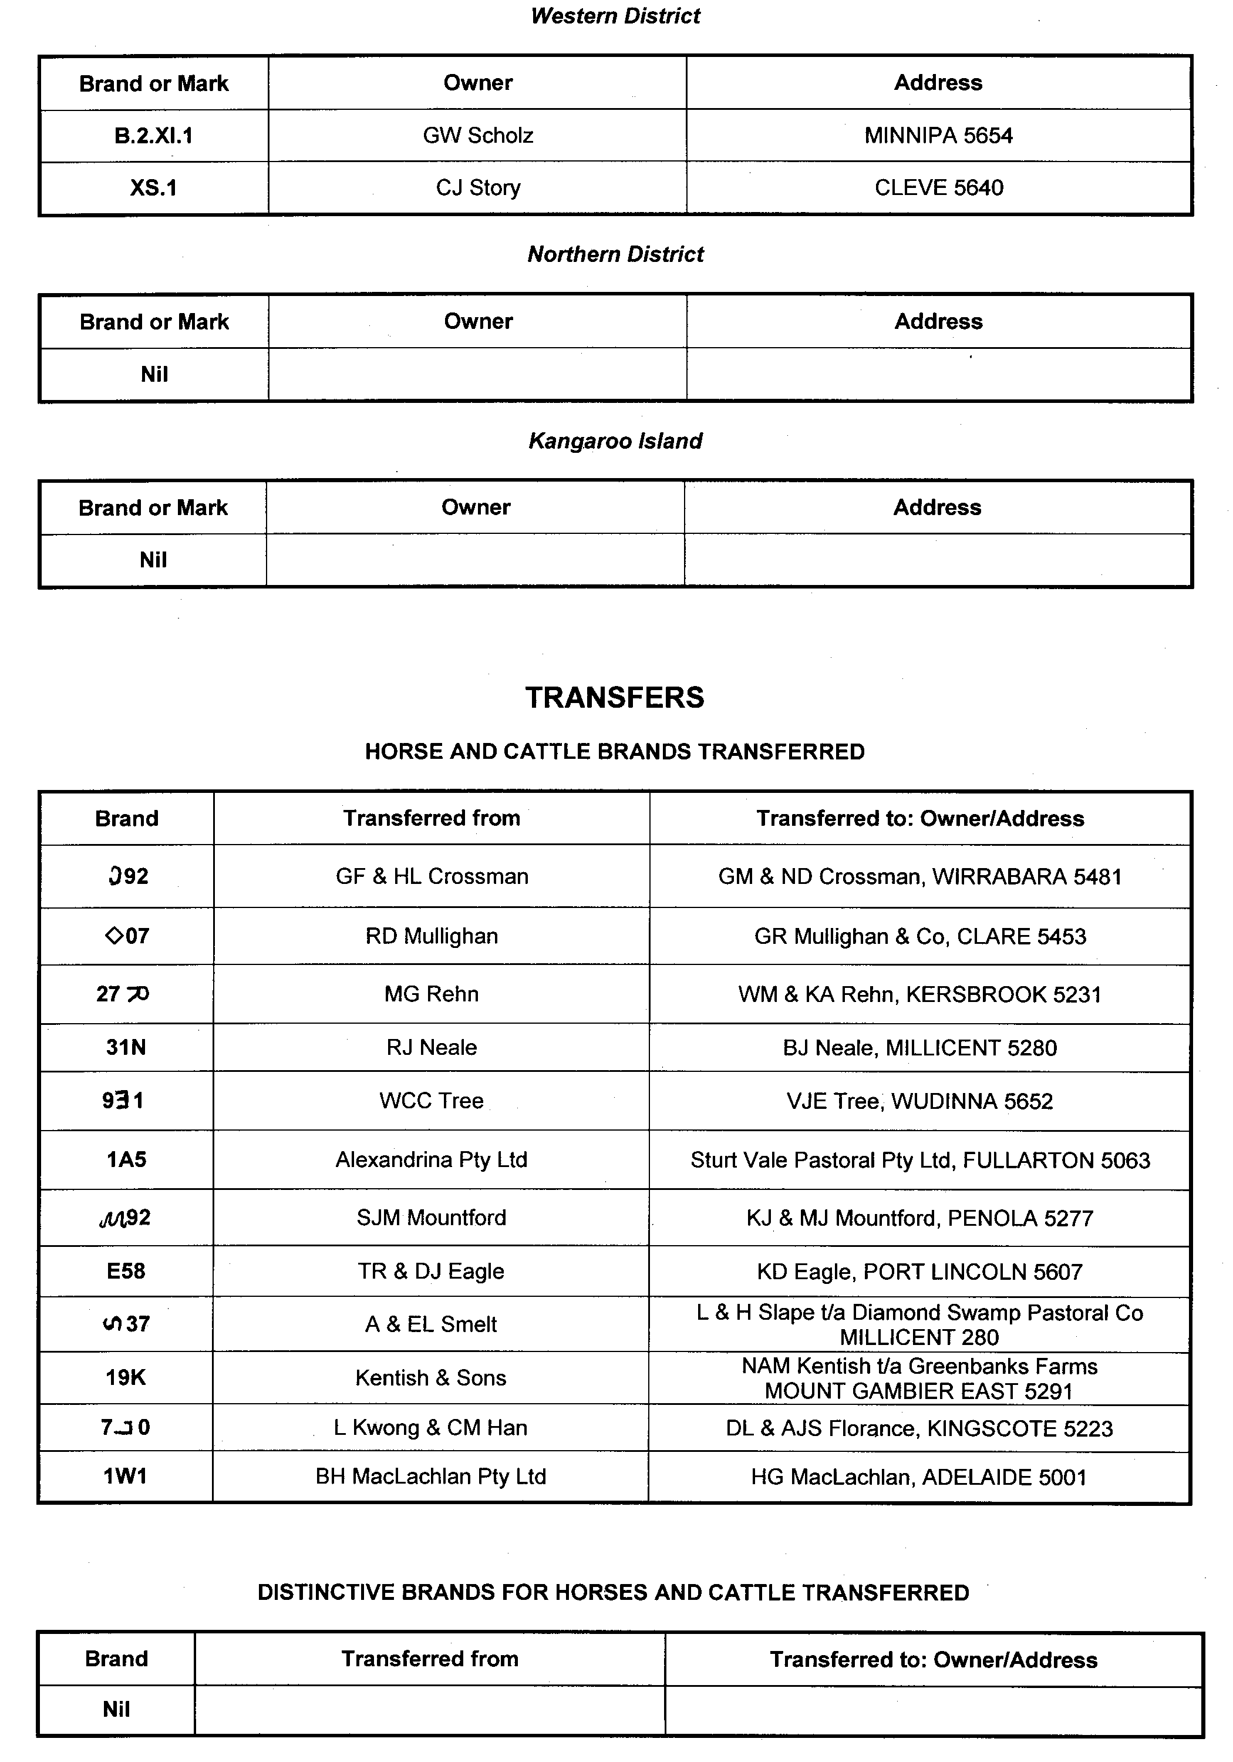
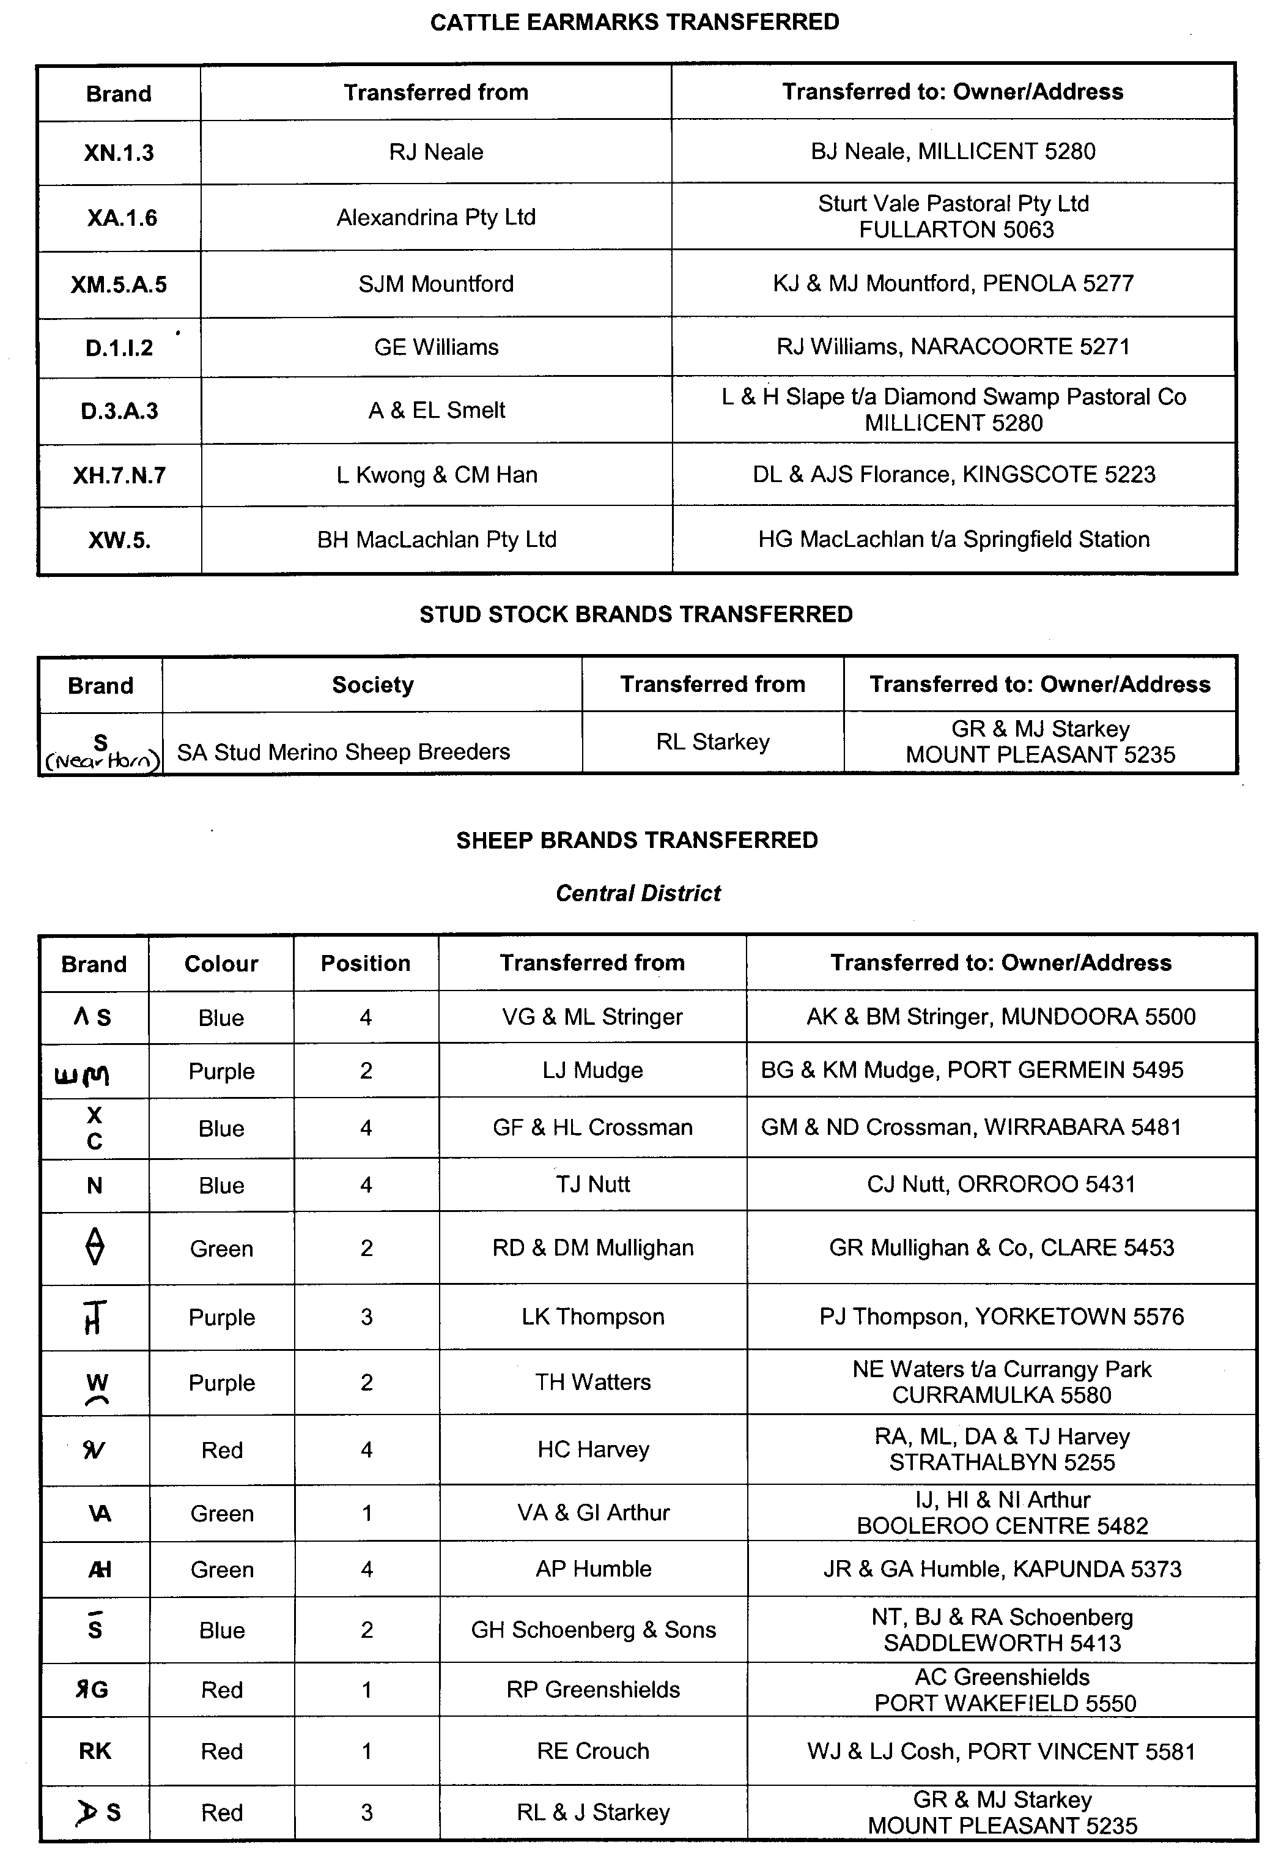
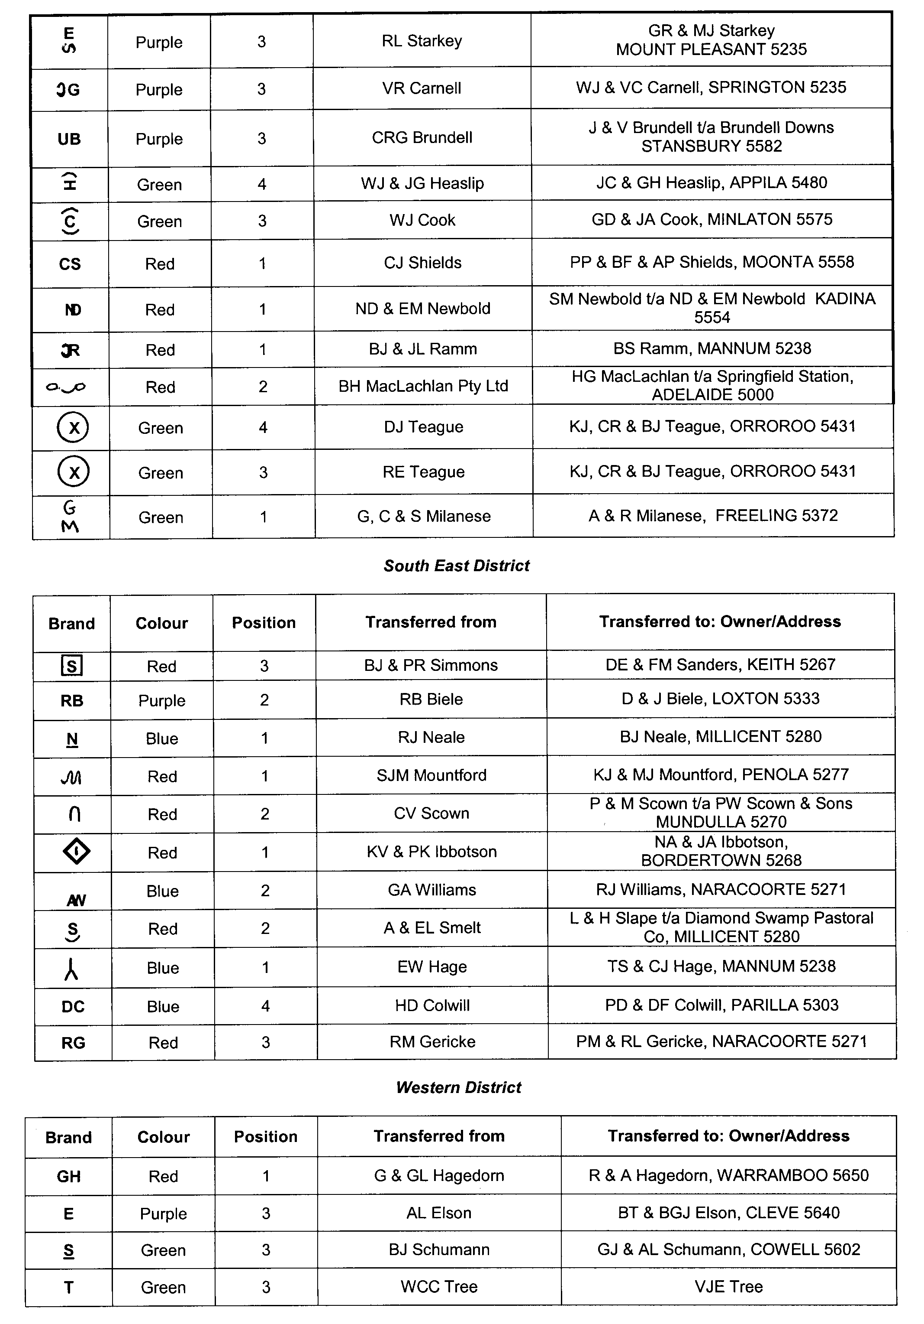
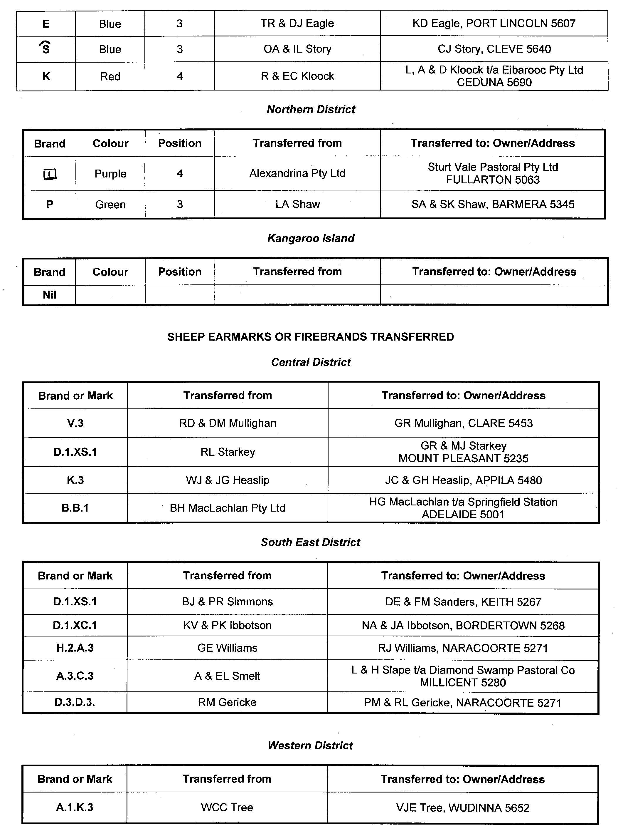
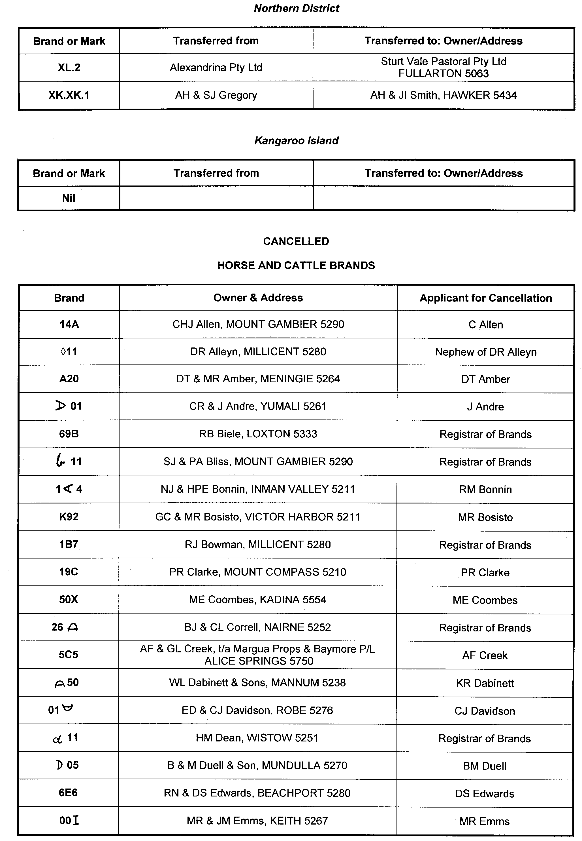
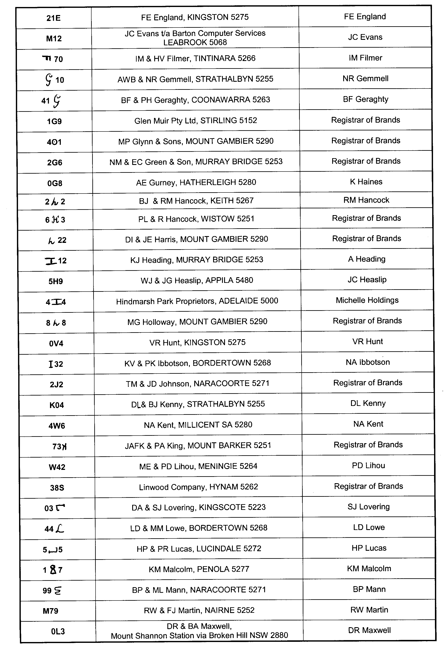
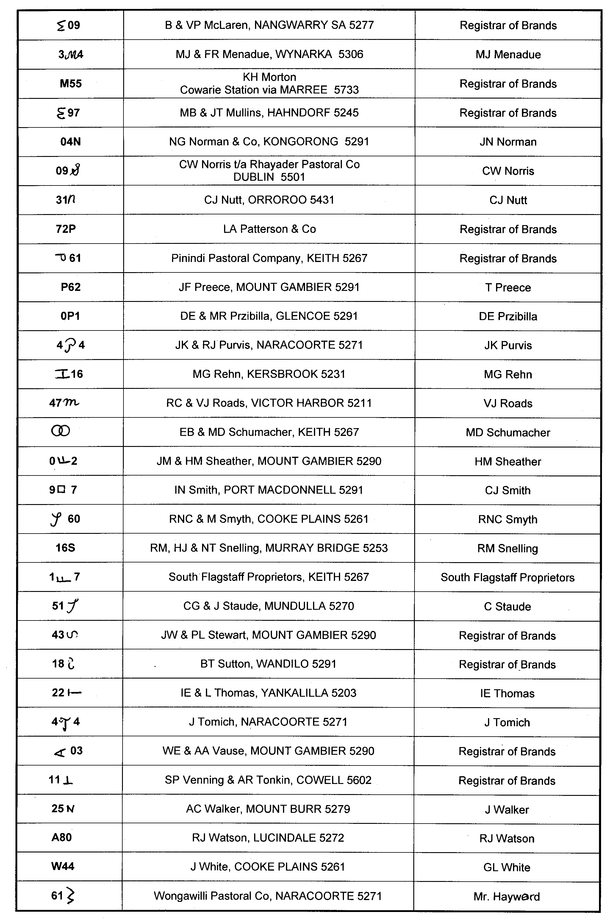
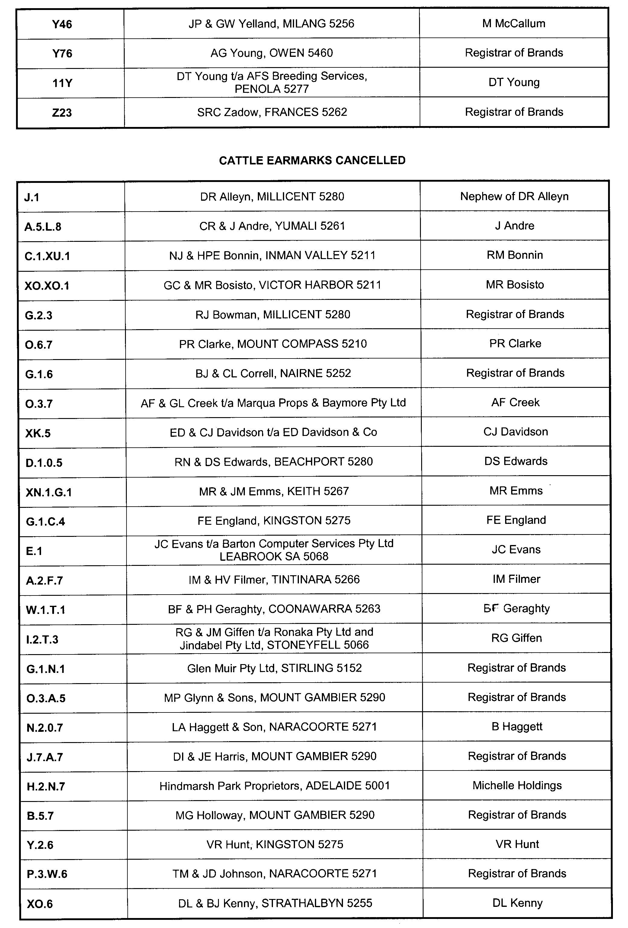
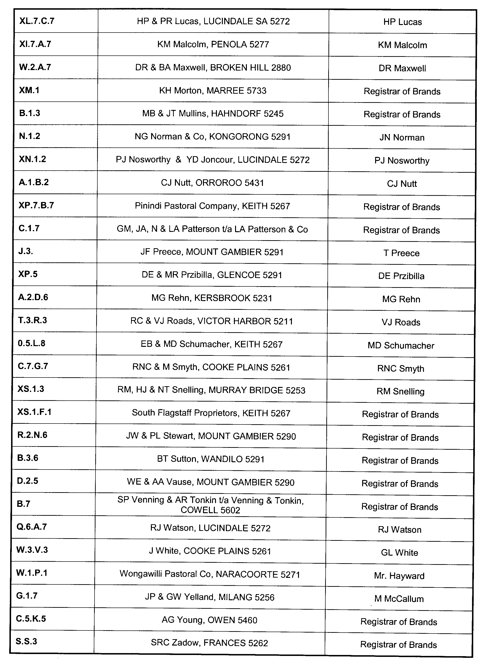
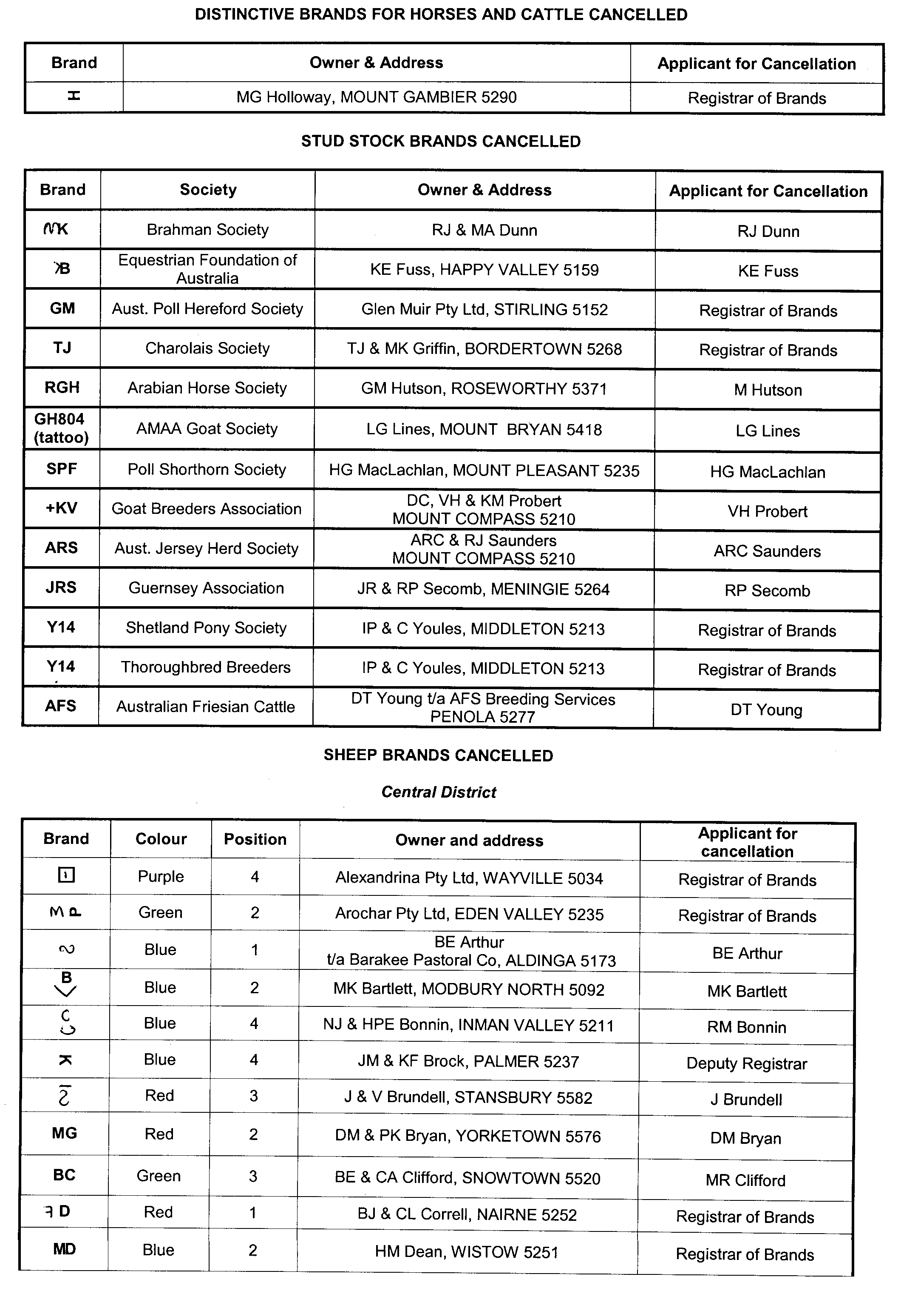
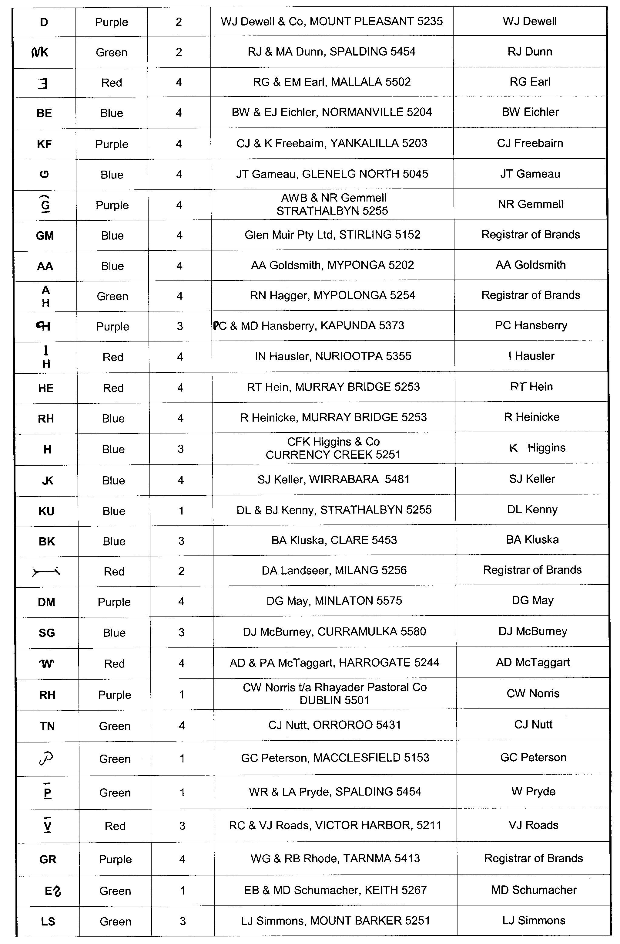
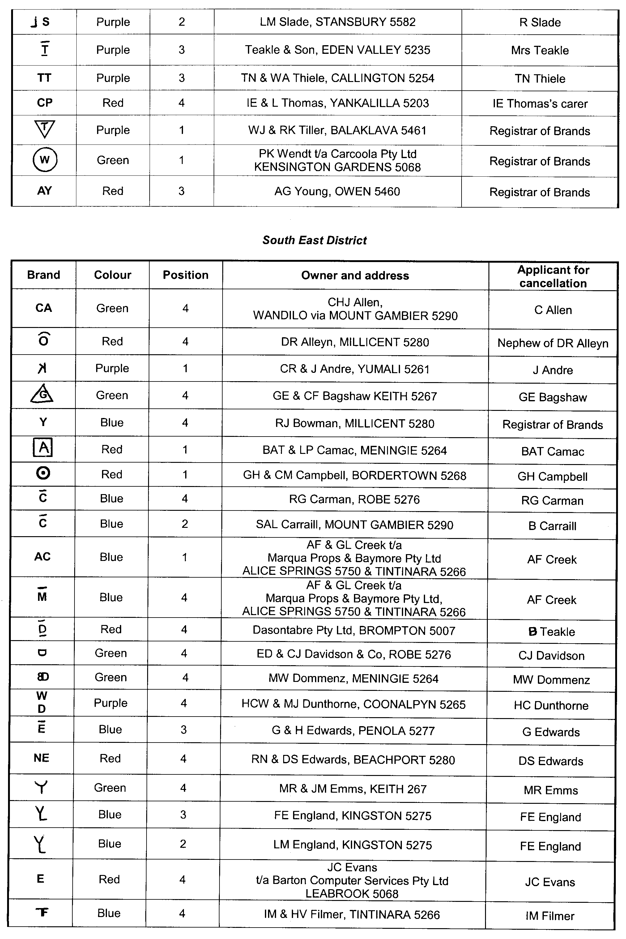
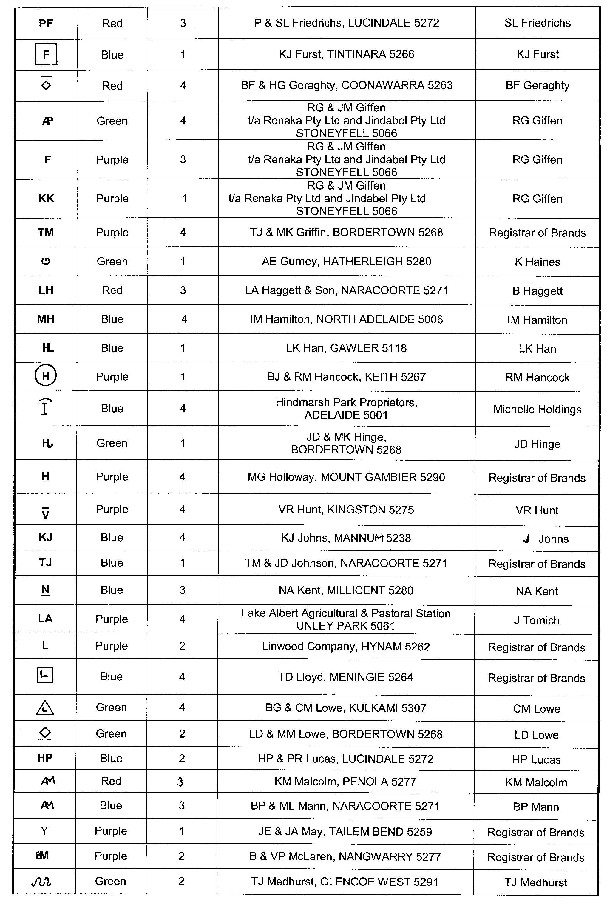
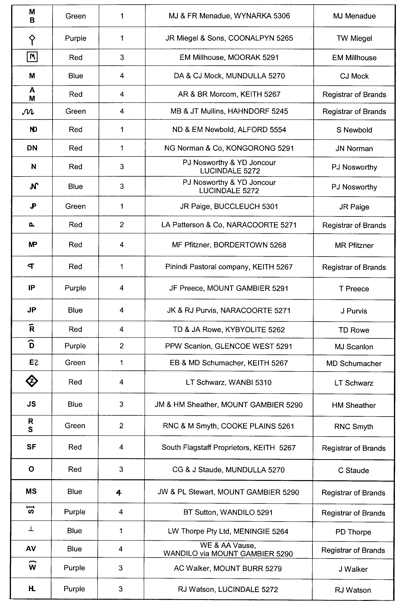
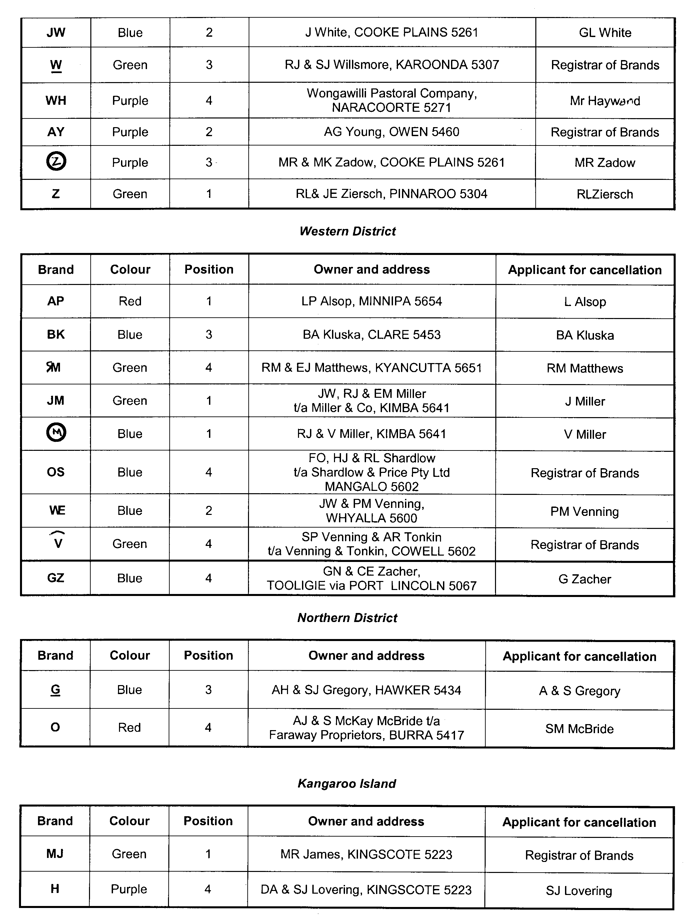
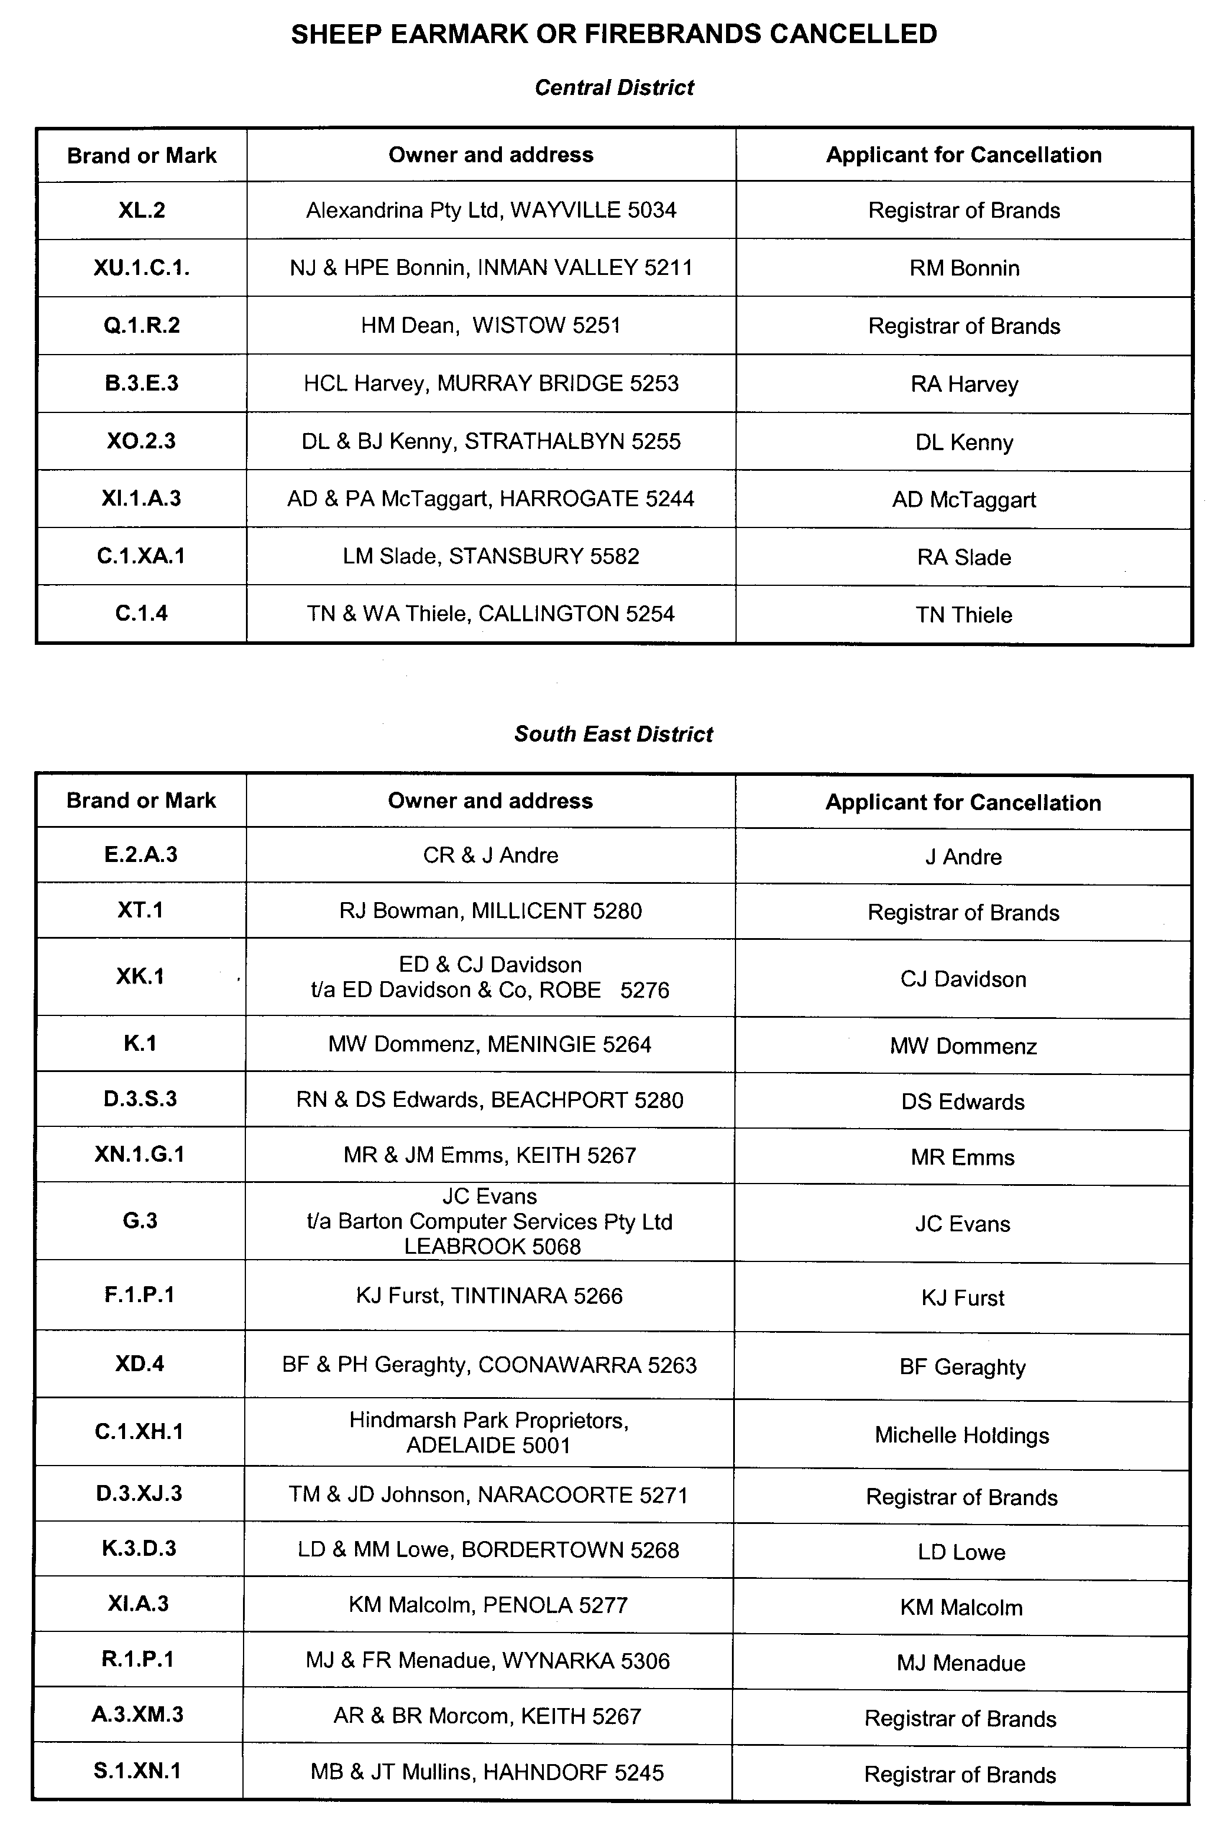

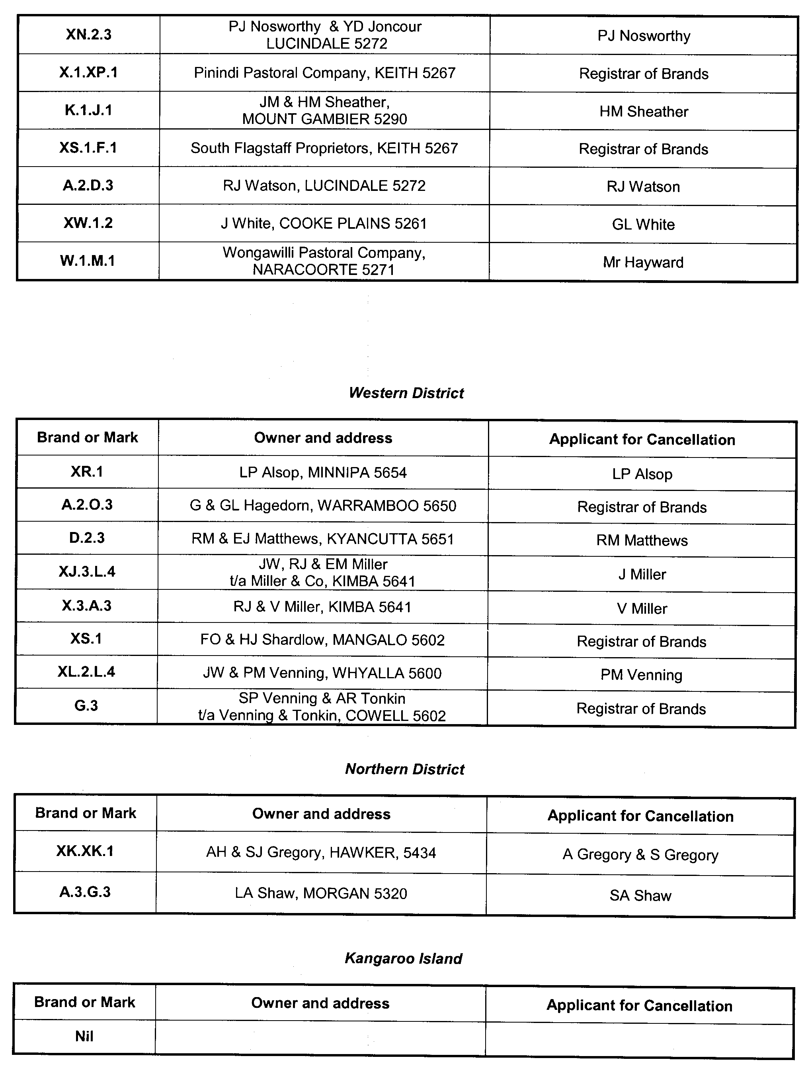

DEVELOPMENT ACT 1993, SECTION 48: DECISION BY THE MINISTER FOR URBAN DEVELOPMENT AND PLANNING UNDER DELEGATION FROM THE GOVERNOR
Preamble
1. On 19 October 1994, the Minister for Housing, Urban Development and Local Government Relations, being of the opinion that a proposed development of a waste management facility in the form of a solid waste landfill (Northern Balefill) near Dublin (‘the development’) was a development of major social, economic or environmental importance, directed the proponent to prepare an Environmental Impact Statement pursuant to section 46 of the Development Act 1993.
2. On 22 April 1996, an Environmental Impact Statement for the development was published in accordance with section 46 of the Development Act 1993. Subsequently, the Minister prepared an Assessment Report in accordance with section 46 of the Development Act 1993.
3. By notice in the Government Gazette on 29 January 1998, the Governor granted development authorisation to the development subject to conditions specified in that notice pursuant to section 48 of the Development Act 1993.
4. Following an application by the beneficiary of the development authorisation for a variation to the authorisation to allow the receipt and disposal of low level contaminated waste, the development was the subject of an Amended Environmental Impact Statement dated June 1998 and an Amended Assessment Report dated December 1998, under section 47 of the Development Act 1993 (‘the amended Major Development’).
5. By notice in the Government Gazette on 8 September 2005, the Governor granted provisional development authorisation to the amended Major Development, reserving specific matters for further assessment.
6. On 30 June 2008, Integrated Waste Services Pty Ltd applied for a second amendment to the development authorisation proposing the establishment of a Multiple Waste Treatment Facility for the treatment and disposal of high level contaminated waste at the existing landfill. The proposal was the subject of an Amended Environmental Impact Statement and an Amended Assessment Report under section 47 of the Development Act 1993 (‘the further amended Major Development’).
7. By notice in the Government Gazette on 27 August 2009, the Governor granted provisional development authorisation to the further amended Major Development, reserving specific matters for further assessment.
8. On 19 May 2010, Integrated Waste Services Pty Ltd applied for approval of the matters reserved for further assessment and for a variation of the development authorisation relating to the Multiple Waste Treatment Facility (‘the MWTF’). The proposed further changes to the MWTF primarily relate to construction being undertaken in one stage (rather than two) and consequent minor modifications to the design of the facility.
9. By notice in the Government Gazette on 27 August 2009, the Governor delegated the following powers to the Minister pursuant to section 48 (8) of the Development Act 1993:
(a) the power to assess and make a decision on matters specified as reserved and to grant a final development authorisation for the purposes of section 48 (2) (b) (i) of the Act;
(b) the power pursuant to section 48B of the Act to grant or permit any variation associated with that development authorisation and associated document (provided the essential nature of the development is not changed); and
(c) in relation to that development authorisation, or any variation thereto—the power to revoke conditions, or to attach new conditions, under section 48 (7) of the Act (provided the essential nature of the development is not changed).
10. I am satisfied that the application for variation of the development authorisation does not require the preparation of a further or amended Environmental Impact Statement and that the application does not change the essential nature of the development.
11. I have assessed the matters reserved for further assessment having regard to all relevant matters in accordance with section 48 (5) of the Development Act 1993, and I am satisfied that the further amended Major Development can now be granted development authorisation.
12. I have decided to grant the requested variation to the amended Major Development by the variation of conditions of the authorisation and the addition of new conditions pursuant to section 48 (7) (b) of the Development Act 1993 and grant development authorisation to the further amended Major Development under section 48 (2) (b) (i) of the Act.
Decision
PURSUANT to section 48 of the Development Act 1993, having due regard to the matters set out in section 48 (5) and all other relevant matters, I:
(a) vary the amended Major Development by:
(i) revoking Conditions 6, 7, 8, 9, 12, 13, 14, 15, 16 and 18 of the provisional development authorisation dated 27 August 2009, in relation to the matter reserved for further assessment in paragraph (c) of the provisional development authorisation dated 27 August 2009;
(ii) revoking Condition 1 of the provisional development authorisation dated 27 August 2009;
(iii) varying Condition 2 of the provisional development authorisation dated 27 August 2009, by adding the following:
• ‘Correspondence from Integrated Waste Services to the Department of Planning and Local Government applying for approval of reserved matters and variations related to the Multiple Waste Treatment Facility dated 19 May 2010, but in the case of conflict with a specific condition below the specific condition shall apply;
• Correspondence from Integrated Waste Services to the Department of Planning and Local Government providing additional information to support application dated 11 May 2010, but in the case of conflict with a specific condition below the specific condition shall apply;
• Correspondence from Katnitch Dodd for Stage 1—Civil and Structural Work dated 31 March 2010 and accompanying certified plans;
• Correspondence from Katnitch Dodd for Final Stage—Services and Fitout Works dated 31 March 2010 and accompanying certified plans’; and
(iv) consolidating and re-numbering the remaining conditions of development authorisation as re-produced below;
(b) grant development authorisation in relation to the matters reserved for further assessment in paragraphs (a) and (b) of the provisional development authorisation dated 27 August 2009;
(c) specify for the purposes of section 48 (7) (b) (i) of the Development Act 1993, that all matters relating to this development authorisation are matters in respect of which conditions of this authorisation may be varied or revoked, or new conditions attached;
(d) specify for the purposes of section 48 (11) (b) the period until 27 August 2011, as the time within which substantial work must be commenced on site, failing which I may cancel this authorisation.
Consolidated Conditions of
Development Authorisation
General Conditions
1. Except where minor amendments may be required by other legislation, or by conditions imposed herein, the proposed Major Development shall be undertaken in strict accordance with the following documents:
• Development application dated 30 June 2008;
• Environmental Impact Statement Amendment, Integrated Waste Services Northern Balefill Dublin Multiple Waste Treatment Facility EIS Amendment prepared by Golder Associates, dated 24 November 2008, but in the case of conflict with a specific condition below the specific condition shall apply;
• Proponent’s response to submissions, letter from Connor Holmes to the Department of Planning and Local Government dated 3 April 2009, but in the case of conflict with a specific condition below the specific condition shall apply;
• Correspondence from Connor Holmes to the Department of Planning and Local Government containing additional information on the proposal dated 27 May 2009, but in the case of conflict with a specific condition below the specific condition shall apply;
• Correspondence from Integrated Waste Services to the Department of Planning and Local Government applying for approval of reserved matters and variations related to the Multiple Waste Treatment Facility dated 19 May 2010, but in the case of conflict with a specific condition below the specific condition shall apply;
• Correspondence from Integrated Waste Services to the Department of Planning and Local Government providing additional information to support application dated 11 May 2010, but in the case of conflict with a specific condition below the specific condition shall apply;
• Correspondence from Katnitch Dodd for Stage 1—Civil and Structural Work dated 31 March 2010 and accompanying certified plans;
• Correspondence from Katnitch Dodd for Final Stage—Services and Fitout Works dated 31 March 2010 and accompanying certified plans.
2. Before any building work is undertaken on the site, the building work is to be certified by a private certifier, or by some person determined by the Minister for Urban Development and Planning, as complying with the provisions of the Building Rules (or the Building Rules as modified according to criteria prescribed by the Regulations).
Multiple Waste Treatment Facility (MWTF)
3. The design of the MWTF shall be amended to include coloured metal cladding on all sides of the building, so as to enclose the whole of the facility.
4. Designs for the effluent treatment and disposal system shall be prepared to the reasonable satisfaction of the District Council of Mallala.
5. Treatment of waste material shall not occur until the construction of the entire MWTF has been completed, to the reasonable satisfaction of the EPA.
6. High Level Contaminated Waste is not required to be baled or shredded.
7. A truck wash with water sprays shall be installed for the removal of residues from vehicles transporting High Level Contaminated Waste to the site. All transport vehicles shall not leave the site unless they have gone through the truck wash.
8. Treatment of the stored materials shall only commence once the completed MTWF is approved by the Environment Protection Authority to commence operation.
9. Bio-remediation and stabilisation are the only treatment processes that shall be used in the MWTF.
10. Pre-remediation trials shall be conducted on all contaminated materials, prior to delivery to the MWTF, to determine if treatment methods approved by the Environment Protection Authority would be successful. Trial results shall be submitted to the Environment Protection Authority for assessment, prior to delivery of contaminated materials to the MWTF.
11. Post-remediation testing on treated materials shall be undertaken to assess its suitability to be disposed of or reused. Testing results shall be submitted to the Environment Protection Authority for assessment, prior to disposal or reuse.
12. Future treatment options shall undergo pre-trial assessment, to the reasonable satisfaction of the Environment Protection Authority, before they can be adopted.
13. An Environmental Management Plan (EMP) for activities associated with the MWTF, prepared to the reasonable satisfaction of the Environment Protection Authority, must be in place prior to the receival, storage and treatment of contaminated materials.
Solid Waste Balefill
14. The work shall be carried out as shown on the plans (Figures 3.1 to 3.9) in the Development Application Report dated 28 November 1997, included with the Development Application dated 2 December 1997, except as varied by these conditions.
15. Subject to Conditions 25, 26 and 27, all waste received for disposal at the facility shall be shredded and baled.
16. Unbaled green waste or unbaled construction or demolition waste of appropriate particle sizes may by placed and compacted in any voids unavoidably occurring between bales and the inclined surface of the cells in which those bales are placed to the reasonable satisfaction of the Environment Protection Authority and in accordance with any applicable requirements of a relevant environmental authorisation.
17. Waste materials received for disposal at the facility need not be shredded before baling where shredding of those materials is not required for the purpose of producing bales of a density and structural integrity that satisfy the applicable requirements of any relevant environmental authorisation.
18. Non-friable asbestos waste shall not be shredded or baled but shall be disposed of in accordance with the applicable requirements of any relevant environmental authorisation.
19. All perimeter plantings shall be started as early as practicable after the date of this authorisation to achieve maximum amelioration of visual impacts.
20. Screening by suitable plantings where adequate natural screening is not provided, shall be provided for the perimeter fence, all built structures, stockpiles and internal roads (where practicable) using suitable species in accordance with the Vegetation Management and Revegetation Plan proposed as part of the Landfill Environmental Management Plan (LEMP).
21. All firebreaks and external drainage channels shall be located on the inner edge of the vegetation screen and existing stands of native vegetation. In the event that drainage channels are required to be located close to the site boundary, their redesign to form low-lying wetland/saltmarsh communities as part of the vegetation screen shall be undertaken and implemented to the satisfaction of the Environment Protection Authority.
22. A leachate monitoring bore shall be installed within each cell to assist with leachate management, particularly if leachate circulation is incorporated in the Landfill Environmental Management Plan (LEMP).
23. The proponent shall pay all reasonable costs of the detailed design and construction of any public roadworks made necessary by this development. Such works may include the opening and associated left turn deceleration lane from Port Wakefield Road, and the upgrading of the entrance to balefill junction to the satisfaction of the Commissioner of Highways.
24. The proponent shall seal (two coat spray seal) the internal site access road for a minimum of 520 m from the nearest residence.
25. The applicant shall prepare a Vegetation Management and Revegetation Plan (which may be included in the LEMP) to the reasonable satisfaction of the Development Assessment Commission and must implement that Plan once it has been approved by the Development Assessment Commission.
Low Level Contaminated Soil and
Liquid Treatment Plant Residues
26. Low Level Contaminated Soil (LLCS) and Liquid Treatment Plant Residues (LTPR) are not required to be baled or shredded.
27. The work shall be carried in accordance with the following documents and plans:
• EIS Amendment, Receipt of Low Level Contaminated Soil and Liquid Treatment Plant Residues at the IWS Northern Balefill, dated July 2003.
• Response Document on the EIS Amendment for the Receipt of Low Level Contaminated Soil and Liquid Treatment Plant Residues (Revised), dated 30 April 2004.
• Supplementary Information EIS Amendment Receipt of Low Level Contaminated Soil and Liquid Treatment Plant Residues at the IWS Northern Balefill, dated 26 November 2004.
• Landfill Environmental Management Plan, dated 2001 or as varied by any applicable requirements of a licence from the Environment Protection Authority.
• Drawings:
– 3307DO1, 4/11/2004 – cell 31 design plan;
– 3307DO2, Drawn 25/8/2004 and checked 18/2/2005—section A, liner and sump design;
– 3307DO3, 10/8/2004—liner design sections and details;
– 3307DO4, 14/10/2004—cell 31 interim capping design;
– 3307DO5, 13/8/2004—landfill staging plan;
– 3307DO6, 13/8/2004—final surface water control;
– 3307DO8, Drawn 27/8/2004 and checked 26/11/2004—interim surface water control;
– 3307DO9 P1, Drawn 4/11/2004 and checked 26/11/2004—cell design plan line 2; and
– 3307DO10, Drawn 29/8/2004 and checked 26/11/2004—sections D and E, swale drain design.
28. Distance to groundwater requirements shall be as follows:
– Based on groundwater level monitoring results and interpolated highest groundwater levels for Cell 31, including a 0.1 m buffer; the base of the sump shall be at 9.1 m AHD;
– Notwithstanding the above requirement, a minimum separation distance of 2 m between the underside of the lowest portion of the lining system (including the sump area) and the underlying groundwater shall be maintained at all times.
29. Leachate collection and extraction system requirements shall be as follows:
– Leachate removal shall implement a system which accommodates the installation of the pumps at the leachate riser access point.
– Following cell completion and until the entire cell base is covered with a minimum of 1.5 m of waste, a pump with a flow capacity of a minimum of 40 litres per second shall be installed.
– After it can be demonstrated that leachate production has declined to less than 1 litre per second, this pump can be replaced by a pump of lesser flow capacity.
– A back-up pump with the relevant capacity shall be readily available on site at all time.
30. Leachate treatment requirements shall be as follows:
– Leachate may be managed and treated by means of:
○ direct extraction into an on-site leachate evaporation pond which shall meet the minimum design specification as follows:
▪ composite lining system comprising a 1 m low permeability clay liner with k < 1x 10⁻⁹m/s compacted to 95% Maximum Dry Density by standard compaction, and a moisture content between 0% and +4% wet of Optimum Moisture Content, overlaid by a 2 mm high density polyethylene (HDPE) liner (welded);
▪ minimum of 600 mm freeboard;
▪ modelling with HELP or LANDSIM shall consider a 1 in 25, 24h duration storm event;
▪ a minimum separation distance of 2 m between the underside of the lowest portion of the lining system and the underlying groundwater shall be maintained at all times.
○ Direct extraction into an on-site tank vehicle suitable for the transport of leachate into an onsite leachate evaporation pond.
○ Direct extraction into a licensed vehicle and transported to an off-site Environment Protection Authority licensed Waste Water Treatment Plant.
○ Direct extraction into a suitably designed, temporary on-site storage tank prior to off-site disposal by an Environment Protection Authority licensed vehicle at an Environment Protection Authority licensed Waste Water Treatment Plant or prior to on-site transport to an on-site leachate evaporation pond.
31. Leachate management requirements shall be as follows:
– The head of leachate on the liner shall not exceed 300 mm (excluding the sump) at all times. To facilitate this, the trigger level for leachate extraction out of the leachate sump shall be set at 290 mm.
– In addition to automatic leachate data readings, a manual monitoring probe shall be installed and calibrated to allow for direct readings of the vertical elevation of leachate in the riser pipe and conversion to the maximum leachate head on top of the liner.
– Leachate levels shall be read manually daily and recorded in the on-site operations logbook or as specified otherwise in the Environment Protection Authority licence.
32. Distance between LLCS/LTPR cells and Balefill cells (reference drawing 3307D03, 18/8/2004) shall be as follows:
– The distance between LLCS/LTPR cells and Balefill cells shall be at a minimum of 5 m, measured between the toe of the LLCS cell structure (that is where the outer surface of the cap of the completed LLCS/LTPR cell joins the outer surface of the underlying clay liner for the same cell) and the cap of the nearest balefill cell (that is where the outer surface of the cap of a completed balefill cell joins the outer surface of the underlying clay liner).
33. Level 1 Supervision requirements shall be as follows:
– The construction of the clay liner of the cell shall be carried out under Level 1 Supervision in accordance with AS 3798-1996, Appendix B.
– The construction of the HDPE liner shall be carried out under the full-time supervision of a suitably qualified geotechnical consultant with experience in the construction and supervision of the construction of HDPE lining systems, quality control procedures and testing.
34. ‘As Constructed Report’ requirements shall be as follows:
– An ‘As Constructed Report’ certifying compliance with the approved design for the lining system, including a Construction Quality Assurance Report (CQA) for the HDPE liner and the Level 1 Supervision Report, shall be submitted to the Environment Protection Authority for acceptance prior to the commencement of the receipt and disposal of waste in each cell. No waste shall be received and disposed of prior to written acceptance of the ‘As Constructed Report’ by the Environment Protection Authority.
35. Coverage of waste requirements shall be as follows:
– All waste shall be covered as soon as reasonable practicable after the receipt of waste and placement in the cell or at close of business on each business day with at least 150 mm of cover material (waste fill or intermediate landfill cover with the restriction to a maximum particle size of 100 mm).
– If a load of particularly odorous material is received at the LLCS/LTPR cell, it shall be covered immediately with a minimum of 150 mm cover material.
– During periods when the LLCS/LTPR cell is not operating, routine monitoring for odorous gases shall be carried out as part of the site monitoring program and may trigger the application of additional cover material.
– Alternative cover materials may be used after the proponent:
○ has demonstrated to the Environment Protection Authority that the proposed material and placement method result in an equivalent or better performance compared to the approved material; and
○ has received written approval from the EPA prior to the use of alternative materials and placement methods.
36. Groundwater management requirements shall be as follows:
– An additional groundwater well shall be installed west of cell 30 and the first round of groundwater sampling and testing shall be completed at least two weeks prior to commencement of construction of cell 31.
– Groundwater level monitoring shall commence at least two weeks before commencement of construction of cell 31; groundwater levels shall be taken weekly and reported to the Environment Protection Authority monthly (datasheet and graph) or as specified otherwise in the EPA authorisation.
– Four monitoring rounds at three monthly intervals in the first 12 months of operation shall be carried out to establish additional background analyte levels around cell 31.
– Six monthly monitoring rounds shall be undertaken following the completion of the initial 12 months of groundwater monitoring or as specified otherwise in the Environment Protection Authority licence.
– Prior to the commencement of construction of any other cell for the receipt of LLCS/LTPR, the groundwater management and monitoring program shall be reviewed and submitted for Environment Protection Authority approval.
37. Surface Water Management requirements shall be as follows:
– A stormwater management plan shall be developed and submitted for Environment Protection Authority’s approval addressing all issues related to the staged construction of LLCS/LTPR cells on site prior to commencement of construction of cell 31.
– The stormwater management plan shall provide surface water control and management measures for:
○ surface water or stormwater runoff that does not interact with the waste material or other operational areas of the site and is considered to be uncontaminated;
○ surface water that comes into contact with waste materials or is collected from landfill areas or other operational areas and is considered to be contaminated;
○ surface runoff from the final landfill cap which has to be controlled; and
○ diversion of surface water runoff from perimeter areas away from the operating cell.
38. Landfill Environmental Management Plan (LEMP) requirements shall be as follows:
– The new section of the LEMP (‘section 17’) shall be completed and incorporated in the revised LEMP document.
– The complete revised LEMP document shall be finalised and submitted to the Environment Protection Authority for approval prior to the receipt and disposal of LLCS/LTPR on the premises.
39. A wheel wash with water sprays shall be installed ensure removal of residues from the wheels and underside of the vehicles transporting low level contaminated soil and liquid treatment plant residues to the site.
Notes to Proponent
Building Rules
• The proponent shall obtain a Building Rules assessment and certification for any building work from either the Wakefield Regional Council or a private certifier (at the proponent’s option) and forward to the Minister for Urban Development and Planning all relevant certification documents as outlined in Regulation 64 of the Development Regulations 2008.
• Pursuant to Development Regulation 64, the proponent is especially advised that the District Council of Mallala or private certifier conducting a Building Rules assessment must:
– provide to the Minister for Urban Development and Planning a certification in the form set out in Schedule 12A of the Development Regulations 2008, in relation to the building works in question; and
– to the extent that may be relevant and appropriate:
(i) issue a Schedule of Essential Safety Provisions under Division 4 of Part 12;
(ii) assign a classification of the building under these regulations; and
(iii) ensure that the appropriate levy has been paid under the Construction Industry Training Fund 1993.
• Regulation 64 of the Development Regulations 2008, provides further information about the type and quantity of all Building Rules certification documentation for Major Developments required for referral to the Minister for Urban Development and Planning. The District Council of Mallala or private certifier undertaking Building Rules assessments must ensure that the assessment and certification are consistent with this provisional development authorisation (including its Conditions and Notes).
Environmental Management Plan for the Multiple Waste Treatment Facility (MWTF)
• An Environmental Management Plan (EMP) covering the operation requirements for the MTWF shall be prepared in consultation with the Environment Protection Authority.
• The EMP shall include an air quality monitoring programme to ensure air emissions from the MWTF do not contain contaminants at levels that may be harmful to nearby residents and land uses.
• The EMP shall include protocols for testing/trialling the suitability and effectiveness of treatment methods for batches of contaminated materials that could potentially be treated at the MWTF, prior to the receival of such material.
• The EMP shall include contingencies for dealing with contaminated materials that cannot meet disposal criteria after treatment.
• The EMP shall include a detailed risk assessment protocol for all contaminated waste types to be treated.
• The EMP shall include a Fire Risk Management Plan.
• The EMP shall include a Hazardous Substances Management Plan.
• The EMP shall include an Occupational Health, Safety and Welfare Plan prepared in consultation with the Department of Health.
• The EMP shall include a financial assurance strategy.
• The EMP shall be amended if new treatment options, that have been approved by the Environment Protection Authority, are adopted in the future.
• The current Landfill Environmental Management Plan (LEMP) shall be amended, to the reasonable satisfaction of the Environment Protection Authority, to address the management of soil erosion and stormwater and the upgrading of existing screens and/or mounds or the establishment of new vegetated screens and/or mounds associated with the MWTF.
• The amendment of the LEMP and the upgrading of the site infrastructure, including but not limited to vegetated screens and/or mounds, shall be undertaken prior to commencement of the MWTF operations.
EPA Licensing and General Environmental Duty of Care
• The applicant is reminded of its general environmental duty, as required by section 25 of the Environment Protection Act 1993, to take all reasonable and practical measures to ensure that the activities on the whole site, including during both construction and operation, do not pollute the environment in a way which causes or may cause environmental harm.
• Environmental authorisation in the form of an amended licence will be required for the construction and/or operation of this development. The applicant is advised to contact the Environment Protection Authority before acting on this approval to ascertain licensing requirements.
• It is likely that as a condition of such a licence the Environment Protection Authority will require the licensee to carry out specified environmental monitoring of air and water quality and to make reports of the results of such monitoring to it.
General Landfill Operations
• To provide additional screening and wildlife habitat the following options could be investigated by the proponent, council, community and local landowners:
– revegetation of the road reserve along Prime Beach Road, in conjunction with the District Council of Mallala and the community;
– revegetation of the road reserve along Port Wakefield Road, in conjunction with the Department of Transport and Urban Planning (Transport SA) to further reduce views from the eastern direction;
– plantings on private property along fence lines adjoining the site, in conjunction with landowners and the community.
• All sedimentation basins, evaporation ponds, and surface water drainage channels should be suitably located, designed and managed to ensure native vegetation (especially low-lying saltmarsh communities) is not adversely affected by construction activities or groundwater mounding and, if possible, the ecological value enhanced.
• A comprehensive Pest Plant and Animal Management Plan must be implemented prior to landfill operations commencing, to ensure the site is free of as many pest species as possible from the onset and adequate monitoring and follow-up control should occur, as discussed in the Assessment Report.
• Whilst not totally within the control of the proponent, monitoring and control programs to reduce the risk of disease transmission between activities in the area may ideally be prepared by adopting a district approach, in co-ordination with the Adelaide Plains Animal and Plant Control Board, Department of Primary Industries and Resources and landowners.
• To minimise and control any on-site soil erosion (particularly of stockpiled material), a Soil Erosion and Drainage Management Plan (SEDMP) as described in the Environment Protection Agency’s ‘Stormwater Pollution Prevention Codes of Practice’, must be prepared and approved as part of the LEMP, before the site becomes operational.
• As part of the LEMP, a Surface Water Management Plan must be prepared by the proponent to the satisfaction of the EPA prior to receipt of any waste. The plan should address the collection and management of all on-site surface water (including any contaminated runoff originating from roadways, carparks and hardstands, the vehicle workshop or wheel washing facility) and management of all surface water flows entering the site from land external to the site, in particular to ensure their final discharge does not impact adversely on any downstream wetlands.
• A monitoring program must be established to record levels of coastal flooding in the western section of the site and, if results indicate a significant risk, a review process be undertaken (ideally through any relevant local community consultative committee) to determine whether to proceed with Stage 9.
• If blasting is required to remove any of the Ripon Calcrete, explosion vibration characteristics and monitoring requirements must be determined in consultation with the Environment Protection Authority and District Council of Mallala, prior to commencement.
• The Environment Protection Agency must be provided with all additional data concerning the site geology as it becomes available, as this could necessitate minor changes to landfill design or method of operation and the installation of additional groundwater monitoring bores.
• To enable detailed design of the proposed groundwater protection system, to determine the minimum depth at which the landfill cells should be based and to enable detailed design of the surface water management system; further investigation of groundwater levels and behaviour on the site must be undertaken prior to finalisation of the detailed design of the landfill and preparation of management plans.
• As part of the LEMP, a detailed Groundwater and Leachate Management Plan must be prepared by the proponent to the satisfaction of the Environment Protection Authority, prior to receipt of any waste. The Plan must demonstrate how the method of hydraulic containment proposed can be practically achieved. Further hydrogeological investigations must be carried out prior to the commencement of any landfill construction in order to fully define the dewatering and groundwater disposal requirements and to provide details of how the cells can be dewatered and constructed for full hydraulic containment of leachate. In particular, monitoring of watertable levels must commence immediately after the granting of the development authorisation in order that the magnitude of seasonal fluctuations can be fully established prior to construction of the landfill. The Plan may provide for staging of leachate and groundwater management works which may be required as a result of the staging of waste disposal activities upon the site, and should include contingency measures to be implemented in the event of any failure of the leachate management system.
• A more sustainable after-use for the site that will encourage the regeneration and rehabilitation of natural communities must be considered during future post closure planning.
• If appropriate with the desired end use to be determined in more detail at a later stage, the entire landform may be planted with appropriate types of native vegetation cover.
• Determination of interim and post closure land uses of the site, proposed to be undertaken in association with any relevant local community consultative committee, must be undertaken as required by the Environment Protection Authority as part of the LEMP.
Given under my hand at Adelaide, 2 September 2010.
Paul Holloway, Minister for Urban Development and Planning

FISHERIES MANAGEMENT ACT 2007: SECTION 79
TAKE note that pursuant to section 79 of the Fisheries Management Act 2007, I hereby declare that it is unlawful for a person to engage in the fishing activities specified in Schedule 1 during the periods specified in Schedule 2 in the waters of the Southern Zone Rock Lobster Fishery.
Schedule 1
Taking southern rock lobster (Jasus edwardsii) for a commercial purpose.
Fishing pursuant to a commercial Southern Zone Rock Lobster Fishery Licence using a rock lobster pot.
Taking southern rock lobster (Jasus edwardsii) for a non-commercial purpose.
Fishing using a rock lobster pot registered for the purpose of non-commercial fishing pursuant to Regulation 10 of the Fisheries Management (General) Regulations 2007.
Schedule 2
1. From 0600 hours on 1 October 2010 to 0600 hours on 1 November 2010.
2. From 1800 hours on 30 April 2011 to 1800 hours on 31 May 2011.
Dated 2 September 2010.
Michael O’Brien, Minister for Agriculture, Food and Fisheries

DEPARTMENT OF PRIMARY INDUSTRIES AND RESOURCES SA—FISHERIES DIVISION
NOTICE is hereby given pursuant to section 90 (2) of the Fisheries Management Act 2007, that the following items have been seized by officers of the Department of Primary Industries and Resources SA, Fisheries Division at Sturt Bay on 19 March 2010:
mono mesh net, 2 anchors
The above items were suspected to have been used or intended to be used, in contravention of the Fisheries Management Act 2007, and were taken into possession at Sturt Bay.
After the expiration of one month from the date of this notice the items listed above shall, on the order of the Minister for Agriculture, Food and Fisheries, be forfeited to the Crown and shall be either disposed of by sale or destruction.
The above items may be viewed at the Kadina office of the Department of Primary Industries and Resources SA, Fisheries Division.
Dated 16 August 2010.
R. N. Parkes, Manager, Strategic Operations

DEPARTMENT OF PRIMARY INDUSTRIES AND RESOURCES SA—FISHERIES DIVISION
NOTICE is hereby given pursuant to section 90 (2) of the Fisheries Management Act 2007, that the following items have been seized by officers of the Department of Primary Industries and Resources SA, Fisheries Division at Cape Jaffa on 9 November 2009:
1 rock lobster pot and two 4L buoys
The above items were suspected to have been used or intended to be used, in contravention of the Fisheries Management Act 2007, and were taken into possession at Cape Jaffa.
After the expiration of one month from the date of this notice the items listed above shall, on the order of the Minister for Agriculture, Food and Fisheries, be forfeited to the Crown and shall be either disposed of by sale or destruction.
The above items may be viewed at the Kingston office of the Department of Primary Industries and Resources SA, Fisheries Division.
Dated 16 August 2010.
R. N. Parkes, Manager, Strategic Operations

DEPARTMENT OF PRIMARY INDUSTRIES AND RESOURCES SA—FISHERIES DIVISION
NOTICE is hereby given pursuant to section 90 (2) of the Fisheries Management Act 2007, that the following items have been seized by officers of the Department of Primary Industries and Resources SA, Fisheries Division at Long Gully on 14 November 2009:
1 recreational rock lobster pot with white 4L buoy
1 drop net with red rope and small red buoy
The above items were suspected to have been used or intended to be used, in contravention of the Fisheries Management Act 2007, and were taken into possession at Long Gully.
After the expiration of one month from the date of this notice the items listed above shall, on the order of the Minister for Agriculture, Food and Fisheries, be forfeited to the Crown and shall be either disposed of by sale or destruction.
The above items may be viewed at the Kingston office of the Department of Primary Industries and Resources SA, Fisheries Division.
Dated 16 August 2010.
R. N. Parkes, Manager, Strategic Operations

DEPARTMENT OF PRIMARY INDUSTRIES AND RESOURCES SA—FISHERIES DIVISION
NOTICE is hereby given pursuant to section 90 (2) of the Fisheries Management Act 2007, that the following items have been seized by officers of the Department of Primary Industries and Resources SA, Fisheries Division at Beachport on 5 December 2009:
1 recreational rock lobster pot with 4L buoy
The above items were suspected to have been used or intended to be used, in contravention of the Fisheries Management Act 2007, and were taken into possession at Beachport.
After the expiration of one month from the date of this notice the items listed above shall, on the order of the Minister for Agriculture, Food and Fisheries, be forfeited to the Crown and shall be either disposed of by sale or destruction.
The above items may be viewed at the Kingston office of the Department of Primary Industries and Resources SA, Fisheries Division.
Dated 16 August 2010.
R. N. Parkes, Manager, Strategic Operations

DEPARTMENT OF PRIMARY INDUSTRIES AND RESOURCES SA—FISHERIES DIVISION
NOTICE is hereby given pursuant to section 90 (2) of the Fisheries Management Act 2007, that the following items have been seized by officers of the Department of Primary Industries and Resources SA, Fisheries Division at Robe on 12 December 2009:
1 drop net with blue rope and small white buoy
1 SZRL pot with yellow rope, one 4L red buoy, one 4L white buoy
1 SZRL pot with red rope and 4L red buoy
The above items were suspected to have been used or intended to be used, in contravention of the Fisheries Management Act 2007, and were taken into possession at Robe.
After the expiration of one month from the date of this notice the items listed above shall, on the order of the Minister for Agriculture, Food and Fisheries, be forfeited to the Crown and shall be either disposed of by sale or destruction.
The above items may be viewed at the Kingston office of the Department of Primary Industries and Resources SA, Fisheries Division.
Dated 16 August 2010.
R. N. Parkes, Manager, Strategic Operations

DEPARTMENT OF PRIMARY INDUSTRIES AND RESOURCES SA—FISHERIES DIVISION
NOTICE is hereby given pursuant to section 90 (2) of the Fisheries Management Act 2007, that the following items have been seized by officers of the Department of Primary Industries and Resources SA, Fisheries Division at Cape Jaffa on 7 June 2010:
1 rock lobster pot
1 red 4L float
1 white 4L float
1 orange rope
The above items were suspected to have been used or intended to be used, in contravention of the Fisheries Management Act 2007, and were taken into possession at Cape Jaffa.
After the expiration of one month from the date of this notice the items listed above shall, on the order of the Minister for Agriculture, Food and Fisheries, be forfeited to the Crown and shall be either disposed of by sale or destruction.
The above items may be viewed at the Kingston office of the Department of Primary Industries and Resources SA, Fisheries Division.
Dated 16 August 2010.
R. N. Parkes, Manager, Strategic Operations

DEPARTMENT OF PRIMARY INDUSTRIES AND RESOURCES SA—FISHERIES DIVISION
NOTICE is hereby given pursuant to section 90 (2) of the Fisheries Management Act 2007, that the following items have been seized by officers of the Department of Primary Industries and Resources SA, Fisheries Division at Robe on 19 November 2009:
1 rock lobster pot, white rope with red flecks, red 4L float with S148 enscribed
The above items were suspected to have been used or intended to be used, in contravention of the Fisheries Management Act 2007, and were taken into possession at Robe.
After the expiration of one month from the date of this notice the items listed above shall, on the order of the Minister for Agriculture, Food and Fisheries, be forfeited to the Crown and shall be either disposed of by sale or destruction.
The above items may be viewed at the Kingston office of the Department of Primary Industries and Resources SA, Fisheries Division.
Dated 16 August 2010.
R. N. Parkes, Manager, Strategic Operations

DEPARTMENT OF PRIMARY INDUSTRIES AND RESOURCES SA—FISHERIES DIVISION
NOTICE is hereby given pursuant to section 90 (2) of the Fisheries Management Act 2007, that the following items have been seized by officers of the Department of Primary Industries and Resources SA, Fisheries Division at Moorook on 19 April 2010:
1 opera house net
2 black yabble pots
The above items were suspected to have been used or intended to be used, in contravention of the Fisheries Management Act 2007, and were taken into possession at Moorook.
After the expiration of one month from the date of this notice the items listed above shall, on the order of the Minister for Agriculture, Food and Fisheries, be forfeited to the Crown and shall be either disposed of by sale or destruction.
The above items may be viewed at the Birkenhead office of the Department of Primary Industries and Resources SA, Fisheries Division.
Dated 16 August 2010.
R. N. Parkes, Manager, Strategic Operations

DEPARTMENT OF PRIMARY INDUSTRIES AND RESOURCES SA—FISHERIES DIVISION
NOTICE is hereby given pursuant to section 90 (2) of the Fisheries Management Act 2007, that the following items have been seized by officers of the Department of Primary Industries and Resources SA, Fisheries Division at Bairds Bay on 8 January 2010:
1 rock lobster pot
The above items were suspected to have been used or intended to be used, in contravention of the Fisheries Management Act 2007, and were taken into possession at Bairds Bay.
After the expiration of one month from the date of this notice the items listed above shall, on the order of the Minister for Agriculture, Food and Fisheries, be forfeited to the Crown and shall be either disposed of by sale or destruction.
The above items may be viewed at the Ceduna office of the Department of Primary Industries and Resources SA, Fisheries Division.
Dated 16 August 2010.
R. N. Parkes, Manager, Strategic Operations

DEPARTMENT OF PRIMARY INDUSTRIES AND RESOURCES SA—FISHERIES DIVISION
NOTICE is hereby given pursuant to section 90 (2) of the Fisheries Management Act 2007, that the following items have been seized by officers of the Department of Primary Industries and Resources SA, Fisheries Division at Ceduna on 19 April 2010:
1 large rock lobster pot with cane top and yellow buoy
The above items were suspected to have been used or intended to be used, in contravention of the Fisheries Management Act 2007, and were taken into possession at Ceduna.
After the expiration of one month from the date of this notice the items listed above shall, on the order of the Minister for Agriculture, Food and Fisheries, be forfeited to the Crown and shall be either disposed of by sale or destruction.
The above items may be viewed at the Ceduna office of the Department of Primary Industries and Resources SA, Fisheries Division.
Dated 16 August 2010.
R. N. Parkes, Manager, Strategic Operations

DEPARTMENT OF PRIMARY INDUSTRIES AND RESOURCES SA—FISHERIES DIVISION
NOTICE is hereby given pursuant to section 90 (2) of the Fisheries Management Act 2007, that the following items have been seized by officers of the Department of Primary Industries and Resources SA, Fisheries Division at Loxton on 19 April 2010:
1 black plastic cylindrical shrimp trap
2 shrimp traps (1 brown, 1 blue)
1 steel cage yabbie tap (4 entrances)
1 white PVC plastic shrimp trap
1 green yabbie trap
1 black opera house yabbie trap
The above items were suspected to have been used or intended to be used, in contravention of the Fisheries Management Act 2007, and were taken into possession at Loxton.
After the expiration of one month from the date of this notice the items listed above shall, on the order of the Minister for Agriculture, Food and Fisheries, be forfeited to the Crown and shall be either disposed of by sale or destruction.
The above items may be viewed at the Loxton office of the Department of Primary Industries and Resources SA, Fisheries Division.
Dated 16 August 2010.
R. N. Parkes, Manager, Strategic Operations

DEPARTMENT OF PRIMARY INDUSTRIES AND RESOURCES SA—FISHERIES DIVISION
NOTICE is hereby given pursuant to section 90 (2) of the Fisheries Management Act 2007, that the following items have been seized by officers of the Department of Primary Industries and Resources SA, Fisheries Division at Loxton on 17 April 2010:
2 shrimp traps (collapsible mesh type)
1 green plastic shrimp trap
4 black plastic cylindrical shrimp traps
1 20 litre white plastic shrimp keeper
6 opera house yabbie nets (1 with no rings @ 7.5 cm)
1 black 20L drum (plastic) shrimp trap
The above items were suspected to have been used or intended to be used, in contravention of the Fisheries Management Act 2007, and were taken into possession at Loxton.
After the expiration of one month from the date of this notice the items listed above shall, on the order of the Minister for Agriculture, Food and Fisheries, be forfeited to the Crown and shall be either disposed of by sale or destruction.
The above items may be viewed at the Loxton office of the Department of Primary Industries and Resources SA, Fisheries Division.
Dated 16 August 2010.
R. N. Parkes, Manager, Strategic Operations

DEPARTMENT OF PRIMARY INDUSTRIES AND RESOURCES SA—FISHERIES DIVISION
NOTICE is hereby given pursuant to section 90 (2) of the Fisheries Management Act 2007, that the following items have been seized by officers of the Department of Primary Industries and Resources SA, Fisheries Division at Moorook on 19 April 2010:
6 opera house nets
1 fish keep (blue)
The above items were suspected to have been used or intended to be used, in contravention of the Fisheries Management Act 2007, and were taken into possession at Moorook.
After the expiration of one month from the date of this notice the items listed above shall, on the order of the Minister for Agriculture, Food and Fisheries, be forfeited to the Crown and shall be either disposed of by sale or destruction.
The above items may be viewed at the Birkenhead office of the Department of Primary Industries and Resources SA, Fisheries Division.
Dated 16 August 2010.
R. N. Parkes, Manager, Strategic Operations

DEPARTMENT OF PRIMARY INDUSTRIES AND RESOURCES SA—FISHERIES DIVISION
NOTICE is hereby given pursuant to section 90 (2) of the Fisheries Management Act 2007, that the following items have been seized by officers of the Department of Primary Industries and Resources SA, Fisheries Division at Moorook on 19 April 2010:
1 large wire shrimp trap
The above items were suspected to have been used or intended to be used, in contravention of the Fisheries Management Act 2007, and were taken into possession at Moorook.
After the expiration of one month from the date of this notice the items listed above shall, on the order of the Minister for Agriculture, Food and Fisheries, be forfeited to the Crown and shall be either disposed of by sale or destruction.
The above items may be viewed at the Birkenhead office of the Department of Primary Industries and Resources SA, Fisheries Division.
Dated 16 August 2010.
R. N. Parkes, Manager, Strategic Operations

DEPARTMENT OF PRIMARY INDUSTRIES AND RESOURCES SA—FISHERIES DIVISION
NOTICE is hereby given pursuant to section 90 (2) of the Fisheries Management Act 2007, that the following items have been seized by officers of the Department of Primary Industries and Resources SA, Fisheries Division at Berri on 19 April 2010:
1 shrimp trap
The above items were suspected to have been used or intended to be used, in contravention of the Fisheries Management Act 2007, and were taken into possession at Berri.
After the expiration of one month from the date of this notice the items listed above shall, on the order of the Minister for Agriculture, Food and Fisheries, be forfeited to the Crown and shall be either disposed of by sale or destruction.
The above items may be viewed at the Loxton office of the Department of Primary Industries and Resources SA, Fisheries Division.
Dated 16 August 2010.
R. N. Parkes, Manager, Strategic Operations

DEPARTMENT OF PRIMARY INDUSTRIES AND RESOURCES SA—FISHERIES DIVISION
NOTICE is hereby given pursuant to section 90 (2) of the Fisheries Management Act 2007, that the following items have been seized by officers of the Department of Primary Industries and Resources SA, Fisheries Division at Moorook on 19 April 2010:
1 black shrimp trap
The above items were suspected to have been used or intended to be used, in contravention of the Fisheries Management Act 2007, and were taken into possession at Moorook.
After the expiration of one month from the date of this notice the items listed above shall, on the order of the Minister for Agriculture, Food and Fisheries, be forfeited to the Crown and shall be either disposed of by sale or destruction.
The above items may be viewed at the Birkenhead office of the Department of Primary Industries and Resources SA, Fisheries Division.
Dated 16 August 2010.
R. N. Parkes, Manager, Strategic Operations

DEPARTMENT OF PRIMARY INDUSTRIES AND RESOURCES SA—FISHERIES DIVISION
NOTICE is hereby given pursuant to section 90 (2) of the Fisheries Management Act 2007, that the following items have been seized by officers of the Department of Primary Industries and Resources SA, Fisheries Division at Paringa on 20 April 2010:
1 shrimp trap
The above items were suspected to have been used or intended to be used, in contravention of the Fisheries Management Act 2007, and were taken into possession at Berri.
After the expiration of one month from the date of this notice the items listed above shall, on the order of the Minister for Agriculture, Food and Fisheries, be forfeited to the Crown and shall be either disposed of by sale or destruction.
The above items may be viewed at the Birkenhead office of the Department of Primary Industries and Resources SA, Fisheries Division.
Dated 16 August 2010.
R. N. Parkes, Manager, Strategic Operations

DEPARTMENT OF PRIMARY INDUSTRIES AND RESOURCES SA—FISHERIES DIVISION
NOTICE is hereby given pursuant to section 90 (2) of the Fisheries Management Act 2007, that the following items have been seized by officers of the Department of Primary Industries and Resources SA, Fisheries Division at Paringa on 21 April 2010:
1 Opera house net
The above items were suspected to have been used or intended to be used, in contravention of the Fisheries Management Act 2007, and were taken into possession at Paringa.
After the expiration of one month from the date of this notice the items listed above shall, on the order of the Minister for Agriculture, Food and Fisheries, be forfeited to the Crown and shall be either disposed of by sale or destruction.
The above items may be viewed at the Birkenhead office of the Department of Primary Industries and Resources SA, Fisheries Division.
Dated 16 August 2010.
R. N. Parkes, Manager, Strategic Operations

DEPARTMENT OF PRIMARY INDUSTRIES AND RESOURCES SA—FISHERIES DIVISION
NOTICE is hereby given pursuant to section 90 (2) of the Fisheries Management Act 2007, that the following items have been seized by officers of the Department of Primary Industries and Resources SA, Fisheries Division at Paringa on 21 April 2010:
1 shrimp trap
The above items were suspected to have been used or intended to be used, in contravention of the Fisheries Management Act 2007, and were taken into possession at Paringa.
After the expiration of one month from the date of this notice the items listed above shall, on the order of the Minister for Agriculture, Food and Fisheries, be forfeited to the Crown and shall be either disposed of by sale or destruction.
The above items may be viewed at the Birkenhead office of the Department of Primary Industries and Resources SA, Fisheries Division.
Dated 16 August 2010.
R. N. Parkes, Manager, Strategic Operations

DEPARTMENT OF PRIMARY INDUSTRIES AND RESOURCES SA—FISHERIES DIVISION
NOTICE is hereby given pursuant to section 90 (2) of the Fisheries Management Act 2007, that the following items have been seized by officers of the Department of Primary Industries and Resources SA, Fisheries Division at Loxton on 18 April 2010:
1 opera house net
The above items were suspected to have been used or intended to be used, in contravention of the Fisheries Management Act 2007, and were taken into possession at Loxton.
After the expiration of one month from the date of this notice the items listed above shall, on the order of the Minister for Agriculture, Food and Fisheries, be forfeited to the Crown and shall be either disposed of by sale or destruction.
The above items may be viewed at the Birkenhead office of the Department of Primary Industries and Resources SA, Fisheries Division.
Dated 16 August 2010.
R. N. Parkes, Manager, Strategic Operations

DEPARTMENT OF PRIMARY INDUSTRIES AND RESOURCES SA—FISHERIES DIVISION
NOTICE is hereby given pursuant to section 90 (2) of the Fisheries Management Act 2007, that the following items have been seized by officers of the Department of Primary Industries and Resources SA, Fisheries Division at Lock 4 via Berri on 29 December 2009:
1 black and red rod with green tip and a MJ5000 gold coloured reel
The above items were suspected to have been used or intended to be used, in contravention of the Fisheries Management Act 2007, and were taken into possession at Lock 4 via Berri.
After the expiration of one month from the date of this notice the items listed above shall, on the order of the Minister for Agriculture, Food and Fisheries, be forfeited to the Crown and shall be either disposed of by sale or destruction.
The above items may be viewed at the Birkenhead office of the Department of Primary Industries and Resources SA, Fisheries Division.
Dated 16 August 2010.
R. N. Parkes, Manager, Strategic Operations

DEPARTMENT OF PRIMARY INDUSTRIES AND RESOURCES SA—FISHERIES DIVISION
NOTICE is hereby given pursuant to section 90 (2) of the Fisheries Management Act 2007, that the following items have been seized by officers of the Department of Primary Industries and Resources SA, Fisheries Division at Renmark on 22 April 2010:
1 opera house net with styrofoam buoy (white)
The above items were suspected to have been used or intended to be used, in contravention of the Fisheries Management Act 2007, and were taken into possession at Renmark.
After the expiration of one month from the date of this notice the items listed above shall, on the order of the Minister for Agriculture, Food and Fisheries, be forfeited to the Crown and shall be either disposed of by sale or destruction.
The above items may be viewed at the Loxton office of the Department of Primary Industries and Resources SA, Fisheries Division.
Dated 16 August 2010.
R. N. Parkes, Manager, Strategic Operations

DEPARTMENT OF PRIMARY INDUSTRIES AND RESOURCES SA—FISHERIES DIVISION
NOTICE is hereby given pursuant to section 90 (2) of the Fisheries Management Act 2007, that the following items have been seized by officers of the Department of Primary Industries and Resources SA, Fisheries Division at Renmark on 22 April 2010:
5 opera house nets with 3L milk container buoys
The above items were suspected to have been used or intended to be used, in contravention of the Fisheries Management Act 2007, and were taken into possession at Renmark.
After the expiration of one month from the date of this notice the items listed above shall, on the order of the Minister for Agriculture, Food and Fisheries, be forfeited to the Crown and shall be either disposed of by sale or destruction.
The above items may be viewed at the Loxton office of the Department of Primary Industries and Resources SA, Fisheries Division.
Dated 16 August 2010.
R. N. Parkes, Manager, Strategic Operations

DEPARTMENT OF PRIMARY INDUSTRIES AND RESOURCES SA—FISHERIES DIVISION
NOTICE is hereby given pursuant to section 90 (2) of the Fisheries Management Act 2007, that the following items have been seized by officers of the Department of Primary Industries and Resources SA, Fisheries Division at Point Pearce on 15 September 2009:
1 cotton mesh net with floats and lead
The above items were suspected to have been used or intended to be used, in contravention of the Fisheries Management Act 2007, and were taken into possession at Point Pearce.
After the expiration of one month from the date of this notice the items listed above shall, on the order of the Minister for Agriculture, Food and Fisheries, be forfeited to the Crown and shall be either disposed of by sale or destruction.
The above items may be viewed at the Kadina office of the Department of Primary Industries and Resources SA, Fisheries Division.
Dated 16 August 2010.
R. N. Parkes, Manager, Strategic Operations

DEPARTMENT OF PRIMARY INDUSTRIES AND RESOURCES SA—FISHERIES DIVISION
NOTICE is hereby given pursuant to section 90 (2) of the Fisheries Management Act 2007, that the following items have been seized by officers of the Department of Primary Industries and Resources SA, Fisheries Division at Point Pearce on 15 September 2009:
1 mesh net, floats, lead, including carry bag
The above items were suspected to have been used or intended to be used, in contravention of the Fisheries Management Act 2007, and were taken into possession at Point Pearce.
After the expiration of one month from the date of this notice the items listed above shall, on the order of the Minister for Agriculture, Food and Fisheries, be forfeited to the Crown and shall be either disposed of by sale or destruction.
The above items may be viewed at the Kadina office of the Department of Primary Industries and Resources SA, Fisheries Division.
Dated 16 August 2010.
R. N. Parkes, Manager, Strategic Operations

DEPARTMENT OF PRIMARY INDUSTRIES AND RESOURCES SA—FISHERIES DIVISION
NOTICE is hereby given pursuant to section 90 (2) of the Fisheries Management Act 2007, that the following items have been seized by officers of the Department of Primary Industries and Resources SA, Fisheries Division at Southend on 5 January 2010:
1 drop net black double hoop, red rope, white 4L float
The above items were suspected to have been used or intended to be used, in contravention of the Fisheries Management Act 2007, and were taken into possession at Southend.
After the expiration of one month from the date of this notice the items listed above shall, on the order of the Minister for Agriculture, Food and Fisheries, be forfeited to the Crown and shall be either disposed of by sale or destruction.
The above items may be viewed at the Kingston office of the Department of Primary Industries and Resources SA, Fisheries Division.
Dated 18 August 2010.
R. N. Parkes, Manager, Strategic Operations

DEPARTMENT OF PRIMARY INDUSTRIES AND RESOURCES SA—FISHERIES DIVISION
NOTICE is hereby given pursuant to section 90 (2) of the Fisheries Management Act 2007, that the following items have been seized by officers of the Department of Primary Industries and Resources SA, Fisheries Division at Beachport on 7 January 2010:
1 rock lobster pot, red neck, white rope, top bait basket—red float 4L
1 rock lobster pot, red 4L float and white float green rope
The above items were suspected to have been used or intended to be used, in contravention of the Fisheries Management Act 2007, and were taken into possession at Beachport.
After the expiration of one month from the date of this notice the items listed above shall, on the order of the Minister for Agriculture, Food and Fisheries, be forfeited to the Crown and shall be either disposed of by sale or destruction.
The above items may be viewed at the Kingston office of the Department of Primary Industries and Resources SA, Fisheries Division.
Dated 18 August 2010.
R. N. Parkes, Manager, Strategic Operations

DEPARTMENT OF PRIMARY INDUSTRIES AND RESOURCES SA—FISHERIES DIVISION
NOTICE is hereby given pursuant to section 90 (2) of the Fisheries Management Act 2007, that the following items have been seized by officers of the Department of Primary Industries and Resources SA, Fisheries Division at Robe on 4 January 2010:
1 rock lobster pot, old/poor condition, black neck, green and blue rope, red 4L float with white 4L float
The above items were suspected to have been used or intended to be used, in contravention of the Fisheries Management Act 2007, and were taken into possession at Robe.
After the expiration of one month from the date of this notice the items listed above shall, on the order of the Minister for Agriculture, Food and Fisheries, be forfeited to the Crown and shall be either disposed of by sale or destruction.
The above items may be viewed at the Kingston office of the Department of Primary Industries and Resources SA, Fisheries Division.
Dated 18 August 2010.
R. N. Parkes, Manager, Strategic Operations

DEPARTMENT OF PRIMARY INDUSTRIES AND RESOURCES SA—FISHERIES DIVISION
NOTICE is hereby given pursuant to section 90 (2) of the Fisheries Management Act 2007, that the following items have been seized by officers of the Department of Primary Industries and Resources SA, Fisheries Division at Robe on 19 November 2009:
1 rock lobster pot, white rope with red flecks, red 4L float with S148 enscribed
The above items were suspected to have been used or intended to be used, in contravention of the Fisheries Management Act 2007, and were taken into possession at Beachport.
After the expiration of one month from the date of this notice the items listed above shall, on the order of the Minister for Agriculture, Food and Fisheries, be forfeited to the Crown and shall be either disposed of by sale or destruction.
The above items may be viewed at the Robe office of the Department of Primary Industries and Resources SA, Fisheries Division.
Dated 18 August 2010.
R. N. Parkes, Manager, Strategic Operations

GEOGRAPHICAL NAMES ACT 1991
Notice to Alter the Boundaries of Places
NOTICE is hereby given pursuant to the provisions of the above Act, that I, PETER MACLAREN KENTISH, Surveyor-General and Delegate appointed by Patrick Conlon, Minister for Infrastructure, Minister of the Crown to whom the administration of the Geographical Names Act 1991 is committed DO HEREBY exclude from the suburb of CRAFERS and include into the suburb of CLELAND that area marked (A) as shown on the plan below:
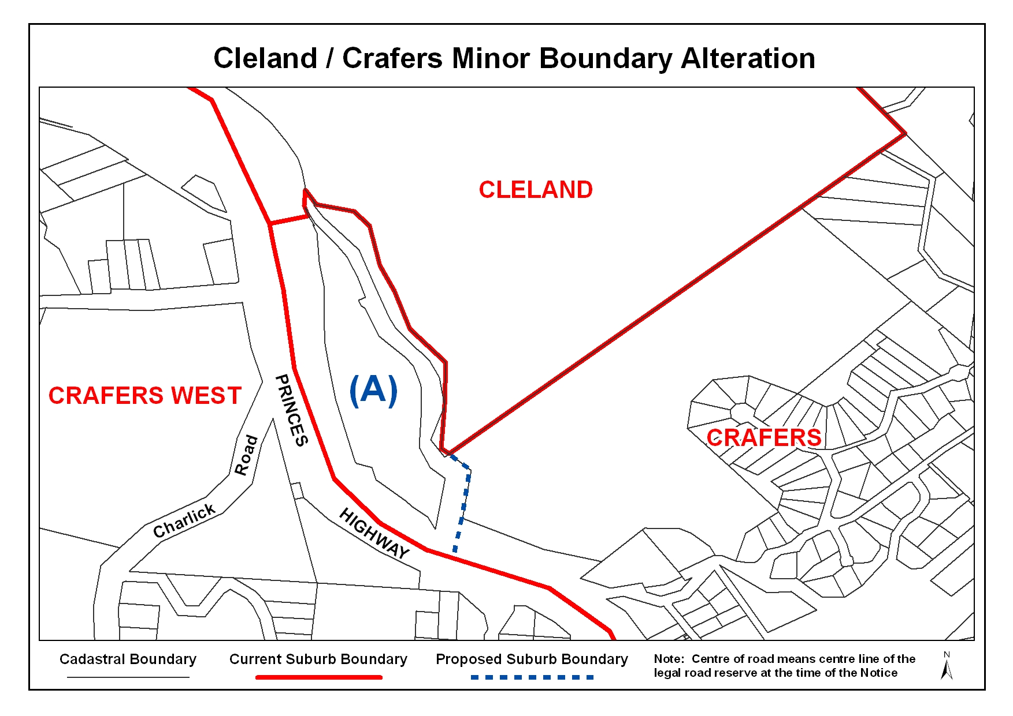
The Plan

Dated 24 August 2010.
P. M. Kentish, Surveyor-General, Department for Transport, Energy and Infrastructure
DTEI.2010/15246/01

GEOGRAPHICAL NAMES ACT 1991
Notice of Declaration of Names of Places
NOTICE is hereby given pursuant to section 11A of the Geographical Names Act 1991, that the names of those places set out in The Schedule hereunder shall be the geographical names of those said places. Precise location of the said features can be obtained from the South Australian Gazetteer at www.placenames.sa.gov.au or by contacting the Geographical Names Unit, DTEI on (08) 8204 8539.
The Schedule

Mapsheet | Feature
1:250 000 Mapsheet SG 53-9 (Alberga) | Ant Well Swamp  Antakatanya (hill)  Atjinyunyanya (hill)  Bindaree Swamp  Itiyanya (dual name with Echo Hill)  Itiyanya (swamp)  Healy Spring  Myall Swamp  Nyilpatjaranya (creek)  Nyilpatjaranya (dual name with Flat Rockhole)  Palpatjaranya (rockhole)  Tjalyiritjanya (hill)  Tjatjanya/Mount Warrabillinna  Untumanyanya (creek)  Wallaby Rock (hill)  Wamitjaranya/Sentinel Hill  Wanalyanya (hill)  Warupulinanya (hill)  Winpiranya (rockhole)  Winpiranya (soak)  Wintjalangunya/Harris Spring  Yampatjataranya (claypan)  Yampatjataranya (hill)  Yampatjataranya (rockhole)
1:250 000 Mapsheet SG 53-13 (Everard) | Perentie Creek
1:50 000 Mapsheet 6028 1 (Lincoln) | Rotten Bay

NOTE: Words shown in parentheses are not part of the name.
Certified that the above names have been examined in line with the policies of the Geographical Names Unit and that they comply with section 11A of the Geographical Names Act 1991.
Dated 2 September 2010.
P. M. Kentish, Surveyor-General, Department for Transport, Energy and Infrastructure
DTEI.2009/29925/01

GEOGRAPHICAL NAMES ACT 1991
Notice to Assign a Name to a Place
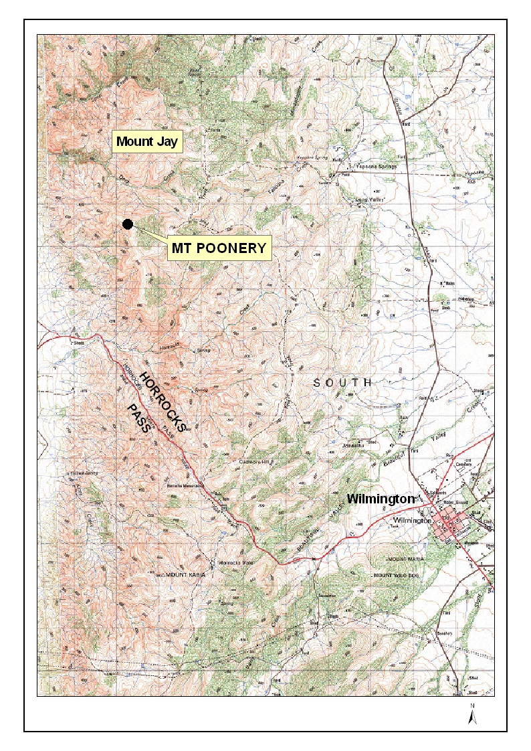
NOTICE is hereby given pursuant to the provisions of the above Act that I, PETER MACLAREN KENTISH, Surveyor-General and Delegate appointed by Patrick Conlon, Minister for Infrastructure, Minister of the Crown to whom the administration of the Geographical Names Act 1991 is committed DO HEREBY assign the name MOUNT POONERY to that feature located on the 1:50 000 Wilmington Mapsheet (6532-4) as shown on the plan below:
The Plan

This naming proposal can be viewed on the Land Services web-site located at:
www.landservices.sa.gov.au/1Online_Services/55Place_Names/
Dated 19 August 2010.
P. M. Kentish, Surveyor-General, Department for Transport, Energy and Infrastructure
DTEI.22-413/09/0020

GEOGRAPHICAL NAMES ACT 1991
Notice to Alter the Boundaries of Places
NOTICE is hereby given pursuant to the provisions of the above Act, that I, PETER MACLAREN KENTISH, Surveyor-General and Delegate appointed by Patrick Conlon, Minister for Infrastructure, Minister of the Crown to whom the administration of the Geographical Names Act 1991 is committed DO HEREBY:
• Exclude from the suburb of BANKSIA PARK and include into the suburb of UPPER HERMITAGE that area marked (A);
• Exclude from the suburb of TEA TREE GULLY and include into the suburb of UPPER HERMITAGE that area marked (B); and
• Exclude from the suburb of TEA TREE GULLY and include into the suburb of BANKSIA PARK that area marked (C) as shown on the plan below.
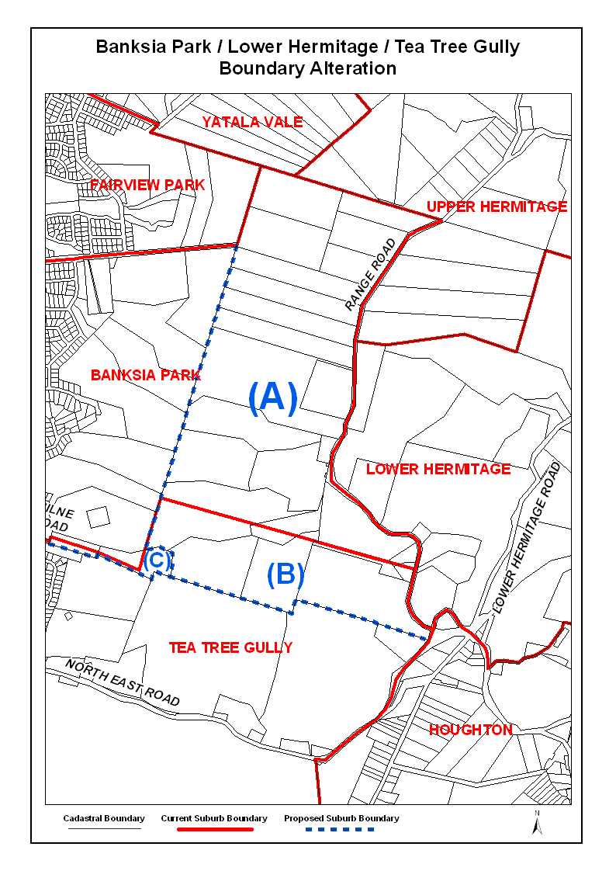
The Plan
This naming proposal can be viewed on the Land Services website located at:
www.landservices.sa.gov.au/1Online_Services/55Place_Names/
Dated 24 August 2010.
P. M. Kentish, Surveyor-General, Department for Transport, Energy and Infrastructure
DTEI.22-413/09/0023

HEALTH CARE ACT 2008
Section 68
Notice by the Chief Executive
TAKE notice that I, Dr Anthony Sherbon, Chief Executive of the Department of Health, do hereby specify, pursuant to section 68 (1) of the Health Care Act 2008, that the classes of incident that will constitute an ‘adverse incident’ for the purposes of Part 8 of the Health Care Act 2008 of South Australia are:
• The death of a patient unrelated to the natural course of the person’s illness and differing from the immediate expected outcome of the patient’s health care management.
• ‘Sentinel Events’, namely:
o Procedures involving the wrong patient or body part resulting in death or major permanent loss of function.
o Suicide of a patient in an inpatient unit.
o Retained instruments or other material after surgery requiring re-operation or further surgical procedure.
o Intravascular gas embolism resulting in death or neurological damage.
o Haemolytic blood transfusion reaction resulting from ABO blood type incompatibility.
o Medication error leading to the death of a patient reasonably believed to be due to incorrect administration of drugs.
o Maternal death or serious morbidity associated with labour or delivery.
o Discharge of an infant to the wrong family.
• The abduction of an infant/child from a hospital facility.
• An intrauterine death that may be related to a system failure in health care delivery.
• The stillbirth¹ of an infant that may be related to a system failure in health care delivery.
• The suspected:
o homicide or suicide, or
o attempted homicide or suicide,
committed by a person who has received care or treatment from a health service entity where there are reasonable clinical grounds to suspect a connection between the death and the care or treatment provided by the entity.
• The suspected suicide or suspected attempted suicide of a person in custody applying the definition of ‘custody’ in the Coroners Act 2003 (SA).
• An incident where a patient:
o suffers a major permanent loss of function (sensory, motor, physiologic or intellectual) unrelated to the natural course of the patient’s illness and differing from the expected outcome of the patient’s health care management.
o suffers significant disfigurement as a result of the incident.
o is or was at significant risk due to being absent against medical advice.
o who, whilst detained, has:
◊ without leave, left the place at which he or she has been detained, or

◊ having been absent with leave from the place at which he or she has been detained, failed to return at the conclusion of the period of leave;
and has been at significant risk during the period of absence or unauthorised absence.
• An incident or occurrence where the incident or occurrence has ‘system wide safety implications’, namely one that involves a systems failure² or multiple systems failure that does or has the potential to compromise the safety of a patient,
and otherwise an incident or occurrence which is not consistent with the routine health care of a patient or client or the routine operation of the health services entity providing the health care and which does or has the potential to result in harm to a person or persons receiving health care.
¹ As defined by section 4 of the Births, Deaths and Marriages Registration Act 1996 (SA).
² A fault, breakdown, or dysfunction within operational methods, processes, or infrastructure, EXPLANATORY NOTES—Patient Safety Management Systems—Australian Council for Safety and Quality in Health Care, May 2005.
Dated 24 August 2010.
Dr Anthony Sherbon, Chief Executive, Department of Health

HOUSING IMPROVEMENT ACT 1940
WHEREAS by notice published in the Government Gazette on the dates mentioned in the following table, the South Australian Housing Trust Board Delegate did declare the houses described in the following table to be substandard for the purposes of Part 7 of the Housing Improvement Act 1940, and whereas the South Australian Housing Trust Board Delegate is satisfied that each of the houses described hereunder has ceased to be substandard, notice is hereby given that, in exercise of the powers conferred by the said Part, the South Australian Housing Trust does hereby revoke the said declaration in respect of each house.
Address of House | Allotment, Section, etc. | Certificate of Title  Volume Folio | Date and page of Government Gazette in which notice declaring house to be substandard published

94 Fifth Avenue, Joslin |  | Allotment 8 in Deposited Plan 2301, Hundred of Adelaide | 5396 | 700 |  | 14.11.89. page 1505
386 Grand Junction Road, Enfield |  | Allotment 6 in Deposited Plan 4685, Hundred of Yatala | 5622 | 35 |  | 26.2.04, page 568
34 Greenwood Crescent, Smithfield Plains |  | Allotment 152 in Deposited Plan 7868, Hundred of Munno Para | 5585 | 630 |  | 17.12.09, page 6321
4 Hull Street, Elizabeth East |  | Allotment 688 in Deposited Plan 6552, Hundred of Munno Para | 5632 | 6 |  | 13.5.10, page 1820
8 Oratava Avenue (also known as Lot 304), Bridgewater |  | Allotment 304 in Deposited Plan 1949, Hundred of Noarlunga | 5275 | 557 |  | 30.7.09, page 3420
108 The Terrace, Port Pirie |  | Allotment 198 in Filed Plan 189140, Hundred of Pirie | 5742 | 503 |  | 13.5.76, page 2568
7 Turnbull Road, Elizabeth Downs |  | Allotment 255 in Deposited Plan 7072, Hundred of Munno Para | 5941 | 391 |  | 13.5.10, page 1820

Dated at Adelaide, 2 September 2010. Rosa Hulm, Acting Director, Corporate Services, Housing SA

HOUSING IMPROVEMENT ACT 1940
NOTICE is hereby given that the South Australian Housing Trust Board Delegate in the exercise of the powers conferred by the Housing Improvement Act 1940, does hereby declare the houses described in the table hereunder to be substandard for the purposes of Part 7 of the Housing Improvement Act 1940.
No. of House and Street | Locality | Allotment, Section, etc. | Certificate of Title  Volume Folio

Lot 2, Quarry Road |  | Warnertown | Allotment 2 in Filed Plan 161432, Hundred of Napperby | 5297 | 801

Dated at Adelaide, 2 September 2010. Rosa Hulm, Acting Director, Corporate Services, Housing SA

HOUSING IMPROVEMENT ACT 1940
WHEREAS by notice published in the Government Gazette on the dates mentioned in the following table the South Australian Housing Trust Board Delegate did declare the houses described in the said table to be substandard for the purposes of Part 7 of the Housing Improvement Act 1940, the South Australian Housing Trust Board Delegate in the exercise of the powers conferred by the said Part, does hereby fix as the maximum rental per week which shall be payable subject to section 55 of the Residential Tenancies Act 1995, in respect of each house described in the following table the amount shown in the said table opposite the description of such house and this notice shall come into force on the date of this publication in the Gazette.
Address of House | Allotment, Section, etc. | Certificate of Title  Volume Folio | Date and page of Government Gazette in which notice declaring house to be substandard published | Maximum rental per week payable in respect of each house  $

15 Delta Court, Athol Park |  | Allotment 8 in Deposited Plan 8217, Hundred of Yatala | 5595 | 708 |  | 8.7.10, page 3393 | 180.00
12 Dolphin Street, Elizabeth East |  | Allotment 11 in Deposited Plan 42679, Hundred of Munno Para | 5284 | 347 |  | 18.3.10, page 1054 | 182.00
73 Fairview Terrace, Clearview |  | Allotment 364 in Deposited Plan 4807, Hundred of Yatala | 5665 | 540 |  | 10.6.10, page 2607 | 125.00
73 Gulfview Road, Christies Beach |  | Allotment 113 in Deposited Plan 7053, Hundred of Noarlunga | 5615 | 503 |  | 22.7.10, page 3538 | 250.00
262A Henley Beach Road, Underdale |  | Allotment 9 in Filed Plan 122803, Hundred of Adelaide | 5333 | 747 |  | 22.2.07, page 555 | 230.00
23 Seaview Grove, Blair Athol |  | Allotment 20 in Deposited Plan 3055, Hundred of Yatala | 5733 | 702 |  | 13.5.10, page 1820 | 140.00
14 Tenth Street, Port Pirie West |  | Allotment 286 in Deposited Plan 622, Hundred of Pirie | 5159 | 509 |  | 29.1.09, page 430 | 170.00

Dated at Adelaide, 2 September 2010. Rosa Hulm, Acting Director, Corporate Services, Housing SA

LEGAL PRACTITIONERS ACT 1981
Instrument of Reappointment
I, JOHN ROBERT RAU, Attorney-General for the State of South Australia, hereby reappoint:
John Michael Boag
as a lay observer pursuant to section 90 (1) of the Legal Practitioners Act 1981, for a term of 12-months at a remuneration of $11 286 per annum, together with an amount of $2 257.20 per annum travelling and incidental expenses, and subject also to these conditions:
• provision of limited office accommodation facilities and supplies and typing assistance from time to time; and
• access to legal advice and assistance.
This appointment is effective from 18 July 2010.
Dated 1 July 2010.
John Rau, Attorney-General

LIQUOR LICENSING ACT 1997 AND GAMING MACHINES ACT 1992
Notice of Application
NOTICE is hereby given, pursuant to section 52 of the Liquor Licensing Act 1997 and section 29 of the Gaming Machines Act 1992, that John Jeffrey Rankine and Anne Margaret Rankine have applied to the Licensing Authority for the transfer of a Hotel and Gaming Machine Licence in respect of premises situated at 27 Torrens Street, Riverton, S.A. 5412 and known as Riverton Hotel.
The applications have been set down for hearing on 7 October 2010 at 11.30 a.m.
Any person may object to the application by lodging a notice of objection in the prescribed form with the Liquor and Gambling Commissioner and serving a copy of the notice on the applicants at the applicants’ address, at least seven days before the hearing date (viz: 30 September 2010).
The applicants’ address for service is c/o Philip Foreman (Foreman Legal), 69 Mount Barker Road, Stirling, S.A. 5152.
The application and certain documents and material (including Plans) relevant to the application may be inspected without fee at a place and during a period specified by the Liquor and Gambling Commissioner, 9th Floor, East Wing, 50 Grenfell Street, Adelaide, S.A. 5000. Telephone 8226 8410, Facsimile: 8226 8512. Email: olgc@agd.sa.gov.au.
Dated 30 August 2010.
Applicants

LIQUOR LICENSING ACT 1997
Notice of Application
NOTICE is hereby given, pursuant to section 52 (2) (b) of the Liquor Licensing Act 1997, that The Boathouse Osborne Pty Ltd has applied to the Licensing Authority for variation to an Extended Trading Authorisation in respect of premises situated at 481-483 Victoria Road, Taperoo, S.A. 5017 and known as the Boathouse Tavern Osborne.
The application has been set down for hearing on 9 September 2010 at 10 a.m.
Conditions
The following licence conditions are sought:
• Variation to an Extended Trading Authorisation to include Area 9 in accordance with the currently approved Extended Trading Authorisation.
Any person may object to the application by lodging a notice of objection in the prescribed form with the Liquor and Gambling Commissioner and serving a copy of the notice on the applicant at the applicant’s address, at least one day before the hearing date (viz: 8 September 2010).
The applicant’s address for service is c/o Andrew John, 481-483 Victoria Road, Taperoo, S.A. 5017.
The application and certain documents and material (including Plans) relevant to the application may be inspected without fee at a place and during a period specified by the Liquor and Gambling Commissioner, 9th Floor, East Wing, 50 Grenfell Street, Adelaide, S.A. 5000. Telephone 8226 8410, Facsimile: 8226 8512. Email: olgc@agd.sa.gov.au.
Dated 23 August 2010.
Applicant

LIQUOR LICENSING ACT 1997
Notice of Application
NOTICE is hereby given, pursuant to section 52 (2) (b) of the Liquor Licensing Act 1997, that Paul Bernard Shirvington and Carolyne Margaret Shirvington have applied to the Licensing Authority for the removal of a Producer’s Licence in respect of premises currently situated at ‘Kurrawyba’, Elliott Road, McLaren Flat, S.A. 5171, to be situated at Lot 12, Rifle Range Road, McLaren Vale, S.A. 5171 and known as Shirvington, PB & CM.
The application has been set down for hearing on 29 September 2010 at 10 a.m.
Any person may object to the application by lodging a notice of objection in the prescribed form with the Liquor and Gambling Commissioner and serving a copy of the notice on the applicants at the applicants’ address, at least seven days before the hearing date (viz: 22 September 2010).
The applicants’ address for service is c/o Paul Shirvington, P.O. Box 220, McLaren Vale, S.A. 5171.
The application and certain documents and material (including Plans) relevant to the application may be inspected without fee at a place and during a period specified by the Liquor and Gambling Commissioner, 9th Floor, East Wing, 50 Grenfell Street, Adelaide, S.A. 5000. Telephone 8226 8410, Facsimile: 8226 8512. Email: olgc@agd.sa.gov.au.
Dated 30 August 2010.
Applicants

LIQUOR LICENSING ACT 1997
Notice of Application
NOTICE is hereby given, pursuant to section 52 (2) (b) of the Liquor Licensing Act 1997, that Liquorland (Australia) Pty Ltd has applied to the Licensing Authority for the removal of a Retail Liquor Merchant’s Licence in respect of premises currently situated at 283 Gouger Street, Adelaide, S.A. 5000, to be situated at Shop 3, 210 Hutt Street, Adelaide, S.A. 5000 and known as Liquorland.
The application has been set down for hearing on 29 September 2010 at 11 a.m.
Any person may object to the application by lodging a notice of objection in the prescribed form with the Liquor and Gambling Commissioner and serving a copy of the notice on the applicant at the applicant’s address, at least seven days before the hearing date (viz: 22 September 2010).
The applicant’s address for service is c/o Rick Harley (Hunt & Hunt Lawyers), G.P.O. Box 439, Adelaide, S.A. 5001.
The application and certain documents and material (including Plans) relevant to the application may be inspected without fee at a place and during a period specified by the Liquor and Gambling Commissioner, 9th Floor, East Wing, 50 Grenfell Street, Adelaide, S.A. 5000. Telephone 8226 8410, Facsimile: 8226 8512. Email: olgc@agd.sa.gov.au.
Dated 30 August 2010.
Applicant

LIQUOR LICENSING ACT 1997
Notice of Application
NOTICE is hereby given, pursuant to section 52 (2) (b) of the Liquor Licensing Act 1997, that Valemport Pty Ltd as trustee for Lakes Resort Trust has applied to the Licensing Authority for the transfer of a Residential Licence in respect of premises situated at 17 Lake Terrace West, Mount Gambier, S.A. 5290 and known as Lakes Resort Mount Gambier.
The application has been set down for hearing on 30 September 2010 at 11.30 a.m.
Any person may object to the application by lodging a notice of objection in the prescribed form with the Liquor and Gambling Commissioner and serving a copy of the notice on the applicant at the applicant’s address, at least seven days before the hearing date (viz: 23 September 2010).
The applicant’s address for service is c/o Amanda Pascoe, DeGaris Lawyers, P.O. Box 869, Mount Gambier, S.A. 5290.
The application and certain documents and material (including Plans) relevant to the application may be inspected without fee at a place and during a period specified by the Liquor and Gambling Commissioner, 9th Floor, East Wing, 50 Grenfell Street, Adelaide, S.A. 5000. Telephone 8226 8410, Facsimile: 8226 8512. Email: olgc@agd.sa.gov.au.
Dated 26 August 2010.
Applicant

LIQUOR LICENSING ACT 1997
Notice of Application
NOTICE is hereby given, pursuant to section 52 (2) (b) of the Liquor Licensing Act 1997, that Modman Food Pty Ltd has applied to the Licensing Authority for the transfer of a Restaurant Licence in respect of premises situated at Shop 50-52, 264 Main North Road, Prospect, S.A. 5082 known as Caffe Primo Northpark.
The application has been set down for hearing on 5 October 2010 at 9.30 a.m.
Any person may object to the application by lodging a notice of objection in the prescribed form with the Liquor and Gambling Commissioner and serving a copy of the notice on the applicant at the applicant’s address, at least seven days before the hearing date (viz: 28 September 2010).
The applicant’s address for service is c/o Lillian Lin, (Lins Lawyers), 66 The Parade, Norwood, S.A. 5067.
The application and certain documents and material (including Plans) relevant to the application may be inspected without fee at a place and during a period specified by the Liquor and Gambling Commissioner, 9th Floor, East Wing, 50 Grenfell Street, Adelaide, S.A. 5000. Telephone 8226 8410, Facsimile: 8226 8512. Email: olgc@agd.sa.gov.au.
Dated 24 August 2010.
Applicant

LIQUOR LICENSING ACT 1997
Notice of Application
NOTICE is hereby given, pursuant to section 52 (2) (b) of the Liquor Licensing Act 1997, that Andrew Alfred De Zolt and Sally Louise Hill, 410 Regency Road, Prospect, S.A. 5082 have applied to the Licensing Authority for a Direct Sales Licence in respect of the business to be known as The Roaming Cellar.
The application has been set down for hearing on 5 October 2010 at 10 a.m.
Any person may object to the application by lodging a notice of objection in the prescribed form with the Liquor and Gambling Commissioner and serving a copy of the notice on the applicants at the applicants’ address, at least seven days before the hearing date (viz: 28 September 2010).
The applicants’ address for service is c/o Andrew De Zolt, 410 Regency Road, Prospect, S.A. 5082.
The application and certain documents and material (including Plans) relevant to the application may be inspected without fee at a place and during a period specified by the Liquor and Gambling Commissioner, 9th Floor, East Wing, 50 Grenfell Street, Adelaide, S.A. 5000. Telephone 8226 8410, Facsimile: 8226 8512. Email: olgc@agd.sa.gov.au.
Dated 24 August 2010.
Applicants

LIQUOR LICENSING ACT 1997
Notice of Application
NOTICE is hereby given, pursuant to section 52 (2) (b) of the Liquor Licensing Act 1997, that Andrew Alfred De Zolt and Sally Louise Hill have applied to the Licensing Authority for a Wholesale Liquor Merchant’s Licence in respect of premises situated at 410 Regency Road, Prospect, S.A. 5082 and to be known as The Roaming Cellar.
The application has been set down for hearing on 5 October 2010 at 10 a.m.
Any person may object to the application by lodging a notice of objection in the prescribed form with the Liquor and Gambling Commissioner and serving a copy of the notice on the applicants at the applicants’ address, at least seven days before the hearing date (viz: 28 September 2010).
The applicants’ address for service is c/o Andrew De Zolt, 410 Regency Road, Prospect, S.A. 5082.
The application and certain documents and material (including Plans) relevant to the application may be inspected without fee at a place and during a period specified by the Liquor and Gambling Commissioner, 9th Floor, East Wing, 50 Grenfell Street, Adelaide, S.A. 5000. Telephone 8226 8410, Facsimile: 8226 8512. Email: olgc@agd.sa.gov.au.
Dated 24 August 2010.
Applicants

LIQUOR LICENSING ACT 1997
Notice of Application
NOTICE is hereby given, pursuant to section 52 (2) (b) of the Liquor Licensing Act 1997, that Knappstein Lenswood Vineyards Pty Ltd as trustee for Knappstein Family Trust has applied to the Licensing Authority for the removal of a Producer’s Licence in respect of premises situated at 3 Davis Street, Norwood, S.A. 5067, to be situated at Lot 1, Croft Road, Lenswood, S.A. 5240 and known as Knappstein Lenswood Vineyards.
The application has been set down for hearing on 5 October 2010 at 11 a.m.
Any person may object to the application by lodging a notice of objection in the prescribed form with the Liquor and Gambling Commissioner and serving a copy of the notice on the applicant at the applicant’s address, at least seven days before the hearing date (viz: 28 September 2010).
The applicant’s address for service is c/o Dale Kelly, P.O. Box 256, Lobethal, S.A. 5241.
The application and certain documents and material (including Plans) relevant to the application may be inspected without fee at a place and during a period specified by the Liquor and Gambling Commissioner, 9th Floor, East Wing, 50 Grenfell Street, Adelaide, S.A. 5000. Telephone 8226 8410, Facsimile: 8226 8512. Email: olgc@agd.sa.gov.au.
Dated 24 August 2010.
Applicant

LIQUOR LICENSING ACT 1997
Notice of Application
NOTICE is hereby given, pursuant to section 52 (2) (b) of the Liquor Licensing Act 1997, that Southern King Pty Ltd has applied to the Licensing Authority for the transfer of a Restaurant Licence with Entertainment Consent in respect of premises situated at 163 Gouger Street, Adelaide, S.A. 5000, known as The Dragon Dynasty Chinese Restaurant and to be known as Santorini Greek Meze Restaurant.
The application has been set down for hearing on 5 October 2010 at 11.30 a.m.
Conditions
The following licence conditions are sought:
• Entertainment Consent is sought in the Dining Area as per plans lodged with this office for the following days and times:
Friday and Saturday: 8 p.m. to 2 a.m. the following day;
Sunday: Midday to midnight; and
New Year’s Eve: 8 p.m. to 2 a.m. the following day.
Any person may object to the application by lodging a notice of objection in the prescribed form with the Liquor and Gambling Commissioner and serving a copy of the notice on the applicant at the applicant’s address, at least seven days before the hearing date (viz: 28 September 2010).
The applicant’s address for service is c/o George Benias, 21 St Albans Terrace, Semaphore Park, S.A. 5019.
The application and certain documents and material (including Plans) relevant to the application may be inspected without fee at a place and during a period specified by the Liquor and Gambling Commissioner, 9th Floor, East Wing, 50 Grenfell Street, Adelaide, S.A. 5000. Telephone 8226 8410, Facsimile: 8226 8512. Email: olgc@agd.sa.gov.au.
Dated 25 August 2010.
Applicant

LIQUOR LICENSING ACT 1997
Notice of Application
NOTICE is hereby given, pursuant to section 52 (2) (b) of the Liquor Licensing Act 1997, that Xayaphon Chaleunxab has applied to the Licensing Authority for the transfer of a Restaurant Licence in respect of premises situated at Shop 2, 2/4 Webb Street, Queenstown, S.A. 5014, known as Kanya’s Thai Cuisine and to be known as Chada Thai Cuisine.
The application has been set down for hearing on 6 October 2010 at 10 a.m.
Any person may object to the application by lodging a notice of objection in the prescribed form with the Liquor and Gambling Commissioner and serving a copy of the notice on the applicant at the applicant’s address, at least seven days before the hearing date (viz: 29 September 2010).
The applicant’s address for service is c/o Xayaphon Chaleunxab, 4 McDermott Place, Greenfields, S.A. 5707.
The application and certain documents and material (including Plans) relevant to the application may be inspected without fee at a place and during a period specified by the Liquor and Gambling Commissioner, 9th Floor, East Wing, 50 Grenfell Street, Adelaide, S.A. 5000. Telephone 8226 8410, Facsimile: 8226 8512. Email: olgc@agd.sa.gov.au.
Dated 25 August 2010.
Applicant

LIQUOR LICENSING ACT 1997
Notice of Application
NOTICE is hereby given, pursuant to section 52 (2) (b) of the Liquor Licensing Act 1997, that C. Lodge Pty Ltd as trustee for the C. Lodge Unit Trust has applied to the Licensing Authority for the transfer of a Special Circumstances Licence in respect of premises situated at Riddoch Highway, Coonawarra, S.A. 5263 and known as Chardonnay Lodge.
The application has been set down for hearing on 6 October 2010 at 10.30 a.m.
Any person may object to the application by lodging a notice of objection in the prescribed form with the Liquor and Gambling Commissioner and serving a copy of the notice on the applicant at the applicant’s address, at least seven days before the hearing date (viz: 29 September 2010).
The applicant’s address for service is c/o Sue Biggs, Clelands Lawyers, 208 Carrington Street, Adelaide, S.A. 5000.
The application and certain documents and material (including Plans) relevant to the application may be inspected without fee at a place and during a period specified by the Liquor and Gambling Commissioner, 9th Floor, East Wing, 50 Grenfell Street, Adelaide, S.A. 5000. Telephone 8226 8410, Facsimile: 8226 8512. Email: olgc@agd.sa.gov.au.
Dated 27 August 2010.
Applicant

LIQUOR LICENSING ACT 1997
Notice of Application
NOTICE is hereby given, pursuant to section 52 (2) (b) of the Liquor Licensing Act 1997, that Kathryn Anne Morrison has applied to the Licensing Authority for a Direct Sales Licence in respect of premises situated at 20 Chasselas Avenue, Wynn Vale, S.A. 5127 and to be known as a Gift That Grows.
The application has been set down for hearing on 6 October 2010 at 11.30 a.m.
Any person may object to the application by lodging a notice of objection in the prescribed form with the Liquor and Gambling Commissioner and serving a copy of the notice on the applicant at the applicant’s address, at least seven days before the hearing date (viz: 29 September 2010).
The applicant’s address for service is c/o Kathryn Morrison, 20 Chasselas Avenue, Wynn Vale, S.A. 5127.
The application and certain documents and material (including Plans) relevant to the application may be inspected without fee at a place and during a period specified by the Liquor and Gambling Commissioner, 9th Floor, East Wing, 50 Grenfell Street, Adelaide, S.A. 5000. Telephone 8226 8410, Facsimile: 8226 8512. Email: olgc@agd.sa.gov.au.
Dated 27 August 2010.
Applicant

LIQUOR LICENSING ACT 1997
Notice of Application
NOTICE is hereby given, pursuant to section 52 (2) (b) of the Liquor Licensing Act 1997, that Mollydooker Wines Pty Ltd has applied to the Licensing Authority for the Redefinition and removal of a Wholesale Liquor Merchant’s Licence in respect of premises situated at Level 1, Building 8, 938 South Road, Edwardstown, S.A. 5039, to be situated at Lot B, Coppermine Road, McLaren Vale, S.A. 5171 and known as Mollydooker Wines.
The application has been set down for hearing on 6 October 2010 at 11 a.m.
Conditions
The following licence conditions are sought:
• Redefinition to include sampling area as per plans lodged with this office.
Any person may object to the application by lodging a notice of objection in the prescribed form with the Liquor and Gambling Commissioner and serving a copy of the notice on the applicant at the applicant’s address, at least seven days before the hearing date (viz: 29 September 2010).
The applicant’s address for service is c/o Minter Ellison Lawyers, G.P.O. Box 1272, Adelaide, S.A. 5001 (Attention: Libby Abbot).
The application and certain documents and material (including Plans) relevant to the application may be inspected without fee at a place and during a period specified by the Liquor and Gambling Commissioner, 9th Floor, East Wing, 50 Grenfell Street, Adelaide, S.A. 5000. Telephone 8226 8410, Facsimile: 8226 8512. Email: olgc@agd.sa.gov.au.
Dated 26 August 2010.
Applicant

LIQUOR LICENSING ACT 1997
Notice of Application
NOTICE is hereby given, pursuant to section 52 (2) (b) of the Liquor Licensing Act 1997, that Trim Hospitality Pty Ltd as trustee for the Trim Hospitality Trust has applied to the Licensing Authority for a Restaurant Licence with section 34 (1) (c), Extended Trading Authorisation and Entertainment Consent in respect of premises situated at 10 O’Connell Street, North Adelaide, S.A. 5006 and to be known as Trim Hospitality Pty Ltd.
The application has been set down for hearing on 7 October 2010 at 10.30 a.m.
Conditions
The following licence conditions are sought:
• Approval under section 34 (1) (c) to sell liquor on any day except Good Friday and Christmas Day for consumption on the licensed premises by persons:
(a) seated at a table; or
(b) attending a function at which food is provided.
• Extended Trading Authorisation is sought in relation to the abovementioned condition for the following days and times:
Monday to Saturday: Midnight to 2 a.m. the following day;
Sunday: 8 a.m. to 11 a.m. and 8 p.m. to 2 a.m. the following day;
• Entertainment Consent is sought for the licensed premises in accordance with the abovementioned Extended Trading Authorisation.
Any person may object to the application by lodging a notice of objection in the prescribed form with the Liquor and Gambling Commissioner and serving a copy of the notice on the applicant at the applicant’s address, at least seven days before the hearing date (viz: 30 September 2010).
The applicant’s address for service is c/o Wallmans Lawyers, G.P.O. Box 1018, Adelaide, S.A. 5001 (Attention: Ben Allen or Sam Ngai).
The application and certain documents and material (including Plans) relevant to the application may be inspected without fee at a place and during a period specified by the Liquor and Gambling Commissioner, 9th Floor, East Wing, 50 Grenfell Street, Adelaide, S.A. 5000. Telephone 8226 8410, Facsimile: 8226 8512. Email: olgc@agd.sa.gov.au.
Dated 27 August 2010.
Applicant

LIQUOR LICENSING ACT 1997
Notice of Application
NOTICE is hereby given, pursuant to section 52 (2) (b) of the Liquor Licensing Act 1997, that Trim Hospitality Group Pty Ltd as trustee for Trim Hospitality Unit Trust has applied to the Licensing Authority for the transfer and removal of a Special Circumstances Licence in respect of premises situated at 10 O’Connell Street, North Adelaide, S.A. 5006, to be situated at 127 The Parade, Norwood, S.A. 5067 and known as Sparrow Kitchen and Bar.
The application has been set down for hearing on 7 October 2010 at 11 a.m.
Any person may object to the application by lodging a notice of objection in the prescribed form with the Liquor and Gambling Commissioner and serving a copy of the notice on the applicant at the applicant’s address, at least seven days before the hearing date (viz: 30 September 2010).
The applicant’s address for service is c/o Wallmans Lawyers, G.P.O. Box 1018, Adelaide, S.A. 5001 (Attention: Ben Allen or Sam Ngai).
The application and certain documents and material (including Plans) relevant to the application may be inspected without fee at a place and during a period specified by the Liquor and Gambling Commissioner, 9th Floor, East Wing, 50 Grenfell Street, Adelaide, S.A. 5000. Telephone 8226 8410, Facsimile: 8226 8512. Email: olgc@agd.sa.gov.au.
Dated 27 August 2010.
Applicant

LIQUOR LICENSING ACT 1997
Notice of Application
NOTICE is hereby given, pursuant to section 52 (2) (b) of the Liquor Licensing Act 1997, that Barossa Harvesting Company Pty Ltd has applied to the Licensing Authority for a Producer’s Licence in respect of premises situated at 16 Edwin Terrace, Gilberton, S.A. 5081 and to be known as the Barossa Harvesting Company.
The application has been set down for hearing on 7 October 2010 at 10 a.m.
Any person may object to the application by lodging a notice of objection in the prescribed form with the Liquor and Gambling Commissioner and serving a copy of the notice on the applicant at the applicant’s address, at least seven days before the hearing date (viz: 30 September 2010).
The applicant’s address for service is c/o Patricia Ross, P.O. Box 555, North Adelaide, S.A. 5006.
The application and certain documents and material (including Plans) relevant to the application may be inspected without fee at a place and during a period specified by the Liquor and Gambling Commissioner, 9th Floor, East Wing, 50 Grenfell Street, Adelaide, S.A. 5000. Telephone 8226 8410, Facsimile: 8226 8512. Email: olgc@agd.sa.gov.au.
Dated 26 October 2010.
Applicant

LIQUOR LICENSING ACT 1997
Notice of Application
NOTICE is hereby given, pursuant to section 52 (2) (b) of the Liquor Licensing Act 1997, that Dashwood Cellars Pty Ltd has applied to the Licensing Authority for the removal of a Wholesale Liquor Merchant’s Licence in respect of premises situated at 1 Westbury Street, Hackney, S.A. 5069, to be situated at 24 Union Street, Dulwich, S.A. 5065 and known as Dashwood Cellars.
The application has been set down for hearing on 7 October 2010 at 9.30 a.m.
Any person may object to the application by lodging a notice of objection in the prescribed form with the Liquor and Gambling Commissioner and serving a copy of the notice on the applicant at the applicant’s address, at least seven days before the hearing date (viz: 30 September 2010).
The applicant’s address for service is c/o Peter Treloar, 24 Union Street, Dulwich, S.A. 5065.
The application and certain documents and material (including Plans) relevant to the application may be inspected without fee at a place and during a period specified by the Liquor and Gambling Commissioner, 9th Floor, East Wing, 50 Grenfell Street, Adelaide, S.A. 5000. Telephone 8226 8410, Facsimile: 8226 8512. Email: olgc@agd.sa.gov.au.
Dated 26 August 2010.
Applicant

LIQUOR LICENSING ACT 1997
Notice of Application
NOTICE is hereby given, pursuant to section 52 (2) (b) of the Liquor Licensing Act 1997, that Sandra Pipinis has applied to the Licensing Authority for a Producer’s Licence in respect of premises situated at 528 Thiele Road, Barmera, S.A. 5345, to be known as Kristalana Wines.
The application has been set down for hearing on 11 October 2010 at 9 a.m.
Any person may object to the application by lodging a notice of objection in the prescribed form with the Liquor and Gambling Commissioner and serving a copy of the notice on the applicant at the applicant’s address, at least seven days before the hearing date (viz: 4 October 2010).
The applicant’s address for service is c/o Sandra Pipinis, P.O. Box 264, Thiele Road, Barmera, S.A. 5345.
The application and certain documents and material (including Plans) relevant to the application may be inspected without fee at a place and during a period specified by the Liquor and Gambling Commissioner, 9th Floor, East Wing, 50 Grenfell Street, Adelaide, S.A. 5000. Telephone 8226 8410, Facsimile: 8226 8512. Email: olgc@agd.sa.gov.au.
Dated 30 August 2010.
Applicant

MINING ACT 1971
NOTICE is hereby given in accordance with section 28 (5) of the Mining Act 1971, that the Minister for Mineral Resources Development proposes to grant an Exploration Licence over the undermentioned area:
Applicant: Straits Exploration (Australia) Pty Ltd
Location: Lake Torrens area—Approximately 90 km south-west of Leigh Creek.
Pastoral Leases: Pernatty, South Gap
Term: 2 years
Area in km²: 912
Ref.: 2010/00066
Plan and co-ordinates can be found on the PIRSA website: http://www.pir.sa.gov.au/minerals/public_notices or by phoning Mineral Tenements on (08) 8463 3103.
J. Martin, Mining Registrar

MINING ACT 1971
NOTICE is hereby given in accordance with section 28 (5) of the Mining Act 1971, that the Minister for Mineral Resources Development proposes to grant an Exploration Licence over the undermentioned area:
Applicant: Monax Mining Limited
Location: Carappee Hill area—Approximately 20 km south-south-west of Kimba.
Term: 2 years
Area in km²: 1 004
Ref.: 2010/00074
Plan and co-ordinates can be found on the PIRSA website: http://www.pir.sa.gov.au/minerals/public_notices or by phoning Mineral Tenements on (08) 8463 3103.
J. Martin, Mining Registrar

MINING ACT 1971
NOTICE is hereby given in accordance with section 28 (5) of the Mining Act 1971, that the Minister for Mineral Resources Development proposes to grant an Exploration Licence over the undermentioned area:
Applicant: Mega Hindmarsh Pty Ltd
Location: Cronje Dam area—Approximately 60 km south of Olary.
Pastoral Leases: Mutooroo, Quondong, Manunda, Sturt Vale
Term: 2 years
Area in km²: 1000
Ref.: 2010/00201
Plan and co-ordinates can be found on the PIRSA website: http://www.pir.sa.gov.au/minerals/public_notices or by phoning Mineral Tenements on (08) 8463 3103.
J. Martin, Mining Registrar

MINING ACT 1971
NOTICE is hereby given in accordance with section 28 (5) of the Mining Act 1971, that the Minister for Mineral Resources Development proposes to grant an Exploration Licence over the undermentioned area:
Applicant: Rex Minerals (Iron Ore) Limited
Location: Kooralla area—Approximately 15 km east of Cowell
Term: 2 years
Area in km²: 85
Ref.: 2010/00220
Plan and co-ordinates can be found on the PIRSA website: http://www.pir.sa.gov.au/minerals/public_notices or by phoning Mineral Tenements on (08) 8463 3103.
J. Martin, Mining Registrar

MINING ACT 1971
NOTICE is hereby given in accordance with section 28 (5) of the Mining Act 1971, that the Minister for Mineral Resources Development proposes to grant an Exploration Licence over the undermentioned area:
Applicant: Lincoln Minerals Limited
Location: Gum Flat area—Approximately 10 km west of Port Lincoln.
Term: 3 years
Area in km²: 208
Ref.: 2010/00221
Plan and co-ordinates can be found on the PIRSA website: http://www.pir.sa.gov.au/minerals/public_notices or by phoning Mineral Tenements on (08) 8463 3103.
J. Martin, Mining Registrar

MINING ACT 1971
NOTICE is hereby given in accordance with Section 28 (5) of the Mining Act 1971, that the Minister for Mineral Resources Development proposes to grant an Exploration Licence over the undermentioned area:
Applicant: Havilah Resources NL
Location: Bonython Hill area—Approximately 35 km east of Olary.
Pastoral Leases: Aroona West, Tepco, Radium Hill, Tikalina
Term: 1 year
Area in km²: 20
Ref.: 2010/00224
Plan and co-ordinates can be found on the PIRSA website: http://www.pir.sa.gov.au/minerals/public_notices or by phoning Mineral Tenements on (08) 8463 3103.
J. Martin, Mining Registrar

MINING ACT 1971
NOTICE is hereby given in accordance with section 28 (5) of the Mining Act 1971, that the Minister for Mineral Resources Development proposes to grant an Exploration Licence over the undermentioned area:
Applicants: Perilya Limited (51%)
Minotaur Operations (49%)
Location: Ediacara area—Approximately 40 km south-west of Leigh Creek.
Pastoral Leases: Beltana, Nilpena
Term: 2 years
Area in km²: 53
Ref.: 2010/00232
Plan and co-ordinates can be found on the PIRSA website: http://www.pir.sa.gov.au/minerals/public_notices or by phoning Mineral Tenements on (08) 8463 3103.
J. Martin, Mining Registrar

NATIONAL ELECTRICITY LAW
THE Australian Energy Market Commission (AEMC) gives notice under the National Electricity Law of the following matter.
Under section 95, United Energy Distribution has requested the DNSP recovery of transmission-related charges Rule proposal (Project Ref ERC0114). The proposal relates to the pricing provisions under Chapter 6 of the National Electricity Rules to clarify distribution businesses’ recovery of charges for ‘transmission services’, inter-DNSP payments and avoided TUOS payments. Submissions must be received by 1 October 2010.
Submissions can be lodged online via the AEMC’s website at www.aemc.gov.au. Before lodging your submission, you must review the AEMC’s privacy collection statement on its website.
Submissions should be made in accordance with the AEMC’s Guidelines for making written submissions on Rule change proposals. The AEMC publishes all submissions on its website subject to a claim of confidentiality.
All documents in relation to the above matter are published on the AEMC’s website and are available for inspection at the offices of the AEMC:
John Pierce
Chairman
Australian Energy Market Commission
Level 5, 201 Elizabeth Street,
Sydney, N.S.W. 2000
Telephone: (02) 8296 7800
Facsimile: (02) 8296 7899
2 September 2010.

NATIONAL PARKS AND WILDLIFE (NATIONAL PARKS) REGULATIONS 2001
Closure of Pandappa Conservation Park
PURSUANT to Regulations 8 (3) (a) and 8 (3) (d) of the National Parks and Wildlife (National Parks) Regulations 2001, I, Edward Gregory Leaman, Director of National Parks and Wildlife, close to the public the whole of Pandappa Conservation Park from 6 a.m. on Friday, 22 October 2010 until 6 p.m. on Monday, 25 October 2010.
The purpose of the closure is to ensure the safety of the public during a pest control and monitoring program within the reserve during the period indicated.
Use of Firearms Within the Reserve
Pursuant to Regulations 8 (4), 20 (1) and 41 of the National Parks and Wildlife (National Parks) Regulations 2001, I, Edward Gregory Leaman, Director of National Parks and Wildlife grant permission to members of the Sporting Shooters Association of South Australia Hunting & Conservation Branch (SA) Inc. in possession of both a current Hunting Permit and a firearm to enter and remain in Pandappa Conservation Park from 6 a.m. on Friday, 22 October 2010 until 6 p.m. on Monday, 25 October 2010, for the purpose of taking feral animals.
This permission is conditional upon the observance by each of those persons of the requirements of the National Parks and Wildlife Act 1972; National Parks and Wildlife (National Parks) Regulations 2001; and the National Parks and Wildlife (Hunting) Regulations 1996, including those requiring compliance with the Director’s requests, requirements and orders of a Warden.
Dated 30 August 2010.
E. G. Leaman, Director of National Parks and Wildlife

THE DISTRICT COURT OF SOUTH AUSTRALIA
PORT AUGUSTA CIRCUIT COURT
Sheriff’s Office, Adelaide, 6 September 2010
IN pursuance of a precept from the District Court of South Australia to me directed, I do hereby give notice that the said Court will sit as a Court of Oyer and Terminer and General Gaol Delivery at the Courthouse at Port Augusta on the day and time undermentioned and all parties bound to prosecute and give evidence and all jurors summoned and all others having business at the said Court are required to attend the sittings thereof and the order of such business will be unless a Judge otherwise orders as follows:
Monday, 6 September 2010 at 10 a.m. on the first day of the sittings the only business taken will be the arraignment of prisoners in gaol and the passing of sentences on prisoners in gaol committed for sentence; the surrender of prisoners on bail committed for sentence; the surrender of persons in response to ex officio informations or of persons on bail and committed for trial who have signified their intentions to plead guilty and the passing of sentences.
Juries will be summoned for Tuesday, 7 September 2010 and persons will be tried on this and subsequent days of the sittings.
Prisoners in H.M. Gaol and on bail for sentence and for trial at the sittings of the Port Augusta Courthouse, commencing Monday, 6 September 2010.
Ahwan, Steven James |  | Indecently assault a person; use of offensive weapon; damage property | On bail
Antoniou, Lazarus Vasilios |  | Fail to comply domestic; foreign violence restraining order; fail to comply with bail agreement | On bail
Bailey, Martin James |  | Unlawful sexual intercourse with a person under 12 | On bail
Baker, Rhoda Manmartja |  | Threaten person involved in investigation of proceedings | On bail
Baker, Tony |  | Aggravated causing harm with intent to cause harm; aggravated possessing a firearm without a licence; aggravated threatening life | On bail
Broadfoot, Glenn Robert |  | Application for enforcement of breached bond; traffic in commercial quantity of controlled drug | On bail
Chester, Herbert Russell |  | Rape (3) | On bail
Clough, Richard |  | Application for enforcement of a breached bond; serious criminal trespass; dishonestly take property without owner’s consent | On bail
Cox, Tracy Ellenor |  | Traffic in a controlled drug | On bail
Kiriacou, Troy |  | Traffic in a controlled drug | On bail
Lundin, Misty |  | Traffic in a controlled drug | On bail
Edwards, Matthew Craig |  | Cause serious harm by dangerous driving; drive with excess blood alcohol; drive under disqualification | On bail
Fitzgibbons, Shannon |  | Threatening life; aggravated threatening to cause harm; arson; endangering life (2) | In gaol
Gardiner, Tyrone Robert |  | Recklessly causing serious harm | On bail
Gray, Peter John |  | Rape; aggravated assault | On bail
Griffiths, Brian Thomas |  | Indecent assault (5); unlawful sexual intercourse | On bail
Haynes, Alec Lindsay |  | Rape | On bail
Jackson, Martin Charles |  | Indecent assault; gross indecency (3) | On bail
Ketses, Anthony |  | Aggravated robbery; traffic in a controlled drug | On bail
Lewis, James David |  | Indecent assault; unlawful sexual intercourse | On bail
Marshall, Phillip Warren |  | Engage in sexual intercourse without consent | On bail
McRae, Peter Jade |  | Trespass in residence; dishonestly take property without owner’s consent; serious criminal trespass; intentionally cause harm | On bail
Patterson, Azeem |  | Escape from custody; resist police | In gaol
Pace, Joel Lloyd |  | Application for enforcement  of breached bond; supply of a controlled drug
Potter, David Barry |  | Aggravated possessing child pornography (3) | On bail
Queama, Clayton Kerry |  | Aggravated assault; aggravated recklessly causing serious harm | In gaol
Robinett, Frederick John |  | Aggravated threaten to cause harm (2); Arson | On bail
Rogers, Kym Ashley |  | Trafficking in a commercial quantity of a controlled drug | On bail
Sexton, Darren |  | Aggravated assault; aggravated threatening life; aggravated kidnapping | On bail
Cook, Ashley James |  | Aggravated assault; aggravated threatening life; aggravated kidnapping | On bail
Williams, Jillian |  | Serious criminal trespass; aggravated assault causing harm | On bail
Williams, Jennifer |  | Serious criminal trespass; aggravated assault causing harm | On bail
Williams, Paula |  | Serious criminal trespass; aggravated assault causing harm | On bail
Lawrie, Dianne Lee |  | Serious criminal trespass; aggravated assault causing harm | On bail
Wilmshurst, Mark |  | Threaten to kill or endanger life | In gaol
Wilton, Jodie Anne |  | Aggravated causing harm with intent to cause harm (2) | On bail

Prisoners on bail must surrender at 10 a.m. of the day appointed for the respective trials. If they do not appear when called upon their recognizances and those of their bail will be estreated and a bench warrant issued forthwith.
By Order of the Court,
M. A. Stokes, Sheriff

ROADS (OPENING AND CLOSING) ACT 1991:
SECTION 24
NOTICE OF CONFIRMATION OF ROAD
PROCESS ORDER
Road Closure—Walkway Between Spruance Road/Holcomb Street, Elizabeth East
BY Road Process Order made on 22 July 2010, the City of Playford ordered that:
1. The whole of the walkway being allotment 1163 in Deposited Plan 6414, situate between Spruance Road and Holcomb Street adjoining allotments 341 and 357 in Deposited Plan 6414, more particularly delineated and lettered ‘A’ in Preliminary Plan No. 10/0015 be closed.
2. Issue a Certificate of Title to City of Playford for the whole of the land subject to closure which land is being retained by Council for reserve purposes.
3. The following easement be granted over portion of the land subject to that closure:
Grant to the South Australian Water Corporation an easement for sewerage purposes.
On 12 August 2010 that order was confirmed by the Minister for Infrastructure conditionally upon the deposit by the Registrar-General of Deposited Plan 84736 being the authority for the new boundaries.
Pursuant to section 24 (5) of the Roads (Opening and Closing) Act 1991, NOTICE of the order referred to above and its confirmation is hereby given.
Dated 2 September 2010.
P. M. Kentish, Surveyor-General

WATER MAINS AND SEWERS

Office of the South Australian Water Corporation
Adelaide, 2 September 2010

WATER MAINS LAID

Notice is hereby given that the following main pipes or parts of main pipes have been laid down by the South Australian Water Corporation in or near the undermentioned water districts and are now available for a constant supply of water to adjacent land.

ADELAIDE WATER DISTRICT

ADELAIDE HILLS COUNCIL
Across and in Elizabeth Street, Houghton. p88
Easements in lot 104 in LTRO DP 29579, lot 140 in LTRO
FP 210926, lot 141 in LTRO FP 210927, lot 143 in
LTRO FP 210929, lot 171 in LTRO FP 210957, lot 142 in LTRO FP 210928, lot 170 in LTRO FP 210956 and lot 113 in LTRO FP 210899, Amberdale Road, Houghton. p88

TOWN OF GAWLER
Elaine Street, Evanston. p50

CITY OF MARION
Bowaka Street, Park Holme. p89

CITY OF PORT ADELAIDE ENFIELD
Wolseley Road, Croydon Park. p52
Sylvia Street, Blair Athol. p92

BORDERTOWN WATER DISTRICT

TATIARA DISTRICT COUNCIL
Handyside Terrace, Bordertown. p86

COOLTONG WATER DISTRICT

RENMARK PARINGA COUNCIL
Waterworks land (lot 105 in LTO DP 51444, Story Avenue, Cooltong. This main is available on application—not available for constant rateable supply. p47

COONALPYN DOWNS COUNTRY LANDS WATER DISTRICT

COORONG DISTRICT COUNCIL
Across and in Narrung Road, Meningie. This main is available on application only. p54-63
Point McLeay Road, Narrung. This main is available on application only. p96-98
Across and in Alexandrina Drive, Narrung. This main is available on application only. p99 and 100
Easements in reserve (section 699, hundred of Baker), Alexandrina Drive, Narrung. This main is available on application only. p100
KINGSTON S-E WATER DISTRICT

KINGSTON DISTRICT COUNCIL
East Terrace, Kingston S-E. p53

MANNUM WATER DISTRICT

MID MURRAY COUNCIL
Gemini Way, Mannum. p93
In and across Ariel Way, Mannum. p93 and 94
Mary Ann Street, Mannum. p93
Tyro Circuit, Mannum. p94
Ruby Drive, Mannum. p93 and 94
Male Road, Mannum. p94

MENINGIE WATER DISTRICT

COORONG DISTRICT COUNCIL
Across and in Warrengie Drive, Meningie. This main is available on application only. p54

MURRAY BRIDGE WATER DISTRICT

THE RURAL CITY OF MURRAY BRIDGE
Easements in lot 61 in LTRO DP 70409, Narooma Boulevard, Murray Bridge. p87
Narooma Boulevard, Murray Bridge. p87
Easements in reserves (allotment piece 36 in LTRO DP 78104, Narooma Boulevard, and lot 51 in LTRO DP 82723), Wetlands Close, Murray Bridge. p87
In and across Uplands Drive, Murray Bridge. p87
Jaensch Road, Murray Bridge. p87
Wetlands Close, Murray Bridge. p87

PORT BROUGHTON WATER DISTRICT

DISTRICT COUNCIL OF BARUNGA WEST
In and across Fisherman Bay Road, Port Broughton. p90

QUORN WATER DISTRICT

FLINDERS RANGES COUNCIL
Park Terrace, Quorn. p49
Hannigan Street, Quorn. p49

OUTSIDE WATER DISTRICTS

COORONG DISTRICT COUNCIL
Narrung Road, Meningie, Meningie West and Narrung. This main is available on application—not available for constant rateable supply. p63-82
Easement in lot 93 in LTRO FP 216903 and section 279NW, hundred of Baker, Narrung Road, Meningie. This main is available on application—not available for constant rateable supply. p70
Easements in allotment piece 30 in LTRO DP 45246, Narrung Road, Meningie. This main is available on application—not available for constant rateable supply. p70 and 71
Easements in allotment piece 50 in LTRO FP 37449 and allotment piece 92 in LTRO FP 209532, Narrung Road, Meningie. This main is available on application—not available for constant rateable supply. p71 and 72
Easements in section 616, hundred of Baker, Narrung Road, Meningie. This main is available on application—not available for constant rateable supply. p73
Easements in section 291, hundred of Baker, Point McLeay Road, Narrung. This main is available on application—not available for constant rateable supply. p95
Across and in Point McLeay Road, Narrung. This main is available on application—not available for constant rateable supply. p96

RENMARK PARINGA COUNCIL
Waterworks land (lot 111 in LTRO DP 44608), Cowra Street, Renmark. This main is available on application—not available for constant rateable supply. p4
Easements in lot 2 in LTRO DP 72521, Cowra Street, and lot 803 in LTRO DP 27497, Goolwa Street, Renmark. This main is available on application—not available for constant rateable supply. p4-8
Across and in Ral Ral Avenue, Renmark, Renmark West, Renmark North, Chaffey and Cooltong. This main is available on application—not available for constant rateable supply. p9-29
Cooltong Avenue, Cooltong. This main is available on application—not available for constant rateable supply. p29-45
Story Avenue, Cooltong. This main is available on application—not available for constant rateable supply. p46 and 47
Waterworks land (lot 105 in LTRO DP 51444), Story Avenue, Cooltong. This main is available on application—not available for constant rateable supply. p47

WATER MAINS ABANDONED

Notice is hereby given that the undermentioned water mains have been abandoned by the South Australian Water Corporation.

PORT BROUGHTON WATER DISTRICT

DISTRICT COUNCIL OF BARUNGA WEST
Fisherman Bay Road, Port Broughton. p90

QUORN WATER DISTRICT

FLINDERS RANGES COUNCIL
Park Terrace, Quorn. p49
Hannigan Street, Quorn. p49

WATER MAINS LAID

Notice is hereby given that the undermentioned water mains have been laid down by the South Australian Water Corporation and are not available for a constant supply of water to adjacent land.

OUTSIDE WATER DISTRICTS

RENMARK PARINGA COUNCIL
Waterworks land (lot 111 in LTRO DP 44608), Cowra Street, Renmark. p1
Easements in lot 2 in LTRO DP 72521, Cowra Street, and lot 803 in LTRO DP 27497, Goolwa Street, Renmark. p1-3

SEWERS LAID

Notice is hereby given that the following sewers have been laid down by the South Australian Water Corporation in the undermentioned drainage areas and are now available for house connections.

ADELAIDE DRAINAGE AREA

CITY OF BURNSIDE
Adnunda Place, Beaumont. FB 1198 p9

CITY OF CHARLES STURT
McQuillan Avenue, Renown Park. FB 1194 p59
Park Avenue, Pennington. FB 1194 p60
Easement in lot 301 in LTRO DP 80195, Hobart Road, Henley Beach South. FB 1198 p6
Wood Avenue, Brompton. FB 1198 p30

TOWN OF GAWLER
Cheek Avenue, Gawler East. FB 1194 p58
East Terrace, Gawler East. FB 1198 p8

CITY OF HOLDFAST BAY
Benny Crescent, South Brighton. FB 1198 p28

CITY OF MARION
Across Marine Parade, Marino. FB 1198 p2
Easement in lot 1 in LTRO DP 72349, Marine Parade and lot 2 in LTRO DP 72349, Ruth Court, Marino. FB 1198 p2
Easement in lots 53 and 54 in LTRO DP 2132, Esplanade, Hallett Cove. FB 1198 p3
Easement in lot 152 in LTRO DP 4783, Wilcox Avenue. Morphettville. FB 1198 p10
Mattson Avenue, Warradale. FB 1198 p11
Kent Avenue, Warradale. FB 1198 p29

CITY OF NORWOOD PAYNEHAM AND ST PETERS
Hereford Avenue, Trinity Gardens. FB 1198 p27

CITY OF ONKAPARINGA
Easement in lot 1 in LTRO DP 39052, Black Road, Flagstaff Hill. FB 1198 p4

CITY OF PLAYFORD
Easements in lot 6 in LTRO DP 39723 and lot 51 in LTRO DP 83393, Burcombe Street, Elizabeth Vale. FB 1198 p1
Easements in lot 2 in LTRO FP 7082 and lots 101 and 102 in LTRO DP 38635, Petherton Road, Penfield. FB 1188 p6, 7 and 10
Across Petherton Road, Penfield and Andrews Farm. FB 1188 p6, 7 and 10
In and across President Avenue, Andrews Farm. FB 1188 p6, 7 and 10
Parkdale Lane, Andrews Farm. FB 1188 p6, 7 and 10
Easements in lot 1006 in LTRO DP 80683, Andrews Road, Andrews Farm. FB 1188 p6-8 and 10
Esperance Drive, Andrews Farm. FB 1188 p6, 8 and 10
Across and in West Parkway, Andrews Farm. FB 1188 p6, 8 and 10-12
Across and in Andrews Road, Andrews Farm. FB 1188 p6, 8, 9 and 11
In and across Coonawarra Avenue, Andrews Farm. FB 1188 p6, 8, 9, 11 and 13
Oregon Avenue, Andrews Farm. FB 1188 p6, 9 and 12
Semillon Crescent, Andrews Farm. FB 1188 p6, 8 and 12
Eden Lane, Andrews Farm. FB 1188 p6, 8, 9 and 12
Across and in Rothbury Street, Andrews Farm. FB 1188 p6, 9, 12 and 13
Langhorne Street, Andrews Farm. FB 1188 p6, 8 and 12
Chateau Avenue, Andrews Farm. FB 1188 p6, 8-10 and 13

CITY OF PORT ADELAIDE ENFIELD
Across Gladstone Avenue, Kilburn. FB 1198 p5
Horley Terrace, Kilburn. FB 1198 p5
Wolseley Road, Croydon Park. FB 1198 p14
Sylvia Street, Blair Athol. FB 1198 p15
Linden Avenue, Northfield. FB 1198 p31
Barton Street, Blair Athol. FB 1198 p32

CITY OF WEST TORRENS
Across Sir Donald Bradman Drive, Brooklyn Park. FB 1198 p7
Byrnes Street, Brooklyn Park. FB 1198 p7

MANNUM COUNTRY DRAINAGE AREA

MID MURRAY COUNCIL
Sickerdick Street, Mannum. FB 1198 p16, 19 and 20
Across and in Male Road, Mannum. FB 1198 p16 and 18-20
Sewerage land (lot 127 in LTRO DP 76206), Ruby Drive,
Mannum. FB 1198 p16, 17, 21, 22 and 25
In and across Ruby Drive, Mannum. FB 1198 p16-19 and 21
Mary Ann Street, Mannum. FB 1198 p16-18 and 21
Easement in reserve (lot 116 in LTRO DP 76206), Gemini Way, Mannum. FB 1198 p16, 17 and 22
Across and in Gemini Way, Mannum. FB 1198 p16, 17, 22 and 23
Easement in lot 128 in LTRO DP 82389, Gemini Way, Mannum. FB 1198 p16, 17 and 22
Across and in Dollard Avenue, Mannum. FB 1198 p16, 17 and 23
In and across Ariel Way, Mannum. FB 1198 p16-19 and 22
Tyro Circuit, Mannum. FB 1198 p16, 18 and 22

SEWERS ABANDONED

Notice is hereby given that the undermentioned sewer has been abandoned by the South Australian Water Corporation.

ADELAIDE DRAINAGE AREA

TOWN OF GAWLER
East Terrace, Gawler East. FB 1198 p8

SEWERS LAID

Notice is hereby given that the undermentioned sewers have been laid down by the South Australian Water Corporation and are not available for house connections.

ADELAIDE DRAINAGE AREA

CITY OF PLAYFORD
Andrews Road, Andrews Farm. FB 1188 p6, 8, 9 and 13

CITY OF PORT ADELAIDE ENFIELD
Port Road, Port Adelaide and Alberton—150 mm PVC transfer pumping main. FB 1198 p12 and 13

MANNUM COUNTRY DRAINAGE AREA

MID MURRAY COUNCIL
Sewerage land (lot 127 in LTRO DP 76206), Ruby Drive, Mannum. FB 1198 p16, 17, 21 and 25
Sewerage land (lot 127 in LTRO DP 76206), Ruby Drive, Mannum—110 mm PVCM pumping main. FB 1198 p16, 24-26
Easement in reserve (lot 116 in LTRO DP 76206), Gemini Way, Mannum—110 mm PVCM pumping main. FB 1198 p16, 24 and 26
Across and in Gemini Way, Mannum—110 mm PVCM pumping main. FB 1198 p16, 24 and 26
Ariel Way, Mannum—110 mm PVCM pumping main. FB 1198 p16, 24 and 26
Across Sickerdick Street, Mannum—110 mm PVCM pumping main. FB 1198 p16, 24 and 26

OUTSIDE MURRAY BRIDGE COUNTRY DRAINAGE AREA

THE RURAL CITY OF MURRAY BRIDGE
Easement in lot 55 in LTRO DP 21148, Tumbella Drive, Murray Bridge. FB 642 p53
Sewerage land (lot 57 in LTRO DP 21148), Tumbella Drive, Murray Bridge. FB 642 p53

A. Howe, Chief Executive Officer, South Australian Water Corporation.

WATERWORKS ACT 1932
Removal of Land from Blue Lake Country Lands Water District and Addition to Mount Gambier Water District
PURSUANT to section 6 of the Waterworks Act 1932, the South Australian Water Corporation:
(a) removes from the Blue Lake Country Lands Water District and adds to the Mount Gambier Water District all the land contained in:
(i) Deposited Plan 84194; and
(b) declares that this notice will have effect from 1 July 2010.
Dated 31 August 2010.
Signed for and on behalf of the South Australian Water Corporation by a person duly authorised so to do:
A. Schirripa, Manager Billing and Collection
In the presence of:
M. Babaniotis, Team Leader Rating
SAWATER 10/04027 W1457

TRAINING AND SKILLS DEVELOPMENT ACT 2008

Part 4—Apprenticeships/Traineeships

Pursuant to the provision of the Training and Skills Development Act 2008, the Training and Skills Commission (TaSC) gives notice that determines the following
Trades or Declared Vocations in addition to the gazette notices of:

- 25 September 2008 | - 23 October 2008 | - 13 November 2008 | - 4 December 2008
- 18 December 2008 | - 29 January 2009 | - 12 February 2009 | - 5 March 2009
- 12 March 2009 | - 26 March 2009 | - 30 April 2009 | - 18 June 2009
- 25 June 2009 | - 27 August 2009 | - 17 September 2009 | - 24 September 2009
- 9 October 2009 | - 22 October 2009 | - 3 December 2009 | - 17 December 2009
- 4 February 2010 | - 11 February 2010 | - 18 February 2010 | - 18 March 2010
- 8 April 2010 | - 6 May 2010 | - 20 May 2010 | - 3 June 2010
- 17 June 2010 | - 24 June 2010 | - 8 July 2010

Trades or Declared Vocations and Required Qualifications and Training Contract Conditions for the
Automotive Industry Manufacturing Training Package (AUM08)

*Trade/ #Declared Vocation | Code | Title | Nominal Term of Training Contract | Prob-  ationary Period
#Production Worker (Manufacturing Specialist-Leadership) | AUM30108 | Certificate III in Automotive Manufacturing—Manufacturing Specialist (Passenger Motor Vehicle) | 24 months | 2 months
#Production Worker (Manufacturing Specialist-Quality)
#Production Worker (Manufacturing Specialist- Processes)
*Automotive Maintenance Technician | AUM40108 | Certificate IV in Automotive Manufacturing—Automotive Development (Passenger Motor Vehicle) | 48 months | 3 months
*Technical Officer (Automotive Development) | AUM50108 | Diploma of Automotive Manufacturing—Automotive Development (Passenger Motor Vehicle) | 48 months*** | 3 months
*** Qualification AUM50108 has a contract duration of 48 months, but can be completed in 24 months if AUM40108 has been satisfactory completed.

GOVERNMENT GAZETTE ADVERTISEMENT RATES

To apply from 1 July 2010

$  Agents, Ceasing to Act as 44.25  Associations:  Incorporation 22.40  Intention of Incorporation 55.50  Transfer of Properties 55.50  Attorney, Appointment of 44.25  Bailiff’s Sale 55.50  Cemetery Curator Appointed 32.75  Companies:  Alteration to Constitution 44.25  Capital, Increase or Decrease of 55.50  Ceasing to Carry on Business 32.75  Declaration of Dividend 32.75  Incorporation 44.25  Lost Share Certificates:  First Name 32.75  Each Subsequent Name 11.30  Meeting Final 37.00  Meeting Final Regarding Liquidator’s Report on  Conduct of Winding Up (equivalent to ‘Final  Meeting’)  First Name 44.25  Each Subsequent Name 11.30  Notices:  Call 55.50  Change of Name 22.40  Creditors 44.25  Creditors Compromise of Arrangement 44.25  Creditors (extraordinary resolution that ‘the Com-pany be wound up voluntarily and that a liquidator be appointed’) 55.50  Release of Liquidator⎯Application⎯Large Ad. 88.00  ⎯Release Granted 55.50  Receiver and Manager Appointed 51.00  Receiver and Manager Ceasing to Act 44.25  Restored Name 41.25  Petition to Supreme Court for Winding Up 77.00  Summons in Action 65.50  Order of Supreme Court for Winding Up Action 44.25  Register of Interests⎯Section 84 (1) Exempt 99.00  Removal of Office 22.40  Proof of Debts 44.25  Sales of Shares and Forfeiture 44.25  Estates:  Assigned 32.75  Deceased Persons⎯Notice to Creditors, etc. 55.50  Each Subsequent Name 11.30  Deceased Persons⎯Closed Estates 32.75  Each Subsequent Estate 1.45  Probate, Selling of 44.25  Public Trustee, each Estate 11.30 |  | $  Firms:  Ceasing to Carry on Business (each insertion) 29.50  Discontinuance Place of Business 29.50  Land⎯Real Property Act:  Intention to Sell, Notice of 55.50  Lost Certificate of Title Notices 55.50  Cancellation, Notice of (Strata Plan) 55.50  Mortgages:  Caveat Lodgement 22.40  Discharge of 23.40  Foreclosures 22.40  Transfer of 22.40  Sublet 11.30  Leases⎯Application for Transfer (2 insertions) each 11.30  Lost Treasury Receipts (3 insertions) each 32.75  Licensing 65.50  Municipal or District Councils:  Annual Financial Statement⎯Forms 1 and 2 618.00  Electricity Supply⎯Forms 19 and 20 439.00  Default in Payment of Rates:  First Name 88.00  Each Subsequent Name 11.30  Noxious Trade 32.75  Partnership, Dissolution of 32.75  Petitions (small) 22.40  Registered Building Societies (from Registrar-  General) 22.40  Register of Unclaimed Moneys⎯First Name 32.75  Each Subsequent Name 11.30  Registers of Members⎯Three pages and over:  Rate per page (in 8pt) 281.00  Rate per page (in 6pt) 371.00  Sale of Land by Public Auction 56.00  Advertisements 3.10  ¼ page advertisement 131.00  ½ page advertisement 262.00  Full page advertisement 514.00  Advertisements, other than those listed are charged at $3.10 per column line, tabular one-third extra.  Notices by Colleges, Universities, Corporations and District Councils to be charged at $3.10 per line.  Where the notice inserted varies significantly in length from that which is usually published a charge of $3.10 per column line will be applied in lieu of advertisement rates listed.  South Australian Government publications are sold on the condition that they will not be reproduced without prior permission from the Government Printer.
All the above prices include GST

GOVERNMENT GAZETTE NOTICES
ALL private advertisements forwarded for publication in the South Australian Government Gazette must be PAID FOR PRIOR TO INSERTION; and all notices, from whatever source, should be legibly written on one side of the paper only and sent to Government Publishing SA so as to be received no later than 4 p.m. Tuesday preceding the day of publication. Phone 8207 1045 or Fax 8207 1040. E-mail: governmentgazette@dpc.sa.gov.au. Send as attachments in Word format. Please include date the notice is to be published and to whom the notice will be charged. The Government Gazette is available online at: www.governmentgazette.sa.gov.au.

MISCELLANEOUS LEGISLATION AND GOVERNMENT PUBLICATIONS PRICES AS FROM 1 JULY 2010

Acts, Bills, Rules, Parliamentary Papers and Regulations
Pages | Main | Amends | Pages | Main | Amends

1-16 | 2.70 | 1.25 | 497-512 | 37.50 | 36.50
17-32 | 3.60 | 2.25 | 513-528 | 38.50 | 37.25
33-48 | 4.70 | 3.35 | 529-544 | 39.75 | 38.50
49-64 | 5.95 | 4.55 | 545-560 | 40.75 | 39.75
65-80 | 6.90 | 5.75 | 561-576 | 41.75 | 40.75
81-96 | 8.05 | 6.65 | 577-592 | 43.25 | 41.25
97-112 | 9.20 | 7.85 | 593-608 | 44.50 | 42.75
113-128 | 10.30 | 9.05 | 609-624 | 45.25 | 44.25
129-144 | 11.50 | 10.20 | 625-640 | 46.50 | 44.75
145-160 | 12.60 | 11.30 | 641-656 | 47.50 | 46.50
161-176 | 13.70 | 12.40 | 657-672 | 48.25 | 47.00
177-192 | 15.00 | 13.50 | 673-688 | 50.25 | 48.25
193-208 | 16.10 | 14.90 | 689-704 | 51.25 | 49.25
209-224 | 17.00 | 15.70 | 705-720 | 52.00 | 50.50
225-240 | 18.20 | 16.80 | 721-736 | 53.50 | 51.50
241-257 | 19.50 | 17.80 | 737-752 | 54.00 | 52.50
258-272 | 20.60 | 18.90 | 753-768 | 55.50 | 53.50
273-288 | 21.70 | 20.40 | 769-784 | 56.50 | 55.50
289-304 | 22.60 | 21.30 | 785-800 | 57.50 | 56.50
305-320 | 24.00 | 22.50 | 801-816 | 59.00 | 57.00
321-336 | 25.00 | 23.60 | 817-832 | 60.00 | 59.00
337-352 | 26.20 | 24.90 | 833-848 | 61.00 | 60.00
353-368 | 27.00 | 26.00 | 849-864 | 62.00 | 60.50
369-384 | 28.50 | 27.00 | 865-880 | 63.50 | 62.00
385-400 | 29.75 | 28.25 | 881-896 | 64.00 | 62.50
401-416 | 30.75 | 29.25 | 897-912 | 65.50 | 64.00
417-432 | 32.00 | 30.50 | 913-928 | 66.00 | 65.50
433-448 | 33.00 | 31.75 | 929-944 | 67.00 | 66.00
449-464 | 33.75 | 32.50 | 945-960 | 68.00 | 66.50
465-480 | 34.25 | 33.50 | 961-976 | 71.00 | 67.50
481-496 | 36.50 | 34.25 | 977-992 | 72.00 | 68.00

Legislation—Acts, Regulations, etc: $
Subscriptions:
Acts 230.00
All Bills as Laid 554.00
Rules and Regulations 554.00
Parliamentary Papers 554.00
Bound Acts 256.00
Index 128.00
Government Gazette
Copy 6.05
Subscription 306.00
Hansard
Copy 16.80
Subscription—per session (issued weekly) 480.00
Cloth bound—per volume 206.00
Subscription—per session (issued daily) 480.00
Legislation on Disk
Whole Database 3 557.00
Annual Subscription for fortnightly updates 1 093.00
Individual Act(s) including updates POA
Notice of Vacancies
Annual Subscription 169.00
Compendium
Subscriptions:
New Subscriptions 2 106.00
Updates 743.00
(All the above prices include GST)

All Legislation, Government Gazette, Hansard and Legislation on disk are available from:
Counter Sales Government Legislation⁺ Outlet
and Mail Orders: Service SA Customer Service Centre,
Ground Floor—EDS Centre, 108 North Terrace, Adelaide, S.A. 5000
Phone: 13 23 24 (local call cost), Fax: (08) 8204 1909
Postal: G.P.O. Box 1707, Adelaide, S.A. 5001

Online Shop: www.shop.service.sa.gov.au

Subscriptions and Government Publishing SA
Standing Orders: Box 9, Plaza Level, Riverside Centre, North Terrace, Adelaide, S.A. 5000
Phone: (08) 8207 1043, (08) 8207 0910, Fax: (08) 8207 1040

South Australia
Environment Protection (Water Quality) Amendment Notice 2010
under section 32 of the Environment Protection Act 1993
Part 1—Preliminary
1—Short title
This notice may be cited as the Environment Protection (Water Quality) Amendment Notice 2010.
2—Commencement
This notice comes into operation on the day on which it is made.
3—Amendment provisions
In this notice, a provision under a heading referring to the amendment of a specified policy under the Environment Protection Act 1993 amends the policy so specified.
Part 2—Amendment of Environment Protection (Water Quality) Policy 2003
4—Amendment of clause 32—Septic systems
Clause 32(4)—delete "1998" and substitute:
1997
5—Amendment of clause 34—Sewerage systems and sewage treatment systems
Clause 34(5)—delete "1996" and substitute:
1997
6—Amendment of clause 39—Road construction and maintenance—stormwater
Clause 39—delete "1997" and substitute:
1998
7—Amendment of clause 40—Building and construction industry—stormwater
Clause 40—delete "1998" and substitute:
1999
8—Amendment of clause 41—Urban stormwater
Clause 41—delete "1997" and substitute:
1998
9—Amendment of clause 43—Matters to be taken into account by Authority
Clause 43—delete "1998" and substitute:
1999
Made by the Minister for Environment and Conservation
On 28 August 2010

South Australia
Environment Protection (Waste to Resources)
Amendment Notice 2010
under section 32 of the Environment Protection Act 1993
Part 1—Preliminary
1—Short title
This notice may be cited as the Environment Protection (Waste to Resources) Amendment Notice 2010.
2—Commencement
This notice comes into operation on the day on which it is made.
3—Amendment provision
In this notice, a provision under a heading referring to the amendment of a specified policy under the Environment Protection Act 1993 amends the policy so specified.
Part 2—Amendment of Environment Protection (Waste to Resources) Policy 2010
4—Amendment of Schedule 4—Prohibited landfill waste
Schedule 4, clause 4, definition of PS— delete "No. 4" and substitute:
No. 6

Made by the Minister for Environment and Conservation
On 28 August 2010

South Australia
Public Sector (Administrative Units of Public Service—Variation 3) Proclamation 2010
under section 28 of the Public Sector Act 2009
1—Short title
This proclamation may be cited as the Public Sector (Administrative Units of Public Service—Variation 3) Proclamation 2010.
2—Commencement
This proclamation comes into operation on the day on which it is made.
3—Alteration of Minister responsible for Auditor-General's Department
The Premier is designated as the Auditor-General's Department's Minister with responsibility for the department.
Made by the Governor
with the advice and consent of the Executive Council
on 2 September 2010
DPC10/005CS

FAXING COPY?
IF you fax copy to Government Publishing SA for inclusion in the Government Gazette, there is no need to send a Confirmation Copy to us as well.
This creates confusion and may well result in your notice being printed twice.
Please use the following fax number:
Fax transmission: (08) 8207 1040
Phone Inquiries: (08) 8207 1045
Please include a contact person, phone number and order number so that we can phone back with any queries we may have regarding the fax copy.
NOTE: Closing time for lodging new copy (fax, hard copy or email) is 4 p.m. on Tuesday preceding the day of publication.

Government Gazette notices can be E-mailed.
The address is:
governmentgazette@dpc.sa.gov.au
Documents should be sent as attachments in Word format.
When sending a document via E-mail, please confirm your transmission with a faxed copy of your document, including the date the notice is to be published.
Fax transmission: (08) 8207 1040
Enquiries: (08) 8207 1045
NOTE: Closing time for lodging new copy (fax, hard copy or email) is 4 p.m. on Tuesday preceding the day of publication.

RURAL CITY OF MURRAY BRIDGE
Roads (Opening and Closing) Act 1991
Road Opening and Closing—Nalpa Station Road, Nalpa
NOTICE is hereby given, pursuant to section 10 of the Roads (Opening and Closing) Act 1991, that the Rural City of Murray Bridge proposes to make a Road Process Order to:
(i) open as road portions of Allotments 36 and 37 in Filed Plan 52722, Allotments 5, 7 and 10 in Road Plan 2199A and sections 388, 389, 392, 394, 395, 396, 415, 416, 420, 429 and 431, Hundred of Brinkley, more particularly delineated and numbered ‘1’ to ‘16’ (inclusive) on Preliminary Plan No. 10/0023; and
(ii) close portions of Nalpa Station Road situated generally south of Langhorne Creek Road and merge with adjoining Allotments 35 and 37 in Filed Plan 52722, Allotment 4 in Road Plan 2199A and sections 389, 391, 392, 393, 396, 401, 415, 416, 420, 421, 430 and 431, Hundred of Brinkley, more particularly delineated and lettered ‘A’ to ‘N’ (inclusive) and ‘P’ on Preliminary Plan No. 10/0023, in exchange for land taken for new road ‘1’ to ‘16’ (above).
A copy of the plan and a statement of persons affected are available for public inspection at the offices of the Rural City of Murray Bridge at the Local Government Centre, 2 Seventh Street, Murray Bridge and the Adelaide office of the Surveyor-General during normal office hours.
Any application for easement or objection must set out the full name, address and details of the submission and must be fully supported by reasons.
The application for easement or objection must be made in writing to the Rural City of Murray Bridge, P.O. Box 421, Murray Bridge, S.A. 5253, WITHIN 28 DAYS OF THIS NOTICE and a copy must be forwarded to the Surveyor-General, G.P.O. Box 1354, Adelaide, S.A. 5001. Where a submission is made, the Council will give notification of a meeting at which the matter will be considered.
Dated 2 September 2010.
D. Moloney, Chief Executive Officer

CITY OF ONKAPARINGA
Change of Road Names
NOTICE is hereby given that under delegation and in accordance with section 219 of the Local Government Act 1999, the following road names have been changed as follows:
• the portion of Aldinga Road, north of Biscay Road to Main South Road, to Flour Mill Road, Whites Valley/Aldinga;
• the portion of Plains Road, south off Main South Road, to Stonehouse Lane, Aldinga;
• the portion of Little Road from Old Coach Road through to Old Main South Road to Township Lane, Aldinga;
• the portion of Adey Road, (formed and unformed), corner of Main South and Malpas Roads through to Little Road to Hampshire Way, Aldinga/Whites Valley;
• the portion of Justs Road, south from Cox Road to the drain and footbridge, to Cox Road, Aldinga Beach;
• the portion of Culley Road, south off Aldinga Road to Biscay Road, to Paddys Row, Aldinga/Whites Valley;
• the portion of Culley Road, (formed and unformed), south off Colville Road through to Hahn Road, to Dabblebrook Close, Aldinga/Sellicks Hill;
• the portion of Jack Thorpes Road, north-west off Moritz Road, to Springs Lane, Blewitt Springs;
• the portion of Gates Road, off Piggott Range Road, to River Heights Rise, Hackham;
• the portion of Piebald Gully Road, (formed and unformed), west of Kangarilla and Saddlebags Roads intersection through to Douglas Gully Road, to Roan Lane, Kangarilla;
• the portion of Old Coach Road, (formed), east from Wicks Road to Kuipto Forest gates, to Stagecoach Lane, Kangarilla/Kuitpo;
• the portion of Trotts Road, (formed and unformed), between Blewitt Springs and Sandhill Roads, to Cooper Lane, McLaren Flat;
• the whole of Sandhill Road, from Trotts to Blewitt Springs Roads, to Ingoldby Road, McLaren Flat;
• the portion of Kays Road, (formed and unformed), west off Blewitt Springs to Whitings Roads to Beltunga Close, Blewitt Springs/McLaren Flat;
• the accessible portion of Hunt Road, north Edwards Road to Shadow Creek Tarn, McLaren Vale;
• the portion of Long Gully Road, (formed and unformed), from Warners Road to Seaview Road to Vaughtons Track, McLaren Vale;
• the portion of Neill Road, (formed and unformed), from Long Gully Road to Coppermine Road to Dugdale Lane, McLaren Vale;
• the portion of Pethick Road, south of Tatachilla Road to Johnston Road to Bellevue Drive, McLaren Vale;
• the portion of Kimbley Road, south of Coxs Hill and Panalatinga Roads intersection to Spriggs Road, to St Vincents View, Onkaparinga Hills;
• the portion of Kimbley Road, north off Piggott Range Road, to Echidna Chase, Onkaparinga Hills;
• the portion of Spriggs Road, (formed and unformed), west off Coxs Hill Road to Kimbley Road, to Emu Creek Lane, Onkaparinga Hills;
• the portion of States Road, (formed), north off Piggott Range Road, to Babette Lane, Onkaparinga Hills;
• the portion of Wheaton Road, east of Main South Road to Ostrich Farm Road, to Bakewell Drive, Seaford Heights;
• the portion of Edwards Road, (formed), south off Thomas Hill Road, to Brightview Brae, The Range/McLaren Vale;
• the portion of Edwards Road, (formed and unformed), north-east of Hall Road to Gaffney Road, to Vickery Lane, Willunga;
• the portion of Ryan Road, south of Aldinga Road to Biscay Road, to Free Lane, Whites Valley;
• un-named portion of road between Kangarilla and Sand Roads, to Mount Bold Road, Kangarilla;
• un-named road, (formed and unformed), south-east off Main road through to Marshall Road, to Cockatoo Lane, Chandlers Hill;
• un-named road west off Turners Gully Road, to Appletree Lane, Clarendon;
• un-named road, (formed and unformed), west of Mount Bold Road beginning from Sand Road, to Colbert Road, Kangarilla;
• un-named road, (formed and unformed), north of Piebald Gully Road through to Colbert Road, to Idle Lane, Kangarilla;
• un-named private road, north-east off Ackland Hill Road 100 m south-east of Driscoll Road, to Wildheath Rise, Coromandel East; and
• un-named private road, north off end of formed Kellys Road, to Windrush Rise, Onkaparinga Hills.
Plans that delineate the roads which are subject to the change are available for inspection at Council’s Principal Office, Ramsay Place, Noarlunga Centre, during normal business hours.
J. S. Tate, Chief Executive Officer

PORT AUGUSTA CITY COUNCIL
Revocation of Community Land Classification
NOTICE is hereby given that Council, at its meeting held on Monday, 23 August 2010, resolved to revoke the Community Land Classification for a portion of section 248 in Crown Record volume 5754, folio 545 (Caritas College Oval) having complied with all requirements in relation to section 194 of the Local Government Act 1999. Council also resolved to relinquish care, control and management over this portion of land.
G. Perkin, City Manager

CITY OF PORT LINCOLN
Revocation of Community Land
NOTICE is hereby given that pursuant to the Local Government Act 1999, section 194, the City of Port Lincoln, resolved to revoke the Classification as Community Land of Allotment 58, Deposited Plan 9683 comprised in certificate of title volume 3294, folio 156 and a portion of Allotment 134, Deposited Plan 10807 comprised in certificate of title volume 5796, folio 570.
G. Dodd, Chief Executive Officer

DISTRICT COUNCIL OF COOBER PEDY
NOTICE is hereby given that at its meeting held on 18 August 2010, the District Council of Coober Pedy resolved as follows:
Adoption of Valuation
Pursuant to section 167 (2) (a) of the Local Government Act 1999, Council adopted for the year ending 30 June 2011, the Valuer-General’s valuation of capital values relating to property within the Council district totalling $158 042 960.
Declaration of Rates
Pursuant to sections 153 (1) (b) and 156 (1) (a) of the Local Government Act 1999, Council declared differential general rates on land within its area for the year ending 30 June 2011, varying according to the use of the land as follows:
Cents in the
dollar
Land Use 1 | Residential | 0.2793
Land Use 2 | Commercial—Shop | 0.8567
Land Use 3 | Commercial—Office | 0.8567
Land Use 4 | Commercial—Other | 0.8853
Land Use 5 | Industry—Light | 0.8853
Land Use 6 | Industry—Other | 0.8853
Land Use 8 | Vacant Land | 0.1720
Pursuant to section 152 (1) (c) (ii) of the Local Government Act 1999, Council declared that a fixed charge of $317 to apply to all rateable land within the Council’s area for the year ending 30 June 2011.
Sewerage Separate Rate
Pursuant to and in accordance with section 154 of the Local Government Act 1999, Council declared a separate rate in respect of all rateable land within the area of the Council and within the Sewerage Scheme Area for the year ending 30 June 2011, for the purposes of making available, supporting and maintaining the Coober Pedy Sewerage Scheme, being a rate of 0.4161 cents in the dollar based on the capital value of the rateable land, with the exception of those properties that cannot be connected.
Water Annual Service Charge
Pursuant to section 155 of the Local Government Act 1999, Council declared an annual service charge for the year ending 30 June 2011, on land within the Council’s area to which it provides or makes available the prescribed service of the provision of water based on the level of usage of the service and varying according to whether the land is vacant or occupied and to land use category as follows:
Access Charges $
• Vacant Land 120
• Residential 150
• Business with usage last year less than 300 kL 290
• Commercial with usage last year over 300 kL 556
Usage Charges $
• Up to 50 kL 3.80 per kL
• 50 kL to 300 kL 4.70 per kL
• 300 kL and over 5.70 per kL
Payment of Rates
Pursuant to section 181 of the Local Government Act 1999, rates will be payable in four equal or approximately equal instalments to be received on or before 1 October 2010,
17 December 2010, 18 March 2011 and 17 June 2011.
D. Clark, Acting Chief Executive Officer

WAKEFIELD REGIONAL COUNCIL
Exclusion of Land from Classification as Community Land
NOTICE is hereby given that Council, at its ordinary meeting on 25 August 2010, resolved pursuant to section 193 (4) (a) of the Local Government Act 1999, to exclude from Classification as Community Land, Allotment 332, Railway Terrace, Snowtown, (Hundred of Barunga) certificate of title volume 5210, folio 824, with such allotment purchased by Council for expanding its works depot operations.
P. Barry, Chief Executive Officer

DISTRICT COUNCIL OF MOUNT BARKER
Roads (Opening and Closing) Act 1991
Road Opening and Closing—Paris Creek
NOTICE is hereby given, pursuant to section 10 of the Roads (Opening and Closing) Act 1991, that the District Council of Mount Barker proposes to make a Road Process Order to:
(i) open as road portions of Allotment 90 in Filed Plan 159767 and Piece 91 in Filed Plan 206315 as delineated ‘1’ and ‘2’ (respectively) on Preliminary Plan No. 09/0062 forming a realignment of the adjoining Public Road; and
(ii) close portions of the Public Road and merge with the adjoining Allotment 90 in Filed Plan 159767, Piece 92 in Filed Plan 206315 and Allotment 91 in Filed Plan 159768, as delineated ‘A’, ‘B’ and ‘C’ (respectively) on Preliminary Plan No. 09/0062.
A copy of the plan and a statement of persons affected are available for public inspection at the offices of the Council, 6 Dutton Road, Mount Barker and the Adelaide office of the Surveyor-General, 101 Grenfell Street, Adelaide, during normal office hours.
Any person is entitled to object to the proposed road process, or any person affected by the proposed closure is entitled to apply for an easement to be granted in that person’s favour over the land subject to the proposed closure. Such objection or application for an easement must set out the full name and address of the person making the objection or application and must be fully supported by reasons.
Any application for an easement must give full particulars of the nature and location of the easement and where made by a person as the owner of adjoining or nearby land, specify the land to which the easement is to be annexed.
The objection or application for an easement must be made in writing to the Council, P.O. Box 54, Mount Barker, S.A., 5251, WITHIN 28 DAYS OF THIS NOTICE and a copy shall be forwarded to the Surveyor-General, G.P.O. Box 1354, Adelaide, S.A. 5001. Where a submission is made, the Council will give notification of a meeting at which the matter will be considered, so that the person making the submission or a representative may attend, if so desired.
Dated 1 September 2010.
A. Stuart, Chief Executive Officer

NARACOORTE LUCINDALE COUNCIL
By-law Made Under the Local Government Act 1999
By-law No. 1 of 2010—Permits and Penalities By-law
A by-law to create a permit system for Council by-laws, to fix maximum and continuing penalties for offences, and for the construction of Council by-laws.
Part 1—Preliminary
1. Title
This by-law may be cited as the Permits and Penalties By-law 2010 and is By-law No. 1 of the Naracoorte Lucindale Council.
2. Authorising Law
This by-law is made under section 246 of the Act and sections 667 (1) 3.liv and 9.xvi of the Local Government Act 1934, as amended.
3. Purpose
The objectives of this by-law are to provide for the good rule and government of the Council area, and for the convenience, comfort and safety of its inhabitants by:
3.1 creating a permit system for Council by-laws;
3.2 providing for the enforcement of breaches of Council by-laws and fixing penalties; and
3.3 clarifying the construction of Council by-laws.
4. Commencement, Revocation and Expiry
4.1 The following by-laws previously made by the Council are revoked from the day on which this by-law comes into operation¹:
4.1.1 By-law No. 1—Permits and Penalties 2002.²
4.2 This by-law will expire on 1 January 2018.³
Note:
¹ Generally a by-law comes into operation four months after the day on which it is gazetted: section 249 (5) of the Act.
² Section 253 of the Act provides that the revocation of a by-law by another by-law that contains substantially the same provisions, does not affect certain resolutions such as those applying a by-law to a part or parts of the Council area.
³ Pursuant to section 251 of the Act, a by-law will expire on 1 January following the seventh anniversary of the gazettal of the by-law.
5. Application
5.1 This by-law applies throughout the Council area.
6. Interpretation
In this by-law, unless the contrary intention appears;
6.1 Act means the Local Government Act 1999;
6.2 Council means Naracoorte Lucindale Council;
6.3 person includes a body corporate.
Note:
Section 14 of the Interpretation Act 1915, provides that an expression used in this by-law has, unless the contrary intention appears, the same meaning as in the Act.
7. Construction of By-laws Generally
7.1 Every by-law of the Council is subject to any Act of Parliament and Regulations made thereunder.
7.2 In any by-law of the Council, unless the contrary intention appears permission means permission of the Council, granted in writing prior to the act, event or activity to which it relates.
Part 2—Permits And Penalties
8. Permits
8.1 Where a by-law requires that permission be obtained any person seeking the grant of permission must submit a written application to the Council in the form (if any) and accompanied by the fee (if any) prescribed by the Council.
8.2 The Council may attach such conditions as it thinks fit to a grant of permission, and may vary or revoke such conditions or impose new conditions by notice in writing to the person granted permission.
8.3 A person granted permission must comply with every such condition.
8.4 The Council may suspend or revoke a grant of permission at any time by notice in writing to the person granted permission.
9 Offences and penalties
9.1 A person who commits a breach of any by-law of the Council is guilty of an offence and is liable to a maximum penalty being the maximum penalty referred to in the Act that may be fixed by a by-law for any breach of a by-law.
9.2 A person who commits a breach of a by-law of the Council of a continuing nature is guilty of an offence and, in addition to any other penalty that may be imposed, is liable to a further penalty for every day on
which the offence continues, such penalty being the maximum amount referred to in the Act that may be fixed by a by-law for a breach of a by-law of a continuing nature.
Note:
The maximum penalty for a breach of a by-law is currently $750, and the maximum penalty for every day in which a breach of a continuing nature continues is currently $50—see section 246 (3) (g) of the Act.
This by-law was duly made and passed at a meeting of the Naracoorte Lucindale Council held on 24 August 2010, by an absolute majority of the members for the time being constituting the Council, there being at least two-thirds of the members present.
A. Evans, Chief Executive Officer

NARACOORTE LUCINDALE COUNCIL
By-law Made Under the Local Government Act 1999
By-law No. 2 of 2010—Local Government Land By-Law
A by-law to regulate the access to and use of Local Government Land (other than roads), and certain public places.
Part 1—Preliminary
1. Title
This by-law may be cited as the Local Government Land By-law 2010 and is By-law No. 2 of the Naracoorte Lucindale Council.
2. Authorising Law
This by-law is made under sections 238 and 246 of the Act and sections 667 (1) 4.i and 9.xvi of the Local Government Act 1934, as amended.
3. Purpose
The objectives of this by-law are to regulate the access to and use of Local Government Land (other than roads), and certain public places:
3.1 to prevent and mitigate nuisances;
3.2 to prevent damage to Local Government Land;
3.3 to protect the convenience, comfort and safety of members of the public;
3.4 to enhance the amenity of the Council area; and
3.5 for the good rule and government of the area.
4. Commencement, Revocation and Expiry
4.1 The following by-laws previously made by the Council are revoked from the day on which this by-law comes into operation¹:
4.1.1 By-law No. 4—Local Government Land 2002.²
4.2 This by-law will expire on 1 January 2018.³
Note:
¹ Generally a by-law comes into operation four months after the day on which it is gazetted: section 249 (5) of the Act.
² Section 253 of the Act provides that the revocation of a by-law by another by-law that contains substantially the same provisions, does not affect certain resolutions such as those applying a by-law to a part or parts of the Council area.
³ Pursuant to section 251 of the Act, a by-law will expire on 1 January following the seventh anniversary of the gazettal of the by-law.
5. Application
5.1 This by-law operates subject to the Council’s Permits and Penalties By-law 2010.
5.2 Subject to Clause 5.3, this by-law applies throughout the Council area.
5.3 Clauses 9.3, 9.9.1, 9.22.3, 10.5 and 10.11.3 of this by-law only apply in such part or parts of the Council area as the Council may, by resolution direct in accordance with section 246 (3) (e) of the Act.
6. Interpretation
In this by-law, unless the contrary intention appears:
6.1 Act means the Local Government Act 1999;
6.2 animal or animals includes birds and insects but does not include a dog;
6.3 boat includes a raft, pontoon or personal watercraft or other similar device;
6.4 camp includes setting up a camp, or causing a tent, caravan or motor home to remain on the land for the purpose of staying overnight, whether or not any person is in attendance or sleeps on the land;
6.5 children’s playground means an enclosed area in which there is equipment or other devices installed for the purpose of children's play (or within 3 m of such devices if there is no enclosed area);
6.6 Council means Naracoorte Lucindale Council;
6.7 electoral matter has the same meaning as in the Electoral Act 1985, provided that such electoral matter is not capable of causing physical damage or injury to any person within its immediate vicinity;
6.8 effective control means a person exercising effective control of an animal either:
6.8.1 by means of a physical restraint; or
6.8.2 by command, the animal being in close proximity to the person and the person being able to see the animal at all times;
6.9 emergency worker has the same meaning as in the Road Traffic (Road Rules—Ancillary and Miscellaneous Provisions) Regulations 1999;
6.10 foreshore means land extending from the edge of any navigable waterway or body of water in the Council’s area to the nearest road or section boundary or for a distance of 50 m (whichever is the lesser).
6.11 funeral ceremony means a ceremony only (i.e. a memorial service) and does not include a burial;
6.12 liquor has the same meaning as in the Liquor Licensing Act 1997;
6.13 Local Government Land means all land owned by the Council or under the Council’s care, control and management (except roads);
6.14 offensive includes threatening, abusive, insulting or annoying behaviour and offend has a complementary meaning;
6.15 open container means a container which:
(a) after the contents of the container have been sealed at the time of manufacture:
(i) being a bottle, it has had its cap, cork or top removed (whether or not it has since been replaced);
(ii) being a can, it has been opened or punctured;
(iii) being a cask, it has had its tap placed in a position to allow it to be used;
(iv) being any other form of container, it has been opened, broken, punctured or manipulated in such a way as to allow access to its contents; or
(v) is a flask, glass, mug or other container able to contain liquid.
6.16 tobacco product has the same meaning as in the Tobacco Products Regulation Act 1997;
6.17 vehicle has the same meaning as in the Road Traffic Act 1961;
6.18 waters includes a body of water, including a pond, lake, river, creek or wetlands under the care, control and management of the Council.
Note:
Section 14 of the Interpretation Act 1915, provides that an expression used in a by-law has, unless the contrary intention appears, the same meaning as in the Acts under which the by-law was made.
Part 2—Access to Local Government Land
7. Access
Note:
Pursuant to section 238 (7) of the Act, if a Council makes a by-law about access to or use of a particular piece of Local Government Land (under section 238), the Council must erect a sign in a prominent position on, or in the immediate vicinity of, the land to which the by-law applies.
The Council may:
7.1 close, or regulate or restrict access to, any part of Local Government Land to the public for specified times and days; and
7.2 fix charges or fees payable for entry onto any part of Local Government Land.
8. Closed Lands
A person must not without permission, enter or remain on any Local Government Land:
8.1 which has been closed, or in respect of which access by the public is regulated or restricted in accordance with Clause 7.1;
8.2 where entry fees or charges are payable, without paying those fees or charges; or
8.3 where the land has been enclosed by fences and/or walls and gates that have been closed and locked.
Part 3—Use of Local Government Land
9. Activities Requiring Permission
Note:
Pursuant to section 238 (7) of the Act, if a Council makes a by-law about access to or use of a particular piece of Local Government Land (under section 238), the Council must erect a sign in a prominent position on, or in the immediate vicinity of, the land to which the by-law applies.
A person must not without the permission of the Council, do any of the following on Local Government Land:
9.1 Advertising
Subject to Clause 14.2, display, paint or erect any sign or hoarding for the purpose of commercial advertising or any other purpose.
9.2 Aircraft
Subject to the Civil Aviation Act 1988, land any aircraft on, or take off any aircraft from the land.
9.3 Alcohol
Consume, carry or be in possession or in charge of any liquor on Local Government Land comprising parks or reserves to which the Council has determined this paragraph applies.
9.4 Amplification
Use an amplifier or other mechanical or electrical device for the purpose of broadcasting sound, or magnifying sound, to an audience.
9.5 Animals
9.5.1 On Local Government Land other than the foreshore:
(a) cause or allow an animal to stray onto, move over, graze or be left unattended on Local Government Land; or
(b) cause or allow an animal to enter, swim, bathe or remain in any waters located on Local Government Land; or
(c) lead, herd or exercise an animal, except where the Council has set aside a track or other area for use by or in connection with an animal of that kind, and provided that the animal or animals are under effective control.
9.5.2 On Local Government Land comprising the foreshore:
(a) cause or allow a sheep, cow, goat or horse to enter, swim, bathe or remain in any waters; or
(b) lead, herd or exercise a sheep, cow, goat or horse.
9.6 Annoyance
Do anything likely to offend or unreasonably interfere with any other person:
(a) using that land; or
(b) occupying nearby premises,
by making a noise or creating a disturbance.
9.7 Attachments
Subject to Clause 14.2, attach anything to a tree, plant, equipment, fence, post, structure or fixture on Local Government Land.
9.8 Bees
Place a hive of bees on such land, or allow it to remain thereon.
9.9 Boats
Subject to the provisions of the Harbors and Navigation Act 1993:
9.9.1 launch or retrieve a boat to or from any waters to which the Council has determined that this subclause applies;
9.9.2 launch or retrieve a boat other than from a boat ramp constructed or set aside by the Council for that purpose;
9.9.3 propel, float or otherwise use a boat on or in any waters;
9.9.4 hire out a boat or otherwise use a boat for commercial purposes; or
9.9.5 moor a boat on any waters or to a pontoon attached to Local Government Land.
9.10 Buildings
Use a building, or structure on Local Government Land for a purpose other than its intended purpose.
9.11 Burials and Memorials
9.11.1 Bury, inter or spread the ashes of any human or animal remains.
9.11.2 Erect any memorial.
9.12 Camping and Tents
9.12.1 Erect a tent or other structure of calico, canvas, plastic or similar material as a place of habitation.
9.12.2 Camp or sleep overnight except where a person is in a caravan park on Local Government Land, the proprietor of which has been given permission to operate the caravan park on that land.
9.13 Canvassing
Convey any advertising, religious or other message to any bystander, passer-by or other.
9.14 Distribution
Subject to Clause 14.2, place on a vehicle (without the consent of the owner of the vehicle), or give out or distribute any hand bill, book, notice, leaflet, or other printed matter to any bystander, passer-by or other person.
9.15 Donations
Ask for or receive or indicate that he or she desires a donation of money or any other thing.
9.16 Entertainment and Busking
9.16.1 Sing, busk or play a recording or use a musical instrument for the apparent purpose of either entertaining others or receiving money.
9.16.2 Conduct or hold a concert, festival, show, public gathering, circus, meeting, performance or any other similar activity.
9.17 Equipment
Use an item of equipment, facilities or property belonging to the Council if that person is of or over the age indicated by a sign or notice as the age limit for using such equipment, facility or property.
9.18 Fires
Subject to the Fire and Emergency Services Act 2005 light a fire except:
9.18.1 in a place provided by the Council for that purpose; or
9.18.2 in a portable barbeque, as long as the barbeque is used in an area that is clear of flammable material for a distance of at least 4 m.
9.19 Fireworks
Ignite or discharge any fireworks.
9.20 Flora and Fauna
Subject to the Native Vegetation Act 1991 and the National Parks and Wildlife Act 1972:
9.20.1 damage, pick, disturb, interfere with or remove any plant or flower thereon;
9.20.2 cause or allow an animal to stand or walk on any flower bed or garden plot;
9.20.3 deposit, dig, damage, disturb, interfere with or remove any soil, stone, wood, clay, gravel, pebbles, timber, bark or any part of the land;
9.20.4 take, interfere with, tease, harm or disturb any animal, bird or marine creature or the eggs or young of any animal, bird or marine creature;
9.20.5 pick, collect, take, interfere with or disturb any fruit, nuts, berries or native seeds;
9.20.6 disturb, interfere with or damage any burrow, nest or habitat of any animal or bird;
9.20.7 use, possess or have control of any device for the purpose of killing or capturing any animal, bird or marine creature; or
9.20.8 burn any timber or dead wood.
9.21 Foreshore
On Local Government Land comprising the foreshore:
9.21.1 drive or propel a vehicle onto or from the foreshore other than by a ramp or thoroughfare constructed or set aside by the Council for that purpose;
9.21.2 drive or propel a vehicle on the foreshore except on an area or road that is constructed or set aside by the Council for that purpose;
9.21.3 launch or retrieve a boat from the foreshore without using a boat ramp or thoroughfare constructed or set aside by the Council for that purpose;
9.21.4 allow a vehicle to remain stationary on a boat ramp longer than is necessary to launch or retrieve a boat; or
9.21.5 hire out a boat on or from the foreshore.
9.22 Games
9.22.1 Participate in, promote or organise any organised competition or sport, as distinct from organised social play.
9.22.2 Play or practise any game which involves kicking, hitting or throwing a ball or other object on Local Government Land which may cause or be likely to cause injury or discomfort to a person being on or in the vicinity of that land or detract from or be likely to detract from another person’s lawful use and enjoyment of that land.
9.22.3 Play or practise the game of golf on Local Government Land to which the Council has resolved this subclause applies.
9.23 Litter
9.23.1 Throw, cast, place, deposit or leave any rubbish, dirt or refuse of any kind whatsoever except in a garbage container provided for that purpose.
9.23.2 Deposit any soil, clay, stone, gravel, green waste or other putrescible waste or any other matter.
9.24 Marine Life
Introduce any marine life to any waters located on Local Government Land.
9.25 Model Aircraft, Boats and Cars
Fly or operate a model aircraft, boat or model or remote control vehicle in a manner which may cause or be likely to cause injury or discomfort to a person being on or in the vicinity of the land or detract from or be likely to detract from another person’s lawful use of and enjoyment of the land.
9.26 Overhanging Articles or Displaying Personal Items
Suspend or hang an article or object from a building, verandah, pergola, post or other structure on Local Government Land where it might present a nuisance or danger to a person using the land or be of an unsightly nature.
9.27 Playing Area
Use or occupy a playing area:
9.27.1 in such a manner as to damage or be likely to damage the surface of the playing area or infrastructure (above and under ground level);
9.27.2 in a manner contrary to the purpose for which the playing area was intended to be used or occupied; or
9.27.3 contrary to directions of the Council made by resolution and indicated on a sign displayed adjacent to the playing area.
9.28 Pontoons
Install or maintain a pontoon or jetty in any waters.
9.29 Posting of Bills
Subject to Clause 14.2, post or allow or cause to be posted any bills, advertisements or other papers or items on a building or structure on Local Government Land or in a public place.
9.30 Preaching
Preach, harangue or solicit for religious purposes.
9.31 Ropes
Place a buoy, cable, chain, hawser, rope or net in or across any waters.
9.32 Swimming
Subject to the provisions of the Harbors and Navigation Act 1993, swim in, bathe or enter any waters except:
9.32.1 in an area which the Council has determined may be used for such purposes; and
9.32.2 in accordance with any conditions that the Council may have determined by resolution apply to such use.
9.33 Trading
Sell, buy, offer or display anything for sale.
9.34 Vehicles
9.34.1 Drive or propel a vehicle except on an area or road constructed and set aside by the Council for that purpose.
9.34.2 Promote, organise or take part in a race, test or trial of any kind in which vehicles take part, except on an area properly constructed for that purpose.
9.34.3 Repair, wash, paint, panel beat or carry out other work to a vehicle, except for running repairs in the case of a breakdown.
9.35 Weddings, Functions and Special Events
9.35.1 Hold, conduct or participate in a marriage ceremony, funeral or special event.
9.35.2 Erect a marquee, stage or structure for the purpose of holding or conducting a wedding, funeral or special event.
9.35.3 Hold or conduct any filming where the filming is for a commercial purpose.
10. Prohibited Activities
A person must not do any of the following on Local Government Land:
10.1 Animals
10.1.1 Cause or allow any animal to enter, swim, bathe or remain in any waters to the inconvenience, annoyance or danger of any other person bathing or swimming.
10.1.2 Cause or allow an animal to damage a flowerbed, garden plot, tree, lawn or like thing or place.
10.1.3 Lead, herd or exercise a horse in such manner as to cause a nuisance or endanger the safety of a person.
10.2 Bridge Jumping
Jump or dive from a bridge on Local Government Land.
10.3 Defacing Property
Deface, paint, spray, write, cut names, letters or make marks on any tree, rock, gate, fence, building, sign, bridge or property of the Council.
10.4 Equipment
Use any item of equipment, facilities or property belonging to the Council other than in the manner and for the purpose for which it was designed, constructed or intended to be used or in such manner as is likely to damage or destroy it.
10.5 Fishing
Fish in any waters to which the Council has determined this subclause applies.
10.6 Glass
Wilfully break any glass, china or other brittle material.
10.7 Interference with Land
Interfere with, alter or damage the land (including a building, structure or fixture located on the land) including:
10.7.1 altering the construction or arrangement of the land to permit or facilitate access from an adjacent property;
10.7.2 erecting or installing a structure in, on, across, under or over the land;
10.7.3 changing or interfering with the construction, arrangement or materials of the land;
10.7.4 planting a tree or other vegetation on the land, interfering with the vegetation on the land or removing vegetation from the land; or
10.7.5 otherwise use the land in a manner contrary to the purpose for which the land was designed to be used.
10.8 Interference with Permitted Use
Interrupt, disrupt or interfere with any other person’s use of Local Government Land which is permitted or for which permission has been granted.
10.9 Nuisance
Behave in such a manner as to cause discomfort, inconvenience, annoyance or offence to any other person.
10.10 Playing Games
Play or practise a game:
10.10.1 which is likely to cause damage to the land or anything on it; or
10.10.2 in any area where a sign indicates that the game is prohibited.
10.11 Smoking
Smoke, hold or otherwise have control over an ignited tobacco product:
10.11.1 in any building;
10.11.2 in any children’s playground or within 10 m of any children’s playground; or
10.11.3 on any land to which the Council has determined this subclause applies.
10.12 Solicitation
Tout or solicit customers for the parking of vehicles or for any other purpose whatsoever.
10.13 Throwing Objects
Throw, roll, project or discharge a stone, substance or other missile, excluding sport and recreational equipment designed to be used in that way.
10.14 Toilets
In any public convenience on Local Government Land:
10.14.1 urinate other than in a urinal or pan or defecate other than in a pan set apart for that purpose;
10.14.2 deposit anything in a pan, urinal or drain which is likely to cause a blockage;
10.14.3 use it for a purpose for which it was not designed or constructed;
10.14.4 enter a toilet that is set aside for use of the opposite sex except:
(a) where a child under the age of eight years is accompanied by an adult parent or guardian of that sex; or
(b) to provide assistance to a disabled person; or
(c) in the case of a genuine emergency.
10.15 Waste
10.15.1 Deposit or leave thereon:
(a) anything obnoxious or offensive;
(b) any offal, dead animal, dung or filth; or
(c) any mineral, mineral waste, industrial waste or bi-products.
10.15.2 Foul or pollute any waters situated thereon.
10.15.3 Deposit any rubbish other than in receptacles provided by the Council for that purpose.
10.15.4 Deposit in a receptacle any rubbish emanating from domestic or trade purposes, unless designated by a sign or signs.
Part 4—Enforcement
11. Directions
11.1 A person on Local Government Land must comply with a reasonable direction from an authorised person relating to:
11.1.1 that person’s use of the land;
11.1.2 that person’s conduct and behaviour on the land;
11.1.3 that person’s safety on the land; or
11.1.4 the safety and enjoyment of other persons on the land.
11.2 A person who, in the opinion of an authorised person, is likely to commit or has committed, a breach of this by-law must immediately comply with a direction of an authorised person to leave that part of Local Government Land.
12. Orders
If a person fails to comply with an order of an authorised person made pursuant to section 262 of the Act in respect of a breach of this by-law, the Council may recover its costs of any action taken under section 262 (3) of the Act from the person to whom the order was directed.
Note:
Section 262 (1) of the Act states:
(1) If a person (the offender) engages in conduct that is a contravention of this Act or a by-law under this Act, an authorised person may order the offender:
(a) if the conduct is still continuing—to stop the conduct; and
(b) whether or not the conduct is still continuing—to take specified action to remedy the contravention.
Subsections (2) and (3) of section 262 also provide that it is an offence to fail to comply with an order and that if a person does not comply, the authorised person may take action reasonably required to have the order carried out. For example, an authorised person may order a person to:
• cease smoking on Local Government Land;
• remove an object or structure encroaching on Local Government Land;
• dismantle and remove a structure erected on Local Government Land without permission.
13. Removal of Animals and Objects
An authorised person may remove an animal or object that is on Local Government Land in breach of a by-law if no person is in charge of, or apparently in charge of, the animal or object.
Part 5—Miscellaneous
14. Exemptions
14.1 The restrictions in this by-law do not apply to a Police Officer, Emergency Worker, Council Officer or employee acting in the course and within the scope of that person’s normal duties, or to a contractor while performing work for the Council and while acting under the supervision of a Council Officer.
14.2 The restrictions in Clauses 9.1, 9.7, 9.14 and 9.29 of this by-law do not apply to electoral matter authorised by a candidate and which is:
14.2.1 related to a Commonwealth or State election and occurs during the period commencing on the issue of the writ or writs for the election and ending at the close of polls on polling day; or
14.2.2 related to an election under the Act or the Local Government (Elections) Act 1999 and occurs during the period commencing four weeks immediately before the date that has been set (either by or under either Act) for polling day and ending at the close of voting on polling day; or
14.2.3 related to, and occurs during the course of and for the purpose of a referendum.
This by-law was duly made and passed at a meeting of the Naracoorte Lucindale Council held on 24 August 2010, by an absolute majority of the members for the time being constituting the Council, there being at least two-thirds of the members present.
A. Evans, Chief Executive Officer

NARACOORTE LUCINDALE COUNCIL
By-law Made Under the Local Government Act 1999
By-law No. 3 of 2010—Roads By-Law
A by-law to regulate certain activities on roads in the Council area.
Part 1—Preliminary
1. Title
This by-law may be cited as the Roads By-law 2010 and is By-law No. 3 of the Naracoorte Lucindale Council.
2. Authorising Law
This by-law is made under sections 239 and 246 of the Act, Regulation 13 (1) (c) of the Local Government (Implementation) Regulations 1999 and sections 667 (1), 4.i, 5.vii, 7.ii and 9.xvi of the Local Government Act 1934, as amended.
3. Purpose
The objectives of this by-law are to manage and regulate the prescribed uses of roads in the Council area:
3.1 to protect the convenience, comfort and safety of road users and members of the public;
3.2 to prevent damage to buildings and structures on roads;
3.3 to prevent certain nuisances occurring on roads; and
3.4 for the good rule and government of the Council area.
4. Commencement, Revocation and Expiry
4.1 The following by-laws previously made by the Council are revoked from the day on which this by-law comes into operation¹:
4.1.1 By-law No. 3—Roads 2002.²
4.2 This by-law will expire on 1 January 2018.³
Note:
¹ Generally a by-law comes into operation four months after the day on which it is gazetted: section 249 (5) of the Act.
² Section 253 of the Act provides that the revocation of a by-law by another by-law that contains substantially the same provisions, does not affect certain resolutions such as those applying a by-law to a part or parts of the Council area.
³ Pursuant to section 251 of the Act, a by-law will expire on 1 January following the seventh anniversary of the gazettal of the by-law.
5. Application
5.1 This by-law operates subject to the Council’s Permits and Penalties By-law 2010.
5.2 This by-law applies throughout the Council area.
6. Interpretation
In this by-law, unless the contrary intention appears:
6.1 Act means the Local Government Act 1999;
6.2 animal includes birds, insects and poultry but does not include a dog or a cat;
6.3 camp includes setting up a camp, or causing a tent, caravan or motor home to remain on the land for the purpose of staying overnight, whether or not any person is in attendance or sleeps on the land;
6.4 Council means Naracoorte Lucindale Council;
6.5 effective control means a person exercising effective control of an animal either:
6.5.1 by means of a physical restraint; or
6.5.2 by command, the animal being in close proximity to the person, and the person being able to see the animal at all times;
6.6 electoral matter has the same meaning as in the Electoral Act 1995, provided that such electoral matter is not capable of causing physical damage or injury to a person within its immediate vicinity;
6.7 emergency worker has the same meaning as in the Road Traffic (Road Rules—Ancillary and Miscellaneous Provisions) Regulations 1999;
6.8 vehicle has the same meaning as in the Road Traffic Act 1961.
Note:
Section 14 of the Interpretation Act 1915, provides that an expression used in this by-law has, unless the contrary intention appears, the same meaning as in the Acts under which the by-law was made.
Part 2—Use of Roads
7. Activities Requiring Permission
A person must not do any of the following activities on a road without the permission of the Council:
7.1 Amplification
Use an amplifier or other device whether mechanical or electrical for the purpose of broadcasting announcements or advertisements.
7.2 Animals
7.2.1 Cause or allow an animal to stray onto, move over, or graze on a road except where the Council has set aside a track or other area for use by or in connection with an animal of that kind, and provided the animal or animals are under effective control.
7.2.2 Lead, herd or exercise an animal in such a manner as to cause a nuisance or endanger the safety of a person.
7.3 Camping and Tents
7.3.1 Erect a tent or other structure of calico, canvas, plastic or other similar material as a place of habitation.
7.3.2 Camp or sleep overnight.
7.4 Donations
Ask for or receive or indicate a desire for a donation of money or any other thing, or otherwise solicit for religious or charitable purposes.
7.5 Obstructions
Erect, install or place or cause to be erected, installed or placed any structure, object or material of any kind so as to obstruct a road or footway, water-channel, or watercourse in a road.
7.6 Posting of Bills
Subject to Clause 11.2, post or allow or cause to be posted any bills, advertisements, or other papers or items on a building or structure on a road.
7.7 Preaching
Preach, harangue or solicit for religious purposes.
7.8 Public Exhibitions and Displays
7.8.1 Sing, busk, play a recording or use a music instrument, or perform similar activities.
7.8.2 Conduct or hold a concert, festival, show, circus, performance or a similar activity.
7.8.3 Erect a stage or structure for the purpose of conducting or holding a concert, festival, show, circus, performance or a similar activity.
7.8.4 Cause any public exhibitions or displays.
7.9 Vehicles
Repair, wash, paint, panel beat or perform other work of a similar nature to a vehicle, except for running repairs in the case of a vehicle breakdown.
Note:
Moveable signs on roads are regulated by sections 226 and 227 of the Act and the Council's Moveable Signs By-law (if any).
Part 3—Enforcement
8. Directions
A person who, in the opinion of an authorised person is committing or has committed a breach of this by-law, must immediately comply with a direction of an authorised person to leave that part of the road.
9. Orders
If a person does not comply with an order of an authorised person made pursuant to section 262 of the Act in respect of a breach of this By-law, the Council may recover its costs of any action taken under section 262 (3) of the Act from the person to whom the order was directed.
Note:
Section 262 (1) of the Act states:
(1) If a person (the offender) engages in conduct that is a contravention of this Act or a by-law under this Act, an authorised person may order the offender:
(a) if the conduct is still continuing—to stop the conduct; and
(b) whether or not the conduct is still continuing—to take specified action to remedy the contravention.
Subsections (2) and (3) of section 262 also provide that it is an offence to fail to comply with an order and that if a person does not comply, the authorised person may take action reasonably required to have the order carried out. For example, an authorised person may order a person to:
• cease busking on a road;
• remove an object or structure blocking a footpath;
• remove bills posted on a structure on a road;
• dismantle and remove a tent from a road.
10. Removal of Animals and Objects
An authorised person may remove an animal or object that is on a road in breach of a by-law if no person is in charge, or apparently in charge, of the animal or object.
Part 4—Miscellaneous
11. Exemptions
11.1 The restrictions in this by-law do not apply to a Police Officer, Emergency Worker, Council Officer or employee acting in the course and within the scope of that person’s normal duties, or to a contractor while performing work for the Council and while acting under the supervision of a Council Officer.
11.2 The restrictions in Clause 7.6 of this by-law do not apply to electoral matter authorised by a candidate and which is:
11.2.1 related to a Commonwealth or State election and occurs during the period commencing on the issue of the writ or writs for the election and ending at the close of polls on polling day; or
11.2.2 related to an election under the Act or the Local Government (Elections) Act 1999 and occurs during the period commencing four weeks immediately before the date that has been set (either by or under either Act) for polling day and ending at the close of voting on polling day; or
11.2.3 related to, and occurs during the course of and for the purpose of a referendum.
This by-law was duly made and passed at a meeting of the Naracoorte Lucindale Council held on 24 August 2010, by an absolute majority of the members for the time being constituting the Council, there being at least two-thirds of the members present.
A. Evans, Chief Executive Officer

NARACOORTE LUCINDALE COUNCIL
By-law Made Under the Local Government Act 1999
By-law No. 4 of 2010—Moveable Signs By-Law
A by-law to set standards for moveable signs on roads and to provide conditions for the placement of such signs.
Part 1—Preliminary
1. Title
This by-law may be cited as the Moveable Signs By-law 2010 and is By-law No. 4 of the Naracoorte Lucindale Council.
2. Authorising Law
This by-law is made under sections 239 and 246 of the Act, and sections 667 (1), 4.i and 9.xvi of the Local Government Act 1934, as amended.
3. Purpose
The objectives of this by-law is to set standards for moveable signs on roads:
3.1 to protect the comfort and safety of road users and members of the public;
3.2 to enhance the amenity of roads and surrounding parts of the Council area;
3.3 to prevent nuisances occurring on roads;
3.4 to prevent unreasonable interference with the use of a road; and
3.5 for the good rule and government of the Council area.
4. Expiry
4.1 This by-law will expire on 1 January 2018.¹
Note:
¹ Pursuant to section 251 of the Act, a by-law will expire on 1 January following the seventh anniversary of the gazettal of the by-law.
5. Application
5.1 This by-law operates subject to the Council’s Permits and Penalties By-law 2010.
5.2 This by-law applies throughout the Council area.
6. Interpretation
In this by-law, unless the contrary intention appears:
6.1 Act means the Local Government Act 1999;
6.2 business premises means premises from which a business is being conducted;
6.3 Council means Naracoorte Lucindale Council;
6.4 footpath area means:
6.4.1 that part of a road between the property boundary of the road and the edge of the carriageway on the same side as that boundary;
6.4.2 a footway, lane or other place made or constructed for the use of pedestrians and not for the use of vehicles;
6.5 vehicle has the same meaning as in the Road Traffic Act 1961.
Note:
Section 14 of the Interpretation Act 1915, provides that an expression used in this by-law has, unless the contrary intention appears, the same meaning as in the Acts under which the by-law was made.
Part 2—Moveable Signs
7. Construction and Design
A moveable sign placed on a footpath area must:
7.1 be of kind known as an ‘A’ frame or sandwich board sign, an inverted ‘T’ sign, or a flat sign or, with the permission of the Council, a sign of some other kind;
7.2 be designed, constructed and maintained in good quality and condition;
7.3 be of strong construction and sufficiently stable or securely fixed so as to keep its position in adverse weather conditions;
7.4 have no sharp or jagged edges or corners;
7.5 not be unsightly or offensive in appearance or content;
7.6 be constructed of timber, metal, plastic or plastic coated cardboard, or a mixture of such materials;
7.7 not exceed 900 mm in height, 600 mm in width and 600 mm in depth;
7.8 in the case of an ‘A’ frame or sandwich board sign:
7.8.1 be hinged or joined at the top;
7.8.2 be of such construction that its sides are securely fixed or locked in position when erected; and
7.8.3 not have a base area in excess of 0.6 m²;
7.9 in the case of an inverted ‘T’ sign, not contain struts or members that run between the display area and the base of the sign.
8. Placement
A moveable sign must not be:
8.1 placed on any part of a road apart from the footpath area;
8.2 placed on a footpath that is less than 2.5 m wide;
8.3 placed closer than 1 m from another structure, fixed object, tree, bush or plant;
8.4 placed within 1 m of an entrance to any business premises;
8.5 placed on the sealed part of a footpath, if there is an unsealed part on which the sign can be placed in accordance with this by-law;
8.6 placed so as to interfere with the reasonable movement of persons or vehicles using the footpath or road in the vicinity of where the moveable sign is placed;
8.7 placed closer than 1 m to the kerb (or, if there is no kerb, to the edge of the carriageway of a road or the shoulder of the road, whichever is the greater);
8.8 placed on a landscaped area, other than landscaping that comprises only lawn;
8.9 placed within 10 m of an intersection of two or more roads;
8.10 placed on a footpath area with a minimum height clearance from a structure above it of less than 2 m;
8.11 placed on a designated parking area or within 1 m of an entrance to premises;
8.12 tied, fixed or attached to, or placed closer than 1 m to any other structure, object or thing (including another moveable sign);
8.13 displayed during the hours of darkness; or
8.14 placed in such a position or in such circumstances that the safety of a user of the footpath area or road is at risk.
9. Appearance
A moveable sign placed on the footpath area of a road must, in the opinion of an authorised person:
9.1 be painted or otherwise detailed at a competent and professional manner;
9.2 be attractive, legible and simply worded to convey a precise message;
9.3 be of such design and contain such colours which are compatible with the architectural design of the premises adjacent to the sign, and which relate well to the town scope and overall amenity of the locality in which it is situated;
9.4 contain combinations of colour and typographical styles which blend in with and reinforce the heritage qualities of the locality and the buildings where it is situated;
9.5 not have balloons, flags, streamers or other things attached to it; and
9.6 not rotate or contain flashing parts.
10. Banners
A person must not erect or display a banner on a building or structure on a road without the Council’s permission.
Note:
A person must not erect or display a banner on a public road for a business purpose without a permit from the Council issued under section 222 of the Local Government Act 1999.
11. Restrictions
11.1 The owner or operator of a business must not cause or allow more than one moveable sign for each business premises to be displayed on the footpath area of a road at any time.
11.2 A person must not, without the Council’s permission, display a moveable sign on or attached to or adjacent to a vehicle that is parked on Local Government Land (including roads) primarily for the purpose of advertising or offering for sale a product (including the vehicle) or business to which the sign relates.
11.3 A person must not cause or allow a moveable sign to be placed on a footpath area unless:
11.3.1 it only displays material which advertises a business being conducted on premises adjacent to the moveable sign or the goods and services available from that business; and
11.3.2 the business premises to which it relates is open to the public.
11.4 If in the opinion of the Council a footpath area is unsafe for a moveable sign to be displayed, the Council may prohibit or restrict the display of a moveable sign on such conditions as the Council thinks fit.
12. Exemptions
12.1 Subclauses 9.3, 9.4, 11.1 and 11.3 of this by-law do not apply to a moveable sign which:
12.1.1 advertises a garage sale taking place from residential premises;
12.1.2 is a directional sign to an event run by a community organisation or charitable body;
12.2 Subclauses 9.4, 11.1 and 11.3.1 of this by-law do not apply to a flat sign which only contains a newspaper headline and the name of a newspaper or magazine.
12.3 A requirement of this by-law will not apply where the Council has granted permission for the moveable sign to be displayed contrary to that requirement.
Note:
This by-law does not apply to moveable signs placed and maintained on a road in accordance with section 226 (3) of the Act, which includes any sign:
• placed there pursuant to an authorisation under another Act;
• designed to direct people to the open inspection of any land or building that is available for purchase or lease;
• related to a State or Commonwealth election and is displayed during the period commencing on the issue of the writ of writs for the election and ending at the close of polls on polling day;
• related to an election held under this Act or the Local Government (Elections) Act 1999 and is displayed during the period commencing four weeks immediately before the date that has been set (either by or under either Act) for polling day and ending at the close of voting on polling day; or
• the sign is of a prescribed class.
Part 3—Enforcement
13. Removal of Moveable Signs
13.1 A person must immediately comply with the order of an authorised person to remove a moveable sign made pursuant to section 227 (1) of the Act.
13.2 The owner of or other person entitled to recover a moveable sign removed by an authorised person pursuant to section 227 (2) of the Act, may be required to pay to the Council any reasonable costs incurred by the Council in removing, storing, and/or disposing of the moveable sign before being entitled to recover the moveable sign.
13.3 The owner, or other person responsible for a moveable sign must remove or relocate the moveable sign at the request of an authorised person:
13.3.1 if, in the opinion of an authorised person, and not-withstanding compliance with this by-law, there is any hazard or obstruction or there is likely to be a hazard or obstruction arising out of the location of the moveable sign; or
13.3.2 for the purpose of special events, parades, roadworks or in any other circumstances which, in the opinion of the authorised person, require relocation or removal of the moveable sign to protect public safety or to protect or enhance the amenity of a particular locality.
This by-law was duly made and passed at a meeting of the Naracoorte Lucindale Council held on 24 August 2010, by an absolute majority of the members for the time being constituting the Council, there being at least two-thirds of the members present.
A. Evans, Chief Executive Officer

NARACOORTE LUCINDALE COUNCIL
By-law Made Under the Local Government Act 1999
By-law No. 5 of 2010—Dogs By-Law
A by-law to limit the number of dogs kept on premises and for the management and control of dogs in the Council area.
Part 1—Preliminary
1. Title
This by-law may be cited as the Dog By-law 2010 and is By-law No. 5 of the Naracoorte Lucindale Council.
2. Authorising Law
This by-law is made under section 90 (5) of the Dog and Cat Management Act 1995, sections 238 and 246 of the Act and sections 667 (1), 9.xvi of the Local Government Act 1934, as amended.
3. Purpose
The objectives of this by-law are to control and manage dogs in the Council area:
3.1 to reduce the incidence of environmental nuisance caused by dogs;
3.2 to promote responsible dog ownership;
3.3 to protect the convenience, comfort and safety of members of the public; and
3.4 for the good rule and government of the Council area.
4. Commencement, Revocation and Expiry
4.1 The following by-laws previously made by the Council are revoked from the day on which this by-law comes into operation¹:
4.1.1 By-law No. 5—Dogs 2002.²
4.2 This by-law will expire on 1 January 2018.³
Note:
¹ Generally a by-law comes into operation four months after the day on which it is gazetted: section 249 (5) of the Act.
² Section 253 of the Act, provides that the revocation of a by-law by another by-law that contains substantially the same provisions, does not affect certain resolutions such as those applying a by-law to a part or parts of the Council area.
³ Pursuant to section 251 of the Act, a by-law will expire on 1 January following the seventh anniversary of the gazettal of the by-law.
5. Application
5.1 This by-law operates subject to the Council’s Permits and Penalties By-law 2010.
5.2 Subject to Clause 5.3, this by-law applies throughout the Council area.
5.3 Clauses 9.1.1 and 10.1.2 of this by-law only apply in such part or parts of the Council area as the Council may, by resolution direct in accordance with section 246 (3) (e) of the Act.
6. Interpretation
In this by-law, unless the contrary intention appears:
6.1 Act means the Local Government Act 1999;
6.2 approved kennel establishment means a building, structure or area approved by a relevant authority, pursuant to the Development Act 1993, for the keeping of dogs on a temporary or permanent basis;
6.3 children’s playground means an enclosed area in which there is equipment or other installed devices for the purpose of children’s play (or within 3 m of such devices if there is no enclosed area);
6.4 Council means Naracoorte Lucindale Council;
6.5 detached dwelling, row dwelling and semi-detached dwelling have the same meanings as in the Development Act 1993;
6.6 dog (except for in Clause 7.1) has the same meaning as in the Dog and Cat Management Act 1995;
6.7 effective control means a person exercising effective control of a dog either:
6.7.1 by means of a physical restraint; or
6.7.2 by command, the dog being in close proximity to the person and the person being able to see the dog at all times;
6.8 keep includes the provision of food or shelter;
6.9 premises includes land, whether used or occupied for domestic or non-domestic purposes, except an approved kennel establishment;
6.10 small dwelling means a self-contained residence that is:
6.10.1 a residential flat building;
6.10.2 contained in a separate strata unit;
6.10.3 on an allotment less than 400 m² in area; or
6.10.4 without a secure yard of at least 60 m² in area;
6.11 working dog means a dog used principally for droving or tending livestock.
Note:
Section 14 of the Interpretation Act 1915, provides that an expression used in this by-law has, unless the contrary intention appears, the same meaning as in the Acts under which the by-law was made.
Part 2—Limits on Dog Numbers
7. Limits on Dog Numbers in Private Premises
7.1 Subject to Clauses 7.3 and 7.5, a person must not, without the Council’s permission keep:
7.1.1 in a township, more than one dog in a small dwelling;
7.1.2 in a township, more than two dogs in premises other than a small dwelling; and
7.1.3 outside of a township, more than three dogs (other than working dogs).
7.2 For the purposes of Clause 7.1, ‘dog’ means a dog that is three months of age or older or, a dog that has lost its juvenile teeth.
7.3 Clause 7.1 does not apply to:
7.3.1 approved kennel establishments operating in accordance with all required approvals and consents; or
7.3.2 any business involving dogs provided that the business is registered in accordance with the Dog and Cat Management Act 1995.
7.4 The Council may require that premises which are the subject of an application for permission to keep additional dogs, must be inspected by an authorised person for the purpose of assessing the suitability of the premises for housing dogs.
7.5 No dog is to be kept on any premises where, in the opinion of an authorised person, there is no secure or appropriate area where a dog may be effectively confined.
Part 3—Dog Controls
8. Dog Exercise Areas
8.1 Subject to Clauses 9 and 10 of this by-law, a person may enter a park in the Council area for the purpose of exercising a dog under his or her effective control.
8.2 A person entering a dog exercise area designated by the Council must ensure that any dog under that person’s control, charge or authority is under effective control at all times.
9. Dog on Leash Areas
9.1 A person must not, without the Council’s permission, allow a dog under that person’s control, charge or authority (except an accredited guide dog, hearing dog or disability dog that is required to remain off-lead in order to fulfil its functions) to be or remain:
9.1.1 on Local Government Land or public place to which the Council has resolved that this subclause applies; and
9.1.2 on any park or reserve during times when organised sport is being played;
unless the dog is secured by a strong leash not exceeding 2 m in length which is either tethered securely to a fixed object capable of securing the dog or held by a person capable of controlling the dog and preventing it from being a nuisance or a danger to other persons.
10. Dog Prohibited Areas
10.1 A person must not allow a dog under that person’s control, charge or authority (except an accredited guide dog, hearing dog or disability dog) to enter or remain:
10.1.1 on any children’s playground on Local Government Land;
10.1.2 on any other Local Government Land or public place to which the Council has determined that this subclause applies.
11. Dog Faeces
No person is to allow a dog under that person’s control, charge or authority to be in a public place or on Local Government Land unless that person has in their possession a bag or other suitable container for the collection and lawful disposal of any faeces that the dog may deposit (for the purpose of complying with their obligation under section 45A (6) of the Dog and Cat Management Act 1995).
Part 4—Enforcement
12. Orders
12.1 If a person engages in conduct that is in contravention of this by-law, an authorised person may order that person:
12.1.1 if the conduct is still continuing—to stop the conduct; and
12.1.2 whether or not the conduct is still continuing—to take specified action to remedy the contravention.
12.2 A person must comply with an order under this Clause.
12.3 If a person does not comply with an order, the authorised person may take action reasonably required to have the order carried out, and the Council may recover its costs of any action so taken from the person to whom the order was directed.
12.4 However, an authorised person may not use force against a person under this section.
Note:
For example, an authorised person may order a person to:
• cease keeping more than the permitted number of dogs on that person’s premises; or
• remove a dog from a dog prohibited area.
This by-law was duly made and passed at a meeting of the Naracoorte Lucindale Council held on 24 August 2010, by an absolute majority of the members for the time being constituting the Council, there being at least two-thirds of the members present.
A. Evans, Chief Executive Officer

DISTRICT COUNCIL OF YANKALILLA
Road Naming Policy
NOTICE is hereby given that the District Council of Yankalilla at its meeting held on 19 August 2010, resolved that pursuant to section 219 of the Local Government Act 1999, to adopt a road naming policy which forms a road naming system for all streets within the District Council of Yankalilla.
A copy of the policy is available for inspection at Council Offices, 1 Charles Street, Yankalilla, during normal business hours and is also available on Council’s website:
www.yankalilla.sa.gov.au.
R. D. Sweetman, Chief Executive

IN the matter of the estates of the undermentioned deceased persons:
Bremner, Kenneth Francis, late of 81-89 Woodend Road, Trott Park, retired technical adviser, who died on 7 April 2010.
Domaille, Gwendoline Agnes, late of 19 Lewis Street, South Brighton, home duties, who died on 10 April 2010.
Greenwood, Patricia Mary, late of 150-164 Bay Road, Encounter Bay, of no occupation, who died on 26 May 2010.
Ieva, Carmelina Maria, late of 44 Kingston Avenue, Daw Park, of no occupation, who died on 16 October 2009.
Ladyman, Annie, late of 52 Esplanade, Semaphore, of no occupation, who died on 4 April 2010.
Palmer, Jean Maud, late of 1144 Greenhill Road, Uraidla, of no occupation, who died on 4 April 2010.
Schmitz, Hermann Josef, late of 18 Cross Road, Myrtle Bank, retired plasterer, who died on 26 October 2009.
Spencer, Tracy Lee, late of 63 Daly Street, South Plympton, home duties, who died on 23 April 2010.
Waylen, Joan Naomi, late of 13 Fitzroy Terrace, Fitzroy, of no occupation, who died on 3 June 2010.
Notice is hereby given pursuant to the Trustee Act 1936, the Inheritance (Family Provision) Act 1972, and the Family Relationships Act 1975, that all creditors, beneficiaries, and other persons having claims against any of the said estates are required to send, in writing, to the Public Trustee, G.P.O. Box 1338, Adelaide, S.A. 5001, full particulars and proof of such claims, on or before 1 October 2010, otherwise they will be excluded from the distribution of the said estates; and notice is also hereby given that all persons who are indebted to the said estates are required to pay the amount of their debts to the Public Trustee or proceedings will be taken for the recovery thereof; and all persons having any property belonging to the said estates are forthwith to deliver the same to the Public Trustee.
Dated 2 September 2010.
M. I. Bodycoat, Public Trustee

PARTNERSHIP ACT 1891
Notice of Termination of Partnership
NOTICE is hereby given that Petnad Pty Ltd (ACN 112 804 467), 27 Greallina Street, Lockleys, S.A. 5032 and Bettad Pty Ltd (ACN 112 804 958), 65 White Avenue, Lockleys, S.A. 5032, both holding 33.3% interest and Princhee Group Pty Ltd (ACN 112 801 484), c/o 13/15 Marina Pier, Holdfast Shores, Glenelg, S.A. 5045 holding 33.3% interest have been trading in partnership trading as Esca Restaurant, 13/15 Marina Pier, Holdfast Shores, Glenelg, S.A. 5045.
Petnad Pty Ltd and Bettad Pty Ltd have given notice to Princhee Group Pty Ltd terminating the partnership taking effect as at the close of business 16 August 2010. Princhee Group Pty Ltd now trades as Esca Restaurant, 13/15 Marina Pier, Holdfast Shores, Glenelg, S.A. 5045 in equal shares with 12 Willow Court Pty Ltd (ACN 119 501 629).
Dated 30 August 2010.
Petnad Pty Ltd (ACN 112 804 467) and Bettad Pty Ltd (ACN 112 804 958)

ATTENTION

CUSTOMERS requiring a proof of their notice for inclusion in the Government Gazette, please note that the onus is on you to inform Government Publishing SA of any subsequent corrections by 10 a.m. on Thursday, which is our publication deadline.

For any corrections to your notice please phone 8207 1045 or Fax 8207 1040 before 10 a.m. on Thursday.

If we do not receive any communication by 10 a.m. on Thursday (day of publication) we will presume the notice is correct and will print it as it is.

Remember—the onus is on you to inform us of any corrections necessary to your notice.

NOTE: Closing time for lodging new copy (electronically, fax or hard copy) is 4 p.m. on Tuesday preceding the day of publication. Phone 8207 1045—Fax 8207 1040.
Email: governmentgazette@dpc.sa.gov.au

Printed and published by authority every Thursday by B. MORRIS, Government Printer, South Australia
Price: $6.05, plus postage; to subscribers, $306.00 per annum.
(The above prices are inclusive of GST)

