No. 65 4793

THE SOUTH AUSTRALIAN

GOVERNMENT GAZETTE
www.governmentgazette.sa.gov.au

PUBLISHED BY AUTHORITY

ALL PUBLIC ACTS appearing in this GAZETTE are to be considered official, and obeyed as such

ADELAIDE, THURSDAY, 16 SEPTEMBER 2010

CONTENTS

Page
Appointments, Resignations, Etc. 4794
Corporations and District Councils—Notices 4887
Fisheries Management Act 2007—Notices 4794
Health Care Act 2008—Notices 4797
Housing Improvement Act 1940—Notices 4841
Liquor Licensing Act 1997—Notices 4842
Mining Act 1971—Notices 4846
Motor Vehicles Act 1959—Notice 4847
Motor Vehicles (Approval of Motor Bikes and Motor
Trikes) Notice 2010 4850
National Parks and Wildlife Act 1972—Notices 4863
National Parks and Wildlife (National Parks)
Regulations 2001—Notice 4863
Proclamations 4868
Public Trustee Office—Administration of Estates 4888

REGULATIONS
Development Act 1993 (No. 206 of 2010) 4879
Criminal Law (Sentencing) Act 1988 (No. 207 of 2010) 4884
Roads (Opening and Closing) Act 1991—Notice 4863
Survey Act 1992—Notice 4863
Trade Standards Act 1979—Notice 4864
Water Mains and Sewers—Mains Laid, Replaced, Etc. 4864
Wheat Marketing Act 1989—Notices 4867

GOVERNMENT GAZETTE NOTICES
ALL poundkeepers’ and private advertisements forwarded for publication in the South Australian Government Gazette must be PAID FOR PRIOR TO INSERTION; and all notices, from whatever source, should be legibly written on one side of the paper only and sent to Government Publishing SA so as to be received no later
than 4 p.m. on the Tuesday preceding the day of publication. Phone 8207 1045 or Fax 8207 1040. E-mail: governmentgazette@dpc.sa.gov.au. Send as attachments in Word format and please confirm your transmission with a faxed copy of your document, including the date the notice is to be published and to whom the notice will be charged. The Government Gazette is available online at: www.governmentgazette.sa.gov.au

Department of the Premier and Cabinet
Adelaide, 16 September 2010
HIS Excellency the Governor in Executive Council has been pleased to appoint the undermentioned to the Libraries Board of South Australia, pursuant to the provisions of the Libraries Act 1982:
Member: (from 7 November 2010 until 6 November 2011)
Peter David Goldsworthy
Presiding Member: (from 7 November 2010 until
6 November 2011)
Peter David Goldsworthy
By command,
Grace Portolesi, for Premier
ASACAB003/10

Department of the Premier and Cabinet
Adelaide, 16 September 2010
HIS Excellency the Governor in Executive Council has been pleased to appoint the undermentioned to the South Australian Motor Sport Board, pursuant to the provisions of the South Australian Motor Sport Act 1984:
Member: (from 16 September 2010 until 9 September 2012)
Roger Anthony Cook
Gregory Colin Boulton
Amanda Rischbieth
Thomas Theodore Schenken
Presiding Member: (from 16 September 2010 until
9 September 2012)
Roger Anthony Cook
Deputy Presiding Member: (from 16 September 2010 until
9 September 2012)
Gregory Colin Boulton
By command,
Grace Portolesi, for Premier
T&F10/056CS

Department of the Premier and Cabinet
Adelaide, 16 September 2010
HIS Excellency the Governor in Executive Council has been pleased to appoint Michael Timothy McRae as a Special Justice of the Peace for South Australia for a term of three years commencing on 24 September 2010 and expiring on 23 September 2013, pursuant to Section 7 (1) of the Justices of the Peace Act 2005.
By command,
Grace Portolesi, for Premier
AGO0035/07CS

FISHERIES MANAGEMENT ACT 2007
TAKE notice that pursuant to section 115 of the Fisheries Management Act 2007, the persons listed in Schedule 1 (the ‘exemption holders’) are exempt from the provision of section 70 of the Fisheries Management Act 2007, Clauses 72 and 121 of Schedule 6 of the Fisheries Management (General) Regulations 2007 and any notice under section 79 of the Fisheries Management Act 2007, prohibiting fishing within areas of Chambers Creek, but only insofar as they may engage in the taking of fish (the ‘exempted activity’) from Chambers Creek, adjacent to Napper Bridge on the Morgan Road, Barmera, using a ‘carp cage’, subject to the conditions set out in Schedule 2, from 22 July 2010 until 30 June 2011, unless varied or revoked earlier.
Schedule 1
• Damien Wilksch, holder of River Fishery Licence No. R03.
• Garry Warrick, holder of River Fishery Licence No. R27.
• Antony Smith, holder of River Fishery Licence No. R54.
Schedule 2
1. The exemption holders may only take and retain Carp (Family Cyprinidae) and non-native species when undertaking the exempted activity.
2. All native species taken in the course of the exempted activity must be immediately returned to the water.
3. All native fish taken pursuant to the exempted activity must be immediately returned to the water and their detention recorded in a by-catch logbook.
4. The exemption holders must follow any instructions and directions from staff of the South Australian Research and Development Institute—Aquatic Sciences in relation to the maintenance and operation of the carp cage.
5. Before initial installation of the ‘carp separation cage’, the exemption holder must contact the PIRSA Fisheries Compliance Unit on 1800 065 522 and answer a series of questions about the exempted activity. You will need to have a copy of your exemp-
tion with you at the time of making the call, and be able to provide information about the area and time of the exempted activity, the vehicles and/or boats involved, the number of agents undertaking the exempted activity and other related issues. Exemption No. 9902374.
6. While engaged in the exempted activity, the exemption holder must be in possession of a copy of this notice. Such notice must be produced to a PIRSA Fisheries Compliance Officer, if requested.
7. The exemption holder must not contravene or fail to comply with the Fisheries Management Act 2007, or any regulations made under that Act, except where specifically exempted by this notice.
Dated 20 July 2010.
M. Smallridge, Director of Fisheries

FISHERIES MANAGEMENT ACT 2007
TAKE notice that pursuant to section 115 of the Fisheries Management Act 2007, the persons listed in Schedule 1 (the ‘exemption holders’) are exempt from the provision of section 70 of the Fisheries Management Act 2007, Clauses 72 and 121 of Schedule 6 of the Fisheries Management (General) Regulations 2007 and any notice under section 79 of the Fisheries Management Act 2007, but only insofar as they may use devices set out in Schedule 2, subject to the conditions in Schedule 3, over the period 31 August 2010 to 31 August 2011, unless varied or revoked earlier.
Schedule 1
• Damien Wilksch, holder of River Fishery Licence No. R03.
• Antony Smith, holder of River Fishery Licence No. R54.
Schedule 2
• 15 small mesh 90 cm double hoop drum nets, covered with 50 mm stretched mesh; connected to two 3.5 m mesh wings.
Schedule 3
1. The exemption holder may only engage in the exempted activity in accordance with instructions from Dr. Qifeng Ye, Program Leader, Inland Waters and Catchment Ecology, SARDI Aquatic Sciences.
2. The exemption holders may only use a boat to engage in the exempted activity if that boat is also registered by endorsement on their respective licences.
3. The exemption holder must not cause or permit a person to act as his agent when engaged in the exempted activity unless that person may lawfully act as an agent for the exemption holder in relation to the River fishers specified in Schedule 1.
4. All native fish excluding bony bream (Nematalosa erebl) Golden Perch (Macquaria ambigua) and Murray cod (Maccullochella peeli peeli) collected for scientific purposes) taken in the course of the exempted activity, must be immediately returned to the water.
5. All non-native fish and bony bream (Nematalosa erebl) taken in the course of the exempted activity may be retained by the exemption holders and used for the purposes of trade or business.
6. All Golden Perch (Macquaria ambigua) and Murray Cod (Maccullochella peeli peeli) retained for research purposes taken pursuant to the exempted activity must be delivered to SARDI Aquatic Sciences, 2 Hamra Avenue, West Beach and in accordance with instructions from the Senior Research Scientist, Inland Waters.
7. Immediately prior to the activity the exemption holder must contact the PIRSA Fisheries Compliance Unit on 1800 065 522 and answer a series of questions about the exempted activity. You will need to have a copy of your exemption with you at the time of making the call, and be able to provide information about the area and time of the exempted activity, the vehicles and/or boats involved, the number of agents undertaking the exempted activity and other related issues. Exemption No. 9902387.
8. While engaged in the exempted activity, the exemption holder must be in possession of a copy of this notice and it must be produced to a PIRSA Fisheries Compliance Officer, if requested.
9. The exemption holders must not contravene or fail to comply with the Fisheries Management Act 2007, or any regulations made under that Act, except where specifically exempted by this notice.
Dated 31 August 2010.
M. Smallridge, Director of Fisheries

FISHERIES MANAGEMENT ACT 2007
TAKE notice that pursuant to section 115 of the Fisheries Management Act 2007, Dr Terry Bertozzi from the Evolutionary Biology Unit, South Australian Museum, North Terrace, Adelaide, S.A. 5000 (the ‘exemption holder’) or a person acting as his agent, are exempt from the provisions of sections 70, 76 and 77 of the Fisheries Management Act 2007, but only insofar as the exemption holders may collect gobies (Family Gobiidae) from the waters described in Schedule 1, using the gear specified in Schedule 2 (the ‘exempted activity’), subject to the conditions set out in Schedule 3, from 4 August 2010 until 31 August 2011, unless varied or revoked earlier.
Schedule 1
South Australia coastal waters including the following aquatic reserves:
• Aldinga Reef Aquatic Reserve.
• American River Aquatic Reserve.
• Barker Inlet—St Kilda Aquatic Reserve.
• Blanche Harbour—Douglas Bank Aquatic Reserve.
• Port Noarlunga Aquatic Reserve.
• St Kilda—Chapman Creek Aquatic Reserve.
• Whyalla Cowleds Landing Aquatic Reserve.
Schedule 2
• 1 fishing rod per person.
• 1 dab net per person.
• 1 seine net (maximum length 6 m with a minimum mesh size of 2 mm).
• 1 beam trawl (500 mm high x 750 mm wide and 12 mm mesh).
• 3 fine mesh drop nets with a maximum hoop diameter of 107 cm and depth of 92 cm with a mesh net size of 5 mm x 1 mm.
• 5 shrimp traps with a maximum dimension of 40 cm, maximum height of 20 cm; maximum mesh of 5 mm and maximum funnel diameter of 3 cm.
Schedule 3
1. The specimens collected by the exemption holders are to be used for scientific purposes only and must not be sold.
2. The exempted activity may only involve the collection of gobies (Family Gobiidae). All other species must be returned to the water immediately.
3. A maximum of five gobies of each species may be taken from any one site.
4. A maximum of 30 gobies of each species may be taken pursuant to this notice.
5. All specimens collect pursuant to this notice must be lodged as Voucher specimens with the South Australian Museum.
6. The exempted activity may be conducted on the exemption holder’s behalf by Dr Michael Hammer, Ralph Foster, Mark Adams, Ruan Gannon, Thierry Laperousaz, Dr James Doube and Dylan Sotino.
7. When undertaking the exempted activity within the waters of the Adelaide Dolphin Sanctuary, mesh nets must be attended at all times. Nets must be removed from the water if a dolphin is within the immediate area to minimise any entanglement.
8. The exempted activity may only be undertaken with the aquatic reserves listed in Schedule 1.
9. Before conducting the exempted activity, the exemption holder must contact the PIRSA Fisheries Compliance Unit on 1800 065 522 and answer a series of questions about the exempted activity. You will need to have a copy of your exemption with you at the time of making the call, and be able to provide information about the area and time of the exempted activity, the vehicles and/or boats involved, the number of agents undertaking the exempted activity and other related issues. Exemption No. 9902352.
10. Within 14 days of each collection of organisms pursuant to this notice, the exemption holder must provide a report in writing to the Director of Fisheries, (G.P.O. Box 1625, Adelaide, S.A. 5001), giving the following details:
• the date and time of collection;
• the description of all species collected; and
• the number of each species collected.
11. While engaged in the exempted activity, the exemption holders and their agents must be in possession of a copy of this notice. Such notice must be produced to a PIRSA Fisheries Officer, if requested.
12. The exemption holder must not contravene or fail to comply with the Fisheries Management Act 2007, or any regulations made under that Act, except where specifically exempted by this notice.
Dated 4 August 2010.
K. Crosthwaite, Acting Director of Fisheries

FISHERIES MANAGEMENT ACT 2007
TAKE notice that pursuant to section 115 of the Fisheries Management Act 2007, Pang Quong, PQ Aquatics, 4 Burrawong Avenue, Seaford, Vic. 3198 (the ‘exemption holder’), or a person acting as his agent, is exempt from sections 71 (1) and 72 of the Fisheries Management Act 2007, but only insofar as the exemption holder shall not be guilty of an offence when taking one egg-bearing male leafy seadragon (the ‘exempted activity’), from the waters described in Schedule 1, subject to the conditions specified in Schedule 2, from 1 November 2010 until 28 February 2011 inclusive, unless varied or revoked earlier.
Schedule 1
South Australian coastal waters excluding waters within one nautical mile of the jetties at Rapid Bay and Second Valley, excluding waters in aquatic reserves and marine parks.
Schedule 2
1. The specimen collected pursuant to this exemption must be retained by the exemption holder.
2. The exemption holder or an agent must notify PIRSA Fisheries on 1800 065 522 at least two hours prior to conducting the exempted activity and answer a series of questions about the exempted activity. The exemption holder will need to have a copy of the exemption at the time of making the call, and be able to provide information about the area and time of the exempted activity, the vehicles and boats involved, the number of agents undertaking the exempted activity and other related questions. Exemption No. 9902359.
3. The exemption holder must post a written report to the Director of Fisheries (G.P.O. Box 1625, Adelaide, S.A. 5001) immediately after collecting a leafy sea dragon pursuant to this exemption, providing details of the location, time and conditions of the collection.
4. The exemption holder must also provide a written report to the Director of Fisheries (G.P.O. Box 1625, Adelaide, S.A. 5001) by 31 March 2011, providing the following information:
• the number of eggs hatched from the specimen collected pursuant to this notice;
• the number of animals hatched from these eggs and an indication of survival rate;
• the number of surviving animals kept as broodstock and the number of animals sold domestically, exported or given away; and
• a status report on the breeding program of the leafy sea dragon.
5. While engaged in the exempted activity the exemption holder or his agents must be in possession of a copy of this notice and must be produced to a PIRSA Fisheries Compliance Officer, if requested.
6. The exemption holder must not contravene or fail to comply with the Fisheries Management Act 2007, or any regulations made under that Act, except where specifically exempted by this notice.
Dated 22 July 2010.
M. Smallridge, Director of Fisheries

FISHERIES MANAGEMENT ACT 2007
TAKE notice that pursuant to section 115 of the Fisheries Management Act 2007, Jonathan McPhail, Randell Donovan and David Grant, Primary Industries and Resources South Australia, G.P.O. Box 1625, Adelaide, S.A. 5001 (the ‘exemption holders’), are exempt from section 70 of the Fisheries Management Act 2007 and Regulation 10 of the Fisheries Management (General) Regulations 2007, but only insofar as they may engage in the collection of aquatic organisms from the waters described in Schedule 1 (the ‘exempted activity’), using the gear specified in Schedule 2, subject to the conditions set out in Schedule 3, from 23 July 2010 until 20 August 2010, unless varied or revoked earlier.
Schedule 1
The waters of Lake Hope (Mulka Station) near Marree and Moomba.
Schedule 2
• 2 Fyke nets (the maximum length of which does not exceed 10 m and minimum mesh size 8.5 mm).
• 4 hand net.
Schedule 3
1. The specimens collected by the exemption holder are for scientific and research purposes only and must not be sold. Any unwanted specimens must be returned to the water immediately and all alien species disposed of appropriately.
2. The exemption holder or his agents must not collect specimens for aquaculture research purposes pursuant to this notice.
3. Before collecting any specimens pursuant to this notice, the exemption holder must contact the PIRSA Fisheries Compliance Unit on 1800 065 522 and answer a series of questions about the exempted activity. The exemption holder will need to have a copy of the exemption at the time of making the call and be able to provide information about the area and time of the exempted activity, the vehicles and/or boats involved, the number of agents undertaking the exempted activity and other related questions. Exemption No. 9902377.
4. While engaged in the exempted activity, the exemption holder or his agents must be in possession of a signed copy of this notice. Such notice must be produced to a PIRSA Fisheries Com-
pliance Officer, if requested.
5. The exemption holders must not contravene or fail to comply with the Fisheries Management Act 2007, or any regulations made under that Act, except where specifically exempted by this notice.
Dated 23 July 2010.
M. Smallridge, Director of Fisheries

HEALTH CARE ACT 2008
Fees and Charges
I, JOHN HILL, Minister for Health, hereby give notice pursuant to section 44 of the Health Care Act 2008, of the fees in the list attached to apply to a Medicare patient who is not a compensable patient.
These charges will operate from 16 September 2010 to 30 June 2011.
Dated 9 September 2010.
John Hill, Minister for Health

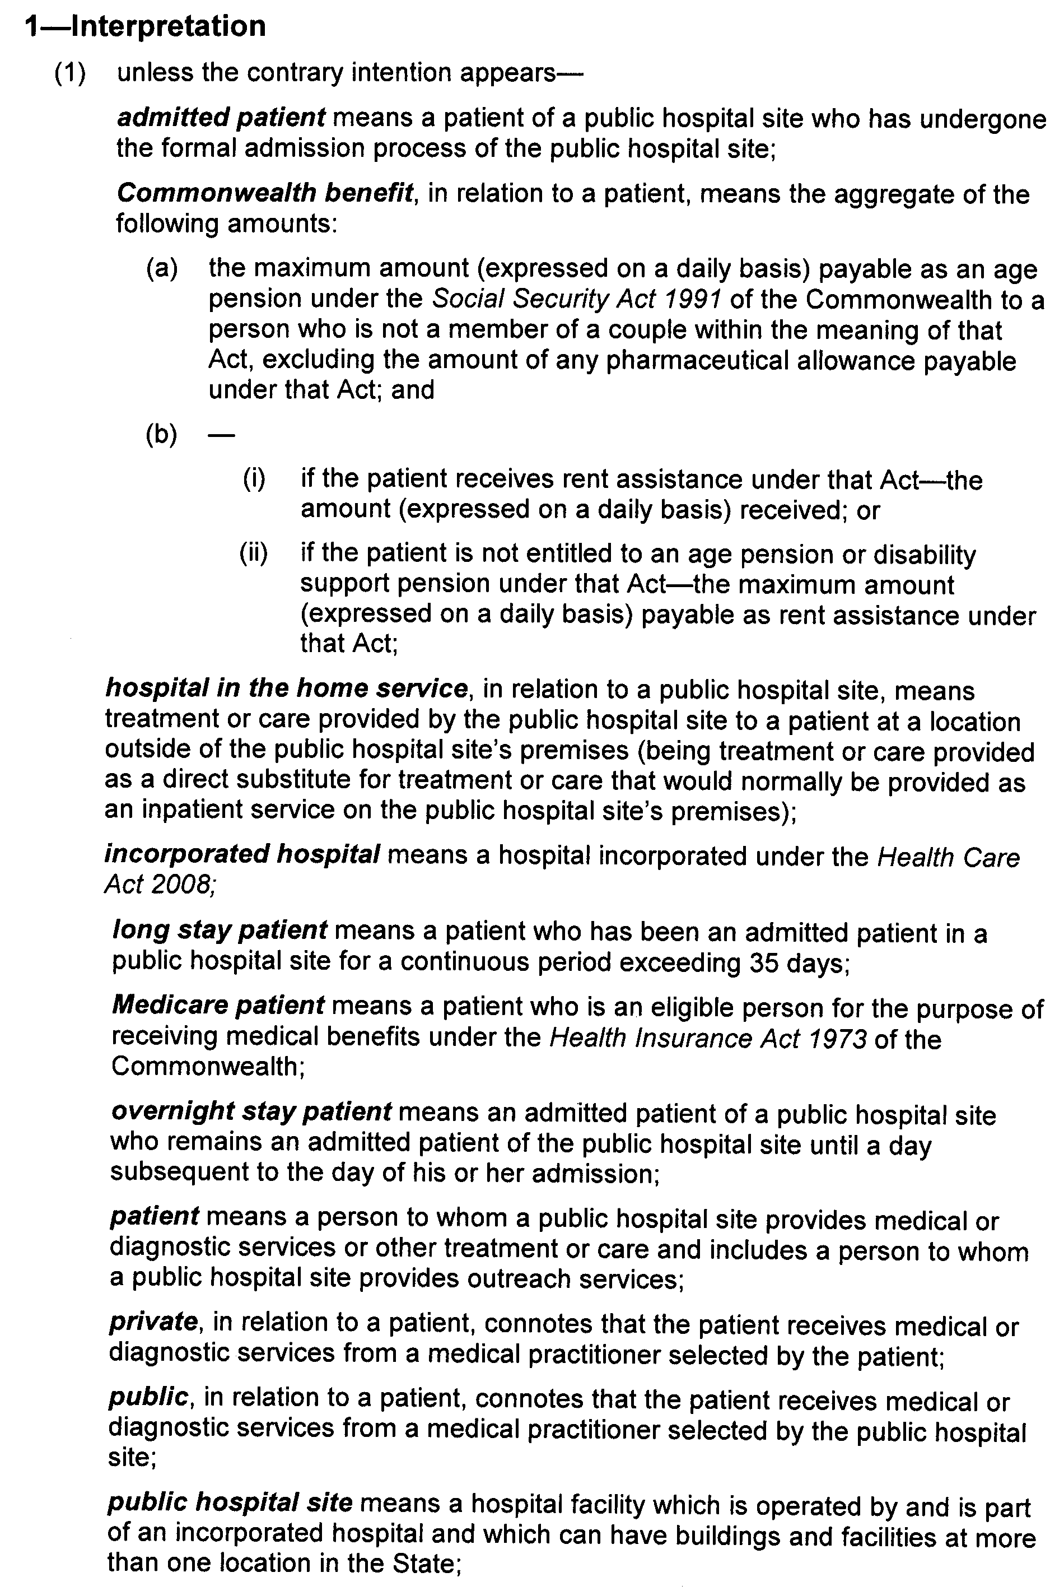
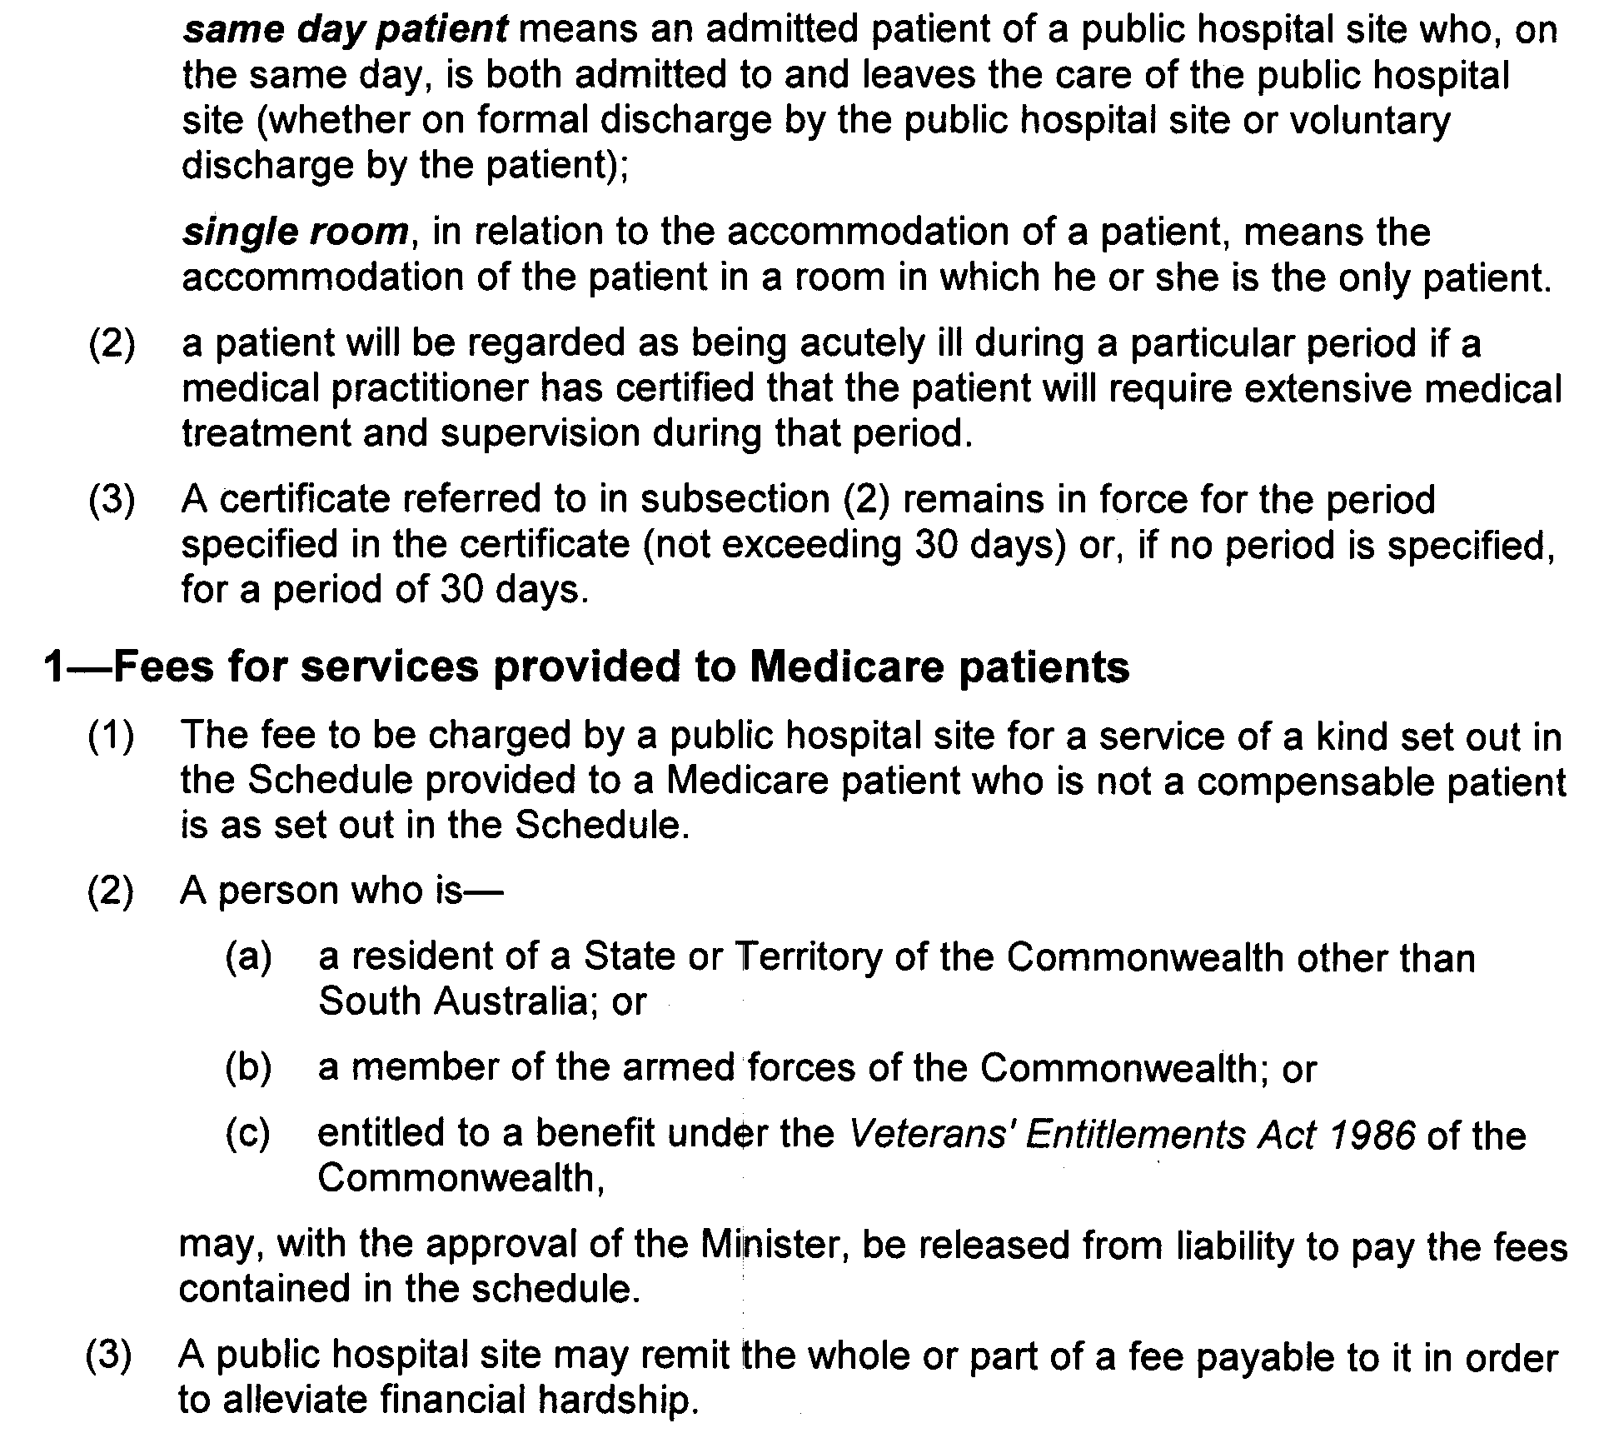
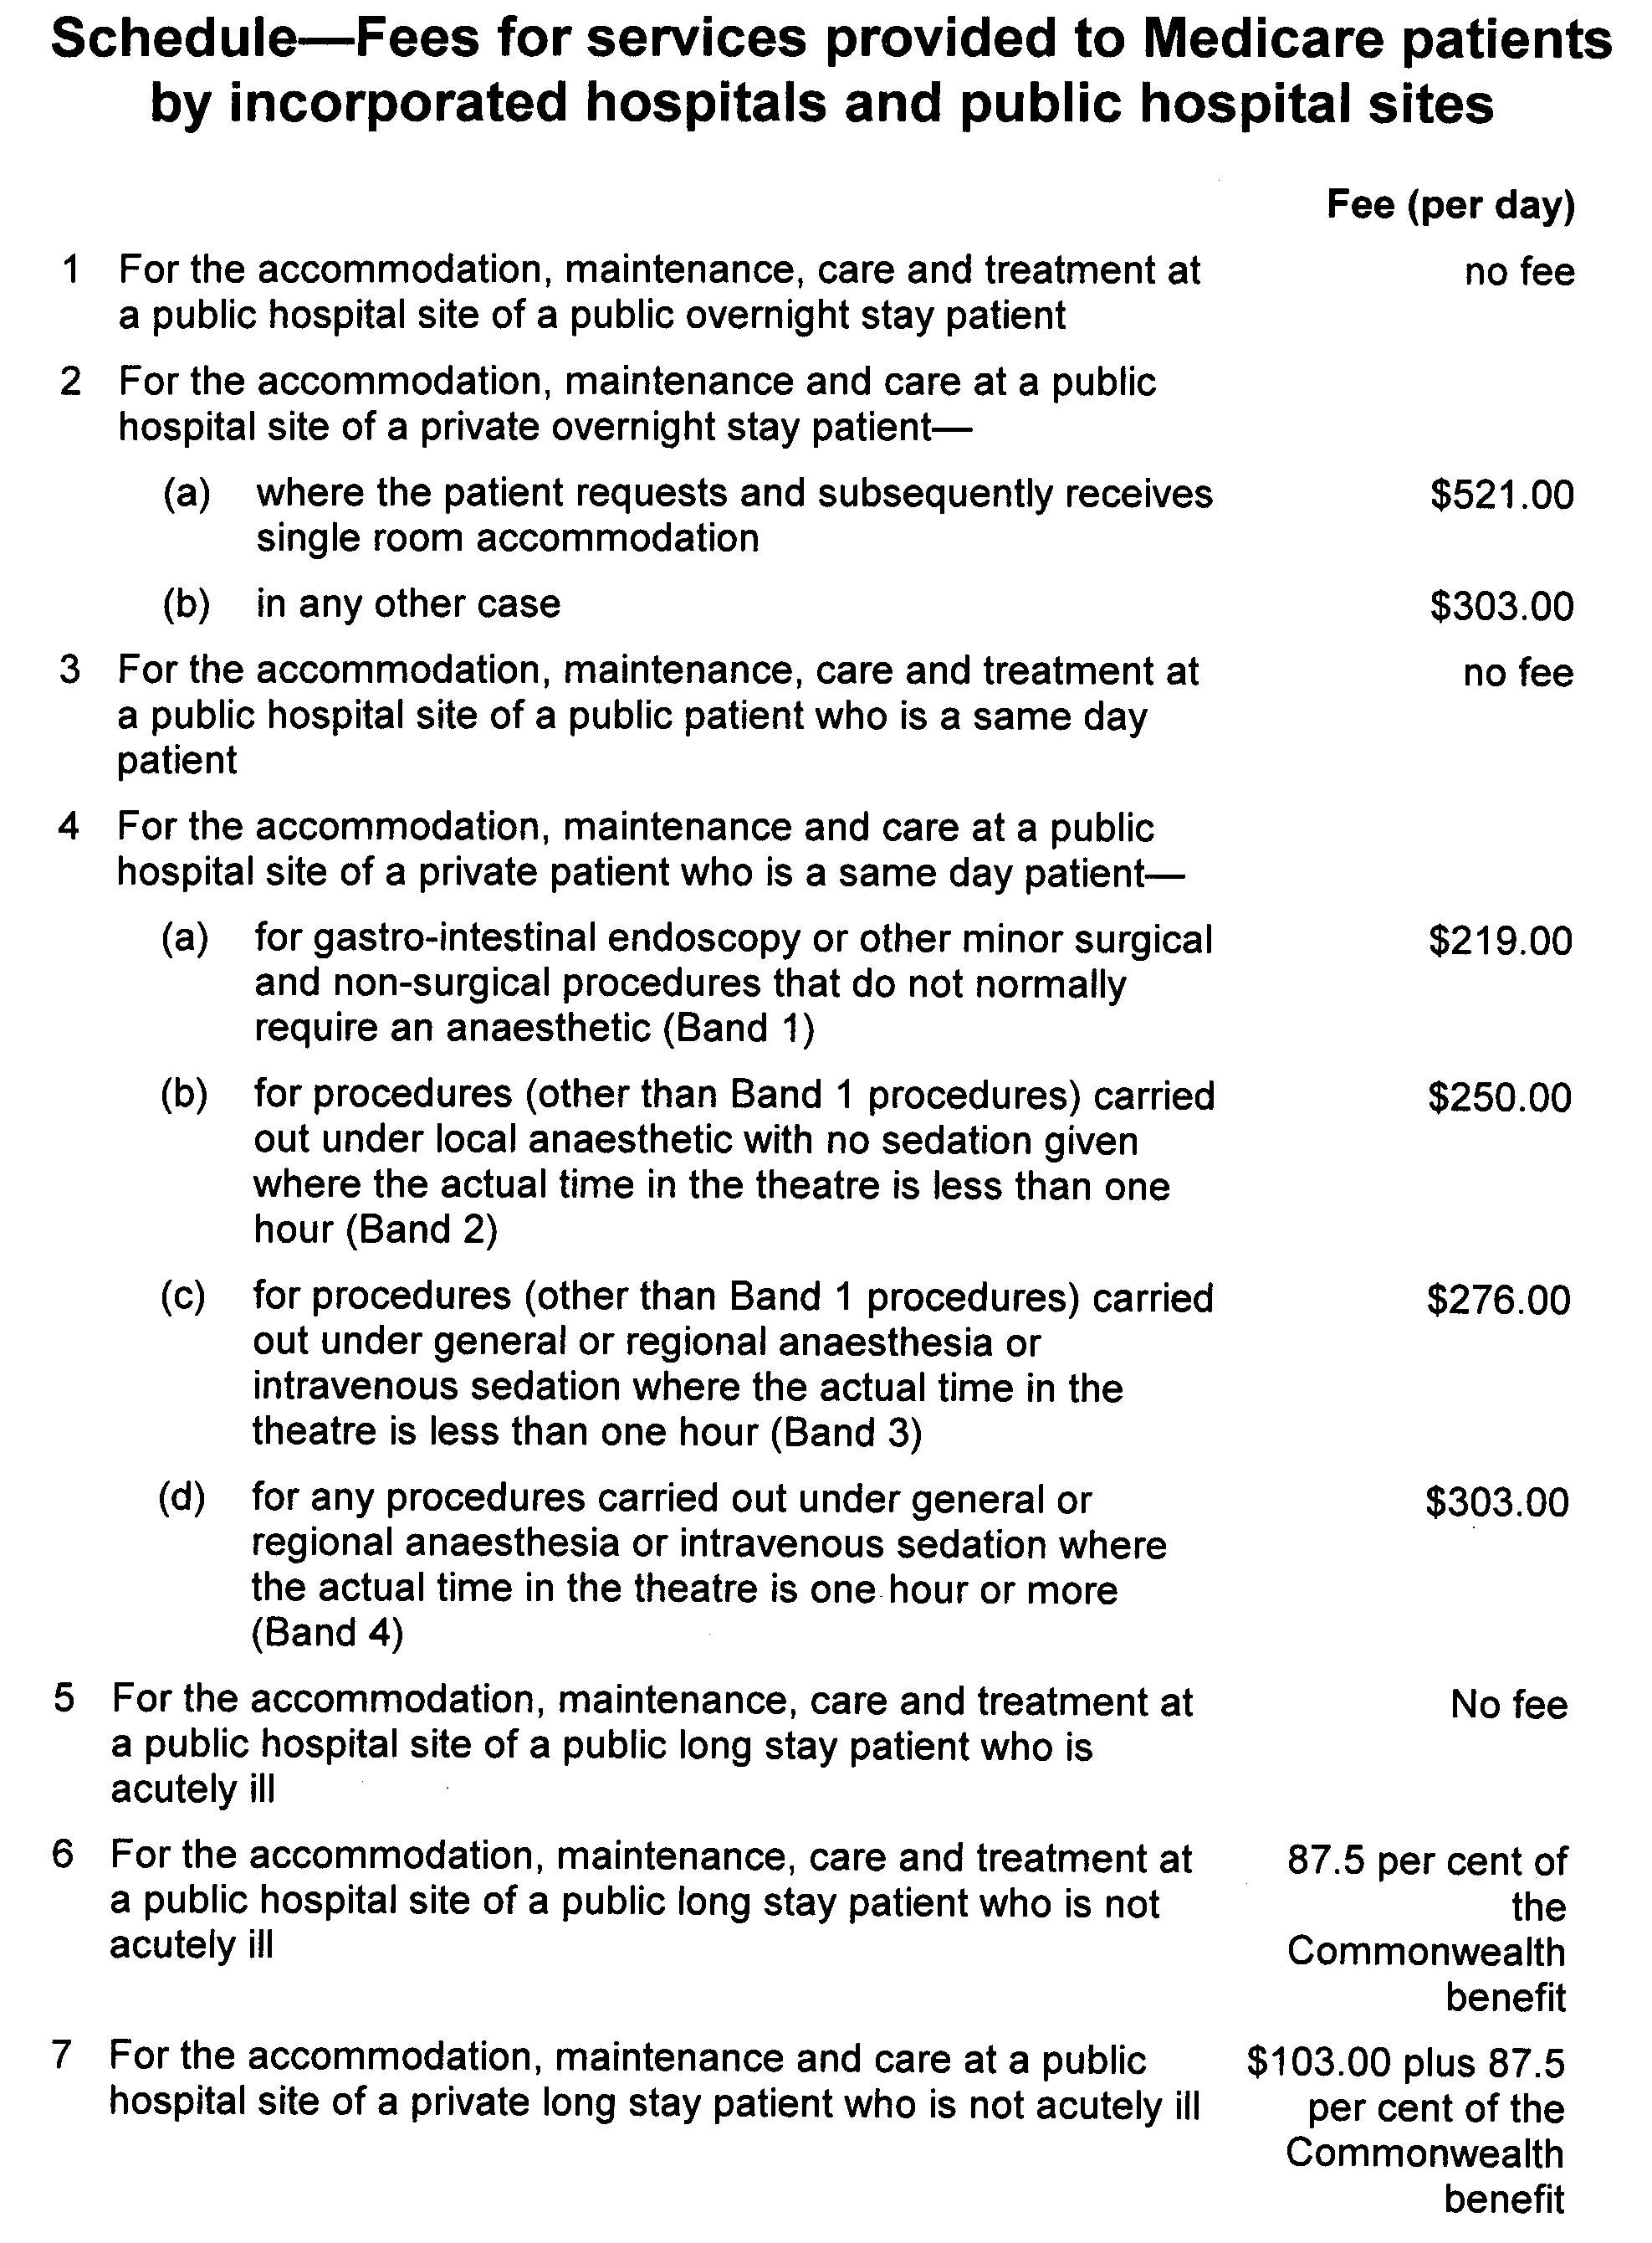


HEALTH CARE ACT 2008
Fees and Charges
I, JOHN HILL, Minister for Health, hereby give notice pursuant to section 44 of the Health Care Act 2008, of the fees in the list attached to apply to a compensable patient:
These charges will operate from 16 September 2010 to 30 June 2011.
Dated 9 September 2010.
John Hill, Minister for Health

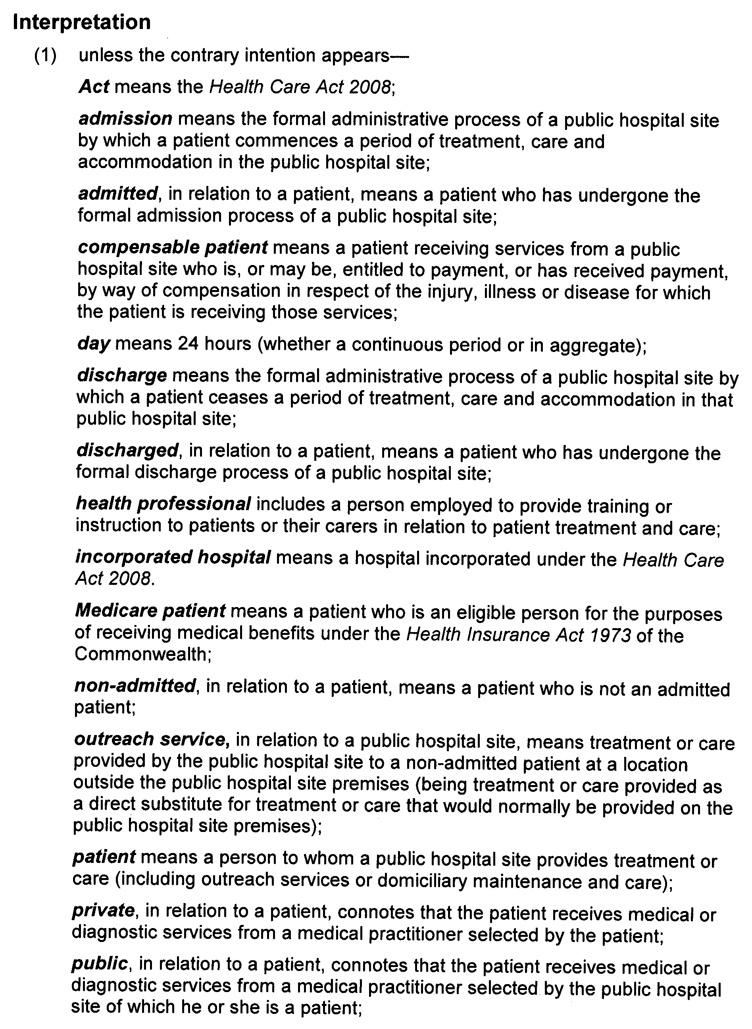

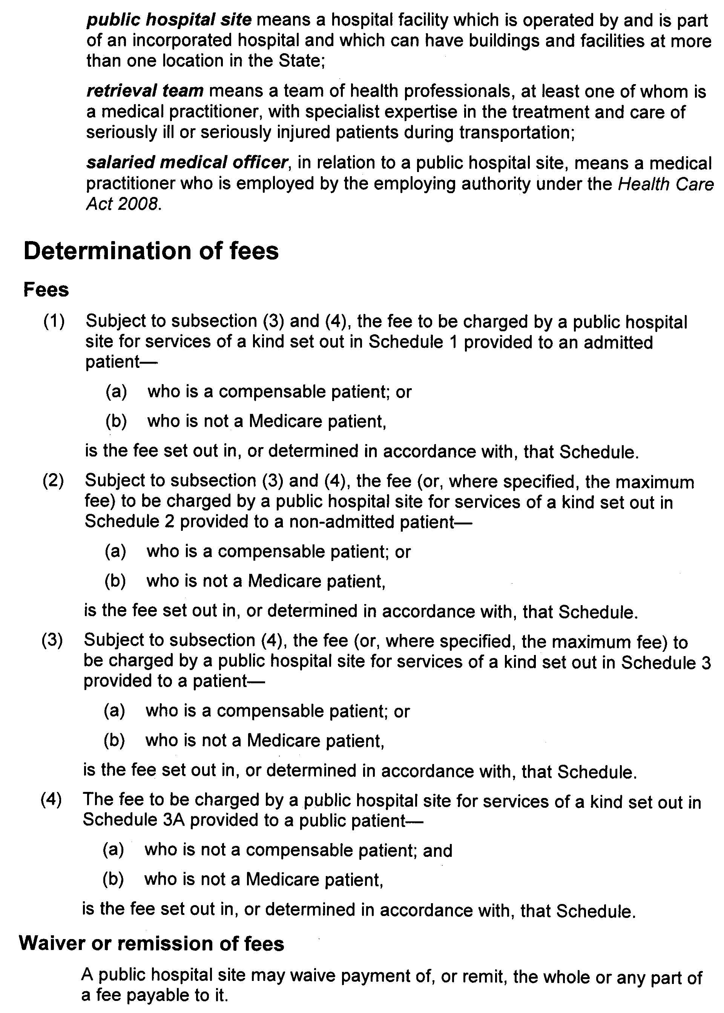
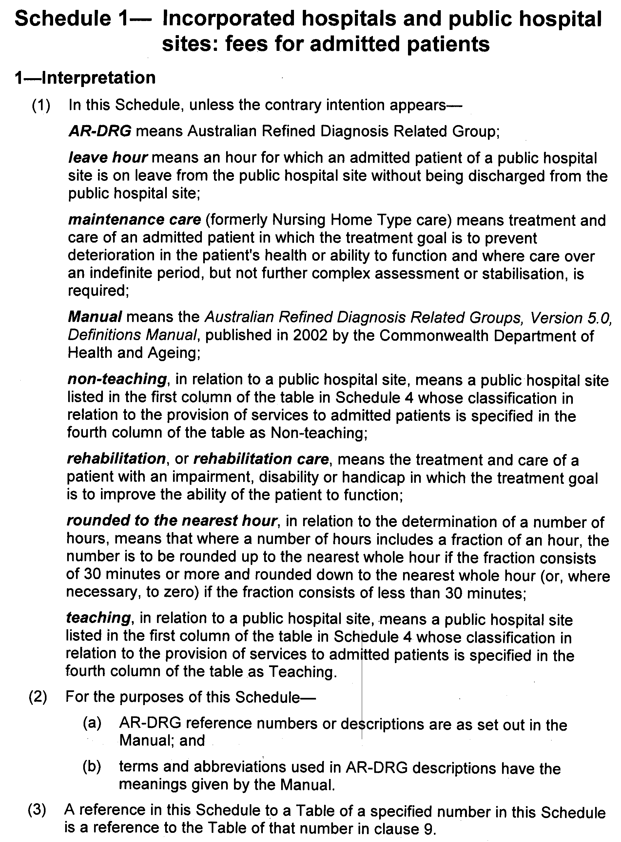
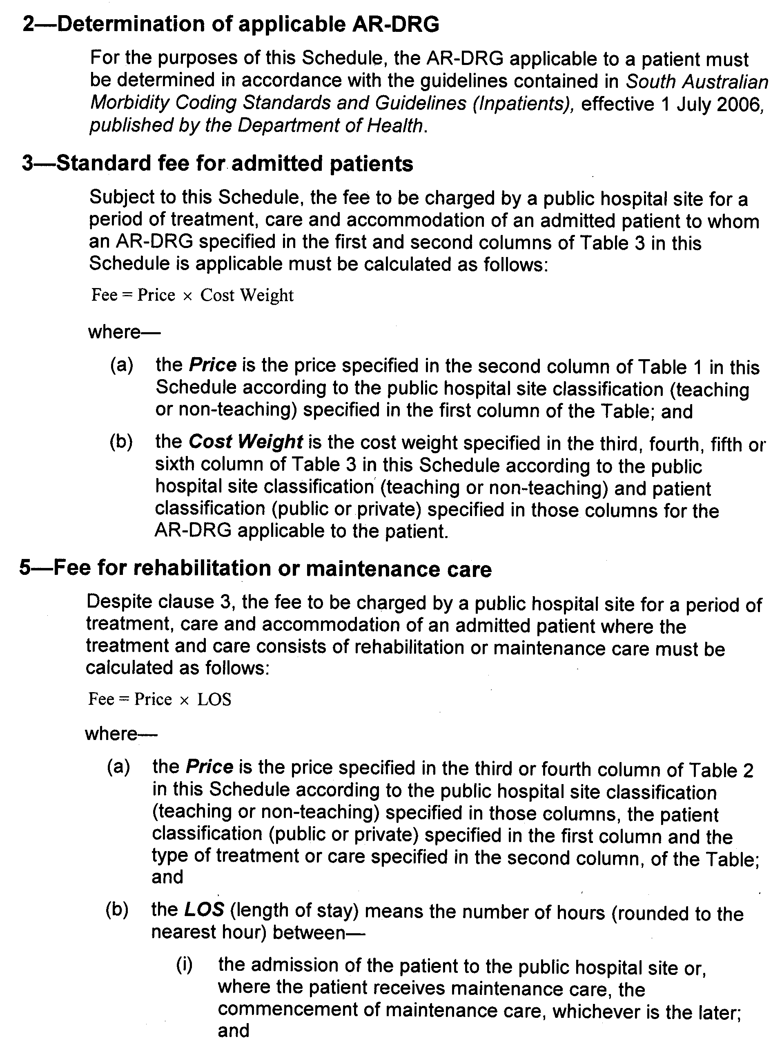
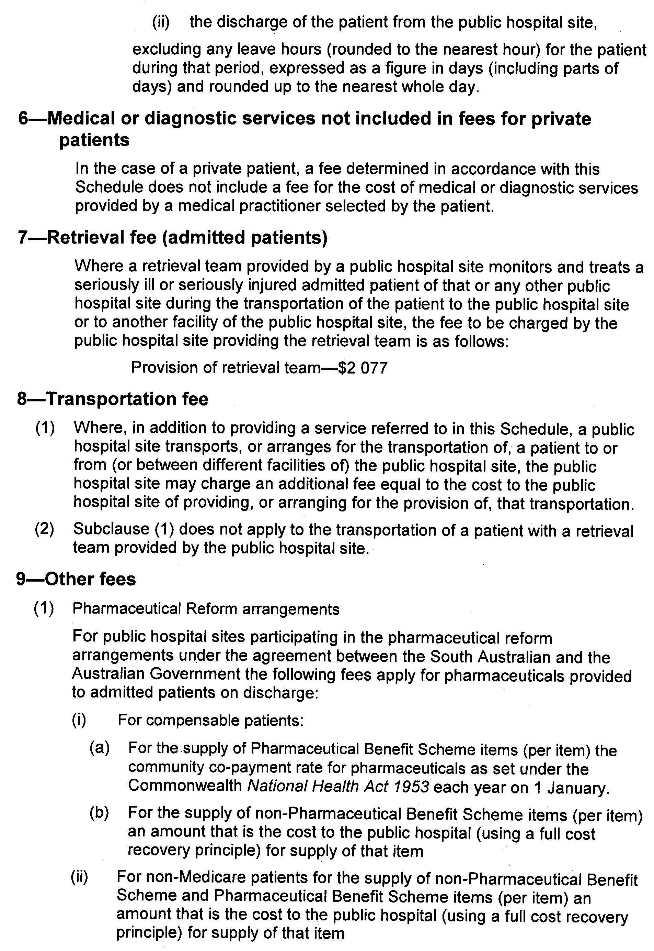

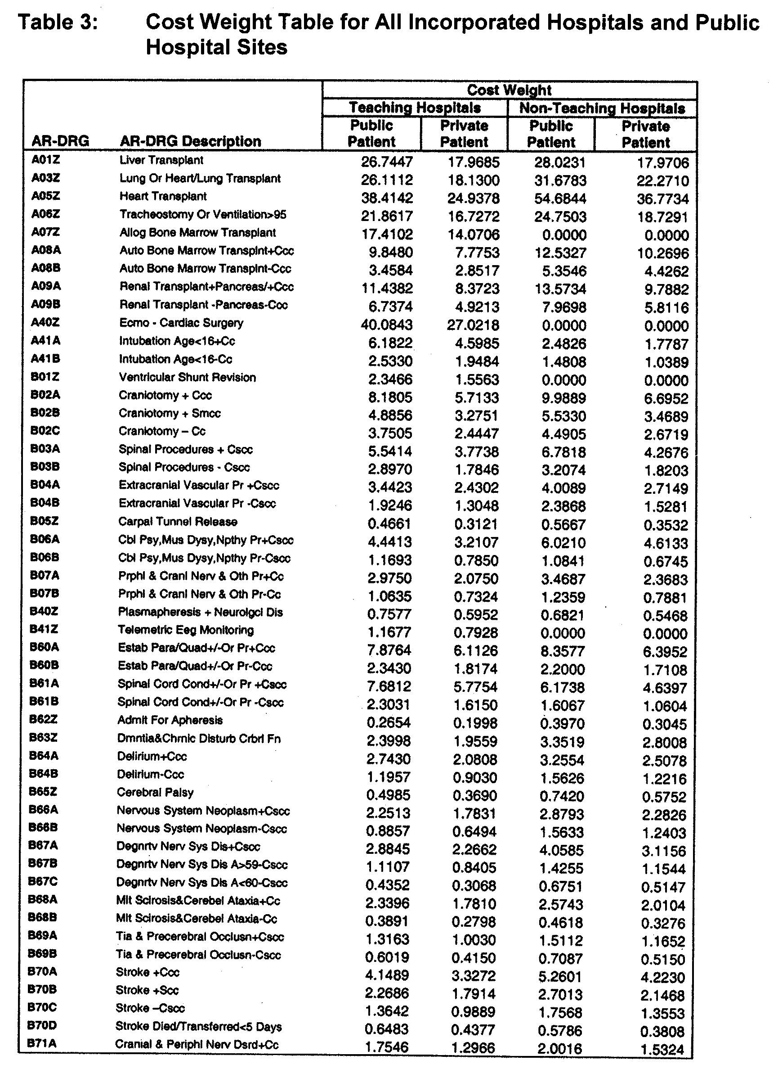
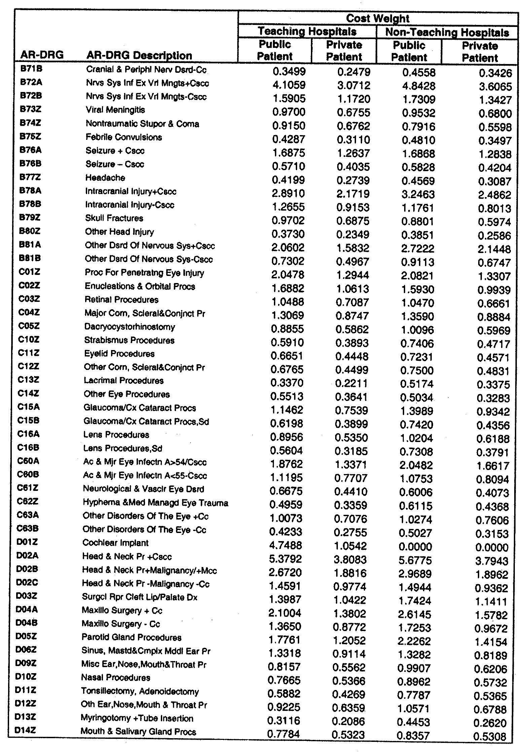
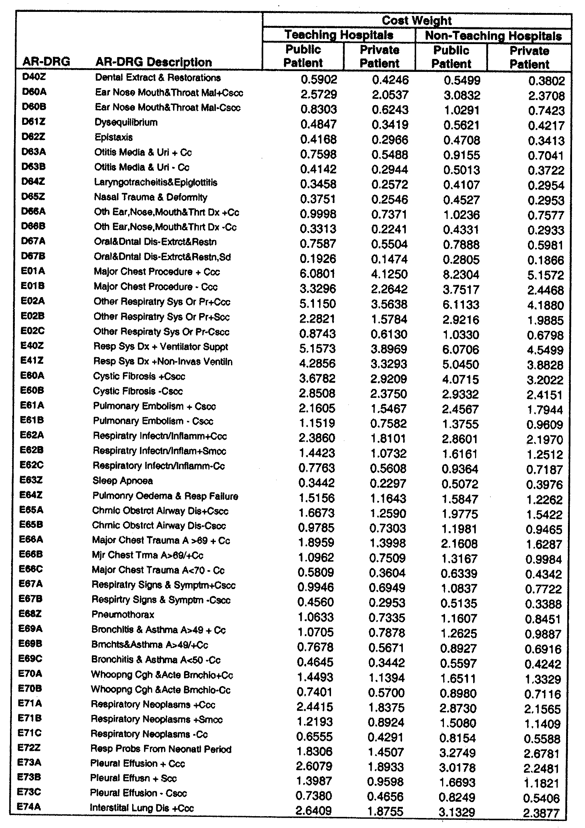
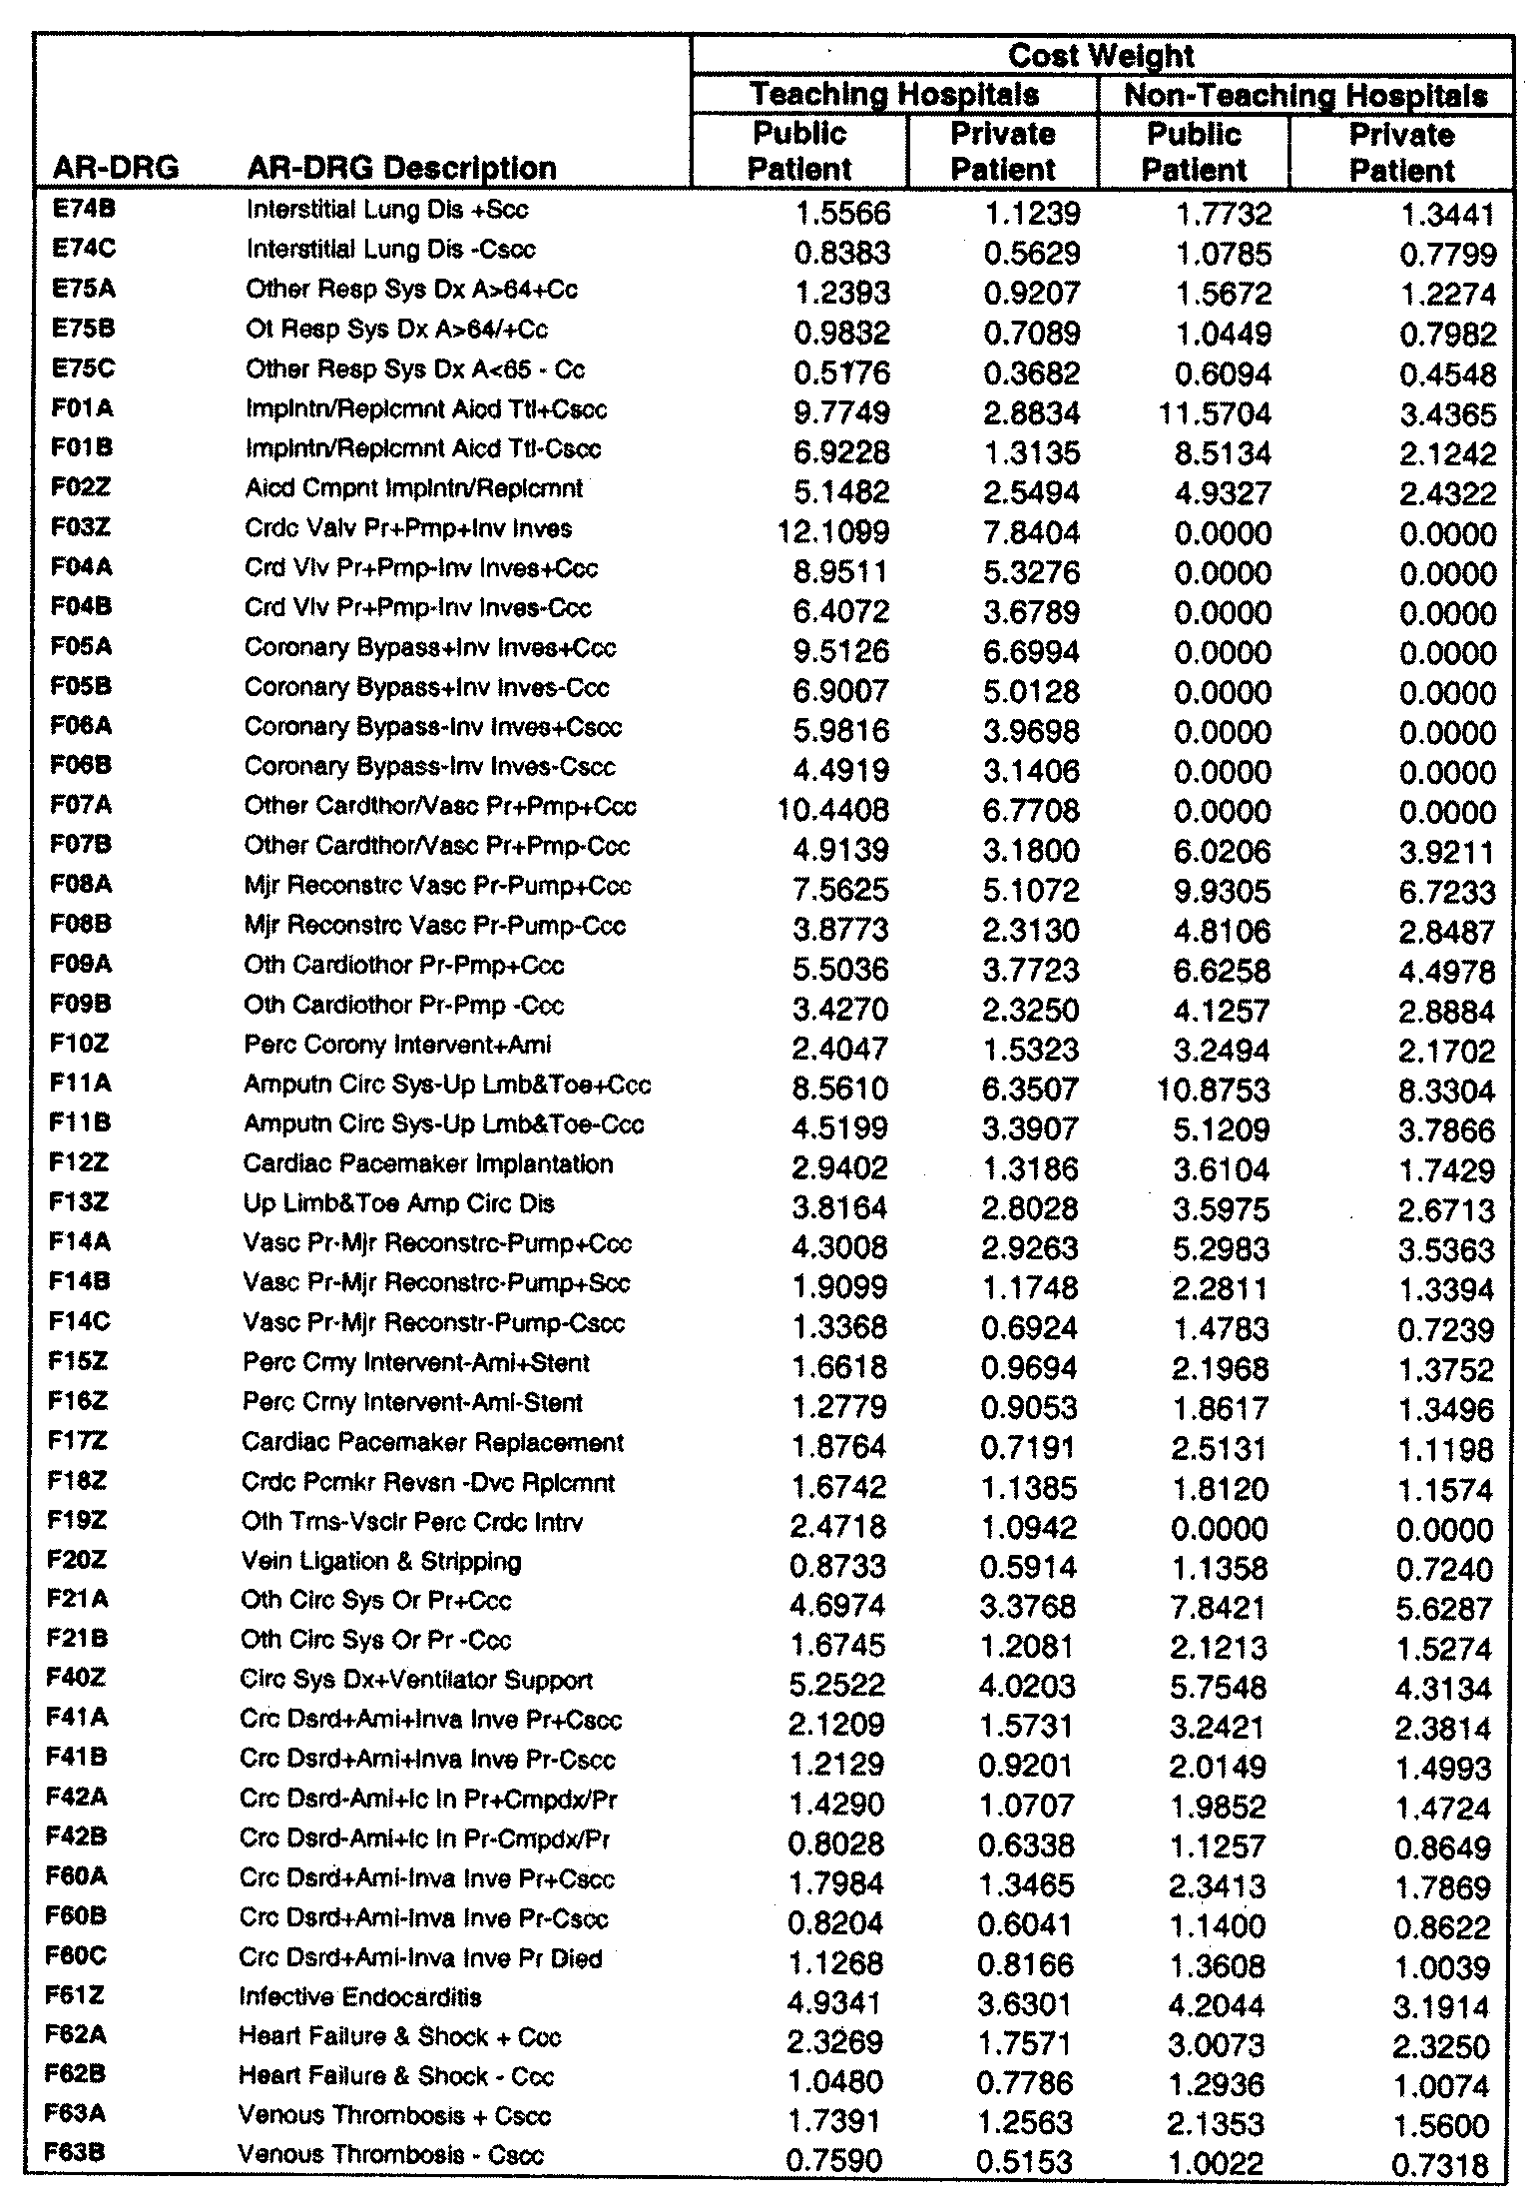
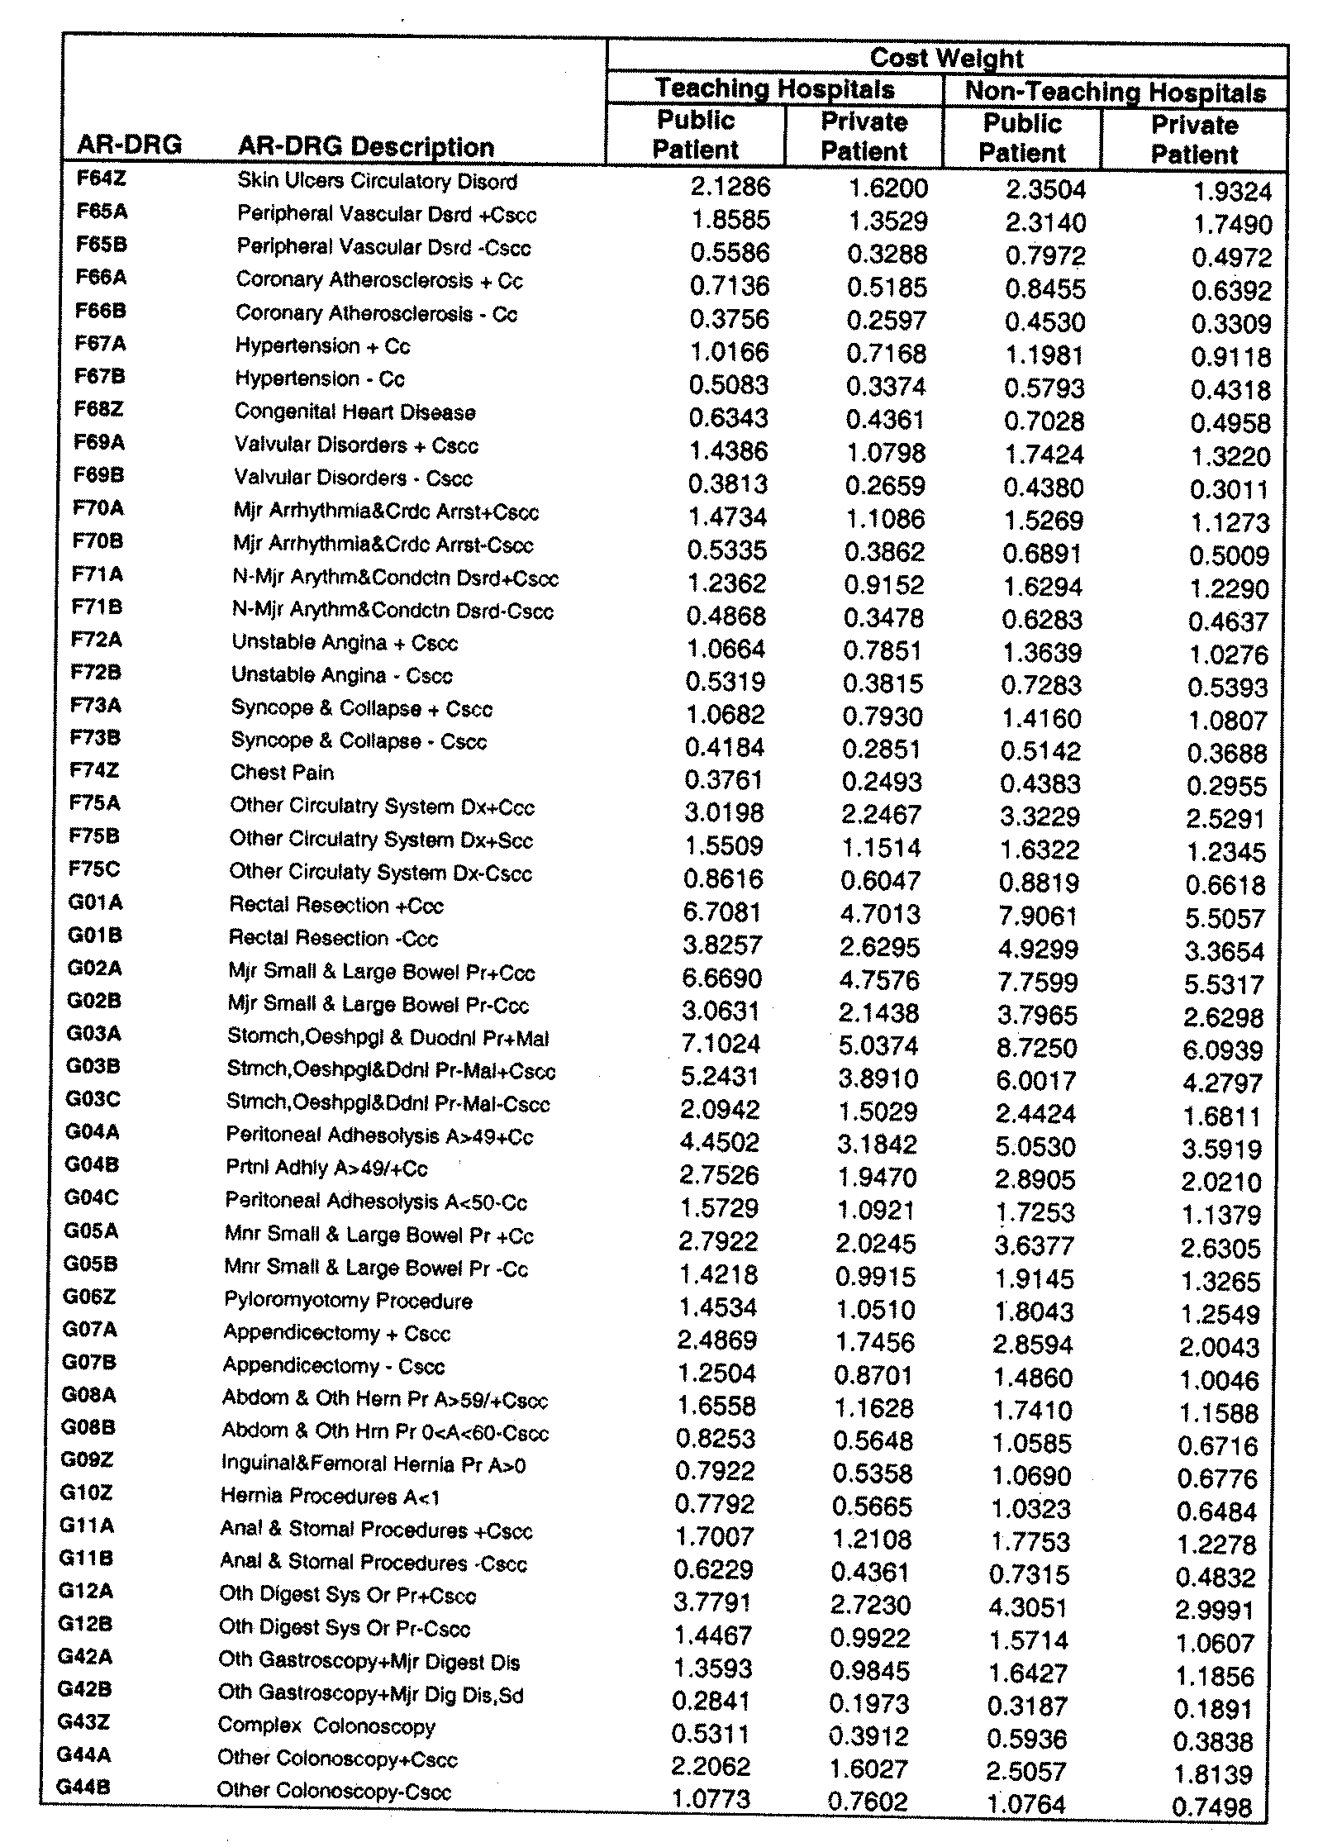
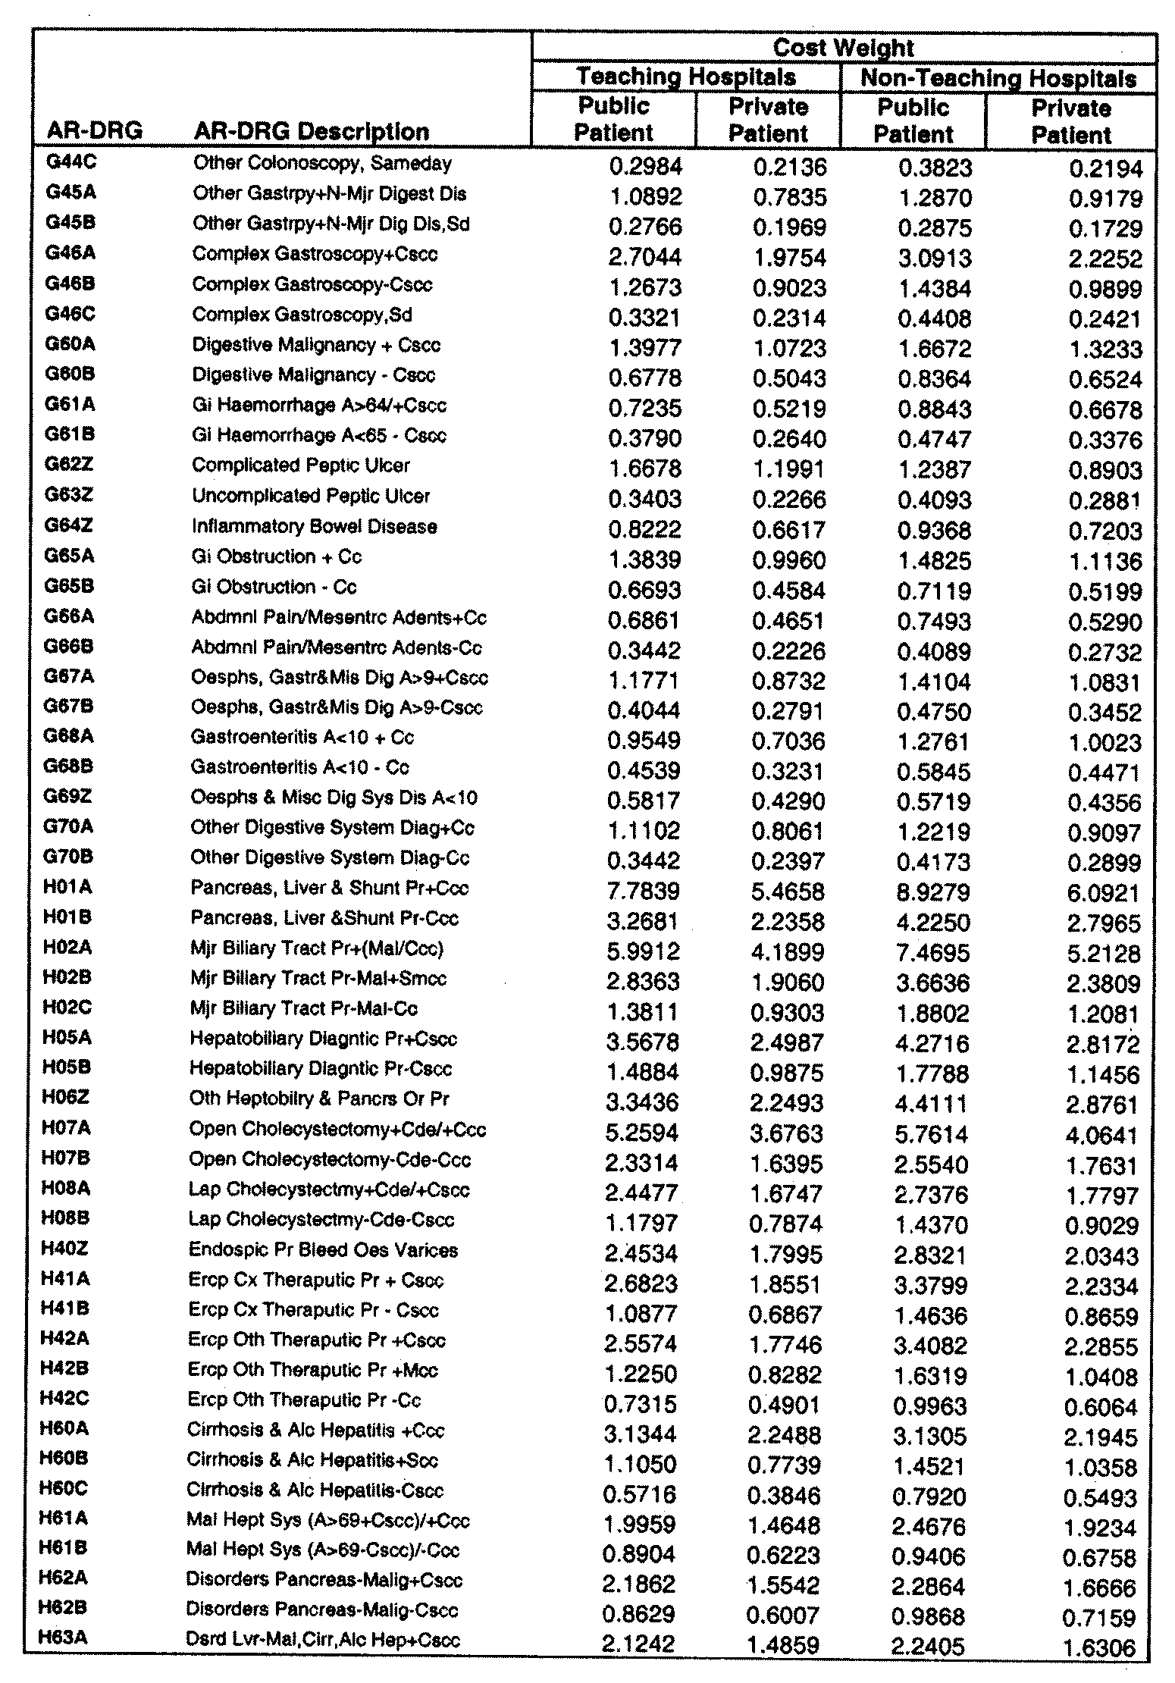
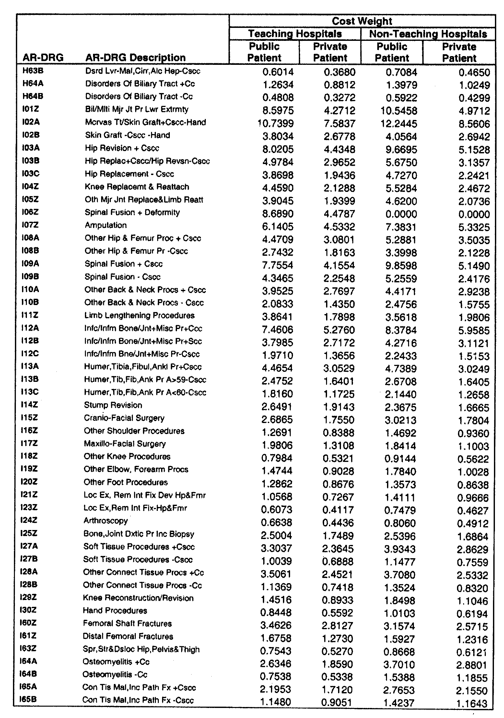
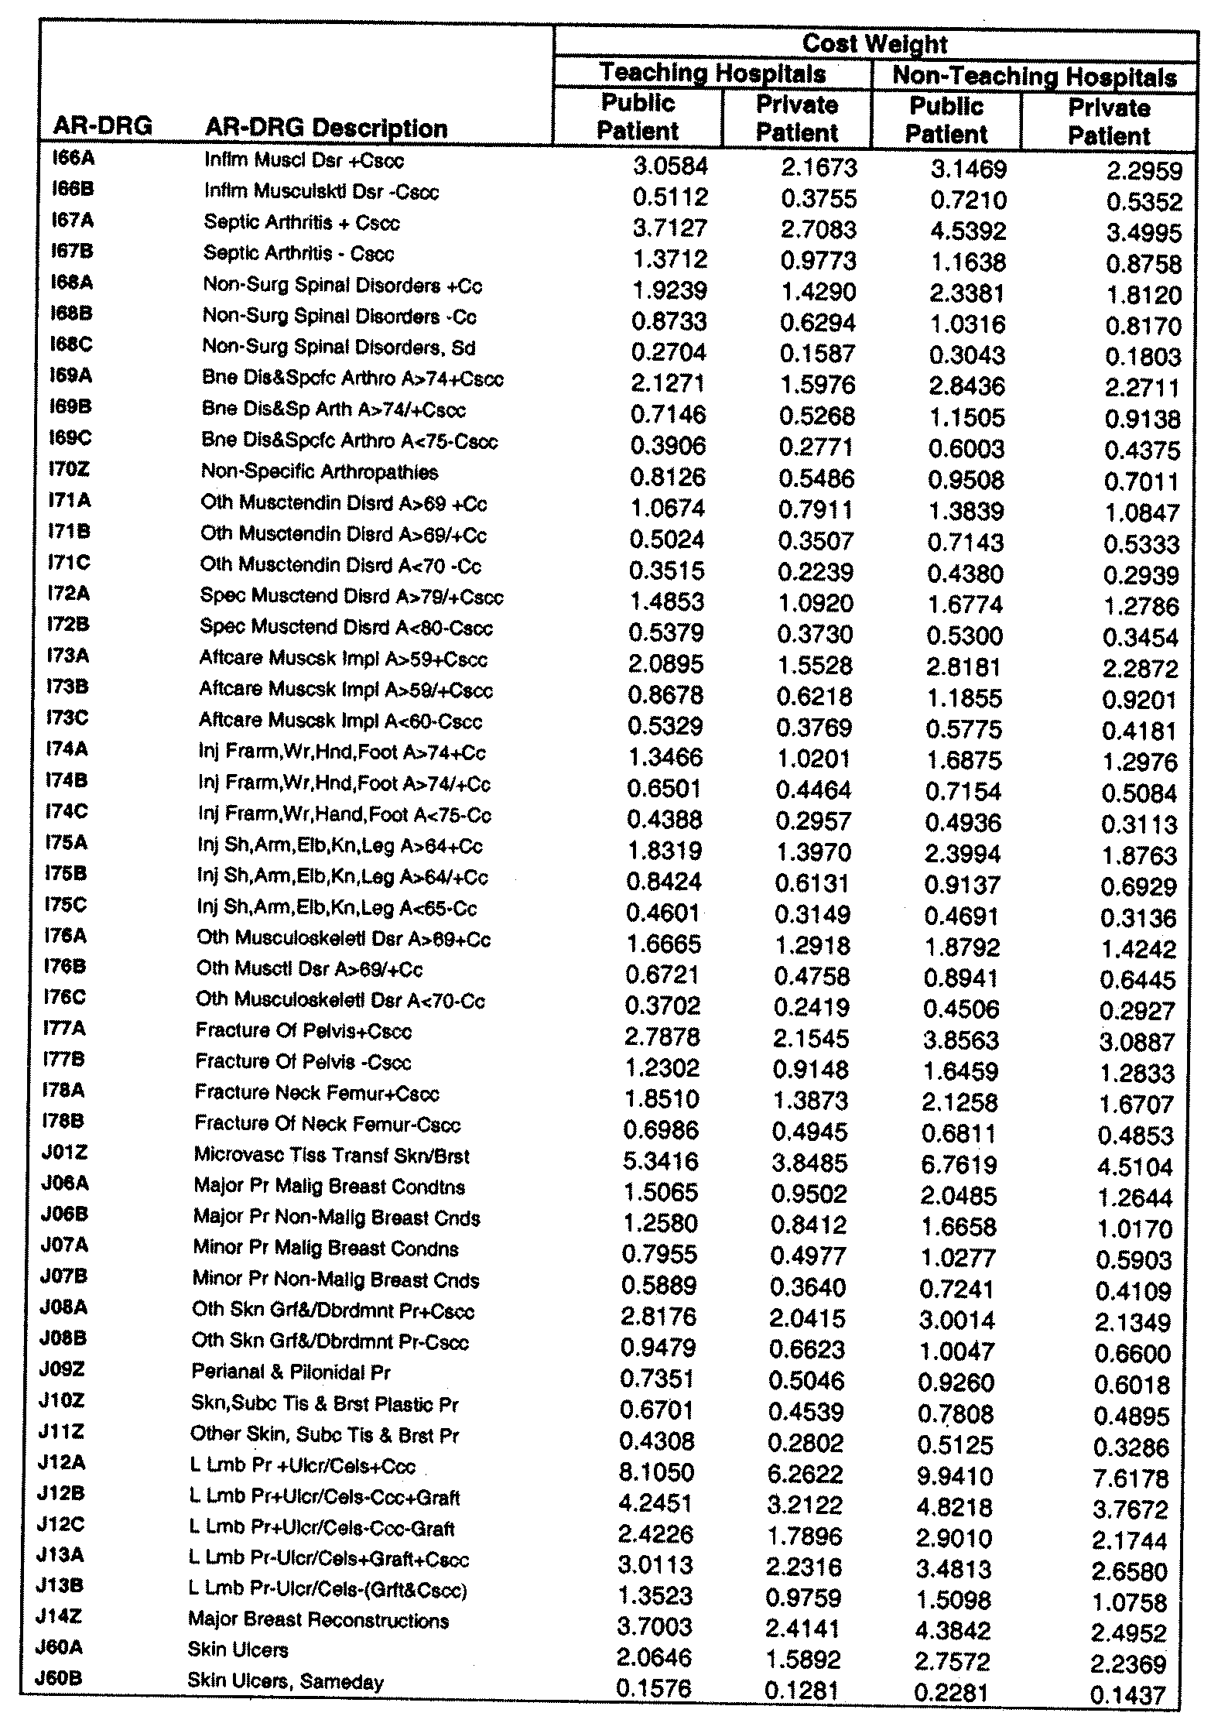
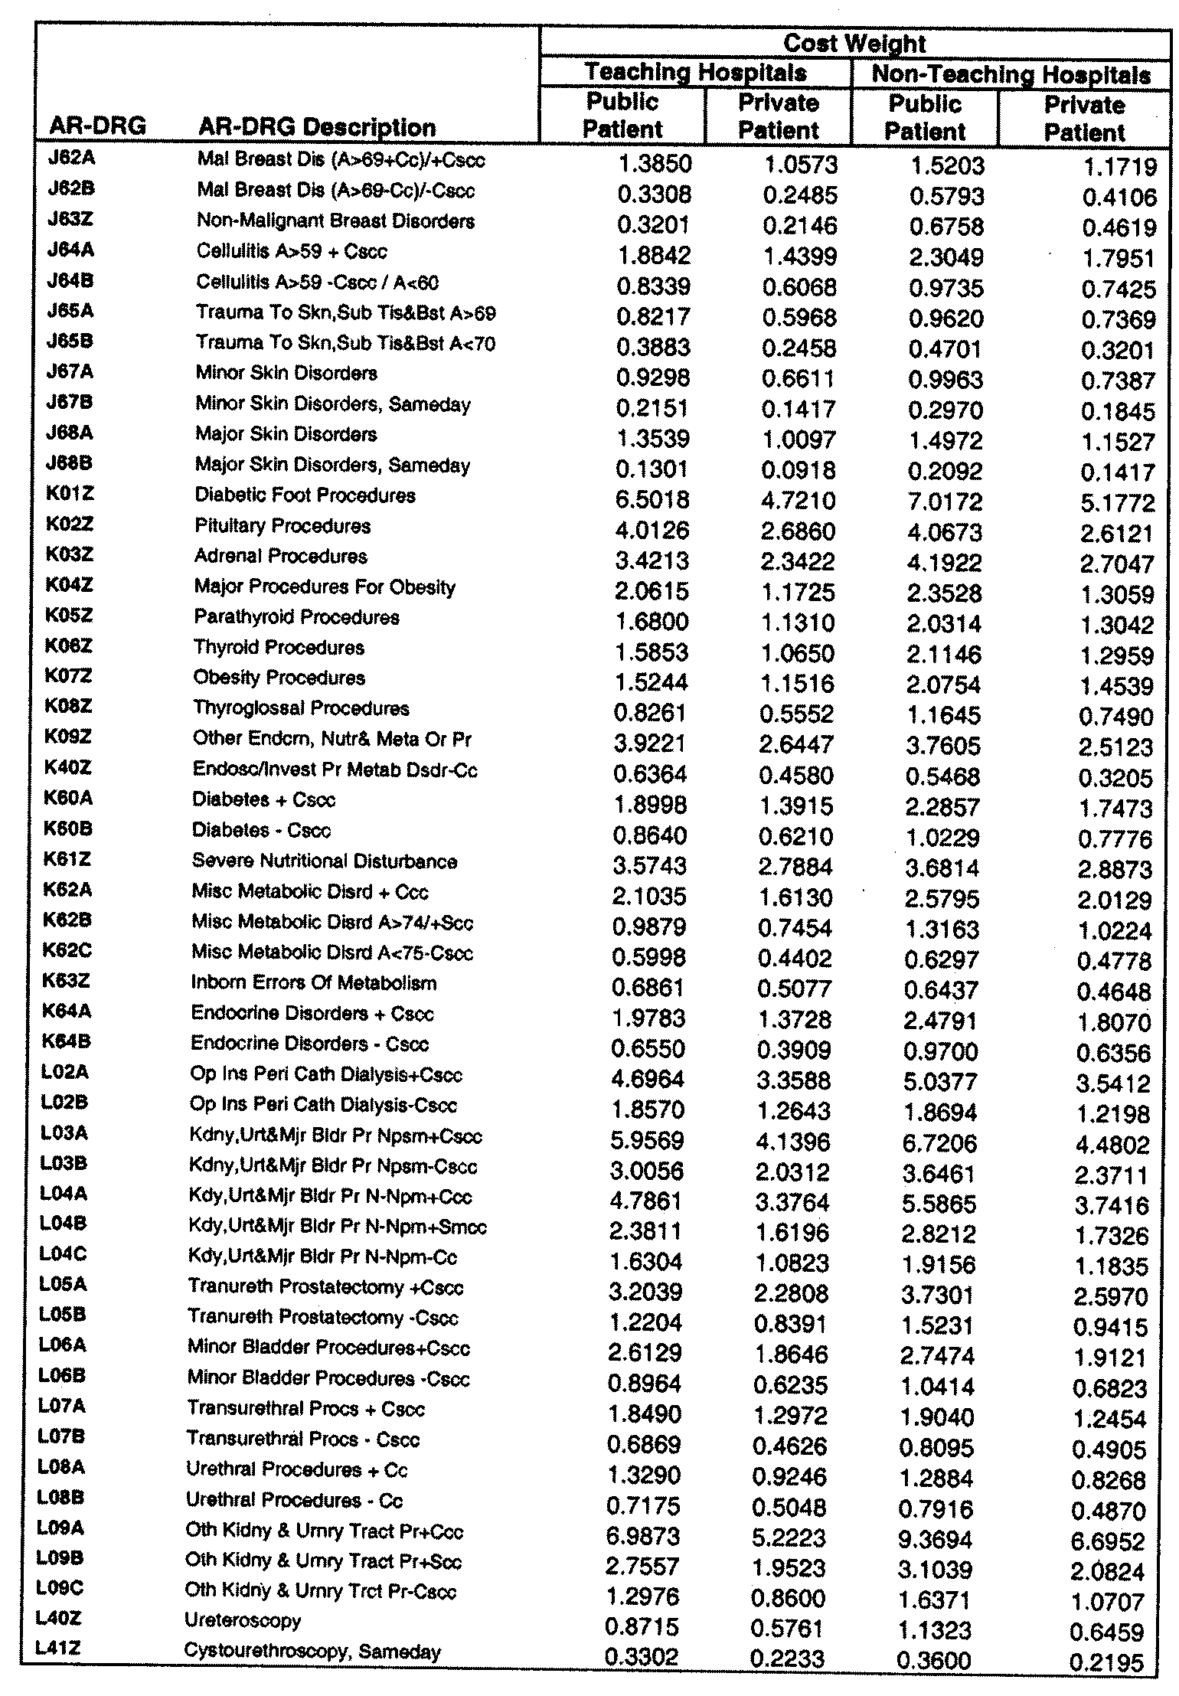
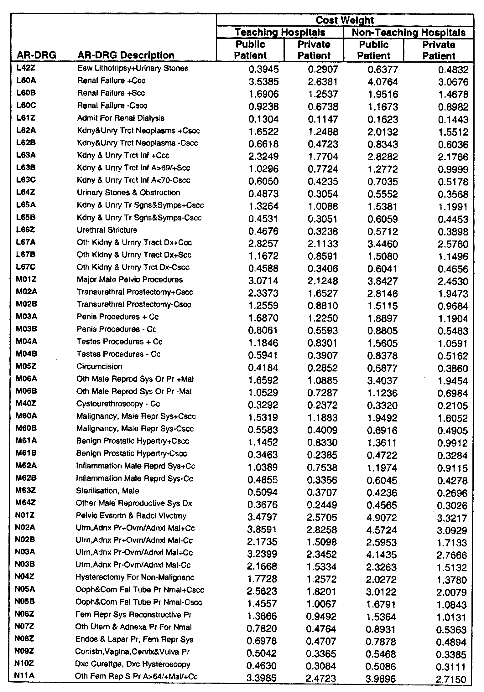
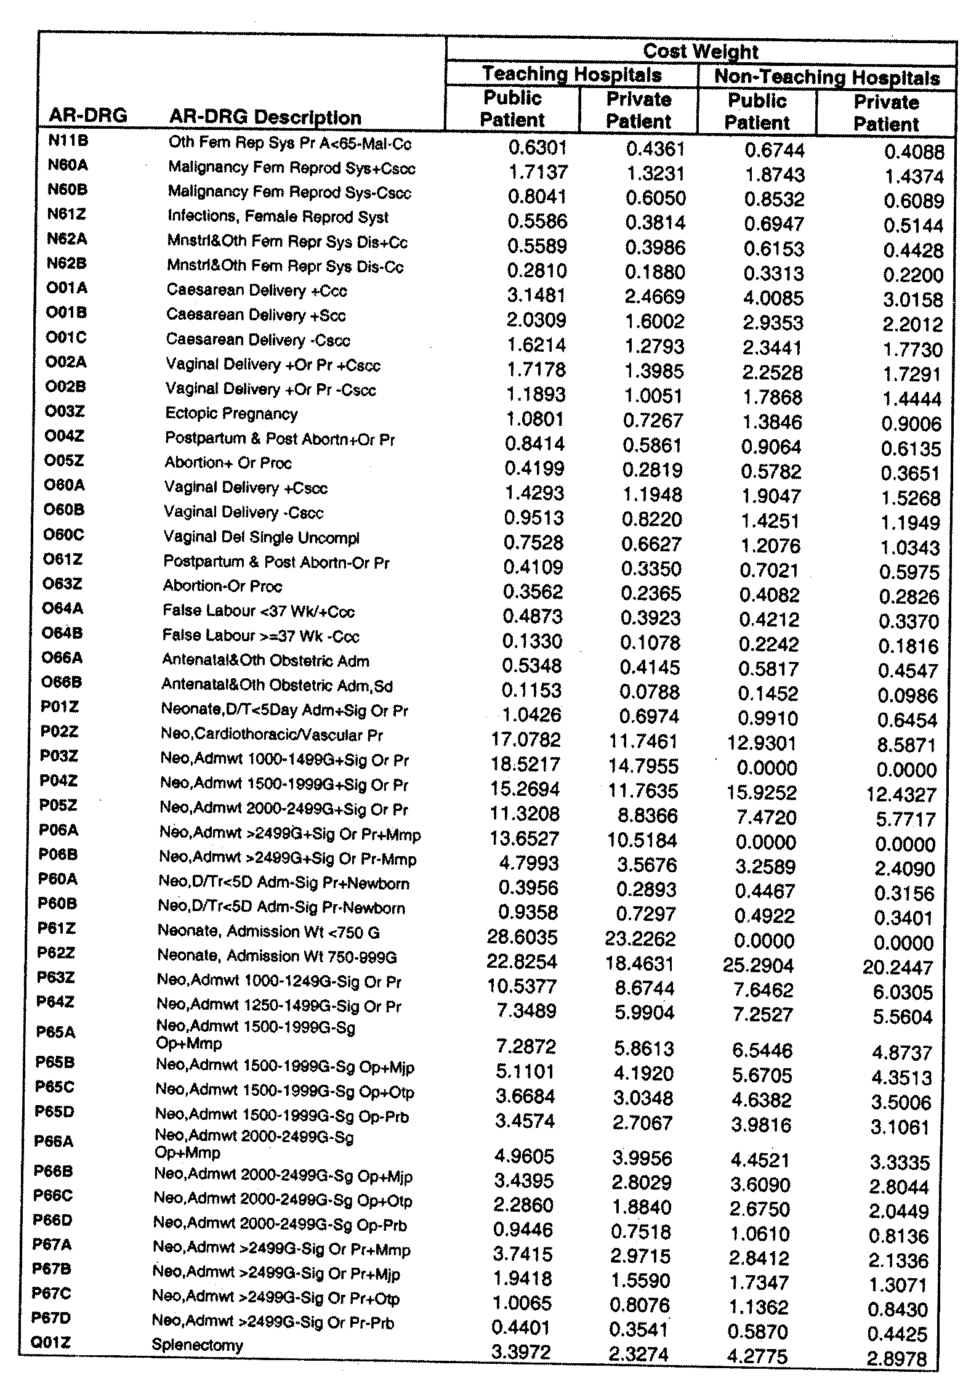
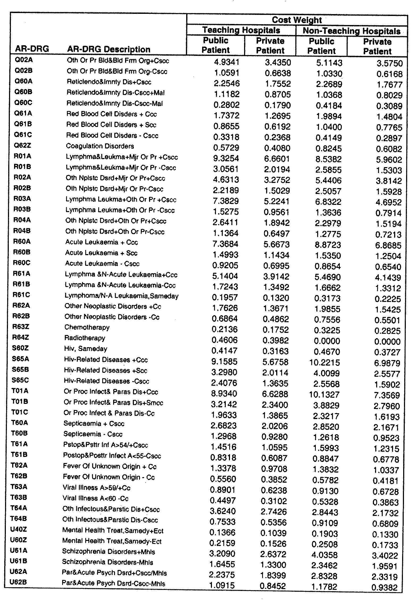
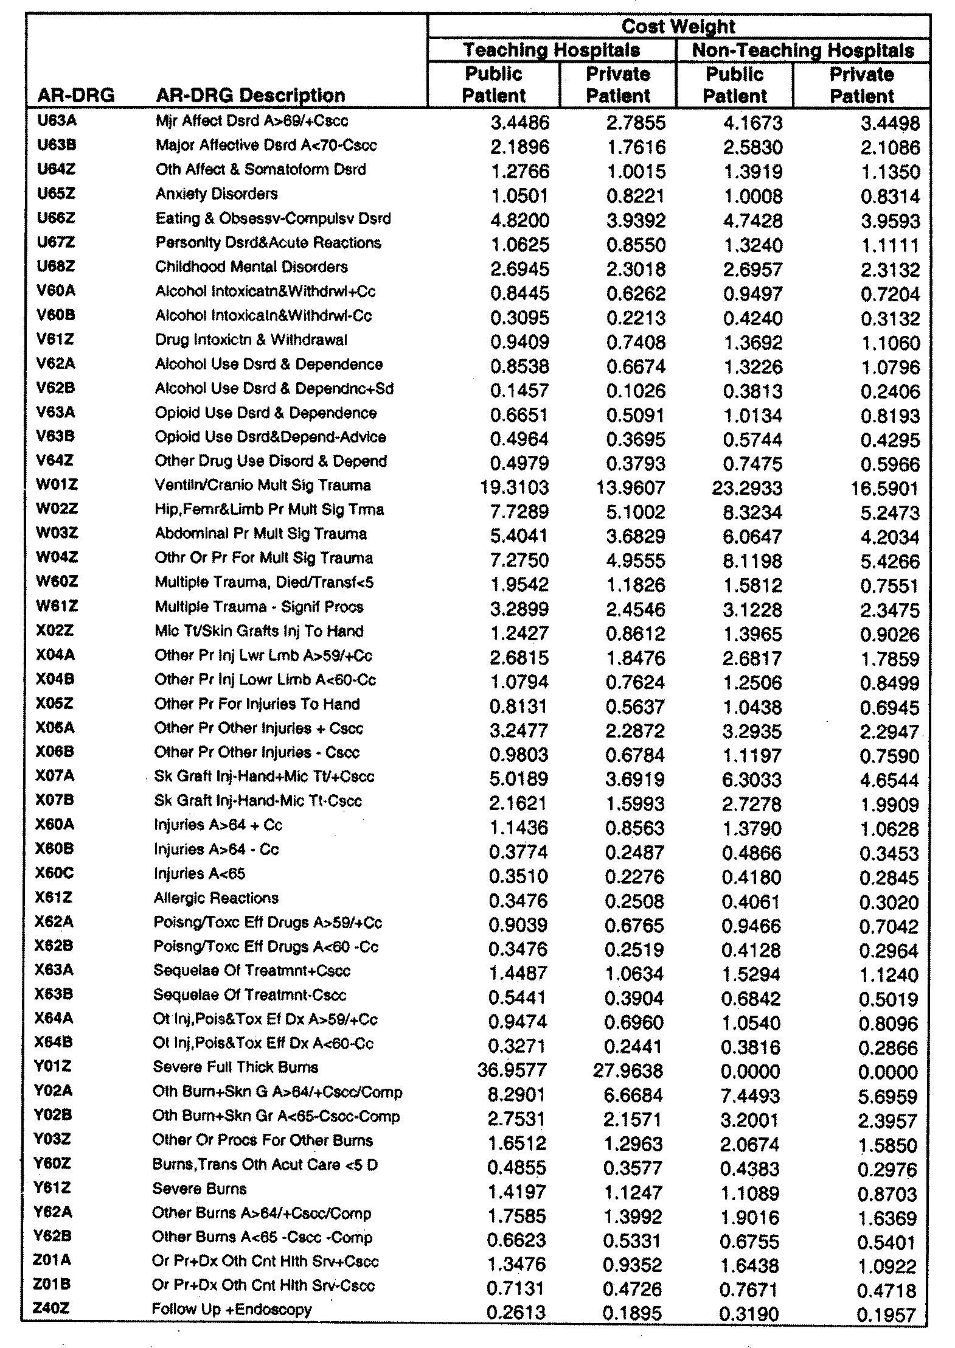
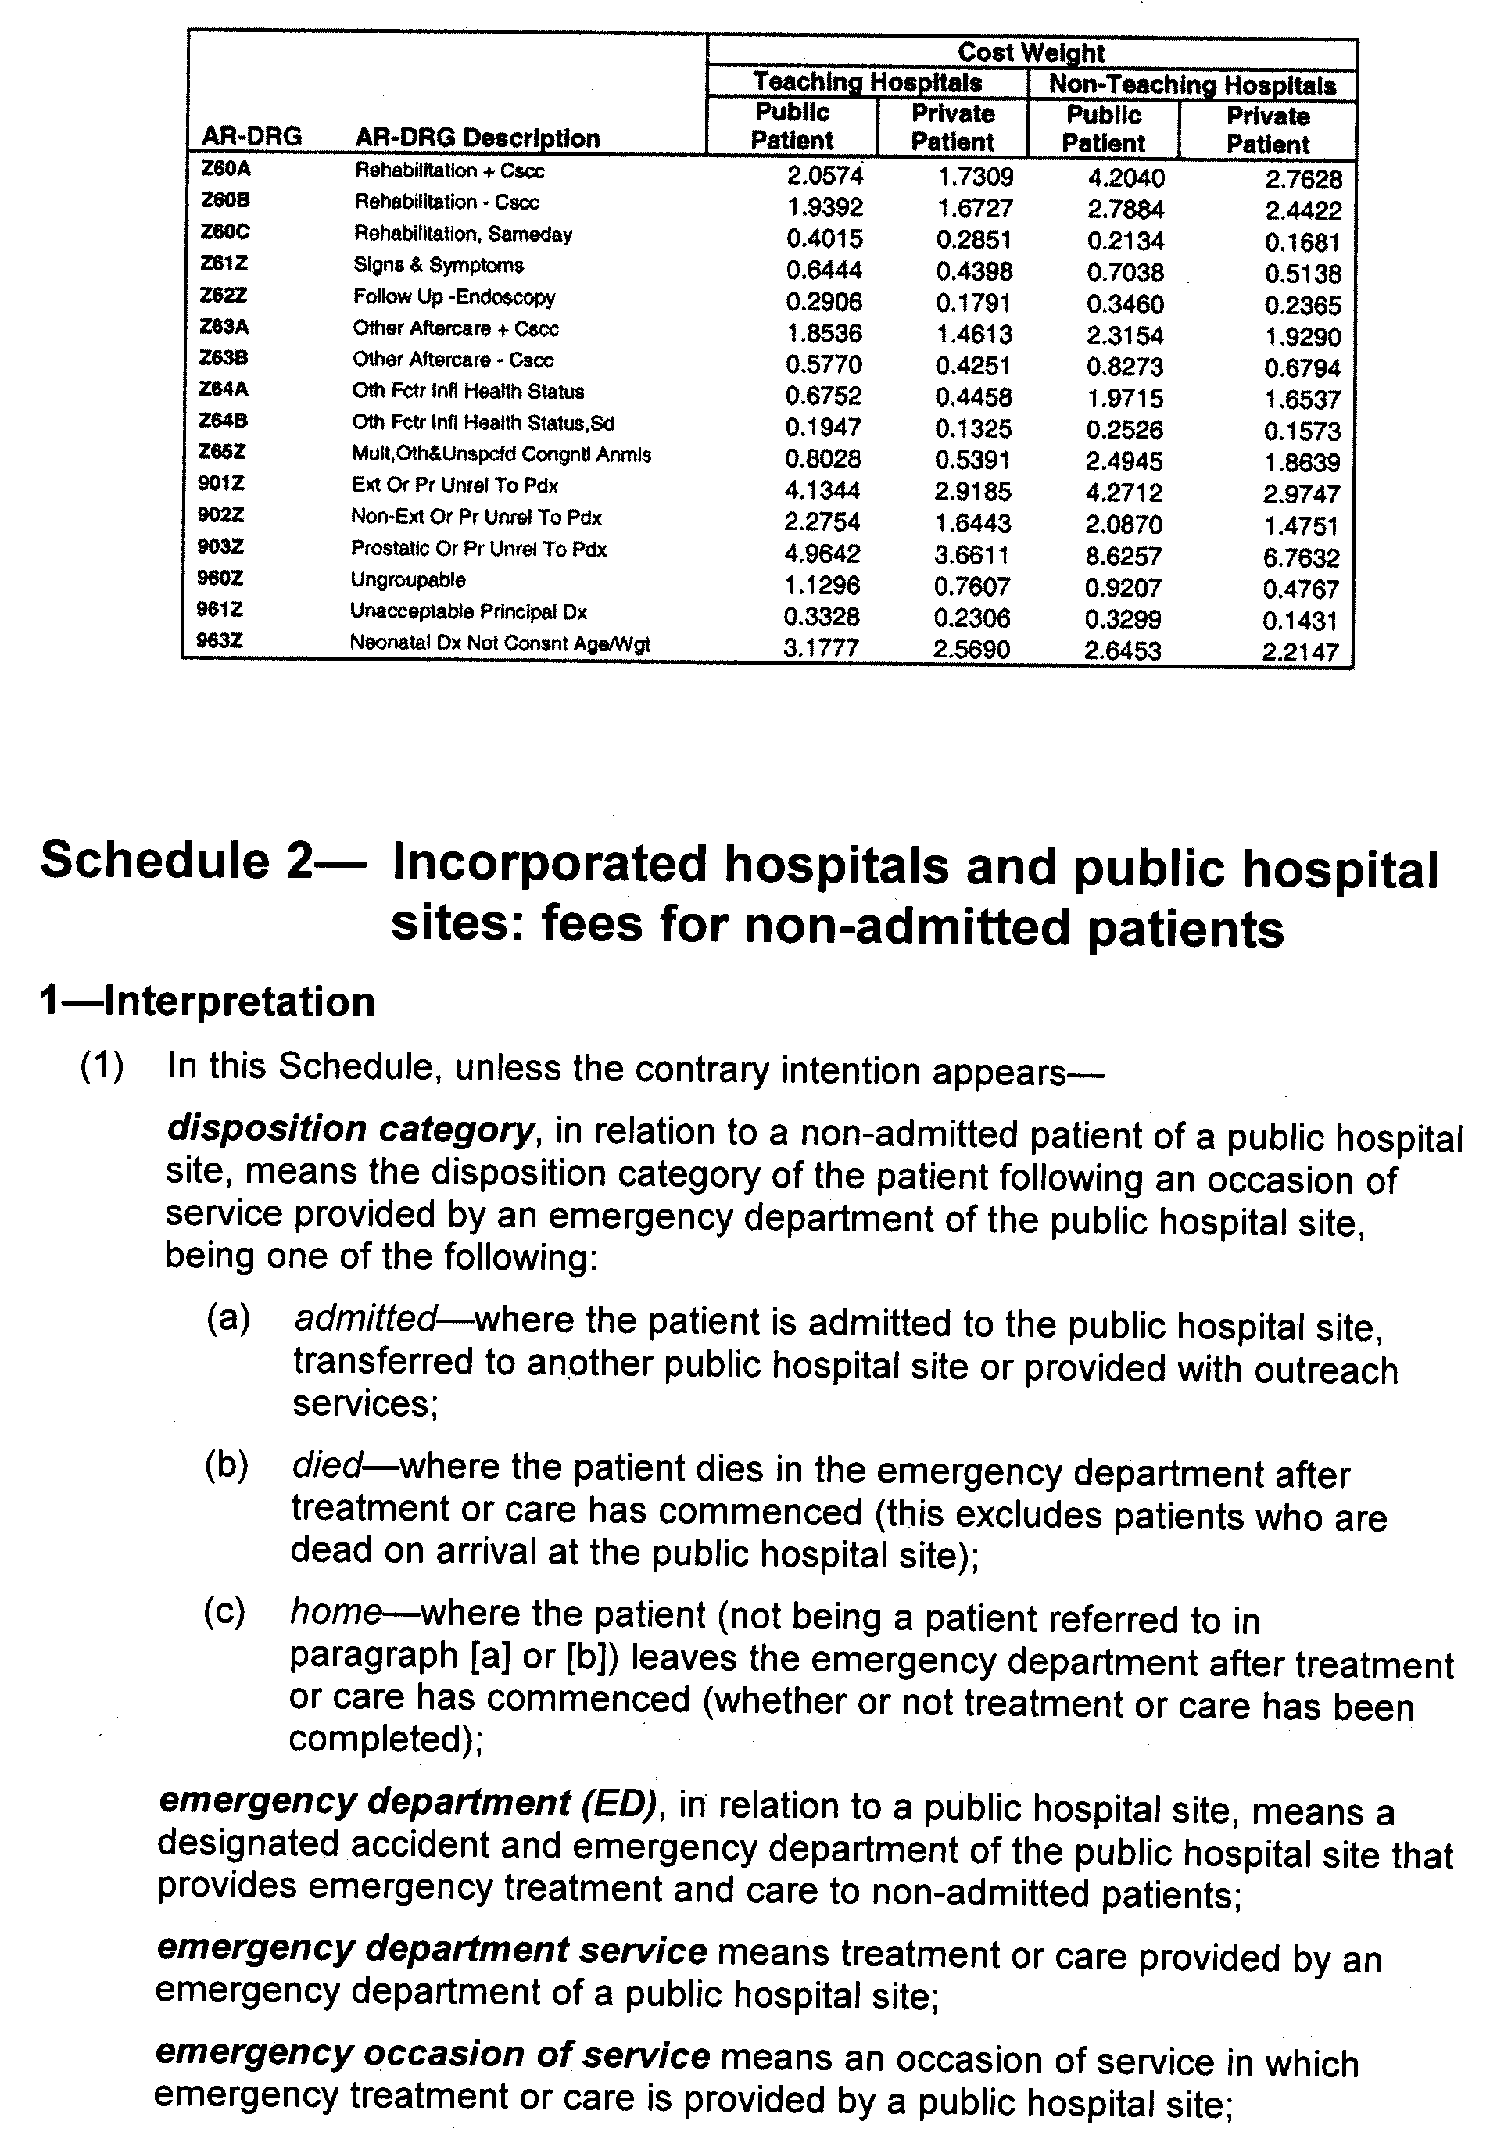
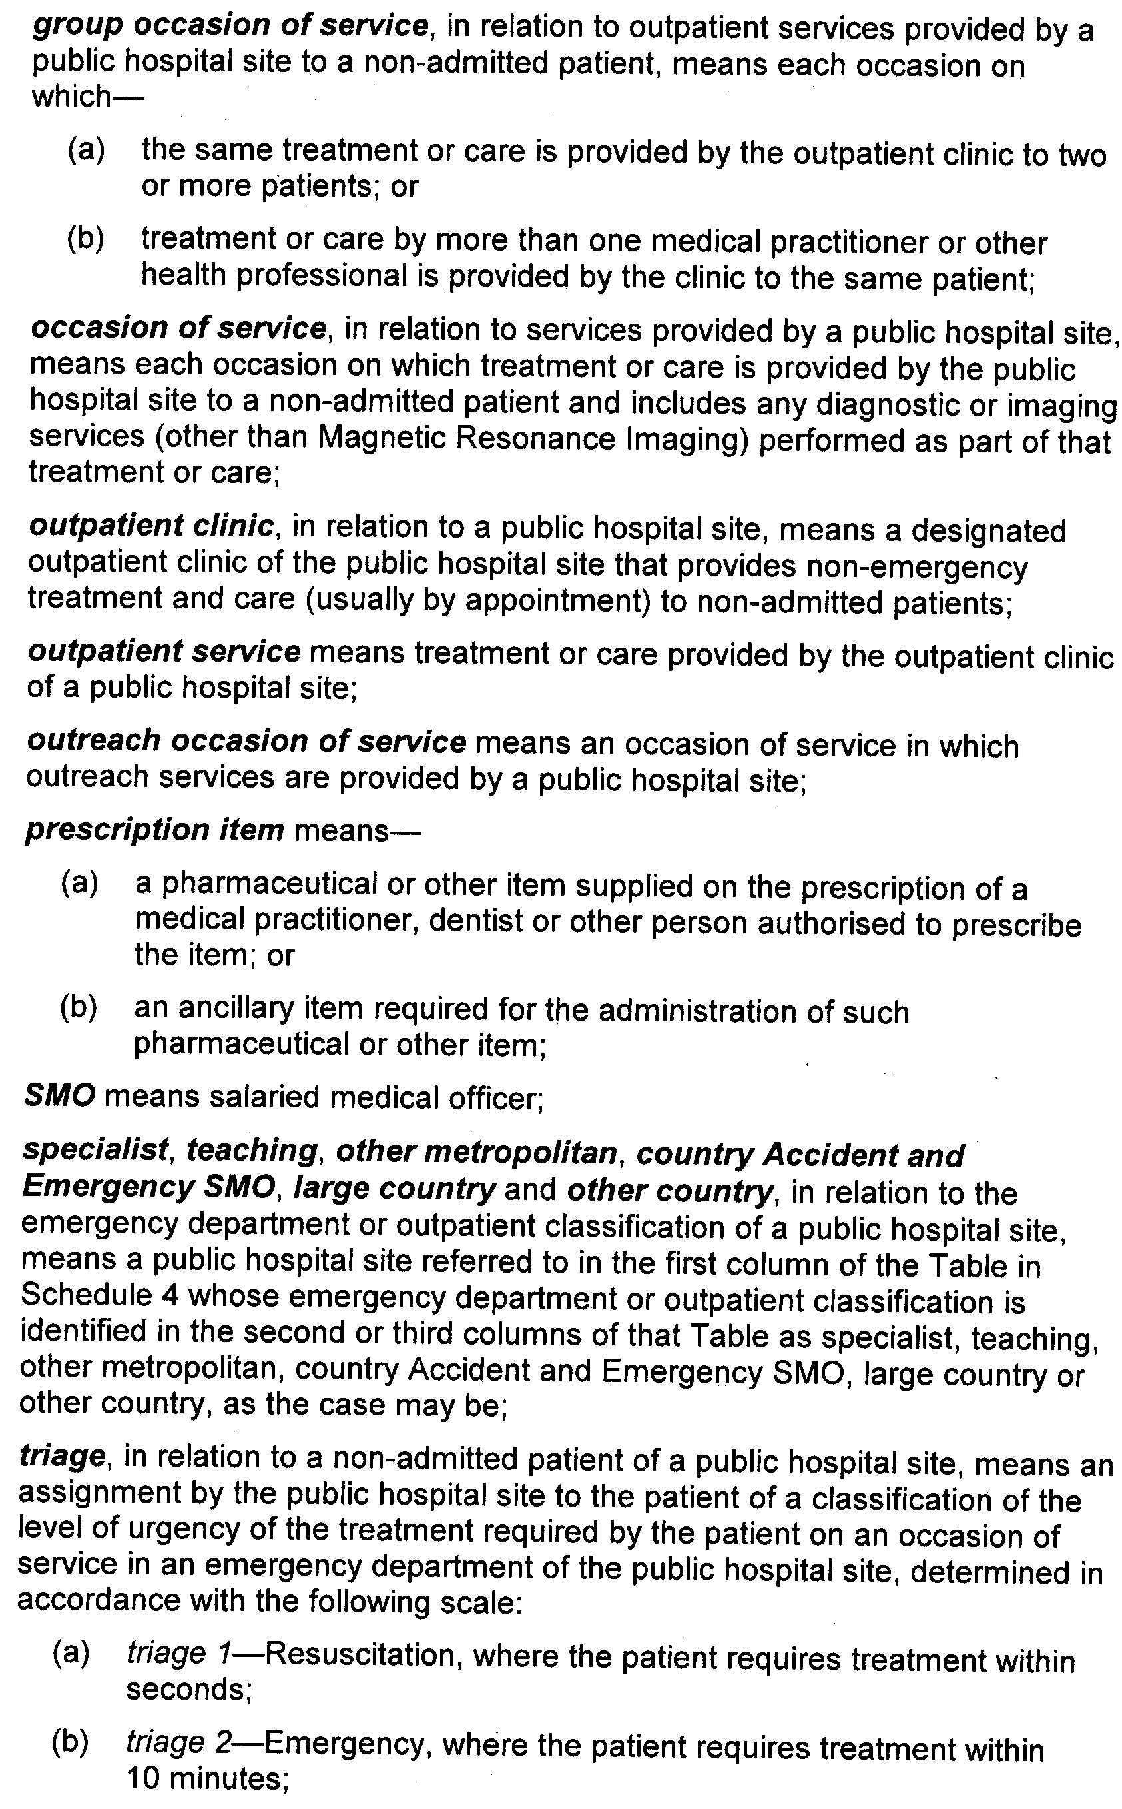
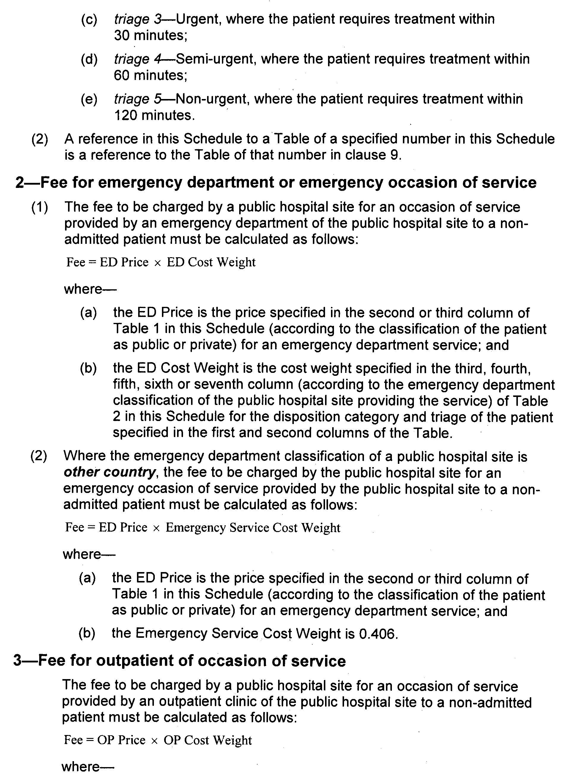
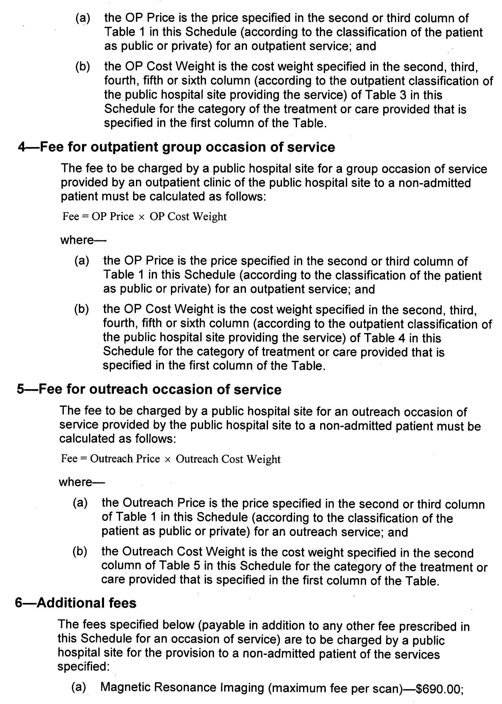
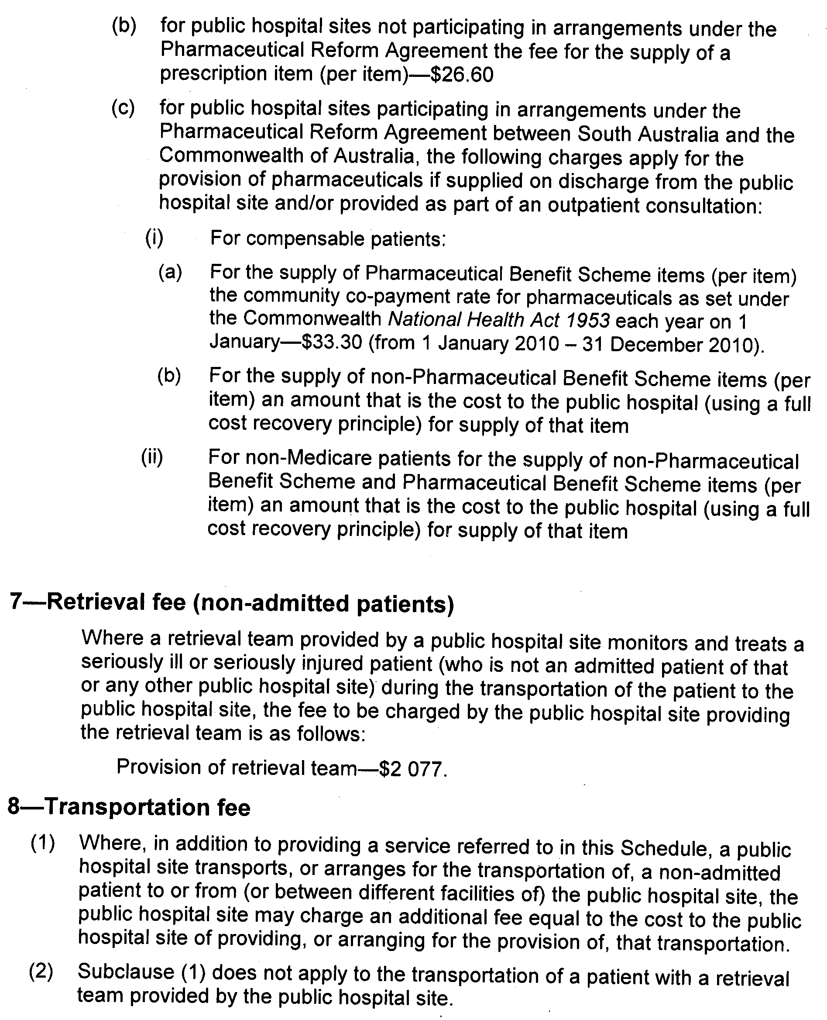
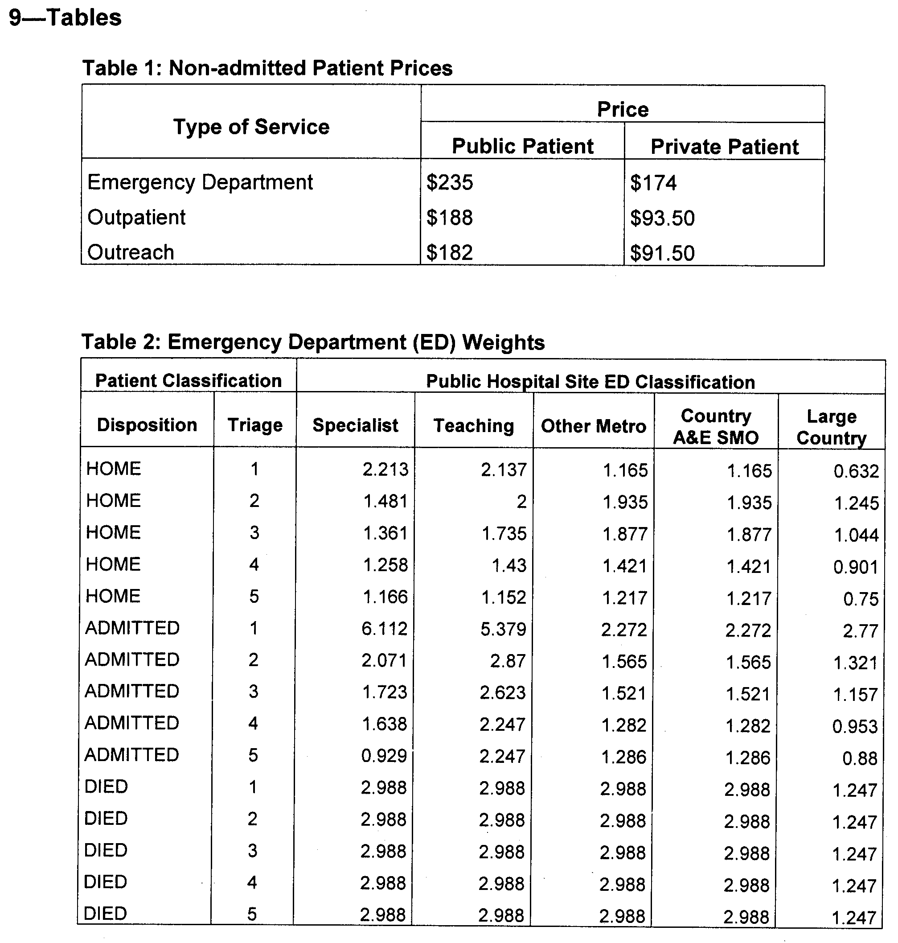
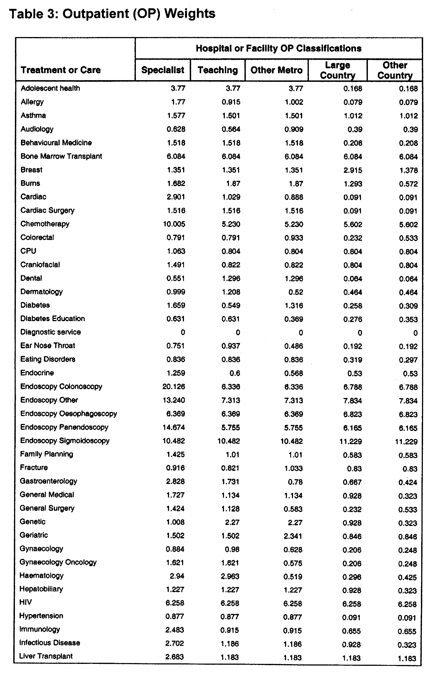
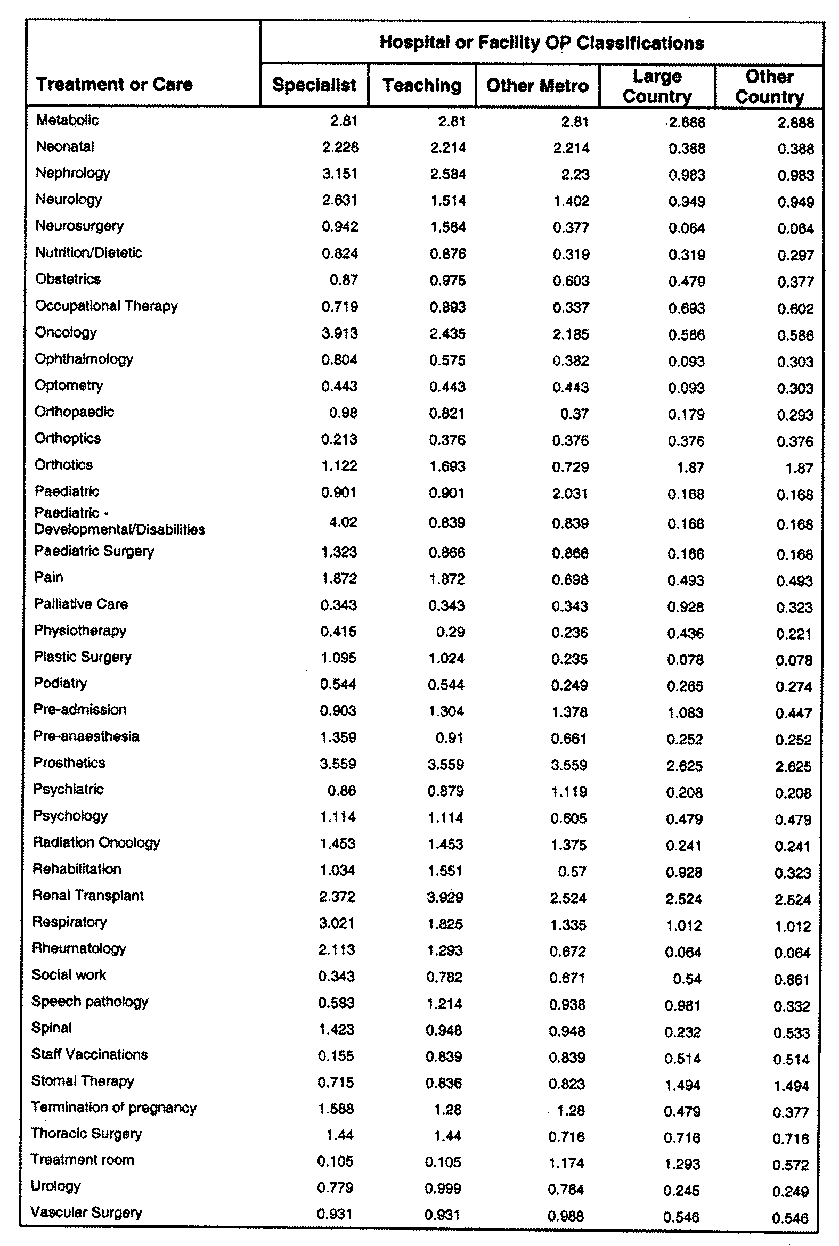
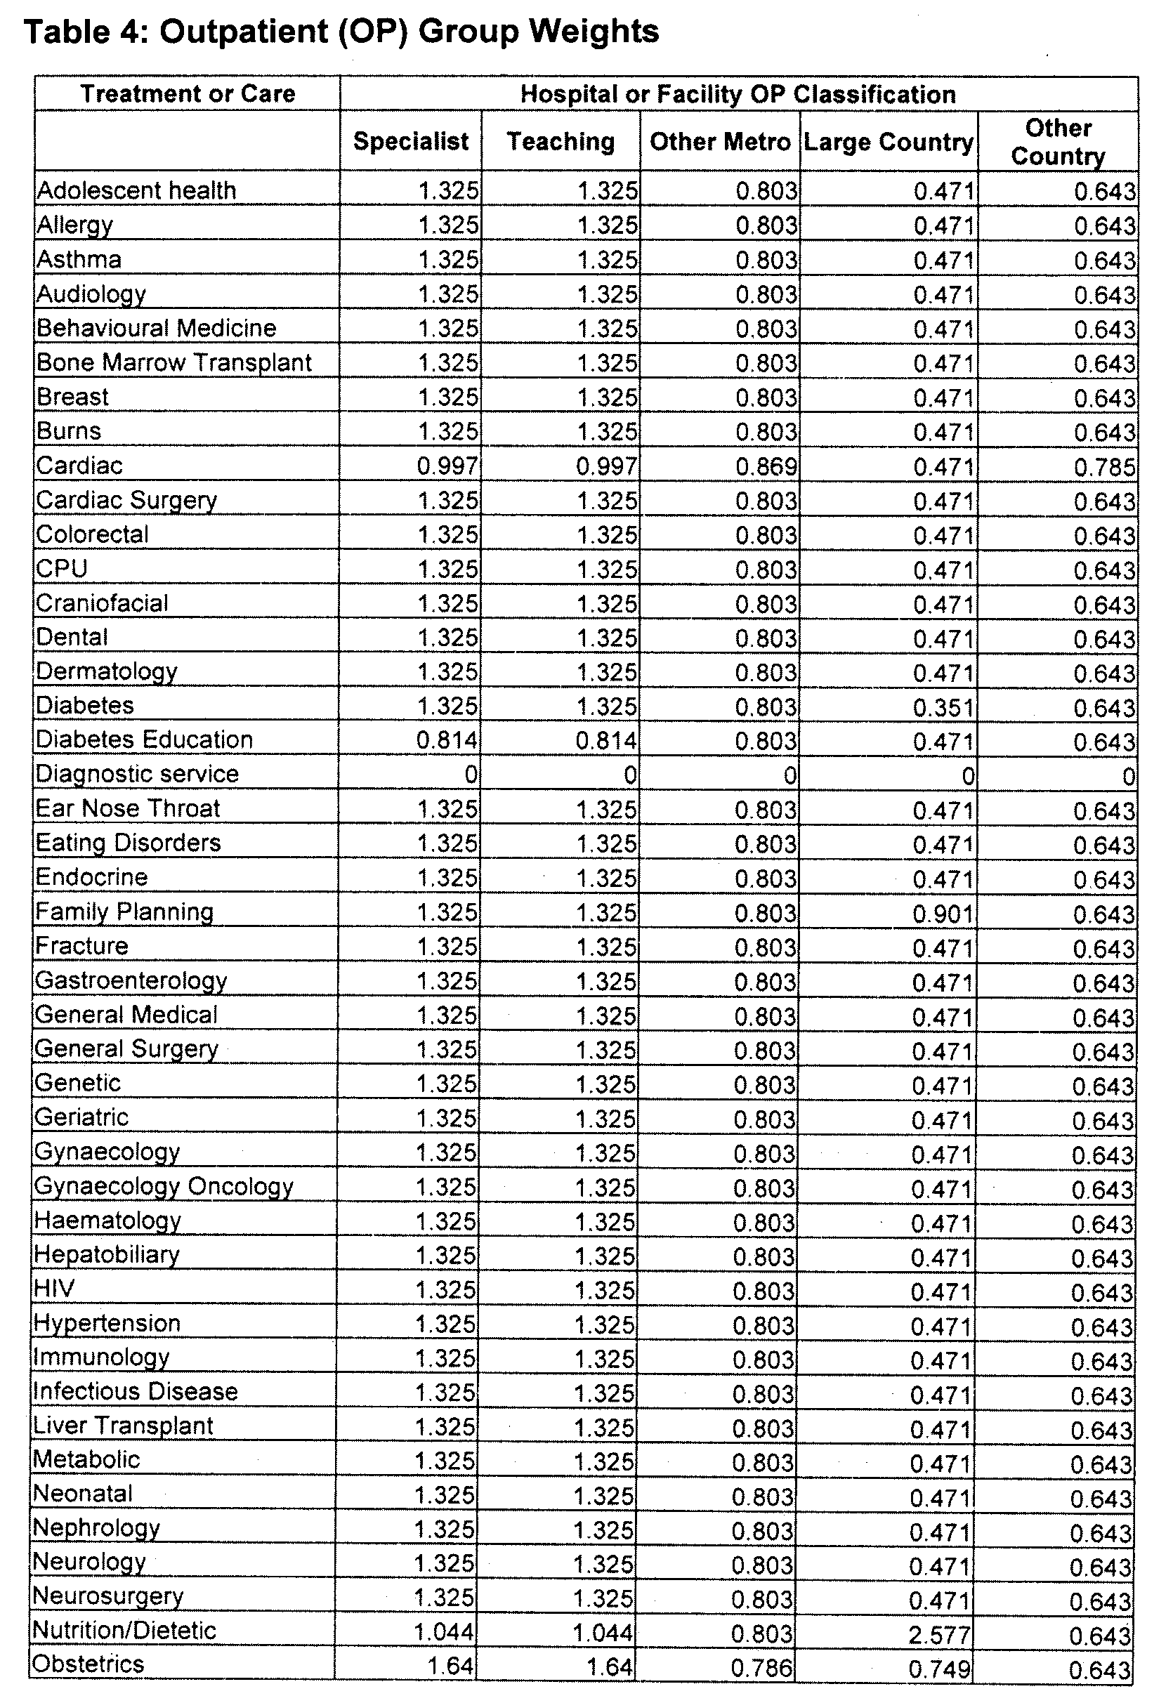
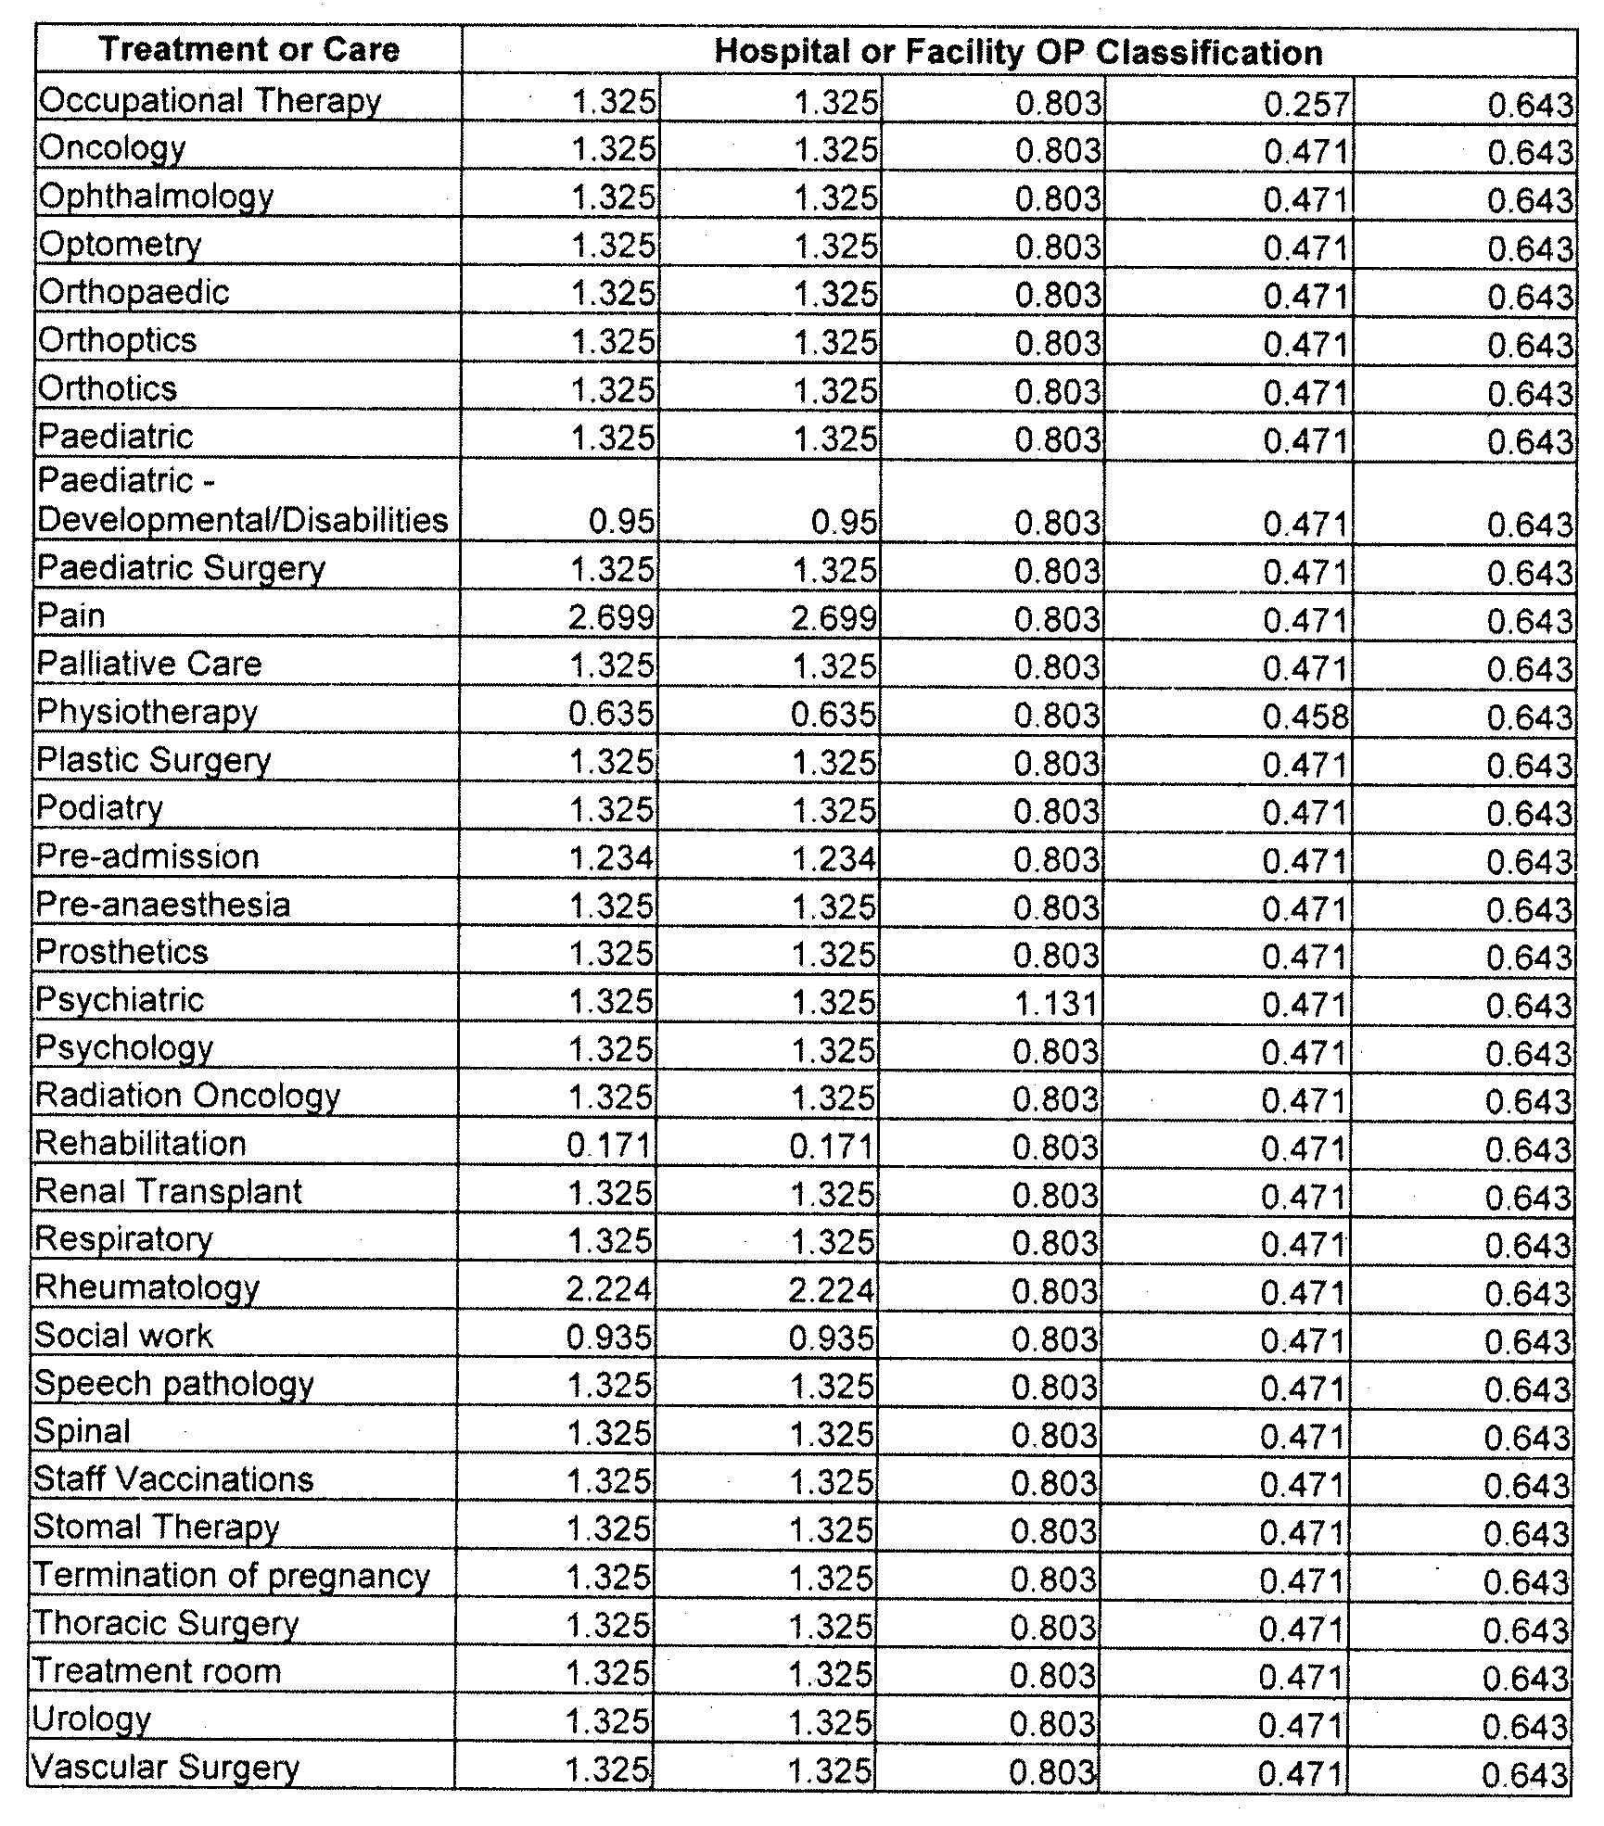
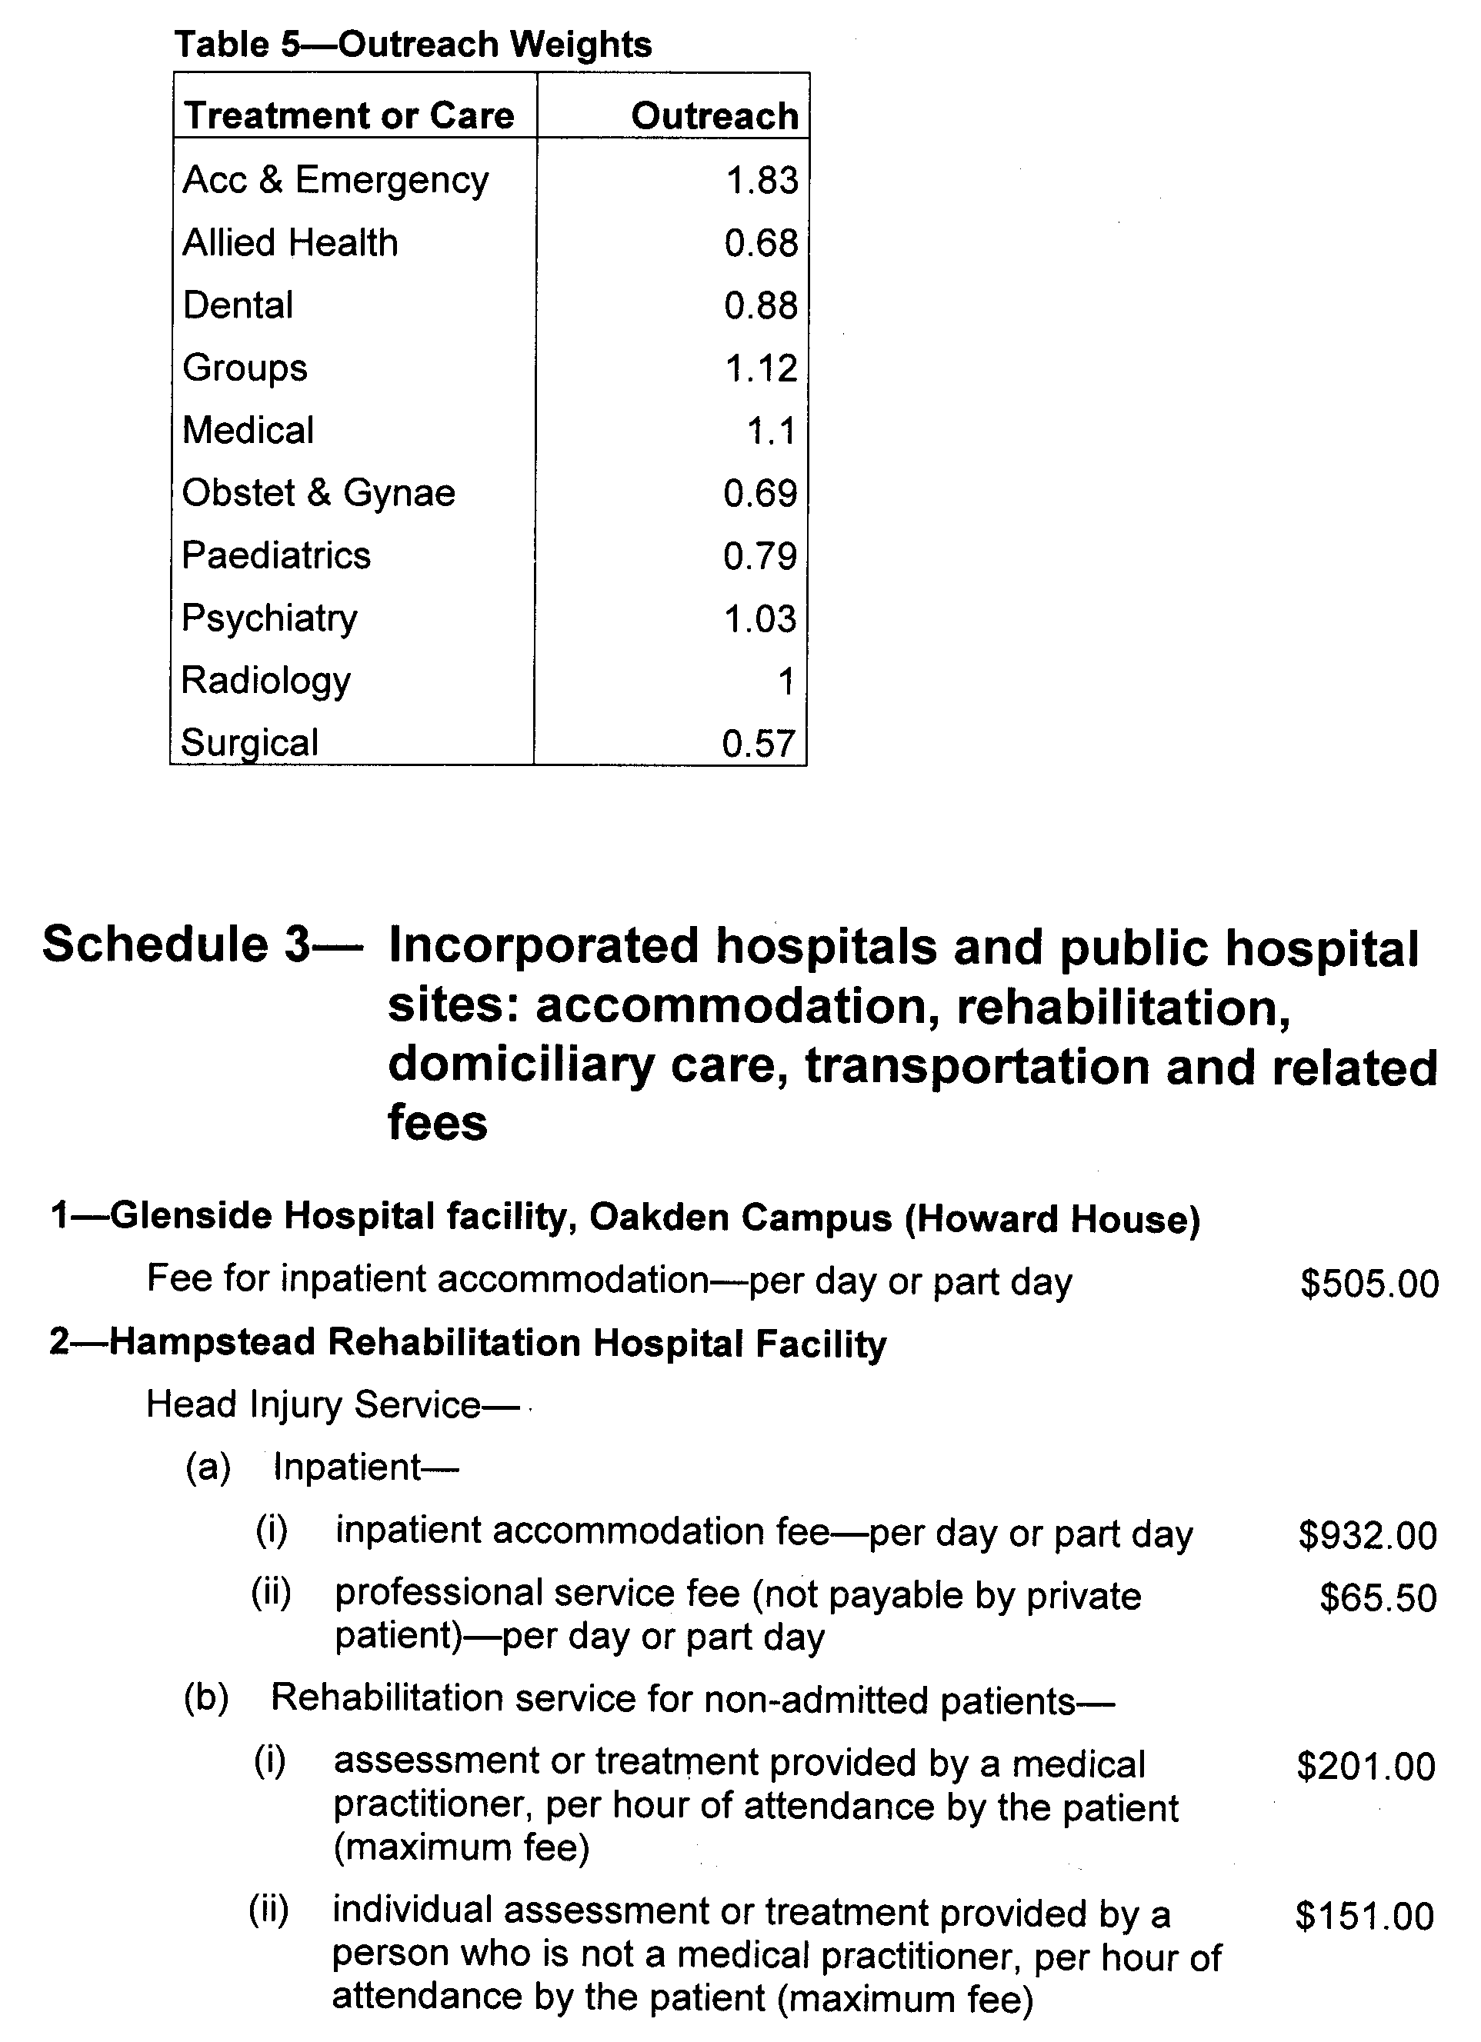
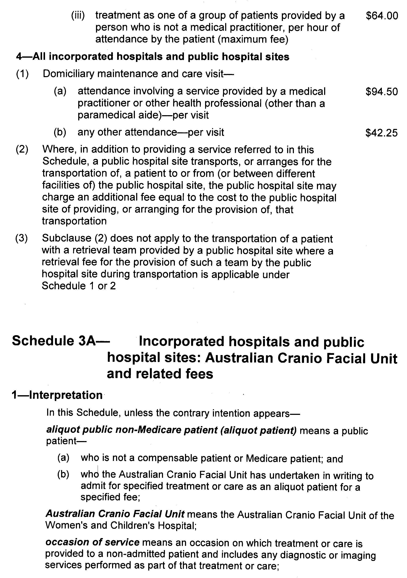
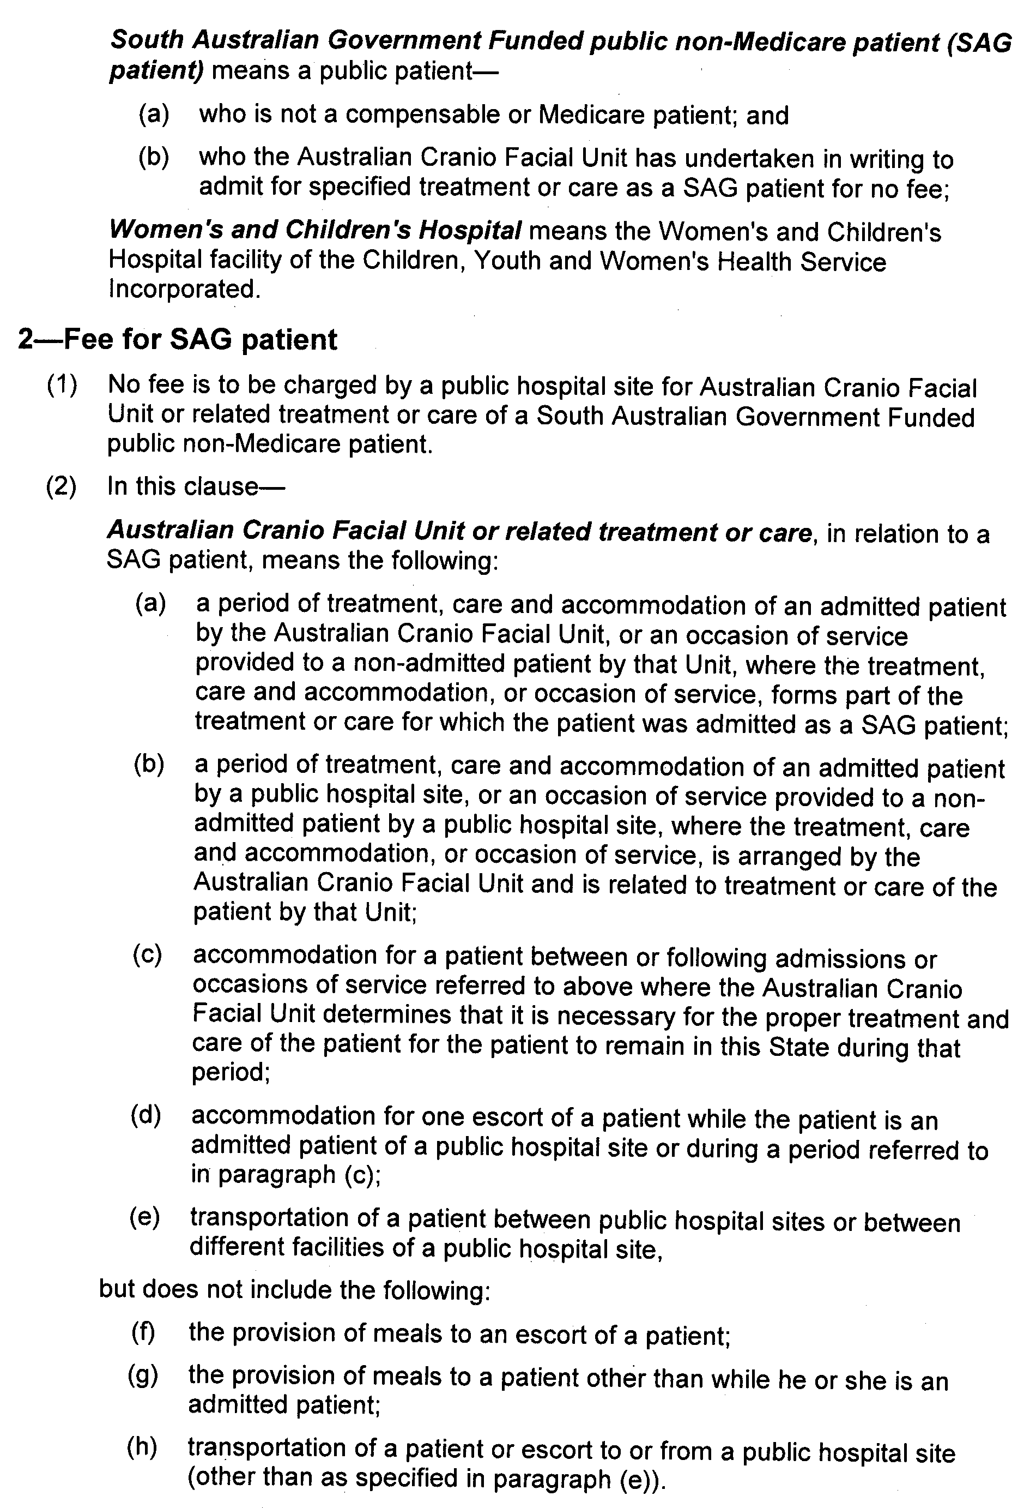
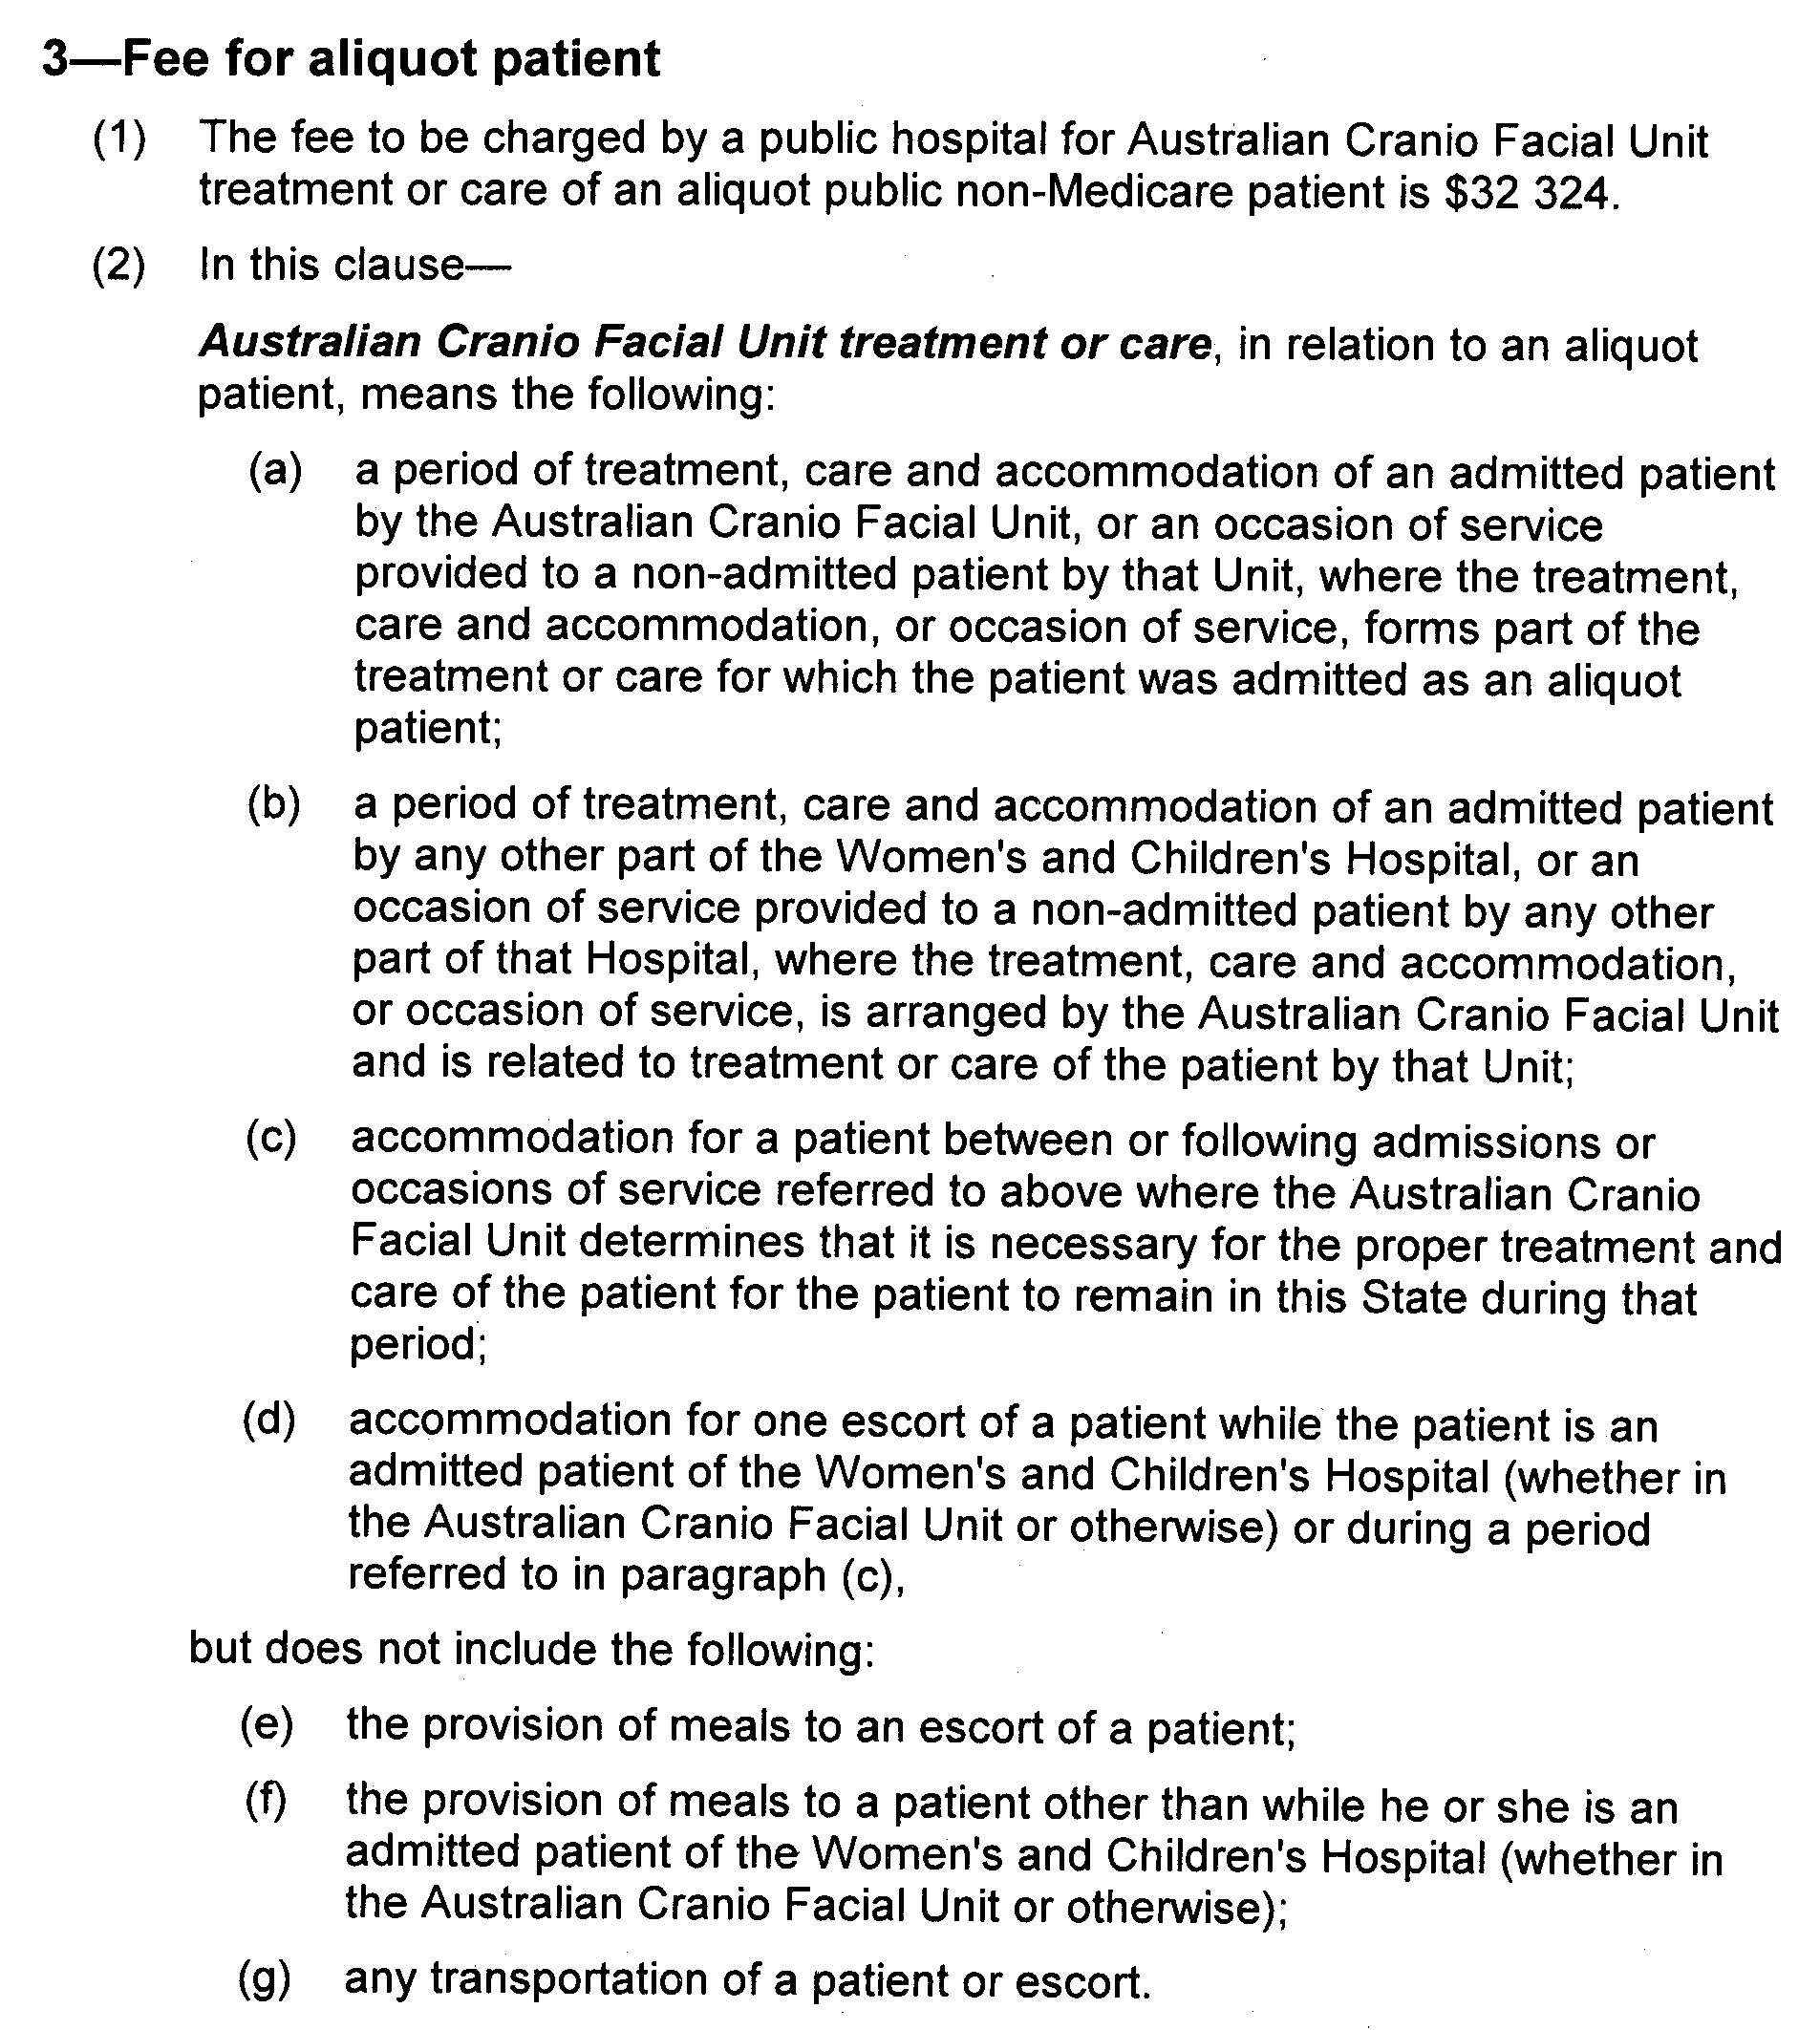
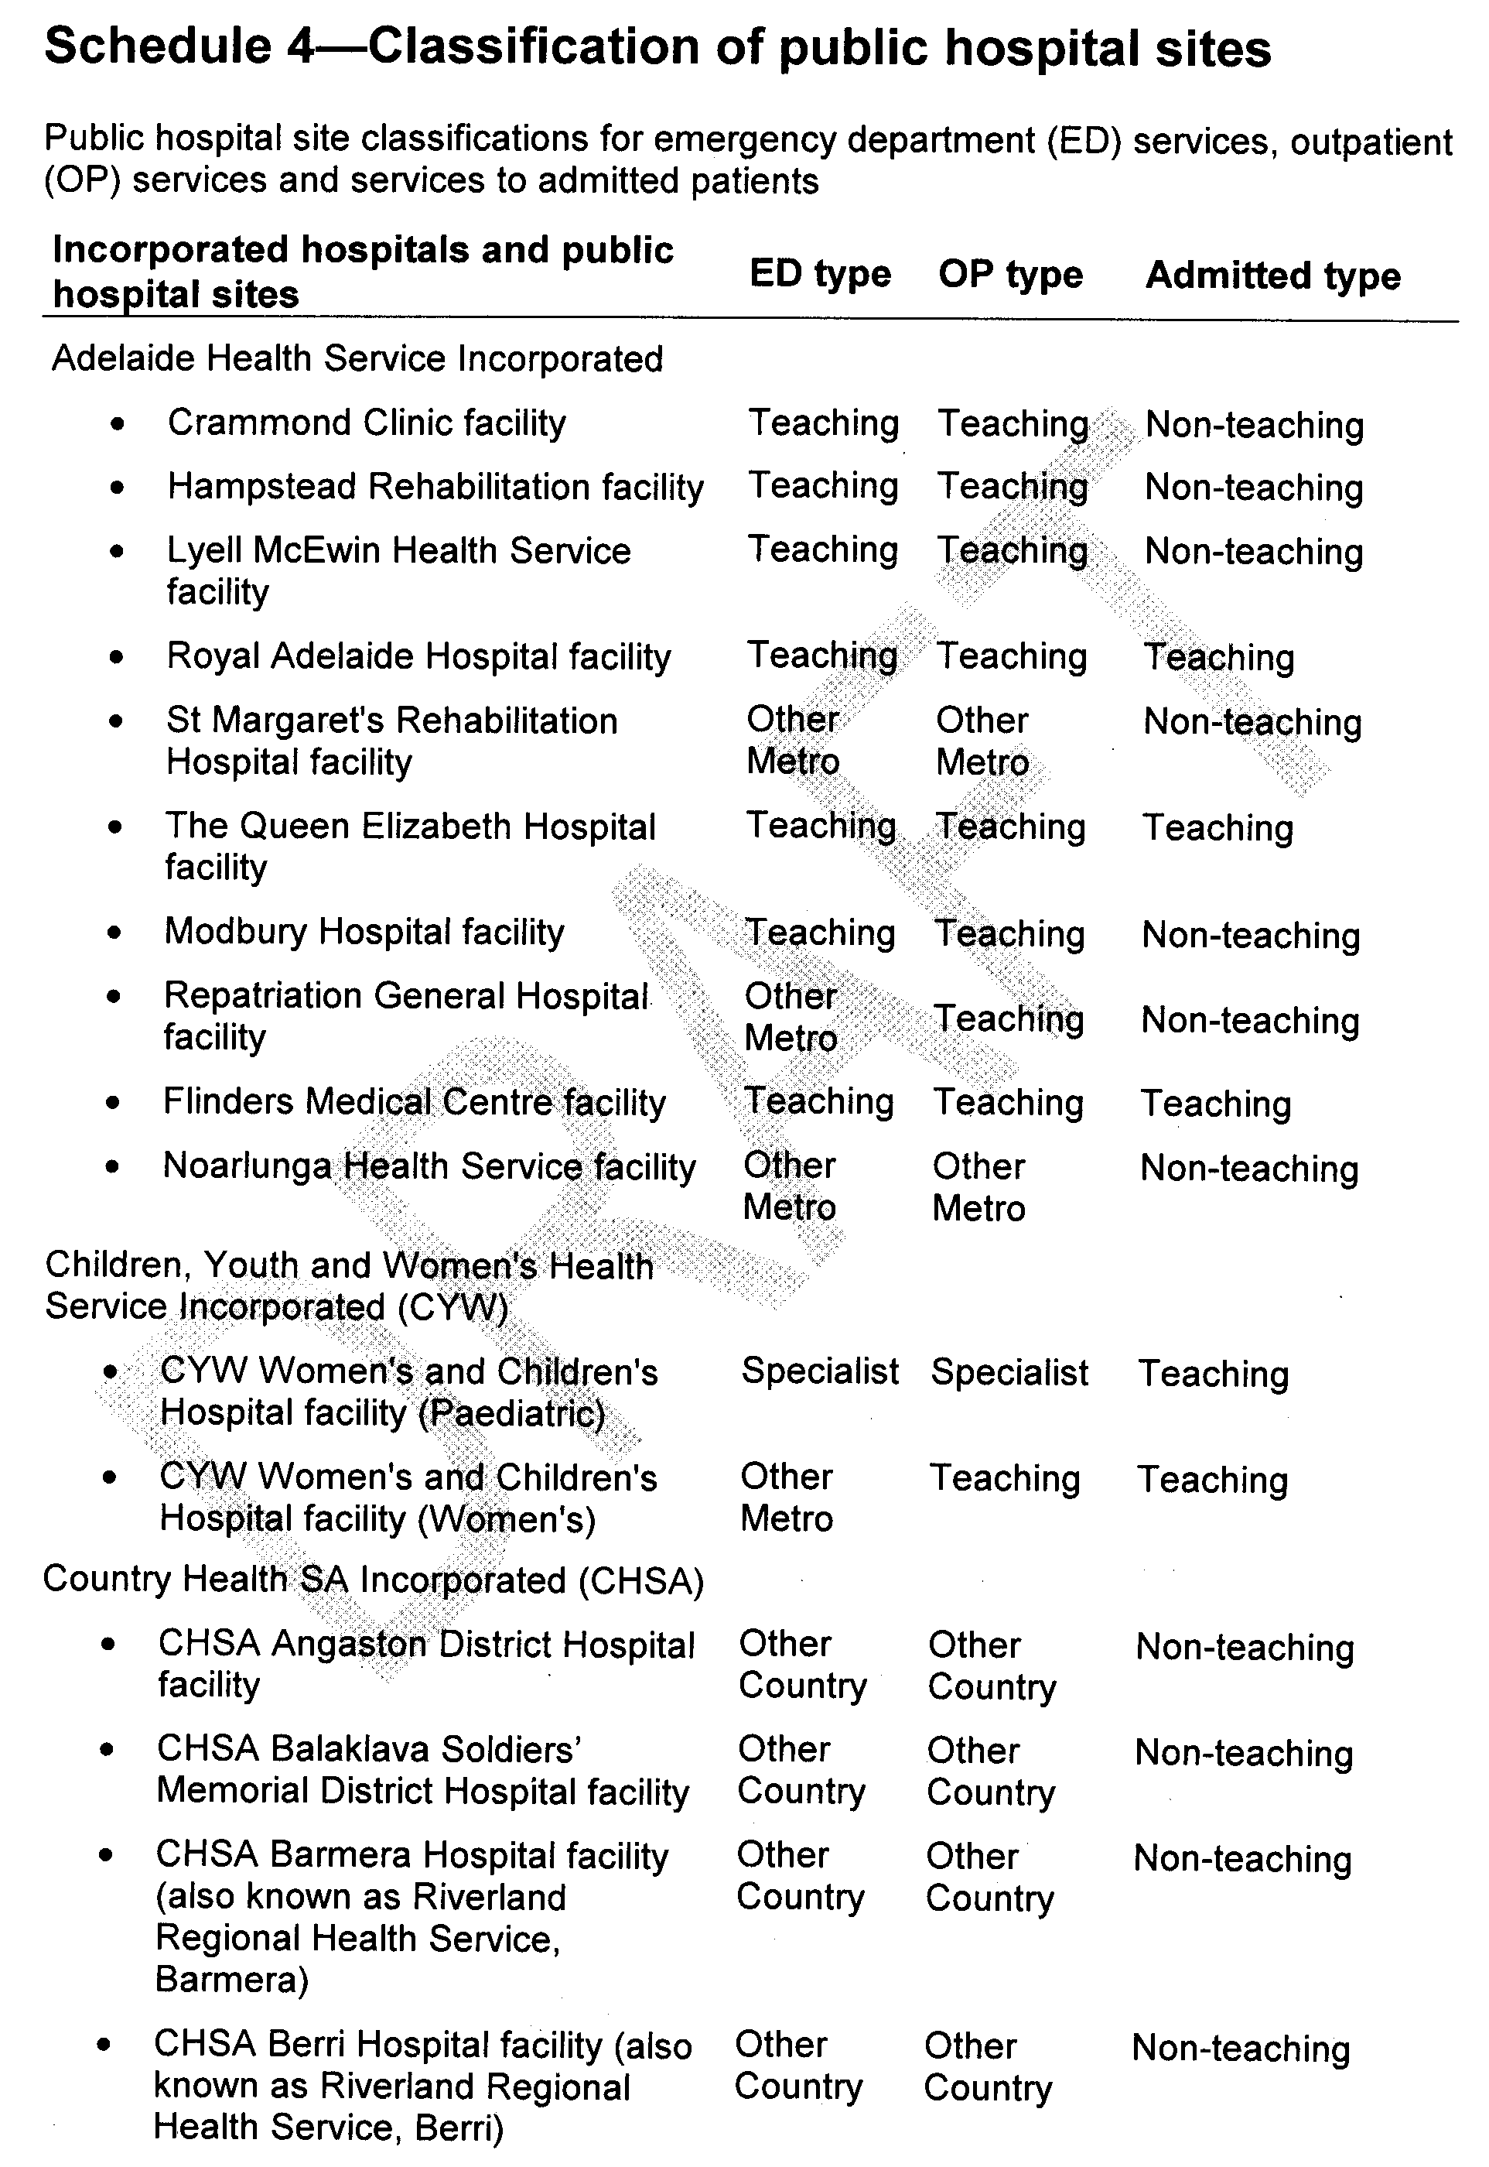
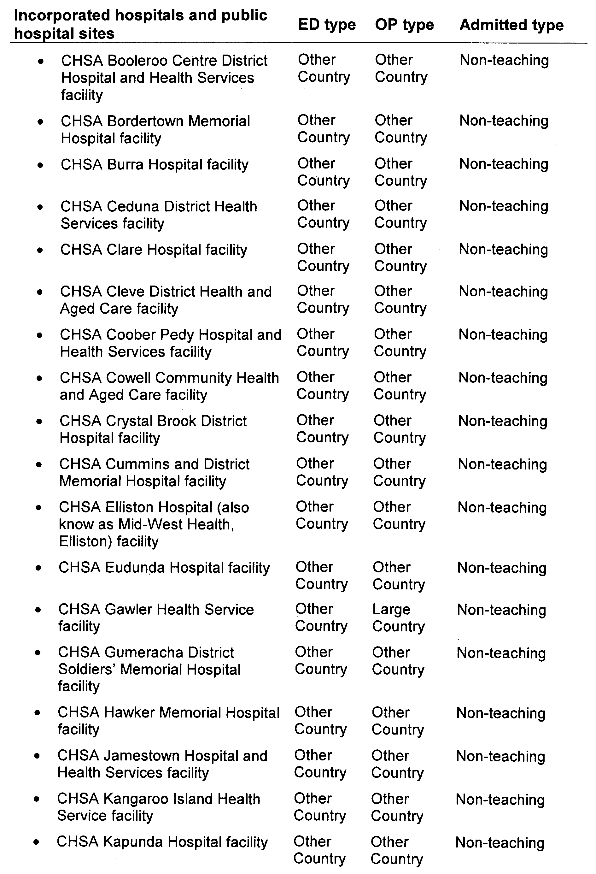
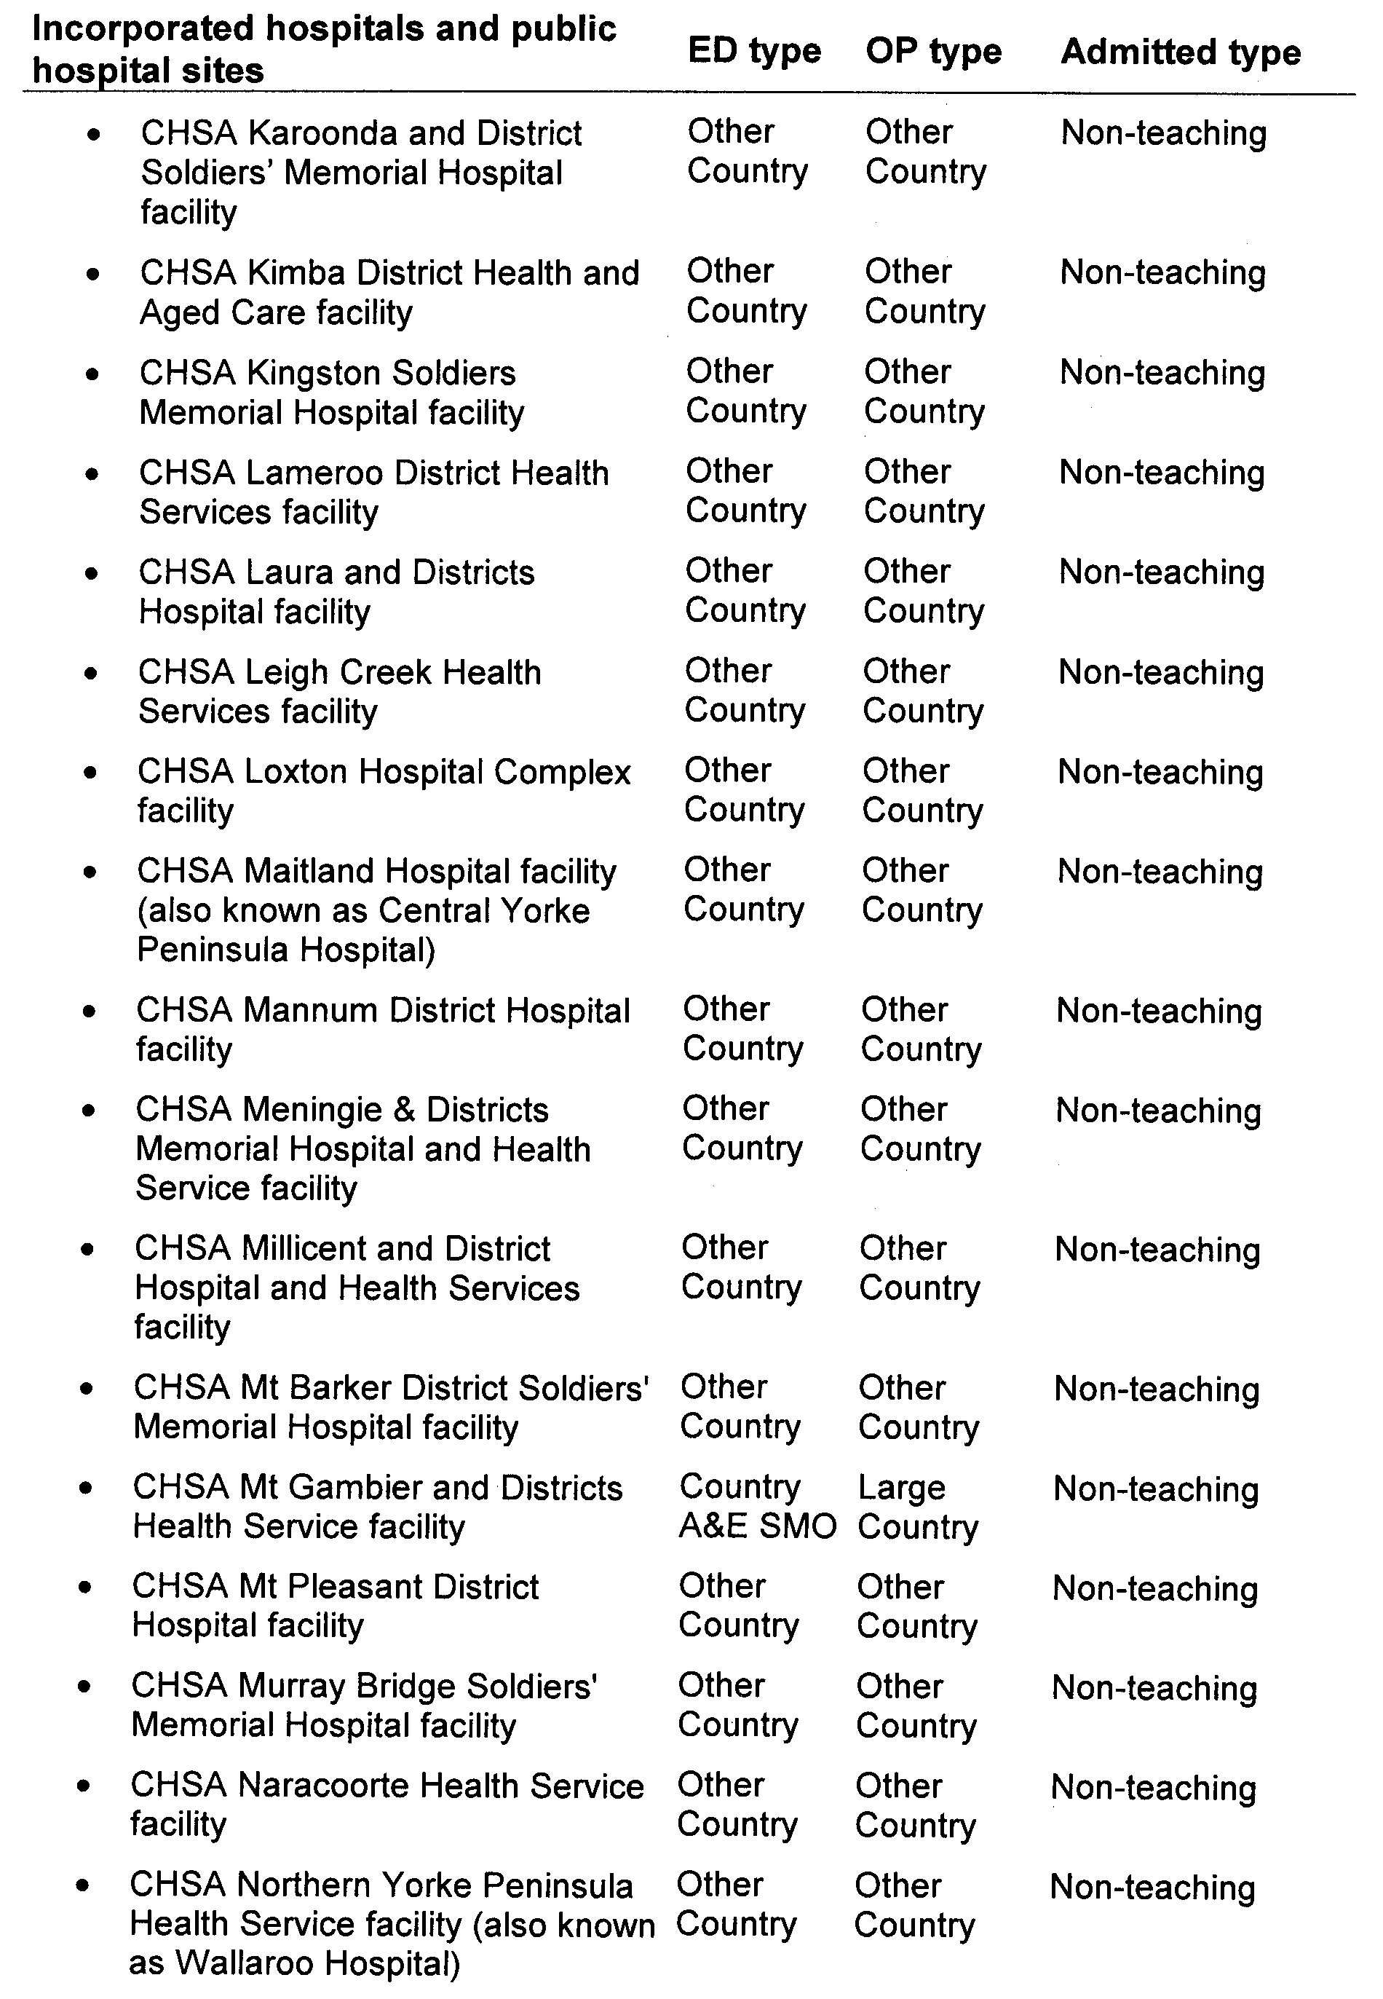
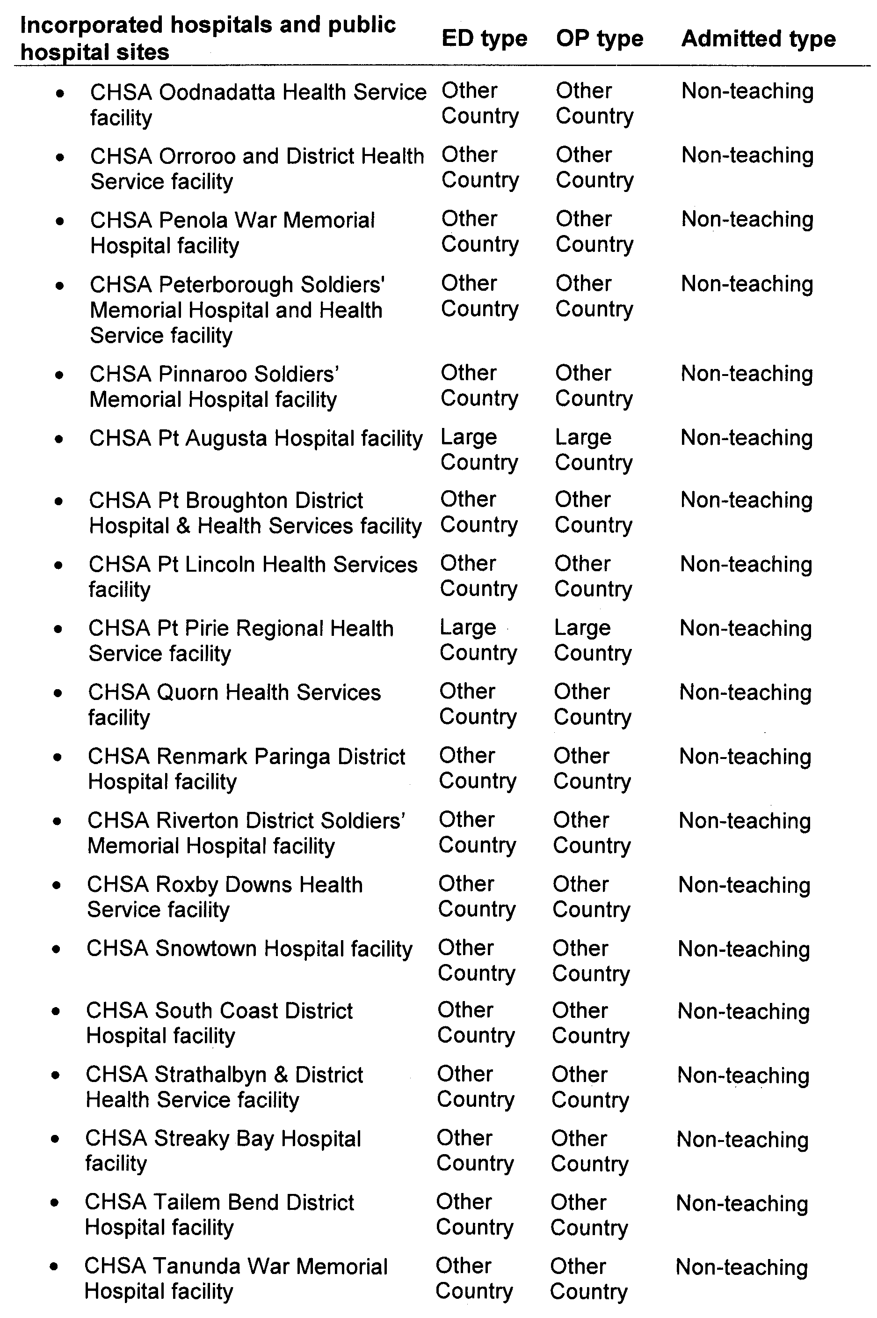

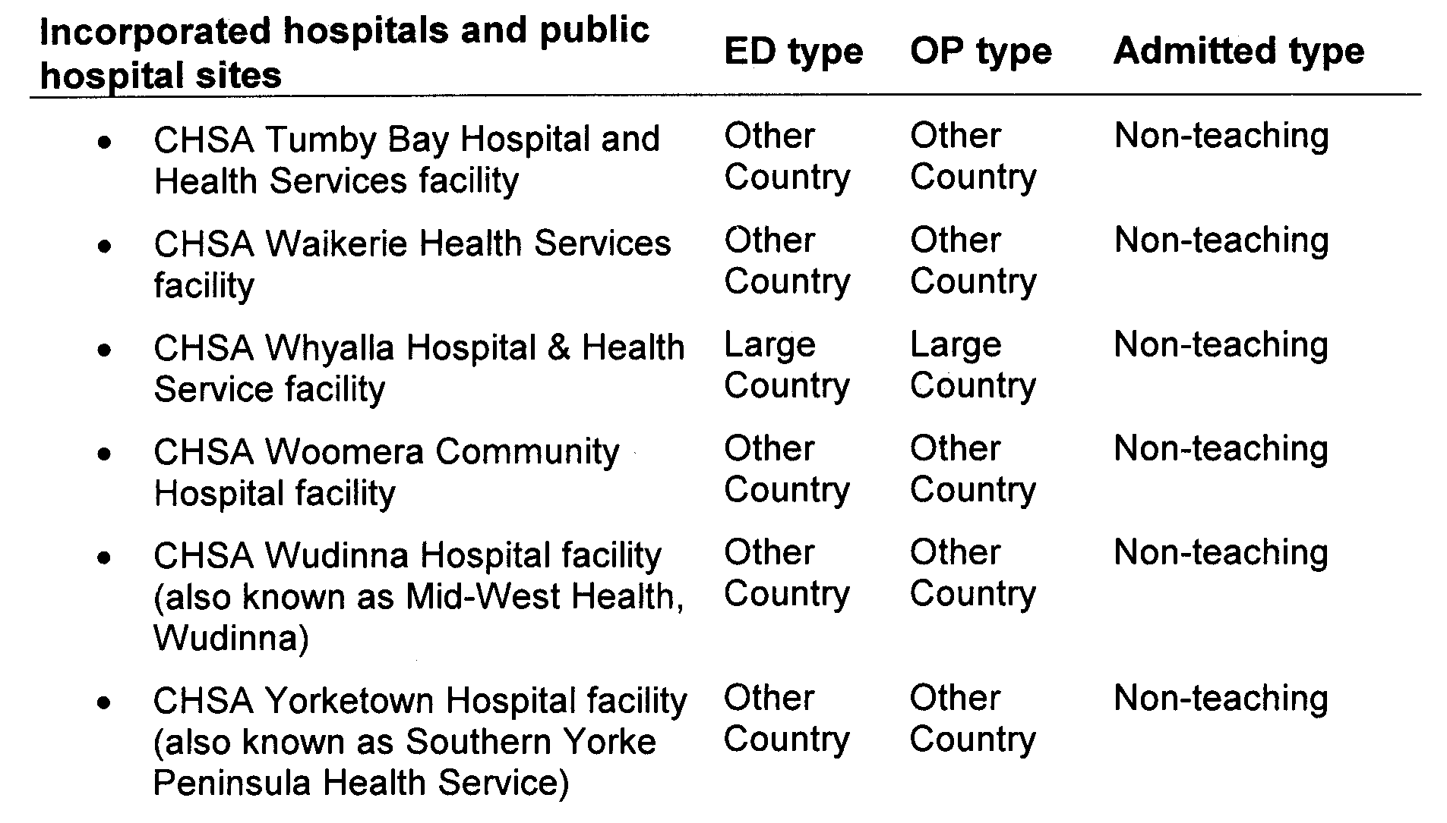

HOUSING IMPROVEMENT ACT 1940
NOTICE is hereby given that the South Australian Housing Trust Board Delegate in the exercise of the powers conferred by the Housing Improvement Act 1940, does hereby declare the houses described in the table hereunder to be substandard for the purposes of Part 7 of the Housing Improvement Act 1940.
No. of House and Street | Locality | Allotment, Section, etc. | Certificate of Title  Volume Folio

Section 239, Angle Road, |  | Sutherlands | Section 239 of Hundred of Neales, in the area named Sutherlands | 5916 | 51
19 Edgeworth Street, |  | Prospect | Allotment 42 in Filed Plan 109907, Hundred of Yatala | 5754 | 735
Lot 729 (also known as 11), George Street, |  | Kybunga | Allotment 729 in Filed Plan 190481, Hundred of Blyth | 5408 | 79
100 Grand Junction Road, |  | Rosewater | Allotment 8 in Deposited Plan 524, Hundred of Yatala | 5617 | 634
Lot 304, Heaslip Road, |  | Penfield | Allotment 304 in Deposited Plan 19546, Hundred of Munno Para | 5904 | 379
2 Humphrey Street, |  | Balaklava | Allotment 451 in Filed Plan 175771, Hundred of Balaklava | 5826 | 321
2 Main Road, |  | Robertstown | Allotment 183 in Filed Plan 169122, Hundred of English | 5783 | 654
19 Northampton Crescent, |  | Elizabeth East | Allotment 11 in Deposited Plan 36616, Hundred of Munno Para | 5068 | 122
18 Palmer Street, |  | Port Pirie West | Allotment 35 in Deposited Plan 1582, Hundred of Pirie | 5404 | 694
Lot 25 (also known as 27 and Allotment 9), Tiver Road, |  | Evanston South | Allotment 9 in Filed Plan 7110, Hundred of Munno Para | 5505 | 797
35 Woodcutts Road, |  | Davoren Park | Allotment 113 in Deposited Plan 7274, Hundred of Munno Para | 5275 | 238

Dated at Adelaide, 16 September 2010. R. Hulm, Acting Director, Corporate Services, Housing SA

HOUSING IMPROVEMENT ACT 1940
WHEREAS by notice published in the Government Gazette on the dates mentioned in the following table the South Australian Housing Trust Board Delegate did declare the houses described in the said table to be substandard for the purposes of Part 7 of the Housing Improvement Act 1940, the South Australian Housing Trust Board Delegate in the exercise of the powers conferred by the said Part, does hereby fix as the maximum rental per week which shall be payable subject to section 55 of the Residential Tenancies Act 1995, in respect of each house described in the following table the amount shown in the said table opposite the description of such house and this notice shall come into force on the date of this publication in the Gazette.
Address of House | Allotment, Section, etc. | Certificate of Title  Volume Folio | Date and page of Government Gazette in which notice declaring house to be substandard published | Maximum rental per week payable in respect of each house  $

Lot 112, Gomersal Road,  Shea-Oak Log |  | Allotment 1 in Filed Plan 155993, Hundred of Nuriootpa | 5281 | 748 |  | 10.6.10, page 2607 | 138.00
9 Lawhill Street, Port Victoria |  | Allotment 98 in Town of Port Victoria, Hundred of Wauraltee | 5221 | 972 |  | 28.4.05, page 1012 | 120.00
Unit 1, 14 William Street, Clarence Park |  | Allotment 226 in Filed Plan 13817, Hundred of Adelaide | 5600 | 194 |  | 27.5.10, page 2028 | 97.00
68 York Road, Port Pirie West |  | Allotment 3 in Deposited Plan 1484, Hundred of Pirie | 5106 | 361 |  | 8.7.10, page 3393 | 160.00

Dated at Adelaide, 16 September 2010. R. Hulm, Acting Director, Corporate Services, Housing SA

HOUSING IMPROVEMENT ACT 1940
WHEREAS by notice published in the Government Gazette on the dates mentioned in the following table, the South Australian Housing Trust Board Delegate did declare the houses described in the following table to be substandard for the purposes of Part 7 of the Housing Improvement Act 1940, and whereas the South Australian Housing Trust Board Delegate is satisfied that each of the houses described hereunder has ceased to be substandard, notice is hereby given that, in exercise of the powers conferred by the said Part, the South Australian Housing Trust does hereby revoke the said declaration in respect of each house.
Address of House | Allotment, Section, etc. | Certificate of Title  Volume Folio | Date and page of Government Gazette in which notice declaring house to be substandard published

25 Harvey Street, Ethelton |  | Allotment 191 in Deposited Plan 2056, Hundred of Port Adelaide | 5286 | 193 |  | 11.1.79, page 55
Section 23, Playford Highway, (also known as Lot 10, 105 Playford Highway), Cygnet River via Kingscote |  | Allotment 105 in Filed Plan 214656, Hundred of Menzies | 5828 | 51 |  | 27.10.94, page 1315
43 Shelly Avenue, Port Willunga |  | Allotment 100 in Deposited Plan 4756, Hundred of Willunga | 5429 | 461 |  | 26.3.09, page 1125
85 Tower Street North, North Adelaide |  | Allotment 400 in Filed Plan 183672, Hundred of Yatala | 5848 | 689 |  | 3.12.70, page 2618
25 (previously known as 27) Worsnop Avenue, Adelaide |  | Lot 8, Primary Community Strata Plan 21566, Hundred of Adelaide | 5889 | 818 |  | 30.5.91, page 1742

Dated at Adelaide, 16 September 2010. R. Hulm, Acting Director, Corporate Services, Housing SA

LIQUOR LICENSING ACT 1997 AND GAMING MACHINES ACT 1992
Notice of Application
NOTICE is hereby given, pursuant to section 52 of the Liquor Licensing Act 1997 and section 29 of the Gaming Machines Act 1992, that Playing Through Pty Ltd as agent for the partnership of Encore Hotels Pty Ltd as trustee for Allen Tap Inn Trust, Leethal Gains Pty Ltd as trustee for Lee Tap Inn Trust and Paddy Hodby Investments Pty Ltd as trustee for Hodby Tap Inn Trust have applied to the Licensing Authority for the transfer of a Hotel and Gaming Machine Licence in respect of premises situated at 76 Rundle Street, Kent Town, S.A. 5067 and known as Kent Town Hotel.
The applications have been set down for hearing on 18 October 2010 at 9 a.m.
Any person may object to the application by lodging a notice of objection in the prescribed form with the Liquor and Gambling Commissioner and serving a copy of the notice on the applicants at the applicants’ address, at least seven days before the hearing date (viz: 11 October 2010).
The applicants’ address for service is c/o DMAW Lawyers, Level 3, 80 King William Street, Adelaide, S.A. 5000 (Attention: Craig Vozzo or Adrian Battiston).
The application and certain documents and material (including Plans) relevant to the application may be inspected without fee at a place and during a period specified by the Liquor and Gambling Commissioner, 9th Floor, East Wing, 50 Grenfell Street, Adelaide, S.A. 5000. Telephone 8226 8410, Facsimile: 8226 8512. Email: olgc@agd.sa.gov.au.
Dated 8 September 2010.
Applicants

LIQUOR LICENSING ACT 1997
Notice of Application
NOTICE is hereby given, pursuant to section 52 (2) (b) of the Liquor Licensing Act 1997, that 2 North Terrace Pty Ltd has applied to the Licensing Authority for Redefinition, variation to an Extended Trading Authorisation and variation to Entertainment Consent in respect of premises situated at 2 North Terrace, Kent Town, S.A. 5067 and known as Royal Hotel.
The application has been set down for hearing on 5 October 2010 at 9 a.m.
Conditions
The following licence conditions are sought:
• Redefinition to extend the Beer Garden as per plans lodged with this office.
• Variation to an Extended Trading Authorisation to include the proposed redefined area as per plans lodged with this office and to include the following:
Sunday: Midnight to 4 a.m. the following day.
• Variation to Entertainment Consent to include the proposed redefined area as per plans lodged with this office.
Any person may object to the application by lodging a notice of objection in the prescribed form with the Liquor and Gambling Commissioner and serving a copy of the notice on the applicant at the applicant’s address, at least one day before the hearing date (viz: 4 October 2010).
The applicant’s address for service is c/o Ashleigh Winn, 2 North Terrace, Kent Town, S.A. 5067.
The application and certain documents and material (including Plans) relevant to the application may be inspected without fee at a place and during a period specified by the Liquor and Gambling Commissioner, 9th Floor, East Wing, 50 Grenfell Street, Adelaide, S.A. 5000. Telephone 8226 8410, Facsimile: 8226 8512. Email: olgc@agd.sa.gov.au.
Dated 7 September 2010.
Applicant

LIQUOR LICENSING ACT 1997
Notice of Application
NOTICE is hereby given, pursuant to section 52 (2) (b) of the Liquor Licensing Act 1997, that Pal. Col. Mar. Pty Ltd has applied to the Licensing Authority for a Restaurant Licence with Section 34 (1) (c) Authorisation and an Extended Trading Authorisation in respect of premises situated at Myer Centre, 14-38 Rundle Mall, Adelaide, S.A. 5000 and to be known as Eating in Italy.
The application has been set down for hearing on 14 October 2010 at 11 a.m.
Conditions
The following licence conditions are sought:
• Approval under Section 34 (1) (c) to sell liquor on any day except Good Friday and Christmas Day for consumption on the licensed premises by persons:
(a) seated at a table; or
(b) attending a function at which food is provided.
• Extended Trading Authorisation is sought in relation to the abovementioned condition for the following day and time:
Sunday: 8 a.m. to 11 a.m.
Any person may object to the application by lodging a notice of objection in the prescribed form with the Liquor and Gambling Commissioner and serving a copy of the notice on the applicant at the applicant’s address, at least seven days before the hearing date (viz: 7 October 2010).
The applicant’s address for service is c/o Clelands Lawyers, 208 Carrington Street, Adelaide, S.A. 5000 (Attention: Rinaldo D’Aloia).
The application and certain documents and material (including Plans) relevant to the application may be inspected without fee at a place and during a period specified by the Liquor and Gambling Commissioner, 9th Floor, East Wing, 50 Grenfell Street, Adelaide, S.A. 5000. Telephone 8226 8410, Facsimile: 8226 8512. Email: olgc@agd.sa.gov.au.
Dated 7 September 2010.
Applicant

LIQUOR LICENSING ACT 1997
Notice of Application
NOTICE is hereby given, pursuant to section 52 (2) (b) of the Liquor Licensing Act 1997, that Lauana Imports Pty Ltd has applied to the Licensing Authority for a Direct Sales Licence in respect of the business situated at 2/366 South Terrace, Adelaide, S.A. 5000, and to be known as Lauana Imports Pty Ltd.
The application has been set down for hearing on 14 October 2010 at 11 30 a.m.
Any person may object to the application by lodging a notice of objection in the prescribed form with the Liquor and Gambling Commissioner and serving a copy of the notice on the applicant at the applicant’s address, at least seven days before the hearing date (viz: 7 October 2010).
The applicant’s address for service is c/o Lauro Martire, 2/366 South Terrace, Adelaide, S.A. 5000.
The application and certain documents and material (including Plans) relevant to the application may be inspected without fee at a place and during a period specified by the Liquor and Gambling Commissioner, 9th Floor, East Wing, 50 Grenfell Street, Adelaide, S.A. 5000. Telephone 8226 8410, Facsimile: 8226 8512. Email: olgc@agd.sa.gov.au.
Dated 8 September 2010.
Applicant

LIQUOR LICENSING ACT 1997
Notice of Application
NOTICE is hereby given, pursuant to section 52 (2) (b) of the Liquor Licensing Act 1997, that Susanne Catherine Gallpen and Sarah Ann Lygo Gallpen have applied to the Licensing Authority for a Special Circumstances Licence with Extended Trading Authorisation in respect of premises situated at 20 Paringa Avenue, Somerton Park S.A. 5044 and to be known as Grog on Wheels.
The application has been set down for hearing on 14 October 2010 at 10.30 a.m.
Conditions
The following licence conditions are sought:
• The licence will authorise the sale and supply of liquor on the licensed premises on any day and at any time for consumption at places other than the licensed premises (including public conveyances and public places) for pre-booked functions and events such as weddings, receptions, christenings, name days, banquets, dances, karaoke, conventions or similar at premises that may or may not be licensed.
• The licensed premises shall be used only as an office.
Any person may object to the application by lodging a notice of objection in the prescribed form with the Liquor and Gambling Commissioner and serving a copy of the notice on the applicants at the applicants’ address, at least seven days before the hearing date (viz: 7 October 2010).
The applicants’ address for service is c/o Susanne Gallpen or Sarah Gallpen, G.P.O. Box 11055, Adelaide, S.A. 5001.
The application and certain documents and material (including Plans) relevant to the application may be inspected without fee at a place and during a period specified by the Liquor and Gambling Commissioner, 9th Floor, East Wing, 50 Grenfell Street, Adelaide, S.A. 5000. Telephone 8226 8410, Facsimile: 8226 8512. Email: olgc@agd.sa.gov.au.
Dated 9 September 2010.
Applicants

LIQUOR LICENSING ACT 1997
Notice of Application
NOTICE is hereby given, pursuant to section 52 (2) (b) of the Liquor Licensing Act 1997, that Simply Organoleptic Pty Ltd has applied to the Licensing Authority for a Producer’s Licence and to form part of a Collective Outlet in respect of premises situated at Section 28, Chalk Hill Road, McLaren Vale, S.A. 5171 and known as Simply Organoleptic.
The application has been set down for hearing on 18 October 2010 at 10.30 a.m.
Any person may object to the application by lodging a notice of objection in the prescribed form with the Liquor and Gambling Commissioner and serving a copy of the notice on the applicant at the applicant’s address, at least seven days before the hearing date (viz: 11 October 2010).
The applicant’s address for service is c/o David Watts, 1 Cator Street, Glenside, S.A. 5065.
The application and certain documents and material (including Plans) relevant to the application may be inspected without fee at a place and during a period specified by the Liquor and Gambling Commissioner, 9th Floor, East Wing, 50 Grenfell Street, Adelaide, S.A. 5000. Telephone 8226 8410, Facsimile: 8226 8512. Email: olgc@agd.sa.gov.au.
Dated 8 September 2010.
Applicant

LIQUOR LICENSING ACT 1997
Notice of Application
NOTICE is hereby given, pursuant to section 52 (2) (b) of the Liquor Licensing Act 1997, that Treasury Wine Estates Limited has applied to the Licensing Authority for the transfer of a Wholesale Liquor Merchant’s Licence in respect of premises situated at 78 Penfold Road, Magill, S.A. 5072, known as Foster’s Wine Estates and to be known as Treasury Wine Estates.
The application has been set down for hearing on 18 October 2010 at 9.30 a.m.
Any person may object to the application by lodging a notice of objection in the prescribed form with the Liquor and Gambling Commissioner and serving a copy of the notice on the applicant at the applicant’s address, at least seven days before the hearing date (viz: 11 October 2010).
The applicant’s address for service is c/o Wallmans Lawyers, G.P.O. Box 1018, Adelaide, S.A. 5001 (Attention: Scott Lumsden).
The application and certain documents and material (including Plans) relevant to the application may be inspected without fee at a place and during a period specified by the Liquor and Gambling Commissioner, 9th Floor, East Wing, 50 Grenfell Street, Adelaide, S.A. 5000. Telephone 8226 8410, Facsimile: 8226 8512. Email: olgc@agd.sa.gov.au.
Dated 8 September 2010.
Applicant

LIQUOR LICENSING ACT 1997
Notice of Application
NOTICE is hereby given, pursuant to section 52 (2) (b) of the Liquor Licensing Act 1997, that Christopher Douglas Richards has applied to the Licensing Authority for an Extended Trading Authorisation in respect of premises situated at Sixth Street, Koolunga, S.A. 5464 and known as Koolunga Hotel.
The application has been set down for hearing on 19 October 2010 at 10 a.m.
Conditions
The following licence conditions are sought:
• Extended Trading Authorisation is sought for Areas 1 to 5 as per plans lodged with this office for the following days and times:
Monday to Saturday: Midnight. to 2 a.m.;
Sunday: 8 a.m. to 11 a.m. and 8 p.m. to Midnight;
Good Friday: Midnight to 2 a.m.;
Christmas Day: Midnight to 2 a.m.;
Sunday Christmas Eve: 8 p.m. to 2 a.m. the following day;
Days preceding other Public Holidays: Midnight to 2 a.m.; and
Sundays preceding Public Holidays: 8 p.m. to 2 a.m. the following day.
Any person may object to the application by lodging a notice of objection in the prescribed form with the Liquor and Gambling Commissioner and serving a copy of the notice on the applicant at the applicant’s address, at least seven days before the hearing date (viz: 12 October 2010).
The applicant’s address for service is c/o Foreman Legal, 69 Mount Barker Road, Stirling, S.A. 5152 (Attention: Philip Foreman).
The application and certain documents and material (including Plans) relevant to the application may be inspected without fee at a place and during a period specified by the Liquor and Gambling Commissioner, 9th Floor, East Wing, 50 Grenfell Street, Adelaide, S.A. 5000. Telephone 8226 8410, Facsimile: 8226 8512. Email: olgc@agd.sa.gov.au.
Dated 9 September 2010.
Applicant

LIQUOR LICENSING ACT 1997
Notice of Application
NOTICE is hereby given, pursuant to section 52 (2) (b) of the Liquor Licensing Act 1997, that Universal Harvest Pty Ltd has applied to the Licensing Authority for the transfer of a Restaurant Licence in respect of premises situated at 103 Gouger Street, Adelaide, S.A. 5000 and known as Great River Korean BBQ Restaurant.
The application has been set down for hearing on 19 October 2010 at 10.30 a.m.
Any person may object to the application by lodging a notice of objection in the prescribed form with the Liquor and Gambling Commissioner and serving a copy of the notice on the applicant at the applicant’s address, at least seven days before the hearing date (viz: 12 October 2010).
The applicant’s address for service is c/o Lins Lawyers, 66 The Parade, Norwood, S.A. 5067 (Attention: Lillian Lin).
The application and certain documents and material (including Plans) relevant to the application may be inspected without fee at a place and during a period specified by the Liquor and Gambling Commissioner, 9th Floor, East Wing, 50 Grenfell Street, Adelaide, S.A. 5000. Telephone 8226 8410, Facsimile: 8226 8512. Email: olgc@agd.sa.gov.au.
Dated 9 September 2010.
Applicant

LIQUOR LICENSING ACT 1997
Notice of Application
NOTICE is hereby given, pursuant to section 52 (2) (b) of the Liquor Licensing Act 1997, that Stocks Enterprises (SA) Pty Ltd as trustee for the Stocker Family Trust has applied to the Licensing Authority for the transfer of a Hotel Licence in respect of premises situated at 1 Main Road, Robertstown, S.A. 5381 and known as Robertstown Hotel.
The application has been set down for hearing on 19 October 2010 at 11 a.m.
Any person may object to the application by lodging a notice of objection in the prescribed form with the Liquor and Gambling Commissioner and serving a copy of the notice on the applicant at the applicant’s address, at least seven days before the hearing date (viz: 12 October 2010).
The applicant’s address for service is c/o Duncan Basheer Hannon Barristers and Solicitors, G.P.O. Box 2, Adelaide, S.A. 5001 (Attention: Max Basheer or David Tillett).
The application and certain documents and material (including Plans) relevant to the application may be inspected without fee at a place and during a period specified by the Liquor and Gambling Commissioner, 9th Floor, East Wing, 50 Grenfell Street, Adelaide, S.A. 5000. Telephone 8226 8410, Facsimile: 8226 8512. Email: olgc@agd.sa.gov.au.
Dated 10 September 2010.
Applicant

LIQUOR LICENSING ACT 1997
Notice of Application
NOTICE is hereby given, pursuant to section 52 (2) (b) of the Liquor Licensing Act 1997, that Glenbrook Park Pty Ltd as trustee for the Brenic Trust, 556 Little Para Road, Kersbrook, S.A. 5231 has applied to the Licensing Authority for a Direct Sales Licence in respect of the business to be known as Glenbrook Wines.
The application has been set down for hearing on 19 October 2010 at 11.30 a.m.
Any person may object to the application by lodging a notice of objection in the prescribed form with the Liquor and Gambling Commissioner and serving a copy of the notice on the applicant at the applicant’s address, at least seven days before the hearing date (viz: 12 October 2010).
The applicant’s address for service is c/o Finlaysons, G.P.O. Box 1244, Adelaide, S.A. 5001 (Attention: Andrew Williams).
The application and certain documents and material (including Plans) relevant to the application may be inspected without fee at a place and during a period specified by the Liquor and Gambling Commissioner, 9th Floor, East Wing, 50 Grenfell Street, Adelaide, S.A. 5000. Telephone 8226 8410, Facsimile: 8226 8512. Email: olgc@agd.sa.gov.au.
Dated 13 September 2010.
Applicant

LIQUOR LICENSING ACT 1997
Notice of Application
NOTICE is hereby given, pursuant to section 52 (2) (b) of the Liquor Licensing Act 1997, that Golden Pearl Chinese Restaurant (Port Augusta) Pty Ltd as trustee for D. Jin Family Trust has applied to the Licensing Authority for the transfer of a Restaurant Licence in respect of premises situated at 78 Commercial Road, Port Augusta, S.A. 5700 and known as Gold Pearl Chinese Restaurant.
The application has been set down for hearing on 20 October 2010 at 10 a.m.
Any person may object to the application by lodging a notice of objection in the prescribed form with the Liquor and Gambling Commissioner and serving a copy of the notice on the applicant at the applicant’s address, at least seven days before the hearing date (viz: 13 October 2010).
The applicant’s address for service is c/o Alex Lu, 22 Ruthven Avenue, Glandore, S.A. 5037.
The application and certain documents and material (including Plans) relevant to the application may be inspected without fee at a place and during a period specified by the Liquor and Gambling Commissioner, 9th Floor, East Wing, 50 Grenfell Street, Adelaide, S.A. 5000. Telephone 8226 8410, Facsimile: 8226 8512. Email: olgc@agd.sa.gov.au.
Dated 10 September 2010.
Applicant

LIQUOR LICENSING ACT 1997
Notice of Application
NOTICE is hereby given, pursuant to section 52 (2) (b) of the Liquor Licensing Act 1997, that Foster’s Wine Estates Limited has applied to the Licensing Authority for the transfer of a Producer’s Licence with Entertainment Consent in respect of premises situated at 30 Tanunda Road, Nuriootpa, S.A. 5355, known as Foster’s Barossa Vineyards and to be known as Penfolds Wines Nuriootpa.
The application has been set down for hearing on 20 October 2010 at 11 a.m.
Any person may object to the application by lodging a notice of objection in the prescribed form with the Liquor and Gambling Commissioner and serving a copy of the notice on the applicant at the applicant’s address, at least seven days before the hearing date (viz: 13 October 2010).
The applicant’s address for service is c/o Wallmans Lawyers, G.P.O. Box 1018, S.A. 5001 (Attention: Scott Lumsden).
The application and certain documents and material (including Plans) relevant to the application may be inspected without fee at a place and during a period specified by the Liquor and Gambling Commissioner, 9th Floor, East Wing, 50 Grenfell Street, Adelaide, S.A. 5000. Telephone 8226 8410, Facsimile: 8226 8512. Email: olgc@agd.sa.gov.au.
Dated 10 September 2010.
Applicant

LIQUOR LICENSING ACT 1997
Notice of Application
NOTICE is hereby given, pursuant to section 52 (2) (b) of the Liquor Licensing Act 1997, that Jin Qi Trading Pty Ltd has applied to the Licensing Authority for the transfer of a Restaurant Licence in respect of premises situated at 150B King William Road, Hyde Park, S.A. 5061 and known as Chao Shan Restaurant.
The application has been set down for hearing on 20 October 2010 at 10.30 a.m.
Any person may object to the application by lodging a notice of objection in the prescribed form with the Liquor and Gambling Commissioner and serving a copy of the notice on the applicant at the applicant’s address, at least seven days before the hearing date (viz: 13 October 2010).
The applicant’s address for service is c/o Lins Lawyers, 66 The Parade, Norwood, S.A. 5067 (Attention: Lillian Lin).
The application and certain documents and material (including Plans) relevant to the application may be inspected without fee at a place and during a period specified by the Liquor and Gambling Commissioner, 9th Floor, East Wing, 50 Grenfell Street, Adelaide, S.A. 5000. Telephone 8226 8410, Facsimile: 8226 8512. Email: olgc@agd.sa.gov.au.
Dated 10 September 2010.
Applicant

LIQUOR LICENSING ACT 1997
Notice of Application
NOTICE is hereby given, pursuant to section 52 (2) (b) of the Liquor Licensing Act 1997, that Jang & Park Pty Ltd has applied to the Licensing Authority for an Entertainment Venue Licence in respect of premises situated at 128 Grote Street, Adelaide, S.A. 5000, and to be known as Baccus Karaoke Bar.
The application has been set down for hearing on 20 October 2010 at 11.30 a.m.
Any person may object to the application by lodging a notice of objection in the prescribed form with the Liquor and Gambling Commissioner and serving a copy of the notice on the applicant at the applicant’s address, at least seven days before the hearing date (viz: 13 October 2010).
The applicant’s address for service is c/o Martin Lee, Suite 4/2, 33 Pirie Street, Adelaide, S.A. 5000.
The application and certain documents and material (including Plans) relevant to the application may be inspected without fee at a place and during a period specified by the Liquor and Gambling Commissioner, 9th Floor, East Wing, 50 Grenfell Street, Adelaide, S.A. 5000. Telephone 8226 8410, Facsimile: 8226 8512. Email: olgc@agd.sa.gov.au.
Dated 10 September 2010.
Applicant

LIQUOR LICENSING ACT 1997
Notice of Application
NOTICE is hereby given, pursuant to section 52 (2) (b) of the Liquor Licensing Act 1997, that Meltmouth Pty Ltd has applied to the Licensing Authority for a Restaurant Licence with Section 34 (1) (c) and Entertainment Consent in respect of premises situated at 38 Waymouth Street, Adelaide, S.A. 5000 and to be known as Melt CBD.
The application has been set down for hearing on 21 October 2010 at 10.30 a.m.
Conditions
The following licence conditions are sought:
• Entertainment Consent is sought as per plans lodged with this office for the following days and times:
Friday: 6 p.m. to midnight; and
Saturday: 6 p.m. to midnight.
Any person may object to the application by lodging a notice of objection in the prescribed form with the Liquor and Gambling Commissioner and serving a copy of the notice on the applicant at the applicant’s address, at least seven days before the hearing date (viz: 14 October 2010).
The applicant’s address for service is c/o Simon Kardachi, 38 Waymouth Street, Adelaide, S.A. 5000.
The application and certain documents and material (including Plans) relevant to the application may be inspected without fee at a place and during a period specified by the Liquor and Gambling Commissioner, 9th Floor, East Wing, 50 Grenfell Street, Adelaide, S.A. 5000. Telephone 8226 8410, Facsimile: 8226 8512. Email: olgc@agd.sa.gov.au.
Dated 13 September 2010.
Applicant

LIQUOR LICENSING ACT 1997
Notice of Application
NOTICE is hereby given, pursuant to section 52 (2) (b) of the Liquor Licensing Act 1997, that Chloe Bay Pty Ltd as trustee for Northern Hotel Port Augusta has applied to the Licensing Authority for the variation to an Entertainment Consent in respect of premises situated at 4 Tassie Street, Port Augusta, S.A. 5700, and known as Sky Tavern.
The application has been set down for hearing on 25 October 2010 at 9.30 a.m.
Conditions
The following licence conditions are sought:
• Variation to Entertainment Consent to include Area 3 as per plans lodged with this office for the following days and times:
Monday to Saturday: 7 a.m. to 1 a.m. the following day;
Sunday: 8 a.m. to midnight;
Maundy Thursday: 8 a.m. to midnight;
Christmas Eve: 7 a.m. to 1 a.m. the following day;
Sunday Christmas Eve: 9 a.m. to midnight; and
New Year’s Eve: 8 a.m. to 2 a.m. the following day.
• Entertainment in Area 3 is restricted to the proposed television only.
Any person may object to the application by lodging a notice of objection in the prescribed form with the Liquor and Gambling Commissioner and serving a copy of the notice on the applicant at the applicant’s address, at least seven days before the hearing date (viz: 18 October 2010).
The applicant’s address for service is c/o Michael Lunniss, 540 Port Road, Allenby Gardens, S.A. 5009.
The application and certain documents and material (including Plans) relevant to the application may be inspected without fee at a place and during a period specified by the Liquor and Gambling Commissioner, 9th Floor, East Wing, 50 Grenfell Street, Adelaide, S.A. 5000. Telephone 8226 8410, Facsimile: 8226 8512. Email: olgc@agd.sa.gov.au.
Dated 13 September 2010.
Applicant

MINING ACT 1971
NOTICE is hereby given in accordance with section 28 (5) of the Mining Act 1971, that the Minister for Mineral Resources Development proposes to grant an Exploration Licence over the undermentioned area:
Applicant: South East Energy Limited
Location: Lake Frome South area⎯Approximately 130 km south-east of Leigh Creek.
Pastoral Leases: Wertaloona, Lakeside and Frome Downs
Term: 2 years
Area in km²: 782
Ref.: 2009/00365
Plan and co-ordinates can be found on the PIRSA website: http://www.pir.sa.gov.au/minerals/public_notices or by phoning Mineral Tenements on (08) 8463 3103.
J. Martin, Mining Registrar

MINING ACT 1971
NOTICE is hereby given in accordance with section 28 (5) of the Mining Act 1971, that the Minister for Mineral Resources Development proposes to grant an Exploration Licence over the undermentioned area:
Applicant: South East Energy Limited
Location: Lake Frome North area⎯Approximately 130 km east-south-east of Leigh Creek.
Term: 2 years
Area in km²: 975
Ref.: 2009/00366
Plan and co-ordinates can be found on the PIRSA website: http://www.pir.sa.gov.au/minerals/public_notices or by phoning Mineral Tenements on (08) 8463 3103.
J. Martin, Mining Registrar

MINING ACT 1971
NOTICE is hereby given in accordance with section 28 (5) of the Mining Act 1971, that the Minister for Mineral Resources Development proposes to grant an Exploration Licence over the undermentioned area:
Applicant: Metallica Minerals Limited (80%) Outlier No. 1 Pty Ltd (20%).
Location: Mount Toodla area⎯Approximately 65 km east of Oodnadatta.
Pastoral Lease: Macumba
Term: 2 years
Area in km²: 188
Ref.: 2010/00190
Plan and co-ordinates can be found on the PIRSA website: http://www.pir.sa.gov.au/minerals/public_notices or by phoning Mineral Tenements on (08) 8463 3103.
J. Martin, Mining Registrar

MINING ACT 1971
NOTICE is hereby given in accordance with section 28 (5) of the Mining Act 1971, that the Minister for Mineral Resources Development proposes to grant an Exploration Licence over the undermentioned area:
Applicant: Cauldron Energy Limited
Location: Mount Frome area⎯Approximately 100 km east-south-east of Leigh Creek.
Pastoral Lease: Wertaloona
Term: 2 years
Area in km²: 268
Ref.: 2010/00202
Plan and co-ordinates can be found on the PIRSA website: http://www.pir.sa.gov.au/minerals/public_notices or by phoning Mineral Tenements on (08) 8463 3103.
J. Martin, Mining Registrar

MINING ACT 1971
NOTICE is hereby given in accordance with section 28 (5) of the Mining Act 1971, that the Minister for Mineral Resources Development proposes to grant an Exploration Licence over the undermentioned area:
Applicant: Cauldron Energy Limited
Location: Blanchewater Hill area⎯Approximately 130 km east-north-east of Marree.
Pastoral Lease: Murnpeowie
Term: 2 years
Area in km²: 809
Ref.: 2010/00203
Plan and co-ordinates can be found on the PIRSA website: http://www.pir.sa.gov.au/minerals/public_notices or by phoning Mineral Tenements on (08) 8463 3103.
J. Martin, Mining Registrar

MINING ACT 1971
NOTICE is hereby given in accordance with section 28 (5) of the Mining Act 1971, that the Minister for Mineral Resources Development proposes to grant an Exploration Licence over the undermentioned area:
Applicant: Cauldron Energy Limited
Location: Camp Hill area⎯Approximately 130 km east of Marree.
Pastoral Leases: Murnpeowie, Mount Freeling and Moolawatana.
Term: 2 years
Area in km²: 760
Ref.: 2010/00204
Plan and co-ordinates can be found on the PIRSA website: http://www.pir.sa.gov.au/minerals/public_notices or by phoning Mineral Tenements on (08) 8463 3103.
J. Martin, Mining Registrar

MINING ACT 1971
NOTICE is hereby given in accordance with section 28 (5) of the Mining Act 1971, that the Minister for Mineral Resources Development proposes to grant an Exploration Licence over the undermentioned area:
Applicant: Cauldron Energy Limited
Location: Manfred Dam area⎯Approximately 200 km east of Leigh Creek.
Pastoral Lease: Quinyambie
Term: 2 years
Area in km²: 922
Ref.: 2010/00205
Plan and co-ordinates can be found on the PIRSA website: http://www.pir.sa.gov.au/minerals/public_notices or by phoning Mineral Tenements on (08) 8463 3103.
J. Martin, Mining Registrar

MINING ACT 1971
NOTICE is hereby given in accordance with section 28 (5) of the Mining Act 1971, that the Minister for Mineral Resources Development proposes to grant an Exploration Licence over the undermentioned area:
Applicant: Cauldron Energy Limited
Location: Drennans Hut area⎯Approximately 140 km south-east of Leigh Creek.
Pastoral Leases: Martins Well, Erudina and Curnamona
Term: 2 years
Area in km²: 357
Ref.: 2010/00206
Plan and co-ordinates can be found on the PIRSA website: http://www.pir.sa.gov.au/minerals/public_notices or by phoning Mineral Tenements on (08) 8463 3103.
J. Martin, Mining Registrar

MINING ACT 1971
NOTICE is hereby given in accordance with section 28 (5) of the Mining Act 1971, that the Minister for Mineral Resources Development proposes to grant an Exploration Licence over the undermentioned area:
Applicant: Cauldron Energy Limited
Location: Lake Frome area⎯Approximately 100 km east-south-east of Leigh Creek.
Pastoral Lease: Wertaloona
Term: 2 years
Area in km²: 819
Ref.: 2010/00210
Plan and co-ordinates can be found on the PIRSA website: http://www.pir.sa.gov.au/minerals/public_notices or by phoning Mineral Tenements on (08) 8463 3103.
J. Martin, Mining Registrar

MOTOR VEHICLES ACT 1959
Recognised as an Historic Motor Vehicle Club
NOTICE is hereby given that the undermentioned club is recognised as an historic motor vehicle club in accordance with Regulation 16 (3) of the Motor Vehicles Regulations 2010, for the purposes of section 25 of the Motor Vehicles Act 1959:
Adelaide Hot Rodders Incorporated
Dated 14 September 2010.
M. Small, Registrar of Motor Vehicles

GOVERNMENT GAZETTE ADVERTISEMENT RATES

To apply from 1 July 2010

$  Agents, Ceasing to Act as 44.25  Associations:  Incorporation 22.40  Intention of Incorporation 55.50  Transfer of Properties 55.50  Attorney, Appointment of 44.25  Bailiff’s Sale 55.50  Cemetery Curator Appointed 32.75  Companies:  Alteration to Constitution 44.25  Capital, Increase or Decrease of 55.50  Ceasing to Carry on Business 32.75  Declaration of Dividend 32.75  Incorporation 44.25  Lost Share Certificates:  First Name 32.75  Each Subsequent Name 11.30  Meeting Final 37.00  Meeting Final Regarding Liquidator’s Report on  Conduct of Winding Up (equivalent to ‘Final  Meeting’)  First Name 44.25  Each Subsequent Name 11.30  Notices:  Call 55.50  Change of Name 22.40  Creditors 44.25  Creditors Compromise of Arrangement 44.25  Creditors (extraordinary resolution that ‘the Com-pany be wound up voluntarily and that a liquidator be appointed’) 55.50  Release of Liquidator⎯Application⎯Large Ad. 88.00  ⎯Release Granted 55.50  Receiver and Manager Appointed 51.00  Receiver and Manager Ceasing to Act 44.25  Restored Name 41.25  Petition to Supreme Court for Winding Up 77.00  Summons in Action 65.50  Order of Supreme Court for Winding Up Action 44.25  Register of Interests⎯Section 84 (1) Exempt 99.00  Removal of Office 22.40  Proof of Debts 44.25  Sales of Shares and Forfeiture 44.25  Estates:  Assigned 32.75  Deceased Persons⎯Notice to Creditors, etc. 55.50  Each Subsequent Name 11.30  Deceased Persons⎯Closed Estates 32.75  Each Subsequent Estate 1.45  Probate, Selling of 44.25  Public Trustee, each Estate 11.30 |  | $  Firms:  Ceasing to Carry on Business (each insertion) 29.50  Discontinuance Place of Business 29.50  Land⎯Real Property Act:  Intention to Sell, Notice of 55.50  Lost Certificate of Title Notices 55.50  Cancellation, Notice of (Strata Plan) 55.50  Mortgages:  Caveat Lodgement 22.40  Discharge of 23.40  Foreclosures 22.40  Transfer of 22.40  Sublet 11.30  Leases⎯Application for Transfer (2 insertions) each 11.30  Lost Treasury Receipts (3 insertions) each 32.75  Licensing 65.50  Municipal or District Councils:  Annual Financial Statement⎯Forms 1 and 2 618.00  Electricity Supply⎯Forms 19 and 20 439.00  Default in Payment of Rates:  First Name 88.00  Each Subsequent Name 11.30  Noxious Trade 32.75  Partnership, Dissolution of 32.75  Petitions (small) 22.40  Registered Building Societies (from Registrar-  General) 22.40  Register of Unclaimed Moneys⎯First Name 32.75  Each Subsequent Name 11.30  Registers of Members⎯Three pages and over:  Rate per page (in 8pt) 281.00  Rate per page (in 6pt) 371.00  Sale of Land by Public Auction 56.00  Advertisements 3.10  ¼ page advertisement 131.00  ½ page advertisement 262.00  Full page advertisement 514.00  Advertisements, other than those listed are charged at $3.10 per column line, tabular one-third extra.  Notices by Colleges, Universities, Corporations and District Councils to be charged at $3.10 per line.  Where the notice inserted varies significantly in length from that which is usually published a charge of $3.10 per column line will be applied in lieu of advertisement rates listed.  South Australian Government publications are sold on the condition that they will not be reproduced without prior permission from the Government Printer.
All the above prices include GST

GOVERNMENT GAZETTE NOTICES
ALL private advertisements forwarded for publication in the South Australian Government Gazette must be PAID FOR PRIOR TO INSERTION; and all notices, from whatever source, should be legibly written on one side of the paper only and sent to Government Publishing SA so as to be received no later than 4 p.m. Tuesday preceding the day of publication. Phone 8207 1045 or Fax 8207 1040. E-mail: governmentgazette@dpc.sa.gov.au. Send as attachments in Word format. Please include date the notice is to be published and to whom the notice will be charged. The Government Gazette is available online at: www.governmentgazette.sa.gov.au.

MISCELLANEOUS LEGISLATION AND GOVERNMENT PUBLICATIONS PRICES AS FROM 1 JULY 2010

Acts, Bills, Rules, Parliamentary Papers and Regulations
Pages | Main | Amends | Pages | Main | Amends

1-16 | 2.70 | 1.25 | 497-512 | 37.50 | 36.50
17-32 | 3.60 | 2.25 | 513-528 | 38.50 | 37.25
33-48 | 4.70 | 3.35 | 529-544 | 39.75 | 38.50
49-64 | 5.95 | 4.55 | 545-560 | 40.75 | 39.75
65-80 | 6.90 | 5.75 | 561-576 | 41.75 | 40.75
81-96 | 8.05 | 6.65 | 577-592 | 43.25 | 41.25
97-112 | 9.20 | 7.85 | 593-608 | 44.50 | 42.75
113-128 | 10.30 | 9.05 | 609-624 | 45.25 | 44.25
129-144 | 11.50 | 10.20 | 625-640 | 46.50 | 44.75
145-160 | 12.60 | 11.30 | 641-656 | 47.50 | 46.50
161-176 | 13.70 | 12.40 | 657-672 | 48.25 | 47.00
177-192 | 15.00 | 13.50 | 673-688 | 50.25 | 48.25
193-208 | 16.10 | 14.90 | 689-704 | 51.25 | 49.25
209-224 | 17.00 | 15.70 | 705-720 | 52.00 | 50.50
225-240 | 18.20 | 16.80 | 721-736 | 53.50 | 51.50
241-257 | 19.50 | 17.80 | 737-752 | 54.00 | 52.50
258-272 | 20.60 | 18.90 | 753-768 | 55.50 | 53.50
273-288 | 21.70 | 20.40 | 769-784 | 56.50 | 55.50
289-304 | 22.60 | 21.30 | 785-800 | 57.50 | 56.50
305-320 | 24.00 | 22.50 | 801-816 | 59.00 | 57.00
321-336 | 25.00 | 23.60 | 817-832 | 60.00 | 59.00
337-352 | 26.20 | 24.90 | 833-848 | 61.00 | 60.00
353-368 | 27.00 | 26.00 | 849-864 | 62.00 | 60.50
369-384 | 28.50 | 27.00 | 865-880 | 63.50 | 62.00
385-400 | 29.75 | 28.25 | 881-896 | 64.00 | 62.50
401-416 | 30.75 | 29.25 | 897-912 | 65.50 | 64.00
417-432 | 32.00 | 30.50 | 913-928 | 66.00 | 65.50
433-448 | 33.00 | 31.75 | 929-944 | 67.00 | 66.00
449-464 | 33.75 | 32.50 | 945-960 | 68.00 | 66.50
465-480 | 34.25 | 33.50 | 961-976 | 71.00 | 67.50
481-496 | 36.50 | 34.25 | 977-992 | 72.00 | 68.00

Legislation—Acts, Regulations, etc: $
Subscriptions:
Acts 230.00
All Bills as Laid 554.00
Rules and Regulations 554.00
Parliamentary Papers 554.00
Bound Acts 256.00
Index 128.00
Government Gazette
Copy 6.05
Subscription 306.00
Hansard
Copy 16.80
Subscription—per session (issued weekly) 480.00
Cloth bound—per volume 206.00
Subscription—per session (issued daily) 480.00
Legislation on Disk
Whole Database 3 557.00
Annual Subscription for fortnightly updates 1 093.00
Individual Act(s) including updates POA
Notice of Vacancies
Annual Subscription 169.00
Compendium
Subscriptions:
New Subscriptions 2 106.00
Updates 743.00
(All the above prices include GST)

All Legislation, Government Gazette, Hansard and Legislation on disk are available from:
Counter Sales Government Legislation⁺ Outlet
and Mail Orders: Service SA Customer Service Centre,
Ground Floor—EDS Centre, 108 North Terrace, Adelaide, S.A. 5000
Phone: 13 23 24 (local call cost), Fax: (08) 8204 1909
Postal: G.P.O. Box 1707, Adelaide, S.A. 5001

Online Shop: www.shop.service.sa.gov.au

Subscriptions and Government Publishing SA
Standing Orders: Box 9, Plaza Level, Riverside Centre, North Terrace, Adelaide, S.A. 5000
Phone: (08) 8207 1043, (08) 8207 0910, Fax: (08) 8207 1040


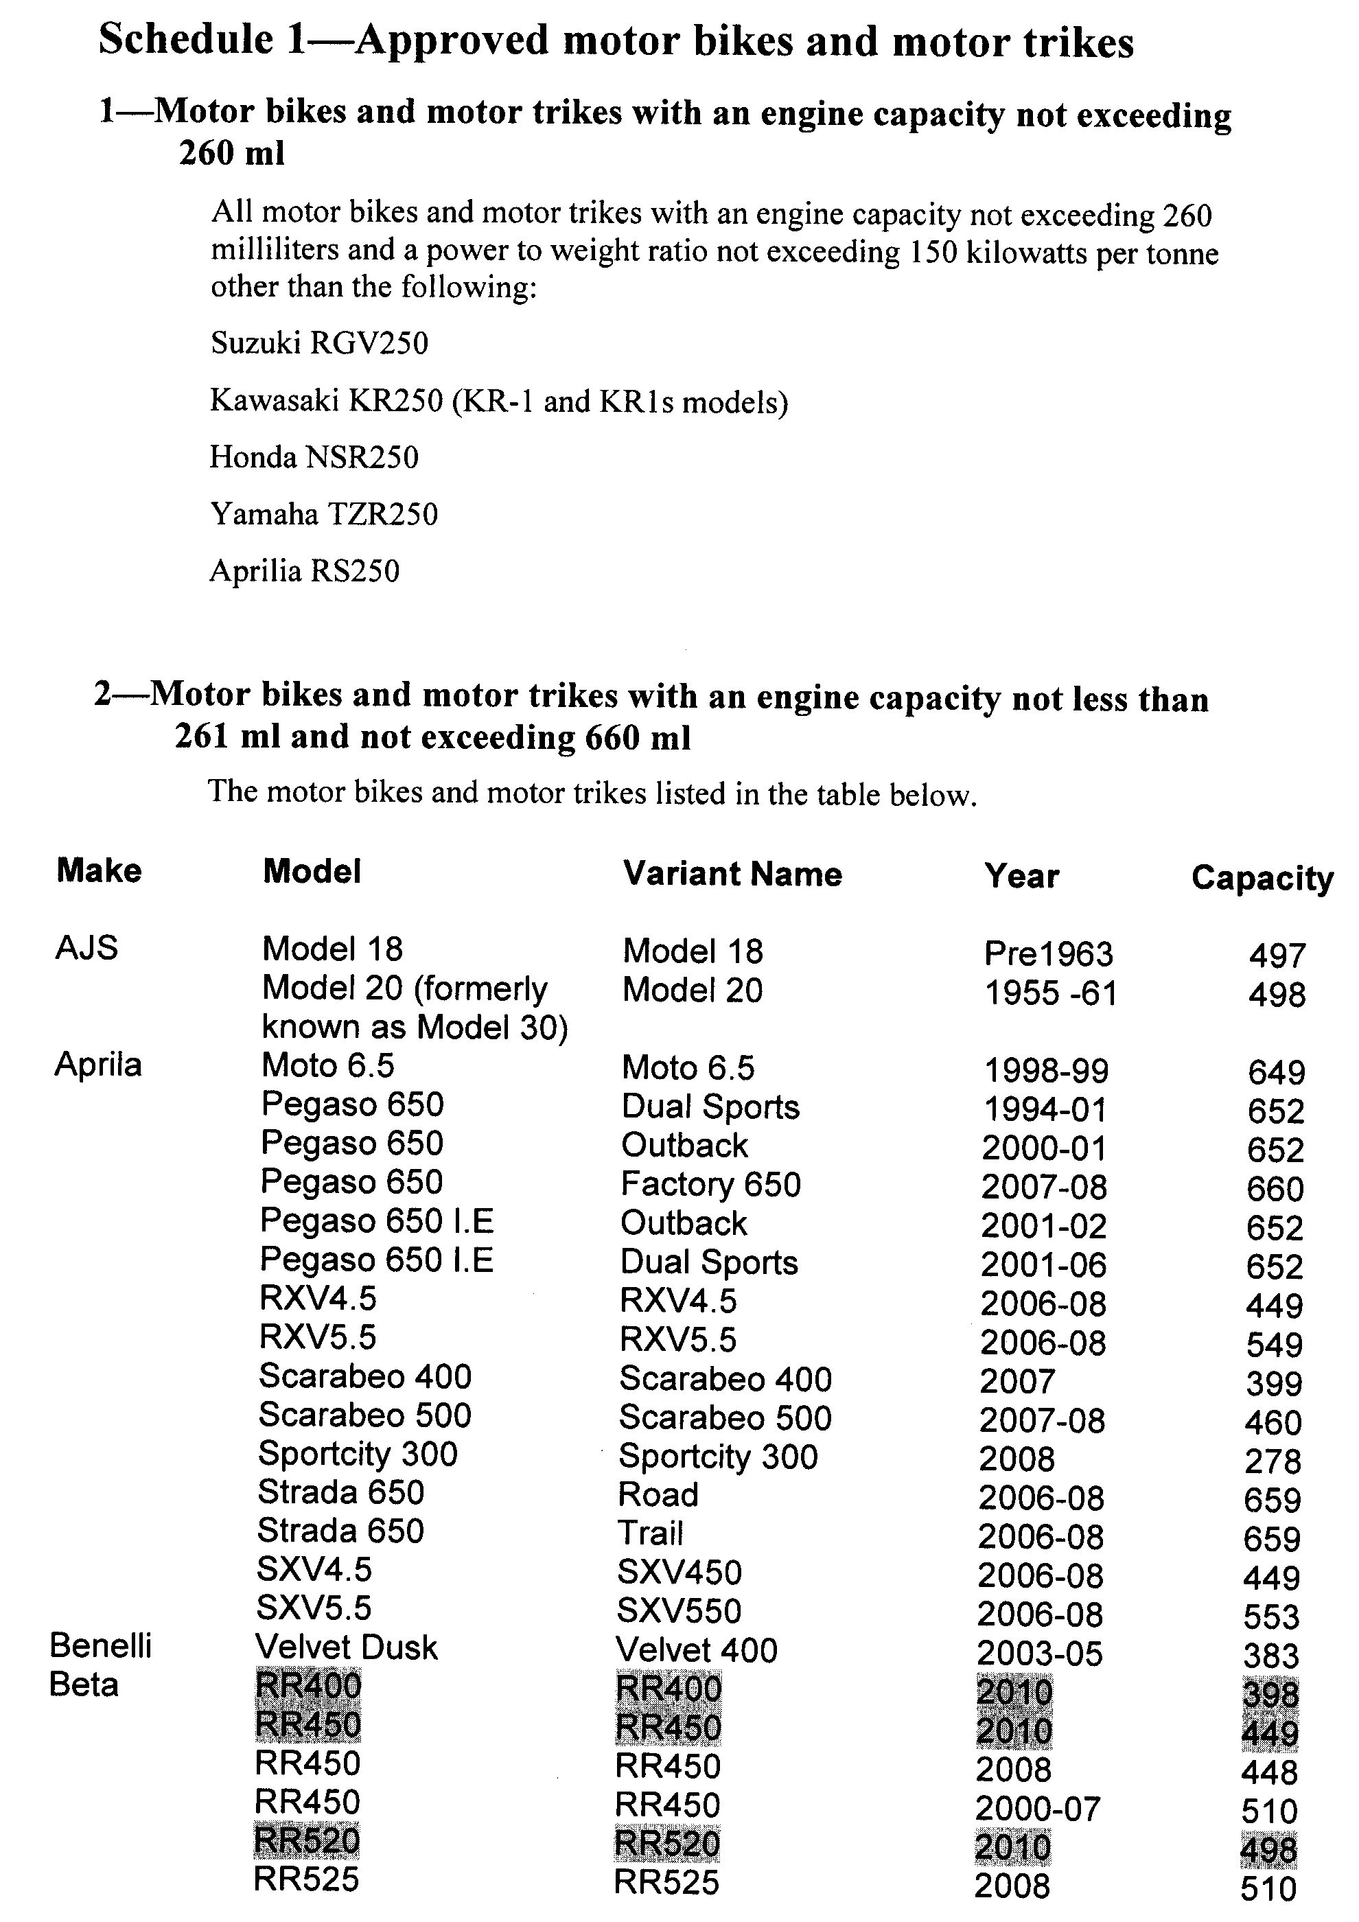
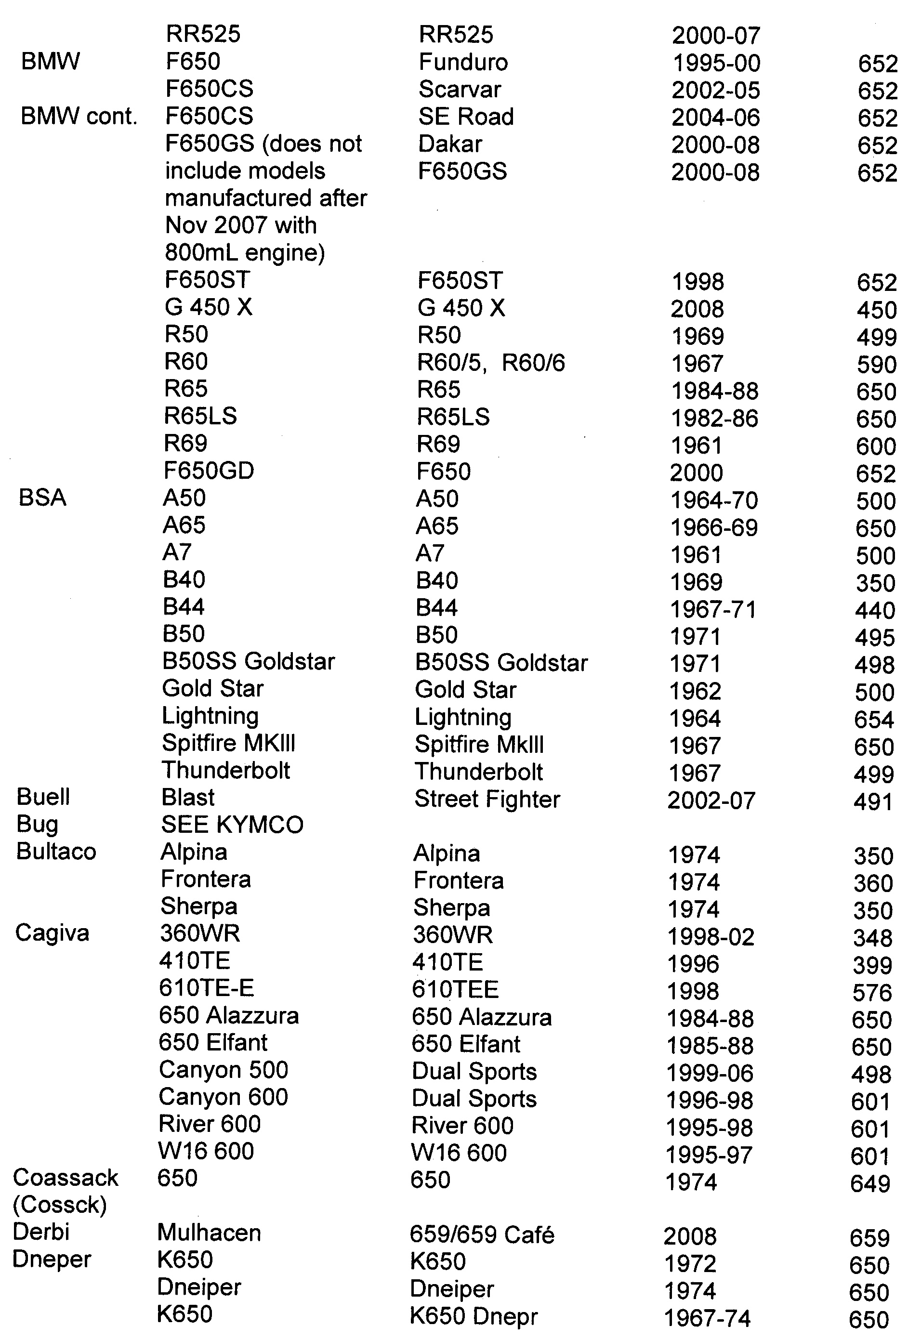
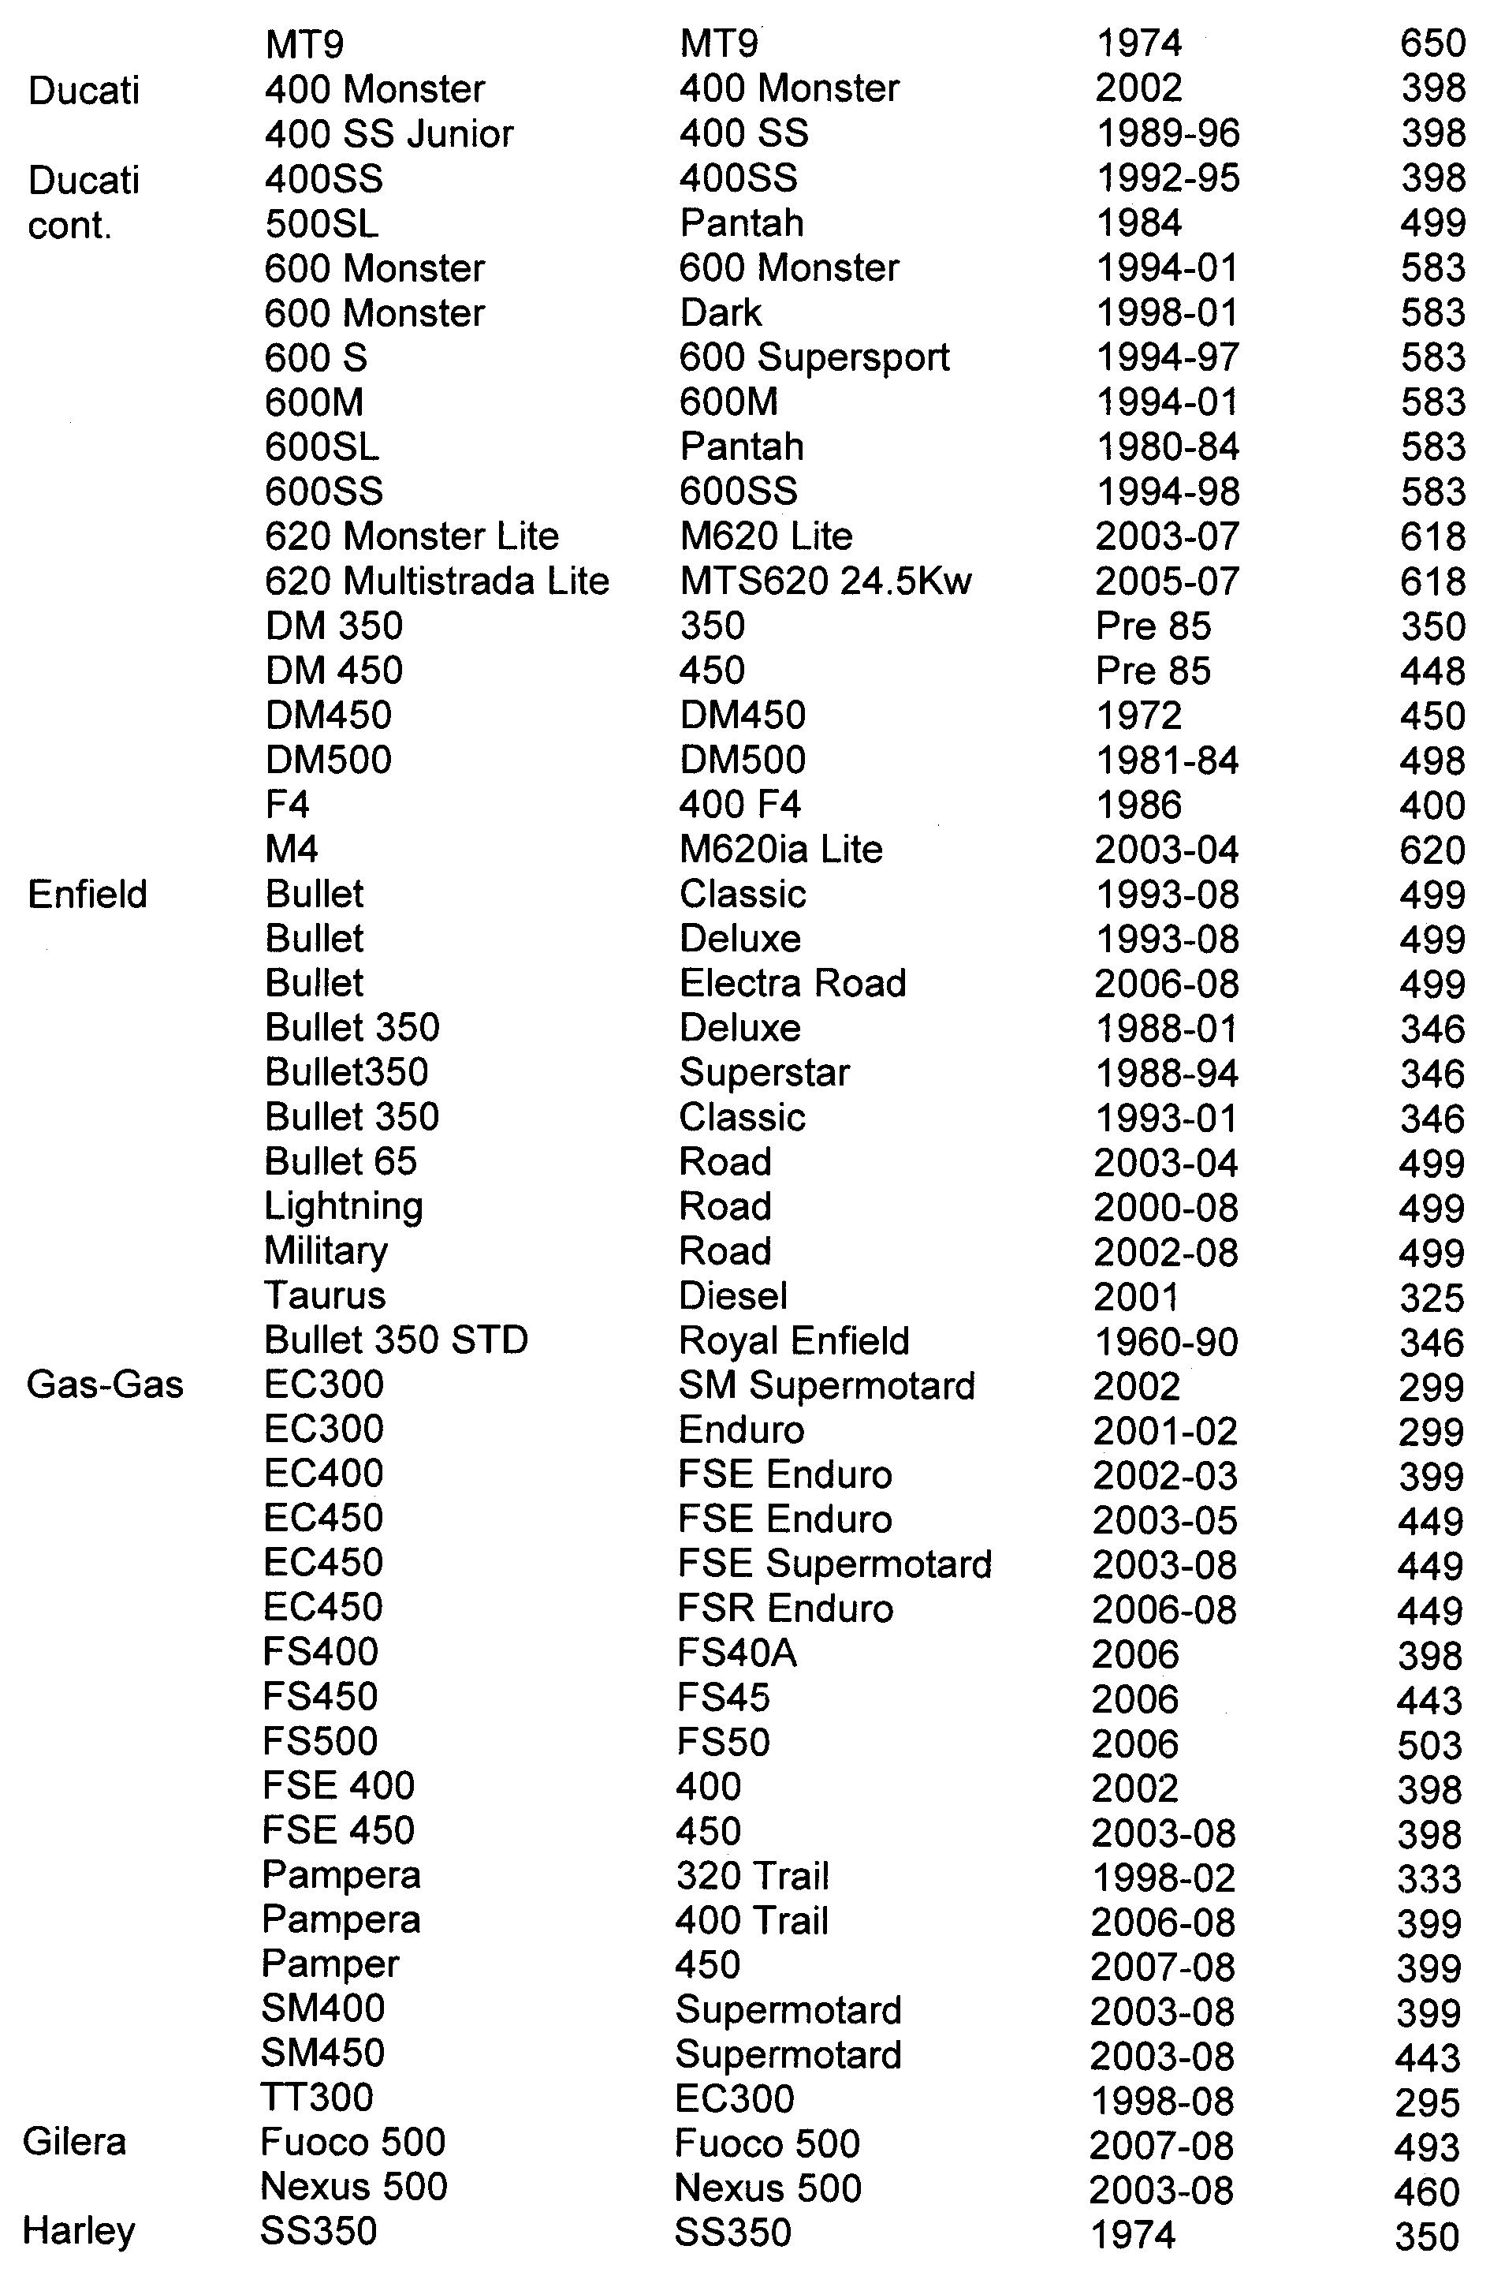
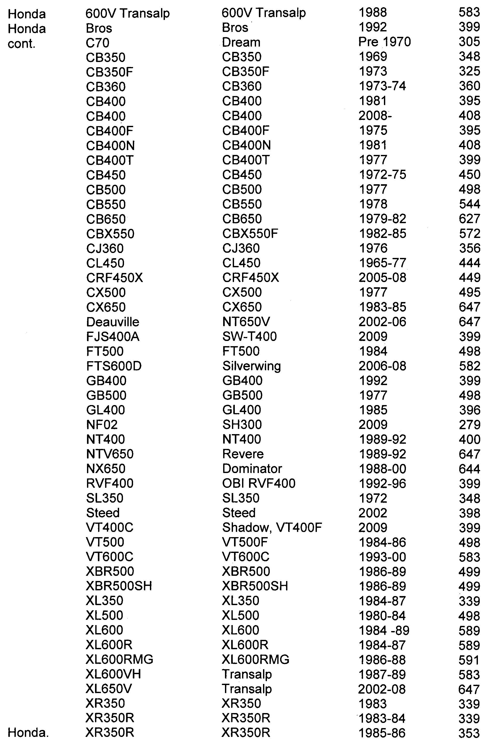
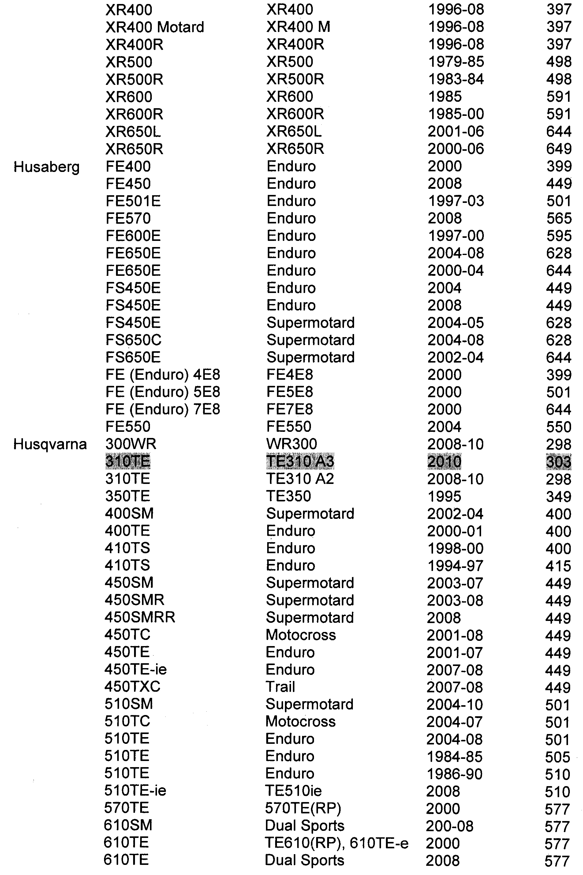
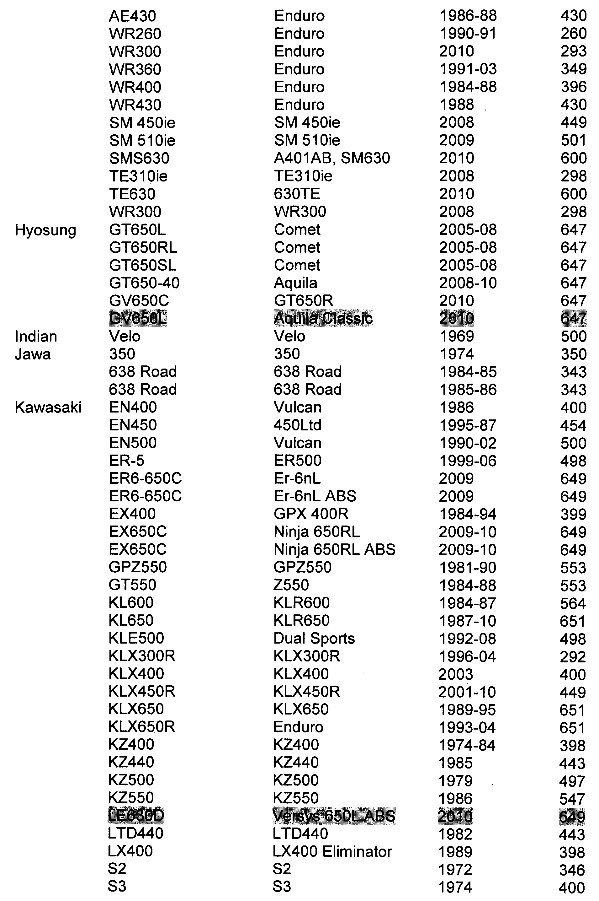
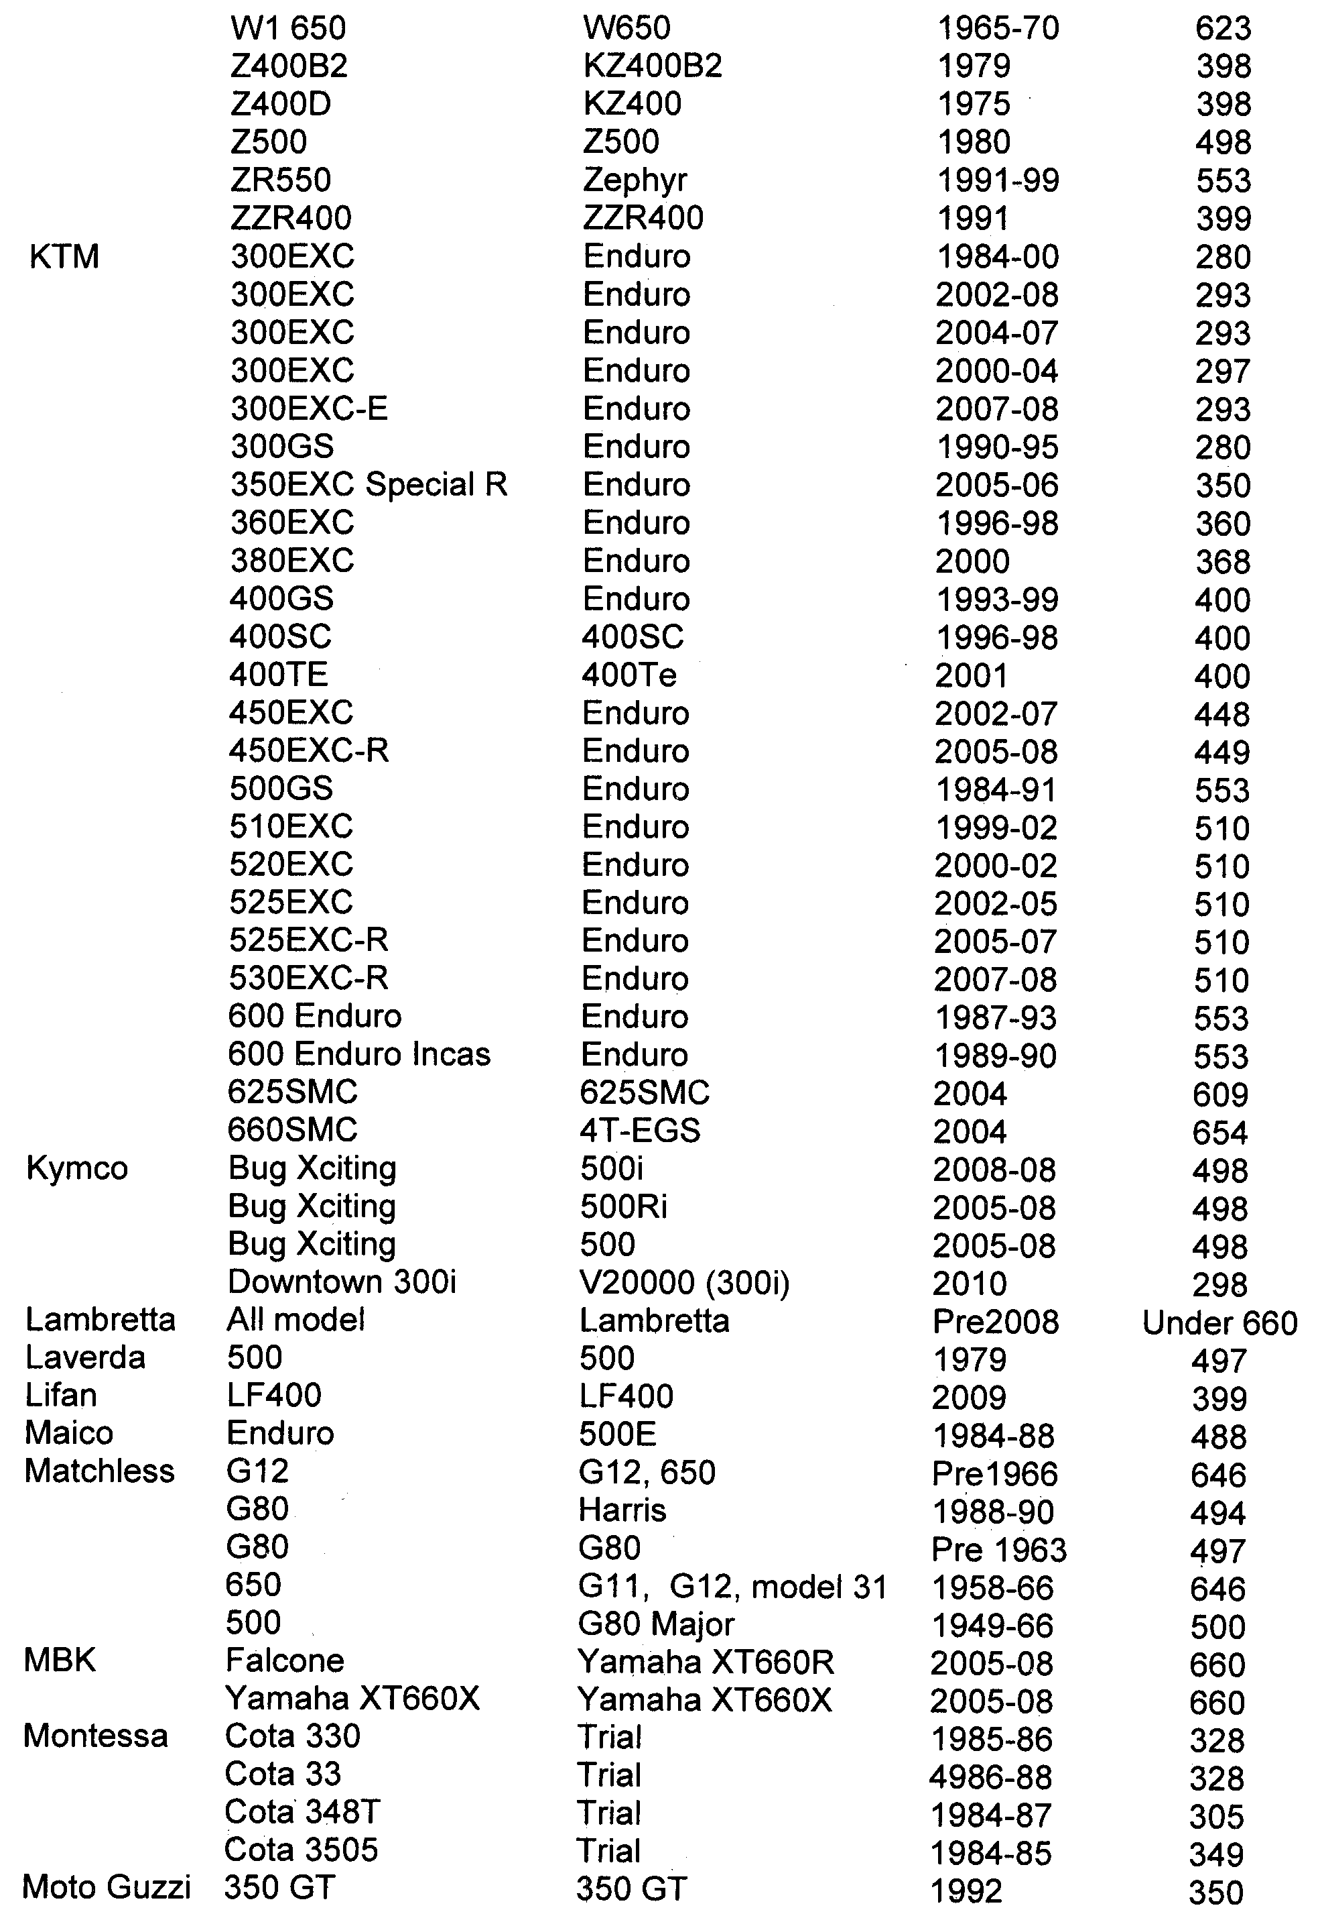
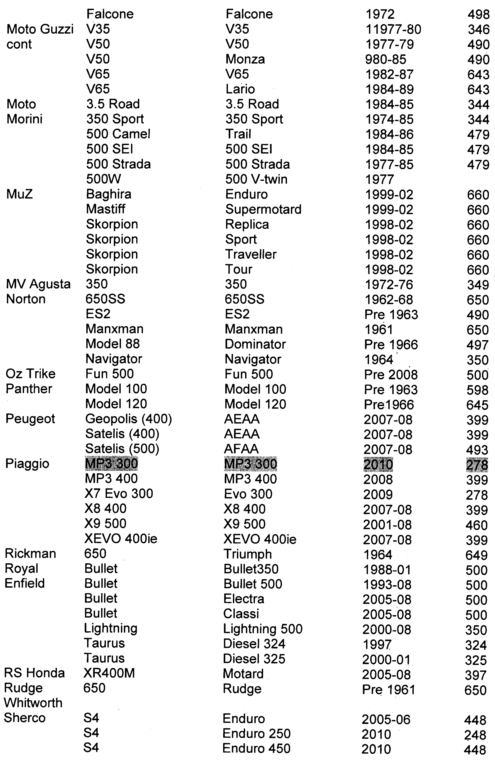
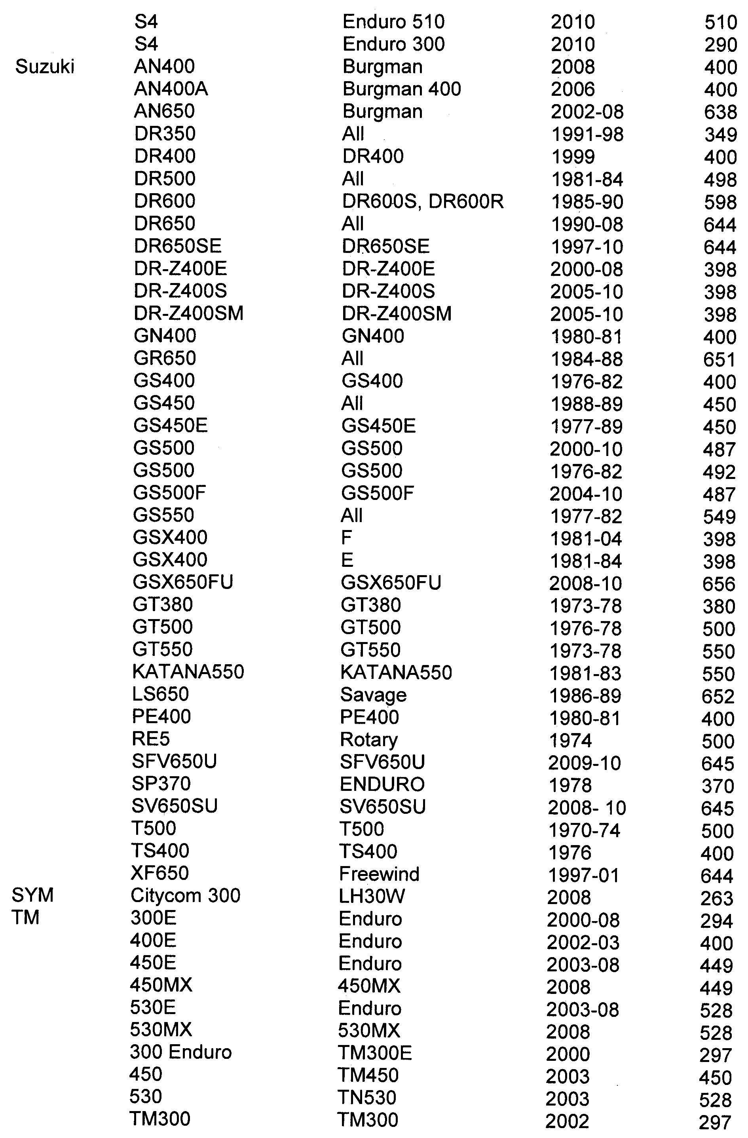
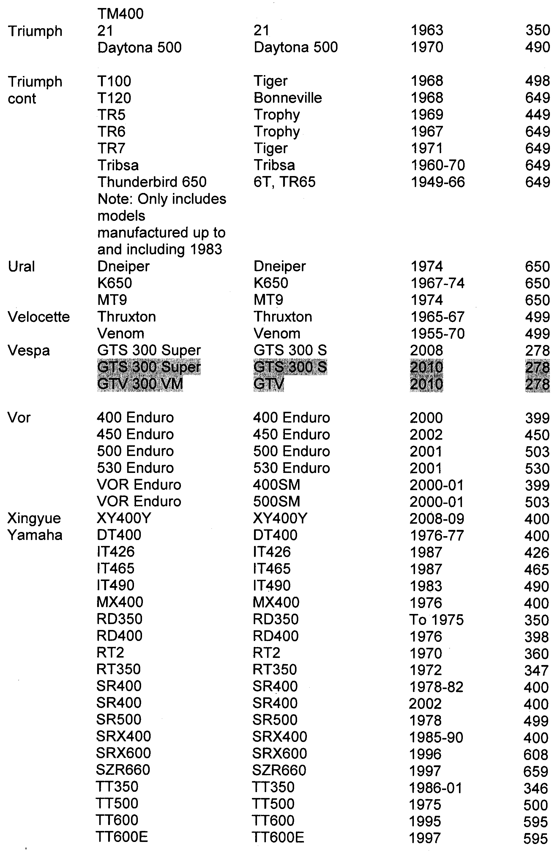
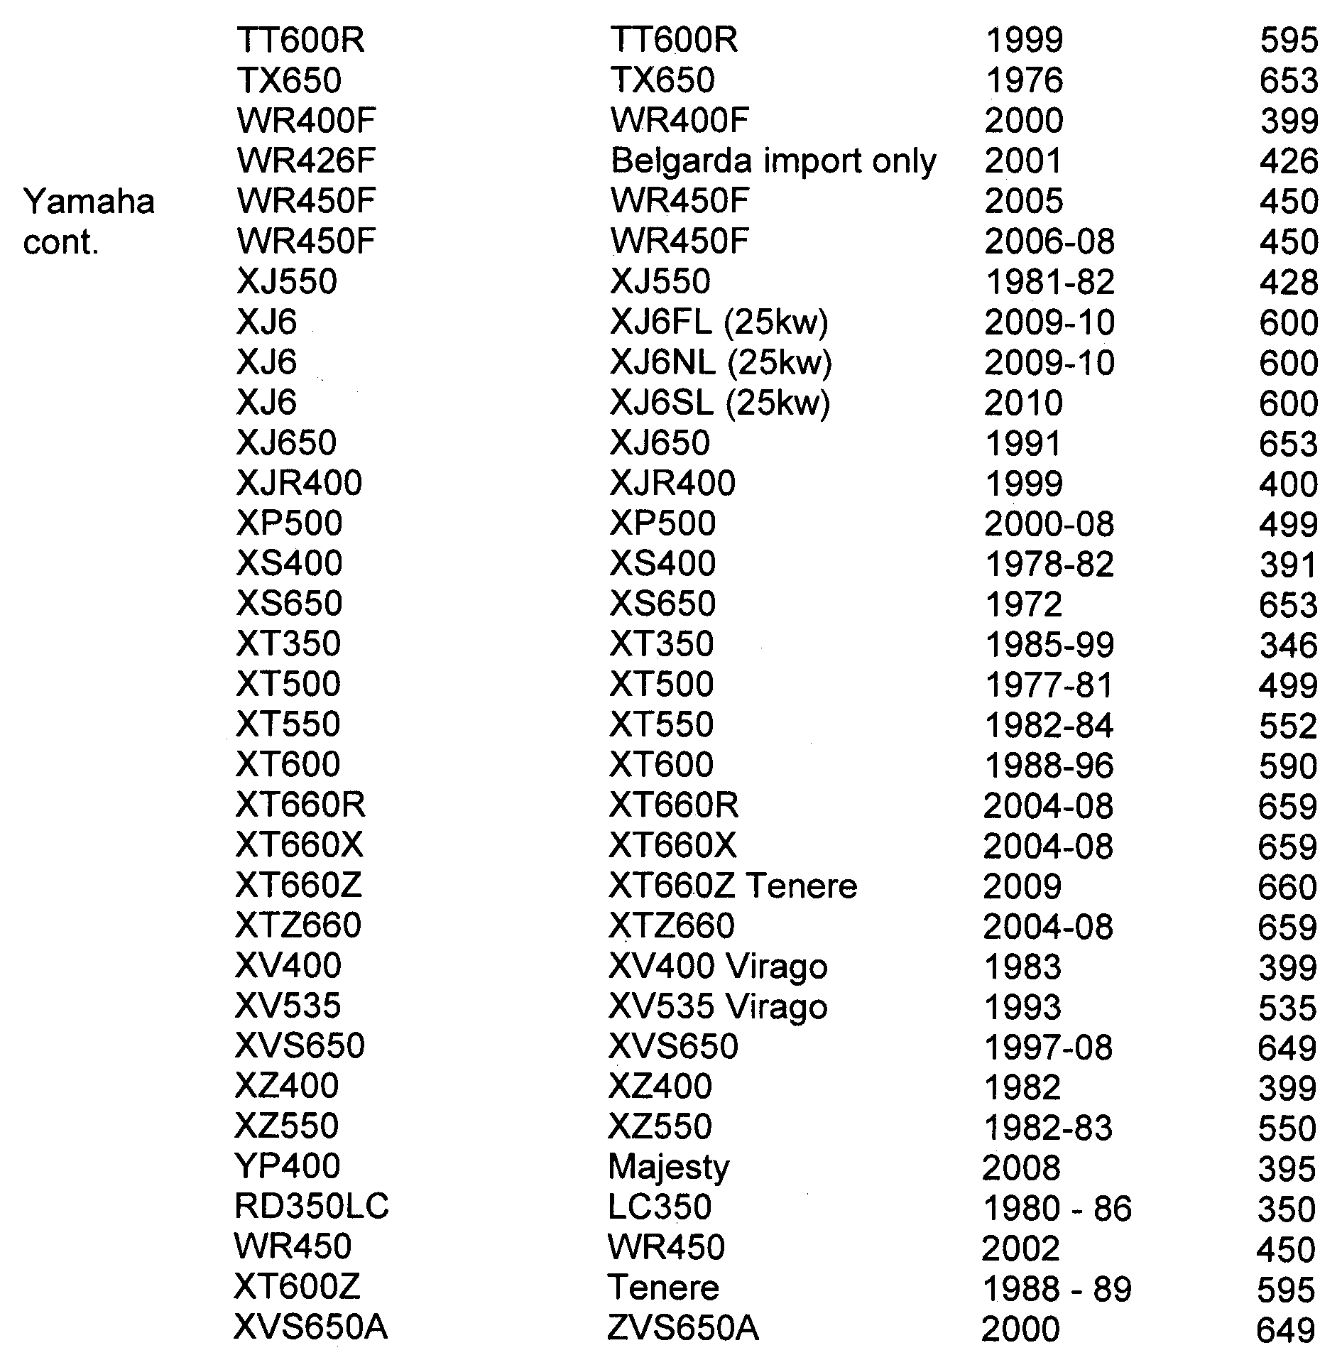

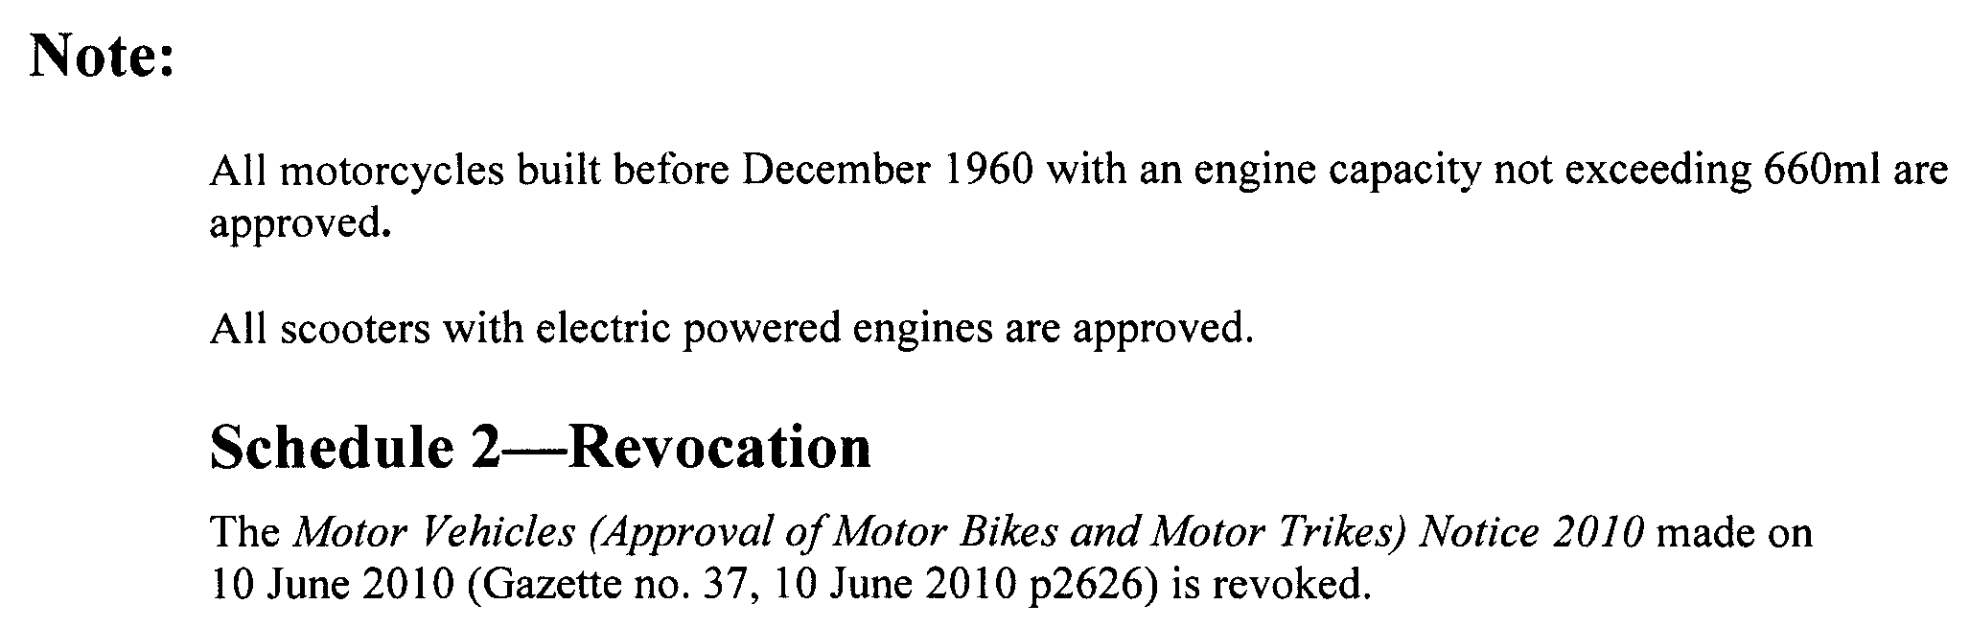
Dated 14 September 2010.
Ron Shanks, Deputy Registrar of Motor Vehicles

NATIONAL PARKS AND WILDLIFE ACT 1972
Ediacara Conservation Park Management Plan—Draft
I, EDWARD GREGORY LEAMAN, Director of National Parks and Wildlife, hereby give notice under the provisions of section 38 of the National Parks and Wildlife Act 1972, that a draft management plan has been proposed for Ediacara Conservation Park.
Copies of the draft plan may be inspected at or obtained from the offices of the Department of Environment and Natural Resources at:
• DENR Information Line (Level 1, 100 Pirie Street, Adelaide, S.A. 5000, e-mail denrinformation@sa.gov.au), telephone (08) 8204 1910;
• http://www.environment.sa.gov.au/parks/management/plans.html;
• DENR Northern Flinders District Office, Flinders Ranges National Park (Wilpena), P.M.B. 22 via Hawker, S.A. 5434, (08) 8648 0049.
Any person may make representations in connection with the draft management plan during the period up to and including Friday, 17 December 2010.
Written comments should be forwarded to the Team Leader, Protected Area Management, Department of Environment and Natural Resources, G.P.O. Box 1047, Adelaide, S.A. 5001 or
e-mailed to:
DENRProtectedAreaManagement@sa.gov.au
E. G. Leaman, Director of National Parks and Wildlife, Delegate of the Minister for Environment and Conservation

NATIONAL PARKS AND WILDLIFE ACT 1972
Lake St Clair Conservation Park Draft Management Plan
I, EDWARD GREGORY LEAMAN, Director of National Parks and Wildlife, hereby give notice under the provisions of section 38 of the National Parks and Wildlife Act 1972, that a draft management plan has been proposed for Lake St Clair Conservation Park.
Copies of the draft plan may be inspected at or obtained from the offices of the Department of Environment and Natural Resources at:
• DENR Information Line (Level 1, 100 Pirie Street, Adelaide, S.A. 5000, e-mail denrinformation@sa.gov.au), telephone (08) 8204 1910;
• http://www.environment.sa.gov.au/parks/management/plans.html;
• South East Regional Office, 11 Helen Street, Mount Gambier, S.A. 5290, (08) 8735 1177.
Any person may make representations in connection with the draft management plan during the period up to and including Friday, 17 December 2010.
Written comments should be forwarded to the Team Leader, Protected Area Management, Department of Environment and Natural Resources, G.P.O. Box 1047, Adelaide, S.A. 5001 or
e-mailed to:
DENRProtectedAreaManagement@sa.gov.au
E. G. Leaman, Director of National Parks and Wildlife, Delegate of the Minister for Environment and Conservation

NATIONAL PARKS AND WILDLIFE (NATIONAL PARKS) REGULATIONS 2001
Temporary, Partial Closure of Moorook Game Reserve
PURSUANT to Regulations 8 (3) (a), 11 (1) and 14 of the National Parks and Wildlife (National Parks) Regulations 2001, I, Edward Gregory Leaman, Director of National Parks and Wildlife, close to the public, a part of the Moorook Game Reserve from 6 a.m. on 16 September 2010, until 6 p.m. on 16 September 2011.
The closure applies to a part of Wachtels Lagoon within the reserve. The area to be closed is defined within the following co-ordinates:
442748E 6210926N to 443079E 6210458N direct line between two co-ordinates;
443079E 6210458N to 443268E 6209307N direct line between two co-ordinates;
443268E 6209307N to 442454E 6209208N direct line between two co-ordinates;
442454E 6209208N to 441737E 6209450N direct line between two co-ordinates;
441737E 6209450N to 441377E 6209958N direct line between two co-ordinates;
441377E 6209958N to 442748E 6210926N direct line between two co-ordinates.
Northings and Eastings are in Universal Transverse Mercator Projection, Zone 54S, Datum: Geocentric Datum of Australia 1994.
The closure is necessary for the proper management of the reserve to allow for the conservation of wildlife.
Dated 14 September 2010.
E. G. Leaman, Director of National Parks and Wildlife

ROADS (OPENING AND CLOSING) ACT 1991
Road Closure—Waterfall Gully Road, Burnside
NOTICE is hereby given, pursuant to section 10 of the Roads (Opening and Closing) Act 1991, that the Development Assessment Commission proposes to make a Road Process Order to close and transfer to the South Australian Water Corporation portion of the public road (Waterfall Gully Road) situate adjoining allotment 101 (Reserve) in Deposited Plan 31781, more particularly delineated and lettered ‘A’ on Preliminary Plan No. 10/0044.
A copy of the plan and a statement of persons affected are available for public inspection at the offices of the Council, 401 Greenhill Road, Tusmore and the office of the Surveyor-General, 101 Grenfell Street, Adelaide, during normal office hours.
Any application for easement or objection must set out the full name, address and details of the submission and must be fully supported by reasons.
The application for easement or objection must be made in writing to the Development Assessment Commission, 136 North Terrace, Adelaide, S.A. 5000, WITHIN 28 DAYS OF THIS NOTICE and a copy must be forwarded to the Surveyor-General, P.O. Box 1354, Adelaide, S.A. 5000. Where a submission is made, the Development Assessment Commission will give notification of a meeting at which the matter will be considered.
Commission Contact: Daniel Hay, Telephone: 8303 0554.
Dated 16 September 2010.
P. M. Kentish, Surveyor-General

SURVEY ACT 1992
Revocation of a Confused Boundary Area
PURSUANT to section 50 (3) of the Survey Act 1992, notice is given that the Confused Boundary Area at Royal Park bounded by Lowe Street, Crown Terrace, Royal Terrace and Kingston Avenue, is revoked.
Dated 16 September 2010.
P. M. Kentish, Surveyor-General
REF: Filed Plan 52656

TRADE STANDARDS ACT 1979
Discretionary Exemption
TAKE notice that I, Gail Gago, Minister for Consumer Affairs in the State of South Australia, do hereby exempt the goods named in Schedule 1 below from the Declaration of Dangerous Goods previously made and described in Schedule 2 below, pursuant to Part 7, section 36 (1) (c) of the Trade Standards Act 1979.
Schedule 1
Expanding novelty toy:
• Emu, Model No. AUSEGG02
• Frilled Neck Lizard, Model No. AUSEGG02
• Platypus, Model No. AUSEGG02
• Turtle, Model No. SEAEGG06T
• Clown Fish, Model No. SEAEGG05CL
• Joey, Model No. AUSEGG01KA
The Growing Round Egg toys are characterised by clear packaging containing the toy inside a dissolvable egg.
Schedule 2
The goods described in Schedule 1 above are exempt from the requirements of the Declaration of Dangerous Goods signed by the Minister for Consumer Affairs on 9 August 1990 and published in the Government Gazette of 30 August 1990.
Dated 1 September 2010.
Gail Gago, Minister for Consumer Affairs

WATER MAINS AND SEWERS

Office of the South Australian Water Corporation
Adelaide, 16 September 2010

WATER MAINS LAID

Notice is hereby given that the following main pipes or parts of main pipes have been laid down by the South Australian Water Corporation in or near the undermentioned water districts and are now available for a constant supply of water to adjacent land.

ADELAIDE WATER DISTRICT

CITY OF CHARLES STURT
Across Pickering Street, Brompton. p43
Frost Place, Brompton. p43
Across Borthwick Street, Henley Beach. p45
In and across Paruna Road, Henley Beach and Fulham Gardens. p45
Henley Court, Fulham Gardens. p45

DISTRICT COUNCIL OF MOUNT BARKER
Across Albert Road, Mount Barker. p49
Duchess Court, Mount Barker. p49
In and across Douglas Drive, Mount Barker. p50 and 51
Galloway Court, Mount Barker. p50
Ongloe Close, Mount Barker. p50
Easements in lot 4000 in LTRO DP 84701, Megan Circuit, Nairne. p86-88
Rachel Circuit, Nairne. p88

CITY OF PLAYFORD
In and across Kerang Street, Andrews Farm. p42
Saint Germain Avenue, Andrews Farm. p42
In and across Vitorio Road, Munno Para West. p53
Luvera Drive, Munno Para West. p53
Stringy Bark Court, Munno Para West. p53
In and across Orchard Street, Munno Para West. p54 and 55
Major Street, Munno Para West. p54 and 55
Easement in lot 8008 in LTRO DP 82627, Douglas Drive, Munno Para West. p54
In and across Tucker Street, Munno Para West. p54 and 55
Hart Lane, Munno Para West. p54
Streeton Road, Munno Para West. p54
In and across Coventry Road, Munno Para West and Munno Para. p54-56
Whiteley Street, Munno Para West. p55
MacKillop Street, Munno Para West. p56
Freeman Avenue, Munno Para West. p56
Greengate Place, Smithfield Plains. p62
Glenmore Place, Smithfield Plains. p62
In and across Sarah Court, Hillbank. p66
Prominent Rise, Hillbank. p66 and 67
Eliza Road, Hillbank. p66
Bungarra Street, Hillbank. p66

CITY OF PORT ADELAIDE ENFIELD
Light Terrace, Northgate. p58
Easement in reserves (lot 2003 in LTRO DP 78350 and lot 2004 in LTRO DP 81933), City View Boulevard, Northgate. p58 and 59
Across and in Neale Lane, Northgate. p59
City View Boulevard, Northgate. p59
Across and in The Strand, Northgate. p59
Across and in East Parkway, Northgate. p59 and 60
Easement in lot 4500 in LTRO DP 82022, East Parkway, Northgate. p60
Murchison Street, Woodville Gardens. p77
Fleming Crescent, Mansfield Park. p78
Wilson Street, Mansfield Park. p78

CITY OF SALISBURY
Kinross Avenue, Burton. p44
Douglas Drive, Mawson Lakes. p47 and 48
James Lane, Mawson Lakes. p48
Thorne Street, Paralowie. p61
Ryans Road, Globe Derby Park. p79

BEETALOO COUNTRY LANDS WATER DISTRICT

DISTRICT COUNCIL OF THE COPPER COAST
Easements in lot 75 in LTRO DP 84289, Schilling Street, Kadina. p71
Across and in Schilling Street, Kadina. p71 and 72
Easements in lot 1003 in LTRO DP 84289, Schilling Street, Kadina. p71
John Olsen Drive, Kadina. p72
Patrick Street, Kadina. p72

BURRA WATER DISTRICT

REGIONAL COUNCIL OF GOYDER
Truro Street, Burra. p17

GOOLWA WATER DISTRICT

ALEXANDRINA COUNCIL
Across Kessell Road, Goolwa. p46
Farquhar Street, Goolwa. p46
Brooking Street, Goolwa. p68
Across Gardiner Street, Goolwa. p69

KADINA WATER DISTRICT

DISTRICT COUNCIL OF THE COPPER COAST
Across and in Moonta Road, Kadina. p73
In and across Railway Terrace, Kadina. p73
Rendell Street, Kadina. p73

LOCK WATER DISTRICT

THE DISTRICT COUNCIL OF ELLISTON
Railway Terrace, Lock. p74

MOUNT GAMBIER WATER DISTRICT

CITY OF MOUNT GAMBIER
Ash Court, Mount Gambier. p52

MURRAY BRIDGE WATER DISTRICT

THE RURAL CITY OF MURRAY BRIDGE
Hennig Street, Murray Bridge. p57
Across Cromwell Road, Murray Bridge. p89
Easements in lot 300 in LTRO DP 82585, Cromwell Road and lot 31 in LTRO DP 80198, Christian Road, Murray Bridge. p89

STRATHALBYN COUNTRY LANDS WATER DISTRICT

ALEXANDRINA COUNCIL
Point Sturt Road, Clayton Bay and Point Sturt. This main is available on application only. p1-16

TOD RIVER COUNTRY LANDS WATER DISTRICT

THE DISTRICT COUNCIL OF ELLISTON
Dawson Road, Lock. p75 and 76

WALLAROO WATER DISTRICT

DISTRICT COUNCIL OF THE COPPER COAST
In and across Beare Street, Wallaroo. p63-65
Wall Road, Wallaroo. p65

OUTSIDE WATER DISTRICTS

COORONG COUNCIL
Across Narrung Road, Narrung. This main is available on application only—not available for constant rateable supply. p21
Loveday Bay Road, Narrung. This main is available on application only—not available for constant rateable supply. p21-41
Easements in allotment piece 101 in LTRO DP 69070, Loveday Bay Road, Narrung. This main is available on application only—not available for constant rateable supply. p36

WATER MAINS ABANDONED

Notice is hereby given that the undermentioned water mains have been abandoned by the South Australian Water Corporation.

ADELAIDE WATER DISTRICT

CITY OF PORT ADELAIDE ENFIELD
Murchison Street, Woodville Gardens. p77
Fleming Crescent, Mansfield Park. p78
Wilson Street, Mansfield Park. p78

BEETALOO COUNTRY LANDS WATER DISTRICT

DISTRICT COUNCIL OF THE COPPER COAST
Easement in lots 75-82 and 1003 in LTRO DP 84289, Schilling Street, Kadina. p71

KADINA WATER DISTRICT

DISTRICT COUNCIL OF THE COPPER COAST
Across and in Moonta Road, Kadina. p73
Railway Terrace, Kadina. p73
Rendell Street, Kadina. p73

LOCK WATER DISTRICT

THE DISTRICT COUNCIL OF ELLISTON
Railway Terrace, Lock. p74
TOD RIVER COUNTRY LANDS WATER DISTRICT

THE DISTRICT COUNCIL OF ELLISTON
Dawson Road, Lock. p75

WATER MAINS LAID

Notice is hereby given that the undermentioned water mains have been laid down by the South Australian Water Corporation and are not available for a constant supply of water to adjacent land.

MYPOLONGA WATER DISTRICT

THE RURAL CITY OF MURRAY BRIDGE
Easement in allotment piece 127 in LTRO FP 39547, Mypolonga. p18

MYPOLONGA WATERWORKS

OUTSIDE MYPOLONGA WATER DISTRICT

THE RURAL CITY OF MURRAY BRIDGE
Easement in lot 136 in LTRO DP 55816, North Bokara Road, Mypolonga. p18
In and across public road east of lot 126 in LTRO FP 39547, Mypolonga. p18
Waterworks land (lots 126, Carawatha Road and 125, Chamberlain Road in LTRO FP 39547), Mypolonga. p18 and 19

SEWERS LAID

Notice is hereby given that the following sewers have been laid down by the South Australian Water Corporation in the undermentioned drainage areas and are now available for house connections.

ADELAIDE DRAINAGE AREA

CITY OF CHARLES STURT
Brice Street, Findon. FB 1198 p36
Lucerne Grove, Findon. FB 1198 p37
Across Pickering Street, Brompton. FB 1197 p24 and 25
Frost Place, Brompton. FB 1197 p24 and 25
Across Borthwick Street, Henley Beach. FB 1197 p33 and 34
In and across Paruna Road, Henley Beach and Fulham Gardens. FB 1197 p33 and 34
Henley Court, Fulham Gardens. FB 1197 p33 and 34

CITY OF ONKAPARINGA
Proctor Street, Flagstaff Hill. FB 1198 p34
Easement in lot 23 in LTRO DP 41282, Alexander Avenue, Morphett Vale. FB 1198 p42

CITY OF PLAYFORD
Kerang Street, Andrews Farm. FB 1197 p21-23
Across and in Saint Germain Avenue, Andrews Farm. FB 1197 p21-23
Across and in Stebonheath Road, Andrews Farm. FB 1197 p21-23
Sarah Court, Hillbank. FB 1197 p35-38
In and across Prominent Rise, Hillbank. FB 1197 p35-38
Across Eliza Road, Hillbank. FB 1197 p35-38
Bungarra Street, Hillbank. FB 1197 p35-38
Easements in reserve (lot 381 in LTRO DP 84417), Bungarra Street and lots 21-17 in LTRO DP 84417, Prominent Rise, Hillbank. FB 1197 p35-38
In and across Orchard Street, Munno Para West. FB 1197 p43, 44 and 46
Across and in Tucker Street, Munno Para West. FB 1197 p43, 44, 46 and 47
Hart Lane, Munno Para West. FB 1197 p43, 44 and 46
Across Streeton Road, Munno Para West. FB 1197 p43, 44 and 46
In and across Major Street, Munno Para West. FB 1197 p43, 44 and 46
Whiteley Street, Munno Para West. FB 1197 p43, 44 and 47
Across and in Coventry Road, Munno Para West and Munno Para. FB 1197 p43-45 and 47
Easement in lot 9001 in LTRO DP 82297, Coventry Road, Munno Para. FB 1197 p43, 44 and 47
MacKillop Street, Munno Para West. FB 1197 p43, 45 and 47
In and across Chellaston Road, Munno Para West. FB 1197 p48-50
In and across Vitorio Road, Munno Para West. FB 1197 p48-50
Luvera Drive, Munno Para West. FB 1197 p48-50
Olive Grove, Munno Para West. FB 1197 p48, 49 and 51
Greengate Place, Smithfield Plains. FB 1197 p55-57
Glenmore Place, Smithfield Plains. FB 1197 p55-57
Across Tudor Crescent, Smithfield Plains. FB 1197 p55-57
Featherstone Street, Smithfield Plains. FB 1197 p55-57
Bluegum Court, Munno Para West. FB 1198 p40
Easements in lots 248 and 247 in LTRO DP 6288, Ashfield Road, Elizabeth. FB 1198 p41

CITY OF PORT ADELAIDE ENFIELD
Across East Parkway, Northgate. FB 1197 p26, 28 and 29
In and across Francis Street, Northgate. FB 1197 p26-30
Kingston Parade, Northgate. FB 1197 p26, 27 and 30
Proclamation Road, Northgate. FB 1197 p26, 27 and 30
Rozells Avenue, Northgate. FB 1197 p26, 27 and 30
Jacob Lane, Northgate. FB 1197 p26, 27 and 30
Ely Street, Mansfield Park. FB 1197 p39, 40 and 42
Kimberley Street, Mansfield Park. FB 1197 p39, 41 and 42
Hampshire Street, Mansfield Park. FB 1197 p39, 41 and 42
Across and in Fleming Crescent, Mansfield Park. FB 1197 p39, 41 and 42
Haven Road, Mansfield Park. FB 1197 p39, 41 and 42
Trafford Street, Mansfield Park. FB 1197 p39, 41 and 42

CITY OF SALISBURY
Across Bolivar Road, Burton. FB 1197 p31 and 32
Easement in reserve (lot 200 in LTRO DP 82049), Bolivar Road, Burton. FB 1197 p31 and 32
Kinross Avenue, Burton. FB 1197 p31 and 32
Thorne Street, Paralowie. FB 1197 p54
Nelson Road, Para Vista. FB 1198 p43

HAHNDORF COUNTRY DRAINAGE AREA

DISTRICT COUNCIL OF MOUNT BARKER
Easements in lot 51 in LTRO DP 57197, lot 282 in LTRO FP 309 and lot 99 in LTRO DP 19416, Male Crescent, Hahndorf. FB 1198 p38

LOBETHAL COUNTRY DRAINAGE AREA

ADELAIDE HILLS COUNCIL
Easements in lots 1003, 1000 and 1004 in LTRO DP 80618, Main Street, Lobethal. FB 1198 p33

MOUNT GAMBIER COUNTRY DRAINAGE AREA

CITY OF MOUNT GAMBIER
Ash Court, Mount Gambier. FB 1175 p42 and 43
Easement in lots 5 and 4 in LTRO DP 82844, Ash Court, Mount Gambier. FB 1175 p42 and 43
Walkway (lot 502) and easement in lot 13 in LTRO DP 82844, Ash Court, Mount Gambier. FB 1175 p42 and 43

MURRAY BRIDGE COUNTRY DRAINAGE AREA

THE RURAL CITY OF MURRAY BRIDGE
In and across Jaensch Road, Murray Bridge. FB 1197 p16-19
In and across Uplands Drive, Murray Bridge. FB 1197 p16-18
Wetlands Close, Murray Bridge. FB 1197 p16-18
Easements in lots 56 and 47 in LTRO DP 82723, Jaensch Road and lot 1 in LTRO DP 69828, Narooma Boulevard, Murray Bridge. FB 1197 p16, 17 and 19
Hennig Street, Murray Bridge. FB 1198 p44 and 45
In and across Cromwell Road, Murray Bridge. FB 1197 p52 and 53
Easements in lot 300 in LTRO DP 82585, Cromwell Road and lot 31 in LTRO DP 80198, Christian Road, Murray Bridge. FB 1197 p52 and 53
Christian Road, Murray Bridge. FB 1197 p52 and 53
SEWERS ABANDONED

Notice is hereby given that the undermentioned sewers have been abandoned by the South Australian Water Corporation.

ADELAIDE DRAINAGE AREA

CITY OF PLAYFORD
Olive Drive, Munno Para West—100 mm PVCU pumping main. FB 1197 p48 and 49
Across Chellaston Road, Munno Para West—100 mm PVCU pumping main. FB 1197 p48 and 49
Featherstone Street, Smithfield Plains. FB 1197 p55 and 56

CITY OF PORT ADELAIDE ENFIELD
Ely Street, Mansfield Park. FB 1197 p39 and 40
Haven Road, Mansfield Park. FB 1197 p39 and 41

LOBETHAL COUNTRY DRAINAGE AREA

ADELAIDE HILLS COUNCIL
Easement in lots 1003 and 1000 in LTRO DP 80618, Main Street, Lobethal. FB 1198 p33

MURRAY BRIDGE COUNTRY DRAINAGE AREA

THE RURAL CITY OF MURRAY BRIDGE
In and across Jaensch Road, Murray Bridge. FB 1197 p16 and 17
Easement in lot 95 in LTRO FP 213752, Jaensch Road and lot 1 in LTRO DP 69828, Narooma Boulevard, Murray Bridge. FB 1197 p16 and 17

SEWERS LAID

Notice is hereby given that the undermentioned sewers have been laid down by the South Australian Water Corporation and are not available for house connections.

MURRAY BRIDGE COUNTRY DRAINAGE AREA

THE RURAL CITY OF MURRAY BRIDGE
Easement in lot 56 in LTRO DP 82723, Jaensch Road, Murray Bridge. FB 1197 p16-18 and 20
Across Jaensch Road, Murray Bridge. FB 1197 p16-18 and 20
Easement in lot 56 in LTRO DP 82723, Jaensch Road, Murray Bridge—100 mm PVC pumping main. FB 1197 p16, 17, 19 and 20
Across and in Jaensch Road, Murray Bridge—100 mm PVC pumping main. FB 1197 p16, 17 and 19

ADDENDUM

Addendum to notice in ‘Government Gazette’ of 5 March 1981

‘Notice is hereby given that the following sewers have been laid down by the Minister of Water Resources in the undermentioned drainage area and are now available for house connections.’

‘STIRLING COUNTRY DRAINAGE AREA’
‘District of Stirling’

‘Sewerage land in part lot 44, Gould Road, across Gould Road, Stirling and easements in section 46, hundred of Noarlunga—4.4 m of 375 mm VC sewer and 321.0 m of 300 mm VC sewer from pumping station running generally north-westerly to easement in lot 7, Pritchard Drive. This sewer is not available for house connections for the first 90.2 m’

To this notice add ‘This main is not available to lot 1 in LTRO FP 158347, Pritchard Drive, Stirling.’ FB 1198 p35

A. Howe, Chief Executive Officer, South Australian Water Corporation

WHEAT MARKETING ACT 1989
Deductions for Grains Research
PURSUANT to section 10 of the Wheat Marketing Act 1989, I, Michael O’Brien, Minister for Agriculture, Food and Fisheries, make the following notice concerning grain for the season 2010-2011:
1. There shall be deductions for the purposes of research from the proceeds of all grain for the season.
2. The prescribed rate for such deductions shall be 25 cents per tonne.
3. A purchaser of grain harvested in 2010-2011 is to presume conclusively that the seller has consented to the making of payments under this section.
4. If the seller, by notice in writing given to the Minister by 31 March 2011, indicates that he or she does not consent to the making of such payments in respect of grain harvested in 2010-2011, the Minister must pay to the seller the amount received by the Minister in respect of grain of that season sold by the seller.
5. The written notice should be forwarded to the Minister for Agriculture, Food and Fisheries, G.P.O. Box 1671, Adelaide, S.A. 5001, by the stipulated date.
Dated 7 September 2010.
Michael O’Brien, Minister for Agriculture, Food and Fisheries

WHEAT MARKETING ACT 1989
Deductions for South Australian Farmers Federation (SAFF) Grains Section
PURSUANT to section 10 of the Wheat Marketing Act 1989, I, Michael O’Brien, Minister for Agriculture, Food and Fisheries, make the following notice concerning grain for the season 2010-2011:
1. There shall be deductions for the purposes of the SAFF grains section (SAFF Grains Industry Committee) from the proceeds of all grain for the season.
2. The prescribed rate for such deductions shall be 5 cents per tonne.
3. A purchaser of grain harvested in 2010-2011 is to presume conclusively that the seller has consented to the making of payments under this section.
4. If the seller, by notice in writing given to the Minister by 31 March 2011, indicates that he or she does not consent to the making of such payments in respect of grain harvested in 2010-2011, the Minister must pay to the seller the amount received by the Minister in respect of grain of that season sold by the seller.
5. The written notice should be forwarded to the Minister for Agriculture, Food and Fisheries, G.P.O. Box 1671, Adelaide, S.A. 5001, by the stipulated date.
Dated 7 September 2010.
Michael O’Brien, Minister for Agriculture, Food and Fisheries

South Australia
Statutes Amendment (Victims of Crime) Act (Commencement) Proclamation 2010
1—Short title
This proclamation may be cited as the Statutes Amendment (Victims of Crime) Act (Commencement) Proclamation 2010.
2—Commencement of Act and suspension of provision
(1) The Statutes Amendment (Victims of Crime) Act 2009 (No 79 of 2009) will come into operation on 19 September 2010.
(2) The operation of section 14 of the Act is suspended until a day or time to be fixed by subsequent proclamation.
Made by the Governor
with the advice and consent of the Executive Council
on 16 September 2010
AGO0199/10CS

South Australia
National Parks and Wildlife (Big Heath Conservation Park—Mining Rights) Proclamation 2010
under section 43 of the National Parks and Wildlife Act 1972

Preamble
1 The Crown land described in Schedule 1 is, by another proclamation made on this day, added to the Big Heath Conservation Park under section 29(3) of the National Parks and Wildlife Act 1972.
2 It is intended that, by this proclamation, certain existing rights of entry, prospecting, exploration or mining be preserved in relation to the land described in Schedule 1.

1—Short title
This proclamation may be cited as the National Parks and Wildlife (Big Heath Conservation Park—Mining Rights) Proclamation 2010.
2—Commencement
This proclamation comes into operation on the day on which it is made.
3—Interpretation
In this proclamation—
Environment Minister means the Minister for the time being administering the National Parks and Wildlife Act 1972;
Mining Minister means the Minister for the time being administering the Petroleum and Geothermal Energy Act 2000.
4—Existing rights to continue
Subject to clause 5, rights of entry, prospecting, exploration or mining under the Petroleum and Geothermal Energy Act 2000 existing immediately before the commencement of this proclamation may continue to be exercised in respect of the land described in Schedule 1.
5—Conditions for exercise of rights
A person in whom rights of entry, prospecting, exploration or mining are vested pursuant to the Petroleum and Geothermal Energy Act 2000 must not exercise those rights in respect of the land described in Schedule 1 unless the person complies with the following conditions:
(a) if work to be carried out in relation to the land in the exercise of those rights is a regulated activity within the meaning of the Petroleum and Geothermal Energy Act 2000, the person must ensure that—
(i) the work is not carried out until a statement of environmental objectives in relation to the activity that has been approved under that Act has also been approved by the Environment Minister; and
(ii) the work is carried out in accordance with the statement as so approved;
(b) if work to be carried out in relation to the land in the exercise of those rights has not previously been authorised (whether by inclusion in an approved statement of environmental objectives referred to in paragraph (a) or otherwise), the person must give at least 3 months notice of the proposed work to the Mining Minister and the Environment Minister and must supply each Minister with such information relating to the proposed work as the Minister may require;
(c) if directions are agreed between the Mining Minister and the Environment Minister and given to the person in writing in relation to—
(i) carrying out work in relation to the land in a manner that minimises damage to the land (including the land's vegetation and wildlife) and the environment generally; or
(ii) preserving objects, structures or sites of historical, scientific or cultural interest; or
(iii) rehabilitating the land (including the land's vegetation and wildlife) on completion of the work,
(being directions that do not reduce or otherwise detract from any requirement in respect of any of those matters contained in an approved statement of environmental objectives referred to in paragraph (a)), the person must comply with those directions in carrying out the work;
(d) if a plan of management is in operation under section 38 of the National Parks and Wildlife Act 1972 in respect of the land, the person must have regard to the provisions of the plan of management;
(e) in addition to complying with the other requirements of this proclamation, the person—
(i) must take such steps as are reasonably necessary to ensure that objects, structures and sites of historical, scientific or cultural interest and the land's vegetation and wildlife are not unduly affected by any work; and
(ii) must maintain all work areas in a clean and tidy condition; and
(iii) must, on the completion of any work, obliterate or remove all installations and structures (other than installations and structures designated by the Mining Minister and the Environment Minister as suitable for retention) used exclusively for the purposes of that work;
(f) if no direction has been given by the Mining Minister and the Environment Minister under paragraph (c)(iii), the person must (in addition to complying with any approved statement of environmental objectives referred to in paragraph (a)) rehabilitate the land (including its vegetation and wildlife) on completion of any work to the satisfaction of the Environment Minister.
6—Governor may give approvals, directions
If—
(a) the Environment Minister does not approve a statement of environmental objectives under clause 5(a); or
(b) the Mining Minister and the Environment Minister cannot agree as to whether a direction should be given under clause 5(c),
the Governor may, with the advice and consent of the Executive Council—
(c) grant or refuse the necessary approval under clause 5(a); or
(d) give a direction in writing under clause 5(c).
Schedule 1—Description of land
Allotment 500 of Deposited Plan 36919, Hundred of Spence, County of Robe.
Made by the Governor
with the advice and consent of the Executive Council
on 16 September 2010
MEC10/0043CS

South Australia
National Parks and Wildlife (Big Heath Conservation Park) Proclamation 2010
under section 29(3) of the National Parks and Wildlife Act 1972
1—Short title
This proclamation may be cited as the National Parks and Wildlife (Big Heath Conservation Park) Proclamation 2010.
2—Commencement
This proclamation comes into operation on the day on which it is made.
3—Alteration of boundaries of Big Heath Conservation Park
The boundaries of the Big Heath Conservation Park are altered by adding to the Park the following Crown land:
Allotment 500 of Deposited Plan 36919, Hundred of Spence, County of Robe.
Made by the Governor
with the advice and consent of the Executive Council
on 16 September 2010
MEC10/0043CS

South Australia
National Parks and Wildlife (Woakwine Conservation Park) Proclamation 2010
under section 30(1) of the National Parks and Wildlife Act 1972
1—Short title
This proclamation may be cited as the National Parks and Wildlife (Woakwine Conservation Park) Proclamation 2010.
2—Commencement
This proclamation comes into operation on the day on which it is made.
3—Constitution of Woakwine Conservation Park
The following Crown land is constituted as a conservation park and assigned the name Woakwine Conservation Park:
Allotments 3 and 5 of Deposited Plan 29451, Hundred of Waterhouse, County of Robe.
Made by the Governor
being of the opinion that the Crown land described in clause 3 should be protected and preserved for the purpose of conserving any wildlife and the natural features of the land and with the advice and consent of the Executive Council
on 16 September 2010
MEC10/0044CS

South Australia
National Parks and Wildlife (Woakwine Conservation Park—Mining Rights) Proclamation 2010
under section 43 of the National Parks and Wildlife Act 1972

Preamble
1 The Crown land described in Schedule 1 is, by another proclamation made on this day, constituted as a conservation park under section 30(1) of the National Parks and Wildlife Act 1972 and assigned the name Woakwine Conservation Park.
2 It is intended that, by this proclamation, certain existing and future rights of entry, prospecting, exploration or mining be preserved in relation to that land.

1—Short title
This proclamation may be cited as the National Parks and Wildlife (Woakwine Conservation Park—Mining Rights) Proclamation 2010.
2—Commencement
This proclamation comes into operation on the day on which it is made.
3—Interpretation
In this proclamation—
Environment Minister means the Minister for the time being administering the National Parks and Wildlife Act 1972;
Mining Minister means the Minister for the time being administering the Mining Act 1971 or the Minister for the time being administering the Petroleum and Geothermal Energy Act 2000, as the case requires.
4—Existing rights to continue
Subject to clause 6, existing rights of entry, prospecting, exploration or mining under the Mining Act 1971 or the Petroleum and Geothermal Energy Act 2000 may continue to be exercised in respect of the land described in Schedule 1.
5—New rights may be acquired
Rights of entry, prospecting, exploration or mining may, with the approval of the Mining Minister and the Environment Minister, be acquired pursuant to the Mining Act 1971 or the Petroleum and Geothermal Energy Act 2000 in respect of the land described in Schedule 1 and may, subject to clause 6, be exercised in respect of that land.
6—Conditions for exercise of rights
A person in whom rights of entry, prospecting, exploration or mining are vested pursuant to the Mining Act 1971 or the Petroleum and Geothermal Energy Act 2000 (whether those rights were acquired before or after the making of this proclamation) must not exercise those rights in respect of the land described in Schedule 1 unless the person complies with the following conditions:
(a) if work to be carried out in relation to the land in the exercise of those rights is a regulated activity within the meaning of the Petroleum and Geothermal Energy Act 2000, the person must ensure that—
(i) the work is not carried out until a statement of environmental objectives in relation to the activity that has been approved under that Act has also been approved by the Environment Minister; and
(ii) the work is carried out in accordance with the statement as so approved;
(b) if work to be carried out in relation to the land in the exercise of rights under the Mining Act 1971 or the Petroleum and Geothermal Energy Act 2000 has not previously been authorised (whether by inclusion in an approved statement of environmental objectives referred to in paragraph (a) or otherwise), the person must give at least 3 months notice of the proposed work to the Mining Minister and the Environment Minister and supply each Minister with such information relating to the proposed work as the Minister may require;
(c) if directions are agreed between the Mining Minister and the Environment Minister and given to the person in writing in relation to—
(i) carrying out work in relation to the land in a manner that minimises damage to the land (including the land's vegetation and wildlife) and the environment generally; or
(ii) preserving objects, structures or sites of historical, scientific or cultural interest; or
(iii) rehabilitating the land (including the land's vegetation and wildlife) on completion of the work; or
(iv) (where the work is being carried out in the exercise of rights acquired after the making of this proclamation) prohibiting or restricting access to any specified area of the land that the Ministers believe would suffer significant detriment as a result of carrying out the work,
(being directions that do not reduce or otherwise detract from any requirement in respect of any of those matters contained in an approved statement of environmental objectives referred to in paragraph (a)), the person must comply with those directions in carrying out the work;
(d) if a plan of management is in operation under section 38 of the National Parks and Wildlife Act 1972 in respect of the land, the person must have regard to the provisions of the plan of management;
(e) in addition to complying with the other requirements of this proclamation, the person—
(i) must take such steps as are reasonably necessary to ensure that objects, structures and sites of historical, scientific or cultural interest and the land's vegetation and wildlife are not unduly affected by any work; and
(ii) must maintain all work areas in a clean and tidy condition; and
(iii) must, on the completion of any work, obliterate or remove all installations and structures (other than installations and structures designated by the Mining Minister and the Environment Minister as suitable for retention) used exclusively for the purposes of that work;
(f) if no direction has been given by the Mining Minister and the Environment Minister under paragraph (c)(iii), the person must (in addition to complying with any approved statement of environmental objectives referred to in paragraph (a)) rehabilitate the land (including its vegetation and wildlife) on completion of any work to the satisfaction of the Environment Minister.
7—Governor may give approvals, directions
If—
(a) the Mining Minister and the Environment Minister cannot agree as to whether—
(i) approval should be granted or refused under clause 5; or
(ii) a direction should be given under clause 6(c); or
(b) the Environment Minister does not approve a statement of environmental objectives under clause 6(a),
the Governor may, with the advice and consent of the Executive Council—
(c) grant or refuse the necessary approval under clause 5; or
(d) give a direction in writing under clause 6(c); or
(e) grant or refuse the necessary approval under clause 6(a).
Schedule 1—Description of land
Allotments 3 and 5 of Deposited Plan 29451, Hundred of Waterhouse, County of Robe.
Made by the Governor
with the advice and consent of the Executive Council
on 16 September 2010
MEC10/0044CS
South Australia
Youth Court (Designation and Classification of Magistrates) Proclamation 2010
under section 9 of the Youth Court Act 1993
1—Short title
This proclamation may be cited as the Youth Court (Designation and Classification of Magistrates) Proclamation 2010.
2—Commencement
This proclamation will come into operation on 3 December 2010.
3—Designation and classification of Magistrates
The Stipendiary Magistrates named in Schedule 1 are—
(a) designated as Magistrates of the Youth Court of South Australia; and
(b) classified as members of the Court's principal judiciary; and
(c) declared to be members of the Court's principal judiciary for a term of 1 year.
Schedule 1—Magistrates of the Court
Penelope Anne Eldridge
Lydia Martha Makiv
Made by the Governor
with the advice and consent of the Executive Council
on 16 September 2010
AGO0185/10CS

South Australia
Youth Court (Designation and Classification of Special Justice) Proclamation 2010
under section 9 of the Youth Court Act 1993
1—Short title
This proclamation may be cited as the Youth Court (Designation and Classification of Special Justice) Proclamation 2010.
2—Commencement
This proclamation will come into operation on 24 September 2010.
3—Designation and classification of special justice
The special justice named in Schedule 1 is—
(a) designated as a special justice of the Youth Court of South Australia; and
(b) classified as a member of the Court's ancillary judiciary; and
(c) declared to be a member of the Court's ancillary judiciary until 23 September 2013.
Schedule 1—Special justice of the Court
Michael Timothy McRae
Made by the Governor
with the advice and consent of the Executive Council
on 16 September 2010
AGO0035/07CS

South Australia
Development (Miscellaneous) Variation
Regulations 2010
under the Development Act 1993

Contents
Part 1—Preliminary
1 Short title
2 Commencement
3 Variation provisions
Part 2—Variation of Development Regulations 2008
4 Variation of regulation 63B—Prescribed fee
5 Variation of regulation 107—Constitution of statutory committees
6 Variation of Schedule 6—Fees
7 Variation of Schedule 10—Decisions by Development Assessment Commission
8 Variation of Schedule 14—State agency development exempt from approval
9 Variation of Schedule 14A—Development involving electricity infrastructure exempt from approval

Part 1—Preliminary
1—Short title
These regulations may be cited as the Development (Miscellaneous) Variation Regulations 2010.
2—Commencement
These regulations come into operation on the day on which they are made.
3—Variation provisions
In these regulations, a provision under a heading referring to the variation of specified regulations varies the regulations so specified.
Part 2—Variation of Development Regulations 2008
4—Variation of regulation 63B—Prescribed fee
Regulation 63B(1)—after paragraph (b) insert:
(ba) an amount determined by the Minister as being appropriate to cover the reasonable costs of the public advertisement under section 46(13)(b) of the Act; plus
5—Variation of regulation 107—Constitution of statutory committees
(1) Regulation 107(2)(a)—delete paragraph (a)
(2) Regulation 107(4)—delete subregulation (4)
6—Variation of Schedule 6—Fees
Schedule 6, item 1(e)(iii)—delete subparagraph (iii) and substitute:
(iii) if—
(A) the development cost exceeds $100 000; or
(B) the development involves the division of land and the number of allotments resulting from the division is greater than the existing number of allotments,
the following fees will be payable to the Development Assessment Commission as if it were a relevant authority (but not so as to require any payment by the Development Assessment Commission to a council under Schedule 7):
(C) any relevant fee under components (1), (2) and (3) of this item; and
(D) an amount determined by the Development Assessment Commission as being appropriate to cover the reasonable costs of the public advertisement—
• in the case of an application lodged by a State agency—under section 49(7d)(a) of the Act; or
• in the case of an application lodged under section 49A—under section 49A(7d)(a) of the Act;
7—Variation of Schedule 10—Decisions by Development Assessment Commission
(1) Schedule 10, clause 1(2)(a)—after "mining operations" insert:
, excluding the construction or excavation of borrow pits
(2) Schedule 10, clause 1(2)(b)—delete "the reception, storage, treatment or disposal of waste" and substitute:
creating a landfill depot within the meaning of the Environment Protection (Waste to Resources) Policy 2010 under the Environment Protection Act 1993
(3) Schedule 10, clause 2(b)—after subparagraph (v) insert:
or
(vi) the use of the shop or office will be ancillary and subordinate to the primary use of the land and buildings the subject of the development;
(4) Schedule 10, clause 2(d)—delete "1" and substitute:
4
(5) Schedule 10, clause 2—after paragraph (d) insert:
(e) development of land for the purpose of creating a facility for the reception, storage, treatment or disposal of waste.
(6) Schedule 10, clause 3(2)(b)—delete paragraph (b)
(7) Schedule 10, clause 4—delete the clause
(8) Schedule 10, clause 6—delete the clause
(9) Schedule 10, clause 9(1)—delete "The Coorong District Council,"
(10) Schedule 10, clause 9(1)—after "Murray Bridge" insert:
, and in the Floodplain Policy Area of the River Murray and Lakes Zone in the area of The Coorong District Council
(11) Schedule 10, clause 13—delete the clause
8—Variation of Schedule 14—State agency development exempt from approval
(1) Schedule 14, clause 1(a)(i)—delete subparagraph (i) and substitute:
(i) the reconstruction (including widening), alteration, repair or maintenance of any road, bridge, railway, tramway, wharf, jetty or boat ramp (including pump-out facilities associated with a boat ramp); or
(2) Schedule 14, clause 1(b)(i)—after "Development Plan" second occurring insert:
, or development that does not require development plan consent under Schedule 1A
(3) Schedule 14, clause 1(b)(ii)—delete subparagraph (ii) and substitute:
(ii) the construction, reconstruction or alteration of any of the following items of infrastructure or works if only of a local nature, namely, a water treatment station, pressure regulating station, pumping station, desalination plant, waste water pumping station, water filtration plant, pump-out facility or sewerage works; or
(4) Schedule 14, clause 1(b)(iv)—delete "where such development is carried out in accordance with an adopted plan of management for the park"
(5) Schedule 14, clause 1(b)(vi)—delete "on or under land which is subject to coastal processes, or in relation to which there is evidence to suggest that the land is likely to be affected by coastal processes within the foreseeable future, or"
(6) Schedule 14, clause 1(b)(vii)—delete subparagraph (vii) and substitute:
(vii) the construction, reconstruction or alteration of, or addition to, an outbuilding, other than—
(A) the construction of a new building exceeding 1 storey in height; or
(B) where the relevant work would be performed within 5 metres of a boundary of the area of the site, or where the outbuilding is not being constructed, added to or altered so that any part of the outbuilding is situated within the set back distance of the allotment prescribed by the relevant Development Plan; or
(C) where the relevant work would affect a local heritage place; or
(7) Schedule 14, clause 1(b)(viii)(D)—delete subsubparagraph (D)
(8) Schedule 14, clause 1(b)(ix)—delete subparagraph (ix) and substitute:
(ix) building work associated with the alteration of, or addition to, a building, other than—
(A) where the work will result in the building exceeding 1 storey in height; or
(B) where the building is, or will be when the building work is completed, within 20 metres of a boundary of the area of the site; or
(C) where the building work would affect a local heritage place; or
(D) where the work will result in the total floor area of the building exceeding 150% of the total floor area prior to the relevant work; or
(9) Schedule 14, clause 1(c)—delete ", other than on or under land which is subject to coastal processes or in relation to which there is evidence to suggest that the land is likely to be affected by coastal processes within the foreseeable future"
(10) Schedule 14, clause 1—after paragraph (d) insert:
(da) the undertaking of any development for a period of not more than 2 years for the purposes of research, investigation or pilot plants; or
(11) Schedule 14, clause 1(j)—after "(or excavating and filling)" insert:
of up to 1 500 cubic metres of material
(12) Schedule 14, clause 1(o)—delete "information or directional signs (whether attached to a structure or freestanding) that are" and substitute:
an item of street furniture (including directional signs, lighting, seating and weather shelters) that is
(13) Schedule 14, clause 1(p)(ii)—delete subparagraph (ii) and substitute:
(ii) structures (including billboards) at roadside information bays;
(14) Schedule 14, clause 1(p)(iii)—delete "for tertiary educational institutions, schools, kindergartens, or child care centres"
(15) Schedule 14, clause 1—after paragraph (p) insert:
(q) the alteration, repair or maintenance of, or addition to, a wall of an existing dam for the purpose of increasing the water storage capacity of the dam; or
(r) works associated with the construction of a road on land which is—
(i) adjacent to the road; and
(ii) associated with the construction of the road; or
(s) the use of any land or building, or the construction or alteration of, or addition to, a building for the purposes of an aquifer recharge scheme.
(16) Schedule 14, clause 1—after its present contents as varied by this clause (now to be designated as subclause (1)) insert:
(2) Paragraphs (a), (b)(ii), (b)(vi)-(ix) and (c) of subclause (1) do not apply to a proposed development if the site where the development is to be undertaken is subject to coastal processes, or in relation to which there is evidence to suggest that the site is likely to be affected by coastal processes within the foreseeable future, unless the Coast Protection Board has authorised the relevant development.
(3) Subclause (1) does not apply to any development which comprises a tree-damaging activity in relation to a significant tree.
(17) Schedule 14, clause 3—after "water flows" insert:
, or for other environmental purposes,
9—Variation of Schedule 14A—Development involving electricity infrastructure exempt from approval
Schedule 14A(1)(a)(iii)—delete "where such development is carried out in accordance with an adopted plan of management for the park" and substitute:
, other than on or under land that is subject to coastal processes, or in relation to which there is evidence to suggest that the land is likely to be affected by coastal processes within the foreseeable future, unless the Coast Protection Board has authorised the development
Note—
As required by section 10AA(2) of the Subordinate Legislation Act 1978, the Minister has certified that, in the Minister's opinion, it is necessary or appropriate that these regulations come into operation as set out in these regulations.
Made by the Governor
with the advice and consent of the Executive Council
on 16 September 2010
No 206 of 2010
MUDP09/031CS
South Australia
Criminal Law (Sentencing) Variation Regulations 2010
under the Criminal Law (Sentencing) Act 1988

Contents
Part 1—Preliminary
1 Short title
2 Commencement
3 Variation provisions
Part 2—Variation of Criminal Law (Sentencing) Regulations 2000
4 Insertion of regulation 7A
7A Enforcement of order for restitution of property (section 59)

Part 1—Preliminary
1—Short title
These regulations may be cited as the Criminal Law (Sentencing) Variation Regulations 2010.
2—Commencement
These regulations will come into operation on the day on which section 10 of the Statutes Amendment (Victims of Crime) Act 2009 comes into operation.
3—Variation provisions
In these regulations, a provision under a heading referring to the variation of specified regulations varies the regulations so specified.
Part 2—Variation of Criminal Law (Sentencing) Regulations 2000
4—Insertion of regulation 7A
After regulation 7 insert:
7A—Enforcement of order for restitution of property (section 59)
The prescribed fees for issuing, serving and executing an order under section 59(2)(b) are the sum of the following:
(a) for the time spent in locating the property to be valued—an amount per hour equal to the amount per hour prescribed under the Sheriff's Regulations 2005 in relation to the sheriff's attendance to execute an enforcement process;
(b) for valuing the property—the actual costs reasonably incurred in causing the property to be valued;
(c) for administrative work in issuing the order—an amount equal to the fee prescribed under the Sheriff's Regulations 2005 in relation to receiving and entering a summons, notice, order or other document for service;
(d) for serving the order—an amount equal to the fee prescribed under the Sheriff's Regulations 2005 in relation to execution of a warrant;
(e) if travelling expenses are incurred in issuing and serving the order—an amount equal to the amount prescribed under the Sheriff's Regulations 2005 as an allowance for travelling expenses incurred in the service of a document or execution of a process.
Note—
As required by section 10AA(2) of the Subordinate Legislation Act 1978, the Minister has certified that, in the Minister's opinion, it is necessary or appropriate that these regulations come into operation as set out in these regulations.
Made by the Governor
with the advice and consent of the Executive Council
on 16 September 2010
No 207 of 2010
AGO0044/07CS

FAXING COPY?
IF you fax copy to Government Publishing SA for inclusion in the Government Gazette, there is no need to send a Confirmation Copy to us as well.
This creates confusion and may well result in your notice being printed twice.
Please use the following fax number:
Fax transmission: (08) 8207 1040
Phone Inquiries: (08) 8207 1045
Please include a contact person, phone number and order number so that we can phone back with any queries we may have regarding the fax copy.
NOTE: Closing time for lodging new copy (fax, hard copy or email) is 4 p.m. on Tuesday preceding the day of publication.

Government Gazette notices can be E-mailed.
The address is:
governmentgazette@dpc.sa.gov.au
Documents should be sent as attachments in Word format.
When sending a document via E-mail, please confirm your transmission with a faxed copy of your document, including the date the notice is to be published.
Fax transmission: (08) 8207 1040
Enquiries: (08) 8207 1045
NOTE: Closing time for lodging new copy (fax, hard copy or email) is 4 p.m. on Tuesday preceding the day of publication.

ADELAIDE CITY COUNCIL
Adoption of Draft Community Land Management Plans for Adelaide City Council Properties
NOTICE is hereby given that at the meeting of the Adelaide City Council held on 30 August 2010, Council resolved to adopt Draft Community Land Management Plans pursuant to section 197 of the Local Government Act 1999, for the following properties comprised in the following Certificates of Title:
Property |  | Title
Adelaide Town Hall Complex (including Prince Alfred Chambers) |  | Town Acre 203, City of Adelaide, Hundred of Adelaide, in certificate of title 5858, folio 13.
Eagle, Gladstone, Queens Chambers |  | Town Acre 203, City of Adelaide, Hundred of Adelaide, in certificate of title 5858, folio 13.
Gawler Place UPark and Rundle Arcade |  | Allotment 96 in Filed Plan 216839, in the area named Adelaide, Hundred of Adelaide, in certificate of title 5697, folio 567.
Dunn Street Car Park |  | Allotment 82 in Deposited Plan 34102, in the area named North Adelaide, Hundred of Yatala, in certificate of title 5128, folio 277.
 |  | Allotment 101 in Deposited Plan 32240, in the area named North Adelaide, Hundred of Yatala, in certificate of title 5154, folio 320.
 |  | Allotment 31 in Deposited Plan 34629, in the area named North Adelaide, Hundred of Yatala, in certificate of title 5907, folio 896.
 |  | Allotment 94 in Filed Plan 213364, in the area named North Adelaide, Hundred of Yatala, in certificate of title 5633, folio 973.
Tynte Street Car Park |  | Allotment 5 in Filed Plan 7308, in the area named North Adelaide, Hundred of Yatala, in certificate of title 5497, folio 700.
 |  | Allotment 6 in Filed Plan 7308, in the area named North Adelaide, Hundred of Yatala, in certificate of title 5497, folio 702.
Walter Street Car Park |  | Allotment 98 in Filed Plan 213333, in the area named North Adelaide, Hundred of Yatala, in certificate of title 6043, folio 928.
Adelaide Central Market—UPark |  | Allotment 11 in Filed Plan 26448, in the area named Adelaide, Hundred of Adelaide, in certificate of title 5307, folio 824.
 |  | Allotment 91 in Filed Plan 212881, in the area named Adelaide, Hundred of Adelaide, in certificate of title 5574, folio 706.
Gawler Place—UPark |  | Allotment 96 in Filed Plan 216839, in the area named Adelaide, Hundred of Adelaide, in certificate of title 5697, folio 567.
Hilton Hotel Site |  | Allotment 1 in Filed Plan 11611, in the area named Adelaide, Hundred of Adelaide, in certificate of title 5206, folio 849.
 |  | Allotment 2 in Filed Plan 11611, in the area named Adelaide, Hundred of Adelaide, in certificate of title 5141, folio 103.
 |  | Allotment 11 in Filed Plan 112202, in the area named Adelaide, Hundred of Adelaide, in certificate of title 5207, folio 32.
Pirie Street Volley Ball Courts |  | Allotment 6 in Deposited Plan 21138, in the area named Adelaide, Hundred of Adelaide, in certificate of title 5471, folio 983.
Coglin Street Community Centre |  | Portion of the Town Acre Numbered 455 in certificate of title 3481, folio 99.
George Court Community Housing |  | Allotment 8 in Deposited Plan 332 in the area named Adelaide, Hundred of Adelaide, in certificate of title 5430, folio 633.
Lowe Street Community Housing |  | Portion of the Town Acre Numbered 396, in certificate of title 2139, folio 138.  Portion of the Town Acre Numbered 396 and 465, in certificate of title 2139, folio 137.
Hocking Court Community Housing |  | Allotment 3 in Deposited Plan 32138, in certificate of title 5119, folio 593.
North Adelaide Institute Library |  | Allotment 2 in Filed Plan 102652, in the area named North Adelaide, Hundred of Yatala, in certificate of title 5845, folio 212.
Grenfell Plaza Open Space  (Stock Exchange Plaza/Brookman Fountain and Land, CBS Court and Register Lane) |  | Allotment 101 in Deposited Plan 47431 in the area named Adelaide, Hundred of Adelaide, in certificate of title 5566, folio 691.  Allotment 4 in Filed Plan 10639, in the area named Adelaide, Hundred of Adelaide, in certificate of title 5506, folio 986.  Allotment 6 in Filed Plan 10639 in the area named Adelaide, Hundred of Adelaide, in certificate of title 5994, folio 788.
 |  | Allotment 95 in Filed Plan 181747 in the area named Adelaide, Hundred of Adelaide, in certificate of title 5892, folio 834.
 |  | Allotment 4 of portion of Town Acre 141, City of Adelaide, Hundred of Adelaide (L.T.R.O. Filed Plan No. 7792), in certificate of title 4176, folio 676.
Margaret Street Garden |  | Allotment 5 in Filed Plan 218378, Hundred of Yatala, in certificate of title 5845, folio 733.
Carrington Street Community Garden |  | Allotment 6 in Filed Plan 15124, in the area named Adelaide, Hundred of Adelaide, in certificate of title 5485, folio 423.
Gilles Street Community Garden |  | NUA 0595/1. Order to Close Old Road Plan No. 8136. in the Hundred of Adelaide being the public road dividing Allotment 5 from Allotment 6 in L.T.R.O. Deposited Plan 446.
Halifax Street Community Gardens  (Catherine Spence Street Open Space and Howard Florey Street Open Space) |  | Allotment 20 in Deposited Plan 55398 in the area named Adelaide, Hundred of Adelaide (being a Reserve), in certificate of title 5920, folio 895.  Allotment 21 in Deposited Plan 55398 in the area named Adelaide, Hundred of Adelaide (being a Reserve), in certificate of title 5861, folio 864.
Gilles Lane (Private Road) |  | Allotment 431 in Filed Plan 182083 in the area named Adelaide, Hundred of Adelaide, in certificate of title 5479, folio 620.
Vaughan Place Land (Private Road) |  | Allotment 804 in Deposited Plan 65118 in the area named Adelaide, Hundred of Adelaide, in certificate of title 6024, folio 38.
James Place Toilets |  | Allotment 123 in Filed Plan 181775 in the area named Adelaide, Hundred of Adelaide, in certificate of title 5883, folio 435.
P. Smith, Chief Executive Officer

CAMPBELLTOWN CITY COUNCIL
Exclusion of Land from Classification of Community Land
NOTICE is hereby given that pursuant to section 193 (4) of the Local Government Act 1999, the Council resolved at its meeting held on 7 September 2010, that the whole of the land in certificate of title volume 5376, folio 953, 28 Anderson Court, Newton, be excluded from Classification of Community Land.
P. Di Iulio, Chief Executive Officer

CITY OF CHARLES STURT
Road Name Change
NOTICE is hereby given that the Council of the City of Charles Sturt at its meeting held on 13 September 2010, resolved that pursuant to section 219 (1) of the Local Government Act 1999, that the name of Stacey Street, Renown Park be changed to Stacey Place, Renown Park.
A plan which delineates the section of road which is subject to the change of name, together with a copy of the Council’s resolution is available for inspection at the Council’s Civic Centre, 72 Woodville Road, Woodville, S.A. 5011, during the hours of 9 a.m. and 5 p.m. on week days.
M. Withers, Chief Executive Officer

CITY OF MARION
Declaration of Dog On-Leash Areas
NOTICE is hereby given, that pursuant to section 246 of the Local Government Act 1999 and Council’s By-law No. 4—Dogs, that at its meeting of 22 June 2010, the Council declared the following areas within the City of Marion to be dog on-leash areas:
• The shared use walking and cycling path commonly known as the ‘Sturt River Linear Trail’, being approximately 6 kms in length and overall width incorporating the adjacent verges of 5 m.
• The shared use walking and cycling path commonly known as the ‘Mike Turtur Bikeway or Tramway Park’, being approximately 4.5 km in length when fully completed and overall width incorporating the adjacent verges of 5 m.
• The shared use walking and cycling path commonly known as the ‘Coast to Vines Rail Trail’, being approximately 8 km in length and overall width incorporating the adjacent verges of 5 m.
M. Searle, Chief Executive Officer

CITY OF ONKAPARINGA
Change of Road Name
NOTICE is hereby given that under delegation and in accordance with section 219 (1) of the Local Government Act 1999, the following road name has changed:
• the portion of the road known as Clovelly Avenue, between Witton Road and Taunton Parade, to Saxon Avenue, Christies Beach.
A plan that delineates the road which is subject to the change of street name, is available for inspection at Council’s Principal Office, Ramsay Place, Noarlunga Centre, during normal business hours.
J. S. Tate, Chief Executive Officer

CITY OF ONKAPARINGA
Change of Road Names
NOTICE is hereby given that under delegation and in accordance with section 219 of the Local Government Act 1999, the following road names have been changed as follows:
• the portion of McMurtrie Road, east of Oakley and Penneys Hill Roads intersection to Edwards Road, to McMurtrie Road East, McLaren Vale;
• the portion of St Matthews Street, between St Johns Terrace and Victor Harbor Road, to Matthews Lane, Willunga South;
• the portion of Justs Road, south of Sellicks Beach Road to Main South Road, to Country Road, Sellicks Beach.
Plans that delineate the roads which are subject to the change are available for inspection at Council’s Principal Office, Ramsay Place, Noarlunga Centre, during normal business hours.
J. S. Tate, Chief Executive Officer

CITY OF WEST TORRENS
Road Naming Policy and Order Making Policy
NOTICE is hereby given that at its meeting on 7 September 2010, the West Torrens Council resolved to adopt:
• A Road Naming Policy, pursuant to section 219 of the Local Government Act 1999, which forms a road naming system for all streets within the City of West Torrens.
• An Order Making Policy, pursuant to section 259 of the Local Government Act 1999, which forms a framework for the operation of its order making powers within the City of West Torrens.
Both policies will be available for public inspection during normal office hours at the Civic Centre, City of West Torrens, 165 Sir Donald Bradman Drive, Hilton and on the Council website at:
www.wtcc.sa.gov.au
Dated 8 September 2010.
T. Buss, Chief Executive Officer

IN the matter of the estates of the undermentioned deceased persons:
Cotsopoulos, Thomai, late of 9 Dunn Avenue, Findon, widow, who died on 14 July 2010.
Forbes, Jack, late of 28B Roger Pitt Street, Modbury Heights, retired storeman, who died on 24 May 2010.
Heenan, Sylvia May, late of 26 Glenora Drive, Ingle Farm, home duties, who died on 24 July 2010.
Milenkovic, Geraldine Lila, late of 23 George Street, Torrens Park, retired nurse, who died on 6 April 2010.
Nielson, John Macbeth, late of Hazel Grove, Ridgehaven, retired health inspector, who died on 14 July 2010.
O’Daniel, James George, late of 11 South Terrace, Minlaton, retired mechanic, who died on 4 May 2010.
Reid, Katharina, late of Kennedy Court, Largs Bay, of no occupation, who died on 4 August 2010.
Symonds, Lorna May, late of South Terrace, Meningie, of no occupation, who died on 25 June 2010.
Notice is hereby given pursuant to the Trustee Act 1936, the Inheritance (Family Provision) Act 1972, and the Family Relationships Act 1975, that all creditors, beneficiaries, and other persons having claims against any of the said estates are required to send, in writing, to the Office of the Public Trustee, G.P.O. Box 1338, Adelaide, S.A. 5001, full particulars and proof of such claims, on or before 15 October 2010, otherwise they will be excluded from the distribution of the said estates; and notice is also hereby given that all persons who are indebted to the said estates are required to pay the amount of their debts to the Public Trustee or proceedings will be taken for the recovery thereof; and all persons having any property belonging to the said estates are forthwith to deliver the same to the Public Trustee.
Dated 16 September 2010.
P. J. Martin, Acting Public Trustee

ATTENTION

CUSTOMERS requiring a proof of their notice for inclusion in the Government Gazette, please note that the onus is on you to inform Government Publishing SA of any subsequent corrections.

For any corrections to your notice please phone 8207 1045 or Fax 8207 1040 before 4 p.m. on Wednesday.

If we do not receive any communication by 10 a.m. on Thursday (day of publication) we will presume the notice is correct and will print it as it is.

Remember—the onus is on you to inform us of any corrections necessary to your notice.

NOTE: Closing time for lodging new copy (electronically, fax or hard copy) is 4 p.m. on Tuesday preceding the day of publication.
Phone: 8207 1045
Fax: 8207 1040
Email: governmentgazette@dpc.sa.gov.au

Printed and published by authority every Thursday by B. MORRIS, Government Printer, South Australia
Price: $6.05, plus postage; to subscribers, $306.00 per annum.
(The above prices are inclusive of GST)

