SUPPLEMENTARY GAZETTE



THE SOUTH AUSTRALIAN

GOVERNMENT GAZETTE
www.governmentgazette.sa.gov.au

PUBLISHED BY AUTHORITY

ALL PUBLIC ACTS appearing in this GAZETTE are to be considered official, and obeyed as such

ADELAIDE, THURSDAY, 16 SEPTEMBER 2010

CONTENTS

Page
Electricity Act 1996—Notice 4892
Gas Act 1997—Notice 4894
Health Care Act 2008—Notices 4895

ELECTRICITY ACT 1996

Default Contract Prices for Small Customers

IN accordance with section 36AB of the Electricity Act 1996 (SA), TRUenergy Pty Ltd (ABN 99 086 014 968) (‘TRUenergy’) hereby publishes its default electricity contract prices for customers who are consuming less than 160MWh per annum of electricity (‘small customers’). These default contract prices apply on and from 16 September 2010.

The default contract prices detailed in this notice apply to small customers of TRUenergy who are purchasing electricity under TRUenergy’s Default Contract Terms and Conditions published in the Government Gazette on 1 April 2005.

TRUenergy reserves the right to change its default electricity contract price from time to time acting in accordance with all applicable regulations.

Justification Statement
The default contract prices set out in this notice reflect TRUenergy’s total costs associated with providing electricity to TRUenergy’s small customers in South Australia.

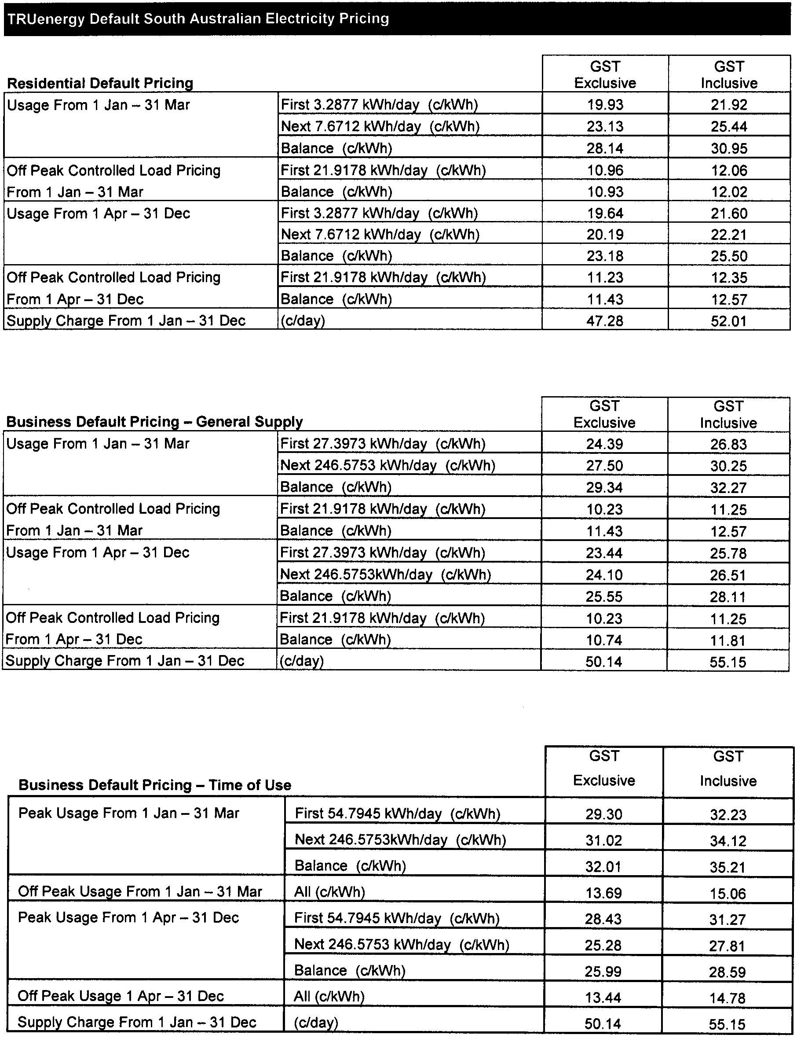
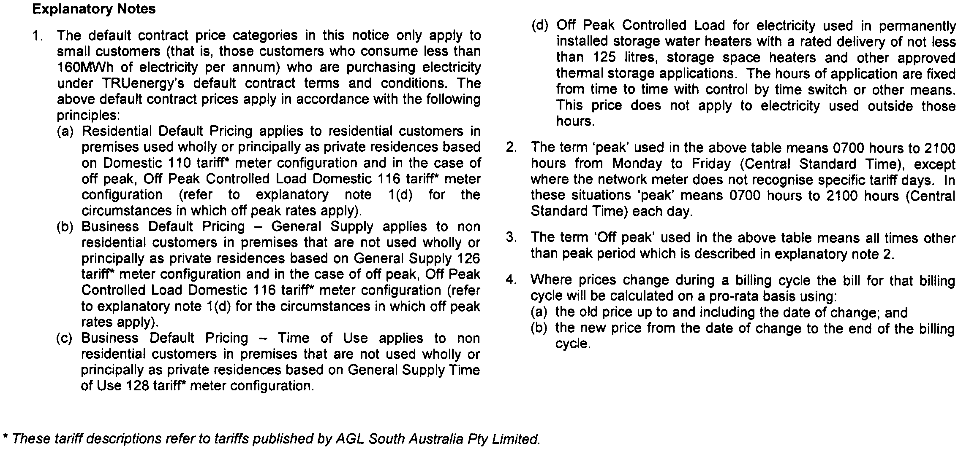

GAS ACT 1997

Default Contract Prices for Small Customers

IN accordance with section 34B of the Gas Act 1997 (SA), TRUenergy Pty Ltd (ABN 99 086 014 968) (‘TRUenergy’) hereby publishes its default gas contract prices for customers who are consuming less than one terajoule per annum of gas (‘small customers’). The default contract prices are set out below in this notice and will apply on and from 16 September 2010.

The default contract prices detailed in this notice apply to small customers of TRUenergy who are purchasing gas under TRUenergy’s Default Contract Terms and Conditions published in the Government Gazette on 1 April 2005.

TRUenergy reserves the right to change its default gas contract price from time to time acting in accordance with all applicable regulations.

Justification Statement
The default contract prices set out in this notice reflect TRUenergy’s total costs associated with providing gas to TRUenergy’s small customers in South Australia.

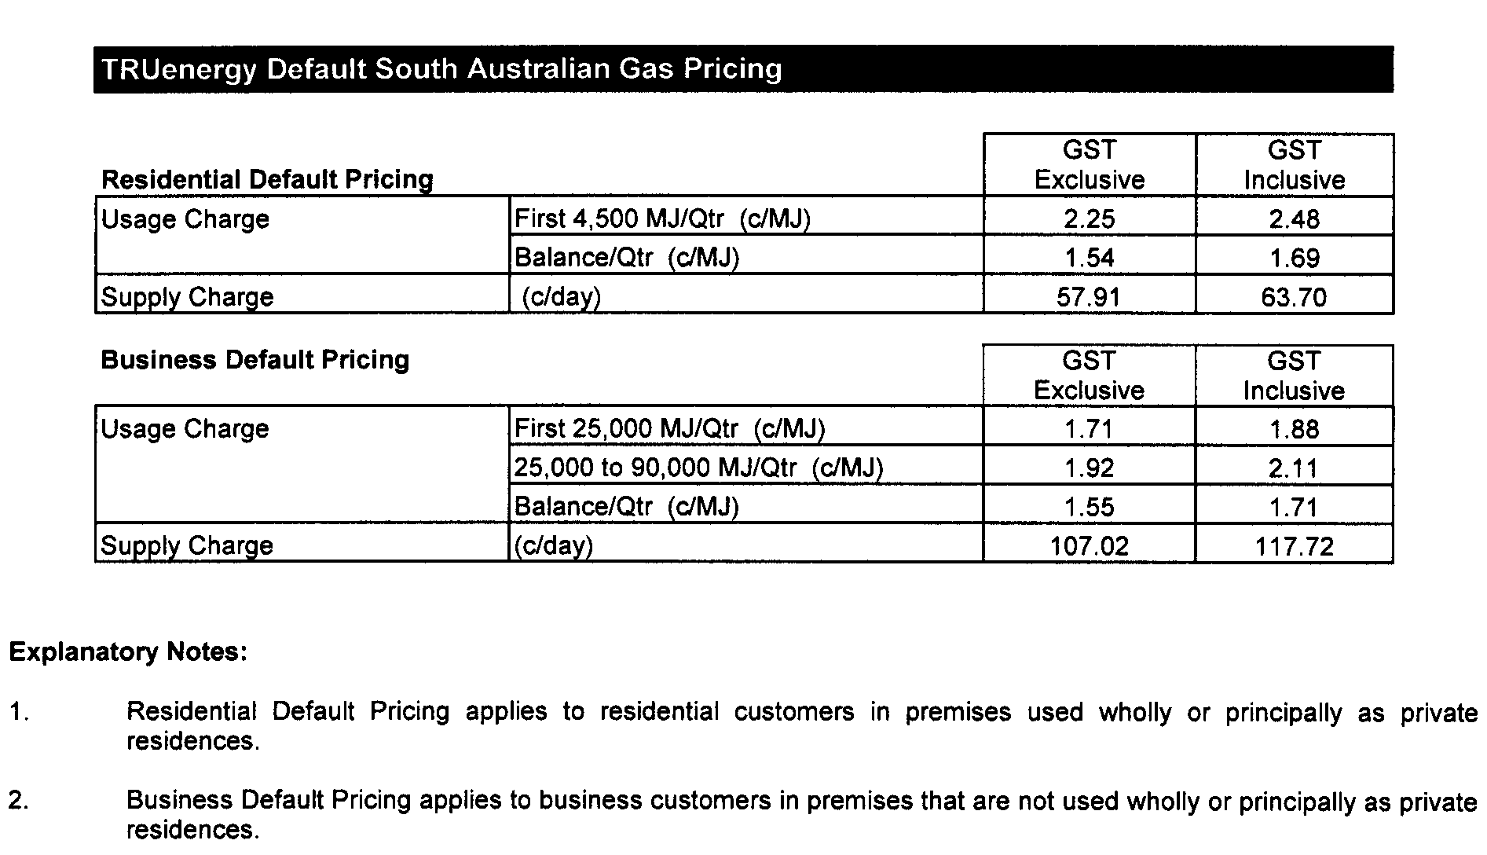

HEALTH CARE ACT 2008
Notice by the Minister
Declaration of Authorised Quality Improvement Activity and Authorised Person under Section 64
TAKE notice that I, John Hill, Minister for Health, pursuant to sections 64 (1) (a) (i) and (b) (i) do hereby:
DECLARE the Activities described in the Schedule to this declaration (the Activities) to be authorised quality improvement activities to which Part 7 of the Act applies.
DECLARE the Person or group of Persons (including a group formed as a committee) described in the Schedule to this declaration (the Persons) to be an authorised entity for the purposes of carrying out the authorised quality improvement activities to which Part 7 of the Act applies,
being satisfied that:
(a) the performance of the activities within the ambit of the declaration and the functions or activities of the person or group of persons within the ambit of the declaration, would be facilitated by the making of the declaration
(b) that the making of the declaration is in the public interest.
Dated 13 September 2010.
John Hill, Minister for Health

Schedule
Declaration of Authorised Quality Improvement Activity and Authorised Person under Section 64
Activity | Person or Group of Persons
Incident Review Quality Improvement | Adelaide Health Service  Lyell McEwin Hospital—  Incident Review Panel
Incident Review Quality Improvement | Adelaide Health Service  Royal Adelaide Hospital—  Incident Review Panel
Incident Review Quality Improvement | Adelaide Health Service  Modbury Hospital—  Incident Review Panel
Incident Review Quality Improvement | Adelaide Health Service  The Queen Elizabeth Hospital incorporating St Margaret’s Rehabilitation Hospital and Pregnancy Advisory Centre—  Incident Review Panel

HEALTH CARE ACT 2008
Notice by the Minister
Expiry of Authorisation under Schedule 4—Part 20, Section 38
TAKE notice that I, John Hill, Minister for Health, pursuant to Part 20, section 38 (2) and (3) do hereby:
FIX the sixteenth day of September 2010 as the date on which the authorisations under Part 7 section 64 as set out in the Schedule to this notice will expire.
Dated 13 September 2010.
John Hill, Minister for Health

HEALTH CARE ACT 2008
Notice by the Minister
Expiry of Authorisation under Schedule 4—Part 20, Section 38
Schedule
Calvary Health Care Adelaide Limited:
Hospital Executive Committee
Nursing Executive Committee
Pharmacy Committee (a Sub-Committee of the Medical Committee)
Infection Control Committee (a Sub-Committee of the Medical Committee)
Occupational Health and Safety Committee
Medical Committee
Critical Care Unit Sub-Committee
Allied Health Committee
Quality Committee
Admitting and Credentials Committee
Human Research Ethics Committee
Operating Suite Sub-Committee
Central Districts Private Hospital:
Obstetric Management Committee
Theatre Management Committee
Central Northern Adelaide Health Service:
Modbury Hospital
Perinatal Care Committee
Patient Safety Review Committee
Lyell McEwin Health Service
Infection Control Committee
Women and Children’s Division Quality Council
Division of Obstetrics, Gynaecology and Paediatrics Quality Council
Incident Review Panel
Royal Adelaide Hospital
Department of Neurosurgery Audit Group
Glenside Campus Clinical Indicators Committee
Sentinel Event Panel
The Queen Elizabeth Hospital and Health Service
Infection Control Committee
Safety and Quality Council
The Queen Elizabeth Hospital
Drugs Committee
Death Review Committee
Nursing Quality Improvement Committee
Western Domiciliary Care and Rehabilitation Services
Case Manager Working Party
Continuum of Care Committee
North Western Adelaide Mental Health Service
Clinical Standards Co-ordinating Committee
Western Area Clinical Standards Committee
Northern Area Clinical Standards Committee
Ethics of Human Research Committee
Health Care Ethics Committee
Manager, Quality Improvement and Evaluation
Cancer Registry
Continuum of Care Surgical Division Committee
Division of Surgery Morbidity and Mortality Committee
North Western Adelaide Health Service/Royal Adelaide Hospital
Incident Monitoring Committee
Royal Flying Doctors Service of Australia (Central Operations) Incorporated:
Medical Retrieval Committee—QA Sub-Committee
Southern Districts War Memorial Hospital and McLaren Vale Private Hospital:
Medical Advisory Continuous Quality Improvement Committee
South Australian Health Commission:
The staff of the SA Birth Defects Register

HEALTH CARE ACT 2008
Notice by the Minister
Declaration of Authorised Research Activity and Authorised Person under Section 64
TAKE notice that I, John Hill, Minister for Health, pursuant to sections 64 (1) (a) (i) and (b) (i) do hereby:
DECLARE the Activities described in the Schedule to this declaration (the Activities) to be authorised quality improvement activities to which Part 7 of the Act applies.
DECLARE the Person or group of Persons (including a group formed as a committee) described in the Schedule to this declaration (the Persons) to be an authorised entity for the purposes of carrying out the authorised quality improvement activities to which Part 7 of the Act applies,
being satisfied that:
(a) the performance of the activities within the ambit of the declaration and the functions or activities of the person or group of persons within the ambit of the declaration, would be facilitated by the making of the declaration
(b) that the making of the declaration is in the public interest.
Dated 13 September 2010.
John Hill, Minister for Health

Schedule
Declaration of Authorised Research Activity and Authorised Person under Section 64
Activity | Person or Group of Persons
Birth Defects Register | Children, Youth and Women’s Health Service  The South Australian Birth Defects Register

B. MORRIS, Government Printer, South Australia

