No. 58 3393

THE SOUTH AUSTRALIAN

GOVERNMENT GAZETTE
www.governmentgazette.sa.gov.au

PUBLISHED BY AUTHORITY

ALL PUBLIC ACTS appearing in this GAZETTE are to be considered official, and obeyed as such

ADELAIDE, THURSDAY, 11 AUGUST 2011

CONTENTS

Page
Appointments, Resignations, Etc. 3394
Aquaculture Act 2001—Notice 3394
Brands Act 1993—Notice 3395
Corporations and District Councils—Notices 3439
Development Act 1993—Notice 3413
Electricity Act 1996—Notice 3412
Environment Protection Act 1993—Notice 3404
Fisheries Management Act 2007—Notices 3413
Land Acquisition Act 1969—Notice 3416
Liquor Licensing Act 1997—Notices 3416
Local Government Act 1999—Notice 3419
Natural Resources Management Act 2004—
Notices 3425

Page
Petroleum and Geothermal Energy Act 2000—
Notices 3426
Plant Health Act 2009—Notice 3428
Public Trustee Office—Administration of Estates 3441
Rail Safety Act 2007—Notice 3431
REGULATION
Fair Trading Act 1987—
(No. 194 of 2011) 3433
Roads (Opening and Closing) Act 1991—
Notice 3431
Erratum 3431
Survey Act 1992—Notice 3431
Transport, Department of—Notices to Mariners 3432

GOVERNMENT GAZETTE NOTICES
ALL poundkeepers’ and private advertisements forwarded for publication in the South Australian Government Gazette must be PAID FOR PRIOR TO INSERTION; and all notices, from whatever source, should be legibly written on one side of the paper only and sent to Government Publishing SA so as to be received no later
than 4 p.m. on the Tuesday preceding the day of publication. Phone 8207 1045 or Fax 8207 1040. E-mail: governmentgazette@dpc.sa.gov.au. Send as attachments in Word format and please confirm your transmission with a faxed copy of your document, including the date the notice is to be published and to whom the notice will be charged. The Government Gazette is available online at: www.governmentgazette.sa.gov.au

Department of the Premier and Cabinet
Adelaide, 11 August 2011
HIS Excellency the Governor’s Deputy in Executive Council has been pleased to appoint the undermentioned to the Development Policy Advisory Committee, pursuant to the provisions of the Development Act 1993:
Member: (from 11 August 2011 until 10 August 2013)
Mario Barone
Gary Robert Mavrinac
Steven Peter Hooper
Demetrius Photios Poupoulas
Michael Klobas
Carol Anne Muzyk
Elizabeth Helen Alexandra Hollidge
Carol Vincent
Rosa Lucia Gagetti
Susan Mary Filby
Presiding Member: (from 11 August 2011 until 10 August 2013)
Mario Barone
By command,
Grace Portolesi, for Premier
UPA0067/11CS

Department of the Premier and Cabinet
Adelaide, 11 August 2011
HIS Excellency the Governor’s Deputy in Executive Council has been pleased to appoint the Honourable Jennifer Mary Rankine, MP, Minister for Families and Communities, Minister for Housing, Minister for Ageing and Minister for Disability to be also Acting Minister for Regional Development, Acting Minister for Public Sector Management, Acting Minister for the Status of Women, Acting Minister for Consumer Affairs, Acting Minister for Government Enterprises and Acting Minister for Gambling for the period from 20 August 2011 to 2 September 2011 inclusive, during the absence of the Honourable Gail Elizabeth Gago, MLC.
By command,
Grace Portolesi, for Premier
11MRD0003CS

Department of the Premier and Cabinet
Adelaide, 11 August 2011
HIS Excellency the Governor’s Deputy in Executive Council has been pleased to appoint the Honourable Patrick Frederick Conlon, MP, Minister for Transport and Minister for Infrastructure to be also Acting Minister for Health, Acting Minister for Mental Health and Substance Abuse, Acting Minister for the Southern Suburbs and Acting Minister Assisting the Premier in the Arts for the period from 15 August 2011 to 26 August 2011 inclusive, during the absence of the Honourable John David Hill, MP.
By command,
Grace Portolesi, for Premier
HEAC-2011-00042

Department of the Premier and Cabinet
Adelaide, 11 August 2011
HIS Excellency the Governor’s Deputy in Executive Council has been pleased to appoint John Broughton Agnew as a part-time Commissioner of the Environment, Resources and Development Court of South Australia and designate him as a Commissioner for the purposes of the Court's jurisdiction under the Environment Protection Act 1993 for a term of three years commencing on 11 August 2011 and expiring on 10 August 2014, pursuant to Section 10 of the Environment, Resources and Development Court Act 1993.
By command,
Grace Portolesi, for Premier
AGO0211/10CS

Department of the Premier and Cabinet
Adelaide, 11 August 2011
HIS Excellency the Governor’s Deputy in Executive Council has been pleased to appoint Jennifer Margaret McKay as a part-time Commissioner of the Environment, Resources and Development Court of South Australia and designate her as a Commissioner for the purposes of the Court's jurisdiction under the Natural Resources Management Act 2004 for a term of three years commencing on 11 August 2011 and expiring on 10 August 2014, pursuant to Section 10 of the Environment, Resources and Development Court Act 1993.
By command,
Grace Portolesi, for Premier
AGO0211/10CS

Department of the Premier and Cabinet
Adelaide, 11 August 2011
HIS Excellency the Governor’s Deputy in Executive Council has been pleased to appoint Peter John Doggett as the Rail Commissioner for a term of five years commencing on 11 August 2011 and expiring on 10 August 2016, pursuant to Section 5 of the Rail Commissioner Act 2009.
By command,
Grace Portolesi, for Premier
MTR/11/072

Department of the Premier and Cabinet
Adelaide, 11 August 2011
HIS Excellency the Governor’s Deputy in Executive Council has revoked the appointment of Chor Soon Wong, as an Inspector of Mines, effective from 11 August 2011, pursuant to the provisions of the Mines and Works Inspection Act 1920 and Section 36 of the Acts Interpretation Act 1915.
By command,
Grace Portolesi, for Premier
MRD11/006SC

Department of the Premier and Cabinet
Adelaide, 11 August 2011
HIS Excellency the Governor’s Deputy in Executive Council has been pleased to appoint Chor Shoon Wong as an Inspector of Mines commencing on 11 August 2011, pursuant to Section 6 of the Mines and Works Inspection Act 1920.
By command,
Grace Portolesi, for Premier
MRD11/006SC

AQUACULTURE ACT 2001
Grant of Aquaculture Lease
PURSUANT to the provisions of Section 22 of the Aquaculture Act 2001, I, Michael O’Brien, Minister for Agriculture and Fisheries, hereby gives notice of the grant of the following lease for the purposes of aquaculture in the waters of the state:
LA00186
Further details are available for the above lease granted on the PIRSA Aquaculture Public Register, which can be found at:
https://info.pir.sa.gov.au/aquapr/page/gui3/map.html.
Michael O’Brien, Minister for Agriculture and Fisheries

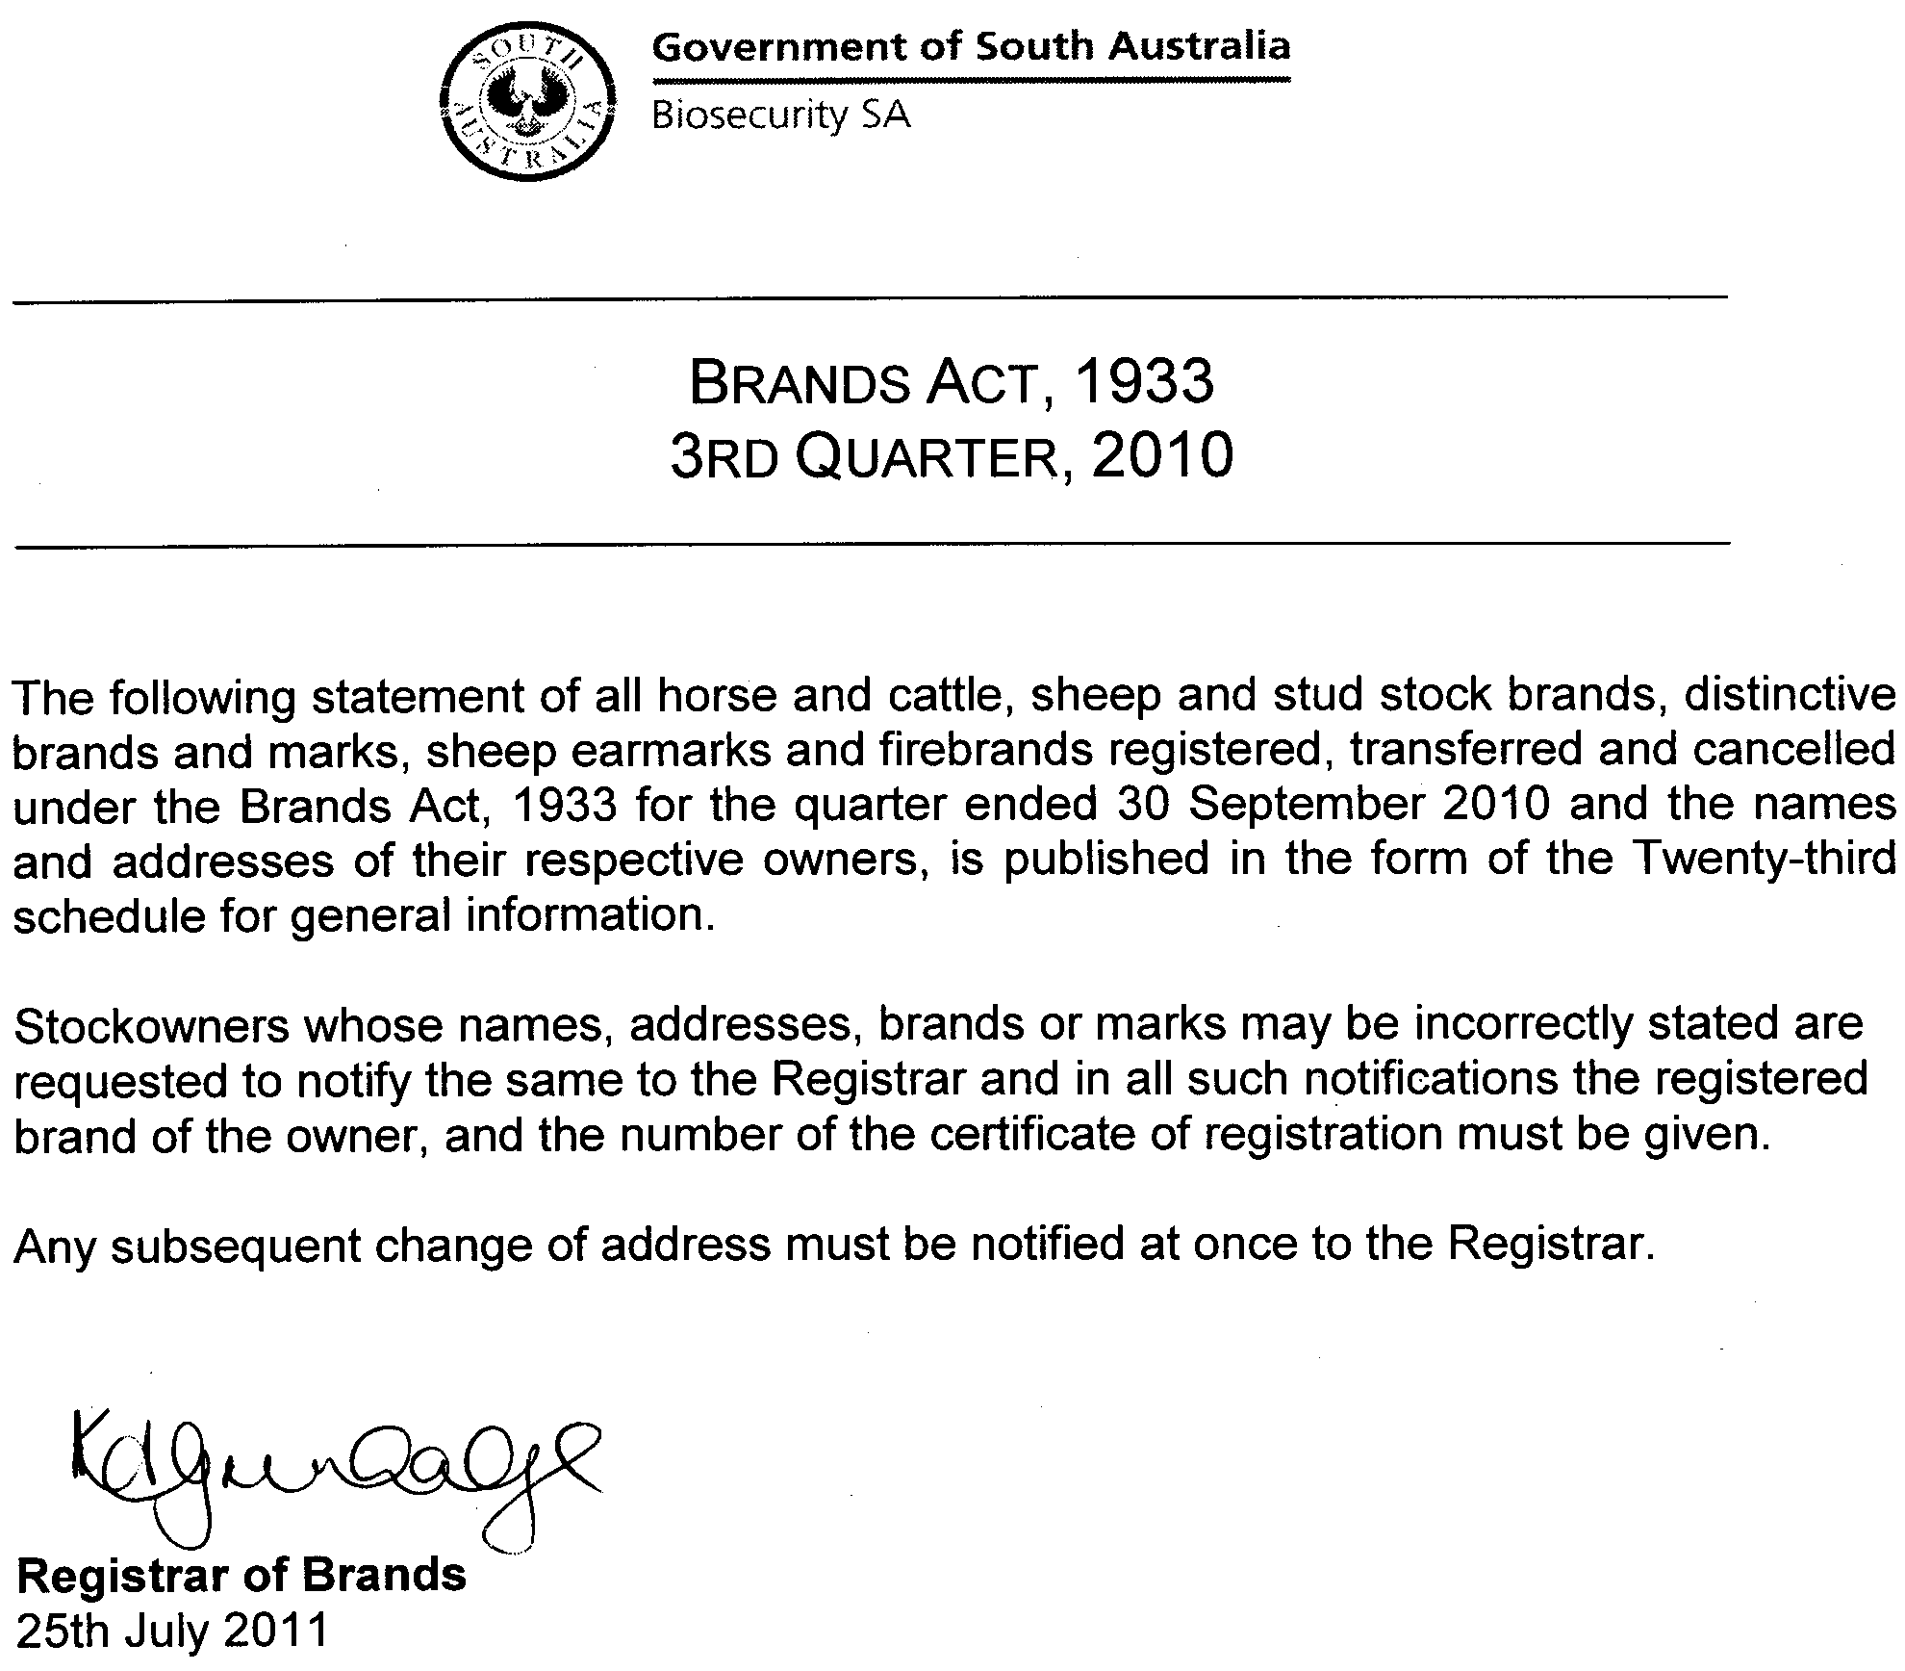
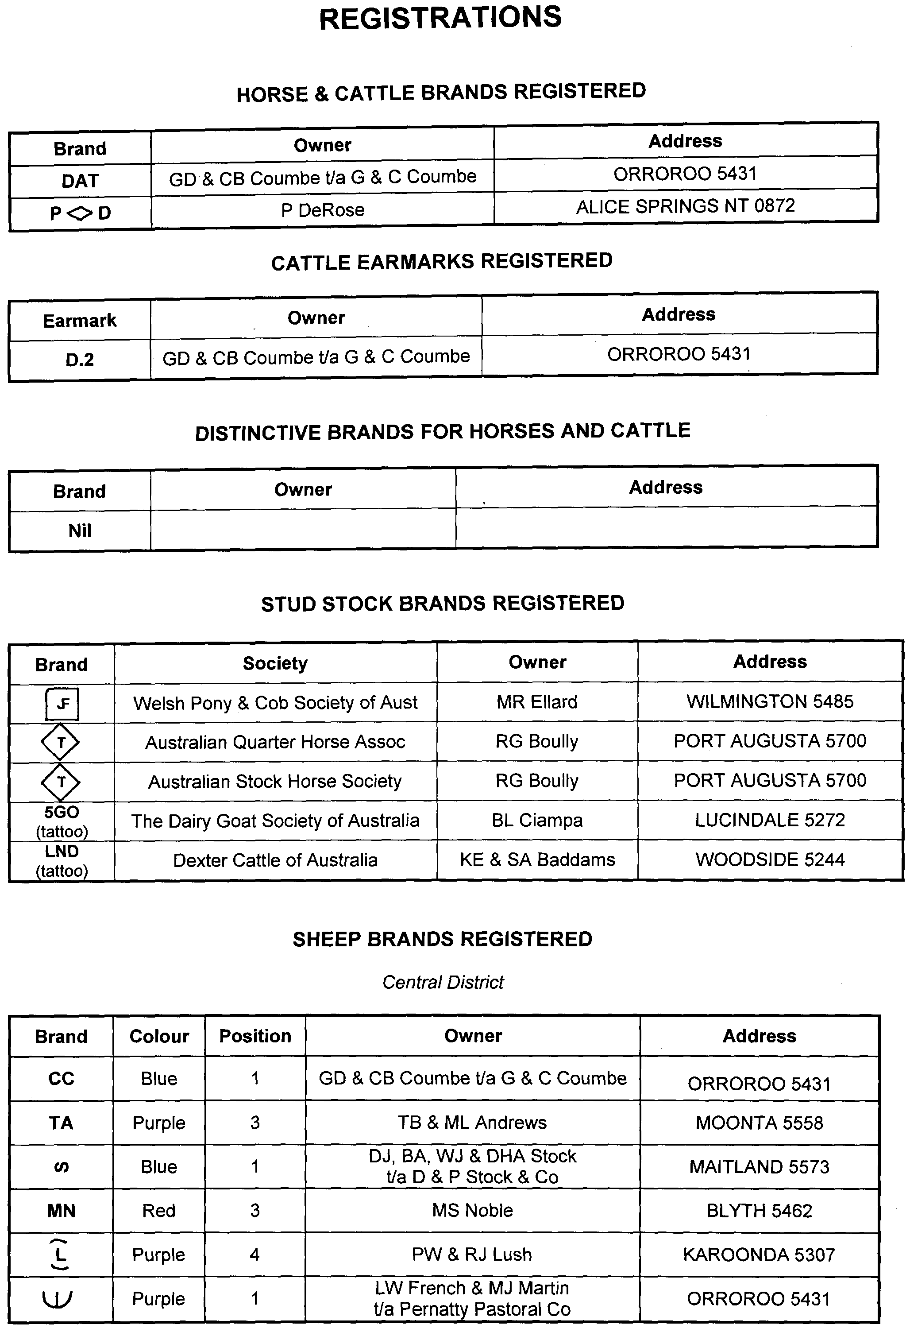
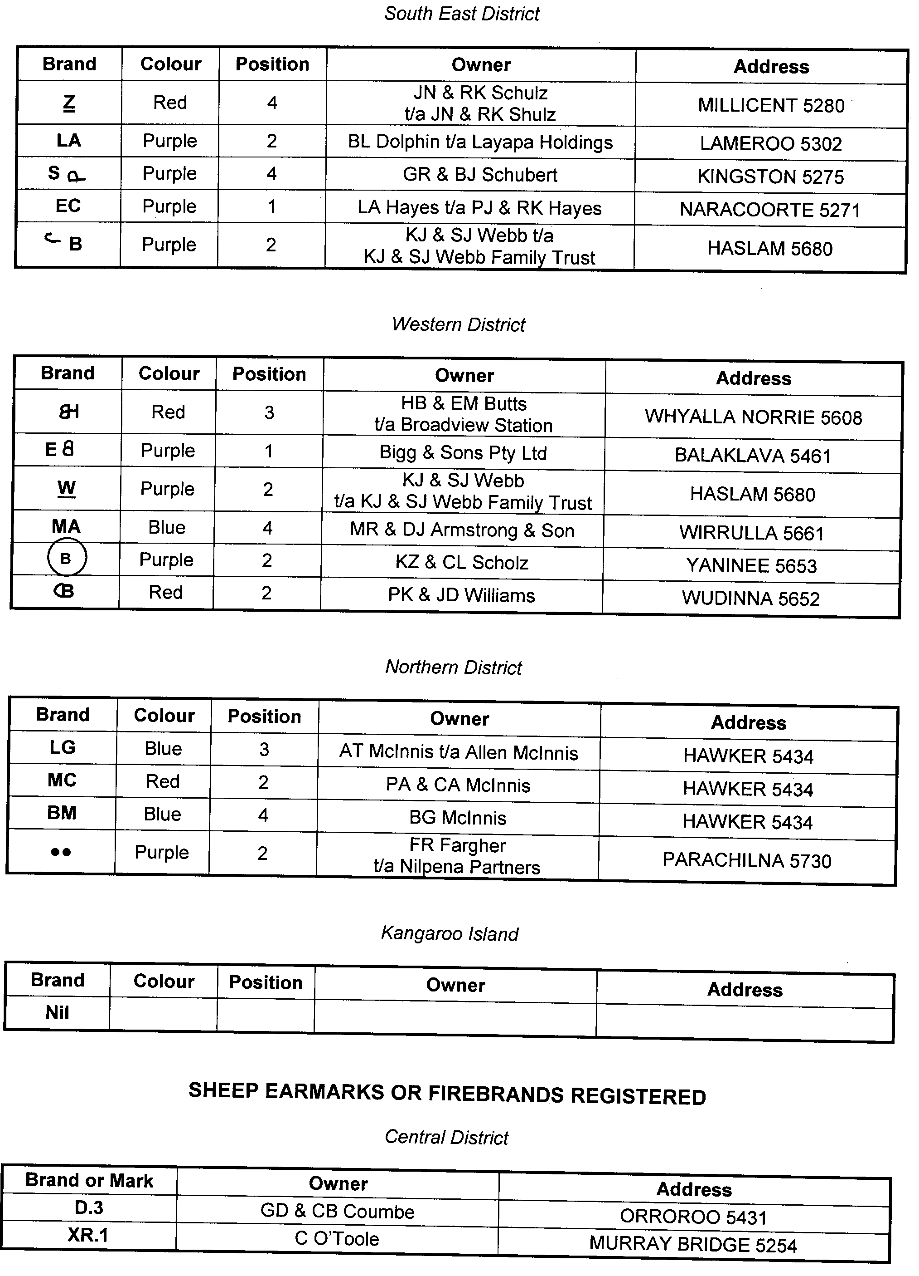
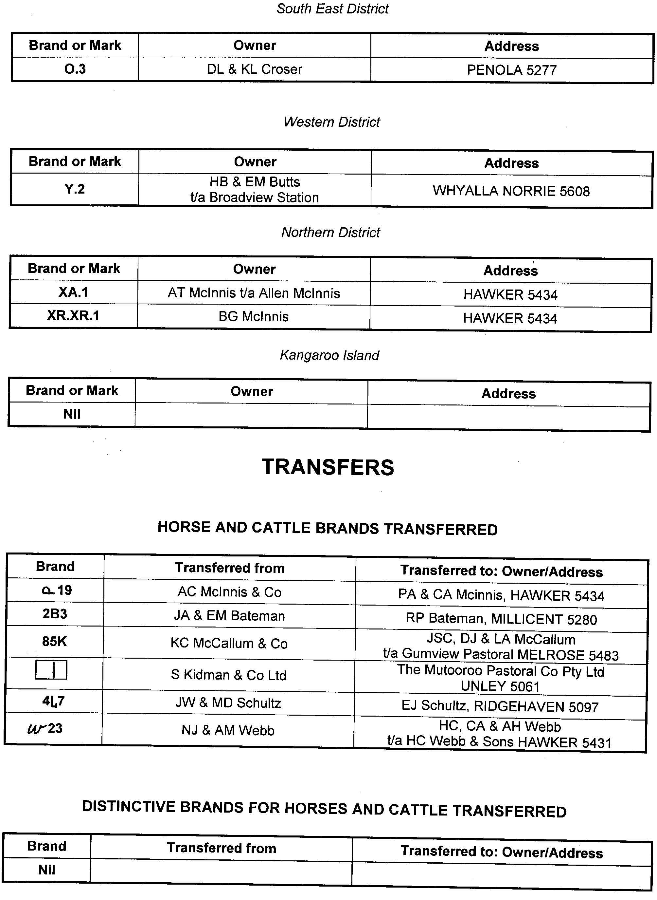
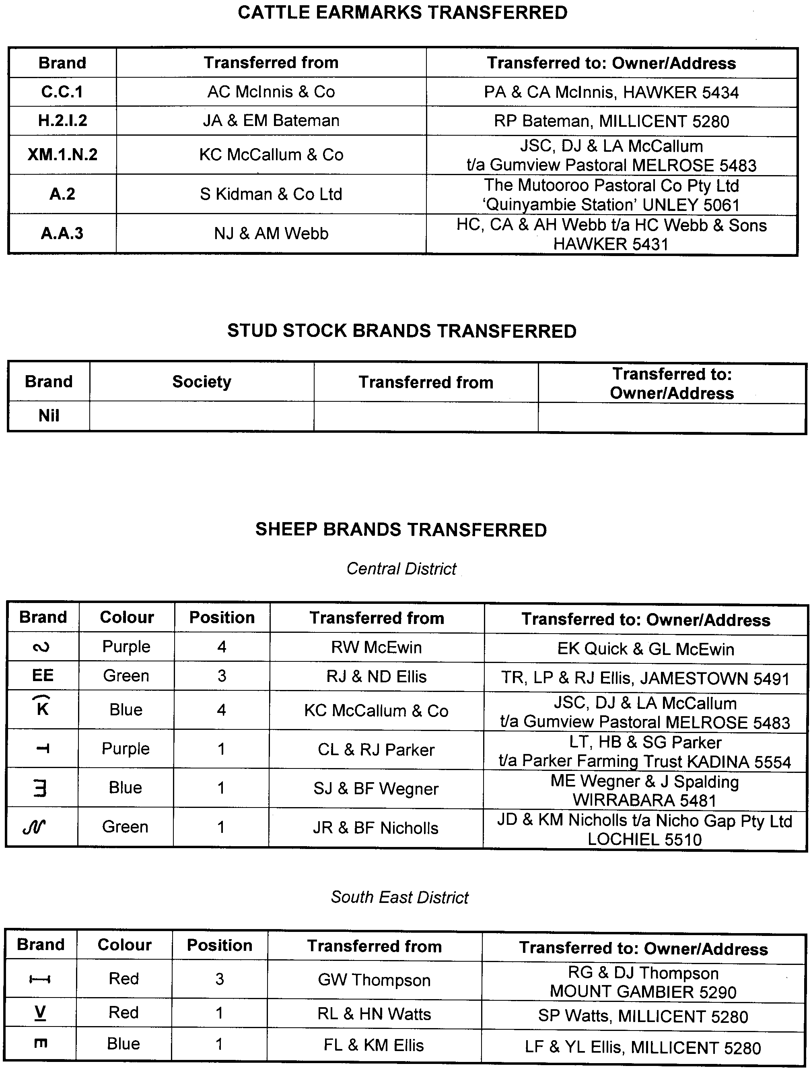
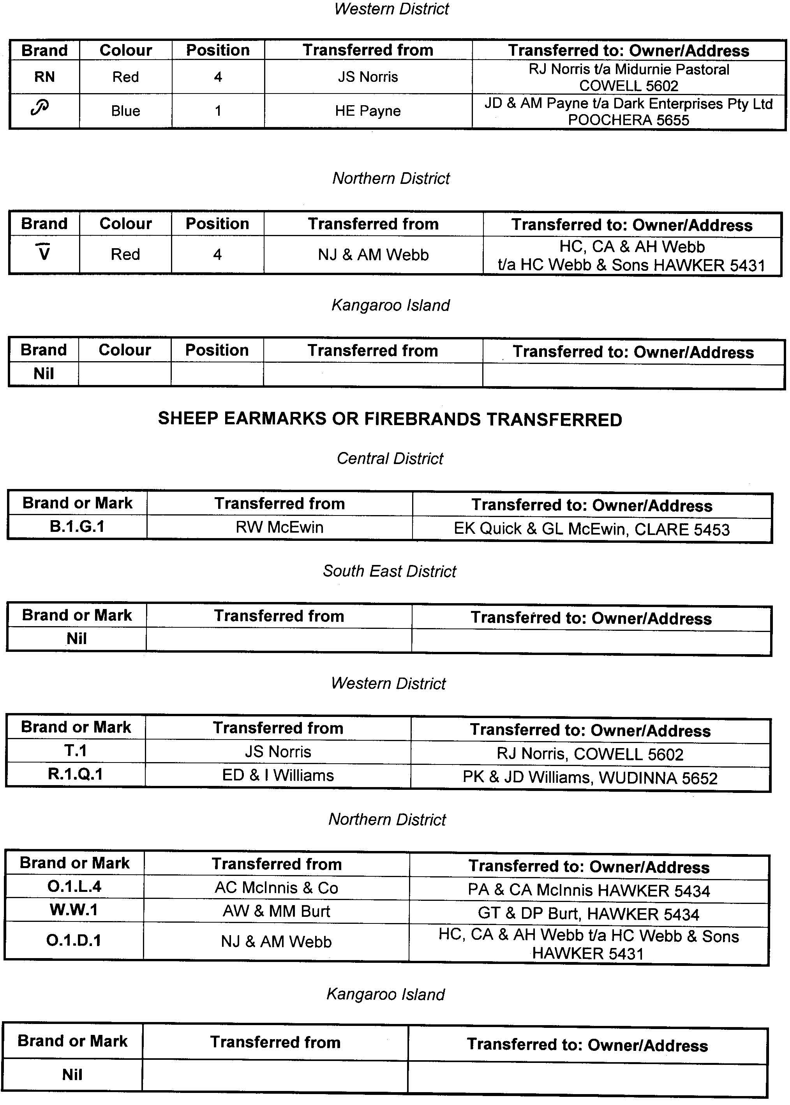
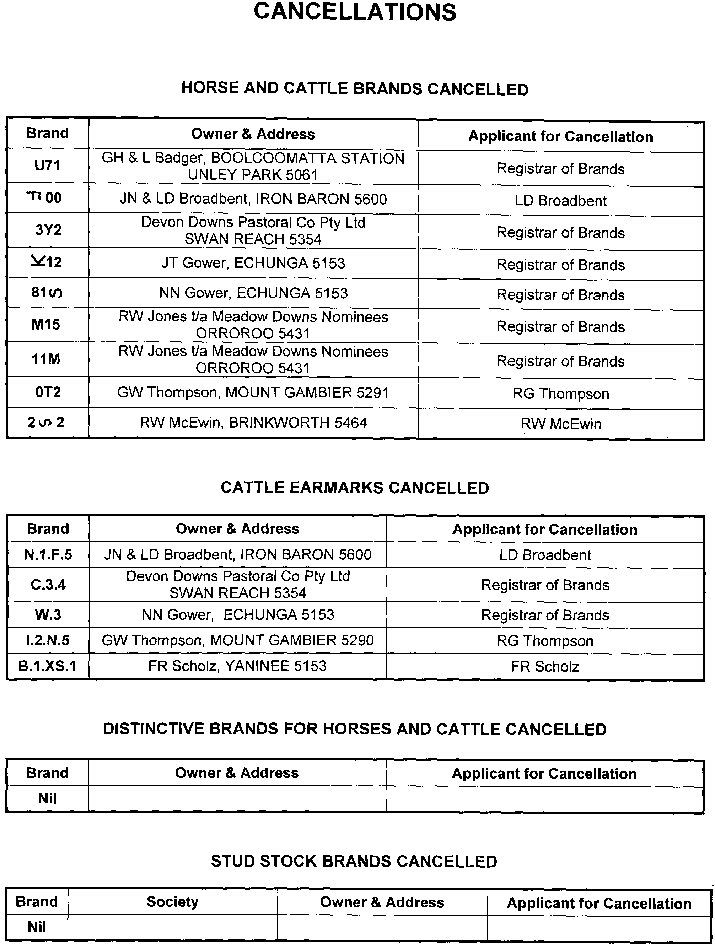
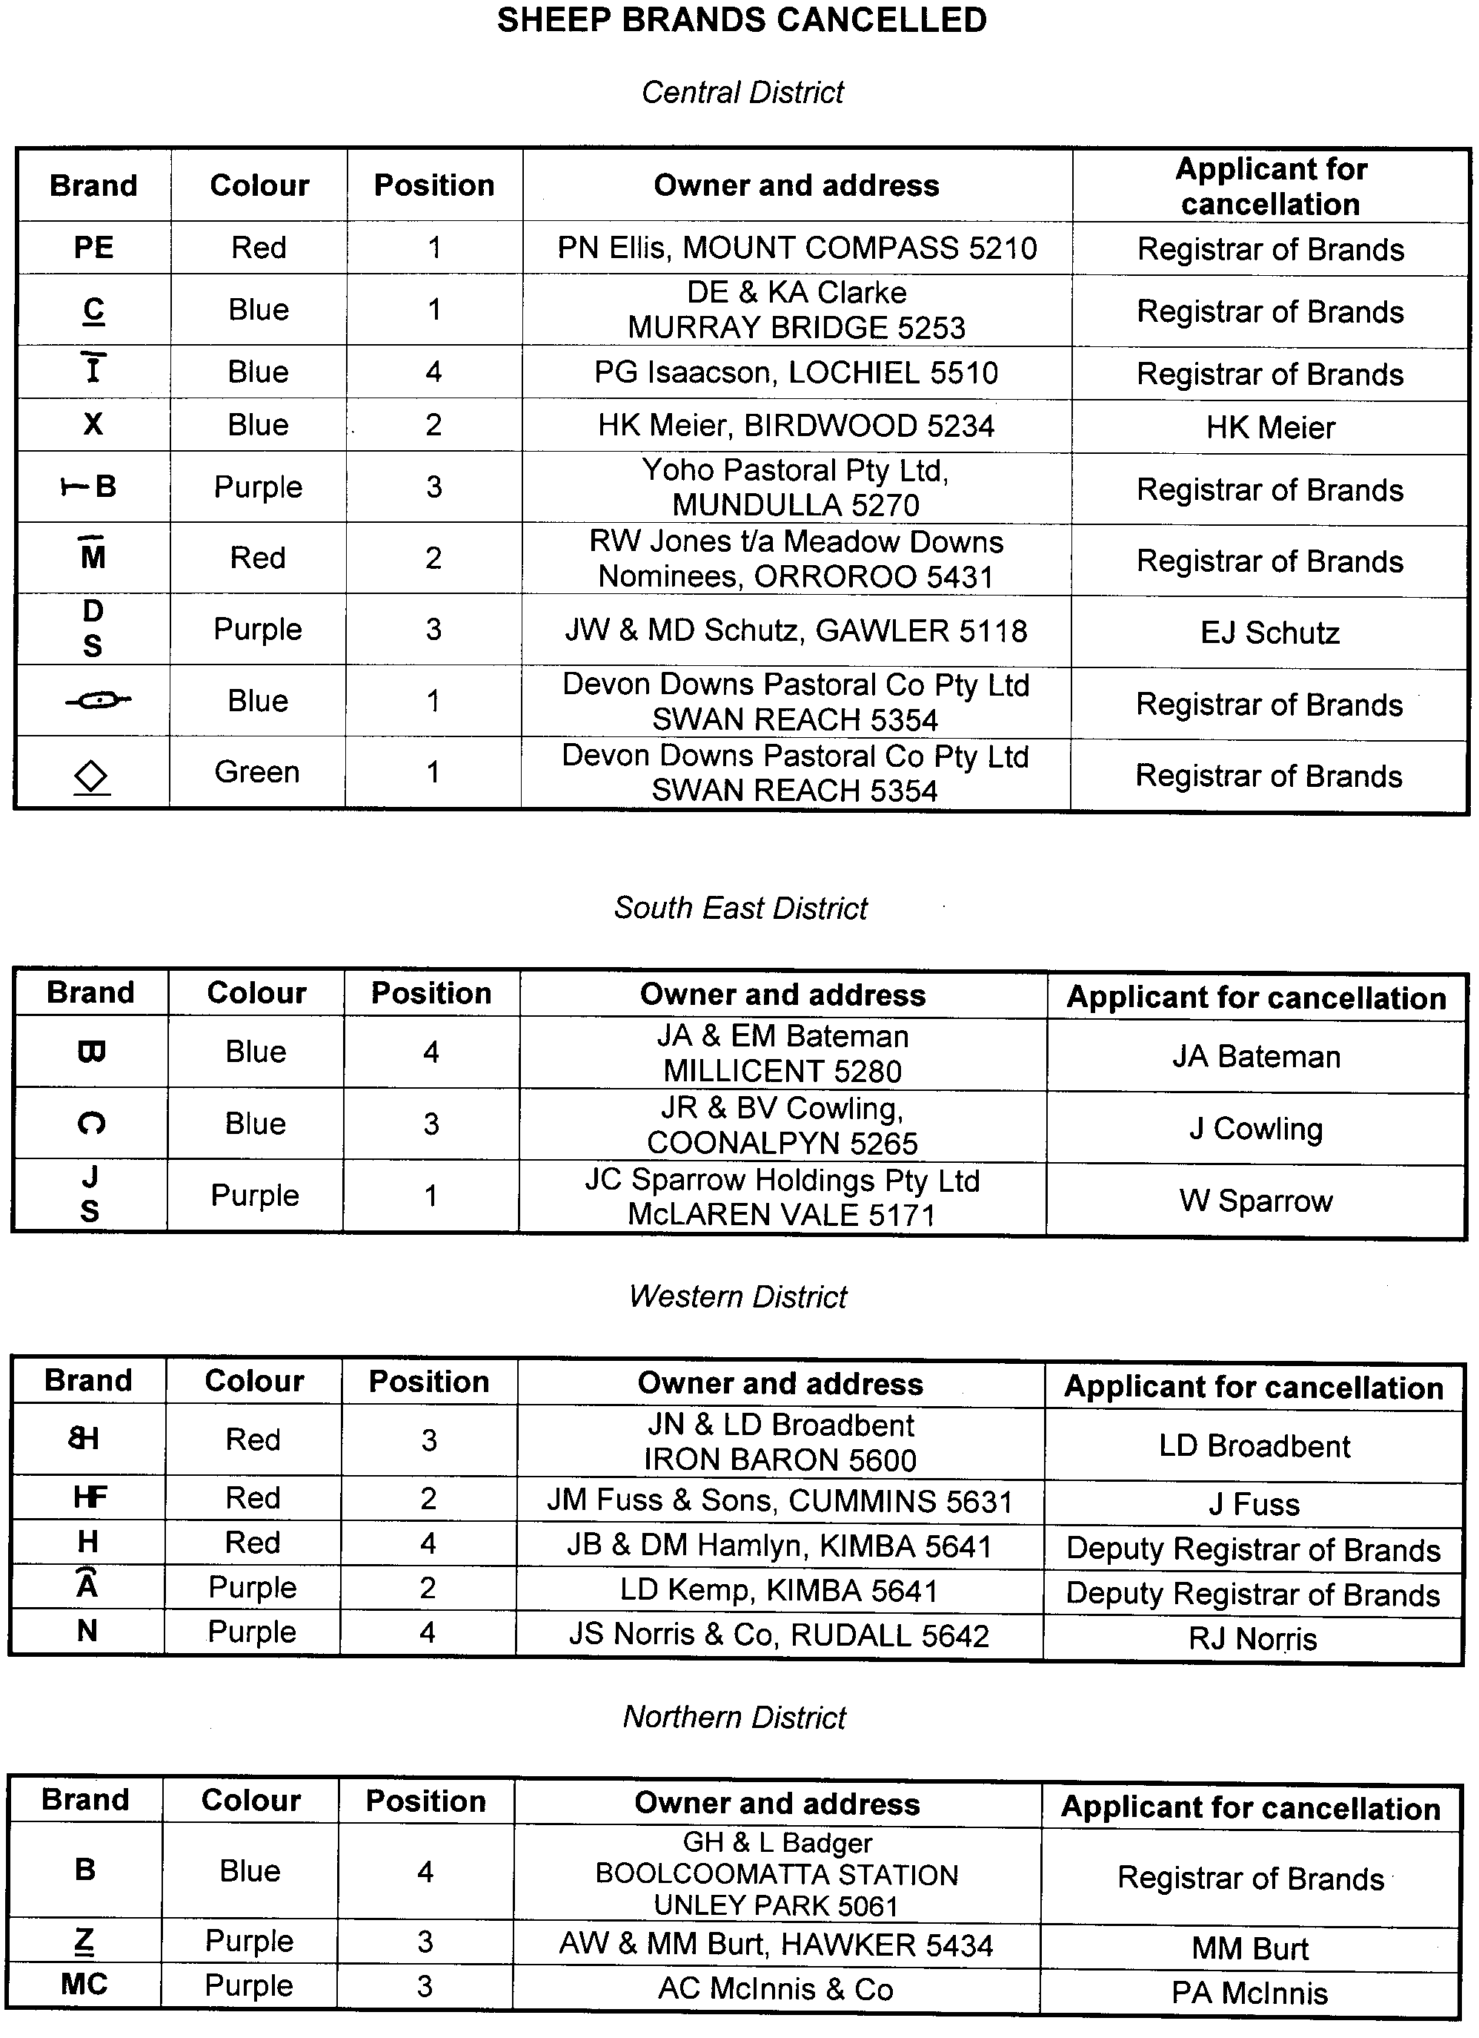
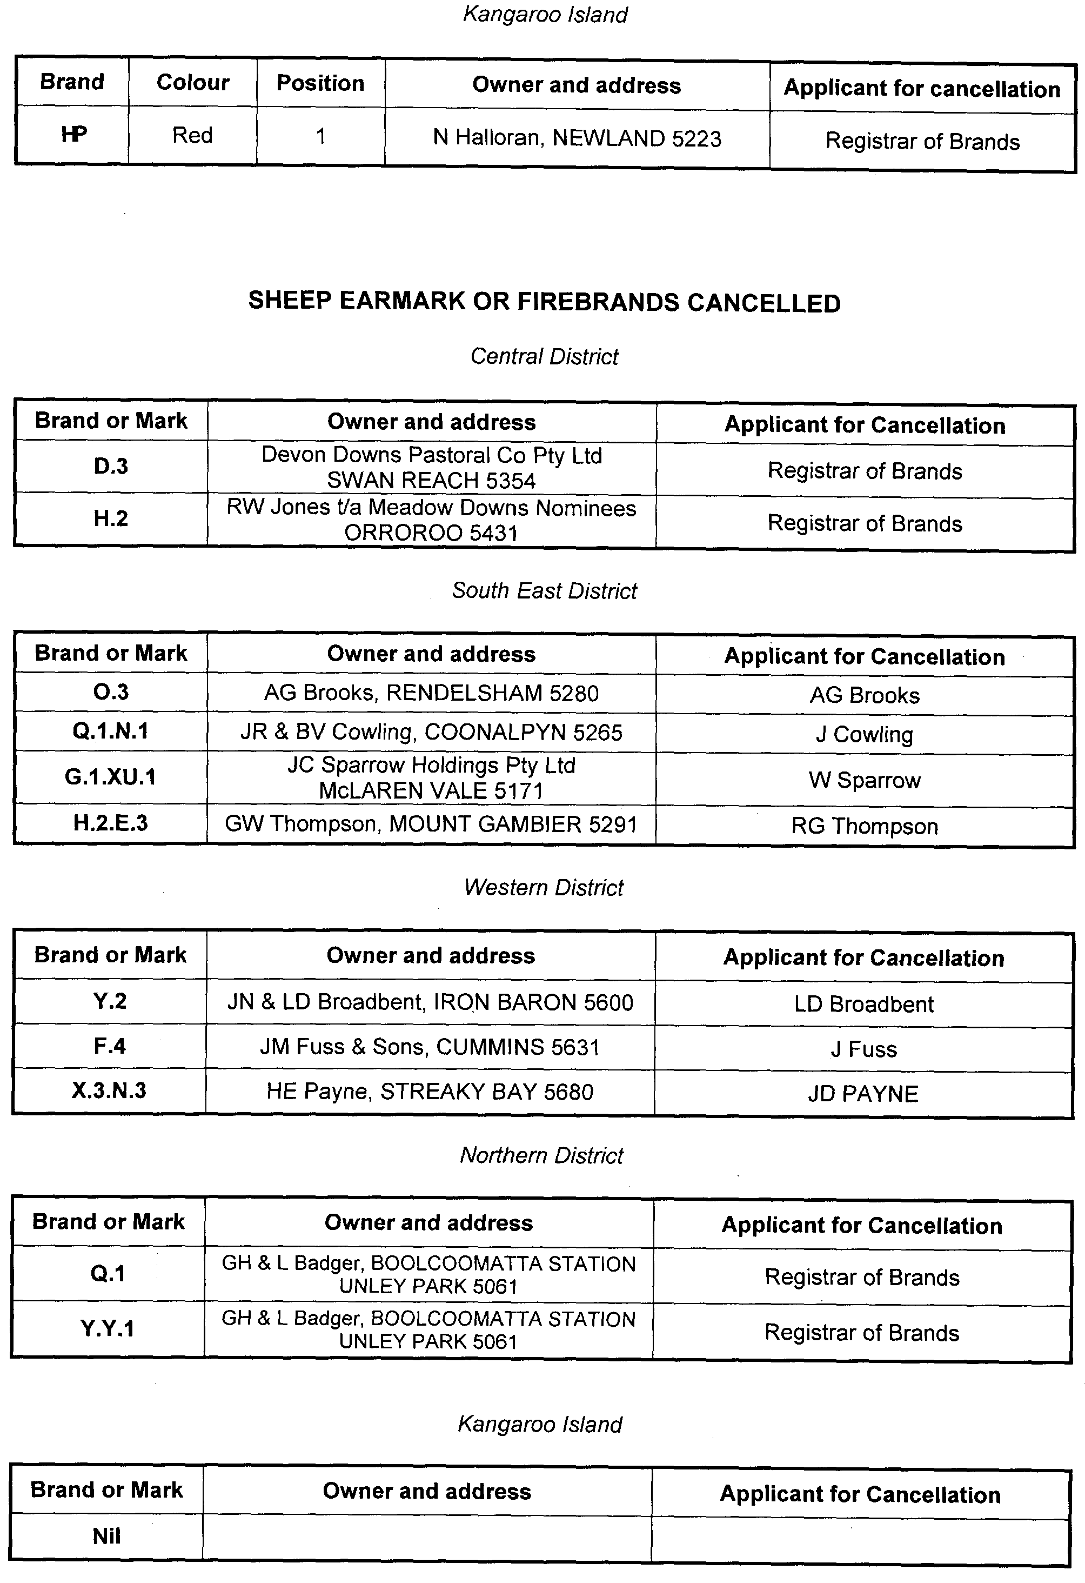

ENVIRONMENT PROTECTION ACT 1993
Vary the Approval of Category B Containers
I, ANDREA KAYE WOODS, Delegate of the Environment Protection Authority (‘the Authority’), pursuant to Section 68 of the Environment Protection Act 1993 (SA) (‘the Act’) hereby:
Vary the Approval of Category B Containers
Approve as Category B Containers, subject to the Conditions 1-4 below, each of the classes of containers identified by reference to the following matters described in the first 4 columns of Schedule 1 of this Notice which are sold in South Australia and were previously approved under the name of Berri Limited:
(a) the product which each class of containers shall contain;
(b) the size of the containers;
(c) the type of containers; and
(d) the name of the holders of these approvals.
(1) That containers of the class to which the approval relates must bear the refund marking specified by the Authority for containers of that class.
(2) The holder of the approval must have in place an effective and appropriate waste management arrangement in relation to containers of that class. For the purpose of this approval notice the company named in Column 5 of Schedule 1 of this Notice is the nominated super collector.
(3) In the case of an approval in relation to Category B containers that the waste management arrangement must require the holder of the approval to provide specified super collectors with a declaration in the form determined by the Authority in relation to each sale of such containers by the holder of the approval as soon as practicable after the sale.
(4) The holder of these approvals must ensure that if a sticker bearing the refund marking has been approved, and is applied to the container, then the sticker must not be placed on any portion of the opening mechanism or in any other place that would require complete or partial removal of the sticker before the contents may be consumed.
Schedule 1

Column 1 | Column 2 | Column 3 | Column 4 | Column 5
Product Name | Container  size (mL) | Container Type | Approval Holder | Waste Management Arrangement
Australian Fresh Apple & Mango Juice | 400 | HDPE | National Foods Ltd | Statewide Recycling
Australian Fresh Apple Mango | 400 | HDPE | National Foods Ltd | Statewide Recycling
Australian Fresh Apple Orange + Iron | 400 | HDPE | National Foods Ltd | Statewide Recycling
Australian Fresh Apple Passionfruit | 400 | HDPE | National Foods Ltd | Statewide Recycling
Australian Fresh Apple Strawberry | 400 | HDPE | National Foods Ltd | Statewide Recycling
Australian Fresh Orange Juice | 400 | HDPE | National Foods Ltd | Statewide Recycling
Australian Fresh Super Green Zone Mango | 400 | HDPE | National Foods Ltd | Statewide Recycling
Australian Fresh Super Juice Immune | 400 | HDPE | National Foods Ltd | Statewide Recycling
Australian Fresh Super Juice Kickstart | 400 | HDPE | National Foods Ltd | Statewide Recycling
Australian Fresh plus Premium Orange Vitamins AC&E | 400 | HDPE | National Foods Ltd | Statewide Recycling
Australian Fresh plus Premium Orange With Calcium | 400 | HDPE | National Foods Ltd | Statewide Recycling
Australian Fresh plus Premium Orange With Iron | 400 | HDPE | National Foods Ltd | Statewide Recycling
Berri Apple | 150 | LPB—Aseptic | National Foods Ltd | Statewide Recycling
Berri Apple & Banana Mango Juice Long Life | 375 | Glass | National Foods Ltd | Statewide Recycling
Berri Apple & Blackcurrant Fruit Juice | 400 | PET | National Foods Ltd | Statewide Recycling
Berri Apple Blackcurrant Juice Long Life | 375 | Glass | National Foods Ltd | Statewide Recycling
Berri Apple Banana Mango Juice Long Life | 300 | PET | National Foods Ltd | Statewide Recycling
Berri Apple Blackcurrant | 150 | LPB—Aseptic | National Foods Ltd | Statewide Recycling
Berri Apple Blackcurrant Juice | 250 | LPB—Aseptic | National Foods Ltd | Statewide Recycling
Berri Apple Blackcurrant Juice Long Life | 300 | PET | National Foods Ltd | Statewide Recycling
Berri Apple Blackcurrant Juice Long Life | 250 | Glass | National Foods Ltd | Statewide Recycling
Berri Apple Fruit Cup | 150 | LPB—Aseptic | National Foods Ltd | Statewide Recycling
Berri Apple Fruit Drink | 3 000 | PET | National Foods Ltd | Statewide Recycling
Berri Apple Fruit Juice | 400 | PET | National Foods Ltd | Statewide Recycling
Berri Apple Juice | 250 | LPB—Aseptic | National Foods Ltd | Statewide Recycling
Berri Apple Juice Long Life | 250 | Glass | National Foods Ltd | Statewide Recycling
Berri Apple Juice Long Life | 375 | Glass | National Foods Ltd | Statewide Recycling
Berri Apple Low GI Juice Long Life | 300 | PET | National Foods Ltd | Statewide Recycling
Berri Apple Mango & Banana Fruit Juice | 400 | PET | National Foods Ltd | Statewide Recycling
Berri Apple Passionfruit | 250 | LPB—Aseptic | National Foods Ltd | Statewide Recycling
Berri Apple Pear | 150 | LPB—Aseptic | National Foods Ltd | Statewide Recycling
Berri Apricot Fruit Drink | 2 400 | PET | National Foods Ltd | Statewide Recycling
Berri Apricot Nectar | 170 | Can—Steel | National Foods Ltd | Statewide Recycling
Berri Apricot Nectar | 405 | Can—Steel | National Foods Ltd | Statewide Recycling
Berri Apricot Nectar Long Life | 850 | Can—Steel | National Foods Ltd | Statewide Recycling
Berri Apricot Nectar Long Life | 400 | Can—Steel | National Foods Ltd | Statewide Recycling
Berri Cranberry & Ruby Red Grapefruit Drink | 1 500 | Glass | National Foods Ltd | Statewide Recycling
Berri Cranberry Fruit Drink | 1 500 | Glass | National Foods Ltd | Statewide Recycling
Berri Harmonics Apple Carrot Orange & Lemon Juice | 300 | PET | National Foods Ltd | Statewide Recycling
Berri Harmonics Cranberry Drink | 1 500 | LPB—Aseptic | National Foods Ltd | Statewide Recycling
Berri Harmonics Cranberry Drink | 300 | PET | National Foods Ltd | Statewide Recycling
Berri Harmonics Cranberry Drink | 1 000 | PET | National Foods Ltd | Statewide Recycling
Berri Harmonics Vegetable Juice | 300 | PET | National Foods Ltd | Statewide Recycling
Berri Iced Blue Haven | 250 | LPB—Aseptic | National Foods Ltd | Statewide Recycling
Berri Iced Chocolate | 250 | LPB—Aseptic | National Foods Ltd | Statewide Recycling
Berri Iced Coffee | 250 | LPB—Aseptic | National Foods Ltd | Statewide Recycling
Berri Iced French Vanilla | 250 | LPB—Aseptic | National Foods Ltd | Statewide Recycling
Berri Iced Strawberry | 250 | LPB—Aseptic | National Foods Ltd | Statewide Recycling
Berri Juice It Up Colour Purple | 800 | PET | National Foods Ltd | Statewide Recycling
Berri Juice It Up Colour Purple | 250 | PET | National Foods Ltd | Statewide Recycling
Berri Juice It Up Glow N Go | 800 | PET | National Foods Ltd | Statewide Recycling
Berri Juice It Up Glow N Go | 250 | PET | National Foods Ltd | Statewide Recycling
Berri Juice It Up Grasshopper | 250 | PET | National Foods Ltd | Statewide Recycling
Berri Juice It Up Grasshopper | 800 | PET | National Foods Ltd | Statewide Recycling
Berri Juice It Up Round The Clock | 800 | PET | National Foods Ltd | Statewide Recycling
Berri Juice It Up Round The Clock | 250 | PET | National Foods Ltd | Statewide Recycling
Berri Low Acid Orange | 300 | PET | National Foods Ltd | Statewide Recycling
Berri Morning Start no added sugar Juice | 250 | LPB—Aseptic | National Foods Ltd | Statewide Recycling
Berri Multi V Apple & Mango Juice with Antioxidants Vitamin A C & E | 400 | PET | National Foods Ltd | Statewide Recycling
Berri Multi V Apple Juice with Fibre Vitamin C & E & Folate | 400 | PET | National Foods Ltd | Statewide Recycling
Berri Multi V Breakfast Juice with Folate Vitamin A & C | 400 | PET | National Foods Ltd | Statewide Recycling
Berri Multi V Juice | 400 | PET | National Foods Ltd | Statewide Recycling
Berri Multi V Juice Long Life | 300 | PET | National Foods Ltd | Statewide Recycling
Berri Multi V With Added Calcium Vitamin A C & Folate Orange Juice | 250 | LPB—Aseptic | National Foods Ltd | Statewide Recycling
Berri Multi V With Added Fibre Vitamin C E & Folate Apple Juice | 250 | LPB—Aseptic | National Foods Ltd | Statewide Recycling
Berri Multi V With Added Folate Vitamin A & C Breakfast Juice | 250 | LPB—Aseptic | National Foods Ltd | Statewide Recycling
Berri Multi V With Antioxidants Vitamin A C & E Apple & Mango Juice | 250 | LPB—Aseptic | National Foods Ltd | Statewide Recycling
Berri Multi V no added sugar Juice | 250 | LPB—Aseptic | National Foods Ltd | Statewide Recycling
Berri Orange Fruit Drink | 3 000 | PET | National Foods Ltd | Statewide Recycling
Berri Orange Fruit Juice | 400 | PET | National Foods Ltd | Statewide Recycling
Berri Orange Fruit Juice | 300 | PET | National Foods Ltd | Statewide Recycling
Berri Orange Fruit Juice | 250 | Glass | National Foods Ltd | Statewide Recycling
Berri Orange Juice | 250 | LPB—Aseptic | National Foods Ltd | Statewide Recycling
Berri Orange Juice Long Life | 375 | Glass | National Foods Ltd | Statewide Recycling
Berri Orange Juice Long Life | 250 | Glass | National Foods Ltd | Statewide Recycling
Berri Orange Juice low acid Long Life | 300 | PET | National Foods Ltd | Statewide Recycling
Berri Orange Low Acid Juice | 250 | LPB—Aseptic | National Foods Ltd | Statewide Recycling
Berri Orange Mango Juice Long Life | 375 | Glass | National Foods Ltd | Statewide Recycling
Berri Orange Mango Juice Long Life | 250 | Glass | National Foods Ltd | Statewide Recycling
Berri Pineapple Fruit Juice | 400 | PET | National Foods Ltd | Statewide Recycling
Berri Pineapple Juice Long Life | 300 | PET | National Foods Ltd | Statewide Recycling
Berri Pineapple Juice Long Life | 250 | Glass | National Foods Ltd | Statewide Recycling
Berri Pineapple Juice Long Life | 375 | Glass | National Foods Ltd | Statewide Recycling
Berri Ruby Red Grapefruit Drink | 1 500 | Glass | National Foods Ltd | Statewide Recycling
Berri Shape Wise Apple | 1 000 | PET | National Foods Ltd | Statewide Recycling
Berri Shape Wise Breakfast | 1 000 | PET | National Foods Ltd | Statewide Recycling
Berri Tomato Juice | 170 | Can—Steel | National Foods Ltd | Statewide Recycling
Berri Tomato Juice Long Life no added sugar | 850 | Can—Steel | National Foods Ltd | Statewide Recycling
Berri Tomato Juice Long Life | 250 | Glass | National Foods Ltd | Statewide Recycling
Berri Tomato Juice Long Life no added sugar | 400 | Can—Steel | National Foods Ltd | Statewide Recycling
Berri Tropical Fruit Drink | 3 000 | PET | National Foods Ltd | Statewide Recycling
Berri Tropical Juice | 250 | LPB—Aseptic | National Foods Ltd | Statewide Recycling
Bi Lo Apple Fruit Drink | 250 | LPB—Aseptic | National Foods Ltd | Statewide Recycling
Bi Lo Orange Fruit Drink | 2 000 | LPB—Gable Top | National Foods Ltd | Statewide Recycling
Bi Lo Orange Fruit Drink | 250 | LPB—Aseptic | National Foods Ltd | Statewide Recycling
Bi Lo Orange Mango Fruit Drink | 2 000 | LPB—Gable Top | National Foods Ltd | Statewide Recycling
Bi Lo Orange Mango Fruit Drink | 250 | LPB—Aseptic | National Foods Ltd | Statewide Recycling
Bi Lo Tomato Juice | 850 | Can—Steel | National Foods Ltd | Statewide Recycling
Bi Lo Tropical Fruit Drink | 250 | LPB—Aseptic | National Foods Ltd | Statewide Recycling
Bi Lo Tropical Fruit Drink | 2 000 | LPB—Gable Top | National Foods Ltd | Statewide Recycling
Black & Gold Apple Fruit Drink | 250 | LPB—Aseptic | National Foods Ltd | Statewide Recycling
Black & Gold Orange & Mango Fruit Drink | 2 000 | LPB—Gable Top | National Foods Ltd | Statewide Recycling
Black & Gold Orange & Mango Fruit Drink | 250 | LPB—Aseptic | National Foods Ltd | Statewide Recycling
Black & Gold Orange Fruit Drink | 2 000 | LPB—Gable Top | National Foods Ltd | Statewide Recycling
Black & Gold Orange Fruit Drink | 250 | LPB—Aseptic | National Foods Ltd | Statewide Recycling
Black & Gold Tropical Fruit Drink | 250 | LPB—Aseptic | National Foods Ltd | Statewide Recycling
Coles Apple Blackcurrant Juice Long Life | 250 | Glass | National Foods Ltd | Statewide Recycling
Coles Apple Juice Long Life | 250 | Glass | National Foods Ltd | Statewide Recycling
Coles Farmland Apple Fruit Drink | 250 | LPB—Aseptic | National Foods Ltd | Statewide Recycling
Coles Farmland Apple Juice | 250 | LPB—Aseptic | National Foods Ltd | Statewide Recycling
Coles Farmland Orange & Mango Fruit Drink | 250 | LPB—Aseptic | National Foods Ltd | Statewide Recycling
Coles Farmland Orange Fruit Drink | 250 | LPB—Aseptic | National Foods Ltd | Statewide Recycling
Coles Farmland Orange Juice | 250 | LPB—Aseptic | National Foods Ltd | Statewide Recycling
Coles Farmland Tropical Fruit Drink | 250 | LPB—Aseptic | National Foods Ltd | Statewide Recycling
Coles Farmland Tropical Juice | 250 | LPB—Aseptic | National Foods Ltd | Statewide Recycling
Coles Orange Juice Long Life | 250 | Glass | National Foods Ltd | Statewide Recycling
Coles Orange Mango Juice Long Life | 250 | Glass | National Foods Ltd | Statewide Recycling
Coles Tropical Juice Long Life | 250 | Glass | National Foods Ltd | Statewide Recycling
Daily Juice Apple BlackCurrant Chilled Juice | 300 | PET | National Foods Ltd | Statewide Recycling
Daily Juice Apple BlackCurrant Chilled Juice | 500 | PET | National Foods Ltd | Statewide Recycling
Daily Juice Apple Chilled Juice | 300 | PET | National Foods Ltd | Statewide Recycling
Daily Juice Apple Chilled Juice | 500 | PET | National Foods Ltd | Statewide Recycling
Daily Juice Apple Out of Season Imported Pop Top | 500 | PET | National Foods Ltd | Statewide Recycling
Daily Juice Apple Pop Top | 500 | PET | National Foods Ltd | Statewide Recycling
Daily Juice Apple Winter Blend Chilled Juice | 300 | PET | National Foods Ltd | Statewide Recycling
Daily Juice Apple Winter Blend Chilled Juice | 500 | PET | National Foods Ltd | Statewide Recycling
Daily Juice Orange Apricot Chilled Juice | 500 | PET | National Foods Ltd | Statewide Recycling
Daily Juice Orange Apricot Chilled Juice | 300 | PET | National Foods Ltd | Statewide Recycling
Daily Juice Orange Chilled Out of Season Juice | 500 | PET | National Foods Ltd | Statewide Recycling
Daily Juice Orange Mango Chilled Juice | 500 | PET | National Foods Ltd | Statewide Recycling
Daily Juice Orange Orange Chilled Out of Season Juice | 300 | PET | National Foods Ltd | Statewide Recycling
Daily Juice Orange Summer Blend Chilled Juice | 300 | PET | National Foods Ltd | Statewide Recycling
Daily Juice Orange Summer Blend Chilled Juice | 500 | PET | National Foods Ltd | Statewide Recycling
Daily Juice Orange Summer Blend Pop Top | 500 | PET | National Foods Ltd | Statewide Recycling
Daily Juice Orange Winter Blend Pop Top | 500 | PET | National Foods Ltd | Statewide Recycling
Farmland Apple Drink | 250 | LPB—Aseptic | National Foods Ltd | Statewide Recycling
Farmland Apple Juice | 250 | LPB—Aseptic | National Foods Ltd | Statewide Recycling
Farmland Orange Drink | 250 | LPB—Aseptic | National Foods Ltd | Statewide Recycling
Farmland Orange Fruit Drink | 2 000 | LPB—Gable Top | National Foods Ltd | Statewide Recycling
Farmland Orange Juice | 250 | LPB—Aseptic | National Foods Ltd | Statewide Recycling
Farmland Orange Mango Drink | 250 | LPB—Aseptic | National Foods Ltd | Statewide Recycling
Farmland Orange Mango Fruit Drink | 2 000 | LPB—Gable Top | National Foods Ltd | Statewide Recycling
Farmland Sparkling Apple Juice | 750 | Glass | National Foods Ltd | Statewide Recycling
Farmland Tomato Juice | 850 | Can—Steel | National Foods Ltd | Statewide Recycling
Farmland Tomato Juice no added salt | 850 | Can—Steel | National Foods Ltd | Statewide Recycling
Farmland Tropical Drink | 250 | LPB—Aseptic | National Foods Ltd | Statewide Recycling
Farmland Tropical Fruit Drink | 2 000 | LPB—Gable Top | National Foods Ltd | Statewide Recycling
Farmland Tropical Jucie | 250 | LPB—Aseptic | National Foods Ltd | Statewide Recycling
Foodland Orange Fruit Drink | 2 000 | LPB—Gable Top | National Foods Ltd | Statewide Recycling
Foodland Orange Mango Fruit Drink | 2 000 | LPB—Gable Top | National Foods Ltd | Statewide Recycling
Foodland Tropical Fruit Drink | 2 000 | LPB—Gable Top | National Foods Ltd | Statewide Recycling
Frizz with a Splash of Passionfruit | 300 | PET | National Foods Ltd | Statewide Recycling
Frizz with a Splash of Watermelon | 300 | PET | National Foods Ltd | Statewide Recycling
Frizz with a Twist of Lemon | 300 | PET | National Foods Ltd | Statewide Recycling
Frizz with a Twist of Lemon | 300 | PET | National Foods Ltd | Statewide Recycling
G7 Green Lemon Lime | 250 | Can—Aluminium | National Foods Ltd | Statewide Recycling
G7 Red Apple Grape & Raspberry | 250 | Can—Aluminium | National Foods Ltd | Statewide Recycling
G7 Yellow Pineapple Orange & Grape | 250 | Can—Aluminium | National Foods Ltd | Statewide Recycling
Homebrand Apple Fruit Drink | 250 | LPB—Aseptic | National Foods Ltd | Statewide Recycling
Homebrand Breakfast Juice | 250 | LPB—Aseptic | National Foods Ltd | Statewide Recycling
Homebrand Orange Fruit Drink | 2 000 | LPB—Gable Top | National Foods Ltd | Statewide Recycling
Homebrand Orange Fruit Drink | 250 | LPB—Aseptic | National Foods Ltd | Statewide Recycling
Homebrand Orange Mango Fruit Drink | 2 000 | LPB—Gable Top | National Foods Ltd | Statewide Recycling
Homebrand Orange Mango Fruit Drink | 250 | LPB—Aseptic | National Foods Ltd | Statewide Recycling
Homebrand Sparkling Apple Juice | 750 | Glass | National Foods Ltd | Statewide Recycling
Homebrand Tomato Juice | 850 | Can—Steel | National Foods Ltd | Statewide Recycling
Homebrand Tropical Fruit Drink | 250 | LPB—Aseptic | National Foods Ltd | Statewide Recycling
IGA Apple Fruit Drink | 250 | LPB—Aseptic | National Foods Ltd | Statewide Recycling
IGA Orange Fruit Drink | 250 | LPB—Aseptic | National Foods Ltd | Statewide Recycling
IGA Orange Mango Fruit Drink | 250 | LPB—Aseptic | National Foods Ltd | Statewide Recycling
IGA Tropical Fruit Drink | 250 | LPB—Aseptic | National Foods Ltd | Statewide Recycling
Juice Bar No. 1 Apple Blueberry Banana Boysenberry | 250 | PET | National Foods Ltd | Statewide Recycling
Juice Bar No. 2 Apple Lemon Honey Ginger | 250 | PET | National Foods Ltd | Statewide Recycling
Juice Bar No. 3 Mandarin Mango | 250 | PET | National Foods Ltd | Statewide Recycling
Juice Bar No. 4 Pineapple Banana Coconut Lime | 250 | PET | National Foods Ltd | Statewide Recycling
Juice Bar No. 5 Apple Banana Mango Orange Passionfruit | 250 | PET | National Foods Ltd | Statewide Recycling
Juice Bar No. 6 Apple Banana Raspberry Strawberry | 250 | PET | National Foods Ltd | Statewide Recycling
Juice Bar No. 7 Apple Strawberry Rhubarb Lemon | 250 | PET | National Foods Ltd | Statewide Recycling
Just Juice Apple | 200 | LPB—Aseptic | National Foods Ltd | Statewide Recycling
Just Juice Apple Blackcurrant Juice | 150 | LPB—Aseptic | National Foods Ltd | Statewide Recycling
Just Juice Apple Fruit Cup Juice | 150 | LPB—Aseptic | National Foods Ltd | Statewide Recycling
Just Juice Apple Passionfruit Juice | 150 | LPB—Aseptic | National Foods Ltd | Statewide Recycling
Just Juice Apple Pear Juice | 150 | LPB—Aseptic | National Foods Ltd | Statewide Recycling
Just Juice Apple Blackcurrant | 200 | LPB—Aseptic | National Foods Ltd | Statewide Recycling
Just Juice Apple Blackcurrant Juice | 250 | LPB—Aseptic | National Foods Ltd | Statewide Recycling
Just Juice Apple Blackcurrant Juice | 150 | LPB—Aseptic | National Foods Ltd | Statewide Recycling
Just Juice Apple Juice | 150 | LPB—Aseptic | National Foods Ltd | Statewide Recycling
Just Juice Apple Juice | 250 | LPB—Aseptic | National Foods Ltd | Statewide Recycling
Just Juice Apple Mango Juice | 250 | LPB—Aseptic | National Foods Ltd | Statewide Recycling
Just Juice Apple Nectarine Juice | 250 | LPB—Aseptic | National Foods Ltd | Statewide Recycling
Just Juice Apple Peach Juice | 250 | LPB—Aseptic | National Foods Ltd | Statewide Recycling
Just Juice Apple Pear | 200 | LPB—Aseptic | National Foods Ltd | Statewide Recycling
Just Juice Apple Pear Juice | 250 | LPB—Aseptic | National Foods Ltd | Statewide Recycling
Just Juice Apple Pineapple Juice | 250 | LPB—Aseptic | National Foods Ltd | Statewide Recycling
Just Juice Breakfast Juice | 250 | LPB—Aseptic | National Foods Ltd | Statewide Recycling
Just Juice Mandarine Apple Juice | 250 | LPB—Aseptic | National Foods Ltd | Statewide Recycling
Just Juice Orange | 200 | LPB—Aseptic | National Foods Ltd | Statewide Recycling
Just Juice Orange Juice | 250 | LPB—Aseptic | National Foods Ltd | Statewide Recycling
Just Juice Orange Mango | 200 | LPB—Aseptic | National Foods Ltd | Statewide Recycling
Just Juice Orange Mango Juice | 250 | LPB—Aseptic | National Foods Ltd | Statewide Recycling
Just Juice Paradise Punch | 200 | LPB—Aseptic | National Foods Ltd | Statewide Recycling
Just Juice Paradise Punch Juice | 250 | LPB—Aseptic | National Foods Ltd | Statewide Recycling
Just Juice Tropical Juice | 250 | LPB—Aseptic | National Foods Ltd | Statewide Recycling
Kyneton Springs Classic Ginger Beer | 330 | Glass | National Foods Ltd | Statewide Recycling
Kyneton Springs Classic Lemon Lime & Bitters | 330 | Glass | National Foods Ltd | Statewide Recycling
Kyneton Springs Classic Lemonade | 330 | Glass | National Foods Ltd | Statewide Recycling
Kyneton Springs Classic Sarsaparilla | 330 | Glass | National Foods Ltd | Statewide Recycling
Kyneton Springs Sparkling Mineral Water Blue Lemonade with 5% Juice | 350 | PET | National Foods Ltd | Statewide Recycling
Kyneton Springs Sparkling Mineral Water with Apple & Raspberry | 350 | PET | National Foods Ltd | Statewide Recycling
Kyneton Springs Sparkling Mineral Water with Apple & Raspberry | 600 | PET | National Foods Ltd | Statewide Recycling
Kyneton Springs Sparkling Mineral Water with Cola | 600 | PET | National Foods Ltd | Statewide Recycling
Kyneton Springs Sparkling Mineral Water with Cola | 350 | PET | National Foods Ltd | Statewide Recycling
Kyneton Springs Sparkling Mineral Water with Lemon & Lime Juice | 600 | PET | National Foods Ltd | Statewide Recycling
Kyneton Springs Sparkling Mineral Water with Lemon & Lime Juice | 350 | PET | National Foods Ltd | Statewide Recycling
Kyneton Springs Sparkling Mineral Water with Lemon Juice | 350 | PET | National Foods Ltd | Statewide Recycling
Kyneton Springs Sparkling Mineral Water with Lemon Juice | 600 | PET | National Foods Ltd | Statewide Recycling
Kyneton Springs Sparkling Mineral Water with Orange Juice | 600 | PET | National Foods Ltd | Statewide Recycling
Kyneton Springs Sparkling Mineral Water with Orange Juice | 350 | PET | National Foods Ltd | Statewide Recycling
Kyneton Springs Sparkling Mineral Water with Orange Passionfruit & Guava | 600 | PET | National Foods Ltd | Statewide Recycling
Magic Power Kick | 330 | Glass | National Foods Ltd | Statewide Recycling
Mildura Sunrise Apple Cherry & Berry | 2 000 | LPB—Gable Top | National Foods Ltd | Statewide Recycling
Mildura 5 Fruits Fruit Drink | 2 000 | LPB—Gable Top | National Foods Ltd | Statewide Recycling
Mildura Apple Apricot Fruit Drink | 2 000 | LPB—Gable Top | National Foods Ltd | Statewide Recycling
Mildura Apple Blackcurrant Fruit Drink | 2 000 | LPB—Gable Top | National Foods Ltd | Statewide Recycling
Mildura Apple Cranberry Fruit Drink | 2 000 | LPB—Gable Top | National Foods Ltd | Statewide Recycling
Mildura Apple Guava Fruit Drink | 2 000 | LPB—Gable Top | National Foods Ltd | Statewide Recycling
Mildura Fruit Punch Fruit Drink | 2 000 | LPB—Gable Top | National Foods Ltd | Statewide Recycling
Mildura Orange Chilled Fruit Drink | 3 000 | HDPE | National Foods Ltd | Statewide Recycling
Mildura Orange Fruit Drink | 2 000 | LPB—Gable Top | National Foods Ltd | Statewide Recycling
Mildura Orange Mango Chilled Fruit Drink | 3 000 | HDPE | National Foods Ltd | Statewide Recycling
Mildura Orange Mango Fruit Drink | 2 000 | LPB—Gable Top | National Foods Ltd | Statewide Recycling
Mildura Orange Passionfruit Fruit Drink | 2 000 | LPB—Gable Top | National Foods Ltd | Statewide Recycling
Mildura Pineapple & Coconut Fruit Drink | 2 000 | LPB—Gable Top | National Foods Ltd | Statewide Recycling
Mildura Sunrise 5 Fruits Fruit Drink | 2 000 | LPB—Gable Top | National Foods Ltd | Statewide Recycling
Mildura Sunrise Apple Blackcurrant Fruit Drink | 2 000 | LPB—Gable Top | National Foods Ltd | Statewide Recycling
Mildura Sunrise Apple Cranberry Fruit Drink | 2 000 | LPB—Gable Top | National Foods Ltd | Statewide Recycling
Mildura Sunrise Apple Guava Fruit Drink | 2 000 | LPB—Gable Top | National Foods Ltd | Statewide Recycling
Mildura Sunrise Apple Raspberry Chill Fruit Drink | 3 000 | HDPE | National Foods Ltd | Statewide Recycling
Mildura Sunrise Fruit Punch Fruit Drink | 2 000 | LPB—Gable Top | National Foods Ltd | Statewide Recycling
Mildura Sunrise Lime Chill Fruit Drink | 3 000 | HDPE | National Foods Ltd | Statewide Recycling
Mildura Sunrise Orange Fruit Drink | 2 000 | LPB—Gable Top | National Foods Ltd | Statewide Recycling
Mildura Sunrise Orange Mango Fruit Drink | 2 000 | LPB—Gable Top | National Foods Ltd | Statewide Recycling
Mildura Sunrise Orange Passionfruit Fruit Drink | 2 000 | LPB—Gable Top | National Foods Ltd | Statewide Recycling
Mildura Sunrise Pineapple Coconut Fruit Drink | 2 000 | LPB—Gable Top | National Foods Ltd | Statewide Recycling
Mildura Sunrise Tropical Fruit Drink | 2 000 | LPB—Gable Top | National Foods Ltd | Statewide Recycling
Mildura Tropical Chilled Fruit Drink | 3 000 | HDPE | National Foods Ltd | Statewide Recycling
Mildura Tropical Fruit Drink | 2 000 | LPB—Gable Top | National Foods Ltd | Statewide Recycling
Mr Juicy | 300 | HDPE | National Foods Ltd | Statewide Recycling
Mr Juicy | 500 | HDPE | National Foods Ltd | Statewide Recycling
Mr Juicy Orange Juice | 500 | PET | National Foods Ltd | Statewide Recycling
Mr Juicy Orange Juice | 300 | PET | National Foods Ltd | Statewide Recycling
No Frills Tomato Juice | 850 | Can—Steel | National Foods Ltd | Statewide Recycling
Prima Apple Berry Fruit Drink | 250 | LPB—Aseptic | National Foods Ltd | Statewide Recycling
Prima Apple Blackcurrant Fruit Drink | 250 | LPB—Aseptic | National Foods Ltd | Statewide Recycling
Prima Apple Fruit Drink | 250 | LPB—Aseptic | National Foods Ltd | Statewide Recycling
Prima Apple Fruit Drink | 3 000 | PET | National Foods Ltd | Statewide Recycling
Prima Apple Raspberry Fruit Drink | 250 | LPB—Aseptic | National Foods Ltd | Statewide Recycling
Prima Lemonade Fruit Drink | 250 | LPB—Aseptic | National Foods Ltd | Statewide Recycling
Prima Mandarine Peach Fruit Drink | 250 | LPB—Aseptic | National Foods Ltd | Statewide Recycling
Prima Orange Fruit Drink | 3 000 | PET | National Foods Ltd | Statewide Recycling
Prima Orange Fruit Drink | 250 | LPB—Aseptic | National Foods Ltd | Statewide Recycling
Prima Orange Mango Fruit Drink | 250 | LPB—Aseptic | National Foods Ltd | Statewide Recycling
Prima Orange Passionfruit Fruit Drink | 250 | LPB—Aseptic | National Foods Ltd | Statewide Recycling
Prima Pear Strawberry Fruit Drink | 250 | LPB—Aseptic | National Foods Ltd | Statewide Recycling
Prima Tropical Fruit Drink | 250 | LPB—Aseptic | National Foods Ltd | Statewide Recycling
Prima Tropical Fruit Drink | 3 000 | PET | National Foods Ltd | Statewide Recycling
Ribena Blackcurrant & Apple | 2 400 | PET | National Foods Ltd | Statewide Recycling
Ribena Light | 2 400 | PET | National Foods Ltd | Statewide Recycling
Ribena Light Blackcurrant Fruit Drink | 1 000 | LPB—Aseptic | National Foods Ltd | Statewide Recycling
Ribena Light Blackcurrant Fruit Drink | 250 | LPB—Aseptic | National Foods Ltd | Statewide Recycling
Savings Orange Fruit Drink | 2 000 | LPB—Gable Top | National Foods Ltd | Statewide Recycling
Savings Orange Mango Fruit Drink | 2 000 | LPB—Gable Top | National Foods Ltd | Statewide Recycling
Simpsons Apple Fruits | 250 | LPB—Aseptic | National Foods Ltd | Statewide Recycling
Simpsons Caribean Fruits | 250 | LPB—Aseptic | National Foods Ltd | Statewide Recycling
Simpsons Fruits of the Forest | 250 | LPB—Aseptic | National Foods Ltd | Statewide Recycling
Simpsons Island Fruits | 250 | LPB—Aseptic | National Foods Ltd | Statewide Recycling
Simpsons Lime Cola Fruits | 250 | LPB—Aseptic | National Foods Ltd | Statewide Recycling
Simpsons Orange Mango Fruits | 250 | LPB—Aseptic | National Foods Ltd | Statewide Recycling
Simpsons Raspberry Fruits | 250 | LPB—Aseptic | National Foods Ltd | Statewide Recycling
Simpsons Valencia Fruits | 250 | LPB—Aseptic | National Foods Ltd | Statewide Recycling
Smart Drink Brain Fule | 250 | Can | National Foods Ltd | Statewide Recycling
Smart Drink Energy | 250 | Can | National Foods Ltd | Statewide Recycling
Smart Drink Happy | 250 | Can | National Foods Ltd | Statewide Recycling
Smart Drink Defence | 250 | Can | National Foods Ltd | Statewide Recycling
Squeeze Orange & Mango Chilled Fruit Drink | 3 000 | HDPE | National Foods Ltd | Statewide Recycling
Squeeze Orange Chilled Fruit Drink | 3 000 | HDPE | National Foods Ltd | Statewide Recycling
Squeeze Passionfruit Nector Chilled Fruit Drink | 3 000 | HDPE | National Foods Ltd | Statewide Recycling
Squeeze Pineapple Chilled Fruit Drink | 2 200 | HDPE | National Foods Ltd | Statewide Recycling
Squeeze Apple Guava Chilled Fruit Drink | 300 | PET | National Foods Ltd | Statewide Recycling
Squeeze Apple Guava Chilled Fruit Drink | 500 | PET | National Foods Ltd | Statewide Recycling
Squeeze Apple Orange Mango Chilled Fruit Drink | 300 | PET | National Foods Ltd | Statewide Recycling
Squeeze Caribbean Chilled Fruit Drink | 2 200 | HDPE | National Foods Ltd | Statewide Recycling
Squeeze Fruits of Forest Chilled Fruit Drink | 2 200 | HDPE | National Foods Ltd | Statewide Recycling
Squeeze Fruits of Forest Fruit Drink | 2 000 | HDPE | National Foods Ltd | Statewide Recycling
Squeeze Fruits of the Forest Chilled Fruit Drink | 500 | PET | National Foods Ltd | Statewide Recycling
Squeeze Lemonade Chilled Fruit Drink | 2 200 | HDPE | National Foods Ltd | Statewide Recycling
Squeeze Orange & Mango Chilled Fruit Drink | 2 200 | HDPE | National Foods Ltd | Statewide Recycling
Squeeze Orange Chilled Fruit Drink | 300 | PET | National Foods Ltd | Statewide Recycling
Squeeze Orange Chilled Fruit Drink | 500 | LPB—Gable Top | National Foods Ltd | Statewide Recycling
Squeeze Orange Chilled Fruit Drink | 2 200 | HDPE | National Foods Ltd | Statewide Recycling
Squeeze Orange Fruit Drink | 2 000 | HDPE | National Foods Ltd | Statewide Recycling
Squeeze Orange Mango Chilled Fruit Drink | 500 | PET | National Foods Ltd | Statewide Recycling
Squeeze Orange Mango Fruit Drink | 2 000 | HDPE | National Foods Ltd | Statewide Recycling
Squeeze Orange Passion Fruit Drink | 2 000 | HDPE | National Foods Ltd | Statewide Recycling
Squeeze Orange Passionfruit Nector Chilled Fruit Drink | 300 | PET | National Foods Ltd | Statewide Recycling
Squeeze Passionfruit Nector Chilled Fruit Drink | 2 200 | HDPE | National Foods Ltd | Statewide Recycling
Subway Spring Water | 600 | PET | National Foods Ltd | Statewide Recycling
Summit Australian Natural Spring Water | 600 | PET | National Foods Ltd | Statewide Recycling
Summit Australian Natural Spring Water | 350 | PET | National Foods Ltd | Statewide Recycling
Summit Australian Natural Spring Water | 250 | PET | National Foods Ltd | Statewide Recycling
Summit Australian Natural Spring Water | 1 000 | PET | National Foods Ltd | Statewide Recycling
Summit Australian Natural Spring Water | 1 500 | PET | National Foods Ltd | Statewide Recycling
Summit Natural Spring Water | 1 000 | PET | National Foods Ltd | Statewide Recycling
Sunrise Apple Blackcurrant Fruit Drink | 200 | LPB—Aseptic | National Foods Ltd | Statewide Recycling
Sunrise Apple Fruit Drink | 200 | LPB—Aseptic | National Foods Ltd | Statewide Recycling
Sunrise Apple Raspberry Fruit Drink | 200 | LPB—Aseptic | National Foods Ltd | Statewide Recycling
Sunrise Calypso Punch Tropical Fruit Drink | 2 000 | PET | National Foods Ltd | Statewide Recycling
Sunrise Fruit Punch Chilled Fruit Drink | 3 000 | HDPE | National Foods Ltd | Statewide Recycling
Sunrise Orange Chilled Fruit Drink | 3 000 | HDPE | National Foods Ltd | Statewide Recycling
Sunrise Orange Fruit Drink | 200 | LPB—Aseptic | National Foods Ltd | Statewide Recycling
Sunrise Orange Mango Chilled Fruit Drink | 3 000 | HDPE | National Foods Ltd | Statewide Recycling
Sunrise Orange Mango Fruit Drink | 200 | LPB—Aseptic | National Foods Ltd | Statewide Recycling
Sunrise Party Punch Berry Fruit Drink | 2 000 | PET | National Foods Ltd | Statewide Recycling
Sunrise Sunshine Punch Orange Fruit Drink | 2 000 | PET | National Foods Ltd | Statewide Recycling
Sunrise Tropical Fruit Drink | 200 | LPB—Aseptic | National Foods Ltd | Statewide Recycling

GOVERNMENT GAZETTE ADVERTISEMENT RATES

To apply from 1 July 2011

$  Agents, Ceasing to Act as 45.50  Associations:  Incorporation 23.00  Intention of Incorporation 57.00  Transfer of Properties 57.00  Attorney, Appointment of 45.50  Bailiff’s Sale 57.00  Cemetery Curator Appointed 33.75  Companies:  Alteration to Constitution 45.50  Capital, Increase or Decrease of 57.00  Ceasing to Carry on Business 33.75  Declaration of Dividend 33.75  Incorporation 45.50  Lost Share Certificates:  First Name 33.75  Each Subsequent Name 11.60  Meeting Final 38.00  Meeting Final Regarding Liquidator’s Report on  Conduct of Winding Up (equivalent to ‘Final  Meeting’)  First Name 45.50  Each Subsequent Name 11.60  Notices:  Call 57.00  Change of Name 23.00  Creditors 45.50  Creditors Compromise of Arrangement 45.50  Creditors (extraordinary resolution that ‘the Com-pany be wound up voluntarily and that a liquidator be appointed’) 57.00  Release of Liquidator⎯Application⎯Large Ad. 90.50  ⎯Release Granted 57.00  Receiver and Manager Appointed 52.50  Receiver and Manager Ceasing to Act 45.50  Restored Name 42.50  Petition to Supreme Court for Winding Up 79.00  Summons in Action 67.50  Order of Supreme Court for Winding Up Action 45.50  Register of Interests⎯Section 84 (1) Exempt 102.00  Removal of Office 23.00  Proof of Debts 45.50  Sales of Shares and Forfeiture 45.50  Estates:  Assigned 33.75  Deceased Persons⎯Notice to Creditors, etc. 57.00  Each Subsequent Name 11.60  Deceased Persons⎯Closed Estates 33.75  Each Subsequent Estate 1.50  Probate, Selling of 45.50  Public Trustee, each Estate 11.60 |  | $  Firms:  Ceasing to Carry on Business (each insertion) 30.25  Discontinuance Place of Business 30.25  Land⎯Real Property Act:  Intention to Sell, Notice of 57.00  Lost Certificate of Title Notices 57.00  Cancellation, Notice of (Strata Plan) 57.00  Mortgages:  Caveat Lodgement 23.00  Discharge of 24.10  Foreclosures 23.00  Transfer of 23.00  Sublet 11.60  Leases⎯Application for Transfer (2 insertions) each 11.60  Lost Treasury Receipts (3 insertions) each 33.75  Licensing 67.50  Municipal or District Councils:  Annual Financial Statement⎯Forms 1 and 2 636.00  Electricity Supply⎯Forms 19 and 20 452.00  Default in Payment of Rates:  First Name 90.50  Each Subsequent Name 11.60  Noxious Trade 33.75  Partnership, Dissolution of 33.75  Petitions (small) 23.00  Registered Building Societies (from Registrar-General) 23.00  Register of Unclaimed Moneys⎯First Name 33.75  Each Subsequent Name 11.60  Registers of Members⎯Three pages and over:  Rate per page (in 8pt) 289.00  Rate per page (in 6pt) 382.00  Sale of Land by Public Auction 57.50  Advertisements 3.20  ¼ page advertisement 135.00  ½ page advertisement 270.00  Full page advertisement 529.00  Advertisements, other than those listed are charged at $3.20 per column line, tabular one-third extra.  Notices by Colleges, Universities, Corporations and District Councils to be charged at $3.20 per line.  Where the notice inserted varies significantly in length from that which is usually published a charge of $3.20 per column line will be applied in lieu of advertisement rates listed.  South Australian Government publications are sold on the condition that they will not be reproduced without prior permission from the Government Printer.
All the above prices include GST

GOVERNMENT GAZETTE NOTICES
ALL private advertisements forwarded for publication in the South Australian Government Gazette must be PAID FOR PRIOR TO INSERTION; and all notices, from whatever source, should be legibly written on one side of the paper only and sent to Government Publishing SA so as to be received no later than 4 p.m. Tuesday preceding the day of publication. Phone 8207 1045 or Fax 8207 1040. E-mail: governmentgazette@dpc.sa.gov.au. Send as attachments in Word format. Please include date the notice is to be published and to whom the notice will be charged. The Government Gazette is available online at: www.governmentgazette.sa.gov.au.

MISCELLANEOUS LEGISLATION AND GOVERNMENT PUBLICATIONS PRICES AS FROM 1 JULY 2011

Acts, Bills, Rules, Parliamentary Papers and Regulations
Pages | Main | Amends | Pages | Main | Amends

1-16 | 2.80 | 1.30 | 497-512 | 38.50 | 37.50
17-32 | 3.70 | 2.30 | 513-528 | 39.50 | 38.25
33-48 | 4.85 | 3.45 | 529-544 | 41.00 | 39.50
49-64 | 6.10 | 4.70 | 545-560 | 42.00 | 41.00
65-80 | 7.10 | 5.90 | 561-576 | 43.00 | 42.00
81-96 | 8.30 | 6.85 | 577-592 | 44.50 | 42.50
97-112 | 9.45 | 8.10 | 593-608 | 45.75 | 44.00
113-128 | 10.60 | 9.30 | 609-624 | 46.50 | 45.50
129-144 | 11.80 | 10.50 | 625-640 | 47.75 | 46.00
145-160 | 13.00 | 11.60 | 641-656 | 49.00 | 47.75
161-176 | 14.10 | 12.80 | 657-672 | 49.75 | 48.25
177-192 | 15.40 | 13.90 | 673-688 | 51.50 | 49.75
193-208 | 16.60 | 15.30 | 689-704 | 52.50 | 50.50
209-224 | 17.50 | 16.20 | 705-720 | 53.50 | 52.00
225-240 | 18.70 | 17.30 | 721-736 | 55.00 | 53.00
241-257 | 20.10 | 18.30 | 737-752 | 55.50 | 54.00
258-272 | 21.20 | 19.40 | 753-768 | 57.00 | 55.00
273-288 | 22.30 | 21.00 | 769-784 | 58.00 | 57.00
289-304 | 23.30 | 21.90 | 785-800 | 59.00 | 58.00
305-320 | 24.70 | 23.20 | 801-816 | 60.50 | 58.50
321-336 | 25.75 | 24.30 | 817-832 | 61.50 | 60.50
337-352 | 27.00 | 25.50 | 833-848 | 63.00 | 61.50
353-368 | 27.75 | 26.75 | 849-864 | 64.00 | 62.50
369-384 | 29.25 | 27.75 | 865-880 | 65.50 | 64.00
385-400 | 30.50 | 29.00 | 881-896 | 66.00 | 64.50
401-416 | 31.75 | 30.00 | 897-912 | 67.50 | 66.00
417-432 | 33.00 | 31.50 | 913-928 | 68.00 | 67.50
433-448 | 34.00 | 32.75 | 929-944 | 69.00 | 68.00
449-464 | 34.75 | 33.50 | 945-960 | 70.00 | 68.50
465-480 | 35.25 | 34.50 | 961-976 | 73.00 | 69.50
481-496 | 37.50 | 35.25 | 977-992 | 74.00 | 70.00

Legislation—Acts, Regulations, etc: $
Subscriptions:
Acts 237.00
All Bills as Laid 570.00
Rules and Regulations 570.00
Parliamentary Papers 570.00
Bound Acts 263.00
Index 132.00
Government Gazette
Copy 6.25
Subscription 315.00
Hansard
Copy 17.30
Subscription—per session (issued weekly) 494.00
Cloth bound—per volume 212.00
Subscription—per session (issued daily) 494.00
Legislation on Disk
Whole Database 3 660.00
Annual Subscription for fortnightly updates 1 125.00
Individual Act(s) including updates POA
Notice of Vacancies
Annual Subscription 174.00
Compendium
Subscriptions:
New Subscriptions 2 167.00
Updates 765.00
(All the above prices include GST)

All Legislation, Government Gazette, Hansard and Legislation on disk are available from:
Counter Sales Government Legislation Outlet
and Mail Orders: Service SA Customer Service Centre,
Ground Floor—EDS Centre, 108 North Terrace, Adelaide, S.A. 5000
Phone: 13 23 24 (local call cost), Fax: (08) 8204 1909
Postal: G.P.O. Box 1707, Adelaide, S.A. 5001

Online Shop: www.shop.service.sa.gov.au

Subscriptions and Government Publishing SA
Standing Orders: Box 9, Plaza Level, Riverside Centre, North Terrace, Adelaide, S.A. 5000
Phone: (08) 8207 1043, (08) 8207 0910, Fax: (08) 8207 1040

ELECTRICITY ACT 1996
Default Contract Prices
Background
This is a notice published by Alinta Energy Retail Sales Pty Ltd (ABN 22 149 658 300) trading as Alinta Energy (Alinta Energy) under Section 36AB of the Electricity Act 1996 (SA).
Default Contract Prices
With effect from 10 September 2011, Alinta Energy fixes the following prices as its default contract prices:
 | GST | GST
 | Exclusive | Inclusive
ALINTA ENERGY ELECTRICITY RATES
From 1 January 2012 to 31 March 2012 inclusive
First 3.2877 kWh/day (c/kWh) | 26.02 | 28.622
Next 7.6712 kWh/day (c/kWh) | 28.36 | 31.196
Next 16.4384 kWh/day (c/kWh) | 32.01 | 35.211
Next 27.3973 kWh/day (c/kWh) | 34.45 | 37.895
Thereafter (c/kWh) | 34.45 | 37.895
Supply charge (c/day) | 55.63 | 61.193
From 1 August 2011 to 31 December 2011 inclusive and
from 1 April 2012 to 31 July 2012 inclusive
First 3.2877 kWh/day (c/kWh) | 24.69 | 27.159
Next 7.6712 kWh/day (c/kWh) | 25.15 | 27.665
Next 16.4384 kWh/day (c/kWh) | 28.79 | 31.669
Next 27.3973 kWh/day (c/kWh) | 31.23 | 34.353
Thereafter (c/kWh) | 31.23 | 34.353
Supply charge (c/day) | 55.63 | 61.193
OFF PEAK CONTROLLED LOAD RATES
First 21.9178 kWh/day (c/kWh) | 11.94 | 13.134
Thereafter (c/kWh) | 12.89 | 14.179
Notes:
• Daily consumption is the total electricity consumption for the period to which an account relates, divided by the number of days in that period.
• Alinta Energy Electricity Rates apply to all consumption unless Off Peak Controlled Load Rates apply.
• Off Peak Controlled Load Rates apply for electricity used in permanently installed storage water heaters with a rated delivery of not less than 125 litres, storage space heaters and other approved thermal storage applications during hours which are fixed from time to time with control by a time switch or other means.
Justification Statement
The default contract prices fixed by Alinta Energy in this notice are the same as the standing contract prices for small customers that apply as Tariff 110 to residential consumption in premises used wholly or principally as private residences and that apply as Tariff 116 for electricity used in permanently installed storage water heaters with a rated delivery of not less than 125 litres, storage space heaters and other approved thermal storage applications. These standing contract prices are fixed in accordance with the Electricity Standing Contract Price Determination made by the Essential Services Commission of South Australia (ESCOSA) under Section 35A of the of the Electricity Act 1996 (SA) on 14 December 2010 and subsequently varied by ESCOSA with effect on 15 June 2011.
For further information please call Alinta Energy on 133 702.
Michael Riches,
Company Secretary,
Alinta Energy Retail Sales Pty Ltd

DEVELOPMENT ACT 1993, SECTION 28 (1): DECLA-RATION OF INTERIM OPERATION OF WAKEFIELD REGIONAL COUNCIL—HERITAGE DEVELOPMENT PLAN AMENDMENT
Notice
PURSUANT to Section 28 (1) of the Development Act 1993, I, John Rau, Minister for Urban Development, Planning and the City of Adelaide, am of the opinion that it is necessary in the interest of the orderly and proper development of the area affected by the Wakefield Regional Council—Heritage Development Plan Amendment that the Development Plan Amendment should come into operation without delay. I declare that the Development Plan Amendment will come into operation on an interim basis on 11 August 2011.
John Rau, Minister for Urban Development, Planning and the City of Adelaide

FISHERIES MANAGEMENT ACT 2007
Section 78 (2)
Permit to Release Fish
Issued under the authority of the Minister for Agriculture and Fisheries.
Pursuant to sub-section 78 (2) of the Fisheries Management Act 2007, this permit is issued to allow the holder of the permit to release fish into the waters specified below, subject to the conditions of this permit.
Permit holder:
South Australian Fly Fishers Association
P.O. Box 489
North Adelaide, S.A. 5006
Specified waters:
Broughton River, Wakefield River, Light River, Finniss River, Hindmarsh River and Currency Creek.
Conditions
1. The permit holder may only release Brown Trout (Salmo trutta) and Rainbow Trout (Oncorhynchus mykiss) pursuant to this permit.
2. The permit is valid from 5 August 2011 until 1 July 2012.
3. Fingerlings must only be obtained from a registered fish farm.
4. Fish must not be collected from rivers, streams, lakes or other inland waters of this State unless approved by the Minister for Agriculture and Fisheries.
5. The permit holder may only release fish into waters listed in this permit.
6. The permit holder must provide a report to PIRSA Fisheries and Aquaculture (G.P.O. Box 1625, Adelaide, S.A. 5001) outlining the source of all ova, fry or adult fish, their numbers and report on the stocking activities and detailed locations for each site by 1 June 2012.
7. The permit holder must not import any live fish (ova, fry or adult) into South Australia unless the batch of fish has prior written approval from the Minister for Agriculture and Fisheries. Translocation approvals require certification from an appropriate authority in the State from which they are obtained, stating that they are free from all relevant notifiable diseases listed pursuant to Section 4 of Livestock Act 1997. This must be provided to PIRSA Fisheries and Aquaculture at least 48 hours prior to releasing.
8. While engaged in the permitted activity, the permit holder must be in possession of a copy of this permit. It must be produced to a PIRSA Fisheries Officer if requested.
9. The permit holder must not contravene or fail to comply with the Fisheries Management Act 2007, or any regulations made under that Act, except where specifically permitted by this notice.
Dated 5 August 2011.
Professor M. Doroudi, Executive Director,
Fisheries and Aquaculture

FISHERIES MANAGEMENT ACT 2007: SECTION 44
TAKE notice that pursuant to Section 44 (9) and (10) of the Fisheries Management Act 2007, I hereby declare that I have adopted the Charter Boat Fishery Management Plan to take effect on 1 August 2011.
Dated 27 July 2011.
Michael O’Brien, Minister for Agriculture and Fisheries

FISHERIES MANAGEMENT ACT 2007: SECTION 79
TAKE note that the notice made under Section 79 of the Fisheries Management Act 2007, dated 18 July 2011, and published in the South Australian Government Gazette dated 28 July 2011, on page 3139, being the second notice on that page, referring to fishing pursuant to a West Coast Prawn Fishery Licence from 1830 hours on 23 July 2011 to 0700 hours on 6 August 2011, is hereby revoked.
Dated 4 August 2011.
C. Noell, Prawn Fisheries Manager

FISHERIES MANAGEMENT ACT 2007: SECTION 115
TAKE notice that pursuant to Section 115 of the Fisheries Management Act 2007, Daryl Edson, 17 Allen Street, Meningie, S.A. 5264, holder of Lakes and Coorong Fishery Licence No. L30, (the ‘exemption holder’) is exempt from Section 55 of the Fisheries Management Act 2007 and Clause 122 of Schedule 6 of the Fisheries Management (General) Regulations 2007, but only insofar as he may engage in the collection of Pipi (Donax spp) during the closed season using cockle rakes (the ‘exempted activity’), subject to the conditions set out in Schedule 1, from 5 August 2011 until 31 October 2011, unless varied or revoked earlier.
Schedule 1
1. A maximum of 1 961.1 kg of Pipi (Donax spp) may be collected pursuant to this notice.
2. The exempted activity may only be undertaken along the Younghusband Peninsula between the Murray Mouth and Kingston SE.
3. The exemption holder must comply with all licence conditions when undertaking the exempted activity.
4. The exemption holder must not conduct any other fishing activity whilst undertaking the exempted activity.
5. The exemption holder must contact a SARDI representative at least seven days before the exempted activity is to take place to advise of his interest in undertaking the exempted activity, and once again no later than 48 hours before the exempted activity takes place to confirm attendance. A SARDI representative must be present on the beach when the exempted activity is taking place.
6. All Pipi taken pursuant to this notice must be secured with a numbered SARDI tag and weighed by a SARDI representative at the completion of the days fishing as determined by the SARDI representative.
7. The exemption holder must notify PIRSA Fisheries Compliance on 1800 065 522 at least two hours prior to conducting the exempted activity and answer a series of questions about the exempted activity. The exemption holder will need to have a copy of the exemption at the time of making the call and be able to provide information about the area and time of the exempted activity, the vehicles and/or boats involved, the number of agents undertaking the exempted activity and other related questions. Exemption No. 9902470.
8. While engaged in the exempted activity, the exemption holder must be in possession of a copy of this notice. This notice must be produced to a PIRSA Fisheries Compliance Officer if requested.
9. The exemption holders must not contravene or fail to comply with the Fisheries Management Act 2007, or any regulations made under that Act, except where specifically exempted by this notice.
Dated 5 August 2011.
Professor M. Doroudi, Executive Director,
Fisheries and Aquaculture

FISHERIES MANAGEMENT ACT 2007: SECTION 115
TAKE notice that pursuant to Section 115 of the Fisheries Management Act 2007, David Backen, Linda Alexander and Russell Alexander (the ‘exemption holders’) are exempt from Section 55 of the Fisheries Management Act 2007 and Clause 122 of Schedule 6 of the Fisheries Management (General) Regulations 2007, but only insofar as they may engage in the collection of Pipi (Donax spp) during the closed season using cockle rakes (the ‘exempted activity’), subject to the conditions set out in Schedule 1, from 5 August 2011 until 31 October 2011, unless varied or revoked earlier.
Schedule 1
1. A maximum of 434.8 kg of Pipi (Donax spp) may be collected pursuant to this notice.
2. The exempted activity may only be undertaken along the Younghusband Peninsula between the Murray Mouth and Kingston SE.
3. The exemption holder must comply with all licence conditions when undertaking the exempted activity.
4. The exemption holder must not conduct any other fishing activity whilst undertaking the exempted activity.
5. The exemption holder must contact a SARDI representative at least seven days before the exempted activity is to take place to advise of his/her interest in undertaking the exempted activity, and once again no later than 48 hours before the exempted activity takes place to confirm attendance. A SARDI representative must be present on the beach when the exempted activity is taking place.
6. All Pipi taken pursuant to this notice must be secured with a numbered SARDI tag and weighed by a SARDI representative at the completion of the days fishing as determined by the SARDI representative.
7. The exemption holder must notify PIRSA Fisheries Compliance on 1800 065 522 at least two hours prior to conducting the exempted activity and answer a series of questions about the exempted activity. The exemption holder will need to have a copy of the exemption at the time of making the call and be able to provide information about the area and time of the exempted activity, the vehicles and/or boats involved, the number of agents undertaking the exempted activity and other related questions. Exemption No. 9902471.
8. While engaged in the exempted activity, the exemption holder must be in possession of a copy of this notice. This notice must be produced to a PIRSA Fisheries Compliance Officer if requested.
9. The exemption holders must not contravene or fail to comply with the Fisheries Management Act 2007, or any regulations made under that Act, except where specifically exempted by this notice.
Dated 5 August 2011.
Professor M. Doroudi, Executive Director,
Fisheries and Aquaculture

FISHERIES MANAGEMENT ACT 2007: SECTION 115
TAKE notice that pursuant to Section 115 of the Fisheries Management Act 2007, Nathan Mammone, Meningie, S.A. 5264, holder of Lakes and Coorong Fishery Licence No. L19, (the ‘exemption holder’) is exempt from the Section 55 of the Fisheries Management Act 2007 and Clause 122 of Schedule 6 of the Fisheries Management (General) Regulations 2007, but only insofar as he may engage in the collection of Pipi (Donax spp) during the closed season using cockle rakes (the ‘exempted activity’), subject to the conditions set out in Schedule 1, from 5 August 2011 until 31 October 2011, unless varied or revoked earlier.
Schedule 1
1. A maximum of 342.8 kg of Pipi (Donax spp) may be collected pursuant to this notice.
2. The exempted activity may only be undertaken along the Younghusband Peninsula between the Murray Mouth and Kingston SE.
3. The exemption holder must comply with all licence conditions when undertaking the exempted activity.
4. The exemption holder must not conduct any other fishing activity whilst undertaking the exempted activity.
5. The exemption holder must contact a SARDI representative at least seven days before the exempted activity is to take place to advise of his interest in undertaking the exempted activity, and once again no later than 48 hours before the exempted activity takes place to confirm attendance. A SARDI representative must be present on the beach when the exempted activity is taking place.
6. All Pipi taken pursuant to this notice must be secured with a numbered SARDI tag and weighed by a SARDI representative at the completion of the days fishing as determined by the SARDI representative.
7. The exemption holder must notify PIRSA Fisheries Compliance on 1800 065 522 at least two hours prior to conducting the exempted activity and answer a series of questions about the exempted activity. The exemption holder will need to have a copy of the exemption at the time of making the call and be able to provide information about the area and time of the exempted activity, the vehicles and/or boats involved, the number of agents undertaking the exempted activity and other related questions. Exemption No. 9902472.
8. While engaged in the exempted activity, the exemption holder must be in possession of a copy of this notice. This notice must be produced to a PIRSA Fisheries Compliance Officer if requested.
9. The exemption holders must not contravene or fail to comply with the Fisheries Management Act 2007, or any regulations made under that Act, except where specifically exempted by this notice.
Dated 5 August 2011.
Professor M. Doroudi, Executive Director,
Fisheries and Aquaculture

FISHERIES MANAGEMENT ACT 2007: SECTION 115
TAKE notice that pursuant to Section 115 of the Fisheries Management Act 2007, Barry Moore of Robe Road, Mount Benson, S.A. 5275, holder of Lakes and Coorong Fishery Licence No. L29, (the ‘exemption holder’) is exempt from the Section 55 of the Fisheries Management Act 2007 and Clause 122 of Schedule 6 of the Fisheries Management (General) Regulations 2007 but only insofar as he may engage in the collection of Pipi (Donax spp) during the closed season using cockle rakes (the ‘exempted activity’), subject to the conditions set out in Schedule 1, from 5 August 2011 until 31 October 2011, unless varied or revoked earlier.
Schedule 1
1. A maximum of 1796.1 kg of Pipi (Donax spp) may be collected pursuant to this notice.
2. The exempted activity may only be undertaken along the Younghusband Peninsula between the Murray Mouth and Kingston SE.
3. The exemption holder must comply with all licence conditions when undertaking the exempted activity.
4. The exemption holder must not conduct any other fishing activity whilst undertaking the exempted activity.
5. The exemption holder must contact a SARDI representative at least seven days before the exempted activity is to take place to advise of his interest in undertaking the exempted activity and once again no later than 48 hours before the exempted activity takes place to confirm attendance. A SARDI representative must be present on the beach when the exempted activity is taking place.
6. All Pipi taken pursuant to this notice must be secured with a numbered SARDI tag and weighed by a SARDI representative at the completion of the days fishing as determined by the SARDI representative.
7. The exemption holder must notify PIRSA Fisheries Compliance on 1800 065 522 at least two hours prior to conducting the exempted activity and answer a series of questions about the exempted activity. The exemption holder will need to have a copy of the exemption at the time of making the call and be able to provide information about the area and time of the exempted activity, the vehicles and/or boats involved, the number of agents undertaking the exempted activity and other related questions. Exemption No. 9902473.
8. While engaged in the exempted activity, the exemption holder must be in possession of a copy of this notice. This notice must be produced to a PIRSA Fisheries Compliance Officer if requested.
9. The exemption holders must not contravene or fail to comply with the Fisheries Management Act 2007, or any regulations made under that Act, except where specifically exempted by this notice.
Dated 5 August 2011.
Professor M. Doroudi, Executive Director,
Fisheries and Aquaculture

FISHERIES MANAGEMENT ACT 2007: SECTION 115
TAKE notice that pursuant to Section 115 of the Fisheries Management Act 2007, the individuals representing Lakes and Coorong Fishery Licences set out in Schedule 1, (the ‘exemption holders’) are exempt from the Section 55 of the Fisheries Management Act 2007 and Clause 122 of Schedule 6 of the Fisheries Management (General) Regulations 2007, but only insofar as they may engage in the collection of Pipi (Donax spp) up to a combined maximum total of 18 957.1 kg during the closed season using cockle rakes (the ‘exempted activity’), subject to the conditions set out in Schedule 2, from 5 August 2011 until 31 October 2011, unless varied or revoked earlier.
Schedule 1
Licences | Exemption Holders
L08 | Christopher Wilton
L14 | Graham Wilton
L20 | Krikor Kessegian
L27 | Steven Jones
L37 | Ashley Stenner
L41 | Timothy Hoad
L44 | Rodney Ayres
L45 | Darren Hoad
L47 | Matthew Hoad

Schedule 2
1. The exempted activity may only be undertaken along the Younghusband Peninsula between the Murray Mouth and Kingston SE.
2. The exemption holder must comply with all licence conditions when undertaking the exempted activity.
3. The exemption holder must not conduct any other fishing activity whilst undertaking the exempted activity.
4. The exemption holder must contact a SARDI representative at least seven days before the exempted activity is to take place to advise of his interest in undertaking the exempted activity and once again no later than 48 hours before the exempted activity takes place to confirm attendance. A SARDI representative must be present on the beach when the exempted activity is taking place.
5. All Pipi taken pursuant to this notice must be secured with a numbered SARDI tag and weighed by a SARDI representative at the completion of the days fishing as determined by the SARDI representative.
6. The exemption holder must notify PIRSA Fisheries Compliance on 1800 065 522 at least two hours prior to conducting the exempted activity and answer a series of questions about the exempted activity. The exemption holders will need to have a copy of the exemption at the time of making the call and be able to provide information about the area and time of the exempted activity, the vehicles and/or boats involved, the number of agents undertaking the exempted activity and other related questions. Exemption No. 9902474.
7. While engaged in the exempted activity, the exemption holder must be in possession of a copy of this notice. This notice must be produced to a PIRSA Fisheries Compliance Officer if requested.
8. The exemption holders must not contravene or fail to comply with the Fisheries Management Act 2007, or any regulations made under that Act, except where specifically exempted by this notice.
Dated 5 August 2011.
Professor M. Doroudi, Executive Director,
Fisheries and Aquaculture

FISHERIES MANAGEMENT ACT 2007: SECTION 115
TAKE notice that pursuant to Section 115 of the Fisheries Management Act 2007, Ryan Barring of the School of Biological Sciences, Flinders University, Sturt Road, Bedford Park, S.A. 5042 (the ‘exemption holder’) or person(s) assisting as agent(s), is exempt from Sections 70, 71 and 72 of the Fisheries Management Act 2007 and Schedule 5 of the Fisheries Management (General ) Regulations 2007, but only insofar as they may engage in the activities specified in Schedule 1, in the areas specified in Schedule 2, using the gear specified in Schedule 3 (the ‘exempted activity’), subject to the conditions set out in Schedule 4, from
8 August 2011 until 8 August 2012, unless varied or revoked earlier.
Schedule 1
The take of aquatic resources within and around floating seaweed for research purposes but not including species protected under the Fisheries Management Act 2007.
Schedule 2
The area being South Australian coastal waters commencing at the high tide mark to 50 m from shore in the specified regions below excluding aquatic reserves and Marine Parks:
1. Metropolitan Adelaide covering the coastline from Largs Bay to North Haven;
2. Fleurieu Peninsula from Maslin Beach through to Victor Harbor; and
3. South East from Granites Beach through to Beachport.
Schedule 3
1. One Haul net with a maximum length 5 m, height 2 m and minimum mesh size 0.5 mm.
2. One Purse seine net with a maximum length 10 m, height 2 m and minimum mesh size 0.5 mm.
Schedule 4
1. The specimens taken by the exemption holder are for scientific and research purposes only and must not be sold.
2. Any specimen mortalities must be lodged with the South Australian Museum as voucher specimens.
3. Before collecting any specimens pursuant to this notice, the exemption holder or a person acting as an agent must contact the PIRSA Fishwatch on 1800 065 522 and answer a series of questions about the exempted activity The exemption holder will need to have a copy of the exemption at the time of making the call and be able to provide information about the area and time of the exempted activity, the vehicles involved, the length, registration number and survey details of boat(s) used, the number of agents undertaking the exempted activity and other related questions. Exemption No. 9902454.
4. All Protected Species incidentally taken while undertaking the exempted activity may be measured and recorded prior to being released. Protected Species may not be retained.
5. Before conducting the proposed exempted activity within the Adelaide Dolphin Sanctuary, the exemption holder must obtain written approval from delegates of the sanctuary namely:
Verity Gibbs verity.gibbs@sa.gov.au or
John Gitsham john.gitsham@sa.gov.au.
6. When undertaking the exempted activity within the waters of the Adelaide Dolphin Sanctuary, all nets must be attended at all times. All nets must be removed from the water if a dolphin is within the immediate area to minimise any entanglement.
7. The exemption holder must provide a report in writing detailing the outcomes of the research and the collection of organisms pursuant to this notice to the Executive Director, Fisheries and Aquaculture (G.P.O. Box 1625, Adelaide, S.A. 5001) within three months of the expiry of this notice, giving the following details:
(a) the date, soak time and location of sampling;
(b) the number of nets used;
(c) the number and description of all species collected; and
(d) any other information regarding size, breeding or anything deemed relevant or of interest that is able to be volunteered.
8. A person acting as an agent must have on them a signed letter from the exemption holder stating that they are acting as an agent during the exempted activity. The agents must be within 500 m of the exemption holder during the exempted activity.
9. While engaged in the exempted activity, the exemption holder or agent must be in possession of a copy of this notice. Such notice must be produced to a PIRSA Fisheries Officer if requested.
10. The exemption holder or agents must not contravene or fail to comply with the Fisheries Management Act 2007, or any regulations made under that Act, except where specifically exempted by this notice.
Dated 8 August 2011.
Professor M. Doroudi, Executive Director,
Fisheries and Aquaculture

LAND ACQUISITION ACT 1969
(Section 16)
Notice of Acquisition
THE SOUTH AUSTRALIAN WATER CORPORATION (the ‘Authority’), G.P.O. Box 1751, Adelaide, S.A. 5001 acquires the following interests in the following land:
An unencumbered estate in fee simple in that piece of land marked Reserve and being portion of Allotment 58 in Deposited Plan 7867 in the Hundred of Mount Muirhead in the area named Millicent and being portion of the land comprised in Certificate of Title Volume 6076, Folio 200 and more particularly delineated and marked Allotment 71 on the plan lodged in the Lands Titles Registration Office No. DP 87547.
This notice is given under Section 16 of the Land Acquisition Act 1969.
Compensation
A person who has or had an interest in the land that is divested or diminished by the acquisition or the enjoyment of which is adversely affected by the acquisition who does not receive an offer of compensation from the Authority may apply to the authority for compensation.
Inquiries
Inquiries should be directed to:
SA Water Corporation,
250 Victoria Square,
Adelaide, S.A. 5000
Contact: Aaron Pearce
Telephone: (08) 7424 1761
Dated 11 August 2011.
By Order of the Authority,
J. W. Hart, Property Service Manager
SAW REF 10/08648 CSO 114902

LIQUOR LICENSING ACT 1997
Notice of Application
NOTICE is hereby given, pursuant to Section 52 (2) (b) of the Liquor Licensing Act 1997, that Tien-Hsiang Pty Ltd has applied to the Licensing Authority for a transfer of a Restaurant Licence in respect of premises situated at 3/160 King William Road, Hyde Park, S.A. 5061 and known as Shinjuku.
The application has been set down for hearing on 13 September 2011 at 11 a.m.
Any person may object to the application by lodging a notice of objection in the prescribed form with the Liquor and Gambling Commissioner and serving a copy of the notice on the applicant at the applicant’s address, at least seven days before the hearing date (viz: 6 September 2011).
The applicant’s address for service is c/o David Watts & Associates, 1 Cator Street, Glenside, S.A. 5065 (Attention: David Watts).
The application and certain documents and material (including Plans) relevant to the application may be inspected without fee at a place and during a period specified by the Liquor and Gambling Commissioner, 9th Floor, East Wing, 50 Grenfell Street, Adelaide, S.A. 5000. Telephone: 131 882. Facsimile: 8226 8512. Email: olgc@agd.sa.gov.au.
Dated 8 August 2011.
Applicant

LIQUOR LICENSING ACT 1997
Notice of Application
NOTICE is hereby given, pursuant to Section 52 (2) (b) of the Liquor Licensing Act 1997, that Gemtree Vineyards Pty Ltd has applied to the Licensing Authority for variation to Licence Conditions to include tastings and retail sales in respect of premises situated at 184 Main Road, McLaren Vale, S.A. 5171 and known as Gemtree Vineyards.
The application has been set down for hearing on 12 September 2011 at 11.30 a.m.
Any person may object to the application by lodging a notice of objection in the prescribed form with the Liquor and Gambling Commissioner and serving a copy of the notice on the applicant at the applicant’s address, at least seven days before the hearing date (viz: 5 September 2011).
The applicant’s address for service is c/o Andrew Buttery, P.O. Box 164, McLaren Vale, S.A. 5171.
The application and certain documents and material (including Plans) relevant to the application may be inspected without fee at a place and during a period specified by the Liquor and Gambling Commissioner, 9th Floor, East Wing, 50 Grenfell Street, Adelaide, S.A. 5000. Telephone: 131 882. Facsimile: 8226 8512. Email: olgc@agd.sa.gov.au.
Dated 8 August 2011.
Applicant

LIQUOR LICENSING ACT 1997
Notice of Application
NOTICE is hereby given, pursuant to Section 52 (2) (b) of the Liquor Licensing Act 1997, that Jung Suk Seo has applied to the Licensing Authority for an Entertainment Venue Licence in respect of premises situated at Level 2, 97 Currie Street, Adelaide, S.A. 5000 and known as X Factor Karaoke Bar.
The application has been set down for hearing on 17 October 2011 at 9.30 a.m.
Any person may object to the application by lodging a notice of objection in the prescribed form with the Liquor and Gambling Commissioner and serving a copy of the notice on the applicant at the applicant’s address, at least seven days before the hearing date (viz: 10 October 2011).
The applicant’s address for service is c/o Patel & Co. Barristers & Solicitors, Suite 6, 1st Floor, 61-63 Grote Street, Adelaide, S.A. 5000 (Attention: Girish Patel).
The application and certain documents and material (including Plans) relevant to the application may be inspected without fee at a place and during a period specified by the Liquor and Gambling Commissioner, 9th Floor, East Wing, 50 Grenfell Street, Adelaide, S.A. 5000. Telephone: 131 882. Facsimile: 8226 8512. Email: olgc@agd.sa.gov.au.
Dated 8 August 2011.
Applicant

LIQUOR LICENSING ACT 1997
Notice of Application
NOTICE is hereby given, pursuant to Section 52 (2) (b) of the Liquor Licensing Act 1997, that Samuel Mark Carter has applied to the Licensing Authority for Wholesale Liquor Merchants Licence in respect of premises situated at 16 North Street, Ardrossan, S.A. 5571 and known as Blue Crab Studio.
The application has been set down for hearing on 15 September 2011 at 9 a.m.
Any person may object to the application by lodging a notice of objection in the prescribed form with the Liquor and Gambling Commissioner and serving a copy of the notice on the applicant at the applicant’s address, at least seven days before the hearing date (viz: 8 September 2011).
The applicant’s address for service is c/o Samuel Carter, 16 North Terrace, Ardrossan, S.A. 5571.
The application and certain documents and material (including Plans) relevant to the application may be inspected without fee at a place and during a period specified by the Liquor and Gambling Commissioner, 9th Floor, East Wing, 50 Grenfell Street, Adelaide, S.A. 5000. Telephone: 131 882. Facsimile: 8226 8512. Email: olgc@agd.sa.gov.au.
Dated 8 August 2011.
Applicant

LIQUOR LICENSING ACT 1997
Notice of Application
NOTICE is hereby given, pursuant to Section 52 (2) (b) of the Liquor Licensing Act 1997, that Sheng Tang Investment Pty Ltd has applied to the Licensing Authority for a Restaurant Licence in respect of premises situated at Shop 5, 60 West Terrace, Adelaide, S.A. 5000 and known as Sheng Tang BBQ House.
The application has been set down for hearing on 12 September 2011 at 11 a.m.
Any person may object to the application by lodging a notice of objection in the prescribed form with the Liquor and Gambling Commissioner and serving a copy of the notice on the applicant at the applicant’s address, at least seven days before the hearing date (viz: 5 September 2011).
The applicant’s address for service is c/o Vanessa Zhang, Sheng Tang BBQ House, Shop 5, 60 West Terrace, Adelaide, S.A. 5000.
The application and certain documents and material (including Plans) relevant to the application may be inspected without fee at a place and during a period specified by the Liquor and Gambling Commissioner, 9th Floor, East Wing, 50 Grenfell Street, Adelaide, S.A. 5000. Telephone: 131 882. Facsimile: 8226 8512. Email: olgc@agd.sa.gov.au.
Dated 5 August 2011.
Applicant

LIQUOR LICENSING ACT 1997
Notice of Application
NOTICE is hereby given, pursuant to Section 52 (2) (b) of the Liquor Licensing Act 1997, that Karina Lee Kroehn has applied to the Licensing Authority for removal of a Special Circumstances Licence in respect of premises situated at 36A Murray Street, Angaston, S.A. 5353 and to be situated at 6 Washington Street, Angaston, S.A. 5353 and known as Taste Eden Valley.
The application has been set down for hearing on 12 September 2011 at 10.30 a.m.
Any person may object to the application by lodging a notice of objection in the prescribed form with the Liquor and Gambling Commissioner and serving a copy of the notice on the applicant at the applicant’s address, at least seven days before the hearing date (viz: 5 September 2011).
The applicant’s address for service is c/o Karina Lee Kroehn, P.O. Box 72, Eden Valley, S.A. 5235.
The application and certain documents and material (including Plans) relevant to the application may be inspected without fee at a place and during a period specified by the Liquor and Gambling Commissioner, 9th Floor, East Wing, 50 Grenfell Street, Adelaide, S.A. 5000. Telephone: 131 882. Facsimile: 8226 8512. Email: olgc@agd.sa.gov.au.
Dated 4 August 2011.
Applicant

LIQUOR LICENSING ACT 1997
Notice of Application
NOTICE is hereby given, pursuant to Section 52 (2) (b) of the Liquor Licensing Act 1997, that B. J. & V. A. Bassham Pty Ltd as trustee for B. J. & V. A. Bassham Family Trust has applied to the Licensing Authority for a Producer’s Licence in respect of premises situated at 27 Bassham Road, Bamera, S.A. 5341 and to be known as Bassham Wines.
The application has been set down for hearing on 6 September 2011 at 9.30 a.m.
Any person may object to the application by lodging a notice of objection in the prescribed form with the Liquor and Gambling Commissioner and serving a copy of the notice on the applicant at the applicant’s address, at least seven days before the hearing date (viz: 30 August 2011).
The applicant’s address for service is c/o Stuart Andrew Solicitors, 11 Ahern Street, Berri, S.A. 5343 (Attention: Dimitria Dale).
The application and certain documents and material (including Plans) relevant to the application may be inspected without fee at a place and during a period specified by the Liquor and Gambling Commissioner, 9th Floor, East Wing, 50 Grenfell Street, Adelaide, S.A. 5000. Telephone: 131 882. Facsimile: 8226 8512. Email: olgc@agd.sa.gov.au.
Dated 4 August 2011.
Applicant

LIQUOR LICENSING ACT 1997
Notice of Application
NOTICE is hereby given, pursuant to Section 52 (2) (b) of the Liquor Licensing Act 1997, that Alastair Malcom Mackinnon, Alison Gay Mackinnon, David Garrick Watson, Nancy Helen Watson, Ian Elliot Davey and Penelope Anne Davey have applied to the Licensing Authority for the removal of a Producer’s Licence in respect of premises situated at 21 Greer Street, Hyde Park, S.A. 5171 and to be situated at Red Poles, Lot 32, McMurtrie Road, McLaren Vale, S.A. 5171 and known as Nine Gums Vineyards.
The application has been set down for hearing on 12 September 2011 at 9.30 a.m.
Any person may object to the application by lodging a notice of objection in the prescribed form with the Liquor and Gambling Commissioner and serving a copy of the notice on the applicants at the applicants’ address, at least seven days before the hearing date (viz: 5 September 2011).
The applicants’ address for service is c/o Malcolm Mackinnon, 21 Greer Street, Hyde Park, S.A. 5061.
The application and certain documents and material (including Plans) relevant to the application may be inspected without fee at a place and during a period specified by the Liquor and Gambling Commissioner, 9th Floor, East Wing, 50 Grenfell Street, Adelaide, S.A. 5000. Telephone: 131 882. Facsimile: 8226 8512. Email: olgc@agd.sa.gov.au.
Dated 3 August 2011.
Applicants

LIQUOR LICENSING ACT 1997
Notice of Application
NOTICE is hereby given, pursuant to Section 52 (2) (b) of the Liquor Licensing Act 1997, that Limin Chen has applied to the Licensing Authority for the transfer of a Special Circumstances Licence in respect of premises situated at 38 Currie Street, Adelaide, S.A. 5000 and known as KBS Convenience Store.
The application has been set down for hearing on 12 September 2011 at 9 a.m.
Conditions
The following licence conditions are sought:
Delete Conditions 3 and 4:
• The range of liquor products offered for sale to the public shall be no more than 10 liquor products and are particularised as follows:
• Beer-Cass Beer, Beer-Ob Rager, Soju (sake)-Chamiseul, Soju, Soju (sake)-Jinro Soju, Soju (sake)-Chungha Soju, Black Raspberry Wine-Bocbunja, Plum Wine-Maechisoon, Plum Wine-Soeljungmae, Rice Wine-Macgulri and Rice Wine-Bekseju.
No liquor other than that made in Korea is to be available for sale of display at any time.
And replace it with the following:
• ‘The majority of the range of liquor available for sale shall be 60% of Chinese, Korean and Japanese origin products and 40% of other Australian or import liquor products’.
Any person may object to the application by lodging a notice of objection in the prescribed form with the Liquor and Gambling Commissioner and serving a copy of the notice on the applicant at the applicant’s address, at least seven days before the hearing date (viz: 5 September 2011).
The applicant’s address for service is c/o Limin Chen, KBS Convenience Store, 38 Currie Street, Adelaide, S.A. 5000.
The application and certain documents and material (including Plans) relevant to the application may be inspected without fee at a place and during a period specified by the Liquor and Gambling Commissioner, 9th Floor, East Wing, 50 Grenfell Street, Adelaide, S.A. 5000. Telephone: 131 882. Facsimile: 8226 8512. Email: olgc@agd.sa.gov.au.
Dated 3 August 2011.
Applicant

LIQUOR LICENSING ACT 1997
Notice of Application
NOTICE is hereby given, pursuant to Section 52 (2) (b) of the Liquor Licensing Act 1997, that Max’s Vineyard Pty Ltd has applied to the Licensing Authority for a Direct Sales Licence in respect of the business to be known as Max’s Vineyard Pty Ltd.
The application has been set down for hearing on 25 August 2011 at 9 a.m.
Any person may object to the application by lodging a notice of objection in the prescribed form with the Liquor and Gambling Commissioner and serving a copy of the notice on the applicant at the applicant’s address, at least seven days before the hearing date (viz: 24 August 2011).
The applicant’s address for service is c/o Wallmans Lawyers, G.P.O. Box 1018, Adelaide, S.A. 5001 (Attention: Peter Hoban or Alex Bastian).
The application and certain documents and material (including Plans) relevant to the application may be inspected without fee at a place and during a period specified by the Liquor and Gambling Commissioner, 9th Floor, East Wing, 50 Grenfell Street, Adelaide, S.A. 5000. Telephone: 131 882. Facsimile: 8226 8512. Email: olgc@agd.sa.gov.au.
Dated 2 August 2011.
Applicant

LIQUOR LICENSING ACT 1997
Notice of Application
NOTICE is hereby given, pursuant to Section 52 (2) (b) of the Liquor Licensing Act 1997, that YZK Pty Ltd has applied to the Licensing Authority for a transfer of a Restaurant Licence in respect of premises situated at Shop 3-4, 297 Payneham Road, Royston Park, S.A. 5070 and known as Jade View Inn Chinese Restaurant.
The application has been set down for hearing on 6 September 2011 at 9 a.m.
Any person may object to the application by lodging a notice of objection in the prescribed form with the Liquor and Gambling Commissioner and serving a copy of the notice on the applicant at the applicant’s address, at least seven days before the hearing date (viz: 30 August 2011).
The applicant’s address for service is c/o David Watts and Associates, 1 Cator Street, Glenside, S.A. 5065.
The application and certain documents and material (including Plans) relevant to the application may be inspected without fee at a place and during a period specified by the Liquor and Gambling Commissioner, 9th Floor, East Wing, 50 Grenfell Street, Adelaide, S.A. 5000. Telephone: 131 882. Facsimile: 8226 8512. Email: olgc@agd.sa.gov.au.
Dated 2 August 2011.
Applicant

LOCAL GOVERNMENT ACT 1999
Southern & Hills Local Government Association
Notice of Alteration to the Charter
PURSUANT to Clause 21 of the Charter and Clause 19, Part 2, Schedule 2 of the Local Government Act 1999, the Charter published in the Gazette on 10 May 2007 at pages 1909 to 1915 was amended by unanimous resolution of the District Council of Mount Barker on 16 May 2011, City of Victor Harbor on 23 May 2011, District Council of Yankalilla on 19 May 2011, Adelaide Hills Council on 24 May 2011, Alexandrina Council on 1 August 2011, Kangaroo Island Council on 8 June 2011 and The Barossa Council on 17 May 2011.
The Charter, as amended, of the Southern & Hills Local Government Association is set out below:
1. INTERPRETATION
‘absolute majority’ means a majority of the whole number of the members.
‘Act’ means the Local Government Act 1999.
‘Association’ means the Southern & Hills Local Government Association.
‘Council’ means a Council as constituted under the Local Government Act 1999.
‘LGA’ means the Local Government Association of South Australia.
‘S&HLGA’ means the Southern & Hills Local Government Association.
2. ESTABLISHMENT
The S&HLGA is established by the Constituent Councils as a regional subsidiary pursuant to Section 43 and Schedule 2 (‘the Schedule’) of the Local Government Act 1999 (‘the Act’).
This Charter governs the affairs of the S&HLGA.
3. CONSTITUENT COUNCILS
The Authority is established by the District Council of Mount Barker, City of Victor Harbor, District Council of Yankalilla, Adelaide Hills Council, Alexandrina Council, Kangaroo Island Council and The Barossa Council (‘the Constituent Councils’).
The Authority is subject to the joint direction of the Constituent Councils.
4. PURPOSE OF THE ASSOCIATION
4.1 To work collaboratively with the LGA to achieve the aims and objectives of the LGA.
4.2 To encourage, promote, protect and foster an efficient and effective autonomous, democratic system of local government elected by and responsible to local communities.
4.3 To identify available resources within the region and to co-ordinate or assist in co-ordinating the management of these resources for the betterment of their region’s community.
4.4 To encourage, assist, seek out, determine, assess and respond to the needs and aspirations of the region’s constituents.
4.5 To develop, encourage, promote, foster and maintain consultation and co-operation between local government authorities, State and Commonwealth Governments and their instrumentalities.
4.6 To develop, encourage, promote, foster and maintain the financial and economic well-being and advancement of the region and if desirable for such purpose to undertake, establish, acquire, conduct or dispose of any business, enterprise, undertaking or venture which in the opinion of S&HLGA is necessary, desirable or convenient.
4.7 To effectively liaise and work with the State and Commonwealth Governments and their instrumentalities on a regional basis for the general enhancement of the region.
5. POWERS
S&HLGA will have the following powers (in addition to and without prejudice to any other powers herein expressed or implied or by virtue of any other legislation applicable):
5.1 To subscribe to, become a member of and/or co-operate with any other association or organisation whose objects are altogether or in part similar or complementary to those of S&HLGA and on such terms as S&HLGA deems appropriate.
5.2 To enter into any arrangements with any Government or authority that are incidental or conducive to the attainment of the objects and the exercise of the powers of S&HLGA.
5.3 To raise revenue through subscriptions or levies from Constituent Councils. To apply for grants from Government Agencies and to seek sponsorship from business enterprise.
5.4 To print or publish any newspapers, periodicals, books, leaflets, treatise, or other writing that S&HLGA may think desirable for the promotion of its objects.
5.5 To acquire, deal with and dispose of real and personal property (wherever situated) and rights in relation to real and personal property.
5.6 To enter into any kind of contract or arrangement.
5.7 To invest funds and in doing so to take into account Part 4 of Chapter 9 of the Act.
5.8 To establish committees for the following purposes:
5.8.1 inquiring into and reporting on any matter within the terms of reference determined by the Board;
5.8.2 exercising, performing and discharging delegated powers, functions or duties;
5.8.3 investigating opportunities for resource sharing within the region and implementing strategies to take advantage of any such opportunities;
5.8.4 a member of a committee established in accordance with Clause 10.8 holds office at the pleasure of the Board;
5.8.5 the President of the S&HLGA shall be an ex officio member of all committees.
5.9 To delegate any function or duty except for any of the powers set out in Section 44 of the Local Government Act 1999, (where such powers are applicable to a Subsidiary).
5.10 To do anything else necessary or convenient for, or incidental to, the exercise, performance or discharge of its powers, functions or duties.
6. SOURCES OF REVENUE
The sources of revenue of the S&HLGA may include:
6.1 Subscriptions to be applied equally from Constituent Councils under such terms and conditions determined by the Board.
6.2 Service charges for services to Constituent Councils under such terms and conditions determined by the Board.
6.3 Grants from Government Agencies and the LGA.
6.4 Sponsorship from business enterprise.
6.5 Loan funds or overdraft, on such conditions as the S&HLGA sees fit for the purpose of the S&HLGA:
6.5.1 A proposal for borrowing by the S&HLGA must be provided to each Constituent Council.
6.5.2 The proposal to borrow must be approved by an absolute majority of the Constituent Councils in writing before it can be considered by the Board.
6.5.3 An Order to Borrow must be approved an absolute majority of the Board.
6.6 Interest from the investment of funds.
7. THE BOARD—ROLE AND MEMBERSHIP
7.1 The S&HLGA will be governed by a Board.
7.2 The Board is responsible for the administration of the affairs of the S&HLGA. The Board must ensure insofar as it is practicable, that the Authority observes the objectives set out in this Charter, that information provided to the Constituent Councils is accurate and that Constituent Councils are kept informed of the solvency of the S&HLGA as well as any material developments which may affect the operating capacity and financial affairs of the S&HLGA.
7.3—
7.3.1 Each of the Constituent Councils will appoint two persons to the Board. The Constituent Councils’ appointees shall be not less than one elected member of the Constituent Council and the other appointee may be a Council Officer.
7.3.2 Each Constituent Council may appoint either an Elected Member or a Council Officer as Deputy Board Member who may attend Board Meetings in the place of a Council Board Member who is absent.
7.3.3 The Board may appoint observers to the Board. Such appointees will not be entitled to vote at meetings.
7.3.4 Board members shall not be entitled to receive a sitting fee.
7.4 A certificate signed by the Chief Executive Officer of the appointing Constituent Council will be sufficient evidence of appointment.
7.5 The President shall preside over all meetings of the Board.
7.6 In the absence of the President, the Deputy President will preside over meetings of the Board.
7.7 In the absence of the President and Deputy President, the Board will elect a temporary Acting Chairperson from amongst their members.
8. TERM OF OFFICE—THE BOARD
8.1 Subject only to the following subclauses, the term of office of each member of the Board will be as determined by the Constituent Council responsible for the appointment of the member.
8.2 The Board may by a two-thirds majority vote of the members present (excluding the member subject to this Clause):
8.2.1 make a recommendation to the Constituent Council responsible for the appointment of the relevant member, seeking the appointing body’s approval to terminate the appointment of the member.
8.3 The Constituent Council which appointed the member whose term of office has become vacant will be responsible to appoint the replacement member.
9. PROCEEDINGS OF THE BOARD
9.1 Subject only to the extent that they are modified by this Clause, the proceedings of the Board will be the same as those for committees of Council as defined in Part 2 of Chapter 6 of the Act and in accordance with the Regulations for ‘Other Committees’ comprised in Parts 1, 3 and 4 of the Local Government (Proceedings at Meetings) Regulations 2000.
References in Part 2 of Chapter 6 of the Act to ‘the Chief Executive Officer’ shall be read as if they were references to the Executive Officer of the Authority and references to ‘the Council’ or ‘the committee’ shall be read as if they were references to the Authority.
To the extent that this Charter and the Act and its associated Regulations are silent, the Board may determine its own meeting procedures.
9.2 Subject only to the special provisions of this Clause, no meeting of the Board will commence until a quorum of members is present and no meeting may continue unless there is a quorum of members present. A quorum of members will comprise half the members plus one. A time limit of 30 minutes shall apply from the advertised time of the meeting in which to reach a quorum. Failure to reach a quorum within this time limit shall result in a failed meeting.
9.3 At the commencement of a telecommunications meeting, each Board member must announce his/her presence to all other Board members taking part in the meeting. A Board member must not leave a telecommunication meeting by disconnecting his/her, audio-visual or other communication equipment, unless that Board member has previously notified the Chairperson of the meeting.
9.4 In the event that there is not a quorum present at two consecutive meetings of the Board, then an extraordinary meeting of the Board may be convened in the same manner as for a special meeting (see Clause 6.1), at which the business which was on the agendas for the two previous but failed meetings may be transacted at the extraordinary meeting of the Board where the requirement for a quorum is that there be at least one member representing each of the Constituent Councils in attendance. Decisions made at such a meeting will be binding on the subsidiary and all members of the Board and the Constituent Councils.
9.5 Subject only to any specific requirement of this Charter, all matters for decision at a meeting of the Board will be decided by a simple majority of the members present and entitled to vote on the matter. Both members from each Constituent Council present are entitled to vote on a matter. Voting members are entitled only to a deliberative vote. Board members may not vote by proxy.
9.6 In the event of equality of votes, the Chairperson will not have a casting vote and the matter will be deemed to have lapsed and may at some later time be reconsidered.
9.7 Meetings of the Board will be held at such time and such place as the Board decides subject only to the requirement that there will be at least one meeting in every two calendar months.
9.8 A special meeting of the Board may be held at any time and may be called at the request of the Chairperson or at the written request of eight members of the Board representing all of the Constituent Councils.
9.9 Notice of all meetings will be given in accordance with the provisions applicable to a committee meeting under Part 2 of Chapter 6 of the Act and the associated Regulations.
9.10 Meetings of the Board will be open to the public unless the Board so resolves to exclude the public pursuant to section 90 of the Act.
9.11 All members must keep confidential all documents and any information provided to them in confidence for their consideration prior to a meeting of the Board.
9.12 The Board must ensure that accurate written minutes of its proceedings are kept and are produced for verification at the subsequent meeting of the Board.
10. OFFICES OF THE BOARD
10.1 The Board shall elect, from the elected member Board members of different Constituent Councils, at the February meeting following the Local Government periodical elections and then every two years thereafter, the following offices for a period of two years:
10.1.1 President, who shall be the Chairperson of the Board;
10.1.2 Deputy President, who shall be the Deputy Chairperson of the Board.
10.3 A Board member cannot be elected to the same office for more than two consecutive terms.
11. PROPRIETY OF MEMBERS OF THE BOARD
11.1 The principles regarding conflict of interest prescribed in the Act will apply to all members of the Board as if they were elected members of a Council.
11.2 The members of the Board will not be required to comply with Division 2, Chapter 5 (Register of Interests) of the Act.
11.3 The members of the Board will at all times act in accordance with their duties of confidence and confidentiality and individual fiduciary duties including honesty and the exercise of reasonable care and diligence with respect to the Board as required by Part 4, Division 1, Chapter 5 of the Act and Clause 23 of Part 2 of Schedule 2.
12. ADMINISTRATIVE MATTERS
12.1 There will be an Executive Officer of the S&HLGA appointed by the Board on terms and conditions to be determined by the Board.
12.2 The Executive Officer will be responsible to the Board:
12.2.1 to ensure that the policies and lawful decisions of the S&HLGA are implemented in a timely manner;
12.2.2 for the efficient and effective management of the operations and affairs of the S&HLGA;
12.2.3 to provide advice and reports to the Board on the exercise and performance of the S&HLGA powers and functions; and
12.2.4 to give effect to the principles of human resource management generally applicable within the local government industry.
12.3 The Executive Officer has such powers, functions and duties prescribed by this Clause and as determined necessary by the Board from time to time to ensure the efficient and effective management of the operations and affairs of the S&HLGA.
12.4 The Board may employ other officers and it may authorise the Executive Officer to employ such other officers on its behalf as are required for the efficient and effective management of the operations and affairs of the Authority.
12.5 The Board may engage professional consultants and it may authorise the Executive Officer to engage professional consultants to provide services to the S&HLGA to ensure the proper execution of its decisions, the efficient and effective management of the operations and affairs of the S&HLGA and for giving effect to the general management objectives and principles of personal management prescribed by this Charter.
13. BUSINESS PLAN
13.1 The S&HLGA shall have a rolling Business Plan in respect of the ensuing four years.
13.2 The Business Plan must:
13.2.1 state the services to be provided by the S&HLGA;
13.2.2 identify how the S&HLGA intends to manage service delivery;
13.2.3 identify the performance targets which the S&HLGA is to pursue;
13.2.4 provide a statement of financial and other resources and internal processes that will be required to achieve the performance targets and objectives of the S&HLGA; and
13.2.5 specify the performance measures that are to be used to monitor and assess performance against targets.
13.3 Prior to setting the draft budget each year the S&HLGA must review the Business Plan in conjunction with the Constituent Councils.
14. BUDGET
14.1 The S&HLGA must prepare a budget for the forthcoming financial year.
14.2 The budget must:
14.2.1 deal with each principal activity of the S&HLGA on a separate basis;
14.2.2 be consistent with and account for activities and circumstances referred to in the S&HLGA’s business plan;
14.2.3 identify the amount of surplus (deficit) brought forward from the previous year;
14.2.4 identify the amount of subscription to be made by each Constituent Council;
14.2.5 be submitted in draft form to each Constituent Council before 30 April for information of its proposed contribution for the ensuing year; and
14.2.6 not be adopted by the Authority until after 31 May but before 30 September.
14.3 The adoption of the budget requires a two-thirds majority of the Board members present.
14.4 The S&HLGA must provide a copy of its budget to each Constituent Council within five business days after adoption.
14.5 The S&HLGA must reconsider its budget in accordance with Regulation 7 of the Local Government (Financial Management) Regulations 1999.
14.6 The S&HLGA must submit to each Constituent Council for approval, any proposed amendment to the budget that provides for an additional financial contribution by the Constituent Councils.
15. ACCOUNTING
The S&HLGA must ensure that its accounting records, accounts and financial statements are prepared and maintained in accordance with all relevant Australian Accounting Standards. See Regulations 8 and 9, Local Government (Financial Management) Regulations 1999, in relation to particular accounting practices.
16. FINANCIAL MANAGEMENT
16.1 The S&HLGA shall maintain an operations bank account and such other accounts as it may determine from time to time. The operators of all bank accounts shall be the President and Executive Officer and not less than two members appointed at the AGM where any two of the bank operators are required to operate the accounts.
16.2 The Executive Officer shall cause adequate and proper books of account to be kept in relation to all affairs of the S&HLGA.
16.3 The Executive Officer shall prepare a draft Operations Manual for the Executive Committee and following any amendment, shall adopt the Operations Manual and make recommendations on the implementation of the manual.
16.4 The S&HLGA shall give due regard to Chapter 9, Part 4 of the Act when investing funds.
16.5 The financial year for the S&HLGA is from 1 July to 30 June.
17. AUDIT
17.1 The S&HLGA must appoint an Auditor.
17.2 The S&HLGA must provide its audited financial statements to the Chief Executive Officer of each Constituent Council by 30 September. See Part 5, Local Government (Financial Management) Regulations 1999, in relation to the S&HLGA’s audit responsibilities.
18. REPORTS AND INFORMATION
18.1 The S&HLGA must submit its annual report on its work and operations including its audited financial statements, to each Constituent Council before 30 September.
18.2 Within two weeks following each ordinary meeting of the Board the Constituent Councils shall be provided with a Key Outcomes Summary of the meeting that shall include the Achievements Against the Business Plan Report for those meetings that it is received by the Board.
18.3 The Board shall report at any other time at the written request of a Constituent Council on matters being undertaken by the S&HLGA. Any such report shall be provided to all Constituent Councils.
19. THE SEAL
19.1 The S&HLGA will have a common seal which may be affixed to documents requiring execution under common seal and must be witnessed by the Chairperson of the Board and one other Board member present at the meeting.
19.2 The common seal must not be affixed to a document except to give effect to a resolution of the Board. The Executive Officer will maintain a register which records the resolutions of the Board giving authority to affix the common seal and details of the documents to which the common seal has been affixed with particulars of the persons who witnessed the fixing of the seal and the date.
19.3 The Board may by instrument under seal authorise a person to execute documents on behalf of the S&HLGA. The Executive Officer will maintain a register of such resolutions and details of any documents executed in this way, together with particulars of the person executing the document.
20. DISPUTES
20.1 In the event of any dispute or difference between one or more Constituent Councils and the S&HLGA concerning the operations or affairs of the Authority, the dispute process shall be initiated by a Constituent Council serving a notice of dispute on the S&HLGA with a contemporaneous copy being served on all other Constituent Councils. The Constituent Councils:
20.1.1 will attempt to settle the dispute or difference by negotiating in good faith;
20.1.2 if good faith negotiations do not settle the dispute or difference within one month of the dispute arising then the dispute shall be referred to an expert for determination. The expert shall be a person with the skills and expertise necessary to resolve the dispute and shall be nominated by the President of the Local Government Association of South Australia. The expert is an expert and not an arbitrator. The expert’s determination shall be final and binding on the Constituent Councils. The costs of the expert will be apportioned and payable in accordance with the expert’s determination;
20.1.3 if the dispute is unable to be resolved by the expert within six months then any Constituent Council may request the Minister to dissolve the S&HLGA; and
20.1.4 notwithstanding the existence of a dispute or difference, the Constituent Councils will continue to meet their obligations to the S&HLGA.
21. ALTERATION TO THE CHARTER
21.1 This Charter may be amended by unanimous resolution of the Constituent Councils.
21.2 The Executive Officer of the S&HLGA must ensure that the amended Charter is published in the Gazette.
21.3 Before the Constituent Councils vote on a proposal to alter this Charter they must take into account any recommendations of the Board.
22. ADDITION OF NEW MEMBER
22.1 The Board may consider the addition of a new member to the S&HLGA.
22.2 The Constituent Councils must resolve unanimously to approve the addition of a new member to the S&HLGA and must obtain Ministerial approval.
22.3 The Charter shall be amended in accordance with the provisions of this Charter to address any new addition.
23. WITHDRAWAL OF A CONSTITUENT COUNCIL
23.1 Subject to the approval of the Minister, a Constituent Council may withdraw from the S&HLGA by giving not less than six months notice of its intention to do so to all other Constituent Councils and the Executive Officer.
23.2 In any event a withdrawal cannot become effective until 30 June following the expiry of the six months in the preceding subclause. Until withdrawal becomes effective, the Constituent Council proposing withdrawal from the Authority will remain liable for all financial contributions in the remaining period and through its members on the Board, the responsibility of ensuring the continued proper conduct of the affairs of the Authority.
23.3 A withdrawing Constituent Council is not entitled to any refunds of any contributions made.
24. CIRCUMSTANCES NOT PROVIDED FOR
24.1 If any circumstances arise to which this Charter is silent, incapable of taking effect or being implemented according to its strict provisions, S&HLGA will have the power to determine what action may be taken to ensure the effective administration and objectives of S&HLGA provided that such action will be determined at a meeting of S&HLGA.
25. WINDING UP
25.1 In addition to the provisions of Clause 33 of Schedule 2 of the Act, the S&HLGA may be wound up by the Constituent Councils.
25.2 In the event of dissolution and after payment of all expenses any surplus assets shall be returned to Constituent Councils in proportion to the subscription paid in the financial year prior to the passing of the resolution to dissolve.
25.3 In the event of dissolution where there are insufficient funds to pay all expenses due by S&HLGA a levy shall be struck to cover the deficiency, such levy being in proportion to the subscription payable in the financial year prior to dissolution.
26. INSOLVENCY
In the event of the insolvency of the S&HLGA each Constituent Council shall be responsible for the liabilities of the Association in proportion to the subscription payable in the financial year prior to its insolvency.
F. Pedler, Executive Officer

NATURAL RESOURCES MANAGEMENT ACT 2004
Notice of Authorisation to Extract Water from the
Central Adelaide Prescribed Wells Area
PURSUANT to Section 128 of the Natural Resources Management Act 2004, I, Paul Caica, Minister for Environment and Conservation, hereby authorise the taking of water from an area within the Central Adelaide Prescribed Wells Area prescribed under the Natural Resources Management (Central Adelaide Prescribed Wells Area) Regulations 2007, that is identified and described in Schedule A below, for the purposes set out in Schedule B and subject to the conditions specified in Schedule C. This authorisation will commence on 1 November 2011 and will expire on 31 May 2014.
Schedule A
Areas
(1) Allotment 59 of Deposited Plan 55490 and Allotment 197 of Deposited Plan 7139, both within the Hundred of Yatala.
Schedule B
Purpose
(2) Extraction of injected River Torrens water from the Saddleworth Formation in the Central Adelaide Prescribed Wells Area, for irrigating land used for recreation.
Schedule C
Conditions
(3) Water may only be taken during the periods:
(a) 1 November 2011 to 31 May 2012;
(b) 1 November 2012 to 31 May 2013; and
(c) 1 November 2013 to 31 May 2014.
(4) The volume that may be taken during each period referred to in (3) above is the lesser volume of either:
(a) 300 megalitres; or
(b) 80% of the volume of water injected into the Saddleworth Formation during the preceding July to October.
(5) Water may only be taken from the wells numbered 6628-23567, 6628-23026 and 6628-23031 located in the Central Adelaide Prescribed Wells Area.
(6) The water user must not take water except through a meter or meters used for the purpose of measuring the quantity of water taken under this Notice, fitted to the satisfaction of the Minister.
(7) The water user must immediately report any fault or suspected fault with any meter.
(8) The water user must not cause, suffer or permit any interference with any meter or any pipes or fittings that may affect the accuracy of any meter, without the Minister’s authority.
(9) The water user must not adjust or alter any meter without the Minister’s authority.
(10) The water user must not permit sand, soil or any other material to be deposited on or around any meter.
(11) The water user must not permit deposits of sand, soil or any other material to build up around any meter.
(12) The water user must keep vegetation cleared away from any meter.
(13) The water user must not damage or destroy any meter.
Dated 2 August 2011.
Paul Caica, Minister for Environment and Conservation

NATURAL RESOURCES MANAGEMENT ACT 2004
Notice of Prohibition on Taking Surface Water,
Water from Watercourses and Wells in the
Western Mount Lofty Ranges Area
Variation
THE Notice of Prohibition on Taking Surface Water, Water from Watercourses and Wells in the Western Mount Lofty Ranges Area published in the Government Gazette dated 1 July 2010, pages 3299-3301 and subsequently varied by notice published in the Government Gazette on 22 July 2010 at page 3542, is hereby varied as follows:
Item (h) is replaced with:
(h) surface water or water from a watercourse or well, if the taking of water is authorised by a notice published in the Government Gazette pursuant to Section 128 of the Act.
Dated 2 August 2011.
Paul Caica, Minister for Environment and Conservation

NATURAL RESOURCES MANAGEMENT ACT 2004
Notice of Authorisation to Extract Water from the River Torrens/
Karrawirra Parri Prescribed Watercourse of the Western Mount Lofty Ranges Prescribed Water Resources Area
PURSUANT to Section 128 of the Natural Resources Management Act 2004, I, Paul Caica, Minister for Environment and Conservation, hereby authorise the taking of water from the River Torrens/Karrawirra Parri Prescribed Watercourse within that area of the Western Mount Lofty Ranges Prescribed Water Resources Area prescribed under the Natural Resources Management (Western Mount Lofty Ranges—Prescribed Watercourses) Regulations 2005 that is identified and described in Schedule A below, for the purposes set out in Schedule B and subject to the conditions specified in Schedule C. This authorisation will commence on the date of publication of this notice in the Government Gazette and will expire on 31 October 2012.
Schedule A
Areas
(1) Allotment Piece 24 of Deposited Plan 60083 and Allotment 2313 of Deposited Plan 55138, both within the Hundred of Yatala.
Schedule B
Purpose
(2) Managed aquifer recharge, for irrigating land used for recreation.
Schedule C
Conditions
(3) Water may only be taken during the periods:
(a) from the date of the publication of this notice to 31 October 2011; and
(b) 1 July 2012 to 31 October 2012.
(4) No more than 375 Megalitres of water may be taken from the River Torrens/Karrawirra Parri Prescribed Watercourse, during each of the periods referred to in (3) above.
(5) Water must not be taken from the River Torrens/Karrawirra Parri Prescribed Watercourse unless the flow rate of the river is greater than 650 litres per second (the threshold flow rate).
(6) The water user must not take water except through a meter or meters, fitted to the satisfaction of the Minister.
(7) The water user must immediately report any fault or suspected fault with any meter.
(8) The user must not cause, suffer or permit any interference with any meter used for the purposes of measuring the quantity of water taken under this Notice or any interference with pipes or fittings that may affect the accuracy of any meter, without the Minister’s authority.
(9) The water user must not adjust or alter any meter without the Minister’s authority.
(10) The water user must not permit sand, soil or any other material to be deposited on or around any meter.
(11) The water user must not permit deposits of sand, soil or any other material to build up around any meter.
(12) The water user must keep vegetation cleared away from any meter.
(13) The water user must not damage or destroy any meter.
Dated 2 August 2011.
Paul Caica, Minister for Environment and Conservation

PETROLEUM AND GEOTHERMAL ENERGY ACT 2000
Application for Grant of Associated Activities Licence—
AAL 164
PURSUANT to Section 65 (6) of the Petroleum and Geothermal Energy Act 2000 (the Act) and Delegation dated 1 October 2009, notice is hereby given that an application for the grant of an Associated Activities Licence within the area described below has been received from:
Santos Limited
Vamgas Pty Ltd
Alliance Petroleum Australia Pty Ltd
Reef Oil Pty Ltd
Santos Petroleum Pty Ltd
Bridge Oil Developments Pty Ltd
Santos (BOL) Pty Ltd
Origin Energy Resources Limited
Delhi Petroleum Pty Ltd
Basin Oil Pty Ltd
Santos (NARNL Cooper) Pty Ltd
The application will be determined on or after 8 September 2011.
Description of Application Area
All that part of the State of South Australia, bounded as follows:
Commencing at a point being the intersection of latitude 27°41′56″S GDA94 and longitude 139°55′51″E GDA94, thence east to longitude 140°04′08″E GDA94, south to latitude 27°43′29″S GDA94, east to longitude 140°04′22″E GDA94, south to latitude 27°43′55″S GDA94, east to longitude 140°04′51″E GDA94, south to latitude 27°44′21″S GDA94, east to longitude 140°05′19″E GDA94, south to latitude 27°46′44″S GDA94, west to longitude 140°05′04″E GDA94, south to latitude 27°46′57″S GDA94, west to longitude 140°04′49″E GDA94, south to latitude 27°47′36″S GDA94, west to longitude 140°04′34″E GDA94, south to latitude 27°49′46″S GDA94, west to longitude 140°04′04″E GDA94, south to latitude 27°50′23″S GDA94, west to longitude 139°55′47″E GDA94, north to latitude 27°47′18″S GDA94, west to longitude 139°52′53″E GDA94, north to latitude 27°43′11″S GDA94, east to longitude 139°55′07″E GDA94, north to latitude 27°42′46″S GDA94, east to longitude 139°55′22″E GDA94, north to latitude 27°42′33″S GDA94, east to longitude 139°55′51″E GDA94 and north to the point of commencement.
Area: 266 km² approximately.
Dated 9 August 2011.
Elinor Alexander,
Acting Executive Director,
Petroleum and Geothermal Division
Minerals and Energy Resources
Primary Industries and Resources SA
Delegate of the Minister for Mineral
Resources Development

PETROLEUM AND GEOTHERMAL ENERGY ACT 2000
Grant of Preliminary Survey Licence—PSL 24
NOTICE is hereby given that the abovementioned Preliminary Survey Licence has been granted with effect from 7 August 2011, under the provisions of the Petroleum and Geothermal Energy Act 2000, pursuant to delegated powers dated 1 October 2009.

Licence No. | Licensees | Locality | Date of  Expiry | Approx  Area in  km² | Reference
PSL 24 | Beach Energy Limited | Cooper  Basin | 4.8.2012 | 509 | F2011/422

General Description of Preliminary Survey Licence Area
All that part of the State of South Australia, bounded as follows:
A line joining points of co-ordinates set out in the following table:
MGA Zone 54
356606.00mE, 6953586.00mN
358576.00mE, 6954146.00mN
360357.00mE, 6953520.00mN
361384.00mE, 6952513.00mN
361879.00mE, 6951383.00mN
363504.00mE, 6936836.00mN
364397.00mE, 6931607.00mN
365908.00mE, 6924730.00mN
365737.00mE, 6915928.00mN
364278.00mE, 6913324.00mN
364343.00mE, 6907982.00mN
363653.00mE, 6906429.00mN
359607.00mE, 6901673.00mN
358921.00mE, 6899625.00mN
359503.41mE, 6895704.59mN
361534.58mE, 6895638.01mN
395377.00mE, 6894478.00mN
416836.00mE, 6894313.00mN
417369.00mE, 6894156.00mN
419656.13mE, 6892697.73mN
420504.97mE, 6892156.32mN
421750.00mE, 6891362.00mN
422124.00mE, 6890929.00mN
422182.34mE, 6890594.27mN
422208.00mE, 6890447.00mN
422051.00mE, 6889983.00mN
422006.18mE, 6889937.87mN
421762.00mE, 6889692.00mN
421298.00mE, 6889531.00mN
420738.00mE, 6889644.00mN
420504.97mE, 6889792.46mN
417665.88mE, 6891600.57mN
416531.00mE, 6892323.00mN
395348.00mE, 6892486.00mN
361898.77mE, 6893632.02mN
359033.84mE, 6893725.82mN
359017.00mE, 6893664.00mN
357634.00mE, 6892355.00mN
355721.00mE, 6891968.00mN
353973.00mE, 6892831.00mN
353234.00mE, 6894039.00mN
353050.00mE, 6895447.00mN
352905.00mE, 6899115.00mN
353004.00mE, 6901132.00mN
354220.00mE, 6904370.00mN
358214.00mE, 6909497.00mN
358309.00mE, 6914629.00mN
359870.00mE, 6917664.00mN
359916.00mE, 6924062.00mN
358496.00mE, 6930471.00mN
357555.00mE, 6935983.00mN
356368.00mE, 6946540.00mN
355454.00mE, 6950306.00mN
355545.00mE, 6952245.00mN
Area: 509 km² approximately.
Dated 5 August 2011.
B. A. Goldstein,
Executive Director,
Petroleum and Geothermal Division
Minerals and Energy Resources
Primary Industries and Resources SA
Delegate of the Minister for Mineral Resources Development

PLANT HEALTH ACT 2009
PURSUANT to the Plant Health Act 2009, I, Michael O’Brien, Minister for Agriculture and Fisheries, make the following notice:
1. Application
The notice of 7 April 2011 under the Plant Health Act 2009, is hereby revoked.
2. Interpretation
In this notice:
‘the Act’ means the Plant Health Act 2009;
‘fruit fly outbreak suspension zone’ means a zone that has been declared, in accordance with the Code of Practice for Queensland fruit fly published by the Interstate Plant Health Regulation Working Group, 1996, as updated or amended from time to time, as a suspension zone in relation to a fruit fly outbreak;
‘inspector’ means an inspector appointed pursuant to Section 41 of the Act;
‘soil’ does not include clean sand;
‘the Standard’ means the document published by Primary Industries and Resources South Australia entitled the ‘Plant Quarantine Standard South Australia’.
3. Section 4—Declaration of Pests
3.1 The following are declared to be pests for the purposes of the Act:
(1) The pests specified by Common Name and Scientific Name immediately below:
Common Name | Scientific Name
Bacterial Wilt (of potato) | Ralstonia solanacearum
Black Spot (of citrus) | Guignardia citricarpa
Boil Smut (of maize) | Ustilago maydis
Branched Broomrape | Orobanche ramosa
Chestnut Blight | Cryphonectria parasitica
Citrus Blight
Citrus Canker | Xanthomonas axonopodis
Citrus Red Mite | Panonychus citri
European House Borer | Hylotrupes bajulus
Fire Blight | Erwinia amylovora
Fruit Flies | pest species of Tephritidae family
Garlic Rust | Puccinia allii
Grapevine Leaf Rust | Phakopsora euvitis
Green Snail | Helix aperta
Java Downy Mildew (of maize) | Peronospora maydis
Myrtle Rust | Uredo rangelii
Melon Thrips | Thrips palmi
Needle Blight | Mycosphaerella pini (syn Dothistroma pini)
Noxious Insects | Chortoicetes terminifera/ Austroicetes cruciata
Onion Smut | Urocystis cepulae
Parlatoria Date Scale | Parlatoria blanchardii
Phylloxera | Daktulosphaira vitifolliae
Potato Cyst Nematodes | Globodera pallida and Globodera rostochiensis
Purple Round Scale | Chrysomphalus ficus
Red Imported Fire Ant | Solenopsis invicta
Scab (of citrus) | Elsinoe fawcetti
Sweet Orange Stem Pitting | Citrus Tristeza Virus
White Louse Scale | Unaspis citri
Wilt (of tomato plants) | Fusarium oxysporum Race 3
(2) Any emergent pest that warrants immediate appli-cation of the Act and subsequent declaration under sub-paragraph (1).
4. Section 5—Quarantine Stations
The following places are declared to be quarantine stations in which a plant or plant related product may, subject to the Act, be held, examined, disinfected, destroyed or otherwise disposed of:
(1) Biosecurity SA
Ceduna Quarantine Inspection Station
Eyre Highway, Ceduna
(2) Biosecurity SA
Oodla Wirra Quarantine Inspection Station
Barrier Highway, Oodla Wirra
(3) Biosecurity SA
Pinnaroo Quarantine Inspection Station
Mallee Highway, Pinnaroo
(4) Biosecurity SA
Yamba Quarantine Inspection Station
Sturt Highway, Yamba
(5) Primary Industries and Resources SA
Prosser Street, Port Augusta
(6) Primary Industries and Resources SA
Riddoch Highway
Struan
(7) Biosecurity SA
Krummel Street, Mount Gambier
(8) Primary Industries and Resources SA
Loxton Research Centre
Bookpurnong Road, Loxton
(9) Biosecurity SA
33 Flemington Street
Glenside
(10) Primary Industries and Resources SA
Research and Advisory Centre
Research Road, Nuriootpa
(11) Biosecurity SA
Adelaide Produce Market
Diagonal Road, Pooraka
(12) Primary Industries and Resources SA
Swamp Road, Lenswood
(13) Primary Industries and Resources SA
Verran Terrace, Port Lincoln
(14) Post-Entry Plant Quarantine Station
SARDI Plant Research Centre
Hartley Grove, Urrbrae
(15) SARDI Entomology
Waite Quarantine Insectary
Waite Road, Urrbrae
(16) Compartments 2 and 3
Glasshouse 109
Division of Plant Industry
Commonwealth, Scientific and Industrial Research Organisation
Hartley Grove, Urrbrae
(17) Scotts Refrigerated Freight Way
Comley Street
Export Park
Adelaide Airport, West Beach
(18) Swire Cold Storage Pty Ltd
4 Bradford Way, Cavan
(19) Woolworths Pty Ltd
599 Main North Road, Gepps Cross
(20) St George Produce
469 Waterloo Corner Road, Burton
(21) Adelaide Produce Market Ltd
Diagonal Road, Pooraka.
5. Section 7—Prohibition on Introducing Pest Affected Plants or Plant Related Products
5.1 A prohibition applies to the importation or introduction into the State of the following:
(1) any pest declared under this Notice;
(2) any fruit, plant or soil affected by such a pest and
in particular those fruits and plants specified in Condition 1 of the Standard;
(3) packaging in which any fruit or plant affected by such a pest has been packed; and
(4) goods with which any fruit or plant affected by such a pest has come into contact.
5.2 The items below must not be imported or introduced into the State unless the provisions of the Standard have been complied with:
(1) the following host fruits of fruit flies being, in my opinion, fruit of species that are likely to introduce fruit fly into the State:
Common Name | Scientific Name
Abiu | Pouteria caimito
Acerola | Malpighia glabra
Achachairu | Garcinia humilis
Apple | Malus domestica
Apricot | Prunus armeniaca
Avocado | Persea americana
Babaco | Carica pentagona
Banana | Musa acuminate
Blackberry | Rubus fruiticosus
Black Sapote | Diospyros ebenum
Blueberry | Vaccinium corymbosum
Brazil Cherry—see Grumichama | Passiflora quadrangularis
Breadfruit | Artocarpus altilis
Caimito | Chrysophyllum cainito
Cape Gooseberry | Physalis peruviana
Capsicum | Capsicum annuum var. grossum
Carambola | Averrhoa carambola
Cashew Apple | Anacardium occidentale
Casimiroa | Casimiroa edulis
Cherimoya | Annona cherimolia
Cherry | Prunus avium
Chilli | Capsicum annuum var. acuminatum
Choko | Sechium edule Jacq. Sw.
Citron | Citrus medica
Coffee Berry | Coffea species
Custard Apple | Annona squamosa
Date (fresh) | Phoenix dactylifera
Dragon Fruit | Hyloscereus undatus
Durian | Durio zibethinus
Eggplant | Solanum melongena
Feijoa | Feijoa sellowiana
Fig | Ficus carica
Granadilla | Passiflora quadrangularis
Grapefruit | Citrus paradise
Grapes | Vitis species
Grumichama | Eugenia braziliensis
Guava | Psidium species
Jaboticaba | Myrciaria cauliflora
Jackfruit | Artocarpus heterophyllus
Jambu | Syzygium cumini
Kiwifruit | Actinidia deliciosa
Kumquat | Fortunella japonica
Lemon | Citrus meyeri
 | (Also Citrus limon x citrus chinese)
Lime—West Indian Lime | Citrus aurantiifolia
Lime—Tahitian Lime | Citrus latifolia
Lime—Rangpur Lime | Citrus reticulata var. austera
Loganberry | Rubus loganobaccus
Longan | Euphoria longan
Loofah, Smooth | Luffa cylindrica
Loquat | Eriobotrya japonica
Lychee | Litchii chinensis
Mandarin | Citrus reticulata
Mango | Mangifera indica
Mangosteen | Garcinia mangostana
Mulberry | Morus nigra
Nashi | Pyrus pyrifolia var. culta
Nectarine | Prunus persicae var. nectarina
Olive | Olea europaea
Orange | Citrus aurantium, Citrus sinensis
Passionfruit | Passiflora spp.
Papaw | Carica papaya
Peach | Prunus persica
Peacharine | Prunus nucipersica
Pear | Pyrus communis
Pepino | Solanum muricatum
Persimmon | Diospyros kaki
Plum | Prunus domestica
Plumcot | Prunus domestica x Prunus armeniaca
Pomegranate | Punica granatum
Prickly Pear | Opuntia stricta or O. ficus indica
Pummelo | Citrus grandis
Quince | Cydonia oblonga
Rambutan | Nephelium lappaceum
Raspberry | Rubus idaeus
Rollinia | Rollinia deliciosa
Rose Apple | Syzygium jambos
Santol | Sandoricum indicum
Sapodilla | Manilkara zapota
Sapote | Sapote
Soursop | Annona muricata
Strawberry | Fragaria ananassa
Sweetsop | Annona squamosa
Tamarillo | Cyphomandra betacea
Tangelo | Citrus reticulata x  C. paradise
Tangor | Citrus reticulata x  C. sinensis
Tomato | Lycopersicon esculentum
Wax Jambu | Eugenia jambos

(2) The following other fruit, vegetables, plants and plant products being, in my opinion, fruit, vegetables, plants and plant products of species that are likely to introduce a pest into the State:
Allium spp. (onion, garlic, chives, leek, shallots, etc.)
Apple (fruit and plants)
Avocado (fruit and plants)
Babaco
Banana
Beans
Capsicum
Chilli
Carambol
Casimiroa (white sapote)
Citrus (fruit and plants)
Cucumbers
Cucurbits
Custard Apple
Cut Flowers
Date Palm (fruit and plants)
Dragon fruit
Durian
Eggplant
Feijoa
Fig
Fire Blight Hosts
Fodder/Hay
Gourd, Bitter
Grapes and Grape Products (marc, must and juice)
Grapevines (cuttings, rootlings, plants/plant parts and tissue cultures)
Guava
Jackfruit
Kiwifruit (Chinese Gooseberry)
Leaf Vegetables
Lettuce
Loofa (smooth)
Longan
Loquat
Lychee (or Litchi, Lichi)
Maize Seed
Mango
Mangosteen
Medlar
Melons (watermelon, rockmelon, honeydew, etc.)
Miscellaneous Host Fruits of Fruit Flies (Tephriditae family)
Myrtaceae family
Okra
Olive
Passionfruit
Papaw
Peas
Persimmon
Pinus Plants
Plant Nursery Stock
Pome Fruits
Pomegranate
Potatoes (tubers and plants)
Prickly Pear
Pumpkin
Quince
Rambutan
Raspberry
Rooted Plants and Cuttings
Root Vegetables
Sapodilla
Sapote, black
Silverbeet
Soursop
Spinach
Squash
Star Apple
Stone Fruits
Strawberry
Tamarillo
Timber
Tobacco
Tomatoes
Turf
Zucchini
(3) soil;
(4) any plant growing in soil or to which soil is adhering;
(5) any equipment (including, but not restricted to) any harvester, machinery, tools, bulk bins, containers or posts that has been used in the production or manipulation of grapes or grapevines in the States of New South Wales, Queensland or Victoria;
(6) any used agricultural machinery; and
(7) plant diagnostic samples.
5.3 Sub-paragraph 5.2 does not apply in relation to any item the importation or introduction of which is prohibited under sub-paragraph 5.1.
6. Section 8—Quarantine Areas
6.1 The following areas are declared to be quarantine areas:
(1) for the purposes of the disease Onion Smut:
(i) Hundred of Munno Para—that part registered in Certificate of Title, Volume 2488, Folio 63 and defined by the following co-ordinates:
Latitude Longitude
34°41′36.6″S 138°34′19.9″E
34°41′12.5″S 138°34′35.9″E
34°41′21.9″S 138°34′57.2″E
34°41′45.4″S 138°34′40.9″E
(ii) Hundred of Finnis—that part registered in Certificate of Title, Volume 5490, Folio 998 and defined by the following co-ordinates:
Latitude Longitude
34°52′50.13″S 139°21′26.93″E
34°52′49.11″S 139°21′28.20″E
34°52′47.17″S 139°21′31.45″E
34°52′53.57″S 139°21′35.44″E
34°52′55.12″S 139°21′32.82″E
34°52′53.33″S 139°21′31.63″E
34°52′53.95″S 139°21′30.24″E
34°52′53.86″S 139°21′29.29″E
(iii) Hundred of Finnis—That part registered in Certificate of Title, Volume 5413, Folio 969 and defined by the following co-ordinates:
Latitude Longitude
34°58′24.95″S 139°17′59.36″E
34°58′29.47″S 139°17′58.30″E
34°58′23.95″S 139°17′51.45″E
34°58′22.25″S 139°17′52.05″E
(iv) Hundred of Forster—That part registered in Certificate of Title, Volume 290, Folio 4 and defined by the following co-ordinates:
Latitude Longitude
34°50′48.6″S 139°36′44.6″E
34°50′52.5″S 139°36′42.9″E
34°50′49.4″S 139°36′36.1″E
34°50′45.6″S 139°36′38.3″E
(2) in respect of the pest fruit flies, any area within
1.5 kilometres radius of the centre of a fruit fly outbreak, the centre being the point where eggs, larvae or adults of fruit flies have been detected;
(3) in respect of the pest fruit flies, for the purpose of excluding fruit flies from the Riverland of South Australia:
(i) the County of Hamley; and
(ii) the Hundreds of Bookpurnong, Cadell, Gordon, Holder, Katarapko, Loveday, Markaranka, Moorook, Murtho, Parcoola, Paringa, Poogi-nook, Pyap, Stuart, Waikerie, Eba, Fisher, Forster, Hay, Murkbo, Nildottie, Paisley, Ridley and Skurray.
6.2 The quarantine areas established under sub-paragraph
6.1 (1) and indexed by Roman numerals cease to exist on the following dates:
Sub-paragraph (iii) on 14 September 2014;
Sub-paragraph (iv) on 18 October 2014;
Sub-paragraph (v) on 7 December 2016; and
Sub-paragraph (vi) on 3 October 2017.
6.3 Measures to be taken in Quarantine Areas:
(1) The owner of any commercial premises within a portion of the State declared to be a quarantine area in respect of the pest Onion Smut must take the measures prescribed in the Standard for eradication of that disease.
(2) The owner of any commercial premises within a portion of the State declared to be a quarantine area in respect of the pest fruit flies must take the measures prescribed in the Standard for the eradication of such flies.
6.4 Measures for the exclusion of fruit flies from the Riverland of South Australia (‘the Riverland Fruit Fly Quarantine Areas’):
- (1) Host fruits of fruit flies (‘host fruits’) as defined in Paragraph 5.2 (1) are prohibited must not be imported or introduced into the quarantine areas declared in Paragraph 6.1 (3) (‘the Riverland Fruit Fly Quarantine Areas’) unless:
(i) if the host fruit was produced in a State or Territory other than South Australia: the host fruit complies with the provisions of the Standard;
(ii) if the host fruit was produced in any part of South Australia outside the Riverland Fruit Fly Quarantine Areas: the host fruit has been certified by an inspector under the Act as having been either:
• grown in an area free of fruit flies as defined by the Standard; or
• treated against fruit flies by a method set out in the Standard.
(iii) if the host fruit was originally produced in the Riverland Fruit Fly Quarantine Areas, but has moved outside those areas and is now proposed to be re-introduced into those areas, the produce must either be:
• be certified by an inspector that it has been maintained in an area free of fruit flies or treated against fruit flies by a method set out in the Standard; or
• moved under an accreditation arrangement as approved by the Minister under Part 4 Division 2 of the Act and Regulation 7 of the Plant Health Regulations 2009.
(2) Sub-paragraph (1) (ii) does not apply to host fruit grown for the purpose of sale if that fruit was grown within a fruit fly outbreak suspension zone.
(3) Sub-paragraph (1) does not apply to host fruits that have been purchased within South Australia and are accompanied by an itemised retail purchase docket applicable to that produce.
7. Section 59—Incorporation of Codes and Standards
7.1 The Plant Quarantine Standard South Australia (the Standard) as in force from time to time is hereby adopted under Section 59 of the Act and provides the basis on which declared pests under 3.1 of this notice are specified, and items listed under 5.2 of this notice may be imported into the State.
7.2 The Plant Health—Plague Locust Control Plan as maintained as part of Primary Industries and Resources South Australia’s Emergency Management Documents as in force from time to time is hereby adopted under Section 59 of the Act.
Dated 27 July 2011.
Michael O’Brien, Minister for Agriculture and Fisheries

RAIL SAFETY ACT 2007
Section 16—Appointment of the Rail Safety Regulator
TAKE notice that pursuant to Section 16 (3) (b) of the Rail Safety Act 2007, I, Patrick Frederick Conlon, MP, Minister of Transport in the State of South Australia, do hereby appoint the person for the time being holding, or acting in, the position of Director, Transport Safety Regulation, Department for Transport, Energy and Infrastructure, as the Rail Safety Regulator. This appointment is effective from 11 August 2011 and may be revoked at any time by me by further notice in the Gazette.
Dated 9 August 2011.
Patrick Conlon, Minister for Transport

ROADS (OPENING AND CLOSING) ACT 1991:
SECTION 24
NOTICE OF CONFIRMATION OF ROAD
PROCESS ORDER
Road Closure—Melton/Paskeville
BY Road Process Order made on 14 November 2010, the District Council of Barunga West ordered that:
1. The whole of the unnamed Public Roads situate south of Paskeville-Kulpara Road and adjoining allotment 399 in Filed Plan 190151, allotment 389 in Filed Plan 190141, allotment 391 in Filed Plan 190143, Section 379, the southern and eastern boundary of Section 141 and the southern and western boundary of Section 142, Hundred of Kulpara, more particularly delineated and lettered ‘A’, ‘B’, ‘C’, ‘D’, ‘E’ and 'F' on Preliminary Plan No. 09/0052 be closed.
2. Transfer the whole of the land subject to closure lettered ‘A’ to Andrew Donald Bowey in accordance with the agreement for transfer dated 20 October 2010 entered into between the District Council of Barunga West and A. D. Bowey.
3. Transfer the whole of the land subject to closure lettered ‘B’ and ‘C’ to Brenton Reginald Pridham and Debra Joan Pridham in accordance with the agreement for transfer dated 20 October 2010 entered into between the District Council of Barunga West and B. R. and D. J. Pridham.
4. Transfer the whole of the land subject to closure lettered ‘D’ to Keith Flint Stock in accordance with the agreement for transfer dated 21 September 2010 entered into between the District Council of Barunga West and K. F. Stock.
5. Transfer the whole of the land subject to closure lettered ‘E’ and ‘F’ to Brenton Reginald Pridham and Steven Graham Pridham in accordance with the agreement for transfer dated 20 October 2010 entered into between the District Council of Barunga West and B. R. and S. G. Pridham.
On 24 November 2010 that order was confirmed by the Minister for Infrastructure conditionally upon the deposit by the Registrar-General of Deposited Plan 85595 being the authority for the new boundaries.
Pursuant to Section 24 (5) of the Roads (Opening and Closing) Act 1991, NOTICE of the order referred to above and its confirmation is hereby given.
Dated 11 August 2011.
P. M. Kentish, Surveyor-General

ROADS (OPENING AND CLOSING) ACT 1991
SECTION 3 (1)
Erratum
NOTICE is hereby given that because of typographical errors in the notice published in the Government Gazette dated 4 August 2011 on page 3252 should read as follows:
Prescribed Public Utilities
TAKE notice that, pursuant to Regulation 4 of the Roads (Opening and Closing) Regulations 2006, I, Peter Maclaren Kentish, Surveyor-General of South Australia do hereby revoke the notice of prescribed public utilities published in the Government Gazette on 31 August 2006, page 3034 and declare the following to be prescribed public utilities for the purpose of Section 3 (1) of the Roads (Opening and Closing) Act 1991.
Distribution Lessor Corporation
Transmission Lessor Corporation
A person who holds a licence under the Electricity Act 1996 authorising the operation of a transmission or distribution network
Envestra (SA) Ltd
South Australian Water Corporation
Telstra Corporation Limited
Epic Energy Ltd
P. M. Kentish, Surveyor-General

SURVEY ACT 1992
Declaration of a Confused Boundary Area
Pursuant to Section 50 of the Survey Act 1992, notice is given that a Confused Boundary Area is declared in the Town of Paskeville bounded by West Terrace, Fourth Street, Prices Road and Railway Terrace North and Allotments 116 to 122.
Dated 11 August 2011.
P. M. Kentish, Surveyor General
REF: LTO 19/2011

NOTICE TO MARINERS
No. 28 of 2011
South Australia Gulf St Vincent—New Beacons Installed for Glenelg North and West Beach Spoil Grounds
WEST BEACH
There are a total of six beacons marking the spoil ground.
New Beacons:
(1) Latitude 34°57′11.18″S, Longitude 138°29′57.91″E.
(2) Latitude 34°57′03.31″S, Longitude 138°29′55.52″E
(3) Latitude 34°57′01.08″S, Longitude 138°30′04.76″E.
Existing Beacons:
(1) Latitude 34°57′05.44″S, Longitude 138°29′46.13″E.
(2) Latitude 34°57′13.24″S, Longitude 138°29′48.93″E.
(3) Latitude 34°57′08.84″S, Longitude 138°30′07.81″E.
All of the above are coloured yellow with a St Andrews cross topmark, flashing yellow 5 secs, Range 2 miles.
GLENELG NORTH
There are a total of four beacons to mark the spoil ground.
New Beacons:
(1) Latitude 34°58′11.16″S, Longitude 138°30′30.78″E
(2) Latitude 34°58′01.08″S, Longitude 138°30′28.92″E.
Both are coloured yellow with a St Andrews cross topmark, flashing yellow 5 secs, range 2 nautical miles.
Existing Beacons—West Cardinal Marks:
(1) Latitude 34°58′01.08″S, Longitude 138°30′11.28″E—Flashing White VQ (9) 10 secs 2 miles.
(2) Latitude 34°58′13.14″S, Longitude 138°30′16.92″E—Flashing White Q (9) 15 secs 2 miles.
All co-ordinates are in WGS 84 datum and mariners are advised to exercise care when navigation in the area.
Charts affected: Aus 125 and 781.
Adelaide, 18 July 2011.
Patrick Conlon, Minister for Transport
DTEI 2011/00735

South Australia
Fair Trading (Pre-paid Funerals Code of Practice) Regulations 2011
under the Fair Trading Act 1987

Contents
1 Short title
2 Commencement
3 Compliance with code of practice
Schedule 1—Fair Trading (Pre-paid Funerals) Code of Practice
1 Short title
2 Interpretation
3 Obligations of funeral director
4 Obligations of approved investment manager
Schedule 2—Revocation and transitional provisions
Part 1—Revocation of Fair Trading (Pre-paid Funerals Code of Practice) Regulations 1996
1 Revocation of regulations
Part 2—Transitional provision
2 Approved investment managers

1—Short title
These regulations may be cited as the Fair Trading (Pre-paid Funerals Code of Practice) Regulations 2011.
2—Commencement
These regulations will come into operation on 1 September 2011.
3—Compliance with code of practice
A trader to whom the code of practice prescribed by Schedule 1 applies must not contravene or fail to comply with the code of practice.
Maximum penalty: $1 000.
Schedule 1—Fair Trading (Pre-paid Funerals) Code of Practice
1—Short title
This code may be cited as the Fair Trading (Pre-paid Funerals) Code of Practice 2011.
2—Interpretation
In this code—
approved investment, in relation to the investment of pre-paid funeral costs, means a bond, endowment policy or other similar form of investment, the terms of which provide that the investment cannot be realised except on production of—
(a) a death certificate relating to the recipient of the funeral; or
(b) a duly signed notice of cancellation of the pre-paid funeral contract;
approved investment manager means—
(a) a body corporate carrying on life insurance business under the Life Insurance Act 1995 of the Commonwealth, as amended from time to time, or an Act of the Commonwealth passed in substitution for that Act; or
(b) a friendly society; or
(c) a licensed trustee company within the meaning of Chapter 5D of the Corporations Act 2001 of the Commonwealth; or
(d) the Public Trustee; or
(e) the Catholic Church Endowment Society Incorporated; or
(f) any other body that—
(i) carries on the business of investing money on behalf of other persons; and
(ii) is approved by the Commissioner for the purposes of this code (who must be satisfied that the body has adequate insurance cover for all money received in relation to a pre-paid funeral);
client means a person who enters into a pre-paid funeral contract with a funeral director;
funeral director means a person or body who carries on the business of providing funeral services;
pre-paid funeral contract means a contract (entered into during the life of the recipient) between a client and a funeral director under which the funeral director agrees to arrange a funeral for the recipient, being a funeral that is to be wholly or partly paid for on the making of the contract;
recipient means the person whose funeral is to be arranged pursuant to a pre-paid funeral contract.
3—Obligations of funeral director
(1) A funeral director must ensure that a pre-paid funeral contract to which the funeral director is a party—
(a) is in writing in a print size of not less than 12 points; and
(b) is signed by all the parties.
(2) If a pre-paid funeral contract is not to be signed by the recipient on the ground that the recipient lacks legal capacity to enter into the contract, the funeral director must—
(a) sight the power of attorney, guardianship order or other instrument that evidences the client's authority to enter into the contract on the recipient's behalf; or
(b) if the client does not have any authority to enter into the contract on the recipient's behalf—take reasonable steps to verify the recipient's lack of legal capacity.
(3) A pre-paid funeral contract must set out—
(a) the date of the contract; and
(b) the name, business address and telephone number of the funeral director; and
(c) the name, business address and telephone number of the approved investment manager with whom the costs of the funeral are to be deposited; and
(d) the name and residential address of the client; and
(e) if the client is not the recipient—the name and residential address of the recipient; and
(f) the name, address and, if available, telephone number of the person or persons to be contacted in the event of the recipient's death.
(4) A pre-paid funeral contract must contain—
(a) the following particulars of the funeral to be arranged by the funeral director on the death of the recipient:
(i) the name and address of the church, crematorium, funeral chapel or other place at which the funeral service is to be held;
(ii) the manner of disposal of the recipient's remains;
(iii) if the recipient's remains are to be interred—the name and address of the cemetery at which they are to be interred;
(iv) the type and style of coffin or other container to be used, the materials of which it is made and details of linings, fittings and mountings;
(v) if the recipient's remains are to be cremated and interred in an urn or other container—the type and style of urn or other container and the materials of which it is made;
(vi) if there is an interment right in force for the benefit of the recipient—
(A) the name of the holder of the interment right; and
(B) the name of the cemetery authority that granted the right; and
(C) the period for which the interment right was granted; and
(D) the nature and location of the interment site;
(vii) if there is a separate contract for a pre-paid memorial for the recipient—
(A) the names of the parties; and
(B) a description of the memorial to be provided; and
(C) a statement as to whether the costs of the memorial have been fully paid; and
(b) particulars of the following matters associated with the funeral:
(i) floral arrangements;
(ii) death and funeral notices;
(iii) mourning coaches;
(iv) the funeral service, including use of clergy or a funeral celebrant;
(v) memorial work; and
(c) particulars of any other requirements associated with the funeral.
(5) A pre-paid funeral contract must set out—
(a) the total cost of the funeral to be arranged under the contract; and
(b) the costs associated with each matter in relation to which particulars are provided under subclause (4); and
(c) the costs associated with any documentary material required in connection with funeral arrangements, such as a copy of the certificate of cause of death; and
(d) any charges that may be levied for transportation of the recipient's remains and the circumstances in which they will apply; and
(e) any amount to be retained by the funeral director for expenses to be incurred in advance of the recipient's death (such as the issue of an interment right); and
(f) the financial and other arrangements that will apply—
(i) if the funeral director ceases to carry on business before the contract is performed; or
(ii) if the funeral director is unable for any other reason to perform the contract; and
(g) if there is to be a right of cancellation—
(i) the person who may exercise the right; and
(ii) the manner in which the right may be exercised; and
(iii) the financial arrangements that will apply, including the period of notice required for the withdrawal of funds deposited with the approved investment manager; and
(iv) the following note in bold type:
NOTE—FOR INFORMATION OF CANCELLING PARTY
It will be important to consider the taxation and social security implications of cancellation of the contract.; and
(h) the following note in bold type:
NOTE: Clients are advised to ensure that the recipient's next-of-kin and executor are aware of the existence of the pre-paid funeral contract.
(6) A funeral director who enters into a pre-paid funeral contract must ensure that, on the signing of the contract, a signed copy of it is given to all the parties.
(7) A funeral director who enters into a pre-paid funeral contract must, within 7 days of receiving money from a client (other than an amount referred to in subclause (5)(e))—
(a) transfer the money to the approved investment manager specified in the contract; and
(b) give the approved investment manager a notice in writing setting out the provisions of the contract relating to the matters referred to in subclause (5)(f) and (g)(i), (ii) and (iii).
4—Obligations of approved investment manager
An approved investment manager must, within 28 days of receiving money from a funeral director for a pre-paid funeral—
(a) invest the money in an approved investment; and
(b) give the client and funeral director a written notice specifying—
(i) the name of the funeral director; and
(ii) the name of the client; and
(iii) if the client is not the recipient—the name of the recipient; and
(iv) the name of the approved investment manager; and
(v) the amount of money received; and
(vi) the amount of money paid for initial management expenses and commission to the approved investment manager or any other person; and
(vii) the amount of money invested; and
(viii) particulars of the form of the approved investment in which the money has been invested.
Schedule 2—Revocation and transitional provisions
Part 1—Revocation of Fair Trading (Pre-paid Funerals Code of Practice) Regulations 1996
1—Revocation of regulations
The Fair Trading (Pre-paid Funerals Code of Practice) Regulations 1996 are revoked.
Part 2—Transitional provision
2—Approved investment managers
A body approved by the Commissioner as an approved investment manager for the purposes of the Fair Trading (Pre-paid Funerals) Code of Practice 1996 will, if the approval was in force immediately before the commencement of this clause, be taken to have been approved by the Commissioner as an approved investment manager for the purposes of the Fair Trading (Pre-paid Funerals) Code of Practice 2011.
Note—
As required by section 10AA(2) of the Subordinate Legislation Act 1978, the Minister has certified that, in the Minister's opinion, it is necessary or appropriate that these regulations come into operation as set out in these regulations.
Made by the Governor’s Deputy
with the advice and consent of the Executive Council
on 11 August 2011
No 194 of 2011
11MCA0022CS

FAXING COPY?
IF you fax copy to Government Publishing SA for inclusion in the Government Gazette, there is no need to send a Confirmation Copy to us as well.
This creates confusion and may well result in your notice being printed twice.
Please use the following fax number:
Fax transmission: (08) 8207 1040
Phone Enquiries: (08) 8207 1045
Please include a contact person, phone number and order number so that we can phone back with any queries we may have regarding the fax copy.
NOTE: Closing time for lodging new copy (fax, hard copy or email) is 4 p.m. on Tuesday preceding the day of publication.

Government Gazette notices can be Emailed.
The address is:
governmentgazette@dpc.sa.gov.au
Documents should be sent as attachments in Word format.
When sending a document via Email, please confirm your transmission with a faxed copy of your document, including the date the notice is to be published.
Fax transmission: (08) 8207 1040
Phone Enquiries: (08) 8207 1045
NOTE: Closing time for lodging new copy (fax, hard copy or email) is 4 p.m. on Tuesday preceding the day of publication.

City of Burnside
Roads (Opening and Closing) Act 1991
Road Closure—Un-named Road near Bayview Crescent, Beaumont
Notice is hereby given pursuant to Section 10 of the said Act, that council proposes to make a Road Process Order to close and sell to K. H. Ang and W. L. Chai the isolated piece of public road adjoining the rear of Allotment 532 in Filed Plan 19033 shown as ‘A’ on Preliminary Plan No. 11/0040.
A copy of the plan and statement of persons affected are available for public inspection at Councils Office, 401 Greenhill Road, Tusmore and the office of the Surveyor-General, 101 Grenfell Street, Adelaide during normal office hours.
Any application for easement or objections must be made in writing within 28 days from 11 August 2011, to the Council, P.O. Box 9, Glenside, S.A. 5065 and the Surveyor-General, G.P.O. Box 1354, Adelaide, S.A. 5001, setting out full details.
Where a submission is made, Council will give notification of a meeting to deal with the matter.
P. Deb, Acting Chief Executive Officer

City of Port Adelaide Enfield
Councillor for Parks Ward
Notice is hereby given in accordance with Section 54 (6) of the Local Government Act 1999, that a vacancy has occurred in the office of Councillor for Parks Ward, due to the passing of Councillor Janice Jensen.
H. Wierda, Chief Executive Officer

City of Port Adelaide Enfield
Close of Roll for Supplementary Election
NOTICE is hereby given that due to the passing of a member of the Council, a supplementary election will be necessary to fill the vacancy of Councillor for Parks Ward.
The voters roll for this supplementary election will close at 5 p.m. on Wednesday, 31 August 2011.
You are entitled to vote in the election if you are on the State electoral roll. If you have recently turned 18 or changed your residential or postal address you must complete an electoral enrolment form, available from post offices or online at www.ecsa.sa.gov.au.
If you are not eligible to enrol on the State electoral roll you may still be entitled to enrol to vote if you own or occupy a property. Contact the Council to find out how.
Nominations to fill the vacancy will open on Thursday, 22 September 2011 and will be received until 12 noon on Thursday, 6 October 2011.
The election will be conducted entirely by post with the return of ballot material to reach the Returning Officer no later than 12 noon on Monday, 7 November 2011.
K. Mousley, Returning Officer

PORT AUGUSTA CITY COUNCIL
Adoption of Valuation and Declaration of Rates
NOTICE is hereby given that the Corporation of the City of Port Augusta at a Meeting held on 25 July 2011, resolved for the 2011-2012 financial year as follows:
Adoption of Valuation
That the Corporation of the City of Port Augusta for the 2011-2012 financial year adopts pursuant to Section 167 (2) (b) of the Local Government Act 1999, the valuations of the Valuer-General of site values for all land in the area of the
Council which amounts in total to a value of $777 808 720 and which represents the sum of all properties set forth in the assessment records of the Council for the 2011-2012 financial year and hereby specifies 25 July 2011, as the day upon which the adoption of such valuations of the Valuer-General shall become the valuations of the Council.
Declaration of Rates
1. Declares differential general rates according to the locality and the use of the land based upon the site value of the land on all rateable land within the area of the Council for the year ending 30 June 2012, as follows:
(a) in that area of the City zoned in the Development Plan as Residential, Highway Services, Residential Stables, Neighbourhood Centre, Urban Coastal, District Centre, Local Centre, Industry, Airport and Recreation:
(i) 1.6648 cents in the dollar on rateable land with land use Categories 1, 8 and 9;
(ii) 2.9374 cents in the dollar on all rateable land with land use Categories 2, 3, 4, 5 and 6;
(iii) 0.4628 cents in the dollar for all rateable land with a land use Category 7; and
(b) in that area of the City zoned in the Development Plan as Public Purposes, Defence, Conservation, Rural Living, Coastal Conservation and Primary Industry;
(i) 1.1099 cents in the dollar on rateable land with land use Categories 1 and 9;
(ii) 2.9374 cents in the dollar on all rateable land with land use Categories 2, 3, 4, 5 and 6;
(iii) 0.4628 cents in the dollar for all rateable land with a land use Category 7;
(iv) 0.5549 cents in the dollar on all rateable land with a land use Category 8; and
(c) in the area of the City zoned in the Development Plan as Coastal Holiday Settlement:
(i) 0.5398 cents in the dollar on all rateable land with land use Categories 1, 2, 3, 4, 5 and 6;
(ii) 0.4628 cents in the dollar on all rateable land with a land use Category 7;
(iii) 0.5549 cents in the dollar on all rateable land with a land use Category 8;
(iv) 1.1099 cents in the dollar on all rateable land with a land use Category 9; and
(d) in all other areas not specifically referred to in sub-paragraphs (a), (b) and (c) above, 1.6648 cents in the dollar on all other rateable land irrespective of its land use category.
2. Council fixes a minimum amount payable by way of rates of $995 in respect of all rateable land in its area except rateable land with a land use of Category 7.
3. Council declares an annual service charge of $395 per unit for all vacant and occupied properties to which the effluent drainage disposal services is made available within the City of Port Augusta for the 2011-2012 financial year in the Willsden, Augusta Park, Hospital Road, Zanuckville, Conwaytown, Transcontinental Estate and Stirling North Effluent Community Waste Water Management Schemes.
4. Council declares an annual service charge of $188 for the purpose of a kerbside waste collection and recycling service for all occupied properties within the City of Port Augusta to which the service is made available in 2011-2012 financial year.
5. In order to reimburse the Council for amounts contributed to the Northern and Yorke Natural Resources Management Board totalling $233 316, the Council declares a separate rate based on a fixed charge of $36 on all rateable properties within the area of the Council.
G. J. Perkin, City Manager

DISTRICT COUNCIL OF BARUNGA WEST
Roads (Opening and Closing) Act 1991
Road Closure—Bennier Road and Fisherman Bay Road,
Port Broughton
NOTICE is hereby given, pursuant to Section 10 of the Roads (Opening and Closing) Act 1991, that the District Council of Barunga West proposes to make a Road Process Order to close portions of Bennier and Fisherman Bay Roads and merge with the adjoining Section 832, Hundred of Mundoora, as delineated and lettered ‘A’ on the Preliminary Plan No. 11/0032.
A copy of the plan and a statement of persons affected are available for public inspection at the Council Office, Bay Street, Port Broughton, S.A. 5522 and the Adelaide Office of the Surveyor-General during normal office hours.
Any application for easement of objection must set out the full name, address and details of the submission and must be fully supported by reasons.
The application for easement or objection must be made in writing to the Council at P.O. Box 3, Port Broughton, S.A. 5522 within 28 days of this notice and a copy must be forwarded to the Surveyor-General, G.P.O. Box 1354, Adelaide, S.A. 5001. Where a submission is made, the Council will give notification of a meeting at which the matter will be considered.
Dated 25 July 2011.
N. Hand, District Manager

DISTRICT COUNCIL OF COOBER PEDY
Adoption of Valuation and Declaration of Rates
NOTICE is hereby given that at its meeting held on 3 August 2011, the District Council of Coober Pedy resolved as follows:
Adoption of Valuation
Pursuant to Section 167 (2) (a) of the Local Government Act 1999, Council adopted for the year ending 30 June 2012, the Valuer-General’s valuation of capital values relating to property within the Council’s area totalling $173 002 760.
Declaration of Rates
Pursuant to Sections 153 (1) (b) and 156 (1) (a) of the Local Government Act 1999, Council declared differential general rates on land within its area for the year ending 30 June 2012, varying according to the use of the land as follows:
Cents in the
dollar
Land Use 1 | Residential | 0.2885
Land Use 2 | Commercial—Shop | 0.8849
Land Use 3 | Commercial—Office | 0.8849
Land Use 4 | Commercial—Other | 0.9145
Land Use 5 | Industry—Light | 0.9145
Land Use 6 | Industry—Other | 0.9145
Land Use 7 | Primary Production | 0.9145
Land Use 8 | Vacant Land | 0.1776
Land Use 9 | Other | 0.9145
Pursuant to Section 152 (1) (c) (ii) of the Local Government Act 1999, Council declared that a fixed charge of $330 to apply to all rateable land within the Council’s area for the year ending 30 June 2012.
Sewerage Separate Rate
Pursuant to and in accordance with Section 154 of the Local Government Act 1999, Council declared a separate rate in respect of all rateable land within the area of the Council and within the Sewerage Scheme Area for the year ending 30 June 2012, for the purposes of making available, supporting and maintaining the Coober Pedy Sewerage Scheme, being a rate of 0.4327 cents in the dollar based on the capital value of the rateable land, with the exception of those properties that cannot be connected.
Water Annual Service Charge
Pursuant to Section 155 of the Local Government Act 1999, Council declared an annual service charge for the year ending 30 June 2012, on land within the Council’s area to which it provides or makes available the prescribed service of the provision of water based on the nature of the service and varying according to the land use category as follows:
 |  | $
Land Use 1 | Residential | 156
Land Use 2 | Commercial—Shop | 575
Land Use 3 | Commercial—Office | 575
Land Use 4 | Commercial—Other | 575
Land Use 5 | Industry—Light | 575
Land Use 6 | Industry—Other | 575
Land Use 7 | Primary Production | 156
Land Use 8 | Vacant Land | 125
Land Use 9 | Other | 156
Payment of Rates
Pursuant to Section 181 of the Local Government Act 1999, rates will be payable in four equal or approximately equal instalments to be received on or before 23 September 2011,
16 December 2011, 16 March 2012 and 15 June 2012.
T. McLeod, Chief Executive Officer

DISTRICT COUNCIL OF LOWER EYRE PENINSULA
Road Naming
NOTICE is hereby given that the District Council of Lower Eyre Peninsula issued a resolution pursuant to Section 219 (1) of the Local Government Act 1999, to name the following:
Meeting held on 18 March 2011:
• That the un-named road commencing at Dolphin Drive, Mount Dutton Bay West and running east and terminating at the north-east corner of Section 500 in the Hundred of Lake Wangary be named Starfish Lane.
Meeting held on 20 May 2011:
• That the road named Smith Street in the township of Yeelanna be renamed Megaw Street.
Meeting held on 15 July 2011:
• That the un-named road running off Mitshan Road in a northerly direction through Section 23 and terminating at the southern boundary of Section 24 all in the Hundred of Shannon Road be named Meaney Road.
R. W. Pearson, Chief Executive Officer

DISTRICT COUNCIL OF MOUNT BARKER
Notice of Acquisition
NOTICE is hereby given that the District Council of Mount Barker (the ‘Authority’), 6 Dutton Road, Mount Barker, S.A. 5251, acquires the following interests in the following land:
Definition of Land Acquired
Comprising an unencumbered estate in fee simple in those pieces of land situated at the junction of Springs Road and Bald Hills Road, Mount Barker, being portions of Allotment 90 in Filed Plan No. 160067 comprised in Certificate of Title Volume 5794, Folio 432 and being the whole of the land numbered 106 and 107 as shown on the survey plan dated 22 September 2009 (reference No. 9155) prepared by Veska and Lohmeyer Pty Ltd, Surveying Consultants, that has been lodged at the Lands Titles Office.
This notice is given under Section 16 of the Land Acquisition Act 1969.
Compensation
A person who has or had an interest in the land that is divested or diminished by the acquisition or the enjoyment of which is adversely affected by the acquisition who does not receive an offer of compensation from the Authority may apply to the Authority for compensation.
Inquiries
Inquiries should be directed to:
David Morton,
The District Council of Mount Barker,
P.O. Box 54,
Mount Barker, S.A. 5251
Phone: (08) 8391 7272
Dated 9 August 2011.
A. Stuart, Chief Executive Officer

WAKEFIELD REGIONAL COUNCIL
Development Act 1993
Wakefield Regional Council Development Plan Heritage Development Plan Amendment—
Draft for Public Consultation
THE Wakefield Regional Council Heritage Development Plan Amendment (DPA) has been prepared by Council under the provisions of the Development Act 1993 and is now available for comment.
The draft DPA proposes to formally list 143 proposed local heritage places in the Development Plan in an effort to protect them from inappropriate development. The Council wide policies relating to heritage places will also be amended and refined to provide appropriate design parameters for development affecting heritage places.
In addition, it is proposed that the existing historic conservation area at Hamley Bridge be expanded and historic conservation areas be introduced at Port Wakefield, Balaklava, Blyth, Bowmans, Brinkworth, Owen and Snowtown.
The draft Development Plan Amendment and Investigations will be available for public inspection from Thursday, 11 August 2011 until Friday, 7 October 2011, during normal office hours at Wakefield Regional Council Office, Scotland Place, Balaklava, as well as being accessible on Council’s website at www.wakefieldrc.sa.gov.au. A copy of the Development Plan Amendment can be downloaded free of cost from Council’s website or a hard copy purchased from the Council office for $150 (full colour) or for $50 (black and white only), or a CD-ROM copy purchased for $5.
Written submissions regarding the draft amendment will be accepted by Wakefield Regional Council until 5 p.m. on Friday,
7 October 2011. All submissions should be addressed to Council’s Chief Executive Officer, Wakefield Regional Council, P.O. Box 167, Balaklava, S.A. 5461. The written submission should clearly indicate whether you will wish to speak at the public meeting on your submission.
Copies of all written submissions received will be available for inspection by interested persons at Council’s offices from Monday, 10 October 2011 until the date of the public meeting.
A public meeting may be held if required at the Council Office, Scotland Place, Balaklava on Thursday, 13 October 2011, commencing at 7.30 p.m.
The public meeting may not be held if no submission indicates an interest in speaking at the public hearing.
Dated 11 August 2011.
G. Sheridan, Acting Chief Executive Officer

WAKEFIELD REGIONAL COUNCIL
Development Act 1993
Rural Living Development Plan Amendment (Part 2 Township
of Owen)—Public Consultation
NOTICE is hereby given that the Wakefield Regional Council, pursuant to Sections 24 and 25 of the Development Act 1993, has prepared a Development Plan Amendment Report (DPA) to amend its Development Plan.
The Amendment will change the Development Plan by proposing to:
• Extend the existing Rural Living zone at Owen by rezoning Primary Production zoned land to the west of the township.
The DPA report will be on public consultation from Thursday, 11 August 2011 until Friday, 7 October 2011.
Copies of the DPA report are available for viewing or purchase during normal office hours at Council’s Office, Scotland Place, Balaklava or can be downloaded from the Council website at www.wakefieldrc.sa.gov.au.
Written submissions regarding the DPA should be submitted no later than 5 p.m. on Friday, 7 October 2011. All submissions should be addressed to The Chief Executive Officer, Wakefield Regional Council, P.O. Box 167, Balaklava, S.A. 5461 and should clearly indicate whether you wish to be heard in support of
your submission at the public hearing. If you wish to lodge
your submission electronically, please email it to admin@wakefieldrc.sa.gov.au.
Copies of all submissions will be available for inspection at the Council office from 10 October 2011 until the conclusion of the public hearing.
A public hearing will be held on Wednesday, 12 October 2011 at 5.30 p.m. in the Owen Town Hall, 10 Railway Terrace, Owen at which time interested persons may be heard in relation to the DPA and the submissions. The public hearing will not be held if no submissions are received or if no submission makes a request to be heard.
If you would like further information about the DPA, please contact Council’s planning consultant David Hutchison of Access Planning on 8364 1956.
Dated 11 August 2011.
G. Sheridan, Acting Chief Executive Officer

IN the matter of the estates of the undermentioned deceased persons:
Cecere, Raffaele, late of 6 Mumford Avenue, St Agnes, retired assembler, who died on 4 December 2010.
Griffin, Richard Harold, late of 80 Moseley Street, Glenelg South, retired butcher, who died on 12 May 2011.
Hollis, Bevon James, late of Point Lowly, retired drainer, who died on 8 December 2010.
Laidlaw, Pamela Barbara, late of 5 Byron Avenue, Plympton Park, retired teacher, who died on 10 March 2011.
Matters, Robert Ernest, late of 2417 Military Road, Semaphore, of no occupation, who died on 10 May 2011.
Pedler, Edna May, late of Cudmore Terrace, Marleston, of no occupation, who died on 25 May 2011.
Purvins, Joan Mary, late of 341 Leonard Street, Magill, home duties, who died on 11 May 2011.
Thompson, Rosina Elda, late of 26 Fisher Street, Magill, home duties, who died on 23 February 2011.
Walker, Joan Mary, late of Lacey Street, Whyalla, home duties, who died on 24 May 2011.
Notice is hereby given pursuant to the Trustee Act 1936, as amended, the Inheritance (Family Provision) Act 1972 and the Family Relationships Act 1975, that all creditors, beneficiaries, and other persons having claims against the said estates are required to send, in writing, to the Office of Public Trustee, G.P.O. Box 1338, Adelaide, S.A. 5001, full particulars and proof of such claims, on or before 9 September 2011 otherwise they will be excluded from the distribution of the said estates; and notice is also hereby given that all persons indebted to the said estates are required to pay the amount of their debts to the Public Trustee or proceedings will be taken for the recovery thereof; and all persons having any property belonging to the said estates are forthwith to deliver same to the Public Trustee.
Dated 11 August 2011.
D. A. Contala, Public Trustee

ATTENTION

CUSTOMERS requiring a proof of their notice for inclusion in the Government Gazette, please note that the onus is on you to inform Government Publishing SA of any subsequent corrections.

For any corrections to your notice please phone 8207 1045 or Fax 8207 1040 before 4 p.m. on Wednesday.

If we do not receive any communication by 10 a.m. on Thursday (day of publication) we will presume the notice is correct and will print it as it is.

Remember—the onus is on you to inform us of any corrections necessary to your notice.

NOTE: Closing time for lodging new copy (electronically, fax or hard copy) is 4 p.m. on Tuesday preceding the day of publication.
Phone: 8207 1045
Fax: 8207 1040
Email: governmentgazette@dpc.sa.gov.au

Printed and published by authority every Thursday by B. MORRIS, Government Printer, South Australia
Price: $6.25, plus postage; to subscribers, $315.00 per annum.
(The above prices are inclusive of GST)

