SUPPLEMENTARY GAZETTE



THE SOUTH AUSTRALIAN

GOVERNMENT GAZETTE
www.governmentgazette.sa.gov.au

PUBLISHED BY AUTHORITY

ALL PUBLIC ACTS appearing in this GAZETTE are to be considered official, and obeyed as such

ADELAIDE, THURSDAY, 10 FEBRUARY 2011

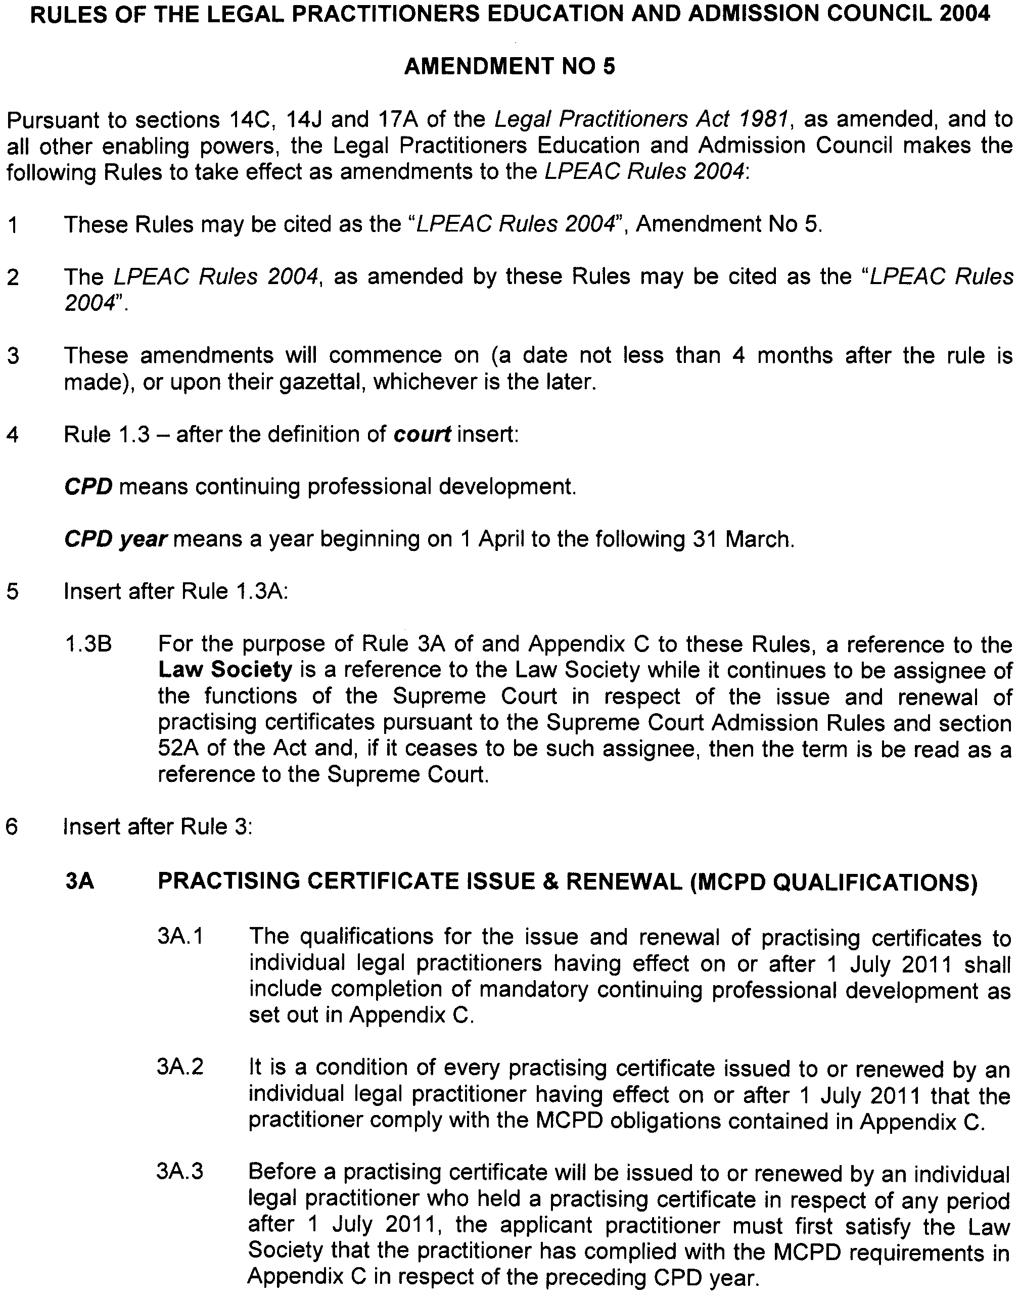
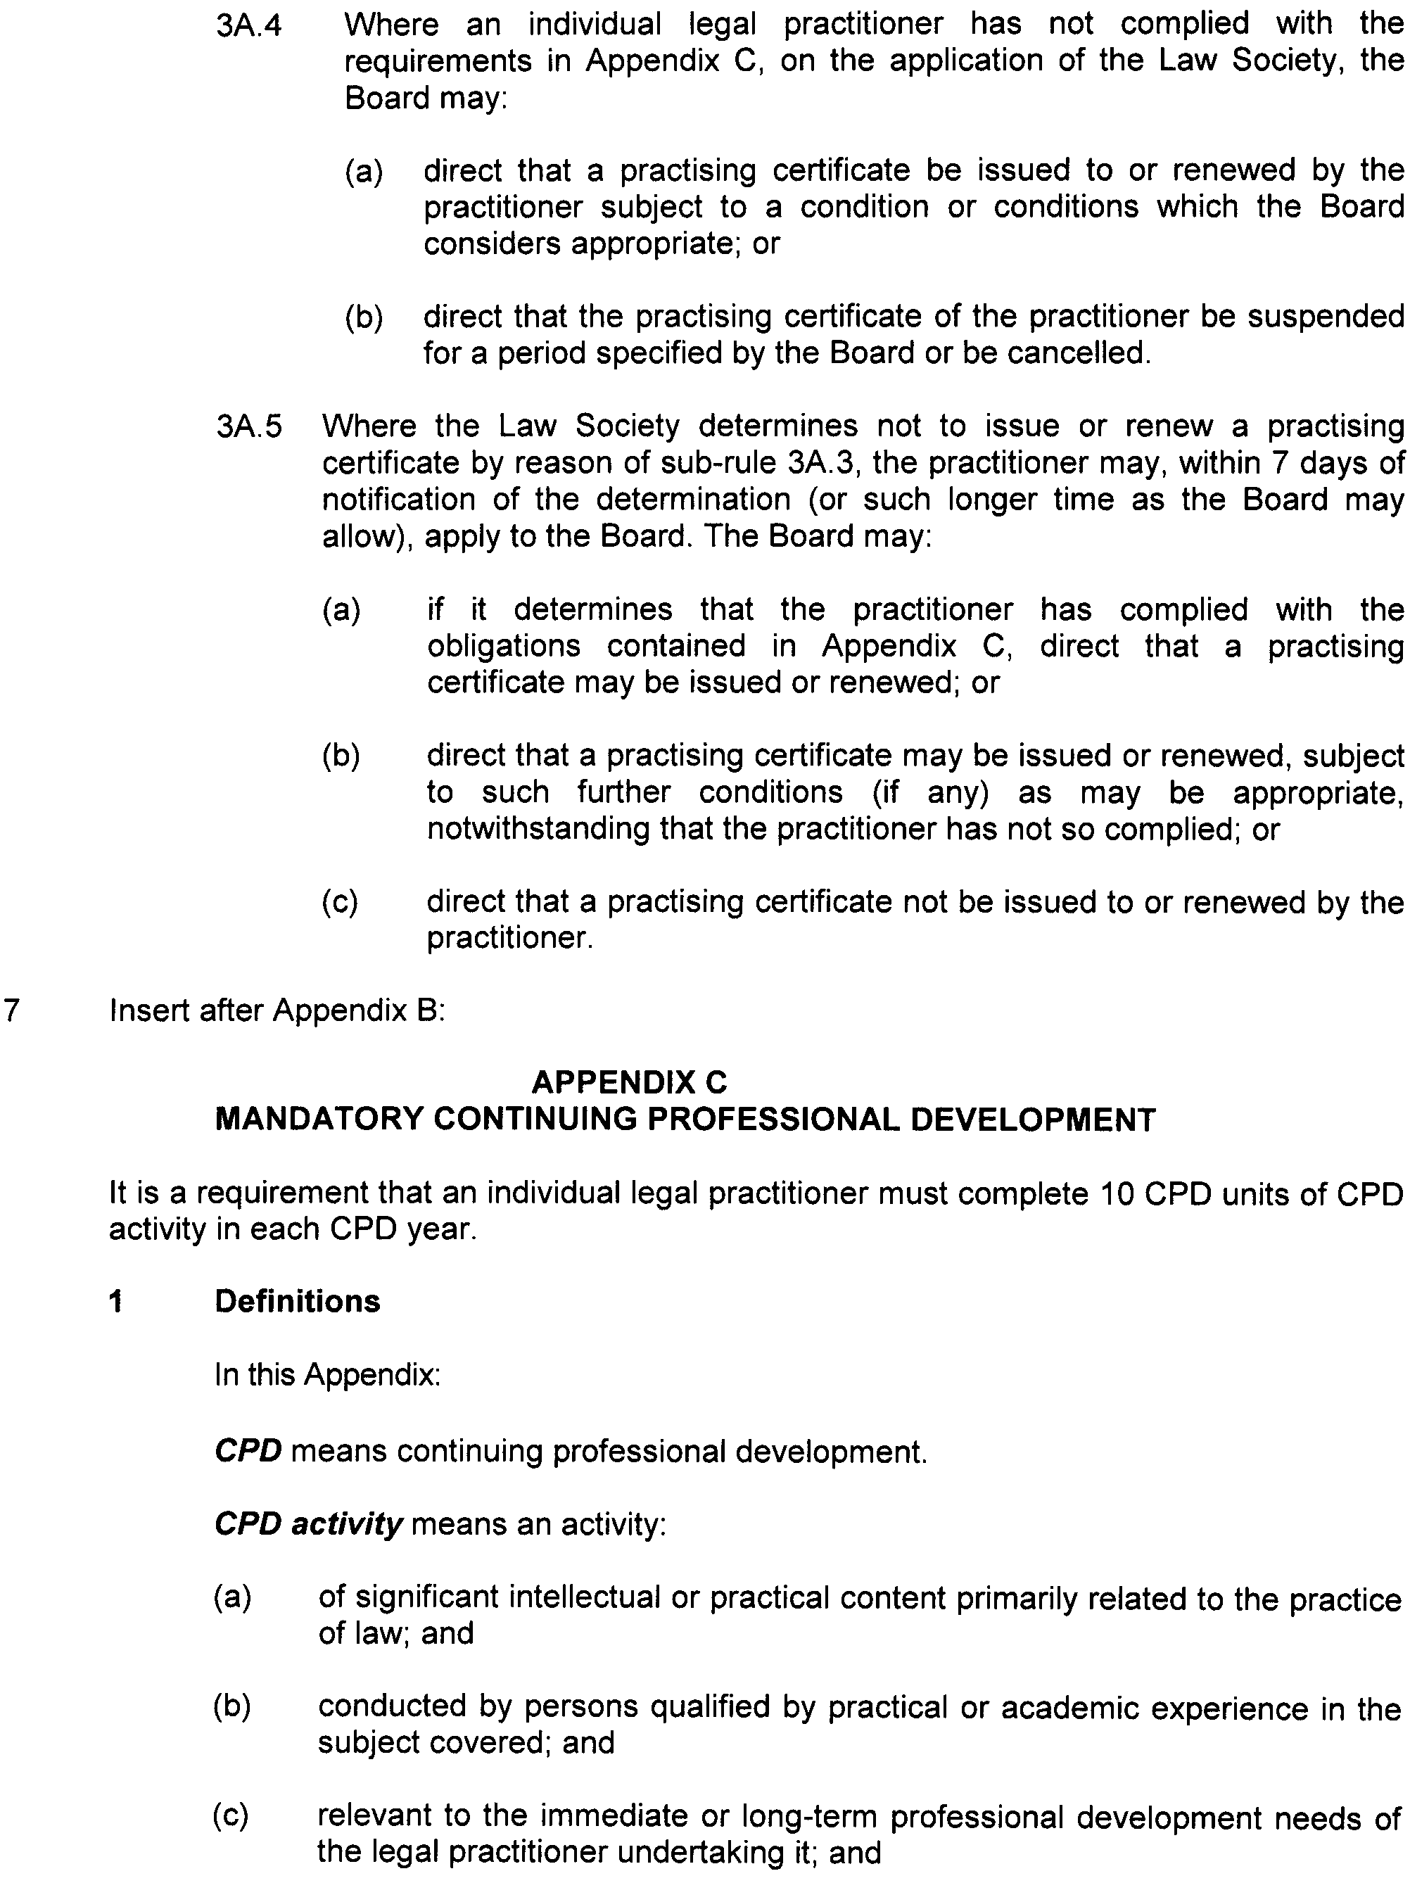
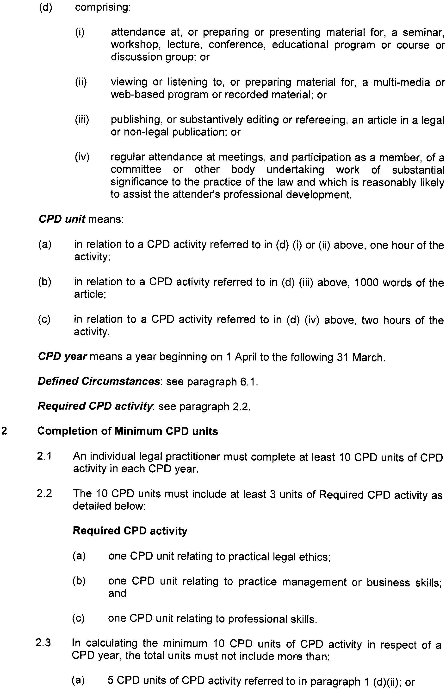
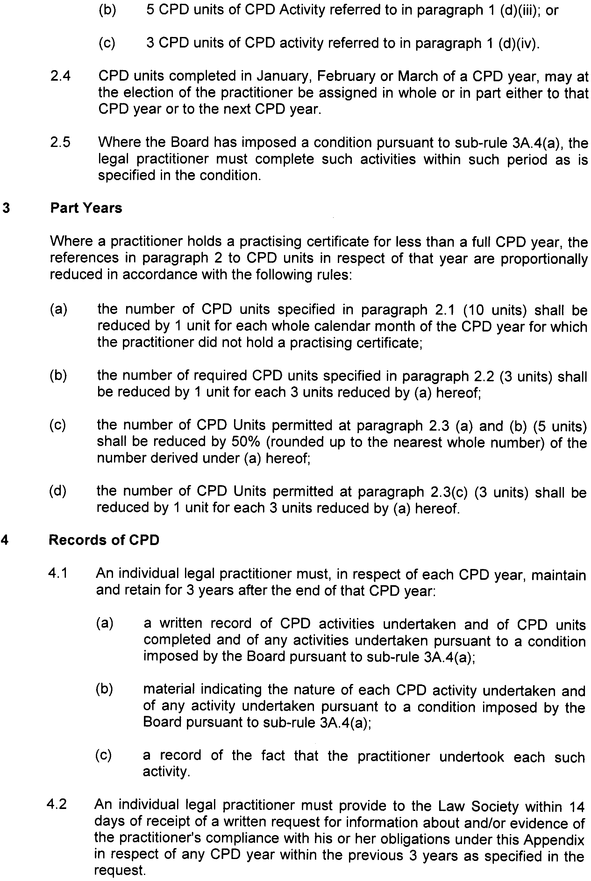
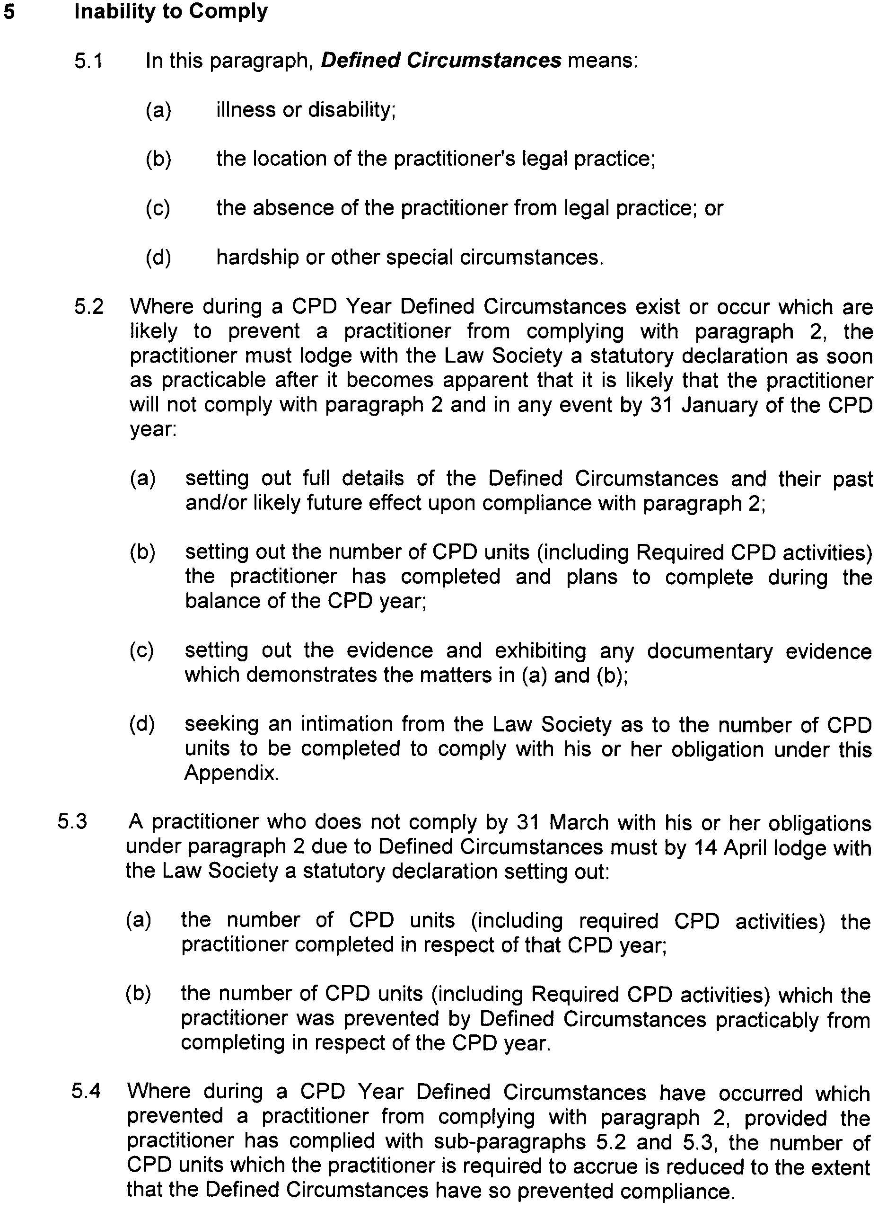
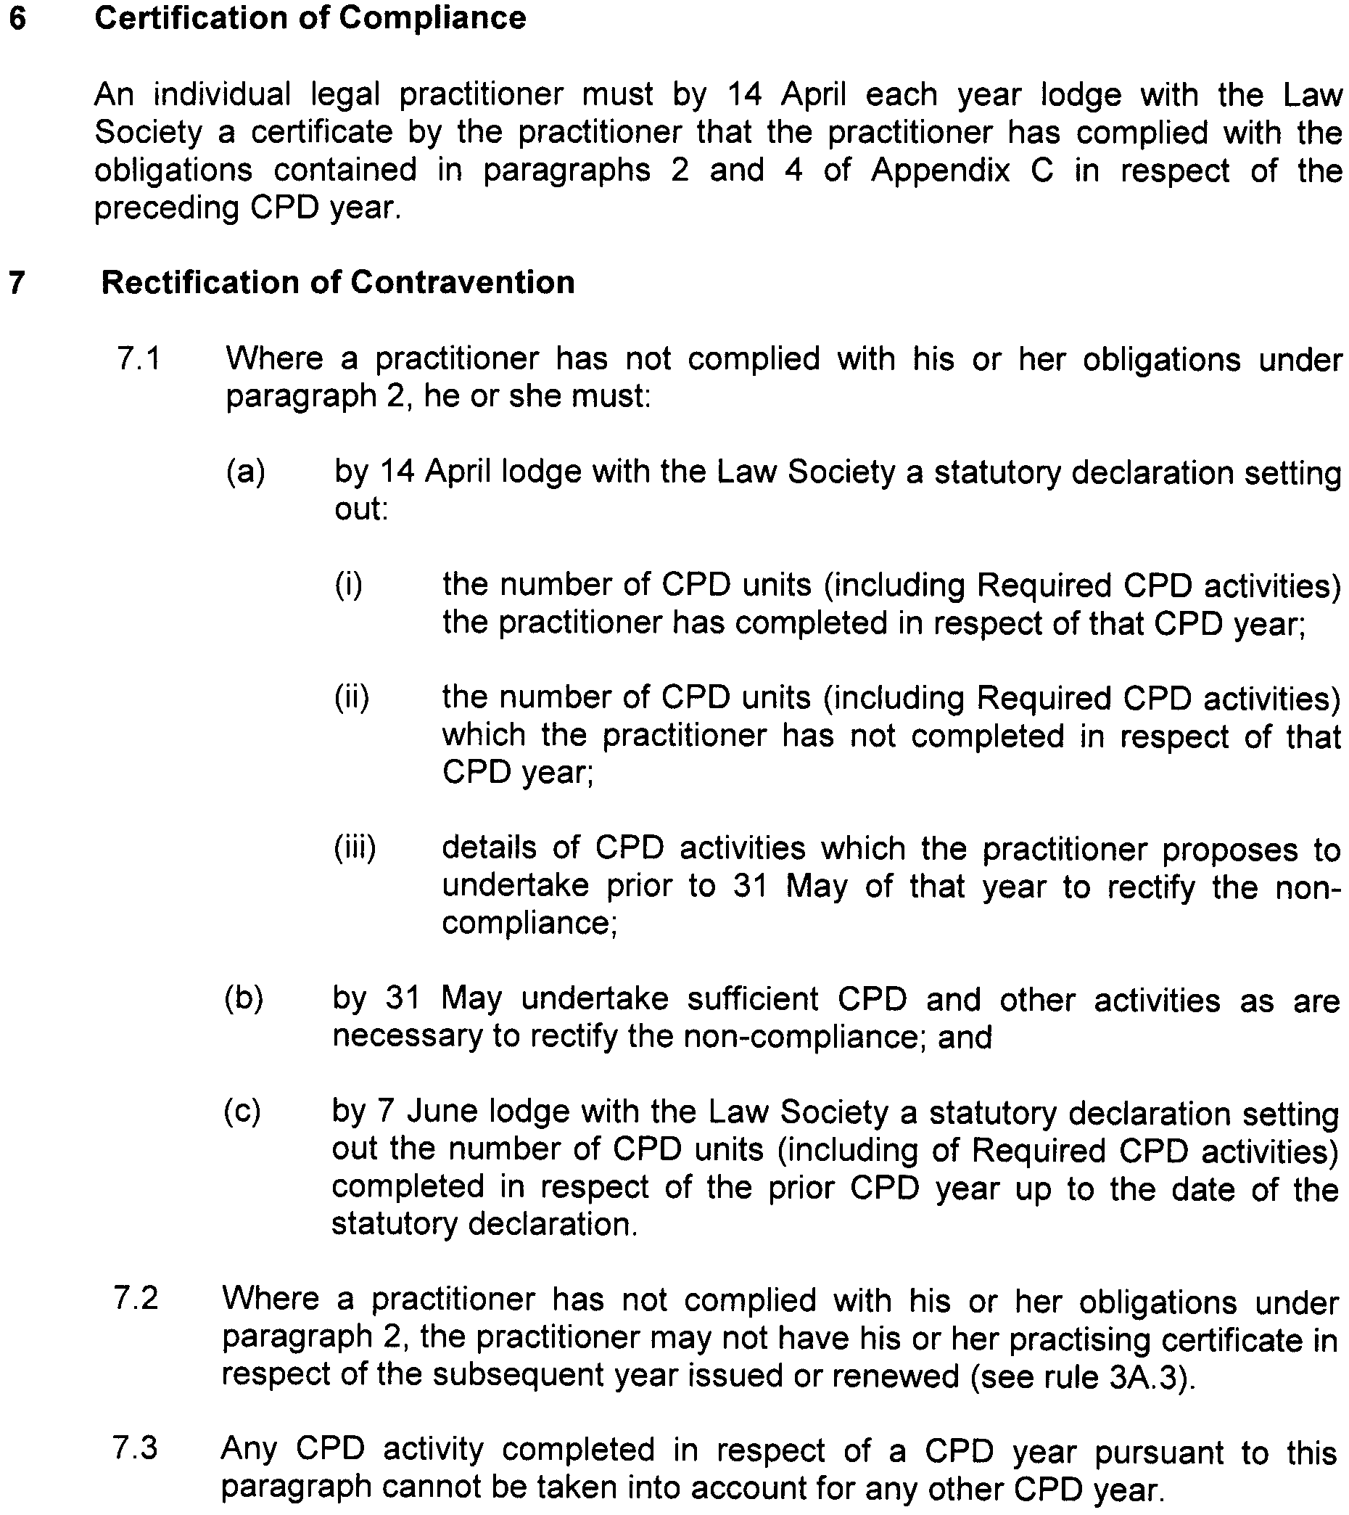

Dated 20 January 2011.

B. MORRIS, Government Printer, South Australia

